September 2019

Australian Public Assessment Report for Tofacitinib (as citrate)
  - Proprietary Product Name: Xeljanz
  - Sponsor: Pfizer Australia Pty Ltd

About the Therapeutic Goods Administration (TGA)
- The Therapeutic Goods Administration (TGA) is part of the Australian Government Department of Health and is responsible for regulating medicines and medical devices.
- The TGA administers the Therapeutic Goods Act 1989 (the Act), applying a risk management approach designed to ensure therapeutic goods supplied in Australia meet acceptable standards of quality, safety and efficacy (performance) when necessary.
- The work of the TGA is based on applying scientific and clinical expertise to decision-making, to ensure that the benefits to consumers outweigh any risks associated with the use of medicines and medical devices.
- The TGA relies on the public, healthcare professionals and industry to report problems with medicines or medical devices. TGA investigates reports received by it to determine any necessary regulatory action.
- To report a problem with a medicine or medical device, please see the information on the TGA website <https://www.tga.gov.au>.
About AusPARs
- An Australian Public Assessment Report (AusPAR) provides information about the evaluation of a prescription medicine and the considerations that led the TGA to approve or not approve a prescription medicine submission.
- AusPARs are prepared and published by the TGA.
- An AusPAR is prepared for submissions that relate to new chemical entities, generic medicines, major variations and extensions of indications.
- An AusPAR is a static document; it provides information that relates to a submission at a particular point in time.
- A new AusPAR will be developed to reflect changes to indications and/or major variations to a prescription medicine subject to evaluation by the TGA.
Copyright
© Commonwealth of Australia 2019
This work is copyright. You may reproduce the whole or part of this work in unaltered form for your own personal use or, if you are part of an organisation, for internal use within your organisation, but only if you or your organisation do not use the reproduction for any commercial purpose and retain this copyright notice and all disclaimer notices as part of that reproduction. Apart from rights to use as permitted by the Copyright Act 1968 or allowed by this copyright notice, all other rights are reserved and you are not allowed to reproduce the whole or any part of this work in any way (electronic or otherwise) without first being given specific written permission from the Commonwealth to do so. Requests and inquiries concerning reproduction and rights are to be sent to the TGA Copyright Officer, Therapeutic Goods Administration, PO Box 100, Woden ACT 2606 or emailed to <tga.copyright@tga.gov.au>.

Contents
Common abbreviations 5
I. Introduction to product submission 10
Submission details 10
Product background 10
Regulatory status 11
Product Information 12
II. Registration time line 12
III. Quality findings 13
IV. Nonclinical findings 13
Introduction 13
Pharmacology 14
Pharmacokinetics 19
Toxicology 20
Nonclinical summary and conclusions 20
V. Clinical findings 21
Introduction 21
Pharmacokinetics 23
Pharmacodynamics 26
Dosage selection for the pivotal studies 26
Efficacy 27
Safety 28
First round benefit-risk assessment 35
First round recommendation regarding authorisation 37
Clinical questions and second round evaluation 38
Second round benefit-risk assessment 46
VI. Pharmacovigilance findings 47
Risk management plan 47
VII. Overall conclusion and risk/benefit assessment 50
Background 50
Quality 52
Nonclinical 52
Clinical 52
Risk management plan 58
Risk-benefit analysis 59
Outcome 65
Attachment 1. Product Information 66

Common abbreviations
Abbreviation | Meaning
ACM | Advisory Committee on Medicines
ACPM | Advisory Committee on Prescription Medicines
ACR | American College of Rheumatology
ACR20 | ACR 20% improvement in disease activity criteria
ACR50 | ACR 50% improvement in disease activity criteria
ACR70 | ACR 70% improvement in disease activity criteria
ADRs | Adverse drug reactions
AE | Adverse event
ALT | Alanine aminotransferase
ANC | Absolute neutrophil count
ANCOVA | Analysis of covariance
APC | Allophycocyanin
AS | Ankylosing spondylitis
ASA | Australian Specific Annex
ASAS | Assessment of SpondyloArthritis international Society
AST | Aspartate aminotransferase
AUC | Area under the concentration time curve
BASDAI | Bath Ankylosing Spondylitis Disease Activity Index
bDMARD | Biologic DMARD
BD | Bis in die; twice daily
bsDMARD | Biosimilar DMARD
CASPAR | Classification Criteria for Psoriatic Arthritis
CD34+ | Cluster of differentiation 34 positive
CD4+ | Cluster of differentiation 4 positive
CHMP | Committee for Medicinal Products for Human Use
CI | Confidence interval
CK | Creatinine kinase
CL/F | Apparent oral clearance
CLcr | Creatinine clearance
C_{max} | Maximum plasma concentration
CMI | Consumer Medicine information
CRP | C reactive protein
csDMARD | Conventional synthetic DMARD
CTSC | Cathepsin C
CV | Cardiovascular
CXCL1 | Chemokine (C-X-C motif) ligand 1
DAS28-3 (CRP) | Disease Activity Score with CRP
DILI | Drug induced liver injury
DMARD | Disease modifying antirheumatic drug
DSS | Dactylitis severity score
ECG | electrocardiogram
eGFR | estimated Glomerular Filtration Rate
ELISA | Enzyme linked immunosorbent assay
EMA | European Medicines Agency
E_{max} | Maximum effect
EPO | Erythropoietin
EQ-5D | EuroQol-5 Dimension Health State Profile
ESR | Erythrocyte sedimentation rate
EU | European Union
EULAR | European League Against Rheumatism
FACIT-F | Functional Assessment of Chronic Illness Therapy-Fatigue
FAS | Full Analysis Set
FDA | Food and Drug Administration (US)
FITC | Fluorescein isothiocyanate
GFR | Glomerular filtration rate
GI | Gastrointestinal
h | hour/s
H&E | Haematoxylin and eosin
HAQ | Health Assessment Questionnaire
HAQ-DI | Health Assessment Questionnaire - Disability Index
Hb | Haemoglobin
HbA1c | Haemoglobin A1c
HBV | Hepatitis B
HCV | Hepatitis C
HDL | High density lipoprotein
HDL-C | High density lipoprotein-cholesterol
HLA-B27 | Human leukocyte antigen B27
HR | Hazard ratio
HZ | Herpes zoster
IC₅₀ | Half maximal inhibitory concentration
IHC | Immunohistochemistry
IL-2 | Interleukin-2
ILD | Interstitial lung disease
IP | Intraperitoneal
IVRS | Interactive voice response system
JAK | Janus kinase
LDL-C | low density lipoprotein-cholesterol
LEI | Leeds Enthesitis Index
LFT | Liver function tests
LS | Least squares
MACE | Major adverse cardiovascular events
MedDRA | medical dictionary for regulatory activities
MMRM | Mixed Model for Repeated Measures
mTSS | modified total Sharp score
MTX | methotrexate
NSAID | Non-steroidal anti-inflammatory drug
OAT1 | Organic anion transporter 1
OATP1B1 | Organic-anion-transporting polypeptide 1 B1
OCT1 | Organic cation transporter 1
OPAL | Optimising Patient outcome in Australian Rheumatology
PASI | Psoriasis Area and Severity Index
PASI75 | 75% reduction in PASI score
PD | Pharmacodynamic(s)
PDE4 | Phosphodiesterase 4
PE | Phycoerythrin
PGA | Physician’s Global assessment
PI | Product Information
PK | Pharmacokinetic(s)
PO | Per os; oral
PP | Per protocol
PsA | Psoriatic arthritis
PsO | Psoriasis
PT | Preferred Term
PY | Patient years
QTc | Corrected QT interval of the ECG
RA | Rheumatoid arthritis
RBC | Red blood cells
rmIL-23 | Recombinant mouse IL-23
RMP | Risk Management Plan
RNA | Ribonucleic acid
RT PCR | Reverse transcription polymerase chain reaction
S100A8 | S100 calcium-binding protein A8
SAE | serious adverse event
SD | standard deviation
SMQ | Standard MedDRA query
SOC | System organ class
STAT | Signal transducer and activator of transcription
TB | tuberculosis
TEAE | treatment emergent adverse event
TNF | Tumour Necrosis Factor (alpha unless otherwise stated)
TNFI | TNF inhibitor
tsDMARD | Targeted synthetic DMARD
TYK2 | Tyrosine kinase 2
ULN | Upper limit of normal
URTI | Upper respiratory tract infection
UTI | Urinary tract infection
VAS | Visual Analog Scale

I. Introduction to product submission

Submission details
Type of submission: | Extension of indications
Decision: | Approved
Date of decision: | 8 November 2018
Date of entry onto ARTG: | 13 November 2018
ARTG numbers: | 196987, 233439
Black Triangle Scheme | No
Active ingredient: | Tofacitinib (as citrate)
Product name: | Xeljanz
Sponsor’s name and address: | Pfizer Australia Pty Ltd  Level 17 151 Clarence Street  Sydney, NSW, 2000
Dose form: | Tablet, film coated
Strength: | 5 mg
Containers: | Bottle and blister pack
Pack sizes: | Bottle: 60 and 180 tablets  Blister pack: 14 (sample size) and 56 tablets
Approved therapeutic use: | Psoriatic Arthritis  Xeljanz in combination with conventional synthetic disease-modifying antirheumatic drugs (DMARDs) is indicated for the treatment of active psoriatic arthritis in adult patients who have had an inadequate response to a prior DMARD therapy.
Route of administration: | Oral
Dosage: | 5 mg administered twice daily used in combination with conventional synthetic disease-modifying antirheumatic drugs (csDMARDs).  For further details refer to the Product Information (PI).

Product background
This AusPAR describes the application by Pfizer Australia Pty Ltd (the sponsor) to register Xeljanz (tofacitinib, as citrate) 5 mg tablets for the following indication:
Xeljanz is indicated for the treatment of active psoriatic arthritis in adult patients who have had an inadequate response or who have been intolerant to a prior DMARD therapy.
Psoriatic arthritis (PsA) is a chronic inflammatory rheumatoid disease associated with painful joint swelling, characteristically affecting the distal phalanges, psoriasis (skin and nails), enthesitis, dactylitis and spondylitis, leading to progressive damage, disability and adverse effects on quality of life. The disease is incurable and therapy is directed at long-term symptom control and prevention of joint destruction. Psoriasis is a chronic skin condition affecting approximately 2 to 3% of the overall population. PsA is usually associated with psoriasis but only 10 to 20% of patients with psoriasis will develop PsA. There are no reliable epidemiological data relating to PsA in Australia. The best estimate of PsA diagnosed by rheumatologists is approximately 9,300 cases compared with 26,700 cases of rheumatoid arthritis (RA) as derived from the Optimising Patient outcome in Australian Rheumatology (OPAL) database).
The current European League Against Rheumatism (EULAR) guideline for PsA recommends starting treatment with non-steroidal anti-inflammatory drugs (NSAIDs), followed by a non-biologic (conventional synthetic) disease modifying anti-rheumatic drugs (csDMARD), usually methotrexate (MTX) if the response is inadequate. If the clinical response is again inadequate, a biological DMARD (bDMARD) may be prescribed, typically a TNF inhibitor (TNFI). TNFIs are usually prescribed with MTX but may be given as monotherapy if MTX is not tolerated or contra-indicated.
In rheumatoid diseases, there is overproduction of a number of pro-inflammatory cytokines including interleukins and tumour necrosis factor (TNF). In the last 20 years, numerous bDMARDs have proved effective in rheumatoid arthritis (RA), and in related conditions including PsA, ankylosing spondylitis and juvenile arthritis. Tofacitinib is a first in class janus kinase (JAK) inhibitor which reduces immune and inflammatory processes in rheumatoid arthritis. It is a targeted synthetic DMARD (tsDMARD) which preferentially inhibits JAK3/JAK1 heterodimeric complexes on the inner aspects of the cell surface membrane. Inhibition of JAK3/JAK1 blocks cytokine signalling affecting inflammation and immune responses, primarily interleukin-2 (IL-2), IL-4, IL-7, IL-9, IL-15 and IL-21. In addition, JAK2 and tyrosine kinase 2 inhibition affects signalling for several hormones, particularly erythropoietin (EPO) and pro-inflammatory cytokines such as IL-6 and type I and II interferons. Tofacitinib is approved for use in RA in more than 50 countries.

Regulatory status
The product received initial registration on the Australian Register of Therapeutic Goods (ARTG, Submission PM-2012-00788-3-3) as a 5 mg tablet blister pack (ARTG 196987) and bottle (ARTG 233439) on 5 February 2015 for the following indication:
Xeljanz is indicated for the treatment of the signs and symptoms of moderate to severe active rheumatoid arthritis in adults who have had an inadequate response or are intolerant to methotrexate. Xeljanz con be used alone or in combination with non-biological disease-modifying anti-rheumatic drugs (DMARDs), including methotrexate.
Therapy with Xeljanz should be initiated and monitored by a rheumatologist or specialist physician with expertise in the management of rheumatoid arthritis.
On 1 June 2017 (Submission PM-2016-00757-1-3) the following changed indications were approved:
Xeljanz is indicated for the treatment of moderate to severe active rheumatoid arthritis in adults who have had an inadequate response or are intolerant to methotrexate. Xeljanz can be used alone or in combination with non-biological DMARDs, including methotrexate.
Therapy with Xeljanz should be initiated and monitored by a rheumatologist or specialist physician with expertise in the management of rheumatoid arthritis.
At the time the TGA considered this application, a similar application had been approved in the United States of America (USA) 14 December 2017 and European Union (EU), centralised procedure 25 June 2018, and was under consideration in Canada (Table 1).
Table 1: International regulatory status as of 18 September 2018
Region | Submission date | Status | Indications
USA | [Information redacted] | Approved  14 December 2017 | Xeljanz/Xeljanz XR (tofacitinib) is indicated for the treatment of adult patients with active psoriatic arthritis who have had an inadequate response or intolerance to methotrexate or other disease-modifying antirheumatic drugs (DMARDs).  Limitations of Use: Use of Xeljanz/Xeljanz XR in combination with biologic DMARDs or with potent immunosuppressants such as azathioprine and cyclosporine is not recommended.
EU (centralised procedure)  Rapporteur: United Kingdom  Co-rapporteur: Italy | [Information redacted] | Approved  25 June 2018 | Xeljanz in combination with methotrexate (MTX) is indicated for the treatment of active psoriatic arthritis (PsA) in adult patients who have had an inadequate response or who have been intolerant to a prior disease-modifying antirheumatic drug (DMARD) therapy (see section 5.1)
Canada | [Information redacted] | Under evaluation | Under evaluation

Product Information
The Product Information (PI) approved with the submission which is described in this AusPAR can be found as Attachment 1. For the most recent PI, please refer to the TGA website at <https://www.tga.gov.au/product-information-pi>.

II. Registration time line
Table 2 captures the key steps and dates for this application and which are detailed and discussed in this AusPAR.
Table 2: Timeline for Submission PM-2017-03802-1-3
Description | Date
Submission dossier accepted and first round evaluation commenced | 30 November 2017
First round evaluation completed | 2 May 2018
Sponsor provides responses on questions raised in first round evaluation | 2 July 2018
Second round evaluation completed | 1 August 2018
Delegate’s Overall benefit-risk assessment and request for Advisory Committee advice | 31 August 2018
Sponsor’s pre-Advisory Committee response | 18 September 2018
Advisory Committee meeting | 4 October 2018
Registration decision (Outcome) | 8 November 2018
Completion of administrative activities and registration on ARTG | 13 November 2018
Number of working days from submission dossier acceptance to registration decision* | 193
*Statutory timeframe for standard applications is 255 working days
Evaluations included under Quality findings and Nonclinical findings incorporate both the first and second round evaluations.

III. Quality findings
There was no requirement for a quality evaluation in a submission of this type.

IV. Nonclinical findings

Introduction
The sponsor has applied for an extension of indications for Xeljanz, an oral formulation of tofacitinib (as citrate). Tofacitinib is currently registered under the name Xeljanz, as a treatment for moderate to severe active rheumatoid arthritis in adults who have had an inadequate response or are intolerant to methotrexate. The current dose regimen is 5 mg twice daily as monotherapy or in combination with methotrexate or other non-biological DMARDs. Xeljanz treatment should be interrupted if a patient develops a serious infection until the infection is controlled. Xeljanz is given orally with or without food.
The new indication is the treatment of active psoriatic arthritis in adult patients who have had inadequate response or who have been intolerant to a prior DMARD therapy.
No change to the formulation has been proposed with this submission.
Xeljanz is proposed to be used for the treatment of active psoriatic arthritis in adult patients who have had inadequate response or who have been intolerant to a prior DMARD therapy.
The proposed standard recommended dosage is 5 mg twice daily used in combination with conventional synthetic disease modifying anti-rheumatic drug.

Pharmacology

In vitro studies

Study CP-690550_17Dec12_140707

Study details
In vitro activity of CP-690550; effects on cytokine-dependent signal transducer and activator of transcription (STAT) phosphorylation with leukocyte populations in human whole blood; dated17 December 2012.
- Cells: human whole blood, human bone marrow cluster of differentiation 34 positive (CD34+).
- Test item: CP-690550 (tofacitinib).
- Cytokines: IL-12, IL-23, IL 27 and erythropoietin (EPO).
- Flow cytometry: IL-12, IL 23 and IL-27 stimulation of lymphocyte population was gated for pSTATs; EPO stimulation of entire populations were gated for phosphorylated STAT5 (pSTAT5).

Results
- In lymphocytes from human whole blood, tofacitinib inhibited phosphorylation of:
  - STAT3 induced by IL-23 (JAK2/tyrosine kinase 2 (TYK2)-dependent) and IL-27 (JAK1/JAK2-dependent; see half maximal inhibitory concentration (IC₅₀) in Table 3).
  - STAT4 induced by IL 12 (JAK2/TYK2-dependent) (see IC₅₀ in Table 3).
Table 3: Study CP-690550_17Dec12_140707 Inhibitory activity of CP-690550 in human whole blood
- Tofacitinib inhibited erythropoietin-induced STAT5 phosphorylation (JAK2/JAK2 dependent) (see half maximal inhibitory concentration (IC₅₀) data in Table 3).

Study CP-690550_17Dec12_140806

Study details
In vitro activity of CP-690550; effects on cytokine-dependent STAT phosphorylation with leukocyte populations in human peripheral blood mononuclear cells. Dated: 17 December 2012.
- Cells: human peripheral blood mononuclear cells and bone marrow CD34+.
- Test item: CP-690550 (tofacitinib).
- Cytokines: IL-10, IL-15, IL 2, IL 21, IL-23 and erythropoietin.
- Flow cytometry: IL-2, IL 10, IL-15, IL-21 and IL-23 stimulation of lymphocyte population was gated for pSTAT3 or pSTAT5; EPO stimulation of entire populations were gated for pSTAT5.

Results
- In lymphocytes from peripheral blood mononuclear cells, tofacitinib inhibited phosphorylation of:
  - STAT3 induced by IL-10 (JAK1/TYK2-dependent), IL-21 (JAK1/JAK3-dependent) and IL-23 (JAK2/TYK2) (see IC₅₀ data in Table 4).
  - STAT5 induced by IL-2 and IL-15 (JAK1/JAK3-dependent) (see IC₅₀ data in Table 4).
- Tofacitinib inhibited erythropoietin-induced STAT5 phosphorylation (JAK2/JAK2 dependent) in bone marrow-derived CD34+ progenitor cells (see IC₅₀ data in Table 4).
Table 4: Study CP-690550_17Dec12_140806 Inhibitory activity of CP-690550 in human whole blood

In vivo studies

Study No CP-690,550_29MAY14_184149

Study details
Tofacitinib reduces inflammation in imiquimod-induced skin inflammation model. Dated: 29 May 2014.
- Animals: Mice, female; BALB/c.
- Age: 8 to 10 weeks, n = 8 per group.
- Test items: tofacitinib, vehicle (2% Tween 80, 0.5% methylcellulose in purified water), anti-p40 antibody.
- Dose range: tofacitinib 30 mg/kg and vehicle per os (PO; oral), bis in die (BD; twice daily). Anti-p40 antibody 16 mg/kg intraperitoneal (IP), twice weekly. Study duration: 5 days.
- Imiquimod inflammation: daily topical dose of imiquimod (5% cream commercially available) on animals shaved back and left ear for 3 consecutive days (= 1.56 mg of active compound).
- Measurements/histology: ear thickness (Day 1 to 5) in triplicate; ear sections haematoxylin and eosin (H&E) and pSTAT3 immunohistochemistry (IHC); cluster of differentiation 4 positive (CD4+) lymphocyte population from whole blood was gated for pSTAT3 staining, reverse transcription polymerase chain reaction (RT PCR), enzyme linked immunosorbent assay (ELISA).

Results
- Tofacitinib significantly decreased ear swelling (79.2%) at Day 3, compared to vehicle control group. This difference was not statistically significant by Day 5 (29%).
- Anti-p40 antibody significantly decreased ear swelling in a time dependent manner (Day3: 52.6%; Day 5: 83%), compared to vehicle treated animals. Four independent additional studies showed that tofacitinib decreased ear swelling on Day 5 by 28 to 48%, compared to controls.
- Tofacitinib and anti-p40 antibody significantly decreased ear oedema, compared to their control littermates, but had no significant effect on ear epidermal hyperplasia.
- Anti-p40 antibody significantly decreased ear inflammation, compared to controls. This was not the case for tofacitinib treated mice (inflammation comparable to controls).
- Tofacitinib and anti-p40 antibody significantly decreased pSTAT3 in the epidermis and dermis relative to vehicle treated animals. Tofacitinib significantly decreased pSTAT3 staining in whole blood, compared to vehicle treated mice.
- RT PCR data showed that tofacitinib significantly decreased IL-22, IL-22R, IL-6 and S100 calcium-binding protein A8 (S100A8) mRNA levels in the ear, compared to controls; while anti-p40 antibody significantly decreased IL-6, IL-1β, IL 22, IL-7, IP10, S100A8, IL-21R and IL-22R mRNA levels.
- ELISA data showed that anti-p40 antibody significantly decreased secretion of IL-17, IL-22 and IL-6 in the ear, compared to controls. Tofacitinib only significantly inhibited IL-6 secretion.

Study No CP-690,550_29May14_184337

Study details
Evaluation of tofacitinib in the IL-23 induced skin inflammation model. Dated: 29 May 2014
- Animals: Mice, female; BALB/c.
- Age: 8 to 10 weeks, n = 7 per group.
- Test items: tofacitinib, vehicle (2% Tween 80, 0.5% methylcellulose in purified water), anti-p40 antibody.
- Dose range: tofacitinib: 30, 10, 3 mg/kg and vehicle PO, BD. Anti-p40 antibody 20 mg/kg IP, once/week. Study duration: 14 days.
- IL-23 injection: recombinant mouse IL-23 (rmIL-23; 150 ng in saline) or saline (vehicle) intradermal in the ears for 7 challenges.
- Measurements/histology: ear thickness; ear sections H&E and pSTAT3 IHC.

Results
- According to the sponsor ‘mice treated with tofacitinib or anti-p40 antibody experienced significant reduction in ear thickness when compared to vehicle treated control. Additionally, mice that received tofacitinib exhibited a dose dependent inhibition of ear swelling’.
- Tofacitinib at 30 mg/kg significantly decreased skin inflammation (67.06% inhibition compared to vehicle control). While tofacitinib at 10 mg/kg and the anti-p40 antibody treatment inhibited inflammation by 40.8% (significant compared to control) and 35.16% (significant compared to controls), respectively. Tofacitinib at 3 mg/kg had no effect on inflammation (< 0% inhibition).
- Additional studies showed that tofacitinib (30 mg/kg) decreased IL-23 induced ear swelling by 49 to 63% compared to controls (56 to 62% for anti-p40 antibody).
- Tofacitinib decreased pSTAT3 positive cells (at 10 mg/kg and significantly at 30 mg/kg, compared to vehicle controls. This effect was not visible in animals treated with anti-p40 antibody.

Study CP-690550_02Jun14_113323

Study details
Evaluation of tofacitinib in the murine T cell transfer model of psoriasis. Dated: 2 June 2014.
- Animals: Mice, female; BALB/c, BALB/cBy, and NOD.CB17-Prkdcscid/J (recipient mice); age: 6 to 8 weeks.
- Test item: tofacitinib (in 0.5% methylcellulose and 0.25% Tween 80).
- Dose range: tofacitinib 30 mg/kg, BD, PO; vehicle: 10 mL/kg, BD, PO (therapeutic (started when inflammation score reached 2) and prophylactic (started day from cell transfer) administrations).
- Skin inflammation model: CD4+T cells enriched from BALB/cBy splenocytes labelled with phycoerythrin (PE) conjugated anti-CD4, fluorescein isothiocyanate (FITC) conjugated anti-CD45RB, and allophycocyanin (APC) conjugated anti-CD25 antibodies. CD4+-CD45RB-highCD25- cells isolated, purified cells injected IP into NOD.CB17-Prkdcscid/J mice.
- Measurements/histology: disease severity scoring, ear sections H&E and pSTAT3 IHC, CD4+ lymphocyte population from whole blood was gated for pSTAT3 staining, RT PCR, lipid level analysis.

Results
- Compared to vehicle controls, prophylactic administration of tofacitinib induced significant:
  - Decrease in disease severity, from Day 27 post transfer until study termination (see Figure 1 left panel).
  - Decrease in ear dermal inflammation and epidermal hyperplasia.
  - Increase in cholesterol and high density lipoprotein (HDL) levels.
  - Decrease in ribonucleic acid (RNA) expression of IL-12 (p35 and p40), IL-23a, S100A8, chemokine (C-X-C motif) ligand 1 (CXCL1), CXCL10 and IL-6 in the ear.
- Prophylactic treatment with tofacitinib did not affect pSTAT3 blood expression (in CD34+ cells).
- Compared to vehicle controls, therapeutic administration of tofacitinib induced significant:
  - Decrease in disease score 11 days post initiation of the treatment (corresponding to 49 days post-transfer; see Figure 1 right panel).
  - Decrease in inflammatory cell infiltrates and epidermal thickening (data not provided).
  - Decrease in pSTAT3 expression in ear dermis and epidermis.
- Therapeutic treatment with tofacitinib did not affect IL-12 (p35 and p40), IL-23a and S100A8 RNA expression.
Figure 1: Study CP-690550_02Jun14_113323 Effects of prophylactic (left) and therapeutic (right) dosing with 30 mg/kg tofacitinib
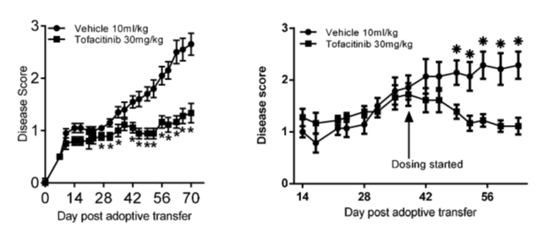

Study CP-690550_02Jun14_113429 (Amendment)

Study details
The effect of tofacitinib in a xenograft model of psoriasis in mice. Dated: 2 June 2014.
- Psoriasis and keratome samples: human psoriatic plaque keratome skin (n = 5), one keratome biopsy for 12 recipient mice.
- Animals: Mice; female; C.B-17 SCID; age: 6 to 8 weeks.
- Test item: tofacitinib, vehicle (0.5% methylcellulose, 0.25% Tween 80), ustekinumab.
- Dose range: tofacitinib: 30 mg/kg, vehicle, PO, BD for 3 weeks; ustekinumab 9 mg/kg, IP, once weekly for 3 weeks.

Results
- Treatment with tofacitinib or ustekinumab decreased psoriatic scores by Day 7 until the end of the study, compared to control (treatment versus control scores at 3 weeks were statistically significant: tofacitinib 0.9 ± 0.7, ustekinumab 1.3 ± 0.6, control 2.1 ± 0.7).
- Tofacitinib treatment significantly decreased epidermal thickness of the grafted skin (178 ± 70 μm) compared to control group (348 ± 103 μm).Ustekinumab: 293 ± 116 μm.
- Histology scores (see Table 5) were significantly improved in tofacitinib treated animals compared to control mice.
- pSTAT3 expression was significantly decreased in epidermis and dermis from tofacitinib treated mice compared to control mice. Ustekinumab treatment did not decrease pSTAT3 expression.
- Tofacitinib treatment significantly decreased skin gene expression of cathepsin C (CTSC), CXCL1 (chemokine), IL-12Rβ1, IL-15, compared to controls. No ustekinumad-related effects on gene expression observed.
- There were no treatment-related effects on body weight (data not provided).
Table 5: Study CP-690550_02Jun14_113429 (Amendment) Histology scores
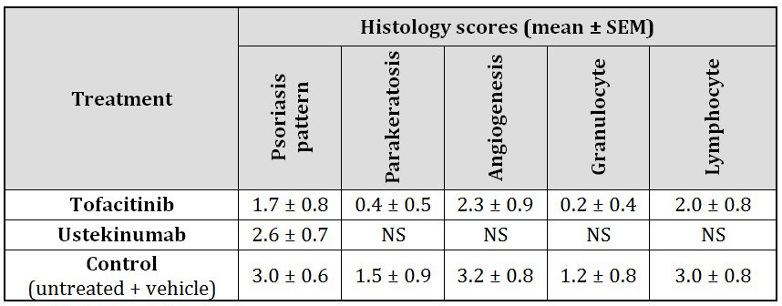
Data for tofacitinib and ustekinumab presented in this table are all statistically significant compared to control except when NS (not significant compared to control group). SEM = standard error of the mean.

Pharmacokinetics
Table 6: Pharmacokinetic drug interactions
Study No. | Purpose | Experimental system | Test concentration range | Results
CP-690550_ 30Nov16_014154 | Substrate affinity for human organic cation transporter 1 (OCT1) | OCT1-transfected HEK 293 cells | In vitro  0.03 to 0.15 μM | Tofacitinib is not a substrate for OCT1 at low substrate concentration.  Consistent with previously assessed studies
CP-690550_ 01Dec16_011352 | Substrate affinity for human organic-anion-transporting polypeptide 1 B1 (OATP1B1) and OATP1B3 | OATP1B1 or OATP1B3-transfected HEK 293 cells | In vitro  0.03 to 0.15 μM | Tofacitinib is not a substrate for OATP1B1 or OATP1B3 at low substrate concentration.  Consistent with previously assessed studies.
CP-690550_ 01Feb17_110227 | Inhibition potential for human organic anion transporter 1 (OAT1) and OAT3 | OAT1- and OAT3-transfected HEK 293 cells | In vitro  0.0244 to 100 μM | IC₅₀ > 100 μM for both OAT1 and OAT3. Inhibition at 100 μM was 12.4 and 1.67%, respectively.
17GR019 and CP-690550_23Jan17_033801 | Inhibition potential for human multidrug resistance-associated protein 2 (MRP2) | Vesicular transport assay (MRP2-mediated estradiol glucuronide (E217βG) transport) | In vitro  0.09 to 66.67 μM | Tofacitinib did not affect MRP2-mediated transport of E217βG. IC₅₀ not calculated.

Toxicology

In silico mutagenicity studies
The impurities PF-05211077 and PF-05198213 were previously assessed for general toxicity (juvenile cynomolgus monkey toxicity study) and potential genotoxicity (in silico using Deductive Estimation of Risk from Existing Knowledge (DEREK)). The evaluation report concluded that ‘on balance, the weight of evidence suggests that neither PF-05198213 nor PF 05211077 pose either a general or genotoxicity concerns.’ at the specification level of not more than 0.2%. A later evaluation report considered these impurities adequately qualified at the specification level of ≤ 0.3%. The present application does not propose to increase the specification limits for these impurities. In the current application, the sponsor has submitted in silico studies for prediction of mutagenicity using the most recent version of the software (Derek Nexus, Sarah Nexus and Leadscope) using identical comparative methods as previously evaluated. Briefly, no alerts were identified for PF-05211077. Based on the above, it is concluded the PF-05211077 and PF-05198213 are not mutagenic.

Nonclinical summary and conclusions
- In vitro and in vivo pharmacology and pharmacokinetic studies as well as in silico impurity studies were submitted in the nonclinical dossier.
- In vitro pharmacology studies demonstrated that tofacitinib inhibited interleukin-induced STATs phosphorylation (JAK/JAK or JAK/TYK mediated).
- Tofacitinib given PO displayed efficacy in vivo in mouse models of induced skin inflammation, T cell transfer and xenograft models of psoriasis. These models showed reduction in disease severity, swelling, oedema, tissue thickness, skin inflammation, epidermal hyperplasia, histology scores (including psoriasis pattern, parakeratosis, angiogenesis, granulocyte and lymphocyte). Tofacitinib induced decreases in phosphorylated STAT3 protein expression and decreased IL-6, IL-12, IL-12Rβ1, IL-15, IL-22, IL-22R, IL-23a, S100A8, CXCL1, CXCL10 gene expression and IL-6 secretion in psoriatic skin.
- Tofacitinib is not a substrate for the uptake transporters: OCT1, OATP1B1 and OATP1B3.
- Tofacitinib is not an inhibitor for the efflux transporter pump MRP2. Tofacitinib had only minimal inhibitory effects on OAT1 and OAT3.
- There are no nonclinical objections to the proposed extension of indications for tofacitinib citrate (Xeljanz).
- The draft Product Information does not require amendment.

V. Clinical findings
A summary of the clinical findings is presented in this section.

Introduction

Information on the condition being treated
Psoriasis affects approximately 2 to 3% of the population. PsA is usually associated with psoriasis but only 10 to 20% of patients with psoriasis will develop PsA. The disease is associated with the human leukocyte antigen B27 (HLA-B27) gene but only a minority of subjects with the gene develop PsA. PsA is a chronic inflammatory rheumatoid disease associated with painful joint swelling, characteristically affecting the distal phalanges, psoriasis (skin and nails), enthesitis, dactylitis and spondylitis, leading to progressive damage, disability and adverse effects on quality of life. It is typically associated with exacerbations and remissions, but approximately 5% of patients with PsA develop severe disease with joint destruction and deformity in the hands and feet. The disease is incurable and therapy is directed at long-term symptom control and prevention of joint destruction. There are no reliable epidemiological data relating to PsA in Australia. The best estimate of PsA diagnosed by rheumatologists is approximately 9,300 cases compared with 26,700 cases of RA (derived from the OPAL database).

Current treatment options
The treatment of RA and related rheumatoid diseases is evolving rapidly and guidelines require frequent updates based on literature reviews, clinical experience and regulatory frameworks. The current EULAR guideline for PsA recommends starting treatment with NSAIDs, followed by a csDMARD if the response is inadequate. MTX is considered the csDMARD of choice, but other options include sulphasalazine or leflunomide if MTX is not tolerated or contraindicated. Low dose oral corticosteroids and intra-articular injections may be used at any stage. If the clinical response is inadequate, a bDMARD may prescribed, typically a TNFI. In Australia, several TNFIs are approved for use in PsA, including adalimumab (Humira), certolizumab (Cimzia), etanercept (Embrel), golimumab (Simponi) and infliximab (Remicade). Switching between TNFIs is often employed if one loses effectiveness. An increasing number of TNFI biosimilars (bsDMARDs) are also being registered, including several infliximab biosimilars. TNFIs are usually prescribed with MTX but may be given as monotherapy if MTX is not tolerated or contra-indicated. DMARDs targeting other pathways have also been approved. These include the IL-12/23 inhibitor ustekinumab (Stelara), the IL-17 inhibitor secukinumab (Cosentyx) and the phosphodiesterase 4 (PDE4) inhibitor apremilast (Otezla). They may be given as alternatives to TNFIs or as monotherapy when treatment with MTX is inappropriate. Numerous other products are in development.

Clinical rationale
In rheumatoid diseases, there is overproduction of a number of pro-inflammatory cytokines including interleukins and TNF. In the last 20 years, numerous bDMARDs have proved effective in RA, and in related conditions including PsA, ankylosing spondylitis and juvenile arthritis. Tofacitinib is a first in class JAK inhibitor which reduces immune and inflammatory processes in rheumatoid arthritis. It is a tsDMARD which preferentially inhibits JAK3/JAK1 heterodimeric complexes on the inner aspects of the cell surface membrane. Inhibition of JAK3/JAK1 blocks cytokine signalling affecting inflammation and immune responses, primarily IL-2, IL-4, IL-7, IL-9, IL-15 and IL-21. In addition, JAK2 and tyrosine kinase2 inhibition affects signalling for several hormones, particularly EPO and pro-inflammatory cytokines such as IL-6 and type I and II interferons.
Tofacitinib is a novel, orally administered tsDMARD which is approved for use in RA in more than 50 countries. The sponsor has conducted clinical studies to demonstrate efficacy and safety in patients with PsA.

Guidance
The design of the Phase III programme was based on extensive guidance from the European Medicines Agency (EMA) Committee for Medicinal Products for Human Use (CHMP). Similar guidance from the US Food and Drug Administration (FDA) was provided. The key outcomes were:
- The overall study programme was considered appropriate.
- Mandatory background csDMARD therapy was required for the pivotal studies.
The initial protocol included an option for tofacitinib monotherapy but this was considered unacceptable.
- The treatment durations for the two pivotal efficacy studies were approved.
- The study endpoints were approved (American College of Rheumatology 20% improvement in disease activity criteria (ACR20) and Health Assessment Questionnaire - Disability Index (HAQ-DI) at Month 3).
- Adalimumab was agreed as a positive control in Study A3921091.
- The rationale for not conducting a Phase II dose ranging study in patients with PsA was accepted. Only the 5 mg BD dose has been progressed (at the sponsor’s risk).
Questions relating to aspects of the proposed new indication must be assessed in the context of the regulatory guidance provided. Required background csDMARD treatment in Studies A3921091 and A3921125 was based on the FDA concerns for use of pure placebo (that is, without background treatment) for 3 months, in patients that are at increased risk of accruing structural damage as described in this document. There was no stated intent to position tofacitinib as second line therapy.

Contents of the clinical dossier
Three pivotal Phase III studies have been submitted:
- Study A3921091 was a randomised, double blind, placebo controlled study of the efficacy and safety of two doses of tofacitinib (5 mg BD or 10 mg BD) or adalimumab in patients with active PsA. The study duration was 12 months, and the primary endpoints were ACR20 response rates and changes in HAQ-DI at Month 3.Patients were required to have had an inadequate response to at least one csDMARD and to be TNF inhibitor naïve. Tofacitinib was added to previous stable csDMARD therapy and monotherapy was not allowed. Adalimumab was included as a positive control.
- Study A3921125 was a randomised, double blind, placebo controlled, study of the efficacy and safety of two doses of tofacitinib (5 mg BD or 10 mg BD) in patients with active PsA and an inadequate response to at least one TNF inhibitor. The study duration was 6 months, and the primary endpoints were ACR20 response rates and changes in HAQ-DI at Month 3. Tofacitinib was added to previous stable csDMARD therapy and monotherapy was not allowed.
- Study A3921092 is an ongoing, open label, long term extension study of tofacitinib in patients with active PsA who were previously enrolled in the pivotal Phase III studies. The primary objective is safety and tolerability measured by the incidence and severity of adverse events (AE) and laboratory abnormalities. The planned study duration is 3 years.
Three supportive clinical studies have been submitted:
- Study A3921137 was an uncontrolled, study in Japanese patients with psoriasis (PsO) and/or PsA.
- Study A3921119 was a Phase II, double blind, placebo controlled, dose ranging study in patients with active ankylosing spondylitis (AS).
- PMAR-EQDD-A392j-sNDA-601 is a population pharmacokinetic (PK) analysis in patients with PsA.

Paediatric data
No paediatric data have been submitted.

Good clinical practice
The pivotal studies were performed according to the principles of Good Clinical Practice (GCP).

Pharmacokinetics

Studies providing pharmacokinetic data

Population PK Study PMAR-EQDD-A392j-sNDA-601
This population PK analysis was undertaken to characterise tofacitinib PKs in patients with active PsA to examine covariate effects on tofacitinib exposure, details below. Nonlinear mixed effects modelling was used to develop a population PK model based on 3,252 PK observations obtained from 650 patients with active PsA who participated in two Phase III studies (Table 7). Two doses of tofacitinib (5 mg and 10 mg) were used in both studies, and samples were taken at Months 1 and Month 4 or 6 in both studies (Table 8). Covariates in the study included race, gender, ethnicity (Hispanic or non-Hispanic), and continuous covariates including baseline age, body weight, creatinine clearance and C reactive protein (CRP) were used to predict oral clearance (CL/F). Baseline age and body weight were assessed as potential predictors of volume of distribution (VF). The results were normalised to a reference White, Hispanic, 50 year old, male patient with body weight 83.3 kg, baseline creatinine clearance 120 mL/min and baseline CRP 0.49 mg/dL. With the exception of creatinine clearance, point estimates of area under the time concentration curve (AUC) and maximum plasma concentration (C_{max}) ratios ranged between 0.88 and 1.10 and between 0.89 and 1.16, respectively. For a patient with a creatinine clearance of 50 mL/min, AUC was estimated to be 32% higher compared to a reference patient with creatinine clearance of 120 mL/min (Figure 2). Based on these data, dosage adjustments are not required except in patients with impaired renal function.

Study PMAR-EQDD-A392j-sNDA-601 (PMAR-601)

Objectives
- To characterise tofacitinib PK in patients with active PsA.
- To identify intrinsic and extrinsic factors that impact tofacitinib PK in this population.
- To obtain individual steady state exposures for exposure-response analyses.

Methods
The full dataset used for model development included PK samples obtained from 290 males and 360 females who participated in two Phase III studies (Table 7). Two tofacitinib doses (5 mg BD and 10 mg BD) were evaluated in both studies.
Table 7: Study PMAR-601 Phase III studies for PK modelling
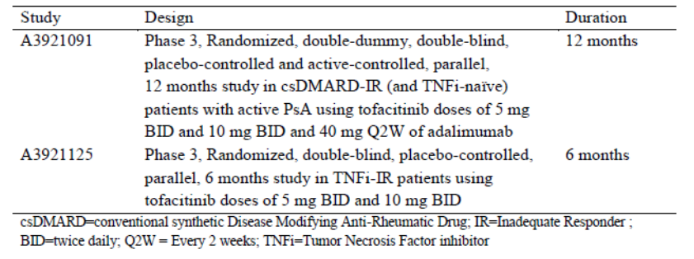
The Phase III dataset consisted of 3,252 PK samples from 650 patients, of whom 93.9% were White, 3.1% Asian, 0.46% Black and 2.6% ‘Others’. The median weight of all subjects included in the analysis was 83.4 kg (range 38.1 to 159.7 kg). The median age was 50 years (range 18 to 78 years). Sampling was performed at Months 1 and Month 4 or Month 6 in both studies. The PK sampling schedule with treatments, doses and number of patients in each data set is shown in Table 8.
Table 8: Study PMAR-601 Patient numbers by study and dose
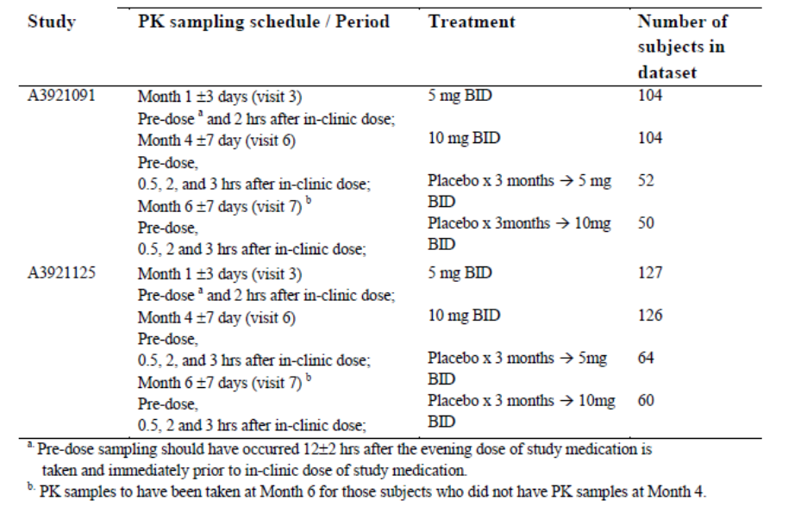
Figure 2: Impact of covariates on the PK of tofacitinib in PsA patients
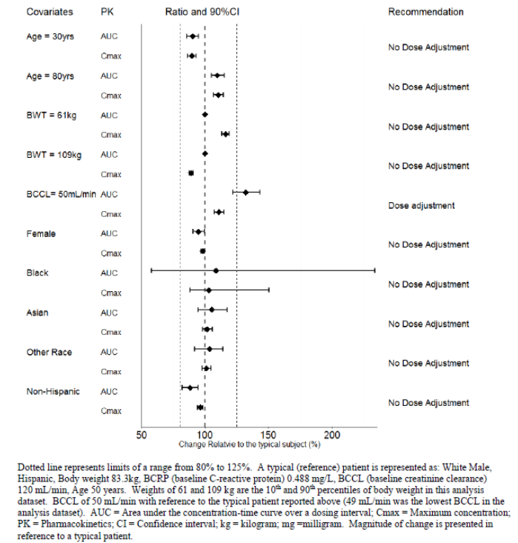

Evaluator’s conclusions on pharmacokinetics
The great majority of patients in the Phase III studies were White and racial differences could not be excluded. However, the results of this population PK study were consistent with population PK studies in RA patients, and in a population PK study conducted in Black patients with psoriasis (PMAR-EQDD-A392g-DP3-112). Overall, no major differences in tofacitinib exposure were identified based on race, ethnicity, gender, age or body weight.
No patients in the Phase III studies had significant renal impairment as a baseline creatinine clearance of ≥ 50 mL/min was required for entry. For patients with renal impairment, recommendations for dose reductions are based on Phase I data from Studies A3921004 and A3921006 which have been evaluated previously. In line with FDA guidance, the recommendations in the current PI for RA patients have been adopted for the proposed PI for PsA patients. No dosage reductions are recommended for patients with mild renal impairment (creatinine clearance ≥ 60 and < 90 mL/min), while halving the dose is recommended for patients with moderate or severe renal impairment. This approach is satisfactory.

Pharmacodynamics

Studies providing pharmacodynamic data
No new data submitted.

Dosage selection for the pivotal studies

Pharmacokinetics and pharmacodynamics: dose finding studies
No new data submitted.

Phase II dose finding studies
No dose ranging studies have been conducted in the PsA program. Dose selection for the PsA program was based on the RA and PsO development programs, in line with regulatory advice.
Study A3921119 was a Phase II, dose ranging study of tofacitinib in patients with active AS (see Section: Efficacy, below).

Phase III pivotal studies investigating more than one dose regimen
Both pivotal Phase III Studies (A3921091 and A3921125) included tofacitinib 5 mg BD and 10 mg BD treatment arms.

Evaluator’s conclusions on dose finding for the pivotal studies
Dose selection for the pivotal studies was based on extensive data from the RA development program. This approach is satisfactory.

Efficacy

Studies providing efficacy data

Pivotal or main efficacy studies
- Study A3921091
- Study A3921125

Other efficacy studies
- Study A3921092
- Study A3921137
- Study A3921119

Analyses performed across trials: pooled analyses
A number of pooled supportive analyses of the pivotal studies were performed, including the placebo treatment group up to 3 months but excluding the placebo to tofacitinib treatment sequences after Month 3.

Evaluator’s conclusions on clinical efficacy
The Phase III program was based on two pivotal efficacy studies in 816 adult patients with active PsA. The studies were designed in line with regulatory advice from the FDA and EMA. Mandatory background csDMARD therapy was required in both studies. Patients in Study A3921091were TNFI-naïve and patients in Study A3921125 had an inadequate response to previous TFNI therapy. Both studies were placebo controlled for the first three months, and Study A3921091 had an adalimumab active control arm. The doses of tofacitinib (5 mg BD and 10 mg BD) selected for the PsA program were based on the RA and PsO programs, an approach accepted by the FDA and EMA. The primary endpoints and treatment durations were also approved by the regulators (ACR20 response rates and change in HAQ-DI at Month 3). The pivotal studies were conducted in compliance with the TGA adopted EMEA Guidelines for Evaluation of Medicinal Products in Treatment of Psoriatic Arthritis.
In both pivotal studies, there was a significant benefit in favour of tofacitinib 5 mg BD and 10 mg BD compared with placebo. In the pooled analysis of ACR20 response rates at Month 3, the treatment difference in favour of tofacitinib 5 mg BD compared with placebo was 22.01% (95% CI: 13.48, 30.54; p < 0.0001). The treatment difference in favour of tofacitinib 10 mg BD compared with placebo was 25.05% (95% CI: 16.55, 33.55; p < 0.0001). There were no meaningful differences in ACR20 response rates between the tofacitinib 5 mg BD and 10 mg BD groups, or compared with the adalimumab active control group. The pooled HAQ-DI changes at Month 3 were comparable. The treatment difference in favour of tofacitinib 5 mg BD compared with placebo was -0.2181 (95% CI: -0.3057, -0.1305; p < 0.0001). The treatment difference in favour of tofacitinib 10 mg BD compared with placebo was -0.2190 (95% CI: -0.3067, -0.1312; p < 0.0001). There were no meaningful differences in change in HAQ-DI between the tofacitinib 5 mg BD, tofacitinib 10 mg BD and adalimumab groups. The ACR20 response rates and change in HAQ-DI were sustained to Months 6 and 12 with no evidence of tolerance. Withdrawal rates due to lack of efficacy in the tofacitinib groups were low. The statistical analysis was corrected for missing data and repeated measures, and sensitivity analyses were consistent with the primary analysis. Improved outcomes were comparable in the tofacitinib 5 mg BD and tofacitinib 10 mg BD groups. Any differences were small, inconsistent, and not clinically meaningful. Efficacy was comparable to adalimumab, a standard of care TNFI. In addition, in patients with PsA, tofacitinib was highly effective against the plaque psoriasis with significant reductions in Psoriasis Area and Severity Index (PASI) scores.
Efficacy was comparable in all subgroups including age, gender, race and body weight. Analyses of multiple secondary endpoints, including ACR50, ACR70, physician reported outcomes, Leeds Enthesitis Index (LEI), Dactylitis Severity Score (DSS) and patient reported outcomes were consistent with the primary analysis. Persistence of effect is being assessed in the ongoing open label long term extension Study A3921092, enrolling patients from Studies A3921091 and A3921125. A total of 680 patients have received treatment for a median duration of 175 days (range 3 to 754 days). In the interim analysis, effectiveness has been sustained with few withdrawals due to inadequate response. Overall, the evidence strongly supports the use tofacitinib 5 mg BD in patients with active PsA, including those with an inadequate response to previous TNFI therapies. However, no studies have been submitted to support the use of tofacitinib in patients intolerant to csDMARDs.

Safety

Studies providing safety data

Pivotal and/or main efficacy studies
Studies A3921091 and A3921125.

Other studies

Other efficacy studies
Studies A3921092 and A3921137.

Studies evaluable for safety only
Study A3921119.

Patient exposure
The overall exposure to tofacitinib in the PsA, RA and PsO datasets is shown in Table 9. In the PsA dataset, a total of 783 patients received tofacitinib for a total of 1237.89 patient years. A total of 635 patients received tofacitinib for ≥ 12 months and 335 patients received tofacitinib for ≥ 24 months. During the placebo-controlled period, 238, 236, 236 and 106 patients, respectively, received tofacitinib 5 mg BD, tofacitinib 10 mg BD, placebo and adalimumab (Table 10).
Table 9: Exposure to tofacitinib in the PsA, RA and PsO datasets
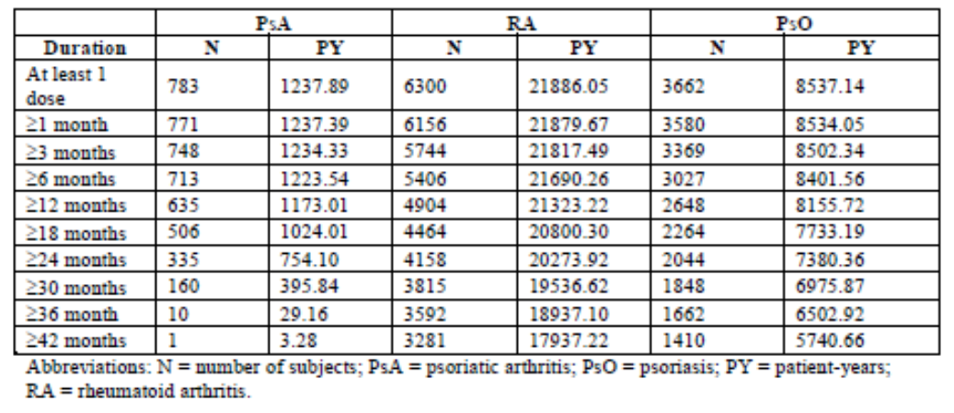
Table 10: Exposure to study treatments during the placebo controlled period
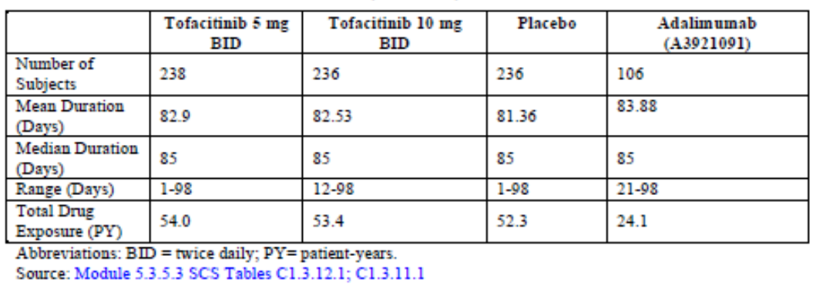

Safety issues with the potential for major regulatory impact

Liver function and liver toxicity

Integrated safety analyses
Potential cases of liver injury were reviewed and adjudicated by an independent, external committee. Four hepatic events in the PsA program met criteria for adjudication. One event was assessed as possible drug-induced liver injury (DILI) event, but none met Hy’s Law criteria.
In Cohort 2 only one patient receiving tofacitinib 5 mg BD had an alanine transaminase (ALT) elevation ≥ 3 x the upper limity of normal (ULN), and there were no cases of bilirubin elevations ≥ 2 x ULN. Similar results were observed in Cohort 1. In Cohort 3, six (0.8%) patients had two consecutive ALT ≥ 3 x ULN. Two patients had elevated ALT ≥ 5 x ULN, and one patient had ALT ≥ 10 x ULN. There were no treatment discontinuations due to abnormal liver function tests (LFTs) in patients treated with tofacitinib, compared with two patients receiving adalimumab, and one patient receiving placebo.
The number of patients with hepatic AEs was low. In Cohort 3, the most common event was hepatic steatosis reported in 1.1% of patients receiving tofacitinib.
No safety signals related to hepatic events were identified.

Renal function and renal toxicity

Integrated safety analyses
In the RA program, small, reversible increases in serum creatinine were associated with small decreases in measured glomerular filtration rate (GFR). In the PsA program, there were small, rapid, dose dependent mean increases in serum creatinine from Baseline. At Month 3, median increases in serum creatinine were 0.011 mg/dL, and 0.034 mg/dL in the tofacitinib 5 mg BD and tofacitinib 10 mg BD groups, respectively. There were no median changes in the placebo and adalimumab groups. The mean changes in Cohort 2 are shown in Figure 3. In Cohort 3, AEs reported as acute renal failure standard MedDRA query (SMQ) occurred in only 0.4% of patients, an incidence rate of 0.24 per 100 patient years (PY).
Figure 3: Integrated safety analysis; changes in serum creatinine in Cohort 2
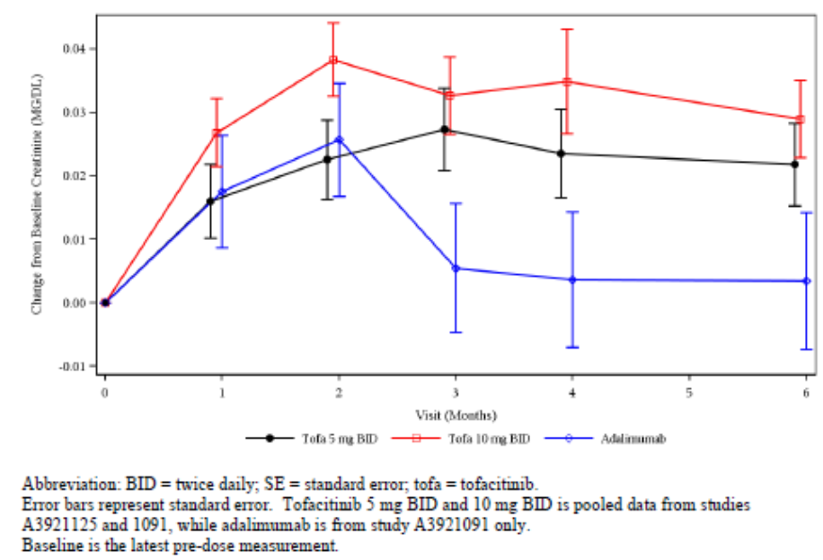
No significant safety signals relating to renal function were identified. Minor increases in serum creatinine are reversible if tofacitinib treatment is discontinued.

Other clinical chemistry

Integrated safety analyses
Data relating to only selected clinical chemistry parameters are presented in the clinical study report (haematological, serum creatinine, creatinine kinase (CK), LFTs, haemoglobin A1c (HbA1c) and lipids). No safety issues were identified relating to CK, HbA1c, lipids or for any other clinical chemistry parameters.

Creatine kinase
There were modest and sustained increases in CK in both tofacitinib treatment groups. At Month 3, the median CK increase from Baseline in the tofacitinib 5 mg BD group was 31 U/L. However, there were no reports of rhabdomyolysis in the PsA program.

Lipids
There were modest increases from Baseline in total cholesterol levels in the tofacitinib and adalimumab groups compared with minimal changes in the placebo group. The mean changes at Month 3 were 8.48%, 12.13%, 1.87% and 9.88% in the tofacitinib 5 mg BD, tofacitinib 10 mg BD, placebo and adalimumab groups, respectively. The changes in the active treatment groups were sustained through Month 6. There were comparable increases from Baseline in low density lipoprotein-cholesterol (LDL-c) levels in the tofacitinib and adalimumab groups compared with minimal changes in the placebo group. The mean changes at Month 3 were 9.20%, 14.03%, 3.98% and 9.17% in the tofacitinib 5 mg BD, tofacitinib 10 mg BD, placebo and adalimumab groups, respectively. The changes in the active treatment groups were sustained through Month 6. There were also increases from Baseline in high density lipoprotein-cholesterol (HDL-c) levels in the tofacitinib and adalimumab groups compared with minimal changes in the placebo group. The mean changes at Month 3 were 10.02%, 13.95%, -0.81% and 6.91% in the tofacitinib 5 mg BD, tofacitinib 10 mg BD, placebo and adalimumab groups, respectively. The changes in the active treatment groups were sustained through Month 6.
Inflammatory conditions are associated with low lipid levels which increase as inflammation is controlled with pharmacological treatments. In the PsA studies, cardiovascular (CV) risk measured by changes in HDL/LDL ratios remained stable as reported in the other tofacitinib programs.

Haematology and haematological toxicity

Integrated safety analyses
Up to Month 3, there were modest, dose-dependent decreases in median haemoglobin (Hb) levels in patients receiving tofacitinib. At Month 3, median Hb levels decreases were -0.05 g/dL in the tofacitinib 5 mg BD group and -0.3 g/dL in the tofacitinib 10 mg BD group. There were no median decreases in the placebo or adalimumab groups (0 and 0.5 g/dL, respectively). The changes in each group were sustained through Month 6. In Cohort 3, the median change from Baseline to last visit for all tofacitinib doses was -0.1 g/dL. In Cohort 3, 1.4% of patients had confirmed Hb decreases of 3 g/dL or an Hb value < 7 g/dL. AEs of anaemia were reported in 1.7% of patients, none of which were severe. One patient discontinued because of anaemia.
Dose-dependent reductions in red blood cells (RBC), Hb and haematocrit have been observed in pre-clinical studies, possibly mediated by inhibition of erythropoietin (EPO) activity via inhibition of JAK2 signalling. The dose-dependent decreases in Hb were comparable to those in the RA and PsO development programs. The changes are generally minor, predictable, and reversible once treatment is stopped.
The mean change from Baseline in ANC in Cohort 2 shows that at Month 1, there were modest reductions in mean absolute neutrophil count (ANC) in each treatment group, least in the tofacitinib 5 mg BD group. No further reductions were observed up to Month 6. ANC below 0.8 x LLN were reported in 3.8%, 5.5% and 4.7% of the tofacitinib 5 mg BD, tofacitinib 10 mg BD and adalimumab groups, respectively. There was no evidence that low ANC was related to serious infections. There were initial transient rises in lymphocyte counts followed by a modest decline thereafter. There was no association between the rates of serious infection and absolute lymphocyte count. No safety signals related to platelets were observed. There were only three events of thrombocytopaenia in Cohort 3.

Other laboratory tests
Not applicable.

Electrocardiograph findings and cardiovascular safety

Integrated safety analyses
No clinically meaningful changes in heart rate were observed in either tofacitinib treatment group. There were no clinically meaningful electrocardiograph (ECG) changes apart from one patient who had an increase length in corrected QT interval (QTc) on ECG (QTc), considered unrelated to study drug.

Vital signs and clinical examination findings

Integrated safety analyses
No issues related to vital signs were identified.

Immunogenicity and immunological events

Integrated safety analyses
Not applicable.

Serious skin reactions

Integrated safety analyses
No serious skin reactions were reported in the PsA program.

AEs of special interest
AEs of special interest were defined based on pre-clinical data, the development programs for other indications (RA, PsO and renal transplantation), the mechanism of action of tofacitinib, and the known risks in the PsA population. These were:
- Serious infections (SI).
- Herpes zoster (HZ).
- Adjudicated opportunistic infections (excluding tuberculosis (TB)).
- Haematological events.
- Adjudicated malignancies.
- Adjudicated major adverse cardiovascular events (MACE).
- Adjudicated DILI and other hepatic events.
- Renal events.
- Adjudicated gastrointestinal (GI) perforations.
- Adjudicated interstitial lung disease (ILD).
AEs relating to haematological, hepatic and renal events are described in the relevant sections.

Serious infections (SI)
In Cohort 1, there were two SIs, both in the tofacitinib 10 mg BD group. There were no events in the tofacitinib 5 mg BD or adalimumab groups. In the Cohort 2a pooled analysis, there were four cases (1.2%) in the tofacitinib 5 mg BD group, and three cases (0.9%) in the tofacitinib 10 mg BD group. The incidence of SIs in Cohort 3 for all doses of tofacitinib was 2.3% with an incidence rate of 1.43 out of 100 PY, comparable to the rates in the RA and PsO programs. A total of 18 SIs were reported, most commonly pneumonia.
Overall, the incidence of SIs was low and no deaths were reported. A Medline and EMBASE search provided by the sponsor showed that the incidence of SIs was comparable to those reported for numerous PsA studies with other agents, including TNFIs.

Herpes zoster (HZ)
In Cohort 1, there were two HZ events in the tofacitinib 5 mg BD group, and one event in the tofacitinib 10 mg BD group. One event (facial) was reported as a serious adverse event (SAE). No events were reported in the placebo or adalimumab groups. In the Cohort 2a pooled analysis, there were seven events, three (1.3%) in the tofacitinib 5 mg BD group and four (1.7%) in the tofacitinib 10 mg BD group. A total of 26 HZ events were reported in Cohort 3. The incidence for all doses of tofacitinib was 3.3% with an incidence rate of 2.10 out of 100 PY, comparable to the rates in the RA and PsO programs.
HZ occurs with increased frequency in patients treated with immunomodulatory agents. Events were reported in 3.3% of PsA patients given any dose of tofacitinib, comparable to rates observed in the RA and PsO populations. A literature search conducted by the sponsor yielded no satisfactory comparative data in PsA patients treated with other agents.

Opportunistic infections (OI)
The incidence rate of OIs was low with three events reported in Cohort 3. Each event was HZ, classified as OIs by the adjudicating committee. The incidence for all doses of tofacitinib was 0.4% with an incidence rate of 0.24 out of 100 PY, comparable to the rates in the RA and PsO programs. No cases of active TB infection were reported.
OIs are defined as infections with bacterial, viral, fungal or protozoan organisms which do not normally cause disease in healthy subjects. No events other than HZ were reported. A literature search yielded no comparative data.

Malignancies
The incidence rate of malignancies was low with nine events reported in Cohort 3. The incidence for all doses of tofacitinib was 1.1% with an incidence rate of 0.72 out of 100 PY, comparable to the rates in the RA and PsO programs. The most commonly reported malignancies were bladder (2) and thyroid (2).
Rheumatological diseases are associated with an increased risk of malignancies, including haematological malignancies and lung cancers. There is no consensus on the possible risks associated with MTX and TNFIs. No new safety signals were identified in the PsA program.

Major adverse cardiovascular events (MACE)
The incidence rate of adjudicated MACE was low with three events reported in Cohort 3 during the 28 day risk period. The incidence for all doses of tofacitinib was 0.4% with an incidence rate of 0.24 out of 100 PY, comparable to the rates in the RA and PsO programs. The three events were sudden cardiac death, ischaemic stroke and myocardial infarction.
The incidence of MACE was low and consistent with the other tofacitinib programs and with the PsA published literature.

GI perforations
A single event of adjudicated GI perforation was reported in a patient who had received tofacitinib 5 mg BD for 18 days. The event was peritonitis due to a ruptured appendix.

Interstitial lung disease (ILD)
No cases of ILD were reported in the PsA program.

Other safety issues

Safety in special populations

Age
Compared with younger patients, patients aged ≥ 65 years had a higher percentage of AEs, SAEs, severe AEs and AEs leading to discontinuation. In patients receiving tofacitinib, serious infections, herpes zoster, and CV events (MACE) were reported notably more commonly in older patients compared with younger patients.

Gender
AEs, SAEs, severe AEs and AEs leading to discontinuation were marginally more common in females compared with males but the differences were not clinically meaningful.

Race
The large majority of patients in the program were White. There were too few patients of other races to allow meaningful comparisons.

Other
There were no other meaningful differences in groups based on geographical region, body weight and baseline disease severity. Overall, there were no meaningful differences in groups based on prior DMARD treatment, or previous experience with TNFI therapy (see Section: Clinical Questions, below).

Pregnancies
There were seven cases (four maternal/ three paternal) of exposure during pregnancy to tofacitinib during the PsA program, each during the first trimester. The outcomes of the four maternal cases were spontaneous abortion, elective abortion, premature birth and a normal delivery (one event each).

Safety related to drug-drug interactions and other interactions
No new data has been submitted.

Post marketing data
Tofacitinib was first approved in the USA on 6 November 2012 for adults with RA. Up until 5 November 2016, exposure to tofacitinib has been approximately 61,043 PY. A total of 20,074 case reports were received by the Marketing Authorisation Holder during the 4 year period. A total of 55,462 AEs have been reported of which 54,966 were spontaneous. Of the 55,462 AEs, 82.6% were non-serious and 17.4% were SAEs. The most commonly reported AEs in the 20,074 cases were: drug ineffective (14.0%), headache (8.2%), condition aggravated (7.1%), arthralgia (6.5%), pain (6.2%), fatigue (5.9%), nausea (5.4%), diarrhoea (5.4%), pain in extremity (4.8%), product use issue (4.8%), malaise (4.1%), RA (3.9%), nasopharyngitis (3.7%), peripheral swelling (3.6%), joint swelling (3.2%), HZ (2.9%), abdominal discomfort (2.8%), abdominal pain upper (2.7%), cough (2.7%), dizziness (2.7%), musculoskeletal stiffness (2.5%), drug dose omission (2.5%), drug effect incomplete (2.4%), sinusitis (2.3%), pneumonia (2.3%), urinary tract infection (UTI; 2.3%), rash (2.2%), weight increased (2.2%), dyspnoea (2.1%) and pyrexia (2.0%). The most common SAEs reported in the same case reports were RA (3.9%), condition aggravated (3.3%) and pneumonia (2.3%).
The usual caveats apply when interpreting spontaneous reports. However, no new safety signals have been detected in the 4 year period since marketing approval was given. The pattern of AEs in the PsA program was consistent with the post-marketing experience in RA.

Evaluator’s conclusions on safety
The safety profile of tofacitinib in patients with PsA was assessed in the two pivotal studies and in an ongoing, open-label long term extension study. A total of 238, 236, 236 and 106 patients were included in the tofacitinib 5 mg BD, tofacitinib 10 mg BD, placebo and adalimumab groups, respectively. In the placebo controlled period, integrated data from the pivotal Studies A3921091 and A3921125 compared the safety profiles of tofacitinib 5 mg BD, tofacitinib 10 mg BD, placebo and adalimumab, and compared the two doses of tofacitinib from Baseline to Month 3 (Cohort 1). Integrated data from six months of treatment compared the two doses of tofacitinib and adalimumab. The analysis excluded patients randomised to the placebo/tofacitinib 5 mg BD and placebo/tofacitinib 10 mg BD groups (Cohort 2). Integrated data from 12 months of treatment compared patients randomised to tofacitinib 5 mg BD, tofacitinib 10 mg BD and adalimumab (Cohort 2a). Integrated data from all patients who received tofacitinib in the PsA program (pivotal and long term extension studies) were analysed. The patient numbers and treatment duration were adequate in the controlled studies, and the open label long term extension study is on-going with data up to 3 years.
In Cohort 1, the frequency of AEs was comparable across all treatment groups, including placebo; and in Cohort 2, including patients receiving adalimumab. Compared with placebo, AEs reported at least 1% more frequently in patients receiving tofacitinib were bronchitis, diarrhoea, dyspepsia, fatigue, headache, nasopharyngitis and pharyngitis. Differences between the tofacitinib 5 mg BD and tofacitinib 10 mg BD groups were inconsistent. Severe AEs and SAEs were infrequent in all treatment groups with no meaningful treatment differences. There were few AEs of special interest, including serious infections, opportunistic infections and malignancies, and no new safety signals were identified. Herpes zoster was reported in 26 cases but the incidence rate was comparable to those seen in the RA program. AEs were reported more commonly in patients aged ≥ 65 years but there were no meaningful differences based on gender.
There are some weaknesses in the safety analyses presented. The PsA safety set is limited by relatively small patient numbers, particularly for racial groups other than White. Adverse drug reactions (ADR) have not been reported in the clinical study reports or integrated analyses and the reason for this omission is not stated (see Clinical Questions). AEs are reported in detail by System Organ Class (SOC) but reports by Preferred Term (PT) are sparse. Despite these weaknesses, the 5 mg BD dose of tofacitinib had an acceptable safety profile consistent with the RA 5 mg BD development program, as detailed in the approved PI. No new safety signals have been identified in the PsA program, or in post-marketing surveillance to date. However, ADRs were not reported in the clinical study report (see Clinical Questions).

First round benefit-risk assessment

First round assessment of benefits
Table 11 summarises the assessment of benefits of Xeljanz for the proposed indication at the first round evaluation.
Table 11: First round assessment of benefits
Benefits | Strengths and Uncertainties
Superior ACR20 response rates compared with placebo after treatment for 3 months and statistically significant difference from placebo at Week 2.  Comparable efficacy compared with adalimumab, a standard of care TNFI, given for 12 months.  Effective in patients who have failed previous TNFI therapies.  Long-term ACR20 response rates maintained for up to 3 years.  Superior ACR50 and ACR70 response rates compared with placebo after 3 months, and comparable response rates with adalimumab after 12 months.  Superior improvements in HAQ-DI compared with placebo after treatment for 3 months.  Comparable change in HAQ-DI to adalimumab given for 12 months.  Superior PASI75 response rates compared with placebo, and comparable response rates compared with adalimumab.  Enthesitis (as measured by LEI) and dactylitis (as measured by DSS) were improved relative to placebo at Month 3 and comparable responses to adalimumab given for 12 months.  Improved functioning and quality of life compared with placebo.  Response rates comparable in population subgroups, based on age, gender and baseline disease activity.  No anti-drug antibodies commonly associated with bDMARDs. | The benefit in favour of tofacitinib compared with placebo was highly statistically significant (p < 0.0001) and clinically meaningful.  Comparative data available up to 12 months, but no placebo response data beyond 3 months.  Long-term data open label.  No long-term mTSS data available  Only limited data in racial groups other than White.

First round assessment of risks
Table 12 summarises the assessment of risks of Xeljanz for the proposed indication at the first round of evaluation.
Table 12: First round assessment of risks
Risks | Strengths and Uncertainties
The safety profile of tofacitinib was comparable to placebo at Month 3 and comparable to adalimumab at Month12.  The overall rates for SAEs and AEs leading to discontinuation were low and similar to the adalimumab group.  The rate of death was low and similar to that observed in observational studies.  The rates of AEs of special interest were low and comparable to the RA. No opportunistic infections other than HZ were reported.  Data in racial groups other than White are sparse.  No new safety signals or ADRs observed. | Patient numbers were relatively low but consistent with the RA program.  The incidences of serious infections and HZ are notably higher in elderly patients compared with patients aged < 65 years.  Unexpected, less common ADRs may emerge in the PsA population.

First round assessment of benefit-risk balance
The efficacy of tofacitinib 5 mg BD is superior to placebo and comparable to adalimumab, a standard of care TNFI for the treatment of the signs and symptoms of PsA. In the pivotal studies, it was also effective against plaque psoriasis in patients with PsA. No loss of efficacy has been observed for up to three years in the long term extension study, although prevention of joint damage has not been studied beyond one year. It is given orally which may be more suitable for some patients than subcutaneous bDMARDs such as TNFIs. It is effective in patients with an inadequate response to previous TNFI therapies, and efficacy is not affected by anti-drug antibodies. Data is incomplete for races other than White; however, it is effective in other sub groups irrespective of age, gender, and baseline disease activity. Tofacitinib is well tolerated with an AE profile comparable to placebo, and comparable to the safety profile of tofacitinib for the RA indication. The frequency of ADRs commonly associated with immune suppression is low and comparable to other bDMARDs.
However, there are no efficacy data to support the use of Xeljanz as monotherapy in patients who have been intolerant to a prior DMARD therapy and this information has not been specified in the proposed wording of the indication. Hence, the benefit risk balance of tofacitinib for the proposed usage is unfavourable but would become favourable if the changes recommended in the following section (Section: First round recommendation regarding authorisation) are adopted.

First round recommendation regarding authorisation
Authorisation is not recommended for the proposed new indication:
Xeljanz is indicated for the treatment of active psoriatic arthritis in adult patients who have had an inadequate response or who have been intolerant to a prior DMARD therapy.
However, approval is recommended for the revised indication below:
Xeljanz in combination with non-biological DMARDs is indicated for the treatment of active psoriatic arthritis in adult patients who have had an inadequate response to a prior DMARD therapy.
The efficacy data in the pivotal studies support the use of Xeljanz in combination with background DMARD therapy in patients who have had an inadequate response to a DMARD alone. However, there are no efficacy data to support the use of Xeljanz in patients who have been intolerant to a prior DMARD therapy or as monotherapy (see Clinical Questions).
The above approval is subject to satisfactory response to comments on the draft PI and clinical questions.

Clinical questions and second round evaluation
The initial questions from the first round report are repeated below followed by summary of the sponsor’s response and then the evaluator’s comments on the sponsor’s response.

Question 1
In the open label long term extension Study A3921092, the percentages of patients maintained long-term on the 5 mg BD dose and those perceived to require the 10 mg BD dose do not appear to be reported in the clinical study report. Please provide these data or provide the link in the clinical study report. It is understood that the efficacy rates for the two doses were comparable in the qualifying studies.

Sponsor’s response
Dose switching was reported post hoc so the data were not included in the clinical study report. Approximately 67% of patients had not increased the tofacitinib 5 mg BD dose at the time of database lock (Table 13). Of the patients who increased the tofacitinib dose to 10 mg BD, nearly half had multiple dose switches (that is, dose reduction back to 5 mg BD, followed by increases back to 10 mg BD). In patients maintained on a constant dose of 5 mg BD, the ACR20 response rate and change from Baseline in HAQ-DI were comparable to the full analysis set.
Table 13: Study A3921092 Dose switching patterns in long term extension study
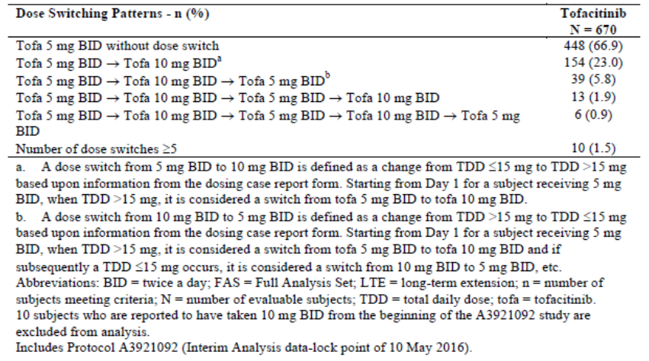

Evaluation of response
The sponsor’s response is satisfactory. The majority of patients were maintained on tofacitinib 5 mg BD throughout the evaluation period. A total of 33% of patients were up-titrated to 10 mg BD but 31% of these were subsequently switched from one dose to other during continued treatment.

Question 2
Regarding the Summary of clinical safety, please provide an overview of treatment emergent adverse events (TEAEs) in Cohort 2a (12 month data) corresponding to Table 14 for Cohort 2. Please also provide a summary of AEs by SOC and Preferred Term (PT) corresponding to Table 15 for Cohort 2.
Table 14: Summary of clinical safety; treatment emergent adverse events (all causalities), 6 month dose comparison (Cohort 2)
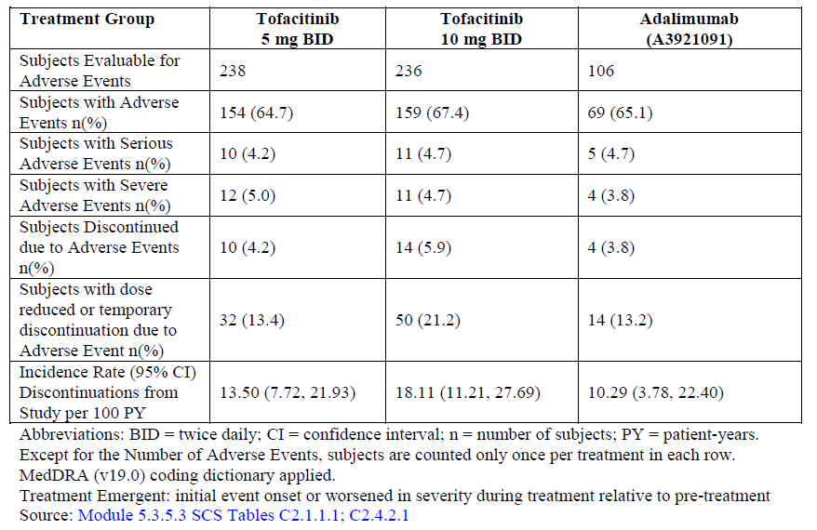
Table 15: Summary of clinical safety; treatment emergent adverse events with PT ≥ 2% occurrence in any treatment group, by SOC and PT (all causalities), 6 month dose comparison (Cohort 2)
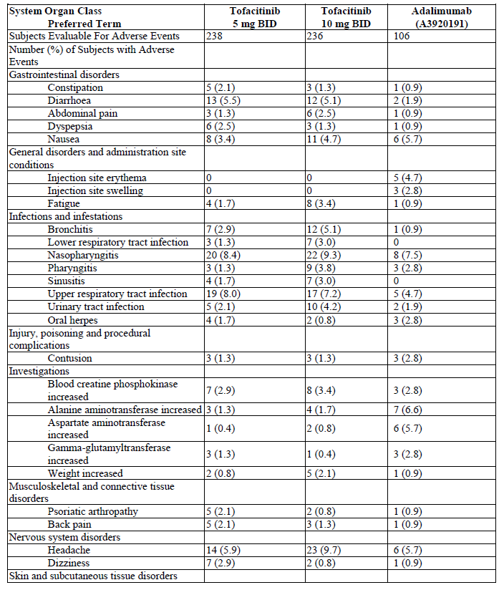

Sponsor’s response
Overall, the proportion of patients reporting TEAEs up to 12 months of exposure was similar between the two tofacitinib doses (68.9% for the 5 mg BD group versus 72.0% for the 10 mg BD group). Given the slightly longer evaluation period in Cohort 2a (up to 12 months) versus Cohort 2 (up to 6 months), the number of patients that reported SAEs increased for both tofacitinib groups, although the proportions of patients with SAEs remained similar between the two dose groups in both cohorts. Discontinuations from the study (all causalities) in C2a showed one more patient discontinued in the in the tofacitinib 5 mg BD group but no additional discontinuations were reported in the in the 10 mg BD group in C2a compared to C2. The proportions of discontinuations remained slightly higher for the tofacitinib 10 mg group versus the 5 mg BD group (5.9% versus 4.6%, respectively). Comparisons between the two tofacitinib doses showed a hazard ratio (HR) of 1.19 (95% CI: 0.64, 2.19), which is similar to the one observed in Cohort 2. A summary of the TEAEs is shown below in Table 16.
Table 16: Treatment emergent adverse events in Cohort 2a (all causalities), safety analysis set
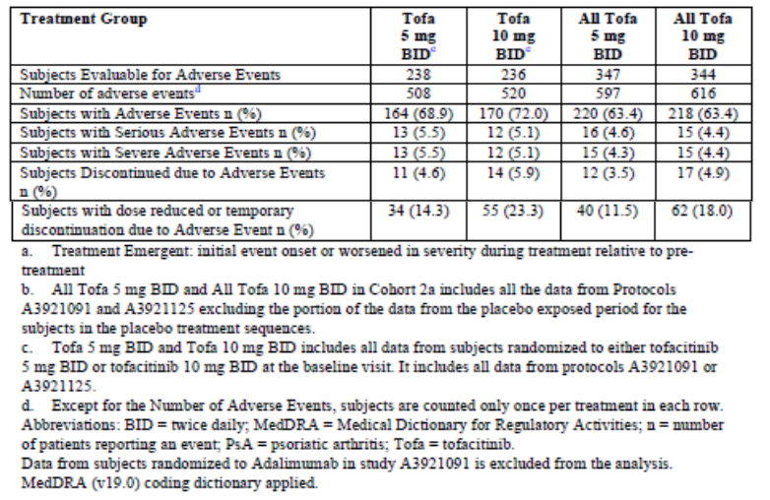
As shown in Table 17, for patients from the two pivotal studies up to 12 months of treatment (Cohort 2a), the incidence of discontinuations from the study were similar between tofacitinib doses (note that the CIs overlap given the small sample for each treatment arm). This is consistent with what was reported in Cohort 2 (up to 6 months of treatment).
Table 17: Discontinuations in Cohort 2a, safety analysis set
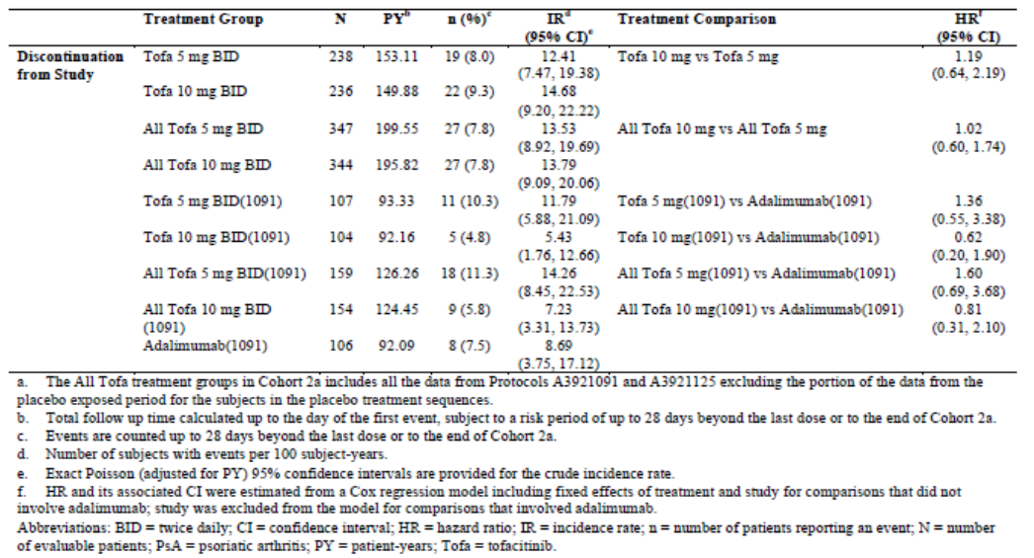
A summary of TEAEs by SOC and PT ≥ 2% in C2a is shown in Table 18. Similar to Cohort 2, the most frequently reported PTs in Cohort 2a were nasopharyngitis, upper respiratory tract infection (URTI) and headache. Some events (headache, bronchitis, pharyngitis, and abdominal pain) were reported more frequently in the tofacitinib 10 mg BD group than for the 5 mg BD group.
Table 18: Treatment emergent adverse events by PT and SOC in Cohort 2a
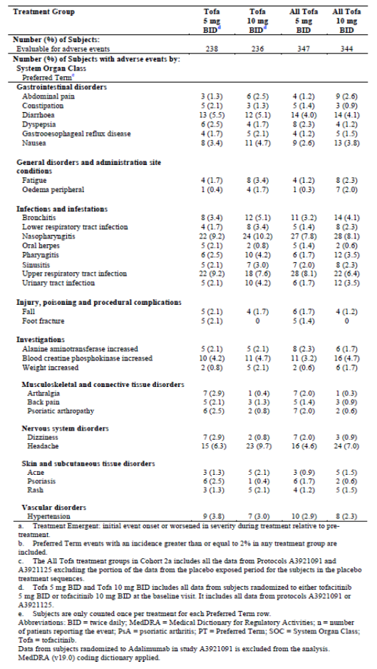

Evaluation of response
The sponsor’s response is satisfactory. The frequencies and types of events reported in C2a were similar to those observed in C2.

Question 3
In the Clinical Summary of Safety, the only reference to treatment-related AEs for Cohort 1 is shown below:
‘Events displayed in this section are irrespective of drug causality. When evaluating study treatment related TEAEs, proportions across treatment groups remain similar. Supportive tables are provided […]. [A table] summarises TEAE during the placebo-controlled treatment period in Cohort 1 (up to 3 months).
The supportive tables refer also to Cohorts 2 and 3 although this is not stated in the text. The statement appears to be correct based on the extensive supportive tables. However, no summarised data, commentary or overview have been provided. Please provide a summary table and a brief commentary for each cohort for inclusion in the clinical evaluation report. Please also provide a corrected copy of [the specified table] (the column describing severe ADRs is missing).

Sponsor’s response
The sponsor has provided summary tables of treatment-related AEs for Cohort 1, Cohort 2, and Cohort 3. In Cohort 1, the frequency of treatment-related AEs was comparable in the tofacitinib 5 mg BD and 10 mg BD groups (26.5% versus 28.4%) and higher than in the placebo group (18.6%). Treatment related AEs were also more frequent in the adalimumab group compared with placebo (34.0% versus 18.6%). Treatment related SAEs were reported only in the 10 mg BD group (1.3%). Treatment related discontinuations were more frequent in the 10 mg BD group (3.4%) compared with the 5 mg BD group (0.4%) or the placebo group (1.7%). In Cohort 2, the frequency of treatment related AEs was comparable between the tofacitinib dose groups up to 6 months (36.1% for 5 mg BD versus 39.4% for 10 mg BD). There was one (0.4%) treatment-related SAE in the tofacitinib 5 mg BD group compared with three (1.3%) in the 10 mg group. Discontinuations due to treatment related AEs were more frequent in the 10 mg BD group (4.2%) compared with the 5 mg BD group (2.1%). In Cohort 3, the proportions of patients that reported treatment related AEs, SAEs, and discontinuations due to treatment related AEs were higher because of the longer evaluation periods compared with Cohort 1 and Cohort 2.
In Cohort 1 (the placebo controlled period), a higher number of treatment related AEs were reported in the tofacitinib groups compared with placebo. The most commonly reported treatment related AEs by SOC were Infections and infestations (11.3% for 5 mg BD; 14.4% for 10 mg BD; 8.5% for adalimumab; and 7.6% for placebo). AEs in the Gastrointestinal disorders SOC were more frequently reported in the 5 mg BD group (9.2%) compared with the 10 mg BD group (5.5%) and placebo group (3.8%). The most frequently reported AEs by PT were nasopharyngitis (3.4% for the tofacitinib 5 mg BD group), headache (3.8% for the 10 mg group), injection site erythema (4.7%), for the adalimumab group, and URTI and headache (3.0% each for the placebo group).
In Cohort 2, the most commonly reported treatment-related AEs by SOC were Infections and infestations with the highest proportion in the tofacitinib 10 mg BD group (15.5% for 5 mg BD; 22.9% for 10 mg BD and 11.3% for adalimumab). The most commonly reported AEs in both tofacitinib groups by PT were nasopharyngitis, URTI and headache.
In Cohort 3, the most commonly reported treatment-related AEs were comparable to those in C1 and C2.
The frequency of treatment-related AEs leading to permanent discontinuation from the study was very low in all treatment groups.
The corrected copy of the specified table has been provided. Only seven severe treatment-related PT events were reported in patients receiving tofacitinib.

Evaluation of response
The sponsor’s response is satisfactory. The frequency of treatment related AEs was comparable in the tofacitinib 5 mg BD and 10 mg BD groups and higher than placebo. Nearly all events were mild to moderate in severity and SAEs were reported in only one patient in the tofacitinib 10 mg BD group during the first 3 months of treatment. The most commonly reported treatment related AEs were reported in the Infections and infestations SOC. The most frequently reported AE by PT was nasopharyngitis.

Question 4
In the Overview of Clinical Safety; Special Populations, it is stated that the safety profile of tofacitinib was comparable in TNFI treatment-experienced and naïve patients. Please provide a summary of the data to support this statement.

Sponsor’s response
The sponsor has provides summaries of the safety profiles of tofacitinib by TNFI status in Cohort 2, Cohort 2a and Cohort 3. The proportion of patients that reported AEs was slightly higher in the TNFI-experienced group compared with the TNFI-naïve group (86.7% versus 79.6%). The proportions of patients that reported SAEs (12.5% versus 13.5%) and discontinuations due to AEs (11.1% versus 10.1%) were comparable.
In the summary of TEAEs by SOC and PT with a frequency of ≥ 2%, the majority of TEAEs were reported in the Infections and infestations SOC in both TNFI-experienced and TNFI-naïve groups (57.8% versus 50%). The types of events were also comparable between the TNFI-experienced and TNFI-naïve patients. Overall, the most frequently reported TEAEs by PT were URTI (15.9%), nasopharyngitis (13.8%) and bronchitis (9.8%) in the TNFI-experienced population. The most frequently reported TEAEs in the TNFI-naïve population were URTI (14.0%), nasopharyngitis (13.3%) and headache (7.6%).
The number of patients who reported SAEs was slightly higher in the TNFI-naïve population compared with the TNFI-experienced population. The most frequently reported SAEs by SOC in the TNFI-experienced group were in Infections and infestations (2.7%), General disorders and administration site conditions (2.4%) and Musculoskeletal and connective tissue disorders (2.4%). In the TNFI-naïve group, the most commonly reported SAEs by SOC were reported in Neoplasms benign, malignant and specified (3.2%), General disorders and administration site conditions (2.2%) and Infections and infestations (2%). The most commonly reported PT in both groups was Condition aggravated with events reported in1.9% and 1.5% of the TNFI-experienced and TNFI-naïve groups, respectively. In the TNFI-experienced group, pneumonia and osteoarthritis were the other two PT most frequently reported (0.8% each). In the TNFI-naïve group, renal colic, fall, humerus fracture, joint injury and osteoarthritis were the next most frequently reported PTs (0.5% each).
The frequency of events of interest was generally comparable in the TNFI-experienced and TNFI-naïve groups.

Evaluation of response
The sponsor’s response is satisfactory. The frequency of AEs and SAEs was marginally higher in the TNFI-experienced population. The pattern of AEs was also comparable between groups.

Question 5
Please provide a summary of SAEs by PT in the integrated summary of safety. Only SAEs by SOC have been provided.

Sponsor’s response
A summary of SAEs by SOC and PT is shown in Table 19. The frequency of SAEs was low in all treatment groups. The majority of SAEs were single instances across all treatment groups and all single events by PT were reported in < 1% of patients.
Table 19: SAEs by SOC and PT in Cohort 2a
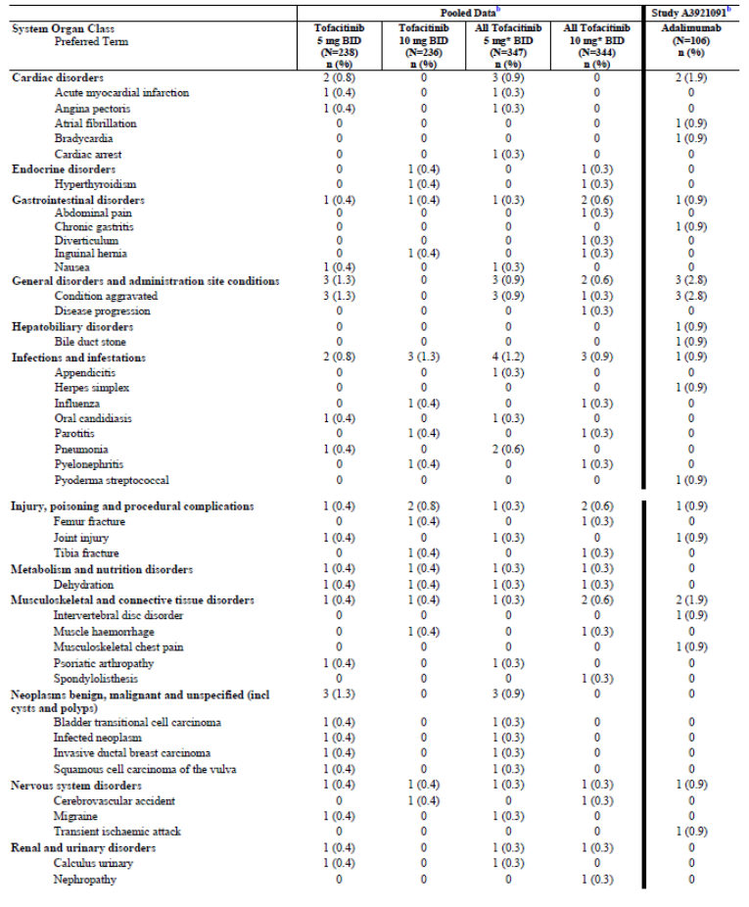
Table 19 (continued): SAEs by SOC and PT in Cohort 2a
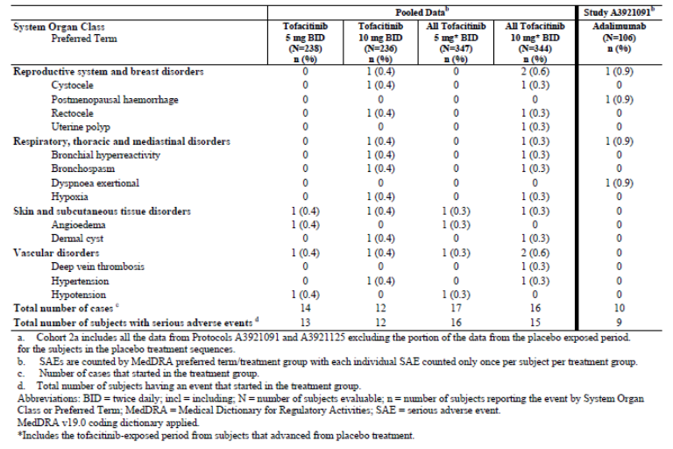

Evaluation of response
The sponsor’s response is satisfactory.

Second round benefit-risk assessment

Second round assessment of benefits
After consideration of the responses to clinical questions, the benefits of Xeljanz in the proposed usage are unchanged from those identified in the first round.

Second round assessment of risks
After consideration of the responses to clinical questions, the risks of Xeljanz in the proposed usage are unchanged from those identified in the first round.

Second round assessment of benefit-risk balance
After consideration of the responses to clinical questions, the benefit-risk balance remains positive.

Second round recommendation regarding authorisation
No change to the first round assessment.
Approval is recommended for the revised indication below:
Xeljanz in combination with non-biological DMARDs is indicated for the treatment of active psoriatic arthritis in adult patients who have had an inadequate response to a prior DMARD therapy.

VI. Pharmacovigilance findings

Risk management plan

Summary of RMP evaluation
- The most recently evaluated risk management plan (RMP) for Xeljanz (for Submission PM-2016-00757-1-3) was an Australian specific-RMP (version 2.0, dated 28 January 2016; data lock point 15 June 2015). In support of the current submission, the sponsor has submitted EU-RMP version 3.0 (date 26 July 2017; data lock point 7 March 2017) and ASA version 1.0 (dated 27 September 2017).
- The proposed Summary of Safety Concerns and their associated risk monitoring and mitigation strategies as outlined in the EU RMP and Australian Specific Annex (ASA) are summarised in Table 20.
Table 20: Summary of safety concerns
Summary of safety concerns |  | Pharmacovigilance |  | Risk Minimisation
 |  | Routine | Additional | Routine | Additional
Important identified risks | Serious and other important infections |  | ^{1,2} |  | ^{4,5}
Important identified risks | Herpes zoster reactivation* |  | ^{1,2} |  | ^{4,5}
Important identified risks | Decrease in neutrophil counts and neutropenia |  | – |  | ⁴
Important identified risks | Decrease in lymphocyte counts and lymphopenia |  | ¹ |  | ⁴
Important identified risks | Decrease in haemoglobin levels and anaemia |  | – |  | ⁴
Important identified risks | Lipid elevations and hyperlipidaemia |  | – |  | ⁴
Important identified risks | Non-melanoma skin cancer |  | ^{1,2} |  | ^{4,5}
Important identified risks | Transaminase elevation and potential for drug-induced liver injury |  | ¹ |  | ^{4,5}
Important identified risks | Hypertension |  | – |  | –
Important identified risks | Creatine kinase increase |  | – |  | –
Important identified risks | Weight increase |  | – |  | –
Important potential risks | Malignancy |  | ^{1,2} |  | ⁴
Important potential risks | Cardiovascular risk |  | ^{1,2} |  | –
Important potential risks | Gastrointestinal perforation |  | ^{1,2} |  | ^{4,5}
Important potential risks | Interstitial lung disease |  | – |  | ^{4,5}
Important potential risks | Progressive multifocal leukoencephalopathy |  | ^{1,2} | – | –
Important potential risks | Increased immunosuppression when used in combination with biologic DMARDs and immunosuppressants including B lymphocyte depleting agents |  | – |  | ^{4,5}
Important potential risks | Increased risk of adverse events when tofacitinib is administered in combination with MTX* |  | ^{1,2} |  | ^{4,5}
Important potential risks | Primary viral infection following live vaccination* |  | – |  | ⁴
Important potential risks | Increased exposure to tofacitinib when co-administered with CYP3A4 and CYP2C19 inhibitors* |  | – |  | ^{4,5}
Important potential risks | Off-label use including children with JIA* |  | – |  | –
Important potential risks | Higher incidence and severity of adverse events in the elderly* |  | ^{1,2} |  | ^{4,5}
Important potential risks | Rhabdomyolysis |  | – | – | –
Important potential risks | Epstein-Barr Virus-related events |  | – |  | ^{4,5}
Important potential risks | QT prolongation |  | – |  | –
Important potential risks | Reduction in renal function |  | – |  | ^{4,5}
Missing information | Effects on pregnancy and the foetus |  | ³ |  | ^{4,5}
Missing information | Use in breastfeeding |  | – |  | ^{4,5}
Missing information | Effect on vaccination efficacy and the use of live/attenuated vaccines |  | – |  | ^{4,5}
Missing information | Use in paediatric patients |  | ¹ |  | –
Missing information | Use in RA and PsA patients with mild, moderate, or severe hepatic impairment |  | – |  | ⁴
Missing information | Use in RA and PsA patients with moderate or severe renal impairment |  | – |  | –
Missing information | Use in patients with evidence of hepatitis B or hepatitis C infection |  | – |  | –
Missing information | Use in patients with elevated transaminases |  | – |  | –
Missing information | Use in patients with malignancy |  | – |  | –
¹Clinical trial, ²PASS, ³Pregnancy registry, ⁴Prescriber information Pack^{, 5}Patient Alert Card, *Safety concerns that are not included in the ASA, Purple highlighted text shows the safety concerns that are specific to the ASA.
- The summary of safety concerns for Australia requires revision to ensure all concerns included in the EU-RMP are also included in the ASA. In addition, as indicated above, there are a number of safety concerns specific to the ASA.
- In response to a recommendation made during first round RMP evaluation, the sponsor committed to include all the safety concerns that are included in the EU RMP in the safety summary of the ASA.
- The pharmacovigilance activities that are proposed are consistent with what was previously agreed, and remain acceptable as the proposed extension of indication.
- The proposed range of additional risk minimisation activities is consistent with what has previously been agreed for this product, and remains acceptable. However, the education materials for Australia need to be updated to include the proposed extension of indications.

New and outstanding recommendations from second round evaluation
The recommendations made in the first round evaluation, along with consideration of the sponsor response, were outlined in the risk management plan report.
In response to these recommendations the sponsor has committed to the following:
- To include ‘Herpes zoster reactivation’ in the summary of safety concerns of the ASA as an important identified risk.
- To include the following important potential risks in the summary of safety concerns of the ASA:
  - Increased immunosuppression when used in combination with biologic DMARDs and immunosuppressants including B lymphocyte depleting agents.
  - Increased risk of adverse events when tofacitinib is administered in combination with MTX.
  - Primary viral infection following live vaccination.
  - Increased exposure to tofacitinib when co-administered with CYP3A4 and CYP2C19 inhibitors.
  - Off-label use including children with Juvenile Idiopathic Arthritis (JIA)
  - Higher incidence and severity of adverse events in the elderly.
- To provide the updated educational materials to the TGA prior to distribution.
There are two new recommendations in relation to the above commitments:
- The sponsor should provide the updated ASA which incorporates the RMP evaluator’s recommendations within 3 months of approval of this submission.
- The sponsor should ensure that appropriate pharmacovigilance and risk minimisation measures are assigned to the safety concerns that are added to the ASA. These should be consistent with the measures in place in the EU-RMP.

Proposed wording for conditions of registration
Any changes to which the sponsor has agreed should be included in a revised RMP and ASA. However, irrespective of whether or not they are included in the currently available version of the RMP document, the agreed changes become part of the risk management system.
The Xeljanz EU-Risk Management Plan (RMP) version 3.0 (date 26 July 2017; data lock point 7 March 2017) with Australian Specific Annex version 1.0 (date 27 September 2017), included with submission PM-2017-03802-1-3, to be revised to the satisfaction of the TGA, will be implemented in Australia.
An obligatory component of risk management plans is routine pharmacovigilance. Routine pharmacovigilance includes the submission of Periodic Safety Update Reports (PSURs).
Reports are to be provided in line with the current published list of EU reference dates and frequency of submission of PSURs until the period covered by such reports is not less than three years from the date of this approval letter.
The reports are to at least meet the requirements for PSURs as described in the European Medicines Agency’s Guideline on good pharmacovigilance practices (GVP) Module VII-Periodic Safety Update Report (Rev 1), Part VII.B Structures and processes. Note that submission of a PSUR does not constitute an application to vary the registration. Each report must have been prepared within ninety calendar days of the data lock point for that report.

VII. Overall conclusion and risk/benefit assessment
The submission was summarised in the following Delegate’s overview and recommendations.

Background
Tofacitinib is an orally active, selective inhibitor of the JAK family of kinases.
This application proposes a new indication for the treatment of adult patients with psoriatic arthritis.
Proposed changes to the PI in this submission include new data supporting the PsA indication, a change to the approved RA indication (relocating the statement regarding initiation and monitoring by a rheumatologist or specialist physician from section 4.1 Therapeutic Indications to section 4.2 Dose and Method of Administration), updated definitions relating to renal impairment, changes to section 4.5 Interactions with other medicines, and updates to section 4.8 Adverse Effects (Undesirable Effects) incorporating pooled ADR data from RA and PsA Phase III randomised controlled trials.

Australian regulatory status
An application for Xeljanz for use in RA at a dosage of 5 mg or 10 mg BD was submitted to the TGA on 27 April 2012 (Submission PM-2012-00788-3-3). Advice was provided by the Advisory Committee on Prescription Medicines (ACPM) in February 2014. The Delegate decided on 14 May 2014 not to register Xeljanz on the grounds that the efficacy and safety of the product had not been satisfactorily established for the proposed uses. Following a s60 appeal; Xeljanz was approved in Australia on 13 January 2015 at a dosage of 5 mg BD for the following indication:
Xeljanz is indicated for the treatment of the signs and symptoms of moderate to severe active rheumatoid arthritis in adults who have had an inadequate response or are intolerant to methotrexate. Xeljanz can be used alone or in combination with non-biological DMARDs, including methotrexate.
Therapy with Xeljanz should be initiated and monitored by a rheumatologist or specialist physician with expertise in the management of rheumatoid arthritis.
An application in 2016 (Submission PM-2016-00757-1-3) sought an extension of indications to include a claim of inhibition of structural damage as measured by plain x-rays in patients with RA. Advice was provided by ACPM in April 2017. The proposed new indication was not accepted but other PI changes were approved.
At the time this application was under consideration, there were several concurrent tofacitinib submissions. Submission PM-2017-04764-1-1 is an extension of indications application proposing a new indication for ulcerative colitis.
[Information redacted]

Overseas regulatory status
- USA: On 14 December 2017, the FDA approved Xeljanz 5mg BD in combination with nonbiologic DMARDs for the following psoriatic arthritis indication:
Xeljanz/Xeljanz XR is indicated for the treatment of adult patients with active psoriatic arthritis who have had an inadequate response or intolerance to methotrexate or other disease-modifying antirheumatic drugs (DMARDs).
Limitations of Use: Use of Xeljanz/Xeljanz Xr in combination with biologic DMARDs or with potent immunosuppressants such as azathioprine and cyclosporine is not recommended.
- EU: On 26 April 2018, the CHMP adopted a positive opinion recommending approval of Xeljanz 5mg BD for the following psoriatic arthritis indication:
Xeljanz in combination with MTX is indicated for the treatment of active psoriatic arthritis (PsA) in adult patients who have had an inadequate response or who have been intolerant to a prior disease-modifying antirheumatic drug (DMARD) therapy (see section 5.1).
Assessment of the PsA indication in other countries is pending.

Guidance
The design of the Phase III program for PsA was based on extensive guidance from the FDA and EMA. The key outcomes were:
- The overall study program was considered appropriate.
- The initial protocol included an option for tofacitinib monotherapy but this was considered unacceptable. Mandatory background csDMARD therapy was required for the pivotal studies because of concern with allocating patients at risk of structural joint damage to placebo with no background treatment for 3 months.
- The treatment durations for the two pivotal efficacy studies were approved.
- The study endpoints were approved (ACR20 and HAQ-DI at Month 3).
- Adalimumab was agreed as a positive control in Study A3921091.
- The rationale for not conducting a Phase II dose ranging study in patients with PsA was accepted.
Other guidance relevant to this submission includes the TGA-adopted EU guideline on Clinical Investigation of Medicinal Products for the Treatment of Psoriatic Arthritis.4

Quality
There was no requirement for a quality evaluation in a submission of this type.

Nonclinical
The nonclinical dossier included in vitro and in vivo pharmacology and pharmacokinetic studies and in silico impurity studies. In vitro pharmacology studies demonstrated that tofacitinib inhibited interleukin-induced STATs phosphorylation (JAK/JAK or JAK/TYK mediated). Tofacitinib displayed efficacy in vivo in mouse models of induced skin inflammation, T cell transfer and xenograft models of psoriasis.
All nonclinical issues raised during the evaluation have been addressed.
There are no nonclinical objections to the proposed extension of indications.
The draft PI is acceptable from a nonclinical perspective.

Clinical
The clinical dossier included two pivotal Phase III studies and an ongoing, open label, long term extension study of patients enrolled in the pivotal studies.
- Study A3921091 was a randomised, double blind, placebo controlled study of the efficacy and safety of tofacitinib (5 mg BD or 10 mg BD) in patients with active PsA. The study duration was 12 months. The primary endpoints were ACR20 response rates and changes in HAQ-DI at Month 3. Patients were required to have had an inadequate response to at least one csDMARD and to be TNF inhibitor naïve. Tofacitinib was added to previous stable csDMARD therapy and monotherapy was not allowed. Adalimumab was included as a positive control.
- Study A3921125 was a randomised, double blind, placebo controlled, study of the efficacy and safety of tofacitinib (5 mg BD or 10 mg BD) in patients with active PsA and an inadequate response to at least one TNF inhibitor. The study duration was 6 months. The primary endpoints were ACR20 response rates and changes in HAQ-DI at Month 3. Tofacitinib was added to previous stable csDMARD therapy and monotherapy was not allowed.
- Study A3921092 is an ongoing, open label, long term extension study of tofacitinib in patients with active PsA who were previously enrolled in the pivotal Phase III studies. The primary objective is safety and tolerability measured by the incidence and severity of AEs and laboratory abnormalities. The planned study duration is 3 years.
Three supportive clinical studies were also submitted:
- Study A3921137 was an uncontrolled, study in Japanese patients with psoriasis (PsO) and/or PsA.
- Study A3921119 was a Phase II, double blind, placebo controlled, dose ranging study in patients with active ankylosing spondylitis (AS).
- Study PMAR-EQDD-A392j-sNDA-601 is a population PK analysis in patients with PsA.

Pharmacology

Population PK data
The population PK Study PMAR-EQDD-A392j-sNDA-601 was performed to characterise tofacitinib PK in patients with active PsA and to identify intrinsic and extrinsic factors that impact tofacitinib PK in this population. Nonlinear mixed effects modelling was used to develop a population PK model based on 3,252 PK observations obtained from 650 patients with active PsA who participated in the pivotal Phase III studies. Covariates in the study included race, gender, ethnicity (Hispanic or non-Hispanic), and continuous covariates including baseline age, body weight, creatinine clearance and CRP were used to predict oral clearance (CL/F).
Overall, no major differences in tofacitinib exposure were identified based on race, ethnicity, gender, age or body weight. For a patient with a creatinine clearance of 50 mL/min, AUC was estimated to be 32% higher compared to a reference patient with creatinine clearance of 120 mL/min. Based on these data, dosage adjustments are not required except in patients with impaired renal function.
In line with FDA guidance, the recommendations in the current PI for RA patients have been adopted for the proposed PI for PsA patients. No dosage reductions are recommended for patients with mild renal impairment (CLcr ≥ 60 and < 90 mL/min), while halving the dose is recommended for patients with moderate or severe renal impairment.

Dosage
No dose ranging studies have been conducted in the PsA program. Dose selection for the PsA program was based on the RA and PsO development programs. Both of the pivotal Phase III studies included tofacitinib 5 mg BD and 10 mg BD treatment arms.

Efficacy

Study A3921091
This was a Phase III, randomised, double blind, placebo controlled study of the efficacy and safety of two doses of tofacitinib or adalimumab in adult patients with active PsA. It was conducted at 94 sites in 16 countries (Australia, Belgium, Bulgaria, Canada, Czech Republic, France, Germany, Hungary, Mexico, Poland, Russia, Slovakia, Spain, Taiwan, UK and US) between January 2014 and December 2015. Subjects were required to have ongoing treatment with a stable dose of one csDMARD (MTX, sulfasalazine, leflunomide, or other approved products) and have had an inadequate response to at least one csDMARD due to lack of efficacy or toxicity and no prior TNFI therapy.
422 patients were randomised in a 2:2:2:1:1 ratio to one of five treatment arms:
- Tofacitinib 5 mg BD for 12 months.
- Tofacitinib 10 mg BD for 12 months.
- Adalimumab 40 mg SC every 2 weeks for 12 months.
- Placebo for three months, then tofacitinib 5 mg BD for 9 months.
- Placebo for three months, then tofacitinib 10 mg BD for 9 months.
The patient demographics were generally comparable across treatment groups. The majority of patients were White (96.9%), with a mean age of 47.9 years. 53.3% were female.
The primary efficacy endpoints (ACR20 responder rates and change in HAQ-DI at Month 3) were met. The ACR20 response rates and change in HAQ-DI at Month 3 were superior for both doses of tofacitinib (5 mg BD and 10 mg BD), and adalimumab, compared with placebo. In the tofacitinib 5 mg BD group, the ACR20 response rate was 50.47% compared with 33.33% in the placebo group. The difference between treatments was 17.13% (95% CI: 4.06, 30.21; p = 0.0102). In the tofacitinib 10 mg BD group, the ACR20 response rate was 60.58% compared with 33.33% in the placebo group. The difference between treatments was 27.24% (95% CI: 14.22, 40.26; p < 0.0001). In the adalimumab group, the ACR20 response rate was 51.89% compared with 33.33% in the placebo group. The difference between treatments was 18.55% (95% CI: 5.45, 31.66; p = 0.0055).
Secondary efficacy endpoints included radiographic changes scored by change in modified total Sharp score (mTSS) at Month 12, ACR20, ACR50 and ACR70 responder rates, enthesitis and dactylitis measures, and patient reported outcomes.
Secondary efficacy outcomes were consistent with the primary outcome. ACR20, ACR50 and ACR70 response rates were maintained or improved to Month 12 in both tofacitinib treatment groups. Patients randomised to placebo until Month 3, showed comparable increases in ACR20 response rates at Month 6 and Month 12. At Month 12, there were no meaningful differences in ACR20, ACR50 and ACR70 response rates between the tofacitinib 5 mg BD and 10 mg BD groups. At Month 6 and Month 12, ACR20, ACR50 and ACR70 response rates in the adalimumab group were comparable to the tofacitinib groups. There were no meaningful changes or differences in mTSS at Month 12 between the tofacitinib and adalimumab groups.
Figure 4: Study A3921091 ACR20 response rates up to Month 6
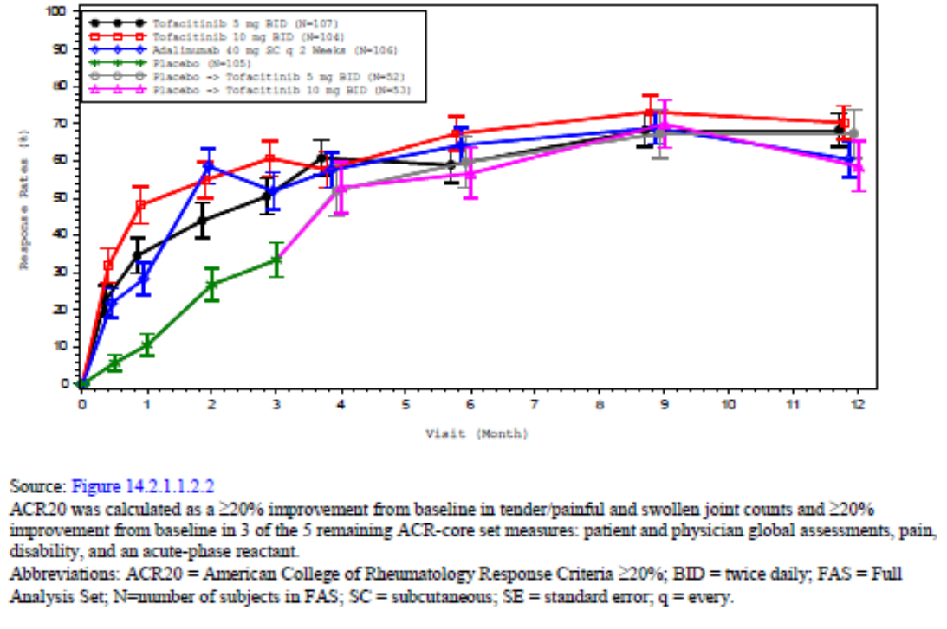

Study A3921125
This was a Phase III, randomised, double blind, placebo controlled study of the efficacy and safety of two doses of tofacitinib in patients with active PsA who have had an inadequate response to at least one TNFI. It was conducted at 98 sites in 14 countries (Australia, Belgium, Brazil, Czech Republic, France, Germany, Mexico, Poland, Russia, Slovakia, Spain, Taiwan, UK and the US) between August 2013 and April 2016. Patients remained on a stable dose of background csDMARD during the study.
395 patients were randomised (394 were treated) in a 2:2:1:1 ratio to one of four treatment groups:
- Group A: tofacitinib 5 mg BD for 6 months.
- Group B: tofacitinib 10 mg BD for 6 months.
- Group C: placebo for 3 months then tofacitinib 5 mg BD for 3 months.
- Group D: placebo for 3 months then tofacitinib 10 mg BD for 3 months.
The baseline demographics were comparable in each treatment group. The majority of patients were White (92.1%), and female (55.3%), with a mean age of 50.0 years.
The primary efficacy endpoints (ACR20 responder rate and change in HAQ-DI at Month 3) were met. The ACR20 response rate was statistically significantly higher for tofacitinib 5 mg BD and tofacitinib 10 mg BD compared with placebo. The response rates were 49.62%, 46.97% and 23.66% in the tofacitinib 5 mg BD, tofacitinib 10 mg BD and placebo groups, respectively. The treatment difference for tofacitinib 5 mg BD versus placebo was 25.95% (95% CI: 14.72, 37.19; p < 0.0001). The treatment difference for tofacitinib 10 mg BD versus placebo was 23.31% (95% CI: 12.10, 34.51; p < 0.0001). The mean HAQ-DI decreases were also statistically significantly greater for tofacitinib 5 mg BD and tofacitinib 10 mg BD compared with placebo.
Figure 5: Study A3921125 ACR20 response rates up to Month 6
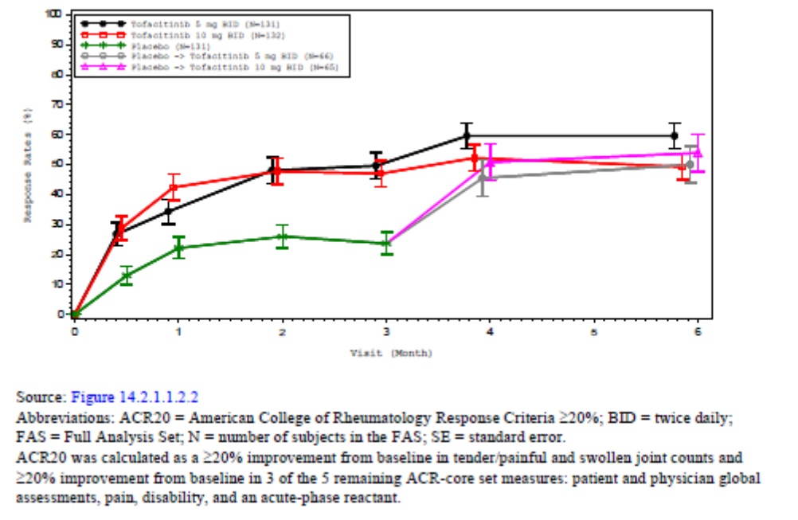
Secondary efficacy endpoints included changes in individual ACR components, ACR20, ACR50 and ACR70 responder rates, PASI75 response rates, enthesitis and dactylitis measures, and patient reported outcomes.
Secondary efficacy outcomes were largely consistent with the primary outcome. ACR50 response rates at Month 3 were significantly higher in both tofacitinib groups compared with placebo. ACR20 and ACR50 response rates were maintained or improved in both groups to Month 6. ACR70 response rates were numerically higher in both tofacitinib groups compared with placebo; however, the treatment differences did not achieve statistical significance. There were no meaningful differences in ACR20, ACR50 and ACR70 response rates between the tofacitinib 5 mg BD and 10 mg BD groups at Months 3 and 6. Patients randomised to placebo until Month 3, showed comparable increases in ACR20 response rates at Month 6.

Study A3921092
This is an ongoing open label, long term extension study of tofacitinib for the treatment of PsA which started on 17 February 2014. Eligible patients were enrolled from the two pivotal studies, StudyA3921091 and Study A3921125. The interim analysis cut-off date is 4 April 2016, the interim report is dated 31 August 2017, and the estimated completion date is 4 February 2019. Data were available up to Month 15.
The primary objective was the long-term safety and tolerability of tofacitinib 5 mg BD or 10 mg BD in patients with PsA. The secondary objective was long term efficacy. All patients received tofacitinib 5 mg BD on entry into the study. Starting at Month 1, patients receiving tofacitinib 5 mg BD were given the option to increase the dose to 10 mg BD at the discretion of the investigator. Patients receiving tofacitinib 10 mg BD were later given the option to reduce the dose to 5 mg BD for safety reasons.
At the data cut-off, 685 patients were enrolled from the qualifying studies, 680 patients (99.3%) were treated, and 608 (89.4%) were ongoing. A total of 72 (10.6%) patients discontinued from the study, most commonly due to inadequate clinical response (2.6%), withdrawal of consent (2.6%), and AEs related to study drug (1.9%). The majority of patients were White (94.2%) and female (53.9%), with a mean age of 48.8 years. The median duration of treatment was 175 days (range 3 to 754 days).
In general, ACR20 response rates at Month 1 were sustained through Month 15, irrespective of which qualifying study patients were enrolled from. The stability of the change in HAQ-DI was also sustained over time.

Other efficacy studies and analyses
A number of pooled analyses of the pivotal studies were performed and were supportive of the primary analyses.
Studies A3921137 and A3921119 are described in the evaluation report but do not contribute meaningfully to efficacy in PsA, so are not discussed further.

Safety
The safety profile of tofacitinib was assessed in PsA patients in the two placebo-controlled pivotal studies (Studies A3921091 and A3921125), the open label long term extension study (Study A3921092) and the supporting Studies A3921137 and A3921119. A total of 783 PsA patients received tofacitinib for a total of 1237.89 patient years. 635 patients received tofacitinib for ≥ 12 months and 335 patients received tofacitinib for ≥ 24 months.
From the pivotal studies, 238, 236, 236 and 106 patients were included in the tofacitinib 5 mg BD, tofacitinib 10 mg BD, placebo and adalimumab groups, respectively. A pooled analysis approach involving 3 cohorts was adopted for the pivotal studies:
- Cohort 1 (placebo controlled period): Integrated data from the pivotal Studies A3921091 and A3921125 compared the safety profiles of tofacitinib 5 mg BD, tofacitinib 10 mg BD, placebo and adalimumab from Baseline to Month 3.
- Cohort 2 (6 month dose comparison): Integrated data from six months of treatment compared the two doses of tofacitinib and adalimumab. The analysis excluded patients randomised to the placebo/tofacitinib 5 mg BD and placebo/tofacitinib 10 mg BD groups.
- Cohort 2a (12 month dose comparison): Integrated data from 12 months of treatment compared patients randomised to tofacitinib 5 mg BD, tofacitinib 10 mg BD and adalimumab.
- Cohort 3 (All PsA): Integrated data from all patients who received tofacitinib in the PsA program (pivotal and long term extension studies) were analysed. Analyses of AEs over time are based on Cohort 3 only.
The incidence of TEAEs in the tofacitinib groups was generally higher than placebo and similar to adalimumab. In Cohort 1, TEAEs were reported in 47.9%, 49.6%, 40.3% and 46.2% of the tofacitinib 5 mg BD, tofacitinib 10 mg BD, placebo and adalimumab groups, respectively. Nearly all TEAEs were mild to moderate in severity. Overall, the most commonly reported TEAEs by PT were nasopharyngitis, headache and URTI. Compared with placebo, TEAEs reported at least 1% more frequently in patients receiving tofacitinib were bronchitis, diarrhoea, dyspepsia, fatigue, headache, nasopharyngitis and pharyngitis.
The incidence of SAEs was low in all treatment groups with no meaningful treatment differences. In Cohort 1, SAEs were reported in 1.7%, 1.7%, 1.7% and 0.9% of the tofacitinib 5 mg BD, tofacitinib 10 mg BD, placebo and adalimumab groups, respectively. The percentage of patients who discontinued due to AEs was low and comparable in each group. The incidence of SAEs was comparable in each treatment group in Cohort 2 during the 12 month reporting period.
The incidence of serious infections for all doses of tofacitinib was 2.3% with an incidence rate of 1.43 out of 100 PY, comparable to the rates in the RA and PsO programs.
26 herpes zoster events were reported, an incidence of 3.3% of PsA patients given any dose of tofacitinib, with an incidence rate of 2.10 out of 100 PY, comparable to rates observed in the RA and PsO populations. The incidence of opportunistic infections was low, with only 3 events (all herpes zoster) in Cohort 3.
The incidence rate of malignancies was low with nine events reported in Cohort 3. The incidence for all doses of tofacitinib was 1.1% with an incidence rate of 0.72 out of 100 PY, comparable to the rates in the RA and PsO programs. The most commonly reported malignancies were bladder (2) and thyroid (2). A possible excess of sporadic cases of pancreatic cancer were identified in the tofacitinib RA and other development programs. The only death due to pancreatic cancer in the PsA program occurred after 84 days of tofacitinib treatment. Direct causality is implausible due to the short exposure, and the investigator did not consider it drug related.
A total of five deaths occurred during the tofacitinib program. All deaths occurred in patients receiving tofacitinib 5 mg BD but none were considered related to study drug. The causes of death were pancreatic cancer, cardiac arrest, acute cardiac failure, chronic obstructive pulmonary disease and pulmonary embolism. Four deaths occurred during the long term extension study. The remaining death (cardiac arrest) occurred in a 73 year old female 29 days after starting tofacitinib therapy. She died in hospital while receiving treatment for unstable diabetes.
Overall, the safety profile in the PsA program is consistent with the RA development program and post marketing experience. Tofacitinib was first approved in the USA on 6 November 2012 for adults with RA. Up until 5 November 2016, exposure to tofacitinib has been approximately 61,043 PY. No new safety signals have been detected in the 4 year period since marketing approval.
There are some differences in ADR frequencies between the draft PI and the SmPC. Updates to ADR frequencies were initially proposed in the draft EU SmPC that were based on pooled Phase III randomised controlled trial data across 4 tofacitinib programmes (rheumatoid arthritis, psoriasis, psoriatic arthritis and ulcerative colitis). This differed from the draft PI which proposed to include updated ADR frequencies based on pooled Phase III randomised controlled trial data across rheumatoid arthritis and psoriatic arthritis only. Subsequently, a change in methodology to ADR frequency determination was applied to the SmPC in response to CHMP comments; with the CHMP-adopted SmPC presenting ADR frequencies based on pooled Phase III randomised controlled trial and long term extension data across rheumatoid arthritis and psoriatic arthritis. As a result, some ADR frequencies differ between the PI and SmPC. In all cases, the ADRs are more frequent in the PI compared to the SmPC. No new ADRs have been identified based on the pooled RA and PsA dataset and no ADRs currently in the PI have been removed.

Risk management plan
In support of the current submission, the sponsor has submitted EU-RMP version 3.0 (dated 26 July 2017; DLP 7 March 2017) and ASA version 1.0 (dated 27 September 2017).
The proposed Summary of Safety Concerns and their associated risk monitoring and mitigation strategies as outlined in the EU RMP and ASA are summarised in Table 20.
Following the first round evaluation, the sponsor committed to the following three recommendations:
- To include ‘Herpes zoster reactivation’ in the summary of safety concerns of the ASA as an important identified risk.
- To include the following important potential risks in the summary of safety concerns of the ASA:
  - Increased immunosuppression when used in combination with biologic DMARDs and immunosuppressants including B lymphocyte depleting agents
  - Increased risk of adverse events when tofacitinib is administered in combination with MTX
  - Primary viral infection following live vaccination
  - Increased exposure to tofacitinib when co-administered with CYP3A4 and CYP2C19 inhibitors
  - Off-label use including children with Juvenile Idiopathic Arthritis (JIA)
  - Higher incidence and severity of adverse events in the elderly
- To provide the updated educational materials to the TGA prior to distribution.
The RMP evaluator made two further recommendations in the second round report:
- The sponsor should provide the updated Australian specific annex (ASA) which incorporates the RMP evaluator’s recommendations within 3 months of approval of this submission.
- The sponsor should ensure that appropriate pharmacovigilance and risk minimisation measures are assigned to the safety concerns that are added to the ASA. These should be consistent with the measures in place in the EU-RMP.
At the time this conclusion was written, the sponsor had not yet confirmed its response to these recommendations.
The RMP evaluator concluded that the proposed pharmacovigilance and risk minimisation activities are otherwise acceptable. The clinical evaluator commented that the summary of safety concerns in the draft RMP is acceptable.
The RMP evaluator recommended a condition of registration:
The Xeljanz EU-Risk Management Plan (RMP) version 3.0 (date 26 July 2017; data lock point 7 March 2017) with Australian Specific Annex version 1.0 (date 27 September 2017), included with submission PM-2017-03802-1-3, to be revised to the satisfaction of the TGA, will be implemented in Australia.

Risk-benefit analysis

Delegate’s considerations

Discussion

Efficacy
The Phase III program was based on two pivotal efficacy studies in 816 adult patients with active PsA. The studies were designed in line with regulatory advice from the FDA and EMA. Background csDMARD therapy was required in both studies. Patients in Study A3921091 were required to have had an inadequate response to a csDMARD and were TNFI-naïve, and patients in Study A3921125 were required to have had an inadequate response to TNFI therapy. Both studies were placebo controlled for the first three months, and Study A3921091 had an adalimumab active control arm. The doses of tofacitinib (5 mg BD and 10 mg BD) selected for the PsA program were based on the RA and PsO programs. In both pivotal studies, there was a significant benefit in favour of tofacitinib 5 mg BD and 10 mg BD compared with placebo.
In Study A3921091, tofacitinib 5 mg BD and 10 mg BD were both superior to placebo for the primary endpoints of ACR20 response rates and change in HAQ-DI at Month 3. Tofacitinib 10 mg BD was numerically superior to tofacitinib 5 mg BD for the primary endpoints but the difference was not significant. Over 12 months, there was no meaningful difference between 5 mg BD and 10 mg BD. The benefit with both doses was statistically significant and clinically meaningful, and it was maintained or improved over the 12 month treatment period. There was no meaningful difference between the tofacitinib and adalimumab treatment groups.
In Study A3921125, which involved 394 patients with PsA who were inadequate responders to at least 1 TNFI, tofacitinib 5 mg BD and 10 mg BD were both superior to placebo for the primary endpoints of ACR20 response rates and change in HAQ-DI at Month 3, and the benefit was maintained or improved to Month 6. This study did not demonstrate a benefit in favour of the higher dose.
Persistence of effect is being assessed in the on-going open label long term extension Study A3921092. A total of 680 patients have received treatment for a median duration of 175 days (range 3 to 754 days). In the interim analysis, the efficacy benefits of tofacitinib treatment were sustained to Month 15. Withdrawals due to lack of efficacy occurred in only 2.6% of patients.

Safety
The safety profile for tofacitinib in PsA has been evaluated in the two pivotal studies, and the ongoing open label long term extension study. Overall, the safety profile of the proposed 5 mg BD dosage in PsA is consistent with the established safety profile in RA.
The incidence of TEAEs in the tofacitinib groups was generally higher than placebo and similar to adalimumab. Overall, the most commonly reported TEAEs by PT were nasopharyngitis, headache and. Severe AEs and SAEs were infrequent in all treatment groups with no meaningful treatment differences. There were few AEs of special interest, including serious infections, opportunistic infections and malignancies, and no new safety signals were identified. Herpes zoster was reported in 26 cases, but the incidence rate was comparable to that seen in the RA program. No new safety signals have been identified from four years of post-marketing experience in RA patients.

Proposed indication
The clinical evaluator was satisfied with the sponsor’s responses to comments and questions on the PI and supported the other proposed changes to the PI. The clinical evaluator recommends approval of a revised indication for PsA:
Xeljianz in combination with non-biological DMARDs is indicated for the treatment of active psoriatic arthritis in adult patients who have had an inadequate response to a prior DMARD therapy.
The pivotal studies both required background csDMARD therapy, so the proposed use in combination with nonbiological DMARDs is considered appropriate. The PsA studies did not include tofacitinib as monotherapy.
The clinical evaluator recommended the removal of ‘or who have been intolerant’ to a prior DMARD therapy from the indication on the basis that patients intolerant to a prior DMARD therapy were excluded from the pivotal studies. The sponsor responded that the pivotal studies did include patients who experienced intolerance to a prior DMARD (csDMARD or TNFI):
‘When reasons for inadequate response to prior csDMARDs were examined, it was found that 2.4% of subjects enrolled into Study A3921091 reported intolerance to at least 1 csDMARD as the only reason for inadequate response, whereas 18.0% of subjects reported both lack of efficacy and intolerance to at least 1 csDMARD. Subjects in Study A3921125 were required to have had an inadequate response (defined as above) to a tumour necrosis factor inhibitor (TNFI). While intolerance was reported in 8.9% of the subjects enrolled into Study A3921125 as the only reason for TNFI discontinuation, 14.2% of subjects reported both lack of efficacy and intolerance to at least 1 prior TNFI. Since there were subjects who participated in the pivotal studies who experienced intolerance to a prior DMARD (csDMARD or TNFI) as per study inclusion criteria, we believe the statement in the PI, as written, is an accurate reflection of the data.’
However, the sponsor has agreed to the evaluator’s proposed wording, noting that the indications for other targeted DMARDs approved for PsA in Australia do not delineate inadequate response due to inadequate efficacy from intolerance.
The proposed relocation of the sentence regarding specialist involvement from section 4.1 to section 4.2 of the PI is reasonable when considered in the context of the safety profile of tofacitinib since registration. The sponsor provided the PIs of other approved treatments for PsA in Australia, and none include that precaution in the indication. Rheumatologist (or specialist physician with expertise in the condition) involvement in the initiation and monitoring of therapy with tofacitinib remains essential, but it is appropriate for this guidance to be removed from the indication and relocated to section 4.2 (noting that the same message is repeated in section 4.4 Special Warnings and Precautions For Use).

Proposed dosage
The data from the pivotal studies support the proposed 5 mg BD dosage for PsA. The same dosage is approved for PsA in EU and USA.

Deficiencies of the data
The efficacy of Xeljanz as monotherapy has not been studied in patients with PsA. A statement to this effect has been included in section 4.4 of the PI.
The majority of subjects in the PsA pivotal studies were White, so safety and efficacy data for other racial groups are very limited.

Conditions of registration
The Xeljanz EU-Risk Management Plan (RMP) version 3.0 (date 26 July 2017; data lock point 7 March 2017) with Australian Specific Annex version 1.0 (date 27 September 2017), included with submission PM-2017-03802-1-3, to be revised to the satisfaction of the TGA, will be implemented in Australia.

Conclusion
The two pivotal studies have satisfactorily demonstrated the efficacy of tofacitinib when used in combination with a csDMARD in adult patients with active PsA. Study A3921091 demonstrated a benefit in patients who have had an inadequate response to csDMARD therapy (no prior TNFI) and Study A3921125 demonstrated a benefit in patients who have had an inadequate response to TNFI therapy. Tofacitinib 5 mg BD and 10 mg BD dosages were both superior to placebo, but a benefit of the 10 mg BD dosage over the 5 mg BD dosage has not been established. Efficacy of tofacitinib as monotherapy in PsA has not been demonstrated.
The proposed 5 mg BD dose of tofacitinib has an acceptable safety profile in PsA, similar to the established safety profile of tofacitinib in RA.

Summary of issues
The efficacy and safety of tofacitinib 5 mg BD in combination with csDMARDs in adults with active PsA has been satisfactorily demonstrated in two pivotal studies. The proposed indication for PsA has been modified in response to the clinical evaluator’s recommendations.

Proposed action
Subject to the advice of ACM, the Delegate proposes to approve the revised indication:
Psoriatic Arthritis
Xeljanz in combination with nonbiological DMARDs is indicated for the treatment of active psoriatic arthritis in adult patients who have had an inadequate response to a prior DMARD therapy.

Request for ACM advice
- What is the committee’s opinion regarding the proposed indication? Does the committee agree with the addition of ‘in combination with nonbiological DMARDs’? Does the committee anticipate any clinical issue arising from the removal of the phrase ‘or who have been intolerant’ from the PsA indication’?
The committee is also requested to provide advice on any other issues that it thinks may be relevant to a decision on whether or not to approve this application.

Questions for sponsor
- Please confirm your response to recommendations 4 and 5 in the second round RMP report.

Response from the sponsor

Introduction
The sponsor welcomes and agrees with the Delegate’s assessment under ‘Summary of Issue/s’ that the efficacy and safety of tofacitinib 5 mg twice daily in combination with conventional synthetic disease-modifying antirheumatic drugs (csDMARDs) in adults with active psoriatic arthritis (PsA) has been satisfactorily demonstrated in two pivotal studies.
The sponsor initially proposed the following indication in the application:
Xeljanz is indicated for the treatment of active psoriatic arthritis in adult patients who have had an inadequate response or who have been intolerant to a prior DMARD therapy.
In response to the clinical evaluator’s recommendation, the proposed indication was revised to:
Xeljanz in combination with nonbiological DMARDs is indicated for the treatment of active psoriatic arthritis in adult patients who have had an inadequate response to a prior DMARD therapy.

Advice sought
The sponsor acknowledges the Delegate’s request for advice from the Advisory Committee on Medicines (ACM) as follows.
- What is the committee’s opinion regarding the proposed indication? Does the committee agree with the addition of ‘in combination with nonbiological DMARDs’? Does the committee anticipate any clinical issue arising from the removal of the phrase ‘or who have been intolerant’ from the PsA indication?
The sponsor agrees with the addition of ‘in combination with nonbiological DMARDs’ in the wording of the indication since it is consistent with the population in the pivotal studies.
The sponsor does not anticipate there to be any clinical issues arising from the removal of the phrase ‘or who have been intolerant’ from the indication. As noted by the Delegate, the sponsor considers this phrase to be an accurate reflection of the data since there were subjects who participated in the pivotal studies who experienced intolerance to a prior DMARD (csDMARD or tumour necrosis factor inhibitor (TNFi)) as per study inclusion criteria. However, given that other targeted DMARDs approved for PsA in Australia do not delineate inadequate response due to inadequate efficacy from intolerance in the indication wording, Pfizer had agreed to the request to revise the indication wording.

Questions for sponsor
The Delegate has raised the following question in relation to the RMP which the sponsor will address in this response:
Please confirm your response to recommendations 4 and 5 in the Round 2 RMP report’ The RMP evaluator made two further recommendations in the second round report, namely:
- Recommendation 4. The sponsor should provide the updated ASA which incorporates the RMP evaluator’s recommendations within 3 months of approval of this submission.
- Recommendation 5. The sponsor should ensure that appropriate pharmacovigilance and risk minimisation measures are assigned to the safety concerns that are added to the ASA. These should be consistent with the measures in place in the EU-RMP.
For recommendation 4, the sponsor confirms that it will provide the updated Australian Specific Annex (ASA) which incorporates the RMP evaluator’s recommendations within 3 months of approval of the submission.
For recommendation 5, the sponsor confirms that appropriate pharmacovigilance and risk minimisation measures will be assigned to the safety concerns that are added to the ASA and that these will be consistent with the measures in place in the EU-RMP. The draft PI has been revised as part of this pre-ACM response to include additional wording copied from the European Summary of Product Characteristics (SmPC) which are assigned to the EU safety concerns that will be added to the ASA. [The sponsor also provided comments on the PI, however inclusion of these is beyond the scope of this AusPAR].

Conclusion
The sponsor concurs with the Delegate’s overall conclusion that the two pivotal studies (Study A3921091 and A3921125) have satisfactorily demonstrated the efficacy of tofacitinib when used in combination with a csDMARD in adult patients with active PsA. The sponsor also agrees with the Delegate that the proposed 5 mg twice daily dose of tofacitinib has an acceptable safety profile in PsA, similar to the established safety profile of tofacitinib in rheumatoid arthritis. The sponsor looks forward to the deliberations of the ACM on tofacitinib for use in adult patients with active PsA.

Advisory Committee Considerations
The Advisory Committee on Medicines (ACM), having considered the evaluations and the Delegate’s overview, as well as the sponsor’s response to these documents, advised the following.
The ACM taking into account the submitted evidence of efficacy and safety, agreed with the Delegate and considered Xeljanz film-coated tablet containing 5 mg of tofacitinib to have an overall positive benefit-risk profile for the proposed indication:
Xeljanz in combination with nonbiological DMARDs is indicated for the treatment of active psoriatic arthritis in adult patients who have had an inadequate response to a prior DMARD therapy.
In providing this advice the ACM noted the following:
- Study A3921091 was a randomised, double blind, placebo controlled study of the efficacy and safety of tofacitinib (5 mg twice daily or 10 mg twice daily) in patients with active PsA, and included adalimumab as an active control. Patients were required to have had an inadequate response to at least one conventional synthetic DMARD (csDMARD) and to be TNF inhibitor naïve. Tofacitinib (in both dose groups) demonstrated superior efficacy compared to placebo in the primary endpoints (ACR20 response rates and changes in HAQ-DI at Month 3).
- Study A3921125 was a randomised, double blind, placebo controlled, study of the efficacy and safety of tofacitinib (5 mg twice daily or 10 mg twice daily) in patients with active PsA who had an inadequate response to at least one TNF inhibitor. The primary endpoints were ACR20 response rates and changes in HAQ-DI at Month 3. Tofacitinib was added to previous stable csDMARD therapy without an option for monotherapy. Tofacitinib (in both dose groups) demonstrated superior efficacy compared to placebo in the primary endpoints (ACR20 response rates and changes in HAQ-DI at Month 3).
- There were no clinically meaningful differences in efficacy between the 5 mg and 10 mg doses of tofacitinib in either of the pivotal trials.
- The safety profile of tofacitinib was acceptable and consistent with the rheumatoid arthritis program and post market experience. Tofacitinib was first approved in the US in 2012 for adults with rheumatoid arthritis; no new safety signals have been detected in the four year period since marketing approval.

Proposed conditions of registration
The ACM agreed with the Delegate on the proposed conditions of registration.

Proposed Product Information (PI)/Consumer Medicine Information (CMI) amendments
The ACM agreed with the Delegate to the proposed amendments to the PI and CMI and specifically advised on the inclusion of the following:
- The ACM was of the view that the word descriptions of renal impairment (that is, mild, moderate and severe) are not routinely used, and that the numerical references assigned to these terms were inconsistent. Therefore the committee suggested that the relevant sections of the PI under sections 4.2 and 4.4 include the following replacement text:
‘No dose adjustment is required in patients with estimated GFR more than 50 mL/min. Xeljanz dose should be reduced to 5 mg once daily in patients with estimated GFR less than 50 mL/min, (including but not limited to those with severe renal impairment who are undergoing haemodialysis).’

Specific advice
The ACM advised the following in response to the Delegate’s specific questions on the submission.
- What is the committee’s opinion regarding the proposed indication? Does the committee agree with the addition of ‘in combination with nonbiological DMARDs’? Does the committee anticipate any clinical issue arising from the removal of the phrase ‘or who have been intolerant’ from the PsA indication’?
The ACM considered the proposed wording of the indication to be appropriate:
Xeljanz in combination with nonbiological DMARDs is indicated for the treatment of active psoriatic arthritis in adult patients who have had an inadequate response to a prior DMARD therapy.
The addition of ‘in combination with nonbiological DMARDs’ was consistent with the pivotal studies presented in the submission, although the ACM noted that the vast majority of patients were taking methotrexate, and evidence about the efficacy of tofacitinib with other nonbiological DMARDs was limited. With respect to the removal of the phrase ‘or who have been intolerant’, the ACM noted that there were only a limited number of patients who were intolerant to csDMARDs.
The Committee also noted that the phrase ‘Therapy with Xeljanz should be initiated and monitored by a rheumatologist or specialist physician with expertise in the management of rheumatoid arthritis’ originally included in the therapeutic indication, will be moved to the section relating to Dose and Method of Administration.
The ACM advised that implementation by the sponsor of the recommendations outlined above to the satisfaction of the TGA, in addition to the evidence of efficacy and safety provided would support the safe and effective use of this product.

Outcome
Based on a review of quality, safety and efficacy, TGA approved the registration of Xeljanz (tofacitinib as citrate) for 5 mg film coated tablet, for the following extension of indications:
Psoriatic Arthritis
Xeljanz in combination with conventional synthetic DMARDs is indicated for the treatment of active psoriatic arthritis in adult patients who have had an inadequate response to a prior DMARD therapy.
As such, the full indications at this time were:
Rheumatoid Arthritis
Xeljanz is indicated for the treatment of moderate to severe active rheumatoid arthritis in adults who have had an inadequate response or are intolerant to methotrexate. Xeljanz can be used alone or in combination with conventional synthetic disease-modifying antirheumatic drugs (DMARDs), including methotrexate.
Psoriatic Arthritis
Xeljanz in combination with conventional synthetic DMARDs is indicated for the treatment of active psoriatic arthritis in adult patients who have had an inadequate response to a prior DMARD therapy.

Specific conditions of registration applying to these goods
The Xeljanz EU-Risk Management Plan (RMP) version 3.0 (date 26 July 2017; data lock point 7 March 2017) with Australian Specific Annex version 1.0 (date 27 September 2017), included with submission PM-2017-03802-1-3, to be revised to the satisfaction of the TGA, will be implemented in Australia.
An obligatory component of risk management plans is routine pharmacovigilance. Routine pharmacovigilance includes the submission of Periodic Safety Update Reports (PSURs).
Reports are to be provided in line with the current published list of EU reference dates and frequency of submission of PSURs until the period covered by such reports is not less than three years from the date of this approval letter.
The reports are to at least meet the requirements for PSURs as described in the European Medicines Agency’s Guideline on good pharmacovigilance practices (GVP) Module VII-Periodic Safety Update Report (Rev 1), Part VII.B Structures and processes. Note that submission of a PSUR does not constitute an application to vary the registration. Each report must have been prepared within ninety calendar days of the data lock point for that report.

Attachment 1. Product Information
The PI for Xeljanz approved with the submission which is described in this AusPAR is at Attachment 1. For the most recent PI, please refer to the TGA website at <https://www.tga.gov.au/product-information-pi>.

Therapeutic Goods Administration
PO Box 100 Woden ACT 2606 Australia
Email: info@tga.gov.au Phone: 1800 020 653 Fax: 02 6232 8605
https://www.tga.gov.au

CP-690550 is the drug development code for tofacitinib.
Study No 15GR329, PF 05211077_DEREK_08NOV2012 and PF 05211077_Leadscope_7Jun2013) or PF-05198213 (Study No 15GR330, PF-05198213_DEREK_04JUN2013, PF 05198213_DEREK_08NOV2012 and PF-05198213_LEADSCOPE_07JUN2013).
European Medicines Agency (EMA), Committee for Proprietary Medicinal Products (CPMP), Guidelines on clinical investigation of medicinal products for the treatment of psoriatic arthritis, 14 December 2006, CPMP/EWP/438/04
Hy’s Law: ALT > 3 x ULN and total bilirubin > 2 x ULN.
Routine risk minimisation activities may be limited to ensuring that suitable warnings are included in the product information or by careful use of labelling and packaging. Routine pharmacovigilance practices involve the following activities: - All suspected adverse reactions that are reported to the personnel of the company are collected and collated in an accessible manner; - Reporting to regulatory authorities; - Continuous monitoring of the safety profiles of approved products including signal detection and updating of labeling; - Submission of PSURs; - Meeting other local regulatory agency requirements.
The Advisory Committee on Prescription Medicines (ACPM) was formed in January 2010 and superseded by the. Advisory Committee on Medicines (ACM) in 2017.
The Therapeutic Goods Act 1989 allows for initial decisions made under the provision (Section 60) of the Act by the Secretary of the Department of Health, or a delegate of the Secretary
The ACM provides independent medical and scientific advice to the Minister for Health and the Therapeutic Goods Administration (TGA) on issues relating to the safety, quality and efficacy of medicines supplied in Australia including issues relating to pre-market and post-market functions for medicines. The Committee is established under Regulation 35 of the Therapeutic Goods Regulations 1990. Members are appointed by the Minister. The ACM was established in January 2017 replacing Advisory Committee on Prescription Medicines (ACPM) which was formed in January 2010. ACM encompass pre and post-market advice for medicines, following the consolidation of the previous functions of the Advisory Committee on Prescription Medicines (ACPM), the Advisory Committee on the Safety of Medicines (ACSOM) and the Advisory Committee on Non-Prescription Medicines (ACNM). Membership comprises of professionals with specific scientific, medical or clinical expertise, as well as appropriate consumer health issues relating to medicines.

