AusPAR Attachment 2

Extract from the Clinical Evaluation Report for Tofacitinib citrate

Proprietary Product Name: Xeljanz
  - Sponsor: Pfizer Australia Pty Ltd
First round report: October 2016
Second round report: January 2017

About the Therapeutic Goods Administration (TGA)
- The Therapeutic Goods Administration (TGA) is part of the Australian Government Department of Health, and is responsible for regulating medicines and medical devices.
- The TGA administers the Therapeutic Goods Act 1989 (the Act), applying a risk management approach designed to ensure therapeutic goods supplied in Australia meet acceptable standards of quality, safety and efficacy (performance), when necessary.
- The work of the TGA is based on applying scientific and clinical expertise to decision-making, to ensure that the benefits to consumers outweigh any risks associated with the use of medicines and medical devices.
- The TGA relies on the public, healthcare professionals and industry to report problems with medicines or medical devices. TGA investigates reports received by it to determine any necessary regulatory action.
- To report a problem with a medicine or medical device, please see the information on the TGA website <https://www.tga.gov.au>.
About the Extract from the Clinical Evaluation Report
- This document provides a more detailed evaluation of the clinical findings, extracted from the Clinical Evaluation Report (CER) prepared by the TGA. This extract does not include sections from the CER regarding product documentation or post market activities.
- The words [Information redacted], where they appear in this document, indicate that confidential information has been deleted.
- For the most recent Product Information (PI), please refer to the TGA website <https://www.tga.gov.au/product-information-pi>.
Copyright
© Commonwealth of Australia 2018
This work is copyright. You may reproduce the whole or part of this work in unaltered form for your own personal use or, if you are part of an organisation, for internal use within your organisation, but only if you or your organisation do not use the reproduction for any commercial purpose and retain this copyright notice and all disclaimer notices as part of that reproduction. Apart from rights to use as permitted by the Copyright Act 1968 or allowed by this copyright notice, all other rights are reserved and you are not allowed to reproduce the whole or any part of this work in any way (electronic or otherwise) without first being given specific written permission from the Commonwealth to do so. Requests and inquiries concerning reproduction and rights are to be sent to the TGA Copyright Officer, Therapeutic Goods Administration, PO Box 100, Woden ACT 2606 or emailed to <tga.copyright@tga.gov.au>.
Contents
List of abbreviations 5
1. Introduction 7
1.1. Drug class and therapeutic indication 7
1.2. Dosage forms and strengths 7
1.3. Dosage and administration 7
2. Clinical rationale 8
3. Contents of the clinical dossier 8
3.1. Scope of the clinical dossier 8
3.2. Paediatric data 8
3.3. Good clinical practice 8
4. Pharmacokinetics 9
4.1. Studies providing pharmacokinetic data 9
4.2. Summary of pharmacokinetics 9
4.3. Evaluator’s overall conclusions on pharmacokinetics 10
5. Pharmacodynamics 10
5.1. Studies providing pharmacodynamic information 10
5.2. Summary of pharmacodynamics 10
5.3. Evaluator’s overall conclusions on pharmacodynamics 12
6. Dosage selection for the pivotal studies 13
7. Clinical efficacy 13
7.1. Studies providing evaluable efficacy data 13
7.2. Pivotal or main efficacy studies 14
7.3. Other efficacy studies 37
7.4. Analyses performed across trials: Pooled and meta-analyses 44
7.5. Evaluator’s conclusions on clinical efficacy 44
8. Clinical safety 46
8.1. Studies providing evaluable safety data 46
8.2. Studies that assessed safety as the sole primary outcome 48
8.3. Patient exposure 53
8.4. Adverse events 54
8.5. Evaluation of issues with possible regulatory impact 60
8.6. Other safety issues 65
8.7. Post marketing experience 65
8.8. Evaluator’s overall conclusions on clinical safety 65
9. First round benefit-risk assessment 67
9.1. First round assessment of benefits 67
9.2. First round assessment of risks 68
9.3. First round assessment of benefit-risk balance 69
10. First round recommendation regarding authorisation 69
11. Clinical questions 70
11.1. Pharmacokinetics 70
11.2. Pharmacodynamics 70
11.3. Efficacy 70
11.4. Safety 71
12. Second round evaluation of clinical data 71
12.1. Question 1 71
12.2. Question 2 72
12.3. Question 3 73
12.4. Question 4 74
12.5. Question 5 76
13. Second round benefit-risk assessment 77
13.1. Second round assessment of benefits 77
13.2. Second round assessment of risks 77
13.3. Second round assessment of benefit-risk balance 78
14. Second round recommendation regarding authorisation 78
15. References 78

List of abbreviations
Abbreviation | Meaning
ACR | American College of Rheumatology
AE | Adverse Event
AIAS | All-Available Immunogenicity Analysis Set
AUC | Area Under Concentration-Time curve over the dosing interval
CCP | Cyclic Citrullinated Peptide
CD | Cluster of Differentiation
CI | Confidence interval
C_{max} | Maximum serum drug concentration
CPK | Creatine Phosphokinase
CRP | C-Reactive Protein
CS | Corticosteroids
DAS | Disease Activity Score
DMARD | Disease Modifying Anti-Rheumatic Drug
EIAS | Evaluable Immunogenicity Analysis Set
ELISA | Enzyme-Linked Immunosorbent Assay
ES | Erosion Score
ESR | Erythrocyte Sedimentation Ratio
EULAR | European League Against Rheumatism
FAS | Full Analysis Set
GMFR | Geometric Mean Fold Rise
HAQ-DI | Health Assessment Questionnaire – Disability Index
IL | Interleukin
Ig | Immunoglobulin
JAK | Janus Kinase
JSN | Joint Space Narrowing
LEP | Linear Extrapolation
LS | Least Squares
LTE | Long Term Extension
mTSS | modified Total Sharp Score
MTX | Methotrexate
NK | Natural Killer
NRI | Non Responder Imputation
NSAID | Non-Steroidal Anti-Inflammatory Drug
OMERACT | Outcome Measures in Rheumatology Clinical Trials
PBO | Placebo
PD | Pharmacodynamic
PK | Pharmacokinetic
PT | Preferred Term
PY | Patient-Years
RA | Rheumatoid Arthritis
RAMRIS | Rheumatoid Arthritis Magnetic Resonance Imaging Score
RF | Rheumatoid Factor
SAE | Serious Adverse Event
SD | Standard Deviation
SOC | System Organ Class
TB | Tuberculosis
TOF | Tofacitinib Citrate
ULN | Upper Limit of Normal
VZV | Varicella Zoster Vaccine

Introduction
This is a full submission requesting an extension of treatment indication for tofacitinib citrate (TOF) to include a claim of inhibition of structural damage as measured by sequential plain X-rays in patients with rheumatoid arthritis (RA). TOF was approved for registration in Australia on the 13 January 2015 for the treatment of moderately to severely active RA in adult patients. In addition, the sponsor is seeking to update the current Product Information (PI) with the latest safety information (as of the data cut-off date of March 31, 2015). The sponsor application letter is dated 5 May, 2016.

Drug class and therapeutic indication
TOF is an immunosuppressant medication (ATC code: L04AA29). It is a selective and reversible inhibitor of the Janus Kinase (JAK) family of kinases.
The currently approved treatment indication is:
- Xeljanz is indicated for the treatment of the signs and symptoms of moderate to severe active rheumatoid arthritis in adults who have had an inadequate response or are intolerant to methotrexate. Xeljanz can be used alone or in combination with nonbiological DMARDs, including methotrexate.
- Therapy with Xeljanz should be initiated and monitored by a rheumatologist or specialist physician with expertise in the management of rheumatoid arthritis.
The proposed treatment indication in this application is:
- Xeljanz is indicated for the treatment of moderate to severe active rheumatoid arthritis in adults who have had an inadequate response or are intolerant to methotrexate. Xeljanz can be used alone or in combination with nonbiological DMARDs, including methotrexate. Xeljanz has been shown to inhibit the progression of structural damage as measured by X-ray.
- Therapy with Xeljanz should be initiated and monitored by a rheumatologist or specialist physician with expertise in the management of rheumatoid arthritis.

Dosage forms and strengths
No new dosage forms or strengths are proposed in this submission. TOF is currently presented as film coated, immediate release tablets containing 5 mg of TOF as the active ingredient.

Dosage and administration
The sponsor is not proposing any changes to the registered posology. The recommended dosage of TOF is 5 mg twice daily (BID) administered orally, with or without food.
The dose of TOF should be reduced to 5 mg once daily in subjects with moderate (creatinine clearance 30 to 50 mL/min) or severe (creatinine clearance < 30 mL/min) renal impairment, moderate hepatic impairment, as well as in those receiving potent cytochrome P450 3A4 inhibitors (for example ketoconazole) or ≥ 1 concomitant medications that result in both moderate inhibition of CYP3A4 and potent inhibition of CYP2C19 (for example fluconazole).

Clinical rationale
TOF is a selective inhibitor of the Janus kinase (JAK) family of kinases, with greater inhibition of JAK1 and JAK3, than JAK2 and tyrosine kinase 2. The JAK system is an intracellular pathway regulatory system that affects the release of cytokines and amplification of the inflammatory response. TOF preferentially inhibits signalling by heterodimeric receptors associated with JAK1 and JAK3, thereby blocking the production and signalling of several pro-inflammatory cytokines including IL-1, 2, 4, 6, 7, 9, 15 and 21 as well as type 1 interferon. In combination, these effects decrease lymphocyte activation, proliferation and function, which are key immune response targets in successfully treating active RA.

Contents of the clinical dossier

Scope of the clinical dossier
The 2 main purposes of this application by the sponsor is to consider inclusion of the efficacy claim in the indication wording relating to the inhibition of structural damage progression, and to update the safety information in the PI with available data as of 31 March 2015.
This report summarises the extensive background Australian regulatory history that predates this submission. The new efficacy data included in this submission is the 2 year results from Study A3921069 (not previously evaluated by the TGA), as well as additional sensitivity analyses of the X-ray data from Study A3921044 and subgroup analyses of patients with poor prognostic factors enrolled into Study A3921044. The sensitivity analyses of the X-ray data in Study A3921044 were presented in a summary format during the initial evaluation process, however, with this submission a more thorough assessment is presented, which is complemented by a subset analysis in second line patients, defined as those who were inadequate responders to or intolerant of MTX, but naïve to biologic therapies.
Persistence of clinical response to TOF (that is improvement in the signs and symptoms of RA) is provided in this submission by the 2 year clinical trial reports for Studies A3921044 and A3921069, as well as additional data from 2 open-label, extension studies (one completed [A3921041] and one ongoing [A3921024]), which followed patients receiving TOF 5 mg twice daily therapy for up to 84 months (7 years).
This submission also proposes to update the safety information in the PI following a review of the available safety dataset as of 31 March 2015, as well as incorporate the information derived from the completed Study A3921237, which assessed the effect of TOF 5 mg twice daily on the zoster vaccine immune response in adult subjects with RA receiving concomitant MTX.

Paediatric data
The EMA and US Food and Drug Administration have granted a waiver for the treatment of chronic juvenile idiopathic arthritis for children from birth to less than 2 years of age as the conditions for which TOF is intended rarely occur in this age group. However, a paediatric investigation plan for the treatment of several types of juvenile idiopathic arthritis (including extended oligoarthritis, RF positive polyarthritis, RF negative polyarthritis, enthesitis related arthritis, psoriatic arthritis and systemic arthritis) for children from 2 to 18 years of age has been agreed.

Good clinical practice
Apart from a couple of noteworthy exceptions, the studies presented in this submission are stated as conducted according to GCP standards and the study reports are consistent with adherence to GCP. The pivotal radiographic Study A3921044 was conducted at 110 investigator sites in 15 countries. One study centre in India was prematurely closed during the trial due to GCP non-compliance during an internal sponsor audit. This site had screened 22 subjects, 8 of whom were randomised to treatment and 3 had discontinued prior to site closure. The efficacy data from this site was excluded from analysis but the safety data for the 8 randomised subjects was included. In addition, 1 study site in Study A3921044 had significant procedural issues, which led to its closure after 3 months of study involvement. Efficacy data from this site was also excluded from the analysis. The sponsor due to non-compliance issues with GCP closed one study centre in the Philippines in Study A3921069, but this was only identified after the study was completed. The efficacy data from this site was excluded but analysis with or without that information showed minimal effect on the overall efficacy data.

Pharmacokinetics

Studies providing pharmacokinetic data
No new pharmacokinetic (PK) data was provided in this submission.

Summary of pharmacokinetics
The information in the following summary is derived from conventional PK studies in humans. The following information is derived from the sponsor’s summaries, as well as the currently approved Product Information (PI), for which there are no proposed changes in the PK section.
The oral absorption of TOF is rapid and independent of dose with the mean absolute bioavailability of the commercial formulation being 74%. Peak plasma concentrations are reached within 0.5-1 hour and elimination is rapid (half-life of approximately 3 hours). Dose proportional increases in systemic exposure are observed at least up to 5 times the dose of 10 mg. Steady state drug concentrations are achieved at 24 to 48 hours and there is negligible drug accumulation over time with twice daily dosing. Two specific food effect studies showed that the co-administration of TOF with a high fat meal resulted in no changes in overall drug exposure (AUC) but there was a significant decrease of 26 to 32% in C_{max}. In the Phase III clinical trials, TOF was taken without regard to food intake. The fraction of unbound TOF to plasma proteins in humans was determined by in vitro methods to be 60%.
The metabolism of TOF is primarily mediated by CYP3A4 with a minor contribution from the CYP2C19 enzyme system. The drug is also a substrate for P-glycoprotein. Approximately 70% of drug clearance is via hepatic metabolism and the remainder is mainly via the renal elimination route. Although there are at least 8 metabolites, the pharmacological activity of TOF is attributed to the parent molecule. The sponsor has conducted 7 in vivo studies assessing the potential for drug interactions in humans. Exposure to TOF is increased when co-administered with potent CYP3A4 and/or CYP2C19 inhibitors such as ketoconazole and fluconazole. Potent CYP3A4 inducers like rifampicin significantly reduce exposure to TOF. Calcineurin inhibitors such as cyclosporine (moderate inhibitor of CYP3A4) also significantly increase the AUC of TOF by up to 73%. The concurrent administration of MTX 15 to 25 mg/week with TOF has no effect on the PK of TOF.
In the population PK analyses in subjects with RA, systemic exposure to TOF was not significantly affected (< 10% variance) by extremes of body weight (40 kg, 140 kg), age, gender or ethnicity. Subjects with mild-moderate renal impairment (creatinine clearance 30 to 80 mL/min) had higher AUC values by 37% to 43% compared to healthy subjects. However, subjects with severe renal impairment (creatinine clearance < 30 mL/min) had higher AUC values by 123% compared to healthy subjects. Subjects with mild and moderate hepatic impairment had higher AUC values by 3% and 65%, respectively, compared to healthy subjects.

Evaluator’s overall conclusions on pharmacokinetics
The PK properties of TOF in adult patients with active RA have been previously assessed. No new PK data was provided in this submission and the sponsor is not proposing any changes to the PK section of the current PI.

Pharmacodynamics

Studies providing pharmacodynamic information
The pharmacodynamic (PD) properties of TOF in adult patients with active RA have been previously assessed in the original TGA submission. However, in this submission, the sponsor has included a previously unevaluated, exploratory Phase II Study (A3921073) that had the primary objective of examining the PD effects of oral TOF 10 mg twice daily over 4 weeks in adults with active RA. The effect of TOF therapy upon synovial tissue biopsy and serum biomarkers of interest was examined in this trial. However, the sponsor is not proposing any changes to the PD section of the current PI based upon data observed in Study A3921073.
In addition, the sponsor has included new data from an ongoing, open-label, long-term extension Study (A3921024) in which lymphocyte subset cell counts was collected for a median duration of 5 years in TOF treated subjects. The sponsor has included this new data as part of the proposed amendments to the PI (Pharmacology section) with this submission.

Summary of pharmacodynamics

Mechanism of action
TOF is a selective and potent inhibitor of the JAK kinase family. Although the drug inhibits JAK1, JAK2, JAK3 and to a lesser extent tyrosine kinase 2 in cellular studies, TOF preferentially inhibits JAK1 and JAK3 dependent signalling with functional cellular selectivity over JAK2 homodimer signalling. JAK3 is preferentially expressed in lymphocytes and mast cells, and pairs with JAK1 to mediate the common γ chain cytokines, including IL-2, IL-4, IL-7, IL-9, IL-15 and IL-21, which are integral to lymphocyte activation, proliferation and function. TOF inhibits IL-15 induced CD69 expression on natural killer (NK) cells and CD8+ T cells. JAK dependent cytokines are also important in the differentiation of naïve T helper cells. TOF also inhibits IL-6 signalling and abrogates the expression of the IL-23 receptor, which subsequently blocks the differentiation of Th17 cells, which are important mediators in the pathogenesis of RA.

Pharmacodynamic effects

Primary pharmacodynamic effects
TOF inhibits multiple cytokine and immune regulatory pathways, predominantly through the inhibition of JAK1 and JAK3.
In the ongoing, open-label, long-term extension Study (A3921024), lymphocyte subset cell counts were collected for a median duration of 5 years in TOF treated subjects. The sponsor has included this new data as part of the proposed amendments to the PI (Pharmacology section) with this submission. The long-term data (multiple years of treatment follow-up) shows a persistent median reduction from baseline of CD4+ and CD8+ T cells of 28% and 27%, respectively. However, CD4+ and CD8+ cell counts recover to baseline values after 4 weeks of treatment discontinuation. Moreover, in contrast to the observed decrease in NK cell counts with 3 to 6 months of TOF treatment, long term therapy (2 to 5 years) shows a median increase of up to 73% in this lymphocyte subset. Treatment with TOF also results in dose dependent increases in CD19+ B cell counts, which show no further increases with prolonged TOF treatment. Study A3921024 did not find any evidence of an increased risk of serious infection in subjects with low CD4+/8+/NK cell counts or high B cell counts. Therefore, specific monitoring of T cell subsets does not appear to be an effective risk minimisation strategy with TOF treatment. However, there is a correlation between the risk of serious infection and an absolute lymphocyte cell count of < 0.5 x 10⁹/L, which is already included in the current PI.

Secondary pharmacodynamic effects
JAK2 is important in erythrocyte maturation through mediation of erythropoietin signalling. Hence, haematological side effects such as decreased reticulocyte numbers, decreased red blood cell counts and haemoglobin levels are important unintended consequences of TOF therapy. In toxicology studies, haematological abnormalities persisted for 35 days following erythropoietin rescue treatment.

Time course of pharmacodynamic effects
Treatment with TOF produces dose dependent reductions in NK cells with maximum reductions occurring at 8 to 10 weeks following treatment initiation. These changes usually resolve 2 to 6 weeks after ceasing the drug.

Relationship between drug concentration and pharmacodynamic effects
In the original TGA submission, pooled results from several Phase II studies showed evidence of dose response with TOF for clinical outcomes (ACR20/50/70 response rate and mean change from baseline to Week 12 in DAS28 score). The point estimates (with 90% CI) for ED50 (that is dose providing half of the maximal effect) were 2.4 mg (1.4, 4.2) for ACR20 response, 4.8 mg (2.6, 8.8) for ACR50 response, 3.7 mg (1.6, 8.2) for ACR70 response and 3.5 mg (2.3, 5.5) for the 12 week change from baseline in DAS28 (CRP) score.

Genetic, gender and age related differences in pharmacodynamic response
A comparison of the monotherapy dose response profiles of TOF in Japanese (Study A3921040) and non-Japanese subjects (Study A3921035) showed no significant differences based on race, except for somewhat higher rates of ACR20 response in Japanese patients treated with TOF 5 mg twice daily dosing. Although Japanese subjects appear to have a higher rate of efficacy response (that is possible exaggerated PD response), Asian subjects appear to have a higher incidence of side-effects including herpes and opportunistic infections, and interstitial lung disease.

Pharmacodynamic effects on RA biomarkers
Study A3921073 was a newly submitted, exploratory, Phase II, randomised, double blind, parallel group, placebo controlled trial with the primary objective of examining the effects of oral TOF 10 mg twice daily for 4 weeks in adult subjects with active RA upon blood and synovial tissue biomarkers. This study was conducted at 6 study centres in the USA between November 2009 and July 2011. Subjects were randomised in a 1:1 design to receive either TOF 10 mg twice daily (15 subjects) or matching PBO tablets (14 subjects).

Eligibility Criteria
To be eligible for inclusion, patients were required to be at least 18 years of age with an established diagnosis of RA, which was active at the time of enrolment despite ongoing treatment with stable doses of MTX (oral or parenteral). Background MTX therapy was continued during this 4 week study at stable pre-enrolment doses and route of administration. Enrolling subjects were required to have at least 1 raised serum inflammatory marker: ESR > 28 mm/hour (local laboratory testing) and/or CRP > 7 mg/L (via central laboratory testing). Washout periods and discontinuation requirements were required for all DMARD therapy (conventional and biologic) other than MTX. The exclusion criteria included active or latent or previous inadequately treated TB, as well as pregnancy, several laboratory test abnormalities or any chronic or severe medical condition.

PD Endpoints and Statistical Considerations
About 4 to 10 days before the initiation of study medication, and at approximately 28 days of treatment, patients underwent arthroscopy of a clinically affected index joint (either knee, elbow, wrist or metacarpophalangeal (MCP) joint) under local anaesthesia or conscious sedation. On the day of biopsy, 2 blood samples were collected to examine for biomarkers of RA activity (various serum pro-inflammatory cytokine, messenger RNA levels and lymphocyte subset levels) and to correlate them with the synovial tissue biomarkers (in particular, various matrix metallopeptidases and chemokines). Given the exploratory nature of the study, no sample size calculation was undertaken and no formal statistical justifications were applied to the efficacy data. Descriptive statistics, summarised by treatment group, were presented in the clinical study report.

Subject disposition and background patient characteristics
A total of 64 subjects were screened for inclusion, and 15 patients were randomised to TOF 10 mg twice daily therapy and 14 subjects were randomised to the PBO arm. All randomised patients (n = 29) were treated, completed the study and were analysed for efficacy and safety outcomes. No patients prematurely discontinued from the trial. The majority of enrolled patients were female (26/29) and Caucasian (23/29). The mean age of all subjects was 53.3 years (range: 27 to 77 years). The mean subject weight was 91.5 kg (range: 59.0 to 136.5 kg) and the mean body mass index was 33.6 kg/m² (range: 21.5 to 55.6 kg/m²). Given the small sample size, the 2 treatment groups were reasonably well matched for baseline features.

PD results
At 28 days, treatment with TOF produced larger reductions from baseline in synovial tissue concentrations of matrix metallopeptidase 3 and chemokines than that observed in the control group. In addition, treatment with TOF + MTX was associated with greater decreases from baseline in serum messenger RNA levels of chemokines and interferons than placebo + MTX therapy, all of which were nominally statistically significant. After 4 weeks of therapy, TOF resulted in lower levels of bone and cartilage turnover markers, as well consistently lower serum inflammatory markers such as CRP and serum Amyloid A protein.
TOF therapy also produced effects on lymphocyte subsets consistent with its known PD effects. In particular, NK cell counts increased 1 to 4 hours post-dose on Day 1, decreased to baseline by Day 10 and then continued to decrease below their baseline level by Day 28. By Day 35, there was recovery in NK cell counts to baseline. The same pattern with TOF was observed for changes in immature and naïve B cell counts. TOF exhibited no effect on regulatory T cells.
Further analysis showed no apparent correlation between the PD markers (synovial tissue biopsy results and various serum cytokine levels) and DAS28 scores was observed in Study A3921073 apart from a possible relationship (correlation coefficients > 0.72) between DAS28 (CRP) score and IL-1β messenger RNA and IL-6 messenger RNA expression on synovial tissue biopsy at Day 28 for subjects treated with TOF 10 mg twice daily.

Evaluator’s overall conclusions on pharmacodynamics
TOF is a potent inhibitor of JAK1 and JAK3 and a moderate inhibitor of JAK2. The impact of these inhibitions is primarily on the immune (T cell function) and haematological systems. Studies (clinical and non-clinical) clearly demonstrate potent inhibition of T-cell proliferation and differentiation, and significant effects on NK cells. The newly submitted Phase II Study (A3921073) shows that treatment with TOF 10 mg twice daily in conjunction with continued weekly low dose MTX has a wide range of beneficial effects on the synovial tissue and serum biomarkers of RA. In particular, TOF therapy impacts upon the bone and cartilage turnover markers of active RA (dampening their over-activity), which supports the biologic plausibility that TOF may produce a beneficial effect on reducing the structural progression of active RA.

Dosage selection for the pivotal studies
The dose response relationship has been assessed in 5 Phase II studies and these results informed the dosage selection in the pivotal Phase III trials. This data has already been evaluated in the original TGA submission and the sponsor is not proposing any changes to the approved posology (TOF 5 mg twice daily by oral administration). The Phase II studies were conducted in diverse populations of DMARD inadequate responders with active RA and examined a TOF dose range of 1 to 30 mg twice daily for durations ranging between 6 and 24 weeks in over 1500 subjects. The selection of the TOF 5 mg and 10 mg twice daily regimens examined in the Phase III studies was primarily based on the dose response modelling of safety and efficacy data in Study A3921025. This trial demonstrated a relationship between efficacy (ACR20/50/70 response rates) and dose, as well as adverse effects (namely, changes in haemoglobin levels) and dose. No other safety parameters such as changes in lymphocyte cell counts and risk of infection were considered in the dose selection analysis.
In both pivotal X-ray studies, the mean and median doses of background treatment with conventional DMARD therapy (MTX) over the entire treatment period were not provided. This is a limitation of the dataset as further information is required to determine the adequacy of comparator treatment and its consistency with contemporary clinical practice in Australia. Recent expert opinion concludes that such prior and/or concurrent therapy reflects sub-optimal practice before the commencement of biologic therapy in patients with active RA (Duran et al, 2016). In particular, the maximal concurrent dose of MTX should be used in the comparator arm of all biologic therapy trials (up to 25 mg/week, by the SC route if dose > 15 mg/week for MTX) as sub-optimal MTX dose in the comparator arm may bias efficacy results in favour of biological agents. Moreover, low dose oral corticosteroid (prednisone 10 mg/day) and NSAID use was recorded in approximately two-thirds of all patients (equally dispersed among the treatment arms) in the 2 pivotal TOF studies, which reflects appropriate concomitant drug use in individuals with active RA, and is consistent with prescribing patterns in Australia.
The comparator treatment in Study A3921069 was low dose, weekly MTX and the trial recruited patients who were predominantly naïve to DMARD therapy (approximately 60% in total). The choice of low dose weekly MTX as the active comparator is of limited value in assessing the sponsor claim of TOF inhibiting structural radiographic progression. The approved treatment indication for MTX in patients with RA does not make a claim of radiographic benefit, thus the comparator is not appropriate for the proposed X-ray claim. The recommended comparator for TOF in making a claim of structural benefit in RA is a drug (anti-TNF or other biologic DMARD) that is already approved for that claim, assessed by a head-to-head, non-inferiority study design.

Clinical efficacy

Studies providing evaluable efficacy data
Radiographic data from 2 pivotal studies, one in a first line treatment population (Study A3921069) and the other in a second line treatment population (Study A3921044) have been submitted as evidence that TOF is an effective DMARD in inhibiting the progression of structural joint damage in adult patients with active RA. The current approved treatment indication in Australia places TOF as a second line therapy as the wording states that TOF is indicated in adults who have an inadequate response to or are intolerant of MTX. In this submission, the sponsor is not requesting a change to its place in therapy (that is TOF remains a second line treatment option).
X-ray and clinical efficacy data had already been evaluated in the original TGA submission. The focus of the efficacy assessment in this clinical evaluation report will be 2 fold: to evaluate the extended radiographic dataset (12 and 24 month X-ray data) to assess the newly proposed indication claim of inhibition of progression of structural damage; and the durability of clinical efficacy outcomes with continued TOF therapy as this data has been included in the updated PI.

Pivotal or main efficacy studies

Study A3921044

Study design, objectives, locations and dates
Study A3921044 was a Phase III, randomised, double blind, placebo (PBO) controlled trial of 2 years duration in which subjects were randomised in a 4:4:1:1 ratio to 1 of 4 parallel treatment sequences as summarised in Table 1. The design of Study A3921044 allowed for early escape to rescue treatment for patients randomised to PBO who demonstrated insufficient improvement at the 3 Month visit. This is appropriate for ethical reasons. Insufficient response was defined as < 20% improvement from baseline in swollen joint count (SJC) or tender joint count (TJC). At 3 months, non-responder subjects were advanced in a blinded manner to the double blind active treatment extension period (as per Table 1). At the 6 Month visit, all patients in Study A3921044 were automatically advanced to the double blind active treatment extension period. For patients initially randomised to either dose of TOF (that is treatment sequence 1 or 2), they remained on their same initial allocated therapy after advancement. Subjects initially randomised to PBO (that is treatment sequence 3 or 4) began receiving either dose of TOF after advancement.
Table 1: Treatment Sequences in Study A3921044
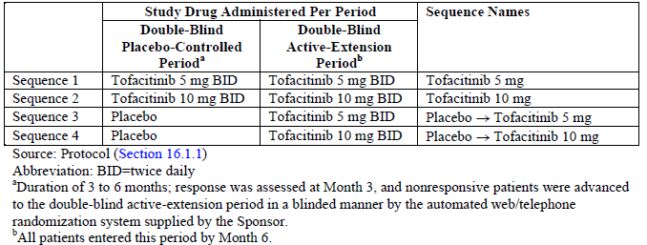
Following a screening period of up to 1 month, subjects were randomised and treated with study medication for up to 24 months in Study A3921044. In this submission, the pivotal radiographic efficacy data up to 24 months has been included and is supported by clinical efficacy measurements. In Study A3921044, plain radiographs of the hands and feet were scheduled at baseline, and Months 6, 12 and 24. In subjects deemed non-responders at Month 3, an additional set of plain X-rays were to be taken at Month 3. In Study A3921044, clinical efficacy and safety assessments were performed at baseline, Month 1 and 3, and thereafter every 3 months until Month 24.
There were 4 primary efficacy objectives of Study A3921044, one of which was the assessment of slowing the progression of structural damage (as measured by joint damage seen on sequential plain X-ray), which is the focus of this submission. The 4 primary efficacy objectives of Study A3921044 have already been evaluated in the initial TGA submission, and 3 of them have been accepted including the demonstration of TOF therapy (5 mg twice daily) when added to MTX is superior to placebo (PBO) and continued MTX in reducing the symptoms and signs of active RA at 6 months (rate of ACR20 response), improving physical function at 3 months (change from baseline in HAQ-DI) and the rate of achieving clinical remission at 6 months (DAS28-ESR < 2.6). A secondary objective of Study A3921044 was to evaluate the durability of various levels of ACR response, clinical remission (DAS28 score < 2.6) and low disease activity (DAS28 score < 3.2) with extended treatment follow-up. The persistence of clinical response to TOF treatment is presented in the 2 year dataset for Study A3921044, which is included in this submission.
Study A3921044 was conducted at 110 investigator sites in 15 countries. An additional 9 study sites received study drug but did not enrol any subjects. The USA had the most investigator sites (n = 32) followed by Japan (n = 15), South Korea and India (n = 8), Brazil and Canada (n = 7), Taiwan and Czech Republic (n = 6), Ukraine (n = 5), Columbia and Bulgaria (n = 4), Australia (n = 3), Mexico and Poland (n = 2) and Greece (n = 1). One study centre in India was prematurely closed during the trial following findings of GCP non-compliance during an internal sponsor audit. This site had screened 22 subjects, 8 of whom were randomised to treatment and 3 had discontinued prior to site closure. The efficacy data from this site was excluded from analysis but the safety data for the 8 randomised subjects was included. In addition, 1 study site in Korea had significant procedural issues, which led to its closure after 3 months of study involvement. Efficacy data from this site was also excluded from the analysis.
The first patient was enrolled into Study A3921044 in March 2009 and the last patient follow-up visit occurred in February 2012. A total of 6 protocol amendments were implemented in Study A3921044. The first amendment was instituted before the recruitment of any patients and the other 5 amendments occurred after. The amendments contained clarifications about the enrolment criteria, explanations about the efficacy and safety measures, and added descriptions to the statistical analysis plan. None of the protocol amendments resulted in major changes to the study design, which may have adversely affected the integrity of the study’s outcomes or statistical analysis.

Inclusion and exclusion criteria
To be eligible for inclusion, patients had to be at least 18 years of age with a diagnosis of RA according to the American College of Rheumatology (ACR) classification criteria for RA (functional class I-III) for at least 4 months. Subjects had to have active disease at screening and baseline as evidenced by ≥ 6 tender joints (out of a possible 68), ≥ 6 swollen joints (out of a possible 66) and at least 1 raised serum inflammatory markers (either CRP > 7 mg/L [by central laboratory] or ESR > 28 mm/hour). In addition, all subjects were required to have at least 1 of the following 3 features for qualification into Study A3921044: at least 3 documented joint erosions on plain X-ray (using local site reader), or positive serology for anti-Cyclic Citrullinated Peptide (anti-CCP) antibodies, or positive serology for RF (Rheumatoid Factor).
The eligibility criteria for Study A3921044 required subjects to have active RA despite current treatment with MTX (oral or parenteral) for a minimum of 4 months prior to randomisation. Furthermore, subjects were required to be on a stable weekly dose of MTX 15 to 25 mg for a minimum of 6 weeks prior to their first dose of study drug, although MTX doses < 15 mg/week were allowed for patients intolerant of higher MTX doses or recruited in countries where the dose of MTX would contravene local labelling recommendations. Concomitant treatment with MTX (up to 25 mg/week) was required in Study A3921044 and the co-administration of folic acid (minimum of 5 mg/week) was also required. Patients taking DMARDs other than MTX were required to cease such therapy prior to receiving study treatment. The concomitant use of NSAID therapy and oral corticosteroids (CS) was permitted for subjects taking stable doses (prednisone [or equivalent] < 10 mg/day) for at least 4 weeks prior to first dose of study medication in Study A3921044. Concomitant NSAID and CS therapy during Study A3921044 was to remain stable for the first 6 months of treatment in Study A3921044. Patients could also continue with stable doses of paracetamol (up to 2.6 g/day) and opioid (up to 30 mg/day of oral morphine or equivalent opioid). Study A3921044 allowed patients with a history of prior biologic DMARD exposure for RA to be included, as long as such therapy had not been given within 4 to 5 half-lives of first study drug administration (12 months for past rituximab exposure). However, a past history of exposure to lymphocyte depleting therapies (for example alemtuzumab) and alkylating agents (for example cyclophosphamide) was an exclusion criterion.
There were a large number (n = 25) of exclusion criteria for Study A3921044. Co-morbid conditions were an exclusion criterion based on the investigator decision as to their clinical significance (including cardiac, pulmonary, neurologic, psychiatric, substance abuse and any major uncontrolled disease). Other significant exclusion criterion included a past history of prosthetic joint infection, history of recurrent herpes zoster infection (more than 1 episode) or any disseminated herpes infection (single episode), history of any infection requiring parenteral antibiotics or hospitalisation within 6 months of randomisation, any infection requiring antimicrobial therapy within 2 weeks of first dosing, as well as a history of lymphoproliferative disease. A history of malignancy (except for excised basal and squamous cell skin cancers, or cervical carcinoma in situ successfully treated by surgery) was also an exclusion criterion. Regarding vaccination, any live vaccine administered 6 weeks prior to randomisation (or 12 months prior for BCG vaccination) was an exclusion criterion.
Subjects were screened for Hepatitis B and C, HIV as well as latent Tuberculosis (TB) at baseline. The screening for latent TB involved either a Mantoux PPD skin test or a QuantiFERON TB-Gold blood test. Subjects with active TB or a history of inadequately treated TB were excluded. All patients were required to have a chest X-ray within 12 weeks prior to screening. Subjects with any significant laboratory abnormalities at screening were also excluded. These included serum transaminases > 1.5 x Upper Limit Normal (ULN), creatinine clearance < 40 mL/min, total white blood cell count < 3.0 x 10⁹/L, neutrophil cell count < 1.2 x 10⁹/L, platelet count < 100 x 10⁹/L and haemoglobin < 9.0 g/dL.

Study treatments
Study drug was self-administered and could be taken with or without food using a twice daily posology (approximately 12 hours apart; once in the morning and once in the evening). TOF was provided as 5 mg tablets with 2 tablets to be taken on each dosing occasion to maintain treatment sequence blinding in the first 6 months (as per Table 1). All study medication was dispensed in bottles at 3 monthly intervals. Concomitant MTX (oral or parenteral) was taken once weekly as per the inclusion criteria.

Efficacy variables and outcomes
The main efficacy variables were:
- Assessment of structural joint damage using the modified Total Sharp Score (mTSS) and its component scores,
- American College of Rheumatology (ACR) clinical response criteria, and
- European League Against Rheumatism (EULAR) clinical response criteria.
The main radiographic outcome in Study A3921044 was the mean change from baseline in the mTSS. This endpoint was supported by examining the mean change from baseline in its component scores, as well as the proportion of subjects who developed no X-ray progression over time.
The mTSS (assessed using the van der Heijde 1999 modification of the Total Sharp Scoring system) is the sum of the joint space narrowing (JSN) score plus the erosion score (ES) and has a range of 0 to 448. A higher score represents greater structural damage. The JSN score has a range of 0 to 168 and is derived from evaluating 40 joints in the hands and feet, which are scored from 0 (no damage) to 4. The ES has a range of 0 to 280 and is derived from assessing 44 hand and foot joints. Each joint is scored 0 (no damage) to 5, except the metatarsophalangeal joints of the feet, which are scored 0 to 10.
All enrolled subjects in Study A3921044 were required to have X-rays taken of both hands and both feet (a single postero-anterior view of each hand, and a single dorso-plantar view of each foot) at baseline, and Months 6, 12 and 24. X-ray images of both hands and feet were obtained using a slotting approach, digitized and assessed by 2 central readers, who were blinded to the treatment group, X-ray sequence and clinical status of the subject. The statistical analysis used the mean score from the 2 readers for all analyses. Although the mTSS is the appropriate radiological scoring method, the minimum time point in which it is assessed is crucial to deciding the validity of a drug’s claim to inhibition of the rate of structural progression of RA. The pertinent EMEA document states that for agents claiming to prevent structural joint damage, it is recommended to demonstrate radiological differences of the hands and forefeet on the basis of before and after treatment comparisons taken not less than 1 year apart, but ideally 2 years, using full randomisation and pre-agreed criteria.
In Study A3921044, the plain X-rays were read in 2 distinct campaigns. Campaign 1 involved the reading of X-rays up to 12 months. For Campaign 2, data up 24 months, all X-rays (including those acquired at baseline and during the first year of study treatment) were re-read by 2 independent, blinded readers.
The primary clinical endpoints in Study A3921044 were the rate of ACR20 response, mean change over time in the HAQ-DI score and other validated composite measures of disease activity and response in RA such as the change in the Disease Activity Score 28 (DAS28) score over time. The ACR20 response rate is a validated composite endpoint recommended in the guideline “Points to Consider on Clinical Investigation of Medicinal Products other than NSAIDs for treatment of Rheumatoid Arthritis” (CPMP/EWP/556/95 rev 1/Final). The ACR20 response is considered to be the minimal clinically important threshold for determining response to an intervention in adult patients with RA. The ACR50 and ACR70 response criteria use the same data components as the ACR20, but at a corresponding higher level of response.
A patient is defined as achieving an ACR20 response if the following was fulfilled:
- A decrease of at least 20% in the number of tender joints (n = 68),
- A decrease of at least 20% in the number of swollen joints (n = 66), and
- At least a 20% improvement in 3 of the following 5 criteria: patient assessment of pain on 100mm VAS; patient global assessment of disease status (100 mm VAS); physician global assessment of disease status (100 mm VAS); Health Assessment Questionnaire –Disability Index (HAQ-DI) and serum inflammatory concentration (ESR or CRP).
The HAQ-DI is a patient reported questionnaire used to provide an assessment of the impact of the disease and its treatment on physical function. It is a validated method for measuring disability in inflammatory arthritis with a range of 0 to 3 (with a higher score indicating more functional impairment). The tool assesses the degree of difficulty experienced by the individual in 8 domains of daily living activities using 20 questions. The domains include dressing and grooming, arising, eating, walking, hygiene, reach, grip and common daily activities, with each domain (activity) consisting of 2 or 3 items. For each question, the level of difficulty is scored from 0 to 3 with 0 = “without any difficulty”, 1 = “with some difficulty”, 2 = “with much difficulty” and 3 = “unable to do”. If the maximum score equals 0 or 1, but a device related to that activity was used or help from another person was provided for the activity, then the activity score is increased to 2. However, if the activity score was already 2 and a device related to that activity was used or help from another person was provided, the score for that activity remains 2. A total score of between 0 and 3 is obtained from the mean of each activity. A change from baseline in the HAQ-DI of at least -0.22 units has been specifically defined for RA in peer-reviewed literature to be the smallest measurable reduction that is clinically significant.
The DAS28 score is a complex mathematical calculation of the 28 joint tender and swollen joint counts, ESR or CRP, and an optional general health assessment (100 mm VAS). The DAS28 score is a validated continuous scale ranging from 0 to 9.4. The level of RA disease activity can be interpreted as low if the DAS28 score is ≤ 3.2, moderate if between 3.2 and 5.1, or high if > 5.1. A DAS28 score of < 2.6 corresponds to clinical remission.

Randomisation and blinding methods
In Study A3921044, patients were randomised into treatment groups with the use of a centralised, web-based or telephone interactive system and no specific stratification methodology was applied. Subjects in the PBO arm eligible to receive rescue treatment with TOF between 3 and 6 months due to lack of efficacy were re-randomised to either TOF treatment regimen.
To protect the double blind design of Study A3921044, TOF and PBO tablets were supplied in matching bottles. Independent joint evaluators not involved with any other aspects of the studies quantified joint disease involvement, and X-rays were scored by readers who were blinded to subject treatment and X-ray film sequence.

Analysis populations
The primary analysis population for efficacy endpoints in Study A3921044 was the Full Analysis Set (FAS), which consisted of all patients randomised into the trial (n = 797 subjects) who also received at least 1 dose of study medication (n = 781 subjects). However, the actual number of patients in the FAS that were used for a specific efficacy analysis (such as the radiographic endpoint) may have been fewer than the number in the total FAS because only subjects with at least 1 post-baseline measurement were included in FAS for that particular endpoint. For the mean change from baseline in the mTSS endpoint, the actual FAS for this endpoint consisted of 708 patients: 278 patients (88.0% of 316) in the TOF 5 mg group, 291 subjects (94.2% of 309) in the TOF 10 mg arm, 71 patients (89.9% of 79) in the PBO→TOF 5 mg group and 68 patients (88.3% of 77) in the PBO→TOF 10 mg arm. Patients may have been excluded for more than 1 reason.
Of the 781 patients in the total FAS, the following events resulted in 73 subjects being excluded from the final radiographic FAS: 57 had no post-baseline data, 9 had no baseline X-rays and 62 had post-baseline data only after the 6-month assessment.

Sample size
The primary radiographic efficacy endpoint (that is the mean change from baseline to 6 months in mTSS) determined the sample size calculation for Study A3921044. The sample size estimation accounted for the specific design of the trial whereby patients randomised to PBO may have advanced to active treatment with either dose of TOF between 3 and 6 months. Using simulation, it was estimated that a total of 750 patients were required to be randomised in a 4:4:1:1 ratio (when the 2 PBO groups were combined there was an effective randomisation of 2:2:1). The recruitment of 750 subjects in total resulted in the following values of statistical power depending on different treatment effects and analysis methods (as per Table 2).

Table 2: Sample Size Determination (based on the mTSS Endpoint) in Study A3921044
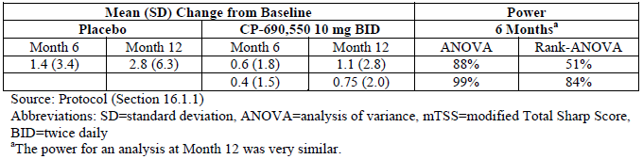

Statistical methods
The statistical analysis plan was designed to address objectives based on 4 primary efficacy endpoints. In order to preserve Type I error, each objective was assessed sequentially using a step-down approach where statistical significance can be claimed for a given endpoint only if the prior endpoint in the sequence met the requirement for significance. Additionally, as there were 2 doses of TOF within each endpoint, the gate-keeping or step-down approach was also applied, that is, the higher TOF dose (10 mg twice daily) at a given endpoint could achieve significance only if the high dose at the prior endpoint was significant; the lower TOF dose (5 mg twice daily) at a given endpoint could achieve significance only if both the higher TOF dose at the same endpoint and the lower TOF dose at the prior endpoint were significant. The sequence of primary efficacy endpoint testing was:
- Signs and symptoms as measured by ACR20 response rates at Month 6;
- Structure preservation as measured by changes from baseline in mTSS at Month 6;
- Physical function as measured by change from baseline in HAQ-DI at Month 3; and
- Incidence of patients achieving DAS28 (ESR) < 2.6 at Month 6.
Descriptive statistics of the mTSS, ES and JSN Scores were presented at baseline, Month 12 and Month 24, along with changes from baseline and changes from Month 12 to 24. As a sensitivity check, missing values for patients who received at least 1 dose of TOF were imputed, allowing for a more complete set of data for the radiographic scores. A linear extrapolation (LEP) approach was used to impute missing data at the baseline, 6, 12 and 24 month time points for the structure data. The LEP approach for the 2 year dataset differed from the LEP method used in the primary radiographic endpoint analysis (at Month 6). For the extended radiographic dataset, extrapolation considered only the X-ray values at baseline, and Months 12 and 24. If the patient was missing a value at 1 of the visits, the values at the other 2 visits were used to impute the missing value. For example, a missing Month 24 value was extrapolated from the baseline and Month 12 score. For the mTSS endpoint at 6 months, patients who were advanced at Month 3 had their 6 month value calculated using LEP from the X-rays taken at baseline and Month 3. For the Month 12 assessment, comparisons to PBO were done by linearly extrapolating a 12 month value based on the baseline and Month 6 scores. All Sharp Score-related variables (mTSS, ES and JSN scores) were imputed using this method.
Binary variables (that is rates of patients with no progression in mTSS and rates of patients with no progression in mean ES) were analysed using normal approximation to the binomial. In analyses, patients were grouped to the treatment group that they were treated with after advancement. For example, the PBO→TOF 5 mg sequence patients were counted as receiving TOF 5 mg at Month 12 and 24. The statistical analysis plan implicitly required that subjects have at least 1 post-baseline measurement in order to be included in the FAS dataset for that efficacy measure.

Participant flow
In Study A3921044, a total of 1291 subjects were screened for involvement and 800 patients were randomised to study treatment, with 797 subjects receiving at least 1 dose of study medication. Three patients in the TOF 10 mg group were randomised but not treated. Table 3 summarises patient disposition in Study A3921044 by treatment group and sequence.

Table 3: Participant Flow in Study A3921044 by Treatment Group and Sequence
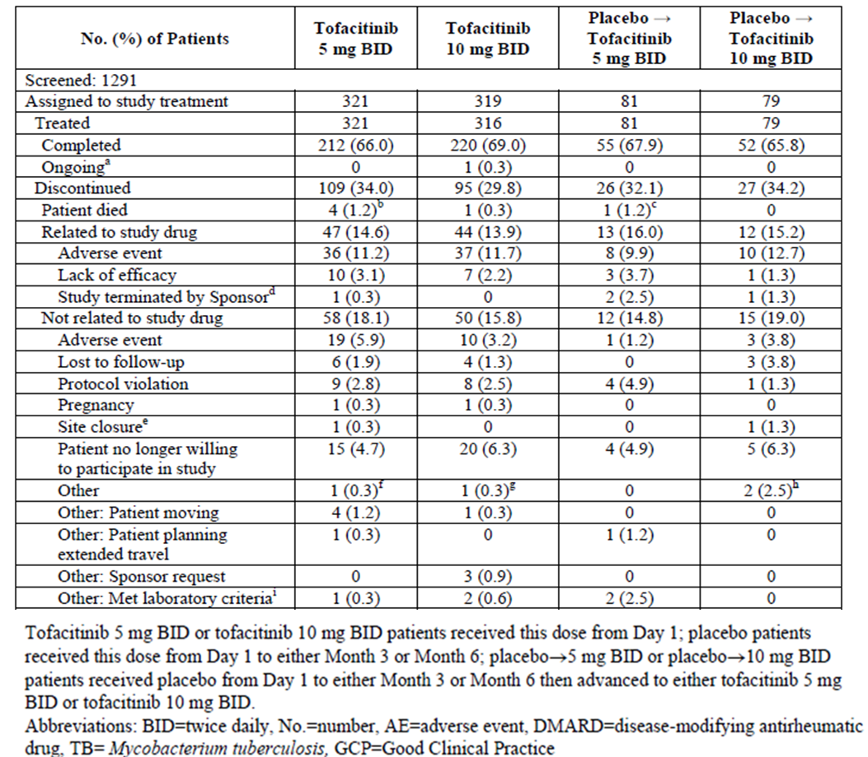
Overall, 67.6% (539/797) of patients completed 2 years of treatment in Study A3921044 in similar proportions in each TOF treatment group and sequence. A total of 257 subjects (32.2% of 797) discontinued from the trial, which included 124 patients (15.6% of 797) withdrawing due to adverse events (91 of these patients had AEs considered to be treatment related and 33 had AEs considered not to be treatment related).
Table 4 provides a summary of patients with available efficacy data (based on the ACR20 assessment) by visit throughout Study A3921044. Approximately 80% of patients in each of the 4 treatment sequences provided efficacy data at 12 months and about two thirds of patients in each treatment sequence had available efficacy data through to 24 months of treatment in Study A3921004. At 3 months, 51.9% (42/81) of patients in the PBO→TOF 5 mg sequence were advanced from PBO to TOF and 46.8% (37/79) of subjects in the PBO→TOF 10 mg sequence were advanced from PBO to TOF. Also at 3 months, 26.2% (84/321) of patients in the TOF 5 mg sequence and 17.7% (56/316) of subjects in the TOF 10 mg sequence were considered as treatment non-responders and advanced in a blinded fashion to continuing TOF therapy.

Table 4: Subjects with Efficacy Data by Visit (based on ACR20 dataset) in Study A3921044
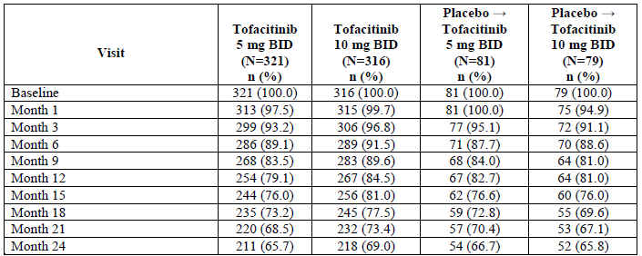

Major protocol violations/deviations
A total of 45 patients were excluded from the Per-Protocol (PP) efficacy analysis cohort because of protocol violations that were considered to have potentially affected their results. The subjects affected by major protocol deviations were determined before the randomisation blind was broken. Major protocol deviations were recorded in 23 patients in the TOF 10 mg group, 17 subjects in the TOF 5 mg arm, 4 patients in the PBO→TOF 5 mg group and 1 subject in the PBO→TOF 10 mg arm. In addition, 67 subjects were recorded as taking prohibited concomitant medications during the trial, which were determined to be clinically important.

Baseline data
The majority of the treated patients in Study A3921044 were female (85.1%; 678/797) and the most frequent races recorded were White (46.2%; 368/797) and Asian (42.4%; 338/797). The 4 treatment groups were well balanced with respect to demographic characteristics. Across the 4 treatment groups, the mean age of patients ranged from 52.0 years to 53.7 years (overall age range 18 to 82 years). The majority of recruited subjects were aged between 45 and 64 years (64.9%; 517/797) with a small percentage of subjects aged ≥ 65 years (13.7%; 109/797). The mean weight across the 4 treatment sequences ranged from 65.6 kg to 70.3 kg (overall range: 36.2 to 159.2 kg). By geographic region (using the ACR20 dataset at 1 month), the largest percentage of patients came from the Asia-Pacific region (43.8%; 338/771) followed by North America (22.8%; 176/771), Europe (21.5%; 166/771) and South America (11.8%; 91/771).
The treatment groups were similar with respect to baseline RA disease characteristics. Across the 4 treatment sequences, the mean duration of RA was 8.8-9.5 years (range: 0.3-43.5 years). In Study A3921044, all patients were to have moderately to severely active RA with joint erosions or positive RF or positive anti-CCP antibodies at enrolment. These characteristics were meant to enrich the study population for they are associated with high risk of structural damage. The majority of patients were seropositive for RA at baseline (76.6% [597/779] were positive for RF and 84.8% [674/795] were positive for anti-CCP antibodies). It was unclear what proportion of subjects met the inclusion criterion of radiographic erosion present at baseline.
In terms of RA clinical disease activity at baseline, the mean numbers of tender and swollen joints were similar for the PBO (23.0 and 14.2, respectively), TOF 5 mg (24.1 and 14.1, respectively) and TOF 10 mg groups (23.0 and 14.4, respectively). All 4-treatment groups recorded mean DAS28-CRP scores that were high at baseline (5.14-5.22). The mean HAQ-DI scores were also high at baseline (approximately 1.40) in each treatment group. The mean CRP for subjects in the PBO arms was slightly lower at 12.2-15.3 mg/L compared to the 2 TOF treatment groups (15.5-17.0 mg/L). Overall, the clinical measures of baseline disease activity are consistent with severely active RA. The mean baseline mTSS were similar in the 2 PBO and TOF 5 mg treatment groups (32.6, 36.6 and 33.8, respectively) but somewhat higher and indicating more X-ray damage at baseline in the TOF 10 mg arm at 38.8. For patients with a mean duration of approximately 9 years, the mean baseline mTSS results indicate significant established structural damage in the treatment cohort, which is numerically higher than expectations for patients residing in developed countries like Australia.
All patients had received at least 1 DMARD prior to enrolling into Study A3921044. As per the trial protocol, all but 1 patient (randomised into the TOF 10 mg group) were treated with a stable dose of MTX prior to and during Study A3921044 (n = 797 subjects). The patient who did not take MTX prior to screening received hydroxychloroquine (HCQ) as their prior DMARD therapy. This subject was excluded from the PP analysis because the study site was closed for GCP non-compliance. Another 2 subjects were also excluded from the PP analysis as they continued to receive HCQ as a prohibited concomitant treatment during the trial. A significant deficiency of the submission is that it did not contain information about the dose and duration of preceding MTX use, as well as any information regarding the dose, persistence and route of concomitant MTX use during the trial.
In addition to MTX use before screening, 62.0% (494/797) of all patients had a recorded history of taking other conventional DMARD therapy, 15.9% (127/797) had taken anti-TNF drugs (mainly, etanercept, infliximab or adalimumab) and 4.6% (37/797) of subjects had received biologic DMARD (mainly, abatacept or tocilizumab) other than TNF inhibitors before screening. The 3 most common, non-biologic DMARDs previously used were HCQ (30.1%; 240/797), sulfasalazine (28.6%; 228/797) and leflunomide (17.1%; 136/797).
At baseline, the majority of subjects in each treatment group had received prior treatment with systemic CS: 55.0% (88/160) patients in the 2 PBO groups, 65.1% (209/321) of subjects in the TOF 5 mg arm and 63.6% (201/316) of patients in the TOF 10 mg group. During the trial, 65.0% (104/160) of patients in the 2 PBO arms, 69.5% (223/321) of subjects in the TOF 5 mg group and 68.0% (215/316) of patients in the TOF 10 mg arm received treatment with systemic CS, nearly all as oral preparations. At baseline, 81.3% (130/160) of patients in the 2 PBO groups, 77.9% (250/321) of subjects in the TOF 5 mg arm and 76.9% (243/316) of patients in the TOF 10 mg group had received prior treatment with NSAID. During the study, 10 to 15% of patients in each treatment group were newly treated with NSAID.
The incidence of relevant co-morbid conditions was similar in the 2 TOF treatment groups. Regarding risk factors for cardiovascular disease, a past history of hypertension was recorded in 30.8% of TOF randomised subjects (196/637), 5.2% (33/637) reported hyperlipidaemia, 3.6% (23/637) recorded diabetes mellitus and 0.6% (4/637) had an established history of coronary artery disease. During Study A3921044, 9.4% (15/160) of patients in the 2 PBO groups, 9.3% (30/321) of subjects in the TOF 5 mg arm and 15.5% (49/316) of patients in the TOF 10 mg group were treated with concomitant lipid lowering therapy, mostly statin drugs.
A total of 104 patients were treated with isoniazid during Study A3921044. Of these 104 patients, 83 had a documented diagnosis of TB (including 27 subjects with a diagnosis of TB documented in the medical history case report form [CRF] and 56 with a diagnosis documented on the screening TB CRF). Another 21 enrolled patients were presumed to have latent TB including 8 subjects with a positive or indeterminate PPD or QuantiFERON Gold test, or the testing was not conducted; and 13 had a negative PPD or QFT on screening but were considered to be at significant risk of TB reactivation. However, another 4 patients had a medical history of TB and were not given isoniazid during the trial. As per protocol, no patient with active TB was enrolled into Study A3921044.

Results for the radiographic efficacy outcome

Mean change from baseline in mTSS
At baseline, the LS mean mTSS values were 31.26, 31.03 and 35.86 in the PBO (n = 139 subjects), TOF 5 mg (n = 287 subjects) and TOF 10 mg groups (n = 298 subjects), respectively. Treatment with TOF (5 mg or 10 mg) resulted in numerically less progression from baseline in the LS mean changes in mTSS scores compared to PBO extrapolated at Months 6, 12 and 24, but this did not reach statistical significance (p-value > 0.05) for any pair-wise comparison between active treatment with TOF (either dose) and PBO, and the 95% Confidence Intervals (CI) crossed zero for each pair-wise comparison; refer to Table 5. The sponsor asserts that the use of a significant amount of extrapolated X-ray data for the control group (as early as 3 months for non-responding patients and after Month 6 for all subjects randomised to PBO) diluted the results of the X-ray dataset, which is a reasonable assumption.

Table 5: Change from baseline in modified total sharp scores at months 6, 12 and 24 in Study A3921044 (using the 2 year FAS dataset with LEP imputation)
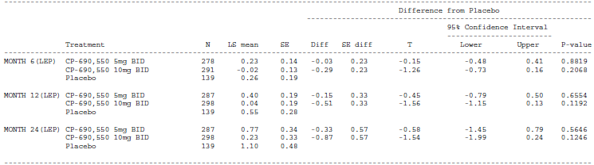
To assess the impact of extrapolation, the sponsor has provided 2 additional post-hoc analyses in this submission, which focussed on the primary radiographic endpoint of Study A3921044 (LS mean change from baseline in mTSS at 6 months). The first sensitivity analysis used the observed data for TOF and PBO treated subjects. Missing values at Month 6 were only extrapolated from 3 months for PBO treated subjects who advanced to TOF due to inadequate response. The second post-hoc sensitivity analysis was a random coefficients model that utilised all observed data between Months 3 and 12. PBO treated subjects who advanced to TOF were set to missing after advancement. This model used all observed data to estimate an average rate of change, which was then used to compute the Month 6 changes from baseline. As displayed in Table 6, both of these sensitivity analyses showed a statistically significant reduction in the LS mean change from baseline to 6 months in mTSS (ranging from -0.33 to – 0.42 treatment related difference) for both doses of TOF in comparison to PBO.

Table 6: Sensitivity analyses of ls mean change from baseline to month 6 in mTSS in study A3921044 (Campaign 1 data)
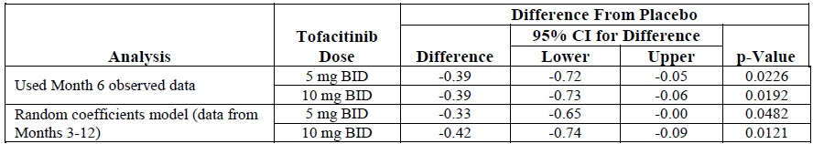
Another series of sensitivity analyses aimed to exclude the effect of data anomalies such as large changes from baseline values at the extremes of the distribution (upper 20% of values). In general, the largest changes were seen in subjects in the PBO group, but the 2 subjects with the largest mean changes from baseline in mTSS at 6 months were recorded in the TOF 5 mg group. The sponsor provided a pre-specified rank analysis and a post-hoc trimmed analysis to reduce the effect of large change values on the overall dataset. The rank analysis showed a statistically significant LS mean change from baseline to 6 months in mTSS for TOF 5 mg versus PBO (p = 0.0237), but not for TOF 10 mg versus PBO (p = 0.1978). The trimmed analysis showed a -0.37 LS mean difference at 6 months for both doses of TOF versus PBO, which were statistically significant (p-value < 0.03).
In this submission, the sponsor has also provided a post-hoc analysis of the Campaign 1 X-ray data acquired in the second line treatment population (that is subjects who were inadequate responder to or intolerant of conventional DMARD, but not an inadequate responder to or intolerant of biologic therapy). The majority of patients in each of the 3 treatment groups met the definition of second line therapy: 87.5% (281/321) of subjects in the TOF 5 mg group, 89.0% (284/319) of patients in the TOF 10 mg arm and 95.0% (152/160) of subjects in the control group. The remainder of subjects enrolled in Study A3921044 were deemed to be a third line treatment population (that is inadequate responders to or intolerant of biologic DMARD). Using the second line treatment population (and LEP), the LS mean change from baseline to Months 6 and 12 were statistically less (better) for both TOF dose groups versus PBO; refer to Table 7.

Table 7: LS Mean change from baseline in mTSS at months 6 and 12 in the second line treatment population of study A3921044 (using Campaign 1 Data with LEP)
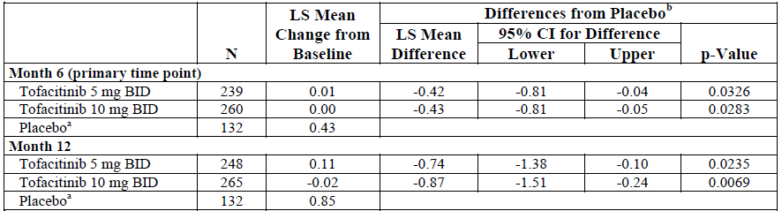
In this submission, the sponsor has also included a subset analysis of the at-risk population for structural progression. This treatment response enriched population had poor prognostic factors at baseline associated with progressive structural joint damage including established joint damage (3 or more erosions at baseline), elevated CRP (> 7 mg/L) and presence of RA autoantibodies (CCP and/or RF). Expectedly, patients treated with PBO (n = 139 subjects) had greater LS mean increases from baseline in mTSS at 6 months (increase of 0.47 sharp units) and 12 months (increase of 0.92 sharp units) compared to TOF 5 mg twice daily (n = 277-286 subjects; increase of 0.12 sharp units at 6 months and increase of 0.29 sharp units at 12 months) and TOF 10 mg twice daily (n = 290-295 subjects; increase of 0.06 sharp units at 6 months and increase of 0.05 sharp units at 12 months). Each of the pair-wise comparisons of each TOF dose versus PBO at 6 and 12 months for the LS mean change from baseline in mTSS in the at-risk population were statistically significant, apart from TOF 5 mg therapy versus control at 6 months for the high risk population of DAS28 [ESR] score > 5.1 at baseline (p = 0.0975). Pair-wise treatment comparisons also examined the LS mean change from baseline at 6 months with increasing CRP strata levels at baseline (> 3, > 7, > 10 and > 15 mg/L) and showed there were greater differences between TOF and PBO.

Mean change from baseline in JSN score
At baseline, the mean JSN scores were 19.89, 18.34 and 20.43 in the PBO, TOF 5 mg and TOF 10 mg groups, respectively. The mean changes (increases) from baseline in JSN scores were numerically lower, but none statistically significant for both doses of TOF (5 mg and 10 mg) at 6, 12 and 24 months versus the extrapolated PBO group; refer to Table 8.

Table 8: Change from baseline in JSN scores at baseline, month 3, 6, 12 and 24 in study A3921044 (using the 2 year FAS dataset with LEP imputation)
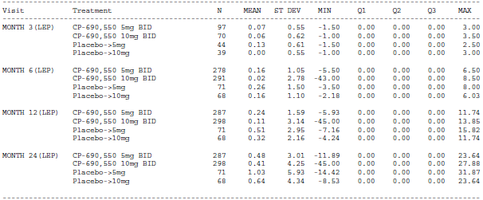

Mean change from baseline in erosion score
At baseline, the mean ES values were 14.8, 15.4 and 18.4 in the PBO, TOF 5 mg and TOF 10 mg groups, respectively. The mean rates of progression in ES at Months 6, 12 and 24 were similar for the TOF 5 mg and extrapolated PBO groups, with a modest (non-statistically significant) improvement from baseline in the TOF 10 mg group – refer to Table 9. The sponsor asserts that there was minimal change in mean ES in Campaign 2 for all 3 treatment groups and this may have diluted the beneficial treatment effect of TOF for the development of joint erosions.

Table 9: Change from baseline in erosion scores at baseline, month 3, 6, 12 and 24 in study A3921044 (using the 2 year FAS dataset with LEP imputation)
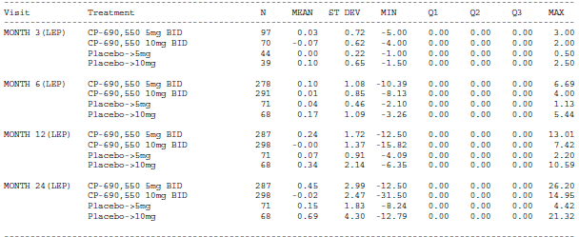

Proportion of patients with no x-ray progression (mTSS and ES)
No X-ray progression was defined as ≤ 0.5 unit increase from baseline in the relevant X-ray variable. As summarised in Table 10, both TOF treatment groups had similar percentages of patients with no progression in mTSS at 12 and 24 months from baseline (using the FAS dataset and LEP). However, neither dose of TOF was statistically superior to the extrapolated PBO group for this outcome.

Table 10: Rates of no progression in mTSS at 12 and 24 months in study A3921044
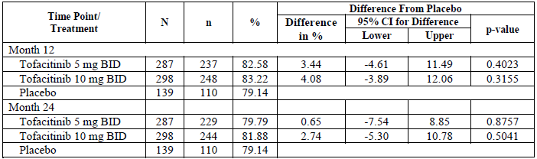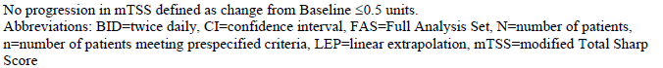
The same finding was observed for the incidence of subjects with no progression in ES. At 12 months, the incidence of no ES progression was 89.9% (258/287) in the TOF 5 mg group, 92.95% (277/298) in the TOF 10 mg arm and 87.8% (122/139) in the extrapolated PBO group. At 24 months, the incidence of no ES progression was 86.7% (249/287) in the TOF 5 mg group, 89.9% (268/298) in the TOF 10 mg arm and 87.8% (122/139) in the extrapolated PBO group.

Results for other efficacy outcomes
The 2 year clinical efficacy results (ACR response rates and the mean changes from baseline in the HAQ-DI scores) for Study A3921044 have already been evaluated in detail in the initial TGA registration submission, and the key information is included in the current approved PI. As such, the clinical response data up to 2 years in Study A3921044 will not be presented again in this report.

Evaluator commentary
Study A3921044 was principally designed to evaluate the claim of inhibition of structural damage, however, the primary X-ray endpoint (LS mean change from baseline to 6 months in mTSS) did not demonstrate a statistical benefit with TOF 5 mg twice daily therapy versus PBO (p = 0.0792 for treatment difference), and was marginal for the non-approved higher TOF dose of 10 mg twice daily versus PBO. When designing Study A3921044, the predicted mean rate of X-ray progression for subjects receiving background MTX was anticipated to be 2.6-2.8 sharp units per year, which was based on published data available at the time in MTX-inadequate response populations. However, in Study A3921044, the control group progression rates were only 0.92 sharp units per year and the percentage of subjects with X-ray progression (change in mTSS at 1 year of > 0.5 units) at Month 12 (Campaign 1) was low at 26%. Because the magnitude of progression in the control group in Study A3921044 was substantially less than anticipated, the ability to demonstrate treatment related differences (TOF versus control) was limited. The sponsor asserts that low rates of structural damage progression, the short treatment period before treatment advancement was required (3 or 6 months), and the large proportion of PBO-treated subjects advancing at the Month 3 time point may have resulted in the analyses being more sensitive to data anomalies such as large change from baseline values at the extremes of the distribution of change scores or to the effects of extrapolation. In this submission, the sponsor has provided additional post hoc sensitivity analyses designed to account for the potential impact of these factors, which in general suggest a statistically significant X-ray benefit with TOF versus control treatment. The results of additional post hoc analyses in subsets of subjects recognised to be at greater risk for radiographic progression (for example autoantibody positive subjects with high CRP values and joint erosions at baseline) also demonstrated significant LS mean reductions in mTSS from baseline to Month 6 for both doses of TOF compared with PBO.
Statistically significant benefits in mTSS were also observed in the subset of second line treatment subjects, which is the current eligible treatment population for TOF in Australia.
One of the limitations of the radiographic dataset is the lack of an active comparator arm over an extended period of follow-up, which may have assisted in confirming that active treatment with TOF reliably inhibits structural progression in RA.
In summary, when the 6 and 12 month X-ray dataset for Study A3921044 (Campaign 1) had analyses applied to the data that reduced the effect of extrapolation and utilised more observed (non-extrapolated) data than in the primary analysis, statistically significant reductions in structural damage progression for both TOF doses were observed compared to PBO. However, many of these sensitivity and secondary analyses were post hoc in nature and their utility is guarded with respect to supporting a scientifically robust conclusion.

Study A3921069

Study design, objectives, locations and dates
Study A3921069 was a Phase III, randomised, double blind, parallel group trial of 2 years duration in adult subjects with active RA who were MTX naïve (≤ 3 prior weekly doses). Enrolled subjects were randomised in a 2:2:1 ratio to 1 of 3 parallel treatment sequences: TOF 5 mg twice daily, TOF 10 mg twice daily or up-titrated oral MTX therapy (10 to 20 mg/week). The MTX control group in Study A3921069 was maintained throughout the entire 2 year period of the trial and there was no design for early escape to rescue treatment with TOF. The up-titration schedule for the MTX arm was 10 mg once weekly for 4 weeks; and if well tolerated, then 15 mg/week for 4 weeks; and if well tolerated, then 20 mg/week thereafter. One MTX dose reduction of 5 mg/week was allowed for intolerance. Division of the weekly MTX dose into 2 to 3 fractions (taken 12 hours apart) was permitted after the Month 2 visit for drug intolerance.
Following a screening period of up to 28 days, subjects were randomised and treated with study medication for up to 24 months in Study A3921069. In this submission, the pivotal radiographic efficacy data up to 24 months has been included and is supported by clinical efficacy measurements. In Study A3921069, plain radiographs of the hands and feet were scheduled at baseline, and Months 6, 12 and 24. Clinical efficacy and safety assessments were performed at baseline, Month 1 and 3, and thereafter every 3 months until Month 24.
There were 2 primary efficacy objectives of Study A3921069, one of which was the assessment of slowing the progression of structural damage (as measured by joint damage seen on sequential plain X-ray), which is the focus of this submission. The other primary efficacy objective of Study A3921069 was the ACR70 response rate at 6 months and this has already been evaluated in the initial TGA submission. A secondary objective of Study A3921069 was to evaluate the durability of various levels of ACR response, clinical remission (DAS28 score < 2.6) and low disease activity (DAS28 score < 3.2) with extended treatment follow-up. The persistence of clinical response to TOF treatment is presented in the 2 year dataset for Study A3921069, which is included in this submission.
Study A3921069 was conducted at 160 investigator sites in 30 countries. Of these, 8 study sites received study drug but did not enrol any subjects. The USA had the most investigator sites (n = 28) followed by Russia (n = 12), Germany (n = 8) and India (n = 7). There were 3 study sites in Australia and 6 in New Zealand (including 4 active). The sponsor due to non-compliance issues with GCP closed one study centre in the Philippines, but this was only identified after the study was completed. The efficacy data from this site was excluded for the primary endpoints, but analysis with or without that data showed minimal effect on the overall efficacy data.
The first patient was enrolled into Study A3921069 in January 2010 and the last patient follow-up visit occurred in March 2013. A total of 5 global and 3 country specific protocol amendments were implemented in Study A3921069. The first amendment was instituted before the recruitment of any patients and the other amendments occurred after. The amendments contained clarifications about the enrolment criteria, explanations about the efficacy and safety measures, and added descriptions to the statistical analysis plan. None of the protocol amendments resulted in major changes to the study design, which may have adversely affected the integrity of the study’s outcomes or statistical analysis.

Inclusion and exclusion criteria
The inclusion and exclusion criteria for Study A3921069 were highly similar to that of Study A3921044. To be eligible for inclusion, patients had to be at least 18 years of age with a diagnosis of RA according to the ACR classification criteria for RA (functional class I-III) with no minimal or maximal duration of diagnosis specified in the protocol. Subjects had to have active disease at screening and baseline as evidenced by ≥ 6 tender joints (out of a possible 68), ≥ 6 swollen joints (out of a possible 66) and at least 1 raised serum inflammatory markers (either CRP > 7 mg/L [by central laboratory] or ESR > 28 mm/hour). In addition, all subjects were required to have at least 1 of the following 3 features for qualification into Study A3921069: at least 3 documented joint erosions on plain X-ray (using local site reader), or positive serology for anti-CCP antibodies, or positive serology for RF.
The eligibility criteria for Study A3921069 required subjects to be either naïve to MTX or have a history of minimal exposure to MTX (≤ 3 prior weekly doses and not ceased due to AEs). Patients were allowed to have a history of exposure to conventional DMARD therapy other than MTX (including sulfasalazine, leflunomide and antimalarial medicines). Concomitant treatment with anti-malarial drugs was allowed in Study A3921069, but all other conventional or biological DMARD use was prohibited. Patients taking DMARDs other than MTX were required to cease such therapy prior to receiving study treatment. The concomitant use of NSAID and oral CS was permitted for subjects taking stable doses (prednisone [or equivalent] < 10 mg/day) for at least 4 weeks prior to first dose of study medication in Study A3921069. Concomitant NSAID and CS therapy during Study A3921069 was to remain stable for the first 6 months of treatment. Patients could also continue with stable doses of paracetamol (up to 2.6 g/day) and opioid (up to 30 mg/day of oral morphine or equivalent opioid). Study A3921069 did not allow patients with a history of prior biologic DMARD exposure for RA to be included unless discussed with the medical monitor and appropriate drug washout periods were undertaken.
There were a large number (n = 27) of exclusion criteria for Study A3921069, which were highly similar to that for Study A3921044. Co-morbid conditions were an exclusion criterion based on the investigator decision as to their clinical significance (including cardiac, pulmonary, neurologic, psychiatric, substance abuse and any major uncontrolled disease). Other significant exclusion criterion included a past history of prosthetic joint infection, history of recurrent herpes zoster infection (more than 1 episode) or any disseminated herpes infection (single episode), history of any infection requiring parenteral antibiotics or hospitalisation within 6 months of randomisation, any infection requiring antimicrobial therapy within 2 weeks of first dosing, as well as a history of lymphoproliferative disease. A history of malignancy (except for excised basal and squamous cell skin cancers, or cervical carcinoma in situ successfully treated by surgery) was also an exclusion criterion. Regarding vaccination, any live vaccine administered 6 weeks prior to randomisation (or 12 months prior for BCG vaccination) was an exclusion criterion.
Subjects were screened for Hepatitis B and C, HIV as well as latent Tuberculosis (TB) at baseline. The screening for latent TB involved either a Mantoux PPD skin test or a QuantiFERON TB-Gold blood test. Subjects with active TB or a history of inadequately treated TB were excluded. All patients were required to have a chest X-ray within 12 weeks prior to screening. Subjects with any significant laboratory abnormalities at screening were also excluded. These included serum transaminases > 1.5 x ULN, creatinine clearance < 60 mL/min, total white blood cell count < 3.0 x 10⁹/L, neutrophil cell count < 1.2 x 10⁹/L, platelet count < 100 x 10⁹/L and haemoglobin < 9.0 g/dL.

Study treatments
The sponsor provided TOF 5 mg tablets and PBO tablets. Each subject was instructed to take 1 tablet from each bottle twice daily. The blinded assignment consisted of 1 active 5 mg tablet and 1 PBO tablet for the 5 mg dose arm; or 2 active 5 mg tablets for the TOF 10 mg dose arm or 2 PBO tablets for the MTX arm. Tablets were supplied in bottles as appropriate for the treatment arm to which the patient was randomised. Study drug was self-administered and could be taken with or without food using a twice daily posology (approximately 12 hours apart; once in the morning and once in the evening).
The sponsor also provided MTX as 2.5 mg capsules and identical PBO capsules in blister packs during the titration phase of the study, and then as bottles as appropriate for the treatment arm to which the patient was randomised for the remainder of the trial. Patients were instructed to take the number of active/PBO capsules weekly from the bottle corresponding to their assignment. The sponsor did not provide folic acid or folinic acid for the folate supplementation, but did reimburse for it to be sourced locally.

Efficacy variables and outcomes
Study A3921069 pre-specified 4 secondary efficacy endpoints of interest with respect to the evaluation of joint structural preservation including:
- Actual and percentage change (mean values) from baseline in mTSS at 12 and 24 months,
- Actual and percentage change (mean values) from baseline in the 2 individual components of the mTSS (ES and JSN score) at 6, 12 and 24 months,
- The rate of no progression in mTSS change from baseline (defined as a change from baseline in mTSS of ≤0.5 Sharp units), and
- The rate of “no new erosions” (defines as a change from baseline in the ES of ≤ 0.5 units).
All enrolled subjects in Study A3921069 were required to have X-rays taken of both hands and both feet (a single postero-anterior view of each hand, and a single dorso-plantar view of each foot) at baseline, and Months 6, 12 and 24. X-ray images of both hands and feet were obtained using a slotting approach, digitized and assessed by 2 central readers, who were blinded to the treatment group, X-ray sequence and clinical status of the subject. The statistical analysis used the mean score from the 2 readers for all analyses. In Study A3921069, plain X-rays of the joints were read in 2 distinct campaigns. Campaign 1 involved the reading of X-rays up to 12 months. For Campaign 2, that is the data up 24 months, all X-rays (including those acquired at baseline and during the first year of study treatment) were re-read by 2 independent, blinded readers.
In support of the claim of maintenance of clinical efficacy over 24 months of treatment, Study A3921069 collected ACR20/50/70 response rates, mean changes (improvement) from baseline in HAQ-DI scores as well as DAS28 response rates (scores of < 2.6 and ≤ 3.2) at all scheduled time points (Months 1, 2, 3, 6, 9, 12, 15, 18, 21 and 24) as a pre-specified secondary objective of the trial. In addition, the incidence of major clinical response (defined as a maintaining ACR70 response for at least 6 consecutive months) was examined as a secondary objective. In the hypothesis testing for each of these clinical efficacy outcomes, both doses of TOF were individually compared to MTX for superiority, but there was no pair-wise assessment of the 2 TOF dose regimens.

Randomisation and blinding methods
In Study A3921069, patients were randomised into treatment groups with the use of a centralised, web-based or telephone interactive system and no specific stratification methodology was applied. To protect the double blind design of Study A3921069, all study medication was supplied in matching packaging. Independent joint evaluators not involved with any other aspects of the studies quantified joint disease involvement, and X-rays were scored by readers who were blinded to subject treatment and X-ray film sequence.

Analysis populations
The primary analysis population for efficacy endpoints in Study A3921069 was the FAS cohort, which consisted of all patients randomised into the trial (n = 958 subjects) who also received at least 1 dose of study medication (n = 956 subjects). However, the actual number of patients in the FAS that were used for a specific efficacy analysis (such as the radiographic endpoint) may have been fewer than the number in the total FAS because only subjects with at least 1 post-baseline measurement were included in FAS for that particular endpoint. For the mean change from baseline in the mTSS endpoint at 2 years, the actual FAS consisted of 892 patients: 348 patients (93.3% of 373) in the TOF 5 mg group, 373 subjects (94.0% of 397) in the TOF 10 mg arm and 171 patients (92.0% of 186) in the MTX arm.

Sample size
The primary radiographic efficacy endpoint (that is the mean change from baseline to 6 months in mTSS) determined the sample size calculation for Study A3921069. With an unequal randomisation ratio of 2:2:1, it was estimated that a total of 900 patients were required in Study A3921069 (360 subjects in each TOF group and 180 patients in the MTX arm). This sample size provided 90% power for the primary radiographic endpoint, assuming a mean difference in mTSS between TOF and MTX of at least 0.9 sharp units (with a standard deviation of 2.8). For the rate of ACR70 at 6 months, the given sample size yielded over 90% power assuming a treatment related difference in response rate of at least 15% (with the MTX response being 20%).

Statistical methods
The 2 primary endpoints of Study A3921069 (mean change from baseline in the mTSS and the rate of ACR70 response at 6 months) were analysed for both dose groups of TOF and the MTX group. Both of these analyses were based on the FAS. For the mean change from baseline in the mTSS at 6 months, an ANCOVA model was used. Missing values were imputed by LEP. The mean change from baseline to 12 and 24 months was analysed using the same method as the analysis for the change of mTSS from baseline to Month 6. Robustness analyses were applied as well. The 2 individual components of mTSS (ES and JSN score) were analysed in the same way as the mTSS. The binary X-ray outcomes such as progression or no X-ray progression were also derived from the linearly extrapolated imputation data. The statistical analysis plan implicitly required that subjects have at least 1 post-baseline measurement in order to be included in the FAS dataset for that efficacy measure. For the rate of ACR70 response at 6 months, the normal approximation for the difference in binomial proportions was used. Non-Responder Imputation (NRI) was used for the handling of missing clinical efficacy data.
In order to preserve Type I error in the dataset, the statistical analysis plan pre-specified sequentially using a step-down approach where statistical significance can be claimed for a given endpoint only if the prior endpoint in the sequence met the requirement for significance. Additionally, as there were 2 doses of TOF within each endpoint, the gate-keeping or step-down approach was also applied, that is, the higher TOF dose (10 mg twice daily) at a given endpoint could achieve significance only if the high dose at the prior endpoint was significant; the lower TOF dose (5 mg twice daily) at a given endpoint could achieve significance only if both the higher TOF dose at the same endpoint and the lower TOF dose at the prior endpoint were significant.

Participant flow
In Study A3921069, a total of 1543 subjects were screened for involvement and 958 patients were randomised to study treatment, with 956 subjects receiving at least 1 dose of study medication. Two patients in the TOF 10 mg group were randomised but not treated. Table 11 summarises patient disposition in Study A3921069 by treatment group and sequence.

Table 11: Participant Flow in Study A3921069 (2 Year Dataset)
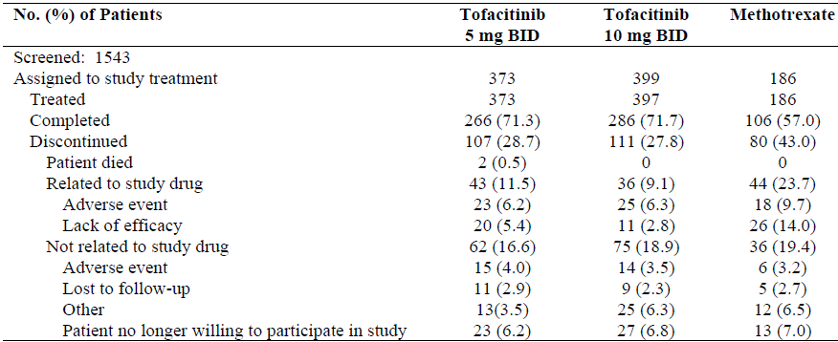
A higher proportion of subjects in each TOF treatment group (71.3% [266/373] in the TOF 5 mg group and 71.7% [286/397] in the TOF 10 mg arm) completed 2 years of treatment in Study A3921069 compared to those in the MTX treatment group (57.0%; 106/186). A total of 298 subjects (31.2% of 956) discontinued from the trial, which included 101 patients (10.6% of 956) withdrawing due to adverse events (66 of these patients had AEs considered to be treatment related and 35 had AEs considered not to be treatment related). There was a higher rate of discontinuation due to lack of efficacy in patients treated with MTX (14.0%; 26/186) compared to TOF. At 2 years, the higher dose of TOF recorded the lowest rate of discontinuation due to lack of efficacy (2.8% [11/397] for 10 mg twice daily versus 5.4% [20/373] in the 5 mg twice daily arm).

Major protocol violations/deviations
A total of 55 patients were excluded from the Per-Protocol (PP) efficacy analysis cohort because of protocol violations that were considered to have potentially affected their results. Major protocol deviations were recorded in 29 patients in the TOF 10 mg group, 17 subjects in the TOF 5 mg arm and 9 subjects in the MTX group. The main reason these subjects were excluded from the PP dataset is that they were recorded as taking prohibited concomitant medications during the trial (such as non-permitted DMARD, NSAID, analgesia and/or CS drug use outside protocol allowances), which were determined to be clinically important.

Baseline data
The 3 treatment groups were well balanced with respect to demographic characteristics. The majority of the treated patients in Study A3921069 were female (79.3%; 758/956) and the most frequent races recorded were White (66.1%; 632/956) and Asian (17.2%; 164/956). Across the 3 treatment groups, the mean age of patients ranged from 48.8 years in the MTX group to 50.3 years in the TOF 5 mg arm (overall age range 18 to 83 years). The majority of recruited subjects were aged between 45 and 64 years (57.8%; 553/956) with a small percentage of subjects aged ≥ 65 years (10.8%; 103/956). The mean weight across the 3 treatment sequences ranged from 70.6 kg to 71.3 kg (overall range: 31.4 to 183.2 kg). By geographic region, the largest percentage of patients came from Europe (40.8%; 390/956) followed by North America (23.0%; 220/956), Asia-Pacific region (19.5%; 186/956) and South America (17.0%; 162/956).
The treatment groups were similar with respect to baseline RA disease characteristics. The mean (and median) duration of RA was 2.9 years (0.8 years) in the TOF 5 mg group, 3.4 years (0.8 years) in the TOF 10 mg arm and 2.7 years (0.7 years) in the MTX range (overall range: 0 to 44 years). In Study A3921069, all patients were to have moderately to severely active RA with joint erosions or positive RF or positive anti-CCP antibodies at enrolment. These characteristics were meant to enrich the study population for they are associated with high risk of structural damage. The majority of patients were seropositive for RA at baseline (82.4% [788/956] were positive for RF and 83.7% [800/956] were positive for anti-CCP antibodies). It was unclear what proportion of subjects met the inclusion criterion of radiographic erosion present at baseline.
In terms of RA clinical disease activity at baseline, the mean numbers of tender and swollen joints were similar for the MTX (25.4 and 16.8, respectively), TOF 5 mg (25.6 and 16.3, respectively) and TOF 10 mg groups (25.1 and 15.6, respectively). All 3 treatment groups recorded mean DAS28-CRP scores that were high at baseline (5.45 to 5.61). The mean HAQ-DI scores were also high at baseline (1.50-1.54) in each treatment group. The mean CRP for subjects in the TOF 10 mg arm was slightly lower at 20.21 mg/L compared to the TOF 5 mg group (22.73 mg/L) and the MTX arm (25.92 mg/L). Overall, the clinical measures of baseline disease activity are consistent with severely active RA. The mean baseline mTSS were similar in the MTX and TOF 10 mg treatment groups (16.5 and 18.85, respectively) but somewhat higher and indicating more X-ray damage at baseline in the TOF 5 mg arm at 20.3.
A total of 67 patients (7.0% of 956), equally spread across the 3 treatment groups, had received ≤ 3 weekly doses of MTX prior to enrolling into Study A3921069. Prior to screening, conventional DMARD therapy other than MTX was recorded in 37.0% (138/373) of patients in the TOF 5 mg group, 39.8% (158/397) of subjects in the TOF 10 mg arm and 41.4% (77/186) of patients in the MTX group. The 3 most common, non-biologic DMARDs previously used were anti-malarial drugs (27.4%; 262/956), sulfasalazine (12.9%; 123/956) and leflunomide (6.3%; 60/956). Two patients (1 randomised into the TOF 10 mg group and the other to the MTX arm) had received prior treatment with biologic therapy (etanercept in both cases).
During Study A3921069, 52.0% (194/373) of patients in the TOF 5 mg arm, 47.4% (188/397) of subjects in the TOF 10 mg group and 51.1% (95/186) of patients in the MTX arm received treatment with systemic CS. During the trial, 80.2% (299/373) of patients in the TOF 5 mg group, 76.8% (305/397) of subjects in the TOF 10 mg arm and 78.0% (145/186) of patients in the MTX group had received concomitant treatment with NSAID. The 2 year report for Study A3921069 only provided a summary of the assigned weekly MTX dose up to 3 months (18.5 mg), which provides insufficient information about the adequacy of comparator treatment.

Results for the radiographic efficacy outcomes
In Study A3921069, statistically significant differences (that is smaller increases) in the LS mean change from baseline in the mTSS was observed for both doses of TOF versus MTX at 6, 12 and 24 months; refer to Figure 1. At 24 months of treatment follow-up, both doses of TOF were observed to have ≤ 0.5 sharp unit LS mean increase from baseline in mTSS compared to just over 2 sharp units recorded in the MTX group. At baseline, the mTSS scores ranged between 16.5 and 20.3 sharp units, so the absolute change from baseline is small in magnitude for all 3 treatment groups.
Figure 1: LS Mean Change from Baseline in mTSS at Months 6, 12 and 24 in Study A3921069
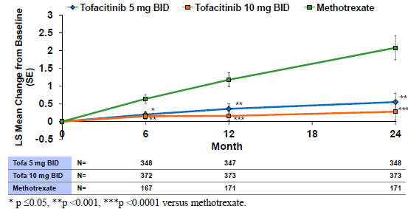
As Figures 2 (LS mean change from baseline in JSN score) and 3 (LS mean change from baseline in ES) demonstrate the total change in mTSS over 2 years was equally accounted for by each component score in the MTX group, and predominantly by changes over time in the JSN score for both TOF treatment groups. There was minimal change from baseline over 2 years in the ES for both TOF treatment groups, but the ES incremented upwards by almost 1 sharp unit for subjects treated with MTX. For the LS mean change from baseline over 2 years in the JSN score, there was a 0.2 to 0.4 sharp unit increase for the TOF treatment groups and > 1 sharp unit increase for the MTX arm.
Figure 2: LS Mean Change from Baseline in JSN Score at Months 6, 12 and 24 in Study A3921069
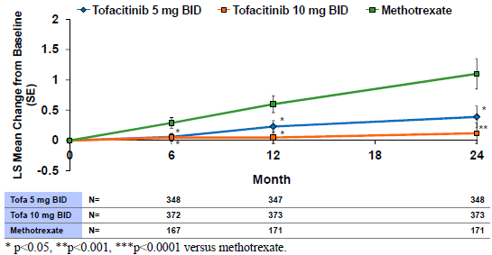
Figure 3: LS Mean Change from Baseline in ES at Months 6, 12 and 24 in Study A3921069
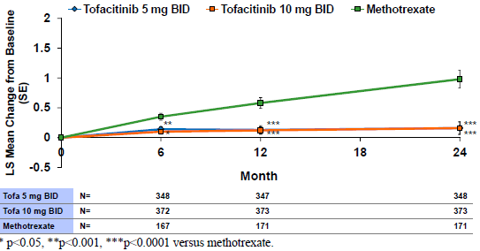
As shown in Table 12, both doses of TOF showed statistically higher rates of patients with no X-ray progression compared to MTX at 6, 12 and 24 months. At 24 months, 79.9% (278/348) of patients treated with TOF 5 mg twice daily and 83.65% (312/373) of subjects treated with TOF 10 mg twice daily recorded a change from baseline in mTSS of ≤ 0.5 sharp units compared with 64.9% (111/171) treated with MTX.

Table 12: Proportion of Patients with No Progression in mTSS at Months 6, 12 and 24 in Study A3921069 (Campaign 2 FAS Cohort)
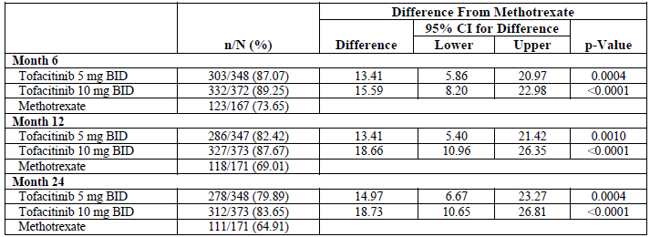

Results for the persistence of clinical efficacy outcomes
ACR70 response rates over time (up to 24 months) were statistically higher (p ≤ 0.0002) for both doses of TOF versus MTX at all measured time points from 1 month to 24 months; refer to Figure 4. At 24 months, the rate of ACR70 response was 34.4% (127/369) in the TOF 5 mg group, 37.6% (148/394) in the TOF 10 mg arm and 15.2% (28/184) in the MTX group. In addition, the rate of sustained ACR70 response over 24 months (that is at least 6 continuous months of ACR70 response) was higher in the TOF 5 mg twice daily group at 28.4%(106/373) and 38.5% (153/397) in the TOF 10 mg twice daily arm compared to 14.0% (26/186) in the MTX group.
Figure 4: ACR70 Response Rate Over Time in Study A3921069 (FAS Cohort with NRI)
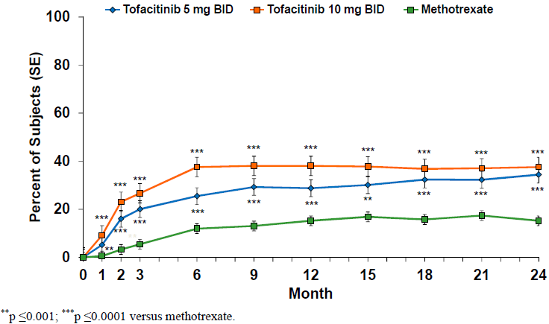
Up to 24 months of follow-up in Study A3921069, the rates of ACR20 and ACR50 response, the mean changes from baseline in HAQ-DI scores, rates of DAS28 remission (score < 2.6) and low disease activity (score ≤ 3.2) demonstrate maintenance of treatment benefit with both doses of TOF compared to MTX at all time points commencing at 1 month. The rate of ACR20 response was 69.9% (258/369) at 3 months with TOF 5 mg twice daily therapy and remained between 64% and 72% at all time points between 3 and 24 months. For the TOF 10 mg twice daily group the rate of ACR20 response at 3 months was 77.9% (307/394) and remained between 62% and 76% between 3 and 24 months. In contrast, the ACR20 response rate was 51.6% (95/184) in the MTX arm at 3 months and remained between 42% and 55% between 3 and 24 months.
In Study A3921069, the mean changes (improvement) from baseline in HAQ-DI scores appeared to reach their maximal response at 6 months in each of the treatment groups and thereafter plateau. At 6 months, the mean improvements from baseline in the HAQ-DI score were -0.6 in the MTX group, -0.8 in the TOF 5 mg arm and -0.9 in the TOF 10 mg group.
The proportion of patients achieving DAS28 (ESR) scores of < 2.6 and ≤ 3.2 were also statistically greater in both TOF groups compared to the MTX arm, however, the response rate curves appear to be numerically higher for the higher (non-approved) TOF dose versus 5 mg twice daily for both endpoints at all measured time points apart from 24 months; refer to Figure 5A and 5B.
Figure 5A: Percentage of Subjects Achieving DAS28 (ESR) < 2.6 Remission Up to 24 Months in Study A3921069 (FAS Cohort with NRI)
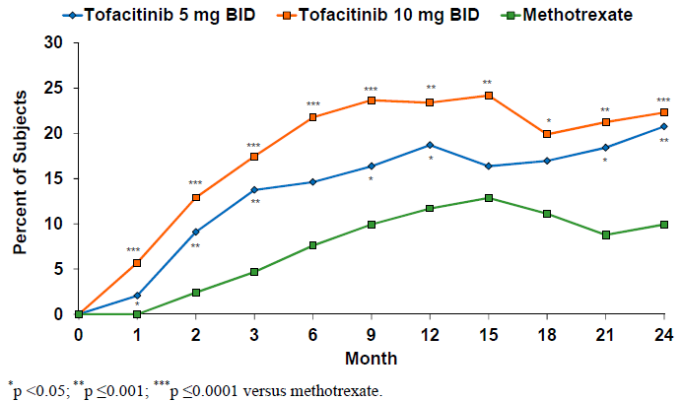
Figure 5B: Percentage of Subjects Achieving DAS28 (ESR) ≤ 3.2 Low Disease Activity Up to 24 Months in Study A3921069 (FAS Cohort with NRI)
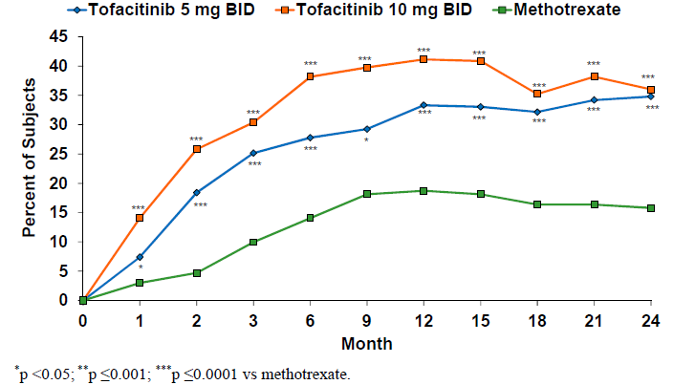

Evaluator commentary
The X-ray results of Campaign 2 (pre-specified analysis) in Study A3921069 are consistent with the results of Campaign 1, demonstrating that both doses of TOF monotherapy (5 mg and 10 mg twice daily) were statistically superior compared with MTX in a first line treatment population (that is mostly MTX naïve subjects) for all primary and secondary radiographic endpoints over 2 years of treatment follow-up. One of the design strengths of Study A3921069 was that the MTX comparator arm continued throughout the course of the trial allowing for comparison of a dataset over 2 years containing largely as observed (rather than extrapolated) data. However, some of the significant design limitations of Study A3921069 with respect to relating the dataset to TOF current approved treatment indication (that is second or subsequent line of therapy) were that it enrolled subjects with early disease (median duration of RA of 0.7 to 0.8 years in each treatment group) and patients were either MTX naïve or had very limited exposure to MTX, which is inconsistent with contemporary treatment guidelines.
The 2 year dataset in Study A3921069 showed the durability of clinical responses with TOF. Up to 24 months of treatment follow-up in Study A3921069, the rates of ACR20/50/70 and major clinical response, the mean changes from baseline in HAQ-DI scores, rates of DAS28 remission (score < 2.6) and low disease activity (score ≤ 3.2) demonstrate maintenance of treatment benefit with both doses of TOF compared to MTX at all time points commencing at 1 month.

Other efficacy studies

Study A3921068

Study design and objectives
Study A3921068 was an exploratory Phase II, randomised, double blind, parallel group trial in MTX naïve subjects with early active RA (≤ 2 years since diagnosis) which had the primary objective of assessing the effect of TOF 10 mg twice daily as monotherapy or in combination with MTX versus MTX alone on Magnetic Imaging Resonance (MRI) endpoints at 3 and 6 months. This study was conducted at 31 study centres in Central and Latin America, Europe and the USA between October 2010 and November 2013. Subjects were randomised in a 1:1:1 design to receive either TOF 10 mg (2 x 5 mg tablets) twice daily plus up-titrated weekly MTX, TOF 10 mg (2 x 5 mg tablets) twice daily with weekly PBO MTX tablets, or PBO TOF tablets twice daily with weekly MTX therapy. MTX was presented as 2.5 mg capsules and the up-titration schedule was identical to that utilised in Study A3921069 (that is 10 mg/week for first 4 weeks; and if tolerated, 15 mg/week for 4 weeks; and if tolerated, 20 mg/week thereafter). The study planned to recruit 30 subjects to each treatment group (90 subjects in total). After a screening period of up to 28 days, randomised subjects were scheduled to attend 6 post-baseline visits (Months 1, 2, 3, 6, 9 and 12). Subjects who completed this trial were eligible to enter into the long-term, open-label extension Study A3921024.

Eligibility criteria
To be eligible for inclusion, patients were required to be at least 18 years of age with a diagnosis of RA of ≤ 2 years duration, which was active at the time of enrolment (> 6 tender and swollen joints plus at least 1 raised serum inflammatory marker; ESR > 28 mm/hour and CRP > 7 mg/L). Patients were required to be naïve to MTX and have unequivocal evidence of at least 1 joint erosion on hand and wrist X-rays at screening. Subjects were also required to have evidence of clinical synovitis of an index wrist or MCP joint at screening and baseline. The exclusion criteria included active or latent or previous inadequately treated TB, as well as pregnancy, several laboratory test abnormalities or any chronic or severe medical condition.

Efficacy endpoints and statistical considerations
The primary efficacy endpoints in Study A3921068 were: (1) the change from baseline in the Outcome Measures in Rheumatology Clinical Trials (OMERACT) Rheumatoid Arthritis Magnetic Resonance Imaging Score (RAMRIS) wrist and MCP bone marrow oedema score (range 0 to 75) at 6 months, and (2) the change from baseline in the OMERACT RAMRIS wrist and MCP synovitis score (range 0 to 24) at 3 months. Secondary efficacy endpoints included structure related outcomes such as the change from baseline in the mTSS and its components (ES and JSN score) on plain X-rays at 6 and 12 months, RAMRIS bone marrow oedema and synovitis scores at other time points, LS mean change from baseline over time in the RAMRIS erosion score, as well as clinical response measures such as ACR20/50/70 response rates and the mean change from baseline in DAS28 score.
All efficacy data was analysed using the FAS cohort. For both of the primary MRI endpoints, the effects of TOF (alone or in combination with MTX) versus MTX alone, a Mixed Effect Model for Repeated Measures (MMRM), including the treatment arm as a factor and the baseline value as a covariate, was used to provide an estimate of the relevant parameter and corresponding 90% CI. The Wilcoxon test at 10% (2 sided) level of significance was used to assess the effect of treatment with a non-parametric approach. The secondary efficacy outcomes were analysed in a similar manner. In addition, to explore the potential relationship between MRI and plain X-ray outcomes, as well as the possible correlation between MRI endpoints and clinical response measures, Spearman’s Rank Correlation Coefficient Test was applied to the dataset.

Participant flow and background patient characteristics
A total of 241 subjects were screened for inclusion, and 109 patients were randomised to treatment within the study: 36 subjects to each of the TOF treatment groups (alone or with MTX), and 37 subjects were randomised to the MTX alone arm. The majority of subjects in the TOF treatment groups (n = 27 to 28; 75 to 78% of 36) completed the study, but there was a significantly lower rate of completion in the MTX arm (56.8%; 21/37). A total of 16 patients prematurely discontinued from the MTX arm, 6 due to insufficient clinical response (versus no subjects in either TOF arm), 5 because of AEs (versus 2 subjects in the TOF monotherapy group and 4 in the TOF + MTX arm), 3 withdrew consent (versus 5 in the TOF alone group and 2 in the TOF + MTX group) and 2 encountered protocol violations. All randomised subjects were analysed for efficacy (FAS cohort) and safety outcomes, but the PP dataset included 28 subjects in the TOF + MTX group (78% of 36), 31 patients in the TOF alone arm (86% of 36) and 32 subjects in the MTX group (86.5% of 37).
The 3 treatment groups were reasonably well matched for baseline features. The majority of enrolled patients were female (82.6%; 90/109) and Caucasian (55.0%; 60/109). The mean age was 47.8 years in the TOF + MTX and MTX groups and 50.8 years in the TOF monotherapy arm (range: 24-79 years). The mean duration of RA since first diagnosis was 0.8 years in the both TOF groups and 0.6 years in the MTX alone arm.

Efficacy results

Primary MRI endpoints
At 6 months, the LS mean decrease from baseline in the RAMRIS wrist and MCP bone marrow oedema score (range: 0 to 75) was -1.26 for the TOF + MTX group and -1.45 for TOF monotherapy arm versus 0.29 for MTX control group; refer to Table 13. The treatment related difference in the LS mean change from baseline in the RAMRIS bone marrow oedema score was -1.55 (90% CI -2.52, -0.58) for TOF + MTX and -1.74 (90% CI -2.72, -0.76) for TOF alone versus MTX, both of which were statistically significant (p = 0.0089 and p = 0.0038, respectively).

Table 13: Changes from Baseline in RAMRIS Bone Marrow Oedema Scores at 6 Months and Synovitis Scores at 3 Months in Study A3921068 (by Treatment Groups)
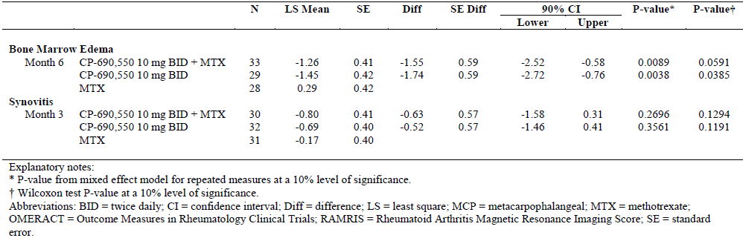
At 3 months, the LS mean decrease from baseline in the RAMRIS wrist and MCP synovitis score (range: 0 to 24) was -0.80 for the TOF + MTX group and -0.69 for TOF monotherapy arm versus -0.17 for MTX control group; refer to Table 20. The treatment related difference in the LS mean change from baseline in the RAMRIS synovitis score was -0.63 (90% CI -1.58, 0.31) for TOF + MTX and -0.52 (90% CI -1.46, 0.41) for TOF alone versus MTX, neither of which were statistically significant.

Secondary x-ray endpoints
In the MMRM analysis at other time points (Months 1, 3 and 12), the LS mean changes from baseline in the RAMRIS bone marrow oedema score were statistically significant in favour of both TOF treatment groups versus MTX alone at 3 and 12 months, but not at 1 month. The LS mean changes from baseline in the RAMRIS synovitis scores were statistically significant in favour of both TOF treatment groups versus MTX alone at 6 and 12 months, but not at 1 month.
The LS mean changes from baseline in the RAMRIS wrist and MCP erosion scores (range 0-250) were statistically significant in favour of both TOF treatment groups at 6 and 12 months, but not at 1 and 3 months. However, the absolute LS mean changes from baseline were small in magnitude and of unclear clinical significance.
The LS mean change from baseline to 6 months in the RAMRIS ES was -0.06 for TOF + MTX and -0.02 for TOF alone versus 0.65 for MTX alone. The LS mean change from baseline to 12 months in the RAMRIS ES was -0.11 for TOF + MTX and -0.08 for TOF alone versus 1.18 for MTX alone.
There was a numerically smaller change (deterioration) from baseline to 6 and 12 months with TOF treatment (alone or in combination with MTX) versus MTX alone with respect to mTSS, ES and JSN scores, however, the results are descriptive in nature only and should be interpreted with caution as the study was not powered for formal hypothesis testing and the sample size was small.
In the Spearman Rank Correlation analysis, there was a weak correlation between all of the plain X-ray outcomes and RAMRIS bone marrow oedema and synovitis scores, but a moderately strong correlation between RAMRIS erosion scores and mTSS as well as ES on Plain X-rays.

Secondary clinical endpoints
Patients who received treatment with TOF 10 mg twice daily (alone or in combination with MTX) had numerically higher rates of ACR response compared to those who were treated with MTX, but the differences in response were only statistically significant at earlier time points in Study A3921068. The proportion of subjects treated with TOF + MTX and TOF alone who achieved ACR20, ACR50 and ACR70 response at 6 months using NRI were 74.3% (26/35) and 66.7% (24/36), 57.1% (20/35) and 47.2% (17/36); and 34.3% (12/35) and 30.6% (11/36), respectively. In contrast, the rates of ACR20/50/70 response at 6 months using NRI in the MTX monotherapy arm were numerically lower at 46.0% (17/37), 21.6% (8/37) and 21.6% (8/37).
Likewise, patients treated with TOF 10 mg twice daily (alone or in combination with MTX) showed a greater reduction DAS28 (CRP and ESR) scores over time compared with the MTX monotherapy group. At 6 months, subjects treated with TOF + MTX showed a mean -2.53 change (improvement) from baseline (5.14) in DAS28 (CRP) score which was similar to that observed in the TOF monotherapy arm (mean change of -2.75 from a baseline of 5.48). Patients treated with MTX alone had a mean -1.58 change at 6 months from baseline (5.36) in DAS28 (CRP) score.
Despite the above findings in support of TOF therapy versus MTX alone, there was no clear relationship between imaging endpoints (bone marrow oedema, synovitis and erosions) and clinical response (for example changes in DAS28 score over time) as shown in the Spearman Rank Correlation analysis.

Study A3921073

Study design and objectives
Study A3921073 was an exploratory Phase II, randomised, double blind, parallel group, PBO controlled trial with the primary objective of examining the PD effects of oral TOF 10 mg twice daily for 4 weeks in adult subjects with active RA. One of the secondary objectives of the study was to investigate the PD-clinical response relationship. This study was conducted at 6 study centres in the USA between November 2009 and July 2011. Subjects were randomised in a 1:1 design to receive either TOF 10 mg twice daily or matching PBO tablets. Approximately 15 subjects were to be assigned to each treatment group. Subjects who completed this trial were eligible to enter into the long-term, open-label extension Study A3921024.

Eligibility criteria
To be eligible for inclusion, patients were required to be at least 18 years of age with an established diagnosis of RA, which was active at the time of enrolment despite ongoing treatment with stable doses of MTX (oral or parenteral). Background MTX therapy was continued during this 4-week study at stable pre-enrolment doses and route of administration. Enrolling subjects were required to have at least 1 raised serum inflammatory marker: ESR > 28 mm/hour (local laboratory testing) and/or CRP > 7 mg/L (via central laboratory testing). Washout periods and discontinuation requirements were required for all DMARD therapy (conventional and biologic) other than MTX. The exclusion criteria included active or latent or previous inadequately treated TB, as well as pregnancy, several laboratory test abnormalities or any chronic or severe medical condition.

Efficacy endpoints and statistical considerations
The efficacy endpoints included the rate of ACR20/50/70 response in each treatment group, the actual and mean change from baseline in DAS28 score and the individual components of the ACR response criteria for each treatment arm, as well as the incidences of DAS28 remission (< 2.6) and low disease activity (≤ 3.2). All efficacy endpoints were assessed at 28 days using the FAS cohort.
Given the exploratory nature of the study, no sample size calculation was undertaken and no formal statistical justifications were applied to the efficacy data. Descriptive statistics, summarised by treatment group, were presented in the clinical study report.

Subject disposition and background patient characteristics
A total of 64 subjects were screened for inclusion, and 15 patients were randomised to TOF 10 mg twice-daily therapy and 14 subjects were randomised to the PBO arm. All randomised patients (n = 29) were treated, completed the study and were analysed for efficacy and safety outcomes. No patients prematurely discontinued from the trial.
The majority of enrolled patients were female (26/29) and Caucasian (23/29). The mean age of all subjects was 53.3 years (range: 27 to 77 years). The mean subject weight was 91.5 kg (range: 59.0 to 136.5 kg) and the mean body mass index was 33.6 kg/m² (range: 21.5 to 55.6 kg/m²). Given the small sample size, the 2 treatment groups were reasonably well matched for baseline features.

Efficacy results
At 28 days, the rate of ACR20, ACR50 and ACR70 response in the TOF group was 60.0% (9/15), 40.0% (6/15) and 6.7% (1/15), respectively, compared to no ACR responses (at any level) recorded in the control arm (n = 14 subjects).
For the TOF group, the mean number of tender joints decreased from 36.9 at baseline to 19.9 at Day 28, which was a numerically greater decrease compared to the PBO arm where the tender joint count decreased from a baseline of 28.6 to 24.9 at Day 28. The mean number of swollen joints decreased from baseline (22 joints) to Day 28 (13.9 joints) for subjects treated with TOF, but patients in the control arm showed an increase in the mean number of swollen joints over the course of the study (16.9 to 19.2 joints). The mean baseline HAQ-DI score was higher in the TOF group compared to PBO (1.76 versus 1.40) and subjects treated with TOF showed a greater improvement over 4 weeks (1.27 for TOF and 1.24 for PBO). The mean baseline CRP value was slightly higher in the TOF group (14.19 mg/L versus 10.54 mg/L in the PBO arm) and both treatment groups showed small decreases in mean CRP values from baseline to Day 28.
The mean DAS28 (CRP) score decreased from a baseline value of 5.57 to 4.06 at 28 days for subjects treated with TOF compared with a smaller decrease observed in the PBO group (baseline of 5.22 to 4.91 at 28 days). A small proportion of subjects in each treatment group achieved low disease activity (DAS ≤ 3.2) at 28 days: 20.0% (3/15) of subjects in the TOF arm and 14.3% (2/14) of patients in the control group. No subjects reached DAS remission (score of < 2.6) at 28 days.
No apparent correlation between the PD markers (synovial tissue biopsy results and various serum cytokine levels) and DAS28 scores was observed in Study A3921073 apart from a possible relationship (correlation coefficients > 0.72) between DAS28 (CRP) score and IL-1β messenger RNA and IL-6 messenger RNA expression on synovial tissue biopsy at Day 28 for subjects treated with TOF 10 mg twice daily.

Long term extension studies (A3921024 and A3921041)
Pooled data from 2 long-term, open-label extension studies (A3921024 and A3921041) was included in this submission to support the persistence of clinical efficacy with continued TOF. Study A3921024 is an ongoing (as of 31 March 2015) long term extension trial (LTE) that enrolled subjects who participated and completed 1 of 15 preceding RA trials. As of 31 March 2015, a total of 4381 subjects have been enrolled in Study A3921024 and 1059 subjects have been initially assigned treatment with TOF 5 mg twice daily and 3322 subjects have been treated with TOF 10 mg twice daily in the LTE phase. An interim study report for this trial was provided in this submission.
Study A3921041 is a completed open-label, LTE trial that was conducted in 486 Japanese patients. It enrolled subjects who participated and completed involvement in 2 Phase II studies (A3921039 [n = 113 subjects] and A3921040 [n = 291 subjects]) as well as Study A3921044 (n = 82 subjects). The majority of patients received TOF 5 mg twice daily (n = 381 subjects) in Study A3921041, but 21.6% (105/486) were treated with TOG 10 mg twice daily. However, throughout the course of both LTE trials the dose of TOF could be adjusted from 5 mg to 10 mg twice daily or vice versa or temporarily discontinued based on side-effects. In addition to possible changes in the TOF dose regimen, adjustments to concomitant therapies such as NSAID, CS, analgesics and conventional DMARD were allowed for efficacy and safety reasons.
Efficacy data for both LTE studies was pooled and reported as 3 TOF dose groups: TOF 5 mg twice daily, TOF 10 mg twice daily and all TOF therapy (5 and 10 mg dose pooled). Because patients could have their TOF dose titrated up or down during the LTE studies, if their average daily dose was ≥ 15 mg then they were assigned the TOF 10 mg twice daily group, and if their average daily dose was < 15 mg then they were allocated to the TOF 5 mg twice daily group.
Up to 84 months of treatment in the pooled, open-label, LTE trial dataset (Studies A3921024 and A3921041), both dose regimens of TOF demonstrated maintenance of clinical response as measured by the rate of ACR20 response (Figure 6), rate of clinical remission as determined by DAS28 (ESR) score < 2.6 (Figure 7) and the mean improvement from baseline in HAQ-DI score (Figure 8). However, a limitation of the LTE trial dataset is that very few patients (50 subjects or less) were treated beyond 60 months with TOF 10 mg twice daily therapy. Approximately 80% of TOF treated patients maintain ACR20 response up to 84 months, which is the considered the minimal most clinically relevant response. Just over 20% of TOF treated subjects achieve a persistence of DAS28 clinical remission, which is a comparable figure to other DMARD therapy. The mean change from baseline in HAQ-DI score was maintained at approximately 0.5 units, which is also a similar observation to that seen with other DMARD treatment in adults with RA.
Figure 6: ACR20 Response Rate Over Time with Continued TOF Treatment in LTE Studies
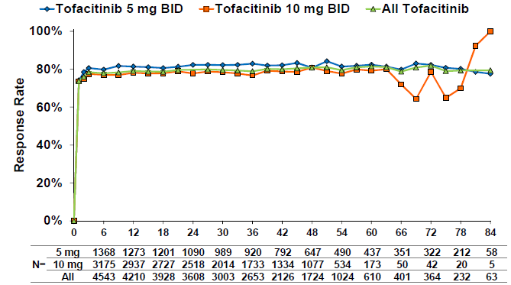
Figure 7: Proportion of Subjects Achieving DAS28< 2.6 Over Time in Pooled LTE Studies
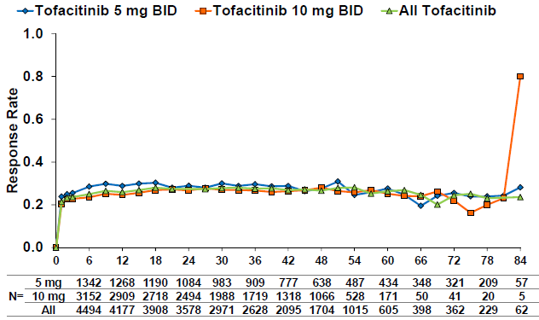
Figure 8: Mean Change from Baseline in HAQ-DI Score Over Time Pooled LTE Studies
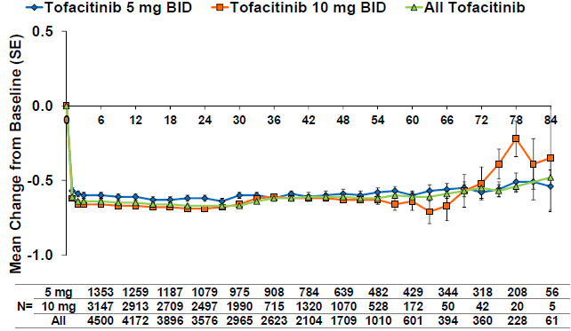

Evaluator commentary: other efficacy studies
In support of this submission, the sponsor has provided efficacy data from 2 exploratory Phase II studies (A3921068 and A3921073), which have not been previously evaluated by the TGA. The sponsor asserts that both studies are supportive of a radiographic claim of benefit. In particular, Study A3921068 was primarily designed as an MRI outcome trial of 12 months duration in MTX naive subjects with a relatively recent diagnosis of RA (≤ 2 years disease duration) which demonstrated that TOF 10 mg twice daily (with or without concomitant MTX) was statistically better than MTX alone at 6 and 12 months of treatment follow-up in retarding MRI evidence of wrist and MCP joint bone marrow oedema, synovitis and erosion. However, there was a limited correlation between the MRI observations and structural changes seen on plain X-ray over time and clinical response measures. Study A392101073 was predominantly designed as an exploratory PD trial, which examined the impact of TOF 10 mg twice daily with continued MTX on blood and synovial tissue biomarkers versus MTX alone in subjects with active RA. The sponsor did not explicitly state the supportive nature of this study, but the evaluator presumes it was included in this submission for completeness of the overall TOF dataset and to support the biological plausibility of TOF (from a biomarker perspective) in being able to affect structural outcomes. In this small sample size trial (n = 29 subjects) of short duration (4 weeks), TOF + MTX was generally shown to produce numerically better clinical responses (of various measures) than MTX alone, but there was a limited correlation with any biomarkers apart from IL-1β messenger RNA and IL-6 messenger RNA expression on synovial tissue biopsy and TOF therapy.
Regarding limitations, neither of these Phase II studies examined the effect of TOF 5 mg twice daily therapy, which is the registered dose regimen in Australia. In both Phase II trials, TOF 10 mg twice daily was the only dose of TOF that was investigated. In addition, Study A3921068 was conducted in a MTX naïve population, which is inconsistent with the line of therapy for which TOF is currently approved in Australia (2nd line treatment indication).
Data pooled from the 2 long-term, open label extension studies (A3921024 and A3921041) was also included in this submission to support the persistence of clinical efficacy in treating RA with continued TOF. Study A3921024 is an ongoing (as of 31 March 2015) LTE trial that enrolled 4381 subjects who participated in one of 15 preceding studies, while Study A3921041 is a completed LTE trial that was conducted in 486 Japanese subjects. In the open-label LTE studies, TOF 5 mg twice daily demonstrated maintenance of clinical efficacy in patients who were responding and tolerating the medicine (that is significant patient selection bias). Up to 84 months of continuous treatment, approximately 80% of subjects were consistently achieving ACR20 response, just over 20% were demonstrating DAS28 clinical remission and there was a persistence of 0.5 unit mean improvement from baseline in HAQ-DI score, which is a measure of physical function.

Analyses performed across trials: Pooled and meta-analyses
The sponsor has not provided an integrated data analysis of the 2 nominated, pivotal Phase III studies, which is appropriate given that the trials enrolled a diverse group of patients. Study A3921069 was largely performed in a first line treatment population (MTX naïve subjects). However, 6.8% (65/952) of subjects had a history of brief prior exposure to MTX (≤ 3 weekly doses) and 38.7% (368/952) of patients had prior conventional synthetic DMARD exposure which was not MTX. In contrast, Study A3921044 predominantly recruited patients for whom TOF was their second line of RA treatment. In addition to MTX use before screening (in all but 1 subject randomised to TOF 10 mg therapy), 62.0% (494/797) of all patients had a recorded history of taking other conventional DMARD therapy, 15.9% (127/797) had taken anti-TNF drugs (mainly, etanercept, infliximab or adalimumab) and 4.6% (37/797) of subjects had received biologic DMARD (mainly, abatacept or tocilizumab) other than TNF inhibitors before screening. Further analysis of the population cohort randomised into Study A3921044 shows that 89.6% (717/800) of subjects were included in the second line treatment population (defined as inadequate response or intolerant of conventional DMARD, but not biologic therapy) and 10.0% (80/800) of patients were included in the third line treatment population (defined as inadequate response or intolerant of biologic DMARD). These analysis populations were equally spread across the 3 treatment groups in Study A3921044.

Evaluator’s conclusions on clinical efficacy
In support of the extension of treatment indication for TOF to include a claim of radiographic benefit in patients with RA, this submission contains two Phase III studies (A3921044 and A3921069), both of which were nominated as pivotal by the sponsor. The 2 studies were of dissimilar design and recruited very different treatment populations. Study A3921044 enrolled 797 subjects with established RA (mean disease duration of approximately9 years) who were inadequate responders to at least 4 months of preceding MTX and approximately20% of patients had previously been exposed to biologic DMARD. Study A3921044 had 3 treatment arms (2 with 2 different doses of TOF; 5 mg and 10 mg twice daily) and a control group, which escaped or mandatorily switched to TOF therapy between 3 and 6 months. All subjects in this trial continued to receive MTX concomitantly throughout the study. In contrast, Study A3921069 was a TOF monotherapy trial of 2 different doses of TOF (5 mg and 10 mg twice daily) versus weekly, low dose MTX in 956 subjects who had early disease (median duration of 0.8 years) and who were largely naïve to MTX. Both of the Phase III studies are completed with final study reports up to 24 months of treatment follow-up being included in this submission. The majority of patients (approximately two thirds) in both Phase III trials completed 2 years of follow-up. However, in Study A3921044 where the patients in control arm were eligible for switching to TOF as early as 3 months, approximately half of all PBO treated patients switched to TOF as they were considered clinical non-responders. At 6 months in Study A3921044, all continuing PBO treated subjects were switched to either dose of TOF in the maintenance treatment phase (between 6 and 24 months).
Both of the Phase III studies were randomised, double blinded and parallel group controlled in design and enrolled adult patients with a confirmed diagnosis of RA. Subjects were required to have moderate-severe disease activity at baseline with the BASDAI score being ≥ 6 tender and swollen joints and have raised serum inflammatory markers (CRP > 7 mg/L) and/or joint erosions or positive autoantibody tests at baseline. Both of the Phase III studies had the mean change from baseline to 6 months in the mTSS as the primary radiographic endpoint. The baseline demographic and disease related characteristics of patients in the Phase III trials are diverse but similar to those in the anticipated Australian patient cohort, and therefore generalisation of these results to the Australian context is expected. The majority of patients were female, of Caucasian ethnicity, and within the expected age range of 45 to 65 years. However, there are some caveats to the generalisability of the treatment population. For example, both studies excluded patients who were at a significant risk of infection or malignancy, or who had various abnormal laboratory results at baseline (for example abnormal haematology or liver function tests).
This submission is seeking an indication of structural benefit in active RA and is generally consistent with the TGA adopted regulatory guideline pertaining to the requested extension of indication: EU guideline CPMP/EWP/556/95 rev 1/final “Points to Consider on Clinical Investigation of Medicinal Products other than NSAIDs for the Treatment of Rheumatoid Arthritis” (effective 29 January 2007). However, neither of the Phase III trials directly evaluated TOF against an already approved drug for the X-ray indication such as anti-TNF therapy. The choice of comparators (MTX in Study A3921069 and PBO + continued MTX in Study A3921044) for the claim of radiographic is an area of significant contention, which is not specifically addressed in the TGA, adopted EU guideline. However, there is no precedent for the registration of a biologic drug currently approved for a radiographic claim in RA to have conducted head-to-head studies. For both Phase III studies, the choice of X-ray efficacy endpoints (primary and secondary), and strategies to maintain blinding and randomisation procedures were suitable.
The primary efficacy endpoint in both Phase III studies was the LS mean change from baseline to 6 months in the mTSS. The pre-specified secondary X-ray efficacy endpoints included the component scores of the mTSS and the proportion of subjects with no X-ray progression (defined as change form baseline of ≤ 0.5 sharp units). X-ray endpoints were evaluated at Months 6, 12 and 24. The supporting exploratory Phase II Study A3921068 also evaluated MRI data of the peripheral joints in association with plain radiography changes over 6 months in a group of treatment naïve patients with early disease (n = 109 subjects). Both the Phase III studies also provided efficacy data up to 24 months in support of the maintenance of treatment effect.
Study A3921069 demonstrated that both doses of TOF monotherapy (5 mg and 10 mg twice daily) produced statistically significant structural preservations benefits compared to MTX, across the range of primary X-ray efficacy measures (LS mean change from baseline in mTSS) and secondary X-ray measures of response (LS mean changes from baseline in ES and JSN scores as well as the proportion of subjects with no X-ray progression) at 6, 12 and 24 months.
In contrast, Study A3921044 (that is in a predominantly second line treatment population) did not show a significant X-ray treatment benefit with TOF 5 mg twice daily versus control therapy in the primary statistical analysis which used LEP for handling of data. However, when the 6 and 12 month X-ray dataset for Study A3921044 (Campaign 1) had analyses applied to the data that reduced the effect of extrapolation and utilised more observed (non-extrapolated) data than in the primary analysis, statistically significant reductions in structural damage progression for both TOF doses were observed compared to PBO. However, many of these sensitivity and secondary analyses were post hoc in nature and their utility is guarded with respect to supporting a scientifically robust conclusion. I agree with the sponsor that low rates of structural damage progression, the short treatment period before treatment advancement was required (3 or 6 months), and the large proportion of PBO treated subjects advancing at the Month 3 time point may have resulted in the initial analyses being more sensitive to data anomalies such as large change from baseline values at the extremes of the distribution of change scores or to the effects of extrapolation. However, this is an unfortunate consequence of the study design and conduct. The sponsor also suggests that the mean changes from baseline in mTSS at 6 and 12 months for TOF 5 mg twice daily therapy (Study A3921044) are of a similar magnitude to those observed with tocilizumab and at least 2 anti-TNF therapies, all of which have an approved X-ray claim in RA. However, indirect data comparisons such as these are fraught with interpretation.
The clinical efficacy data available up to 24 months in both Phase III studies indicated that the majority of responding patients appear to maintain their treatment related benefit with continued TOF. In addition, for PBO patients who switched to TOF at 3 to 6 months in Study A3921044, the rates of ACR response observed at 12 and 24 months were similar to those achieved in the originally treated TOF cohort. Like the Phase III studies, the open label, LTE Studies A3921024 and A3921041 showed that clinical efficacy was maintained in the majority of subjects up to 7 years with continued TOF 5 mg twice daily therapy.
Overall, the data in this submission provides an unclear picture on the radiographic efficacy of TOF 5 mg twice daily therapy for inhibiting the X-ray structural progression of RA, in those with moderate-severely active disease at baseline, with or without concurrent MTX. In the DMARD naïve group of patients with early disease (Study A3921069), the magnitude of beneficial X-ray response with TOF versus MTX is small, but statistically significant. Treatment related X-ray differences between TOF and PBO in the second line treatment population (as per Study A3921044 and consistent with TOF current registration status in Australia) is of unclear magnitude and only reached statistical benefit when sensitivity and subset analyses were applied to the dataset, which had its limitations for various reasons.

Clinical safety

Studies providing evaluable safety data

Pivotal studies that assessed safety as the sole primary outcome
Study A3921237 is a newly submitted Phase II trial of 14 weeks duration (12 weeks of study treatment), which primarily assessed immune responses (humoral and cell mediated) following administration of zoster vaccine to subjects aged at least 50 years (n = 112 subjects) with active RA receiving TOF or PBO with background MTX treatment. Immunogenicity and clinical safety data from this study will be presented separately in this report. The trial did not specifically collect efficacy data.

Pivotal and/or main efficacy studies
In the registration application for TOF (Submission PM-2012-00788-3-3), the interim 1 year results of Study A3921069 were evaluated, but the final 2 year clinical study report was deemed to have been submitted too late in the process and therefore was not evaluated in detail. The full 24 month safety dataset from Study A3921069 will be considered in this report.
The following safety data was collected in Study A3921069 (as well as the other pivotal efficacy studies of the program):
- Adverse Events (AEs) in general were assessed by completion of the AE Case Report Form (CRF) and physical examination performed every 4 weeks until Month 3, and then every 3 months thereafter up until Month 24 (or upon early withdrawal).
- AEs of particular interest, including infections (overall and serious), gastrointestinal perforation, malignancy, interstitial lung disease, Major Adverse Cardiovascular Events (MACE) and drug induced liver disease were assessed by CRF and physical examination as per the schedule for general AE evaluation.
- Laboratory tests, including haematology, clinical chemistry, urinalysis and urine pregnancy testing (in female subjects) were performed at baseline, every 4 weeks until Month 3 and then every 3 months thereafter. A fasting lipid profile was collected at baseline, every 3 months until Month 12 and then at Months 18 and 24. Episodes of neutropenia, lymphopenia and abnormalities of liver function tests (particularly, elevated serum transaminases) were an AE of special interest as this was an identified risk with TOF.
- Screening tests for tuberculosis (Chest X-ray and QuantiFERON Gold testing; or PPD skin testing in countries without QuantiFeron Gold testing) were taken at baseline, but not routinely collected thereafter.
- Vital signs such as blood pressure, heart rate and subject weight were performed at each scheduled study visit.
- ECG was taken at baseline and at Month 12 and 24 visits.
AEs were summarised by the MedDRA classification using the System Organ Class (SOC) and Preferred Term (PT) nomenclature.
The final 2 year report for Study A3921044 has been previously evaluated in detail and that information is included in the current PI. As such, the safety data from that trial will not be considered separately in this report. Nonetheless, safety information from Study A3921044 contributes to the integrated safety population.

Other studies

Other efficacy studies
In addition to Studies A3921044 and A3921069, another 4 Phase III studies (A3921032, A3921045, A3921046 and A3921064) and 2 open label, LTE studies (A3921024 [ongoing] and A3921041 [completed] have contributed safety data to the integrated safety dataset included in this submission. Two of the Phase III trials (A3921045 and A3921069) were TOF monotherapy studies, whereas all of the other 4 Phase III studies involved the addition of TOF to background DMARD, mainly MTX. All but one of the trials included 2 dose regimens of TOF – 5 mg twice daily and 10 mg twice daily. The TGA approved dose is 5 mg twice daily, but for completeness of the safety data review, the TOF 10 mg twice daily regimen is considered in this review. Study A3921024 is a global located trial, whereas Study A3921041 was only conducted in Japan. Study A3921041 initiated all subjects on TOF 5 mg twice daily and subjects from China in Study A3921024 also did the same. As a result, there is a geographically skewed distribution of TOF 5mg therapy in Asian subjects overall, which appears to be an at risk population for certain AEs including interstitial lung disease and specific opportunistic infections like Pneumocystis jirovecii pneumonia (PJP).

Studies with evaluable safety data: dose finding and pharmacology
The integrated safety population in this submission also included safety information from 2 Phase 1 studies (A3921030 and A3921152) and 9 Phase II studies (A3921019, A3921025, A3921035, A3921039, A3921040, A3921068, A3921073, A3921109 and A3921129).

Studies evaluable for safety only
Nil in addition to Study A3921237.

Overview of safety data presentations
In this submission, the sponsor presented safety information in 3 main populations. Firstly, the complete 2 year dataset for Study A3921069 was presented in isolation. Secondly, the sponsor pooled safety data from the controlled periods (0-3 months, or 0-6 months) in all 6 of the Phase III studies to examine certain safety endpoints for example risk of infection and various abnormal laboratory results like hyperlipidaemia. Finally, the total integrated safety dataset, which the sponsor calls the “P123LTE” population, was provided for certain safety outcomes if changes to the current PI are proposed.

Studies that assessed safety as the sole primary outcome

Study A3921237

Study design, objectives, locations and dates
Study A3921237 was a 14 week, randomised, double blind, PBO controlled, parallel group Phase II trial with the primary objective of evaluating the effect of TOF on varicella-zoster (VZV) specific immunoglobulin (Ig) responses 6 weeks after zoster vaccination in subjects with RA on concomitant MTX. The secondary objective of the study was to evaluate the effect of TOF on VZV-specific Ig responses at 2 and 14 weeks post-vaccination.
Subjects were randomised 1:1 to receive either TOF 5 mg twice daily or matching PBO tablets. Study treatment was initiated 2-3 weeks following immunisation. It was expected that approximately 70 subjects would be randomised into each treatment arm. This study was conducted at 27 study centres in the USA between June 2014 and July 2015. Figure 10 represents the study design schematic. Following a screening period of 2 weeks, eligible subjects received zoster vaccination. Study Day 1 was 2 weeks post-vaccination, at which time study treatment (TOF or PBO) was initiated and scheduled to continue for 12 weeks. Subjects who participated in this trial were eligible to enter the open label, LTE Study A3921024.
Figure 10: Design of Study A3921237
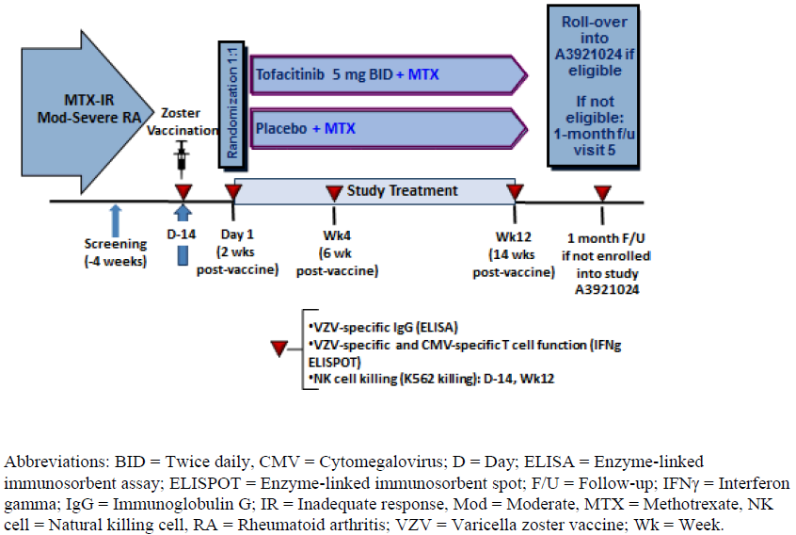

Inclusion and exclusion criteria
To be eligible for inclusion, patients were required to be at least 50 years of age with an established diagnosis of RA based on a score of ≥ 6 on the ACR/EULAR Classification Criteria for RA. The condition had to be active at the time of enrolment: ≥ 4 tender and swollen joints on the 28 joint count plus CRP > 3 mg/L or Clinical Disease Activity score > 10. Patients were required to have a stable background dose of MTX for a minimum of 4 months prior to screening. The exclusion criteria included active or latent or previous inadequately treated TB, as well as several laboratory test abnormalities or any chronic or severe medical condition.

Study treatments
Subjects who received live zoster vaccine (given subcutaneously) at least 2 weeks before randomisation were assigned to treatment with either oral TOF 5 mg twice daily or matching PBO tablets. Study treatment was taken from study Day 1 for 12 weeks. Study drug was self-administered and taken twice daily (approximately 12 hours apart). Study drug was taken with or without food (other than on study days when fasting was required). All subjects continued on a stable background dose of MTX throughout the duration of the trial.

Safety variables and outcomes

Immunogenicity endpoints
The primary immunogenicity endpoint was the fold rise from pre-vaccination baseline in VZV-specific IgG antibodies as measured by glycoprotein enzyme-linked immunosorbent assay (gpELISA) at 6 weeks post-vaccination (that is week 4 on study treatment). In the VZV gpELISA assay, human serum was incubated with VZV glycoproteins purified from VZV infected human fibroblasts.
The secondary immunogenicity endpoints were further assessment of VZV-specific IgG antibody levels (as measured by gpELISA) at 2, 6 and 14 weeks following immunisation including the magnitude of the immune response (absolute level and fold rise from baseline) as well as the proportion of subjects who respond to the vaccine (defines as the occurrence of ≥ 1.5 fold titre rise from baseline).
Exploratory immunogenicity endpoints included T cell subset analysis of VZV specific cell mediated immunity (as measured by ELISPOT testing). The ELISPOT assay measures the frequency of interferon γ secreting cells at the single cell level (CD4+ helper T cells and CD8+ cytotoxic T cells) that are responsive to a particular antigen.

Clinical safety outcomes
Safety monitoring included AE and SAE reporting (including potential cases of herpes zoster or zoster vaccine AEs), clinical laboratory tests (in particular, liver function test and haematological abnormalities), physical examination and vital signs.

Randomisation and blinding methods
In Study A3921237, patients were randomised into treatment groups with the use of a centralised, web-based or telephone interactive system with stratification according to prior exposure to biological DMARD treatment (naïve versus experienced with an inadequate response). To protect the double blind design of Study A3921237, all study medication was supplied in matching packaging.

Analysis populations
Safety endpoints including AEs and SAEs were evaluated using the safety analysis set, which was defined as all randomised subjects who received as least 1 dose of study drug (TOF 5 mg or PBO).
The primary and secondary immunogenicity endpoints were calculated using the Evaluable Immunogenicity Analysis Set (EIAS), which is a subset of patients from the All-available Immunogenicity Analysis Set (AIAS) who did not record any major protocol deviations and who had valid assay results. The AIAS included all randomised subjects who had taken at least 1 dose of study medication and who had at least 1 valid assay result during the study. All randomised subjects were included in the AIAS population (57 subjects in the PBO group and 55 patients in the TOF arm). A total of 4 patients in the PBO group and 1 subject in the TOF arm were excluded from the EIAS.

Sample size
Based on the publication by Levin et al (2008), it was estimated that approximately 70 subjects per treatment group would provide the study with power to examine the immunogenicity endpoints. For the primary endpoint of fold rise from vaccination baseline in VZV-specific IgG antibodies at 6 weeks post-vaccination (Week 4 on study treatment), assuming a common standard deviation of 1.33 on the logarithmical scale (approximately 3.8 fold on the original scale), a sample size of 70 subjects in each group would yield a half-width of approximately 0.288 on the logarithmical scale for a 2-sided 80% CI of the ratio of GMFR between the TOF 5 mg group and control. In addition, a sample size of 70 subjects per group provided a probability of 79.1% to exclude a ratio of 1.6 fold between control and TOF GMFRs (or a ratio of 0.625 fold for TOF: control) using the 2-sided 80% CI. With a total sample size of 107 subjects and an observed ratio of GMFRs of 1.213, the lower bound of the 80% CI was 1.033, thereby excluding ratios lower than 1.033 with 90% confidence.

Statistical methods
The immunogenicity endpoints were analysed as continuous variables with an adjusted estimation of the geometric mean fold rise (GMFR) reported using a linear mixed effect model (ANCOVA) with repeated measures that included age, gender, randomisation strata and baseline value as covariates and study treatment, visit after vaccination and treatment-by-visit interaction as fixed effects. The ratio of the GMFR between the 2 treatment groups was calculated and 2-sided 80% CI limits of this ratio were obtained. Descriptive statistics were used to assess the clinical safety endpoints and laboratory test abnormalities.

Participant flow
A total of 159 subjects were screened for inclusion, and 115 patients were vaccinated. Three subjects discontinued from the study after vaccination but before randomisation (including 1 subject discontinued due to a protocol violation; not meeting inclusion criteria). Of the 112 subjects assigned to treatment within the study, 55 were allocated to TOF 5 mg twice daily treatment and 57 subjects were randomised to the PBO arm. The majority of subjects in both treatment groups completed the 14 week study: 90.9% (50/55) in the TOF arm 80.7% (46/57) in the PBO group. A total of 16 patients prematurely discontinued from the study, 4 due to drug related AEs (2 subjects in each group), 3 due to insufficient clinical response (2 subjects in the PBO arm and 1 subject in the TOF group), and another 9 non-drug related AEs (7 subjects in the PBO group versus 2 subjects in the TOF arm). All randomised subjects (n = 112) were analysed for immunogenicity and safety outcomes.

Major protocol violations/deviations
The overall incidence of key protocol deviations in Study A3921237 was 42.0% (47/112). These occurred at a similar frequency in each of the treatment groups. The most frequently reported protocol deviation was subject randomisation to the incorrect treatment strata, which affected 18 subjects. Other notable key protocol deviations were not meeting inclusion/exclusion criteria (7 subjects), taking prohibited concomitant medication (3 subjects), dispensed wrong study treatment or compliance with therapy < 80% (3 subjects) and scheduled visit occurring outside of limit (1 subject).

Baseline data
The 2 treatment groups were reasonably well matched for baseline features. The majority of enrolled patients were female (71.4%; 80/112) and Caucasian (92.9%; 104/112). The mean age of subjects in each treatment group was 62 years with the majority of subjects (52.7%; 59/112) being aged between 60 and 74 years (overall age range: 50-81 years). Five subjects (8.8% of 57) in the PBO group were aged ≥ 75 years versus no such subjects in the TOF arm. The mean duration of RA since first diagnosis was slightly longer in the PBO group at 12.6 years (range: 0.5 to 45.1 years) compared with 9.7 years in the TOF arm (range: 0.5 to 30.7 years). The mean body mass index in the study cohort was 31 kg/m² (range: 18.5-56.4 kg/m²).
Of the 57 subjects enrolled in the PBO group, 20 (35.1%) had a history of inadequate response to MTX but were naïve to biologic therapy, and 37 (64.9%) had a history of inadequate response to biologic treatment. Of the 55 subjects randomised to TOF therapy, 29 (52.7%) had a history of inadequate response to MTX but were naïve to biologic therapy, and 26 (47.3%) had a history of inadequate response to biologic treatment.

Results for the immunogenicity safety outcomes
For the primary immunogenicity endpoint of the fold change from baseline to week 4 of study treatment in VZV-specific IgG levels, the estimated GMFRs were 1.74 (80% CI 1.55, 1.95) in the PBO group and 2.11 (80% CI 1.87, 2.37) in the TOF arm. The GMFR ratio (of TOF/PBO) was 1.21 (80% CI 1.03, 1.42). Overall, subjects treated with TOF 5 mg twice daily + MTX achieved a fold rise in VZV-specific IgG antibody levels that was similar to (and not lower than) that seen in the PBO + MTX group.
Table 14 displays the geometric mean titres (GMT) by visit in Study A3921237. The GMT ratios (of TOF/PBO) were 1.10 at visit 1 (Day -14), 1.06 at visit 2 (Day 1), 1.25 at visit 3 (week 4) and 1.12 at visit 4 (week 12). The VZV specific IgG GMT ratios between the 2 treatment groups were slightly above 1.0 at baseline and at all subsequent visits, indicating that VZV specific IgG responses were similar between TOF and PBO throughout the trial.

Table 14: VZV Specific IgG Levels by Visit in Study A3921237 (EIAS Population)
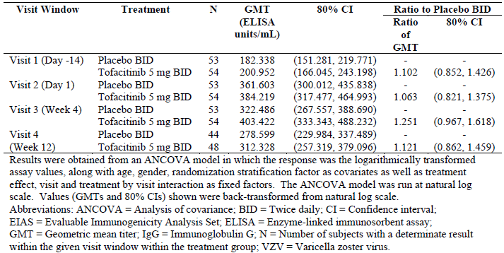
At visit 2 (study Day 1), the percentage of immune responders (≥ 1.5 titre rise from baseline) was higher in the TOF (55.6%; 30/54) versus PBO group (47.2%; 25/53) and this trend was observed at week 4 (57.4% for TOF versus 43.4% for PBO) and 12 of study treatment (45.8% for TOF versus 43.2% for PBO) – refer to Table 15.

Table 15: Proportion of Subjects with ≥ 1.5 fold Increase in VZV Specific IgG Levels by Visit in Study A3921237 (EIAS Population)
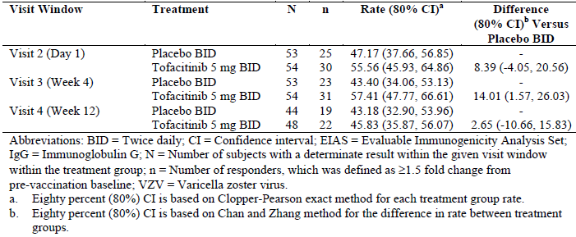
At Day 1 and week 12, the GMFRs in VZV specific IgG levels were numerically similar between the 2 treatment groups. In the control arm, at visit 2 (Day 1) and visit 4 (week 12), the GMFRs were 1.95 (80% CI 1.73, 2.19) and 1.50 (80% CI 1.32, 1.69), respectively. In the TOF group, at visit 2 (Day 1) and visit 4 (week 12), the GMFRs were 2.01 (80% CI 1.78, 2.26) and 1.64 (80% CI 1.45, 1.85), respectively. For the EIAS population, the GMFR ratios (of TOF/PBO) were 1.03 (80% CI 0.88, 1.21) at visit 2 (Day 1) and 1.09 (80% CI 0.92, 1.29) at visit 4 (Week 12).
Analysis of VZV specific cell mediated immunity (as measured by ELISPOT) at 2, 6 and 14 weeks post-vaccination were numerically slightly higher in the TOF group compared to PBO, but with overlapping CIs for the mean results to indicate similar vaccine induced, cell mediated immune responses between the 2 treatment groups.

Results for other safety outcomes (clinical and laboratory)
The median duration of study treatment was 83.0 days for the PBO group and 84.0 days for the TOF arm (overall range: 15 to 91 days). Overall, 21 subjects (36.8% of 57) reported 39 AEs in the PBO group and 16 subjects (29.1% of 55) recorded 40 AEs in the TOF arm. The most frequently reported type of AE by SOC in both groups was musculoskeletal disorders (that is symptoms or signs of inadequately treated RA), which affected 9 subjects (15.8%) in the PBO arm and 7 patients (12.8%) in the TOF group. Infection was the second most frequent type of AE by SOC in both groups affecting 4 subjects (7.0%) in the PBO group and 8 patients (14.5%) in the TOF arm. The most common types of infection by PT were URTI (2 cases in the TOF group and 1 case in the PBO arm), bronchitis (2 cases in the PBO arm and 1 case in the TOF group), nasopharyngitis (2 cases in the TOF arm) and oral herpes (2 cases in the PBO group). All other infections were single cases, including 1 case each of candida infection, viral gastroenteritis, EBV infection and disseminated herpes zoster, which were only recorded in the TOF group. A total of 4 subjects (7.0%) in the PBO group and 3 subjects (5.5%) in the TOF arm were considered to have treatment related AEs and the only SOC in which > 5% of subjects experienced AEs that were deemed to be treatment related was infection (affecting 3 subjects in each treatment group – 5.3-5.5%).
Three subjects in the TOF group (5.5% of 55 versus none in the PBO arm) experienced 4 SAEs including 1 case each of disseminated herpes zoster, bronchitis (considered drug related) and cholangitis with bile duct stone (deemed unrelated to TOF). All of the SAEs resolved within 2 weeks of treatment cessation. The case of disseminated VZV infection was an SAE of special interest, which occurred in a female subject 16 days after vaccination and 2 days after commencing treatment with TOF. The subject was previously varicella virus naïve as evidenced by no prior history of varicella infection and negative antibody testing at baseline. TOF was permanently discontinued and the subject recovered without sequelae after treatment with anti-viral therapy. Subsequent testing showed the subject made robust anti-varicella T cell and antibody responses at 6 weeks post-vaccination but not at 2 weeks post-vaccination. This was interpreted as being consistent with primary VZV infection. No subject died in this study.
In the PBO group, 15.8% (9/57) of subjects permanently discontinued from the study due to AEs, including 7 subjects who did so because of worsening of RA symptoms. Two PBO (with continued MTX) treated subjects discontinued from the trial because of treatment related AEs; 1 case of neutropenia and another subject experienced oral herpes infection of moderate severity. In the TOF group, 7.3% (4/55) of subjects withdrew, which includes the 3 subjects who experienced SAEs as well as another patient who discontinued because of RA worsening. Another 5 subjects (1 in the PBO group and 4 in the TOF arm) had temporary treatment discontinuations or dose reductions of study treatment because of AEs, which were mainly due to inter-current infection or laboratory abnormalities.
Regardless of baseline values, laboratory test abnormalities were recorded in 49.1% (28/57) of subjects in the control group and 29.1% (16/55) of patients in the TOF arm. The most frequently reported laboratory test abnormalities (incidence > 6% in any treatment group) were lymphopenia (19.3% [11/57] of subjects in the PBO group and 10.9% [6/55] in the TOF arm), neutrophilia (14.0% [8/57] of subjects in the PBO group and 9.1% [5/55] in the TOF arm) and hyperglycaemia (12.3% [7/57] of subjects in the PBO group and 7.3% [4/55] in the TOF arm). Among subjects with normal baseline test results, laboratory test abnormalities were recorded in 17.5% (10/57) of subjects in the control group and 20% (11/55) of patients in the TOF arm. The most frequent new laboratory test abnormalities were leucopenia (1 case in the PBO group), neutropenia (1 case in the PBO arm), lymphopenia (1 case in the PBO group), anaemia (1 case in the PBO group), heparin induced thrombocytopenia (1 case in the TOF arm), hypercholesteraemia (1 case in the TOF group) and raised liver function tests (1 case in the TOF arm).

Evaluator commentary
Study A3921237 demonstrated that in subjects aged at least 50 years with active RA despite MTX, VZV specific IgG responses at 2, 6 and 12 weeks following zoster vaccination were similar in TOF + MTX treated and control subjects (continued MTX monotherapy) indicating similar vaccine induced humoral immune responses. In addition, T-cell subset analyses following zoster vaccination were similar between the 2 treatment groups indicating similar vaccine induced cell-mediated immune responses. The incidence and type of clinical safety outcomes and laboratory test abnormalities observed in Study A3921237 were consistent with the known safety profile of TOF. There were no SAEs observed in the control arm, but 3 subjects treated with TOF permanently discontinued from the trial due to 4 SAEs, all of which resolved by 2 weeks off therapy. In general, zoster vaccination appeared safe in all subjects except 1 patient who lacked pre-existing exposure to varicella infection. Cutaneous dissemination of vaccine strain VZV occurred in 1 TOF treated subject who recovered without sequelae on anti-viral therapy.

Patient exposure
Table 16 presents the total number of subjects with RA who have received at least 1 dose of TOF in clinical trial program, and the same table displays the drug exposure (mean and total) to TOF across the different nominated safety populations such as all 6 Phase III studies combined, Study A3921069 in isolation, the 2 LTE trials combined and finally, the total integrated safety dataset, which the sponsor calls the “P123LTE” population.

Table 16: TOF Exposure in main safety populations
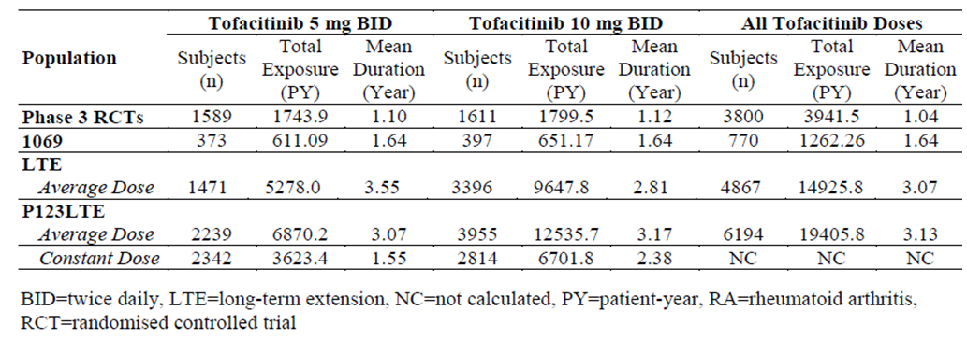
As a comprehensive analysis of the 24 month safety dataset for Study A3921069 is a focus of this submission, the number of subjects exposed to study drug (either dose of TOF or MTX) over time in this particular trial is presented in Table 17. In this pivotal trial, most patients (> 60% in the MTX group and almost three quarters in each of the TOF arms) took their allocated study treatment for at least 18 months in Study A3921069.

Table 17: Number of Subjects and Drug Exposure by Treatment Group in Study A3920169
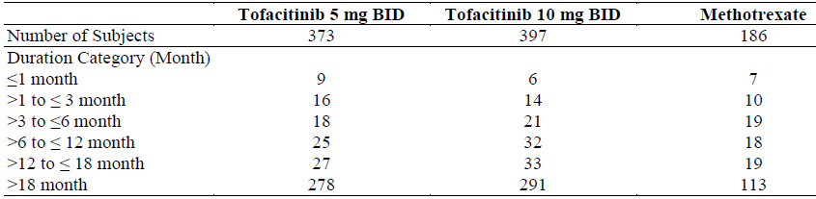

Adverse events

All adverse events (irrespective of relationship to study treatment)

Integrated safety analyses
In the long term safety all exposure population (n = 4867 subjects), the rates of overall infection with TOF 5 mg twice daily therapy is 43.8 events per 100 PY (95% CI 41.2, 46.55 events per 100 PY) and 47.2 events per 100 PY (95% CI 45.25, 49.16 events per 100 PY) for TOF 10 mg twice daily treatment. For patients on TOF monotherapy (n = 1750 subjects), the rates of overall infection were 48.9 and 41.9 events per 100 PY for 5 mg and 10 mg twice daily, respectively. For patients taking TOF with concomitant DMARD (n = 3117 subjects), the rates of overall infection were 41.0 and 50.3 events per 100 PY for TOF 5 mg and 10 mg twice daily therapy, respectively. It is difficult to clinically interpret this data as it seems the highest risk of overall infection is observed with high dose TOF in combination with DMARD and low dose TOF monotherapy.

Pivotal and/or main efficacy studies
The proportion of subjects who experienced at least 1 AE through to 24 months of treatment in Study A3921069 was similar between the lower dose TOF and MTX treatment groups (79.6% [297/373] in the TOF 5 mg group and 79.0% [147/186] in the MTX arm), but occurred at a slightly higher incidence in the TOF 10 mg group.
The most common types of AEs by SOC with TOF treatment were infections, gastrointestinal disorders and abnormal investigations. The risk difference for the incidence of AEs (occurring at a frequency of at least 2% in either treatment group) between the TOF 5 mg and MTX groups is presented in Table 18.

Table 18: Number, Percentage and Risk Difference of Common Adverse Events (≥ 2% incidence) between TOF 5 mg and MTX in Study A3921069 (2 Year Analysis)
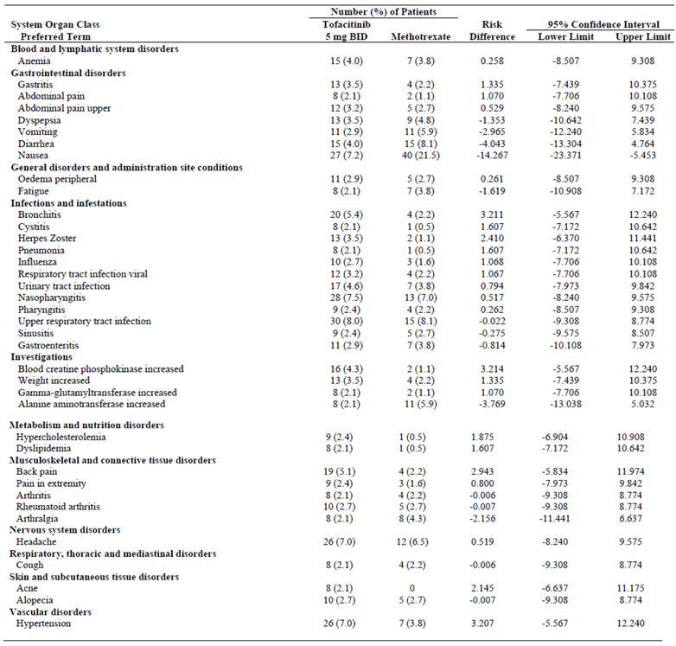
For the TOF 5 mg group (in comparison to MTX), the AEs with the greatest risk difference were increased blood creatine phosphokinase (CPK; risk of 3.21 [95% CI: -5.57, 12.24]), bronchitis (risk of 3.21 [95% CI: -5.57, 12.24]) and hypertension (3.21 [95% CI: -5.57, 12.24]). In contrast, higher frequencies of nausea and diarrhoea were reported with MTX versus TOF 5 mg therapy. The greatest negative risk (lower risk) difference was observed in nausea (-14.27 [95% CI: -23.37, -5.45]) and diarrhoea (-4.04 [95% CI: -13.30, 4.76]).
For the TOF 10 mg group (in comparison to MTX), the AEs with the greatest positive risk difference were increased blood CPK (7.99 [95% CI: -0.71, 16.87]), bronchitis (4.65 [95% CI: -4.05, 13.56]), and hypertension (3.54 [95% CI: -5.16, 12.46]). The greatest negative risk difference was observed with nausea (-13.95 [95% CI: -23.04, -5.25]) and vomiting (-2.64 [95% CI: -11.85, 6.06]).

Other studies
With the addition of safety data from Study A3921069, the most commonly reported AEs during the first 3 months of TOF therapy in the 6 Phase III clinical trials (occurring in ≥ 2% of patients treated with TOF, either as monotherapy or in combination with conventional DMARD) were headache, upper respiratory tract infection, nasopharyngitis, diarrhoea, nausea and hypertension. The sponsor has proposed an amendment to the current PI reflecting the updated dataset.
In this submission, the sponsor proposes to update the current PI with respect to the rates of overall and serious infection with TOF. This will result in a numerical increase in the rate of overall infection with TOF 5 mg twice daily therapy. In the controlled portion (0-3 months) of the 2 Phase III monotherapy studies (A3921045 and A3921069), the rates of overall infection with TOF 5 mg twice daily and 10 mg twice daily monotherapy were 16.1% and 17.8%, respectively, compared to 18.9% in the control group. In the controlled portion (0 to 3 months) of the 4 Phase III studies (A3921032, A3921044, A3921046 and A3921064) where TOF was combined with background DMARD, the rates of overall infection in the 5 mg twice daily and 10 mg twice daily plus DMARD groups were 21.3% and 21.8%, respectively, compared to 18.4% in the PBO plus DMARD arm. With extended combination treatment follow-up (0 to 6 months of the 3 Phase III studies A3921044, A3921046 and A3921064) where TOF plus DMARD was used, the rates of overall infection in the 5 mg twice daily and 10 mg twice daily TOF plus DMARD groups were 34.6% and 32.8%, respectively, compared to 21.3% in the PBO plus DMARD group. The most commonly reported types of infections were upper respiratory tract infections (3.7%) and nasopharyngitis (3.2%).

Treatment related adverse events (adverse drug reactions)

Integrated safety analyses
No new information.

Pivotal and/or main efficacy studies
The proportion of subjects who experienced at least 1 treatment related AE through to 24 months of treatment in Study A3921069 was similar between the higher dose TOF and MTX treatment groups (53.1% [211/397] in the TOF 10 mg group and 53.2% [99/186] in the MTX arm), but occurred at a slightly lower incidence in the TOF 5 mg group (45.0%; 168/373). Table 19 presents the most frequent (that is incidence ≥ 2% in any of the 3 treatment groups) treatment related AEs by SOC and PT for the 2 year safety dataset of Study A3921069. The most frequently recorded treatment related AE by PT in each treatment group was nausea, which was experienced by a greater percentage of MTX treated subjects (20.4%; 38/186) compared to those who received TOF (4.3 to 6.5%). Overall, upper respiratory tract infection and headache was the second and third most common treatment related AEs by PT, with both of these AE types occurring at a similar frequency between the 3 treatment groups. However, some types of treatment related AEs were either only recorded in TOF treatment groups or occurred at a higher frequency with TOF versus MTX. These AEs include increased blood CPK levels (2.1% with TOF 5 mg and 5.5% with TOF 10 mg versus 0 cases with MTX), hypertension (1.3% with TOF 5 mg and 3.0% with TOF 10 mg versus 0 cases with MTX), herpes zoster infection (2.7% with TOF 5 mg and 3.0% with TOF 10 mg versus 0.5% with MTX) and hypercholesteraemia (1.3% with TOF 5 mg and 2.3% with TOF 10 mg versus 0.5% with MTX).

Table 19: Most Frequent Treatment Related AEs by SOC and PT in Study A3921069
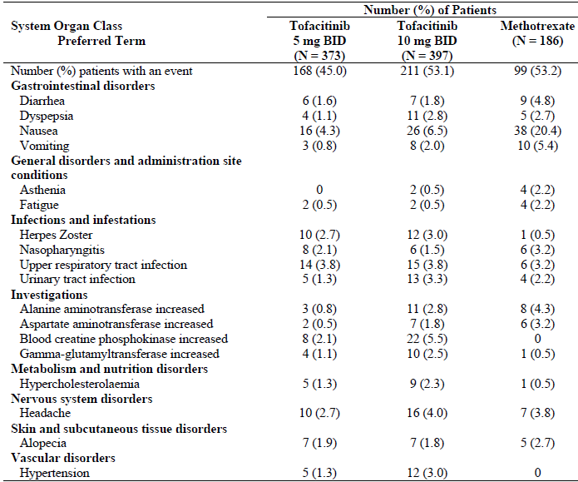

Other studies
No new information.

Deaths and other serious adverse events

Integrated safety analyses
In the long term safety all exposure population, the incidence of serious infection is 2.38 events per 100 PY (95% CI 1.98, 2.84) for patients treated with TOF 5 mg twice daily and 2.97 events per 100 PY (95% CI 2.64, 3.34) for patients treated with TOF 10 mg twice daily. The most common types of serious infection in the long term dataset are pneumonia, herpes zoster, urinary tract infection, cellulitis, gastroenteritis and diverticulitis, all of which are included in the proposed PI.
In the long term safety all exposure population, the incidence of adjudicated gastrointestinal perforations is low at 0-0.07 events per 100 PY for TOF 5 mg therapy (using either the average or constant dose method), but significantly higher at 0.14-0.15 events per 100 PY in those treated with TOF 10 mg twice daily (using either the average or constant dose method) – refer to Table 20. Curtis et al (2011) reported that the rate of gastrointestinal perforation for subjects exposed to oral CS while receiving biologic DMARD therapy is 0.112 events per 100 PY, which is similar to that observed for the lower dose of TOF therapy. In addition, identified risk factors for gastrointestinal perforations in patients with RA include diverticulitis, and concurrent NSAID and/or oral CS use.

Table 20: Exposure Adjusted Incidence Rates for Adjudicated Gastrointestinal Perforations in the Integrated Safety Dataset
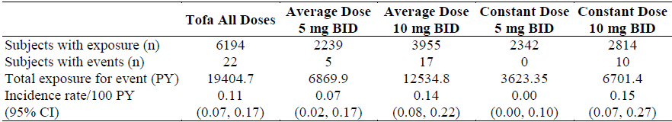
A total of 90 deaths in association with TOF therapy (any dose) have been recorded in the long term safety dataset (1.45% of 6194 subjects) at an incidence rate of 0.47 deaths per 100 PY (95% CI 0.37, 0.57). Regarding the 5 mg twice daily regimen, 37 deaths (2.5% of 1471) have been reported at an incidence rate of 0.70 deaths per 100 PY (95% CI 0.49, 0.97), which is more than double the all-cause mortality results observed with TOF 10 mg twice daily (32 deaths [0.94% of 3396] at an incidence rate of 0.33 deaths per 100 PY [95% CI 0.23, 0.47]).
In December 2015, the sponsor provided the TGA with information reporting 11 cases of pancreatic cancer with TOF, which appeared to disproportionately occur in patients with skin psoriasis (6 cases). There were also 4 cases of pancreatic cancer in subjects with RA and 1 in an individual receiving TOF for psoriatic arthritis. A review of the cases noted that many patients; including all reported in the skin psoriasis program, had a medical history of several established risk factors for pancreatic cancer including family history of pancreatic cancer, smoking, diabetes, obesity, and chronic pancreatitis. Additionally, the duration of exposure to TOF at the time the cancer was diagnosed was < 1 year in 5 of the reported cases (3 of 4 RA and 2 of 6 skin psoriasis individuals). Overall, an expert panel concluded that there is insufficient evidence for a direct causal association between TOF and pancreatic cancer, but surveillance is required.
This submission did not contain an updated integrated safety analysis of 2 SAEs of special interest with TOF, for which changes to the PI are being requested by the sponsor. These SAEs of special interest include the overall rates of malignancy and some sub-types of cancer such as lymphoma, as well as the risk of interstitial lung disease. The sponsor states that these proposed PI changes are being processed via a separate safety related request to the TGA.

Pivotal and/or main efficacy studies
A total of 4 subjects died during Study A3921069, 3 of who received TOF 5 mg therapy and 1 patient in the TOF 10 mg arm died of advanced stage colon cancer (considered not related to treatment). None of the 186 subjects treated in the MTX arm died. A patient died on study Day 472 (2 days after ceasing TOF 5 mg twice daily) of sudden and unexplained cardiac death. The death was considered to be possibly related to study medication. Another patient died of cardiac failure on study Day 685; the death followed lung lobectomy surgery for emphysema. The death was not considered to be treatment related. A patient died on study Day 765 of Non-Hodgkin’s lymphoma, which was judged to be possibly related to TOF.
Up to 24 months in Study A3921069, the proportion of subjects who experienced SAEs was comparable in each of the 3 treatment groups: 10.7% (40/373) in the TOF 5 mg group, 10.8% (43/397) in the TOF 10 mg arm and 11.8% (22/186) in the MTX group. Infection was the most frequent type of SAE by SOC in each of the 3 treatment groups reported at an incidence of 2.9% (11/373) in the TOF 5 mg group, 2.8% (11/397) in the TOF 10 mg arm and 2.7% (5/186) in the MTX group. Excluding musculoskeletal disorders, gastrointestinal disorders was the second most frequent SAE by SOC reported at an incidence of 1.3% (5/373) in the TOF 5 mg group, 1.5% (6/397) in the TOF 10 mg arm and 2.2% (4/186) in the MTX group. Of note, 1 subject treated with TOF 5 mg therapy experienced perforation of a gastric ulcer. No other cases of gastrointestinal perforation were observed in Study A3921069.
By PT, the most common type of infectious SAE was pneumonia, which was recorded in 2 subjects in each of the TOF dose groups (0.5% incidence) versus no cases in the MTX arm. One additional patient in the TOF 10 mg arm had an SAE of lower respiratory tract infection. Gastroenteritis was the second most common type of infectious SAE by PT affecting 1 patient each in the TOF 5 mg and MTX groups (0.3 to 0.5%) and 2 subjects in the TOF 10 mg arm (0.5%). Two cases of herpes zoster infection (1 in each TOF dose group) were recorded in Study A3921069, plus a patient in the TOF 10 mg arm experienced an additional case of disseminated herpes zoster infection. No patients in the MTX group recorded zoster infection but 1 subject developed varicella as an SAE. Other single cases of note in the dataset were bone TB (in a patient treated with TOF 10 mg) and sepsis (in a subject in the TOF 5 mg arm).
Regarding major adverse cardiovascular events, 2 subjects (1 in each TOF group) recorded myocardial ischaemia up to 24 months in Study A3921069, 3 patients experienced deep vein thrombosis (2 subjects in the MTX arm and 1 in the TOF 5 mg group), 3 subjects developed angina (all in the TOF 5 mg group), 3 patients experienced stroke (2 in the TOF 10 mg arm and 1 in the TOF 5 mg group) and 2 patients recorded cardiac failure (1 in each TOF arm). Of note, 1 case of demyelinating polyneuropathy was recorded in a subject treated with TOF 10 mg twice daily. There were no other cases of demyelinating disorders identified in Study A3921069.
Neoplasms (benign and malignant) were reported at a slightly higher incidence in the TOF treatment groups (1.1% [4/373] in the 5 mg group and 0.8% [3/397] in the 10 mg arm) versus MTX (0.5%; 1/186; gastric cancer). Three cases of haematological malignancy were reported in the 24 month dataset including Non-Hodgkin’s lymphoma (TOF 5 mg group), high grade B cell lymphoma (TOF 10 mg therapy) and T cell chronic lymphocytic leukaemia (TOF 5 mg arm).

Other studies
In this submission, the sponsor proposes to update the current PI with respect to the rates of overall and serious infection with TOF. In the controlled portion (0-3 months) of the 2 Phase III monotherapy studies (A3921045 and A3921069), the rates of serious infection with TOF 5 mg twice daily and 10 mg twice daily monotherapy were 0.2% and 0.3%, respectively, compared to zero in the control group. In the controlled portion (0-3 months) of the 4 Phase III studies (A3921032, A3921044, A3921046 and A3921064) where TOF was combined with background DMARD, the rates of serious infection in the 5 mg twice daily and 10 mg twice daily plus DMARD groups were 0.8% and 0.8%, respectively, compared to 0.4% in the PBO plus DMARD arm. With extended combination treatment follow-up (0-6 months of the 3 Phase III studies A3921044, A3921046 and A3921064) where TOF plus DMARD was used, the rates of overall infection in the 5 mg twice daily and 10 mg twice daily TOF plus DMARD groups were 1.8% and 1.4%, respectively, compared to 0.5% in the PBO plus DMARD group. The most commonly reported types of serious infections were lower respiratory tract infections/pneumonia, various types of soft tissue infections (such as cellulitis and folliculitis) and urinary tract infections.

Discontinuations due to adverse events

Integrated safety analyses
No new information provided in this submission.

Pivotal and/or main efficacy studies
Up to 24 months in Study A3921069, a slightly higher percentage of subjects in the MTX arm (13.4%; 25/186) discontinued due to AEs compared to both TOF dose groups (10.7% [40/373] in the 5 mg group and 10.3% [41/397] in the 10 mg arm). Abnormal investigation results (11 subjects) and various types of infection (8 patients) were the 2 most common reasons for treatment related AEs leading to withdrawal for patients in the TOF 5 mg group. The 11 subjects affected by abnormal investigation results included 3 cases of elevated serum transaminases, 3 cases of increased CPK levels and 2 cases of increased serum creatinine. Patients discontinuing from TOF 10 mg therapy showed a similar pattern of AEs, with the notable exception of 2 cases of TB being the precipitating treatment related AE. However, patients who discontinued from the MTX group mainly did so because of nausea, vomiting, stomatitis or various types of gastrointestinal disorders. The AE profile for MTX discontinuations in Study A3921069 is consistent with expectations for that drug.

Other studies
No new information provided in this submission.

Evaluation of issues with possible regulatory impact

Liver function and liver toxicity

Integrated safety analyses
No new information provided in this submission.

Pivotal and/or main efficacy studies
In Study A3921069, subjects treated with TOF showed a slight median increase from baseline in serum ALT of 2 to 3 IU/L, which peaked at 6 months and remained stable thereafter up to 24 months. Subjects treated with MTX showed a median increase from baseline of 4 IU/L at Month 6, which stabilised thereafter. Changes of similar magnitude were observed for serum AST in all 3 treatment groups. The median changes from baseline in serum total bilirubin through to 24 months were minimal in all 3 treatment groups.
In Study A3921069, the majority of subjects in all 3 treatment groups remained within normal limits for serum transaminases (ALT/AST) and bilirubin. Most subjects with abnormal liver function results were in the ≥ 1 x ULN category, and the affected subject proportions were as common in the MTX and TOF groups; refer to Table 21. The most notable difference between treatment groups was observed for the percentage of subjects with ALT or AST ≥ 3× ULN, which was an abnormality seen at least twice as frequently with MTX compared to TOF.

Table 21: Proportion of Subjects with Abnormal Liver Function Tests in Study A3921069
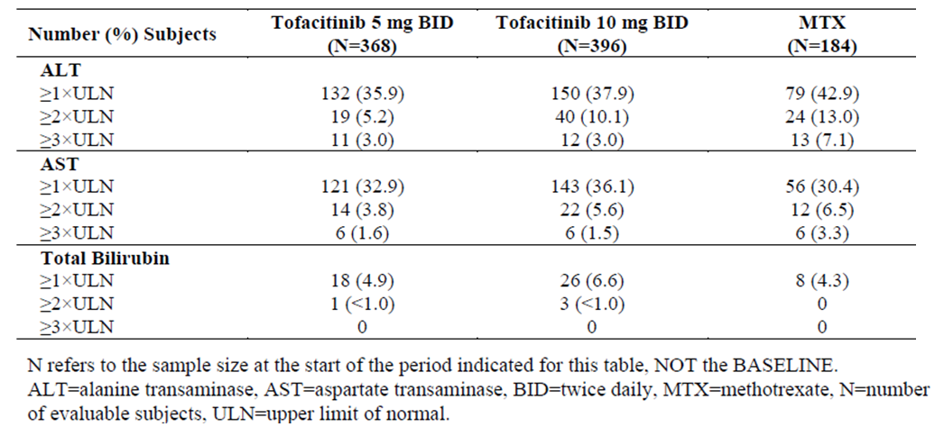
In Study A3921069, 12 (3.2%) subjects in the TOF 5 mg group, 13 (3.3%) patients in the TOF 10 mg arm and 13 subjects (7%) in the MTX group met the protocol criteria for further intensive monitoring (that is elevated serum transaminases on 2 consecutive readings). Two subjects in the TOF 10 mg group and 1 subject in the MTX arm had to permanently discontinue treatment due to persistent abnormalities of liver function tests. In addition, 2 subjects (both treated with TOF 10 mg therapy) met the initial screening process of potential Hy’s Law cases (that is serum ALT or AST ≥ 3 x ULN and bilirubin ≥ 2 x ULN). However, 1 case was subsequently dismissed because she did not meet the biochemical definition. This patient had an increase in serum ALP > 2 x ULN in conjunction with raised serum transaminases but normal serum bilirubin. The other case was also subsequently dismissed upon sponsor review. A patient with a history of poorly controlled hypertension and biliary lithiasis recorded an SAE of biliary colic on study Day 478 (confirmed on ultrasound on study Day 480), which resolved within 2 weeks of onset.

Other studies
No new information provided in this submission.

Renal function and renal toxicity

Integrated safety analyses
In the long term integrated dataset, the proportion of subjects who showed 2 consecutive increases in serum creatinine levels > 50% above their baseline value (that is the protocol specified TOF discontinuation criteria) was 2.4%. The 2.4% event rate is slightly higher than the 2% rate quoted in the current PI, so the sponsor has proposed an amendment to the PI to reflect the slightly higher observed incidence of significant change in renal function with long term TOF therapy.

Pivotal and/or main efficacy studies
In Study A3921069, the baseline mean serum creatinine levels in the 3 treatment groups were similar at 64.55 to 65.43 μmol/L. Up to 24 months, TOF treatment (either dose) produced a mean increase from baseline of 8.84 μmol/L in serum creatinine (evident from 6 months and stable thereafter) compared to a mean increase of 4.42 μmol/L in the MTX group.
In Study A3920169, the proportions of patients with raised serum creatinine (both ≥ 33% and > 50% of the average of the screening and baseline values; on at least 2 consecutive visits) were greater in the TOF arms than the MTX group. The proportion of patients who developed raised serum creatinine ≥ 33% of their baseline/screening value (which was the protocol defined threshold for intensive monitoring) was 9.9% (37/373) in the TOF 5 mg group, 9.5% (38/399) in the TOF 10 mg arm and 2.7% (5/186) in the MTX group. The percentage of subjects who recorded raised serum creatinine > 50% of their baseline/screening value (which was the protocol defined threshold for drug discontinuation) was 1.6% (6/373) in the TOF 5 mg group, 2.5% (10/399) in the TOF 10 mg arm and zero in the MTX group.

Other studies
No new information.

Other clinical chemistry

Integrated safety analyses
No new information.

Pivotal and/or main efficacy studies
Over 24 months of observation in Study A3921069 (without regard to baseline values), the percentage of subjects who experienced a > 2-fold increase in serum CPK reading was significantly higher with TOF therapy (in a dose related manner) compared to MTX. Overall, 12.5% (46/368) of subjects in the TOF 5 mg group, 22.2% (88/396) of patients in the TOF 10 mg arm and 3.8% (7/184) of subjects in the MTX group developed 2-fold increases in serum CPK levels. One subject discontinued from Study A3921069 because of increased CPK. A 29 year old male in the TOF 5 mg group permanently discontinued from the trial because of rhabdomyolysis with the peak serum CPK value being 3680 U/L on study Day 450. No other patients recorded rhabdomyolysis in Study A3921069. No other significant abnormalities of clinical chemistry were observed.

Other studies
No new information.

Haematology and haematological toxicity

Integrated safety analyses
With the addition of data from Study A3921069 and the latest data cut-off date of 31 March 2015, the sponsor proposes updating the rates of lymphopenia in the Adverse Effects section of the PI from the current 0.21% to 0.23% for patients treated with TOF in the controlled clinical studies, and from 0.31% to 1.3% of patients in the long-term safety population.

Pivotal and/or main efficacy studies
After 24 months of treatment in Study A3921069, the median decrease from baseline in absolute neutrophil counts was -1.17, -1.57 and -0.85 x 10⁹ cells/L in the TOF 5 mg, TOF 10 mg and MTX groups, respectively. The study also demonstrated greater median decreases from baseline in total lymphocyte counts with TOF (5 and 10 mg therapy) compared to MTX over the 2–year period. The median change from baseline to last observation in total lymphocyte count was -0.33, -0.43 and -0.16 x 10⁹ cells/L in the TOF 5 mg, TOF 10 mg and MTX groups, respectively. For all 3 groups, no significant mean changes over time in haemoglobin levels were observed.
As JAK2 is an important mediator of erythrocyte production, anaemia was a safety focus in Study A3921069. Overall, the proportion of patients who experienced severe (up to 3.5% incidence with MTX versus up to 1.4% with TOF) or potentially life threatening decreases in haemoglobin levels was low (< 1% of patients in any treatment group) at any time-point throughout Study A3921069. Table 22 summarises the proportions of patients with decreased haemoglobin values (based on the OMERACT criteria) by visit and treatment group in Study A3921069.

Table 22: Proportion of Subjects with Decreased Haemoglobin Levels during Study A3921069
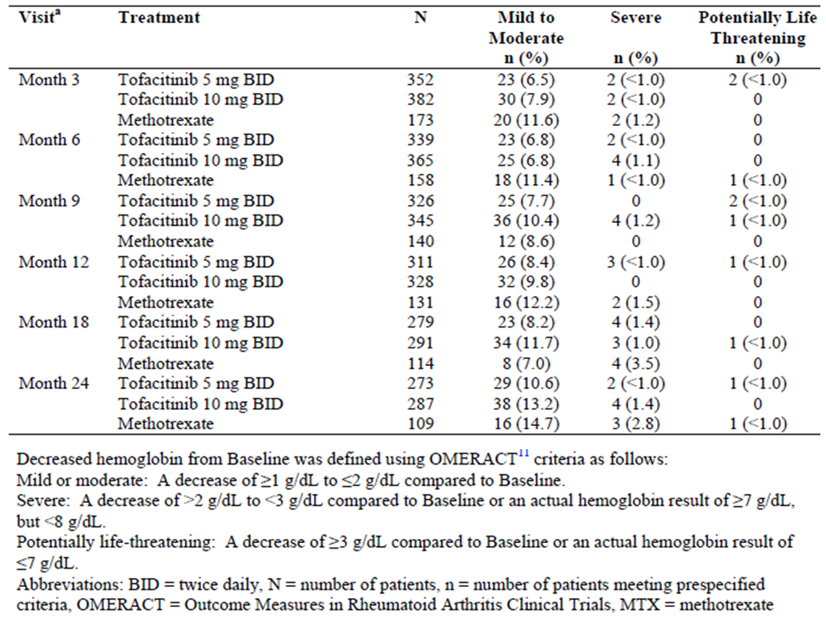
The case incidence of mild (frequency of up to 3.5%) or moderate to severe neutropenia (incidence ≤ 1.8%) was relatively low and comparable between the low dose TOF and MTX groups throughout Study A3921069, but somewhat higher in a consistent pattern for the TOF 10 mg arm; refer to Table 23. However, only 1 patient developed potentially life-threatening neutropenia during the 24 month trial and that subject was treated with TOF 5 mg therapy (occurred at Month 15).

Table 23: Proportion of Subjects recording Neutropenia during Study A3921069
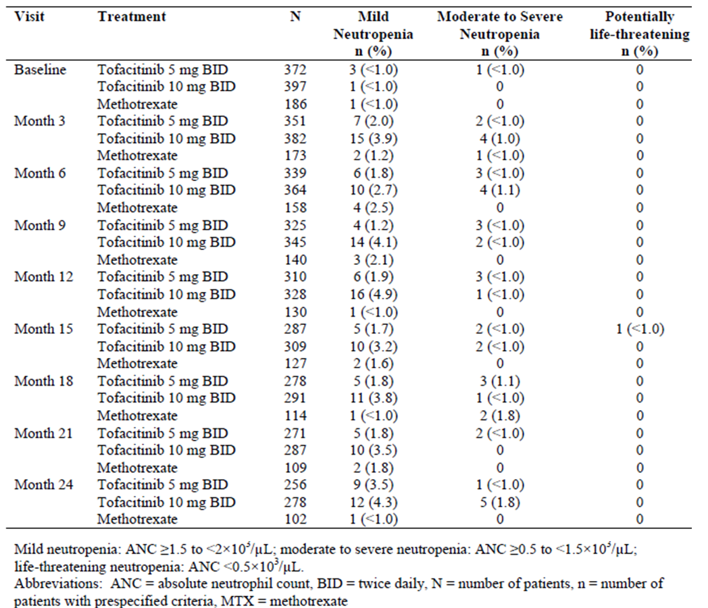
A total of 5 patients (3 in the TOF 5 mg group, and 1 each in the TOF 10 mg and MTX arms) developed thrombocytopenia (platelet count < 100 x 10⁹/L) during Study A3921069. Only 1 subject in the TOF 5 mg group developed significant lymphopenia (< 0.5 x 10⁹/L) which persisted on 2 sequential readings during the trial.

Other studies
No new information.

Lipid Profiles

Integrated safety analyses
No new information.

Pivotal and/or main efficacy studies
Treatment with TOF produces a significant, dose dependent increase in serum total cholesterol, which is evident by 3 months of therapy, plateaus at 6 months and remains stable thereafter up to 24 months of treatment follow-up. By 24 months, TOF 5 mg twice daily results in a mean 17.4% increase from baseline in total cholesterol and TOF 10 mg twice daily causes a mean 20.7% increase from baseline. Similar results with TOF were observed for low density lipoprotein levels and serum triglyceride levels. No significant mean changes in any lipid parameters over time are seen with MTX therapy.

Other studies
Changes in lipid parameters from baseline through to the end of the controlled trial periods (up to 24 months) in the Phase III studies confirms that significant, dose dependent increases in serum total cholesterol, LDL cholesterol and HDL cholesterol with TOF remain stable after 3 to 6 months of drug initiation. The current PI contains data on the impact of TOF upon lipid profiles up to 12 months in the controlled trials, so the update on this issue is appropriate. Table 23 shows the mean percentage change (increase) from baseline to 24 months in LDL cholesterol in the combined Phase III dataset.

Table 23: Mean Percentage Change from Baseline to 24 Months in LDL Cholesterol in the combined Phase III Trial Population
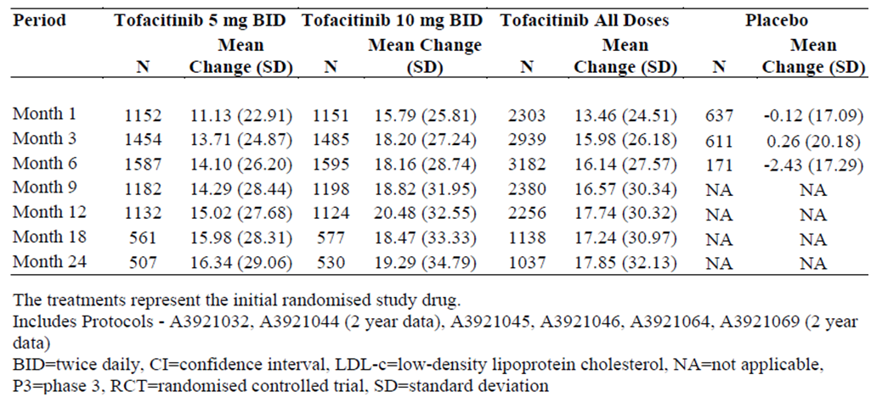

Electrocardiograph findings and cardiovascular safety

Integrated safety analyses
No new information.

Pivotal and/or main efficacy studies
Electrocardiograms (ECG) were obtained for all patients at the screening, Month 12 and 24. At screening, the percentage of patients with ECG abnormalities was small and similar (incidence ranging from 3.9 to 4.4%) across the 3 treatment groups. At Months 12 and 24, the percentage of patients with an increase from baseline in QT intervals of 30 to 60 msec and an increase from baseline of ≥ 60 msec were numerically similar (incidences ranging from 0 to 0.3%) in all treatment groups.

Other studies
No new information.

Vital signs and clinical examination findings

Integrated safety analyses
No new information.

Pivotal and/or main efficacy studies
In Study A3921069, the mean increase from baseline in body mass index was numerically greater in the 2 TOF groups than in the MTX arm at all time-points over 2 years, but the overall changes were small in all 3 treatment groups (< 1.5 kg/m² at all time-points). Minimal changes in heart rate were observed during the 2 year treatment period in Study A3921069, which were comparable between the 3 treatment groups. Although there were no significant mean changes in systolic and diastolic blood pressure over time with any treatment in Study A3921069, a greater proportion of subjects reported hypertension related AEs (as coded for by the Standardised MedDRA Query) in the TOF 5 mg (9.4%; 35/373) and TOF 10 mg (10.3%; 41/397) groups compared to the MTX arm (4.3%; 8/186). One subject in the TOF 10 mg group permanently discontinued due to hypertension.

Other studies
No new information.

Other safety issues

Safety in special populations
In Study A3921069, there were 5 cases of exposure to TOF in utero, 4 concerned pregnant female patients and 1 case related to a male patient with a pregnant partner. The outcome of the pregnancy was reported in 3 cases, with all 3 cases reporting live births with no congenital abnormalities. The current Australian PI does not recommend the use of TOF during pregnancy or by women attempting to become pregnant. In the RMP, the sponsor details how pregnancy outcomes in all TOF treated patients will continue to be monitored through routine monitoring and a pregnancy registry. In the updated RMP, 11 pregnancies in association with TOF therapy from post-marketing use have been recorded in the safety database as of June 2015. Outcome information was provided in 4 of the 11 pregnancies including 1 normal newborn, 1 premature baby with a short umbilical cord (gestational age 37 weeks) and 2 spontaneous abortions. The sponsor states that the outcomes in the other 7 pregnancies will be provided when available.

Safety related to drug-drug interactions and other interactions
No new information is available.

Post marketing experience
As of November 2015, the sponsor estimates that 34,000 PY of drug exposure with 3 years of global availability (based on sales data) has occurred. However, the Australian post-marketing experience is limited with sales of 4384 packs of 14 tablets recorded up to 31 July 2015 since the launch of TOF in Australia in March 2015. No specific post-marketing report was provided in this submission.

Evaluator’s overall conclusions on clinical safety
In this submission for extension of treatment indication in patients with active RA, the sponsor has provided an update to the overall safety database for TOF (as of the data cut-off date of 31 March 2015), as well as new Phase II study (A3921237) which evaluated the effects of TOF 5 mg twice daily on the zoster vaccine immune response in patients with RA.
The total clinical safety dataset for the use of TOF (any dose) in adult patients with active RA consists of 19,406 PY of drug exposure observed in 6194 patients. Of the treated subjects, 3470 have received treatment for > 2 years, 1443 subjects have received therapy for > 4 years and 345 patients have been exposed for > 6 years. In terms of the approved TOF regimen of 5 mg twice daily, 1589 patients have been exposed for a total of 1743.9 PY in the Phase III controlled studies and in the LTE population, 1471 patients have taken TOF for a mean duration of 3.5 years, which represents a total drug exposure at the registered dose of 5278 PY. About 80% of patients in the RA dataset have received concurrent conventional DMARD (usually low dose weekly MTX), more than 70% were taking concomitant NSAID, and approximately half were taking concurrent low dose oral CS. Overall, there is a sufficient volume of data to make a meaningful assessment of TOF safety (5 mg twice daily) for up to 7 years of treatment in adult patients with active RA.
Up to 24 months in Study A3921069, TOF 5 mg twice daily therapy + low dose weekly MTX showed a similar incidence of overall AEs, SAEs and AEs resulting in permanent treatment discontinuation compared to PBO tablets + continued MTX. However, some types of AEs occurred at a higher incidence in the TOF group (versus MTX) such as increased blood CPK levels, bronchitis and hypertension. In contrast, nausea and diarrhoea were more common with MTX versus MTX. Infection was the most common AE recognised with TOF and these occurred at a higher frequency in the TOF treatment groups versus control during the true PBO-controlled treatment periods (3-6 months for most Phase III trials). The majority of infections were mild in severity, self-limiting, and were predominately either nasopharyngitis or URTI. The use of concurrent MTX did not appear to increase the overall risk of AEs, including infection related AEs. SAEs including serious infection related events were reported in a low proportion of TOF-treated patients (< 3.0 serious infections per 100 PY of exposure). Some patients treated with TOF 10 mg twice daily developed reactivation of latent TB. However, there was an increased risk of herpes virus infections with any dose of TOF. This finding may be expected given the role of multiple cytokines in protective immunity. The majority of herpetic infections were rated as mild or moderate in severity, responded to standard treatment and did not result in permanent discontinuation from TOF, but there reports of disseminated herpes zoster.
Hypertension is an uncommon type of AE reported at a slightly higher incidence in patients receiving TOF (with no dose response relationship) compared to PBO therapy. Most hypertension related AEs were rated as mild or moderate in severity and did not result in discontinuation from TOF.
Cases of gastrointestinal perforation are a safety concern with TOF therapy, but the integrated dataset revealed a relatively low incidence of such events (< 0.07 per 100 PY) with TOF 5 mg twice daily therapy. Four treatment emergent deaths were reported in Study A3921069 (all in TOF treated subjects) and a total of 90 deaths have been reported in patients with RA in the long-term safety population. The rate of malignancies observed in Study A3921069 is within expectations of the treatment population and the types of cancer observed did not identify any specific new safety signals with TOF. There were also several MACE reports in Study A3921069, but overall these were within expectations for the selected treatment population. Nonetheless, longer periods of treatment follow-up are required to inform about these potential safety concerns (malignancy and MACE).
Neutropenia and lymphopenia are recognised safety concerns with TOF therapy and the issue was identified in the original TGA submission. In the short term period (first 3-6 months) of the Phase III studies, the overall incidence of neutropenia and lymphopenia was higher in both TOF (5 and 10 mg twice daily) treatment groups compared with PBO. There were occasional cases of severe neutropenia or lymphopenia observed in both TOF treatment groups, which required treatment discontinuation. Over long-term follow-up, the incidence of lymphopenia was only 1.3% with TOF. The majority of neutropenic and lymphopenic episodes were transient, and not associated with infection related AEs, but there is an association between severe lymphopenia and the incidence of treated and serious infection.
The total safety dataset also identified 4 other abnormalities of laboratory values which occurred at a numerically higher frequency in the TOF treatment cohorts compared with PBO or control populations. Elevations in hepatic transaminases, cases of raised CPK levels, increased serum creatinine levels and hyperlipidaemia have been associated with TOF. None of these abnormalities appear to display a dose response relationship with TOF. In general, patients who developed increases in laboratory tests had changes of mild-moderate severity, which were mainly transient in nature (apart from the impact upon lipids) and without associated clinical sequelae. There are occasional permanent discontinuations from TOF because of persistent and/or severe abnormal laboratory results.
Study A3921237 demonstrated that in subjects aged at least 50 years with active RA despite MTX, VZV specific IgG responses at 2, 6 and 12 weeks following zoster vaccination were similar in TOF + MTX treated and control subjects (continued MTX monotherapy) indicating similar vaccine induced humoral immune responses. In addition, T cell subset analyses following zoster vaccination were similar between the 2 treatment groups indicating similar vaccine induced cell mediated immune responses. The incidence and type of clinical safety outcomes and laboratory test abnormalities observed in Study A3921237 were consistent with the known safety profile of TOF. There were no SAEs observed in the control arm, but 3 subjects treated with TOF permanently discontinued from the trial due to 4 SAEs, all of which resolved by 2 weeks off therapy. In general, zoster vaccination appeared safe in all subjects except 1 patient who lacked pre-existing exposure to varicella infection. Cutaneous dissemination of vaccine strain VZV occurred in 1 TOF treated subject who recovered without sequelae on anti-viral therapy.
Because TOF is an oral targeted synthetic DMARD (in contrast to biologic DMARD therapy administered by intravenous infusion or subcutaneous injection) it is not expected nor observed to produce immunogenicity or an increased incidence of allergic skin reactions.
In summary, the safety data indicates that TOF 5 mg twice daily has an acceptable overall safety profile up to 7 years of therapy in the treatment of adult patients with moderately to severely active RA. There is limited long-term safety data to assess the risk of some types of AEs such as malignancy and MACE, which will require additional longitudinal safety follow-up. There are some significant identified safety concerns including the risk of overall infection, opportunistic infection (mainly herpes viral infection and TB), neutropenia, lymphopenia, abnormal liver function tests and dyslipidaemia. These safety concerns are consistent with the known profile of TOF in adult patients with RA. Ongoing pharmacovigilance will be required for the continued registration of TOF in the treatment of patients with RA. This would include vigilance for opportunistic infections, MACE and malignancy (particularly, non-melanoma skin cancers and lymphoma).

First round benefit-risk assessment

First round assessment of benefits
In this submission requesting an extension of treatment indication, the benefits of TOF 5 mg twice daily (with or without concomitant MTX) in adult patients with active RA are:
- TOF + MTX versus PBO + MTX results in statistically significant less worsening of structural progression (as measured by mean changes from baseline in mTSS) over 6 and 12 months when sensitivity and patient subset analyses (mostly, post hoc analyses) are applied to the X-ray dataset of Study A3921044. However, the primary X-ray analysis did not support a robust finding in favour of TOF therapy in a predominantly second line treatment population with established RA. Trial design and unexpectedly low rates of X-ray progression in the control group may have contributed to the non-statistical finding with the primary analysis.
- TOF therapy (versus MTX) is associated with a lower rate of structural disease progression at Months 6, 12 and 24 months of treatment in a RA population with early disease (median < 12 months duration) who are mainly naive to DMARD therapy (Study A3921069), however, this is not the current approved treatment population for TOF in Australia and the sponsor is not requesting a change to the recommended patient treatment group.
- X-ray benefits with TOF versus PBO in Study A3921044 were observed in a treatment response enriched population (that is autoantibody positive subjects with established joint erosions and elevated CRP values at baseline). However, the generalisability of this finding to the Australian clinical practice setting is limited and has not been included in the sponsor proposed X-ray indication wording or PI.
- The magnitude and clinical relevance of the potential X-ray benefits with TOF versus alternative treatment options in adult patients with active RA is unclear and cannot be quantified with scientific rigor from the current dataset.
- Improvement in the signs and symptoms of RA (as per the ACR clinical response criteria), which appear to be maintained to at least 2 years of treatment in the 2 pivotal Phase III studies (A3921044 and A3921069).
- Persistence of clinical efficacy response for up to 7 years in the subgroup of patients who are responding to and tolerating TOF 5 mg twice daily therapy (as seen in the LTE Studies A3921024 and A3921041). The volume and recorded outcomes of the extended TOF treatment cohort is a relative strength of the current dataset.
- Correlation between improvements in RAMRIS erosion scores on MRI, and mTSS and ES on Plain X-rays at 6 months with TOF therapy (Study A3921068), which supports the plausibility of TOF exerting a possible structural modification effect (preliminary data only).
- Study A3921237 demonstrated that in subjects aged at least 50 years with active RA despite MTX, VZV specific IgG responses at 2, 6 and 12 weeks following zoster vaccination were similar in TOF + MTX treated and control subjects (continued MTX monotherapy) indicating similar vaccine induced humoral immune responses. In addition, T cell subset analyses following zoster vaccination were similar between the 2 treatment groups indicating similar vaccine induced cell-mediated immune responses.
- Convenient mode of administration (oral ingestion) with an acceptable dosing schedule (twice daily administration) versus subcutaneous injection for a variety of other DMARD therapies.

First round assessment of risks
The risks of TOF in the proposed usage include:
- Increased incidence of overall infection compared to PBO, which are usually minor in severity (in particular, URTI and nasopharyngitis), but there is also an increased risk of serious infection with TOF.
- Increased risk of pneumonia (including compared to MTX – see Table 18) and various types of herpes infection (in particular, herpes zoster infection) with TOF.
- Increased risk of drug induced neutropenia and lymphopenia compared to PBO.
- Risk of precipitation of gastrointestinal perforation (mainly seen with the higher non-approved dose of TOF 10 mg twice daily).
- Increased frequency of raised serum transaminases and atherogenic serum lipid profiles compared to PBO.
- Potential increased risk of malignancy and MACE requiring long-term surveillance; not evident in the current safety dataset.
- Higher rates of hypertension with TOF versus control therapy, which are usually non-severe in nature and rarely leads to permanent treatment discontinuation.
- Increased rates of raised serum CPK values and occasional reports of rhabdomyolysis resulting in permanent treatment discontinuation from TOF.
- Potential for drug induced interstitial lung disease and reduction in renal function with TOF.
- TOF has not been studied in patients < 18 years of age, in subjects with significant organ dysfunction (including renal, hepatic or cardiac failure), those at risk of reactivated latent tuberculosis (requiring meticulous screening at baseline), and in pregnant or lactating women.
- TOF has not been studied and should not be used in combination with biologic DMARD therapy in patients with RA.

First round assessment of benefit-risk balance
The overall benefit-risk balance of TOF, with or without combination non-biologic DMARD (mainly, weekly low dose oral MTX) in adult patients with moderately to severely active RA, who have had an inadequate response to or intolerant of at least 1 DMARD, with respect to inhibition of structural progression associated with RA is unclear. The claim of radiographic benefit in RA is an add-on claim to an overall treatment indication, which already includes improvement in the symptoms and signs as well improving physical function. Several biologic therapies approved in Australia for the treatment of RA also include a claim of radiographic benefit.
TOF is a small molecule drug that selectively inhibits JAK1 and JAK3, thereby blocking the effects of various pro-inflammatory cytokines. In this submission, TOF has been evaluated in a large clinical program, which complied with CHMP guidelines for evaluation of treatment in RA. The clinical studies have evaluated an adequate number of subjects in the target patient population and demonstrated that TOF 5 mg twice daily is an effective in the treatment of active RA. The complete radiographic dataset questionably suggests superior inhibition of X-ray progression in the currently approved treatment population, but superiority of this X-ray data has been observed in various sensitivity and patient subgroup analyses, many of which were not pre-specified in the statistical testing for the 1 true pivotal trial that recruited patients consistent with the approved treatment indication (that is Study A3921044).
The safety profile of TOF observed in the extended clinical safety dataset included in this submission is largely consistent with that known for TOF, based on the original TGA submission. The recognised risks with TOF therapy include an increased risk of infection and changes in certain laboratory parameters, in particular, decreases in neutrophil count and increases in hepatic transaminases and serum lipids. The risk profile of TOF is based on a total of 1589 TOF 5 mg twice daily treated patients with RA involved in the Phase III studies, as well as additional safety information collected from > 6000 patients treated with any dose of TOF in the all exposure population.
In the RA trials, there was an increased incidence in overall infections in the 2 TOF dose groups compared to PBO. The majority of reported infections were mild or moderate upper respiratory tract infections. Herpes related infections were also more frequent with TOF compared to PBO. However, very serious opportunistic infections like TB were reported with TOF.
Neutropenia was much more frequently observed with TOF than PBO, but most cases were of mild severity (CTCAE Grade 1-2), transient and reversible. More severe neutropenia (CTCAE Grade 3-4) was also observed with TOF, but were rarely associated with serious infection. There was also an increased incidence of mild-moderate hepatic transaminase elevations, increased blood CPK levels and dyslipidaemia with TOF versus PBO. Significant changes in laboratory parameters associated with TOF were generally managed by dose interruptions.
Malignancy represents a theoretical risk with any immunosuppressive therapy, but there is limited evidence that TOF confers an increased risk for certain types of malignancy such as non-melanoma skin cancers and lymphoma in the current dataset.

First round recommendation regarding authorisation
The evaluator does not recommend acceptance of the sponsor’s request for the extension of TOF registration to include the add-on claim of radiographic benefit in for the treatment of moderately to severely active RA in adult patients who have failed to respond to or are intolerant of at least 1 DMARD. There is only 1 pivotal trial in the current radiographic dataset (Study A3921044), which has rigorously examined for joint structural progression in the treatment population that reflects the approved indication for TOF in Australia. The evaluator recommends approval for the sponsor to add the X-ray data (as listed in the proposed PI), but no change to the treatment indication wording is recommended. The current submission provides unclear evidence that TOF 5 mg twice daily is effective in slowing the progression of structural joint damage in RA, but the data does not meet rigorous and robust scientific standards such as being statistically significant on the primary pre-specified analysis of the FAS.
The evaluator recommends the sponsor’s proposed claim of durability in clinical efficacy response and the various safety updates to be included in the updated PI. No significant deficiencies or inaccuracies of that information is proposed in the new PI and all statements have been justified in this submission; except for the proposed changes to the malignancy and interstitial lung disease sections of the PI (subject to another TGA process of assessment).
Should approval of the sponsor’s proposed extension of treatment indication for TOF in active RA be granted, the evaluator also recommends that approval should be subject to:
- Satisfactory response to the questions in this report,
- Regular periodic safety update reports, and
- When available, the sponsor provides the TGA with the final clinical study report for the LTE Study A3921024.

Clinical questions

Pharmacokinetics
Nil

Pharmacodynamics
Nil

Efficacy
- In the pivotal Phase III Study A3921069, the control treatment arm was assigned weekly low dose methotrexate. The clinical study report did not provide information on the dose (including the proportion of subjects who received dose split regimens as specified in the protocol) as well as the route of administration of methotrexate after 3 months to allow evaluation of the adequacy of comparator treatment. Recent expert opinion has identified suboptimal methotrexate therapy (dose and route of administration) as a source of biasing findings in favour of biologic therapies in RA clinical trials. Could the sponsor comment on the adequacy of therapy in the control arm of Study A3921069 (over the entire 24 months) as a potential source of efficacy bias?
(Ref: Duran J, Bockorny M, Dalal D, et al. Methotrexate dosage as a source of bias in biological trials in rheumatoid arthritis: a systematic review. Ann Rheum Dis. 2016 Sep;75(9):1595-8)
- Could the sponsor provide information about the dose and duration of preceding methotrexate use, as well as any information regarding the dose, persistence and route of concomitant methotrexate use during the pivotal radiographic Study A3921044?
- In this submission, the 24 month X-ray dataset of Study A3921044 had various sensitivity and subgroup analyses applied, many of which were post-hoc in nature, which suggested a potential treatment benefit with tofacitinib in reducing the rate of X-ray progression in RA. Can the sponsor comment on the scientific validity and robustness of such findings (in particular, the use of post-hoc analyses) with respect to a claim of inhibition of structural damage progression with tofacitinib?
- Could the sponsor comment on the clinical relevance of the magnitude of treatment related X-ray differences between tofacitinib and control therapy in both pivotal studies included in this submission? In particular, can the sponsor provide scientific validation of the relationship between radiographic progression and clinical outcomes, and what is the minimal clinically important difference in X-ray scores over time?

Safety
- In the long term safety all exposure population, the incidence rate of all-cause mortality with tofacitinib 5 mg twice daily was more than double that observed for tofacitinib 10 mg twice daily therapy (Risk Management Plan). Could the sponsor comment on the relevance of this observation and provide a potential explanation?

Second round evaluation of clinical data
The sponsor’s response dated 27 December 2016 addresses 5 questions that were raised in the first round clinical assessment.

Question 1
In the pivotal Phase III Study A3921069, the control treatment arm was assigned weekly low dose methotrexate. The clinical study report did not provide information on the dose (including the proportion of subjects who received dose split regimens as specified in the protocol) as well as the route of administration of methotrexate after 3 months to allow evaluation of the adequacy of comparator treatment. Recent expert opinion has identified suboptimal methotrexate therapy (dose and route of administration) as a source of biasing findings in favour of biologic therapies in RA clinical trials. Could the sponsor comment on the adequacy of therapy in the control arm of Study A3921069 (over the entire 24 months) as a potential source of efficacy bias?
(Ref: Duran J, Bockorny M, Dalal D, et al. Methotrexate dosage as a source of bias in biological trials in rheumatoid arthritis: a systematic review. Ann Rheum Dis. 2016 Sep;75(9):1595-8)
Sponsor response:
In the response, the sponsor states that the dosing strategy used in the MTX control arm of Study A3921069 was consistent with published data (from biologic DMARD trials), clinical guidelines (EULAR and ARA) and real world UK data regarding the maximal tolerable dose of MTX in adult patients with RA. In Study A3921069, 59.7% (111/186) of subjects enrolled in the MTX treatment group were dosed with weekly oral MTX 17.5-20 mg, 13.4% (25/186) received ≤ 12.5 mg/week and 26.9% (50/186) were given weekly MTX doses between 12.5 and 17.5 mg. The use of MTX in patients with RA is a balance between achieving efficacy (ideally, disease remission) with acceptable tolerability. The sponsor states that the publication by Schnabel (1994) found the mean tolerable effective dose of MTX in adult patients with RA to be 17 to 20 mg/week. In addition, the expert opinion of a senior Australian rheumatologist states that the mean MTX dose in modern RA trials is 17.5 mg/week, which is consistent with Australian practice. The rheumatologist also states in their supporting statement that up to 25% of RA patients are unable to tolerate or are contra-indicated from taking MTX.
The sponsor also states that the use of an injectable MTX comparator versus oral therapy with TOF would have presented trial design (that is maintenance of study treatment blinding) and patient/physician preference issues over the 2 year period of Study A3921069.
Evaluation of response:
According to the sponsor quoted literature and real world data experience, 40.3% (75/186) of patients in the MTX control arm of Study A3921069 were receiving sub-optimal comparator treatment (that is < 17.5 mg/week of MTX). This represents a significant deficiency of the trial, and limits the interpretation of the efficacy data with respect to the comparative effectiveness of TOF versus MTX as well as its external validity (generalisability). The sponsor has not provided an explanation as to why a significant proportion of MTX control subjects (approximately 40%) did not achieve a weekly MTX dose of 17.5 to 20 mg/week. The use of an injectable MTX dummy to maintain treatment blinding for a prolonged period of time may have been logistically difficult but would have provided the most robust treatment comparison in the subset of patients who may have needed to transition to this approach with dose up-titration.

Question 2
Could the sponsor provide information about the dose and duration of preceding methotrexate use, as well as any information regarding the dose, persistence and route of concomitant methotrexate use during the pivotal radiographic Study A3921044?
Sponsor response:
In the response, the sponsor has provided additional information with respect to preceding and concomitant MTX use in Study A3921044. The median weekly dose of preceding MTX therapy was 15 mg for all 3 treatment groups with the mean weekly doses also being similar between the arms at 14.32-14.71 mg. As per the trial protocol all subjects took preceding MTX, and approximately one third of patients (at a similar frequency in each of the 3 treatment groups) had only taken very low dose prior MTX (that is ≤ 12.5 mg/week). In both of the TOF dose groups just over one quarter of subjects (27.8% in both TOF arms) had previously taken at least 17.5 mg/week of MTX versus a slightly lower proportion of subjects in the PBO group (22.4%; 35/156). The mean and median durations of prior MTX therapy were similar between the 3 treatment groups and the majority of recruited subjects (approximately70%) had been treated for at least 48 weeks with MTX prior to baseline in Study A3921044.
During Study A3921044, the intended MTX dose range was between 15 and 25 mg/week, with subjects able to receive lower doses of MTX because of intolerability or where doses ≥ 15 mg would contravene local dosing recommendations. The trial did not record the route of MTX administration. The mean weekly dose of MTX received during Study A3921044 was 15 mg for all 3 treatment groups, and approximately 30% of all patients (at a similar frequency in each of the 3 treatment groups) only received very low dose prior MTX (that is ≤ 12.5 mg/week). The mean duration of concomitant MTX was similar between the 3 treatment groups at 83 to 87 weeks. The sponsor also states that selected published trials involving other biological therapies for RA report similar doses of concurrent MTX therapy.
Evaluation of response:
The majority of enrolled subjects in Study A3921044 had active established RA for which they had received an adequate duration of preceding MTX (that is > 97% recorded at least 16 weeks of preceding MTX). However, approximately one third of all subjects (at a similar frequency across the 3 treatment groups) appear to have received an insufficient dose of prior MTX (that is ≤ 12.5 mg/week) before proceeding to JAK inhibition (approved as a second line treatment option for RA). The sponsor has not provided detail on the relevant percentage of very low dose MTX recipients who recorded intolerability to MTX versus local prescribing restrictions. In addition, Study A3921044 had a screening failure rate of 38% (491/1291) and with up to one third all subjects appearing to receive sub-optimal preceding therapy with MTX, the eligible patient population would have reduced further or the screening failure rate may have increased due to insufficient disease activity. The potential sub-optimal preceding treatment reduces the generalisability (external validity) of Study A3921044, which is a limitation of the cohort in support of the claim of radiographic benefit.
With respect to concomitant MTX use during Study 3921044, approximately 30% of all subjects (equally distributed across the 3 treatment groups) were recorded to receive sub-optimal weekly doses of concurrent/comparator MTX therapy (that is ≤ 12.5 mg/week). Published literature clearly indicates there is a dose-response effect for MTX in RA, and therefore for a patient to be deemed a non-responder to MTX (that is to be eligible for entry into MTX inadequate response trial such as Study A3921044), or for MTX to be an appropriate comparator, the maximum dose (up to 25 mg/week) should be used in subjects who require and tolerate it. Response to MTX in a significant proportion of subjects is only achieved when the maximum dose and route of administration are used. There are established drug exposure limitations of oral MTX at weekly doses exceeding 15 mg, which may be overcome by switching to SC administration. The PBO control arm of Study A3921044 did not receive maximal standard comparator treatment with MTX as their pre-existing regimen, for which they recorded inadequate response at baseline, was continued during the trial.
In addition, for the sponsor to state that biologic DMARD treatment trials in RA have reported similar concomitant MTX dose utilisation as justification of the recorded MTX dosing in Study A3921044 is of limited value in assessing this submission. This may reflect a fundamental flaw (that is insufficient prior and comparator MTX dosing) in the design of many RA treatment trials in the last 10 years. This was one of the key opinions expressed in the quoted reference in question 1.

Question 3
In this submission, the 24 month X-ray dataset of Study A3921044 had various sensitivity and subgroup analyses applied, many of which were post-hoc in nature, which suggested a potential treatment benefit with tofacitinib in reducing the rate of X-ray progression in RA. Can the sponsor comment on the scientific validity and robustness of such findings (in particular, the use of post-hoc analyses) with respect to a claim of inhibition of structural damage progression with tofacitinib?
Sponsor response:
In the response, the sponsor asserts that the totality of the dataset supports the claim that TOF 5 mg twice daily (with or without MTX) results in inhibition of structural disease progression in a scientifically valid manner. The pivotal X-ray trial (Study A3921044) did not achieve its primary X-ray outcome for the TOF 5 mg dose regimen principally because the comparator (PBO) arm showed a lower rate of X-ray progression than expected making it more difficult to demonstrate treatment related inhibition of X-ray progression. The sponsor states that post hoc analyses were unavoidable because the lack of X-ray progression was unexpected in the control arm, and further investigation of the data was required to demonstrate a treatment related benefit with respect to the LS mean change from baseline to 6 months in mTSS with TOF 5 mg twice daily versus PBO (with background MTX). In addition, by examining the subset of patients at high risk of X-ray progression (namely those with very high clinical disease activity and/or prognostic factors for future X-ray damage) and showing that TOF 5 mg versus PBO was statistically superior for X-ray outcomes, the sponsor states that this observation supports the claim of X-ray benefit with the approved TOF dose regimen (5 mg twice daily). In the response, the sponsor has re-iterated the applicability of the X-ray results observed in Study A3921069 (MTX naïve subjects) as supportive data.
Evaluation of response:
The evaluator concurs with the sponsor that the PBO group enrolled in Study A3921044 (pivotal X-ray trial) recorded historically low levels of X-ray progression for a MTX inadequate responder population, but this has been a feature observed in several RA treatment studies in the last 7 years (for example GO-BEFORE Study with golimumab). The reasons for this observation are unclear, but may reflect a trend towards decreased disease progression in RA patients in recent years attributable to earlier and more effective treatment. The primary radiographic endpoint determined the sample size calculation for Study A3921044 and the published literature used to determine the magnitude of expected treatment related difference in X-ray outcomes, as well as calculations using the higher non-approved TOF dose regimen of 10 mg twice daily, may have affected the sample size determination resulting in the under-powering of Study A3921044 for showing a potential treatment related X-ray benefit with the lower dose of TOF versus PBO.
The sponsor has provided several post hoc analyses of the X-ray data to show and claim the superiority of the TOF 5 mg twice daily regimen versus PBO. One of those analyses included a population at high risk of X-ray progression. However, the high risk population analysis reduces the external validity of the observed data. In addition, the sponsor has not provided discussion about the potential limitations of post hoc and subgroup analyses (for example multiplicity), which is a weakness of the X-ray claim.
Hence, on the basis of the totality of the dataset, I do not recommend TOF 5 mg twice daily be registered for the add-on claim of X-ray benefit in adult patients with active RA. Currently, there are insufficiently robust X-ray efficacy differences to support the approval of the extension of treatment indication. Post hoc analyses of the X-ray dataset and extrapolation of the dataset from non-approved treatment populations do not meet the scientific standards of making such a claim, particularly in view of the significant potential limitations of post hoc analyses.

Question 4
Could the sponsor comment on the clinical relevance of the magnitude of treatment related X-ray differences between tofacitinib and control therapy in both pivotal studies included in this submission? In particular, can the sponsor provide scientific validation of the relationship between radiographic progression and clinical outcomes, and what is the minimal clinically important difference in X-ray scores over time?
Sponsor Response:
In the response the sponsor has identified 3 broad issues. Firstly, the sponsor acknowledges that there is a paucity of published data defining the minimally clinically important difference in X-ray changes for individuals with RA. Sharp et al (1991) reported the annual rate of X-ray progression in adult patients with active RA to be approximately 4 units per year (maximum possible Sharp score of 314) over the first 25 years after disease onset with more X-ray progression earlier in the disease compared with later (established) RA. Later publications (Bruynestein et al 2002, and Welsing et al 2006) identified a similar level of X-ray progression (that is approximately5.0 sharp units) to define the minimally clinically important difference in mTSS. The sensitivity and specificity of the proposed 5.0 sharp unit cut-off in subjects with established RA and high disease activity (which is similar baseline characteristics to the population enrolled in Study A3921044) was determined to be 76% and 84%, respectively. However, the sponsor also states that when an expert panel of 3 rheumatologists was convened to determine a threshold for X-ray progression, a cut-off of 0.5 sharp units was stated to have a sensitivity of 80% (Bruynesteyn et al 2001). The sponsor has not stated the specificity of the 0.5 sharp unit threshold, nor reported the complete publication findings or methodology to derive that opinion. The sponsor also states that draft EMA RA guidelines (2015) recommend that responder analyses of subjects without X-ray progression be provided as either co-primary or key secondary efficacy endpoints in RA trials. In Study A3921044, a statistically higher proportion of subjects treated with TOF 5 mg showed no X-ray progression (defined as change from baseline in mTSS ≤ 0.5 units; plus this analysis was defined apriori) compared to PBO at 6 and 12 months (Campaign 1 read) despite relatively small, statistically insignificant, LS mean treated related changes from baseline in mTSS. At 6 months, 88.8% (246/277) of TOF 5 mg treated subjects were regarded as X-ray non-progressors versus 77.7% (108/139) of PBO patients (p = 0.0050). At 12 months, 86.0% (246/286) of TOF 5 mg treated subjects were deemed to be X-ray non-progressors versus 74.1% (103/139) of PBO treated patients. The treatment related difference for the rate of non-progression in subjects at 6 and 12 months is approximately 12%, which reflects a number needed to treat of approximately 8.
The second issue identified by the sponsor in the response is the limited amount of published data supporting the relationship between X-ray progression and clinical outcomes despite draft EMA RA treatment guidelines (2015) recommending prevention of radiographic progression as a desirable goal. Additionally, there is some data to justify a correlation between mTSS and HAQ-DI scores, which is mainly validated in RA patients with established disease (> 5 years duration), older patients (age > 55 years) and with greater X-ray damage at baseline.
The third issue the sponsor addressed in the S31 response is the indirect data comparisons between TOF and selected biologic DMARDs (certolizumab, golimumab and tocilizumab) for radiographic outcomes. The sponsor acknowledges the limitations of indirect data comparisons, but asserts that the magnitude of X-ray benefit seen with TOF 5 mg twice daily over 6 and 12 months with respect to the mean change from baseline in mTSS is highly similar to the 3 above biologic DMARDs.
Evaluation of response:
The evaluator concurs with the sponsor that there is a paucity of quality data defining the minimally clinically important difference in X-ray scores over time. The evaluator agrees that the most relevant publications on this topic are those by Bruynesteyn et al (2001 and 2002) as well as the publication by Welsing et al (2006), which estimated the threshold for minimal clinically important X-ray progression of joint damage using its longitudinal relation with functional disability. The analysis by Welsing et al concluded that for a typical patient in their cohort (age at diagnosis of 55 years, some baseline X-ray damage and an expected disease duration of 30 years), a constant progression of 6 sharp points per year led to an increase of about 0.2 on the HAQ-DI score, solely related to damage, over the disease course. At 6 and 12 months in Study A3921044, smaller LS mean increases from baseline in the mTSS were observed in subjects treated with TOF 5 mg twice daily (mean increase of 0.12 at 6 months and mean increase of 0.29 at 12 months) than in patients treated with PBO (mean increase of 0.47 at 6 months and mean increase of 0.92 at 12 months). The observed differences between TOF 5 mg and PBO were not statistically significant (p value > 0.05) and the clinical relevance of those mean changes in mTSS are unknown but appear to be of insignificant in the context of the above publications. Statistical significance is not the same as clinical relevance. The evaluator reviewed the publication by Bruynesteyn et al (2001) for which the sponsor claims a lower mTSS threshold of 0.5 sharp units was recommended to define non-progression (with a sensitivity of 80% and an apparent specificity of 83%). However, this data was primarily reported for the purposes of defining the sensitivity of the expert panel and was not the primary focus of the study. The primary objective of the study was to determine the minimally clinically important difference in X-ray changes by comparing progression using 2 scoring methods in 4 different clinical settings. The conclusion stated “The threshold value with the highest accuracy was subsequently chosen as the score representing the MCID. Five Sharp/van der Heijde units and 2 Larsen/Scott units were the best cut-off values. The accompanying sensitivities ranged from 77% to 100% for the Sharp/van der Heijde method and from 73% to 84% for the Larsen/Scott method for the 4 clinical settings. The specificities were between 78% and 84% for the Sharp/van der Heijde method and between 74% and 94% for the Larsen/Scott method. The smallest progression score that can be detected apart from inter-observer measurement error, the smallest detectable difference (SDD), was equal to or larger than the calculated MCID, 5 Sharp/van der Heijde units and 6 Larsen/Scott units in our study, if the mean progression scores of the same 2 observers were used. The SDD is a conservative estimate of the MCID and our panel rated progression at or below this level as clinically significant.”
In addition, there is no published (non-draft) evidence to support the sponsor proposal that the proportion of subjects with no X-ray progression is the most clinically relevant outcome in assessing a claim of X-ray benefit in RA. The evaluator also concurs with the sponsor that there is no clear relationship between structural X-ray progression and clinical outcomes apart from a correlation between mTSS and the HAQ-DI score in subgroups of patients with RA. The magnitude of change from baseline in mTSS with TOF 5 mg twice daily therapy is similar to 3 approved biologic DMARDs, but indirect data comparison have several limitations in their interpretation including heterogeneity in studied populations. Similar magnitudes of X-ray change with TOF therapy and some biologic DMARDs by indirect data comparison do not meet the standards of scientific rigor for a robust determination.

Question 5
In the long term safety all exposure population, the incidence rate of all-cause mortality with tofacitinib 5 mg twice daily was more than double that observed for tofacitinib 10 mg twice daily therapy (Risk Management Plan). Could the sponsor comment on the relevance of this observation and provide a potential explanation?
Sponsor response:
In the S31 response, the sponsor concurs that the all-cause mortality rate for TOF 5 mg twice daily therapy was numerically higher than 10 mg twice daily treatment, but still within expectations for RA patients treated with conventional and/or biologic DMARD therapies (as per several literature references). In addition, the most frequently recorded causes of death for subjects enrolled in the TOF studies are consistent with population expectations (such as deaths mainly due to malignancy, infection and MACE). The sponsor has also commented on the limitations of the long term safety dataset for TOF with respect to dose alterations over time and duration of observation for each assigned dose group. These methodological factors may have partially influenced the raw mortality numbers for comparative purposes.
Evaluation of response:
The evaluator concurs with the explanation provided in the sponsor response regarding the incidence and pattern of recorded deaths in RA patients who have received treatment TOF 5 mg twice daily. In particular, the overall mortality rate is within cohort expectations and the causes of death are population appropriate. The mortality data in the RMP should be noted but does not raise a significant safety concern at this point in time. However, future vigilance for the incidence and pattern of deaths in TOF treated patients with RA is recommended.

Second round benefit-risk assessment

Second round assessment of benefits
After consideration of the responses to the clinical questions, the benefits of TOF 5 mg twice daily therapy for the treatment of adult patients with active RA in the proposed usage are unchanged to those identified in this report. The current supporting radiographic dataset is limited to a single pivotal Phase III study (A3921044) which was well conducted and this trial failed to demonstrate a robust and clinically meaningful X-ray benefit with TOF 5 mg twice daily therapy versus control on the primary pre-specified analysis. The null X-ray result may have been impacted by factors such as an unexpected low rate of X-ray progression in the control arm making it difficult to demonstrate a clear treatment related benefit with low dose TOF, but this has been recognised in several X-ray studies in patients with active RA in the last 7 years, and is also a feature (that is less X-ray progression over time) seen in contemporary Australian clinical practice, whereby patients are generally treated earlier and more effectively. Because of the limitations of post hoc analyses, the X-ray response data provided in the response does not support a robust scientific claim of additional benefit with TOF 5 mg twice daily therapy with respect to inhibition of the progression of structural damage. There are features of Study A3921044, which limit the external validity of its findings. In particular, the screen failure rate was 38% and approximately one third of all subjects (at a similar incidence in the 3 treatment groups) appeared to receive an insufficient prior dose of MTX (that is ≤ 12.5 mg/week) for unclear reasons, before proceeding to second line therapy (with either dose of TOF or continued MTX). Similarly, approximately one third of the PBO treated continued with sub-optimal MTX dosing during Study A3921044. Post hoc analysis of the X-ray data in a high risk patient population was statistically in favour of TOF 5 mg therapy versus PBO, but this observation has the caveat of reducing the generalisability of the observation. To further complicate the assessment for a claim of X-ray benefit with TOF 5 mg twice daily therapy, there is a paucity of published scientific data to define the minimally clinically important difference in X-ray scores over time.
Study A3921069 provides supportive data to the claim of X-ray benefit with TOF 5 mg twice daily, but the main limitation of interpreting this patient dataset is that it examined predominately treatment naïve patients with active RA. This patient group is inconsistent with the current approved treatment indication for TOF 5 mg twice daily therapy (that is second or subsequent line of treatment option) and the sponsor is not requesting alteration to the line of therapy initiation with this submission. In addition, approximately 40% of subjects (75/186) in the MTX arm of Study A3921069 did not reach a weekly MTX dose of 17.5 to 20 mg/week for unclear reasons, which suggests a larger than expected cohort of comparator treatment subjects may have received sub-optimal treatment.
In conclusion, the X-ray benefit of TOF 5 mg twice daily treatment (using data obtained in Study A3921044 and A3921069) is unclear with respect to a broad group of patients with active RA and the clinical relevance of any statistically significant observations are unclear. On the current dataset, I do not recommend that the additional treatment indication claim of radiographic benefit with TOF 5 mg twice daily therapy be approved.

Second round assessment of risks
After consideration of the responses to the clinical questions (principally, question 5), the risks of TOF are unchanged from those identified in this report. The increased incidence rate of all-cause mortality in the long term TOF 5 mg twice daily treated group of patients versus those who received TOF 10 mg twice daily remains within expectations for the RA population cohort, and the types of deaths recorded is also consistent with expectations. As such, this observation is unlikely to be of clinical significance and does not unfavourably impact upon the overall benefit: risk assessment for long term TOF 5mg twice daily therapy.

Second round assessment of benefit-risk balance
After consideration of the responses to the clinical questions, there is no change to the opinion expressed above after the round 1 evaluation. The overall benefit-risk balance of TOF 5 mg twice daily treatment in the proposed additional treatment indication claim of inhibition of the progression of structural damage in active RA is unclear. Clinically relevant, robust efficacy (with respect to X-ray benefit) has not been observed with TOF 5 mg twice daily therapy in the current approved RA patient population (that is second line treatment group). However, the durability of clinical response has been presented in the submission. Furthermore, the longer term safety dataset does not reveal any significant changes in the incidence and pattern of unfavourable effects over time and was consistent with the expected profile for TOF. The major risks with TOF therapy (versus PBO) include an increased risk of infection, raised serum transaminases, atherogenic lipid profiles, neutropenia and lymphopenia.

Second round recommendation regarding authorisation
The evaluator does not recommend acceptance of the sponsor’s request for the extension of treatment indication of TOF 5 mg twice daily treatment to include a claim of radiographic benefit. There is only 1 pivotal trial in the X-ray dataset (Study A3921044), which has rigorously examined for joint structural progression in the approved treatment population and this reveals an unclear benefit with TOF 5 mg twice daily versus PBO (and continued low dose MTX), which is of uncertain clinical relevance. On the balance of scientific evidence and validity, the sponsor proposed add on treatment claim of inhibition of the progression of structural damage as measured by plain X-ray for TOF 5 mg twice daily is insufficiently acceptable. The sponsor proposed changes regarding durability of clinical response and updated safety data with TOF are acceptable for inclusion in the amended PI.
The evaluator recommends the continued registration of TOF 5 mg twice daily treatment for the treatment of active RA is subject to regular periodic safety update reports and when available, the sponsor provides the TGA with the final clinical study report for the long-term study A3921024.

References
- Bombardier C, Barbieri M, Parthan A, et al. The relationship between joint damage and functional disability in rheumatoid arthritis: a systematic review. Ann Rheum Dis 2012; 71: 836-44.
- Breedveld FC, Weisman MH, Kavanaugh AF, et al. The PREMIER study: A multicenter, randomized, double blind clinical trial of combination therapy with adalimumab plus methotrexate versus methotrexate alone or adalimumab alone in patients with early, aggressive rheumatoid arthritis who had not had previous methotrexate treatment. Arthritis Rheum 2006; 54: 26-37.
- Curtis J, Xie F, Chen L, et al. The Incidence of Gastrointestinal Perforations Among Rheumatoid Arthritis Patients. Arthritis Rheum 2011; 63: 346-51.
- Duran J, Bockorny M, Dalal D, et al. Methotrexate dosage as a source of bias in biological trials in rheumatoid arthritis: a systematic review. Ann Rheum Dis. 2016 Sep;75(9):1595-8.
- Emery P, Fleischmann R, van der Heijde D, et al. The effects of golimumab on radiographic progression in rheumatoid arthritis: Results of randomized controlled studies of golimumab before methotrexate therapy and golimumab after methotrexate therapy. Arthritis Rheum 2011; 63: 1200–1210
- Keystone E, van der Heijde D, Mason, D, et al. Certolizumab pegol plus methotrexate is significantly more effective than placebo plus methotrexate in active rheumatoid arthritis: Findings of a fifty-two–week, phase III, multicenter, randomized, double blind, placebo controlled, parallel-group study. Arthritis Rheum 2008; 58: 3319–3329
- Klareskog L, van der Heijde D, de Jager JP, et al. Therapeutic effect of the combination of etanercept and methotrexate compared with each treatment alone in patients with rheumatoid arthritis: double blind randomised controlled trial. Lancet 2004; 363: 675-81.
- Kremer JM, Genant HK, Moreland LW, et al. Effects of abatacept in patients with methotrexate-resistant active rheumatoid arthritis. Ann Intern Med 2006; 144: 865-76.
- Kremer JM, Blanco R. Brzosko M, et al. Tocilizumab inhibits structural joint damage in rheumatoid arthritis patients with inadequate responses to methotrexate: Results from the double blind treatment phase of a randomized placebo controlled trial of tocilizumab safety and prevention of structural joint damage at one year. Arthritis Rheum 2011; 63: 609–621
- Levin MJ, Oxman MN, Zhang JH, et al. Varicella-zoster virus-specific immune responses in elderly recipients of a herpes zoster vaccine. J Infectious Diseases 2008; 197: 825-35.
- Singh JA, Hossain A, Tanjong Ghogomu E, et al. Biologics or tofacitinib for rheumatoid arthritis in incomplete responders to methotrexate or other traditional DMARDs: a systematic review and network meta-analysis. Cochrane Database of Systematic Reviews 2016, Issue 5.
- Smolen JS, Landewé R, Breedveld FC, et al. EULAR recommendations for the management of rheumatoid arthritis with synthetic and biological disease-modifying antirheumatic drugs: 2013 update. Ann Rheum Dis 2014; 73:492-509.
- van der Heijde D, Simon L, Smolen J, et al. How to report radiographic data in randomized clinical trials in rheumatoid arthritis: guidelines from a roundtable discussion. Arthritis Rheum 2002; 47: 215-8.

Therapeutic Goods Administration
PO Box 100 Woden ACT 2606 Australia
Email: info@tga.gov.au Phone: 1800 020 653 Fax: 02 6232 8605
https://www.tga.gov.au

Schnabel A et al Tolerability of methotrexate starting with 15 or 25 mg/week for rheumatoid arthritis Rheumatology International 1994; 14: 33-38
Bruynestein K et al Detecting radiological changes in rheumatoid arthritis that are considered important by clinical experts: influence of reading with or without known sequence. The Journal of Rheumatology 2002; 29: 2306-2312
Welsing PMJ et al Minimal clinically important difference in radiological progression of joint damage. A definition based on patient perspective. The Journal of Rheumatology 2006; 33: 501-507
Bruynestein K et al Minimal clinically important difference in radiological progression of joint damage over 1 year in rheumatoid arthritis: preliminary results of a validation study with clinical experts. The Journal of Rheumatology 2001; 28:904-910

