October 2012

Australian Public Assessment Report for Tobramycin inhalation powder
  - Proprietary Product Name: TOBI Podhaler
  - Sponsor: Novartis Pharmaceuticals Australia Pty Ltd

About the Therapeutic Goods Administration (TGA)
- The Therapeutic Goods Administration (TGA) is part of the Australian Government Department of Health and Ageing, and is responsible for regulating medicines and medical devices.
- TGA administers the Therapeutic Goods Act 1989 (the Act), applying a risk management approach designed to ensure therapeutic goods supplied in Australia meet acceptable standards of quality, safety and efficacy (performance), when necessary.
- The work of the TGA is based on applying scientific and clinical expertise to decision-making, to ensure that the benefits to consumers outweigh any risks associated with the use of medicines and medical devices.
- The TGA relies on the public, healthcare professionals and industry to report problems with medicines or medical devices. TGA investigates reports received by it to determine any necessary regulatory action.
- To report a problem with a medicine or medical device, please see the information on the TGA website <www.tga.gov.au>.
About AusPARs
- An Australian Public Assessment Record (AusPAR) provides information about the evaluation of a prescription medicine and the considerations that led the TGA to approve or not approve a prescription medicine submission.
- AusPARs are prepared and published by the TGA.
- An AusPAR is prepared for submissions that relate to new chemical entities, generic medicines, major variations, and extensions of indications.
- An AusPAR is a static document, in that it will provide information that relates to a submission at a particular point in time.
- A new AusPAR will be developed to reflect changes to indications and/or major variations to a prescription medicine subject to evaluation by the TGA.
Copyright
© Commonwealth of Australia 2012
This work is copyright. You may reproduce the whole or part of this work in unaltered form for your own personal use or, if you are part of an organisation, for internal use within your organisation, but only if you or your organisation do not use the reproduction for any commercial purpose and retain this copyright notice and all disclaimer notices as part of that reproduction. Apart from rights to use as permitted by the Copyright Act 1968 or allowed by this copyright notice, all other rights are reserved and you are not allowed to reproduce the whole or any part of this work in any way (electronic or otherwise) without first being given specific written permission from the Commonwealth to do so. Requests and inquiries concerning reproduction and rights are to be sent to the TGA Copyright Officer, Therapeutic Goods Administration, PO Box 100, Woden ACT 2606 or emailed to <tga.copyright@tga.gov.au>.

Contents
I. Introduction to product submission 4
Submission details 4
Product background 4
Regulatory status 6
Product Information 6
II. Quality findings 6
Drug substance (active ingredient) 6
Drug product 7
Quality summary and conclusions 8
III. Nonclinical findings 8
Introduction 8
Pharmacology 9
Pharmacokinetics 9
Toxicology 9
Nonclinical summary and conclusions 14
IV. Clinical findings 16
Introduction 16
Pharmacokinetics 16
Pharmacokinetics 22
Efficacy 25
Safety 36
List of questions 43
Clinical summary and conclusion 47
V. Pharmacovigilance findings 52
Risk management plan 52
VI. Overall conclusion and risk/benefit assessment 56
Quality 56
Nonclinical 57
Clinical 57
Risk management plan 61
Risk-benefit analysis 61
Outcome 68
Attachment 1. Product Information 68

I. Introduction to product submission

Submission details
Type of Submission | New dosage form
Decision: | Approved
Date of Decision: | 27 February 2012
Active ingredient(s): | Tobramycin inhalation powder
Product Name(s): | TOBI Podhaler
Sponsor’s Name | Novartis Pharmaceuticals Australia Pty Ltd  54 Waterloo Road  North Ryde NSW 2113
Dose form(s): | Powder for inhalation in unit dose capsules
Strength(s): | 28 mg
Container(s): | Other plastic laminate/Al blister packs
Pack size(s): | 56 capsules plus one Podhaler device  224 capsules plus five Podhaler devices
Approved Therapeutic use: | TOBI Solution and TOBI Podhaler are indicated for the management of cystic fibrosis patients with Pseudomonas aeruginosa infections.  Safety and efficacy have not been demonstrated in patients under the age of 6 years, patients with FEV₁ ≤25 % or ≥80 % predicted at screening, or patients colonised with Burkholderia cepacia.
Route(s) of administration: | Inhalation by mouth, only using the supplied Podhaler device(s).
Dosage: | The proposed dose of TOBI Podhaler is 4 capsules (4 x 28 mg =112 mg) twice daily (BID), administered according to a 28 day on/28 day off schedule.
ARTG Number (s) | 182302

Product background
Tobramycin is a well known drug substance that is currently registered in Australia by a number of sponsors in the form of injections, eye drops and eye ointment. Novartis has registered a tobramycin 300 mg/5 mL solution for inhalation in high density polyethylene (HDPE) ampoules. This is a sterile solution that is administered to the lungs using a nebuliser device.
This AusPAR describes the application by the sponsor to register a dry powder inhalation formulation of tobramycin (TOBI Podhaler) for the same indications as approved for TOBI Solution (management of cystic fibrosis [CF] patients with Pseudomonas aeruginosa [P. aeruginosa] infections). The powder is contained in unit dose capsules and is administered using supplied Podhaler devices. Each capsule contains 28 mg of tobramycin. The intended/approved dose is four capsules, twice daily, for 28 days.
The dry powder inhalation has a number of claimed benefits over the inhalation solution, including:
- a lower daily dose of tobramycin (224 mg versus 600 mg);
- faster administration time;
- decreased equipment complexity, without the need for burdensome cleaning and disinfection procedures;
- increased portability (a compressor and electricity are not required); and
- storage of the product at room temperature instead of in the refrigerator.
The drug substance used in the dry powder inhalation is the same as used in the registered inhalation solution.
CF is an autosomal recessive disease that has been diagnosed in ~60,000 people worldwide and is due to mutations occurring in the gene encoding the transmembrane conductance regulator (CFTR), a chloride channel protein. To date more than 1,600 different genetic mutations causing this disease have been identified. The mutations result in a complex, multisystem disease. CF is notably associated with the production of viscous endobronchial and digestive secretions, along with pancreatic insufficiency. Diabetes and obstructive hepatobiliary disease are also common in CF. Disease symptoms and progression vary according to the severity of CFTR mutations, genetic modifiers and environmental factors. The predicted median age of survival for CF patients is around 37.4 years. Death is most commonly attributed to respiratory disease, and in relation to this, infection with P. aeruginosa is a major problem.
The aminoglycoside tobramycin is a bactericidal drug that inhibits protein synthesis by irreversibly binding to the 30S bacterial ribosome. It is active against most Gram negative bacilli and is active against strains of Enterococcus and Staphylococcus. Uptake across the bacterial cell wall is energy dependent and is impaired in anaerobic environments. Thus, the low oxygen partial pressure in CF sputum plugs may limit the efficacy of this drug. Tobramycin is positively charged and thought to be bound in CF airways to the negatively charged DNA fibres and P. aeruginosa alginate in airways in CF.
Aerosolised administrations of aminoglycosides, including tobramycin, are currently standard treatment for P. aeruginosa infection in CF patients, aiming to control the endobronchial infection in order to limit the progression of lung disease, whilst minimising systemic bioavailability and the adverse events (AEs) such as ototoxicity and nephrotoxicity.
The sponsor considers that the use of a nebulised solution of tobramycin may limit patient compliance due to the time taken for preparation, administration, and cleaning of the nebulisation equipment. The formulation proposed for registration in this application is intended to offer the same efficacy and safety as TOBI Solution for nebulisation but with decreased dosing time and simpler administration. The intention is to increase compliance which may then lead to better long term patient health outcomes.
The development program for the powder formulation was initiated by Chiron Corporation, and continued by Novartis Pharmaceuticals from April 2006 onwards when Chiron was acquired by Novartis. The product is delivered with the Podhaler device (T-326 Inhaler), a dry powder inhaler (DPI) developed by Nektar Therapeutics, whose pulmonary business was acquired by Novartis in January 2009. The product has been designated an orphan drug.
There is no proposed change to the indication.
In this application, Novartis Pharmaceuticals seeks TGA’s approval to register TOBI Podhaler capsules for inhalation (or Tobramycin Inhalation Powder [TIP]). TOBI Podhaler is administered via a handheld, breath actuated device (Podhaler). This new product is for the treatment of P. aeruginosa infection in patients with CF. Tobramycin solution for inhalation via a nebuliser has been registered for this indication for about 10 years. The TOBI Podhaler formulation administered by Podhaler aims to reduce the drug administration time and improve device portability. The proposed dose of TOBI Podhaler is 4 capsules (4 x 28 mg = 112 mg) twice daily. The approved dose for tobramycin inhalation solution is 300mg/5mL twice daily. Both products are administered according to a 28 day on/28 day off schedule.

Regulatory status
The international regulatory history at the time of the pre ACPM response (January 2012) is summarised in Table 1.
Table 1: Summary of international regulatory status of Tobi Podhaler.

Product Information
The approved product information (PI) current at the time this AusPAR was prepared can be found as Attachment 1.

II. Quality findings

Drug substance (active ingredient)
The drug substance used in the dry powder inhalation is the same as used in the registered TOBI Solution for inhalation.
The structure of tobramycin is described in Figure 1. There are tobramycin monographs in the European Pharmacopoeia and US Pharmacopoeia.

Figure 1: Chemical structure of tobramycin.

Drug product
The tobramycin powder is contained in unit dose capsules and is administered using the supplied Podhaler device. Each TOBI Podhaler capsule contains 28 mg of tobramycin, and excipients (distearoylphosphatidyl choline (DPSC), calcium chloride, and sulfuric acid).
DSPC is a component of endogenous human pulmonary surfactant, and is a component of lecithin, which is described in the United States Pharmacopeia. Lecithin is an integral part of cell membranes. A number of inhaled and intratracheal products that contain DSPC or lecithin are approved overseas. In Australia, DSPC was a component of daunorubicin (“DaunoXome”) injection, which is no longer registered.
Calcium chloride (CaCl₂) is also present in the dry powder. It is a component of another registered product, Pulmozyme, which is also administered by inhalation into the lungs.
Sulfuric acid is included in the formulation in order to achieve a physiologically acceptable pH for lung administration. Sulfuric acid forms the salt, tobramycin sulfate.
The hard capsule shell contains hypromellose, potassium chloride, carrageenan, carnauba wax, and edible blue ink. Hypromellose capsule shells are used to avoid the potential transmissible spongiform encephalopathy risks associated with the use of gelatin.
The dose is four capsules, twice daily, for 28 days.
Traditional dry powder inhalations are generally limited to dosing less than 10 mg of drug substance due to strong inter particle cohesive forces, which necessitate blending the drug substance with large carrier particles. Novartis has developed small, porous particles using patented PulmoSphere technology. This allows the delivery of higher doses of tobramycin to the lungs.
There is no pharmacopoeial monograph for tobramycin inhalation powder. The specifications applied to the product include limits for identity, assay, purity, and other physical, chemical, and microbiological properties relevant to the clinical use of the product.
The formulation proposed for registration was used in all nonclinical and clinical trials except for an early phase clinical study where a prototype formulation was assessed. However, changes have been made to the manufacturing process during development.

Delivery device
The drug is delivered using a dedicated device known as the Podhaler. It is a handheld, manually operated, breath activated, single dose dry powder inhaler that uses no stored power sources or electronics. The capsule is inserted between the body and the mouthpiece.
The device is reusable, with an in use shelf life of one week. Appropriate in use studies were performed, including dosing for ten days with storage under high humidity conditions (25°C/75% rh [relative humidity]). Under these conditions there was some build up of tobramycin within the device but this did not significantly affect flow resistance. The standard high humidity stability test condition for pharmaceuticals is 25°C/60% rh.

Quality summary and conclusions
The experiments performed at the lower flow rates show that the APSD characteristics of validation batches are different from the APSD characteristics of the batches used in clinical trials. The company argues that the differences are not clinically relevant, and the arguments provided have been referred to the clinical evaluator.

III. Nonclinical findings

Introduction
Tobramycin is a water soluble aminoglycoside antibiotic produced by Streptomyces tenebrarius. It has in vitro activity against a wide range of gram negative organisms and has been approved for over ten years by ophthalmic, parenteral and inhalational routes of administration to treat various susceptible organisms.
The nonclinical submission included bridging studies investigating the toxicity of the dry powder formulation after nose only inhalation in the rat, a species previously used for toxicity studies of the inhalation solution. Repeat dose inhalation toxicity studies of the dry powder were also conducted in the dog (via mouth only administration), which was not used for previous inhalation studies of the solution. Studies in dogs to some extent address previous concerns over the absence of toxicity studies of inhalational tobramycin in a non rodent species. Toxicokinetics, including lung concentration data, were obtained in all of these studies.
The dry powder formulation includes the excipients DSPC and CaCl₂, which are not present in tobramycin solution or in any other powder formulation approved for inhalational administration. All toxicity studies included an appropriate vehicle control group, which allowed assessment of these excipients. In addition, studies conducted specifically with the excipients and to qualify proposed limits for certain impurities present in the dry powder were submitted.
All studies were performed to the current Good Laboratory practice (GLP) standards. The most obvious limitation was that the relevant device was unable to be used in animal studies, but an aerosolised method was used to as the next most suitable method of administering the dry powder via inhalation to animals.
There were no studies investigating reproductive toxicity, genotoxicity or carcinogenicity of tobramycin in dry powder form, but these aspects have been adequately addressed in previously evaluated studies of other forms of tobramycin. Local tolerance investigations of the powder proposed for registration were adequately assessed in the repeat dose toxicity studies submitted for evaluation.
Overall, the bridging package was sufficient to address nonclinical toxicity aspects expected to be considered for a new formulation of a well established medicine to be administered using an approved route of administration.

Pharmacology
There were no nonclinical pharmacology studies to determine if the efficacy of tobramycin is affected by the new formulation; however, it is acknowledged that such investigations are better conducted in a relevant human population.
No specific safety pharmacology studies were conducted; however, respiratory function (respiratory rate, tidal volume and minute volume) was measured in the rat and dog studies of up to 6 months duration and cardiovascular function was monitored additionally in the dog studies. There were no notable findings for any of these measurements.

Pharmacokinetics
No specific pharmacokinetic (PK) studies with tobramycin powder for inhalation were submitted; however, serum and lung exposure to tobramycin after inhalational administration of the powder was investigated in rats and dogs as an integral part of the toxicology studies. Inhaled tobramycin had a short serum half life in both species (0.7 to 4.4 h in rats, 1.1 to 3.1 in dogs) and did not accumulate in serum with once daily administration. However, inhaled tobramycin accumulated in lung tissue, where it had a long and highly variable half life (up to 70 h or more) and remained detectable for at least 4 weeks after exposure ceased.
Studies directly comparing exposure to tobramycin after administration of the powder and solution were not provided; however, the findings in the rat with the powder were consistent with those in previously evaluated studies of the solution.

Toxicology
In the current toxicity studies, animals were exposed to the dry powder at a target total mass aerosol concentration ranging from 1.0 mg/L (rats) and 2.5-3.3 mg/L (dogs). Different doses were achieved by varying the duration of daily exposure from 30 min to 4 h in rats and 15 min to 1 h in dogs. The fraction of inhaled doses depositing in the respiratory tract and lungs depends on many factors, most importantly the aerosol particle size and inspiratory volume. Prior studies have shown that for aerosol particle size of around 3 µm (mass median aerodynamic diameter [MMAD]), approximately 50% of the inhaled dose is deposited in the lungs and respiratory tract including the nose (total respiratory deposition) in rats. Of the deposited particles, a significant amount is filtered through the nose taking up nearly 40%, resulting in around 10% pulmonary deposition for rats and 20% for dogs. These parameters were used to estimate exposure in the animal studies as shown in Table 2.

Table 2: Mean pulmonary doses of tobramycin powder in animals compared to humans.
Study | Mean estimated tobramycin inhaled dose (mg/kg/day) | Mean estimated tobramycin deposited dose (mg/kg/day) | Mean estimated pulmonary deposited dose (mg/kg/day) | Mean estimated pulmonary deposited dose (mg/m²/day)
Rat 4 weeks | 9.9, 19.7, 72.9 | 4.9, 9.9, 36.5 | 1.0, 1.2 , 7.3 | 6, 7.2, 43.8
Rat 26 weeks | 6.4, 11.0,38.0 | 3.2, 5.5, 19.0 | 0.7, 1.1, 3.8 | 4.2, 43.2
Dog 1 week | 8.2, 23.8 | 4.1, 11.9 | 0.8, 2.1 | 1.6, 42
Dog 4 weeks | 12, 21 (M), 38.7 (F), 27.6 | 6.0, 10.5 (M), 19 (F), 13.8 | 2.4, 4.2 (M), 7.7 (F), 5.5 | 48, 84 (M), 154 (F), 110
Human  (50 kg) | 4.48 (112 mg x 2) | --- | 1.5 | 49.5
Assuming 50% of an inhaled dose is deposited in the respiratory tract; deposition of the inhaled dose into the lung is estimated to be 10% for rats, 20% for dogs and 34% for humans. Surface area calculations are based on conversion factor of 6 for rats, 20 for dogs and 33 for humans.
A clinical Study INH-007 with radiolabelled tobramycin reportedly showed that 34% of an 80 mg dose of tobramycin powder was deposited in the lungs (compared with 5% of a 300 mg dose of tobramycin inhalation solution).
Mean estimated pulmonary deposited doses of tobramycin powder in animals compared with that expected in humans are shown in Table 2.
On the basis of highest dose deposited in the lungs, animals were exposed to tobramycin levels similar to or up to about 3 times that expected in humans on an mg/m² basis.
Systemic exposure to tobramycin C_{max} (maximum concentration) and AUC (area under plasma concentration-time curve) in the animal studies was determined after exposure ended. Table 3 shows exposure ratios (animal:human C_{max} and AUC), based on average exposure achieved in male and female (combined) animals across all study measurement days; and based on exposure in patients with CF.
Table 3: Exposure ratios (animal:human).
Study | Mean estimated tobramycin inhaled dose (mg/kg/day) | C_{max} (µg/mL), | Plasma AUC (µg.h/mL) | Animal to *human exposure ratio (C_{max}) | Animal to *human exposure ratio (AUC)
Rat 4 weeks | 9.9, 19.7, 73.0 | 10.9, 16.6, 31.1 | 16.6, 49.0, 118 | 10.7, 16.2, 30.0 | 2.6, 4.8, 11.6
Rat 26 weeks | 6.4, 11.0, 38.0 | 9.4, 11.8, 29.4 | 24.3, 31.4, 82.4 | 9.0, 20.8, 43.0 | 2.4, 3.1,8.1
Dog 1 week | 8.2, 23.8 | 0.8, 2.6 | 5.6, 21.8 | 0.8, 2.5 | 0.55, 2.1
Dog 4 weeks | 12, 30.5, 27.6 | 1.5, 3.4, 4.6 | 5.7, 9.15, 18.7 | 1.5, 3.7, 4.5 | 0.6, 1.4, 1.9
* Human C_{max} - 1.02 µg/mL after a single 112 mg dose, and AUC - 10.2 (2 x 5.1) µg.h/mL after 112 mg twice daily (from study TP1001 in CF patients).
Compared with that expected in humans, AUC ranged from 2-11.6 fold higher in the rat studies, and 0.5-2 fold higher in the dog studies; C_{max} values were generally higher than those expected in humans.
The exposure margins, on a dose-for dose basis or on the basis of serum drug concentrations, are similar to those achieved in previous studies with the inhalational solution in rat studies.

Dose selection
Doses used in all animal studies were sufficient to cause local and systemic toxicity without causing moribundity or death. While the duration of each daily exposure in animals (up to 1 h in dogs, 4 h in rats) was in excess of the time taken to consecutively administer 4 x TOBI Podhaler capsules (a few minutes), there were no studies where animals were exposed twice daily, mimicking the human dosing schedule. As in humans, the serum half life of tobramycin in animals is relatively short (2-3 h) and therefore animals would not have been systemically exposed to tobramycin for a considerable period before the next dose.
In response to a TGA request for comment on reasons the animals were not dosed twice daily, the sponsor indicated this was not technically feasible and/or able to be tolerated (for dogs); and in any case, exposures achieved with once daily dosing matched or exceeded that expected in humans (sponsor’s response dated 27 Oct 2011). This response is accepted.

Bridging studies in the rat
Two repeat dose toxicity studies (1 and 6 months’ duration) were conducted with tobramycin dry powder or vehicle administered daily (in humidified air) via nose only inhalation. A concurrent group exposed to tobramycin inhalational solution was not included but findings from a previously evaluated 6 month study of TOBI Solution in rats can be used to compare the toxicity profile of tobramycin solution versus tobramycin dry powder as shown in Table 4.
Table 4: Toxicity profile of TOBI Solution versus TOBI Podhaler in rats.
 | TOBI Solution for inhalation | TOBI Podhaler
Duration of study | 6 months, daily | 6 months, daily
Duration and frequency of exposure | 20 min, 1 h or 3 h, daily | 30 min, 1 h or 3 h, daily
Inhaled tobramycin doses mg/kg/day | 2.8, 8.4, 25.2 | 6.4, 11, 38
Lung deposited tobramycin doses mg/kg/day | 0.28, 0.8, 2.5 | 0.7, 1.1, 3.8
Plasma tobramycin concentration at end of exposure (µg/mL) | 4.1-5.6, 7.8-14, 14-20 | 9.4, 11.8, 29.4
Main toxicity findings | Local: degeneration of olfactory epithelium, hyperplasia of squamous epithelium (larynx), hyperplasia of bronchiole epithelium and interstitial inflammation, macrophage infiltration alveolar  Systemic: chronic nephropathy | Local: degeneration of olfactory epithelium, hyperplasia of squamous epithelium (larynx), hyperplasia of bronchiole epithelium and interstitial inflammation, macrophage infiltration alveolar  Systemic: chronic nephropathy
NOAEL (no observed adverse effect level) | Lowest study dose  (2.8 mg/kg/day) | Lowest study dose  (6.4 mg/kg/day)
NOAEL (no observed adverse effect level) | Local and systemic toxicities were generally less severe and/or occurred with lower incidence after a 4 week treatment-free period in both studies.
The primary target organs with both formulations were the respiratory tract and the kidney. The no observable effect level (NOEL) in rats with either formulation was at approximately equivalent total mean inhaled doses and was based on observations of minimal nonspecific inflammatory changes in the respiratory tract.
A comparison of the 6 month studies suggests the toxicity profile of tobramycin dry inhalation powder is qualitatively, and probably quantitatively, no worse than tobramycin inhalation solution. No novel toxicities or progression of expected toxicities emerged with the powder when compared with effects of tobramycin solution at comparable doses and systemic exposure levels.
Lesions described in the above studies were also observed at higher doses and/or in studies of shorter duration with the powder form of tobramycin; again, no new toxicities were observed with the powder compared with effects observed in previous studies of the solution.

Studies of tobramycin dry inhalational powder in dogs
Inhalation toxicity studies in dogs with tobramycin solution were not completed, therefore, a direct comparison of toxicity with the proposed and registered formulations cannot be made in dogs.
Mouth only inhalational studies of the dry powder in dogs were performed with (lung deposited) doses and systemic exposure levels similar to or slightly (up to approximately 5) greater than those expected in humans. There were no notable findings after daily administration for 1 week, and findings similar to those in rats (renal tubular degeneration and inflammation of respiratory tissues) were observed in the 1 month study. The latter findings support the suggestion that toxicities associated with tobramycin powder in the dog are consistent with those expected with tobramycin solution. The lack of findings in buccal cavity tissues is notable.

Excipients
Tobramycin dry powder includes the excipients DSPC and calcium chloride. Calcium chloride is found in a solution formulation for inhalation, Pulmozyme.
DSPC is a synthetic, non animal derived, long chain fully saturated phosphatidylcholine with stearic acid as its fatty acid component. This excipient is also present in liposomal daunorubicin an anthracyline antitumour antibiotic (subsequently cancelled from the ARTG). Related long chain fatty acid phospholipids are found in a small number of formulations currently registered (such as ambisome powder for injection containing liposomal amphotericin B, caelyx (doxorubicin) and definity [perflutran]); while the registered drugs beractant and poractant alfa are a mixture of phospholipids that include DSPC. Phosphatidylcholines are natural components of all cell membranes and are primary lipid constituent of lung surfactant; DSPC is a major component of lecithin.
Calcium chloride is a standard excipient found in many registered products, particularly parenteral formulations, but it is not present in any inhalational powder formulation currently on the ARTG.
DSPC and calcium chloride were included in the tobramycin powder and in the vehicle formulations used for the rat and dog inhalation studies. The sponsor provided additional data from a two week rat study and a six month (weekly dosing) dog study where the control groups received air or vehicle containing DSPC and calcium chloride by inhalation. Doses of DSPC and calcium chloride used in the animal studies were generally higher than the expected human doses (on a mg/m² basis), as shown in the Table 5.
Table 5: Comparison of rat and dog inhalation studies.
Study | Mass inhaled dose (vehicle)  mg/kg/day | Inhaled dose of DSPC; CaCl₂  mg/kg/day | Lung deposited dose of DSPC  mg/kg/day (*mg/m²/day) | Lung deposited dose of CaCl₂  mg/kg/day  (*mg/m²/day)
Rat 1 month | 20 | 18; 1.3 | 1.8 (10.8) | 0.13 (0.78)
Rat 6 month | 12.3 | 11.2; 0.8 | 1.1 (6.6) | 0.11 (0.66)
#Rat 2 week | 28.4 | 26.3; 1.9 | 2.6 (15.6) | 0.19 (1.14)
Dog 1 month | 11.5 | 10.5; 0.74 | 2.1 (42) | 0.15 (3)
#Dog 2 week | 25.13 | 23.5; 1.7 | 4.7 (94) | 0.33 (6.6)
#Dog 6 month (weekly dosing) | 14 | 13.0; 0.9 | 1.3 (26) | 0.18 (3.6)
Data are from vehicle control groups only (number of groups used in studies of another agent). Dose calculations are based on vehicle formulation containing 91-93% DSPC and 6.4-6.6% CaCl₂ and assuming lung deposition = 10% (rats) and 20% (dogs) of the inhaled dose of excipient. * A conversion factor of 6 for rats and 20 for dogs is used for these calculations.
There were no findings in the vehicle control groups that raise concern over the use of DSPC and CaCl₂ in tobramycin inhalation powder.
DSPC was also assessed in a standard battery of genotoxicity studies, all of which were negative. The potential for carcinogenicity and reproductive toxicity with DSPC was not investigated, but given its chemical nature and the fact that it is an endogenous substance the risk that DSPC will have these types of activities is considered low.

Impurities
The finished product specifications for TOBI Podhaler capsules includes some impurities which are above ICH limits acceptable without qualification or justification. For example, DSPC contains several identified and unidentified actual or potential impurities with proposed limits higher than those accepted without justification.
In response to a TGA question on whether any of the other DSPC impurities have been qualified in toxicity studies, the sponsor advised that “There were no additional qualification studies completed for any other impurities”. On this basis, it would be expected that limits for the above impurities (as relevant) would be reduced to levels that that do not require justification or qualification.
Specification sheets for drug and vehicle batches used for toxicity studies did not contain information on the levels of any of the above substances and therefore it is not possible to determine if they were present at amounts higher than those proposed for the finished product.

Paediatric use
The powder is proposed for patients who are 6 years of age and older but no juvenile studies have been submitted by the sponsor. The sponsor justified this by stating that the nonclinical toxicity profile of tobramycin (ototoxicity, nephrotoxicity) is not expected to differ based on age of animals. Therefore, juvenile animal studies were not completed for tobramycin and were not considered necessary to support registration.

Nonclinical summary and conclusions
- Nonclinical data to support this application comprised studies where tobramycin powder or the vehicle was administered once daily by nose only (rats) or mouth only (dogs) inhalation for up to 6 months. Studies conducted specifically with the excipients and to qualify proposed limits for an impurity in the dry powder were also submitted.
- There were no studies directly comparing the toxicity of tobramycin powder and solution; however previously evaluated studies of the solution in rats were available for cross study comparisons of the toxicity profile in this species. Nonclinical studies have not been done to determine if the new formulation impacts on tobramycin efficacy, but these are not a requirement.
- Overall, the nonclinical data were of high quality and sufficient in scope to address nonclinical aspects expected to be considered for a new formulation of a well established medicine for administration by an approved route.
- As in humans, the serum half life of tobramycin after inhalational administration in animals is relatively short 2 to 3 h and there is no evidence of accumulation with repeated once daily dosing. However, inhaled tobramycin accumulated in lung tissue, where it had a long and highly variable half life (up to 70 h or more) and remained detectable for at least 4 weeks after exposure ceased in rats. These data are consistent with those found in previous rat studies with inhalation tobramycin solution.
- Animals were exposed to tobramycin dry powder by nose only inhalation for periods up to 4 h/day (rats), or by mouth only inhalation for up to 1 h/day (dogs). The dose regimen was sufficient to cause toxicity without causing moribundity or death; at the highest doses, the amount of drug deposited in the lungs and systemic concentrations of tobramycin (AUC) were similar to or slightly greater than that expected in humans after twice daily administration of tobramycin powder.
- Target organs for toxicity of tobramycin powder in rats were the respiratory tissues (degeneration of olfactory epithelium, hyperplasia of squamous epithelium [larynx], hyperplasia of bronchiole epithelium and interstitial inflammation, alveolar macrophage infiltration) and the kidneys (chronic nephropathy). Similar local and systemic toxicities were observed in previously evaluated studies of tobramycin inhalation solution in rats at equivalent inhaled doses and systemic exposures.
- Findings with tobramycin powder in dogs (renal tubular degeneration and inflammation of respiratory tissues) were similar to those in rats. There were no findings of note in buccal cavity tissues and no unexpected toxicities with tobramycin given by mouth only inhalation in this species. All toxicities were reversible when treatment ceased.
- The primary excipients in tobramycin dry powder capsules are DSPC and CaCl₂. Studies of tobramycin powder containing these excipients and studies of the excipient mixture itself in rats and dogs did not provide evidence for concern over the inhalational administration of these substances. There was no evidence for significant local or systemic toxicity findings with vehicle alone.
- DSPC was also assessed in a standard battery of genotoxicity studies, all of which were negative.
- Quality specifications for tobramycin capsules include limits for several impurities that are higher than those accepted without justification according to the relevant regulatory guidelines. Adequate nonclinical data were provided to qualify limits proposed for some impurities. Limits for other impurities found in the excipient DSPC remain to be qualified or should be reduced to levels that do not require justification on nonclinical grounds.

Conclusions and recommendation
Based on animal studies, the local and systemic toxicity profile of tobramycin powder for inhalation appears to be qualitatively similar to and no worse than tobramycin inhalation solution at equivalent doses and systemic exposures. Adequate inhalational studies of tobramycin vehicle in animals have not provided evidence for concern over the safety of the proposed tobramycin dry powder excipients.
There are no objections on nonclinical grounds to the registration of tobramycin dry powder for inhalation, provided the sponsor reduces or qualifies the limits for any impurities that have not been justified on nonclinical grounds.
The nonclinical evaluator also provided comments on the nonclinical aspects of the proposed combined PI for TOBI Solution for inhalation and TOBI Podhaler.

IV. Clinical findings

Introduction
Clinical data included two pivotal efficacy and safety Studies C2301 and C2302, performed on 655 randomised patients with CF aged 6 years and older, 395 of whom received TOBI Podhaler capsules for inhalation.
The sponsor submitted other “important published articles”; however, it was unclear as to what extent the sponsor wished to rely on these articles as it was not clarified in the letter of application. Other supporting studies included:
- Study INH-007 examined the prototype formulation and inhaler.
- Study TSB-001 examined the ability of CF patients aged 6 years and older to generate sufficient flow rates to effectively inhale dry powder using simulated dry powder inhalers.
- Study TPI001 was a Phase 1 study performed to determine a dose that would result in a similar PK profile with respect to serum measurement to the approved TOBI dose.

Pharmacokinetics

Study INH-007 – Pulmonary deposition

Design
This study of healthy adult participants was designed to assess regional deposition of a prototype tobramycin inhalation powder capsule formulation following inhalation as well as assessing the intra individual variability of TOBI Podhaler lung deposition and the PK profile after inhalation of tobramycin powder compared to the nebulised product TOBI. Safety was monitored throughout the study.
The study was open label, non randomised, two part, five period crossover design in which treatments were administered to all participants in the same order: two of the three study treatments, the test and the reference products were radio labelled with ^{99m}Tc. As no chemical interaction between the radiolabel and tobramycin was determined, the labelling was considered by the investigator, not to alter tobramycin serum PK.

Test product
The dose of tobramycin powder was 25 mg. The powder contained 90% tobramycin sulphate, or 55% active tobramycin. The powder was radio labelled with up to 10 MBq^{99m}Tc. Six inhalations provided a total nominal dose of 80 mg tobramycin. This dose was expected to deliver a similar amount of tobramycin sulphate to the lung as the reference nebuliser treatment TOBI. The test product was inhaled from the Inhale Therapeutic Systems, Inc. T-326 Dry Powder Inhaler (T-326 DPI).

Reference product
Commercially available tobramycin solution for inhalation (TOBI) 5 mL ampoule containing 300 mg tobramycin solution for inhalation by Pari LC Plus air jet nebuliser. TOBI Solution was mixed with up to 10 MBq^{99m}Tc and administered by nebulisation over 15 minutes.

Treatments

Part 1
Treatment A: Radio labelled TOBI Podhaler by a DPI was administered three times to each participant (Periods 1, 2 and 3), with at least a 4 day interval between periods.

Part II
Treatment B: Nebulised TOBI Solution for inhalation was administered in Period 4.
Treatment C: TOBI Podhaler 6 capsule inhalations, was administered in Period 5 as shown in Table 6.
Table 6: Study IN-007 outline.
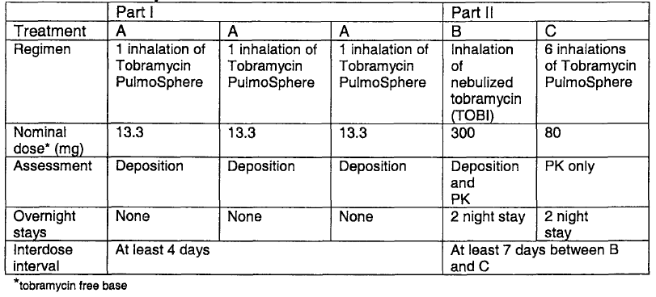
*Treatments A and B were labelled with radioactive technetium.
Gamma scintigraphy was performed to determine lung deposition immediately following Treatments A and B. Blood and urine samples were collected following Treatments B and C to determine the PK profile.

Criteria for evaluation
Lung deposition of ^{99m}Tc TOBI Podhaler and ^{99m}Tc TOBI were determined immediately after dose administration. Regional deposition was compared between Treatment A and Treatment B. Intra individual variability was calculated.
The PK of tobramycin was determined following inhalation of TOBI Solution and TOBI Podhaler using non compartmental methods. The mean ratio of PK parameter values for treatments B and C were determined along with 95% CIs.
Safety assessments included lung function tests at screening, pre dose, 30 minutes and 24 h post dose in Part II, prior to discharge after each visit and at the post study medical examination. Clinical laboratory tests were done at screening and post study. Vital signs and AEs were monitored throughout the study. Hearing tests were performed only following complaints of tinnitus or vestibular problems, serum blood urea nitrogen and creatinine were determined after Part I and after Treatments B and C.
Serum sample analysis for tobramycin was performed and reported.

Results
Fourteen participants enrolled and were dosed, four females and 10 males, two were Asian and twelve were “White”, mean age was 34 years, range 23 to 47 years, mean weight was 72.1 kg, range 49.2 to 89.2 kg, mean height 172 cm, range 152 to 187 cm.
Twelve participants completed the study. Two participants withdrew consent. Thirteen completed all radio labelled treatments (Periods 1 to 4). One participant who coughed during the first inhalation of powder was not included in descriptive statistics.

Lung Deposition ^{99m}Tc-TOBI Podhaler
- The percentages of ^{99m}Tc TOBI Podhaler dose deposited in the oropharynx and retained in the device and capsule were 43.6% and 21.7%, respectively.
- Mean standard deviation (SD) whole lung deposition of ^{99m}Tc TOBI Podhaler in Periods 1, 2 and 3 was 32.8% (8.6%), 31.9% (6.9%) and 37.7% (6.7%), respectively.
- The overall mean SD whole lung deposition from Period 1 to 3 was 34.3% (5.8%) (CV 17%), or 4.6 (0.8) mg tobramycin per inhalation.
- The mean within individual coefficient of variation for lung deposition was 18% (range 6% to 35%)
- Corrected for emitted dose, mean whole lung deposition was 44.1 (7.2)% (range 32 to 56)

Lung Deposition ^{99m} Tc-TOBI
Over 50% of the dose remained in the nebuliser cup at the end of the 15 minute period. When corrected for emitted dose, whole lung, mean (SD) whole lung deposition was 5.0 (2.0%), range 2.2 to 8.7% of nominal dose. Corrected for emitted dose, mean whole lung deposition was 12.5 (4.9%), range 7 to 22%.
The relative distribution of radio labelled (^{99m}Tc) tobramycin within the central, intermediate, and peripheral airways was considered similar for both the TOBI Podhaler and TOBI formulations, with a trend for greater deposition in the peripheral (P) versus central airways (C), as seen in a P/C ratio of 1.5 or greater for both formulations as shown in Table 7.
Table 7: Radiolabelled distribution after inhalation of ^{99m}Tc-tobramycin in TOBI Solution and TOBI Podhaler (Study INH-007).
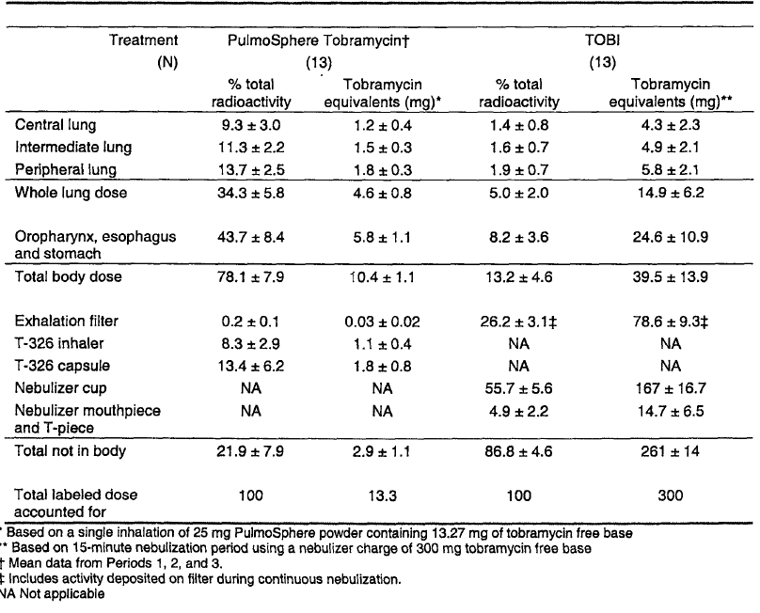

Study IN-007 Summary
The serum tobramycin PK parameter values are summarised in Table 8. Mean serum tobramycin concentrations over time are pictured in Figure 2. Observed C_{max} concentrations of tobramycin after inhalation of the powder formulation were approximately twice as great as after nebulised TOBI: 0.60 versus. 0.28 µg/mL. These concentrations were well below the reported threshold for nephrotoxicity and ototoxicity of 2.0 µg/mL.
Table 8: Summary of PK results (Study IN-007).
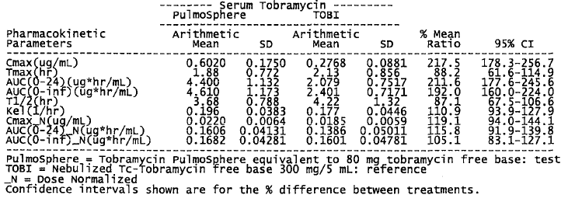
Figure 2: Mean (SD) serum tobramycin concentrations versus time (Study IN-007).
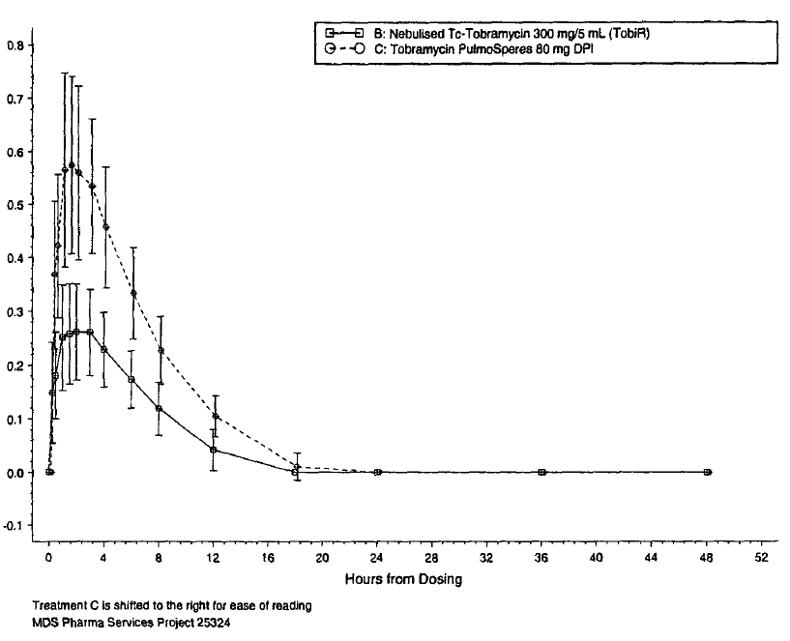
NB: the y-axis was not labelled . The lower line is for TOBI and the upper line for the powder formulation.

Safety
There were no deaths or serious AEs reported. There were no study discontinuations due to AEs. Eight of the 14 participants (57%) experienced 23 treatment emergent adverse events (TEAE), all considered mild in severity. AE reports were more common after inhalation of TOBI Podhaler (Table 9). Cough was the most common AE reported. Six participants reported 11 episodes of coughing, ten of which were suspected to be related to study drug. There were two reports of wheezing; one after nebulised solution and one after powdered formulation.
Table 9: AEs by treatment (Study IN-007).
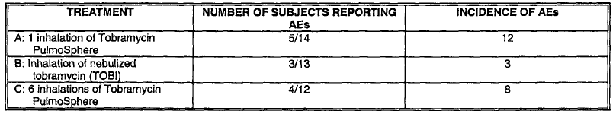
Four participants experienced post study alanine aminotrasferase (ALT) elevation, two of whom had pre dose elevations. There were no clinically significant mean changes in other laboratory findings, in forced expiratory volume in 1 second (FEV1) or forced vital capacity (FVC) measurements, or in vital signs electrocardiogram (ECG) or physical examination assessments.

Discussion

Sponsor
A therapeutic dose of tobramycin could be delivered to the lung with 6 inhalations from the Podhaler. The relative systemic bioavailability of tobramycin based on lung dose normalised AUC₀₋₂₄ (area under the plasma concentration-time curve during the first 24 h) delivered as a dry powder formulation was almost 4.9 fold greater than the nebulised product (range 1.8 to 99.8). However, the rate and extent of tobramycin absorption from the lung were nearly identical for the two formulations after normalisation of PK parameters for actual lung dose. Systemic exposures were well below toxic levels. The powder formulation was safe and well tolerated.

Evaluator
An average of approximately half of the dose of TOBI remained in the nebuliser cup and approximately 20% of the dose of the powdered formulation remained in the device. The reason for not requiring administration of the whole dose of each was unclear. Mean % of radio labelled TOBI Podhaler tobramycin deposited in the oropharynx, oesophagus and stomach was 43.7% versus 8.2% for TOBI. The adult participants in this study had good respiratory function in contrast to patients with CF, most of who have reduced lung function. Validity of findings in the proposed treatment population is considered limited.
AEs, in particular cough, were reported more commonly following inhalation of the powdered formulation.

Good clinical practice

Sponsor
The sponsor states that the study was conducted in accordance with the protocol, with ICH Good Clinical Practice (GCP) guidelines, and with all applicable regulatory requirements including an appropriate Administration of Radioactive Substances Advisory Committee certificate. Participants were required to read and sign an informed consent form.

Evaluator
The participant consent form was considered problematic. Planned exposure to radioactive material was not clearly identified in the leading text. There was minimal discussion about the safety of exposure to inhaled radioactive substance. Radioactive labelling of the study products is mentioned for the first time later on in the consent form, in 2 out of 17 dot point numbers. The wording for both dot points is that the medication and nebuliser solution would be mixed with a small amount of radioactivity. Information is provided under the heading:
“What are the possible disadvantages of taking part?”
“By taking part in the study, you will be exposed to ionising radiation. The Department of Health has authorised the administration of radioactive substances for this study. The maximum total radiation dose to you from taking part will be 0.61 mSv, which is less than the dose received from two abdominal X rays.”
The consent form mentions that participants will be required to inhale a radioactive gas (^{81m}Kr) in order to record lung shape. There was no discussion of the safety of this procedure. The evaluator could not find any record of lung shape in the report or the study; and the ability to electronically search the scanned report had limitations. The need for this particular exposure to radiation is questioned.
The imbalance of knowledge between investigator and the potential participant is considered troubling. Participants inhaling TOBI Podhaler had over 40% of the dose of radioactivity localised to the oropharyngeal area in close proximity to the thyroid gland.

Study TPI001

Design
This study conducted in patients with CF, was open label, randomised, sequential cohort, active controlled, single dose, dose escalation. The primary objective was to assess the general safety of TOBI Podhaler. The secondary objectives were to estimate comparable dose of TOBI Podhaler to TOBI based on the serum PK of tobramycin and to assess administration time. Criteria for evaluation were as follows:

Safety
- Absolute and relative changes in FEV₁% predicted from predose to 30 minutes after the end of dosing.
- Laboratory measure of safety, spirometry testing, vital signs.
- Incidence of treatment-emergent adverse events (AEs).

Aerosol Delivery
- Pharmacokinetic assessment of sputum and serum tobramycin concentration at predose and 30 minutes, 1, 2, 4, 8 and 12 hours after the start of dosing.
- Administration time will be recorded for each treatment.
Participants needed to confirm diagnosis of CF, to be aged at least 6 years at the time of screening, to be clinically stable, to have FEV₁ at least 40% of predicted from pre dose and to be able to expectorate sputum samples on demand. Individuals who had used inhaled or intravenous aminoglycosides within 14 days prior to study administration or who required such treatment during the study period were excluded.
Concentrations of tobramycin were analysed with modified fluorescence polarisation immunoassay.

Treatments
In each sequential cohort, participants were randomised in a 3:1 ratio to receive either a single dose of TOBI Podhaler administered using a T-326 inhaler, according to the dosing schedule shown below, or a single dose of TOBI 300 mg/5mL aerosolised by a PARI LC PLUS jet nebuliser with a DeVibiss PulmoAide compressor. Participants were to self administer the study drug in the presence of the investigator. Concomitant therapy was in accordance with standard practice at each study site. Individuals were to participate in one cohort only.
The product characteristics are shown in Table 10.

Table 10: Single experimental doses of TOBI Podhaler administered using the Podhaler inhaler in Study TPI001.
Cohort | Number of TOBI Podhaler capsules (mg dosage strength)
1 | 2 (14)
2 | 4 (14)
3 | 2 (28)
4 | 4 (28)
5 | 3 (28)

Results
Ninety participants were randomised to one of the six treatments. Eighty six participants received at least a partial dose of study treatment and were evaluated for safety. Eighty four were evaluated for the PK and dose comparability objectives.
Participants ranged in age from 7 to 50 years, 52% were female. Fifteen participants were 7 to 12 years of age; 22 were 13 to 17 years and 53 were 18 to 50 years. The percentage of children aged 6 to 12 included in each group ranged from 7% in the TOBI Podhaler3 x 28 mg group to 36% in the TOBI Podhaler 4 x 28 mg group . The range of median screening FEV₁ percent predicted was lowest (58.51%) in the group administered 2 x 14 mg, and highest, (82.4%) in the group administered 3 x 28 mg. The FEV₁ percent predicted for the TOBI group was 67.95. Thirty six participants used short acting bronchodilators. The group taking 4 x 28 mg had the lowest bronchodilator use: 29% versus 40% to 43%.

Pharmacokinetics

Serum
Six participants did not contribute results; four did not receive treatment; two did not receive a full dose. The median t_{max} (time to reach peak drug plasma concentration) was 1 h in all treatments. The levels declined in a non exponential fashion with average terminal half lives between 2.8 and 3.5 h. Increases in dose of TOBI Podhaler led to increases in exposure to tobramycin; however, the increases were slightly less than proportional with dose (Table 11). Exposure in terms of AUC₀₋₁₂, after administration of TOBI 300 mg was very similar to that of TOBI Podhaler 4 x 28 mg. A similar relationship was demonstrated based on AUC∞ (area under the plasma concentration-time curve from time zero to infinity).
Table 11: PK parameters after administration of TOBI and TOBI Podhaler (denoted as TPI) (Study TIP-001).
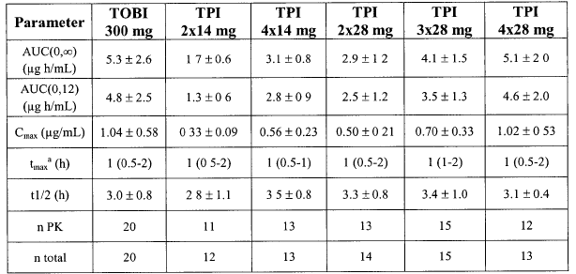
ª median (range). Except for number of subjects in last 2 rows, other entries are ± standard deviation

Pharmacokinetic subgroup analyses
Subgroup analyses were stated to demonstrate that age, sex, and body weight did not appear to influence exposure while the exposure in terms of AUC∞, AUC₁₂ and C_{max} was higher for participants using bronchodilators: 18%, 24% and 35%, respectively. These appear to be the result of post hoc analyses.

Sputum
Not all individuals were able to produce sputum with no more than three participants per group missing sputum sample at any one time. The variability in PK parameters was higher in sputum than in serum. There was a trend to increasing exposure in sputum; however, dose proportionality based on sputum levels could not be confirmed (Table 12).
Table 12: Sputum PK parameters (TPI = TOBI Podhaler) (Study TPI-001).
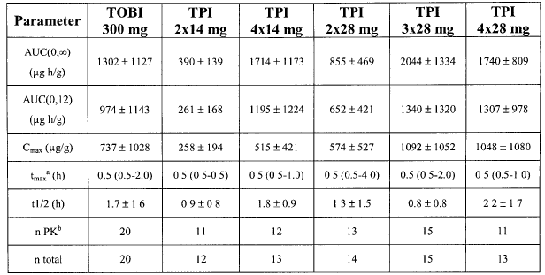
ª median (range). Except for number of subjects in last 2 rows, other entries are mean ± standard deviation
^{b} n may be different for different parameters. The maximum number of subjects used in any single analysis is listed.

Safety
Evaluation of safety was the primary objective. The incidence of AEs was higher for TOBI Podhaler than for TOBI. The percents of participants with any AE were. TOBI Podhaler 2 x 14 mg = 45%; TOBI Podhaler 4 x 14 mg = 54%; TOBI Podhaler 2 x 28 mg = 64%; TOBI Podhaler 3 x 28 mg = 67%; TOBI Podhaler 4 x 28 mg = 69% suggesting a dose response. The proportion of participants with any AEs for the TOBI group was 30%.
There were no notable mean changes from baseline in haematology values or serum chemistry values or in dipstick urine protein results. There were no deaths reported. One TOBI Podhaler 4 x 28mg participant experienced two serious adverse events (SAEs): moderate cough and sputum increased leading to hospitalisation on the eighth day after the single dose study. These events were considered related to underlying conditions and unrelated to study treatment.
TOBI Podhaler: The most commonly reported AEs for those receiving TOBI Podhaler were cough or cough aggravation (19.7%), dysgeusia (16.7%), pharyngitis, haemoptysis and rhinorrhea (6.1% each), sputum increased, crackles lung, lacrimation increased, abdominal pain upper, dizziness, headache and throat irritation (4.5% each). All TEAEs were mild or moderate in intensity. One participant withdrew due to cough aggravation, dysgeusia and increased lacrimation. These AEs were of moderate intensity and considered study treatment related. Four TOBI Podhaler participants experienced cough which interrupted the dosing. There was one report of 20.9% reduction in FEV₁ percent predicted after a dose of TOBI Podhaler 2 x 28 mg. There was one report of a decrease in FEV₁ percent predicted at 19.1% in a patient treated with TOBI.
TOBI: No more than one TOBI participant experienced any AE. No TOBI participant experienced cough aggravated or dysgeusia. There were no dose interruptions reported in the TOBI group.

Discussion
It is agreed that the serum PK results for 4 x 28 mg appear similar to those of TOBI. The group taking 4 x 28 mg had the lowest bronchodilator use: 29% versus 40% to 43% in other groups, representing a possible difference in disease character in that group. This suggests that lung function played a part and the subgroup analysis would have benefited from stratification on the basis of FEV₁ percent predicted and age group categories.
Detailed instructions for administration of study treatments could not be located. It was unclear whether the patients administered TOBI were to completely run the nebuliser until it sputters or were to limit the administration according to a specified time as in the preceding Study IN-007.
The participants administering more than two capsules of TOBI Podhaler used two inhaler devices. It seems unlikely that this would occur in wider use and this is considered a possible limit to external validity. The study included only patients with FEV₁ percent predicted equal to or greater than 40%. This also has potential to limit external validity.
In many of the tables the results are in the order of increasing dose: 2 x 14 mg; 4 x 14 mg; 2 x 28 mg; 3 x 28 mg and 4 x 28mg. For demographic and baseline results the last two headings are reversed with 4 x 28 mg preceding 3 x 28 mg. The baseline data are considered important in evaluating the results. For instance, it appears that the 3 x 28 mg group included only one child less than 12 years of age, and the FEV₁ percent predicted was highest in this group. The concern is that the headings may have been inadvertently incorrectly labelled. The same concern relates to the tabulation of AEs. This concern was addressed by the sponsor who confirmed that table headings related to the data. The proportion of participants reporting AEs and dose interruptions was higher following the test than the reference treatment with the incidence of AEs in the TOBI Podhaler groups increasing consistently with increase in dose. While numbers of participants are small, it would appear that patients may require access to TOBI at times when difficulties are experienced with administration of TOBI Podhaler.

Efficacy

Study C2301

Design
A Phase III, multicentre, randomised, double blind, three cycle, two arm trial to assess the efficacy and safety of TOBI Podhaler in CF patients. The first cycle of the trial was placebo controlled. The study was completed in 2007.
Primary objective was to demonstrate the efficacy of a 28 day twice daily dose regime of TOBI Podhaler 4 x 28 mg capsules compared to placebo. The primary outcome was the relative change in FEV₁ percent predicted from baseline on Day 1, to the end of Cycle 1, Day 28.
The secondary objectives assessed safety, and efficacy beyond one cycle of treatment. Safety assessment included reporting of AEs and monitoring of laboratory parameters, changes in airway reactivity, vital signs and physical condition. Bronchospasm was defined as a relative decrease of at least 20% in FEV₁ percent predicted from pre dose to 30 minutes after the end of dosing. Secondary efficacy assessments included measurement of P. aeruginosa colony forming units (CFUs) per gram of sputum and P. aeruginosa susceptibility assessed by minimum inhibitory concentrations (MIC), time to first antipseudomonal antibiotic use, first hospitalisation due to respiratory events and incidence and length of hospitalisation due to respiratory related SAE.
Blood samples were taken for PK assessments before and 1 h after administration of the dose at Visits 2, 5, 7 and 8. Serum tobramycin concentrations were also considered a safety variable. Audiology was available at selected centres.
Included were clinically stable patients from six to twenty one years, with confirmed diagnosis of CF with screening FEV₁ equal or greater than 25% to equal or smaller than 80% of predicted values for age, sex and height based upon Knudson criteria. P aeruginosa must have been present in a sputum, culture, throat culture or bronchial lavage culture within six months prior to screening and in the culture at screening visits.
Patients were excluded if B. cepacia had been isolated within the preceding two years. Use of inhaled antipseudomonal antibiotics within four months of the study or use of systemic antipseudomonal antibiotics within 28 days prior to the study was precluded. Initiation of treatment with dornase alfa or inhaled steroids or macrolides antibiotics within 28days prior to the study was disallowed. However, if these treatments had started more than 28 days before study drug administration, continuation was allowed.

Study treatments
Tobramycin inhaled powder capsules and placebo were manufactured by Nektar Therapeutics, San Carlos, California USA. The matching placebo capsules contained the excipients of the active formulation. The powders were administered via the T-326 inhaler. Treatments were administered in the following order: Bronchodilator 15 to 60 minutes prior to study drug inhalation; chest physiotherapy; other inhaled medicine; study drug administration.
Approximately 140 patients were planned for randomisation 1:1 to active treatment or placebo using a coin adaptive randomisation procedure.

Statistics
The primary efficacy endpoint was the relative change in FEV₁ percent predicted from baseline to pre dose Day 28 of Cycle 1. Superiority of TOBI Podhaler versus placebo was assessed via the standard t test/one way analysis of variance model (unadjusted analysis) and an analysis of covariance model (adjusted analysis). Covariates were age, region and treatment. Response was measured as relative change in FEV₁ percent predicted from baseline to pre dose Day 28 of Cycle 1. There was no imputation of missing data in the final analyses.
An interim statistical analysis of the primary endpoint was planned after the 80th randomised patients had completed Cycle 1 dosing. The plan was to use the Intent to Treat (ITT) population in the analysis. However after auditing, two Latin American sites were found to have concerns related to pulmonary function test calibration practices. Thus a sensitivity interim analysis was organised excluding 18 patients from these two sites. This was done under the auspices of an independent expert panel of pulmonologists and an independent contract research organisation (CRO) using the same approach as the original protocol defined in the interim analysis.
The clinical database was locked on 2 November 2006 and the Data Monitoring Committee (DMC) interim analysis meeting was held on 20 November 2006. The DMC reviewed interim analysis results on 89 randomised subjects. Ten patients were not included due to absence of study drug dosing information or withdrawal of consent. A total of 79 subjects (TOBI Podhaler and placebo) were included in the safety and ITT populations.
Following the review of the results from the interim analysis, the DMC recommended stopping the study based on results that demonstrated a benefit in the treatment arm compared to the placebo arm.

Results
Thirty nine patients were randomised at sites in Europe: Bulgaria (21), Lithuania (4) and Serbia (14). Thirty nine patients were randomised at sites in Latin America: Argentina (17), Brazil (10), Chile (6) and Mexico (6). Twenty four patients were randomised at sites in North America. Participant disposition is summarised in Table 13 and analysis populations are summarised in Table 14. The mean age of patients was 13 years, the range 6 to 21 years; 84.2% were Caucasian and 55.8% were female. Demographic characteristics were well balanced between groups. Baseline characteristics were well balanced with the exception of distribution of FEV₁ percent predicted at baseline in which there were more patients in the placebo group than the TOBI Podhaler group with FEV₁ percent predicted smaller than 25% or greater than 80%.
Table 13: Study C2301 participant disposition.
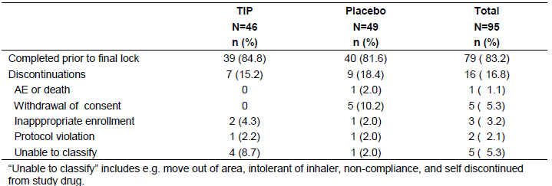
Table 14: Study C2301 analysis populations.
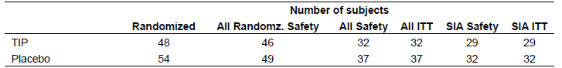
SIA = sensitivity interim analysis
Sixty nine patients (72.6%) had at least one protocol deviation. No patients were excluded from safety or efficacy analyses due to protocol deviation. The most frequent protocol deviations related to the following:
- Not taking the full dose (46 patients);
- Using bronchodilator outside preset time limits (20 patients);
- Less than 26 days on treatment (18 patients);
- Interrupted study medication (16 patients).

Relative change in FEV₁ percent predicted
As shown in Table 15, the calculation included 29/46 (63%) of the TOBI Podhaler participants and 32/49 (65%) of the TOBI participants. The difference (95% CI) in the relative change in FEV₁ percent predicted from baseline to pre dose Day 28 was 13.79% (5.87% to 21.70%). The probability (p) value of 0.0016 was less than the specified 0.0044 required to demonstrate superiority of active compared to placebo treatment.
Table 15: Study C2301 Relative change in FEV1 percent predicted from baseline to predose Day 28 of Cycle 1 (Sensitivity Interim Analysis [SIA] ITT Population).
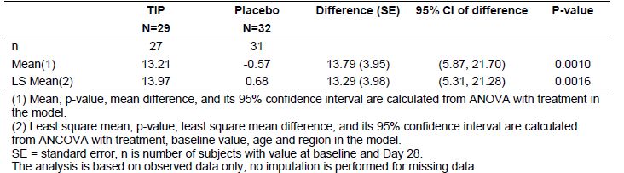
The relative change in FEV₁ percent predicted from baseline in Cycles 1 to 3 (Figure 3).
Figure 3: Study C2301 Relative change in FEV1 percent predicted from baseline in Cycles 1-3 (SIA ITT Population).
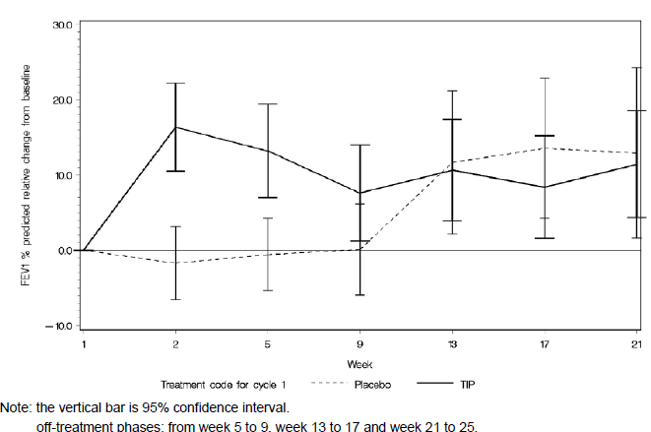

P. aeruginosa density
P. aeruginosa density in sputum was measured at Day 1 and Day 28 for each Cycle 1 to 3. Results were summarised using logarithm scale as log₁₀ (log₁₀ CFU per gram of sputum). Absolute change from baseline to each post baseline time points was summarised descriptively by treatment group and biotype 1 and 2. The greatest differences in both biotypes between TOBI Podhaler group and placebo group were seen at Day 28 of Cycle 1 when the placebo component of the study ceased.

Concentration
Biotype-1 mucoid: Among 26 patients (56%) with MIC values at both baseline and end of Cycle 3 treatment in the TOBI Podhaler group, 11 patients had an increase of MIC value, 11 had no change, and 4 had a decrease relative to baseline. Nine patients had at least 4 fold increase from baseline, 3 of whom had MIC greater than 8 µg/mL (16, 64 and 512 µg/mL) at the end of Cycle 3 treatment.
Among 26 patients (53%) with MIC value at both baseline and end of Cycle 3 in the placebo group, ten patients had an increase of MIC value, six had no change, and ten had a decrease at Day 28 of Cycle 3 relative to baseline. Five patients had at least 4 fold increase from baseline, of the five patients, one had MIC greater than 8 μg/mL (256 μg/mL) at the end of Cycle 3 treatment.
Biotype-2 dry: Among 12 (26%) patients with MIC value at baseline and end of Cycle 3 treatment in the TOBI Podhaler group, eight patients had an increase of MIC value, one had no change, and three had a decrease relative to baseline. Five patients had at least 4 fold increase from baseline; of the five, two had MIC greater than 8 µg/mL (16 and 512 µg/mL) at the end of Cycle 3 treatment.
Among ten patients (20%) with MIC value at baseline and end of Cycle 3 treatment in placebo group, six patients had an increase of MIC value, and four had no change relative to baseline. Five patients had at least 4 fold increase from baseline three of whom had MIC greater than 8 μg/mL (32, 64, and 256 μg/mL) at the end of Cycle 3 treatment.

Antipseudomonal antibiotic usage in Cycle 1
The percentage of patients using antipseudomonal antibiotic in Cycle 1 was greater in the placebo group than in the TOBI Podhaler group, 32.7% versus 19.6% respectively. In addition, the duration of usage in Cycle 1 was longer in the placebo group than that in the TOBI Podhaler group (mean 31.3 versus 17.0 days).

Respiratory related hospitalisations in Cycle 1
The percentage of patients with respiratory related hospitalisations in Cycle 1 was greater in the placebo group than that in the TOBI Podhaler group (12.2% versus 0%). The average number of days of hospitalisation in Cycle 1 was 12.3 in the placebo group.

Discussion
The reported result of the interim analysis was not based on the protocol pre specified analysis population. The conclusion of superiority of response of FEV₁ in the TOBI Podhaler group compared to placebo at the time of interim analysis was based on the revised sensitivity analysis population excluding 18 patients from South America and excluded 35-37% of patients. The need to use an analysis population other than that specified in the protocol is regrettable and is considered to taint the result.
The note for guidance on clinical investigation of medicinal products in the paediatric population recommends that studies conducted in children are stratified by age. While the randomisation process appears to have resulted in similar proportions of children between 6 and 12 in each group, a protocol defined plan to stratify at study entry and a pre planned analysis based on age would have been desirable. It has been found very difficult to determine whether efficacy in the older participants was the major contributor to overall improvement in FEV₁ percent predicted. It is also not possible to determine response in patients with marked reduction in FEV₁ percent predicted compared to those with better lung function.
With respect to P. aeruginosa density in sputum, results were based on a reanalysis included in an addendum which did not include all participants in the study. The reason for requirement of reanalysis could not be located.
With respect to MIC, the sponsor commented and the evaluator agrees that given the small numbers, it is difficult to draw any conclusion that treatment of TOBI Podhaler increases resistance of P. aeruginosa to tobramycin. However a tendency toward increased MIC during treatment cannot be excluded.

Good clinical practice
The study was stated to have been conducted in accordance with the Declaration of Helsinki. Informed consent was stated to have been obtained.
The first patient was enrolled in September 2005. The World Medical Association (WMA) Declaration of Helsinki current at that time would have been amended version Tokyo 2004, which included the amendment Section C number 29 and the associated footnote:
The benefits, risk, burdens and effectiveness of a new method should be tested against those of the best current prophylactic, diagnostic, and therapeutic methods. This does not preclude the use of placebo or no treatment, in studies where no proven prophylactic, diagnostic or therapeutic method exists.
The WMA hereby reaffirms its position that extreme care must be taken in making use of a placebo controlled trial and that in general this methodology should only be used in the absence of existing proven therapy. However, a placebo controlled trial may be ethically acceptable, even if proven therapy is available, under the following circumstances:
Where for compelling and scientifically sound methodological reasons its use is necessary to determine the efficacy or safety of a prophylactic, diagnostic or therapeutic method; or
Where a prophylactic, diagnostic or therapeutic method is being investigated for a minor condition and the patients who receive placebo will not be subject to any additional risk of serious or irreversible harm.
All other provisions of the Declaration of Helsinki must be adhered to, especially the need for appropriate ethical and scientific review.
Documentation of the reason for the inclusion of a placebo group could not be located in the submission dossier and neither could a copy of the consent form explaining the benefits and risks of the study be located in the submission.
In order to meet inclusion criteria, patients in the placebo arm with documented P. aeruginosa infection could only be included if they had not needed to receive inhaled antipseudomonal treatment for the four months prior to the study. No active treatment was requested or required to be withdrawn. In the study the patients allocated to placebo went another two months during the study without active therapy. They also went without systemic antipseudomonal treatment for a month prior to the study. Some of the patients fell well below an acceptable transplant criterion of less than 30% FEV₁ percent predicted and one such child in the placebo group died.
Having decided to include a placebo group, it is considered that scrupulous attention to the conduct of the study including meticulous auditing at participating sites should have been assured by the Sponsor and the investigators; however, this fell short as evidenced by the requirement to exclude the 18 patients in two study sites from the planned primary analysis.

Study C2302

Efficacy

Design
This was a randomised, open label, active controlled, parallel arm, multicentre; Phase III trial to assess the safety of TOBI Podhaler compared to TOBI Solution in treatment of CF. Eligible patients were randomised to TOBI Podhaler or TOBI Solution in a 3:2 ratio, using “biased coin” adaptive allocation procedure. The study was completed in 2009.
Patients were eligible if they had confirmed diagnosis of CF, were clinically stable and had FEV₁ precent predicted at screening of equal to or greater than 25% and equal to or smaller than 75%, had P. aeruginosa in sputum/deep throat cough swab culture at the screening visit.
The primary objective was to evaluate the safety of twice daily dosing of TOBI Podhaler. There was no single primary safety endpoint; the following were assessed: AEs, SAEs, clinical laboratory results, spirometry, audiology, vital signs, and physical condition. Bronchospasm was defined as reduction equal to or less than -20% in FEV₁ percent predicted from pre dose to 30 minutes post dose.
The secondary objectives were to assess relative change in FEV₁ percent predicted at the end of Cycle 3 compared to baseline, and to evaluate subject reported treatment satisfaction using a Chiron modified version of the validated instrument, the Treatment Satisfaction Questionnaire for Medication (TSQM). This questionnaire included four added questions along with rewording of instructions and adjusted wording. The four additional questions were:
- How convenient is it to store the medication?
- How easy or difficult is it to put together the parts of the delivery device?
- How convenient or inconvenient would it be to use the delivery device away from home?
- How convenient or inconvenient is it for you to take care of the delivery device?
Also assessed was change in P. aeruginosa density (log₁₀ colony forming units/g sputum) from baseline to all post baseline visits, change in P. aeruginosa tobramycin MIC susceptibility from baseline to all post baseline visits.
A subset of patients provided sputum samples before dosing, 30 minutes after the completion of dosing and between 30 minutes and 2 h after the completion of dosing. These patients also provided additional serum specimens before dosing, and between 2 and 5 h after the completion of dosing.
Tobramycin concentrations in human serum were determined using validated fluorescence polarisation immunoassay (FPIA) technology (limit of quantitation 0.05 μg/mL). Tobramycin concentrations in sputum were determined by high performance liquid chromatography (HPLC) with ultraviolet detection (limit of quantitation 1 μg/g).

Study treatments
TOBI Podhaler was administered by inhalation of 4 x 28 mg capsules twice daily for 3 cycles of 28 days on and 28 days off treatment (168 days). The reference product TOBI Solution was administered as 5 mL of a 60 mg/mL solution twice daily using the same dosing cycles as TOBI Podhaler. Treatments were administered in the following order: Short acting bronchodilator 15 to 90 minutes prior to study drug inhalation, chest physiotherapy, other inhaled medicine, study drug administration.

Statistics
The planned sample size of approximately 500 patients was based primarily upon considerations for safety data: 300 randomised to TOBI Podhaler and 200 to TOBI Solution. A sample size of 300 TOBI Podhaler patients was adequate to observe a 99.8% chance of at least one AE with a true incidence rate of 2% from the TOBI Podhaler arm, and a 95% chance of observing at least one AE with a true incidence rate of 1% from the TOBI Podhaler arm.
Safety data were assessed by means of summary and descriptive statistics. Efficacy analysis was based on the ITT population. No imputation was performed for missing data. The analysis of non inferiority of TOBI Podhaler relative to TOBI Solution was based on a one sided 85% confidence interval calculated from an analysis of covariance (ANCOVA) of relative change in FEV₁ percent predicted from baseline to pre dose Day 28 of Cycle 3. The non inferiority margin (Δ) of 6% was pre defined. Sensitivity analyses based on one sided 90% and 95% confidence intervals from the same ANCOVA model were provided. In addition, the non inferiority analysis was also performed for the per protocol population.

Results
A total of 553 patients were randomised of whom 517 were included in the analysis populations and 396 completed the study. Patient disposition is summarised in Table 16. A higher proportion of patients in the TOBI Podhaler group discontinued 26.9% compared to TOBI Solution 18.2%, with a higher proportion discontinuing due to AEs in the TOBI Podhaler group than the TOBI Solution group: 14.0% versus 8.0% respectively. Note that in the safety component of the clinical submission, the number reported to have discontinued due to AEs in the TOBI Podhaler group was 46 (14.9%) as shown in Table 16 below. The discrepancy was stated to be due to data coming from separate case report form (CRF) pages, the AE page and study completion page and non reconciliation of the data.
Table 16: Study C2302 Patient disposition (%) of patients (all randomised Safety Population)
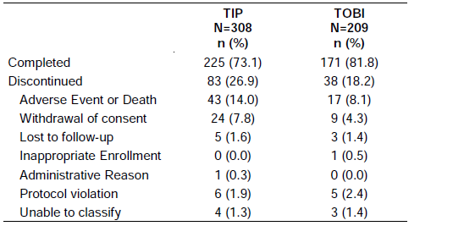
All except seven patients had at least one protocol deviation (98.6%). The majority of these were considered by the sponsor to be minor and were not expected to unduly affect the interpretation of the study results. The most frequently reported deviations were interruption of study medication during an on treatment period (94.8%) and not taking either a morning or evening dose (94.4%). There were no differences between treatment groups with regard to the types of deviations reported.
The extent of the major protocol deviations was generally well matched between the treatment groups. The most frequent major deviation was failure to take at least 80% of the study drug (14.3% of patients), with a greater incidence in the TOBI Podhaler treatment group. The use of inhaled tobramycin outside of the protocol defined use (7.4% of patients) was the second most frequent deviation, followed by the use of inhaled antipseudomonal antibiotics other than study drug (6.8% of patients).
Seven patients in the TOBI Podhaler treatment group had withdrawal criteria but were not withdrawn. Two patients had withdrawal criteria at baseline/screening which should have prevented further continuation in the study; four used some form of prohibited medication, whilst one patient was non compliant.
Numbers included in analysis populations are summarised in Table 17. The dropout rate in the per protocol populations was almost 40% in the TOBI Podhaler per protocol population and 33% in the TOBI Solution per protocol population.
Table 17: Study C2302 analysis populations.
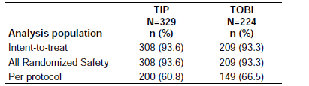
The majority of patients were Caucasian and ~30% were less than 20 years of age. Demographic characteristics disease characteristics and baseline symptoms were similar between groups including numbers of patients within age group categories.
An increase was recorded in FEV₁ percent predicted from baseline to Day 28 of Cycle 3 in both TOBI Podhaler and TOBI Solution treatment groups with relative change of 3.1% and 2.3%, respectively. This increase for TOBI Podhaler was non inferior to that for TOBI Solution in the terms defined in the protocol (Table 18). Least squares mean values for the per protocol population supported the analysis least square (LS) mean difference in FEV₁ 1.2, lower limits of the one sided 85% CI, 90% CI and 95% CI were -1.02, -1.54 and -2.31 respectively. The FEV₁ percent predicted relative change from baseline is showing similarity of findings across time (Figure 4).
Table 18: Study C2302 FEV₁ percentage predicted relative change from baseline to pre dose Day 28 of Cycle 3 (ITT population).
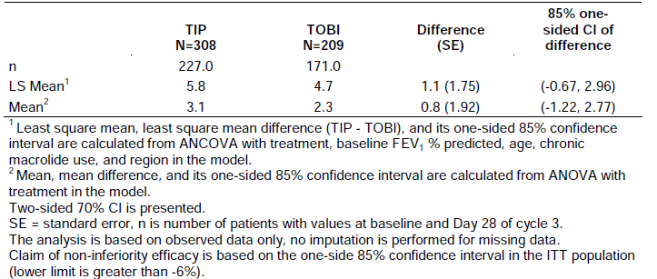
Figure 4: Study C2302 FEV₁ percent predicted relative change from baseline by treatment group (ITT population).
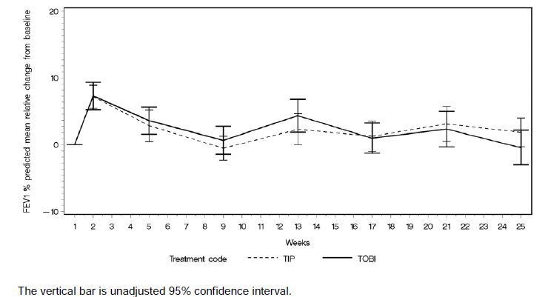
The mean AUC of FEV1 percent predicted was 28.7% in the TOBI Podhaler group and 29.1 % in the TOBI Solution group on Day 8 of Cycle 1 This result was supported by data for the FEV₁ 25 to 75 percent of predicted. FVC showed no consistent or meaningful changes in either treatment group.

Microbiology
The data demonstrated a change in baseline in P. aeruginosa sputum density over time. Not all participants contributed data (Table 19).
Table 19: Study C2302 Change in P. aeruginosa sputum density (log₁₀ CFUs) from baseline, by biotype and treatment group ITT population (sum of dry, mucoid and small colony variant).
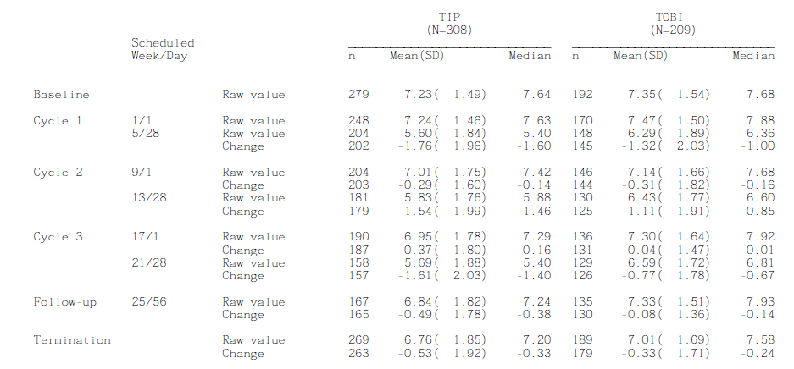
The shift of maximum tobramycin MIC values from baseline is summarised in Table 20. The numbers of participants contributing to the information was limited. Between 28 to 33.7% demonstrated an equal or greater than 4 fold increase in MIC values at Weeks 21 and 35 with more patients in the TOBI Podhaler group demonstrating both an equal or greater than 4 fold increase and MIC greater than 8 µg/mL.
Table 20: Study C2302 Shift of maximum tobramycin MIC values from baseline to Weeks 21 and 25 (ITT population).
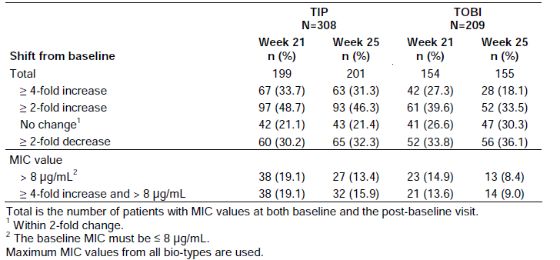
There was no evidence reported of concerning shifts in detection of methicillin resistant and methicillin sensitive Staphylococcus aureus, Haemophilus parainfluenzae, Aspergillus fumigans or Aspergillus fumigates.
The MIC distribution for aztreonam for the sum of all P. aerugenosa biotypes showed a slight tendency to an increase in the percentage of patients with a MIC greater than 4 μg/mL over the course of the study in both treatment groups. There was little change for the MIC distribution of ceftazidime or meropenem. Ciprofloxacin MIC values showed a small shift to higher values over the course of the study and this was most clear for the P. aeruginosa mucoid biotype. There was little overall change in the MIC distribution for imipenem, however the percentage of patients with a MIC of greater than 32 μg/mL did increase from baseline (23.1%) to Week 25 (31.0%) in the TOBI Solution treatment group, and was stable at the termination visit (30.2%). Significance of these findings with respect to study treatment is uncertain.
Over half of patients in both treatment groups used antibiotics during the study, with a higher proportion in the TOBI Podhaler treatment group. According to the Kaplan Meier estimates, over 50% of patients had used antipseudomonals in both groups by Day 112, with a median time of 89 days for TOBI Podhaler and 112 days for TOBI Solution.
PK assessments were performed in 30 patients in the TOBI Podhaler group and in 14 patients in the TOBI Solution group. The systemic levels reported were low relative to the maximum systemic levels of 10 to 12 µg/mL recommended for avoidance of toxicity.
At the start of Cycle 3 (Week 17), pre dose serum tobramycin concentrations were detected in four patients in the TOBI Podhaler group: 0.75, 0.06, 0.82 and 0.05 μg/mL. At this visit, three patients in the TOBI Solution group had detectable pre dose serum concentrations: 0.07, 0.92 and 0.06 μg/mL. The reason for detecting these pre dose concentrations is not known as there was a four week washout period between the end of Cycle 2 and the start of Cycle 3.
Mean pre dose concentrations were well below 2 µg/mL. Tobramycin sputum concentrations appeared generally higher for the TOBI Podhaler dose compared to TOBI Solution though there was higher inter individual variability.
The administration time excluded the time required to set up, clean and disinfect the nebuliser, so only actual administration times were compared. TOBI Podhaler was ~14 minutes faster to administer than TOBI Solution. There were considerable numbers of participants with missing data at different time points.

Discussion
It is common in non inferiority trials to employ either a one sided confidence interval limit to be less than 97.5% or a two sided 95% CI. Furthermore, to analyse both the ITT and PP population and present non inferiority results for the PP population. It is also highly recommended that there be very limited dropout from these populations which was not the case in this study. In addition, although non inferiority was described as the primary analysis it was not described as the primary objective of the study. In general terms the result of the primary objective analysis is considered the most suitable result for inclusion in the PI and for this study the primary outcome related to safety.
With respect to change in baseline in P. aeruginosa sputum density over time, the study was of short duration and the relevance to this in the long term is a matter of conjecture. It is noted that the whole study population did not contribute to the study results and the numbers contributing at each time point are not specified.
The finding of measurable amounts of tobramycin at the beginning of cycles is of concern and brings into question the reliability of the assay or the possibility of long term persistence of tobramycin, which seems less likely.

Good clinical practice
The sponsor states that the study and any amendments were reviewed by the Independent Ethics Committee or Institutional Review Board for each centre. The study was conducted according to the ethical principles of the Declaration of Helsinki. Written informed consent was obtained from each patient or their legal representative after the study was described by a nurse/study coordinator/the investigator, who answered any questions, and before randomisation.

Safety
A limited analysis of results for a “supportive safety population” was provided comparing patients who were treated with TOBI Podhaler in both studies with those treated with TOBI Solution and presenting results summarised according to whether the patients received 1, 2 or 3 cycles of treatment. Tables 21 and 22 summarise the studies contributing safety data discussed in the clinical overview and the numbers of patients included.
Table 21: Summary of trials contributing safety data.
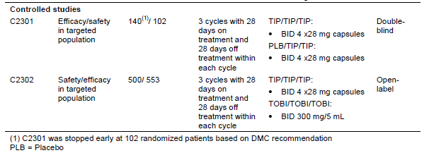
Table 22: Population groupings by cycle and study.
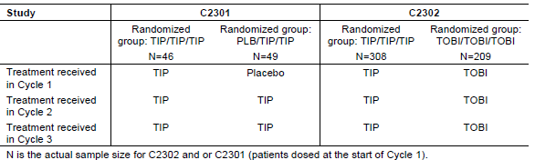
To limit confusion and repetition of study design, the safety component of the pharmacology studies has been discussed with the studies overall, for Study INH-007 and for Study TPI001.

Study C2301 – placebo control
The most commonly reported AEs by preferred term in Cycle 1 was the placebo controlled component of the study (Table 23). This included coughing (13.0% for TOBI Podhaler versus 26.5% for placebo), lung disorders (10.9% for TOBI Podhaler versus 12.2% for placebo), and pharyngolaryngeal pain (10.9% for TOBI Podhaler versus 0.0% for placebo). AEs in Cycle 1 tended to occur with a higher frequency in the placebo group than in the TOBI Podhaler group with the exception of pharyngolaryngeal pain, pyrexia and dysgeusia which had a higher incidence in the TOBI Podhaler group (10.9%, 6.5% and 6.5% for TOBI Podhaler versus 0.0%, 4.1%, and 2.0% for placebo). The incidence of cough in the TOBI Podhaler arm was (13%) compared to the placebo arm (26.5%). More patients in the placebo group had cough associated with concurrent events indicative of an infection than in the TOBI Podhaler group (such as fever, pulmonary exacerbations, sinus infection or respiratory tract infection) though more patients in the placebo group had cough reported at screening.
Table 23: Study C2301 Duration of exposure to study medication, by treatment group (Safety population).
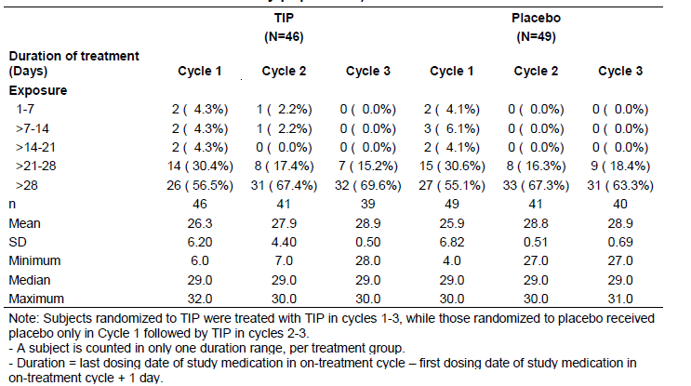
The most common reported AEs in all three cycles were cough (26.1%), lung disorders (21.7%), and pyrexia (13.0%). The most commonly reported AEs during two cycles of TOBI Podhaler treatment in placebo group by preferred term were cough (24.4%), lung disorders (12.2%), and pyrexia (12.2%). Overall, the pattern of frequency order of reported AEs are general similar comparing three cycles of TOBI Podhaler treatment and two cycles of TOBI Podhaler treatment.
A total of 17 participants had reports of SAEs during the study. During Cycle 1 the proportion of patients experiencing a SAE was lower in the TOBI Podhaler treatment group than in the placebo treatment group (6.5 % versus 14.3%, respectively). The most commonly reported SAEs during Cycle 1 for both treatment groups included respiratory, thoracic and mediastinal disorders and in particular lung disorder (6.5% and 8.2% in the TOBI Podhaler and placebo treatment groups, respectively). In Clinical Study Report TBM100C2301, two more respiratory SAEs were reported for patients in the placebo group.
It is uncertain why the number of patients in the placebo group safety population is reported to be different (49 versus 41).
There was one death reported. In the placebo treatment group one patient with decompensated chronic cor pulmonale, died during this study. The patient took the last treatment on Day 8 of Cycle 1 and discontinued from the study on the next day. The death occurred 39 days after the last study visit in Cycle 1. This patient did not receive any TOBI Podhaler treatment.
There was no detected safety signal associated with haematology, biochemistry testing, evidence of nephrotoxicity and any significant change in vital signs reported. There was no obvious safety signal detected.
Audiometry was not systematically studied. Twenty two patients at selected sites underwent audiometry however; baseline audiometry was not done. Five of these had decrease of frequency by audiology; three in the TOBI Podhaler group at Day 28 Cycle 1. One patient also had decreases noted at Day 28 Cycle 3; one did not have repeat audiometric testing and one had no decreases at follow up. Two patients in the placebo group had abnormalities detected at Day 28 Cycle 1. One patient had no decrease noted at Day 28 Cycle 3 while the other had persistence but no worsening of findings at Day 28 Cycle 3.

Discussion
The events in the placebo group were probably due to the underlying disease including the presence of untreated P. aeruginosa, and possibly to inhalation of the excipients of TOBI Podhaler.
The assessment of hearing and vestibular function was insufficiently systematic to be meaningful.

Study C2302 – active control
Compliance with treatment in terms of mean percentage is summarised in Table 24. Compliance of 80% or more was recorded for 82.4% of TOBI Podhaler treated patients, and 90.8% of TOBI treated patients for all three cycles. Duration of exposure is summarised in Table 25.
Table 24: Study C2302 Percent compliance of study drug (all randomised safety population).
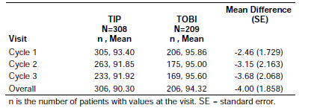
Table 25: Study C2302 duration of exposure to study medication by treatment group (all randomised safety population).
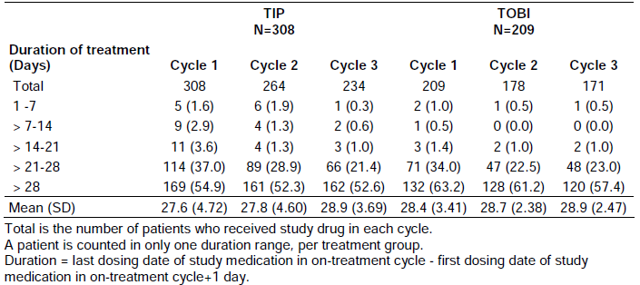
In total, for all cycles, on and off treatment periods, 88% of patients experienced AEs, with a higher percentage reported in the TOBI Podhaler group than the TOBI group (90.3% versus 84.2%).
On treatment AEs were reported by 83.4% of patients in the TOBI Podhaler treatment group and by 75.1% of patients in the TOBI group. In the TOBI Podhaler group, chest discomfort, pulmonary function test decreased, forced expiratory volume decreased, dysgeusia, cough, dysphonia, oropharyngeal pain, nasal congestion, rales and nasal mucosal disorder were reported by at least 2% more patients in the TOBI Podhaler treatment group than in the TOBI group. There were no terms for which the reverse was true.
The majority of AEs were mild or moderate in severity (73.4% TOBI Podhaler versus 68.5% TOBI). A similar percentage of patients in both groups experienced mild and severe events (11.0% versus 9.6% respectively), whilst the percentage of patients reporting moderate AEs was greater in the TOBI Podhaler group (51.3% compared with 43.1% in the TOBI group).
Events suspected by the investigator to be possibly related to the study drug included 51.0% of patients in the TOBI Podhaler treatment group and 20.1% in the TOBI group. Preferred terms where there was a difference of 2% or more between treatment groups were:
- chest discomfort: 3.2% of patients in the TOBI Podhaler group and 1.0% in the TOBI group;
- dysgeusia: 3.9% of patients in the TOBI Podhaler group and 0.5% in the TOBI group;
- cough: 25.3% of patients in the TOBI Podhaler group and 4.3% in the TOBI group;
- dysphonia: 12.7% of patients in the TOBI Podhaler group and 3.3% in the TOBI group;
- dyspnoea: 5.5% of patients in the TOBI Podhaler group and 1.4% in the TOBI group;
- oropharyngeal pain/productive cough: 4.5% of patients in the TOBI Podhaler group and 1.0% in the TOBI group; and
- throat irritation: 3.2% of patients in the TOBI Podhaler group and 1.0% in the TOBI group.
A total of twelve patients in the TOBI Podhaler treatment group, and two in the TOBI group had severe AEs suspected of being possibly related to the study drug by the investigator. In the TOBI Podhaler treatment group there were three events of lung disorder, three of cough, two of productive cough, and two of decreased pulmonary function test. In the TOBI group there were two events of abdominal pain.
There were three deaths during the study, all in the TOBI Podhaler treatment group. The investigators did not suspect a relationship between the deaths and the study medication. The two respiratory related deaths are consistent with the diagnosis of CF and age of the patients. One death was related to an accidental overdose of a recreational drug.
The percentage of patients with SAEs was similar between the two treatment groups. SAEs suspected of being related to the study drug by the investigator were reported for eleven patients in the TOBI Podhaler treatment group and one in the TOBI group. These were predominantly lung disorder (pulmonary exacerbation).
AEs resulting in study discontinuation were more frequent in the TOBI Podhaler treatment group. AEs in the respiratory, thoracic and mediastinal system organ class were the most frequent cause of discontinuation, with a higher percentage of patients concerned in the TOBI Podhaler treatment group than the TOBI group (11.0% versus 5.7%).
TOBI Podhaler: Twelve cases of cough led to discontinuation, nine of which were reported as possibly related to study drug. Dyspnoea led to discontinuation for eight patients, all were considered at least possibly related. Seven cases reported lung disorders (mostly reported as “pulmonary exacerbation”), leading to discontinuation, all were considered at least possibly related. Five patients discontinued with chest discomfort (mostly chest tightness), all at least possibly related.
TOBI: Two cases of cough led to discontinuation, one of which was suspected to be treatment related. Four events of dyspnoea led to discontinuation, one of which was considered possibly related. Six cases of lung disorders led to discontinuation, one of which was suspected to be treatment related. No patient discontinued due to chest discomfort and none discontinued due to bronchospasm.
With regard to laboratory parameters and vital signs, no safety signal was apparent.
Audiology was tested in a subpopulation of participants, 78 (25.3%) TOBI Podhaler patients and 45 (21.5%) TOBI patients. At baseline, 79.5% and 78.6% of the TOBI Podhaler and TOBI treated patients respectively had normal hearing assessments, with 20.6% and 14.3% having had a prior hearing event in the TOBI Podhaler and TOBI groups, respectively. Over the entire study, 20 (25.6%) patients in the TOBI Podhaler treatment group and 7 (15.6%) patients in the TOBI group reported a decrease from baseline in audiology testing at any visit. Of these patients, six in the TOBI Podhaler group and one in the TOBI group had no decrease at the final audiology assessment.
Six patients in the TOBI Podhaler group who had experienced a decrease from baseline in audiology testing had a hearing complaint (four patients with tinnitus, one with intermittent muffling and one with decreased ability to hear a mobile telephone ring). An additional five patients in the TOBI Podhaler audiology population had a hearing complaint (three with tinnitus, one with ear pressure, and one with a mild drop in hearing at 500 Hz). All hearing complaints were reported to have occurred during only one cycle.
In the TOBI audiology population, no hearing complaints were reported by patients who had a decrease from baseline in audiology testing. However, hearing complaints were reported for five patients (two patients with tinnitus, one with a humming noise, one with pressure, and another whose complaint had been ongoing from Visit 2). All but one event (humming) were no longer present at the last assessment.
Clinically significant hearing loss appeared to have been defined post hoc, the definition being a decrease of 10 to 15 dB in at least two consecutive frequencies of equal to or greater than 20 dB at a single frequency which was not transient. A similar incidence of relative decrease of equal to or greater than 20% for any cycle was for both groups: 5.2% for the TOBI Podhaler group and 5.3% for the TOBI group.

Discussion
The primary objective which related to safety was stated in very general terms and a specific primary safety outcome was not defined.
The AEs profiles for the powdered and the solution formulations were similar in Medical Dictionary for Regulatory Activities (MedDRA) terms and TOBI Podhaler appeared generally well tolerated. However, more treatment related events were reported with the use of powdered formulation, mainly upper airway and respiratory AEs, in particular cough, dysphonia and dysgeusia. In addition there were more discontinuations in the TOBI Podhaler group than in the TOBI group while the TOBI group reported better compliance with treatment.
The study was of short duration and seasonal influences may have played a part. The study was open label, a design with inherent potential for bias.
There was no assessment of aerosol technique reported. There was insufficient information provided to guarantee that patients as young as six years old and patients with markedly reduced FEV₁ were consistently able to effectively inhale the tobramycin powdered formulation.
The approach to testing of audiometry was considered insufficiently rigorous to provide meaningful results in the context of the study, though results may have been individually useful for clinical management. The following are considered critical to assessment of hearing.
- Pre defined definition of clinically significant drop in hearing, with consideration given to baseline hearing acuity. A drop of 10 or 20 dB is more clinically significant to a patient with pre existing hearing loss than for one with normal hearing at baseline.
- Inclusion of all patients
- Paired results, baseline and on-study
- Follow up sufficient to determine whether a detected decrease is persistent
- Protocol defined methods of investigating reports of auditory symptoms such as tinnitus, hearing loss, or findings of reduced hearing on audiometry with a view to eliminating the possibility of nerve damage.

Supportive safety population
The supportive safety population included patients from the two controlled Studies C2301 and C2302.
There would appear to be no conflicting safety information generated in the individual studies. The most common AEs considered at least possible related to study treatment are summarised in Table 26.
Table 26: AEs possibly or probably related to treatment in ≥ 2% patients (supportive safety population).
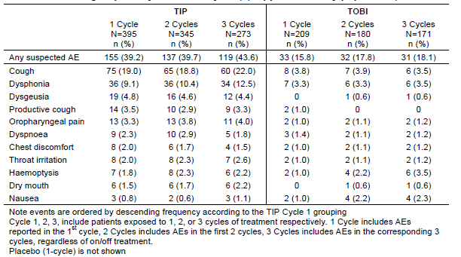
Incidences of events of special interest in the supportive safety population for the TOBI Podhaler treated groups, are summarised as follows:
- “Bronchospasm” occurred for 35 (8.9%) patients (most commonly wheezing for 22 patients [5.6%] patients and FEV₁ decreased for 12 [3%] patients);
- “Coughing and associated symptoms” occurred for 198 (50.1%) patients (most commonly cough for 171 patients [43.3%] patients, productive cough for 63 patients [15.9%] and haemoptysis for 44 [11.1%] patients);
- “Dizziness” was reported by 6 (1.5%) patients;
- “Hearing losses” for 6 (1.5%) patients;
- “Inner ear signs and symptoms” for 8 (2.0%) patients;
- “Nephrotoxicity” for 5 (1.3%) patients (reported as “proteinuria” for 2 [0.5%] patients, “blood creatinine increased” for 1 [0.3%] patient, “blood urea increased” for 1 [0.3%] patient, and “protein urine present” for 1 [0.3%] patient);
- “Taste disorders” for 22 (5.6%) patients, most commonly dysgeusia for 20 (5.1%) patients; and
- “Voice alteration” for 51 (12.9%) patients, most commonly dysphonia for 49 (12.4%) patients.

Discussion supporting safety population
It is considered inadequate to report the events of special interest without comment regarding the relationship of the treatment and the events.

Post marketing experience
The Periodic Safety Update Report for 2006 to 2008 was evaluated for this report. Identification of the possible association of nephrotoxicity was reported. In the majority of cases in which there was sufficient information, there were confounding pre existing medical conditions and concomitant use of drugs with nephrotoxic potential. The company committed to continuing monitoring.
A bridging PSUR, 2004 to 2008 was also evaluated and included no potential signals other than the above. The PSUR evaluation reports are appended to the clinical evaluation report.

List of questions
The following information was requested:
- Confirmation that the identical product and device were used in Studies IN-007, TPI001, C2301 and C2302.
The compositions of TOBI Podhaler hard capsule batches used for Studies IN-007, TPI001, C2301 and C2302 were provided in the sponsor’s response to the consolidated questions (October 2011). All materials are qualitatively the same.

Comment:
Response satisfactory.
- Clarification of the number of Podhalers that will be included in the kits.

Sponsor’s response:
It is stated in the text of the response that the 7 day presentation will include one Podhaler inhalation device, while the accompanying table of presentations states inclusion of two devices. The 28 day pack includes five devices.

Comment:
In view of the conflicting information regarding the 7 day pack, the response is considered partially satisfactory. The potential problem is foreseen related to the presentation in kit form which means that a whole kit may have to be purchased in case of repeated device problem or loss.
- Study TIP001: Inconsistency of labelling of table headings in the clinical summary was noted; table headings for the 3 x 24 mg group and the 4 x 24 mg group being transposed for some tables. The sponsor is asked to confirm that the results included under the transposed headings have been accurately reported.

Sponsor’s response:
Novartis states their understanding that the data presented under these headings is correct. The inconsistency is believed to be due to change of dosing cohort 5 from 6 to 3 capsules based on protocol amendment and Operations Memorandum 8 both dated January 26th 2004.

Comment:
The assurance is accepted.
- Study C2301: Justification for the use of a placebo control in this study.

Sponsor’s response:
The decision was that of Chiron prior to the product acquisition by Novartis. The following justifications were offered and were premised on the assertion that the formulation was not yet proven to be clinically beneficial. Novartis stated the belief that patients with chronic P. aeruginosa infection who have not received inhaled tobramycin for four months are in need of treatment.
The design benefits were stated:
- Limitation of the number of participants required
- Limitation of the exposure to experimental therapy
- Allowance for blinding
- The safeguard existed that patients could be withdrawn from the study
- The placebo patients were not without treatment
- Patients were switched to active study medication for the final 2 cycles
- Novartis did not require that patients were withdrawn from inhaled tobramycin in order to participate
- Patients who might not be receiving inhaled anti pseudomonal antibiotic due, for example, to local prescribing/ healthcare practices or budget restrictions, were able to access such treatment
- Patients who were not treated with inhaled tobramycin may have continued not to have access to the treatment for much longer periods of time
- Novartis put in place measures to ensure that all subjects had on-going access to inhaled tobramycin through a compassionate supply program.

Comment:
Responses (a) to (e) are considered uncontroversial.
Responses (f) to (j): for patients with chronic P. aeruginosa, inhaled antipseudomonal treatment is considered standard of care. The lure of ongoing treatment after completion of the trial may have been sufficient to result in an investigator withholding expensive or difficult to obtain treatment in order to gain access to the compassionate supply program.
While recognising that differing views are held on this subject, the evaluator holds the opinion that placebo control should not be undertaken when there is a recognised, best practice treatment which could be used as comparator, and that different standards should not be applied to those who have the benefit of resources and those who have not.
- Study C2302: The clinical expert states in the clinical overview that cough, dysgeusia and dysphonia had odds ratios independently indicating a greater risk of developing these events when using TOBI Podhaler than TOBI. Results of OR could not be found and direction to their location in the submission dossier is requested. Inclusion of 95% CIs in addition to the point estimates is requested.

Sponsor’s response:
The data are presented in Clinical Overview: Summary of clinical safety section and are summarised thus:
- cough - odds ratio 2.08 (95% CI 1.41, 3.06),
- dysgeusia - odds ratio 8.43 (95% CI 1.23, 362.17),
- dysphonia - odds ratio 3.97 (95% CI 1.78, 9.98).

Comment:
Odds ratios excluding 1 are suggestive of significant differences favouring TOBI.
- Studies C2301 and C2302: It is requested that the individual patients aged 6 to 12 years inclusive are grouped by year of age with the following information supplied for each individual. This information is also required for all patients with FEV₁ percent predicted greater than 40%, irrespective of age, the figure is chosen as such patients would have been excluded from Study TIP001 according to protocol.
- Patient ID
- The study group study that is, active or comparator
- The FEV₁ percent predicted of the at baseline
- Adequacy of use of the delivery device and any problems encountered in the use of the device
- Requirement for unscheduled replacement of the device
- Problems encountered with the capsule, including occasions on which replacement capsules were required for any reason
- The number of inhalations required to inhale the product
- The number of occasions on which the full dose was not taken and the reason for the failure to take the full dose
- The number of occasions on which the treatment was interrupted and the reason for the interruption
- The change in FEV₁ percent predicted from baseline to pre dose 28 for each cycle and overall
- Information on peak inspiratory flow rates of these patients in terms of percentiles for age
- PK data

Sponsor’s response:
The requested information was provided for patients 6 to 12 years and for patients with FEV₁ percent predicted smaller than 40%. Patients aged 6 to 12 with FEV₁ percent predicted smaller than 40% were listed once based on age.
Peak inspiratory flow rates were not measured in either study and the number of inhalations was not documented. Problems with the capsule or the device were occasionally documented but events may have been missed.
Some patients from Study C2301 had empty profiles occurring when there was no evidence of the drug having been dispensed.
Patients with no FEV₁ information corresponded to those from Latin America whose spirometry data were deemed unacceptable.

Comment:
The documentation was found to be unsuitable for determining whether the youngest patients and adults with significant respiratory impairment were capable of adequately using the device, particularly in Study C2301 in which comment by the investigator was rare. A number of children were noted to have missed from 15 to 50 doses without documented reason.
Documentation of PK data gave rise to some concerns with examples given below (Tables 27-30). Sampling dates were as follows: Week 1 Day1 commenced Cycle 1; Week 5 Day 28 ended Cycle 1, Week 9 Day 1 commenced Cycle 2 and Week 13 Day 28 ended Cycle 2.
Table 27: Participant, age 11, TOBI Podhaler group.
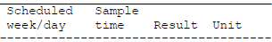
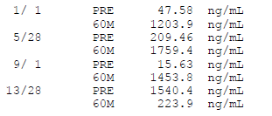
It was noted that measurable tobramycin was reported before the first dose of the first cycle was given. It was also noted that pre dose measurement was higher than the post dose level (Visit 13 Day 28), leading to the assumption that the figures may have been incorrectly entered.
Table 28: Participant, age 6, placebo group.
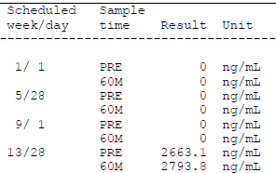
The results reported a pre dose level greater than 2 µg/mL which is said to be the trough level above which adverse auditory and renal events are possible. For this patient, no measurable tobramycin was detected following the first dose of the second cycle at which time the patient should have been on active treatment. As for most participants, there was no clarifying investigator comment recorded.
Table 29: Participant, age 6, TOBI Podhaler group.
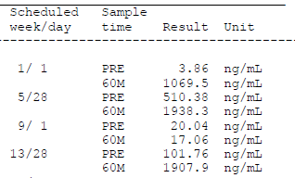
This patient had results showing low, but measurable serum tobramycin level after a month off the treatment, and an even lower level after the first dose of Cycle 2, again with no explanation.
Table 30: Patient, age 6, TOBI Podhaler group.
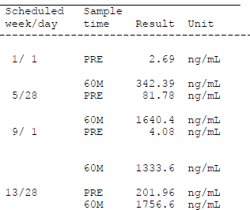
For this patient, the order of reporting is reversed on two occasions, that is, post dose is reported after pre dose for Week 5 and Week 9.
The poor quality of the reporting and data entry combined with the apparent lack of supervision of the trial such that two centres were eliminated from the analysis after study completion because of unreliable spirometry does not inspire confidence that the results overall are totally reliable. It is the evaluator’s opinion that measurement of peak inspiratory flow and strict documentation of a patient’s ability to manage the device in an effective manner should have been prerequisites of the study.
While the concern regarding a young child’s ability to use the device has not been satisfactorily resolved, it appears that at least for some of the children for whom PK measurement were made, the serum levels of tobramycin were higher than the mean C_{max} levels reported in the dose finding study.

Clinical summary and conclusion
Novartis Pharmaceuticals wishes to register the new dosage form, Tobramycin Podhaler capsules, for inhalation for the management of patients with CF with P. aeruginosa infections in accordance with the indication already approved for TOBI Solution for inhalation. The Podhaler formulation was developed with the aim of improving treatment compliance by reducing the time required to administer inhaled tobramycin and to overcome the limitations on use of treatment outside the home.
Study IN-007 compared regional deposition of radio labelled prototype tobramycin powder capsule, nominal dose approximately 80 mg and TOBI Solution for inhalation, 300 mg. Twelve healthy adult participants aged 18 to 50 years with screening FEV₁ greater than 80% predicted completed the study.

Sponsor:
On the basis of the study results, the sponsor concluded that a therapeutic dose of tobramycin could be delivered to the lung using the Podhaler device. The rate and the extent of tobramycin absorption from the lung were nearly identical for the two formulations after normalisation of PK parameters for actual lung dose. Systemic exposures were well below toxic levels. The powder formulation was safe and well tolerated.

Evaluator:
It was not clear whether the capsule formulation and the device used in this study were identical to those proposed for registration. External validity of this study was considered problematic. In healthy adults with good respiratory function, the mean percent of radio labelled TOBI Podhaler deposited in the oropharynx, oesophagus and stomach was 43.7% versus 8.2% for TOBI. It is concerning that in children or patients with impaired lung function, a considerably higher proportion of the dose would be deposited in this area. In addition there were concerns about the sufficiency of information regarding radio labelling provided to the participants in the Patient Information Sheet as the basis for informed consent.
Study TIP001 was a dose ranging study including clinically stable patients with CF aged at least 6 years, with FEV₁ percent predicted at least 40%. The primary objective was to assess safety; the secondary objectives related to measurements of plasma and sputum PK, and to compare administration time compared to standard dose of TOBI Solution for inhalation. Patients were exposed to 2 x 14 mg, 4 x 14 mg, 2 x 28 mg, 3 x 38 mg and 4 x 28 mg single doses of TOBI Podhaler and TOBI 300 mg.
The sponsor concluded and the evaluator agreed that serum PK results for four capsules of 28 mg of TOBI Podhaler indicated systemic exposures that are comparable to 300 mg of TOBI; However, bioequivalence was not assessed. It is noted that patients at inclusion were to have at least 40% predicted FEV₁ and thus were not totally representative of the population in the proposed indication.
It was also noted that patients in the 4 x 28 mg group had the lowest bronchodilator use 29% versus 40-43% for other groups, and the concern is that this group may either have had different disease characteristics or have been differently treated in this non blinded study. Inconsistent labelling of table headings in the clinical summary was noted, with headings for the 3 x 24 mg group and the 4 x 24 group being transposed for some tables; however, the sponsor’s assertion that headings and results corresponded was accepted.
The proportion of patients reporting AEs and dosage interruptions was higher following the test drug administration than following nebulised TOBI Solution.
Study C2301 was a Phase III, multicentre, randomised, three cycle, two arm trial in which the first cycle of treatment was placebo controlled and double blind.
The primary objective was to demonstrate efficacy in terms of the relative change in FEV₁ percent predicted from baseline to the end of Cycle 1, Day 28 with the aim of demonstrating superiority of the active treatment. Secondary objectives were to assess safety and efficacy over three cycles. The study included clinically stable CF patients from 6 to 21 years of age with screening FEV₁ percent predicted of 25% and 80% inclusive, with P. aeruginosa positive culture within the six months prior to screening and at screening. Patients who had received inhaled antipseudomonal antibiotics within four months or systemic antimicrobial treatment within 28 days before the study were excluded.
The protocol planned interim analysis was undertaken but this original analysis was not used due to a problem identified in calibration of spirometry equipment in two centres. A sensitivity interim analysis overseen by an independent expert panel of pulmonologists was considered to demonstrate superiority of TOBI Podhaler over placebo and enrolment in the study was prematurely ceased at that point. However, having viewed some of the study documentation appeared to lack rigor, and in view of the brevity of the study and the failure to perform the protocol defined analysis, the evaluator is hesitant to endorse the finding of superiority.
There were more AEs reported in the placebo arm than the treatment arm in Cycle 1 of the study. One placebo exposed patient died due to decompensated chronic cor pulmonale. The most commonly reported AEs were cough and lung disorders. Discussion of relationship of AEs to study treatment could not be located in the study report in the Clinical section.
The decision to include a placebo arm is considered problematic in view of the established efficacy of inhaled antibiotic treatment.
Study C2302 was a randomised, open label, active controlled multicentre study comparing three cycles of 28 day on and 28 days off treatment with TOBI Podhaler and TOBI in clinically stable CF patients aged at least six years with FEV₁ percent predicted between 25% and 75% and with P. aeruginosa positive culture at screening. The primary objective was to assess safety in general terms. One of the secondary objectives was to assess non inferiority in terms of the relative change in FEV₁ percent predicted at the end of Cycle 3 compared to baseline.
A total of 517 patients were included in the analysis populations. Approximately 9% of the two groups were aged 6 to 12 years, just over 20% were aged 13 to 19 years and nearly seventy percent were older than 20 years, the mean age was ~25 years. In total, 396 completed the study while 27% of the TOBI Podhaler group and 18.2% of the TOBI group discontinued the study. Withdrawals for AEs were more common in the TOBI Podhaler group than the TOBI group 14% versus 8.1% and 7.8% of the TOBI Podhaler group withdrew consent compared to 3.4% of the TOBI group. Treatment compliance of at least 80% was recorded for 82.4% of the TOBI Podhaler group and 90.8% of TOBI patients.
With regard to overall safety, 51.0% of patients in the TOBI Podhaler treatment group and 20.1% in the TOBI group reported AEs suspected of being related to the treatment. Cough, dysphonia, dysgeusia, chest discomfort, oropharyngeal pain and throat irritation were all reported more commonly for following TOBI Podhaler treatment than following TOBI treatment with odds ratios suggesting the difference was significant.
The least squares mean relative change in FEV₁ percent predicted from baseline to pre dose Day 28 of Cycle three was 5.8% for TOBI Podhaler and 4.7% for TOBI, while the mean change calculated from Analysis of Variance (ANOVA) was 3.1% for TOBI Podhaler and 2.3% for TOBI. These results did not represent a substantial improvement in either group, but were similar between groups. The sponsor claimed non inferiority based on a one sided 85% CI calculated from an analysis of covariance (ANCOVA) of relative change in FEV₁ percent predicted, with delta of 6%. However, the parameters for claiming non inferiority did not conform to those stated in the European Union Guideline, and the claim of equivalence in statistical terms is not accepted.

The device
The presentation described in the draft PI appears to be a kit. The device appears to have been specifically developed for use with the tobramycin powder capsules for inhalation. It is considered essential that the device is separately evaluated.
DPIs often show a high flow dependency in their deposition characteristics. The internal resistance of the DPI may be such that a child will find the inhaler more difficult to use than would an adult. Discussion of the character of flow rate dependency in the patient populations in the studies is considered lacking. In particular it is considered essential to demonstrate that children and patients with very limited lung function have sufficient peak inspiratory flow rate to adequately inhale the capsule contents.
Limitations with PK studies in relation to inhaled products include their inability to differentiate the distribution of drug within the different zones of the lung following inhalation. The guideline states that equivalent pulmonary deposition and equivalent systemic safety of two inhaled products may be concluded if the 90 % confidence interval for the maximum concentration, the area under the curve and the time to maximum concentration lies within the acceptance range of 0.8 to 1.25. Equivalent lung deposition of two drugs may be concluded if the 90% CI of the radioactivity in each area is within a range of 0.8 to 1.25. Results of testing of bioequivalence were not presented for the dose ranging study.
It is of concern that the Podhaler is required to be replaced after a week of use. This suggests that the sponsor may be concerned that deposition of powder may quickly increase internal resistance of the device. It was not possible to determine how many Podhalers would be supplied with each kit. Monthly discarding of four or more Podhalers with enveloping case appears wasteful and a contribution to pollution. In addition the Podhaler device may well be contaminated with tobramycin resistant organisms and as P. aeruginosa is a commonly found in soil and water, this may contaminate the environment.
Study TSB-001 was designed to assess the inspiratory variables of a representative population of CF patients 6 years and older with varying degrees of lung disease while inhaling through resistances that simulate DPI devices. The reported “general results” stated that younger patients and those with more severe lung disease may not be able to adequately use a typical dry powder inhaler. The evaluator considers that the fact that such patients may be included in small numbers in Phase III studies of efficacy and safety, does not necessarily justify their inclusion in the Indication criteria.
Patients using dry powder inhalers need explanations in the package leaflet as to how to recognise an inadequate hand operated or breath operated inhalation and when they may need to be switched from one method of administration to the other.

Excipients
When a new excipient or excipient mix is introduced, the possible impact on clinical efficacy and safety should be assessed including local tolerability, evidence of increased bronchial irritability and the effect that the excipient may have on mucociliary clearance or on interactions with other drugs. Such information could not be located in the submission.

Benefits
- Reduced delivery time was demonstrated in the clinical trials
- Better portability is likely
- While efficacy results of Studies 2301 and 2302 are considered to be inconclusive, the similarity of TOBI Podhaler and TOBI PK findings in Study TPI001, albeit without bioequivalence testing, would suggest the likelihood that efficacy would be similar to the already registered TOBI Solution for inhalation, based on previous evaluation of efficacy of that product.

Risks
- The incidence of AEs considered related to study treatment was higher in the TOBI Podhaler group. The AEs occurring more frequently, cough, dysphonia, dysgeusia (Study C2302) pharyngeal pain (Study 2301), suggest that there may be considerable deposition of the powder in the upper airways causing local irritation.
- It is considered uncertain that children, or patients of any age with significantly reduced respiratory function, can develop sufficient peak inspiratory flow to effectively administer the powdered formulation.
- Multiple tobramycin encrusted devices, potentially also contaminated with P. aeruginosa, S. aureus and other pathogens will be discarded into the environment at least weekly by individual patients.
- Use of inhaled tobramycin has the potential to increase the resistance of P. aeruginosa over time. Spread of more resistant P. aeruginosa in the CF community may impact the ability to adequately treat patients systemically. Definitive studies of this potential are needed.
- Studies have so far been insufficiently rigorous to disprove an association with reduced auditory thresholds and renal function in the long term and in the presence of concomitant medication. This concern is reinforced by the finding of trough level of greater than 2 µg/mL for one child and also by the puzzling finding of measurable serum tobramycin levels one month after the completion of a cycle of treatment.
- Compliance with TOBI Podhaler treatment was not shown to be better than compliance with TOBI despite the advantage in terms of time taken for administration.
- The safety profile of the excipients requires supporting data.

Balance
- While the balance may be positive for patients who can satisfactorily use the device, the population who can effectively use the device has not been satisfactorily delineated.

Recommendation
Registration of product is recommended with the following qualifications:
- The device should be separately evaluated prior to registration.
- There should be a requirement that a patient’s ability to use the device is be demonstrated before the product is prescribed
- Tobramycin trough levels should be monitored at least once at the end of the first cycle of treatment.

V. Pharmacovigilance findings

Risk management plan
The sponsor submitted a Risk Management Plan which was reviewed by the TGA’s Office of Product Review (OPR).

Safety specification
The sponsor provided a summary of ongoing safety concerns which are shown in Table 31.
Table 31: Ongoing safety concerns for tobramycin.

OPR reviewer comment:
Pursuant to the evaluation of the nonclinical and clinical aspects of the Safety Specifications, the above summary of the ongoing safety concerns is considered acceptable.

Pharmacovigilance plan
The sponsor states that routine pharmacovigilance activities, consistent with the activities outlined in the TGA adopted EU guideline, are proposed to monitor all the specified ongoing safety concerns.
The sponsor states that there will also be targeted follow up for all serious and non serious spontaneous cases using a corresponding questionnaire/checklist for the important potential risks: ‘Haemoptysis’, ‘Ototoxicity’ and ‘Decreased P. aeruginosa susceptibility to tobramycin (MIC)’. The sponsor has provided copies of these questionnaires/checklists in the Australian Implementation Supplement.
In addition, the sponsor proposes to further monitor the important missing information: ‘Potential adverse effects of long term use (other than listed as potential risks)’ by:
- Conducting two sequential Phase III open label extension Studies CTBM100C2303E1 and CTBM100C2303E2 of the ongoing Study CTBM100C2303:
  - Study CTBM100C2303 is a double blind, placebo controlled, randomised study in CF subjects and not having been previously treated with inhaled anti pseudomonals at all or at least not within the past four months, aged 6 to 21 years, who are infected with P. aeruginosa. The study will consist of a one to two week screening period, a baseline visit, followed by the treatment phase (eight weeks), and the termination visit. The primary efficacy variable is the relative change of FEV₁ percent predicted from baseline to Day 29. In the primary efficacy analysis, an ANOVA model will be used with factors of treatment, screening FEV₁ percent predicted and age based on intent to treat principle (all subjects received at least one dose of study medication). Safety analysis will be based on descriptive statistics for subjects received at least one dose of study medication. A sample size of 100 subjects (50 per group) is needed to provide 90% power to detect a treatment difference of 11% in the mean relative change of FEV₁ percent predicted from baseline to Day 29 at two sided 5% significance level, if the SD is 16% and drop out rate is less than 10%. Descriptive statistics will be provided for tobramycin serum and sputum concentrations. Serum PK of tobramycin from dry powder inhaler will be characterised by population non linear mixed effects modelling techniques using data from the current and previous studies. The effect of factors like manufacturing process, age, gender, race, weight, lung function and study will also be assessed as covariates. The planned date for submission of final data is 31 December 2011.
  - The ongoing Study CTBM100C2303E1 is designed to evaluate the safety and efficacy of tobramycin inhalation powder after modifications in the manufacturing process for the treatment of infections with P. aeruginosa in subjects suffering from CF over a period of three treatment cycles. To be eligible for study participation, subjects must have completed core Study CTBM100C2303. The planned date for submission of final data is 30 June 2012.
  - The ongoing Study CTBM100C2303E2 is designed to evaluate the safety and efficacy of tobramycin inhalation powder for an additional six months (after Study CTBM100C2303E1) after modifications in the manufacturing process for the treatment of infections with P. aeruginosa in patients suffering from CF over a period of three treatment cycles. The planned date for submission of final data is 31 December 2012.
  - The combination of data from Studies CTBM100C2303E1 and E2 will enable the evaluation of the one year safety profile of tobramycin inhalation powder.
- Conducting a single arm, open label, multicentre Phase IV trial in CF patients 6 years and older (Study CTBM100C2401). The purpose of this planned study is to provide long term safety data for the use of tobramycin dry powder for inhalation hard capsule together with supportive efficacy endpoints over the same period. The study is to be conducted over a period of six cycles of treatment (a duration of 48 weeks) where one cycle of treatment is defined as four capsules of tobramycin inhalation powder at 28 mg dosage strength, inhaled twice daily in the morning and in the evening, for 28 days (on treatment), followed by 28 days of no study drug treatment (off treatment). This study will provide one year treatment data for safety parameters in the context of a Phase IV development program. The sample size of 150 patients to receive tobramycin inhalation powder is based primarily upon regulatory considerations for safety data. In a sample size of 150 tobramycin inhalation powder patients, there is a 95.2 % chance of observing at least one AE with a true incidence rate of 2%, and a 77.9 % chance of observing at least one AE with a true incidence rate of 1%. In a previous study, the discontinuation rate was ~27% and appeared to be different in younger patients compared to older patients. The study has 150 patients participating and has over 70% power to detect a 20% difference in discontinuation rate between younger and older patients.
The sponsor provided final study protocols for these ongoing studies and a synopsis for the planned Study CTBM100C2401, dated 23 September 2010. Subsequently, the sponsor’s correspondence dated 7 July 2011 provided a final protocol for Study CTBM100C2401 (dated 20 June 2011) and advised that initiation of this study was anticipated in October 2011.
To further monitor the important missing information ‘Handling of the T-326 Inhaler in young paediatric patients’, the sponsor is conducting a multicentre human factors engineering handling study to assess the usability of the T-326 Inhaler device and the ability of subjects with a clinical diagnosis of CF aged between 6 and 10 years old to successfully and safely, alone or with assistance, use the device for inhalation of tobramycin inhalation powder hard capsules. Evaluation of the successful completion of the usage steps described in the instructions for use (as approved by the EU) is conducted upon receipt and after 5 days of use of a commercial weekly patient pack. This study will simulate use with empty capsules manufactured and packaged under current good manufacturing practice (cGMP) and is not defined as a clinical trial. Using a binomial distribution [pass (accept)/fail (reject)] the passing objective is 90%. A study population of 20 patients will yield a sample of 80 (each subject uses the device four times per assessment to inhale one dose). If three events are detected, it is claimed it can be stated with greater than 95% confidence that there will be less than 10% occurrence of that event in the true population. The planned date for submission of final data is 31 December 2011. The sponsor provided a draft protocol for this ongoing study. However, the sponsor’s correspondence, dated 7 July 2011, has stated that this was in fact the final protocol.

OPR reviewer comment:
In principle there is no objection to the sponsor implementing additional pharmacovigilance activities to further monitor all the specified ongoing safety concerns. However, the ongoing and initiated studies are not considered to be part of the planned clinical studies in the pharmacovigilance plan. Therefore the related study protocols have not been reviewed. Nevertheless an update on the progress/results/analysis of this study, as outlined in the updated RMP, will be expected in future Periodic Safety Update Report (PSURs).

Risk minimisation activities
The sponsor has concluded that routine risk minimisation activities are sufficient for all the specified ongoing safety concerns, except for the important missing information ‘Potential adverse effects of long term use (other than listed as potential risks)’, ‘Patients with disease severity different from that studied in clinical trials’, ‘Effects of medications prior to treatment (such as steroids, other antibiotics)’ and ‘Demographics of risk for aminoglycoside related deafness in both Caucasians and non Caucasians’.

OPR reviewer comment:
The sponsor’s justification and conclusion would appear to be reasonable, except in relation to the important missing information, ‘Handling of the T-326 Inhaler in young paediatric patients’. On the basis of the Clinical Evaluation Report recommendation that there should be a requirement that a patient’s ability to use the device be demonstrated before the product is prescribed, summary of planned actions of the RMP should be amended to indicate that routine risk minimisation activities are not considered sufficient for this ongoing safety concern or alternatively provide compelling justification for not implementing such activities.

Risk minimisation plan
Routine risk minimisation activities will include special warning and precaution statements, instructions for use and/or notification of undesirable effects in the product literature for all the specified ongoing safety concerns, except for the important missing information ‘Potential adverse effects of long-term use (other than listed as potential risks)’, ‘Patients with disease severity different from that studied in clinical trials’, ‘Effects of medications prior to treatment (such as steroids, other antibiotics)’ and ‘Demographics of risk for aminoglycoside related deafness in both Caucasians and non Caucasians’.

OPR reviewer comment:
The sponsor’s proposed RMP would appear to be reasonable, except in relation to the important missing information: ‘Handling of the T-326 Inhaler in young paediatric patients’. Based on the Clinical Evaluation Report, the sponsor should propose additional risk minimisation activities to ensure that only patients who have demonstrated an ability to use the device be prescribed this product. Consequently this section of the RMP should be amended accordingly, detailing how such activities will be implemented and how the effectiveness of these additional risk minimisation activities as a measure to reduce medication error in the post market environment will be assessed. Alternatively, compelling justification for not implementing such activities should be provided.

Summary of recommendations
The OPR provides these recommendations in the context that the submitted RMP is supportive to the application; the implementation of a RMP satisfactory to the TGA is imposed as a condition of registration; and the submitted EU-RMP is applicable without modification in Australia unless so qualified:
- Based on the Clinical Evaluation Report, the sponsor should propose additional risk minimisation activities to ensure that only patients who have demonstrated an ability to use the device be prescribed this product. Alternatively, compelling justification for not implementing such activities should be provided.
- In principle, there is no objection to the sponsor implementing additional pharmacovigilance activities to further monitor all the specified ongoing safety concerns. However, the ongoing and initiated studies are not considered to be part of the planned clinical studies in the pharmacovigilance plan. Therefore the related study protocols have not been reviewed. Nevertheless an update on the progress/results/analysis of this study, as outlined in the updated RMP, will be expected in future PSURs.
- The sponsor’s justification and conclusion that routine risk minimisation activities are sufficient for the specified ongoing safety concerns would appear to be reasonable, except in relation to the important missing information, ‘Handling of the T-326 Inhaler in young paediatric patients’. On the basis of the Clinical Evaluation Report recommendation, there should be a requirement that a patient’s ability to use the device be demonstrated before the product is prescribed. Summary of planned actions of the RMP should be amended to indicate that routine risk minimisation activities are not considered sufficient for this ongoing safety concern or alternatively provide compelling justification for not implementing such activities.
- The potential for medication errors of the RMP has not sufficiently addressed the important missing information, ‘Handling of the T-326 Inhaler in young paediatric patients’ and the risk of the patient not receiving a therapeutic dose of the medicine. Consequently, this section of the RMP should be amended to indicate that the sponsor proposes to implement additional risk minimisation activities to reduce such medication error in the post market environment or alternatively provide compelling justification for not implementing such activities.
- The sponsor’s proposed RMP would appear to be reasonable, except in relation to the important missing information, ‘Handling of the T-326 Inhaler in young paediatric patients’. Based on the Clinical Evaluation Report, the sponsor should propose additional risk minimisation activities to ensure that only patients who have demonstrated an ability to use the device be prescribed this product. Consequently, this section of the RMP should be amended accordingly, detailing how such activities will be implemented and how the effectiveness of these additional risk minimisation activities as a measure to reduce medication error in the post market environment will be assessed. Alternatively, compelling justification for not implementing such activities should be provided.

VI. Overall conclusion and risk/benefit assessment
The submission was summarised in the following Delegate’s overview and recommendations:

Quality
The evaluator considers that the submission is not approvable at this stage. The limits for impurities in the excipient, DSPC, need to be tightened as do the limits for fine particle dose in the finished product specifications. Satisfactory qualification data was provided for the other impurities to justify the proposed limit, or the limit for each of those impurities should be tightened.
APSD characteristics of validation batches representative of the proposed commercial product have been compared to Phase III trial batches tested using a multi stage cascade impactor. The experiments performed showed that there is a statistical difference in FPD between the Phase III and the final commercial validated batches. The trend from these data indicates that the differences between the Phase III and the validation batches are greater when flow rate is higher. It is noted that this application will be discussed in the PSC (pharmaceutical subcommittee) meeting on 23 January 2012.

Nonclinical
The local and systemic toxicity profile of TOBI Podhaler appears to be qualitatively similar to and no worse than tobramycin inhalation solution at equivalent doses and systemic exposures based on the evaluation of the animal studies. Adequate inhalational studies of tobramycin vehicle in animals have not provided evidence for concern over the safety of the proposed tobramycin dry powder excipients. Adequate justification on nonclinical grounds has been provided only for some of the impurities.
The primary excipients in tobramycin dry powder capsules are DSPC and calcium chloride (CaCl₂), both of which are not present in medicines registered currently for inhalation administration. Studies of tobramycin powder containing these excipients and studies of the excipient mixture itself in rats and dogs did not provide evidence for concern over the inhalational administration of these substances. There was no evidence for significant local or systemic toxicity findings with vehicle alone. DSPC was also assessed in a standard battery of genotoxicity studies, all of which were negative. Quality specifications for tobramycin capsules include limits for several impurities that are higher than those accepted without justification according to the relevant regulatory guidelines. Adequate nonclinical data were provided to qualify limits proposed for some ingredients. Limits for other impurities found in the excipient DSPC remain to be qualified or should be reduced to levels that do not require justification on nonclinical grounds.
There are no objections on nonclinical grounds to the registration of tobramycin dry powder for inhalation, provided the sponsor reduces or qualifies the limits for any impurities that have not been justified on nonclinical grounds.

Clinical
Two PK studies (Study INH-007 and Study TPI001) and two clinical studies (Study C2301 and Study C2302) are submitted to support this application. These studies were evaluated in detail in the Clinical Evaluation Report and are briefly discussed below.

Pharmacokinetics, regional deposition, and dose ranging information
Study INH-007 was a non randomised, five period cross over study conducted in 14 healthy volunteers. The study compared regional deposition of radio labelled prototype tobramycin capsules for inhalation and TOBI Solution for inhalation. The PK characteristics of TOBI Podhaler capsule and TOBI Solution were also assessed. The capsule formulation used is an earlier prototype formulation while the device used was the same as that used in Phase III trials (T-326 DPI). A total of 12 healthy adults aged 18 to 50 years with screening FEV₁ greater than 80% predicted completed the study.
Periods 1 to 3 consisted of three single capsule dosing periods and each dosing consisted of the inhalation of one capsule of 25 mg radio labelled powder (containing 13.3 mg tobramycin). At Period 4, subjects inhaled radio labelled TOBI Solution (300 mg tobramycin) for 15 minutes. For period 5, subjects received serial inhalations from 6 capsules of TOBI Podhalerover a 15 minute. Each capsule contained 25 mg unlabeled TOBI Podhaler formulation (13.3 mg tobramycin content).
The results showed that 43.7% of radio labelled TOBI Podhaler was deposited in the oropharynx, oesophagus and stomach, 21.7% retained in the device, and about 34% deposited in the lung. For TOBI Solution, over 50% doses remain in the nebuliser cup, 8.2% deposited in the oropharynx/oesophagus/ stomach, and 5% deposited in the lung. In Period 5, total deposited dose after inhalation of six capsules was calculated to be 27 mg tobramycin based on the estimated lung deposition of 34% with TOBI Podhaler. In Period 4, the estimated total tobramycin dose deposited in the lung after inhalation of 300 mg TOBI was 15 mg. The C_{max} and AUC of tobramycin after inhalation of TOBI Podhaler were about 2 fold higher than after TOBI and is consistent with the scintigraphy results indicating that inhalation of six capsules of TOBI Podhaler delivered nearly twice the amount of tobramycin to the lungs compared with TOBI inhalation. The rate and the extent of tobramycin absorption from the lung were nearly identical for the TOBI Podhaler capsule and TOBI Solution after normalisation of PK parameters for actual lung dose. Systemic exposures were well below toxic levels. The powder formulation was safe and well tolerated.
Overall, the results of this study confirm the concept that a therapeutic dose of tobramycin could be delivered to the lung by using TOBI Podhaler formulation via the T-326 DPI inhaler. The studies discussed below explored the optimal dose of TOBI Podhaler and compared the TOBI Podhaler versus TOBI Solution in terms of efficacy and safety.
Study TIP001 was an open label, randomised, sequential cohort, and active controlled dose ranging study. The primary objective was to assess safety; the secondary objectives were to assess the plasma and sputum PK, and to compare administration time using the Podhaler device versus that using the standard dose of TOBI Solution for inhalation.
A total of 90 stable CF patients (greater than 6 years, with FEV₁ predicted at least 40% ) were randomised to one of the six treatments: TOBI Solution 300 mg, TOBI Podhaler2 x 14 mg, 4 x 14 mg, 2 x 28mg, 3 x 28mg, or 4 x 28 mg. The plasma PK results showed that increases in TOBI Podhaler dose led to increases in tobramycin exposure, however, the increases were slightly less than proportional. The AUC₁₂ were very similar after inhalation of TOBI Solution 300 mg and 4 capsules of 28 mg of TOBI Podhaler twice daily. A similar relationship was demonstrated based on AUC∞. The TOBI Podhaler 4 x 28mg capsules twice daily was selected and was later used in the Phase III studies. The variability in sputum PK parameters was higher than in serum. There was a trend of increasing exposure with increased dose but dose proportionality based on sputum levels could not be confirmed.
The evaluator noted that patients at inclusion were to have at least 40% predicted FEV₁ and thus were not totally representative of the population in the proposed indication. It was also noted that patients in the 4 x 28 mg group had the lowest bronchodilator use 29% versus 40-43% for other groups. The evaluator expressed concerns that this group may either have had different disease characteristics or have been differently treated in this non blinded study.

Efficacy evaluation
Efficacy of TOBI Podhaler was evaluated as primary objective in Study C2301 and as one of the secondary objectives in Study C2302.
Study C2301 was a Phase III, multicentre, randomised trial. The study has two treatment groups with three cycles of 28 days on/28 days off treatment. The 1st cycle was TOBI Podhaler versus placebo and was double blind. The 2nd and 3rd cycles were open label and all patients received TOBI Podhaler treatment.
TOBI Podhaler112 mg (4 x 28 mg capsules) was administered twice daily for three cycles. The total treatment period was 24 weeks. Patients who were randomised to the placebo group received placebo in the first cycle and TOBI Podhaler in the subsequent two cycles.
The primary objective was to demonstrate the efficacy of TOBI Podhaler112 mg twice daily for 28 days (first cycle) compared to placebo of 28 days. The primary endpoint was the relative change in FEV₁ percent predicted from baseline (Day 1) to the end of Cycle 1 (Day 28). Secondary objectives were to assess safety and efficacy over three cycles.
The study included clinically stable CF patients from 6 to 21 years of age with screening FEV₁ percent predicted of 25% and 80% inclusive, with P. aeruginosa positive culture within the 6 months prior to screening and at screening. A total of 102 patients were randomised, and 95 received study drug (46 received TOBI Podhaler and 49 received placebos). The mean age was 13 years (range 6-21 years). Demographic characteristics were balanced between groups. At baseline, more patients in the placebo group have FEV₁ percent predicted greater than 25% or less than 80% while more patients in the TOBI Podhaler group have FEV₁ percent predicted from greater than25% to less than 59%. The patients in this study had no exposure to inhaled tobramycin for at least 4 months prior to study start.
The primary efficacy analysis was based on the SIA ITT population using an analysis of covariance. The SIA population was used because this population utilised the most robust spirometry data and it excluded 18 patients for whom the spirometry data had not been collected in accordance with acceptable standards. The analysis showed that after 28 days of TOBI Podhaler treatment, there was a relative increase of 13% in FEV₁ percent predicted, this was significantly improvement compared to placebo. The difference (95% CI) between active and placebo group was 13.79% (5.87% to 21.70%). The p value of 0.0010 was less than the specified 0.0044, indicating superiority of TOBI Podhaler compared to placebo. The improvements in lung function achieved during the first treatment cycle were maintained during the two subsequent cycles of TOBI Podhaler treatment.
The results of secondary endpoints were supportive and were directionally in favour of TOBI Podhaler over placebo. Treatment with TOBI Podhaler for 28 days resulted in a reduction in P. aeruginosa sputum density for both biotypes during Cycle 1 compared to placebo. In comparison to the TOBI Podhaler treatment group, the placebo group had a higher percentage of patients using anti pseudomonal antibiotic in Cycle 1 (32.7% versus 19.6%), longer duration of antibiotic usage in Cycle 1 (mean 31.3 versus 17.0 days), and higher percentage of patients with respiratory related hospitalisations in Cycle 1 (12.2% versus 0%). The average number of days of hospitalisation in Cycle 1 was 12.3 in the placebo group.
The evaluator expressed the concern regarding the inclusion of a placebo arm in view of the established efficacy of inhaled antibiotic treatment. The sponsor has provided justification and stated that these CF patients had not previously been treated with inhalational tobramycin (treatment naïve), and enrolling in this study provided them the chance to commence the treatment with inhalational tobramycin.
Study C2302 was a randomised, open label, active controlled multicentre study, and the study compared three cycles of treatments with TOBI Podhaler and TOBI in clinically stable CF patients aged at least 6 years with FEV₁ percent predicted between 25% and 75% and with P. aeruginosa positive culture at screening. The primary objective was to assess safety. One of the secondary objectives was to assess non inferiority of TOBI Podhaler versus TOBI Solution in terms of change from baseline in FEV1 percent predicted at the end of Cycle 3. This was performed using an inferential analysis and CI approach. The non inferiority margin of 6% was pre defined. A claim of non inferiority efficacy was based on the one sided 85% CI in the ITT population (lower limit greater than -6%).
A total of 517 patients were included in the analysis populations. Approximately 9% of the two groups were aged 6 to 12 years, just over 20% were aged 13 to 19 years and nearly 70% were over 20 years. The mean age was 25 years. A total of 396 subjects completed the study. The analysis showed there was a greater increase in mean (3.1% versus 2.3%) and least squares (LS) mean FEV₁ percent predicted in the TOBI Podhaler group compared to the TOBI group (5.8% versus 4.7%). The LS mean difference was 1.1% with 85% CI of -0.67, 2.96. Non inferiority of TOBI Podhaler to TOBI was demonstrated at 6% margin with LS mean one sided 90% CI of -1.10 to 3.39 and the one sided 95% CI of -1.74 to 4.03. The LS mean values from the PP population supported this analysis. The LS mean difference was 1.2%, and lower limits of the one sided 85% CI, 90% CI and 95% CI were -1.02, -1.54, and -2.31, respectively. The sponsor claimed non inferiority based on a one sided 85% CI calculated from ANCOVA with delta of 6%.
In both treatment groups, P. aeruginosa sputum CFU density for both dry and mucoid biotypes decreased, with the greatest decrease on Day 28 of each cycle. The mean decrease from baseline was numerically greater in the TOBI Podhaler than in the TOBI group on Day 28 of all three cycles. The mean decreases from baseline for TOBI Podhaler approaching 2 logs. New anti pseudomonal antibiotic use was greater in the TOBI Podhaler group than in the TOBI group (64.9% versus 54.5%), but the duration of new anti pseudomonal antibiotic use was shorter in the TOBI Podhaler group than in the TOBI group (30.9 days versus 33.4).
The administration time for TOBI Podhaler was ~70% shorter than that for TOBI at all weeks, with an LS mean difference averaged over all weeks of -14.06 minutes per administration. This difference applied purely to the administration time and did not take into account the time for set up, disassembly, and cleaning required for the nebuliser and compressor. Treatment satisfaction, as assessed by the modified TSQM, was better in the TOBI Podhaler group compared with the TOBI group for the effectiveness, convenience and global satisfaction.

Safety evaluation
The overall risk associated with the use of TOBI Podhaler appeared to be similar to that associated with TOBI, particularly with respect to the most important aspects of systemic safety. In the submitted clinical trials, there was no evidence of nephrotoxicity following TOBI Podhaler treatment, and the mean tobramycin serum levels recorded during all studies were below those known to be associated with renal toxicity.
In Study C2302, a greater percentage of patients reported cough, dysphonia and dysgeusia in the TOBI Podhaler treatment group than in the TOBI group, and the rate of discontinuations due to those AEs was notably higher during three cycles of TOBI Podhaler treatment than TOBI treatment. Increased airway reactivity, as indicated by post dose bronchospasm (acute reduction in percent predicted FEV₁) or assessed as an AE following inhalation of TOBI Podhaler or TOBI was observed in a small proportion of patients. The incidence of decreased percent predicted FEV₁ was similar in the TOBI Podhaler and TOBI treatment groups (5.2% versus 5.3%).
Three deaths were reported in the off treatment period in the TOBI Podhaler group (Study C2302), and one in the placebo group (Study C2301), all were considered as not related to the study treatment. The incidence of SAEs was similar between the TOBI Podhaler and TOBI treatment groups. There were no differences between groups with regard to the individual SAEs reported.
Audiology testing was not systematically studied in Study C2301. Audiology was tested in a subpopulation of participants in Study C2302, and there was a decrease from baseline in audiology testing for both TOBI Podhaler and TOBI groups with a higher percentage of patients with decreased audiology test in the TOBI Podhaler group (25.6% versus 15.6%) than the TOBI group. For the majority of patients, these decreases were transient as were hearing complaints such as tinnitus.
In both studies, small increases in the tobramycin MIC were observed from the beginning to end of a treatment cycle with both TOBI Podhaler and TOBI. However, MIC values returned to baseline after an off treatment period. In Study C2302, the percentage of patients with an increase in tobramycin MIC at Week 25 was greater in the TOBI Podhaler group than the TOBI group. Long term data beyond 6 month (3 cycles) is not available.
The RMP has discussed relevant risks associated with the TOBI Podhaler use, and the strategies to minimise these risks, especially with regards to the issue of TOBI Podhaler use in young children who would require detailed instruction on how to use the inhaler.

Risk management plan
The proposed RMP has been reviewed by the OPR and evaluation report is provided for ACPM. The RMP addressed the important identified risks with TOBI Podhaler treatment, including increased incidence of cough and other bronchial irritation symptoms, possible nephrotoxicity and ototoxicity, reduced susceptibility to tobramycin, treatment interactions with relevant drugs. The RMP also addressed the important missing information in patients with co morbidities, in patients whose CF disease are more severe than these included the trials, in pregnant and lactating women, and in young children who may not able to correctly operate the inhaler and so on. A number of issues have been raised which require clarification or justification from the sponsor. The RMP evaluator’s recommendations to the Delegate are supported, and the sponsor is required to address these issues to the satisfaction of the RMP evaluator.

Risk-benefit analysis

Delegate considerations
The Delegate agrees that the advantage of the TOBI Podhaler include reduced administration time and better portability. The Podhaler device provides the convenience for patients to use the medication outside home. The superior efficacy of TOBI Podhaler compared to placebo in terms of relative change from baseline in FEV1 percent predicted was demonstrated in Study C2301. The non inferiority to the TOBI Solution inhalation was claimed based on a one sided 85% CI calculated from an ANCOVA of relative change in FEV₁ percent, with delta of 6%.
The risks associated with the use of TOBI Podhaler include increased frequency of AEs such as cough, dysphonia, dysgeusia, and pharyngeal pain. The reasons for these are not yet clear and would require further investigation. It is postulate that these increased AEs may be related to the use of the new excipient causing increased bronchial irritability. Decreased auditory thresholds and renal function are identified risks associated with the long term TOBI Podhaler use, and drug level monitoring is necessary to reduce such risks. It is important to note that the patients who can benefit from this product are those who are capable of using the device correctly and who have sufficient peak inspiratory flow rate to be able to adequately inhale the capsule contents. These would require detailed plan in risk minimisation activities.
Based on the Quality Evaluation relating to APSD characteristics and the influence of flow rate to APSD, the Delegate is of the view that a lesser amount of active drug would be delivered to the lung tissue if the validated commercial batches instead of the Phase III batches were administered. The efficacy and safety of the final commercial batches of TOBI Podhaler have not been assessed in clinical trials. The sponsor needs to provide evidence to demonstrate that there are no differences between the commercial batches and the Phase III batches of TOBI Podhaler capsules in terms of clinical efficacy and safety. In addition, the limits for impurities in the excipient, DSPC, need to be tightened.
ACPM advice is requested, specifically with regards to whether clinical trials are needed to assess the therapeutic equivalence between the validated commercial batches and the Phase III batches in view of the difference detected in the in vitro testing of the APSD characteristics.
Pending the advice from the PSC and the ACPM, the delegate is of the view that the registration of TOBI Podhaler capsules for inhalation (TOBI Podhaler capsules) can only be approved following the resolution of the outstanding issues listed below:
- Convincing evidence should be provided to demonstrate that there are no differences between the commercial batches and the Phase III batches of TOBI Podhaler capsules in terms of clinical efficacy and safety.
- The impurity limits for a number of excipients need to be tightened as specified in the Quality Evaluation Report.

Response from sponsor
The clinical and nonclinical evaluators support the registration of TOBI Podhaler based on the regulatory submission for marketing authorisation. The Delegate agrees there are potential advantages to CF patients associated with use of the drug product. However, the Delegate considers the application can only be approved following resolution of outstanding quality issues, specifically:
- demonstration of comparable therapeutic outcomes with validated commercial batches and the Phase 3 batches, and
- tightening of impurity limits in DSPC (excipient).
Novartis is of the view that the approval of TOBI Podhaler should be viable for the following reasons, and we expand on these points in the following pages:
- The small differences observed with in vitro APSD testing in comparison of Phase 3 and commercial materials are not of clinical significance and do not alter the overall positive risk/benefit balance seen in the clinical trials.
- The in vivo delivery of tobramycin is multiple folds above the MIC to conductive and respiratory areas of the lung where P. aeruginosa colonies are present.
- Clear advantage to CF patients of administration of tobramycin as a dry powder inhalation formulation in terms of shorter administration time and patient satisfaction compared to that of a nebulised solution.
- We have agreed to tighten the limits for impurities and have amended the finished product testing specifications, thus fully addressing this quality issue.
We understand that our pre ACPM response will be considered by the PSC. In our response, we primarily address the quality issues raised in the Delegate’s proposed actions. We have also taken this opportunity to inform the ACPM of new clinical information on the commercial batches, which was recently provided to the European Medicines Agency in fulfilment of a post approval commitment. In addition, we address other issues raised in the Delegate’s overview including not assessing drug deposition at a higher flow rate; drug level monitoring to manage certain risks associated with the product, and the need to assess a patient’s ability to use the device before the product is prescribed.

Responses to issues raised in the Delegate’s proposed actions
Below are our responses to the two specific points raised in the Delegate’s proposed action.
For clarity and convenience, these are transcribed ahead of our response.
- “Convincing evidence should be provided to demonstrate that there are no differences between the commercial batches and Phase 3 batches of TOBI Podhaler capsules in terms of clinical safety and efficacy.”
Novartis considers that the in vitro comparison of commercial and Phase III batches provides convincing evidence that they will be comparable in terms of efficacy and safety.The therapeutic equivalence of commercial and Phase III batches of TOBI Podhaler capsules has been demonstrated by means of comparative technical data in accordance with EU guidelines, which have been adopted by the TGA. Notably, the relevant CHMP Guideline⁶ allows for a 15% difference in the flow rate study data presented in the Quality section. For an assessment based on CI, the Quality Evaluator noted that CI criteria were also satisfied. It is noted that CI evaluation is a statistical tool applicable to larger data sets than required per CHMP guideline and available for the flow rate study.
The Quality Evaluator agrees that the commercial batches can be considered equivalent to the clinical batches subject to the clinical evaluator agreeing with company’s justification for a maximum 15% difference in APSD between clinical and commercial batches. The Clinical Evaluator appears to not have specifically commented on this matter in the Clinical Evaluation Report. However, the Delegate feels that a lesser amount of active drug will potentially be delivered to the lung tissue if the validated commercial batches instead of the Phase III batches were administered. Our justification for a maximum 15% difference in APSD is summarised in the evaluation of replies to CMC Questions. For the sake of clarity and completeness, we repeat our justification here.
- The APSD, reflecting the key in vitro performance parameter, implies that the deposition and distribution of the particles into the lungs of CF patients will be closely comparable for material produced by the commercial and Phase III processes. The small in vitro differences observed with APSD testing in comparison of Phase III and commercial materials are not of clinical significance with respect to the total capsule content of 28 mg tobramycin, and show less variability than that observed within the Phase III batches.
- The effectiveness of TOBI Podhaler is dictated by its ability to deposit tobramycin at levels well above the MIC at the site of pseudomonal colonies in the lung. In CF patients, P. aeruginosa is present in varying degrees in the relevant airways. The comparability of the data indicate that there should be no practical difference in the in vivo delivery of tobramycin at concentrations that are many fold above the MIC to conductive and respiratory areas of the lung where P. aeruginosa colonies are present.
- The heterogeneity of the CF population in terms of disease progression of both mucoid and non mucoid P. aeruginosa and corresponding target site variability are more likely to impact efficacy than small differences in aerosol deposition.
For these reasons, the slight differences in the in vitro APSD between Phase III and commercial materials are not of clinical significance and do not alter the overall positive risk-benefit balance demonstrated in clinical studies. The clinical studies with TOBI Podhaler demonstrated that efficacy with respect to pulmonary function changes and decreased bacterial sputum levels in CF patients with P. aeruginosa would be similar to that of the currently registered TOBI Solution for inhalation. The Delegate acknowledged that the overall risk associated with the use of TOBI Podhaler appeared to be similar to that associated with TOBI, particularly with respect to the most important aspect of systemic safety. In addition, there are clear advantages to CF patients of administration of tobramycin as a dry powder inhalation formulation in terms of shorter administration time and patient satisfaction compared to that of a nebulised solution.

New information on commercial batches
The Delegate has sought advice on whether there is convincing evidence for the therapeutic comparability of validated commercial and Phase III batches. For the reasons given previously,we consider the data presented in our marketing authorisation application are adequate to support the assertion that minor differences in flow characteristics between commercial and Phase III batches would not be clinically significant. For completeness however, we call attention to recently available findings from a study on commercial batches of TOBI Podhaler capsules. The protocol for Study C2303 was included in the RMP of our submission. Briefly, the trial design was similar to the first cycle of the pivotal trial, Study C2301, comparing TOBI Podhaler (4 x 28 mg twice daily) to placebo in CF patients at a ratio of 1:1 for one cycle.
The findings from Study C2303 provide supportive information on the efficacy and safety of TOBI Podhaler capsules as manufactured by the commercial process. It also provides PK data for the amount of active drug delivered to the lungs. The primary efficacy analysis of relative change from baseline showed improvement in lung function of about 6% relative to placebo, with a p value of 0.148. There are several aspects of Study C2303 which require consideration.
Recruitment was severely impacted by the placebo controlled design and the requirement for patients with no use of other inhaled anti pseudomonal antibiotics permitted four months prior to screening. Despite extensive efforts, only 62 of the planned 100 patients could be randomised due to the widespread global use of inhaled tobramycin as a standard treatment, as well as health authority/ethics committee objections to the placebo controlled design (these reflect a shift in the environment for placebo controlled CF clinical studies since Study C2301 was initiated in 2005). Consequently, Study C2303 was underpowered for the primary analysis.
The primary endpoint was also substantially affected by other factors which may have contributed to an underestimation of the true treatment effect. These included (a) missing spirometry data and resulting imputation (with zero) disproportionately affecting the TOBI Podhaler treatment group, (b) the impact of one TOBI Podhaler patient whose data represented an extreme low outlier and (c) the misdispensation of study drug by one investigator. Importantly, the analysis of absolute change from baseline in FEV₁ percent predicted (pre planned for Study C2303) showed a statistically significant treatment effect in both studies. The treatment effect for Study C2303 (5.6%, 95% CI 0.7, 10.5, p=0.025) was similar to that seen in the equivalent analysis for Study C2301 (6.9%, 95% CI 2.40, 11.40, p = 0.0033). Although the numerical estimates of effect in Studies C2301 and C2303 are different, they fall within the expected range of clinical variability, similarly observed between the two pivotal TOBI Solution studies.
The clinical study report for Study C2303 was provided to EMA as a post approval commitment following approval in the EU. Pending the outcome of the ACPM’s deliberations and TGA decision, Novartis offers the same commitment to submit the data from study C2303 for formal review by TGA as a condition of registration. There are significant difficulties in conducting additional trials in CF patients due to the low worldwide prevalence of the disease. Based on the very difficult experience of recruiting and performing Study C2303, Novartis concludes that placebo controlled studies in TOBI naïve populations are no longer feasible. We also note that Phase III batches can no longer be produced to compare with commercial batches in clinical trials. TOBI Podhaler was designated as an Orphan Drug in Australia for treatment of P. aeruginosa infections in patients with CF on 8 November 2010. We consider the proposal to provide the data from Study C2303 as a condition of registration to be a viable option. Additional efficacy and safety data (open label) on commercial batches will also be made available from the C2303 extension studies (–E1 and –E2) and Study C2401, all described in the RMP.
In summary, Novartis believes that the available comparative technical data already provided sufficient evidence that the Phase III and commercial batches can be considered therapeutically equivalent. The CMC Evaluator has agreed with this conclusion. The slight shifts in particle size are further put into perspective by the relatively high-dose delivery of tobramycin to the lung at concentrations which are many fold above the MIC. For confirmatory information, Study C2303 was conducted, and provided adequate efficacy and safety data in support of TOBI Podhaler capsules as manufactured by the commercial process.
- “The impurity limits need to be tightened as specified in the Quality Evaluation Report”
In our response dated 15 December 2011 to the Evaluation of Replies to CMC Questions, Novartis committed to tighten the impurity limits for the excipient (DSPC), and also provided a revised finished product testing monograph and specifications as requested by the TGA Quality Evaluator. Consequently, we feel this matter should not represent a barrier to approval.
- Comments on other issues raised in the Delegate’s overview
- Justification for not assessing drug deposition at greater than the highest flow rate tested.
Drug deposition at higher flow rate was not assessed due to the technical limitations of the equipment used for APSD determination, such as achieving critical flow through the test apparatus. Not testing at higher flow rates was considered a low risk because we had demonstrated that fluidisation and dispersion increase with flow rate. Thus patients with higher flow rates than tested would empty capsules with a minimum number of inhalations and receive a complete dose more readily.
Novartis respectfully disagrees that “...the differences between the Phase 3 batches and the validation batches are greater when flow rate is higher”. Given the small absolute values and consistency of differences across flow rates tested, Novartis considers the lack of APSD data at higher flow rates to not be a meaningful deficiency, particularly for a relatively flow rate independent drug product.
- Comment on the need to assess patient’s ability to use the device before prescribing
We agree with the Delegate that patients who can benefit from the drug product are those who can use the device correctly and who have sufficient peak inspiratory flow rate to be able to adequately inhale the capsule contents. Substantial steps have been taken to assess patients’ ability to use the device, which were provided in our response to questions from RMP evaluation report. In light of these results, which are briefly described below, we believe that prior proven ability to use the device should not be required before it is prescribed.
The Podhaler device was designed for an intended patient population of ages 6 and older. The device was developed according to TGA recognised standards for risk management and quality management systems for the design and manufacture of medical devices. To allow for home use, extensive efforts have been made in designing the commercial packaging and adapting the instructions for use prior to submission. The product will contain a descriptive and graphic leaflet which fully explains and illustrates how to take the capsules. This is supported by graphics and instructions on the inside of the carton. In response to the RMP evaluation report, we provided the TOBI Podhaler Usability Evaluation in Children Report which became available in mid November 2011. A five day home use handling study with 20 CF patients of age 6 to 10 was conducted to assess the usability of the product in the commercial packaging including the operation of the device. The study has shown that after a week of use, all subjects, alone or with the assistance of their caregiver, were able to successfully demonstrate a full dosing procedure, which means that all subjects removed four capsules from the blister card, pierced and inhaled from each of the four capsules as required for a full dose. All subjects rated the inhaler as easy to use in a post use questionnaire and 85% of the subjects preferred the Podhaler inhaler versus a nebuliser. Additionally after one week of use, the observed task performance rates for key steps required to inhale a dose of four capsules were overall excellent. Greater than or equal to 96% of the subjects performed each key step correctly.
The only exceptions were:
- The orientation of the device when piercing the capsule (piercing with the mouthpiece upwards instead of downwards). The rate of improper execution of this step is reduced from ~30% at first time of use to ~20% after one week use week. Results of an in vitro study show that it does not have an impact on the device performance.
- Forgetting to check the capsules after use as instructed in the leaflet. The lack of capsule checking by ~20% of the subjects is thought to have been influenced by the fact that empty capsules were used for this study. Therefore some subjects thought that rechecking whether the capsule was empty after use was unnecessary and did not “role play” this step. In addition, CF patients are typically seen in highly specialised centres with regular follow ups. The prescribing respiratory physician and CF specialised care team should provide adequate training to the patient and supervision of one dose, similar to instruction provided in the Usability study. Following the training, the health care provider is in the best position to assess whether the patient is ready to use the device and receive a prescription. Hence, proven ability to use the device before obtaining a prescription should be effectively overseen by the physician or health care provider who is providing training. Appropriate text has also been added to the label regarding adequate training by the health care provider.
- Justification for not conducting drug level monitoring
The Delegate has noted the Clinical Evaluator’s recommendation for drug level monitoring to reduce the risk of decreased auditory thresholds and renal function. Novartis considers that this recommendation is excessive, and would not reduce the risk of these AEs. Both nephrotoxicity and transient hearing loss are well documented and precautionary statements appear in the Product Information document. The Delegate acknowledges that there was no evidence of nephrotoxicity following TOBI Podhaler treatment and the mean tobramycin serum levels recorded during all studies were below those known to be associated with renal toxicity. In addition, while loss of hearing was higher in TOBI Podhaler patients, the majority of these decreases were transient. In general, PK assessment showed that both the peak and trough concentrations for TOBI Podhaler and TOBI Solution are comparable after single and multiple doses, and are well below thresholds for systemic toxicity concerns. Study C2302 showed there was no upward trend of tobramycin serum concentrations in Cycle 3 as compared to Cycle 1, and trough serum levels were well below the safety threshold of less than 2 μg/mL. Therefore, the clinical impact of a potential slow elimination phase of tobramycin is considered minimal. As no direct correlation was observed between tobramycin concentrations and nephro/ototoxicity, drug level monitoring would potentially place an additional burden on patients who already face considerable treatment burden. Novartis considers that there are similar risks associated with the use of TOBI Podhaler capsules and TOBI Solution for inhalation, notably, that drug level monitoring is required in patients with known or suspected renal or auditory dysfunction; patients treated with concomitant parenteral tobramycin should be monitored at the discretion of the physician.

Concluding remarks
Novartis maintains the view that the data presented in our submission supports the approval of TOBI Podhaler capsules for the treatment of P. aeruginosa infection in patients with CF. The TGA Quality Evaluator agreed that the commercial batches can be considered equivalent to Phase 3 batches on the basis of the in vitro results. Clinical studies with TOBI Podhaler demonstrated comparable efficacy to currently registered TOBI Solution, and that the overall risk associated with the use of TOBI Podhaler was similar to that associated with the solution for inhalation.
There are potential advantages to CF patients of administration of tobramycin as a dry powder inhalation in terms of shorter administration time and patient satisfaction compared to that of a nebulised solution. A greatly simplified and faster method of administration, in addition to the convenience of unrefrigerated storage is expected to reduce the high treatment burden associated with the delivery of nebulised liquid aerosol formulations. TOBI Podhaler capsules are a valuable treatment option with significant additional benefits on convenience and treatment time. The drug-device combination presents a substantial design improvement compared to TOBI Solution for inhalation. The Podhaler delivery system results in a decrease in the complexity of equipment, increased portability, no need for an external power supply and reduced maintenance. The product therefore has the potential to provide meaningful and important patient benefits in terms of ease of use which in turn may translate into improved compliance and potentially better treatment outcomes. Furthermore, the findings of Study C2303, which Novartis commits to provide to TGA as a condition of registration, adequately reaffirm the quality, efficacy, and safety of commercial batches of TOBI Podhaler capsules in this orphan indication.

Advisory committee considerations
The ACPM, having considered the evaluations and the Delegate’s overview, as well as the sponsor’s response to these documents, considered this product to have a positive benefit-risk profile for the indication:
TOBI Podhaler is indicated for the management of CF in patients 6 years of age and over with P. aeruginosa infection.
The ACPM supported the amendments proposed by the Delegate to the PI and Consumer Medicines Information (CMI) including the addition of:
- statements in the Dosage and Administration section to ensure awareness of the risk of product failure in high humidity areas weather and storage areas, for example tropical regions and bathrooms.
The ACPM advised that a specific condition of registration which may be considered include a request for the provisions of efficacy data in patients with baseline FEV₁ of 25% to 40%.
The ACPM advised that the implementation by the sponsor of the recommendations outlined above to the satisfaction of the TGA, in addition to the evidence of efficacy and safety provided would support the safe and effective use of this product.

Outcome
Based on a review of quality, safety and efficacy, TGA approved the registration of approve the registration of TOBI Podhaler tobramycin 28 mg hard capsule for inhalation blister pack with Podhaler device, indicated for:
TOBI Solution and TOBI Podhaler are indicated for the management of cystic fibrosis patients with P. aeruginosa infections.
Safety and efficacy have not been demonstrated in patients under the age of 6 years, patients with FEV₁ ≤25 % or ≥80 % predicted at screening, or patients colonised with Burkholderia cepacia.

Specific conditions of registration applying to these therapeutic goods:
The implementation in Australia of the tobramycin 28 mg hard capsule for inhalation RMP version 2.0 dated 15 December 2010 included with the submission, and any subsequent revisions, as agreed with the TGA and its OPR.

Attachment 1. Product Information
The following Product Information was approved at the time this AusPAR was published. For the current Product Information please refer to the TGA website at <http://www.tga.gov.au/hp/information-medicines-pi.htm>.

FEV₁ is the volume of air that can forcibly be blown out in 1 second, after full inspiration.
A number of inhaled and intra tracheal products that contain DSPC or lecithin are approved overseas. In Australia, DSPC was a component of daunorubicin (DaunoXome) injection, which is no longer registered. CaCl₂ is a component of Pulmozyme, which is also administered by inhalation into the lungs.
Schlesinger RB. (1985) Comparative deposition of inhaled aerosols in experimental animals and humans: a review. J. Toxicol. Environ. Health 15:197-214.
Forced vital capacity (FVC) is the volume of air that can forcibly be blown out after full inspiration, measured in litres.
Sponsor comment: “The most recent Australian registry reports that 48.6% of the CF patients are adults; thus, the phrase ‘most of who have reduced lung function’ is not appropriate.”
Sponsor comment: “It is noted that the observed data for the whole population in the OIA (overall integrated assessment) of 79 patients showed a treatment effect of 23%. The removal of these patients is therefore notably penalising to the result.”
European Medicines Agency. ICH Topic E 11 Clinical Investigation of Medicinal Products in the Paediatric Population Step 5: Note for Guidance on Clinical Investigation of Medicinal Products in the Paediatric Population (CPMP/ICH/2711/99). January 2001, accessed 29 August 2012 <http://www.emea.europa.eu/docs/en_GB/ document_library/Scientific_guideline/2009/09/WC500002926.pdf>.
Sponsor comment: “Approximately 140 eligible patients were to be randomised to placebo or TIP treatment groups in a 1:1 ratio using a biased coin, adaptive randomisation procedure to achieve balance between the two treatment groups with respect to the following covariates: region (Europe, United Sates/Canada, Latin America), age (≥ 6 to < 13, ≥ 13 to ≤ 21), screening FEV₁ (≥ 25% predicted to < 50% predicted, ≥ 50% predicted to ≤ 80% predicted).”
Sponsor comment: “The data for outcome by age group and baseline disease severity are provided in an appendix.”
Sponsor comment: “We did not have knowledge of this.”
Sponsor comment: “All patients received active therapy in Cycles 2 and 3 and a compassionate use program was implemented after the trial completed.”
Sponsor comment: “For reference, the compliance was calculated based on an assumed 28 days. Thus, patients discontinuing up to 80% of 28 days if fully compliant (22 days) were calculated as <80% compliant. Thus, the discontinuation rate affects the calculated rate.”
European Medicines Agency. Committee for Medicinal Products for Human Use (CHMP): Guideline on the Choice of the Non-Inferiority Margin (EMEA/CPMP/EWP/2158/99). 27 July 2005, accessed 29 August 2012 <http://www.emea.europa.eu/docs/en_GB/document_library/Scientific_guideline/2009/09/ WC500003636.pdf>.
European Medicines Agency. ICH Topic E 9 Statistical Principles for Clinical Trials Step 5: Note for Guidance on Statistical Principles for Clinical Trials (CPMP/ICH/363/96). September 1998, accessed 29 August 2012 <http://www.emea.europa.eu/docs/en_GB/document_library/Scientific_guideline/2009/09/ WC500002928.pdf >.
Sponsor comment: “We dispute that there was no assessment of aerosol technique.”
Sponsor comment: “According to page 22 of the 13th Annual Report Australian Cystic Fibrosis Registry (ACFDR), there is one child classified as severe in the 6-11 year age group (total of 444 in this age group): see <www.cysticfibrosis.org.au/projects/dataregistry>.”
Sponsor comment: “The criteria used were post hoc but matched the American Speech-Language-Hearing Association (ASHA) guidelines.”
Sponsor comment: “The centres were not entirely excluded – just the patients with unreliable spirometry data at those centres.”
Sponsor comment: “The response (answer) was provided within the Quality section.”
Sponsor comment: “This requires clarification. In fact, the Data Monitoring Committee (DMC) did meet and conducted the original interim analysis. Based on these results (+23% for TOBI Podhaler versus placebo), a recommendation to stop the study was made. However, due to the problematic spirometry data, this was not communicated to the two centres. A subsequent Social Impact Assessment on the reliable data showed the 13.29 effect and the DMC again recommended to stop the study.”
Sponsor comment: “The OIA was performed with a +23% treatment effect.”
Sponsor comment: “However, the one side 95% was provided as a pre planned sensitivity and was also within 2%.”
Sponsor comment: “In our sponsor response to List of Questions, we indicated that there 5 Podhaler devices in each 224 capsule pack.”
Routine risk minimisation activities may be limited to ensuring that suitable warnings are included in the product information or by careful use of labelling and packaging.
European Medicines Agency. ICH Topic E 2 E Pharmacovigilance Planning (Pvp) Step 5: Note for Guidance on Planning Pharmacovigilance Activities (CPMP/ICH/5716/03). June 2005, accessed 29 August 2012 <http://www.ema.europa.eu/docs/en_GB/document_library/Scientific_guideline/2009/09/ WC500002818.pdf>.
Routine risk minimisation activities may be limited to ensuring that suitable warnings are included in the product information or by careful use of labelling and packaging.
Sponsor comment: “We committed to do this and provided revised specifications in our response to the Quality Evaluation.”
Bjarnsholt T, et al. (2009) Pseudomonas aeruginosa biofilms in the respiratory tract of cystic fibrosis patients. Pediatr. Pulmonol. 44:547-558.
Therapeutic Goods Administration. Australian regulatory guidelines for medical devices. V1.1 May 2011, accessed 31 August 2012 <http://www.tga.gov.au/pdf/devices-argmd-p1.pdf>.

