March 2022

Australian Public Assessment Report for tixagevimab/cilgavimab
  - Proprietary Product Name: Evusheld
  - Sponsor: AstraZeneca Pty Ltd

About the Therapeutic Goods Administration (TGA)
- The Therapeutic Goods Administration (TGA) is part of the Australian Government Department of Health and is responsible for regulating medicines and medical devices.
- The TGA administers the Therapeutic Goods Act 1989 (the Act), applying a risk management approach designed to ensure therapeutic goods supplied in Australia meet acceptable standards of quality, safety and efficacy (performance) when necessary.
- The work of the TGA is based on applying scientific and clinical expertise to decision-making, to ensure that the benefits to consumers outweigh any risks associated with the use of medicines and medical devices.
- The TGA relies on the public, healthcare professionals and industry to report problems with medicines or medical devices. TGA investigates reports received by it to determine any necessary regulatory action.
- To report a problem with a medicine or medical device, please see the information on the TGA website <https://www.tga.gov.au>.

About AusPARs
- An Australian Public Assessment Report (AusPAR) provides information about the evaluation of a prescription medicine and the considerations that led the TGA to approve or not approve a prescription medicine submission.
- AusPARs are prepared and published by the TGA.
- An AusPAR is prepared for submissions that relate to new chemical entities, generic medicines, major variations and extensions of indications.
- An AusPAR is a static document; it provides information that relates to a submission at a particular point in time.
- A new AusPAR will be developed to reflect changes to indications and/or major variations to a prescription medicine subject to evaluation by the TGA.

Copyright
© Commonwealth of Australia 2022
This work is copyright. You may reproduce the whole or part of this work in unaltered form for your own personal use or, if you are part of an organisation, for internal use within your organisation, but only if you or your organisation do not use the reproduction for any commercial purpose and retain this copyright notice and all disclaimer notices as part of that reproduction. Apart from rights to use as permitted by the Copyright Act 1968 or allowed by this copyright notice, all other rights are reserved and you are not allowed to reproduce the whole or any part of this work in any way (electronic or otherwise) without first being given specific written permission from the Commonwealth to do so. Requests and inquiries concerning reproduction and rights are to be sent to the TGA Copyright Officer, Therapeutic Goods Administration, PO Box 100, Woden ACT 2606 or emailed to <tga.copyright@tga.gov.au>.

Contents
List of abbreviations 4
I. Introduction to product submission 6
Submission details 6
Product background 8
Regulatory status 15
Product Information 15
II. Registration timeline 15
III. Submission overview and risk/benefit assessment 16
Quality 16
Nonclinical 17
Clinical 18
Risk management plan 73
Risk-benefit analysis 74
Outcome 89
Attachment 1. Product Information 91

List of abbreviations
Abbreviation | Meaning
ACE2 | Angiotensin converting enzyme 2
ACM | Advisory Committee on Medicines
ARTG | Australian Register of Therapeutic Goods
ASA | Australia-specific annex
AUC | Area under the curve
AUC_{0-210days} | Area under the curve from time zero to Day 210
AUC_{inf} | Area under the curve from time zero to infinity
AZD1061 | Cilgavimab
AZD8895 | Tixagevimab
BMI | Body mass index
CDC | Centers for Disease Control (United States of America)
CI | Confidence interval
C_{max} | Maximum concentration
COVID-19 | Coronavirus disease 2019
DLP | Data lock point
eGFR | Estimated glomerular filtration rate
EMA | European Medicines Agency (European Union)
EUA | Emergency Use Authorization (United States of America)
FDA | Food and Drug Administration (United States of America)
IC₅₀ | 50% maximal inhibitory concentration
IM | Intramuscular
IV | Intravenous
K_{a} | Absorption rate constant
K_{D} | Dissociation constant
MHRA | Medicines and Healthcare products Regulatory Agency (United Kingdom)
PD | Pharmacodynamic(s)
PI | Product Information
PK | Pharmacokinetic(s)
popPK | Population pharmacokinetic(s)
qRT-PCR | Real-time quantitative reverse transcription polymerase chain reaction
RMP | Risk management plan
RT-PCT | Reverse transcription polymerase chain reaction
SARS-CoV-2 | Severe acute respiratory syndrome coronavirus 2
t_{1/2} | Half life
t_{1/2λz} | Terminal half life
t_{max} | Time of maximum concentration
UK | United Kingdom
US(A) | United States (of America)

I. Introduction to product submission

Submission details
Type of submission: | New biological entity
Product name: | Evusheld
Active ingredients: | Tixagevimab and cilgavimab
Decision: | Approved for provisional registration
Date of decision: | 24 February 2022
Date of entry onto ARTG: | 26 February 2022
ARTG number: | 378245
Black Triangle Scheme: | Yes  As a provisionally registered product, this medicine will remain in the Black Triangle Scheme for the duration of its provisional registration

Sponsor’s name and address: | AstraZeneca Pty Ltd  66 Talavera Road  Macquarie Park, NSW 2113
Dose form: | Solution for injection
Strength: | 100 mg/mL (150 mg) tixagevimab  100 mg/mL (150 mg) cilgavimab
Container: | Vial
Pack size: | Each carton of Evusheld contains two vials:  - 150 mg of tixagevimab in 1.5 mL (100 mg/mL)  - 150 mg of cilgavimab in 1.5 mL (100 mg/mL)
Approved therapeutic use: | Evusheld (tixagevimab and cilgavimab) has provisional approval for the pre-exposure prophylaxis of COVID-19 in adults and adolescents aged 12 years and older weighing at least 40 kg,  - Who have moderate to severe immune compromise due to a medical condition or receipt of immunosuppressive medications or treatments that make it likely that they will not mount an adequate immune response to COVID-19 vaccination or  - For whom vaccination with any approved COVID-19 vaccine is not recommended due to a history of severe adverse reaction (for example., severe allergic reaction) to a COVID-19 vaccine(s) and/or COVID‐19 vaccine component(s).  See Section 4.2 Dose and method of administration and Section 5.2 Pharmacokinetic properties.  Evusheld is not recommended as a substitute for vaccination in individuals for whom COVID-19 vaccination is recommended.  This decision has been made on the basis of short-term efficacy and safety data. Continued approval depends on the evidence of longer-term efficacy and safety data from ongoing clinical trials.
Route of administration: | Intramuscular injection
Dosage: | The recommended dosage is 300 mg of Evusheld administered as two separate 1.5 mL, sequential injections of:  - 150 mg of tixagevimab  - 150 mg of cilgavimab  In clinical trials, Evusheld was not administered to subjects who have already received a COVID-19 vaccine (See Section 5.1 Clinical trials in Product Information). The potential effect of Evusheld on the body’s immune response to a COVID-19 vaccine is unknown.  For further information regarding dosage, refer to the Product Information.
Pregnancy category: | B2  Drugs which have been taken by only a limited number of pregnant women and women of childbearing age, without an increase in the frequency of malformation or other direct or indirect harmful effects on the human fetus having been observed.  Studies in animals are inadequate or may be lacking, but available data show no evidence of an increased occurrence of fetal damage.  The use of any medicine during pregnancy requires careful consideration of both risks and benefits by the treating health professional. This must not be used as the sole basis of decision making in the use of medicines during pregnancy. The TGA does not provide advice on the use of medicines in pregnancy for specific cases. More information is available from obstetric drug information services in your State or Territory.

Product background
This AusPAR describes the application by AstraZeneca Pty Ltd (the sponsor) to register Evusheld (150 mg of tixagevimab in 1.5 mL (100 mg/mL); and 150 mg of cilgavimab in 1.5 mL (100 mg/mL)) solution for injection for the following proposed indication:
Evusheld has provisional approval for the prophylaxis of COVID-19 in adults and adolescents aged 12 years and older weighing at least 40 kg, see Section 4.2 Dose and method of administration and Section 5.2 Pharmacokinetic properties.
Evusheld has provisional approval for the treatment of mild to moderate COVID-19 in adults and adolescents aged 12 years and older weighing at least 40 kg, see Section 4.2 Dose and method of administration and Section 5.2 Pharmacokinetic properties.
The decision has been made on the basis of short term efficacy and safety data. Continued approval depends on the evidence of longer term efficacy and safety data from ongoing clinical trials.

Coronavirus disease 2019 (COVID-19)
The SARS-CoV-2 virus is an enveloped, positive-sense, single-stranded RNA betacoronavirus which was first identified following reports of a cluster of acute respiratory illness cases in December 2019. The virus causes a respiratory illness in people, known as COVID-19, which is thought to spread primarily via respiratory droplets and aerosol transmission between people who are in close contact.³ After incubation of around 5 days (range: 1 to 14), common clinical manifestations include fever, cough, dyspnoea and myalgia.^{3,} Severity ranges from asymptomatic or mild presentations, to severe cases requiring intensive care/respiratory support, and death in > 2% of cases.
Figure 1: Schematic representation of the SARS-CoV-2 structure, genome and functional domain of SARS-CoV-2 spike protein
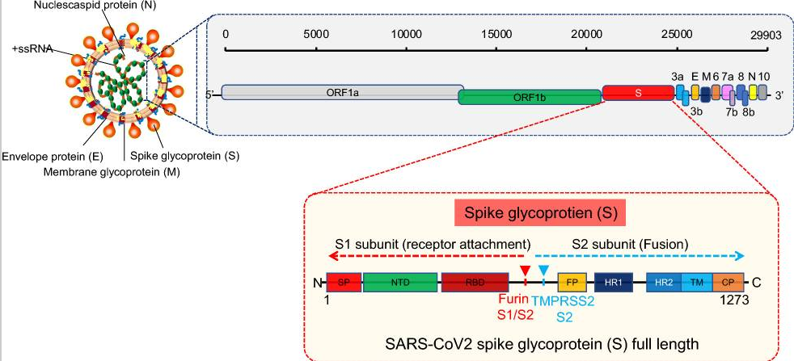
Source: Kumar, M. and S. Al Khodor, Pathophysiology and treatment strategies for COVID-19. J Transl Med, 2020. 18(1): p. 353.
Increasing age is a strong risk factor for morbidity and mortality associated with COVID-19, with a case fatality rate in those aged over 65 years estimated to be around 60 times higher than in those aged under 55 years.³ Irrespective of age, certain underlying comorbidities or conditions, such as cancer, chronic kidney disease, chronic obstructive pulmonary disease, obesity, type 2 diabetes, pregnancy, and immunocompromised states, increase the risk of progression to severe COVID-19.³
As of 2 February 2022 for this overview, COVID-19 has been reported to have caused 373 million cases and 5.6 million deaths worldwide. In Australia, in excess of 2.2 million cases and 3800 deaths have been reported. SARS-CoV-2 variants have appeared at regular intervals, including the Alpha, Beta, Gamma, Delta, and most recently, the Omicron variant. With the persistent rise in the number of COVID-19 cases and related deaths, the protection against this disease that could be achieved through vaccination has become even more important. In that aspect, there are individuals who are unable to receive vaccination due to an underlying medical condition or a comorbidity and also at high risk of severe disease. The availability of therapeutic options that could be an alternative for vaccines are critical to provide protection for those individuals against developing COVID-19.

Current therapeutic options

Current treatment options
Several monoclonal antibodies have been provisionally registered by the TGA for the treatment of COVID-19. Most have a treatment indication, while Ronapreve (casirivimab and imdevimab) has both treatment and post-exposure prophylaxis indications. None of the products have full registration at the time a regulatory decision was made for this submission.
The main management of COVID-19 is supportive care with oxygen therapy and assisted ventilation, as required. Medications that have been proven to be effective against COVID-19 and listed on the Australian Register of Therapeutic Goods (ARTG) as of the 2 February 2022 are listed in Table 1: Currently approved treatment options for COVID-19 in Australia below. An updated list of approved treatment options is available on the TGA website.
Table 1: Currently approved treatment options for COVID-19 in Australia
Name (active) | Date approved | Indication
Veklury (remdesivir) ,, | 10 July 2020 | Veklury has provisional approval for the treatment of Coronavirus Disease 2019 (COVID-19) in adults and adolescents (aged 12 years and older weighing at least 40 kg) with pneumonia, requiring supplemental oxygen.  The decision to approve this medicine has been made based on limited data. More comprehensive evidence is required to be submitted.
Xevudy (sotrovimab) , | 20 August 2021 | Xevudy has provisional approval for the treatment of adults and adolescents (aged 12 years and over and weighing at least 40 kg) with coronavirus disease 2019 (COVID-19) who do not require initiation of oxygen due to COVID-19 and who are at increased risk of progression to hospitalisation or death (see Section 5.1 Pharmacodynamic properties, clinical trials).  The decision has been made on the basis of short term efficacy and safety data. Continued approval of this indication depends on the evidence of longer term efficacy and safety from ongoing clinical trials and post-market assessment.
Ronapreve (casirivimab + imdevimab) , | 15 October 2021 | Ronapreve has provisional approval for the indications below:  Treatment: Ronapreve is indicated for the treatment of COVID-19 in adults and adolescents (aged 12 years and older and weighing at least 40 kg) who do not require supplemental oxygen for COVID-19 and who are at increased risk of progressing to severe COVID-19.  Post-exposure prophylaxis: Ronapreve is indicated for the prevention of COVID-19 in adults and adolescents (aged 12 years and older and weighing at least 40 kg) who have been exposed to SARS-CoV-2 and who either:  have a medical condition making them unlikely to respond to or be protected by vaccination, or  are not vaccinated against COVID-19. (refer to Section 4.2 Dose and method of administration and 5.1, Clinical Trials)  Ronapreve is not intended to be used as a substitute for vaccination against COVID-19.  The decision has been made on the basis of short term efficacy and safety data. Continued approval of this indication depends on the evidence of longer term efficacy and safety from ongoing clinical trials and post-market assessment.
Actemra (tocilizumab) | 1 December 2021 | Coronavirus disease 2019 (COVID-19) (IV formulation only)  Actemra has provisional approval for the treatment of coronavirus disease 2019 (COVID-19) in hospitalised adults who are receiving systemic corticosteroids and require supplemental oxygen or mechanical ventilation.  Provisional approval has been made on the basis of short-term efficacy and safety data. Continued approval depends on the evidence of longer-term efficacy and safety from ongoing clinical trials and post-market assessment.
Regkirona (regdanvimab) | 6 December 2021 | Regkirona has provisional approval for the treatment of adults with coronavirus disease 2019 (COVID-19) who do not require supplemental oxygen and are at increased risk of progressing to severe COVID-19 (see Section 5.1 Pharmacodynamic properties, clinical trials).  The decision has been made on the basis of short term efficacy and safety data. Continued approval of this indication depends on the evidence of longer term efficacy and safety from assessment.
Paxlovid (nirmatrelvir + ritonavir) | 18 January 2022 | Paxlovid has provisional approval for the treatment of coronavirus disease 2019 (COVID 19) in adults 18 years of age and older, who do not require initiation of supplemental oxygen due to COVID 19 and are at increased risk of progression to hospitalisation or death (see Section 5.1 Pharmacodynamic properties, clinical trials).  The decision has been made on the basis of short term efficacy and safety data. Continued approval of this indication depends on the efficacy and safety data from ongoing clinical trials and post-market assessment.
Lagevrio (molnupiravir) | 18 January 2022 | Lagevrio (molnupiravir) has provisional approval for the treatment of adults with COVID 19 who do not require initiation of oxygen due to COVID-19 and who are at increased risk for hospitalisation or death (see section 5.1 Pharmacodynamic properties - Clinical trials).  The decision to approve this indication has been made on the basis of the analysis of efficacy and safety data from a Phase 3 trial. Continued approval of this indication depends on additional data.

Current vaccine options
As of 2 February 2022, the TGA has granted provisional approval to the COVID-19 vaccines listed in Table 2: Currently approved COVID-19 vaccines in Australia below. An update list of approved vaccines is available from the TGA website.
Table 2: Currently approved COVID-19 vaccines in Australia
Name (active) | Effective date(s) | Sponsor | Type
Nuvaxovid (NVX-CoV2373)  For individuals aged 18 years and over | 20 January 2022 | Biocelect Pty Ltd on behalf of Novavax Inc | Protein vaccine
Spikevax (elasomeran),,  a. For individuals aged 18 years and over  b. For individuals aged 12 years and over  c. Booster dose for individuals aged 18 years and over | a. 9 August 2021  b. 3 September 2021  c. 7 December 2021 | Moderna Australia Pty Ltd | mRNA
COVID-19 Vaccine Janssen,  For individuals aged 18 years and over | 25 June 2021 | Janssen-Cilag Pty Ltd | Viral vector
Vaxzevria (ChAdOx1-s; previously COVID-19 Vaccine AstraZeneca),  For individuals aged 18 years and over | 15 February 2021 | AstraZeneca Pty Ltd | Viral vector
Comirnaty (tozinameran),,  a. For individuals aged 16 years and over  b. For individuals aged 12 years and over  c. Booster dose for individuals aged 18 years and over  d. For individuals aged 5 years and over  e. Booster dose for individuals aged 16-17 years old | a. 25 January 2021  b. 22 July 2021  c. 26 October 2021  d. 3 December 2021  e. 27 January 2022 | Pfizer Australia Pty Ltd | mRNA

Therapeutic need
Australia is in a fortunate position as 93.4% of Australians aged 16 and over are now vaccinated with at least 2 doses of an approved vaccine (as of 2 February 2022). While Australia has among the world’s highest COVID-19 vaccination rates, a substantial number of people remain unable to receive the vaccines, due to medical conditions and hence they are vulnerable to the disease. A greater proportion of this specific population, are also at high risk of developing moderate to severe COVID-19 due to underlying co-morbidities. Taken together, there remains an urgent need for effective and/or preventive therapeutics to reduce the burden and spread of disease.
This application was evaluated in part with international collaboration with other members of the Access Consortium. Under the workshare initiative of the Access Consortium, each regulator makes their own independent decisions regarding approval (market authorisation) of the new medicine.

Regulatory status
This product is considered a new biological entity for Australian regulatory purposes.
Provisional determination for the COVID-19 prophylaxis indication in adults was granted on 4 November 2021. This was expanded to include adolescents aged 12 years and older weighing at least 40 kg, as well as a COVID-19 treatment indication on 4 January 2022.
At the time the TGA considered this application, similar applications were under consideration in countries or regions listed in the following table.
Table 3: International regulatory status
Region | Submission date | Status | Approved indications
Canada¹ | 3 November 2021 | Under consideration | Under consideration
European Union | 13 October 2021 | Under consideration | Under consideration
United States of America² | 30 September 2021 | Authorized for Emergency Use on 08 December 2021 | Pre-exposure prophylaxis of coronavirus disease 2019 (COVID-19) in adults and pediatric individuals (12 years of age and older weighing at least 40 kg) in certain populations
1) Canada: Rolling submission; New Drug Submission with Flexibilities for Designated Drug (NDS-CV).
2) United States of America: Emergency Use Authorization (EUA) submission.

Product Information
The Product Information (PI) approved with the submission, which is described in this AusPAR, can be found as Attachment 1. For the most recent PI, please refer to the TGA website at <https://www.tga.gov.au/product-information-pi>.

II. Registration timeline
The following table captures the key steps and dates for this application and which are detailed and discussed in this AusPAR.
Data were provided as a rolling submission. Under normal circumstances, the TGA's assessment (for both provisional and general registration) begins once all information to support registration is available. As part of the Department of Health's response to the pandemic, the TGA has agreed to accept rolling data for COVID-19 vaccines, therapeutics and treatments, to enable early evaluation of data as it comes to hand.
Table 4: Timeline for Submission PM-2021-05375-1-2
Description | Date
Provisional pathway determination; | 4 November 2021  4 January 2022
Submission dossier accepted | 2 December 2021
Evaluation completed | 24 February 2022
Delegate’s Overall benefit-risk assessment and request for Advisory Committee advice | 28 January 2022
Sponsor’s pre-Advisory Committee response | 2 February 2022
Advisory Committee meeting | 4 February 2022
Registration decision (Outcome) | 24 February 2022
Completion of administrative activities and registration on the ARTG | 26 February 2022
Number of working days from submission dossier acceptance to registration decision* | 54
*Statutory timeframe for standard applications is 255 working days

III. Submission overview and risk/benefit assessment
The submission was summarised in the following Delegate’s overview and recommendations.

Quality
There are no objections on quality grounds, pending the approval of Good Manufacturing Practice (GMP) clearances; and pending stability data for the Evusheld manufactured by Process 2; (similar manufacturing process as commercial batches) for up to 12 months will be provided.
The critical issue is that the current acceptance criteria of the specifications are wide. In combination with the limited stability data for the proposed shelf life of 18 months, there is a theoretical risk of loss of potency of the product, unless data is provided for the product manufactured by Process 2, which is the manufacturing process that will be utilised for commercial supply. The TGA has taken a similar approach with previously approved monoclonal antibodies.
The sponsor has proposed a shelf life of 18 months for tixagevimab/cilgavimab when stored at 2°C to 8°C. The recommended shelf-life supported by the clinical batch stability studies provided for tixagevimab/cilgavimab is 12 months when stored at 2°C to 8°C. However, the sponsor has so far only provided up to 9 months stability data for Evusheld (tixagevimab/cilgavimab) manufactured at a manufacturing site when stored at 2°C to 8°C.
Thus, data provided so far only supports 9 months shelf-life for the commercial batches. The sponsor has indicated that 12 months shelf-life for the commercial batches will be submitted to the TGA [Information redacted].
The evaluator has highlighted that the above approach is generally not acceptable but based on these commitments and a risk-benefit consideration under current pandemic environment, a 12 month shelf life could be recommended based on the conditions proposed below.
There are no concerns with the PI from a microbiological perspective.

Proposed conditions of registration
The quality evaluator suggests the following proposed conditions of registration:
- The sponsor will submit up to 12 months of acceptable stability data for the drug product (cilgavimab and tixagevimab) from commercial batches manufactured at (a specified manufacturing plant) in [Information redacted].
- The sponsor will submit up to 12 months of acceptable stability data from capillary electrophoresis assay for the tixagevimab drug product.
- The sponsor will submit up to 12 months of acceptable stability data from a specified clinical lot, for the tixagevimab drug product manufactured from Process 2 by [Information redacted].
- The sponsor will complete all ongoing stability studies and report any confirmed out of specification result and proposed remediation approaches to the TGA immediately.

Nonclinical
The evaluator has stated that there are no objections on nonclinical grounds to the registration of Evusheld (tixagevimab/cilgavimab) for the proposed indication.
In vitro pharmacology results suggest efficacy against currently circulating variants and variants of concern/interest, although the activity to the Omicron BA.1 variant was around 15-fold lower than to original wild type strain.
Efficacy studies in animal models support the prevention for Evusheld.
Mutations at R346 and K444 confer resistance to cilgavimab but remain susceptible to tixagevimab and the combination of the two. The combination of two antibodies in Evusheld has less potential risk of treatment failure. Nonetheless, the potential risk of treatment failure due to the development of viral variants that are resistant to tixagevimab and cilgavimab would need to be monitored clinically. Evusheld is not expected to affect antibody responses to COVID-19 adenovirus-based vaccination.
No toxicity was observed in a study in monkeys at high doses.
Tixagevimab, cilgavimab and Evusheld (tixagevimab/cilgavimab in combination) displayed reduced or no activity in assays of Fc mediated effects and did not permit pseudovirus entry and replication in human immune cell lines that do not express ACE2 (angiotensin converting enzyme 2), suggesting minimal risk for causing enhancement of infection or disease.
No dedicated safety pharmacology studies were submitted. Tixagevimab and cilgavimab are monoclonal antibodies and are unlikely to inhibit (cardiac) hERG potassium ion channels. Due to its size and the presence of an Fc domain, the monoclonal antibodies are unlikely to cross the blood-brain barrier or be present in the brain in an appreciable amount. There was no evidence of an effect on the central nervous, cardiovascular or respiratory systems in the submitted toxicity study at high doses (resulting in a maximum concentration (C_{max}) > 50 times the clinical C_{max}). Evusheld is not expected to affect the cardiovascular, respiratory or central nervous systems during clinical use.
Tixagevimab and cilgavimab showed around 9- and 6-fold increased binding affinity (reduced dissociation constant (K_{D})) to neonatal Fc receptors (FcRn) at low pH (pH 6.0) compared to their counterparts that lack the YTE modification (YTE; M252Y/S254T/T256E). A second modification (TM; L234F/L235E/P331S) reduced tixagevimab and cilgavimab binding (49 to 99%) to human FcγRs and C1q proteins as compared to their counterparts that lack the TM modification. The results indicate that Evusheld may have a longer elimination half-life due to enhanced binding to FcRn which may promote antibody recirculation in the serum, and reduced propensity to elicit Fc-mediated effects which may reduce the risk of antibody-dependent disease enhancement.
The sponsor has stated that independent laboratories have generated in vitro potency data showing that Evusheld maintains neutralising activity against the Omicron variant, although increases in 50% maximal inhibitory concentration (IC₅₀) compared to the original SARS-CoV-2 strain were observed. The IC₅₀ for neutralisation activity of Evusheld against Omicron BA.1 were 273 ng/mL and 147 ng/mL from two independent labs in authentic virus assays (12- to 30-fold reduction compared to original strain). The IC₅₀ for Evusheld in pseudovirus neutralisation assays performed at two independent labs were 277 and 171 ng/mL (132- to 183-fold reduction). The applicant presented modelling data predicting appropriate dose frequency of Evusheld required to maintain a minimum effective plasma concentration against Omicron BA.1.
In neutralisation assays with authentic SARS-CoV-2 virus isolates or spike-pseudotyped viruses bearing all spike substitutions identified in circulating variants, Evusheld retained full or nearly-full neutralisation activity against Alpha (B.1.1.7), Beta (B.1.351), Gamma (P.1), and Delta (B.1.617.2) variants of concern; and Iota (B.1.526), Eta (B.1. 525), Kappa (B.1.617.1), Lambda (C.37), and Mu (B.1.621) variants of interest.

Clinical

Submitted clinical data evaluable for this submission
The submission was supported by the following clinical data:
- Pharmacology:
  - Study D8850C00001: Phase I first-in-human study in healthy adults (safety, pharmacokinetics, neutralising antibodies, and anti-drug antibodies data).
  - Population pharmacokinetic report: extrapolation of adult pharmacokinetics to support dosing in adolescents.
- Efficacy and safety:
  - For the prophylaxis indication, primary efficacy, tolerability, pharmacokinetics, neutralising antibodies plus topline 6-month efficacy and safety data from:
    - the PROVENT trial (Study D8850C00002), a Phase III study into pre-exposure prophylaxis; and
    - the STORM CHASER trial (Study D8850C00003), a Phase III study into post-exposure prophylaxis.

Pharmacology

Pharmacokinetics
The pharmacokinetics (PK) of Evusheld was characterised in Phase I and Phase III studies. Noncompartmental and population PK analyses were utilised in a single Phase I study and population PK analysis was performed on the Phase III study dataset.
The PK parameters are primarily derived from Phase I Study D8850C00001, with supportive drug concentration data available from the Phase III studies.

Study D8850C00001
Study D8850C00001 is Phase I, double-blind, placebo-controlled, dose escalation study in healthy adults.
The current dossier consisted of results of this study up to a data cut-off of 6 June 2021. At the time of data cut-off for this interim analysis, 60 subjects were randomised to receive Evusheld, of which 59 subjects were in the follow-up period. At that stage, all participants in Cohort 1a and Cohort 1b had completed their Day 271 visit and all participants in Cohorts 2, 3, and 4 had completed their Day 211 visit.
Figure 2: Study D8850C00001 Study schematic
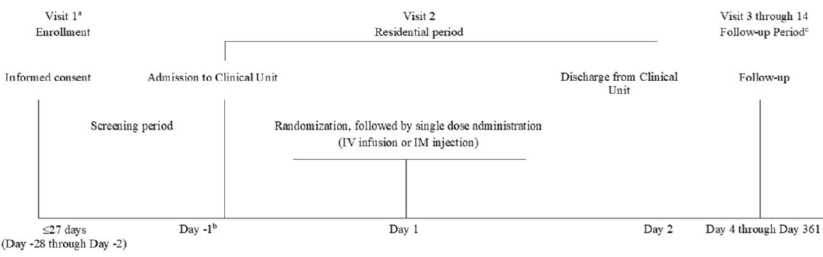
a Visit 1 could be conducted over one or more days during Screening Period.
b Participant could be admitted to the clinical unit on Day -2 to allow for SARS-CoV-2 qRT-PCR results to be available before dosing on Day 1.
c An unscheduled unblinding visit was included when a participant wanted to be unblinded for vaccination purposes outside the visits window.
Abbreviation: IM = intramuscular; IV = intravenous; qRT-PCR = quantitative reverse transcriptase polymerase chain reaction; SARS-CoV-2 = severe acute respiratory syndrome coronavirus 2.
Five cohorts of subjects were included, based on the total dose of Evusheld (tixagevimab and cilgavimab). Evusheld was administered as a combination product of 2 monoclonal antibodies, AZD8895 (tixagevimab) and AZD1061 (cilgavimab).
Doses of Evusheld were defined as the total monoclonal antibody dose administered, for example, Evusheld 300 mg = AZD8895 (tixagevimab) 150 mg + AZD1061 (cilgavimab) 150 mg, which were administered sequentially.
Table 5: Study D8850C00001 Cohort descriptions
Cohort | Description
Cohort 1a | 300 mg of Evusheld or placebo administered as two sequential intramuscular injections: 150mg AZD8895/placebo, followed by 150 mg AZD1061/placebo
Cohort 1b | 300 mg of Evusheld or placebo administered as two sequential intravenous infusions at a maximal infusion rate of 20 mg/minute, starting with 150 mg AZD8895/placebo and followed by 150 mg AZD1061/placebo
Cohort 2 | 1000 mg of Evusheld or placebo administered as two sequential intravenous infusions at a maximal infusion rate of 20 mg/minute, starting with 500 mg AZD8895/placebo and followed by 500 mg AZD1061/placebo
Cohort 3 | 3000 mg of Evusheld or placebo administered as two sequential intravenous infusions at a maximal infusion rate of 20 mg/minute, starting with 1500 mg AZD8895/placebo and followed by 1500 mg AZD1061/placebo
Cohort 4 | 3000mg of Evusheld or placebo administered as a single IV infusion (containing both monoclonal antibodies (1500 mg of each)) at a maximal infusion rate of 50 mg/min
Study treatment was a single dose of Evusheld/placebo, followed by a 360-day safety follow up.
60 subjects were enrolled, with 12 subjects in each cohort (10 randomised to Evusheld and 2 randomised to placebo). At data cut-off, one subject withdrew and the rest were in the follow-up period.
The primary objective was to evaluate safety and tolerability of Evusheld administered intravenously or intramuscularly to healthy adults.
The secondary objectives were to evaluate single dose pharmacokinetics of Evusheld; and to evaluate anti-drug antibody responses to Evusheld.
The exploratory objectives were to evaluate single dose pharmacokinetics of Evusheld in nasal fluid; and to evaluate the functional inhibition of SARS-CoV-2 by Evusheld concentrations in serum.
Inclusion criteria were:
- Adults aged 18 through 55 years with negative SARS-CoV-2 qRT-PCR and/or serology tests.
- Weight ≥ 50 kg and ≤ 110 kg.
Exclusion criteria were:
- Participants with any confirmed current or previous COVID-19 infection before randomisation.
- Participant had clinical signs and symptoms consistent with COVID-19.
At Baseline, the median age was around 40 years, with 68% of subjects aged between 18 to 44 years. 64% of subjects were males.
Results: After a single dose of 300mg of Evusheld that was administered intramuscularly, maximum concentration (C_{max}) was similar for AZD8895 (tixagevimab) and AZD1061 (cilgavimab) at 16.52 and 15.27 μg/mL, respectively. The median time to maximum concentration (T_{max}) was around 14 days for both antibodies. Between-participant variability (%CV) in AZD8895 (tixagevimab) area under the curve from dosing to infinity (AUC_{inf}) and C_{max} after 300 mg intramuscular administration was 30.22% and 35.56%, respectively, and 31.66% and 38.53%, respectively, for AZD1061 (cilgavimab).
Half-lives (t_{1/2λz}) of AZD8895 and AZD1061 (tixagevimab and cilgavimab) were similar for all cohorts, routes of administration, and dose levels. The average of mean t_{1/2λz} calculated for both antibodies from all cohorts was 89.88 days, ranging from 87.93 to 94.60 days for AZD8895 (tixagevimab) and 82.90 to 91.24 days for AZD1061 (cilgavimab).
Table 6: Study D8850C00001 Summary of pharmacokinetic parameters for tixagevimab and cilgavimab following single 300 mg Evusheld intramuscular dose
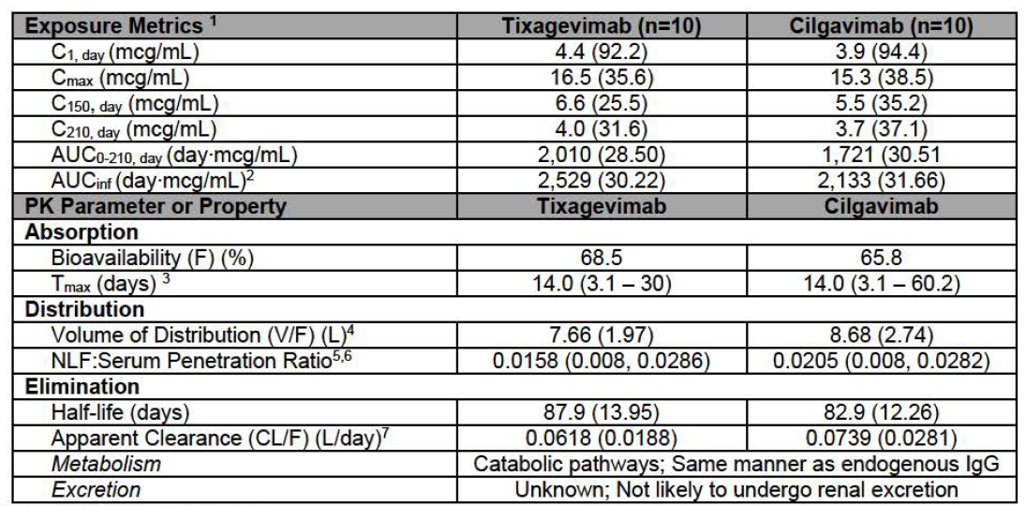
A dose-proportional increase in the PK parameters were observed, when Evusheld was administered at doses ranging from 300 mg to 3000 mg. The 300 mg dose was administered as both intramuscular and intravenous. The 1000 mg to 3000 mg doses were administered as intravenous infusion.
The serum concentration of Evusheld appears to be higher than AZD8895 (tixagevimab) and AZD1061 (cilgavimab), when administered individually (See figure below). The absolute values cannot be found in the clinical study report..The sponsor was requested to provide these (see Questions for the sponsor).

Figure 3: Study D8850C00001 Mean serum concentrations of AZD8895 (tixagevimab), AZD1061 (cilgavimab), and Evusheld (AZD8895 + AZD1061; tixagevimab and cilgavimab) following single dose intramuscular or intravenous administration
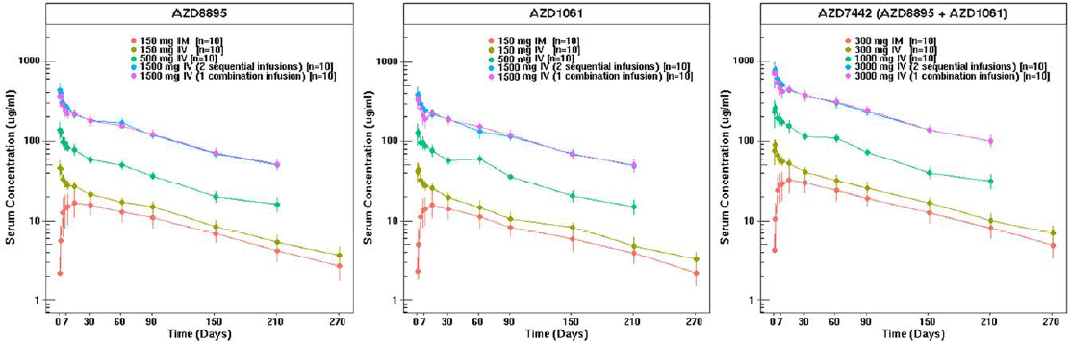
AZD 7442 concentration = the sum of the AZD 8895 and AZD 1061 concentration
Days on the horizontal axis are days post-doc (that is Study Day -1)
Across doses, half-life, volume of distribution and clearance were comparable for both mono-components.
Table 7: Summary of pharmacokinetic parameters for AZD8895 and AZD1061 (tixagevimab and cilgavimab) following single dose intramuscular or intravenous administration of Evusheld; Day 211 (pharmacokinetic analysis set)
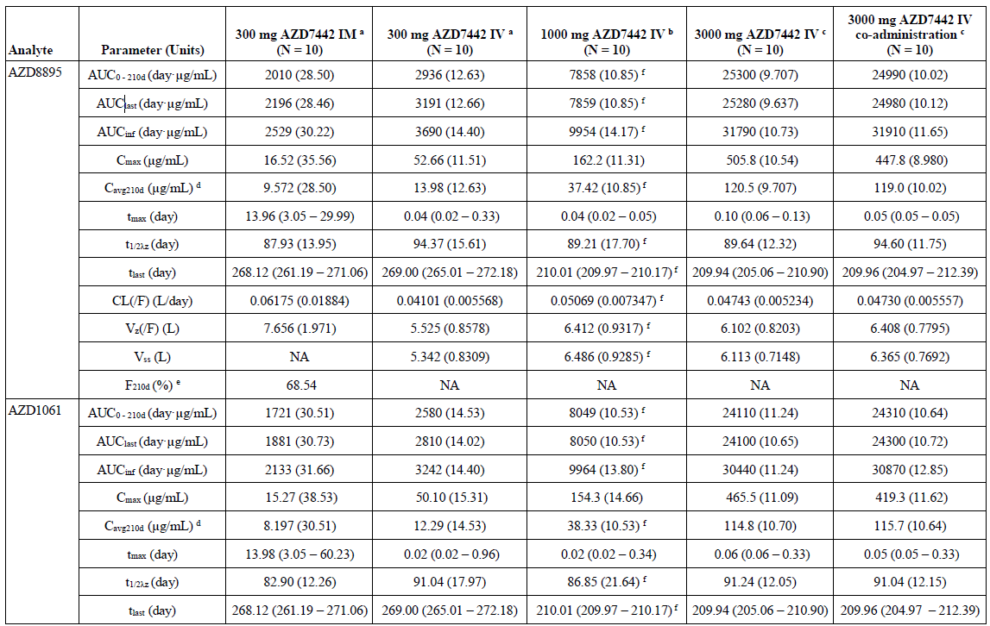
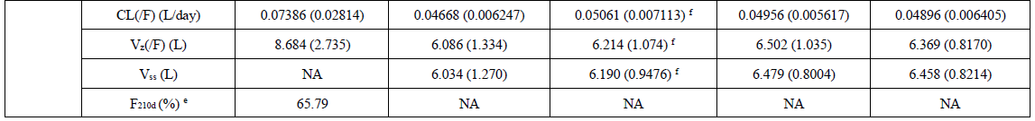
a 300 mg AZD7442 (150 mg AZD8895 and 150 mg AZD1061).
b 1000 mg AZD7442 (500 mg AZD8895 and 500 mg AZD1061).
c 3000 mg AZD7442 (1500 mg AZD8895 and 1500 mg AZD1061).
d Average concentration over 210 days post-dose, calculated as AUC0 - 210d/210 days.
e Calculated as the single ratio of geometric mean AUCinf after IM to IV, thus no %CV.
f n = 9, participant E0001070 had no samples beyond 1440 hours post-dose due to early termination; this participant’s AUC0 - 210d and Cavg210d were calculated via extrapolation.
Data are presented as geometric mean (geometric CV), except for tmax and tlast as median (min – max), and t1/2λz, CL(/F), Vz(/F), and Vss as arithmetic mean (SD).
AUC0-210d, area under the serum concentration-time curve from time zero to Day 211; AUClast, area under the serum concentration-time curve from time zero to the last measurable time point; AUCinf, area under the serum concentration-time curve from time zero to infinity; Cavg210d, average serum concentration over 210 days post-dose; Cmax, maximum serum concentration; CL, total body clearance of drug from serum after intravascular administration; CL(/F), apparent total body clearance of drug from serum after extravascular administration; %CV, percent coefficient of variation; F210d, bioavailability at Day 211; IM, intramuscular; IV, intravenous; NA, not applicable; t1/2λz, half-life associated with terminal slope of a semi-logarithmic concentration-time curve; tlast, time to last serum concentration measurement; tmax, time to maximum serum concentration; Vss, volume of distribution at steady state from an IV dose; Vz, volume of distribution following iv administration (based on terminal phase); Vz(/F), volume of distribution (apparent) following extravascular administration (based on terminal phase).
Pharmacokinetics in nasal lining fluid: Concentrations of AZD8895 and AZD1061 (tixagevimab and cilgavimab) in nasal lining fluid were determined by collecting nasal fluid via a nasosorption device. Data were presented for pre-dose, Day 8 and Day 31 in all cohorts.
In the 300 mg IM dose cohort, the median AZD8895 and AZD1061 (tixagevimab and cilgavimab) nasal lining fluid concentrations were 171 ng/mL and 187 ng/mL respectively, at Day 8, and226 ng/mL and 205 ng/mL, respectively, at Day 31.
Figure 4: Study D8850C00001 Concentrations of AZD8895 (tixagevimab), AZD1061 (cilgavimab), and Evusheld (tixagevimab and cilgavimab) in nasal lining fluid after a single Evusheld dose (pharmacokinetic analysis set)
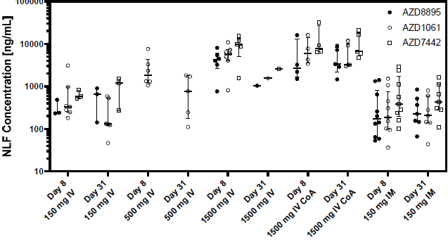
Error bars correspond to Q1 and Q3 of results
CoA, co-administered; IM, intramuscular; IV, intravenous; NLF, nasal lining fluid; Q1, first quartile; Q3, third quartile

Study D8850C00002 (PROVENT trial)
Serum concentrations of Evusheld assessed in clonal cell line material and cell pool material over the study period were provided. The PK parameters such as C_{max}, AUC, t_{max} and t_{1/2} were missing. The clonal cell line data are limited by 29 days.
Study D8850C00009 is ongoing to compare PK parameters between Evusheld sourced from clonal cell line and cell pool, when administered to healthy adults as two separate IM injections. The sponsor was requested to provide these (see Questions for the sponsor).
Figure 5: Study D8850C00002 (PROVENT trial) Arithmetic mean (± standard deviation) of serum drug concentration (μg/mL) versus time, semi-logarithmic line plot by analyte (PK analysis set)

Study D8550C00003 (STORM CHASER trial)
Serum concentrations of Evusheld in post-exposure prophylaxis setting were provided. Key PK parameters such as C_{max}, AUC, t_{max} and t_{1/2} are missing.The sponsor was requested to provide these (see Questions for the sponsor).
Table 8: Study D8550C00003 (STORM CHASER trial) Summary of serum drug concentrations (μg/mL) by visit (PK analysis set)

Population pharmacokinetic data
The key objectives of the population pharmacokinetic (popPK) model analysis were to establish that:
- efficacy of Evusheld lasts for around 6 months in majority of recipients; and
- pharmacokinetic parameters of Evusheld in adults are comparable to adolescents ≥ 12 years of age and ≥ 40 kg of weight.

Base pharmacokinetic model
The popPK analysis for Evusheld was based on a clinical Phase I study in healthy volunteers (Study D8850C00001) and two Phase III studies (Study D8850C00002, the PROVENT trial; and Study D8850C00003, the STORM CHASER trial).
The final pooled dataset for analysis included 2029 participants. An IM dose of 300 mg was used in the 2 Phase III studies; the Phase I study investigated the PK of Evusheld in healthy volunteers with doses ranging from 300 to 3000 mg IV and 300 mg IM. This Phase I population PK model included IV (300 to 3000 mg) and IM (300 mg) route of administrations. Interim non-compartmental PK analysis suggested the C_{max} and AUC_{0-210days} of tixagevimab and cilgavimab increased approximately dose proportionally.
Based on non-compartmental analysis the bioavailability of Evusheld (based on AUC_{0-210days}; following single dose IM administration of 300 mg Evusheld) was 67% and 66% for tixagevimab and cilgavimab, respectively. Evusheld had a median time to reach maximum serum concentration (t_{max}) of 14 days after IM dose of 300 mg and an estimated mean t_{1/2} across dose cohorts and across the 2 antibodies of 90 days.
For the pooled PK data set analysis, a two-compartmental model with first-order absorption and first-order elimination following IV and IM administration was adopted by the sponsor to describe the data. Parameter estimates and goodness of fit plots for Evusheld showed that the model described the data. The rationale for inclusion of allometric exponents in the structural base PK model was adequately developed.
The absolute bioavailability of Evusheld administered via IM route was 73.3%. The derived t_{1/2} of Evusheld was 96.4 days. The relative standard error for the model was considered as acceptable (< 30%).

Covariate selection and final pharmacokinetic model
Covariate selection was performed for Evusheld and the covariate model was applied to tixagevimab and cilgavimab. Given the magnitude of shrinkage on clearance (53%) and the absorption rate constant (K_{a}) (43%), consideration might have been given to excluding covariate evaluations on these parameters. Nevertheless, covariate selection was conducted. Although 4 covariates were identified to be statistically significant, the impact of the covariates was negligible in explaining inter-individual variability in Evusheld PK.
Model diagnostics were presented for all three analytes and confirmed the adequacy of the model to describe the data. Parameter estimates for the final population PK model showed good precision. Goodness of fit plots showed good agreement between observations and model predictions.

Pooled population pharmacokinetic analysis
Baseline characteristics of subjects in the pooled dataset: The mean age was around 53 years, with a mean body weight of around 84 kg. The mean body mass index was in the over-weight range (29.2), with a wide margin (20.44 to 41.2).
Table 9: Population pharmacokinetic analysis; Baseline characteristics of subjects in the pooled dataset
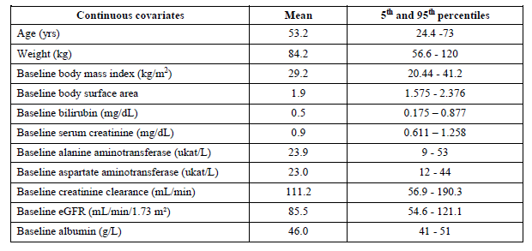
Around 43% of subjects were ≥ 60 years of age. 53.7 % of subjects were males. Overall, the dataset appears to be representative of the targeted patient population.
Table 10: Population pharmacokinetic analysis; Baseline characteristics of subjects in the pooled dataset
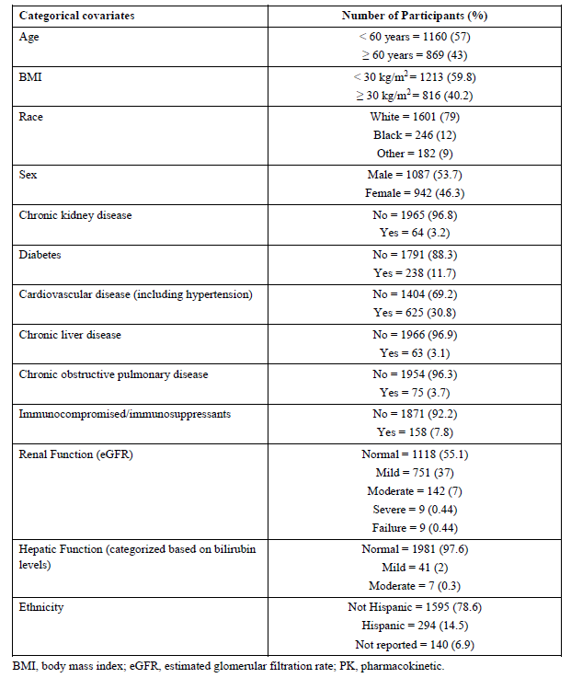
BMI = body mass index; eGFR = estimated glomerular filtration rate; PK = pharmacokinetic

Results
Body mass index and age were statistically significant covariates on absorption rate constant (K_{a}), diabetes on central compartment volume, and baseline serum albumin on apparent clearance. These covariates were not considered clinically significant as these covariates reduced the inter-individual variation of K_{a} by only 2.0%, central compartment volume by 1.6%, and clearance by just 1% relative to the base population PK model with fixed allometric exponents on clearance and volume of distribution.
The data on renal function was limited in the PK data set with 160 participants (8%) who were considered renally impaired. Renal function was tested as a categorical covariate on clearance and was not statistically significant. Overall, 55% of the participants had normal renal function, 37% had mild renal impairment, 7% had moderate impairment, 0.45% of the participants had severe impairment (estimated glomerular filtration rate (eGFR) < 30 mL/min/1.73 m²), and 0.45% of the participants had renal failure (eGFR < 15 mL/min/1.73 m²). The mean eGFR was 85.5 mL/min/1.73 m².
The data on hepatic function was limited in the PK data set with 48 participants (2.3%) who were considered mild or moderately hepatically impaired. Hepatic function using aspartate aminotransferase, alanine aminotransferase, or bilirubin as a continuous covariate on apparent clearance was not statistically significant.
Table 11: Population pharmacokinetic model; Parameter estimates (95% confidence interval) for Evusheld, tixagevimab, and cilgavimab PK model based on Phase I and Phase III studies, accounting for covariate effects
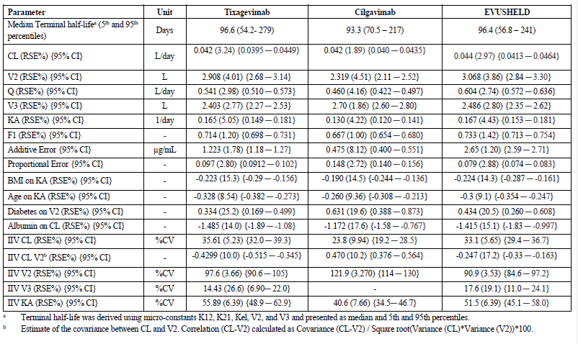
a Terminal half-life was derived using micro-constant K12, K21, Kel, V2 and V3 and presented as median and 5th and 95th percentiles.
b Estimate of the covariance between CL and V2. Correlation (CL-V2) calculated as Covariance (CL-V2)/Square root (Variance (CL)*Variance (V2))*100
Model predictions supported that the minimum serum protective concentration threshold of 2.2 µg/mL was reached on average 6 hours (interquartile range of 3.4 to 11.7 hours) for a typical 70 kg human after IM administration of 300 mg of Evusheld and that the mean serum Evusheld concentrations will continue to exceed this minimum concentration for approximately 12 months.
Figure 6: Population pharmacokinetic model; Minimum serum protective concentration
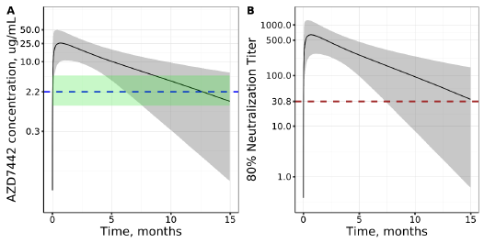
Blue horizontal line represents minimum protective concentration of 2.2 µg/mL in serum which with a 1.81% NLF: Serum partition ratio will result in the 40 ng/mL (IC80) in the upper respiratory tract. Green shaded area represents 25th (0.8%) and 75th (3.6%) percentile of NLF: Serum partition ratio. Brown horizontal line represents the geometric mean of the nAb titer (30.8) measured in 28 individual convalescent plasma samples.
Abbreviation: IM = intramuscular, PK = pharmacokinetics; SAR-CoV-2 = severe acute respiratory syndrome coronavirus 2.
The popPK model based predictions indicated that Evusheld concentrations are expected to exceed 2.2 µg/mL for at least 6 months in 96% of the participants, 9 months in 77% of the participants, and for 12 months in 55% of the participants.
Table 12: Population pharmacokinetic model; Percentage of participants with Evusheld concentrations > 2.2 µg/mL
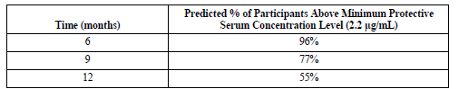
The difference between simulated PK profiles (10 trials of 2029 participants) and AUC (0 to 91 days or 3 months and 0 to 270 days or 9 months) for 2 groups, ‘All weight (36 to 177 kg)’ and ‘Adolescents 40 to 95 kg’, is presented. Plot A represents the median prediction (solid lines) and 95% prediction intervals (shadow areas) for the respective groups. Plots B and C show comparison of AUC at 3 and 9 months.
In response to the United States Food and Drug Administration (FDA) question, the sponsor performed popPK modelling and simulations to determine whether repeat dosing of 300 mg Evusheld IM is expected to produce C_{trough} values greater than or equal the mean observed Day 90 concentrations of tixagevimab and cilgavimab in the PROVENT trial. Day 90 was the timepoint where the efficacy of preexposure prophylaxis was demonstrated.
The population model predicted median 6 month post-dose concentration as 8 μg/mL. PK simulations were conducted for every 6, 9 and 12 months dosing to assess the proportion of subjects with a minimum protective concentration lower than 8 μg/mL and within the lower limit of 2.2 μg/mL. The target concentration was derived based on potency, virus inhibition projections, and drug distribution data to the upper respiratory area. It appears that the six-monthly dosage regimen results in a trough concentration of Evusheld that is consistently above the proposed minimum protection concentration of 2.2 μg/mL.
Figure 7: Pooled population-PK model predicted median (90% prediction intervals) serum Evusheld concentration for a 6, 9 or 12 months dosing interval following administration of 300 mg intramuscular Evusheld, over 36 months
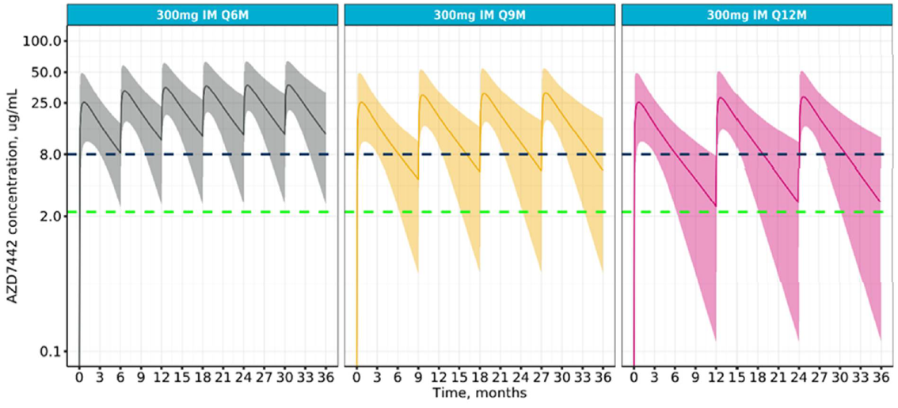
The evaluator has highlighted the following limitations of the popPK model:
- Specific dose and data handling details were unclear. It was presumed that the doses presented throughout the PK report were for Evusheld and represent the sum of the doses for tixagevimab and cilgavimab (per DVID in data specification, Appendix B). It was also unclear how Evusheld concentrations were determined in the presence of one quantifiable and one unquantifiable concentration. The sponsor was requested to provide these (see Questions for the sponsor).
- Of the 5184 scheduled PK samples, 5066 (97.3%) were collected up to the nominal sampling time point of 91 days (or less than one estimated half-life of Evusheld (median: 96 days, 5th to 95th percentile: 57 to 241 days)). No subjects in the Phase III studies had PK sampling beyond nominal PK sampling day 91. In the Phase I trial, 20 of 50 subjects (or 40%) had their last PK sample collected on nominal PK sampling Day 271 (or less than 3 estimated half-lives of Evusheld); these 20 PK samples were pivotal in the estimation of half-life in this analysis.
Pharmacokinetic sampling over a period of a minimum of 3 half-lives (preferably 4 to 5 half-lives) is required to accurately estimate a drug’s half-life following a single dose. Therefore, inferences based on the estimated half-life of Evusheld should be made cautiously, including simulations.
The lack of PK sampling data in the Phase III studies to accurately estimate half-life was acknowledged in the PK report. However, the implications of the limited PK sampling design in the overall population PK analysis set (including both Phase I and Phase III studies) were not discussed. The sponsor was requested to provide these (see Questions for the sponsor).
- Given the magnitude of shrinkage on clearance (53%) and the absorption rate constant (K_{a}) (43%), consideration might have been given to excluding covariate evaluations on these parameters.

Simulations

Simulations of pharmacokinetic profiles
Model-based simulations were performed to obtain the median and 90% prediction interval of Evusheld serum concentrations following a 300 mg IM dose for a period of 15 months. Serum neutralising antibody titres were also derived. Simulations used covariate combinations in the population PK analysis set. A good agreement between observed and simulated data was observed. The population PK evaluator has highlighted that the majority of PK samples (collected in Study D8850C00002) were collected within 30 days of dose administration with only 5 of 1328 subjects having a PK sample on Day 58 and 3 subjects on Day 92 after dose administration. Therefore, the PK profile at late times (> 30 days after dosing) was informed primarily by a subset of 20 healthy subjects in the Phase I study with PK samples collected on Day 270.
96% of study participants at 6 months and 55% of study participants at 12 months were expected to have an Evusheld serum concentration that exceeded a pre-defined protective serum concentration of 2.2 µg/mL. Confidence intervals were not reported.
In view of the limited data to inform the model at late times in the population PK analysis set, the simulation results should be considered speculative. PK sampling at a minimum of 6 months after dosing and preferably 9 to 12 months after dosing, would be required to confirm the projections.

Simulations of weight-based dosing versus fixed dosing
The popPK evaluator has highlighted the following issues:
- The methods were not described in the analysis plan or the PK report, so it was not clear how the simulations were conducted.
- The body weight adjusted dose was not specified.
- For a direct comparison of fixed versus weight-adjusted dosing, the same range of body weights should have been used.
- Only area under the curve (AUC) was presented. Variability in AUC is primarily influenced by interindividual variability in clearance, estimated in the final population PK model to be 33%. Peak concentration (C_{max}) is primarily influenced by interindividual variability in the volume of central compartment (V2), estimated in the final population PK model to be 91%. Exposures shown should have minimally included AUC and C_{max}; consideration might also have been given to serum concentration at 6 months.
- Comparisons of exposures (for example, using grouped box plots) over the body weight range (particularly at the extremes of body weight) would have been more informative than the figures provided.
- The list of simulations purported to evaluate the influence of fixed versus weight-adjusted dosing of Evusheld. The weight-adjusted dosing group (40 to 95 kg) was referenced as ‘adolescents’.
- Was a normal or uniform distribution used to simulate body weights for adolescents in the 40 to 95 kg range? For comparison with adult values, what were the 5th, 50th and 95th percentiles of body weight for adolescents? (The range of adult body weights was 36 to 177 kg (mean: 84.2 kg, 5th and 95% percentiles 56.6 to 120 kg)).
- How were age, body mass index (BMI) and body weight combinations generated for adolescent subjects? The impact of these covariates (age and BMI were covariates on K_{a} in the final population PK model) on C_{max} should have been discussed.
- Simulated exposures (AUC and C_{max}) at a 300 mg IM fixed dose should have been shown to support the claim that this regimen was appropriate for adolescents.
Based on this assessment, simulations related to comparability of fixed versus body weight-based dosing and/or application to adolescent dosing should be revised.
Figure 8: PopPK analysis; Simulated systemic exposure for adolescent population
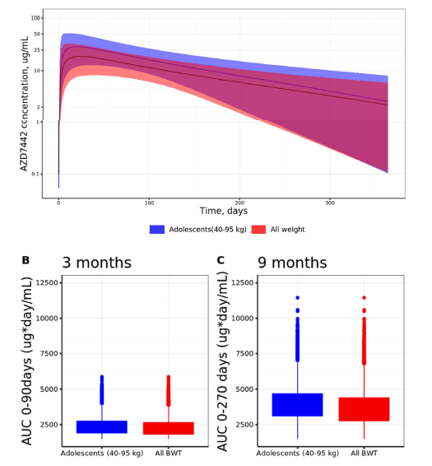
Figure 9: PopPK analysis; Comparison of area under the curve across fixed and weight-based dose regimens
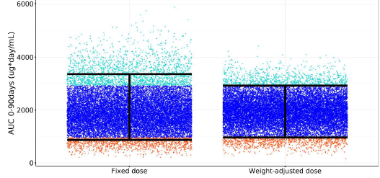
The point represent the predicted AUC for the individual in the data set assuming 300 mg IM dose. The black vertical bars covers 90% of the exposure ranges. The dark blue points for a given dosing regimen fall within the exposure range of the other regimen at the same dose. The light blue and orange points for one dose and regimen fall above and below the exposure range of the other regimen at the same dose, respectively. AUC = Area under the curve.

Conclusions
The evaluator has concluded that the model adequately described data from Phase I and Phase III studies over a dose range of 300 mg to 3000 mg, showing PK linearity over this dose range. Visual predictive checks showed generally good predictive performance of the model, particularly for the Phase III IM Evusheld doses.
Body mass index, age, diabetes and baseline serum albumin were statistically significant covariates in the final population PK model but were not considered clinically relevant due to minimal impact on interindividual variability of PK parameters.
The evaluator noted that some key PK parameter estimates shifted with the addition of excluded data. Due to ambiguous descriptions of the data in the PK report, the nature of the excluded data was unclear. On the other hand, reasonably consistent PK parameter estimates were obtained with the addition of data from another Phase III study in subjects infected with COVID-19. Although not reported in the addendum to the PK report, it would have been interesting to see the impact of excluded data on the updated model. The sponsor was requested to provide these (see Questions for the sponsor).
The methods used for the extrapolation to adolescents were not stated. As a result, it is not clear how body weight, BMI and age covariate sets were simulated. In particular the distribution of adolescent body weights was not specified (only the range was provided). It was also not specified what weight-based dose was used in the adolescent simulations. AUC was the only PK parameter that was presented. Greater variability may be expected in C_{max} (due to large interindividual variability in V2 and Ka), however, these comparisons were not shown. Taken together, the adolescent simulations were poorly presented and therefore difficult to interpret. The sponsor has been requested to clarify (See Questions for the sponsor).
The duration of PK sampling in the Phase I study was less than three half-lives and in the Phase III studies was less than one half-life. Therefore, the elimination (terminal) phase of the drug was poorly characterised. This was evidenced by high shrinkage in the estimated clearance in the population PK modelling and simulations showing progressively wider prediction intervals over time. A longer duration of PK sampling is required to accurately characterise the terminal phase of the PK profile and estimate the half-life of Evusheld. The results of the analyses should therefore be considered interim and conclusions based on the half-life of Evusheld should be regarded as speculative.

Pharmacodynamics

Mechanism of action
The combination of two monoclonal antibodies AZD8895 (tixagevimab) and AZD1061 (cilgavimab) that form Evusheld bind to the receptor binding domain (RBD) of the SARS-CoV-2 virus, which results in neutralisation of the virus. It should be noted that the two monoclonal antibodies act non-competitively by binding to non-overlapping epitopes on the spike protein. Both tixagevimab and cilgavimab bind the RBD with nanomolar affinity and are individually capable of sterically blocking the virus from engaging its cellular receptor, human angiotensin converting enzyme 2 (human ACE2) receptor. This binding translates to potent neutralisation of SARS-CoV-2 infection by Evusheld in vitro, with IC₅₀ values between 10 to 26 ng/ml.
The tixagevimab and cilgavimab mAbs have been engineered with triple amino acid substitutions M252Y/S254T/T256E (YTE) in the Fc region to prolong the t_{1/2}. The triple amino acid substitutions L234F/L235E/P331S (TM) were incorporated into the Fc region for both tixagevimab and cilgavimab to reduce Fc-mediated effector function.
Figure 10: Synergistic action of tixagevimab and cilgavimab
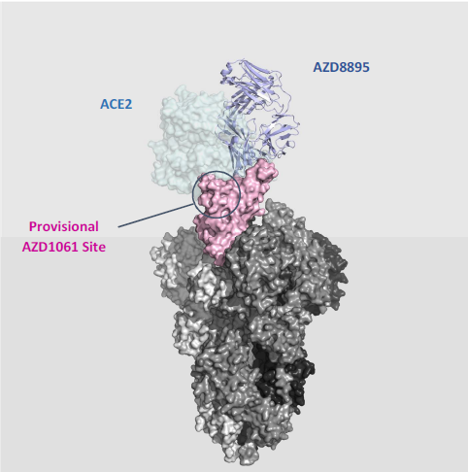

Neutralising antibodies

Neutralising activity against Delta variant
Research-grade pseudovirus neutralisation testing of AZD8895 (tixagevimab), AZD1061 (cilgavimab), and Evusheld was performed by investigators at the FDA.
Table 13: Neutralising activity against Delta variant
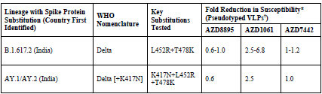
* Range of reduced in vitro potency across multiple sets of co-occurring substitution, and/or testing labs using research grade assays: mean fold change in half maximal inhibitory concentration (IC50) of mAb required for a 50% reduction in infection compared to wild type reference strain.
+ In vitro potency data derived from US Food and Drug Administration (Sliver Spring, MD, USA).

Neutralising activity against Omicron variant
Phenotypic evaluation of AZD8895 (tixagevimab), AZD1061 (cilgavimab) and Evusheld neutralisation susceptibility against the Omicron variant was evaluated in pseudotyped virus-like particles (VLP) and authentic virus assays from multiple laboratories, including the FDA.
No major difference in terms of neutralising activity was noted between the two monoclonal antibodies. Overall, the activity against Omicron was low, compared to Delta.
Table 14: Potency assessment for Evusheld against the Omicron SARS-CoV-2 variant
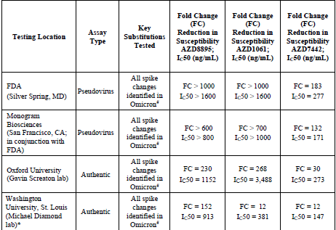
* Testing conducted with parental version of AZD8895 (2196) and AZD1061 (2130)
# Omicron spike mutations: A67V, H69-, V70-, T95I, G142D, V143-, Y144-, Y145-, N21I, L212I, ins214EPE, G339D, S371L, S373P, S375F, K417N, N440K, G446S, S477N, T478K, E484A, Q493R, G498R, N501Y, Y505H, T547K, D614G, H655Y, N679K, P681H, N764K, D796Y, N856K, Q954H, N969K and L981F.
Pharmacodynamic assessments comprised serum levels of neutralising antibodies to SARS-CoV-2, and anti-drug antibodies to Evusheld. These data are derived from Phase I Study D8850C00001, as well as the Phase III studies (note that neutralising antibody data are not currently available from the STORM CHASER trial, and anti-drug antibody data from the Phase III prophylaxis-based PROVENT and STORM CHASER trials are also not yet available).
The sponsor’s potency assessment for Evusheld against the Omicron BA.1 SARS-CoV-2 variant suggest that the geometric mean of the IC50 assessments was around 209 ng/mL (Table 14: Potency assessment for Evusheld against the Omicron SARS-CoV-2 variant. Based on this finding, the serum concentration of Evusheld that would result in 80% inhibition of viral cell entry in the lung would be 3.3 ug/mL. This concentration is reached on average 5 hours post 600 mg IM dose (Figure 12).
Figure 11: Predicted serum Evusheld concentration over time for a dose of 600 mg (intramuscular route)
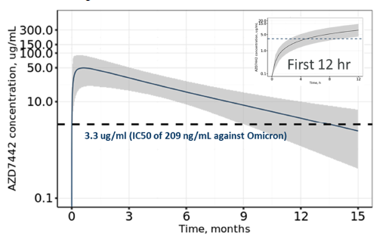
One day post the 600 mg IM dose, the average serum Evusheld concentration is 14 µg/mL and reaches drug levels within 80% of the C_{max} at 5.5 days post-dose with serum concentrations of 48 µg/mL 28 days post-dose.

Study D8850C00001
Neutralising antibody titres against SARS-CoV-2 were measured at Baseline (Day 1), 7 days (Day 8), 30 days (Day 31), 60 days (Day 61), 90 days (Day 91), 150 days (Day 151), 210 days (Day 211), and 270 days (Day 271) after administration of Evusheld.
A dose-proportionate increase in the geometric mean of the neutralising antibody titres was reported for Evusheld. At a dose of 300 mg Evusheld, administered intramuscularly, the peak geometric mean titre (GMT; 852.81) was achieved at Day 31. Around 40% reduction in GMT was noted at Day 91 (533.6).
Table 15: Geometric mean and fold-change serum neutralising antibody titre following single dose intramuscular or intravascular administration of Evusheld (safety analysis set)
Table 16: Geometric mean and fold-change serum neutralising antibody titre following single dose intramuscular or intravascular administration of Evusheld (safety analysis set), continued’
Table 16: Geometric mean and fold-change serum neutralising antibody titre following single dose intramuscular or intravascular administration of Evusheld (safety analysis set), continued’
Figure 12: Box plot of neutralising antibody titres against SARS-CoV-2 on Day 8, Day 31, Day 61, Day 91, Day 151,Day 211, and Day 271 in comparison with convalescent plasma (safety analysis set)
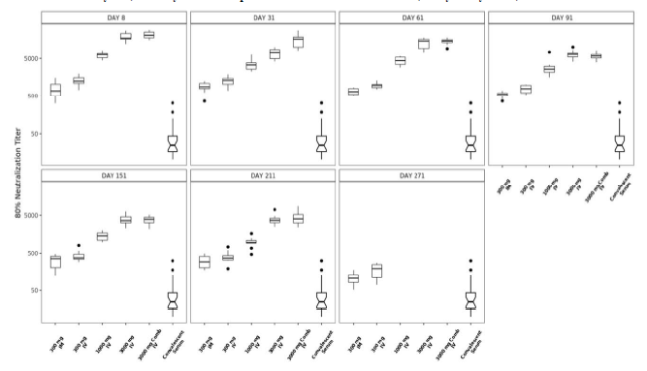

Study D8850C00002 (PROVENT trial)
Neutralising antibody titres against SARS-CoV-2 were evaluated at 7 days (Day 8), 28 days (Day 29), 57 days (Day 58) and 91 days (Day 92) after administration of Evusheld. As of the data cut-off date, 05 May 2021, post-Baseline neutralising antibody titres were available for a total of 1071 Evusheld participants, 86 (8%) and 985 (92%) in the PROVENT clonal cell line and cell pool-derived groups, respectively. It should be noted that the proposed product for marketing are sourced from the clonal cell line.
Overall, the neutralising Ab titres in participants who received Evusheld in the clonal cell line cohort were comparable with the Phase I study (Day 8: 779.5 versus 689 (Phase I)). However, the availability of titres for those who received product from the clonal cell line were limited to Day 29. The titres for the subjects in the cell pool cohort were almost 50% lower than the corresponding values from the Phase I study. In these subjects, the geometric mean titres were also lower than the corresponding cell pool cohort. The low number subjects in the clonal cell line cohort limits the ability to compare data across these groups.
Table 16: Study D8850C00002 (PROVENT trial) Geometric mean and fold-change serum neutralising antibody titre following intramuscular administration of Evusheld (safety analysis set)
Table 17: Study D8850C00002 (PROVENT trial) Geometric mean and fold-change serum neutralising antibody titre following intramuscular administration of Evusheld (safety analysis set), continued

Table 17: Study D8850C00002 (PROVENT trial) Geometric mean and fold-change serum neutralising antibody titre following intramuscular administration of Evusheld (safety analysis set), continued
Baseline is defined as the last non-missing measurement taken prior to the first dose of study drug (including unscheduled measurement, if any)
The fold rise was calculated as the ratio of the Day x titer level to the pre-dose (screening) titer level.
Figure 13: Study D8850C00002 (PROVENT trial) Box plot of neutralising antibody titres on Days 8 and 29 compared with convalescent plasma

Pharmacokinetic-pharmacodynamic correlation
The 50% neutralising antibody titres measured in the pseudovirus assay were correlated to the 80% neutralising antibody titres measured in the authentic virus assay. The correlation data was based on the titres that were achieved after administration of 300 mg IM and 300 mg IV samples in Phase I study in 20 subjects on the Day 8 and 31.
Figure 14: Regression analysis of the monogram 50% pseudoneutralisation antibody titres versus the authentic virus 80% SARS-CoV-2 neutralisation antibody titres
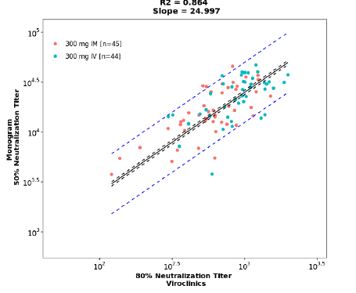

Antidrug antibody results
Study D8850C00001: At the time of data cut-off (6 June 2021), antidrug antibody data up to Day 211 were available for all cohorts. By Day 211, no subjects in the study had tested positive for antidrug antibodies to either tixagevimab or cilgavimab.
Studies D8850C00002 and D8850C00003 (PROVENT and STORM CHASER trials): The bioanalytical analysis for assessing the presence of antidrug antibodies against either tixagevimab or cilgavimab is currently ongoing.
The presence of antidrug antibodies did not appear to impact the PK of Evusheld, as demonstrated by the serum concentrations of Evusheld falling within the range of the population PK model, in the participants who were treatment-emergent antidrug antibody positive. None of the 6 treatment-emergent antidrug antibody positive participants in the study reported adverse events or primary endpoint events.

Efficacy

Dose selection
Based on PK study findings, 2.2 μg/mL was determined as the minimum protective serum concentration (80% SARS-CoV-2 neutralising activity in upper respiratory tract) for Evusheld (tixagevimab and cilgavimab). The minimum serum protective concentration threshold was reached on average 6 hours (interquartile range of 3.4 to 11.7 hours) after administration of 300 mg of Evusheld IM. Based on PK simulations, it is predicted to remain above this concentration for at least 6 months in 96% of the participants, 9 months in 77% of the participants, and for 12 months in 55% of the participants.

Prophylaxis and treatment studies

Prophylaxis studies
Studies D8850C00002 and D8850C00003 (the PROVENT and STORM CHASER trials) were initiated with cell pools material. The proposed product for marketing are sourced from clonal cell lines. Once clonal cell line material became available, an additional cohort of subjects administered with the clonal cell-derived product were included in the Phase III Study D8850C00002 (PROVENT trial).

Study D8850C00002 (PROVENT trial)

Study design
This is a Phase III randomised control trial to assess the safety and efficacy of a single IM dose of Evusheld compared to placebo for the prevention of COVID-19 in adults:
- having an increased risk for inadequate response to active immunisation (predicted poor responders to vaccines OR intolerant of vaccine); or
- having an increased risk for SARS-CoV-2 infection, defined as those whose locations or circumstances put them at appreciable risk of exposure to SARS-CoV-2 and COVID-19.
At the time of conducting the primary analysis, enrolment was complete (last participant in 22 March 2021), and 58 sites in the USA, 9 sites in the UK, 5 sites in Belgium, 5 sites in Spain, and 10 sites in France had screened 5873 participants, randomised 5254 participants of which 5197 received Evusheld.
Figure 15: Study D8850C00002 (PROVENT trial) Study schematic
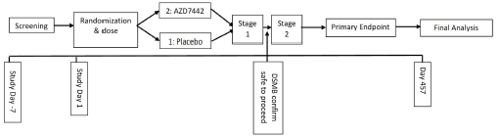

Inclusion and exclusion criteria
Key inclusion criteria:
- Adults at an increased risk for inadequate response to active immunisation (predicted poor responders to vaccines OR intolerant of vaccine), defined as:
  - elderly, that is, ≥ 60 years old
  - obesity, that is, a body mass index (BMI) ≥ 30
  - congestive heart failure
  - chronic obstructive pulmonary disease
  - chronic kidney disease, that is, an estimated glomerular filtration rate (eGFR) < 30 mL/min/1.73 m²
  - chronic liver disease
  - immunocompromised state from solid organ transplant, blood or bone marrow transplant, immune deficiencies, HIV, use of corticosteroids, or use of other immunosuppressive medicines
  - intolerant of vaccine, defined as previous history of severe adverse event or serious adverse event after receiving any approved vaccine.
- Adults having an increased risk for SARS-CoV-2 infection, defined as those whose locations or circumstances put them at appreciable risk of exposure to SARS-CoV-2 and COVID-19, based on available risk assessment at time of enrolment:
  - health care workers
  - workers at industrial settings at an increased risk for SARS-CoV-2 transmission
  - military personnel
  - students living in dormitory setting
- Negative result from point of care SARS-CoV-2 serology testing at screening.
Key exclusion criteria:
- history of laboratory-confirmed SARS-CoV-2 infection
- any prior receipt of COVID-19 vaccine or mAb/biologic for its prevention (or expected receipt during study)
Subjects were enrolled into one of the two cohorts that were categorised based on age (Cohort 1: ≥ 60 years and Cohort 2: < 60 years). In total, 5197 subjects were randomised in a 2:1 ratio to receive a single IM dose of either 300 mg of Evusheld (n = 3460) or saline placebo (n = 1737) given as 2 sequential IM injections. Further, subjects were followed up until Day 457.
The PROVENT and STORM CHASER trials were initiated with cell pools material. Once clonal cell line material (the proposed commercial material) became available, this drug product supplied an additional cohort in the PROVENT Phase III study to gain user experience in the clinic. To allow for the assessment of clonal cell line material, 150 participants were planned to be randomised 2:1.

Amendments
The primary analysis of the primary endpoint was changed to include all participants who were hospitalised due to COVID-19, regardless of severity. Previously, only participants who were hospitalised due to COVID-19 that met the protocol-defined criteria for severe were included.

Primary efficacy endpoint
The primary efficacy endpoint in the PROVENT trial was a binary response, whereby a participant is defined as a COVID-19 case if their first case of SARS-CoV-2 real time polymerase chain reaction (RT-PCR) positive symptomatic illness occurs post-dose of Evusheld and prior to Day 183.
Patients who developed COVID-19 qualifying symptom/s were swabbed for RT-PCR testing.

Secondary efficacy endpoints
The key secondary endpoint was the incidence of participants who have a post-treatment response (negative at Baseline to positive at any time post-baseline) for SARS-CoV-2 nucleocapsid antibodies.
Secondary endpoints included for US Emergency Use Authorization request were:
- the incidence of SARS-CoV-2 RT-PCR-positive severe or critical symptomatic illness occurring after dosing with Evusheld.
- the incidence of COVID-19-related emergency department visits occurring after dosing with Evusheld.

Statistical methods
The primary efficacy endpoint was a binary response, whereby a participant was defined as a COVID-19 case if their first case of SARS-CoV-2 RT-PCR-positive symptomatic illness occurs post-dose of Evusheld and prior to Day 183. The primary efficacy was calculated as relative risk reduction = 100% × (1-relative risk), which is the incidence of infection in the Evusheld arm relative to the incidence of infection in the control arm, expressed as a percentage. In the primary analysis, participants who were unblinded to intervention assignment/ took vaccine prior to experiencing a primary endpoint event, were censored at the earlier time of unblinding/vaccine. A key supportive analysis, in which participants who were unblinded to investigational product assignment/took vaccine prior to experiencing a primary endpoint event were included and analysed regardless of their unblinding or vaccine status.
At the time of primary analysis, 1555 (29.6%) participants (1012 (28.9%) Evusheld and 543 (31.0%) placebo) had been unblinded. In total, 965 (18.4%) participants (426 (12.2%) Evusheld and 539 (30.7%) placebo) received COVID-19 vaccination.
All primary endpoint events accrued up until the data cut-off (5 May 2021) were included in the primary analysis.

Baseline characteristics
Median participant age was 57 years, with 53.9% males. 23.6% were aged ≥ 65 years and 4.2% were aged ≥ 75 years. 67.7% had comorbidities at Baseline (mostly history of obesity (42.4%), obesity (41.7%), and hypertension (35.9%)). 77.5% met the US Centers for Disease Control (CDC) criteria for being at high risk for severe COVID-19.
96.3% of subjects had a negative SARS-CoV-2 RT-PCR status at Baseline. 24 subjects (< 1%) (15 in Evusheld and 9 in placebo arms) had an immunosuppressive disease. 109 and 63 subjects (< 1%) in Evusheld and placebo arms were undergoing immunosuppressive treatment respectively.
92 participants were administered with Evusheld that was sourced from clonal cell line (the proposed product for marketing).
In total, 965 (18.4%) participants (426 (12.2%) Evusheld and 539 (30.7%) placebo) received COVID-19 vaccination during the study period.
Table 17: Study D8850C00002 (PROVENT trial) Baseline characteristics
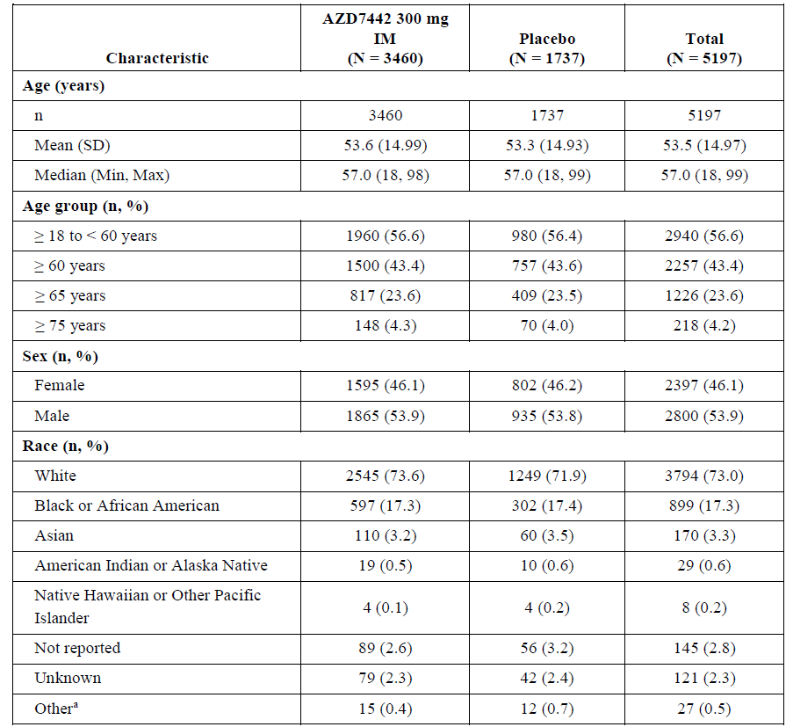
Table 20: Study D8850C00002 (PROVENT trial) Baseline characteristics, continued’
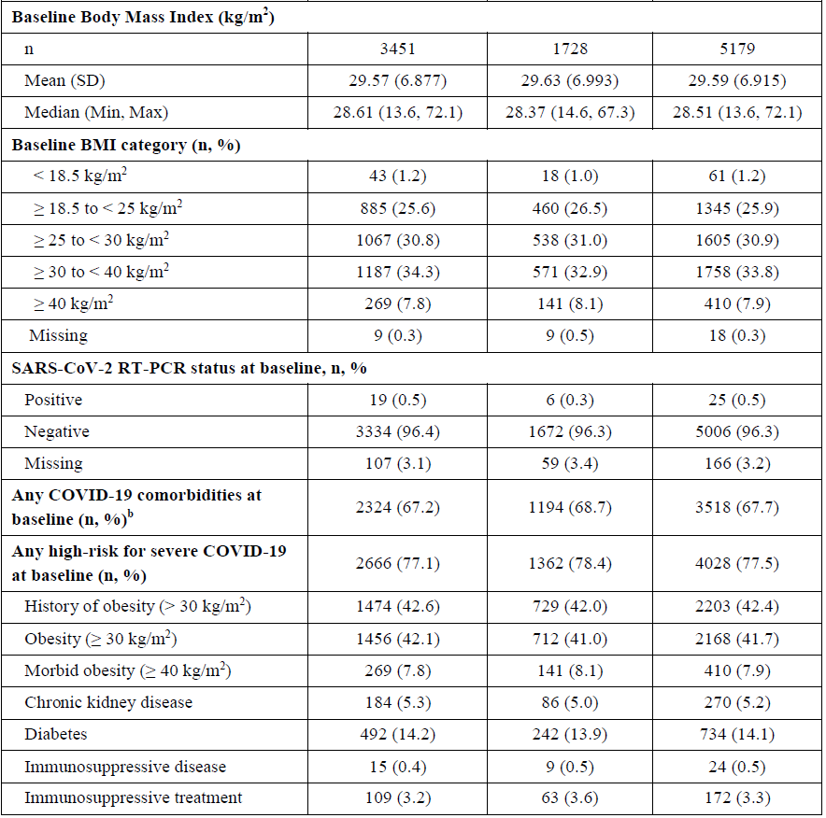
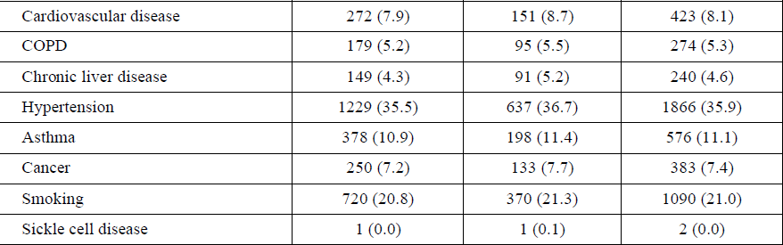

Results
Further to primary analysis, a statistically significant reduction in incidence of SARS-CoV-2 RT-PCR-positive symptomatic illness was reported for subjects in the Evusheld arm, compared to placebo, relative risk reduction 76.73 (95% CI: 46.05, 89.96); p < 0.001, when subjects were followed for up to Day 183 post dose.
There were 8 out of 3441 (0.2%) subjects with SARS-CoV-2 RT-PCR-positive symptomatic illness in the Evusheld arm, compared to 17 out of 1731 (1%) participants in the placebo arm.
Table 18: Study D8850C00002 (PROVENT trial) Primary efficacy results -first SARS-CoV-2 RT-PCR-positive symptomatic illness, primary estimand, full pre-exposure analysis set, primary analysis (data cut-off date May 2021)
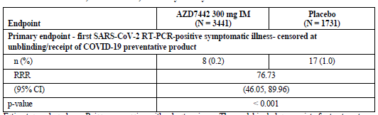
RRR = Relative risk reduction
Two key supportive analyses were pre-specified in the study protocol within a formal hierarchical multiple testing framework to control the Type I error rate.
In the first key supportive estimand, subjects who were unblinded to the study treatment assignment or took vaccine prior to experiencing a primary endpoint event were included and analysed regardless of their unblinding or vaccine status, that is, including all participants. There was a statistically significant reduction in incidence of SARS-CoV-2 RT-PCR-positive symptomatic illness for subjects in the Evusheld arm compared with placebo relative risk reduction 77.29 (95% CI: 52.01, 89.25; p-value < 0.001).
For the second key supportive analysis, the analysis included first case of SARS-CoV-2 RT-PCR-positive symptomatic illness or death from any cause post-dose of Evusheld. There was a statistically significant reduction in incidence of SARS-CoV-2 RT-PCR-positive symptomatic illness or death from any cause for participants who had received Evusheld compared with placebo, relative risk reduction 68.78 (95% CI: 35.64, 84.86); p-value 0.002.
Table 19: Study D8850C00002 (PROVENT trial) Primary endpoint – key supportive estimands, full pre-exposure analysis set, primary analysis
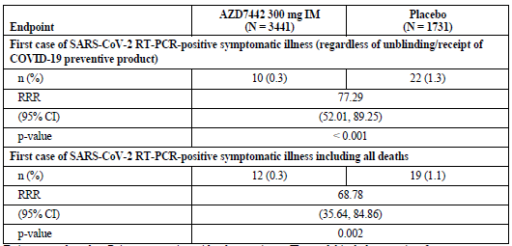
CI = confidence interval; RRR = relative risk reduction
Time to SARS-CoV-2 RT-PCR positive symptomatic illness was longer in the Evusheld arm compared to placebo. hazard ratio (95% CI) = 0.23 (0.1, 0.53).
The difference in the time interval was statistically significant.
Figure 16: Study D8850C00002 (PROVENT trial) Primary efficacy, time to first SARS_CoV-2 RT-PCR-positive Symptomatic Illness Occurring Post-dose of randomised intervention; Kaplan-Meier Curves by Arm, Supplementary Analysis, full pre-exposure analysis set
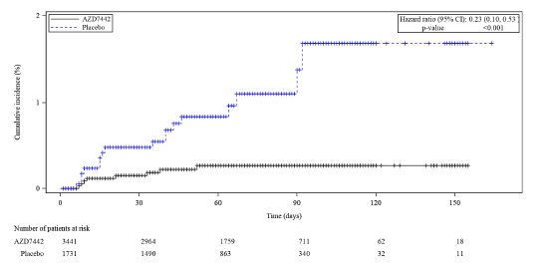
Efficacy was generally consistent across the pre-defined subgroups:
Figure 17: Study D8850C00002 (PROVENT trial) Forest plot of primary endpoint events by subgroup
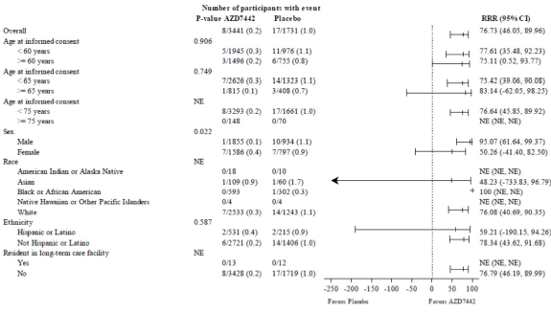
Figure 20: Study D8850C00002 (PROVENT trial) Forest plot of primary endpoint events by subgroup, continued’
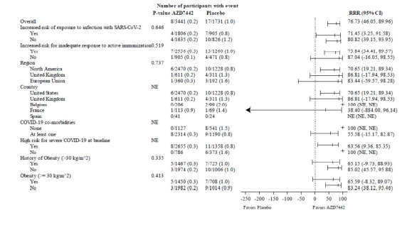

Efficacy at 6 months (median) after dosing
The analysis at 6 months (median) post-dose had a data cutoff date of 29 August 2021.
At 6 months, 95% of subjects were continuing in the study. A high rate of unblinding was noted (40%), mostly for vaccination.
At 5 months after the last participant was dosed, with a median follow up of 6 months, subjects in Evusheld arm achieved a relative risk reduction of 82.80 against developing a RT-PCR positive symptomatic illness, compared to those in placebo arm. The treatment difference was statistically significant.
Table 20: Study D8850C00002 (PROVENT trial) First SARS-CoV-2 RT-PCR-positive symptomatic illness, primary estimand
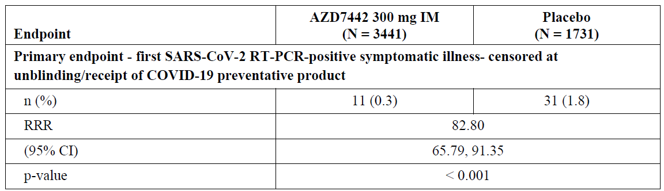
CI = confidence interval; RRR = relative risk reduction
Subjects in the Evusheld arm also achieved a relative risk reduction of around 77 and 75 for having a RT-PCR positive symptomatic illness, irrespective of unblinding and COVID-19 vaccination and death respectively.
Table 21: Study D8850C00002 (PROVENT trial) Key supportive estimands
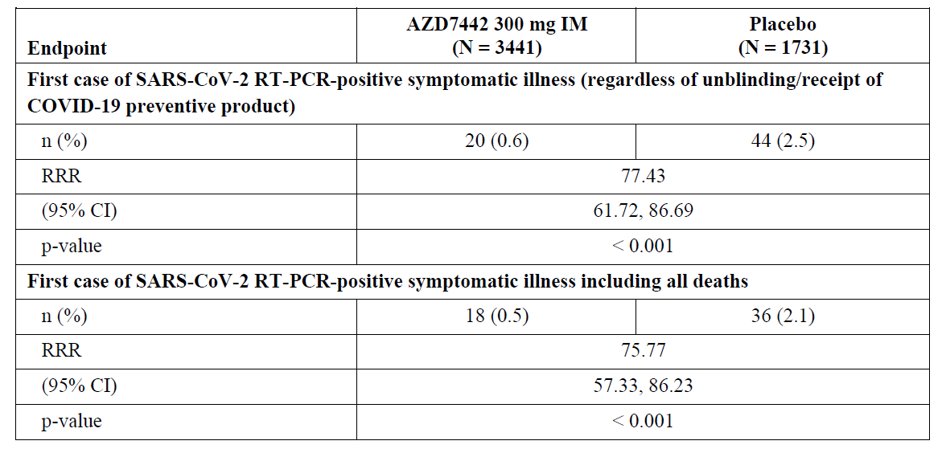
CI = confidence interval; RRR = relative risk reduction
Table 22: Study D8850C00002 (PROVENT trial) forest plot for efficacy for incidence of first SARS-CoV-2 RT-PCR positive symptomatic illness
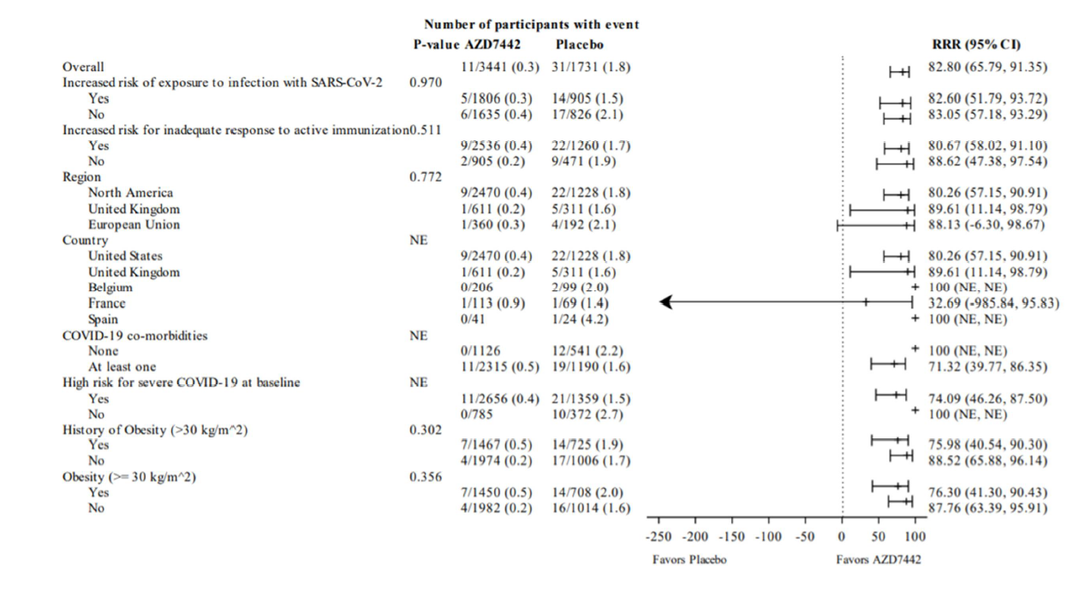

Study D8550C00003 (STORM CHASER trial)
A Phase III double blind, placebo controlled study of Evusheld for post-exposure prophylaxis of COVID-19 in adults.
At the time of conducting the primary analysis, enrolment was complete (last participant in 19 March 2021), and 53 sites in the USA and 6 sites in the UK had randomised 1131 participants, of which 1121 received Evusheld or placebo.
Figure 18: Study D8550C00003 (STORM CHASER trial) Study schematic
Primary analysis to be conducted 30 days after 25th event is observed.
1131 participants were randomised 2:1 to receive a single dose of either 300 mg of Evusheld (n = 756) or saline placebo (n = 375) on Day 1, with planned follow-up until Day 457. Doses were administered as 2 sequential IM injections containing 150 mg of each monoclonal antibody, or saline placebo.
If subjects developed COVID-19 qualifying symptoms after dosing, swabs were collected for SARS-CoV-2 PCR testing.
The pre-specified primary analysis (data cut-off date 7 April 2021) was conducted 30 days after the 25th primary endpoint event had accrued (reduced from 50 events with Amendment 5, in view of decreasing attack rates). Post-hoc efficacy data at the 6-month data cut-off date are also available (data cut-off date 19 August 2021).

Inclusion and exclusion criteria
Key inclusion criteria were:
- Adults with potential exposure, within 8 days, to a specific identified individual with laboratory-confirmed SARS-CoV-2 infection, symptomatic or asymptomatic, who are therefore at appreciable risk of imminently developing COVID-19, based on available risk assessment at time of enrolment, within any of the following settings:
  - long-term care facilities (incl. nursing homes, assisted living homes, independent living residences for the elderly)
  - industrial settings at high risk for SARS-CoV-2 transmission (incl. meatpacking plants)
  - military settings
  - health care facilities (staff)
  - university/college dormitories
  - household contacts
  - other settings of similar close or high-density inter-personal proximity
- asymptomatic to COVID-19 within 10 days prior to dosing
- negative SARS-CoV-2 serology at screening
The study included subjects could be SARS-CoV-2 PCR positive or negative at Baseline.
Key exclusion criteria:
- History of laboratory-confirmed SARS-CoV-2 infection at screening
- Prior receipt of COVID-19 vaccine or other mAb/biologic indicated for its prevention or expected receipt during the period of study (participants could request unblinding to receive a COVID-19 vaccine when these became locally available, but were advised to wait 6 to 9 months post dose of Evusheld (2 to 3 elimination half-lives). Such patients were still included in primary endpoint analysis.)
Participants were stratified into two cohorts:
- Cohort 1: (n = 7) Adults ≥ 60 years old living in long-term care facilities (with potential exposure defined as SARS-CoV-2 infection in another resident of the facility or a staff member)
- Cohort 2: (n = 1114) other adults ≥ 18 years old with potential exposure to a specific individual with SARS-CoV-2 infection.
The planned proportion of subjects recruited into Cohort 1 was reduced due to priority vaccination of elderly populations in the UK and USA.

Primary endpoint
Primary endpoint: First case of SARS-CoV-2 RT-PCR-positive symptomatic illness occurring post-dose of Evusheld or placebo and prior to Day 183.
Efficacy will be calculated as 1 - relative risk, which is the incidence of infection in the Evusheld group relative to the incidence of infection in the control group (full analysis set).

Secondary endpoints
The key secondary endpoint was the incidence of SARS-CoV-2 RT-PCR-positive severe or critical symptomatic illness occurring after dosing with IMP
Other secondary endpoints included:
- The incidence of participants who have a post-treatment response (negative at Baseline to positive at any time post-baseline) for SARS-CoV-2 nucleocapsid antibodies.
- The incidence of COVID-19-related death occurring after dosing with Evusheld or placebo.
- The incidence of all-cause mortality occurring after dosing with Evusheld or placebo.
At the primary analysis, 98.1% of subjects were ongoing in the study and 1.9% had discontinued. 10.2% participants had been unblinded (8.2% Evusheld and 14.1% placebo) and 6.5% had received a COVID-19 vaccination (3.4% Evusheld and 12.5% placebo).

Baseline characteristics
Median age was 48 years. 12% of subjects were aged ≥ 65 years, and 3.5% of subjects were aged ≥ 75 years. 65.7% were considered to meet CDC criteria for being at high risk of severe COVID-19 (mostly due to obesity (40.8%), hypertension (23.9%), and smoking (19.2%)). 48.9% of participants had comorbidities at Baseline (most commonly obesity (29.7%) and hypertension (23.9%)). No subject had immunosuppressive disease, and 0.8% were receiving immunosuppressive treatment.
At Baseline, 974 (86.9%) participants (646 (86.2%) Evusheld and 328 (88.2%) placebo) had a negative or missing SARS-CoV-2 RT-PCR status.
Table 23: Study D8550C00003 (STORM CHASER trial) Baseline demographics
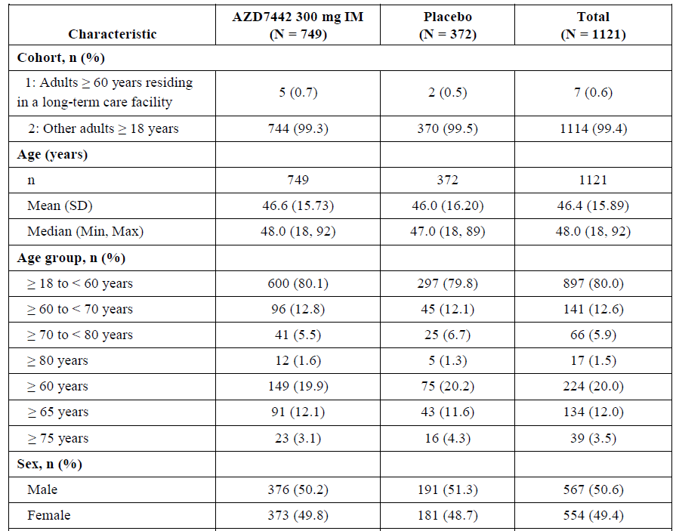
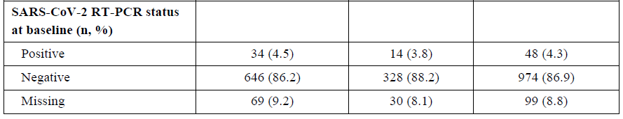
Table 26: Study D8550C00003 (STORM CHASER trial) Baseline demographics, continued’
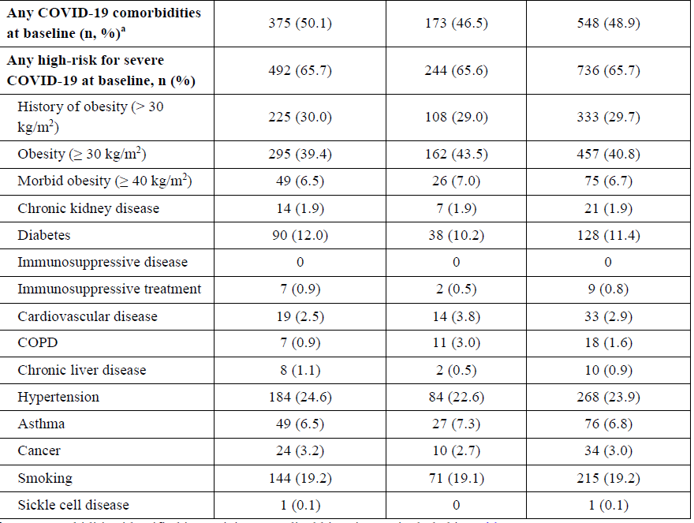

Results
The primary endpoint was not met, with an relative risk reduction of 33.31% (95% CI: -25.92, 64.68). This finding was confirmed by supplementary analyses showing no superiority of Evusheld compared to placebo, when subjects were followed for up to Day 183 post-dose.
Table 24: Study D8550C00003 (STORM CHASER trial) Primary efficacy endpoint, (primary analysis; full analysis set)
Estimates are based on Poisson regression with robust variance. The model includes the log of the follow up time as an offset and a covariate for treatment (AZD 7442 versus placebo). Estimated RRR greater than 0% provides evidence in favour of AZD 7442 with p-value less than 0.05 indicating statistical significance.
Percentages are based on the number of participants in the analysis by arm (N). Data cutoff date: 7 April 2021.
There were no cases of SARS-CoV-2 RT-PCR positive symptomatic illnesses in the Evusheld arm after Day 11, while there were 5 cases in the placebo arm. Based on the incubation period of COVID-19 (around 5 days), the cases occurring after Day 11 may reflect new exposure to COVID-19 which occurred after randomised intervention administration. The Kaplan-Meier curves of time to primary endpoint event are shown below.
Figure 19: Study D8550C00003 (STORM CHASER trial) Primary analysis time to first SARS-CoV-2 RT-PCR positive symptomatic illness occurring post-dose of randomised intervention (full analysis set)
Hazard ratio is from the PH model with Efron method. The 95% CI for the Hazard Ratio is obtained by taking 95% profile likehood CI of the hazard ratio from PH model.
P-value is obtained from log-rank test
Data cutoff date: 7 April 2021
In the pre-specified subgroup of participants with SARS-CoV-2 RT-PCR status negative/missing at Baseline, the primary endpoint reached nominal significance: relative risk reduction 73.17 (95% CI: 27.10, 90.13). Forest plot of the other subgroup analyses is shown below.

Figure 20: Study D8550C00003 (STORM CHASER trial) Forest plot for efficacy for incidence of first SARS-CoV-2 RT-PCR-positive symptomatic illness by subgroup full analysis set, primary analysis
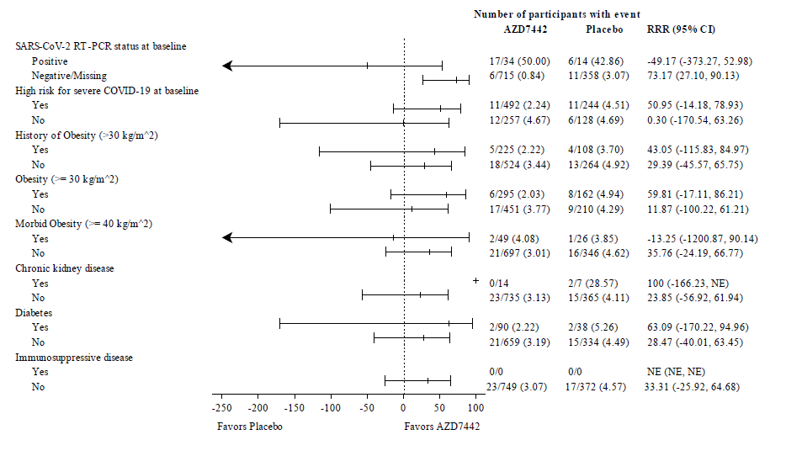
Figure 23: Study D8550C00003 (STORM CHASER trial) Forest plot for efficacy for incidence of first SARS-CoV-2 RT-PCR-positive symptomatic illness by subgroup full analysis set, primary analysis, continued’
There was one event of severe/critical COVID-19 meeting key secondary endpoint criteria in the placebo group, and no cases in the Evusheld group.
At the 6-month data cutoff date, the primary endpoint had reached nominal significance, with 27 (3.6%) events in the Evusheld arm and 23 (6.2%) events in the placebo arm, relative risk reduction 43.21% (95% CI: 0.14, 67.70). Per the FDA report:
‘Note that this finding was not considered as statistically significant since it was based on post-hoc analysis conducted after the primary analysis of the study had failed.’
Kaplan-Meier curves showed the separation in primary endpoint events that was evident from around Day 30 was sustained through Month 6.
Figure 21: Study D8550C00003 (STORM CHASER trial) Time to first SARS-CoV-2 RT-PCR-positive symptomatic illness occurring post-dose of Evusheld or placebo; Kaplan-Meier curves by arm; full analysis set, supplementary analysis

SafetySafety data

Prophylaxis
Safety data are available for 5197 participants in Study D8850C00002 (PROVENT trial) (3461 of whom received Evusheld 300 mg IM) and 1121 participants in Study D8550C00003 (STORM CHASER trial) (749 of whom received Evusheld 300 mg IM). Safety data are available up to the 6-month data cut-off, with a median follow-up in the Evusheld arms of 196 days in the PROVENT trial and 182 days in the STORM CHASER trial.

Supportive Phase I safety data (healthy adults)
Supportive safety data are available at a variety of dose levels and routes of administration (IV and IM) from Phase I Study D8850C00001 in healthy adults, with up to 271 days median follow up.

Pooled safety analyses
Pooled safety analyses were limited to Study D8850C00002 (PROVENT trial) and Study D8550C00003 (STORM CHASER trial) with data cut-off dates prior to the 6 month follow up data cut off.

Summary of adverse events
In healthy adults (Study D8850C00001; Phase I study in healthy adults) there were generally similar rates of adverse events reported between the placebo group and the various Evusheld IV dose groups. Only one subject in the Evusheld 300mg IM group reported an adverse event. All adverse events were mild or moderate. The most frequent was headache (placebo: 2 (20%), total Evusheld: 4 (8%)). There were no deaths or serious adverse events reported in the study. One subject in the Evusheld 3000mg IV group had an adverse event leading to dose interruption. There was a balance of laboratory results, ECG, and vital signs when comparing Evusheld and placebo.
No participants reported injection site reactions or hypersensitivity events.
The overall summary of adverse events in this Phase I study is presented below.
Table 25: Study D8850C00001 Overall summary of adverse events in any category (safety analysis set)
In Studies D8550C00002 and D8550C00003 (the PROVENT and STORM CHASER trials, respectively), the overall incidence of adverse events, serious adverse events, treatment-related serious adverse events and deaths were comparable between Evusheld and placebo arms.
Table 26: Study D8550C00002 (PROVENT trial) Overall summary of adverse events, (safety analysis set, data cut-off date: 29 August 2021)
a AEs are determined to be ‘related’ to IMP and/are study procedures by the Investigators based on their judgement.
Table 27: Study D8550C00003 (STORM CHASER trial) Summary of adverse events, (safety analysis set, 6-month data cut-off date: 19 August 2021)
a AEs are determined to be ‘related’ to IMP and/are study procedures by the Investigators based on their judgement.

Adverse events
The overall rate of adverse events in the Study D8850C00002 (PROVENT trial) was similar between Evusheld and placebo. The most frequently reported adverse events are presented by Preferred Term (PT) below. The most common event was headache (Evusheld: 7.7%, placebo: 7.5%). Individual Preferred Terms were balanced across the treatment arms, except for COVID-19 adverse events, which were more frequent in the placebo group:
Table 28: Study D8850C00002 (PROVENT trial) Most frequently reported (≥ 1%) adverse events by Preferred Term (safety analysis set, (6-month data cut-off: 29 August 2021)
The overall rate of adverse events in STORM CHASER was higher in the placebo arm (42.7%) comparedwith Evusheld (33.4%). The most common event in both arms was headache: Evusheld 8.0%, placebo 11.0%. The most frequently reported adverse events are presented by PT below:
Table 29: Study D8850C00003 (STORM CHASER trial) Most frequently reported (≥ 1%) adverse events by Preferred Term (safety analysis set; 6 month data cutoff date: 19 August 2021)

Adverse events leading to discontinuation
In Study D8850C00002 (PROVENT trial), two (0.1%) participants in the Evusheld arm discontinued from the study due to adverse events, one due to colon cancer stage IV and the other due to cerebrovascular accident. One (0.1%) participant in the placebo arm discontinued from the study due to the adverse event of alcoholism.

In Study D8850C00003 (STORM CHASER trial), one subject in each arm discontinued study due to an adverse event. Both adverse events resulted in death.Adverse events of special interest
Adverse events of special interest for Evusheld were defined as anaphylaxis and other serious hypersensitivity reactions, including immune complex disease, and injection site reactions.
In Study D8850C00002 (PROVENT trial), these adverse events of special interest were numerically more frequently reported with Evusheld (92; 2.7%) than with placebo (37; 2.1%). The most common event was injection site pain, reported in 28 (0.8%) subjects with Evusheld and 16 (0.9%) with placebo. There was one reported event of anaphylaxis in the Evusheld arm (none in placebo). The FDA Emergency Use Authorization review (based on an earlier data cut-off which captured 87 and 37 adverse events of special interest in the Evusheld and placebo arms, respectively) noted that all adverse events of special interest were mild (93%) or moderate in severity.
Table 30: Study D8850C00002 (PROVENT trial) Adverse events of special interest, by System Organ Class and Preferred Term (Safety Analysis Set, 6-month data cut-off date: 29 August 2021)
In Study D8850C00003 (STORM CHASER trial), 13 (1.2%) participants had reported at least one adverse event of special interest (6 (0.8%) Evusheld and 7 (1.9%) placebo). No subject reported anaphylaxis or serious hypersensitivity reactions at the time of the 6-month data cut-off.

Pooled analysis of hypersensitivity events and injection site reactions
Hypersensitivity related events were analysed based on pooled data (data cut off dates of 29 June 2021 for Study D8850C00002 (PROVENT trial) and 19 June 2021 for Study D8850C00003 (STORM CHASER trial)). A search using Hypersensitivity SMQ (Standardised MedDRA Query), 114 non-serious events were reported in 99 subjects in the active arm, out of which 29 were assessed as related and 85 events were assessed as not related by the investigators. All events except for one were mild to moderate in severity. The most frequently reported related events (≥ 3 events) were Injection related reaction (11), Rash (8), and Urticaria (3). The sponsor could not rule out a causal relationship, so these 3 Preferred Terms were added to the core data sheet as adverse drug reactions.
Injection site reactions related events were analysed based on pooled data (data cut off dates of 29 June 2021 for Study D8850C00002 (PROVENT trial) and 19 June 2021 for Study D8850C00003 (STORM CHASER trial)). A search was performed for Injection site reactions High Level Term (HLT) with MedDRA version 24.0. The search identified 80 events of Injection site reactions in 71 subjects. The injection site reactions were non serious and mild (79) to moderate (1) in severity. Of the 51 events considered treatment related by the investigators, the following were most frequently reported (≥ 3 events): Injection site pain (27), Injection site pruritus (5), Injection site erythema (4), Injection site reaction (3), and Injection site induration (3). These Preferred Terms are considered potential adverse drug reactions for Evusheld and have been added to the core data sheet.
Table 31: Summary of hypersensitivity, injection site reactions and injection-related reactions (pooled analysis, (i) Study D8850C00002 (PROVENT trial) and (ii) StudyD8850C00003 (STORM CHASER trial), data cut-off (i) 29 June 2021 and (ii) 19 June 2021
* Grouped terms

Serious adverse events
In Study D8850C00002 (PROVENT trial), serious adverse events were slightly more frequently reported with Evusheld (130; 3.8%) than placebo (58; 3.3%). There was one treatment-related serious adverse event (mesenteric artery thrombosis) in the Evusheld arm, and none in the placebo arm. The event had onset Day 7 post study drug and occurred in the context of ischemic segmental colitis on a background of atheromatous overload of vascular vessels which was not considered serious and which resolved with IV hydration. The patient history (aged 65 ≤ 75 years, female) included obesity and smoking, as well as past surgery for diverticulosis, hiatus hernia, abdominal hysterectomy and bilateral salpingo-oophorectomy. The sponsor did not find evidence of a causal relationship between the event and study drug.
In Study D8850C00003 (STORM CHASER trial), serious adverse events were more frequently reported with placebo (2.4%) than with Evusheld (1.7%). None were considered treatment related. No individual Preferred Term was reported in more than one subject in each treatment arm.No serious adverse events were reported in the Phase I healthy adult study (Study D88C00001).

Serious adverse events of cardiac disorders
In Study D8850C00002 (PROVENT trial), a numerically high and > 2 times the proportion of subjects in the Evusheld arm experienced cardiovascular serious adverse events, compared to placebo (6 events (0.8%) versus one event (0.3%)) at the primary data cut-off date of 5 May 2021; and (23 events (1.2%) versus 5 events (0.5%) at the 6-month data cut off (29 August 2021).
As per the case narratives, all of the subjects had pre-existing clinical risk factors. Information on the temporal relationship between the time of dosing and the occurrence of these events was not found. The sponsor was requested to comment (see Questions for the sponsor). None of these events were determined by the investigator as related to the treatment with Evusheld.
Table 32: Study D8850C00002 (PROVENT trial) Cardiac serious adverse events by Preferred Term Adjusted by Exposure (in-patient years)
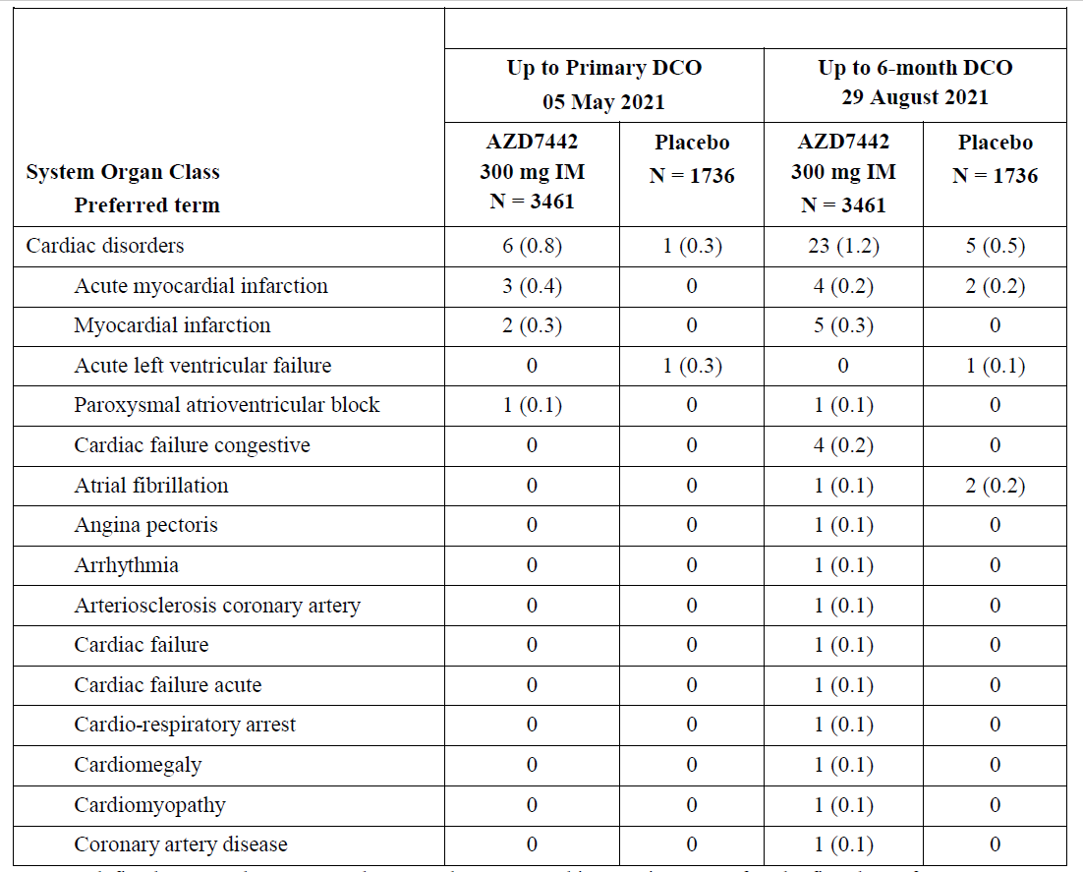

Temporal relationship for cardiac events
In Study D8850C00002 (PROVENT trial), the majority of cardiac events (17/31) were reported within 14 days after the commencement of treatment with Evusheld. Most of the ischaemic events also appear to be reported within the 30 days of the commencement of treatment with Evusheld. No ischaemic events were reported in placebo group within the 14 days and overall, a similar trend of ischaemic events was not noted in the placebo group.
Table 33: Study D8850C00002 (PROVENT trial), Number of participants with cardiac adverse events, onset < 14 days (safety analysis set)
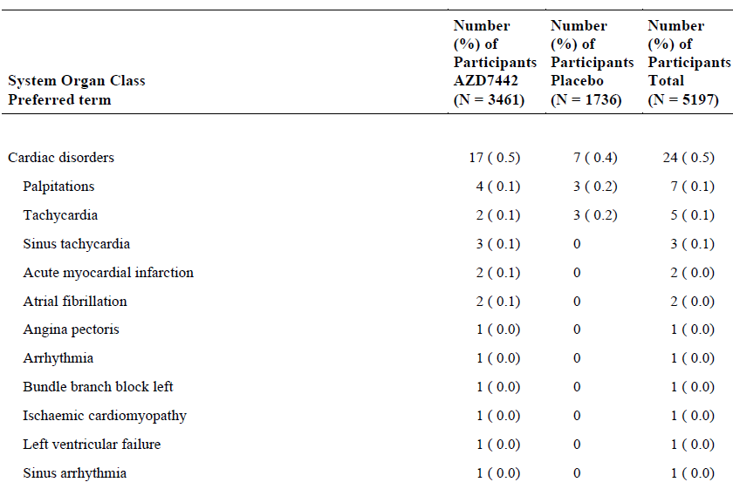
Table 34: Study D8850C00002 (PROVENT trial), Number of participants with cardiac adverse events, onset 30 to <60 days (safety analysis set)
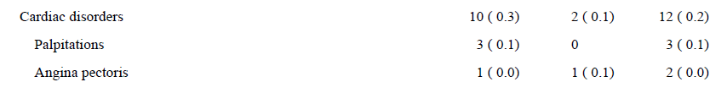
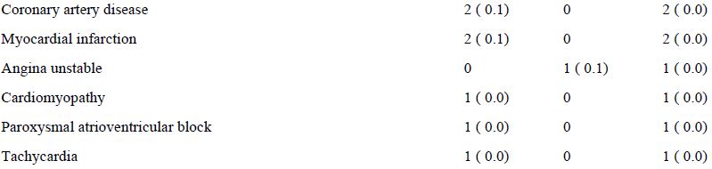
Table 35: Study D8850C00002 (PROVENT trial) Number of participants with cardiac adverse events, onset 60 to < 90days (safety analysis set)
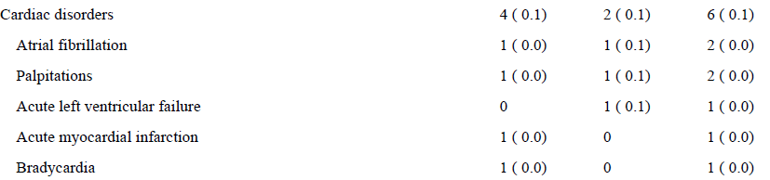

Magnitude of Cardiac serious adverse events
Table 36: Study D8850C00002 (PROVENT trial) Number of participants with cardiac adverse events, maximum reported intensity, with only Grade 3 or higher (safety analysis set)
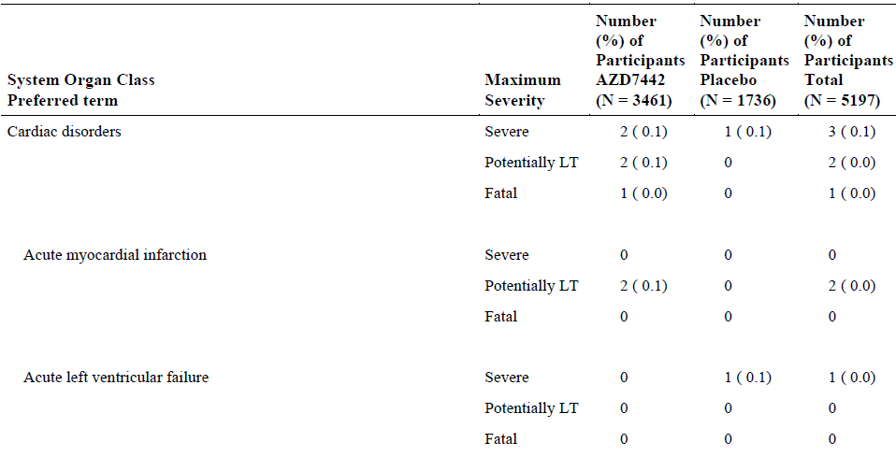
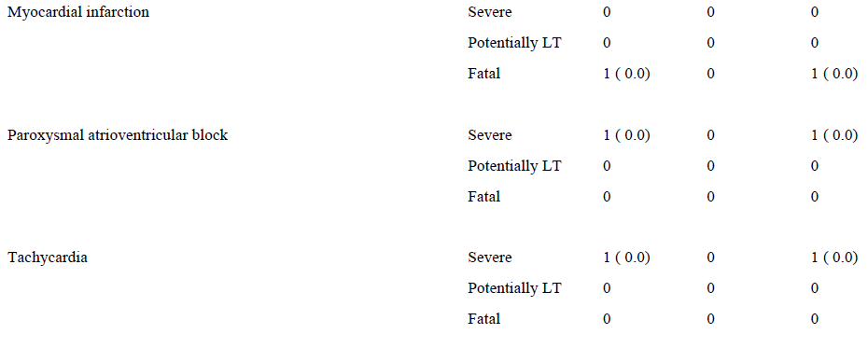
There was one life threatening or disabling adverse event of Arrythmia in the placebo group.
In response to FDA’s questions, the sponsor considers that no nonclinical evidence or plausible mechanism by which Evusheld would impact the risk of cardiovascular events due to the following reasons:
- There are no human targets for Evusheld, which has been corroborated by tissue cross-reactivity analysis: no binding to any tissue was observed in the full panel of 32 human tissues from 3 independent donors (Study 20250022).
- Cardiovascular safety pharmacology (ECGs, heart rate, body temperature and blood pressure) was assessed in the single dose Good Laboratory Practice toxicity study in cynomolgus monkeys with Evusheld:
  - A single IV dose of 600 mg/kg of Evusheld did not induce any clinical signs, microscopical findings in the cardiovascular system, or effects on ECGs, heart rate, body temperature, or blood pressure (Study No. 20249158).
- There were also no adverse reactions observed in non-human primates that received Evusheld in SARS-CoV-2 challenge studies.

Deaths
In Study D8850C00002 (PROVENT trial), the proportion of subjects who died was comparable across Evusheld (9 subjects, 0.3%) and placebo (7 subjects, 0.4%) arms. Four out of 9 events of death in the Evusheld arm were due to cardiac serious adverse events and none in placebo.
Table 37: Study D8850C00002 (PROVENT trial) Deaths and serious adverse events that led to an event of death
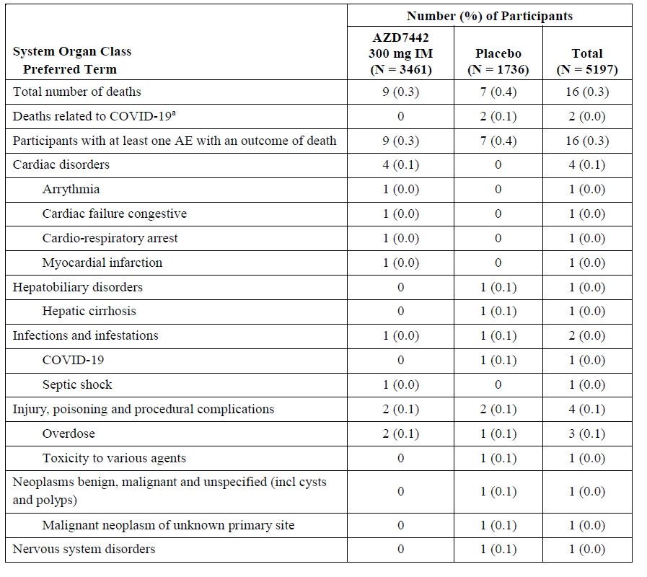
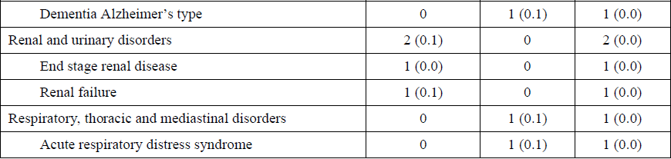
In Study D8850C00003 (STORM CHASER trial) there were 3 deaths during the study, 2 (0.3%) in the Evusheld arm and 1 (0.3%) in the placebo arm. None of the deaths were known to be related to COVID-19.

Risk management plan
AstraZeneca Pty Ltd has submitted Core-risk management plan (RMP) version 1 (dated 12 January 2022; data lock point (DLP) 21 August 2021) and Australia specific annex (ASA) version 1.0 succession 2 (dated 19 January 2022) in support of this application. The sponsor stated that currently only a draft EU-RMP is available at this stage, and it only contains the prevention indication. Therefore, the Core-RMP has been submitted.
The summary of safety concerns and their associated risk monitoring and mitigation strategies are summarised in Table 38.
Table 38: Summary of safety concerns
Summary of safety concerns |  | Pharmacovigilance |  | Risk Minimisation
 |  | Routine | Additional | Routine | Additional
Important identified risks | None | – | – | – | –
Important potential risks | Cardiac serious adverse events^ | ü# | – | ü | –
Important potential risks | Antiviral resistance due to emerging viral variants^ | ü | – | ü | –
Missing information | Immunocompromised/immunosuppressed patients^ | ü | – | – | –
Missing information | Use in pregnant and breastfeeding women | ü | ü* | ü | –
^Australia-specific safety concern
#Follow-up questionnaire
*Pregnancy registry
The sponsor revised the summary of safety concerns as requested by the TGA. The ASA has been updated to include the Australia-specific safety concerns.
The sponsor has proposed routine pharmacovigilance measures for the newly added safety concerns, with a targeted follow-up questionnaire to monitor cardiac serious adverse events. The sponsor should include interval and cumulative reports of cardiac serious adverse events with summary assessments of these cases in the monthly summary safety reports.
Routine risk minimisation measures are considered acceptable to address the risks associated with this product.

Risk-benefit analysis

Delegate’s considerations
The following discussion and conclusions are based on the FDA Emergency Use Authorization (EUA) data.
The combination of two recombinant human IgG1κ monoclonal antibodies, tixagevimab and cilgavimab, directed against unique epitopes on the receptor binding domain of the SARS-CoV-2 spike protein provides a complimentary effect in preventing the SARS-CoV-2 virus from entering human cells in an affected individual. There is in vitro evidence to support this assumption and forms the mechanistic basis for the proposed use of tixagevimab and cilgavimab.

Pharmacology
Pharmacokinetic (PK) data was collected from one Phase I PK study in healthy adults (Study D8850C00001) and one Phase III trials (Study D8850C00002 (PROVENT trial evaluating Evusheld administered intramuscularly for pre-exposure prophylaxis and post-exposure prophylaxis of COVID-19 in adults. Overall, tixagevimab and cilgavimab exhibited comparable PK parameters across studies, when administered sequentially. The terminal half-life was approximately 90 days (IM and IV). The lack of repeat dose PK study and clinical studies/PK parameters in paediatric population was noted. The simulation of repeat dose regimen is based on PK data that was mostly over a limited duration. Moreover, the duration of PK sampling in the Phase I study was less than three half-lives and in the Phase III studies was less than one half-life. The safety issues that are related to cumulative toxicity, particularly when administered to adolescents needs to be considered. A long-term study is being planned by the sponsor to investigate repeat dosing of Evusheld. The planned study is anticipated to start in first Quarter of 2022. This will be a safety, immunogenicity, and PK/PD study. As a condition of the provisional registration, the sponsor is expected to submit the data, when available.
The PK modelling supported that a dose of 300 mg IM will provide protection for at least 6 months and that the target serum concentration of 2.2 µg/mL was reached within 6 hours in the typical subject and by 28 hours in 90% of the participants in the Study D8850C00002 (PROVENT trial) Phase III population. In addition, a 2.2 µg/mL concentration was predicted to be exceeded in 50% of the PROVENT trial participants 12 months post the single 300 mg IM dose. The potential effects of the viral load on the PK parameters of Evusheld is unknown. The sponsor was requested to comment (see Questions for the sponsor).
The proposed product (Evusheld) for marketing is sourced from clonal cell line. However, the majority of subjects in the PROVENT trial were administered with a product that was derived from a cell pool, and not clonal cell line (n = 92 out of 3460). The neutralising antibody titres for the product sourced from clonal cell line was around 40% greater than the corresponding titres from the cell pool (Day 8: 779.5 versus 472.3). The data is limited by the low number of subjects in the clonal cell line cohort. The sponsor’s rationale for changing to clonal cell line to source the proposed product for marketing is unclear. From a quality perspective, the evaluator has stated that the manufacturing process of the product sourced from both sources are comparable.
The incidence of treatment emergent anti-drug antibodies was low for the tixagevimab component and comparable to placebo (1.8% versus 0%) and high for the component, compared to placebo (5% versus 0%). The overall incidence of anti-drug antibodies was considered as low.

Population pharmacokinetics
The evaluator has concluded that the final popPK model adequately described data from the Phase I and Phase III studies. Dose linearity over a dose range of 300 mg to 3000 mg was shown. It was concluded that body mass index, age, diabetes and baseline serum albumin were not considered clinically relevant due to the minimal impact on interindividual variability of PK parameters.
The limited duration of PK sampling was highlighted as a limitation that may have implication on the half-life that was calculated and hence needs to be taken into account, when determining the dose interval of Evusheld.
In terms of the simulations of weight-based dosing versus fixed dosing, which is the key basis of extrapolation of efficacy and safety findings of Evusheld from adults to adolescent age group, the key limitations were the lack of data regarding PK parameters such as C_{max} and lack of details regarding the methodological aspects of the Pop PK model that formed the basis of the assumption of comparative systemic exposure of Evusheld across adult and adolescent populations. The sponsor was requested to comment (see Questions for the sponsor).

Efficacy

Pre-exposure prophylaxis
The key inclusion criteria of the event-driven Study D8850C00002 (PROVENT trial) largely reflect the targeted patient population (that is, adults at an increased risk for inadequate response to active immunisation or having an increased risk for SARS-COV-2 infection). At Baseline 67% of subjects were having a COVID-19 comorbidity and 77% of subjects were at high risk for severe COVID-19 infection due to a co-morbidity. Obesity (41%) and hypertension (35%) were the commonest co-morbidities. There is some evidence to suggest an impaired vaccine response in individuals with obesity. However, the proportion of individuals with an immunosuppressive disease (< 1%) and those with a history of severe adverse reaction to prior vaccination (< 1%) were not well represented in the study population. From a clinical perspective, these are the individuals who will be considered as candidates for passive immunisation. Similarly, a low proportion of subjects in the ≥ 65 years (around 23%) and ≥ 75 years (around 4 %) were noted and has led to fewer data points for efficacy and safety of Evusheld in the elderly age group which is considered as one of the factors that contributes to inadequate response to active immunisation.
In the primary analysis at the data cut-off date of 5 May 2021, a relative risk reduction of 76.73 was achieved for subjects in the treatment arm, following administration of Evusheld, compared to placebo. The treatment difference was statistically significant. The treatment difference remained statistically significant in the supportive analyses regardless of subject’s vaccine status, being unblinded during study period or COVID-19 illness leading to death. The treatment benefit appears to be sustained at a later data cut-off, when a median follow up of 6 months for the subjects was reached, with a relative risk reduction of 82.8.
In the subgroup analyses, a lower proportion of subjects in the ≥ 65 years age group with a significant treatment benefit, compared to the rest of the cohort in the Evusheld arm was noted. The fewer number of subjects in this age group was taken into account.
No clinical data were included with repeat dosing of Evusheld, and repeat dosing will likely be needed for a pre-exposure prophylaxis authorisation. From a clinical perspective, safety profile of Evusheld, when administered as repeat dosing is unknown, particularly the risk of developing hypersensitivity reactions and anti-drug antibodies.
No clinical data were included with the administration of Evusheld to vaccinated individuals. This is clinically relevant as there are individuals who have already been administered with a COVID-19 vaccine and unable to have the required immunity, primarily due to underlying immunosuppressive conditions. The sponsor has been requested to clarify how the findings from an unvaccinated cohort can be extrapolated to already vaccinated population, now requiring passive vaccination (Questions for the sponsor).

Post exposure prophylaxis
Study D8850C00003 (STORM CHASER trial) did not meet its primary endpoint. In a relatively small cohort (749 versus 3441 participants in Study D8850C00001 (PROVENT trial)) of adults with a potential exposure to COVID-19 within 8 days of treatment with Evusheld and who were therefore at appreciable risk of imminently developing COVID-19, there was no significant reduction in the development of a SARS-CoV-2 RT-PCR-positive symptomatic illness, compared to placebo. In contrast to the PROVENT trial, the eligible subjects were needed to be only at risk of imminently developing COVID-19 and not at risk of developing severe COVID-19. A pre-specified sub-group analysis showed a nominal significance in subjects with SARS-CoV-2 RT-PCR status negative/missing at Baseline. This finding is supportive of the outcome of the PROVENT trial, in a pre-exposure setting.
If approved, from a clinical perspective, individuals with immunosuppressive conditions are likely to form a majority of individuals who may benefit from treatment with Evusheld. However, across both prophylaxis studies, only a minority subjects (< 1% in the PROVENT trial and 0% in the STORM CHASER trial) had immunosuppressive disease and a minority of the subjects (3% in the PROVENT trial and 14% in the STORM CHASER trial) were on immunosuppressive treatment during study period.

----Activity against Omicron variant
Based on in vitro findings, the neutralising activity of Evusheld against Omicron was around 15-fold lower than to original wild type strain of SARS-CoV-2. It is also in line with the observation that a higher minimum concentration of Evusheld was required to achieve a 80% inhibition of viral cell entry in the lung for Omicron, compared to the rest of the SARS-CoV-2 variants (3.3 µg/mL versus 2.2 µg/mL). The neutralising activity against Omicron variant appears to be lower than that against the Delta variant. No greater activity of any one monocomponent against Omicron was noted.
The US FDA has requested the sponsor to conduct analyses to examine whether a higher dose (600 mg versus 300 mg) and a shorter interval (3 months versus 6 months) of administration of Evusheld might deliver higher neutralising activity against the Omicron variant. The analyses are currently progressing and there is no timeline known for the availability of this data. The outcome of the analyses and the relevant safety data of the higher dose will be considered, once available and submitted to the TGA.
From a clinical perspective, the efficacy of Evusheld against Omicron will depend on the plasma concentration that will be achievable and the severity of the disease in patients affected by this variant of SARS-CoV-2. There is a theoretical risk of treatment failure due to the development of viral variants that may be resistant to Evusheld.
In this aspect, as with previous monoclonal antibody therapies that are registered for the prevention/treatment of COVID-19, if approved, Evusheld will also be used in patients affected by all strains of SARS-CoV-2 and not a particular variant of this virus. Moreover, the lack of data of activity against an evolving variant has always been a challenge with already approved drugs and will be the same for the future applications.
The sponsor must assess the neutralising activity of Evusheld against the novel variants of concern/variant of interest that are identified in the future. Efficacy of Evusheld in patients affected with viral variants should be monitored closely and examined in company-sponsored clinical trials.

Safety
Overall, the incidence of adverse events, treatment-emergent adverse events, and serious adverse events were comparable across Evusheld and placebo groups, when administered to individuals in a prophylaxis setting.

Cardiac serious adverse events
In Study D8850C00002 (PROVENT trial), 7.5% of participants randomised to receive Evusheld and 8.7% randomised to receive placebo group had serious heart conditions at Baseline. The Delegate has considered the fact that the participants were having cardiovascular risk factors at Baseline. However, a higher rate of cardiac events and related deaths were reported in Evusheld arm, compared to placebo, as described below.
A higher proportion of subjects administered with Evusheld, experienced cardiac serious adverse events both in pre-exposure prophylaxis (The exposure adjusted rates in PROVENT trial: 1.2% versus 0.5%) compared to placebo. Across studies, 31 cardiac serious adverse events were reported in Evusheld arm, compared to 2 adverse events in placebo arm. In addition to the 23 serious adverse events in the Evusheld arm in the PROVENT trial, a further 2 participants in the Evusheld group had raised troponin levels. In the PROVENT trial, at a median of 6 months follow up, 23 cardiac serious adverse events were reported in Evusheld arm, compared to 5 events in placebo. 9/23 and 2/5 events were myocardial infarctions. In the PROVENT trial, an event of mesenteric artery thrombosis in the Evusheld arm was considered as treatment related.
The higher proportion of cardiac events (17/28) that were reported within 14 days and most of the ischaemic event that were reported within 30 days of commencement of treatment with Evusheld in the PROVENT trial suggest a temporal relationship between the administration of Evusheld and cardiac events. With due consideration of the baseline cardiac risk factors, no ischaemic events were reported in placebo arm and the overall rate of cardiac events was low.
In the PROVENT trial, 4 out of 9 deaths in Evusheld arm were due to cardiac serious adverse events such as arrhythmia, cardiac failure, cardiac arrest and myocardial infarction.
An event of left ventricular failure (PROVENT trial) was reported as cardiac serious adverse events in the placebo arm. No cardiac deaths or ischaemic events were reported in the placebo arm.
There were no cardiac serious adverse events in the STORM CHASER trial. In contrast to the PROVENT trial, the safety data is limited by the 6-month duration, the patient population was younger with a mean age of 46.4 years in STORM CHASER, compared to 53.5 years in the PROVENT.
Upon FDA request, the applicant provided the additional information based on data from the PROVENT trial that suggest no association between development of anti-drug antibodies and cardiac events.
Based on the above facts, an increased risk for cardiac events, particularly the ischaemic cardiac events when patients with cardiovascular risk factors are treated with Evusheld cannot be ruled out. Further monitoring and specific reporting of such events in ongoing trials and from post market data is required. Cardiac events should be considered as a potential risk and adequately addressed in the proposed PI and RMP.
Across all clinical studies, prior receipt of a COVID-19 vaccine was an exclusion criterion for participation. In the PROVENT trial, at the data cut-off of May 2021, 28% subjects received COVID-19 vaccine. At a median of 6 months of treatment period (August 2021), a total of around 40% of subjects in the Evusheld arm received COVID-19 vaccine. The safety profile of Evusheld in individuals who have previously received a COVID-19 vaccine, particularly the susceptibility for re-infection has not been explored. The sponsor should evaluate this aspect in the post-market studies.
No healthy adults in Phase I study tested positive for the anti-drug antibodies. A minority of subjects in the AZD8895 (1.8%) and AZD1061 (5%) tested positive for treatment-emergent anti-drug antibodies. Similar reports from the PROVENT and STORM CHASER trials with a larger population and longer duration are pending. Sponsor must submit these results when seeking full registration. The incidence of antidrug antibody formation following repeat dosing is unknown.

Proposed action
The Delegate has considered the urgent public health need due to the COVID-19 pandemic, and the submitted data on quality, safety and efficacy.
The Delegate is of the view that the potential benefits outweigh the risks associated with the use of Evusheld for the pre-exposure prophylaxis against COVID-19.
At this point in time, based on the data that has been provided, the Delegate is not convinced that there is enough evidence to support the use of Evusheld for the proposed post-exposure prophylaxis.
This conclusion is based on the following limitations and critical issues:
- Post exposure prophylaxis against COVID-19
- The STORM CHASER trial did not meet its primary endpoint. There is no evidence to suggest efficacy of Evusheld for the post-exposure prophylaxis against COVID-19.
- Safety issues that are critical
- Limited safety data, with a median follow up of 84 days, particularly in view of the cardiac events that were reported in the PROVENT trial.
- In subjects with cardiovascular risk factors, 3 cardiac serious adverse events were reported, out of which 2 of them were fatal. No similar rate of events were reported in the placebo arm.

Indication
The sponsor’s proposed indication is very broad. Considering the data that was provided in pre-exposure, post-exposure and the evidence to support the use of Evusheld in these settings, particularly the safety data, the Delegate has considered the following indication for approval, pending Advisory Committee on Medicines (ACM) advice and satisfactory resolution of outstanding issues.
Pre-exposure prophylaxis
Evusheld (tixagevimab and cilgavimab) has provisional approval for the prophylaxis of COVID-19 in adults and adolescents aged 12 years and older weighing at least 40 kg,
    - Who are not currently infected with SARS-CoV-2 and who have not had a known recent exposure to an individual infected with SARS-CoV-2 and
    - Who have moderate to severe immune compromise due to a medical condition or receipt of immunosuppressive medications or treatments and may not mount an adequate immune response to COVID-19 vaccination or
- For whom vaccination with any approved COVID-19 vaccine is not recommended due to a history of severe adverse reaction (e.g., severe allergic reaction) to a COVID-19 vaccine(s) and/or COVID-19 vaccine component(s).
Evusheld is not intended to be used as a substitute for vaccination against COVID-19.
This approval has been granted on the basis of short-term efficacy and safety data. Evidence of longer-term efficacy and safety from ongoing trials continues to be gathered and assessed. The approval of Evusheld is associated with conditions that need to be met by the sponsor to ascertain the continued quality, safety, and efficacy of the product. Patients and doctors should be advised of the nature of the provisional registration. Evusheld should only be administered if the treatment benefit outweighs the associated risks.
Further changes to the PI may be required following the ACM discussion. The final approval is subject to the satisfactory resolution of any outstanding issues.

Questions for the sponsor
The sponsor provided the following response to questions from the Delegate.
- In Study D8850C00001 [Phase I study in healthy adults], the serum concentration of AZD7442 (Evusheld) appears to be higher than AZD8895 (tixagevimab) and AZD1061 (cilgavimab), when administered individually. The absolute values cannot be found in the clinical study report [for this study]. The sponsor is requested to provide a response.
Serum concentration of Evusheld (AZD7442) is calculated as the sum of tixagevimab (AZD8895) and cilgavimab (AZD1061), thus it is expected to be numerically higher than those of the component monoclonal antibodies. Summary statistics of serum concentrations of tixagevimab and cilgavimab up to Day 271 of all participants in all cohorts are presented in the Study D8850C00001 clinical study report.
- In terms of PK in nasal lining fluid, in the 300 mg IM dose cohort, the median AZD8895 (tixagevimab) and AZD1061 (cilgavimab) nasal lining fluid concentrations were 171 ng/mL and 187 ng/mL respectively, at Day 8 and 226 the significance/clinical relevance of these results against the COVID-19 variants, particularly the Omicron variant. The data is limited to Day 31. Please provide data (if available) for up to Day 183, which corresponds to the timeline for the primary endpoint in Study D8850C00002 (PROVENT trial).
Preliminary data on nasal lining fluid concentrations are available up to Day 151 for tixagevimab, cilgavimab, and Evusheld (tixagevimab plus cilgavimab) in the Phase I study. The nasal lining fluid Evusheld concentration exceeds the IC₅₀ value for the original SARS_CoV-2 strain (10 ng/mL) over 150 days with a geometric mean value of 163 ng/mL, while the Evusheld concentration exceeds the IC₅₀ value for the Omicron BA.1 variant (geometric mean of the first 4 available IC₅₀ of 209 ng/mL); over 90 days with a geometric mean concentration of 326 ng/mL. These nasal lining fluid concentrations are only relevant for upper respiratory tract protection since penetration into the lower respiratory tract is expected to be higher compared to the upper respiratory tract. the sponsor considers that the major public health benefit of Evusheld is in the prevention of lower respiratory tract infection (that is, viral pneumonitis), which is the major cause of hospitalisation and death from COVID-19. Furthermore, while the severity of Omicron infection appears to be reduced compared to previous variants, hospitalisations due to Omicron are not negligible and remain a significant health care burden., Therefore, reducing progression to severe disease remains a public health priority.
To predict Evusheld concentrations in the lower respiratory tract, the sponsor uses a lung epithelial lining fluid penetration ratio of 12% which is in the range of published values and values used by other sponsors. This means that 6 months post the 300 mg IM dose, the concentration in lung epithelial lining fluid is predicted to be on average 960 ng/mL which will result in more than 80% of viral cell inhibition against Omicron (geometric mean IC₅₀ of 209 ng/mL) which is sufficient for prophylaxis and thus escalation of viral load in the lower respiratory tract and will prevent worsening of COVID-19 symptoms due to Omicron BA.1 for 6 months. For the Omicron BA.2 variant, the Evusheld IC₅₀ value (9.8 ng/mL) is comparable to the potency for the original SARS-CoV-2 variant and thus supports at least 6 months protection against any type of symptoms.
Table 39: Virus-like particles data for the BA.1, BA.1+R346K, and BA.2 lineages of the Omicron variant of concern with AZD8895, AZD1061 and AZD7442 (Evusheld)
Assay type | Variant B | Fold change (FC) reduction in susceptibility AZD8895; IC₅₀  (ng/mL) | Fold change (FC) reduction in susceptibility AZD1061; IC₅₀  (ng/mL) | Fold change (FC) reduction in susceptibility AZD7442; IC₅₀  (ng/mL)
Pseudovirus a | BA.1 | FC > 600  IC₅₀ > 800 | FC >700  IC₅₀ >1000 | FC= 132  IC₅₀ = 171
Pseudovirus a | BA.1 + R346K | FC= 460  IC₅₀ = 552 | FC > 500  IC₅₀ > 1000 | FC = 424  IC₅₀ = 466
Pseudovirus a | BA.2 | FC > 1000  IC₅₀ > 1000 | FC = 1.9  IC₅₀ = 11 | FC = 3.2  IC₅₀ = 9.8
a: In vitro potency across multiple sets of co-occurring substitutions was tested in a research-grade recombinant spike pseudotyped virus microneutralisation assays (replication defective recombinant lentivirus expressing the SARS-CoV-2 spike protein and luciferase reporter gene).
b: Key spike substitutions tested: BA.1: A67V_H69-_V70-_T95I_G142D_V143-_Y144-_Y145-_N211-
_L212I_ins214EPE_G339D_S371L_S373P_S375F_K417N_N440K_G446S_S477N_T478K_E484A_Q49 3R_G496S_Q498R_N501Y_Y505H_T547K_D614G_H655Y_N679K_P681H_N764K_D796Y_N856K_Q
954H_N969K_L981F; BA.1+R346K: A67V_H69-_V70-_T95I_G142D_V143-_Y144-_Y145-_N211-
_ins214EPE_G339D_R346K_S371L_S373P_S375F_K417N_N440K_G446S_S477N_T478K_E484A_Q4 93R_G496S_Q498R_N501Y_Y505H_T547K_D614G_H655Y_N679K_P681H_N764K_D796Y_N856K_ Q954H_N969K_L981F; BA.2: T19I_L24-_P25-_P26-
_A27S_G142D_V213G_G339D_S371F_S373P_S375F_T376A_D405N_R408S_K417N_N440K_S477N_ T478K_E484A_Q493R_Q498R_N501Y_Y505H_D614G_H655Y_N679K_P681H_N764K_D796Y_Q954 H_N969K
Abbreviations: FC, fold change; IC₅₀, half maximal inhibition
- Please provide comparative PK parameter: Clearance for Evusheld in individuals with and without being affected with COVID-19.
[Information redacted]
- Please clarify why clonal cell line and not cell pool was chosen to produce the product proposed for marketing. Please clarify which of these products was used in STORMCHASER and [Information redacted] trials [Studies D8850C00003 and [Information redacted] respectively]. If both were used, please provide the proportion of subjects treated with each of them. PK data for the product sourced from the clonal cell line needs to be provided. Please provide any data of comparability of PK, efficacy and safety of Evusheld from these two sources and provide a justification of how the findings with Evusheld from the clonal cell pool can be extrapolated to that from the clonal cell line.
The purpose of having a clonal cell line is to produce drug product with consistent productivity and product quality, as described in the Note for Guidance on Quality of Biotechnological Products: Derivation and Characterisation of Cell Substrates used for Production of Biotechnological/Biological Products. Participants in the STORM CHASER trial on the Evusheld arm received only cell pools material; all participants on the Evusheld arm in the [Information redacted] received clonal material.
Information on the comparison of the clonal cell and the cell pools material is available within the Study D8850C00002 (PROVENT trial) clinical study report [not included in this AusPAR].
For ease of review, information from these documents is provided herewith.
In the PROVENT trial, pharmacokinetic (PK) data were collected from the 29 June 2021 data cut off to have a minimum of 3 months’ post-dose data to allow for an early and preliminary PK comparability between the cell pools material and the clonal cell line material. This comparability analysis was not initially planned when the study was designed. The PROVENT trial was conducted using mainly an investigational product derived from cell pools material, however a subset of 150 participants (100 Evusheld -treated participants) was added (protocol amendment 4 v 5.0) who received investigational product derived from clonal cell line material. Given via the intramuscular route Based on the measured AUC_{0-91days} (area under the curve from time zero (dosing) to Day 91) variability (around 40%) in Phase I, it was calculated that PK data were required from at least 70 participants dosed with the clonal cell line material to be able to demonstrate that the 90% CI interval of the ratio of the geometric mean AUC_{0-91days} or C_{max} is between 80 to 125%.
Serum Evusheld data were available for 68 of the 92 participants who had been dosed with the clonal cell line material and had PK results for both tixagevimab and cilgavimab at all sampling time points (Days 8, 29, 58, and 92). For the additional 24 participants that were dosed with clonal cell line material, scheduled PK samples were missing over the first 3 months. Corresponding data were used for 67 participants who were dosed with cell pools material.
For some participants from whom the Day 92 samples were collected earlier than scheduled, the parameter AUC_{0-91days} could not be calculated by extrapolation and AUC_{last} was used instead. This was the case for 18, 19, 18, 20, 21, and 23 participants for tixagevimab cell pools, cilgavimab cell pools, Evusheld cell pools, tixagevimab clonal cell line, cilgavimab clonal cell line, and Evusheld clonal cell line material, respectively.
Importantly, serum Evusheld data for the PROVENT trial primary analysis data cut-off showed that the PK variability up to Day 92 was higher in the PROVENT trial population compared with the Phase I population of healthy volunteers, with the geometric coefficient of variation (CV%) ranging from 71.5% to 90.3% for Evusheld over the 4 time points sampled.
Therefore, the dataset used for PK comparability analysis is underpowered for being able to demonstrate comparability of the 90% CI of the ratio of the geometric mean of C_{max} and AUC_{0-91days} of the 2 materials.
Nevertheless, based on a partial dataset (due to the interim data cut-off as well as data not being available for all participants), the C_{max} is comparable between the cell pools material and the clonal cell line material following administration of a single dose of Evusheld 300 mg IM, with a ratio of the geometric means of 97.1% with the 90% CI well within the 80% to 125% comparability bounds for tixagevimab, cilgavimab, and Evusheld (86.8%, 109%) (Table 40). For AUC_{0-91days}, the ratio of the geometric means (90% CI) was 83.8% (74.8%, 93.8%) for Evusheld (Table 2). Overlap of the serum Evusheld concentration distributions over the first 3 months for the 2 materials was observed and support that both materials result in serum Evusheld concentrations above the minimum protective concentration of 2.2 μg/mL in 100% of the participants. Testing material (cell pools versus clonal cell line) as a covariate for clearance in the population PK model supported that material was not a clinically significant covariate and did not reduce the percentage of unidentified inter-subject variability in clearance. Also, the distribution of the ex vivo 80% neutralising antibody titres (pharmacodynamics) were comparable for the cell pools material and the clonal cell line material and the pharmacokinetic neutralising antibody correlation was unchanged. Based on these collective data, the AUC_{0-91days} of the cell pools material and the clonal cell line material can be considered comparable.
With the future availability of additional PK data beyond Month 3, the expectation is that the more formal comparability criteria of 90% CI interval of the ratio of the geometric mean AUC between 80% to 125% will be met.
Table 40: Statistical comparison of pharmacokinetic exposure parameters between clonal cell line and cell pools materials (pharmacokinetics analysis set)
Analyte | Parameter (Units) | Treatment | N | GLS M | 90% CI | Material Comparison (Clonal Cell Line versus Cell Pool)
 |  |  |  |  |  | GMR (%) | 90% CI
Tixagevimab | AUC₀₋₉₁  (day·µg/mL) | Cell Pools (Reference) | 67 | 949 | (873, 1030) | 87.7 | (78.0, 98.6)
Tixagevimab | AUC₀₋₉₁  (day·µg/mL) | Clonal Cell Line (Test) | 68 | 833 | (767, 904) | 87.7 | (78.0, 98.6)
Tixagevimab | C_{max} (µg/mL) | Cell Pools (Reference) | 67 | 13.3 | (12.2, 14.4) | 102 | (90.4, 114)
Tixagevimab | C_{max} (µg/mL) | Clonal Cell Line (Test) | 68 | 13.5 | (12.4, 14.6) | 102 | (90.4, 114)
Cilgavimab | AUC₀₋₉₁  (day·µg/mL) | Cell Pools (Reference) | 67 | 916 | (840, 999) | 80.5 | (71.3, 90.9)
Cilgavimab | AUC₀₋₉₁  (day·µg/mL) | Clonal Cell Line (Test) | 68 | 737 | (677, 803) | 80.5 | (71.3, 90.9)
Cilgavimab | C_{max} (µg/mL) | Cell Pools (Reference) | 67 | 12.8 | (11.7, 13.9) | 94.4 | (83.4, 107)
Cilgavimab | C_{max} (µg/mL) | Clonal Cell Line (Test) | 68 | 12.0 | (11.0, 13.1) | 94.4 | (83.4, 107)
Evusheld | AUC₀₋₉₁  (day·µg/mL) | Cell Pools (Reference) | 67 | 1880 | (1740,  2040) | 83.8 | (74.8, 93.8)
Evusheld | AUC₀₋₉₁  (day·µg/mL) | Clonal Cell Line (Test) | 68 | 1580 | (1460,  1710) | 83.8 | (74.8, 93.8)
Evusheld | C_{max} (µg/mL) | Cell Pools (Reference) | 67 | 26.1 | (24.1, 28.3) | 97.1 | (86.8, 109)
Evusheld | C_{max} (µg/mL) | Clonal Cell Line (Test) | 68 | 25.4 | (23.5, 27.5) | 97.1 | (86.8, 109)
AUC0-91, area under the concentration-time curve from time zero to time 91 days; CI, confidence interval; Cmax, maximum serum concentration; DCO, data cut-off; GLSM, geometric least squares mean; GMR, geometric mean ratio; N, number of participants for whom data were available in each category; PK, pharmacokinetic.
- The sponsor is requested to inform when the Study D8850C00009 data will be available.
Study D8850C00009 started enrolment in December 2021. Enrolment is currently ongoing with a planned last participant enrolled in May 2022. An interim analysis is planned per protocol when all participants have completed the Day 91 visit. Initial data is anticipated in late Q4 2022 and final data is anticipated in Q4 2023.
- In the PROVENT trial (Study D8850C00002), obesity was considered as a factor that may contribute to ‘inadequate response to active immunisation’. The Delegate could not find a relevant reference included in the CSR, that could support this assumption. The majority of subjects in the PROVENT trial had obesity. Please provide a reference that is specific and relevant for the COVID-19 vaccines.
The PROVENT trial was designed in 2020 with the first participant enrolled in November 2020. Around that time, and prior to the widespread deployment of COVID-19 vaccines, multiple publications,,, raised concerns regarding the potential for attenuated immune responses to vaccination (including COVID-19 vaccination) in obese patients, based upon data from vaccination studies in other diseases.
- Please provide a summary of results of anti-drug antibody assessment across studies, with a focus on subjects who had cardiac events in PROVENT.
Overall, based on the available data, a causal link between antidrug antibodies against Evusheld and the development of cardiac disorder System Organ Class serious adverse events or adverse events of troponin increased is unlikely. The Evusheld antibodies are fully human antibodies, which are generally associated with very low antidrug antibody incidence with no clinical impact.
For more details, please refer to the US FDA Emergency Use Authorization responses dated 12 November 2021 and 02 December 2021 [not included in this AusPAR]
Phase I first trial in humans study
At the time of data cut off (6 June 2021), antidrug antibody data up to Day 211 were available for all participants (50 and 10 in the active and placebo groups, respectively) in all cohorts. By Day 211, no participants in the study had tested positive for antidrug antibody to either tixagevimab or cilgavimab.
PROVENT trial
As of the data cut off of 29 August 2021, antidrug antibody data to tixagevimab up to Day 183 were available on a subset of 716 and 382 antidrug antibody-evaluable participants in the Evusheld and placebo groups, respectively. Antidrug antibody data to cilgavimab over the same period were available on a subset of 644 and 339 antidrug antibody-evaluable participants in the Evusheld and placebo groups, respectively.
Antidrug antibody data to Evusheld over the same period were available on a subset of 743 and 393 antidrug antibody-evaluable participants in the Evusheld and placebo groups, respectively.
Over 182 days post-dose, antidrug antibody prevalence (% antidrug antibody positive) and antidrug antibody incidence (% treatment emergent- antidrug antibody positive) of tixagevimab in the Evusheld group were 3.5% (25/716) and 0.8% (6/716), respectively. Antidrug antibody prevalence and antidrug antibody incidence of cilgavimab in the Evusheld group were 3.4% (22/644) and 1.1% (7/644), respectively. antidrug antibody prevalence of Evusheld (defined as antidrug antibody positive to tixagevimab and/or cilgavimab) and antidrug antibody incidence of Evusheld (defined as treatment-emergent antidrug antibody positive to tixagevimab and/or cilgavimab) in the Evusheld group were 5.0% (37/743) and 1.3% (10/743), respectively. These results indicate that the majority of antidrug antibody-positive participants were classified as non-treatment-emergent antidrug antibody positive. The medians of the maximum antidrug antibody titers to tixagevimab and cilgavimab in treatment-emergent antidrug antibody positive participants were low (160.0 and 80.0, respectively) and close to the limit of detection of 80 and 40, respectively.
Table 41: PROVENT trial Summary of antidrug antibody responses to tixagevimab and cilgavimab following administration of 300 mg IM Evusheld over 182 days (antidrug antibody evaluable analysis set)
c | Statistics | Tixagevimaba |  | Cilgavimabb |  | Evusheldc
 |  | Treatment (N = 716) | Placebo (N = 382) | Treatment (N = 644) | Placebo (N = 339) | Treatment (N = 743) | Placebo (N = 393)
ADA | n (%) | 25 (3.5) | 10 (2.6) | 22 (3.4) | 8 (2.4) | 37 (5.0) | 14 (3.6)
positive at  any visit | Median of maximum titer | 160.0 | 240.0 | 80.0 | 160.0 | 80.0 | 160.0
(ADA
prevalence)
 | (min, max) | (80, 5120) | (160, 1280) | (40, 5120) | (40, 640) | (40, 5120) | (40, 1280)
TE-ADA | n (%) | 6 (0.8) | 3 (0.8) | 7 (1.1) | 2 (0.6) | 10 (1.3) | 3 (0.8)
positive^{d} | Median of | 160.0 | 320.0 | 80.0 | 240.0 | 160.0 | 320.0
(ADA | maximum titer
incidence)
incidence) | (min, max) | (160, 1280) | (160, 320) | (80, 320) | (160, 320) | (80, 1280) | (160, 320)
ª Lowest reportable titer = 80
^{b} Lowest reportable titer = 40
^{c} ADA positive to Evusheld is defined as ADA positive to tixagevimab and/or cilgavimab; TE-ADA positive to Evusheld is defined as TE-ADA positive to tixagevimab and/or cilgavimab.
^{d} Either ADA negative at Baseline and ADA positive at ≥ 1 post-baseline assessments with ADA titer
≥ 2 times the MRD of the respective mAb, or baseline positive ADA titer that was boosted to ≥ 4-fold during the study period.
ADA, anti-drug antibody; min, minimum; max, maximum; TE-ADA, treatment-emergent ADA.
Participants who had cardiac events in PROVENT
In the PROVENT trial, 7 out of 30 participants with cardiac disorder serious adverse events or increased troponin adverse events were antidrug antibody‑positive, 6 in the Evusheld arm and 1 in the placebo arm. All except 1 antidrug antibody-positive participant in the Evusheld arm were classified as non-treatment-emergent antidrug antibody- positive. The treatment-emergent antidrug antibody-positive participant had a positive result only at Day 183 with antidrug antibody titer which were close to the minimum required dilution. Based on the low observed antidrug antibody titers and/or the temporal relationship between antidrug antibody positive time point and the onset of cardiac adverse events, it is unlikely that there is a causal link between antidrug antibody and cardiac disorder serious adverse events/increased troponin adverse events.

Advisory Committee considerations
The Advisory Committee on Medicines (ACM), having considered the evaluations and the Delegate’s overview, as well as the sponsor’s response to these documents, advised the following.

Specific advice to the Delegate
- Evusheld sourced from a cell pool was largely administered across all clinical studies, which is different to the proposed product for marketing, that is sourced from a clonal cell line.
Does the ACM have any concerns regarding this limitation, with regards to efficacy and safety?
The ACM commented that this is a biosimilar question, resulting from a desire to expedite the clinical programme given the nature of the indication.
The ACM noted that in general in vitro literature supports a ‘representativeness’ of pooled samples compared with clonal cell lines.
The ACM noted that monoclonal cells from the master cell bank were added late in the clinical trial programme, as a result PK data comparing the cell pool and clonal cell line are limited to 3 months exposure. The lack of bioequivalence, in terms of area under the curve (AUC) was discussed. However, overall the PK data was considered to be reassuring.
The ACM commented that there was some variability observed between the cell pool and clonal cell lines, however interpretation of this is limited by the relatively short follow-up.
In view of the above facts and the current availability of stability data, a shelf-life of one year was considered to be acceptable. The ACM was supportive of additional PK, efficacy, and safety data being provided to the TGA as it becomes available.
- Please comment on the adequacy of the PK data to support the extrapolation of the efficacy and safety findings to adolescents.
The ACM advised that it is reasonable to extrapolate the safety and efficacy findings to adolescents based on the PK modelling and the known preclinical therapeutic window.
The ACM noted that the model predicts that the median AUC over 6 months will be 24% greater in adolescents than adults at a fixed dose, with approximately 5% of adolescents having an AUC greater than 6000 µg*day/mL. The ACM commented that this increased variability in adolescents could have implications but was of the view that a single dose is unlikely to lead to exposure-related toxicity. This may need to be reconsidered should multi-dosing be used or if dosing was to be increased.
The ACM was supportive of further information being provided to the TGA as it becomes available.
- Please comment on the adequacy of the PopPK data to extrapolate the efficacy and safety findings to adolescents and to support the use of Evusheld in this age group.
The ACM advised that the PopPK data is sufficiently robust. The ACM was of the view that the simulations are reassuring regarding efficacy and safety within the known therapeutic window for adolescents after a single dose. The duration of effect in this group is likely sufficiently greater than the proposed 6-month dosing intervals.
Additional longer-term sampling, additional adolescent sampling, and further simulations of repeated dosing will better support repeat dose intervals and safety, in addition to safety and efficacy data as it becomes available.
- Please comment whether the statements in the proposed PI adequately reflects the available safety data, particularly in relation to the cardiovascular events.
The ACM noted that many cardiac serious adverse events were in patients with co-morbidities. The ACM was of the view that this is a population that this product would likely be used in and therefore found the cardiac serious adverse events to be highly relevant and important.
The ACM was of the view that there is a real signal for cardiac events, noting that the mechanism is not currently identified.
The ACM mentioned that the included population are reflective of the general population rather than those specifically at high risk of cardiovascular disorders at Baseline. The ACM highlighted the increased incidence of cardiovascular events, including cardiac serious adverse events in the treatment arm, compared to placebo arms at various time points of 14 days, 30 days and > 30 days and agreed that this should be highlighted within the PI, along with rates of vascular disorders. In terms of cardiac serious adverse events, there was an increasing incidence of cardiovascular events in the treatment arm, compared to placebo over the 6 months median treatment period.
The ACM was supportive of the PI changes recommended by the Delegate regarding cardiovascular events, with modification to the proposed text as shown by strikethrough below:
‘4.4 SPECIAL WARNINGS AND PRECAUTIONS FOR USE
Cardiovascular events
In PROVENT there was a higher rate of cardiovascular serious adverse events (SAEs), including myocardial infarction (one fatal SAE) and cardiac failure, in subjects who received Evusheld compared to placebo [see Adverse Reactions (6.1)]. All subjects who experienced cardiac SAEs had cardiac risk factors and/or a prior history of cardiovascular disease. A causal relationship between Evusheld and these events has not been established. There was no signal for cardiac toxicity or thrombotic events identified in the nonclinical studies.
Consider the risks and benefits prior to initiating Evusheld in individuals at high risk for cardiovascular events, and advise individuals to seek immediate medical attention if they experience any signs or symptoms suggestive of a cardiovascular event.’
‘4.8 ADVERSE EFFECTS (UNDESIRABLE EFFECTS)
Cardiac Serious Adverse Events
Through the additional data cut-off in PROVENT, a higher proportion of subjects who received Evusheld versus placebo in PROVENT reported myocardial infarction SAEs, one of which resulted in death, and cardiac failure SAEs (see Table 3 below). All subjects who experienced cardiac SAEs had cardiac risk factors and/or a prior history of cardiovascular disease at Baseline. There was no clear temporal pattern, with events reported from several hours after Evusheld receipt through the end of the follow-up period.
[Table] Cardiac SAEs Regardless of Causality in PROVENT with Onset Prior to Day 183 Using the Median 6-Month Data Cut-off Date’
- In view of the safety profile of Evusheld, based on the available (cardiac safety) data, please comment on the adequacy of the proposed RMP and advice the need for any additional pharmacovigilance activities.
The ACM strongly supported implementation of additional pharmacovigilance activities, including long term follow-up.
In view of the spread of cardiac events, a longer term (minimum) follow up was recommended (14, 30 days post treatment). The ACM also advised that active monitoring of these events (for example, an automated SMS message to solicit adverse event reports) should be considered rather than just passive monitoring.
The ACM was supportive of cardiac serious adverse events being included in the RMP as an important potential safety risk, in addition to the questionnaire as a long term measure. The ACM was also supportive of the establishment of a patient registry.
In addition, the ACM was supportive of immunocompromised/immunosuppressed patients being included as missing information within the RMP.
- Does ACM support the provisional registration of Evusheld for the pre and post exposure prophylaxis indications?
The ACM noted that there are currently no other monoclonal antibodies approved for COVID-19 pre-exposure prophylaxis in Australia.
The ACM agreed that there are reasonable efficacy data for the pre-exposure prophylaxis indication and that the benefits appear to outweigh the risks for this indication in the trial population, subject to enhanced risk management. The ACM advised that the indication wording should be enhanced in regard to mounting an adequate immune response to COVID-19 vaccines and suggested that ‘may not mount an adequate immune response to COVID‐19 vaccination’ be amended to ‘that make it likely that they will not mount an adequate immune response to COVID‐19 vaccination’.
The ACM noted there was an insufficient number of immunocompromised / immunosuppressed people included within the trial population to robustly demonstrate safety and efficacy within this subgroup. The ACM expressed some concern with this as Australian usage will likely centre around use in the immunocompromised / immunosuppressed population.
The ACM advised that there is insufficient evidence at this time to support the approval of a post exposure prophylaxis indication, noting that the STORM CHASER trial (Study D8850C00003) did not meet its primary endpoint.
- Does the ACM have any other advice concerning this submission?
The ACM noted that approval of shelf-life for a 12-month period appeared appropriate, conditional to the sponsor submitting further stability data.
The ACM emphasised that this therapy is not an alternative or substitute for vaccination. The ACM reiterated its view that vaccination is the preferred and primary option to prevent COVID-19.

Conclusion
The ACM considered this product to have an overall positive benefit-risk profile for the indication:
Pre‐exposure prophylaxis
Evusheld (tixagevimab and cilgavimab) has provisional approval for the prophylaxis of COVID-19 in adults and adolescents aged 12 years and older weighing at least 40 kg,
    - Who are not currently infected with SARS‐CoV‐2 and who have not had a known recent exposure to an individual infected with SARS-CoV‐2 and
    - Who have moderate to severe immune compromise due to a medical condition or receipt of immunosuppressive medications or treatments that make it likely that they will not mount an adequate immune response to COVID‐19 vaccination or
    - For whom vaccination with any approved COVID‐19 vaccine is not recommended due to a history of severe adverse reaction (e.g., severe allergic reaction) to a COVID‐19 vaccine(s) and/or COVID‐19 vaccine component(s). see Section 4.2 Dose and method of administration and Section 5.2 Pharmacokinetic Properties.
Evusheld is not intended to be used as a substitute for vaccination against COVID‐19.
This decision has been made on the basis of short-term efficacy and safety data. Continued approval depends on the evidence of longer-term efficacy and safety data from ongoing clinical trials

Outcome
Based on a review of quality, safety and efficacy, the TGA approved the registration of Evusheld (150 mg of tixagevimab in 1.5 mL (100 mg/mL); and 150 mg of cilgavimab in 1.5 mL (100 mg/mL)) solution for injection, single dose vial, indicated for:
Evusheld (tixagevimab and cilgavimab) has provisional approval for the pre-exposure prophylaxis of COVID-19 in adults and adolescents aged 12 years and older weighing at least 40 kg,
- Who have moderate to severe immune compromise due to a medical condition or receipt of immunosuppressive medications or treatments that make it likely that they will not mount an adequate immune response to COVID-19 vaccination or
- For whom vaccination with any approved COVID-19 vaccine is not recommended due to a history of severe adverse reaction (for example., severe allergic reaction) to a COVID-19 vaccine(s) and/or COVID‐19 vaccine component(s).
See Section 4.2 Dose and method of administration and Section 5.2 Pharmacokinetic properties.
Evusheld is not recommended as a substitute for vaccination in individuals for whom COVID-19 vaccination is recommended.
This decision has been made on the basis of short-term efficacy and safety data. Continued approval depends on the evidence of longer-term efficacy and safety data from ongoing clinical trials.

Specific conditions of registration applying to these goods
- Evusheld (tixagevimab/cilgavimab) is to be included in the Black Triangle Scheme. The PI and CMI for Evusheld must include the black triangle symbol and mandatory accompanying text for the products entire period of provisional registration.
- The Evusheld Core-RMP (version 1, date 2 February 2022; DLP 21 August 2021), with ASA (version 1.0 succession 3; 15 February 2022), included with submission PM-2021-05375-1-2, to be revised to the satisfaction of the TGA, will be implemented in Australia.
An obligatory component of risk management plans is routine pharmacovigilance. Routine pharmacovigilance includes the submission of periodic safety update reports (PSURs).
Unless agreed separately between the supplier who is the recipient of the approval and the TGA, the first report must be submitted to TGA no later than 15 calendar months after the date of the approval letter. The subsequent reports must be submitted no less frequently than annually from the date of the first submitted report until the period covered by such reports is not less than three years from the date of the approval letter, or the entire period of provisional registration, whichever is longer.
The reports are to at least meet the requirements for PSURs as described in the European Medicines Agency’s Guideline on good pharmacovigilance practices (GVP) Module VII-periodic safety update report (Rev 1), Part VII.B Structures and processes. Note that submission of a PSUR does not constitute an application to vary the registration. Each report must have been prepared within ninety calendar days of the data lock point for that report.
Additional to the submission of PSURs, expedited monthly summary safety reports (including safety data for patients in Australia and reporting of Australia specific safety concerns) are to be provided for the first 6 months post registration, and thereafter at intervals specified by the TGA.
Quality Conditions
- The manufacturer is to update the specification acceptance criteria after the manufacture of a total of 20 DS [Drug substance]/DP [Drug product] batches across both manufacturing sites through submission of a Category 3 application.
- The sponsor is to provide the following data for DS manufacture [Information redacted] or as otherwise indicated through submission of a Category 3 application:
  - Column chromatography resin lifetime studies with qualification data for small scale models
  - Membrane reuse studies
  - Hold study validation (cilgavimab)
  - Data from Drug Substance manufacturing site 2
  - Additional drug substance stability data [Information redacted]
- The sponsor is to provide the following data to support DP shelf life of 12 months:
  - Up to 12 months of acceptable stability data for DP (cilgavimab and tixagevimab) from commercial batches manufactured at [Information redacted]
  - Up to 15 months stability data from two clinical batches manufactured from Process 2 from each DP (tixagevimab and cilgavimab)[Information redacted]
  - a commitment to complete all ongoing stability studies and report any confirmed out of specification result and proposed remediation approaches to the TGA immediately.
- Laboratory testing & compliance with Certified Product Details (CPD)
  - All batches of Evusheld supplied in Australia must comply with the product details and specifications approved during evaluation and detailed in the Certified Product Details (CPD).
  - When requested by the TGA, the sponsor should be prepared to provide product samples, specified reference materials and documentary evidence to enable the TGA to conduct laboratory testing on the Product. Outcomes of laboratory testing are published biannually in the TGA Database of Laboratory Testing Results http://www.tga.gov.au/ws-labs-index and periodically in testing reports on the TGA website.
Clinical Conditions
- The final study reports for the following studies will have to be submitted before a definitive authorisation can be considered: PROVENT, STORM, CHASER and TACKLE.
- All anti-drug antibody (ADA) assessments that have not been completed at the time of this authorisation for subjects from the PROVENT clinical trial for Days 1, 29, 58, and 183.
- Interim analysis results through Day 28 for the first 50 subjects to receive a second dose from the PROVENT repeat-dose sub-study by [Information redacted].
- Baseline and all subsequent study visits, of the following biomarkers from the PROVENT repeat-dose sub-study: d-dimer, P-selectin, thrombin, and Factor VIII.
- Top line data, to include safety, pharmacokinetic, ADA, and biomarker results for thrombotic events from the first 9 months of the PROVENT repeat-dose sub-study.
- Monthly aggregate reports for serious adverse events in the Cardiac Disorder System Order Class (SOC) and other non-cardiac thrombotic serious adverse events.
- Systematic data collection from spontaneous reporting of cardiac events should be conducted and reported regularly to the TGA.
- The complete 6- month safety summary for PROVENT, STORM CHASER and TACKLE should be submitted for review and should include a critical review of cardiac events and non- cardiac vascular events.

Attachment 1. Product Information
The PI for Evusheld approved with the submission which is described in this AusPAR is at Attachment 1. For the most recent PI, please refer to the TGA website at <https://www.tga.gov.au/product-information-pi>.

Therapeutic Goods Administration
PO Box 100 Woden ACT 2606 Australia
Email: info@tga.gov.au Phone: 1800 020 653 Fax: 02 6232 8605
https://www.tga.gov.au

The Black Triangle Scheme provides a simple means for practitioners and patients to identify certain types of new prescription medicines, including those being used in new ways and to encourage the reporting of adverse events associated with their use. The Black Triangle does not denote that there are known safety problems, just that the TGA is encouraging adverse event reporting to help us build up the full picture of a medicine's safety profile.
Sponsor submitted indication include both a treatment and a prophylaxis part. During TGA’s evaluation, the indication has been spilt into two submissions, one for the treatment indication and one for the prophylaxis indications. This AusPAR will only be discussing the prophylaxis indication.
Wu, F., et al., A new coronavirus associated with human respiratory disease in China. Nature, 2020. 579(7798): p. 265-269.
Huang, C., et al., Clinical features of patients infected with 2019 novel coronavirus in Wuhan, China. Lancet, 2020. 395(10223): p. 497-506.
WHO: WHO Coronavirus (COVID-19) Dashboard. World Health Organization (WHO). Available at https://www.health.gov.au/health-alerts/covid-19/case-numbers-and-statistics
Department of Health: COVID Dashboard. Australian Government, Canberra. Available at: https://www.health.gov.au/health-alerts/covid-19/case-numbers-and-statistics
Shuai, H., et al., Attenuated replication and pathogenicity of SARS-CoV-2 B.1.1.529 Omicron. Nature, 2022.
TGA: COVID-19 treatments, provisional registrations. Available at: https://www.tga.gov.au/covid-19-treatments-provisional-registrations
As part of the provisional approval pathway, the provisional registration process will allow certain medicines to be provisionally registered in the Australian Register of Therapeutic Goods (ARTG) for a limited duration. These medicines are registered on the basis of preliminary clinical data, where there is the potential for a substantial benefit to Australian patients. The TGA will re-assess risks related to the absence of evidence through data provided at a later stage, as part of the confirmatory data. Confirmatory data should confirm the relationship between outcomes predicted by the surrogate endpoint, or other preliminary data, and the clinical benefit as demonstrated by direct clinical outcomes. The sponsor may apply to transition to full registration at any time up until the provisional registration lapse date, once they have completed the obligations outlined for the provisional registration period and complete confirmatory data on safety and efficacy are available.
Veklury was first registered on the ARTG on 10 July 2020 (ARTG number: 338419).
AusPAR for Veklury (remdesivir) new chemical entity, published on 21 July 2020. Available at: https://www.tga.gov.au/auspar/auspar-remdesivir
Xevudy was first registered on the ARTG on 20 August 2021 (ARTG number: 364110)
AusPAR for Xevudy (sotrovimab) new biological entity, published on 20 August 2021. Available at: https://www.tga.gov.au/auspar/auspar-sotrovimab
Ronapreve was first registered on the ARTG on 18 October 2021 (ARTG number: 373839 and 374310)
AusPAR for Ronapreve (casirivimab/imdevimab) new biological entity, published on 2 November 2021. Available at: https://www.tga.gov.au/auspar/auspar-casirivimabimdevimab
AusPAR Paxlovid nirmatrelvir/ritonavir Pfizer Australia Pty Ltd PM-2021-04880-1-2. Available at: https://www.tga.gov.au/auspar/auspar-nirmatrelvirritonavir
TGA: COVID-19 Vaccines, provisional approvals. Available at: https://www.tga.gov.au/covid-19-vaccine-provisional-registrations
Spikevax was first registered on the ARTG on 9 August 2021 (ARTG number: 370599).
AusPAR for Spikevax (elasomeran) new biological entity, adult indication, published on 9 August 2021. Available at: https://www.tga.gov.au/auspar/auspar-elasomeran
AusPAR for Spikevax (elasomeran) new biological entity, paediatric indication, published on 4 September 2021. Available at: https://www.tga.gov.au/auspar/auspar-elasomeran-0
COVID-19 Vaccine Janssen was first registered on the ARTG on 25 June 2021 (ARTG number: 350150).
AusPAR for COVID-19 Vaccine Janssen (Ad26.COV2.S) new biological entity, published on 25 June 2021. Available at: https://www.tga.gov.au/auspar/auspar-ad26cov2s
COVID-19 Vaccine AstraZeneca was first registered on the ARTG on 16 February 2021 (ARTG number: 349072).
AusPAR for COVID-19 Vaccine AstraZeneca (ChAdOx1-S) new biological entity, published on 16 February 2021. Available at: https://www.tga.gov.au/auspar/auspar-chadox1-s
Comirnaty was first registered on the ARTG on 25 January 2021 (ARTG number: 346290).
AusPAR for Comirnaty (BNT162b2 (mRNA)) new biological entity, published on 25 January 2021. Available at: https://www.tga.gov.au/auspar/auspar-bnt162b2-mrna-comirnaty
AusPAR for Comirnaty (BNT162b2 (mRNA)) extension of indications, published on 23 July 2021. Available at: https://www.tga.gov.au/auspar/auspar-bnt162b2-mrna
Australian Government Department of Health, Vaccination Numbers and Statistics. Available at: https://www.health.gov.au/initiatives-and-programs/covid-19-vaccines/numbers-statistics
The TGA is a member of the Access Consortium along with Health Canada, Health Sciences Authority of Singapore, Swissmedic and the UK's Medicines and Healthcare products Regulatory Agency (MHRA). The Access Consortium is a medium-sized coalition of regulatory authorities that work together to promote greater regulatory collaboration and alignment of regulatory requirements. The original consortium, formed in 2007 and known as 'ACSS', comprised the national regulatory authorities of Australia, Canada, Singapore and Switzerland. In October 2020, the MHRA joined and the group's name was changed to the 'Access Consortium'.
Provisional determination for Evusheld for the indication 'for the prophylaxis of COVID-19 in adults 18 years of age and older' was granted on 4 November 2021. The sponsor has subsequently developed a population-based pharmacokinetic model which suggests a broader age range of patients for which this product will be appropriate. It was later proposed to include adolescents (12 years of age and older weighing at least 40 kg) and a new provisional determination was granted on 4 January 2022.
GMP clearances have now been approved prior to registration of Evusheld.
Sponsor has submitted Process 2 twelve month stability data for two clinical batches (December 2021 for two batches and 25 January 2022 for on batch and 22 February 22 for one batch).
Variants of Interest - https://www.who.int/en/activities/tracking-SARS-CoV-2-variants/
Sponsor’s clarification: This adverse event was not reported as a serious adverse event and, upon review, did not meet the protocol-defined criteria of anaphylaxis. The medical records from the hospital admission confirmed no signs of anaphylaxis
CDER Review 08 Dec 2021 (last viewed 04 Jan 2022)
Routine risk minimisation activities may be limited to ensuring that suitable warnings are included in the product information or by careful use of labelling and packaging. Routine pharmacovigilance practices involve the following activities: - All suspected adverse reactions that are reported to the personnel of the company are collected and collated in an accessible manner; - Reporting to regulatory authorities; - Continuous monitoring of the safety profiles of approved products including signal detection and updating of labelling; - Submission of PSURs; - Meeting other local regulatory agency requirements.
Joshua Nealon, Benjamin J Cowling, Omicron severity: milder but not mild, The Lancet, Volume 399, Issue 10323, 2022, Pages 412-413,
Neil Ferguson, Azra Ghani, Anne Cori et al. Growth, population distribution and immune escape of the Omicron in England. Imperial College London (16 December 2021).
Magyarics Z, Leslie F, Barko J, Rouha H, Luperchio S, Schörgenhofer C, et al. Randomized, double-blind, placebo-controlled, single-ascending-dose study of the penetration of a monoclonal antibody combination (ASN100) targeting Staphylococcus aureus cytotoxins in the lung epithelial lining fluid of healthy volunteers. Antimicrob Agents Chemother. 2019; 63(8):e00350-19. doi: 10.1128/AAC.00350-19.
International Council for Harmonisation of Technical Requirements for Pharmaceuticals for Human Use (ICH) Harmonised Tripartite Guideline CPMP/ICH/294/95.
Leford H. How obesity could create problems for a COVID vaccine. Nature. 2020;585:489.
Painter SD, Ovsyannikova IG, Poland GA. The weight of obesity on the human immune response to vaccination. Vaccine. 2015;33(36):4422-9. doi: 10.1016/j.vaccine.2015.06.101.
Poland GA, Ovsyannikova IG, Kennedy RB. Personalized vaccinology: A review. Vaccine. 2018;36(36):5350-7.
Zimmermann P, Curtis N. Factors That Influence the Immune Response to Vaccination. Clin Microbiol Rev. 2019;32(2).
Roskos LK, Davis CG, and Schwab GM. The clinical pharmacology of therapeutic monoclonal antibodies. Drug Dev. Res. 2004:61:108-120.
The ACM provides independent medical and scientific advice to the Minister for Health and the Therapeutic Goods Administration (TGA) on issues relating to the safety, quality and efficacy of medicines supplied in Australia including issues relating to pre-market and post-market functions for medicines. The Committee is established under Regulation 35 of the Therapeutic Goods Regulations 1990. Members are appointed by the Minister. The ACM was established in January 2017 replacing Advisory Committee on Prescription Medicines (ACPM) which was formed in January 2010. ACM encompass pre and post-market advice for medicines, following the consolidation of the previous functions of the Advisory Committee on Prescription Medicines (ACPM), the Advisory Committee on the Safety of Medicines (ACSOM) and the Advisory Committee on Non-Prescription Medicines (ACNM). Membership comprises of professionals with specific scientific, medical or clinical expertise, as well as appropriate consumer health issues relating to medicines.

