October 2014

AusPAR Attachment 2

Extract from the Clinical Evaluation Report for Tiotropium Bromide
  - Proprietary Product Name: Spiriva Respimat/ Favint Respimat
  - Sponsor: Boehringer Ingelheim Pty Ltd

About the Therapeutic Goods Administration (TGA)
- The Therapeutic Goods Administration (TGA) is part of the Australian Government Department of Health, and is responsible for regulating medicines and medical devices.
- The TGA administers the Therapeutic Goods Act 1989 (the Act), applying a risk management approach designed to ensure therapeutic goods supplied in Australia meet acceptable standards of quality, safety and efficacy (performance), when necessary.
- The work of the TGA is based on applying scientific and clinical expertise to decision-making, to ensure that the benefits to consumers outweigh any risks associated with the use of medicines and medical devices.
- The TGA relies on the public, healthcare professionals and industry to report problems with medicines or medical devices. TGA investigates reports received by it to determine any necessary regulatory action.
- To report a problem with a medicine or medical device, please see the information on the TGA website <https://www.tga.gov.au>.
About the Extract from the Clinical Evaluation Report
- This document provides a more detailed evaluation of the clinical findings, extracted from the Clinical Evaluation Report (CER) prepared by the TGA. This extract does not include sections from the CER regarding product documentation or post market activities.
- The words [Information redacted], where they appear in this document, indicate that confidential information has been deleted.
- For the most recent Product Information (PI), please refer to the TGA website <https://www.tga.gov.au/product-information-pi>.
Copyright
© Commonwealth of Australia 2016
This work is copyright. You may reproduce the whole or part of this work in unaltered form for your own personal use or, if you are part of an organisation, for internal use within your organisation, but only if you or your organisation do not use the reproduction for any commercial purpose and retain this copyright notice and all disclaimer notices as part of that reproduction. Apart from rights to use as permitted by the Copyright Act 1968 or allowed by this copyright notice, all other rights are reserved and you are not allowed to reproduce the whole or any part of this work in any way (electronic or otherwise) without first being given specific written permission from the Commonwealth to do so. Requests and inquiries concerning reproduction and rights are to be sent to the TGA Copyright Officer, Therapeutic Goods Administration, PO Box 100, Woden ACT 2606 or emailed to <tga.copyright@tga.gov.au>

Contents
List of abbreviations 5
1. Introduction 10
2. Clinical rationale 10
3. Contents of the clinical dossier 11
3.1. Scope of the clinical dossier 11
3.2. Paediatric data 12
3.3. Good clinical practice 13
4. Pharmacokinetics 13
4.1. Studies providing pharmacokinetic data 13
4.2. Summary of pharmacokinetics 15
4.3. Evaluator’s overall conclusions on pharmacokinetics 25
5. Pharmacodynamics 27
5.1. Studies providing pharmacodynamic data 27
5.2. Summary of pharmacodynamics 27
5.3. Evaluator’s overall conclusions on pharmacodynamics 29
6. Dosage selection for the pivotal studies 29
6.1. Proof of concept trials: 205.341 and 205.342 29
6.2. Dose ranging study in adults: 205.380 40
6.3. Dosing regimen trial in adults: 205.420 44
6.4. Dose ranging trials in paediatric patients: 205.424 and 205.425 47
7. Clinical efficacy 52
7.1. Pivotal efficacy studies 53
7.2. Other efficacy studies 75
7.3. Analyses performed across trials (pooled analyses and meta analyses) 77
8. Clinical safety 94
8.1. Studies providing evaluable safety data 94
8.2. Pivotal studies that assessed safety as a primary outcome 99
8.3. Patient exposure in asthma studies 112
8.4. Adverse events 114
8.5. Laboratory tests 123
8.6. Post marketing experience 125
8.7. Safety issues with the potential for major regulatory impact 127
8.8. Other safety issues 128
8.9. Evaluator’s overall conclusions on clinical safety 132
9. First round benefit risk assessment 135
9.1. First round assessment of benefits 135
9.2. First round assessment of risks 135
9.3. First round assessment of benefit risk balance 136
10. First round recommendation regarding authorisation 138
10.1. Recommendation for proposed extension of indications to include Asthma 138
11. Clinical questions 139
11.1. Pharmacokinetics 139
11.2. Efficacy 139
11.3. Safety 140
12. Second round evaluation of clinical data submitted in response to questions 140
12.1. Pharmacokinetics 140
12.2. Efficacy 142
13. Second round evaluation of clinical data submitted in response to questions 168
14. References 168

List of abbreviations
Abbreviation | Meaning
#PV | Pharmacovigilance endpoint
ACQ | Asthma control questionnaire
AE | Adverse event
Ae | Amount excreted unchanged in urine
Ae_{t1-t2(,ss}) | Amount excreted unchanged in urine within the time interval t1 to t2 (at steady state)
AM | Asthma monitoring
AQLQ(S) | Standardised asthma quality of life questionnaire
ATS | American thoracic society
AUC | Area under the analyte plasma concentration time curve
AUC_{0-tz(,ss)} | Area under the analyte plasma concentration time curve from time point of administration to the time point of the last quantifiable plasma concentration (at steady state)
AUC_{t1-t2(,ss)(,norm)} | Area under the analyte plasma concentration time curve from the time point t1 to the time point t2 (at steady state) (dose normalised)
Ba 679 | BR Tiotropium bromide BD
Ba 679 | Tiotropium
BAC | Benzalkonium chloride
BI | Boehringer Ingelheim
BD | Bis in die; twice daily
BLQ | Below limit of quantification
BMI | Body mass index
bpm | Beats per minute
BSA | Body surface area
CCDS | Company Core Data sheet
CD | Concomitant diagnosis
CI | Confidence interval
CLCR | Creatinine Clearance
CLR_{,t1-t2} | Renal clearance of the analyte from time point t1 until the time point t2
C_{max(,ss)(,norm)} | Maximum analyte plasma concentration (at steady state) (dose normalised)
COPD | Chronic obstructive pulmonary disease
C_{pre,ss(,norm)} | Pre dose concentration at steady state (dose normalised) immediately before administration of the next dose
CT | Concomitant therapy
CTR | Clinical trial report
CV | Coefficient of variation
CYP450 | Cytochrome P450
DPI | Dry powder inhaler
ECG | Electrocardiogram
EDTA | Edetate disodium / Ethylenediaminetetraacetic acid
ERS | European respiratory society
EU | European Union
F or f | Female
FAE | Fatal adverse events
fe | Fraction of the administered dose excreted in urine
fe_{t1-t2(,ss)} | Fraction of the administered dose excreted in urine over the time interval t1 to t2 (at steady state)
FEV₁ | Forced expiratory volume in 1 second
FVC | Forced vital capacity
gCV | Geometric coefficient of variation
GEE | Generalised estimating equations
GINA | Global Initiative for Asthma
h or hr | hour
HFA | Hydrofluoroalkane
HFA-MDI | Hydrofluoroalkane metered dose inhalers
HH | HandiHaler
HPLC | High performance liquid chromatography
HR | Hazard ratio
HV | Healthy volunteers
ICH | International Conference on Harmonisation
ICS | Inhaled corticosteroids
IgE | Immunoglobulin E
LABA | Long acting beta2 adrenoceptor agonist
LLOQ | Lower limit of quantification
M or m | Male
MACE | Major adverse cardiovascular events
Max | Maximum value md or m.d
MD | Multiple dose
MDI | Metered dose inhaler
Mean | Arithmetic mean
MedDRA | Medical Dictionary for Regulatory Activities
Min | Minimum
min | Minutes
mL | Millilitre(s)
OCS | Oral corticosteroid
OR | odds ratio
P10 | 10th percentile
P90 | 90th percentile
PD | Pharmacodynamic
PDCO | Paediatric committee
PEF | Peak expiratory flow
PEF_{am} | Morning peak expiratory flow
PEF_{pm} | Evening peak expiratory flow
PFT | Pulmonary function test
PG | Parallel group
pg | Picogram(s)
PIP | Paediatric investigational plan
PK | Pharmacokinetic
pMDI | pressurised metered dose inhaler
PRN | pro re nata, or as necessary
PT | Preferred term of MedDRA
Q1 | First quartile
Q3 | Third quartile
qd | quaque die (once daily)
R | Respimat
RR | Rate ratio
s | Second
SABA | Short acting β2 adrenergic agonist
SAE | Serious adverse event
Sal 50 | Treatment group: 50 μg salmeterol administered via a hydrofluoralkane metered dose inhaler
SCE | Summary of clinical efficacy
SCS | Summary of clinical safety
SD | Standard deviation
sd | Single dose
SE | Standard error
SmPC | Summary of Product Characteristics
SMQ | Standardised MedDRA Query
SOC | System organ class of MedDRA
SS | Steady state
Tio HH | Tiotropium inhalation powder administered via the HandiHaler
Tio HH18 | Treatment group: Tiotropium 18 μg dry powder for inhalation delivered via HandiHaler
Tio R1.25 | Treatment group: 1.25 μg tiotropium administered as 2 actuations of the 0.625 μg solution for inhalation administered via the Respimat
Tio R10 | Treatment group: 10 μg tiotropium administered as 2 actuations of the 5 μg solution for inhalation administered via the Respimat
Tio R2.5 | Treatment group: 2.5 μg tiotropium administered as 2 actuations of the 1.25 μg solution for inhalation administered via the Respimat
Tio R5 | Treatment group: 5 μg tiotropium administered as 2 actuations of the 2.5 μg solution for inhalation administered via the Respimat
TIOSPIR | The tiotropium safety and performance in Respimat trial
t_{max,ss} | Time from dosing to maximum tiotropium plasma concentration (at steady state)
TS | Treated set
US-FDA or FDA | United States Food and Drug Administration
week | week
yr(yrs) | year(s)
μg | Micogram(s)
μL | Microlitre(s)

Introduction
This is an application for extension of indications for the registration of Spiriva Respimat/Favint Respimat tiotropium in asthma.
Spiriva Respimat is currently approved for the following indications:
Spiriva Respimat is indicated for the long term maintenance treatment of bronchospasm and dyspnoea associated with chronic obstructive pulmonary disease (COPD). Spiriva is indicated for the prevention of COPD exacerbations.
The proposed indications are:
COPD: Spiriva Respimat is indicated for the long term maintenance treatment of bronchospasm and dyspnoea associated with chronic obstructive pulmonary disease (COPD). Spiriva Respimat is indicated for the prevention of COPD exacerbations.
Asthma: Spiriva Respimat is indicated as add-on maintenance treatment for the improvement of asthma symptoms, quality of life and reduction of exacerbations.

Clinical rationale
Asthma is a chronic inflammatory disorder of the airways that affects approximately 5% of the world's population. Currently, about 300 million people worldwide have asthma and The Global Initiative for Asthma (GINA) guideline categorises asthma as intermittent, mild persistent, moderate persistent, or severe persistent. Previous GINA documents subdivided asthma into these categories based only on the severity of the underlying disease (that is, the level of symptoms, airflow limitation, and lung function variability) in patients who had not yet received treatment. However, as patients with very severe symptoms might respond well to low dose treatment, asthma severity is now classified using both the severity of the underlying disease and its responsiveness to treatment.
Therapy is increased in a stepwise manner until asthma control is achieved. Depending on the level of asthma control, treatment can be modified by 'stepping up' in case of uncontrolled asthma or 'stepping down' if asthma symptoms have been controlled for at least three months. Inhaled corticosteroids (ICS) are the first line controller therapy for asthma. Depending on asthma severity, other therapies may also be added to the treatment regimen (that is, LABA, leukotriene modifiers, theophyllines, antihistamines, oral steroids, and anti immunoglobulin E [IgE]), but still less than half of patients with asthma are well controlled. Thus, there is a growing need for additional therapeutic options for the treatment of asthma, especially for patients who remain symptomatic (that is, uncontrolled and/or at potential risk of asthma exacerbation) despite treatment with ICS (or ICS+LABA).
Tiotropium is one of the most widely used long acting bronchodilators worldwide for the treatment of Chronic Obstructive Pulmonary Disease (COPD). The use of anticholinergic agents like tiotropium as add on maintenance bronchodilator treatment in patients with asthma, however, has only recently been subject to systematic clinical investigation. Studies like "Tiotropium Bromide as an Alternative to Increased Inhaled Glucocorticoid in Patients Inadequately Controlled on a Lower Dose of Inhaled Corticosteroid" (TALC) showed that tiotropium inhalation powder administered via the HandiHaler (HH) not only improved lung function parameters but also provided a symptomatic benefit to patients (Peters SP, 2010). The addition of an anticholinergic bronchodilator (that is, tiotropium) as a maintenance therapy to the treatment regimen of patients who remain symptomatic despite treatment with at least ICS represents an important paradigm shift in the treatment of asthma.

Contents of the clinical dossier

Scope of the clinical dossier
The submission contained the following clinical information:
A comprehensive clinical development programme was initiated comprising a total of 18 trials to evaluate the efficacy and safety of tiotropium Respimat in patients with persistent asthma (hereafter referred to as asthma). Eleven of these trials have been completed and are included in this submission; Table 1.

Table 1: Summary of Phase II, proof of concept, dose ranging, and dosing frequency studies of the tiotropium Respimat clinical programme
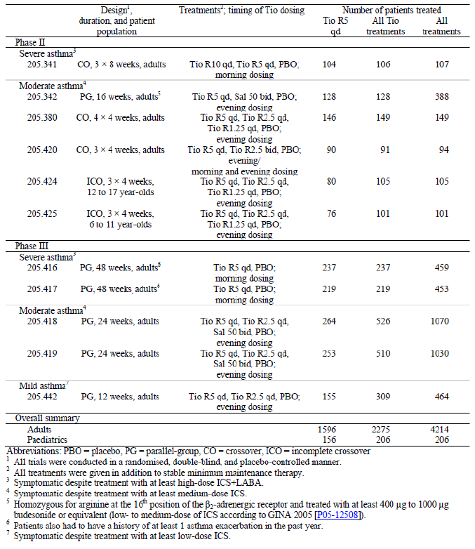
- Clinical pharmacology studies: The pharmacokinetic (PK) profile of tiotropium inhaled via the Respimat was previously addressed in the clinical development programme for Spiriva Respimat in COPD. For the purposes of this submission package, the PK parameters of tiotropium in patients with asthma have been assessed in two Phase II trials in adults (205.420 and 205.380), four Phase III studies in adults (205.416, 205.417, 205.418, and 205.419), and one Phase II trial in adolescents (205.424)
- The Phase II clinical programme included a total of six Phase II trials: two proof of concept trials in adults (205.341 and 205.342), one dose ranging trial in adults (205.380), one dosing regimen trial in adults (205.420), and two dose ranging trials in paediatric patients (205.424 and 205.425)
- Metanalysis of non compartmental PK parameters across various tiotropium trials in the asthma program and comparison to COPD indication (U13-1604)
- five pivotal Phase III studies were completed in adults (205.416, 205.417, 205.418, 205.419, 205.442)
- Safety Studies 205.452 and 205.458 in COPD patients.
- other, for example, pooled analyses, meta analyses, PSURs, Integrated Summary of Efficacy, Integrated Summary of Safety, etcetera.
- Module 5 structure: Both the TOC and tabs indicate to which change requested the data corresponds to, that is, the indication in asthma (‘Asthma’) or the two new studies addressing the safety concern (abbreviated to ‘TIOSPIR’ for simplicity). The TOC indicates to which product the data refers, that is, Spiriva Respimat/Favint Respimat, Spiriva/Favint (capsules), or both.
Throughout this report (and similar to the submitted dossier), treatment groups are described using the terminology Tio R1.25 (which refers to 1.25 μg tiotropium administered as two actuations of 0.625 μg), Tio R2.5 (which refers to 2.5 μg tiotropium administered as two actuations of 1.25 μg), Tio R5 (which refers to 5 μg tiotropium administered as two actuations of 2.5 μg), and Tio R10 (which refers to 10 μg tiotropium administered as two actuations of 5 μg), with the terms qd and BD used to indicate once daily or twice daily dosing, respectively. It should be noted that in most trials in the programme, tiotropium was administered qd. Unless specifically mentioned, all data should be assumed to be taken from the qd treatment group. It should be noted that all treatments given during the clinical development programme of tiotropium in asthma were given in addition to maintenance ICS therapy.

Paediatric data
A Paediatric Investigational Plan (PIP; EMEA-000035-PIP02-09) was submitted to the Paediatric Committee (PDCO) in November 2009. The PDCO issued a D60 Request for Modification in February 2010. The PIP, which contains seven paediatric studies (five of which [205.443, 205.444, 205.445, 205.446, and 205.456] have been deferred) was agreed upon in January 2013. In May 2013, the PDCO issued a positive opinion on PIP compliance for completed Paediatric Trials 205.424 and 205.425.
The submission contained the 2 Phase II studies 205.424 (12-17y) and 205.425 (6-11y) that were completed at the time of the submission. The sponsor requested a deferral for ages one to 17 yrs until the deferred paediatric studies are completed and the safety and efficacy in adult patients with asthma is determined. Waiver for ages less than one yr was requested on the grounds that Spiriva Respimat as a long acting inhalation drug product does not represent a meaningful therapeutic benefit over existing therapies for paediatric patients in this age group and is not likely to be used by a substantial number of paediatric patients in that age group.

Good clinical practice
All trials were performed according to the Declaration of Helsinki, the International Conference on Harmonisation (ICH) Good Clinical Practice, and the respective national regulatory requirements.

Pharmacokinetics

Studies providing pharmacokinetic data
For the purposes of this submission package, the PK parameters of tiotropium in patients with asthma have been assessed in two Phase II trials in adults, four Phase III studies in adults (205.416, 205.417, 205.418, and 205.419), and one Phase II trial in adolescents (205.424; 12 to 17 yr olds). Table 2 summarises the trials and the doses tested as part of PK evaluation.

Table 2: Summary table of completed trials including pharmacokinetic evaluation in patients with asthma
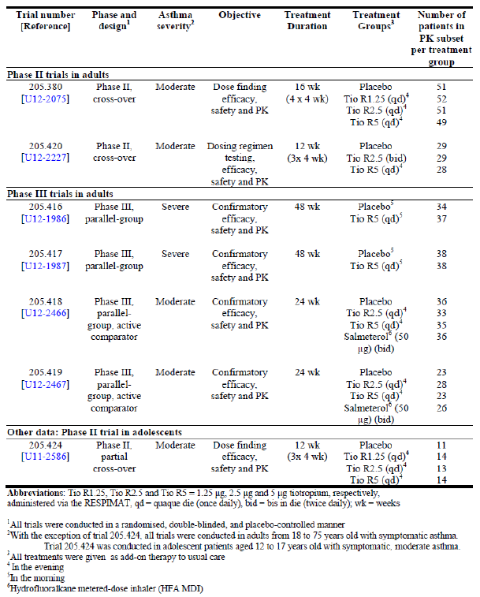
Table 3 (below) shows the studies relating to each PK topic and the location of each study summary.

Table 3: Submitted pharmacokinetic studies
PK topic | Subtopic | Study ID
PKs in healthy subjects | Not submitted in this dosser | None
PK in special populations | Target population § Single dose | None
PK in special populations | Multi dose | 205-380  205-420
PK in special populations | PK analysis in subsets of Phase III studies | 205.416  205.417  205.418  205.419
PK in special populations | Hepatic impairment | None
PK in special populations | Renal impairment | None
PK in special populations | Neonates/infants/children/adolescents | 205-424
PK in special populations | Elderly | None
PK in special populations | {Other special population} | None
Genetic/gender related PK | Males versus. females
Genetic/gender related PK | {other genetic variable}
PK interactions | Not submitted in this dossier | None
Population PK analyses | Healthy subjects | None
Population PK analyses | Target population Pooled PK data from  Studies 205.380/ 420/416/ 417/ 418/419.
* Indicates the primary aim of the study. † Bioequivalence of different formulations.§ Subjects who would be eligible to receive the drug if approved for the proposed indication.
None of the PK studies had deficiencies that excluded their results from consideration.

Summary of pharmacokinetics

Pharmacokinetics in healthy subjects
No new PK studies were submitted in healthy subjects. The following information is based on the submission for COPD.

Absorption

Sites and mechanisms of absorption
Following inhalation via the Respimat inhaler, approximately 40% of the dose is deposited in the lungs, the target organ. Urinary excretion data suggests that approximately 33% of the dose reaches the systemic circulation (Tiotropium Respimat clinical summary for COPD).

Bioavailability

Absolute bioavailability
Following inhalation in young healthy volunteers (HVs), the absolute bioavailability of 19.5% suggests that the proportion reaching the lung is highly bioavailable. The bioavailability is the apparent bioavailability, which is dependent upon the amount of tiotropium that is effectively inhaled. Following inhalation by young HVs, urinary excretion data suggests that approximately 33% of the inhaled dose reaches the systemic circulation. This was confirmed in a study in young HVs, with a low bioavailability of 2 to 3% for oral solutions. Maximum tiotropium plasma concentrations were observed five to minutes (mins) after inhalation.

Bioequivalence of clinical trial and market formulations
Tiotropium Respimat consists of an aqueous solution delivered via the Respimat inhaler. Neither the physico chemical characteristics nor the composition of the tiotropium Respimat formulation was changed throughout the entire asthma clinical development programme or since the last submission for COPD. The clinical doses of 1.25 μg, 2.5 μg, 5 μg, and 10 μg (ex mouthpiece, calculated as the free cation) used during this clinical programme were achieved by two actuations from the 0.625 μg, 1.25 μg, 2.5 μg, or 5 μg solutions for inhalation, respectively.
Comment: It is important to note that Respimat formulation of tiotropium was evaluated for the COPD indication but is still not being marketed in Australia (due to withdrawal by the sponsors in 2010).

Bioequivalence of different dosage forms and strengths
In the Phase II, crossover Study 205.458 involving 154 COPD patients, exposure to tiotropium following oral inhalation of 5 μg tiotropium solution delivered by the Respimat Inhaler (Tio R 5) was lower compared to oral inhalation of tiotropium 18 μg delivered by the HH (Tio HH18) and bioequivalence was not shown between the Tio R5 and Tio HH18 formulations.

Influence of food
Due to low systemic absorption, food is not expected to influence the absorption of tiotropium.

Distribution
Tiotropium was found to have 72% plasma protein binding and a steady state (SS) volume of distribution of 32 L/kg in HVs. After attainment of SS, tiotropium plasma concentrations decline very rapidly in a multi exponential manner. Local concentrations in the lung are not known, but the mode of administration suggests substantially higher concentrations in the lung than in plasma. Studies in rats showed that tiotropium does not penetrate the blood brain barrier to a relevant extent.

Metabolism

Sites of metabolism and mechanisms / enzyme systems involved
Metabolism does not occur to any great extent in young HVs, as indicated by 74% renal excretion of unchanged drug after an intravenous dose. The major metabolic pathway is non enzymatic ester cleavage to the alcohol N-methylscopine and dithienylglycolic acid that are inactive on muscarinic receptors.
In studies in animals and in vitro experiments with human liver microsomes and hepatocytes, minor amounts of a variety of glutathione conjugates, after oxidation of the thiophene rings, were observed. In vitro studies in human liver microsomes revealed that the enzymatic pathway, relevant for only a small amount of tiotropium metabolism, can be inhibited by cytochrome P450 (CYP450) 2D6 inhibitor quinidine and CYP 3A4 inhibitors ketoconazole and gestodene. Tiotropium, even in supra therapeutic concentrations, does not inhibit CYP 1A1, 1A2, 2B6, 2C9, 2C19, 2D6, 2E1 or 3A in human liver microsomes.

Metabolites identified in humans

Active metabolites
The major metabolic pathway is non enzymatic ester cleavage to the alcohol N-methylscopine and dithienylglycolic acid that are inactive on muscarinic receptors.

Excretion

Routes and mechanisms of excretion
In healthy young volunteers, total clearance was 880 ml/min after intravenous dosing. Intravenously administered tiotropium bromide is mainly excreted unchanged in urine (approximately 74%). After inhalation of a solution formulation, urinary excretion was 20.1 to 29.4% of the dose. The renal clearance of tiotropium exceeds the creatinine clearance (CLCR), indicating active secretion into the urine.

Mass balance studies
No new studies were submitted in this dossier.

Renal clearance
After an intravenous dose, 74% of unchanged drug is eliminated by renal excretion.

Pharmacokinetics in the target population

PKs in asthma patients
The PK of tiotropium was evaluated in a subset of patients in six trials in adults with moderate asthma [Phase II Studies 205.380/ 420 and Phase III Studies 205.418/ 419] or severe asthma (205.416/ 417). One trial in adult patients with moderate asthma (205.441) comparing 2.5 μg twice daily (BD) to 5 μg once daily (qd) is currently ongoing and the data from this trial were not provided in this submission.
Furthermore, PKs was also evaluated in two trials in paediatric patients (205.424/ 425). Doses of 1.25 μg, 2.5 μg, 5 μg and 10 μg tiotropium bromide were tested in various trials in the asthma development programme. Following results from the proof of concept trial (Trials 205.341 and 205.342), the 10 μg dose was not included in later Phase II and Phase III studies within the clinical development programme in asthma. However, PKs of tiotropium were not evaluated in trials 205.341 and 205.342.

PK results of individual studies
Tiotropium was rapidly absorbed following single and multiple inhalations of Tio R1.25, Tio R2.5 and Tio R5 in the Phase II dose finding, safety, efficacy and PK Study 205-380 in patients with moderate asthma still symptomatic on medium dose ICS. Median t_{max,ss} values ranged from 0.0720 hours (hrs)to 0.196 hrs (4.3 to 11.8 mins) and 0.0830 hrs to 0.114 hrs (5 to 6.8 mins) following single and multiple dosing, respectively. An at least bi exponential decline in plasma profile was observed following multiple dosing. On an average, 4.79% to 7.41% of the tiotropium dose was excreted unchanged in the urine over 24 hrs following the inhalation of a single (first) dose of tiotropium. At SS, an average of 10.6% to 11.3% of the dose was excreted unchanged in the urine over 24 hrs post dose. Administration of multiple doses (MDs) of tiotropium did not result in accumulation based on C_{max} and AUC_{00.5} values. However, there was approximately 2 to 2.6 fold accumulation based on Ae₀₋₂₄ values. A slightly less than dose proportional increase was observed for the geometric mean C_{max(,ss)} and AUC values. In contrast, dose proportional behaviour was observed for fe_{0-24(,ss)} values. The renal clearance (geometric mean 162 mL/min to 254 mL/min) of tiotropium was higher than the CLCR, indicating active secretion into the urine.
The Phase II dosing regimen testing, efficacy, safety and PK Study 205-420 in patients with moderate asthma still symptomatic on medium dose ICS also showed that tiotropium was rapidly absorbed following inhalation. Following the administration of a single dose, t_{max} was achieved approximately two to six min (median) post dosing. At steady state (SS), t_{max,ss} was achieved approximately five to six mins (median) post dosing. At SS, the total exposure was comparable between Tio R2.5 BD and Tio R5 qd treatments based on Ae_{0-24,ss} and AUC_{0-24,ss} values . The C_{max} values (C_{max,2}, C_{max,ss,2}) observed following the administration of a dose (single dose or at SS) of 2.5 μg in the morning appeared to be slightly higher (29% and 14%, respectively) than after the evening dose (C_{max}, C_{max,ss}). The total exposure over the 12 hr dosing interval based on a comparison of AUC_{0-τ,ss,2} and AUC_{0-τ,ss} values was similar between the morning and evening doses. Approximately two fold accumulation was observed following dosing to SS with Tio R5 qd. With the Tio R2.5 BD regimen, there was less than two fold accumulation based on C_{max} and AUC_{0-0.5} values and about four fold accumulation based on 24 hr urinary excretion.
Comment: Unexpected PK plasma profiles were observed at SS (that is, after four weeks (weeks) administration of Tio R5 qd or Tio R2.5 BD) for six of the 30 patients in the PK subset. The unexpected profile for five out of these six patients consisted of a profile consistent with BD administration although tiotropium had to be administered only qd. One patient had a profile consistent with qd administration although tiotropium had to be administered BD. The sponsors state that the unexpected findings were evaluated in detail, and it was concluded that they do not affect the robustness of the PK characterisation of tiotropium in asthma patients in this study. However, 20% of the patients were administered the study drug incorrectly and the CSR does not clarify if the PK analysis was done after excluding these patients. A question regarding this has been asked in section 12 of this report.
In a subset of 71 patients with severe asthma in the Phase III Study 205-416, Tio R5 was rapidly absorbed following oral inhalation with a median t_{max,ss} of four to five mins post dosing. Tiotropium plasma concentrations were below the lower limit of quantification (LLOQ) (2.5 pg/mL) at 24 hrs post dose following administration of an single dose and at SS in most patients. Approximately 5.35% and 11.3% of the administered dose was excreted unchanged in the urine over 24 hrs (fe_{0-24(,ss)}) post dosing following the inhalation of an sd (first dose) and at SS, respectively. Dosing to SS resulted in slight accumulation with 1.45 fold higher C_{max} values, 1.62 fold higher AUC_{0-0.5} values and 2.25 fold higher Ae₀₋₂₄ as compared with an single dose. Similar results were observed in the PK subset of 76 patients with severe asthma in Phase III Study 205-417.
In the confirmatory Phase III, efficacy, safety and PK study in 140 patients with moderate asthma (Study 205-418), tiotropium was rapidly absorbed following oral inhalation with a median t_{max,ss} of approximately five mins post dosing following administration of the first dose (that is,) and at SS. The exposure to tiotropium increased in a dose proportional manner between the 2.5 and 5 μg doses. PK SS was reached at the latest by seven days following the start of dosing. Overall, an average of 4.57 to 5.32% of the dose following the administration of the first dose and an average of 15.7 to 16.0% of the dose following the administration of MDs (after four weeks) to SS was excreted unchanged in urine within 24 hrs post dose. Dosing to SS resulted in approximately 1.2 fold higher C_{max}, 1.24 to 1.45 fold higher AUC_{0-0.5}, but 2.89 to 3.51 fold higher Ae₀₋₂₄ values compared to the values found after the first (single) dose. The geometric mean terminal elimination half life ranged between 34.5 to 47.3 hrs. Similar PK results were observed in the PK subset of 100 patients in the other identical confirmatory Phase III study in patients with moderate asthma (205-419).
Comment: Based on Ae₀₋₂₄ data, dosing with Tio R5 to SS resulted in 2.2 to 2.9 fold accumulation in patients with moderate/ severe asthma.

PKs in new COPD study
The primary objective of the Phase II, crossover Study 205.458 involving 154 COPD patients was to compare the PK of 5 μg tiotropium solution for inhalation delivered by the Respimat Inhaler (Tio R5) with tiotropium powder for inhalation 18 μg delivered by the HH. The exposure to tiotropium following the use of Tio R5 was lower compared to Tio HH18. Using the parameters AUC_{0-6,ss} and C_{max,ss,} bioequivalence was not established between Tio R5 and Tio 18 HH. The ratio of AUC _{0-6,ss} (Tio R5/ Tio HH18) was 75.99% (90% confidence interval (CI) of (70.44, 81.98)). The ratio of C_{max,ss} was 80.66% (90% CI: 73.49, 88.52). The shape of the plasma concentration time profile of tiotropium following inhalation via HH and Respimat devices was similar. Tiotropium was rapidly absorbed following inhalation via the two devices with a median t_{max,ss} value ranging between five to seven mins post dosing. The plasma profile and amount excreted in the urine following inhalation via the HH was higher than all doses of Respimat. Based on plasma and urinary PK parameters, exposure to tiotropium following inhalation via the Respimat device did not appear to deviate relevantly from dose proportionality. The C_{pre,ss} values were 6.43% lower for Tio R5 compared to Tio HH18. The amount of tiotropium excreted in urine over six hrs post dosing was 25.86% lower for Tio R5 compared to Tio HH18. Hence, the urinary excretion data supported the primary exposure conclusions based on AUC_{0-6,ss}. The renal clearance of tiotropium estimated over the six hrs post dose at SS (CLR,_{0-6,ss}) was high and the average values ranged between 256 to 310 mL/min for the various treatment groups.

Comparison and analysis of PK results across studies

Study U13-1604
Study U13-1604 was a meta analysis of non compartmental PK parameters across various tiotropium trials in the asthma programme and comparison to COPD indication and analysed 489 patients (276 asthma patients and 213 COPD patients). The main objectives of this meta analysis were to identify best estimates of standard PK parameters for tiotropium in patients with asthma, to describe the effect of intrinsic and extrinsic factors on drug exposure and to compare the PK of tiotropium between COPD patients and patients with asthma.
Despite advancements in the bioanalytical methodologies for the analysis of tiotropium in plasma which have resulted in an improved LLOQ, there is a bioanalytical limitation in computing parameters such as AUC for the entire dosing interval of 24 hrs post inhalation in some patients. It is known that approximately 74% of an intravenous dose of tiotropium is excreted unchanged in the urine over 24 hrs post dosing. Given the high urinary excretion, the measurement of tiotropium concentrations in urine is not as challenging as in plasma. Hence, the urinary excretion of tiotropium was used as a surrogate for total exposure to tiotropium to supplement the AUC data. The parameters fet_{1-t1,ss} (fraction of dose excreted unchanged in the urine between time t1 and t2 at SS) and C_{max,ss} (maximum concentration of tiotropium in plasma at SS) were considered as the primary parameters in these assessments as indicators of total and peak exposure. Data from other parameters such as AUC_{t1-t2} were provided as secondary supporting parameters, wherever appropriate.
PK parameters of tiotropium were compared in patients with asthma and COPD, because the management of COPD is the only currently approved indication for tiotropium Respimat and a vast amount of tiotropium safety data is available in this indication.
Although data derived from two separate programmes was used for the comparison, the trials were run around the same time and used the same bioanalytical precision (LLOQ in plasma of 1.0 pg/mL). An exception to this was the data from Trials 205.416 and 205.417 in severe asthma and Trials 205.249 and 205.250 in COPD which had bioanalytical method with a LLOQ in plasma of 2.5 pg/mL. Data from a total of 489 patients (213 COPD patients, 201 moderate asthma patients and 75 severe asthma patients) was available for this comparison.
Comment: It should be noted that patients with COPD inhaled tiotropium in the morning, whereas most trials in the asthma programme involved evening dosing of tiotropium, except for Trials 205.416 and 205.417 where tiotropium was dosed in the morning. However, the PK of tiotropium was not found to be influenced by morning or evening administration in asthma patients in Trial 205.420.
The geometric mean tiotropium plasma concentration time profiles at SS following administration of Tio R2.5 have been compared between patients with COPD and moderate asthma in Figure 1.
Figure 1: Geometric mean tiotropium plasma concentration time profiles following multiple inhaled administrations to steady state of Tio R2.5 compared by indication (semi log scale)
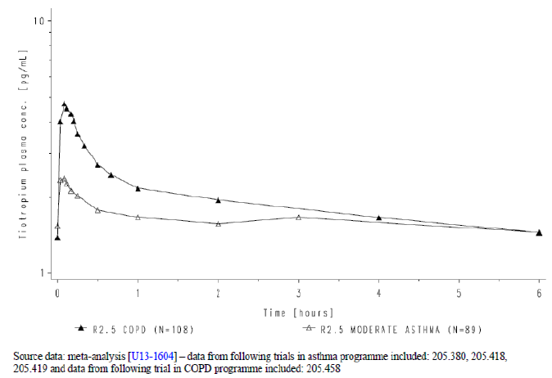
These figures were truncated at six hrs post dose because plasma concentration data are not available beyond six hrs post dosing in patients with COPD following Respimat administration. Key exposure parameters for Tio R2.5 have been summarised in Table 4.

Table 4: Overall summary descriptive statistics of dose normalised pharmacokinetic parameters of tiotropium following administration of Tio R2.5 compared by indication
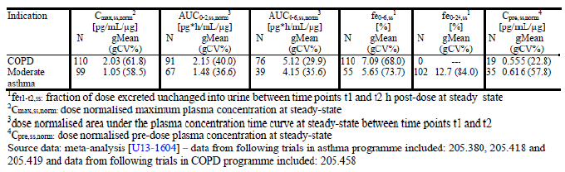
Similarly, geometric mean tiotropium plasma concentration time profiles at SS following administration of Tio R5 to patients with COPD, moderate asthma and severe asthma have been displayed in Figure 2 and key exposure parameters have been summarised in Table 5.
Figure 2: Geometric mean tiotropium plasma concentration time profiles following multiple inhaled administrations to steady state of Tio R5 compared by indication (semi log scale)
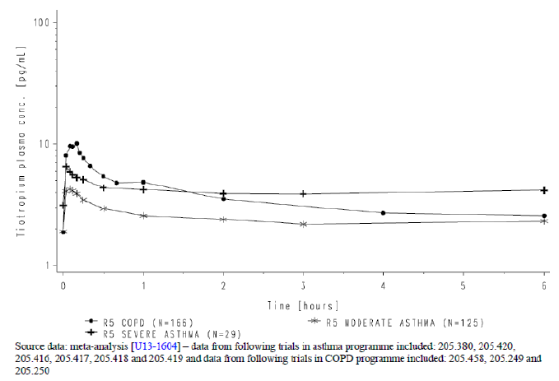

Table 5: Overall summary descriptive statistics of dose normalised pharmacokinetic parameters of tiotropium following administration of Tio R5 compared by indication
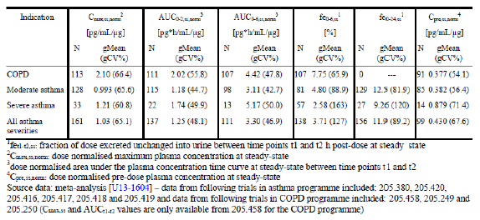
The C_{max,ss,norm} value in patients with asthma was between 42% to 53 % lower than patients with COPD) although there was no difference in the t_{max,ss} between asthma and COPD. The total exposure in patients with asthma based on AUC_{0-2,ss,norm} was approximately 14% to 42% lower than in patients with COPD. The total exposure in patients with asthma based on AUC_{0-6,ss,norm} ranged from comparable (severe asthma) to 30% lower (moderate asthma) than in patients with COPD. However, due to limited data, comparison of AUC_{0-6,ss,norm} values based on severe asthma should be interpreted with caution.

Compared to patients with COPD, the fraction of dose excreted unchanged in urine over six hrs post dose was 52% lower (between 20% to 38% lower in patients with moderate asthma and 67% lower in patients with severe asthma). At SS, 11.9% of the dose (595 ng) was excreted unchanged in the urine over 24 hrs post dosing in patients with asthma. Corresponding 24 hr data is not available from COPD patients for a comparison to asthma. In addition to a higher peak and higher total exposure to tiotropium, the plasma concentration in COPD patients continues to decline comparatively more rapidly between one to six hrs post dosing. In contrast, the profile in asthma patients appears to be more flat during this time (Figures 1 and 2).
Comment: Although there are limitations in correlating exposure (based on plasma and urine data) of a locally acting drug such as tiotropium to lung function improvement, exposure to tiotropium is considered as a predictor of its safety profile. Hence, the PK evaluation was intended to assess whether the exposure to tiotropium in asthma is in the range of what is known in COPD and to further support its safety evaluation in asthma. The sponsors claim that the slightly lower exposure observed in asthma patients compared to those with COPD (based on C_{max}, AUC_{0-2hss}, norm and AUC_{0-6hnorm}) is not likely to raise additional safety concerns than those already known in COPD appears to be justified although interpretation may have been limited by smaller number of patients with severe asthma.

Dose proportionality
PK parameters obtained from six trials in adult asthma patients (205.380, 205.420, 205.416, 205.417, 205.418 and 205.419) were combined to assess dose proportionality. PK data was available from three doses during the clinical development of tiotropium Respimat in asthma, that is, Tio R1.25, Tio R2.5 and Tio R5. The number of patients from whom data was available for each parameter under comparison is shown in Table 4. Based on a graphical representation of various PK parameters by dose (fe_{0-24,ss,} C_{max,ss,norm}) the data does not appear to meaningfully deviate from a dose proportional behaviour.
Due to bioanalytical limitations, PK data for secondary parameters, that is, AUC_{0-6,ss,norm} and AUC_{0- τ,,ss,norm} for the 1.25 μg dose was only derived from the dose ranging Trial 205.380 in patients with moderate asthma. Furthermore, the plasma concentrations of tiotropium were very close to the LLOQ [(2.5 pg/mL in studies 205.416 and 205.417) and 1.0 pg/mL in all other trials in the asthma programme]. The AUCs computed over short duration post inhalation (for instance AUC_{0-0.5,ss,norm}) can be expected to be influenced by the C_{max,ss} and hence are not desirable for comparisons of total exposure. There are insufficient AUC estimates available for the Tio R1.25 dose group for this comparison whereas it was not possible to compute AUC over the dosing interval, that is, 24 hrs for majority of patients in the Tio R2.5 dose group. Given that the AUC estimates cannot be made for patients with low exposure, the reported AUC estimates can be considered as slight overestimations. As a result, the dose normalised geometric mean values of AUCs are slightly higher for the Tio R2.5 than Tio R5 dose group. However, based on fe_{0-24,ss} and C_{max,ss} data, which are not expected to be influenced by such bioanalytical limitations, dose proportionality of tiotropium was shown in the dose range of 2.5 to 5µg. The dose proportional behaviour observed in asthma patients was in accordance with what is known from the clinical development in COPD.

Pharmacokinetics in other special populations

Pharmacokinetics in subjects with impaired hepatic function
Hepatic insufficiency is not expected to have a relevant influence on the PK of tiotropium as tiotropium is predominantly cleared by renal elimination and non enzymatic ester cleavage to pharmacologically inactive products. However, Spiriva Respimat was not specifically tested in asthma patients with impaired hepatic function.

Pharmacokinetics in subjects with impaired renal function
In the tiotropium PK subset of the asthma programme, there were 227 patients with normal renal function, 69 patients with mild renal impairment. There were only two patients in the PK subset with moderate renal impairment and none with severe renal impairment. Hence descriptive statistics could not be presented for the latter two categories. Based on a comparison of geometric mean values, mild renal impairment resulted in a 28% decrease in fe_{0-24,ss}, a 27% increase in C_{max,ss} as well as 20% increases in AUC_{0-6,ss} and AUC_{0-τ,ss} values compared to asthma patients with normal renal function. However, these parameters are comparable between patients with normal and mild renal function within the range of variability. Given that insufficient (moderate renal impairment) or no (severe renal impairment) data was available for other categories in the asthma programme, data generated in patients with COPD should be referred to for estimating the effects of moderate and severe renal impairment.
Mild renal impairment (CLCR 50 to 80 ml/min), which is often seen in elderly patients, increased tiotropium plasma concentrations slightly (39% increase in AUC₀₋₄ after intravenous infusion) in COPD patients. In COPD patients with moderate (CLCR 30 to 50 mL/min) to severe renal impairment (CLCR < 30 ml/min), the intravenous administration of tiotropium bromide resulted in doubling of the plasma concentrations (AUC_{0-4h} increased 81% in patients with moderate renal impairment and 94% in patients with severe renal impairment), which was confirmed by plasma concentrations after inhalation via HH.
Comment: There is no evaluation of tiotropium PKs in asthma patients with moderate/ severe renal impairment, but similar precautions and close monitoring in patients with moderate to severe renal impairment (CLCR of < 50 mL/min) is essential.

Pharmacokinetics according to age
Pooled PK data from asthma patients was divided into two age categories, that is, 18 to < 65 yrs and 65 to < 75 yrs. Based on a comparison of C_{max,ss,norm}, AUC_{0-τ,ss,norm} and fe_{0-24,ss} values between the two age categories, exposure was not found to differ by the age of patients.
Advanced age is associated with a decline in tiotropium renal clearance which may be explained by decreased renal function. Tiotropium excretion in urine after inhalation was 14% in healthy young volunteers (age range: 24 to 42 yrs) and 7% in COPD patients (age range: 39 to 85 yrs), however plasma concentrations did not change significantly with advancing age within COPD patients.
In the randomised, placebo (placebo) controlled, double blind, incomplete crossover design Study 205-424 involving adolescent (11 to 17 yrs) asthma patients, tiotropium was rapidly absorbed with a median t_{max,ss} ranging between four to six mins post dose. The PK of tiotropium was found to be dose proportional at SS and a PK SS was reached at the latest by Day 26 following the start of dosing. Dosing to SS resulted in up to 3.97 fold accumulation.
Comment: The current submission is focussed on adult patients with asthma. Although results of Study 205.424 in adolescents are briefly described above, there was no comparison of this data with adult data. The clinical development of tiotropium in paediatric asthma patients is currently ongoing and the PK in this population will be described as part of a paediatric submission in the future.

Pharmacokinetics in other special population

Influence of asthma severity on PKs of tiotropium
The geometric mean fraction of tiotropium dose excreted unchanged in the urine over six and 24 hrs post dosing at SS was 49.6% and 24.7% lower, respectively, for severe compared to moderate asthma. However, the fractions excreted were comparable between the severities within the range of the variability. The C_{max,ss} value was comparable between patients with moderate and severe asthma. The AUC_{0-6,ss,norm} value was 32.5% higher for severe compared to moderate asthma patients, but results should be interpreted with caution due to small number of patients evaluated (AUC_{0-6,ss,norm} was analysed in 13 and 141 patients with severe and moderate asthma, respectively).

Influence of the post bronchodilator percentage predicted forced expiratory volume in 1 second (FEV₁) from the screening visit on PKs of tiotropium
The geometric mean C_{max,ss,norm} and fe_{0-24,ss} values as well as variability associated with these values were comparable between the three categories tested, that is, post bronchodilator percentage predicted FEV₁ < 60%, ≥ 60 to < 80% and ≥ 80%. The geometric mean AUC_{0-6,ss,norm} value in patients with FEV_{1%} value ranging between ≥ 60% and < 80% was between 15 to 26% higher than patients with FEV_{1%} value ≥ 80%. Patients with FEV_{1%} value < 60% had a 84% higher geometric mean AUC_{0-6,ss,norm} compared to patients with FEV_{1%} ≥ 80%. However, the geometric mean AUC_{0-6,ss,norm} value in patients with FEV_{1%} value < 60% was only based on data from five patients and should be interpreted with caution. Overall, the AUC_{0- 6,ss,norm} was comparable between the three categories, especially after considering the variability associated with the values.
Overall, various intrinsic factors tested (sex, age, race, smoking categories, body weight, height, body surface area (BSA)concomitan, body mass index (BMI), renal function, asthma severity, lung function) did not appear to influence the PKs of tiotropium in the asthma programme.
In Study 205-417 following the administration of a single dose, the geometric mean C_{max.ss} values were 1.78 fold higher and AUC_{0-0.25} values were 1.86 fold higher in the Japanese patients compared to White patients. However, the total amount excreted unchanged in urine over 24 hrs post dosing of single dose was similar between the two races. At SS, the geometric mean C_{max,ss} values were 2.05 fold higher, AUC_{0-0.25,ss} values were 2.24 fold higher, and Ae_{0-24,ss} values were 4.90 folds higher in the Japanese patients compared to White patients. However, interpretation was limited as the values indicate a strong overlap of individual values between the races.

Pharmacokinetic interactions
No new DDI studies in healthy subjects were provided in this submission.
Use of common concomitant medications (extrinsic factors – long acting beta2 agonists (LABAs), inhaled corticosteroid LABA combinations, oral corticosteroids (OCS) and leukotriene modifiers) by patients with asthma was not found not to alter the exposure to tiotropium in the asthma programme.
Comment: The co administration of tiotropium bromide with other anticholinergic containing drugs has not been studied and therefore is not recommended.

Evaluator’s overall conclusions on pharmacokinetics
The PKs of tiotropium following oral inhalation via Respimat was already evaluated in the earlier submission for COPD. Hence, this section mainly summarises PK results in asthma patients and the comparison of PKs by indication (asthma versus COPD).

PKs in asthma patients
At steady state, a tiotropium peak plasma concentration of 5.15 pg/mL was attained five mins following the administration of 5 μg to patients with asthma. After chronic qd inhalation by patients with asthma, PK SS was reached at the latest by Day 7 with no accumulation thereafter, which was similar to that observed in COPD patients. At steady state, following inhalation of the 5 μg dose by patients with asthma, approximately 595 ng (11.9% of the dose) is excreted unchanged in the urine over 24 hrs post dose. At steady state, a tiotropium peak plasma concentration of 5.15 pg/mL was attained five mins following the administration of 5 μg to patients with asthma. The effective half life of tiotropium following inhalation by patients with asthma was estimated based on accumulation ratio as shown by the formula in Figure 3. It was not possible to estimate the AUC over the entire dosing interval and hence effective half life was estimated based on a ratio of urinary excretion over 24 hrs over SS and single dose. For the Tio R5 dose, the accumulation ratio based on 24 hr urine data was 2.56.
Figure 3: The effective half-life of tiotropium following inhalation by patients with asthma was estimated based on accumulation ratios using the following formula
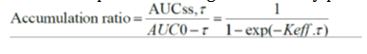

Bioequivalence between Respimat and Handihaler tiotropium formulations
The Phase II, crossover Study 205.458 involving 154 COPD patients compared the PKs of 5 μg tiotropium solution for inhalation delivered by the Respimat Inhaler (Tio R5) with tiotropium powder for inhalation 18 μg delivered by the HH. The exposure to tiotropium following the use of Tio R5 was lower compared to Tio HH18. Using the parameters AUC_{0-6,ss} and C_{max,ss,} bioequivalence was not established between Tio R5 and Tio 18 HH. The ratio of AUC _{0-6,ss} (Tio R5/ Tio HH18) was 75.99% (90% CI of (70.44, 81.98)). The ratio of C_{max,ss} was 80.66% (90% CI: 73.49, 88.52). The shape of the plasma concentration time profile of tiotropium following inhalation via HH and Respimat devices was similar. Tiotropium was rapidly absorbed following inhalation via the two devices with a median t_{max,ss} value ranging between five and seven mins post dosing. The plasma profile and amount excreted in the urine following inhalation via the HH was higher than all doses of Respimat.

Comparison of tiotropium PKs in asthma versus COPD patients
Tiotropium PK parameter estimates across asthma trials were compared to COPD patients because the management of COPD is the only currently approved indication for tiotropium Respimat and a vast amount of tiotropium safety data is available in this indication. Although there are limitations in correlating exposure (based on plasma and urine data) of a locally acting drug such as tiotropium to lung function improvement, exposure to tiotropium is considered as a predictor of its safety profile. Hence, the PK evaluation was intended to assess whether the exposure to tiotropium in asthma is in the range of what is known in COPD and to further support its safety evaluation in asthma. Patients with asthma had approximately 50% lower peak and total exposure but same t_{max,ss} to tiotropium compared to patients with COPD. Also the plasma concentrations of tiotropium appeared to decline comparatively more rapidly between one to six hrs post dosing in patients with COPD compared to patients with asthma. In contrast, the profile in patients with asthma appears to be more flat during this time. This is potentially a result of different absorption profiles of tiotropium between patients with asthma and COPD.

Dose proportionality
PK parameters obtained from six trials in adult asthma patients (205.380, 205.420, 205.416, 205.417, 205.418 and 205.419) were combined to assess dose proportionality. PK data was available from three doses during the clinical development of tiotropium Respimat in asthma, that is, Tio R1.25, Tio R2.5 and Tio R5 and based on a graphical representation of various PK parameters by dose (fe_{0-24,ss}, C_{max,ss,norm}) the data does not appear to meaningfully deviate from a dose proportional behaviour.

Effect of intrinsic factors on PKs of tiotropium
In common with all other drugs that undergo predominantly renal excretion, renal impairment was associated with increased tiotropium plasma drug concentrations and reduced renal clearance. Mild renal impairment was not found to relevantly influence the exposure to tiotropium in the asthma development programme. However, insufficient (moderate renal impairment) or no (severe renal impairment) data was available for other categories in the asthma programme. Hence, tiotropium should not be administered or only given with adequate precautions in asthma patients with moderate and severe renal impairment.
The effect of hepatic impairment on tiotropium PKs was not evaluated.
The PKs of tiotropium in the asthma programme was not found to be influenced by various intrinsic factors such as age, asthma severity and lung function. However, PK results in patients with severe asthma were difficult to interpret due to very small sample sizes compared to those with moderate asthma.

Drug interactions
Although no formal drug interaction studies have been performed, tiotropium bromide has been used concomitantly with other drugs commonly used in the treatment of COPD and asthma, including sympathomimetic bronchodilators, methylxanthines, oral and inhaled steroids, antihistamines, mucolytics, leucotriene modifiers, cromones, anti IgE treatment without clinical evidence of drug interactions. The co administration of tiotropium bromide with other anticholinergic containing drugs has not been studied and therefore is not recommended and this fact has been incorporated in the proposed PI.

Comments on PK section of proposed PI
Lack of information on tiotropium PKs in asthma patients with moderate/ severe renal impairment and due precautions/ close monitoring in these patients should be included in the proposed PI.

Pharmacodynamics

Studies providing pharmacodynamic data
No new pharmacodynamics (PD) studies were provided in this submission.

Summary of pharmacodynamics

Mechanism of action
Tiotropium is a long acting, specific antimuscarinic (anticholinergic) agent. It has similar affinity to the muscarinic receptor subtypes M1 to M5 (KD 5-41 pM). In the airways, inhibition by tiotropium of M3 receptors at the smooth muscle results in relaxation. The competitive and reversible nature of antagonism was shown with human and animal origin receptors. In non clinical in vitro as well as in vivo studies, bronchoprotective effects were dose dependent. Bronchoprotective effects lasting at least 24 hrs were observed in some of the in vivo studies. Tiotropium exhibited a significantly longer dissociation half life from M3 receptors than ipratropium. Tiotropium, a N-quaternary anticholinergic agent, is topically (broncho) selective when administered by inhalation. The high potency (IC50 approximately 0.4 nM for M3) and slow receptor dissociation is associated with a significant and long acting bronchodilation in patients with COPD and asthma. The bronchodilation following inhalation of tiotropium is primarily a local effect on the airways, not a systemic one.

Pharmacodynamic effects

Primary pharmacodynamic effects
The two ‘proof of concept’ trials in patients with severe (205.341) and moderate (205.342) asthma are discussed in section 6 of this report.
Tiotropium is one of the most widely used long acting bronchodilators worldwide for the treatment of COPD. Study 205.458 was a Phase II multicentre, randomised, placebo and active controlled, five way crossover trial to characterise the PKs and evaluate the bronchodilator efficacy and safety of qd tiotropium delivered (double blind) from the Respimat inhaler as solution for inhalation (1.25, 2.5, 5μg or placebo) and as inhalation powder (18 μg) from the HH (open label) after four week treatment periods in patients with COPD.
A dose response was observed with greatest bronchodilatation seen with Tio R5 followed by Tio R2.5 and lowest efficacy observed with Tio R1.25. Both 5 µg and 2.5 µg doses of tiotropium by Respimat were significantly better than placebo. Tio R5 was shown to be the most comparable dose to Tio HH18 in terms of FEV₁ AUC_{0-6h}, trough FEV₁, FEV₁ AUC_{0-3h}, forced vital capacity (FVC) AUC _{0-6h}, trough FVC, FVC AUC_{0-3h,} FEV₁ and trough FVC over time indicated a clear treatment difference between each active dose compared to placebo at all time points.
Although the Tio R1.25 dose has an adjusted arithmetic mean (mean) result below the other active doses at each time point, the Tio R2.5, Tio R5 and Tio HH18 doses were not well separated across all time points. Each Respimat dose was also compared to Tio HH18, although this was not a main objective and the study was not designed for these comparisons (due to Tio HH18 being open label). Tio R5 was shown to be the most comparable Respimat dose to Tio HH18 in terms of FEV₁ and FVC trough, AUC₀₋₆ and AUC₀₋₃. In comparison, Tio R1.25 provided significantly less bronchodilation compared to Tio HH18 in all endpoints. Tio R2.5 provided FEV₁ and FVC AUC₀₋₆ and AUC₀₋₃ values which were comparable to Tio HH18, although the mean FEV₁ and FVC values appeared notably lower than those for Tio HH18 in the first 60 mins post inhalation. The mean FEV₁ trough value for Tio R2.5 was significantly less than the mean for Tio HH18, while the mean FVC trough value was numerically less, although the difference was not statistically significant.

Secondary pharmacodynamic effects
There were no studies in asthma patients.
Study 205.458 evaluated effect of tiotropium given via Respimat on safety including electrocardiogram (ECG) intervals and Holter monitoring in 154 patients with COPD. Holter (arrhythmia) analysis showed that maximum and mean hazard ratios (HR) (evaluated over 6.5 hrs as well as by hourly intervals) were comparable between tiotropium Respimat doses, HH and placebo. There were no relevant differences across treatments regarding the number of patients with SVPB runs, pairs, and single premature beats as well the number of patients with VPB pairs and single premature beats assessed over 6.5 hrs and during the first hr after inhalation (when the highest plasma levels of tiotropium were observed).
More patients experienced VPB runs (including ventricular tachycardia, ideoventricular rhythm, and other events with at least three subsequent ventricular beats) on the higher dose levels of tiotropium (Tio R5: 10 patients, Tio HH18: nine patients) compared with the lower dose levels (Tio R1.25: five patients, Tio R2.5: four patients) or on placebo (three patients). None of the events was sustained (defined as extending over more than 30 seconds); the longest event had a duration of seven seconds. The median HR of the fastest VPB run as well as the median number of beats in the longest VPB run did not consistently differ between active treatments and placebo.

Evaluation of ECG intervals and heart rate
The analyses of the QT / QTcN and PR intervals as well as the QRS complex did not reveal any relevant effects associated with the tiotropium treatments as compared with placebo. All upper 90% confidence limits of the placebo corrected adjusted mean QTcN intervals between trough and 45 mins after inhalation were well below the threshold of 10 ms suggested by the ICH guideline E14.
The most frequent abnormalities across all treatments including placebo were ectopies (25.9 to 36.5%) and conduction defects (24.3 to 34.5%) followed by irregularities in rhythm and T wave abnormalities. Sinus tachycardia (defined as HR > 100 beats per minute (bpm) at any time point on treatment) seemed slightly more frequent on tiotropium (9.7 to 11.3%) compared with placebo (7.0%), irrespective of the dose level administered.
The mean values, however, of the endpoints ‘maximum HR evaluated over the entire 6.5 hr Holter monitoring period’ (109 to 110 bpm) as well as ‘mean HR evaluated over the entire 6.5 hr Holter monitoring period’ (77 to 78 bpm) were nearly identical for all active treatments and placebo. First degree AV block was more frequent on active treatment (18.3 to 20.7%) than on placebo (11.3%), but the effect was not dose dependent.
Comment: In view of a slightly lower systemic exposure of Tio R5 and comparable safety and bronchodilator efficacy of Tio R5 and Tio HH18, the results from Study 205.458 indicate that the currently marketed dose of Tio R5 is an optimal match to Tio HH18 for the maintenance therapy of patients with COPD. Evaluation of safety did not reveal differences between the formulations. No safety findings of clinical concern arose from the analysis of ECG intervals and Holter monitoring for Tio R1.25, Tio R2.5, Tio R5 and Tio HH18.

Relationship between drug concentration and pharmacodynamic effects
Correlating drug exposure to lung function improvement is limited by the fact that tiotropium is a locally acting drug and the investigation of the PK / PD relationship was not planned for study 205.458 in COPD patients. PK evaluation was intended to describe the PK in patients with asthma and serve as a surrogate for safety.

Genetic, gender and age related differences in pharmacodynamic response
In Phase II Study 205.341, it was planned to investigate in a subset of patients, whether patients with the B16 Arg/Arg genotype would profit from tiotropium as an additional treatment option. In total 87 patients consented on Visit 2 to have a blood sample drawn to participate in the genotyping subinvestigation. However, only six patients were available for subgroup analysis for the combination of interest (B16 Arg/Arg). Hence, the decision was taken to perform a sensitivity analyses on the remaining 81 patients to compare the result with the FAS population. The differences compared to placebo in this subgroup of patients with B16 Arg/Gly; Gly/Gly were slightly higher compared to the results of the primary endpoint in the FAS.
Comment: The above analysis did not provide any useful information as it could not address the question of whether patients with the B16 Arg/Arg genotype (n = 6 only) would profit from tiotropium as an additional treatment option due to very low patient numbers.

Evaluator’s overall conclusions on pharmacodynamics
There were no specific PD studies submitted in the current dossier. Results of the Phase II Study 205.458 in COPD patients showed that Tio R5 was shown to be the most comparable Respimat dose to Tio HH18 in terms of FEV₁ and FVC trough, AUC₀₋₆ and AUC₀₋₃, although this was not an objective of the study (due to open label HH). The Holter arrhythmia analyses in the same study did not suggest any clinically relevant untoward effects associated with the tiotropium Respimat (1.25, 2.5 and 5 µg) and HH (18 µg) treatments.

Dosage selection for the pivotal studies
The Phase II clinical programme included six trials: two proof of concept trials in adults (205.341 and 205.342), one dose ranging trial in adults (205.380), one dosing regimen trial in adults (205.420), and two dose ranging trials in paediatric patients (205.424 and 205.425).

Proof of concept trials: 205.341 and 205.342

Study 205.341

Study design, objectives, methodology
Study 205.341 was a Phase IIa, randomised, double blind, placebo controlled, three way cross over study to examine efficacy and safety of tiotropium compared with placebo as add on therapy in 107 patients with severe asthma. The study was conducted at 16 sites in three countries (Denmark, Germany and Netherlands) from 7 August 2006 to 8 November 2007. Two week run in period was followed by three, eight week treatment periods giving a total treatment period of 24 weeks; the three treatments included 5 µg (two actuations of 2.5 µg) and 10 µg (two actuations of 5 µg) of tiotropium inhalation solution delivered by the Respimat Inhaler and matching placebo. Open label salbutamol hydrofluoroalkane metered dose inhalers (HFA MDIs) were provided as rescue medication. The study medication was inhaled qd in the morning as add on therapy to the individual patient's asthma therapy (for example, ICS and LABAs) and was to be taken at approximately the same time each morning between 7:00 a.m. and 10:00 a.m. (plus or minus 30 mins). Patients had to record the number of inhalations (puffs) of rescue medication used during the daytime and the night time throughout the study in their electronic Diary (AM2). If rescue medication was administered during a test day, the test had to be discontinued.

Inclusion/ exclusion criteria
The study included outpatients of either sex, age 18 to 75 yrs, with a history of asthma of at least five yrs and a current diagnosis of severe, persistent asthma (GINA 2005 Step 4) and a post bronchodilator (400 μg salbutamol) FEV₁ ≤ 80% predicted (European Coal and Steel Community [ECSC] criteria). In addition, patients had to have a FEV₁ ≤ 70% of FVC, smoking history < 10 pack yrs and ≥ 1 yr smoking cessation, symptomatic (based on Asthma Control Questionnaire [ACQ] score ≥ 1.5) and at least four weeks on a high, stable dose of ICS plus LABA. The exclusion criteria included medical conditions that might have interfered with the performance of the trial or put the safety of the patients at risk.

Efficacy endpoints, statistical considerations
Efficacy variables included FEV₁, FVC, mini Standardised Asthma Quality of Life Questionnaire (AQLQ), PEF, use of as necessary (PRN) rescue medication, and daytime and nocturnal symptoms. Spirometers and their use, including daily calibration, had to meet American Thoracic Society (ATS) criteria. The primary efficacy endpoint was the peak FEV₁ response (within three hrs post dosing) determined at the end of each eight week treatment period. Peak FEV₁ response was defined as the change from baseline in peak FEV₁. Based on previous studies in a COPD population, a standard deviation (SD) of approximately 0.250 L for paired differences was observed for peak FEV₁ response in patients treated with tiotropium. An improvement by 100 mL in FEV₁ was deemed clinically relevant for asthmatics that are already being treated with asthma specific controller medications in accordance with the current guidelines. Under these assumptions a total of 84 completed patients were needed to detect a difference of 100 mL in peak FEV₁ for a single comparison, with a power of about 95% and a Type I error probability of 2.5% (one sided) using a t test for paired differences.

Patient disposition, protocol violations
Majority (96 to 99%) of the patients completed treatment. Overall nine patients had major protocol violations and were excluded from the PP analysis. The FAS consists of all randomised patients (N = 107) and this population is used for the primary analysis; there were 98 patients included in the PP analysis. A subset of 67 patients at some centres underwent 24 hr lung function profile (FAS24).

Baseline demographics, disease characteristics
The mean age was 54.8 yrs (range 25 to 77 yrs), 54.2% of the trial population were female and all patients were White. The mean duration of asthma was 29.7 yrs. The mean smoking history in patients who were ex smokers was 5.6 pack yrs, with 31.8% of the patients being ex smokers and 68.2% never smokers. Overall, the mean pre bronchodilator FEV₁ was 1.713 L and the mean percent of predicted FEV₁ was 58.03%. The mean pre bronchodilator FEV₁/FVC was 56.16%.The mean post bronchodilator FEV₁ was 1.93 L and the mean percent of predicted FEV₁ (ECSC) was 65.35%. The mean post bronchodilator increase from pre dose was 0.22 L in absolute terms and 14.0% as the mean percentage change.

Efficacy results
The primary endpoint of peak FEV₁ response (adjusted mean) after eight weeks of treatment was 0.451 L for 5 μg tiotropium, 0.483 L for 10 μg tiotropium and 0.313 L for placebo (all treatments were given on top of usual care of at least a LABA and an ICS). The observed difference between both the tiotropium dose groups and the placebo group were statistically significant (0.139 L and 0.170 L for 5 μg and 10 μg tiotropium, respectively. p<0.0001). Similar results were observed for trough FEV₁ and AUC_{(0-3h)} response values.
Following a single dose of study medication at Day 1, patients in all three treatment groups showed a clear bronchodilator response within 30 mins. At all time points for both tiotropium groups, the response was higher compared to placebo. The observed treatment differences in comparison to placebo at the three hr time point were 0.089 L and 0.104 L for 5 μg and 10 μg tiotropium, respectively. The FVC results were similar to the results obtained with FEV₁.
The weekly mean pre dose morning PEFs for Week 4 to Week 8 were greater for both active treatment groups compared to placebo. For 10 μg tiotropium the differences to placebo ranged from 11.85 L/min to 18.46 L/min and were statistically significant. For 5 μg tiotropium the differences to placebo were lower compared to the 10 μg tiotropium group and ranged from 6.84 L/min to 9.09 L/min, with p values always lower than 0.1. The observed patterns of the evening unsupervised PEF measurements were different compared to the morning PEF measurements, with the differences compared to placebo being higher. Once again the responses for 10 μg tiotropium were numerically higher compared to 5 μg tiotropium. For this parameter the results for both groups were statistically significant in comparison to placebo. For 10 μg tiotropium the differences to placebo ranged from 19.95 L/min to 26.41 L/min and for 5 μg tiotropium they ranged from 13.89 L/min to 15.68 L/min.
The overall mean use of rescue salbutamol at baseline for all treatment groups combined was 3.75 puffs/day. In all treatment groups the use of rescue medication decreased compared to baseline, but there were no differences observed between treatment groups. No statistically significant difference was seen for patient reported outcomes (asthma control questions asked by an e diary [VIASYS AM2 device] and mini AQLQ) between the active treatments and placebo. For the mini AQLQ score, the treatment differences in all domains were always numerically in favour of the tiotropium dose groups.
In the 67 patients who underwent the 24 hr lung function profiling, the differences between the active treatment groups and the placebo group were statistically significant (p < 0.01) for the endpoints FEV₁, (AUC_{0-12h}) and FEV₁ (AUC_{0-24h}) and p < 0.05 for FEV₁ (AUC_{12-24h}), FVC (AUC_{0-24h}), FVC (AUC_{0-12h}) and FVC (AUC_{12-24h}), thus showing that the treatment effect of tiotropium lasted over the 24 hr evaluation period. The sensitivity analyses performed on the primary efficacy variable FEV₁ showed consistent stable results.
During the treatment phase, the overall occurrence of AEs was similar between the placebo (39.8%) and 5 μg tiotropium (42.3%) groups and slightly higher in the tiotropium 10 ug group (49.5%) mainly due to a higher incidence of dry mouth.
Comment: Crossover study design limits interpretation regarding dose response and efficacy. According to the CHMP guidelines for evaluation of drugs in treatment of asthma (2013), the therapeutic exploratory studies should be randomised, double blind and placebo controlled with duration of 6 to 12 weeks. Furthermore, an active control may also be considered in order to demonstrate assay sensitivity. Compared with placebo, both 5 µg and 10 µg doses of tiotropium produced statistically significant improvements in peak and trough FEV₁, FVC and PEF in patients with severe asthma. However, no improvements in use of rescue medication or symptom scores were observed after eight weeks of treatment in this crossover study. The bronchodilation with 10 µg tiotropium was not significantly greater than the lower 5 µg dose, but the higher dose was associated with slightly more AEs, especially dry mouth.

Study 205.342

Study design, objectives, methodology
Study 205.342 was a Phase IIa, randomised, placebo controlled, double blind, double dummy, parallel group study in 388 moderate persistent asthma patients homozygous for B16 Arg/Arg. The primary objective was to compare the efficacy and safety of tiotropium inhalation solution (5 μg [two puffs of 2.5 μg] qd p.m.) delivered by the Respimat inhaler with that of salmeterol metered dose inhaler (MDI) (50 μg [two puffs of 25 μg] BD]) and to show non inferiority of tiotropium versus salmeterol after 16 weeks of treatment. Superiority of tiotropium over placebo was also to be demonstrated. Eligible subjects were randomised (1:1:1) to the three study treatments: 5 μg Tiotropium qd (pm) from the Respimat inhaler (n = 128), 50 μg Salmeterol MDI BD. (n = 134) and placebo (n = 125). Comparison of three groups was over a 16 week treatment period following a minimum four week open label run in period, and with a four week open label follow up period, both on stable dose of inhaled steroid (ICS) and salmeterol. The study was conducted from 17 July 2006 to 10 September 2008 at 113 centres 14 countries (Austria, Belgium, Denmark, Finland, France, Germany, Greece, Italy, Russia, Slovakia, South Africa, Spain, Turkey, and the United Kingdom).

Inclusion/ exclusion criteria
The study included asthmatic outpatients homozygous for B16 Arg/Arg, age 18 to 65 yrs, smoking history of ≤ 10 pack yrs, pre bronchodilator FEV₁ ≤ 80% predicted (patients not LABAs within the last yr) or pre dose FEV₁ ≤ 90% predicted (patients on LABAs within the last three months), FEV₁ increase ≥ 12% and ≥ 200 mL on reversibility testing, treatment with ICS within the last three months with a total daily dose of 400 to 1000 μg budesonide or equivalent (stable within the last three weeks). Patients with medical conditions that might have interfered with the performance of the trial or put the safety of the patients at risk were excluded.
Comment: β2 adrenoceptors play an important role in the regulation of vascular and bronchial smooth muscle tone. A recent meta analysis of case control and cohort studies showed an association of β2 adrenergic receptor polymorphisms with asthma phenotypes. Several studies suggest that asthmatics homozygous for arginine at the 16th position of the β2 adrenergic receptor (B16 Arg/Arg) may not benefit from short acting β2 agonists (SABAs) The BARGE (Beta Adrenergic Response by Genotype) trial showed that SNPs at the 16th amino acid residue of the β2 adrenergic receptor affect long term treatment response to salbutamol use (Israel E, et al, 2004). An epidemiology review (Thakkinstian A, et al, 2005) concluded that patients homozygous for B16 Arg/Arg may experience a detrimental effect on lung function and suffer from adverse effects by regular administration of a SABA. It was assumed that patients homozygous for B16 Arg/Arg might not benefit from long term use of LABAs either. In the LARGE (Long Acting Beta Agonist Response by Genotype) trial conducted by the Asthma Clinical Research Network (ACRN) in the USA, the effects of regular LABA treatment in asthmatics homozygous for B16 Arg/Arg (one sixth of the Caucasian population compared to asthmatics homozygous for B16 Gly/Gly were assessed. Patients were treated with salmeterol (for 18 weeks) and with placebo (for 18 weeks) in a double blind, placebo controlled, cross over trial (total study duration 62 weeks with the two treatment periods and additional run in and run out periods). The primary endpoint of the LARGE study was morning PEF as in the BARGE study. It was assumed that the regularly scheduled administration of an inhaled LABA had a detrimental effect (as defined by morning peak flow) on asthma control in asthma patients homozygous for B16 Arg/Arg as compared to asthma patients homozygous for B16 Gly/Gly. Data from the LARGE trial have not yet been published.
Recently, however, evidence has been published to contradict the suggestion that suggests that pharmacogenetic variation at the β2 adrenergic receptor may have a significant influence on the therapeutic response of asthmatic patients to LABAs plus inhaled steroids. Bleecker et al (2007) conducted two studies in which asthmatics were stratified by β2 adrenergic receptor genotype to assess the effects of LABA plus inhaled steroids. In Study 1 (double blind), 2,250 asthmatics were randomly assigned to budesonide plus formoterol maintenance and reliever therapy, fixed dose budesonide plus formoterol, or fixed dose fluticasone plus salmeterol for six months. Study 2 (open label) consisted of 405 asthmatics and compared an adjustable regimen of budesonide plus formoterol with fixed dose budesonide plus formoterol and fixed dose fluticasone plus salmeterol for seven months. Bleecker et al concluded from the results of these two trials that the pharmacogenetic variation of the β2 adrenergic receptor genotype did not have a significant influence in terms of safety or efficacy on therapeutic response to LABA plus inhaled steroids in asthma patients.
This Phase IIa Study 205.342 investigated whether tiotropium might be an alternative controller medication with an advantageous safety profile in B16 Arg/Arg patients with moderate persistent asthma (GINA Step 3) who were usually treated with LABAs and ICS according to the current GINA guideline. The relevance of including only B16 Arg/Arg patients is not clear as there appears to be no conclusive evidence to suggest that patients with the B16 Arg/Arg β2 adrenoceptor genotype actually have a reduced therapeutic response to LABAs. Furthermore, there were no comparisons with other genotypes precluding interpretation of effect of genotype on efficacy of tiotropium in asthma patients.

Efficacy endpoints, statistical considerations
The main efficacy variables were Asthma monitor AM2+: daily morning and evening pre dose peak expiratory flow (PEF), daily morning and evening pre dose FEV₁, use of rescue medication, questionnaire on asthma control, peak flow variability. Morning pre dose FEV₁ and FVC (by spirometry) and Mini AQLQ at study visits; exacerbations of asthma.
The primary endpoint was the change in mean weekly morning pre dose PEF from the last week prior to the randomisation visit to the last week of treatment. A delta of 20 L/min was defined as the non inferiority margin with regard to the primary endpoint morning PEF baseline EOT. The primary analysis was performed on the FAS and the PPS. In the primary analyses the ordered one sided hypotheses were tested based on adjusted means of PEF baseline EOT from an analysis of covariance (ANCOVA) with terms for centre, pre treatment (treated or not treated with LABAs), treatment and baseline as a covariate. The ANCOVA for the primary endpoint was repeated for certain subgroups: All secondary efficacy analyses were performed on the FAS and, in addition, using the PPS for the following endpoints: morning and evening PEF, PEF variability, and morning and evening FEV₁.
Based on data obtained in other studies, a SD of about 40 L/min was expected for morning PEF and a total of 105 completed patients were needed to detect a difference of 20 litres in morning PEF for a single comparison with a power of about 95% and a Type I error probability of 2.5% (one sided) using a two group t test. The overall power to reject both null hypotheses was 90%.

Patient disposition, protocol violations
Of the 530 enrolled patients, 388 were randomised and received at least one dose of study medication and 367 (94.6%) patients completed the trial. During the double blind treatment period seven, eight and six patients prematurely discontinued study medication during placebo, tiotropium and salmeterol treatment, respectively with no marked difference between treatment groups with regard to reasons for premature discontinuation.
In total, 110 of the randomised patients (treated set) were not included in the PPS due to major PVs with similar incidence of PVs in each of the three treatment groups; there were 278 patients included in the PP analysis. The most common reason for exclusion from the PPS was non compliance to randomised study medication (compliance < 75%) or run in medication (patient took only half of the required dose of salmeterol MDI; 61 patients). In addition, 21 patients took no ICS during some parts of the study (five patients) or they inhaled the ICS not at the same dosage as during the last three weeks before Visit 1 (16 patients), 20 patients were not on a maintenance treatment with ICS within the last three months or the total daily dose was not 400 to 1000 μg budesonide or equivalent within the last three months or not on a stable dose within the last three weeks before Visit 1, and four patients used prohibited medications (two patients using β blockers and two patients using inhaled terbutaline and/or inhaled formoterol during the study).

Baseline demographics, disease characteristics
There was no marked difference in baseline demographic or disease characteristics across the three randomised treatment groups. The mean age was 43.3 yrs (range 18 to 67 yrs), 61.9% of the trial population were female and 92.8% were White. The mean age at onset of asthma was 26.4 yrs; 28.6% of patients were ex smokers; 71.4% were non smokers and there were no current smokers. The majority of patients (71.4%) had previous treatment with LABAs, 79.9% of patients had a history of allergies (58%, 54%, 45% and 42% had allergy to dust, pollen/ragweed, animals and dust mites, respectively). Baseline disease characteristics, Asthma Monitor AM2+ data at baseline (last week of run in period) were similar across treatment groups.
All except one patient were on ICS within the last three months prior to Visit 1. Overall, 203 (52%) patients were on budesonide, 148 (38%) patients were on fluticasone, and 51 (13%) patients were on beclometasone either alone or in combination with inhaled LABAs. Overall, 21 (5.4%) patients were on inhaled anticholinergics, all of whom took the short acting anticholinergic, ipratropium. No patient was on long acting tiotropium before entering the study at Visit 1. In total, 277 (71.4%) patients were on LABAs and 276 (71.1%) patients were on SABAs prior to Visit 1. There was a slight imbalance in the LABA and SABA use prior to Visit 1, with more tiotropium patients on LABA (74.2%) than on SABA (67.2%), whereas in the salmeterol group there were more patients on SABA (75.4%) than on LABA (69.4%). It should be noted that the primary endpoint analysis was adjusted for LABA pre treatment. In total, 14 (3.6%) patients were on theophylline, 23 (5.9%) patients took leukotriene modifiers, and only one patient took cromone prior to Visit 1; 57 (14.7%) patients took systemic antihistamines (Table 6).

Table 6: Pulmonary medications used prior to enrolment (Visit 1) by substance category and by randomised treatment group – treated set
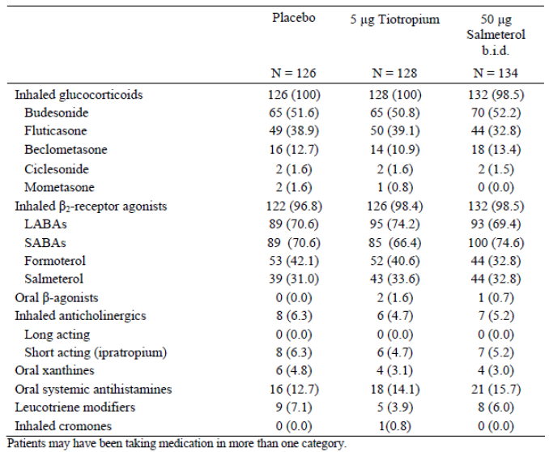

Primary efficacy results
The primary endpoint, the change in mean weekly morning pre dose PEF (in FAS) from the last week prior to randomisation visit to the last week of treatment, was similar in both active treatment groups with adjusted means (SE) of mean weekly changes of -3.93 (4.873) and -3.15 (4.640) L/min for the tiotropium and salmeterol groups, respectively. In comparison, the change on placebo was -24.63 (4.835) L/min. The differences between treatments showed that both active treatments tiotropium and salmeterol were statistically superior to placebo (p < 0.05) and tiotropium was non inferior to salmeterol (p < 0.05). The results in FAS were confirmed in the PP (Table 7) and the sensitivity analysis (Table 8).

Table 7: Adjusted means (SE) and adjusted response (change from baseline) means (SE) of mean weekly pre dose PEF (L/min) – FAS and PPS
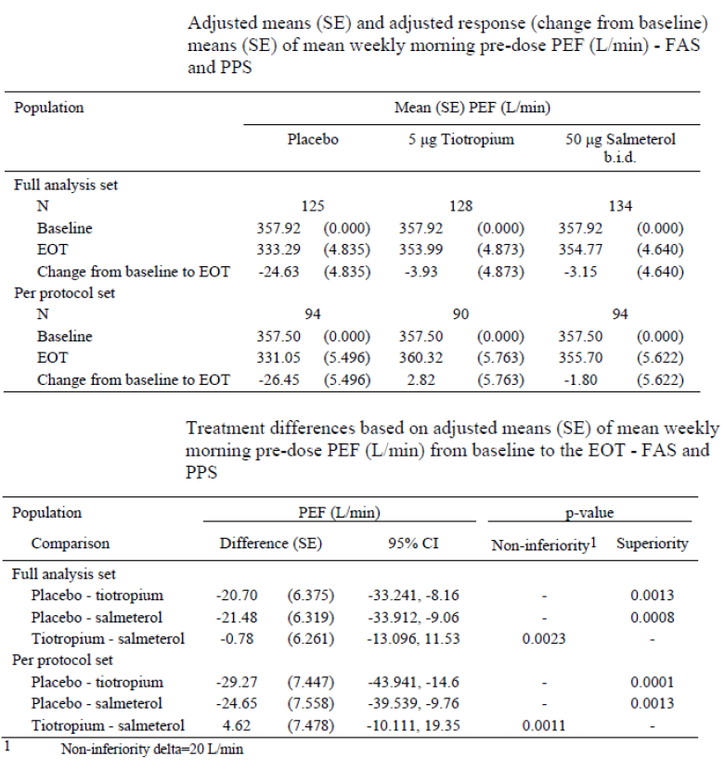

Table 8: Sensitivity analyses for the primary endpoint: adjusted response means of mean weekly morning pre dose PEF (L/min) from baseline to the EOT by subgroup – FAS
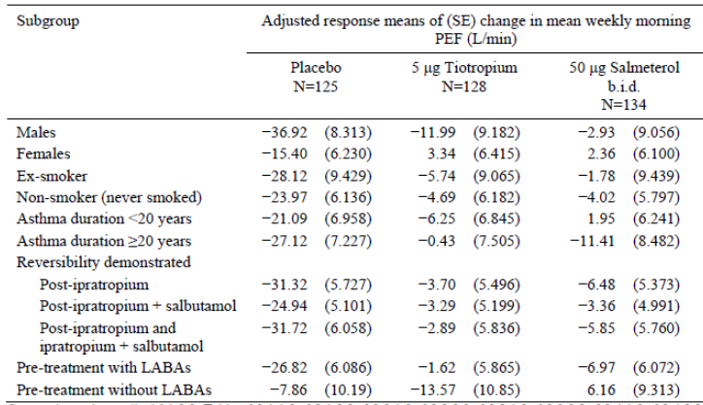

Secondary efficacy results
There were only slight changes in weekly means of morning and evening pre dose PEF across the 16 week treatment period for both active treatment groups. In contrast, there was a marked decrease in both morning and evening pre dose PEF for the placebo group.
The pattern of change in PEF was similar for morning and evening pre dose PEF values. In the placebo group PEF decreased immediately after randomisation and was significantly lower than the baseline at all timepoints during the double blind treatment period. In comparison, there was a slight increase in PEF in the tiotropium group within the first two weeks followed by a decline to mean values at or slightly below the baseline value. For the salmeterol group, a slight increase in PEF from baseline was apparent at Week 1 and Week 4 for morning PEF; at all other time points, PEF was at or below baseline values. There were only slight changes in weekly means of morning and evening pre dose FEV₁ across the 16 week double blind treatment period for the tiotropium and salmeterol groups. In contrast, there was a marked decrease in both morning and evening pre dose FEV₁ for the placebo group.
PEF variability was calculated as the difference between the highest morning PEF and the highest evening PEF of one day divided by the mean of these two PEF values, expressed as a percentage. There were only minor fluctuations in weekly means of peak flow variability across the 16 week treatment period for the tiotropium and salmeterol groups and for the placebo group, with no noteworthy difference between all three groups.
There was a slight increase in morning pre dose FEV₁, with mean values above baseline at all visits in the tiotropium and salmeterol groups. In comparison, in the placebo group there was a marked decrease in FEV₁ with mean values significantly below baseline at all visits; the difference between tiotropium/ salmeterol and placebo was statistically significant (p < 0.0001) in favour of tiotropium (Table 9).

Table 9: Adjusted response (change from baseline) means (SE) of morning pre dose FEV₁ values measured by spirometry at Visits 3, 4 and 5 – FAS
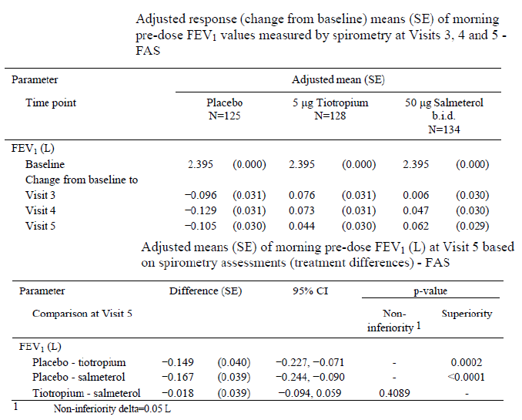
Comment: The difference from placebo in pre dose FEV₁ was 149 mL for tiotropium 5 µg and 167 mL for salmeterol 50 µg (p < 0.0002 in favour of active treatments). However, interpretation was limited as p values for all secondary endpoints were only exploratory.
For FVC, both tiotropium and salmeterol were statistically significantly superior to placebo at all visits. Non inferiority of tiotropium compared with salmeterol was shown at all visits (p = 0.0001, 0.0349, and 0.0345 at Visits 3, 4, and 5, respectively (Table 10).

Table 10: Adjusted response (change from baseline) means (SE) of morning pre dose FVC (L) values measured by spirometry at Visits 3, 4 and 5 – FAS
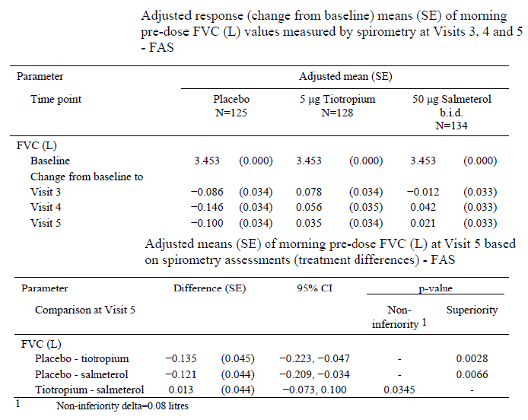

Use of rescue medication
With some fluctuation, the mean weekly number of puffs of rescue medication required by tiotropium and salmeterol patients was slightly reduced from baseline, while the corresponding values increased slightly for placebo patients with no significant difference between treatment groups.

Asthma control (asthma symptoms and quality of life)
Mean values for all symptom and quality of life questions were in the range between 1.0 and 2.0 on the five point verbal rating scale where 1.0 represented no impairment at all and 2.0 represented only slight impairment or mild symptoms (5.0 represented the greatest impairment, for example, very severe asthma symptoms). All mean weekly response changes and mean differences across treatment groups were not larger than of 0.1 or 0.2 and no clear pattern of change was apparent in either active treatment group.
The adjusted weekly means for symptom free days were identical in all groups at baseline (adjusted mean: 1.40 days per week) and increased slightly at almost all post baseline time points in both the tiotropium and salmeterol groups.

Mini AQLQ
Adjusted mean values for overall score, symptoms, activity limitations, emotional function and environmental stimuli were in the range between the scores 4.753 and 5.706 (4.0: impairment some of the time, 5.0: impairment a little of the time, 6.0: impairment hardly any of the time). The treatment differences compared to placebo were not clinically relevant (clinical relevance being considered as a change of at least 0.5).
Comment: In this double blind, double dummy, parallel group study involving moderate asthma patients homozygous for B16 Arg/Arg genotype, the primary endpoint (change in mean weekly morning pre dose PEF from baseline to the last week of treatment based on weekly means of electronic peak flow meter recordings measured at home) demonstrated the statistical non inferiority of tiotropium versus salmeterol and the superiority of both tiotropium and salmeterol versus placebo. The secondary efficacy results in terms of trough FEV₁ and FVC supported the primary efficacy results. However, this study had some limitations:
Only one dose of tioropium was evaluated (5 µg) and so dose response of tiotropium could not be evaluated in the only Phase II parallel group study (other Phase II dose response studies in adult patients with asthma were limited by their crossover study design).
Treatment with tiotropium 5 µg once daily or salmeterol 50 µg BD for 16 weeks failed to show any significant reduction in use of rescue medication or improvement in symptom scores.
Although this study did show that tiotropium may be useful in patients homozygous for B16 Arg/Arg, there were no comparisons with other genotypes precluding interpretation of effect of genotype on efficacy of tiotropium in asthma patients.

Dose ranging study in adults: 205.380

Study design, objectives, methodology
Study 205.380 was a Phase II, randomised, double blind, placebo controlled, cross over study. The objective of this study was to evaluate the efficacy and safety of three doses of tiotropium solution for inhalation (1.25 μg [Tio R1.25], 2.5 μg [Tio R2.5], and 5 μg [Tio R5] qd in the evening) in comparison to placebo delivered by the Respimat inhaler in 149 adult patients with moderate persistent asthma on top of maintenance therapy with ICS. There was a four week run in period followed by four, four week treatment periods no washouts (off treatment periods) between treatments. The study was conducted from 19 November 2010 to 9 January 2012 at 19 sites in three European countries including Germany, Austria and Ukraine.

Inclusion/exclusion criteria
The study included outpatients between 18 and 75 yrs old with at least a three month history of asthma that was diagnosed before the age of 40. Patients must have never smoked or must have been ex smokers with less than 10 pack yrs who had quit smoking at least one year prior to enrolment. A diagnosis of moderate, persistent asthma was required, and patients must have been symptomatic despite treatment with a medium, stable dose of ICS for at least four weeks prior to screening; in order to be considered symptomatic, patients needed to have an ACQ mean score of ≥ 1.5 at screening (Visit 1) and randomisation (Visit 2). Patients should have had a pre bronchodilator FEV₁ of ≥ 60% and ≤ 90% of predicted normal at screening (Visit 1), and an increase in pre bronchodilator FEV₁ of ≥ 12% and ≥ 200 mL at a time point 15 mins to 30 mins after the inhalation of 400 μg of salbutamol (albuterol). Variability between the pre bronchodilator FEV₁ at Visit 1 and Visit 2 had to be within ± 30%. Patients were not eligible if they had an asthma exacerbation or acute respiratory tract infection in the four weeks prior to screening and/or during the screening period.

Efficacy endpoints, statistical considerations
The primary efficacy endpoint was the maximum FEV₁ measured within the first three hrs post dosing (FEV₁ peak_{0−3h}), which was determined at the end of each four week treatment period and it was analysed as a response. Secondary endpoints included: Peak FVC measured within three hrs post dosing (FVC peak_{0−3h}), trough (pre dose) FVC, trough FEV₁, areas under the curve from zero to three hrs for FEV₁ (FEV₁ AUC_{0−3h}) and FVC (FVC AUC_{0−3h}), individual FEV₁, FVC, and PEF measurements, daily morning and evening PEF (PEF_{am} and PEF_{pm}), PEF variability, use of rescue salbutamol, and weekly mean number of night time awakenings. In a subset of patients: FEV₁ AUC_{0−12h}, FEV₁ AUC_{12−24h}, FEV₁ AUC_{0−24h}, FVC AUC_{0−12h}, FVC AUC_{12−24h}, FVC AUC_{0−24h}. Other endpoints were pre dose morning and evening FEV₁ (FEV_{1 am} and FEV_{1 pm}) and ACQ. All endpoints (except ACQ) were analysed as a response. Blood and urine samples were obtained from 53 patients for PK analysis of an single dose and from 52 patients for PK analysis of MDs.
The superiority of treatment with tiotropium (5 μg qd followed by 2.5 μg and 1.25 μg qd) over treatment with placebo was tested in terms of FEV₁ peak_{0−3h} response in a sequential, hierarchical fashion at the level of α = 0.025 (one sided). The primary analysis was a mixed model repeated measures (MMRM). The statistical model included 'treatment' and 'period' as fixed effects and 'patient' as a random effect; study baseline was included as covariate. Secondary endpoints were analysed using the MMRM as described above for the primary efficacy endpoint. All calculated p values for secondary endpoints were to serve an exploratory function. All other endpoints were analysed descriptively.

Sample size
In a previous study with tiotropium in patients with asthma [205.341], a SD of 0.228 L was observed for within patient difference of FEV₁ peak_{0−3h}. Assuming this SD, a sample size of 88 completed patients was needed for a full crossover design to be able to detect a treatment difference of 0.080 L for FEV₁ peak_{0−3h} with 90% power. In order to obtain 88 completed patients (based on complete randomisation blocks) it was deemed appropriate to randomise about 120 patients.

Patient disposition, protocol violations
Of the 224 enrolled patients, 149 were randomised to receive treatment with 1.25 μg tiotropium inhalation solution (Tio R1.25), 2.5 μg tiotropium inhalation solution (Tio R2.5), 5 μg tiotropium inhalation solution (Tio R5), and placebo inhalation solution in a predefined sequence. Overall, 141 patients (94.6%) completed the trial, that is, each of the four treatment periods. In total, eight patients (5.4%) prematurely discontinued trial medication; two patients discontinued during treatment with Tio R1.25, three patients during treatment with Tio R2.5, and three patients during treatment with Tio R5. Reasons for premature discontinuation were AEs, lost to follow up, consent withdrawn not due to AEs and other reasons in one, two, three and two patients, respectively. Important protocol violations (IPVs) were observed in 33 randomised patients (22.1% of the treated set). At least one IPV was reported for (22.9%, 21.9%, 22.4% and 22.6% of patients while taking placebo, Tio R1.25, Tio R2.5 and Tio R5, respectively. The most frequently reported IPVs were related to incorrect timing of PFTs and were reported for 14 patients.
The full analysis set (FAS) included 148 patients, the per protocol set (PPS) included 115 patients and the 24 hr pulmonary function test (PFT) analysis set (FAS24) included 53 patients and the 24 hr PFT visit was performed after the first treatment period only.

Baseline demographics, disease characteristics
Among the 149 patients in the treated set (TS), majority were female (55%) and White (100%) with mean age of 49.3 yrs, mean weight was 78.2 kg, and the mean BMI was 26.9 kg/m². The majority of patients had never smoked (80.5%), only 19.5% were ex smokers, and no patients were current smokers. The mean number of pack yrs was 5.6 for those patients who were ex smokers (29 patients). The mean duration of asthma (from date of first diagnosis) in the treated set was 23.8 yrs (range: 1.9 yrs to 66.0 yrs) and 59.7% of the patients had symptoms of asthma for at least 20 yrs.
All 149 patients of the treated set had taken ICS within the last three months before Visit 1; all patients had used ICS required for participation in the study, while three patients (2.0%) had also taken intranasal glucocorticoids, and one patient (0.7%) had taken oral glucocorticoids. No patient had taken intravenous, intramuscular, or other glucocorticoids. In total, 146 of the treated patients (98.0%) were on β2 adrenergic agonists; including 79.2% of patients on SABAs and 55.0% of patients on LABAs. Very few patients had taken systemic antihistamines (6.0%), xanthines (theophyllines only; 2.7%), leukotriene modifiers (2.7%), anticholinergics (2.0%), mucolytics (1.3%), anti allergic agents (excluding corticosteriods; 1.3%), expectorants (1.3%), immune modulatory agents and antibodies (1.3%), antibiotics (0.7%), or flu vaccinations (0.7%). No patients took other xanthines (excluding theophyllines) or β blockers.
During the treatment period, all patients continued ICS medication and were allowed to use salbutamol rescue medication as needed. Budesonide was the ICS taken most frequently (37% to 39% of the patients), followed by fluticasone (33% to 35%) and beclometasone (24% to 25%). The mean pre bronchodilator FEV₁ of patients in the TS was 2.236 L, or 71.3% of predicted normal FEV₁. FEV₁ was ≥ 60% and ≤ 80% of predicted normal in 85.2% of patients in the TS.

Primary efficacy results
Compared to placebo (0.116 L), the largest FEV₁ peak_{0−3h} response after four weeks of treatment was observed during treatment with Tio R5 (0.304 L) followed by Tio R2.5 (0.244 L) and Tio R1.25 (0.255 L). Inhalation of tiotropium resulted in adjusted mean treatment differences from placebo of 0.188 L with Tio R5, 0.138 L with Tio R1.25, and 0.128 L with Tio R2.5 for the FEV₁ peak_{0−3h}. Differences from placebo were statistically significant (p < 0.0001) at all doses confirming the superiority of all active treatments over placebo; furthermore, a significant difference was shown between Tio R5 and each of the two lower doses in terms of FEV₁ peak_{0−3h} response; however, no significant difference was shown between Tio R2.5 and Tio R1.25 (95% CI included 0). Similar results were observed in the PP analysis.

Secondary efficacy results
Compared with placebo, statistically significantly greater increase was observed for all three doses of tiotropium (1.25, 2.5 and 5 µg) in trough FEV₁ response, FEV₁ AUC_{0−3h} response, FVC peak (0-3h) response, trough FVC response and FVC AUC_{0-3h} response; furthermore, For FEV₁ AUC_{0−3h} response, the treatment differences between Tio R5 and Tio R2.5 (0.051 L), and between Tio R5 and Tio R1.25 (0.049 L) were statistically significant in favour of Tio R5.
The maximum effect of Tio R5 in terms of FEV₁ response was observed two hrs after study drug inhalation (adjusted mean FEV₁ response 0.218 L), the maximum effect of Tio R2.5 was shown at 30 mins after inhalation (adjusted mean FEV₁ response 0.163 L), the maximum effect of Tio R1.25 was shown at both 30 mins and three hrs after inhalation (adjusted mean FEV₁ response 0.160 L), and the maximum effect of placebo was shown at two hrs after inhalation (adjusted mean FEV₁ response 0.033 L). All three doses of tiotropium were superior to placebo in an exploratory way at all timepoints (p < 0.0001) in terms of FEV₁ response. A statistically significant difference between Tio R5 and the two lower tiotropium doses in terms of mean FVC response was observed at 30 mins, one hr and two hrs after trial drug inhalation; the difference was in favour of Tio R5 in every case.
The maximum effect of Tio R5 in terms of PEF response was shown at the time point two hrs after study drug inhalation (adjusted mean PEF response 42.694 L/min), while the maximum effect of both Tio R2.5 and Tio R1.25 was shown at three hrs after inhalation (adjusted mean PEF responses 37.283 L/min and 34.620 L/min, respectively). All three doses of tiotropium were superior to placebo at all timepoints (p < 0.0001 in every case) in terms of PEF response with no significant difference between the tiotropium doses. The pre dose PEF_{am} response was statistically significantly greater in all tiotropium groups compared with placebo with no significant difference between the tiotropium doses with similar results observed for pre dose evening PEF_{pm} response. Baseline mean PEF variability was 14.151% (SD 8.726%) and there was no significant difference between placebo and the tiotropium groups in mean PEF variability response (-0.171%, -0.248%, -0.711% and -0.285% with placebo, Tiotropium 5, 2.5 and 1.25 µg, respectively).
The two lower tiotropium doses were shown to be superior to placebo in terms of rescue salbutamol use over 24 hrs (Tio R1.25: p = 0.0296; Tio R2.5: p = 0.0454) and during the daytime (Tio R1.25: p = 0.0183; Tio R2.5: p = 0.0288); superiority of Tio R5 over placebo was not observed for any of the time periods analysed. The exploratory superiority of active treatment over placebo in terms of rescue salbutamol use during the night time was not shown for any dose. No significant differences were found between the three tiotropium treatments in terms of rescue salbutamol use over 24 hrs, during the daytime, or at night time.
In comparison with the baseline period, the mean score for night time awakenings due to asthma decreased slightly while patients took randomised treatment (mean change from baseline for placebo: −0.156, Tio R1.25: −0.166, Tio R2.5: −0.162, Tio R5: −0.187). No significant differences were observed between the three tiotropium treatments and placebo as well as between the three tiotropium daily dose regimens.
AM2+ device and electronic diary (home assessment) other endpoints: Compared with placebo, the mean pre dose morning FEV₁ response was significantly superior for tiotropium 5 µg and 1.25 µg (but not for 2.5 µg) while evening FEV₁ response was significantly superior for only tiotropium 5 µg. All three tiotropium doses showed statistically significant improvement in ACQ scores compared with placebo with no significant difference between each of the tiotropium doses.
In a subset of patients who participated in the 24 hr PFT, no significant difference between tiotropium treatment and placebo was shown for FEV₁ AUC_{0−12h} response and FVC AUC_{12−24h} response. However, treatment with Tio R5 showed superiority over placebo in an exploratory way in terms of FEV₁ AUC_{12−24h} response and FEV₁ AUC_{0−24h} response, and treatment with Tio R2.5 showed superiority over placebo in terms of FVC AUC_{0−12h} response and FVC AUC_{0−24h} response.
Comment: The primary endpoint FEV₁ peak_{0−3h} response (adjusted mean) measured after four weeks of treatment showed a statistical significant difference between the active treatments and placebo. The difference between treatment with Tio R5 and the two lower doses was statistically significant for the FAS. However, no statistically significant difference was seen between the three tiotropium treatments for the PPS. FEV₁ based secondary endpoints (FEV₁ AUC_{0−3h}, trough FEV₁) confirmed the efficacy of tiotropium compared with placebo within the first three hrs after dosing. The results for FVC based endpoints (FVC peak_{0−3h}, FVC AUC_{0−3h}) paralleled the results found for FEV₁ based endpoints, except for trough FVC (only significant for Tio R2.5 and Tio R5).
The efficacy of tiotropium compared with placebo as demonstrated by the supervised in clinic spirometric assessments was also confirmed by the BD recording of PEF (morning and evening) by the patients at home. During the three tiotropium daily dose regimens PEF_{am} and PEF_{pm} were significantly (p ≤ 0.0001) increased compared with placebo. However, no relevant difference was found between the three tiotropium treatments and placebo in terms of rescue medication use at night and number of night time awakenings. Similarly, differences between tiotropium and placebo in terms of ACQ score were small and below the threshold of clinical relevance (that is, < 0.5 difference from placebo). The sponsors suggest that based on efficacy, safety, and PK results from this study, 5 μg tiotropium administered via the Respimat inhaler appeared to be the preferred dose. Although 5 µg dose of tiotropium appears to be optimal dose in treatment of asthma, interpretation of results of this Phase II dose ranging study was limited by the crossover study design and short treatment duration of only four weeks (both of which do not comply with recommended CHMP guidelines for therapeutic exploratory studies for asthma).

Dosing regimen trial in adults: 205.420

Study design, objectives, methodology
Study 205.420 was a Phase II, randomised, double blind, placebo controlled, crossover efficacy and safety comparing different dose regimens of tiotropium with placebo for four weeks on top of maintenance therapy with a medium dose ICS controller medication in 94 patients with moderate persistent asthma. The objective of this study was to demonstrate the 24 hr bronchodilator efficacy and safety of tiotropium 5 μg administered qd (in the evening) [Tio R5 qd] delivered by the Respimat inhaler for four weeks in comparison to placebo in patients with moderate persistent asthma. The study further aimed to evaluate the efficacy and safety of tiotropium 2.5 μg administered BD [Tio R2.5 BD] in comparison to placebo and to Tio R5 qd delivered by the Respimat inhaler for four weeks. A four week run in period was followed by a 12 week treatment period, including three, four week treatment periods without washouts (off treatment periods) between treatments. The study was conducted from 5 July 2006 to 19 August 2011 at 15 sites in five countries (Czech Republic, Estonia, Latvia, Austria, and Germany).

Inclusion/ exclusion criteria
The study included outpatients between 18 and 75 yrs old with at least a three month history of asthma that was diagnosed before the age of 40. Patients must have never smoked or have been ex smokers with less than 10 pack yrs who had quit smoking at least one yr prior to enrolment. A diagnosis of moderate, persistent asthma was required, and patients must have been symptomatic despite treatment with a medium, stable dose of ICS for at least four weeks prior to screening; in order to be considered symptomatic, patients needed to have an ACQ score of ≥ 1.5 at screening (Visit 1) and randomisation (Visit 2). Patients had to have a pre bronchodilator FEV₁) of ≥ 60% and ≤ 90% of predicted normal at screening (Visit 1), and an increase in pre bronchodilator FEV₁ of ≥ 12% and ≥ 200 mL 15 mins after the inhalation of 400 μg of salbutamol (albuterol). Variability between the pre bronchodilator FEV₁ at Visit 1 and Visit 2 had to be within ± 30%. Maintenance treatment with medium dose ICS (stable for at least four weeks prior to Visit 1) was required.

Efficacy endpoints, statistical considerations
The primary endpoint was the area under the curve (AUC) from 0 to 24 hrs for FEV₁ (FEV₁ AUC_{0−24h}). It was analysed as an absolute value and as a response (change from study baseline). Secondary endpoints that were assessed during clinic visits included FEV₁ AUC_{0-12h}, FEV₁ AUC_{12-24h}, FEV₁ peak_{0−24h}, trough FEV₁, trough FVC, FVC AUC_{0-12h}, FVC AUC_{12-24h}, FVC AUC_{0-24h}, FVC peak_{0−24h}, PEF AUC_{0-24h}, all of which were determined as a response at the end of each four week period of randomised treatment. Secondary endpoints that were assessed using the Asthma Monitor AM2+ included daily PEF_{am} and PEF_{pm}, PEF variability, use of rescue salbutamol, and weekly mean number of night time awakenings, all of which were determined as a weekly mean response from study baseline during the last week of each four week treatment period. Other endpoints related to efficacy included the ACQ score, which was determined at the end of each four week treatment period, and the predose morning and evening FEV₁ (FEV₁ am and FEV₁ pm) from the AM2+, which were analysed as a weekly mean response from study baseline during the last week of each four week treatment period. In a subset of patients, PK parameters of tiotropium were evaluated.
The superiority of treatment with tiotropium (5 μg qd followed by 2.5 μg BD) over treatment with placebo was tested in terms of FEV₁ AUC_{0−24h} in a sequential, hierarchical fashion at the level of α = 0.025 (one sided). The primary analysis was a mixed model repeated measures (MMRM) that compared the mean FEV₁ AUC_{0−24h}. The statistical model included 'treatment' and 'period' as fixed effects and 'patient' as a random effect; study baseline was included as covariate. All continuous secondary endpoints were analysed using the MMRM as described above for the primary efficacy endpoint. Adjusted mean values as well as treatment contrasts were calculated together with the 95% CIs. All calculated p values were to serve an exploratory function. All other endpoints were analysed descriptively.

Sample size
In a previous study with tiotropium in patients with asthma, a SD of 0.220 L was observed for within patient difference of FEV₁ AUC_{0−24h}. Assuming this SD, a sample size of 82 completed patients was needed for a full crossover design to be able to detect a treatment difference of 0.080 L for FEV₁ AUC_{0−24h} with 90% power. In order to obtain 82 completed patients (based on complete randomisation blocks), 90 patients were randomised.

Patient disposition, protocol violations
Of the enrolled patients, 94 were randomised to receive treatment with either 5 μg tiotropium solution for inhalation qd in the evening [Tio R5 qd], 2.5 μg tiotropium solution for inhalation BD (that is, once in the morning and once in the evening) [Tio R2.5 BD], or placebo solution for inhalation in a predefined sequence. Overall, 89 patients (94.7%) completed the trial and five patients (5.3%) prematurely discontinued trial medication: three patients (3.3%) when on placebo, one patient (1.1%) when on Tio R2.5 BD, and one patient (1.1%) when on Tio R5 qd. Reasons for premature discontinuation were the occurrence of AEs (placebo: two patients), non compliance with protocol (placebo: one patient), and lost to follow up (Tio R2.5 BD: one patient, Tio R5 qd: one patient). A total of 81 patients (86.2% of the TS) were included in the per protocol set (PPS); 11 patients (11.7% of the TS) were excluded from the PPS due to important PVs and two patients (2.1% of the TS) were excluded because no efficacy data was available. The main statistical analyses of efficacy were performed on the FAS, and a sensitivity analysis of the primary efficacy endpoint was performed on the PPS.

Baseline demographics, disease characteristics
The study population was White (100%) and contained slightly more female patients (58.5%). The mean age in the TS was 44.3 yrs and the mean duration of asthma (from date of first diagnosis) was 21.3 yrs. In general, concomitant diagnoses at screening, concomitant medications at screening and other baseline efficacy variables were as expected for a population of adult patients with moderate, not fully controlled, persistent asthma (mean baseline FEV₁: 2.513 L, mean baseline percent of predicted FEV₁: 76.779%).

Primary efficacy results
For the primary efficacy endpoint FEV₁ AUC_{0−24h} response, inhalation of tiotropium resulted in statistically significant (p < 0.0001) adjusted mean treatment differences from placebo of 0.158 L for patients who took Tio R5 qd and 0.149 L for patients who took Tio R2.5 BD. In the exploratory analysis, no significant difference between Tio R5 qd and Tio R2.5 BD was observed in terms of FEV₁ AUC_{0−24h} (0.009 L; [95% CI: -0.038, 0.056]). These results were confirmed in the PP analysis.
The tiotropium treatments and placebo were also compared in terms of mean FEV₁ response at individual time points over 24 hrs after four weeks of each treatment; maximum effect of both Tio R5 qd and Tio R2.5 BD was observed at 16 hrs after study drug inhalation in the evening (adjusted mean FEV₁ responses 0.313 L and 0.306 L, respectively), and the maximum effect of placebo was shown at 18 hrs after inhalation in the evening (adjusted mean FEV₁ response 0.177 L). Both tiotropium dose regimens were superior to placebo at all time points (p < 0.01) in terms of FEV₁ response and no statistically significant difference was noted at any time point between the two tiotropium dose regimens in terms of mean FEV₁ response at individual time points (95% CIs included 0 in every case).
A subgroup analysis of the primary endpoint (FEV₁ AUC_{0−24h} response) was performed in order to evaluate patients with (IgE > 430 μg/L) or without (IgE ≤ 430 μg/L) potentially allergic asthma. There were twice as many patients observed with a total IgE > 430 μg/L (60 patients) than with a total IgE ≤ 430 μg/L (30 patients). A statistically significant difference was found between the two tiotropium dose regimens and placebo in favour of both active treatment groups for patients with IgE ≤ 430 μg/L (Tio R5 qd: p = 0.0023; Tio R2.5 BD: p = 0.0058) and with IgE > 430 μg/L (Tio R5 qd and Tio R2.5 BD: p < 0.0001).

Secondary efficacy results
Significant treatment differences in favour of tiotropium (both Tio R5 qd and Tio R2.5 BD) over placebo were also observed for the secondary spirometry endpoints of adjusted mean FEV₁ AUC_{0-12h} (p < 0.0001), FEV₁ AUC_{12-24h} (p < 0.0001), FEV₁ peak_{0−24h} (p < 0.0001), trough FEV₁ (p < 0.0001), FVC AUC_{0-24h} (p ≤ 0.004), FVC AUC_{0-12h} (p ≤ 0.002), FVC AUC_{12-24h} (p ≤ 0.0123), and PEF AUC_{0-24h} (p < 0.0001) responses. For the secondary endpoints of adjusted mean trough FVC and FVC peak_{0−24h} responses, treatment differences were always in favour of tiotropium (Tio R5 qd and Tio R2.5 BD) over placebo, but statistical significance could not always be shown. No significant differences between Tio R5 qd and Tio R2.5 BD were observed for any of the secondary spirometry endpoints measured in the clinic.
The tiotropium treatments and placebo were also compared in terms of adjusted mean FVC response at individual time points; tiotropium 5 µg QD and 2.5 µg BD showed statistically significantly greater increase compared with placebo at most time points. In terms of PEF AUC_{0-24h} response, both tiotropium treatments provided significantly greater bronchodilation, while no difference was found between the two dose regimens of tiotropium. Both tiotropium 5 µg qd and 2.5 µg BD showed significant improvements in pre dose morning and evening PEF response with no significant difference between the two tiotropium groups.
Significant differences between the treatment groups in favour of tiotropium (both Tio R5 qd and Tio R2.5 BD) were observed for the AM2+ endpoints of adjusted weekly mean PEF_{am} (p < 0.0001), PEF_{pm} (p < 0.0001), FEV₁ am (p ≤ 0.0449), and FEV₁ pm (p ≤ 0.0002) responses with no significant differences between the two tiotropium regimens for any of these endpoints. No significant differences were noted between tiotropium (Tio R5 qd and Tio R2.5 BD) and placebo in terms of adjusted mean PEF variability, use of rescue medication or night time awakenings score responses. For the other endpoint of adjusted mean ACQ score, an improvement (decrease) was reported for all treatment groups from study baseline (2.317) after four weeks of treatment (placebo: 1.808, Tio R2.5 BD: 1.618, Tio R5 qd: 1.535).
Both tiotropium dosing regimens (Tio R5 qd and Tio R2.5 BD) showed statistically significant improvement for adjusted mean ACQ score (p≤ 0.0072) compared with placebo; however, the minimal clinically important difference of 0.5 between the treatment groups was not met.
Comment: Tiotropium solution for inhalation via the Respimat inhaler was a safe and effective bronchodilator as add on therapy to medium dose ICS in adult patients with not fully controlled, moderate persistent asthma. Significant and comparable bronchodilation over a complete 24 hr period was achieved following administration of a total daily dose of 5 μg tiotropium, regardless of whether it was administered as a qd dose of 5 μg (in the evening) or a BD dose of 2.5 μg (in the morning and evening). However, interpretation was limited by the short duration (four weeks) and crossover design of the study.

Dose ranging trials in paediatric patients: 205.424 and 205.425

Study design, objectives, methodology
Study 205.424 was a Phase II randomised double blind, placebo controlled, incomplete crossover trial with four treatments and three treatment periods. A four week run in period was followed by three, four week treatment periods with no washouts between treatments. The objective of the trial was to investigate the efficacy and safety of three doses of tiotropium solution for inhalation (1.25 μg, 2.5 μg and 5 μg) in comparison to placebo delivered by the Respimat inhaler in adolescents with moderate persistent asthma on concomitant ICS.

Inclusion/ exclusion criteria
The study included adolescent patients of either sex aged 12 to 17 yrs with a current diagnosis of and with a minimum documented three month history of asthma; pre bronchodilator FEV₁ > 60% and ≤ 9 0% predicted; FEV₁ increase of ≥ 12% and 200 mL at a timepoint 15 mins to 30 mins after 400 μg salbutamol (albuterol) as compared to pre salbutamol FEV₁; stable on medium dose ICS either as mono treatment or in combination with a LABA or leukotriene receptor antagonist (LTRA) for at least four weeks prior to screening (Visit 1); ACQ ≥ 1.5 at screening (Visit 1) and randomisation (Visit 2); no asthma exacerbation or acute respiratory tract infection in the past four weeks prior to screening.

Efficacy endpoints, statistical considerations
The primary endpoint was peak FEV₁ within three hrs post dosing (FEV₁ peak_{0−3h}) as a response (change from baseline). Secondary endpoints included: Trough (pre dose) FEV₁ as a response, peak FVC within three hrs post dosing (FVC peak_{0−3h}) as a response, trough FVC as a response, FEV₁ area under the curve from zero to three hrs (FEV₁ AUC_{0−3h}) as a response, FVC AUC_{0−3h} as a response, individual FEV₁ and FVC measurements, PEF_{am/pm}, PEF variability, use of PRN rescue medication, and ACQ. In a subset of patients: FEV₁ AUC_{0-14h}, FEV₁ AUC_{14−24h}, FEV₁ AUC_{0−24h}, FVC AUC_{0−14h}, FVC AUC_{14−24h}, FVC AUC_{0−24h}; in a subset of patients PK data following first dose and at SS (blood and urine). The superiority of treatment with tiotropium over placebo was tested in a sequential hierarchical fashion at the level of α = 0.025 (one sided). The primary analysis was a mixed model repeated measures (MMRM) that included 'treatment' and 'period' as fixed effects (period as repeated) and 'patient' as a random effect; study baseline was included as a covariate. A MMRM analysis with 'centre' as an additional fixed effect was performed as a sensitivity analysis. Adjusted mean values as well as treatment contrasts were calculated together with 95% CIs.

Patient disposition, protocol violations
Of the 139 enrolled patients, 105 were randomised to treatment, 97 patients (92.4%) completed the entire trial, including all three treatment periods and eight patients (7.6%) prematurely discontinued study medication.
A total of 89 patients (84.8% of the TS) were included in the per protocol set (PPS); 15 patients (14.4% of the TS) were excluded from the PPS due to important protocol violations and one patient (1.0% of the TS) was excluded because no efficacy data was available. The randomised set (RS) was similar to the TS and included 105 patients; the full analysis set (FAS) included 104 patients. A total of 89 patients met the criteria to be included in the PPS . The 24 hr pulmonary function test (PFT) analysis set (FAS₂₄) was defined as all patients in the FAS who participated in the 24 hr PFTs, and included a total of 49 patients.

Baseline demographics, disease characteristics
Majority of patients were male (63.8%) and White (97.1%) and aged between 12 yrs and 14 yrs old (62.9%); the mean age was 14 yrs (range: 12 to17 yrs), mean body weight was 60 kg (32 to 137 kg), median BMI was 19.3 kg.m² and most patients had never smoked (99%). Overall, patients taking part in this study had an average (mean) duration of asthma of almost seven yrs (range from five months to 16 yrs); 37.1%, 34.3% and 22.9% had a duration of asthma from three yrs to < 10 yrs, 10 yrs to < 18 yrs and one yr to < three yrs, respectively. Only six patients (5.7%) had less than a one yr history of asthma. The baseline disease characteristics were consistent with patients having moderate asthma.
The most frequent concomitant diagnosis (CD) by preferred term (PT) was allergic rhinitis (60.0%), atopic dermatitis (9.5%), seasonal allergy (8.6%), allergic conjunctivitis (7.6%), and multiple allergies (6.7%). All patients had taken the ICS required for participation in the study, while 27.6% had also taken intranasal glucocorticoids, two patients (1.9%) had taken oral glucocorticoids, and none had taken intravenous or intramuscular glucocorticoids. Approximately half of patients (50.5%) were taking β2 adrenergic agonists (43.8% of patients who took LABAs and 21.0% of patients who took SABAs); 22.9% of patients were taking leukotriene modifiers, 20% were taking systemic antihistamines and 10.5% were taking anti allergic agents (excluding corticosteroids) in the last three months before screening.

Primary efficacy results
The adjusted mean treatment difference between Tio R5 and placebo for the FEV₁ peak_{0-3h} response after four weeks of randomised treatment was 0.113 L for the FAS and Tio R5 was statistically significantly superior to placebo (two sided p value for superiority = 0.0043). However, superiority of Tio R2.5 (adjusted mean treatment difference = 0.057 L, p = 0.1484) and Tio R1.25 (0.067 L, p = 0.0664) over placebo was not shown. The differences between the three active treatments were not statistically significant because the 95% CIs included zero in every case; no clear dose dependent efficacy response was seen for the primary endpoint.
Three different sensitivity analyses of the primary endpoint were carried out: a PPS analysis, an analysis including the effect of centre, and an analysis using a different definition of baseline . The superiority of Tio R5 over placebo was confirmed in all these sensitivity analysis; however, the PPS also showed superiority of Tio R1.25 over placebo for which there appears to be no clear explanation.

Secondary efficacy results
Superiority of Tio 5 µg over placebo was also shown for trough FEV₁ response, FEV₁ AUC_{0-3h} response, but no clear dose dependent response was observed. The superiority of treatment with tiotropium (Tio R5, Tio R2.5, or Tio R1.25) over treatment with placebo was not shown for FVC Peak_{0−3h}, trough FVC, or FVC AUC_{0−3h} response. Differences between active tiotropium treatment and placebo treatment were generally small (< 0.043 L), and two sided p values for superiority remained larger than 0.2. Similarly, the differences between the three active treatments were also small (< 0.025 L) and were not considered to be statistically significant for these three FVC endpoints.
In terms of individual FEV₁ measurements at each time point analysed as a response, Tio R5 treatment was superior to placebo treatment at all time points (p ≤ 0.0140 in all cases), Tio R1.25 was superior to placebo up to one hr post dose (p ≤ 0.0134), and Tio R2.5 was only superior to placebo at three hrs post dose (p = 0.0251).
For individual FEF_{25−75%} measurements at each time point, treatment with Tio R5, Tio R2.5, and Tio R1.25 was superior to treatment with placebo at all time points (p ≤ 0.0050 in every case), with the exception of the 10 minute pre dose time point for Tio R2.5 (p = 0.1311). However, the differences between the active treatments for individual FEF_{25−75%} measurements at each time point were not as pronounced.
Overall, ACQ scores improved (decreased) for patients while they took randomised treatment; the adjusted mean treatment difference (compared to placebo) was − 0.182 (p = 0.0113), −0.006 (p = 0.9349) and − 0.084 (p = 0.2213) for tiotropium 1.25 µg, 2.5 µg and 5 µg, respectively. Although this indicates the exploratory superiority of treatment with Tio R1.25 over treatment with placebo, ACQ differences of less than 0.5 are generally not considered clinically significant.
Whereas all three doses of tiotropium were superior to placebo for PEF_{am}, for PEF_{pm} exploratory superiority over placebo could only be shown for Tio R5 and Tio R2.5. Overall, in comparison with baseline, the use rescue medication decreased on average during randomised treatment although there was no significant difference between tiotropium and placebo groups with similar results observed for number of night time awakenings due to asthma.
Despite improvements in AQLQ(S) + 12 total score, the superiority of active treatment over placebo was not shown for any tiotropium dose (p ≥ 0.1372 in every case). The same was true for the AQLQ(S) + 12 activity limitations (p ≥ 0.0702 in every case), emotional function (p ≥ 0.3136 in every case), and environmental stimuli domain scores (p ≥ 0.2119 in every case).
The endpoints related to 24 hr lung function testing were only exploratory (insufficiently powered) and no dose ordering was expected to be detected due to the small sample size. There were a total of 49 patients who took part in 24 hr PFTs and were considered to be part of the FAS₂₄ (11, 11, 10 and 17 patients who completed 24 hr PFTs while taking placebo, Tio R1.25, Tio R2.5 and Tio 5, respectively). None of the active treatments were superior to placebo in an exploratory way for the FEV₁ AUC_{0−14h} response, and none of the differences between the active treatments were statistically significant (95% CIs always included zero) and only Tio R1.25 was shown to be superior to placebo in an exploratory way for FEV₁ AUC_{14−24h} response; neither Tio R5 nor Tio R2.5 was shown to be superior to placebo in this case. Furthermore, none of the differences between the three active treatments were statistically significant. No dose ordering was observed for the FEV₁ AUC_{0−24h} responses only Tio R1.25 was shown to be superior to placebo in an exploratory way for the FEV₁ AUC_{0−24h} response, and none of the differences between the active treatments were statistically significant. Similar results were observed for the FVC AUC_{0−14h} response FVC AUC_{14−24h} response and FVC AUC_{0−24h} responses.
Comment: Based on efficacy, safety, and PK results of this study, 5 μg tiotropium administered via the Respimat inhaler appears to be the preferred dose in adolescents with moderate asthma. However, interpretation was limited by crossover design and short treatment duration (only four weeks).

Study 205 425

Study design, objectives, methodology
Study 205.425 was a Phase II randomised, placebo controlled, double blind, incomplete crossover trial with four treatments and three treatment periods. Patients were randomly assigned to three of the four treatments evaluated in the study. This trial consisted of a four week screening/run in period, a 12 week (three times four weeks) treatment period, and a three week follow up period. The objective of this trial was to investigate the efficacy and safety of three doses of tiotropium solution for inhalation in comparison to placebo delivered by the Respimat inhaler on top of usual care in children (six to 11 yrs old) with moderate persistent asthma. The study was conducted from 23 August 2011 to 25 September 2012 at 24 sites in six countries, including Germany, Hungary, Latvia, Lithuania, Russia and Ukraine.

Inclusion/ exclusion criteria
The study included children of either sex aged six to 11 yrs with at least a documented six month history of asthma; pre bronchodilator FEV₁ ≥ 60% and ≤ 90% predicted; FEV₁ increase ≥ 12% at 15 to 30 mins after 200 μg salbutamol; stable on medium dose ICS either as mono treatment or in combination with a LABA or leukotriene modifier for at least four weeks prior to screening (Visit 1) (LABA was stopped at least 24 hrs prior to Visit 1 as no LABAs were permitted during the run in and treatment periods of this trial; ACQ ≥ 1.5 at Visit 1 and at randomisation, Visit 2); no asthma exacerbation or acute respiratory tract infection in the four weeks prior to Visit 1.

Efficacy endpoints, statistical considerations
The primary and secondary efficacy endpoints were similar to those described for Study 205.424 above. However, the Standardised Paediatric Asthma Quality of Life Questionnaire (PAQLQ(S)) was used instead of the ACLQ(S) + 12.

Patient disposition, protocol violations
A total of 101 patients were randomised and treated with study medication: 76 patients were treated with placebo, 75 with Tio R1.25, 74 with Tio R2.5, and 76 with Tio R5; one patient prematurely discontinued study medication in the first treatment period (withdrew consent not due to an AE) while on Tio R5. Overall 21 patients were excluded from the PPS due to important protocol violations (most common was treatment compliance < 30%).

Baseline demographics, disease characteristics
Majority of the patients were male (68.3%) and White (100%). The mean age of all patients was 8.8 yrs, mean BMI was 17.4 kg/m², and mean duration of asthma was 4.54 yrs. Most patients (76.2%) had been diagnosed with asthma for ≥ three yrs. At Visit 1, mean pre bronchodilator FEV₁ was 1.539 L, 79.661% of predicted normal, and mean post bronchodilator FEV₁ was 1.909 L, 98.9% of predicted normal. At study baseline (Visit 2; randomisation visit), mean FEV₁ was 1.640 L, 85.39% of predicted normal. All patients had taken the ICS required for participation in the study, while 27.7% had also taken intranasal glucocorticoids, and no patients had taken oral, IV or IM glucocorticoids. All 101 patients were taking β2 adrenergic agonists; this included 36.6% of patients who took LABAs and 98.0% of patients who took SABAs; 45.9% of the patients were taking leukotriene modifiers, 9.9% were taking systemic antihistamines and 5.0% were taking anti allergic agents (excluding corticosteroids) in the last three months before screening.

Primary efficacy results
The primary endpoint (FEV₁ peak_{0-3h} response) showed statistically significantly superior response for all three tiotropium doses compared with placebo; the adjusted mean response was 0.185 L, 0.261 L, 0.290 L and 0.272 L on placebo, Tio 1.25, 2.5 and 5 µg, respectively. The adjusted mean differences between Tio R5, Tio R2.5, and Tio R1.25 compared with placebo were, 0.087 L (p = 0.0002), 0.104 L (p < 0.0001) and 0.075 L (p = 0.0011) respectively. No clear dose dependent efficacy response was seen for the primary endpoint. Sensitivity analyses of the primary endpoint were consistent with the primary analysis.

Secondary efficacy results
The analyses of all secondary endpoints were exploratory. For trough FEV₁ and FEV₁ AUC_{0-3h} responses, the findings were consistent with the primary analysis showing the exploratory superiority of all doses of tiotropium over placebo. For FVC peak_{0-3h}, trough FVC, and FVC AUC_{0-3h} responses, the exploratory analyses did not show superiority of tiotropium over placebo.
Secondary endpoints measured using the AM3 peak flow meter and eDiary were analysed as responses based on the weekly mean of the last week of treatment for each treatment period. For morning PEF, the exploratory analyses confirmed the superiority of all doses of tiotropium over placebo; for evening PEF, although the responses were greater following treatment with all doses of tiotropium compared with placebo, only the exploratory superiority of the Tio R5 dose was shown. The night time awakenings due to asthma symptoms and the use of rescue medication as needed decreased during all tiotropium periods as well as during the placebo period, but the exploratory superiority of the active treatments was not shown versus placebo with regard to these endpoints. The adjusted mean ACQ total scores were comparable for the tiotropium doses and placebo after four weeks of treatment and the exploratory analyses did not show the exploratory superiority of tiotropium over placebo. The PAQLQ(S) total score did not show any significant differences between the tiotropium and placebo groups.
Comment: In children aged six to 11 yrs with moderate persistent asthma, the superiority over placebo of 1.25 μg, 2.5 μg, and 5.0 μg tiotropium administered qd in the evening using the Respimat inhaler was shown for the primary endpoint, the FEV₁ peak_{0-3h} response after four weeks of treatment. This was supported by the sensitivity analyses of the primary endpoint and by analyses of secondary endpoints based on FEV₁. However, none of the tiotropium doses had any significant effect on FVC based lung function parameters, use of rescue medication or any of the symptom based endpoints. No dose dependent differences in efficacy response were apparent across the three doses of tiotropium for the primary endpoint or for any secondary or other efficacy endpoints. Interpretation was again limited by crossover design and short duration (four weeks) of treatment.

Clinical efficacy
Assement of clinical efficacy for the new proposed indication as add on maintenance treatment for the improvement of asthma symptoms, quality of life, and reduction of exacerbations, in adult patients with asthma who remain symptomatic on at least inhaled corticosteroids.
A comprehensive clinical development programme was initiated in July 2006 comprising a total of 18 trials to evaluate the efficacy and safety of tiotropium Respimat in patients with persistent asthma. Eleven of these trials have been completed and are included in this submission (Table 11); a total of four Phase II studies were completed in adults (205.341, 205.342, 205.380 and 205.420), two Phase II studies were completed in paediatric patients (205.424 and 205.425) and five Phase III studies were completed in adults (205.416, 205.417, 205.418, 205.419 and 205.442). Trials that are currently ongoing in adult (205.441 and 205.464 [US and Japanese regulatory requirements]) and paediatric (205.443, 205.444, 205.445, 205.446, 205.456) patients were not included in this submission package.

Table 11: Summary of Phase II, proof of concept, dose ranging and dosing frequency studies and Phase III confirmatory studies of the tiotropium Respimat clinical programme
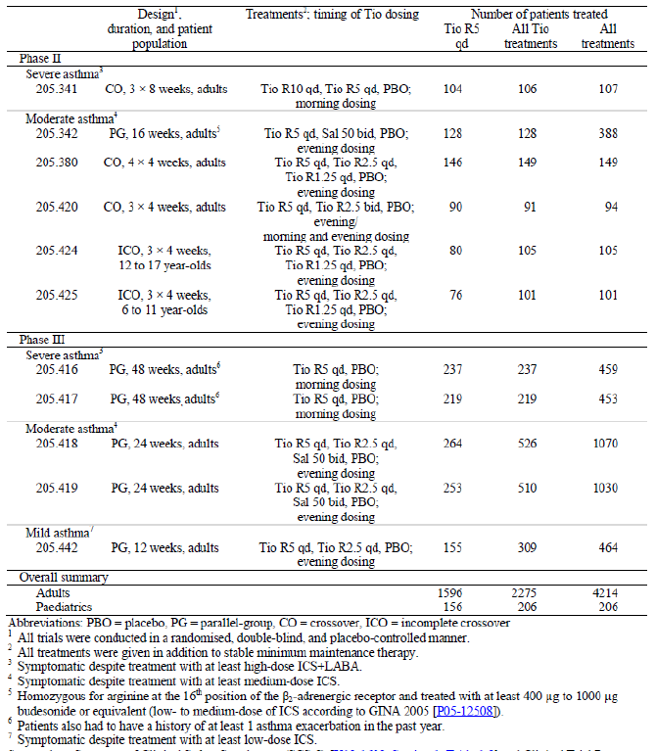

Pivotal efficacy studies

Studies 205.416 and 205.417

Study design, objectives, locations and dates
Studies 205.416 and 205.417 are twin trials with identical protocols. They are Phase III, randomised, double blind, placebo controlled, parallel group trials to evaluate efficacy and safety of tiotropium inhalation solution delivered via Respimat inhaler (5 μg/day) over 48 weeks as add on controller therapy on top of usual care in patients with severe persistent asthma.
Study 205.416 was conducted from 30 October 2008 to 25 July 2011 at 73 sites in 14 countries (Australia, Canada, Denmark, Germany, Italy, Japan, Netherlands, Russia, Serbia, South Africa, Turkey, Ukraine, United Kingdom, and United States). Study 205.417 was conducted from 3 November 2008 to 22 July 2011 at 75 sites in 15 countries (Australia, Canada, Denmark, Germany, Italy, Japan, The Netherlands, New Zealand, Russia, Serbia, South Africa, Turkey, Ukraine, United Kingdom, and the United States).
Comment: Study design was adequate and complied with CHMP note for guidance on clinical investigations for medicinal products for treatment of asthma. Since tiotropium is not intended to be substituted for ICS, add on designs where the new drug is compared with placebo were used.

Inclusion and exclusion criteria
The main inclusion criteria were: Male and female outpatients between 18 and 75 yrs old with a current diagnosis of severe, persistent asthma; a minimum documented five yr history of asthma diagnosed before the age of 40; the diagnosis must have been confirmed in the past and documented by at least one of the following criteria:
- an increased hyperresponsiveness to histamine, methacholine, mannitol, or exercise challenge.
- a positive trial of glucocorticosteroids or bronchodilator reversibility in response to a β2 adrenergic agonist that resulted in either
  - FEV₁ increase of at least 12% and at least 200 mL or more from baseline or
  - PEF increase of 20% or more.
- either a diurnal PEF variability of ≥ 10% or ≥20% with two measurements per day.
- bronchodilator reversibility to salbutamol that resulted in a FEV₁ increase of at least 12% and 200 mL or more from baseline.
Other inclusion criteria were never smokers or ex smokers who had quit smoking at least one yr prior to enrolment and who had a smoking history of < 10 pack yrs; symptomatic despite treatment with a high, stable dose of ICS and a LABA for at least four weeks prior to screening; FEV₁ ≤ 80% of predicted and ≤ 70% of the FVC 30 mins after the inhalation of 400 μg salbutamol (albuterol); ACQ ≥ 1.5 at screening (Visit 1) and prior to randomisation (Visit 2); a history of one or more asthma exacerbations in the past yr that required treatment with systemic corticosteroids.
The main exclusion criteria were: current smokers, any significant medical illness other than asthma such as COPD, recent history of MI, cardiac failure, malignancy (treated basal cell carcinoma allowed), alcohol/ drug abuse, asthma exacerbations and/or respiratory tract infections in the four weeks prior to screening (Visit 1) or during the four week screening period.
Comment: Evaluation of the eligibility of a patient was based on his or her medical history, a physical examination, clinical laboratory tests, PFTs, and the ACQ.The inclusion criteria complied with CHMP guidelines and the diagnosis of asthma was based on clinical symptoms (ACQ > 1.5 and history of exacerbation in past yr) and assessment of airflow limitation. Spirometry was performed under standardised conditions to measure FEV₁ and FCV which is the preferred method to assess airflow limitation, its reversibility and variability. The reversibility of FEV₁ after inhalation of a SABA should normally be greater than 12 to 15 % and 200 mL. However, this figure may be difficult to attain in patients on controller therapy and in this case, the reversibility criteria for diagnosis could be provided by the patient’s medical history. PEF measurements can also be used to diagnose asthma but their value can underestimate the airflow limitation. In patients with clinical symptoms and normal lung function, measurement of airway hyperresponsiveness (direct or indirect) could be useful to establish the diagnosis although the specificity of the test is limited. A lack of airway hyperresponsiveness can exclude a diagnosis of asthma if no controller medication is being used, but this was not relevant to this study as all patients were on controller medication (ICS+LABA).

Study treatments
Daily oral inhalation in the morning via the Respimat inhaler of: tiotropium 5 µg (as two actuations of 2.5 µg) or matching placebo. A four week screening period was followed by a 48 week treatment period. Patients were followed up for 30 days. Each patient received a visit specific number of Respimat inhalers with corresponding cartridges. After insertion of the cartridge in the Respimat inhaler, the patient was to inhale two puffs orally from the Respimat inhaler qd in the morning after taking his or her usual asthma medication (high dose ICS and LABA at a minimum). Oral β2 adrenergic agonists, β blockers, short acting anticholinergics, long acting anticholinergics (other than trial medication), other investigational drugs, and experimental or non approved asthma medications were generally not allowed during the treatment period of the study, except in special circumstances (that is, asthma exacerbations).
Comment: The use of all concomitant treatments including bronchodilators, OCS, ICS, antibiotics and mucolytic antioxidants was accurately recorded and balanced among treatment groups at baseline. A run in to standardise concomitant medication was done and the use of rescue medication was standardised. It is important to note that Tio R5 was administered qd in the morning in the studies in severe asthma (Phase II: 205.341; Phase III 205.416/417), while it was administered in the evening in the studies in moderate asthma (Phase II 205.342/380/420; Phase III: 205/418/419).

Efficacy variables and outcomes
Co primary endpoints included: maximum FEV₁ within three hrs post dosing (FEV₁ peak_{0−3h}) and trough (pre dose) FEV₁. Both of these co primary endpoints were analysed as a response (change from study baseline) after 24 weeks of treatment. The third co primary endpoint was time to first severe asthma exacerbation during the 48 week treatment period; this was considered primary only in the analysis of pooled data from the two twin trials 205.416 and 205.417. Secondary endpoints included: maximum FVC measured within three hrs post dosing (FVC peak_{0−3h}), trough FVC, FEV₁ area under the curve from zero to three hrs (FEV₁ AUC_{0−3h}), and FVC AUC_{0−3h}. These endpoints were reported as a response after 24 weeks of treatment.
Further secondary endpoints analysed during the 48 week treatment period were the time to first asthma exacerbation (including severe, ‘symptomatic’ and ‘any’ exacerbation), time to first severe asthma exacerbation, ACQ, and the Standardised Asthma Quality of Life Questionnaire (AQLQ(S)). Pre dose PEF_{am} and PEF_{pm}, pre dose morning and evening FEV₁ (FEV₁ am and FEV₁ pm), PEF variability, use of rescue medication as needed, and asthma symptoms were secondary endpoints measured at home using the Asthma Monitor (AM3). These AM3 endpoints were analysed as a weekly mean response during the 48 week treatment period (that is, Weeks 1, 2, 3 etcetera) and during the last seven days before Visit 6 (that is, after approximately 24 weeks of treatment, but not necessarily the weekly mean response of Week 24). In a subset of patients who underwent 24 hr spirometry, FEV₁ AUC_{0−12h}, FEV₁ AUC_{0−24h}, FEV₁ AUC_{12−24h}, FVC AUC_{0−12h}, FVC AUC_{0−24h}, and FVC AUC_{12−24h} were also secondary endpoints that were analysed as a response after 24 weeks of treatment.
Spirometers and their use, including daily calibration, had to meet ATS and European Respiratory Society (ERS) criteria. Measurement of the PFTs, including FEV₁ and FVC, was to be carried out with the patient in a seated position. Ideally, all PFTs for a given patient were to be performed by the same examiner throughout the trial. For each patient, PFTs were to start at approximately the same time of the day (± 30 mins). Thus, visits and PFTs were to be scheduled to enable dosing between 07:00 and 10:00. At each time point, FEV₁ and FVC were to be measured from a series of at least three acceptable spirometric manoeuvres. The highest FEV₁ and FVC values from an acceptable manoeuvre were recorded regardless of whether they came from different spirometric manoeuvres. The end of the second inhalation of trial medication from Respimat was regarded as time point 0 for PFTs. The time of the first manoeuvre for each PFT time point was also to be recorded.
Comment: The CHMP guidelines state that for a new bronchodilator drug to be administered as concomitant medication with ICS, an effect on both lung function and exacerbations should be demonstrated. Pre bronchodilator FEV₁ and exacerbations should be considered as co primary endpoints. This study complied with these criteria as it had pre dose FEV₁, peak FEV₁ (0-3h post dose) and time to first severe asthma exacerbation as co primary endpoints.
The clinical methodology was adequately standardised, but it has not been clearly stated if the patients received training in respiratory function testing, inhaler technique, compliance and the use of diary cards.
According to CHMP guidelines, the length of the study should be of sufficient duration to capture exacerbation events (at least 12 months) and that recruitment should continue throughout all four seasons. During the trial it is necessary to document in what season the wheezing episodes/exacerbations occur. The duration of treatment in this study was slightly less than the recommended 12 months (it was 48 weeks) and the CSR does not state if recruitment continued throughout all four seasons; furthermore, there was no documentation of details in what season the exacerbations occurred.

Randomisation and blinding methods
After screening, eligible patients were randomly assigned in a 1:1 ratio to either tiotropium 5 µg or placebo. Both treatments were double blinded so that the treatments were indistinguishable for the patient as well as for the investigator. The tiotropium and placebo solutions for inhalation were identical in appearance in order to safeguard blinding in the study. The randomisation list was generated using a validated system using a pseudo random number generator and a supplied seed number; this ensured that the resulting allocation of medication numbers to treatment was both reproducible and non predictable. Using a fixed block randomisation ensured the patients were allocated as balanced as possible in equal numbers to the treatments selected. A block size of four was used.
Comment: According to CHMP guidelines, it should be ensured that treatment arms are balanced according to important predictors of outcome and stratification according to relevant baseline characteristics, for example, number of exacerbations, use or non use of LABAs could be considered. The CSR does not clarify if randomisation of patients was stratified. Although it is accepted that stratification based on use/ non use of LABAs is not relevant in these studies as Tio R5 was administered as add on to stable high dose of ICS+LABAs. However, stratification based on other baseline disease characteristics would have been useful.

Analysis populations
The primary analysis was performed on the full analysis set (FAS).which included all 459 patients (tiotropium versus placebo: 222 versus 237). The per protocol set (PPS) included 347 patients (176 versus 171). The 24 hr pulmonary function testing set (FAS₂₄) included a total of 176 patients (90 versus 86 patients). The PKS included a total of 71 patients (37 versus 34 patients).

Sample size
For the first co primary endpoint FEV₁ peak_{0-3h} a delta of 100 mL with a SD of 230 mL were used for sample size calculation. For the second co primary endpoint trough FEV₁, a delta of 90 mL with a SD of 220 mL was used. Based on these values, several power considerations were carried out with various numbers of patients per group. The power values were calculated based on a two sided t test with α = 0.05. With a sample size of 150 per group, the overall power for the first two co primary endpoints was assumed to be greater than 90% (90.75%).

Statistical methods
The superiority of treatment with tiotropium (5 μg) over treatment with placebo was tested at the level of α = 0.025 (one sided). The primary analysis was a restricted maximum likelihood (REML) based mixed effect model repeated measures (MMRM) approach that included 'treatment', 'pooled centre', 'visit', and 'treatment by visit' interaction as fixed, categorical effects and 'baseline' and 'baseline by visit' interaction as continuous, fixed covariates. A spatial power structure was used to model the within patient errors. Adjusted mean values as well as treatment contrasts were calculated together with 95% CIs. Analysis of time to first severe asthma exacerbation was based on the pooled data from the twin trials 205.416 and 205.417.

Participant flow

Study 205.416
A total of 459 patients were randomised and treated with either tiotropium 5 μg (237 patients) or placebo (222 patients). Of the treated patients, 10% discontinued prematurely (tiotropium: 11.0%, placebo: 9.0%) and the most frequent reason for discontinuation was 'other', that is, not related to AEs, lack of efficacy, non compliance, loss to follow up or withdrawn consent.

Study 205.417
A total of 453 patients were randomised and treated with either tiotropium 5 μg (219 patients) or placebo (234 patients). Of the treated patients, 11.5% discontinued prematurely (tiotropium: 9.6%, placebo: 13.2%) and the most frequent reason for discontinuation was due to refusal to continue taking trial medication.

Major protocol violations/deviations

Study 205.416
A total of 112 treated patients were reported with at least one iPV (Tio R5: 25.7%, placebo: 23.0%). In both treatment groups, the largest proportion of patients was reported with iPVs related to trial medication and randomisation (Tio R5: 9.7%, placebo: 7.7%) and the primary violation in this category was "treatment compliance < 70%" (Tio R5: 9.3%, placebo: 7.7%).

Study 205.417
A total of 120 treated patients were reported with at least one iPV (Tio R5: 29.2%, placebo: 23.9%) and the most common iPV was treatment compliance < 70%.

Baseline data

Study 205.416
Majority of the patients were female (63.0%), White (84.3%) and 80% had duration of asthma > 20 yrs (median duration was 30 yrs). Overall, the demographic profile was balanced between the treatment groups, and study baseline characteristics were as expected for a population of adult patients with severe, uncontrolled, persistent asthma (mean baseline FEV₁: 1.578 L, mean baseline percent of predicted FEV₁: 55.64%, mean baseline ACQ: 2.7). After salbutamol inhalation, FEV₁ values generally increased. Only 39.4% of patients had a post bronchodilator FEV₁ that was < 60% predicted normal, 58.8% of patients had a FEV₁ that was from 60% to 80% of predicted normal and eight patients (Tio R5: one patient, placebo: seven patients) had a FEV₁ from 80% to 90% of predicted normal; no patients were reported with a FEV₁ > 90% of predicted normal at Visit 1 after bronchodilation. The median reversibility was 0.200 L (mean: 0.215 L), and the median percent increase in FEV₁ after bronchodilation was 13.793% (mean: 15.359%).
The reported concomitant therapies used in the Tio R5 and placebo groups within the last three months before Visit 1 were similar. The largest difference was a slightly higher incidence of salbutamol use in the Tio R5 (75.1%) group than in the placebo group (69.4%). During the treatment period, patients generally continued taking the concomitant therapies that they had been taking at Visit 2. However, some differences were noted. In particular, more patients took antibiotics (treatment period: 31.6%, Visit 2: 0.9%), oral glucocorticoids (treatment period: 30.9%, Visit 2: 5.9%), and prednisone (treatment period: 16.3%, Visit 2: 2.4%) during the treatment period than at Visit 2. In general, the number of patients taking concomitant therapies was comparable between the different treatment groups. The only exceptions were that more patients in the Tio R5 group than in the placebo group took systemic antihistamines (Tio R5: 27.4%, placebo: 21.6%) whereas more patients in the placebo group than in the Tio R5 group took prednisone (Tio R5: 12.7%, placebo: 20.3%) and oral glucocorticoids (Tio R5: 27.8%, placebo: 34.2%). For all other concomitant therapies of interest, the difference between the groups in terms of frequency of use during the treatment period was less than 5%.

Study 205.417
Majority of patients were female (57.8%), White (82.1%) with asthma duration of > 20 yrs (73.1%). Overall, the demographic profile was balanced between the treatment groups, and study baseline characteristics were as expected for a population of adult patients with severe, uncontrolled, persistent asthma (mean baseline FEV₁: 1.628 L, mean baseline percent of predicted FEV₁: 56.29%, mean baseline ACQ: 2.6). After salbutamol inhalation, FEV₁ values generally increased. Only 40.0% of patients had a post bronchodilator FEV₁ that was < 60% predicted normal, 59.2% of patients had a FEV₁ that was from 60% to 80% of predicted normal, and four patients (two patients in each treatment group) had a FEV₁ from 80% to 90% of predicted normal; no patients were reported with a FEV₁ that was greater than 90% of predicted normal at Visit 1 after bronchodilation. The median reversibility was 0.210 L (mean: 0.218 L), and the median percent increase in FEV₁ after bronchodilation was 14.379% (mean: 14.973%). The baseline disease characteristics and concomitant medications were similar to those described in Study 205.416 above and were also similar between the tiotropium and placebo treatment groups.
Comment: The baseline characteristics were representative of the target patient population of asthma. The differentiation between COPD and asthma may be difficult as these two conditions may overlap. Patients with predominantly COPD should be excluded from studies in asthma. The inclusion criteria were set so as to exclude possibility of enrolling patients with COPD or ACOS (Asthma COPD Overlap Syndrome). Age at diagnosis of < 40 yrs, enrolling non smokers or ex smokers and reversibility documented by post bronchodilator increase in FEV₁ of > 200 mL helped ensure that efficacy/ safety of tiotropium was actually being evaluated in asthma patients only. Although median reversibility after salbutamol inhalation was 0.200 and 0.210 L in Study 205.416 and 205.417, respectively, the actual proportion of patients with post bronchodilator reversibility was not provided in the CSRs. The clinical safety summary mentions that 52% of the patients enrolled in the severe asthma studies had reversible disease while 48% did not, if this is true it would be interesting to evaluate efficacy results in these subgroups to rule out the possibility of Tio R5 showing efficacy predominantly in patients with irreversible airway limitation characteristic of COPD. The sponsor has been asked to clarify this.

Results for the primary efficacy outcome

Study 205.416
Superiority of tiotropium over placebo was demonstrated for both co primary endpoints of adjusted mean FEV₁ peak_{0−3h} and trough FEV₁ response after 24 weeks of treatment. The observed treatment differences of 0.086 L (p = 0.0110) for adjusted mean FEV₁ peak_{0−3h} response and 0.088 L (p = 0.0050) for adjusted mean trough FEV₁ response were statistically significant and in favour of tiotropium. Similar results were observed in the sensitivity analysis. A significant difference between treatments in favour of tiotropium in terms of adjusted mean FEV₁ peak_{0−3h} response was also observed at most other visits during the treatment period (p ≤ 0.0347 in most cases), with the exception of Visits 2 (Day 1; p = 0.0830) and 5 (Week 16; p = 0.0561). A significant difference between treatments in favour of tiotropium in terms of adjusted mean trough FEV₁ response was observed at Visits 6 (Week 24, above) and 7 (Week 32; p = 0.0042), but not at any other visit.

Study 205.417
The response was slightly better in this study, observed treatment differences of 0.154 L (p < 0.0001) for adjusted mean FEV₁ peak_{0−3h} response and 0.111 L (p = 0.0002) for adjusted mean trough FEV₁ response at Week 24 were statistically significant and in favour of tiotropium. These results were robust as they were confirmed in the sensitivity analysis. Significant differences between treatments in favour of tiotropium in terms of adjusted mean FEV₁ peak_{0−3h} and trough FEV1 response were also observed at all other visits during the treatment period (p ≤ 0.0173 in every case).

Results for other efficacy outcomes

Study 205.416
There was no statistically significant difference in the incidence of patients who reported at least one severe asthma exacerbation (Tio R5 versus placebo: 22.4% versus 30.6%, odds ratio (OR) = 0.65, p = 0.0561). Very few patients were hospitalised due to asthma (eight and 10 patients in Tio R5 versus placebo groups, respectively) with no significant differences between the treatment groups in terms of hazard or odds ratios for hospitalisation for asthma exacerbation. However, the incidence of patients who reported at least one asthma exacerbations (48.9% versus 61.7%; OR = 0.59, p = 0.0065) and at least one symptomatic asthma exacerbation (34.6% versus 44.6%; OR = 0.66, p = 0.0354) was statistically significantly lower in the Tio R5 group compared with placebo group over the 48 weeks of the study.
The treatment differences between tiotropium and placebo for secondary FEV₁ endpoints measured in the clinic (adjusted mean FEV₁ AUC_{0−3h} and individual FEV₁ responses at each time point) were significant and in favour of tiotropium at Visit 6 (Week 24; p ≤ 0.0333 in every case). At all other visits and time points the treatment differences were in favour of tiotropium, but statistical significance was not always shown. With the exception of the adjusted mean FVC response measured one hr after inhalation (p = 0.0612), treatment differences for all secondary FVC endpoints (adjusted mean FVC peak_{0−3h}, trough FVC, FVC AUC_{0−3h}, and individual FVC responses) were significant and in favour of tiotropium at Visit 6 (Week 24; p ≤ 0.0362).
For the secondary endpoint of adjusted mean ACQ score, an improvement was reported for both treatment groups from study baseline (2.666) to Week 48 (tiotropium: 1.986, placebo: 2.107), but the difference between the treatment groups of −0.121 was not significant (p = 0.0727) and the minimal clinically important difference of 0.5 was not met. Similar results were observed for other patient reported outcomes such as AQLQ(S), asthma symptoms, and use of rescue medication measured at home using the AM3.
Significant differences between the treatments in favour of Tio R5 were observed for adjusted weekly mean PEF_{am} (22.293 L/min; p < 0.0001), PEF_{pm} (23.267 L/min, p < 0.0001), FEV₁ am (0.117 L, p < 0.0001), and FEV₁ pm (0.124 L, p < 0.0001) responses during the last seven days before Visit 6 (after approximately 24 weeks of treatment); all of these parameters were measured at home using the AM3. With the exception of Week 4 (at which no statistical significance was reached for the adjusted weekly mean FEV₁ am and FEV₁ pm responses), statistically significant differences between the treatment groups in favour of Tio R5 were observed for these AM3 lung function endpoints at all weeks of the treatment period as well (p ≤ 0.0340 in all cases). No significant difference was seen between the treatment groups in terms of adjusted mean PEF variability response (0.283%, p = 0.7012) during the last seven days before Visit 6.
There were a total of 176 patients who took part in the 24 hr PFTs (that is, who were part of the FAS₂₄); this included 90 patients who took Tio R5 and 86 patients who took placebo. In terms of FEV₁ measurements over 24 hrs, the difference between treatment with Tio R5 and placebo was significant at most timepoints (p ≤ 0.0484); the only exceptions to this were at timepoints shortly after Tio R5 administration (30 min) and shortly before the next day's administration (22 hrs and 23 hrs). Accordingly, the treatment differences of 0.134 L for adjusted mean FEV₁ AUC_{0−12h} response, 0.122 L for adjusted mean FEV₁ AUC_{0−24h} response and 0.110 L for adjusted mean FEV₁ AUC_{12−24h} response were significant (p = 0.0212, p = 0.0305, and p = 0.0488, respectively) and in favour of Tio R5. On the other hand, in terms of FVC measurements over 24 hrs, the difference between treatment with Tio R5 and placebo was not statistically significant at most time points; the only exceptions to this was at the time point eight hrs after study drug inhalation (p = 0.0317). Accordingly, the treatment differences for adjusted mean FVC AUC_{0−12h} response (0.119 L; p = 0.0707), adjusted mean FVC AUC_{0−24h} response (0.102 L, p = 0.1080), and adjusted mean FVC AUC_{12−24h} response (0.085 L, p = 0.1841) were not statistically significant.

Study 205.417
There was no statistically significant difference in the incidence of patients who reported at least one severe asthma exacerbation (TioR5 versus placebo: 31.9% versus 34.9%, OR = 0.88, p = 0.5481). Only eight and 10 patients in Tio R5 versus placebo groups, respectively were hospitalised due to asthma exacerbation. However, the incidence of patients who reported at least one asthma exacerbation (50.9% versus 64.7%; OR = 0.57, p = 0.0040) and symptomatic exacerbation (39.8% versus 50.4%; OR = 0.65, p = 0.0289) was statistically significantly lower in the Tio R5 group compared with placebo group over the 48 weeks of the study.
The treatment differences between tiotropium and placebo for other secondary FEV₁ endpoints measured in the clinic (adjusted mean FEV₁ AUC_{0−3h} and individual FEV₁ responses at each time point) were significant and in favour of tiotropium at Visit 6 (Week 24; p < 0.0001 in every case), and, with the exception of the adjusted mean FEV₁ response measured 30 mins after inhalation at Visit 2 (Day 1; p = 0.1032), at all other visits and time points (p ≤ 0.0371 in every case).
Treatment differences between tiotropium and placebo for all secondary FVC endpoints (adjusted mean FVC peak_{0−3h}, trough FVC, FVC AUC_{0−3h}, and individual FVC responses) were also significant and in favour of tiotropium at Visit 6 (Week 24; p ≤ 0.0275).
Significant differences between the treatment groups in favour of tiotropium were observed for the AM3 endpoints of adjusted weekly mean PEF_{am} (20.654 L/min, p < 0.0001), PEF_{pm} 32.453 L/min (p < 0.0001), FEV₁ am (0.090 L, p = 0.0027) and FEV₁ pm (0.137 L, p < 0.0001) responses during the last seven days before Visit 6 (after approximately 24 weeks of treatment).
There were no statistically or clinically relevant improvements in ACQ or other patient reported outcomes such as AQLQ(S), asthma symptoms and use of rescue medication measured at home using the AM3.
For FEV₁ endpoints measured during the 24 hr lung function measurements for the FAS₂₄ (tiotropium: 82 patients, placebo: 91 patients) treatment differences were always statistically significant (p ≤ 0.0088) and in favour of tiotropium and confirmed the 24 hr bronchodilator efficacy of tiotropium.

Studies 205.418 and 205.419

Study design, objectives, locations and dates
Studies 205.418 and 205.419 are twin trials with identical protocols. They are Phase III randomised, double blind, placebo controlled, parallel group studies to evaluate efficacy and safety of tiotropium inhalation solution delivered via Respimat inhaler (2.5 and 5 μg qd) compared with placebo and salmeterol HFA MDI (50 μg BD) over 24 weeks in patients with moderate persistent asthma. The objective of this trial was to evaluate the long term efficacy and safety of two doses of tiotropium inhalation solution (2.5 μg and 5 μg) delivered by the Respimat inhaler compared to placebo and to salmeterol (all treatments on top of medium dose ICS maintenance therapy) in adults with moderate persistent asthma.
Study 205.418 was conducted from 07 September 2010 to 13 November 2012 at 114 sites in 11 countries (Latvia, Poland, Russia, Brazil, China, Guatemala, India, Japan, Mexico, Peru, and USA). Study 205.419 was conducted from 24 August 2010 to 07 November 2012 at 124 sites in 11 countries (Poland, Romania, Brazil, China, Colombia, Germany, India, Japan, Mexico, Peru, and USA).

Inclusion and exclusion criteria
The main inclusion criteria were: Male and female outpatients between 18 and 75 yrs of age with a current diagnosis of and with a minimum documented three month history of moderate, persistent asthma that was diagnosed before the age of 40. All patients had to have been on maintenance treatment with a medium, stable dose of ICS (alone or in a fixed combination with a LABA or SABA) for at least for four weeks prior to Visit 1; patients who had never smoked or who were ex smokers with < 10 pack yrs and had stopped smoking at least one yr prior to enrolment; symptomatic despite treatment with a medium, stable dose of ICS for at least four weeks prior to screening, pre bronchodilator FEV₁ ≥ 60% and ≤ 90% of predicted; post bronchodilator FEV₁ increase of ≥ 12% and ≥ 200 mL; variation in absolute FEV₁ values at Visit 1 (pre bronchodilator) and Visit 2 (pre dose) within ± 30%; ACQ total score ≥ 1.5 at screening (Visit 1) and prior to randomisation (Visit 2). The main exclusion criteria were: any significant medical illness other than asthma such as COPD, recent history of MI, cardiac failure, malignancy (treated basal cell carcinoma allowed), alcohol/ drug abuse, asthma exacerbations and/or respiratory tract infections in the four weeks prior to screening (Visit 1) or during the four week screening period.
Comment: The medium stable dose of ICS was not defined in the CSR and this information has been requested from the sponsors.

Study treatments
The study treatments included oral inhalation using Respimat inhaler of tiotropium 2.5 µg (two actuations of 1.25 µg each) and tiotropium 5 µg (two actuations of 2.5 µg each) qd in the evening. The reference treatments included oral inhalation by MDI of salmeterol 50 µg (two actuations of 25 µg each) BD (morning and evening), placebo via Respimat inhaler and by MDI. All treatments given during this trial (Tio R2.5, Tio R5, placebo or salmeterol) were given on top of medium dose ICS therapy.
A four week run in period was followed by a 24 week treatment period. Patients were followed up for 21 days after completion of the treatment period or in the event of early discontinuation of trial medication. Systemic corticosteroids, inhaled LABAs (other than salmeterol provided as trial medication), β blockers, short acting anticholinergics, long acting anticholinergics (other than tiotropium provided as trial medication), ICS in combination with LABAs, ICS in combination with SABAs, short acting anticholinergics in combination with SABAs, and experimental or non approved asthma medications were not allowed during the treatment period of the trial, except in case of exacerbations or other exceptional circumstances. Patients on combination ICS and LABAs were to be switched to the inhaled steroid monoproduct without changing the steroid dose and posology at least 24 hrs prior to Visit 1. Patients on combination ICS and SABAs or combination SABAs and short acting anticholinergic were to be switched to the inhaled steroid mono product without changing the steroid dose and posology at least eight hrs prior to Visit 1.

Efficacy variables and outcomes
The co primary endpoints for this trial were the maximum FEV₁ within three hrs post dosing (FEV₁ peak_{0-3h}) and pre dose FEV₁ (trough FEV₁). Both were analysed as a response (change from baseline) after 24 weeks of treatment. For the analysis of pooled data from the twin Trials 205.418 and 205.419, the primary endpoint was the (binary) responder rate as assessed by the ACQ total score determined after 24 weeks of treatment. This endpoint was analysed as a secondary endpoint in the individual trials.
Secondary endpoints included maximum FVC measured within three hrs post dosing (FVC peak_{0-3h}), pre dose (trough) FVC, FEV₁ area under the curve from zero to three hrs (FEV₁ AUC_{0-3h}), FVC AUC_{0-3h}, and pre dose trough PEF, analysed as a response (change from trial baseline after 24 weeks of treatment); ACQ total score, ACQ responder rate, and AQLQ(S) total score after 24 weeks of treatment; and the AM3 endpoints (measured by the patient at home) pre dose PEF_{am} and PEF_{pm}, PEF variability, pre dose morning (FEV₁ am) and evening FEV₁ (FEV₁ pm), daily use of salbutamol, and asthma symptom free days, analysed as the weekly mean response at Week 24. Secondary endpoints for the pooled analysis were time to first severe asthma exacerbation and time to first asthma exacerbation.
Comment: The duration of this study was only 24 weeks which is much shorter than the recommended duration of 12 months to detect effect on asthma exacerbations (Note for guidance on clinical investigation of medicinal products for treatment of asthma, CHMP 2013).
Further efficacy endpoints measured in the clinic included individual FEV₁, FVC, and PEF measurements at each time point; FEV₁ and FVC (peak_{0-3h}, trough, and AUC_{0-3h}), PEF (peak_{0-3h} and AUC_{0-3h}) at all visits; FEV₁ AUC_{0-12h}, FEV₁ AUC_{0-24h}, FEV₁ AUC_{12-24h}, FVC AUC_{0-12h}, FVC AUC_{0-24h}, and FVC AUC_{12-24h} after 24 weeks of treatment (in a subset of 249 patients); individual FEV₁ and FVC measurements at each time point including the five and 15 minute time points after 16 weeks of treatment (in a subset of 438 patients); the AM3 endpoints PEF_{am}, PEF_{pm}, PEF variability, and FEV₁ am, FEV₁ pm at each week during the 24 week treatment; use of rescue medication (daytime, night time, entire 24 hr day), asthma symptoms, and asthma symptom free days during each week of the 24 week treatment period; ACQ total score, ACQ6, and AQLQ(S) scores at all visits, ACQ6 and AQLQ(S) responder rates; time to first asthma exacerbation (including severe, non severe; symptomatic, asymptomatic; that is, any exacerbation), time to first symptomatic asthma exacerbation, time to first severe asthma exacerbation, number of exacerbations (any/symptomatic/severe) per patient, and number of patients with at least one exacerbation (any/symptomatic/severe) during the 24 week treatment period; patient satisfaction and preference questionnaire (PASAPQ) after 24 weeks of treatment (in a subset of 285 patients).

Randomisation and blinding methods
Patients were randomised in a 1:1:1:1 ratio to 2.5 μg tiotropium solution for inhalation, 5 μg tiotropium solution for inhalation, 50 μg salmeterol, or placebo for the 24 week treatment period. Tiotropium, salmeterol, and placebo were administered in a double blind, double dummy fashion; neither patients nor investigators were aware of the identity of their treatment. The double blind, double dummy design of the trial was ensured by the use of matching placebos. During the treatment period, the patients were to inhale two puffs from the MDI (salmeterol or placebo) every morning and every evening, and two puffs from the Respimat inhaler (tiotropium or placebo) every evening. The sponsor generated the randomisation list using a validated system involving a pseudorandom number generator and a supplied seed number, thereby ensuring that the resulting allocation to a treatment was both reproducible and non predictable. Using a fixed block randomisation ensured that the patients were allocated as balanced as possible in equal numbers to the sequences selected. A block size of four was used.
Comment: According to CHMP guidelines, it should be ensured that treatment arms are balanced according to important predictors of outcome and stratification according to relevant baseline characteristics, for example, number of exacerbations, use or non use of LABAs could be considered. The CSR does not clarify if randomisation of patients was stratified.

Analysis populations
The primary analysis was performed on the Full Analysis Set (FAS), which included all patients of the TS with baseline data and at least one on treatment efficacy measurement. The 24 hr PFT full analysis set (FAS₂₄) included all patients of the FAS who participated in the 24 hr PFT measurements at Visit 6. The Per Protocol Set (PPS) included all patients of the FAS with no important protocol violations (IPVs) affecting the primary endpoints. The final decision regarding inclusion of patients in the PPS and FAS was made prior to unblinding. The FAS was used for the co primary and secondary efficacy evaluations. The PPS was only investigated for the co primary efficacy endpoints.

Sample size
With a sample size of 250 patients per treatment group, a difference of 120 mL and 100 mL for FEV₁ peak_{0-3h} and trough FEV₁, respectively could be detected with an overall power of 90%, using two one sided tests, each with a type I error of 0.025 (that is, α), assuming observed SDs for change from baseline of 370 mL in FEV₁ peak_{0-3h} and 310 mL in trough FEV₁.

Statistical methods
The co primary endpoints for each of the twin Trials 205.418 and 205.419 were tested as part of a sequential testing scheme versus placebo. Testing of the ACQ response was based on the pooled data from the twin trials. Each step of the following six hypotheses was only to be considered confirmatory if all the previous steps had been successful. To be successful, test results from Steps 1, 2, 4, and 5 had to be significant in each of the twin trials and test results from Steps 3 and 6 had to be significant for the pooled data.
- Mean FEV₁ peak_{0-3h} response after 24 weeks treatment with tiotropium (5 μg)
- Mean trough FEV₁ response after 24 weeks treatment with tiotropium (5 μg)
- Probability of ACQ response after 24 weeks treatment with tiotropium (5 μg)
- Mean FEV₁ peak_{0-3h} response after 24 weeks treatment with tiotropium (2.5 μg)
- Mean trough FEV₁ response after 24 weeks treatment with tiotropium (2.5 μg)
- Probability of ACQ response after 24 weeks treatment with tiotropium (2.5 μg).
For Steps 1, 2, 4, and 5, the superiority of treatment with tiotropium over placebo was tested at the level of α = 0.025 (one sided). The primary analysis was a restricted maximum likelihood (REML) based mixed effect model with repeated measures (MMRM) approach that included ‘treatment’, ‘centre (pooled)’, ‘visit’, and ‘treatment by visit’ interaction as fixed, categorical effects and ‘baseline’ as well as ‘baseline by visit interaction’ as continuous, fixed covariates. Patient was included as a random effect in the model. A spatial power structure for unequally spaced visits was used to model the within patient errors. Adjusted mean values as well as treatment contrasts were calculated together with 95% CIs. Comparisons of salmeterol versus placebo and tiotropium versus salmeterol were performed for descriptive purposes only. The analysis of the ACQ total score responder rate based on the pooled data from the twin trials was described.

Participant flow

Study 205.418
A total of 2,015 patients were enrolled, 1,071 patients were randomised, and 1,070 patients were treated in this trial (269, 262, 264 and 275 patients in placebo, Tio R2.5, Tio R5 and salmeterol groups, respectively). The FAS included 1,056 patients (265, 259, 261 and 271 patients, respectively). Of these, 72 patients (6.7%) prematurely discontinued trial medication (7.8%, 5.0%, 8.7% and 5.5%, respectively). The most frequent reason for premature discontinuation apart from ‘other’ reasons was the occurrence of AEs (3.0%, 1.5%, 3.0%, and 1.1%, respectively). The PPS included 851 patients (209, 215, 207 and 220 patients, respectively). The FAS24 included a total of 249 patients from 24 centres (64, 63, 56 and 66 patients, respectively).

Study 205.419
A total of 2,102 patients were enrolled, 1,032 were randomised and 1,030 patients were treated (TS); five patients had no on treatment efficacy data, thus the FAS included 1,025 patients (253, 256, 252 and 264 patients in placebo, Tio R2.5, Tio R5 and salmeterol groups, respectively). The most frequent reasons for premature discontinuation along with ‘other’ reasons was the occurrence of AEs; a slightly higher percentage of patients withdrew for this reason in the placebo and salmeterol groups than in the tiotropium groups (2.0%, 0.8%. 0.8%, and 2.6%, respectively). The PPS included 827 patients (198, 210, 204 and 215 patients, respectively).

Major protocol violations/deviations

Study 205.418
A total of 208 treated patients (205 patients of the FAS and three patients of the TS who were not included in the FAS) were reported with at least one IPV (21.2%, 16.8%, 20.8%, and 18.9% in placebo, Tio R2.5, Tio R5 and salmeterol groups, respectively). In all treatment groups, the largest proportion of patients was reported with IPVs related to trial medication and randomisation.

Study 205.419
A total of 203 treated patients (198 patients of the FAS and five patients of the TS who were not included in the FAS) were reported with at least one IPV (22.0%, 18.3%, 19.4% and 19.2%, respectively) and the most common protocol violation was ‘treatment compliance < 70%’ (11.0%, 7.8%, 9.5% and 8.6%, respectively).

Baseline data

Study 205.418
Majority of the patients were female (59.3%), White (48.4%) or Asian (42.2%) and aged between 31 and 50 yrs (51.5%). The demographic characteristics were generally well balanced between the four treatment groups and other characteristics were as expected for a population of adult patients with not fully controlled, moderate, persistent asthma at trial baseline (mean baseline [pre dose] FEV₁: 2.240 L, mean baseline percent of predicted FEV₁: 74.72%, mean baseline ACQ total score: 2.18). All patients had taken ICS as required for participation in the trial. Overall, 87.9% of patients were taking β2 adrenoreceptor agonists; this included 63.3% of patients who took SABAs and 54.8% of patients who took LABAs. Systemic antihistamines were being taken by 14.6% of patients and leukotriene modifiers were being taken by 10.7%. In general, the percentages of patients taking concomitant therapies were comparable between the treatment groups. However, proportion of patients taking antibiotics was slightly lower in the Tio R5 group (placebo: 19.3%, Tio R2.5: 16.4%, Tio R5: 13.3%, salmeterol: 17.1%); for all other concomitant therapies of interest, the difference between the groups in terms of frequency of use during the treatment period was less than 5%. Overall, median treatment compliance was high (93.3%) and similar between the four treatment groups (placebo: 93.0%, Tio R2.5: 93.6%, Tio R5: 92.8%, salmeterol: 93.6%).

Study 205.419
Majority of the patients were female (58.6%), White (47.3%) or Asian (42.8%) and aged between 31 and 50 yrs (50.8%). The demographic characteristics were generally well balanced between the treatment groups and other characteristics were as expected for a population of adult patients with not fully controlled, moderate, persistent asthma at trial baseline (mean baseline [pre dose] FEV₁: 2.295 L, mean baseline percent of predicted FEV₁: 75.41%, mean baseline ACQ total score: 2.18). All patients had taken ICS as required for participation in the trial. Overall, 90.2% of patients were taking β2 adrenoreceptor agonists; this included 69.1% of patients who took SABAs and 67.0% of patients who took LABAs. Systemic antihistamines were being taken by 19.6% of patients and leukotriene modifiers were being taken by 9.5% of patients in the last three months before screening. There were no noteworthy differences between the four treatment groups regarding the reported concomitant therapies used within the last three months with similar results during treatment period; however during the 24 week treatment period, the use of antibiotics was slightly higher in the Tio R5 group (16.9%, 16.3%, 20.9% and 17.3% in placebo, Tio R2.5, Tio R5 and salmeterol groups, respectively) and that of systemic antihistamines was lowest in the Tio R5 and salmeterol groups (25.2%, 25.7%, 19.8% and 21.8%, respectively). Overall, median treatment compliance was high (93.9%) and similar between the four treatment groups (placebo: 93.9%, Tio R2.5: 92.7%, Tio R5: 93.6%, salmeterol: 94.5%).

Results for the primary efficacy outcome

Study 205.418
Both Tio R5 and Tio R2.5 were shown to be superior over placebo for the co primary endpoints FEV₁ peak_{0−3h} and trough FEV₁ response after 24 weeks of randomised treatment. Based on the MMRM analysis, the adjusted mean FEV₁ peak_{0-3h} response was comparable in the two tiotropium groups (placebo: 0.053 L, Tio R2.5: 0.289 L, Tio R5: 0.250 L, salmeterol: 0.266 L). Compared to placebo, the treatment difference in the adjusted mean FEV₁ peak_{0-3h} response was statistically significant (p < 0.0001) for both Tio R2.5 (0.236 L) and Tio R5 (0.198 L). Similar results were observed for trough FEV₁ response after 24 weeks with statistically significant (p < 0.0001) improvements over placebo with both Tio R2.5 (0.185 L) and Tio R5 (0.152 L). Sensitivity analyses confirmed these results. The treatment differences between salmeterol and placebo in the adjusted mean FEV₁ peak_{0-3h} response (0.213 L) and adjusted mean trough FEV₁ response (0.123 L), which were analysed for descriptive purposes only, were also statistically significant (p < 0.0001 in each case) and comparable to the tiotropium groups in terms of the magnitude of effect.

Study 205.419
Both Tio R5 and Tio R2.5 were shown to be superior over placebo for the co primary endpoints of FEV₁ peak_{0−3h} and trough FEV₁ response after 24 weeks of randomised treatment. Based on the MMRM analysis, the adjusted mean FEV₁ peak_{0-3h} response was comparable in the two tiotropium groups (placebo: 0.075 L, Tio R2.5: 0.287 L, Tio R5: 0.244 L, salmeterol: 0.252 L). Compared to placebo, the treatment difference in the adjusted mean FEV₁ peak_{0-3h} response was statistically significant (p < 0.0001) for both Tio R2.5 (0.211 L) and Tio R5 (0.169 L). Similar results were observed for trough FEV₁ response after 24 weeks with statistically significant (p < 0.0001) improvements over placebo with both Tio R2.5 (0.176 L) and Tio R5 (0.133 L). Sensitivity analyses performed on the PPS confirmed these results. The treatment differences between salmeterol and placebo in the adjusted mean FEV₁ peak_{0-3h} response (0.176 L) and adjusted mean trough FEV₁ response(0.106 L), which were included for descriptive purposes only, were also statistically significant for both co primary endpoints (p < 0.0001 and p = 0.0002, respectively) and comparable to the tiotropium groups in terms of the magnitude of effect.
Comment: It was observed that the improvement in peak FEV₁ (0-3h) and trough FEV₁ was numerically greater in patients treated with the lower dose of tiotropium (2.5 µg) compared to the higher 5 µg dose, although both were statistically significantly better than placebo. The sponsor has proposed Tio R5 for all asthma severities and probability of a lower effective dose in patients with moderate asthma may need further evaluation.

Results for other efficacy outcomes

Study 205.418
For the secondary lung function endpoints measured in the clinic (FEV₁ AUC_{0-3h,} FVC peak_{0-3h}, trough FVC, FVC AUC_{0-3h}, and trough PEF); the adjusted mean responses after 24 weeks of treatment were comparable in the active treatment groups and larger than in the placebo group. For all of these endpoints, the treatment differences between Tio R2.5 and placebo and between Tio R5 and placebo were statistically significant, as were the treatment differences between salmeterol and placebo (p values ranging from 0.0359 to < 0.0001) (Table 12).

Table 12: Adjusted mean pulmonary function test (clinic assessment) responses after 24 weeks, MMRM analysis: active treatment versus placebo – FAS
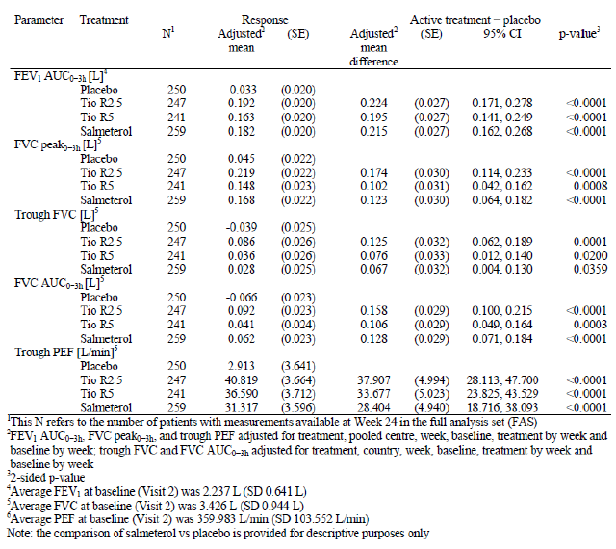
For the secondary endpoints related to questionnaires, the adjusted mean ACQ total score improved (decreased) from trial baseline (2.176) to Week 24 in all four treatment groups (placebo: 1.563, Tio R2.5: 1.362, Tio R5: 1.431, salmeterol: 1.302) and the minimal clinically important difference (0.5) was met in each treatment group. The treatment difference in the adjusted mean ACQ total score at Week 24 was -0.202 points between Tio R2.5 and placebo (p = 0.0007), - 0.113 points between Tio R5 and placebo (p = 0.0262), and -0.262 points between salmeterol and placebo (p < 0.0001). After 24 weeks of treatment, the responder rates for the ACQ total score were higher in the active treatment groups than in the placebo group (placebo: 53.2%, Tio R2.5: 62.5%, Tio R5: 66.7%, salmeterol: 68.6% of patients). Concomitantly, the placebo group showed the highest percentage of patients with no change or worsening of the total ACQ score. The difference between each active treatment group and placebo was statistically significant. The distribution of patients in the responder categories based on the ACQ6 scores was similar to that for the ACQ total scores.. The AQLQ(S) total score also improved (increased) from trial baseline (4.845) to Week 24 in all four treatment groups (placebo: 5.449, Tio R2.5: 5.522, Tio R5:5.519, salmeterol: 5.654). Compared to placebo, the treatment difference was statistically significant for salmeterol (0.204 points, p = 0.0019) but not for Tio R2.5 or Tio R5 (Tio R2.5: 0.073 points, p = 0.2717; Tio R5: 0.070 points, p = 0.2956).
For the secondary endpoints measured at home using the AM3 device, the adjusted mean responses for PEF_{am} and PEF_{pm} after 24 weeks of treatment were comparable in the active treatment groups and larger than in the placebo group. The treatment differences compared to placebo were statistically significant for all three active treatments (p < 0.0001). For FEV₁ am and FEV₁ pm, the treatment differences compared to placebo favoured each active treatment but were only statistically significant for Tio R2.5 and salmeterol (FEV₁ am, Tio R2.5: p = 0.0069, Tio R5: p = 0.0810, salmeterol: p = 0.0012; FEV₁ pm, Tio R2.5: p = 0.0363, Tio R5: p = 0.2077, salmeterol: p = 0.0188).
After 24 weeks of treatment, the adjusted weekly mean number of puffs of rescue medication used in 24 hrs had decreased in all treatment groups; the 24 hr weekly mean response at Week 24 was -0.962 for placebo, -1.124 for Tio R2.5, -0.818 for Tio R5, and -1.416 for salmeterol. The treatment difference compared to placebo was statistically significant for salmeterol (-0.454 puffs, p = 0.0010) but not for Tio R2.5 (-1.162 puffs, p = 0.2447) or Tio R5 (0.144 puffs, p = 0.3046). The adjusted weekly mean asthma symptom free days response had increased after 24 weeks of treatment in all treatment groups; the weekly mean response at Week 24 was 0.162 for placebo, 0.207 for Tio R2.5, 0.157 for Tio R5, and 0.266 for salmeterol. Compared to placebo, the treatment differences in the weekly mean asthma symptom free days response was statistically significant for salmeterol (0.105 days, p = 0.0002) but not for Tio R2.5 (0.045 days, p = 0.1178) or Tio R5 (-0.004 days, p = 0.8880).
During the 24 week treatment period, severe asthma exacerbations were reported for 9.1%, 3.5%, 6.5% and 5.2% in the placebo, Tio R2.5, Tio R5 and salmeterol groups, respectively; compared with placebo, the HR for the risk of first severe asthma exacerbation was 0.37 for Tio R2.5, 0.72 for Tio R5 and 0.55 for salmeterol. All of these ratios favoured the active treatment, but statistical significance was only shown for Tio R2.5 (p = 0.0112). At least one asthma exacerbation (any asthma exacerbation) was reported for 34.7%, 21.2%, 29.9% and 26.6% in the placebo, Tio R2.5, Tio R5 and salmeterol groups, respectively; compared with placebo, the HR ratio for the risk of first asthma exacerbation was 0.57 for Tio R2.5, 0.87 for Tio R5 and 0.72 for salmeterol. All of these ratios favoured the active treatment, and were statistically significant for Tio R2.5 (p = 0.0008) and salmeterol (p = 0.0362) but not for Tio R5. Symptomatic asthma exacerbation was reported for 20.8%, 13.5%, 19.5% and 16.2% in the placebo, Tio R2.5, Tio R5 and salmeterol groups, respectively; compared with placebo, the HR for the risk of first symptomatic asthma exacerbation was 0.63 for Tio R2.5, 0.96 for Tio R5, and 0.75 for salmeterol; statistical significance could be shown for Tio R2.5 (p = 0.0325) but not for Tio R5 and salmeterol.

Twenty four hour PFT endpoints
The adjusted mean FEV₁ AUC_{0−12h}, FEV₁ AUC_{12−24h}, and FEV₁ AUC_{0−24h} responses at Week 24 were larger in the active treatment groups than in the placebo group. The treatment differences compared to placebo favoured the active treatment for each endpoint; statistically significant differences in the adjusted mean FEV₁ AUC_{0−12h} response were seen for all three active treatments, in the adjusted mean FEV₁ AUC_{12−24h} response for Tio R2.5, and in the FEV₁ AUC_{0−24h} response for Tio R2.5 and salmeterol.
The subset of 285 patients who completed the PASAPQ after 24 weeks of treatment expressed a clear preference for the Respimat inhaler over the MDI in terms of the PASAPQ total score, performance, overall satisfaction and willingness to continue with the inhaler. The score for convenience was the only score not to show a statistically significant difference in favour of the Respimat inhaler.
Treatment differences between the tiotropium groups and placebo with respect to the adjusted weekly mean scores for nighttime awakenings, asthma symptoms in the morning, asthma symptoms during the day, activity limitation, shortness of breath, wheeze or cough, and number of asthma symptom free days were non significant at all weeks. Statistically significant differences in favour of salmeterol over placebo were observed at some weeks.

Study 205.419
For the secondary lung function endpoints measured in the clinic (FEV₁ AUC_{0-3h}, FVC peak_{0-3h}, trough FVC, FVC AUC_{0-3h}, and trough PEF) the adjusted mean responses after 24 weeks of treatment were comparable in the active treatment groups and larger than in the placebo group. For all of these endpoints, the treatment differences between Tio R2.5 and placebo and between Tio R5 and placebo were statistically significant, as were the treatment differences between salmeterol and placebo (p values ranging from 0.0312 to < 0.0001).
For the secondary endpoints related to questionnaires, the adjusted mean ACQ total score improved (decreased) from trial baseline (2.181) to Week 24 in all four treatment groups (placebo: 1.442, Tio R2.5: 1.315, Tio R5: 1.359, salmeterol: 1.318); in each treatment group, the minimal clinically important difference (0.5) was met. Compared to placebo, the treatment difference in the adjusted mean ACQ total score at Week 24 was statistically significant for Tio R2.5 (-0.127 points, p = 0.0305), and salmeterol (-0.124 points, p = 0.0339), but not for Tio R5 (-0.083 points, p = 0.1602). The proportion of responders (binary) based on the mean ACQ total score at Week 24 was similar in all four treatment groups (placebo: 62.5%, Tio R2.5: 66.4%, Tio R5: 61.9%, salmeterol: 64.4%). The AQLQ (S) total score improved (increased) from trial baseline (4.799) to Week 24 in all four treatment groups (placebo: 5.551, Tio R2.5: 5.562, Tio R5: 5.548, salmeterol: 5.634). For both the proportion of responders based on the mean ACQ total score and the AQLQ(s) total score, the differences between active treatment and placebo were not statistically significant (p ≥ 0.4012).
For the secondary endpoints measured at home using the AM3 device, the adjusted mean responses for PEF_{am} and PEF_{pm} after 24 weeks of treatment were comparable in the active treatment groups and larger than in the placebo group. The treatment differences compared to placebo were statistically significant for all three active treatments (p = 0.0099 to < 0.0001). For FEV₁ am and FEV₁ pm, the treatment differences compared to placebo favoured each active treatment and were statistically significant with the exception of salmeterol versus placebo for FEV₁ pm (FEV₁ am, Tio R2.5: p = 0.0111, Tio R5: p = 0.0395, salmeterol: p = 0.0071; FEV₁ pm, Tio R2.5: p = 0.0357, Tio R5: p = 0.0422, salmeterol: p = 0.1214.
After 24 weeks of treatment, the adjusted weekly mean number of puffs of rescue medication used in 24 hrs had decreased in all treatment groups; the 24 hr weekly mean response at Week 24 was -0.952 for placebo, -1.123 for Tio R2.5, -0.843 for Tio R5, and -1.078 for salmeterol. The adjusted weekly mean asthma symptom free days response had increased after 24 weeks of treatment in all treatment groups; the weekly mean response at Week 24 was 0.189 for placebo, 0.164 for Tio R2.5, 0.196 for Tio R5, and 0.195 for salmeterol. Compared to placebo, the treatment differences in the weekly mean number of puffs of rescue medication and asthma symptom free days were not statistically significant for any of the active treatment groups (p ≥ 0.1927).
During the 24 week treatment period, severe asthma exacerbations were reported for 7.5%, 5.1%, 5.6% and 7.6% in the placebo, Tio R2.5, Tio R5 and salmeterol groups, respectively; compared with placebo, the HR for the risk of first severe asthma exacerbation was 0.66 for Tio R2.5, 0.72 for Tio R5 and 1.0 for salmeterol and none of these were statistically significant. During the 24 week treatment period, at least one asthma exacerbation (any asthma exacerbation) was reported in 25.8%, 23.4%, 25.8% and 23.9% in the placebo, Tio R2.5, Tio R5 and salmeterol groups, respectively; compared with placebo, the HR for the risk of first asthma exacerbation was 0.78 for Tio R2.5, 0.86 for Tio R5 and 0.79 for salmeterol; all of these ratios favoured the active treatment but were not statistically significant. Similarly, symptomatic asthma exacerbation was reported for 20.6%, 17.6%, 18.3% and 18.6% in the placebo, Tio R2.5, Tio R5 and salmeterol groups, respectively; the HR for the risk of first symptomatic asthma exacerbation was 0.83 for Tio R2.5, 0.86 for Tio R5 and 0.86 for salmeterol none of these were statistically significant.
Twenty four hour (24 hr) PFTs were performed at Week 24 in a subset of 334 patients (placebo: 84 patients, Tio R2.5: 81 patients, Tio R5: 85 patients, salmeterol: 84 patients). Compared to placebo, the adjusted mean FEV₁ AUC_{0−12h}, FEV₁ AUC_{12−24h}, FEV₁ AUC_{0−24h}, FVC AUC_{0−12h}, FVC AUC_{12−24h}, and FVC AUC_{0−24h} responses were statistically significant in favour of each active treatment. In terms of the individual FEV₁ measurements, the treatment differences between each active treatment and placebo were statistically significant at all post inhalation time points. For individual FVC measurements, the treatment differences between each active treatment and placebo were statistically significant at most time points.
The subset of 351 patients who completed the PASAPQ after 24 weeks of treatment expressed a preference for the Respimat inhaler over the MDI in terms of the PASAPQ performance and convenience scores.
Treatment differences between Tio R2.5 and placebo with respect to the adjusted weekly mean scores for night time awakenings, asthma symptoms in the morning, asthma symptoms during the day, activity limitation, shortness of breath, wheeze or cough, and number of asthma symptom free days were non significant at all weeks. Statistically significant differences in favour of Tio R5 over placebo and salmeterol over placebo were observed for some scores at some weeks.
Comment: In patients with moderate persistent asthma, 24 weeks treatment with both tiotropium 2.5 µg and 5 µg qd as add on maintenance therapy (on top of stable medium dose ICS) produced statistically significant improvements in the co primary endpoints of peak FEV₁ (0-3h) and trough FEV₁ compared with placebo; the improvements were numerically greater with the lower 2.5 µg dose of tiotropium.
The secondary lung function endpoints measured in the clinic (FEV₁ AUC_{0-3h}, FVC peak_{0-3h}, trough FVC, FVC AUC_{0-3h}, and trough PEF) also showed statistically significant improvements with Tio 2.5 µg, 5 µg and salmeterol 50 µg compared with placebo.
For the secondary endpoints measured at home using the AM3 device, the adjusted mean responses for PEF_{am} and PEF_{pm} after 24 weeks of treatment were comparable in the active treatment groups and larger than in the placebo group. The treatment differences compared to placebo were statistically significant for all three active treatments (p < 0.0001). For FEV₁ am and FEV₁ pm, the treatment differences compared to placebo favoured each active treatment but were only statistically significant for Tio R2.5 and salmeterol in Study 205.418 although statistically significant difference was observed in all treatment groups in Study 205.419.
Results regarding asthma exacerbations should be interpreted with caution as the duration of these pivotal studies in moderate asthma were only 24 weeks which is much shorter than the recommended duration of 12 months to detect effect on asthma exacerbations according to CHMP guidelines. Furthermore, both studies failed to show any statistically significant reduction in severe/ symptomatic or ‘any’ asthma exacerbation with proposed dose of Tio R5. The incidence of symptomatic asthma exacerbation was significantly reduced with only Tio R2.5 and that of ‘any’ asthma exacerbation was reduced with only Tio R2.5 and salmeterol (but this was only observed in Study 205.418 and not in Study 205.419).
Compared to placebo, the treatment differences in the weekly mean number of puffs of rescue medication and asthma symptom free days were not statistically significant for any of the active treatment groups in Study 205.419 and were statistically significant only for the salmeterol group in Study 205.418 (no significant improvement with Tio 2.5 µg and 5 µg).
Treatment differences between the tiotropium groups and placebo with respect to the adjusted weekly mean scores for night time awakenings, asthma symptoms in the morning, asthma symptoms during the day, activity limitation, shortness of breath, wheeze or cough, and number of asthma symptom free days were non significant at all weeks. Compared with placebo, statistically significant differences in favour of salmeterol (in Studies 205.418 and 205.419) and Tio 2.5 µg (in Study 205.419 only) were observed at some weeks.
The sponsor has recommended only Tio R5 for all asthma severities and it does not seem justified based on results observed in two pivotal studies in moderate asthma described above.

Study 205.442

Study design, objectives, locations and dates
This was a Phase III, randomised, double blind, placebo controlled, parallel group trial to evaluate efficacy and safety of tiotropium inhalation solution delivered via Respimat inhaler (2.5 μg and 5 μg qd in evening) compared to placebo over 12 weeks in mild persistent asthma. The objective of the trial was to investigate the efficacy and safety of two doses of tiotropium inhalation solution in comparison to placebo (all treatments on top of low dose ICS maintenance therapy) delivered by the Respimat inhaler in adult patients with uncontrolled, mild, persistent asthma The study was conducted from 07 Apr 2011 to 19 Apr 2012 at 65 sites in 12 countries in Europe, Asia, and South America (Argentina, Austria, Croatia, Estonia, Guatemala, Hungary, India, Italy, Korea, Latvia, Poland and Slovakia).

Inclusion and exclusion criteria
The main inclusion criteria were: Male and female outpatients between 18 and 75 yrs of age with a current diagnosis of and with a minimum documented three month history of mild, persistent asthma that was diagnosed before the age of 40. All patients had to have been on maintenance treatment with a low, stable dose of ICS for at least four weeks prior to Visit 1; patients who had never smoked or who were ex smokers with < 10 pack yrs and had stopped smoking at least one yr prior to enrolment; symptomatic despite treatment with a low, stable dose of ICS for at least four weeks prior to screening, (FEV₁) ≥ 60% and ≤ 90% of predicted; FEV₁ increase of ≥ 12% and ≥ 200 mL at a timepoint 15 mins to 30 mins after inhalation of 400 μg salbutamol (albuterol); variation in absolute FEV₁ values at Visit 1 (pre bronchodilator) and Visit 2 (pre dose) within ± 30%; ACQ total score ≥ 1.5 at screening (Visit 1) and prior to randomisation (Visit 2). The main exclusion criteria were: any significant medical illness other than asthma such as COPD, recent history of MI, cardiac failure, malignancy (treated basal cell carcinoma allowed), alcohol/ drug abuse, asthma exacerbations and/or respiratory tract infections in the four weeks prior to screening (Visit 1) or during the four week screening period.

Study treatments
The study treatments included oral inhalation using Respimat inhaler of tiotropium 2.5 µg (two actuations of 1.25 µg each) and tiotropium 5 µg (two actuations of 2.5 µg each) qd in the evening. The reference treatments included oral inhalation of placebo by via Respimat inhaler. All treatments given during this trial (Tio R2.5, Tio R5, and placebo) were given on top of low dose ICS therapy. A four week run in period was followed by a 12 week treatment period. Patients were followed up for 21 days. Systemic corticosteroids, inhaled LABAs, β blockers, short acting anticholinergics, ICS in combination with LABAs, ICS in combination with SABA, ipratropium bromide in combination with SABAs, short acting theophyllines, long acting theophyllines, other investigational drugs, anti IgE treatment, and experimental/non approved asthma medications were not allowed during the treatment period of the trial, except in case of exacerbations or other exceptional circumstances. Patients on combination ICS + SABA were to be switched to the inhaled steroid monoproduct without changing the steroid dose and posology at least eight hrs prior to Visit 1. The combination SABA and short acting anticholinergic was to be stopped at least eight hrs prior to Visit 1. Patients should have switched to salbutamol/albuterol as necessary for use during the screening and treatment period of the trial. Use of salbutamol/albuterol was recorded in the e Diary of the AM2+ device.

Efficacy variables and outcomes
The primary endpoint was the maximum FEV₁ within three hrs post dosing (FEV₁ peak_{0-3h}). This was analysed as a response (change from trial baseline) after 12 weeks of treatment. Secondary endpoints included trough (pre dose) FEV₁ (key secondary endpoint), maximum FVC measured within three hrs post dosing (FVC peak_{0-3h}), FEV₁ area under the curve from zero to three hrs (FEV₁ AUC_{0-3h}), and FVC AUC_{0-3h}. These endpoints were analysed as a response (change from baseline after 12 weeks of treatment). Further secondary endpoints were the ACQ, use of rescue medication as needed, time to first severe asthma exacerbation, and time to first asthma exacerbation.
Comment: The CHMP guidelines for investigation of treatments for asthma clearly state that for a new controller treatment equal emphasis should be placed on lung function and symptom based clinical endpoints. A significant benefit from co primary endpoints of lung function and clinical symptoms should be demonstrated so that no multiplicity adjustment to significance levels is indicated. In this pivotal Phase III study in mild asthma, co primary endpoints of lung function and clinical symptoms were not evaluated as symptomatic endpoints were only evaluated as secondary endpoints.

Randomisation and blinding methods
After final assessment of all inclusion and exclusion criteria, each eligible patient was randomly assigned in 1:1:1 ratio to one of the three treatment groups (2.5 μg tiotropium, 5 μg tiotropium, or placebo solution for inhalation) at Visit 2. The sponsor generated the randomisation list using a validated system involving a pseudorandom number generator and a supplied seed number, thereby ensuring that the resulting allocation to a treatment was both reproducible and non predictable. Using a fixed block randomisation ensured that the patients were allocated as balanced as possible in equal numbers to the sequences selected. A block size of six was used. The doses of tiotropium and placebo were administered in a double blind fashion; neither patients nor investigators were aware of the identity of their treatment. The two different doses of tiotropium and placebo were identical in appearance in order to safeguard blinding in this trial.
Comment: According to CHMP guidelines, it should be ensured that treatment arms are balanced according to important predictors of outcome and stratification according to relevant baseline characteristics, for example, number of exacerbations, use or non use of LABAs could be considered. The CSR does not clarify if randomisation of patients was stratified.

Analysis populations
The efficacy analyses and the summary of safety data were based on all randomised patients who were dispensed trial medication and received at least one documented dose of trial medication; this set of patients was the TS and included 464 patients. The full analysis set (FAS) was the same as the TS. The per protocol set (PPS) included all patients in the FAS with no IPVs affecting the primary endpoint; 383 patients were included in the PPS (Tio R5: 136 patients, Tio R2.5: 123 patients, placebo: 124 patients.

Sample size
Using a two sided test with a Type I error of 0.05 (that is, α) and assuming an observed SD of 370 mL, this trial with a sample size of 150 patients per treatment group had have a power of approximately 80% to detect a difference of 120 mL between treatments in the change from baseline of peak FEV₁.

Statistical methods
The superiority of treatment with tiotropium over placebo was tested at the level of α = 0.025 (one sided). The primary analysis was a restricted maximum likelihood (REML) based mixed effect model with repeated measures (MMRM) approach that included ‘treatment’, ‘centre (pooled)’, ‘visit’, and ‘treatment by visit’ interaction as fixed, categorical effects and ‘baseline’ as well as ‘baseline by visit interaction’ as continuous, fixed covariates. Patient within treatment and centre were included as a random effect in the model. A hierarchical procedure was used for the analysis of the primary endpoints, that is, the superiority of tiotropium (2.5 μg) as compared to placebo in peak FEV₁ was only to be tested if the statistical superiority of tiotropium (5.0 μg) over placebo was demonstrated. Adjusted mean values as well as treatment contrasts were calculated together with 95% CIs.

Participant flow
A total of 686 patients were enrolled, 465 patients were randomised, and 464 patients were treated in this trial (Tio R5: 155 patients, Tio R2.5: 154 patients, placebo: 155 patients). Of these, nine patients (1.9%) prematurely discontinued trial medication (Tio R5: three patients [1.9%], Tio R2.5: five patients [3.2%], placebo: one patient [0.6%].

Major protocol violations/deviations
A total of 81 treated patients (17.5%) were reported with at least ONE IPV (Tio R5: 12.3%, Tio R2.5: 20.1%, placebo: 20.0%). In all treatment groups, the largest proportion of patients was reported with IPVs related to entrance criteria not being met. The primary violation in this category was ‘patient was not on adequate maintenance treatment for at least four weeks before screening visit’ (Tio R5: 3.9%, Tio R2.5: 5.8%, placebo: 5.2%).

Baseline data
Majority of the patients were female (60.6%), White (78%) and aged between 31 and 50 yrs (51.7%) with mean age of 42.9 yrs (median = 43 yrs) and median duration of asthma of 15 yrs. The demographic characteristics were generally well balanced between the treatment groups and other characteristics were as expected for a population of adult patients with mild, uncontrolled, persistent asthma at trial baseline (mean baseline FEV₁: 2.420 L, mean baseline percent of predicted FEV₁: 77.66%, mean baseline ACQ total score: 2.10); however, the incidence of males was slightly higher in the Tio R2.5 group compared with the Tio R5 µg group (33.5%, 46.8% and 38.5% in placebo, Tio R2.5 and Tio R5 groups, respectively). All patients had taken ICS as required for participation in the trial. Overall, 75.4% of patients were taking β2 adrenergic agonists; this included 69.2% of patients who took SABAs and 14.0% of patients who took LABAs. Systemic antihistamines were being taken by 34.3% of patients and anti allergic agents (excluding corticosteroids) were being taken by 11.9% of patients in the last three months before screening. The incidence of concomitant medications prior to and during the double blind treatment period were similar between treatment groups; furthermore, proportion of patients taking concomitant medications during treatment period was similar across treatment groups with minor differences in use of antihistamines, fluticasone and mometasone. Overall, median treatment compliance was high (96.3%) and similar between the three treatment groups (Tio R5: 96.2%, Tio R2.5: 96.5%, placebo: 96.2%).

Results for the primary efficacy outcome
Both doses of tiotropium were shown to be superior over placebo in terms of FEV₁ peak_{0-3h} response after 12 weeks of randomised treatment for the FAS and the adjusted mean FEV₁ peak_{0-3h} response was 0.134 L, 0.293 L. and 0.262 L with placebo, TIO 2.5 µg and TIO5 µg, respectively. The treatment difference between Tio R5 and placebo in the adjusted mean FEV₁ peak_{0-3h} response was 0.128 L (95% CI: 0.057, 0.199, p = 0.0005), and the treatment difference between Tio R2.5 and placebo in the adjusted mean FEV₁ peak_{0-3h} response was 0.159 L (95% CI: 0.088, 0.230, p < 0.0001). Consequently, both confirmatory hypotheses were met. The sensitivity analysis performed using the PPS confirmed these results.

Results for other efficacy outcomes
Compared to placebo, statistically significant differences in favour of Tio R5 and Tio R2.5 were also shown for the key secondary endpoint, trough FEV₁ response and the adjusted mean trough FEV₁ response after 12 weeks was 0.015 L, 0.125 L and 0.137 L in placebo, Tio 2.5 µg and Tio 5 µg groups, respectively. The treatment difference in the adjusted mean trough FEV₁ response was 0.122 L between Tio R5 and placebo (p = 0.0010) and 0.110 L between Tio R2.5 and placebo (p = 0.0028). The difference between Tio R5 and placebo for other secondary FEV₁ endpoints measured in the clinic (adjusted mean FEV₁ peak_{0-3h}, trough FEV₁, and FEV₁ AUC_{0-3h}) were significant and in favour of Tio R5 at each visit. Compared to placebo, the treatment differences for other secondary FEV₁ endpoints also favoured Tio R2.5 at each visit, and were mostly statistically significant (the visit on Day 1 was generally an exception). For the FVC secondary endpoints (adjusted mean FVC peak_{0-3h}, FVC AUC_{0-3h}), the adjusted mean response after 12 weeks of treatment was larger in the Tio R2.5 group than in the Tio R5 group. Compared to placebo, the treatment differences at Week 12 were in favour of Tio R5 and Tio R2.5, but were only statistically significant for the Tio R2.5 group.
For the secondary endpoint of adjusted mean ACQ total score, an improvement was observed in all three treatment groups from trial baseline (2.101) to Week 12 (Tio R5: 1.391, Tio R2.5: 1.438, placebo: 1.377). The treatment difference in the adjusted mean ACQ total score at Week 12 between Tio R5 and placebo (0.014 points) and Tio R2.5 and placebo (0.061 points) was not statistically significant or clinically relevant (< 0.5 points). For the ACQ total score, approximately 60% of patients in each treatment group met the definition of responder (Tio R5: 59.2%, Tio R2.5: 61.1%, placebo: 59.1%). Compared to the Tio R5 and placebo groups, the Tio R2.5 group had a lower percentage of patients who did not experience any change in the total ACQ score, and a higher percentage of patients who experienced worsening of the ACQ score. Similar results were obtained for the adjusted mean ACQ6 score and the distribution of patients in the responder categories based on the ACQ6 scores. The weekly mean number of puffs of rescue medication used per day decreased during the trial in all treatment groups with no significant difference between groups. Compared to trial baseline (1.841 puffs/day), the 24 hr weekly mean response for Week 12 was -0.848 for Tio R5, -0.594 for Tio R2.5, and -0.815 for placebo. Compared to placebo, the weekly mean number of puffs of rescue medication used by patients in the Tio R2.5 group tended to be higher at the later weeks of the trial; this difference was statistically significant for night time use at Weeks 8 to 11 and at Week 8 for 24 hr use.
At least one asthma exacerbation was reported for 14.2%, 13.6% and 8.4% of patients in the placebo, Tio 2.5 µg and Tio 5 µg groups, respectively; the HR for Tio R5 versus placebo for the risk of first asthma exacerbation was 0.58 for Tio R5 and 0.96 for Tio 2.5 µg. Overall, only 11 patients experienced at least one severe asthma exacerbation during the trial (Tio R5: one patient, Tio R2.5: six patients, placebo: four patients), and the differences between the tiotropium groups and placebo were not statistically significant.
Comment: The duration of this study was only 12 weeks which is much shorter than the recommended duration of 12 months to detect effect on asthma exacerbations (Note for guidance on clinical investigation of medicinal products for treatment of asthma, CHMP 2013).
The adjusted mean trough FVC response after 12 weeks of randomised treatment was larger for patients taking Tio R2.5 than for patients taking Tio R5, and smallest for patients taking placebo (Tio R5: 0.056 L, Tio R2.5: 0.089, placebo: -0.010 L). The treatment difference in adjusted mean trough FVC response was 0.066 L between Tio R5 and placebo (non significant) and 0.098 L between Tio R2.5 and placebo (p = 0.0236). For the PFT endpoint FEV₁ response at individual time points of each visit (Day 1, Weeks, 4, 8, and 12), the treatment differences compared to placebo were statistically significant at all post inhalation time points for Tio R5 and for Tio R2.5 (with the exception of Day 1). For trough FVC response and FVC response at individual time points, the treatment differences favoured Tio R5 and Tio R2.5 treatment over placebo treatment, but statistical significance was not always shown.
For the AM2+ endpoints, significant differences in favour of Tio R5 and Tio R2.5 over placebo were observed for the adjusted weekly mean PEF_{am} and PEF_{pm} responses at each of the 12 weeks of the treatment period. Generally, PEF_{am} and PEF_{pm} responses were larger in the Tio R5 group than in the Tio R2.5 group, and smallest in the placebo group. Compared to placebo, the treatment differences in the adjusted mean PEF_{am} response ranged from approximately 23 L/min to 37 L/min for Tio R5 and from approximately 18 L/min to 27 L/min for Tio R2.5; for adjusted mean PEF_{pm} response, the differences ranged from approximately 22 L/min to 33 L/min for Tio R5 and from approximately 16 L/min to 26 L/min for Tio R2.5. No significant differences were seen between tiotropium groups and placebo in terms of the adjusted mean PEF variability response. The differences in the adjusted mean FEV_{1am} and FEV_{1pm} responses between Tio R5 and placebo and between Tio R2.5 and placebo favoured the active treatment, but statistical significance was not always shown.
Treatment differences between each tiotropium group and placebo with respect to the adjusted weekly mean scores for night time awakenings, asthma symptoms during the day, and wheeze or cough during the day, were small and non significant at all weeks.
Comment: Following 12 weeks treatment, both Tio R2.5 and Tio R5 showed statistically significant improvement in primary endpoint of peak FEV₁ as well as other secondary lung function endpoints including trough FEV₁ in patients with mild persistent asthma on stable low dose of ICS. However, one of the main limitations of this study was lack of assessment of asthma symptoms as a co primary endpoint.

Other efficacy studies
Efficacy was the secondary endpoint in the Phase IIIb study 205.452 involving 17811 COPD patients (described in Section 8.2).
For the second primary endpoint of time to first COPD exacerbation, the HR for Tio R5 versus Tio HH18 was 0.978 [95% CI: (0.928, 1.032), p = 0.4194], that is, at any time during the trial a subject in the Tio R5 group had a 2.2% lower chance of experiencing a COPD exacerbation than a subject in the Tio HH18 group. The statistical comparison for superiority of Tio R5 over Tio HH18 was not achieved for the primary endpoint of time to first COPD exacerbation. The HR for Tio R2.5 versus Tio HH18 was 1.016 [95% CI: (0.964, 1.070)], that is, at any time during the trial a subject in the Tio R2.5 treatment group had a 1.6% higher chance of experiencing a COPD exacerbation than a subject in the Tio HH18 group. The HR for Tio R2.5 versus Tio R5 was 1.038 [95% CI: (0.985, 1.094)] that is, at any time during the trial a subject in the Tio R2.5 treatment group had a 3.8% higher chance of experiencing a COPD exacerbation than a subject in the Tio R5 treatment group. No statistically significant differences were observed for any of the three treatment comparisons. The incidence of COPD exacerbations was 47.9% in the Tio R5 group, 49.4% in the Tio R2.5 group, and 48.9% in the Tio HH18 group. The median time to first COPD exacerbation (as calculated using median Kaplan Meier survival time) was longer in the Tio R5 group compared to the Tio HH18 group (756 days and 719 days, respectively). The Tio R2.5 group had the shortest median time to first COPD exacerbation with 707 days.
As observed within the time to death subgroup analysis, a slight increase in COPD exacerbations was noted in Asian subjects treated with Tio R2.5 versus Tio HH18 within race [N = 1626: HR = 1.15, 95% CI: (0.99, 1.33)] as well as region [N = 1582: HR = 1.17, 95% CI: (1.00, 1.35)]. In addition, analyses for subjects taking ICS (but not LABA) at baseline (noted because the treatment by subgroup interaction p = 0.01) showed an increased risk of COPD exacerbation within Tio R5 versus Tio HH18 [N = 827: HR = 1.30, 95% CI: (1.07, 1.58)]; a similar trend was observed for comparison of Tio R2.5 versus Tio HH18 [N = 828: HR = 1.19, 95% CI: (0.98, 1.44)]. However, these differences were not considered to be meaningful.
Overall, 8,342 of 17,116 treated subjects (48.7%) experienced at least one COPD exacerbation during the trial. Of all subjects who experienced at least one COPD exacerbation, more than half experienced two or more COPD exacerbations during the trial. The number of COPD exacerbations analyses account for multiple exacerbations per subject. The total number of COPD exacerbations was similar between treatment groups (Tio R2.5: 6,565; Tio R5: 6,425; and Tio HH18: 6,504). The rate ratios (RRs) of events for Tio R5 versus Tio HH18 was 0.99 [95% CI: (0.94, 1.05); p = 0.8047] and 1.01 for Tio R2.5 versus Tio HH18 [95% CI: (0.95, 1.06); p = 0.8330]. The mean adjusted rates of exacerbation were 0.59 per patient yr in all three treatment groups.
The incidence of COPD exacerbation associated with hospitalisation was similar in the three tiotropium groups (14.5%, 15.2% and 14.3% in Respimat Tio 5 µg, 2.5 µg and HH Tio 18 µg groups, respectively); there was no significant difference between HH Tio 18 µg and Tio Respimat 5 µg (HR of Tio 5 µg versus Tio 18 µg, 1.024, 95% CI: 0.929, 1.128, p = 0.6384) as well as Tio 2.5 µg (HR = 1.068, 95% CI: 0.971, 1.176, p = 0.1762). The total number of COPD exacerbations associated with hospitalisation was 1316 for Tio R2.5, 1284 for Tio R5, and 1216 for Tio HH18. The RRs were 1.06 (95% CI: 0.94, 1.18; p = 0.3441) for Tio R5 versus Tio HH18 and 1.09 for Tio R2.5 versus Tio HH18 (95% CI: 0.98, 1.22; p = 0.1255), that is, the number of COPD exacerbations associated with hospitalisation at any time during the trial was 6% higher in the Tio R5 group and 9% higher in the Tio R2.5 group compared to the Tio HH18 group. The adjusted mean rate of events was similar between treatment groups (Tio R2.5: 0.12; Tio R5: 0.12; Tio HH18: 0.11). The analysis of time to first moderate to severe COPD exacerbation was correlated with the analysis of time to first COPD exacerbation. Nearly all subjects (8195 of 8342; approximately 98%) who experienced at least one COPD exacerbation during the trial had an exacerbation defined as moderate to severe consistent with the primary analysis of time to first COPD exacerbation, there were no significant differences between treatment groups for time to first moderate to severe COPD exacerbation.
A substudy of pulmonary function testing was completed in 1,370 subjects and the objective of this substudy was to assess long term lung function every 24 weeks. Endpoints defined for the substudy were trough FEV₁ and trough FVC. The first test performed assessed the main effect for treatment in the MMRM model, specifically the 95% CI for the contrast between Tio R5 and Tio HH18 (compared to the non inferiority delta of -50 mL). If the first test was successful, the second test in the hierarchy was to assess the main effect for treatment in the MMRM model, specifically the 95% CI for the contrast between Tio R2.5 and Tio HH18 (compared to the non inferiority delta of -50 mL). Non inferiority testing was performed based on a non inferiority delta of 50 mL and SD of 225 mL for trough (that is, morning pre dose FEV₁). The sample size needed per group was estimated at 427 subjects per group for 90% power and one sided α = 0.025. Rounding to 435 subjects per group, 1,305 subjects was the target sample size for the substudy.
Differences between the substudy population and the non substudy population were observed for gender, race, smoking history (pack yrs), and BMI: the proportion of male subjects was lower (62.0% compared to 72.3% in the non substudy population), the proportion of Asian subjects was lower (0.2% compared to 15.4% in the non substudy population), and smoking history was longer (45 compared to 40 median pack yrs in the non substudy population) in the substudy population. Differences in demographics may be due to fact that centres participating in the substudy were localised in either the European region or North America whereas the overall trial included additional centres in Asia and Latin America. Overall, a slightly greater proportion of patients were taking concomitant medications at baseline in the PFT substudy compared to the rest of the study population (96.1% versus 90.1%). Overall, the mean pre bronchodilator FEV₁ for the SSS was 1.225 L. There was a difference of 53 mL in the mean pre bronchodilator FEV₁ between the Tio R5 group (1.256 L) compared to the Tio HH18 group (1.203 L) and a 73 mL difference in mean pre bronchodilator FVC (2.555 L for Tio R5 and 2.482 L for Tio HH18). When comparing Tio R5 with Tio R2.5, there was a difference of 41 mL in the mean pre bronchodilator FEV₁ (1.256 L for Tio R5 and 1.215 L for Tio R2.5) and a 38 mL difference in mean pre bronchodilator FVC (2.555 L for Tio R5 and 2.517 L for Tio R2.5).
The PFT substudy demonstrated similar lung function, on average, as measured by FEV₁, between the Tio R5 group (1.285 L) and Tio HH18 group (1.295 L) over 120 weeks. The adjusted difference between Tio R5 and Tio HH18 was -0.010 L [95% CI: (-0.038 to 0.018)]. Because the lower bound of the CI was greater than the predefined non inferiority delta of -50 mL (-0.050 L), it was demonstrated that Tio R5 is non inferior to Tio HH18 for FEV₁. However, Tio R2.5 did not achieve non inferiority compared to Tio HH18 for FEV₁ (adjusted difference between Tio R2.5 and Tio HH18 was -0.037 L; 95% CI: -0.065 to -0.009); furthermore, the upper bound of the CI was less than zero, suggesting that Tio R2.5 may be inferior to Tio HH18 for FEV_{1.}. Similar results were observed for trough FVC.
Comment: The large scale, Phase IIIb, long term, event driven, active controlled Study 205.452 involving 17811 COPD patients with approximately two to three yrs of treatment showed that Tio R5 has similar effects as Tio HH18 in time to first COPD exacerbation, time to moderate to severe COPD exacerbation, time to first severe exacerbation (hospitalisation) and the number of COPD exacerbations.

Analyses performed across trials (pooled analyses and meta analyses)
Pooled efficacy analysis was done for Studies 205.416 and 205.417 in patients with severe asthma and also for Studies 205.418 and 205.419 in patients with moderate asthma.

Pooled analysis of studies 205.416 and 205.417

Design, endpoints, statistical analysis and sample size calculation
These two multinational, multicentre, replicate trials were conducted in 148 sites in 15 countries (Australia, Canada, Denmark, Germany, Italy, Japan, The Netherlands, New Zealand, Russia, Serbia, South Africa, Turkey, Ukraine, United Kingdom and United States). The primary endpoint for the pooled analysis was time to first severe asthma exacerbation during the 48 week treatment eriod. The reason for pooling was to have a reasonable power for this endpoint. Secondary endpoints for the pooled analysis were: Time to first asthma exacerbation during the 48 week treatment period (including severe, non severe; symptomatic, asymptomatic; that is, any exacerbation); number of patients with at least one severe asthma exacerbation/ at least one asthma exacerbation and number of severe asthma exacerbations/ asthma exacerbations per patient. The superiority of treatment with Tio R5 compared with placebo was tested in terms of time to first severe asthma exacerbation. For this endpoint a pre planned interim analysis of the HR of time to first severe asthma exacerbation was performed with the option to adapt the sample size. With a sample size of approximately 600 patients (300 per treatment group) in the pooled data from the two trials with α = 0.05 for a two sided test for a HR of one (no difference between tiotropium and placebo), the power would be slightly higher than 90% to detect a constant HR of approximately 0.562 (43.8% reduced risk). Based on the interim analysis which was conducted by an independent data monitoring committee, the sample size was increased from 300 to approximately 400 patients for each trial as the HR exceeded pre defined 0.60 for the 65 events (number of patients with at least one exacerbation).

Patient disposition, baseline demographics, disease characteristics
A total of 912 patients were randomised and treated with either Tio R5 (456 patients) or placebo (456 patients). The full analysis set (FAS) was defined as all treated patients who had baseline data and at least one on treatment efficacy measurement, and included 907 patients; 453 of these patients were in the Tio R5 group and 454 taking placebo. The per protocol set (PPS) was defined as all treated patients who were part of the FAS and complied with the CTP without any important protocol violations. A total of 205 patients were excluded from the PPS because of important protocol violations and 692 patients were included in the PPS (Tio R5 = 340, placebo = 352). Of the treated patients, 10.7% discontinued prematurely (Tio R5: 10.3%, placebo: 11.2%). The most frequent reason for discontinuation was withdrawn consent (3.3%) (Tio R5: 3.3%; placebo: 3.3%).
Majority of patients were female (60.4%), White (83.2%) and aged between 31 and 75 yrs (93.6%) with mean age of 53 yrs and median asthma duration of 20 yrs. Overall, the demographic profile was balanced between the treatment groups. Baseline characteristics were as expected for a population of adult patients with severe, uncontrolled, persistent asthma (mean baseline FEV₁: 1.603 L, mean baseline FEV₁% predicted: 55.96, mean baseline ACQ: 2.6). The concomitant treatments being taken by both groups were similar at baseline with the most common ones being ICS (99.3%; TIO R5 versus placebo: 100% versus 98.7%), intranasal glucocorticoids (16.3%; 15.6% versus 17.1%), oral glucocorticoids (2.4%; 2.6% versus 2.2%), LABAs (97.9%; 97.4% versus 98.5%), SABAs (33.4%; 34.9% versus 32.0%), leukotriene modifiers (21.9%; 20.2% versus 23.7%), xanthines (19.1%; 19.7% versus 18.4%) and systemic antihistamines (14.9%; 17.8% versus 12.1%).

Primary efficacy results
Superiority of Tio R5 over placebo was demonstrated for the primary endpoint of time to first severe asthma exacerbation. At least one severe asthma exacerbation was reported by 26.9% and 32.8% of patients in the Tio R5 and placebo groups. Less than 50% of patients in both treatment groups were reported with at least one severe asthma exacerbation, so median time to first severe exacerbation could not be calculated. The time to first severe asthma exacerbation (which is the time until at least 25% of the patients had a first severe asthma exacerbation) was 282 days and 226 days for Tio R5 and placebo respectively. Using a proportional hazard model with only treatment as effect, the HR of Tio R5 to placebo was 0.79 (p = 0.0343) which translated into a risk reduction of 21%. A Kaplan Meier estimate of the time to first severe asthma exacerbation on treatment is provided in Figure 4 and shows an early advantage of Tio R5 over placebo as the two curves start to separate from approximately 60 days of treatment onwards.
Figure 4: The cumulative percentage of patients with at least one severe asthma exacerbation – Kaplan Meier method – FAS
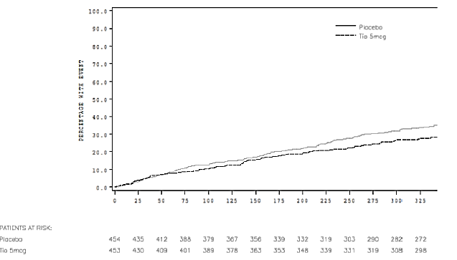

Sensitivity analysis of primary endpoint
In the PPS analysis, at least one severe asthma exacerbation was reported by 27.7% and 30.2% of patients of patients in the Tio R5 and placebo groups, respectively and the time to first severe asthma exacerbation for the first quartile (Q1) of patients was 282 days and 255 days for Tio R5 and placebo respectively. Using a proportional hazard model with only treatment as effect, the HR for Tio R5 versus placebo for time to first severe asthma exacerbation was 0.91 (p = 0.4918) which translated into a non significant 9% risk reduction with Tio R5 for experiencing at least one severe asthma exacerbation as compared with patients taking placebo in the per protocol set.
Using a proportional hazard model with treatment and trial as effects, the HR for Tio R5 versus placebo for time to first severe asthma exacerbation was found to be 0.80; however, this 20% risk reduction for experiencing at least one severe asthma exacerbation as compared with patients taking placebo was not statistically significant (p = 0.0643).
A majority of patients did not report any severe asthma exacerbations during the course of this 48 week study (Tio R5: 331 patients, placebo: 305 patients). Fewer Tio R5 patients than placebo patients were reported with one (Tio R5: 75 patients, placebo: 90 patients), two (Tio R5: 27 patients, placebo: 34 patients) and three or more severe asthma exacerbations (Tio R5: 20 patients, placebo: 25 patients). Only two patients in the Tio R5 group and one in the placebo group reported more than six severe asthma exacerbations during this study. For the secondary endpoint of the number of patients with a severe asthma exacerbation, the odds ratio for Tio R5 versus placebo was not statistically significant (0.75, p = 0.0592). However, the ratio of number of severe exacerbations per patient of Tio R5 to placebo was 0.80 with a 95% CI of 0.64, 1.00 showing a significant difference in favour of Tio R5 (p = 0.0458).
Comment: Although, ratio of number of severe exacerbations per patient was just statistically significant (OR = 0.80; 95% CI of 0.64, 1.00, p = 0.0458), these results should be interpreted with caution as the 95% CI included one.

Secondary efficacy results
The proportion of patients who reported at least one asthma exacerbation was 49.9% and 63.2% in the Tio R5 and placebo groups, respectively over the 48 weeks of the study and the median time to first asthma exacerbation was 315 and 181 days, respectively. Using a proportional hazard model with only treatment as effect, the HR for Tio R5 versus placebo was found to be 0.69 (p < 0.0001) with a statistically significant risk reduction of 31% for experiencing at least one asthma exacerbation with Tio R5 compared with placebo. A Kaplan Meier estimate of the time to first asthma exacerbation on treatment is provided in Figure 5 and the two Kaplan Meier curves start to separate from approximately 30 days of treatment onwards. Overall, 227 patients in the Tio R5 group and 167 patients in the placebo group did not report any asthma exacerbations during the course of this 48 week study. While similar numbers of patients in each treatment group were reported with one (Tio R5: 93 patients, placebo: 100 patients) and two (Tio R5: 45 patients, placebo: 48 patients) asthma exacerbations, fewer Tio R5 patients than placebo patients were reported with three or more asthma exacerbations (Tio R5: 86 patients, placebo: 135 patients). Only two patients in the Tio R5 group and four in the placebo group reported more than 21 asthma exacerbations during this study. The ratio of number of exacerbations per patient of Tio R5 to placebo was 0.76 with a 95% CI of 0.63 to 0.91 showing a significant difference in favour of Tio R5 (p = 0.0031).
Figure 5: The cumulative percentage of patients with at least one asthma exacerbation – Kaplan Meier method – FAS
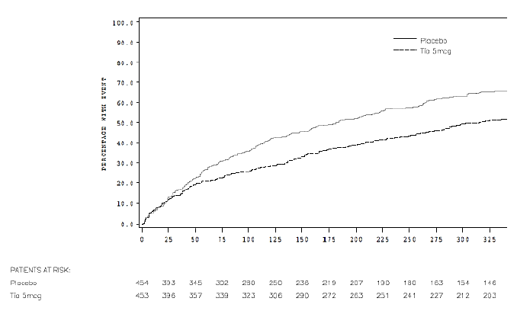
In the Tio R5 group, 37.1% of patients were reported with at least one symptomatic asthma exacerbation as compared with 47.6% of patients in the placebo group over the 48 weeks of the study. Less than 50% of patients in both treatment groups were reported with at least one symptomatic asthma exacerbation, so median time to first symptomatic exacerbation could not be calculated. The time to first symptomatic asthma exacerbation (which is the time until at least 25% of the patients had a first symptomatic asthma exacerbation) was 158 days and 111 days for Tio R5 and placebo respectively. Using a proportional hazard model with only treatment as effect, the HR for Tio R5 versus placebo was found to be 0.73 (p = 0.0024) with a statistically significant risk reduction of 27% for experiencing at least one symptomatic asthma exacerbation with Tio R5 compared with placebo. A Kaplan Meier estimate of the time to first symptomatic asthma exacerbation on treatment is provided in Figure 6 and the two Kaplan Meier curves start to separate from approximately 40 days of treatment onwards. Overall, 285 patients in the Tio R5 group and 238 patients in the placebo group did not report any symptomatic asthma exacerbation during the course of this 48 week study. Fewer Tio R5 patients than placebo patients were reported with one (Tio R5: 80 patients, placebo: 108 patients) symptomatic asthma exacerbation. While similar numbers of patients in each treatment group were reported with two (Tio R5: 43 patients, placebo: 43 patients) and three (Tio R5: 17 patients, placebo: 23 patients) symptomatic asthma exacerbations, fewer Tio R5 patients than placebo patients were reported with four or up to six symptomatic asthma exacerbations (Tio R5: 16 patients, placebo: 32 patients). 12 patients in the Tio R5 group and 10 in the placebo group reported between seven and 20 symptomatic asthma exacerbations during this study. The ratio of number of symptomatic exacerbations per patient of Tio R5 to placebo was 0.79 with a 95% CI of (0.65, 0.97) showing a significant difference in favour of Tio R5.
Figure 6: The cumulative percentage of patients with at least one symptomatic asthma exacerbation – Kaplan Meier method FAS
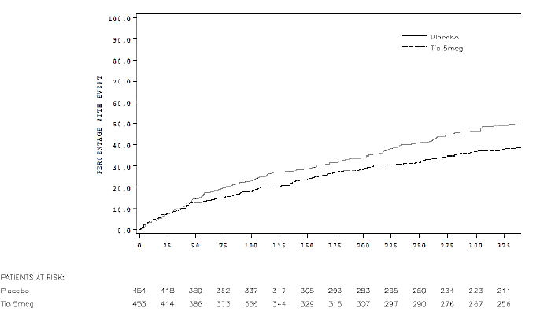
Comment: The interim analyses was planned to be performed after 65 events (number of patients with at least one severe asthma exacerbation) and was performed in December 2009. The HR for Tio R5 versus placebo at the interim time point was found to be 0.64 (p = 0.060), which meant that patients taking Tio R5 had a risk reduction of 36% compared with patients taking placebo for experiencing at least one severe asthma exacerbation at the timepoint of the interim analysis.
According to CTP, the sample size was increased to about 400 patients for each trial as the HR exceeded 0.60 for the 65 events observed during the interim analysis. As there was some over recruitment (n = 912), the results were also calculated for the first 812 randomised patients. The HR for Tio R5 versus placebo after the first 812 randomised patients was found to be 0.73 (p = 0.014) and patients taking Tio R5 had a risk reduction of 27% as compared with patients taking placebo.
However, the pooled analysis done using the actual sample size of 912 patients showed that the HR was 0.79 (p = 0.0343) and patients taking Tio 5 µg had a risk reduction of 21% compared with placebo for experiencing severe asthma exacerbation. However, these results were not robust as the PPS analysis only showed non significant risk reduction of 9% (HR= 0.91, p -0.4918).
The sponsors state that the main reason why the HR for the primary analysis in the end turned out to be 0.79 was due to the fact that in the population of the Japanese patients, a higher proportion of patients in the Tio R5 treatment group experienced at least one severe asthma exacerbation compared with placebo. Furthermore, the Japanese patients were recruited mainly at the end of the two trials; 10 out of 29 patients treated with placebo and 15 out of 36 patients treated with Tio R5 had at least one severe asthma exacerbation, the respective HR in this subgroup is 1.25.
However, the above justification does not seem adequate and even if true, it would raise concerns regarding efficacy of tiotropium in reducing risk of severe asthma exacerbations in Japanese patients, especially since majority of patients in Studies 205.416/417 were White (83.2%). The sponsors were asked to clarify these inconsistent results.
However, the pooled analysis did provide evidence to suggest that treatment of severe asthma patients with tiotropium 5 µg for 48 weeks was associated with a significant 31% reduction in risk of ‘any’ asthma exacerbation (Tio 5 µg versus placebo: 49.9% versus 63.2%; HR = 0.69, p < 0.0001) and a 27% reduction in risk of symptomatic asthma exacerbation (37.1% versus 47.6%; HR = 0.73, p = 0.0024).

Pooled analysis of Studies 205.418 and 205.419

Design, endpoints, statistical analysis, sample size calculation
These two multinational, multicentre, replicate trials were conducted at 233 sites in 14 countries (Latvia, Poland, Romania, Russia, Brazil, China, Colombia, Germany, Guatemala, India, Japan, Mexico, Peru and USA). Each trial was a randomised, double blind, double dummy, placebo and active controlled, parallel group trial to evaluate the efficacy and safety of two doses of tiotropium (2.5 μg and 5 μg) delivered by the Respimat inhaler compared to placebo and to salmeterol (50 µg) on top of medium dose ICS maintenance therapy over 24 weeks in adults with not fully controlled, moderate, persistent asthma.
The primary endpoint of the combined analysis was the (binary) responder rate as assessed by the ACQ total score after 24 weeks of treatment on combined data from the two twin Trials 205.418 and 205.419. The reason for pooling was to have a reasonable power for this endpoint. The combined statistical analysis plan included the following secondary endpoints: Time to first severe asthma exacerbation during the 24 week treatment period; time to first asthma exacerbation (including severe, non severe; symptomatic, asymptomatic; that is, any exacerbation) during the 24 week treatment period; ACQ total score at all visits. Further endpoints related to asthma exacerbations were: Number of any asthma, symptomatic and severe asthma exacerbations per patient during the 24 week treatment period; Number of patients with at least one asthma exacerbation (any exacerbation), symptomatic and severe asthma exacerbations during the 24 week treatment period; time to first symptomatic asthma exacerbation during the 24 week treatment period; number of severe asthma exacerbations per patient during the 24 week treatment period. Further endpoints related to ACQ were: ACQ6 score at all visits; ACQ total score responder categories (responder/no change/ worsening) after 24 weeks of treatment; ACQ6 responder categories (responder/no change/ worsening) after 24 weeks of treatment.
The primary analysis was performed on the Full Analysis Set (FAS), which included all patients of the TS with baseline data and at least one on treatment efficacy measurement. The Per Protocol Set (PPS) included all patients of the FAS with no important protocol violations (IPVs) affecting the primary endpoints. The primary analysis on the total ACQ score was a responder analysis, carried out to determine the percentage of patients with at least the minimal important difference of 0.5 compared to baseline. The proportion of responders (binary, that is, yes/no) was analysed using Fisher’s Exact Test. The odds ratio (active treatment/ placebo and salmeterol/tiotropium) and corresponding two sided 95% CI was calculated together with the p value (for the test of the null hypothesis of the odds ratio equalling one). Sample size consideration for the primary variable ACQ of the pooled analysis was based on the endpoint of the relative frequency of patients who reached the minimum clinically important difference in the ACQ total score, which was set to 0.5 (that is, if ACQ total score difference to baseline ≥ 0.5 then responder) With 500 patients per treatment group, the power was 91.34% for the pooled analysis assuming a placebo response rate of 30%.

Patient disposition, baseline demographics, disease characteristics
Of the 4,117 enrolled patients, 2,103 were randomised in a 1:1:1:1 ratio to receive treatment with either placebo, 2.5 μg tiotropium (Tio R2.5), 5 μg tiotropium (Tio R5), or salmeterol according to a parallel group design (placebo: 523 patients, Tio R2.5: 520 patients, Tio R5: 519 patients, salmeterol: 541 patients). Two patients randomised to Tio R5 and one patient randomised to Tio R2.5 was not treated; all of the other 2100 randomised patients were treated with trial medication. Of these, 1,972 patients (93.9%) completed the 24 week treatment period (placebo: 93.3%, Tio R2.5: 95.2%, Tio R5: 93.0%, salmeterol: 94.1%), and 128 patients (6.1%) prematurely discontinued trial medication (placebo: 6.7%, Tio R2.5: 4.8%, Tio R5: 7.0%, salmeterol: 5.9%). The most frequent reasons for premature discontinuation apart from ‘other’ reasons was the occurrence of AEs (placebo: 2.5%, Tio R2.5: 1.2%, Tio R5: 1.9%, salmeterol: 1.8%). The FAS was defined as all treated patients who had baseline data and at least one on treatment efficacy measurement. A further eight patients were excluded as they had no on treatment efficacy data (placebo: two patients, Tio R2.5: one patient, Tio R5: two patients, salmeterol: three patients). The FAS thus included 2,081 patients (placebo: 518 patients, Tio R2.5: 515 patients, Tio R5: 513 patients, salmeterol: 535 patients). The per protocol set (PPS) was defined as all treated patients who were part of the FAS and complied with the clinical trial protocol (CTP) without any important protocol violations (IPVs). A total of 403 patients were excluded from the PPS because of IPVs; thus, the PPS included 1,678 patients (placebo: 407 patients, Tio R2.5: 425 patients, Tio R5: 411 patients, salmeterol: 435 patients).
The majority of patients were female (59%), White (47.9%) or Asian (42.5%), aged between 31 and 50 yrs (51.1%) with median age of 43 yrs and median asthma duration of 20 yrs. The demographic characteristics were generally well balanced between the treatment groups and other characteristics were as expected for a population of adult patients with moderate, persistent asthma at trial baseline (mean baseline [pre dose] FEV₁: 2.267 L, mean baseline percent of predicted FEV₁: 75.06%, mean baseline ACQ total score: 2.18. All patients had taken ICS as required for participation in the trial. The most common concomitant therapies taken in three months prior to screening were SABAs (66.1%), LABAs (60.8%), systemic antihistamines (17.0%) and leukotriene modifiers (10.1%) with similar medications taken between screening and randomisation and also during double blind treatment period. Overall, median treatment compliance was high (93.6%) and similar between the four treatment groups (placebo: 93.6%, Tio R2.5: 93.3%, Tio R5: 93.2%, salmeterol: 94.3%).

Primary efficacy results
Both Tio R5 and Tio R2.5 were shown to be superior over placebo for the primary endpoint responder rate as assessed by the ACQ total score after 24 weeks of randomised treatment. The responder rates were 57.7%, 64.5%, 64.3%, and 66.5% of patients in the placebo, Tio R2.5, Tio R5, and salmeterol groups of the FAS, respectively. The odds ratio for Tio R5 versus placebo was 1.32 (95% CI: 1.02, 1.71; p = 0.0348) and the odds ratio for Tio R2.5 versus placebo was 1.33 (95% CI: 1.03, 1.72; p = 0.0308). The treatment difference between salmeterol and placebo, which was included for descriptive purposes only, was also statistically significant (OR: 1.46; 95% CI: 1.13, 1.89; p = 0.0039). The results of the sensitivity analysis of the primary endpoint were conducted for the PPS, FAS including centre 07006, unweighted generalised estimating equations (GEE) results and weighted GEE results. The ACQ responder rates for all sensitivity analyses were similar to those obtained for the primary analysis on the FAS. All differences between active treatment and placebo were statistically significant with the exception of the unweighted and weighted GEE analyses for Tio R5 versus placebo.

Secondary efficacy results
Time to first severe asthma exacerbation and time to first asthma exacerbation (including severe, non severe; symptomatic, asymptomatic; that is, any exacerbation) were secondary endpoints of this pooled analysis. During the 24 week treatment period, severe asthma exacerbations were reported for 8.3%, 4.3%, 6.0% and 6.4% of patients in the placebo, Tio R2.5, Tio R5 and salmeterol groups, respectively. The HR for the risk of first severe asthma exacerbation compared to placebo was 0.50 for Tio R2.5, 0.72 for Tio R5 and 0.75 for salmeterol; all of these ratios favoured active treatment but the HR was statistically significant only for Tio R2.5 (p = 0.0084). The median time to first severe exacerbation could not be calculated because less than 50% of patients in each treatment group were reported with at least one severe asthma exacerbation. A Kaplan Meier estimate of the proportion of patients experiencing any severe asthma exacerbation during the 24 week treatment period is provided in Figure 7 and the curves for the three active treatment groups are similar; the placebo curve starts to separate from the curves representing active treatments from approximately 90 days of treatment onward.
Figure 7: Cumulative proportion of patients having severe asthma exacerbations – FAS
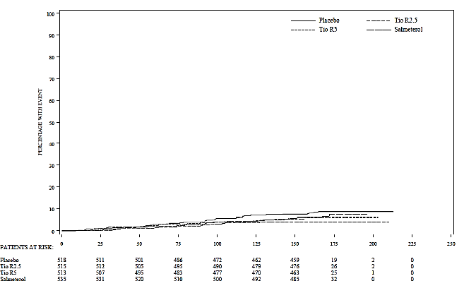
At least one asthma exacerbation (any asthma exacerbation) was reported for 31.7%, 22.3% , 27.9% and 25.2% of patients in the placebo, Tio R2.5, Tio R5 and salmeterol groups, respectively; the HR for the risk of first asthma exacerbation compared with placebo was 0.66 for Tio R2.5, 0.87 for Tio R5, and 0.75 for salmeterol; again, all of these ratios favoured active treatment but were statistically significant only for Tio R2.5 (p = 0.0007) and salmeterol (p = 0.0131). The median time to first asthma exacerbation (any or severe) could not be calculated as less than 50% of patients in each treatment group experienced an asthma exacerbation. A Kaplan Meier estimate of the proportion of patients experiencing any asthma exacerbations during the 24 week treatment period is provided in Figure 8 and the curves indicate that the risk of experiencing an asthma exacerbation does not change over time in any of the treatment groups.
Figure 8: Cumulative proportion of patients having asthma exacerbations (any asthma exacerbation) – FAS
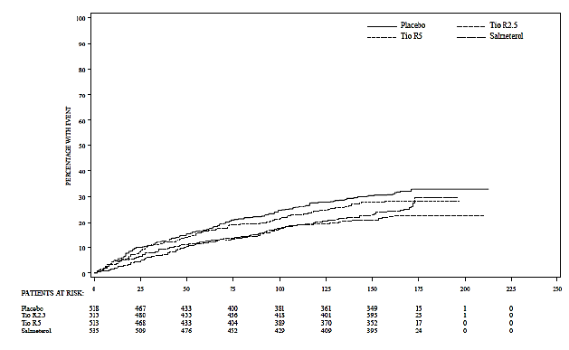
Evaluated by visit, the adjusted mean ACQ total score improved (decreased) during the 24 week treatment period in all four treatment groups (trial baseline: 2.178). Compared to placebo, the difference in adjusted mean ACQ total score was largest for Tio R2.5 and Tio R5 at Week 24 (-0.160 points and -0.115 points, respectively) and largest for salmeterol at Week 8 (-0.206 points); the treatment differences were statistically significant in favour of Tio R2.5 at Weeks 8, 16, and 24 (p = 0.0143 to p = 0.0002), in favour of Tio R5 at Weeks 8 and 24 (p = 0.0370 and p = 0.0084, respectively), and in favour of salmeterol at all visits (p = 0.0006 to < 0.0001).

Other efficacy results
After 24 weeks of treatment the responder rate for the ACQ total score was higher in the active treatment groups than in the placebo group (placebo: 57.7%, Tio R2.5: 64.5%, Tio R5: 64.3%, salmeterol 66.5% of patients). Concomitantly, the placebo group showed the highest percentage of patients with no change or worsening of the total ACQ score. The difference between each active treatment group and placebo was statistically significant. The distribution of patients in the responder categories based on the ACQ6 scores was similar to that for the ACQ total scores (placebo: 65.1%, Tio R2.5: 68.7%, Tio R5: 70.2%, salmeterol: 73.1% of patients). Compared to the active treatment groups the placebo group showed higher percentage of patients who experienced worsening of the ACQ6 score (placebo: 8.5%, Tio R2.5: 4.5%, Tio R5: 4.7%, salmeterol: 4.3%). Compared to placebo, the treatment difference was statistically significant for Tio R5 and salmeterol, but not for Tio R2.5.
Comment: A difference between the two trials in the placebo response rate (ACQ binary responders) was found in the Japanese patients. In Trial 205.418, the placebo response rate of the Japanese patients was 18 out of 29 patients, and for Trial 205.419 it was 28 out of 29 patients. Pooling of the studies went ahead as planned. The impact of high placebo response in Japanese patients was not evaluated.
The majority of patients did not report asthma exacerbations (any exacerbation) during the course of this 24 week trial (68.3%, 77.7%, 72.1% and 74.8% with placebo, Tio R2.5, Tio R5 and salmeterol, respectively). Fewer patients in the active treatment groups than in the placebo group were reported with one or three asthma exacerbations (one exacerbation in 94, 72, 72 and 84 patients, respectively; three exacerbations in 23, eight, 12 and nine patients, respectively). However, the number of patients experiencing two asthma exacerbations was numerically higher in the Tio R5 treatment group than in the other treatment groups (21, 23, 37 and 25 patients, respectively). Similar numbers of patients in each treatment group were reported with four exacerbations (eight, six, seven and seven patients, respectively). Few patients (zero to eight in any treatment group) had more than four (maximum 20) asthma exacerbations during the trials. Using the Poisson regression model, the estimated rate of asthma exacerbations (any exacerbation) per patient per yr was higher in the placebo group than in the active treatment groups (1.50, 0.88, 1.34 and 1.04, respectively); the ratio (active treatment versus placebo) of the estimated rates of asthma exacerbations per patient per yr was 0.59 for Tio R2.5 versus placebo, 0.89 for Tio R5 versus placebo, and 0.69 for salmeterol versus placebo; all of these ratios favoured active treatment but were statistically significant only for Tio R2.5 (p < 0.0001) and salmeterol (p = 0.0005).
During the 24 week treatment period symptomatic asthma exacerbations were reported for 20.7%, 15.5%, 18.9% and 17.4% in the placebo, Tio R2.5, Tio R5 and salmeterol groups, respectively. None of the patients experienced more than six symptomatic asthma exacerbations. Using the Poisson regression model, the estimated rate of symptomatic asthma exacerbations per patient per yr was larger in the placebo group than in the active treatment groups (placebo: 0.70, Tio R2.5: 0.43, Tio R5: 0.62, salmeterol: 0.54); the ratio (active treatment versus placebo) of the estimated rates of symptomatic asthma exacerbations per patient per yr was 0.62 for Tio R2.5 versus placebo, 0.88 for Tio R5 versus placebo, and 0.76 for salmeterol versus placebo; all of these ratios favoured active treatment but were statistically significant only for Tio R2.5 (p < 0.0001) and salmeterol (p = 0.0192).
The majority of patients did not report any severe asthma exacerbations during the course of the 24 week trials (placebo: 475 patients [91.7%], Tio R2.5: 493 patients [95.7%], Tio R5: 482 patients [94.0%], salmeterol: 501 patients [93.6%]). None of the patients experienced more than four severe asthma exacerbations. Fewer patients in the active treatment groups than in the placebo group reported with one severe asthma exacerbation (38, 20, 25 and 31 patients, respectively). Similar numbers of patients in each treatment group were reported with two severe exacerbations (three, two, five and two patients, respectively). Only three patients (two in the placebo group and one in the Tio R5 group) reported three severe asthma exacerbations and one patient in the salmeterol group reported four severe asthma exacerbations during the trials. Using the Poisson regression model, the estimated rate of severe asthma exacerbations per patient per yr was larger in the placebo group than in the active treatment groups (placebo: 0.21, Tio R2.5: 0.10, Tio R5: 0.16, salmeterol: 0.16); the ratio (active treatment versus placebo) of the estimated rates of severe exacerbations per patient per yr was 0.48 for Tio R2.5 versus placebo, 0.77 for Tio R5 versus placebo, and 0.75 for salmeterol versus placebo; all of these ratios favoured active treatment but were statistically significant only for Tio R2.5 (p < 0.0001) and salmeterol (p = 0.0369). Treatment differences in favour of the active treatments over placebo were observed for the further endpoints related to questionnaires and asthma exacerbations, although statistical significance was not always shown.
Comment: Although ACQ responder rates for Tio 2.5 and 5 µg groups were statistically significantly greater than placebo, there was no difference between the two Tio dose groups (57.7%, 64.5% and 64.3% with placebo, Tio 2.5 µg and 5 µg, respectively). The adjusted mean ACQ total score improved (decreased) during the 24 week treatment period in all four treatment groups, but it was statistically significantly better than placebo at all visits for only salmeterol; it was statistically significantly better than placebo for Tio 2.5 µg at Weeks 8, 16 and 24 and for Tio 5 µg at only Weeks 8 and 24.
Reduction in risk of severe asthma exacerbation was statistically significantly greater than placebo only following Tio 2.5 µg (not for Tio 5 µg or salmeterol), while risk reduction for ‘any’ and symptomatic asthma exacerbation was only statistically significant for Tio R2.5 and salmeterol 50 µg (not for proposed dose of Tio R5). However, interpretation of asthma exacerbation results was limited by the short duration of treatment in this study (24 weeks only while CHMP recommended duration for assessment of effect on asthma exacerbations is 12 months).

Evaluator’s conclusions
Evaluator’s conclusions on clinical efficacy for indication of add on maintenance treatment for the improvement of asthma symptoms, quality of life, and reduction of exacerbations, in adult patients with asthma who remain symptomatic on at least inhaled corticosteroids.
The inclusion and exclusion criteria for the Phase II and III studies allowed the recruitment of a representative sample of the target population of patients with a confirmed diagnosis of persistent asthma. A broad spectrum of asthma has been addressed in this clinical development programme including patients with severe asthma (who remained symptomatic, that is, uncontrolled according to the ACQ and at potential risk of asthma exacerbation despite treatment with at least high dose ICS+LABA), moderate asthma (who remained symptomatic, that is, uncontrolled) despite treatment with at least medium dose ICS) and mild asthma (who remained symptomatic despite treatment with at least low dose ICS). Exclusion criteria aimed at ensuring safety and patients with significant concomitant diseases or past medical history were excluded. Main inclusion and exclusion criteria of all studies are summarised in Tables 13 and 14.

Table 13: Main inclusion criteria of all studies
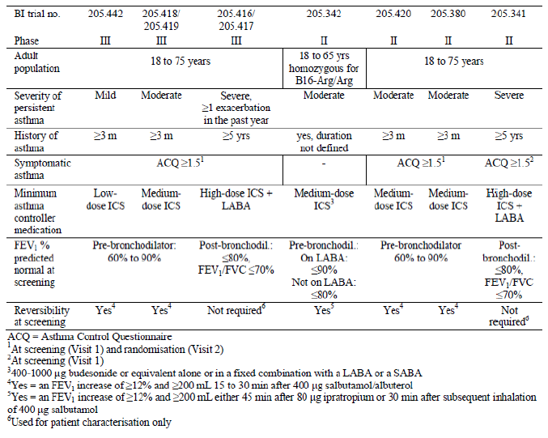

Table 14: Main exclusion criteria of all studies
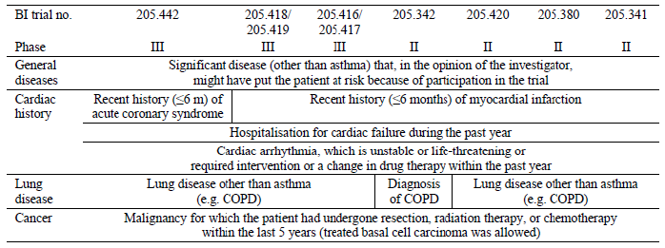
Across all asthma severities, more patients were female than male. Of the patients with mild and severe asthma, the majority were White, while in patients with moderate asthma the proportion of White and Asian patients was similar. The mean age was higher for patients with severe asthma than for patients with mild or moderate asthma. The median duration of asthma increased with asthma severity. The proportion of patients with concomitant diagnoses at screening was similar across all asthma severities. Concomitant diagnoses indicating an allergic disposition (for example, allergic rhinitis, allergic conjunctivitis) seemed to be more frequent in patients with mild or moderate asthma than in patients with severe asthma, while diagnoses known to increase in frequency with age (for example, hypertension, obesity, diabetes mellitus, hypercholesterolaemia) were reported with highest frequencies in patients with severe asthma.
It is important to note that that all trial medication was given in addition to stable dose of asthma maintenance therapy (low, medium, or high dose ICS, depending on asthma severity). Of particular note, patients who participated in Trials 205.341, 205.416, and 205.417 were additionally required to take a LABA throughout the treatment period. Because of this requirement for stable asthma maintenance therapy throughout the treatment period of all trials in this clinical programme, treatment comparisons are actually comparisons of tiotropium versus placebo against a background of at least high dose ICS+LABA, medium dose ICS, or low dose ICS. Patients of all asthma severities were to take ICS, and patients with severe asthma were to take LABAs. At randomisation, patients with mild or moderate asthma were to stop inhaled LABAs; patients of all asthma severities were to stop anticholinergics and SABAs. However, salbutamol was provided for use as rescue medication in all trials.
In general, the tiotropium in asthma clinical programme took well established standards for the evaluation of the efficacy and safety of bronchodilators in asthma into consideration, namely the Note for Guidance on the Clinical Investigation of Medicinal Products in the Treatment of Asthma (CPMP/EWP/2922/01), the 2005, 2007, and 2009 Global Strategy for Asthma Management and Prevention from GINA, the Guidelines for the Diagnosis and Management of Asthma from the National Heart, Lung, and Blood Institute's National Asthma Education and Prevention Program (NAEPP), and the ATS and ERS Statement on Asthma Control and Exacerbations. Trial design was also based on extensive interaction with and feedback from authorities in the EU and US. In pivotal Phase III Studies 205.418 and 205.419 involving adults with moderate asthma, salmeterol, a commercially available LABA approved for treatment of asthma, was included as a control group in this trial in order to comply with EU regulations requiring the inclusion of an active comparator treatment arm.
According to CHMP guidelines, a new controller treatment for asthma should place equal emphasis on lung function and symptom based clinical endpoints. A significant benefit from co primary endpoints of lung function and clinical symptoms should be demonstrated so that no multiplicity adjustment to significance levels is indicated. The severe asthma Studies 205/416/417 evaluated pre dose FEV₁, peak FEV₁ (0-3h) and time to first severe asthma exacerbation as co primary endpoints and complied with the CHMP recommendations. The moderate asthma studies (205.418/419) evaluated pre dose FEV₁, peak FEV₁ (0-3h) as co primary endpoints; although ACQ responder rate was evaluated as a primary endpoint for the pooled analysis of Studies 205/418/419, this endpoint was only a secondary endpoint in the individual studies. In the pivotal Phase III study in mild asthma, peak FEV₁ (0-3h) was the only primary endpoint; trough FEV₁ and ACQ responder rate were only analysed as secondary endpoints.

Phase II clinical studies
The Phase II clinical programme included six Phase II trials: 205.341, 205.342, 205.380, 205.420, 204.424, and 205.425 involving 738 adult patients and 206 paediatric patients; 468 of these adult patients (and 156 paediatric patients) were treated with at least one dose of proposed Tio R5. According to CHMP guidelines for clinical investigation of medicinal products for treatment of asthma, the dose related benefit and adverse effects should be characterised in randomised, double blind, placebo controlled studies as suggested in ICH E 4 Dose Response Information to Support Drug Registration. These studies should characterise the crucial part of the dose response curve. It may be useful to include one or more doses of an active control drug. Alternatively, to enhance the assay sensitivity the inclusion of a placebo and an active control would be needed. Study designs depend upon the pharmacology of the test drug and the response to treatment may follow a very different time course not only dependent on the drug but also on the outcome measure. For β2 adrenergic agonists, a cumulative dose response may be performed preferably using FEV₁ (or PEF) as a PD endpoint; for long acting bronchodilators six to 12 week studies are recommended.
Of the four Phase II studies in adults with asthma, only Study 205.342 complied with the above CHMP guidelines. In this double blind, double dummy, parallel group study involving moderate asthma patients homozygous for B16 Arg/Arg genotype, the primary endpoint (change in mean weekly morning pre dose PEF from baseline to the last week of treatment based on weekly means of electronic peak flow meter recordings measured at home) demonstrated the statistical non inferiority of tiotropium versus salmeterol and the superiority of both tiotropium and salmeterol versus placebo. This study also demonstrated that patients homozygous for arginine at the sixteenth position of the β2 adrenergic receptor were responsive to both qd Tio R5 and BD Sal 50. All Phase II trials showed the statistical superiority of tiotropium over placebo either in terms of PEF_{am} (Trial 205.342) or FEV₁ peak_{0−3h} (Trials 205.341, 205.380, 205.424, and 205.425), or FEV₁ AUC_{0-24h} (Trial 205.420). However, interpretation from the Phase II adult asthma studies was limited due to crossover design and short duration in Studies 205.341 (eight weeks), 205.380 ( four weeks) and 205.420 (four weeks). Evidence from the Phase II trials suggests that qd Tio R5 is not on the plateau of the dose response curve for tiotropium, and that an increase in bronchodilation can be achieved with increasing the dose. In Study 205.420 involving 92 patients with moderate asthma, significant and comparable bronchodilation over a complete 24 hr period was achieved following administration of a total daily dose of 5 μg tiotropium, regardless of whether it was administered as a qd dose of 5 μg (in the evening) or a BD dose of 2.5 μg (in the morning and evening). However, interpretation was again limited by the short duration (four weeks) and crossover design of the study.

Pivotal phase III studies
The Phase III clinical programme included a total of five Phase III trials: 205.416, 205.417, 205.418, 205.419, and 205.442. A total of 3476 adult patients were treated during the Phase III clinical programme; 1128 of these patients were treated with at least one dose of Tio R5.

Efficacy in severe asthma

Lung function endpoints
The superiority of tiotropium over placebo in terms of FEV₁ peak_{0−3h} and trough FEV₁ responses was observed in both severe asthma pivotal trials (205.416/417). Improvements in FEV₁ related endpoints achieved with Tio R5 compared with placebo were either approaching or were well over 0.1 L. In Study 205.416, the observed treatment differences was 0.086 L (p = 0.0110) for adjusted mean FEV₁ peak_{0−3h} response and 0.088 L (p = 0.0050) for adjusted mean trough FEV₁ response. The response was slightly better in Study 205.417 with observed treatment differences of 0.154 L (p < 0.0001) for adjusted mean FEV₁ peak_{0−3h} response and 0.111 L (p = 0.0002) for adjusted mean trough FEV₁ response at Week 24. These results were robust as they were confirmed in the sensitivity analysis. Significant improvements in FEV₁ peak_{0-3h} response with Tio R5 as compared with placebo were already apparent after the first dose of trial medication on Day 1 of these trials, and the bronchodilator efficacy in terms of FEV₁ peak_{0−3h} and trough FEV₁ was sustained over the 48 week treatment period in Trials 205.416/417. Other FEV₁ and FVC assessments in clinic showed similar significant improvements with Tio R5 compared with placebo. Significant differences between the treatments in favour of Tio R5 were observed for adjusted weekly mean PEF_{am} (22.293 L/min; p < 0.0001), PEF_{pm} (23.267 L/min, p < 0.0001), FEV₁ am (0.117 L, p < 0.0001), and FEV₁ pm (0.124 L, p < 0.0001) responses during the last seven days before Visit 6 (after approximately 24 weeks of treatment); all of these parameters were measured at home using the AM3. Additionally, the 24 hr lung function measurements carried out after 24 weeks of treatment in Trials 205.416/417 confirmed the bronchodilator efficacy of tiotropium during the whole 24 hr dosing interval.

Asthma exacerbations
As the assessment of asthma exacerbations is an essential part of the evaluation of future risk for patients with severe asthma, time to first severe asthma exacerbation was included as a pre specified co primary endpoint for Trials 205.416/417. In the pooled analysis of pivotal Phase III studies involving 912 patients with severe asthma (205.416/417), time to first severe asthma exacerbation was the primary endpoint and time to first ‘any’ and ‘symptomatic’ asthma exacerbation were secondary endpoints. Treatment of severe asthma patients with tiotropium 5 µg over 48 weeks was associated with a significant 21% reduction in risk of severe asthma exacerbation (Tio 5 µg versus placebo: 26.9% versus 32.8%; HR = 0.79, p = 0.0343). However, these results were not robust as the analysis in the PPS only showed a non significant 9% risk reduction. However, treatment of severe asthma patients with tiotropium 5 µg was associated with a significant 31% reduction in risk of ‘any’ asthma exacerbation (Tio 5 µg versus placebo: 49.9% versus 63.2%; HR = 0.69, p < 0.0001) and a 27% reduction in risk of symptomatic asthma exacerbation (37.1% versus 47.6%; HR = 0.73, p = 0.0024).

Symptoms and quality of life
In Study 205.416, for the secondary endpoint of adjusted mean ACQ score, an improvement was reported for both treatment groups from study baseline (2.666) to Week 48 (tiotropium: 1.986, placebo: 2.107), but the difference between the treatment groups of −0.121 was not significant (p = 0.0727) and the minimal clinically important difference of 0.5 was not met. Similar results were observed for other patient reported outcomes such as AQLQ(S), asthma symptoms, and use of rescue medication measured at home using the AM3. In Study 205.417, there were no statistically or clinically relevant improvements in ACQ or other patient reported outcomes such as AQLQ(S), asthma symptoms, and use of rescue medication. Although treatment with tiotropium did not significantly increase the odds of being an AQLQ(S) responder as compared to treatment with placebo, there were more AQLQ(S) responders in the tiotropium treatment groups than in the placebo groups across both Trials 205.416 and 205.417.
In patients with severe asthma, add on treatment with Tio R5 (in combination with high dose ICS+LABA) was associated with statistically and clinically significant improvements in lung function endpoints (improvements in FEV₁ peak_{0−3h} and trough FEV₁ responses with tiotropium compared to placebo were in the order of 0.1 L, whereas improvements in PEF_{am} and PEF_{pm} were generally above 20 L/min) after 24 weeks with maintenance of efficacy till 48 weeks of treatment. However, there was lack of adequate, conclusive evidence for efficacy of Tio R5 as add on treatment in terms of reduction of severe asthma exacerbation or asthma symptoms (ACQ, ACQL, other asthma symptoms) and use of rescue medication.

Efficacy in moderate and mild asthma

Lung function
Both Tio R5 and Tio R2.5 were shown to be superior over placebo for the co primary endpoints FEV₁ peak_{0−3h} and trough FEV₁ response after 24 weeks of randomised treatment. It was observed that the improvement in peak FEV₁ (0-3h) and trough FEV₁ was numerically greater in patients treated with the lower dose of tiotropium (2.5 µg) compared to the higher 5 µg dose, although both were statistically significantly better than placebo. Significant improvements in FEV₁ peak_{0-3h} response with Tio R2.5 as compared with placebo were observed early on (that is, at the latest by Week 4) and were sustained over the entire treatment period of Trials 205.418/419 and 205.442. The descriptive statistical comparisons of tiotropium and the well established bronchodilator salmeterol 50 µg carried out as part of Trials 205.418/419 showed that both treatments were similar in terms of their effect size.

Asthma Symptoms and quality of life
The effect of tiotropium on asthma symptoms using the ACQ responder rate was analysed as a prespecified co primary endpoint for Trials 205.418/419. Across Trials 205.418/419, patients in the tiotropium treatment groups had significantly higher odds of being ACQ responders at Week 24 as compared to patients in the placebo group. Although ACQ responder rates for Tio 2.5 and 5 µg groups were statistically significantly greater than placebo, there was no difference between the two Tiotropium dose groups (57.7%, 64.5% and 64.3% with placebo, Tio 2.5 µg and 5 µg, respectively). The adjusted mean ACQ total score improved (decreased) during the 24 week treatment period in all four treatment groups, but it was statistically significantly better than placebo at all visits for only salmeterol; it was statistically significantly better than placebo for Tio 2.5 µg at Weeks 8, 16 and 24 and for Tio 5 µg at only Weeks 8 and 24.
In the pivotal studies in moderate asthma (205.418/419), treatment differences between the tiotropium groups and placebo with respect to the adjusted weekly mean scores for night time awakenings, asthma symptoms in the morning, asthma symptoms during the day, activity limitation, shortness of breath, wheeze or cough, and number of asthma symptom free days were non significant at all weeks. In Study 205.442 in patients with mild asthma, treatment differences between each tiotropium group and placebo with respect to the adjusted weekly mean scores for night time awakenings, asthma symptoms during the day, and wheeze or cough during the day, were small and non significant at all weeks.

Asthma exacerbation
In the pooled analysis of pivotal Phase III studies (205.418/ 419) in moderate asthma, the time to first severe and any asthma exacerbation were secondary endpoints. Reduction in risk of severe asthma exacerbation was statistically significantly greater than placebo only following Tio 2.5 µg (not for Tio 5 µg or salmeterol), while risk reduction for any asthma exacerbation was only statistically significant for Tio 2.5 µg and salmeterol 50 µg (not for proposed dose of Tio 5 µg). However, interpretation of these results was limited by the short duration of treatment in this study (24 weeks only while CHMP recommended duration for assessment of effect on asthma exacerbations is 12 months).
In the Phase III Trials 205.418/419 and 205.442, the effect of Tio 2.5 µg was numerically greater than that of the proposed dose of Tio 5 µg for the endpoints FEV₁ peak_{0-3h} and trough FEV₁ response. The sponsors claim that there were two important imbalances between the Tio R5 and Tio R2.5 treatment groups in these trials that might have caused this apparent lack of dose ordering: an imbalance in responsiveness to salbutamol (measured at screening) in Trials 205.418/419, and a gender imbalance in Trial 205.442. Responsiveness to salbutamol (that is, increase in FEV₁ as a result of inhaling 400 μg salbutamol) at screening was lower for patients in the Tio R5 than in the Tio R2.5 treatment group in Trials 205.418/419. However, this is not true as the CSRs for Studies 205.418/419 do not mention any difference in responsiveness to salbutamol between treatment groups. An association between salbutamol responsiveness at baseline and treatment response in patients with asthma is known to exist, and is sometimes corrected for by stratification at baseline. Such stratification was not carried out in the clinical programme.
The clinical summary of efficacy mentions that significant bronchodilation of tiotropium over placebo was observed in patients in all subgroups based on post bronchodilator percent of predicted FEV₁ at screening (medium and low airways obstruction) (none of the 95% CIs included zero) but the magnitude of the benefit differed between subgroups. In patients with low airways obstruction at screening the treatment effect of Tio R2.5 compared to placebo for trough FEV₁ response was higher than that for Tio R5. However, in patients with medium airways obstruction at screening, the treatment effect for trough FEV₁ was greater with Tio R5 than with Tio R2.5. Comparing across subgroups within a dose, the treatment effect of Tio R2.5 was smaller for trough FEV₁ response in patients with medium airways obstruction than in those with low airways obstruction. In contrast, the treatment effects were similar in all patients regardless of the degree of obstruction for Tio R5 and slightly better in the more obstructed patients for salmeterol. Thus, Tio R5 was a more robust dose, with consistent treatment effects irrespective of the level of airways obstruction at screening, whereas Tio R2.5 provided less improvement in FEV₁ in patients with medium airways obstruction.
However, the above explanation by the sponsors again raised the concern about whether these patients had underlying COPD rather than asthma and the effect of tiotropium was related to known efficacy in COPD.
The sponsors also mention that the gender imbalance observed in Trial 205.442 (with higher proportion of males in the Tio R2.5 than in the placebo and Tio R5 groups) may explain why a slightly larger response from baseline was observed for patients in the Tio R2.5 group than for patients in the Tio R5 group in Trial 205.442 for some lung function endpoints. While no dose ordering was seen for results analysed in litres for Trial 205.442, dose ordering was observed when results were analysed in percent of predicted normal, which takes gender and height as well as other factors into account (as males tend to have a greater height which impacts lung volume than females). However, the above explanation by the sponsors is not convincing as the difference between treatment groups was only minor (33.5%, 46.8% and 38.5% in placebo, Tio R2.5 and Tio R5 groups, respectively). Due to lack of conclusive evidence to support use of proposed dose of Tio 5 µg in patients with mild asthma, it is more likely that a lower dose of 2.5 µg may be more suitable for these patients.
In the Phase III pivotal trials in moderate asthma (205.418/419) and mild asthma (205.442), the effect of Tio 2.5 µg was greater than that of higher proposed dose of Tio 5 µg for the endpoints FEV₁ peak_{0-3h} and trough FEV₁ response. Overall, the dose of 2.5 μg showed similar or even numerically better lung function and symptomatic responses (ACQ responder rate in pooled Studies 205.418/419 in moderate asthma was 57.7%, 64.5%, 64.3% and 66.5% in placebo, Tio 2.5 µg, Tio 5 µg and salmeterol 50 µg groups, respectively). Overall, based on results observed, the evaluators feel that a lower dose of 2.5 µg may need to be explored further in patients with mild/moderate asthma.

Limitations of the submission
High dose and low dose ICS were defined in the CSRs for pivotal Studies 205.418/419/442. However, pivotal studies in moderate asthma (205.418/419) did not define moderate dose ICS in the CSRs.
Randomisation not stratified according baseline factors such as history of exacerbations, use of LABAs et cetera.
Duration of all pivotal studies less than recommended 12 months for assessment of asthma exacerbations 48 weeks in severe asthma Studies 205.416/417, 24 weeks in moderate asthma studies (205.418/419) and only 12 weeks in mild asthma study (205.442).
Effect on reduction of severe asthma exacerbations was not conclusive in the severe asthma studies.
Although median reversibility after salbutamol inhalation was 0.200 and 0.210 L in Study 205.416 and 205.417, respectively, the actual proportion of patients with post bronchodilator reversibility was not provided in the CSRs. The clinical safety summary mentions that 52% of the patients enrolled in the severe asthma studies had reversible disease while 48% did not. Efficacy was not evaluated in subgroups based on reversibility to rule out the possibility that efficacy of Tio R5 was predominantly due to effects in patients with irreversible airway limitation characteristic of COPD.
The sponsor has proposed a single dose of 5 µg (Tio R5) for all asthma severities. However, in mild/moderate asthma studies, the effect of lower dose of 2.5 µg showed similar or even numerically better improvements in lung function and symptomatic endpoints.
Overall, evidence for efficacy of Tio R5 in asthma was not conclusive due to the various limitations of the submission as outlined above.

Clinical safety

Studies providing evaluable safety data
The studies which provided evaluable safety data for tiotropium Respimat is summarised in Table 15 and included the nine completed studies in adult asthma patients [five Phase III studies in patients with mild (205.442), moderate (205.418, 205.419), or severe (205.416, 205.417) asthma) and four Phase II studies (205.341, 205.420, 205.380 and 205.342).

Table 15: Overview of clinical studies (all randomised, double blind) included in the evaluation of safety
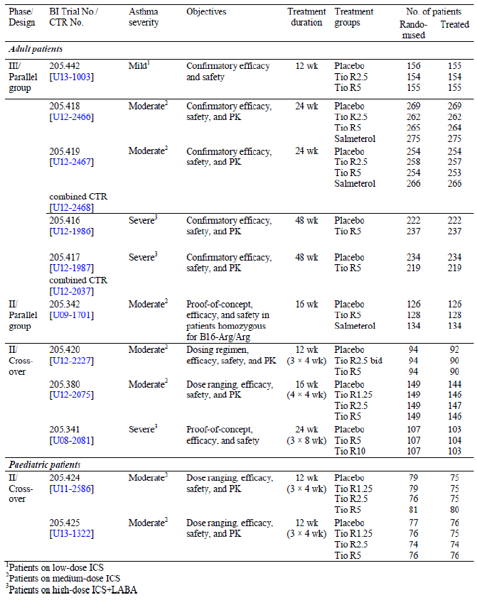
The integrated assessment of safety was primarily based on the analyses of the data from the five Phase III parallel group trials, which were grouped by asthma severity. Additionally, pooled data from all six parallel group trials were analysed; however, this pool allowed only for meaningful comparisons between the Tio R5 and the placebo groups, which were represented in all six parallel group trials across all asthma severities. Safety comparisons to the Tio R2.5 and salmeterol groups in the pool of all parallel group trials was not done because these treatment groups were only included in trials conducted in patients with mild (Tio R2.5) or moderate asthma (Tio R2.5, salmeterol). The assessment of safety was supported by the analyses of the individual and pooled data from three Phase II crossover trials (See Figure 9 below).
Figure 9: Study grouping for integrated safety analyses
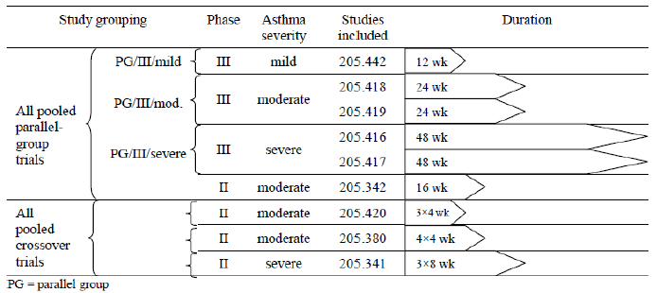
The safety data collected in each of the Phase III and II studies is summarised in Table 16.

Table 16: Overview of integrated safety analyses
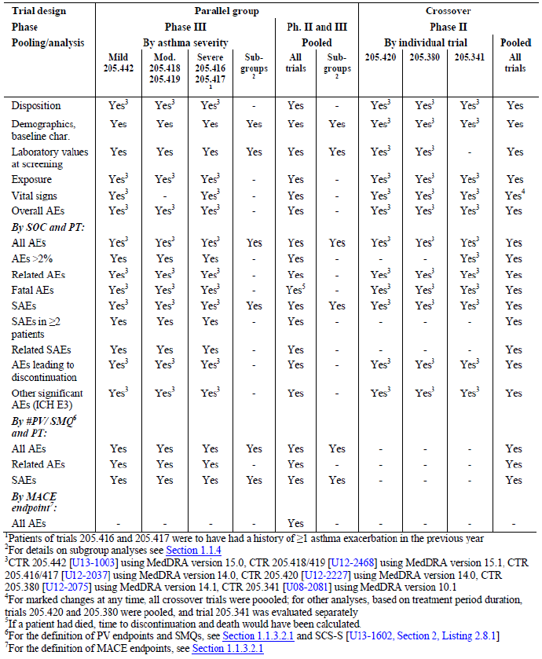

Table 16 (continued): Overview of integrated safety analyses
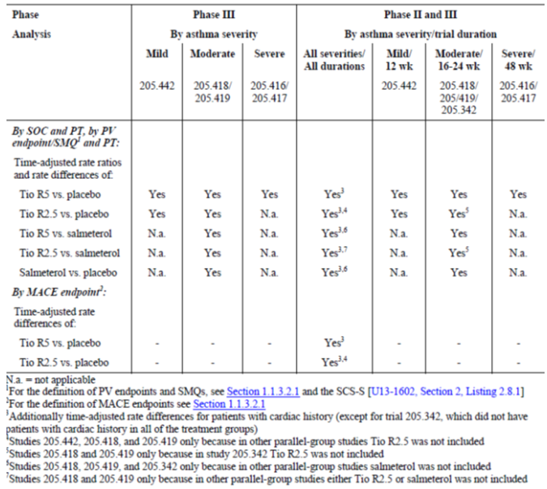
Adverse events (AEs) in the Summary of Clinical Safety (SCS-S) were coded using the Medical Dictionary for Regulatory Activities (MedDRA) Version 15.1. For the clinical development of tiotropium in asthma, BI customised pharmacovigilance endpoints (#PV) and Standardised MedDRA Queries (SMQ) were defined, which collapse multiple MedDRA preferred terms (PTs) into clinically relevant categories. They were selected in accordance with tiotropium's safety profile in the indication of asthma, asthma comorbid conditions, and indication specific symptoms. The MedDRA PTs included in each PV endpoint and SMQ are given in the SCS-S. It should be noted that a given PT may be counted under multiple #PV/SMQs and that the System Organ Classes (SOCs) used here are not identical to the MedDRA SOCs.
Adverse event (AE) analyses were based on the number of patients with AEs rather than on the number of AEs. The frequency of patients with AEs were summarised by treatment, primary SOC, and PT. Separate tables were provided for all AEs, common AEs, drug related AEs, fatal AEs, all SAEs, common SAEs, drug related SAEs, other significant AEs based on ICH E3, and AEs leading to discontinuation. Additionally, the frequency of patients with AEs summarised by treatment, BI customised #PV/SMQ and PT for all AEs, drug related AEs, and SAEs were summarised. The analysis by #PV/SMQ was used for the presentation of AEs by organ system or syndrome. The frequency of patients by treatment and Major Adverse Cardiovascular Events (MACE) endpoints was also evaluated. Analyses of AE RRs and rate differences adjusted for time at risk (incidence rate per 100 patient yrs of time at risk) are presented by SOC and PT or by #PV/SMQ for different treatment groups (for example, Tio R5 versus placebo) and different treatment durations/asthma severities.
The safety analysis were done on the TS which consisted of all randomised patients who were dispensed study medication and were documented to have taken at least one dose of investigational treatment. Clinical laboratory testing, a standard 12 lead ECG, and a pregnancy test in female patients were conducted at the screening visit (Visit 1) to determine a patient's eligibility in the trial.
Several subgroups were defined to assess the consistency of safety results across subpopulations of patients. Subgroup analyses of demographics, baseline characteristics, laboratory values at screening, and all AEs and SAEs (both by treatment, SOC, and PT, and by treatment, #PV/SMQ, and PT) were in general performed for all Phase III parallel group trials by asthma severity and for all pooled parallel group trials. However, subgroup analysis by pre specified B16 genotype of the β2 adrenergic receptor was performed for Trial 205.341 and for pooled data from Trials 205.416 and 205.417 only,. Subgroup analysis by reversibility at screening (yes/no) was performed for pooled data from Trials 205.416 and 205.417 only; in these trials reversibility testing was performed for patient characterisation, while in all other trials reversibility at screening was an inclusion criterion.

Pivotal studies that assessed safety as a primary outcome
205.452 was a Phase IIIb, randomised, active controlled, double blind, double dummy, parallel group design, multicentre study to compare the efficacy and safety of 2.5 μg and 5 μg tiotropium inhalation solution delivered by the Respimat inhaler with tiotropium inhalation capsules 18 μg delivered by the HH in 17183 patients with COPD.

Dose response and non pivotal efficacy studies
These include the Phase II crossover (205.341/ 380/420) and parallel group study (205.342) as well as safety data from paediatric patients (205.424/425).

Pivotal studies that assessed safety as a primary outcome

Study 205.452

Study design, objectives, locations and dates
205.452 was a Phase IIIb, randomised, active controlled, double blind, double dummy, parallel group, multicentre study. The main objective was to compare the efficacy and safety of 2.5 μg and 5 μg tiotropium inhalation solution delivered by the Respimat inhaler with tiotropium inhalation capsules 18 μg delivered by the HH. The event driven trial had a recruitment period of 11 months and was to end when approximately 1,266 fatal AEs were reported. All subjects were to be followed for vital status, regardless of premature discontinuation of study medication, until study closeout. The actual number of deaths was 1302 and the actual duration of the trial was approximately three yrs. Vital status was confirmed for 99.7% of all eligible randomised subjects at the end of the trial.
The study was conducted at 1,280 sites in 50 countries from 14 May 2010 to 23 May 2013. The largest proportion of randomised subjects were enrolled in the United States (3,589 subjects, 306 sites), followed by Germany (1,405 subjects, 116 sites), China (1,008 subjects, 36 sites), Russia (837 subjects, 56 sites), Poland (769 subjects, 47 sites), Ukraine (645 subjects, 26 sites), Canada (551 subjects, 50 sites) and Hungary (527 subjects, 30 sites).

Inclusion and exclusion criteria

Inclusion cirteria
The main inclusion criteria were: male and female outpatients with a diagnosis of COPD (post bronchodilator FEV₁ ≤ 70%, predicted FEV₁/ FVC ≤ 70%) aged 40 yrs or older and a smoking history of ≥ 10 pack yrs. Subjects with a medical history, including MI, cardiac arrhythmia, or cardiac failure were generally included and only excluded if they were known to have had: a myocardial infarction (MI) within six months, hospitalisation for heart failure within 12 months, or unstable or life threatening arrhythmia that required intervention or change in drug therapy within 12 months of Visit 1 (randomisation).

Exclusion criteria
The main exclusion criteria were: significant diseases other than COPD; known active tuberculosis; history of asthma, cystic fibrosis, clinically evident bronchiectasis, interstitial lung disease, or pulmonary thromboembolic disease; history of thoracotomy with pulmonary resection; subjects planning to undergo lung transplant or lung volume reduction surgery (LVRS); malignancy for which the subject had undergone resection, radiation, chemotherapy or biological treatments within the last five yrs (subjects with treated basal cell carcinoma were allowed); known respiratory infection or exacerbation of COPD in the four weeks prior to randomisation; known hypersensitivity to anticholinergic drugs, lactose, benzalkonium chloride (BAC), ethylenediaminetetraacetic acid (EDTA), or any other components of the HH or Respimat inhalation solution delivery system; known moderate to severe renal impairment (as judged by the investigator); known narrow angle glaucoma; known significant symptomatic prostatic hyperplasia or bladder neck obstruction; use of systemic corticosteroid medication at unstable doses (that is, less than six weeks on stable dose) or at doses in excess of the equivalent of 10 mg prednisolone per day; Pregnant or nursing women or women of childbearing potential not using a medically approved means of contraception for at least three months prior to and for the duration of the trial; significant alcohol or drug abuse within the past 12 months; subjects requiring the use of supplemental oxygen therapy for > 12 hrs per day; subjects who had completed a pulmonary rehabilitation program in the six weeks prior to the screening visit or subjects who were currently in a pulmonary rehabilitation program that was not maintained throughout the duration of the study.

Study treatments
Study treatment was Tiotropium inhalation solution given by oral inhalation via Respimat inhaler; 2.5 μg (two actuations of 1.25 μg) qd; 5 μg (two actuations of 2.5 μg) qd and 0 μg (two actuations of placebo) qd for double dummy design. Reference treatment was Tiotropium inhalation capsule, oral inhalation via the HH; 18 μg (two inhalations per capsule) qd and 0 μg (two inhalations per capsule of placebo) qd for double dummy design.

Safety variables and outcomes
The primary safety endpoint was time to death (all cause mortality). All deaths reported during the trial were adjudicated to one primary cause of death by an independent Mortality Adjudication Committee (MAC).
Additional safety endpoints included the following two time to event evaluations of MACE: time to first MACE (on treatment); time to death from MACE (including vital status follow up). Further endpoints were: time to onset of first stroke; time to onset of first MI; time to onset of TIA.
The following AEs were collected: all fatal adverse events (FAEs), all serious adverse events (SAEs), all AEs leading to discontinuation of study medication, and all AEs considered by the investigator to be drug related. The following other AEs were assessed as protocol defined outcome events: all COPD exacerbations, all pneumonias, all myocardial infarctions (MIs), all strokes, and all transient ischemic attacks (TIAs). Other non serious, non related AEs were not routinely collected.
The primary efficacy endpoint was time to first COPD exacerbation. Secondary efficacy endpoints: number of COPD exacerbations, time to first COPD exacerbation associated with hospitalisation, number of COPD exacerbations associated with hospitalisation, time to first moderate to severe COPD exacerbation and number of moderate to severe COPD exacerbations. Spirometry endpoints were evaluated in a PFT substudy in a subset of 1,370 subjects. Trough FEV₁ was defined as a key secondary endpoint within the substudy.

Randomisation and blinding methods
Eligible subjects were assigned to one of the three double blind treatments (Tiotropium inhalation solution 2.5 µg and 5 µg given by oral inhalation via Respimat inhaler and tiotropium 18 µg oral inhalation via HH). An interactive voice response system (IVRS) / interactive web response system (IWRS) was used for randomisation to a treatment group and for the appropriate allocations and supply of medications to subjects throughout the trial. This study incorporated a double blind study design and the IVRS/IWRS was available for the unblinding of subjects only in an emergency situation.

Analysis populations
The primary analysis of time to death from any cause was based on all subjects included in the death analysis set (DAS) and included 17,135 subjects. The primary analysis of time to first COPD exacerbation was based on all subjects included in the TS (TS = 17,116). A total of 1,370 randomised subjects participated in the pulmonary function testing (PFT) substudy.

Sample size
In the UPLIFT study, the Kaplan Meier estimate of all cause mortality (based on the intention to treat approach; that is, on treatment and vital status follow up) at two yrs was 5.6% for tiotropium HH and 6.6% for placebo. The sample size was determined given the following assumptions: one sided significance level; 2.5%, death rates of 5.6% at two yrs for tiotropium HH, 5 μg and 2.5 μg tiotropium Respimat, accrual over 1.5 yrs, maximum follow up of 3.5 yrs, ≤ 1% lost to follow up rate (based on an assumption of close to complete vital status follow of all subjects), 90% power and non inferiority delta of 1.25. The number of events needed for the two group comparison was 844, and number of subjects was 5,587 per group (round to 5,600). Because the trial had three treatment groups, the minimum number of fatal cases needed was 1,266 and the estimated number of subjects needed was 16,800. Achieving statistical significance in this scenario resulted in a HR no larger than 1.09.

Statistical methods
Cox proportional hazards regression model was used to analyse time to event endpoints. Analyses of numbers of events were performed using the negative binomial model using the natural log of treatment exposure as offset. Kaplan Meier plot estimation of the survival function and descriptive statistics were also used.
For the primary analyses, three tests were conducted in hierarchical order. Non inferiority of time to death from any cause was tested on the two Respimat doses (Tio R5 first, followed by Tio R2.5 if non inferiority was achieved with Tio R5) versus Tio HH18. Additionally, if non inferiority was also shown with Tio R2.5, the Respimat dose of 5 μg (Tio R5) was to be tested for superiority over Tio HH18 for time to first COPD exacerbation. The non inferiority delta for time to death was 1.25. Non inferiority tests were performed at the one sided α = 0.025 level. Superiority tests were performed at the two sided α = 0.05 level. An independent Data Monitoring Committee (DMC) regularly reviewed safety data to detect any relevant imbalance in safety endpoints, with the focus on all cause mortality. Interim analyses generated for DMC review were partially unblinded with the option to completely unblind if needed. If at any time during the trial, the test for greater mortality of either Respimat dose relative to Tio HH18 for the time to death endpoint reached p < 0.01, the DMC was to have considered modification of the study design.

Participant flow
Overall, 20,313 subjects were enrolled in the study. Of these, 17,183 were randomised to one of three tiotropium treatments and 48 did not receive trial medication (46 subjects did not receive trial medication and two subjects were double randomised). Using an intention to treat approach, the remaining 17,135 subjects were followed for vital status for the duration of the trial (regardless of whether the subject prematurely discontinued study medication). A total of 17,116 subjects received at least one dose of study drug: 5724 received Tio R2.5, 5,705 received Tio R5, and 5,687 received Tio HH18. Of the 17,116 treated subjects, 3,917 subjects (22.9%) prematurely discontinued study medication with similar incidence across the three treatment groups (23.1%, 22.9% and 22.6% in the Tio R2.5, Tio R5 and Tio HH18 groups, respectively). The three most common reasons for discontinuation were occurrence of AEs (10.8%), subject refusal to continue taking trial medication (5.8%), and 'other' (3.3%), where 'other' included, but was not limited to, subject no longer willing or able to participate in trial, inclusion or exclusion criteria not met (after randomisation), subject moved, site closure by sponsor, and personal or family reasons. Overall, the majority of subjects that were eligible for follow up of vital status were followed for 24 to 36 months: 62.1% of subjects were followed for 24 to 30 months and an additional 27.1% were followed for 30 to 36 months. The mean observation time was 838.2 days in the total population and similar across the three tiotropium treatment groups (837.3, 840.1 and 837.1 days in the Tio R2.5, Tio R5 and Tio HH18 groups, respectively). Vital status was confirmed for 99.7% of all eligible randomised subjects (N = 17,135) at the end of the trial. Based on the assessment of vital status, the proportion of subjects who were lost to follow up was 0.3%. The event driven end of the trial was to be declared when approximately 1,266 fatal events were reported. The actual number of deaths reported during the trial was 1,302.

Major protocol violations/deviations
Overall, 1,872 out of 17,116 treated subjects (10.9%) had at least one important protocol violation during the trial. The overall incidence of protocol violations was similar between the three treatment groups (11.0%, 10.9%, and 11.0% in the Tio R2.5, Tio R5, and Tio HH18 groups, respectively). The incidence of protocol violations reported during trial conduct (1,429 out of 17,116 subjects, 8.3%) was higher than the incidence of protocol violations related to inclusion/exclusion criteria (495 out of 17,116 subjects, 2.9%). Of those categorised within the inclusion/exclusion criteria, the majority of IPVs (325 subjects, 1.9%) were related to subjects having exceeded the spirometric criteria specified at the screening visit (Visit 0) or randomisation visit (Visit 1), that is, FEV₁ > 70% predicted and/or post bronchodilator FEV₁ / FVC > 70%. All other IPVs related to inclusion/exclusion criteria occurred in no more than 0.3% of subjects, including subjects with a history of asthma, cystic fibrosis, bronchiectasis, interstitial lung disease, or pulmonary thromboembolic disease (50 subjects, 0.3%) and subjects who had a malignancy within the past five yrs (43 subjects, 0.3%). The most frequent important PVs that occurred during the trial involved use of other anticholinergics in a non life threatening situation (1,254 subjects, 7.3%), incorrect trial medication taken (142 subjects, 0.8%), and medication code broken (39 subjects, 0.2%). Overall, the number of important PVs was relatively low and, with exception of the incidence of important PVs categorised as medication code broken, similar between treatment groups. Although important PVs were collected and summarised for the trial, subjects with important PVs were not excluded from any of the planned analyses (no per protocol analysis was planned).

Baseline data
All baseline demographic characteristics were generally similar across the three treatment groups. Majority of subjects were male (71.5%), White (81.6%; 14.2% were Asian and 1.5% were black) with mean age of 65 yrs and mean BMI of 26.2 kg/m² (39.1% of all subjects were categorised as having normal BMI of 18.5 ≤ BMI<,25 kg/m²). Majority were ex smokers (61.9%) and 38.1% were current smokers, with a median smoking history of 40.0 pack yrs. The mean duration of COPD was 7.4 yrs. In addition to the assessment at baseline, smoking status was evaluated at every visit and during the trial; shifts in smoking status from baseline were observed for < 9.0% of subjects in each category (baseline ex smoker or baseline smoker). Overall, 5.9% of ex smokers restarted smoking at some point during the trial while 8.8% of smokers at baseline were ex smokers at the final on treatment visit. The proportion of subjects who shifted smoking status was comparable in each of the three treatment groups.
Overall, 10.7% of all treated subjects had a history of cardiac arrhythmias at baseline and 15.2% of all treated subjects had a history of ischaemic heart disease/coronary artery disease. The incidence of subjects who reported a medical history of stroke, TIA, or MI was 2.3%, 1.4%, and 6.0%, respectively. Medical history, including history of cardiovascular and COPD events, was generally similar across the three treatment groups at baseline.
At baseline, 46.9%, 61.8%, 53.6% and 59% of subjects reported concomitant use of inhaled long acting anticholinergics, LABAs, SABAs and ICS, respectively. Majority of subjects were receiving both ICS and LABA at baseline (51.8%); the percentage of subjects who used either ICS (but not LABA) or LABA (but not ICS) at baseline was 7.2% and 10.0%, respectively. Use of all classes (including the combination) of pulmonary medications at baseline was balanced across treatment groups. Overall, 90.3% of all treated subjects were taking concomitant pulmonary medications during the trial and the three most commonly used pulmonary medications taken during the trial were LABAs (68.2%), ICS (67.8%) and SABAs (64.4%). Oral/IV/IM steroids were used by 35.8% of subjects during the treatment period (inclusive of treatments administered for COPD exacerbations). Anticholinergics were taken as concomitant therapy (CT) by 12.6% of all treated subjects (2,160 out of 17,116). Of these, 10.2% were taking short acting/inhaled anticholinergics and 3.6% were taking long acting/inhaled anticholinergics. Subjects who used other anticholinergics (in a non life threatening situation) were categorised as important protocol violations during the trial.
Overall, 51.1% of subjects were receiving cardiac medications (excluding statins, which were not collected) at baseline; the most commonly used cardiovascular medications taken at baseline (taken by ≥ 15% of all treated subjects) included ACE inhibitors (20.7%), acetylsalicylic acid (19.3%), and calcium channel blockers (17.8%). The incidence of cardiovascular medication use at baseline was balanced across the three tiotropium treatments. Overall, 60.2% of all treated subjects were taking concomitant cardiovascular medications during the trial and the most commonly used classes of cardiovascular medications taken during the trial (taken by ≥ 20% subjects) were consistent with those being taken at baseline: ACE inhibitors (27.3%), acetylsalicylic acid (27.3%), and calcium channel blockers (23.9%) with similar use across the three tiotropium groups. The overall reported compliance for the trial was good and similar between the two devices with majority of subjects achieving between 80 to 120% compliance with use of the Respimat device (90.6%) and the HH device (91.3%) during the trial.

Results for the primary safety outcome
For the first primary endpoint of time to death from any cause, the two tests for non inferiority of Tio R5 versus Tio HH18 and Tio R2.5 versus Tio HH18 were successful. The incidence of death from any cause (that is, total number of deaths during the observation period, regardless of treatment discontinuation) was 7.7%, 7.4% and 7.7% in the Tio R2.5, Tio R5 and Tio HH18 groups, respectively. The HR for Tio R5 versus Tio HH18 was 0.957 [95% CI: (0.837, 1.094)] and the HR for Tio R2.5 versus Tio HH18 was 0.996 [95% CI: (0.872, 1.136)], that is, at any time during the trial a subject in the Tio R5 had a 4.3% lower chance of death from any cause than a subject in the Tio HH18 group, while the chance of death from any cause was nearly identical for Tio R2.5 compared to Tio HH18. The upper limits of the CI for the comparisons of Tio R5 (1.094) and Tio R2.5 (1.136) compared to Tio HH18 were below the predefined non inferiority margin of 1.25; therefore, non inferiority was achieved for Tio R5 and Tio R2.5 compared to Tio HH18. The HR for Tio R2.5 versus Tio R5 was 1.040 [95% CI: (0.910, 1.189)], that is, at any time during the trial a subject in the Tio R2.5 treatment group had a 4.0% higher chance of death from any cause than a subject in the Tio R5 treatment group. The Kaplan Meier plot of deaths by treatment is displayed in Figure 10.

Figure 10: Kaplan Meier plot of deaths by treatment (DAS including vital status follow up)
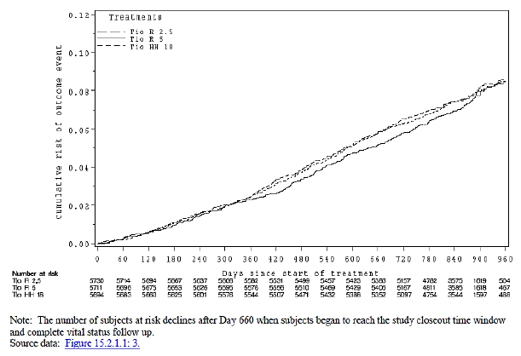
Similar results were observed in the on treatment sensitivity analysis. The incidence of fatal AEs while on treatment was 6.3%, 5.7% and 6.3% in the Tio R2.5, Tio R5 and Tio HH18 groups, respectively; HR for Tio R5 versus Tio HH18 was 0.913 [95% CI: (0.785, 1.060)], that is, at any time during the trial a subject in the Tio R5 group had an 8.7% lower chance of experiencing a fatal AE on treatment than a subject in the Tio HH18 group. Results indicated that subjects in the Tio R2.5 treatment group had the same chance of experiencing a fatal AE as subjects in the Tio HH18 group [HR = 1.001, 95% CI: (0.864, 1.159)].The HR for Tio R2.5 versus Tio R5 was 1.097 [95% CI: (0.944, 1.274)], that is, at any time during the trial a subject in the Tio R2.5 treatment group had a 9.7% higher chance of experiencing a fatal AE than a subject in the Tio R5 treatment group.
Although there was a higher incidence of deaths in subjects with cardiac arrhythmia at baseline compared to subjects without cardiac arrhythmia in each of the treatment groups, the relative differences between Tio R5 and Tio R2.5 compared to Tio HH18 were comparable. In the subgroup of subjects with cardiac arrhythmia at baseline in the Tio R5 and Tio HH18 groups (N = 1221), the incidences of deaths were 10.6% and 12.9%, respectively [HR = 0.81, 95% CI: (0.58, 1.12)]. In the Tio R2.5 group, the incidence of deaths in subjects with cardiac arrhythmia at baseline (N = 1211) was 13.1% compared to 12.9% in the Tio HH18 group [HR = 1.02, 95% CI: (0.74, 1.39)]. In the subgroup of subjects with no cardiac arrhythmia at baseline in the Tio R5 and Tio HH18 groups (N = 10167), the incidence of deaths was 7.0% and 7.1%, respectively [HR = 0.99, 95% CI: (0.85, 1.14)]. In the Tio R2.5 group, the incidence of deaths in subjects with no cardiac arrhythmia at baseline (N = 10194) was 7.0% compared to 7.1% in the Tio HH18 group [HR = 0.99, 95% CI: (0.86, 1.15)]. No differences between treatments in the incidence of death from any cause were observed in subjects with (Tio R5 versus Tio HH18: 10.6% versus 11.2%) and without cardiac history (6.3% versus 6.4%).
The following baseline characteristics were identified to be of potential interest because the treatment by subgroup interaction p values were 0.05 (gender) and 0.04 (baseline pulmonary concomitant medication) for the comparison Tio R2.5 versus Tio HH18 and showed no clinically meaningful effects for gender [females: N = 3308, HR = 0.78, 95% CI: (0.59, 1.04)] and baseline pulmonary concomitant medications [LABA (but not ICS): N = 1164, HR = 0.67, 95% CI: (0.45, 1.01) and neither ICS nor LABA: N = 3496, HR = 1.29, 95% CI: (1.00, 1.67)] were not deemed to be meaningful. No prespecified baseline characteristics for the Tio R5 versus Tio HH18 treatment comparison had p values less than 0.05.
A slight increase in deaths was noted in Asian subjects treated with Tio R2.5 over Tio HH18 for race [N = 1626, HR = 1.20, 95% CI: (0.86, 1.67)] as well as region [N = 1582, HR = 1.23, 95% CI: (0.87, 1.73)]. A trend favouring Tio HH18 versus Tio R2.5 for Asians was also observed in the analysis of time to first COPD exacerbation.

Results for other safety outcomes

AEs, drug related AEs and discontinuations due to AEs
Categories of protocol specified AEs collected for this trial included protocol defined outcome events (all COPD exacerbations, all pneumonias, and all serious and non serious MIs, strokes, and TIAs), FAEs, SAEs, AEs leading to discontinuation of trial medication, and AEs considered drug related by the investigator. The incidence of any AE, drug related AE, severe AEs, discontinuations due to AEs and SAEs was similar across the three tiotropium groups.
During the trial, 65.5% of subjects (N = 17,116) reported at least one AE during treatment (66.2%, 64.9%, and 65.5% in the Tio R2.5, Tio R5, and Tio HH18 groups, respectively) with similar incidence of severe AEs (26.8%, 26.5% and 25.7%, respectively). No imbalance was observed in the proportion of subjects with investigator defined drug related AEs (6.4%, 6.6% and 6.6%, respectively) and the most common drug related AEs (incidence ≥ 0.5% in the total population) were respiratory, thoracic and mediastinal disorders (506 subjects, 3.0%), gastrointestinal disorders (354 subjects, 2.1%), and nervous system disorders (96 subjects, 0.6%). The incidence of drug related dry mouth was 1.3%, 1.6%, and 1.8% in the Tio R2.5, Tio R5 and Tio HH18 groups, respectively. All other investigator defined drug related AEs were reported in < 0.5% of subjects.
A total of 1,414 out of 17,116 subjects (8.3%) discontinued study drug due to at least one treatment emergent AEs (7.8%, 8.2%, and 8.8%, respectively) and the most common AEs leading to discontinuations were COPD, pneumonia and cardiac AEs with similar incidence in all treatment groups.

Deaths and SAEs
The percentage of deaths was similar in the three tiotropium treatment groups (7.7%, 7.4%, and 7.7% in the Tio R2.5, Tio R5, and Tio HH18 groups, respectively). The most common SOCs in which the adjudicated primary causes of death were reported (incidence ≥ 1.0% in the total population) were respiratory, thoracic and mediastinal disorders (369 subjects, 2.2%); general disorders and administration site conditions (320 subjects, 1.9%); and neoplasms benign, malignant and unspecified (including cysts and polyps) (305 subjects, 1.8%). The frequencies of adjudicated causes of death were similar across the three treatment groups for these specific SOCs.
By preferred term, the most frequently reported adjudicated cause of death (incidence ≥ 0.5% in the total population) was COPD (342 subjects, 2.0%) followed by sudden death (129 subjects, 0.8%), lung neoplasm malignant (105 subjects, 0.6%), death (99 subjects, 0.6%), and sudden cardiac death (88 subjects, 0.5%). The incidence of adjudicated primary cause of death was similar between the three treatment groups for each of these respective event terms.
The incidences of investigator determined causes of death were comparable across treatment groups at the level of SOC. By preferred term, the most frequently reported investigator determined primary cause of death (incidence ≥ 0.5% in the total population; N = 17,135) was COPD (181 subjects, 1.1%) followed by death (129 subjects, 0.8%) and pneumonia (79 subjects, 0.5%). The incidence of all other investigator determined fatal events in the total population did not exceed 0.5%. The adjudicated primary causes of death differed from the investigator reported causes of death in some cases. The largest numeric shifts from investigator reported to adjudicated cause of death occurred in the cardiac disorders SOC (from 214 events to 66 events) and the general disorders and administration site conditions SOC (from 226 events to 320 events). The majority of cases that shifted from cardiac disorders were shifted to the SOC of general disorders and administration site conditions (93 cases), respiratory, thoracic, and mediastinal disorders (36 cases), and neoplasms (11 cases). The most consistent agreement between the investigator reported and adjudicated primary cause of death was in the SOC of respiratory, thoracic and mediastinal disorders (from 326 events to 369 events). Within SOCs where notable shifts were observed, the incidence of investigator reported primary cause of death was comparable in the Tio R2.5, Tio R5, and Tio HH18 treatment groups: cardiac disorders (1.2%, 1.3%, and 1.3%, respectively), general disorders and administration site conditions (1.6%, 1.1%, and 1.3%, respectively), and respiratory, thoracic and mediastinal disorders SOC (1.7%, 2.1%, and 1.9%, respectively).
Upon adjustment for time of observation, incidence rates of adjudicated primary causes of death were similar across the three treatment groups at the level of SOC. Incidence rates per 100 patient yrs at risk for the following three most common SOCs in which the adjudicated primary causes of death were reported were comparable across the Tio R2.5, Tio R5, and Tio HH18 treatments groups: respiratory, thoracic and mediastinal disorders SOC (0.9, 0.9, and 1.0, respectively); general disorders and administration site conditions SOC (0.9, 0.7, and 0.8, respectively); and neoplasms benign, malignant and unspecified (including cysts and polyps) SOC (0.8, 0.8, and 0.7, respectively). By preferred term, incidence rates were balanced across the Tio R2.5, Tio R5, and Tio HH18 treatments groups for each of the most frequently reported adjudicated causes of death (incidence ≥ 0.5% in total population): COPD (0.8, 0.9, and 0.9, respectively), sudden death (0.3, 0.3, and 0.4, respectively), lung neoplasm malignant (0.3, 0.3, and 0.2, respectively), death (0.3, 0.2, and 0.3, respectively) and sudden cardiac death (0.3, 0.2, and 0.2, respectively).

Death event terms of special interest
Medically similar adjudicated primary causes of death (event terms) were discussed for two categories of clinical relevance to this trial: respiratory related disorders and cardiac disorders, including cardiac arrhythmias, ischaemic heart disease and cardiac failure. The frequency of adjudicated causes of death categorised within the SOC of respiratory, thoracic, and mediastinal disorders was similar across the three treatment groups (2.0%, 2.2%, and 2.3% in the Tio R2.5, Tio R5, and Tio HH18 groups, respectively). The PT COPD was the most frequently reported primary cause of death within this SOC (342 subjects, 2.0% in the total population). The frequency of subjects with adjudicated primary cause of death within the COPD exacerbation (broad) with pneumonia PV endpoint is presented in Table 17 and the incidence of deaths within this PV endpoint was balanced across the three treatments: 136 subjects (2.4%) in the Tio R2.5 group, 140 subjects (2.5%) in the Tio R5 group, and 141 subjects (2.5%) in the Tio HH18 group. The incidence of the two most frequently reported preferred terms, COPD (342 subjects, 2.0%) and pneumonia (71 subjects, 0.4%), was balanced between the three treatment groups. All other event terms within this PV endpoint were reported in no more than one subject in the total population.

Table 17: Frequency [N (%)] of subjects with primary cause of death as determined by adjudication (PV endpoint/SMQ) by treatment, COPD exacerbation (broad) with pneumonia #PV and preferred term – (DAS including vital status follow up)
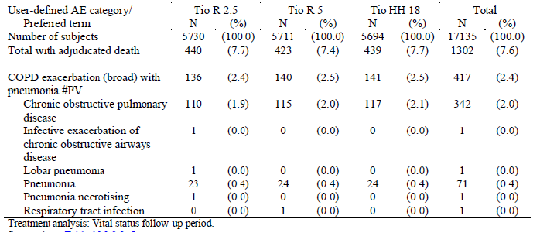
The incidence of death events observed in the cardiac disorders SOC was balanced in the three treatment groups (0.4%, 0.5%, and 0.3% in the Tio R2.5, Tio R5, and Tio HH18 groups, respectively). Within the cardiac disorders SOC, the PT myocardial infarction (MI) was the most frequently reported primary cause of death (17 subjects, 0.1% in the total population) followed by cardiac failure congestive (12 subjects, 0.1%) and cardiac failure (nine subjects, 0.1%). All other event terms were reported in no more than five subjects each.
The incidence of adjudicated primary causes of death categorised within the SMQs of cardiac arrhythmias, ischaemic heart disease, and cardiac failure were evaluated.

Cardiac arrhythmias
The largest number of cardiac related deaths in the trial was attributed to cardiac arrhythmias (SMQ cardiac arrhythmias) as reported for 223 subjects (1.3%) in the total population. The incidence of all cardiac arrhythmias within this SMQ was comparable in the Tio R2.5 (84 subjects, 1.5%), Tio R5 (70 subjects, 1.2%), and Tio HH18 (69 subjects, 1.2%) treatment groups. By preferred term, sudden cardiac death and sudden death comprised the majority of fatal events within the cardiac arrhythmias SMQ. The collective incidence of both preferred terms was balanced between the three treatment groups.

Ischemic heart disease
Overall, death events categorised within the SMQ ischaemic heart disease were reported for 30 subjects (0.2%) in the total population. The incidence of death events within the myocardial infarction and acute myocardial infarction were the most frequently reported death events within this SMQ (reported for 17 and five subjects, respectively). By sub SMQ, the majority of death events (24 of 30) were categorised within the sub SMQ myocardial infarction (broad), including the terms myocardial infarction, acute myocardial infarction and acute coronary syndrome; by treatment, deaths within this sub SMQ were reported for 10 subjects (0.2%) in the Tio R2.5 group, 11 subjects (0.2%) in the Tio R5 group, and three subjects (0.1%) in the Tio HH18 group. The adjusted incidence rate ratios (IRRs) for Tio R5 compared to Tio HH18 was 3.64 (95% CI: 1.02, 13.06) indicating a significant difference between treatments in favour of Tio HH18 over Tio R5. Similar results were observed for Tio R2.5 compared to Tio HH18 [IRR was 3.31 (95% CI: 0.91, 12.03)].

Cardiac failure
Death events categorised within the SMQ cardiac failure (narrow) were reported for 28 subjects (0.2%) in the total population. The incidence of deaths within this SMQ was balanced across the three treatments: seven subjects (0.1%) in the Tio R2.5 group, 11 subjects (0.2%) in the Tio R5 group, and 10 subjects (0.2%) in the Tio HH18 group. Cardiac failure congestive and cardiac failure, were the most frequently reported primary causes of death within this SMQ (reported for 12 and nine subjects, respectively). By treatment, cardiac failure congestive was reported as the primary cause of death for five subjects (0.1%) in the Tio R2.5 group, three subjects in the Tio R5 group (0.1%), and four subjects in the Tio HH18 group (0.1%).

Stroke
Death event terms categorised within the stroke PV endpoint were reported for 35 subjects (0.2%) in the total population. The incidence of all death events within the stroke PV endpoint was balanced in all three treatment groups (0.2% for each). Cerebrovascular accident was the most frequently reported PT within the stroke PV endpoint (reported for 25 of 35 subjects).

SAEs
Overall, 5,625 out of 17,116 subjects (32.9%) experienced at least one SAE during the trial and the incidence of SAEs was comparable across the three treatment groups (33.8%, 32.4% and 32.4%, respectively) The most common SOCs in which SAEs were reported (incidence ≥ 2.0% in the total population) were respiratory, thoracic and mediastinal disorders (2,938 subjects, 17.2%); infections and infestations (1,494 subjects, 8.7%); cardiac disorders (836 subjects, 4.9%); neoplasms benign, malignant and unspecified (including cysts and polyps) (803 subjects, 4.7%); gastrointestinal disorder (440 subjects, 2.6%) and nervous system disorders (395 subjects, 2.3%). The incidence of SAEs within each of these most common SOCs was similar across the three treatment groups. By preferred term, the most frequently reported SAE (incidence ≥ 0.5% in the total population) was COPD (2,614 subjects, 15.3%) followed by pneumonia (1,023 subjects, 6.0%), lung neoplasm malignant (160 subjects, 0.9%), myocardial infarction (137 subjects, 0.8%), respiratory failure (117 subjects, 0.7%), atrial fibrillation (110 subjects, 0.6%), cerebrovascular accident (108 subjects, 0.6%), acute respiratory failure (90 subjects, 0.5%), and pulmonary embolism (80 subjects, 0.5%). The incidence of each of these respective event terms was similar between the three treatment groups.
The most common investigator determined drug related SAE was COPD [reported for nine subjects in the total population, including five subjects in the Tio R2.5 group, three subjects in the Tio R5 group, and one subject in the Tio HH18 group] followed by urinary retention [reported for seven subjects in the total population, including two subjects in the Tio R2.5 group, three subjects in the Tio R5 group, and two subjects in the total population, including two subjects in the Tio R2.5 group, three subjects in the Tio R5 group, and two subjects in the Tio HH18 group]. All other drug related SAEs were reported in no more than three subjects. Upon adjustment for patient yrs of exposure, incidence rates of SAEs were comparable across the three treatment groups at the level of SOC. By preferred term, incidence rates were similar across the Tio R2.5, Tio R5, and Tio HH18 treatments groups for the five most frequently reported SAEs COPD (8.2, 8.0, and 7.8, respectively) followed by pneumonia (2.9, 3.0, and 3.0, respectively), lung neoplasm malignant (0.4, 0.5, and 0.4, respectively), myocardial infarction (0.4, 0.4, and 0.3, respectively), and respiratory failure (0.4, 0.3, and 0.3, respectively. The incidence of the two most frequently reported preferred terms, COPD (2,614 subjects, 15.3%) and pneumonia (1,023 subjects, 6.0%) was balanced between the three treatment groups.
SAEs categorised within the SMQ cardiac arrhythmias were reported for 372 subjects (2.2%) in the total population. Consistent with the evaluation of death events, the incidence of all cardiac arrhythmias was balanced in the Tio R2.5 (132 subjects, 2.3%), Tio R5 (118 subjects, 2.1%), and Tio HH18 (122 subjects, 2.1%) treatment groups. The most frequently reported SAE event term was atrial fibrillation (0.6%) followed by sudden death (0.3%), syncope (0.3%), and cardiac arrest (0.2%). The incidences of these SAE event terms across treatments were similar.
The incidence of SAEs in the sub SMQ other ischaemic heart disease (broad) was similar in the three treatment groups (1.2%, 1.4%, and 1.3% in the Tio R2.5, Tio R5, and Tio HH18 treatment groups, respectively). Frequently reported event terms within this sub SMQ were angina pectoris and coronary artery disease (each 0.4%), angina unstable (0.2%), and myocardial ischemia and coronary artery stenosis (each 0.1%). The incidence of SAEs in the sub SMQ myocardial infarction (broad) was similar in the three treatment groups (1.4%, 1.2%, and 1.1% in the Tio R2.5, Tio R5, and Tio HH18 treatment groups, respectively). Within the sub SMQ myocardial infarction (broad), the IRR was 1.09 [95% CI: (0.78, 1.53)] for Tio R5 versus Tio HH18 and 1.23 [95% CI: (0.88, 1.71)] for Tio R2.5 versus Tio HH18.
SAE events categorised within the SMQ cardiac failure (narrow) were reported for 235 subjects (1.4%) in the total population. The incidence was of SAEs categorised within the SMQ cardiac failure was similar in the Tio R2.5 (83 subjects, 1.5%), Tio R5 (68 subjects, 1.2%) group, and Tio HH18 (84 subjects, 1.5%) groups. Cardiac failure congestive and cardiac failure, were the most frequently reported SAE event terms within this SMQ (each 77 subjects, 0.4% in the total population). The incidences of all SAE event terms within this SMQ were similar across treatments.
The overall incidence of SAE events within the stroke PV endpoint (213 subjects, 1.2%) was balanced across treatments (1.3%, 1.3%, and 1.1% in the Tio R2.5, Tio R5, and Tio HH18 groups, respectively). The majority of cerebrovascular related SAEs were categorised in the SMQ ischaemic cerebrovascular conditions (207 subjects, 1.2%) compared to the SMQ haemorrhagic cerebrovascular conditions (139 subjects, 0.8%). Cerebrovascular accident was the most frequently reported SAE PT in both SMQs (108 subjects, 0.6%). The incidence was similar in the three treatment groups (0.6%, 0.7%, and 0.6% in the Tio R2.5, Tio R5, and Tio HH18 groups, respectively).

MACE
The composite endpoint of MACE was a predefined secondary endpoint to further evaluate cardiovascular safety. The overall incidence of MACE (on treatment) was 3.9%, 3.9%, and 3.6% in the Tio R2.5, Tio R5, and Tio HH18 groups, respectively. No statistically significant differences were observed for either treatment comparison [Tio R5 versus Tio HH18, HR = 1.100, 95% CI: (0.909, 1.331) and Tio R2.5 versus Tio HH18, HR = 1.105, 95% CI: (0.913, 1.336)]. The overall incidence of death from MACE was 2.1%, 2.0%, and 1.8% in the Tio R2.5, Tio R5, and Tio HH18 groups, respectively with no statistically significant differences observed for either treatment comparison (Tio R2.5 or Tio R5 compared to Tio HH18); the HRs were 1.111 [95% CI: (0.850, 1.453)] for Tio R5 versus Tio HH18 and 1.171 [95% CI: (0.898, 1.526)] for Tio R2.5 versus Tio HH18.
Evaluation of the individual components of MACE (stroke, MI and TIA) showed no statistically significant differences across treatment groups for all components with the exception of fatal events of MI described below in Table 18.

Table 18: Analysis of time to first stroke/MI/TIA by treatment (TS, on treatment only)
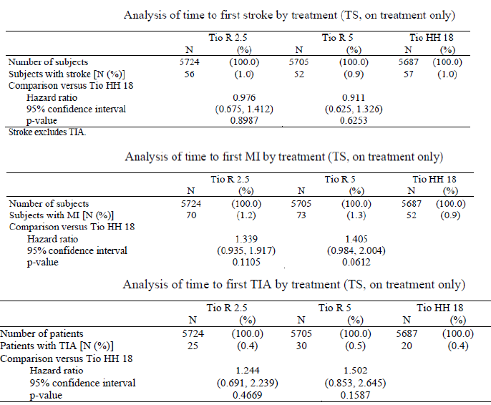
The incidence of subjects who experienced an outcome event of stroke was similar in the Tio R2.5 (1.0%), Tio R5 (0.9%), and Tio HH18 (1.0%) treatment groups. The HR was 0.911 [95% CI: (0.625, 1.326)] for Tio R5 versus Tio HH18 and 0.976 [95% CI: (0.675, 1.412)] for Tio R2.5 versus Tio HH18, that is, at any time during the trial a subject had a 8.9% and 2.4% lower chance of experiencing a stroke in the Tio R5 and Tio R2.5 treatment groups, respectively, than a subject in the Tio HH18 group. The differences observed between treatments were not statistically significant.
Myocardial infarctions were defined in two different ways in this trial: first, as an outcome event with central monitoring of the protocol defined criteria for MI, and secondly, by coding of investigator reported terms in the SMQ ischaemic heart disease, sub SMQ myocardial infarction (broad). The incidence of subjects who experienced an outcome event of MI was 1.2% in the Tio R2.5 group, 1.3% in the Tio R5 group, and lower (0.9%) in the Tio HH18 treatment group. The HR was 1.405 [95% CI: (0.984, 2.004)] for Tio R5 versus Tio HH18 and 1.339 [95% CI: (0.935, 1.917)] for Tio R2.5 versus Tio HH18, that is, at any time during the trial a subject had a 40.5% and 33.9% higher chance of experiencing an outcome event of MI in the Tio R5 and Tio R2.5 treatment groups, respectively, than a subject in the Tio HH18 group. Although the incidence of MI was higher for both Tio R5 and Tio R2.5 compared to Tio HH18, differences were not statistically significant for either treatment comparison (p values = 0.0612 and 0.1105, respectively). The incidence of SAEs in the sub SMQ myocardial infarction (broad) was similar in the three treatment groups (1.4%, 1.2%, and 1.1% in the Tio R2.5, Tio R5, and Tio HH18 treatment groups, respectively).
The analysis of time to first TIA (collected as a protocol defined outcome event) was not prespecified as a further safety endpoint, but was included post hoc to complete the time to event analyses for the three outcome events included as components of MACE (MI, stroke, and TIA).
The incidence of subjects who experienced an outcome event of TIA was 0.4%, 0.5% and 0.4% in the Tio R2.5, Tio R5 and Tio HH18 groups, respectively. The HR was 1.502 [95% CI: (0.853, 2.645)] for Tio R5 versus Tio HH18 and 1.244 [95% CI: (0.691, 2.239)] for Tio R2.5 versus Tio HH18, that is, at any time during the trial a subject had a 50.2% and 24.4% higher chance of experiencing a TIA in the Tio R5 and Tio R2.5 treatment groups, respectively, than a subject in the Tio HH18 treatment group, but the differences observed between treatments were not statistically significant.
Among the components of fatal MACE, an imbalance in fatal MI was observed between the two Respimat [Tio R2.5 (10 subjects, 0.2%) and Tio R5 (11 subjects, 0.2%)] and HH doses [Tio HH18 (three subjects, 0.1%)] during the trial observation period. The incidence of fatal events within the cardiac disorders and vascular disorders SOC however was balanced in the three treatment groups, and the collective incidence of the preferred terms sudden death, cardiac death, and sudden cardiac death was also similar. The incidence rate of fatal MI associated with Tio HH18 was low when compared to a large database like UPLIFT.
Comment: There were fewer fatal myocardial infarction events (defined by the sub SMQ myocardial infarction [broad]) in the Tio HH18 group (three subjects, 0.1%) compared with Tio R5 group (11 subjects, 0.2%) and Tio R2.5 group (10 subjects, 0.2%); IRR (Tio R5/Tio HH18) = 3.64, 95% CI: (1.02, 13.06) and IRR (Tio R2.5/Tio HH18) = 3.31, 95% CI: (0.91, 12.03); however, the number of events was low, and the incidence rates for Tio R2.5 and Tio R5 in TIOSPIR (0.1 per 100 patient yrs for both) were similar to those observed in the UPLIFT trial for both treatment groups (0.1 per 100 patient yrs for Tio HH18 and placebo) , while the incidence rate for Tio HH18 in TIOSPIR (0.0 per 100 patient yrs) was lower which may reflect the variability at low numbers of a relatively rare event.
Clinical laboratory evaluations were not planned for this trial. Physical examination, including vital signs (systolic blood pressure, diastolic blood pressure, and pulse rate) was conducted only at Visit 1 prior to randomisation. Any clinically significant findings were to be recorded on the medical history page of the eCRF.
Comment: In accordance with the European Union (EU) regulations, this study (TIOSPIR) was initiated by Boehringer Ingelheim (BI) as a Post Authorisation Safety Study. An unexplained numerically higher rate in all cause mortality (compared to placebo) had been observed in the pooled tiotropium Respimat trials (Tio R5) [HR = 1.33, 95% CI: (0.93 to 1.92)], particularly in subjects with known cardiac rhythm disorders. The Respimat mortality data were contrary to data with Tio HH18 in the UPLIFT study, a four year placebo controlled study, where fewer deaths were observed with Tio HH18 than placebo [14.9% versus 16.5%;HR = 0.89, 95% CI: (0.79 to 1.02)] during a period of four years plus 30 days (1470 days, inclusive of vital status); for the planned treatment period of 1440 days (inclusive of vital status, analysis conducted post unblinding) 14.4% of subjects died in the tiotropium group and 16.3% in the placebo group [HR = 0.87, 95% CI: (0.76 to 0.99)]. During treatment, there was a 16% reduction in the risk of death. The incidence rate of death was 4.79 per 100 patient yrs in the placebo group versus 4.10 per 100 patient yrs in the tiotropium group [HR tiotropium / placebo = 0.84, 95% CI = (0.73, 0.97)]. Given the smaller amount of safety data available from the pooled clinical database for Tio R5 compared to Tio HH18, combined with known comparable systemic exposure and comparable efficacy as well as retrospective pooled analyses of causes of death, a relationship between Tio R5 and mortality risk has not been established. TIOSPIR was therefore designed as a prospective trial of adequate size and duration to establish that compared to Tio HH18, Tio R5 has (a) similar effects on mortality and superior effects on exacerbations. The tiotropium Respimat 2.5 μg dose (Tio R2.5) was included to establish the safety and exacerbation efficacy relative to the other marketed tiotropium formulations.
Compared to the HH formulation (Tio HH18), the Respimat (Tio R5 and Tio R2.5) tiotropium formulations showed similar risks of all cause mortality in a large Phase IIIb study involving 17,116 COPD patients. Although there was a higher incidence of deaths in subjects with cardiac arrhythmia at baseline compared to subjects without cardiac arrhythmia in each of the treatment groups, the relative differences between Tio R5 and Tio R2.5 compared to Tio HH18 were comparable.
The composite endpoint MACE was a predefined secondary endpoint to further evaluate cardiovascular safety. The overall incidence of MACE (3.9%, 3.9%, and 3.6% in the Tio R2.5, Tio R5, and Tio HH18 treatment groups, respectively) and death from MACE (2.1%, 2.0%, and 1.8%) was similar across all three treatment groups. Evaluation of the individual components of MACE showed no statistically significant differences across treatment groups for all components with the exception of fatal events of MI which was higher in the Respimat tiotropium groups [IRR (Tio R5/Tio HH18) = 3.64, 95% CI: (1.02, 13.06) and IRR (Tio R2.5/Tio HH18) = 3.31, 95% CI: (0.91, 12.03).
The frequencies of SAEs, AEs leading to discontinuation, and investigator determined drug related AEs were comparable across treatment groups and no imbalance of substantial concern was identified. No overall safety advantage was observed for the lower dose of Tio R2.5 compared to the two approved dose strengths of Tio R5 and Tio HH18. Results from the recently completed four week cross over Trial 205.458 have demonstrated lower but similar systemic exposure of Tio R5 compared to Tio HH18 in subjects with COPD suggesting that any potential safety difference between Tio R5 and Tio HH18 are not likely to be due to higher systemic exposure following tiotropium Respimat formulation.

Patient exposure in asthma studies
Overall, 3,864 asthma patients were treated in the six parallel group trials and 350 patients were treated in the three crossover trials; 1,929 patients in the parallel group studies and 346 patients in the crossover studies were treated with tiotropium. The exposure to tiotropium in all parallel group and crossover studies is summarised in Table 19 below.

Table 19: Exposure to any dose of tiotropium, all Phase II and III trials – TS
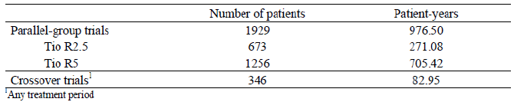
In the Phase III study in patients with mild asthma, median duration of exposure was 85 days in all treatment groups and > 75% of patients in all treatment groups were exposed to study treatment for at least 85 days (more than 12 weeks).
In Phase III Studies 205.418/ 419 in patients with moderate asthma, median duration of exposure was 169 days in all treatment groups and > 70% of patients in all treatment groups were exposed to study treatment for at least 168 days (24 weeks).
In Phase III Studies 205.416/417, median duration of exposure was 337 days in all treatment groups and > 70% of patients were exposed to study treatment for at least 336 days (48 weeks).
In accordance with the duration of trials, exposure was shortest in Trial 205.442 in patients with mild asthma, followed by Trials 205.418/419 in patients with moderate asthma, and longest in Trials 205.416/417 in patients with severe asthma. In the pooled parallel group trials (205.442/418/419/416/417/342), 1929 patients were exposed to daily doses of either 5 μg (Tio R5) or 2.5 μg (Tio R2.5) of tiotropium in the parallel group trials with a duration of exposure between one day and 434 days (62 weeks) and a median duration of 169 days (> 24 weeks). Exposure to the different treatment groups in the individual crossover trials is provided in Table 20.

Table 20: Exposure to study medication, all crossover trials (205.420, 205.380, 205.341) – TS
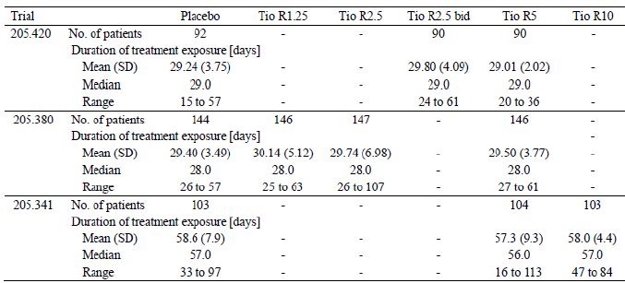
Within each of the crossover trials, mean and median treatment exposure were similar between the treatment groups. In the parallel group trials, median treatment compliance was similar between the treatment groups in each trial and ranged from 89.2% to 96.5%. In the crossover trials, median treatment compliance was similar between the treatment groups in each trial and was over 95%.
Besides a minimum requirement for stable asthma maintenance medication for each trial based on asthma severity (low dose ICS, medium dose ICS, or high dose ICS + LABA), patients were allowed to continue appropriate medications throughout the treatment period based on asthma severity.
Comment: Overall exposure was adequate for assessment of safety in patients with severe asthma however; there was lack of adequate long term safety data in patients with mild/moderate asthma.

Adverse events

All adverse events (irrespective of relationship to study treatment)

Pivotal studies

Mild asthma (205.442)
The frequency of patients with AEs (29%, 31.2% and 32.3% in placebo, Tio R2.5 and Tio R5 groups, respectively) and severe AEs (1.3%, 0.6% and 1.3%, respectively) was balanced between the three treatment groups. In all three treatment groups, patients were most frequently reported with AEs in the SOC respiratory, thoracic and mediastinal disorders followed by the SOC infections and infestations. Specifically the most common PTs were asthma (12.9%, 15.6% and 11%, respectively); PEF rate decreased (3.9%, 5.8% and 3.9%, respectively) and upper respiratory tract infection (4.5%, 1.3% and 4.5%, respectively). After adjustment for time at risk, the incidence rates for any AE remained similar for all treatment groups (122.9, 119.9 and 111.9 per 100 patient yrs in the Tio R5, Tio R2.5 and placebo groups, respectively).

Moderate asthma (205.418/419)
The frequency of patients with AEs was similar between the treatment groups (59.1%, 58.2%, 57.3% and 54.3% in placebo, Tio R2.5, Tio R5 and salmeterol groups, respectively), but the proportion of patients with severe AEs was numerically higher in the Tio R5 group than in the other treatment groups (3.4%, 2.9%, 5.4% and 3.5%, respectively). In all four treatment groups the highest frequency of AEs was in the SOC respiratory, thoracic and mediastinal disorders, followed by the SOC infections and infestations. At the PT level, the notable differences between the treatment groups were a lower incidence of asthma in patients treated with Tio R2.5 (22.0%, 15.8%, 21.5% and 19.4% in the placebo, Tio R2.5, Tio R5 and salmeterol groups, respectively), a higher incidence of headache with Tio R2.5 compared to other groups (2.7%, 3..5%, 1.5% and 1.1%, respectively); higher incidence of PEF rate decreased in patients treated with placebo (15.1%, 9.4%, 11.4% and 8.7%, respectively), and a higher incidence in the Tio R5 group of dysphonia (0.6%, 0.4%,1.5% and 0.2%, respectively), thirst (0.6%, 0.4%, 1.5% and 0.7%, respectively) and oropharyngeal pain (0.8%, 1.5%, 1.9% and 0.4%, respectively).
After adjustment for time at risk, the incidence rates for any AE remained similar for all treatment groups (180.5, 178.4, 162.8 and 188.6 per 100 patient yrs in the Tio R5, Tio R2.5, salmeterol and placebo groups, respectively). The profile and frequency of AEs was generally similar among the treatment groups. There were no noteworthy differences between the treatment groups at the SOC level.
Comment: It is important to note that the incidence of severe AEs was greater with the higher Tiotropium dose (5 µg) compared with the lower dose of 2.5 µg. Furthermore, Tio 5 µg was associated with higher incidence of asthma, dysphonia, oropharyngeal pain and thirst. This information should be interpreted in light of the fact that efficacy with the lower dose of 2.5 µg was similar or sometimes better than 5 µg in patients with moderate asthma.

Severe asthma (205.416/417)
Overall, a lower percentage of patients in the Tio R5 group than in the placebo group were reported with AEs (Tio R5 versus placebo: 73.5% versus 80.3%), but the incidence of severe AEs was similar across treatment groups (12.5% versus 11.6%). In both treatment groups the highest frequency of AEs was within the SOCs respiratory, thoracic and mediastinal disorders (45.6% versus 54.4%), infections and infestations (37.7% versus 35.5%), and investigations (21.7% versus 28.6%). On the PT level, the most frequently reported events were as expected and included asthma (Tio R5 versus placebo: 39.9% versus 50.9%), PEF rate decreased (20.4% versus 26.8%), and nasopharyngitis (11.2% versus 12.3%). After adjustment for time at risk, the incidence rates for any AE were significantly lower in the Tio R5 group (166.9/100 patient yrs) than in the placebo group (220.1/100 patient yrs) with a RR (Tio R5/ placebo) of 0.76 (95% CI 0.65, 0.88). For AEs with a frequency of ≥ 2%, significantly higher incidence rates in the Tio R5 than in the placebo group were observed for rhinitis allergic (Tio R5 versus placebo: 2.9% versus 0.7%) and the PT 'rhinitis allergic' was also a frequent CD at screening (Tio R5 versus placebo: 22.6% versus 20.0%. The incidence rates for the following PTs were significantly lower in the Tio R5 than in the placebo group: asthma (39.9% versus 50.9%), PEF rate decreased (20.4% versus 26.8%) and insomnia (0.4% versus 2.2%).

Pooled parallel group trials (205.442/418/419/416/417/342)
In all pooled parallel group trials (205.442/418/419/416/417/342), the incidence rates for any AE were significantly lower in the Tio R5 group than in the placebo group, with a RR (Tio R5/ placebo) of 0.87 (95% CI 0.78, 0.96). However, a significantly higher incidence rate in the Tio R5 group than in the placebo group was observed for the PT bronchitis (3.4% versus 2.1%; RR = 1.62, 95% CI: 1.00, 2.62). The other AEs with a higher incidence in the Tio R5 group compared with placebo were gastrooesophageal reflux disease (1.1% versus 0.4%; RR Tio R5/ placebo = 2.87, 95% CI: 1.03, 7.99), rhinitis allergic (1.6% versus 0.6%; RR = 2.55, 95% CII: 1.13, 5.75) and dry mouth (1.1% versus 0.6%; RR = 2.05, 95% CI: 0.82, 5.1).
In the pooled parallel group trials in adult patients with asthma, significantly lower incidence rates in the Tio R5 group than in the placebo group were observed for the PTs asthma and PEF rate decreased. No other significantly different incidence rates between the Tio R5 group and the placebo group occurred.
Comment: The sponsor states that no additional data from the asthma clinical database (for example, increase in rescue medication use, increased cough and mechanistic considerations) could be found that were suggestive of a causal relationship between tiotropium and bronchitis. Hence, data from a pooled analysis of seven trials from the Spiriva Respimat clinical database for the indication COPD (Tio R5: 3282 patients, placebo: 3283 patients) were evaluated. In this pool, the PT bronchitis was reported at a lower frequency in the Tio R5 group (3.4%) than in the placebo group (4.1%) and had a lower incidence rate in the Tio R5 group than in the placebo group leading to a RR (Tio R5/ placebo) of 0.79 (95% CI 0.61, 1.01). However, incidence of cough was higher with Tio R5 in the pooled parallel group studies. Furthermore, safety results observed in the COPD patient population cannot be extrapolated to asthma patients and a question regarding higher incidence of bronchitis with proposed dose of Tio R5 was raised.

Other studies (Crossover studies)

Moderate asthma (205.420, 205.380)
In Trial 205.420, the overall frequency of AEs was similar between the treatment groups (Tio R5: 24.4%, Tio R2.5 BD: 28.9%, placebo: 28.3%). The most frequently reported PTs in any treatment group were nasopharyngitis (Tio R5: 3.3%, Tio R2.5 BD: 3.3%, placebo: 4.3%), headache (Tio R5: 5.6, Tio R2.5 BD: 7.8%, placebo: 4.3%), diarrhoea (Tio R5: 3.3%, Tio R2.5 BD: 1.1%, placebo: 1.1%), dry mouth (Tio R5: 3.3%, Tio R2.5 BD: 1.1%, placebo: 1.1%), and respiratory tract infection viral (Tio R5: 0%, Tio R2.5 BD: 1.1%, placebo: 3.3%). All other PTs were reported in ≤ two patients in any treatment group. In Trial 205.380, the overall frequency of AEs was as follows: Tio R5: 15.8%, Tio R2.5: 13.6%, Tio R1.25: 9.6%, and placebo: 14.6%. The most frequently reported PTs in any treatment group were nasopharyngitis (Tio R5: 3.4%, Tio R2.5: 0.7%, Tio R1.25: 1.4%, placebo: 1.4%), asthma (Tio R5: 2.7%, Tio R2.5: 2.0%, Tio R1.25: 0.7%, placebo: 3.5%), and dyspnoea (Tio R5: 0%, Tio R2.5: 2.0%, Tio R1.25: 0%, placebo: 0.7%). All other PTs were reported in ≤ two patients in any treatment group.

Severe asthma (205.341)
In Trial 205.341, the overall frequency of patients with AEs was highest in the Tio R10 group (49.5%) and similar between the Tio R5 (42.3%) and placebo groups (39.8%). The most frequently reported PTs in any treatment group were nasopharyngitis, asthma, dry mouth, cough, and dyspnoea. All other PTs were reported in ≤ four patients in any treatment group. The only AE that occurred at a higher frequency in both tiotropium groups than in the placebo group and had a higher frequency in the Tio R10 than in the Tio R5 group was dry mouth; dry mouth was a dose related anticholinergic effect and is a known side effect of tiotropium.
Comment: Although results of the only parallel group Phase II study (205.342) were included in the “pooled parallel group trials” safety dataset, the safety results of this study are also discussed individually in this section.
Phase IIa double blind, double dummy, parallel group Study 205.342 in 388 patients with moderate asthma compared the efficacy and safety of tiotropium inhalation solution (5 μg [two puffs of 2.5 μg] qd, pm) delivered by the Respimat inhaler with that of salmeterol metered dose inhaler (MDI) (50 μg [two puffs of 25 μg] BD). During the double blind treatment and follow up periods, the overall incidence of AEs was similar in the active treatment and placebo groups (41.3%, 39.8% and 41.8% in the placebo, tiotropium and salmeterol groups, respectively). The most common AEs by PT were asthma exacerbation (13.5%, 12.5% and 12.7%, respectively) and nasopharyngitis (7.1%, 3.9% and 2.2%, respectively). All other individual AEs were reported by fewer than 5% of patients in any treatment group.

Treatment related adverse events (adverse drug reactions)

Pivotal studies

Mild asthma (205.442)
Drug related AEs as assessed by the investigator were reported for a total of six patients (1.3%), two patients (1.3%) in each of the treatment groups and the most common AEs were headache, dysphonia, asthma, haematuria, dry mouth.

Moderate asthma (205.418/419)
Overall 6.2% of the patients reported drug related AEs (Tio R5: 7.4%, Tio R2.5: 6.9%, salmeterol: 5.2%, placebo: 5.4%) and the most frequent drug related AEs were thirst, dry mouth, cough, asthma, and dysphonia. Other drug related AEs that were reported for more than four patients overall were oropharyngeal discomfort, gamma glutamyl transferase increased, aspartate aminotransferase increased and headache. All other drug related AEs were reported for one to four patients overall. Differences of more than 0.5% in the frequency of drug related AEs were observed between the Tio R5 group and the other three treatment groups for dysphonia, thirst, and dry mouth.
There were five drug related AEs of severe intensity: asthma (placebo: one patient, Tio R2.5: one patient, Tio R5: one patient), dry mouth (Tio R2.5: one patient), and urinary tract infection (salmeterol: one patient). Two of these AEs (asthma in one patient each in the placebo and Tio R2.5 group) lead to treatment discontinuation). The AE of urinary tract infection was the only serious drug related AE (required hospitalisation of the patient).

Severe asthma (205.416/417)
Overall, 5.2% of patients reported drug related AEs (Tio R5: 5.7%, placebo: 4.6%) and the most frequent drug related AEs were asthma, dry mouth, dry throat, and dysphonia (Tio R5: two patients [0.4%], placebo: two patients [0.4%]). All other drug related AEs were reported for less than three patients overall. Differences of more than 0.5% in the frequency of drug related AEs were observed between the Tio R5 and the placebo group for dry mouth and dry throat. Most of the drug related AEs were mild or moderate with only one serious AE (asthma requiring hospitalisation in Tio R5 patient).

All parallel group trials
Across all parallel group trials, in addition to the AEs described above, dizziness was the only drug related AE reported in at least three patients overall and only in the tiotropium treatment groups (Tio R5: two patients, Tio R2.5: one patient). Dizziness is listed in the current label as undesirable effect of tiotropium Respimat in COPD.

Other studies

Crossover phase II studies
In Trial 205.420, drug related AEs were reported for a total of 10 patients (Tio R5: four patients [4.4%], Tio R2.5 BD: three3 patients [3.3%], placebo: three patients [3.3%]). The most frequently reported drug related AE was dry mouth (Tio R5: three patients, Tio R2.5 BD: one patient, placebo: one patient), followed by dysphonia (Tio R5: none, Tio R2.5 BD: two patients, placebo: one patient) and nasal dryness (Tio R5: one patient, Tio R2.5 BD: none, placebo: two patients). All other drug related PTs were reported by one patient in any of the treatment groups only.
In Trial 205.380, drug related AEs were reported for a total of seven patients (Tio R5: three patients [2.1%], Tio R2.5: none, Tio R1.25: two patients [1.4%], placebo: two patients [1.4%]). All drug related PTs were reported by only one patient in any of the treatment groups.
In Trial 205.341 (severe asthma), drug related AEs as assessed by the investigator were reported for a total of seven patients (Tio R10: five patients [4.9%], Tio R5: one patient [1.0%], placebo: one patient [1.0%]). The most frequently reported drug related AE was dry mouth (Tio R10: four patients, other treatment groups: none). All other drug related PTs were reported by only one patient in any of the treatment groups.

Parallel group phase II study
In Phase IIa Study 205.342, few AEs were considered drug related and the incidences of such AEs were also similar across groups: four (3.2%) placebo patients, six (4.7%) tiotropium patients and three (2.2%) salmeterol patients.

Deaths and other serious adverse events

Deaths
There were no deaths reported during the treatment or follow up period of any of the parallel group or crossover trials.

SAEs

Parallel group studies
In Study 205.442 (mild asthma), two patients (0.4%) were reported with SAEs: one patient (0.6%) in the placebo group reported immediately life threatening asthma and one patient (0.6%) in the Tio R5 group reported breast cancer in situ, which required hospitalisation. None of the SAEs were assessed as drug related.

Moderate asthma (205.418/419)
Overall, 48 patients (2.3%) were reported with SAEs, which were balanced between the four treatment groups; the most frequent SAE was asthma, which occurred at a similar frequency across all treatment groups. Cerebrovascular accident was reported for three patients (one in the salmeterol group and two in the placebo group). Pneumonia and hypertension were reported for two patients in the Tio R2.5 group. All other SAEs were reported for one patient per treatment group. Immediately life threatening SAEs were reported for four patients overall: two patients in the Tio R5 group (one patient with anaphylactic reaction, one patient with chemical poisoning), one patient in the Tio R2.5 group (myocardial infarction), and one patient in the salmeterol group (cerebrovascular accident). The only drug related SAE was urinary tract infection requiring hospitalisation, which was reported for one patient in the salmeterol group.

Severe asthma (205.416/417)
Overall, 77 patients (8.4%) were reported with SAEs, which were balanced between the treatment groups. The most frequent SAE was asthma followed by pneumonia, which was reported with equal frequency in both groups. Intervertebral disc protrusion was reported by two patients in the placebo group. All other SAEs were reported for one patient per treatment group. Immediately life threatening SAEs were reported for three patients in the Tio R5 group (one patient with cerebral infarction; one patient with hypotension, shock, and renal failure after hospitalisation for a non life threatening asthma exacerbation; and one patient with acute respiratory failure and asthma [exacerbation]). The only drug related SAE was asthma requiring hospitalisation, which was reported for one patient in the Tio R5 group.
In the pooled parallel group trials (205.442/418/419/416/417/342), the SAE with the highest frequency overall was asthma, which was most frequently reported in the placebo group (26 patients [2.1%]), followed by the Tio R5 (18 patients [1.4%]), salmeterol (six patients [0.9%]), and Tio R2.5 (two patients [0.3%]) treatment groups. All other SAEs were reported by no more than two patients per treatment group. Of note, the SAEs atrial fibrillation (Tio R5: one patient with severe asthma in Trial 205.416, Tio R2.5: one patient with moderate asthma in Trial 205.418) and hypertension (Tio R2.5: two patients with moderate asthma, one each in Trial 205.418 and 205.419) were reported only for the tiotropium treatment groups and in at least two patients overall. Atrial fibrillation is listed in the current label as undesirable effect of tiotropium Respimat in COPD.
In Phase IIa Study 205.342, there were no deaths or immediately life threatening AEs. The incidence of SAEs overall was low: one (0.8%) placebo patient, two (1.6%) tiotropium patients, compared to seven (5.2%) salmeterol patients. All these SAEs were considered serious because the patients were hospitalised. The most common SAE was asthma exacerbation, reported for four salmeterol patients, one placebo patient, and no tiotropium patients. All other SAEs were different events, each reported for only one patient: meningitis, pilonidal cyst (tiotropium), headache/ nausea/joint injury, ligament injury, gastroenteritis (salmeterol). No SAEs were considered to be drug related.

Moderate asthma crossover studies (205.420, 205.380)
In Trial 205.420, a total of three patients were reported with SAEs (Tio R5: one patient with haemorrhage and rib fracture due to a road traffic accident, one patient with venous thrombosis limb, placebo: one patient with hypertensive crisis). All patients required hospitalisation, and none of the SAEs were considered as drug related. In Trial 205.380, two patients were reported with SAEs (Tio R5: one patient with alcohol abuse and panic attack, one patient with inguinal hernia). Both patients required hospitalisation, and none of the SAEs were considered drug related.

Severe asthma crossover study (205.341)
In Trial 205.341, a total of five patients were reported with SAEs (Tio R10: one patient with angioedema, Tio R5: one patient with gastritis, one patient with pneumonia and pleurisy, placebo: one patient with asthma, one patient with osteoarthritis). All patients required hospitalisation, and none of the SAEs were considered drug related.
In the pooled crossover trials (205.420/380/341), none of the SAEs occurred in more than one patient on the PT level within a treatment group during the crossover trials, and none of the SAEs were assessed as drug related. The seriousness criterion for all SAEs was 'requiring hospitalisation'.

Discontinuation due to adverse events

Pivotal studies

Mild asthma (205.442)
AEs leading to discontinuation were reported for one patient (0.6%) in the Tio R5 group (SAE: breast cancer in situ) and for two patients (1.3%) in the Tio R2.5 group (asthma).

Moderate asthma (205.418/419)
AEs leading to discontinuation were slightly more common in the placebo (13 patients [2.5%]) than in the other treatment groups (Tio R5: nine patients [1.7%], Tio R2.5: six patients [1.2%], salmeterol: 10 patients [1.8%]. In the Tio R5 group, three patients (0.6%) were reported with asthma, while all other AEs leading to discontinuation were reported for one patient only (dry throat, dysphonia, pharyngeal hypoaesthesia, urticaria, blurred vision, non cardiac chest pain, drug hypersensitivity, sinusitis, ECG ST segment depression, SAE: colitis). In the Tio R2.5 group, all AEs leading to discontinuation were reported by one patient only (asthma, oropharyngeal pain, extrasystoles, gastrooesophageal reflux disease, SAEs: haemoptysis, atrial fibrillation, myocardial infarction). In the salmeterol group, asthma was the most common AE leading to discontinuation (four patients [0.7%]), all other AEs were reported for one patient only (tachycardia, pruritus, rash, hernia, viral upper respiratory tract infection, SAE: eosinophilic pneumonia). In the placebo group, the most frequent AE leading to discontinuation was asthma (seven patients [1.3%]); all other AEs were reported for one patient only (dyspnoea, ventricular extrasystoles, tremor, abortion spontaneous, SAEs: acute myocardial infarction, coronary artery disease, cerebral haemorrhage, gastrointestinal tract adenoma).

Severe asthma (205.416/417)
AEs leading to discontinuation were slightly more common in the placebo group (14 patients [3.1%]) than in the Tio R5 group (eight patients [1.8]) In both treatment groups the most frequent AE leading to discontinuation was asthma (Tio R5: 3 patients [0.7%], placebo: seven patients [1.5%]), which was an SAE in two patients of the Tio R5 group and in one patient of the placebo group. In the placebo group, two patients (0.4%) discontinued due to headache. All other PTs were reported by one patient only (Tio R5: bronchiectasis, dysphonia, arthritis, muscle spasm, erythema, SAE: cerebrovascular accident; placebo: bronchospasm, throat irritation, urinary incontinence, SAEs: road traffic accident, bone neoplasm malignant).

Pooled parallel group trials (205.442/418/419/416/417/342)
In the pooled parallel group trials (205.442/418/419/416/417/342), the proportion of patients who prematurely discontinued due to AEs was highest in the placebo group. The most frequent AEs that resulted in treatment discontinuation were respiratory events with asthma being the most frequent one. The only other AEs that were reported by two patients in a treatment group were dysphonia in the Tio R5 group (two patients [0.2%]) and headache in the placebo group (two patients [0.2%]). All other preferred terms were reported for one patient in any given treatment group.

Other studies

Phase II cross over studies
In Trial 205.420, two patients of the placebo group (one patient with hypertension, one patient with diarrhoea) but none of the patients of the tiotropium groups discontinued the trial prematurely due to AEs. In Trial 205.380, one patient of the Tio R5 group discontinued the trial prematurely due to the SAEs alcohol abuse and panic attack. In Trial 205.341, a total of six patients discontinued the trial prematurely due to AEs: one patient in the Tio R10 group with asthma, four patients in the Tio R5 group (two patients with asthma, one patient with the SAEs pneumonia and pleurisy, one patient with abdominal pain upper), and one patient in the placebo group with asthma. The AE upper abdominal pain reported in one patient in the Tio R5 group was considered drug related.

Phase IIa parallel group Study 205.342
In Phase IIa parallel group Study 205.342, nine patients discontinued study medication due to AEs and the incidence was higher for the tiotropium group than for placebo or salmeterol groups: two (1.6%) placebo patients; five (3.9%) tiotropium patients; and two (1.5%) salmeterol patients. The AEs leading to discontinuation for placebo patients were lichenoid keratosis (drug related) and chest discomfort. For the tiotropium group, the AEs were bronchitis, sleep disorder (drug related), hypertension (drug related), asthma exacerbation (two patients; one drug related). For the salmeterol group, the AEs were chest pain (drug related) and asthma exacerbation (the only AE that was both serious and led to discontinuation of trial drug).

Analysis of AEs by organ system or syndrome

Respiratory system
The frequency of the PTs asthma and bronchitis and of their associated frequency #PV/SMQs increased with asthma severity across all treatment groups. The incidence of lower respiratory tract infection and bronchitis was > 2% in patients with moderate and severe asthma, but not in patients with mild asthma.. The frequency of PT decreased PEF rate and of PTs nasopharyngitis, upper respiratory tract infection, sinusitis and/or influenza and of their associated #PV/SMQs increased with asthma severity across all treatment groups. Other respiratory #PV/SMQs which showed increased incidence with asthma severity and were reported in > 2% of patients were cough, pneumonia, dysphonia and dyspnoea.
In the pooled parallel group trials in adult patients with asthma, the incidence of asthma exacerbation #PV; bronchospasm (broad) #PV; bronchospasm #PV; SMQ asthma/bronchospasm (narrow) and asthma worsening #PV was significantly lower in the Tio R5 group compared with the placebo group and they were all associated to the lower incidence rates in the Tio R5 group of PTs asthma or PEF rate decreased. However, incidence of bronchitis (Tio R5 versus placebo: 3.8% versus 2.2, RR = 1.75, 95% CI: 1.10, 2.79), lower respiratory tract infections (5.1% versus 3.3%, RR = 1.60, 95% CI: 1.08, 2.17) and cough (2.1% versus 1.7%, RR = 1.25, 95% CI: 0.70, 2.22) was higher in the Tio R5 group compared with placebo. The other respiratory #PV/SMQ with a low overall incidence but at least two fold higher time adjusted incidence rate in the Tio R5 than in the placebo group was pneumonia #PV [Tio R5 versus placebo: 1.2% versus 0.6%; RR Tio R5/ placebo = 2.20, 95% CI 0.89, 5.43).
Comment: There is no clear explanation for the higher incidence of bronchitis, cough and pneumonia in patients treated with Tio R5 compared with placebo and this has been included as a question for the sponsors in Section 12.

Gastrointestinal system
In patients with mild or moderate asthma, all gastrointestinal #PV/SMQs were reported in < 2% of patients in any treatment group. In moderate asthma (205.418/419), significantly higher incidence rates were observed in the Tio R5 compared with salmeterol for dry mouth #PV (Tio R5 versus salmeterol: 5% versus 0.2%) and for the oropharyngeal candidiasis (broad) #PV (1.2% versus 0.2%). Dry mouth and oropharyngeal candidiasis are listed in the current label as undesirable effects of tiotropium Respimat in COPD.
Gastrointestinal #PV/SMQs occurring at a frequency of > 2% in any of the treatment groups in patients with severe asthma (205.416/417) were dyspepsia (Tio R5 versus placebo: 3.9% versus 2.2%), gastroesophageal reflux (3.1% versus 1.5%), nausea / vomiting (2.6% versus 2.4%), oropharyngeal candidiasis (2.6% versus 1.5%) and dry mouth (2.2% versus 0.7%). In severe asthma after adjustment for time at risk, the incidence rate for the dry mouth #PV was significantly higher in the Tio R5 than in the placebo group with a rate difference (Tio R5 - placebo) of 1.66 (95% CI 0.02, 3.30).
In the pooled parallel group trials, the dyspepsia (including reflux) #PV was the only gastrointestinal #PV/SMQ that was reported at a frequency of ≥ 2% in any of the treatment groups (Tio R5: 2.0% [25 patients], placebo: 1.4% [18 patients] RR (Tio R5/ placebo) of 1.41 (95% CI 0.77, 2.59)). The incidence of dry mouth was also significantly (two fold) higher in the Tio R5 than in the placebo group.

Nervous system; Injury, poisoning and procedural complications
In the Phase III parallel group studies, the nervous system AEs observed were headache, sleep disturbance and insomnia with lower incidence in patients treated with tiotropium. In moderate asthma (205.418/419), the incidence of headache was significantly lower in the Tio R5 (1.5%) than in the placebo (3.6%) and Tio R2.5 (3.5%) groups and similar to that in the salmeterol (1.7%) group. In severe asthma (205.416/417), the incidence rates for none of the nervous system disorders #PV/SMQs were significantly higher in the Tio R5 group than in the placebo group. The incidence rates for headache were similar (Tio R5 versus placebo: 6.6% versus 7.5%) while that of insomnia (0.4% versus 2.4%) and sleep disturbance (0.4% versus 2.4%) were lower in the Tio R5 group than in the placebo group.
In the Phase III parallel group studies, the SMQ accidents and injuries (narrow) exceeded a frequency of 2% in patients with moderate and severe asthma only. For AEs with a frequency of ≥ 2%, the incidence rates for the SMQ accidents and injuries (narrow) were not significantly different between the Tio R5 group and the placebo group.

Cardiovascular system/ MACE
In the pooled parallel group trials (205.442/418/419/416/417/342), hypertension #PV and the SMQ hypertension (narrow) were reported in 1.4% (18 patients) in the Tio R5 group compared with 2.1% (26 patients) in the placebo group. All other cardiovascular #PV/SMQs were reported in < 1% in any treatment group: the palpitations #PV and #PV/SMQs related to cardiac arrhythmia occurred in ≤ six patients in any tiotropium group (≤ eight patients in any treatment group), SMQs related to ischaemic heart disease or ischaemic cerebrovascular disorders were reported in ≤ three patients in any tiotropium group (≤ five patients in any treatment group), the SMQ haemorrhagic cerebrovascular conditions and the stroke #PV were reported in ≤ two patients in any tiotropium group (≤ three patients in any treatment group), and the SMQ cardiac failure (narrow) was reported for one patient in the Tio R5 group, none of the patients in the Tio R2.5 or salmeterol groups, and for two patients in the placebo group.
MACE endpoints represent serious cardiovascular events that were used to assess the cardiovascular risk of tiotropium. A definition of the included MedDRA SOCs, SMQs, PTs, and BI customised PV endpoints is summarised in Table 21 below:

Table 21: Definition of MACE endpoints
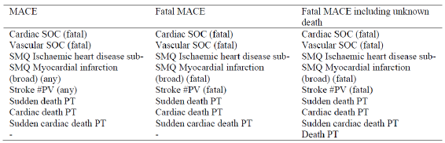
There were no patients with fatal MACE endpoints and only individual patients with non fatal MACE endpoints in each of the parallel group trials (Tio R5: four patients [0.3%]; Tio R2.5: one patient [0.1%], salmeterol: one patient [0.1%]; placebo: four patients [0.3%]). The reported non fatal MACE endpoints also included six patients with AEs in the stroke #PV (Tio R5: two patients, Tio R2.5: none, salmeterol: one patient, placebo: three patients) and four patients with AEs in the SMQ ischaemic heart disease sub SMQ myocardial infarction (broad) (Tio R5: two patients, Tio R2.5: one patient, salmeterol: none, placebo: one patient). After adjustment for time at risk, the incidence rates for the non fatal MACE endpoints in the tiotropium groups were equal to (Tio R5) or lower (Tio R2.5) than the incidence rates in the placebo group.

Renal urinary and subcutaneous / skin
In moderate asthma patients, the incidence of urinary tract infection #PV was similar across all four treatment groups (1.3%, 1.3%, 1.7% and 1.1% in placebo, Tio R2.5, Tio R5 and salmeterol groups, respectively). In patients with severe asthma, the incidence of urinary tract infections was lower in patients treated with Tio R5 compared with placebo (0.9% versus 2.6%).
In moderate asthma patients, the incidence of rash #PV was low but slightly higher in patients treated with Tio R5 (1.2%) and salmeterol (1.8%) compared with Tio R2.5 (0.6%) or placebo (0.6%). In severe asthma patients, the incidence of rash was 2.6% and 1.8% in Tio R5 and placebo groups, respectively.

Benign, malignant and unspecified neoplasms
In Trial 205.442, a female patient in the Tio R5 group aged 50 yrs was reported with the SAE breast cancer in situ (mammary ductal carcinoma), which had an onset on Day 7 after the start of treatment. In Trials 205.418 and 205.419, a total of 12 patients (Tio R5: seven patients, Tio R2.5: one patient, salmeterol: two patients, placebo: two patients) were reported with neoplasms. The most frequent neoplasm was uterine leiomyoma, reported in two patients in the Tio R5 group and one patient in the salmeterol group. In Trials 205.416 and 205.417, a total of nine patients (Tio R5: five patients, placebo: four patients) were reported with neoplasms. Squamous cell carcinoma of skin was reported in one patient in the Tio R5 group and in one patient in the placebo group. All other cases were individual occurrences. Time adjusted incidence rates for the SOC neoplasms benign, malignant and unspecified (including cysts and polyps) and its PTs did not show any evidence of an imbalance between the treatment groups.

Administration related bronchospasm
Paradoxical bronchospasm is of special interest as an AE because the excipients BAC and EDTA might induce bronchospasm when bronchodilator drugs are delivered from nebulisers. Due to the small amount of solution delivered via the Respimat (22.1 μL per two actuations), absolute amounts of BAC and EDTA delivered to the lungs are approximately 12.5 to 25 times lower compared to use of a nebuliser solution (2 to 4 mL). The doses of BAC and EDTA delivered from the tiotropium Respimat formulations are well below those for which bronchospasm has been reported with nebulised solutions [Hodder et al, 2005]. The probability, therefore, that these agents will cause bronchoconstriction when administered from the Respimat inhaler is expected to be low.
The Respimat solution used to formulate tiotropium has a pH of 2.9. Acidic aerosols may cause bronchoconstriction and/or cough in asthmatic patients. A cross over, randomised, double blind trial was undertaken to evaluate the local tolerability of an acidic placebo solution (pH = 2.7) for inhalation via the Respimat as compared with a placebo solution for inhalation via a CFC-MDI, a placebo solution with pH of 3.4 for inhalation via the Respimat, and a placebo solution with pH of seven for inhalation via the Respimat. All solutions were well tolerated and there was no evidence of bronchoconstriction. This study was not provided in this submission dossier.
Comment: The sponsors state that based on this information and data obtained during the clinical program for COPD [U05 - 2643], there appears to be negligible basis for concern regarding administration related bronchospasm with the Respimat inhaler. However, there is no data on incidence of bronchospasm in the asthma studies and this was requested from the sponsors.

Laboratory tests

Liver/kidney function, haematology, clinical chemistry
In severe asthma studies 205.416/417, standard laboratory parameters (haematology, blood chemistry, and urine analysis) were only evaluated for all patients at screening (Visit 1) to determine eligibility for the trial. In moderate asthma studies 205.418/419, standard laboratory parameters (haematology and blood chemistry) were evaluated for all patients at Visit 1 (screening) to determine eligibility for the trial and at Visit 6 (end of treatment) or at the withdrawal visit if the patient did not complete all trial visits. In Study 205.442 (mild asthma), standard laboratory parameters (haematology, blood chemistry, and urine analysis) were evaluated for all patients at screening (Visit 1) to determine eligibility for the trial, at the end of treatment (Visit 5) or at the withdrawal visit if the patient did not complete all trial visits, and at the follow up visit (Visit 6) if the test results at Visit 5 or the withdrawal visit required additional investigation. New clinically significant lab deviations (that is, new clinically significant findings or worsening of a baseline condition) occurring throughout the course of the trials were to be reported as AEs. Only few patients were reported with AEs related to laboratory parameters throughout the tiotropium asthma clinical programme. Abnormal laboratory parameters that were reported as AEs only in the tiotropium treatment groups and for at least two patients were: hepatic enzyme increased (reported for two patients who took Tio R5), blood lactate dehydrogenase increased, and blood phosphorus abnormal (both reported for one patient who took Tio R2.5, and one patient who took Tio R5). In general no specific concerns with regard to abnormal laboratory parameters were raised for patients with asthma who took tiotropium.

Electrocardiograph
ECGs were performed on all patients at screening to assure eligibility for the trials. Any significant findings from this examination were to be recorded as Medical History or Baseline Condition (CD). As stated in the exclusion criteria, a patient was not to be randomised to treatment if the ECG indicated the presence of a disease. In Trials 205.442, 205.418, 205.419, 205.420, and 205.380, ECGs were also recorded at the end of study. Significant findings from ECGs were to be reported as AEs. Additional ECG recordings during the trials of the clinical development programme of tiotropium in asthma were not specifically performed because there was no indication of a relevant change in ECG parameters in the development programmes of tiotropium Respimat in COPD. Absence of QT prolongation was also observed with tiotropium HH at a dose of 18 μg daily in COPD patients during a Holter monitoring trial (Clinical Trial Report (CTR) 205.284) and at doses of 18 μg and 54 μg daily in HVs in a thorough QT study (CTR 205.302). However, individual patients were reported with AEs related to ECGs while on treatment with tiotropium; these included one patient in the Tio R5 treatment group who reported ST segment depression and one patient in the Tio R5 treatment group reported with ECG abnormal (this AE was also reported for one patient in the salmeterol treatment group).
Comment: Details regarding type of abnormal ECG in the Tio R5 and salmeterol patient were not provided.

Vital signs
Vital signs (that is, pulse rate, systolic and diastolic blood pressure) were measured from Visit 1 throughout the study at each clinic visit (at several timepoints) with the patient seated and rested for at least five mins. Vital signs were summarised by treatment group using descriptive statistics for absolute values and changes from baseline. Frequency tables with the number and percentage of patients with marked changes in vital signs were presented.

Pivotal studies
In all Phase III parallel group trials, vital signs were measured at randomisation (baseline) and after four, eight and 12 (Trial 205.442 only) weeks. In Trials 205.418, 205.419 and in Trials 205.416, 205.417, they were additionally measured after 16 and 24 weeks, and in Trials 205.416, 205.417 also after 32, 40, and 48 weeks. In the Phase II parallel group Trial 205.342, vital signs were measured at Week 6, 12, and 16. Vital signs were measured pre dose and 0.5 hrs, 1 hr, 2 hrs and 3 hrs post dose.
At baseline, mean SBP and DBP were similar between the treatment groups. During the course of the studies, mean changes from baseline at any timepoint were very small and also similar across the treatment groups. For SBP, mean changes from baseline at any timepoint ranged from -2.7 mmHg in the Tio R5 group to 1.0 mmHg in the Tio R2.5 group compared to a largest mean decrease of -2.1 mmHg in the placebo group and of -1.3 mmHg in the salmeterol group. For DBP, mean changes from baseline at any timepoint ranged from -1.3 mmHg to 0.3 mmHg in the Tio R5 group, compared to a largest mean decrease of -2.0 mmHg in the placebo group and mean changes from -1.0 mmHg to 0.2 mmHg in the salmeterol group. There was no apparent time dependency of changes for any of the treatment groups. The proportion of patients with marked changes in blood pressure at any timepoint was comparable for all treatment groups. In both tiotropium groups, between 6.1% and 8.3% of patients had a marked decrease in SBP or DBP compared to 7.8% to 8.3% of patients in the placebo group and 7.9% to 8.6% in the salmeterol group. Marked increases in SBP were reported for 4.9%, 3.9%, 4.9% and 3.3% of patients in the Tio R5, Tio R2.5, placebo and salmeterol groups, respectively. Marked increases in DBP were reported in slightly more patients but were still similar across all treatment groups (14.1%, 12.0%, 11.6% and 9.8%, respectively).
At baseline, mean pulse rate was approximately 75 bpm in all treatment groups. Mean changes from baseline at any timepoint during the course of the studies were small and similar for all treatment groups (Tio R5: -0.5 to 1.4 bpm, Tio R2.5: -0.8 to 0.7 bpm, salmeterol: 1.5 bpm, placebo: -0.9 to 0.8 bpm). There was no apparent time dependency of changes for any of the treatment groups. The proportion of patients with marked changes in pulse rate at any timepoint was comparable for all treatment groups. Marked decreases in pulse rate were reported for 8.0%, 9.4%, 9.7% and 4.9% of patients in the Tio R5, Tio R2.5, placebo and salmeterol groups, respectively. Marked increases in pulse rate were reported for 5.7%, 5.1%, 5.5% and 5.5%, respectively.
Comment: Tiotropium treatment (2.5 µg and 5 µg OD) did not raise any concerns with regard to abnormal vital signs in patients with asthma.

Other studies
In the Phase II crossover trials, vital signs were measured pre dose and 0.5 hr, 1 hr, 2 hrs, and 3 hrs postdose at randomisation (baseline) and after four (Trials 205.420 and 205.380), eight (all trials), 12 (Trials 205.420 and 205.380), 16 (Trials 205.380 and 205.341) and 24 weeks (Trial 205.341).
In each of the crossover trials, mean SBP, DBP and pulse rate were comparable between the treatment groups; no clinically relevant changes in mean vital signs associated with tiotropium were seen. The number of patients with marked changes was similar in the placebo group and in the tiotropium treatment groups and there were no dose dependent trends.

Post marketing experience
Tiotropium has not yet received marketing approval for treatment of asthma.
Since this is an application for a label extension (asthma) of the existing marketing authorisation for tiotropium Respimat in COPD, the post marketing data of Spiriva Respimat in asthma are limited to case reports of off label use that are captured in the Postmarketing Safety database of BI.
As of 28 February 2013, BI received reports on 5,133 patients with at least one AE who used Spiriva for non COPD indications, representing 7.0% of the total number of patients in BI’s Postmarketing Safety database.. The most commonly reported off label indication was asthma (2,451 patients with 4,776 AEs). However, about 60% of cases reporting use of Spiriva in asthma were not confirmed by a healthcare professional and 'asthma' may be used as a general term by patients to describe other diseases and complications. The age and gender distribution of the patients with at least one AE while using Spiriva to treat asthma is presented in Table 22. About 81% of the reports corresponded to patients using Spiriva HH and 3% to Spiriva Respimat. Of the patients who reported their gender and/or age, more than 70% were female and about 55% were between 61 and 80 yrs of age. The most commonly reported AEs are shown in Table 23. Except for dyspnoea, all other AEs are listed in the current label as undesirable effects of tiotropium Respimat in COPD.

Table 22: Age and gender distribution of patients who reported at least one AE to BI while using Spiriva for asthma (off label) by formulation
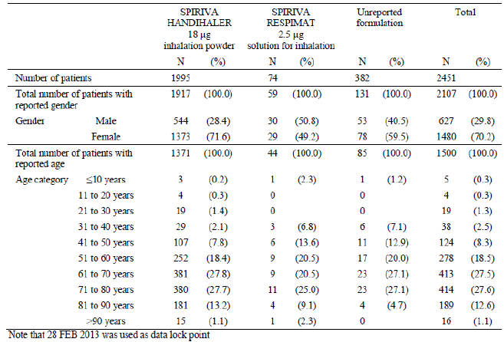

Table 23: Most frequently reported AEs among patients who used Spiriva for asthma (off label) by formulation
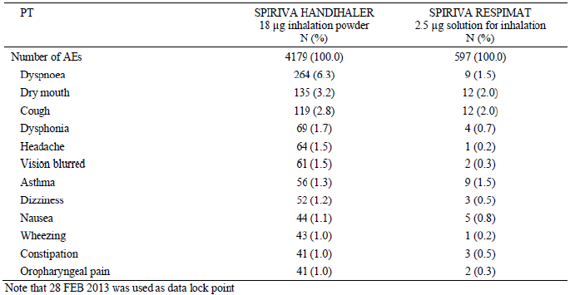
The sponsor has also discussed the TALC (tiotropium bromide as an alternative to increased inhaled glucocorticoid in patients inadequately controlled on a lower dose of ICS) Study reporting safety observations with Spiriva in asthma. In the TALC Study, 210 patients with asthma, who were poorly controlled by a low dose ICS alone, received either inhaled tiotropium, salmeterol, or an additional dose of inhaled corticosteroid in addition to standard ICS in one of three crossover treatment phases. Tiotropium was administered via the Spiriva HH. In the TALC Study, asthma exacerbations were reported in nine patients in the Spiriva group compared with five patients in the salmeterol group and 16 patients of the double dose ICS group. Hospitalisations for asthma occurred in one patient in the Spiriva group and in one patient in the double dose ICS group. Other hospitalisations were reported for three patients in the Spiriva group (two for pneumonia, one for fractured radius) compared with three patients in the salmeterol group (one for sepsis after hysterectomy for endometrial carcinoma with subsequent death, one for hysterectomy to remove fibroids, one for knee replacement surgery) and four patients in the double dose ICS group (one for spinal stenosis surgery, one for atypical chest pain, one for transient global amnesia, one for pneumonia). However, the results should be interpreted with caution as the exposure time was not reported for this study.
Comment: It is important to note that most of the postmarketing safety information is based on use of Spiriva HH. However, the HH device was not used in the asthma clinical development program (only the Respimat formulation was used). The TALC study also used HH device and not the proposed Respimat formulation for asthma.

Safety issues with the potential for major regulatory impact

Cardiovascular safety
In the pooled pivotal parallel group studies, there were no patients with fatal MACE endpoints and only individual patients with nonfatal MACE endpoints in each of the parallel group trials (Tio R5: four patients [0.3%]; Tio R2.5: one patient [0.1%], salmeterol: one patient [0.1%]; placebo: four patients [0.3%]) The incidence of hypertension and other cardiac arrhythmias was low with no increased incidence in tiotropium treated patients (refer Section 8.4.5.5 of this report).
In the pooled parallel group trials there were 81 patients with cardiac history (Tio R5: 24 patients, Tio R2.5: 10 patients, salmeterol: 16 patients, placebo: 31 patients). There were no patients with fatal MACE endpoints and only individual patients with nonfatal MACE endpoints in any of the trials. Of the six patients reported with AEs in the stroke #PV (Tio R5: two patients, Tio R2.5: none, salmeterol: one patient, placebo: three patients), there was one patient with cardiac history in the Tio R5 group who was reported with a cerebrovascular accident. Of the four patients reported with AEs in the SMQ ischaemic heart disease sub SMQ myocardial infarction (broad) (Tio R5: two patients, Tio R2.5: one patient, salmeterol: none, placebo: one patient), there was one patient with cardiac history in the Tio R2.5 group who was reported with myocardial infarction. Time adjusted incidence rates for nonfatal MACE endpoints in patients with cardiac history did not show any evidence of an imbalance between the tiotropium groups and the placebo group. In all pooled parallel group trials, less than 1% of all patients were reported with any of the cardiovascular #PV/SMQs (except for hypertension #PV/SMQ [narrow], which occurred in ≤ 2.2% of patients) in any treatment group. Of the patients with cardiac history, only individual patients were reported with cardiovascular #PV/SMQs. In addition to the two patients mentioned for the MACE endpoints above, these were four patients reported with AEs in the hypertension #PV/SMQ hypertension (narrow) (Tio R2.5: one patient, placebo: three patients), one patient each with an AE in the palpitations #PV and in the SMQ cardiac failure (narrow) in the Tio R5 group, and one patient with an AE in the tachycardia #PV/tachycardia with SVT #PV in the placebo group. The rate differences between the tiotropium and placebo groups were not significant for any of the cardiovascular #PV/SMQs.
Study 205.452 was a large scale, long term, randomised, double blind, active controlled, event driven trial involving 17,135 patients with COPD. Tio R5 and Tio R2.5 achieved non inferiority to the active comparator Tio HH18 for the primary safety endpoint of time to death from any cause, demonstrating that both Tio R5 and Tio R2.5 are not associated with a higher mortality than Tio HH18. The composite endpoint MACE was a predefined secondary endpoint to further evaluate cardiovascular safety. The overall incidence of MACE (3.9%, 3.9%, and 3.6% in the Tio R2.5, Tio R5, and Tio HH18 treatment groups, respectively) and death from MACE (2.1%, 2.0%, and 1.8%) was similar in the three tiotropium groups. The HR for time to death from MACE was 1.111 [95% CI: (0.850, 1.453)] for Tio R5 versus Tio HH18 and 1.171 [95% CI: (0.898, 1.526)] for Tio R2.5 versus Tio HH18; however, the differences observed between treatments were not statistically significant. Evaluation of the individual components of MACE showed no statistically significant differences across treatment groups for all components with the exception of fatal events of MI. There were fewer fatal myocardial infarction events (defined by the sub SMQ myocardial infarction [broad]) in the Tio HH18 group (three subjects, 0.1%) compared with Tio R5 group (11 subjects, 0.2%) and Tio R2.5 group (10 subjects, 0.2%); IRR (Tio R5/Tio HH18) = 3.64, 95% CI: (1.02, 13.06) and IRR (Tio R2.5/Tio HH18) = 3.31, 95% CI: (0.91, 12.03); however, the number of events was low, and the incidence rates for Tio R2.5 and Tio R5 in TIOSPIR (0.1 per 100 patient yrs for both) were similar to those observed in the UPLIFT trial for both treatment groups (0.1 per 100 patient yrs for Tio HH18 and placebo), while the incidence rate for Tio HH18 in TIOSPIR (0.0 per 100 patient yrs) was lower, which most likely, reflects the variability at low numbers of a rare event. Myocardial infarctions were defined in two different ways in this trial: first, as an outcome event with central monitoring of the protocol defined criteria for MI, and secondly, by coding of investigator reported terms in the SMQ ischaemic heart disease, sub SMQ myocardial infarction (broad). The incidence of subjects who experienced an outcome event of MI was 1.2% in the Tio R2.5 group, 1.3% in the Tio R5 group, and lower (0.9%) in the Tio HH18 treatment group (HR = 1.405 and 1.339 for Tio R5 and Tio R2.5, respectively, compared to Tio HH18). These differences were not statistically significant for either treatment comparison. The incidence of SAEs in the sub SMQ myocardial infarction (broad) was similar in the three treatment groups (1.4%, 1.2%, and 1.1% in the Tio R2.5, Tio R5, and Tio HH18 treatment groups, respectively).
Comment: Overall, no new cardiovascular safety concerns were identified following evaluation of tiotropium in asthma patients. The long term large safety Study 205.452 showed similar overall mortality and cardiovascular safety in COPD patients receiving tiotropium via Respimat (2.5 µg and 5 µg) and HH (18 µg) devices. However, this large safety study was conducted only in patients with COPD and there is no similar long term safety database in asthma patients.

Other safety issues

Safety in special populations

Intrinsic factors

Asthma severity
Evaluation of safety by asthma severity was done using data from the Phase III parallel group trials in which Tio R5 and placebo were used in all asthma severities while Tio R2.5 was used only in mild and moderate asthma. Across all asthma severities, the most frequently reported SOCs were respiratory, thoracic and mediastinal disorders, infections and infestations, and investigations; the most frequently reported PTs were asthma and PEF rate decreased. Nasopharyngitis was the third most frequently reported PT in patients with moderate and severe asthma; while in patients with mild asthma the PT upper respiratory tract infection was reported more frequently.

Effect of gender
Approximately 60% of the patients were female and about 40% were male, irrespective of asthma severity of the patient population and there was no evidence of a drug gender interaction with lower incidence of AEs in Tio R5 group compared with placebo group for both males (Tio R5 versus placebo: 70.5% versus 80.9%) and females (75.5% versus 79.9%).

Effect of age
To determine the effect of age on the safety profile of tiotropium in asthma, patients were divided into the following three age groups: < 40 yrs, between 40 and 60 yrs, and > 60 yrs. While the majority of patients with mild or moderate asthma were < 40 yrs of age or between 40 and 60 yrs old, most patients with severe asthma were between 40 and 60 yrs or older than 60 yrs.. The overall incidence of AEs was similar in patients aged < 40 yrs (Tio R5 versus placebo: 73.9% versus 79.1%) and > 60 yrs (72.9% versus 81.2%), but slightly lower in patients aged 40 to 60 yrs (46.5% versus 55.2%). Safety in elderly (> 65 yrs) and nonelderly (< 65 yrs) was also evaluated and across all asthma severities, most patients were < 65 yrs old, while the proportion of patients aged > 65 yrs or above was highest in patients with severe asthma. However, the overall incidence of AEs was similar in the nonelderly (Tio R5 versus placebo: 72.8% versus 80.2%) and elderly (77% versus 80.6%) subgroups.
A development program of tiotropium in paediatric patients with asthma is currently ongoing. To date, information on efficacy and safety of tiotropium in paediatric patients has been obtained from two paediatric Phase II placebo controlled incomplete crossover trials with four week treatment periods, investigating Tio R1.25, Tio R2.5, and Tio R5 versus placebo. In Trial 205.424 involving 100 adolescents aged 12 to 17 yrs with moderate asthma, the proportion of patients reporting AEs was highest in patients on Tio R5 (13.3%, 17.3%, 13.3% and 22.5% in placebo, Tio R1.25, Tio R2.5 and Tio R5 groups, respectively). The higher incidence of AEs in the Tio R5 group as compared to the placebo group was mostly driven by the SOC infections and infestations (that is, bronchitis, pharyngitis, gastroenteritis, rhinitis, and sinusitis). No patients were reported with drug related AEs. In Trial 205.425 involving 100 children aged six to 11 yrs, the proportion of patients with any AE was comparable between the different treatment groups (placebo: 10.5%, Tio R1.25: 9.3%, Tio R2.5: 9.5%, Tio R5: 9.2%). No patients were reported with AEs of severe intensity, drug related AEs, other significant AEs (according to ICH E3), AEs leading to discontinuation, or serious AEs during the trial.
Overall, in both paediatric studies, all doses of tiotropium (1.25, 2.5 and 5 µg) were well tolerated with no new safety concerns. However, the current submission is only seeking approval for Tio R5 in treatment of adult patients with asthma.

Effect of race
To determine the impact of race on the safety profile of tiotropium in asthma, patients were divided into the following race categories: American Indian/Alaska Native, Asian, Black/African American, Hawaiian/Pacific Islander, and White. Across all asthma severities, most patients were White followed by Asian patients and the proportion of Asian patients was highest in moderate asthma. There was no consistent effect of race on overall safety of tiotropium with similar trends for overall AE incidence in the two most common races: White (Tio R5 versus placebo: 70.5% versus 78.3%) and Asians (87.5% versus 89.4%).

Effect of BMI
To determine the impact of the BMI on the safety profile of tiotropium in asthma, patients were divided into the following BMI categories: < 20 kg/m², 20 kg/m² to < 25 kg/m², 25 kg/m² to < 30 kg/m², and >30 kg/m². Across all asthma severities, the proportion of patients with a BMI of < 20 kg/m² was lowest. While most patients with mild or moderate asthma had a BMI between 20 and < 30 kg/m², most patients with severe asthma had a BMI of > 25 kg/m². Patients in all the BMI subgroups showed similar trends in terms of overall incidence of AEs: 20 kg/m² to < 25 kg/m² (Tio R5 versus placebo:75.8% versus 77.6%) 25 kg/m² to < 3 0 kg/m² (69.6% versus 86.1%) and > 30 kg/m² (50.7% versus 61.3%) with exception of subgroup with BMI < 20 kg/m² which showed higher incidence of AEs in the Tio R5 group compared with placebo (68.8% versus 52.6%).

Effect of duration of asthma
The proportion of patients with longer duration of asthma increased with severity of the disease. Overall incidence of AEs showed similar trends in patients with asthma duration five to 20 yrs (68.1% versus 74.3%) and > 20 yrs (75.2% versus 82%); however, incidence of AEs was slightly higher in the Tio R5 group compared to placebo in subgroup with asthma duration < five yrs (54.5% versus 51.5%).

Age at onset of asthma
To determine the impact of age at the onset of asthma on the safety profile of tiotropium in asthma, patients were divided into the following categories of age at the onset of asthma: < 18 yrs and > 18 yrs and most patients had an onset of asthma at the age of ≥ 18 yrs. There was no consistent ‘drug age at the onset of asthma’ interaction for tiotropium with regard to safety with similar trends in subgroup with age of onset < 18 yrs (Tio R5 versus placebo: 82.4% versus 83.9%) and > 18 yrs (69.2% versus 76.9%).

Total serum IgE
To determine the impact of total serum IgE on the safety profile of tiotropium in asthma, patients were divided into the following categories of total serum IgE: up to 430 μg/L, which was considered as normal according to the Harrison reference range and > 430 μg/L. Across all asthma severities, more patients had a total serum IgE level of > 430 μg/L than a total serum IgE level of ≤ 430 μg/L. However, the AE profile was similar in both subgroups with serum IgE < 430 µg/L (Tio R5 versus placebo: 73.3% versus 80.8%) and > 430 µg/L (75.8% versus 82.1%).

Absolute eosinophil count
To determine the impact of absolute eosinophil count on the safety profile of tiotropium in asthma, patients were divided into the following categories of absolute eosinophil count: < 0.6 × 10⁹/L, which was considered as normal according to the BI reference range, or > 0.6 × 10⁹/L. There was no apparent relationship between the absolute eosinophil count and asthma severity and most patients had an absolute eosinophil count of < 0.6 × 10⁹/L. Although the overall incidence of AEs was slightly higher in patients with eosinophil count > 0.6 x 10⁹/L, there were no consistent drug absolute eosinophil count interaction for tiotropium with regard to safety with similar trends observed in subgroups with eosinophil count < 0.6 × 10⁹/L (Tio R5 versus placebo: 71.1% versus 78.4%) and > 0.6 × 10⁹/L (81.4% versus 87.4%).

Allergic asthma
The proportion of patients with allergic asthma according to investigator judgement minimally increased with asthma severity and most patients (61 to 67%) were judged by the investigator as having allergic asthma. Although the incidence of AEs was higher in patients with allergic asthma (Tio R5 versus placebo: 81.2% versus 85.2%), the overall trend was similar to that in the subgroup with non allergic asthma (61.7% versus 72.3%).

Lung function at screening
To determine a possible impact of lung function at screening on the safety profile of tiotropium in asthma, patients were divided into the following categories of lung function at screening, based on the post bronchodilator FEV₁% predicted of normal at the screening visit: < 60%, 60% to < 80%, and > 80%. As expected, the proportion of patients with lower FEV₁% predicted of normal categories at screening increased with severity of asthma. The overall AE profile (Tio R5 versus placebo) was similar across subgroups [< 60%: 74.3% versus 81.3%; 60 to 80%: 72.6% versus 79.5%) with exception of subgroup > 80% (100% versus 77.8%) although interpretation was confounded by very small sample size for this subgroup (only three and seven patients in Tio R5 and placebo groups, respectively).

Reversibility at screening
In Trials 205.416 and 205.417, reversibility testing at screening was performed to characterise the patient population. To determine the impact of reversibility at screening on the safety profile of tiotropium in asthma, patients of Trials 205.416 and 205.417 were divided into the following two categories based on the change in post bronchodilator FEV₁ at screening: reversible (that is, change in post bronchodilator FEV₁ ≥ 12% and ≥ 200 mL) and not reversible (that is, change in post bronchodilator FEV₁ < 12% and < 200 mL). At screening, slightly more patients were not reversible (52.0%) than reversible (48.0%). Reversibility at screening did not affect the safety profile of tiotropium in treatment of severe asthma.
Comment: The higher incidence of patients with non reversible disease in the severe asthma trials confounds interpretation as these patients may also have underlying COPD component which limits interpretation of efficacy and safety results of tiotropium treatment for the proposed asthma indication.

Pre specified B16 genotype
To assess if the AE profile of tiotropium in asthma is different in patients with the B16 Arg/Arg genotype than in patients with other genetic variations in the B16 genotype of the β2 adrenergic receptor, patients were divided into the following categories: B16 Arg/Arg, B16 Arg/Gly, and B16 Gly/Gly. Pharmacogenomic investigations of the B16 genotype were performed in most patients of trials 205.416, 205.417, and 205.341. The AEs of the pooled data from Trials 205.416/417 and separately of Trial 205.341 were summarised for the categories mentioned and evaluated for differences between B16 Arg/Arg and the two other categories by treatment and SOC/PT. However, the low number of patients with the B16 Arg/Arg genotype in Trials 205.416/417 (81 patients [8.9%]) and in Trial 205.341 (six patients [5.6%]) limited comparability. Overall, no consistent drug B16 genotype interaction for tiotropium with regard to safety could be determined.
In Trial 205.342 (Phase II trial in patients with moderate asthma), all patients were genotyped and only patients homozygous for B16 Arg/Arg were enrolled. The overall frequency of patients with AEs during the double blind treatment period was similar across all treatment groups (Tio R5: 51 patients [39.8%], salmeterol: 56 patients [41.8%], placebo: 52 patients [41.3%]).

Extrinsic factors

Country/ geographical region
To determine if there were regional differences in the safety profile of tiotropium in asthma, the following countries or geographical regions were used for the AE analysis: USA and Canada, Japan, Europe, and 'all other countries' (including countries in South America, Asia except for Japan, Australia, New Zealand, and South Africa). Most of the patients with mild or severe asthma were from Europe, while most of the patients with moderate asthma were from 'all other countries'. Across all asthma severities, no clear drug country/region interaction for tiotropium with regard to safety could be identified.

Smoking history
Across all asthma severities, most patients had never smoked. Due to the low number of ex smokers, which limited comparability, no consistent drug smoking history interaction for tiotropium with regard to safety across all asthma severities could be determined.

Safety related to drug drug interactions and other interactions
No formal drug interaction studies with tiotropium in asthma have been performed. However, in the clinical trials with tiotropium in asthma, tiotropium Respimat has been used concomitantly with a large variety of other drugs commonly used in asthma, including sympathomimetic bronchodilators, methylxanthines, oral and inhaled steroids, leukotriene modifiers, anti IgE treatment, antihistamines, mucolytics, and cromones.

Use in pregnancy/ lactation
Pregnant and nursing women and female patients of child bearing potential not using a highly effective method of birth control were to be excluded from the trials. No pregnancies were reported in the parallel group Trials 205.442, 205.416, and 205.342 and in all crossover trials. However, 14 pregnancies were observed in the parallel group Trials 205.418, 205.419, and 205.417. In Trials 205.418 and 205.419, ten patients with drug exposure during pregnancy were reported (Tio R5: four patients, Tio R2.5: one patient, salmeterol: two patients, placebo: three patients), which occurred in all cases during the first trimester of pregnancy. Three patients (Tio R5: one patient, salmeterol: one patient, placebo: one patient) were reported with spontaneous abortion, one patient in the Tio R5 group underwent induced abortion, and one patient in the Tio R2.5 group was reported with an ectopic pregnancy leading also to induced abortion. The outcome of three pregnancies (Tio R5: two patients, placebo: one patient) was unknown and two patients (salmeterol: one patient, placebo: one patient) gave birth to healthy babies. In Trial 205.417, two patients were exposed during their first trimester of pregnancy to Tio R5 and two patients became pregnant approximately two to three months after having completed their trial medication (Tio R5 or placebo). All four patients gave birth to healthy babies. Based on the limited data, there did not appear to be any specific concerns regarding the use of tiotropium in pregnancy, but as a precautionary measure, it is preferable to avoid the use of tiotropium during pregnancy and this has been incorporated in the proposed PI.

Overdose, drug abuse, withdrawal/ rebound, effect on ability to drive or operate machinery or impairment of mental ability
No cases of overdose with tiotropium were reported in the clinical development programme of tiotropium in asthma. Tiotropium has no known abuse potential. All AEs with an onset any time following the first dose of study drug up to 30 days after the last study drug administration were assigned to the randomised treatment. Therefore, withdrawal or rebound symptoms/effects occurring within this period were collected as treatment emergent AEs. In Trials 205.416 and 205.417, the proportion of patients with asthma exacerbations after the end of treatment was evaluated. After the end of treatment, the proportion of patients with any asthma exacerbation (Tio R5: 27 patients [5.96%], placebo: 29 patients [6.39%]) or severe asthma exacerbations (Tio R5: 14 patients [3.09%], placebo: 16 patients [3.52%]) was lower for the Tio R5 than for the placebo group.
No studies evaluating effects of Tio R5 on the ability to drive and use machines have been performed.

Evaluator’s overall conclusions on clinical safety
In all trials, tiotropium was administered via the Respimat inhaler to adult patients with persistent asthma in addition to low dose ICS, medium dose ICS, or high dose ICS+LABA. Exposure to tiotropium Respimat in the clinical program in asthma covered more than 1,000 patient yrs involving more than 2,200 patients.
However, only Studies 205.416/417 in patients with severe asthma evaluated efficacy and safety up to 48 weeks. However, the studies in moderate asthma were only 24 weeks and the one in mild asthma was only 12 weeks in duration. Hence the long term safety of tiotropium in treatment of asthma has not been adequately evaluated.
The overall frequencies of AEs, drug related AEs, and SAEs, including immediately life threatening SAEs, were similar across the Tio R5, Tio R2.5, salmeterol, and placebo treatment groups in trials with the same duration and patient population. On the PT level and in the analysis of AEs by #PVs/SMQs, the most frequently reported.
AEs and #PV/SMQs were consistent with the disease under study and included asthma and PEF rate decreased and their associated #PV/SMQs. Notably, incidence rates of the PTs asthma and PEF rate decreased were significantly lower for patients who took Tio R5 than for patients who took placebo across all pooled parallel group trials.
In the moderate asthma pivotal studies (205.418/419), the incidence of severe AEs was greater with the higher Tiotropium dose (5 µg) compared with the lower dose of 2.5 µg. Furthermore, Tio 5 µg was associated with higher incidence of asthma, dysphonia, oropharyngeal pain and thirst.
In the severe asthma studies (205.416/ 417), for AEs with a frequency of ≥ 2%, significantly higher incidence rates in the Tio R5 than in the placebo group were gastrooesophageal reflux disease (1.1% versus 0.4%; RR Tio R5/ placebo = 2.87, 95% CI: 1.03, 7.99), rhinitis allergic (1.6% versus 0.6%; RR = 2.55, 95% CII: 1.13, 5.75) and dry mouth (1,1% versus 0.6%; RR = 2.05, 95% CI: 0.82, 5.1).
In all pooled parallel group trials (205.442/418/419/416/417/342), a significantly higher incidence rate in the Tio R5 group than in the placebo group was observed for the PT bronchitis (3.4% versus 2.1%; RR = 1.62, 95% CI: 1.00, 2.62). The sponsor states that no additional data from the asthma clinical database (for example, increase in rescue medication use, increased cough and mechanistic considerations) could be found that were suggestive of a causal relationship between tiotropium and bronchitis. Hence, data from a pooled analysis of seven trials from the Spiriva Respimat clinical database for the indication COPD (Tio R5: 3282 patients, placebo: 3283 patients) were evaluated. In this pool, the PT bronchitis was reported at a lower frequency in the Tio R5 group (3.4%) than in the placebo group (4.1%) and had a lower incidence rate in the Tio R5 group than in the placebo group leading to a RR (Tio R5/ placebo) of 0.79 (95% CI 0.61, 1.01). However, the incidence of cough was higher in the Tio R5 group in pooled asthma parallel group studies. Furthermore, safety results observed in the COPD patient population cannot be extrapolated to asthma patients.
MACE was reported in individual patients only and no deaths were reported during the entire clinical program.
No clinically relevant changes in vital signs based on the review of mean changes and marked changes for either blood pressure or pulse rate were noted. No patterns were identified with regard to abnormal laboratory parameters while patients were on treatment with tiotropium.
There were no consistent patterns of increases in particular AEs for the tiotropium treatment groups compared to placebo in any subgroup analysis.
Overall, the safety data collected in the asthma clinical programme of tiotropium in adult patients with asthma, support both the 2.5 μg dose of tiotropium for maintenance treatment in addition to low dose ICS and medium dose ICS and the 5 μg dose of tiotropium for maintenance treatment in addition to low dose ICS, medium dose ICS, or high dose ICS+LABA delivered via the Respimat to adult patients with asthma.

TIOSPIR
In accordance with the European Union regulations, this study (TIOSPIR) was initiated by BI as a Post Authorisation Safety Study. An unexplained numerically higher rate in all cause mortality (compared to placebo) had been observed in the pooled tiotropium Respimat trials (Tio R5) [HR = 1.33, 95% CI: (0.93 to 1.92)], particularly in subjects with known cardiac rhythm disorders. The Respimat mortality data were contrary to data with Tio HH18 in the UPLIFT study, a four yr placebo controlled study, where fewer deaths were observed with Tio HH18 than placebo [14.9% versus 16.5%;HR = 0.89, 95% CI: (0.79 to 1.02)] during a period of four yrs plus 30 days (1,470 days, inclusive of vital status); for the planned treatment period of 1,440 days (inclusive of vital status, analysis conducted post unblinding) 14.4% of subjects died in the tiotropium group and 16.3% in the placebo group [HR = 0.87, 95% CI: (0.76 to 0.99)]. During treatment, there was a 16% reduction in the risk of death. The incidence rate of death was 4.79 per 100 patient yrs in the placebo group versus 4.10 per 100 patient yrs in the tiotropium group [HR tiotropium/ placebo = 0.84, 95% CI = (0.73, 0.97)]. Given the smaller amount of safety data available from the pooled clinical database for Tio R5 compared to Tio HH18, combined with known comparable systemic exposure and comparable efficacy as well as retrospective pooled analyses of causes of death, a relationship between Tio R5 and mortality risk has not been established. TIOSPIR was therefore designed as a prospective trial of adequate size and duration to establish that compared to Tio HH18, Tio R5 has (a) similar effects on mortality and superior effects on exacerbations. The tiotropium Respimat 2.5 μg dose (Tio R2.5) was included to establish the safety and exacerbation efficacy relative to the other marketed tiotropium formulations.
Compared to the HH formulation (Tio HH18), the Respimat (Tio R5 and Tio R2.5) tiotropium formulations showed similar risks of all cause mortality in a large Phase IIIb study involving 17,116 COPD patients. Although there was a higher incidence of deaths in subjects with cardiac arrhythmia at baseline compared to subjects without cardiac arrhythmia in each of the treatment groups, the relative differences between Tio R5 and Tio R2.5 compared to Tio HH18 were comparable.
The composite endpoint MACE was a predefined secondary endpoint to further evaluate cardiovascular safety. The overall incidence of MACE (3.9%, 3.9%, and 3.6% in the Tio R2.5, Tio R5, and Tio HH18 treatment groups, respectively) and death from MACE (2.1%, 2.0%, and 1.8%) was similar across all three treatment groups. Evaluation of the individual components of MACE showed no statistically significant differences across treatment groups for all components with the exception of fatal events of MI which was higher in the Respimat tiotropium groups [IRR (Tio R5/Tio HH18) = 3.64, 95% CI: (1.02, 13.06) and IRR (Tio R2.5/Tio HH18) = 3.31, 95% CI: (0.91, 12.03).
Overall, results from this study do help to clear the air regarding the safety of tiotropium delivered by Respimat. However, it is important to note that the absence of a placebo group in this study has implications for its interpretation and that it cannot be concluded from these results that tiotropium reduces mortality in patients with COPD.
The frequencies of SAEs, AEs leading to discontinuation, and investigator determined drug related AEs were comparable across treatment groups and no imbalance of substantial concern was identified. No overall safety advantage was observed for the lower dose of Tio R2.5 compared to the two approved dose strengths of Tio R5 and Tio HH18.
Results from the recently completed four week cross over Trial 205.458 have demonstrated lower but similar systemic exposure of Tio R5 compared to Tio HH18 in subjects with COPD suggesting that any potential safety difference between Tio R5 and Tio HH18 are not likely to be due to higher systemic exposure following tiotropium Respimat formulation. However, there are no dedicated safety information/ trials investigating effect on all cause mortality and cardiovascular safety in asthma.

Limitations of the safety data for tiotropium Respimat
- Inadequate evidence for long term safety of Tio R5 in treatment of asthma.
- No dedicated safety information/trials investigating effect on all cause mortality and cardiovascular safety was obtained for use in asthma in its own right.
- No adequate explanation for higher incidence of bronchitis, pneumonia and cough in the Tio R5 group compared with placebo in the severe asthma pivotal Studies 205.416/417.
- No information on incidence of bronchospasm in the asthma clinical studies.

First round benefit risk assessment

First round assessment of benefits
The benefits of tiotropium 5 µg (qd oral inhalation via Respimat) in the proposed usage are:
- Significant benefits with Tio R5 over placebo observed in terms of lung function when used as add on therapy to low dose ICS in mild asthma, medium dose ICS in moderate asthma and high dose ICS+LABA in severe asthma. Improvements in FEV₁ peak_{0−3h} and trough FEV₁ responses with tiotropium compared to placebo were in the order of 0.1 L, whereas improvements in PEF_{am} and PEF_{pm} were generally above 20 L/min. In patients with moderate asthma, improvements in lung function with Tio R25 and Tio R5 were similar to that observed with salmeterol 50 µg.
- Tiotropium Respimat showed a 24 hour duration of action which may be useful in asthma patients suffering from nocturnal events although no significant benefit was shown in mean scores for night time awakenings, asthma symptoms, activity limitation, shortness of breath, wheeze/ cough, symptom free days or use of rescue medications in any of the pivotal Phase III studies.
- Across moderate asthma studies 205/418/419, ACQ responder rates were significantly greater in patients treated with Tio R5 (64.3%) and TIo R2.5 (64.5%) compared with placebo (57.7%) although there was no difference between the two tiotropium doses.
- In pooled analysis across severe asthma studies 205.416/417, evidence for reduction in severe asthma exacerbation which was a co primary endpoint was not conclusive. However, there was statistically significant reduction in risk of ‘any’ or ‘symptomatic’ asthma exacerbation (secondary efficacy endpoints) with Tio R5 compared with placebo.

First round assessment of risks
The risks of tiotropium 5 µg (qd oral inhalation via Respimat) in the proposed usage are:
- It appears that Tiotropium 2.5 µg may offer a better benefit risk profile in patients with mild/moderate asthma, but the sponsors are only proposing the 5 µg od for all asthma severities.
- Increased risk of dry mouth, dysphonia, gastroesophageal reflux, bronchitis associated with tiotropium in treatment of asthma.
- Risk of bronchospasm.
- No dedicated safety information/trials investigating effect on all cause mortality and cardiovascular safety was obtained for use in asthma in its own right.
- Results of the TIOSPIR (205.452) study confirmed that Respimat formulations of tiotropium showed similar overall mortality compared to HH formulation (Tio HH18) in a large Phase IIIb study involving 17,135 COPD patients. However, both Tio R5 and Tio R2.5 were associated with increased risk of fatal MI compared with Tio HH18.

First round assessment of benefit risk balance
Asthma is a chronic inflammatory disorder of the airways caused by the interaction of genetic and environmental factors. It is characterised by variable and recurring symptoms, airflow obstruction, bronchial hyperresponsiveness and an underlying inflammation. Asthma is a heterogeneous disease in its manifestations and also in its response to treatment.
The GINA Workshop Report classifies drug treatments as controllers or relievers. In addition allergen specific immunotherapy is available for allergic asthma although its specific role is not completely established yet. Controllers are taken daily and long term and include both anti inflammatory drugs and drugs which control symptoms (ICS, leukotriene modifiers, anti IgE treatment, OCS). Relievers are medications used on an as needed basis to reverse bronchoconstriction and relieve symptoms. Examples of relievers include rapid acting bronchodilators (for example, short and some LABAs). Some chronic treatments are of little immediate benefit in the acute attack, for example anti inflammatory prophylactic treatment. European and US guidelines recommend a stepped management approach to treatment based on disease control. The goal of treatment is to achieve and maintain control. The level of asthma control obtained with treatment determines the need to step up or step down to the next treatment step in order to achieve optimum control with the minimum level of medication. The majority of asthma patients can achieve and maintain clinical control with standard treatment. Those patients who do not achieve adequate control with the highest level of medication (reliever plus two or more controller treatments) are considered to have difficult to treat asthma.
According to CHMP guidelines, a new controller treatment for asthma should place equal emphasis on lung function and symptom based clinical endpoints. A significant benefit from co primary endpoints of lung function and clinical symptoms should be demonstrated so that no multiplicity adjustment to significance levels is indicated. The severe asthma Studies 205/416/417 evaluated pre dose FEV₁, peak FEV₁ (0-3h) and time to first severe asthma exacerbation as co primary endpoints and complied with the CHMP recommendations. The moderate asthma studies (205.418/419) evaluated pre dose FEV₁, peak FEV₁ (0-3h) as co primary endpoints; although ACQ responder rate was evaluated as a primary endpoint for the pooled analysis of Studies 205/418/419, this endpoint was only a secondary endpoint in the individual studies. In the pivotal Phase III study in mild asthma, peak FEV₁ (0-3h) was the only primary endpoint; trough FEV₁ and ACQ responder rate were only analysed as secondary endpoints.

Effect on lung function
In each individual Phase III pivotal trial, the superiority of tiotropium over placebo in terms of FEV₁ peak_{0−3h} (Trials 205.416, 205.417, 205.418, 205.419, 205.442) and trough FEV₁ (Trials 205.416, 205.417, 205.418, 205.419) responses was observed. Improvements in FEV₁ related endpoints achieved with Tio R5 and Tio R2.5 as compared with placebo were approaching or were well over 0.1 L. and were already apparent after the first dose of trial medication on Day 1 of these trials; furthermore, the bronchodilator efficacy in terms of FEV₁ peak_{0−3h} and trough FEV₁ was sustained over the 48 week treatment period in Trials 205.416/417, over the 24 week treatment period in Trials 205.418/419, and over the 12 week treatment period in Trial 205.442. Similar improvements were observed with both Tio R5 and Tio R2.5 compared with placebo in terms of both weekly mean PEF_{am} and PEF_{pm} responses (which were > 20 L/min) evident from Week 1 and maintained for the duration of the studies (for 12 to 48 weeks). The descriptive statistical comparisons of tiotropium and the well established bronchodilator Sal 50 carried out as part of Trials 205.418/419 revealed that both treatments were similar in terms of their effect size. Additionally, the 24 hour lung function measurements carried out after 24 weeks of treatment in Trials 205.416/417 and 205.418/419 confirmed the bronchodilator efficacy of tiotropium during the whole 24 hour dosing interval.

Effect on asthma exacerbation
In the pooled analysis of pivotal Phase III studies involving 912 patients with severe asthma (205.416/417), treatment with tiotropium 5 µg over 48 weeks was associated with a significant 21% reduction in risk of severe asthma exacerbation which was the co primary endpoint (Tio 5 µg versus placebo: 26.9% versus 32.8%; HR = 0.79, p = 0.0343). However, these results were not robust as the analysis in the PPS only showed a nonsignificant 9% risk reduction. Secondary endpoints of ‘any’ and ‘symptomatic’ asthma exacerbations did show a significant reduction with Tio R5 compared with placebo.
In the pooled analysis of pivotal Phase III studies (205.418/ 419) in moderate asthma, the time to first ‘severe’ and ‘any’ asthma exacerbation were secondary endpoints. Reduction in risk of severe asthma exacerbation was statistically significantly greater than placebo only following Tio 2.5 µg (not for Tio 5 µg or salmeterol), while risk reduction for ‘any’ asthma exacerbation was only statistically significant for Tio 2.5 µg and salmeterol 50 µg (not for proposed dose of Tio 5 µg). However, interpretation of these results was limited by the short duration of treatment in this study (24 weeks only while CHMP recommended duration for assessment of effect on asthma exacerbations is 12 months). Asthma exacerbation was not evaluated in the 12 week study in mild asthma (205.442).

Effect on asthma symptoms and quality of life
The effect of tiotropium on asthma symptoms using the ACQ responder rate was analysed as a prespecified co primary endpoint for Trials 205.418/419. This co primary endpoint was also met. Across Trials 205.418/419, patients in the tiotropium treatment groups had significantly higher odds of being ACQ responders at Week 24 as compared to patients in the placebo group. Although ACQ responder rates for Tio 2.5 and 5 µg groups were statistically significantly greater than placebo, there was no difference between the two Tio dose groups (57.7%, 64.5% and 64.3% with placebo, Tio 2.5 µg and 5 µg, respectively). The adjusted mean ACQ total score improved (decreased) during the 24 week treatment period in all four treatment groups, but it was statistically significantly better than placebo at all visits for only salmeterol; it was statistically significantly better than placebo for Tio 2.5 µg at Weeks 8, 16 and 24 and for Tio 5 µg at only Weeks 8 and 24. Similar improvements in ACQ response was not observed for the severe asthma Trials 205.416/417. Although treatment with tiotropium did not significantly increase the odds of being an AQLQ(S) responder as compared to treatment with placebo, there were more AQLQ(S) responders in the tiotropium treatment groups than in the placebo groups across both Trials; 205.416/417 and 205.418/419.
In the pivotal studies in moderate asthma (205.418/419), treatment differences between the tiotropium groups and placebo with respect to the adjusted weekly mean scores for night time awakenings, asthma symptoms in the morning, asthma symptoms during the day, activity limitation, shortness of breath, wheeze or cough, and number of asthma symptom free days were nonsignificant at all weeks. Compared with placebo, statistically significant differences in favour of salmeterol (in Studies 205.418 and 205.419) and Tio 2.5 µg (in Study 205.419 only) were observed at some weeks. In Study 205.442 in patients with mild asthma, treatment differences between each tiotropium group and placebo with respect to the adjusted weekly mean scores for night time awakenings, asthma symptoms during the day, and wheeze or cough during the day, were small and nonsignificant at all weeks.
In summary, significant benefits of treatment with tiotropium over placebo in addition to at least ICS were observed in terms of lung function across a broad spectrum of patients with asthma. Improvements in FEV₁ peak_{0−3h} and trough FEV₁ responses with tiotropium compared to placebo were in the order of 0.1 L, whereas improvements in PEF_{am} and PEF_{pm} were generally above 20 L/min. These improvements were seen specifically with Tio R2.5 and Tio R5 as add on to low dose ICS in mild asthma and medium dose ICS in moderate asthma and for Tio R5 as add on to high dose ICS and LABA in severe asthma.
However, evidence for reduction of exacerbations was equivocal, that is, only severe asthma Studies 205/416/417 had adequate duration to assess effect on exacerbations (48 weeks); although Tio R5 was associated with significant reduction in risk of ‘any’ and ‘symptomatic’ asthma exacerbation, the co primary endpoint of severe asthma exacerbation did not provide robust evidence to support Tio R5 (the significant 21% risk reduction in FAS was not observed in the PPS analysis nonsignificant 9% risk reduction with Tio R5). The duration of treatment was not adequate to evaluate effect on exacerbations in moderate asthma (24 weeks) and mild asthma (12 weeks in Study 205.442). Furthermore, the only evidence to support improvement in asthma symptoms was the better ACQ responder rate with Tio R5 and Tio R2.5 compared with placebo in the pooled moderate asthma Studies 205.418/419. Similar improvements were not observed in the severe asthma studies (205.416/417) and none of the pivotal Phase III studies showed significant improvements with Tio R5 in mean scores for night time awakenings, asthma symptoms in morning or during day, activity limitation, shortness of breath, wheeze/cough, symptom free days or use of rescue medications.
The main objective in asthma treatment is to maintain asthma control. The concept of ‘asthma control’ is not synonymous with ‘asthma severity’ and is defined as ‘the extent to which the various manifestations of asthma have been reduced or removed by treatment’. This concept encompasses two components, the patient’s recent clinical status/current disease impact (symptoms, night awakenings, use of reliever medication and lung function) and future risk (exacerbations, decline in lung function or treatment related side effects). According to the GINA Guidelines asthma is controlled when a patient has daytime symptoms only twice or less per week, has no limitation of daily activities, has no nocturnal symptoms and no exacerbations, has normal or near normal lung function and uses reliever medication twice or less per week. As discussed above, Tiotropium 5 µg failed to provide adequate evidence to justify this major paradigm shift in treatment of asthma.
Hence, the benefit risk balance of tiotropium 5 µg (qd oral inhalation via Respimat) is unfavourable for the proposed indication of add on maintenance treatment for the improvement of asthma symptoms, quality of life, and reduction of exacerbations in adult patients with asthma who remain symptomatic on at least ICS.

First round recommendation regarding authorisation

Recommendation for proposed extension of indications to include Asthma
It is recommended that the application for marketing approval for the use of Tiotropium 5 µg (two puffs of 2.5 µg by oral inhalation via Respimat) be rejected for the proposed indication of add on maintenance treatment for the improvement of asthma symptoms, quality of life, and reduction of exacerbations, in adult patients with asthma who remain symptomatic on at least ICS.
The main reasons for the rejection at this stage are:
- Inadequate evidence to support claim for improvement in asthma symptoms and quality of life.
- Inadequate evidence to support claim for reduction in exacerbations.
- Use of tiotropium 5 µg dose for all asthma severities when there was evidence to suggest that lower dose of 2.5 µg might be equally effective in patients with mild/ moderate asthma.

Clinical questions

Pharmacokinetics
In the Phase II dose regiment Pk Study 205.480, unexpected PK plasma profiles were observed at SS (that is, after four weeks administration of Tio R5 once daily or Tio R2.5 BD) for six of the 30 patients in the PK subset. The unexpected profile for five out of these six patients consisted of a profile consistent with BD administration although tiotropium had to be administered only once daily. One patient had a profile consistent with once daily administration although tiotropium had to be administered BD. The sponsors state that the unexpected findings were evaluated in detail, and it was concluded that they do not affect the robustness of the PK characterisation of tiotropium in asthma patients in this study. However, 20% of the patients were administered the study drug incorrectly and the CSR does not clarify if the PK analysis was done after excluding these patients. Could the sponsors confirm if such analysis was done and if it affected the results of the study?

Efficacy
- According to CHMP guidelines, the length of the study should be of sufficient duration to capture exacerbation events (at least 12 months) and that recruitment should continue throughout all four seasons. During the trial it is necessary to document in what season the wheezing episodes/exacerbations occur. The duration of treatment in the severe asthma pivotal Phase III studies 205.416/417 was slightly less than the recommended 12 months (it was 48 weeks) and the CSR does not state if recruitment continued throughout all four seasons; furthermore, there was no documentation of details in what season the exacerbations occurred. Could the sponsors provide clarification on this?
- According to CHMP guidelines, it should be ensured that treatment arms are balanced according to important predictors of outcome and stratification according to relevant baseline characteristics, for example, number of exacerbations, use or non use of LABAs could be considered. Could the sponsors clarify if randomisation of patients was stratified in pivotal studies 205/416/417/418/419/442?
- The medium stable dose of ICS (in moderate asthma studies 205.418/419) was not defined in the CSRs of these studies. Could the sponsors please provide this information?
- The sponsor has proposed use of a single dose of tiotropium 5 µg dose for all asthma severities when there was evidence to suggest that lower dose of 2.5 µg might be equally effective in patients with mild/ moderate asthma.
- Although median reversibility after salbutamol inhalation was 0.200 and 0.210 L in Study 205.416 and 205.417, respectively, the actual proportion of patients with post bronchodilator reversibility was not provided in the CSRs. The clinical safety summary mentions that 52% of the patients enrolled in the severe asthma studies had reversible disease while 48% did not. Efficacy results in these subgroups to rule out possibility of Tio R5 showing efficacy predominantly in patients with irreversible airway limitation characteristic of COPD did not appear to have been done. Could the sponsors clarify if such analysis was done and provide the data if available?
- There are two ongoing trials in adult patients (205.441 and 205.464 [US and Japanese regulatory requirements]). Could the sponsors provide some information about the study design and objectives of these trials?
- It is important to note that Tio R5 was administered once daily in the morning in the studies in severe asthma (Phase II: 205.341; Phase III 205.416/417), while it was administered in the evening in the studies in moderate asthma (Phase II 205.342/380/420; Phase III: 205. 418/419). However, the proposed PI states that the recommended dosage of Spiriva Respimat is two puffs once daily at the same time each day. Could the sponsors clarify reason for different times of dosing in the severe and moderate asthma studies?

Safety
- In the pooled parallel group trials in adult patients with asthma, the incidence of asthma exacerbation #PV; bronchospasm (broad) #PV; bronchospasm #PV; SMQ asthma/bronchospasm (narrow) and asthma worsening #PV was significantly lower in the Tio R5 group compared with the placebo group and they were all associated to the lower incidence rates in the Tio R5 group of PTs asthma or PEF rate decreased. However, incidence of bronchitis (Tio R5 versus placebo: 3.8% versus 2.2, RR = 1.75, 95% CI: 1.10, 2.79), lower respiratory tract infections (5.1% versus 3.3%, RR = 1.60, 95% CI: 1.08, 2.17) and cough (2.1% versus 1.7%, RR = 1.25, 95% CI: 0.70, 2.22) was higher in the Tio R5 group compared with placebo. The other respiratory #PV/SMQ with a low overall incidence but at least two fold higher time adjusted incidence rate in the Tio R5 than in the placebo group was pneumonia #PV [Tio R5 versus placebo: 1.2% versus 0.6%; RR Tio R5/ placebo = 2.20, 95% CI 0.89, 5.43).
Could the sponsors please address the concerns of the evaluators regarding the increased incidence of bronchitis, pneumonia and cough in asthma patients treated with tiotropium 5 µg?
- The sponsors state that based on this information and data obtained during the clinical programme for COPD [U05 2643], there appears to be negligible basis for concern regarding administration related bronchospasm with the Respimat inhaler. However, there is no data on incidence of bronchospasm in the asthma studies and the sponsors are requested to provide details regarding bronchospasm in the asthma clinical trials.

Second round evaluation of clinical data submitted in response to questions

Pharmacokinetics
- In the Phase II dose regiment Pk Study 205.420, unexpected PK plasma profiles were observed at steady state (that is, after 4 weeks administration of Tio R5 qd or Tio R2.5 BD) for 6 of the 30 patients in the PK subset. The unexpected profile for 5 out of these 6 patients consisted of a profile consistent with BD administration although tiotropium had to be administered only qd. One patient had a profile consistent with qd administration although tiotropium had to be administered BD. The sponsors state that the unexpected findings were evaluated in detail, and it was concluded that they do not affect the robustness of the PK characterisation of tiotropium in asthma patients in this study. However, 20% of the patients were administered the study drug incorrectly and the CSR does not clarify if the PK analysis was done after excluding these patients. Could the sponsors confirm if such analysis was done and if it affected the results of the study?
Sponsor’s response:
Table 24 provides the PK parameters using data from all subjects and Table 25 provides the PK parameters that would have resulted if data from the 6 patients with suspicious plasma profile was excluded. Similarly, Figure 11 compares the geometric mean (gMean) plasma concentration time profile from all patients (top panel) and by excluding data from 6 patients with a suspicious plasma profile (bottom panel). As shown by these results, including the 6 patients does not relevantly influence the PK outcome of the Trial 205.420. Further, no relevant impact was observed on the results of the primary efficacy endpoint when excluding patients with tiotropium levels following placebo dosing in the morning.

Table 24: Comparison of multiple dose pharmacokinetic parameters (N, gMean and gCV[%]) of tiotropium in adult patients with moderate persistent asthma by treatment (data from all patients included)
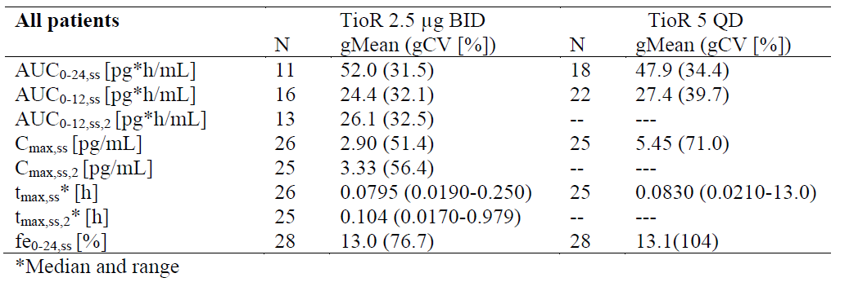

Table 25: Comparison of multiple dose pharmacokinetic parameters (N, gMean and gCV[%]) of tiotropium in adult patients with moderate persistent asthma by treatment (data from all patients except 6 patients with implausible PK profile)
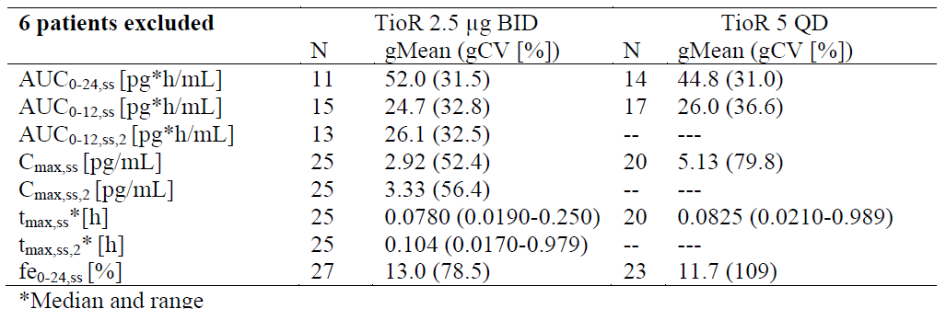
Figure 11: Geometric mean tiotropium plasma concentration time profile on linear scale following administration of Tio R2.5 bd or Tio R5 qd to patients with moderate asthma (Top panel: data from all patients; Bottom panel: data from all patients except 6 patients with implausible PK profile).
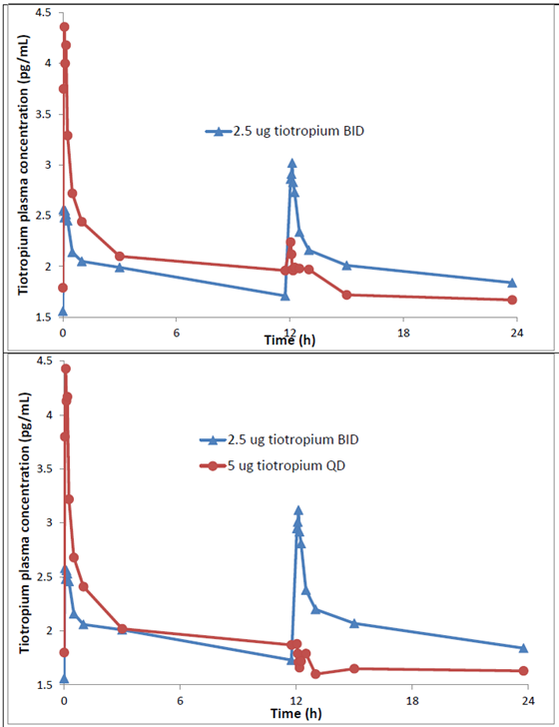

Efficacy
- According to CHMP guidelines, the length of the study should be of sufficient duration to capture exacerbation events (at least 12 months) and that recruitment should continue throughout all 4 seasons. During the trial it is necessary to document in what season the wheezing episodes/exacerbations occur. The duration of treatment in the severe asthma pivotal Phase III studies 205.416/417 was slightly less than the recommended 12 months (it was 48 weeks) and the CSR does not state if recruitment continued throughout all 4 seasons; furthermore, there was no documentation of details in what season the exacerbations occurred. Could the sponsors provide clarification on this?
Sponsor’s response:
Study duration
The tiotropium Respimat in asthma clinical program was based on the current Committee for Proprietary Medicinal Product (CPMP) Note for Guidance on the Clinical Investigation on Medicinal Products in the Treatment of Asthma. In July 2013, a Draft Note for Guidance on Clinical Investigational of Medicinal Products for Treatment of Asthma was published for public consultation and is currently being revised before adoption by the Committee for Medicinal Products for Human Use (CHMP). There is a discrepancy regarding the topic of study duration between the draft guideline and the guideline valid and applicable at the time of study conduct. While both guidelines recommend that claims for chronic treatment with new controller medication should be supported by randomised, double blind, parallel, controlled clinical trials of at least 6 months duration, the most recent draft CHMP Note for Guidance on clinical investigation of medicinal products for treatment of asthma recommends a duration of at least 12 months for trials assessing asthma exacerbations. The latter recommendation had not been included in the CPMP Note for Guidance on the Clinical Investigation of Medicines Products in the Treatment of Asthma, which was valid during the conduct of Trials 205.416 and 205.417 and is still current.
This means that the tiotropium Respimat in asthma program complies with the current guideline in terms of both study duration and endpoint selection. The confirmatory Phase III trials of the clinical program were two trials of 48 weeks duration (205.416, 205.417), two trials of 24 weeks duration (205.418, 205.419), and 1 trial of 12 weeks duration (205.442). Thus, the existing data on efficacy and safety of tiotropium Respimat in asthma are comprehensive; see Table 26.
In conclusion, the treatment durations of the Phase III studies in the tiotropium RESPIMAT clinical program in adult patients with asthma were sufficient to evaluate pulmonary function as well as clinical endpoints (that is, asthma control questionnaire [ACQ]) and exacerbations).

Table 26: Summary of Phase III studies (all randomised, double blind, parallel group (PG)) of the tiotropium Respimat clinical program in adult patients with asthma
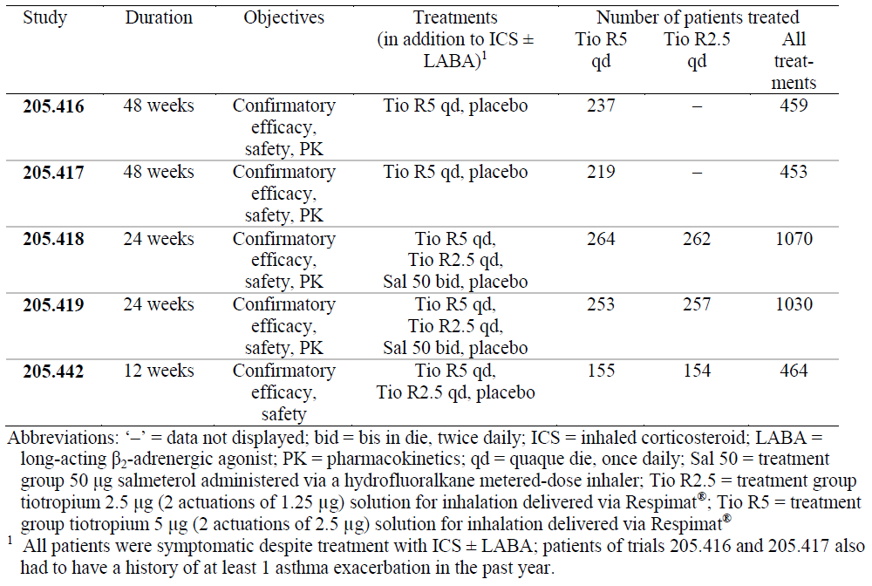
Patient recruitment throughout all four seasons
Trials 205.416 and 205.417 recruited patients (that is, first patient signed the informed consent to last patient entered) over a period of about 21 months in trial sites in Australia, New Zealand, North America, Europe, Japan, and South Africa (see Table 27).
Table 27: Recruitment dates and countries with trial sites for Trials 205.416 and 205.417
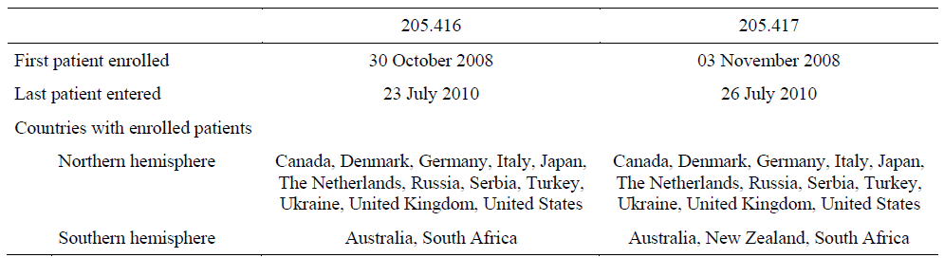
Overall, recruitment was steady from first patient enrolled until last patient entered for both individual trials (see Figure 12). As shown in Figure 13, recruitment in Trials 205.416/417 continued throughout all 4 seasons.
Figure 12: Recruitment status of Trials 205.416 and 205.417
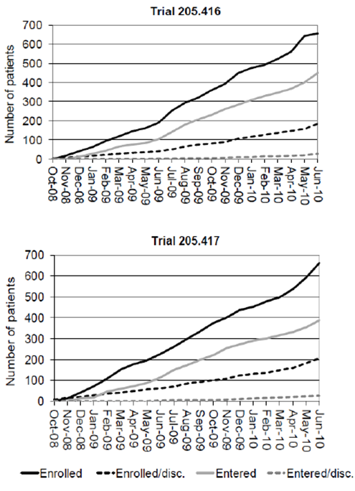
Figure 13: Number of patients recruited in Trials 205.416/417 by month (shifted by 6 months for Southern hemisphere countries
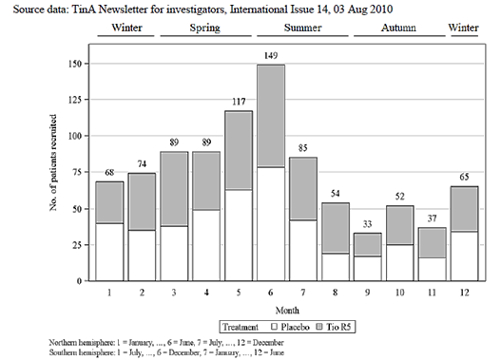
Abbreviation: Tio R5 = treatment group tiotropium 5 µg (two actuations of 2.5 µg) solution for inhalation delivered via Respimat The data from the Northern and Southern hemispheres are summarised seasonally (summer with summer, etcetera.) based on a factor of +6 months.
Occurrence of first severe asthma exacerbation and first asthma worsening during all four seasons
The number of severe asthma exacerbations and asthma worsenings per month is summarised in Figure 14 and Figure 15. In summary, while the occurrence of the first severe asthma exacerbation was lower during the summer months, the occurrence of the first asthma worsening was similar throughout all 4 seasons.
Figure 14: Occurrence of first severe asthma exacerbation in Trials 205.416/417 per month (shifted by 6 months for Southern hemisphere countries)
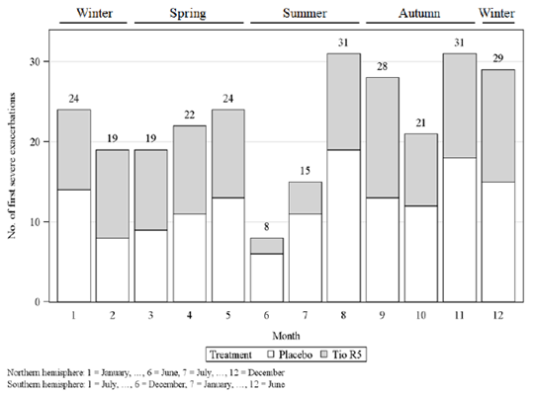
Abbreviation: Tio R5 = treatment group tiotropium 5 µg (two actuations of 2.5 µg) solution for inhalation delivered via Respimat. The data from the Northern and Southern hemispheres are summarised seasonally (summer with summer, etcetera.) based on a factor of +6 months.
Figure 15: Occurrence of first asthma worsening in Trials 205.416/417 per month (shifted by 6 months for Southern hemisphere countries)
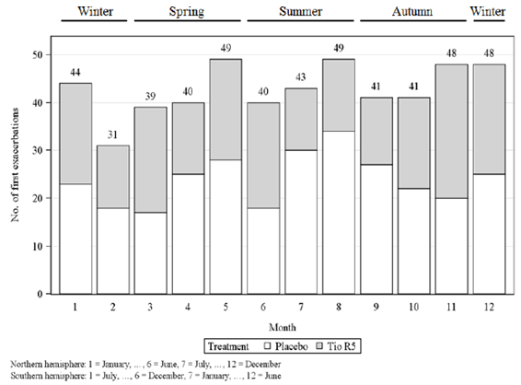
Abbreviation: Tio R5 = treatment group tiotropium 5 µg (two actuations of 2.5 µg) solution for inhalation delivered via Respimat. Asthma worsening was defined as any non severe, severe, asymptomatic, or symptomatic asthma exacerbation. The data from the Northern and Southern hemispheres are summarised seasonally (summer with summer, etcetera.) based on a factor of +6 months.
Training
In the Clinical Evaluation Report, the evaluator comments ‘The clinical methodology was adequately standardised, but it has not been clearly stated if the patients received training in respiratory function testing, inhaler technique, compliance and the use of diary cards.’ We would like to clarify that in the tiotropium Respimat in asthma clinical program patients received training in the use of Respimat, metered dose inhaler (MDI; only applicable in Trials 205.418 and 205.419), and Asthma Monitor 3 (AM3) device at Visit 1 as outlined in the respective CTRs.
- According to CHMP guidelines, it should be ensured that treatment arms are balanced according to important predictors of outcome and stratification according to relevant baseline characteristics, for example, number of exacerbations, use or non use of LABAs could be considered. Could the sponsors clarify if randomisation of patients was stratified in pivotal studies 205/416/417/418/419/442?
Sponsor’s response
In the pivotal Studies 205.416, 205.417, 205.418, 205.419, and 205.442, randomisation was not stratified because stratification is not required per current CPMP Note for Guidance on the Clinical Investigation of Medicinal Products in the Treatment of Asthma. The CHMP Draft Note for Guidance on Clinical Investigation of Medicinal Products for Treatment of Asthma, which states that stratification according to baseline characteristics could be considered, is currently being revised before adoption by the CHMP. For further details on CHMP guidelines, please see the response to Question 1 (above). Furthermore, there was no scientific rationale for stratification as in these randomised trials no imbalance due to small subgroups with a difference in baseline characteristics was expected.
As described below, there were no relevant differences between the treatment groups with regard to long acting β2 adrenergic agonist (LABA) use and asthma exacerbations prior to the confirmatory trials of the tiotropium Respimat in asthma clinical program in adults.
LABA use
The number of patients who took LABAs in the 3 months before screening is shown in Table 28 In Trials 205.416 and 205.417, the vast majority (>97%) of entered patients were taking LABAs before screening as required for participation in the trial. In Trials 205.418 and 205.419, approximately 60% of patients in each treatment group were taking LABAs within the last 3 months before screening. In these trials, maintenance treatment with LABA had to be discontinued 24 hrs before screening. In Trial 205.442, around 15% of patients per treatment arm were taking LABAs within the last 3 months before screening. The use of LABA within 4 weeks prior to screening and/or during the screening period was an exclusion criterion.
Within each (set of) trial(s), there were no relevant differences between the treatment groups with regard to LABA use prior to the trial.
Table 28: Number of patients with LABA use in the 3 months prior to screening – Trials 205.416/417, 205.418/419, and 205.442 – TS
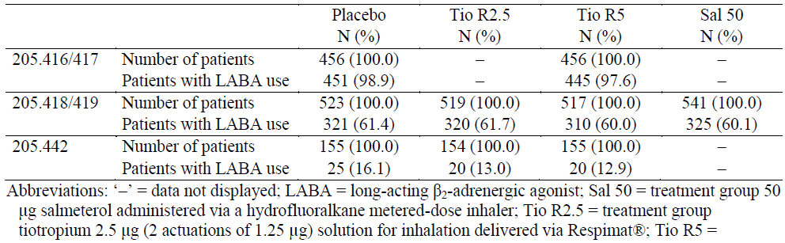
Number of exacerbations
In Trials 205.416 and 205.417, all patients had to have a history of 1 or more asthma exacerbations in the previous yr. A previous asthma exacerbation in this context was based on the patient’s recollection and was defined by the sponsor as an unplanned need for medical care at any primary care physician, pulmonologist, emergency room, or hospital due to an aggravation of asthma symptoms that required an addition or increased dose of a systemic corticosteroid (CTRs 205.416).
The number of severe asthma exacerbations, as defined above, was not explicitly collected in Trials 205.416 and 205.417, whereas the number of systemic steroid courses in the previous yr was documented in the case report form (CRF). According to the American Thoracic Society (ATS)/European Respiratory Society (ERS) task force statement on asthma control and exacerbations, the number of systemic steroid courses in the previous yr can be taken as a surrogate parameter for the number of severe asthma exacerbations in the previous yr. On trial level, a subgroup analysis with the categories < 3, 3 to 5, and > 5 systemic steroid courses in the previous yr were performed (CTRs 205.416/417). The same categories of the number of systemic steroid courses are presented for pooled data from Trials 205.416/417 in Table 29.
There were no relevant differences in the number of systemic steroid courses in the previous yr between the treatment groups for Trials 205.416/417, implying that the number of severe asthma exacerbations in the previous yr was also comparable between the treatment groups.
Table 29: Number of patients with less than 3, 3 to 5, or more than 5 courses of systemic steroids in the previous year in Trials 205.416/417 – TS
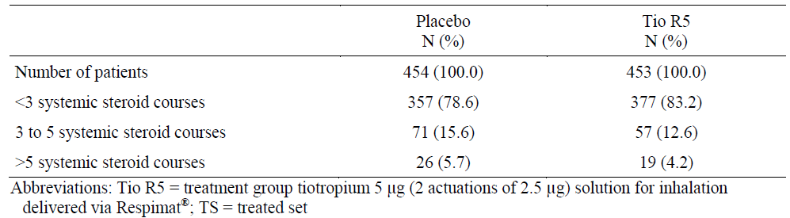
In the other pivotal trials in patients with moderate (205.418, 205.419) and mild (205.442) asthma, a previous severe asthma exacerbation was not a prerequisite for participation in the trial; therefore, the number of systemic steroid courses was not assessed.
- The medium stable dose of ICS (in moderate asthma studies 205.418/419) was not defined in the CSRs of these studies. Could the sponsors please provide this information?
The medium, stable dose of an ICS that all patients of Trials 205.418 and 205.419 were required to take for at least 4 weeks prior to Visit 1 (according to inclusion criterion 6) and throughout screening, treatment, and follow up periods of the trial, was defined in the clinical trial protocols (CTP 205.418/419) and summarised in the Summary of Clinical Efficacy (SCE); please see Table 30.
Table 30: Definition of medium daily doses of ICS adapted from GINA 2009
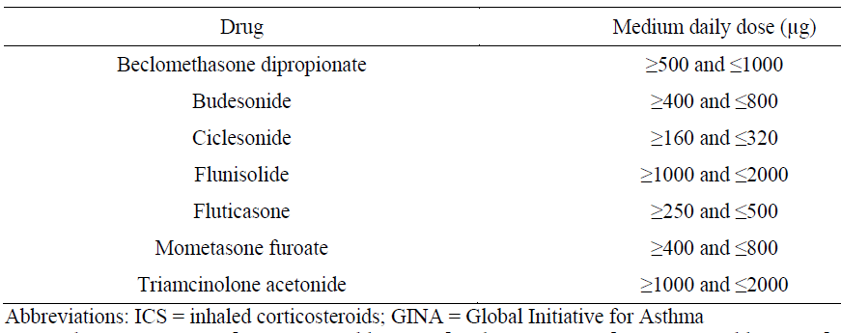
- The sponsor has proposed use of an sd of tiotropium 5 µg dose for all asthma severities when there was evidence to suggest that lower dose of 2.5 µg might be equally effective in patients with mild/ moderate asthma.
Sponsor’s response
In patients with all grades of asthma severity, tiotropium 5 µg qd (Tio R5) is considered to be the appropriate dose for the add on maintenance therapy to at least ICS, with the dose of ICS related to the severity of disease. While the safety profile of the two doses was comparable, the efficacy of Tio R5 was more robust and consistent compared with tiotropium 2.5 µg qd (Tio R2.5) for patients of all grades of asthma severity.
Detailed trial results supporting the dose selection are provided in the next section below.
In summary, the totality of the efficacy data from the tiotropium RESPIMAT in asthma clinical program demonstrated that Tio R5 provided sustained bronchodilation over the entire 24 hour (h) dosing interval, independent of the time of dosing, with statistically significant impact on clinical outcomes (that is, exacerbations and symptoms [ACQ]), across a broad spectrum of asthma severities.
Furthermore, comparability of Tio R5 with the established bronchodilator salmeterol was demonstrated in terms of an improvement in lung function (FEV1 peak0-3 h, trough FEV1, and PEFam) and clinical outcomes (that is, exacerbations and symptoms [ACQ]).
The effect on pulmonary function (FEV1 and PEF) was more consistent for Tio R5 than for Tio R2.5. In the three Phase II studies including both Tio R5 and Tio R2.5 (205.380, 205.420, 205.424), the effect size of Tio R5 was consistently larger compared with Tio R2.5 for the pulmonary function endpoints. In Trial 205.424, Tio R2.5 did not reach statistical significance for the pulmonary function endpoints, while Tio R5 showed statistically significant effects compared with placebo.
The larger effect size of Tio R5 compared with Tio R2.5 was also observed for the co primary endpoint trough FEV1 in patients with a post bronchodilator FEV1 expressed as percentage (%) of the predicted FEV1 value at the screening visit (hereafter referred to as PB FEV1 % pred) of < 80% in Trials 205.418/419. The effect size of Tio R2.5 decreased with increasing airway obstruction, whereas the effect size of Tio R5 increased with increasing airway obstruction, indicating that especially in patients with a higher grade of airway obstruction, Tio R5 is the more beneficial dose compared with Tio R2.5.
We note that the occasionally higher response to Tio R2.5 than to Tio R5 cannot be explained other than by patient variability. Taking into account the comprehensive knowledge about tiotropium, which is one of the most intensely investigated compounds in respiratory diseases, there is no evidence of a pharmacological or PD mechanism of tiotropium that could explain the (small) numerical difference between both doses.
A lower dose is usually preferred in cases of comparable efficacy because of lower systemic exposure. However, the clinical data do not indicate a more favourable safety profile of the lower dose 2.5 µg compared with 5 µg, whereas the efficacy data indicate more consistency and robustness for the 5 µg dose of tiotropium across all studies and all severities of asthma. While ICS doses differ between asthma severities, bronchodilators are generally administered with the same dose for all patients, independent of asthma severity. Furthermore, since the systemic exposure of tiotropium in asthma is lower compared with COPD, a lowering of the therapeutic dose in moderate asthma is considered to be not necessary taking into account the established safety of the 5 µg dose in asthma as well as in COPD.
Moreover, the qd dose of tiotropium 5 µg is currently registered in Australia, eliminating the need for specific dosing considerations between patients with COPD and asthma. This is in accordance with other approved bronchodilators, for which dosing recommendations between COPD and asthma have historically matched.
In conclusion, qd tiotropium 5 µg demonstrated a more favourable benefit/risk assessment than qd tiotropium 2.5 µg for asthma patients of all grades of severity, including patients on medium dose ICS.
Detailed trial results supporting the dose selection
The qd dose of tiotropium 5 µg is considered to be the appropriate dose for adult (and adolescent) patients, regardless of the grade of asthma severity, for the following reasons:
Phase II:
- Tio R5 was not on the plateau of the dose response curve (FEV1); additional bronchodilation was observed following administration of Tio R10 in adult patients with severe asthma (CTR 205.341). The frequency of dry mouth was somewhat higher for Tio R10 than for Tio R5.
- The effect size of Tio R5 was consistently larger than that of Tio R2.5 and Tio R1.25 in the Phase II dose ranging trials in adults and adolescents with moderate asthma, and Tio R5 was the only dose that met the primary endpoint in all Phase II trials in adults and adolescents (CTRs 205.380 and 205.424).
- Non inferiority in terms of lung function improvement of Tio R5 compared with Sal 50 was demonstrated in adults in a 16 wk parallel group trial (CTR 205.342).
- Testing of qd versus BD inhalation of a total daily dose of 5 µg tiotropium supports a qd dosing regimen of Tio R5 (CTR 205.420).
- 24 h pulmonary function data from a subset of patients in Trial 205.380 further support qd dosing of tiotropium.
Phase III:
- The (co) primary endpoints for lung function and clinical outcomes (that is, exacerbations and symptoms [ACQ]) were met for Tio R5 and Tio R2.5 in all trials in adults, see Table 12 and Table 13.
- Trials including Tio R5 and Tio R2.5 showed that both doses were efficacious, with either a comparable or a numerically higher trough FEV1 value for Tio R2.5 (Trials 205.418, 205.419, and 205.442; see Table 31 to Table 32 and Figure 16).
- The weekly mean response of home-measured PEFpm (that is, the PEF measurement at the end of dosing interval for tiotropium) in all Phase III trials that included both tiotropium doses (Tio R5 and Tio R2.5) was generally higher for Tio R5 compared with Tio R2.5 at most time points, with persistence of the bronchodilator effect over the entire treatment periods (see Figure 17).
- The 24 h lung function measurements in subsets of patients in the long-term trials in adults, where Tio R5 was administered either am or pm, showed sustained bronchodilation over the entire 24 h dosing interval, which supports qd dosing of tiotropium. The shape of the lung function profile curves was comparable regardless of time of dosing and background medication, with a higher level of the daytime curve for Tio R5 + ICS + LABA due to dual bronchodilation in Trials 205.416/417 compared with Tio R5 + ICS or Sal 50 + ICS in Trials 205.418/419 (see Figure 18 and Table 35).
- Tiotropium administered on top of ICS + LABA in patients with more severe asthma improves lung function (trough FEV1), as shown in the long term Trials 205.416 and 205.417; see Table 31 and Figure 19.
- Superiority was demonstrated for tiotropium over placebo in terms of ACQ responder rate in patients with moderate (combined analysis from Trials 205.418/419) or severe asthma (combined analysis from Trials 205.416/417, post hoc); see Table 31 and Table 32.
- Tio R5 but not Tio R2.5 showed statistically significant differences compared with placebo for ACQ6, which lacks the lung function component of ACQ (combined CTR 205.418/419.
- For time to first severe asthma exacerbation, superiority of tiotropium over placebo was shown in the combined analysis from Trials 205.416/417 and a positive trend in the individual trials was demonstrated (see Table 31). Time to first asthma worsening as secondary endpoint was statistically significant in both the pooled analysis and in the individual trials. In Trials 205.418/419, the same endpoints were shown to be statistically significant for the lower dose of tiotropium; see Table 32.
- Comparable effect sizes (improvements in lung function and symptoms [that is, ACQ) and safety profiles were observed with Tio R5, Tio R2.5, and Sal 50 in the Phase III trials including these treatment groups (205.418, 205.419).
All trials:
- Similar safety profiles were observed for placebo, Tio R5, Tio R2.5, and Tio R1.25 with approximately 50% lower systemic exposure of tiotropium in patients with asthma compared with patients with COPD; Tio R10 showed a higher frequency of dry mouth in a Phase II study (CTR 205.341).
Table 31 Summary of key efficacy results of Phase III Trials 205.416/417 in severe asthma for Tio R5 compared with placebo – FAS
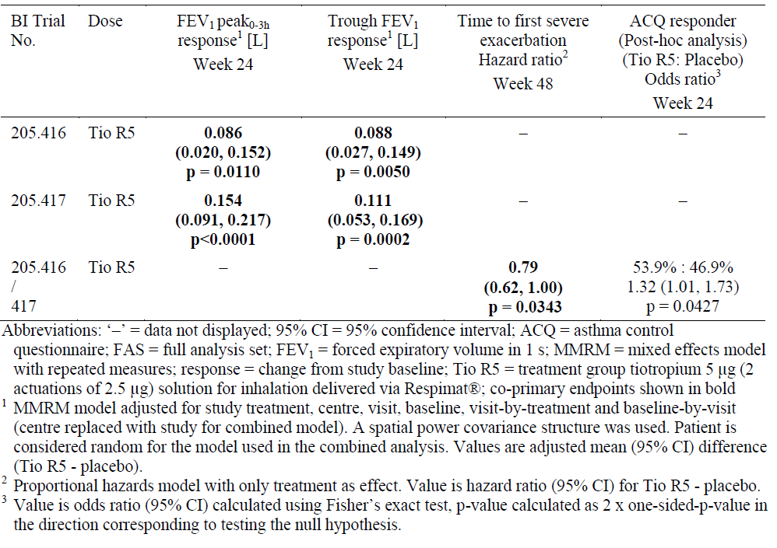
Table 32. Summary of key efficacy results of Phase III Trials 205.418/419 in moderate asthma and Trial 205.442 in mild asthma for Tio R5 and Tio R2.5 compared with placebo – FAS
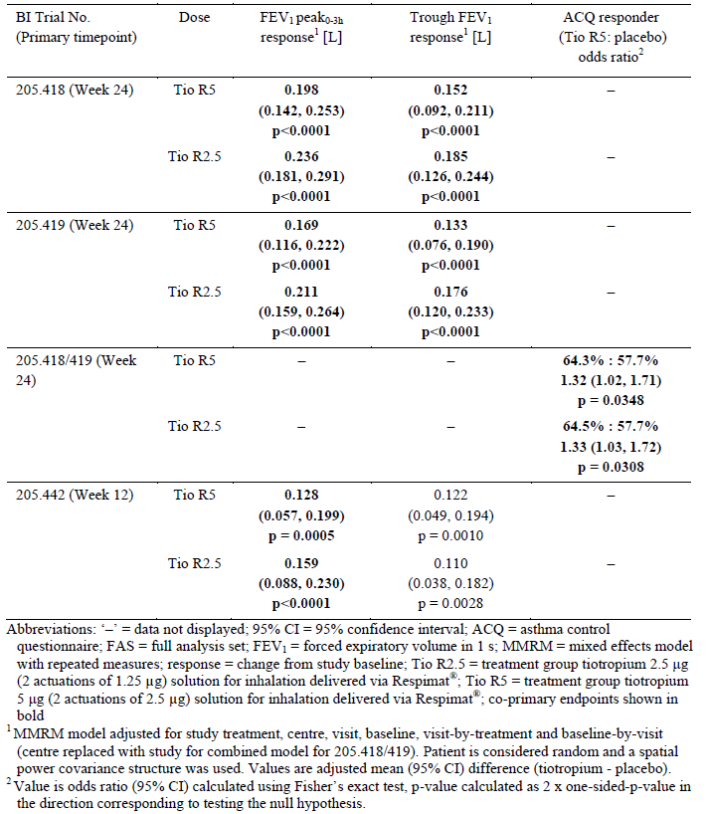
Figure 16: Trough FEV1 responses (± SE) in Phase III trials – FAS
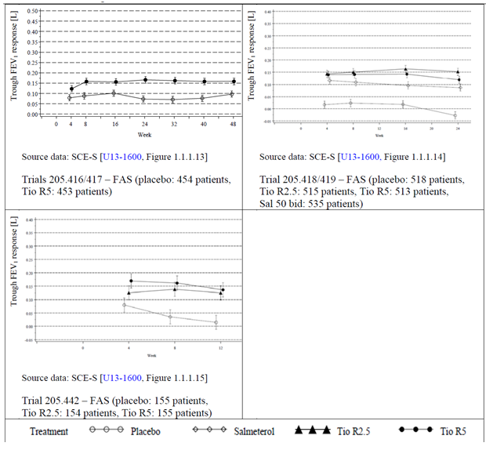
Abbreviations: FAS = full analysis set; FEV1 = forced expiratory volume in 1 s; response = change from study baseline; Salmeterol = treatment group 50 µg salmeterol administered via a hydrofluoralkane metered dose inhaler; SE = standard error; Tio R2.5 = treatment group tiotropium 2.5 µg (two actuations of 1.25 µg) solution for inhalation delivered via Respimat; Tio R5 = treatment group tiotropium 5 µg (2 actuations of 2.5 µg) solution for inhalation delivered via Respimat
Figure 17: Weekly mean PEFam or PEFpm response (pre dose) in L/min (± SE) versus time in Phase III trials – FAS
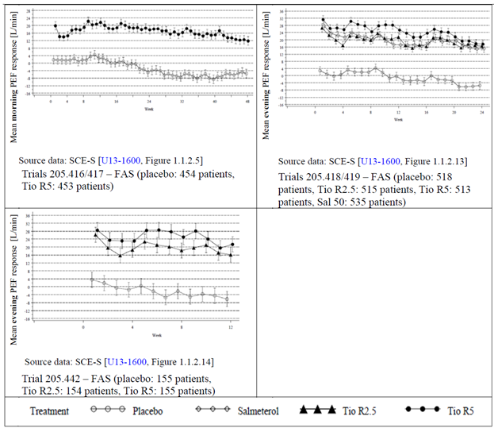
Abbreviations: FAS = full analysis set; FEV1 = forced expiratory volume in 1 s; PEF = peak expiratory flow; response = change from study baseline; Salmeterol = treatment group 50 µg salmeterol administered via a hydrofluoralkane metered dose inhaler; SE = standard error; Tio R2.5 = treatment group tiotropium 2.5 µg (two actuations of 1.25 µg) solution for inhalation delivered via Respimat; Tio R5 = treatment group tiotropium 5 µg (2 actuations of 2.5 µg) solution for inhalation delivered via Respimat
- Although median reversibility after salbutamol inhalation was 0.200 and 0.210 L in Study 205.416 and 205.417, respectively, the actual proportion of patients with post bronchodilator reversibility was not provided in the CSRs. The SCS mentions that 52% of the patients enrolled in the severe asthma studies had reversible disease while 48% did not. Efficacy results in these subgroups to rule out possibility of Tio R5 showing efficacy predominantly in patients with irreversible airway limitation characteristic of COPD did not appear to have been done. Could the sponsors clarify if such analysis was done and provide the data if available?
Sponsor’s response
The inclusion and exclusion criteria in Trials 205.416/417 were specifically designed to include patients with severe asthma and exclude patients with COPD. Inclusion criteria included that the diagnosis of asthma must have been made before the patient was 40 years old and that patients should have never smoked or should have been ex smokers who stopped smoking at least one yr prior to enrolment and who had a smoking history of less than 10 pack years. In total, 75.9% of the patients in 205.416/417 had never smoked (combined CTR 205.416/417). Moreover, patients with COPD were specifically excluded from the trials, as stated in the exclusion criteria. Further details on in /exclusion criteria are provided in the respective CTRs 205.416 and 205.417.
Subgroup analyses of efficacy by reversibility at screening, defined as a post bronchodilator change in FEV1 of at least 12% and 200 mL, were carried out in Trials 205.416 and 205.417 for the first co primary endpoints FEV1 peak0-3h and trough FEV1 on trial level (CTRs 205.416 and 205.417). The results are summarised in Table 33. As the treatment by subgroup interaction was not statistically significant for reversibility at screening (that is, the interaction p values were ≥ 0.1 in each case).
For the pooled data from Trials 205.416/417, additional subgroup analyses of efficacy by reversibility at screening were presented in the SCE-S. Results for the lung function endpoints are summarised in Table 33. Results for ACQ related endpoints and asthma exacerbation related endpoints can be found in the SCE-S. As indicated in the SCE the subgroup analyses revealed no treatment by subgroup interactions for pulmonary function endpoints and ACQ total score, that is, all p values for the treatment by subgroup interaction were ≥ 0.1 (SCE-S). There was also no indication of a treatment by subgroup interaction for exacerbation related endpoints (SCE-S).
In summary, there was no indication of a treatment by subgroup interaction based on reversibility at screening in Trials 205.416 and 205.417.
Table 33: Subgroup analyses of FEV1 based co primary endpoints at 24 weeks for individual and pooled data of Trials 205.416 and 205.417 – MMRM – FAS
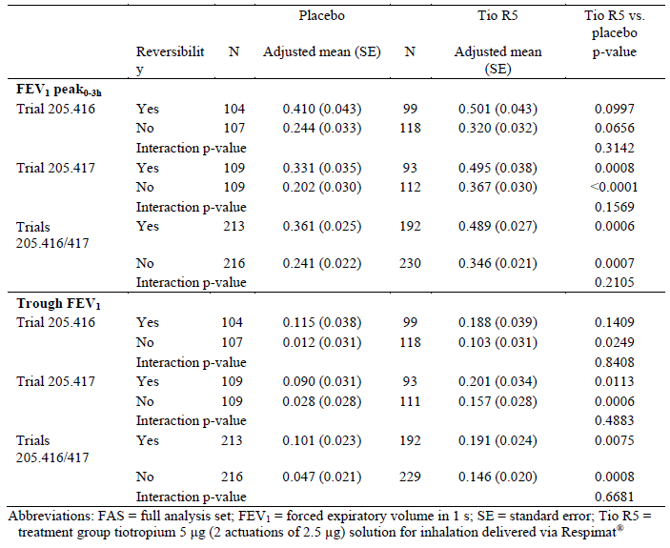
- There are two ongoing trials in adult patients (205.441 and 205.464 [US and Japanese regulatory requirements]). Could the sponsors provide some information about the study design and objectives of these trials?
Sponsor’s response
Trials 205.441 and 205.464 in adult patients, which were ongoing at the time of submission, have since been completed. Clinical trial reports (CTRs) are available (CTR 205.441 and CTR 205.464). Short descriptions of the study design and objectives are outlined in Table 34. Results of both trials are provided below.
Table 34: Summary of Trials 205.441 and 205.464
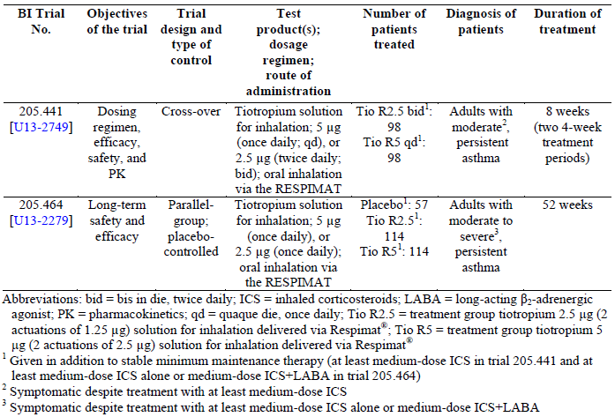
Trial 205.441 (moderate asthma)
The randomised, double blind, Phase II cross over trial (2 times 4 weeks) 205.441 was conducted in adults with asthma who remained symptomatic despite treatment with at least medium dose ICS (≥ 400 and ≤ 800 µg of budesonide or equipotent). Based on the cross over design of this dosing regimen trial, each patient received treatment with a total daily dose of 5 µg tiotropium either as a qd dose of Tio R5 in the evening (Tio R5 qd) or as twice daily doses of Tio R2.5 (Tio R2.5 BD) once in the morning and once in the evening. This trial was designed to provide information about the appropriate dosing regimen, the 24 h bronchodilator efficacy (primary endpoint: FEV1 AUC0-24h response, secondary endpoint: trough FEV1 response, exploratory treatment comparison only), and the PK plasma profiles of Tio R5 qd and Tio R2.5 BD; see CTR 205.441. Trial 205.441 was conducted to confirm PK and FEV1 results of Trial 205.420, in which contamination of some PK samples had occurred.
In Trial 205.441, comparable bronchodilation was shown, regardless of whether tiotropium 5 µg/day was administered as a qd dose of 5 µg (in the evening) or as a twice daily dose of 2.5 µg (in the morning and evening), as evaluated by the AUC FEV1 over a 24 h period. The primary endpoint was supported by the secondary FEV1 based endpoints assessed at the clinic and by at home assessments. With regard to the tiotropium plasma concentration versus time profile, the results of Trial 205.420 were confirmed.
Trial 205.464 – long term trial conducted in Japan (moderate to severe asthma)
Trial 205.464 was a 52 wk, randomised, double blind, placebo controlled, Phase III parallel group trial that was carried out in patients who remained symptomatic despite maintenance treatment with at least medium dose ICS (≥ 400 and ≤ 800 µg of budesonide or equipotent) ± LABA. Patients were randomised in a 1:2:2 ratio to qd placebo, Tio R2.5, or Tio R5. This trial was designed to evaluate the long term safety of qd tiotropium (evening dosing) compared with placebo and to evaluate long term efficacy in an exploratory fashion. Trough FEV1 was evaluated as secondary endpoint. The conduct of this trial was agreed with the Japanese Pharmaceuticals and Medical Device Agency (PMDA). Note that there are no relevant ethnic differences between Japanese and Caucasian patients with respect to tiotropium, and the approved dose of tiotropium Respimat for COPD in Japan is the same (that is, qd 5 µg) as in the EU and the rest of world. The overall safety profiles of Tio R5 and Tio R2.5 in Trial 205.464 were generally consistent with the known AE profiles for tiotropium and an asthmatic trial population, and were generally balanced between treatment groups including placebo.
With regards to efficacy, it is noteworthy that the variability in this trial was lower than in the other Phase III trials. This is likely due to a more homogenous population and more standardised treatment in this trial that was conducted in one country only. In this 52 wk trial in adult patients with moderate to severe persistent asthma, Tio R5 but not Tio R2.5 showed sustained improvements in lung function compared with placebo over the 52 wk treatment period (that is, trough FEV1 response after 52 weeks was higher for Tio R5 than for Tio R2.5 and only statistically significantly different from placebo for Tio R5 but not for Tio R2.5). This supports the more consistent and more robust effect of Tio R5 compared to Tio R2.5 as outlined in the response to Question 4. The CTR of Trial 205.464 is available on request.
- It is important to note that Tio R5 was administered qd in the morning in the studies in severe asthma (Phase II: 205.341; Phase III 205.416/417), while it was administered in the evening in the studies in moderate asthma (Phase II 205.342/380/420; Phase III: 205. 418/419). However, the proposed PI states that the recommended dosage of Spiriva Respimat is two puffs qd at the same time each day. Could the sponsors clarify reason for different times of dosing in the severe and moderate asthma studies?
Sponsor’s response
In the Phase II proof of concept trial in adult patients with severe asthma (Trial 205.341; the first tiotropium Respimat asthma trial), morning (am) dosing was chosen due to the off label use of Spiriva HH in asthma and with the assumption that am dosing was more convenient and best adapted to the daytime physical activity profile of these patients. Subsequently, this time of dosing choice was carried forward into the Phase III trials of tiotropium Respimat in patients with severe asthma. For the later trials in patients with mild and moderate asthma, evening (pm) dosing was considered more consistent with qd ICS dosing, which is generally taken in the evening.
The following lung function data confirm that tiotropium’s 24 h bronchodilator efficacy is neither affected by the time of administration (that is, morning or evening), nor by different background medications (ICS ± LABA).
Figure 18 provides a summary of the 24 h FEV1 response [L] at Wk 24 in subsets of patients in Trials 205.416/417 and 205.418/419; results observed in each individual trial were similar. The curves in a) and b) show the 24 h duration of action of tiotropium in Trials 205.416/417 and 205.418/419, respectively. As shown in curve c), which presents the 12 h daytime period (that is, the first 12 hs for Trials 205.416/417 with am dosing and the last 12 hs for Trials 205.418/419 with pm dosing), the shape of the curves shown in a) and b) is comparable, irrespective of the time of dosing across trials. The higher level of the daytime curve of Tio R5 + ICS + LABA reflects dual bronchodilation in Trials 205.416/417 with comparable slopes of all curves. The level of the daytime curves of Tio R5 + ICS and Sal 50 + ICS in Trials 205.418/419 were comparable with a small deviation within the first 4 hs following the morning dose; this deviation may be explained by the morning administration of Sal 50 (BD) versus the evening administration of Tio R5 (qd).
Figure 18: FEV1 response [L] (± SE) versus time during the 24 h PFTs at Wk 24: (a) 205.416/417 – FAS24, (b) 205.418/419 – FAS24, and (c) Daytime (between 07:00 and 19:00 h)
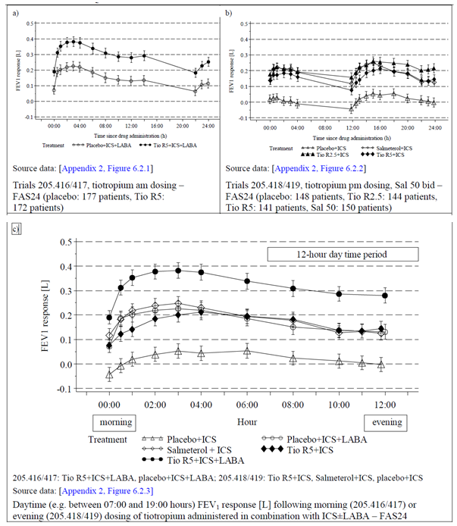
Abbreviations: am = morning dosing; FAS24 = full analysis set with 24 h pulmonary function test measurements; FEV1 = forced expiratory volume in 1 s; ICS = inhaled corticosteroids; LABA = long acting β2 adrenergic agonist; pm = evening dosing; Sal 50/Salmeterol = treatment group 50 µg salmeterol administered via a hydrofluoralkane metered dose inhaler; Tio R2.5 = treatment group tiotropium 2.5 µg (two actuations of 1.25 µg) solution for inhalation delivered via Respimat; Tio R5 = treatment group tiotropium 5 µg (two actuations of 2.5 µg) solution for inhalation delivered via Respimat
For the endpoints FEV1 AUC0-12h and FEV1 AUC12-24h, which were analysed as part of the 24 h pulmonary function tests (PFTs) in subsets of patients in Trials 205.416, 205.417, 205.418, and 205.419, treatment differences between tiotropium and placebo were similar for FEV1 AUC0-12h and FEV1 AUC12-24h in all 4 trials (that is, the 95% CIs overlapped) and thus indicated a stable effect of tiotropium on the FEV1 response over the entire 24 h dosing interval independent of the time of dosing (that is, am or pm); see Table 35.
Table 35: Response differences between active treatment and placebo for FEV1 AUC 12 h daytime and night time [L] at Wk 24, confirmatory Phase III trials with 24 h PFT – FAS24
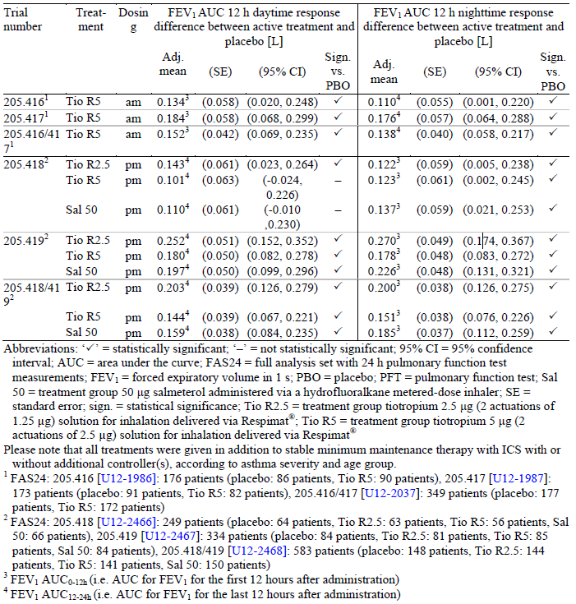
The proposed dosing of tiotropium 5 µg, given as two puffs from the Respimat inhaler qd, at the same time of the day, is consistent with that approved for the treatment of patients with asthma in Europe and in several other countries worldwide (Chile, Colombia, Ecuador, Mexico, Peru, Russia, and Thailand).
- In the pooled parallel group trials in adult patients with asthma, the incidence of asthma exacerbation #PV; bronchospasm (broad) #PV; bronchospasm #PV; SMQ asthma/bronchospasm (narrow) and asthma worsening #PV was significantly lower in the Tio R5 group compared with the placebo group and they were all associated to the lower incidence rates in the Tio R5 group of PTs asthma or PEF rate decreased. However, incidence of bronchitis (Tio R5 versus placebo: 3.8% versus 2.2, RR = 1.75, 95% CI: 1.10, 2.79), lower respiratory tract infections (5.1% versus 3.3%, RR = 1.60, 95% CI: 1.08, 2.17) and cough (2.1% versus 1.7%, RR = 1.25, 95% CI: 0.70, 2.22) was higher in the Tio R5 group compared with placebo. The other respiratory #PV/SMQ with a low overall incidence but at least 2 fold higher time adjusted incidence rate in the Tio R5 than in the placebo group was pneumonia #PV [Tio R5 versus placebo: 1.2% versus 0.6%; RR Tio R5/ placebo = 2.20, 95% CI 0.89, 5.43). Could the sponsors please address the concerns of the evaluators regarding the increased incidence of bronchitis, pneumonia and cough in asthma patients treated with tiotropium 5 µg?
Sponsor’s response
Bronchitis
The PT Bronchitis was more frequently reported among patients using Tio R5 than placebo in the pool of all asthma parallel group trials (205.342, 205.416, 205.417, 205.418, 205.419, and 205.442): placebo: 27 cases (incidence rate: 3.4/100 patient years), Tio R5: 43 cases (incidence rate: 5.5/100 patient years). The resulting time adjusted incidence RR (Tio R5/placebo) is 1.62 (95% CI: 1.00, 2.62). The incidence of bronchitis increased for both treatment groups from Trial 205.442 ("mild" asthma) to Trials 205.418/419/342 ("moderate" asthma) to Trials 205.416/417 ("severe" asthma); however, a closer look at the time adjusted incidence RRs shows that this increase in incidence is likely related to the longer duration of the trials in patients with severe asthma rather than disease severity.
Conversely, in the comparison of Tio R5 and Sal 50 (Trials 205.342, 205.418, and 205.419) the time adjusted incidence RR (Tio R5/salmeterol) of 1.05 (95% CI: 0.52, 2.15) for bronchitis indicates that there is no significant difference in the frequency of bronchitis between the two active treatments (Tio R5: 15 cases [incidence rate: 4.9/100 patient years], Sal 50: 15 cases [incidence rate: 4.6/100 patient years]) (it should be noted that the term “bronchitis” is not listed in the salmeterol Australian Product Information (Serevent Accuhaler salmeterol 50 µg (as xinafoate) powder for inhalation blister pack, AUST R 53775). The increased frequency of PT Bronchitis reported in the asthma clinical program may in part be related to the clinical efficacy of tiotropium in asthma, i.e. tiotropium reduces the intensity of severe asthma exacerbations, which might be instead reported as bronchitis.
BI also examined the clinical database of Spiriva Respimat in COPD, which consists of seven trials. In this large database, the PT bronchitis was reported at a lower frequency for patients in the Tio R5 group as compared to those in the placebo group [placebo: 136 cases (incidence rate: 5.42/100 patient years), Tio R5: 113 cases (incidence rate: 4.27/100 patient years), incidence RR (Tio R5/placebo): 0.79 (95% CI: 0.61, 1.01)].
Therefore, in the absence of additional data from the asthma clinical database (for example, increase in rescue medication use, increased cough, mechanistic considerations) nor from the COPD database, bronchitis is not deemed an event of concern for Spiriva Respimat.
Pneumonia
The prevalence of acute lower respiratory tract infection is increased in adults with asthma compared to the general adult population (asthma population: 35.4% versus general population: 11.5%, OR: 3.87, 95% CI: 3.81, 3.93).
BI evaluated the incidence of pneumonia in the following datasets:
- Tio R5 versus placebo asthma trials (205.442, 205.418/419, 205.416/417)
- Tio R5 versus salmeterol moderate asthma trials (205.418/419)
- Tio R5 and HH COPD trials

  - Tio R5 versus placebo asthma trials:
The data from the Phase III parallel group Trials 205.442, 205.418/419, and 205.416/417 indicate that the occurrence of pneumonia is low and confounded by asthma severity and/or study duration (studies in severe asthma were longer) (Table 36). An additional case of pneumonia in the Tio R5 group was identified in Phase II Trial 205.342. None of the events were assessed as related. Two (0.2%) and 4 (0.3%) of the patients in the placebo and Tio R5 group, respectively, experienced serious pneumonia. In both groups, female patients with pneumonia were more represented than males (placebo: 4 of 7, Tio R5: 9 of 15). The distribution across age groups by treatment is presented in Table 37.
Table 36: Frequency of patients with AEs in the Pneumonia #PV¹ in Phase III parallel group trials (205.442, 205.418/419, 205.416/417)
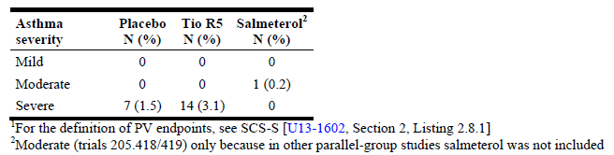
Table 37: Distribution by age groups of patients with AEs in the Pneumonia #PV in parallel group trials (205.342, 205.442, 205.418/419, 205.416/417)
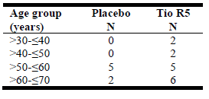
- Tio R5 versus salmeterol moderate asthma trials (205.342, 205.418/419)
In these moderate asthma trials, there was 1 case of pneumonia in each group (salmeterol: 0.1%, Tio R5: 0.2%). The resulting IRR (95 % CI) was 1.05 (0.07, 16.57). It should be noted that pneumonia is not a listed side effect of salmeterol.
- Tio R5 and HH COPD trials
BI evaluated the cases with pneumonia in the tiotropium Respimat 5 µg (Tio R5) and tiotropium HH (Tio HH) COPD databases (seven clinical trials of Tio R5 and 28 clinical trials of HH). In both, the incidence rate of pneumonia was higher in the placebo group than in the tiotropium group (Table 38).
Table 19: Frequency of patients with AEs in the Pneumonia #PV in placebo controlled, parallel group COPD clinical trials
Table 38: Frequency of patients with AEs in the Pneumonia #PV in placebo controlled, parallel group COPD clinical trials
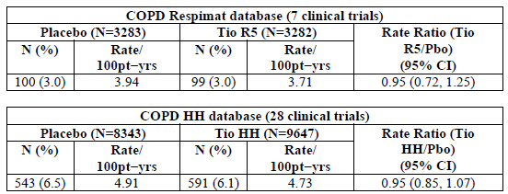
Therefore, in the absence of additional data from the asthma clinical database nor from the COPD database indicating an increased risk, pneumonia should not be considered an event of concern for Spiriva.
Cough
In the pooled parallel group trials of adult patients with asthma, the incidence of AEs in the Cough #PV was slightly higher in the Tio R5 group (N: 26, 2.1%) than in the placebo group (N: 21, 1.7%). Distribution by asthma severity in the Phase III parallel group trials is shown in Table 39. Cough is a listed side effect of Spiriva Respimat. Therefore, this risk is adequately described in the Product Information.
Table 39: Frequency of patients with AEs in the Cough #PV in Phase III parallel group trials (205.442, 205.418/419, 205.416/417)
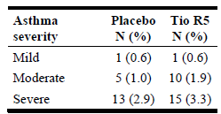
- The sponsors state that based on this information and data obtained during the clinical programme for COPD [U05 2643], there appears to be negligible basis for concern regarding administration related bronchospasm with the Respimat inhaler. However, there is no data on incidence of bronchospasm in the asthma studies and the sponsors are requested to provide details regarding bronchospasm in the asthma clinical trials.
Sponsor’s response
Bronchospasm was analysed in the asthma development program using the endpoints Bronchospasm #PV and Bronchospasm (broad) #PV. The PTs covered by these 2 PV endpoints are the following as shown in Table 40:
Table 40 Bronchospasm and Bronchospasma (broad) endpoints
Bronchospasm #PV: | Bronchospasm (broad) #PV
Analgesic asthma syndrome | Analgesic asthma syndrome
Asthma | Asthma
Asthma exercise induced | Asthma exercise induced
Asthma late onset | Asthma late onset
Bronchial hyperreactivity | Bronchial hyperreactivity
Bronchial obstruction | Bronchial obstruction
Bronchospasm | Bronchospasm
Bronchospasm paradoxical | Bronchospasm paradoxical
Reversible airways obstruction | Reversible airways obstruction
Status asthmaticus | Status asthmaticus
 | Unilateral bronchospasm
 | Wheezing
Briefly, in the pooled parallel group trials of adult patients with asthma both endpoints had significantly lower incidence rates in the Tio R5 group than in placebo (Table 41). Both endpoints were associated with the PT asthma, which occurred with a significantly lower incidence rate in the Tio R5 group than in the placebo group in all pooled parallel group trials.
Table 41: Time adjusted rate ratios of bronchospasm #PV1 pooled parallel group trials (205.342, 205.442, 205.418/419, 205.416/417)
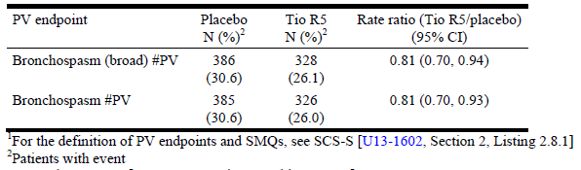
Table 42 displays the data for the individual PTs covered by the 2 PV endpoints in the pooled parallel group trials in adult patients with asthma. No imbalance was observed for any of the individual PTs in these PV endpoints. This is in line with the findings of Hodder et al. (2005), who compared the incidence of paradoxical bronchoconstriction after chronic use of bronchodilators via Respimat Soft Mist Inhaler (SMI) and chlorofluorocarbon metered dose inhalers (CFC MDI) in patients with asthma. No occurrences of bronchospasm were reported with Respimat SMI on any test day. Overall, the incidence of respiratory events possibly indicative of paradoxical bronchoconstriction was low and similar for both devices. There was no increase in the incidence of events during 12 weeks' treatment. The authors concluded that delivery of bronchodilators by Respimat SMI is safe with regard to paradoxical bronchoconstriction during chronic use in patients with asthma.
Table 42: Time adjusted rate ratios of tiotropium versus placebo by PV endpoint/SMQ and preferred term, all parallel group trials (205.342, 205.442, 205.418/419, 205.416/417)
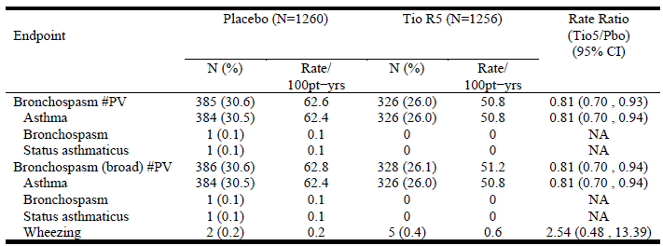
- The sponsor is asked to comment on all issues raised in the clinical evaluation report; and to ensure that they comment on the clinical evaluator’s assertion that the Phase III program did not adhere to EMA guidance. Specifically, the sponsor should report on any discussions with the EMA about the Phase III program and on the status of the current evaluation by the EMA (dossier submitted to EMA in Aug 2013). The sponsor could also provide any evaluation reports received from the EMA during the EMA’s evaluation and the latest PI as negotiated with the EMA.
Sponsor’s response
Spiriva Respimat is registered in the EU using the Decentralised Procedure with the Netherlands (National Health Agency MEB) as the Reference Member State. The asthma program was discussed with the MEB in Dec 2009. A Type II variation to add the asthma indication was submitted in Europe in Aug 2013. The procedure was finalised in Aug 2014 and the Final Assessment Report prepared by MEB.
In the clinical evaluation report, the sponsor was asked to clarify the inconsistent results in Trials 205.416/417 with regard to the time to first severe asthma exacerbations between the Japanese and the overall population. As this question was not included in the TGA request for further information, we would like to address this issue below.
This topic was further investigated by analysing the subgroup of Japanese patients in Trials 205.416/417 more closely to assess if certain factors might have contributed to the inconsistency of the results.
The data of the Japanese patient population (Tio R5: 36 patients, placebo: 29 patients) in Trials 205.416/417 were summarised for the subcategories of PB FEV1% pred ≥ 60% to < 80% or < 60%. These subcategories are shown by gender and asthma duration (1 to < 10 years, 10 to < 20 years, ≥ 20 years) in Table 43.
Table 43: Number of Japanese patients for different levels of obstruction by gender and asthma duration – Trials 205.416/417 – TS
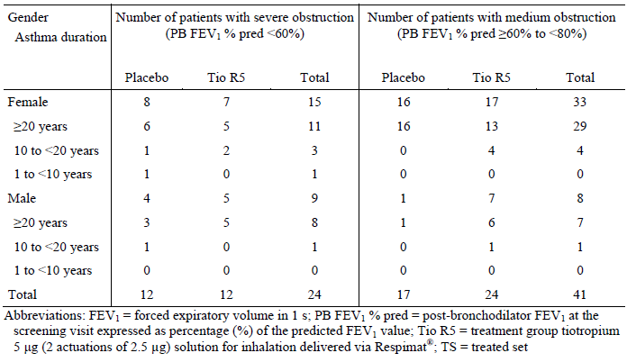
In the Japanese patient population, the subgroup of patients with severe obstruction (PB FEV1 % pred <60%) was smaller (12 patients per treatment group) than the subgroup of patients with medium PB FEV1 % pred ≥ 60% to < 80%) obstruction (Tio R5: 24 patients; placebo: 17 patients). This is consistent with the overall population (see Table 24).
Subgroup analyses by PB FEV1 % pred were performed in an exploratory manner; the results are shown in Table 44. In the Japanese patient population, the hazard ratio (HR) of Tio R5 over placebo with regard to time to first severe asthma exacerbation was 0.63 for the subgroup of patients with severe obstruction, while the HR was 1.79 for the subgroup of patients with medium obstruction. However, interpretation of these results is very limited due to the low number of patients in these subgroups. In the overall population, in which the numbers of patients and events were sufficient to allow for a meaningful comparison, there was no relevant difference in the HR between patients of different levels of obstruction.
Table 44: Number of patients and frequency of severe asthma exacerbations for different levels of obstruction in Japanese patients and the overall population – Trials 205.416/417 – FAS
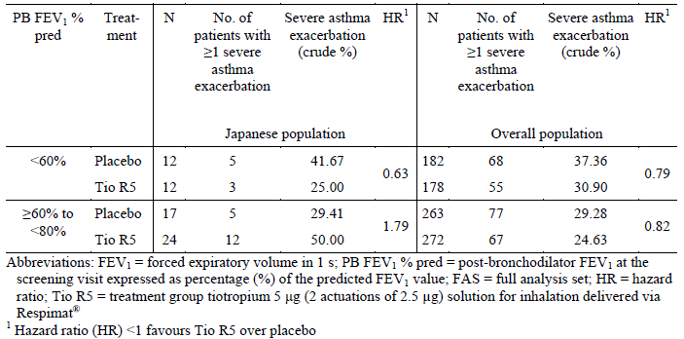
In summary, while the difference in the HRs for the two subcategories of high and medium obstruction was pronounced in Japanese patients, the HRs were comparable in the overall population. However, based on the low number of Japanese patients per subcategory, these findings have to be interpreted with caution and are considered to be a chance finding.

Second round evaluation of clinical data submitted in response to questions
A second round clinical evaluation report was not prepared for this submission. The responses by the sponsor to the questions raised were taken into consideration by the Delegate.

References
Bleecker ER, Postma DS, Lawrance RM, et al. Effect of ADRB2 polymorphisms on response to longacting beta2 agonist therapy: a pharmacogenetic analysis of two randomised studies. Lancet 2007; 9605:2118-25.
Global Initiative for Asthma. Global strategy for asthma management and prevention. 2011. Available 677 from: www.ginasthma.com
Hodder R, Pavia D, Dewberry H, Alexander K, Iacono P, Ponitz H, Beck E. Low incidence of paradoxical bronchoconstriction in asthma and COPD patients during chronic use of Respimat Soft Mist inhaler. Respir Med 2005; 99:1087-1095.
Israel E, Chinchilli VM, Ford JG, et al. Use of regularly scheduled albuterol treatment in asthma: genotype stratified, randomised, placebo controlled cross over trial. Lancet 2004; 364 (9444):1505-12.
Note for guidance on clinical investigation of medicinal 4 products for treatment of asthma. 27 June 2013; CHMP/EWP/2922/01 Rev.1
Peters SP, et al. national Heart, Lung, and Blood Institute Asthma Clinical Research Network. Tiotropium bromide step up therapy for adults with uncontrolled asthma. N. Engl J Med 2010; 363: 1715-1726.
Thakkinstian A, McEvoy M, Minelli C, Gibson P, Hancox B, Duffy D, et al. Systematic review and meta analysis of the association between beta2 adrenoceptor polymorphisms and asthma: a HuGE review. Am J Epidemiol 2005;162 (3): 201-11.

Therapeutic Goods Administration
PO Box 100 Woden ACT 2606 Australia
Email: info@tga.gov.au Phone: 1800 020 653 Fax: 02 6232 8605
https://www.tga.gov.au

Baseline was the pre treatment FEV₁ measured at Visit 2 in the morning 10 mins prior to administration of the first dose of study medication.
Seven patients were non completers, one patient had a treatment duration that was too short in one period and one patient had non intake of trial medication recorded more than 20 times.
Long acting beta agonist response by genotype (LARGE) (record first received: September 12, 2005). 2005 National Heart, Lung, and Blood Institute (NHLBI), 2005; website: clinicaltrials.gov/ct/show/NCT00200967
Subgroups; by gender (male, female); by smoking history (ex smokers, non smokers); by duration of trial disease (asthma duration < 20 yrs, asthma duration ≥ 20 yrs); by reversibility (reversibility demonstrated after inhalation of ipratropium, reversibility demonstrated after inhalation of ipratropium and salbutamol, reversibility demonstrated after inhalation of ipratropium, and ipratropium plus salbutamol).
All patients were provided with salbutamol 100 μg per puff from the MDI to take as needed as rescue medication throughout the study. Use of rescue salbutamol was recorded on the AM2+
A day was considered an asthma symptom free day if there were no reported symptoms and no use of unscheduled rescue medication recorded
FEV₁ peak_{0−3h} response was defined as the difference between the FEV₁ peak_{0−3h} and the FEV₁ baseline measurement, which was measured 10 min before administration of the first dose of trial medication at Visit 2.
FAS was defined as all treated patients who had baseline data and at least 1 on treatment efficacy measurement after 4 wks of treatment within a period.
PPS was defined as all treated patients who were part of the FAS and complied with the CTP without any important protocol violations (IPVs)
defined as all patients in the FAS who gave informed consent for the 24-h PFT and who participated in this optional PFT
The asthma symptom question included in the AM2+ device on night-time awakenings was scored on a 5 point rating scale in which a 1 corresponded to 'did not wake up' and 5 corresponded to 'was awake all night
RS was defined as all enrolled patients who were randomised to study medication.
The TS was composed of all patients in the randomised set who received at least 1 dose of randomised study medication.
FAS was defined as all treated patients who had baseline data and at least 1 on-treatment efficacy measurement after four wks on treatment within a period.
PPS was defined as all treated patients who were part of the FAS and complied with the CTP without any important protocol violations.
The mean value of the FEV₁ measurements taken 1 h predose and 10 min pre-dose at Visit 2 were used as study baseline; this is in contrast to the primary analysis, in which only the 10 min pre-dose FEV₁ was used as study baseline.
All patients were provided with salbutamol (100 μg per puff, metered dose inhaler) to take as needed throughout the study. Use of salbutamol rescue medication by the patient at home was recorded on the AM3 device.
The asthma symptom question from the AM3® device on night-time awakenings was scored on a 5 point rating scale in which a 1 corresponded to 'did not wake up' and 5 corresponded to 'was awake all night'.
The standardised asthma quality of life questionnaire for patients 12 yrs and older (AQLQ(S) + 12) was administered at Visits 2 through 5. AQLQ(S) + 12 scores can range from 1, which corresponds to 'maximum impairment' to 7, which corresponds to 'minimum impairment', so a larger AQLQ(S) + 12 score corresponds to a higher quality of life as related to asthma. The AQLQ(S) + 12 consists of 4 domains (symptoms, activity limitations, emotional function, and environmental stimuli) and a total score, each of which are calculated as the average of all questions relevant to that domain.
PAQLQ(S) scores range from 1 (worst controlled) to 7 (best controlled). The PAQLQ(S) consists of 3 domains (symptoms, activity limitations, and emotional function) and a total score, each of which are calculated as the average of all questions relevant to that domain.
Diurnal PEF variability was defined as the difference between the maximum and minimum PEF value for the day expressed as percentage of the mean daily PEF value and averaged over 7 to 14 days
Definition of high dose inhaled corticosteroids (ICS).Belcomethasone dipropionate ≥ 1,000 µg/day; Budesonide ≥ 800 µg/day; Ciclesonide ≥ 320 µg/day; Flumisolide ≥ 2,000 µg/day; Fluticasone ≥ 1500 µg/day; Mometasone furoate ≥ 1800 µg/day; Triamcinolone acetonide ≥ 2,000 µg/day.
Severe asthma exacerbations were defined by the sponsor as a subgroup of all asthma exacerbations that required treatment with systemic (including oral) corticosteroids for at least three days or in case of ongoing and pre-existing systemic corticosteroid therapy that required at least a doubling of the previous daily dose of systemic corticosteroids for at least three days and/or a need for emergency visit, or hospitalisation due to asthma.
Symptomatic asthma exacerbation was defined as an episode of progressive increase in one or more asthma symptoms for at least two consecutive days.
Any asthma exacerbation was defined as an episode of progressive increase in 1 or more asthma symptoms or as a decrease in a patient's best morning PEF of 30% or more from a patients' mean morning PEF for at least two consecutive days that may or may not have been accompanied by symptoms.
The FAS was defined as all randomised patients who were treated with at least one dose of study medication and had at least one on-treatment efficacy measurement.
Per-protocol set (PPS) was defined as all treated patients who were part of the FAS and complied with the CTP without any important PVs that would affect the primary endpoint. If any important PVs occurred in any treatment period for a patient, that patient was excluded from the PPS. The PPS was only to be investigated for the primary efficacy variable.
OR for Tio R5 versus PBO was calculated using Fischer's exact test
The patient’s diagnosis of asthma had to be confirmed at Visit 1; a bronchodilator reversibility (15 to 30 mins after 400 μg salbutamol/albuterol) resulting in a FEV₁ increase of ≥ 12% and ≥ 200 mL was required. If this was not achieved, the reversibility test could be repeated once within two wks
The AM3 device combined an electronic peak flow meter with an e-Diary in 1 device. The patient was to carry out PFTs to record PEF and FEV₁ bid and answer the questions in the e-Diary of the device during the fourwk screening period and during the 24 wk treatment period (Visits 1 to 6).
FAS was defined as all treated patients who had baseline data and at least one on treatment efficacy measurement
The per-protocol set (PPS) was defined as all treated patients who were part of the FAS and complied with the clinical trial protocol (CTP) without any important protocol violations (IPVs).
The 24 hr pulmonary function testing set (FAS₂₄) was defined as all patients of the FAS who participated in the 24 hr pulmonary function tests (PFTs) at selected centres.
The patient’s diagnosis of asthma had to be confirmed at Visit 1; a bronchodilator reversibility (15 to 30 mins after 400 μg salbutamol/albuterol) resulting in a FEV₁ increase of ≥ 12% and ≥ 200 mL was required. If this was not achieved, the reversibility test could be repeated once within two wks
Definition of low daily doses of ICS( adapted from GINA 2009 ).Belcomethasone dipropionate 200 to 500 µg/day; Budesonide 200 to 400 µg/day; Ciclesonide 80 to 160 µg/day; Flumisolide 500 to 1,000 µg/day; Fluticasone proprionate 100 to 250µg/day; Mometasone furoate 200 to 400 µg/day; Triamcinolone acetonide 400 to 1,000 µg/day.
The AM2+ device combined an electronic peak flow meter with an e-Diary in one device. The patient was to carry out PFTs, including PEF and FEV₁, bid and answer the questions in the e-Diary of the device during the entire four wk screening period, during the 12 wk treatment period, and during the three wk follow-up period (Visits 1 to 6).
trough FEV₁ was defined as the FEV₁ measured at the -10 minute time point at the end of the dosing interval (24 hrs post drug administration
Sample size estimation for the third co-primary endpoint was based on data from results observed in two omalizumab trials,
The interim analysis was performed when the total number of patients with at least one severe exacerbation in the two trials together reached 65. An independent Data Monitoring Committee (IDMC) received data on severe asthma exacerbations along with the treatment code. The IDMC could have either recommended to limit the recruitment of patients to 150 per treatment group in each trial or to increase it to about 200 per treatment group in each trial based on what was observed in the interim analysis; in this case, it was recommended to increase recruitment in accordance with the CTP.
The ACQ total score at a specific time point was calculated as the mean of the responses to all seven questions in the ACQ. The ACQ6 score was calculated as the mean of the responses to the first 6 questions of the ACQ that were completed by the patient (that is, question 7 concerning pre-bronchodilator FEV₁ was not considered)
Based on for-cause audit findings, the 11 treated patients from site 07006 (Russia) in Trial 205.418 were excluded from the FAS (PBO: three patients, Tio R2.5: three patients, Tio R5: two patients, salmeterol: three patients)
because in these trials enrolled patients who had given a separate informed consent were genotyped for the B16 variant of the β2-adrenergic receptor and participated in the trial regardless of their genotype.
For the purposes of this trial, MACE was defined as: Fatal event in the system organ classes of cardiac and vascular disorders; preferred terms: sudden death, cardiac death, sudden cardiac death; Outcome events of myocardial infarction (serious and non-serious); Outcome events of stroke (serious and non-serious); Outcome events of TIA (serious and non-serious)
Cardiac history was defined as a history of at least one of myocardial infarction, cardiac arrhythmia, NYHA heart failure Class I-IV, or ischemic heart disease / coronary artery disease.
on treatment up to 30 days following last dose
composite endpoint of MACE includes all fatal events in the two SOCs of cardiac and vascular disorders; all outcome events (serious and non-serious) of MI, stroke, and TIA; and the preferred terms sudden death, cardiac death, and sudden cardiac death. The latter three preferred terms were not coded to the cardiac or vascular SOCs (as the primary SOC by MedDRA) and instead appear under the SOC of general disorders and administration site conditions
Patients with mild asthma (205.442) could continue antihistamines and mucolytics in addition to treatment with low-dose ICS. Patients with moderate asthma (205.418, 205.419, 205.342, 205.380, and 205.420) could continue antihistamines, mucolytics, and leukotriene modifiers (205.418 and 205.419 only) in addition to treatment with medium-dose ICS. Patients with severe asthma (205.416, 205.417, 205.341) could continue antihistamines, mucolytics, leukotriene modifiers, cromones, anti-IgE treatments (205.416 and 205.417 only), methylxanthines (205.341: long-acting theophylline only), and oral steroids (prednisolone or prednisolone equivalent of ≤ 5 mg/d or ≤ 10 mg every second day) in addition to treatment with high-dose ICS+LABA.
PT ‘asthma’ summarises several lowest level terms (LLTs) including 'exacerbation of asthma’
When comparing the treatment groups, it has to be borne in mind that this pool allowed only for meaningful comparisons between the Tio R5 group and the PBO group because only these two treatment groups were represented in all six pooled parallel group trials across all asthma severities. Comparability to the Tio R2.5 group and the salmeterol group was biased because Tio R2.5 was only used in trials conducted in patients with mild (Trial 205.442) or moderate (Trials 205.418 and 205.419) asthma, and salmeterol was only used in trials conducted in patients with moderate asthma (Trials 205.418, 205.419, and 205.342).
including PT asthma
study drug was continued and patient recovered
study drug was continued and patient recovered
Unpublished reference: Vitry F, Lafferre M. Evaluation of the local tolerability of an acidic (pH = 2.7) solution for inhalation administered via the Respimat device in 32 asthmatic adults. A single-dose (four puffs), cross over randomised study. BI trial number 05.248. Report date: 22 January 2002. Sub ID: 2006-2417-5; TGA approval of 22 Apr 2008
Unpublished reference: Pavia D, Disse B. Clinical Overview: Tiotropium bromide solution for inhalation, 2.5 μg per actuation, COPD indication. Date: 09 January 2006. Sub ID: 2006-2417-5; TGA approval of 22 Apr 2008
reports of use of Spiriva for emphysema or chronic bronchitis were not considered off-label in this analysis.
Peters SP, et al, National Heart, Lung, and Blood Institute Asthma Clinical Research Network. Tiotropium bromide step-up therapy for adults with uncontrolled asthma. N Engl J Med 2010; 363:1715-1726.
Patients with cardiac history were defined as those patients for whom at least one of the following four questions on the Medical History eCRF page was answered with "Yes": "history of myocardial infarction", "history of cerebrovascular accidents", "history of cardiac arrhythmia", and "history of heart failure NYHA class III or IV".
as shown, all incidence rates are rounded to one decimal place
At the follow-up visit, which was performed either around three wks (Trials 205.442, 205.418, 205.419, all crossover trials) or four wks (Trials 205.416, 205.417, 205.342) after the end of treatment, all AEs were collected
Unpublished reference: Pavia D, Disse B. Clinical Overview: Tiotropium bromide solution for inhalation, 2.5 μg per actuation, COPD indication. Date: 09 January 2006. Sub ID: 2006/2417/5; TGA approval of 22 Apr 2008
Unpublished reference: Pavia D, Disse B. Clinical Overview: Tiotropium bromide solution for inhalation,2.5 μg per actuation, COPD indication. Date: 09 January 2006. Sub ID: 2006/2417/5; TGA approval of 22 Apr 2008

