Date of first round report: 24 September 2015
Date of second round report: 22 March 2016

AusPAR Attachment 1

Extract from the Clinical Evaluation Report for Ticagrelor
  - Proprietary Product Name: Brilinta
  - Sponsor: AstraZeneca Pty Ltd

About the Therapeutic Goods Administration (TGA)
- The Therapeutic Goods Administration (TGA) is part of the Australian Government Department of Health, and is responsible for regulating medicines and medical devices.
- The TGA administers the Therapeutic Goods Act 1989 (the Act), applying a risk management approach designed to ensure therapeutic goods supplied in Australia meet acceptable standards of quality, safety and efficacy (performance), when necessary.
- The work of the TGA is based on applying scientific and clinical expertise to decision-making, to ensure that the benefits to consumers outweigh any risks associated with the use of medicines and medical devices.
- The TGA relies on the public, healthcare professionals and industry to report problems with medicines or medical devices. TGA investigates reports received by it to determine any necessary regulatory action.
- To report a problem with a medicine or medical device, please see the information on the TGA website <https://www.tga.gov.au>.
About the Extract from the Clinical Evaluation Report
- This document provides a more detailed evaluation of the clinical findings, extracted from the Clinical Evaluation Report (CER) prepared by the TGA. This extract does not include sections from the CER regarding product documentation or post market activities.
- The words [Information redacted], where they appear in this document, indicate that confidential information has been deleted.
- For the most recent Product Information (PI), please refer to the TGA website <https://www.tga.gov.au/product-information-pi>.
Copyright
© Commonwealth of Australia 2017
This work is copyright. You may reproduce the whole or part of this work in unaltered form for your own personal use or, if you are part of an organisation, for internal use within your organisation, but only if you or your organisation do not use the reproduction for any commercial purpose and retain this copyright notice and all disclaimer notices as part of that reproduction. Apart from rights to use as permitted by the Copyright Act 1968 or allowed by this copyright notice, all other rights are reserved and you are not allowed to reproduce the whole or any part of this work in any way (electronic or otherwise) without first being given specific written permission from the Commonwealth to do so. Requests and inquiries concerning reproduction and rights are to be sent to the TGA Copyright Officer, Therapeutic Goods Administration, PO Box 100, Woden ACT 2606 or emailed to <tga.copyright@tga.gov.au>.

Contents
List of common abbreviations 5
1. Introduction 8
2. Clinical rationale 8
3. Contents of the clinical dossier 9
3.1. Scope of the clinical dossier 9
3.2. Paediatric data 9
3.3. Good clinical practice 9
4. Pharmacokinetics 10
4.1. Overview 10
4.2. Bioequivalence of proposed to the registered product 10
4.3. PEGASUS PPK study 11
4.4. Results 12
4.5. Evaluator's comments on pharmacokinetics 18
5. Pharmacodynamics 19
5.1. Study D5130L00012 - Phase IV therapeutic use study 19
5.2. Evaluator's comments on pharmacodynamics 25
6. Dosage selection for the pivotal studies 26
7. Clinical efficacy 27
7.1. Pivotal efficacy study (Phase III) - PEGASUS (D5132C00001) 27
7.2. Evaluator's conclusion on clinical efficacy 43
8. Clinical safety 44
8.1. Overview 44
8.2. Patient exposure 46
8.3. Overview of adverse events (AEs) 47
8.4. Deaths and other serious adverse events 49
8.5. Laboratory tests 65
8.6. Drug interactions 66
8.7. Use in pregnancy and lactation 66
8.8. Overdose 67
8.9. Drug abuse 67
8.10. Withdrawal and rebound 67
8.11. Effects on ability to drive or operate machinery 67
8.12. Post-marketing experience 67
8.13. Evaluator's comments on clinical safety 67
9. First round benefit-risk assessment 71
9.1. First round assessment of benefits 71
9.2. First round assessment of risks 72
9.3. First round assessment of benefit-risk balance 75
9.4. First round recommendation regarding authorisation 77
10. Clinical questions 78
11. Second round evaluation of clinical data submitted in response to questions 78
11.1. Overview 78
12. Second round benefit-risk assessment 78
12.1. Second round assessment of benefits 78
12.2. Second round assessment of risks 78
12.3. Second round assessment of benefit-risk balance 78
13. Second round recommendation regarding authorisation 78
14. References 79

List of common abbreviations
Abbreviation | Meaning
ACS | Acute coronary syndromes
ADP | Adenosine diphosphate
ADR | Adverse drug reaction
AE | Adverse event
ALP | Alkaline phosphatase
ALT | Alanine aminotransferase
ApoA, ApoB | Apolipoprotein A, B
AR-C124910XX | Active metabolite of ticagrelor (formerly AZD6140)
ARR | Absolute risk reduction
ASA | Acetylsalicylic acid
AST | Aspartate aminotransferase
ATC | Anatomical, Therapeutical, and Chemical
AUC | Area under the plasma concentration-time curve from zero to infinity
AV | Atrioventricular
AZD6140 | Former name for ticagrelor
bd | Twice daily
BMI | Body mass index
CABG | Coronary artery bypass graft
CAD | Coronary artery disease
CEC | Clinical endpoints committee
CER | Clinical Evaluation Report (CER)
CHD | Coronary heart disease
CI | Confidence interval
CL/F | Apparent clearance
COPD | Chronic obstructive pulmonary disease
CrCL | Creatinine clearance
CSED | Common study end date
CSP | Clinical study protocol
C_{ss,av} | Average plasma concentration at steady state
CV | Cardiovascular
CV death | Cardiovascular death
CYP3A | Cytochrome P450 isoenzyme 3A
DME | Designated medical event
ECG | Electrocardiogram
eCRF | Electronic case report form
eGFR | Estimated glomerular filtration rate
EoS | End of study (visit)
EoT | End of treatment (visit)
EQ-5D | Euro Quality of Life-5 Dimensions
EU | European Union
FAS | Full analysis set
GCP | Good Clinical Practice
GUSTO | Global Utilization of Streptokinase and Tissue Plasminogen Activator for Occluded
HEOR | Health economics outcomes research
HR | Hazard ratio
ICH | International Conference on Harmonisation
IDMC | Independent data monitoring committee
IEC | Independent ethics committee
IPA | Inhibition of platelet aggregation
IRB | Institutional review board
ISTH | International Society on Thrombosis and Haemostasis
ITT | Intention to treat
IVRS | Interactive Voice Response S
IWRS | Interactive Web Response System
JWG | Joint working group
KM | Kaplan-Meier
LS | Least squares
MDRD | Modification of Diet in Renal Disease
MedDRA™ | Medical Dictionary for Regulatory Activities
MI | Myocardial infarction
NSAID | Non-steroidal anti-inflammatory drug
NSTEMI | Non-ST elevation myocardial infarction
od | Once daily
P-gp | P-glycoprotein
P2Y₁₂ | A subtype of receptor found on platelets
PAR-1 | Protease-activated receptor-1
PCI | Percutaneous coronary intervention
PD | Pharmacodynamics
PEGASUS | AstraZeneca Study D5132C00001: PrE vention with TicaGrelor of SecondAry Thrombotic Events in High-RiSk Patients with Prior Acute Coronary Syndrome - TIMI Study Group.
PK | Pharmacokinetic
PLATO | AstraZeneca Study D5130C5262: A study of PLATelet inhibition and Patient Outcomes
PRU | P2Y₁₂ reaction units as assessed using the VerifyNow™ assay
PT | Preferred term
RMP | Risk management plan
RRR | Relative risk reduction
SAE | Serious adverse event
SAP | Statistical analysis plan
SD | Standard deviation
SMQ | Standardised MedDRA queries
SOC | System organ class
STEMI | ST-segment elevated myocardial infarction
TIA | Transient ischaemic attack
Tica, Ti, T | Ticagrelor
TIMI | Thrombolysis In Myocardial Infarction – A cardiology clinical trials study group
UA | Unstable angina
UK | United Kingdom
US | United States

Introduction
This is a Category 1 application to
- extend the indications of Brilinta (ticagrelor) and
- to register a new Brilinta tablet strength (60 mg).
Ticagrelor is a selective and reversibly binding adenosine diphosphate (ADP) receptor antagonist acting on the platelet P2Y₁₂ ADP-receptor and preventing ADP-mediated platelet activation and aggregation. Ticagrelor does not interact with the ADP binding site itself but its interaction with the platelet P2Y₁₂ ADP-receptor prevents signal transduction.
Brilinta, in combination with aspirin, is indicated for the prevention of atherothrombotic events (cardiovascular death, myocardial infarction and stroke) in adult patients with acute coronary syndromes (unstable angina [UA], non ST elevation Myocardial Infarction [NSTEMI] or ST elevation Myocardial Infarction [STEMI]) including patients managed medically, and those who are managed with percutaneous coronary intervention (PCI) or coronary artery by-pass grafting (CABG).
The submission proposes to amend the indication to include ‘patients with a history of myocardial infarction (MI occurred at least one year ago) and a high risk of developing an atherothrombotic event’. The proposed wording is provided below (bolded):
Brilinta, in combination with aspirin, is indicated for the prevention of atherothrombotic events (cardiovascular death, myocardial infarction and stroke):
- [approved indication, see above].
- in patients with a history of myocardial infarction (MI occurred at least one year ago) and a high risk of developing an atherothrombotic event (refer to DOSAGE and ADMINISTRATION).
The currently registered product is a 90 mg round, biconvex, yellow, film-coated tablet.
The proposed product is a 60 mg round, biconvex, pink, film coated tablet.

Clinical rationale
The sponsor’s Clinical Overview included the following rationale for the development of ticagrelor for the proposed indication.
The continued risk of further CV events in the years following an initial MI represents an unmet need that may be addressed by establishing the optimal duration and combination of antiplatelet therapy with a positive benefit-risk profile. The rationale for investigating ticagrelor in this setting was based on a hypothesis supported by the mechanism of action of ticagrelor, and by the results of the post-hoc analysis of the CHARISMA study with clopidogrel and the PLATO study with ticagrelor. The results of these studies suggest that extended dual antiplatelet therapy targeted to a high-risk population with prior MI may provide clinical benefit. In addition, the more recent studies, TRA2 ̊P-TIMI 50 with the PAR-1 antagonist vorapaxar, and the Dual Antiplatelet Therapy study (the ‘DAPT study’) provide further support to the hypothesis that intensive antiplatelet therapy over a longer period of time may be beneficial, although the populations studied and the study designs are quite different.
Comment: The sponsor's rationale for the proposed extension of indication is acceptable. Secondary prevention with dual anti-platelet therapy is currently recommended for 1 year following acute coronary syndromes, but the effect of longer-term dual therapy in preventing atherothrombotic events is unclear.¹ The Heart Foundation of Australia guidelines recommend dual anti-platelet therapy with low dose aspirin and a P2Y₁₂ inhibitor for up to 1 year after a MI (and other acute coronary syndromes).² The guidelines also recommend low dose aspirin (75-100 mg/day), unless contraindicated, for long-term pharmacological antiplatelet management of all patients with coronary heart disease (CHD), and suggest that clopidogrel be considered in combination with aspirin in patients who have recurrent cardiac ischaemic events. However, clopidogrel is not approved for secondary prevention for patients who have experienced a MI at least 1 year previously and are at high-risk of atherothrombotic events.

Contents of the clinical dossier

Scope of the clinical dossier
The relevant clinical information provided in the dossier is summarised below:
- 1 pivotal Phase III efficacy and safety study in adult subjects supporting the proposed extension of indication and errata list (PEGASUS TIMI-54);
- 1 population pharmacokinetic (PPK) study based on the data from PEGASUS (Study D5132C00001).
- 1 pharmacodynamic (PD) Phase IV study to assess the anti-platelet effects of ticagrelor versus clopidogrel in patients with coronary artery disease (CAD) who self-identify as Hispanic.

Paediatric data
No paediatric data were submitted supporting the proposed extension of indication. The sponsor indicated that it had not submitted paediatric data for the proposed indication to either the EU or the USA regulatory authorities. The sponsor indicated that it did not have an agreed Paediatric Investigation Plan (EU) or an agreed Pediatric Plan with the Food and Drug Administration (FDA) under the relevant USA legislation.
Comment: The absence of paediatric data is acceptable. The proposed extension is considered to be not relevant to children and adolescents. The FDA's letter to AstraZeneca of 3 September 2015, indicates that it has waived the paediatric study requirement for the application ‘because necessary studies are impossible or highly impractical because [ACS] rarely occur in the pediatric population. Furthermore, the pathophysiology of [ACS] in children is generally different from its adult counterpart’.

Good clinical practice
The sponsor stated that its ‘procedures, internal quality control measures, and audit programmes provide reassurance that the clinical study programme was carried out in accordance with Good Clinical Practice (GCP), as documented by the International Conference on Harmonisation (ICH)’.

Pharmacokinetics

Overview
The submission included 1 new population pharmacokinetic (PPK) study (D5132C00001) based on data from the pivotal study Phase III study (PEGASUS) submitted to support the proposed extension of indication. The PPK study also included an exploratory graphical exposure-response analysis relating to both safety and efficacy (PK/PD analysis).

Bioequivalence of proposed to the registered product
The sponsor proposes registration of a new strength tablet (60 mg) to be used for treatment of the proposed extension of indication. The sponsor did not submit a clinical bioequivalence study comparing the proposed tablet (60 mg) with the approved tablet (90 mg). The sponsor submitted a justification for not providing biopharmaceutic studies for the 60 mg tablet. The basis of the sponsor's justification is outlined below:
- the manufacturing process is the same for the 60 mg and 90 mg tablets;
- the formulation (core composition) of the 60 mg tablet is a direct scale of the 90 mg tablet, and the two tablets differ only in compression weight and composition of the non-functional film coat;
- the film-coat for the 60 mg and 90 mg tablets have a similar qualitative composition with the exception of different ferric oxides and talc to provide colour differentiation;
- the in vitro dissolution performance of the 60 mg tablet is equivalent to that of the 90 mg tablet; and
• ticagrelor displays linear pharmacokinetics. The mean absolute bioavailability of the 90 mg tablet following oral administration is 36%, with a range of 25.4% to 64.0%. Ingestion of a high-fat meal had no effect on ticagrelor C_{max}, but resulted in a 21% increase in ticagrelor AUC. This small food effect is considered to be of minimal clinical significance. Therefore, ticagrelor can be given with or without food.
Comment: The sponsor's justification for not submitting a clinical bioequivalence study comparing the 60 mg and 90 mg tablets is mainly based on the similarity of the physicochemical properties of the two tablet strengths. This aspect of the justification is considered to be acceptable. However, definitive comment on the sponsor's pharmaceutical chemistry justification is primarily a matter for the quality evaluator. The approved ticagrelor PI indicates that the drug demonstrates linear PK, with exposure to ticagrelor and the active metabolite AR-C124910XX being approximately dose proportional. The C_{max} and AUC of ticagrelor and the active metabolite increased in an approximately dose proportional manner over the dose range studied (30-1260 mg). The approved PI indicates that the mean absolute bioavailability of ticagrelor is estimated to be 36%, (range 25.4% to 64.0%). Ingestion of a high-fat meal had no effect on either the C_{max} of ticagrelor or the AUC of the active ticagrelor metabolite, but resulted in a 21% increase in the AUC of ticagrelor and a 22% decrease in the C_{max} of the active ticagrelor metabolite. These small changes are considered to be of minimal clinical significance and, therefore, ticagrelor can be given with or without food. It is likely that the relatively low mean absolute bioavailability of ticagrelor is due to a significant first pass effect resulting from hepatic metabolism mediated primarily by CYP3A. Overall, the sponsor's clinical justification for not submitting a clinical bioequivalence study is considered to be acceptable, particularly as the pivotal clinical study (PEGASUS) included efficacy and safety comparison between the two ticagrelor tablet strengths (60 mg BD or 90 mg BD) administered in combination with low dose acetylsalicylic acid for the proposed indication. Therefore, there is a large amount of relevant clinical data from PEGASUS comparing the two tablet strengths (60 mg and 90 mg), which offsets the absence of a clinical bioequivalence study.

PEGASUS PPK study

Introduction
The title of the study was Population Pharmacokinetic Analysis for Ticagrelor and AR-C124910XX in Patients with History of Myocardial Infarction on a Background of Acetyl Salicylic Acid (PEGASUS TIMI-54 study). The report was approved by the sponsor on 26 February 2015.
PEGASUS was a randomised, double-blind, placebo-controlled, parallel-group Phase III study conducted in 21,162 patients with history of MI (1 to 3 years prior to randomisation) and at high risk of an atherothrombotic event (that is, at least 1 of the following: age 65 years, diabetes mellitus requiring medication, a second prior MI, evidence of multi-vessel coronary artery disease, or chronic non-end-stage renal dysfunction). PEGASUS was designed to evaluate whether long-term dual antiplatelet therapy with ticagrelor 60 mg BD or 90 mg BD in combination with ASA (75 mg to 150 mg daily) reduces major CV events compared to placebo in combination with ASA (75 mg to 150 mg daily). The primary efficacy endpoint was time to first event after randomisation from the composite of CV Death/MI/Stroke, while the key safety endpoint was time to first Thrombolysis in Myocardial Infarction Study Group (TIMI) Major Bleeding event following the first dose of study drug.
Comment: The methods used in the PPK analysis were pre-specified and outlined in the analysis plan. The PPK objectives, methods, and results of the PPK analysis were extensively described in the submitted report. The reporting of the results of the PPK analysis was consistent with that specified in the relevant TGA adopted EU guideline (CPMP/EWP/185990/06).

Objectives of the PPK analysis
The pre-specified objectives of the PPK analysis were:
- Objective 1: To develop a population model describing the plasma PK of ticagrelor and AR-C124910XX (the active metabolite of ticagrelor), including associated inter-individual variability (IIV) and residual unexplained variability (RUV) following oral ticagrelor administration of 60 mg BD or 90 mg BD.
- Objective 2: To evaluate the impact of covariates on apparent clearance (CL/F) for ticagrelor and AR-C124910XX.
- Objective 3: To derive individual predictions of exposure (that is, average steady state plasma concentration [C_{ss,av}]) of ticagrelor and AR-C124910XX.
- Objective 4: To graphically evaluate the possible relationships between the C_{ss,av} of ticagrelor and AR-C124910XX and the primary efficacy endpoint (time to first occurrence of CV death/MI/stroke) as well as the key safety endpoint (time to first occurrence of TIMI major bleeding).

PPK analysis data set
The PPK analysis set contained treatment and covariate information on patients in the PEGASUS treatment population. Approximately one third of the patients in the study were included in the PPK sampling cohort, and provided 1 sample for the analysis of ticagrelor and AR-C124910XX plasma concentrations on each of 3 occasions (Months 4, 8 and 12). The PPK analysis data set contained 11,348 ticagrelor and 11,283 AR-C124910XX plasma concentrations from 4,426 patients with PK observations (see Table 1, below). Baseline observations of body weight, age, race, ethnicity, sex and habitual smoking were investigated for potential covariate effects on the CL/F of ticagrelor and AR-C124910XX. The covariates to be analysed were pre-specified. Exposure in all ticagrelor treated patients was predicted based on the final PK model, individual dose information, individual covariate information, and plasma concentrations for ticagrelor and AR-C124910XX (when available).

Table 1: PPK PEGASUS - Number of patients with observations and number of observations in the final PPK analysis set
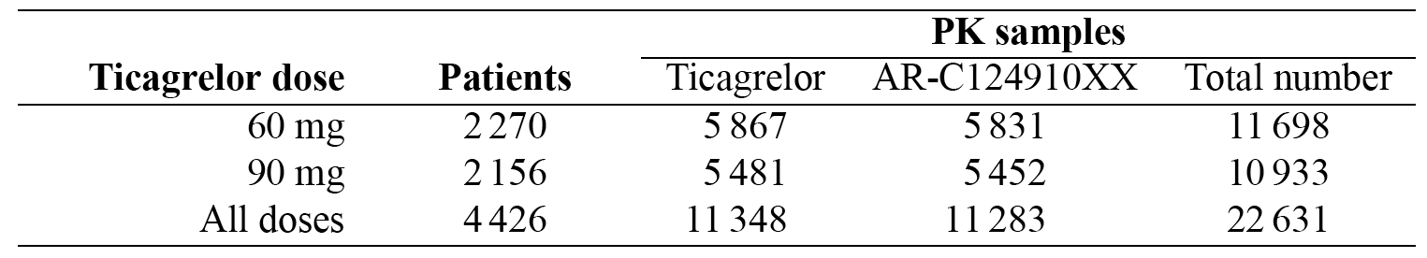
The demographic characteristics of the PPK analysis population were similar to the total study population. The median age of patients in the PPK analysis population was 64 years; 51% were < 65 years, 39% were 65 to 75 years, and 11% were > 75 years. The PPK population was predominantly Caucasian (84%), and 79% of the population was male. The median body weight was 83.0 kg, with a range of 33.0 to 172 kg. The proportion of Japanese patients was higher in the PPK population than in the total study population (12% versus 4%); 93% of the Asian patients in the PK population were Japanese. The proportion of patients self-identified as Hispanic or Latino in the PPK population was lower compared to the total study population (2% versus 12%). The absolute number of Black patients included in the PPK population was low (n=99), although there were sufficient patients to meet the pre-specified 2% threshold for inclusion in the PPK analysis.

Methods
A non-linear mixed-effect modelling approach was used to analysis the PPK data (standard NONMEM software). Parameter estimation was performed using the first-order conditional estimation method with interaction (FOCEI) and the standard errors of the parameter estimates were computed based on the NONMEM variance-covariance matrix. The analysis followed steps pre-specified in the analysis plan. The previously developed PPK model (final DISPERSE2/PLATO model) was used as the starting point for the new PPK analysis. PPK model building was first performed on ticagrelor data only. Thereafter, AR-C124910XX data were analysed as an extension to the final ticagrelor model.
The assessed covariates included those that were significant in the final DISPERSE2/PLATO model (that is, Asian race, Black race and smoking for ticagrelor, and sex and smoking for AR-C124910XX). The main interest of the covariate analysis was to quantify the effects of covariates on CL/F. The sponsor stated that the covariate effects on model parameters other than CL/F_{ticagrelor} and CL/F_{AR-C124910XX} would not affect the total steady state exposure (for example, C_{ss,av}) of either ticagrelor or AR-C124910XX. Therefore covariates other than CL/F were not investigated in the PPK analysis. For categorical covariates, if < 2% of the patients belonged to a covariate category then that category was not evaluated in the covariate analysis.
Model evaluation included graphical analysis of goodness of fit (GOF) plots, relative standard errors (RSEs), and visual predictive checks (VPCs). Stratification, for example by dose, visit or covariate, was used when appropriate to ensure that the models performed adequately across important sub-groups of the data.

Results
- The final PPK model for ticagrelor was a one-compartment model with first-order absorption into the central compartment and first order elimination from the central compartment. The PK parameter estimates of the final ticagrelor model are presented in Table 2.

Table 2: PEGASUS PPK Parameter estimates of the final ticagrelor model
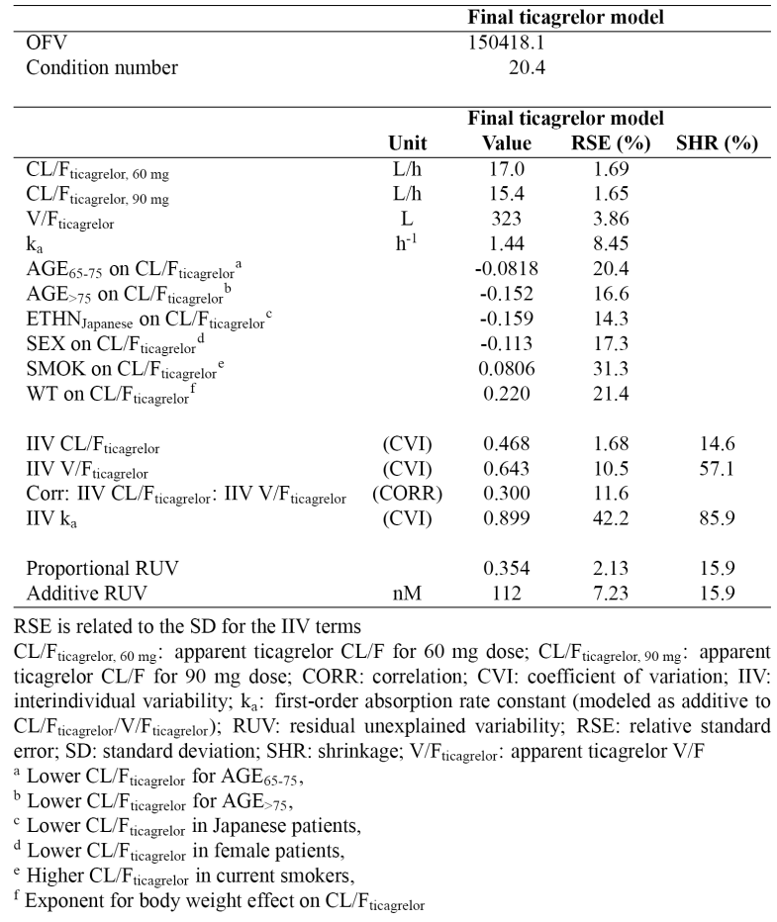
- The final PPK model for AR-C124910XX was a one-compartment model with first-order elimination where 22% of ticagrelor was assumed to be metabolised to its active metabolite. The PK parameter estimates of the final AR-C124910XX model are presented in Table 3.

Table 3: PEGASUS PPK - Parameter estimates of the final AR-C124910XX model
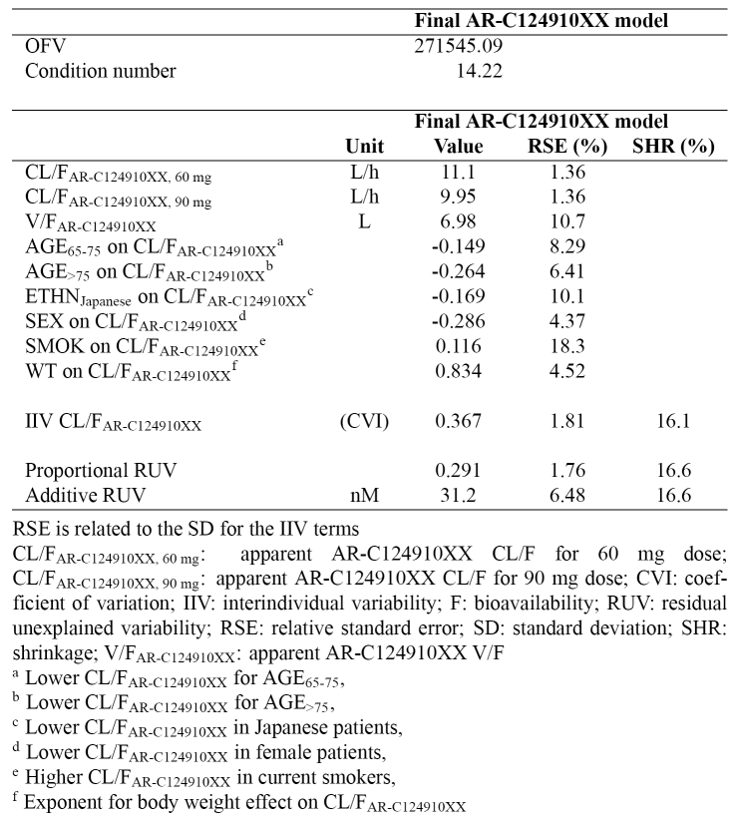
- There were no time dependent effects on the PK of ticagrelor and AR-C124910XX through to 12 hours after dosing (that is, the proposed dosing interval). The VPC of the final ticagrelor and AR-C124910XX model versus time after 12 hours of observation after dose showed that the predicted concentrations were lower than the observed concentrations (that is, under prediction). The sponsor speculated that the under prediction observed at later time-points is a consequence of errors in recorded dose and sampling times, and inability to account for the censored observations below the LLOQ.
- A small but statistically significant (p<0.001) deviation from dose proportionality was detected between the studied doses of 60 mg and 90 mg both for ticagrelor and AR-C124910XX. The median (90th inter-percentile range) predicted steady-state ticagrelor concentrations (C_{ss,av}) were 606 nM (333 to 1245 nM) with the 60 mg dose and 998 nM (546 to 2029 nM) with the 90 mg dose, respectively. For AR-C124910XX the median steady-state concentrations (C_{ss,av}) was approximately 37% of that of ticagrelor. The median (90th inter-percentile range) predicted steady-state concentrations (C_{ss,av}) of ticagrelor plus AR-C124910XX were 849 nM (468 to 1675 nM) with the 60 mg dose and 1381 nM (790 to 2771 nM) with the 90 mg dose, respectively. The CL/F values for both ticagrelor and AR-C124910XX were found to be approximately 10% lower in the 90 mg dose group compared to the 60 mg dose group.
- The CL/F of ticagrelor (CL/F_{ticagrelor}) was considered to be the key pharmacokinetic parameter of interest. No covariate had an effect greater than 20% on mean population CL/F_{ticagrelor}, and did not explain any major part of the inter-individual variability. The population typical estimate for CL/F_{ticagrelor} was 17 L/h for the 60 mg dose and 15.4 L/h for the 90 mg dose. CL/F_{ticagrelor} was associated with an inter-individual variability of 47%. The results for covariate effects on CL/F_{ticagrelor} are summarised below:
- The population typical CL/F_{ticagrelor} was found to be lower in elderly patients compared to young patients (age <65 years). In patients aged 65 to 75 years the CL/F_{ticagrelor} was 8% (95% CI: 5%, 11%) lower than in patients < 65 years and in patients older than 75 years the CL/F_{ticagrelor} was 15% (95% CI: 10%, 20%) lower than in patients < 65 years.
- The population typical CL/F_{ticagrelor} was found to be 16% (95% CI: 12%, 20%) lower in patients of Japanese ethnicity compared to patients of non-Japanese ethnicity (that is, other patients).
- The population typical CL/F_{ticagrelor} was found to be 11% (95% CI: 8%, 15%) lower in female patients compared to male patients.
- Current smoking was found to increase the population typical CL/F_{ticagrelor} by 8% (95% CI: 4%, 13%) compared to non-smoking.
- CL/F_{ticagrelor} was found to be positively correlated with body weight. The estimated exponent for body weight on CL/F_{ticagrelor} was 0.22 (95% CI: 0.12, 0.31). Compared to a typical 83 kg patient, this corresponds to a 6% (95% CI: 4% to 9%) higher CL/F_{ticagrelor} for a 110 kg patient and a 10% (95% CI: 6% to 14%) lower CL/F_{ticagrelor} for a 50 kg patient.
- Hispanic or Latino ethnicity and Black race did not have any statistically significant impact on CL/F_{ticagrelor} (p<0.001).
- The population typical estimate for CL/F_{AR-C124910XX} was 11.1 L/h for the 60 mg dose and 9.9 L/h for the 90 mg dose. CL/F_{AR-C124910XX} was associated with inter-individual variability of 37%. No covariate had an effect greater than 35% on mean population CL/F_{AR-C124910XX}, and did not explain any major part of the inter-individual variability. The results for covariate effects on CL/F_{AR-C124910XX} are summarised below:
- The population typical CL/F_{AR-C124910XX} was found to be lower in elderly patients compared to young patients (age < 65 years). In patients aged 65 to 75 years the CL/F_{AR-C124910XX} was 15% (95% CI: 12%, 17%) lower than in patients aged < 65 years, and in patients older than 75 years the CL/F_{AR-C124910XX} was 26% (95% CI: 23%, 30%) lower than in patients aged < 65 years.
- The population typical CL/F_{AR-C124910XX} was found to be 17% (95% CI: 14%, 20%) lower in patients of Japanese ethnicity compared to patients of non-Japanese ethnicity (that is, other patients).
- The population typical CL/F_{AR-C124910XX} was found to be 29% (95% CI: 26%, 31%) lower in female patients compared to male patients.
- Current smoking was found to increase the population typical CL/F_{AR-C124910XX} by 12% (95% CI: 8%, 16%) compared to non-smoking.
- CL/F_{AR-C124910XX} was found to be positively correlated with body weight. The estimated exponent for body weight on CL/F_{AR-C124910XX} was 0.83 (95% CI: 0.76, 0.91). Compared to a typical 83 kg patient, this corresponds to a 26% (95% CI: 24%, 29%) higher CL/F_{AR-C124910XX} for a 110 kg and a 34% (95% CI: 32%, 37%) lower CL/F_{AR-C124910XX} for a 50 kg patient.
- Hispanic or Latino ethnicity and Black race did not have any statistically significant impact on CL/F_{AR-C124910XX} (p<0.001).
- An exploratory graphical assessment was performed to evaluate potential relationships between ticagrelor exposure and events, consisting of the primary efficacy endpoint (time to first occurrence of any CV Death/MI/Stroke), and the key safety endpoint (time to first occurrence of any TIMI Major Bleeding). Individual predictions of ticagrelor and AR-C124910XX exposures (C_{ss,av}) were generated for all ticagrelor treated patients who received at least one dose using the final PEGASUS PPK model. The graphical exposure-response analyses were based on Kaplan-Meier plots and boxplots. The Kaplan-Meier plots displayed the proportion of patients without an event, including placebo-treated and ticagrelor-treated patients stratified by C_{ss,av} quartiles. The box-plots compare C_{ss,av} in patients with or without an event.
- Overall, a lower risk of CV Death/MI/Stroke was seen in ticagrelor treated patients compared to placebo. However, no apparent exposure-response relationship was seen within the ticagrelor treated patients taking 60 mg BD or 90 mg bd. There was a large overlap in ticagrelor exposure in patients with and without efficacy events. The relationships between exposure (C_{ss,av}) and event (CV Death/MI/Stroke/None) for ticagrelor and for the sum of ticagrelor and AR-C124910XX are summarised in Figure 1. Kaplan-Meier estimates of patients without CV Death/MI/Stroke events, stratified by exposure, versus time after first dose (days) are presented in Figure 3.
- The exploratory graphical exposure-response analysis showed a higher incidence of TIMI Major Bleeding events in ticagrelor treated patients compared to placebo. However, no apparent exposure-response relationship was seen within the ticagrelor treated patients taking 60 mg or 90 mg bd. There was a large overlap in ticagrelor exposure in patients with and without TIMI Major Bleeding events. The relationships between exposure (C_{ss,av}) and event (TIMI Major Bleeding) for ticagrelor and for the sum of ticagrelor and AR-C124910XX are summarised in Figure 2. The sponsor considered that a trend towards an exposure-response relationship for TIMI Major bleeding was observed, with patients in the lower drug exposure range having a slightly lower risk of an event compared to patients in the higher drug exposure range (see Figure 4).
Figure 1: PPK PEGASUS CV Deaths/MI/Stroke/no events versus exposure
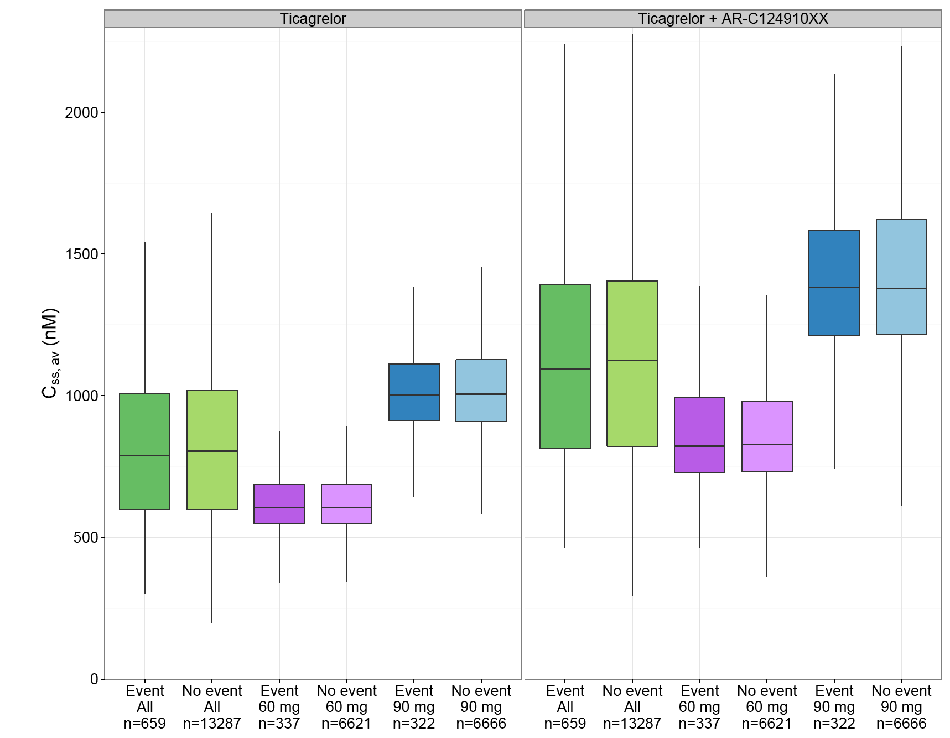
Left panel ticagrelor C_{ss,av} exposure, right panel ticagrelor + AR-C124910XX C_{ss,av} exposure. Each panel is stratified on patients with event and patients without events. Only patients treated with ticagrelor are included in the figure. The horizontal line within each box represents the median. The box edges represent the lower (25th) and upper (75th) quartiles. The whiskers extend from the lower and upper quartiles to the furthest data points still within a distance of 1.5 interquartile ranges from the lower and upper quartiles. The data points outside the whiskers are outliers.
Figure 2: PPK PEGASUS - TIMI Major Bleeding events/no events versus exposure
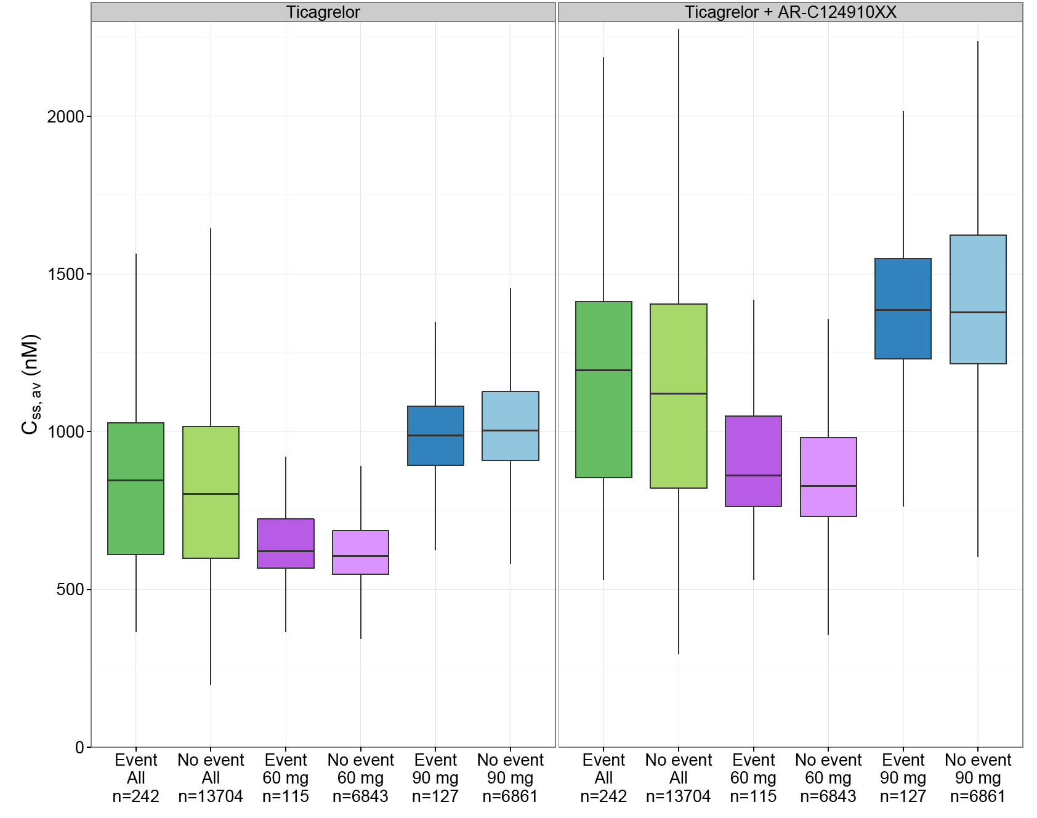
Left panel ticagrelor C_{ss,av} exposure, right panel ticagrelor + AR-C124910XX C_{ss,av} exposure. Each panel is stratified on patients with event and patients without events. Only patients treated with ticagrelor are included in the figure. The horizontal line within each box represents the median. The box edges represent the lower (25^{t}) and upper (75th) quartiles. The whiskers extend from the lower and upper quartiles to the furthest data points still within a distance of 1.5 interquartile ranges from the lower and upper quartiles. The data points outside the whiskers are outliers.
Figure 3: PPK PEGASUS - Kaplan-Meier (KM) estimator of patients without CV Death/MI/Stroke events versus time after first dose in days
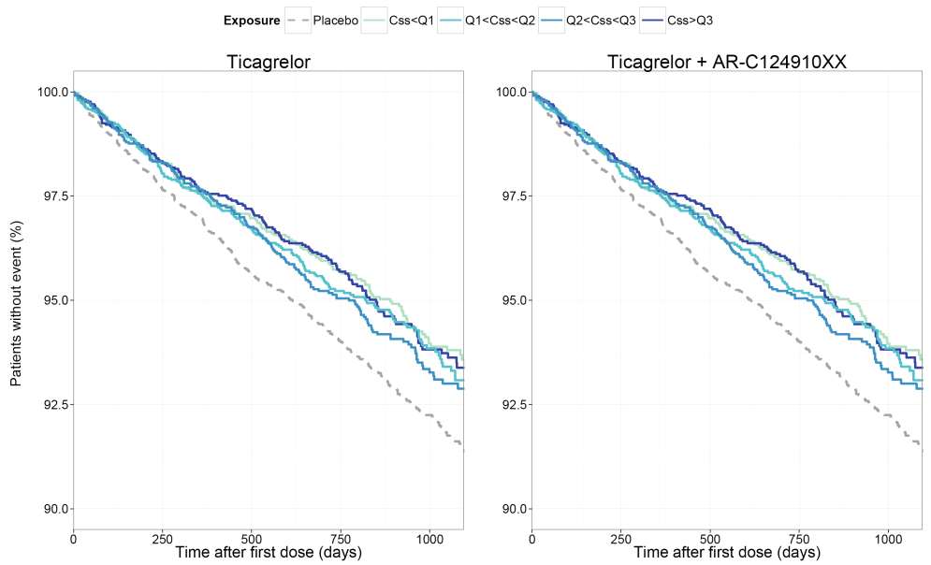
Kaplan-Meier (KM) estimator of patients without CV Death/MI/Stroke versus time after first dose in days; The figure is stratified by ticagrelor (left panel) and ticagrelor + AR-C124910XX (right panel). Each panel contains Kaplan-Meier estimates of patients receiving placebo, patients with exposure ≤ the 25th percentile (< Q1), patients with exposure > than the 25th percentile and ≤ the median (Q1-Q2), patients with exposure > than the median and ≤ the 75th percentile (Q2-Q3) and patients with exposure > the 75th percentile (>Q3).
Figure 4: PPK PEGASUS - Kaplan-Meier (KM) estimator of patients without TIMI Major Bleeding events versus time after first dose in days
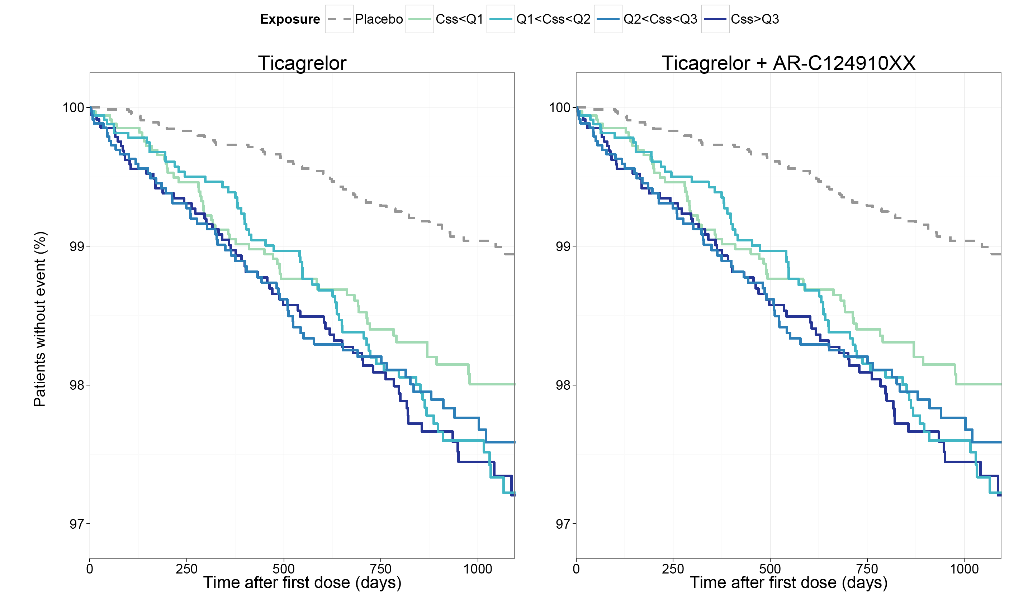

Evaluator's comments on pharmacokinetics
- The submission included 1 new PPK study providing both PPK data and exploratory exposure-response data following ticagrelor 60 mg BD and 90 mg BD in the proposed patient population (PEGASUS). The PPK of ticagrelor and its active metabolite AR-C124910XX were adequately described by one-compartment disposition models with first-order absorption (ticagrelor), formation (AR-C124910XX) and elimination. The sponsor comments that the PK parameter estimates for ticagrelor reported in the new PPK analysis based on data from PEGASUS were generally similar to those reported in the previous PPK analysis based on data from DISPERSE2/PLATO.
- The 5 individual covariates identified to have a statistically significant impact on the CL/F of ticagrelor and AR-C124910XX were body weight, age, Japanese ethnicity, female sex and current smoking. The covariate effects were qualitatively the same for the CL/F of both ticagrelor and AR-C124910XX, but were generally more pronounced for AR-C124910XX. In summary the covariate effects were: CL/F increased with increasing body weight; CL/F decreased with increasing age; CL/F was lower in Japanese patients compared to non-Japanese patients; CL/F was lower in females compared to males; and CL/F was higher in current smokers compared to non-smokers. The analysis of Black race on CL/F did not meet the pre-defined statistical significance criterion (p<0.001), and was excluded in the backwards elimination step of the stepwise covariate model building procedure. However, the sponsor comments that patients of Black race have previously been described to have generally higher CL/F_{ticagrelor} values than patients of non-Black race (PPK analysis based on DISPERSE2/PLATO).
- No exposure-response relationships were demonstrated for ticagrelor exposure (C_{ss,av}) versus CV Death/MI/Stroke (efficacy outcome), or for ticagrelor exposure (C_{ss,av}) versus TIMI Major Bleeding (safety outcome). The sponsor considered that a trend towards an exposure-response relationship for TIMI Major Bleeding was observed, with patients in the lower drug exposure range having a slightly lower risk of event compared to patients in the higher drug exposure range. However, based on Kaplan-Meier estimates of patients without TIMI Major Bleeding events, stratified by exposure to ticagrelor and to ticagrelor plus AR-C124910XX versus time after first dose (days), the observed trend is considered to be clinically insignificant. There was a large overlap in ticagrelor exposure in patients with and without both efficacy and safety endpoint events. The sponsor comments that the exploratory graphical exposure-response analyses had some weaknesses and should be interpreted with caution. One issue with the graphical analysis is that it does not control for the distribution of risk factors. It is possible that certain risk factors are correlated with exposure. Without appropriately accounting for such risk factors false exposure-response relationships might be identified or actual true exposure-response relationships might be hidden. A full non-linear mixed effect modelling approach including risk factor assessment based on the placebo cohort could offer a better possibility for an unbiased assessment of the exposure-response relationship.
- There were no clinical biopharmaceutical studies comparing the bioequivalence of the proposed ticagrelor 60 mg tablet strength and the approved ticagrelor 90 mg tablet strength. The sponsor submitted an acceptable justification for not submitting such studies.

Pharmacodynamics

Study D5130L00012 - Phase IV therapeutic use study

Introduction
The submission included 1 new PD study assessing the antiplatelet effects of ticagrelor versus clopidogrel in Hispanic patients with stable coronary artery disease (D5130L000120). The study was undertaken in the USA (6 centres). The first patient was enrolled on 17 April 2012, the last patient visit was on 10 May 2013, and the study report was dated 1 April 2014 (Final Version v2.1).

Objectives (PD and PK) - primary and secondary
The primary objective of the study was to compare on-treatment platelet reactivity of ticagrelor versus clopidogrel at the 2-hour time-point after a loading dose of each drug, with platelet reactivity being measured by P2Y₁₂ Reaction Units (PRU) using VerifyNow™ (Accumetrics, San Diego, USA) in Hispanic patients with stable coronary artery disease (CAD) on chronic low-dose ASA.
The secondary objectives of the study were: (1) to compare on-treatment platelet reactivity of ticagrelor versus clopidogrel at the 0.5-hour and 8-hour time points after a loading dose of each drug; (2) to compare on-treatment platelet reactivity of ticagrelor versus clopidogrel at the 2- and 8-hour time points on Day 7, and end of the dosing interval on Day 8 (that is, 12 hours after the last evening dose of ticagrelor and 24 hours after the last morning dose of clopidogrel); and (3) to evaluate plasma concentration of ticagrelor and its active metabolite AR-C124910XX at the same time-points as platelet activity assessment.
Comment: The primary measure of platelet aggregation in the study was optical aggregometry designed to measure P2Y₁₂ receptor blockade expressed as PRU by the VerifyNow™ device. The VerifyNow™ System (Accumetrics, San Diego, CA) is a turbidimetric based optical detection system that measures platelet aggregation in whole blood. The assay device contains a lyophilised preparation of human fibrinogen-coated beads, platelet activators, and buffer. The assay is based on the ability of activated platelets to bind fibrinogen. Fibrinogen-coated micro-particles aggregate in whole blood in proportion to the number of expressed platelet GPIIb/IIIa receptors. The rate of micro-bead aggregation is more rapid and reproducible if platelets are activated. Therefore, the reagent adenosine-5-diphosphate (ADP/PGE1) is incorporated into the assay channel to induce platelet activation without fibrin formation. Light transmittance increases as activated platelets bind and aggregate fibrinogen-coated beads. The VerifyNow™ instrument measures the change in optical signal and reports the results in P2Y₁₂ Reaction Units (PRU), which indicate the amount of ADP-mediated aggregation specific to the platelet P2Y₁₂ receptor. Perusal of the manufacturer's documents indicates that the PRU reference range is 194 to 418 (that is, normal ADP reactivity, no evidence of P2Y₁₂ inhibitor effect), and that values less than the lower PRU limit (194) are highly specific for a P2Y₁₂ inhibitor effect.
Both clopidogrel and ticagrelor are known to specifically block the P2Y₁₂ receptor. Therefore, the P2Y₁₂ inhibitory effects of the two drugs can be directly compared using PRU values obtained from the VerifyNow™ assay. The study showed that the PRU levels at all time-point endpoints were markedly lower for ticagrelor than for clopidogrel, demonstrating greater P2Y₁₂ inhibition in patients treated with ticagrelor compared to clopidogrel. The study showed that PRU LS mean values for clopidogrel were above the lower limit of the reference range for a number of the time-point endpoints, while corresponding values for ticagrelor were below the limit of the reference range for all time-point endpoints.

Methods
This was a single-country (USA), multi-centre, randomised, open-label, multiple-dose, crossover study comparing the anti-platelet effects of ticagrelor and clopidogrel in approximately 34 Hispanic patients with stable CAD taking chronic low-dose ASA. Patients were randomised to receive 1 of 2 possible treatment sequences, with patients randomised to Sequence 1 receiving Treatment A (clopidogrel) in the first period and Treatment B (ticagrelor) in the second period, and patients randomised to Sequence 2 receiving Treatment B (ticagrelor) in the first period and Treatment A (clopidogrel) in the second period. There was a 10 to 14 day washout between the 2 treatment periods.
Treatment A consisted of clopidogrel 600 mg loading dose (8 x 75 mg tablets) followed by 75 mg once daily (QD) for 7, 8, or 9 days. Treatment B consisted of ticagrelor 180 mg loading dose (2 x 90 mg tablets) followed by 90 mg twice daily (BD) for 7, 8, or 9 days. The two study drugs were administered open-label, while the VerifyNow™ P2Y₁₂ assay was undertaken by an operator blinded to treatment allocation. In addition to the clopidogrel and ticagrelor, patients also received ASA (75-100 mg) daily maintained at a constant dose throughout the study period. Thirty-four (34) patients were to be randomised in order to ensure 28 patients were evaluable. The study was conducted at 6 actively recruiting centres. The study consisted of 8 visits for each patient, and the duration of the study for each patient was for up to 11 weeks. The study design is summarised below in Figure 5.
Figure 5: D5130L00012 - Flow chart of study design
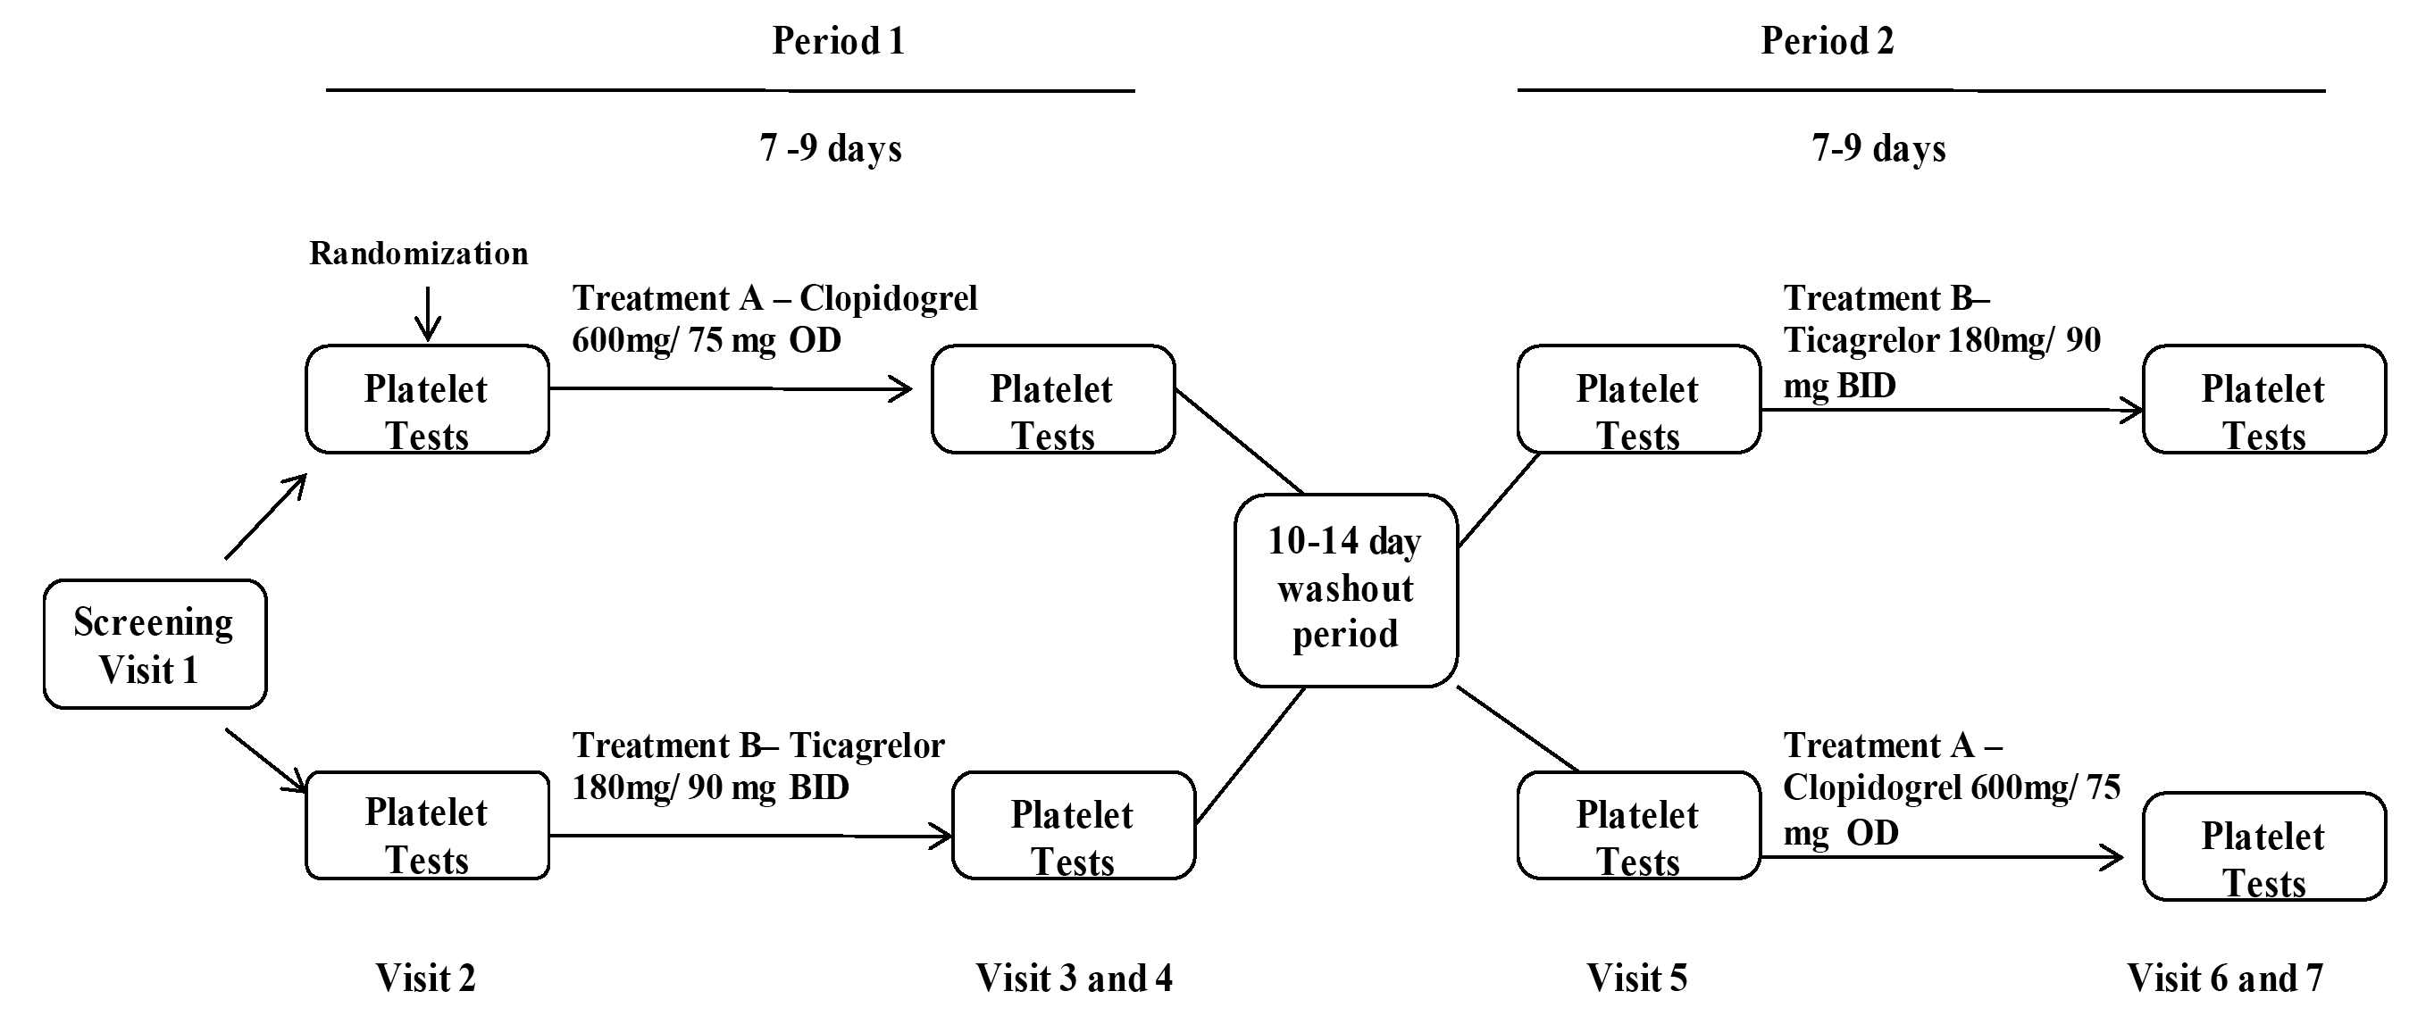
Platelet assessments and PK samples were assessed at Visit 2, Visit 3, and Visit 4 in Treatment Period 1 and Visit 5, Visit 6, and Visit 7 in Treatment Period 2.
The timing of the PK samples and platelet function samples is summarised below in Table 4. Patients fasted for at least 8 hours prior to pre-dose PK blood and platelet function blood samples at Visits 2 through 7, while diabetic patients fasted for at least 4 hours with appropriate fluids and foods being permitted to maintain patient safety. A meal could be provided to patients following the 2-hour sample collection. Patients fasted again for 2 hours prior to the 8-hour sample collection. Patients could not donate blood or bone marrow at any time during the study period, and were required to refrain from scheduling surgical procedures at any time following the screening visit and through the completion of the follow-up visit.

Table 4: D5130L00012 - Timing of PK and platelet function samples
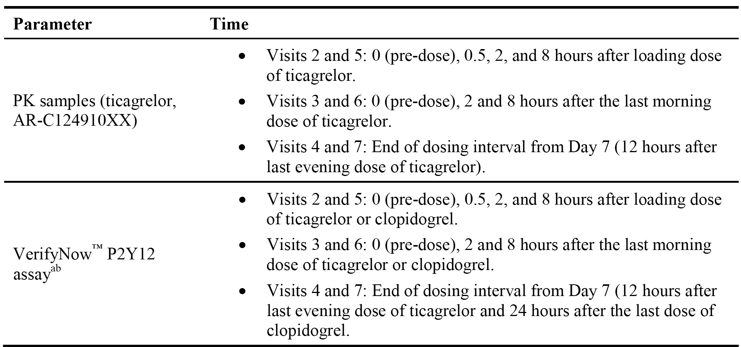
- VerifyNow™ P2Y12 assay measured P2Y12 reaction units and percent inhibition of P2Y12 receptor.
- Visit 2 occurred on Day 1; Visit 3 occurred on Day 7, 8, or 9 (Treatment Period 1); Visit 4 occurred 1 day after Visit 3 (Treatment Period 1); Visit 5 occurred 10 to 14 days after Visit 4 (Treatment Period 2); Visit 6 occurred on Day 7, 8 or 9 (Treatment Period 2); Visit 7 occurred 1 day after Visit 6 (Treatment Period 2).

Inclusion and exclusion criteria
The study included males and females aged 18 years of age or older who self-identified as Hispanic, had a history of documented stable CAD and were taking ASA (75-100 mg) daily. The inclusion and comprehensive exclusion criteria have been examined and are considered to be acceptable. The study included appropriate criteria relating to patient discontinuation from treatment and assessment.

Study variables
The primary PD outcome was inhibition of the P2Y12 receptor at 2 hours after loading dose with ticagrelor compared to clopidogrel as measured by PRU from VerifyNow™.

Analysis sets
The randomised analysis set included all patients who signed informed consent and were randomised (n=40).
The PD analysis set included all patients for whom PD data were available with no major protocol deviations thought to significantly affect the PD of ticagrelor or clopidogrel (n=38).
The safety analysis set included all patients who received at least one dose of study medication, grouped according to actual treatment received (n=40).

Sample size
The primary outcome of this study was P2Y₁₂ receptor inhibition at 2 hours, as measured by PRUs using Verify Now™. A sample size of 12 completed patients was required to provide 90% power to detect a difference of 100 PRUs between ticagrelor and clopidogrel at 2 hours post loading dose, assuming a standard deviation (SD) of 93 PRUs, a correlation of 0.5 between paired observations, and a two-sided alpha level of 0.05. The assumed standard deviation of 93 PRUs represented the largest variability for ticagrelor or clopidogrel observed in study D5130C00048 at time-points within the first 24 hours. Based on a need to enrol a cohort of sufficient to evaluate P2Y₁₂ receptor inhibition at secondary time points and to collect potential AEs, it was planned that 34 patients would be enrolled in order to ensure 28 patients were evaluable. This would provide more than 99% power to detect the anticipated primary outcome effect.

Statistical methods
The primary analysis of the difference between ticagrelor and clopidogrel in PRU was at 2 hours after the loading dose. Least square (LS) means and 95% CIs were estimated for ticagrelor and clopidogrel from a linear mixed-effect model with fixed effects for treatment group (A/B), period (1/2), and treatment sequence (AB/BA) and a random effect for patient within sequence. The treatment effect was assessed using pairwise comparisons of difference in LS means with two-sided 95% CI, and two-sided alpha level of 0.05. Distribution assumptions underlying the analysis were assessed by residual plots. If the assumptions were violated, a Wilcoxon signed rank test was to be used. Secondary analyses of PRUs at other time points were analysed with similar mixed-effects models. Additionally, there were secondary analyses of percentage change from baseline in PRUs and of percent inhibition of platelet aggregation (IPA) from baseline. No imputation was planned for missing PRU values. No multiplicity adjustments were planned. No subgroup analyses were planned. No interim analyses were planned. No data monitoring committee was used for the study.

Subject disposition
A total of 53 patients were screened and 40 patients meeting all inclusion and no exclusion criteria were enrolled from 6 centres in the US. Of the 13 patients screened but not randomised, 12 patients did not meet inclusion and/or exclusion criteria, and 1 patient withdrew due to ‘other’ reasons after screening (that is, unable to complete the randomisation visit according to study timelines).
Of the 40 enrolled patients, 38 patients ‘completed 14 days of treatment’ according to the study protocol (that is, completed 7, 8 or 9 days of both sequences), and 2 patients failed to complete all 14 days of treatment. Thirty-nine (39) patients received both ticagrelor and clopidogrel and completed the follow-up period and 1 patient discontinued from treatment during ticagrelor treatment and did not crossover to clopidogrel.

Subject demographics
Of the 40 patients in the randomised analysis set, the mean (SD) age was 63.8 (8.8) years, ranging from 42 to 88 years. There were 18 (45.0%) patients who were ≥ 65 years old. Twenty-eight patients (70%) were male, and 43.6% of all patients had a BMI > 30 kg/m². All patients self-identified as Hispanic.

Results primary PD outcome
The primary outcome of this study was P2Y₁₂ receptor inhibition at 2 hours following loading doses of ticagrelor and clopidogrel, measured by PRUs using Verify Now™. The results for the primary efficacy analysis is summarised below in Table 5.

Table 5: D5130L00012 - Summary of platelet activity 2 hours after loading dose
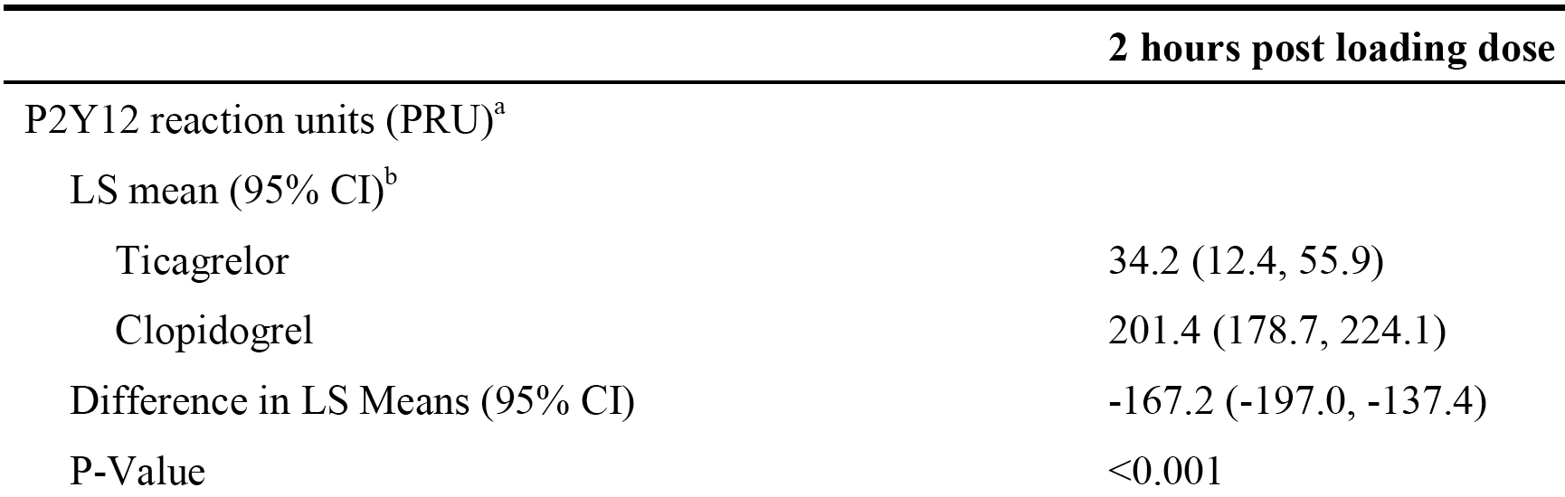
  - As measured from VerifyNow™.
  - Least squares, estimated from linear mixed-effect model with treatment group, period, and sequence as fixed effects and a random effect for patient within sequence.
The LS mean percent reduction in platelet P2Y₁₂ receptor activity from baseline (pre-treatment) at 2 hours after the loading dose was 86.3% (95% CI: 79.1, 93.6) in the ticagrelor group and 28.7% (95% CI: 21.2, 36.3) in the clopidogrel group, with an LS mean difference of 57.6% (95% CI: 48.4%, 66.8%), p<0.001.
In a pre-specified sensitivity analysis, which included PRU baseline value as a fixed effect in the linear mixed-effect model, the LS mean PRU was consistent with the primary analysis for patients who received ticagrelor (35.3 [95% CI: 15.0, 55.6]) compared to clopidogrel (197.1 [95% CI: 175.9, 218.3]), with an LS mean difference of -161.8 (95% CI [-191.2, -132.4]; p<0.001).
Comment: The data demonstrated that P2Y₁₂ inhibition was statistically significantly greater with ticagrelor than with clopidogrel at 2 hours after a loading dose.

Results secondary PD analyses

Platelet function at 0.5 and 8 hours following the loading dose
- The LS mean PRU, measured using VerifyNow™, at 0.5 hours after the loading dose was 134.6 (95% CI: 105.1, 164.1) in the ticagrelor group and 269.8 (95% CI: 238.7, 300.8) in the clopidogrel group, with an LS mean difference of -135.2 (95% CI: -172.3, -98.0), p<0.001. The LS mean percent reduction in platelet P2Y₁₂ receptor activity from baseline (pre-treatment) at 0.5 hours after the loading dose was 49.9% (95% CI: 40.2, 59.5) in the ticagrelor group and 1.7% (95% CI: -8.5, 11.9) in the clopidogrel group, with an LS mean difference of 48.2% (95% CI: 35.4, 61.0), p<0.001.
- The LS mean PRU, measured using VerifyNow™, at 8 hours after the loading dose was 34.0 (95% CI: 9.2, 58.8) in the ticagrelor group and 202.8 (95% CI: 176.6, 229.0) in the clopidogrel group, with an LS mean difference of -168.9 (95% CI: -204.0, -133.7), p<0.001. The LS mean percent reduction in platelet P2Y₁₂ receptor activity from baseline (pre-treatment) at 8 hours after the loading dose was 87.3% (95% CI: 78.9, 95.6) in the ticagrelor group and 29.1% (95% CI: 20.2, 37.9) in the clopidogrel group, with an LS mean difference of 58.2% (95% CI: 46.0, 70.4), p<0.001.

Platelet function at 2-hour and 8-hour time-points on Day 7 after multiple doses
- The LS mean PRU, measured using VerifyNow™, at 2 hours on Day 7 after multiple dosing was 28.5 (95% CI: 8.0, 49.0) in the ticagrelor group and 179.0 (95% CI: 157.7, 200.3) in the clopidogrel group, with an LS mean difference of -140.2 (95% CI: -168.4, -111.9), p<0.001. The LS mean percent reduction in platelet P2Y₁₂ receptor activity from baseline (pre-treatment) at 2 hours on Day 7 after multiple dosing was 89.0% (95% CI: 82.4, 95.6) in the ticagrelor group and 36.0% (95% CI: 29.1, 42.9) in the clopidogrel group, with an LS mean difference of 53.0% (95% CI: 44.2, 61.9), p<0.001.
- The LS mean PRU, measured using VerifyNow™, at 8 hours on Day 7 after multiple dosing was 38.7 (95% CI: 17.2, 60.3) in the ticagrelor group and 178.9 (95% CI: 156.5, 201.4) in the clopidogrel group, with an LS mean difference of -140.2 (95% CI: -168.4, -111.9), p<0.001. The LS mean percent reduction in platelet P2Y₁₂ receptor activity from baseline (pre-treatment) at 8 hours on Day 7 after multiple dosing was 84.0% (95% CI: 75.3, 92.8) in the ticagrelor group and 34.0% (95% CI: 24.8, 43.2) in the clopidogrel group, with an LS mean difference of 50.0% (95% CI: 38.0, 62.1), p<0.001.

Platelet function at end of dosing interval on day 8 after multiple doses
- The LS mean PRU, measured using VerifyNow™, at the end of the dosing interval on Day 8 after multiple dosing was 51.5 (95% CI: 29.8, 73.1) in the ticagrelor group and 182.1 (95% CI: 159.5, 204.7) in the clopidogrel group, with an LS mean difference of -130.6 (95% CI: -158.0, -103.2), p<0.001. The LS mean percent reduction in platelet P2Y₁₂ receptor activity from baseline (pre-treatment) at the end of the dosing interval on Day 8 after multiple dosing was 77.4% (95% CI: 68.6, 87.0) in the ticagrelor group and 33.4% (95% CI: 23.9, 43.0) in the clopidogrel group, with an LS mean difference of 44.4% (95% CI: 33.8, 54.9), p<0.001.

Results secondary PK analyses
A secondary objective of the study was to evaluate plasma concentration of ticagrelor and its active metabolite AR–C124910XX at the same times as the VerifyNow™ assessments. The geometric mean ticagrelor and AR–C124910XX plasma concentrations after the loading and maintenance doses of ticagrelor are summarised below in Figure 6. The sponsor comments that exposures to ticagrelor and AR-C124910XX were similar to those observed in previous ticagrelor studies. The sponsor comments that results do not highlight any differences in metabolism of ticagrelor in a Hispanic population compared to prior populations that have been studied, although the sample size of the current study was small and the treatment effect of ticagrelor between Hispanics and non-Hispanics was not directly compared.
Figure 6: D5130L00012 Ticagrelor (panel a) and AR-C124910XX (panel b) geometric mean (SD) plasma concentrations after loading and maintenance doses of ticagrelor versus protocol times for VerifyNow™ assessments; PK analysis set
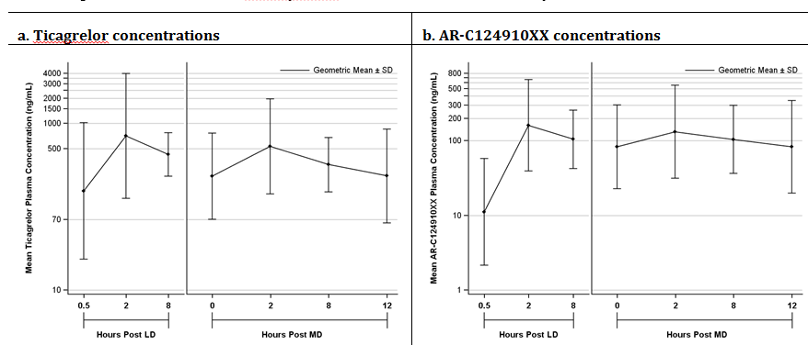
LD Loading dose; MD Maintenance dose; PK Pharmacokinetic; SD Standard deviation

Safety results
In the randomised analysis set, the mean (range) duration of treatment in patients in the ticagrelor group (n=40) was 7.8 days (2, 9 days) compared to 7.9 days (range: 4, 9 days) in patients in the clopidogrel group (n=39), and the mean (range) cumulative dose in the two groups was 1498.5 mg (450, 1710 mg) and 1151.9 mg (1050, 2250 mg), respectively.
In the safety analysis set (that is, patients who received at least one dose of study medication and analysed by actual treatment received), 5 (12.5%) patients in the ticagrelor group (n=40) experienced 12 AEs and 6 (15.4%) patients in the clopidogrel group (n=39) experienced 7 AEs. The majority of AEs were mild in intensity, with 1 patient in each treatment group experiencing a moderate AE and no patients in either treatment group experiencing severe AEs. There were no deaths, no SAEs, no AEs leading to discontinuation of study treatment, no other significant AEs and no bleeding events in either of the two treatment groups. AEs occurring more than 30 days after the last dose of study medication were not included in the AE count, unless considered to be treatment-related.
Of the 12 AEs occurring in the ticagrelor group, dyspnoea was reported twice and all others were reported once (diarrhoea, oropharyngeal discomfort, malaise, heart rate irregular, heart rate increased, headache, dizziness, dysgeusia, burning sensation, and musculoskeletal chest pain). Of the 7 AEs occurring in the clopidogrel group, headache and fall were each reported twice and all others were reported once (abdominal pain upper, rib fracture, nasopharyngitis).
Of the 5 patients in the ticagrelor group experiencing AEs, 2 (5.0%) patients were reported to have experienced three treatment-related AEs (one each for dyspnoea, malaise, and musculoskeletal chest pain). There were no treatment-related AEs reported in the clopidogrel group.
Clinical laboratory tests (haematology and clinical chemistry) were collected at screening only, and no pre-treatment or post-treatment data were obtained. No numeric urinalysis variables were reported.
Comments: The limited safety data (that is, small patient numbers, short duration of treatment) indicate that ticagrelor was well tolerated. No new or unexpected safety concerns were identified in patients treated with ticagrelor.

Evaluator's comments on pharmacodynamics
The submission included 1 new PD study (D5130L00012) comparing the effects of ticagrelor and clopidogrel in combination with ASA on platelet function in Hispanic patients with stable CAD, based on P2Y₁₂ inhibition assessed using mean PRU measured by VerifyNow™. In this study, P2Y₁₂ inhibition was statistically significantly greater at 2 hours following the loading dose in the ticagrelor group than in the clopidogrel group (primary PD outcome), and at 0.5 and 8 hours following the loading dose in the ticagrelor group compared to the clopidogrel group (secondary PD outcomes). In addition, P2Y₁₂ inhibition was statistically greater on Day 7 at 2-hours and 8-hours following multiple doses in the ticagrelor group than in the clopidogrel group, as was P2Y₁₂ inhibition at the end of the dosing interval on Day 8 after multiple doses (secondary PD outcomes). The effects of ticagrelor on platelet function in Hispanic patients were stated by the sponsor to be consistent with the effects in non-Hispanic patients.

Dosage selection for the pivotal studies
The submission included one, Phase III pivotal study (PEGASUS), which assessed the clinical efficacy and safety of ticagrelor 90 mg BD and 60 mg BD in combination with ASA for treatment of the proposed patient population. The sponsor indicated that ticagrelor 90 mg BD was selected based on available data from clinical studies showing that this dose was well tolerated and demonstrated high and consistent levels of inhibition of platelet aggregation (IPA). In PLATO, ticagrelor 90 mg BD reduced major CV events by 16%, CV mortality by 21% and all-cause mortality by 22% compared to clopidogrel 75 mg od in ACS patients also taking ASA and treated with dual antiplatelet therapy for up to 12 months. Total major bleeding, fatal and fatal/life-threatening bleeding all occurred in a similar proportion of patients in the ticagrelor and clopidogrel groups. However, minor bleeding and non-procedural major bleeding occurred more frequently in patients in the ticagrelor group compared to the clopidogrel group. Overall, the benefit-risk balance for ticagrelor 90 mg BD in combination with ASA was favourable in ACS patients. Consequently, ticagrelor 90 mg BD in combination with ASA was considered to be an appropriate dose for study in stable patients with CAD 1 to 3 years following their most recent MI.
Ticagrelor 60 mg BD in combination with ASA had not been specifically tested in clinical studies prior to PEGASUS. However, since the optimal intensity of platelet inhibition for long-term therapy in CAD is unknown, it was postulated that having outcome data for 2 doses of ticagrelor may allow tailoring of dosing to optimise the benefit-risk benefit ratio in the proposed patient population. The sponsor commented that although the risk of recurrent thrombotic events following an MI persists over time it is higher in the first year post-MI. Consequently, the sponsor postulated that a lower intensity of platelet inhibition than utilised in the ACS setting may be sufficient to prevent major CV events during chronic therapy with ticagrelor.
Based on PK and PD modelling of IPA response and clinical findings in DISPERSE, the 60 mg BD dose of ticagrelor was expected to provide less platelet inhibition than the 90 mg BD dose, but greater mean platelet inhibition and less variability than clopidogrel 75 mg QD daily, with a favourable benefit-risk balance. Ticagrelor doses lower than 60 mg BD were also considered, but modelling predicted that ticagrelor 45 mg BD would not generate a sustained IPA level greater than clopidogrel 75 mg. Furthermore, intra-individual variability in IPA of ticagrelor would be 2 to 3 times greater with 45 mg BD than with 90 mg BD as this PK parameter increases with decreasing ticagrelor dose. Doses higher than 90 mg BD were not considered as this dose has near maximal impact on IPA and efficacy.
Treatment duration of a minimum of 12 months was selected with the goal of demonstrating long-term efficacy and safety. Ticagrelor or placebo were administered on a background of ASA therapy, since ASA is standard therapy for prevention of atherothrombotic events and new therapies are likely to be administered in combination with ASA. The ASA dose of 75 mg to 150 mg once daily was recommended based on clinical trial evidence that higher doses confer no additional antithrombotic protection, but increase the risk of bleeding.³
Comment: The selection of ticagrelor 90 mg BD and 60 mg BD in combination with low dose ASA for long-term treatment of the proposed population is considered to be acceptable.

Clinical efficacy

Pivotal efficacy study (Phase III) - PEGASUS (D5132C00001)

Study design, objectives, locations and dates

Study title
A Randomised, Double-Blind, Placebo-Controlled, Parallel-Group, Multinational Trial, to Assess the Prevention of Thrombotic Events with Ticagrelor Compared to Placebo on a Background of Acetyl Salicylic Acid (ASA) Therapy in Patients with History of Myocardial Infarction.
The study is also identified by the name PEGASUS (that is, PEGASUS = PrEvention with TicaGrelor of SecondAry Thrombotic Events in High-RiSk Patients with Prior AcUte Coronary Syndrome - Thrombolysis In Myocardial Infarction [TIMI] Study Group).

Location, dates, sponsor and ethics
Patients were randomised at 1161 participating sites in 31 countries including Argentina, Australia, Belgium, Brazil, Bulgaria, Canada, Chile, China, Colombia, Czech Republic, France, Germany, Hungary, Italy, Japan, Netherlands, Norway, Peru, Philippines, Poland, Romania, Russian Federation, Slovakia, South Africa, South Korea, Spain, Sweden, Turkey, Ukraine, the UK and the US. The international co-ordinating investigator was located in Boston, USA.
The first subject was enrolled on 29 October 2010 and the last subject visit was on 3 December 2014. The CSR was dated 14 February 2015, and an Errata List to the CSR was dated 16 July 2015. The study has been published in the New England Journal of Medicine (May 7, 2015).⁴
The sponsor is AstraZeneca, Sweden. The sponsor indicates that the study was performed in accordance with the ethical principles of the Declaration of Helsinki, the guidelines of the International Conference on Harmonisation/Good Clinical Practice (GCP), country specific regulatory requirements and the AstraZeneca policy on Bioethics. For each study site, an Institutional Review Board (IRB) or Independent Ethics Committee (IEC) approved the final study protocol (or gave a favourable opinion in writing to the protocol). All patients gave written informed consent to participation in the study.

Study objectives
- Primary Efficacy Objective: The primary efficacy objective was to compare the effect of long-term treatment with ticagrelor versus placebo on a background of low-dose ASA (75 mg to 150 mg daily) on the event rate of the composite outcome of CV death, non-fatal MI, or non-fatal stroke in patients with a history of MI and high-risk of developing atherothrombotic events.
- Secondary Efficacy Objectives: The first secondary objective was to compare the effect of long-term treatment with ticagrelor versus placebo on a background of ASA on the event rate of CV death in patients with history of MI and high-risk of developing atherothrombotic events. The second secondary objective was to compare the effect of long-term treatment with ticagrelor versus placebo on a background of ASA on the event rate of all-cause mortality in patients with history of MI and high risk of developing atherothrombotic events.
- Other efficacy objectives: There were a number of other secondary efficacy objectives, which were stated to be ‘not under type 1 error control’ and were referred to in the CSR as ‘other efficacy objectives’.
- Safety objectives: The safety objectives were to assess the safety and tolerability of long-term therapy with ticagrelor compared to placebo on a background of ASA in patients with history of MI and high risk of developing atherothrombotic events. Bleeding events were analysed using the TIMI, PLATO, Global Utilization of Streptokinase and Tissue Plasminogen Activator for Occluded Coronary Arteries Trial (GUSTO), and International Society on Thrombosis and Haemostasis (ISTH) definitions. Specific focus was on: (1) time to first TIMI Major bleeding event following the first dose of study drug, time to first TIMI Major or Minor bleeding event and time to first PLATO Major bleeding event; (2) time to discontinuation of study drug due to any bleeding event; and (3) evaluation of adverse events (AEs).
- Exploratory objectives: The study included exploratory objectives related to CV biomarkers, pharmacogenetic analyses, and population pharmacokinetic (PK) analyses.

Design and investigational plan
PEGASUS was a randomised, double-blind, placebo-controlled, 3-arm parallel group, multinational, multicentre study designed to assess the prevention of cardiovascular events following dual antiplatelet therapy with ticagrelor (90 mg BD or 60 mg bd) in combination with ASA compared to placebo in combination with ASA in patients with history of MI (1 to 3 years prior to randomisation) and high-risk of an atherothrombotic event. The study was event driven and aimed to collect 1360 primary events in the randomised population based on a 24-month recruitment period and a 14-month follow-up period. The study was to run until the common study end date (CSED), when all patients had been treated for a minimum of 12 months and the pre-estimated number of primary events had been reached. The study design allowed for the study to be terminated early if either a clear beneficial or harmful effect of the study drug was detected by the Independent Data Monitoring Committee (IDMC).
The CSED was the date after which the final visits started, including end-of-treatment (EoT) visit and follow-up visit if patient was on treatment with study drug, or a final follow-up visit if the patient had prematurely discontinued treatment (that is, end-of-study [EoS] visit). The CSED was the censoring date for efficacy analyses, including events occurring on or prior to CSED. The target number of adjudicated primary events (that is, 1360) was to be reached on or before the predicted day for the CSED. On 12 May 2014, the CSED was set for 14 September 2014. The last follow-up patient visit (the end of study, as defined by the clinical study protocol [CSP]) took place on 3 December 2014. The study design is shown below in Figure 7.
Figure 7: PEGASUS Study flow chart
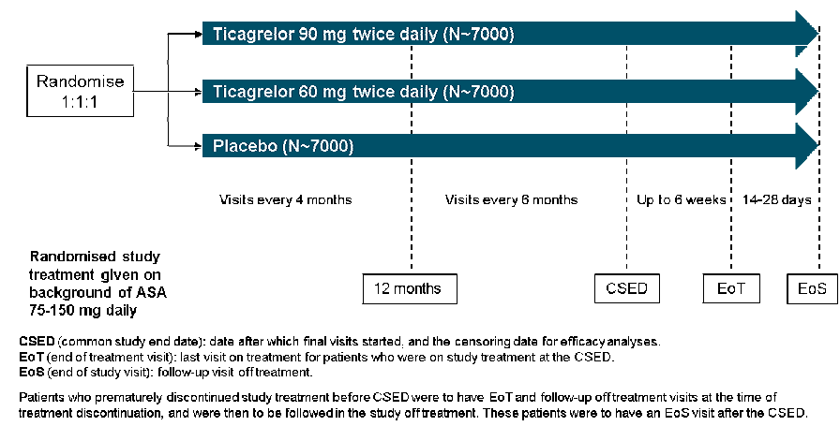
Comment: The study design is considered appropriate to test the primary and secondary efficacy objectives. The randomised, double-blind approach to treatment is designed to minimise potential bias. The choice of placebo plus low-dose ASA as the control arm is appropriate as long-term ASA is a standard secondary prevention treatment for cardiovascular disease in patients with a history of MI at high-risk of atherothrombotic events. The minimum treatment duration of 12 months is relatively short for a treatment regimen that is likely to continue indefinitely.

Changes to the study protocol
The original Clinical Study Protocol (CSP) was dated 9 September 2010. There was 1 global amendment to the CSP dated 9 March 2011 (occurring after the start of the study), and 9 local amendments. All amendments were approved by the appropriate regulatory mechanisms. The primary reason for the global amendment was to stop patients with a history of prior ischaemic stroke from receiving study drug. This global amendment was based on increasing data from studies of other antiplatelet drugs suggesting that more intensive antiplatelet therapy might pose a high-risk of intracranial haemorrhage (ICH) in patients with a history of ischaemic stroke. The sponsor stated that it was considered prudent to exclude patients with prior stroke from the ongoing study so as not to potentially complicate the interpretation of the results. Previously randomised stroke patients continued to be followed up off-treatment. In addition to excluding patients with history of stroke, the global amendment broadened prior exclusion criteria to exclude patients with a history of a central nervous system tumour or intracranial vascular abnormality (for example, aneurysm, arteriovenous malformation) at any time, or intracranial or spinal cord surgery within 5 years. These conditions are associated with an increased risk of intracranial/intraspinal haemorrhage. Other minor clarifications and revisions were also included in the global amendment. At the time of the global amendment and adoption of the Revised CSP, all patients were reassessed and those with baseline characteristics meeting the amended exclusion criteria were discontinued from treatment with the study drug.

Inclusion and exclusion criteria
The target population was patients with previous MI, occurring at least 1 year previously, and at high-risk of atherothrombotic events beyond the first year after MI. The inclusion criteria included male and female patients aged ≥ 50 years with a history of MI 1 to 3 years prior to randomisation and at least 1 of the following risk factors: age ≥ 65 years; diabetes mellitus requiring medication; a second prior MI; evidence of multi-vessel CAD; or chronic non-end stage renal dysfunction (that is, creatinine clearance < 60 mL/min). The exclusion criteria were extensive and included conditions and treatments that would place the study participants at risk of bleeding. Doses of simvastatin or lovastatin ≤ 40 mg daily or any dose of any other statin were not exclusion criteria. There were no specific dietary or activity restrictions for patients enrolled in the study other than those typical for a patient with history of MI and high atherothrombotic risk.

Study treatments

1. Study drugs
At Visit 2, eligible patients were randomly assigned to 1 of 3 treatment groups: ticagrelor 90 mg BD ticagrelor 60 mg BD, or placebo. The 2 ticagrelor tablets administered in the study had different sizes. Therefore, all patients therefore needed to take 2 tablets bd to guarantee blinding: (1) ticagrelor 90 mg and ticagrelor 60 mg placebo; (2) ticagrelor 90 mg placebo and ticagrelor 60 mg; or (3) ticagrelor 90 mg placebo and ticagrelor 60 mg placebo. The study drug was to be swallowed whole with water and could be taken with or without food. The study drug was not to be altered (for example, crushed, put in another vehicle) and was not to be given by nasogastric tube or other routes. If a dose was missed, the next regularly scheduled dose was to be taken. In addition to ticagrelor or placebo, all patients were to take open-label ASA at a dose of 75 mg to 150 mg once daily throughout the study.
Additional ADP receptor blockers were not allowed during the study unless a patient already enrolled in the study developed an indication for use of an ADP receptor blocker according to medical guidelines (for example, an ACS or PCI). Selection of the appropriate ADP receptor blocker for individual patients was at the discretion of the local investigator and was to be made in accordance with local medical guidelines and standard of care. Once the event had resolved, patients were switched back to their pre-existing randomised treatment regimen. The modified double-blind dosing regimens for an event with an indication for dual antiplatelet therapy where the selected ADP receptor blocker was clopidogrel are outlined below in Figure 8.
Figure 8: PEGASUS Treatment in case of an event with indication for dual antiplatelet therapy with ADP receptor blocker; all patients continued to take ASA 75-150 mg QD.
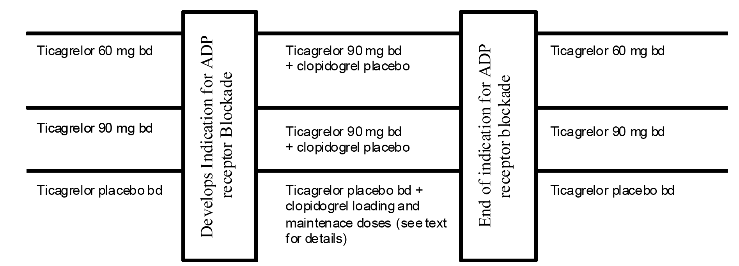
In addition to double-blind treatment with an ADP receptor blocker, investigators also had the option to treat open-label with these agents. In these cases the patient temporarily stopped the study drug for the duration of open-label treatment with the ADP receptor blocker. When there was no longer an indication for open-label ADP receptor blockade, patients returned to randomised treatment. Patients were to continue taking ASA throughout the open-label or double-blind ADP receptor blockade modified dosing regimen.
Appropriate procedures were in place for follow-up patients who permanently discontinued the study drug. At the EOT visit, ongoing antiplatelet treatment was determined by the patient's treating physician.

Pre-study and concomitant medications
In general, the protocol allowed concomitant use of commonly used treatments in patients with ACS events, unless there was a known interaction or specific reason for restriction. If treatment with restricted medications was required, investigators were advised to temporarily stop treatment with the study drug until the restricted medication was no longer required. Other medication considered necessary for the patient’s safety and well-being could be given at the discretion of the investigator.
GPIIb/IIIa receptor antagonists were allowed during the study. Concomitant treatment with oral anticoagulant drugs was not permitted. Short-term treatment with approved parenteral anticoagulants ([for example, unfractionated heparin (UFH), low-molecular-weight heparin (LMWH), bivalirudin, fondaparinux]) was allowed. However, concomitant long-term out-patient treatment with LMWH at doses required for the treatment of venous thrombosis was not allowed. Concomitant treatment with venous thrombosis prophylaxis doses was allowed. Concomitant treatment with NSAIDs was allowed. If fibrinolytic therapy was required the study drug was to be stopped, but could be restarted no earlier than 24 hours after completion of fibrinolytic therapy and when the risk of bleeding was deemed to be low. Specific instructions were provided relating to concomitant use with digoxin (a P-gp substrate); CYP3A4 substrates, inhibitors and inducers; and CYP2C19 inhibitors.

Surgery and other invasive cardiovascular procedures
It was recommended that elective major surgery not be performed until more than 5 days after stopping the study drug in order to avoid excessive bleeding. It was also recommended that the study drug not be discontinued for significantly longer than 5 days so as to minimise the risk of atherothrombotic complications while off-treatment with the study drug. After surgery, study drugs were to be restarted when the investigator deemed the risk of bleeding to be low. For elective minor surgery or other invasive procedures, the study drug could be continued or interrupted temporarily at the discretion of the investigator.

Post study
Discontinuation of the study drug did not mean discontinuation of follow-up. Study assessments or telephone follow-up were to be continued in all cases. The study included appropriate criteria for temporary treatment discontinuation and permanent treatment discontinuation. Appropriate procedures were in place for follow-up of patients who permanently discontinued the study drug. At the EOT visit, ongoing antiplatelet treatment was determined by the patient's treating physician according to local medical practice.

Efficacy variables and outcomes

Primary efficacy variable
The primary efficacy variable was the time to first occurrence of any event after randomisation of the composite endpoint of cardiovascular death (CV death), myocardial infarction (MI) or stroke.
- CV deaths were deaths due to cardiovascular causes or for which there was no clearly documented non-cardiovascular cause, MIs were diagnosed based on the Universal MI definition applicable at the time of study initiation⁵ and stroke was defined as an acute episode of neurologic dysfunction attributed to a central nervous system vascular cause.
- CV death, MI, and stroke endpoints were adjudicated by the Clinical Endpoints Committee (CEC) established by the protocol. Both ischaemic and haemorrhagic strokes were included in the primary variable of stroke to avoid any potential issues of event misclassification. The CEC provided a centralised independent and blinded review and adjudication of suspected endpoint events based on endpoint packages described in the Endpoint Reporting Manual For Investigators. CEC members were non-AstraZeneca experts who were not otherwise involved in the study. Positively adjudicated events included deaths, cardiac ischaemic events (MI, urgent coronary revascularisation, unstable angina), and cerebrovascular events (stroke, TIA).
- Deaths were sub-classified by cardiovascular and non-cardiovascular primary cause. CV death included death due to cardiovascular causes and deaths for which there was no clearly documented non-cardiovascular cause (that is, presumed CV death). Additionally, deaths were sub-classified by CHD death or non-CHD death. CHD death included sudden cardiac death, death due to acute MI, and the subset of death due to other cardiovascular causes that were secondary to a coronary revascularisation procedure.
- Diagnosis of urgent coronary revascularisation required ischaemic chest pain (or equivalent) at rest ≥ 10 minutes in duration or repeated episodes at rest lasting ≥ 5 minutes considered to be myocardial ischemia upon final diagnosis and prompting hospitalisation and percutaneous coronary revascularisation within 7 days of the symptoms or surgical coronary revascularisation within 14 days of symptoms.
- Diagnosis of unstable angina required ischaemic chest pain (or equivalent) at rest ≥10 minutes in duration considered to be myocardial ischaemia upon final diagnosis and prompting hospitalisation within 24 hours of the most recent symptoms, and without elevation in cardiac biomarkers of necrosis, and the presence of objective evidence of ischaemia.
- TIA was defined as a transient episode of neurological dysfunction caused by focal brain, spinal cord, or retinal ischaemia, without acute infarction. Stent thrombosis was classified as per the Academic Research Consortium Definition.⁶
Comment: The use of the pre-specified composite primary efficacy endpoint is considered to be acceptable. Each of the endpoints contributing to the composite were pre-specified, clearly defined, able to be objectively determined and clinical meaningful. The TGA approved EU Guideline on the evaluation of medicinal products for cardiovascular disease prevention (EMEA/CHMP/EWP/311890/ 2007) specifically states that ‘composite outcomes, including fatal and non-fatal CVD events, in which multiple endpoints are combined, are frequently used as primary outcome measures in randomised trials to reflect a number of outcomes that are of clinical importance and to increase statistical efficiency when event rates are low.......Composite endpoints may be appropriate in trials of CV disease prevention when including hard clinical events (e.g. nonfatal myocardial infarction, stroke)’.

Secondary efficacy variables
- The first secondary efficacy variable was to time to occurrence of CV death after randomisation.
- The second secondary efficacy outcome was time to occurrence of all-cause mortality after randomisation.

Other efficacy variable
Other efficacy variables (and objectives) were also reported.

Randomisation and blinding methods
Randomisation (1:1:1) to one of the three treatment groups was managed via the central Interactive Voice Response System (IVRS) or Interactive Web Response System (IWRS). The first dose of study drug was to be taken as soon as possible at Visit 2. AstraZeneca Research and Development generated the randomisation codes using the AstraZeneca Global Randomisation computerised system and Worldwide Clinical Trials (WCT) loaded the codes into the IWRS database. A blocked randomisation schedule by site was produced for the study. Treatment allocation was double-blind, and appropriate procedures were specified for unblinding in the case of medical emergencies.

Analysis populations
- Full Analysis Set (FAS): All patients who were randomised to study drug were included in the FAS, irrespective of their protocol adherence and continued participation in the study. Patients were analysed according to their randomised study drug irrespective of whether the event occurred before or following discontinuation of study drug. All efficacy variables were analysed using the FAS and included events occurring on or prior to the CSED. The FAS analysis complies with the principles of an intention-to-treat (ITT) analysis.
- Safety Analysis Set: All patients who received at least 1 dose of randomised ticagrelor or placebo and for whom post-dose data are available were included in the safety population.
The number of patients in the analysis sets are summarised below in Table 6. The analysis sets were well balanced across the three treatment groups.

Table 6: PEGASUS - Analysis sets
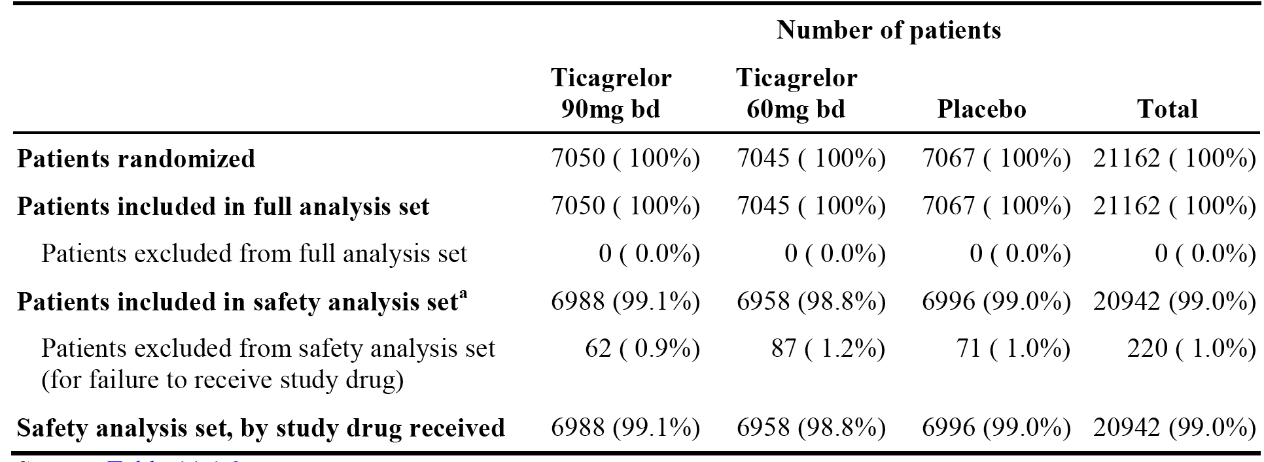
Safety analysis set: all patients who received at least 1 dose of randomised ticagrelor or placebo and for whom post-dose data are available.

Sample size
The expected primary composite efficacy event rate was 3.5% per 12 months. An analysis conducted in patients with prior MI in the CHARISMA study observed a 3.64% per 12 months event rate for the MI, vascular death, or stroke composite. The sponsor commented that ‘because of advances in current medical practice including the use of new drugs, the observed event rates of the composite of MI, stroke and cardiovascular death’ are viewed as being ‘an overestimate of the current rates on ASA’. The study also assumed a constant event rate.
The assumed target relative risk reduction (RRR) for ticagrelor was 20% (equivalent to a hazard ratio of 0.7971). In patients in CHARISMA with a prior MI, a RRR of 22.6% was observed with clopidogrel versus placebo on a background of ASA. The sponsor commented that PEGASUS included patients at higher risk of an atherothrombotic event than patients studied in CHARISMA. Using inhibition of platelet aggregation (IPA) data from the DISPERSE study and assuming that the log hazard ratio is proportional to the ratio of mean IPA for the 60 mg dose relative to the 90 mg dose, an estimated hazard ratio for ticagrelor 60 mg of 0.814 was obtained.
Under the above assumptions, with 24 months accrual period and a 14-month follow-up period, randomisation of 21,000 patients was expected to yield 1360 primary events (518, 425 and 417 in the placebo, 60 mg and 90 mg groups respectively). This provides 89.2% power (935 events) for 90 mg versus placebo and 82.5% power (943 events) for 60 mg versus placebo at 2.59% significance level (assuming 2 interim efficacy analyses by the IDMC). The sample size was based on 14 months minimum follow-up, but the study could have been stopped after 12 months of minimum follow-up if the targeted number of events had been reached.

Statistical methods

Primary efficacy variable
The primary efficacy variable was time to first occurrence of any event from the composite of CV death, MI or stroke. When the first event was MI or stroke, the time of the composite endpoint was the time of the MI or stroke, irrespective of whether or not the patient died as a sequel to the event. Consequently, the sponsor states that the qualifier ‘non-fatal’ used for MI and stroke for the composite objectives in the protocol can be ignored. The qualifier ‘non-fatal’ was used to clarify that fatal MI and fatal strokes would not be counted twice in counting the composite endpoint (for example, as an MI and as a CV death).
The primary analysis compared the time from randomisation to the first occurrence of any event in the composite endpoint using the Cox proportional hazards model with a factor for treatment group. The null hypothesis was that the hazard ratio (ticagrelor divided by placebo) was equal to 1, and the alternate hypothesis was that the hazard ratio (ticagrelor divided by placebo) was greater or less than 1. Each ticagrelor dose was tested separately versus placebo, with p-values and CIs for the HR being based on the Wald statistic, and Kaplan-Meier (KM) estimates of the cumulative percentage of patients with an event per treatment group calculated at 36 months. No multiplicity adjustment was made to CIs as they were interpreted descriptively and used as a measure of precision. All p-values were unadjusted.
The primary analysis of the composite endpoint was conducted on the FAS. The contribution of each component of the primary composite efficacy endpoint to the overall treatment effect was also examined for each dose. Patients who failed to record a primary composite efficacy endpoint event were censored at the time of the CSED (defined as study closure in the protocol), or death from non-cardiovascular causes, or at the time-point after which the occurrence of all components of the primary endpoint could not be assessed.
To assess possible effects of informative censoring, sensitivity analyses of the primary efficacy endpoint were conducted. Patients in either treatment group who were censored prior to CSED for incomplete follow-up (withdrawal of consent or incomplete event assessment) were summarised for missing follow-up time up to CSED per randomised treatment group. Sensitivity analysis of the primary composite endpoint also included analysis with: (1) censoring at the earlier of last in-person visit or CSED for event free patients with modified follow-up after permanent premature discontinuation of study drug; (2) censoring at time of first dose of modified study treatment for patients who developed an indication for ADP receptor blockade treatment; and (3) CV death replaced with all-cause mortality, including vital status information from patients who had withdrawn consent.
To evaluate consistency across relevant pre-defined subgroups, descriptive analyses of the primary efficacy variable were performed for the comparisons of 90 mg versus placebo and 60 mg versus placebo. A test of interaction between randomised treatment group and each subgroup variable was performed in each Cox model. The p-values were unadjusted for multiple comparisons and were regarded as descriptive.

Secondary efficacy variables
The statistical analysis of the primary composite efficacy endpoint was repeated for the secondary efficacy variables of time to occurrence of CV death after randomisation and time to occurrence of all-cause mortality after randomisation.

Other efficacy variables
Other efficacy variables were analysed in a similar manner to the primary and secondary efficacy variables.

Interim analyses
The IDMC performed interim analyses of unblinded data. A pre-planned interim analysis of efficacy was to be conducted when approximately 50% of the total planned number of events for the primary endpoint had occurred, with the possibility of further interim analyses as considered necessary by the IDMC. For each interim analysis, each of the ticagrelor 90 mg and 60 mg doses was to be compared separately versus placebo. A 1-sided significance level of 0.001 was to be applied to each ticagrelor dose-placebo comparison at each interim efficacy analysis. The Haybittle-Peto alpha spending function governed interim and final statistical testing to ensure an overall Type I error of 5%. Only one interim analysis was conducted (with 46% of the final number of events).

Confirmatory hierarchical analysis
The primary efficacy composite end-point (CV death, MI, and stroke) and the two secondary efficacy endpoints (CV death and all-cause mortality) were included in a confirmatory hierarchical testing sequence to control for type I error. The confirmatory hierarchal testing procedure is outlined below in Figure 9.
The significance level for the primary analysis of the composite endpoint at the final analysis was α = 0.02598 for each of the pairwise comparisons (that is, ticagrelor 90 mg BD versus placebo and ticagrelor 60 mg BD versus placebo). A Dunnett approach was used to adjust for the two placebo versus ticagrelor pairwise comparisons, and the Haybittle-Peto alpha-spending approach was used to account for repeated testing at the interim analysis and the final analysis.
For the 2 secondary endpoints, if tests of both doses were significant for the endpoint at the previous level in the hierarchy (that is, primary composite endpoint) then both doses would be tested for CV death at a significance level of α = 0.02478. If only one of the tests was significant for the previous endpoint (that is, primary composite endpoint) then this dose would be tested for CV death at a significance level of α = 0.02106. Similarly, only if CV death was confirmatory significant for a given dose would all-cause mortality be formally tested for that dose in the confirmatory hierarchal testing sequence. If tests of both doses were significant for CV death then all-cause mortality would be tested at a significance level of α = 0.02478. If CV death was significant for only one of the doses, then all-cause mortality would be tested for that dose at a significance level of α = 0.02106.
Figure 9: PEGASUS Confirmatory analysis multiple testing procedure
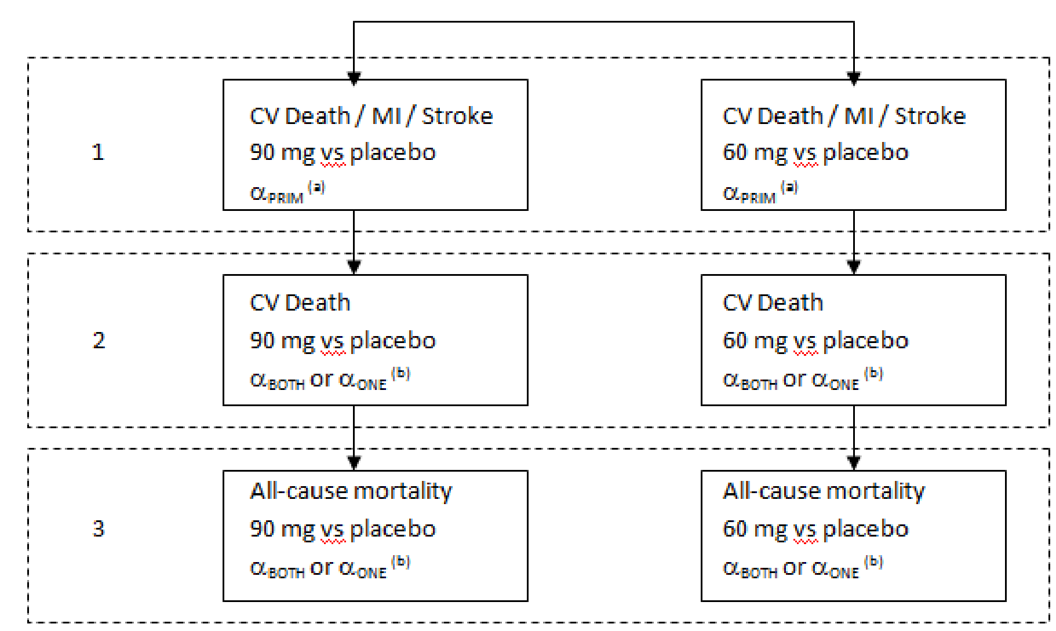
(a) The significance level for the primary analysis at the final analysis αPRIM =0.02598 was determined based on the proportion of events and the interim analysis using the Haybittle-Peto approach.
(b) If tests of both doses are significant for the endpoint at the previous level in the hierarchy, then both doses would be tested at significance level αBOTH =0.02478. If only one of the tests is significant for the previous endpoint, this dose will be tested at significance level αONE =0.02106 determined based on the proportion of events at the interim analysis.

Participant flow

1. Patient disposition
- In total, 21326 patients were enrolled from 1164 study sites in 31 countries. The first patient was enrolled on 29 October 2010, the common study end date (CSED) was 14 September 2014, and the last visit of the last patient took place on 3 December 2014.
- Of the 21326 enrolled patients, 21162 (99.2%) were randomised and 164 (0.8%) were not randomised (due to incorrect enrolment or patient decision to withdraw consent). Of the 21162 randomised patients, 7050, 7045, and 7067 patients were randomised to ticagrelor 90 mg BD, ticagrelor 60 mg BD, and placebo bd, respectively. Of the randomised patients, 154 (0.7%) prematurely withdrew from the study, and the proportion of patients who prematurely withdrew from the study was similar across the treatment groups.
- Of the 21162 randomised patients, 20998 (99.3%) completed the study and the proportions of patients who completed the study were similar across the three treatment groups. Randomised patients were considered to have completed the study unless they withdrew consent (n=154) or were lost to follow-up (n=10). Of the 154 patients who withdrew consent, 13 had unknown vital status at the end of the study, resulting in a total of 23 (0.1%) patients having unknown vital status at the end of the study. Death was an endpoint in the study and patients who died were considered to have completed the study. In the full analysis set, there were 336, 299, and 336 deaths in the ticagrelor 90 mg, ticagrelor 60 mg and placebo groups, respectively.
- Nearly all (98.7% to 98.8%) randomised patients in each of the three treatment groups had complete follow-up of all primary efficacy events (that is, until death or CSED). Complete follow-up was defined as receipt of eCRF responses regarding assessment of cardiac ischaemia or cerebrovascular events. The time under observation calculated from randomisation until the earliest of death, last visit or withdrawal of consent for patients in the FAS was similar for the three treatment groups.

Major protocol violations/deviations
Overall, 11.5% of the total patient population had at least 1 major protocol deviation, with similar incidences in each of the 3 treatment groups (see Table 7, below). As the efficacy analyses are based on the FAS, protocol deviations do not imply exclusion from analysis. All important protocol deviations were reviewed and agreed on before database lock.

Table 7: PEGASUS Important protocol deviations; FAS
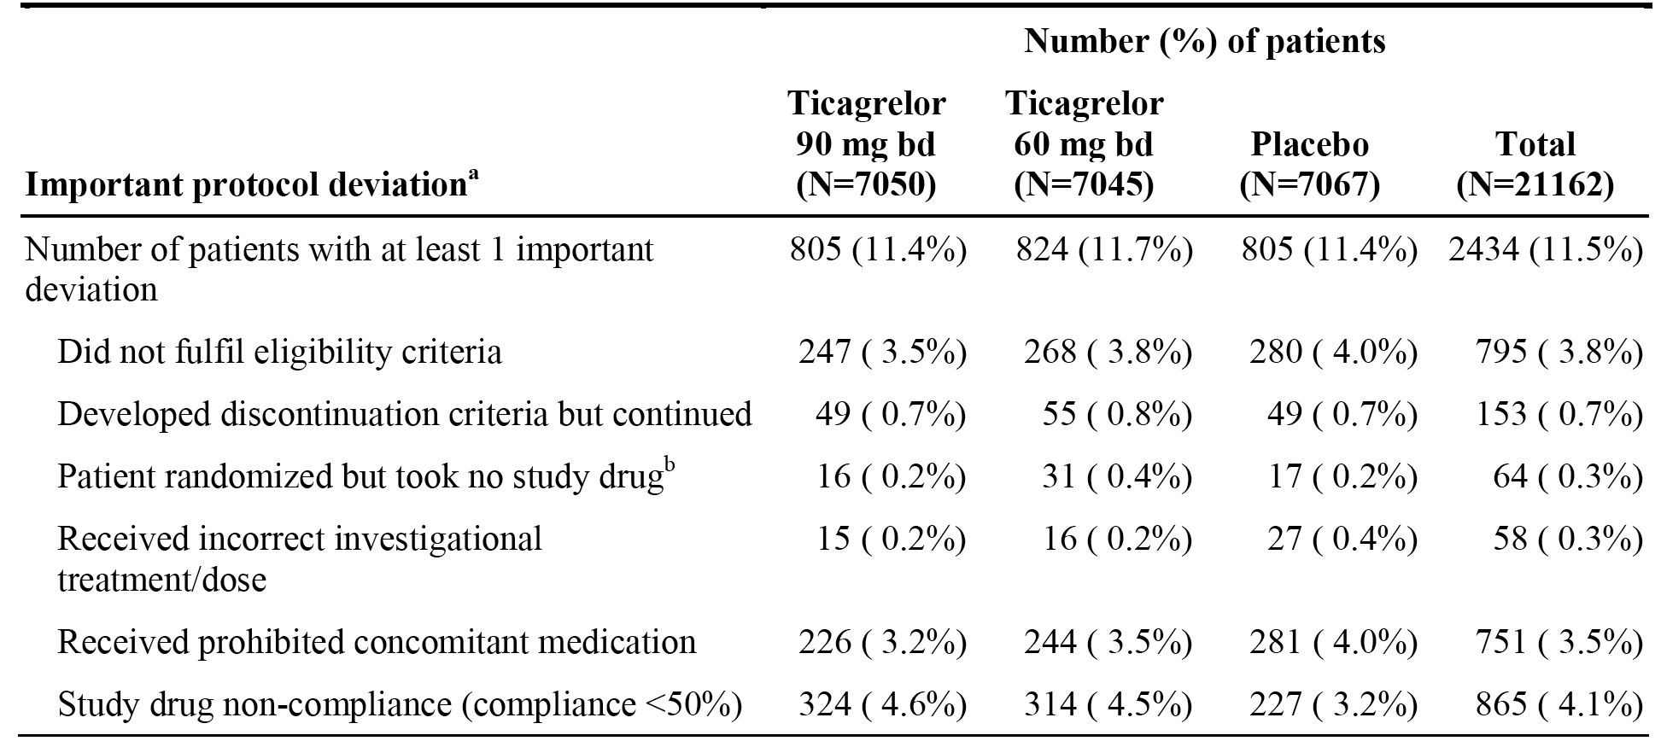
Note that the same patient may have had more than 1 important protocol deviation. Percentages are based on N (total number of patients in the treatment group). a. Important deviations before the start of treatment and during treatment. Protocol deviations include investigator assessment and criteria evaluated programmatically. b. Excludes patient decision and safety reasons.
Comment: The three treatment groups were similar with respect to both incidence and type of the important protocol deviations. Overall, it is considered that the major protocol deviations are unlikely to have compromised the efficacy analysis.

Baseline data

1. Baseline demographic characteristics (FAS)
The baseline demographic characteristics of the study population were similar for the three treatment groups. The mean age of the total population was 65.3 years (range: 47, 95 years), with 45.5% of the total population being aged < 65 years, 42.4% aged 65 to 75 years and 12.1% aged ≥ 75 years. The majority of the total patient population were male (76.1% versus female 23.9%). The majority of the total population were Caucasian (86.8%), with most of the remaining patients being Asian (10.8%). The mean weight of the total population was 82.0 kg (range: 30, 200 kg), with 50.3% of the total population being 70 to 90 kg, 22.6% < 70 kg and 27.1% > 90 kg. The mean BMI of the total population was 28.5 kg/m² (range: 11.9, 95.6 kg/m²), with 67.5% of the total population being < 30 kg/m² and 32.5% being ≥ 30 kg/m². Of the total population, 35.0% had never smoked, 48.3% were former smokers and 16.7% were current smokers. The majority of the patients in the total population were from Europe and South Africa (58.7%), 18.5% from North America, 11.6% from South America and 11.2% from Asia and Australia.

2. Qualifying event and risk factors (FAS)
The targeted population were patients with a documented history of presumed spontaneous MI, with the most recent MI occurring 1 to 3 years prior to randomisation, and at least 1 additional risk factor and currently being treated with ASA. The qualifying event and risk factors at enrollment were similar for the three treatment groups. In the total population, the qualifying MI was STEMI in 53.5% of patients, NSTEMI in 40.6% and unknown in 5.8%. In the total population, the mean time from qualifying MI to randomisation was 21.8 months (range: 0.7, 146 months), and for the majority of patients (60.7%) the time from qualifying MI to randomisation was ≥ 1 to < 2 years. There were 26 (0.1%) patients with no prior MI. As regards additional pre-defined atherothrombotic risk factors at enrollment, 54.4% of patients in the total population were aged ≥ 65 years, 28.5% had diabetes mellitus requiring medication, 16.5% had a history of a second prior presumed spontaneous MI (≥ 1 year prior to randomisation), 59.3% had a history of angiographic evidence of multi-vessel CAD, and 5.9% had chronic non-end stage renal dysfunction (as reported by the investigator). In the total population, 0.6% of patients had no qualifying risk factors, 51.6% had 1 risk factor, 33.2% had 2 risk factors, and 14.6% had ≥ 3 risk factors.

3. Specific relevant medical and surgical history (FAS)
Specific relevant medical history was well balanced across the three treatment groups. In the total population, 29.5% of patients had a family history of premature CHD, 31.0% had a history of angina pectoris, 20.0% had a history of congestive heart failure, 1.5% had a permanent pacemaker for bradycardia, 4.1% had a history of atrial fibrillation/flutter, 76.7% had hypercholesterolaemia requiring medical therapy, 77.5% had hypertension requiring medical therapy, 0.5% had a history of stroke, and 1.2% had a history of TIA. The risks of other medical conditions were similar in the three treatment groups, including patients with a history of asthma and COPD.
The specific relevant history of intervention and surgery was summarised: In the total patient population, 83.0% of the patients had a history of PCI, and 79.8% had a history of coronary stent implantation. Regarding stent type, 42.1% of patients had received a bare metal stent, and 39.2% had received a drug-eluting stent. Few patients (4.6%) had a medical history of coronary artery bypass graft (CABG), as those with CABG in the 5 years prior to enrolment were excluded from the study (unless the patient had experienced a subsequent spontaneous MI). Cerebrovascular revascularisation was reported in 0.4% of patients.

Concomitant anti-thrombotic treatment

1. Anti-thrombotic treatment within 7 days prior to or at randomisation
In accordance with the study inclusion criteria, 21112 (99.8%) patients were taking ASA at randomisation and 20386 (96.3%) were already on the protocol-mandated dose of 75 mg to 150 mg daily. The most commonly used ADP receptor blocker was clopidogrel (24.0% of patients). The pattern of antithrombotic use within 7 days prior to randomisation or at randomisation was similar in each of the three treatment arms. Selected antithrombotic treatment within 7 days prior to randomisation or at randomisation was reported.

2. Previous treatment with an ADP blocker at any time prior to randomisation
Most patients in the total population (89.1%) had received previous treatment with an ADP receptor blocker most commonly clopidogrel (83.7%), followed by prasugrel (4.4%), ticlopidine (0.5%), and ticagrelor (0.4%). For 25.8% of patients, their last dose of ADP receptor blocker was within 7 days before randomisation, while for 23.5% of patients, their last dose of an ADP receptor blocker was more than 12 months before randomisation. The main reason for patients stopping treatment with an ADP blocker was recommendation from treating physician (83.6% of patients). The randomised treatment groups were well balanced with regard to both type of prior ADP receptor blocker received, time from last dose of ADP receptor blocker to randomisation, and reason for stopping treatment with ADP receptor blocker. Previous treatment with ADP receptor blocker any time prior to randomisation was reported.

3. Concomitant anti-thrombotic therapy post-randomisation
In accordance with the protocol, almost all patients took ASA during the study (9 patients did not take ASA), with doses of 75-81 mg and 100 mg dominating (48.9% and 48.3%, respectively), with few patients taking more than 100 mg ASA or less than 75 mg (2.7% and < 0.1%, respectively). Clopidogrel (not part of the specified modified treatment regimen) was taken by 13.3% of patients, and ticagrelor (not part of the study drug regimen) was taken by 1.3% of patients. Heparin group products were taken by 10.9% of patients. Anti-thrombotic medications taken post-randomisation were reported.

Concomitant medication other than anti-thrombotic treatment

1. Medication other than anti-thrombotic treatment prior to or at randomisation
Medications other than anti-thrombotic treatment prior to or at randomisation were being taken by 99.6% of patients in the total population, with 94.2% taking lipid lowering agents, 82.9% beta-blockers, and 58.3% angiotensin converting enzyme (ACE) inhibitors. The pattern of medication use was similar for each of the three treatment groups. Selected medications within 7 days prior to, or at randomisation, excluding antithrombotic medication, were reported.

2. Concomitant medication other than anti-thrombotic treatment post-randomisation
The majority of patients (93.6%) were taking HMG CoA reductase inhibitors post-randomisation, followed by selective beta-blockers (71.7%) and plain ACE inhibitors (59.3%). The pattern of medication use was similar for each of the three treatment groups.

Prohibited concomitant medication
Overall, 10.4% of patients in the total population received prohibited concomitant medications, with the most commonly used being platelet aggregation inhibitors (excluding heparin) reported in 8.6% of patients. The most commonly used anti-platelet inhibitor was clopidogrel (7.4% of patients). No other prohibited concomitant medication was taken by more than 1.0% of patients. The median use of prohibited concomitant platelet inhibitors, including clopidogrel, was 13 days. Prohibited concomitant medication use was balanced between the three treatment groups.

Treatment compliance
Treatment compliance derived from pill counts was reported. The median percentage of patients was similar for the three treatment groups (96% to 97%), and the percentage of patients with > 80% compliance was 82.8%, 83.5% and 86.4% in the ticagrelor 90 mg BD, ticagrelor 60 mg BD, and placebo groups, respectively.

Results for the primary efficacy variable
The results for the primary composite efficacy endpoint analysis are summarised below in Table 8, and the KM plots are presented below in Figure 10.

Table 8: PEGASUS - Analysis of the primary efficacy endpoint; FAS
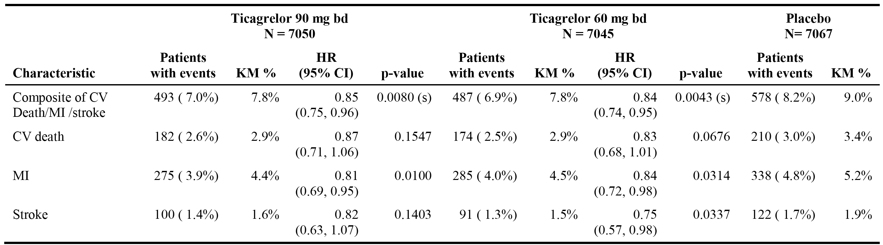
Hazard ratio and p-values are calculated separately for each ticagrelor dose versus placebo from Cox proportional hazards model with treatment group as the only explanatory variable. Kaplan-Meier percentage calculated at 36 months. Note: the number of first events for the components CV Death, MI and Stroke are the actual number of first events for each component and do not add up to the number of events in the composite endpoint.
Figure 10: PEGASUS - Kaplan-Meier plots of the primary efficacy endpoint; FAS
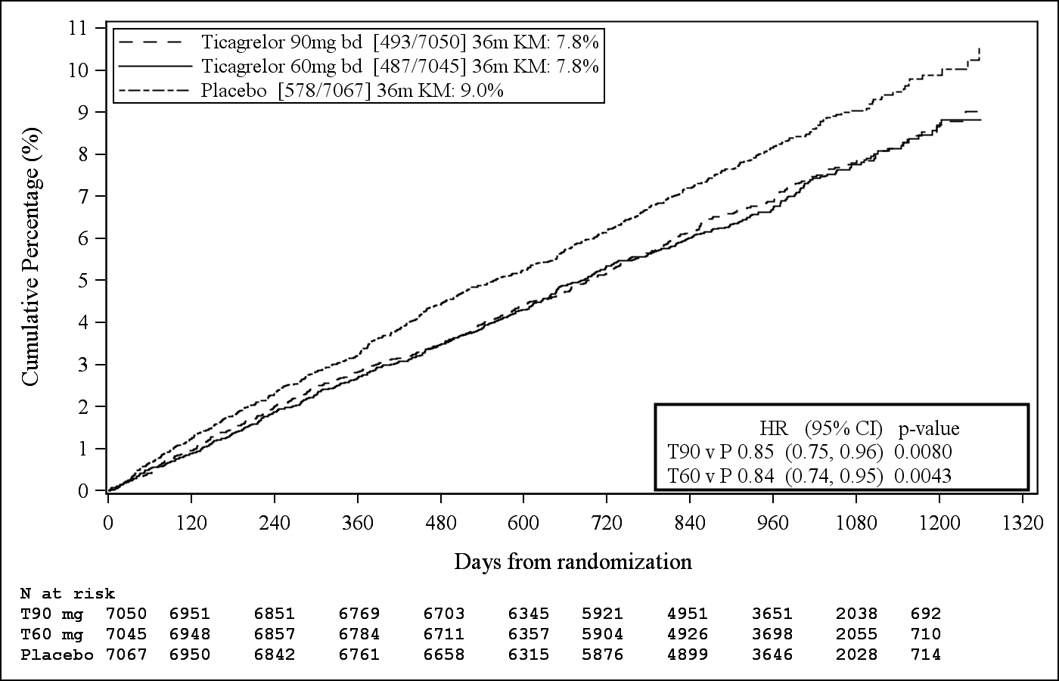
The results of the sensitivity analyses were consistent with the results of the primary analysis. The three summarised sensitivity analyses were: (1) CV death replaced by all-cause mortality using vital status information in patients who withdrew consent; (2) composite of CV death/MI/stroke, with event free patients censored at the earlier of last in-person visit and study closure; and (3) composite of CV death/MI/stroke at first dose of modified study treatment. The results for the subgroup analyses of the primary composite efficacy endpoint were consistent with the primary analysis for both pairwise comparisons between ticagrelor and placebo.
Comment: Primary composite endpoint events at CSED were reported for 493, 487 and 578 patients on ticagrelor 90 mg BD, ticagrelor 60 mg BD, and placebo, respectively, corresponding to KM percentages at 36 months of 7.8%, 7.8%, and 9.0%. The HR for ticagrelor 90 mg relative to placebo was 0.85 (95% CI: 0.75, 0.96), p=0.0080, and the HR for ticagrelor 60 mg relative to placebo was 0.84 (95% CI: 0.74. 0.95), p=0.0043. The p-values for each or the two comparisons between placebo and ticagrelor were significant as they were less than the pre-specified p-value of 0.02598. The results for the primary composite endpoint were similar for both ticagrelor versus placebo pairwise comparisons, suggesting no dose-response relationship for the two doses of ticagrelor (90 mg BD versus 60 mg bd). The KM plots for the primary composite endpoint for the two ticagrelor doses were virtually superimposable, and the two ticagrelor plots began to favourably separate from placebo shortly after randomisation.
The majority of first events in each of the three treatment groups were MIs, followed by CV deaths and stroke. Most of the reported MIs in each of the three treatment groups were categorised as spontaneous (Type 1). No particular pattern was observed in the adjudicated CV and non-CV deaths. The majority of first event strokes in the three treatment groups (80% to 90%) were ischaemic strokes.

First and second secondary endpoints
The first secondary efficacy endpoint was time from randomisation to first occurrence 0f CV death, and the second secondary efficacy endpoint was time from randomisation to first occurrence of all-cause mortality. The confirmatory hierarchical analysis of the primary and secondary efficacy is summarised below in Table 9. The significance level for each pairwise comparison for the primary composite endpoint was 0.02598. Therefore, the first secondary endpoint of CV death was tested at the significance level of 0.02478, and both pairwise comparisons were not significant at this level. Consequently, hierarchical testing was stopped and the second secondary endpoint of all-cause mortality was not formally tested.

Table 9: PEGASUS - Confirmatory hierarchical analysis of primary and secondary efficacy endpoints
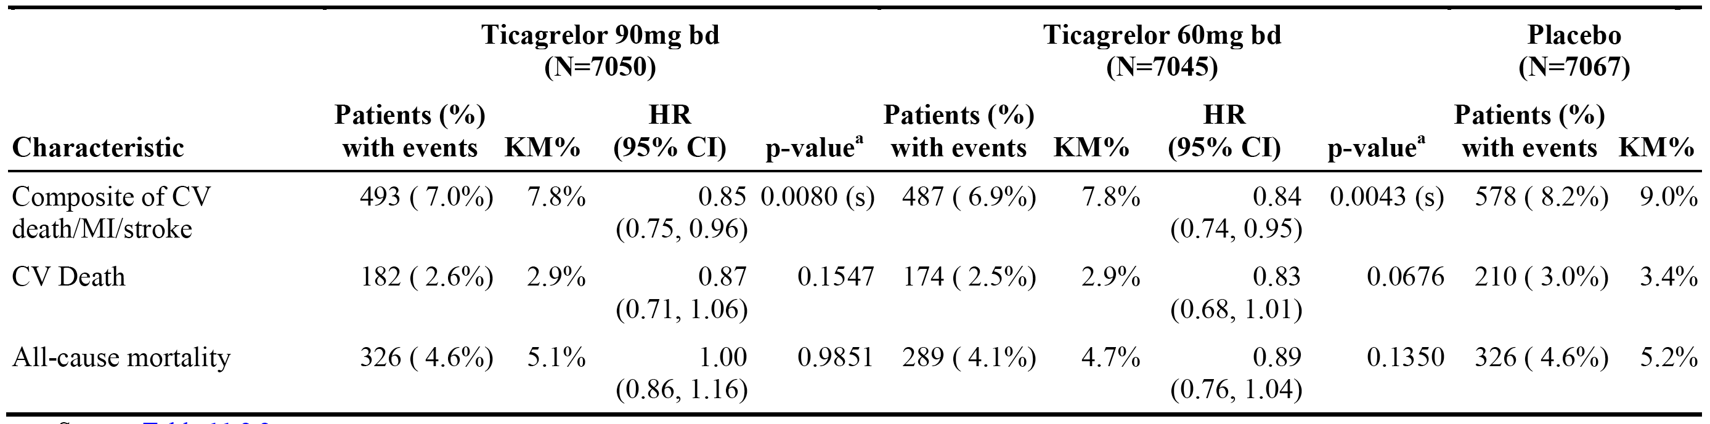
Hazard ratio and p-values are calculated separately for each ticagrelor dose versus placebo from Cox proportional hazards model with treatment group as the only explanatory variable. Kaplan-Meier percentage calculated at 36 months. (s) Indicates statistical significance.
Comment: Neither the first nor the second secondary efficacy endpoints for both dose versus placebo comparisons were statistically significant when tested using the hierarchical confirmatory analysis procedure. Therefore, there is no confirmatory evidence that either of the two ticagrelor doses confer a survival benefit on patients treated with the drug in combination with ASA compared to ASA alone.

Exploratory analysis of the primary and secondary efficacy analyses
- CV death replaced by all-cause mortality in the primary composite endpoint: Ticagrelor demonstrated numerical reductions in the event rate of all-cause mortality, MI, and stroke versus placebo for both doses (see Table 10, below).

Table 10: PEGASUS Composite of all-cause mortality, MI and stroke; FAS
 | Ticagrelor 90 mg BD (n=7050) | Ticagrelor 60 mg (n=7045) | Placebo (n=7067)
Patients with events | 623 (8.8%) | 580 (8.2%) | 673 (9.5%)
KM% at 36 months | 9.9% | 9.3% | 10.4%
Hazard Ratio (95% CI); p-value * | 0.92 (0.83, 1.03); p=0.1441 | 0.86 (0.77, 0.96); p=0.0068
* P-value is nominal.
- ‘On-treatment’ analysis of the primary composite endpoint: The exploratory analysis of the primary composite endpoint, limited to the period when patients were on study drug, demonstrated a greater reduction in the number of events in the ticagrelor groups than in the primary ITT analysis (see Table 11, below).

Table 11: PEGASUS Analysis of primary composite endpoint on-treatment; FAS
 | Ticagrelor 90 mg BD (n=6988) | Ticagrelor 60 mg (n=6959) | Placebo (n=6996)
Patients with events | 322 (4.6%) | 337 (4.8%) | 475 (6.6%)
KM% at 36 months | 6.6% | 6.8% | 8.4%
Hazard Ratio (95% CI); p-value * | 0.79 (0.68, 0.91); p=0.0009 | 0.78 (0.68, 0.90); p=0.0006
* P-value is nominal.
- Treatment compliance analysis of the primary composite endpoint: The ‘on-treatment’ exploratory analysis of the primary composite endpoint by study drug compliance assessed the outcome based on an upper tertile of ≥ 98.6% compliance, a middle tertile of ≥ 92.1% to < 98.6% compliance, and a lower tertile of < 92.1% compliance. The reduction in the number of primary endpoint events on ticagrelor was greater in the upper and middle tertiles than in the lower tertile: 34%, 32%, and 9% RRR, respectively, for 90 mg and 31%, 32%, and 10% RRR, respectively, for 60 mg.
- Both ticagrelor doses combined versus placebo: The KM estimate at 36 months for the composite endpoint of CV death/MI/stroke was 7.8% in the combined ticagrelor group (980 [7.0%] events) and 9.0% in the placebo group (578 [8.2%] events): HR = 0.84 (95% CI: 0.76, 0.94), p=0.0012. P-value is nominal.
- Sub-group analysis of the primary composite endpoint: The treatment effect of favourable KM estimates (%) at 36 months for the composite endpoint in the two ticagrelor treatment groups compared to placebo was consistently seen across most pre-defined patient subgroups.
- Primary endpoint events after CSED: Primary endpoint events during the follow-up period after the last dose of study drug for those patients who were on study drug at CSED were reported for 14, 17, and 10 patients in the ticagrelor 90 mg, ticagrelor 60 mg and placebo treatment groups, respectively. It is considered that the number of patients is too small to allow meaningful clinical conclusions to be drawn.

Other exploratory efficacy variables
- There was a numerical reduction in the rate of time from randomisation to first occurrence of any composite event of CV death, MI, stroke or urgent coronary revascularisation for both ticagrelor 90 mg BD (563 [8.0%] events; KM at 36 months = 8.9%) and ticagrelor 60 mg BD (542 [7.7%] events; KM at 36 months = 8.5%) compared to placebo (644 events [9.1%]; KM at 36 months = 10.0%): HR = 0.87 (95% CI: 0.78, 0.98), p=0.0173 for 90 mg relative to placebo, and HR = 0.84 (95% CI: 0.75, 0.94), p=0.0024 for 60 mg relative to placebo.
- There was a numerical reduction in the rate of time from randomisation to first occurrence of any composite event of CV death, coronary or cerebrovascular arterial thrombosis hospitalisation (including MI or stroke, urgent coronary revascularisation, unstable angina or TIA) for both ticagrelor 90 mg BD (600 [8.5%]; KM at 36 months = 9.5%) and ticagrelor 60 mg BD (584 [8.3%]; KM at 36 months = 9.2%) compared to placebo (684 [9.7%] events; KM at 36 months = 10.6%): HR = 0.87 (95% CI: 0.78, 0.98), p=0.0166 for 90 mg relative to placebo, and HR = 0.85 (95% CI: 0.76, 0.95), p=0.0039 for 60 mg relative to placebo.
- There was a numerical reduction in the rate of time from randomisation to first occurrence of any composite event of coronary heart disease death, MI or stroke for both ticagrelor 90 mg BD (438 [6.2%] events; KM at 36 months = 7.0%) and ticagrelor 60 mg BD (445 [6.3%] events; KM at 36 months = 7.1%) compared to placebo (535 [7.6%] events; KM at 36 months = 8.3%): HR = 0.82 (95% CI: 0.72, 0.93), p=0.0016 for 90 mg relative to placebo, and HR = 0.83 (95% CI: 0.73, 0.94), p=0.0033 for 60 mg relative to placebo.

Evaluator's conclusion on clinical efficacy
- The study demonstrated that both doses of ticagrelor (90 mg BD and 60 mg BD), given in combination with low-dose ASA, reduced the risk of experiencing a primary composite efficacy endpoint event (CV death/MI/stroke) compared to low dose ASA alone in patients with a history of MI (1 to 3 years prior to randomisation) and at high-risk of an atherothrombotic event.
- Primary composite efficacy endpoint events (CSED) were reported for 493, 487, and 578 patients on ticagrelor 90 mg, ticagrelor 60 mg, and placebo, respectively, corresponding to KM percentages at 36 months of 7.8%, 7.8%, and 9.0%: RRR = 15%, HR = 0.85 (95% CI: 0.75, 0.96), p=0.0080 for ticagrelor 90 mg relative to placebo; and RRR = 16%, HR = 0.84 (95% CI 0.74, 0.95), p=0.0043 for ticagrelor 60 mg relative to placebo. The higher dose of ticagrelor provided no clinically meaningful increase in efficacy compared to the lower dose of ticagrelor, with the absolute risk reduction for both ticagrelor plus ASA dosage regimens relative to ASA being 1.2%.
- The KM plots for the primary composite endpoint for both ticagrelor doses separated from placebo shortly after randomisation, and continued to separate throughout the study. The superior treatment effect of both doses of ticagrelor compared to placebo was consistent throughout the study, with a median duration of 33 months to CSED (maximum duration of up to 47 months) for each of the three treatment groups. In an exploratory landmark analysis, the RRR was similar from 1 to 360 days for both ticagrelor 90 mg BD relative to placebo and ticagrelor 60 mg BD relative to placebo (13% and 17% respectively) and from 361 days and onwards (16% for both doses). The results indicate that there was no apparent diminution in effect of either ticagrelor dose relative to placebo through end of treatment.
- The KM percentages at 36 months numerically favoured ticagrelor (both doses) compared to placebo for each of the three individual components of the composite event. The nominally statistically significant individual events for the ticagrelor versus placebo pairwise comparisons were MI for both ticagrelor 90 mg BD and 60 mg BD dose groups and stroke for the ticagrelor 60 mg BD dose group.
- The confirmatory hierarchical analysis of the primary and secondary endpoints failed to show that the observed differences between both doses of ticagrelor (90 mg BD and 60 mg BD) and placebo for the first secondary efficacy endpoint of CV death. Consequently, formal statistical of the second efficacy endpoint of all-cause mortality did not proceed.
- There were a number of exploratory efficacy endpoints (including subgroup analyses) and these consistently showed a numerical advantage for both doses of ticagrelor compared to placebo.
- The HRs for the primary, secondary and other efficacy endpoints of interest are summarised in Figure 11.
Figure 11: PEGASUS - Hazard ratios and rates for primary, secondary, and other efficacy endpoints; FAS
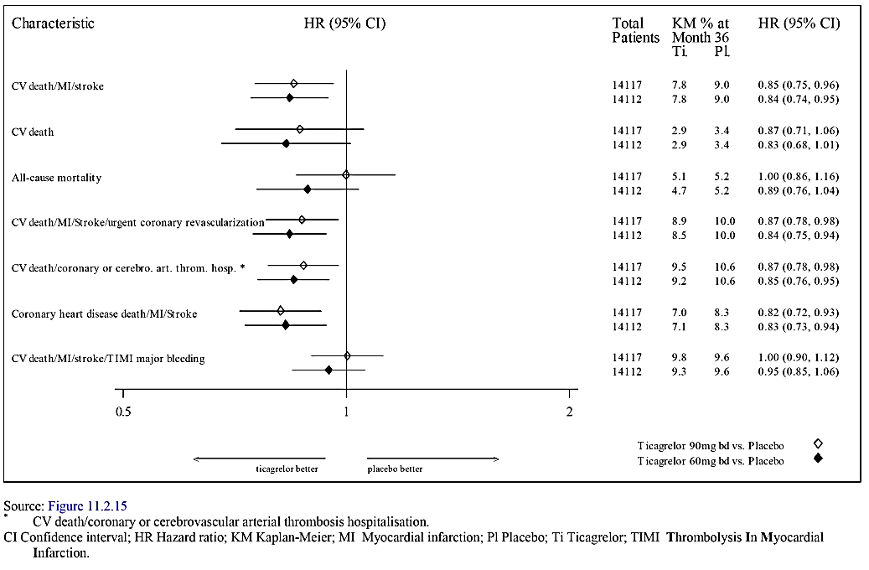

Clinical safety

Overview
The relevant safety data for the proposed ticagrelor dosing regimen for the proposed indication were provided by the pivotal Phase III study (PEGASUS). The safety objective of PEGASUS was to assess the safety and tolerability of long-term therapy with ticagrelor compared to placebo on a background of ASA in patients with history of MI and high risk of developing atherothrombotic events. The overall safety focus in the CSR was: (1) time to first TIMI Major bleeding event following the first dose of study drug, as well as time to first TIMI Major or Minor bleeding event and time to first PLATO Major bleeding event; (2) time to discontinuation of study drug due to any bleeding event; and (3) evaluation of AEs.
The PEGASUS safety analysis set was defined as all patients who received at least 1 dose of randomised ticagrelor or placebo and for whom post-dose safety data were available. The primary safety analysis was an on-treatment analysis where patients were censored 7 days after their last dose of study drug and grouped by actual treatment received. For bleeding events and AEs of special interest, KM time-to-event analyses were performed.
To counter potential bias caused by differences in treatment discontinuation, AEs were presented by event rate per 100 patient years, based on the total duration of treatment with study drug. The total duration of treatment for all patients was 13936 years, 14663 years, and 15939 years in the ticagrelor 90 mg, ticagrelor 60 mg, and placebo groups, respectively.
All bleeding events that the investigator considered necessitated reporting as an AE were reported on a bleed event form in the eCRF. Bleeding events initially classified as minimal (by an algorithm based on data on the bleed event form) underwent medical review by the CEC, and were either confirmed as minimal or submitted to adjudication if the event was considered to be possibly consistent with a higher category of bleeding. In addition, an event could be classed as a minimal bleed via the adjudication process. The CEC adjudicated all bleeding events, except events confirmed as minimal during the initial CEC medical review (that is, those events with no involvement of a critical area, no clinical signs and no medical evaluation or intervention). Relevant information was compiled into a ‘Bleeding Package’, as described in the Endpoint Reporting Manual for Investigators, and adjudicated by the CEC. The CEC adjudicated and evaluated non-minimal bleeding events according to TIMI, PLATO, Global Utilization of Streptokinase and Tissue Plasminogen Activator for Occluded Coronary Arteries Trial (GUSTO) and International Society on Thrombosis and Haemostasis (ISTH) definitions. The bleeding event definitions applied by the CEC are provided in Figure 12.
Figure 12: PEGASUS - Comparison of definitions between the TIMI, PLATO, GUSTO and ISTH bleeding severity classifications
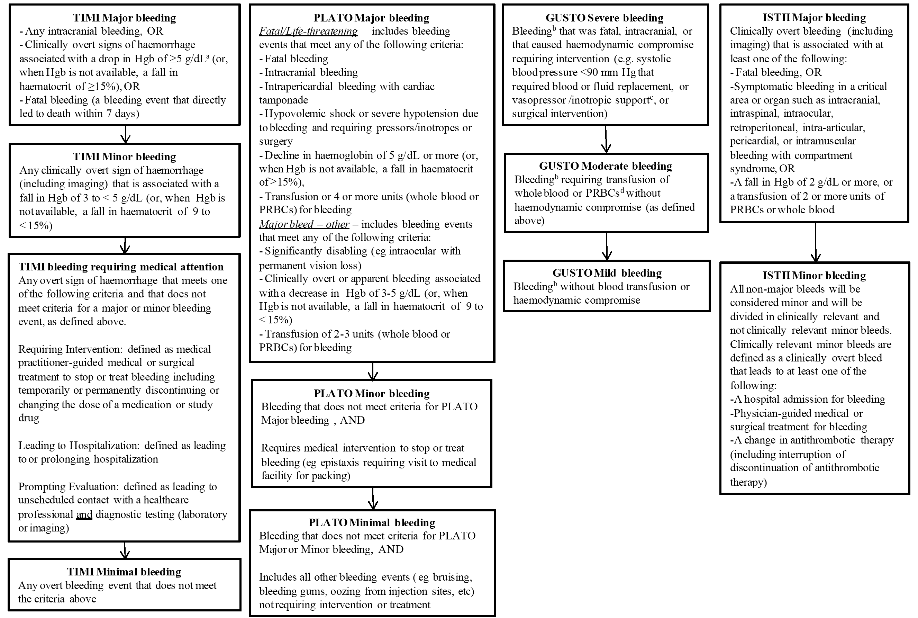
a. To account for transfusions, haemoglobin (Hgb) measurements were adjusted for any packed red blood cells (PRBCs) or whole blood given between baseline and post-transfusion measurements. A transfusion of 1 unit of blood was assumed to result in an increase by 1 g/dL in Hgb. Thus, to calculate the true change in Hgb, if there has been an intervening transfusion between 2 blood measurements, the following calculations was performed: Δ Hgb =[Baseline Hgb -Post transfusion Hgb]+[# transfused units]; Δ Haematocrit = [Baseline Hct – post transfusion Hct] + [number of transfused units x 3]. b. In all cases, bleeding must be clinically overt. c. Need for vasopressor/inotropic support for haemodynamic compromise, even if blood pressure is >90 mm Hg with treatment. d. Does not include cell-saver transfusion during CABG.
In PEGASUS, the safety analyses of bleeding events focused on the TIMI and PLATO bleeding scales. The sponsor stated that the TIMI scale is well known and has been applied in a number of ACS studies. The study drug was to be stopped immediately in case of a bleed deemed to be clinically significant in the judgment of the investigator (for example, a significant fall in haemoglobin, need for blood transfusion, haemodynamically significant, or in a critical location such as intracranial, intraspinal, intraocular, or pericardial). In the case of any intracranial bleeding the study drug was to be stopped permanently, while for other clinically significant bleeding events the study drug could be restarted when the investigator deemed the risk of bleeding to be low. The study drug did not need to be stopped in case of minor bleeding events. All bleeding events were to be treated and followed up according to local clinical practice.
All deaths and events adjudicated by the CEC as bleeding events were reported as AEs/SAEs. Non-fatal events adjudicated by the CEC to be efficacy events were not reported as AEs/SAEs unless they were also adjudicated as bleeding events. All events included in the efficacy analyses were adjudicated, including deaths that occurred after withdrawal of consent. Adjudication of these deaths was based on publicly available source data and the events were included in the all-cause mortality analyses.

Patient exposure
- A total of 20942 patients (99.0% of randomised patients) received at least 1 dose of randomised study drug, including 6988 patients in the ticagrelor 90 mg group, 6958 patients in the ticagrelor 60 mg group, and 6996 patients in the placebo group.
- For the ticagrelor 90 mg, ticagrelor 60 mg, and placebo groups, mean±SD total duration of exposure to study drug from first to last dose in months was 23.9±13.7 (range: 0.3, 48.0), 25.3±13.1 (range: 0.03, 47.4), and 27.3±11.6 (range: 0.03, 47.4), respectively, and median total duration of exposure was 28.3, 29.4, and 30.4 months, respectively. Total treatment years were 13936, 14663, and 15939, respectively.
- For the ticagrelor 90 mg, ticagrelor 60 mg, and placebo groups, mean±SD actual duration of exposure to study drug, defined as total exposure excluding prescribed temporary interruptions, in months was 23.5±13.6 (range: 0.3, 47.9), 24.9±13.1 (0.03, 47.4), and 27.0±11.6 (range: 0.03, 47.4), respectively, and median total duration of exposure was 27.8, 28.9, and 30.1 months, respectively. Total actual treatment years were 13710, 14440, and 15766, respectively.
- The percentage of patients still on treatment over time is presented in Figure 13. The total exposure time for patients in the ticagrelor groups was shorter than in the placebo group due to the higher rates of discontinuation in the two ticagrelor groups. Cumulative exposure to the study drug is summarised below in Table 12.
Figure 13: PEGASUS - Percentage of patient still on treatment over time; safety analysis
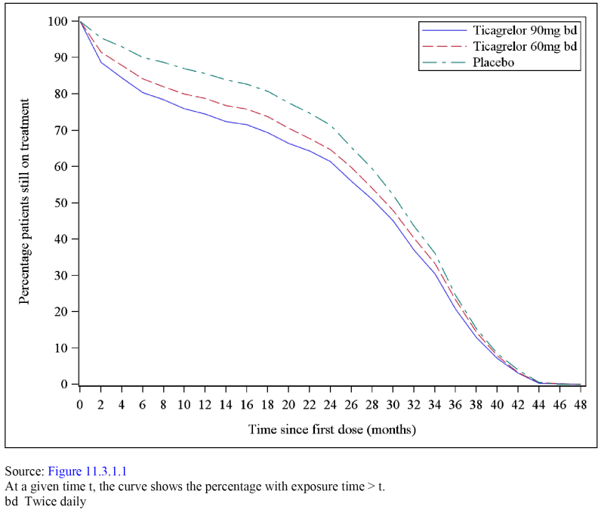

Table 12: PEGASUS - Cumulative exposure over time; safety analysis set
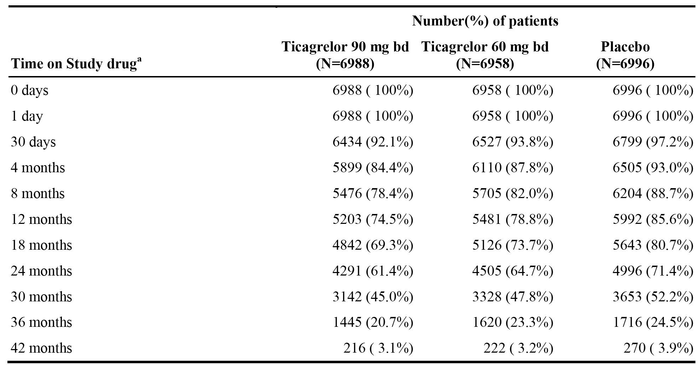
a. Number of patients on treatment at the start of the interval.

Overview of adverse events (AEs)

AEs (including bleeding events)
AEs were classified using Medical Dictionary for Regulatory Activities (MedDRA) (version 17.0) preferred term (PT) and system organ class (SOC). Each AE was assigned to the following periods: (1) baseline period, the time before first administration of study drug; (2) on-treatment, the time from first administration of study drug until 7 days after last dose of study drug (that is, after permanent discontinuation), temporary stops in study drug of ≤ 7 days were considered as ‘on-treatment’; and (3) off-treatment, more than 7 days after the last dose of the study drug.
AEs (including bleeding events) in any category reported on-treatment are summarised below in Table 13. Event rates/100 patient years for any AE (including bleeding events) were 38.2, 36.0, and 30.4 for ticagrelor 90 mg, ticagrelor 60 mg, and placebo, respectively. Event rates/100 patient years for any SAEs (including bleeding events) were 10.9, 10.2, and 9.5 for ticagrelor 90 mg, ticagrelor 60 mg, and placebo, respectively.

Table 13: AEs (including bleeding) in any category on-treatment; safety analysis set
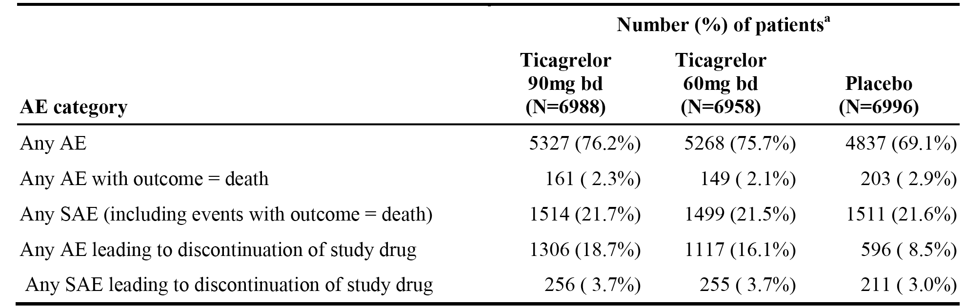
Patients with multiple events in the same category are counted only once in that category. Patients with events in more than 1 category are counted once in each of those categories.

AEs (excluding bleeding events)
AEs (excluding bleeding events) in any category reported on on-treatment are summarised below in Table 14. Event rates/100 patient years for AEs (excluding bleeding events) were 35.0, 33.4, and 30.0 for ticagrelor 90 mg, ticagrelor 60 mg, and placebo, respectively. Event rates/100 patient years for SAEs (excluding bleeding events) were 9.48, 9.08, and 8.88 for ticagrelor 90 mg, ticagrelor 60 mg, and placebo, respectively.

Table 14: AEs (excluding bleeding events) in any category on-treatment; safety analysis set
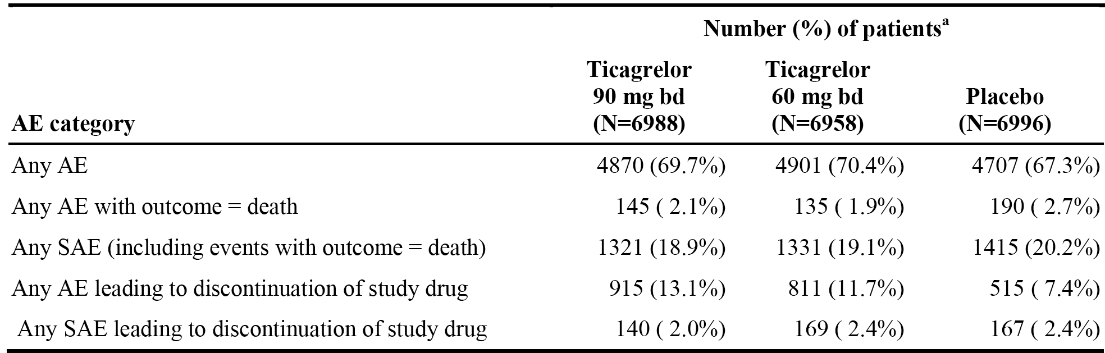
- Patients with multiple events in the same category are counted only once in that category. Patients with events in more than 1 category are counted once in each of those categories.

Commonly reported adverse events (including bleeding events)

Adverse events by system, organ, class (SOC)
The most commonly reported AEs (including bleeding events) by SOC occurring with a frequency of ≥ 2% of patients in the ticagrelor 90 mg group were summarised. AEs (including bleeding events) by SOC reported in ≥ 20% of patients in at least one of the three treatment groups were:
- Respiratory, thoracic, and mediastinal disorders (events/100 patient years (% of patients)): 14.11 (28.1%) versus 11.85 (25.0%) versus 6.13 (14.0%) for ticagrelor 90 mg, ticagrelor 60 mg and placebo, respectively.
- Infections and infestations (events/100 patient years (% of patients)): 11.26 (22.5%) versus 10.63 (22.4%) versus 10.08 (23.0%) for ticagrelor 90 mg, ticagrelor 60 mg and placebo, respectively.
- Gastrointestinal disorders (events/100 patient years (% of patients)): 10.61 (21.2%) versus 10.22 (21.5%) versus 8.23 (18.8%) for ticagrelor 90 mg, ticagrelor 60 mg and placebo, respectively.
Comment: The most notable difference between the ticagrelor and placebo groups in AEs (including bleeding events) by SOC was the increased incidence of ‘respiratory, thoracic, and mediastinal disorders’, which were reported approximately twice as commonly in the ticagrelor groups than in the placebo group. The difference was driven primarily by the increased incidence of dyspnoea (PT) in the ticagrelor groups compared to the placebo group. Other commonly reported AEs (including bleeding events) reported in ≥ 5% of patients in either ticagrelor group were ‘injury, poisoning, and procedural complications’, and ‘blood and lymphatic system disorders’.

Adverse events by preferred term (PT)
The most commonly reported AEs (including bleeding events) by PT occurring with a frequency of > 1% of patients in the ticagrelor 90 mg group were summarised. AEs (PT) reported in ≥ 5% of patients in at least one of the treatment groups are summarised below in Table 15.

Table 15: PEGASUS AE (including bleeding events) by PT reported in ≥ 5% of patients in at least one of the treatment groups
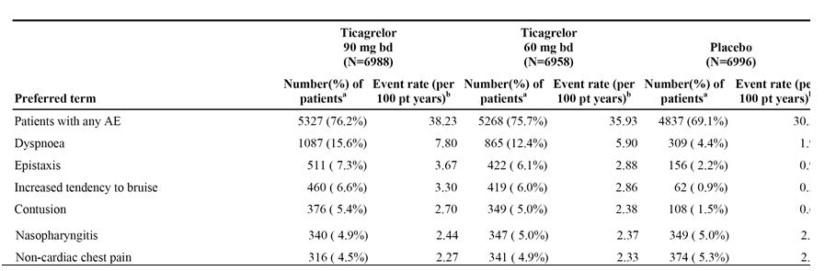
Comment: The most notable difference in AEs (PT) between the ticagrelor and placebo groups was the increased risk of dyspnoea with ticagrelor compared to placebo. AEs reported in ≥ 2% of patients in either of the two ticagrelor groups and ≥ 2% more commonly in either group compared to placebo were (90 mg versus 60 mg versus placebo): dyspnoea (15.6% versus 12.4% versus 4.4%); epistaxis (7.3% versus 6.1% versus 2.2%); increased tendency to bruise (6.6% versus 6.0% versus 0.9%); contusion (5.4% versus 5.0% versus 1.5%); spontaneous haematoma (3.8% versus 3.1% versus 0.6%); and traumatic haematoma (2.8% versus 2.3% versus 0.6%).

Deaths and other serious adverse events

Deaths
All deaths were reported as SAEs as well as efficacy endpoints in this study. All deaths were adjudicated. There were 961 deaths in the safety analysis set, and 952 of these were recorded as having ‘An AE with outcome = death’. The difference between the two figures results from 8 deaths that occurred after withdrawal of consent and 1 death identified during follow-up procedures. Deaths in the FAS have been summarised in the description of efficacy (that is, CV deaths, all-cause mortality).

On-treatment AEs with an outcome of death
In the safety analysis set, on-treatment AEs with an outcome of death were reported in 161 (2.3%) patients in the ticagrelor 90 mg group, 149 (2.1%) patients in the ticagrelor 60 mg group, and 203 (2.9%) patients in the placebo group. When bleeding events were excluded, the frequency of AEs with outcome of death was lower for the ticagrelor groups compared to the placebo group: 2.1% (n=145) for ticagrelor 90 mg bd; 1.9% (n=135) for ticagrelor 60 mg BD; and 2.7% (n=190) for placebo. The most common AEs (including bleeding) with outcome of death (SOC) were ‘general disorders and administration site conditions’, ‘cardiac disorders’, and ‘neoplasms benign, malignant and unspecified (including cysts and polyps). Deaths in each of these SOCs were reported at a similar frequency in the 3 treatment groups. The most common AEs (PT), including bleeding events, with outcome of death reported in ≥ 10 patients in the ticagrelor 90 mg BD group were death, sudden cardiac death and acute myocardial infarction (see Table 16, below). The incidence of on-treatment deaths was low in each of the three treatment groups, and there was no increased risk of on-treatment deaths in the ticagrelor groups compared to the placebo group.

Table 16: PEGASUS - AEs (PT) with an outcome of death (with a frequency of > 0.05% in the ticagrelor 90 mg group) on-treatment; safety analysis set
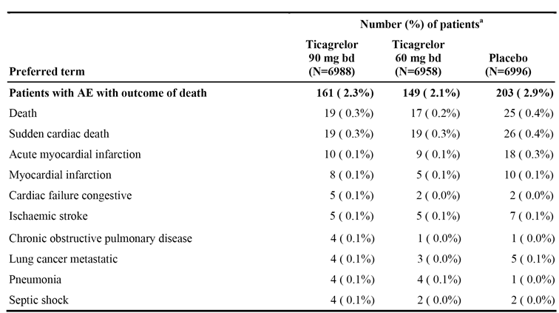
MedDRA version 17.0 Patients with multiple AEs with outcome of death are counted once for each preferred term. a. Number (%) of patients with AE with outcome of death, sorted by descending frequency for preferred term in patients treated with ticagrelor 90 mg BD.

Deaths based on adjudicated classification (on and off treatment)
CV deaths based on adjudicated classification (on and off treatment) were reported in 2.7% (n=190), 2.5% (n=176) and 3.1% (n=219) of patients in the ticagrelor 90 mg, ticagrelor 60 mg and placebo groups, respectively. The most frequently reported CV deaths in each of the three treatment groups on and off treatment were sudden cardiac deaths: 1.2% (n=85), 1.2% (n=82) and 1.5% (n=106) in the ticagrelor 90 mg, ticagrelor 60 mg and placebo groups, respectively. No CV deaths were reported more frequently in either ticagrelor group than in the placebo group.
Non-CV deaths based on adjudicated classification (on and off treatment) were reported in 2.1% (n=145), 1.7% (n=116) and 1.6% (n=115) of patients in the ticagrelor 90 mg, ticagrelor 60 mg and placebo groups, respectively. The most frequently reported non-CV deaths in each of the three treatment groups were malignancy: 1.1% (n=78), 0.9% (n=63) and 0.8% (n=53) in the ticagrelor 90 mg, ticagrelor 60 mg and placebo groups, respectively. The only other non-CV death reported more frequently in either ticagrelor group compared to placebo was infection (including sepsis).

Serious adverse events
SAEs (including bleeding) on-treatment was reported with similar frequency in the three treatment groups: 21.7% (n=1514), 21.5% (n=1499) and 21.6% (n=1511) in the ticagrelor 90 mg, ticagrelor 60 mg and placebo groups, respectively. The event rates/100 patient years were 10.86 versus 10.22 versus 9.48 in the ticagrelor 90 mg, ticagrelor 60 mg and placebo groups, respectively.
SAEs (including bleeding) by SOC on-treatment reported in ≥ 2.0% of the ticagrelor 90 mg group (vs ticagrelor 60 mg versus placebo) were: ‘cardiac disorders’ (4.0% versus 4.3% versus 4.3%); ‘gastrointestinal disorders’ (3.6% versus 3.0% versus 2.0%); ‘infections and infestations’ (3.4% versus 3.3% versus 3.5%); ‘neoplasms benign, malignant and unspecified (including cysts and polyps)’ (3.0% versus 2.7% versus 3.0%); ‘general disorders and administration site conditions’ (2.1% versus 2.2% versus 2.4%); and ‘injury, poisoning and procedural complications’ (2.0% versus 2.3% versus 1.8%). SAEs (including bleeding) by SOC were summarised.
SAEs (including bleeding) by PT on-treatment reported in ≥ 0.5% of patients in the ticagrelor 90 mg group (versus ticagrelor 60 mg versus placebo) by descending order of frequency are summarised below in Table 17. Event rates/100 patient years for the SAEs reported in ≥ 0.5% of patients in the ticagrelor 90 mg group (versus ticagrelor 60 mg versus placebo) were: non-cardiac chest pain (0.63 versus 0.62 versus 0.57); atrial fibrillation (0.41 versus 0.50 versus 0.33); pneumonia (0.33 versus 0.28 versus 0.35); COPD (0.29 versus 0.19 versus 0.21); congestive cardiac failure (0.26 versus 0.25 versus 0.19); and angina pectoris (0.25 versus 0.25 versus 0.29).

Table 17: PEGASUS SAEs (including bleeding) by PT with a frequency ≥ 0.5% in the ticagrelor group on-treatment; safety analysis set
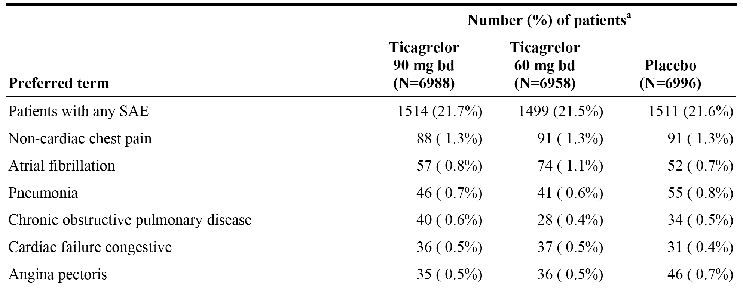
A patient can have one or more preferred terms reported under a given preferred term. Includes SAEs with an onset date on or after the date of first dose and up to and including 7 days following the date of last dose of study drug a. Number (%) of patients with an SAE, sorted on descending frequency for preferred term in patients treated with ticagrelor 90 mg BD.

Discontinuations due to adverse events
Permanent discontinuation of the study drug due to AEs (including bleeding) on-treatment occurred approximately 2-fold more frequently in both ticagrelor groups than in the placebo group: 18.7% (n=1306), 16.1% (n=1117) and 8.5% (n=596) in the ticagrelor 90 mg, ticagrelor 60 mg and placebo groups, respectively. AEs (including bleeding) by SOC on-treatment resulting in permanent treatment discontinuation and reported in ≥ 2.0% of patients in the ticagrelor 90 mg group (vs ticagrelor 60 mg versus placebo) were: ‘respiratory, thoracic and mediastinal disorders (7.4% versus 5.3% versus 1.1%); ‘gastrointestinal disorders’ (2.7% versus 2.9% versus 1.4%); and ‘blood and lymphatic system disorders’ (2.5% versus 1.8% versus 0.2%). Discontinuations due to AEs (including bleeding) by SOC on-treatment were summarised.
Discontinuations due to AEs (including bleeding) on-treatment and reported in ≥ 0.5% of patients in the ticagrelor 90 mg group (vs ticagrelor 60 mg versus placebo) are summarised below in Table 18. The rate of discontinuation of the study drug due to dyspnoea was notably increased in both ticagrelor groups compared to placebo. In addition, discontinuations due to bleeding events were reported more frequently in the ticagrelor groups than in the placebo group.

Table 18: PEGASUS - Discontinuations due to AEs (including bleeding) by PT with a frequency ≥ 0.5% in the ticagrelor group on-treatment; safety analysis set
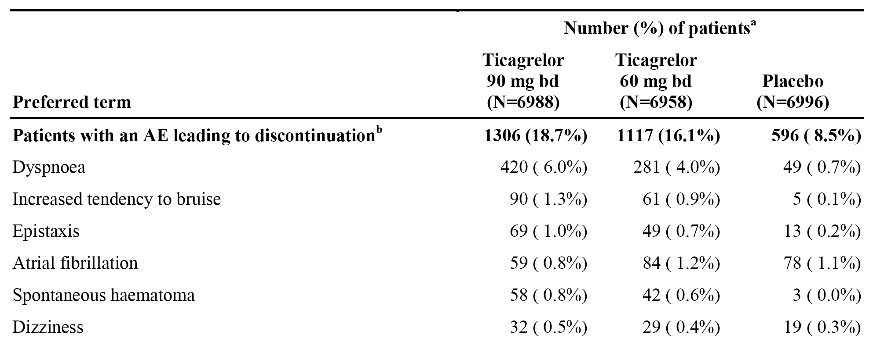
Patients with multiple AEs leading to discontinuation are counted once for each preferred term. a. Number (%) of patients with an AE leading to discontinuation of study drug, sorted on descending frequency for preferred term in patients treated with ticagrelor 90 mg BD.

Temporary treatment interruptions
The proportion of patients with any temporary treatment interruption of the study drug was 26.4%, 25.4%, and 22.7% in the ticagrelor 90 mg, ticagrelor 60 mg, and placebo groups, respectively. The proportion of patients with 1 temporary treatment interruption was 18.2%, 17.2%, and 16.7%, for the ticagrelor 90 mg, ticagrelor 60 mg, and placebo groups, respectively. Few patients had > 3 temporary treatment interruptions: 1.0%, 1.1%, and 0.6% in ticagrelor 90 mg, ticagrelor 60 mg, and placebo patients, respectively. The median number of days per temporary treatment interruption was 9.0, 8.0, and 9.0 for the ticagrelor 90 mg, ticagrelor 60 mg, and placebo groups, respectively, and the median total days of interruption per patient were 16, 15, and 13 days, respectively. Temporary interruption of treatment with the study drug occurred for various reasons, with the most common reason being non-bleeding events (14.5%, 13.7%, and 10.5% of patients in the ticagrelor 90 mg, ticagrelor 60 mg, and placebo groups, respectively). Temporary treatment interruptions of the study drug due to bleeding occurred in 3.4%, 2.8%, and 0.8% of patients in the ticagrelor 90 mg, ticagrelor 60 mg and placebo groups, respectively.

Adverse events of special interest

Bleeding events

Bleeding events by AE category

1. Overview
Bleeding events by AE category are summarised below in Table 19.

Table 19: PEGASUS - Bleeding events in any category on-treatment; safety analysis set
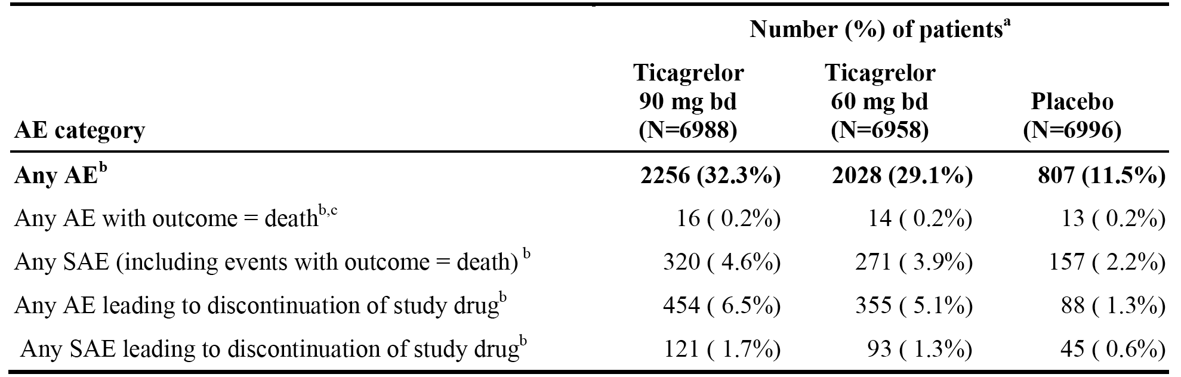
a. Patients with multiple events in the same category are counted only once in that category. Patients with events in more than 1 category are counted once in each of those categories. b. AEs with a bleeding documented by the investigator or a bleeding event eCRF form, including unadjudicated minimal bleedings, excluding events adjudicated as not a bleeding event. c. The final outcome of the AE recorded by the investigator is death.
Hospitalisation due to bleeding events was reported in 258 (3.7%), 216 (3.1%), and 113 (1.6%) patients in the ticagrelor 90 mg, ticagrelor 60 mg, and placebo groups, respectively. As a consequence of a bleeding AE, blood transfusions were required in 226 (3.2%), 213 (3.1%), and 116 (1.7%) patients in the ticagrelor 90 mg, ticagrelor 60 mg, and placebo groups, respectively.

2. Bleeding events by SOC and PT
Bleeding events (SOC) reported in ≥ 2% of patients in at least one of the three treatment groups are summarised below in Table 20.

Table 20: PEGASUS - Bleeding events by SOC reported in ≥ 2% of patients in at least one of the three treatment groups; safety analysis set
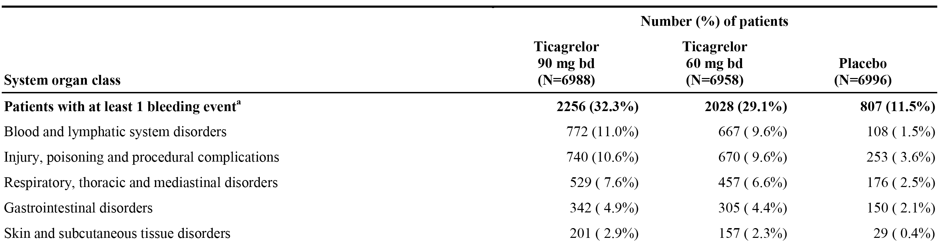
Bleeding events (PT) reported in ≥ 1% of patients in at least one of the three treatment groups are summarised below in Table 21.

Table 21: PEGASUS - Bleeding events by PT reported in ≥ 1% of patients in at least one of the three treatment groups; safety analysis set
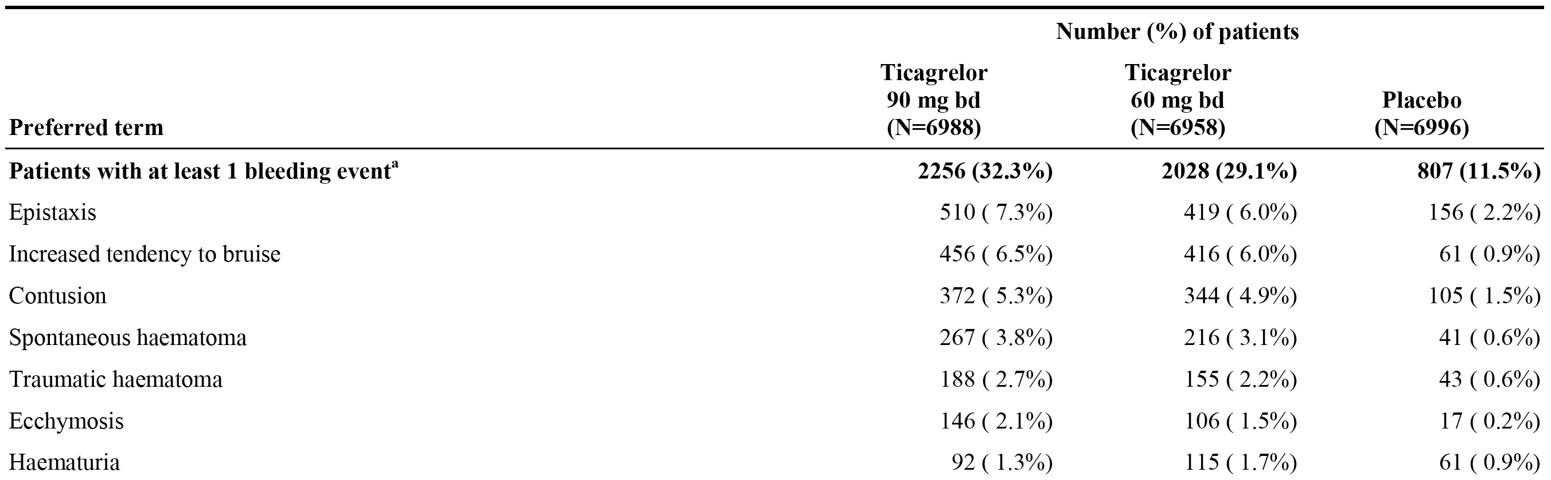
Sorted by descending frequency of the number of patients with events in the ticagrelor 90 mg group; This table includes PTs with frequency >0.1% for ticagrelor 90 mg. Patients may be counted in more than 1 bleeding event category. This table includes AEs with an onset date on or after the date of first dose and up to an including 7 days following the date of last dose of study drug. a. AEs with a bleeding documented by the investigator on a bleeding event eCRF form, including unadjudicated minimal bleedings, excluding events adjudicated as not a bleeding event.

3. Bleeding events by PT leading to discontinuation of the study drug
Bleeding events (PT) leading to discontinuation of the study drug with a frequency of > 0.1% in the ticagrelor 90 mg BD group are summarised below in Table 22. The KM plots showed an increase risk of discontinuation due to bleeding in the ticagrelor groups arising shortly after randomisation, and the ticagrelor plots remained separated from placebo throughout the study.

Table 22: Pegasus Bleeding events leading to discontinuation of study drug by preferred term with frequency >0.1% in the ticagrelor 90 mg BD group; safety analysis set
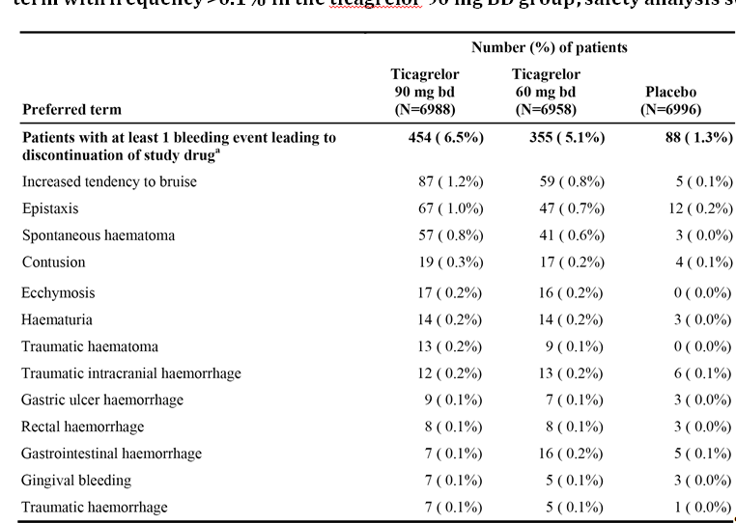
Sorted by descending frequency of the number of subjects with event in the ticagrelor 90 mg group; This table includes PTs with frequency >0.1% for ticagrelor 90 mg. Patients with multiple bleedings leading to discontinuation are counted once for each PT. This table includes AEs with an onset date on or after the date of first dose and up to an including 7 days following the date of last dose of study drug. a. AEs with a bleeding documented by the investigator on a bleeding event eCRF form, including unadjudicated minimal bleedings, excluding events adjudicated as not a bleeding event, where action taken study drug = Permanently Discontinued.

TIMI major bleeding events
- TIMI major bleeding events were defined as any of the following: (1) fatal bleeding directly leading to death within 7 days; (2) intracranial haemorrhage (ICH); and (3) other major bleeding defined as clinically overt signs of haemorrhage associated with a drop in haemoglobin of ≥ 5 g/dL, or when haemoglobin not available a fall in haematocrit of ≥ 15%. TIMI major bleeding events are summarised below in Table 23.

Table 23: PEGASUS - TIMI major bleeding events on-treatment; safety analysis set
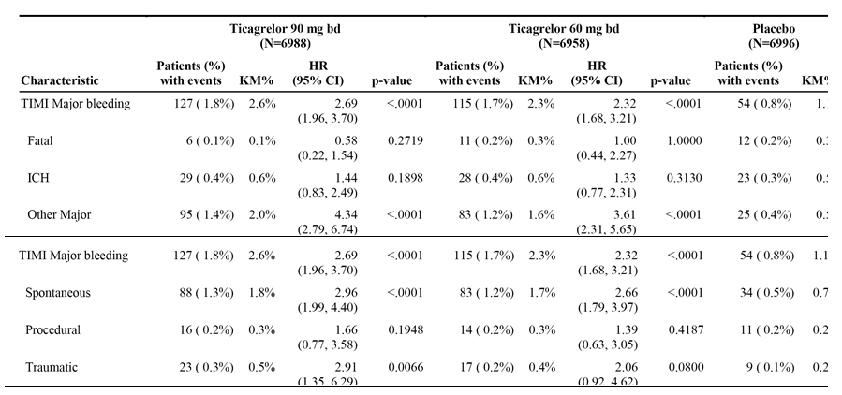
Patients may be counted in more than 1 bleeding event category. KM percentage is calculated at 36 months. HRs and p-values are calculated separately for each ticagrelor dose versus placebo from Cox proportional hazards model with treatment group as the only explanatory variable. P-values are to be considered nominal because bleeding is not part of the confirmatory testing sequence.
- The most frequently reported TIMI major bleeding events (SOC) reported in ≥ 5 patients in the ticagrelor 90 mg group (versus ticagrelor 60 mg BD versus placebo) in descending order of frequency are summarised below in Table 24.

Table 24: PEGASUS TIMI major bleeding events (SOC) reported in ≥ 5 patients in the ticagrelor 90 mg group on-treatment; safety analysis set
Preferred term | Tica 90 mg BD (n=6988) | Tica 60 mg BD (n=6958) | Placebo (n=6996)
Patients with at least 1 TIMI Major bleeding event | 127 (1.8%) | 115 (1.7%) | 54 (0.8%)
Gastrointestinal disorders | 57 (0.8%) | 53 (0.8%) | 15 (0.2%)
Injury, poisoning and procedural complications | 36 (0.5%) | 32 (0.5%) | 19 (0.3%)
Neoplasms benign, malignant and unspecified (incl cysts and polyps) | 9 (0.1%) | 5 (0.1%) | 3 (0.0%)
Nervous system disorders | 8 (0.1%) | 10 (0.1%) | 14 (0.2%)
Blood and lymphatic system disorders | 5 (0.1%) | 5 (0.1%) | 1 (0.0%)
Sorted by descending frequency of the number of subjects with event in the ticagrelor 90 mg group; Patients with multiple bleeding events are counted once for each preferred term. Tica=ticagrelor.
- The most frequently reported TIMI major bleeding events (PT) reported in ≥ 2 patients in the ticagrelor 90 mg group (vs ticagrelor 60 mg BD versus placebo) in descending order of frequency are summarised below in Table 25.

Table 25: PEGASUS TIMI major bleeding events (PT) reported in ≥ 2 patients in the ticagrelor 90 mg group on-treatment; safety analysis set
Preferred term | Tica 90 mg BD (n=6988) | Tica 60 mg BD (n=6958) | Placebo (n=6996)
Patients with at least 1 TIMI Major bleeding event | 127 (1.8%) | 115 (1.7%) | 54 (0.8%)
Traumatic intracranial haemorrhage | 16 (0.2%) | 14 (0.2%) | 9 (0.1%)
Gastric ulcer haemorrhage | 11 (0.2%) | 7 (0.1%) | 2 (< 0.1%)
Gastrointestinal haemorrhage | 9 (0.1%) | 12 (0.2%) | 3 (< 0.1%)
Gastric ulcer | 7 (0.1%) | 3 (< 0.1%) | 1 (< 0.1%)
Post procedural haemorrhage | 7 (0.1%) | 1 < (0.1%)) | 2 (< 0.1%)
Duodenal ulcer haemorrhage | 5 (0.1%) | 3 (< 0.1%) | 4 (0.1%)
Ischaemic stroke | 3 (< 0.1%) | 2 (< 0.1%) | 2 (< 0.1%)
Aortic aneurysm rupture | 2 (< 0.1%) | 0 (0.0%) | 0 (0.0%)
Diverticulum intestinal haemorrhagic | 2 (< 0.1%) | 2 (< 0.1%) | 0 (0.0%)
Duodenal ulcer | 2 < 0.1%)) | 0 (0.0%) | 0 (0.0%)
Gastritis | 2 (< 0.1%) | 0 (0.0%) | 0 (0.0%)
Gastrointestinal ulcer haemorrhage | 2 (< 0.1%) | 0 (0.0%) | 0 (0.0%)
Haemorrhagic erosive gastritis | 2 (< 0.1%) | 0 (0.0%) | 0 (0.0%)
Iron deficiency anaemia | 2 (< 0.1%) | 1 (< 0.1%) | 0 (0.0%)
Microcytic anaemia | 2 (< 0.1%) | 0 (0.0%) | 0 (0.0%)
Peptic ulcer haemorrhage | 2 (< 0.1%) | 3 (< 0.1%) | 0 (0.0%)
Subdural haematoma | 2 (< 0.1%) | 2 (< 0.1%) | 0 (0.0%)
Sorted by descending frequency of the number of subjects with event in the ticagrelor 90 mg group; Patients with multiple bleeding events are counted once for each preferred term. Tica=ticagrelor.
- The observed increased risk of TIMI major bleeding with ticagrelor was driven primarily by a higher frequency of ‘other’ TIMI major bleeding events (that is, non-fatal, non-ICH). The high-level overview of ‘other’ TIMI major bleeding events is summarised below in Table 26. ‘Other’ TIMI major bleeding events were reported primarily in the gastrointestinal system.

Table 26: PEGASUS Overview of ‘other’ TIMI major bleeding events on-treatment (that is, non-fatal, non-ICH); safety analysis set
AE category | Ticagrelor 90 mg BD  (n=6988) | Ticagrelor 60 mg BD  (n=6958) | Placebo  (n=6996)
Any AE | 95 (1.4%) | 83 (1.2%) | 25 (0.4%)
Any AE with outcome = death | 5 (0.1%) | 0 (0.0%) | 0 (0.0%)
Any SAE (including outcome = death) | 88 (1.3%) | 64 (0.9%) | 24 (0.3%)
Any AE leading to discontinuation of study drug | 36 (0.5%) | 28 (0.4%) | 10 (0.1%)
Any SAE leading to discontinuation of study drug | 34 (0.5%) | 24 (0.3%) | 10 (0.1%)
Any causally related AE | 57 (0.8%) | 50 (0.7%) | 9 (0.1%)
Any causally related SAE | 54 (0.8%) | 39 (0.6%) | 9 (0.1%)
Any causally related AE with outcome = death | 0 (0.0%) | 0 (0.0%) | 0 (0.0%)
Any causally related SAE leading to discontinuation of study drug | 26 (0.4%) | 18 (0.3%) | 7 (0.1%)
Patients with multiple events in the same category are counted only once in that category.
- In patients with ‘other’ TIMI major bleeding events: (1) hospitalisation was reported in the majority of patients, and occurred more commonly in the ticagrelor groups than in the placebo group: 81.1% (77/95) ticagrelor 90 mg bd; 75.9% (63/83) ticagrelor 60 mg BD; and 68.0% (17/25) placebo; and (2) blood transfusions were required in the majority of patients in each of the three treatment groups and with a similar incidence: 81.1% (77/95) ticagrelor 90 mg bd; 77.1% (64/83) ticagrelor 60 mg bd; and 80.0% (20/25) placebo.
- TIMI major bleeding events (HR and rates) on-treatment by sub-groups were summarised in Forest plots. In all subgroups, TIMI major bleeding events were reported more frequently in the ticagrelor groups than in the placebo group.

TIMI minor bleeding events
TIMI minor bleeding is defined as bleeding that is clinically apparent with 3 to < 5 g/dL decrease in haemoglobin, or when haemoglobin is not available a fall in haematocrit of 9% to < 15%. TIMI minor first bleeding events were reported in 66 (0.9%) patients in the ticagrelor 90 mg BD group, 55 (0.8%) patients in the ticagrelor 60 mg BD group, and 18 (0.3%) patients in the placebo group. The most commonly reported TIMI minor bleeding events in the three treatment groups were gastrointestinal disorders (SOC), which were reported in 39 (0.6%) patients in the ticagrelor 90 mg BD group, 25 (0.4%) patients in the ticagrelor 60 mg BD group and 12 (0.2%) patients in the placebo group. TIMI minor bleeding events reported in ≥ 2 patients in the ticagrelor 90 mg group (vs ticagrelor 60 mg BD versus placebo) in descending order of frequency are summarised below in Table 27.

Table 27: PEGASUS TIMI minor bleeding events (PT) reported in ≥ 2 patients in the ticagrelor 90 mg group on-treatment; safety analysis set
Preferred term | Tica 90 mg BD (n=6988) | Tica 60 mg BD (n=6958) | Placebo (n=6996)
Patients with at least 1 TIMI minor bleeding event | 66 (0.9%) | 55 (0.8%) | 18 (0.3%)
Gastrointestinal haemorrhage | 5 (0.1%) | 1 (< 0.1%) | 1 (< 0.1%)
Diverticulum intestinal haemorrhagic | 4 (0.1%) | 2 (< 0.1%) | 0 (0.0%)
Gastric ulcer haemorrhage | 3 (< 0.1%) | 3 (< 0.1%) | 3 (< 0.1%)
Haematuria | 3 (< 0.1%) | 2 (< 0.1%) | 0 (0.0%)
Post procedural haemorrhage | 3 (< 0.1%) | 0 (0.0%) | 1 (< 0.1%)
Rectal haemorrhage | 3 (< 0.1%) | 0 (0.0%) | 0 (0.0%)
Duodenal ulcer haemorrhage | 2 (< 0.1%) | 3 (< 0.1%) | 0 (0.0%)
Epistaxis | 2 (< 0.1%) | 0 (0.0%) | 0 (0.0%)
Gastric ulcer | 2 (< 0.1%) | 1 (< 0.1%) | 3 (< 0.1%)
Gastrointestinal ulcer haemorrhage | 2 (< 0.1%) | 0 (0.0%) | 0 (0.0%)
Lower gastrointestinal haemorrhage | 2 (< 0.1%) | 1 (< 0.1%) | 0 (0.0%)
Oesophageal ulcer haemorrhage | 2 (< 0.1%) | 0 (0.0%) | 0 (0.0%)
Sorted by descending frequency of the number of subjects with event in the ticagrelor 90 mg group; Patients with multiple bleeding events are counted once for each preferred term. Tica=ticagrelor

TIMI major or minor bleeding events
TIMI major or minor bleeding events are summarised below in Table 28. TIMI major and minor bleeding events by severity and provocation are summarised in Table 29.

Table 28: PEGASUS TIMI major or minor bleeding events on-treatment; safety analysis set
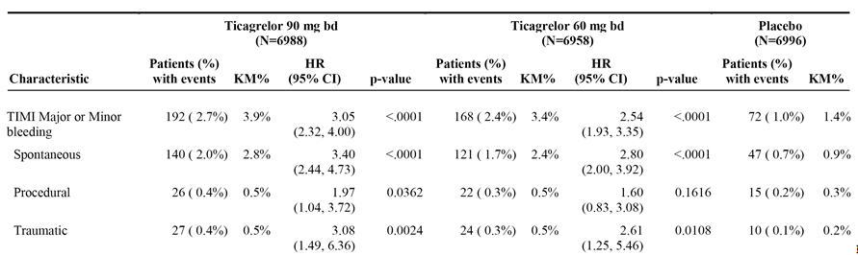
Patients may be counted in more than 1 bleeding event category. KM percentage is calculated at 36 months. HRs and p-values are calculated separately for each ticagrelor dose versus placebo from Cox proportional hazards model with treatment group as the only explanatory variable. P-values are to be considered nominal because bleeding is not part of the confirmatory testing sequence.

Table 29: PEGASUS TIMI major and minor bleeding events by severity and provocation on-treatment; safety analysis set
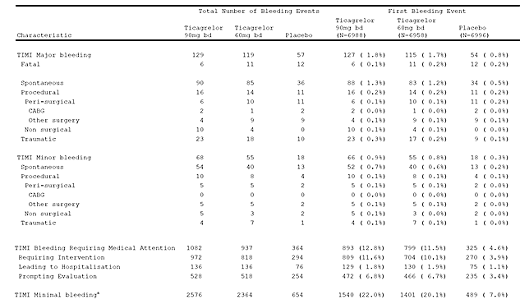

PLATO major bleeding events
PLATO major bleeding is defined as any of the following: (1) Fatal/Life-threatening bleeding - Bleeding that is clinically apparent with ≥ 5 g/dL decrease in haemoglobin, or when haemoglobin is not available a fall in haematocrit of 9% to < 15%, or ≥ 4 red cell units transfused, or fatal, or intracranial, or intrapericardial with cardiac tamponade, or with hypovolaemic shock or severe hypotension requiring pressors or surgery. PLATO Fatal bleeding is the same as TIMI Fatal bleeding; and (2) Other PLATO Major bleeding - Bleeding that is clinically apparent with 3 to <5 g/dL decrease in haemoglobin, or when haemoglobin is not available a fall in haematocrit of 9 to <15%, or 2 to 3 red cell units transfused, or is significantly disabling. PLATO major bleeding events are summarised below in Table 30.

Table 30: PEGASUS PLATO major events on-treatment; safety analysis set
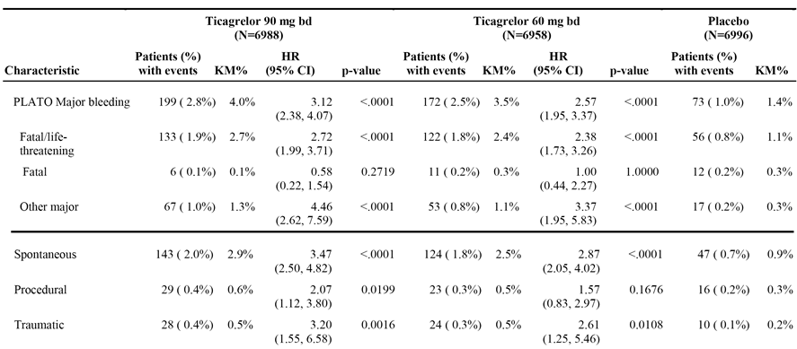
Patients may be counted in more than 1 bleeding event category. KM percentage is calculated at 36 months. HRs and p-values are calculated separately for each ticagrelor dose versus placebo from Cox proportional hazards model with treatment group as the only explanatory variable. P-values are to be considered nominal because bleeding is not part of the confirmatory testing sequence.
Comment: PLATO major bleedings events were reported more commonly in each of the three treatment arms than TIMI major bleeding events, with the most marked difference between the two definitions being observed in the two ticagrelor groups. The KM% estimates at 36 months for the TIMI versus PLATO definitions of major bleeding events for each of the three treatment groups were: 2.6% versus 4.0% ticagrelor 90 mg bd; 2.3% versus 3.5% ticagrelor 60 mg BD; and 1.1% versus 1.4% placebo. The KM plots show that the plots for the two ticagrelor treatment groups begin to separate from placebo shortly after randomisation and continued to diverge throughout the duration of the study. The HRs show that the largest observed RRR for both doses of ticagrelor relative to placebo was seen for ‘other’ PLATO major bleeding events. The majority of PLATO major bleeding events were spontaneous.

Fatal bleeding
Fatal bleeding was adjudicated as an event where bleeding led directly to death within 7 days. Fatal bleeding events are summarised by anatomical location (as recorded in the eCRF) and provocation (that is, spontaneous, procedural, or traumatic as confirmed in adjudication). Fatal bleeding events on-treatment were infrequent and the rates were similar across the three treatment groups: 0.1% (6 patients) ticagrelor 90 mg bd; 0.2% (11 patients) ticagrelor 60 mg bd; and placebo 0.2% (12 patients) placebo. The HRs for fatal bleeding events (TIMI) are summarised above in Table 23. Most fatal bleeding events were spontaneous and the most frequently reported anatomical location was intracranial.

Intracranial haemorrhage (ICH)
ICH is a component of both the TIMI Major and PLATO Major bleeding definitions. Confirmed ICH events are summarised by provocation (that is, whether they were traumatic, procedural, or spontaneous) and anatomical location. ICH events were reported in 29, 28, and 23 patients in the ticagrelor 90 mg, ticagrelor 60 mg, and placebo groups, respectively, corresponding to KM percentages at 36 months of 0.6%, 0.6%, and 0.5%: HR = 1.44 (95% CI: 0.83, 2.49) for ticagrelor 90 mg relative to placebo, and HR = 1.33 (95% CI: 0.77, 2.31) for ticagrelor 60 mg relative to placebo. The overall numerical difference in ICH events was due mainly to traumatic and procedural events, which occurred in 18 (0.3%), 15 (0.2%), and 10 (0.1%) patients in the ticagrelor 90 mg, ticagrelor 60 mg, and placebo groups, respectively. Spontaneous ICH events occurred in 11 (0.2%), 13 (0.2%), and 13 (0.2%) patients in the ticagrelor 90 mg, ticagrelor 60 mg, and placebo groups, respectively.

Dyspnoea
Dyspnoea is a known adverse effect of ticagrelor. The sponsor states that in previous studies (PLATO, DISPERSE, and DISPERSE2), ticagrelor was shown to cause dyspnoea, although the event was generally brief and resolved with continued ticagrelor treatment. The sponsor commented that extensive evaluation in these studies has demonstrated no impact of ticagrelor on pulmonary or cardiac function. The sponsor also commented that there appears to be a relationship with ticagrelor dose and the incidence of dyspnoea. The PI indicates that the mechanism of action for dyspnoea has not been elucidated.
In PEGASUS, dyspnoea was assessed by reviewing AEs for the following predefined PTs: dyspnoea; dyspnoea exertional; dyspnoea at rest; nocturnal dyspnoea; and dyspnoea paroxysmal nocturnal. Dyspnoea was also assessed in the subgroups of patients with a medical history of asthma and COPD. Dyspnoea AEs by preferred term were.
The high-level overview of dyspnoea AEs on-treatment are summarised in Table 31.

Table 31: PEGASUS - Overview of dyspnoea AEs on-treatment; safety analysis set
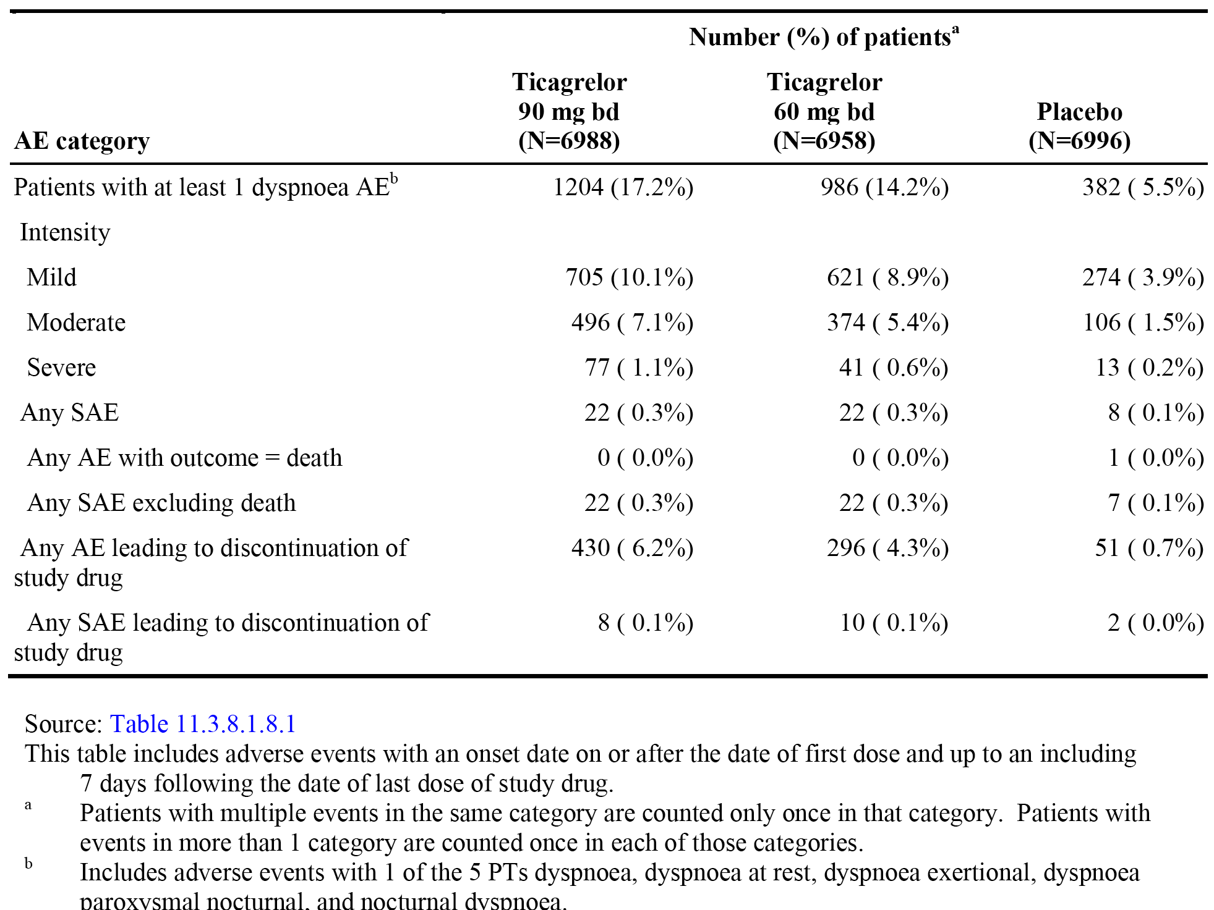
The key findings relating to dyspnoea were: (1) dyspnoea AEs were reported more frequently in patients in both ticagrelor groups than in the placebo group (17.2%, 14.2% and 5.5% in the ticagrelor 90 mg, ticagrelor 60 mg and placebo groups, respectively); (2) There was a dose-response relationship, with dyspnoea AEs being reported more frequently in the 90 mg BD group than in the 60 mg BD group; (3) the majority of dyspnoea AEs were rated by investigators to be mild or moderate in intensity; (4) dyspnoea SAEs were infrequent (0.3%, 0.3% and 0.1% in the ticagrelor 90 mg, ticagrelor 60 mg and placebo groups, respectively); (5) no deaths were reported to be due to dyspnoea AEs in the ticagrelor groups and 1 death was reported in the placebo group; (6) discontinuations due to dyspnoea were reported notably more frequently in both ticagrelor groups than in the placebo group (6.2%, 4.3% and 0.7% in the ticagrelor 90 mg, ticagrelor 60 mg and placebo groups, respectively); and (7) of the patients who permanently discontinued study drug due to dyspnoea, 49.5%, 43.9% and 23.5% of patients on ticagrelor 90 mg, ticagrelor 60 mg, and placebo, respectively, discontinued within the first 7 days of treatment.
The key findings relating to dyspnoea were: (1) the median time-to-first dyspnoea AE on-treatment was notably shorter in both ticagrelor groups than in the placebo group, and there was a dose-response relationship (11, 29, an 240 days in the ticagrelor 90 mg, ticagrelor 60 mg and placebo groups, respectively; (2) the time-to-onset of first dyspnoea AE was within 3 days from start of treatment in 35.0%, 28.0%, and 8.1% of patients in the ticagrelor 90 mg, ticagrelor 60 mg, and placebo groups, respectively; (3) the KM plots began to separate shortly after randomisation with the difference in rate of onset between ticagrelor and placebo being greatest in the first 120 days of treatment after which time the rate of onset was similar for the three treatment groups; and (4) the KM percentages at 36 months for patients with dyspnoea were higher in both ticagrelor groups compared to placebo (19%, 15.9%, and 6.4% in the ticagrelor 90 mg, ticagrelor 60 mg and placebo groups, respectively).
The key findings were: (1) the majority of patients reporting dyspnoea had only 1 event; and (2) the median time to resolution of dyspnea was 22, 31 and 39 days, in the ticagrelor 90 mg, ticagrelor 60 mg and placebo groups, respectively.
The key findings were: (1) the patterns of dyspnoea AEs, SAEs and discontinuations due to AEs in the ticagrelor groups compared with the placebo group were similar for patients with a medical history of asthma or COPD compared to patients without such a history; and (2) across all three treatment groups the frequency of patients with AEs of dyspnoea was higher in patients with a medical history of asthma or COPD than patients without a such a history.

Bradyarrhythmia
Bradyarrhythmias, specifically ventricular pauses, have been observed during Holter monitoring in previous ticagrelor studies. Patients considered to be at risk of bradycardia (for example, known sick sinus syndrome or second or third degree atrioventricular [AV] block) were not eligible for PEGASUS, unless already being treated with a permanent pacemaker. Bradyarrhythmias were assessed by analysing reported bradyarrhythmic AEs as well as AEs possibly related to bradyarrhythmias.
The key findings were:
- bradyarrhythmic AEs were reported in a similar proportion of patients in the ticagrelor 90 mg, ticagrelor 60 mg, and placebo groups (1.5%, 1.7% and 1.5%), and the event rates/100 patient years were 0.75, 0.83 and 0.66, respectively; and
- the most commonly reported bradyarrhythmic AEs occurring in ≥ 10 patients in the ticagrelor 90 mg group in descending order of frequency were bradycardia, sinus bradycardia, and AV block.
Bradyarrhythmic SAEs on-treatment were reported in 0.4% (n=31), 0.5% (n=33) and 0.4% (n=2) of patients in the ticagrelor 90 mg, ticagrelor 60 mg and placebo groups, respectively, and the event rates/100 patient years were 0.22, 0.23, and 0.18, respectively. There were no deaths associated with bradyarrhythmic AEs in the three treatment groups. Discontinuation of the study drug due to bradyarrhythmic AEs on-treatment were reported in 0.05% (n=3), 0.06% (n=4), and 0.03% (n=2) in the ticagrelor 90 mg, ticagrelor 60 mg and placebo groups, respectively. KM percentages at 36 months were 2.0%, 2.3% and 2.0% for the ticagrelor 90 mg, ticagrelor 60 mg and placebo groups, respectively.

Renal impairment/serum creatinine increased
In PLATO, the sponsor states that both the ticagrelor and clopidogrel treatment groups showed an increase in serum creatinine, with the mean increase in serum creatinine at 12 months being less than 10% above the baseline level. The mean increases in serum creatinine levels from baseline at 12 months was 8.4 μmol/L and 6.2 μmol/L for the ticagrelor and clopidogrel groups, respectively and were considered by the sponsor to be not clinically significant. The sponsor stated that the increase in serum creatinine diminished after discontinuation of ticagrelor with no increase in reports of renal impairment or renal failure.
In PEGASUS, assessment of renal impairment included review of pre-defined PTs associated with renal impairment and serum creatinine values. Investigators were also required to complete a renal eCRF, triggered when an AE was coded to one of the following terms: nephropathy toxic, renal failure, renal failure acute, renal failure chronic, renal impairment, or blood creatinine increased. More than 90% of the renal AEs were identified by ‘routine laboratory test only’, and these events were primarily categorised as increased creatinine levels. The remaining AEs were identified by ‘clinical presentation’ such as ‘volume over load’, ‘decreased urine output’, ‘signs and symptoms of uremia’, with similar frequencies across the three treatment groups. According to the investigator’s assessment, systemic hypoperfusion and concomitant medication were the most common aetiologies, with similar frequencies across the three treatment groups. Other ‘renal and urinary disorders’ (SOC), which were not included in the prespecified PTs for renal-related AEs of special interest, were assessed by reviewing overall AE data (for example, nephrolithiasis, renal cyst, and pollakiuria).
The key findings for renal-related AEs on-treatment were: (1) the incidence of renal-related AEs was similar in the ticagrelor 90 mg, ticagrelor 60 mg and placebo groups (2.4%, 2.5% and 2.3%, respectively); (2) the most commonly reported renal-related AEs reported in ≥ 0.1% of patients in the ticagrelor 90 mg group (vs ticagrelor 60 mg versus placebo) in descending order of frequency were blood creatinine increased (0.9% versus 0.9% versus 1.0%), renal failure acute (0.5% versus 0.5% versus 0.4%), renal failure (0.4% versus 0.6% versus 0.5%), renal impairment (0.3% versus 0.4% versus 0.2%) and proteinuria (0.2% versus 0.2% versus 0.2%); (3) the event rate/100 patient years for renal-related SAEs was low and similar in each of the three treatment groups (0.16 [0.3%], 0.21 [0.4%], and 0.18 [0.4%] for ticagrelor 90 mg, ticagrelor 60 mg, and placebo, respectively); (4) renal-related AEs resulting in death were reported in 0.0% (n=0), 0.01% (n=1), and 0.04% (n=3) of patients in the ticagrelor 90 mg, ticagrelor 60 mg, and placebo groups, respectively; and (5) renal-related AEs leading to discontinuation of the study drug were reported in 0.2% (n=11), 0.1% (n=10), and 0.1% (n=8) of patients in the ticagrelor 90 mg, ticagrelor 60 mg, and placebo groups, respectively.
The greatest change from baseline to maximum creatinine value and to minimum eGFR value on-treatment were summarised: The key findings were: (1) the majority of patients in the three treatment groups had increases in serum creatinine levels of 0% to 30%; (2) the proportion of patients in each of the three treatment groups with increases in serum creatinine levels > 30% were generally similar in each of the two categories; (3) the majority of patients in the three treatment groups had decreases in eGFR of 0% to 30%; and (4) the proportion of patients in each of the three treatment groups with decreases in eGFR values > 30% were generally similar in each of the two categories.
The last observation on-treatment mean±SD serum creatinine levels were 92.4±28.1, 91.9±28.9, and 91.6±28.1 µm/L for the ticagrelor 90 mg (n=6053), ticagrelor 60 mg (n=6240), and placebo (n=6543) groups, respectively, with the mean±SD absolute change from baseline being 2.0±17.3, 1.5±17.6, and 0.7±16.6 µm/L for the ticagrelor 90 mg (n=5977), ticagrelor 60 mg (n=6174), and placebo (n=6480) groups, respectively.
The last observation on-treatment mean±SD eGFR were 75.3±19.4, 73.1±19.6, and 72.9±19.3 mL/min/m² for the ticagrelor 90 mg (n=6053), ticagrelor 60 mg (n=6240), and placebo (n=6543) groups, respectively, with the absolute mean±SD change from baseline being -0.7±12.96, -0.3±12.52, and 0.2±12.57 for the ticagrelor 90 mg (n=5977), ticagrelor 60 mg (n=6174), and placebo (n=6480) groups, respectively.

Gout and urate nephropathy/hyperuricaemia
In PLATO, the sponsor states that treatment with ticagrelor was associated with small increases in serum uric acid levels that returned towards normal after cessation of the drug. In PEGASUS, the mean serum uric acid level increased from baseline over time in both ticagrelor groups, while a small decrease in mean level was observed in the placebo group. The last observation on-treatment mean±SD increase (and % increase) from baseline in serum uric acid (µmol/L) was 15.8±76.8 (6.3%) in the ticagrelor 90 mg group (n=4657) and 13.8±75.3 (5.6%) in the ticagrelor 60 mg group (n=5229), while the mean±SD (%) decrease from baseline in the placebo group (n=5229) was -0.4±69.5 (-1.5%). Serum uric acid increased to more than the upper limit of normal in 9.1% and 8.8% of patients in the ticagrelor 90 mg and 60 mg groups, respectively, compared to 5.5% in the placebo group. Elevations in serum uric acid were reversible, with mean values in all treatment groups being below baseline at the follow-up visit.
The event rate/100 patient years for the AE of hyperuricaemia was higher in the ticagrelor 90 mg and 60 mg treatment groups compared to placebo (0.42 [n=59], 0.35 [n=51], and 0.19 [n=30], respectively), and the event rate/100 patient years for the AE of blood uric acid increase was similar across the three treatment groups (0.10 [n=14], 0.11 [n=16], and 0.08 [n=13], respectively).
AEs of gout and gouty arthritis were reported in 115, 101, and 74 patients in the ticagrelor 90 mg, ticagrelor 60 mg, and placebo groups, respectively, corresponding to KM percentages at 36 months of 2.3%, 2.0%, and 1.5%: HR 1.77 (95% CI: 1.32, 2.37) for ticagrelor 90 mg relative to placebo, and HR 1.48 (95% CI: 1.10, 2.00) for ticagrelor 60 mg relative to placebo. Gout was reported in 99 (1.4%), 97 (1.4%) and 70 (1.1%) patients in the ticagrelor 90 mg, ticagrelor 60 mg, and placebo groups, respectively, while gouty arthritis was reported in 16 (0.2%), 5 (0.1%) and 4 (0.1%) patients, respectively. No urate nephropathy AEs were reported in the study.
SAEs of gout were reported in 3 (< 1%), 1 (< 1%) and 1 (< 1%) patients in the ticagrelor 90 mg, ticagrelor 60 mg, and placebo groups, respectively, with no reports of death due to the AE of gout. AEs of gout leading to discontinuation of the study drug were reported in 3 (< 1%), 1 (< 1%) and 4 (< 1%) in the ticagrelor 90 mg, ticagrelor 60 mg, and placebo groups, respectively.

Hepatic related adverse events
Pre-defined hepatic-related AEs were infrequent: 29, 41, and 29 patients in the ticagrelor 90 mg, ticagrelor 60 mg, and placebo groups, respectively, corresponding to KM percentages at 36 months of 0.5%, 0.9%, and 0.6%, respectively: HR = 1.13 (95% CI 0.68, 1.90) for ticagrelor 90 mg relative to placebo, and HR = 1.54 (95% CI 0.96, 2.48) for ticagrelor 60 mg relative to placebo. Drug-induced liver injury (DILI) was reported in 0 (0%), 1 (< 1%) and 1 (< 1%) patient in the ticagrelor 90 mg, ticagrelor 60 mg, and placebo groups, respectively. The patients with DILI were taking several concomitant medications, including statins.
Hepatic-related AEs on-treatment were reported in 29 (0.4%), 41 (0.6%) and 29 (0.4%) patients in the ticagrelor 90 mg, ticagrelor 60 mg, and placebo groups, respectively. The majority of hepatic-related AEs reported in the three treatment groups were categorised as mild in intensity. The two most commonly reported hepatic-related AEs in patients on-treatment were hepatic steatosis (16 [0.2%], 22 [0.3%], and 15 [0.2%] in the ticagrelor 90 mg, ticagrelor 60 mg, and placebo groups, respectively), and liver disorder (7 [0.1%], 5 [0.1%], and 1 [0.1%], in the ticagrelor 90 mg, ticagrelor 60 mg, and placebo groups, respectively).
Hepatic-related SAEs on treatment were reported 2 (< 0.1%) patients in each of the three treatment groups, and there was 1 death in the placebo group due to a hepatic-related AE. Hepatic-related AEs leading to treatment discontinuation were reported in 1 (< 0.1%), 0 (0%) and 2 (< 0.1%) patients in the ticagrelor 90 mg, ticagrelor 60 mg, and placebo groups, respectively.

Gynaecomastia
In PLATO, the sponsor states that there was a numerical difference in reports of gynaecomastia in men between the treatment arms (0.23% on ticagrelor compared to 0.05% on clopidogrel). In PEGASUS, the number of reported AEs of gynaecomastia in men was low and evenly distributed across the treatment groups (10 [0.1%], 8 [0.1%], and 11 [0.2%] in the ticagrelor 90 mg, ticagrelor 60 mg, and placebo groups, respectively). Four (4) patients discontinued study treatment due to gynaecomastia, 2 in the ticagrelor 60 mg group and 2 in the placebo group. One SAE of gynaecomastia (right-sided tumour confirmed by histology as benign) was reported in the ticagrelor 90 mg treatment group.

Designated medical events
Designated medical events (DMEs) were AE terms that the sponsor considers to represent clinical circumstances that are generally rare in occurrence, usually medically significant, and often considered to be potentially drug-related. Designated medical event AEs of special interest were not re-evaluated as DMEs. DMEs included: thrombocytopenia pancytopenia, haemolytic anaemia, aplastic anaemia, rhabdomyolysis, Stevens-Johnson syndrome, erythema multiforme, vasculitis, toxicity to various agents, drug hypersensitivity, angioedema, anaphylactic reaction/shock, polyneuropathy, Guillain-Barre, myasthenic syndrome, convulsions, pancreatitis, pancreatitis acute, pulmonary hypertension, pulmonary fibrosis, interstitial lung disease, pneumonitis, and electrocardiogram QT prolongated. The frequency of DMEs was similar in each of the three treatment group: 2.1%, 2.2% and 2.1% of patients in the ticagrelor 90 mg BD, ticagrelor 60 mg BD and placebo groups, respectively. The pattern of DMEs on-treatment did not differ across the three treatment groups.
The term thrombocytopenia in the DME analysis included the following AEs (PT), megakaryocytes abnormal, megakaryocytes decreased, platelet count abnormal, platelet count decreased, platelet disorder, platelet maturation arrest, platelet production decreased, platelet toxicity, plateletcrit abnormal, plateletcrit decreased, thrombocytopenia, thrombocytopenia neonatal, immune thrombocytopenic purpura. Thrombocytopenia AEs on-treatment were reported in 0.3% (n=20), 0.2% (n=17), and 0.2% (n=17) of patients in the ticagrelor 90 mg, ticagrelor 60 mg, and placebo groups respectively. Thrombocytopenia SAEs on-treatment were reported in 0.1% (n=6), < 0.1% (n=2), and < 0.1% (n=3) of patients in the ticagrelor 90 mg, ticagrelor 60 mg, and placebo groups respectively. No deaths were reported due to thrombocytopenia. Thrombocytopenia leading to discontinuation of the study drug was reported in < 1% (n=1), 0.1% (n=4), and < 0.1% (n=1) of patients in the ticagrelor 90 mg, ticagrelor 60 mg, and placebo groups respectively. No significant difference in the type of thrombocytopenia AEs was observed across the three treatment groups.

Laboratory tests

Haematology
- Comparisons of the mean absolute values and changes from baseline in haemoglobin, haematocrit, platelets, white blood cells, and white blood cells differential to the end of treatment visit were summarised in the CSR. Haemoglobin was also measured at 12, 24, and 36 months. Changes from baseline over time for the haematology parameters were summarised. Box plots of the haematology values over time by treatment were also summarised.
- Overall, there were no significant differences in mean changes over time in haematological parameters. Mean values at baseline and end of treatment visit were generally similar for the haematological parameters. The majority of patients in the three treatment groups had normal haematology values at the last observation on treatment, and there were no notable shifts from baseline values to last observation on treatment.

Clinical chemistry
- Comparisons of the mean absolute values over time and changes in ALP, AST, ALT, total bilirubin, and glucose from baseline to end of treatment visit were summarised in the CSR. Box plots of clinical chemistry values over time by treatment were also summarised.
- There were no apparent treatment differences in either mean value or mean change from baseline in ALP, AST, ALT, total bilirubin, or glucose. There were no apparent treatment differences in the pattern of shifts in clinical chemistry parameters.
- In this study DILI was assessed though analysis of hepatic-related AEs rather than liver enzymes and bilirubin as hepatic samples were only collected at baseline and at the EoT visit. The sponsor considered that this was sufficient as there has been no signal in the clinical development program of ticagrelor causing liver-related problems. Five (5) patients had combined ALT or AST (> 3 x ULN) and bilirubin (> 2 x ULN) elevations at the end of treatment (2, 1, and 2 patients in the ticagrelor 90 mg, ticagrelor 60 mg, and placebo treatment groups, respectively). Each of these patients had significant medical histories, which could have accounted for these observations.

Urinalysis
Data on urinalysis (protein, blood) were collected at baseline, after 12 months on-treatment, and at the end of treatment visit. There were no apparent differences across the treatment groups.

Vital signs
Heart rate, systolic blood pressure, diastolic blood pressure, and weight were assessed at enrolment and end of treatment (on-treatment, and on- and off-treatment). There were no apparent differences across the treatment groups in these parameters. ECGs were scheduled at enrolment and end of treatment and were only to be used as a clinical reference if indicated and no analysis was performed. ECGs were performed according to local clinical practice to document any occurrences of MI or recurrent cardiac ischaemia during the study.

Safety in special subgroups
AEs by age group (<65 years, 65 to 75 years, or >75 years) demonstrated that the incidence of AEs increased with age in the three treatment groups, with the safety profile in each of the age groups being similar to the safety profile in the total population. Patients < 65 years and 65-75 years each accounted for approximately 44% of the total population, with patients > 75 years accounting for approximately 12% of the total population. All patients in the total patient population were aged ≥ 47 years.
AEs by sex demonstrated that the AE profiles for male and female patients were generally similar to that of the overall study population for both ticagrelor dose groups.
AEs by race (Caucasian, Black, Asian, Other) demonstrated that the AE profiles across race subgroups were generally similar to that of the overall study population for both ticagrelor dose groups, although the study population was predominantly Caucasian (approximately 86%).

Drug interactions
There were no specific studies specifically exploring the safety of drug-drug interactions.

Use in pregnancy and lactation
Patients who were pregnant or breastfeeding were excluded from participation in PEGASUS. Women of child-bearing potential were eligible, provided they had a negative urine pregnancy test at enrolment and were willing to use a medically accepted method of contraception that was considered reliable in the opinion of the investigator. No pregnant or breastfeeding women were inadvertently exposed to study drug in PEGASUS.

Overdose
An overdose in PEGASUS was defined as any intake of study drug greater than 360 mg per day. Two (2) patients met the criteria for overdose during the study, 1 patient in each of the ticagrelor 90 mg and 60 mg groups. One (1) patient in the ticagrelor 60 mg group took 11700 mg ticagrelor together with other drugs (4875 mg clopidogrel, 85000 mg metformin, and 40 mg alprazolam) in an attempt to commit suicide. The patient had suffered from depression for 1 week before the event. The time period between drug intake and treatment (ventricle lavage) was 3 hours. Symptoms were dizziness, nausea and somnolence, and the patient recovered. According to limited information, 1 patient in the ticagrelor 90 mg group took an (apparently inadvertent) overdose of study medication for 57 days. The estimated mean dose taken per day was 396 mg, and no AEs were reported as being related to the overdose.

Drug abuse
Based on its pharmacological properties, ticagrelor is unlikely to have a potential for drug abuse.

Withdrawal and rebound
Discontinuation of any antiplatelet therapy could potentially result in an increased risk of CV death, MI or stroke due to the patient’s underlying disease. Primary endpoint events were recorded during the follow-up period after the last dose of study drug for those patients who were on study drug at CSED. This follow-up period from end of treatment visit to end of study visit was 14 to 28 days. In those patients who completed the study drug on-treatment, with last dose of study drug on or after CSED (4090, 4319, and 4814 in the ticagrelor 90 mg, ticagrelor 60 mg and placebo groups, respectively) primary composite efficacy endpoint events were reported in 14 (0.3%), 17 (0.4%), and 10 (0.2%) patients, respectively.

Effects on ability to drive or operate machinery
No studies on the effects of ticagrelor on the ability to drive and use machines have been performed. Ticagrelor is expected to have no or negligible influence on the ability to drive and use machines. During treatment with ticagrelor, dizziness and confusion have been reported. Therefore, patients who experience these symptoms should be cautious while driving or using machines.

Post-marketing experience
No post-marketing experience is available for the proposed indication.

Evaluator's comments on clinical safety
- The safety profile of patients treated with ticagrelor 90 mg BD and 60 mg BD in combination with ASA (that is, ticagrelor groups) was inferior to that of patients treated with ASA alone (that is, placebo group). Furthermore, the safety profile of ticagrelor 90 mg BD in combination with ASA was inferior to that ticagrelor 60 mg BD in combination with ASA.
- The safety of ticagrelor compared to placebo for the proposed indication was assessed in 6988 patients in the ticagrelor 90 mg group, 6958 patients in the ticagrelor 60 mg group, and 6996 patients in the placebo group. Based on the ‘rule of threes’, it can be estimated that adverse drug reactions to ticagrelor with an incidence of 1 in 4,655 patients would likely to have been detected in the 13,946 patients treated with the drug.
- In the ticagrelor 90 mg, ticagrelor 60 mg, and placebo groups, the mean±SD total duration of exposure to the study drug was 23.9±13.7 (range: 0.3, 48.0), 25.3±13.1 (0.03, 47.4), and 27.3±11.6 (range: 0.03, 47.4) months, respectively, and the median total duration of exposure was 28.3, 29.4, and 30.4 months, respectively. Actual exposure to the study drugs was marginally lower than total exposure in the three treatment groups due to temporary treatment interruptions.
- Patients in the ticagrelor groups were at a greater risk of experiencing TIMI major bleeding events (fatal, ICH, or ‘other’) than patients in the placebo group. The majority of TIMI major bleeding events were categorised as ‘other’ major haemorrhages, rather than either intracranial or fatal haemorrhages. Intracranial haemorrhages occurred in a smaller proportion of patients in each of the three treatment groups than ‘other’ major haemorrhages, and more commonly in the two ticagrelor groups than in the placebo group. Fatal haemorrhages were reported in a smaller proportion of patients in each of the three treatment groups than either ‘other’ or intracranial haemorrhages, with the frequency of fatal haemorrhages being similar across the three treatment groups.
- The risk of TIMI major bleeding events was greater in patients in both ticagrelor groups than in the placebo group, and in the higher compared to the lower dose ticagrelor group. TIMI major bleeding events were reported in 127, 115, and 54 patients in the ticagrelor 90 mg, ticagrelor 60 mg, and placebo groups, respectively, corresponding to KM percentages at 36 months of 2.6%, 2.3%, and 1.1%: HR = 2.69 (95% CI: 1.96, 3.70), p < 0.0001 for ticagrelor 90 mg relative to placebo; and HR = 2.32 (95% CI: 1.68, 3.21), p < 0.0001 for ticagrelor 60 mg relative to placebo. The absolute difference in TIMI major bleeding events based on the KM percentages at 36 months between the ticagrelor 90 mg and placebo groups was 1.5%, and between the ticagrelor 60 mg and placebo groups was 1.2%.
- The KM plots for TIMI major bleeding events showed that the increased risk in patients in the ticagrelor groups compared to patients in the placebo emerged shortly after randomisation. The rate of bleeding in both ticagrelor groups remained relatively constant over the 36 months of observation.
- The observed increased risk of TIMI major bleeding with ticagrelor compared to placebo was driven primarily by a higher risk of ‘other’ TIMI major bleeding events: 95, 83, and 25 patients in the ticagrelor 90 mg, ticagrelor 60 mg, and placebo groups, respectively, corresponding to KM percentages at 36 months of 2.0%, 1.6%, and 0.5%, respectively: HR = 4.34 (95% CI 2.79, 6.74), p<0.0001 for ticagrelor 90 mg relative to placebo; and HR = 3.61 (95% CI 2.31, 5.65), p<0.0001 for ticagrelor 60 mg relative to placebo.
- The observed higher frequency of ‘other’ TIMI major bleeding events in the ticagrelor groups was primarily driven by ‘gastrointestinal disorders’ (SOC): 56 (0.8%), 51 (0.7%), and 12 (0.2%) patients in the ticagrelor 90 mg, ticagrelor 60 mg, and placebo groups, respectively. ‘Other’ TIMI major bleedings events (AE/PT) reported in ≥ 0.1% patients in the ticagrelor 90 mg group (vs ticagrelor 60 mg versus placebo) were: gastric ulcer haemorrhage (0.2% versus 0.1% versus < 0.1%); gastrointestinal haemorrhage (0.1% versus 0.2% versus < 0.1%); gastric ulcer (0.1% versus < 0.1% versus < 0.1%); post procedural haemorrhage (0.1% versus < 0.1% versus < 0.1%); and duodenal haemorrhage (0.1% versus < 0.1% versus < 0.1%). Death due to ‘other’ TIMI major bleeding events were reported in 5 (0.1%) patients in the ticagrelor 90 mg group and no patients in either the ticagrelor 60 mg or placebo groups. ‘Other’ TIMI major bleeding events leading to permanent discontinuation of the study drug were reported in 0.5%, 0.4% and 0.1% of patients in the ticagrelor 90 mg, ticagrelor 60 mg and placebo groups, respectively.
- In patients with ‘other’ TIMI major bleeding events, hospitalisations were common and higher in both ticagrelor groups compared to the placebo group: 81.1% (77/95), 75.9% (63/83), and 68.0% (17/25) in the ticagrelor 90 mg, ticagrelor 60 mg, and placebo groups, respectively. In patients with ‘other’ TIMI major bleeding events, blood transfusions were common and reported in a similar proportion of patients in the three treatment groups: 81.1% (77/95), 77.1% (64/83), and 80.0% (20/25) in the ticagrelor 90 mg, ticagrelor 60 mg, and placebo groups, respectively.
- TIMI major or minor bleeding events on-treatment were reported in 192, 168, and 72 patients in the ticagrelor 90 mg, ticagrelor 60 mg, and placebo groups, respectively, corresponding to KM percentages at 36 months of 3.9%, 3.4%, and 1.0%, respectively: HR = 3.05 (95% CI: 2.32, 4.00), p < 0.0001 for ticagrelor 90 mg relative to placebo; and HR = 2.54 (95% CI: 1.93, 3.35), p < 0.0001 for ticagrelor 60 mg relative to placebo. TIMI minor bleeding events were reported in 0.9% (n=66), 0.8% (n=55) and 0.3% (n=18) of patients in the ticagrelor 90 mg, ticagrelor 60 mg, and placebo groups, respectively. TIMI minor bleeding events (PT) reported in ≥ 0.1% of patients in the ticagrelor 90 mg group (vs ticagrelor 60 mg versus placebo) were gastrointestinal haemorrhage (0.1% versus < 0.1% versus < 0.1%) and diverticulum intestinal haemorrhage (0.1% versus < 0.1% versus 0%).
- AEs (bleeding events) on-treatment were reported more frequently in patients in both the ticagrelor 90 mg and ticagrelor 60 mg groups compared to the placebo group (32.3% versus 29.1% versus 11.5%), respectively. SAEs (bleeding events), including events resulting in death, were also reported more frequently in patients in both the ticagrelor 90 mg and ticagrelor 60 mg groups compared to the placebo group (4.6% versus 3.9% versus 2.2%), respectively. Deaths due to bleeding AEs were reported in the same proportion of patients (0.2%) in each of the three treatment groups. Discontinuations due to AEs (bleeding events) were reported more frequently in both the ticagrelor 90 mg and ticagrelor 60 mg groups compared to the placebo group (6.5% versus 5.1% versus 1.3%), respectively.
- Hospitalisations due to AEs (bleeding events) were reported in 3.7%, 3.1%, and 1.6% of patients in the ticagrelor 90 mg, ticagrelor 60 mg, and placebo groups, respectively. As a consequence of a bleeding AE, blood transfusions were required in 3.2%, 3.1%, and 1.7% patients in the ticagrelor 90 mg, ticagrelor 60 mg and placebo groups, respectively.
- The most commonly reported AEs (bleeding events), by preferred term, on-treatment occurring in ≥ 1% of patients in the ticagrelor 90 mg group were epistaxis, increased tendency to bruise, contusion spontaneous haematoma, traumatic haematoma, ecchymosis, and haematuria. Each of these events, apart from haematuria, were reported more frequently in the ticagrelor 90 mg group than in the ticagrelor 60 mg group, and each of these events were reported more frequently in both ticagrelor groups than in the placebo group. The most commonly reported AEs (bleeding events) leading to discontinuation, by preferred term, on-treatment occurring in ≥ 0.5% of patients in the ticagrelor 90 mg group (vs ticagrelor 60 mg versus placebo) were increased tendency to bruise (1.2% versus 0.8% versus 0.1%), epistaxis (1.0% versus 0.7% versus 0.2%) and spontaneous haematoma (0.8% versus 0.6% versus < 0.1%).
- AEs (including bleeding) were reported in 76.2% (38.2 patient years), 75.7% (35.9/100 patient years), and 69.1% (30.4/100 patient years) of patients in the ticagrelor 90 mg, ticagrelor 60 mg and placebo groups, respectively. The most commonly reported AE (including bleeding) in the ticagrelor groups was dyspnoea (unknown mechanism), occurring in 15.6%, (7.8/100 patient years), 12.4% (5.9/100 patient years), and 4.4% (1.94/100 patient years) of patients in the ticagrelor 90 mg, ticagrelor 60 mg and placebo groups, respectively. Other AEs (including bleeding) reported in ≥ 5% of patients in the ticagrelor 90 mg group were epistaxis, increased tendency to bruise and contusion. Each of these events occurred more commonly in both ticagrelor groups compared to the placebo group, and were reported more commonly in the ticagrelor 90 mg group than in the ticagrelor 60 mg group.
- In the safety analysis population, AEs (including bleeding) resulting in death on-treatment were reported in 2.3% (n=161), 2.1% (149) and 2.9% (n=203) of patients in the ticagrelor 90 mg, ticagrelor 60 mg and placebo groups, respectively. The most commonly reported AEs resulting in death on-treatment in the three treatment groups were death, sudden cardiac death, and acute myocardial infarction.
- CV deaths based on adjudicated classification (on-and off-treatment) were reported in 2.7% (n=190), 2.5% (n=176) and 3.1% (n=219) of patients in the ticagrelor 90 mg, ticagrelor 60 mg and placebo groups, respectively. The most frequently reported CV death in each of the three treatment groups was sudden cardiac death (1.2% [n=85], 1.2% [n=82] and 1.5% [n=106] in the ticagrelor 90 mg, ticagrelor 60 mg and placebo groups, respectively). No CV deaths were reported more frequently in either ticagrelor group than in the placebo group.
- Non-CV deaths based on adjudicated classification (on- and off-treatment) were reported in 2.1% (n=145), 1.7% (n=116) and 1.6% (n=115) of patients in the ticagrelor 90 mg, ticagrelor 60 mg and placebo groups, respectively. The most frequently reported non-CV deaths in each of the three treatment groups were due to malignancy (1.1% [n=78], 0.9% [n=63] and 0.8% [n=53] in the ticagrelor 90 mg, ticagrelor 60 mg and placebo groups, respectively). The two non-CV deaths reported more frequently in either ticagrelor group compared to placebo were malignancy and infection (including sepsis).
- SAEs (including bleeding) on-treatment were reported with similar frequency in the three treatment groups, with the rates being 21.7% (10.86/100 patients), 21.5% (10.22/100 patients) and 21.6% (9.48/100 patients) of patients in the ticagrelor 90 mg, ticagrelor 60 mg and placebo groups, respectively. SAEs (including bleeding) reported in ≥ 0.5% of patients in the ticagrelor 90 mg group (vs ticagrelor 60 mg versus placebo) were: non-cardiac chest pain (1.3% versus 1.3% versus 1.3%); atrial fibrillation (0.8% versus 1.1% versus 0.9%); pneumonia (0.7% versus 0.6% versus 0.8%); COPD (0.6% versus 0.4% versus 0.5%); congestive cardiac failure (0.5% versus 0.5% versus 0.4%); and angina pectoris (0.5% versus 0.5% versus 0.7%).
- Permanent discontinuation of the study drug due to AEs (including bleeding) occurred more frequently in patients in the ticagrelor 90 mg and ticagrelor 60 mg groups than in the placebo group (18.7%, 16.1% and 8.5%, respectively). The most commonly reported AEs leading to permanent discontinuation of the study drug in the ticagrelor groups was dyspnoea. Permanent discontinuation of the study drug due to AEs (including bleeding) reported in ≥ 1.0% of patients in the ticagrelor 90 mg group (versus ticagrelor 60 mg versus placebo) were dyspnoea (6.0% versus 4.0% versus 0.7%), increased tendency to bruise (1.3% versus 0.9% versus 0.1%), and epistaxis (1.0% versus 0.7% versus 0.2%).
- The proportion of patients with any temporary interruption of treatment with the study drug was higher in the ticagrelor 90 mg and ticagrelor 60 mg groups than in the placebo group (26.4% versus 25.4% versus 22.4%, respectively). The majority of patients in each of the three treatment groups experiencing a temporary treatment interruption reported 1 interruption only (18.2%, 17.2%, and 16.7% in the ticagrelor 90 mg, ticagrelor 60 mg and placebo groups, respectively). The median number of days per temporary interruption was 9, 8 and 9 in the ticagrelor 90 mg, ticagrelor 60 mg and placebo groups, respectively. The most commonly reported reason in the three treatment groups for temporary treatment interruption were non-bleeding AEs/SAEs (14.5%, 13.7%, and 10.5% in the ticagrelor 90 mg, ticagrelor 60 mg and placebo groups, respectively), while bleeding resulted in temporary treatment interruption in 3.4%, 2.8% and 0.8% of patients in the ticagrelor 90 mg, ticagrelor 60 mg and placebo groups, respectively.
- In addition to bleeding events and dyspnoea known to be associated with ticagrelor, gout and hyperuricaemia have also been reported to be associated with ticagrelor and these events occurred in a greater proportion of patients in both ticagrelor groups than in the placebo group. However, bradyarrhythmias and renal-related AEs, which have also been reported with an increased incidence in ticagrelor treated patients occurred in a similar proportion patients in the three treatment groups. In addition, no particular safety concerns with ticagrelor relative to placebo were identified in the analysis of designated medical events (on-treatment), with all events occurring with a frequency of ≤ 1.0% in each of the three treatment groups and with a similar frequency across the groups.

First round benefit-risk assessment
The sponsor proposes that ticagrelor 60 mg BD co-administered with ASA be approved for treatment of the proposed patient population. The sponsor is not seeking approval of ticagrelor 90 mg BD co-administered with ASA for the proposed extension of indication. The sponsor comments that although the efficacy profiles of ticagrelor 90 mg and 60 mg were similar, there is evidence that the lower dose has a better safety profile in relation to the risk of bleeding and dyspnoea. Consequently, as ticagrelor 90 mg BD in combination with ASA is not being proposed for approval the benefit-risk assessment relates only to ticagrelor 60 mg BD in combination with ASA for the proposed usage.

First round assessment of benefits
- In the pivotal study (PEGASUS), ticagrelor 60 mg compared to placebo demonstrated a statistically significant reduction in the risk of experiencing a composite cardiovascular efficacy endpoint event of CV death, MI or stroke in the proposed patient population (p=0.0043). The reduction in risk for each of the components of the composite endpoint was numerically greater in the ticagrelor 60 mg group than in placebo group.
- Composite efficacy endpoint events at the CSED were reported for 487 and 578 patients on ticagrelor 60 mg and placebo, respectively, corresponding to KM percentages at 36 months of 7.8%, and 9.0%, respectively: that is, RRR = 16%; HR = 0.84 (95% CI 0.74, 0.95), p=0.0043. The absolute risk reduction (ARR) for ticagrelor compared to placebo was 1.2%, based on KM percentages at 36 months.
- In an exploratory ‘landmark’ analysis of the composite primary efficacy endpoint, the RRR for ticagrelor 60 mg compared to placebo was similar from 1 to 360 days (17%) and from 361 days and onwards (16%), suggesting no diminution of treatment effect over time through end of treatment.
- The majority of composite first events in both the ticagrelor 60 mg and placebo groups were MIs (58.1% versus 58.0%, respectively), followed by CV deaths (23.8% versus 22.1%, respectively) and strokes (18.1% versus 19.9%, respectively). The KM percentages at 3 years for ticagrelor 60 mg versus placebo, respectively were 4.5% versus 5.2% for MI, 2.9% versus 3.4% for CV death, and 1.5% versus 1.9% for stroke. Based on KM percentages at 36 months, the absolute risk reduction due to ticagrelor 60 mg relative to placebo for each of the three individual components of the composite endpoint was 0.7% for MI, 0.5% for CV death and 0.4% for stroke.
- In a pre-specified hierarchal confirmatory statistical analysis involving the primary efficacy endpoint and the two key secondary efficacy endpoints, the difference in CV death (first secondary efficacy endpoint) between ticagrelor 60 mg and placebo was not significant (KM percentages at 36 months 2.9% versus 3.4%, respectively; p=0.0676, which is greater than the pre-specified significance level p=0.02478). Therefore, formal confirmatory analysis of all-cause mortality (second secondary efficacy endpoint) between ticagrelor 60 mg and placebo did not proceed (KM percentages at 36 months 4.7% versus 5.2%, respectively; nominal p=0.1350). However, the incidence of both CV death and all-cause mortality was numerically lower in the ticagrelor 60 mg group compared to the placebo group, based on KM percentages at 36 months.
- In general, pairwise comparisons of numerous other secondary efficacy and exploratory efficacy endpoints all numerically favoured ticagrelor 60 mg compared to placebo, but there were no confirmatory statistical analyses of the differences between the treatment groups with all p-values being nominal.

First round assessment of risks
- The most clinically significant risk associated with ticagrelor 60 mg compared to placebo in the proposed patient population relate to TIMI major bleeding events. The majority of TIMI major bleeding events were categorised as ‘other’ (that is, neither ICH nor fatal haemorrhages), and were most commonly gastrointestinal in origin. ‘Other’ TIMI major haemorrhages were associated with significant morbidity in the majority of patients in both the ticagrelor 60 mg and placebo groups, characterised by hospitalisation and blood transfusions. TIMI major bleeding events categorised as ICH and fatal haemorrhages were reported in a similar proportion of patients in the ticagrelor 60 mg and placebo groups. The most clinically significant non-bleeding risk associated with ticagrelor 60 mg was dyspnoea (unknown cause). Discontinuation of the study drug due to AEs was higher in the ticagrelor group 60 mg group than in the placebo group.
- TIMI major bleeding events were reported in 115 and 54 patients in the ticagrelor 60 mg and placebo groups respectively, corresponding to KM percentages at 36 months of 2.3% and 1.1%, respectively: HR = 2.32 (95% CI: 1.68, 3.21), p <0.0001. The results indicate that there was a 2.3-fold increased risk of TIMI major bleeding in the ticagrelor 60 mg group compared to the placebo group. The absolute risk difference in TIMI major bleeding events between ticagrelor 60 mg and placebo was 1.2% in the safety analysis set, based on KM percentages at 36 months.
- The observed increased risk of TIMI major bleeding in the ticagrelor 60 mg group compared to placebo was primarily driven by ‘other’ TIMI major bleeding events (that is, neither ICH nor fatal haemorrhages). TIMI major bleeding events (other) were reported in 83 patients in the ticagrelor 60 mg group and 25 patients in the placebo group, corresponding to KM percentages at 36 months of 1.6% and 0.5%, respectively (HR = 3.61 [95% CI: 2.31, 5.65], p<0.0001). Intracranial haemorrhage was reported in 28 and 23 patients in the ticagrelor 60 mg BD and placebo groups, respectively, corresponding to KM percentages at 36 months of 0.6% and 0.5%, respectively (HR = 1.33 [95% CI: 0.77, 2.31], p<0.3130). Fatal haemorrhage was reported in 11 and 12 patients in the ticagrelor 60 mg and placebo groups, respectively, corresponding to a KM percentage at 36 months of 0.3% in both treatment groups (HR = 1.00 [95% CI: 0.44, 2.27], p<1.000).
- The observed higher frequency of ‘other’ TIMI major bleeding events in the ticagrelor 60 mg group compared to the placebo group was driven primarily by ‘gastrointestinal disorders’ (SOC), which were reported in 51 (0.7%) and 12 (0.2%) patients, respectively. ‘Other’ TIMI major bleeding events by SOC in ≥ 10 patients in the ticagrelor 60 mg group (versus placebo) were ‘injury, poisoning and procedural complications’ (32 [0.5%] versus 19 [0.3%]) and ‘nervous system disorders’ (10 [0.1%] versus 14 [0.2%]). The most commonly reported ‘other’ TIMI major bleeding events by preferred term in ≥ 5 patients in the ticagrelor 60 mg group (vs placebo) were, gastrointestinal haemorrhage (12 [0.2%] versus 3 (<0.1%]), and gastric ulcer haemorrhage (7 [0.1%] versus 2 [<0.1%]).
- ‘Other’ TIMI major bleeding events categorised as SAEs were reported in 64 (0.9%) patients in the ticagrelor 60 mg group and 24 (0.3%) patients in the placebo group, and ‘other’ TIMI major bleeding events leading to discontinuation of the study drug were reported in 28 (0.4%) and 10 (0.1%) patients, respectively. ‘Other’ TIMI major bleeding events were associated with significant morbidity in both treatment groups, with 75.9% (63/83) of patients in the ticagrelor 60 mg group being hospitalised compared to 68.0% (17/25) of patients in the placebo group, while 77.1% (64/83) of patients in the ticagrelor 60 mg group required blood transfusion compared to 80.0% (20/25) of patients in the placebo group.
- TIMI major or minor bleeding events on-treatment were reported in 168 patients in the ticagrelor 60 mg group and 72 patients in the placebo group, corresponding to KM percentages at 36 months of 3.4%, and 1.0%, respectively: HR = 2.54 (95% CI: 1.93, 3.35), p < 0.0001. TIMI minor bleeding events were reported in 0.8% (n=55) of patients in the ticagrelor 60 mg group and 0.3% (n=18) of patients in the placebo group. TIMI minor bleeding events (PT) reported in ≥ 2 patients in the ticagrelor group (versus the placebo group) were gastric ulcer haemorrhage (n=3 [<0.1%] versus n=3 [<0.1%]), duodenal ulcer haemorrhage (n=3 [<0.1%] versus n=0 [0.0%]), diverticulum intestinal haemorrhage (n=2 [<0.1%] versus n=0 [0.0%]), and haematuria (n=2 [<0.1%] versus n=0 [0.0%]).
- AEs (any bleeding event) occurring on-treatment were reported more frequently in patients in the ticagrelor 60 mg group compared to the placebo group (29.1% [n=2028] versus 11.5% [n=807], respectively). The most commonly reported AEs (any bleeding event) occurring on-treatment in ≥ 1% of patients in the ticagrelor group 60 mg group (vs placebo) in decreasing order of frequency were: epistaxis (6.0% versus 2.2%); increased tendency to bleed (6.0% versus 0.9%); contusion (4.9% versus 1.5%); spontaneous haematoma (3.1% versus 0.6%); traumatic haematoma (2.2% versus 0.6%); haematuria (1.7% versus 0.9%); and ecchymosis (1.5% versus 0.2%);
- SAEs (any bleeding event) occurring on-treatment were reported more frequently in patients in the ticagrelor 60 mg group compared to the placebo group (3.9% [n=271] versus 2.2% [n=157], respectively). SAEs (any bleeding event) reported in ≥ 0.2% of patients in the ticagrelor 60 mg group (vs placebo) were epistaxis (0.2% versus > 0.1%), gastrointestinal haemorrhage (0.2% versus > 0.1%), gastric ulcer haemorrhage (0.2% versus < 0.1%), and traumatic intracranial haemorrhage (0.2% versus 0.1%). Hospitalisations due to AEs (any bleeding events) were reported in 3.1% and 1.6% of patients in the ticagrelor 60 mg BD and placebo groups, respectively, while blood transfusions due to AEs (any bleeding event) were reported in 3.1% and 1.7% patients in the ticagrelor 60 mg and placebo groups, respectively.
- Discontinuations due to AEs (any bleeding event) were reported more frequently in the ticagrelor 60 mg group than in the placebo group (5.1% [n=335] versus 1.3% [n=88], respectively). The most commonly reported discontinuations due to AEs (any bleeding event) reported in ≥ 0.5% of patients in the ticagrelor 60 mg group (vs placebo) were increased tendency to bruise (0.8% versus 0.1%), epistaxis (0.7% versus 0.2%), and spontaneous haematoma (0.6% versus < 0.1%).
- Adjudicated fatal bleeding AEs on-treatment was reported in 0.2% of patients in both the ticagrelor 60 mg group (11 patients) and the placebo group (12 patients). The most commonly reported fatal bleeding events reported in ≥ 2 patients in either treatment group were ICH (6 patients [0.1%] in the ticagrelor 60 mg group and 5 [0.1%] patients in the placebo group) and gastrointestinal system (3 patients [< 0.1%] in the ticagrelor 60 mg group and 3 [<0.1%] patients in the placebo group). The majority of fatal haemorrhages in patients in both the ticagrelor 60 mg and placebo groups were spontaneous (8/11 versus 9/12, respectively), with the other fatal haemorrhages being either procedural or traumatic.
- The risk of patients experiencing at least 1 AE (including bleeding) on-treatment was similar in the ticagrelor 60 mg and placebo groups (75.7% [36.0/100 patient years] and 69.1% [30.4/100 patient years], respectively). The most commonly reported AE (including bleeding) in the ticagrelor 60 mg group was dyspnoea (unknown mechanism), which occurred in 12.4% of patients (5.9/100 patient years) in the ticagrelor 60 mg group and 4.4% of patients (1.94/100 patient years) in the placebo group. In addition to dyspnoea, other AEs (including bleeding) reported on-treatment in ≥ 5% of patients in the ticagrelor 60 mg group (vs placebo group) were epistaxis (6.2% versus 2.2%), increased tendency to bruise (6.0% versus 0.9%), contusion (5.0% versus 1.5%), and nasopharyngitis (5.0% versus 5.0%).
- The risk of patients experiencing at least 1 SAE (any) on-treatment was similar in the ticagrelor 60 mg and placebo groups (21.5% [10.22/100 patients] versus 21.6% [9.48/100 patients], respectively). SAEs (any) reported on-treatment in ≥ 0.5% of patients in the ticagrelor 60 mg group (vs placebo group) were non-cardiac chest pain (1.3% versus 1.3%), atrial fibrillation (1.1% versus 0.7%), pneumonia (0.6% versus 0.8%), cardiac failure (0.6% versus 0.5%), osteoarthritis (0.6% versus 0.8%), cardiac failure congestive (0.5% versus 0.4%), and angina pectoris (0.5% versus 0.7%).
- The risk of permanent discontinuation of the study drug due to AEs (any) occurred more frequently in the ticagrelor 60 mg group than in the placebo group (16.1% and 8.5% of patients, respectively). The most common reason for permanent treatment discontinuation (any) in the ticagrelor 60 mg group was dyspnoea. Permanent discontinuation of the study drug due to AEs (any) reported in ≥ 0.5% of patients in the ticagrelor 60 mg group (versus placebo group) were dyspnoea (4.0% versus 0.7%), atrial fibrillation (1.2% versus 1.1%), increased tendency to bruise (0.9% versus 0.1%), epistaxis (0.7% versus 0.2%), and spontaneous haematoma (0.6% versus < 0.1%).
- The risk of adjudicated CV death (on and off treatment) was lower in the ticagrelor 60 mg group than in the placebo group (2.5% [n=176] versus 3.1% [n=219], respectively). The most frequently reported CV death in each of the two treatment groups was sudden cardiac death, which occurred in 1.2% (n=82) of patients in the ticagrelor 60 mg group and 1.5% (n=106) of patients in the placebo group. Death due to acute MI was reported in 0.3% (n=22) of patients in the ticagrelor 60 mg group and 0.4% (n=26) of patients in the placebo group, death due to heart failure or cardiogenic shock was reported in 0.3% (n=18) and 0.3% (n=22) of patients, respectively, and death due to intracranial haemorrhage was reported in 0.1% (n=7) and 0.1% (n=9) of patients, respectively. No CV deaths were reported more frequently in the ticagrelor 60 mg group than in the placebo group.
- The risk of adjudicated non-CV death (on and off treatment) was similar in the ticagrelor 60 mg and placebo groups (1.7% [n=116] versus 1.6% [n=115], respectively). The most frequently reported non-CV deaths in the two treatment groups were malignancy, which was reported in 0.9% (n=63) of patients in the ticagrelor 60 mg group and 0.8% (n=53) of patients in the placebo group. The only other non-CV death reported with a greater incidence in the ticagrelor 60 mg group than in the placebo group was infection (includes sepsis), which was reported in 0.4% (n=23) and 0.3% (n=24) of patients, respectively.
- In addition to bleeding events and dyspnoea, gout and hyperuricaemia have also been reported to be associated with ticagrelor. The risks of gout and hyperuricaemia were greater in the ticagrelor 60 mg BD group than in the placebo group, but the increased risks were small. Bradyarrhythmias and renal-related AEs have also been reported to be associated with ticagrelor but in PEGASUS the risks of these events were similar in the ticagrelor 60 mg and placebo groups. There were no clinically significantly increased risks of designated medical events (on-treatment) in patients in the ticagrelor 60 mg group compared to the placebo group.

First round assessment of benefit-risk balance
It is considered that the data from PEGASUS demonstrate that the benefit-risk balance of ticagrelor 60 mg BD in combination with ASA is favourable for the treatment of patients with a history of MI at least 1 year previously and at high risk of atherothrombotic events.
In the Clinical Study Protocol (PEGASUS), analysis of net clinical benefit was defined as the time to first occurrence of any event after randomisation from the composite of CV death, MI, stroke, or TIMI major bleeding. In the FAS, there were 585 (8.3%) events in the ticagrelor 60 mg group and 618 (8.7%) events in the placebo group, corresponding to KM percentages at 36 months of 9.3% and 9.6%, respectively; HR = 0.95 (0.85, 1.06), p=0.3412. The results indicate that the net clinical benefits of ticagrelor 60 mg and placebo were similar, with a numerically small risk reduction in favour of ticagrelor 60 mg relative to placebo based on KM percentages at 36 months (that is, RRR = 5%; ARR = 0.3%). The complete results of the analysis of net clinical benefit are summarised in Table 32.

Table 32: PEGASUS - Analysis of net clinical benefit, the composite of CV death, MI, stroke, and TIMI major bleeding; FAS
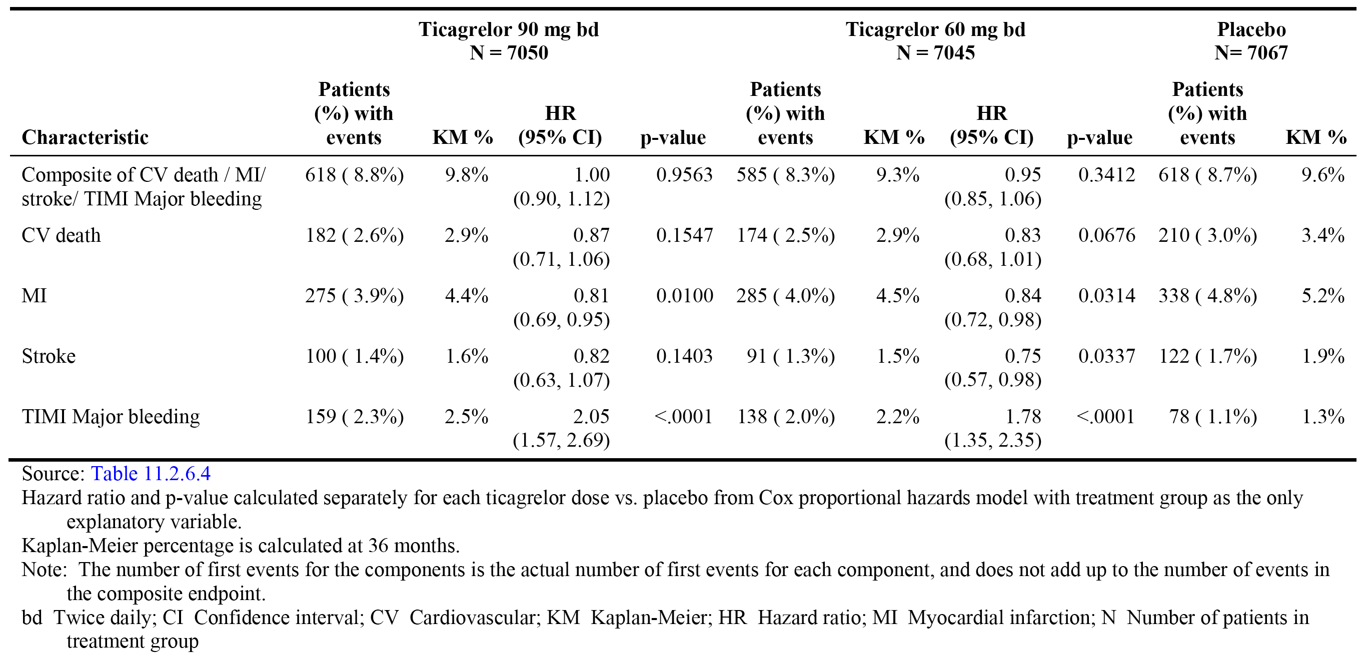
PEGASUS also included an ad hoc analysis of net clinical benefit by irreversible harm (that is, composite of all-cause mortality/MI/stroke/ICH/fatal bleeding). In the FAS, there were 600 (8.5%) events in the ticagrelor 60 mg group and 686 (9.7%) events in the placebo group, corresponding to KM percentages at 36 months of 9.6% and 10.6%, respectively; HR = 0.87 (0.78, 0.97), p=0.0139. Based on KM percentages at 36 months, the results indicate a numerical risk reduction in irreversible harm in the ticagrelor 60 mg group compared to the placebo group (that is, RRR = 13%; ARR = 0.9%). The complete results of the analysis of net clinical benefit by irreversible harm are summarised in Table 33.

Table 33: PEGASUS - Analysis of net clinical benefit by irreversible harm, the composite of all-cause mortality, MI, stroke, ICH, and fatal bleeding; FAS
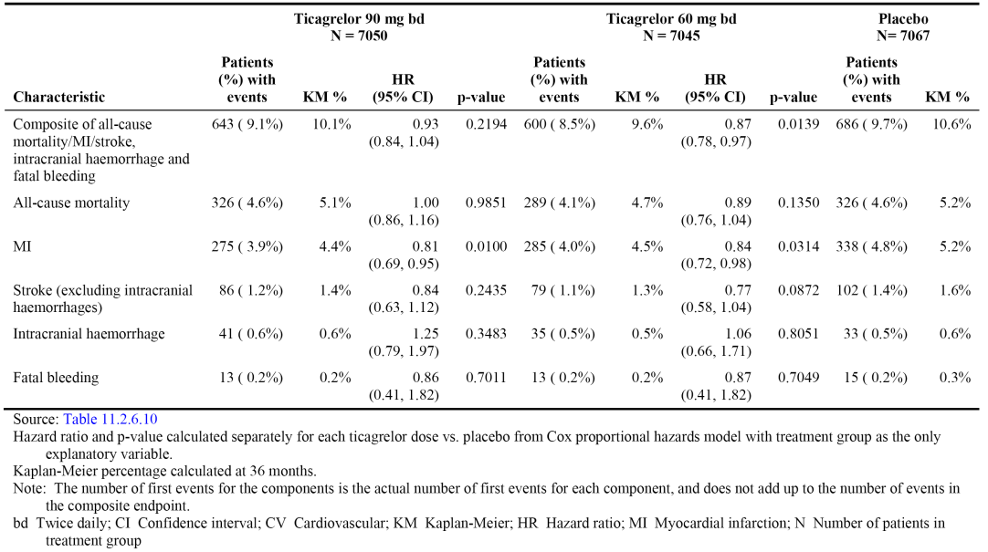
Based on the absolute risk difference in primary composite efficacy events (CV death/MI/stroke) between ticagrelor 60 mg and placebo in the ITT analysis (FAS) (1.2% in favour of ticagrelor 60 mg BD), it can be estimated that 84 patients need to be treated with ticagrelor 60 mg BD for 3 years in order to prevent 1 composite event, and that treatment of 1000 patients with ticagrelor 60 mg for 3 years will prevent 12 composite events. Based on the absolute risk difference for primary safety outcome of TIMI major bleeding events between ticagrelor 60 mg and placebo in the ITT analysis (FAS) (0.9% in favour of placebo), it can be estimated that 112 patients treated with ticagrelor 60 mg for three years will experience 1 TIMI major bleeding event due to treatment, and 9 events will be caused by ticagrelor 60 mg BD in 1000 patients treated for 3 years. Therefore, based on the analysis in the ITT analysis (FAS) the benefit-risk balance (composite efficacy endpoint versus TIMI major bleeding event) for ticagrelor 60 mg BD in combination with ASA is favourable, with the benefit marginally outweighing the risk.
The primary benefit of treatment with ticagrelor 60 mg compared to placebo was a statistically significant reduction in the primary composite efficacy endpoint event rate (CV death/MI/stroke). In patients in the ticagrelor 60 mg (487 events) and placebo groups (578 events), KM percentages at 36 months for composite events were 7.8% and 9.0%, respectively (HR = 0.84 [95% CI: 0.74, 0.95], p=0.0043). The risk of each separate component of the primary composite efficacy endpoint was numerically lower in the ticagrelor 60 mg group than in the placebo group. The benefits observed with ticagrelor 60 mg compared to placebo relating to the composite endpoint are considered to be clinically meaningful.
There was no confirmatory evidence that ticagrelor 60 mg statistically significantly reduced the risk of the key secondary efficacy endpoints of CV death and all-cause mortality compared to placebo. However, based on KM percentages at 36 months the risk of both of these mortality outcomes was numerically lower in the ticagrelor 60 mg group than in the placebo group. Other secondary and exploratory cardiovascular and mortality endpoints consistently numerically favoured treatment with ticagrelor 60 mg compared to placebo.
The most clinically significant risks associated with ticagrelor 60 mg compared to placebo in the proposed patient population relate to TIMI major bleeding events. In patients in the ticagrelor 60 mg BD (115 events) and placebo groups (54 events), KM percentages at 36 months for TIMI major bleeding events were 2.3% and 1.1%, respectively (HR = 2.32 [95% CI: 1.68, 3.21], p <0.0001). The increased risk of TIMI major bleeding events in the ticagrelor 60 mg group was primarily driven by ‘other’ TIMI major bleeding events (predominantly gastrointestinal haemorrhage), which were associated with significant morbidity characterised by hospitalisation and blood transfusions in both the ticagrelor 60 mg and placebo groups. TIMI major bleeding events categorised as ICH and fatal were both reported in a similar proportion of patients in the ticagrelor 60 mg and placebo groups.
Adjudicated fatal bleeding AEs (any) on-treatment was reported in 0.2% of patients in both the ticagrelor 60 mg BD group and the placebo group. Adjudicated CV deaths (on and off treatment) were reported in a greater proportion of patients in the placebo group than in the ticagrelor 60 mg BD group, and adjudicated non-CV deaths (on and off treatment) were reported in a similar proportion of patients in both treatment groups. Overall, the mortality data indicate that patients treated with ticagrelor 60 mg BD plus ASA are not at an increased risk of death compared to patients treated with ASA.
The risk of experiencing at least one AE (any) was higher for patients in the ticagrelor 60 mg group than the placebo group (75.7% [36.0 events/100 patient years] versus 69.1% [30.4 events/100 patient years, respectively). The most frequently reported AE (any) in the ticagrelor 60 mg group was dyspnoea, which was reported in 12.4% of patients (5.9/100 patient years) in the ticagrelor 60 mg group and 4.4% of patients (1.94/100 patient years) in the placebo group. SAEs (any) were reported in a similar proportion of patients in both the ticagrelor 60 mg group and the placebo group (21.4% [10.2 events/100 patient] years versus 21.6% [9.5 events/100 patient years], respectively). SAEs reported in ≥ 1% of patients in the ticagrelor 60 mg group (versus placebo) were non-cardiac chest pain (1.3% versus 1.3%, respectively) and atrial fibrillation (1.1% versus 0.7%, respectively), with dyspnoea being reported in 0.3% of patients in the ticagrelor 60 mg group and 0.1% in the placebo group.
The risk of permanent discontinuation of the study drug due to AEs (any) was notably greater in the ticagrelor 60 mg group than in the placebo group (16.1% versus 8.5% of patients, respectively), with the most frequently reported AE resulting in permanent treatment of ticagrelor 60 mg being dyspnoea. Permanent discontinuation of the study drug due to AEs (any) reported in ≥ 0.5% of patients in the ticagrelor 60 mg group (vs placebo group) were dyspnoea (4.0% versus 0.7%), atrial fibrillation (1.2% versus 1.1%), increased tendency to bruise (0.9% versus 0.1%), epistaxis (0.7% versus 0.2%), and spontaneous haematoma (0.6% versus < 0.1%).
The favourable benefit-risk balance relating to ticagrelor 60 mg BD in combination with ASA observed in PEGASUS cannot be extrapolated to all patients with a previous history of MI. Consequently, careful selection of patients to be treated with the proposed dosage regimen will be required in order to avoid potentially harmful effects of the combination resulting in an unfavourable benefit-risk balance.
The pivotal study (PEGASUS) included patients aged ≥ 50 years with a history of MI occurring more than 1 year previously and with at least one of the following high risk factors for a further atherothrombotic event: age ≥ 65 years; diabetes mellitus requiring medication; angiographic evidence of significant multi vessel CAD; or chronic non-end stage renal dysfunction defined as CrCL < 60 mL/min. The study specifically excluded patients at risk for bleeding events and patients with a significant history of bleeding (for example, ICH at any time; GIT bleeding within the previous 6 months). In addition, the study excluded patients with a history of intracranial haemorrhage at any time, a history of ischaemic stroke at any time, and severe liver disease. The study also excluded patients needing chronic oral anti-coagulant therapy or chronic LMWH therapy at venous thrombosis treatment doses, but not prophylaxis doses. Patients requiring concomitant treatment with strong CYP3A4 inhibitors were excluded, as were patients at an increased risk of bradycardia and patients with renal impairment requiring dialysis. There were also exclusions relating to the time interval between previous specified treatments and enrolment in the study, including coronary artery by-pass graft (GABG) surgery, intracranial and spinal surgery, other major surgery and gastrointestinal bleeding.

First round recommendation regarding authorisation
It is recommended that the application to register ticagrelor 60 mg BD in combination with ASA for the prevention of atherothrombotic events (CV death, MI, stroke) in patients with a history of MI occurring at least 1 year previously and a high risk of developing an atherothrombotic event be approved.

Clinical questions
No clinical questions.

Second round evaluation of clinical data submitted in response to questions

Overview
No clinical questions for the sponsor were raised by the clinical evaluator as a result of the first round clinical evaluation. However, in their response the sponsor provided comment on errors or omissions associated with the first round clinical evaluation report. This second round report has taken into account the sponsor’s comments on errors and omissions.
In addition to comments on the first round clinical evaluation report, the sponsor also provided a response to the matters raised by the clinical evaluator relating to the clinical aspects of the draft PI, together with an updated draft PI. The sponsor’s response also included additional proposals relating to amendments to the PI, which had not been discussed in the original submission. The sponsor’s response relating to the PI was considered.
The same clinical evaluator prepared the first and second round clinical evaluation reports.

Second round benefit-risk assessment

Second round assessment of benefits
No new clinical information was submitted in the sponsor’s response to the first round clinical evaluation report. Accordingly, the benefits of ticagrelor for the proposed extension of indication are unchanged from those identified in the first round evaluation.

Second round assessment of risks
No new clinical information was submitted in the sponsor’s response to the first round clinical evaluation report. Accordingly, the risks of ticagrelor for the proposed extension of indication are unchanged from those identified in the first round evaluation.

Second round assessment of benefit-risk balance
The benefit-risk balance of ticagrelor, given the proposed usage, is favourable.

Second round recommendation regarding authorisation
It is recommended that the application to register ticagrelor 60 mg BD in combination with ASA for the prevention of atherothrombotic events (CV death, MI, stroke) in adult patients with a history of myocardial infarction (MI occurred at least 1 year ago) and a high risk of developing an atherothrombotic event be approved.

References
- Keaney JF. Balancing the risk of and benefits of dual antiplatelet therapy (editorial). N Engl J Med 2015; 372:19: 1854-55.
- National Heart Foundation of Australia and the Cardiac Society of Australia and New Zealand. Reducing risk in heart disease: an expert guide to clinical practice for secondary prevention of coronary heart disease. Melbourne: National Heart Foundation of Australia, 2012.
- Antithrombotic trialists’ collaboration. Collaborative meta-analysis of randomised trials of antiplatelet therapy for prevention of death, myocardial infarction, and stroke in high risk patients. BMJ. 2002; 324(7329):71-86.
- Bonaca MP, Bhatt DL, Cohen M et al. Long-term use of ticagrelor in patients with prior myocardial infarction. N Engl J Med 2015; 372:1791-800.
- Thygesen K, Alpert JS, White HD, Joint ESC/ACCF/AHA/WHF Task Force for the Redefinition of Myocardial Infarction, Jaffe AS, Apple FS, et al. Universal definition of myocardial infarction. Circulation. 2007 Nov 27; 116(22):2634-2653.
- Mauri L, Hsieh WH, Massaro JM, Ho KK, D'Agostino R, Cutlip DE. Stent thrombosis in randomised clinical trials of drug-eluting stents. N Engl J Med 2007; 356(10):1020-1029.

Therapeutic Goods Administration
PO Box 100 Woden ACT 2606 Australia
Email: info@tga.gov.au Phone: 1800 020 653 Fax: 02 6232 8605
https://www.tga.gov.au

