January 2021

Australian Public Assessment Report for Teriparatide
  - Proprietary Product Name: Terrosa
  - Sponsor: Gedeon Richter Australia Pty Ltd

About the Therapeutic Goods Administration (TGA)
- The Therapeutic Goods Administration (TGA) is part of the Australian Government Department of Health and is responsible for regulating medicines and medical devices.
- The TGA administers the Therapeutic Goods Act 1989 (the Act), applying a risk management approach designed to ensure therapeutic goods supplied in Australia meet acceptable standards of quality, safety and efficacy (performance) when necessary.
- The work of the TGA is based on applying scientific and clinical expertise to decision-making, to ensure that the benefits to consumers outweigh any risks associated with the use of medicines and medical devices.
- The TGA relies on the public, healthcare professionals and industry to report problems with medicines or medical devices. TGA investigates reports received by it to determine any necessary regulatory action.
- To report a problem with a medicine or medical device, please see the information on the TGA website <https://www.tga.gov.au>.

About AusPARs
- An Australian Public Assessment Report (AusPAR) provides information about the evaluation of a prescription medicine and the considerations that led the TGA to approve or not approve a prescription medicine submission.
- AusPARs are prepared and published by the TGA.
- An AusPAR is prepared for submissions that relate to new chemical entities, generic medicines, major variations and extensions of indications.
- An AusPAR is a static document; it provides information that relates to a submission at a particular point in time.
- A new AusPAR will be developed to reflect changes to indications and/or major variations to a prescription medicine subject to evaluation by the TGA.

Copyright
© Commonwealth of Australia 2021
This work is copyright. You may reproduce the whole or part of this work in unaltered form for your own personal use or, if you are part of an organisation, for internal use within your organisation, but only if you or your organisation do not use the reproduction for any commercial purpose and retain this copyright notice and all disclaimer notices as part of that reproduction. Apart from rights to use as permitted by the Copyright Act 1968 or allowed by this copyright notice, all other rights are reserved and you are not allowed to reproduce the whole or any part of this work in any way (electronic or otherwise) without first being given specific written permission from the Commonwealth to do so. Requests and inquiries concerning reproduction and rights are to be sent to the TGA Copyright Officer, Therapeutic Goods Administration, PO Box 100, Woden ACT 2606 or emailed to <tga.copyright@tga.gov.au>.

Contents
List of abbreviations 4
I. Introduction to product submission 6
Submission details 6
Product background 7
Regulatory status 8
Product Information 9
II. Registration timeline 10
III. Submission overview and risk/benefit assessment 10
Quality 10
Nonclinical 12
Clinical 13
Risk management plan 18
Risk-benefit analysis 19
Outcome 20
Attachment 1. Product Information 21

List of abbreviations
Abbreviation | Meaning
ACM | Advisory Committee on Medicines
ADR | Adverse drug reaction
AE | Adverse event
ANOVA | Analysis of variance
ARGPM | Australian Regulatory Guidelines for Prescription Medicines
ARTG | Australian Register of Therapeutic Goods
ASA | Australia specific annex
AUC_{0-inf} | Area under concentration time curve from time zero to infinity
AUC_{0-tlast} | Area under concentration time curve from time zero to last quantifiable concentration
BMD | Bone mineral density
BMI | Body mass index
cAMP | Cyclic adenosine monophosphate
CI | Confidence interval
C_{max} | Maximum plasma concentration
CMI | Consumer Medicine Information
CPD | Certified Product Details
CSR | Clinical study report
CV | Coefficient of variation
DEXA/DXA | Dual energy x-ray absorptiometry
DLP | Data lock point
DNA | Deoxyribonucleic acid
DP | Drug product
DS | Drug substance
EU | European Union
FAS | Full analysis set
GLP | Good Laboratory Practice
GMR | Geometric mean ratio
GVP | Good pharmacovigilance practice
IFU | Instruction for use
LOCF | Last observation carried forward
LSM | Least square means
P1NPJ | Procollagen type 1 amino-terminal propeptide
PI | Product Information
PK | Pharmacokinetic
PPS | Per protocol set
PSUR | periodic safety update report
PTH | Parathyroid hormone
PTHR1 | Parathyroid hormone receptor 1
RMP | Risk management plan
SAE | Serious adverse event
SC | Subcutaneous
SD | Standard deviation
T_{1/2} | Terminal half-life
TGA | Therapeutic Goods Administration
T_{last} | Time at last measurable concentration
YAM | Young adult mean

I. Introduction to product submission

Submission details
Type of submission: | New biosimilar entity
Product name: | Terrosa
Active ingredient: | Teriparatide
Decision: | Approved
Date of decision: | 24 November 2020
Date of entry onto ARTG: | 1 December 2020
ARTG number: | 326885
Black Triangle Scheme: | No
Sponsor’s name and address: | Gedeon Richter Australia Pty Ltd  Units 33 - 34, 23 Narabang Way  Belrose, New South Wales, 2085
Dose form: | Solution for injection
Strength: | 250 microgram (µg)/mL
Container: | Cartridge
Pack sizes: | 1 cartridge and a pen, 1 cartridge, 3 cartridges
Approved therapeutic use: | Terrosa is indicated for the treatment of osteoporosis in postmenopausal women and the treatment of primary osteoporosis in men when other agents are considered unsuitable and when there is a high risk of fractures.  Terrosa is indicated for the treatment of osteoporosis associated with sustained systemic glucocorticoid therapy in women and men at high risk for fracture.
Route of administration: | Subcutaneous injection
Dosage: | The recommended dose of Terrosa is 20 µg administered once daily by subcutaneous injection in the thigh or abdomen.  Based on clinical experience, treatment with teriparatide is recommended for a lifetime duration of 24 months treatment (for post-treatment efficacy, see Section 5.1 Pharmacodynamic in Product Information (PI))  For further information regarding dosage, refer to the PI.
Pregnancy category: | B3  Drugs which have been taken by only a limited number of pregnant women and women of childbearing age, without an increase in the frequency of malformation or other direct or indirect harmful effects on the human fetus having been observed.  Studies in animals have shown evidence of an increased occurrence of fetal damage, the significance of which is considered uncertain in humans.  The use of any medicine during pregnancy requires careful consideration of both risks and benefits by the treating health professional. This must not be used as the sole basis of decision making in the use of medicines during pregnancy. The TGA does not provide advice on the use of medicines in pregnancy for specific cases. More information is available from obstetric drug information services in your State or Territory.

Product background
This AusPAR describes the application by Gedeon Richter Australia Pty Ltd (the sponsor) to register Terrosa (teriparatide) 250 microgram (µg)/mL, injection solution for the following proposed indication:
Terrosa is indicated for the treatment of osteoporosis in postmenopausal women and the treatment of primary osteoporosis in men when other agents are considered unsuitable and when there is a high risk of fracture.
Terrosa is indicated for the treatment of osteoporosis associated with sustained systemic glucocorticoid therapy in women and men at high risk for fracture.
This is an application to register Terrosa (teriparatide) as a biosimilar medicinal product of Forteo (teriparatide) manufactured by Eli Lilly Australia Pty Ltd. Forteo was registered in Australia in 2003.
Teriparatide is a polypeptide consisting of the first 34 amino acids of endogenous human parathyroid hormone. Recombinant teriparatide has no glycosylation or other post-translational modifications. Terrosa and Forteo are produced in Escherichia coli using recombinant deoxyribonucleic acid (DNA) technology.
The sponsor has proposed the same indications as Forteo. The dosing regimen/route and maximum recommended total treatment duration for Terrosa are the same as those approved for Forteo.
Osteoporosis is a common condition particularly in the ageing population. It is characterised by a progressive loss of bone mineral density (BMD) affecting both cortical and trabecular bone, predisposing patients to minimal trauma or even apparently spontaneous fractures. Of most clinical interest, and occurring most commonly, are fractures of the vertebral bodies, femoral neck and wrist. Diagnosis of osteoporosis in the past depended on specialised radiography but in the current era this been superseded by techniques for measurement of BMD, the index method now being dual energy x-ray absorptiometry (DEXA; also abbreviated as DXA).
Osteoporosis may occur secondary to endocrine disorders but primary or idiopathic osteoporosis is more common. Primary or idiopathic osteoporosis is most often seen in menopausal females but may occur in either gender and sometimes in younger adults, particularly where there is a genetic factor. In the causation of osteoporosis, both the impairment of bone formation by osteoblasts and the increase in bone resorption by osteoclasts may be implicated. Physiological maintenance of bone involves a delicate balance of these two factors, both of which can be therapeutic targets.
Current treatment options include biosphosphonate drugs such as alendronate, etidronate and zoledronate; teriparatide (recombinant parathyroid hormone); strontium ranelate; and the antiresorptive therapy, denosumab. Other osteoporosis management strategies, often used in combination with these therapies, include calcium and vitamin D supplementation to maintain or improve bone density and hormonal therapies, particularly oestrogen replacement therapy following menopause.

Regulatory status
Terrosa (teriparatide) is considered to be a new biosimilar medicine for Australian regulatory purposes. The reference product is Forteo (teriparatide), manufactured by Eli Lilly Australia Ptd Ltd. Forteo was registered on the Australian Register of Pharmaceutical Goods (ARTG) in May 2003.
At the time the TGA considered this application, a similar application had been approved in European Union (EU) (approved on 4 January 2017), Switzerland (approved on 4 December 2018), Japan (approved on 20 September 2019), South Korea (approved on 29 October 2019), and was under consideration in Canada and Israel.
Table 1: International regulatory status history for Terrosa
Region | Submission date | Status | Approved indications
EU (centralised)  Rapporteur: Austria  Co-rapporteur: United Kingdom | 30 November 2015 | Approved on 4 January 2017 | Terrosa is indicated in adults.  Treatment of osteoporosis in postmenopausal women and in men at increased risk of fracture. In postmenopausal women, a significant reduction in the incidence of vertebral and non-vertebral fractures but not hip fractures has been demonstrated.  Treatment of osteoporosis associated with sustained systemic glucocorticoid therapy in women and men at increased risk for fracture.
Switzerland | 27 July 2017 | Approved on 4 December 2018 | Terrosa is indicated for treatment of osteoporosis in postmenopausal women with apparent osteoporosis and at increased risk of fracture. In postmenopausal women with osteoporosis, a significant reduction in the incidence of vertebral and nonvertebral fractures has been demonstrated.  Terrosa is indicated in men with idiopathic or hypogonadal osteoporosis at increased risk for fracture.  In men with idiopathic or hypogonadal osteoporosis Terrosa increases bone mineral density.  Treatment of Glucocorticoid-induced osteoporosis in adults at increased risk for fracture.
Japan | 27 September 2018 | Approved on 20 September 2019 | Terrosa is indicated for treatment of osteoporosis at high risk of fracture.
South Korea | 14 February 2018 | Approved on 29 October 2019 | Treatment of osteoporosis in postmenopausal women and in men at increased risk of fracture.  Treatment of osteoporosis associated with sustained systemic glucocorticoid therapy in women and men at increased risk for fracture.
Canada | 11 April 2018 | Under consideration | Under consideration
Israel | 3 September 2018 | Under consideration | Under consideration

Product Information
The Product Information approved with the submission which is described in this AusPAR can be found as Attachment 1. For the most recent PI, please refer to the TGA website at <https://www.tga.gov.au/product-information-pi>.

II. Registration timeline
The following table captures the key steps and dates for this application and which are detailed and discussed in this AusPAR.
Table 2: Timeline for Submission PM-2019-05333-1-5
Description | Date
Submission dossier accepted and first round evaluation commenced | 3 January 2020
First round evaluation completed | 10 July 2020
Sponsor provides responses on questions raised in first round evaluation | 10 August 2020
Second round evaluation completed | 28 August 2020
Delegate’s Overall benefit-risk assessment | 12 November 2020
Sponsor’s pre-Advisory Committee response | Not applicable
Advisory Committee meeting | Not applicable
Registration decision (Outcome) | 24 November 2020
Completion of administrative activities and registration on the ARTG | 1 December 2020
Number of working days from submission dossier acceptance to registration decision* | 195
*Statutory timeframe for standard applications is 255 working days

III. Submission overview and risk/benefit assessment
The submission was summarised in the following Delegate’s overview and
The Delegate has referred to the below guidelines:
- Committee for Medicinal Products for Human Use (CHMP). Guideline on similar biological medicinal products containing biotechnology-derived proteins as active substance: non-clinical and clinical issues. EMEA/CHMP/BMWP/42832/2005 Rev 1; December 2014
- Committee for Medicinal Products for Human Use (CHMP). Guideline on similar biological medicinal products. CHMP/437/04 Rev 1; October 2014

Quality
The quality evaluator had no objections on quality grounds to the registration of Terrosa. Overall, sufficient evidence was provided to demonstrate that the risks related to the manufacturing quality of Terrosa have been controlled to an acceptable level.
Forsteo (EU-sourced reference product) was used as the main reference product to demonstrate biosimilarity in terms of quality and non-clinical comparability. Comparisons of the primary, secondary and tertiary structures, physicochemical properties and biological activities showed that Terrosa and Forsteo are generally similar. Bridging studies confirmed the EU-sourced Forsteo and Australian-sourced Forteo reference products were generally similar. The sponsor has demonstrated that Terrosa is physiochemically and biologically similar to EU-sourced Forsteo and Australian-sourced Forteo.
Forteo (Japanese-sourced reference product) was used as the reference product in Study RGB1023O31. Based on a comparison of the Japanese, EU and Australian health authority reviews, as well as the carton boxes of reference materials Forteo sourced from Japan (Eli Lilly Japan Kabushiki Kaisha) appears to be the same as the reference biologic drug Forsteo sourced from the EU and Forteo sourced from Australia. This meets the reference medicines requirements detailed in the TGA’s Biosimilars guidelines.
The data supplied in relation to the physical and chemical properties of Terrosa were satisfactory. There were no issues pertaining to the specifications or the stability of the drug substance (DS) or the drug product (DP). There were no quality related concerns.
All manufacturing steps and analytical procedures were validated and there were no issues pertaining to manufacture or to the manufacturers of the product.
There were no objections to the registration of this product from a sterility, endotoxin, container safety or an adventitious agent perspective.
The real time data submitted support the proposed DP shelf life of 24 months when stored at 2°C to 8°C and protected from light. The in-use data supported the in-use conditions listed in the PI after opening.
Figure 1: Structure of human parathyroid hormone (1-34), superposition of the crystal structure (yellow) with nuclear magnetic resonance structures of human parathyroid hormone (1-34) (green)
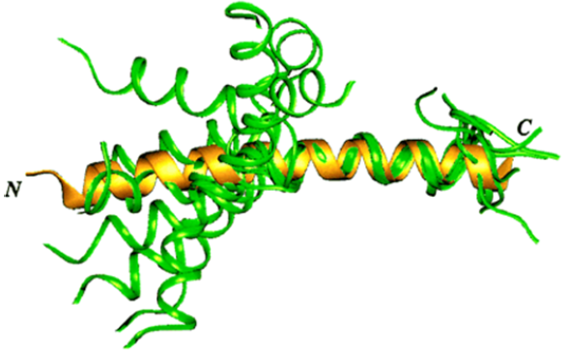

Quality related proposed conditions of registration

Laboratory testing and compliance with Certified Product Details
- All batches of Terrosa supplied in Australia must comply with the product details and specifications approved during evaluation and detailed in the Certified Product Details (CPD).
- When requested by the TGA, the sponsor should be prepared to provide product samples, specified reference materials and documentary evidence to enable the TGA to conduct laboratory testing on the product. Outcomes of laboratory testing are published biannually in the TGA Database of Laboratory Testing Results http://www.tga.gov.au/ws-labs-index and periodically in testing reports on the TGA website.

Certified Product Details
- The CPD, as described in Guidance 7: Certified Product Details of the Australian Regulatory Guidelines for Prescription Medicines (ARGPM) (http://www.tga.gov.au/industry/pm-argpm-guidance-7.htm), in PDF format, for the above products should be provided upon registration of these therapeutic goods. In addition, an updated CPD should be provided when changes to finished product specifications and test methods are approved in a Category 3 application or notified through a self-assessable change. The CPD should be emailed to Biochemistry.Testing@health.gov.au as a single PDF document.

Nonclinical
The nonclinical evaluator had no objections to the registration of Terrosa on the conditions that the EU-sourced Forsteo is considered to be identical or highly comparable to Australian-sourced Forteo. Overall, the nonclinical program provided sufficient evidence for no clinically relevant differences between Terrosa and EU-sourced Forsteo.
The nonclinical dossier contained comparative studies on pharmacology, pharmacokinetics and repeat-dose toxicity. The scope of the nonclinical program was adequate under the relevant TGA adopted EU guideline. The toxicity study was Good Laboratory Practice (GLP)-compliant. The studies were conducted using EU sourced Forsteo as the reference product.
The Terrosa and EU Forsteo forms of teriparatide showed highly comparable pharmacological activity in terms of their binding affinity (to recombinant human parathyroid hormone receptor 1 (PTHR1)) and functional potency (as stimulation of PTHR1-mediated cyclic adenosine monophosphate (cAMP) production in rat (UMR-106) and human (Saos-2) osteosarcoma cell lines) in vitro.
Comparative in vivo pharmacology and repeat-dose toxicity studies, involving once daily subcutaneous (SC) injection for 4 weeks, were performed in rats. Effects on bone and other endpoints were seen to be comparable between Terrosa and EU-sourced Forsteo in the repeat-dose toxicity study. Statistically significant greater increases in bone slice area and bone mineral content but not BMD were observed with Terrosa compared to EU-sourced Forsteo in the pharmacology study. However, this occurred in the context of apparent higher drug exposure, at only one of the tested dose levels, and the magnitude of the differences was modest. BMD is considered to be the most clinically relevant endpoint, and this was highly similar between teriparatide forms.
A definitive conclusion on the comparability of the pharmacokinetic profiles of the Terrosa and EU-sourced Forsteo forms of teriparatide in rats cannot be made due to limited sampling and high inter-animal variation. With bioequivalence to be established from human data, this is not of concern.
The nonclinical evaluator noted that multiple contraindications do not match those of the Australian PI for Forteo.

Clinical
The clinical dossier contains:
- one Phase I comparative pharmacokinetics/pharmacodynamics study; and
- one Phase III comparative efficacy/safety study.
The clinical evaluator raised no objections to the approval of the product. The benefit-risk balance for treatment with the biosimilar product by comparison with the existing available teriparatide product Forteo was considered neutral. The benefit-risk balance of teriparatide for the approved indications is unchanged. The submission included a single dose pharmacokinetic (PK) study and one pivotal study of efficacy and safety in patients with osteoporosis who were at high risk of fracture. Table 3 summarises the clinical development program for Terrosa.
Table 3: Clinical development program for Terrosa
Study No. | Study type | Subject / patient type | Terrosa | Comparator | Treatment duration | No. treated
RGB-10-001 | Equivalence | Healthy adult female pre-menopausal subjects | Single dose SC 20 µg / 80 µL | Single dose SC 20 µg/80 µL | Single dose | 54
RGB-1023O31 | Phase III | Patients with osteoporosis | SC 20 µg / 80 µL daily | SC 20 µg / 80 µL daily | 52 weeks | 250
Note: Comparator was Forsteo.

Pharmacology

Pharmacokinetics
The bioequivalence of Terrosa and Forsteo was assessed in a randomised, double blind, active controlled, single centre, single fixed dose, two way crossover study (Study RGB-10-001). Participants were healthy adult premenopausal females aged 18 to 55 years. There was a washout period of at least 24 hours between treatments. Teriparatide concentrations were measured at 10, 20, 25, 30, 35, 40, 50, 60, 70, 80, 90, 120, 180, and 240 minutes post-dose (see Figure 2, below).
Terrosa and Forsteo were shown to be bioequivalent since the 94.12% confidence interval (CI) for the ratio of means were well within the pre-specified 80 to 125% limits. Both the peak level and total exposure appear between 8 to 10% lower, and half-life 9% shorter, following Terrosa compared to Forsteo (Table 4). These differences were statistically significant but the products satisfy the criteria for bioequivalence.
Table 4: Study RGB-10-001 Summary of bioequivalence parameters for Terrosa versus Forsteo
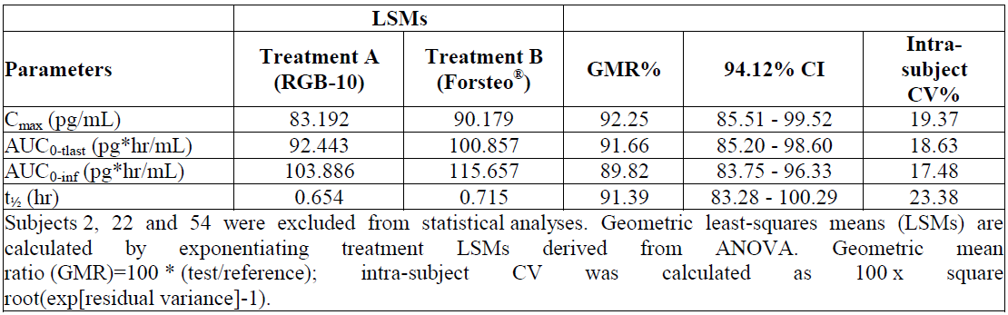
Abbreviations: AUC_{0-inf} = area under concentration-time curve from time zero to infinity; AUC_{0-tlast} = area under concentration-time curve from time zero to last quantifiable concentration; CI = confidence interval; Cmax = maximum plasma concentration; t_{½} = terminal half-life; t_{last} = time at last measurable concentration
Figure 2: Study RGB-10-001 Concentration time profile for Terrosa and Forsteo
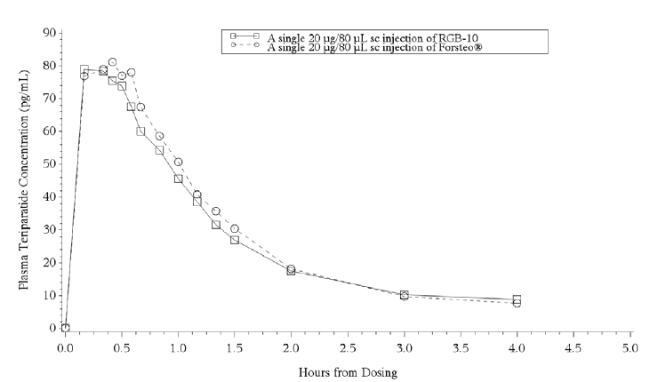

Efficacy

Study RGB1023O31
Study RGB1023O31 was a multi-centre, randomised, active drug-controlled, rater-blinded, parallel-group comparative study to evaluate efficacy and safety of 52 weeks of treatment with Terrosa compared to Forteo in patients with osteoporosis and at high risk of fracture. The study was conducted in Japan using a locally sourced Forteo reference product.
Study subjects were ambulatory outpatients with a diagnosis of primary osteoporosis and at high risk of fracture. Female patients were required to be at least 5 years menopausal. The criteria for high risk of fracture were:
- patients, aged 55 years or older, with lumbar spine (L2 to L4) BMD < 80% (-1.7 standard deviation (SD)) of young adult mean (YAM) with at least 1 vertebral body fragility fracture; or
- patients, aged 65 years or older, with lumbar spine (L2 to L4) BMD < 70% (-2.6 SD) of YAM; or
- patients, aged 55 years or older, with lumbar spine (L2 to L4) BMD < 65% (-3.0 SD) of YAM.
The test and reference treatments were Terrosa and Forteo, respectively. Subjects self-administered 20 µg of teriparatide daily via SC injection for the 52 weeks treatment period. All patients received orally administered calcium and vitamin D.
The primary efficacy endpoint was the percentage change from Baseline to 52 weeks in lumbar spine (L2 to L4) BMD. Secondary efficacy endpoints, all measured from Baseline at 52 weeks, included:
- absolute change in lumbar spine (L2 to L4) BMD
- % and absolute change in lumbar spine (L1 to L4) BMD
- % and absolute change in femoral neck BMD
- % and absolute change in proximal femoral BMD
- % and absolute change in the bone metabolic marker serum procollagen type I amino terminal propeptide (P1NPJ)
- any incidence of vertebral or non-vertebral fractures.
369 subjects were recruited, 119 were withdrawn at screening, and 250 subjects were randomised (125 to Terrosa (test) and 125 to Forteo (reference product)). 219 subjects completed the study (107 test, 112 reference). The remaining 31 (18 test, 13 reference) were withdrawn during the treatment, mostly (26 out of 31) for occurrence of an adverse event (AE) (15 test, 11 reference). 3 subjects (1 test, 2 reference) were withdrawn during the two weeks follow-up period after completing treatment. The full analysis set (FAS) comprised all 250 randomised and treated subjects. The per protocol set (PPS) included 218 subjects (106 test, 112 reference).
The great majority of subjects (241 out of 250, 96.4%) were female. At Baseline, mean age of the test subjects was 70.5 years (range 56 to 70) and of the reference subjects, 70.3 years (55 to 69). Mean body mass index (BMI) was similar between treatment arms. The groups were well matched in terms of years since menopause. A minority (24.8% test, 27.2% reference) had received prior treatment for osteoporosis, and very few (6 test, 5 reference) had specifically received bisphosphonate therapy. 51 (40.8%) of test and 38 (30.4%) of reference subjects had existing vertebral fractures.
The percent change (mean ± SD) in lumbar spine (L2 to L4) BMD at Week 52 (last observation carried forward (LOCF) was 8.94% ± 6.19% in the Terrosa group and 9.65% ± 6.22% in the Forteo group. The (adjusted) difference (two-sided 95% CI) in the mean between the Terrosa and Forteo groups was - 0.65% (- 2.17% to 0.87%). The two-sided 95% CI fell within the range of the pre-specified equivalence margin of ± 2.8%. This equivalence margin was determined by referring to the least significant change, which was considered as the detection limit of bone mass changes over time, described in the Japanese guidelines for prevention and treatment of osteoporosis. The clinical evaluator considered the choice of a 2.8% margin as conservative and appropriate.
Over time, percent change in L2 to L4 BMD increased progressively in both groups from Baseline to Week 12, 24 and 52 in an approximately linear fashion (see Table 5, below). The results show a persistent difference between the percent increase in BMD between the two treatments, although not one increasing with time.
Table 5: Study RGB1023O31 Change in L2 to L4 bone mineral density from Baseline to Week 52
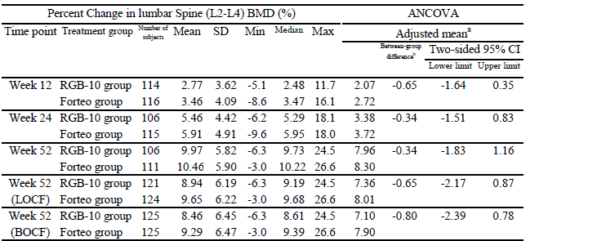
a = Mean percent change in lumbar spine (L2 to L4) BMD adjusted for baseline lumbar spine (L2 to L4) BMD and prior bisphosphonate status
b = RGB-10 Group – Forteo group
Results for the absolute change in lumbar spine (L2 to L4) BMD showed a similar pattern to that for the primary efficacy parameter (see Figure 3, below). Results for the outcome measures for L1 to L4 BMD showed a pattern of change consistent with that observed for L2 to L4. There was no significant difference between the two groups, there was a small arithmetic difference between the groups of between 0.3 to 0.5% slightly favouring the Forteo group.
Measurement of femoral neck and proximal femoral BMD showed increases of BMD over the treatment period which were of lesser magnitude, approximately 1% increase from Baseline, not significantly different between the groups but again with a slight arithmetic difference favouring the reference group.
Serum P1NP rose markedly from Baseline in both groups, at 52 weeks by a mean of 269.8% in the test group and 230.9 % in the reference group. The rise was progressive over time and showed marked inter-individual variation.
A small number of vertebral and non-vertebral fractures occurred during the treatment period, but there was no significant difference in the incidence of these between the test and reference groups. The total number of fractures of various types of classification was the same in each group.
Figure 3: Study RGB1023O31 Pattern of absolute change in lumbar spine bone mineral density
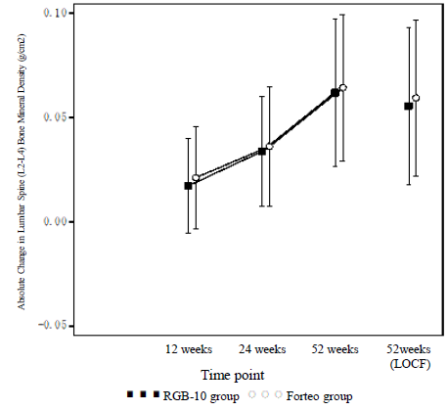

Safety
Terrosa is yet to be marketed, therefore exposure is limited to the two clinical studies presented in the submission. No integrated analysis of safety was performed. In Study RGB-10-001, the total exposure was 54 patient days. In Study RGB1023O31, the total exposure was 39,383 patient days or 107.9 patient years.
In Study RGB-10-001, AEs reported in > 10% of all subjects are shown in Table 6, below. There was a clear trend for the AE are dependent on completion of the product (nausea, vomiting, dizziness, headache and presyncope) to occur less commonly with RGB-10 than with Forteo. This could be related to the arithmetically lower exposure for Terrosa shown in PK Study RGB-10-001 for AEs that are PK dependent.
Table 6: Study RGB-10-001 Adverse events reported in ≥ 10% of all subjects
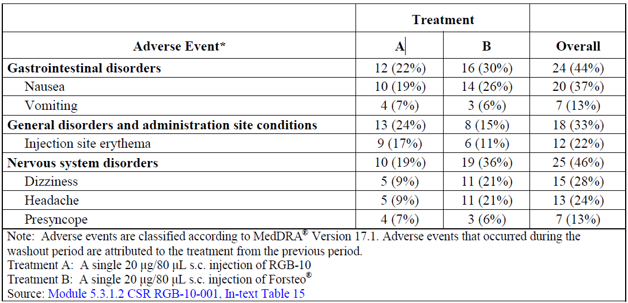
In Study RGB 1023O31 26.0% of subjects had received prior treatment for osteoporosis, 4.4% had received prior treatment with bisphosphonate. Subjects who had previously used another parathyroid hormone (PTH) preparation were excluded from the study. A high proportion of subjects in both test and reference groups reported some form of AE (85.6% in each group). The incidence of AE and their qualitative distribution was similar whether the trial subjects were administered teriparatide as the biosimilar RGB-10 product or the reference Forteo product.
No deaths occurred in either study. No serious adverse events (SAE) occurred during Study RGB-10-001. In Study RGB 1023O31, SAEs, other than death, during the treatment and the follow-up periods occurred in 2.4% (3 out of 125) of the subjects in the RGB-10 group and 4.8% (6 out of 125) of the subjects in the Forteo group. None of the SAEs were considered to be adverse drug reactions (ADR).
In Study RGB 1023O31, anti-teriparatide antibody level was measured in all subjects at Baseline and Week 52. No positive results were found in the RGB-10 ,group, by comparison with 2 out of 125 of the reference Forteo group, one of whom also tested positive at Baseline.
In long term Study RGB 1023O31, hypercalcaemia was observed in a single patient treated with RGB-10 and not at all in the reference group. The AE was classified as mild and recovered spontaneously. The clinical study report (CSR) did not report any cases of hypocalcaemia or decreased serum calcium.
The submitted clinical studies revealed no new safety signals attributable to the biosimilar product, nor does it show any difference in AEs between the two products over 52 weeks of treatment, except for a possible minor trend for non-serious adverse effects to be less common with Terrosa, perhaps attributable to the lesser PK exposure figures found for that product. The clinical evaluator concluded that Terrosa is safe for use in the same clinical setting as applies to the existing product Forteo.

Risk management plan
The sponsor submitted EU-risk management plan (RMP) version 2.0 (dated 28 June 2019; data lock point (DLP) 8 April 2019) and Australia specific Annex (ASA) version 1.0 (dated 7 November 2019) in support of this application. The sponsor then submitted EU RMP version 2.1 (date 18 June 2020; DLP 10 June 2020) and an ASA version 2.0 (date 24 June 2020) with the response to TGA questions. Terrosa will be self-administered by patients and the ASA states that the consumer medicine information (CMI) and instruction for use (IFU) will be included in each pack. The RMP evaluator considered the summary of safety concerns acceptable (Table 6). Routine pharmacovigilance and risk minimisation activities have been proposed. In addition, the sponsor has proposed a patient consent form to obtain informed consent, in order to ensure that the risks associated with the product and 24 months lifetime limit on treatment is understood by the patient. This is consistent with the reference product Forteo patient consent form requirements. The RMP evaluator has requested changes to the wording of the proposed consent form.
The summary of safety concerns and their associated risk monitoring and mitigation strategies are summarised in Table 7.
Table 7: Summary of safety concerns
Summary of safety concerns |  | Pharmacovigilance |  | Risk Minimisation
 |  | Routine | Additional | Routine | Additional
Important identified risks | None
Important potential risks | Osteosarcoma | * | – |  | #
Missing information | None
*Follow–up form
# Patient consent form

RMP evaluator recommendations regarding conditions of registration
- The Terrosa EU- RMP (version 2.1, dated 18 June 2020; DLP 10 June 2020), with ASA (version 2.0, dated 24 June 2020), included with submission PM-2019-05333-1-5, and any subsequent revisions, as agreed with the TGA will be implemented in Australia.
An obligatory component of risk management plans is routine pharmacovigilance. Routine pharmacovigilance includes the submission of periodic safety update reports (PSURs).
Reports are to be provided in line with the current published list of EU reference dates and frequency of submission of PSURs until the period covered by such reports is not less than three years from the date of this approval letter.
The reports are to at least meet the requirements for PSURs as described in the European Medicines Agency’s Guideline on good pharmacovigilance practices (GVP) Module VII-periodic safety update report (Rev 1), Part VII.B Structures and processes. Note that submission of a PSUR does not constitute an application to vary the registration.

Risk-benefit analysis

Delegate’s considerations
This is the first application the TGA has received to register a biosimilar for Forteo (teriparatide). The data provided was adequate to support the registration of Terrosa as a biosimilar to Forteo. Comparisons of the EU, Japanese and Australian reference products met the TGA’s reference medicines requirements. The nonclinical program did not identify any clinically relevant differences between Terrosa and EU Forsteo.
There were concerns that whilst Terrosa and Forsteo met the criteria for bioequivalence (the 94.12% CI for the ratio of means fell within the pre-specified 80 to 125% limits), the results did not include unity and the PK parameters showed a slight arithmetic difference in favour of the reference product. Both the peak level and total exposure were between 8% to 10% lower, and half-life some 9% shorter, following the administration of Terrosa compared to Forsteo. In Study RGB1023O31 this lower exposure did not translate to a clinically significant difference in efficacy.
The submitted clinical studies revealed no new safety signals attributable to the biosimilar product. There was no difference in AEs between the two products over 52 weeks of treatment, apart from a minor trend for non-serious adverse effects to be less common with Terrosa. This may be attributable to the lower exposure identified in Study RGB-10-001.

Proposed action
The Delegate proposes to approve the registration of Terrosa (teriparatide 250 µg/mL, solution for injection, cartridge) as a new biosimilar of the reference product Forteo (teriparatide). The evidence for comparability supports the use of Terrosa for the proposed indications.

Advisory Committee considerations
The Delegate did not refer this application to the Advisory Committee on Medicines (ACM) for advice.

Outcome
Based on a review of quality, safety and efficacy, the TGA approved the registration of Terrosa (teriparatide) 250 µg/mL, solution for injection, cartridge, indicated for:
Terrosa is indicated for the treatment of osteoporosis in postmenopausal women and the treatment of primary osteoporosis in men when other agents are considered unsuitable and when there is a high risk of fractures.
Terrosa is indicated for the treatment of osteoporosis associated with sustained systemic glucocorticoid therapy in women and men at high risk for fracture.

Specific conditions of registration applying to these goods
- The Terrosa EU-RMP (version 2.1, dated 18 June 2020; DLP 10 June 2020), with ASA (version 2.0, dated 24 June 2020), included with submission PM-2019-05333-1-5, and any subsequent revisions, as agreed with the TGA will be implemented in Australia.
An obligatory component of risk management plans is routine pharmacovigilance. Routine pharmacovigilance includes the submission of periodic safety update reports (PSURs).
Reports are to be provided in line with the current published list of EU reference dates and frequency of submission of PSURs until the period covered by such reports is not less than three years from the date of this approval letter.
The reports are to at least meet the requirements for PSURs as described in the European Medicines Agency’s Guideline on good pharmacovigilance practices (GVP) Module VII-periodic safety update report (Rev 1), Part VII.B Structures and processes. Note that submission of a PSUR does not constitute an application to vary the registration.
- Laboratory testing and compliance with Certified Product Details
  - All batches of Terrosa supplied in Australia must comply with the product details and specifications approved during evaluation and detailed in the Certified Product Details (CPD).
  - When requested by the TGA, the sponsor should be prepared to provide product samples, specified reference materials and documentary evidence to enable the TGA to conduct laboratory testing on the Product. Outcomes of laboratory testing are published biannually in the TGA Database of Laboratory Testing Results http://www.tga.gov.au/ws-labs-index and periodically in testing reports on the TGA website.
- Certified Product Details
The CPD, as described in Guidance 7: Certified Product Details of the Australian Regulatory Guidelines for Prescription Medicines (ARGPM) [http://www.tga.gov.au/industry/pm-argpm-guidance-7.htm], in PDF format, for the above products should be provided upon registration of these therapeutic goods. In addition, an updated CPD should be provided when changes to finished product specifications and test methods are approved in a Category 3 application or notified through a self-assessable change. The CPD should be emailed to Biochemistry.Testing@health.gov.au as a single PDF document.
- For all injectable products the PI must be included with the product as a package insert.

Attachment 1. Product Information
The PI for Terrosa approved with the submission which is described in this AusPAR is at Attachment 1. For the most recent PI, please refer to the TGA website at <https://www.tga.gov.au/product-information-pi>.

Therapeutic Goods Administration
PO Box 100 Woden ACT 2606 Australia
Email: info@tga.gov.au Phone: 1800 020 653 Fax: 02 6232 8605
https://www.tga.gov.au

The Black Triangle Scheme provides a simple means for practitioners and patients to identify certain types of new prescription medicines, including those being used in new ways and to encourage the reporting of adverse events associated with their use. The Black Triangle does not denote that there are known safety problems, just that the TGA is encouraging adverse event reporting to help us build up the full picture of a medicine's safety profile.
Forteo (teriparatide) was first registered on the ARTG on the 22 May 2003 (ARTG number 80333).
Forteo (teriparatide) was first registered on the ARTG on the 22 May 2003 (ARTG number 80333).
A Category 3 application relates to updates to the quality data of medicines already included on the Australian Register of Therapeutic Goods (ARTG) which, in the opinion of the TGA, do not need to be supported by clinical, non-clinical or bioequivalence data.
EMEA/CHMP/BMWP/42832/2005 Rev 1: Guideline on similar biological medicinal products containing biotechnology-derived proteins as active substance: non-clinical and clinical issues.
The contraindication section was harmonised in line with the Australian PI for Forteo as requested by the TGA on 9 November 2020.
Routine risk minimisation activities may be limited to ensuring that suitable warnings are included in the product information or by careful use of labelling and packaging. Routine pharmacovigilance practices involve the following activities: - All suspected adverse reactions that are reported to the personnel of the company are collected and collated in an accessible manner; - Reporting to regulatory authorities; - Continuous monitoring of the safety profiles of approved products including signal detection and updating of labelling; - Submission of PSURs; - Meeting other local regulatory agency requirements.
The ACM provides independent medical and scientific advice to the Minister for Health and the Therapeutic Goods Administration (TGA) on issues relating to the safety, quality and efficacy of medicines supplied in Australia including issues relating to pre-market and post-market functions for medicines. The Committee is established under Regulation 35 of the Therapeutic Goods Regulations 1990. Members are appointed by the Minister. The ACM was established in January 2017 replacing Advisory Committee on Prescription Medicines (ACPM) which was formed in January 2010. ACM encompass pre and post-market advice for medicines, following the consolidation of the previous functions of the Advisory Committee on Prescription Medicines (ACPM), the Advisory Committee on the Safety of Medicines (ACSOM) and the Advisory Committee on Non-Prescription Medicines (ACNM). Membership comprises of professionals with specific scientific, medical or clinical expertise, as well as appropriate consumer health issues relating to medicines.

