Date of CER: 7 June 2012

AusPAR Attachment 2

Extract from the Clinical Evaluation Report for Teriflunomide
  - Proprietary Product Name: Aubagio/ Teriflunomide Withnrop/ Teriflunomide Sanofi
  - Sponsor: Sanofi-Aventis Australia Pty Ltd

About the Therapeutic Goods Administration (TGA)
- The Therapeutic Goods Administration (TGA) is part of the Australian Government Department of Health and Ageing, and is responsible for regulating medicines and medical devices.
- The TGA administers the Therapeutic Goods Act 1989 (the Act), applying a risk management approach designed to ensure therapeutic goods supplied in Australia meet acceptable standards of quality, safety and efficacy (performance), when necessary.
- The work of the TGA is based on applying scientific and clinical expertise to decision-making, to ensure that the benefits to consumers outweigh any risks associated with the use of medicines and medical devices.
- The TGA relies on the public, healthcare professionals and industry to report problems with medicines or medical devices. TGA investigates reports received by it to determine any necessary regulatory action.
- To report a problem with a medicine or medical device, please see the information on the TGA website <http://www.tga.gov.au>.
About the Extract from the Clinical Evaluation Report
- This document provides a more detailed evaluation of the clinical findings, extracted from the Clinical Evaluation Report (CER) prepared by the TGA. This extract does not include sections from the CER regarding product documentation or post market activities.
- The words [Information redacted], where they appear in this document, indicate that confidential information has been deleted.
- For the most recent Product Information (PI), please refer to the TGA website <http://www.tga.gov.au/hp/information-medicines-pi.htm>.
Copyright
© Commonwealth of Australia 2013
This work is copyright. You may reproduce the whole or part of this work in unaltered form for your own personal use or, if you are part of an organisation, for internal use within your organisation, but only if you or your organisation do not use the reproduction for any commercial purpose and retain this copyright notice and all disclaimer notices as part of that reproduction. Apart from rights to use as permitted by the Copyright Act 1968 or allowed by this copyright notice, all other rights are reserved and you are not allowed to reproduce the whole or any part of this work in any way (electronic or otherwise) without first being given specific written permission from the Commonwealth to do so. Requests and inquiries concerning reproduction and rights are to be sent to the TGA Copyright Officer, Therapeutic Goods Administration, PO Box 100, Woden ACT 2606 or emailed to <tga.copyright@tga.gov.au>.

Contents
List of abbreviations 5
1. Clinical rationale 8
1.1. Therapeutic indication 8
1.2. Clinical rationale 9
2. Contents of the clinical dossier 11
2.1. Scope of the clinical dossier 11
2.2. Good clinical practice 12
3. Pharmacokinetics 12
3.1. Studies providing pharmacokinetic data 12
3.2. Summary of pharmacokinetics 29
3.3. Evaluator’s overall conclusions on pharmacokinetics 42
4. Pharmacodynamics 43
4.1. Studies providing pharmacodynamic data 43
4.2. Summary of pharmacodynamics 46
4.3. Evaluator’s overall conclusions on pharmacodynamics 47
5. Dosage selection for the pivotal studies 47
6. Efficacy - the treatment of patients with relapsing forms of multiple sclerosis 47
6.1. Monotherapy - To Reduce the Frequency of Clinical Relapses 50
6.2. Monotherapy - To delay the accumulation of physical disability 85
6.3. Analyses performed across trials (pooled analyses and meta-analyses) 117
6.4. Adjunctive therapy 118
6.5. Evaluator’s conclusions on clinical efficacy 118
7. Clinical safety 124
7.1. Studies providing evaluable safety data 124
7.2. Pivotal studies that assessed safety as a primary outcome 125
7.3. Patient exposure 131
7.4. Adverse events 133
7.5. Post-marketing experience 146
7.6. Specific safety issues of regulatory importance 146
7.7. Other safety issues 161
7.8. Evaluator’s overall conclusions on clinical safety 163
8. Preliminary benefit-risk assessment 165
8.1. Preliminary assessment of benefits 165
8.2. Preliminary assessment of risks 165
8.3. Preliminary assessment of benefit-risk balance 165
9. Preliminary recommendation regarding authorisation 165
10. List of questions 166
10.1. Efficacy 166
11. Second round evaluation: clinical data submitted in response to questions 166
11.1. Second round benefit-risk assessment 167
12. Second round recommendation regarding authorisation 167
13. Additional information 167
14. References 167
15. Addendum to the clinical evaluation report 168
15.1. Reason for Addendum 168
15.2. Contents of the clinical dossier reviewed 168
15.3. Indication applied for 168
15.4. Clinical efficacy 168
15.5. Evaluator’s conclusions on population for which clinical efficacy was shown 178
15.6. Further benefit-risk assessment 179
15.7. Further recommendation regarding authorisation 179

List of abbreviations
Abbreviation |  | Meaning
4-TFMA | 4-triflouro-methylaniline
A771726 | teriflunomide
ARR | Annual or Annualised Relapse Rate
BOD | Burden of Disease assessed by cerebral MRI, and was defined as the total volume of all abnormal brain tissue (calculated as the sum of the total volume of T2 lesion component and T1 hypointense lesion component).
BPCM | Blood pressure co-administration
BPSYST | Supine systolic blood pressure
BPDIAST | Supine diastolic blood pressure
EQ-5D | EuroQoL comprises 5 dimensions: mobility, self-care, usual activities, pain/discomfort, and anxiety/depression. The 5 dimensional 3-level systems were converted into a single index utility score, which ranged from a minimum of –0.594, corresponding to level 3 (severe problems) for mobility, self-care, usual activities, pain/discomfort, and anxiety/depression, to a maximum value of 1.0, corresponding to full health (level 1, no problems).
EDSS | Expanded Disability Status Scale Score used in conjunction with the observations of gait and use of assistive devices to provide an EDSS rating ranging from 0 (normal neurological examination) to 10 (death due to MS). Subjects with a score of 6 need intermittent or unilateral constant assistance (cane, crutch or brace) to walk 100 meters with or without resting.
FS score | Functional System Score 7 functional systems (visual, brainstem, pyramidal, cerebellar, sensory, bowel/bladder, and cerebral) in addition to ambulation were rated with an FS score ranging from 0 (normal) to 5 or 6.
FIS | Fatigue Impact Scale It consists of a total score and 3 subscales to assess the impact of fatigue on cognitive function (10 items), physical function (10 items), and psychosocial function (20 items). The responses range from 0 (no problem) to 4 (extreme problem)
GA | glatiramer acetate
GEE | generalized estimating equation
HMR1726 | teriflunomide
INR | international normalized ratio
LTMMD | largest time-matched mean difference
MCONC | mean teriflunomide concentrations (steady-state)
MMRM | mixed-effect model with repeated measures
MSFC | Multiple Sclerosis Functional Composite consists of measurements of 3 components: leg function/ambulation (timed 25- foot walk), arm/hand function (9-hole peg test), and cognitive function (paced auditory serial addition test
NBACTNORM | Total number of unique active lesions / number of scans over the treatment Period
NPT1NORM | Total number of Gadolinium-enhanced T1 lesions / number of scans over the treatment period
PCSA | Potentially clinically significant abnormalities
Rac | Accumulation ratio of teriflunomide
SF-36 | Short Form general health survey. 36 questions that provides an 8-scale profile of functional health and well-being scores as well as psychometrically based physical and mental health summary measures (8). The 2 summary scores each evaluate 4 measures of physical health(physical functioning, role-physical, bodily pain, and general health) and mental health(vitality, social functioning, role-emotional, and mental health). In addition, a single question assesses reported health transition.
SUSARs | suspected unexpected serious adverse reactions (are serious adverse events judged to be related to therapy)
T1GDFREE | Number of patients free of active lesions
TDP | Time to disability progression sustained for 12-week
WPAI | work productivity and activities impairment assessing productivity losses over the past 7 days. The 4 scores of the questionnaire are expressed as impairment percentages: the percent work time missed due to health, the percent impairment while working due to health, the percent activity impairment due to health, and overall percent work impairment score due to health
Z4 score | The Z4 composite score integrates quantitative measures of 4 parameters: the volume of Gd- enhancing T1 lesions, the BOD, the volume of hypointense post-Gd T1 lesions, and the proportion of total intracranial contents segmented as cerebrospinal fluid. It is defined as the sum of individual Z scores derived from each of these 4 parameters.
η eta | Estimate of the inter-individual variability of a given PopPK parameter
θ theta | Estimate of a (part of a) PK/PD parameter
ω omega | Estimate of the variance of the inter-individual variability η of a PopPK parameter
Definitions:
Child-Pugh classification (grading system for liver cirrhosis)
 |  |  | Points scored and observed findings
 |  |  | 1 | 2 | 3
Encephalopathy grade |  |  | None | 1 to 2 | 3 to 4
Ascites |  |  | Absent | Slight | Moderate
Serum bilirubin, mg/dL |  |  | <2 | 2 to 3 | >3
Serum albumin g/dL |  |  | >3.5 | 2.8 to 3.5 | <2.8
Prothrombin time sec prolonged (INR)* |  |  | <4 (<1.7) | 4 to 6 (1.7-2.2) | >6 (>2.2
Or prothrombin level |  |  | >54% | 44-54% | <44%
Encephalopathy Grade
Grade 0: normal consciousness, personality, neurological examination.
Grade 1: restless, sleep disturbed, irritable/agitated, tremor, impaired handwriting, 5 cps waves
Grade 2: lethargic, time-disoriented, inappropriate, asterixis, ataxia, slow triphasic waves
Grade 3: somnolent, stuporous, place-disoriented, hyperactive reflexes, rigidity, slower waves
Grade 4: unrousable coma, no personality/behaviour, decerebrate, slow 2 to 3 cps delta activity
INR (International Normalized Ratio) = (prothrombin time of subject/prothrombin time of control) where ISI is the International Sensitivity Index, which depends on the type of thromboplastin used. The normal INR value is usually between 1.0 and 1.2.

Clinical rationale

Therapeutic indication
In the application Pre-submission Planning Form, the Proposed Indication is as follows:
‘TRADENAME’ is indicated for the treatment of patients with relapsing forms of multiple sclerosis to reduce the frequency of clinical relapses and to delay the accumulation of physical disability.
In accordance with the Pre submission planning form statements and since the sponsor had not re-submitted the submission the evaluator is obliged to proceed with the evaluation on the basis of this Indication:
The proposed indication in Australia is identical to that planned for submission in the EU. In the USA the submitted indication differs in the use of the term clinical exacerbations vs. clinical relapses.
However, in the Pre-Submission draft Product Information (PI), the proposed Indication is:
‘Aubagio is indicated for the treatment of Relapsing Remitting Multiple Sclerosis and Secondary Progressive Multiple Sclerosis with superimposed relapses to reduce the frequency of clinical relapses and to delay the accumulation of physical disability.’
In relation to the difference in Indication between that given in the PI and that given in the Pre-Submission Planning Form, the sponsor has justified the change thus:
“The proposed indication stated in Part 1Sections 1.2 and 1.4 of the pre-submission planning form reflects that included in Attachment 1 of the planning letter. However as error was noted in the draft PI version submitted with the PPF, which has been corrected in the final version.
Furthermore, the proposed indication in the PI provided in this application was discussed with Delegate at the pre-submission meeting and this was documented in pre-submission meeting minutes. The proposed indication has not changed significantly and continues to reflect the patient population in the pivotal trial. The sponsor will await the outcome of any advice sought by the TGA from neurologists, prior to any further amendments to the indication.”
This is further complicated by the statement in the sponsor’s Letter of Application:
“The sponsor believes that the proposed indication reflects the patient population in the pivotal TEMSO study as dictated by the inclusion criteria. The inclusion criteria for the study are as follows;
Patients with relapsing forms of multiple sclerosis meeting McDonald’s criteria for MS diagnosis at time of screening visit, and EDSS score ≤ 5.5 at screening visit.
At least one relapse in the 12 months preceding randomization, or at least 2 relapses in the 24 months preceding the randomization visit.
Additionally, the protocol was designed such that patients with any form of relapsing MS could be included in the study. Consequently, the sponsor has not amended the proposed indication but will wait until the evaluation of the application and the outcome of advice sought by the TGA on this matter.”
And by the statement in the sponsor’s Clinical Overview:
“Teriflunomide has been developed as disease modifying therapy with the following objectives:
  - To demonstrate that teriflunomide as monotherapy reduces the frequency of clinical exacerbations and delays the accumulation of physical disability in patients with relapsing MS.”

Clinical rationale
Multiple sclerosis is an immune-mediated disease involving both the cellular and humoral arms of the immune system. The generally accepted view of human MS immunopathogenesis implicates nonanergic myelin-specific autoreactive T cells activated in the peripheral immune system via an interplay between environmental triggers and genetic susceptibility. After activation, T cells acquire the potential to cross the blood–brain barrier resulting in central nervous system lesions which can be assessed by various magnetic resonance imaging (MRI) techniques.
As many as 80 to 85% of all patients present with a form of disease known as relapsing-remitting MS (RRMS), which is characterised by unpredictable acute episodes of neurological dysfunction named clinical attacks or relapses, followed by variable recovery and periods of clinical stability. Within ten years more than 50% of patients who presented with a RR form eventually develop sustained deterioration with or without relapses superimposed; this form is called the secondary progressive variety of MS (SPMS). The term relapsing MS (RMS) applies to those patients either with a RRMS form or a SPMS form that are suffering relapses. Patients with RMS, in spite of suffering from different MS forms, constitute a common target for current treatments. Around 15% of patients develop a sustained deterioration of their neurological function from the beginning; this form is called primary progressive MS (PPMS). Some patients who begin with a progressive deterioration may experience relapses with time and this form is called progressive relapsing MS (PRMS). Besides these main types of disease, the benign variety of MS refers to a RRMS form with few relapses and no significant disability after several years of evolution. Conversely, the term malignant MS applies to a very aggressive variety leading to severe disability or death in a few years after the onset of the disease.
Finally, the term clinically isolated syndrome (CIS) applies to those patients who have suffered a single clinical event but do not comply with the diagnostic criteria for definite MS.
The drug is an immunomodulator with both anti-proliferative and anti-inflammatory activity by potent (IC₅₀ = 1.25 µM), noncompetitive, selective and reversible inhibition of the mitochondrial enzyme dihydroorotate dehydrogenase (DHO-DH). That leads to a blockade of the de novo pyrimidine synthesis and a subsequent cytostatic effect on proliferating T-and B-lymphocytes in the periphery, resulting in diminished numbers of activated lymphocytes available to enter the central nervous system. Whereas slowly dividing or resting cells which rely on salvage pathways for pyrimidine supply are unaffected by teriflunomide.

Development
Teriflunomide has been developed as disease modifying therapy with the following objectives:
- To demonstrate that teriflunomide as monotherapy reduces the frequency of clinical exacerbations and delays the accumulation of physical disability in patients with relapsing MS
- To demonstrate that teriflunomide as monotherapy reduces conversion of patients presenting with their first clinical episode consistent with MS (CIS) to clinically definite MS
- To demonstrate that teriflunomide as adjunct therapy to IFN-β or GA reduces the frequency of clinical exacerbations and delays the accumulation of physical disability in patients with relapsing MS
The present submission corresponds to the first objective. Clinical studies for the second and third objectives are ongoing and are expected to result in subsequent applications for label amendments/indications.
The relevant Guideline has:
2.1 Different goals of treatments
- Treatment of acute relapses to shorten their duration and/or severity of symptoms and/or preventing their sequelae.
- Modification of the natural history of the disease. This includes:
- Preventing or delaying the accumulation of disability. This may refer to the sustained accumulation of disability related with relapses or to the progression of disability either in the progressive phase of the disease (SPMS) or in PPMS. Those three situations demand a separate approach.
- Preventing or modifying relapses. It is not clear to what extent the effect on relapses is related to the prevention or delay in the long-term accumulation of disability, which is considered a more clinically relevant effect
- Improvement of an apparently stable residual disability

Guidance

Pre-submission Meeting 22 July 2011:

From the minutes:
- The TGA advised that an indication for ‘relapsing’ forms of MS may not be supportable as only a minority of patients had a form different from relapsing-remitting in the pivotal study population. Guidance from neurologists was likely to be sought on this aspect.
- The TGA noted the choice of a 14mg vs. 7mg dose had been based on differences seen in Phase II on disability progression rather than any significant differences in the pivotal trial, where the clinical differences vs. placebo between the two groups were very small. It will be important to discuss the choice of dosing regimen, since the lack of an alternative dose makes the safety assessment impact regarding dose related side effects an important focus.
- It was noted that some AEs seemed to be dose related, with neutropenia for example being higher in the 14mg vs. 7mg and clarification was sought on any evidence of problems with skin reactions considering the known safety profile of leflunomide.
- In view of the long terminal half-life of teriflunomide i.e. steady state 3–3.5 months, TGA indicated the importance of ensuring clear labelling statements advising the need to allow time for drug elimination prior to conception.
- The FDA has agreed to receive interim analysis of TOWER/EFC10531. While submission of this data to the TGA was discussed, it is agreed to submit the complete study report as a condition of registration, not an interim analysis.
- TGA confirmed that the proposed clinical data set based on the pivotal study TEMSO/EFC6049 and supporting Phase 2 data would be sufficient to support submission of an application for teriflunomide
- TGA confirmed that the safety database planned for submission would be sufficient to support evaluation of benefit/risk
- TGA confirmed that the pooling strategy for safety was acceptable, however individual study results would be reviewed as well as pooled data. Individual data was particularly relevant when looking at long term effects considering concerns regarding immuno-suppression and the need to consider data from patients with longer term exposures.
- TGA advised that whilst the claimed outcomes of reductions in frequency of clinical exacerbations and delaying the accumulation of physical disability was supported by TEMSO/EFC6049, the proposed target indication would need to be adjusted to better reflect the patient population as not all relapsing forms of MS such as CIS were represented in the pivotal study population. Guidance from neurologists was likely to be sought on this aspect.
- The Module 2-5 data set is based on that submitted in the USA with the exception that the Australian dossier does not include an interim analysis of the ongoing Clinical Study EFC10531/TOWER.
Thus EU Guidelines have not necessarily been referred to and followed.

Contents of the clinical dossier

Scope of the clinical dossier
The submission included only one efficacy study of monotherapy for ≥ 104 weeks.
The submission contained the following clinical information in Module 5:
- 20 clinical pharmacology studies, including 12 that provided pharmacokinetic data and 9 that provided pharmacodynamic data.
- 5 population pharmacokinetic analyses.
- 1 pivotal efficacy/safety studies.
- 0 dose-finding studies.
- 6 other efficacy/safety studies.
- 4 safety studies,
- 2 other, e.g. pooled analyses, meta-analyses, PSURs, Integrated Summary of Efficacy, Integrated Summary of Safety, etc.
The company submitted:
Module | Volumes  (N) | Contents relevant to this evaluation include
Module 1 | 2
Module 2 | 3 | Clinical overview
Module 2 | 3 | PK summary
Module 2 | 3 | Clinical pharmacology summary
Module 2 | 3 | Clinical efficacy summary
Module 2 | 3 | Summary of clinical safety
Module 2 | 3 | Study synopses
Module 5 | 30 | Study reports (PK/PD in healthy volunteers)
Module 5 | 30 | Study reports (PK/PD in patients)
Module 5 | 30 | Study reports (efficacy & safety in patients)
Module 5 | 30 | References

Good clinical practice
The studies used as a basis for clinical data presented in this dossier were conducted in compliance with Good Clinical Practice (GCP), as required by the ICH E6 “Guideline for Good Clinical Practice.” The studies also meet with the requirements of the Declaration of Helsinki.

Pharmacokinetics

Studies providing pharmacokinetic data
Descriptions of the pharmacokinetic studies are presented in Table 1 of this report.
In all clinical studies, cholestyramine or activated charcoal was administered to subjects and patients to accelerate the elimination of teriflunomide at the end of the studies, presumably by interrupting reabsorption processes at intestinal level. In one repeated dose study in healthy subjects (TES10852), a comparison between cholestyramine (8 g or 4 g tid) and charcoal (50 g bid) was performed with regards to safety and efficiency to rapidly eliminate teriflunomide.
The doses selected in the first Phase 1 and Phase 2 studies were based on doses active in animal experimental allergic encephalomyelitis models and pharmacokinetic data obtained with the parent compound leflunomide, which provided the initial source of information.

Table 1. Submitted pharmacokinetic studies.
Study identifier  [Information redacted]  Centres | Objective(s)  Study design | Treatment | Subjects Enrolled/  completed  M/F
PK and Initial Tolerability Study Reports
1001  *  1 centre  Germany  Sept 1999 – Oct 2000 | Assess relative bioavailability of teriflunomide compared to leflunomide, both given as 20mg tablets  Double-blind, randomized, 2- period crossover study followed by an open-label period  Comment: This study was used in selecting the dose to be used in subsequent studies. | Teriflunomide 20mg tablets  20mg on Dl, D18, and D38;  100mg QD for 2d (D44 and D45)  Leflunomide 20mg tablets  20mg on D18 and D38  Cholestyramine for 11d (D51 to D61)  Part 1: 1d; Part 2: 1d (in each of 2 periods); Part 3: 2d | 16/15  16 M  49 ± 6.2 (40-61)y  Healthy
HWA486/1024  *  1 centre, UK  March – May 1997 | Safety and pilot PK of intravenous C13teriflunomide  Pilot, open, single-period, single-dose study | Teriflunomide - 10mg IV  Constant infusion over 2h on Dl  Cholestyramine for 3days(D15 through D17) | 6/6  6M  43.67 ± 4.27 (40 - 49)y  Healthy
BEX6038  *  1 centre  USA  Jun – Jul 2005 | Investigate absorption, metabolism, and excretion  ¹⁴C teriflunomide following oral administration Open-label, nonrandomized, single-dose study | ¹⁴C teriflunomide  Oral solution containing 10mg/mL teriflunomide and 50 µCi ¹⁴C-radioactivity  Single dose of 70mg (50 µCi) on Dl after an overnight fast  Cholestyramine for 7 d (D22 to D28) | 6/6/5  6/0  5/1/0  31.2 ± 9.89 (21 —47)y  Healthy
TDR10892  *  1 centre  France | Assess tolerability, safety, and PK parameters after repeated oral doses of teriflunomide 70mg Randomized, double-blind, placebo-controlled, 14-day repeated dose study | Teriflunomide 14mg tablets  70mg (5 tablets) QD for 14 d (Dl through D14)  Placebo (5 tablets) QD for 14 d (Dl through D14)  Cholestyramine for 13d (D15 to 27) | 13/4  6M/7F  48.8 ± 13.6 (19-64)y  teriflunomide: 10 placebo: 3  Healthy
Bioavailability Study Reports
1002  *  1 centre  Germany  July - Nov 2000 | To assess the effect of food on bioavailability of teriflunomide 20mg  Open-label, randomized, 4-period, 2-treatment crossover study with 7d washout between 2 treatment administrations | Teriflunomide 20-mg tablets single dose  Period1: loading dose of 20mg on Day l under, fasted conditions  Periods 2 and 3:20mg under fasted conditions on either Day18 or 38 and 20mg under fed conditions (15 mm after high-fat meal) on either Day 18 or 38  Period 4 – Oral Cholestyramine for 9d | 16/14  16M  48 ± 8.1 (40 — 65)y  Healthy
ALI6504  *  1 centre  France  Jan – May 2010 | To assess effect of food on bioavailability of teriflunomide 7 and 14mg tablets  Open-label, randomized, single-dose study with 2 parallel groups and a 2-treatment by 2- sequence crossover | Teriflunomide:7-and 14mg tablets in fed (high- fat breakfast) or fasted conditions  Single dose of7mg for Group 1 or 14mg for Group 2  Cholestyramine for 5d | 30/26  20M/10F  Group 1: 39.6 ± 12.5 (23-60)y Group 2: 36.8 ± 14.3 (20 —58)y  Grp 1:16  Grp 2: 14
Intrinsic Factor PK Study Reports
POP6507  *  1 centre  Russia  Dec 2007 – Jun 2008 | Assess PK of a single teriflunomide 14mg dose in patients with mild and moderate hepatic impairment (HI) and in matched subjects with normal liver function  Open-label, single-dose, parallel design study in 3 groups of subjects | Teriflunomide 14mg tablets  Single dose of 14mg under fasted conditions on Dl  Activated charcoal for 2 d (054 through D55) to assist washout | 25/24  19M/6F  47.0 ± 11.9 (25 - 62)y Mild HI: 9; Moderate HI: 8; Healthy: 8
POP11432  *  1 centre  Germany  Nov 2010 – Mar 2011 | Assess effect of severe renal impairment on PK of a single 14mg dose teriflunomide.  Open-label, single-dose study | Teriflunomide 14mg tablets  Single dose of 14mg under fasted conditions on Dl  Cholestyramine for 2 d | 16/16  12M/4F  59.5 ± 5.6 (41 - 75)y  8 severe renal impairment;  8 healthy
Extrinsic Factor PK Study Reports
INT6039 (D1003)  *  1 centre  USA Apr – Aug 2005 | Effect of repeated doses of rifampin on PK profile of a single 70-mg dose of teriflunomide  Single-dose, open-label, randomized, 2-way crossover study with 2 treatment periods (teriflunomide alone and coadministration) and a washout period of at least 21 d between treatments | Teriflunomide 14mg tablets  Single dose of 70mg (5 tablets) on D8 of each period  Rifampin 300mg capsules  600mg QD for 22 d (Dl through D22)  Cholestyramine for7d | 21/19  21M Healthy  31.0± 12.2 (18-51)y  Group A: 11  Group B: 10
INTl1720  *  2 centres  France  Jan – Apr 2011 | Assess effect of repeated doses of teriflunomide on PK of caffeine, omeprazole, and metoprolol used as probe substrates for their respective CYP1A2, CYP2C19, and CYP2D6 activities.  Open label study using a single sequence 2 period crossover design  Healthy subjects, excluding poor metabolizers of CYP2C1 9 and 2D6 and subjects with Gilbert’s syndrome | Teriflunomide 14mg tablets  70mg QD for 4 d (Dl through D4) in P2, then 14mg QD for 9 d (D5 through D13) in P2 In fed conditions (except when co administered with cocktail (D12, P2)  Cocktail Caffeine: 25-mg vials; omeprazole: 20mg capsules; metoprolol: 100-mg coated tablets  given as a single dose on Dl, P1, and D12, P2 orally in fasted condition  Cholestyramine for lld (Dl4 through D24)  Teriflunomide: 13d  Cocktail: 2d | 36/34  36/0  28.1 ± 7.1 (18—46)  32/3/1  Cocktail alone: 36  Teriflunomide alone: 35  Cocktail + teriflunomide: 34
INT11932  *  1 centre  USA  Feb – May 2011 | Assess effect of repeated oral doses of teriflunomide on PKs of bupropion (CYP2B6 probe). Assess teriflunomide trough plasma concentrations (C_{trough}). Assess clinical and laboratory safety of teriflunomide co-administered with bupropion. A single-centre, open-label, nonrandomized, single-sequence, 2-treatment, 2- period study with a minimum 3-day washout following single oral administration in Period 1 | Initially given buprion150mg tablet single dose on P1, D 1  Then(P2 only) teriflunomide (14mg tablets) 70mg single dose QD for 4d followed by 14mg QD for 10d, 12th dose of teriflunomide given 30 min before bupropion 150-mg tablet | 17/17  17M  32.4 ± 7.1 (23 - 44)y  Bupropion alone: 17  Teriflunomide alone: 17  Bupropion + teriflunomide: 17  Healthy
INTl1697  *  1 centre  USA  Jan – Apr 2011 | Assess effect of repeated doses of teriflunomide on PK of a single dose of repaglinide.  Open-label, nonrandomized, 2-period, 2-treatment, single sequence study | Teriflunomide 14mg tablet  Loading dose of 70mg (5 tablets) QD for 4d followed by 14mg (1 tablet) QD for 8d (P2 only); 12th dose given 30 mm before repaglinide  In fed conditions except when co administered with repaglinide  Repaglinide 0.5mg tablet, halved  0.25mg (1/2 tablet) single dose on P1, Dl and P2, D12  In fasted conditions  Cholestyramine for 11d  Teriflunomide: 12d  Repaglinide: 2d | 20/18  20M  31.8 ± 5.8 (21 - 44)y  Teriflunomide: 20  Teriflunomide + repaglinide:  Repaglinide: 20  Healthy
INT6040  *  1 centre  UK  Feb – Jul 2007 | Assess effect of repeated daily oral doses of teriflunomide on PD and PK profile of warfarin after a single oral dose of 25mg warfarin; assess safety of teriflunomide co administered with warfarin compared to warfarin alone  Open, nonrandomized, single sequence, 2- treatment, 2-period study | Teriflunomide 14mg tablets  Loading dose of 70mg QD for first3d of P2, followed by 14mg QD for 8 consecutive days  Warfarin 5mg tablets  Single dose of 25mg (5 tablets) on P1, Dl and on P2, D5  Cholestyramine for 11d (D12 to D22)  Teriflunomide: 11d  Warfarin: 2d | 14/12  14M  31.0 ± 9.0 (19 - 45)  P1: 14 (warfarin);  P2: 12 (warfarin +  teriflunomide)  Healthy
INT10563  *  1 centre  USA  Jan – May 2008 | Assess effect of 14-day repeated oral doses of teriflunomide on PK of midazolam, as a probe substrate for CYP3A activity.  Open-label, nonrandomized, single-sequence, 2-period, 2-treatment repeat dose for teriflunomide, single dose for midazolam study | Teriflunomide 14mg tablets  70mg (5 tablets) QD 3d followed by 14mg maintenance dose QD 11d  Midazolam 1mg/mL solution for injection  2mg single dose on Dl and P2, D14  Cholestyramine for 11d  Teriflunomide: 14d  Midazolam: 2d, 1 in each period | 26/23  26M  26.0 ± 7.2 (18 - 45)y  Healthy
INT10564  *  1 centre  France  Mar 2010- Aug 2011 | Assess effect of 14-day repeated oral doses of teriflunomide on PK profile of oral contraceptive steroids.  Open-label, 2-period, 2- treatment, single-sequence study, underfed conditions, with 7-day washout period between P1 and P2 | Teriflunomide 14mg tablets  70mg QD for 4d followed by 14mg QD for 10d  Minidril tablet containing 0.03mg ethinylestradiol  and 0.l5mg levonorgestrel  P1: Minidril alone for 21d  P2: Minidril alone for 7d,  then in combination with teriflunomide D8-D21  Cholestyramine for 11d  Teriflunomide: 14d  Minidril: 42d | 24/22  24F  31.7 ± 7.6(23 —44)y  Minidril + teriflunomide: 23  Minidril alone: 24  Healthy
Population PK Study Reports
P0H0290  France  Undated | Population pharmacokinetics analysis | A PopPK model was developed and validated for teriflunomide using data from 834 MS patients (Studies 2001 and EFC6049) and 10 healthy subjects (Study TDRI 0892). It accurately predicted patient’s individual parameters and exposures. A significant relationship was identified between the apparent clearance of teriflunomide and bilirubin, non specific inducer co-administration, albumin and gender, as well as between the apparent volume of distribution of teriflunomide and albumin, weight, race - coded as Caucasians vs. non-Caucasians - and age). However the impact of the inclusion of these covariates in the PopPK model was limited in terms of parameter variation, except for bilirubin for the 14mg dose. Teriflunomide exposures were very slightly affected by the covariates (less than 35% difference of the mean AUC₀ ₋ ₂₄ value at steady-state whatever the covariate range. In patients with a bilirubinaemia greater than 17µmol/L, there was a 1.74-fold increase in steady-state AUC₀₋₂₄, compared to patients with a bilirubinaemia lower or equal to 17 µmol/L. The significance of this finding is unknown. | P0H0290  France  Undated
SIM0041  France | Simulation | An estimation of the time needed to decrease steady state teriflunomide plasma concentration after treatment interruption down to 0.1 or 0.25 µg/mL was performed. Moreover, new descriptive statistics were computed using the model from the PopPK analysis (Study POH0290) to evaluate the impact of covariates on exposure variables taking into account different thresholds (i.e. 25th and 75th percentiles of the covariates). The 95th and 99th percentiles were 1.29 and 2.21 years to reach 0.1 µg/mL and were 1.11 and 1.93 years to reach 0.25 µg/mL. The impact of covariates on the typical PopPK parameters was very limited, the most important variation being observed for V2/F as a function of weight: V2/F increased by ~25% in a typical patient weighting 79.8 kg (75th percentile) as compared to 59.5 kg (25th percentile). Overall, this resulted in ≤ 31% changes in exposure (AUC₀₋₂₄). | SIM0041  France
Reports on Hepatic Metabolism and Drug Interaction Studies
PMH0086  France  June-2011 | Meta-analysis | Using data from healthy subjects in clinical pharmacology studies, this study evaluated the impact on teriflunomide exposure of genotype-predicted metabolizing phenotypes of CYP2C19, CYP2C9, CYP2D6, UGT1A1 and NAT2 enzymes and of genotypes of CYP1A2, CYP2C9, CYP2C19, CYP2D6, CYP3A5, CYP4F2, UGT1A1, UGT1A7, NAT1 and NAT2 enzymes, as well as of the efflux transporter BCRP and of the uptake transporters OATP1B1 and OATP1B3. A statistically significant predicted phenotype effect (UM/EM) was observed for CYP2C19 on teriflunomide AUC₀₋₂₄ after repeated doses (p = 0.031). A statistically significant genotype effect was found for UGT1A7 on teriflunomide pharmacokinetics after single dose (p 0.0098) and for CYP2C19 and CYP2D6 on teriflunomide pharmacokinetics after repeated doses (p ≥ 0.0120). | PMH0086  France  June-2011
PMH0091  France  Jun-2011 | Meta-analysis | Using data from MS patients in clinical Phase 2/3 studies, this study evaluated the impact on teriflunomide exposure of genotype-predicted metabolizing phenotypes of CYP2C19, CYP2C9, CYP2D6, UGT1A1, NAT1 and NAT2 enzymes and of genotypes of CYP1A2, CYP3A5, CYP4F2 and UGT1A7 enzymes, as well as of the efflux transporter BCRP and of the uptake transporters OATP1B1 and OATP1B3. A statistically significant predicted phenotype effect was observed for CYP2C9 on teriflunomide Cmax (p < 0.001), AUC₀ ₋ ₂₄ (p < 0.001) and C_{trough} (p = 0.006). Exposure IM/PM ratios were < 1.20-fold, while exposure PM/EM ratios were ~ 2-fold. No effect on teriflunomide exposure was observed for the haplotypes for the other genes for which no phenotype could be predicted. | PMH0091  France  Jun-2011
Comparative BA and Bioequivalence Study Reports
BDR6639  *  1 centre  UK  N0v 2005 – Apr 2006 | To determine relative bioavailability of tablets manufactured with unmilled product and tablets manufactured with milled product.  Open, randomized, single- dose, 3-period crossover, 3- sequence study with a 21d washout between doses of teriflunomide. | Teriflunomide unmilled:  Treatment A: 1 x 14mg tablet;  Treatment C: 2 x 7mg tablets as a single dose  Teriflunomide milled:  Treatment B: 14mg tablet  Cholestyramine for 5d (D6 through D10) of each period | 27/25  27M  27.9 ± 7.04 (19—45)y  A: 26  B: 25  C: 26  Healthy
BEQ10169  *  1 centre  UK  Feb – Jun 2007 | Determine bioequivalence of teriflunomide 7 and 14mg test tablets and teriflunomide 7 and 14mg reference tablets, respectively Open-label, randomized, single-dose, 2-treatment by 2-sequence crossover study performed in 2 parallel groups, with a 32d washout  Between doses of teriflunomide | Teriflunomide test tablets  7 and 14mg tablets without colloidal silica  Single doses of 7mg (Group 1) or 14mg (Group 2) on Dl  fasting  Cholestyramine for 3d(D27 through D29) | 94/84  60M/34F  Grp 1: 27.8 ± 6.0 (19-44)y;  Grp 2: 27.2 ± 6.4 (18-45)y  Grp 1: 47;  Grp 2: 47  Healthy
*[Information redacted]

In vitro studies
The in vitro human biomaterials studies for teriflunomide evaluated its potential interaction with p-glycoprotein (P-gp) and breast cancer resistant protein (BCRP) (Study AIV0202), its transport in hepatocytes (Study TRE0034), its protein binding (Studies HMR008477, HMR010274, HMR015182, HMR014543), its hepatic metabolism (Studies DMPK/USA/2005-0050, HMR14997, HMR017949, MIH0794), its effect on uric acid renal transport (DIV1516) and its potential for non-metabolic-based drug-drug interactions (Study TRE0029) or metabolic-based drug-drug interactions (Studies DMPK/USA/2005-0097, MIH0376, MIH0542, MIH0793, MIH0882, MIH0318).
Table 2 In vitro studies
¹⁴C-teriflunomide metabolism
2005-0050  USA | Human hepatocytes | ¹⁴C teriflunomide (10 µM, 2.7µg/mL) was incubated in Costar 24-well cell culture plates for 4 hours. Methanol extracts of the incubation were radio-profiled using reverse phase HPLC-UV. Profiling was done by LC-MS/MS. No prominent metabolites were observed after incubation of ¹⁴C- teriflunomide with human hepatocytes for 4 hours. A repeated incubation showed the same results. The experimental data indicated that ¹⁴C-teriflunomide was metabolically stable in human hepatocytes suspension.
HMR014997 | Human liver microsomes, cytosol, and gastrointestinal sub cellular fractions | The in vitro metabolism of ¹⁴C-teriflunomide was assessed in human liver microsomes, cytosol, and gastrointestinal sub cellular fractions. The in vitro metabolism of ¹⁴C-A813226 (2-cyano-ethanoic acid-(4’-trifluoromethyl-phenyl)-amide, an impurity and minor metabolite) was assessed in human microsomes and cytosol. Microsomes or cytosol were incubated with 100µM (27µg/mL) of ¹⁴C-teriflunomide or ¹⁴C-A813326 and nicotinamide adenine dinucleotide phosphate (NADPH). Samples were assayed for teriflunomide or A813226 by HPLC-UV and LCMS/ MS. Radioactivity in each sample was determined by LSC. After 3 hours of incubation with ¹⁴C-teriflunomide, turnover was low with teriflunomide representing 89.9% and 97.0% of radioactivity in microsomes and cytosol, respectively. 4-TFMA oxalinic acid and 4-TFMA glycolanilide were the major metabolites in microsomes (1.2% and 4.4%, respectively) and in cytosol (0.4% and 1.1%, respectively). Incubation with ¹⁴C-A813226 produced the same metabolite
4-triflouro-methylaniline (4-TFMA)
HMR017949  Germany | Human liver microsomes  and hepatocytes | 4-TFMA was rapidly and extensively metabolized in both microsomal fractions and hepatocytes. In microsomes, the main metabolites observed were 2-hydroxy-TFMA and an uncharacterized 4-TFMA oxidized derivative at the nitrogen level. In hepatocytes, the main metabolites were 2-hydroxy-  TFMA, N-acetyl-TFMA and 4-TFMA oxalinic acid. Samples were analysed using HPLC-UV, LC/MS, and/or nuclear magnetic resonance (NMR).

Teriflunomide CYP metabolism
2005 – 0097  USA | Human liver  microsomes | Inhibition of CYP2C19 was investigated using human liver microsomes in CYP enzyme activity assays. Microsomes with a protein concentration of 0.5mg/mL were initially incubated with or without teriflunomide (0.02 to 200µM; 0.0054 to 54µg/mL) and a selective substrate (S-(+)-mephenytoin). A specific CYP2C19 inhibitor was used as positive control (tranylcypromine). Metabolism-dependent inhibition was tested by pre-incubation of teriflunomide with or without reduced NADPH. The metabolite formed was quantitated using LC-MS/MS. IC50 values were determined. Teriflunomide inhibited CYP2C19 (IC50 = 49µM). Pre-incubation of teriflunomide with NADPH as compared to that without NADPH did not result in more than a 16% decrease in enzyme activity for CYP2C19. The sponsor suggests that the potential for metabolism-dependent inhibition was minimal and would not warrant a follow-up definitive study
MIH0794  USA | Liver microsomes  Supersomes  (GYP- and FMO-  expression systems) | Teriflunomide concentrations of 1.5, 15 and 150µM (0.405, 4.05, 40.5µg/mL) were incubated with microsomes expressing individual recombinant human enzymes (Supersome) for CYP isoforms (CYPs 1A2, 2B6, 2C8, 2C9, 2C19, 2D6, 3A4 and 3A5), or Supersome for flavin monoxidase (FMO) isoforms (FMOs 3 and 5) with or without NADPH. Samples were assayed using LC-MS/M. Recombinant human CYP or FMO enzymes were not directly involved in the metabolism of teriflunomide or their contribution was negligible. Therefore, enzyme kinetic parameters and estimation of the hepatic fraction metabolized by these enzymes could not be determined. GYP selective substrate control reaction mixtures showed that each recombinant human GYP preparation was metabolically active.
MIH0376  USA | Human Liver microsomes | Microsomes with a protein concentration of 0.1mg/mL were initially incubated with or without teriflunomide (50 to 800µM; 13.5 to 216µg/mL) and a selective substrate (bupropion). A specific CYP2C8 inhibitor was used as positive control (ticlopidine). The metabolite formed was quantitated using LC-MS/MS. Apparent Ki values were determined. Teriflunomide at 100µM (27.0µg/mL) did not inhibit activity of CYP2B6 by more than 50% (IG50 480µM). Consequently, assuming competitive inhibition, the estimated Ki value would be greater than 50µM (14.5µg/mL).
MIH0542  Japan | Liver microsomes | Microsomes with a protein concentration of 1mg/mL were initially incubated with or without teriflunomide (0.1 to 200µM; 6.75 to 54µg/mL) and a selective substrate (paclitaxel). A specific CYP2C8 inhibitor was used as positive control (quercetin). The metabolite formed was quantitated using LC-MS/MS. Apparent enzyme inhibition constant (Ki) values were determined and competitive, non-competitive, mixed-type, and uncompetitive inhibition models were fitted to the data Teriflunomide was a competitive inhibitor of CYP2G8 (IG50 = 0.219 µM; Ki = 0.100 µM)a.
MIH0793  USA | Human liver microsomes | Microsomes with a protein concentration of 0.05 to 0.5mg/mL were initially incubated with or without teriflunomide (25 to 200µM; 6.75 to 54µg/mL) and selective substrates. Specific inhibitors of CYP1A2, 2C8, 2C9, 2C19, 2D6, and 3A were used as positive controls. The metabolites formed were quantitated using LC-MS/MS methods specific for each substrate. Apparent Ki values were determined and competitive, non-competitive, mixed-type, and uncompetitive inhibition models were fitted to the data. Teriflunomide reversibly inhibited CYP2C8 (RI = 0.150µM) and CYP2C9 (Ki 0.60µM). Teriflunomide at 100µM (27.0µg/mL) did not inhibit activity of CYPIA2, 2C19, 2D6, and 3A by more than 50% (IC50 values were 138, 315, 624, and 210µM, respectively). Consequently, assuming competitive inhibition, the estimated Ki values would be greater than 50µM (14.5µg/mL).
MIH0882  USA | Human liver microsomes | Teriflunomide (15 to 500µM; 4.05 to 135µg/mL) was incubated with selective substrate probes of CYP2A6 or CYP2E1 in microsome reaction mixtures. Selective chemical inhibitors of these CYPs were used as positive controls. The probe metabolites formed were quantified using LC-MS/MS methods specific for each substrate. Teriflunomide at 100µM (27.0µg/mL) did not inhibit the activity of CYP2A6 and 2E1 by more than 50% (IC50 values were >500µM). Consequently, assuming competitive inhibition, the estimated Ki values would be greater than 250µM (67.6µg/mL).
MIHO318  USA | Human hepatocytes | The potential for teriflunomide to induce CYP1A2, 2C8, 2C9, and 3A was investigated. Hepatocytes were initially incubated with or without teriflunomide (5.1 to 139µM; 1.38 to 37.5µg/mL) and selective substrates. Specific inducers of these CYPs (rifampin and omeprazole) were used as positive controls. The metabolites formed were quantitated using LC-MS/MS. Cells were lyzed and used for messenger RNA (mRNA) determination of each CYP isoform using real time RT-PCR TaqMan technology Cytotoxicity was not observed. Teriflunomide induced CYP2C9 at 15.4µM (4.16µg/mL). Statistically significant increases of CYP2C9 mRNA expression were observed with teriflunomide concentrations 15.4µM or up to 139µM for2 cultures over 3. Teriflunomide induced CYP3A at 139µM (37.5µg/mL). Statistically significant increases of CYP3A mRNA expression were observed with teriflunomide concentrations 15.4µM for all three cultures. Teriflunomide was not an inducer of CYPIA2. Teriflunomide treatment with concentrations 15.4µM showed statistically significant increases in CYP1A2 mRNA expression as compared to the vehicle control but this effect was much less than observed with omeprazole treatment (37.0- to 645-fold increase).
¹⁴C-teriflunomide cellular transport
AIVO2O2  Germany | Caco-2-TC7 cells | Teriflunomide was a high permeability compound at pH 6.5 and at pH 7.4 in the apical compartment at 37°C with Papp values of 206 ± 4 and 106 ± 5 x 10-7 cm/s, respectively. P-gp was not or only negligibly involved in the transport of teriflunomide in Caco-2 TC7 cells, but BCRP was most obviously responsible for the efflux properties of the drug. Additionally, teriflunomide was not identified as a P-gp inhibitor.
AIVO213  Germany | Caco-2-TC7 cells | Apparent permeability of teriflunomide was temperature-dependent in Caco Module 2 TC7 cells, with a markedly reduced permeability at 4°C with Papp values of 27.1± 0.8 and 9.51 ± 0.93 x 10-7 cm/s at pH 6.5 and at pH 7.4, respectively.
TREOO34  Germany | Human  cryopreserved  hepatocytes | In human hepatocytes uptake of ¹⁴C-teriflunomide at 37°C was indistinguishable in the absence and in the presence of a potent transporter inhibitor cocktail’ for OATP-, OCT-, and NTCP-dependent uptake. Uptake of ¹⁴C-teriflunomide in human hepatocytes was clearly reduced at 4°C. Teriflunomide was not identified as a substrate of the most important hepatic uptake transporters OATPs, OCTs and NTCP.
TREOO29  Germany | recombinant cell  lines and hBCRP  membrane vesicles | [Cell lines: CHOFi, CHOFi hOAT3, CHOFihOCT2, HEKTR and HEKThOATP1BI]  In recombinant transporter assay cell lines, teriflunomide was identified as an inhibitor of the human drug transporters human OAT3 and human OATP1B1 with IC50 valuesb of 11.03 ± 0.3µM and 7.14 ± 2.19µM, respectively. Teriflunomide was a very weak inhibitor of human OCT2 with an IC50 of > 100µM. In the membrane vesicle assay, teriflunomide was an inhibitor of the efflux transporter human BCRP with an IC50 value of 0.146 ± 0.067µM.
DlVI516  Switzerland | Brush-border membrane vesicles prepared from renal cortical tissue  received after  nephrectomy | Teriflunomide produced a dose-dependent inhibition of [¹⁴C] urate stimulated uptake, with complete inhibition observed at 100µM. When compared to the uricosuric drugs benzbromarone, sulfinpyrazone and probenecid on the 15 second [¹⁴CJ urate stimulated uptake, the 1C50 values for teriflunomide, benzbromarine, sulfinpyrazone and probenecid were 10, 0.7, 520, and 807µM, respectively.  Teriflunomide (100µM) also showed an inhibitory effect on [¹⁴C] urate efflux from BBMV.  Teriflunomide had an effect on both uptake and efflux, indicating inhibition of the transport of urate through the apical urate / anion exchanger, which is the first step in urate reabsorption. Teriflunomide was a more potent inhibitor of urate uptake than the uricosuric drugs sulfinpyrazone and probenecid.
Protein binding
HMR010274 England | Human serum | The in vitro protein binding of ¹⁴C-teriflunomide to human serum was determined by equilibrium dialysis using Dianorm cells separated by a membrane of Visking tubing 32/32 Plasma samples were incubated at concentrations of 0.14, 20.5, 40.8, 60.9, 81.2, 102, 128, 155, 181, and 204µg/mL. The content of each cell was analysed for radioactivity by LSC. ¹⁴C-teriflunomide was found to be highly bound to human plasma protein (99.7% to 99.8%) with no significant effect of concentration over the range of 0.14 to 204 µg/mL.
HMR014543  England  Mar 1995 – Jan 1996 | Human Plasma | Albumin binding of ¹⁴C-teriflunomide in human plasma from hypoalbuminaemic patients with kidney disease before (20 to 34mg/mL) and after adjustment to physiological albumin concentrations (40mg/mL) or purified albumin solution (10, 15, 30, 55, and 60mg/mL) was determined by equilibrium dialysis using Dianorm cells separated by a membrane of Visking tubing 32/32. The content of each cell was analysed for radioactivity by LSC. Plasma binding of teriflunomide was lower in hypoalbuminaemic plasma (20 to 34mg/mL (1.82%) than in healthy subjects (0.64%) at a concentration of 50mg/mL. However, there was no significant change in the extent of binding after adjustment to physiological albumin concentrations (40mg/mL). In purified albumin solution (10 to 60mg/mL), binding increased with increasing albumin concentration (free fraction: 3.28% at 10mg/mL to 0.41% at 60mg/mL).
HMR015182  Oct 1995 | Human serum | The in vitro protein binding of ¹⁴C-teriflunomide to human serum was determined by equilibrium dialysis using Dianorm cells separated by a membrane of Visking tubing 32/32. ¹⁴C-teriflunomide was found to be highly bound to plasma protein (99.3% to 99.7%), with no significant effect of concentration over the range of 89 to 573µg/mL. At the higher concentration of 839µg/mL, the extent of binding was reduced to 98.7%, showing some saturation at very high concentrations.

Several validated bioanalytical assays were used in the biopharmaceutical studies. Teriflunomide plasma concentrations were determined using high performance liquid chromatography (HPLC) coupled with ultraviolet (UV) detection [Study HMR015904]) or liquid chromatography coupled with tandem mass spectrometry (LC-MS/MS) method, both with a lower limit of quantification (LLOQ) of 0.100 µM µM g/mL (Studies [DOH0468] and [DOH0622]). Teriflunomide plasma concentrations, obtained after the treatment with cholestyramine or charcoal, were determined using an LC-MS/MS method with an LLOQ of 0.0100 µg/mL (Studies [HMR017944], [DOH0524], and [DOH0590]).

Summary of pharmacokinetics
The information in the following summary is derived from conventional pharmacokinetic studies unless otherwise stated.
Table 3. Mean (SD) after single oral administration of teriflunomide to healthy subjects
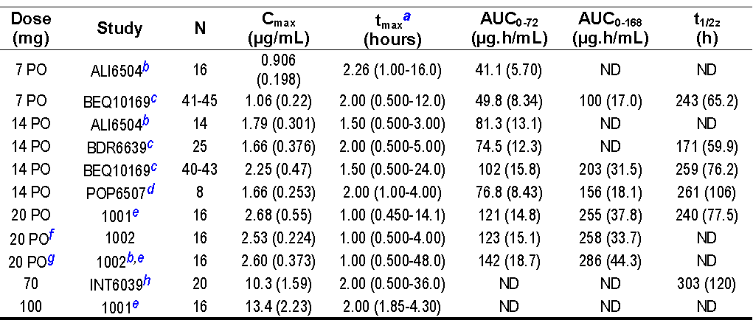
ND=not determined; Values are rounded to 3 significant figures or less.
Note: Following intravenous 10mg single 2-hour IV infusion, mean (SD) Cmax was 1.24 (0.16) µg/mL, AUC_{0-168 h} was 123 (12.3) µg.h/mL, and mean (SD) t½z was 234 (40.5) hours (1024; n=6).
a: median (minimum, maximum); b: fasted state only; c: reference formulation only; d: healthy subjects only; e: pharmacokinetic parameters corrected for carry-over; f: loading dose; g: 2nd or 3rd dose; h: teriflunomide alone treatment
Table 4. PK parameters following repeated OD oral 70mg teriflunomide (TDR10892)
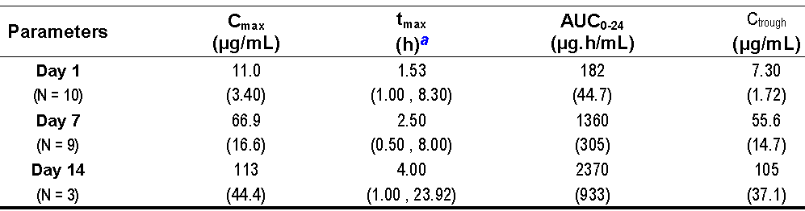
Note: values are rounded to 3 significant figures or less. a: median (minimum, maximum)
Table 5. PK parameters following repeated OD teriflunomide oral 70mg for 4 days followed by 14mg once daily for 8 days (TES10852)
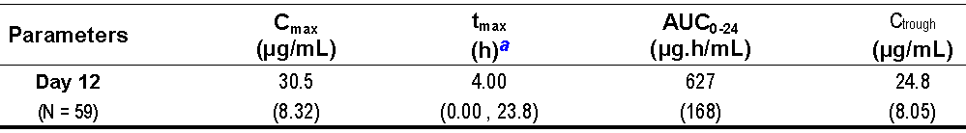
Note: values are rounded to 3 significant figures or less. a: median (minimum, maximum)

Population pharmacokinetic analysis
Table 6. Mean (%CV) of individual exposure parameters given by covariates included in the final population PK model – 14mg dose (n=410)
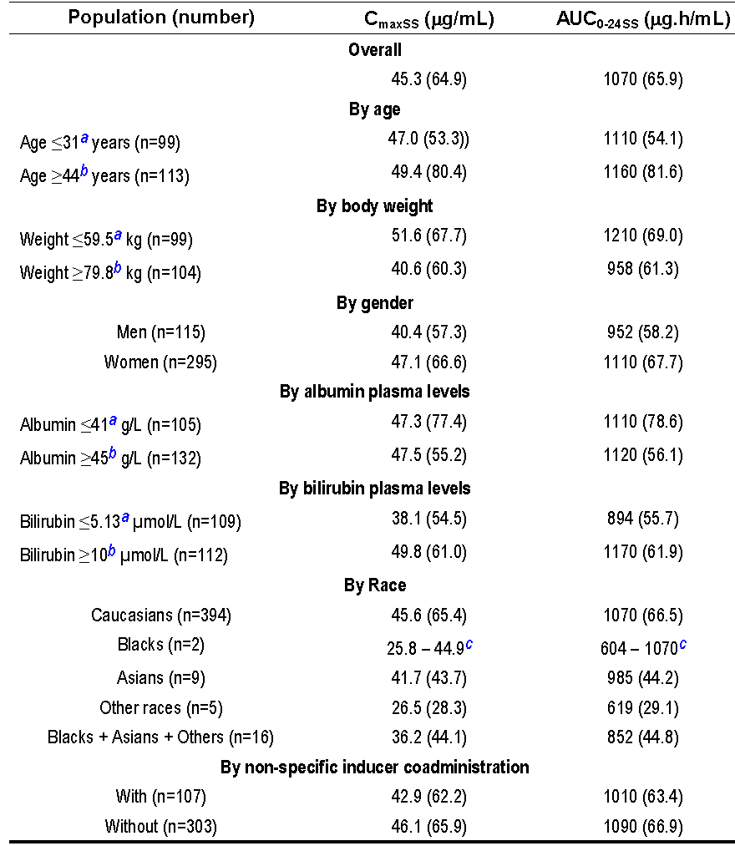
a: 25th percentile of the Total Data Set; b: 75th percentile of the Total Data Set; c: individual values
A significant relationship was identified between the apparent clearance of teriflunomide and bilirubin levels, albumin levels, gender and non specific inducer coadministration, as well as between the apparent volume of distribution of teriflunomide and albumin levels, body weight, race (Caucasians vs. non-Caucasians) and age. However, the impact of the inclusion of these covariates in the PopPK model had limited impact on the model parameter variation.
V2/F, Cmax and AUC increased by ~25% in a typical patient weighing 79.8 kg (75th percentile) as compared to 59.5 kg (25th percentile). Cmax and AUC increased by ~5% in patients aged > 44 years (75th percentile) as compared to patients aged < 31 years (75th percentile).

Pharmacokinetics in healthy subjects

Absorption
At the proposed dose (14mg - studies ALI6504, BDR6639, BEQ10169, POP6507) median tmax was 1.5, 2.0, 2.0 and 2.0h (range 0.5-5h). After loading doses then repeated 14mg doses median tmax was 4.00h (range 0.00 - 23.8h; study TES10852).

Sites and mechanisms of absorption
Animal (rat) data propose both biliary and direct gastrointestinal secretion, which lead to enterohepatic recycling from subsequent reabsorption.
Site of absorption could not be determined from the clinical studies submitted.

Bioavailability

Absolute bioavailability
This was not determined in a single study (t½z was >10days in most studies). By cross studies comparison (Studies HWA486/1024 and Study 1001) absolute oral bioavailability was ~100%.
Less than 2% was unabsorbed after a single oral dose ¹⁴C-teriflunomide (assuming that the cumulative radioactive dose excreted in the faeces over 48 hours reflects the unabsorbed teriflunomide).

Bioequivalence of clinical trial and market formulations
In Study BDR6639 of the comparative bioavailability between tablets made with unmilled product and tablets made with milled product using a single dose of 14mg teriflunomide in healthy volunteers all 90% CIs were in the equivalence interval of [0.80-1.25].
In Study BEQ10169 to assess the bioequivalence between 7- and 14mg tablets manufactured without colloidal silica and 7- and 14-mg reference tablets used in efficacy/safety studies, all 90% CIs were in the equivalence interval of [0.80-1.25].

Bioequivalence of different dosage forms and strengths
The submission is for the registration of one strength only – 14mg. However Study BDR6639 also compared the bioavailability between tablets made 2 x 7mg unmilled tablets with a single 14mg milled tablet in healthy volunteers all 90% CIs were in the equivalence interval of [0.80-1.25].

Bioequivalence to relevant registered products
Study 1001 to assess the relative bioavailability, as measured by teriflunomide plasma concentrations, of teriflunomide and of leflunomide, both given as 20mg tablets in healthy subjects. The relative bioavailability of leflunomide (as measured by teriflunomide concentrations) was found to be approximately 70% of that of teriflunomide: Cmax: 63% (90% CI 58%-69%) and AUC_{0-72 h}: 73% (90% CI: 69%-77%).

Influence of food
Food produced a statistically significant decrease in Cmax (18%) and an increase in tmax (~ 3 hours), that were judged to have no clinically relevant effects. AUC parameters 90% CIs were within the range for equivalence (study 1002).

Dose proportionality
The submission is for the 14mg strength only. Given the prolonged half life within subject assessment is difficult.
The Summary of Clinical Pharmacology Studies refers to an analysis combining data from studies BEQ10169, POP6507 and POP11432 (not in the submission) that showed Systemic exposure appears to increase in a dose proportional manner after single oral administration of 7 to 14mg doses in healthy subjects Cmax increased 1.87-fold (90% CI: 1.77, 1.98); AUC_{last} increased 2.42-fold (90% CI: 1.96, 2.99), and AUC increased 1.62-fold (90% CI: 1.43, 1.83). Study BEQ10169 showed:
Table 7. Comparison of mean PK parameters of teriflunomide following a single 7or 14mg tablet
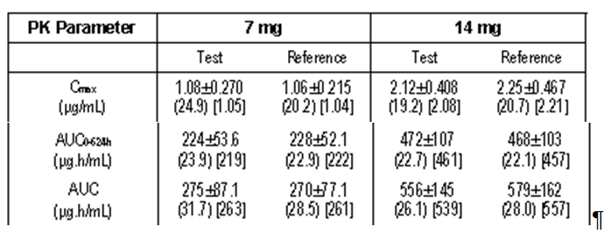
Tabulated values are Mean ± SD (CV%) [Geometric Mean]7mg Test and Reference formulation: N = 41 (AUC), 44/45 (AUC_{0-624h}) and 45 (Cmax), 14mg Test and Reference formulation: N = 36/40 (AUC) and 42/41 (AUC_{0-624h}) and 43 (Cmax)
Dose proportionality in terms of C_{trough} was also seen after 7 or 14mg multiple dosing to MS patients at steady-state.
Table 8 Teriflunomide steady-state C_{trough} (µg/mL) at Week 36
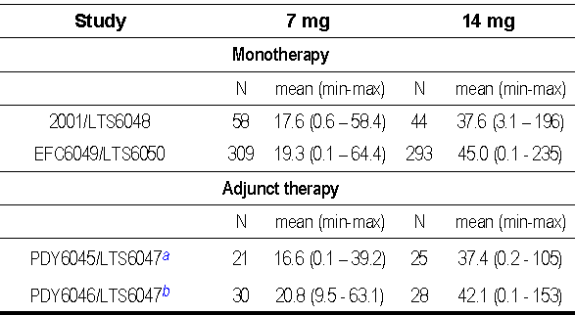
a: Teriflunomide on top of interferon-β; b: Teriflunomide on top of glatiramer acetate

Figure 1. Mean (SD) plasma concentration of teriflunomide 7 mg in efficacy/safety studies (truncated at Week 180)
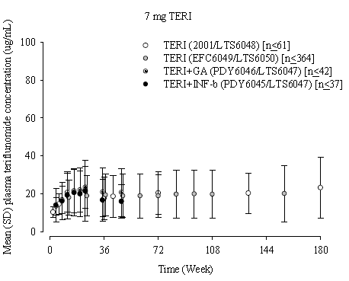
Figure 2. Mean (SD) plasma concentration of teriflunomide 14 mg in efficacy/safety studies (truncated at Week 180)
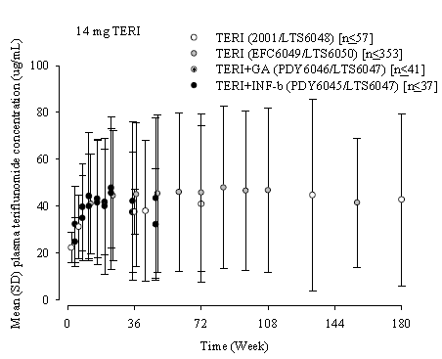
In Study POH0290 (popPK analysis), dose was not a significant covariate of teriflunomide PKs, confirming the dose linearity.

Bioavailability during multiple-dosing
None of the repeated dose studies in healthy subjects were long enough to assess steady state achievement. The use of a loading dose achieved a “pseudo-steady state” which gave plasma concentrations in the steady state range observed in MS patients after a few months.
The PopPK analysis (Study POH0290) of teriflunomide in healthy subjects and MS patients showed that plasma concentrations of teriflunomide accumulate over time (i.e., ~90 to 100 days or 3 to 3.5 months to attain 95% of steady state concentrations based on a median t½z of ~ 18 to 20 days), with the estimated AUC_{0-24 h} accumulation ratio 30.3 for7mg (median, 5th - 95th percentile: 25.8, 12.0 - 62.9) and 33.6 for 14mg (median, 5th - 95th percentile: 28.1, 11.8 - 73.7).

Distribution

Volume of distribution
Following a single IV dose administration, teriflunomide had a limited Vss of 11 L (Study HWA486/1024).
Pop PK Study POH0290 showed apparent volume of distribution of teriflunomide was increased by ~ 25% in a typical patient of 79.8 kg (75th percentile of patient’s body weight) as compared to a patient weighing 59.5 kg (25th percentile).

Plasma protein binding
In vitro, teriflunomide human plasma protein binding was linear in the concentration range 0.75 to 570 µg/mL (99.5% bound and 0.49% unbound), while at the concentration of 839 µg/mL the binding fraction decreased (98.7% bound and 1.26% unbound) (Studies HMR008477, HMR010274, and Study HMR015182). Most of the binding was to albumin (> 96% at 50µg/mL), and dependent upon the concentrations of albumin (unbound fraction 3.3% at 10g/L and 0.41% at 60g/L) (Study HMR014543).-
The ex vivo binding was also high (99.7%) with mean unbound fractions being 0.20% to 0.27% (Studies POP6507 and Study POP11432).

Erythrocyte distribution
Radioactivity in blood (blood to plasma ratio ~ 0.5) and red blood cells (red blood cells to plasma ratio ~0.2) was lower than that in plasma, suggesting the distribution of radioactivity mainly in plasma (Study BEX6038)

Metabolism

Interconversion between enantiomers
The two isomers (E and Z) are interconvertible via a 1, 3-diketo intermediate. In the solid state, it can be concluded from single crystal and powder diffraction x-ray analytical data that only the Z isomer is present, since only in the Z isomer can the proton from the hydroxyl group attached to the double bond form a stabilizing hydrogen bond to the keto function via a 6 membered ring. In dimethyl sulfoxide (DMSO) solution, a dynamic equilibrium between the 2 isomers at an E / Z = 8 / 92 ratio was observed. A separation of the isomers in solution by high performance liquid chromatography (HPLC) is not possible, because of the dynamic nature of this equilibrium. If, theoretically, one would have some E isomer in solution, this would immediately revert to the described E / Z mixture. The active pharmaceutical ingredient is the Z isomer, which has been isolated in the solid state and fully characterized. The E isomer cannot be enriched to more than the 8 / 92 solution equilibrium described above, and it cannot be isolated and characterized in the solid state, e.g., as reference material.

Sites of metabolism and mechanisms / enzyme systems involved
The primary biotransformation pathway for teriflunomide is hydrolysis, with oxidation being a minor pathway. Secondary pathways involved oxidation, N-acetylation and sulfate conjugation.
In vitro: With human hepatocytes teriflunomide was metabolically stable at 4h, (Study 2005-0050). After 2h in human liver microsomes, ¹⁴C-teriflunomide two metabolites were observed: 4-TFMA oxanilic acid (1.2% of total radioactivity) and 4-TFMA glycolanilide (4.4%),(Study HMR014997).

Non-renal clearance
The continued excretion of unchanged drug in faeces after 72h suggests it as a complex route of excretion (Study BEX6038). Animal (rat) data propose both biliary and direct gastrointestinal secretion, which lead to enterohepatic recycling from subsequent reabsorption.
Overall, the predominant clearance pathway(~ 2/3 of the total clearance) for teriflunomide appears to be biliary excretion of parent compound together with possibly direct gastrointestinal secretion. Metabolic clearance represents the remaining 1/3 of total clearance.(from Clinical Summary).

Metabolites identified in humans
4-trifluoro-methylaniline (4-TFMA), a minor metabolite and impurity of teriflunomide, was quantified in plasma in some studies. Other metabolites, 4-TFMA oxalinic acid and methyl-hydroxy-teriflunomide (X910228) were quantified in urine in Study 1001.
Figure 3. Metabolic pathway for teriflunomide in man
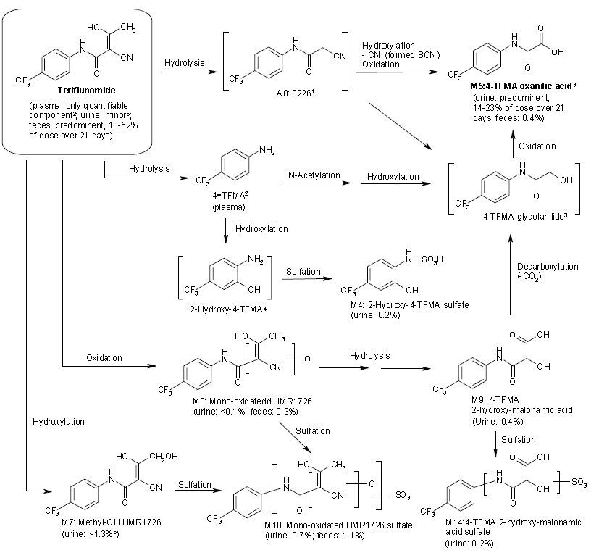
Note: HMR1726 = teriflunomide.
A813226 was detected as a minor metabolite after a single oral administration of 100mg/kg to rats (ABS0455).
4-TFMA was not detected in the human in vivo metabolism study, but detected in plasma in low amounts mostly after repeated doses in clinical studies.
4-TFMA glycolanilide and 4-TFMA oxalinic acid were formed after incubation of teriflunomide or A813226 in human in vitro (HMR014997). 4-TFMA oxalinic acid was also formed after incubation of 4-TFMA in vitro in human hepatocytes (HMR017949).
Teriflunomide and methyl-OH teriflunomide co eluted in urine and total accounted for 1.3% of dose (BEX6038).
Teriflunomide plasma concentrations were determined using HPLC coupled with ultraviolet (UV) detection, or a liquid chromatography coupled with mass spectrometry (LC-MS/MS) method with a lower limit of quantification (LLOQ) of 0.100µg/mL or of 0.0100µg/mL. 4-TFMA was analysed by gas chromatography (GC) coupled with nitrogen selective detection with an LLOQ of 1.00ng/mL and by GC coupled with mass spectrometry (GC-MS) with an LLOQ of 0.500ng/mL.
In urine, 4-TFMA oxalinic acid was analysed by LC-MS/MS and X910228 by an HPLC-UV method, with an LLOQ of 25ng/mL for both analytes. In semen, teriflunomide concentrations were determined using a validated LC-MS/MS method with an LLOQ of 0.01µg/mL.

Pharmacokinetics of metabolites
Some 21.3% of a single dose is excreted as metabolites in the urine and 1.8% as metabolites in the faeces (Study BEX6038 & Summary of Clinical Pharmacology Studies).

Consequences of genetic polymorphism
4-TFMA metabolism is via multiple pathways with no single path dominating, thus it is unlikely to be sensitive to genetic polymorphism (in case of N-acetylation) or saturation of metabolism.

Excretion
After 14mg in healthy volunteers had a t½z (± SD) of 171 ± 59.9h in study BDR6639, 259 ± 76.2h in BEQ10169 and 261 ± 106h in POP6507.
Based on post-hoc individual prediction of pharmacokinetic parameters using the PopPK model of teriflunomide in healthy subjects and MS patients, median terminal half-life was 17.8 and 19.4 days for the7mg and the 14mg doses, respectively (Study POH0290).

Routes and mechanisms of excretion
Figure 4 In vivo excretion of teriflunomide after a single dose over 21 days
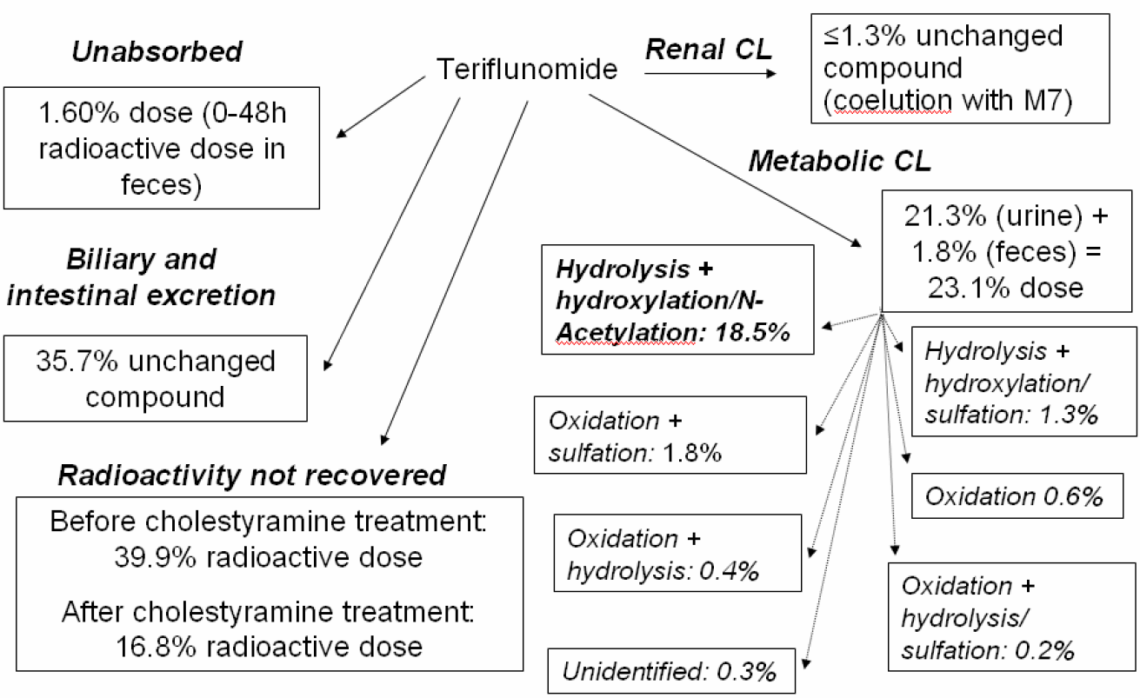

Mass balance studies
After an oral 70mg dose of ¹⁴C-teriflunomide, 60% of the total radioactivity was excreted after 21days (beyond 21 days cholestyramine was administered which increased excretion and produced a further 21% of the total). The radioactivity was excreted by 21days in faeces (37.5%) and in urine (22.6% - 0.147% of the total administered was excreted unchanged) (Study BEX6038).

Renal clearance
The fraction of the drug dose excreted in urine in the 21 days after drug administration (Fe0-t) was 0.147 ± 0.229%. Renal clearance of the unchanged teriflunomide was 0.0489 mL/hour (calculated over 21 days study BEX6038).
After a single IV infusion administration of 10mg teriflunomide, mean teriflunomide CL was 30.5 mL/h (Study 1024).

Intra- and inter-individual variability of pharmacokinetics
In healthy subjects, after a single 7 and 14mg dose, the total and within-subject variability of teriflunomide Cmax were 20.5% and 12.4%, of AUC_{last} were 27.0% and 7.5% and of AUC was 27.2% and 10.1%, respectively.
In MS patients inter-patient coefficient of variation in teriflunomide clearance was 55.2%, central volume 22.4%, peripheral volume 105%, and absorption constant 149%. The residual (intra-individual) variability was 21.3%.
Suggested possible factors in the high variability seen after repeated doses were intestinal secretion/reabsorption leading to enterohepatic recycling and differences in time to achieve steady-state from the long terminal half-life.

Pharmacokinetics in the target population
Teriflunomide C_{trough} ss at Week 36 were similar between monotherapy studies (Studies 2001 and EFC6049) after 7 and 14mg OD doses. Teriflunomide C_{trough} ss also were similar in patients treated with teriflunomide alone and in patients treated with teriflunomide plus IFN-β (Studies PDY6045 and LTS6047) or glatiramer acetate (GA) (Studies PDY6046 and LTS6047).
Table 9. Teriflunomide steady-state C_{trough} (µg/mL) at Week 36
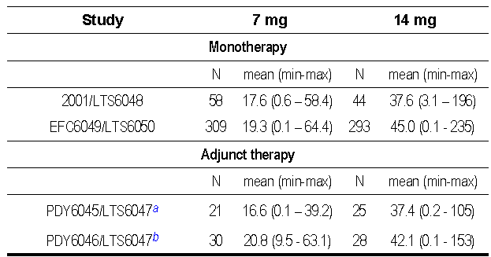
a: Teriflunomide on top of interferon-β; b: Teriflunomide on top of glatiramer acetate
Table 10. 4-trifluoro-methylaniline steady-state plasma concentrations (ng/mL) in MS patients
 | Teriflunomide 7mg |  | Teriflunomide 14mg
 | Week 36  (n=58) | Week 432  (n=13) | Week 36  (n=44) | Week 432  (n=8)
Mean | 0.9 | 0.27 | 1.4 | 0.55
SD | 0.31 | 0.07 | 0.85 | 0.27
Min | 0.5 | 0.250 | 0.5 | 0.250
Max | 1.7 | 0.503 | 5.3 | 0.912
N < -LLOQ | 15 |  | 6
Study 2001 and its extension LTS6048. LLOQ = 0.5 ng/mL
In MS patients (Study 2001/LTS6048 with LLOQ of 0.5 ng/mL), 4-TFMA plasma concentrations were lower (than at 36weeks) after 432 weeks of repeated teriflunomide doses of 7mg and 14mg.

Pharmacokinetics in other special populations

Pharmacokinetics in subjects with impaired hepatic function
After a single 14mg dose in subjects with mild and moderate hepatic impairment teriflunomide exposure (total and unbound) was not appreciably different from those observed with matched (gender, age and weight) healthy subjects (Study POP6507).
ALT and AST did not affect teriflunomide pharmacokinetics (PopPK Study POH0290) and albumin levels ≤ 41 g/L (25th percentile) vs. ≥ 45 g/L (75th percentile) showed similar mean teriflunomide exposure values for both doses (study SIM041).
Patients with a baseline bilirubin of ≥ 10 µmol/L (75th percentile) vs. ≤ 5.13µmol/L (25th percentile), an increase in mean teriflunomide AUC_{0-24SS} values of 20% and 31% for the7mg and 14mg doses, respectively (Study SIM0041).
Patients with severe hepatic impairment were not included in clinical trials.

Pharmacokinetics in subjects with impaired renal function
Study POP11432 evaluated severe renal function impairment (creatinine clearance <30mL/min) and matched subjects with normal renal function. PKs were similar after a single oral 14mg dose of teriflunomide.
There was no relationship observed between renal function (measured by creatinine clearance) and population PK parameters of teriflunomide (Pop PK Study POH0290).

Pharmacokinetics according to age
Pop PK Study POH0290 & SIM 0041 showed apparent volume of distribution of teriflunomide decreased of ~ 7% for a 44-year old patient as compared to a 31-year old patient while Cmax and AUC_{0 – 24 hSS} increased by~5%.

Pharmacokinetics related to genetic factors (sex, ethnicity, genetic polymorphism)
Pop PK Study POH0290 showed apparent clearance of teriflunomide was decreased by 23% in females as compared to males while AUC_{0-24 hSS} and Cmax increased by17% (14mg) for females vs. males (Study SIM0041).
The sample size was too small to draw any firm conclusions on effects of ethnicity, but non Caucasian race appears to have only small effects on PK parameters.
In healthy subjects, after single and repeated dose of teriflunomide, there were no significant predicted phenotype effects on teriflunomide PK for any of the genes: CYP2C9, CYP2C19, CYP2D6, UGT1A1 and NAT2 enzymes. There were no significant genotype effects on teriflunomide pharmacokinetic for any of the genes: CYP1A2, CYP2C9, CYP3A5, CYP4F2, UGT1A1, UGT1A7, NAT1 and NAT2 enzymes, as well as BCRP, OATP1B1 and OATP1B3 transporters. Although for UGT1A7 (single dose, p = 0.0098), CYP2C19 (repeated doses, 0.0120 ≤ p ≤ 0.0243) and CYP2D6 (repeated doses, 0.0182 ≤ p ≤ 0.0327), the p-values were below the threshold 0.05, these findings should be considered as exploratory due to the limited number of subjects (in this context, no multiplicity correction was applied). Even if a trend was observed on CYP2C19 and CYP2D6 from a genotyping point of view (p-values <0.05 for all pharmacokinetic parameters determined in the secondary objective of this study), the primary analysis demonstrated no phenotype effect which suggest that the following genes (CYP2C9, CYP2C19, CYP2D6, UGT1A1, and NAT2) are not substantially involved in teriflunomide metabolism based on the available dataset in healthy subjects (Study PMH0086).
In MS patients, after repeated dose at steady-state, there was no significant impact of diplotype predicted metabolizing phenotype of CYP2C19, CYP2D6, NAT1, and NAT2 enzymes on teriflunomide exposure, as well as no significant impact of haplotype-clusters of drug metabolism enzymes and transporters genes CYP1A2, CYP2E1, CYP3A5, CYP4F2, UGT1A, UGT2B7, BCRP, P-gp, MPR2, OATP1B1 and OATP1B3. However a statistically significant predicted phenotype effect was observed for CYP2C9 on teriflunomide steady-state Cmax (p<0.001), AUC_{0 – 24 h} (p<0.001) and C_{trough} (p=0.006). Exposure IM/PM ratios were <1.20-fold, while exposure PM/EM ratios were ~ 2-fold. CYP2C9 PM were only 4% of the MS patients (n=26), however the distribution of the CYP2C9 predicted phenotype were consistent with what has been observed in the Caucasian population.
This finding is not consistent with the current information available on the enzymes involved in teriflunomide metabolism and will need to be confirmed with an independent set of patients (Study PMH0091).

Pharmacokinetic interactions

Pharmacokinetic interactions demonstrated in human studies
No drug interactions due to displacement from the protein are expected.

Rapid elimination
Cholestyramine, an ion exchange resin and activated charcoal were able to accelerate the elimination of teriflunomide, as shown by increased excretion of radioactivity in faeces (37.5% to 61.3%) following cholestyramine in Study BEX6038 and the reduced apparent terminal half-life after cholestyramine and activated charcoal in Study TES10852.

Figure 5. Mean (SD) concentration-time profiles of radioactivity (blood, RBC, and plasma) and teriflunomide (plasma) after oral administration of 70mg (50 mcCi) solution of ¹⁴C-teriflunomide
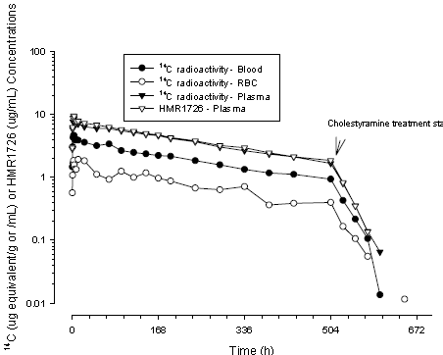
N = 6 up to 528h post-dose, N = 5 after 528h post-dose; Subject 1005 exited the study. Cholestyramine treatment started at 504 h post-dose.
Table 11. Percent decrease in teriflunomide concentrations over 11 days after rapid elimination procedure (INT6040, INT10563, INT10564, and TES10852)
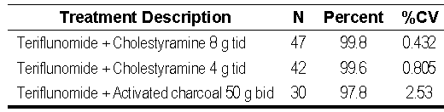

Other drug interactions
- Rifampin 600mg QD for 22 days, led to ~39% decrease in mean plasma AUC and t½z, but not Cmax, of teriflunomide after a single 70mg dose. (Study INT6039).
- Apparent clearance of teriflunomide was increased by ~10% when co administered with a non specific inducer with a decrease of the mean AUC_{0-24 hSS} of ~ 2% for 7mg and 7% for 14mg doses in the PopPK analysis Study POH0290.
- Repaglinide a CYP2C8 substrate showed an increase in mean Cmax and AUC (1.6- and 2.3-fold, respectively), following teriflunomide (StudyINT11697).
- Midazolam a CYP3A substrate showed an increase in mean Cmax (1.13 fold) and AUC (1.27-fold), following teriflunomide (Study INT10563).
- Minidril (0.03mg ethinylestradiol and 0.15mg levonorgestrel), an oral contraceptive, showed a moderate increase in mean ethinyloestradiol Cmax and AUC_{0 – 24 h} (1.58- and 1.54-fold, respectively) and levonorgestrel Cmax and AUC_{0 – 24 h} (1.33- and 1.41-fold, respectively) following teriflunomide (Study INT10564).
- Caffeine a CYP1A2 substrate showed after a single 100mg dose a decreased geometric mean Cmax by 18% and AUC by 55% following teriflunomide (Study INT11720).
Although, in vitro teriflunomide showed inducing and inhibiting effects on CYP2C9, in vivo the effects seemed balanced and no interaction observed, as the 90% CIs for S- and R- warfarin Cmax and AUC ratio estimates were included within the [0.80 - 1.25] interval, at the anticipated therapeutic dose. (Study INT6040)
However, a 25% decrease in peak INR was observed when teriflunomide was co administered with warfarin as compared with warfarin alone. (see section on pharmacodynamics).
- Teriflunomide had no effect on the PKs of bupropion following a single 150mg dose of bupropion on Day 12, as the 90% CI for bupropion Cmax and AUC ratio estimates were included within the [0.80 - 1.25] interval (Study INT11932).
- Teriflunomide likewise had no effect on the PKs of omeprazole (a CYP2C19 substrate) after a single 20mg dose of omeprazole on Day 12, (Study INT11720), nor on the PKs of metoprolol (a CYP2D6 substrate) following a single 100mg dose of metoprolol on Day 12, (Study INT11720).

Clinical implications of in vitro and interaction findings
Although the popPK study could only show a small effect of inducers on PKs of teriflunomide, this comparison was for all inducers while some of the single inducer studies e.g. INT 6039 showed considerable effect. This supports the sponsor’s recommendation that potent CYP and transporter inducers should be used with caution during the treatment with teriflunomide.
When teriflunomide is co administered with drugs metabolized by cytochrome P450 interactions may occur.
Considerable increase in exposure (especially of AUC) may occur with CYP2C8 substrates, such as paclitaxel, repaglinide, pioglitazone or rosiglitazone necessitating caution.
Despite that in vitro teriflunomide exhibited some inducing and inhibiting effects, the net effect in vivo is a weak inhibition on CYP3A at the anticipated therapeutic dose.
The increases in Cmax and AUC seen with the oral contraceptive OC components, particularly ethinyloestradiol may warrant reconsideration of the OC prescribed, but of greater concern in OC selection would be the effectiveness of the contraceptive chosen given the long t½ and possible teratogenicity. Leflunomide, a product metabolised to teriflunomide within hours of oral administration has pregnancy category X, given to medicines which have such a high risk of causing permanent damage to the foetus that they should not be used in pregnancy or when there is a possibility of pregnancy.
Although the results observed in vitro do not explain the in vivo results, caution should be observed when teriflunomide is co administered with drugs metabolized by CYP1A2 (e.g., duloxetine, alosetron, theophylline, tizanidine), as it could lead to a reduction of their efficacy.
While Cmax and AUC for warfarin when co-administered with teriflunomide showed no statistical effect, since an effect was seen on INR, close INR follow-up and monitoring is recommended.
Cholestyramine and activated charcoal can be used when more rapid elimination is clinically desirable e.g. allergy or overdose.

Evaluator’s overall conclusions on pharmacokinetics
“The general characteristics of pharmacokinetics of the active metabolite were the long half life (~14 days), and evidence of enterohepatic recycling based on the reduction in half life to about one day following administration of either charcoal or cholestyramine.”
Absolute bioavailability was not determined in a single study, but rather by cross studies comparison because of the prolonged half life (t½z was >10days in most studies).
None of the repeated dose studies in healthy subjects were long enough to assess steady state achievement. Based on post-hoc individual predicted pharmacokinetic parameters from this PopPK model [Study POH0290])., there was a slow approach to steady-state concentration (i.e., ~90 to 100 days or 3 to 3.5 months to attain 95% of steady state concentrations based on a median t½z of ~ 18 to 20 days),
This is the source of support for the PI statement.
The estimated mean AUC accumulation ratio was 30.3 for7mg and 33.6 for 14mg (see study POH0290).
The continued excretion of unchanged drug in faeces after 72h suggests it as a complex route of excretion (Study BEX6038). Animal (rat) data propose both biliary and direct gastrointestinal secretion, which lead to enterohepatic recycling from subsequent reabsorption.
While the Summary of Clinical Pharmacology Studies supports the proposed PI statement that median t½z was ~19days using the PopPK model 0290, a table in the study report itself gives a mean t½beta of 557h (23.21days).
A similar effect was observed in patients in study EFC6049/TEMSO, but only when the potent CYP and transporter inducers were considered: carbamazepine, phenobarbital, phenytoin, and St John’s Wort. At Week 36, mean (SD) teriflunomide trough plasma concentrations were 19.3 (11.1) µg/mL at7mg and 45.0 (30.7) µg/mL at 14mg for MS patients overall and were 12.7 (4.29) µg/mL at7mg and 35.8 (19.4) µg/mL at 14mg for MS patients with potent inducers.. (According to the Summary of Clinical Pharmacology Studies) The support for this statement could not be found in the referenced study report.
In relation to the total body clearance of 30.5mL/h this was calculated after a constant infusion of 10mg for 2h, by using an exploratory model adjusted to the concentration-time data. The concentration-time course was described by a sum of two exponential functions for each subject. This sum of exponentials was considered as an open compartmental model where the compartments are linked mamillarily, and where elimination takes place from the central (monitored) compartment.
There were no studies submitted in paediatric patients
The impact of the intrinsic variability on exposure parameters for 14mg was age +5%, body weight +26%, gender F +16%, race numbers too small, albumin no effect, bilirubin +31%, reported using the PopPK model study 02090.
In relation to hepatic impairment numbers were small and variability high, means showed some effect on AUC (POP6507) for moderately impaired. This is supported by the bilirubin effect in the PopPK study but not the lack of effect of the ALT, AST levels.
These results suggest no dose adjustment is necessary for mild to moderate hepatic impairment.
Table 12. Treatment ratio estimates for teriflunomide with 90% CI - hepatic impairment
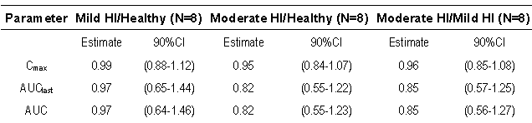
Note: values are rounded to 3 significant figures or less.
In study POP11432 of renal impairment, again numbers were small and CIs wide with some effect on Cmax but not AUC, suggesting no dose adjustment is necessary.
Table 13. Treatment ratio estimates with 90% CI for teriflunomide (Comparison Severe Renal Impairment,)
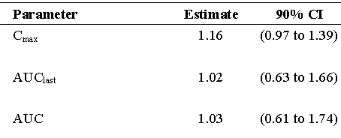
Note: values are rounded to 3 significant figures or less. N = 8 vs. Healthy, N = 8 (Study POP11432)
The studies support the other PK and Drug Interaction statements in the proposed PI.

Pharmacodynamics

Studies providing pharmacodynamic data
These are summarised below.

Table14. Submitted pharmacodynamic studies.
Study  *  Centres | Objective(s)  Study design | Treatment | Subjects  Enrolled/completed  M/F
TES10852  *  single centre  France  Mar 2010 - Feb 2011 | Assess effect of repeated doses of teriflunomide on QTcF interval, compared to placebo and using moxifloxacin (400mg, single dose) as a positive control  Randomized, double-blind, double-dummy, repeated dose, placebo-controlled study, stratified by gender, conducted in 3 parallel groups | Teriflunomide tablets: 70mg QD for first 4 days, then14mg QD for 8 days,  Placebo: matched to teriflunomide tablets QD for 14days  Moxifloxacin capsules: 400mg on D12  All treatments preceded by a single-blind placebo run-in day  Placebo: matched to moxifloxacin capsules QD for 11days (moxifloxacin group ) or 12days (teriflunomide and placebo groups) | 192/179  (87M/95F)  healthy subjects  Teriflunomide: 64  Placebo: 56  Moxifloxacin: 62  41.6 ± 16.1  (18 – 65) yr
INT6040  *  1 centre  UK  Feb – Jul 2007 | Assess effect of repeated daily oral doses of teriflunomide on PD and PK profile of warfarin after a single oral dose of 25mg warfarin; assess safety of teriflunomide co administered with warfarin compared to warfarin alone  Open, nonrandomized, single sequence, 2- treatment, 2-period study | Teriflunomide 14mg tablets  Loading dose of 70mg QD for first3d of P2, followed by 14mg QD for 8 consecutive days  Warfarin 5mg tablets  Single dose of 25mg (5 tablets) on P1, Dl and on P2, D5  Cholestyramine for 11d (D12 to D22)  Teriflunomide: 11d  Warfarin: 2d | 14/12  14M  31.0 ± 9.0 (19 - 45)  P1: 14 (warfarin);  P2: 12 (warfarin+  teriflunomide)  Healthy
POH0295  *  France  Undated | Pharmacokinetic Pharmacodynamic Analysis of data from EFC6049-TEMSO and 2001 | The objective was to explore the relationships between the selected safety and efficacy parameters and mean teriflunomide plasma concentrations in patients with relapsing forms of MS, after 7 or 14mg of QD teriflunomide. The selected safety variables were: Alanine amino transferase, Neutrophils, Lymphocytes, White blood cells, Lipase, Amylase, supine systolic and diastolic blood pressure, Alopecia, creatinine clearance Phosphate and Uric acid. The selected efficacy variables were: Annual relapse rate, Time to disability progression sustained for 12-week, Total number of Gadolinium-enhanced T1 lesions / number of scans over the treatment period, Total number of unique active lesions / number of scans over the treatment period, Number of patients free of active lesions and Burden of disease at week 108.
*[Information redacted]

Summary of pharmacodynamics
The information in the following summary is derived from conventional pharmacodynamic studies in humans unless otherwise stated.

Mechanism of action
Teriflunomide (A771726) is the active predominant metabolite of the already registered drug leflunomide.
It has immunomodulating/immunosuppressive characteristics, acts as an anti-proliferative agent, and displays weak anti-inflammatory properties. The antiproliferative activity is reversed by the addition of uridine to the cell culture, indicating that A771726 acts at the level of the pyrimidine biosynthesis pathway. Binding studies using radiolabelled ligand demonstrate that the active metabolite binds to and inhibits the human enzyme dihydroorotate dehydrogenase (DHODH, an enzyme involved in de novo pyrimidine synthesis). Together, these data suggest that, in vivo, at concentrations achievable in patients receiving Arava, pyrimidine synthesis in lymphocytes and other rapidly dividing cell populations may be inhibited. Further, the inhibition of tyrosine kinase activity has been reported, for both in vitro and in vivo situations. The in vitro activity does not seem to be mediated directly through enzyme inhibition and takes place only at much higher concentrations of A771726 than is necessary for the inhibition of DHODH. Leflunomide has demonstrated prophylactic and therapeutic effects in animal models of autoimmune disease. In animal models of chronic graft versus host disease and solid organ graft rejection, leflunomide has prolonged rejection time or reversed ongoing rejection reactions.

Pharmacodynamic effect

Primary pharmacodynamic effects
The drug is an immunomodulator with both anti-proliferative and anti-inflammatory activity by potent (IC₅₀ = 1.25 µM), noncompetitive, selective and reversible inhibition of the mitochondrial enzyme dihydroorotate dehydrogenase (DHO-DH). That leads to a blockade of the de novo pyrimidine synthesis and a subsequent cytostatic effect on proliferating T-and B-lymphocytes in the periphery, resulting in diminished numbers of activated lymphocytes available to enter the central nervous system. Whereas slowly dividing or resting cells which rely on salvage pathways for pyrimidine supply are unaffected by teriflunomide.

Secondary pharmacodynamic effects
The pharmacokinetic/pharmacodynamic analysis (Study POH0295) showed that an increase in teriflunomide plasma concentrations led to a decrease in uric acid with an Emax relationship. This was seen in study TES 10852 and has been described previously with the parent compound leflunomide. This effect on uric acid is linked to the inhibition of the transport of urate through the apical urate/anion exchanger as reported in in vitro Study DIV1516. Upon cessation of treatment and subsequent elimination of teriflunomide by cholestyramine, the values of uric acid in plasma returned to baseline/placebo values.
In the PopPK study (0295) teriflunomide led to a mean increase in ALT, and a decrease in neutrophils, in lymphocyte count, in WBC and in phosphate. The incidence of alopecia increased with increased teriflunomide median concentration.

Time course of pharmacodynamic effects
In vitro studies were reported to show considerable species variation in sensitivity to teriflunomide effects. Time to onset of inhibition of proliferation of lymphocytes in was not studied clinically.

Relationship between drug concentration and pharmacodynamic effects
In vitro study IIVT0017 reported inhibition of treatment induced proliferation in human T cells and B cells in a concentration dependant manner in the 5 or 7 days of study.
In vivo mean plasma concentration effects (mostly C_{trough}) were shown for safety and efficacy variables in PopPK/PD study POH0295.

Genetic-, gender- and age-related differences in pharmacodynamic response
While PopPK Study 0295 showed an effect of race only for the safety variable amylase, it was only for Caucasians vs. non-Caucasians and the numbers of the latter were very small so that the effects of race have not been clearly demonstrated for any variable.
For effects of age and gender on safety and efficacy variables see results of PopPK/PD study POH0295.

Pharmacodynamic interactions
In vitro study IIVT0017 reported inhibition of treatment induced proliferation in human T cells and B cells could be reversed by the addition of exogenous uridine.
In vitro study DIV1516 showed teriflunomide was a more potent inhibitor of urate uptake than the uricosuric drugs sulfinpyrazone and probenecid.
PopPK Study 0295 showed an effect of systemic steroid co-administration on ALT, neutrophils and WBC.

Evaluator’s overall conclusions on pharmacodynamics
With the usually slow clinical progression of MS, onset of action would be difficult to determine in vivo, however in vitro studies have only shown that proliferation is prevented over 5 -7 days. The PD studies have shown a potential mechanism of action in reduction of T-cell proliferation. It is not clear if this is an effective surrogate for the desired clinical effect of delaying accumulation of physical disability in patients with MS.

Dosage selection for the pivotal studies
In Study 1001, relative to leflunomide, teriflunomide Cmax was 63% (90% CI 58%-69%) and AUC_{0-72 h}: 73% (90% CI 69%-77%). Based on 10mg and 20mg leflunomide being effective and safe in patients with rheumatoid arthritis,7mg/day and 14mg/day were chosen for study 2001.
Following the results of Study 2001 the doses used were both selected for Phase 3 trials with the exception that the use of an initial loading dose was omitted in anticipation of decreasing the frequency of AEs in the early treatment period.

Efficacy - the treatment of patients with relapsing forms of multiple sclerosis
These are summarised below.

Table 15. Efficacy Studies of teriflunomide in the proposed indications
Study | Main objective of the study | Comparator | Treatment duration | No. randomized | Status
Monotherapy
EFC6049/TEMSO | Evaluate the efficacy and safety of teriflunomide 7 and 14mg in reducing the frequency of relapses in patients with relapsing MS | Placebo controlled | 108 weeks | 1088 | Completed
LTS6050 (extension of EFC6049) | Assess the long-term safety and efficacy of teriflunomide in patients who had completed Study EFC6049 | Uncontrolled | Open-ended | 742 | Ongoing, Interim Analysis
2001 | Assess the effect on MRI activity, clinical efficacy, and safety of teriflunomide 7 and 14mg | Placebo controlled | 36 weeks | 179 | Completed
LTS6048 (extension of 2001) | Assess the long-term safety and efficacy of teriflunomide in patients who had completed Study 2001 | Uncontrolled | Open-ended 1 | 47 | Interim Analysis
Not Evaluated for Efficacy (Pre-Submission Meeting)– Monotherapy
EFC10531/TOWER | Evaluate the efficacy and safety of teriflunomide 7 and 14mg in reducing the frequency of relapses in patients with relapsing MS | Placebo controlled | Fixed end for all patients, 48 weeks for last patient randomized | 1096ª | Ongoing, Interim Analysis^{b}
Not Evaluated (not covered by Indications in present submission)- Adjunctive therapy
PDY6045 | Adjunctive safety and efficacy study of teriflunomide 7 and 14mg and a stable dose of IFN-β vs. placebo and IFN-β | Placebo controlled | 24 weeks | 118 | Completed
PDY6046 | Adjunctive safety and efficacy study of teriflunomide 7 and 14mg and a stable dose of glatiramer acetate compared to placebo and glatiramer acetate | Placebo controlled | 24 weeks | 123 | Completed
LTS6047 (extension of PDY6045 and PDY6046) | Double-blind long-term safety extension study enrolling patients who had completed Studies PDY6045 and 6046 | Placebo controlled | 24 additional weeks | 182 | Completed
a: Number of patients randomized by the end of November 2010. Study randomization completed 17 February 2010 with a total of 1169 patients. b: While submission of this data to the TGA was discussed, it is agreed to submit the complete study report as a condition of registration, not an interim analysis Minutes TGA Pre-submission Meeting 22 July 2011

In accordance with the relevant Guideline the submission is evaluated as two separate Indications for the treatment of patients with relapsing forms of Multiple Sclerosis
- To Reduce the Frequency of Clinical Relapses
- To Delay the Accumulation of Physical Disability

Monotherapy - To Reduce the Frequency of Clinical Relapses

Pivotal efficacy studies - study 3001/6049TEMSO
See also:
- Study 6049 evaluation of To Delay the Accumulation of Physical Disability
- Study POH0290: Population pharmacokinetic analysis of teriflunomide- combined analysis of a Phase 1 study (TDR10892), a Phase II study (HMR1726D/2001) and a Phase III Study (EFC6049)
- Study PMH0091: Impact of drug metabolizing enzyme phenotype and genotype on teriflunomide exposure in studies EFC6049 and HMR1726D/2001
- Study POH0295: Pharmacokinetic Pharmacodynamic Analysis of teriflunomide (data from TEMSO:EFC6049 and 2001)

Study design, objectives, locations and dates
A 2-year, multicentre, multinational, randomized, placebo-controlled, double-blind, parallel-group, stratified (by centre and by baseline EDSS score [≤ 3.5 versus > 3.5]) of teriflunomide in MS patients.
24 September 2004 to 08 July 2010 in 126 sites in Austria, Canada, Chile, Czech Republic, Denmark, Estonia, Finland, France, Germany, Italy, the Netherlands, Norway, Poland, Portugal, Russian Federation, Sweden, Switzerland, Turkey, Ukraine, United Kingdom, and United States.
The primary objective was to determine the effect of teriflunomide in reducing the frequency of relapses in subjects with relapsing MS. the accumulation of disability. This was a secondary measure.
The secondary objectives included to:
- Evaluate the effect of teriflunomide on delaying the accumulation of disability at 2 years as assessed by the Kurtzke Expanded Disability Status Scale (EDSS)
- Evaluate the effect of teriflunomide on subject-reported fatigue as assessed by the Fatigue Impact Scale (FIS)
- Evaluate the effects of teriflunomide on MRI variables: burden of disease (volume of abnormal brain tissue on MRI) and other MRI variables including number and volume of gadolinium (Gd)-enhanced T1 lesions, volume of T2 lesion, volume of T1 hypo-intense lesions, atrophy and a composite score.
The tertiary objectives included to:
- Explore the impact of teriflunomide on general health status using the Short Form general health survey (SF-36) subject-reported questionnaire
Health economic variables Resource utilization and productivity (measured by WPAI) variables were analysed. The results will be presented in a separate report.
Comment: The primary outcome is relapse rate, the accumulation of disability was a secondary measure. The latter is of more relevance.
Screening took ≤ 4 weeks. Randomized (1:1:1 stratified, based on centre, and by patient’s EDSS score (≤ 3.5 or > 3.5)) to either QD placebo, 7mg teriflunomide, or 14mg teriflunomide. Treated for ~ 2 years. Followed by entry into an optional long-term extension study (LTS6050) or an 11-day washout period with cholestyramine or activated charcoal to accelerate elimination of teriflunomide to levels less than 0.02 µg/mL. An MRI scan of the brain and the spinal cord and an abdominal ultrasound of the pancreas (followed by pancreatic CT or MRI scan if abnormal) were performed at baseline, at 6-month intervals for the first 72 weeks, and at the close-out visit. There were at least 25 visits to the study centre that included:
- Screening (Visit 1) up to 4 weeks prior to the baseline visit
- MSFC test practice (Visit 2) 5 to 7 days prior to the baseline visit and baseline visit
- A study treatment period, including randomization at baseline, visits for safety blood sampling (every month for the first 6 months, then every 6 weeks), the close-out visit (Visit 23 at 108 weeks), and unscheduled visits for relapse assessment
- Two post-washout visits, 4 weeks and 16 weeks after the close-out visit.

Inclusion criteria
- Multiple sclerosis patients, aged 18 to 55, who were ambulatory (EDSS of ≤ 5.5)
- Exhibiting a relapsing clinical course, with or without progression (relapsing remitting, secondary progressive, or progressive relapsing)
- Meeting McDonald’s criteria for MS diagnosis
- Experienced at least 1 relapse over the 1 year preceding the trial or at least 2 relapses over the 2 years preceding the trial
- No relapse onset in the preceding 60 days prior to randomization
- During the 4 weeks prior to randomization, the patients must have been clinically stable, without adrenocorticotrophic hormone (ACTH) or systemic steroid treatment

Exclusion criteria
- The patients with significantly impaired bone marrow function or significant anaemia,
- leucopoenia, or thrombocytopenia: Hematocrit < 24% and/or Absolute white blood cell count < 4000 cells/mm³ and/or Platelet count < 150000 cells/mm³ and/or Absolute neutrophil ≤ 1500 cells/mm³
- The patients with a congenital or acquired severe immunodeficiency, a history of cancer lymphoproliferative disease, or any patient who had received lymphoid irradiation
- HIV positive subjects
- Therapies that were disallowed (minimum of 4 weeks prior to randomization): phenytoin, warfarin, tolbutamide, St. John’s Wort, or cholestyramine
- Pregnancy, Breastfeeding or wishing to parent children during the course of the trial
- Prior or concomitant use of cladribine, mitoxantrone, or other immunosuppressant agents such as azathioprine, cyclophosphamide, cyclosporin, methotrexate, or mycophenolate
- Prior use of interferons or cytokine therapy in the preceding 4 months
- Prior use of glatiramer acetate therapy in the preceding 4 months or intravenous immunoglobulins in the preceding 6 months
- Liver function impairment or persisting elevations of SGPT /ALT, SGOT /AST or direct bilirubin > 1.5-fold ULN.
- Hypoproteinemia (e.g., in case of severe liver disease or nephrotic syndrome) with serum albumin < 3.0 g/dL
- Moderate to severe impairment of renal function, as shown by serum creatinine >133 µmol/L (or > 1.5mg/dL)
- Prior use of natalizumab (Tysabri)
- Persisting elevations of serum amylase or lipase greater than 2 x ULN or Known history of chronic pancreatic disease or pancreatitis

Study treatments
Both doses had been retained from earlier study 2001for EFC6049 as there was insufficient evidence of differences between them. All tablets were similar in appearance taken orally in the morning with 200 mL water with or without food
Relapses were treated with corticosteroids if clinically necessary (preferably 1g IV methylprednisolone sodium succinate daily for 3 to 5 days).
All patients who withdrew from the study or did not enter the long-term extension study received 8 g cholestyramine 8 hourly for 11 days (recommended) ; alternatively, 50 g activated charcoal powder every 6 hourly for 11 days could be administered. After this washout, the teriflunomide plasma concentration was to be verified as ≤ 0.02 µg/mL prior to withdrawal from the study (or the washout repeated).

Efficacy variables and outcomes assessed
The primary efficacy variable was the annualized relapse rate (ARR),
Tertiary efficacy variables included:
- The time to first confirmed relapse
- The proportion of patients without confirmed relapse at 6 months, 1 year, and 2 years
- The change from baseline in SF-36
- The change from baseline in EQ-5D
Many of the secondary and tertiary variables apply to delaying the accumulation of physical disability and are assessed under that section.

Sample size
From the available data on the approval of Betaseron, Copaxone, Avonex, and Rebif, it was assumed that the 2-year relapse rates were 2.20 and 1.66 for the placebo and teriflunomide groups, respectively. From recently available data on Tysabri trials, the placebo 2-year relapse rate was estimated to be 1.48. Assuming the number of relapses follows approximately a Poisson distribution with a common SD of 1.252, a study with 360 randomized subjects per treatment arm, or a total of 1080 randomized subjects, could have ≥ 95% power to detect a 25% relative risk reduction in the 2-year relapse rate at the 2-tailed significance level of α = 0.050. This calculation incorporated a potential 20% 2-year dropout rate. In addition, a study with a sample size of 360 subjects per treatment arm would lead to an 80% powered log-rank test to detect a 37% hazard rate reduction of an assumed disability progression hazard rate of 0.1783 in the placebo group and 0.1116 in the teriflunomide group (i.e., 30% probability to disability progression for placebo patients by the end of 2 years, 20% for teriflunomide patients).The calculation also incorporated a 20% 2-year dropout rate.

Randomisation and blinding methods
Randomized (1:1:1 stratified, based on centre, and by patient’s EDSS score (≤ 3.5 or > 3.5))
29 codes were broken for regulatory purposes (placebo: 9 patients; teriflunomide7mg: 10 patients; teriflunomide 14mg: 10 patients).
At the local level, 18 codes were broken for medical and accidental reasons. (Placebo: 9 patients; teriflunomide7mg: 6 patients; teriflunomide 14mg: 3 patients)
Table 16. Randomization and drug allocation irregularities - randomized population
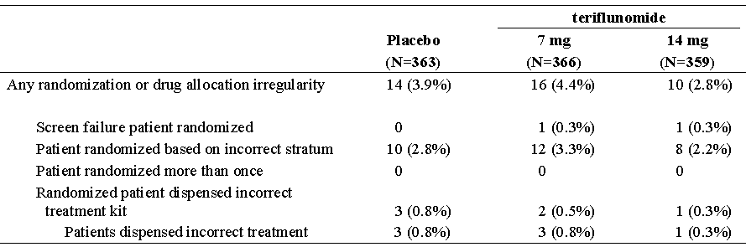
Note: Percentages are calculated using the number of randomized patients as denominator.

Statistical methods
The primary analysis for the ARR was performed using a Poisson regression model with robust error variance to accommodate the potential over-dispersed data appropriately. The model included the total number of confirmed relapses with onset between randomization date and last dose date as response variable, a 3-level treatment group (placebo, teriflunomide7mg, and teriflunomide 14mg), and EDSS strata (baseline EDSS score ≤3.5 versus >3.5) and region as covariates. To account for different study durations among patients, the log-transformed standardized study duration was included in the model as an “offset” variable for appropriate computation of relapse rate.
The primary endpoint was analysed using the GEE model instead of the regular Poisson model, since the GEE estimator was robust against violation of the correlation structure and the distributional assumptions. In addition, the treatment-by-EDSS strata and the treatment-by-region interactions were evaluated. Separately at the 5% level of significance by adding the corresponding interaction term to the above GEE model. If a statistically significant interaction was detected, further investigations were performed to explore the possibility of a qualitative interaction.
Subgroup analyses were performed for the primary efficacy variable by:
- Gender
- Race
- Age category (<38, ≥38; age of 38 was close to the median age of all randomized patients)
- Regions (Eastern Europe, Western Europe, Americas)
- Baseline EDSS strata
- Number of relapses experienced within past 2 years (0, 1, 2, 3, and ≥4)
- MS subtypes (relapsing remitting MS, secondary progressive MS, or progressive relapsing MS) as described by the Investigator
- Received approved, disease modifying MS drug prior to enrolment (Yes, No)
- Number of baseline Gd-enhancing lesions (0, ≥1)
- Baseline of BOD (<13, ≥13; BOD of 13 mL is close to the median BOD of all randomize patients at baseline)
The GEE method was used to assess whether there was evidence for inconsistency of treatment effect across each subgroup factor using a treatment-by-subgroup interactions test. Each subgroup factor was assessed separately. The model included treatment, EDSS strata, region, subgroup, and treatment-by-subgroup interaction as fixed effects and log-transformed standardized study duration as offset. If the p-value for an interaction was smaller than 0.05, a further investigation was performed to explore the possibility of a qualitative interaction.
Multiplicity adjustment was made for testing 2 doses on the primary and key secondary endpoints for the primary analysis in the ITT population first, i.e., for testing a family of the following hypotheses:
- H1: no treatment difference between teriflunomide 14mg and placebo on ARR
- H2: no treatment difference between teriflunomide7mg and placebo on ARR
- S1: no treatment difference between teriflunomide 14mg and placebo on disability progression
- S2: no treatment difference between teriflunomide7mg and placebo on disability progression
To strongly control Type-I error rate for this family, a step down testing procedure was applied in the order specified above. Each hypothesis was formally tested only if the preceding one was significant at 5% level.

Other secondary endpoints
If all hypothesis tests described above were significant at 5% level, a step down testing procedure was applied to the following secondary endpoints in the order specified below within each dose at 2.5% significance level, i.e., within a dose each hypothesis was formally tested only if the preceding one was significant at the 2.5% level:
- Change from baseline in total score of fatigue impact scale at Week 108
- Total number of gadolinium enhancing (Gd-enhancing) T1-lesions per MRI scan over the treatment period
- Change from baseline in MRI burden of disease at Week 108
By applying the multiplicity adjustment approach described above for a family of hypotheses about 5 endpoints and 2 doses, Type-1 error rate was strongly controlled for the entire family.
Table 17. Analysis populations
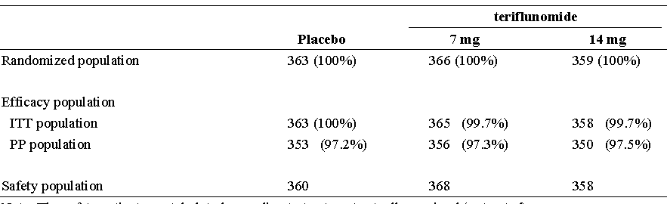
Note: The safety patients are tabulated according to treatment actually received (as treated). For the other populations, patients are tabulated according to their randomized treatment.

Participant flow
Table 18. Patient disposition - randomized population
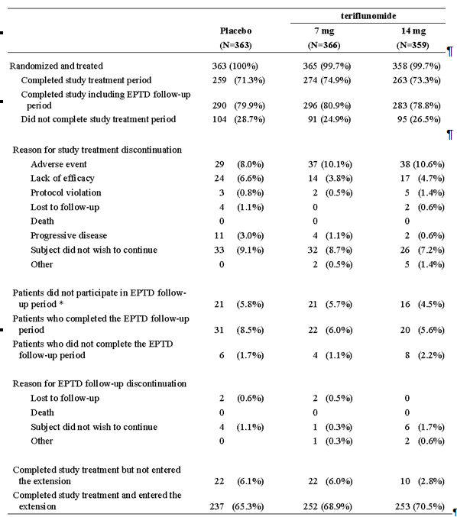
*EPTD (Early permanent treatment discontinuation) follow-up was implemented during protocol amendment 4 (12 February 2007). Patients who discontinued study medication before the amendment are not included
Note: Percentages are calculated using the number of randomized patients as denominator (1 teriflunomide 7mg Patient and 1 teriflunomide 14mg Patient were screen failure patients who were randomized, but were not treated).
Table 19. Major efficacy-related protocol deviations - randomized population
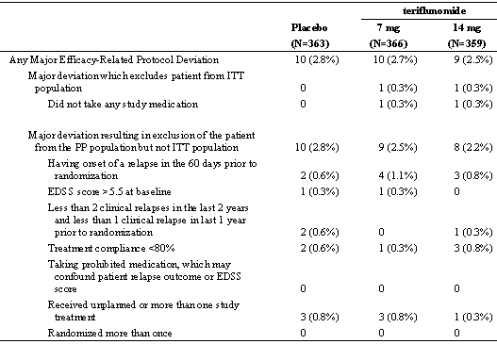
Note: Percentages are calculated using the number of randomized patients as denominator

Baseline data
The median time since first diagnosis of MS was 3.50 years and the median time since first symptoms of MS was 6.83 years. The majority of the patients (91.5%) in the randomized population had relapsing-remitting MS with a median baseline EDSS score of 2.50. The number of relapses (median) within the past 1 year was reported to be 1. 73% had had no previous treatment with MS medication.
Only 12 patients out of 363 (3.3%) receiving placebo had Progressive Relapsing MS, likewise only 14 patients out of 359 (3.9%) receiving teriflunomide 14mg had Progressive Relapsing MS (16/366 [4.4%] receiving teriflunomide 7mg).
Table 20. Demographics and patient characteristics at baseline - randomized population
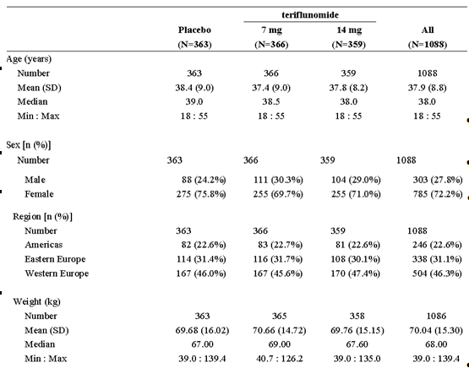
Table 21. MS medications taken within 2 years prior to first investigational product intake - randomized population
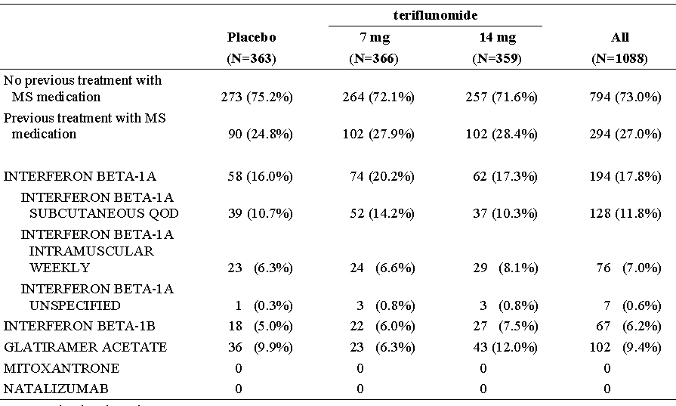
Prior medications are those the patients used prior to first IP intake. A patient can be counted in several categories.
Table 22. Baseline disease characteristics - randomized population
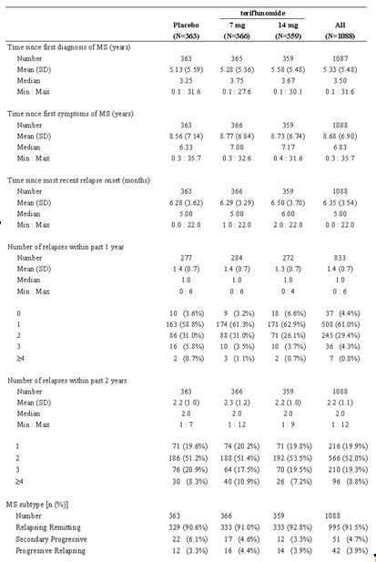

Table 22 continued. Baseline disease characteristics - randomized population
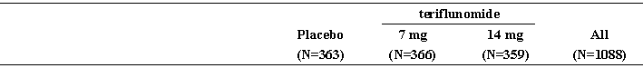
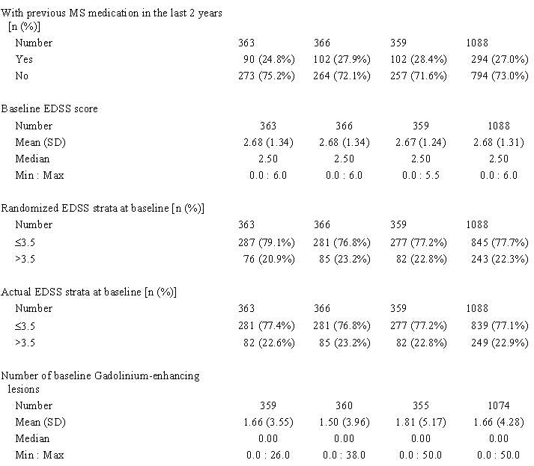
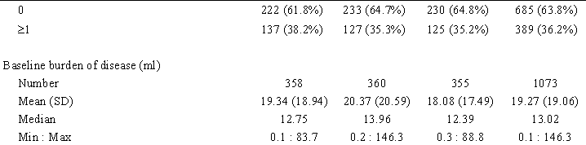

Results for the primary efficacy outcome
The adjusted Annual Relapse Rate (ARR) was 0.539 (95% CI: 0.466 to 0.623) in the placebo group, 0.370 (95% CI: 0.318 to 0.432) in the teriflunomide7mg group, and 0.369 (95% CI: 0.308 to 0.441) in the teriflunomide 14mg group. These results corresponded to a relative risk of 68.8% (p = 0.0002) in the teriflunomide7mg group and 68.5% (p = 0.0005) in the teriflunomide 14mg group compared to placebo.
In the PP population, the adjusted ARR was 0.545 (95% CI: 0.471 to 0.631) in the placebo group, 0.367 (95% CI: 0.314 to 0.428) in the teriflunomide7mg group, and 0.366 (95% CI: 0.305 to 0.438) in the teriflunomide 14mg group. These results were also significant for the relative risk vs. placebo in the teriflunomide7mg group (p = 0.0001) and the teriflunomide 14mg group(p = 0.0002).
Using the additional data collected during the follow-up period, the adjusted ARR was 0.505 (95% CI: 0.438 to 0.583) in the placebo group, 0.358 (95% CI: 0.308 to 0.416) in the teriflunomide7mg group, and 0.358 (95% CI: 0.300 to 0.427) in the teriflunomide 14mg group. These results corresponded to a relative risk of 70.9% in both the teriflunomide7mg group (p = 0.0006) and the teriflunomide 14mg (p = 0.0012) group relative to placebo.
Table 23. Analysis of multiple sclerosis relapse – ITT
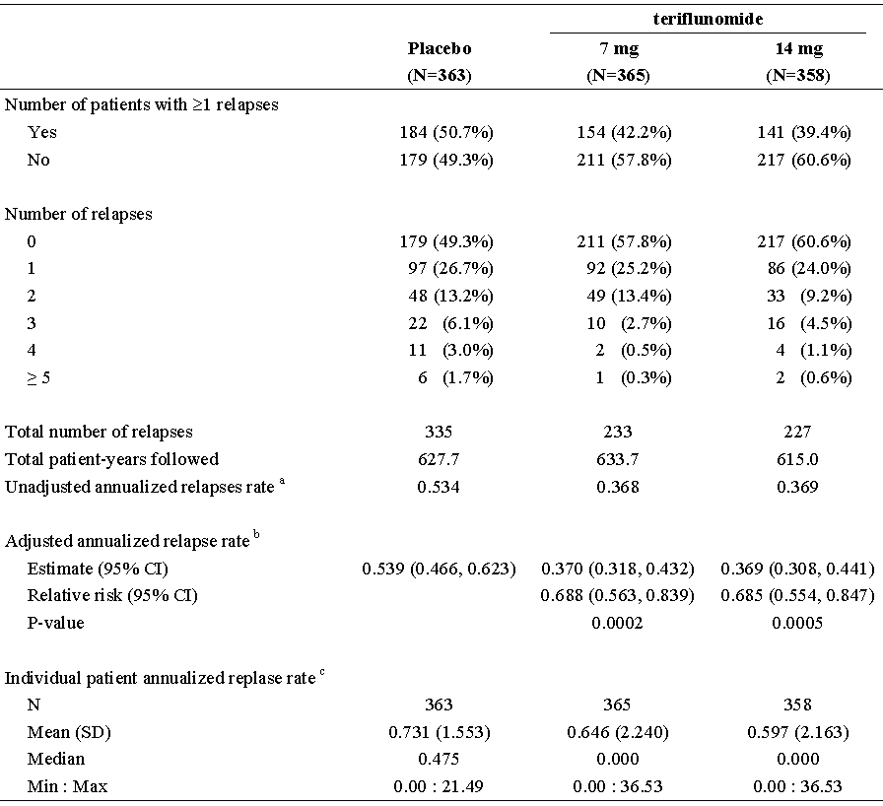
a The total number of relapses that occurred during the treatment divided by the total number of patient-years treated in the study; b Derived using Poisson model with the total number of confirmed relapses onset between randomization date and last dose date as the response variable, treatment, EDSS strata at baseline and region as covariates, and log transformed standardized study duration as an offset variable; c The number of relapse for each patient divided by the number of years treated in the study.

Figure 6. Plot of the Nelson-Aalen estimates of the mean functions for the no. of relapses – ITT
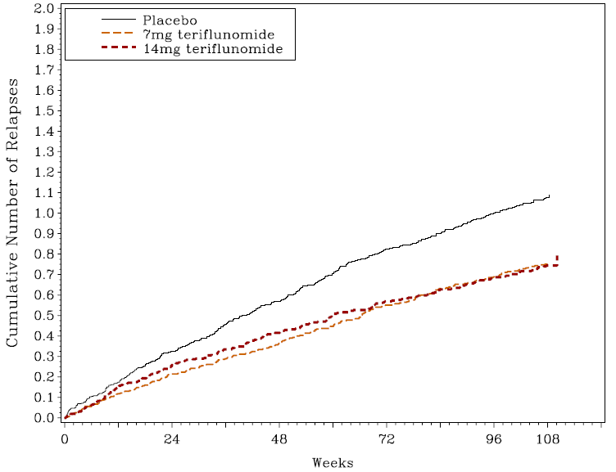
Table 24. Analysis of multiple sclerosis relapse – PP
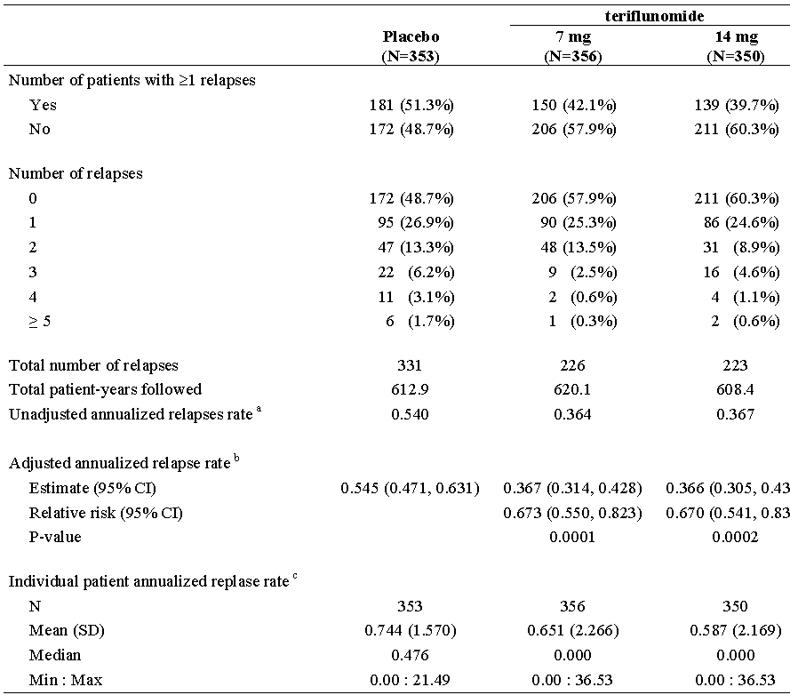
a The total number of relapses that occurred during the treatment divided by the total number of patient-years treated in the study; b Derived using Poisson model with the total number of confirmed relapses onset between randomization date and last dose date as the response variable, treatment, EDSS strata at baseline and region as covariates, and log transformed standardized study duration as an offset variable; c The number of relapse for each patient divided by the number of years treated in the study.
Table 25. Analysis of multiple sclerosis relapse, sensitivity analysis - ITT
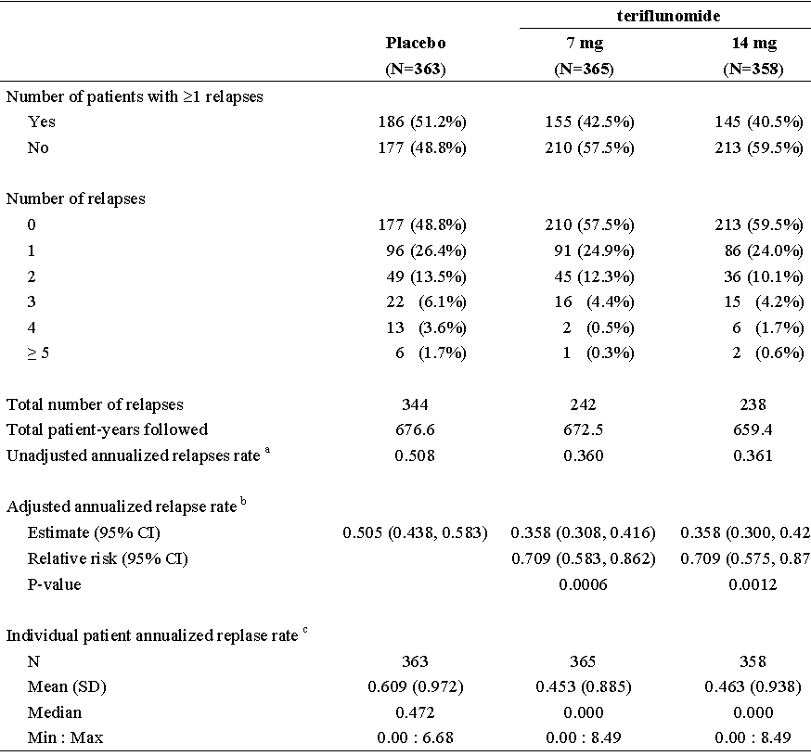
a The total number of relapses that occurred during the study divided by the total number of patient-years followed in the study. b Derived using Poisson model with the total number of confirmed relapses onset between randomization date and last follow-up date as the response variable, treatment, EDSS strata at baseline and region as covariates, and log transformed standardized study (including follow-up) duration as an offset variable. c The number of relapse for each patient divided by the number of years treated in the study.
Subgroup analysis: The effect of teriflunomide on ARR was, overall, homogeneous in the subgroups analysed. A trend for interaction was observed for the 14mg dose and baseline EDSS grouping, with a quantitatively smaller difference for teriflunomide 14mg vs. placebo in the EDSS > 3.5 stratum as compared to the EDSS ≤ 3.5 stratum (p = 0.0656)
Table 26. Summary of systemic corticosteroid treatment for confirmed MS relapses - ITT
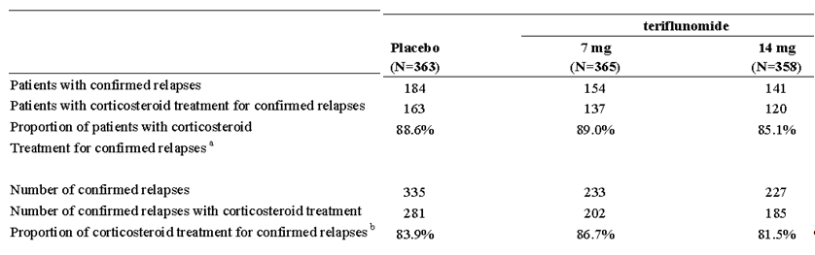a The numerator is the number of patients with systemic corticosteroid treatment for confirmed relapses, and the denominator is the number of patients with confirmed relapses during treatment.
b The numerator is the number of confirmed relapses with systemic corticosteroid treatment, and the denominator is the number of confirmed relapse during treatment
Table 27. Summary of confirmed MS relapses by intensity – ITT
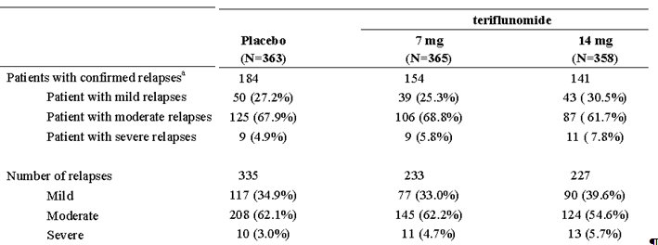
a In case of several relapses for the same patient, the maximal intensity is used

Tertiary variables
The tertiary objectives were exploratory.

Time to first multiple sclerosis relapse
Table 28. Analysis of time to first multiple sclerosis relapse -ITT
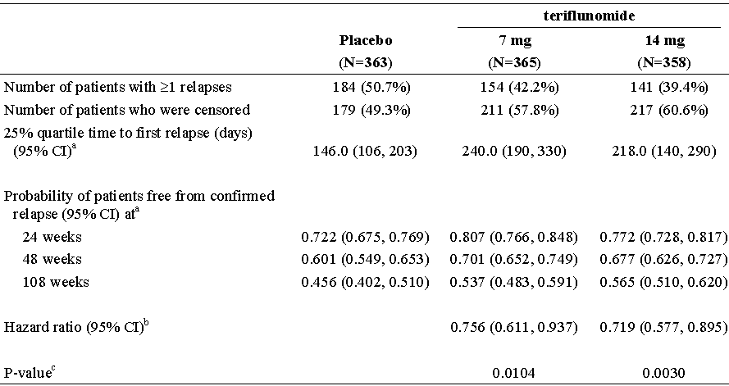
Note: The time-to-event variable is defined as the time (days) from the date of randomization to the date of the first relapse. For patients who have no relapse during treatment period, it will be censored at the last date of study treatment intake.
a Derived from Kaplan-Meier estimates; b Derived using Cox proportional hazard model with treatment, EDSS strata at baseline and region as covariates; c Derived using Log-rank test with stratification of EDSS strata at baseline and region

Figure 7. Kaplan-Meier plot of time to first multiple sclerosis relapse -ITT
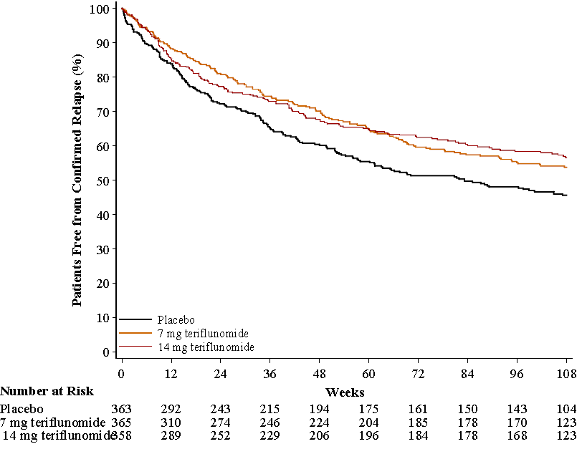

SF-36 (short form generic health survey with 36 questions)
No statistically significant treatment differences were in either SF-36 physical health summary score or in SF-36 mental health summary score up to Week 108.

EuroQol (EQ-5D quality of life questionnaire)
No statistically significant treatment differences were reported in both single index utility scores and VAS scores

Pivotal efficacy studies - study 6050 (Extension of 3001/6049TEMSO)
This report is an interim analysis of the long-term study planned to follow patients for approximately 6 years.

Study design, objectives, location and dates
A multicentre, multinational, randomized, double-blind, parallel-group study of two fixed doses of teriflunomide (7 and 14mg/day), maintaining the double-blind status of the treatment in the previous study EFC6049/TEMSO. Patients receiving placebo in the previous study were randomized to either 7 or 14mg/day.
First patient enrolled 16 October 2006; Last Patient Enrolled Date 29 April 2010; Interim Analysis Cut-Off Date 10 January 2011.
Primary objective: The primary objective was to document the long-term safety and tolerability of two doses of teriflunomide (7 and 14mg) in multiple sclerosis (MS) patients with relapses.
Secondary objective: The secondary objective was to document the long-term effect on disability progression (key secondary endpoint), annual relapse rate, and MRI variables.

Inclusion criteria
Patients who had completed the last study visit of the previous study (EFC6049/TEMSO) and did not meet criteria for treatment withdrawal.

Study treatments
7 and 14mg teriflunomide as in previous study 6049.

Efficacy variables and outcomes
They were similar to study 6049 except:
- Annualized relapse rate (ARR) became a secondary efficacy variable.
- Time to (first) disability progression sustained for at least 12 weeks was retained as a key secondary efficacy variable
- Time to first confirmed relapse became a secondary efficacy variable rather than an exploratory tertiary
“Secondary Efficacy Variables” relevant to Reducing the Frequency of Clinical Relapses included:
- Annualized relapse rate (ARR);
- Time to first confirmed relapse
- Proportion of patients without confirmed relapse at yearly time points (by years since randomization in LTS6050);

Sample size
Not relevant.

Randomisation and blinding methods
Patients continued to receive the same teriflunomide double-blind treatment, except for patients who were previously randomized to the placebo group and who were blindly randomized in a 1:1 ratio to either the 7mg/day or 14mg/day teriflunomide treatment arm.
1 code was broken (a 7mg/7mg patient) due to medical and accidental reasons at the local level as the patient was pregnant and 1 code was broken (another 7mg/7mg patient) for regulatory purposes as the patient died.

Statistical methods
Time to first confirmed relapse was analysed using log-rank test (to compare placebo/7mg vs.7mg/7mg, placebo/14mg vs. 14mg/14mg, and7mg/7mg vs. 14mg/14mg) with time to first relapse as the dependent variable, treatment group as test variable, and region and baseline EDSS strata as covariates. Hazard ratios (placebo/7mg vs.7mg/7mg, placebo/14mg vs. 14mg/14mg, and7mg/7mg vs. 14mg/14mg) were estimated using Cox regression model with treatment group, region and baseline EDSS strata as covariates.
The analysis was based on LTS6050 data only.

Participant flow
Table 29. Patient disposition - Randomized population
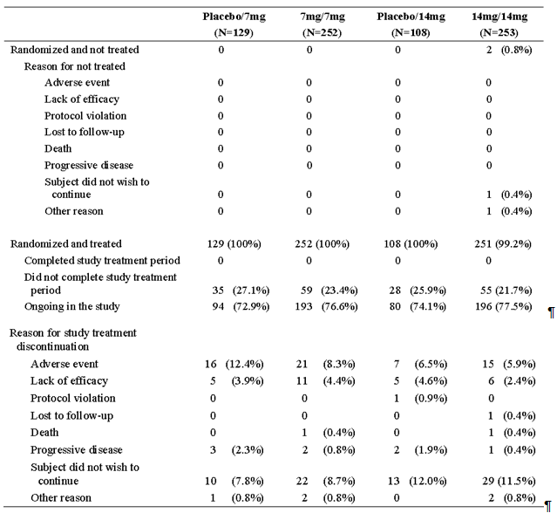
Note: Percentages are calculated using the number of randomized patients as denominator.
Table 30. Major efficacy-related protocol deviations - Randomized population
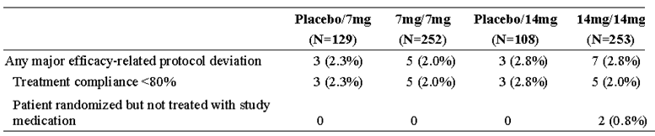
Note: Percentages are calculated using the number of randomized patients as denominator.
Table 31. Randomization and drug allocation irregularities - Randomized population
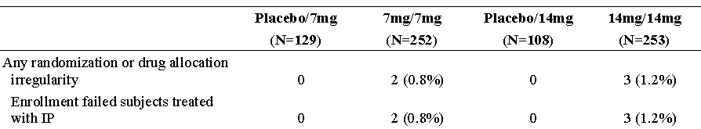
Note: Percentages are calculated using the number of randomized patients as denominator.

Baseline data
Overall it was a mean of 5.25 years since first diagnosis, 26% had had 3 or more relapses in the last 2 years, 23% had had MS medication previously, 20% had had ≤ 1 relapse in last 2 years.
Only 10 out of 361 (2.8%) receiving teriflunomide 14mg had Progressive Relapsing MS.
Table 32. Demographics and patient characteristics at baseline - Randomized population
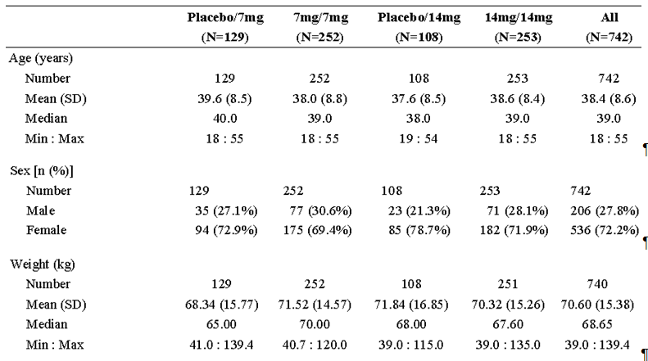

Results for efficacy outcomes

Table 33. Analysis of MS relapse – ITT (LTS6050) population
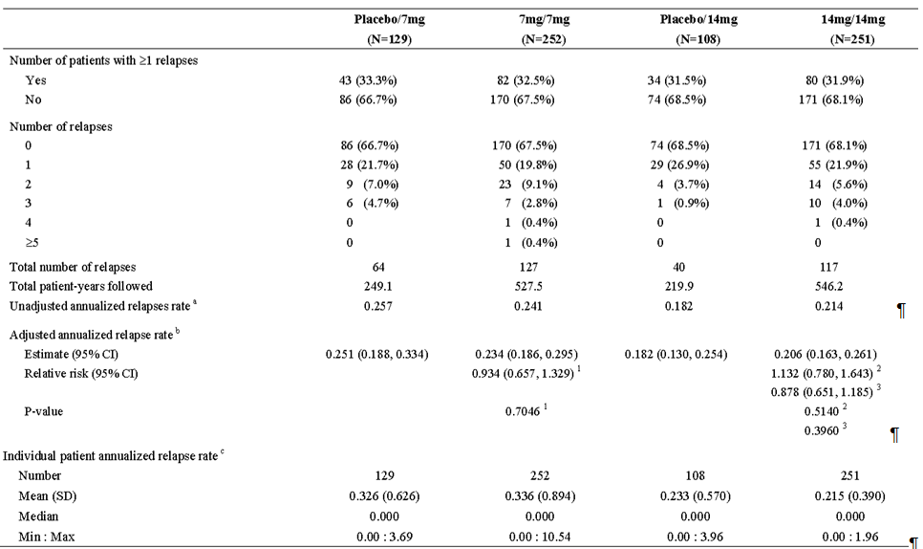
a The total number of relapses that occurred during LTS6050 divided by the total number of patient-years followed in LTS6050; b: Derived using Poisson model with the total number of confirmed relapses onset between randomization date in LTS6050 and last dose date as the response variable, treatment, EDSS strata at baseline and region as covariates, and log-transformed standardized LTS6050 study duration as an offset variable; c: The number of relapse for each patient divided by the number of years followed in LTS6050 for that patient
1 Comparing with placebo/7mg group; 2 Comparing with placebo/14mg group; 3 Comparing with 7mg/7mg group
Table 34. Analysis of time to first MS relapse - ITT (LTS6050) Population
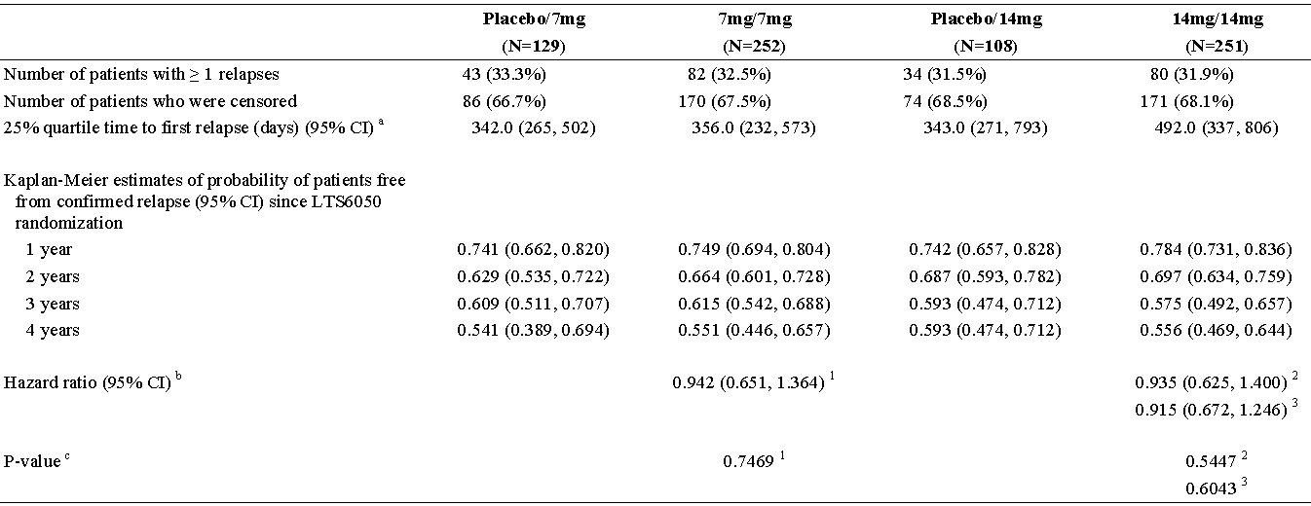
Note: The time-to-event variable is defined as the time (days) from the date of randomization in LTS6050 to the date of the first relapse. For patients who have no relapse during TREATMENT period, it will be censored at the last date of study treatment intake.
a Derived from Kaplan-Meier estimates
b Derived using Cox proportional hazard model with treatment, EDSS strata at baseline and region as covariates
c Derived using Log-rank test with treatment, EDSS strata at baseline and region as covariates
1 Comparing with placebo/7mg group
2 Comparing with placebo/14mg group
3 Comparing with 7mg/7mg group

Proportion of patients without confirmed relapse
The proportion of patients without confirmed relapse was similar between all treatment groups at 4 years since LTS6050 randomization with probability of 54.1% in the placebo/7mg group, 55.1% in the7mg/7mg group, 59.3% in the placebo/14mg group, and 55.6% in the 14mg/ 14mg group.
Figure 8. Plot of change from baseline in SF36 physical health summary score over time - ITT
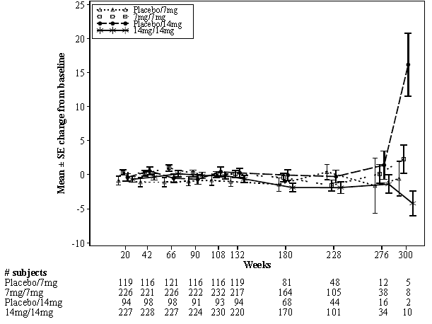
Figure 9. Plot of change from baseline in EQ-5D single utility index over time - ITT (LTS6050)
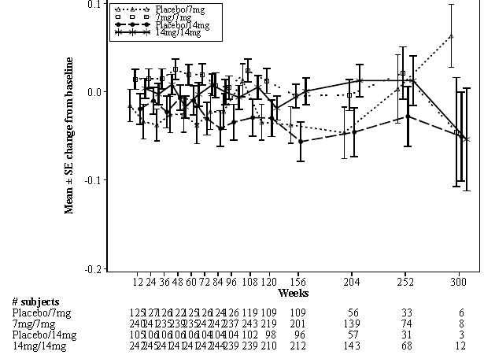

Other efficacy studies - Study 2001
See also:
- Study PMH0091: Impact of drug metabolizing enzyme phenotype and genotype on teriflunomide exposure in studies EFC6049 and 2001
- Study POH0290: Population pharmacokinetic analysis of teriflunomide- combined analysis of a study TDR10892, study 2001 and Study EFC6049
- Study POH0295: Pharmacokinetic Pharmacodynamic Analysis of teriflunomide (data from TEMSO:EFC6049 and 2001)

Study design, objectives, location and dates
A phase II, multinational, placebo-controlled, double-blind, parallel-group study of the safety and efficacy of teriflunomide in MS with relapses. Patients were randomized in a ratio of 1:1:1 to daily oral doses of placebo, 7mg, or 14mg teriflunomide. The study comprised 3 periods: a 4-week treatment-free screening period with MRI scans at week –4 and baseline (visits 1 and 3); a 36-week double-blind treatment period with 6 additional MRI scans performed every 6 weeks (visits 4 to 10); and a 6-week post-treatment observation period with a final MRI scan at week 42 (visit 11).
26 April 2001 to 17 March 2003 in 16 centres: Canada (10), France (6)
Secondary Objectives included:
- To determine the effect of teriflunomide on clinical and quality of life measures
  - Changes in clinical scales and quality of life measures including the Multiple Sclerosis Functional Composite scale (MSFC), clinical relapse rate and the Multiple Sclerosis Quality of Life Questionnaire (MSQOL-54)

Inclusion criteria
These included:
- MS with at least 2 documented relapses as defined by the Poser criteria. The disease course for each subject was to be defined on the basis of the initial episode, subsequent relapses, and progress assessed by review of clinical history and neurological examinations
- Clinical disease severity between 0 and 6 inclusively according to the EDSS
- Screening MRI scan (visit 1) fulfilling the criteria for a diagnosis of MS
- At least 2 clinical relapses in the 3 years prior to screening with at least 1 relapse in the last year.
- Willing to undergo 9 MRI scans within 1 year.

Exclusion criteria
These included:
- Significantly impaired bone marrow function or significant anaemia, leucopoenia, or thrombocytopenia.
- Congenital or acquired severe immunodeficiency, history of cancer, lymphoproliferative disease, or treatment with lymphoid irradiation.
- Persistent significant or severe infection in the 4 months before visit 1.
- Treatment with systemic, inhaled, intra-articular, or widely applied topical corticosteroids or ACTH in the 4 weeks before visit 1.
- Treatment with interferon, gamma-globulin, or other non-corticosteroid, immunomodulatory therapies in the 4 months before visit 1.
- Previous treatment with cladribine or mitoxantrone. Treatment with other chemotherapeutic agents such as azothioprine, cyclophosphamide, cyclosporine, or methotrexate in the 6 months before visit 1.

Study treatments
In each of the 3 groups, subjects were to take a daily loading dose of 2 tablets for the first 7 days of the treatment period, followed by a maintenance dose of 1 tablet daily of either placebo or teriflunomide7mg/day or 14mg/day.

Efficacy variables and outcomes
Included:
- Number of subjects with a relapse within the treatment period
- Number of subjects with a relapse within the treatment period requiring treatment with a steroid
- Time to first relapse (in days)
- Annual relapse rate: number of relapses per subject and year
- Multiple Sclerosis Quality of Life Questionnaire
- Fatigue Impact Scale

Sample size
Some 54 evaluable subjects per treatment group were considered sufficient to detect with 90% power an effect size of 0.32 (i.e., probability of X less than Y) using a 2-sided Wilcoxon rank-sum test and an α-level of 0.05. This effect size for the Wilcoxon rank-sum test corresponds to a parametric effect size (i.e., difference in means divided by the standard deviation) of 0.67. Anticipating a 10% dropout rate, it was considered necessary to randomize 60 subjects per treatment group for a total of 180 subjects

Randomisation and blinding methods
Randomization of subjects was stratified on the basis of EDSS scores. Subjects with a score ≤3.5 were randomized in ascending order beginning with the lowest number; subjects with a score >3.5 were randomized in descending order beginning with the highest number.

Statistical methods
Primary efficacy analysis: The null hypothesis was no treatment difference between 14mg dosage group and placebo for the average number of unique active lesions per scan. To preserve the α-level at 0.05 for both the 14mg dosage group comparison and the 7mg dosage group comparison, the critical value for the Dunnett’s test for 2 groups compared with a control was used. The hypotheses were tested using a rank analysis of covariance (ANCOVA) on the ranked average number of unique active lesions per scan during the double-blind treatment period with treatment, stratum (baseline EDSS score ≤ 3.5 vs. >3.5), and pooled centre as fixed effects and the ranked average pre-randomization number of unique active lesions as covariate. Differences between treatment groups in the ranked average pre-randomization number of unique active lesions were compared by analysis of variance (ANOVA). The primary efficacy variable was analysed for the following subgroups based on background variables:
- Sex (male versus female)
- Age (< 35 years versus ≥35 years)
- MS diagnosis (RRMS versus SPMS)
- Duration of disease (< 3 years versus ≥3 years)
- Pooled centre
- Prior treatment with interferon beta-1a, interferon beta-1b, glatiramer acetate, gamma globulin, azothioprine, cyclophosphamide, cyclosporine, or methotrexate or no prior treatment with those medications
Secondary efficacy analyses:
- MRI count variables were analysed using the same ANCOVA model as for the primary variable.
- MRI change from baseline variables were analysed with ANCOVA on change from baseline to endpoint with treatment, stratum, and pooled centre as fixed effects and the baseline score as covariate.
- Changes from baseline assessments (e.g., for the EDSS and MSFC) were analysed using ANCOVA on change from baseline of the clinical assessments with treatment, stratum, and pooled centre as fixed effects and the baseline score as covariate.
- For the number of subjects that progressed on the basis of the EDSS and for the number of subjects with relapses, the Cochran-Mantel-Haentzel procedure controlling for pooled centre was used.
- Time to progression and time to relapse were analysed by PROC LIFETEST using the number of days until progression or relapse, respectively. Subjects who did not progress or relapse were censored on the last day of study medication.
- The changes from baseline for each of the quality of life variables were analysed using ANCOVA on change from baseline with treatment, stratum, and pooled centre as fixed effects and the baseline score as covariate.
Table 35. Reasons for discontinuing study medication (safety-evaluable population)
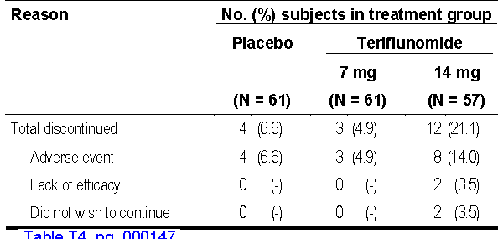

Figure 10. Participant flow
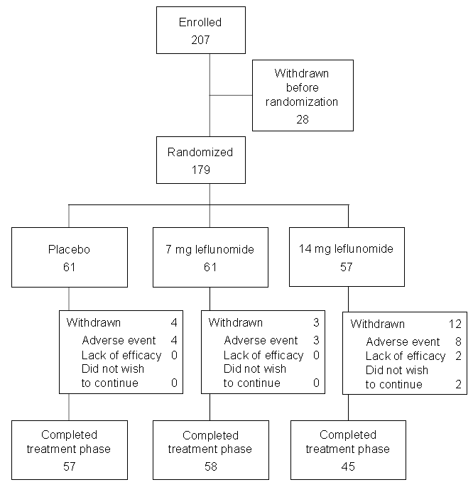
Table 36. Major protocol deviations (efficacy evaluable population)
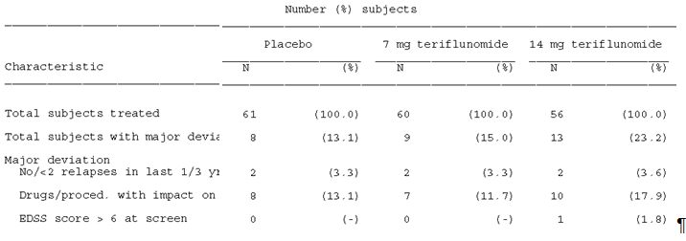

Baseline data
Table 37. Demographic data (safety population)
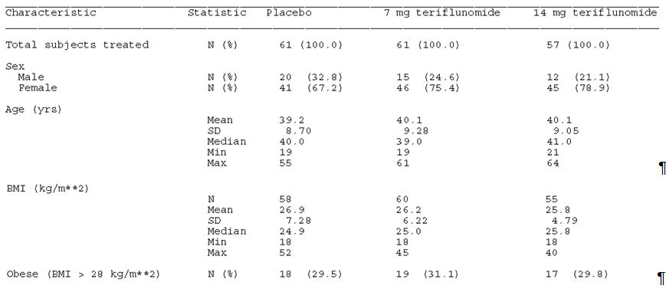
Table 38. MS history (efficacy-evaluable population)
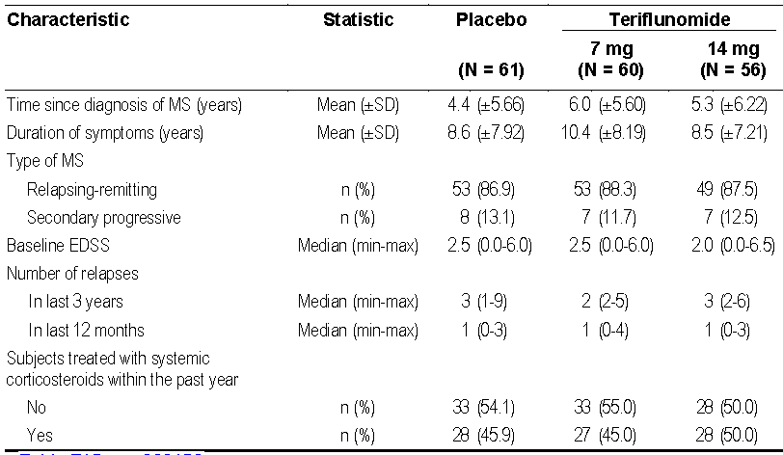
Table 39. Medications for MS taken by at least 10% of subjects in one or more treatment groups (safety-evaluable population)
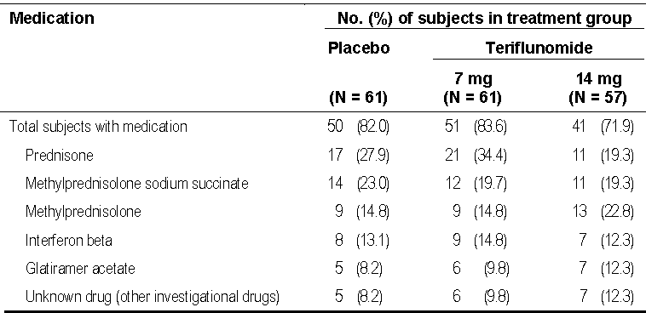

Results for the primary efficacy outcome
See primary efficacy outcomes for study 6050.

Results for other efficacy outcomes
See Tables below.

Table 40. Analysis of MS relapses for the treatment period in the efficacy-evaluable population
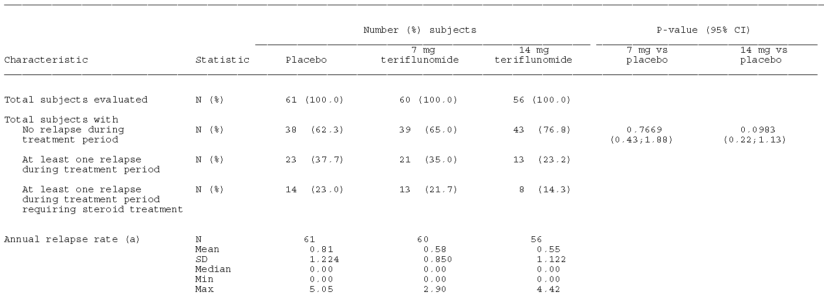
a: Annual relapse rate was defined as (number of relapses per subject x 365/days on treatment)

Table 41. MSFC, ANCOVA results for comparison 7mg & 14mg vs. Placebo
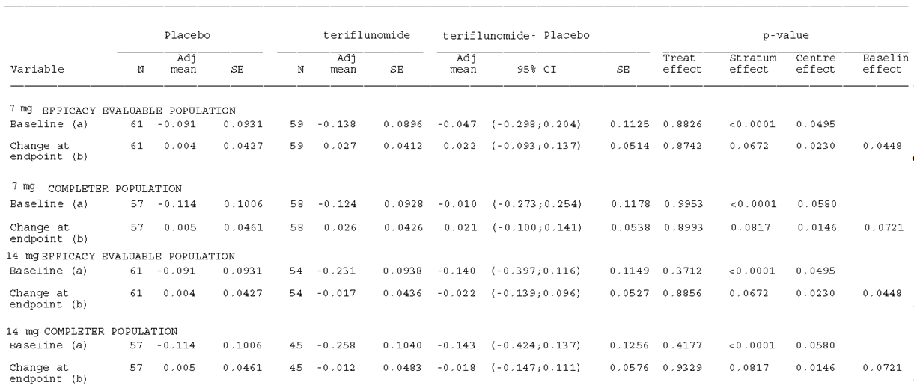
(a) The ANOVA model includes treatment, stratum (≤ 3.5 EDSS,>3.5 EDSS) and centre as fixed effects.
(b) The ANCOVA model includes treatment, stratum (≤3.5 EDSS, >3.5 EDSS), centre as fixed effects and MSFC at baseline as covariate.
Adjustment for multiple comparisons between treatment groups according to Dunnett.

Other efficacy studies - Study LTS6048 (2002 – an Extension of 2001)
This report is an interim analysis of the long-term study planned to follow patients for approximately 8 years.

Study design, objectives, location and dates
An open-label continuation of treatment on either 7mg or 14mg of teriflunomide for patients completing study 2001. Randomization to 7 or 14mg teriflunomide for patients on placebo in study 2001. First patient enrolled 28 January 2002; last patient enrolled 13 March 2003; Interim Analysis Cut-Off Date 10 January 2011.
The primary objective was to assess the long-term safety of teriflunomide in MS.
The secondary objectives included:
- To assess the long-term efficacy of teriflunomide in MS patients with respect to the following parameters:
  - EDSS scores,
  - Multiple sclerosis functional composite (MSFC) score,
  - Burden of disease (BOD) and brain atrophy as calculated from the MRI scans,
  - Annual rate of relapses.
- To assess the long-term effect of teriflunomide on the quality of life of MS patients with respect to the following instruments:
  - MSQOL-54 questionnaire,
  - Fatigue impact scale (FIS),
There were multiple protocol amendments, some altering the efficacy variables assessed.

Inclusion criteria
These included:
- Male or female patients, aged between 18 and 65 years who had satisfactorily completed study 2001 with respect to safety.
- Patients had to demonstrate a willingness and ability to participate in a long-term safety and efficacy study with the opportunity to continue treatment on either 7 or 14mg of teriflunomide under double-blind conditions, until the randomization code has been broken for study 2001. During this period, all patients had to be willing to undergo blood testing at 2 week intervals for a maximum of 24 weeks. Patients had to actively refuse existing approved therapies

Study treatments
7mg or 14mg teriflunomide OD for 528 weeks.

Efficacy variables and outcomes
Included:
- annual relapse rate
- number of relapse-free subjects
- change from baseline in MSQOL-54
- change from baseline in the Fatigue Impact Scale
To these were added the Time to first relapse and proportion of relapse-free subjects by Modification from Protocol Amendment 8; 05-Feb-2010.

Sample size
Not applicable.

Randomisation and blinding methods
Patients receiving placebo in the study 2001 were randomized in a 1:1 ratio to either 7mg or 14mg teriflunomide. This randomization was assigned at the time the patient was randomized in study 2001.

Statistical methods
For Annualized relapse Rate the primary analysis was performed using a Poisson regression model with robust error variance that would accommodate the potential over-dispersed data appropriately. The model included the total number of confirmed relapses with onset between LTS6048 first dosing date and last dose date as response variable, treatment group, country and baseline EDSS strata (baseline EDSS score ≤ 3.5 versus > 3.5) as covariates. In order to account for different treatment durations among patients, the log-transformed standardized treatment duration was included in the model as an “offset” variable for appropriate computation of relapse rate. The robust error variances could be estimated by specifying the patient identifier in the repeated statement using SAS PROCGENMOD, and this was equivalent to the Generalized Estimating Equation (GEE) model. Two-sided 95% CIs of the rate ratios (placebo/7mg vs. 7mg/7mg, placebo/14mg vs. 14mg/14mg, and 7mg/7mg vs. 14mg/14mg) were provided. The estimated relapse rate in LTS6048 and its 2-sided 95% CIs was also provided for each treatment group.
The gross estimate of annualized relapse rate was also presented for each treatment group.
The Time to first MS relapse in the LTS6048 study was analysed using log-rank test (to compare placebo/7mg vs. 7mg/7mg, placebo/14mg vs. 14mg/14mg and 7mg/7mg vs.14mg/14mg) with time to first relapse as the dependent variable, treatment group as test variable, and country and baseline EDSS strata as covariates. Hazard ratio (placebo/7mg vs.7mg/7mg, placebo/14mg vs. 14mg/14mg, and7mg/7mg vs. 14mg/14mg) was estimated using Cox regression model with treatment group, country and baseline EDSS strata as covariates. This analysis was based on LTS6048 data only.
Estimates of the Proportion of patients without relapse at selected time points in the LTS6048 study were derived using Kaplan-Meier method. The analysis was based on LTS6048 data only.

Baseline data
Data were provided.

Participant flow
Two patients in the placebo/14mg group had major efficacy related protocol deviation one with a treatment compliance<80% and one who took prohibited concomitant medications which might have potential effects on the immune system.
Table 42. Overall patient disposition – Randomized population
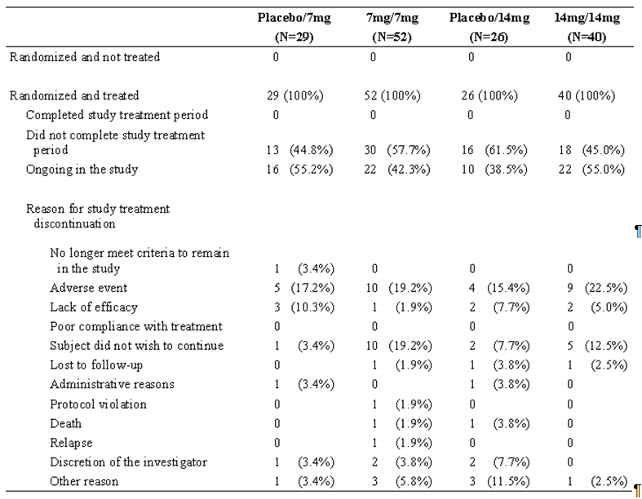Note: Percentages are calculated using the number of randomized patients as denominator

Results for other efficacy outcomes
Figure 11. Kaplan-Meier plot of time to first MS relapse – ITT
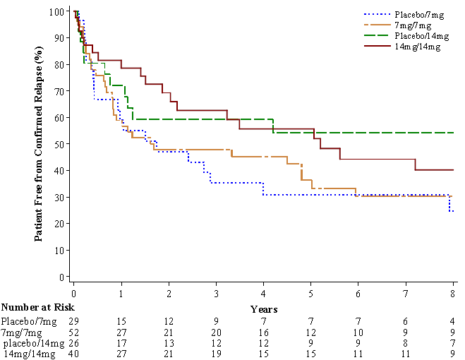

Table 43 Analysis of MS relapse – ITT
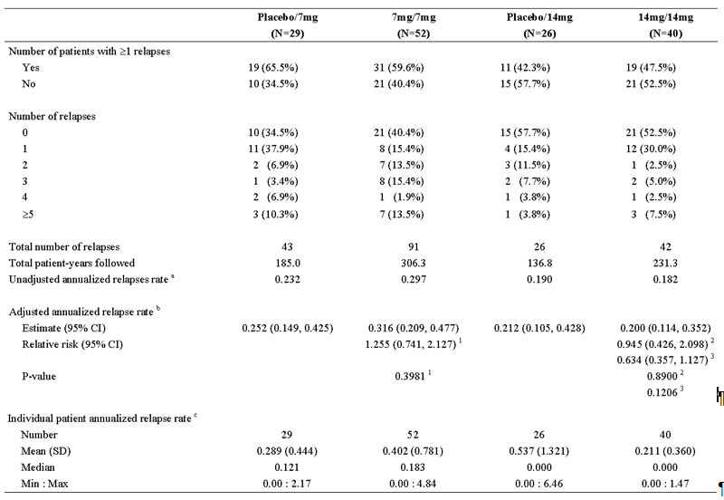
a The total number of relapses that occurred during LTS6048 divided by the total number of patient-years followed in LTS6048
b Derived using Poisson model with the total number of confirmed relapses onset between first dose date in LTS6048 and last dose date as the response variable, treatment, EDSS strata at baseline, and country as covariates, and log-transformed standardized LTS6048 study duration as an offset variable c The number of relapse for each patient divided by the number of years followed in LTS6048 for that patient 1 Comparing with placebo/7mg group; 2 Comparing with placebo/14mg group;3 Comparing with 7mg/7mg group.
Table 44. Analysis of Time to First MS Relapse – ITT
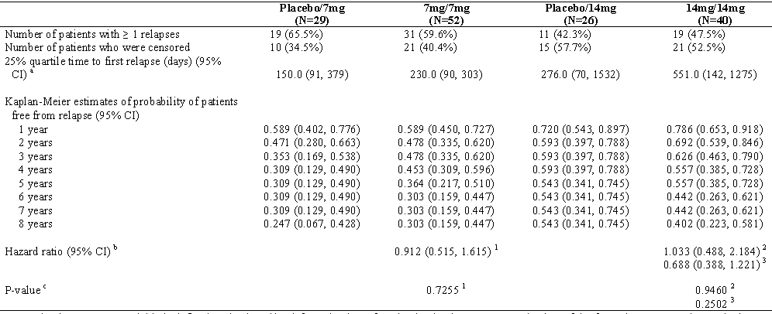
Note: The time-to-event variable is defined as the time (days) from the date of randomization in LTS6048 to the date of the first relapse. For patients who have no relapse during treatment period, it will be censored at the last date of study treatment intake.
a Derived from Kaplan-Meier estimates
b Derived using Cox proportional hazard model with treatment, EDSS strata at baseline and country as covariates
c Derived using Log-rank test with treatment, EDSS strata at baseline and country as covariates
1 Comparing with placebo/7mg group; 2 Comparing with placebo/14mg group;3 Comparing with 7mg/7mg group.

Proportion of patients without confirmed relapse
The estimated percentage of probabilities of patients free from relapse at 8 years since the start of the LTS6048 study using the Kaplan-Meier method was 24.7%, 30.3%, 54.3% and 40.2% in the placebo/7mg group, the7mg/7mg group, in the placebo/14mg group and the 14mg/14mg group, respectively.
Figure 12. Plot of change from baseline in FIS total score over time - ITT
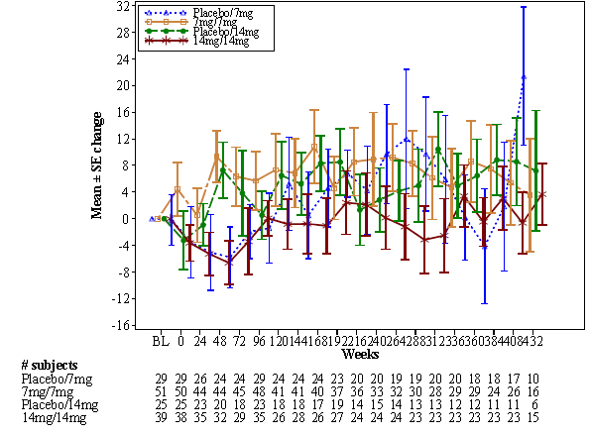
Figure 13. Plot of change from baseline in mental health composite score over time - ITT
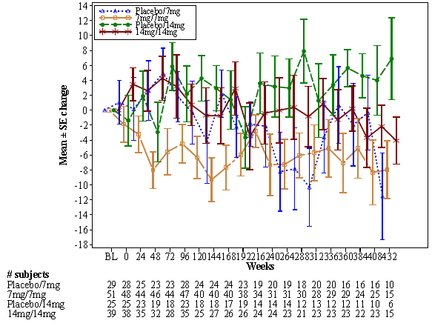

Figure 14. Plot of change from baseline in physical health composite score over time - ITT
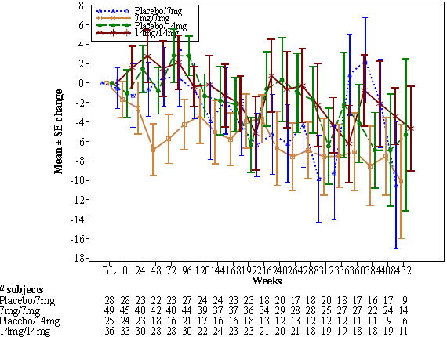

Monotherapy - To delay the accumulation of physical disability

Pivotal efficacy studies - study 3001/6049TEMSO
See also:
- Study 6049 evaluation of To Reduce the Frequency of Clinical Relapse
- Study POH0290: Population pharmacokinetic analysis of teriflunomide- combined analysis of a Phase 1 study (TDR10892), a Phase II study (HMR1726D/2001) and a Phase III Study (EFC6049)
- Study PMH0091: Impact of drug metabolizing enzyme phenotype and genotype on teriflunomide exposure in studies EFC6049 and HMR1726D/2001
- Study POH0295: Pharmacokinetic Pharmacodynamic Analysis of teriflunomide (data from TEMSO:EFC6049 and 2001)

Study design, objectives, locations and dates
The secondary objectives included to:
- Evaluate the effect of teriflunomide on delaying the accumulation of disability at 2 years as assessed by the Kurtzke Expanded Disability Status Scale (EDSS)
- Evaluate the effect of teriflunomide on subject-reported fatigue as assessed by the Fatigue Impact Scale (FIS)
- Evaluate the effects of teriflunomide on MRI variables: burden of disease (volume of abnormal brain tissue on MRI) and other MRI variables including number and volume of gadolinium (Gd)-enhanced T1 lesions, volume of T2 lesion, volume of T1 hypo-intense lesions, atrophy and a composite score.
The tertiary objectives included to:
- Explore the impact of teriflunomide on disease progression using the Multiple Sclerosis Functional Composite (MSFC)

Inclusion and exclusion criteria, Study treatments
See details for Study 3001/6049TEMSO above.

Efficacy variables and outcomes
Secondary efficacy variables included:
- Time to disability progression
- FIS total score and domain scores
- Magnetic resonance imaging variables:
  - The total number of Gd-enhancing T1-lesions per MRI scan over the treatment period
  - The Burden of disease (BOD)
  - The total volume of Gd-enhancing T1-lesions per MRI scan over the treatment period
  - The volume of hypo-intense post-Gd T1 lesions (black holes)
  - The volume of T2 lesion component
- Proportion of patients free of disability progression at 6 months, 1 year, and 2 years, estimated by Kaplan-Maier curves
Tertiary efficacy variables included:
- The change from baseline in EDSS score at the end of treatment (Week 108)
- The change from baseline in MSFC score (leg function/ambulation [timed 25-foot walk], arm/hand function [9-hole peg test], and cognitive function) at Week 96.
Exploratory MRI variables included atrophy, volume of white matter, volume of gray matter, number of unique active lesions per scan, and Z4 score.

Sample size randomisation and blinding methods participant flow
See details for Study 3001/6049TEMSO above.

Statistical methods
The key secondary efficacy variable is time to disability progression.
The time to disability progression was analysed using the log-rank test with time to disability progression as the dependent variable, the treatment group as test variable, and region and baseline EDSS strata as stratification factors.
The Kaplan-Meier method was used to estimate the time to disability progression rate specific to each group, based on the ITT population. Kaplan-Meier graphs were generated and quartiles and point probabilities were calculated. Interval estimates were calculated using 95% point wise CIs.
The main analysis was the time to disability progression confirmed for at least 12 weeks. The supportive analyses were also performed using time to disability progression confirmed for at least 24 weeks and time to first sustained disability progression based on the PP population. The subgroup analyses were performed for the key secondary efficacy variable using the same subgroups as those used for the primary variable.
The analysis to assess the proportion of the patients free of disability progression at 6 months, 1 year, and 2 years was the same as for the key secondary efficacy variable.

Other secondary endpoints:
If all hypothesis tests described above were significant at 5% level, a step down testing procedure was applied to the following secondary endpoints in the order specified below within each dose at 2.5% significance level, i.e., within a dose each hypothesis was formally tested only if the preceding one was significant at the 2.5% level:
- Change from baseline in total score of fatigue impact scale at Week 108
- Total number of gadolinium enhancing (Gd-enhancing) T1-lesions per MRI scan over the treatment period
- Change from baseline in MRI burden of disease at Week 108
By applying the multiplicity adjustment approach described above for a family of hypotheses about 5 endpoints and 2 doses, Type-1 error rate was strongly controlled for the entire family.

Analysis of MRI variables
The change from baseline in BOD was analysed using a mixed-effect model with repeated measures (MMRM) on cubic root transformed volume data. The model included factors (fixed effects) for treatment, EDSS strata, region, visit, treatment-by-visit interaction, baseline value (cubic root transformed), and baseline-by-visit interaction. An unstructured correlation matrix was used to model the within-patient errors. The parameters were estimated using the restricted maximum likelihood method with the Newton-Raphson algorithm and the denominator degrees of freedom were estimated using Satterthwaite’s approximation.
The baseline-adjusted least squares means (LS-means) estimates at Week 108 by treatment group are provided, as well as the differences of these estimates versus placebo, with their corresponding standard errors and associated 95% CIs. The statistical significance of the comparison of each active treatment versus placebo was determined using Student t-tests.
The number of Gd-enhancing T1 lesions per MRI scan and the number of unique active lesions per MRI scan were compared between the treatment groups using the same model as for the ARR. The model included the total number of Gd-enhancing T1 lesions as response variable and treatment group, EDSS strata, region, and baseline number of Gd enhancing T1 lesions as covariates. To account for the different numbers of scans performed among the patients, the log-transformed number of scans were included in the model as an offset variable.
The total volume of Gd-enhancing T1 lesions per MRI scan was analysed using rank analysis of covariance due to the nonnormality of the distribution. The baseline Gd enhancing T1 lesions and the endpoint (volume of lesions per MRI scan) were respectively ranked for all patients who had both baseline and at least 1 on-treatment scan. No imputation was needed since the patients with post baseline measurements all had the response value. The adjustment for covariance in the rank and strata was accomplished by an ANCOVA model, which included the ranked volume of Gd-enhanced T1 lesions per scan as the response variable and ranked baseline volume of Gd-enhanced T1 lesions, EDSS strata, and region as covariates. The treatment effect for baseline-adjusted rank volumes with the p values for treatment comparisons were calculated.
The change from baseline in transformed volume of hypointense post-Gd T1 lesion component and in T2 lesion component was analysed using the same model as for the BOD.
The change from baseline in other MRI variables (atrophy, volume of white matter, volume of gray matter, and Z4 score) at Week 108 was analysed using the same model as for the BOD without data transformation.

Baseline data
Table 45. Baseline data
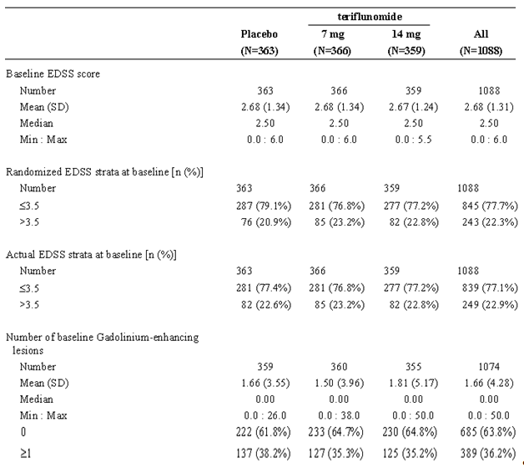

Results for other efficacy outcomes

Time to disability progression sustained for 12 weeks
In the ITT population the time to disability progression was significantly greater (p = 0.0279) for 14mg teriflunomide vs. placebo by log-rank test whereas there was no significant difference (p = 0.0835) for 7mg teriflunomide vs. placebo.
The Kaplan-Meier estimated percentage of patients with 12-week sustained disability progression at Week 108 was placebo 27.3%, teriflunomide7mg 21.7%, and teriflunomide 14mg 20.2%.
Analysis of the PP population produced supportive results for 14mg (nominal p = 0.258; HR 0.699 CIs 0.502, 0.972).
Table 46. Analysis of time to disability progression sustained for 12 weeks - ITT
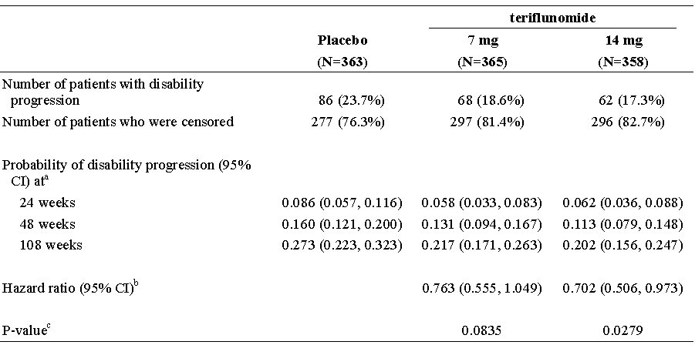
Note: The time-to-event variable is defined as the time (days) from the date of randomization to the date of the first disability progression. For patients who have no disability progression on or before last during treatment EDSS evaluation, it will be censored at the date of last during-treatment EDSS evaluation.
a Derived from Kaplan-Meier estimates
b Derived using Cox proportional hazard model with treatment, EDSS strata at baseline and region as covariates.
c Derived from log-rank test with stratification of EDSS strata at baseline and region.
Figure 15. Kaplan-Meier plot of time to disability progression sustained for 12 weeks - ITT
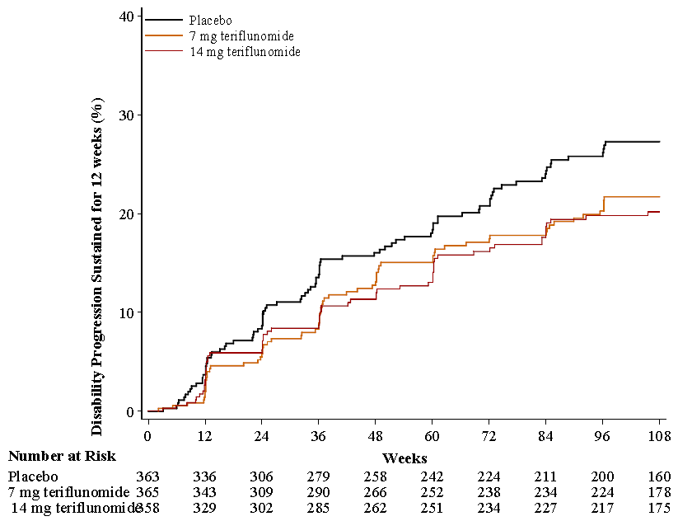
Table 47. Analysis of time to disability progression sustained for 12 weeks – PP
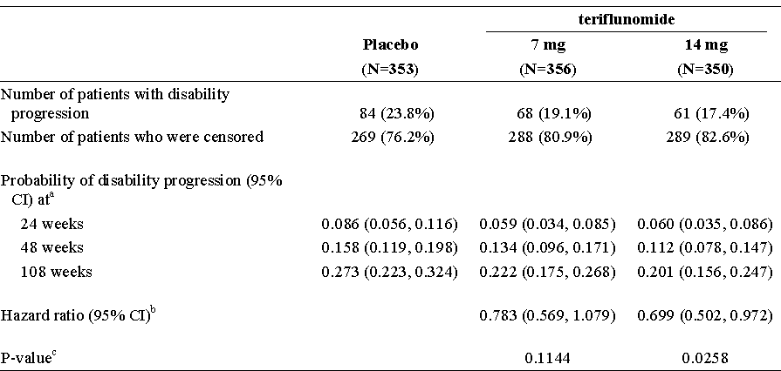
Note: The time-to-event variable is defined as the time (days) from the date of randomization to the date of the first disability progression. For patients who have no disability progression on or before last during treatment EDSS evaluation, it will be censored at the date of last during-treatment EDSS evaluation.
a Derived from Kaplan-Meier estimates
b Derived using Cox proportional hazard model with treatment, EDSS strata at baseline and region as covariates.
c Derived from log-rank test with stratification of EDSS strata at baseline and region
Figure 16. Kaplan-Meier plot of time to disability progression sustained for 12 weeks – PP
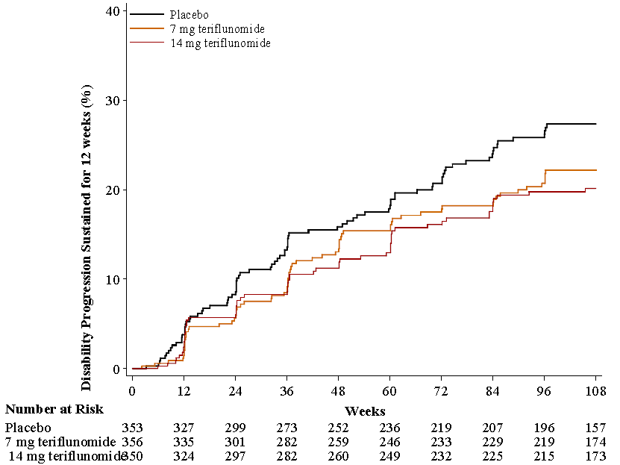
Subgroup analysis The effect of teriflunomide on disability progression was, overall, homogeneous in the subgroups analysed. A trend for interaction was observed for the7mg and 14mg doses and baseline EDSS grouping, with a quantitatively larger difference vs. placebo in the EDSS >3.5 stratum as compared to the EDSS ≤ 3.5 stratum (respectively p = 0.0921 and p = 0.0670).

Of the other disability progression (variables) analyses:
Note: The sponsor in section 31 responses clarified that since statistical significance was not achieved for the key secondary efficacy endpoint of 12-week sustained disability progression for teriflunomide 7mg versus placebo,( the last step of the step down procedure), and so no formal, conclusive statistical testing could be performed for other secondary or tertiary endpoints including those covered by the other secondary endpoint step down testing procedure. The p-values for the secondary and tertiary efficacy endpoints were nominal p-values only.
According to hazard ratio calculations (ITT) the 14mg teriflunomide reduced the probability of disability progression by 29.8% vs. placebo while the 7mg teriflunomide reduced the probability by 23.7% vs. placebo.
The analysis of time to disability progression sustained for 24 weeks in the PP population and the sensitivity analysis of time to disability progression sustained for 24 weeks in the ITT showed no treatment difference from placebo.
Change from baseline in Expanded Disability Status Score showed no treatment differences compared to placebo at Week 108
Proportion of patients free of disability progression was not assessed and analysed separately from patients with disease progression.
Table 48. Analysis of time to disability progression sustained for 24 weeks – ITT
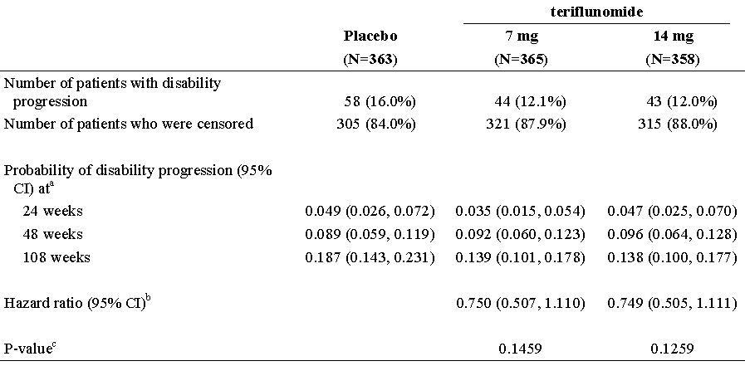

Figure 17. Kaplan-Meier plot of time to disability progression sustained for 24 weeks- ITT
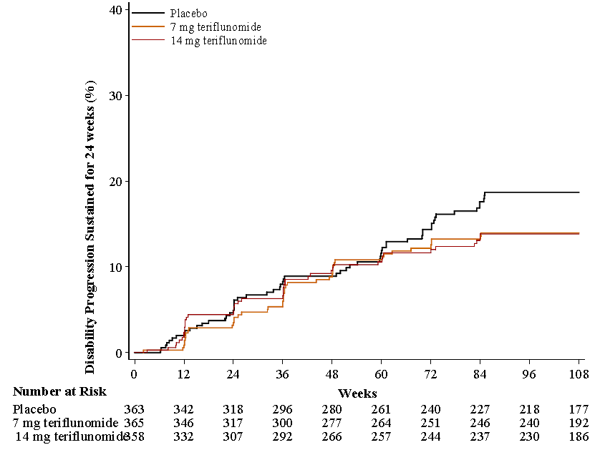

Fatigue Impact Scale
In the MMRM analysis, no treatment difference (LS mean values) was observed in the FIS score at Week 108 (p = 0.3861 for the teriflunomide7mg group compared with the placebo group and p = 0.8271 for the teriflunomide 14mg group compared with the placebo group).
Comment: The evaluator understood that the step down analysis in the Statistical Analysis Plan applied to the Fatigue Impact Scale and the subsequently listed secondary and tertiary variables and that despite the lack of significance in the result the MRI variables were analysed. The sponsor in response to a section 31 question clarified that the stepdown procedure applied from disability progression so that the Fatigue Impact Scale results should not have been analysed as well and that all p-values for secondary and tertiary efficacy endpoints were nominal had no relevance for the purpose of the evaluation.
Figure 18. Plot of change from baseline in FIS total score over time - ITT population
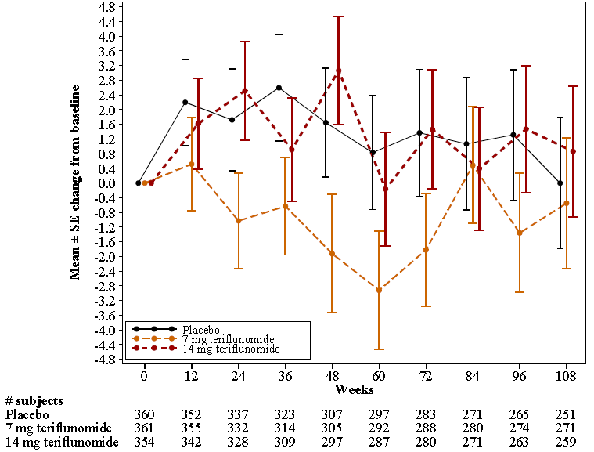
Table 49. Analysis of change from baseline in Fatigue Impact Scale total score –ITT
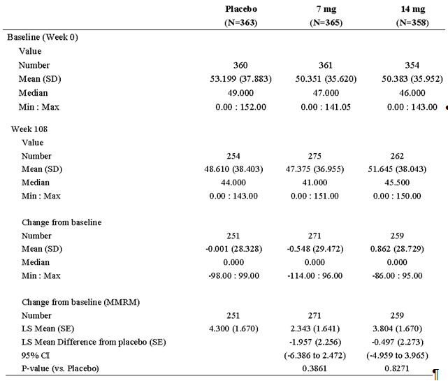Note: MMRM analysis adjusted for EDSS strata at baseline, region and baseline value.

MRI variables
While not directly related to disability, MRI changes reflect progress of the disease.
Gadolinium enhancing T1-lesions per scan The adjusted Gd-enhancing T1 lesions per scan was 1.331 in the placebo group, 0.570 in the teriflunomide7mg group, and 0.261 in the teriflunomide 14mg group.
Burden of disease At Week 108, the model adjusted least square mean difference from baseline was - 0.053 for the teriflunomide7mg group and -0.089 for the teriflunomide 14mg group.
Gadolinium enhancing T1-lesions total volume The total volume per scan was 0.089mL for placebo, 0.06mL for teriflunomide 7mg and 0.023mL for 14mg.
Hypointense post-gadolinium T1 lesion component At Week 108, the mean change in cubic root transformed volume data from baseline was 0.088 for the placebo group, 0.077 for the teriflunomide7mg group and 0.062 for the teriflunomide 14mg group.
T2 lesion component MMRM analysis of volume of T2 lesion component using cubic root transformed volume data (ITT population) showed that at Week 108, the LS mean difference from placebo was -0.051 for the teriflunomide 7mg group and -0.089 for the 14mg group.

Exploratory MRI variables
Atrophy The change from baseline in atrophy at Week 108 in the ITT population was not different vs. placebo for either group.
Volume of white matter The LS mean difference from placebo in volume of white matter in the ITT population at Week 108 was 3.106 for the teriflunomide7mg group and 6.146 for the teriflunomide 14mg group.
Volume of gray matter The LS mean difference from placebo in volume of gray matter in the ITT population at Week 108 was 1.584 for the teriflunomide7mg group and -1.985 for the teriflunomide 14mg group
Z4 composite score The LS mean difference from placebo in Z4 score in the ITT population at Week 108 was -0.333 for the teriflunomide7mg group and -0.512 for the teriflunomide 14mg group Number of unique active lesions per MRI scan At Week 108, the adjusted active unique lesions per MRI scan was 2.463 in the placebo group, 1.288 in the teriflunomide7mg group, and 0.754 in the teriflunomide 14mg group.

Tertiary variables (exploratory)
Multiple sclerosis functional composite showed no treatment differences (in MSFC Z score) compared to placebo in either teriflunomide treatment group at Week 96.
Figure 19. Plot of change from baseline in EDSS over time - ITT
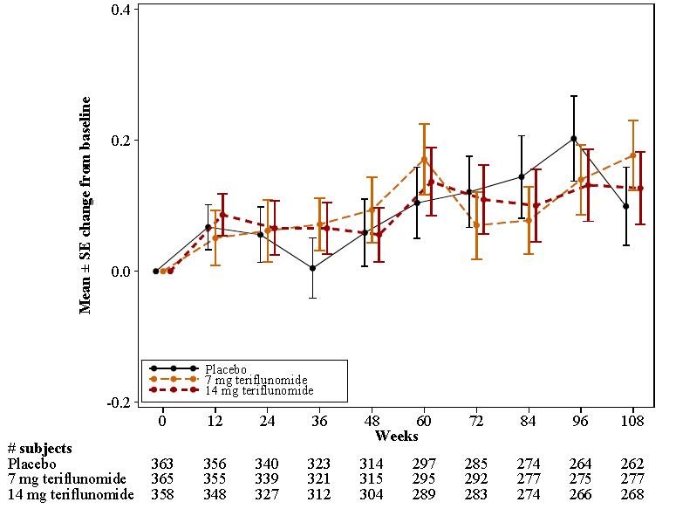
Table 50. Analysis of EDSS - ITT
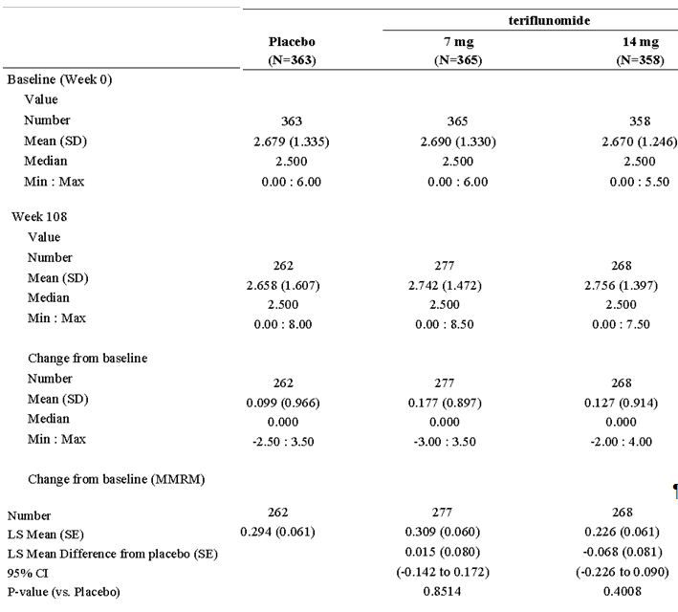Note: MMRM analysis adjusted for EDSS strata at baseline, region and baseline value.

Pivotal efficacy studies -Study 6050 (Extension of 3001/6049TEMSO)

Study design, objectives, location and dates
Primary objective: The primary objective was to document the long-term safety and tolerability of two doses of teriflunomide (7 and 14mg) in multiple sclerosis (MS) patients with relapses.
Secondary objective: The secondary objective was to document the long-term effect on disability progression (key secondary endpoint), annual relapse rate, and MRI variables.

Inclusion and exclusion criteria and Study treatments
See Study 3001/6049TEMSO above.

Efficacy variables and outcomes
They were similar to study 6049 except:
- Annualized relapse rate (ARR) became a secondary efficacy variable.
- Time to (first) disability progression sustained for at least 12 weeks was retained as a key secondary efficacy variable
- The change from baseline in EDSS score and MSFC score became secondary efficacy variables rather than an exploratory tertiary
“Primary Efficacy Variable” included:
- Time to (first) disability progression sustained for at least 12 weeks.
“Secondary Efficacy Variables” relevant to Delaying the Accumulation of Physical Disability included:
- Proportion of patients free of disability progression at yearly time points (by years since randomization in EFC6049/TEMSO);
- MRI variables:
  - burden of disease (BOD);
  - The total number of Gd-enhancing T1-lesions per MRI scan over the treatment period;
  - The total volume of Gd-enhancing T1-lesions per MRI scan over the treatment period;
  - The volume of hypointense post-Gd T1-lesion component (black holes);
  - The volume of T2-lesion component;
  - Exploratory MRI variables included atrophy, volume of white matter, volume of gray matter, and a composite Z4 score;
- The change from baseline in EDSS score;
- The FIS total score and domain scores;
- The change from baseline in MSFC score.

Sample size and Randomisation and blinding methods
See Study 3001/6049TEMSO above.

Statistical methods
They were essentially similar to study 6049 except MRI variables were summarized by treatment group using descriptive statistics for each visit.

Participant flow and baseline data
See above.

Results for the primary efficacy outcome
See Tables below.

Table 51. Analysis of time to disability progression sustained at least for 12 weeks – ITT (EFC6049+LTS6050) population
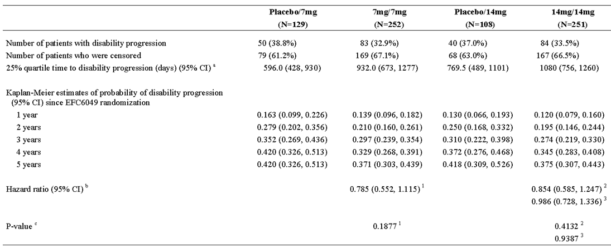Note: The time-to-event variable is defined as the time (days) from the date of randomization in EFC6049 to the date of the first disability progression. For patients who have no disability progression on or before last during treatment EDSS evaluation, it will be censored at the date of last scheduled EDSS evaluation.
a Derived from Kaplan-Meier estimates
b Derived using Cox proportional hazard model with treatment, EDSS strata at baseline and region as covariates
c Derived using Log-rank test with treatment, EDSS strata at baseline and region as covariates
1 Comparing with placebo/7mg group 2 Comparing with placebo/14mg group 3 Comparing with 7mg/7mg group
Table 52. Analysis of time to disability progression sustained at least for 24 weeks - ITT (EFC6049+LTS6050) population
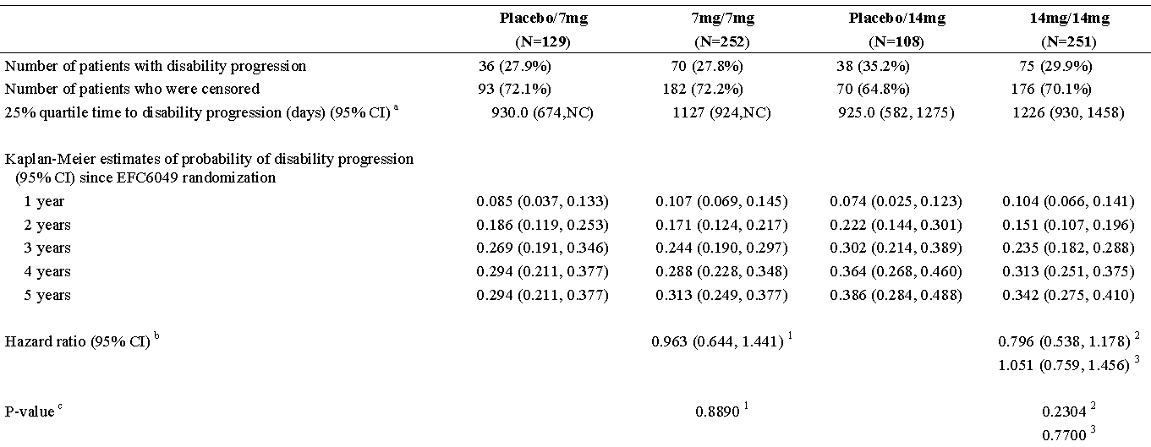
NC = Not calculated
Note: The time-to-event variable is defined as the time (days) from the date of randomization in EFC6049 to the date of the first disability progression. For patients who have no disability progression on or before last during treatment EDSS evaluation, it will be censored at the date of last scheduled EDSS evaluation.
a Derived from Kaplan-Meier estimates
b Derived using Cox proportional hazard model with treatment, EDSS strata at baseline and region as covariates
c Derived using Log-rank test with treatment, EDSS strata at baseline and region as covariates
1 Comparing with placebo/7mg group 2 Comparing with placebo/14mg group 3 Comparing with 7mg/7mg group

Figure 20. Kaplan-Meier plot of time to disability progression sustained at least for 12 weeks – ITT (EFC6049+LTS6050) population
Figure 21. Kaplan-Meier plot of time to disability progression sustained at least for 24 weeks - ITT (EFC6049+LTS6050) Population

Patients free of disability progression
From the Kaplan-Meier estimates of probability of disability progression since EFC6049 randomization at 5 years, the remaining patients free of disability progression confirmed after 12 weeks were 58.0% in the placebo/7mg, 62.9% in the7mg/7mg, 58.2% in the placebo/14mg, and 62.5% in the 14mg/14mg groups and were 70.6% in the placebo/7mg, 68.7% in the7mg/7mg, 61.4% in the placebo/14mg, and 65.8% in the 14mg/14mg groups confirmed after 24 weeks.
Figure 22. Plot of change from baseline in FIS total score over time - ITT (LTS6050)
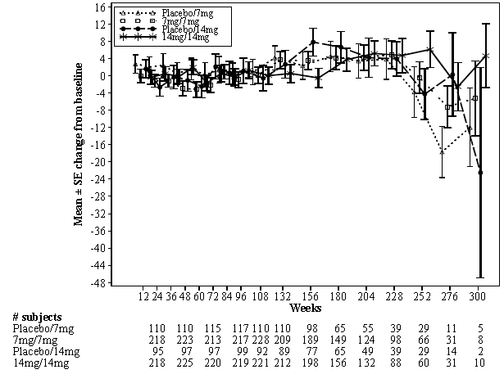

MRI variables
Figure 23. Plot of change from baseline in total number of Gd-enhancing T1-lesions per MRI scan - ITT (LTS6050)
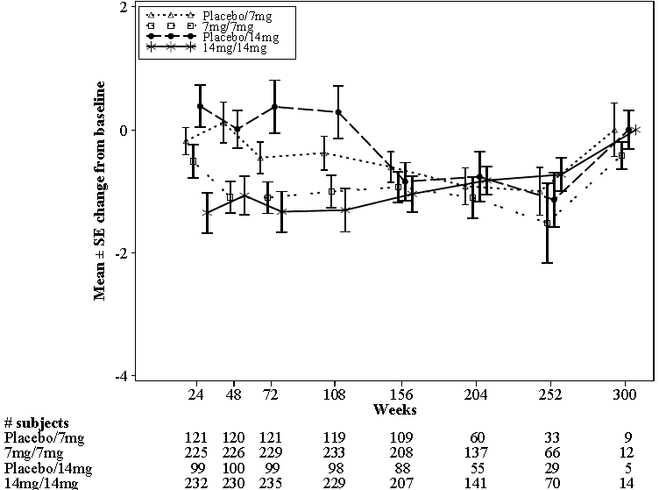

Figure 24. Plot of change from baseline in burden of disease (mL) over time –ITT (LTS6050)
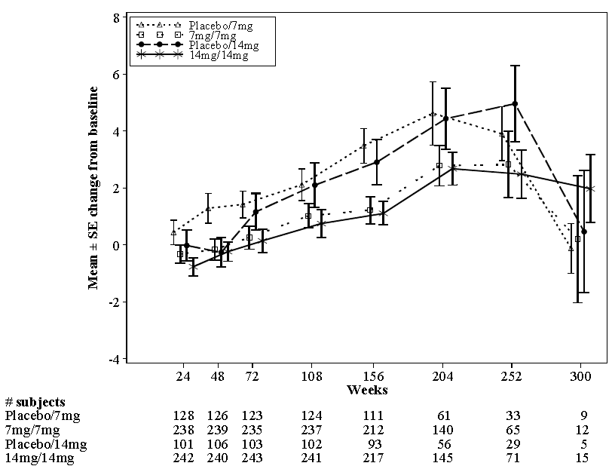
Figure 25. Plot of change from baseline in volume of hypointense post-gadolinium T1 lesion component over time - ITT (LTS6050)
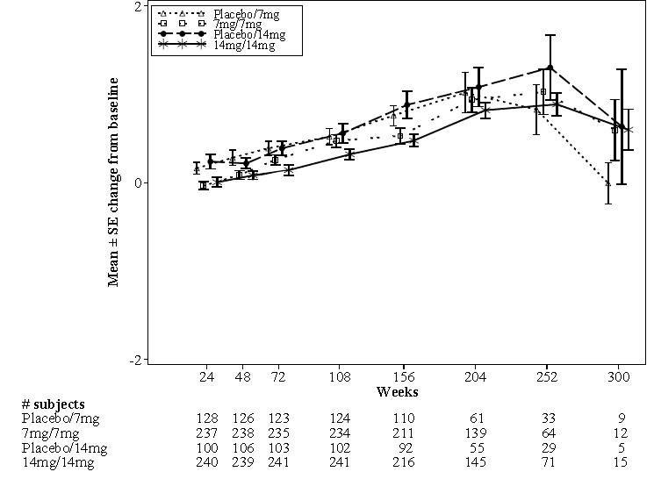

Figure 26. Plot of change from baseline in atrophy over time - ITT (LTS6050)
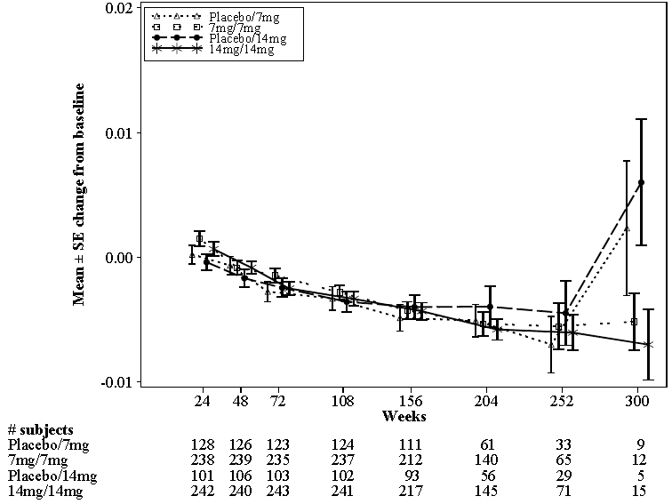
Figure 27. Plot of change from baseline in atrophy over time - ITT (LTS6050)

Figure 28. Plot of change from baseline in volume of white matter over time - ITT (LTS6050) Population
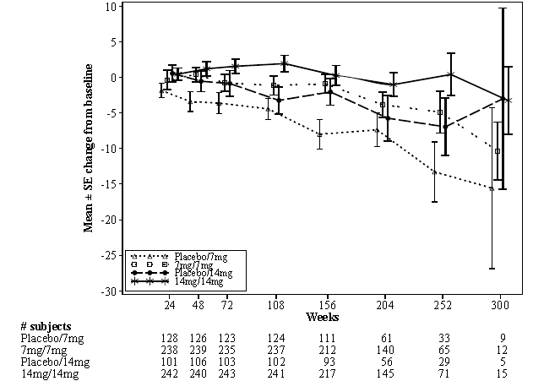
Figure 29. Plot of change from baseline in volume of gray matter over time - ITT (LTS6050)
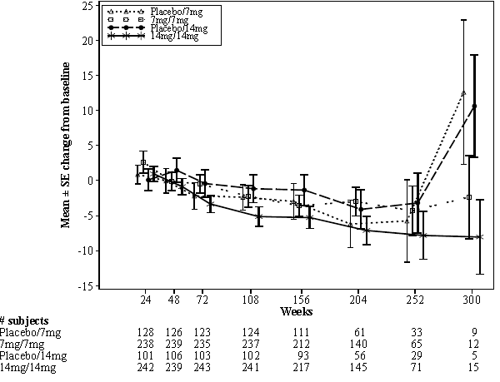

Figure 30. Plot of change from baseline in Z4 score over time - ITT (LTS6050)
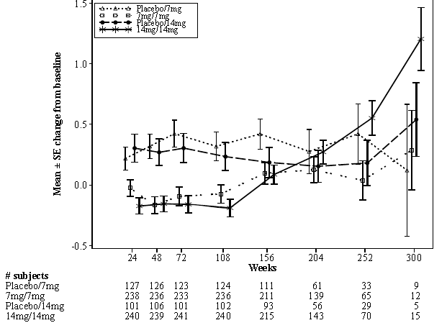
Figure 31. Plot of change from baseline in total volume (ml) of Gd-enhancing T1-lesions per MRI scan - ITT (LTS6050)
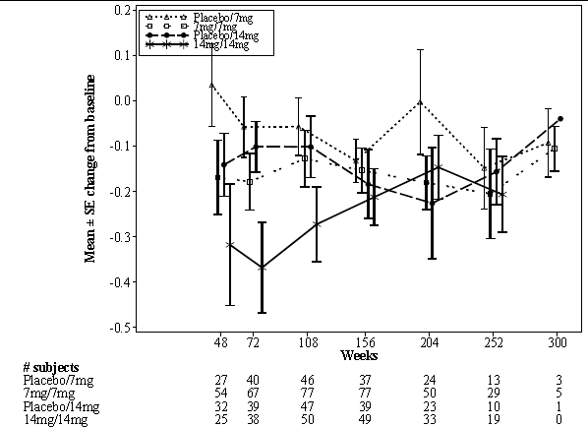

Table 53. Analysis of EDSS - ITT (EFC6049+LTS6050)
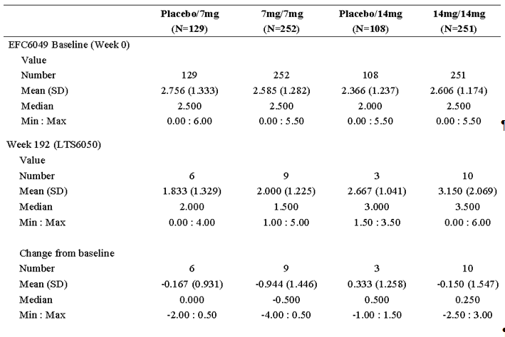Note: * Week 0 (LTS6050) takes the value from EFC6049 week 108 if no LTS6050 week 0 value is available
Figure 32. Plot of change from baseline in EDSS over time - ITT (EFC6049+LTS6050)
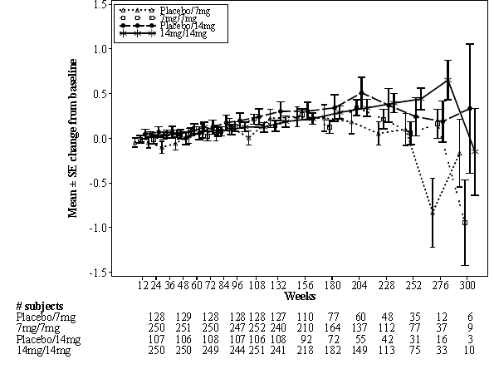
Table 54. Change from baseline in MSFC Z score – ITT (LTS6050)
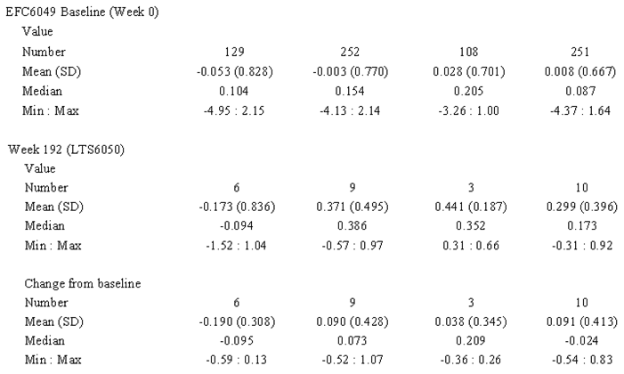* Week 0 (LTS6050) takes the value from EFC6049 week 108 if no LTS6050 week 0 value is available.
Figure 33. Plot of change from baseline in MSFC Z score over time - ITT (LTS6050)
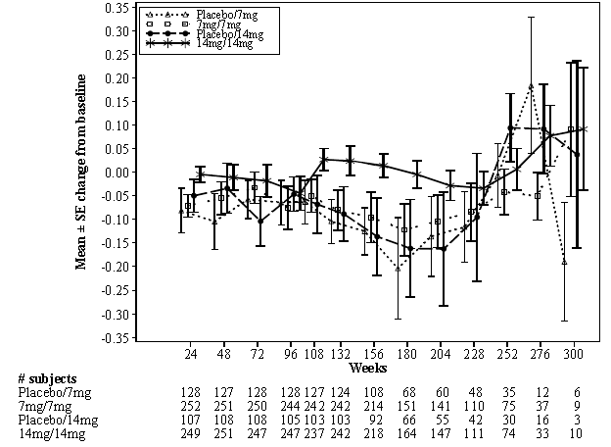

Other efficacy studies -Study 2001

Study design, objectives, location and dates
Primary Objective was to determine the safety and efficacy of teriflunomide in MS with relapses.
Secondary Objectives included:
- To determine the effect of teriflunomide on additional MRI variables as well as clinical measures:
  - Changes in clinical scales measures including the EDSS.
- Investigation of PK and PD relationships:
  - Investigation of relationships between teriflunomide plasma concentrations and average number of unique active lesions per MRI scan

Inclusion and exclusion criteria
See details for 3001/6049TEMSO above.

Study treatments
See details for 3001/6049TEMSO above.

Efficacy variables and outcomes
The primary efficacy variable was the average number of unique active lesions per MRI scan for the double-blind treatment period of the study.
Other efficacy variables were:
Based on MRI scans:
- Average number of new T1 lesions per scan
  - Average number of newly enhancing lesions per scan
  - Average number of persistently enhancing lesions per scan
- Average number of new T2 lesions per scan
  - Average number of new lesions per scan
  - Average number of newly enlarging lesions per scan
  - Average number of persistently enlarging lesions per scan
- Average number of newly active lesions per scan (T1 and T2 combined)
- Average number of persistently active lesions per scan (T1 and T2 combined)
- Number of subjects with no new lesion
- Number of subjects with no newly enhancing lesion
- Number of subjects with no new unique active lesion
- Percentage of scans per subject showing no enhancement
- Percentage change from baseline to endpoint in the burden of disease (and percentage change from baseline to weeks 18 and 36 for the completer population only)
- Percentage change from baseline in atrophy at week 36
- Change from baseline to endpoint in EDSS score
- Number of subjects having progressed at any visit excluding EDSS scores performed at the time of a relapse.
- Time to progression measured by EDSS score at any visit in days
- Change from baseline to endpoint in MSFC score

Sample size, Randomisation and blinding methods, Statistical methods, Participant flow and Baseline data
See details for 3001/6049TEMSO above.

Results for the primary efficacy outcome
The average numbers of unique active lesions during the treatment period in the efficacy-evaluable population were significantly lower for subjects in the7mg teriflunomide and 14mg teriflunomide groups in comparison to the placebo group. The variables with statistically significant differences between subgroups (p-value ≤ 0.05) were:
- Age: older subjects had fewer active lesions during treatment than younger subjects.
- Disease duration: subjects with longer disease duration had fewer active lesions during treatment than subjects with shorter disease duration.
- Prior treatment: subjects with prior treatment had fewer active lesions during treatment than subjects without prior treatment.
No treatment by subgroup interactions were detected for any of the subgroup variables.
Table 55. Analysis of average number of unique active lesions per scan (comparison between treatment groups over 36 weeks)
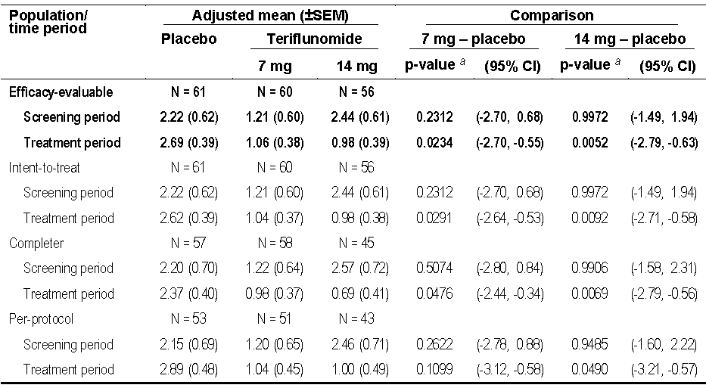
a The p-value calculation for comparison between treatment groups is based on a rank ANCOVA.

MRI variables Average numbers of lesions
Table 56. Analysis of average numbers of MRI lesions for the treatment period - EE population
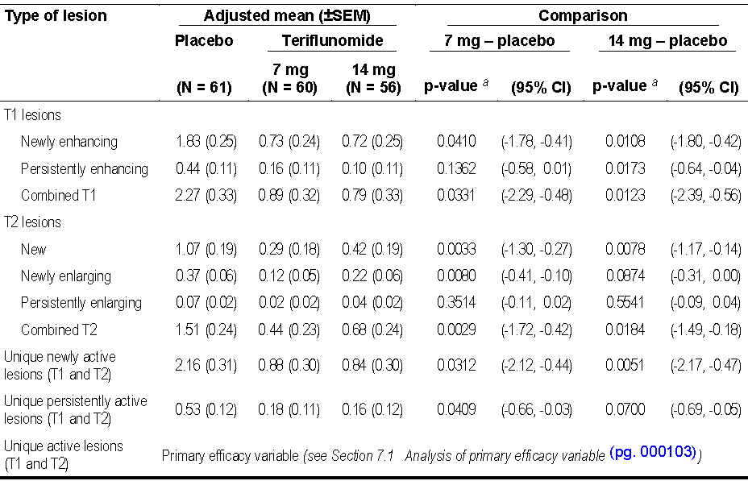
a: The calculation of the p-value for the comparison between treatment groups is based on a rank analysis of covariance.

Frequencies of subjects with no new lesions
Table 57. Subjects with no new lesions during the treatment period (efficacy evaluable population)
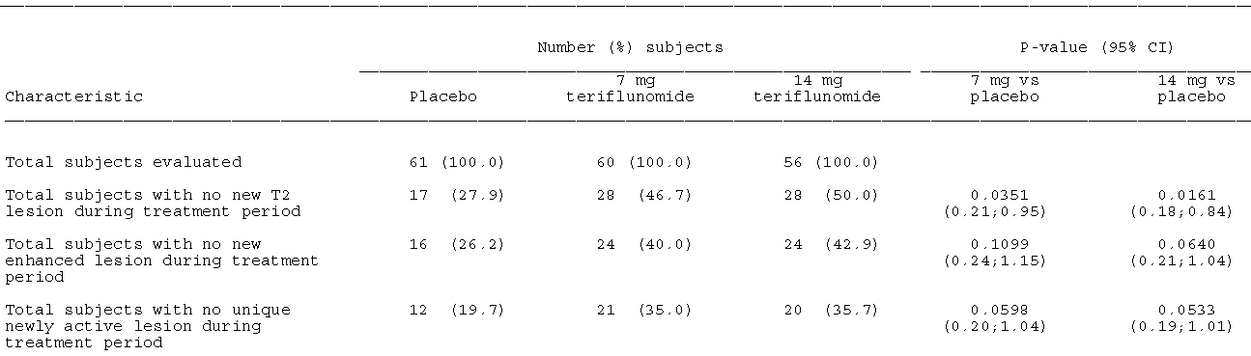
NOTE: The number of subjects with no new lesions was analysed by Cochran-Mantel-Haentzel test controlling for centre and the 95% CI for the odds ratio.

Burden of disease
Table 58. Burden of disease (EE population)
(b) The ANCOVA model includes treatment, stratum (≤3.5 EDSS, >3.5 EDSS), centre as fixed effects and burden of disease at baseline as covariate Note: Adjustment for multiple comparisons between treatment groups according to Dunnett.

Table 59. Subjects with progression in EDSS (efficacy evaluable population)
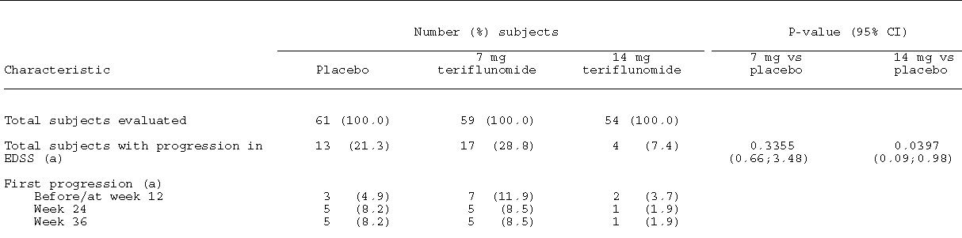
(a) Progression was defined as an increase in EDSS score by at least 1 in subjects with baseline score ≤ 5.5 or by at least 0.5 in subjects with baseline score > 5.5.
NOTE: The number of subjects with progression was analysed by Cochran-Mantel-Haentzel test controlling for centre and the 95% CI for the odds ratio.
The average percentage of scans per subject showing no enhanced lesions during treatment with study medication was 53.8% for placebo, 71.9% for7mg teriflunomide, and 67.6% for 14mg teriflunomide.
In the in the completer population as well as 7mg vs. placebo, the 14mg vs. placebo comparison of subjects with progression also did not reach statistical significance (p = 0.0781).

Other efficacy studies - Study LTS6048 (2002 – an Extension of 2001)

Study design, objectives, location and dates, Inclusion and exclusion criteria, and Study treatments
See details for 3001/6049TEMSO above.

Efficacy variables and outcomes
Included:

MRI
- change from baseline in the burden of disease (T2)
- change from baseline in brain atrophy

Clinical assessments
- change from baseline in EDSS (Expanded Disability Status Scale)
- number of subjects with a baseline EDSS ≤ 5.5 who increase by at least 1.0, plus number of subjects with a baseline EDSS > 5.5 who increase by at least 0.5
- change from baseline in MSFC (Multiple Sclerosis Functional Composite)
To these were added the disease activity parameters (new T2 lesion, newly enlarging T2 lesion, newly GD enhancing lesion and unique newly active lesion) in the analyses of MRI variables by Modification from Protocol Amendment 8; 05-Feb-2010.

Sample size, Randomisation and blinding method, Statistical methods, Participant flow, and Baseline data
See above.

Results for the primary efficacy outcome
Figure 34. Plot of change from baseline in EDSS in Study 2001+LTS6048 - ITT
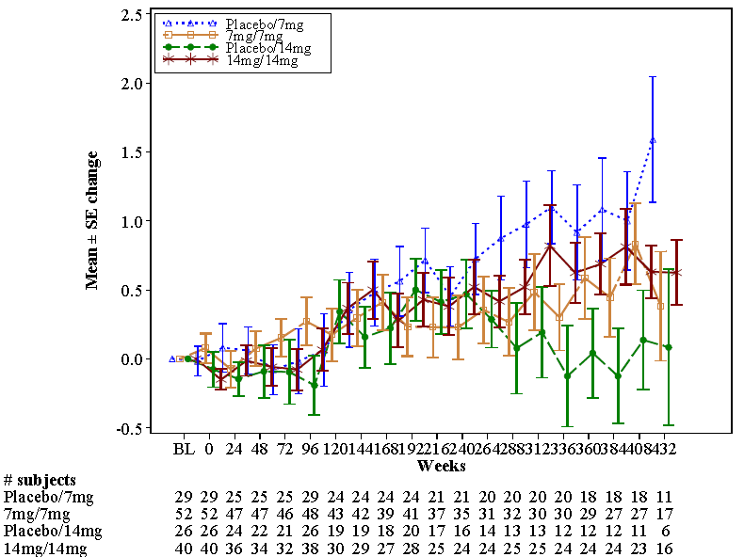

Figure 35. Plot of change from baseline in burden of disease (mm3) over time in Study 2001+LTS6048 - ITT
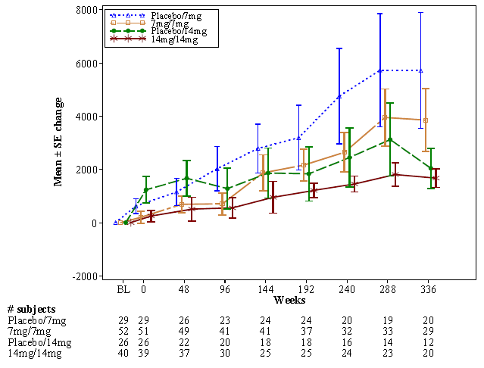
Figure 36. Plot of change from baseline in brain atrophy over time in Study 2001+LTS6048 - ITT
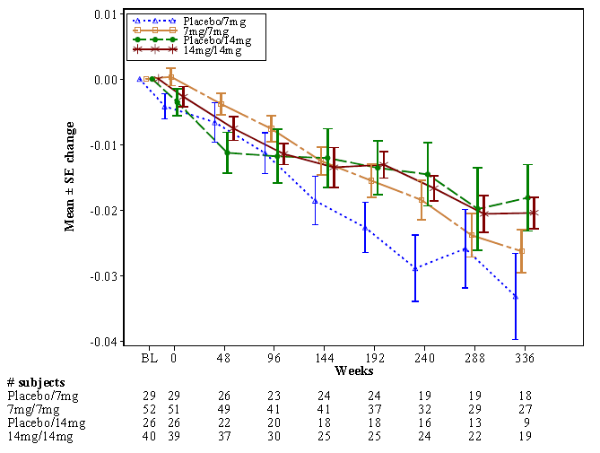

Figure 37. Plot of percent change from baseline in brain atrophy over time in Study 2001+LTS6048 - ITT
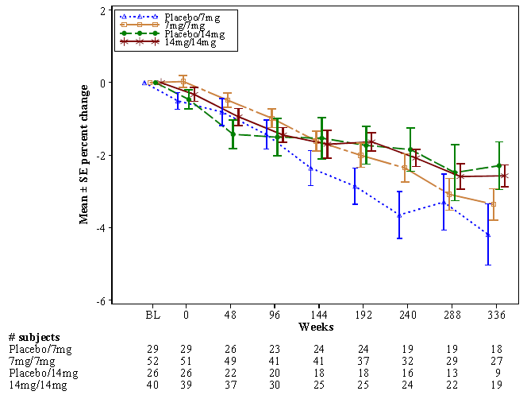
Figure 38. Plot of newly active T2 lesion over time - ITT
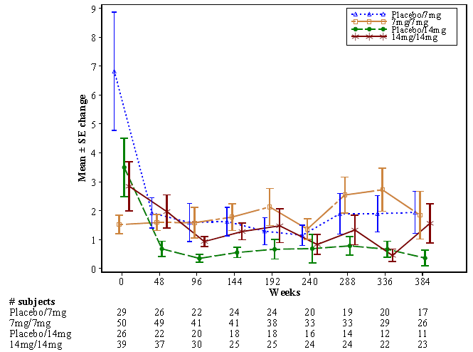

Figure 39. Plot of newly enlarging T2 lesion over time - ITT
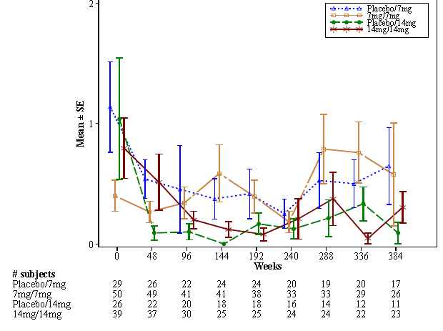
Figure 40. Plot of newly GD-enhancing lesion over time - ITT
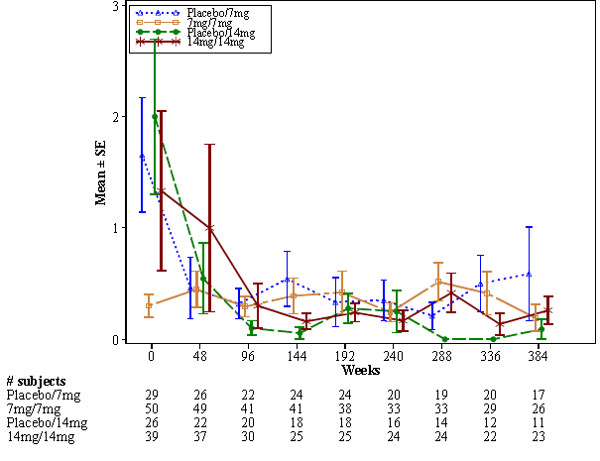

Figure 41. Plot of unique newly active lesion over time - ITT
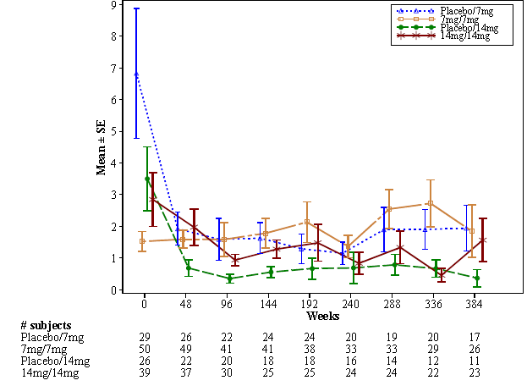
Figure 42. Plot of change from baseline in MSFC Z score over time in Study 2001+LTS6048 - ITT population
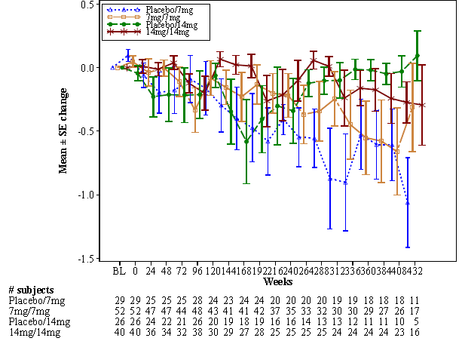

Figure 43. Plot of change from baseline in MSFC Z score over time in Study 2001+LTS6048 - ITT population
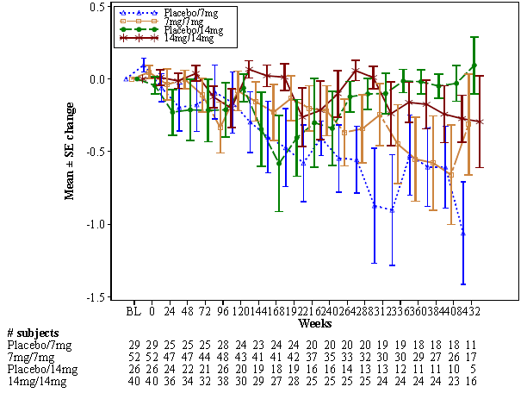

Analyses performed across trials (pooled analyses and meta-analyses)
STUDY POH0295 was a Pharmacokinetic /Pharmacodynamic Analysis of teriflunomide (data from EFC6049-TEMSO and 2001; see also section on PD).
Efficacy variables evaluated:
- Primary endpoint: Annual relapse rate (ARR),
- Secondary endpoints:
  - Time to disability progression sustained for 12-week (TDP),
  - Total number of Gadolinium-enhanced T1 lesions / number of scans over the treatment period (NBT1NORM),
  - Total number of unique active lesions / number of scans over the treatment period (NBACTNORM),
  - Number of patients free of active lesions (T1GDFREE),
  - Burden of disease at week 108 (BOD).
No significant relationship between mean teriflunomide concentrations and Annual relapse rate or Burden of disease at week 108 was found.
Table 60. Summary of the final PK/PD models for efficacy variables
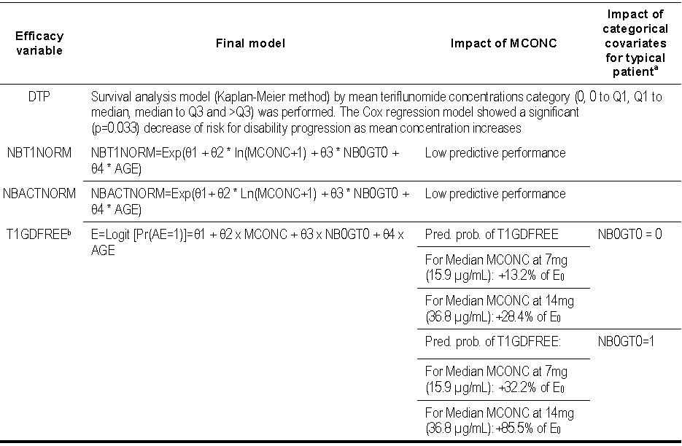
a typical patient (WT=68 kg and AGE = 39 y) b Pr(AE=1) = exp(Logit [Pr(AE=1)])/(1+exp(Logit [Pr(AE=1)])); MCONC = mean teriflunomide concentrations(steady-state)

Adjunctive therapy
While 2 studies, their extension and a blinded interim analysis of another of teriflunomide as adjunctive therapy were in the submission they were evaluated as part of the submission safety data only. They were not evaluated for efficacy as Adjunctive therapy constitutes a future claim.

Evaluator’s conclusions on clinical efficacy
Of the relevant guidelines that on One Pivotal Study advises:
In cases where the confirmatory evidence is provided by one pivotal study only, this study will have to be exceptionally compelling, and in the regulatory evaluation special attention will be paid to:
  - The internal validity. There should be no indications of a potential bias.
  - The external validity. The study population should be suitable for extrapolation to the population to be treated.
  - Clinical relevance. The estimated size of treatment benefit must be large enough to be clinically valuable.
  - The degree of statistical significance. Statistical evidence considerably stronger than p < 0.05 is usually required, accompanied by precise estimates of treatment effects, i.e. narrow confidence intervals. The required degree of significance will depend on factors such as the therapeutic indication, the primary endpoint, the amount of supportive data and whether the alternative analyses demonstrating consistency are pre-specified. When the aim is to demonstrate non-inferiority, one study is more likely to be accepted if the lower 95% confidence bound is well away from the non-inferiority margin.
  - Data quality.
  - Internal consistency. Similar effects demonstrated in different pre-specified sub-populations. All-important endpoints showing similar findings.
  - Centre effects. None of the study centres should dominate the overall result, neither in terms of number of subjects nor in terms of magnitude of effect.
  - The plausibility of the hypothesis tested.

Monotherapy - For the treatment of patients with relapsing forms of multiple sclerosis – Conclusions
- The sponsor argues that the basis of the population for the Indication i.e. patients with relapsing forms of multiple sclerosis is that of the pivotal trial (Study EFC6049/TEMSO).
Comment: In pivotal Study 6049 only 12 patients out of 363 (3.3%) receiving placebo had Progressive Relapsing MS, likewise only 14 patients out of 359 (3.9%) receiving teriflunomide 14mg had Progressive Relapsing MS. In the extension study 6050 only 10 out of 361 (2.8%) receiving teriflunomide 14mg had Progressive Relapsing MS. There were no patients with other forms of MS with relapses e.g. Clinically Isolated Syndrome(CIS). The Clinical Overview states that teriflunomide has been developed for relapsing MS and CIS is a separate objective.
Conclusion: The single pivotal trial does not have a population to justify all the population described as patients with relapsing forms of multiple sclerosis.
- The sponsor believes that the proposed indication reflects the patient population in the pivotal TEMSO study as dictated by the inclusion criteria.
The sponsor continues:
Additionally, the protocol was designed such that patients with any form of relapsing MS could be included in the study.
The inclusion criteria for the study are as follows;
    - Patients with relapsing forms of multiple sclerosis meeting McDonald’s criteria for MS diagnosis at time of screening visit, and EDSS score ≤ 5.5 at screening visit.
    - At least one relapse in the 12 months preceding randomization, or at least 2 relapses in the 24 months preceding the randomization visit.
Comment: While this is true of the original Protocol this was amended shortly into the trial by Protocol Amendment 2 to read: Exhibiting a relapsing clinical course, with or without progression (relapsing remitting, secondary progressive, or progressive relapsing)
Conclusion: The inclusion criteria in study 6049/TEMPSO are not sufficient to meet the proposed Indication population.
- The sponsor is most definite that the Indication applied for is:
Aubagio is indicated for the treatment of patients with relapsing forms of multiple sclerosis to reduce the frequency of clinical relapses and to delay the accumulation of physical disability.
Overall Conclusion: The evaluator finds that efficacy in the proposed population i.e. patients with relapsing forms of multiple sclerosis, has not been shown.

Monotherapy - To reduce the frequency of clinical relapse -Conclusions
In the Pivotal Study 3001/6049TEMPSO efficacy of teriflunomide was shown in the principle variable the Annualised Relapse Rate with no overlap of CIs vs. placebo and a reasonable reduction in relative risk. This held for the ITT, PP and when adjustment was made using data from the follow-up period. Most of the subgroups analysed showed similar effect of teriflunomide on ARR. Most of the other efficacy parameters assessed for this Indication were similar.
Conclusion: Adequate efficacy has been demonstrated in the population of the study in reducing the frequency of relapse to satisfy the requirements of a single pivotal study.
The long term extension of this study (Study 6050) interim analysis provided showed no statistical difference in ARR, or in proportion of patients without confirmed relapse, between patients already on teriflunomide and those on placebo during the preceding 2 years of Study 6049, suggesting an ongoing inhibitory effect rather than a deferment.
However when the Annualised Relapse Rate is compared between the studies it is much lower in the extension study e.g. 0.369 vs.0.206 for the teriflunomide 14mg group. Explanation might lie in the ≥ 30% of participants in the Study 6049 groups who discontinued and/or failed to continue on to the extension study (6050).
Some 54 patients completed study 6049 but did not enter study 6050 (22 in the placebo group, 22 in the7mg group, and 10 in the 14mg group), reasons not given.
Overall 174/363 (48%) of the initial Study 6049 placebo group, 193/365 (53%) of the initial 7mg teriflunomide group and 196/358 (55%) of the 14mg group continued in the 6050 study after the interim analysis.
Table 61 Overall Discontinuations Studies 6049, 6050
Reason for study treatment discontinuation | Placebo / 7 or 14mg  (N=363) | teriflunomide
Reason for study treatment discontinuation | Placebo / 7 or 14mg  (N=363) | 7mg (N=366) | 14mg (N=359)
Adverse event | 52 | 58 | 53
Lack of efficacy | 34 | 25 | 23
Protocol violation | 4 | 2 | 5
Lost to follow-up | 4 | 0 | 3
Death | 0 | 1 | 1
Progressive disease | 16 | 6 | 3
Subject did not wish to continue | 56 | 54 | 55
Other | 1 | 4 | 7
Completed 6049 but did not enter 6050 | 22 | 22 | 10
Totals | 189 | 172 | 160
Study 2001 was a Phase II study of short duration (36 weeks) that had MRI results for the primary and many secondary variables. This accords with the description of Exploratory trials in CPMP/EWP/561/98 Rev 1 Guideline on clinical investigation of Medicinal Products for the Treatment of Multiple Sclerosis. Relapse parameters were secondary variables, and there was no statistical difference in total numbers without relapse between placebo and teriflunomide groups. The study had small numbers and short duration for what was a secondary variable and does not provide supporting evidence of efficacy.
Table 62. Overall Discontinuations Studies 2001, 6048
Reason for study treatment discontinuation | Placebo (N=61) | Teriflunomide
Reason for study treatment discontinuation | Placebo (N=61) | 7mg (N=61) | 14mg (N=57)
No longer meet criteria to remain in the study | 1 | 0 | 0
Adverse event | 13 | 13 | 17
Lack of efficacy | 5 | 1 | 4
Subject did not wish to continue | 3 | 10 | 7
Lost to follow-up | 1 | 1 | 1
Administrative reasons | 2 | 0 | 0
Protocol violation | 0 | 1 | 0
Death | 1 | 1 | 0
Relapse | 0 | 1 | 0
Discretion of the investigator | 3 | 2 | 0
Other | 4 | 3 | 1
Completed 2001but did not enter 6048 | 2 | 6 | 5
TOTAL | 35 | 39 | 35
Overall 26/61 (43%) of the initial Study 2001 placebo group, 22/61(36%) of the initial 7mg teriflunomide group and 22/61 (36%) of the 14mg group continued in the 6048 study after the interim analysis. The numbers were thus small, with the ARR being 0.252 for placebo/7mg. 0.316 for 7mg, 0.212 for placebo/14mg and 0.200 for the14mg group.
Overall Conclusion: In the population of the pivotal study adequate efficacy in reducing the frequency of relapse has been demonstrated to satisfy the requirements of a single pivotal study. While study 2001, a phase II study with similar design did not show a statistically significant difference in relapse rate.

Monotherapy - To delay the accumulation of physical disability -Conclusions
In the pivotal study 6049 the key secondary efficacy variable was time to disability progression. The numbers of patients with disability progression sustained for 12 weeks were relatively low: placebo 86 (23.7%), teriflunomide 7mg 68 (18.6%), teriflunomide 14mg 62 (17.3%), significant difference vs. placebo was only shown for the 14mg teriflunomide (p = 0.0279). This gave a hazard ratio showing for 14mg teriflunomide the risk of disability progression was 70.2% vs. placebo (ITT); the 95% CI approached but did not include 1 (0.506, 0.973).
While KM method estimated the probability of disability progression at Week 108 as placebo 27.3% (95% CI 0.223, 0.323) and for teriflunomide 14mg 20.2% (0.156, 0.247) i.e. there was limited overlap of CIs.
Statistical difference could not be shown for time to disability progression sustained for 24 weeks - the numbers were less than for 12 week sustained disability.
The evaluator understood the Statistical Analysis Plan called for a step down testing procedure to the secondary endpoints of which the first was Change from baseline in total score of Fatigue Impact Scale at Week 108. In the MMRM analysis, no statistically significant treatment difference (LS mean values) was observed in the FIS score at Week 108 (p = 0.3861 for the teriflunomide7mg group compared with the placebo group and p = 0.8271 for the teriflunomide 14mg group compared with the placebo group). Despite the lack of significance in the result the subsequently listed MRI variables were analysed.
The sponsor clarified in response to a section 31 question that the step down procedure applied from 12-week sustained disability progression for teriflunomide 7mg versus placebo to Fatigue Impact Scale so that the analysis of the latter as well as the MRI variables should be considered nominal.
Conclusion: In the presence of a single pivotal study, there is only a limited signal for efficacy in the key secondary efficacy variable, after which the step down analysis was to halt. Thus while the other secondary efficacy variables varied from no difference for the FIS, to strong nominal p-values for many of the MRI variables the latter carried no statistical weight according to the Statistical Analysis Plan. Further So far, the correlation between Magnetic Resonance Imaging and clinical outcomes has not proved to be strong enough as to accept it as a validated surrogate endpoint in pivotal studies.
The extension study 6050 KM analysis showed an increased probability of disease progression in those initially on placebo, but beyond 3years the numbers participating were small; in other assessments of time to disability progression the 95% CIs overlapped or the p-values were not significant when comparing those always on teriflunomide and those starting after 2 years of placebo...
Study 2001 was exploratory with an MRI primary efficacy variable - the average numbers of unique active lesions during the treatment period which were significantly lower for both the 7mg and 14mg teriflunomide groups vs. the placebo group. The number of subjects with progression was significant vs. placebo only for 14mg teriflunomide and only in the efficacy evaluable population There were many other MRI efficacy variable some of which had significantly better results for teriflunomide than placebo, others did not or were not analysed.. In the extension study 6048 only summary statistics for EDSS score and MRI variables were submitted.
Overall Conclusion: Study 2001 did little to support the pivotal study results of a limited signal for efficacy in the key secondary efficacy variable, while analyses of the other secondary efficacy variables were not valid according to the Statistical Analysis Plan.

Clinical safety

Studies providing evaluable safety data
Table 63. Teriflunomide exposure in clinical studies
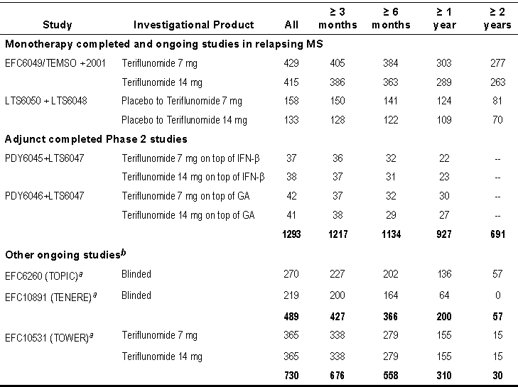
a Approximate number of patients since the study is still blinded b In addition, EFC6058/TERACLES, started in February 2011, is only included in the update for serious treatment-emergent adverse events
Study EFC6049was placebo controlled to 2years, Study 2001placebo controlled to 36weeks.
Studies 6049 and 6050 had safety as their primary variable and are ongoing. For synopses of Studies 2001, 6048, 6049 and 6050 see section on Efficacy.
Study protocols and amendments only were provided in Module 5 for Studies EFC6058, EFC6260 and EFC10891. No information was provided in Module5 for Study EFC10531

Study PDY6045
A multinational, randomized, stratified (low dose or high dose IFN-β treatment), double-blind, placebo-controlled, parallel-group pilot study to estimate the tolerability, safety, PKs, and PDs of teriflunomide for 24 weeks when added to treatment with interferon-β in subjects with multiple sclerosis. Eligible patients were randomized (1:1:1) to teriflunomide7mg, 14mg, or placebo groups.
28 sites in Canada, Germany, Italy, Spain, and the US from 24-May-2007 to 15-Jun-2009
Primary Objective: To estimate the tolerability and safety of a7mg and a 14mg dose of teriflunomide administered once daily for 24 weeks, compared with placebo, by means of adverse event (AE) reports, physical examinations, laboratory evaluations, electrocardiograms (ECGs) and abdominal ultrasound of the pancreas in patients with multiple sclerosis who are concurrently on a stable dose of interferon-β (IFN-β).
Planned: 120 patients (40 patients per treatment group). Evaluated for Safety: 116 patients (41 in placebo group, 37 in7mg teriflunomide group, 38 in 14mg teriflunomide group).
Included subjects meeting McDonald’s criteria for definite MS diagnosis and who are ambulatory (EDSS ≤to 5.5), on a stable dose of IFN-β for at least 26 weeks prior to the study screening visit and clinically stable for 4 weeks prior to randomization.

Study PDY6046
This was similar to PDY 6045 except subjects were on a stable dose of glatiramer acetate for at least 26 weeks prior to the study screening visit and clinically stable for 4 weeks prior to randomization.
In 24 centres in Austria, Canada, Germany, Italy, the UK, and the USA from 17 April 2007 to 26 October 2009.
Evaluated for Safety: 123 patients (41 in placebo group, 42 in7mg teriflunomide group, 40 in 14mg teriflunomide group)

Study LTS6047
A placebo controlled, double-blind, extension of studies PDY6045 and PDY6046 to document the safety of teriflunomide when added to treatment with interferon-β or glatiramer acetate in patients with multiple sclerosis with relapses.
The study ran for a minimum of 24 weeks (and a 16-week follow-up period) in 35 sites in Austria, Canada, Germany, Italy, Spain, the United Kingdom, and the United State of America from 17 October 2007 to 14 April 2010.
Primary objective: To evaluate the long-term safety and tolerability of teriflunomide when added to treatment with interferon-β or glatiramer acetate in patients with multiple sclerosis with relapses.
Evaluated for safety:
From Study 6045 (interferon-β) placebo 41, teriflunomide 7mg 37, teriflunomide 14mg 38
From Study 6046 (glatiramer acetate) placebo 40, teriflunomide 7mg 42, teriflunomide 14mg 41.
From the tabulated summary in Module 2:
- Study EFC10531 was a placebo-controlled study to evaluate the efficacy and safety of teriflunomide 7 and 14mg in reducing the frequency of relapses in patients with relapsing MS with 1096patients and a fixed end for all patients, 48 weeks for last patient randomized.
- Study EFC6058 was a double-blind, parallel-group, placebo-controlled study for at least 48 wks to assess the effect of teriflunomide compared to placebo on frequency of MS relapses in patients with relapsing MS already treated with IFN-β
- Study EFC6260 was a randomized, double-blind, placebo-controlled, parallel-group study over 108 wks to demonstrate the effect of teriflunomide (7- and 14mg/d) compared to placebo for reducing conversion of patients presenting with their first clinical episode consistent with MS to clinically definite MS

Pivotal studies that assessed safety as a primary outcome

Study 6050
The primary objective of the LTS6050 study was to document the long-term safety and tolerability of two doses of teriflunomide (7 and 14mg) in MS patients with relapses.

Safety outcomes
The safety analysis was based on the reported adverse events (AEs), clinical laboratory tests (biochemistry, haematology, and urinalysis), physical examination, vital sign measurements (systolic blood pressure [SBP] and diastolic blood pressure [DBP], pulse rate, body temperature, and weight), abdominal ultrasound, and peripheral neuropathy test.

Numbers analysed
Safety population Placebo/ teriflunomide 7mg 129 (100%), teriflunomide 7mg/7mg 254 (100%), Placebo/teriflunomide 14mg 107 (100%), teriflunomide 14mg/14mg 250 (100%).

Results for safety outcomes
See Tables below.

Table 64. Summary of exposure - Safety population
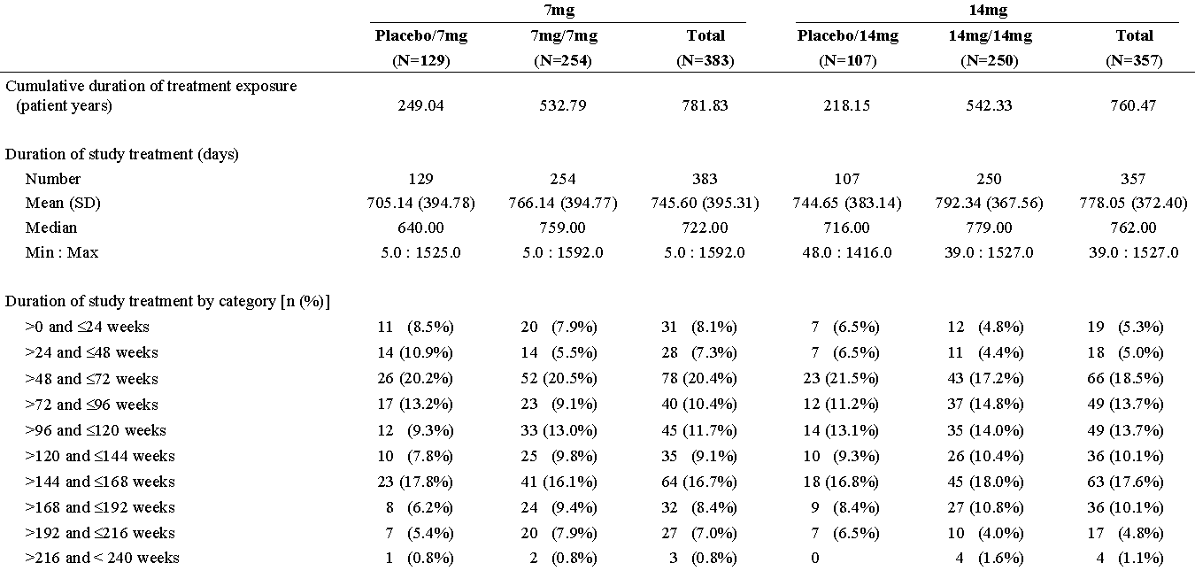
Table 64 continued. Summary of exposure - Safety population
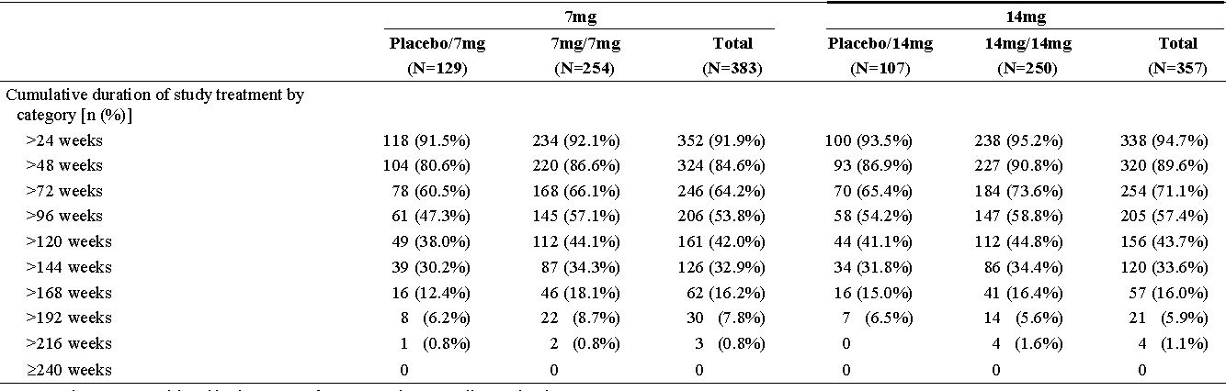
Note: Patients are considered in the group of treatment they actually received. Duration of exposure is defined as last dose date in LTS6050-first dose in LTS6050 +1 day.
Comment: Some patients had up to 105% intake of study dose, others were captured due to failure to return the drug supply
Table 65. Overview of safety profile: treatment emergent adverse events - Safety population
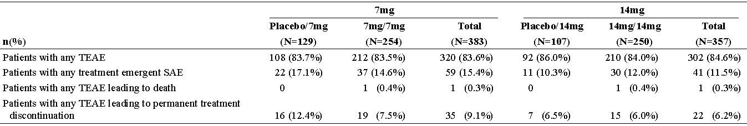

Two deaths, 1 in the7mg/7mg group from an advanced neurological disease and 1 in the 14mg/14mg groups from acute cardiac failure with coronary-cardio-sclerosis and chronic coronary artery disease.
Treatment-emergent SAEs were reported in:
- 22 patients (17.1%) in the placebo/7mg group,
- 37 patients (14.6%) in the7mg/7mg group,
- 11 patients (10.3%) in the placebo/14mg group, and
- 30 patients (12.0%) in the 14mg/14mg group.
Two patients were reported with 3 SUSARs: 24y F with phlegmonous appendicitis and diffuse seroplastic peritonitis; 52y F with bradycardia/asystole at anaesthetic induction
- The TEAEs leading to permanent discontinuation of study treatment were reported in 55 patients: 16 patients (12.4%) in the placebo/7mg group,
- 19 patients (7.5%) in the7mg/7mg group,
- 7 patients (6.5%) in the placebo/14mg group, and
- 15 patients (6.0%) in the 14mg/14mg group.
Overall, the proportion of patients with TEAEs leading to study treatment discontinuation in the7mg group (9.1%) was > the 14mg group (6.2%). An ALT increase was the most common TEAE leading to permanent discontinuation of study treatment in both dose groups (7mg: 6 patients [1.6%]; 14mg: 10 patients [2.8%])
The TEAEs (MedDRA preferred terms) occurring with a frequency greater than 8% in at least 1 group were:
- nasopharyngitis (7mg: 21.4%; 14mg: 23.5%),
- headache (7mg: 11.0%; 14mg: 12.3%),
- ALT increased (7mg: 12.0%; 14mg: 11.8%),
- pain in extremity (7mg: 7.6%; 14mg: 10.6%),
- back pain (7mg: 7.6%; 14mg: 10.4%),
- diarrhea (7mg: 6.3%; 14mg: 10.4%),
- urinary tract infection (7mg: 7.3%; 14mg: 9.5%),
- influenza (7mg: 9.7%; 14mg: 9.2%),
- paraesthesia (7mg: 6.3%; 14mg: 8.4%), and
- fatigue (7mg: 11.2%; 14mg: 7.8%)
The TEAEs occurring more frequently in the 14mg group compared to the7mg group, with a relative difference ≥ 50% and an absolute difference of ≥ 1% were:
- Hypertension (7mg: 3.4%; 14mg: 7.0%),
- anaemia (7mg: 1.3%; 14mg: 4.5%),
- musculoskeletal pain (7mg: 1.0%; 14mg: 3.6%),
- neutropaenia (7mg: 1.0%; 14mg: 3.4%),
- migraine (7mg: 0.8%; 14mg: 2.2%),
- transaminase increased (7mg: 1.0%; 14mg: 2.2%),
- pharyngitis (7mg: 1.0%; 14mg: 2.2%),
- gait disturbance (7mg: 0.3%; 14mg: 2.0%),
- foot fracture (7mg: 0.8%; 14mg: 2.0%),
- pyrexia (7mg: 1.0%; 14mg: 2.0%),
- decreased appetite (7mg: 0%; 14mg: 1.4%),
- arthropod bite (7mg: 0.3%; 14mg: 1.4%),
- abdominal tenderness (7mg: 0%; 14mg: 1.1%),
- face injury (7mg: 0%; 14mg: 1.1%), and
- ovarian cyst (7mg: 0%; 14mg: 1.1%).
The TEAEs occurring more frequently in the7mg group compared to the 14mg group, with a relative difference of ≥ 50% and an absolute difference of ≥ 1% were:
- Depression (7mg: 6.3%; 14mg: 2.8%),
- oral herpes (7mg: 3.7%; 14mg: 1.7%),
- oedema peripheral (7mg: 2.9%; 14mg: 1.4%),
- joint sprain (7mg: 2.3%; 14mg: 0.6%),
- gastritis (7mg: 2.3%; 14mg: 1.1%),
- seasonal allergy (7mg: 2.3%; 14mg: 1.1%),
- sensory disturbance (7mg: 1.8%; 14mg: 0.3%),
- hepatic enzyme increased (7mg: 1.8%; 14mg: 0.6%),
- vulvovaginal mycotic infection (7mg: 1.8%; 14mg: 0.8%),
- respiratory tract infection viral (7mg: 1.6%; 14mg: 0%),
- hepatic steatosis (7mg: 1.6%; 14mg: 0.3%),
- limb injury (7mg: 1.6%; 14mg: 0.3%),
- eye pain (7mg: 1.3%; 14mg: 0%), and
- amenorrhea (7mg: 1.0%; 14mg: 0%)
Laboratory values: Elevation of ALT was the most frequent hepatic abnormality in both teriflunomide groups, (7mg: 52.7%; 14mg: 54.9% for ALT >1 x ULN,7mg: 13.8%; 14mg: 14.3% for ALT > 2 x ULN, and 7mg: 7.0%; 14mg: 8.1% for ALT > 3 x ULN)

Figure 44. Plot of mean change from baseline in neutrophils (GIGA/L) over time - Safety Pop.
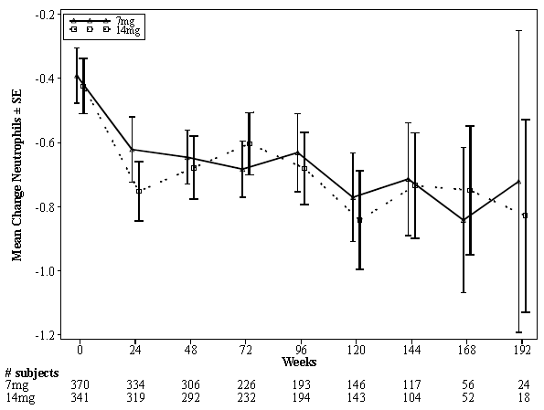
Figure 45. Mean change from baseline in lymphocytes (GIGA/L) over time – Safety Pop.
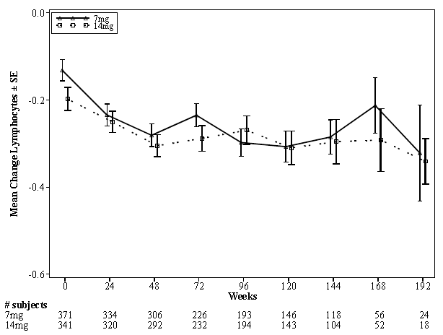
The incidence of Potentially clinically significant abnormalities for supine systolic BP increase (≥ 160mmHg and increase from baseline ≥ 20mm Hg) was similar in both treatment groups (7mg: 5.5%; 14mg: 5.6%).
Change in weight (≥ or ≤ 5% from baseline) occurred with a higher frequency in the 14mg group. Mean change from baseline did not exceed 1 kg with the 14mg dose.
There were 5 reports of pregnancies, including 2 reports in the female partners of the patients enrolled in the study. Healthy newborns without any structural defects or functional deficits were reported in all occurrences.

Patient exposure
Analysis across all studies was not undertaken, instead the data was grouped into:
- Phase 2/3 monotherapy studies
  - Pool 1: Placebo-controlled, completed studies 2001 and EFC6049
  - Pool 2: Active treatment patients receiving teriflunomide during the main studies (2001 and EFC6049/TEMSO), plus any patient who received teriflunomide during the extensions LTS6048 and LTS6050
- Adjunct studies: Patients receiving teriflunomide as adjunctive therapy to IFN-β (Study PDY6045+extension LTS6047) or GA: glatiramer acetate (Study PDY6046+extension LTS6047). These were reported separately and as combination therapy has not been sought, these data are evaluated in an appendix to this evaluation.
- Clinical pharmacology studies
  - Pooled clinical pharmacology single-dose studies
  - Pooled clinical pharmacology repeated-dose studies
- Ongoing studies at dossier cut-off:
  - Ongoing monotherapy studies active-controlled study in patients with relapsing MS (EFC10891/TENERE) and placebo-controlled study in patients with CIS, early MS (EFC6260/TOPIC)
  - Ongoing adjunct therapy study: placebo-controlled study in patients with relapsing MS receiving teriflunomide as adjunctive therapy to IFN-β (EFC6058/TERACLES)
Cumulative exposure in the monotherapy trials was over 3738 patient years up to the data lock, with a median treatment exposure in placebo controlled trials of 755 days and a maximum exposure of up to 10 years.
Table 66. Exposure to Investigational Product - Safety population - Pool 1
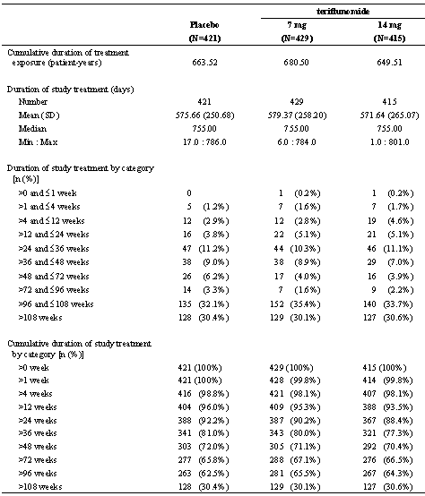
Note: Patients are considered in the group of treatment they actually received.

Adverse events

All adverse events (irrespective of relationship to study treatment)

Placebo controlled studies- Pool 1
Table 67. Overview of safety profile: adverse events - Safety population - Pool 1 Placebo-controlled
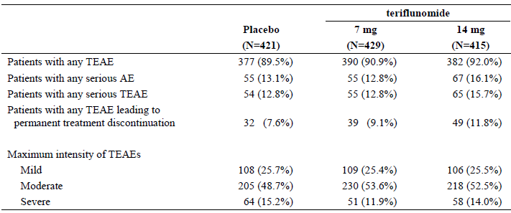
n (%) = number and percentage of patients with at least one adverse event
Figure 46. Forest plot of relative risk ratio for TEAEs with PT ≥ 10% in any treatment group (teriflunomide 14mg vs. Placebo) - Safety population - Pool 1
TEAEs Preferred Term Sorted by Relative Risk
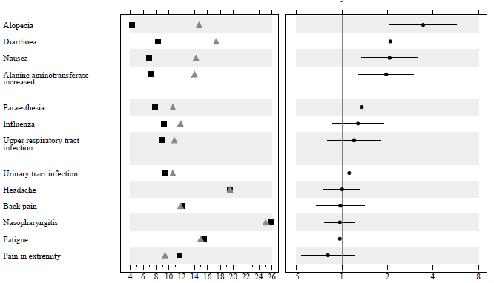

Figure 47. Forest plot of relative risk ratio for TEAEs with PT ≥10% in any treatment group (teriflunomide7mg vs. Placebo) - Safety population – Pool 1
TEAEs Preferred Term Sorted by Relative Risk
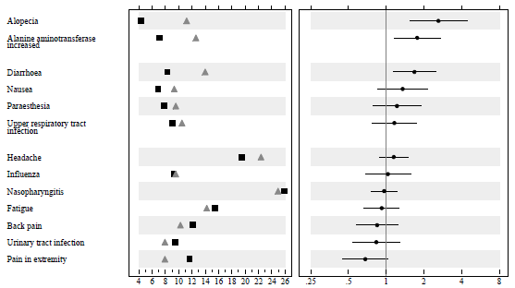

Other studies
Active treatment Pool 2 and long term exposure follow-up. The most common TEAEs (PT ≥ 10% in any treatment group) were: nasopharyngitis, headache, diarrhea, fatigue, ALT increased, back pain, influenza, alopecia, nausea, pain in extremity, upper respiratory tract infection, paraesthesia, urinary tract infection, hypoesthesia, arthralgia, depression, and muscular weakness.
Globally, there was no unexpected finding in the adverse event profile in patients receiving teriflunomide for a long term period. The same nature of events was observed in the long term use as compared to the main period.
Pooled single-dose studies. The most frequently reported TEAEs (with incidence ≥10% in any teriflunomide group) were, by decreasing frequency in teriflunomide 14mg dose group: Gastrointestinal disorders, Nervous system disorders, Infections and infestations, Musculoskeletal and connective tissue disorders and Respiratory, thoracic and mediastinal disorders. Most of the Gastrointestinal disorders occurred during the accelerated elimination treatment procedure with cholestyramine
Pooled repeated-dose studies. The SOC with the most frequently reported TEAEs (with incidence
≥ 10% in teriflunomide group) was Gastrointestinal disorders, Investigations, and Nervous system disorders, while in the placebo group the SOC with an incidence .10% were Gastrointestinal disorders and Nervous system disorders

Ongoing studies
Study EFC10891/TENERE had SAEs in 4.3% (14 of 324) of patients. 13.3% of patients discontinued the study due to an AE, most frequently ALT increased (3.7% of patients) and gastrointestinal disorders (2.5% of patients). The most common non-serious AEs (PT ≥10%) were: headache, influenza like illness, nasopharyngitis, and diarrhoea.
Study EFC6260/TOPIC had SAEs in 8.7% (35 of 404) of patients. 9.7% of patients discontinued the study due to an AE, mainly ALT increased (4.2% of patients). The most common non-serious blinded AEs (PT .10%) were: ALT increased, nasopharyngitis, and headache

Treatment-related adverse events (adverse drug reactions)
These were not provided separately reviewed in the submission. There is in the Study submission tables of Number (%) of patients with TEAE(s) regardless of relationship and related to IP (Investigational products) by Primary SOC, HLGT, HLT and PT - Safety population that comprises 168 pages.
Comment: comparison was made across treatment groups of TEAs.
In the most common TEAEs the following were more frequent with 14mg teriflunomide:
- diarrhoea (8.3%, 14.0%, 17.3% for placebo, teriflunomide 7mg and 14mg respectively),
- alopecia (4.3%, 11.2%, 14.7%),
- nausea (6.9%, 9.3%, 14.2%),
- alanine aminotransferase increase (7.1%, 12.6%, 14.0%) and
- paraesthesia (7.8%, 9.6%, 10.6%.
However diarrhoea, alopecia, nausea and paraesthesia infrequently led to permanent premature treatment discontinuation.
The trend of dose effect was also in TEAEs reported with less frequency (≤ 10%):
- sinusitis (3.8%, 4.4%, 5.8% for placebo,7mg and 14mg teriflunomide respectively),
- neutropaenia (0.5%, 2.3%, 4.6%),
- anxiety (2.1%, 2.6%, 3.9%),
- gastroenteritis viral (1.2%, 1.9%, 3.6%),
- cystitis (1.2%, 1.6%, 3.4%),
- oral herpes (1.4%, 2.3%, 3.4%),
- Pollakiuria (0.7%, 1.6%, 2.7%),
- menorrhagia (0.5%, 0.9%, 2.2%), and
- tinea pedis (0.5%, 0.7%, 1.7%).
Increases of ALT, > ULN and >3 x ULN, occurred with both doses of teriflunomide (29.5%, 47.7% and 49.6% for placebo, teriflunomide7mg and teriflunomide 14mg groups respectively). There were no differences between treatment groups for higher elevations, nor for serious hepatic TEAEs. Neutropaenia was reported more frequently in the 14mg teriflunomide dose (0.5%, 2.3%, 4.6%). TEAEs potentially related to peripheral neuropathy were reported with a higher frequency in teriflunomide 14mg (4.8%, 3.7%, 6.0%) with 1 patient discontinuing in each teriflunomide treatment group.
A PK/PD analysis using data from Pool 1(Study POH0295) showed an increase in mean teriflunomide trough plasma concentrations was associated with a modest increase in ALT, minimal decrease in amylase, limited increase in diastolic BP and a modest decrease in phosphates, decrease in WBC including neutrophils and lymphocytes, and a greater probability to report alopecia/hair thinning. The maximum effects were modest and generally in the same range for both 7 and 14mg (except for white blood cells and alopecia, for which it was higher at 14mg).

Deaths and other serious adverse events
Deaths: there were no deaths in Pool 1, 4 in Pool 2, none in adjunct or pharmacology studies and 3 deaths the ongoing studies: 1 motor vehicle accident still blinded in Study EFC10531/TOWER, and 2 completed suicide (1 in a placebo patient in Study EFC6260/TOPIC and 1 still blinded in Study EFC10531/TOWER).
Table 68. Listing of all deaths in the studies of Pool 1 and Pool 2
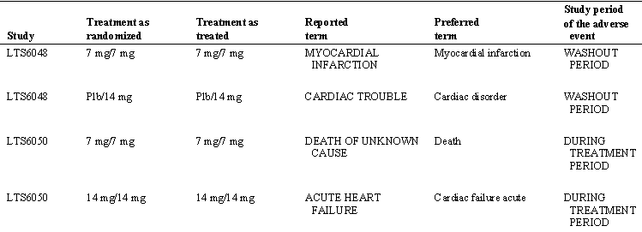

Placebo controlled studies- Pool 1
While there were only 23% more SAEs with teriflunomide 14mg than with placebo there were 55% more discontinuations due to TAEs.
Table 69. Number (%) of patients experiencing ≥ 1 TE SAEs - Safety population - Pool 1
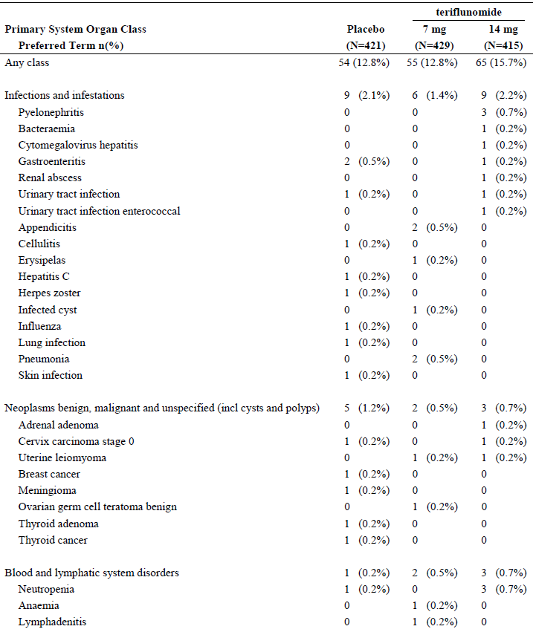
Table 69 continued. Number (%) of patients experiencing ≥ 1 TE SAEs - Safety population - Pool 1
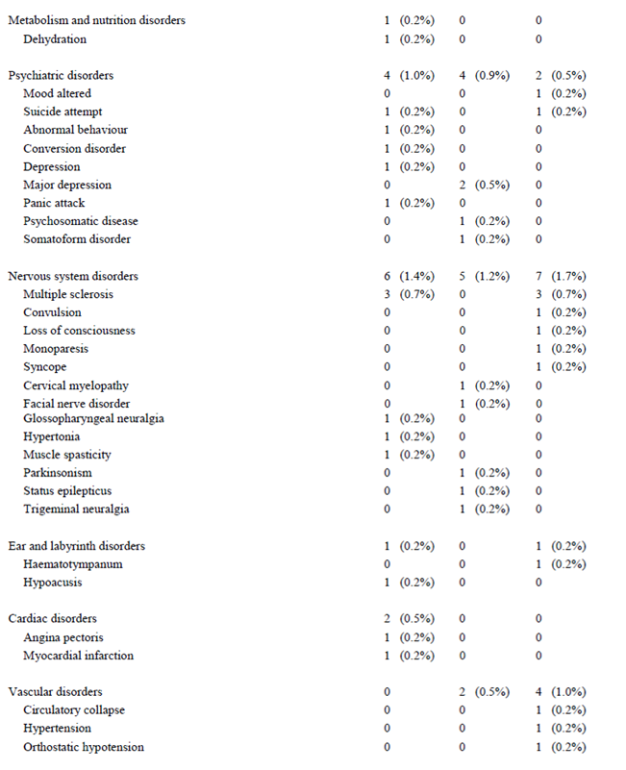

Table 69 continued. Number (%) of patients experiencing ≥ 1 TE SAEs - Safety population - Pool 1
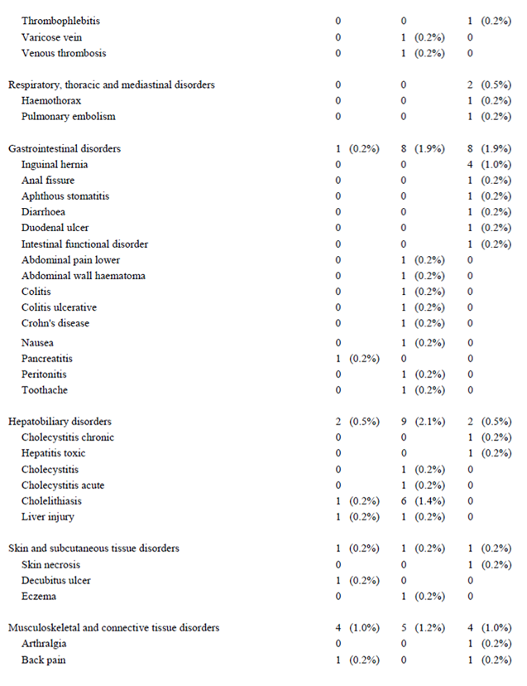

Table 69 continued. Number (%) of patients experiencing ≥ 1 TE SAEs - Safety population - Pool 1
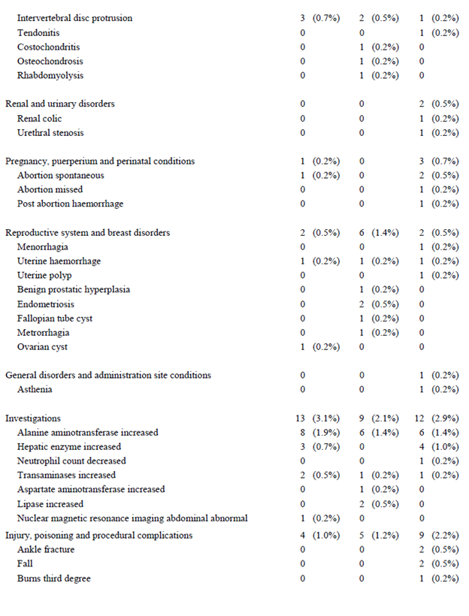
Table 69 continued. Number (%) of patients experiencing ≥ 1 TE SAEs - Safety population - Pool 1
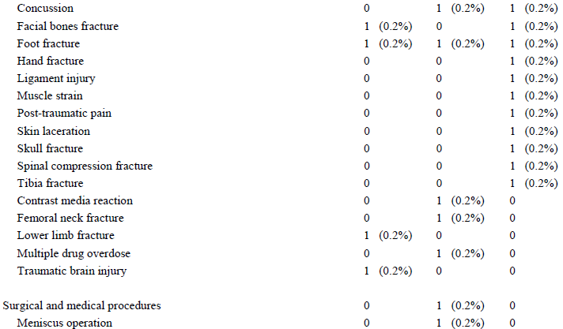
Note: Table sorted by SOC internationally agreed order and PT sorted by decreasing frequency in the teriflunomide 14mg group.

Other studies
In Pool 2, there were 23.9% of patients treated with teriflunomide 7mg and 21.2% of those on 14mg had ≥ serious TEAE The most frequent were from the SOC Investigations (7mg: 4.6% and 14mg: 4.7%). Infections and infestations SOC Serious TEAEs were 7mg 3.6% and 14mg: 4.0%.
In Pooled single-dose studies Serious TEAEs were reported in 1 subject in the 7mg group, and in 2 subjects in the 14mg group and none in the >14mg group
In Pooled repeated-dose studies 1 patient had an SAE during teriflunomide treatment while 2 (1 on placebo; 1 teriflunomide had SAEs during the accelerated elimination treatment procedure with cholestyramine.
Ongoing studies: Study EFC6260/TOPIC was blinded with 39patients (9.7%) with SAEs reported; Study EFC10891/TENERE also was blinded with 22 (6.8%) with SAEs; Study EFC10531/TOWER reported 21 .patients with SAEs between February 28 and Jun 1, 20011 only.

Discontinuation due to adverse events

Placebo controlled studies- Pool 1
Table 70. Number (%) of patients experiencing TEAEs leading to permanent treatment discontinuation presented by primary SOC and PT - Safety population - Pool 1
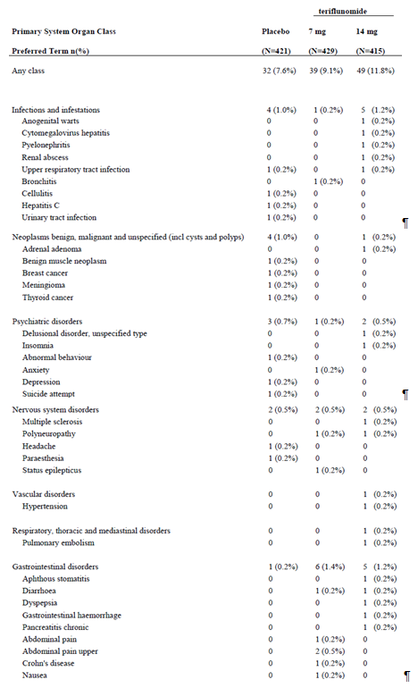
Table 70 continued. Number (%) of patients experiencing TEAEs leading to permanent treatment discontinuation presented by primary SOC and PT - Safety population - Pool 1
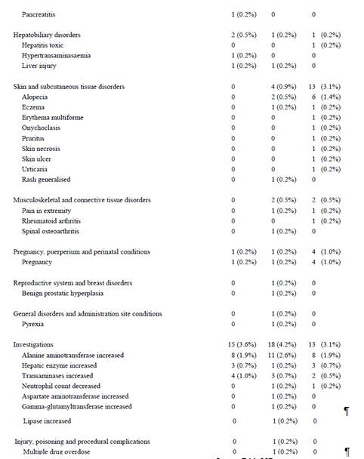

Other studies
In Pool 2, discontinuations due to TEAEs were similar between teriflunomide 7mg (15.8%) and 14mg, (15.1%). Most frequent was the SOC Investigations with teriflunomide 7mg 6.6% and 14mg 5.8%, ALT increase was the most common.
In the Pooled repeated-dose studies 5 subjects on teriflunomide discontinued including 2 for urticaria, 1 pancreatic enzyme increase and 1 neutropaenia.
Ongoing studies: In Study EFC10891/TENERE, 13.3% (43 of 324) of patients discontinued due to AEs (most frequent were ALT increased (3.7% of patients) and gastrointestinal disorders (2.5%). In Study EFC6260/TOPIC, 9.7% (39 of 404) discontinued due to AEs - the main reason was ALT increased (4.2%).

Laboratory tests
      - Liver function
This is considered under the section on Specific Safety Issues of Regulatory Importance.

Kidney function

Placebo controlled studies- Pool 1
Shift from baseline for creatinine at week 108 was -2.6 µmol/L for placebo, -3.5 µmol/L for 7mg teriflunomide and -5.2µmol/L for 14mg. Total creatinine increase ≥ 100% from baseline occurred in placebo 0%, 7mg teriflunomide 1.2% and in 14mg, 1.2% of patients. Assessment of creatinine clearance and BUN did not suggest an effect of teriflunomide treatment on renal functions
Table 71. Renal function - Number of patients with abnormalities (PCSA) according to baseline status - Safety population - Pool 1
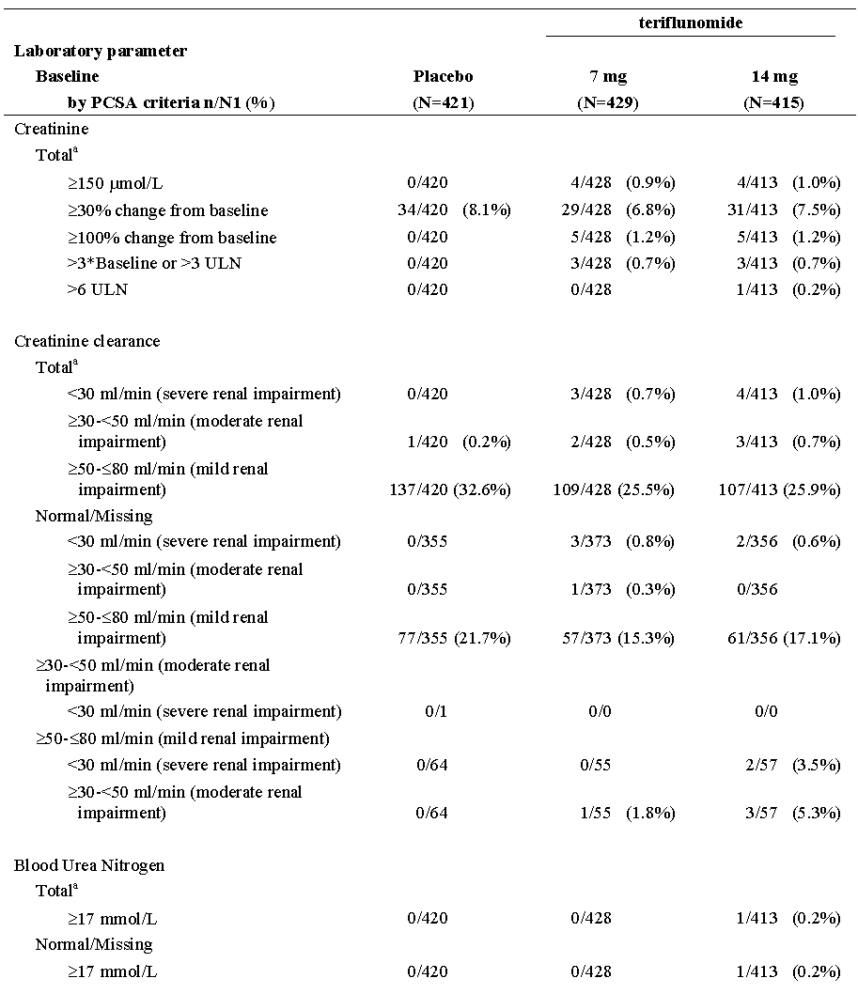
PCSA: Potentially clinically significant abnormalities. a Regardless of baseline status. The number (n) represents the subset of the total number of patients who met the criterion in question at least once in the TEAE period. The denominator (/N1) for each parameter within a treatment group is the number of patients for the treatment group who had that parameter assessed post-baseline by baseline PCSA status. Only the worsening of the worst case for each patient is presented by baseline status.

Other studies
In Pool 2 There was no difference in frequency of Potentially clinically significant abnormalities of creatinine, creatinine clearance and BUN between teriflunomide treatment groups.

Uric acid
This is considered under Specific Safety Issues of Regulatory Importance.

Other clinical chemistry
Placebo-controlled studies Pool 1
Overall, similar proportions of patients in the placebo group and teriflunomide treatment groups experienced abnormalities in metabolic functions. Mean changes from baseline in values of metabolic functions were minimal over time and did not vary between treatment groups. There were greater numbers in increase in CPK vs. placebo but they were based on small numbers.

Haematology
This is considered under Specific Safety Issues of Regulatory Importance

Phosphorus
This is considered under Specific Safety Issues of Regulatory Importance

Electrocardiograph

Study TES10852
See PD Section for more information.
The effect of repeated oral doses (70mg for 4 days followed by 14mg for 8 days) of teriflunomide on ventricular repolarisation, as compared with placebo with moxifloxacin (400mg single dose) as a positive control was studied in healthy subjects. Primary analysis: The largest time-matched mean difference estimate between teriflunomide and placebo for the change from time-matched baseline in QTcF on Day 12 was 3.46ms ( 90% CI 0.47; 6.45ms), and occurred at T3h. Teriflunomide did not show any potential for prolonging the QTcF interval. No QTcF values were ≥ 480 ms and no changes from baseline were > 60 ms. No effect on heart rate was seen.

Studies 2001 & 6048
Mean change from baseline for QTcB at endpoint of Study 2001 were 2.72 ms, 0.43 ms and 3.28 ms and mean change from baseline for QTcF were 0.92 ms, -0.03 ms and 2.73 ms for placebo, teriflunomide7mg and 14mg. An increase in mean change in QTcB and QTcF from baseline over time was observed in analysis of pooled data Study 2001+6048. An increase close to 10 ms became notable for both intervals with longer teriflunomide exposure (mean change from baseline for QTcB at endpoint was 11.66 ms and 11.55 ms and mean change from baseline for QTcF was 11.40 ms and 8.48 ms for the7mg and 14mg doses).
In study 2001: No patients had QTcF ≥ 500 ms or QTcB ≥ 500 ms in any treatment group. Few patients had prolonged QTcF or QTcB (> 450 ms in male and > 470 ms in female) with no differences across treatment groups. Similar proportion of patients within each treatment group experienced increase vs. baseline >60 ms for QTcF (3.3% in placebo and teriflunomide7mg and none in 14mg) and QTcB (4.9%, 3.3% and 3.5% in placebo, teriflunomide7mg, and 14mg, respectively).
In Study 2001 + LTS6048: Few patients had prolonged QTcF or QTcB. Of these, 3 patients (3.3%) had QTcB .500 ms in teriflunomide7mg and 1 (1.2%) in teriflunomide 14mg. Increase from baseline in QTcB > 60 ms was recorded in 6 patients in each group. Prolonged QTcF ≥ 500 ms was reported in 1 patient (1.1%) in teriflunomide7mg vs. none in 14mg. Increase from baseline > 60 ms was recorded in 5 patients (5.6%) in teriflunomide7mg and 4 (4.8%) in 14mg.
Clinical Pharmacology Studies: In pooled single-dose studies, based on machine read ECG, rare prolonged QTc were observed with teriflunomide (none at7mg or > 14mg and 2 of 104 subjects at 14mg) or cholestyramine after teriflunomide (1 subject after 14mg and > 14mg). No prolonged QTc above 500 ms was reported.
In pooled repeated-dose studies, based on machine read ECG, no prolonged QTc were reported.
      - Vital signs
        - Blood Pressure and Body Weight
These are considered under Specific Safety Issues of Regulatory Importance
  - Post-marketing experience
Not applicable.
  - Specific safety issues of regulatory importance
The following TEAEs are considered of importance as they are from the Leflunomide PI
A summary of these with relative risk in Pool 1 was provided in the submission.
    - Gastrointestinal
Diarrhoea and nausea occur in 10-15% of patients taking leflunomide.
In Pool 1, nausea was more frequently reported in teriflunomide (7mg 9.3%; and 14mg, 14.2%), than in placebo (6.9%). However, vomiting was reported in a similar proportion of patients across all treatment groups (3.6%, 3.5%, and 4.6%, in placebo, teriflunomide7mg, and respectively). Median time to onset of nausea was 47.0 days in the teriflunomide7mg group and 42.0 days in the 14mg group compared to 126.0 days in the placebo group. The median duration was 8 days in the teriflunomide7mg group and 17.75 days in the teriflunomide 14mg group compared to 8.5 days in the placebo group. Most of the events were of mild intensity; nausea was considered as severe in 1 of 29 patients in placebo, 2 of 40 patients in teriflunomide7mg, and 2 of 59 patients in teriflunomide 14mg groups, with an SAE leading to permanent treatment discontinuation in only 1 patient in the teriflunomide7mg group.
Figure 48. Kaplan-Meier plots for time to onset of nausea TEAEs - Safety population - Pool 1
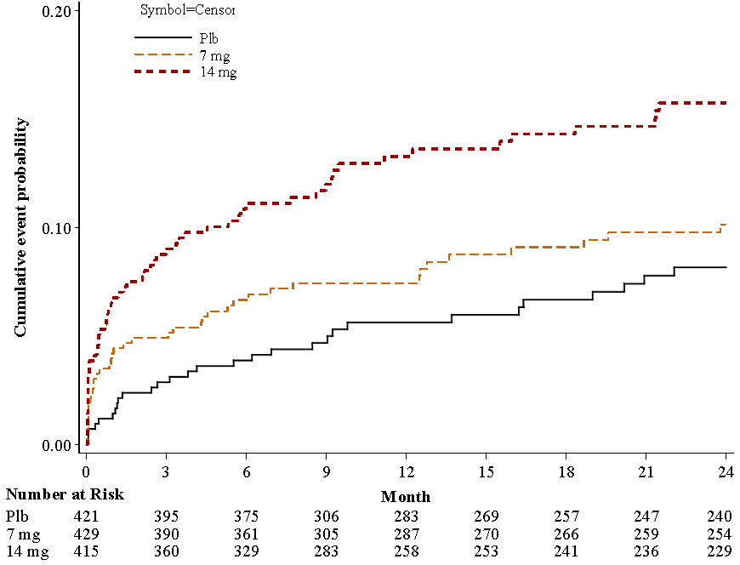
In Pool 2 the proportion of teriflunomide7mg patients with nausea was 11.8% and 16.1% in 14mg, patients respectively; one patient in each group discontinued due to nausea.
In Pooled repeated-dose studies the incidence was similar between teriflunomide (3.0%) and placebo (2.9%) groups.
Diarrhoea: In Pool 1, the proportion of patients with diarrhoea was higher in the teriflunomide groups (7mg, 14.2%, and 14mg, 17.3%)than in the placebo group(8.3%). w
Median time to onset was 131.0 days placebo group, 112.0 days teriflunomide7mg group and 68.5 days in the teriflunomide 14mg group.
Diarrhoea led to discontinuation in 1 patient in each teriflunomide group. Events were considered severe in 2 of 35 patients in placebo, in 4 of 61 patients in teriflunomide7mg and in 1 of 72 patients in 14mg. The median duration of an event was 15.0 days in the teriflunomide7mg group and 17.8 days in the teriflunomide 14mg group vs. 5.5 days in the placebo group. There was 1 SAE of diarrhoea (on teriflunomide 14mg). A second SAE on 14mg occurred in the Active treatment Pool 2 with 1 further discontinuation in each group due to diarrhoea.

Liver toxicity
Hepatic reactions: Three fold elevation of serum aminotransferase have been noted in 10-15% of patients treated with leflunomide
Table 72. Number (%) of patients with hepatic disorder TEAEs by Primary SOC and PT – Safety population - Pool 1
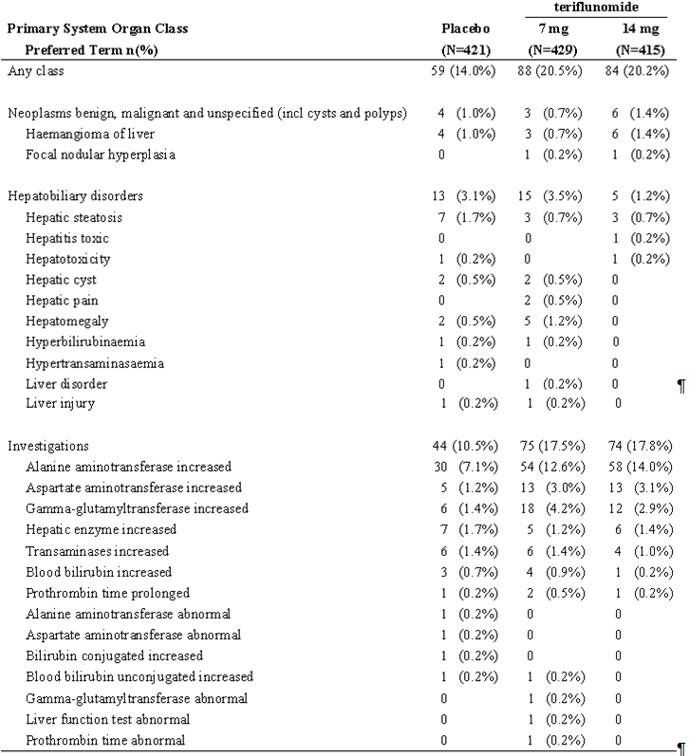
n (%) = number and percentage of patients with at least one TEAE Table sorted by SOC internationally agreed order and decreasing frequency of PTs in teriflunomide 14mg group SOC: System Organ Class, PT: Preferred term
In Pool 1, the proportion of patients with hepatic disorder TEAEs was 20.5% in the teriflunomide 7mg and 20.2% in the teriflunomide 14mg groups, vs. placebo group 14.0%, mostly due to ALT increase
The Kaplan-Meier plot (cumulative events) of time to onset of hepatic disorder TEAEs showed a higher probability of events with both teriflunomide treatment groups during the first 6 months compared to placebo.
The median time to onset of hepatic disorders was 141.0 days in placebo, 129.0 days in the teriflunomide7mg group and 127.0 days in the 14mg group.
Hepatic disorders were considered as severe in intensity in 10 of 59 patients in the placebo group, 5 of 88 patients in the teriflunomide7mg group, and 5 of 84 patients in the teriflunomide 14mg group. Serious hepatic disorders TEAEs were 3.1%, 1.9%, and 2.9% of patients in placebo, teriflunomide 7 and 14mg groups, respectively.
The proportions of patients with ALT >1 to ≤ 3 x ULN in the on treatment period were higher in the teriflunomide treatment groups compared to the placebo group However, the proportion of patients with ALT >3 to ≤ 5 x ULN or >5 to ≤ 20 x ULN, or ALT >20 x ULN was balanced across treatment groups. The Kaplan-Meier plot (cumulative events) of time to onset of ALT >3 x ULN recorded in Pool 1 showed no difference across treatment groups
Overall, complete normalization (ALT ≤ 1 ULN or return to baseline) was not recorded for 4 patients in placebo, 3 patients in teriflunomide7mg, and 4 patients in teriflunomide 14mg. Whereas normalization on treatment was recorded for 9 patients in placebo, 6 patients in teriflunomide7mg, and 10 patients in the 14mg groups, and normalization after treatment discontinuation was recorded for 4 patients in placebo, 5 patients in teriflunomide7mg, and 7 patients in 14mg groups.
Table 73. Overview of liver disorders related TEAEs and ALT increase (based on laboratory data) according to baseline status - Safety population - Pool 1
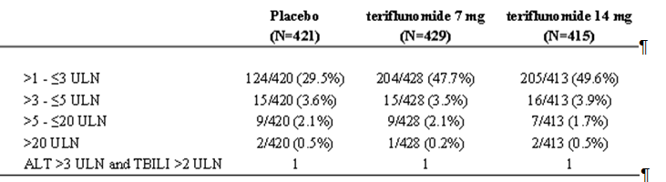
In the PK/PD analysis using data from Pool 1 (Study POH0295), an increase in mean teriflunomide trough plasma concentrations was associated with an increase in ALT with a maximum effect relationship. The mean baseline (Eo) value was 9.64% higher in patients with steroids co-administration than without steroids co-administration, and 11.3 % higher in males than in females. The mean maximum effect (Emax) value was only 22.6% higher than the mean baseline (Eo) value with a concentration producing 50% of maximal effect (EC50) of 9.94 µg/mL. The predicted effect at the median of mean concentration for7mg dose (15.9 µg/mL) and for 14mg dose (36.8 µg/mL) were in the same range: increase of 13.4% and 17.4% from mean baseline Eo, respectively
In Pool 2, hepatic disorder TEAEs were reported in 29.1% and 28.8% of patients treated with teriflunomide7mg or 14mg, respectively mainly ALT increase. Serious TEAEs related to hepatic disorders were reported in 4.3% and 4.9% of patients in the7mg and 14mg groups, respectively. The numbers were small but the higher the ALT the greater the proportion that did not normalise.
In pooled Phase 1 repeated-doses studies, there was no potentially clinically significant abnormality of ALT increase (>3 x ULN) during the treatment period with teriflunomide or placebo.

Pancreatitis
There have been rare events of acute pancreatitis with the use of leflunomide
In placebo-controlled Pool 1, 2.9% of placebo patients had pancreatic disorders TEAEs, 3.3% of teriflunomide7mg, and 2.2% of teriflunomide 14mg.
Table 74. Number (%) of patients with pancreatic disorder TEAEs by Primary SOC and PT – Safety population - Pool 1
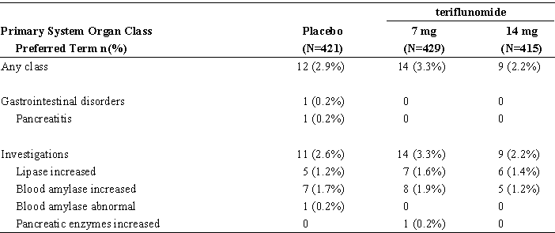
n (%) = number and percentage of patients with at least one TEAE.
Note: Table sorted by SOC internationally agreed order and decreasing frequency of PTs in teriflunomide 14mg group
Median time to onset was 275.5 days in placebo, 155.0 days in teriflunomide7mg, and 55.0 days in teriflunomide 14mg. The majority of the events were mild and there were no TEAE related discontinuations.
Elevation of pancreatic lipase and amylase (>2 to ≤5 x ULN or >5 x ULN) was reported in a small number of patients in the placebo and the teriflunomide7mg groups. No increase in pancreatic lipase >2 x ULN or in pancreatic amylase >5 x ULN was reported in patients in the teriflunomide 14mg group. Asymptomatic increase in pancreatic lipase was reported as serious TEAEs in 2 patients in the teriflunomide7mg group. Both patients recovered.
CT scan/MRI confirmation was requested for all abnormal ultrasound findings in the Study EFC6049/TEMSO. Among all the abnormal ultrasound pancreatic findings followed up during the study, only 1 case was confirmed by a CT scan/MRI and this case of pancreatitis was reported in the placebo group.
In the pooled repeated-dose pharmacology studies 3 subjects had abnormal lipase and or amylase increases (> 2 x ULN) reported as TEAEs.

Haematological toxicity (Bone marrow disorders)
Cytopaenia (pancytopaenia, leucopoenia, anaemia and thrombocytopenia) rarely occurs in patients receiving leflunomide monotherapy, but is more frequent in patients receiving concomitant treatment with methotrexate or other immunosuppressive drugs.
Pool 1: Analysis suggested an increased risk with both teriflunomide7mg (RR=3.93; 95% CI: 2.06 to 7.50) and 14mg (RR=3.32; 95% CI: 1.71 to 6.43) compared with placebo.
Table 75. Number (%) of patients with bone marrow disorder TEAEs by Primary SOC and PT -Safety population - Pool 1
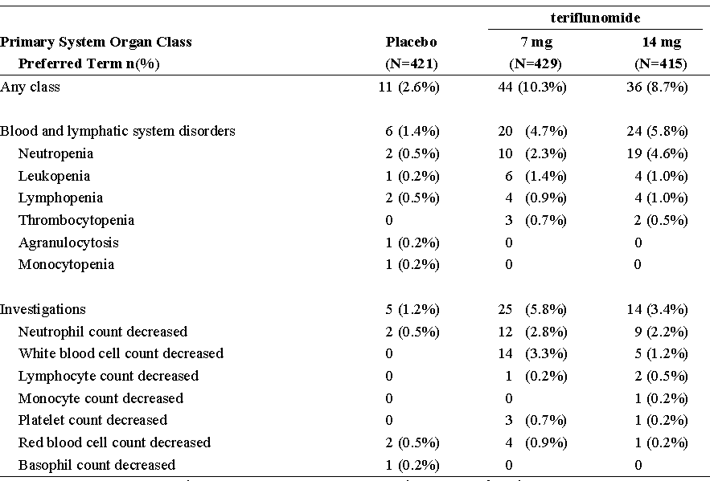
n (%) = number and percentage of patients with at least one TEAE. Note: Table sorted by SOC internationally agreed order and decreasing frequency of PTs in teriflunomide 14mg group
Figure 49. Kaplan-Meier plots for time to onset of bone marrow disorder TEAEs - Safety population- Pool 1
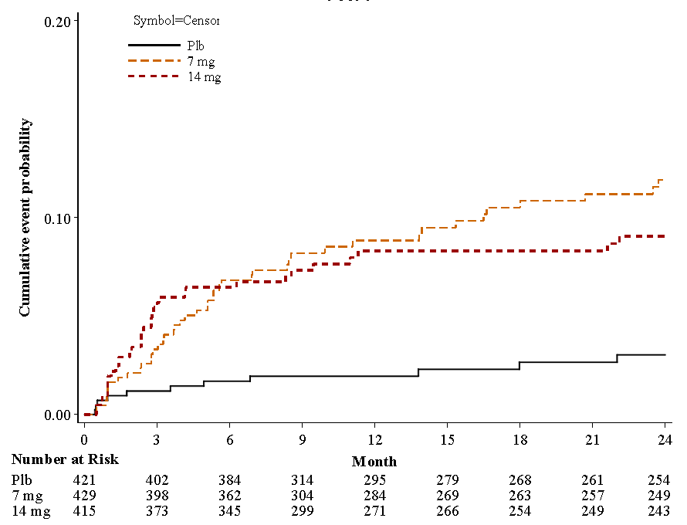
Median time to onset of bone marrow disorders TEAEs was 108.0 days in placebo, 148.0 days in teriflunomide7mg and 79.0 days in teriflunomide 14mg. The majority of events were mild to moderate; 4 and 1 events were considered as severe in the teriflunomide7mg and 14mg groups, respectively. Recovery during the observation period of Pool 1 was reported in all of the11 patients in placebo, 40 of 44 patients in teriflunomide7mg and 34 of 36 patients in teriflunomide 14mg.
One patient in each teriflunomide group discontinued treatment due to non serious bone marrow disorder (decreased neutrophil count).
TEAEs of neutropaenia/ neutrophil count decreased were serious in 1 placebo patient and 4 in teriflunomide 14mg vs. none in the teriflunomide7mg group.
Laboratory: White blood cell decrease Lymphocyte count decrease and neutrophil count decrease all were higher in the teriflunomide treatment groups compared to the placebo groups, with in some instances an apparent dose-effect relationship.
At week 12, the mean (SD) changes from baseline in lymphocyte counts were -0.24 (0.43) Giga/L in the7mg group, -0.27 (0.42) Giga/L in the 14mg group, vs. 0 (0.44) Giga/L in the placebo group. At week 108, the mean (SD) changes from baseline in lymphocyte counts were -0.20 (0.46) Giga/L in the7mg group, -0.30 (0.48) Giga/L in the 14mg group, vs. -0.02 (0.50) Giga/L in the placebo group.
Table 76. White blood cells - Number of patients with abnormalities (CTCAE) according to baseline status - Safety population - Pool 1
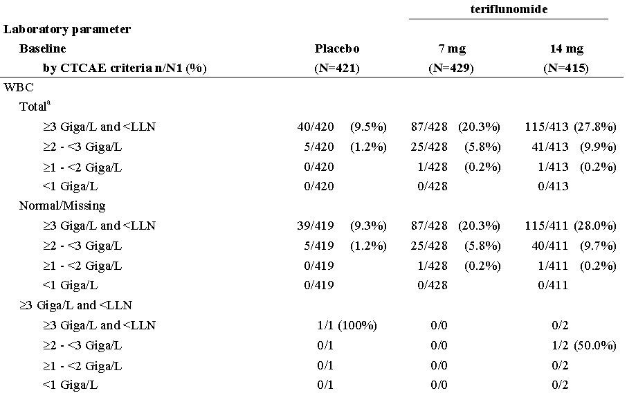

Table 76 continued. White blood cells - Number of patients with abnormalities (CTCAE) according to baseline status - Safety population - Pool 1
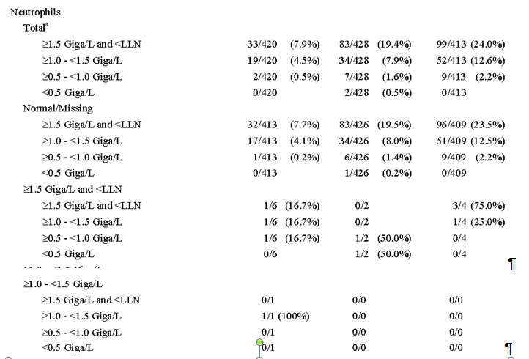

Table 76 continued. White blood cells - Number of patients with abnormalities (CTCAE) according to baseline status - Safety population - Pool 1
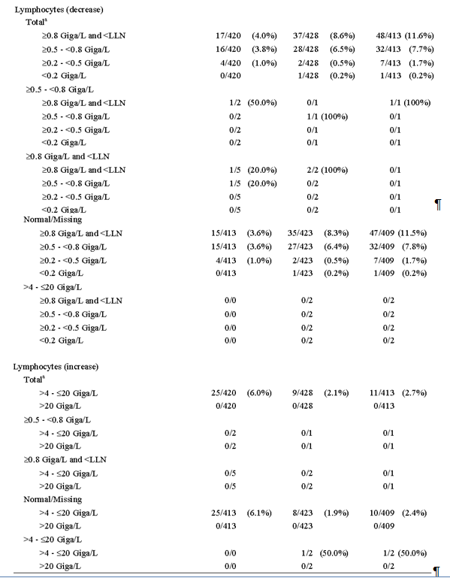
a Regardless of baseline. CTCAE: Common Terminology Criteria for Adverse Events.. The number (n) represents the subset of the total number of patients who met the criterion in question at least once in the TEAE period. The denominator (/N1) for each parameter within a treatment group is the number of patients for the treatment group who had that parameter assessed post-baseline by baseline CTCAE status.

Figure 50. Neutrophils (%) - plot of mean percent change from baseline over time – Safety population - Pool 1
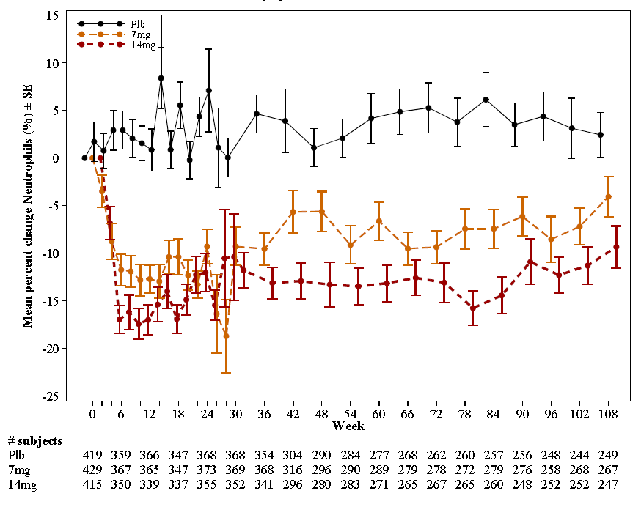
Normalization of neutrophil counts was observed in the majority of patients with ongoing treatment in all treatment groups.
At week 8, the mean (SD) changes from baseline in platelet counts were -20.7 (40.0) Giga/L in the7mg group, -26.3 (43.1) Giga/L in the 14mg group, vs. 0.5 (37.9) Giga/L in the placebo group. At week 48, the mean (SD) changes from baseline in platelet counts were -15.4 (44.4) Giga/L in the7mg group, -14.7 (46.2) Giga/L in the 14mg group, vs. 2.8 (43.7) Giga/L in the placebo group. At week 108, the mean (SD) changes from baseline in platelet counts were -11.4 (38.9) Giga/L in the7mg group, -14.0 (45.8) Giga/L in the 14mg group, vs. 9.3 (45.0) Giga/L in the placebo group.
The proportion of patients with a CTCAE grade 1 platelet count decrease (<LLN to 75.000/mm³) was higher in teriflunomide7mg and 14mg groups than in placebo (placebo: 3.1%, teriflunomide7mg: 7.5% and teriflunomide 14mg: 8.0%). There was no grade 2 or grade 3 platelet count decrease in any group. One subject in the teriflunomide7mg group had a grade 4 platelet count decrease, vs. none in the other treatment groups
In the PK/PD analysis (Study POH0295), an increase in mean teriflunomide trough plasma concentrations was associated with a decrease in WBC including neutrophils and lymphocytes with a maximum effect relationship. For WBC, the mean baseline (Eo) value was 15.0 % higher in patients with steroids co-administration than without steroids co-administration. Consistent with the clinical findings, the mean maximum effect (Emax) value was only 22.9% lower than the mean baseline (Eo) value whatever the steroid co-administration status. For the lymphocytes, the mean baseline value (Eo) was the same for all patients. Consistent with the clinical findings, the mean maximum effect (Emax) value was only 18.3% lower than the mean baseline (Eo) value. For neutrophils, the mean baseline (Eo) value was 20.9 % higher in patients with steroids co-administration than without steroids co-administration. Consistent with the clinical findings, the mean maximum effect (Emax) value was only 28.8% lower than the mean baseline (Eo) value whatever the steroid co-administration status.
Pool 2: Patients with neutropaenia again showed a dose-effect relationship (2.4% and 5.3%, in teriflunomide 7 and 14mg, respectively). No additional patient had serious TEAEs, but an additional 3 patients discontinued treatment due to neutrophil count decreased in teriflunomide7mg group and 2 (1 leucopoenia; 1 neutropaenia)in the teriflunomide 14mg group. There was a higher incidence of patients who had WBC decrease, neutrophil and lymphocyte counts decrease in teriflunomide 14mg than in7mg groups.
Clinical pharmacology studies: In pooled repeated-dose studies, low neutrophil values (<1.5 Giga/L) were reported in 12 subjects (11 of 180 with normal baseline and 1 of 2 with abnormal baseline) in the teriflunomide groups vs. none in the placebo group Only 2 subjects had neutrophils values <1 Giga/L.

Serious skin reactions (and Hypersensitivity)
Very rare cases of severe skin reactions such as Stevens-Johnson syndrome, toxic epidermal necrolysis and erythema multiforme were associated with the use of leflunomide. Alopecia, rash and pruritus are considered to be common in patients taking leflunomide.
In Pool 1, hypersensitivity and skin disorder TEAEs occurred in 19.1% of teriflunomide7mg patients and in 20.5% of 14mg patients vs. 14.5% in the placebo group The most frequently reported events in all 3 treatment groups were rash, cough, and pruritus.
The relative risk with teriflunomide compared to placebo was 1.32 [0.97 to 1.79] for7mg and 1.41 [1.05 to 1.91] for 14mg).
Skin and subcutaneous tissue disorders (such as pruritus, urticaria, erythema, rash pruritic) had an 11.7% incidence in the teriflunomide7mg group, 12.0% in 14mg and 7.1% in the placebo group.
The median time to onset was 160.0 days in placebo, 133.5 days in teriflunomide7mg, and 129.0 days in teriflunomide 14mg.
Recovery during the observation period in Pool 1 was reported in 53 of 61, 72of 82, and 66 of 85 patients in the placebo, teriflunomide7mg, and teriflunomide14mg groups, respectively.
There were no discontinuations on placebo, 1 patient teriflunomide7mg discontinued for an intense generalized rash and 2 teriflunomide 14mg patients discontinued, one for pruritus, and the other for urticaria.
In Pool 2, the proportion of patients experiencing TEAEs was 24.7% and 26.6% in teriflunomide 7 and 14mg, respectively. Four patients in the teriflunomide7mg group had serious TEAEs, and 4 in the teriflunomide 14mg group: There were 3 discontinuations for TEAEs in the teriflunomide7mg and 2 in the teriflunomide 14mg groups.
Pooled single-dose studies TEAEs potentially related to hypersensitivity were 2 of 69 (2.9%) subjects at doses of7mg, 4 of 104 (3.8%) subjects at 14mg and 1 of 59 (1.7%) subject at doses > 14mg.
Pooled repeated-dose studies TEAEs potentially related to hypersensitivity were 6 of 198 (3.0%) subjects in the teriflunomide group vs. none in placebo.

Renal safety - Uricosuria and Phosphaturia
Due to a specific effect on the brush border of the renal proximal tubule, leflunomide has a uricosuric effect. A separate effect of hypophosphaturia is seen in some patients. These effects have not been seen together, nor have there been alterations in renal function.

Uric acid

Placebo controlled studies- Pool 1
Inhibition of the transport of urate through the apical urate/anion exchanger has been shown in vitro (Study DIV1516).
The mean uric acid level in both teriflunomide treatment groups decreased steadily within the first 10 to 12 weeks and stabilized thereafter until the end of the study, with a dose effect between7mg and 14mg. At week 10 the mean changes from baseline in uric acid were 40.33µmol/L in placebo, -112.67µmol/L in teriflunomide 7mg and -88.0µmol/L for 14mg. The mean decreases ranged from 20% to 30% of the value found in placebo patients. A change from baseline > 30% occurred in 8.1% of placebo, 6.8% of teriflunomide 7mg, and 7.5% of 14mg patients.
Consistent with the clinical observations, Study POH0295, a PK/PD analysis using data from Pool 1 showed, an increase in mean teriflunomide trough plasma concentrations was associated with a decrease in uric acid with a maximum effect relationship. The mean baseline (Eo) value was 23.9 % lower in females than in males. Whatever the gender, the mean maximum effect (Emax) value was 26.7 % lower than the mean baseline (Eo) value. Whatever the gender, consistent with clinical finding, the impact is similar for the median of mean trough concentration at7mg dose (15.9µg/mL) and at 14mg dose (36.8µg/mL): decrease of 26.5 % and 26.6% of mean baseline Eo, respectively. stayed within normal ranges (lower threshold baselines), with normal creatinine values ( effect relationship (placebo: 12.4%; teriflunomide7mg: 4.2%; teriflunomide 14mg: 2.9%).
Table 77. Renal function - Number of patients with abnormalities (PCSA) according to baseline status - Safety population - Pool 1
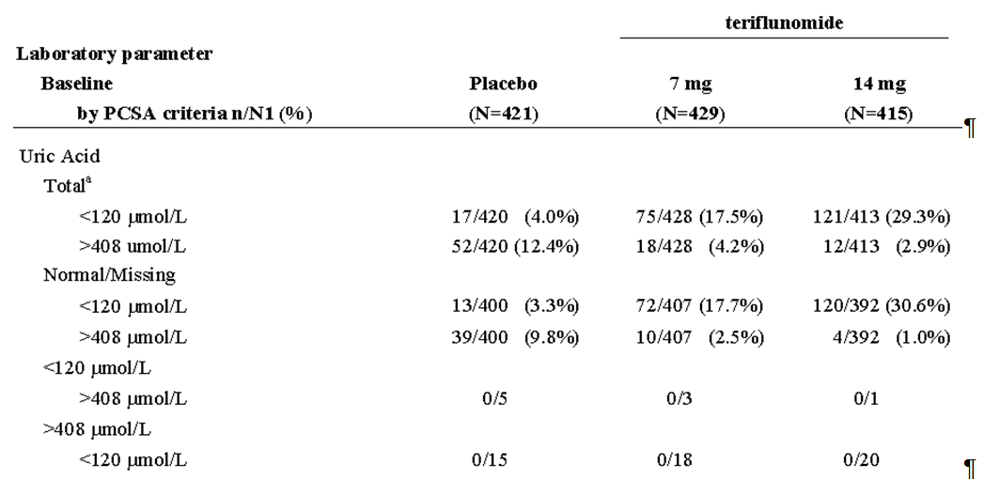
PCSA: Potentially clinically significant abnormalities . a Regardless of baseline status. The number (n) represents the subset of the total number of patients who met the criterion in question at least once in the TEAE period.
The denominator (/N1) for each parameter within a treatment group is the number of patients for the treatment group who had that parameter assessed post-baseline by baseline PCSA status. Only the worsening of the worst case for each patient is presented by baseline status.

Other studies
In Pool 2 Potentially clinically significant abnormalities of total uric acid below 120 µmol/L were seen in 18.8% of teriflunomide 7mg vs. 27.8% of 14mg patients treated.
The pooling of all repeated-dose pharmacology studies showed a 33 % decrease in uric acid.

Phosphorus

Placebo controlled studies- Pool 1
A frequent decrease in phosphorus< lower limits of normal occurred with both teriflunomide7mg (23.1%) and 14mg, (27.8%) vs. 9.5% in the placebo group.
Decrease in phosphorus was observed with the initiation of teriflunomide treatment reaching maximum shift from baseline at 16 weeks (mean change from baseline of -0.018 mmol/L, -0.130 mmol/L, and -0.158 mmol/L in placebo, teriflunomide7mg, and 14mg, respectively. The values appeared to be stabilized over time. At week 108 (Pool 1), shift from baseline for the7mg and for the 14mg dose were -0.068 mmol/L and -0.108 mmol/L, with no changes in placebo.
In the PK/PD analysis using data from Pool 1 (Study POH0295), an increase in mean teriflunomide trough plasma concentrations was associated with a decrease in phosphates with a maximum effect relationship. The mean baseline (Eo) value was 2.73 % higher in females than in males. Whatever the gender, the effect was limited with a mean maximum effect (Emax) value only about 15% lower than the mean baseline (Eo) value. Consistent with clinical finding, the impact was limited for the median of mean trough concentration at7mg dose (15.9µg/mL) and at 14mg dose (36.8 µg/mL): decrease of about 8% and 11% of mean baseline Eo, respectively, for both genders.

Other studies
The pooling of all repeated-dose pharmacology studies showed a 5% maximum decrease in phosphorus.

Cardiovascular safety – Cardiac arrhythmiasarrhythmias
Pool 1: 1 patient in the placebo group and one in teriflunomide7mg experienced atrial fibrillation.
Pool 2 cardiac arrhythmia TEAEs were in 6 patients in the7mg teriflunomide group and 1 in the 14mg group

Cardiovascular safety – Blood pressurepressure
Hypertension is a common reaction in patients treated with leflunomide.
The incidence of hypertension TEAEs of any class was 3.3% for the placebo,, 5.4% teriflunomide7mg and 5.5% teriflunomide 14mg groups. The relative risk for hypertension class of events showed a trend of increased risk with teriflunomide treatment as compared to placebo, however the CIs included 1 (RR=1.61; 95% CI: 0.84 to 3.09 with teriflunomide7mg; and RR= 1. 67; 95% CI: 0.87 to 3.19 with 14mg compared to placebo).
Median time to onset of TEAEs potentially related to hypertension was 197.5 days in placebo, 406.0 days in teriflunomide7mg and 310.0 days in teriflunomide 14mg. There was 1 SAE on teriflunomide 14mg.
New-onset hypertension (TEAE) occurred in 2.8% and 3.5% of patients in the teriflunomide7mg and 14mg groups compared to 1.3% of patients on placebo. Exacerbation/worsening of pre-existing hypertension was also more frequent in patients treated with teriflunomide compared to placebo (9.5% and 10.6% in teriflunomide 7 and 14mg compared to 8.9% in placebo).
PK/PD analysis (Study POH0295) showed an increase in mean teriflunomide trough plasma concentrations was associated with an increase in diastolic BP with a maximum effect relationship. The mean baseline value (Eo) was the same for all patients and the mean maximum effect (Emax) value was 3.64% higher than the mean baseline (Eo) value with a concentration producing 50% of maximal effect (EC50) of 44.6 µg/mL.
Consistent with the clinical findings, the impact was different but limited for the median of mean trough concentration at7mg dose (15.9 µg/mL) and at 14mg dose (36.8 µg/mL) with a predicted increase compared to mean baseline Eo of 0.94% and 1.63%, respectively.
Table 78. Number (%) of patients with hypertension/ blood pressure increase TEAEs by Primary SOC and PT - Safety population - Pool 1
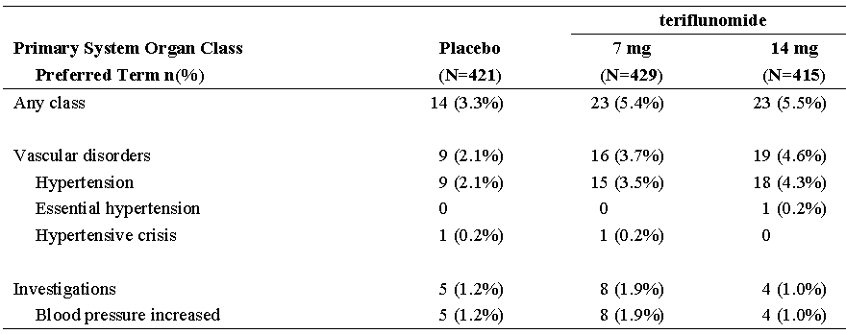
n (%) = number and percentage of patients with at least one TEAE. Note: Table sorted by SOC internationally agreed order and decreasing frequency of PTs in teriflunomide 14mg group.
In Pool 2 The proportion of patients with any hypertension related TEAEs was 9.2% and 10.9% in teriflunomide7mg and 14mg groups, respectively. Treatment-emergent AEs of hypertension (PT) were more common in patients treated with the 14mg teriflunomide dose (5.5% in the7mg group and 8.4% in the 14mg group). There were 2 SAEs. At endpoint, with mean exposure of 3.3 years and 3.25 years for the7mg and 14mg groups, mean increases from baseline for systolic (diastolic) BP were 3.5 mmHg (2.5 mmHg) for the teriflunomide7mg group and 5.3 mmHg (3.4mmHg) for the teriflunomide 14mg group.

Alopecia
In Pool 1, the proportion of patients with TEAEs related to alopecia was higher in the 2 teriflunomide treatment groups compared to the placebo group with a dose-effect relationship (4.3%, 11.4%, and 15.2% in placebo, teriflunomide7mg and 14mg, respectively). The RR analysis showed an increased risk of alopecia with both teriflunomide doses vs. placebo (RR=2.67; 95% CI: 1.58 to 4.51, for teriflunomide7mg, and RR=3.55; 95% CI: 2.14 to 5.89 for teriflunomide 14mg). The median time to onset of alopecia was 95.0 days and 90.0 days in teriflunomide7mg and 14mg, respectively compared to 119.5 days in placebo. 1 event in the teriflunomide 14mg group was severe. In the placebo group 13 of 18 patients recovered, 38 of 49 patients in teriflunomide7mg and 57 of 63 patients in teriflunomide 14mg.
In Pool 2, the proportion of patients with alopecia was higher in teriflunomide 14mg (17.3%) than in teriflunomide7mg (12.1%).
Table 79. Number (%) of patients with alopecia TEAEs by Primary SOC and PT - Safety population -Pool 1
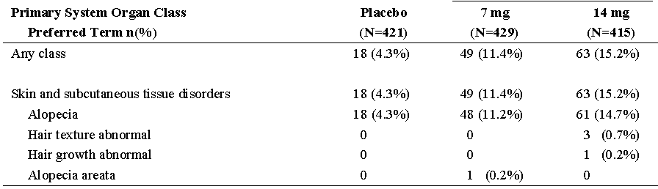
n (%) = number and percentage of patients with at least one TEAE Note: Table sorted by SOC internationally agreed order and decreasing frequency of PTs in teriflunomide 14mg group.

Figure 51. Kaplan-Meier plots for time to onset of alopecia TEAEs - Safety population - Pool 1
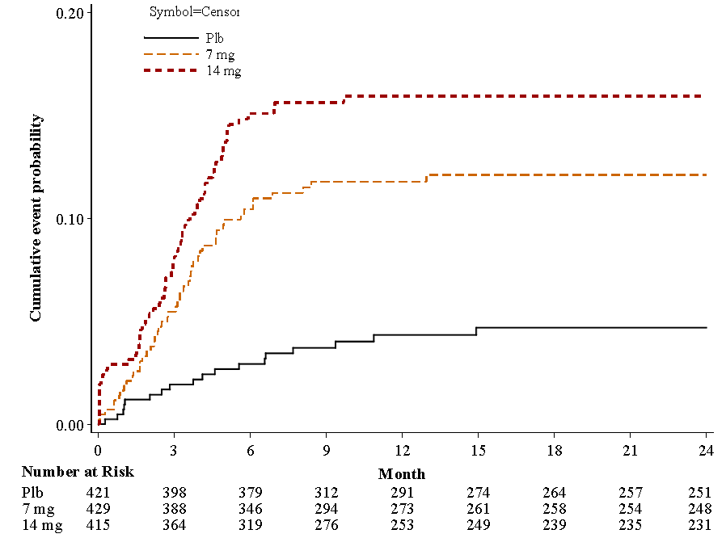

Bodyweight
Weight loss is described as a common side effect in the data sheet. It does not correlate with diarrhoea or nausea.
Weight decreased was slightly more frequent with teriflunomide and was reported in 4 patients on placebo (1.0%), 12 patients on teriflunomide7mg (2.8%), and 10 patients on teriflunomide 14mg (2.4%). There was a higher decrease from baseline with teriflunomide than with placebo for 5% changes (39.1% and 44.4% for teriflunomide7mg and 14mg respectively, versus 26.6% for placebo), and for 7 % changes (25.4% and 29.0% for teriflunomide7mg and 14mg respectively, versus 14.9% for placebo). The maximal decrease occurred within the first 6 months and stabilized thereafter.

Peripheral neuropathy
In clinical trials paraesthesia was more common with leflunomide (2.9%) than with placebo and active control (1%). Peripheral neuropathy, specifically a sensory axonal neuropathy, has been suggested as a side effect of leflunomide in the postmarketing setting
Overall TEAEs potentially related to peripheral neuropathy were reported in 4.8% of patients in placebo, 3.7% in teriflunomide7mg and 6.0% in teriflunomide 14mg. The RR with teriflunomide treatment versus placebo in the teriflunomide7mg group was RR=0.79; 95% CI: 0.41 to 1.49 and in the 14mg group was RR=1.27; 95% CI: 0.72 to 2.25. No SAEs. 1 event in the teriflunomide 14mg group was severe. Median time to onset of peripheral neuropathy TEAEs was 250.0 days in placebo, 189.5 days in teriflunomide7mg and 168.0 days in teriflunomide 14mg. Overall, recovery during the observation period in Pool 1 was reported in 10 of 20 patients in placebo, in 5 of 16 patients in teriflunomide7mg, and 14 of 25 patients in teriflunomide 14mg
2 patients (1 in each teriflunomide group) discontinued due to polyneuropathy.
Table 80. Number (%) of patients with peripheral neuropathy TEAEs by Primary SOC and PT -Safety population - Pool 1
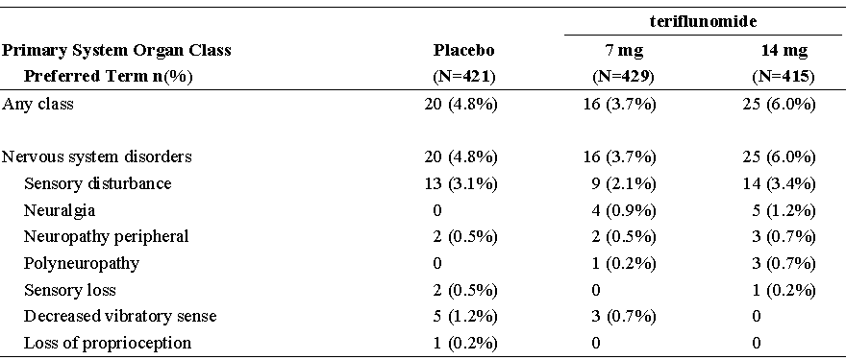
n (%) = number and percentage of patients with at least one TEAE. Note: Table sorted by SOC internationally agreed order and decreasing frequency of PTs in teriflunomide 14mggroup.
Pool 2 TEAEs potentially related to peripheral neuropathies were reported in the teriflunomide 7 and 14mg groups (11.6% and 11.3%, respectively).

Interstitial lung disease
Leflunomide treatment has been associated with an increased risk of interstitial lung disease
In Pool 1, 1 patient in the placebo group had pneumonitis TEAE.
In Pool 2, 2 potential cases of suspected interstitial lung disease were identified in patients treated with teriflunomide 14mg.

Unwanted immunological events (infections and Infestations)
Immunosuppressive effects: Leflunomide can increase susceptibility to infections, including opportunistic infections. Rare cases of severe infections, including sepsis were reported.
In placebo-controlled Pool 1, the proportion of patients with TEAEs related to infections and infestations was 57.5% in placebo, 59.7% in teriflunomide7mg and 61.7% in teriflunomide 14mg
Relative risk compared to placebo teriflunomide7mg (RR=1.04; 95% CI: 0.93 to 1.16) and 14mg (RR=1.07; 95% CI: 0.96 to 1.20).
Viral infections were 4.4% in teriflunomide7mg and 6.5% in 14mg groups vs. 1.9% with placebo. Serious Infections and infestations disorders were 2.1% in placebo, 1.4% in teriflunomide7mg group, and 2.2% in 14mg. These events led to treatment discontinuation in 4 (1.0%) patients in the placebo group, 1 patient (0.2%) in the teriflunomide7mg group and 5 patients (1.2%) in the teriflunomide 14mg.
Opportunistic infections were 35 of 421 (8.3%) in placebo, 39 of 429 (9.1%) in teriflunomide7mg and 44 of 415 (10.6%) in teriflunomide 14mg. Two serious TEAEs of opportunistic infections were reported: one hepatitis CMV and one herpes zoster zona.
In Pool 2, the proportion of patients with TEAEs related to infections and infestations was 66.6% in teriflunomide7mg and 65.3% in 14mg groups. Opportunistic infections was 78 (13.3%) in teriflunomide7mg and 77 (14.1%) in teriflunomide 14mg. One serious TEAE of oral herpes on7mg teriflunomide.

Malignancy
The risk of malignancy, particularly lymphoproliferative disorders, is known to be increased with the use of immunosuppression medications, however, no apparent increase in the incidence of malignancies and lymphoproliferative disorders was reported in the clinical trials of leflunomide.
In Pool 1 patients with malignant and benign tumours TEAE were 5 (1.2%) in placebo, 1 (0.2%) in teriflunomide7mg, and 2 (0.5%) in 14mg.
Pool 2 12(2.0%) cases in the7mg group, 7 (1.3%) cases in 14mg group.
Date of onset, tumour presentation, and evolution of malignant disease was not considered to be related to the study drug.

Adjunct studiesstudies
These were separately analysed in the safety reviews and since they are not in the Indications applied for, thus have not been included in the above evaluation.

Other safety issues

Safety in special populations

Age
In placebo-controlled Pool 1: The risk of AESI nausea with teriflunomide vs. placebo tended to be greater in patients ≥38 years (RR=1.87; 95% CI: 0.92 to 3.82 with teriflunomide7mg and RR=3.37; 95% CI: 1.75 to 6.49 with teriflunomide 14mg) compared to patients < 38 years (RR=1.03; 95% CI: 0.56 to 1.88 with teriflunomide7mg and RR=1.29; 95% CI: 0.73 to 2.28 with teriflunomide 14mg). In addition, in patients treated with teriflunomide 14mg, and compared to placebo, an increased risk was found in patients ≥38 years for the HLTs Urinary tract infections.

Gender
In placebo-controlled Pool 1, the analysis by intrinsic factors showed an increased risk in females compared to male treated with teriflunomide 7 or 14mg versus placebo, for HLTs liver function analyses, muscle pains, white blood cell analyses (mainly for7mg), neutropaenia (mainly for 14mg), vascular hypertensive disorders NEC (mainly for 14mg), herpes viral infections (mainly for 14mg), and influenza viral infections. However, the numbers of events were small, and given the number of factors/events assessed, the observations need to be interpreted with caution.

Weight and body mass index
In Pool 1, the analysis by intrinsic factors showed an increased risk of HLTs alopecia and diarrhoea (mainly7mg) in patients with BMI <30 kg/m² compared to patients with BMI >30 kg/m² treated with teriflunomide 7 or 14mg versus placebo, and for HLTs upper respiratory tract infections (mainly 14mg), pain and discomfort NEC (mainly 14mg) in patients with a BMI >30 kg/m² compared to patients with BMI <30 kg/m² treated with teriflunomide 7 or 14mg versus placebo. However, the relatively small number of events in patients with BMI >30 kg/m² limits the interpretability and validity of the findings.

Safety related to drug-drug interactions and other interactions
No safety concern was identified during coadministration of teriflunomide with midazolam, repaglinide, bupropion or cocktail including caffeine, metoprolol and omeprazole. Coadministration with warfarin produced a 25%elevation in INR. In the interaction study with oral contraceptives (Study INT10564) when teriflunomide was administered concomitantly to Minidril (containing 0.03mg ethinylestradiol and 0.15mg levonorgestrel) for 14 days. Eight of 23 subjects experienced a TEAE. There were mostly nervous system disorders (5 subjects, mainly headache) and gastrointestinal disorders (4 subjects mainly diarrhoea).

Use in pregnancy and lactation
57 pregnancies were reported to the Pharmacovigilance database (1 female patient experienced 2 pregnancies). 45 pregnancies occurred in female patients aged from 22 to 45 years old.
Table 81. Treatment allocation by outcome
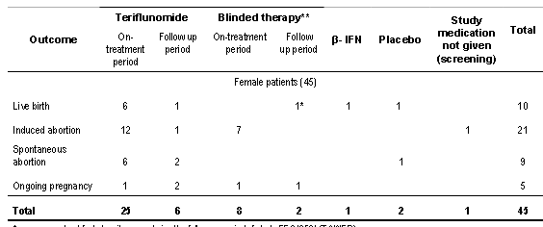
* case was not unblinded as it occurs during the follow-up period of study EFC10531 (TOWER).
** 7 cases in Study EFC10531 and 3 cases in Study EFC6260.
Table 82. Patient exposure
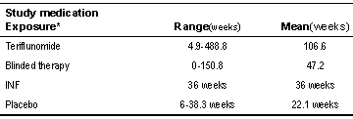
*Exposure was calculated from the first intake to the last menstruation period
Ten pregnant female patients delivered healthy newborn babies in teriflunomide clinical program without complications at the cut off date. All the newborn babies had no malformation or functional problems reported that could suggest a link to any teratogenic effect.
12 pregnancies occurred in female partners of male patients aged from 18 to 53 years old.
Table 83. Treatment allocation by outcome
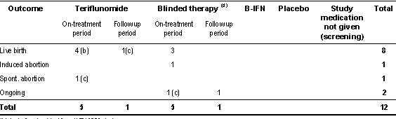
(b): including 1 subject from INT10563 study (c): Intended pregnancy (d): 3 cases in Study EFC10531 and 3 cases in Study EFC6260
Eight pregnant female partners of male patients delivered healthy newborn babies in the teriflunomide clinical program without structural defect and functional abnormality at the cut off date. All the newborn babies had no malformation or functional problems that could suggest a link to any teratogenic effect.

Treatment withdrawal
In the Study EFC6049/TEMSO, the frequency of relapses during the washout period was numerically lower than the frequency on treatment, for both teriflunomide doses and placebo. Suggesting there is no major rebound phenomenon.
Table 84. Summary of relapse rate for patients with post treatment washout follow-up ITT population
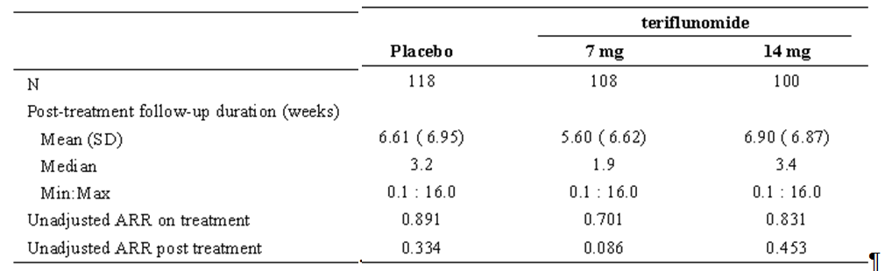

Evaluator’s overall conclusions on clinical safety
The lack of a listing of Adverse Reactions is a considerable gap in the Summary of Clinical Safety.
It may be that in patients with differing pathology (MS vs. rheumatoid or psoriatic arthritis) they will have a differing Adverse Reactions profile, as well as there being a differing profile between teriflunomide and leflunomide.
The pattern of Adverse Reactions in the leflunomide PI appears to be reflected in the TEAEs of teriflunomide (with the exception of diarrhea, nausea and vomiting) but no summary of investigator’s opinion of causality was submitted.
The number of patients treated with monotherapy was adequate.
The greatest concerns with AEs of leflunomide and hence teriflunomide are unlikely to be picked up in trials as they are rare reactions – skin, hepatic and haemopoetic. Against this the condition proposed for treatment with teriflunomide is one of progressive deterioration and death, whereas the arthritic indications for leflunomide, though causing progressive deterioration do not lead progressively to death.
Rare reactions listed in the leflunomide PI include eosinophilia, leucopoenia pancytopaenia, hepatitis, jaundice/cholestatis, severe infections and interstitial lung disease (including interstitial pneumonitis); very rare reactions include Severe anaphylactoid reactions. Stevens-Johnson syndrome, toxic epidermal necrolysis, erythema multiforme, agranulocytosis, Severe liver injury such as hepatic failure, and acute hepatic necrosis, pancreatitis and peripheral neuropathy.
- Of these rare reactions ADEC specifically resolved that a warning that leflunomide treatment may be associated with pancytopaenia and Stevens-Johnson syndrome or Toxic Epidermal Necrolysis be inserted in the PI.
The teriflunomide Proposed PI carries no warning on Stevens-Johnson syndrome or Toxic Epidermal Necrolysis. There was an increase in skin AEs and this is shown in the proposed PI.
- Pancytopaenia is not specifically mentioned in the mentioned in the proposed PI, there is a reasonable warning however the recommendations on monitoring are not specific as for the leflunomide PI which it is recommended they match.
Mean decrease in WBC counts was observed (mainly neutrophil and lymphocyte count decrease) with a small dose response. The mean decrease occurred during the first 6 weeks, followed by stabilization over time on-treatment, with a magnitude not exceeding 15%.
The most frequently reported individual TEAEs with a higher incidence in the teriflunomide treatment groups as compared to placebo were alopecia or hair thinning, diarrhea, nausea, and increased alanine aminotransferase.
- Of these leflunomide carries a FDA black box warning in relation to Hepatotoxicity. It, like the Australian PI ,carries specific recommendations on monitoring. The incidence of >3-fold ULN ALT elevations for Arava monotherapy in study US301, MN301 and MN302 was 1.5% to 4.4% (Arava PI). There was an incidence of 6.1% on teriflunomide 14mg (vs. 6.2% placebo). The proposed PI recommendation on monitoring is non specific, in the absence of a summary of causality it is recommended that it be strengthened to that in the leflunomide PI.
Mild increases in transaminase, ALT below or equal to 3 x ULN, were more frequently seen in teriflunomide treated groups as compared to placebo. Transaminase increases occurred usually within the first 6 months of treatment and often recovered with continued treatment.
- Events of nausea and diarrhoea appeared early after initiation of treatment. They were rarely considered as serious and led to treatment discontinuation in only a few patients. However they appear specific to teriflunomide in this patient group and, since they could be a problem in the more disabled, there is a specific warning in the proposed PI.
- Alopecia carries adequate information in the proposed PI.
Other events occurring with higher frequency in the teriflunomide 7mg or14mg groups as compared to placebo were: viral infections, menstruation with increased bleeding, tinea infections and erythema.
- Menorrhagia is not specifically discussed in the proposed PI, however given the discussion of drug interactions with oral contraceptives it is recommended that this warning be strengthened to include both the increased incidence of menorrhagia seen and the concerns about animal teratogenicity.
- Infections were the most frequently reported TEAEs in the placebo-controlled Pool 1 with a slightly higher incidence in the teriflunomide treated groups compared to placebo. The evaluator believes these are adequately presented in the proposed PI.
- Cutaneous reactions, such as urticaria, erythema, pruritus and pruritic rash were observed with low incidences across treatment groups, but more frequently in the teriflunomide treatment groups compared to placebo. The evaluator believes these are adequately presented in the proposed PI.
Of the common reactions listed in the leflunomide PI:
- Increase in blood pressure was common especially in those with pre-existing hypertension and it is recommended that the PI warning be strengthened accordingly.
Blood pressure elevations were more frequent in teriflunomide as compared to placebo. The risk for experiencing hypertension was higher in patients with pre-existing hypertension at baseline.
- Weight loss was more frequently observed in the teriflunomide treated groups than in the placebo.
- The maximum median weight loss occurred at week 48, was below 2 kg for both teriflunomide treatment groups, and stabilized thereafter. It is recommended that comment be made under Adverse Effects, Clinical Trial Experience
Decrease in mean plasma levels of uric acid, was seen. The uricosuric effect was considered to be most probably due to an increase in renal tubular uric acid elimination and is adequately discussed under pharmacodynamics in the proposed PI.
Similarly, an approximately 10% mean decrease in phosphorus plasma levels was observed, also considered to be due to increased renal tubular elimination. This may be considered a potential risk factor for osteoporosis with long-term treatment. However, no signal in the long term Pool 2 data was detected. Again this is adequately discussed under pharmacodynamics in the proposed PI.
In vivo, teriflunomide was a moderate inhibitor of CYP2C8, a weak inhibitor of CYP3A, but not of CYP2B6, CYP2C9, CYP2C19, and CYP2D6. Teriflunomide also seemed to be a weak inducer of CYP1A2 in vivo. No major drug interactions are expected, however, drugs metabolized by CYP2C8 should be used with caution during the treatment with teriflunomide. Apart from the above comments on oral contraceptives, drug Interactions were adequately discussed in the PI.
The study on the effects on the QT interval was adequate for safety.

Preliminary benefit-risk assessment

Preliminary assessment of benefits
The benefits of teriflunomide were not demonstrated in the proposed usage as efficacy in the proposed population of Patients with Relapsing Forms of Multiple Sclerosis was not shown. The proposed population is inclusive of all MS patients with relapses while, despite the sponsor’s assertion to the contrary, the population of the pivotal study was restricted by protocol amendment. The population in study 6049 was further restricted in that only 12 patients out of 363 (3.3%) receiving placebo had Progressive Relapsing MS, likewise only 14 patients out of 359 (3.9%) receiving teriflunomide 14mg had Progressive Relapsing MS. See Addendum.

Preliminary assessment of risks
The risks of teriflunomide in the proposed usage are:
- Apparently broadly similar to those of leflunomide with the exception of the risk of diarrhoea and vomiting, and effects on uric acid and phosphorus.
There does not appear to be an increased risk of rarer events compared with leflunomide, however ongoing monitoring of patients for hepatic, pancreatic and haematologic function as well as blood pressure is recommended.

Preliminary assessment of benefit-risk balance
The benefit-risk balance of teriflunomide is unfavourable for monotherapy for the treatment of patients with relapsing forms of multiple sclerosis to reduce the frequency of clinical relapses and to delay the accumulation of physical disability, given that the evaluator finds that efficacy in the proposed population was not shown. See Addendum.

Preliminary recommendation regarding authorisation
It is recommended that teriflunomide not be registered as monotherapy for the treatment of patients with relapsing forms of multiple sclerosis to reduce the frequency of clinical relapses and to delay the accumulation of physical disability.
It is recommended that the sponsor be asked to consider a more restricted population for the Indications. This would require a limited amount of further evaluation of efficacy data. See Addendum.

List of questions

Efficacy
- In the Final Statistical Analysis Plan Study 6049:
Other secondary endpoints
If all hypothesis tests described above are significant at 5% level, a step down testing procedure will be applied to the following secondary endpoints in the order specified below within each dose at 2.5% significance level, i.e., within a dose each hypothesis will be formally tested only if the preceding one is significant at the 2.5% level:
- Change from baseline in total score of fatigue impact scale at week 108
- Total number of gadolinium enhancing (Gd-enhancing) T1-lesions per MRI scan over the treatment period
- Change from baseline in MRI burden of disease at week 108
Fatigue Impact Scale In the MMRM analysis, no statistically significant treatment difference (LS mean values) was observed in the FIS score at Week 108 (p=0.3861 for the teriflunomide7mg group compared with the placebo group and p=0.8271 for the teriflunomide 14mg group compared with the placebo group).
Question: Given the result for the Fatigue Impact Scale why were the other secondary endpoints tested?
- In the Final Statistical Analysis Plan Study 6049:
Total volume of Gd-enhancing T1-lesions per MRI scan over the treatment period
Due to the non-normality of the distribution, total volume of Gd-enhancing T1-lesions per MRI scan will be analysed using rank analysis of covariance.
To perform this rank analysis of covariance, baseline Gd-enhancing T1-lesions and endpoint (volume of lesions per MRI scan) will be respectively ranked (via NPLUS1 denominator n+1) for all patients who had both baseline and at least one on-treatment scan. No imputation is needed since patients with post baseline measurements all have the response value.
Question: What was the result of this analysis? Analysis results were submitted only for Patient level volume of Gd-enhancing T1-lesions per MRI scan, change from baseline at week 108.

Second round evaluation: clinical data submitted in response to questions
Question 1. The sponsor has clarified that the step-down procedure applied to disability progression after Annualised relapse rate:
statistical significance was not achieved for the key secondary efficacy endpoint of 12-week sustained disability progression for teriflunomide 7mg versus placebo (p= 0.0835), the last step of this procedure, and so no formal, conclusive statistical testing could be performed for other secondary or tertiary endpoints including those covered by the other secondary endpoint step down testing procedure. The p-values for the secondary and tertiary efficacy endpoints were nominal p-values only.
Question 2. The sponsor provided the location of the data requested and clarified that the p-value presented was for Total volume and not Patient level volume:
presented in appendix 16-2-6-eff-response-data [14.2.6.4.33] of Study EFC6049 CSR. The cumulative volume of Gd-enhancing T1-lesions per MRI scan was 0.089 in placebo group, 0.06 in the teriflunomide 7mg group, and 0.023 in the teriflunomide 14mg group. The rank-ANCOVA as specified in the SAP was performed to test the treatment differences and the nominal p-value derived from the analysis (p<0.0001 for both doses versus placebo)

Second round benefit-risk assessment

Second round assessment of benefits
After consideration of the responses to clinical questions, the benefits of teriflunomide in the proposed usage are unchanged from those identified in the Preliminary Assessment, above.

Second round assessment of risks
After consideration of the responses to clinical questions, the risks of teriflunomide are unchanged from those identified in the Preliminary Assessment, above.

Second round assessment of benefit-risk balance
The benefit-risk balance of teriflunomide is unfavourable for monotherapy for the treatment of patients with relapsing forms of multiple sclerosis to reduce the frequency of clinical relapses and to delay the accumulation of physical disability, given that the evaluator finds that efficacy in the proposed population was not shown. See Addendum (the second round assessment has not affected the decisions therein).

Second round recommendation regarding authorisation
It is recommended that teriflunomide not be registered as monotherapy for the treatment of patients with relapsing forms of multiple sclerosis to reduce the frequency of clinical relapses and to delay the accumulation of physical disability.
It is recommended that the sponsor be asked to consider a more restricted population for the Indications. This would require a limited amount of further evaluation of efficacy data. See Addendum. (the second round Assessment has not affected the decisions therein).

Additional information
The sponsor supplied on 4/6/12 by email (Aubagio (teriflunomide) - Top-Line Results of TOWER, a Pivotal Phase III Trial in Relapsing MS) a press release. This information was supplied after the response to section 31 questions and in a form that cannot be assessed - indeed to quote the press release Analysis of the full TOWER data is ongoing.

References
Not applicable.

Addendum to the clinical evaluation report

Reason for Addendum
The Delegate has requested that the data in the teriflunomide submission 2011-02772 be reviewed to see if efficacy been shown for any group with MS.

Contents of the clinical dossier reviewed
- Clinical Evaluation Report teriflunomide
- Submitted efficacy data study 6049
- Submitted efficacy data study 2001
- Submitted efficacy data study 6050
- Submitted efficacy data Clinical Efficacy Summary

Indication applied for
‘TRADENAME’ is indicated for the treatment of patients with relapsing forms of multiple sclerosis to reduce the frequency of clinical relapses and to delay the accumulation of physical disability.’
The evaluator recommended rejection of this proposed population.

Clinical efficacy

Pivotal efficacy studies

Study 6049 (TEMPSO)

Study design, objectives, locations and dates
The study ran from 24 September 2004 to 08 July 2010.

Inclusion and exclusion criteria
The original Protocol Inclusion Criteria had as a second dot point:
- Exhibiting a relapsing clinical course, with or without progression
This was amended by Amendment 2 on the 26 July 2005 by:
To add the collection of specific MS subtype diagnoses (Relapsing Remitting, Secondary Progressive or Progressive Relapsing) at study entry.

Efficacy variables and outcomes
The efficacy variables related to reducing the frequency of clinical relapses were:
The primary efficacy variable was the annualized relapse rate (ARR),
Tertiary efficacy variables included:
- The time to first confirmed relapse
- The proportion of patients without confirmed relapse at 6 months, 1 year, and 2 years
- The change from baseline in SF-36
- The change from baseline in EQ-5D
The efficacy variables related to delaying the accumulation of physical disability were:
The secondary objectives included to:
- Evaluate the effect of teriflunomide on delaying the accumulation of disability at 2 years as assessed by the Kurtzke Expanded Disability Status Scale (EDSS)
- Evaluate the effect of teriflunomide on subject-reported fatigue as assessed by the Fatigue Impact Scale (FIS)
- Evaluate the effects of teriflunomide on MRI variables: burden of disease (volume of abnormal brain tissue on MRI) and other MRI variables including number and volume of gadolinium (Gd)-enhanced T1 lesions, volume of T2 lesion, volume of T1 hypo-intense lesions, atrophy and a composite score.
The tertiary objectives included to:
- Explore the impact of teriflunomide on disease progression using the Multiple Sclerosis Functional Composite (MSFC)

Baseline data
Only 12 patients out of 363 (3.3%) receiving placebo had Progressive Relapsing MS, likewise only 14 patients out of 359 (3.9%) receiving teriflunomide 14mg had Progressive Relapsing MS (and 16/366 [4.4%] receiving teriflunomide 7mg). Likewise the numbers of patients with Secondary Progressive MS were small.
Table 15.1 Baseline disease characteristics - randomized population
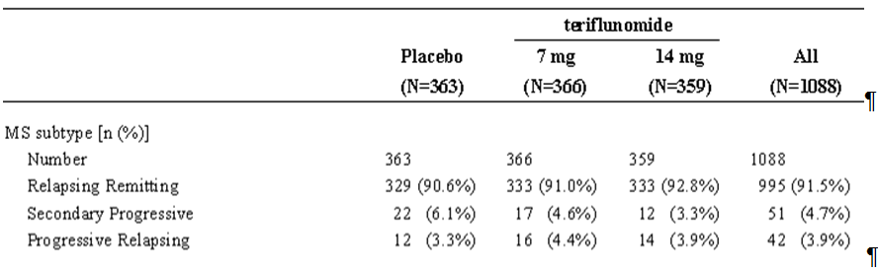

Results for the efficacy outcomes related to reducing the frequency of clinical relapses
In the population of the study:
The adjusted Annual Relapse Rate (ARR) was 0.539 (95% CI: 0.466 to 0.623) in the placebo group, 0.370 (95% CI: 0.318 to 0.432) in the teriflunomide7mg group, and 0.369 (95% CI: 0.308 to 0.441) in the teriflunomide 14mg group. These results corresponded to a relative risk of 68.8% (p = 0.0002) in the teriflunomide7mg group and 68.5% (p = 0.0005) in the teriflunomide 14mg group compared to placebo.
In the PP population, the adjusted ARR was 0.545 (95% CI: 0.471 to 0.631) in the placebo group, 0.367 (95% CI: 0.314 to 0.428) in the teriflunomide7mg group, and 0.366 (95% CI: 0.305 to 0.438) in the teriflunomide 14mg group. These results were also significant for the relative risk vs. placebo in the teriflunomide7mg group (p = 0.0001) and the teriflunomide 14mg group(p = 0.0002).
Using the additional data collected during the follow-up period, the adjusted ARR was 0.505 (95% CI: 0.438 to 0.583) in the placebo group, 0.358 (95% CI: 0.308 to 0.416) in the teriflunomide7mg group, and 0.358 (95% CI: 0.300 to 0.427) in the teriflunomide 14mg group. These results corresponded to a relative risk of 70.9% in both the teriflunomide7mg group (p = 0.0006) and the teriflunomide 14mg (p = 0.0012) group relative to placebo.

Subgroup analysis
The effect of teriflunomide on ARR was, overall, homogeneous in the subgroups analysed. A trend for interaction was observed for the 14mg dose and baseline EDSS grouping, with a quantitatively smaller difference for teriflunomide 14mg vs. placebo in the EDSS > 3.5 stratum as compared to the EDSS ≤ 3.5 stratum (p = 0.0656)

MS subtypes
However when the analysis of subgroups by MS subtypes is reviewed, even when Secondary Progressive and Progressive Relapsing populations are combined: For 14mg teriflunomide the relative risk vs. placebo is 0.985 (95%CI 0.447, 2.172) and for 7mg it is 0.639 (0.317, 1.287) i.e both CIs cross 1. Whereas for the Relapsing Remitting population on 14mg there was a relative risk vs. placebo of 0.661 (95%CI 0.531, 0.824).
Figure 15.1 Summary of multiple sclerosis relapse by all subgroups - intent-to-treat population
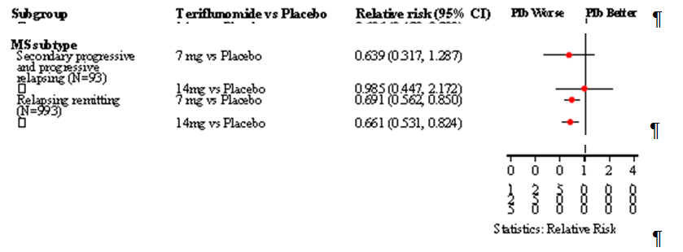

Table 15.2 Analysis of MS relapse by MS subtype - ITT population
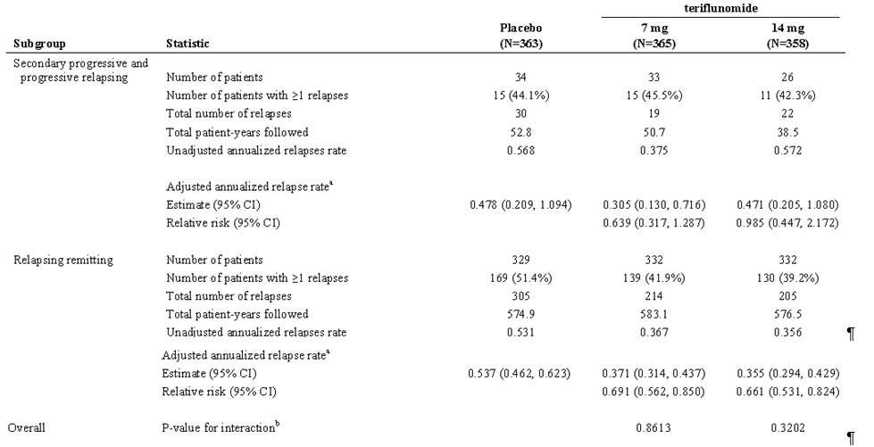
a Derived using Poisson model with the total number of confirmed relapses onset between randomization date and last dose date as the response variable, treatment, EDSS strata at baseline and region as covariates, and log-transformed standardized study duration as an offset variable. b Derived using Poisson model with the total number of confirmed relapses onset between randomization date and last dose date as the response variable, treatment, EDSS strata at baseline, region, MS subtype and treatment by MS subtype interaction as covariates, and log-transformed standardized study duration as an offset variable.

Results for the efficacy outcomes related to delaying the accumulation of physical disability
In the ITT population the time to disability progression was significantly greater (p = 0.0279) for 14mg teriflunomide vs. placebo by log-rank test whereas there was no significant difference (p = 0.0835) for 7mg teriflunomide vs. placebo. (Thus according to the stepdown analysis plan subsequent analyses of the secondary and tertiary endpoints were not supposed to be made – those that were must be considered nominal).
The Kaplan-Meier estimated percentage of patients with 12-week sustained disability progression at Week 108 was placebo 27.3%, teriflunomide7mg 21.7%, and teriflunomide 14mg 20.2%.
According to hazard ratio calculations(ITT) the 14mg teriflunomide reduced the probability of disability progression by 29.8% vs. placebo while the 7mg teriflunomide reduced the probability by 23.7% vs. placebo.
Analysis of the PP population produced supportive results for 14mg (p = 0.258; HR 0.699 CIs 0.502, 0.972).
Of the other disability progression (variables) analyses:
The analysis of time to disability progression sustained for 24 weeks in the PP population and the sensitivity analysis of time to disability progression sustained for 24 weeks in the ITT showed no statistically significant treatment difference from placebo.
Change from baseline in Expanded Disability Status Score showed no statistically significant treatment differences compared to placebo at Week 108
Proportion of patients free of disability progression was not assessed and analysed separately from patients with disease progression.

Subgroup analysis
The effect of teriflunomide on disability progression was, overall, homogeneous in the subgroups analysed. A trend for interaction was observed for the7mg and 14mg doses and baseline EDSS grouping, with a quantitatively larger difference vs. placebo in the EDSS >3.5 stratum as compared to the EDSS ≤ 3.5 stratum (respectively p = 0.0921 and p = 0.0670).

MS subtypes
However when the analysis of subgroups by MS subtypes is reviewed, even when Secondary Progressive and Progressive Relapsing populations are combined: For 14mg teriflunomide the Hazard Ratio vs. placebo is 0.489 (95%CI 0.128, 1.868) and for 7mg it is 0.371 (0.096, 1.438) i.e. both CIs overlap 1. While for Relapsing Remitting population on 14mg teriflunomide the Hazard Ratio vs. placebo is 0.721 (0.514, 1.011) i.e. the CIs also include1.
Figure 15.2 Summary of time to disability progression sustained for 12 weeks by all subgroups – ITT
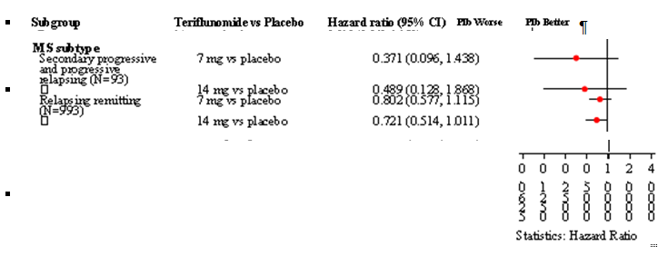

Table 15.3. Analysis of time to disability progression sustained for 12 weeks by MS subtype – ITT
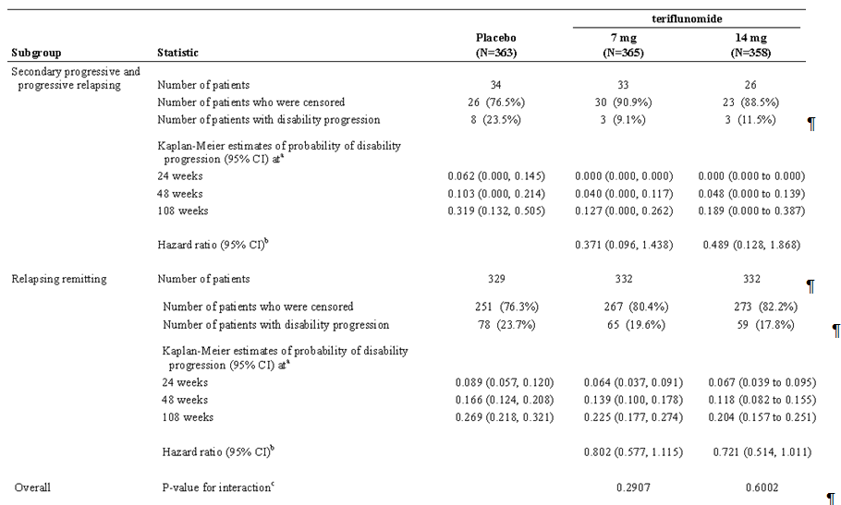
Note: The time-to-event variable is defined as the time (days) from the date of randomization to the date of the first disability progression. For patients who have no disability progression on or before last during treatment EDSS evaluation, it will be censored at the date of last during-treatment EDSS evaluation. a Derived from Kaplan-Meier estimates. b Derived using Cox proportional hazard model with treatment, EDSS strata at baseline and region as covariates. c Derived from Cox proportional hazard model with treatment, EDSS strata at baseline and region, MS subtype and treatment by MS subtype as covariates

Study 6050 (An extension of 6049)

Inclusion and exclusion criteria
As for study 6049.

Baseline data
Only 10 out of 361 (2.8%) receiving teriflunomide 14mg had Progressive Relapsing MS.
Table 15.4 Baseline disease characteristics - Randomized population
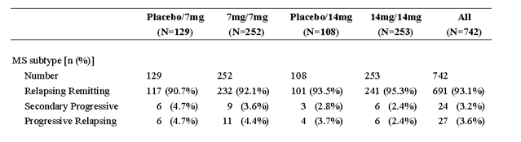

Results for the efficacy outcomes
Subgroup analyses relating to subtype were not submitted.

Other efficacy studies – 2001

Inclusion criteria were those of the proposed Indication population:
Clinically definite MS with at least 2 documented relapses as defined by the Poser criteria. The disease course for each subject was to be defined on the basis of the initial episode, subsequent relapses, and progress assessed by review of clinical history and neurological examinations.
However the population included no patients with Progressive Relapsing MS.
Table 15.5. Baseline disease characteristics - Randomized population
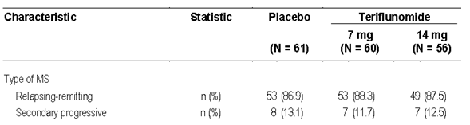

Results
This was a Phase II exploratory study with multiple end points including clinical ones. The Primary endpoint was MRI based - the average number of unique active lesions per MRI scan.
The total number of subjects was small, there was no statistical difference in the number without relapse at the end of the treatment period (36weeks). 23/61 (37.7%) of placebo patients, 21/60 (35.0%) of teriflunomide 7mg and 13/56 (23.2%) patients on 14mg teriflunomide had ≥ 1 relapse during the study period giving a mean ARR for placebo of 0.81 ± 1.224 (SD); teriflunomide 7mg of 0.58 ± 0.850; and for teriflunomide 14mg of 0.55 ±1.122.
The numbers of subjects showing progression in neurological functional impairment (Defined as an increase in EDSS score of at least 1 point for subjects with a baseline score . 5.5 or an increase of at least 0.05 points for subjects with a baseline score of >5.5.) were significantly lower in the 14mg teriflunomide group than in the placebo group: 4 (7.4%) vs. 13 (21.3%), p = 0.0397. There were no differences in the number of subjects who had progressed between 7mg teriflunomide and placebo: 17 (28.8%) vs. 13 (21.3%), p = 0.3355.

Subgroup analysis
The only subgroup analysis was for the primary variable.

Table 15.6. Subjects with progression in EDSS (efficacy evaluable population)
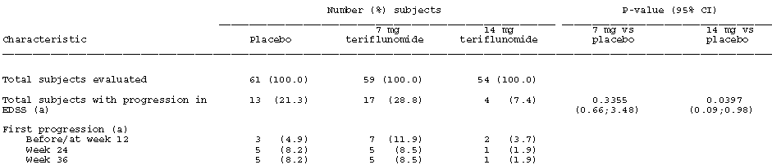
(a) Progression was defined as an increase in EDSS score by at least 1 in subjects with baseline score <= 5.5 or by at least 0.5 in subjects with baseline score > 5.5.
NOTE: The number of subjects with progression was analysed by Cochran-Mantel-Haenzel test controlling for center and the 95% CI for the odds ratio.
Table 15.7. Average number of unique active lesions per scan by diagnosis, summary statistics (Efficacy Evaluable population)
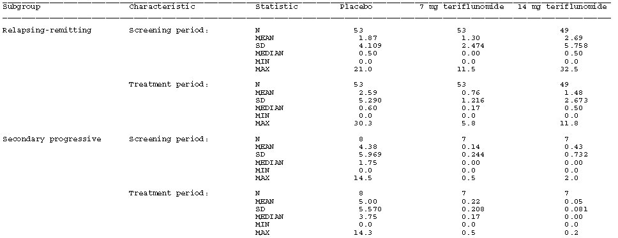
Table 15.8. Average number of unique active lesions per scan (efficacy evaluable population) Stratified by diagnosis (Relapsing Remitting vs. Secondary Progressive) ANCOVA results
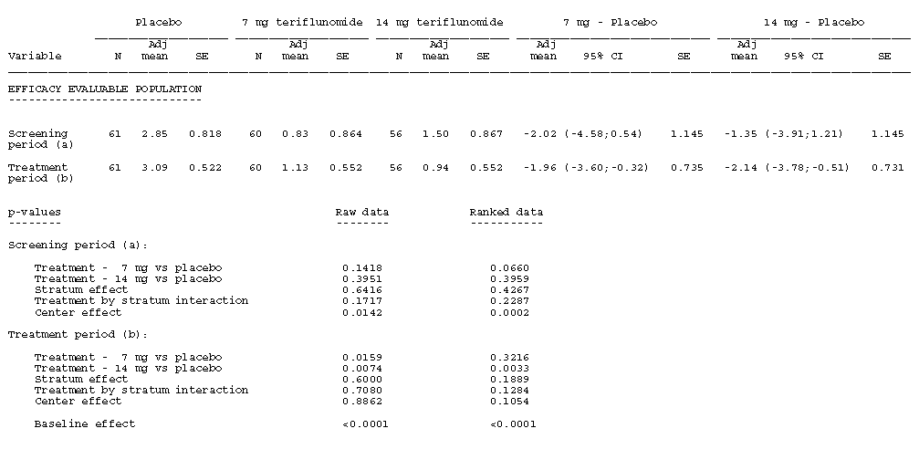
(a) The ANOVA model includes treatment, stratum, treatment by stratum interaction, and center as fixed effects.
(b) The ANCOVA model includes treatment, stratum, treatment by stratum interaction, and center as fixed effects and the number of unique active lesions at baseline as covariate.
Note: Adjustment for multiple comparisons between treatment groups according to Dunnett.

Evaluator’s conclusions on population for which clinical efficacy was shown
- Efficacy for the proposed population for the proposed Indications was not shown. The inclusion criteria for the pivotal study 6049 and the actual population enrolled were restricted to Relapsing Remitting, Secondary Progressive and Progressive Relapsing MS patients, and while the inclusion criteria in study 2001 matched that of the proposed Indication, the population enrolled included only Relapsing Remitting and Secondary Progressive MS.
- In the pivotal study 6049 efficacy was shown for teriflunomide 14mg in the study population for reducing the frequency of clinical relapses but not delaying the accumulation of physical disability. However subgroup analysis showed that teriflunomide 14mg was effective vs. placebo in reducing the frequency of clinical relapses only in Relapsing Remitting MS patients, it was not effective in Secondary Progressive and Progressive Relapsing patients.
- Subgroup analysis in study 6049 failed to show efficacy for teriflunomide 14mg in Secondary Progressive and Progressive Relapsing patients for delaying the accumulation of physical disability (as measured by the time to disability progression) with CIs for the Hazard Ratio vs. placebo including 1. The same was true of the Relapsing Remitting MS subgroup.
- Phase II exploratory study 2001 although showing a trend, at 36 weeks failed to show significant efficacy in reducing the frequency of clinical relapses in the population of Relapsing Remitting and Secondary Progressive MS patients. The study did show efficacy in delaying the accumulation of physical disability as measured by progression in neurological functional impairment however the numbers in the study were small.
Overall conclusion: The evaluator concludes that :
- The efficacy of teriflunomide 14mg as monotherapy has been shown to the level required by a single pivotal study for the treatment of patients with Relapsing Remitting MS to reduce the frequency of clinical relapses.
- The efficacy of teriflunomide 14mg as monotherapy has not been sufficiently shown to the level required by a single pivotal study for the treatment of any patient population with MS to delay the accumulation of physical disability.
The relevant guideline has 2 statements relevant to these observations under 2.3.1 Relapsing multiple sclerosis:
- Prevention and/or modification of relapse features as well as prevention or delay of the accumulation of disability as sequelae of acute relapses, are meaningful goals in the treatment of RMS.
- It is therefore accepted that the indication in relapsing MS will mainly rely on the effects shown in patients with relapsing remitting MS and that an effect on relapses in relapsing remitting MS may be extrapolated to an effect on relapses in secondary progressive MS.
Accordingly the evaluator considers that the available data supports the Indication of:
Monotherapy for the treatment of patients with Relapsing Remitting Multiple Sclerosis and Secondary Progressive Multiple Sclerosis to reduce the frequency of clinical relapses

Further benefit-risk assessment

Further assessment of benefits
The benefits of teriflunomide in the treatment of patients with Relapsing Remitting Multiple Sclerosis and Secondary Progressive Multiple Sclerosis are:
- Monotherapy - To Reduce the Frequency of Clinical Relapse: the evaluator believes this has been adequately demonstrated.
Benefit of teriflunomide in any population was not shown for:
- Monotherapy - To Delay the Accumulation of Physical Disability: In the pivotal study 6049 the evaluator believes that the level of significance required of a single pivotal study for efficacy when assessed in the key (secondary) efficacy variable, together with the results of the supporting variables was not met as required by CPMP/EWP/2330/98 Points to Consider on Application with 1. Meta-Analyses; 2. One Pivotal Study.

Further assessment of risks
There was no addition to be made to this First round assessment of risks:
The risks of teriflunomide in the treatment of patients with Relapsing Remitting Multiple Sclerosis and Secondary Progressive Multiple Sclerosis are:
- Apparently broadly similar to those of leflunomide with the exception of the risk of diarrhoea and vomiting, and effects on uric acid and phosphorus.
There does not appear to be an increased risk of rarer events compared with leflunomide, however ongoing monitoring of patients for hepatic, pancreatic and haematologic function as well as blood pressure is recommended.

Further assessment of benefit-risk balance
The benefit-risk balance of teriflunomide is favourable for Monotherapy in the treatment of patients with Relapsing Remitting Multiple Sclerosis and Secondary Progressive Multiple Sclerosis To Reduce the Frequency of Clinical Relapse: the evaluator believes this has been adequately demonstrated, and the risks are similar to those seen in rheumatoid arthritis with leflunomide.
However the evaluator believes the benefit-risk balance of teriflunomide for Monotherapy - To Delay the Accumulation of Physical Disability is unfavourable in any of the populations considered.

Further recommendation regarding authorisation
It is recommended that teriflunomide be registered for:
Aubagio is indicated as monotherapy for the treatment of patients with Relapsing Remitting Multiple Sclerosis and Secondary Progressive Multiple Sclerosis to reduce the frequency of clinical relapses
If Delegates accepts the above review of populations then the following further revision is recommended to the Indications section of the proposed PI.

Indications
- Aubagio is indicated as monotherapy for the treatment of patients with relapsing forms of multiple sclerosis Relapsing Remitting Multiple Sclerosis and Secondary Progressive Multiple Sclerosis to reduce the frequency of clinical relapses and to delay the accumulation of physical disability.
Comment: The submission was only for monotherapy. Should the Delegate approve registration it is recommended that the above be modified accordingly. The deletion of the Indication of delaying the accumulation of physical disability is consistent with the evaluator’s findings in the above review.

4.2.7 Change of details after pre-submission: If it appears that the scope and/or scale of the application as described in the submission dossier is greater than that described in the pre-submission planning form there is a risk that the submission will be considered to be not effective. If the sponsor wanted to proceed with the application, a new pre-submission planning form would need to be lodged with new submission dates. Examples of changes that are not likely to be acceptable include:· a significant change of proposed indication or addition of an indication: Transitional prescription medicine streamlined submission process V1.5 January 2011
The term relapsing MS (RMS) applies to those patients either with a RRMS form or a SPMS form that are suffering relapses CPMP/EWP/561/98 Rev 1 Guideline on clinical investigation of Medicinal Products for the Treatment of Multiple Sclerosis (Adopted by TGA 10 January 2002) 1. Introduction
CPMP/EWP/561/98 Rev 1 Guideline on clinical investigation of Medicinal Products for the Treatment of Multiple Sclerosis (Adopted by TGA 10 January 2002) 1. Introduction
CPMP/EWP/561/98 Rev 1. Guideline on clinical investigation of Medicinal Products for the Treatment of Multiple Sclerosis
Confirmatory trials .Two years is considered the minimum duration to demonstrate efficacy. CPMP/EWP/561/98 Rev 1 Guideline on clinical investigation of Medicinal Products for the Treatment of Multiple Sclerosis
70mg for 4 days followed by 14mg once daily for 8 days – study TES10852
Erratum. The correct study is ALI3625
Phase 1 studies (Studies 1001, INT6039, BEX6038, 1024) and one Phase 2 study in MS patients (Study 2001/LTS6048).
Summary of Clinical Pharmacology Studies Page 80 Analysis combining data from studies BDR6639 and BEQ10169 - not submitted.
Based on the PopPK analysis of teriflunomide in healthy subjects and MS patients, Study POH0290
Child-Pugh total score from 5 to 6
Child-Pugh total score from 7 to 9
A CYP2B6, 2C8, 2C9, 2C19, 3A inducer, as well as an inducer of P-gp, and BCRP
amobarbital, carbamazepine, dexamethasone, efavirenz, isoniazid, modafinil, nevirapine, norethindrone, omeprazole, oxcarbamazepine, phenobarbital, phenytoin, pioglitazone, prednisone, prednisolone, primidone, rifabutin, rifampin, rifapentin, ritonavir, secobarbital, St John’s wort, and troglitazone
70mg QD for 4 days and 14mg QD for 8 days
70mg QD for 3 days and 14mg QD for 11 days
70mg QD for 4 days and 14mg QD for 10 days
70mg QD for 4 days, followed by 14mg QD for 9 days
70mg QD for 4 days, followed by 14mg QD for 10 days
Minutes from the 64th (1999/1) meeting of the pharmaceutical subcommittee (PSC) 27 January 1999
2.7.2 Summary of Clinical Pharmacology Studies; 3.1.6 Steady state - accumulation ratio; Page 79
carbamazepine, phenobarbital, phenytoin, and St John’s Wort.
Arava PI.
Erratum. The correct value is 147.
CPMP/EWP/561/98 Rev 1. Guideline on clinical investigation of Medicinal Products for the Treatment of Multiple Sclerosis 2.1 Different goals of treatments.
CPMP/EWP/561/98 Rev 1 Preventing or modifying relapses. It is not clear to what extent the effect on relapses is related to the prevention or delay in the long-term accumulation of disability, which is considered a more clinically relevant effect. In SPMS patients, a claim of an effect on disability should be demonstrated in patients without superimposed relapses in case the product has activity against relapses.
CPMP/EWP/561/98 Rev 13.2.1 Primary efficacy parameters. The most relevant parameter in MS is the accumulation of disability.
defined as the number of confirmed relapses per patient-year.
defined as “the date of first relapse – randomization date +1,” i.e., day 1 was the randomization day. A patient with no relapse before treatment discontinuation/completion was considered free of relapse until the date of treatment discontinuation/completion. Their data was censored after this date. For analysis purposes, the time to first confirmed relapse was derived.
Both the Study Report and the protocol list safety as the primary objective but they both then list as Primary efficacy variable the time to (first) disability progression sustained for at least 12 weeks, with a string of secondary efficacy variables
defined as the time to at least 1 point increase on EDSS score from baseline (if the baseline EDSS score was ≤ 5.5) or time to at least 0.5 point increase on EDSS score from baseline (if the baseline EDSS score was >5.5) and this increase in EDSS score was to be persistent for at least 12 weeks.
assessed by cerebral MRI, and was defined as the total volume of all abnormal brain tissue (calculated as the sum of the total volume of T2 lesion component and T1 hypointense lesion component).
The Z4 composite score integrates quantitative measures of 4 parameters: the volume of Gd-enhancing T1 lesions, the BOD, the volume of hypointense post-Gd T1 lesions, and the proportion of total intracranial contents segmented as cerebrospinal fluid. It is defined as the sum of individual Z scores derived from each of these 4 parameters.
Disability progression is defined as at least 1 point increase on EDSS from baseline if baseline EDSS ≤5.5 or at least 0.5 point increase on EDSS from baseline if baseline EDSS >5.5, which has to be confirmed to be persistent for at least 12 weeks.
Accurate and reliable definition of sustained worsening is important and should include two consecutive examinations carried out by the same physician at least 6 months apart. CPMP/EWP/561/98 Rev 1
Erratum. The correct value is 0.0258.
To strongly control Type-I error rate, a step down testing procedure was applied in the order specified. Each hypothesis was to be formally tested only if the preceding one was significant at 5% level.
So far, the correlation between Magnetic Resonance Imaging and clinical outcomes has not proved to be strong enough as to accept it as a validated surrogate endpoint in pivotal studies. In exploratory trials, however, changes in MRI findings may be used as a first indication of dealing with a potentially clinically effective product. CPMP/EWP/561/98 Rev 1
The total number of Gd-enhancing T1-lesion that occurred during the study divided by the total number of scans during the study.
The total volume of all abnormal brain tissue
Both the Study Report and the protocol list safety as the primary objective but they both then list as Primary efficacy variable the time to (first) disability progression sustained for at least 12 weeks, with a string of secondary efficacy variables
Calculated as the sum of unique newly active lesions and of unique persistently active lesions for all scans divided by the number of scans on which the sum was based. This average is based on all scans performed during the treatment period
excluding EDSS assessments made to qualify relapses (and change from baseline to weeks 12, 24, and 36 for the completer population only)
Progression is defined as an increase in EDSS score by at least 1 point in subjects with baseline EDSS score .≤ 5.5 or an increase in EDSS score by at least a half (0.5) point in subjects with a baseline EDSS score > 5.5.
All randomized subjects for whom there was at least 1 on-treatment MRI assessment.
Only the data of study, EFC6049-TEMSO, were taking into account for the evaluation of the efficacy variables
CPMP/EWP/2330/98 Points to Consider on Application with 1. Meta-Analyses; 2. One Pivotal Study
The proposed indication has not changed significantly and continues to reflect the patient population in the pivotal trial. Module 1 1.8.3 Compliance with Pre-Submission Planning Form and Planning Letter Table 2
CPMP/EWP/561/98 Rev 1 Guideline on clinical investigation of Medicinal Products for the Treatment of Multiple Sclerosis 1. Introduction The term relapsing MS (RMS) applies to those patients either with a RRMS form or a SPMS form that are suffering relapses 2.3.1The term relapsing MS includes 1) patients with RRMS, 2) patients with SPMS and superimposed relapses and 3) patients with a single demyelinating clinical event who show lesion dissemination on subsequent MRI scans according to McDonald’s criteria.
Teriflunomide has been developed as disease modifying therapy with the following objectives: • To demonstrate that teriflunomide as monotherapy reduces the frequency of clinical exacerbations and delays the accumulation of physical disability in patients with relapsing MS • To demonstrate that teriflunomide as monotherapy reduces conversion of patients presenting with their first clinical episode consistent with MS (CIS) to clinically definite MS
This Indication is in the Letter of Application, the Application form and in Module 1 1.8.3 Compliance with Pre-Submission Planning Form and Planning Letter Table 2 says The proposed indication stated in Part 1Sections 1.2 and 1.4 of the presubmission planning form reflects that included in Attachment 1 of the planning letter. However as error was noted in the draft PI version submitted with the PPF, which has been corrected in the final version.
The adjusted ARR was 0.539 (95% CI: 0.466 to 0.623) in the placebo group, 0.370 (95% CI: 0.318 to 0.432) in the teriflunomide7mg group, and 0.369 (95% CI: 0.308 to 0.441) in the teriflunomide 14mg group. These results corresponded to a relative risk reduction of 31.2% (p = 0.0002) in the teriflunomide7mg group and 31.5% (p = 0.0005) in the teriflunomide 14mg group compared to placebo.
The adjusted ARR was 0.251 (95% CI: 0.188 to 0.334) in the placebo /7mg group, 0.182 (95% CI: 0.130 to 0.254) in the placebo /14mg group, 0.234 (95% CI: 0.186 to 0.295) in the teriflunomide7mg group, and 0.206 (95% CI: 0.163 to 0.261) in the teriflunomide 14mg group.
2 participants in 6050 were randomised but not treated.
In exploratory trials in RMS, the use of MRI derived parameters, as the main endpoint, is acceptable. Usually, studies will have a parallel double blind design and duration of 6 month may be adequate. Relapses and other clinically meaningful outcomes should also be evaluated.
From log-rank test with stratification of EDSS strata at baseline and region.
CPMP/EWP/561/98 Rev 1 Guideline on clinical investigation of Medicinal Products for the Treatment of Multiple Sclerosis
While submission of this data to the TGA was discussed, it is agreed to submit the complete study report as a condition of registration, not an interim analysis Minutes TGA Pre-submission Meeting 22 July 2011.
Frequency ≥ 10%, more frequent on both teriflunomide doses [difference.1%] than on placebo and with a difference of ≥ 1% between both teriflunomide doses
This data was updated to 1 June 2011 with 24 new SAEs and 4 new SUSARs (treatment groups not given) Summary of Clinical Safety Page 67.
Which is quoted in italics at the start of each section.
It is anticipated that the total number of individuals treated with the investigational drug, including short-term exposure, will be about 1500. pp. 121 - 125 of Rules 1998 (3C) - 3CC5a The Extent of Population Exposure to Assess Clinical Safety for Medicines Intended for Long-Term Treatment of Non-Life-Threatening Conditions
The safety evaluation during clinical product development is not expected to characterise rare adverse events, for example, those occurring in less than 1 in 1000 patients. pp. 121 - 125 of Rules 1998 (3C) - 3CC5a The Extent of Population Exposure to Assess Clinical Safety for Medicines Intended for Long-Term Treatment of Non-Life-Threatening Conditions
For some of these a casual relationship with leflunomide treatment could not be established, but cannot be excluded, Leflunomide PI.
Minutes of the 207th meeting of 2-3 December 1999 Resolution no 7802
Protocol Amendment 2 read: Exhibiting a relapsing clinical course, with or without progression (relapsing remitting, secondary progressive, or progressive relapsing)
defined as the number of confirmed relapses per patient-year.
defined as “the date of first relapse – randomization date +1,” i.e., day 1 was the randomization day. A patient with no relapse before treatment discontinuation/completion was considered free of relapse until the date of treatment discontinuation/completion. Their data was censored after this date. For analysis purposes, the time to first confirmed relapse was derived.
CPMP/EWP/561/98 Rev 1 Guideline on clinical investigation of Medicinal Products for the Treatment of MS
This was the population was in the presubmission PI but retracted in the submission as an error.

