First Round November 2014
Second Round February 2015

AusPAR Attachment 2

Extract from the Clinical Evaluation Report for: Tenofovir disoproxil fumarate / Emtricitabine / Elvitegravir / Cobicistat
  - Proprietary Product Name: Stribild
  - Sponsor: Gilead Sciences Pty Ltd

About the Therapeutic Goods Administration (TGA)
- The Therapeutic Goods Administration (TGA) is part of the Australian Government Department of Health, and is responsible for regulating medicines and medical devices.
- The TGA administers the Therapeutic Goods Act 1989 (the Act), applying a risk management approach designed to ensure therapeutic goods supplied in Australia meet acceptable standards of quality, safety and efficacy (performance), when necessary.
- The work of the TGA is based on applying scientific and clinical expertise to decision-making, to ensure that the benefits to consumers outweigh any risks associated with the use of medicines and medical devices.
- The TGA relies on the public, healthcare professionals and industry to report problems with medicines or medical devices. TGA investigates reports received by it to determine any necessary regulatory action.
- To report a problem with a medicine or medical device, please see the information on the TGA website <https://www.tga.gov.au>.
About the Extract from the Clinical Evaluation Report
- This document provides a more detailed evaluation of the clinical findings, extracted from the Clinical Evaluation Report (CER) prepared by the TGA. This extract does not include sections from the CER regarding product documentation or post market activities.
- The words [Information redacted], where they appear in this document, indicate that confidential information has been deleted.
- For the most recent Product Information (PI), please refer to the TGA website <https://www.tga.gov.au/product-information-pi>.
Copyright
© Commonwealth of Australia 2017
This work is copyright. You may reproduce the whole or part of this work in unaltered form for your own personal use or, if you are part of an organisation, for internal use within your organisation, but only if you or your organisation do not use the reproduction for any commercial purpose and retain this copyright notice and all disclaimer notices as part of that reproduction. Apart from rights to use as permitted by the Copyright Act 1968 or allowed by this copyright notice, all other rights are reserved and you are not allowed to reproduce the whole or any part of this work in any way (electronic or otherwise) without first being given specific written permission from the Commonwealth to do so. Requests and inquiries concerning reproduction and rights are to be sent to the TGA Copyright Officer, Therapeutic Goods Administration, PO Box 100, Woden ACT 2606 or emailed to <tga.copyright@tga.gov.au>.

Contents
List of abbreviations 4
1. Introduction 9
2. Clinical rationale 9
3. Contents of the clinical dossier 9
3.1. Scope of the clinical dossier 9
3.2. Good clinical practice 10
4. Pharmacokinetics 10
4.1. GS-US-236-0135 Pharmacokinetic drug interaction study 10
4.2. Evaluator’s conclusion on pharmacokinetics 22
5. Pharmacodynamics 22
6. Dosage selection for the pivotal studies 22
7. Clinical efficacy 22
7.1. GS-US-236-0102 23
7.2. GS-US-236-0103 31
7.3. GS-US-236-0115 39
7.4. GS-US-236-0121 48
7.5. GS-US-236-0123 57
7.6. Evaluator’s conclusions on efficacy 60
8. Clinical safety 60
8.1. GS-US-236-0118 61
8.2. GS-US-236-0102 69
8.3. GS-US-236-0103 75
8.4. GS-US-236-0115 79
8.5. GS-US-236-0121 83
8.6. GS-US-236-0123 86
8.7. Evaluator’s conclusion on safety 88
9. First round benefit-risk assessment 90
9.1. First round assessment of benefits 90
9.2. First round assessment of risks 90
9.3. First round assessment of benefit-risk balance 91
10. First round recommendation regarding authorisation 91
11. Clinical questions 91
12. Second round evaluation of clinical data submitted in response to questions 91

List of abbreviations
Abbreviation | Meaning
AE | adverse event
aGFR | actual GFR
ALT | alanine aminotransferase
ANOVA | analysis of variance
ARV | antiretroviral
AST | aspartate aminotransferase
ATR | Atripla: EFV/FTC/TDF
ATV | atazanavir
ATV/r | ritonavir boosted atazanavir
BMD | bone mineral density
BMI | body mass index
CD4 | cluster determinant 4
CG | Cockcroft-Gault
CI | confidence interval
CLiohexol | iohexol plasma clearance
CMH | Cochran-Mantel-Haenszel
CMI | consumer medicine information
COBI | cobicistat; GS-9350
CPK | creatine phosphokinase
CSR | clinical study report
CYP | cytochrome P450
CysC | cystatin C
DRV | darunavir
EFV | efavirenz
EFV/FTC/TDF | efavirenz/emtricitabine/tenofovir disoproxil fumarate; Atripla
eGFR | estimated glomerular filtration rate
eGFR_{CG} | estimated glomerular filtration rate calculated using the Cockcroft-Gault method
eGFR_{MDRD} | estimated glomerular filtration rate calculated using the Modification of Diet in Renal Disease method
EU | European Union
EVG | elvitegravir
EVG/COBI/FTC/TDF | elvitegravir/cobicistat/emtricitabine/tenofovir disoproxil fumarate; Stribild; STB
FAS | Full Analysis Set
FEPO₄ | fractional excretion of phosphate
FTC | emtricitabine
FTC/RPV/TDF | emtricitabine/rilpivirine/tenofovir disoproxil fumarate; Complera/Eviplera
FTC/TDF | emtricitabine/tenofovir disoproxil fumarate; Truvada
GFR | glomerular filtration rate
GGT | gamma glutamyltransferase
HBsAg | Hepatitis B surface antigen
HCVAb | Hepatitis C virus antibody
HDL | High density lipoprotein
HIV-1 | human immunodeficiency virus (type 1)
HLT | higher level term
INSTI | integrase strand-transfer inhibitor
INSTI-R | integrase strand-transfer inhibitor resistance
ITT | Intent to treat
IVRS/IWRS | interactive voice response system/interactive web response system
KM | Kaplan-Meier
LDL | Low density lipoprotein
LOCF | last observation carried forward
LPV | Lopinavir
LSM | least-squares means
M = E | missing equals excluded
M = F | missing equals failure
MDRD | Modification of Diet in Renal Disease
MH | Mantel-Haenszel
NNRTI | nonnucleoside reverse transcriptase inhibitor
NNRTI-R | nonnucleoside reverse transcriptase inhibitor resistance
NRTI | nucleoside or nucleotide reverse transcriptase inhibitor
NRTI-R | nucleoside or nucleotide reverse transcriptase inhibitor resistance
NVP | nevirapine
PD | pharmacodynamic
PI | product information
PIn | protease inhibitor
PI-R | protease inhibitor resistance
PK | pharmacokinetic(s)
PPS | per protocol set
PR | protease
PROs | patient reported outcomes
PRT | proximal renal tubulopathy
PT | preferred term
PVF | pure virologic failure
PVR | pure virologic response
R | reference
RAL | raltegravir
RAP | resistance analysis population
RNA | ribonucleic acid
RPV | rilpivirine
RT | reverse transcriptase
RTV | ritonavir
SAE | serious adverse event
SAS | safety analysis set
SBR | staying on a baseline regimen
Scr | serum creatinine
SD | standard deviation
SOC | system organ class
STB | elvitegravir/cobicistat/emtricitabine/tenofovir /disoproxil fumarate; Stribild
STR | Single tablet regimen
T | test
TDF | tenofovir disoproxil fumarate; tenofovir DF; Viread
TFV | tenofovir
TLOVR | time to loss of virologic response
TOC | table of contents
TVR | telaprevir
UK | United Kingdom
ULN | upper limit of normal
US | United States

Introduction
This is a Category 1 application to extend the indications and make changes to the Product Information (PI) and Consumer Medicine Information (CMI).
The following indications were stated in the PI dated June 2014:
Stribild is indicated as a single tablet regimen for the treatment of HIV infection in treatment naïve adults.
Stribild is a fixed dose combination of one integrase inhibitor, one pharmacokinetic enhancer and two nucleos(t)ide HIV-1 reverse transcriptase inhibitors.
Stribild is available as tablets. Each tablet contains 300 mg tenofovir DF (which is equivalent to 245 mg of tenofovir disoproxil), 200 mg emtricitabine (FTC), 150 mg of elvitegravir (EVG) and 150 mg of cobicistat (COBI). The tablets are film coated, capsule shaped and green in colour. Each tablet is debossed with ‘GSI’ on one side and the number ‘1’ surrounded by a square box on the other side.
There is a proposed change to the indications for use to include use in adults with no known mutations associated with resistance to any of the Stribild components. The additional included text is in bold as follows:
Stribild is indicated as a single tablet regimen for the treatment of HIV infection in treatment naïve adults or adults who have no known mutations associated with resistance to the individual components of Stribild.
Other proposed changes are:
- Inclusion of results from further analyses of the pivotal Phase III studies evaluated for initial registration of Stribild with Week 144 efficacy, resistance, and safety data.
- Inclusion of study results from data provided in this submission to support updates to:
  - The current approved indication to include the use of Stribild in patients who have no known mutations associated with resistance to the individual components of Stribild.
  - The adverse effects section with the addition of 48 week efficacy, resistance, and safety data in HIV-1 infected treatment naïve patients with mild to moderate renal impairment.
  - The pharmacokinetics (PK) section with the addition of drug-drug interaction data from a Phase I study investigating potential interactions with telaprevir (TVR).
There are also minor proposed changes to the CMI.

Clinical rationale

Contents of the clinical dossier

Scope of the clinical dossier
Clinical Study Report (CSR) of Extrinsic Factor PK Study x 1;
Reports of Efficacy and Safety Studies:
- CSRs of Controlled Clinical Studies Pertinent to the Claimed Indication x 4
- CSRs of Uncontrolled Clinical Studies x 2
- Reports of Analyses of Data from More than One Study: Integrated Summary of Safety, Integrated Summary of Efficacy
- Other Study Reports: Integrated Virology Summary Report for Studies GS-US-236-0102 and GS-US-236-0103).
The information provided is adequate to undertake the evaluation. It is noted that the clinical expert is an employee of Gilead Sciences Pty Ltd.

Good clinical practice
It is stated in the CSRs that the studies were undertaken in accordance with good clinical practice.

Pharmacokinetics

GS-US-236-0135 Pharmacokinetic drug interaction study

Study design, objectives, locations and dates
This was a randomised, open label, multiple dose, two part, multiple cohort study. Part 1 assessed the PK and drug interaction potential of TVR and elvitegravir/cobicistat /emtricitabine/tenofovir disoproxil fumarate (Stribild: STB). Part 2 assessed the PK and drug interaction of TVR and ritonavir (RTV) boosted atazanavir (ATV/r) + EVG. It was conducted at one site in the United States (US) between January and March 2013.
The primary objectives were:
- Part 1: To evaluate the PK of TVR and EVG after co-administration of TVR and STB relative to the administration of TVR or STB alone
- Part 2:
  - Cohort 1: to evaluate the PK of TVR and ATV after co-administration of TVR and ATV/r)+EVG 85 mg relative to the administration of TVR or ATV/r alone;
  - Cohort 2: to evaluate the PK of EVG after co-administration of TVR and ATV/r+ EVG 85 mg relative to the administration of ATV/r+ EVG 85 mg or EVG 150 mg /r alone
The secondary objectives were:
- Part 1: To evaluate the PK of COBI, (FTC), and tenofovir (TFV) after co-administration of TVR and STB relative to the administration of STB alone
- Part 2: To evaluate the PK of ATV after co-administration of TVR and ATV/r+ EVG 85 mg relative to the administration of ATV/r+ EVG 85 mg alone: Cohort 2.
The secondary objectives also included assessment of safety. These are not relevant to the proposed PI change and hence are not presented in this report.

Main inclusion criteria
Healthy males and non-pregnant, non-lactating females, 18 to 45 years old, with a body mass index (BMI) from 19 to 30 kg/m², and an estimated glomerular filtration rate (eGFR) ≥ 90 mL/min.

Study treatments
The study treatments for Parts 1 and 2 were administered with food for 10 days as follows:
- Treatment A: 2 x 375 mg of TVR 3 times daily plus 1 x STB tablet once daily
- Treatment B: 1 x STB tablet once daily
- Treatment C: 2 x 375 mg of TVR 3 times daily
- Treatment D: 2 x 375 mg of TVR 3 times daily plus 1 x 300 mg of ATV, 1 x 100 mg of RTV, and 1 x EVG 85 mg all given once daily
- Treatment E: 1 x 300 mg of ATV plus 1 x 100 mg of RTV both once daily
- Treatment F: 1 x 150 mg of EVG plus 1 x 100 mg of RTV both once daily
- Treatment G: 1 x 300 mg of ATV plus 1 x 100 mg of RTV plus 1 x EVG 85 mg all once daily
In Part 1, subjects received STB+TVR (Treatment A), STB (Treatment B), and TVR (Treatment C) each for 10 days in a 3 period, fixed sequence design. This is shown in Figure 1.
Figure 1: GS-US-236-0135: Part 1 study schema
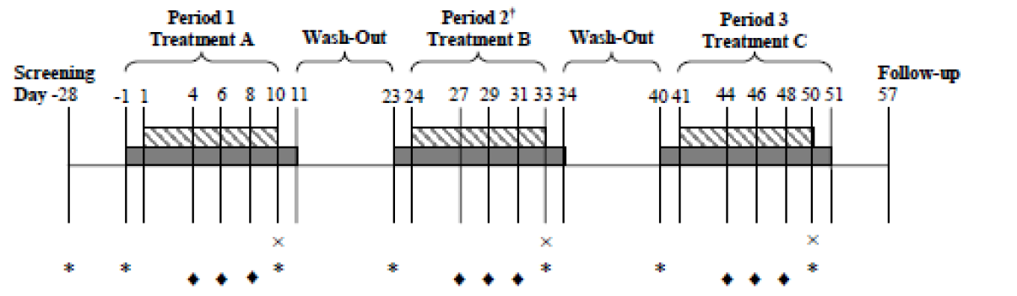
In Part 2, Cohort 1 subjects received TVR + ATV/r + EVG 85 mg (Treatment D) for 10 days followed by a washout of no less than 13 days. Subjects then received 10 days of either ATV/r (Treatment E, Sequence 1) or TVR (Treatment C, Sequence 2). Cohort 2 subjects received 150 mg of EVG/r (Treatment F) for 10 days in Period 1, then received ATV/r + EVG 85 mg (Treatment G) and TVR + ATV/r + EVG 85 mg (Treatment D) each for 10 days in a sequential manner in Periods 2 and 3. This is shown in Figure 2.
Figure 2: GS-US-236-0135: Part 2 study schema
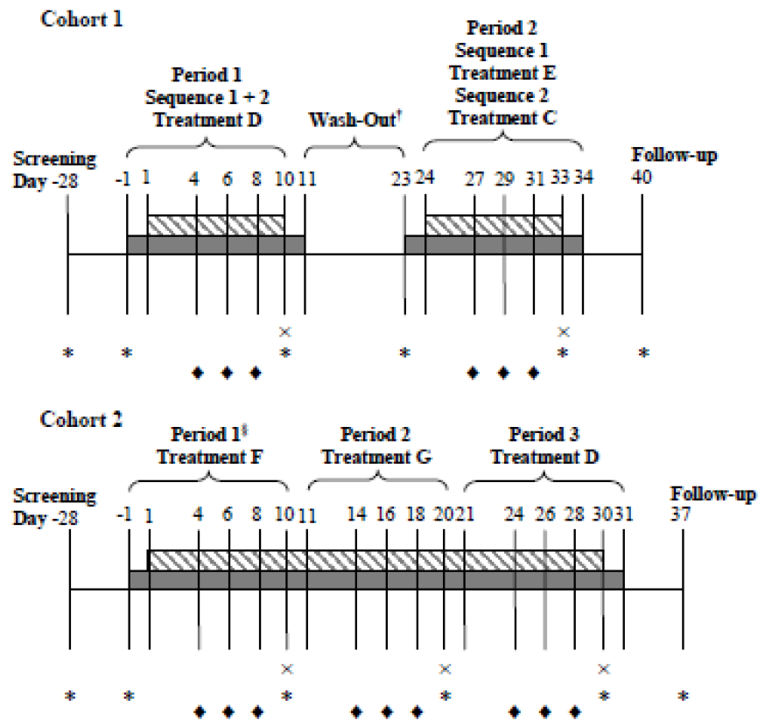
In both diagrams:
- The solid row shows the periods during which subjects were clinic inpatients.
- The hatched row shows the periods during which subjects received study drugs.
- The cross indicates the days on which intensive PK sampling was undertaken.
- The diamond indicates the days on which trough PK samples were taken.
- The asterisk indicates the safety profiling days.

Method of assigning study subjects to treatment groups
After screening and completion of the study procedures on Day –1, eligible subjects were assigned to either: Part 1; Part 2 Cohort 1, and randomised to Sequence 1 or 2; or Part 2 Cohort 2 using a randomisation scheme provided by the sponsor. Subjects were enrolled with an approximate even distribution between males and females. Replacements could have been enrolled if subjects did not complete all PK procedures except where subjects discontinued due to treatment related toxicity.

Sample size
Data from previous studies were used to estimate the standard deviations (SDs) of difference for the PK parameters AUC_{tau} and C_{max} for each analyte. For each analyte, the estimated SDs of the difference for each PK parameter and the statistical power to reject the null hypothesis that there was at least a 30% difference in each of the 2 PK parameters between a treatment pair of interest are provided in the CSR. When the expected ratio of geometric means is 1.0, using these estimated SDs of difference, a total sample size of 10 evaluable subjects provides at least 90% power to conclude no PK alternation for the following:
- Part 1: EVG, COBI, FTC, TFV and TVR
- Part 2: sequences x 2 Cohort 1: ATV/r and TVR
- Part 2: Cohort 2: EVG/r
To allow for missing information and dropouts, 16 subjects each were enrolled for Part 1, 26 for the 2 sequences for Part 2 Cohort 1 and 12 for Part 2 Cohort 2 resulting in 54 subjects.

PK sampling and analysis

Sampling
- Part 1: Plasma concentrations of TVR, EVG, COBI, FTC, and TFV were determined from intensive PK (Days 10, 33, and 50) and trough sample (predose on Days 4, 6, 8, 27, 29, 31, 44, 46, and 48).
- Part 2: Plasma concentrations of TVR, ATV, RTV, and EVG were determined from intensive PK (Cohort 1: Days 10 and 33; Cohort 2: Days 10, 20, and 30) and trough samples (Cohort 1: predose on Days 4, 6, 8, 27, 29, and 31; Cohort 2: predose on Days 4, 6, 8, 14, 16, 18, 24, 26, and 28).
On the days of intensive PK sampling, blood samples were collected at 0 (predose), 0.5, 1, 1.5, 2, 3, 4, 5, 6, 8, 10, 12, 18, and 24 hours post dose. On these days study treatments were given in the morning after an overnight fast and within 5 minutes of finishing a standard breakfast. Subjects refrained from food until after the 4 hour post dose sample. Water intake was restricted 1 hour before and 2 hours after dosing.

Analysis
The following plasma PK parameters were assessed for each analyte by part and cohort: AUC_{tau}, C_{tau}, C_{max}, Cl_{ast}, T_{max}, T_{last}, t_{½}, and λ_{z}. Concentration data were summarised across time points for each analyte by part and cohort. For each analyte the primary PK parameters (AUC_{tau}, C_{max}, and C_{tau}) were analysed using natural-log transformed values. These values were compared between treatments by part and cohort using a parametric analysis of variance (ANOVA) by a mixed effect model. The mixed effects model included treatment as a fixed effect and subject as a random effect. Two sided 90% confidence intervals (CIs) were constructed for the ratio of geometric least squares means (GLSMs) for each test (T) versus reference (R) treatment. The T and R comparisons are provided below in Table 1.

Table 1: GS-US-236-0135: Statistical comparisons for PK analyses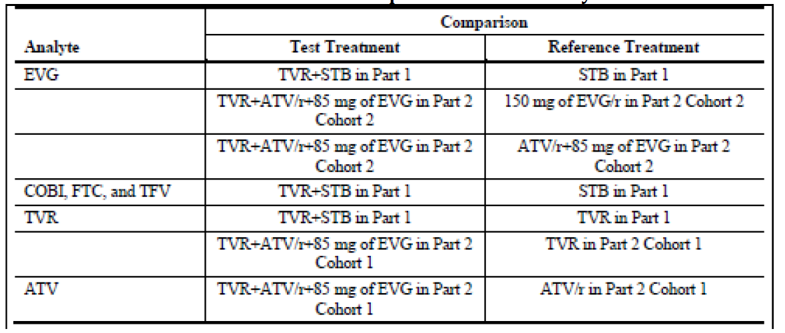
The T treatment was concluded to be equivalent to the R treatment if the 90% CI for the ratio of GLSMs (T/R treatment) fell within 70% to 143% for AUC_{tau} and C_{max}.

Pharmacokinetic analysis sets
All sets included all enrolled and treated subjects who had any non-missing, paired data for key PK parameters. Excluding RTV, they comprised the following:
- EVG
  - 1: subjects receiving the treatment pair of Treatment A versus Treatment B in Part 1.
  - 2: subjects receiving Treatment D versus Treatment F in Part 2 Cohort 2.
  - 3: subjects receiving Treatment D versus Treatment G in Part 2 Cohort 2.
  - 4: subjects receiving Treatment D in Part 2 Cohort 1.
- TVR
  - 1: subjects receiving the treatment pair of Treatment A versus Treatment C in Part 1.
  - 2: subjects receiving the treatment pair of Treatment D (Sequence 2, DC) versus Treatment C (Sequence 2, DC) in Part 2 Cohort 1.
  - 3: subjects receiving Treatment D in Part 2 Cohort 1 (Sequence 1, DE) and Part 2 Cohort 2.
- ATV
  - 1: subjects receiving the treatment pair of Treatment D in Part 2 Cohort 1 (Sequence 1, DE) versus Treatment E in Part 2 Cohort 1.
  - 2: subjects receiving Treatment D in Part 2 Cohort 1 (Sequence 2, DC) and Part 2 Cohort 2, and Treatment G in Part 2 Cohort 2.
- COBI, FTC and TFV: subjects receiving Treatment A versus Treatment B in Part 1.
- Trough PK: all subjects who had any non-missing concentration data for any analyte.

Study subjects
54 subjects were enrolled and randomised as follows:
- Part 1: 16 subjects to receive Treatments A, B, and C Part 2 Cohort 1, Sequence 1 (DE): 13 to receive Treatments D and E.
- Part 2 Cohort 1, Sequence 2 (DC): 13 to receive Treatments D and C.
- Part 2 Cohort 2: 12 subjects enrolled to receive Treatments D, F, and G.
48 subjects completed the study. One subject in Part 1 discontinued due to a protocol violation. Five subjects in Part 2 Cohort 1 discontinued due to adverse events (AEs) all with TVR+ATV/r + EVG 85 mg (Treatment D).

Major protocol violations/deviations
One subject in Part 1 did not return for the 3rd period and was classified as discontinued due to a protocol violation.

Baseline data
Data are provided showing that:
- The mean age of subjects was 37 years (range: 24 to 45).
- There was an approximately even distribution of males and females.
- Most subjects were White (79.6%, 43/54) and of Hispanic/Latino ethnicity (92.6%, 50/54).
- The mean baseline BMI was 26.2 kg/m² and the mean eGFR_{CG} was 126.3 mL/min.
- Subject demographics were generally similar between parts, cohorts, and sequences.
The table below shows the numbers in each analysis set.

Table 2: GS-US-236-0135: Analysis sets
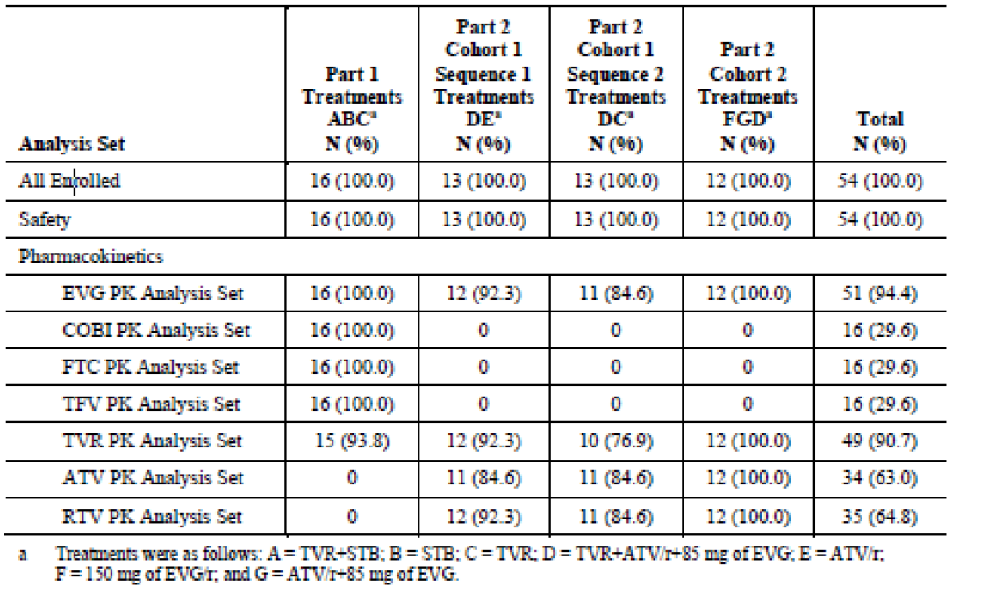

Results

Pharmacokinetics of elvitegravir
Mean (SD) EVG plasma concentration time profiles after STB, TVR + STB, TVR + ATV/r + EVG 85 mg, ATV/r + EVG 85 mg of EVG, or EVG 150 mg/r are shown in the figure below. The profiles were similar across treatments though slightly higher with STB relative to the other treatments.
Figure 3: GS-US-236-0135: Mean (SD) plasma concentration-time profile of elvitegravir after treatment A, B, D, F, or G administration to 24 hours (EVG PK analysis set)
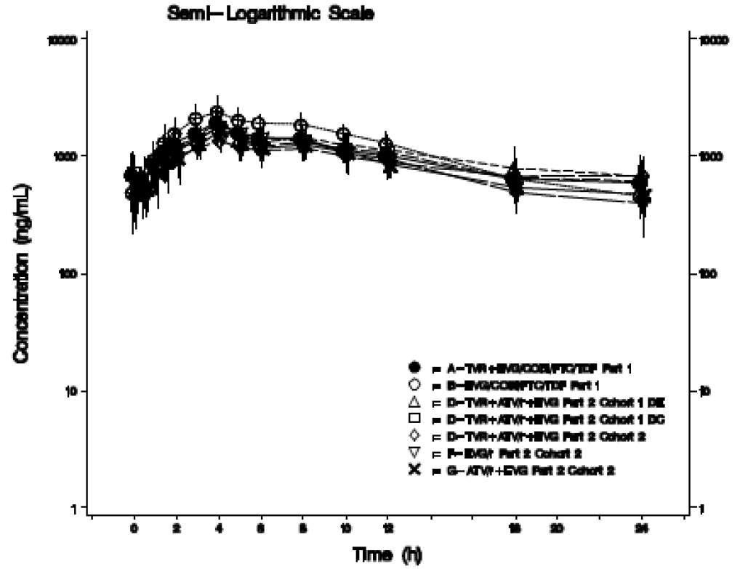
The EVG PK parameters are shown in the following table. Overall, the plasma EVG PK parameters were similar across treatments except for a slightly higher C_{tau} with TVR containing treatments.

Table 3: GS-US-236-0135: Summary of elvitegravir pharmacokinetic parameters (EVG PK analysis set)
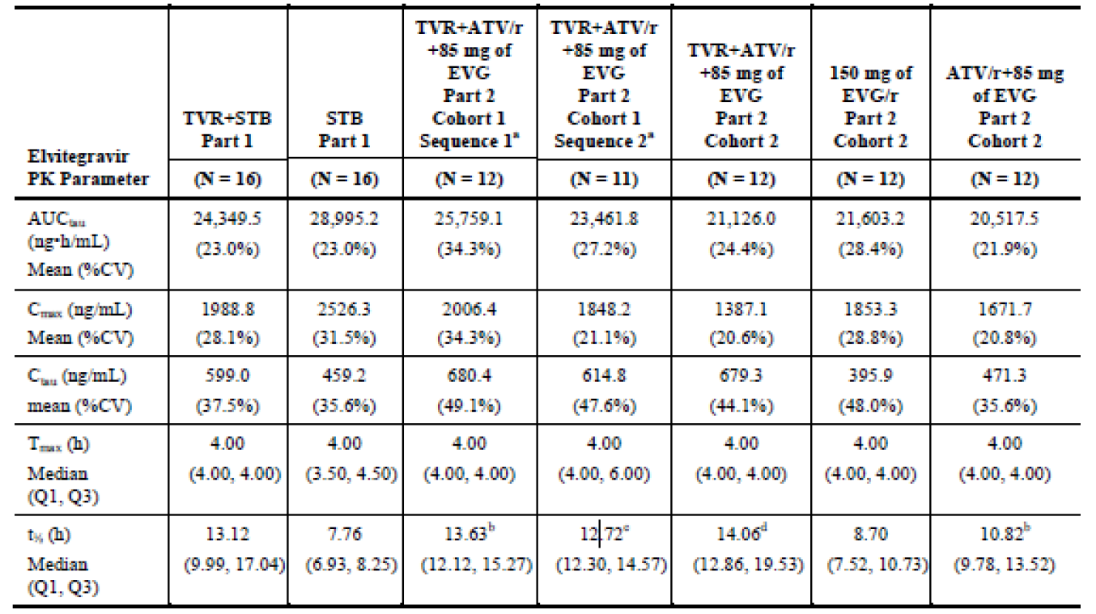
Results of the statistical analyses are presented below.
These data show that the 90% CIs for the GLSM ratios for AUC_{tau} and C_{max} were within the 70 to 143% lack of effect boundaries except for the following:
- Part 2 Cohort 2: C_{max} for TVR + ATV/r + EVG 85 mg versus 150 mg of EVG/r was slightly below the lower boundary.
- Part 1: C_{tau} was slightly above the upper boundary.
- Part 2 Cohorts 1 and 2: C_{tau} was notably above the upper boundary.

Table 4: GS-US-236-0135: statistical comparisons of elvitegravir pharmacokinetic parameters for test versus reference treatments (All PK analysis set)
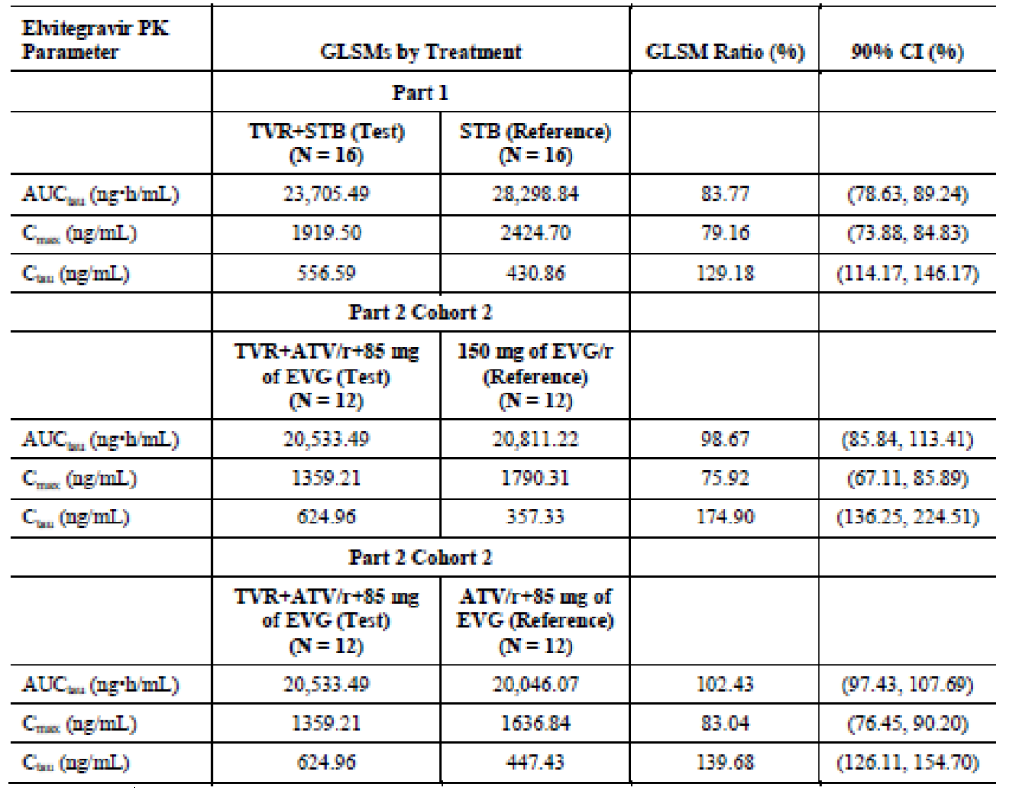
It is noted that the mean EVG C_{tau} with TVR + STB or + ATV/r + EVG 85 mg was > 10 fold above the protein binding adjusted concentration of 45 ng/mL that resulted in 95% inhibition (IC₉₅), the key parameter for the efficacy of EVG.

Cobicistat pharmacokinetic parameters
COBI PK parameters after TVR + STB or STB alone are provided in the table below.

Table 5: GS-US-236-0135: Summary of cobicistat pharmacokinetic parameters (COBI PK analysis set)
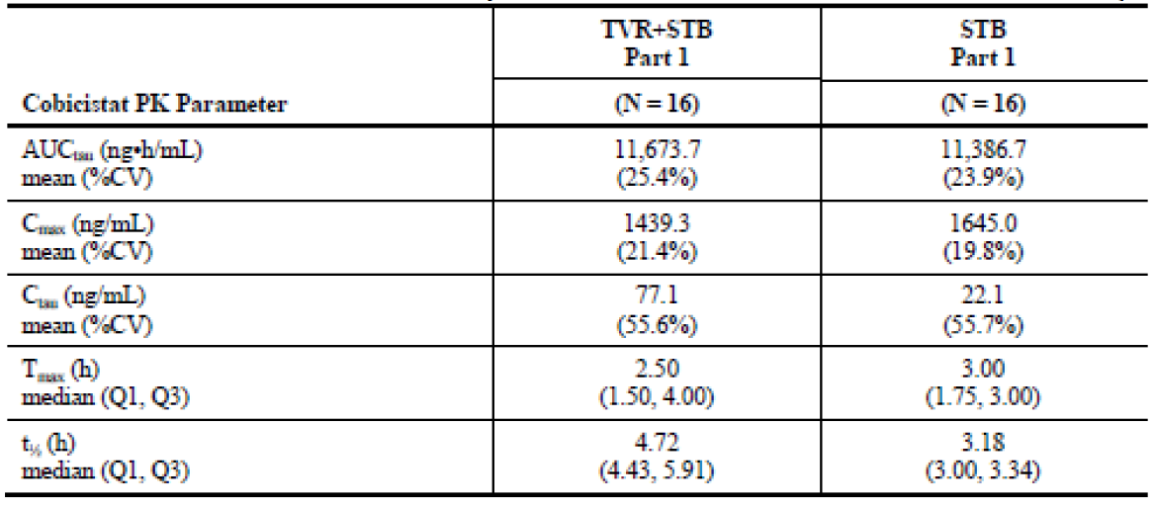
These show the values were similar across treatments except for C_{tau} which was higher with TVR + STB. The sponsor considered that this was not clinically relevant as the COBI exposures in both treatments were associated with boosting of EVG PK, the key function of COBI within STB. Also, it is noted that the results with TVR + STB is in the range of historical data from Study GS-US-216-0134.
Results provided in the table below for the statistical analyses showed that the 90% CIs for the GLSM ratios for AUC_{tau} and C_{max} were contained within the 70 to 143% lack of effect boundaries. However, results for C_{tau} were above the upper limits of this boundary.

Table 6: GS-US-236-0135: Statistical comparisons of cobicistat pharmacokinetic parameters for test versus reference treatments (All PK analysis set)
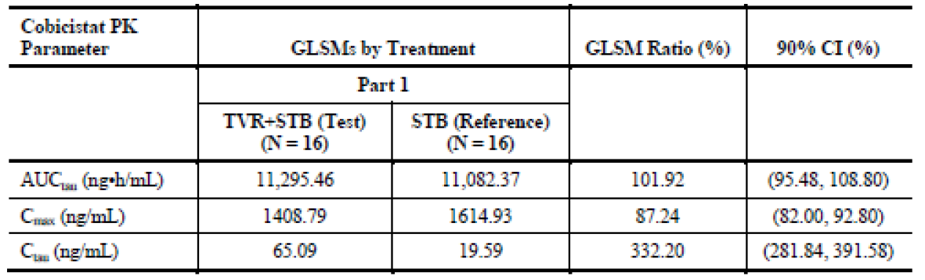

Pharmacokinetics of emtricitabine
Mean (SD) plasma concentration time profiles after TVR + STB or STB alone presented in the figure below show that the FTC profiles were similar with STB +/- TVR.
Figure 4: GS-US-236-0135: Mean (SD) plasma concentration-time profile of emtricitabine after treatment A or B administration to 24 hours (FTC PK analysis set)
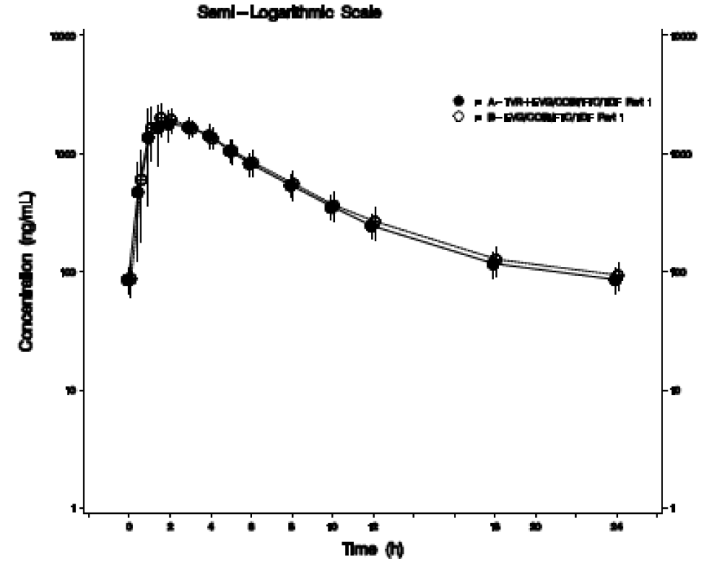
Results provided for the FTC PK parameters show that they were similar with both treatments. Results provided for the statistical analyses showed that the 90% CIs for the GLSM ratios for AUC_{tau}, C_{max}, and C_{tau} were within the 70% to 143% lack of effect boundaries.

Pharmacokinetics of tenofovir
Mean (SD) plasma concentration time profiles after TVR + STB or STB alone presented in the figure below show that the TFV profiles were similar with STB +/- TVR.
Figure 5: GS-US-236-0135: Mean (SD) plasma concentration-time profile of tenofovir after treatment A or B administration to 24 hours (TFV PK analysis set)
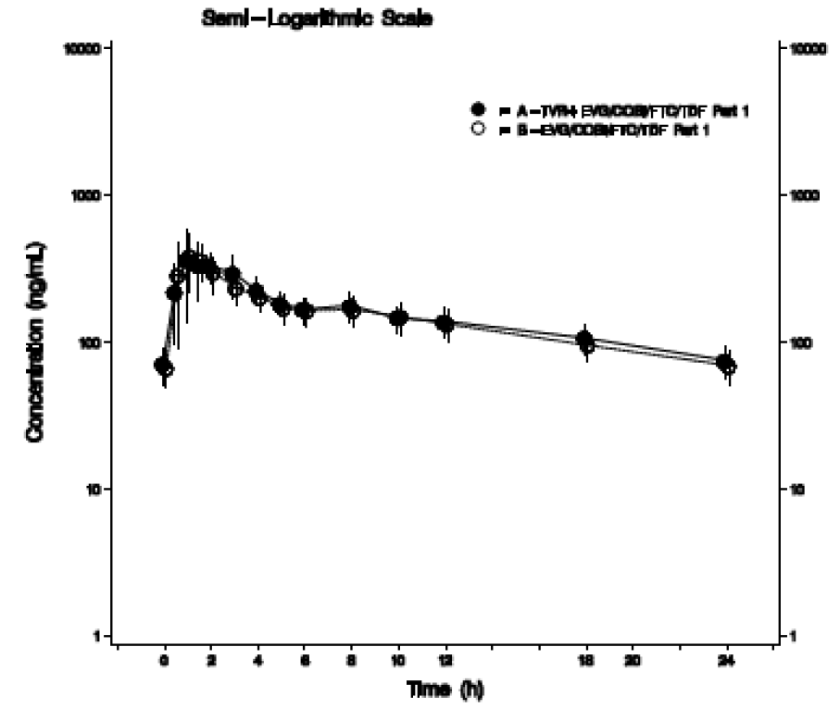
Results provided for the TFV PK parameters show that they were similar with both treatments. Results provided for the statistical analyses showed that the 90% CIs for the GLSM ratios for AUC_{tau}, C_{max}, and C_{tau} were within the 70% to 143% lack of effect boundaries.

Pharmacokinetics of telaprevir
Mean (SD) plasma concentration time profiles after TVR + STB or TVR + ATV/r + EVG 85 mg presented in the figure below show that the TVR profiles were similar across treatments.
Figure 6: GS-US-236-0135: Mean (SD) plasma concentration-time profile of telaprevir after treatment A, C, or D administration to 8 hours (TVR PK analysis set)
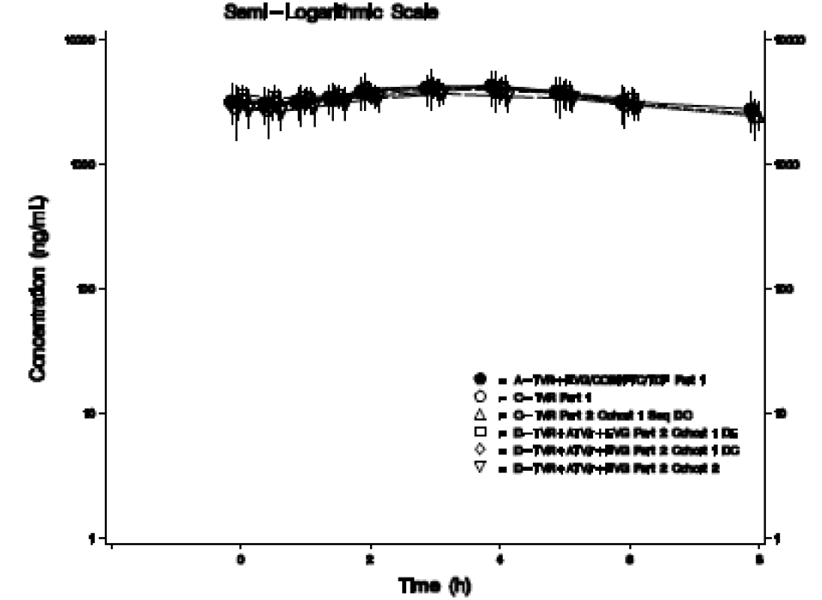
Results provided for the TVR PK parameters show that they were similar across treatments. Results provided for the statistical analyses showed that the 90% CIs for the GLSM ratios for AUC_{tau}, C_{max}, and C_{tau} were within the 70 to 143% lack of effect boundaries.

Pharmacokinetics of Atazanavir
Mean (SD) plasma concentration time profiles after TVR + ATV/r + 85 mg of EVG, ATV/r + EVG 85 mg and ATV/r presented in the figure below show that the ATV profiles were similar across treatments with slightly higher concentrations seen after ATV/r compared to other treatments.
Figure 7: GS-US-236-0135: Mean (SD) plasma concentration-time profile of atazanavir after treatment D, E, or G administration to 24 hours (ATV PK analysis set)
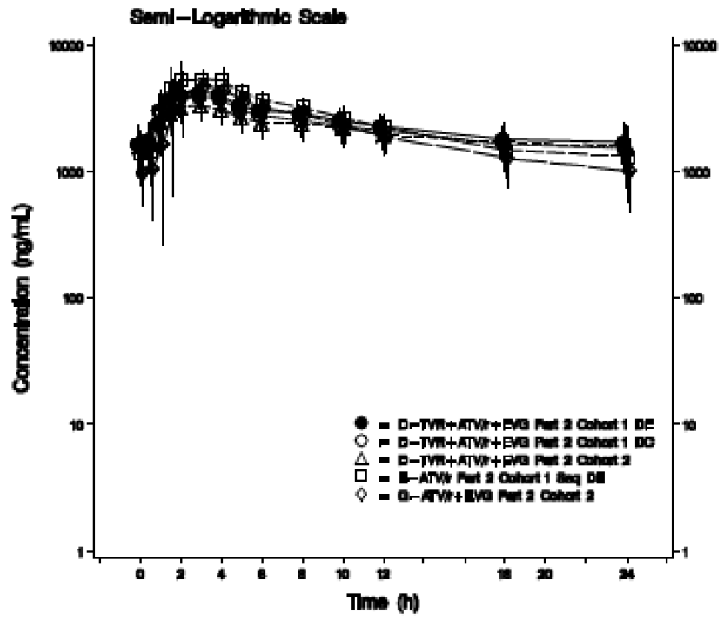
Results provided for the ATV PK parameters presented below show that the AUC_{tau} was generally similar across treatments. However, mean C_{max} tended to be higher in treatments without TVR and mean C_{tau} and median t_{1/2} were moderately higher in treatments with TVR.

Table 7: GS-US-236-0135: Summary of atazanavir pharmacokinetic parameters (ATV PK analysis set)
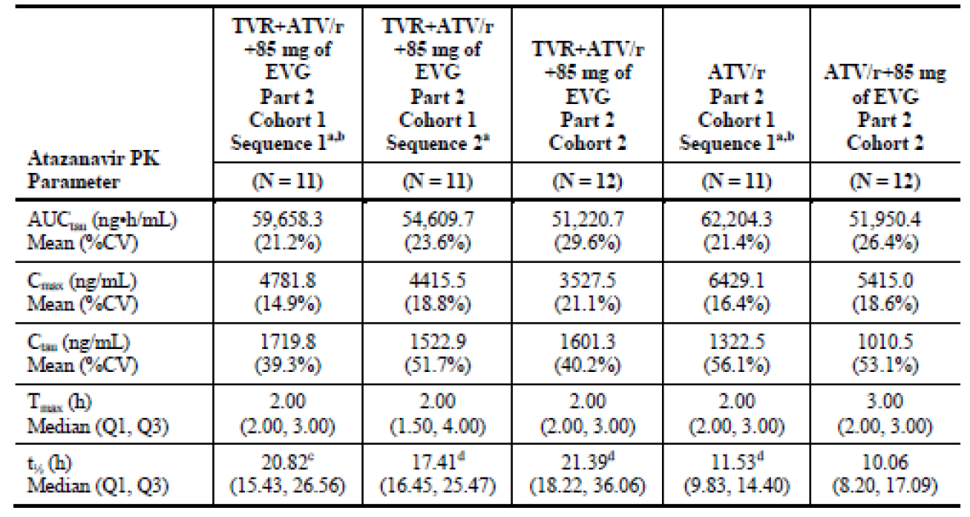
Results for the statistical analyses are presented in the table below. These show that the 90% CIs for the GLSM ratio of ATV after co-administration of TVR + ATV/r + EVG 85 mg compared with ATV/r for AUC_{tau} was within the 70% to 143% lack of effect boundaries. However, the lower boundary for C_{max} was slightly lower than the lack of effect boundary and the upper boundary for C_{tau} was slightly higher than the lack of effect boundary. It is noted that the mean ATV C_{tau} after TVR + ATV/r + EVG 85 mg was > 100 fold above the protein binding adjusted IC90 (14 ng/mL).

Table 8: GS-US-236-0135: Statistical comparisons of atazanavir pharmacokinetic parameters for test versus reference treatments (All PK analysis set)
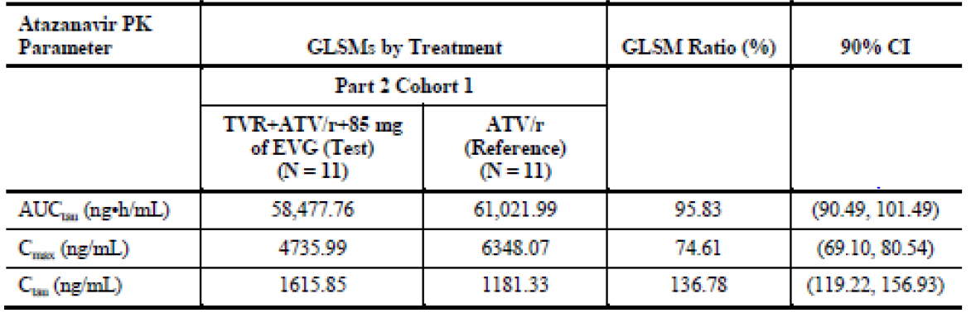
The results are summarised as follows:
- The 90% CIs for the ratio of the GLSMs with TVR + STB versus TVR or STB alone were within the lack of effect boundaries for AUC_{tau}, C_{max}, and C_{tau} for TVR, FTC, and TFV.
- The 90% CIs for the GLSM ratios for AUC_{tau} and C_{max} for EVG and COBI were within the lack of effect boundaries.
- Although the 90% CI for the GLSM ratio for EVG C_{tau} was slightly outside the upper limit of lack of effect boundary with TVR + STB, the mean C_{tau} was > 10 fold above the protein binding adjusted IC₉₅ (45 ng/mL).
- With TVR and ATV/r + EVG 85 mg, the 90% CIs for the GLSM ratios for AUC_{tau}, C_{max}, and C_{tau} for TVR were within the lack of effect boundaries.
- For the comparison of TVR + ATV/r + EVG 85 mg versus EVG 150 mg/r, the 90% CIs for the GLSM ratios for EVG AUC_{tau} were within the lack of effect boundary; C_{max} was narrowly outside the lower boundary and within the boundaries for the comparison of TVR + ATV/r + 85 EVG mg versus ATV/r + EVG 85 mg; the 90% CIs for the GLSM ratios for EVG C_{tau} following TVR + ATV/r + 85 mg of EVG were above the upper boundary for lack of effect and the mean EVG C_{tau} was > 10 fold above the protein binding adjusted IC₉₅ (45 ng/mL).
- For the comparison of TVR + ATV/r + 85 EVG mg versus ATV/r, the 90% CI for the GLSM ratio for ATV AUC_{tau} was within the lack of effect boundaries; the 90% CIs for the GLSM ratios for ATV C_{max} was narrowly below and for C_{tau} narrowly above the boundaries; mean ATV C_{tau} was modestly higher after TVR + ATV/r + EVG 85 mg versus ATV/r; however, mean ATV C_{tau} after TVR + ATV/r + EVG 85 mg was > 100 fold above the protein binding adjusted IC₉₀ (14 ng/mL); there was an increase in C_{tau} was for ATV from TVR + ATV/r versus ATV/r alone, which was attributed to TVR inhibition of CYP3A; ATV AUC_{tau} and C_{max} were within the no effect boundary; it is noted that ATV/r is the only protease inhibitor (PIn) allowed for use in combination with TVR.

Evaluator’s conclusion on pharmacokinetics
The sponsor concluded that:
- There were no clinically relevant drug interactions between the components of STB and TVR, and, between ATV/r + EVG 85 mg and TVR, and no dose adjustment is necessary when these are co-administered.
The sponsor’s conclusions are accepted.

Pharmacodynamics
There was no separate evaluation of the pharmacodynamics presented by the clinical evaluator.

Dosage selection for the pivotal studies
There was no separate evaluation of the dose selection for the pivotal studies presented by the clinical evaluator.

Clinical efficacy
The efficacy data provided in the dossier comprise CSRs for the following studies:
- GS-US-236-0102 and GS-US-236-0103 to support updates to the drug resistance subsection of the pharmacology section and the clinical trials section to include data from patients treated to 144 weeks.
- GS-US-236-0115, GS-US-236-0121 and GS-US-236-0123 to support an update to the current approved indication to include the use of STB in virologically suppressed patients who have no known mutations associated with resistance to the individual components of STB.
Of note, studies GS-US-236-0102 and GS-US-236-0103 were provided to and evaluated by the Therapeutic Goods Administration (TGA) in the 2011-03533 application for initial marketing authorisation. CSRs for the other studies have not been previously been submitted to the TGA.

GS-US-236-0102

Study design, objectives, locations and dates
This was a Phase III, randomised, double blind study to evaluate the safety and efficacy of a single tablet regimen (STR) containing a fixed dose combination of STB (EVG/COBI/FTC/TDF) versus an STR of Atripla (ATR; efavirenz [EFV]/FTC/TDF) in HIV-1 infected, antiretroviral (ARV) treatment naïve adults. It was undertaken at 102 study sites, 97 in the US and 5 in Puerto Rico. It commenced in March 2010 and the last observation for this report was June 2013. Treatment was planned for 192 weeks in the randomised, double blinded phase. After this, subjects will continue to take study drug until treatment assignments are unblinded, at which point all subjects will be given the option to participate in an open-label rollover study. During the double blind treatment period, study visits occurred at Weeks 2, 4, 8, 12, 16, 24, 32, 40, and 48 and then every 12 weeks to Week 192.
The objectives were:
- Primary: To evaluate the efficacy of an STR containing EVG/COBI/FTC/TDF (STB) versus an STR containing EFV/FTC/TDF (ATR) in HIV-1 infected, ARV treatment naïve adult subjects, as determined by the achievement of HIV-1 ribonucleic acid (RNA) < 50 copies/mL at Week 48.
- Secondary: To evaluate the efficacy, safety, and tolerability of the 2 STRs through 96 weeks of treatment and the durability of the efficacy, safety, and tolerability results of the 2 STRs observed through 192 weeks of treatment.
The primary and 1st secondary objectives were addressed in previous CSRs and are not presented in this report. Results for the secondary objectives presented in this CSR include data analysis to 144 weeks of treatment.

Main inclusion and exclusion criteria
HIV-1 infected, ARV treatment naïve adults with plasma HIV-1 RNA levels ≥ 5000 copies/mL and eGFR ≥ 70 mL/min at screening, with no prior use of any approved or experimental ARV drug, and sensitivity to EFV, FTC, and TDF as demonstrated by the subject’s HIV-1 genotype at screening. Key exclusion criteria included receipt of prohibited therapy and pregnancy.

Study treatments
- Treatment Group 1: STR containing EVG 150 mg/COBI 150 mg/FTC 200 mg/TDF 300 mg (STB) once daily + placebo for ATR once daily prior to bedtime.
- Treatment Group 2: STR containing EFV 600 mg/FTC 200 mg/TDF 300 mg (ATR) once daily prior to bedtime + placebo for STB once daily.
Study drugs were dispensed in a double blinded fashion such that each subject received 2 tablets per day, 1 with food and 1 on an empty stomach prior to bedtime. Allowed and prohibited prior and concomitant medication was specified. Procedures for measuring compliance were described.

Efficacy outcome variables
The primary efficacy endpoint was the percentage (%) of subjects with HIV-1 RNA < 50 copies/mL at Week 48 using the US Food and Drug Administration (FDA) defined snapshot analysis. The secondary efficacy endpoint evaluated for the Week 144 analysis was the % of subjects with HIV-1 RNA < 50 copies/mL at Week 144 as defined by the snapshot analysis algorithm.
Tertiary efficacy endpoints evaluated for the Week 144 analysis were:
- Pure virologic failure (PVF) with HIV-1 RNA cut off at 50 copies/mL by Week 144
- The % of subjects with HIV-1 RNA < 50 copies/mL using missing equals failure (M = F) and missing equals excluded (M = E) methods at Week 144
- The change from baseline in HIV-1 RNA (log₁₀ copies/mL) at Week 144
- Change from baseline in cluster determinant 4 (CD4) cell count and CD4 % (CD4%) at Week 144.
This evaluation focuses on the analysis and results for those endpoints proposed for inclusion in the PI. These are:
- The secondary efficacy endpoint, the % of subjects with HIV-1 RNA < 50 copies/mL at Week 144
- One tertiary P efficacy endpoint, the change from baseline in CD4 cell count at Week 144.
Also, although not a specified outcome, resistance analysis was also undertaken and updated results proposed for the PI.

Sample size
A sample size of 700 subjects randomised in a 1:1 ratio to 2 groups (350 per group) had at least 95% power to establish non-inferiority with respect to the response rate of HIV-1 RNA < 50 copies/mL at Week 48 between the 2 groups. For sample size and power computation, it was assumed that both groups had a response rate of 0.795 based on results from a prior study, a non-inferiority margin of 0.12, and a 1 sided, 0.025 significance level.

Randomisation and blinding methods
Subjects were randomised in a 1:1 ratio to the treatment groups. Randomisation was stratified based on HIV-1 RNA level (< 100,000 copies/mL or ≥ 100,000 copies/mL) at screening. This was a double blind, double dummy study. The interactive voice response system/interactive web response system (IVRS/IWRS) assigned blinded study drug bottle numbers at each study visit (except Week 2). Study drugs were dispensed in a blinded fashion.

Analysis populations
The analysis populations relevant to this application and evaluation are as follows:
- Safety analysis set (SAS): enrolled subjects who received at least 1 dose of study medication
- The intent to treat (ITT) analysis set: all randomised subjects who received at least 1 dose of study drug. This was the Primary analysis set for efficacy analyses and included data collected after the last dose of study drug.
- The per protocol set (PPS): The PPS was defined separately for the analyses at Weeks 48, 96, and 144. The Week 144 PPS included all randomised subjects who had received at least 1 dose of study drug, and who did not have any major protocol violation. For the PPS analysis, efficacy data were summarised up to the last dose date of study drug. The PPS was the secondary analysis set for the efficacy analysis. The criteria for subject exclusion from the Week 144 PPS are described.
- Resistance analysis population (RAP): Subjects on study drugs and who experienced either suboptimal virologic response or virologic rebound were considered to have virologic failure and were included in the RAP. Suboptimal virologic response was assessed at Week 8 and was defined as having HIV-1 RNA ≥ 50 copies/mL and < 1 log₁₀ reduction from baseline at the Week 8 visit, which was confirmed at the subsequent visit. Virologic rebound was defined as having 2 consecutive visits with HIV-1 RNA ≥ 400 copies/mL after achieving HIV-1 RNA < 50 copies/mL, or as having 2 consecutive visits with >1 log₁₀ increase in HIV-1 RNA from their nadir. In addition, subjects who were on study drugs, had not been analysed previously, and who had HIV-1 RNA ≥ 400 copies/mL at Weeks 48, 96,144, or their last visit (at or after Week 8) were also analysed for resistance.

Statistical methods
This focuses on the analysis of endpoints for which results are proposed for the PI. In addition, the analysis of resistance is presented as an update of this is also proposed for inclusion in the PI. The analysis window was from Study Days 967 to 1050 inclusive.

Secondary efficacy endpoint
This was the % of subjects with HIV-1 RNA < 50 copies/mL at Week 144 as defined by the snapshot analysis algorithm. All the HIV-1 RNA data collected on treatment (prior to or on the permanent discontinuation date of study drug) were used.
Virologic outcome was defined as the following categories:
- Virologic Success: subjects with last available HIV-1 RNA value < 50 copies/mL in the Week 144 analysis window.
- Virologic Failure: subjects with last available HIV-1 RNA value ≥ 50 copies/mL in the Week 144 analysis window while on treatment or who did not have on treatment HIV-1 RNA data for the Week 144 analysis due to study drug discontinuation for lack of efficacy or reasons other than an AE, death, or lack of efficacy.
- No virologic data in the Week 144 analysis window: subjects with no on treatment HIV-1 RNA data for the Week 144 analysis because of discontinuation of study drug due to an AE or death (regardless of last available HIV-1 RNA result) or reasons other than an AE, death, or lack of efficacy and the last available on treatment HIV-1 RNA value was < 50 copies/mL, or subjects had missing data during the window, but remained on study drug.
The virologic outcome analysis was primarily based on the ITT. The number and % of subjects with virologic success, virologic failure, and reasons for no virologic data at Week 144 were summarised and listed. This endpoint was analysed to determine if STB treatment was non-inferior to ATR treatment at Week 144. Non-inferiority was assessed using the 95% CI approach, with a non-inferiority margin of 12%. The baseline HIV-1 RNA stratum (≤ 100,000 or > 100,000 copies/mL) weighted difference in the response rate (P1 – P2) and its 95% CI were calculated based on stratum adjusted Mantel-Haenszel (MH) proportion. An alpha level of 0.05 was used to construct the 95% CI. It was concluded that STB was non-inferior to ATR if the lower bound of the 2 sided 95% CI of the difference in the response rate (STB – ATR) was > -12%. If non-inferiority of STB versus ATR was established, the same 95% CI was used to evaluate superiority using the ITT set. The superiority of STB over ATR was established if the lower bound of the 95% CI was < 0. The baseline HIV-1 RNA stratum (≤ 100,000 or > 100,000 copies/mL) weighted, 2 sided CMH test was also used to assess superiority as a supportive analysis.
To evaluate the robustness of the virologic response at Week 144, the following sensitivity analyses were performed:
- The virologic response at Week 144 was analysed using the Week 144 PPS.
- Subjects with non-virologic related study drug discontinuation and the last on treatment HIV-1 RNA < 50 copies/mL were counted as a success; non-virologic related study drug discontinuation were subjects who had no virology data in the Week 144 analysis window due to discontinuation prior to or in the Week 144 analysis window for reasons other than lack of efficacy, AE, or death; results were summarised in a similar manner to that used for the ITT analysis described above.
Also, analysis of virologic response using the snapshot analysis algorithm at Week 144 was repeated within each of the following subgroups using the ITT set:
- Baseline HIV-1 RNA level (copies/mL): ≤ 100,000 copies/mL or > 100,000 copies/mL
- Age (years): < 40 and ≥ 40
- Sex: male and female
- Race: White and Non-White
- Baseline CD4 group (cells/µL): ≤ 350 and > 350
- Study drug adherence (%): < 95 and ≥ 95 (based on adherence to the Week 144 visit).

Tertiary efficacy endpoints
- PVF: Subjects classified as a pure virologic responder at Week 144 were those with confirmed suppression (HIV-1 RNA< 50 copies/mL on 2 consecutive visits) or did not have a confirmed rebound (HIV-1 RNA ≥ 50 copies/mL on 2 consecutive visits or the last available HIV-1 RNA ≥ 50 copies/mL followed by premature study discontinuation) after achieving confirmed suppression prior to or on the upper limit of the Week 144 analysis window.
- M = F and M = E Analyses: virologic response analysed using M = F and M = E methods; for the M = F method, all missing data were treated as a virologic failure; for the M = E method, all missing data were excluded in the computation of virologic response from the numerator and denominator.
- Changes from baseline in HIV-1 RNA (log₁₀ copies/mL), CD4 cell count and CD4 % (%) at Week 144.
As aforementioned, the only tertiary endpoint result proposed for inclusion in the PI is the change from baseline in the CD4 cell count at Week 144. This change was summarised using descriptive statistics. The difference in the CD4 cell count change from baseline between treatment groups and the associated 95% CI was constructed using an ANOVA with baseline HIV-1 RNA as a fixed effect. Also, the change from baseline in CD4 cell counts using the last observation carried forward (LOCF) imputation method for missing values was summarised at each visit using the ITT set. The algorithm for LOCF was if a value was missing in an analysis window, the missing value was replaced with the last on treatment value observed before the analysis visit with the missing value.
Key points from information provided on the analysis for the other tertiary endpoints are as follows:
- The same statistical methods were used for the secondary and tertiary efficacy endpoints.
- Descriptive statistics were used for the virologic outcome at Week 144 for the PVF analysis.
- Time to PVF by the Week 144 analysis data cut-off date was analysed using the Kaplan-Meier (KM) estimate and the log-rank test stratified by baseline HIV-1 RNA level.
- Analysis of the changes from baseline to Week 144 in log₁₀ HIV-1 RNA, and CD4% were the same as that for the CD4 cell count except for the LOCF analysis.
- The number and % of subjects with HIV-1 RNA < 50, 50 to < 400, 400 to < 1000, and ≥ 1000 copies/mL using M = F and M = E methods were summarised for all visits to Week 144.

Measurement and analysis of resistance data
At screening, the HIV-1 subtype and protease/reverse transcriptase (PR/RT) genotype were assessed. For post baseline resistance analyses of subjects with virologic failure or failure to achieve plasma HIV-1 RNA < 400 copies at Weeks 48, 96, 144, or study discontinuation (at or after Week 8 and on study drug), PR/RT and integrase (IN) genotyping and phenotyping assays were performed. Samples with successful results for PR/RT, but with IN failure were retested for the IN genotype using different methodologies. IN testing was also conducted at baseline for subjects with emergent integrase strand-transfer inhibitor (INSTI) resistance (INSTI-R) in the RAP. The post baseline assay included genotypic and phenotypic data relevant to all currently approved nucleoside reverse transcriptase inhibitor (NRTIs), nonnucleoside reverse transcriptase inhibitors (NNRTIs), and PIns, with the exception of rilpivirine (RPV). The IN assay assessed both EVG and raltegravir (RAL) phenotypes. No analyses of viral tropism were conducted. A retrospective analysis of the IN genotype was conducted at baseline for subjects in the STB group and a subset of those in the ATR group.

Participant flow
700 of 707 randomised subjects received at least 1 dose of study drug and comprised the safety and ITT analysis sets. Of these 700, 20.7% (145) prematurely discontinued study drug before the Week 144 analysis data cut-off date (STB 18.4%, 64; ATR 23.0%, 81) and 17.7% (124) had prematurely discontinued from the study (STB 15.2%, 53; ATR 20.2%, 71). Numbers of subjects prematurely discontinuing study drug and the study were higher with ATR. The most common reasons for premature discontinuation of study drug were AEs (STB 5.7%, 20; ATR 7.4%, 26), lost to follow up (STB 5.2%, 18; ATR 6.5%, 23), withdrawal of consent (STB 1.4%, 5; ATR 4.0%, 14), subject noncompliance (STB 1.7%, 6; ATR 2.8%, 10), and lack of efficacy (STB 2.3%, 8; ATR 2.0%, 7). The most common reasons for premature discontinuation from the study were lost to follow-up, AEs, withdrawal of consent and subject noncompliance. Reasons for study discontinuation were generally similar between the 2 groups. However, study discontinuation due to AEs was numerically lower with STB compared to ATR. A summary of subject disposition is presented in the table below.

Table 9: GS-US-236-0102: Disposition of subjects: all randomised subjects: Week 144 dataset
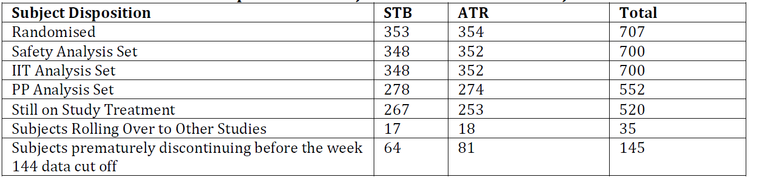
Of the 148 subjects excluded from the Week 144 PP analysis set, most (125) discontinued prior to or in the Week 144 analysis window for reasons other than lack of efficacy.

Major protocol violations/deviations
The table below is a summary of important deviations occurring up to the Week 144 analysis data cut-off date. It was considered that none affected the overall quality or interpretation of the study data.

Table 10: GS-US-236-0102: Important protocol deviations by category: all randomised subjects

Baseline data
Data are provided showing that, overall, demographic and general baseline characteristics were similar between the 2 groups. Most subjects in the SAS were male (89.0%), with a mean age of 38 years (range, 18 to 67 years); most were White (63.0%) or Black (28.1%) and non-Hispanic/Latino (76.1%). Mean BMI at baseline was 26.4 kg/m². There were no significant differences between the 2 groups for any baseline disease characteristics. The mean (SD) baseline HIV-1 RNA was 4.76 (0.583) log₁₀ copies/mL, CD4 cell count was 386 (179.5) cells/µL, and CD4% was 22.9% (8.27%). 66.6% of subjects had baseline HIV-1 RNA ≤ 100,000 copies/mL. The most common HIV risk factor category was homosexual sex (79.9% of subjects). The majority (83.6%) had asymptomatic HIV-1 infection. A small % was hepatitis B surface antigen (HBsAg: 2.0%) positive or hepatitis C antibody (HCVAb: 4.6%) seropositive. Overall, the mean (SD) baseline eGFR_{CG} was 120.6 (32.64) mL/min and estimated glomerular filtration rate calculated using the Modification of Diet in Renal Disease method (eGFR_{MDRD}) was 99.7 (19.96) mL/min/1.73 m². There were no significant differences between treatment groups in mean baseline eGFR_{CG} or eGFR_{MDRD}.

Results for the efficacy outcomes
Data are provided showing that adherence to active study drug up to the Week 144 visit, as measured by pill count, was similar with STB and ATR (medians: STB 97.6%, ATR 98.0%). Most subjects had an adherence rate of ≥ 95% up to the Week 144 visit (STB 75.1%, ATR 73.6%).

Secondary efficacy endpoint: virologic outcome at week 144 using snapshot analysis and HIV-1 RNA < 50 copies/mL
High rates of virologic success were seen in both treatment groups at Week 144. The numbers of subjects in the ITT analysis set who had HIV-1 RNA < 50 copies/mL were 279 out of 348 (80.2%) with STB and 265 out of 352 (75.3%) with ATR 75.3%. The difference between groups in the % of subjects with virologic success at Week 144 was 4.9% (95% CI: - 1.3% to 11.1%). The %s of subjects with virologic failure or no virologic data at Week 144 were lower with STB than ATR as follows:
- Virologic failure: STB: 7.5%/26; ATR: 9.7%/34.
- No virologic data: STB: 12.4%/3; ATR: 15.1%/53.
Reasons for virologic failure and lack of virologic data in the Week 144 analysis window were balanced between the treatment groups.
These data are shown in the table below.

Table 11: GS-US-236-0102: Virologic outcome at Weeks 48, 96, and 144 using the Week 144 dataset (HIV-1 RNA Cut off at 50 copies/mL, snapshot analysis, ITT analysis set, Week 144 dataset)
Data are provided showing that:
- In the Week 144 PPS analysis, the %s of subjects with virologic success were numerically higher than in the ITT analysis set and similar in the 2 groups, STB 268out of 278 (96.4%) and ATR 260 out of 274: 94.9%.
- In a sensitivity analysis of the secondary endpoint including subjects with study drug discontinuations not related to virologic response and the last on treatment HIV-1 RNA < 50 copies/mL as virologic successes and using the ITT analysis set, the %s with virologic success at Week 144 were similar in the 2 groups, STB 298 out of 348 (85.6%) and ATR 291 out of 352 (82.7%).
Data are provided showing that subgroup analyses at Week 144 revealed similar rates of virologic success with point estimates generally favouring the STB group. The rates of virological success were similar with STB and ATR for the subgroups HIV-1 RNA > 100,000 copies/mL (77.1% versus 77.6%) and baseline CD4 cell count ≤ 350 cells/µL (75.5% versus 76.2%). However, in the non-White, HIV-1 RNA ≤ 100,000, and CD4 cell count > 350 cells/µL subgroups, differences in response rates that favoured STB.

Tertiary endpoint: change from baseline in CD4 cell count at week 144
Data are provided showing the following:
- Mean (SD) baseline CD4 cell counts were 391 (188.6) cells/µL with STB and 382 (170.2) cells/µL with ATR.
- CD4 cell counts increased following initiation of study drug and the mean increases were similar in both groups at all time points.
- The CD4 cell counts continued to increase with increased duration of exposure to study drug.
- The observed Week 144 mean [SD] increases from baseline were 321 [227.0] cells/µL with STB and 300 [202.3] cells/µL with ATR; the LSM difference at Week 144 was 21 (95% CI: -14 to 56) and was not statistically significant (p = 0.24).
- Similar trends were seen in the ITT analysis set using the LOCF imputation method and in the PPS.
The following figure shows the increase over time to Week 144.
Figure 8: GS-US-236-0102: Mean and 95% CIs of change from baseline in CD4 cell count: ITT analysis set, Week 144 dataset
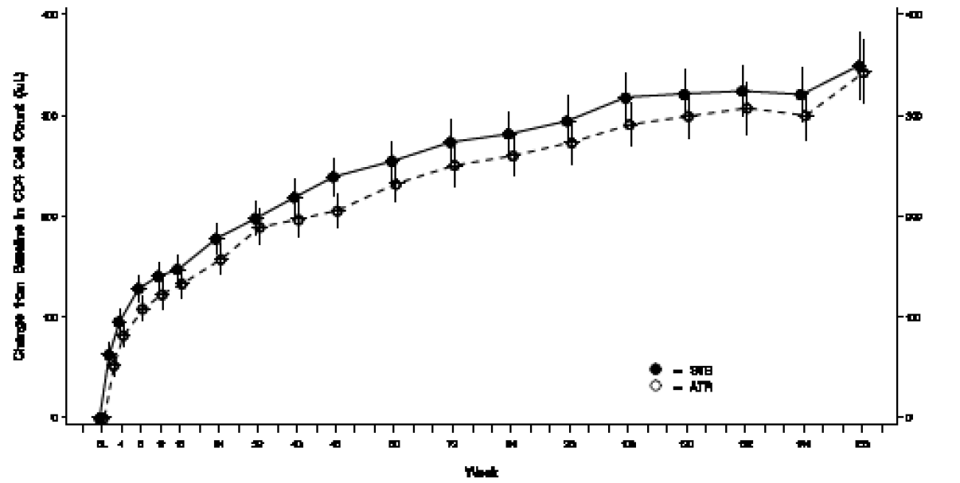
Results for the other tertiary endpoints were consistent with those presented above.

Virologic resistance data
49 (7.0%: 49/700) subjects met the virologic failure criteria and were included in the RAP. The numbers in the RAP were similar in the 2 groups: STB: 6.0% (21 out of 348) subjects; ATR 8.0% (28 out of 352 subjects).
To Week 144 in the STB group, of the 21 subjects in the RAP the following is noted:
- 20 had post baseline genotypic data for PR and RT.
- 21 had post baseline IN genotypic data.
- 19 had post baseline IN, PR, and RT phenotypic data available.
- 10 subjects (ITT: 10 out of 348, 2.9%; RAP: 10 out of 21, 48%) had emergent resistance to a study drug.
- Resistance substitutions developed in 8 subjects by Week 48, 2 subjects between Weeks 48 and 96, and no subjects between Weeks 96 and 144.
In total to Week 144 the following was found:
- 9 subjects had isolates with emergent EVG resistance substitutions at E92Q (N = 7), N155H (N = 3), Q148R (N = 1), and T66I (N = 1) in the IN gene.
- Other INSTI substitutions (2P0P IN substitutions) that each developed in a single case in addition to a primary INSTI-R substitution, were H51Y, L68V, and S153A.
- 10 subjects had isolates that developed M184V/I, of which 4 subjects also developed K65R and 2 subjects developed A62V. (commonly as a mixture with wild type in combination with K65R and M184V in the RT gene)
- All 10 isolates with emergent resistance in the STB group were HIV-1 subtype B.
- The remaining 11 subject isolates in the STB group lacked emergent resistance substitutions in IN or RT and remained phenotypically susceptible to all drugs in their regimen.
- There was no development of primary PI-R substitutions within the STB group.
- In phenotypic analyses, 8 subjects had HIV isolates with reduced susceptibility to EVG, 10 had reduced susceptibility to FTC and 1 had reduced susceptibility to TFV.
To Week 144 in the ATR group, of the 28 subjects in the RAP the following is noted:
- 28 had post baseline genotypic and phenotypic data for PR and RT.
- 28 had post baseline IN genotypic data.
- 22 had post baseline IN phenotypic data available.
- 14 (ITT: 14/352, 4.0%; RAP: 14/28, 50%) had emergent resistance to a study drug.
- Resistance substitutions developed in 8 subjects by Week 48, 2 subjects between Weeks 48 and 96, and 4 subjects between Weeks 96 and 144.
- The 14 subjects with resistance substitutions by Week 144 had isolates with emergent EFV resistance substitutions at K103N (N = 13), K101E (N = 5), V108I (N = 4), Y188F/H/L (N = 3), M230L (N = 2), and V90I, G190A/S, and P225H (N = 1 each) in RT; 4 subjects had isolates that developed M184V/I and 3 of these also developed K65R in RT.
- All 14 isolates with emergent resistance in the ATR group were HIV-1 subtype B.
- The remaining 14 subject isolates lacked emergent resistance substitutions and were phenotypically susceptible to all drugs in their regimen.
- 2 subjects had isolates with only emergent primary PIn Resistance (R) substitutions within the ATR group, despite not being treated with a PIn; one had Q58E and several other polymorphic changes in PR and RT and one had a mixture at I50I/L in PR.
- In phenotypic analyses, 4 subjects had HIV isolates with reduced susceptibility to FTC and 3 had reduced susceptibility to TFV.
The sponsor conclusions were:
- STB demonstrated durable antiviral efficacy through 144 weeks of treatment in ARV treatment naïve subjects.
- High rates of virologic success were achieved in both the STB and ATR groups by Week 144.
- Immunologic benefit continued in both groups with increases from baseline in CD4 cell counts.
- Resistance development to ≥ 1 components of STB or ATR occurred infrequently.
Comment: The sponsor’s conclusions are accepted.

GS-US-236-0103

Study design, objectives, locations and dates
This was a Phase III, randomised, double blind study to evaluate the safety and efficacy of STB versus ATV/r plus Truvada (TVD: FTC/ TDF) in HIV-1 infected, ARV treatment naïve adults. It was a multinational multi-centre study undertaken at 146 study sites in the US, Puerto Rico, France, Germany, Australia, Canada, United Kingdom (UK), Belgium, Italy, Austria, Thailand, the Netherlands, Portugal, Mexico, Denmark, Switzerland, and Sweden. It commenced in August 2010 and the last subject observation for this report was August 2013. Treatment was planned for 192 weeks in the randomised, double blinded phase. After this, subjects will continue to take their blinded study drug until treatment assignments are unblinded, at which point all subjects will be given the option to participate in an open label rollover study. During the double blind treatment period, study visits occurred at Weeks 2, 4, 8, 12, 16, 24, 32, 40, and 48; and then every 12 weeks to Week 192.
The objectives were:
- Primary: to evaluate the efficacy of an STR containing STB versus a regimen containing ATV/r + TVD in HIV-1 infected, ARV treatment naïve adult subjects as determined by the achievement of HIV-1 RNA < 50 copies/mL at Week 48.
- Secondary: to evaluate the efficacy, safety, and tolerability of the 2 treatment regimens to 96 weeks of treatment, and, the durability of the efficacy, safety, and tolerability results of the 2 treatment regimens observed to 192 weeks of treatment.
The primary and first secondary objectives were addressed in Weeks 48 and 96 interim CSRs and are not considered in this report. This report addresses the secondary objectives with data analysis to 144 weeks of treatment.

Main inclusion and exclusion criteria
Subjects included in this study were HIV-1 infected, ARV treatment naïve adults with plasma HIV-1 RNA levels ≥ 5000 copies/mL and eGFR ≥ 70 mL/min at screening, with no prior use of any approved or experimental ARV drug, and sensitivity to FTC, TDF, and ATV, as demonstrated by the subject’s HIV-1 genotype at screening. Key exclusion criteria included receipt of prohibited therapy and pregnancy.

Study treatments
- Treatment Group 1: STR of EVG 150 mg/COBI 150 mg/FTC 200 mg/TDF 300 mg (STB) once daily + placebos to match RTV 100 mg, ATV 300 mg, and TVD (FTC 200 mg/TDF 300 mg) once daily.
- Treatment Group 2: RTV 100 mg, ATV 300 mg, and TVD (FTC 200 mg/TDF 300 mg) once daily + placebo to match STR containing EVG 150 mg/COBI 150 mg/FTC 200 mg/TDF 300 mg (STB) once daily.
All subjects received 3 tablets and 1 capsule of study drug (active drug and placebo), administered orally, once daily with food, at approximately the same time each day. Allowed and prohibited prior and concomitant medication was specified. Procedures for measuring compliance were described.

Efficacy outcome variables
- The Primary efficacy endpoint was the % of subjects with HIV-1 RNA < 50 copies/mL at Week 48 using the US FDA defined snapshot analysis.
- The secondary efficacy endpoints evaluated for the Week 144 analysis was the % of subjects with HIV-1 RNA < 50 copies/mL at Week 144 as defined by the snapshot analysis algorithm.
- The tertiary efficacy endpoints evaluated for the Week 144 analysis were:
  - PVF with HIV-1 RNA cut-off at 50 copies/mL
  - The % of subjects with HIV-1 RNA < 50 copies/mL using M = F and M = E methods
  - The change from baseline in HIV-1 RNA (log10 copies/mL)
  - The change from baseline in CD4 cell count and CD 4%
This evaluation focuses on the analysis and results for those endpoints proposed for inclusion in the PI. These are:
- The secondary efficacy endpoint, namely the % of subjects with HIV-1 RNA < 50 copies/mL at Week 144 as defined by the snapshot analysis algorithm.
- One of the tertiary efficacy endpoints, the change from baseline in CD4 cell count at Week 144.
Also, although not a specified outcome, resistance analysis was undertaken and updated results proposed for the PI.

Sample size
A sample size of 700 subjects randomised in a 1:1 ratio to 2 groups (350 subjects per group) had at least 95% power to establish non-inferiority with respect to the response rate of HIV-1 RNA < 50 copies/mL at Week 48 between the 2 treatment groups. For sample size and power computation, it was assumed that both treatment groups had a response rate of 0.795 based on results from a prior study, a non-inferiority margin of 0.12, and a 1 sided, 0.025 significance level.

Randomisation and blinding methods
Prior to or during the baseline/Day 1 visit, the investigator or designee randomised the subject using the IVRS/IWRS. Subjects were randomised in a 1:1 ratio to Treatment Group 1 or 2. Randomisation was stratified by HIV-1 RNA level (< 100,000 copies/mL or ≥ 100,000 copies/mL) at screening. This was a double blind, double dummy study. The IVRS/IWRS assigned blinded study drug bottle numbers at each study visit (except Week 2). Study drugs were dispensed in a blinded fashion.

Analysis populations
- SAS: enrolled subjects who received at least 1 dose of study medication.
- ITT set: all subjects who had received at least 1 dose of study drug; this was the Primary analysis set for efficacy analyses.
- PPS: the PPS was defined separately for analyses at Weeks 48, 96, and 144; the Week 144 set included all randomised subjects who received at least 1 dose of study drug, without any major protocol violation; the PPS was the secondary analysis set for the secondary endpoint and selected tertiary endpoints.
- RAP: subjects on study drugs and who experienced either suboptimal virologic response or virologic rebound were considered to have virologic failure and were included in the RAP.

Statistical methods

Secondary efficacy endpoint
The ITT set was used for analysis of the Week 144 virologic outcome. The analysis window was Study Days 967 to 1050 (inclusive). The number and % of subjects having virologic success, virologic failure, and reasons for no virologic data at Week 144 were summarised and listed. Virologic outcome was defined as the following categories:
- Virologic success: subjects with their last available HIV-1 RNA value < 50 copies/mL in the Week 144 analysis window.
- Virologic failure: subjects with their last available HIV-1 RNA value ≥ 50 copies/mL in the Week 144 analysis window while on treatment or who did not have on treatment HIV-1 RNA data for the Week 144 analysis due to discontinuation of study drug for lack of efficacy or for reasons other than an AE, death, or lack of efficacy and their last available on treatment HIV-1 RNA value was ≥ 50 copies/mL.
- No virologic data in the Week 144 analysis window: subjects with no on treatment HIV-1 RNA data for the Week 144 analysis because of discontinuation of study drug due to an AE or death (regardless of last available HIV-1 RNA result) or reasons other than an AE, death, or lack of efficacy and the last available on treatment HIV-1 RNA value was < 50 copies/mL, or subjects had missing data during the window, but remained on study drug.
This endpoint was analysed to determine if treatment with STB was non-inferior to treatment with ATV/r + TVD at Week 144. Non-inferiority was assessed using the 95% CI approach, with a non-inferiority margin of 12%. The baseline HIV-1 RNA stratum (≤ 100,000 copies/mL or > 100,000 copies/mL) weighted difference in the response rate (P1 – P2) and its 95% CI were calculated based on stratum adjusted MH proportion. An alpha level of 0.05 was used to construct the 95% CI. It was concluded that STB was non-inferior to ATV/r + TVD if the lower bound of the 2 sided 95% CI of the difference in the response rate (STB group – ATV/r + TVD group) was > -12%. If non-inferiority of STB versus ATV/r + TVD was established, the same 95% CI was used to evaluate superiority using the ITT analysis set. The superiority of STB over ATV/r + TVD was established if the lower bound of the 95% CI was greater than 0. The baseline HIV-1 RNA stratum (≤ 100,000 copies/mL or > 100,000 copies/mL) weighted, 2 sided CMH test was also used to assess superiority as a supportive analysis.
To evaluate robustness of virologic response at Week 144, the following sensitivity analyses were performed:
- The virologic response at Week 144 was analysed using the Week 144 PPS.
- Subjects with non-virologic related study drug discontinuation and the last on treatment HIV-1 RNA < 50 copies/mL were counted as a success; non-virologic related discontinuation was defined as subjects who had no virology data in the Week 144 analysis window due to discontinuation prior to or in the Week 144 analysis window for reasons other than lack of efficacy, AE, or death; results were summarised in a similar manner to that used for the ITT analysis described above.
Also, analysis of virologic response using the snapshot analysis algorithm at Week 144 was repeated within each of the following subgroups using the ITT set:
- Baseline HIV-1 RNA level (copies/mL): ≤ 100,000 copies/mL or > 100,000 copies/mL
- Age (years): < 40 and ≥ 40
- Sex: male and female
- Race: White and non-White
- Baseline CD4 group (cells/µL): ≤ 350 and > 350
- Study drug adherence (%): < 95 and ≥ 95 (based on adherence to the Week 144 visit).

Tertiary efficacy endpoints
- PVF: Subjects classified as a pure virologic responder at Week 144 were those with confirmed suppression (HIV-1 RNA < 50 copies/mL on 2 consecutive visits) or without a confirmed rebound (HIV-1 RNA ≥ 50 copies/mL on 2 consecutive visits or the last available HIV-1 RNA ≥ 50 copies/mL followed by premature discontinuation of study) after achieving confirmed suppression prior to or on the upper limit of the Week 144 analysis window.
- M = F and M = E Analyses: virologic response also analysed using M = F and M = E methods; for the M = F method, all missing data were treated as a virologic failure; for the M = E method, all missing data were excluded in the computation of virologic response from both the numerator and denominator.
- Changes from baseline in HIV-1 RNA (log₁₀ copies/mL), CD4 cell count and CD4 % at Week 144.
As aforementioned, the only tertiary endpoint result proposed for inclusion in the PI is the change from baseline in the CD4 cell count at Week 144. This change was summarised using descriptive statistics based on observed data. The difference in the CD4 cell count change from baseline between treatment groups and the associated 95% CI was constructed using an ANOVA with baseline HIV-1 RNA level as a fixed effect. Also, the change from baseline in CD4 cell counts using the LOCF imputation method for missing values was summarised at each visit using the ITT set. The algorithm for LOCF was if a value was missing in an analysis window, the missing value was replaced with the last on-treatment value observed before the analysis visit window that had the missing value.
Key points from information provided on the analysis for the other tertiary endpoints are as follows:
- All analyses used the ITT set.
- The same statistical methods were used for the secondary and tertiary efficacy endpoints.
- Descriptive statistics were used for the virologic outcome at Week 144 for the PVF analysis.
- Time to PVF by the Week 144 analysis data cut-off date was analysed using the KM estimate and the log-rank test stratified by baseline HIV-1 RNA level.
- Analysis of the changes from baseline to Week 144 in log₁₀ HIV-1 RNA, and CD4% were the same as that for the CD4 cell count except for the LOCF analysis.
- The number and % of subjects with HIV-1 RNA <50, 50 to < 400, 400 to < 1000, and ≥ 1000 copies/mL using M = F and M = E methods were summarised for all visits up to Week 144.

Measurement and analysis of resistance data
Suboptimal virologic response was assessed at Week 8 and was defined as having HIV-1 RNA ≥ 50 copies/mL and < 1 log₁₀ reduction from baseline at the Week 8 visit, which was confirmed at the subsequent visit. Virologic rebound was defined as having 2 consecutive visits with HIV-1 RNA ≥ 400 copies/mL after achieving HIV-1 RNA < 50 copies/mL, or as having 2 consecutive visits with >1 log₁₀ increase in HIV-1 RNA from their nadir. In addition, subjects who were on study drugs, had not been analysed previously, and who had HIV-1 RNA ≥ 400 copies/mL at Weeks 48, 96,144, or their last visit (at or after Week 8) were also analysed for resistance.
At screening, the HIV-1 subtype and PR/RT genotype were assessed. For post baseline resistance analyses of subjects with virologic failure or failure to achieve plasma HIV-1 RNA < 400 copies at Weeks 48, 96, 144, or study discontinuation (at or after Week 8 and on study drug), PR/RT and IN genotyping and phenotyping assays were performed. Samples with successful results for PR/RT, but with IN failure were retested for the IN genotype using different methodologies. IN testing was also conducted at baseline for those subjects with emergent INSTI-R in the RAP. The post baseline assay included genotypic and phenotypic data relevant to all currently approved NRTIs, NNRTIs and PIns, with the exception of the NNRTI RPV. The IN assay assessed both EVG and RAL phenotypes. No analyses of viral tropism were conducted. A retrospective analysis of the IN genotype was conducted in a subset of subjects with non-B subtype HIV-1 in the STB group and for a subset of most subjects considered to have virologic failure in both STB and ATV/r + TVD groups.

Participant flow
715 subjects were randomised, 357 to receive STB and 358 to receive ATV/r + TVD. The SAS and ITT set comprised 708 subjects who received at least 1 dose of study drug. Of these 708 subjects:
- 58.9% (417) had screening HIV-1 RNA ≤ 100,000 copies/mL
- 21.2% (150) discontinued study drug prior to the Week 144 analysis data cut-off date: STB 19.3%/68; ATV/r + TVD 23.1%/82.
- 17.7% (125) had prematurely discontinued from the study (STB: 16.7%/59; ATV/r + TVD: 18.6%/66.
The most common reasons for premature discontinuation of study drug were AEs (STB 5.9%/21; ATV/r + TVD 8.5%/30), lost to follow up (STB 4.8%/17; ATV/r + TVD 4.5%/16), withdrawn consent (STB 2.0%/7; ATV/r + TVD 5.1%/18) and subject noncompliance (STB 2.8%/10; ATV/r + TVD 10%/2.8). The most common reasons for premature study discontinuation were lost to follow up (STB 5.7%/20; ATV/r + TVD 4.5%/16), withdrawal of consent (STB 3.4%/12; ATV/r + TVD 5.1%/18) and AEs (STB 2.3%/8; ATV/r + TVD 3.9%/14). Reasons for discontinuation of study drug and study discontinuation were generally similar between the 2 groups. A summary of subject disposition is presented in the table below.

Table 12: GS-US-236-0103: Disposition of subjects (all screened subjects, Week 144 dataset)
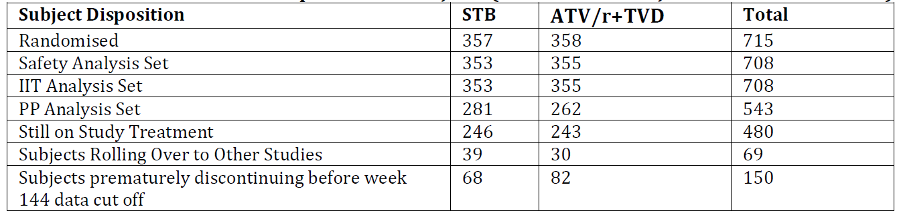
Of the 165 subjects excluded from the Week 144 PPS, 141 discontinued before or in the Week 144 analysis window for reasons other than lack of efficacy.

Major protocol violations/deviations
The following table presents the important protocol deviations. None were considered to affect the overall interpretation of the study data.

Table 13: GS-US-236-0103: Important protocol deviations by category (all randomised subjects)

Baseline data
Overall, demographic and general baseline characteristics were similar between the 2 groups. Most subjects in the SAS were male (90.4%), with a mean age of 38 years (range: 19 to 72); most were White (74.4%) or Black (16.8%) and non-Hispanic/Latino (82.2%). The mean baseline BMI was 25.6 kg/m². There were no significant between group differences for any disease characteristics. The mean (SD) baseline HIV-1 RNA value was 4.81 (0.613) log₁₀ copies/mL, CD4 cell count was 370 (170.1) cells/µL, and CD4% was 21.4% (8.29%). Overall, 58.9% of subjects had baseline HIV-1 RNA ≤ 100,000 copies/mL. The most common HIV risk factor category was homosexual sex (77.5%). Most subjects (81.6%) had asymptomatic HIV-1 infection. A small % were HBsAg positive (1.7%) or HCVAb seropositive (4%). Overall, the mean (SD) baseline eGFR_{CG} and eGFR_{MDRD} were 119.5 (32.44) mL/min and 99.2 (19.28) mL/min/1.73m² respectively. There were no notable between group differences in baseline eGFR_{CG} or eGFR_{MDRD}. 8 subjects who met entry criteria at screening had baseline eGFR_{CG} < 70 mL/min upon retesting at their baseline visit.

Results for the efficacy outcomes
Adherence to study drug up to the Week 144 visit was similar with STB and ATV/r + TVD (medians: STB 97.2%, ATV/r + TVD 97%). Most subjects had an adherence rate of ≥ 95% up to the Week 144 visit (STB 71.3%, ATV/r + TVD 69.2%). The numbers of subjects in the Week 144 analysis data set and reasons for exclusion from this are shown in the table below.

Secondary efficacy endpoint: virologic outcome at week 144 using snapshot analysis and HIV-1 RNA < 50 copies/mL
Data provided in the table below showed the following:
- High rates of virologic success in both groups at Week 144 using the ITT analysis set (STB 77.6%, 274/353 subjects; ATV/r + TVD 74.6%, 265/355), the difference in the % of subjects with virologic success at Week 144 being 3.1% (95% CI: - 3.2% to 9.4%).
- Similar %s of subjects with virologic failure or no virologic data at Week 144 in the 2 groups: virologic failure: STB 7.9%/28; ATV/r + TVD 7.3%/26; no virologic data: STB 14.4%/51; ATV/r + TVD 18%/64.
- Reasons for virologic failure and lack of virologic data were balanced in the treatment groups.

Table 14: GS-US-236-0103: Virologic outcome at Weeks 48, 96, and 144 using the Week 144 dataset (HIV-1 RNA cut-off at 50 copies/mL, snapshot analysis, ITT analysis set, Week 144 dataset)
Data are provided showing that:
- In the Week 144 PPS, the %s of subjects with virologic success was numerically higher than in the ITT set and similar in the 2 groups: STB 95.4%, 268 out of 281 subjects; ATV/r + TVD 96.9%, 254 out of 262.
- The secondary endpoint sensitivity analysis including study drug discontinuations not related to virologic response and with the last on treatment HIV-1 RNA < 50 copies/mL as virologic successes, the %s of subjects with virologic success at Week 144 were similar in the 2 groups: STB 85.6%, 302 out of 353; ATV/r + TVD 83.7%, 297 out of 355.
Data provided from subgroup analyses at Week 144 showed high and generally comparable rates of virologic success with STB and ATV/r + TVD by age, sex, race, baseline HIV-1 RNA level, baseline CD4 cell count, or study drug adherence rate. The lower bound of the 95% CI was < 0 for most subgroups suggesting no between group difference. For female and subjects with an adherence rate < 95% subgroups, the lower bound of the 95% CI was > 0 and the treatment difference favoured ATV/r + TVD. Ad hoc analysis of both groups identified a greater number receiving STB who discontinued study drug due to other reasons and had the last available HIV-1 RNA < 50 copies/mL.

Tertiary endpoint: change from baseline in CD4 cell count at week 144
Data are provided showing the following:
- Mean (SD) baseline CD4 cell counts were 364 (180.6) cells/µL with STB and 375 (158.9) cells/µL with ATV/r + TVD.
- CD4 cell counts increased with initiation of study drug; mean increases were similar in both groups at all-time points.
- The CD4 cell counts continued to increase with increased duration of exposure.
- The Week 144 mean [SD] increases from baseline were 280 [159.8] cells/µL with STB and 293 [211.5] cells/µL with ATV/r + TVD; the LSM difference at Week 144 was - 16 (95% CI: - 46 to 14).
- Similar trends were seen in the IIT set with the LOCF imputation method and in the PPS.
- The same trend for change in CD4 % at Week 144.
The following figure shows the increase in CD4 cell count over time to Week 144.
Figure 9: GS-US-236-0103: Mean and 95% CIs of change from baseline in CD4 cell count (cells/µL): ITT analysis set, Week 144 dataset
Data provided from subgroup analyses showed high and generally comparable rates of virologic success by age, sex, race, baseline HIV-1 RNA level, baseline CD4 cell count, and study drug adherence rate. The lower bound of the 95% CI was < 0 for most subgroups suggesting no between group difference. For females and those with adherence rate < 95%, the lower bound of the 95% CI was > 0 with the treatment difference favouring the ATV/r + TVD over STB. In the female subgroup, the difference was 9.2%. In the subgroup with adherence < 95% (n = 209), the difference in response rate was 7.1%.

Virologic resistance data
41 subjects met the virologic failure criteria and were included in the RAP (5.8%, 41 out of 708 subjects). Subject distribution in the RAP was similar with STB (6.2%, 22 out of 353) and ATV/r + TVD (5.4%, 19 out of 355). 40 (5.6%) were analysed for resistance development due to virologic failure.
With STB:
- 21 subjects (21 out of 353, 5.9%) were analysed.
- 19 had post baseline genotypic and 18 had post baseline phenotypic data available for PR and RT.
- 19 had post baseline genotypic and 15 had post baseline phenotypic data available for INSTI.
- 8 subjects (ITT: 2.3%; RAP: 38.1%) developed emergent resistance, 5 before Week 48, 1 between Weeks 48 and 96, and 2 between Weeks 96 and 144.
- Six subjects had emergent INSTI resistance mutations including E92Q (1), Q148R (2), N155H (1), T97A (n), or a complex mixture of T66I, E92Q and N155H (1).
- In phenotypic analyses, 5 subjects had HIV-1 isolates with reduced susceptibility to EVG, 7 had reduced susceptibility to FTC and 1 had reduced susceptibility to TFV.
With ATV/r + TVD:
- 19 subjects were analysed (19 out of 355, 5.4%).
- All had available data for at least 1 gene; 18 had post baseline genotypic and 17 had post baseline phenotypic data available for PR and RT, and 17 had post baseline genotypic and 18 had post baseline phenotypic data available for IN.
- 2 (ITT: 0.6%: RAP: 10.5%) had emergent resistance which developed between Weeks 96 and 144.
- These 2 subjects developed M184V/I in RT and phenotypic resistance to FTC.
The sponsor concluded that:
- STB demonstrated durable antiviral efficacy through 144 weeks of treatment in HIV-1 infected ARV treatment naïve subjects.
- There were high rates of virologic success with STB and ATV/r + TVD at Week 144.
- Immunologic benefit continued in both groups as shown by increases from baseline in CD4 cell counts.
- Resistance development to ≥ 1 component(s) of STB or ATV/r + FTC/TDF was infrequent.
Comment: The sponsor’s conclusions are accepted.

GS-US-236-0115

Study design, objectives, locations and dates
This was a multi-centre Phase IIIB randomised, open label study to evaluate the efficacy, safety, and tolerability of switching from regimens consisting of a ritonavir boosted PIn + RTV plus FTC/TDF (TVD) to the STB STR in virologically suppressed, HIV-1 infected patients. It was conducted at 86 sites in the US, Spain, Germany, France, Italy, UK, Belgium, Switzerland, Austria, Canada, Puerto Rico and Portugal. It commenced in November 2011 with the last subject observation for this report in November 2013.
The objectives were:
- Primary: To evaluate the non-inferiority of switching to STB relative to staying on a baseline regimen (SBR) comprising PIn + RTV + FTC/TDF in maintaining HIV-1 RNA < 50 copies/mL at Week 48 (snapshot algorithm) in virologically suppressed, HIV-1 infected subjects.
- Secondary: To evaluate the efficacy, safety and tolerability of the 2 regimens through Week 96.
Subjects were randomised in a 2:1 ratio to 1 of the following 2 treatment groups:
- Treatment Group 1: Switch to STB.
- Treatment Group 2: Stay on SBR.
Treatment was planned for 96 weeks with study visits occurring at Weeks 4, 8, 12, 24, 36, and 48, and then every 12 weeks up to Week 96. After Week 96, subjects on STB in countries where is not commercially available will be given the option to receive STB until it becomes commercially available or until Gilead determines otherwise.
This section of the report describes the efficacy results with a data cut-off when all subjects had completed 48 weeks of study treatment or had discontinued before the Week 48 visit.

Main inclusion criteria
Subjects were HIV-1 infected adults receiving an ARV regimen comprising a PIn + RTV + FTC/TD for ≥ 6 consecutive months, with documented undetectable plasma HIV-1 RNA levels before the screening visit, and who had never experienced 2 consecutive HIV-1 RNA values above detectable levels after first achieving virologic suppression on the first or second regimen with no prior use of any approved or experimental INSTI, no known resistance to TDF or FTC, and an eGFR_{CG} ≥ 70 mL/min at screening. Documented historical genotype prior to starting initial ARV therapy showing no known resistance to TDF or FTC, including, but not limited to the presence of RT resistance mutations K65R, M184V/I, or 3 or more thymidine analogue associated mutations (TAMs: M41L, D67N, K70R, L210W, T215Y/F, K219Q/E/N/R) that included M41L or L210W was also required.

Study treatments
- Treatment Group 1: STB was administered orally 1 tablet daily with food at around the same time each day.
- Treatment Group 2: FTC 200 mg/TDF 300 mg (TVD) plus PIn + RTV administered orally in the same manner as before study entry.
Allowed and prohibited prior and concomitant medication was specified. Procedures for measuring compliance were described.

Efficacy outcome variables
The primary efficacy endpoint was the % of subjects with HIV-1 RNA < 50 copies/mL at Week 48 using the US FDA defined snapshot analysis. The secondary and tertiary endpoints for the Week 48 analysis were:
- Changes in CD4 cell count from baseline to Week 48.
- Percent of subjects with HIV-1 RNA < 50 copies/mL by visit to Week 48.
- Percent of subjects who have last, on study drug, HIV-1 RNA < 50 copies/mL to Week 48.
- Percent of subjects who maintained HIV-1 RNA < 50 copies/mL to Week 48 (time to loss of virologic response [TLOVR]).
- Time to loss of pure virologic response (PVR) to Week 48.
- Joint distribution of PVF and study drug discontinuation.
- Percent of subjects with emergent HIV-1 drug resistance.
In addition, Patient Reported Outcomes (PROs) were assessed. These are not evaluated as they are not relevant to the proposed PI changes.

Sample size
420 subjects were planned to be randomised in a 2:1 ratio to the 2 groups. With 280 subjects randomised to switch to STB and 140 to SBR, the lower limit of the observed 1 sided 97.5% CI was expected to be > -0.12 (that is, non-inferiority difference of 12%) with 85% power assuming that the % of responders in both groups for the Primary endpoint was 82% at Week 48.

Randomisation and blinding methods
Subjects were randomised in a 2:1 ratio to group 1 or 2. Blinding did not apply as this was an open label study.

Analysis populations
- SAS: enrolled subjects who received at least 1 dose of study medication.
- The Full Analysis Set (FAS): all randomised subjects who received at least 1 dose of study medication; this was the analysis set for efficacy endpoints and consistent with the ITT approach.
- The PPS: subjects in the FAS excluding those who were not virologically suppressed at both the screening and baseline visits, did not have reported HIV-1 RNA in the Week 48 analysis window for reasons other than discontinuation of study drug due to lack of efficacy, did not meet the key inclusion criterion that the historical genotype must show sensitivity to FTC and TDF or were receiving therapy with any prohibited medication not to be used with STB.

Statistical methods
Demographic data and baseline characteristics were summarised by treatment group and overall using descriptive statistics for continuous data and by the number and % of subjects for categorical data. Information regarding HIV disease specific characteristics, prior ARV medications and cardiovascular disease specific medical history was summarised.

Primary efficacy endpoint
The Week 48 analysis window was defined as Days 295 to 378 (inclusive) for the Primary efficacy endpoint analysis. Virologic outcome was defined as success, failure, and no virologic data. The Primary analysis used the FAS. Evaluation of non-inferiority was done by constructing a 2 sided exact 95% CI for the difference in the %s of virologic success between groups (STB – SBR). Non-inferiority was assessed using the 95% CI approach with a non-inferiority margin of 12%. It was concluded that STB was non-inferior to SBR if the lower bound of the 2 sided 95% CI of the difference in response rates between groups was > -12%. If non-inferiority of switching to STB versus SBR was established, superiority was assessed between the 2 groups based on the same 95% CI used for non-inferiority. The superiority of switching to STB versus staying on SBR would be established if the lower bound of the 95% CI was > 0. The Fisher exact test was used to calculate the p-value. Virologic outcome at Week 48 was also analysed for the PPS.
In a sensitivity analysis, the difference between treatment groups and its 95% CI, in the % of subjects with virologic failure at Week 48 was determined using the snapshot algorithm and the same methods as for the Primary analysis for the FAS.

Secondary and tertiary efficacy endpoints
- Change from Baseline in CD4 Cell Counts and %s: Observed values and change from baseline in CD4 cell count were analysed using M = E and M = LOCF methods and summarised using descriptive statistics for each visit and treatment group; the statistical significance of the change from baseline was assessed using the Wilcoxon signed rank test within each treatment; the Wilcoxon rank sum test was used to assess the difference between the groups at Week 48; CD4% by visit (M = E) while on study and study drug were summarised using descriptive statistics.
- Percent of Subjects with plasma HIV-1 RNA levels < 50 copies/mL: this was analysed using M = F by visit to Week 48, M = E by visit using all available data, and M = LOCF to Week 48. The exact 95% CI for the difference between groups in % of subjects with plasma HIV-1 RNA < 50 copies/mL was calculated. The Fisher exact test was used to calculate the p-value.
- TLOVR: The maintenance of confirmed HIV-1 RNA < 50 copies/mL to Week 48 (responder) was derived using all available non-missing HIV-1 RNA based on the FDA defined TLOVR algorithm. The count and % of responders (with the 95% CI for the difference between groups) and non-responders (by category) were calculated.
- Time to Loss of PVR: The KM method was used to estimate this outcome to Week 48. PVR was defined as not having a PVF event on or prior to the last dose of study drug. The PVF event time was defined as the day of the first of 2 consecutive HIV-1 RNA ≥ 50 copies/mL or 1 HIV-1 RNA ≥ 50 copies/mL followed by permanent discontinuation of study drug. Only events before permanent discontinuation were included in the analysis. Subjects with no PVF and no early discontinuation were censored on Day 378 (the upper limit of the Week 48 analysis window). The 95% CI for the difference between the 2 groups was calculated using the normal approximation approach. The p-value for the difference between the 2 groups was calculated based on the log rank test.
- Joint Distribution of PVF and Study Drug Discontinuation: This was summarised and included the number of subjects with no PVF and no discontinuation, PVF only, discontinuation only, and discontinuation and PVF.
Subgroup analyses were undertaken for age: < 40 and ≥ 40 years, sex: male and female, race: White and non-White, PI at screening: ATV, darunavir (DRV), lopinavir (LPV), and other, and number of prior ARV regimens: 1, 2, or > 2.

Measurement and analysis of resistance data
Identification of a genotype at screening to exclude subjects with known resistance to study drugs could not be done due to the suppressed HIV-1 viral load. Hence, historical genotypes were used to assess sensitivity to FTC and TDF at screening. HIV-1 genotyping testing (resistance testing) was done if a subject was confirmed as a virologic failure (HIV-1 RNA ≥ 400 copies/mL) or if HIV-1 RNA was ≥ 400 copies/mL at the subject’s last visit. Virologic rebound was defined as having 2 consecutive HIV-1 RNA values ≥ 50 copies/mL at least 2 weeks apart. Subjects with virologic rebound were considered to have virologic failure and were included in the RAP if HIV-1 RNA was ≥ 400 copies/mL at the 2nd visit. The sample from the confirmation visit was analysed for resistance development. In addition, subjects who were on study drugs, who had not been analysed previously, and who had confirmed HIV-1 RNA ≥ 400 copies/mL at Week 48 or their last visit, were assessed for resistance.

Participant flow
433 of 438 randomised subjects received at least 1 dose of study drug (STB: 293; SBR: 140). Of these 433, 11.8% (51) prematurely discontinued study drug before the Week 48 analysis data cut-off (STB 8.5%, 25; SBR 18.6%, 26), and 10.9% (47) had prematurely discontinued from the study (STB 7.8%, 23; SBR 17.1%, 24). The most common reasons for premature study drug discontinuation were protocol violation (STB 3.1%, 9; SBR 2.9%, 4), consent withdrawal (STB 2.0%, 6; SBR 5.7%, 8), and AEs (STB 2.0%, 6; SBR 1.4%, 2). The most common reasons for premature study discontinuation were protocol violation (STB 3.1%, 9; SBR 2.9%, 4), consent withdrawal (STB 2.4%, 7; SBR 6.4%, 9), and lost to follow-up (STB 1.0%, 3; SBR 3.6%, 5).
A summary of subject disposition is presented in the table below.

Table 15: GS-US-236-0115: Disposition of subjects (Week 48: all screened subjects) subject disposition
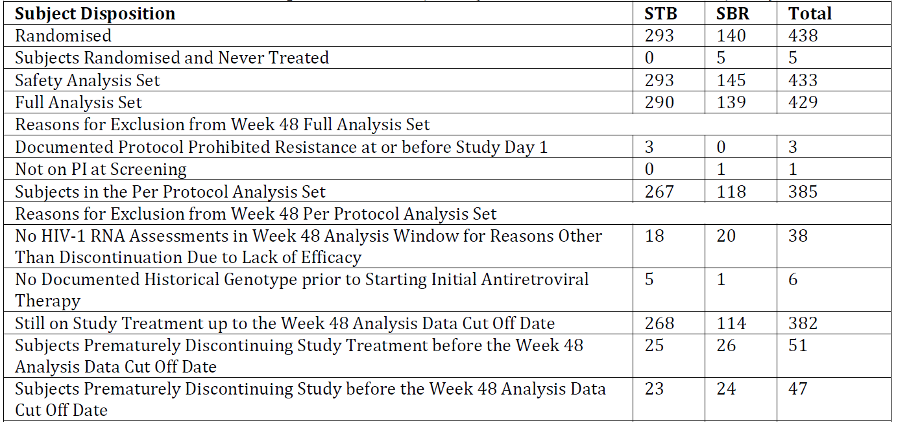
Of the 44 subjects excluded from the Week 48 PPS, 38 discontinued study drug prior for reasons other than lack of efficacy, and 6 had no documented genotype before starting initial ARV therapy.

Major protocol violations/deviations
The table below is a summary of important deviations occurring up to the Week 144 analysis data cut-off date. It was considered that none affected the overall quality or interpretation of the study data.

Table 16: GS-US-236-0115: Important protocol deviations by category: all randomised subjects

Baseline data
Data are provided showing that demographic and baseline characteristics were similar between the 2 treatment groups. The majority were male (85.7%), with a mean age of 41 years (range: 21 to 76); most were White (80.1%) or Black (14 to 15%). The mean (SD) value for baseline BMI was 26.1 (4.61) kg/mP2P. The mean (SD) baseline eGFR_{CG} was 114.1 (26.27) mL/min. The most common reasons for enrolment into the study were desire to simplify the current anti-HIV regime (85.7%) and concern about long term side effects of the current anti-HIV regimen (12.2%). Baseline HIV disease characteristics were similar in the 2 groups. All subjects had HIV-1 RNA < 50 copies/mL at screening. A few had HIV-1 RNA ≥ 50 copies/mL at baseline. The mean (SD) baseline CD4 cell count was 610 (272.9) cells/µL and the mean (SD) CD4% was 32.3 (9.44). The majority (62.8%) had a CD4 cell count > 500 cells/µL. The most common HIV risk factor was homosexual sex. Most (73.7%) had asymptomatic HIV-1 infection. The median times since HIV diagnosis (4 years) and 1PstP ARV treatment (3 years) were the same in each group. A small % were HBsAg positive (13/3.0%) or HCVAb seropositive (29/6.7%). 79.0% (342) had received 1 ARV regimen, 19.2% (83) had received 2 regimens, and 1.8% (8) had received > 2 prior regimens. At screening subjects were receiving ATV (40.3%), DRV (40.0%), LPV (17%), fosamprenavir (3%) or saquinavir (< 1%) as the PI in their regimen.

Results for the efficacy outcomes
Adherence to STB was high (median: 99.7%). Most had an adherence rate ≥ 95% up to the Week 48 visit (93.2%). The adherence rate could not be calculated for the SBR group as ARV drugs other than TVD were not provided by the sponsor. At Week 48, 429 out of 433 subjects (97.9%) were included in the FAS as 3 receiving STB had protocol defined exclusion mutations and 1 SBR subject came into the study on ATR.
Key results for the Primary efficacy endpoint, Week 48 virologic outcome, in the table below show that:
- Virologic success rates at Week 48 were STB 93.8% (272 out of 290) and SBR 87.1% (121 out of 139); the difference in the % of subjects with virologic success (STB – SBR) was 6.7% (95% CI: 0.4 to 13.7); as the lower bound of the 2 sided 95% CI of the difference in response rate was > the pre-specified –12% non-inferiority margin, switching to STB was determined to be non-inferior to SBR at Week 48.
- Statistical superiority of STB over SBR was established because the lower bound of the same 95% CI used to evaluate non-inferiority was > zero, and the difference in virologic success rates was statistically significant (p = 0.025).
- Percent of subjects with virologic failure at Week 48 were low and similar in both groups (STB 0.7%: 2 out of 290; SBR 1.4%: 2 out of 139).
- A lower % receiving STB had no virologic data in the Week 48 window (STB 5.5%, 16 out of 290; SBR 11.5%, 16 out of 139).

Table 17: GS-US-236-0115: Analysis sets: virologic outcome at Week 48: HIV-1 RNA cut-off at 50 copies/mL, snapshot algorithm, FAS
Data provided using the PPS show that the % of subjects with Week 48 virologic success were numerically higher than in the FAS, and similar in both groups: STB 99.3%, 265 out of 267; SBR 99.2%, 117 out of 118; the difference in the % of subjects with virologic success (STB – SBR) was 0.1% (95% CI: –2.1-3.7), supporting the non-inferiority of STB to SBR.

Secondary and tertiary efficacy endpoints

Percent of Subjects who maintained HIV-1 RNA < 50 copies/mL to Week 48: TLOVR
Key results shown in the table below are:
- The % of responders with STB (91.7%, 266 out of 290) was higher than with SBR (84.2%, 117 out of 139); the difference in the % of responders was 7.6% (95% CI: 0.9-15.0; p = 0.029) and similar to that observed for the primary endpoint described above.
- The reason for virologic failure was rebound (STB 1.0%, 3 out of 290; SBR 1.4%, 2 out of 139).
- Small numbers in each group were considered non-responders because of discontinuation due to AEs (STB 2.1%, 6 out of 290; SBR 0.7%, 1 out of 139); there was a lower % of non-responders because of drug discontinuation due to other reasons with STB (5.2%, 15 out of 290) than SBR (12.9%, 18 out of 139 subjects.

Table 18: GS-US-236-0115: Virologic outcome at Week 48: TLOVR analysis, FAS

Percent of subjects with plasma HIV-1 RNA < 50 copies/mL at week 48
High rates of virologic suppression were maintained in both groups. The % of subjects with HIV-1 RNA < 50 copies/mL was numerically higher with STB than SBR using the M = F method and similar between groups using M = E and M = LOCF methods for the Week 48 results as follows:
- M = F: STB 94.1%, 273 out of 290; SBR 89.2%, 124 out of 139; STB-SBR difference: 4.9% (95% CI: -0.6-11.5).
- M = E: STB 99.3%, 273 out of 275; SBR 98.4%, 124 out of 126; STB-SBR difference: 0.9% (95% CI: -1.5-4.8).
- M = LOCF: STB 99.3%, 288 out of 290; SBR 98.6%, 137 out of 139: STB-SBR difference: 0.7% (95% CI: -1.5-4.3).
Results for the M=F analysis are shown in the figure below.
Figure 10: GS-US-236-0115: Percent of subjects with plasma HIV-1 RNA < 50 copies/mL by Visit: M = F, FAS

Time to loss of pure virologic response
Data are provided showing that at Week 48, 1% of subjects receiving STB and 2% receiving SBR had lost PVR (overall p-value = 0.32).

Joint distribution of PVF and study drug discontinuation
266 out of 290 subjects (91.7%) receiving STB had no PVF and no discontinuation of study drug, 3 (1.0%) had PVF alone, and 21 (7.2%) discontinued study drug. No subject receiving STB had PVF and discontinued study drug. 117 out of 139 subjects (84.2%) receiving SBR had no PVF and no discontinuation of study drug, no subject had PVF alone (no discontinuation), and 19 (13.7%) discontinued study drug. 3 subjects receiving SBR had PVF and discontinued study drug.

Change from baseline in CD4 cell count through week 48
Mean (SD) baseline CD4 cell counts were STB 603 (275.4) cells/µL and SBR 625 (270.3) cells/µL. Data are provided showing there were small increases from baseline in both groups to Week 48. Using the M = E method the mean [SD] change at Week 48 with STB was 40 [169.5] cells/ µL and with SBR 32 [166.1] cells/ µL. The difference between these mean changes was 8 cells/ µL (95% CI: –29 to 44 cells/ µL; p = 0.68). There was a similar trend using the LOCF method with the mean [SD] change for STB of 33 [168.9] cells/ µL for SBR 30 [159.2]) cells/ µL. The difference was 4 cells/ µL (95% CI: –30 to 37 cells/ µL; p = 0.78).

Change from baseline in CD4 cell percent at week 48
Mean (SD) baseline CD4% values were STB 32.1% (9.70%) and SBR 32.5% (8.91%). Data are provided showing that the CD4% remained relatively constant to Week 48 in both groups.

Subgroup analyses
Treatment differences and 95% CIs for virologic success are displayed by subgroup in the figure below. This shows that STB was favoured over SBR for age ≥ 40 years, male sex, White race and ATV at screening.
Figure 11: GS-US-236-0115: Forest plot of treatment difference in virologic success by subgroup at Week 48: HIV-1 RNA < 50 copies/ml snapshot algorithm, FAS

Virologic resistance data
Historical genotypes were available for 426 of 429 subjects in the FAS. The HIV-1 subtype was determined for 73% (312 out of 426) and most had Subtype B (258 out of 312, 83%). 123 out of 426 subjects (29%) showed evidence of pre-existing Primary resistance mutations in their historical HIV-1 genotypes. In 288 subjects who switched to STB with historical data available, 88 (31%) had HIV-1 with evidence of ≥ 1 pre-existing Primary resistance mutations in RT and/or PR, 61 (21%) had primary NNRTI resistance mutations including K103N/S (15), Y181C/I/V (6), and G190A/E/Q/S ( 6), 28 (10%) had Primary NRTI resistance mutations including V118I (16) and M41L (4) and 9 (3%) had Primary PI resistance mutations.
In the 138 subjects receiving SBR, 35 (25%) had HIV-1 with evidence of ≥ 1 pre-existing Primary resistance mutations, 27 (20%) had Primary NNRTI resistance mutations, 10 (7%) had primary NRTI resistance mutations and 5 (4%) had primary PI resistance mutations, but all were considered sensitive to their current PI.
No subject in either treatment group with or without a pre-existing mutation met virologic failure criteria and met the criteria for inclusion in the RAP to Week 48.
The sponsor conclusions were:
- Switching to STB met the primary endpoint of non-inferiority versus staying on a PI + RTV + FTC/TDF regimen in virologically suppressed, HIV-1 infected subjects.
- The rate of virologic success with STB was statistically superior than with PI + RTV + FTC/TDF at Week 48 in the FAS.
- Small increases from baseline in CD4 cell counts were seen in both groups.
- There was no treatment emergent HIV-1 drug resistance in either group.
Comment: The sponsor conclusions are accepted.

GS-US-236-0121

Study design, objectives, locations and dates
This was a multi-centre Phase IIIB randomised, open label study to evaluate the efficacy, safety, and tolerability of switching from a SBR treatment comprising a NNRTI plus FTC and TDF to the STB STR in virologically-suppressed, HIV-1 infected patients. It was conducted at 72 sites in the US, Spain, Germany, France, Italy, UK, Belgium, Switzerland, Austria, Canada, Puerto Rico and Portugal. It commenced in December 2011 with the last subject observation for this report being in November 2013.
The objectives were:
- Primary: To evaluate the non-inferiority of switching to STB relative to staying on SBR in maintaining HIV-1 RNA < 50 copies/mL at Week 48 in virologically suppressed, HIV-1 infected subjects.
- Secondary: To evaluate the efficacy, safety and tolerability of the 2 regimens through Week 96.
Subjects were randomised in a 2:1 ratio to 1 of the following 2 treatment groups:
- Treatment Group 1: Switch to STB.
- Treatment Group 2: Stay on SBR.
Treatment was planned for 96 weeks with study visits occurring at Weeks 4, 8, 12, 24, 36, and 48, and then every 12 weeks up to the Week 96 visit. After Week 96, subjects on STB in countries where is not commercially available will be given the option to receive STB until it becomes commercially available or until the sponsor determines otherwise.
This section of the report describes the results with a data cut-off when all subjects had completed 48 weeks of study treatment or had discontinued before the Week 48 visit.

Main inclusion criteria
Subjects were HIV-1 infected adults receiving an ARV regimen comprising an NNRTI + FTC/TDF for ≥ 6 consecutive months, with documented undetectable plasma HIV-1 RNA levels preceding the screening visit, and who had never experienced 2 consecutive HIV-1 RNA values above detectable levels after initially achieving virologic suppression on the 1st or 2nd regimen with no prior use of any approved or experimental INSTI, no known resistance to TDF or FTC, and an estimated eGFR_{CG} ≥ 70 mL/min at screening. Documented historical genotype prior to starting initial ARV therapy showing no known resistance to TDF or FTC, including, but not limited to the presence of RT resistance mutations K65R, M184V/I, or 3 or more TAMs (M41L, D67N, K70R, L210W, T215Y/F, K219Q/E/N/R) that included M41L or L210W was also required.

Study treatments
- Treatment Group 1: STB was administered orally 1 tablet daily with food at around the same time each day.
- Treatment Group 2: SBR: NNRTI + FTC/TDF; EFV, nevirapine (NVP), and RPV were the only allowed NNRTIs in combination with FTC/TDF (TVD), and could include the STRs EFV/FTC/TDF [ATR] or FTC/RPV/TDF; these were administered the same way as before the study.
Allowed and prohibited prior and concomitant medication was specified. Procedures for measuring compliance were described.

Efficacy outcome variables
The primary efficacy endpoint was the % of subjects with HIV-1 RNA < 50 copies/mL at Week 48 using the US FDA defined snapshot analysis.
The Secondary and tertiary efficacy endpoints evaluated for the Week 48 analysis were:
- Changes in CD4 cell count from baseline to Week 48.
- Percent of subjects with HIV-1 RNA < 50 copies/mL by visit to Week 48.
- Percent of subjects who have last, on study drug, HIV-1 RNA < 50 copies/mL to Week 48.
- Percent of subjects who maintained HIV-1 RNA < 50 copies/mL to Week 48 (TLOVR).
- Time to loss of PVR to Week 48.
- Joint distribution of PVF and study drug discontinuation.
- Percent of subjects with emergent HIV-1 drug resistance.
In addition, PROs were assessed. These are not evaluated as they are not relevant to the proposed PI changes.

Sample size
420 subjects were planned to be randomised in a 2:1 ratio to the 2 treatment groups (STB; SBR). With 280 subjects randomised to STB and 140 to SBR, the lower limit of the observed 1 sided 97.5% CI was expected to be > -0.12 (that is, non-inferiority difference of 12%) with 85% power assuming that the % of responders in both groups for the primary endpoint was 82% at Week 48.

Randomisation and blinding methods
Subjects were randomised in a 2:1 ratio to treatment Group 1 or 2 using permuted blocks stratified for use of EFV at enrolment. Blinding did not apply as this was an open label study.

Analysis populations
- SAS: enrolled subjects who received at least 1 dose of study medication.
- FAS: All randomised subjects who received at least 1 dose of study medication. The FAS was the primary set for analysis of efficacy endpoints and is consistent with the ITT approach. Subjects with major protocol violations including documented protocol prohibited resistance at or prior to Day 1 and not being on an NNRTI at screening were excluded.
- PPS: This included subjects in the FAS but excluded those who were not virologically suppressed at both the screening and baseline visits, did not have reported HIV-1 RNA in the Week 48 analysis window for reasons other than discontinuation of study drug due to lack of efficacy, did not meet the key inclusion criterion that the historical genotype report must show sensitivity to FTC and TDF or were receiving therapy with any prohibited medication not to be used with STB. Subjects were grouped according to the treatment they actually received and only efficacy data up to the last dose date of study drug were included.

Statistical methods
Demographic data and baseline characteristics were summarised by treatment group and overall using descriptive statistics for continuous data and by the number and % of subjects for categorical data. Information regarding HIV disease specific characteristics, prior ARV medications and cardiovascular disease specific medical history was summarised.

Primary efficacy endpoint
The Week 48 analysis window was defined as Days 295 to 378 (inclusive) for the primary efficacy endpoint analysis. Virologic outcome was defined as success, failure, and no virologic data. The primary analysis used the FAS. Evaluation of non-inferiority was done by constructing a 2 sided exact 95% CI for the difference in the %s of virologic success between groups (STB – SBR). Non-inferiority was assessed using the 95% CI approach with a non-inferiority margin of 12%. It was concluded that the STB group was non-inferior to the SBR group if the lower bound of the 2 sided 95% CI of the difference in response rates between groups was > -12%. If non-inferiority of switching to STB versus SBR was established, superiority was assessed between the 2 groups based on the same 95% CI used to assess non-inferiority. The superiority of switching to STB versus staying on SBR would be established if the lower bound of the 95% CI was > 0. The Fisher exact test was used to calculate the p-value. Virologic outcome at Week 48 was also analysed for the PPS. In a sensitivity analysis, the difference between treatment groups and its 95% CI, in the % of subjects with virologic failure at Week 48 was determined using the snapshot algorithm and the same methods as for the primary analysis for the FAS.

Secondary and tertiary efficacy endpoints
- Change from Baseline in CD4 Cell Counts and % (while on study drug): these were analysed using M = E and M = LOCF methods and summarised using descriptive statistics for each visit and treatment group. The statistical significance of the change from baseline in CD4 cell count was assessed using the Wilcoxon signed rank test within each treatment. The Wilcoxon rank-sum test was used to assess the difference between the groups at Week 48. Descriptive statistics were used to summarise CD4% by visit (M = E) while on study and on study drug.
- Percent of Subjects with Plasma HIV-1 RNA levels < 50 copies/mL: this was analysed using M = F by visit to Week 48, M = E by visit using all available data, and M = LOCF to Week 48. The exact 95% CI for the difference between groups in % of subjects with plasma HIV-1 RNA < 50 copies/mL was calculated. The Fisher exact test was used to calculate the p-value.
- TLOVR: The maintenance of confirmed HIV-1 RNA < 50 copies/mL to Week 48 (responder) was derived using all available non-missing HIV-1 RNA based on the FDA defined TLOVR algorithm. The count and % of responders (with the 95% CI for the difference between groups) and non-responders (by category) were calculated.
- Time to Loss of PVR: The KM method was used to estimate this outcome to Week 48. PVR was defined as not having a PVF event on or prior to the last dose of study drug. The PVF event time was defined as the day of the first of 2 consecutive HIV-1 RNA ≥ 50 copies/mL or 1 HIV-1 RNA ≥ 50 copies/mL followed by permanent discontinuation of study drug. Only events before permanent discontinuation were included in the analysis. Subjects with no PVF and no early discontinuation were censored on Day 378. The 95% CI for the difference between the 2 groups was calculated using the normal approximation approach. The p-value for the difference between the 2 groups was calculated based on the log rank test.
- Joint Distribution of PVF and Study Drug Discontinuation: This was summarised and included the number of subjects with no PVF and no discontinuation, PVF only, discontinuation only, and discontinuation and PVF.
Subgroup analyses were done for age: < 40 and ≥ 40 years, sex: male and female, race: White and non-White, PI at screening: ATV, DRV, LPV and other, and number of prior ARV regimens: 1, 2, or > 2.

Measurement and analysis of resistance data
Identification of a genotype at screening to exclude subjects with known resistance to study drugs could not be done due to the suppressed HIV-1 viral load. Hence, historical genotypes were used to assess sensitivity to FTC and TDF at screening. HIV-1 genotyping testing (resistance testing) was done if a subject was confirmed as a virologic failure or if HIV-1 RNA was ≥ 400 copies/mL at the subject’s last visit. Subjects with virologic rebound were considered to have virologic failure. Virologic rebound was defined as having 2 consecutive HIV-1 RNA values ≥ 50 copies/mL at least 2 weeks apart. Subjects with rebound were included in the RAP if HIV-1 RNA was ≥ 400 copies/mL at the 2nd visit. The sample from the confirmation visit was analysed for resistance development. In addition, subjects who were on study drugs, who had not been analysed previously, and who had confirmed HIV-1 RNA ≥ 400 copies/mL at Week 48 or their last visit, were assessed for resistance.

Participant flow
434 of 439 randomised subjects received at least 1 dose of study drug (STB: 291; SBR: 143). Of these 434, 9.2% (40 subjects) prematurely discontinued study drug prior to the Week 48 analysis data cut-off date (STB 7.6%/22; SBR 12.6%/18), and 7.8% (34) had prematurely discontinued from the study (STB 5.8%/17; SBR 11.9%/17). Reasons for discontinuation were generally similar in the 2 groups. The most common reasons for study drug discontinuation were withdrawal of consent (STB 3.1%/9; SBR 9.1%/13), AE (STB 2.1%/6; SBR 0.7%/1), and protocol violation (STB 1.4%/4; SBR 0.7%/1). The most common reasons for study discontinuation were withdrawal of consent (STB 3.1%/9; SBR 9.8%/14), protocol violation (STB 1.0%/3; SBR 0.7%/1), and lost to follow-up (STB 0.3%/1; SBR 1.4%/2). A summary of subject disposition is presented in the table below.

Table 19: GS-US-236-0121: Disposition of subjects (all screened subjects)
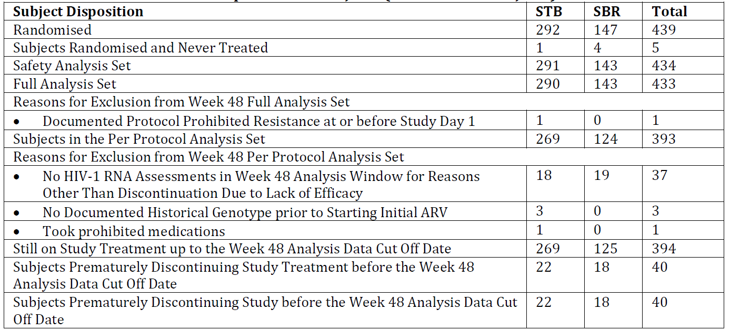

Major protocol violations/deviations
73 important protocol deviations occurred in 61 subjects up to the Week 48 analysis data cut-off date. 7 deviations in 6 subjects were identified after database finalisation and 1 in the SBR group should have been excluded from the PPS analysis. The sponsor considered this did not affect the results as the rate of virologic success with SBR with this subject excluded was identical with their data included. The table below is a summary of important deviations.

Table 20: GS-US-236-0121: Important protocol deviations by category: all randomised subjects

Baseline data
Data are provided showing that demographic and baseline characteristics were generally similar in the 2 treatment groups. The majority of subjects were male (92.6%), with a mean age of 41 years (range: 20 to 72), most were White (76 to 80%) or Black (16 to 17%). The mean (SD) baseline BMI was 26.2 (4.59) kg/m². The mean (SD) baseline eGFR_{CG} was 118.2 (29.40) mL/min. All subjects had HIV-1 RNA < 50 copies/mL at screening, and a few subjects had HIV-1 RNA ≥ 50 copies/mL at baseline. The mean (SD) baseline CD4 cell count was 588 (214.9) cells/µL. The mean (SD) CD4% was 33.1% (8.72%). The majority (63.4%) had a CD4 cell count > 500 cells/µL.
The most common HIV risk factor was male to male sex (78.8%). The majority (78.3%) had asymptomatic infection. The median time since HIV diagnosis was 5 years in both groups and since the 1st P ARV treatment was 4 years with STB and 3 years with SBR. A small % were HBsAg positive (1.8%) or HCVAb seropositive (3.0%). Before screening, 90.6% (393) had received 1 ARV regimen, 9.0% (39) 2 regimens, and 0.5% (2) > 2 regimens. At screening subjects were receiving EFV (77.9%, mainly ATR; 74.2%), NVP (17.1%), RVP (4% Eviplera) or etravirine (1%) as the NNRTI in their regimen.

Results for the efficacy outcomes
Adherence to STB was high (median: 99.7%). Most had an adherence rate ≥ 95% up to the Week 48 visit (91.1%). The adherence rate could not be calculated with SBR as ARV components other than TVD were not provided by the sponsor. Of the 439 randomised subjects, 433 (98.6%) were included in the FAS, and 393 (89.5%) in the Week 48 PPS. 1 subject treated with STB was excluded from the FAS due to the presence of a protocol prohibited resistance mutation. Of the 40 subjects in the FAS excluded from the Week 48 PPS, 37 (92.5%) had no HIV-1 RNA assessment in the Week 48 analysis window for a reason other than discontinuation due to a lack of efficacy.

Primary efficacy endpoint

Virologic outcome at week 48 using snapshot algorithm and HIV-1 RNA < 50 copies/mL
Data are provided showing that in the FAS virologic success rates were STB 93.4% (271 out of 290 subjects) and SBR 88.1% (126 out of 143). The difference in the %s of subjects with virologic success (STB – SBR) was 5.3% (95% CI: - 0.5% to 12.0%). Because the lower bound of the 2 sided 95% CI of the difference in response rate was > the pre-specified –12% non-inferiority margin, switching to STB was determined to be non-inferior to SBR at Week 48. Percent of subjects with virologic failure at Week 48 were low and similar in the 2 groups: STB 1.0% (3 out of 290); SBR (0.7% 1 out of 143; difference [95% CI] in %s [STB – SBR] 0.3% [–2.8% to 2.5%]). A lower % of subjects receiving STB than SBR had no virologic data in the Week 48 window (STB 5.5%, 16 out of 290; SBR 11.2%, 16 out of 143). These results are shown in the table below.

Table 21: GS-US-236-0121: Analysis sets: virologic outcome at Week 48: HIV-1 RNA cut-off at 50 copies/mL, snapshot algorithm, FAS
Using the PPS, the % of subjects with virologic success at Week 48 were higher than in the FAS and similar in the 2 groups, STB 99.3% (267 out of 269); SBR 99.2% (123 out of 124). The % difference of subjects with virologic success was 0.1% (95% CI: –2.1% to 3.5%) supporting non-inferiority of STB to SBR.

Secondary and tertiary efficacy endpoints

Percent of subjects who maintained HIV-1 RNA < 50 copies/mL to Week 48: TLOVR
Results for this analysis are shown in the table below.

Table 22: GS-US-236-0115: Virologic outcome at Week 48: TLOVR analysis, FAS
This shows that responders to Week 48 were STB 91.7% (266 out of 290) and SBR 86.7% (124 out of 143). The difference in the % of responders was 5.0% (95% CI: -1.1% to 12.1%) and consistent with the primary endpoint results. The majority (STB: 5.8%; SBR 12.6%) considered as non-responders were drug discontinuation due to AEs and other reasons. A small % (STB 2.4%; SBR 0.7%) were classified as virologic failure.

Percent of subjects with plasma HIV-1 RNA < 50 copies/mL at week 48
High rates of virologic suppression were maintained in both groups. The Week 48 results showed that the % of subjects with HIV-1 RNA < 50 copies/mL was numerically higher with STB than SBR using the M = F method and similar between groups using M = E and M = LOCF methods as follows:
- M = F: STB 94.8% (275 out of 290); SBR 88.1% (126 out of 143); STB-SBR difference: 6.7% (95% CI: 0.8% to 13.3%).
- M = E: STB 99.3% (275 out of 277); SBR 99.2% (126 out of 127); STB-SBR difference: 0.1% (95% CI: -2.0% to 3.5%).
- M = LOCF: STB 99.0% (287 out of 290); SBR 99.3% (142 out of 143); STB-SBR difference: –0.3% (95% CI: -2.5% to 2.8%).
Results for the M=F analysis are shown in the figure below.
Figure 12: GS-US-236-0121: Percent of subjects with plasma HIV-1 RNA < 50 copies/mL by visit: M = F, FAS

Time to loss of pure virologic response
Data are provided showing that at Week 48, 2% of subjects receiving STB and 1% receiving SBR group had loss of PVR (overall p-value = 0.23).

Joint distribution of pure virologic failure and study drug discontinuation
Results provided of this analysis are tabulated below.

Table 23: GS-US-236-0121: Joint distribution of pure virologic failure and study drug discontinuation
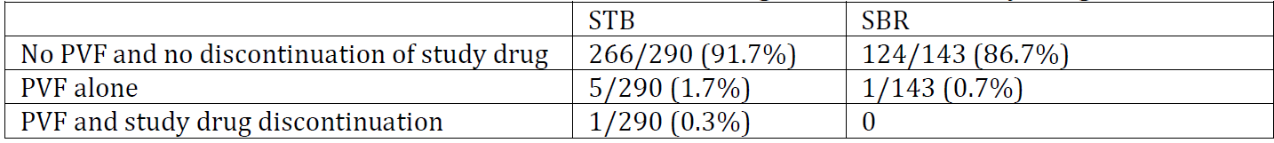

Change from baseline in CD4 cell count through week 48
Mean (SD) baseline CD4 cell counts were STB 586 (210.7) cells/µL and SBR 593 (224.6) cells/µL. Data are provided showing small increases from baseline in CD4 cell counts in both groups to Week 48. Using the M-E method the mean (SD) change at Week 48 with STB was 56 [147.3] cells/µL and with SBR 58 [179.3] cells/µL. A similar trend was found using the M = LOCF method.

Change from baseline in CD4 cell % at week 48
Mean (SD) baseline CD4% values were STB 33.3% (8.88%) and SBR 32.7% (8.43%). Data are provided showing that the CD4% remained relatively constant to Week 48 in both groups.

Subgroup analyses
Treatment differences and 95% CIs for virologic success are shown by subgroup in the figure below. Point estimates for treatment differences in virologic success generally favoured STB. However, except for subjects aged < 40 years, the 95% CIs included zero suggesting no between group differences.
Figure 13: GS-US-236-0121: Forest Plot of treatment difference in virologic success by subgroup at Week 48: HIV-1 RNA < 50 copies/mL, snapshot algorithm, FAS

Virologic resistance data
At screening, resistance data were available for all subjects in the FAS. The HIV-1 subtype was determined for 69% of subjects (298 out of 433) by the historical genotype. Most had HIV-1 subtype B (276 out of 298, 93%). 73 out of 433 subjects (17%) showed evidence of pre-existing primary resistance mutations in their historical HIV-1 genotypes. In the 290 subjects who switched to STB with historical genotype data available, 51 (18%) had HIV-1 with evidence of ≥ 1 pre-existing primary resistance mutation in RT and/or PR, 26 (9%) had primary NNRTI resistance mutations, including E138A/G/K/Q/R (11), V90I (6), V179D/F/L/T (5), and K103N (1), 21 (7%) had primary NRTI resistance mutations, mainly V118I (13); and 10 (3%) had 1P0P PI resistance mutations.
In the 143 SBR subjects, 22 (15%) had evidence of ≥ 1 pre-existing primary resistance mutation, 10 (7%) had primary NNRTI primary mutations; 9 (6%) had primary NRTI resistance mutations and 3 (2%) had primary PIn resistance mutations.
No subject in either group with a pre-existing mutation met virologic failure criteria to Week 48. A subject receiving STB with a pre-existing resistance mutation maintained HIV-1 RNA < 50 copies/mL to Week 48. A subject receiving STB with a number of pre-existing resistance mutations was excluded from the FAS even though they maintained HIV-1 RNA < 50 copies/mL to Week 48. To Week 48, 1 subject without a pre-existing mutation in each treatment group had confirmed virologic rebound and met the criteria for inclusion in the RAP. Results of post baseline genotypic and phenotypic data for PR, RT, and IN revealed that neither subject developed drug resistance in their HIV-1. Both subsequently resuppressed to < 50 copies/mL whilst on study drugs.
The sponsor conclusions were:
- Switching to STB met the primary endpoint of non-inferiority versus staying on an NNRTI + FTC/TDF regimen in virologically suppressed, HIV-1 infected subjects, based on the % of subjects with HIV-1 RNA < 50 copies/mL at Week 48.
- Both groups maintained high rates of virologic suppression. Small increases from baseline in CD4 cell counts were seen in both groups.
- There was no treatment emergent HIV-1 drug resistance in either group.
Comment: The sponsor’s conclusions are accepted.

GS-US-236-0123

Study design, objectives, locations and dates
This was a Phase IIIB open label pilot study to evaluate switching from a regimen comprising RAL plus FTC/TDF (TVD) to STB in virologically suppressed, HIV-1 infected patients. It was conducted at 7 centres in the US between January 2012 and August 2013. The objectives were:
- Primary: To evaluate the efficacy of STB after switching from a regimen consisting of RAL plus FTC/TDF at baseline in maintaining HIV-1 RNA <50 copies/mL at Week 12.
- Secondary: To evaluate the safety and tolerability of STB over 24 and 48 weeks and the efficacy of STB after switching from RAL plus FTC/TDF at baseline in maintaining HIV-1 RNA < 50 copies/mL at Weeks 24 and 48.
After screening, study visits occurred at baseline and Weeks 4, 8, 12, 24, 36, and 48. After Week 48, all subjects completed a 30 day follow up visit or telephone call.
Information on and results from the safety assessment are presented in the safety section of this report.

Main inclusion criteria
HIV-1 infected adults who had been virologically stable on their current 1st ARV regimen comprising only RAL twice daily plus TVD continuously for ≥ 6 months before screening. Subjects were required to have documented undetectable plasma HIV-1 RNA levels for ≥ 6 months before screening, never to have experienced 2 consecutive detectable HIV-1 RNA levels after having achieved a confirmed undetectable HIV-1 RNA level on the 1st regimen, to have plasma HIV-1 RNA < 50 copies/mL at screening, and to have no known resistance to any of the study agents as demonstrated by HIV-1 genotyping at screening. Subjects were also required to have adequate renal function.

Study treatments
All subjects received STB orally, once daily, with a meal. Allowed and prohibited prior and concomitant medication was specified. Procedures for measuring compliance were described.

Efficacy outcome variables
The primary efficacy endpoint was the % of subjects with HIV-1 RNA < 50 copies/mL at Week 12, as defined by the FDA snapshot algorithm. The analysis window was defined as study Days 71 to 126 (inclusive).
Virologic outcome was defined virologic success or failure and no virologic data in the Week 12 visit window.
The secondary efficacy endpoints were:
- Percent of subjects with HIV-1 RNA < 50 copies/mL at Weeks 24 and 48.
- Percent of subjects with HIV-1 RNA < 50 copies/mL by visit.
- Percent of subjects with HIV-1 RNA < 50 copies/mL at Weeks 12, 24, and 48.
- CD4 cell count and changes from baseline by visit.
Resistance analysis was also undertaken.

Sample size
50 subjects were planned for the study. This number was selected based on the feasibility of conducting the study.

Analysis populations
- SAS: enrolled subjects who received at least 1 dose of study medication.
- FAS: All enrolled subjects who received at least 1 dose of study medication with no major protocol violations including documented protocol-prohibited resistance at or prior to Day 1.

Statistical methods
Demographic data and baseline characteristics were summarised using descriptive statistics for continuous data and by the number and % of subjects for categorical data. Baseline disease data were summarised by HIV-1 RNA copies/mL categories (< 50, 50 to < 200, 200 to < 400, 400 to < 1000, ≥ 1000), CD4 cell count and cell count categories (/µL) (≤ 50, 51 to ≤ 200, 201 to ≤ 350, 351 to ≤ 500, > 500), HIV disease status, mode of infection, HBV and HCV status, enrolment survey results, eGFR_{CG}, use of lipid lowering agents and duration of RAL use.

Primary efficacy endpoint
Virologic outcomes at Week 12 were summarised using frequency counts and %, and a 2 sided exact 95% CI for the % of subjects with virologic success was constructed.

Secondary efficacy endpoints
- Percent of subjects with HIV-1 RNA < 50 copies/mL at Weeks 24 and 48: Similar methods to those used for analysis of the primary endpoint were used to estimate the % of subjects with HIV-1 RNA < 50 copies/mL at Weeks 24 and 48. The analysis windows were Days 127 to 210 for the Week 24 analysis and Days 295 to 379 for the Week 48 analysis.
- Percent of subjects with HIV-1 RNA Levels < 50 copies/mL by visit: A categorical summary of HIV-1 viral load at each visit (< 50, ≥ 50 to < 200, ≥ 200 to < 400, ≥ 400 to < 1000, and ≥ 1000 copies/mL, non-completer, missing) was to be provided. A non-completer was a subject who prematurely discontinued study drug prior to the summarised visit for the on-treatment analysis, or who prematurely discontinued from the study prior to the summarised visit for the on-study analysis. These %s of were analysed using M = F (by visit), M = E (by visit), and M = LOCF (at Weeks 12, 24, and 48). The exact 95% CI was calculated for each of the above %s at Weeks 12, 24, and 48.
- Change from baseline in CD4 cell counts and %s by visit: Descriptive statistics were used to summarise CD4 cell counts and change from baseline at each visit. CD4% and change from baseline in CD4% were summarised in a similar manner for subjects in the FAS.

Resistance analysis
Virologic rebound was defined as having 2 consecutive visits with HIV-1 RNA ≥ 50 copies/mL at least 2 weeks apart. Subjects with virologic rebound were considered to have virologic failure. Also subjects who had HIV-1 RNA ≥ 400 copies/mL at Week 48 or at their last visit were to be analysed for resistance at their last visit.

Participant flow
48 subjects were enrolled and all completed the study.

Major protocol violations/deviations
14 important protocol deviations occurred in 9 subjects. The majority were for subjects who had dispensing or dosing errors or who were not managed according to protocol-specified requirements. 1 subject had violated the inclusion criterion requiring a subject to have been on their first ARV regimen consisting only of RAL plus TVD. They had received RAL plus ATR for 3 months prior to switching to RAL plus TVD. The sponsor considered that none of the deviations affected the overall interpretation of the study data. The table below is a summary of important deviations.

Table 24: GS-US-236-0123: Important protocol deviations by deviation category: all enrolled subjects

Baseline data
Data are provided showing that the majority of subjects were male (95.8%). The mean age was 44 years (range: 23 to 58), most were White (83.3%) or Black (14.6%), and non-Hispanic/Latino (79.2%). Mean BMI at was 27.7 kg/m². The majority (95.8%) had HIV-1 RNA < 50 copies/mL. 2 subjects had HIV-1 RNA 50-< 200 copies/mL. The mean (SD) CD4 cell count was 711 (265.9) cells/µL. The mean (SD) baseline CD4% was 35.4% (8.95%). The mean (SD) duration for which subjects had received RAL was 31.6 (14.26) months. The most common HIV risk factor category was homosexual sex (91.7% of subjects). The majority (93.8%) had asymptomatic infection. No subjects were HBsAg positive and 1 subject was HCVAb positive. The mean (SD) baseline eGFR_{CG} was 110.4 (21.75) mL/min.

Results for the efficacy outcomes

Primary efficacy endpoint
Data are provided showing that all subjects maintained virologic success at Week 12 and that in all, HIV-1 RNA was < 50 copies/mL.

Secondary efficacy endpoints

Virologic outcome at Weeks 24 and 48 using snapshot algorithm and HIV-1 RNA < 50 copies/mL
Data are provided showing that all subjects maintained virologic success at Weeks 24 and 48, and that in all, HIV-1 RNA was < 50 copies/mL.

Percent of subjects with plasma HIV-1 RNA levels < 50 copies/mL by visit
Data are provided showing that all subjects had HIV-1 RNA < 50 copies/mL at Weeks 12, 24, and 48 using the M = F, M = E, and M = LOCF methods. It is noted that 1 subject had HIV-1 RNA ≥ 50 copies/mL during the study. This occurred at Week 8 and HIV-1 RNA was 59 copies/mL.

Change from baseline in CD4 cell counts and percent
At Week 48, mean (SD) CD4 cell counts were 733 (270.1) cells/µL, and the mean (SD) change from baseline 23 (144.6) cells/µL. At Week 48, the mean (SD) change from baseline in CD4% was 0.7% (3.92%).

Virologic resistance data
It is indicated that no subject experienced virologic failure. In 42 out of 48 (88%) subjects with available historical HIV-1 subtype information, most (41 out of 42) had subtype B. 8 out of 48 (17%) had evidence of ≥ 1 primary RT resistance mutation in their HIV-1 genotype. These comprised NNRTI resistance mutations for 7 subjects, including K103N (n = 4), V106I (n = 2), and G190A (n = 1). The NRTI resistance mutations K219K/Q and D67N+K219Q were also present in isolates from the 2 subjects with V106I. The primary NRTI resistance mutation M41L was present in the isolate from the remaining subject.
No subject with a pre-existing mutation met virologic failure criteria. As virologic suppression was maintained through 48 weeks in all subjects, the sponsor considered that the presence of NNRTI and NRTI resistance mutations did not affect the antiviral activity of STB.
The sponsor concluded that STB was effective in maintaining virologic suppression and immunologic control for 48 weeks in virologically suppressed, HIV-1 infected subjects who switched from a regimen of RAL+TVD, as indicated by the following:
- Virologic success was maintained in 100% of subjects at Weeks 12, 24, and 48.
- There was no development of drug resistance.
Comment: The sponsor’s conclusions are accepted.

Evaluator’s conclusions on efficacy
The results from Week 144 data in Studies GS-US-236-0102 and GS-US-236-0103 demonstrate continued efficacy of STB in treatment naïve subjects with HIV.
Data and information to support an extension of indications to include the use of STB in virologically suppressed HIV-1 infected subjects is provided in Studies GS-US-236-0115, GS-US-236-0121 and GS-US-236-0123. In GS-US-236-0115 and GS-US-236-0121, subjects were switched to STB from the baseline regimens of PIn + RTV + FTC/TDF and NNRTI plus FTC and TDF respectively and compared with subjects continuing on the baseline regimens. Results are presented showing that at Week 48 treatment with STB was non-inferior to continued treatment with the baseline regimens. Also, in both studies, there was no treatment emergent HIV-1 drug resistance in either treatment group. Efficacy of STB in this population was also demonstrated from the results of Study GS-US-236-0123. In this study, subjects were switched to STB from a regimen of RAL + TVD. All subjects maintained virologic suppression and there was no development of drug resistance. It is considered that these data support the use of STB in virologically suppressed HIV-1 infected subjects.

Clinical safety
The safety data provided in the dossier that are relevant to the proposed PI changes in the precautions and adverse effects sections comprise:
- The CSR for Study GS-US-236-0118 to support an update to the adverse effects section to include 48-week safety data with use of STB in HIV-1 infected treatment naïve patients with mild to moderate renal impairment.
- CSRs for Studies GS-US-236-0102 and GS-US-236-0103 to support an update of safety information in the precautions and adverse effects sections to include Week 144 data.
- CSRs for Studies GS-US-236-0115, GS-US-236-0121 and GS-US-236-0123 to support additional information in the adverse effects section to include data from the use of STB in virologically suppressed patients.
A summary of key safety data and information provided in the CSRs of these studies is presented as follows.

GS-US-236-0118

Study design, objectives, locations and dates
This was an open label, multicentre, multiple cohort study to evaluate the effect of COBI-containing ARV regimens on parameters of renal function in HIV-1 infected subjects with mild to moderate renal impairment and to assess the safety and tolerability of those regimens to inform dosing recommendations in this subset of patients. It was conducted at 40 sites in the US, UK, Australia, Austria, Canada, Mexico, Dominican Republic and Germany. It commenced in May 2011 with the last subject observation for this report being in July 2013.
The objectives were:
- Primary: To evaluate the effect of COBI containing regimens on renal parameters at Week 24.
- Secondary: To evaluate the safety and tolerability of COBI containing regimens and the long term effect of COBI containing regimens on renal parameters, and to measure the proportion of subjects achieving virologic response at Weeks 24, 48, and 96.
Also, all subjects were asked to participate in an intensive PK/pharmacodynamic (PD) sub-study with assessments at baseline and Weeks 2, 4, and 24 to investigate the PK/PD of COBI, FTC, TFV, EVG, ATV and DRV. Actual GFR (aGFR), using iohexol plasma clearance (CLiohexol), was assessed at baseline and Weeks 2, 4, and 24 and/or if necessary as part of the toxicity management procedures for reductions in eGFR for subjects in this sub-study. In addition, resistance assessment was undertaken.
Subjects were in 1 of the following 2 cohorts:
- Cohort 1: ARV treatment naïve: STB: STB cohort.
- Cohort 2 (including 2 sub-groups): pharmacoenhancer switch: COBI 150 mg boosted ATV 300 mg or COBI 150 mg boosted DRV 800 mg + 2 NRTIs: PIn/co cohort.
Treatment was planned for 96 weeks with study visits at Weeks 4, 8, 12, 24, 36, and 48, and then every 12 weeks up to the Week 96 visit. After Week 96, if STB or COBI is not commercially available, subjects will be able to participate in a study extension to continue their study regimen until all subjects have discontinued or there is approval of STB or COBI in their country.
The sponsor indicates this is an interim CSR as the data analysis and results presented for the primary and secondary objectives are up to the date at which the last subject continuing in the study completed 48 weeks of treatment. In this evaluation, only information and data pertaining to the renal parameters are considered as these are relevant to the proposed changes in the Adverse Effects section of the PI.

Main inclusion criteria
Adult HIV-1 infected subjects with mild to moderate renal impairment (eGFR_{CG} 50 to < 90 mL/min, inclusive), with stable renal function, who met the following criteria:
- STB Cohort: ARV treatment naïve, with HIV-1 RNA ≥ 1000 copies/mL at screening.
- PIn/co Cohort: ARV treatment experienced, receiving a regimen of ATV 300 mg/ RTV 100 mg plus 2 NRTIs or DRV 800 mg/RTV 100 mg plus 2 NRTIs for at least 6 months prior to screening; with plasma HIV-1 RNA concentrations (at least 2 measurements) at undetectable levels (according to the local assay being used) in the 6 months preceding the screening visit; and HIV-1 RNA < 50 copies/mL at screening.
Across both cohorts, there were to be at least 10 subjects with screening eGFR_{CG} 50 to < 60 mL/min, and no more than 50 subjects with screening eGFR_{CG} 80 to < 90 mL/min.

Study treatments
- STB Cohort: STB orally once daily with food at approximately the same time each day.
- PIn/co Cohort: 1 × 150 mg COBI tablet orally once daily with food at approximately the same time each day. All other regimen components (ATV or DRV + 2 NRTIs) were as prescribed by the investigator.
Allowed and prohibited prior and concomitant medication was specified. Procedures for measuring compliance were described. Of note, there were protocol defined toxicity management criteria for potential study drug discontinuation, these being confirmed eGFR_{CG} < 50 mL/min and > 20% decrease in cystatin C (CysC) derived GFR at the confirming visit.

Renal endpoints
The primary renal endpoints were the change from baseline at Week 24 in the following parameters:
- Glomerular filtration rate estimated by the Cockcroft-Gault method: eGFR_{CG} (mL/min) = [(140 – age (years)) x weight (kg) x (0.85 if female)] / (serum creatinine (mg/dL) [Scr] x 72).
- Glomerular filtration rate, estimated, by modification of diet method: eGFR_{MDRD} (mL/min/1.73m2) = 186 x Scr–1.154 (mg/dL) x age–0.203 (years) x (0.742 if female) x (1.21 if Black).
- Glomerular filtration rate, estimated, by chronic kidney disease epidemiology collaboration methods using creatinine: eGFR_{CKD-EPIR}, _{creatinine} (mL/min/1.73 m2) = 141 x min(Scr/κ, 1)α x max(Scr/κ, 1)-1.209 x 0.993age x (1.018 if female) x (1.159 if Black) where κ is 0.7 for females and 0.9 for males, α is - 0.329 for females and - 0.411 for males, min indicates the minimum of Scr/κ or 1, and max indicates the maximum of Scr/κ or 1.
- Glomerular filtration rate, estimated by chronic kidney disease epidemiology collaboration methods using cystatin: eGFR_{CKD-EPI, cysCR, adjusted} [for age, sex and race]) (mL/min/1.73 m2) = 127.7 x cysC_{–1.17} (mg/L) x age–0.13 (yrs) x (0.91 if female) x (1.06 if Black), and eGFR_{CKD EPI, cysC, unadjusted} (mL/min/1.73 m2) = 76.7 x cysC_{–1.19} (mg/L).
- Actual Glomerular Filtration Rate: aGFR (mL/min) = iohexol dose / AUC_{inf} of iohexol.
Other renal endpoints included Scr, serum CysC, serum phosphorus, and urine fractional excretion of phosphate (FEPO₄) based on unadjusted Scr:
- FEPO₄ (%) = (Scr x UPO4) / (SPO4 x Ucr) x 100(%), where Scr is serum creatinine concentration (mg/dL), UPO4 is urine phosphate concentration (mg/dL), SPO4 is serum phosphate concentration (mg/dL), and Ucr is urine creatinine concentration (mg/dL).
To identify any potential subclinical proximal renal tubulopathy (PRT) not reported as AEs, renal laboratory abnormalities associated with possible renal dysfunction were assessed.
Also, clinically significant AEs in the Renal and Urinary Disorders SOC (system organ class) and Renal Function Analyses HLT (higher level term) under the Investigations SOC were assessed.

Sample size
A sample size of approximately 100 subjects in the STB and PIn/co cohorts combined was based on practical considerations and considered to be sufficient to evaluate the primary objective of the study.

Randomisation and blinding methods
This study was open label and subjects were not randomised.

Analysis populations
- SAS: enrolled subjects who received at least 1 dose of study medication.
- PK/PD sub-study analysis set: enrolled subjects who received at least 1 dose of study medication and for whom steady state PK parameters were available. This was used for assessment of the aGFR.

Statistical methods
Demographic and baseline characteristics were summarised for the SAS by group using descriptive statistics for continuous data and by the number and % of subjects for categorical data. The primary renal endpoints were summarised by group and visit using descriptive statistics. Change from baseline and % change from baseline (except for aGFR) at each post baseline visit were provided. For aGFR, a parametric ANOVA using a mixed effects model with repeated statement was fitted to the natural logarithm transferred aGFR obtained at post baseline visits and baseline. The geometric mean ratio between each of the post baseline visits and baseline visit and its 90% CIs was constructed. The point estimate and 90% CIs on log scale for the difference between visits was produced. The test/reference (e.g., Week 2/Baseline) ratio and 90% CIs were calculated by exponentiation of the point estimate and the corresponding lower and upper limits. 90% CIs for the ratio of the geometric LSM of the test and reference visits were calculated for aGFR, consistent with the two 1 sided tests approach. Plots of eGFR_{CG}, eGFR_{MDRD}, eGFR_{CKD-EPI}, and aGFR over time were generated by subject group. Other renal endpoints were summarised by visit for each group and change from baseline provided. Plots of these parameters over time were generated by subject group.
To identify potential subclinical PRT, renal laboratory abnormalities were analysed as follows:
- Possible renal dysfunction: confirmed Scr increase from baseline ≥ 0.4 mg/dL.
- Possible tubular dysfunction: confirmed ≥ 2 grade level increase from baseline in graded proteinuria, ≥ 1 grade level increase from baseline in graded hypophosphatemia and ≥ 1 grade level increase from baseline in graded normoglycaemic glycosuria.
If the AE preferred term (PT) was renal tubular disorder or Fanconi syndrome acquired, the subject was assessed as having PRT irrespective of laboratory findings. Confirmed renal laboratory abnormalities were defined as abnormalities observed at 2 consecutive post baseline measurements. Renal laboratory data were listed for subjects with any confirmed laboratory abnormalities. AEs assessed as due to structural abnormalities, congenital abnormalities, neoplasm, infection (non-HIV), obstruction, inflammation, vascular disorder, kidney stone, or were anatomically related to the ureter, bladder, or urethra, were not considered to be relevant.

Participant flow
In the STB cohort, 33 subjects were enrolled and received at least 1 dose of study drug. There are 2 statements in relation to discontinuations:
- 27 subjects (81.8%) were still on study drug at the time of the data cut-off with reasons for discontinuation AE (4), withdrawal of consent (1), and investigator’s discretion (1).
- 29 subjects (87.9%) were still on study at the time of the data cut-off with reasons for discontinuation AE (2), withdrawal of consent (1), and investigator’s discretion (1).
In the PI/co cohort, 73 subjects were enrolled and received at least 1 dose of study drug (ATV/co n = 52, DRV/co n = 21; TDF containing regimen n = 51). There are 2 statements in relation to discontinuations:
- 54 subjects (74.0%) were still on study drug at the time of the data cut-off with reasons for discontinuation AE (7), withdrawal of consent (6) investigator’s discretion (4) and loss to follow-up and protocol violation (1 each).
- 57 subjects (78.1%) were still on study at the time of the data cut-off with reasons for study discontinuation withdrawal of consent (8), AE (3) and investigator’s discretion, loss to follow-up, and protocol violation (1 each).

Major protocol violations/deviations
There were 39 important protocol deviations reported in 13 subjects receiving STB and 18 in the PIn/co group. It was considered that most did not affect the quality of the data or GCP compliance. The most common violation entailed the eligibility criterion of availability of Scr values within 3 months of screening. The table below is a summary of important deviations.

Table 25: GS-US-236-0118: Important protocol deviations by category: all randomised subjects

Baseline data
In the STB SAS, 81.8% of subjects were male with a mean age of 50 years (range: 22 to 72).
Subjects were predominantly White (42.4%) or Black (39.4%). The mean (SD) BMI was 23.7 (3.43) kg/m². The mean (SD) baseline HIV-1 RNA level was 4.76 (0.652) log₁₀ copies/mL. 27.3% of subjects had baseline HIV-1 RNA > 100,000 copies/mL. The mean (SD) CD4 cell count was 356 (174.2) cells/µL. The mean (SD) eGFR_{CG} was 72.6 (14.56) mL/min. 4 subjects (12.1%) had abnormal Scr. 12 (36.4%) had hypertension, 3 (9.1%) had diabetes and 1 (3.0%) had HIV associated nephropathy. Proteinuria ≥ trace was present in 18 (54.5%). Demographic and baseline characteristics were similar in eGFR_{CG} subgroups: (< 70 mL/min: 12; ≥ 70 mL/min: 21).
In the PIn/co SAS, 82.2% were male with a mean age of 54 years (range: 29 to 73) and predominantly White (76.7%) or Black (19.2%). The mean (SD) BMI was 25.6 (3.64) kg/m². All subjects had HIV-1 RNA < 50 copies/mL at baseline. The mean (SD) CD4 cell count was 627 (263.2) cells/µL. The mean (SD) eGFR_{CG} was 71.4 (12.55) mL/min. 10 (13.7%) had abnormal Scr, 28 (38.4%) had hypertension, 13 (17.8%) had diabetes, 2 (2.7%) had HIV associated nephropathy and 1 (1.4%) had PRT. Proteinuria ≥ trace was present in 37 (50.7%). Demographic and baseline characteristics were generally similar in the PI/co subgroups (ATV/co: 52; DRV/co: 21), in subgroups by use of TDF in the ARV regimen (TDF: 51; no TDF: 22) and in eGFR_{CG} subgroups (< 70 mL/min: 35; ≥70 mL/min: 38).
The protocol required that across both cohorts there were at least 10 subjects with screening eGFR_{CG} 50 to < 60 mL/min, and no > 50 with screening eGFR_{CG} 80 to < 90 mL/min. In the study subjects there were 19 with screening eGFR_{CG} 50 to < 60 mL/min (STB: 5; PI/co: 14) and 27 with screening eGFR_{CG} 80 to < 90 mL/min (STB: 10; PI/co: 17).

Results
106 subjects were included in the SAS (STB: 33; PI/co: 72 [51 ATV/co+2NRTIs, 21 DRV/co+2NRTIs). The median adherence rates to study drug were 97.9% with STB and 98.1% with PI/co. Most (STB 66.7%; PIn/co 80.6%) had an adherence rate of ≥ 95%. The median exposure with STB was 61.1 weeks with the majority receiving study drug for ≥ 48 weeks (84.8%, 28). In the PIn/co cohort, the median exposure was 59.6 weeks and similar in the PIn/co subgroups: ATV/co: 59.1 weeks; DRV/co: 60.0 weeks. The majority received study drug for ≥ 48 weeks (79.5%, 58 subjects).

Changes from baseline in GFR
A summary of these changes is presented in the table below.

Table 26: GS-US-236-0118: Changes from baseline in GFR: safety analysis set
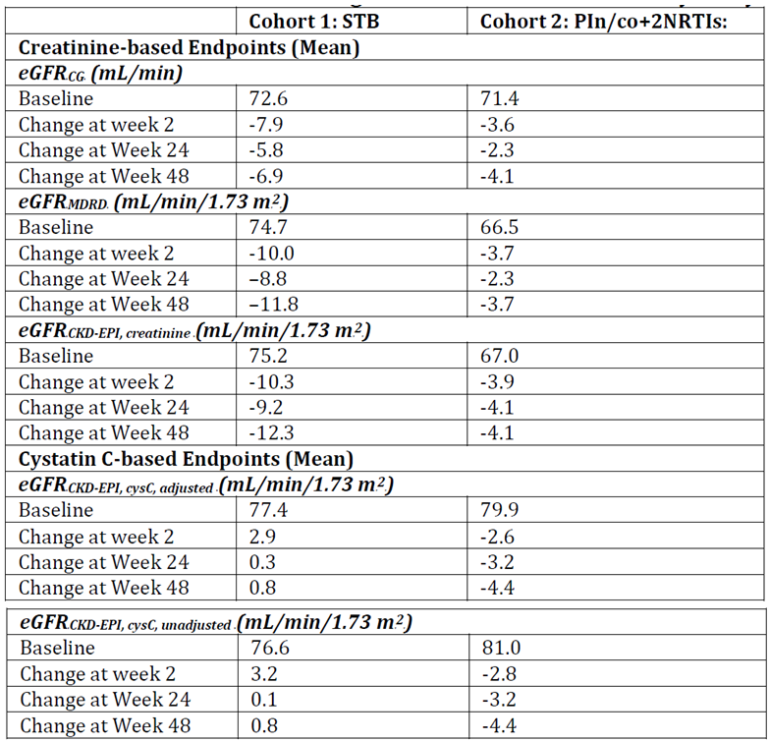
Notes: STB: N = 33, 30 and 28 at baseline, 24 and 28 weeks respectively; Pi/co: N = 73, 67 and 63 at baseline, 24 and 28 weeks respectively
The data provided for the STB Cohort showed that decreases in eGFR_{CG} were noted by Week 2 after which they generally stabilised and did not increase further up to Week 48.
- The pattern of changes in other creatinine based eGFR endpoints, eGFR_{MDRD} and eGFR _{CKD-EPI}, creatinine, was consistent with that for eGFR_{CG}.
- There were no notable changes from baseline in CysC based eGFR endpoints, eGFR _{CKD EPI, cysC}, adjusted Rand eGFRR_{CKD-EPI, cysC, unadjusted}.
- The pattern of changes from baseline in mean eGFR_{CG} were similar for subjects in subgroups by baseline eGFR_{CG}; the size of the changes was smaller with baseline eGFR_{CG} < 70 mL/min (mean change at Weeks 24 and 48 respectively 0.6 and – 5.5 mL/min) than with baseline eGFR_{CG} ≥ 70 mL/min (mean change at Weeks 24 and 28 respectively -9.0 and -7.5 mL/min).
- The pattern of changes in eGFR_{MDRD} and eGFR_{CKD-EPI, creatinine} was consistent with that for eGFR_{CG} in each subgroup.
- Analysis by baseline eGFR_{CG} for CysC-based eGFR endpoints showed that changes were small and not considered clinically relevant.
The data provided for the PIn/co Cohort shows:
- There were small changes in eGFR which were not considered clinically relevant; this was expected as the 2 pharmaco enhancers COBI from RTV similarly inhibit the tubular secretion of creatinine.
- Small decreases in mean eGFR_{CG} were noted as early as Week 2 after which they generally stabilised and did not increase further up to Week 48.
- The pattern of changes in other eGFR endpoints was consistent with that for eGFR_{CG}, both for creatinine and CysC based endpoints.
- The patterns of changes from baseline for eGFR endpoints were similar for subjects with or without TDF in their ARV regimen and generally similar in each subgroup.
- In subjects with baseline eGFR_{CG} < 70 mL/min, there were no notable changes from baseline.
- In subjects with baseline eGFR_{CG} ≥ 70 mL/min, there were decreases from baseline in creatinine based eGFR endpoints that were higher than those in the < 70 mL/min group as seen in this subgroup with STB.
- The pattern of changes in eGFR_{MDRD} and eGFR_{CKD-EPI,} creatinine was consistent with that for eGFR_{CG} in each subgroup.
- The changes from baseline for CysC based eGFR endpoints were similar for subjects in subgroups by baseline eGFR_{CG}.

Changes in aGFR
aGFR data from subjects in the PK/PD analysis set comprising 1 with STB and 14 with PI/co were combined as shown in the table below.

Table 27: GS-US-236-0118: Changes from baseline in aGFR: PK/PD analysis set
Statistical comparisons of aGFR based on CLiohexol between test (Week 2, 4, and 24 visits) and reference (baseline) are presented in the table below.

Table 28: GS-US-236-0118: Statistical comparison of aGFR (CLiohexol) for visits at Weeks 2, 4, and 24 versus baseline: PK/PD analysis set
These show that aGFR was unaffected over 24 weeks of treatment as demonstrated by the GLSM ratios and associated 90% CIs for each comparisons of aGFR between baseline and Weeks 2, 4, and 24. The sponsor states that these data are consistent with results from Study GS-US-216-012 which showed that COBI or COBI-containing treatments do not alter actual renal function.

Other renal endpoints and proximal renal tubulopathy
For Scr, data are provided showing:
- Increases in median values for Scr were noted by Week 2 after which they generally stabilised and did not increase up to Week 48; the changes from baseline at Week 48 in the STB and PIn/co cohorts were 0.17 and 0.06 mg/dL respectively.
- Graded Scr abnormalities were reported for around 25% in both groups, all of which were Grade 1 or 2 in severity.
- 1 and 3 subjects in the STB and PIn/co cohorts respectively had creatinine increases ≥ 0.4 mg/dL; the subject receiving STB discontinued from the study.
- In both cohorts baseline median Scr values were higher in subjects with baseline eGFR_{CG} < 70 mL/min than with baseline eGFR_{CG} ≥ 70 mL/min and the %s of subjects with graded Scr abnormalities were higher in those with baseline eGFR_{CG} < 70 mL/min.
For serum CysC, data are provided showing:
- In both cohorts, there were no clinically relevant changes from baseline in median values.
- There were no clinically relevant changes from baseline in median values in either eGFR_{CG} subgroup.
- In the PIn/co cohort, results were similar in those with or without TDF.
For serum phosphorus, data are provided showing:
- In both cohorts, median serum phosphorus values were within normal ranges throughout the study and there were no clinically relevant changes from baseline in median values.
- Results were similar in subgroups of subjects by baseline eGFR_{CG.}
- Hypophosphatemia was reported for subjects in both cohorts; none was reported as an AE.
- Results were similar in subgroups of subjects by baseline eGFR_{CG} and in the PIn/co cohort with or without TDF.
For urine fractional excretion of phosphate, data are provided showing:
- In both cohorts, small increases in median values for FEPO4 were noted by Week 2 after which they generally stabilised and did not increase up to Week 48; the sponsor considered that these were not clinically relevant as they are unlikely to represent a true increase in renal phosphate excretion due to the calculation of FEPO₄ being influenced by Scr.
- In both cohorts, baseline median FEPO₄ values were slightly higher in subjects with baseline eGFR_{CG} < 70 mL/min than with baseline eGFR_{CG} ≥ 70 mL/min; there was no notable pattern in changes from baseline in either cohort.
For glycosuria, data are provided showing:
- With STB and PIn, glycosuria was seen in 4 and 11 subjects respectively. All had a history of diabetes, hyperglycaemic glycosuria, baseline glycosuria, or isolated and transient occurrences.
- With STB, glycosuria was reported as an AE for 1 subject that resolved and all subjects with glycosuria had baseline eGFR_{CG} ≥70 mL/min.
- In the PIn/co cohort, glycosuria was reported as a non-serious AE for 1 subject who discontinued due to proteinuria and haematuria; glycosuria was reported for 9 out of 50 subjects (18.0%) with TDF and for 2 out of 22 (9.1%) without TDF; 6 out of 11 subjects with glycosuria had baseline eGFR_{CG} < 70 mL/min and 5 had baseline eGFR_{CG} ≥ 70 mL/min.
For proteinuria, data are provided showing:
- With STB, baseline proteinuria ≥ trace was present in 18 subjects (54.5%); treatment emergent graded proteinuria was observed for 13 (39.4%); all were Grade 1 or 2 in severity and tended to be isolated and transient; proteinuria was reported as a non-serious, Grade 1 AE for 1 subject; no action was taken and the event resolved; treatment emergent graded proteinuria was reported for 3 out of 12 subjects (25.0%) with baseline eGFR_{CG} < 70 mL/min and for 10 out of 21 (47.6%) with baseline eGFR_{CG} ≥ 70 mL/min.
- In the PIn/co cohort, proteinuria ≥ trace was present at baseline in 37 subjects (50.7%); treatment emergent graded proteinuria was observed for 29 out of 72 subjects (40.3%) all of which was Grade 1 or 2 in severity, and tended to be isolated and transient; proteinuria was reported as a non-serious Grade 2 AE for 1 subject; study drug was discontinued due to this and concurrent haematuria and glycosuria; treatment emergent graded proteinuria was reported for 23 out of 50 subjects (46.0%) with TDF and for 6 out of 22 (27.3%) without TDF in their regimens; treatment emergent graded proteinuria was reported for 15 out of 34 subjects (44.1%) with baseline eGFR_{CG} < 70 mL/min and for 14 out of 38 (36.8%) with baseline eGFR_{CG} ≥ 70 mL/min.

Adverse events
The AE data is summarised as follows:
- No subjects were reported with renal SAEs.
- With STB, 3 subjects discontinued due to the renal AEs of decreased creatinine renal clearance, increased blood creatinine and abnormal GFR; all had baseline eGFR_{CG} < 70 mL/min.
- In the PIn/co cohort, 2 subjects discontinued due to the renal AEs of abnormal GFR, and proteinuria and haematuria; both subjects had baseline eGFR_{CG} < 70 mL/min.
- No subject who discontinued had renal AEs and laboratory findings consistent with PRT.
- 3 of the 5 subjects (STB x 2; PIn/co x 1) who discontinued met the protocol defined toxicity management criterion for potential study drug discontinuation.
- 1 subject in the PIn/co cohort with pre-existing TDF associated PRT discontinued TDF due to an AE of renal tubular disorder but continued COBI.
- No subjects met the criteria for treatment emergent subclinical PRT.
- No subjects had > 1 confirmed renal laboratory abnormality.
The interim Week 48 sponsor conclusions are as:
- In HIV-1 infected subjects with mild to moderate renal impairment, the renal safety profiles of COBI containing regimens, specifically STB or a regimen including a PI with or without TDF, were consistent with those from previous studies.
- No subject had treatment emergent laboratory findings consistent with PRT.
- With STB decreases in median values for creatinine based estimates of GFR were noted by Week 2, after which they generally stabilised and did not increase up to Week 48; there were no notable median changes from baseline in CysC based estimates of GFR; results were similar for subjects with baseline eGFR_{CG} < 70 mL/min or ≥ 70 mL/min.
- In the PIn/co cohort, there were no clinically relevant changes in median values for creatinine or CysC based estimates of GFR.
- aGFR was unaffected over 24 weeks of treatment.
- There were no clinically relevant changes from baseline in median values for other renal endpoints and few subjects had clinically relevant changes in urine glucose or urine protein.
- No subjects were reported with serious renal AEs.
Comment: The sponsor’s conclusions are accepted.

GS-US-236-0102

Safety analysis
This comprised baseline and post baseline analysis of AEs, clinical laboratory tests (chemistry, haematology, urinalysis), electrocardiograms (ECGs), height, and weight. Summaries (number and % of subjects) of treatment emergent AEs by SOC, HLT and PT were provided by treatment group using the SAS. Particular aspects of the AE analysis were:
- Review for potential classification as a category C event indicative of an AIDS-defining diagnosis.
- Renal and fracture AEs were considered as AEs of interest.
- Important treatment-emergent AEs were neurological and psychiatric events, and rash events.
For AEs of interest and important AEs, statistical comparisons of the incidence rates between treatment groups were performed using the Fisher exact test.
For laboratory data absolute values and change from baseline at all scheduled time points were summarised by treatment group. For lipids and serum glucose, only fasting measurements were summarised. P-values for the baseline and for the change from baseline in fasting lipid and glucose data (including fasting total cholesterol, triglycerides, low density lipoprotein (LDL), high density lipoprotein (HDL), fasting total cholesterol to HDL ratio, and glucose) were estimated from the 2 sided Wilcoxon rank sum test to compare the 2 treatment groups. Calcium corrected for albumin was summarised. Estimated GFR was calculated using 3 different methods, CG, MDRD, and CysC. The CysC method was only conducted after Week 48 for subjects reporting a renal event. Laboratory abnormalities were graded according to toxicity criteria defined by the sponsor or division of AIDS scales. Treatment emergent laboratory abnormalities were defined as values that increased at least 1 toxicity grade from baseline at any time post baseline up to the last dose plus 30 days.
To identify any potential subclinical PRT not reported as an AE, a systematic analysis of renal laboratory abnormalities was performed for possible glomerular dysfunction (Scr confirmed increase from baseline of ≥ 0.4 mg/dL with STB and ≥ 0.24 mg/dL with ATR) and possible tubular dysfunction (confirmed ≥ 2 grade level increase from baseline in proteinuria, confirmed ≥ 1 grade level increase from baseline in hypophosphataemia, and confirmed ≥ 1 grade level increase from baseline in normoglycaemic glycosuria). These data were summarised by treatment group. Abnormalities observed at 2 consecutive post baseline measurements were assessed as confirmed.
For liver related laboratory tests, the number and percent of subjects were summarised by categories according to their level above the upper limit of normal (ULN).
Results for other safety data, weight, height and ECG results were summarised.

Safety results
The SAS comprised 348 subjects receiving STB and 352 receiving ATR. Data are provided showing that the median duration of exposure to study drug was 155.4 weeks (144.1 to 156.3) with STB and 155.4 weeks (143.6 to 156.4) with ATR. The majority of subjects in each group received study drug for ≥ 144 weeks (STB 78.2%/272; ATR 71.9%/253).

Adverse events
Similar %s of subjects in each group reported any AE (STB 97.7%/340; ATR 98.3%/346). An overview of AEs is presented in the table below. Of note a smaller proportion of subjects receiving STB reported any AE and Grade 2, 3 or 4 AEs assessed as treatment related.

Table 29: GS-US-236-0102: Overall summary of treatment-emergent adverse events: safety analysis set
The sponsor indicates that frequently reported AEs were consistent with those expected in the population and the known safety profile of the study drugs. AEs reported in ≥ 10% of subjects in either group are presented in the table below. Key points are:
- The most frequently reported AEs with STB were diarrhoea (26.4%/92), upper respiratory tract infection (URTI: 5.6%/89) and nausea (22.7%/79) and with ATR, abnormal dreams (28.1%/99), dizziness (26.1%/92) and diarrhoea (25.9%/91).
- Nausea and headache were the only AEs reported with a notable higher % difference (≥ 5%) with STB (nausea: 22.7%/79; headache: 18.1%/63) than with ATR (nausea: 16.2%/57; headache: 13.1%/46).
- AEs with a notable lower % difference (≥ 5%) with STB than with ATR were abnormal dreams (STB 16.1%/56; ATR 28.1%/99), dizziness (STB 7.8%/27; ATR 26.1%/92), and rash (STB 9.5%/33; ATR 14.5%/51).

Table 30: GS-US-236-0102: Treatment-emergent adverse events reported for at least 10% of subjects in either treatment group: safety analysis set
Data provided on the severity of AEs showed that in both groups, most were assessed as Grade 1 or 2 and similar % of Grade 3 or 4 AEs were reported: STB 20.1%/70; ATR 16.8%/59.
With STB, these were most frequent in the gastrointestinal (GIT) disorders and infections and infestations SOCs and with ATR, these were most frequent in the GIT and psychiatric disorders SOCs.
For treatment related AEs data showing the following are provided:
- A lower % of subjects with STB (48.9%/170) had AEs assessed as treatment related than with ATR (69.3%/244); AEs in the psychiatric, nervous system and skin disorders SOCs primarily accounted for the higher % with ATR.
- GIT AEs were commonly assessed as treatment related in both groups.
- The most frequently reported treatment related AEs were nausea (16.4%/57), abnormal dreams (14.4%/subjects), and diarrhoea (11.2%/39) with STB and abnormal dreams (27.0%/95), dizziness (20.7%/73) and diarrhoea (11.1%/39) with ATR.
- Grade 3 or 4 AEs assessed as treatment related to study were reported in 30 subjects, STB 3.7%/13 and ATR 4.8%/17; there was no pattern of PTs with STB. With ATR, these were mainly psychiatric, nervous system and skin disorders.
For the AEs of interest, bone and renal events, key results are summarised as follows. With bone events, 25 fractures (STB: 17/4.9%; ATR: 8/2.3%) were reported. It is indicated that all were trauma related and none were reported to be due to osteoporosis or pathologic fractures.
With STB 11 subjects (3.2%) had a renal SAE reported, discontinued study drug due to a renal AE, and/or had a renal AE of interest. 1 subject (0.3%) with ATR had a renal AE of interest reported. These are summarised as follows:
- 1 subject (0.3%) with STB had a renal SAE reported (renal failure).
- 8 subjects (2.3%) with STB discontinued due to renal events (renal failure x 3, blood creatinine increased x 3, Fanconi syndrome acquired x 1, and GFR abnormal x 1 subject.
- Renal AEs of interest were reported for 7 subjects (2.0%) with STB and 1 (0.3%) with ATR (p = 0.037); with STB, these were renal failure x 5, Fanconi syndrome acquired x 1 and acute renal failure x 1. The renal AE reported with ATR was renal failure.
- 4 subjects (1.1%) with STB had renal AEs and laboratory findings consistent with PRT; these were renal failure Grade 3 x 1, Fanconi syndrome x 1 and blood creatinine increased x 2; all were identified prior to Week 48; 2 of the 4 subjects had eGFR < 70 mL/min at screening or baseline; their laboratory findings improved without clinical consequence upon discontinuation of study drug; abnormalities of tubular dysfunction either normalised or returned to baseline in 3 of these subjects, and Scr improved in all subjects but did not completely resolve.
- For 7 subjects with STB (acute/renal failure x 5, GFR abnormal x 1, blood creatinine increased x 1) and the 1 subject with ATR (renal failure x 1) the reported renal AEs were not associated with PRT.
For the important AEs, key results presented for neurological and psychiatric events were:
- A lower % of subjects with STB (50.9%/177) reported any important neurological/ psychiatric than with ATR (67.9%/239): p < 0.001.
- The reported events with ATR were consistent with its known safety profile.
- The most frequently reported AEs were headache (18.1%/63 subjects), abnormal dreams (16.1%/56), and depression (14.9%/52) with STB and abnormal dreams (28.1%/99), dizziness (26.1%/92), and insomnia (17.0%/60) with ATR.
- Most AEs were Grade 1 or Grade 2 in severity.
Key results presented for rash events are summarised below.
- A lower % of subjects receiving STB (24.7%/86) reported any rash AE than with ATR (31.8%/112): p = 0.044.
- The most frequently reported were rash (9.5%/33), dermatitis (4.0%/14), and pruritus (2.9%/10) with STB and rash (14.5%/51), dermatitis (5.4%/19), and pruritus (4.0%/14) with ATR.
- Most rash AEs were Grade 1 or 2 in severity.
There were 6 deaths, 4 (2 in each group) of which were treatment emergent. These were suicide and upper GIT bleed with STB and suicide and metastatic carcinoma with ATR. Only the suicide with ATR was assessed as treatment related.
Serious AEs (SAEs) were reported for a higher % with STB (STB 19.0%/66) than ATR (12.5%/44). This difference was primarily due to higher numbers in the Infections and Infestations SOC with STB, all of which were assessed as unrelated to study drug. However, all (i.e., serious and non-serious) Infections and Infestations AE % were similar in both groups (STB 77.6%/270; ATR 73.0%/257) suggesting no evidence of increased infection AEs with STB relative to ATR. The most frequently reported SAEs were pneumonia (STB 2.3%/8; ATR 0.6%/2), cellulitis (STB 1.4%/5; ATR 0%), and appendicitis (STB 1.1%/4; ATR 0.3%/1). All other SAEs were reported in < 1% in either group. 5 subjects with STB had SAEs that were AIDS-defining illnesses, 2 in the Infections and Infestations SOC (pulmonary tuberculosis and pneumonia) and 3 in the neoplasms benign, malignant, and unspecified SOC (lymphoma, Burkitt’s lymphoma and Kaposi’s sarcoma). Small numbers of SAEs were assessed as treatment related these comprising 4 subjects (1%) with STB and 7 (2.0%) with ATR.
Discontinuations due to AEs occurred in 47 subjects: STB 6.0%/21; ATR 7.4%/26. AEs leading to discontinuation in > 1 subject were renal failure (3) and blood creatinine increased (3) with STB, and, depression (5), and fatigue, abnormal dreams, anxiety, insomnia, and rash (2 each) with ATR. Renal events resulted in study drug discontinuation for more subjects with STB than ATR (4 versus 0). Neurological and psychiatric AEs, (13 versus 7) and rash (4 versus 0) AEs resulted in discontinuation for more subjects with ATR than STB.

Clinical laboratory evaluations
There were no clinically relevant changes from baseline in median values for haematology and clinical chemistry (excluding renal laboratory and fasting lipid parameters, which are summarised separately) parameters in either group to Week 144. The majority of subjects had at least 1 treatment emergent laboratory abnormality: STB 97.7%/339; ATR 95.2%/334. The majority were Grade 1 or 2 in severity. Grade 3 or 4 abnormalities were reported at a similar frequency with STB (27.4%/95) and ATR (31.9%/112). Apart from increased creatinine x 3 and liver injury x 1, there were no discontinuations due to abnormal laboratory results. There were 3 reports of increased liver enzyme SAEs.

Renal laboratory parameters
- Creatinine: Increases in median Scr of 0.08 mg/dL with STB were noted by Week 2 from a baseline median of 0.96 mg/dL after which they generally stabilised. The median change from baseline at Week 144 was 0.14 mg/dL. There were no notable changes from baseline for Scr with ATR. Treatment emergent graded Scr abnormalities were reported for a higher % with STB (14.7%/51) than ATR (1.7%/6). With STB 50/51 subjects had Grade 1 or 2 abnormalities. The remaining subject had a Grade 3 abnormality and discontinued.
- Phosphorus: Median serum phosphorus was in the normal range in the study. Treatment emergent hypophosphatemia was reported in 36 (10.4%) with STB and 23 (6.6%) with ATR. All were Grade 1 or 2 except for 2 subjects with STB who had Grade 3 and in these values normalised.
- Estimated Glomerular Filtration Rate: Decreases -10.1 mL/min in median values for eGFR_{CG} with STB were noted by Week 2 from the baseline median of 114.6 mL/min after which they generally stabilised. The median change from baseline at Week 144 was -15.7 mL/min. Median values remained within the normal range. There were no notable changes from baseline for eGFR_{CG} with ATR. Results for eGFR_{MDRD} were consistent with those for eGFR_{CG}.
- Glycosuria: This was observed for a small % of subjects in both groups: STB 3.5%/12; ATR 2.0%/7. Grade 3 abnormalities were reported for 5 subjects (1.4%) with STB and for 5 (1.4%) with ATR. These subjects also had glycosuria at baseline.
- Proteinuria: Treatment emergent proteinuria was reported for a higher % of subjects with STB (53.9%/18) than ATR (40.7%/143). All were Grade 1 or 2 in severity except for 1 subject with STB group who had x 1 Grade 3 at a single visit. Results of other analyses taking into account the presence of baseline proteinuria did not reveal any clinically relevant between group differences. Abnormalities in individual patients were generally isolated and transient.

Fasting glucose and lipid parameters
Data are provided showing that increases from baseline in fasting total cholesterol, LDL cholesterol, and HDL cholesterol were lower with STB than ATR. These were seen by Week 24 and were sustained up to Week 144. The difference in the changes for cholesterol, LDL cholesterol and HDL cholesterol between STB and ATR were statistically significant. There were no clinically relevant changes from baseline through Week 144 for fasting glucose in either group. Mean values for each fasting metabolic laboratory analyte remained in the normal range in both groups. Abnormalities in individual patients were generally isolated and transient.

Liver related laboratory tests
Lower % of subjects with STB (8.9%; 31/347) than ATR (16.5%; 58/351) had alanine aminotransferase (ALT) or aspartate aminotransferase (AST) elevations at least x 3 ULN. Total bilirubin elevations were higher % with STB (6.6%; 23/347) than ATR (1.7%; 6/351). Those with significant liver function test abnormalities generally had concurrent underlying hepatic disease. 3 subjects with STB and 1 with ATR had elevations in AST or ALT > 3 times the ULN along with elevations of total bilirubin > 2 times the ULN. All had alternative aetiologies for the hepatic laboratory abnormalities and no Hy’s law cases were identified.

Body weight
There were no clinically relevant changes from baseline in median values for body weight.

Electrocardiogram
There were no notable differences between treatment groups in the % of subjects with ECG abnormalities. Clinically significant abnormalities were reported for 6 subjects up to Week 144, 4 with STB and 2 with ATR. 2 with STB had baseline abnormalities. None were assessed as treatment related.
The sponsor concluded that:
- STB and ATR were generally well tolerated as demonstrated by the low % of subjects who had SAEs or who discontinued study due to AEs. Notable safety findings were:
  - A lower % of subjects with STB than ATR reported neurological and psychiatric AEs and skin rash; these AEs resulted in more subjects with ATR that with STB discontinuing study drug.
  - Increases from baseline in fasting total cholesterol, LDL cholesterol, and HDL cholesterol were lower with STB than ATR.
  - Renal AEs observed with STB were consistent with previous experience with TDF.
  - Changes from baseline in Scr and eGFR_{CG} seen by Week 2 and stabilising up to Week 144 were consistent with the inhibitory effect of COBI on renal tubular creatinine secretion.
Comment: The sponsor’s conclusions are accepted.

GS-US-236-0103

Safety analysis
This analysis was essentially the same as that undertaken in Study GS-US-236-0102 as is described in section 6.2 above. There were several differences as follows:
- Important treatment emergent AEs comprised only rash events.
- There was a DEXA sub-study which included subjects who had non missing hip or spine bone mineral density (BMD) for the baseline and at least 1 post baseline visit; for those in the sub-study, DEXA scans of the spine and hip were performed at baseline and at Weeks 24, 48, 96, and 144 (and at early study drug discontinuation visit, if applicable) to measure changes from baseline in BMD.

Safety results
The SAS comprised 708 subjects, 353 receiving STB and 355 receiving ATV/r + TVD. Data provided showed that the median duration of exposure to study drug was 145.3 weeks with STB and 144.9 weeks with ATV/r + TVD. The majority received study drug for ≥ 144 weeks: STB: 70.3%/248; ATV/r + TVD: 66.5%/236. A summary of the data provided by the sponsor is presented below.

Adverse events
Similar % of subjects reported any AE with STB (97.2%/343) and ATV/r + TVD (97.7%/347). A summary of AEs is presented in the table below. Of note, there were fewer subjects who experienced an AE assessed as treatment related.

Table 31: GS-US-236-0103: Overall summary of treatment emergent adverse events: safety analysis set
Frequent AEs were consistent with those expected in the subject population and the known safety profiles of study drugs. The most frequently reported were diarrhoea (STB 27.2%/96; ATV/r + TVD 33.2%/118), URTI (STB 23.5%/83; ATV/r + TVD 25.6%/91) and nausea (STB 21.8%/77; ATV/r + TVD 22.0%/78). Among the events reported for at least 10% of subjects in either treatment group, the only AE with a notable between group difference was ocular icterus: STB 0.6%/2; ATV/r + TVD 14.6%/52.
Most AEs reported in each group were Grade 1 or 2 in severity. A slightly lower % with STB (19.3%/68) reported any Grade 3 or 4 AE than with ATV/r + TVD 22.0%/78. Grade 3 or 4 AEs reported for ≥ 1% in either group were depression, fatigue, diarrhoea, abdominal pain and blood creatine phosphokinase (CPK) increased; the maximum % in either group was 1.7% of subjects reporting abdominal pain with ATV/r + TVD. Grade 3 or 4 AEs were assessed as treatment related in 29 subjects (STB 3.1%/11; ATV/r + TVD 5.1%/18).
A lower % with STB (46.7%/165) reported any AE assessed as treatment related than with ATV/r + TVD (61.1%/217). The most frequently reported AEs assessed as treatment related were nausea (15.0%/53), diarrhoea (13.0%/46) and headache (7.1%/25) with STB and diarrhoea (16.9%/60), nausea (13.5%/48) and ocular icterus (13.2%/47 subjects) with ATV/r + TVD. Treatment related AEs with a notable between group difference (≥ 5%) and a lower % with STB were ocular icterus, jaundice and flatulence; there were no ≥ 5% higher AEs reported with STB.
Information on AEs of interest is as follows. 8 subjects (2.3%) with STB and 9 (2.5%) with ATV/r + TVD discontinued due to a renal event or had a pre-specified renal AE of interest. With STB, these were increased blood creatinine x 2, renal failure x 3, acute renal failure x 2 and chronic renal failure x 1. With ATV/r + TVD, these were toxic nephropathy x 2, increased blood creatinine x 2, and decreased renal creatinine clearance, hypophosphatemia, acquired Fanconi syndrome, decreased GFR and renal failure in 1. 5 subjects (1.4%) with STB and 8 (2.3%) with ATV/r + TVD discontinued due to a renal event or AE of interest. For 3 subjects with ATV/r + TVD, the renal AEs and laboratory findings were consistent with PRT. All discontinued. After discontinuation renal tubular laboratory abnormalities normalised and Scr improved in all subjects but did not completely resolve. No subject with a renal AE who did not discontinue met the criteria for subclinical kidney disease.
Bone events were infrequent with STB (2.8%/10) and ATV/r + TVD (5.4%/19) and the difference between groups was not statistically significant: p = 0.13. The majority of fractures occurred due to traumatic injury. 2 subjects receiving ATV/r + TVD group experienced non-traumatic bone fractures.
For the important AE, Rash, a similar % with STB (23.8%/84) and ATV/r + TVD (25.4%/90) reported any rash AE. The most frequently PTs reported were rash, eczema and dermatitis. Most were Grade 1 or 2 in severity. 1 with STB and 4 with ATV/r + TVD reported a Grade 3 AE there were no Grade 4 AEs. 1 subject with ATV/r + TVD reported a rash SAE (drug eruption) assessed as treatment related. 1 subject with STB and 4 with ATV/r + TVD group discontinued due to a rash AE.
There were 4 deaths, 3 of which, all with ATV/r + TVD, were treatment emergent. None was assessed as treatment related.
SAEs were reported for a similar % with STB (14.4%/51) and ATV/r + TVD (16.6%/59). The most common SAE and the only SAE that occurred in ≥ 1% of subjects in either group was abdominal pain. SAEs assessed as treatment related were infrequent: STB 0.6%/2 subjects; ATV/r + TVD 1.1%/4. 5 SAEs, 3 with STB and 2 with ATV/r +TVD, were classed as CDC Class C AIDS-defining events. Only 1, Burkitt’s lymphoma in a subject with STB was assessed as treatment related.
Discontinuations due to AEs occurred in 51 subjects: STB 5.9%/21; ATV/r + TVD 8.5%/30. Events leading to discontinuations were consistent with the safety profiles of study drugs. AEs leading to discontinuation in ≥ 1 subject in either group were blood creatinine increased, diarrhoea, hepatitis C, and pyrexia (each reported for 2 subjects) with STB, and, ocular icterus and nausea (each in 4 subjects), and blood creatinine increased, dizziness, drug eruption, fatigue, jaundice, nephropathy toxic, and vomiting (each reported for 2 subjects) with ATV/r + TVD.

Clinical laboratory evaluations
There were no clinically relevant changes from baseline in median values for haematology and clinical chemistry (excluding renal laboratory, fasting lipid, and hepatic parameters, which are described separately) parameters in either group to Week 144. Also, median values were within normal ranges. The majority of subjects had at least 1 treatment-emergent laboratory abnormality: STB 94.0%/331; ATV/r + TVD 98.9%/348. With STB, the majority were Grade 1 or 2 in severity, whilst with ATV/r + TVD most were Grade 3. Grade 3 or 4 abnormalities were reported less frequently with STB (22.4%/79) than with ATV/r + TVD (78.4%/276); the largest contributor to this differential was hyperbilirubinaemia which was reported in a small % with STB (1.1%/4) compared to ATV/r + TVD (68.5%/241).

Renal laboratory parameters
- Creatinine: Increases from the baseline median Scr of 0.94 mg/dL in both groups were noted by Week 2 with changes of 0.09 mg/dL with STB and 0.05 mg/dL with ATV/r + TVD. After this, median values generally stabilised and were non-progressive with changes from baseline of 0.12 mg/dL with STB and 0.08 mg/dL ATV/r + TVD to Week 144. There was a higher % of Grade 1 or 2 elevated Scr abnormalities with STB (9.1%/32) than ATV/r + TVD (6.0%/21). No treatment emergent Grade 3 or 4 abnormalities were reported. 4 subjects with STB and 2 with ATV/r + TVD discontinued due to increased Scr AEs.
- Phosphorus: Median serum phosphorus was within normal ranges throughout the study. Hypophosphatemia of any grade was reported for similar %s of subjects with STB (8.5%/30) and ATV/r + TVD (10.8%/38) all of which was Grade 1 or 2 in severity, except in 4 subjects with ATV/r + TVD group who had Grade 3 events.
- Estimated Glomerular Filtration Rate: Decreases in median eGFR_{CG} were observed by Week 2 with STB (change of –9.4 mL/min from baseline median of 112.9 mL/min) and ATV/r + TVD (change of –4.5 mL/min from median baseline of 114.7 mL/min). The changes generally stabilised and were non-progressive with changes from baseline of –13.0 mL/min with STB and –10.0 mL/min with ATV/r + TVD up to Week 144. Results for eGFR_{MDRD} were consistent with those observed for eGFR_{CG}.
- Glycosuria: Less glycosuria was observed with STB (3.4%/12) than ATV/r + TVD (8.5%/30). Grade 3 abnormalities were reported for 6 subjects (1.7%) with STB and for 9 (2.6%) with ATV/r + TVD.
- Proteinuria: Treatment emergent proteinuria was reported in more subjects with STB (49.1%/173) than ATV/r + TVD (41.8%/147). Most was Grade 1 in severity (STB 40.9%/144; ATV/r + TVD 33.0%/116). Results of other analyses taking into account the presence of baseline proteinuria did not reveal any clinically relevant between group differences. Abnormalities in individual patients were generally isolated and transient.
With fasting glucose and lipid parameters increases from baseline in fasting triglycerides were lower with STB than with ATV/r + TVD. There were no clinically relevant changes from baseline to Week 144 in mean fasting total cholesterol, fasting LDL cholesterol, fasting HDL cholesterol, fasting total cholesterol to HDL ratio, or fasting glucose in either group. Mean values for each fasting metabolic laboratory analyte remained in the normal range in both treatment groups, abnormalities were generally isolated and transient and there was no apparent pattern in the occurrence of these abnormalities.
For liver related laboratory tests fewer subjects with STB (9.7%/34) had elevations of AST or ALT > 3 x ULN than with ATV/r + TVD (13.4%/47). Around 50% of those receiving ATV/r + TVD also had elevations in total bilirubin and alkaline phosphatase whilst none receiving STB had elevations in these parameters. Elevations in total bilirubin (> 1 x ULN) were observed for notably fewer subjects with STB (7.1%/25) than with ATV/r + TVD (97.7%/344). Subjects with significant liver function test abnormalities generally had concurrent underlying hepatic disease such as chronic hepatitis co-infection or a history of alcoholism. No Hy’s Law cases were identified.

Body weight
There were no clinically relevant changes from baseline in median values for body weight in either group.

Electrocardiogram
There were no notable differences between treatment groups in the %s of subjects with ECG abnormalities. Clinically significant ECG abnormalities were reported for 7 subjects, 2 with STB and 5 with ATV/r + TVD. Both with STB had normal ECGs at baseline; Week 144 information was not available. With ATV/r + TVD, 2 subjects had abnormalities at baseline assessed as not clinically significant; it is indicated that findings at Week 144 were considered not clinically significant except for 1 subject in whom there is no comment regarding Week 144 data.

DEXA sub-study analysis
132 subjects (STB: 144; ATV/r + TVD: 66) were enrolled in the DEXA sub-study. 120 were eligible for inclusion in the DEXA analysis set as 12 subjects only had baseline scans. Key results from the data provided are:
- Decreases in spine and hip BMD were observed with STB and ATV/r + TVD in the 1st 24 to 48 weeks of treatment after which they generally stabilised and did not progress up to Week 144.
- The mean % change from baseline at Week 144 in spine BMD was –1.43% with STB and -3.68% with ATV/r + TVD; the point estimate of the treatment difference (STB - ATV/r + TVD) was 2.25 (95% CI: 0.40 to 4.10; p = 0.018).
- The mean % change from baseline at Week 144 in hip BMD was similar with STB (–2.83%) and ATV/r + TVD (-3.77%); the point estimate of the treatment difference between groups (STB - ATV/r + TVD) was 0.95 (95% CI: -0.61 to 2.51; p = 0.23).
- At Week 144, a smaller % receiving STB than ATV/r + TVD had a > 3% decrease in spine or hip BMD (spine: STB 37.5%, ATV/r + TVD 59.6%; hip: STB 38.5%, ATV/r + TVD 57.4%).
- Similar numbers of subjects in each group showed a deterioration from baseline in spine or hip clinical status measured by BMD T-scores at Week 144: spine: STB 7/54 subjects, ATV/r + TVD 10/66; hip: STB 3/54; ATV/r + TVD 3/66.
- There were decreases in spine and hip BMD Z-scores with STB and ATV/r + TVD in the 1st 48 weeks of treatment, after which they generally stabilised and did not progress up to Week 144; the mean change from baseline at Week 144 in spine and hip BMD Z-scores was similar with STB (spine: –0.11; hip: –0.18) and ATV/r + TVD (spine: -0.32; hip: -0.23).
Comment: The sponsor’s conclusions are accepted.

GS-US-236-0115

Safety analysis
This comprised baseline and post baseline analysis of AEs, clinical laboratory tests (chemistry, haematology, and urinalysis), ECGs, height, weight, vital signs and physical examination. Summaries of treatment emergent AEs were provided by treatment group using the SAS. AE subgroup analyses were undertaken by age (< 40 and ≥ 40 years), sex, race (White and non-White), NNRTI at screening (EFV and non-EFV) and number of prior ARV regimens (1, 2, or > 2). Clinically significant renal AEs and laboratory parameters were considered as AEs of interest and assessed for association with PRT. Laboratory data (clinical chemistry and haematology) were summarised using descriptive statistics. To identify potential subclinical kidney disease, an analysis of renal laboratory abnormalities was performed to identify possible glomerular dysfunction. Results for other safety data were summarised or provided in listings.

Safety results
The SAS comprised 293 subjects receiving STB and 140 receiving SBR (ritonavir boosted PIn plus FTC/TDF). Data are provided showing that the median duration of exposure was 71.9 weeks (51.3-83.7) with STB and 70.7 weeks (48.1-83.3) with SBR 48.1-83.3. The majority of subjects in each group received study drug for ≥ 144 weeks (STB: 82.6%, 242/293; SBR: 78.6%, 110/140). A summary of the safety data provided by the sponsor is presented below.

Adverse events
The summary of AEs is presented in the table below. It is noted that, as expected, when comparing virologically suppressed subjects switching to a new regimen with those SBR, higher %s in the switch group (STB) had any AE reported: STB 79.2%/232 of 293 subjects; SBR 74.3%, 104/140) and any AE assessed as treatment related (STB: 24.9%, 73/323; SBR 6.4%, 9/140).

Table 32: GS-US-236-0115: Overall summary of adverse events (safety analysis set)
The most common AEs by treatment group were:
- STB: nasopharyngitis (11.9%/35 subjects), URTI (8.2%/24), diarrhoea (7.2%/21) and nausea (7.2%/21).
- SBR: nasopharyngitis (10.0%/14 subjects), diarrhoea (7.9%/11), headache (6.4%/9) and depression (5.7%/8).
No AE was reported with a ≥ 5% difference in %s between groups. Most AEs in either group were mild or moderate in severity. Similar %s of subjects in each group had any Grade 2, 3, or 4 AE (STB 45.4%; SBR 40.7%), or any Grade 3 or 4 AE reported (STB 4.1%; SBR 7.9%). No Grade 3 or 4 AEs were reported for ≥1% of subjects in either group.
A higher % of subjects with STB had any AE assessed as treatment related (STB 24.9%, 73/293; SBR 6.4%, 9/140). Most were Grade 1 in severity. The % with treatment related Grade 2, 3, or 4 AEs were low, STB 3.8% and SBR 1.4%, and there were few Grade 3 or 4 AEs, STB 0.7% and SBR 0%. With STB, the most common treatment related AEs were nausea (3.4%/10 subjects), flatulence (2.4%/7), and hypercholesterolemia (1.7%/5). With SBR, the only treatment related AE that occurred in >1 subject was haematuria (1.4%/2 subjects).
No subject with STB experienced a clinically significant renal event, namely a renal SAE or AE resulting in discontinuation. 1 subject receiving SBR had an AE of decreased GFR resulting in discontinuation. No subject met the criteria for subclinical kidney disease. In both groups, all subjects had ≤ 1 treatment-emergent confirmed renal laboratory abnormality.
Data provided on subgroup analyses of AEs by age, sex, race, PI at screening, and number of prior ARV regimens showed the following key results:
- With STB and SBR, the %s of subjects experiencing any AE was slightly higher in the subgroup receiving DRV compared with ATV or LPV at screening.
- There were no notable differences in the %s of subjects with any AE in subjects < 40 and ≥ 40 years and by sex with STB and SBR.
- In non-White subjects, the %s with any AE was slightly higher than White subjects with STB (non-White 86.0%, 49/57) and slightly lower than White subjects with SBR (non-White 68.0%, 17/25 subjects); it is noted that the numbers of non-White subjects with SBR was relatively small with the difference unlikely to be clinically meaningful as the study drugs were generally well tolerated overall.
- The % of subjects with any AE who received 2 prior regimens with SBR group was lower than those receiving 1 or 2 prior regimens with STB and 1 prior regimen with SBR group.
Also:
- There was 1 death. This occurred in a subject receiving SBR who died of bronchial carcinoma and was assessed as not treatment related.
- SAEs were reported for similar %s in both groups: STB 5.8%, 17/293 subjects; SBR 6.4%, 9/140. No SAE was reported in > 1 subject in either group. 2 subjects receiving STB had SAEs assessed as treatment related. These were attempted suicide and major depression, and, Hodgkin’s disease.
- There were few discontinuations due to AEs in either group: STB 2.0%, 6/293 subjects; SBR 2.9%, 4/140.

Clinical laboratory evaluations
There were no clinically relevant trends in the median of change from baseline for haematology and clinical chemistry parameters (excluding renal laboratory and fasting lipid parameters, which are summarised separately) parameters in either group up to Week 48. Most subjects had at least 1 laboratory abnormality (STB 85.0%, 249/293 subjects; SBR 89.9%, 125/139) the majority of which were Grade 1 or 2 in severity. Grade 3 or 4 abnormalities were reported for a lower % with STB (14.3%/42) than SBR (23.0%/32), predominantly due to the higher incidence of hyperbilirubinaemia with SBR (STB 0%; SBR 12.2%/17). All hyperbilirubinaemia with SBR occurred in subjects taking ATV consistent with the known profile of this drug. The most common laboratory abnormalities were:
- STB: urine protein (33.1%, 97/293), and increases in total cholesterol (31.8%, 91/286) and ALT (29.4%, 86/293).
- SBR: increases in total cholesterol (38.3%, 51/133) and total bilirubin (23.0%, 32/139) and urine protein (27.3%, 38/139).
Laboratory abnormalities occurring in notably different %s (≥ 5%) by treatment group were:
- Higher with STB: urine protein, increased ALT and gamma glutamyltransferase (GGT).
- Lower with STB: increased total cholesterol and total bilirubin.
Lipase testing was only performed in subjects with total amylase > 1.5 x the ULN. The % with lipase abnormalities was 40.0% (6/15) in those receiving STB and none with SBR. Grade 3 or 4 abnormalities of ALT and GGT were reported for a similar % of subjects in each group. All were non-serious and no action was taken with study drug in relation to these AEs.

Renal laboratory parameters
- Creatinine: With STB, there was an increase (0.04 mg/dL) in Scr from a baseline median of 0.95 mg/dL by Week 4 that generally stabilised and was non-progressive up to Week 48 (median change 0.07 mg/dL). There were no notable trends in the change from baseline for Scr with SBR. There were few graded Scr abnormalities in both groups. All were Grade 1 and none were reported as AEs.
- Phosphorus: There were no clinically relevant trends in the median of change from baseline in serum phosphorus values in either group. Graded serum phosphorous abnormalities (hypophosphatemia) were reported for similar % in each group the majority of which were Grade 1 or 2 in severity with none reported as AEs.
- Estimated Glomerular Filtration Rate: With STB, there was a median change of 5.2 mL/min in eGFR_{CG} from a baseline median of 111.2 mL/min by Week 4; this generally stabilised and was non-progressive with a median change from baseline of 7.5 mL/min at Week 48. A similar pattern was seen for eGFR_{MDRD}. There were no notable trends in the change from baseline for eGFR_{CG} with SBR. 2 subjects (1 in each group) had AEs of decreased GFR both of which were non-serious and assessed as treatment related. The subject receiving SBR discontinued.
- Glycosuria: Graded urine glucose abnormalities were reported for a similar % with STB (1.7%, 5/293) and SBR (3.6%, 5/139). Grade 3 abnormalities were reported in 2 subjects, 1 in each group and were associated with hyperglycaemia in both.
- Proteinuria: Graded urine protein abnormalities were reported for a slightly higher % with STB (33.1%, 97/293) than SBR (27.3%, 38/139). All except for 1 were Grade 1 or 2 in severity. 5 subjects receiving STB and 3 receiving SBR group had AEs of proteinuria. All were non-serious and no action was taken with study drug.

Fasting glucose and lipid parameters
There were no notable changes from baseline with STB or SBR for fasting glucose, LDL cholesterol, HDL cholesterol or the ratio of fasting total: HDL cholesterol up to Week 48. There was a decrease (improvement) in fasting triglycerides of -16 mg/dL with STB from a baseline median of 119 mg/dL up to Week 48 with no notable change in those receiving SBR with a baseline median of 128 mg/dL and median change up to Week 48 of 3 mg/dL. The between group differences for these changes from baseline were statistically significant at all time points: p ≤ 0.005. Subgroup analyses showed that this was mainly driven by subjects who switched to STB from regimens containing LPV or ATV at screening. Abnormalities in fasting glucose and lipid parameters were generally isolated and transient. Similar and small %s of subjects in each group had laboratory abnormalities in serum glucose (hyper- and hypoglycaemia). The % with hypercholesterolaemia was lower with STB (31.8%, 91/286) than SBR (38.3%, 51/133) and Grade 3 or 4 hypercholesterolaemia was uncommon in both. Similar small %s of subjects in each group had hypertriglyceridemia. Lipid-related AEs were uncommon in both groups. All were non-serious and did not result in study discontinuation.

Vital signs, physical findings, and other observations related to safety
There were no clinically relevant trends in the median of change from baseline for body weight and no clinically relevant changes in any vital signs parameter during the study.
The sponsor concluded that:
- STB and SBR were generally well tolerated as shown by infrequent discontinuations due to AEs and low incidence of study drug-related SAEs. There were no clinically significant renal events (i.e. SAEs or AEs leading to discontinuation) with STB.
- No new safety issues were identified.
Comment: The sponsor’s conclusions are accepted.

GS-US-236-0121

Safety analysis
This was the same as that undertaken for Study GS-US-236-0115 described in Section 6.4 above. In addition, rash and nervous system and psychiatric symptoms were assessed as important AEs.

Safety results
The SAS comprised 291 subjects receiving STB and 143 receiving SBR (NNRTI plus FTC and tenofovir DF). The median duration of exposure to study drug was 60.6 weeks (48.6 to 72.9 weeks) with STB and 61.0 weeks (48.1 to 73.7 weeks) with SBR. The majority of subjects in each group received study drug for ≥ 48 weeks (STB 84.9%, 247/291 subjects; SBR 81.8%, 117/143).

Adverse events
It is noted that, as expected, when comparing virologically suppressed subjects switching to a new regimen with those SBR, higher %s in the switch group (STB) had any AE reported (STB 81.4%, 237/291; SBR 74.8%, 107/143) and any AE considered related to study drug by the investigator (STB 23.4%/68; SBR 6.3%/9). A summary of AEs is presented in the table below.

Table 33: GS-US-236-0121: Overall summary of adverse events (safety analysis set)
The most common AEs occurring in ≥ 5% of subjects were:
- STB: URTI (9.6%, 28 subjects), headache (9.6%, 28), and nasopharyngitis (9.3%/27).
- SBR: nasopharyngitis (9.8%, 14 subjects), diarrhoea (7.0%/10) and URTI (7.0%, 10).
Headache and nausea were the only AEs reported for a notably higher % with STB than SBR.
Most AEs reported in either treatment group were Grade 1 or 2 in severity. In both there were similar %s with Grade 2, 3, or 4 AEs or any Grade 3 or 4 AE reported.
A higher % with STB (23.4%, 68/291) had any AE assessed as treatment related than with SBR (6.3%, 9/143). The majority were Grade 1 in severity. The %s with Grade 2, 3, or 4 related AEs were low with STB (5.5%/16) and SBR (1.4%/2). With STB, the most common AEs assessed as treatment related were nausea (4.8%/14), headache (3.4%/10) and diarrhoea (2.4%/7). With SBR, the only AE assessed as related occurring in > 1 subject was abnormal dreams (1.4%/2). There were small numbers of subjects with Grade 2 and 3 AEs and no Grade 4 events assessed as related.
Clinically significant renal events (renal SAEs and AEs leading to discontinuation) were uncommon. 2 subjects receiving STB had renal AEs (acquired Fanconi syndrome and increased blood creatinine) resulting in discontinuation. There was 1 with SBR, acute renal failure. No subjects met the criteria for subclinical kidney disease. All except the subject with Fanconi syndrome, had no confirmed treatment emergent abnormalities or had a single confirmed abnormality that, in isolation, did not constitute a marker of kidney damage.
Nervous system or psychiatric events, and rash events, were designated important AEs. The % with nervous system or psychiatric AEs was higher with STB (26.8%, 78/291) than SBR (17.5%, 25/143). There was a similar pattern in subjects on EFV at screening. The most common important nervous system or psychiatric AEs were:
- STB: headache (9.6%, 28/291), insomnia (5.8%/17) and depression (3.8%/11).
- SBR: insomnia (4.9%, 7/143), headache (3.5%/5) and abnormal dreams (2.8%/4).
6 subjects with STB and none with SBR had Grade 3 or 4 nervous system or psychiatric AEs. 1 subject had a Grade 3 psychiatric AE (depression) assessed as treatment related. 6 subjects with STB and none with SBR had nervous system or psychiatric SAEs.
A similar % of subjects with STB (8.2%, 24 of 291) and SBR (4.2%, 6 of 143) reported any rash AE. All were Grade 1 or 2 in severity. No subject discontinued because of a rash event or had a rash SAE. The most frequently reported were:
- STB: rash (3.4%, 10/291), pruritis (2.7%/81) and rash pruritic (0.7%/2).
- SBR: rash (2.1%, 3/143), erythema, rash erythematous, rash pustular, and skin ulcer (each 0.7%, 1/143).
Subgroup analysis by age, sex, race, NNRTI at screening, and number of prior ARV regimens showed that overall the AE profiles for STB and SBR were similar across the subgroups of age, sex, race, and number of prior regimens. With STB and SBR, the %s of subjects experiencing any AE was lower in subjects on EFV at screening compared with those who were not.
Also:
- There was 1 death due to suicide in the STB treatment group assessed as not treatment related.
- SAEs were reported for similar %s with STB (4.8%, 14/291) and SBR (4.2%, 6/143) with none assessed as treatment related.
- There were few discontinuations due to AEs with STB (2.1%, 6/291) and SBR (0.7%, 1/143); these were assessed as treatment related in 3 subjects with STB and in the 1 with SBR.

Clinical laboratory evaluations
There were no clinically relevant trends in the median of change from baseline for haematology and clinical chemistry (excluding renal laboratory and fasting lipid parameters, which are summarised separately) parameters in either group up to w eek 48. Most subjects had at least 1 laboratory abnormality: STB 84.4%, 243 out of 288 subjects; SBR 86.4%, 121 out of 140. The majority were Grade 1 or 2 in severity. The most common abnormalities by treatment group were:
- STB: urine protein (33.0%, 95 out of 288) and, increased total cholesterol (28.6%, 82out of 287) and ALT (21.2%, 61 out of 288).
- SBR: urine protein (30.7%, 43 out of 140) and, increased total cholesterol (35.0%, 48 out of 137) and ALT (23.6%, 33 of 140).
Small numbers had lipase abnormalities, 6 with STB group and 2 with SBR. These were generally transient and not associated with pancreatic or hepatic AEs. Laboratory abnormalities that occurred in notably different %s (≥ 5%) of subjects by treatment group were:
- Higher with STB: Hyperuricaemia: STB 10.4%/30; SBR 3.6%/5.
- Lower with STB: Elevated AST (STB 16.0%/46; SBR 21.4%/30), GGT (STB 8.0%/23; SBR 15.7%/22), serum glucose (STB 12.5%/36; SBR 17.9%/25) and total cholesterol (STB 28.6%/82; SBR 35.0%/48).
Apart from 1 Grade 3 abnormality, there were no notable AEs in the hyperuricaemia with STB.
Results for renal laboratory assessments are summarised as follows:
- Creatinine: With STB, there was an increase from a baseline median Scr of 0.94 mg/dL of 0.10 mg/dL by Week 4 that generally stabilised and was non-progressive with a median change from baseline of 0.12 mg/dL at Week 48. There was no notable change from baseline for Scr with SBR. All Scr abnormalities were Grade 1 or 2 in severity and reported for a similar % with STB (4.2%, 12 out of 291) and SBR (4.3%, 6 of 143 subjects). 4 subjects receiving STB had non-serious AEs of elevated creatinine with 1 discontinuing due to the event.
- Phosphorus: There were no clinically relevant trends in the median of change from baseline in serum phosphorus values in both groups and small numbers of serum phosphorous abnormalities (hypophosphatemia) were reported for a similar % in each. 1 subject receiving STB had an AE of hypophosphatemia.
- Estimated Glomerular Filtration Rate: With STB, there was a decrease of -11.3 mL/min by Week 4 from a median baseline of 114.4 mL/min in eGFR_{CG}. This generally stabilised and was non-progressive with a change from baseline of -11.6 mL/min at Week 48. A similar pattern was seen for eGFR_{MDRD}. There was no notable change from baseline for eGFR_{CG} with SBR. 1 subject receiving STB had a non-serious AE of decreased GFR with no discontinuation.
- Glycosuria: Abnormalities were reported for a similar % with STB (3.5%, 10/288) and SBR (2.1%, 3/140). Grade 3 abnormalities were reported in 4 subjects, 2 in each group and associated with hyperglycaemia in 3. 2 receiving STB had non-serious AEs of glycosuria 1 of whom discontinued due to Fanconi Syndrome.
- Proteinuria: Abnormalities were reported for a similar % with STB (33.0%, 95/288) and SBR 30.7%, 43/140) all of which were Grade 1 or 2 in severity. 4 subjects receiving STB and 3 receiving SBR had non-serious AEs of proteinuria one of which was in a subject who discontinued due to Fanconi Syndrome.

Fasting glucose and lipid parameters
There was a small improvement in fasting total cholesterol with STB with a median change at Week 48 of -5 mg/dL from a baseline median of 189 mg/dL. There was no notable change with SBR. The between group differences for changes from baseline were statistically significant at all-time points prior to Week 48 (p < 0.004), and was 0.071 at Week 48. These differences were mainly due to changes in subjects who switched from an EFV containing regimen to STB. Similar patterns were seen for LDL and HDL cholesterol overall and by use of EFV at screening. There were no notable trends in change from baseline with STB or SBR for fasting triglycerides, fasting glucose, or the ratio of fasting total:HDL cholesterol. Abnormalities in fasting glucose and lipid parameters were generally isolated and transient. The % with hyperglycaemia was lower with STB (12.5%, 36/288) than SBR (17.9%, 25/140) and there was only 1 Grade 3 or 4 event in each group. The % with hypercholesterolaemia was lower with STB (28.6%, 82/287) than SBR (35.0%, 48/137) and there was only 2 Grade 3 or 4 hypercholesterolaemia in each group. There was a similar % of hypertriglyceridaemia with STB (2.4%, 7/287) and SBR (3.6%, 5/137). Lipid-related AEs were uncommon and reported in 1-3 subjects in either group with no associated discontinuations.

Vital signs, physical findings, and other observations related to safety
There were no clinically relevant trends in the median of change from baseline for body weight and no clinically relevant changes in any vital signs parameter during the study.
The sponsor concluded that:
- STB and SBR were generally well tolerated as shown by infrequent discontinuations due to AEs and low incidence of study drug related SAEs.
- The renal safety profile was consistent with that seen in previous studies.
- No new safety issues were identified.
Comment: The sponsor’s conclusions are accepted.

GS-US-236-0123
Information on the design, objectives, treatment and inclusion criteria are presented in the clinical efficacy section of this report.

Safety analysis
This was the same as that undertaken for Study GS-US-236-0115 described above except that subgroup analysis with and without EFV was not undertaken as it was irrelevant for this study.

Safety results
The SAS comprised 48 subjects all of whom received STB. The median (Q1, Q3) duration of exposure to study drug was 48.1 weeks (48.0, 48.7 weeks). All subjects received study drug for > 44 weeks. The majority of subjects (58.3%) received study drug for > 48 weeks.

Adverse effects
One or more AEs were reported for 43 of 48 subjects (89.6%). A summary of AEs is presented in the table below.

Table 34: GS-US-236-0123: Overall summary of adverse events (safety analysis set)
Key findings were:
- The most common AEs were URTI (20.8%/10 subjects), insomnia (12.5%/6) and anxiety, diarrhoea, and fatigue (each 10.4%/5).
- Over 95% of AEs were Grade 1 or Grade 2 in severity. There were 2 Grade 3 AEs neither of which was assessed as treatment related. There were no Grade 4 AEs.
- AEs assessed as treatment related were reported for 25.0% of subjects. The most common AEs were fatigue (3), and abdominal discomfort, diarrhoea, dyspepsia, gastroesophageal reflux, and sleep disorder (each reported for 2 subjects).
- No clinically significant renal AEs were reported; no subject met the criterion for subclinical kidney disease.
- There were no deaths.
- SAEs were reported in 1 subject (2.1%). This was assessed as not treatment related.
- There were no discontinuations due to an AE.
- There were no notable findings in the subgroup analysis by age. The numbers of females and non-Whites were too small for meaningful assessment of differences by sex and race.

Clinical laboratory evaluations
There were no clinically relevant trends in the median of change from baseline for haematology and clinical chemistry (excluding renal laboratory and fasting lipid parameters, which are described separately) parameters up to Week 48. Most subjects (91.7%, 44) had at least 1 laboratory abnormality the majority of which were Grade 1 or 2 in severity. Grade 3 or 4 abnormalities were reported for 2 subjects both of which were increased creatine kinase with neither reported as an AE.
Results for the renal laboratory parameters are summarised as follows:
- Creatinine: There was a small increase of 0.06 mg/dL from a median baseline Scr of 1.06 mg/dL by Week 4 which generally stabilised and was non-progressive with a median change from baseline of 0.04 mg/dL at Week 48. 3 subjects had Grade 1 abnormalities of increased blood creatinine. This was reported as an AE for 1 subject without any associated discontinuation.
- Phosphorus: There was no clinically relevant trend in the median of change from baseline in serum phosphorus. Transient or intermittent hypophosphatemia (Grade 2) was reported for 4 subjects and confirmed hypophosphatemia reported for 1. None was reported as an AE.
- Estimated Glomerular Filtration Rate: There was a median decrease in eGFR_{CG} of -5.0 mL/min at Week 4 from a baseline median of 105.4 mL/min. This generally stabilised and was non-progressive with a median change from baseline of -6.2 mL/min at Week 48 which was not considered clinically relevant. Results for eGFR_{MDRD} were consistent with those observed for eGFR_{CG}.
- Glycosuria: Grade 1glycosuria was observed in 2 subjects. This was transient in 1 subject and the other had a history of type 2 diabetes.
- Proteinuria: Treatment emergent graded proteinuria was observed for 14 subjects all of which were Grade 1 or Grade 2 in severity and generally transient. It was reported as an AE for 2 subjects with no associated discontinuations.
There were no clinically relevant changes from baseline in mean or median fasting values for glucose and lipid parameters. Abnormalities in these parameters were generally isolated and transient with no apparent pattern in their occurrence.

Vital signs and other observations related to safety
There were no clinically relevant changes in vital signs parameter, change from baseline for body weight and ECG findings reported during the study.
The sponsor concluded that: “Stribild was well tolerated in this study, as evidenced by the absence of discontinuations due to AEs and study drug related SAEs. There were no clinically relevant changes from baseline in renal parameters. No subject had laboratory findings consistent with PRT.”

Evaluator’s conclusion on safety
The results of Study GS-US-236-0118 showed that in HIV-1 infected subjects with mild to moderate renal impairment, the renal safety profiles of COBI containing regimens, STB or a regimen including a PI with or without TDF, were consistent with those from previous studies.
The Week 144 results from Studies GS-US-236-0102 and GS-US-236-0103 continued to show a favourable safety and tolerability profile. This included clinically relevant tolerability advantages over ATR and ATV/r + TVD as follows:
- Lower incidence of AEs considered related to study drug.
- Lower incidence of treatment emergent Grade 3 or 4 laboratory abnormalities.
- Smaller increases from baseline in fasting total cholesterol and LDL cholesterol versus ATR and smaller increases from baseline in fasting triglycerides versus ATV/r + TVD.
- Lower incidence of neurological and psychiatric AEs versus ATR.
- Lower incidence of rash AEs versus ATR.
- Lower incidence of liver-related laboratory abnormalities versus ATR or ATV/r + TVD.
Also:
- The renal events and changes from baseline in renal parameters were consistent with the known safety profile.
- The findings in relation to bone fractures and changes in BMD were consistent with data from other studies of TDF containing regimens.
In Studies GS-US-236-0115 and GS-US-236-0121, there were higher %s of AEs with STB. This was considered to be expected when changing to a new treatment regimen. The higher % of subjects with AEs assessed as treatment related is consistent with this. Of note, there were few Grade 3 or 4 treatment related AEs. SAEs were reported for a similar % of subjects in both groups in both studies and there were few discontinuations due to AEs. In Study GS-US-236-0115 no subject with STB experienced a clinically significant renal event, namely a renal SAE or AE resulting in discontinuation and there were no notable changes in renal laboratory parameters with STB. In Study GS-US-236-0121, 2 subjects receiving STB had renal AEs (acquired Fanconi syndrome and increased blood creatinine) resulting in discontinuation. Results for laboratory evaluations (in particular fasting glucose and lipids) and nervous system, psychiatric and rash events were consistent with known information.
An overview of AEs in these studies is presented below.

Table 35: GS-US-236-0115 and GS-US-236-0121: Overall summary of adverse events (safety analysis set)
The sponsor’s conclusions summarised below are accepted: concluded that:
- STB and SBR were generally well tolerated as shown by infrequent discontinuations due to AEs and low incidence of study drug-related SAEs.
- The renal safety profile was consistent with that seen in previous studies.
- No new safety issues were identified.
The results from Study GS-US-236-0123 in which subjects switched to STB from a RAL + FTC/TDF regimen showed that STB was well tolerated and that there were no new safety issues observed. Key findings were:
- The AEs and laboratory findings reported were consistent with the known safety profile of STB.
- 43 of 48 subjects (89.6%) experienced ≥ 1 AE; there were Grade 3 events in 2 subjects and no Grade 4.
- 2 SAEs were reported neither of which were assessed as treatment related.
- There were no discontinuations due to an AE and no deaths.
- Results for renal parameters were consistent with the known profile and there were no clinically significant renal AEs.

First round benefit-risk assessment

First round assessment of benefits
The Week 144 efficacy results for Studies GS-US-236-0102 and GS-US-236-0103 showed continued and similar rates of virologic success following on from the Week 48 results. Resistance development to ≥ 1 components of STB, ATR, or ATV/r + TVD occurred infrequently and the majority of emergent resistance was reported during the first 48 weeks of study drug treatment. As well as robust and durable efficacy, STB demonstrated a favourable safety and tolerability profile with clinically relevant advantages over both ATR and ATV/r + TVD.
In Studies GS-US-236-0115 and GS-US-236-0121, high rates of virologic suppression were maintained to Week 48 in subjects who switched to STB and in those who remained on their baseline regimens containing a PI + RTV + FTC/TDF or an NNRTI + FTC/TDF. In each study, results of the primary efficacy analysis using the FDA defined snapshot algorithm demonstrated that switching to STB was non-inferior to SBR. In Study GS-US-236- 0115, statistical superiority of STB over SBR (PI + RTV + FTC/TDF) was established.
In the single group Study GS-US-236-0123, 100% of subjects who switched to STB from RAL + FTC/TDF had virologic success at Week 48.
There was no treatment emergent HIV-1 drug resistance in Studies GS-US-236-0115, GS-US-236-0121 and GS-US-236-0123 either in subjects switching to STB or in those SBR through the 48 week treatment periods.

First round assessment of risks
Results from Studies GS-US-236-0102 and GS-US-236-0103 showed that the safety profile for STB at Week 144 was the same as that for the Week 48 data. There were no new adverse drug reactions (ADRs) though the frequency of some ADRs changed. Of note, the renal safety profile was consistent with existing information and there were only several bone events not related to trauma.
In Study GS-US-236-0118 with HIV-1 infected subjects with mild to moderate renal impairment there were no clinically relevant median changes from baseline in CysC based estimates of GFR for subjects who received STB, no clinically relevant changes in creatinine or CysC based estimates of GFR for subjects who switched RTV to COBI in the PI/co cohort, and no changes in aGFR in either cohort. Also, there were no clinically relevant changes from baseline in median values for other renal endpoints (serum phosphorus; urine FEPO₄), and few subjects had clinically relevant changes in urine glucose or urine protein. Overall renal safety results were similar for subjects in subgroups by baseline eGFR_{CG} (< 70 mL/min and ≥ 70 mL/min).
In Studies GS-US-236-0115 and GS-US-236-0121, there were a higher % of subjects who switched to STB experiencing an AE assessed as treatment related. The AEs were consistent with the known profile. Only a few of these were Grade 3 events and there were no Grade 4 events. Discontinuations due to AEs were infrequent. Overall STB was generally well tolerated in subjects who switched and there were no new safety issues identified.
In Study GS-US-236-0123 STB was well tolerated. Nearly all AEs were Grade 1 or 2 in severity with only 2 Grade 3 and none Grade 4. No subject discontinued due to an AE.

First round assessment of benefit-risk balance
The results of Studies GS-US-236-0102 and GS-US-236-0103 support the benefit risk balance of use of STB in treatment naïve subjects. The results of Studies GS-US-236-0115, GS-US-236-0121 and GS-US-236-0123 support the use of STB in virologically suppressed subjects.

First round recommendation regarding authorisation
It is recommended that the indications for use of STB are extended to include use in virologically suppressed subjects.

Clinical questions
It is requested that:
- The sponsor addresses the issues regarding the PI and provides an updated PI. In the updated PI it is requested that the spelling is consistent with Australian norms.
- Provide an update on the international regulatory status of STB.

Second round evaluation of clinical data submitted in response to questions
The sponsor did not provide an update on the regulatory status of STB. However it is noted that the US label dated December 2014 includes use of STB in virologically suppressed patients.
Apart from the international regulatory status update, there were no questions in relation to the clinical data and information. The first round recommendation that the indications for use of STB are extended to include use in treatment naïve and virologically suppressed subjects remains the same.

Therapeutic Goods Administration
PO Box 100 Woden ACT 2606 Australia
Email: info@tga.gov.au Phone: 1800 020 653 Fax: 02 6232 8605
https://www.tga.gov.au

