October 2012

Australian Public Assessment Report for telaprevir
  - Proprietary Product Name: Incivo
  - Sponsor: Janssen-Cilag Pty Ltd

About the Therapeutic Goods Administration (TGA)
- The Therapeutic Goods Administration (TGA) is part of the Australian Government Department of Health and Ageing, and is responsible for regulating medicines and medical devices.
- The TGA administers the Therapeutic Goods Act 1989 (the Act), applying a risk management approach designed to ensure therapeutic goods supplied in Australia meet acceptable standards of quality, safety and efficacy (performance), when necessary.
- The work of the TGA is based on applying scientific and clinical expertise to decision-making, to ensure that the benefits to consumers outweigh any risks associated with the use of medicines and medical devices.
- The TGA relies on the public, healthcare professionals and industry to report problems with medicines or medical devices. TGA investigates reports received by it to determine any necessary regulatory action.
- To report a problem with a medicine or medical device, please see the information on the TGA website <www.tga.gov.au>.
About AusPARs
- An Australian Public Assessment Record (AusPAR) provides information about the evaluation of a prescription medicine and the considerations that led the TGA to approve or not approve a prescription medicine submission.
- AusPARs are prepared and published by the TGA.
- An AusPAR is prepared for submissions that relate to new chemical entities, generic medicines, major variations, and extensions of indications.
- An AusPAR is a static document, in that it will provide information that relates to a submission at a particular point in time.
- A new AusPAR will be developed to reflect changes to indications and/or major variations to a prescription medicine subject to evaluation by the TGA.
Copyright
© Commonwealth of Australia 2012
This work is copyright. You may reproduce the whole or part of this work in unaltered form for your own personal use or, if you are part of an organisation, for internal use within your organisation, but only if you or your organisation do not use the reproduction for any commercial purpose and retain this copyright notice and all disclaimer notices as part of that reproduction. Apart from rights to use as permitted by the Copyright Act 1968 or allowed by this copyright notice, all other rights are reserved and you are not allowed to reproduce the whole or any part of this work in any way (electronic or otherwise) without first being given specific written permission from the Commonwealth to do so. Requests and inquiries concerning reproduction and rights are to be sent to the TGA Copyright Officer, Therapeutic Goods Administration, PO Box 100, Woden ACT 2606 or emailed to <tga.copyright@tga.gov.au>.

Contents
I. Introduction to product submission 4
Submission details 4
Product background 5
Regulatory status 5
Product Information 6
II. Quality findings 6
Drug substance (active ingredient) 6
Drug product 6
Biopharmaceutics 7
Advisory committee considerations 7
Quality summary and conclusions 7
III. Nonclinical findings 8
Introduction 8
Pharmacology 8
Pharmacokinetics 10
Toxicology 15
Nonclinical summary and conclusions 24
IV. Clinical findings 27
Introduction 27
Pharmacokinetics 28
Pharmacodynamics 68
Efficacy 74
Safety 119
List of questions 135
Clinical summary and conclusions 141
V. Pharmacovigilance findings 149
Risk management plan 149
VI. Overall conclusion and risk/benefit assessment 155
Quality 155
Nonclinical 156
Clinical 156
Risk management plan 163
Risk-benefit analysis 163
Outcome 169
Attachment 1. Product Information 170

I. Introduction to product submission

Submission details
Type of Submission | New Chemical Entity
Decision: | Approved
Date of Decision: | 24 February 2012

Active ingredient(s): | Telaprevir
Product Name(s): | Incivo
Sponsor’s Name and Address: | Janssen-Cilag Pty Ltd  1-5 Khartoum Road  Macquarie Park NSW 2113
Dose form(s): | Tablet
Strength(s): | 375 mg
Container(s): | HDPE (high density polyethylene) bottle
Pack size(s): | 42 tablets
Approved Therapeutic use: | Incivo, in combination with pegylated interferon alpha (Peg-IFNα) and ribavirin (RBV), is indicated for the treatment of genotype 1 chronic hepatitis C in adult patients with compensated liver disease (including cirrhosis):  • who are treatment naïve;  • who have previously been treated with interferon alfa (pegylated or non pegylated) alone or in combination with RBV, including relapsers, partial responders and null responders (see Pharmacodynamics: Clinical Experience, Efficacy in Previously Treated Adults).
Route(s) of administration: | Oral
Dosage: | The recommended dose is 750 mg (2 tablets) taken orally three times daily with food. Treatment with Incivo must be initiated in combination with Peg-IFNα and RBV and is recommended for administration for 12 weeks.
ARTG Number (s) | 180138

Product background
This AusPAR describes an application by the sponsor, Janssen-Cilag Pty Ltd, to register a new chemical entity, telaprevir (Incivo), in a 375 mg film coated tablet presentation. Telaprevir is a HCV (hepatitis C virus) protease inhibitor which inhibits HCV replication by binding the active site of NS3 4A serine protease and preventing cleavage of the viral polyprotein into functional units. The proposed indications are:
Incivo, in combination with Peg-IFNα and RBV, is indicated for the treatment of genotype 1 chronic hepatitis C in adult patients with compensated liver disease (including cirrhosis):
    - who are treatment naive;
    - who have previously been treated with IFNα (pegylated or non pegylated) alone or in combination with RBV, including relapsers, partial responders and null responders.
In previously treated patients, when available, the use of Peg-IFNα-2a in combination with Incivo and RBV should be considered due to limited data with Peg-IFNα-2b.

Regulatory status
The telaprevir clinical development plan was commenced by Vertex in 2004 but, from June 2006, development proceeded as a collaboration between Vertex and Janssen Pharmaceuticals/Tibotec. Vertex retains the commercial rights to telaprevir in the US, Canada and Mexico; Mitsubishi Pharma holds the commercial rights in Japan, China and southeast Asia; and Janssen/Tibotec jointly hold the commercial rights in the EU (European Union) and rest of the world, including Australia. An application for the approval of telaprevir was submitted to the EMA (European Medicines Agency) in December 2010 and it was granted accelerated assessment. It was submitted to the health authority of Switzerland in the first quarter of 2011 and a submission based on Phase 2 data was submitted to the Russian health authority in August 2010.
In 2008, the EMA approved a paediatric investigational plan for telaprevir, granting a waiver for children <3 years of age.
On 23 May 2011, telaprevir was approved for marketing by the US FDA (Food and Drug Administration) for:
‘the treatment of chronic hepatitis C genotype 1 infection, in combination with Peg-IFNα and RBV, in patients aged 18 years and older with compensated liver disease, including cirrhosis, who are treatment-naive or who have been previously treated with IFN-based treatment’.
The current international regulatory history is summarised in Table 1.
Table 1: Summary of international regulatory status of telaprevir.
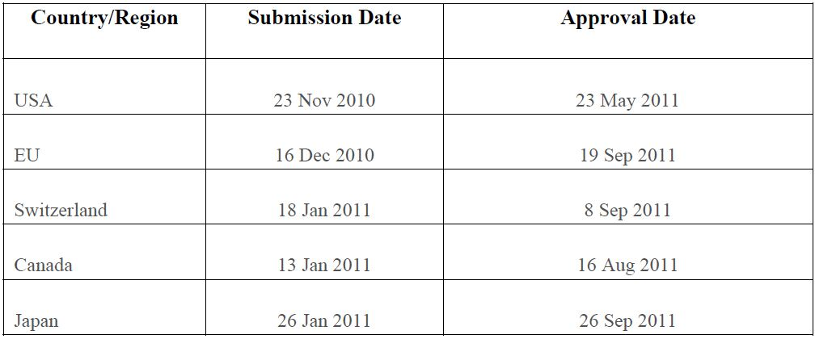

Product Information
The approved product information (PI) current at the time this AusPAR was prepared can be found as Attachment 1.

II. Quality findings

Drug substance (active ingredient)
The drug substance has a chemical structure as shown in Figure 1.
Figure 1: Chemical structure of telaprevir.
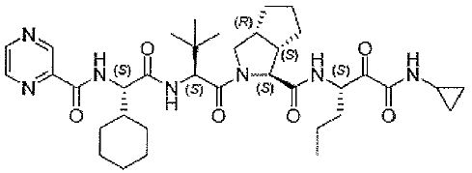
There are six chiral centres, all of which are controlled so that telaprevir is a single stereoisomer. However, one chiral centre is adjacent to a ketone group so it epimerises in vitro and in vivo via keto-enol tautomerism. The equilibrium ratio of the two stereoisomers in solution is about 60:40 S:R. The R isomer has very little pharmacological activity (about 30 fold lower than the S isomer).
There are no functional groups that are ionisable within the physiological pH range (the pyrazine moiety would have a pKa less than 0.5).
Only one crystalline form of the drug substance is known (Form A). Telaprevir is stated to be BSC Class II (low solubility, high permeability). . A satisfactory toxicological justification was submitted for the approved impurity limits.
The drug substance shows good stability in the solid state. A retest period of two years with storage below 25ºC has been satisfactorily established.

Drug product
In order to keep telaprevir in its amorphous form in the tablets, a solution of telaprevir is spray dried with a polymer . This spray dried powder is then mixed with other excipients, dry compressed into tablets and film coated. The spray dried powder showed no signs of crystal formation after six months’ storage at 40ºC/75% rh (relative humidity).
The finished product specifications include limits for the same two impurities that are controlled in the API (Active Pharmaceutical Ingredients) specification. A satisfactory toxicological justification was submitted for the approved impurity limits.
Tablet dissolution limits were set to the satisfaction of the evaluator.
The proposed shelf life for the tablets is 24 months below 25ºC. Adequate stability data have been provided to support this shelf life.

Biopharmaceutics
Phase 3 clinical studies used uncoated tablets that were otherwise of the formulation proposed for registration. Study VX07-950-017 showed that the AUC (area under the plasma concentration-time curve) of the film coated tablets was significantly higher (by ∼11-13%) than that of the uncoated tablets. This has been drawn to the attention of the Delegate.
Study VX-950-C121 showed that food increases the bioavailability of telaprevir significantly. Using the uncoated tablets, the relative AUC results for various types of food were approximately as follows:
high fat meal 1.20
standard meal 1.00
low calorie, high protein meal 0.74
low calorie, low fat meal 0.61
fasting 0.27
The effects of food on bioavailability are appropriately described in the PI.
An absolute bioavailability study was not performed. The sponsor attempted to develop a suitable intravenous (IV) formulation using, for example, surfactants, cyclodextrins and liposomes to increase the aqueous solubility. However, adequate solubility could not be achieved and the drug substance was unstable in many of the systems investigated.

Advisory committee considerations
This application was considered by the Pharmaceutical Subcommittee (PSC) of the Advisory Committee on Prescription Medicines (ACPM) at its 139th meeting in July 2011. The subcommittee endorsed the questions that had been raised by the TGA and also requested the PI be amended to include information on the partition coefficient of the drug substance. All issues have been satisfactorily resolved.

Quality summary and conclusions
There are no objections on Chemistry, Manufacturing and Controls (CMC) grounds to registration of Incivo tablets subject to clearance by the Medicines Toxicology Evaluation Section of the limits applied to impurities in the drug substance and finished product specifications.

III. Nonclinical findings

Introduction
A comprehensive nonclinical submission was provided for telaprevir. Pivotal safety and toxicity studies were adequately conducted, GLP (Good Laboratory Practice) compliant, used appropriate animal models, the intended clinical dose route, appropriate doses and were of sufficient duration to support the proposed clinical regime. However, it should be noted that toxicity studies involved a twice daily PO (per os, by mouth) dosing regimen (two doses at least 8 h apart), while the intended clinical dose regimen is thrice daily (every 8 h). Nonetheless, pharmacokinetic (PK) data from animals species used in these studies suggested reasonably sustained exposure. While no carcinogenicity studies were performed, this is acceptable for a product intended for short term (12 week) clinical use. A PK drug interaction study was performed with RBV; however, no other PK or toxicology studies were provided to support telaprevir’s use in combination with IFNα and RBV. A justification for the absence of these studies was provided (see below). Toxicology studies were provided to qualify proposed impurity specifications.

Pharmacology

Primary pharmacodynamics

Mechanism of action
Telaprevir is a single diastereomer (S configuration) that binds to the active site of the NS3 4A protease necessary for the proteolytic cleavage of the HCV encoded polyprotein into the mature forms of NS4A, NS4B, NS5A and NS5B proteins and thereby directly inhibits HCV replication. Telaprevir epimerises at position 21 in vitro and in vivo to form its R diastereomer, VRT-127394.
Telaprevir was shown to be a slow binding inhibitor with a Ki (inhibition constant) of 7 nM for HCV NS3 protease. The slow binding mechanism for the interaction of telaprevir with the HCV NS3 protease was also shown to occur in two steps, with the formation of a weaker complex followed by rearrangement to the tightly bound form. Although the potency of the initial complex in the first step could not be quantified directly, its formation was estimated to be in the micromolar range. In the second step, telaprevir was shown to form a stable covalent enzyme inhibitor (EI*) complex, with a t_{1/2} (enzymatic half life) of ∼1 h. The inhibition constant for the EI* complex (Ki*) representing the equilibrium binding constant at steady state was determined as 7 nM. VRT-127394 was ∼30 fold less active than telaprevir.

Cell based assays
Respective telaprevir mean IC₅₀ (half maximal [50%] inhibitory concentration), IC₉₀ and CC₅₀ (50% cytotoxicity concentration) values in HCV replicon cells (genotype 1b) were 0.35, 0.83 and 83 μM, which resulted in a mean selectivity index (CC₅₀/IC₅₀) of 234. A similar IC₅₀ of 0.28 μM was measured in human foetal hepatocytes infected with HCV genotype 1a. The telaprevir IC50 was increased ∼10 fold in 40% human serum. Telaprevir showed similar inhibition of NS3 protease from HCV genotypes 1a, 1b and 2, while activity against genotypes 3 and 4 was slightly reduced.
The telaprevir metabolites VRT-842291 (minor) and VRT-922061 (major) were ∼15 and >82 fold less active than telaprevir, respectively. Selectivity of telaprevir was examined against the human serine proteases kallikrein, thrombin, plasmin and factor Xa. Telaprevir (10 μM) was inactive against all four human serine proteases.

Combination studies
Given the currently proposed treatment regimen of HCV infection is in combination with IFN-α and RBV, potential additive or inhibitory effects were also investigated in the HCV replicon assay. Telaprevir had additive or moderate synergy with IFN-α and RBV in HCV replicons.

Resistance
Phenotypic studies (enzymatic and replicon based) were performed to characterise substitutions identified in the HCV NS3 protease domain that were observed after treatment failure in clinical studies of telaprevir. The dominant telaprevir resistant mutation in HCV NS3 selected by serial passage of HCV replicons was A156S. The most frequently observed telaprevir resistant variants in clinical trials were V36A/M, T54A/S, R155K/T and A156S (3-25 fold increase in replicon IC₅₀ from wild type), and A156V/T and V36M + R155K (>25 fold increase in replicon IC₅₀ from wild type).

Cross resistance
Telaprevir resistant variants were also tested for cross resistance against representative linear inhibitors (boceprevir) and macrocyclic inhibitors (ciluprevir, danoprevir, TMC435 and vaniprevir). Substitutions at residues 36 and 54 conferred low level resistance to linear inhibitors, but not macrocyclic NS3 protease inhibitors, and substitutions at residues 155, 156, or double substitutions at residues 36 and 155, showed cross resistance to all NS3 protease inhibitors with a wide range of sensitivities. All telaprevir resistant variants remained fully sensitive to INF-α and RBV.

HCV inhibition in vivo
An in vivo HCV protease mouse model was developed using a HCV protease dependent secreted alkaline phosphatase (SEAP) reporter construct to ascertain whether telaprevir was able to inhibit HCV protease activity in the target organ (liver) after oral administration. Telaprevir was able to inhibit HCV protease dependent SEAP secretion from the liver with an ED₅₀ of <0.3 mg/kg. Analysis of PK/PD parameters showed that the concentration of telaprevir in the liver was 6-16 fold higher than the concentration in the plasma one hour after dosing. These data also support the liver targeting activity of telaprevir in vivo.

Secondary pharmacodynamics
In an extensive battery of in vitro assays, telaprevir exhibited no significant activity at a wide range of receptors and ion channels. The selectivity of telaprevir against either human immunodeficiency virus (HIV) or hepatitis B virus (HBV) was also investigated. Telaprevir was inactive against HIV-1 (EC₅₀ [half maximal {50%} effective concentration] = 15.34 μM) and its protease (IC₅₀ >10 μM) in vitro. Telaprevir had no anti HBV activity at a concentration up to 10 μM in vitro. Overall, these studies suggested that telaprevir exhibits specificity for HCV NS3 protease inhibition versus other relevant mammalian serine proteases and for HCV versus HBV and HIV viruses and is unlikely to interact with other biological systems or processes outside of its intended target at therapeutic concentrations.

Safety pharmacology
A standard battery of GLP compliant safety pharmacology studies were conducted with telaprevir. These studies investigated the nervous, respiratory and cardiovascular systems in human Ether-à-go-go-Related Gene (hERG) transfected HEK 293 cells and isolated dog Purkinje fibres in vitro and in rats and dogs in vivo.
Telaprevir had no remarkable effect on major organ systems investigated in vitro (≤80 μM) or in vivo (≤250 mg/kg and ≤1000 mg/kg PO in dogs and rats, respectively). Although results from in vitro evaluations suggested a potential, albeit small, for telaprevir to inhibit the repolarisation of cardiac action potentials at ≥30 μM and to slightly, non significantly, prolong action potential duration (APD) at ≥50 μM, these effects were not corroborated in vivo. Moreover, exposure to 30-50 μM telaprevir in vitro represented ∼5-11 fold the telaprevir C_{max} (maximum plasma drug concentration) at the proposed clinical dose (4.5 μg/mL; 6.6 μM). No effects on cardiac function or electrocardiography (ECG) parameters were observed in male dogs given up to 250 mg/kg PO (4 fold the proposed clinical dose based on C_{max} [17.6 μg/mL]). These findings were also consistent with repeat dose toxicity studies in dogs which demonstrated no remarkable ECG effects at clinically relevant doses (2 fold the anticipated clinical telaprevir C_{max} at 300 mg/kg/day [1-2 h post dose on Day 28 of 1 month study]). No remarkable respiratory or nervous system effects were seen in male rats given the maximum feasible dose of 1000 mg/kg PO. While no plasma kinetic data was determined in these studies, extrapolations from single dose absorption studies suggest that rats were exposed to clinically relevant telaprevir levels at this dose (1.4 fold anticipated clinical C_{max}; 6.5 μg/mL).

Pharmacokinetics
Telaprevir is a single diastereomer with the S configuration (also designated as L diastereomer) at position 21. Telaprevir can epimerise both in vitro and in vivo at position 21 to the corresponding R diastereomer (also designated as D diastereomer), VRT-127394. The rate of interconversion between the two diastereomers decreases with decreasing pH. The ratio of the S:R diastereomers at equilibrium in vitro is ∼60:40.
An extensive array of in vitro and in vivo studies were conducted to evaluate the absorption, distribution, metabolism and excretion characteristics of telaprevir and its diastereomer, VRT-127394. In vivo PK parameters for telaprevir and VRT-127394 were evaluated in all pivotal nonclinical species employed in toxicity testing including CD-1 mice, Sprague-Dawley rats, New Zealand White rabbits (not employed due to limited exposure and rapid clearance) and beagle dogs. Pivotal nonclinical studies were performed with telaprevir; however, both telaprevir and VRT-127394 were routinely quantified in the biological samples from the in vitro and in vivo studies given the potential for epimerisation in vivo.

Absorption
Earlier formulations of telaprevir were considered inadequate for oral administration due to solubility and bioavailability issues. Thus, an optimised spray dried dispersion (SDD) telaprevir formulation (49.5% telaprevir, 49.5% HPMCAS, 1% SLS) was used for pivotal nonclinical studies. When formulated as an SDD suspension and administered orally, telaprevir was rapidly absorbed in mice, rats, rabbits and dogs with mean peak plasma concentrations occurring between 0.5 to 2 h. After single dose administration, exposures generally increased in an approximately dose proportional for the lower range of doses and in a less than dose proportional manner for the higher range of doses. Oral bioavailability was ∼33% and 52% for male and female rats, respectively, and less than 22% in rabbits. In fasted dogs administered a 250 mg/kg PO dose of telaprevir, apparent oral bioavailability was 43% to 67%. Exposure increased between 1.5-4 fold in the presence of food in dogs where apparent oral bioavailability was 70% to 95% at the highest dose (250 mg/kg). Oral PK parameters for VRT-127394 were similar to those observed for telaprevir in these species. The relative percent systemic exposure to VRT-127394 ranged from 3.9% to 23% in mice, 17% to 34% in rats, and from 17% to 31% in dogs.
After repeated oral administration at higher doses, exposures decreased slightly in pregnant mice (2 fold) and in rats (1.5 to 2.5 fold), whereas in dogs exposures slightly increased (1.5 fold) when compared to those observed on the first day of dosing. There were no major differences in PK parameters between males and females for mice and dogs, whereas exposures in female rats were markedly higher (up to 2 fold) than those observed in male rats.
Apparent permeability studies in Caco-2 cells in vitro suggest that the permeability of telaprevir (5 or 10 μM) in human intestine will be high at therapeutically relevant concentrations in vivo. Caco-2 cell studies also established telaprevir as a substrate for efflux pump protein P-glycoprotein (P-gp).

Distribution
Telaprevir and/or its metabolites were widely distributed to tissues in Sprague-Dawley rats as evidenced by ¹⁴C telaprevir radioactivity distribution, although primarily in the gastrointestinal system and in organs of metabolism and excretion (that is, liver, pancreas and kidneys). Distribution to the brain, fat, lymphatic tissues, muscle and testes was also demonstrated but was low. In pigmented Long-Evans rats, no increase in bound radioactivity was observed in melanin containing tissues (skin or eyes) when compared to values observed in the same tissues obtained from non pigmented Sprague-Dawley rats. After repeated administration, telaprevir and VRT-127394 were predominantly distributed to the liver in rats and dogs.
Placental transfer of telaprevir and VRT-127394 to the whole foetus and foetal tissues were also demonstrated in pregnant mice and rats in vivo at anticipated therapeutic concentrations (refer to ‘Reproductive Toxicity’ section below).
In vitro studies conducted with ¹⁴C telaprevir (0.1-20 μM) demonstrated moderate binding to plasma proteins from all species evaluated and ranged from 63% to 71% in mouse, 82% to 86% in rat, 62% to 67% in dog, and 59% to 76% in human plasma. Given free telaprevir was ∼20-40% in all species (29-37% in mice, 14-18% in rats, 33-38% in dogs and 24-41% in humans), no corrections were needed for human/animal exposure calculations (refer to ‘Relative Exposure’ section below). Protein binding of ¹⁴C telaprevir to human serum albumin (HSA) or α1 glycoprotein (AAG) was also demonstrated and was low to moderate and dependent upon test article concentration and protein concentration.

Metabolism
Plasma systemic clearance following IV administration of telaprevir was ∼60% to 90% less than hepatic blood flow in rats and dogs, and clearance in rabbits was ∼2 fold higher than that of hepatic blood flow. Elimination half lives were short (from 0.8 to 1.5 h in rats, rabbits and dogs), and volumes of distribution at steady state were higher than total body water in these species, indicating that telaprevir may distribute into the tissues.
Telaprevir was shown to undergo extensive metabolism, with multiple metabolites observed in in vitro studies using ¹⁴C telaprevir with S9 and liver microsomes from mice, rats, dogs and humans. The major metabolites of telaprevir identified in vitro from preparations across all species evaluated were VRT-127394 (epimer of telaprevir) and M1 (hydroxylation of the cyclohexyl glycine or pyrazinoic acid moieties). Additional oxidative metabolites identified included M2 (hydroxylation of the tetrahydropyrrol cyclopentyl moiety), M8/M9 (telaprevir OH) and isomer, and diOH telaprevir. Non oxidative metabolites were also identified and included M3 (reduction of keto carbonyl), M4 (amide hydrolysis), M5 (amide hydrolysis), M7 (descyclopropyl) and M12 (amide hydrolysis). Minor qualitative sex differences were observed in the metabolism of ¹⁴C telaprevir in vitro in incubations with microsomal and S9 fractions from all species.
In in vivo studies using ¹⁴C telaprevir, metabolites in rats or dogs were identified in bile, urine, plasma and faecal samples. Consistent with in vitro study results, metabolites were formed predominantly by oxidation, reduction, or hydrolysis of ¹⁴C telaprevir. The metabolite profiles in human urine, plasma and faeces corresponded to those observed in rats or dogs, with the exception of the M6 metabolite (amide hydrolysis). M6 was observed in humans (faeces only) and dogs (plasma, urine and faeces) but not in rats. Additional steady state metabolite profiling work conducted in plasma samples from mice, rats, dogs and humans identified the R diastereomer (VRT-127394), pyrazinoic acid (PZA), and M3 isomer (reduction product; VRT-922061) as the predominant circulating metabolites.
Thus, there were no unique human metabolites observed in vivo that weren’t seen in either of the key nonclinical species (rats or dogs) involved in toxicity testing. Moreover, all nonclinical species (mice, rats and dogs) were exposed to predominant circulating human plasma metabolites.
The main cytochrome P450 (CYP) involved in the metabolism of telaprevir was shown to be CYP3A4. In vitro inhibition studies using specific isozymes and human liver microsomes showed that telaprevir was a CYP3A4 inhibitor, whereas no inhibition of CYP1A2, CYP2A6, CYP2B6, CYP2C8, CYP2C9, CYP2C19, CYP2D6, and CYP2E1 was observed. Evidence of time and concentration dependent telaprevir inhibition of CYP3A4 was observed in human liver microsomes. Based on these results, there is the potential for drug-drug interactions between telaprevir and drugs that are substrates, inducers or inhibitors of CYP3A4.
Repeated administration of PO telaprevir to rats for 13 weeks demonstrated dose dependent increases (≥100 mg/kg/day) in CYP3A and CYP2E1 activities in liver preparations from both sexes, with CYP2B activity inhibited in female rats also at anticipated sub therapeutic clinical exposure levels (based on AUC). In dogs given repeated PO telaprevir for 13 weeks, liver total CYP content declined, and significant dose dependent declines in liver microsomal CYP3A and CYP2E1 activities were also observed at ≥25mg/kg/day (from anticipated sub therapeutic clinical exposure levels (based on AUC). These changes in CYP activity had a demonstrable effect in vivo with generally slight (≤2 fold) decreases in telaprevir exposure in rats and slight increases (1.5 fold) in telaprevir exposure in dogs observed at high doses after repeated administration.

Excretion
After PO and IV administration of ¹⁴C telaprevir, overall mass balance of radioactivity excreted across all species evaluated ranged from 86% to 100% and 81% to 97%, respectively. When administered PO and as a result of limited absorption associated with ¹⁴C telaprevir rotary evaporated formulations, ¹⁴C telaprevir was mainly excreted via faeces as unchanged compound. Biliary clearance was likely the major route of elimination of absorbed compound, whereas renal clearance was limited. Considerable (3.5-22%) radioactivity was also excreted as CO₂ in expired air. Telaprevir was excreted in the milk of lactating rats at levels 2 fold those shown in maternal plasma at anticipated therapeutic concentrations (refer to ‘Reproductive Toxicity’ section).

Pharmacokinetic drug interactions
Co administration of RBV (75 mg/kg PO) with telaprevir (3-30 mg/kg PO) to male rats did not significantly alter telaprevir (or RBV) systemic exposure (AUC_{0-∞} [area under the plasma concentration-time curve from time zero to infinity] and C_{max}). Thus, under these study conditions, there was no apparent drug-drug PK interaction between RBV and telaprevir. In contrast, co administration of ritonavir (3 mg/kg IV or 25 mg/kg PO) with telaprevir (10 or 30 mg/kg PO) to male rats in two separate studies was associated with increased (1.6-1.7 fold) systemic and liver exposures when compared to telaprevir alone. Based on these studies, ritonavir mediated a significant effect on telaprevir PK, presumably resulting from ritonavir mediated inhibition of CYP3A. Conversely, when co administered with a single dose of telaprevir, systemic exposures (AUC_{0-∞}) to ritonavir were ∼20% of those observed when ritonavir was dosed alone. The mechanism for this result is unclear. There were no PK drug interaction studies conducted with IFN-α.

Relative exposure
Telaprevir and its epimer, VRT-127394 exposure was determined in mouse, rat and dog toxicity studies as summarised in Tables 2-4 due to potential epimerisation in vivo. Systemic exposures were also determined in genotype 1 chronic hepatitis C subjects repeatedly dosed with telaprevir (750 mg dosed as 375-mg core tablets every 8 h in the fed state) in combination with IFN-α and RBV (Clinical Study Report VX-950-TiDP24-C208). The mean clinical telaprevir and VRT-127394 AUC_{0-24h} values were 85.9 μg.h/mL and 45.9 μg.h/mL, respectively on Day 57. Based on anticipated clinical exposures with the proposed treatment regimen, telaprevir animal/human AUC_{0 24h} ratios at the high doses employed in the pivotal studies were low (∼1.8 for pregnant mouse/human, 0.6 in pregnant rat/human, 0.2-0.5 in rat/human (3 and 6 month studies) and 1.9-2.3 in dog/human (3 and 9 month studies).
Table 2: Telaprevir exposure margins in repeat dose toxicity studies.
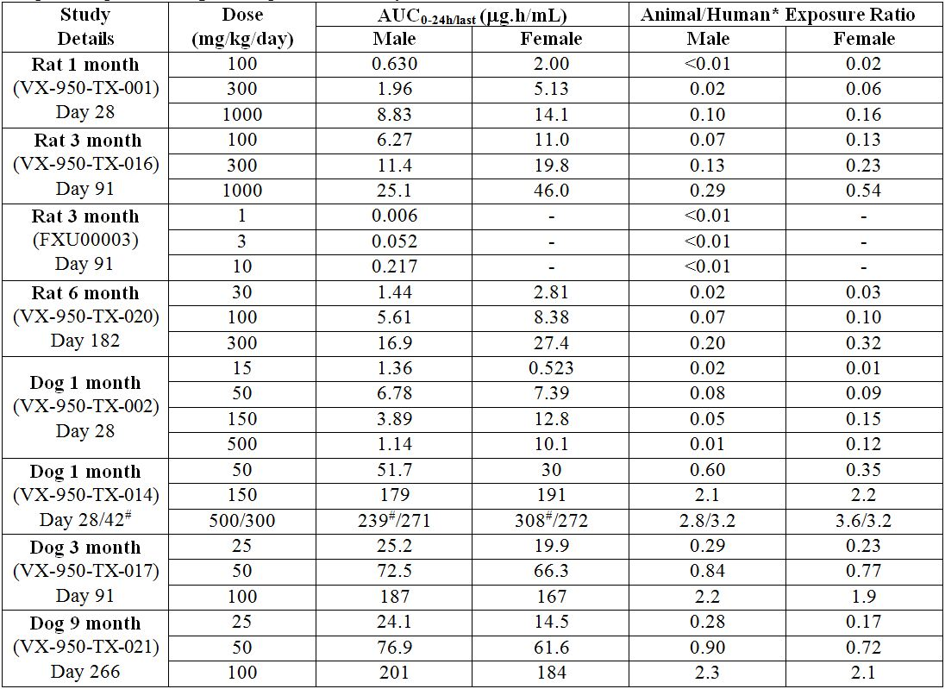
*Human AUC_{0-24h} = 85.9 μg.h/mL (Clinical Study VX-950-TiDP24-C208).
Table 3: VRT-127394 exposure margins in repeat dose toxicity studies.
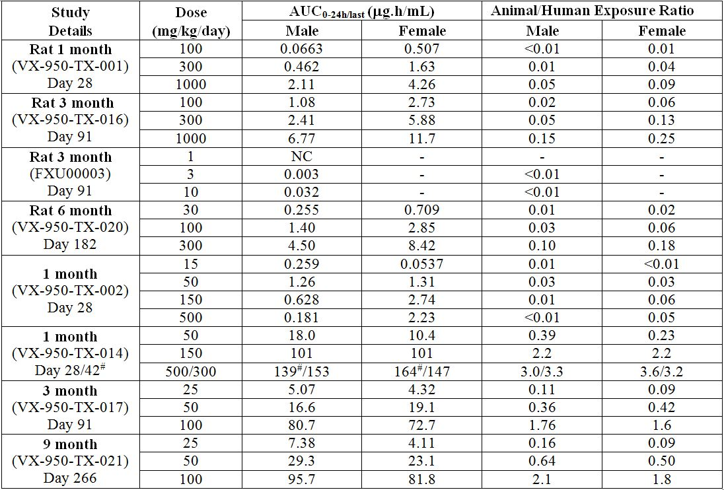
*Human AUC_{0-24h} = 45.9 μg.h/mL (Clinical Study VX-950-TiDP24-C208)
Table 4: Telaprevir and VRT-127394 exposure margins in reproductive toxicity studies.
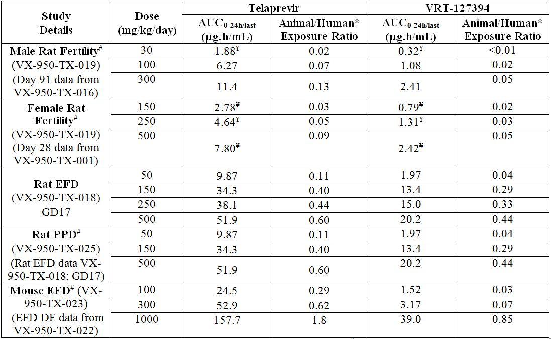
*Human AUC_{0-24h} = 85.9 μg.h/mL (Clinical Study VX-950-TiDP24-C208); #Data extrapolated (and/or adjusted for dose¥) from other repeat-dose or reproductive toxicity studies, as indicated; EFD = embryofetal development; PPD = pre- and post-natal development; GD = gestation day; DF= dose-finding.

Toxicology
A comprehensive package of toxicology studies was submitted in support of telaprevir registration. These studies documented acute toxicity in rodents, chronic toxicity in rodents and dogs (up to 6-9 months), genotoxicity in vitro and in vivo, reproductive toxicity in rodents, local tolerance and other specific toxicity studies.
All pivotal toxicology studies complied with GLP, with telaprevir administered orally (by gavage), consistent with the proposed clinical route of administration. Twice daily dosing (two doses at least 8 h apart) was employed in toxicity studies. Although this was not consistent with the thrice daily dosing clinical regimen proposed, reasonably sustained exposure to telaprevir and its epimer, VRT-127394 was demonstrated. Pivotal nonclinical species (mice, rats and dogs) examined were exposed to telaprevir and its main human metabolites, and are therefore considered appropriate models for toxicity testing.
The duration of the pivotal toxicity studies (6/9 months) was adequate to support the proposed duration of use (12 weeks) use in humans. Doses employed in pivotal toxicity studies were adequate based on maximum dosing feasibility limits and/or dose limiting toxicity. However, it is noted that exposure to telaprevir and VRT-127394 was low in all studies (refer to ‘Relative Exposure’ section). Animal numbers were low (n=10-15) in the pivotal rat (6 month) study, however, this is unlikely to impact on the overall safety assessment of telaprevir.

Acute toxicity
The acute toxicity of telaprevir was examined in mice and rats given a single PO (gavage) dose. The maximum feasible concentration (MFC) of the dosing suspension was established at 50 mg/g; thus, for each species 1000 mg/kg was the maximum feasible dose (MFD). Acute IV toxicity studies were not performed due to limitations in solubility and stability of telaprevir in an appropriate vehicle. There were no notable effects in either species up to the MFD. These studies suggested that the acute oral toxicity of telaprevir is low. Exposure to telaprevir and VRT-127394 in these studies was low (0.1-0.8 fold the anticipated clinical AUC).

Repeat dose toxicity
Repeat dose toxicity studies were conducted in rats and dogs given repeated PO (gavage) doses of telaprevir up to 300 mg/kg/day and 100 mg/kg/day for up to 6 months and 9 months, respectively. For all repeat dose toxicity studies, telaprevir was dosed on a weight basis at a maximum dosing volume for repeated twice daily dosing in each species (10 g/kg and 5 g/kg for rats and dogs, respectively). The maximum feasible concentration of the dosing suspension was again established at 50 mg/g; thus, 1000 mg/kg/day and 500 mg/kg/day were the MFDs employed for rats and dogs, respectively.

Toxicity profile
Repeat dose studies in rats identified the hematopoietic system, liver, testis and epididymis (secondary target) as target organs of toxicity whereas in dogs, the hematopoietic system, bone marrow (secondary target), liver and vascular system were identified as target organs. Effects in these organs were generally dose and duration dependent, and reversible or at least partly reversible by the end of a 3 month recovery period. No observable effect levels (NOELs) were unable to be determined in studies in patients with chronic disease due to the range of effects observed. However, dose limiting toxicity was observed in dogs at ≥150 mg/kg/day in the 1 month study and at 100 mg/kg/day in 3 and 9 month studies (∼2 fold the anticipated clinical AUC for telaprevir). Overall, exposure to both telaprevir and VRT 127394 at the highest doses employed in the long term studies was low (0.1-0.3 fold in rats and ∼2 fold in dogs the anticipated clinical AUC).
It should be noted that repeat dose toxicity studies were conducted in rats and dogs early in development with research grade telaprevir, VRT-111950, and with a SDD formulation of a diasteriomeric mixture of telaprevir VRT-127394, designated VRT-108720. While these formulations were not considered representative of telaprevir drug substance proposed clinically, no novel toxicities were identified during these evaluations.

Haematopoietic system
Effects in both species on the hematopoietic system were similar in terms of the red blood cell parameters affected, however they were more pronounced and resulted in anaemia (that is, >10% decrease) in dogs. In both species, compensatory increases in reticulocytes and the development of extramedullar haematopoiesis in the red pulp of the spleen were observed as well as bone marrow cytology findings specific to dogs of increased total erythroid precursors and decreased myeloid:erythroid (M:E) ratios. Collectively, these effects were considered a physiological response to the effects on peripheral blood erythrocytic parameters. In dogs, there were also indications of increased destruction of erythrocytes and sequestering of breakdown products by Kupffer cells in the liver, as evidenced by the hyperpigmentation noted in these cells, particularly at dose levels resulting in anaemia. NOELs could often not be determined in rats, with hematopoietic system effects observed at doses ≥30 mg/kg/day, while in dogs, effects were observed at doses ≥50 mg/kg/day with telaprevir and VRT-127394 exposures equal to or below those anticipated clinically. Interestingly, no direct effect of telaprevir (80 μM) was observed in human erythrocytes in vitro. However, according to the clinical safety summary, these effects were consistent with anaemia findings in clinical subjects at currently proposed telaprevir doses. Given anaemia is already a well documented effect in subjects receiving IFN-α/RBV treatment, the potential additive haematopoietic effects of telaprevir at clinically relevant doses should be considered in any laboratory monitoring program for erythrocyte parameters.

Liver
Liver effects observed in rats included elevations in serum transaminases, increased liver weights, minimal to mild hepatocellular hypertrophy and single cell necrosis (sometimes accompanied by multinucleated giant cells). These changes were considered adaptive or compensatory in nature to the observed CYP inhibition/induction effects of telaprevir and were at least partly reversible. Repeat dose administration of telaprevir to rats for 13 weeks resulted in mild dose dependent increases in CYP3A1/2 and CYP2E1 activities in liver preparations from both sexes and decreased CYP2B1/2 female rat liver activity. While repeat dose administration of telaprevir to dogs for 13 weeks was shown to decrease total liver CYP content and dose dependently reduce liver CYP3A12, CYP2E1 and CYP2B11 activities, these changes in CYP activity were inconsistent with those noted in rats. Moreover, they were not accompanied by any liver enzyme or other similar relevant histopathological correlates and had a limited impact in vivo because telaprevir exposure increased only slightly (1.5 fold) after 9 months of repeated administration at the highest dose in dogs. NOELs could not be determined for these effects, however, telaprevir exposure at the lowest doses in these studies were below those anticipated clinically.

Testes and epididymides
Effects on the testes and epididymides in rats were minimal to marked in nature, were often associated with macroscopic lesions of small soft testes, a decrease in testicular weights and histopathological correlates of degeneration of the germinal epithelium of the testis. Exfoliated germ cells, hypospermia, and/or aspermia were also observed in the epididymis and considered secondary to the effects on the testes. Similar findings were also seen in the rat fertility study at similar (300 mg/kg/day) doses (refer to ‘Reproductive Toxicity’ section). It is noted that degeneration of the germinal epithelium of the testis was observed in 3/4 recovery dogs at the high dose (100 mg/kg/day; 3 compared with 0-1 in placebo/control groups) in the 9 month study. However, there were no similar increased incidence of these findings in terminal animals (0-1/4 all groups), any other correlates or evidence of testicular effects in this species in any other study. Moreover, the rat findings were associated with observations of minimal testicular distribution of telaprevir following single dose administration to rats and a noted affinity for the rat testosterone receptor resulting in inhibition of testosterone binding. NOELs for testicular effects in the 3 and 6 month rat studies were established at 100 mg/kg/day (<0.1 fold the anticipated clinical telaprevir AUC).

Vascular system
Effects on the vascular system observed in dogs were consistent with those observed in Beagle Pain Syndrome (Idiopathic Canine Polyarteritis), and in more severe cases animals presented with clinical signs of poor or ill health consistent with this syndrome. Microscopic findings were generally minimal to mild in nature and were observed in multiple tissues, particularly the coronary artery, a known target tissue for vasculitis in beagle dogs. Many other microscopic findings noted in dogs were considered secondary effects to the diffuse vasculitis observed in these animals. The clinical relevance of this finding in beagle dogs has not been demonstrated. Nonetheless, similar effects, particularly in the mesenteric artery, a known target tissue for vasculitis in rats, were not observed in rats following repeat dose administration. Drug induced vasculitis in beagle dogs has been observed previously with marketed products including endothelin antagonists and phosphodiesterase inhibitors, with no correlate in humans. The NOEL for vascular effects in dogs was 50 mg/kg/day (0.7-0.9 fold the anticipated clinical AUC for telaprevir).

Combination studies
There were no studies provided to support the use of telaprevir in combination with Peg-IFNα and RBV.
At the pre submission meeting held on 2 September 2010, the sponsor was advised that the EU guideline on nonclinical toxicology studies for virology products recommends testing of combination therapy in toxicology studies. Thus, the TGA would expect studies on both telaprevir alone and in combination with other antiviral drugs as part of the nonclinical submission. It was also noted that a justification would be required in the absence of these combination studies.
In their response provided, the sponsor considered the relevant EU guideline that may be considered in situations of development of a combination therapy not involving a fixed combination formulation. This guideline was applicable for the intended telaprevir posology.
The sponsor stated that in a “fixed combination containing one or more new active substances, the guideline indicates that a complete nonclinical development program with the new active substance may be undertaken, together with additional bridging studies with the combination, taking the considerations outlined in the guideline into account.”
However, “Tibotec has considered after having evaluated the toxicity profile of telaprevir on the basis of a comprehensive and adequate data set that a bridging study with Peg-IFNα-2a was not useful. The safety of Peg-IFNα-2a was tested in the nonhuman primate and the Syrian hamster. The toxicity profile of telaprevir was assessed in rats and dogs for repeat dosing and in rats and mice for reproduction toxicity.”
With respect to RBV combination studies, “Tibotec considered that a bridging study with RBV would not reveal relevant findings. The pharmacological mechanism of action and the chemical nature of RBV and telaprevir are different making synergistic or additive effects highly unlikely. Repeat dose toxicity of RBV was evaluated in rats and dogs causing a high number of severe toxic effects on many rapidly proliferating tissues and/or tissues with high cellular metabolism. Moreover, RBV demonstrated significant teratogenesis and/or embryocidal potential whereas the viability of foetuses and offspring was typically reduced, in mice and rats. The toxicity of telaprevir was limited to slightly reduced red blood cell parameters in rats and dogs, testicular toxicity in rats, and vasculitis resembling idiopathic canine arteritis in dogs. RBV and telaprevir demonstrate ‘overlapping’ toxic effects on red blood cell parameters in rats and dogs and on degeneration of the germinal epithelium of testis in rats.”
The sponsor also stated that in “clinical studies, the combination of telaprevir and RBV caused more prominent anaemia than RBV as single agent. A nonclinical study with the combination of telaprevir and RBV would probably have shown a similar increase in the reduction of red blood cell parameters. The lowest dose of telaprevir tested in rats was not without effects. The exposure at this lowest dose was lower than the exposure of patients treated with telaprevir. Consequently, a safety margin could not be established for telaprevir. A possible increase of the testicular effects due to telaprevir by a combined administration of telaprevir and RBV would not have impacted the NOAEL (no observed adverse effect level) or safety margin.”
This is considered plausible on the basis of the different mechanism of actions and chemical natures of RBV and telaprevir, the absence of drug-drug PK interactions between RBV and telaprevir evaluated in rats, well defined toxicity profiles for both substances and observed telaprevir effects at sub therapeutic doses. A bridging study is unlikely to reveal any novel findings or significantly alter clinical safety margins for telaprevir related toxicities.
While the absence of combination studies is considered a deficiency of the submission, the evaluator accepts the sponsors proposal that “major changes to the safety profile of telaprevir are not anticipated when co administered with IFN-α and RBV”.

Genotoxicity and carcinogenicity
Telaprevir was tested for potential genotoxic effects in a standard battery of in vitro (bacterial reverse mutation and forward gene mutation) and in vivo (mouse micronucleus) test systems. All studies were GLP compliant, used appropriate doses/concentrations and included appropriate positive controls. The mutagenic potential of its R diastereomer, was also evaluated in an adequately conducted GLP compliant bacterial mutation assay in vitro. These studies demonstrated that both telaprevir and its epimer were negative for mutagenic and/or clastogenic potential.
While results from early studies conducted with research grade telaprevir and/or telaprevir like substances (VRT-111950 and VRT-108720) suggested potential genotoxic effects, it should be noted that these formulations were not representative of telaprevir material proposed clinically and contained high unspecified levels of organic process impurities. Moreover, telaprevir process impurities TEMPO, VRT-836781 and VRT-126036 have each been shown to exhibit mutagenic or clastogenic potential in at least one adequately conducted genotoxicity assay (refer to ‘Impurities’ section). Thus, the overall weight of evidence observed in pivotal studies supports the conclusions that the telaprevir drug substance, representative of that which will appear in the final marketed form and its epimer are non genotoxic.
No carcinogenicity studies were performed with telaprevir. However, this is acceptable for a product intended for short term (12 weeks) clinical use. Moreover, no evidence of genotoxic potential or evidence of pre neoplastic or proliferative lesions was observed in the chronic toxicity studies in rats and dogs at clinically relevant doses of the telaprevir drug substance representative of that proposed for registration.

Reproductive toxicity
A comprehensive reproductive toxicology assessment of telaprevir was conducted in rats and mice. All studies were conducted according to GLP, utilised adequate animal numbers and generally appropriate doses (based on acute and subchronic toxicity study results). However, it is noted that a 1000 mg/kg/day upper dose limit (compared to 500 mg/kg/day) may have been feasible in rats given the limited toxicity observed at this dose in the acute and the repeat dose studies.
The rat was considered an appropriate nonclinical model to evaluate developmental and reproductive endpoints given its demonstrated exposure to telaprevir and its major human metabolites in vivo. According to the sponsor, on the basis of the insufficient maternal systemic exposures in rabbits following administration of various telaprevir containing PO formulations and demonstration of rapid clearance of telaprevir in this species following IV administration, the mouse was selected as an alternate species for the evaluation of telaprevir related developmental toxicity. While extensive metabolic profiling was not performed in mice, exposure to telaprevir and its predominant human plasma metabolites in vivo has been demonstrated (refer to ‘Pharmacokinetics’ section).
Although the proposed clinical treatment regimen is thrice daily, animals dosed twice daily (separated by at least 8 h) have demonstrated relatively sustained telaprevir exposure. It should also be noted that toxicokinetic data provided was limited to the mouse dose range finding embryofoetal study and rat embryofetal study. Estimates of the telaprevir and VRT-127394 exposure (AUC) for the other reproductive toxicity studies were extrapolated from other relevant repeat dose toxicity (male) and reproductive toxicity (pregnant female) studies. Nonetheless, telaprevir and VRT-127394 exposures achieved in all studies were low (<0.1-2 fold anticipated clinical exposure, based on AUC; refer to ‘Relative Exposure’ section).
Reproductive studies with telaprevir illustrated no effects on the fertility of male and female rats given PO doses up to 300 and 500 mg/kg/day, respectively (less than the anticipated clinical telaprevir exposure based on AUC). However, degenerative testicular changes and testicular weight loss were observed in male rats given PO doses of 300 mg/kg/day (as seen at 300 mg/kg/day PO in the 3 and 6 month rat repeat dose toxicity studies). These testicular changes were primarily associated with degeneration and necrosis of individual germ cells within tubules, with degeneration of entire tubules (multifocal tubular degeneration) observed in some rats. Epididmyal changes included minimal to marked amounts of exfoliated spermatogenic cells and residual bodies in the lumen of the epididymal tubules. Complete reversibility of these findings was observed in some recovery animals but evidence of degeneration of tubules and exfoliated spermatogenic cells in the epididymal tubules was still evident in some rats. As previously discussed (refer to ‘Toxicity Profile’ section), this finding was not observed in long-term (9 month) studies in dogs (which were associated with greater telaprevir exposure).
Treatment of male rats at 300 mg/kg/day prior to and during mating (with 500 mg/kg/day treated or untreated females) was also associated with increased pre-plantation loss and/or nonviable embryos. However, it is important to note that there was no female telaprevir treatment only arm in this study to elucidate maternal only affects on early embryonic development. Treatment groups included treated males with treated females, treated males with untreated females and recovery males with untreated females. Treatment of both males and females prior and during mating appeared to have impacted early embryonic parameters to a slightly greater extent compared to male treatment alone, however this could not be verified. Thus, the participation of maternal telaprevir treatment prior to and during mating to the early embryonic effects in this study cannot be dismissed.
No remarkable effects on embryofoetal development were observed in pregnant mice and rats given PO doses up to 1000 mg/kg/day and 500 mg/kg/day, respectively during organogenesis (2 and 0.6 fold, respectively, the anticipated clinical telaprevir exposure based on AUC). Pre and post natal development studies in rats showed no effects on natural delivery and litter data at PO doses up to 500 mg/kg/day (0.6 fold the anticipated clinical telaprevir exposure, based on AUC). However, adverse effects on offspring growth (but not functional or behavioural development), as evidenced by the reduced body weights observed pre and post weaning, were observed at ≥150 mg/kg/day (0.4 fold the anticipated clinical telaprevir exposure, based on AUC). It is likely that the onset of the body weight effects during the lactation period may be associated with suckling behaviour affected by telaprevir in maternal lacteal secretions.
In a placental transfer study, telaprevir and VRT-127394 were shown to readily cross the placental barrier and distribute to foetal tissues in pregnant mice and rats given a single PO maternal telaprevir dose of 500 mg/kg or 250 mg/kg, respectively. Similarly, telaprevir and VRT-127394 were also shown to be excreted in rat milk (with exposure levels twice those of maternal plasma), and with suckling pups demonstrating exposure, albeit at low levels, after a single PO maternal telaprevir dose of 250 mg/kg. These findings are consistent with the reduced pup weights observed from birth to post partum day 21 (weaning) in offspring of dams administered ≥150 mg/kg/day PO telaprevir from gestation day 7 (GD7) to post partum day 21.

Pregnancy classification
Telaprevir is proposed for use in combination with RBV (pregnancy category X) and Peg-IFNα (category D) and therefore Incivo will be contraindicated in pregnancy.
In the draft PI for Incivo, the sponsor proposes ‘Category B2’ for the use of telaprevir in pregnancy. Given the absence of teratogenic findings in mice and rats given telaprevir during embryogenesis but only exposed to low systemic telaprevir levels, Category B2 is considered appropriate.

Use in children
No studies in juvenile animals have been performed with telaprevir to support its use in children. However, reduced offspring weight gain was observed from birth through weaning following maternal treatment of rats during embryogenesis through weaning at 500 mg/kg/day (0.6 fold anticipated clinical exposure, based on AUC) (refer to ‘Reproductive Toxicity’ section).

Local tolerance
A skin irritation study in rabbits and in vitro bovine corneal opacity and permeability assay (BCOP) conducted in compliance with GLP demonstrated that telaprevir is not a dermal or ocular irritant.

Antigenicity
Telaprevir was evaluated in a murine local lymph node assay (LLNA) and concluded to be negative for skin sensitising potential. On the basis of a positive result for skin sensitising potential associated with the regulatory starting material VRT-126032, a recognized strong structural similarity of this material to the M11 metabolite (VRT-841125) of telaprevir, and incidence of rash observed clinically, it was postulated that antigenicity associated with M11 may play a role in the aetiology of rash observed in clinical studies evaluating telaprevir. VRT-841125 was initially found to be negative for skin sensitising potential in an LLNA but was later demonstrated as positive for skin sensitizing potential in a subsequent guinea pig maximisation test. Given that M11 is not a predominant circulating metabolite in humans and the nature of the rash observed in clinical studies with telaprevir, it is unlikely that the observed potential for skin sensitivity relates to the aetiology of the observed rash, but these results show that a telaprevir metabolite can act as an antigen in a delayed type hypersensitivity reaction.

Mechanistic studies
Given the demonstrated nonclinical effects on the hematopoietic system, particularly erythrocytic parameters, and likely clinical relevance, an investigative study was performed to evaluate potential direct effects of telaprevir (80 μM) on human erythrocytes in vitro. Interestingly, no appreciable effects of telaprevir were observed at supra therapeutic levels (based on C_{max}) for typical cell health parameters (including osmotic haemolysis, oxidative stress, glutathione and ATP [adenosine triphosphate] content).
Given the testicular effects noted in the rat 3 and 6 month repeat dose toxicity and fertility studies, investigative studies were conducted to determine the binding affinity of telaprevir and VRT-127394 for the rat testosterone receptor as a potential mechanism of action and to determine the potential for effects mediated by a similar mechanism in dogs and humans. The affinity of telaprevir and VRT-127394 for the rat testosterone receptor was confirmed (34% and 16% inhibition at 10 μM, respectively), whereas no appreciable binding was reported for either the dog or human androgen receptors (≤10 μM, therapeutic concentrations based on C_{max}). These results were also consistent with the lack of testicular findings noted in 3 and 9 month dog repeat dose toxicity studies at therapeutic telaprevir levels (based on AUC). The sponsor also reported a lack of macroscopic findings and/or effects on hormonal biomarkers (inhibin-B, FSH [follicle stimulating hormone] and LH [luteinising hormone]) of testicular effects in clinical studies. However, this would need to be verified by the clinical evaluator.

Impurities and degradation products
Several organic process impurities and degradation products were identified at various stages of telaprevir development. In silico analyses using DEREK (Lhasa Limited, Leeds, UK) were conducted on all novel impurities detected in telaprevir drug substance and SDD at levels above the ICH Q3 identification threshold (≥0.05%, for a clinical total daily dose exceeding 2 g) and on potential degradation products to identify structural alerts and potential causes for concern. With the exception of the chloroamine bond associated with the impurity designated VRT-836871, there were no in silico structural alerts associated with any identified organic process impurities or degradation products.
A GLP compliant repeat dose impurity and degradation qualification study was conducted in rats given telaprevir spiked with a mixture of impurities and degradation products at PO doses of 50, 150 or 500 mg/kg or non spiked telaprevir at an oral dose of 500 mg/kg twice daily for three months. Specific impurities evaluated in spiked material are summarised in Table 5.
Table 5: Specific impurities evaluated in spiked material.
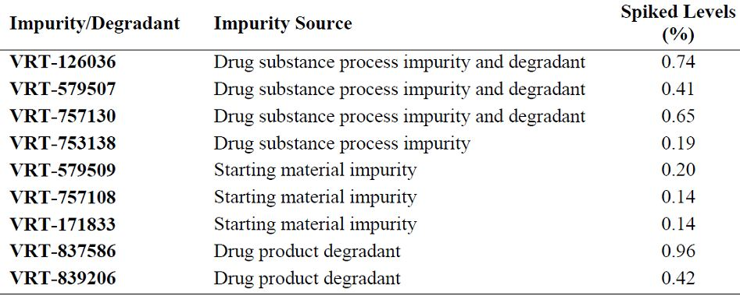
VRT-127394 = 0.26%, RRT 1.50 = 0.11%, VX-950 (Telaprevir) = 94.4%
The toxicity profile obtained from the dose groups receiving telaprevir spiked with the mixture of impurities was compared to the concurrent non spiked control and to the historical data obtained from the pivotal subchronic study in rats (refer to ‘Toxicity profile’ section). Results from this study indicate no change or shift in the toxicity profile in rats dosed up to 1000 mg/kg/day (500 mg/kg/dose twice daily) with the spiked material when compared to the profiles obtained from the non spiked concurrent control and from the pivotal three month toxicity study in rats.
Telaprevir process impurities (VRT-127394, VRT-758640, TEMPO, VRT-836871 and VRT-126036) of interest were tested for potential genotoxic effects in standard GLP compliant in vitro bacterial reverse mutation and chromosome aberration assays. Three impurities with genotoxic activity were identified in at least one assay. These included the chloroamine impurity VRT-836871 which elicited a structural alert for mutagenicity which was confirmed in a bacterial reverse mutation assay, the process catalyst impurity TEMPO which was associated with contradictory scientific literature relating to mutagenicity but was confirmed to be clastogenic in a chromosome aberration assay, and the isolated process intermediate VRT-126036 (also known as M5) which was weakly clastogenic in a chromosomal aberration assay.
Mechanistic studies demonstrated that the chloroamine impurity (VRT836861) decomposes rapidly in gastric juice and therefore is unlikely to present cause for concern in vivo. Nevertheless, two additional washing steps have been introduced in the manufacturing process of telaprevir to reduce the level of this impurity to approximately 30% of the TTC. This is considered acceptable.

Specification limits for TEMPO and TEMPOH
According to the sponsor, manufacturing controls have been implemented to bring the level of the combination of TEMPO and its reduced form TEMPOH as low as reasonably practicable (ALARP). Batches manufactured under these controls consistently showed levels below 2 ppm. A specification for the combination of TEMPO and TEMPOH was proposed at not more than (NMT) 2 ppm, which is below the proposed limit for the staged TTC approach of 9 ppm given the intended clinical duration of treatment of 12 weeks or less.
Questions were raised with the Sponsor (s31 request, 1 August 2011) on the basis of the staged TTC approach and the assigning of a 2 ppm limit, given the EMA guideline quoted is applicable during clinical development only, and the fact that the FDA (Food and Drug Administration) has specifically dismissed the suggestion that a staged TTC approach may be applied to marketed products. In accordance with the general TTC of 1.5 μg/day, the sponsor was asked to reduce combined limit for TEMPO and TEMPOH to 0.7 ppm.
In response, the sponsor indicated that TEMPO manufacturing controls achieved combined levels of TEMPO and TEMPOH of 0.4 ppm in several (14) commercial batches representative of the product intended for marketing. With these levels, the sponsor considered that it had demonstrated as low as reasonably practicable combined levels of TEMPO and TEMPOH.
The sponsor considers that any combined level of TEMPO and TEMPOH exceeding 0.7 ppm but staying below their proposed specification (NMT 2 ppm) in a commercial batch will have no safety impact based on the following:
- The TTC of 1.5 μg/day and the associated level of 0.7 ppm are intended for compounds which have a structural alert for genotoxicity and carcinogenicity. TEMPO and TEMPOH do not have such an alert from a DEREK assessment. TEMPO was also tested in a bacterial reverse mutation (Ames) test and was found to be negative (equivocal in main study). The Draft FDA guideline states: “If the initial evaluation of the genotoxic potential of an impurity is negative, no further genotoxicity studies are recommended and the impurity should be considered to be adequately qualified regarding its genotoxic potential”.
- However, TEMPO was also tested in two chromosome aberration tests with Chinese hamster ovary cells. In both tests, TEMPO showed an increased incidence of structural aberrations in the absence of the metabolic activation. The increased incidences occurred only at concentrations of 250 and 225 μg/mL, very close to the cytotoxic cut off of 250 μg/mL. The results suggest that clastogenicity of TEMPO may be associated with a threshold based effect as evidenced by the nature and dose response relationship associated with the noted positive response approaching the limits of cytotoxicity.
- The CHMP (Committee for Medicinal Products for Human Use) guideline on the limits of genotoxic impurities states: “For (classes of) compounds with clear evidence for a thresholded genotoxicity, exposure levels which are without appreciable risk of genotoxicity can be established according to the procedure as outlined for class 2 solvents in the Q3C Note for Guidance on Impurities: Residual Solvents”.
- Telaprevir will not be administered chronically but only for 12 weeks.
For the reasons outlined above, the sponsor considers that the combined specification of 2 ppm for TEMPO and TEMPOH does not pose a toxicological concern. While the equivocal bacterial reverse mutation assay and positive chromosome aberration assay findings suggest some cause for concern, the likely threshold effect for the positive clastogenicity findings (occurring after 4 h exposure in the absence of metabolic activation only) and the short duration of clinical treatment proposed indicate that this upper combined limit of 2 ppm for TEMPO and TEMPOH (that is below the TTC approach of 9 ppm) is reasonable. This is therefore considered acceptable.

Specification limits for VRT-126036 and VRT-127394
The sponsor has also proposed the following specifications for VRT-126036 and VRT-127394 of 0.5% each in the API and 0.5% and 3.5% for VRT-126036 and VRT-127394, respectively in the finished product. These specifications exceed the limit acceptable without qualification or justification (0.15% for individual impurities in the finished product, for drug doses >2 g/day).
VRT-127394 is the R diastereomer and major circulating metabolite of telaprevir. It was evaluated and concluded to be negative for mutagenic potential in a bacterial reverse mutation assay. Based on in vitro and in vivo rates of epimerisation and associated in vivo toxicokinetic evaluations monitoring epimer formation, it is also likely that VRT-127394 is negative for clastogenic potential, based on telaprevir evaluations. It was also not associated with any novel toxicities when present at 0.26% in the rat repeat dose toxicity qualification study (15.6 mg/m2) at exposure levels similar (0.3-2 fold) to those proposed clinically at these specification levels (0.5%: 2250 mg/50 kg person/day x 33 x 0.5/100 = 7.4 mg/m2; 3.5%: 2250 mg/50 kg person x 33 x 1.3/100 = 52 mg/m2).
With respect to VRT-126036, it is noted that this metabolite has been detected in human plasma at levels around 1-2% of total drug related material. It should also be noted that there was no mutagenic activity observed in the bacterial reverse mutation assay for VRT-126036 alone (at up to 5 mg/plate) or when included in spiked telaprevir (at 0.13% (6.5 µg) at concentrations up to 5 mg/plate) and that the biological significance of the weakly clastogenic response of this metabolite is currently unclear. It was also not associated with any novel toxicities when present at 0.74% in the rat repeat-dose toxicity qualification study (44.4 mg/m2) at exposure levels 6 fold those proposed clinically at the 0.5% specification level (2250 mg/50 kg person/day x 33 x 0.5/100 = 7.4 mg/m2). However, it is questionable whether this study would be sensitive enough to detect any slight differences in toxicity at this level.
Nonetheless, the proposed specification limits for VRT-127394 in the API and finished product of 0.5% and 3.5%, respectively and for VRT-126036 in both the API and finished product of 0.5% are considered acceptable.

Nonclinical summary and conclusions

Summary
- Janssen-Cilag Pty Ltd has applied to register telaprevir (Incivo 375 mg tablets) for the treatment of chronic HCV at a dose of 750 mg three times daily in combination with IFN-α and RBV. Telaprevir (single S diastereomer) inhibits HCV replication by inhibiting the HCV NS3 4A serine protease essential for HCV polyprotein processing.
- A comprehensive nonclinical submission was provided for telaprevir, with pivotal studies adequately conducted and compliant with relevant guidelines. There were no toxicity studies provided to support the use of telaprevir in combination with IFN-α and RBV. This is considered a deficiency of the submission and will rely on clinical studies for assessing any potential inhibitory or additive effects of the combination.
- Telaprevir is a slow binding inhibitor of the HCV NS3 protease, with a steady state Ki* of 7 nM. Its R diastereomer was ∼30 fold less active. Respective telaprevir mean IC₅₀, IC₉₀ and CC₅₀ values in HCV replicon cells (genotype 1b) were 0.35, 0.83 and 83 μM, with a mean selectivity index (CC₅₀/IC₅₀) of 234. A similar IC₅₀ of 0.28 μM was measured in human foetal hepatocytes infected with HCV genotype 1a. The telaprevir IC₅₀ was increased ∼10 fold in 40% human serum. Telaprevir showed similar inhibition of NS3 protease from HCV genotypes 1a, 1b and 2, and reduced activity against genotypes 3 and 4. Telaprevir had additive or moderate synergy with IFN-α and RBV against HCV in hepatocyte replicons.
- The dominant telaprevir resistant mutation in HCV NS3 selected by serial passage of HCV replicons was A156S. The most frequently observed telaprevir resistant variants in clinical trial isolates were V36A/M, T54A/S, R155K/T and A156S/T (3-25 fold increase in replicon IC₅₀), and A156V/T and V36M + R155K (>25 fold increase in IC₅₀). Substitutions at residues 36 and 54 conferred low level resistance to linear, but not macrocyclic NS3 protease inhibitors, and substitutions at residues 155, 156, or double substitutions at residues 36 and 155, showed cross resistance to all NS3 protease inhibitors investigated, including boceprevir. All telaprevir resistant variants were fully sensitive to IFN-α and RBV.
- In an HCV protease model in mice, telaprevir inhibited liver secretion of a HCV protease reporter protein with an ED₅₀ of <0.3 mg/kg PO.
- Telaprevir (10 μM) was inactive against four human serine proteases. Telaprevir (≤10 μM) in vitro did not bind to a wide range of receptors and ion channels, and was inactive against HIV-1 or its protease and HBV.
- A standard battery of safety pharmacology studies conducted with telaprevir did not identify any remarkable effects on major organ systems investigated at clinically relevant and supra therapeutic exposure levels (based on C_{max}).
- Oral telaprevir was rapidly absorbed in all nonclinical species, with peak plasma concentrations occurring between 0.5 to 2 h. Oral bioavailability of telaprevir was ∼33% for male rats, 52% for female rats, less than 22% for rabbits, 43% to 67% for dogs in the fasted state, which increased to 70% to 95% in the fed state. Telaprevir can epimerise both in vitro and in vivo to the corresponding R diastereomer, VRT-127394.
- Telaprevir and its metabolites were widely distributed to rat tissues with the highest concentrations measured in gastrointestinal tract, liver, pancreas, and kidneys. After repeated administration, telaprevir and the R diastereomer were mainly distributed in the liver in rats and dogs. No apparent melanin binding of drug was observed in pigmented rats. Telaprevir was moderately bound to plasma proteins in rodents, dogs and humans.
- Systemic clearance following IV telaprevir administration was slightly lower than hepatic blood flow in rats and dogs and approximately 2 fold higher in rabbits. Telaprevir had a short elimination half life and the volume of distribution was greater than total body water in all species tested, indicating that the drug distributes to multiple tissues.
- The metabolism of telaprevir involved oxidation, reduction and hydrolysis pathways to produce numerous metabolites and isomers. Metabolite profiles were qualitatively similar in rats, dogs and humans, with major plasma human metabolites (pyrazinoic acid, VRT-127394 and VRT-922061) also identified in all species, including mice. No unique metabolites were determined in humans in vivo or in vitro.
- In vitro studies suggest that telaprevir is mainly metabolized by CYP3A4 and is a time and concentration dependent inhibitor of CYP3A4. Co administration of telaprevir with RBV did not affect systemic exposure to either substance in rats. In contrast, co administration of telaprevir with ritonavir in rats resulted in a significant effect on telaprevir (and ritonavir) PK, presumably resulting from ritonavir mediated inhibition of CYP3A. No PK drug interaction studies were conducted with telaprevir and IFN-α.
- Telaprevir is excreted predominantly in the faeces across all species evaluated.
- Toxicology studies submitted in support of telaprevir registration documented acute toxicity in rodents, chronic toxicity in rodents and dogs, genotoxicity in vitro and in vivo, reproductive toxicity in rodents, local tolerance and other toxicity studies. These studies were GLP compliant, used relevant nonclinical species, the intended clinical (PO) route, generally adequate dose levels (although exposure levels were low) and animal numbers, and were of sufficient duration. While a twice daily PO dosing regimen was employed (as opposed to thrice daily proposed clinically), PK data suggested reasonably sustained telaprevir exposure over a 24 h period.
- The acute PO toxicity of telaprevir in rodents was low (at clinical exposure levels based on AUC). Acute IV toxicity studies were not performed due to solubility and stability issues.
- Repeat dose toxicity studies were conducted in rats and dogs given PO doses of telaprevir up to 300 mg/kg/day and 100 mg/kg/day for up to 6 and 9 months, respectively. In rats, the hematopoietic system, liver, testis and epididymis (secondary target) were identified as target organs of toxicity whereas in dogs, the hematopoietic system, bone marrow (secondary target), liver and vascular system were identified as target organs. NOELs could not be determined in the chronic studies. However, telaprevir exposure at the highest doses employed in the long term studies was low (0.2-0.3 fold in rats and ∼2 fold in dogs compared with the anticipated clinical AUC).
- Effects on the haematopoietic system, particularly erythrocytic parameters, were similar for both species and were observed at exposure levels equal to or below those anticipated clinically (based on AUC). Given that anaemia is a well documented effect in subjects receiving IFN-α/RBV treatment, the potential additive hematopoietic effects of telaprevir with this combination should be considered in any laboratory monitoring program. Similarly, the potential for liver effects, as observed in rats at exposure levels below those anticipated clinically (based on AUC), should also be considered in any laboratory monitoring program.
- Testes and epididymides effects observed in rats and vascular effects observed in dogs at sub therapeutic exposure levels (based on anticipated clinical AUCs) were considered to be of limited clinical relevance in vivo. The potential clinical relevance of vascular toxicity (idiopathic polyarteritis) in dogs is not clear.
- Telaprevir was not mutagenic nor clastogenic in an adequate battery of genotoxicity assays. No carcinogenicity studies were performed with telaprevir. However, this is acceptable for a product intended for short term (12 weeks) clinical use.
- Telaprevir had no effects on the fertility of male and female rats given PO doses up to 300 and 500 mg/kg/day, respectively (less than the anticipated clinical telaprevir exposure based on AUC). However, increased pre plantation loss and/or nonviable embryos was observed following the pairing of treated male rats (300 mg/kg/day PO) with untreated and treated (500 mg/kg/day PO) female rats prior to mating and during early embryonic development. Degenerative testicular changes and testicular weight loss were also noted in male rats at PO doses of 300 mg/kg/day.
- No remarkable effects on embryofetal development were observed in pregnant mice and rats given PO telaprevir doses up to 1000 mg/kg/day and 500 mg/kg/day, respectively during organogenesis (2 and 0.6 fold the anticipated clinical telaprevir exposure, based on AUC). Placental transfer of telaprevir and the R diastereomer to the whole foetus and foetal tissues was also demonstrated in pregnant mice and rats in vivo at anticipated therapeutic concentrations.
- Pre and post natal development studies in rats showed no effects on natural delivery and litter data at PO doses up to 500 mg/kg/day (0.6 fold the anticipated clinical telaprevir exposure, based on AUC). However, reduced offspring weight gain was observed at maternal doses ≥150 mg/kg/day (0.4 fold the anticipated clinical telaprevir exposure, based on AUC). Telaprevir was also shown to be excreted in the milk of lactating rats at levels two fold those shown in maternal plasma at anticipated therapeutic concentrations.
- Telaprevir was not a dermal or ocular irritant or skin sensitiser. The M11 metabolite VRT-841125 had skin sensitising potential and associated immune reactivity, but this is not a predominant circulating metabolite.
- Proposed impurity specifications for telaprevir are adequately qualified on toxicity grounds.

Conclusions and recommendation
A comprehensive nonclinical submission was provided for telaprevir which demonstrated inhibition of HCV in vitro and in a nonclinical model in vivo. A well defined toxicity profile was established for telaprevir with clinically relevant haematopoietic effects observed at potentially therapeutic doses. Potential additive hematopoietic (anaemic) and liver effects of telaprevir when used in combination with IFN-α/RBV treatment should be considered in the pharmacovigilance monitoring and risk management plans as proposed.
There were no nonclinical safety concerns that that would preclude registration of telaprevir. There were no combination or bridging toxicology studies to support its use in combination with IFN-α and RBV. Thus, registration of telaprevir as proposed in combination with IFN-α and RBV will rely on clinical data.

IV. Clinical findings

Introduction
To support this application, three Phase 3 studies of telaprevir (code VX-950) were conducted in adult patients infected with HCV. Study VX07-950-108 was a double blind, efficacy and safety study of telaprevir and Peg-IFNα/RBV in 1088 treatment naïve patients over a 24 to 48 week period; Study VX08-950-111 compared rapid viral response (eRVR) with different treatment regimens in 540 treatment naïve patients over a 24 to 48 week period; and Study VX-950-TiDP24-C216 was a double blind assessment of efficacy, safety and PK/PD in 662 Peg-IFNα/RBV treatment failure patients. Four supportive safety and efficacy Phase 2 studies were conducted: Study VX-950-104, a study comparing T/Peg-IFNα/RBV combination therapy over 12, 24 and 48 week time periods in 250 patients; Study VX-950-104EU, a study comparing 12 and 24 weeks Peg-IFNα/RBV in 323 patients treated with T/Peg-IFNα/RBV; Study VX06-950-0106, a study comparing different T/Peg-IFNα/RBV treatment durations; and Study VX06-950-107, a study of 117 treatment failure patients.
The studies complied with ICH GCP (Good Clinical Practice) guidelines; they were adequately monitored and selected sites were subjected to internal company audits.

Pharmacokinetics

Methods

Analytical methods
Plasma concentrations of telaprevir were determined using validated liquid chromatography with tandem mass spectrometry (LC/MS/MS) methods using either turbo ion spray, ESI+ or APCI+ mode detection. The methods were validated prior to analysis of study samples, and were determined to be specific, selective, precise, accurate, and reproducible for the quantitative determination of telaprevir (VX-950) and VRT-127394 (R diaesteromer). The assays were linear over the range 2 to 1000 ng/mL. For human plasma, the assay was also validated to be linear over the range 20 to 5000 ng/mL (high range assay). Assay precision was deemed acceptable with intra assay and inter assay results demonstrating a relative standard deviation (RSD) for calibration standards (inter assay) and quality control (QC) samples (intra assay and inter assay) of ≤15.0% (≤20.0% at the lower limit of quantitation [LLOQ]). Accuracy was acceptable with the difference between the means of the measured concentrations of the calibration standards (inter assay) and QC samples (intra assay and inter assay) and their theoretical concentrations falling within the range of 85.0% to 115.0% (80.0% to 120.0% at the LLOQ). The LLOQ for telaprevir and VRT-127394 in human plasma and urine was set at 2.00 ng/mL.

Pharmacokinetic data analysis
Standard non compartmental methods were used for the determination of PK parameters in studies where intensive sampling was conducted (mainly Phase 1 studies in healthy subjects). Population PK and PK/PD approaches using nonlinear mixed effects modelling, graphical analyses, and logistic regression analyses were used on data from Phase 2 and 3 studies to examine the effects of demographic or baseline covariates on PK and exposure-response relationships. Additionally, viral dynamic models were developed for wild type HCV and telaprevir resistant variants to evaluate the optimal duration of dosing with telaprevir and the combination of Peg-IFN and RBV. PK analyses were carried out using WinNonlin Version 5.0.1 (Pharsight Corporation, Mountain View, CA).

Statistical analysis
In general, summary statistics (mean, median, standard deviation [SD], minimum, maximum) were calculated for PK parameters and statistical analyses were performed using WinNonlin Professional, Version 5.1.1 (Pharsight Corporation, Mountain View, CA), or S-Plus, Version 7.0 (Insightful Corporation, Seattle, WA).

Absorption

Bioavailability
As crystalline telaprevir has low solubility and therefore low bioavailability following oral administration, early clinical studies used an aqueous suspension of an amorphous spray dried dispersion of telaprevir. Subsequently, 250 mg and 375 mg tablets were developed. The registration studies used an uncoated 375 mg tablet.
Study VX07-950-017 evaluated the relative bioavailability of coated and uncoated 375mg tablets of telaprevir in 20 healthy subjects.
On the whole, the PK of the two formulations were similar (Table 6); however, the C_{max} for the coated tablets was slightly higher than for the uncoated tablets (1888 and 1692 ng/mL, respectively), as was the AUC_{0-∞} (11921 and 10414 ng.hr/mL, respectively). The magnitude of the standard deviations on each of these measures indicated a large degree of inter subject variability in exposure with each formulation.
Table 6: Arithmetic mean (SD) of telaprevir PK parameters by formulation (Study VX07-950-017).
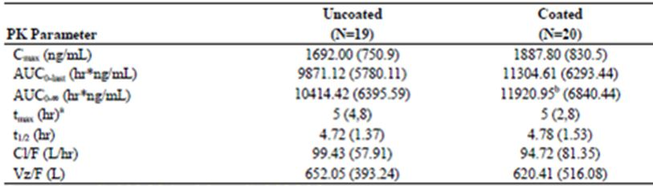
a Median (range).
b One subject had >25% extrapolated AUC_{0-∞} and was not included in analysis (N=19).
The upper bounds of the 90% CI (confidence interval) for both C_{max} (128%) and AUC_{0-∞} (132%) were slightly higher than the bioequivalence cut off (125%) indicating that the C_{max} and the AUC_{0-∞} were 7% and 12% higher, respectively, for the coated than for the uncoated tablets (Table 7). These results were submitted to the FDA and the CHMP, who concurred that the results support introducing the 375 mg film coated tablet as the commercial product.
Table 7: Analysis of relative bioavailability of the coated tablets in comparison to the uncoated tablets (Study VX07-950-017).
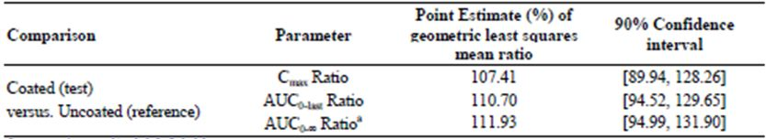
a One subject had >25% extrapolated AUC0-∞ with coated tablet. This value was not included in comparison.

Bioequivalence
In the first part of a randomised, open label, single dose crossover study (VX05-950-003), the PK of VX-950 following a single oral dose of 750 mg (3 x 250 mg) VX-950 formulated as VX-950 alone (Formulation A) or as Vitamin E TPGS and HPMC E50 (or equivalent) (Formulation B) were examined following an overnight fast in 35 healthy males, aged 19 to 55 years. There was at least a 7 day washout between treatment periods and blood samples for PK analysis were taken pre dose and up to 24 h post dose. VX-950 T_{max} (3.50 h) and t_{1/2} (5.07 to 5.24 h) were similar following administration of both formulations. By contrast, mean C_{max} significantly increased from 379 ng/mL to 489 ng/mL (approximately 20.4%) following administration of Formulation B compared to Formulation A and AUC_{0-∞} increased from 3199 to 3901 ng.h/mL (approximately 25.5%), respectively. The ratios of VX-950 AUC values to the sum of VX-950 and VRT-127394 AUC values were similar between treatments.

Influence of food
The PK food effect and colonic absorption of VX-950 and VRT-127394 (R diastereomer of telaprevir, which is 30 fold less active) were examined in a two part study (VX05-950-002) in 16 healthy males, aged 21 to 52 years. Part A of the study was an open label, single formulation, two sequence, two period standard crossover study in 16 subjects, which examined the PK profile of a VX-950 formulation using a hydroxypropyl methylcellulose acetate succinate (HPMCAS) polymer and assessed the effect of food on the PK of this formulation. Part B, an open label, single formulation, one sequence study in 10 subjects who continued on from Part A assessed the colonic PKs of HPMCAS formulation. There was a 40 day washout period between the two parts of the study. Blood samples were taken pre dose and up to 24 h following dosing for the determination of VX-950 (S diastereomer) and VRT-127394 (R diastereomer) PKs.
The mean C_{max} for VX-950 was 862 and 2922 ng/mL under fasted and fed conditions, respectively, and AUC_{0-∞} was 686 and 19932 ng.h/mL, respectively (Table 8). The median T_{max} value was 3 h in the fasted state and 6 h in the fed state, whereas t_{1/2} was not significantly affected by food (P = 0.47). The geometric mean ratio (fed/fast) of VX-950 C_{max} was 3.73 (90% CI: 2.85 to 4.89) and the mean ratio for AUC_{0-∞} was 3.22 (90% CI: 2.49 to 4.17). Therefore, food significantly (P <0.05) increased the subject’s exposure to VX-950.
Table 8: Summary statistics of C_{max}, AUC_{0-∞}, t_{lag}, t_{max} and t_{1/2},λz of VX-950.
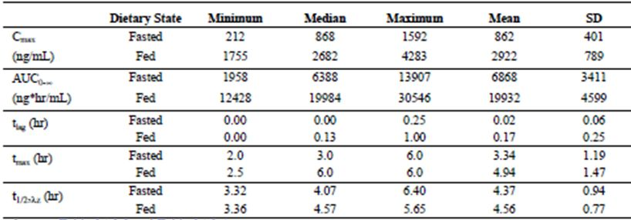
For Part B, Enterion capsule retrieval confirmed that 7 of 10 capsules were successfully activated; however, some test material remained inside all 7 capsules. Two capsules were not retrieved, however, based on the detectable concentrations of VX-950 in the plasma of the subjects who took the two unrecovered capsules, it was concluded that these capsules had also been activated. All 9 activations occurred in the targeted colonic release site. Nine of the 10 subjects in Part B had VX-950 and VRT-127394 concentrations below the limit of quantification (2 ng/mL) suggesting that VX-950 is not absorbed from the colon.
A randomised, open label, cross over design study (VX05-950-004) examined the effect of food (a regular non high fat breakfast ) on the PK of six formulations of VX-950 in 36 healthy males, aged 18 to 55 years. The effect of Vitamin E TPGS on the bioavailability of VX-950 was also evaluated in the fed state by comparing the formulations consisting of Vitamin E TPGS (Formulation I, II, and III) with the corresponding formulations which did not contain Vitamin E TPGS (Formulation IV, V, and VI). Therefore, PK parameters for Formulation I were compared with Formulation IV, II with V, and III with VI. In Periods 1 and 2, 12 subjects were randomised to two different sequences within each formulation group (6 subjects per sequence) and were administered a single 750 mg oral dose of either Formulation I, II or III VX-950 in the fed and fasted state. In Period 3, Formulations IV, V and VI were evaluated in the same healthy male subjects under fed conditions only, such that subjects in Formulation Group I also received Formulation IV, subjects in Formulation Group II also received Formulation V, and subjects in Formulation Group III also received Formulation VI. There was a washout period of approximately 7 days between doses. Blood samples were collected pre dose and up to 24 h post dose.
For VX-950, the median T_{max} for Formulations I to III ranged from 3.25 to 3.75 h in the fasted state and was 4.00 h in the fed state (Table 9). For VRT-127394, median T_{max} was slightly higher and ranged between 4.00 and 6.00 h (Table 10). No effect of formulation was observed on the apparent elimination t_{1/2} of VX-950 and the median t_{1/2} ranged from 3.26 and 4.73 h. By contrast, the median t_{1/2} appeared to be slightly higher in the fasted state for all comparisons. The median C_{max} and AUC_{0-∞} for VX-950 were approximately 4.0 and 2.8 fold higher in the fed state than in the fasted state for all formulations. The median percent of the total exposure (VX-950 AUC_{0-∞} + VRT-127394 AUC_{0-∞}) attributable to VX-950 ranged between 67.0 and 71.2% for the various formulations and did not appear to be affected by the presence of food.
Table 9: Summary statistics (median and range) of VX-950 PK parameters following oral administration of VX-950 (n=12 per group).
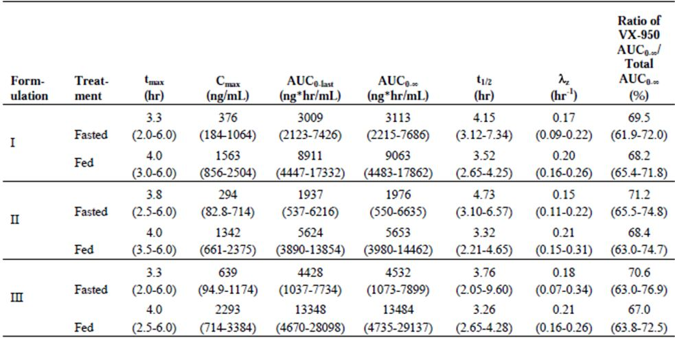
Note: total AUC includes sum of AUC_{0-∞} of VX-950 and VRT-127394.
Table 10: Summary statistics (median and range) of VRT-127394 PK parameters following oral administration of VX-950 (n=12 per group) (Study VX05-950-004).
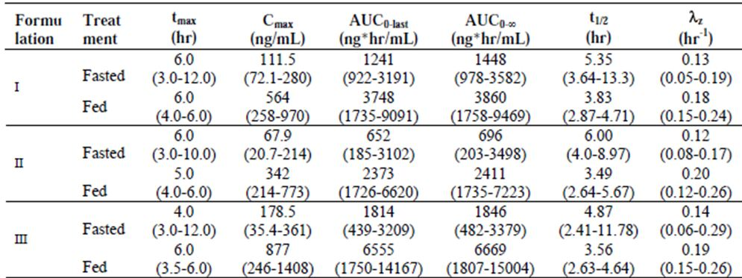
For Formulations I to III, the Cmax for VX-950 in the fasted state was 21-26% of the corresponding Cmax under fed conditions and the AUC0-∞ was 28-38% of the corresponding AUC_{0-∞} in the fed state.
The effect of Vitamin E TPGS on the PK parameters of VX-950 was investigated in the fed state (Table 11). Analysis of the geometric least squares (GLS) mean ratios between the formulations containing Vitamin E TPGS (Formulations I, II and III) and those without (IV, V and VI) indicated that the Cmax and AUC_{0-∞} were: 25% higher for Formulation I compared to IV; and 26 to 28% higher for Formulation II compared to V; whereas although there was little change in AUC for the Formulation III/VI comparison, C_{max} was 15% higher in the formulation containing Vitamin E TPGS.
Table 11: Arithmetic mean (%CV) of VX-950 PK parameters for six formulations (Study VX05-950-004).
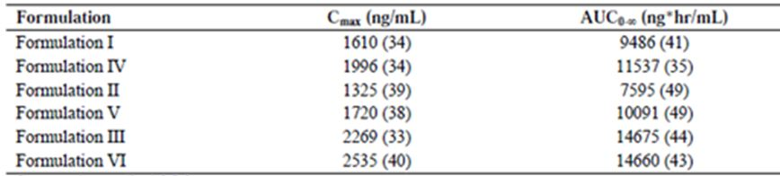
An open label, randomised, 5 way, crossover study (VX-950-C121) examined the effect of different types of food on the bioavailability of telaprevir and VRT127394 after a single oral dose of 750 mg (2 x 375 mg tablets), in 30 healthy subjects (2 female), aged 23 to 54 years, with 28 subjects completing the trial. The different treatments were:
- Treatment A, telaprevir intake after a standard breakfast (4 slices of bread, 1 slice of ham, 1 slice of cheese, butter, jelly, and 2 cups of decaffeinated coffee or tea with milk and/or sugar, if desired);
- Treatment B, telaprevir intake under fasting conditions;
- Treatment C, telaprevir intake after a high calorie high fat breakfast (2 eggs fried in butter, 2 strips of bacon, 2 slices of white bread with butter, 1 croissant with 1 slice of cheese, and 240 mL of whole milk);
- Treatment D, telaprevir intake after a low calorie high protein breakfast (115 g turkey without skin, 1 slice of bread, and 1 teaspoon fat [mayo or butter]); and
- Treatment E, telaprevir intake after a low calorie low fat breakfast (2 slices of white bread, jam [20 g] and low calorie low fat yogurt [100 g]).
There was a washout period of at least 6 days between treatments and plasma samples were obtained for PK analysis pre dose and up to 24 h post dose on treatment days.
Following the different meals, the median T_{max} of telaprevir ranged from 3.5 to 5 h (Table 12). The range of T_{max} values were comparable for all treatments, except for telaprevir following a high calorie high fat breakfast, in which case T_{max} values were observed up to 10 h post dosing. Mean telaprevir C_{max}, AUC_{last} and AUC∞ were significantly lower following administration under fasting conditions (83%, 75% and 73%, respectively) compared to telaprevir after a standard breakfast. Mean telaprevir C_{max}, AUC_{last} and AUC∞ were similar when telaprevir was administered after a low calorie high protein breakfast or after a low calorie low fat breakfast, but were lower than the PK values obtained when telaprevir was administered after a standard breakfast. Although the C_{max} values obtained following a standard breakfast and after a high calorie high fat breakfast were similar, the AUC_{last} and AUC∞ were significantly higher (19% and 20%, respectively) following a high calorie/high fat meal.
Table 12: PK results of telaprevir after a single oral dose of 750 mg telaprevir under different food conditions (Study VX-950-C121).
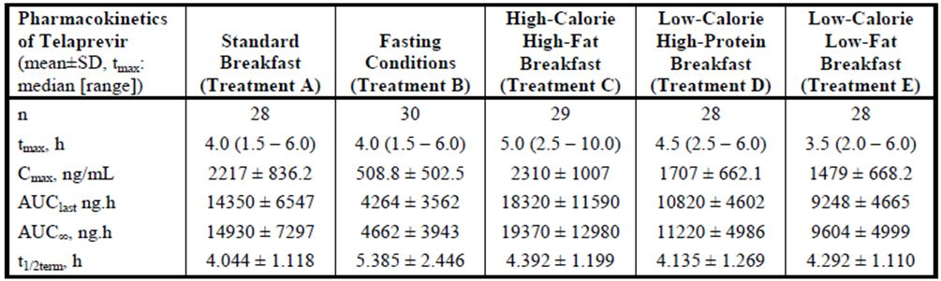
A randomised, open label, single dose, crossover study (VX06-950-010) evaluated the bioequivalence of two oral formulations of telaprevir in 115 healthy subjects (6 female), aged 18 to 55 years, in the fed and fasted state. Each arm of the study contained two dosing sequences: in Arm 1 (26 subjects), each subject received one dose of Formulation A (3 x 250 mg tablets) and one dose of Formulation B (2 x 375 mg tablets) in the fed state; and in Arm 2 (89 subjects), each subject received two single doses of Formulation A and Formulation B in the fasted state. Each treatment period was separated by a 7 day washout and blood samples for PK analysis were taken pre dose and up to 24 h post dose. In the fed state, the mean C_{max}, AUC_{last} and AUC∞ for telaprevir were significantly higher (approximately 32% higher) following Formulation B than with Formulation A. Therefore, the two formulations were not deemed to be bioequivalent in the fed state; in the fasted state, the mean PK exposures were similar for both formulations.
In Part B of Study VX03-950-001, the effects of food on the PK of a single oral dose of VX-950 in 10 healthy male subjects were assessed. Subjects received a single dose of either 600 mg VX-950 or placebo on the first dosing occasion and 600 mg VX-950 or placebo on the second dosing occasion, in either a fed/fasted or fasted/fed sequence. There was a minimum washout of 7 days between doses and blood samples were taken pre dose and up 24 h following dosing.
Based on the limited available data, the intake of food had a substantial impact on the PK of VX-950 and caused mean decreases of 77% and 65% in AUC_{0-∞} and C_{max}, respectively. However, p values were not statistically significant, most likely due to the small sample size.

Distribution
An open label, non randomised, mass balance study (VX06-950-005) investigated the PK, route, and rate of elimination and total recovery of a single, oral dose of [¹⁴C]-VX-950 (750 mg/2.84 MBq) administered within 5 to 15 minutes of a standard breakfast in 6 healthy males, aged 19 to 58 years. If on Day 5 the radioactivity was more than 50 dpm/mL in urine (background corrected) or more than 75 dpm/100 mg in the faeces sample, the subject’s stay in the clinic was extended for a maximum of 4 additional days. Blood samples for the analysis of [¹⁴C] radioactivity in whole blood and plasma and for VX-950 and VRT-127394 PKs in plasma, as well as urine samples and breath samples, were collected pre dose and up to 24 h post dose, and every 24 h thereafter until discharge. Blood samples for metabolite identification/profiling in plasma were collected 5 to 48 hours post-dose. Faeces were collected pre dose on Day -1 or pre dose on Day 1 and were then collected from the time of study drug administration until discharge from the clinic.
Following the administration of [¹⁴C]-VX-950, radioactivity in plasma increased, with a mean lag time, C_{max} and T_{max} of 4.00 h, 0.46 μg/mL and 18.51 h, respectively (Table 13). Plasma concentrations of radioactivity appeared to increase approximately 48 h post dose, following an initial decline (Figure 2). Plasma concentrations of VX-950 and VRT-127394 increased with a mean lag time of 0.96 h and 2.00 h, respectively, to achieve a mean C_{max} of 0.18 μg/mL and 0.05 μg/mL, respectively, and both analytes were quantifiable up to 24 h post dose. The mean plasma AUC_{0-∞} for VX-950 and VRT-127394 was 0.86 μg.hr/mL and 0.36 μg.hr/mL, respectively, and was highly variable between subjects. The CL/F (apparent oral clearance) and Vz/F (apparent volume of distribution) for VX-950 were 1153 L/hr and 7394 L.
Table 13: Mean (SD) of 14C radioactivity, VX-950 and VRT-127394 PK parameters (Study VX06-950-005).
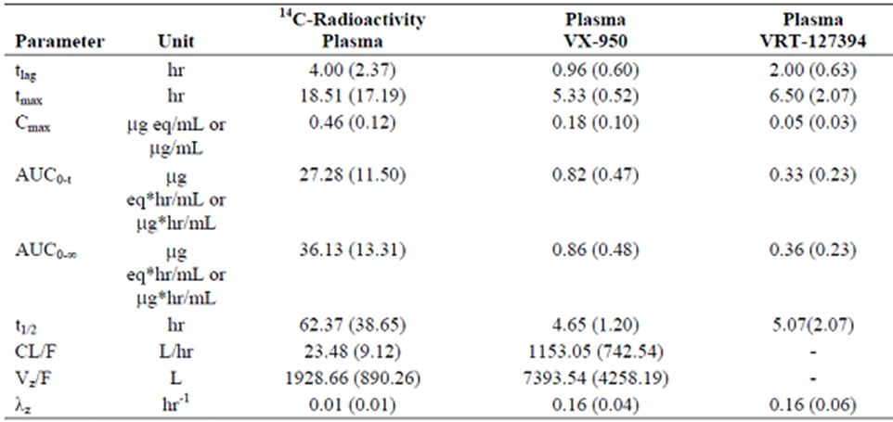
Figure 2: Median plasma concentration-time profile of 14C radioactivity, VX-950 and VRT-127394.
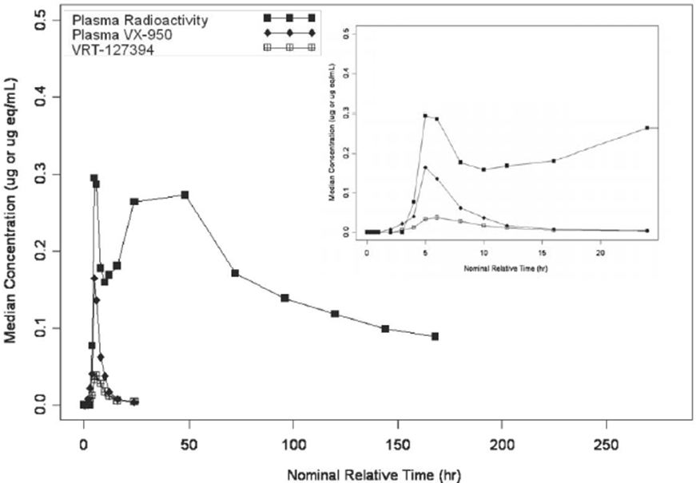
Excretion
In Study VX06-950-005, the t_{1/2} for VX-950 and VRT-127394 were similar (4.65 h and 5.07 h, respectively) (Table 13), whereas, t_{1/2} of total radioactivity was approximately 12 fold higher (62.4 h). The mean total recovery of administered dose was greater than 90% (range 86.9 to 93.9%) and the mean percent of dose recovered in the faeces was 82%, whereas, approximately 8% of dose was recovered in expired air and 1% in urine (Table 14). The contribution of unchanged ¹⁴C-VX-950 and VRT-127394 towards total radioactivity recovered in faeces was 31.8 and 18.7%, respectively.
Table 14: Summary statistics of fraction of administered radioactive dose (f_{e}) and total amount of ¹⁴C radioactivity (A_{e}) excreted in urine, faeces and expired air (Study VX06-950-005).
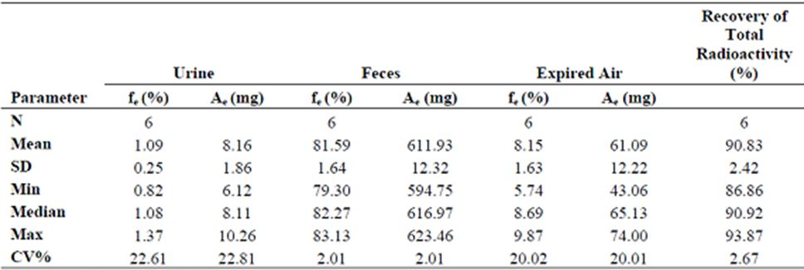

Metabolism
[¹⁴C] VX-950 is extensively metabolised via hydrolysis, oxidation, and reduction.

In vitro studies
The in vitro metabolism of [¹⁴C] telaprevir was studied in liver microsomal and S9 fractions isolated from rats, dogs, and humans. Studies were conducted at concentrations of 5 and 10 μM in sub cellular fractions from both sexes and analysed using radio HPLC and LC/MS (Report No. 6536-392). [¹⁴C] telaprevir was extensively metabolised in the microsomal and S9 fractions with the amount of parent drug remaining at the end of incubation ranging from 31.4% to 72.3%. The extent of metabolism was greatest in the sub cellular fractions from dog, followed by rat, and human. There were no apparent sex related differences in metabolism in human liver microsomes, whereas, microsomes from male rats and dogs metabolised [¹⁴C] telaprevir more extensively than females of the same species. In rat and human S9 liver fractions no apparent sex related differences in metabolism were observed, whereas, in dogs metabolism was more extensive in females than males. In addition to telaprevir and VRT-127394, a number of oxidative metabolites were identified including M1 isomers (hydroxylation of the cyclohexyl glycine or pyrazinoic acid moieties), M2 (hydroxylation of the tetrahydropyrrol cyclopentyl moiety), M8/M9 (telaprevir OH) and isomer, and diOH telaprevir. Additional metabolites were observed including M3 isomers (telaprevir reduction products), M4, M5, M7, and M12. M1 was the major metabolite observed in all species regardless of the sub-cellular fraction (microsomal or S9) studied or the sex of animal. Comparison across species indicated that no metabolites were unique to humans. M1, M3, M5, M8/M9 metabolites, telaprevir and VRT-127394 were detected in rat microsomes and diOH-telaprevir, M1, M4, M5, M8/M9 metabolites, telaprevir, and VRT-127394 were detected in dog microsomes. In human microsomes, M1, M2, M8/M9, telaprevir, and VRT-127394 were observed.
Study 03-VERT.P09R1 examined the CYP enzymes involved in the metabolism of telaprevir using human recombinant isoforms. Of the six isoforms examined (CYP1A2, CYP2C9, CYP2C19, CYP2D6, CYP2E1 and CYP3A4), CYP3A4 was the predominant CYP isoform responsible for the metabolism of telaprevir. Telaprevir (20 μM) was less susceptible (79% parent remaining) to CYP3A4 metabolism than the lower concentration of 2 μM telaprevir (14% parent remaining).

In vivo studies
Following radiochromatographic profiling of samples from Study VX06-950-005, 10 metabolites were identified in plasma, faeces and urine samples (Table 15). [¹⁴C] VX-950 and [¹⁴C] VRT-127394 were the primary radioactive components in the plasma samples. Plasma metabolites included the M3, M4, M8/M9, and M12 isomers; however, the metabolite levels in plasma were too low to be quantified. Metabolite profiling and quantitation was also undertaken in plasma samples from two other trials using LC/MS/MS. The results indicated that M4, M5, and M12 were present in the plasma of subjects at various concentrations, whereas, M11 was present only in trace amounts in some samples. Pyrazinoic acid, a by product of M11 and M12, was also detected. The major faecal metabolites were hydrolysis products from different sites of VX-950 and isomers of M12, M11, M4, and M6 accounted for 6.85, 3.88, 3.36, and 0.69%, respectively, of total administered dose. Several metabolites were detected in the urine; however, they accounted for less than 1% of the total administered dose. Qualitatively, the metabolites detected in humans were similar to those seen in the rat and no new metabolites were identified in humans that had not been previously observed in rats.
Table 15: Unchanged ¹⁴C VX-950 and metabolites detected in human plasma and excreta samples expressed as percent of total administered radioactivity (Study VX06-950-005).
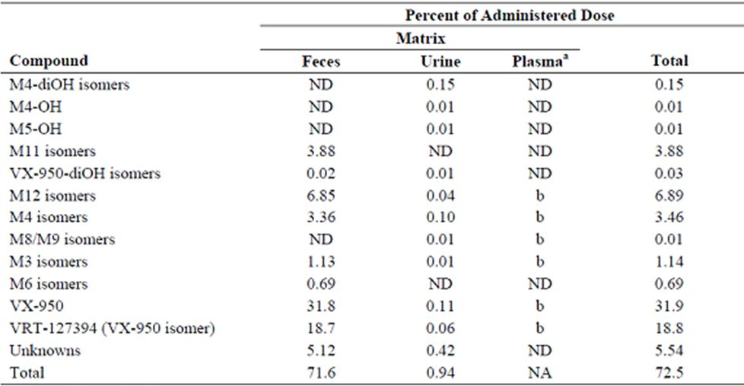
NA Not applicable.
ND Not detected.
a The metabolite profile of pooled plasma is located in Covance Report 6536-401.
b Detected but not quantified.

Interconversion
Telaprevir epimerises to form a mixture of its R diastereomer VRT-127394 and telaprevir (S diastereomer). In healthy subjects, following administration of a single dose of 375 mg telaprevir, the relative exposure ratio of VRT-127394 (exposure due to VRT-127394 compared to the exposure due to the sum of both VRT-127394 and telaprevir) ranged from ∼28% to 35% over a dose range of 375 to 1500 mg (Study VX07-950-017) (Table 16). Following multiple dose administration of telaprevir, the relative exposure of VRT-127394 was ∼37% and was similar in subjects with HCV who received multiple doses of telaprevir co administered with Peg-IFN/RBV.
Table 16: PK parameters for telaprevir and VRT-127394 after single and multiple doses of 750 mg telaprevir q8h.
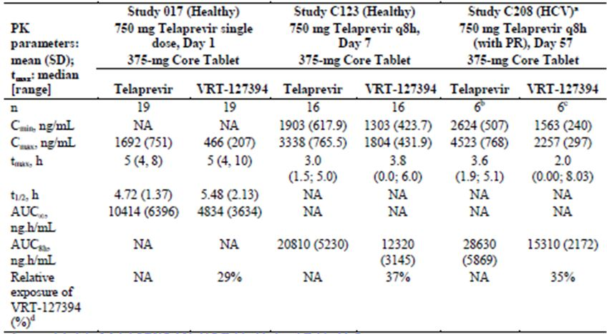
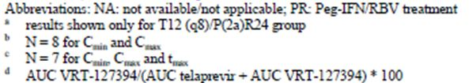

PK of metabolites
Study VX05-950-003 examined the PK of VRT-127394 following a single oral dose of 750 mg of VX-950 formulated as VX-950 alone (Formulation A) or as and Vitamin E TPGS and HPMC E50 [or equivalent] (Formulation B). The t_{1/2} of VRT-127394 was similar following administration of Formulation A (6.62 h) and Formulation B (6.72 h). By contrast, there was a 21% increase in C_{max} and 22% increase in AUC_{0-∞} following dosing with Formulation B compared to A.
The effect of food on the PK of VRT-127394 following a 750 mg oral dose of telaprevir was examined in Study VX05-950-002. The mean C_{max} and AUC_{0-∞} of VRT-127394 was 4 and 3.25 fold higher, respectively, in fed compared to fasted subjects (Table 17).
Table 17: Summary statistics of C_{max}, AUC_{0-∞}, t_{lag}, t_{max} and t_{1/2},λz of VRT-127394 (Study VX05-950-002).
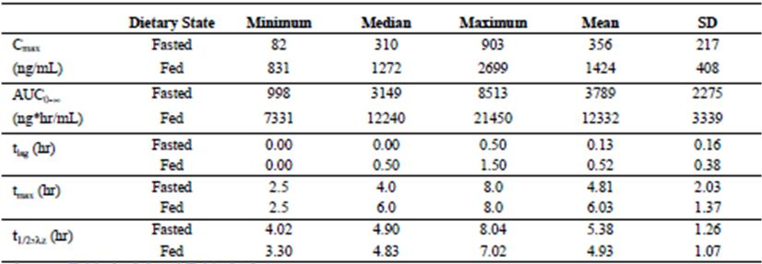
Study VX-950-C121 examined the effect of different types of food on the bioavailability of VRT-127394 after a single oral dose of 750 mg telaprevir.
The median T_{max} of VRT-127394 administered under fasting conditions was 8 h whereas under all fed conditions it was 5 h (Table 18). Similar to its parent compound, the mean VRT-127394 C_{max} and AUC_{last} were significantly lower (85% and 77%, respectively) when telaprevir was administered under fasting conditions compared to telaprevir after a standard breakfast. Mean VRT-127394 C_{max}, AUC_{last}, and AUC∞ were lower when telaprevir was administered following a low calorie low fat breakfast or a low calorie high protein breakfast compared to telaprevir administered after a standard breakfast, but higher compared to telaprevir administered under fasting conditions. When telaprevir was administered after a high calorie/high fat breakfast the C_{max}, AUC_{last}, and AUC∞ of VRT-127394 were significantly higher (∼13%, 27% and 26%, respectively) than after a standard breakfast.
Table 18: PK results of VRT-127394 after oral administration of 750 mg telaprevir under different food conditions (Study VX-950-C121).
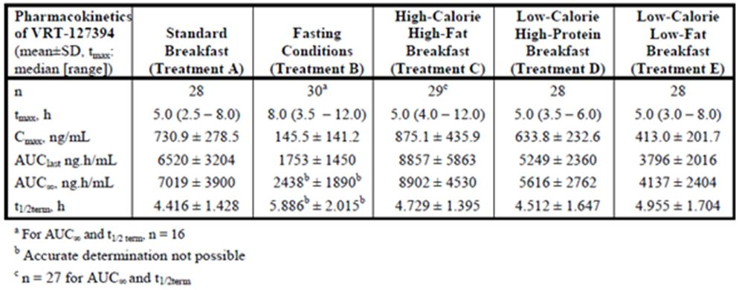
Study VX07-950-017 evaluated the dose proportionality and PK of VRT-127394 following ascending doses of uncoated 375 mg tablets of telaprevir and the relative bioavailability of coated and uncoated 375 mg tablets of telaprevir.
VRT-127394 exposure increased with increasing dose with mean C_{max} and AUC_{0-last} values ranging from 155 to 1170 ng/mL and 1223 to 15178 ng.hr/mL, respectively. The values for AUC_{0-∞} also increased with dose from doses of 375 mg to 1500 mg but then decreased from doses of 1500 mg to 1875 mg. The sponsor suggests this decrease in mean AUC_{0-∞} between the two highest dose levels was due to the exclusion of a number of profiles from this statistic as noted in the footnote to Table 19, which resulted in an underestimation of the true AUC_{0-∞}. T_{max} was similar across the dose groups (6 h for 375 mg dose and 5 h for all other doses), whereas, t_{1/2} of VRT-127394 increased from 3.4 h at the 375 mg dose to 10.0 h at the 1875 mg dose. Similar to the results seen with telaprevir, the mean C_{max} and AUC of VRT-127394 was higher in subjects given coated tablets compared to those given uncoated telaprevir tablets (Table 20). By contrast, both formulations exhibited similar T_{max} and t_{1/2} values.
Table 19: Arithmetic mean (SD) of VRT-127394 PK parameters by dose administered (Study VX07-950-017).
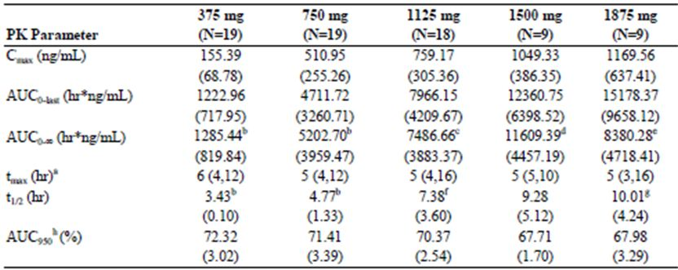
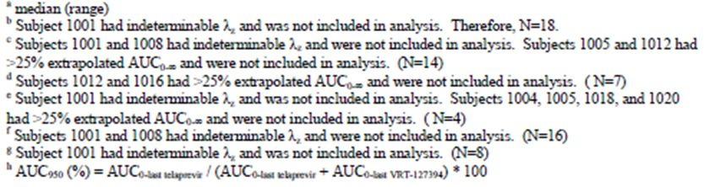
Table 20: Arithmetic mean (SD) of VRT-127394 PK parameters by formulation group (Study VX07-950-017).
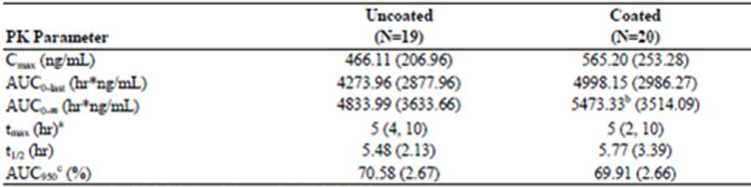
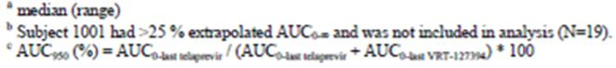
Study VX03-950-001 assessed the PK of VRT127394 following ascending single oral doses of VX-950 administered to healthy males in the fasted state. In this study, the percentage of VRT-127394, based on AUC_{0-∞}, increased with increasing dose of VX-950, and stabilised at ∼30% over the total exposure of VX-950 and VRT-127394. The median Cmax values were approximately 20%, except at the lowest dose (25 mg) where only one subject had quantifiable concentrations of VRT-127394. The C_{max} and AUC_{0-∞} of VRT-127394 at the 1250 mg dose were slightly higher than the respective means of 20% and 30%.

Consequences of possible genetic polymorphism
No PK studies specifically examined the effects of genetic polymorphism on the PKs of telaprevir. However, as telaprevir is primarily metabolised by CYP3A4, it is highly likely that subjects with mutations in this gene will possess abnormal telaprevir PKs.

Dose proportionality and time dependency

Dose proportionality
A randomised, open label, 4 group, Phase 1 study (VX07-950-017) evaluated the dose proportionality of uncoated 375 mg tablets of telaprevir and the relative bioavailability of coated and uncoated 375 mg tablets of telaprevir in 20 healthy subjects (1 female), aged 23 to 51 years. Each subject was randomly assigned to 1 of 4 treatment groups as shown in Table 21.
Table 21: Dose (mg) on dosing occasion (Study VX07-950-017).
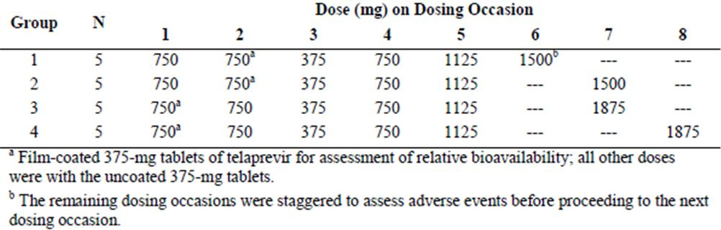
Subjects were treated in the fed state and there was a 5 to 7 day washout between treatment periods. Blood samples for PK assessment were taken pre dose and up to 24 h post dose.
Telaprevir exposure increased with increasing dose with mean C_{max} values ranging from 540 to 3259 ng/mL between doses 375 to 1875 mg (Table 22). Similarly, AUC_{0-last} and AUC_{0-∞} ranged from 3084 to 30394 hr*ng/mL and 3147 to 34944 hr*ng/mL, respectively. Mean C_{max}, increased only slightly between doses of 1500 mg and 1875 mg. By contrast, mean AUC_{0-last} and AUC_{0-∞}, continued to increase at the 1875 mg dose. The median T_{max} was 5 h for all doses, whereas, mean t_{1/2} increased with increasing dose, ranging from 3.23 to 8.31 hours. Clearance (Cl/F) decreased between doses of 375 mg and 750 mg (157 to 101 L/hr, respectively), and then remained relatively constant for all of the higher doses (ranging from 69 to 93 L/hr). The Vz/F was also similar across doses ranging from 523 to 1103 L.

Table 22: Arithmetic mean (SD) of telaprevir PK parameters by dose administered (Study VX07-950-017).
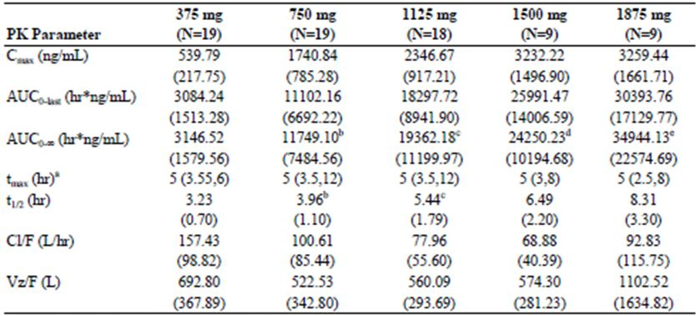
a Median (range).
b One subject had indeterminable z and was not included in statistic (N=18).
c Two subjects had indeterminable z and were not included in statistic (N=16).
d One subject had >25% extrapolated AUC0-∞ and was not included in statistic (N=8).
e One subject had >25% extrapolated AUC0-∞ and was not included in statistic (N=8).
Dose proportionality was assessed in two ways. Using a power model based on linear mixed effects modelling of the natural logarithm (ln) of C_{max}, AUC_{0-last} and AUC_{0-∞}; the C_{max}, AUC_{0-last} and AUC_{0-∞} increased more than proportional to dose for all dose pairs examined, except for Cmax between the doses of 750 mg to 1500 mg.
Dose proportionality was also assessed using an ANOVA (analysis of variance) method. The 750 mg dose was selected as the reference dose, as this was the dose used in clinical trials. Using this method, the C_{max}, AUC_{0-last}, and AUC_{0-∞} increased more than proportional to dose between doses of 375 mg and 750 mg. The increase in C_{max} was dose proportional between doses of 750 mg and 1125 mg (90% CI: 83.3 to 107.4) and was close to proportional between doses of 750 mg and 1500 mg (90%CI: 79.5 to 110.5). By contrast, AUC_{0-last} and AUC_{0-∞} increased more than dose proportionally between doses of 750 mg and 1125 mg and doses of 750 mg and 1500 mg. C_{max} increased less than proportional to dose between doses of 750 mg and 1875 mg, whereas, AUC_{0-last} and AUC_{0-∞} increased greater than proportional to dose.
A randomised, double blind, placebo controlled, single oral dose escalation study (VX03-950-001) assessed the PK of VX-950 following ascending single oral doses of VX-950 administered to 35 healthy males (25 Part A and 10 Part B), aged 19 to 55 years, in the fasted state. This part of the study comprised three panels: Panels 1 and 2 each included 8 subjects, and Panel 3 included 9 subjects. The subjects were treated in each of the panels as follows:
- Panel 1, subjects received 25, 50, 100, or 200 mg VX-950, and placebo on four dosing occasions, in an ascending order, in the fasted state;
- Panel 2, subjects received 300, 450, 600, or 750 mg VX-950, and placebo over four dosing occasions, in an ascending order, in the fasted state; and
- Panel 3, subjects received 1000, 1250 (LE), or 1250 mg VX-950, and placebo over three dosing occasions, in an ascending order, in the fasted state.
There was a washout of at least 7 days between dosing periods and blood and urine samples for the determination of PK parameters were taken pre dose and up to 24 h following dosing.
The mean C_{max} and AUC_{0-∞} for VX-950 increased with increasing dose and ranged from 10 to 2009 ng/mL and 38 to 15830 ng.h/mL, respectively. Median T_{max} for VX-950 ranged from 1.0 to 4 h for all doses studied, and the mean t_{1/2} ranged from 1.9 to 6.5 h. By contrast, CL/F decreased with dose up to 450 mg but was stable thereafter. Vz/F was generally stable when the two lower doses (25 and 50 mg) with incomplete profiles were excluded. The drug had a large apparent volume of distribution, indicating that it is widely distributed throughout the body.
Dose proportionality was assessed using power models expressing AUC_{0-∞} and C_{max} of VX-950 as a function of dose. Two models were used one which included two parameters (intercept and slope) and the other which included one parameter (slope). The Bayesian Information Criterion (BIC) was used for model comparison so that when fitting the same set of data, the model with the lowest BIC was considered to be the preferred model. These results identified that across the full range of doses the C_{max} and AUC_{0-∞} of VX-950 were more than proportional to dose.

Time dependency
Population PK Study VX-950-TiDP24-C208 identified a 69% decrease in bioavailability following telaprevir dosing in the afternoon compared to dosing in the morning. The reason for this difference is unclear however the sponsor suggests that it may relate to the well documented food effect for telaprevir.

Intra and inter individual variability
Based on the results of four trials (VX-950-C121, VRT-127394, VX03-950-001 and VX04-950-101) under fed conditions the inter-subject variability on PK estimates ranged from: 20% to 62%; 43% to 67%; 21% to 104%; and 18% to 95.0% for C_{max}, AUC, CL/F and Vz/F (apparent volume of distribution), respectively. Inter subject variability was even higher under fasted conditions. Population PK analysis G190 estimated inter subject variability on CL/F and Vz/F as 27.2% and 72.2%, respectively.

Pharmacokinetics in target population
The PK of VX-950 following ascending multiple doses of VX-950 administered to 22 healthy subjects (2 female, PART A), aged 19 to 65 years, and 34 subjects (12 female) with hepatitis C (HCV; Part B), aged 25 to 64 years were examined in a two part, randomised, multiple dose, dose escalation, blinded, placebo controlled study (VX04-950-101). In this study hepatitis C was defined as subjects with HCV genotype 1, HCV RNA levels of ≥1 x 105 IU/mL, and alanine aminotransferase (ALT) of ≤ 4.0 times the upper limit of normal (ULN). In Part A, healthy subjects received 450, 750, or 1250 mg VX-950 or placebo q8h for 5 consecutive days from Day 1. In Part B, subjects with hepatitis C received 450 mg VX-950 or placebo every 8 h (q8h) (Panel 4), 750 mg VX-950 or placebo q8h (Panel 5), or 1250 mg VX-950 or placebo q12h (Panel 6) for 14 consecutive days. Samples for PK analysis were obtained pre dose and up to 24 hours post-dose on Days 1 and 5. In addition, samples for C_{trough} (trough plasma drug concentration) on Day 3 (pre dose 1).
In all subjects, the AUC of VX-950 increased with increasing dose (Tables 23-24) and the drug accumulated to steady state with a mean accumulation index of 2.8 in healthy subjects and 1.7 in subjects with hepatitis C. As this was a multiple dose study it was difficult to estimate the apparent elimination half life for most subjects and the apparent elimination half life values reported in Table 25 are only for those subjects who had the percent of extrapolated AUC not exceeding 30%. In these subjects, the derived mean apparent elimination half life on Day 1 ranged from 2.6-2.8 in healthy subjects (Part A) and 2.7-4.6 in subjects with HCV (Part B). The median exposure (AUC0-8h) percentage of VRT-127394 over the sum of exposure of VX-950 and VRT-127394 was 30.91% (range from 17.65% to 42.88%). The median C_{max} at steady state for Part A were 1344, 1997, 2655 ng/mL for the 450 mg q8h, 750 mg q8h, and 1250 mg q8h regimen, respectively and in Part B were 1919, 1722, 2147 ng/mL for the 450 mg q8h, 750 mg q8h, and 1250 mg q12h regimens, respectively. The average C_{trough}.ss for Part B was 781.1, 1054.4, and 675.5 ng/mL for the 450 mg q8h, 750 mg q8h, and 1250 mg q12h regimens, respectively.
Table 23: VX-950 and VRT-127394 AUC₀₋₈ values (ng*hr/ml) for healthy subjects (Part A) (Study VX04-950-101).
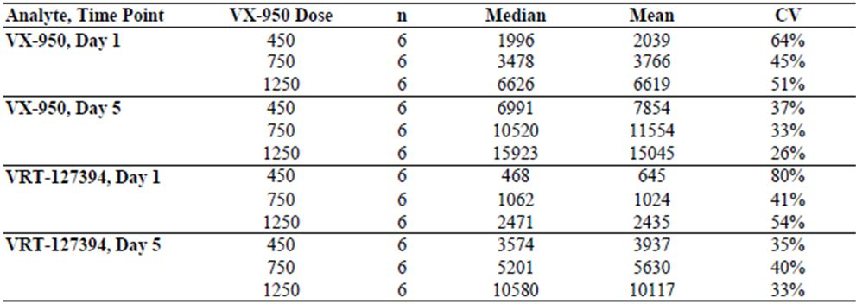
Table 24: VX-950 and VRT-127394 AUC_{last} values (ng*hr/ml) for subjects with hepatitis C (Part B) (Study VX04-950-101).
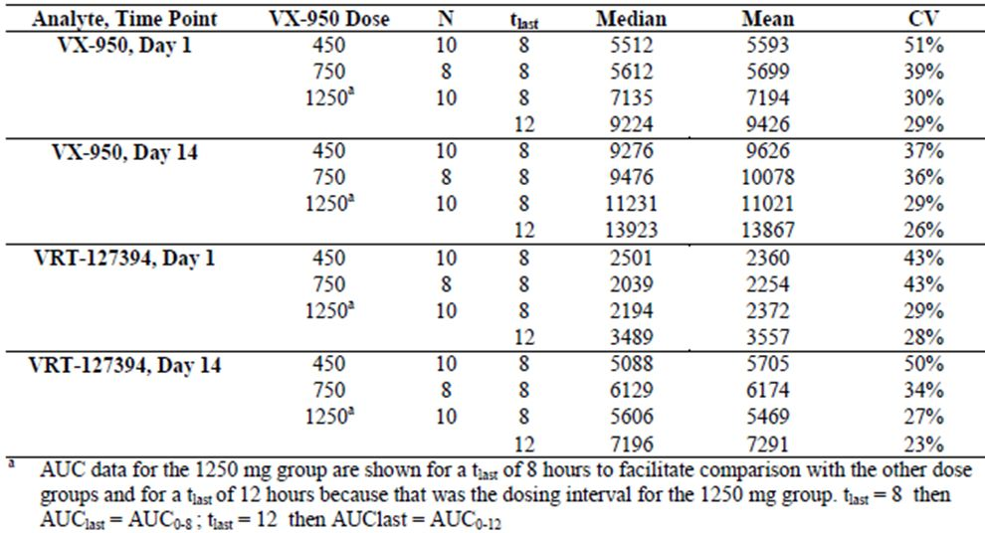
Table 25: Summary table for VX-950 apparent elimination half-life (Part A and Part B) (Study VX04-950-101).
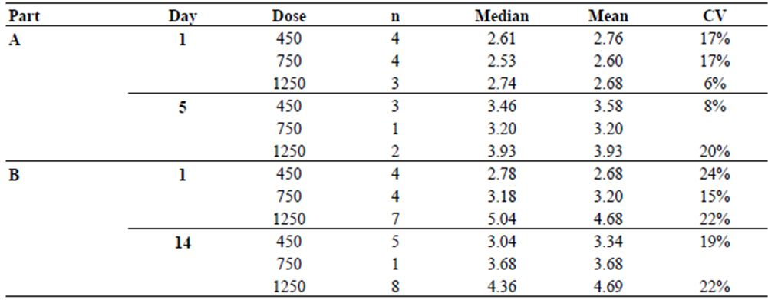
CV: coefficient of variation
n: number of subjects that apparent elimination half-lives was estimatable.

Special populations
No studies specifically examined the PK of telaprevir in children and the elderly nor did they examine the effects of gender, weight and race on telaprevir PKs. However, these populations were examined as part of the population PK analysis.
In summary, population PK study G190 indicated that subject age and race were unlikely to have a clinically relevant effect on telaprevir exposure. By contrast, subject weight was identified as having the potential for a clinically relevant impact on telaprevir exposure. However, evaluation of the exposure response results reported previously indicated that the magnitude of the effect of weight on telaprevir exposure did not have a clinically relevant impact on the safety or efficacy of telaprevir within the range of 51-120 kg.

Impaired renal function
Study VX-950-TiDP24-C132 is an open label study that investigated the single dose PK of telaprevir in 12 subjects (4 female), aged 41 to 73 years, with severe renal impairment (defined as CrCl [creatinine clearance] less than 30 mL/min) as compared to 12 subjects (4 female), aged 47 to 71 years, with normal renal function, matched for sex, race, age (± 10 years), and BMI (body mass index) (± 20%). All subjects received a single 750 mg dose of telaprevir. Blood samples for PK analysis were taken pre dose and up to 24 h post dose. In addition, total and unbound plasma concentrations of the sum of telaprevir and VRT-127394 were determined at specified time points. The telaprevir C_{max} and AUC in subjects with severe renal impairment were approximately 10% and 21% higher, respectively, than in healthy controls. After exclusion of a subject with severe renal impairment who had considerably higher exposure of telaprevir compared to the other subjects, the difference in telaprevir C_{max} and AUC_{last} between subjects with severe renal impairment and healthy subjects decreased to approximately 3% and 16%, respectively. The median T_{max} was 5 h for both groups. For the sum of telaprevir and VRT-127394, C_{max} and AUC_{last} were about 7% and 29% higher respectively (total), and about 5% and 19% higher respectively (unbound), for severely renal impaired subjects compared to healthy subjects. The mean fraction of the sum of telaprevir and VRT-127394 that was unbound to protein in plasma at different time points between 1 and 24 h after telaprevir intake was comparable for both cohorts: between about 0.11 and 0.16 in healthy subjects, and between about 0.13 and 0.17 in subjects with severe renal impairment, indicating that severe renal impairment did not affect the plasma protein binding of telaprevir.

Impaired hepatic function
Hepatic metabolism plays a major role in the elimination of telaprevir. Therefore, two studies were conducted to determine the effect of mild hepatic impairment (Child Pugh Score A [CPA]: score 5 or 6) and moderate hepatic impairment (Child Pugh Score B [CPB]: score 7 to 9) on telaprevir PKs.
An open label Study VX06-950-006 compared the PK of VX-950 following multiple oral doses in 10 healthy subjects (3 female) aged 50-63 years, and 10 subjects (3 female) aged 45-65 years, with mild hepatic impairment but without HCV infection. Telaprevir was administered in the fed state at a dosage of 750 mg q8h for 5 days. Following a single 750 mg dose on Day 1, subjects with mild hepatic impairment had approximately 18% and 11% lower C_{max} and AUC values, respectively, than healthy subjects and following multiple doses these values were 10% and 15% lower in the subjects with CPA. By contrast, T_{max} was similar in both groups at each of the time points. In addition, the accumulation ratio of telaprevir in both groups of subjects was similar, indicating that mild hepatic impairment did not increase accumulation of telaprevir in plasma.
An open label Study VX06-950-012 compared the PKs of telaprevir in the fed state following administration of 750 mg q8h for 5 days in 10 subjects (2 female) with CPB but without HCV infection, aged 47-62 years. Surprisingly, as CPB subjects were expected to be deficient in their ability to metabolise telaprevir, thus leading to increased concentrations of telaprevir in these subjects, following a single dose, telaprevir C_{max} and AUC_{8h} were reduced by approximately 41% and 37%, respectively, in CPB subjects compared to healthy control subjects (PK taken from preceding studies). Following 5 days dosing in patients with CPB, telaprevir C_{max} and AUC_{8h} were reduced by approximately 49% and 46%, respectively. The sponsor states that the mechanism of this reduction in exposure has not been established, but suggest it may be related to reduced concentrations of plasma proteins in subjects with hepatic impairment as concentrations of both albumin and alpha-1 acid glycoprotein (AAG) have been reported to be reduced by 68% and 74% in subjects with cirrhosis, a marker of hepatic impairment, and lower than normal concentrations of albumin were observed in patients with CPB in the present study. Therefore, lower albumin concentrations found in CPB subjects, as well as presumed lower AAG concentrations as previously described (but not measured in the current study), may result in reduced total plasma concentrations of telaprevir due to greater distribution of telaprevir to nonvascular compartments and increased clearance. It must be noted that the appropriate dose of telaprevir in subjects with CPB has not been determined and therefore telaprevir is not recommended in these subjects.

Evaluator’s overall comments on PK in special populations
Population PK study G190 indicated that subject age and race were unlikely to have a clinically relevant effect on telaprevir exposure. By contrast, subject weight was identified as having the potential for a clinically relevant impact on telaprevir exposure. However, evaluation of the exposure response results reported previously show the magnitude of the effect of weight on telaprevir exposure did not have a clinically relevant impact on the safety or efficacy of telaprevir within the weight range of 51-120 kg.
The telaprevir C_{max} and AUC in subjects with severe renal impairment, were approximately 10% and 21% higher, respectively, than in healthy control subjects and the sponsor believes these differences in telaprevir exposure are unlikely to be clinically relevant.
Following a single 750 mg dose on Day 1, subjects with mild hepatic impairment had approximately 18% and 11% lower C_{max} and AUC values, respectively, than healthy subjects and following multiple doses these values were 10% and 15% lower in the subjects with CPA.
In subjects with moderate hepatic impairment (CBP) following a single dose, telaprevir C_{max} and AUC_{8h} were reduced by approximately 41% and 37%, respectively, in CPB subjects compared to healthy control subjects. Following 5 days dosing telaprevir C_{max} and AUC_{8h} were reduced by approximately 49% and 46%, respectively, in CPB subjects. It must be noted that the appropriate dose of telaprevir in subjects with CPB has not been determined and therefore telaprevir is not recommended in these subjects.
Telaprevir has not been studied in subjects with severe hepatic impairment (Child-Pugh Class C), and is not recommended in this population.

Interactions

In vitro PK interactions
In vitro studies (Report 03-VERT.P09R1, Report 1 B050860 and 6VERTP3) identified that telaprevir and VRT-127394 did not inhibit CYP2A6, CYP2B1, and CYP2E1 (Table 26). In addition, they did not inhibit or only weakly inhibited CYP1A2, CYP2C9, CYP2D6, CYP2C8 and CYP2C19 (IC₅₀ >100μM), whereas telaprevir, VRT-127394, and a 55:45 mixture of telaprevir: VRT-127394 inhibited CYP3A4 with IC₅₀ values <18.9 μM.
Table 26: Effect of telaprevir on human CYP450 activities using probe substances.ª
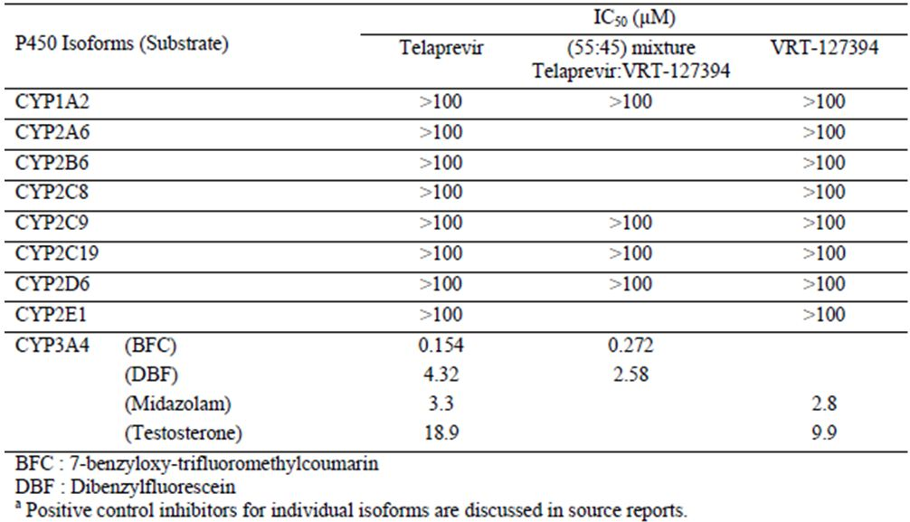
Further in vitro studies examined the potential for telaprevir to induce CYP1A, CYP2C, and CYP3A activities in primary cultures of human hepatocytes (Report No. 6536-307). Cells were incubated with three concentrations of telaprevir (0.1, 1 and 100 μM) and the data were compared to that obtained with the positive controls omeprazole and rifampicin. Although incubation with 100 μM telaprevir resulted in average induction values of 1.4, 0.4 and 0.1 fold for CYP1A, CYP2C and CYP3A, respectively, the increase in CYP1A activity was only 2% to 3% of the positive control and there was no evidence for a concentration-related effect. Therefore, telaprevir was concluded to have a low potential to induce CYP2C, CYP3A, or CYP1A.
The potential metabolism dependent inhibition of telaprevir or VRT-127394 on CYP3A4/5 was investigated using pooled human liver microsomes (Report Nos. 6536-306 and A124). Telaprevir and VRT-127394 were competitive in vitro inhibitors of CYP3A4/5 substrates with Ki values for telaprevir and VRT-127394 of 1.43 μM and 0.94 μM, respectively, using midazolam as substrate and 18.6 and 5.18 μM, respectively, using testosterone as substrate. The inhibition of CYP3A4 by telaprevir was both time and concentration dependent with a maximum inactivation rate of 0.065 min-1 and a dissociation constant of 1.5 μM. These results suggest that there is the potential for drug-drug interactions between telaprevir and drugs that are substrates, inducers, or inhibitors of CYP3A4.
Telaprevir was also tested for its potential inhibitory effect on uridine diphosphate glucuronyltransferase 1A1 (UGT1A1), which is primarily responsible for the glucuronidation of bilirubin in the liver. Incubation with human liver microsomes and bilirubin as probe substrate were performed in the presence of telaprevir at concentrations ranging between 0.045 to 100 μM. In these studies, telaprevir did not inhibit UGT1A1 catalysed bilirubin glucuronidation (IC50 > 100 μM).

In vivo PK interactions

CYP3A Inhibitors
In part B of Study VX05-950-003 the effect of single doses of ketoconazole (400 mg) or ritonavir (100 mg) on single dose PK of telaprevir (750 mg) was examined in healthy male subjects. A single dose of ketoconazole increased telaprevir C_{max} and AUC_{0-tlast} by approximately 1.2 and 1.6 fold, respectively. Similarly, the C_{max} and AUC_{0-last} of VRT-127394 were increased by 1.4 and 1.8 fold, respectively, when ketoconazole was co administered.
Co administration of ritonavir also increased the C_{max} and AUC_{0-last} of VX-950 (1.3 and 1.8 fold, respectively) and VRT-127394 (1.6 and 2.3 fold, respectively).
A randomised, placebo controlled, 4 treatment, 4 period crossover study designed to evaluate the effect of VX-950 on QT intervals in 89 healthy males, aged 18-54 years, also evaluated the PK effects of ketoconazole (200 and 400 mg) on steady state VX-950 (1250 mg). Blood samples for PK analysis were taken pre dose and up to 8 h post dose. The Tmax of VX-950 was unaffected (3.17 h) following co administration of either the 200 and 400 mg doses of ketoconazole (Table 27). By contrast, the mean steady state C_{max}, C_{min} (minimum plasma drug concentration), and AUC_{0-8h} of VX-950 observed following the VX-950/KETO dosing regimen were increased ∼20% compared to the VX-950 alone regimen (Table 28).
Table 27: Arithmetic mean (SD) of VX-950 PK parameters by treatment group (Study VX05-950-008).
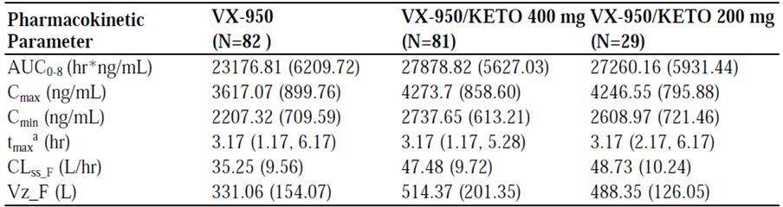
ª median (range).
Table 28: Statistical analysis of VX-950 PK parameters (Study VX05-950-008).
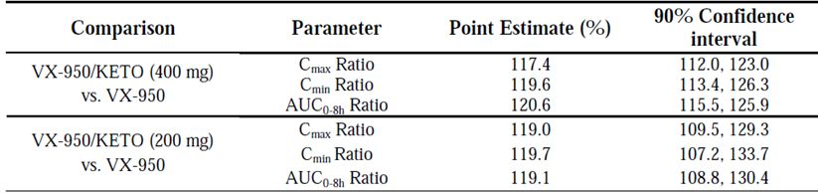
The point estimates and 90% CIs for the geometric mean ratios of VX-950 between VX-950/KETO (400 mg) and the VX-950 alone dosing regimens were 117.4% [90% CI: 112.0%, 123.0%] for C_{max}, 119.8% [90% CI: 113.5%, 126.4%] for C_{min}, and 120.6% [90% CI: 115.5%, 125.9%] for AUC_{0-8h}. The PK parameters of VX-950 when dosed with 200 mg ketoconazole (dosing error) were similar to those obtained with 400 mg ketoconazole group (correct dose). Similarly, the AUC of the 400 mg dose of ketoconazole was increased by 46% following co administration with the fourth dose of 1250 mg telaprevir compared to when ketoconazole was given alone (Table 29). In the subset of subjects who received 200 mg of ketoconazole instead of the 400 mg dose the AUC of ketoconazole was increased by 125%. As concomitant systemic use of ketoconazole and telaprevir may increase plasma concentrations of telaprevir, and because plasma concentrations of ketoconazole may also be increased in the presence of telaprevir, high doses of ketoconazole (>200 mg/day) are not recommended when co administration with telaprevir is required.
Table 29: Statistical analysis of ketoconazole PK parameters (Study VX05-950-008).
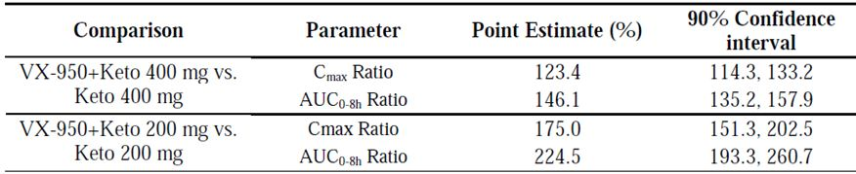
An open label, randomised, multiple dose, parallel group Study VX05-950-009 evaluated the single dose and steady state PK of telaprevir 250 mg every q12h or 750 mg q12h in combination with ritonavir 100 mg q12h in 46 healthy males aged 18-53 years. Subjects were randomly assigned to receive one of four different dose regimens (A, B, C and D) containing telaprevir, with and without ritonavir, in the fed or fasted state, for 14 days. Blood samples were taken pre dose and up to 12 h following dosing on Days 1 and 14.
Following a single dose of 750 mg telaprevir under fed conditions, the AUC_{0-last} of telaprevir increased from 6995 ng.h/mL when it was administered alone (Group D) to 22367 ng.h/mL when it was administered in combination with ritonavir (Group B) (Table 30). Similarly, C_{max} increased from 1613 ng/mL to 3608 ng/mL in the two groups, respectively. Based on C_{max}, C_{trough} and C_{avg} (average plasma drug concentration) values, telaprevir exposure was approximately two fold higher in Group B compared Group D (Table 31).
Table 30: Mean (SD) telaprevir PK parameters after a single dose (Day 1) of telaprevir with and without ritonavir in the fed and fasted states (Study VX05-950-009).
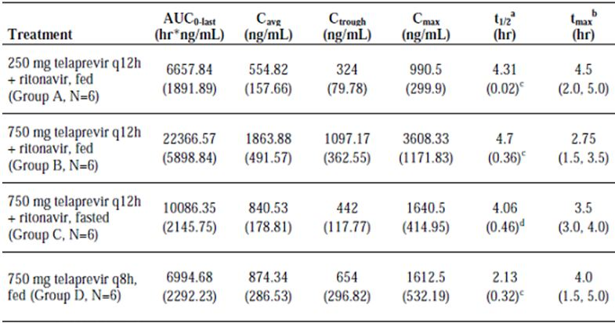
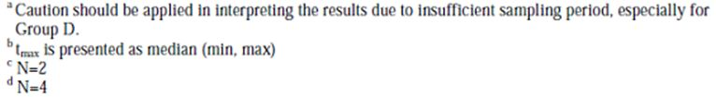
Table 31: Comparison of telaprevir PK parameters following a single dose of telaprevir with and without ritonavir in the fed and fasted states (Study VX05-950-009).
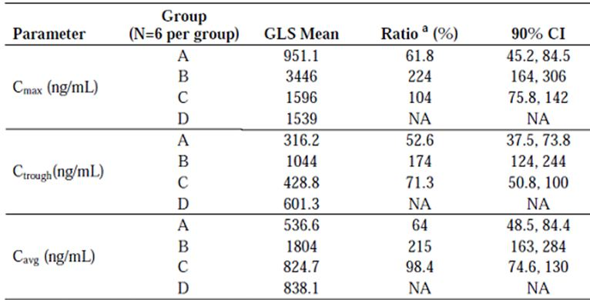
The C_{max} and AUC_{0-last} of telaprevir were approximately 2.2 fold higher following a single 750 mg dose of telaprevir given with ritonavir in the fed versus fasted state (Table 32).
Table 32: Comparison of telaprevir PK parameters following a single dose of telaprevir with ritonavir in the fed and fasted states (Study VX05-950-009).
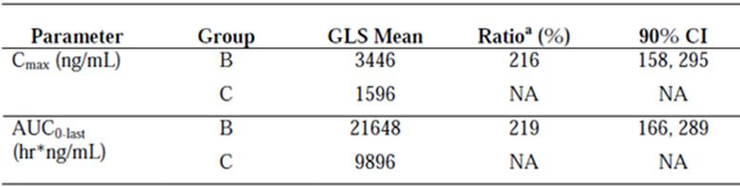
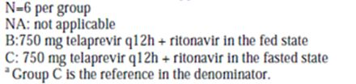
Following multiple doses on day 14, the AUC_{0-last} of telaprevir increased from 16602 ng.h/mL to 19059 ng.h/mL in groups B and D, respectively, whereas C_{max} decreased from 2808 ng/mL to 2368 ng/mL, respectively (Table 33). Based on C_{max}, C_{trough} and C_{avg} values, telaprevir exposure was between 15% and 32% higher in Group B compared Group D (Table 34), indicating that the increase in exposure to telaprevir was lower after multiple dosing compared to single dosing. In the fed state, ritonavir exposure was higher following co administration with 750 mg telaprevir than with 250 mg telaprevir on both Days 1 and 14 (Tables 30 and 33).
Table 33: Mean (SD) telaprevir PK parameters after multiple doses (Day 14) of telaprevir with and without ritonavir in the fed and fasted states (Study VX05-950-009).
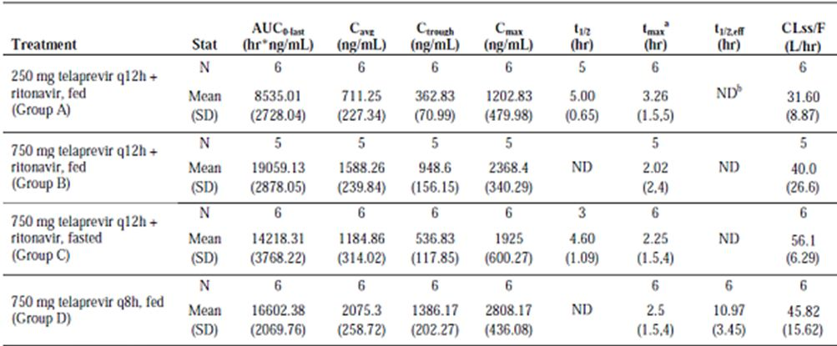
a tmax is presented as median (min, max).
b ND: not done.
Table 34: Comparison of telaprevir PK parameters following multiple doses of telaprevir with and without ritonavir in the fed and fasted states (Study VX05-950-009).
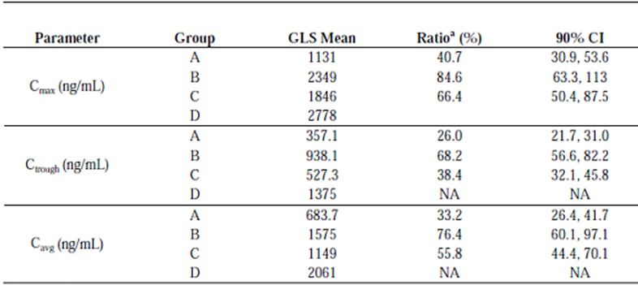
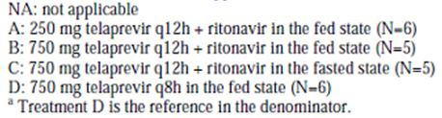
Following multiple doses, the effect of food on the C_{max} and AUC_{0-last} of telaprevir was also decreased (increases of 1.27 and 1.37 fold, respectively) when it was given in combination with ritonavir (Table 35).
Table 35: Comparison of telaprevir PK parameters following multiple doses of telaprevir with ritonavir in the fed versus fasted states (Study VX05-950-009).
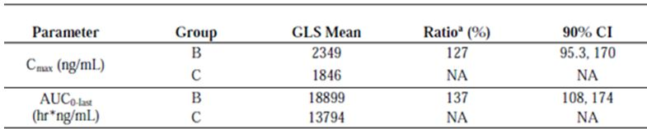
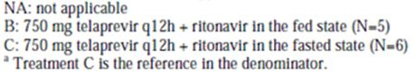
In the fed state, ritonavir exposure was higher following co administration with 750 mg telaprevir than with 250 mg telaprevir on both Days 1 and 14 (Table 36). There was no consistent food effect on systemic ritonavir exposure when 100 mg ritonavir was administered in combination with telaprevir in the fed state versus the fasted state (Tables 37-38).
Table 36: Mean (SD) ritonavir PK parameters after a single dose of telaprevir co administered with ritonavir in the fed and fasted states (Study VX05-950-009).
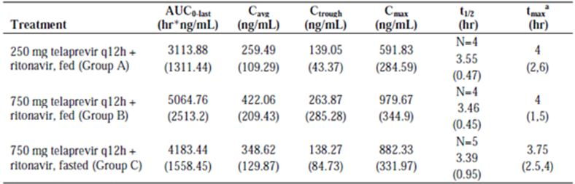
N=6 per group
ª t_{max} is presented as median (min, max).
Table 37: Comparison of ritonavir PK parameters following a single dose of 100 mg ritonavir co administered with 750 mg telaprevir in the fed versus fasted states (Study VX05-950-009).
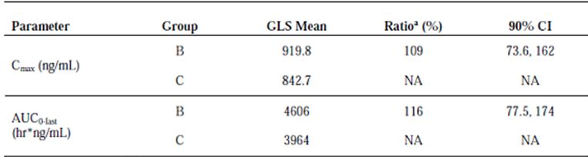
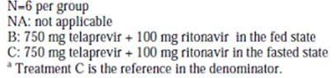
Table 38: Comparison of ritonavir plasma PK parameters following multiple dose ritonavir co administered with telaprevir in the fed versus fasted states (Study VX05-950-009).
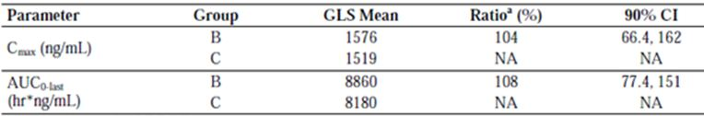
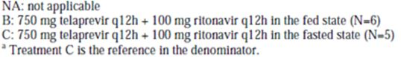

CYP3A4 inducers
An open label, single sequence, non randomised Study VX07-950-016 examined the effect of rifampin, a strong CYP3A4 inducer, and efavirenz (EFV), a moderately strong inducer of CYP3A, on the single dose PK of telaprevir following a standard breakfast in 44 healthy subjects (4 female) aged 20-58 years, of which 36 subjects completed the study. A single dose of telaprevir (750 mg) was administered on two occasions (Days 1 and 9), and rifampin (600 mg) was administered qd (once daily) for 8 days (Days 2 through 9). Blood samples for the PK analysis of telaprevir and EFV were taken pre dose and up to 8 and 24 h post dosing, respectively.
When rifampin was co administered with telaprevir, overall telaprevir AUC∞ was reduced by ∼92%, telaprevir C_{max} was reduced by ∼86%, and telaprevir elimination half life was reduced by ∼50%, indicating that the co administration of telaprevir and strong CYP3A4 inducers is contraindictaed. When given in combination with EFV, the telaprevir AUC and C_{max} were reduced by 26% and 9%, respectively, and telaprevir reduced EFV AUC and C_{max} by 7% and 16%, respectively.

CYP3A substrates
An open label, single centre, non randomised Study VX06-950-011 analysed the effect of co administration of telaprevir on the PK parameters of the CYP3A substrate midazolam, administered either orally or intravenously in 24 healthy subjects (14 female) aged 18-60 years, of which 21 completed the study. Telaprevir (750 mg) was administered q8h for 16 days (Study Days 8 through 23). Oral midazolam (2 mg) was administered as a single dose on two occasions (Study Days 3 and 19). IV midazolam (0.5 mg) was administered as a single dose on two occasions (Study Days 1 and 17). Digoxin (0.5 mg), a P-gp substrate, was administered as a single dose on two occasions (Study Days 3 and 19).
Although there was little effect on midazolam C_{max}, the AUC∞ of midazolam after IV administration increased 3.4 fold following co administration with telaprevir. The elimination half life of midazolam increased ∼4 fold upon co administration with telaprevir, whereas the Vz/F remained unchanged. The major metabolite of midazolam, 1’-hydroxymidazolam, could not be detected in most subjects following co administration with telaprevir, whereas, detectable concentrations were seen in the absence of telaprevir. These results indicate that telaprevir significantly inhibited the CYP3A mediated hepatic metabolism of midazolam. The effect of telaprevir on the PK of orally administered midazolam were even more pronounced with midazolam C_{max} increasing approximately 3 fold while the AUC∞ increased approximately 13 fold following co administration with telaprevir. The ratio of 1-hydroxymidazolam to midazolam also decreased approximately 17 fold. The increase in midazolam t_{1/2} in the presence of telaprevir (approximately 4 fold) was similar following both oral administration and IV administration. These results indicate that oral midazolam should not be co administered with telaprevir.
A secondary objective of this study was to determine the PK of telaprevir following co administration of a single dose of midazolam (IV and oral). The median apparent t_{1/2} of telaprevir was 6.56 and 6.38 h on Days 17 and 19, respectively (Table 39), and was higher than the half life of 3.8 h seen in Study VX07-950-016.
Table 39: Summary statistics of PK parameters for telaprevir and VRT-127394 on Day 17 and 19 (Study VX06-950-011).
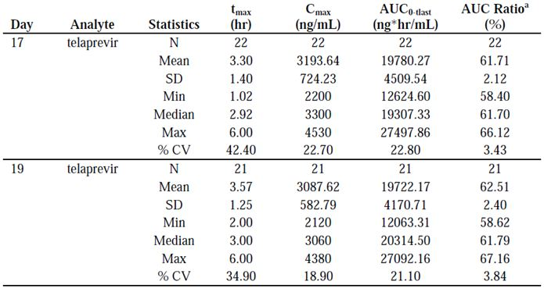

P-Glycoprotein substrates
Although in vitro studies did not indicate that telaprevir inhibits P-gp at concentrations of up to 10 μM, Study VX06-950-011 demonstrated that following co administration with telaprevir, digoxin C_{max} and AUC increased 1.5 and 1.85 fold, respectively, and digoxin t_{1/2} increased from 28 to 50 h. By contrast, the renal clearance of digoxin appeared to be similar in the absence and presence of telaprevir, indicating that there was minimal, if any, effect of telaprevir on the P-gp in the kidney. These results possibly suggest that telaprevir enhanced digoxin absorption may result from intestinal P-gp inhibition and indicate that drugs, which are P-gp substrates and have narrow therapeutic indices, may require dose adjustment when co-administered with telaprevir.

Commonly used co medications
As telaprevir is an inhibitor of CYP3A studies were conducted examining the interaction between telaprevir and drugs that are commonly used by HCV infected subjects that are substrates of CYP3A, such as oral contraceptives, amlodipine, atorvastatin, zolpidem, alprazolam, escitalopram and methadone. As proton pump inhibitors can affect the absorption of some drugs by increasing the intra gastric pH, the effect of esomeprazole, a drug commonly used by HCV infected subjects, on the PK of telaprevir was also evaluated.

Oral contraceptives
An open label, single centre, non randomised Study VX06-950-007 examined the interaction between Modicon qd, an oral hormonal contraceptive that contains 0.5 mg norethindrone (NE) and 0.035 mg estradiol (EE), and oral telaprevir (750 mg q8h) in 24 healthy females aged 19-45 years. The subjects received 1 cycle of NE/EE and a second cycle of NE/EE in combination with telaprevir (750 mg telaprevir q8h for 21 days). Blood samples for the determination of NE and EE PKs were taken pre dose on Days -1, 7, 14, 28, 35, and 42; and pre dose and up to 24 h post dose on Days 21 and 49. Blood samples for the determination of VX-950 and VRT-127394 PK were taken pre dose on Days 29, 35, and 42; and pre dose and up to 8.0 h post dose on Days 49 and 56. Co administration of NE/EE did not affect the PK of telaprevir.
By contrast, the mean plasma concentrations of EE were lower following co administration of EE 0.035 mg qd/NE 0.5 mg, qd with telaprevir compared to administration of EE 0.035 mg qd/NE 0.5 mg, qd alone with the C_{max}, C_{min}, and AUC_{ss} (steady state AUC) of EE decreasing by approximately 26%, 33%, and 28%, respectively, whereas, co administration of telaprevir did not affect NE exposure. These results suggest that alternative methods of non hormonal contraception should be used when estrogen based contraceptives are co administered with telaprevir and that subjects using estrogens as hormone replacement therapy should be clinically monitored for signs of estrogen deficiency.

Amlodipine and atorvastatin
Amlodipine and atorvastatin are both used for the treatment of cardiovascular disease and are extensively metabolised by CYP3A4. An open label, non randomised, single centre Study VX07-950-018 examined the PK interaction between telaprevir and Caduet, a prescription tablet containing 5 mg amlodipine and 20 mg atorvastatin, following a standard moderate fat breakfast in 21 healthy subjects (6 female) aged 21-53 years, of which 17 completed the study. Subjects received a single dose of a co formulation of amlodipine/atorvastatin on Days 1 and 17, and received multiple doses of telaprevir (750 mg q8h) from Day 11 until the evening dose on Day 26. Blood samples for the assessment of amlodipine and atorvastatin PK were taken pre dose and up to 12 h post dose on Days 1 and 17, and for telaprevir pre dose and up to 8 h post dose on Day 17. Telaprevir significantly increased the C_{max} and AUC of amlodipine and atorvastatin, consistent with the inhibitory effect of telaprevir on the CYP3A4 mediated metabolism of these agents.
When amlodipine and atorvastatin were co administered with telaprevir, the AUC of amlodipine increased approximately 2.8 fold and the AUC of atorvastatin increased 7.9 fold. The median t_{1/2} of amlodipine increased from 41 to 95 h, while the t_{1/2} of atorvastatin decreased from approximately 9.5 to 6.8 h. The median C_{max} and C_{min} of telaprevir when co administered with amlodipine/atorvastatin were similar to the steady state estimates obtained from other studies. This suggests that exposure to telaprevir is unchanged when amlodipine or atorvastatin are co administered. By contrast, in the case of amlodipine and atorvastatin, a dose reduction should be considered when subjects are to receive telaprevir concomitantly.

Zolpidem and alprazolam
Zolpidem is a non benzodiazepine hypnotic that is indicated for the short term treatment of insomnia characterised by difficulties with sleep initiation, while alprazolam is a benzodiazepine that is indicated for the management of anxiety disorder or the short term relief of symptoms of anxiety. Both drugs are mainly metabolised by CYP3A4.
An open label, single centre, non randomised, crossover Study VX07-950-019 examined the PK interaction between telaprevir and zolpidem and telaprevir and alprazolam in 40 healthy subjects (5 female), aged 20 to 57 years, of which 35 subjects completed the trial. In Group 1, subjects received a single dose of zolpidem (5 mg) on Days 1, 5 and 15, and telaprevir 750 mg q8h from Days 5 to 15. In Group 2, subjects received a single dose of alprazolam (0.5 mg) on Days 1 and 17, and telaprevir 750 mg q8h on Days 7 to 20. In Group 1, blood samples for zolpidem PK were taken pre dose and up to 24 h post dose on Days 1, 5, and 15, and up to 8 h post dose on Days 5 and 15 for telaprevir PK. For Group 2, blood samples for alprazolam PK were drawn up to 96 h post dose on Days 1 and 17, and up to 8 h post dose on Day 17 for telaprevir PK.
The Cmax of alprazolam was similar when alprazolam was given alone and when it was co administered with multiple doses of telaprevir, whereas alprazolam AUC increased by ∼35% and mean t_{1/2} increased from 13.4 to 18.7 h. The sponsor therefore recommends that caution should be taken and a dose reduction considered when subjects are receiving the two drugs concomitantly. Zolpidem C_{max} and AUC were reduced by 42% and 47%, respectively, when multiple doses of telaprevir were co administered with zolpidem compared to zolpidem alone. This decrease in exposure was accompanied by a decrease in t_{1/2} from 4.32 to 3.37 h. These results suggest multiple doses of telaprevir may induce the enzymes responsible for zolpidem metabolism (possibly CYP1A2); therefore, the sponsor recommends that clinical monitoring and dose titration of zolpidem is undertaken when it is co administered with telaprevir to achieve the desired clinical response.

Escitalopram
Escitalopram is indicated in the treatment of depression. Its mechanism of action is unknown; however, it is primarily metabolised by CYP3A4 and CYP2C19 in vitro.
A randomised, open label, cross over, multiple dose Study VX950-TiDP24-C133 examined the effect of steady state telaprevir 750 mg every q8h on the steady state PK of escitalopram 10 mg once qd and the effect of steady state escitalopram 10 mg qd on the steady state PK of telaprevir 750 mg q8h in 16 healthy males aged 20-50 years. Subjects received two treatments in randomised order consisting of: Treatment A, escitalopram 10 mg qd from Day 1 to Day 7; and Treatment B, telaprevir 750 mg q8h from Day 1 to Day 14, with co administration, of escitalopram 10 mg qd from Day 8 to Day 14. The two treatments were separated by a washout period of at least 14 days and all study medication was with food. Blood samples for the determination of escitalopram PKs were taken pre dose and up to 24 h after dosing and for telaprevir PKs pre dose and up to 8 h post dose on Day 7 of Treatment A and Day 14 of Treatment B.
Steady state escitalopram at 10 mg qd had no effect on the steady state PK of telaprevir. Telaprevir at steady state decreased steady state escitalopram C_{min}, C_{max} and AUC_{24h} by 42%, 30%, and 35%, respectively, compared to escitalopram alone. The sponsor states that the mechanism for this interaction is unknown and; although selective serotonin reuptake inhibitors, such as escitalopram, have a wide therapeutic index, escitalopram doses may need to be adjusted when combined with telaprevir.

Esomeprazole
Drugs that increase the intra gastric pH, such as esomeprazole, may influence the solubility and hence absorption of orally administered compounds. Esomeprazole is rapidly absorbed and metabolised primarily by CYP2C19 and to a lesser extent by CYP3A4.
An open label, randomised, cross over Study VX950-TiDP24-C130 investigated the effect of steady state esomeprazole on the PK of a single dose of telaprevir in 24 healthy subjects (1 female) aged 19-55 years. Subjects received Treatment A and Treatment B in two separate sessions, in a randomised order. In Treatment A, a single dose of 750 mg telaprevir was administered; in Treatment B, 40 mg esomeprazole qd was administered for 6 days and a single dose of 750 mg telaprevir was given on Day 6. There was a washout period of at least 7 days between the treatment periods and blood samples for the determination of telaprevir PKs were taken pre dose and up to 24 h post dose on Day 1 of Treatment A and Day 6 of Treatment B. Co administration of esomeprazole did not affect telaprevir exposure, indicating that telaprevir and esomeprazole can be administered concomitantly without dose adjustment.

Methadone
Methadone is a synthetic narcotic analgesic that is primarily metabolised by CYP3A4, CYP2B6, and CYP2C19, and to a lesser extent by CYP2C9 and CYP2D6, which is administered as a combination of its R and S isomers, with the R isomer being biologically active.
An open label, single sequence Study VX950-TiDP24-C135 in 16 subjects (2 female) aged 23-45 years on stable methadone maintenance therapy investigated the potential interaction between telaprevir 750 mg every q8h and methadone, at steady state. Telaprevir 750 mg q8h was added for 7 days to subjects' current methadone therapy. The methadone dosage was not changed from screening until Day 7 (inclusive). Full 24 h PK profiles of both isomers of methadone were determined on Day -1 (methadone alone) and on Day 7 (methadone plus telaprevir). Profiles of both isomers were determined as R methadone is mainly responsible for the opioid effect and S methadone has been linked to the QTc prolongation effect of methadone. A full 8 h PK profile of telaprevir was determined on Day 7 (methadone plus telaprevir).
The PKs of telaprevir in the presence of methadone were comparable to previous studies (Study C135; telaprevir PK compared to that in Studies C123, C124, and C133), suggesting that co administration of methadone did not affect the PK of telaprevir.
By contrast, in the presence of steady state telaprevir, the C_{min}, C_{max} and AUC_{24h} of R methadone decreased by 31%, 29%, and 29%, respectively, compared to methadone alone (Table 40), and the C_{min}, C_{max} and AUC_{24h} of S methadone were reduced by 40%, 35%, and 36%, respectively. However, the S/R methadone ratio of AUC_{24h} was comparable in the presence of telaprevir compared to methadone maintenance treatment alone, indicating the absence of a significant stereospecific effect on methadone metabolism. To investigate the mechanism for the reduction in methadone concentrations during co administration of telaprevir, the protein binding of 3H-R-methadone was studied in pre dose plasma samples, before and after addition of telaprevir by equilibrium dialysis (Report EDMS-ERI-17193999). The median unbound fraction of R methadone was 7.92% (range 5.27% to 9.94%) before addition of telaprevir, and increased to 9.98% (range 8.17% to 13.2%) following the addition of telaprevir. Although the median unbound fraction of 3H-R-methadone increased by 33% upon addition of telaprevir, the estimated unbound minimum concentration of R methadone was comparable before and after addition of telaprevir. However, the reduction in total R methadone concentrations following co administration with telaprevir resulted in fewer subjects experiencing withdrawal symptoms, overall craving for heroin was reduced or identical, and the resting pupil diameter was smaller, when compared with methadone alone. These results indicate that no adjustment of methadone dose is required when initiating co administration of telaprevir; however, the sponsor recommends that clinical monitoring is undertaken as the dose of methadone during maintenance therapy may need to be adjusted in some subjects.
Table 40: Effect of telaprevir on R and S methadone PK (Study VX950-TiDP24-C135).
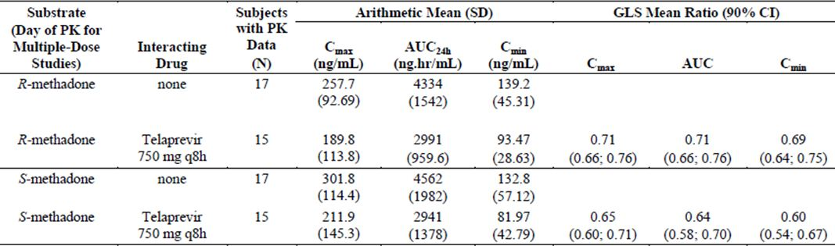

Cyclosporine and tacrolimus
Tacrolimus and cyclosporine are potent immunosuppressive drugs that are substrates of both CYP3A and P-gp. As both tacrolimus and cyclosporine have narrow therapeutic ranges a two part, open label, single centre, non randomised Study VX09-950-021 examined the interaction between these drugs and telaprevir in 30 subjects (8 female) aged 24-60 years. Initially, only 20 subjects were planned for enrolment; however, due to compromised PK plasma sample stability during Part A of the study, Part A was repeated.
Part A was divided into two periods: in Period 1, a single 100 mg dose of cyclosporine was administered on Day 1. This was followed by a washout period of at least 8 days prior to the commencement of Period 2. In Period 2, single 10 mg doses of cyclosporine (a 10 fold reduction in dose compared with that in Period 1) were administered on Days 1 and 8. Subjects received telaprevir 750 mg q8h from Days 1 to 11 of Period 2. Part B was also divided into two periods. In Period 1, a single 2 mg dose of tacrolimus was administered on Day 1, followed by at least an 8 day washout. In Period 2, a single 0.5 mg dose of tacrolimus (a 4 fold reduction in dose compared to that in Period 1) was administered on Day 8. Subjects also received telaprevir 750 mg q8h from Days 1 to 13 of Period 2.
Co administration of cyclosporine with telaprevir resulted in a marked increased cyclosporine exposure (Table 41). When normalised for the different doses of cyclosporine (that is, 100 mg given in Period 1 compared to 10 mg given in Period 2), cyclosporine AUC∞ was increased approximately 4.1 to 4.6 fold and C_{max} 1.3 to 1.4 fold after either single dose or steady state co administration of telaprevir. Without dose normalisation, the 10 fold lower dose of cyclosporine resulted in about a 87% lower C_{max} and a 54% lower AUC∞ during co administration with steady state telaprevir. Cyclosporine terminal t_{1/2} increased from 12 h for cyclosporine alone to 42 h when given with steady state telaprevir and the mean T_{max} increased from 1.5 to 2.5 h. Co administration of tacrolimus and telaprevir also markedly increased tacrolimus exposure. When normalised for the different doses of tacrolimus (that is, 2 mg given in Period 1 compared with 0.5 mg given in Period 2), tacrolimus AUC∞ was increased approximately 70 fold and C_{max} 9.4 fold after co administration with steady state telaprevir. Without dose normalisation, the 4 fold lower dose of tacrolimus resulted in approximately a 2.3 fold higher C_{max} and an 18 fold higher AUC∞ during co administration. Tacrolimus t_{1/2} increased from 41 h when tacrolimus was given alone to 196 h when co administered with steady state telaprevir and mean T_{max} increased from 2.3 to 3.0 h. By contrast, telaprevir exposure following both single dose and at steady state was similar to previous studies where telaprevir was co administered with cyclosporine (telaprevir PK compared to that in Studies C123, C124, C133, and C134). Co administration of tacrolimus resulted in slightly lower telaprevir exposure compared to results obtained with cyclosporine (that is, on Day 8, telaprevir exposures when co administered with 10 mg cyclosporine were 21930 ng.h/mL for AUC_{8h} and 3432.22 ng/mL for C_{max}, versus16577.38 ng.h/mL for AUC_{8h}, 2496.67 ng/mL for C_{max} when co administered with 0.5 mg tacrolimus). However, telaprevir exposure was still within about one SD of previous controls (that is, Study C134, mean C_{max} was 3081). The sponsor therefore recommends that the dose and/or dosing frequency of cyclosporine and tacrolimus should be decreased when co administered with telaprevir and their concentrations monitored frequently. By contrast, telaprevir can be co administered with cyclosporine or tacrolimus without telaprevir dose adjustment.
Table 41: Effect of telaprevir on cyclosporine and tacrolimus PK (Study VX09-950-021).
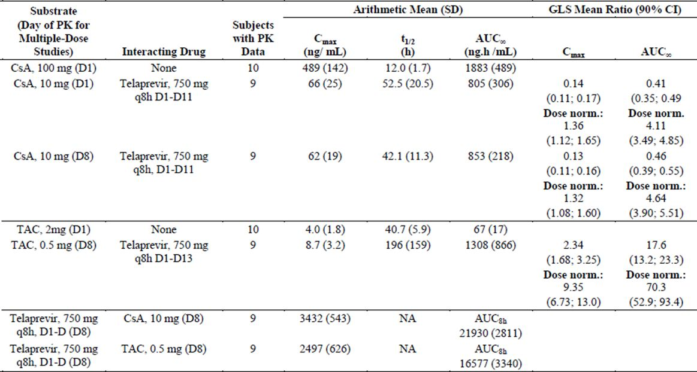
Abbreviations: CsA: cyclosporine A; Dose norm.: dose normalised; TAC: tacrolimus

Anti HIV drugs
Patients are often co infected with both HIV, which is often treated with highly active antiretroviral therapy (HAART), and HCV. Therefore, drug interaction studies between telaprevir and commonly used HAARTs were investigated. Telaprevir and HIV protease inhibitors are both substrates and inhibitors of CYP3A4, and may also interact via P-gp. In addition, HIV protease inhibitors are often co administered with low dose ritonavir to increase their concentrations and simplify dosing regimens.

HIV protease inhibitors

Lopinavir/Ritonavir and Atazanavir/Ritonavir
A randomised, two way cross over Study VX950-TiDP24-C122 in two separate panels of 20 healthy subjects (40 in total; 11 female) aged 18-55 years, examined the effect of steady state concentrations of telaprevir 750 mg q8h on the steady state PK of lopinavir/ritonavir (LPV/rtv) 400/100 mg bid (twice daily); to determine the effect of steady state concentrations of atazanavir/ritonavir (ATV/rtv) 300/100 mg qd on the steady state PK of telaprevir 750 mg q8h and to determine the effect of steady state concentrations of telaprevir 750 mg q8h on the steady state PK of ATV/rtv 300/100 mg qd. During Session 1, subjects were administered telaprevir 750 mg q8h for 10 days, followed by PK sampling pre dose and up to 8 hours following the last dose. In Session 2, subjects were administered either 400 mg lopinavir/100 mg ritonavir bid (LPV/rtv) or 300 mg atazanavir/100 mg ritonavir qd (ATV/rtv) for 24 days, with telaprevir co administered 750 mg q8h from Days 11 to 20, and 750 mg q12h from Days 21 to 24. Blood samples were taken pre dose and up to 16 h post dose on Days 10, 20 and 24.
On Day 20, telaprevir C_{max}, C_{min} and AUC_{8h} decreased by 53%, 52% and 54%, respectively, after co administration with LPV/rtv 400/100 mg bid compared to administration of telaprevir alone (Table 42).
Table 42: Effect of lopinavir/ritonavir and atazanavir/ritonavir on telaprevir PK and vice versa (Study VX950-TiDP24-C122).
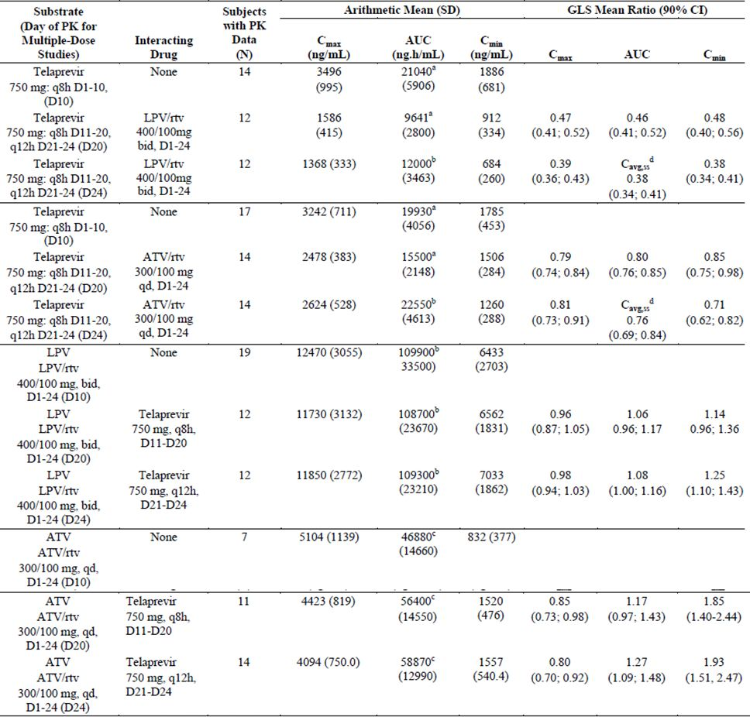
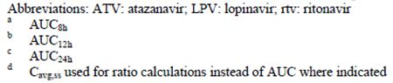
On Day 24, telaprevir C_{max} decreased by 61%, C_{min} was decreased by 65%, and C_{avg,ss} was decreased by 62% following co administration with LPV/rtv 400/100 mg bid compared to administration of telaprevir alone at 750 mg q8h. After co administration with telaprevir 750 mg q8h, the C_{max} and AUC_{12h}, of lopinavir were unchanged, whereas, C_{min} increased by ∼14%. On Day 20, the steady state plasma concentrations of telaprevir decreased following co administration with ATV/rtv compared to when telaprevir was administered alone with telaprevir C_{max}, AUC_{8h} and C_{min} decreasing by 21%, 20% and15%, respectively, following co administration of the two drugs. On Day 24, telaprevir C_{max}, C_{min} and C_{avg.ss} were decreased by 19%, 29% and 24%, respectively, following co administration of telaprevir and ATV/rtv.
Following co administration with telaprevir, the AUC_{24h} and C_{min} of atazanavir increased by 17% and 85%, respectively, while the C_{max} decreased by 15%. By contrast, co administration of telaprevir did not result in any clinically significant changes in LPV/rtv or ATV/rtv exposures. The sponsor states that co-administration of telaprevir and LPV/rtv is not recommended due to the decrease in telaprevir exposure that occurs when these drugs are co administered (decreases of about 60%), while ATV/rtv and telaprevir can be administered concomitantly without the need for dose adjustment as the changes in telaprevir exposure seen with ATV/rtv co administration are unlikely to be clinically significant.

Darunavir/Ritonavir and Fosamprenavir/Ritonavir
A randomised, two way crossover Study VX950-TiDP24-C124 examined the PK interaction between steady state darunavir/ritonavir (DRV/rtv) 600/100 mg bid and steady state telaprevir 750 mg q8h and 1125 mg q12h. In addition, the PK interaction between steady state fosamprenavir/ritonavir (fAPV/rtv) 700/100 mg bid and steady state telaprevir 750 mg q8h and 1125 mg q12h was also examined. This study was conducted in two separate panels of 20 healthy subjects (40 in total; 5 female) aged 19-55 years. During Session 1, subjects were administered telaprevir 750 mg q8h for 10 days, followed by telaprevir 1125 mg q12h for 4 days. In Session 2, subjects were administered either 600 mg darunavir/100 mg ritonavir bid (DRV/rtv) or 700 mg fosamprenavir/100 mg ritonavir bid (fAPV/rtv) for 24 days, with telaprevir co administered 750 mg q8h from Days 11 to 20, and 1125 mg q12h from Days 21 to 24. Intensive PK sampling was undertaken on Days 10 and 14 of Session 1, and on Days 10, 20, and 24 of Session 2.
Following multiple doses of 750 mg q8h telaprevir, the C_{min}, C_{max} and AUC of telaprevir decreased by 32%, 36%, and 35%, respectively, following DRV/rtv co administration. Similar decreases were observed following doses of 1125 mg telaprevir q12h. Decreases of similar magnitude were also observed for telaprevir in the presence of steady state fAPV/rtv with telaprevir C_{min}, C_{min} and AUC decreasing 30%, 33% and 32%, respectively. Once again, similar decreases were observed following doses of 1125 mg telaprevir q12h. Darunavir concentrations were decreased in the presence of telaprevir with C_{min}, C_{max} and AUC_{12h} decreasing 42%, 40%, and 40%, respectively. Amprenavir concentrations also decreased in the presence of telaprevir with amprenavir C_{min}, C_{max} and AUC_{12h} decreasing 56%, 35% and 47%, respectively. For darunavir, the decreases were slightly higher in the presence of telaprevir at 1125 mg q12h compared to telaprevir at 750 mg q8h. For amprenavir, similar decreases were observed in the presence of telaprevir at 750 mg q8h or 1125 mg q12h. The sponsor concludes that co administration of telaprevir and DRV/rtv or fAPV/rtv resulted in decreased plasma concentrations of telaprevir, darunavir, and amprenavir, compared to when the compounds were administered without telaprevir co administration. Based on these results, it is not recommended to co administer telaprevir with either DRV/rtv or fAPV/rtv.

Tenofovir Disoproxil Fumarate
An open label, randomised, cross over Study VX950-TiDP24-C123 examined the PK interaction between steady state concentrations of telaprevir 750 mg q8h and the steady state tenofovir following administration of tenofovir disoproxil fumarate (TDF) 300 mg qd in 18 healthy subjects (3 female) aged 21-54 years. Subjects received Treatments A, B, and C in a randomised order. During Treatment A, 750 mg telaprevir q8h was administered for 6 days with an additional 750 mg morning dose on Day 7. During Treatment B, 300 mg TDF qd was administered for 7 days. In Treatment C, 750 mg telaprevir q8h and 300 mg TDF qd were co administered for 7 days. There was a washout period of at least 7 days between sessions and all treatments were given under fed conditions. Intensive PK sampling was undertaken on Day 7 of each treatment period.
The steady state telaprevir C_{min}, C_{max} and AUC_{8h} were not affected by co administration of TDF. By contrast, the steady state plasma concentrations of tenofovir were higher after co administration of TDF with telaprevir than after intake of TDF alone with tenofovir C_{min}, C_{max} and AUC_{24h} increasing by 41%, 30%, and 30%, respectively. Renal clearance of tenofovir was decreased by 36% when TDF was administered in combination with telaprevir, compared to TDF administration alone. The sponsor recommends that TDF and telaprevir can be co administered without dose adjustments but with increased clinical and/or laboratory monitoring for adverse events (AEs) related to increased tenofovir exposure.

Efavirenz
An open label, single sequence, non randomised Study VX07-950-016 examined the PK interactions between steady state rifampin and single dose telaprevir; and steady state EFV and steady state telaprevir in 40 healthy subjects (4 female), aged 20 to 58 years. In Part 1 of the study, a single dose of telaprevir (750 mg) was administered on two occasions (Days 1 and 9). Rifampin (600 mg) was administered qd for 8 days (Study Days 2 through 9). In Part 2, telaprevir (750 mg) was administered q8h for 20 days (Study Days 1 through 10 and Study Days 28 through 37). EFV (600 mg qd) was administered for 20 days (from Study Day 18 through 37). All treatments were given in the fed state and the PK sampling times for the various treatments are summarised in Table 43. As in Study VX07-950-016, co administration of rifampin with telaprevir induced a large and significant inhibition of the subject’s exposure to telaprevir.
Table 43: Part 1 (telaprevir and rifampin) PK sampling times and schedule of assessments (Study VX07-950-016).
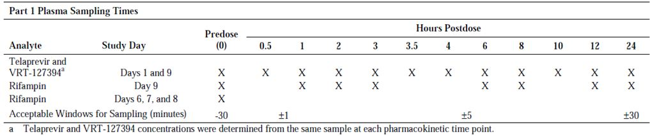
When steady state EFV was co administered with steady state telaprevir the C_{min} and AUC of telaprevir decreased by ∼46% and ∼26%, respectively. By contrast, the C_{max} of telaprevir was not affected by co administration with EFV. Co administration of telaprevir did not affect the steady state AUC or C_{min} of EFV, whereas, the EFV C_{max} decreased by ∼16%.

Tenofovir Disoproxil Fumarate and Efavirenz
An open label, randomised, cross over Study VX950-TiDP24-C134 examined the PK interactions between EFV and telaprevir; and TDF and telaprevir in 20 subjects (8 female), aged 21 to 54 years. All subjects received four different treatments comprising: Treatment A, TVR 750 mg q8h alone was administered for 6 days with an additional morning dose on Day 7; Treatment B, EFV 600 mg once qd and TDF 300 mg qd were administered for 7 days; Treatment C, TVR 1125 mg q8h, EFV 600 mg qd, and TDF 300 mg qd were administered for 7 days; and Treatment D, TVR 1500 mg q12h, EFV 600 mg qd., and TDF 300 mg qd were administered for 7 days. Treatments A and B were separated by a 7 or 8 day washout period. At the end of Treatment B, subjects were randomised (1:1) to Sequence C/D or Sequence D/C. There was no washout period between Treatment B and C or D and no washout period between Treatment C and D. Telaprevir was taken with food, whereas EFV and TDF were taken on an empty stomach. Intensive PK sampling was undertaken on Day 7 of each treatment period.
In the presence of EFV/TDF, at a dosage of 1125 mg q8h telaprevir, the telaprevir C_{min}, C_{max} and AUC_{8h} values decreased by 25%, 14%, and 18%, respectively, compared to telaprevir dosed at 750 mg q8h alone. At a dosage of 1500 mg q12h telaprevir, telaprevir C_{min}, C_{max} and C_{avg,ss} values decreased by 48%, 3%, and 20%, respectively. Plasma concentrations of EFV at steady state decreased when EFV/TDF were co administered with telaprevir, with both telaprevir doses having a similar effect. EFV C_{max}, AUC_{24h} decreased by 24% and 18%, respectively, when EFV/TDF were administered in the presence of telaprevir 1125 mg q8h, and EFV C_{max} and AUC_{24h} decreased by 20% and 15%, respectively, when EFV/TDF were co administered with 1500 mg telaprevir compared to EFV/TDF administered alone. For C_{min} of both treatment comparisons, the 90% CIs of the LS_{mean} ratios fell within the 80% to 125% equivalence boundaries. Plasma concentrations of steady state tenofovir increased when EFV/TDF were co administered with telaprevir, with tenofovir C_{min} and C_{max} increasing by 17% and 22%, respectively, when EFV/TDF were administered in the presence of telaprevir 1125 mg q8h, and tenofovir C_{max} increased by 24% when EFV/TDF were administered in the presence of 1500 mg telaprevir q12h, compared to EFV/TDF administered alone. For C_{min} of the latter comparison and for AUC_{24h} of both treatment comparisons, the 90% CIs of the LS_{mean} ratios fell within the 80% to 125% equivalence boundaries. Therefore, even though telaprevir doses were higher in the present study, the increases in tenofovir concentrations were less than those observed in Study C123, which may have resulted from the co administration of EFV in this study. The sponsor recommends that during the co administration of telaprevir, EFV and TDF, the dosage of telaprevir should be increased from 750 mg q8h to 1125 mg q8h, whereas, EFV and TDF can be administered without dose adjustment.

Other extrinsic factors
Clinical studies examining the effects of extrinsic factors such as smoking or alcohol use on the safety, efficacy and PK of telaprevir have not been conducted. However, the sponsor believes that these extrinsic factors will not impact the safety, efficacy or PK of telaprevir as telaprevir is predominantly metabolised by CYP3A4 which is not influenced by smoking or alcohol use.

Population PK analysis
A population PK model was developed based on PK data from several Phase 1 clinical trials (Studies 121, 122 and 123), and a Phase 2 Study VX-950-TiDP24-C208. The final model obtained was a one compartment model, with a CL/F of 57.2 L/hour and a Vz/F of 205 L. By contrast, telaprevir absorption was more complex and was best described by a model with two absorption pathways. The first pathway consisted of a zero order process that lasts 0.7 h (D1), which feeds into a slow first order absorption with an absorption rate constant (Ka1) of 0.06 h⁻¹. Following completion of the first zero order process, a parallel absorption pathway commenced via the second route, which consists of a zero order process that lasts 2.2 hours (D2), followed by a faster first order absorption that has an absorption rate constant (Ka2) of 1.2 h⁻¹. Twenty one percent of the dose was absorbed through the first pathway, and 79% through the second pathway. In patients, the first pathway consisted of a first order process only.
Following administration of multiple doses of telaprevir, the telaprevir PKs were different to those after administration of a single dose and the overall exposure was higher than expected based on the single dose data, whereas the absorption was slower. Bioavailability was 45% higher after dosing in the home and 69% lower after dosing in the afternoon; there were also differences between patients and healthy volunteers, with the bioavailability being 46% higher in patients. The final model provided a good fit to the data, and the parameters were precisely estimated.
A second population PK analysis was conducted using data from Study VX-950-TiDP24-C216. This analysis was based on a population PK model developed previously for telaprevir in Study VX05-950-104 using a non linear mixed effects modelling approach. This approach yielded a one compartment linear model. The absorption process was assumed to be governed by two functions, a Weibull type function for the first dose followed by a first order process for subsequent doses. The population CL/F and Vz/F values were estimated to be 35.7 L/h and 432 L, respectively. The data from Study C216 was then fitted to yield individual empirical Bayesian estimates of model parameters. These parameters were then used to simulate full model predicted telaprevir PK profiles, from which steady state PK exposure parameters could be calculated.
The CL/F for the Study C216 data set was 27.1 L/h, the Vz/F was 478 L, the C_{max,ss} was 3990 ng/mL and the AUC was 30100 ng.hr/mL.
A third population PK study (G190): modelled the PKs of telaprevir following oral administration in adults with chronic genotype 1 HCV infection; generated estimates of typical PK parameters of telaprevir in the target population and their inter and intra individual variability; and evaluated the effects of subjects’ demographic characteristics and other covariates on telaprevir PK.
The data for this pooled population PK analysis was obtained from four Phase 2 studies and three Phase 3 studies. In all studies, telaprevir was administered orally in tablet formulation under fed conditions in combination with Peg-IFNα-2a or Peg-IFNα-2b, with or without RBV. The pooled analysis dataset used for the covariate model contained 1836 subjects and 14413 concentration records.
In this study, the final structural model used to describe the PK of telaprevir was a one compartment model with first order absorption. Random effects for inter individual variability in the PK parameters were modelled using a multiplicative exponential random effect. A random effect for inter individual variability was included on the apparent oral clearance, and a shared random effect for inter individual variability was included on the apparent volume of distribution and the first order KA. A covariance term between CL/F and Vz/F was also included to account for the observed correlation between these parameters. The residual error was modelled using a combined (additive and proportional) error model. A separate error model was estimated for the two bioanalytical laboratories used in the pooled data. The covariates included in the covariate model were subject baseline age, weight, and race on telaprevir CL/F, the concomitant administration of RBV on telaprevir CL/F, subject baseline weight on Vz/F, and telaprevir formulation and study group on bioavailability. The predicted CL/F and apparent Vz/F of telaprevir were 32.4 [31.8; 32.9] L/h and 252 [204; 273] L (point estimate [bootstrap 95% CI]), respectively. Inter individual variability on CL/F and Vz/F were estimated to be 27.2% and 72.2%, respectively. Results of the covariate effect analysis on telaprevir CL/F indicated that subject age and race and the concomitant administration of RBV were unlikely to have a clinically relevant effect on telaprevir exposure. Subject weight was classified as having the potential for a clinically relevant impact on telaprevir exposure. However, evaluation of the exposure response results reported previously show the magnitude of the effect of weight on telaprevir exposure did not have a clinically relevant impact on the safety or efficacy of telaprevir within the weight range of 51-120 kg.

Other PK studies
Exploratory study G200 examined whether the prevalence of C3435T and C1236T MDR1 polymorphisms differed among subgroups of 44 subjects from Study VX05-950-104 who had severe rash, mild or moderate rash, or no rash during treatment with telaprevir, Peg-IFNα-2a, and RBV. In addition, telaprevir exposure was evaluated in subjects homozygous for 1236T/3435T alleles. No correlation was identified between the presence of a C3435T or C1236T genotype and the severity of rash. In addition, telaprevir exposures based on Cmin_{ss}, was similar in subjects homozygous for 1236T/3435T and subjects with 1236/3435 CT or CC genotypes.
Study G153 summarises PK/PD simulations conducted to support removal of the loading dose from telaprevir regimens when it is combined with Peg-IFNα and RBV. The PK/PD model from Study VX05-950-102 (in which telaprevir was combined with Peg-IFNα and RBV) was used to carry out simulations with and without a loading dose of 1250 mg of telaprevir followed by a dose of 750 mg q8h. One thousand subjects were simulated for each scenario, and the resulting HCV RNA profiles (for wild type virus) were plotted, showing the median HCV RNA concentration versus time profiles and the 95% bounds of simulated populations with and without the loading dose. The difference in the HCV RNA log drop for subjects with loading dose minus that for those without the loading dose was calculated at 48 and 144 h, and the distributions of 1500 replicates of the bootstrapped median were plotted. The median HCV RNA concentration profiles versus time for 1000 simulated subjects and the associated 95% bounds of the distribution are shown in Figure 3. There was no difference in the HCV profiles, and the resulting decline in HCV RNA was almost identical with and without a loading dose. The expected distribution of the difference in log drop in HCV RNA observed at 48 and 144 h between the loading dose and the no loading dose scenario is shown in Figure 4. The median of the distributions, centred around 0, also indicating that there is little difference observed when a loading dose is given compared to the no loading dose scenarios. Based on these simulations it would appear that a loading dose of 1250 mg has no effect on either the decline in HCV RNA over time and HCV RNA log drop observed at 48 and 144 h post first dose.
Figure 3: Median HCV RNA concentration profiles versus time for 1000 simulated subjects and the associated 95% bounds of the distribution with and without the loading dose.
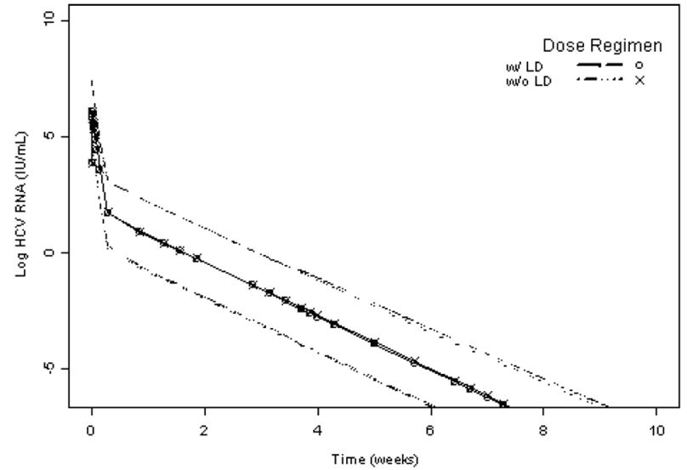
Figure 4: Expected distribution of the difference in log-drop in HCV RNA observed at 48 and 144 h between the loading dose and the no loading dose scenario.
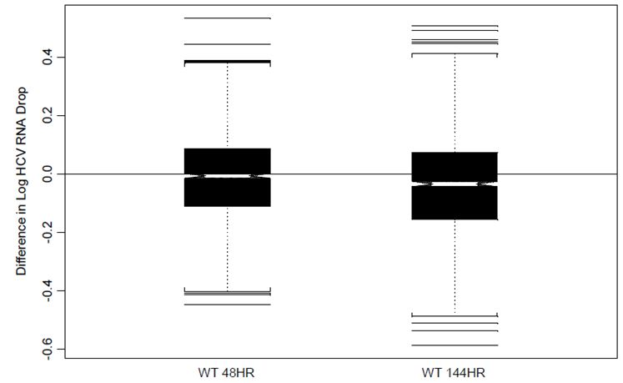

Evaluator’s overall comments on PK interactions
Drug interaction studies indicate that steady state doses of telaprevir decreased the exposure of co administered EE, zolpidem, escitalopram, and methadone, and increased the exposure to amlodipine, atorvastatin, and alprazolam. As such, telaprevir may affect the PK of any co administered drugs that are also CYP3A substrates and/or transported by P-gp. In addition, telaprevir PK may also be severely affected by inhibitors and inducers of CYP3A and/or P-gp.
Co administration of telaprevir and LPV/rtv results in an approximately 60% decrease in telaprevir exposure; therefore, co administration of the two drugs is not recommended.
ATV/rtv and telaprevir can be administered concomitantly without the need for dose adjustment as the changes in telaprevir exposure seen with ATV/rtv co administration are unlikely to be clinically significant.
Co-administration of telaprevir and DRV/rtv or fAPV/rtv is not recommended as it results in decreased exposure to telaprevir, darunavir and amprenavir.
TDF has little effect on the steady state PK of telaprevir, while telaprevir co administration increased the AUC of TDF by ∼30%. Therefore, the two drugs can be co administered on the proviso that increased clinical and/or laboratory monitoring for AEs is undertaken.
Although co administration of telaprevir and EFV did not affect the steady state AUC or C_{min} of EFV, EFV decreased the steady state C_{min} and AUC of telaprevir by approximately 46% and 26%, respectively. Therefore, the sponsor recommends that the dosage of telaprevir should be increased from 750 mg q8h to 1125 mg q8h, while EFV can be administered without dose adjustment.
Following co administration with telaprevir, digoxin C_{max} and AUC increased 1.5 and 1.85 fold, respectively, and digoxin t_{1/2} increased from 28 to 50 h.
Co administration of telaprevir decreased the mean plasma C_{max}, C_{min} and AUC_{ss} of EE by approximately 26%, 33%, and 28%, respectively, while it had no effect on NE exposure. These results suggest that alternative methods of non hormonal contraception should be used when estrogen based contraceptives are co administered with telaprevir and that subjects using estrogens as hormone replacement therapy should be clinically monitored for signs of estrogen deficiency.
When amlodipine and atorvastatin were co administered with telaprevir, the AUC of amlodipine increased approximately 2.8 fold and the AUC of atorvastatin increased 7.9 fold. The median t_{1/2} of amlodipine increased from 41 to 95 h, whereas the t_{1/2} of atorvastatin decreased from approximately 9.5 h to 6.8 h.
Alprazolam AUC increased by approximately 35% and mean t_{1/2} increased from 13.4 to 18.7 hours when administered with steady state telaprevir.
Zolpidem C_{max} and AUC were reduced by 42% and 47%, respectively, when multiple doses of telaprevir were co administered with zolpidem compared to zolpidem alone.
Telaprevir at steady state decreased steady state escitalopram C_{min}, C_{max}, and AUC_{24h} by 42%, 30%, and 35%, respectively, compared to escitalopram alone.
Co-administration of esomeprazole did not affect telaprevir exposure, indicating that telaprevir and esomeprazole can be administered concomitantly without dose adjustment.
When normalised for cyclosporine dose, cyclosporine AUC∞ was increased approximately 4.1 to 4.6 fold and C_{max} 1.3 to 1.4 fold after either single dose or steady state co administration of telaprevir.
When normalised for tacrolimus dose, tacrolimus AUC∞ was increased approximately 70 fold and C_{max} 9.4 fold after co administration with steady state telaprevir.

Exposure relevant for safety evaluation
In a single dose study in healthy subjects, telaprevir AUC increased more than dose proportionately for doses ranging from 750 mg to 1875 mg. Following multiple doses of telaprevir 1875 mg q8h, AUC was 40% higher than following telaprevir 750 mg q8h.
Moderate hepatic impairment decreases steady state telaprevir C_{max} and AUC_{8h} by approximately 49% and 46%, respectively and as the appropriate dose of telaprevir in subjects with CPB has not been determined, telaprevir is not recommended in these subjects. In addition, telaprevir has not been studied in subjects with severe hepatic impairment (Child Pugh Class C), and is also not recommended in this population.
Co administration of ritonavir with telaprevir increased the C_{max} and AUC_{0-tlast} of VX-950 by 1.3 and 1.8 fold, respectively. Ketoconazole increased the C_{max} and AUC_{0-8h} by ∼20%. Following a single dose of 750 mg telaprevir under fed conditions, the AUC_{0-last} of telaprevir increased from 6995 ng.h/mL when it was administered alone to 22367 ng.h/mL when it was administered in combination with ritonavir. Therefore co administration of these drugs may increase the side effect profile of telaprevir.

Evaluator’s overall conclusions on PK
The recommended dose of telaprevir is 750 mg every 8 h with food, in combination with Peg-IFNα/RBV, for both treatment naïve and prior treatment failure patients.
Based on PK/PD simulations it would appear that a loading dose of 1250 mg has no effect on either the decline in HCV RNA over time and HCV RNA log drop observed at 48 and 144 h post first dose.
The FDA and the CHMP concurred that the studies examining the bioequivalence of coated and uncoated tablets support introducing the 375 mg film coated tablet as the commercial product.
Compared to administration following a standard normal caloric meal (21 g fat, 561 kcal), telaprevir exposures decreased by 73% when telaprevir was taken in the fasted state, by 39% following a low calorie low fat meal (3.6 g fat, 249 kcal), and by 26% following a low calorie high protein meal (9 g fat, 260 kcal). The exposure to telaprevir increased by 20% when taken following a high fat high caloric meal (56 g fat, 928 kcal) compared to an intake following a standard normal caloric meal.
Following a single dose of [¹⁴C] VX-950 (750 mg/2.84 MBq) the CL/F and Vz/F for VX-950 were 1153 L/hr and 7394 L.
Telaprevir is approximately 59%-76% bound to plasma proteins and has a large apparent Vz/F estimated from population PK analyses of Phase 2 and Phase 3 studies to be 252 L, with inter individual variability on Vz/F estimated to be 72.2%.
Telaprevir is orally available and likely to be absorbed in the small intestine with no evidence for absorption in the colon.
It is a substrate of P-gp and it is both a substrate and inhibitor of CYP3A.
Telaprevir is extensively metabolised in the liver via hydrolysis, oxidation, and reduction.
Following repeated oral administration of telaprevir in combination with Peg-IFNα/RBV in subjects with chronic hepatitis C, the main metabolites of telaprevir were VRT-127394 (R diastereomer of telaprevir, 30 fold less active), pyrazinoic acid (not active), and VRT-0922061 (M3 isomer metabolite, reduction at the α ketoamide bond of telaprevir, not active).
Telaprevir is predominantly eliminated in the faeces with minimal renal excretion. Following administration of a single oral dose of 750 mg [¹⁴C] telaprevir in healthy subjects, the median recovery of the administered radioactive dose was approximately 82% in faeces, 9% in exhaled air, and 1% in urine. CL/F of telaprevir was estimated from population PK analyses of Phase 2 and Phase 3 studies to be 32.4 L/hr, with inter individual variability estimated to be 27.2%.
In a single dose study in healthy subjects, telaprevir AUC increased more than dose proportionately for doses ranging from 750 mg to 1875 mg. Following multiple doses of telaprevir 1875 mg q8h AUC was 40% higher than following telaprevir 750 mg q8h.
When telaprevir was dosed as 750 mg q8h, steady state was reached by 3 to 7 days with an accumulation ratio (ratio of the AUC at steady state to the AUC after the first dose) of approximately 2.2.
Following a single dose, the mean half life of telaprevir was approximately 4 h. At steady state, the effective half life was approximately 9 to 11 h.
Population PK studies indicate that a subject’s age, sex, and race had no impact on the clearance and average steady state exposure of telaprevir. By contrast, the subject’s weight did affect telaprevir clearance but there was no clinically relevant impact on safety or efficacy of a telaprevir containing regimen.
No telaprevir dose adjustment is required for subjects with mild hepatic impairment or mild, moderate, or severe renal impairment.
Moderate hepatic impairment decreases steady state telaprevir C_{max} and AUC_{8h} by approximately 49% and 46%, respectively and as the appropriate dose of telaprevir in subjects with Child Pugh Class B has not been determined, therefore, telaprevir is not recommended in these subjects. In addition, telaprevir has not been studied in subjects with severe hepatic impairment (Child Pugh Class C), and is also not recommended in this population.
Drug interaction studies indicate that steady state doses of telaprevir decreased the exposure of co administered EE, zolpidem, escitalopram, and methadone, and increased the exposure to amlodipine, atorvastatin, and alprazolam. As such, telaprevir may affect the PK of any co administered drugs that are CYP3A substrates and/or transported by P-gp. In addition, telaprevir PK may also be severely affected by inhibitors and inducers of CYP3A and/or P-gp.
Co administration of telaprevir and LPV/rtv results in a approximately 60% decrease in telaprevir exposure; therefore, co administration of the two drugs is not recommended.
ATV/rtv and telaprevir can be administered concomitantly without the need for dose adjustment as the changes in telaprevir exposure seen with ATV/rtv co administration are unlikely to be clinically significant.
Co administration of telaprevir and DRV/rtv or fAPV/rtv is not recommended as it results in decreased exposure to telaprevir, darunavir and amprenavir.
TDF has little effect on the steady state PK of telaprevir, whereas, telaprevir co administration increased the AUC of TDF by approximately 30%. Therefore, the two drugs can be co administered on the proviso that increased clinical and/or laboratory monitoring for AEs is undertaken.
Although co administration of telaprevir and EFV did not affect the steady state AUC or C_{min} of EFV, EFV decreased the steady state C_{min} and AUC of telaprevir by approximately 46% and 26%, respectively. Therefore, the sponsor recommends that the dosage of telaprevir should be increased from 750 mg q8h to 1125 mg q8h, whereas, EFV can be administered without dose adjustment.
Following co administration with telaprevir, digoxin C_{max} and AUC increased 1.5 and 1.85 fold, respectively, and digoxin t_{1/2} increased from 28 to 50 h.
Co administration of telaprevir decreased the mean plasma C_{max}, C_{min} and AUC_{ss} of EE by approximately 26%, 33%, and 28%, respectively, whereas it had no effect on NE exposure. These results suggest that alternative methods of non hormonal contraception should be used when estrogen based contraceptives are co administered with telaprevir and that subjects using estrogens as hormone replacement therapy should be clinically monitored for signs of estrogen deficiency.
When amlodipine and atorvastatin were co administered with telaprevir, the AUC of amlodipine increased approximately 2.8 fold and the AUC of atorvastatin increased 7.9 fold. The median t_{1/2} of amlodipine increased from 41 to 95 h, whereas the t_{1/2} of atorvastatin decreased from approximately 9.5 h to 6.8 h.
Alprazolam AUC increased by approximately 35% and mean t_{1/2} increased from 13.4 to 18.7 hours when administered with steady state telaprevir.
Zolpidem C_{max} and AUC were reduced by 42% and 47%, respectively, when multiple doses of telaprevir were co administered with zolpidem compared to zolpidem alone.
Telaprevir at steady state decreased steady state escitalopram C_{min}, C_{max} and AUC_{24h} by 42%, 30%, and 35%, respectively, compared to escitalopram alone.
Co administration of esomeprazole did not affect telaprevir exposure, indicating that telaprevir and esomeprazole can be administered concomitantly without dose adjustment.
When normalised for cyclosporine dose, cyclosporine AUC∞ was increased approximately 4.1 to 4.6 fold and C_{max} 1.3 to 1.4 fold after either single dose or steady state co administration of telaprevir.
When normalised for tacrolimus dose, tacrolimus AUC∞ was increased approximately 70 fold and C_{max} 9.4 fold after co administration with steady state telaprevir.

Pharmacodynamics

Introduction
In the evaluation materials, 6 studies examined the PD of telaprevir in 89 healthy subjects (44 of which were female) and 66 patients with HCV (26 females).

Mechanism of action
Telaprevir is a member of a new class of direct acting antiviral agents (the HCV NS3-4A protease inhibitors) and it is a potent, reversible, selective, linear peptidomimetic inhibitor of the NS3-4A serine protease, which is essential for the replication of HCV. For HCV treatment regimens treatment efficacy is based upon the drug’s ability to eradicate HCV. In the primary PD studies described below, HCV RNA levels were used as a marker for inhibition of HCV. However, plasma HCV RNA levels below the limit of detection do not necessarily imply HCV eradication and viral dynamic modelling analyses were also undertaken. The effects of therapeutic and supratherapeutic levels of exposure to telaprevir on QT and QTc were examined using a Holter monitor in accordance with ICH E14 guidelines.

Primary pharmacology

Target population
HCV kinetics were examined following ascending multiple doses of VX-950 administered in 34 subjects with hepatitis C in Part B of Study VX04-950-101. Blood sampling was conducted for the analysis of serum neopterin, gene expression profiling, and viral sequencing. In the placebo treated group, there was little change in median HCV RNA levels during the dosing period. By contrast, median HCV RNA levels in the 3 VX-950 dose groups decreased substantially and rapidly. All three VX-950 dose groups showed similar declines up to Day 3 of dosing. In the 450 mg q8h and 1250 mg q12h groups there was evidence of HCV rebound during the dosing period; by contrast, in the 750 mg q8h group, the median HCV RNA value continued to decrease through the entire dosing period. A median reduction of >3 log₁₀ in HCV RNA levels was achieved in all three VX-950 dose groups, and the 750 mg q8h group achieved a median reduction of >4 log₁₀. Seven subjects treated with telaprevir achieved HCV RNA levels below the LLOQ; three of these had undetectable HCV RNA levels, but all had detectable HCV levels within 12 weeks of the end of treatment. The mean and 95% CI values for the maximum change from baseline in HCV RNA were -0.3973 log₁₀ IU/mL (-0.4922, -0.3025) for the placebo group, -3.7040 log₁₀ IU/mL (-4.2625, -3.1455) for the 450 mg q8h group, -4.6529 log₁₀ IU/mL (-5.490, -3.8469) for the 750 mg q8h group, and -3.4539 log₁₀ IU/mL (-3.6973, -3.2105) for the 1250 mg q12h group.
A single arm, open label Study VX04-950-102 conducted in 12 treatment naïve subjects (6 female) with genotype 1 HCV infection aged 21-57 years assessed the clinical activity of 28 days of dosing of VX-950 (1250 mg initial dose followed by 750 mg VX-950 q8h) in combination with Peg-IFNα (once weekly doses of 180/g), and RBV (1000 mg/day for subjects weighing <75 kg and 1200 mg/day for subjects >75kg) in the fed state.
The median log₁₀ baseline HCV RNA level for all subjects was 6.4987 IU/L (range: 5.334 to 7.688). The combination of VX-950, Peg-IFNα and RBV produced a biphasic decline in viral load with all subjects demonstrating a response to the study drug regimen. Two subjects reached undetectable levels of plasma HCV RNA (<10 IU/mL) within 8 days of the start of dosing, and all subjects had undetectable HCV RNA levels by the end of the 28 day dosing period. The median change in HCV RNA (log₁₀ IU/mL) was -5.7997 (with a range -6.989 to -4.635). No subject had viral breakthrough during the dosing period. At the Week 12 follow up, HCV RNA was detectable at <30 IU/mL in one subject and could not be detected in the other 11 subjects (LLOQ was set to 30 IU/mL in this study). All subjects showed rapid decline in HCV RNA levels. The data was also used to generate a model of the anti viral effectiveness of VX-950, which was described using an E_{max} model.
This analysis indicated that the effectiveness of VX-950 was positively correlated with VX-950 concentration and to achieve an effectiveness of VX-950 of more than 0.999, the estimated VX-950 target concentration range (IC_{99.9}) was 1198 to 3092 ng/mL (median 2007 ng/mL).
The antiviral effect of telaprevir administered over 14 days in combination with Peg-IFNα was examined in a multiple dose, randomised Study VX05-950-103 in 20 treatment naïve subjects (8 female) with genotype 1 HCV infection aged 21-61 years. One group (n = 4) received placebo and Peg-IFNα, 1 group (n = 8) received telaprevir and Peg-IFNα, and 1 group received telaprevir alone (n = 8). Telaprevir was administered as 250 mg tablets, q8h, in the fed state. The first telaprevir dose was 1250 mg; all other doses were 750 mg.
The median log₁₀ baseline HCV RNA level for all subjects was 6.6462 (range: 5.326 to 7.580). Between Baseline and Day 15, the HCV RNA level decreased slightly in the placebo + Peg-IFNα group (median change of -1.09 log₁₀), whereas, the two groups administered telaprevir had greater changes from Baseline, with the VX-950 + Peg-IFNα group having the largest decrease: the median change at Day 15 was -5.49 log₁₀ in the VX-950 + Peg-IFNα group and -3.99 log₁₀ in the VX-950 group. In all subjects who received VX-950 (either with Peg-IFNα or alone), HCV RNA levels declined rapidly between the first and fourth days of dosing with VX-950 (Figure 5). A second, sustained phase of viral decline occurred in 4 of 8 subjects in the VX-950 group and in all 8 subjects in the VX-950 + Peg-IFNα group. In the VX-950 + Peg-IFNα group at Day 15, HCV RNA levels were below the LLOQ in 6 subjects and 4 subjects had undetectable HCV RNA levels. In the VX-950 group at Day 15, HCV RNA levels could not be detected in one subject. The presence of Peg-IFNα and the Ctrough of telaprevir were the most important predictors of viral response during the second phase of plasma HCV RNA decline. At the Week 12 follow up, in the placebo + Peg-IFN group, HCV RNA levels could not be detected in one subject and were lower than Day 15 in the three other subjects but they were above the LLOQ. In the VX-950 + Peg-IFNα group, HCV RNA could not be detected in all 8 of subjects in this treatment group. In the VX-950 group at Week 12, HCV RNA could not be detected in 5 subjects, below the LLOQ in one other subject, and above the LLOQ in two subjects (including the subject who declined SOC treatment).
Figure 5: HCV RNA levels for individual subjects through the Week 1 follow up visit, FA (full analysis) set (Study VX05-950-103).
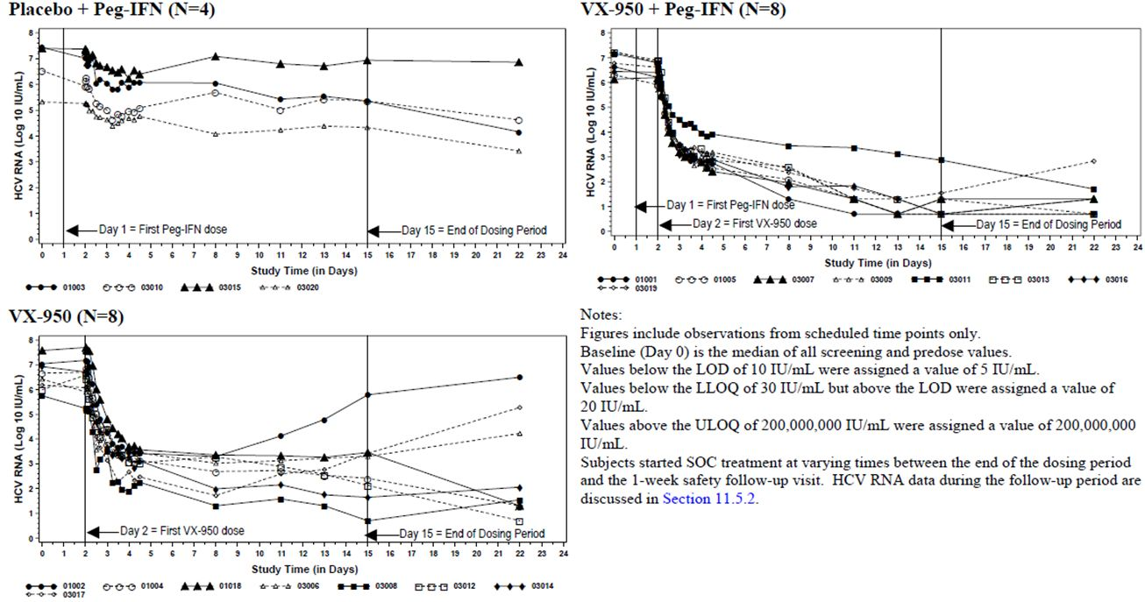

Secondary pharmacology
A randomised, placebo controlled, four treatment, four period crossover Study VX06-950-008 examined whether therapeutic and supratherapeutic systemic exposure to telaprevir prolonged the mean QT/corrected QT (QTc) interval more than 5 msec (based on an upper bound of 95% CI of 10 msec) in 89 healthy males. The four treatments administered were:
- telaprevir therapeutic dose, referred to as “TVR”, was administered as 1250 mg dose followed by three 750 mg doses given q8h;
- telaprevir supratherapeutic dose, referred to as “TVR/KETO”, was administered as four 1250 mg doses given q8h, with single dose of 400 mg ketoconazole given with the fourth dose of telaprevir;
- “KETO”, four placebo doses (q8h), with a single dose of 400 mg ketoconazole with the fourth dose of telaprevir placebo; and
- “Placebo”, four TVR-placebo doses (q8h).
All doses were orally administered and there was a 5 to 20 day washout between treatment periods. On Day 0, baseline ECGs were obtained using a Holter monitor. On Day 1, all subjects received moxifloxacin (400 mg, active control). The active control, moxifloxacin, increased QTcF with a mean maximum effect of 6.6 msec (two sided 95% CI=4.8, 8.37 msec and two sided 90% CI=5.09, 8.08 msec). By contrast when, VX-950 was given alone at standard clinical doses, there was no discernable increase in QTcF interval duration. The mean differences in QTcF between the VX-950 and placebo regimens were analysed (with and without period effect adjustments) and there were no discernable differences in the results, suggesting that period effect was irrelevant in this study.
Following the VX-950/KETO dosing regimen, mean placebo corrected differences in QTcF exceeded 5 msec at all time points from 2 to 8 h post dose with a maximum mean difference of 11.1 msec (90% CI: 9.45, 12.69 msec) at 3 h post dose. When VX-950/KETO was compared with KETO, the mean differences ranged from 1.3 msec (90% CI: -0.39, 2.97 msec) to 7.2 msec (90% CI: 5.31, 9.15 msec), however, the 90% CI upper bounds (equivalent to the 95% one sided CI) did not exceed 10 msec. KETO (400-mg) alone also increased the mean placebo corrected difference in QTcF with the difference exceeding 5 msec at 2, 3, 4, and 6 h post dose and a maximum mean difference of 6.0 msec (90% CI: 4.34, 7.58 msec) was observed at 3 h post dose.
A double blind, double dummy, randomised, placebo and active controlled, four period crossover Study VX950-TiDP24-C136 examined the effect of steady state telaprevir 750 mg q8h and 1875 mg q8h versus placebo on the QT and QTc interval in healthy subjects in 44 healthy subjects (20 female) aged 21-52 years. A single dose of 400 mg moxifloxacin was used as a positive control to assess study sensitivity. Each subject received the following four treatments in random order:
- Treatment A, telaprevir 750 mg q8h on Days 1-4 + single 750 mg morning dose on Day 5;
- Treatment B, telaprevir 1875 mg q8h on Days 1-4 + single 1875 mg morning dose on Day 5;
- Treatment C, single dose of 400 mg moxifloxacin on morning of Day 5; and
- Treatment D, placebo.
There was a washout period of at least 8 days between each treatment period. QT/QTc data was recorded continuously for 24 h by 12 lead Holter monitoring on Days -1 and 5. Time matched triplicate ECGs on Day -1 (baseline) and Day 5 of all treatment sessions at -0.5 h and at 1, 2, 3, 4, 5, 6, 8 and 24 h time points were extracted from the 12 lead Holter monitor. Baseline was defined as the pre dose, time matched observation. The mean telaprevir C_{max} and AUC_{8h} for the supratherapeutic 1875 mg q8h regimen were ~40% higher than those of the therapeutic 750 mg q8h regimen (Table 44).
Table 44: Summary of the statistical analysis of the PK parameters of telaprevir after administration of telaprevir at 750 mg q8h (Treatment A) and at 1875 mg q8h (Treatment B) (Study VX950-TiDP24-C136).
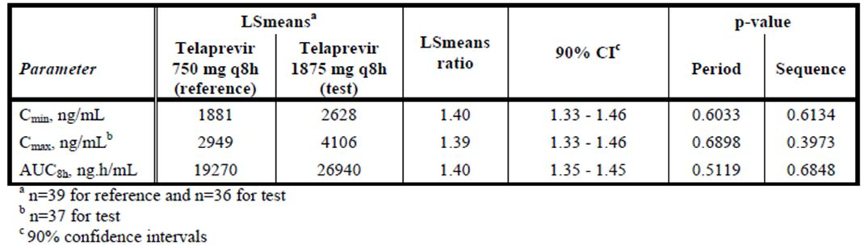
Moxifloxacin induced a significant increase in QTc compared to placebo with a maximal increase of 10.01 msec (7.01, 13.11) 4 h after drug administration. By contrast, telaprevir 750 mg q8h dose regimen was not associated with a clinically relevant effect on QTcF interval with a maximum mean time-matched change on telaprevir minus time matched change on placebo in QTcF interval of 5.7 msec (90% CI: 3.04; 8.41 msec) (Table 45).
Table 45: Summary statistics of the primary parameter: time matched changes on drug minus time matched changes on placebo (double delta) in QTcF interval (Study VX950-TiDP24-C136).
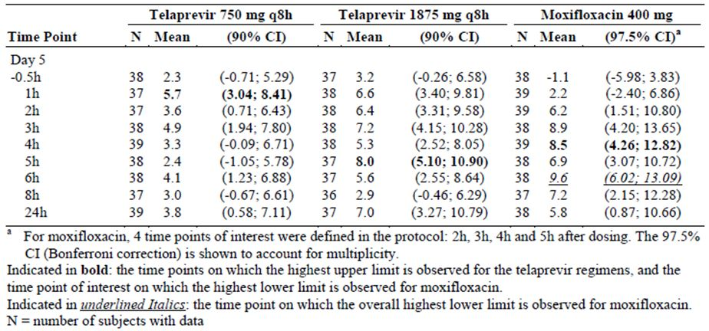
For the telaprevir 1875 mg q8h dose regimen, the upper limit of the 90% CIs for the time matched difference with placebo crossed the 10 ms threshold as per ICH E14 guideline at 3, 5 and 24 h (mean [90% CI]: 7.2 ms [4.15; 10.28] at 3 h, 8.0 ms [5.10; 10.90] at 5 h, and 7.0 ms [3.27; 10.79] at 24 h) for observed values. A mixed effects model was also generated from the data (adjusting for sequence, treatment, period, reference QTcF interval, time, and the interaction of time and treatment as fixed effects, and subject as a random effect). This model did not confirm the previous results and the highest upper limit of the 90% CI estimated in the mixed effects model for the telaprevir 1875 mg q8h regimen was below 10 ms (mean [90% CI]: 7.5 ms [5.22, 9.80] at 5 h post dose)(Table 46).
Table 46: Estimated time matched changes on drug minus time matched changes on placebo (double delta) in QTcF interval (Study VX950-TiDP24-C136).
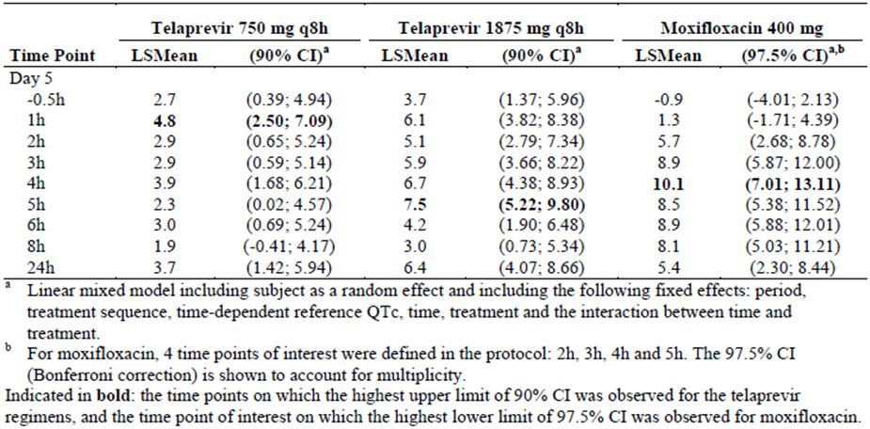
The data analysis also identified that the observed time matched differences versus placebo in QTcF interval were larger in males than females for both telaprevir regimens. No subjects had a QTcF value above 480 ms or a QTcF increase of more than 60 ms. No relationship between telaprevir plasma concentration and change in QTcF interval from reference was observed within the observed plasma concentration range. With both telaprevir regimens, mean increases in heart rate were observed, which persisted until 24 h after last intake; however, the mechanism behind this observation is not known.

Relationship between plasma concentration and effect
The data analysis conducted in Study VX04-950-102 indicated that the effectiveness of VX-950 was positively correlated with VX-950 concentration.

Pharmacodynamic interactions with other medicinal products or substances
An open label, single centre, non randomised Study VX06-950-007 examined the interaction between Modicon qd, an oral hormonal contraceptive that contains 0.5 mg norethindrone (NE) and 0.035 mg EE, and oral telaprevir (750 mg q8h) in 24 healthy females, aged 19 to 45 years. The subjects received one cycle of NE/EE and a second cycle of NE/EE in combination with telaprevir (750 mg telaprevir q8h for 21 days). The pharmacologic activity of NE/EE was assessed by comparing LH, FSH, and progesterone serum levels during Cycle 1 (NE/EE alone) and Cycle 2 (NE/EE plus telaprevir). Co administration of telaprevir with Modicon increased the serum concentrations of LH (148.3%; 90% CI: 114.8%, 191.6%) and FSH (137.6%; 90% CI: 112.2%, 170.2%), whereas, co administration decreased serum progesterone concentrations (82.2%; 90% CI: 75.8%, 89.0%) on Day 21 of dosing. Therefore, telaprevir may reduce the contraceptive effectiveness of oral contraceptives containing EE.

Genetic differences in pharmacodynamic response
No studies specifically examined the effect of genetic mutation on the Pharmacodynamics of VX-950.

Evaluator’s overall conclusions on pharmacodynamics
Using HCV RNA levels as a measure of anti viral activity, telaprevir induced a significantly greater and more sustained decrease in HCV RNA levels than placebo. This inhibitory effect was further enhanced by co administration of telaprevir and Peg-IFNα.
The effectiveness of VX-950 was positively correlated with the plasma concentration of telaprevir.
The estimated VX-950 target concentration range (IC_{99.9}) is 1198 to 3092 ng/mL (median 2007 ng/mL).
HCV RNA levels decline rapidly between the first and fourth days of dosing with VX-950. A second, sustained phase of viral decline may occur following dosing with VX-950 alone. The incidence of this second phase is increased when VX-950 is given in combination with Peg-IFNα.
Exposure to the standard dose of telaprevir (750 mg q8h) was not associated with a clinically relevant effect on QTcF interval in two thorough QT studies (that is, a placebo corrected mean increase of at least 5 ms above baseline values as evidenced by the upper limit of the two sided 90% CI ≥ 10 ms). By contrast, supratherapeutic exposure to telaprevir resulted in an observed QTcF prolongation in placebo corrected observed values (that is, the upper limit of the 90% CI exceeded 10 ms).
Therapeutic doses of telaprevir may induce increases in heart rate which persist up until 24 h following dosing.
Telaprevir may reduce the contraceptive effectiveness of oral contraceptives containing EE.

Efficacy

Introduction
The current treatment for patients with HCV is Peg-IFNα combined with RBV but only 50% of patients achieve sustained clearance of HCV RNA (sustained virologic response, SVR). There are no effective treatment options for patients who do not achieve viral clearance. SVR equates to cure in over 99% of patients treated with standard Peg-IFNα/RBV with long term follow up. SVR rates in patients who have failed or only partially responded to previous treatment range from 4-31%. Telaprevir prevents HCV replication and has been tested in combination with Peg-IFNα and RBV in treatment naïve and treatment failure patients. Clinical efficacy for the telaprevir development program is based on three Phase 3 studies in adult patients with chronic HCV genotype 1 infection. Studies 108 and 111 were conducted in treatment naïve patients and Study 216 was conducted in treatment failure patients. Two Phase 2 studies were conducted in treatment naïve patients (104, 104EU) and two were conducted in treatment failure patients (106 and 107). All studies were conducted in patients with chronic HCV genotype 1 infection. The primary efficacy parameter in the Phase 2 studies was SVR, defined as HCV RNA undetectable 24 weeks after the last administered dose of study drug, the primary endpoint recommended in HCV clinical efficacy studies.
In the Phase 3 studies, the primary efficacy endpoint was the more conservative SVR 24 weeks after the last planned dose of study drug (which thereby required longer follow up of subjects who discontinued early). In the Phase 3 studies, the efficacy endpoints also included SVR 24 weeks after the last administered dose of study drug, SVR 48 weeks and SVR 72 weeks.

Dose response studies and main clinical studies

Dose response studies
The two goals in selecting a therapeutic dose of telaprevir for the treatment of HCV were to:
- achieve a high enough exposure to inhibit replication of WT and LV variants within an acceptable safety margin; and
- maintain this dose for a duration needed to eliminate the virus (to keep replication at a minimum during treatment to prevent generation and selection of resistant variants).
The initial doses used to investigate the efficacy of telaprevir in patients with HCV were chosen based upon on human PK data, in vitro viral inhibition data, and animal liver to plasma partitioning data.
In vitro studies identified that the concentration of telaprevir that inhibited 90% of WT HCV mRNA replication was 476 ng/mL. In rats and dogs, telaprevir concentrations in the liver (site of HCV replication) were consistently higher than those in plasma. Therefore, as the relationship between telaprevir concentration in human plasma and liver was not known liver to plasma ratios from 10 to 20 were used in predicting liver exposure in humans.
To ensure effective inhibition of viral replication a 10 fold higher concentration of telaprevir was then set as a target. In Study 101, which examined the PK of telaprevir in patients with HCV, three doses of telaprevir (450 mg q8h, 750 mg q8h, and 1250 mg q12h) were investigated as these were estimated to provide trough liver concentrations of approximately 4760 ng/mL (that is, 10 fold higher than IC₉₀ of 476 ng/mL). All of the doses examined were well tolerated and the data indicated that in plasma, the highest steady state trough concentration was attained with the 750 mg q8h dose. In addition, the 750 mg q8h dose was also the most effective at inhibiting HCV mRNA levels with little or no evidence of viral rebound.
A second study examining the target population identified that co administration of telaprevir with Peg-IFNα-2a and RBV suppressed the emergence of telaprevir resistant HCV variants more effectively than telaprevir or Peg-IFNα-2a alone. No further dose ranging studies were performed prior to the commencement of Phase 2 clinical trials and subsequent studies investigated 750 mg q8h in combination with Peg-IFNα-2a, with and without RBV.
Studies 104 and 104EU were then conducted to ensure that this dose resulted in telaprevir exposures that provided a good balance between safety and efficacy before Phase 3 studies were initiated, and clinical utility analyses performed on final Phase 2 data (Studies 104, 104EU and 106) confirmed these results.
Exposure response analyses in Phase 3 Studies confirmed the administration of 750 mg telaprevir q8h provided a good balance between safety and efficacy and that telaprevir AUC was associated with virological response.

Main (pivotal) studies

Study VX-950-108 (108)
This was a Phase 3 study of two dose regimens of telaprevir in combination with Peg-IFNα-2a (Pegasys) and RBV (Copegus) in treatment naïve subjects with genotype 1 chronic hepatitis C.

Methods
This was a randomised, double blind, placebo controlled, parallel group, multicentre study conducted in treatment naïve patients. Two regimens of telaprevir dosed with PR (Peg-IFNα/RBV) were compared with standard treatment of PR. The telaprevir containing regimens were given for 24 or 48 weeks with telaprevir given in combination with Peg-IFNα and RBV for either the first 8 weeks (T8/PR group) or the first 12 weeks (T12/PR group). In patients who achieved eRVR (undetectable HCV RNA at 12 weeks), Peg-INFα and RBV were continued for a total of 24 weeks. Patients who did not achieve eRVR were dosed with PR for a total of 48 weeks. Control patients were treated with PR for 48 weeks with matching telaprevir placebo given for the first 12 weeks. Planned enrolment was 1050 patients with 350 patients to be assigned to each treatment group. The study schematic is shown in Figure 6.

Figure 6: Schematic for Study VX-950-108.
All plasma HCV RNA levels were assessed using the Roche TaqMan HCV RNA assay (Version 2.0, LLOQ of 25 IU/mL, limit of detection [LOD] of 10 IU/mL). HCV RNA values ≤10 IU/mL were considered undetectable; HCV RNA values >10 IU/mL were considered detectable. To minimise risk in patients who were not achieving an adequate virologic response, HCV RNA levels were monitored by an independent unblinded reviewer from Week 4 while the investigator and sponsor remained blinded. The independent reviewer determined if treatment or procedural modifications were required in individual patients based on viral response criteria shown in Table 47.
Table 47: Treatment and procedural modifications based on viral response assessments.
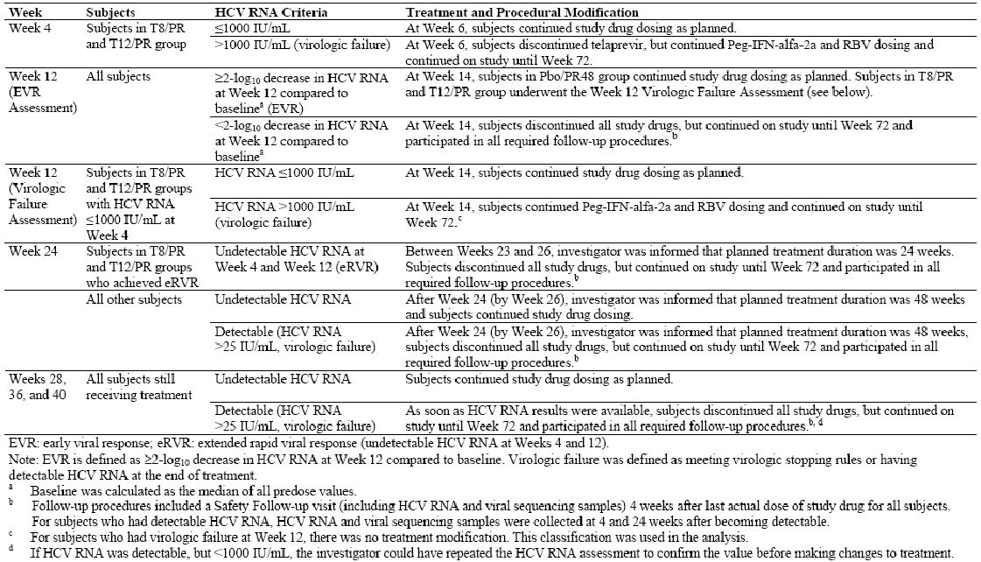

Objectives
The primary objective was to demonstrate the efficacy of telaprevir in combination with PR in treatment naïve patients with genotype 1 chronic HCV. The secondary objective was to evaluate the safety of T/PR. There was also a population PK analysis performed in a subset of patients.

Study participants
The study was multicentre study with sites located in Argentina, Europe, Australia, Israel and North America. The study enrolled male and female patients aged 18-70 years with chronic HCV infection of at least six months duration. A liver biopsy was required within one year of screening to confirm evidence of hepatitis. A biopsy performed more than one year before screening was acceptable if the report confirmed histological cirrhosis. Key exclusion criteria included: decompensated liver cirrhosis, other significant liver disease in addition to HCV, suspected hepatocellular carcinoma, patients requiring systemic corticosteroids, patients with autoimmune disease, patients with tuberculosis or chronic pulmonary disease, and patients currently abusing illicit drugs or alcohol.

Treatments
All patients received oral telaprevir 750mg q8h after food (given as two 375mg tablets). Peg-IFNα-2a (Pegasys) was given SC once weekly at a dose of 180µg. RBV (Copegus) was administered orally after food at a dose of 1000mg/day for patients weighing <75kg and 1,200mg/day for subjects weighing ≥75kg.

Treatment compliance and withdrawals
Treatment compliance was assessed by returned drug counts and dosing diary cards and all the discrepancies were recorded in the source documents. Continued non compliance required discontinuation. Patients were also withdrawn if they developed a medical condition requiring therapy with a prohibited medication, or if they developed a medical condition which may have adversely affected their health, or which contraindicated continued treatment with PR. Patients could also be withdrawn if consent was withdrawn, or if they were unable to continue for reasons such as surgery or AEs. Patients who were enrolled and did not fulfil the inclusion/exclusion criteria were replaced. Patients who discontinued from the trial after randomisation and intake of at least one dose of study drug were not replaced. Temporary interruptions of the trial drug were strongly discouraged and patients were counselled on the importance of drug compliance.
Patients could have drug treatment stopped based on criteria described in Table 47. All patients attended all study visits to Week 72 irrespective of treatment duration and HCV RNA status. Patients who stopped study drug early were seen at their next scheduled visit after the safety follow up visit. In all withdrawn patients, HCV RNA was measured 24 weeks after the last dose of study drug was actually given.

Outcomes/endpoints
Evaluation of plasma HCV RNA was the only efficacy endpoint, measured pre dose and at Weeks 1, 2, 3, 4, 6, 8, 10, 12, 16, 20, 24, 28, 36, 40, 48, 60 and 72. If HCV RNA became detectable, plasma HCV RNA samples were collected at Weeks 4 and 24 after HCV RNA became detectable.

Sample size
Planned enrolment was 1050 patients. Three treatment groups were compared for SVR24_{planned}; T8/PR, T12/PR and Placebo/PR48. Assuming a 50% response rate in the control group and a 64% response rate in the telaprevir group, a sample size of 350 patients in each group had a power of 92% to detect a statistically significant treatment difference.

Randomisation and blinding
Patients were randomised on Day 1 by IWRS (interactive web response system) and were balanced among treatment groups for genotype 1 sub types and baseline viral load (HCV RNA <800,000 IU/mL or ≥800,000 IU/mL). Patients were randomised 1:1:1 to the three treatments with 350 patients planned for each group. Patients and investigators were blind to the randomised treatment. HCV RNA results were double blinded up to but not including Week 28, after which they were available to the investigator. HCV RNA test results prior to Week 28 were not available to the investigator until after data base lock. Specified members of the sponsor study team received HCV RNA data after all subjects had reached Week 52 although they remained blind to the treatment assignment. Unblinded virologists, who were not part of the study team, conducted viral sequencing throughout the study for subjects with virologic failure. They were aware of the randomised treatment groups but the sequencing results were not revealed until after data base lock. The sponsor unblinded SAE (serious adverse event) for regulatory reporting but the study team and investigator remained blind. Unblinding could be performed for medical need by the investigator.

Statistical methods
All statistical analyses were performed using version 9.1.3 of the SAS system (SAS Institute Inc., Cary, NC). For the efficacy analyses, patients were analysed in the treatment group to which they were assigned (T8/PR or T12/PR) whether or not they achieved eRVR. Categorical data were presented using counts and percentages. Continuous variables were presented using mean, SD, median, minimum, maximum, and patient numbers. Various statistical methods were defined a priori to manage non quantifiable or undetectable HCV RNA values; missing HCV RNA values; missing SVR24_{planned}; missing genotype 1 subtypes and missing dates. The primary efficacy endpoint was analysed using a regression model with SVR24_{planned} as the dependent variable and treatment (reference category: Placebo/PR48), genotype 1 subtype (reference category: 1a) as determined using the LiPA method, and baseline HCV RNA plasma level (reference category: ≥800,000 IU/mL) as factors. Treatment was coded via two indicator variables for the telaprevir based regimens: T8/PR and T12/PR. Odds ratios, p values and 95% CI for the odds ratios between each of the telaprevir groups (T8/PR and T12/PR) and the control group (Placebo/PR48) were calculated. Additionally, the 95% CI for the differences in response rate between the placebo group and each telaprevir group, as well as the 95% CI for the difference between the T8/PR and T12/PR were given. Calculation of the CI was performed using normal approximation. A supportive analysis was performed using the Cochran-Mantel-Hanszel method stratifying for genotype subtype and baseline viral load.

Results

Recruitment
A total of 1095 patients were randomised to treatment (Figure 7). In the T8/PR group assigned to 24 weeks treatment, 191/207 patients completed treatment at Week 24; the commonest reason for discontinuation was AE. In the T8/PR group assigned to 48 weeks treatment, 69/157 patients completed 48 weeks; the commonest reasons for discontinuation were virologic failure and AE. In the T12/PR group assigned to 24 weeks treatment, 195/210 patients completed treatment at Week 24; the commonest reason for discontinuation was AE. In the T12/PR group assigned to 48 weeks of treatment, 73/153 patients completed treatment at Week 48; the commonest reasons for discontinuation were virologic failure and AE. In the Placebo/PR48 group, 202/361 patients completed treatment at 48 weeks; 118 patients had virologic failure and most other withdrawals were due to AE (Table 48).

Figure 7: Assignment of subjects in Study VX-950-108.
Table 48: Treatment and study completion status and reasons for discontinuation, FA set (Study VX-950-108).
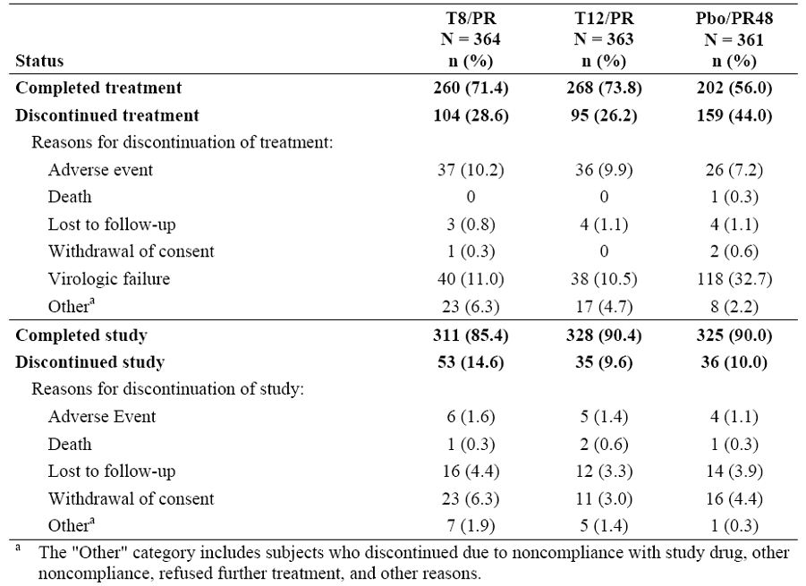

Protocol deviations
All patients who received at least one dose of blinded treatment were included in the FA (full analysis) set. A total of 42 patients (14 patients in the T8/PR group, 16 patients in the T12/PR group and 12 patients in the Placebo/PR48 group did not meet the study entry criteria and were excluded from the PP (per protocol [analysis set]) efficacy analysis. The most common reasons were failure to confirm genotype 1, clinically significant laboratory abnormalities and failure to obtain ophthalmological clearance for patients with diabetic or hypertensive retinopathy. The reasons for non inclusion in the PP analysis set are shown in Table 49. Treatment adherence was at least 95% in the majority of patients in each treatment group. Treatment with RBV had the lowest adherence rate, particularly in both T/PR treatment groups compared with placebo, possibly related to dose interruptions and discontinuations, and to AE.

Table 49: Subjects included in PP set, FA set (Study VX-950-108).
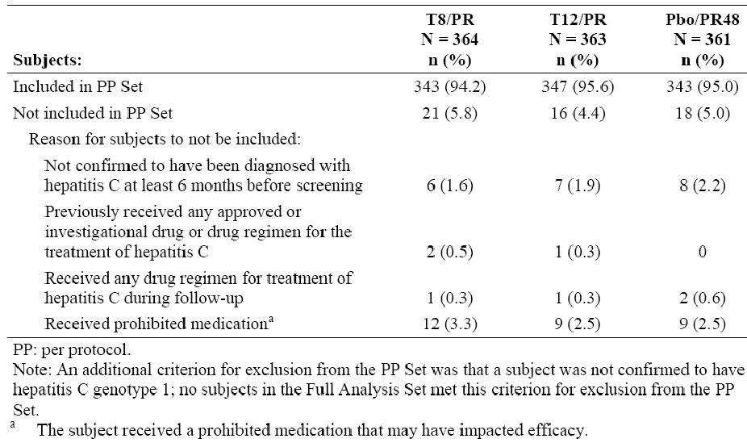

Baseline data
Demographics were balanced evenly between the groups at baseline. The mean age in all groups was ∼47 years; ∼58% were male and ∼88% were White. Approximately 60% of patients were recruited in North America and ∼29% were recruited in Europe. HCV disease characteristics were similar in the three treatment groups. Median log₁₀ HCV RNA was 6.4 IU/mL (range 2-8 IU/mL) and 77.1% of patients had high baseline HCV RNA levels >800,000 IU/mL. Of 1088 patients in the total group, 37.6% had no or minimal fibrosis, 41.2% had portal fibrosis and 15% had bridging fibrosis.

Numbers analysed
A total of 1088 patients were treated with blinded medications. Of these, 964 (88.6%) patients completed the study, 124 (11.4%) were discontinued and 730 (67.1%) patients completed dosing. A total of 386 (35.5%) patients completed dosing at Week 24 due to eRVR and 344 (31.6%) completed 48 weeks of dosing. A total of 358 (32.9%) patients discontinued dosing, mostly due to AE and virologic failure.

Outcomes

Primary efficacy endpoint
Efficacy analyses were performed on the FA set as shown in Figure 8.

Figure 8: Subjects who were assigned to receive 24 weeks of treatment.
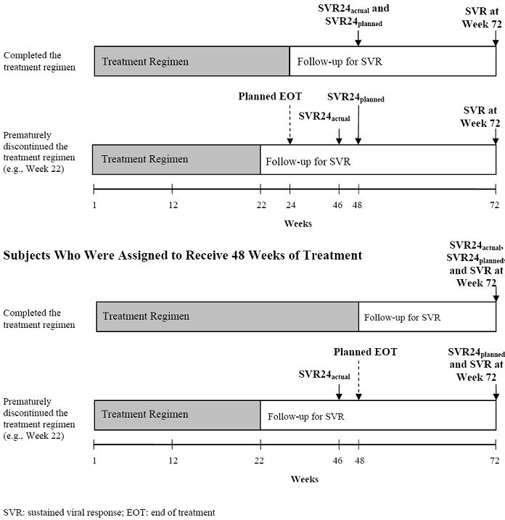
SVR24_{Planned} rates were significantly higher in the T/PR treatment groups than in the Placebo/PR48 group: 68.7% for the T8/PR group and 74.7% for the T12/PR group compared with 43.8% for the Placebo/PR48 group (p <0.0001 for both comparisons). The differences in SVR24_{planned} for T8/PR and T12/PR groups compared with the Placebo/PR48 group were 24.9% (95% CI 17.9% to 31.9%) and 30.9% (95% CI 24.1% to 37.7%), respectively. Similar results were obtained for SVR24_{planned} in the PP data set. Figure 9 shows the mean change from baseline of HCV RNA concentrations to Week 48 by eRVR status. HCV RNA concentration rates fell faster in the T/PR groups compared with the Placebo/PR48 group. After Week 3, HCV RNA concentrations in the T/PR groups remained steady while HCV concentrations continued to fall until Week 24 in the Placebo/PR48 group. The mean decrease from baseline in HCV RNA was higher in the T/PR groups compared with the Placebo/PR48 group. In the T/PR groups HCV RNA concentrations fell more quickly in patients who had eRVR than in those who did not. The time to undetectable HCV RNA during the overall treatment phase is shown graphically by Kaplan-Meier plot in Figure 10.

Figure 9: Mean (SE) change from baseline of log10 HCV RNA concentrations from baseline through Week 48 by treatment group and visit, FA set (Study VX-950-108).
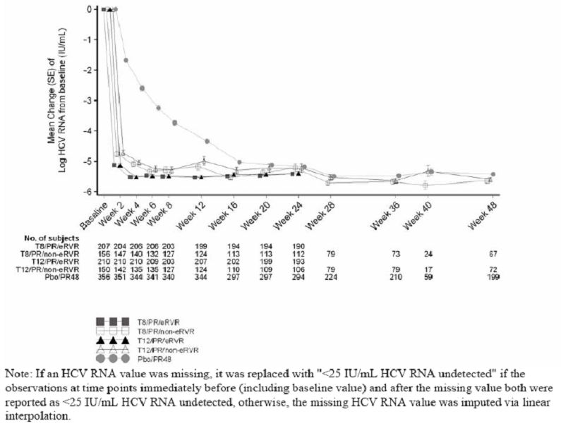
Figure 10: Kaplan Meier estimates for time to undetectable HCV RNA during the overall treatment phase, FA set (Study VX-950-108).
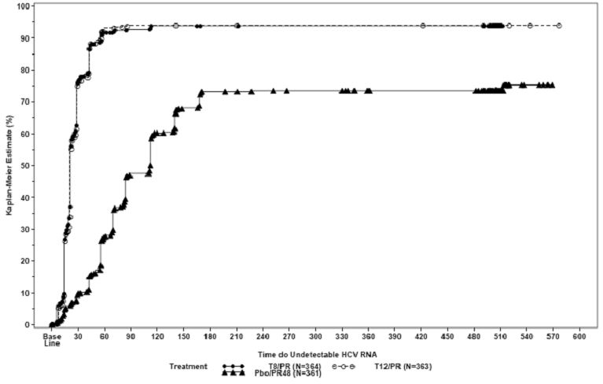

Secondary efficacy endpoints
SVR rates at Week 72 were similar to the SVR24_{planned} rates, consistently higher in the T/PR groups compared with the Placebo/PR48 group: 66.8% for the T8/PR group and 73.0% for the T12/PR group compared with 43.8% for the Placebo/PR48 group (p <0.0001 for both comparisons).
SVR24_{planned} rates were higher among subjects with genotype 1b compared with genotype 1a, the latter being associated with more virologic failure due to telaprevir resistant variants. A total of 66.6% of patients in the T8/PR group and 67.8% of patients in the T12/PR group achieved RVR compared with 9.4% in the Placebo/PR48 group. 56.9% of patients in the T8/PR and 58.4% in the T12/PR group achieved eRVR compared with 8.0% of patients in the Placebo/PR48 group. The majority of the subjects in the TPR groups received treatment for 24 weeks. Subjects with eRVR had a high SVR24_{planned} rate with a low relapse rate. Relapse_{planned} rates were lower in the TPR groups than in the Placebo/PR48 group: 9.5% in the T8/PR group, 8.6% in the T12/PR group and 27.9% in the Placebo/PR48 group. Virologic failure rates were lower in the T/PR groups than in the Placebo/PR48 group: 12.9% in the T8/PR group, 8.3% in the T12/PR group and 31.9% in the Placebo/PR48 group (Table 50). Virologic failure rates at Weeks 12 and 24 were lower in the T/PR groups than in the Placebo/PR48 group. More patients had virologic failure on treatment in the T8/PR group than in the T12/PR group. During the telaprevir or placebo treatment period, virologic failure rates were similar in the T8/PR group and T12/PR group: 2.7% and 3.3%, respectively. The proportion of patients with virologic failure after Week 12 on treatment with PR was higher in the T8/PR group than in the T12/PR group: 10.2% and 5.0%, respectively.
Table 50: Outcomes of subjects who did not have SVR24_{planned}, FA set (Study VX-950-108).
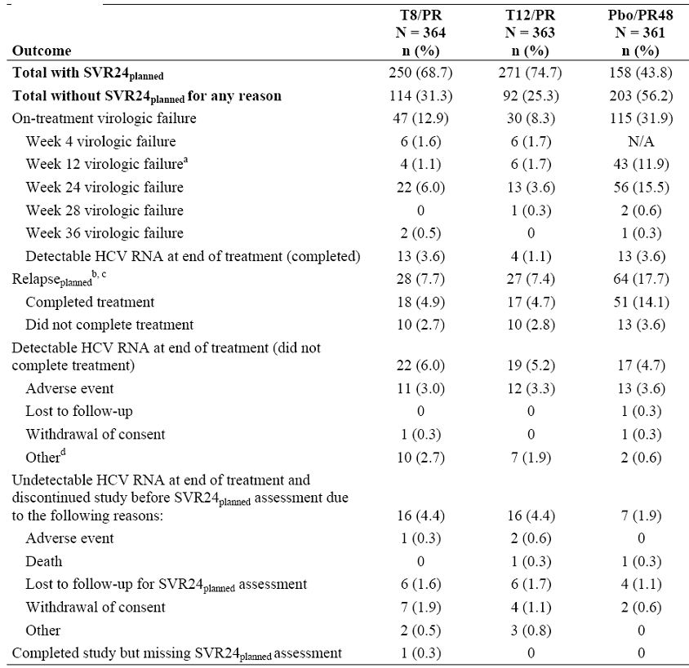
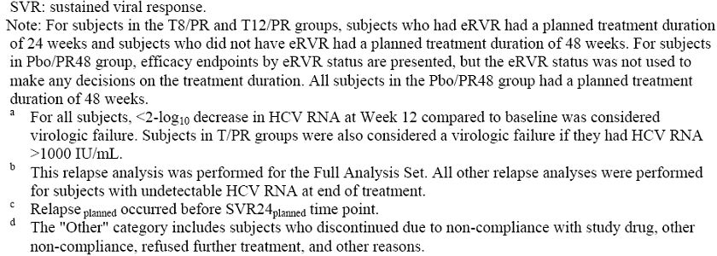

Pharmacokinetic results
All quantifiable telaprevir concentrations with distribution across treatment groups and sampling times are shown in Figure 11. The majority of the telaprevir plasma concentrations fell within the 2,000-4,000 ng/mL range. Telaprevir plasma concentrations also appeared similar between the T8/PR and T12/PR groups. Telaprevir concentrations were almost constant between Week 1 and Week 12 indicating constant steady state exposure to telaprevir during the 12 week dosing period. Peg-IFNα concentrations also appeared to have reached steady state by Week 4 and remained constant until Week 12. RBV plasma concentrations also reached steady state by Week 4 and were sustained through Week 12 with most concentrations in the 1,500 to 3,000 ng/mL range. Mean telaprevir plasma concentrations in patients who had intensive PK sampling are shown in Table 51 and graphically in Figure 12. Telaprevir PK parameters in the same population are shown in Table 52.
Figure 11: Observed telaprevir plasma concentrations (Study VX-950-108).
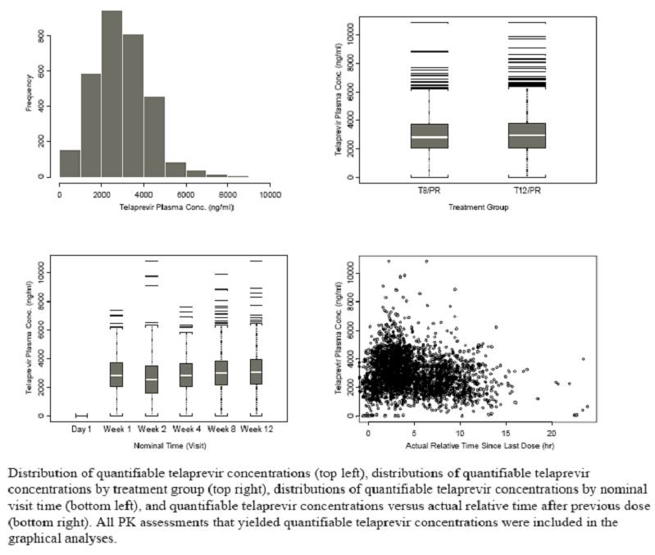
Table 51: Summary of telaprevir concentration data by normal time (Study VX-950-108).
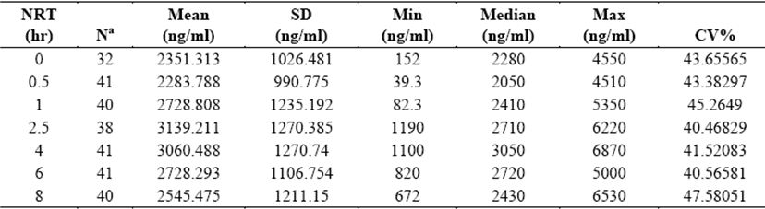
Figure 12: Mean (SD) telaprevir plasma concentration versus time – intensive PK substudy (Study VX-950-108).
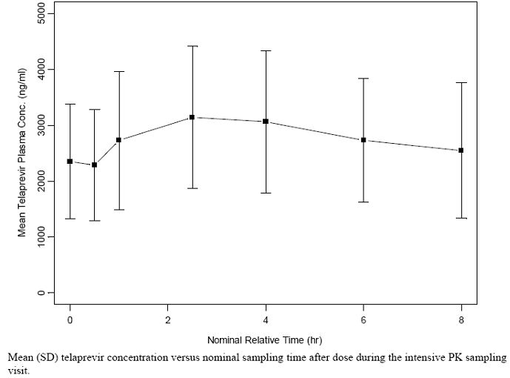
Table 52: Telaprevir PK parameters – NCA analysis on intensive PK substudy (Study VX-950-108).
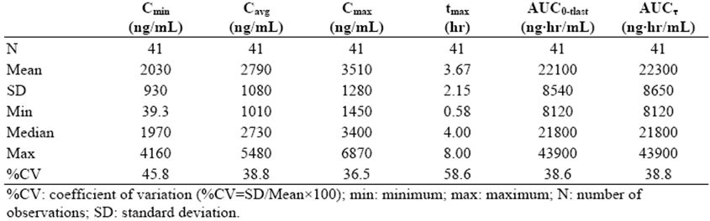

Ancillary analyses
Male and female patients had similar SVR24 response rates in all treatment groups. Patients in the T12/PR group with BMI <25 had a higher response rate (83.7%) than patients with BMI ≥25 (67-71%). Patients <45 years old had higher SVR24 rates than those >45 years old in all treatment groups. Caucasian patients also had higher response rates than Black patients. Diabetic patients had lower SVR24 response rates than non diabetic patients (Table 53).
Table 53: SVR24_{planned} rates by demographic characteristics, FA set (Study VX-950-108).
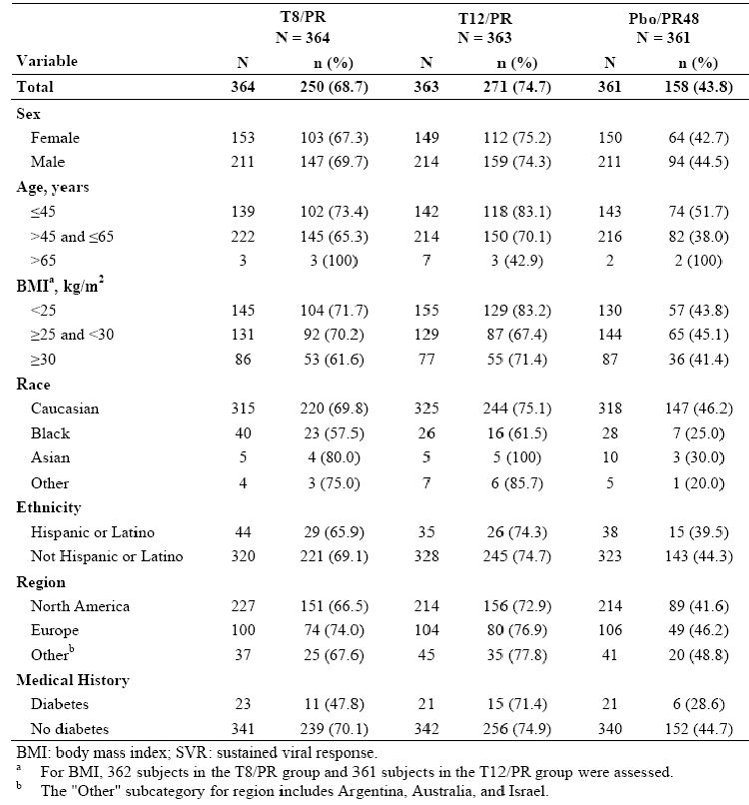

Comments
There was a higher rate of SVR in patients who received the T/PR regimen compared with patients who received PR without telaprevir. The higher rate of SVR was seen in all regions in patients of all races, although notably there were very few Asian patients. Higher SVR rates with T/PR regimens rates were also observed in patients who had diabetes or fibrosis, or who had baseline high HCV RNA levels, when compared with patients who received PR alone. The SVR24_{planned} rate of 43.8% in the Placebo/PR group was similar to SVR rates reported in other published studies. The SVR _{planned} rate in each of the T/PR groups was significantly higher than in the Placebo/PR group; 68.7% in the T8/PR group (p <0.0001) and 74.7% in the T12/PR group (p <0.0001). SVR rates at Week 72 were significantly higher in both T/PR groups (p <0.0001) and were similar to the SVR_{planned} rates for all treatment groups. A total of 357 patients were followed beyond the SVR_{planned} time point and all but five of these patients had undetectable HCV RNA at week 72. The eRVR rates were 56.9% in the T8/PR group, 58.4% in the T12/PR group and 9.4% in the Placebo/PR group. More than half of patients in the T/PR groups had eRVR so these patients were assigned to treatment for 24 weeks. eRVR rates were strongly predictive of SVR in each group with a positive predictive value of 82.6% in the T8/PR group, 89.2% in the T12/PR group and 96.6% in the Placebo/PR group. These results support the use of 24 weeks treatment in patients with eRVR. Telaprevir greatly increased the early virologic response and the majority of patients achieved SVR with a shorter duration of treatment compared with standard therapy. There was a 6% efficacy benefit in favour of T12/PR compared with T8/PR. The study was appropriately balanced, stratified and randomised and telaprevir exposure at steady state was similar in both treatment groups. This benefit is clinically meaningful and warrants the proposed longer telaprevir treatment period.

Study VX08-950-111 (111)
This was a randomised study of stopping treatment at 24 weeks or continuing treatment to 48 weeks in treatment naïve subjects with genotype 1 chronic hepatitis C who achieve extended rapid viral response while receiving telaprevir, Peg-IFNα-2a (Pegasys), and RBV (Copegus).

Methods
This was a Phase 3, randomised, open label, multicentre trial conducted in treatment naïve patients with genotype 1, chronic HCV infection. Planned enrolment was 470-500 patients. It was designed to measure SVR rates in patients who achieved eRVR with telaprevir in combination with PR. The two treatments were 24 or 48 weeks in duration, with telaprevir administered with PR for the first 12 weeks (T12/PR24 and T12/PR48, respectively). Patients who achieved eRVR and completed the Week 20 visit were randomised in a 1:1 ratio to stop all study treatment at Week 24 or to continue treatment with PR until Week 48. Patients who did not achieve eRVR continued PR treatment until Week 48. The study design schematic is in Figure 13.
Figure 13: Schematic for Study VX08-950-111.
The planned regimens presented above were modified during the conduct of the study based on viral response assessments performed throughout the study or on premature treatment discontinuation. HCV RNA levels were monitored and subjects who were not demonstrating an adequate antiviral response had treatment and procedural modifications made on pre defined viral response criteria.

Objectives
The study objective was to estimate the difference in SVR rates between T12/PR24 and T12/PR48 treatment regimens in patients who achieved eRVR.

Study participants
Key inclusion criteria included: patients were male or female aged 18-70 years inclusive with diagnosed genotype 1, chronic hepatitis C with detectable HCV RNA; diagnosis of HCV >6 months before the screening visit; abnormal LFT >6 months before screening; screening laboratory values within pre specified acceptable ranges; patients with a documented liver biopsy within the previous year with evidence of hepatitis and/or fibrosis. Key exclusion criteria included: patients who had contraindications to Peg-IFNα or RBV therapy; evidence of hepatic decompensation in patients with cirrhosis; patients with significant liver disease in addition to hepatitis C; patients with suspected hepatic carcinoma; patients with a history of malignant disease; patients with autoimmune disease, severe retinopathy, chronic pulmonary disease or significant infections; patients requiring systemic steroids; patients currently abusing illicit drugs or alcohol.

Treatments
All patients received oral telaprevir 750mg q8h after food (given as two 375mg tablets). Peg-IFNα-2a (Pegasys) was given SC once weekly at a dose of 180μg. RBV (Copegus) was administered orally after food at a dose of 1000mg/day for patients weighing <75kg and 1,200mg/day for subjects weighing ≥75kg.

Treatment compliance and withdrawals
Treatment compliance was assessed by reviewing returned drug and dose diary cards. All discrepancies were discussed and recorded and patients with continued non compliance were withdrawn. Patients were also withdrawn if they developed a medical condition requiring therapy with a prohibited medication, or if they developed a medical condition which may have adversely affected their health or which contraindicated continued treatment with PR. Patients could also be withdrawn if consent was withdrawn, or if they were unable to continue for reasons such as surgery or AEs. Patients who were enrolled and did not fulfil the inclusion/exclusion criteria were replaced. Patients who discontinued from the trial after randomisation and intake of at least one dose of study drug were not replaced. Temporary interruptions of the trial drug were strongly discouraged and patients were counselled on the importance of drug compliance.

Outcomes and endpoints
The primary objective of the study was to estimate the difference in SVR rates between T12/PR24 and T12/PR48 treatment regimens in patients who achieved eRVR. The primary purpose of the study was to assess whether a 24 week treatment regimen was non inferior (NI) to a 48 week treatment regimen for patients who achieved eRVR. The secondary objective was to evaluate the safety of telaprevir in combination with PR.

Sample size and statistics
Two analyses were performed for SVR and relapse endpoints: planned and actual. The planned analyses were based on endpoints measured from the last planned dose of study treatment. The actual analyses were based on the time from the last actual dose of study treatment. Patients who had undetectable HCV RNA at Week 4 and Week 12 were considered to have eRVR. Patients who could not have their eRVR status determined were considered to not have eRVR. Subjects who discontinued from the study early were included in a separate analyses group designated ‘Other’. The definition of undetectable HCV RNA levels was prospectively defined as <25 IU/mL. The FA set was used to evaluate efficacy and safety for the final analysis; the PP set was used for analysis of the primary efficacy endpoint. All statistical analyses were performed using Version 9.1.3 of the SAS System (SAS Institute Inc.). The sample size estimate was based on a two sided 95% CI for the treatment difference between stopping treatment at Week 24 and continuing treatment until Week 48. An expected SVR rate of 90% was assumed in each group, based on randomisation at Week 20.
With 90% SVR rates and at least 157 randomised patients in each group, there was at least 80% power to exclude a 10.5% difference (as discussed with FDA and EMA) in SVR rates between stopping treatment at Week 24 and continuing treatment to Week 48. Based on data from the Phase 2 studies, it was assumed that 33% of patients were likely to discontinue treatment before randomisation or were unlikely to achieve eRVR. Based on these assumptions, the target enrolment was 470 patients to have 157 patients randomised to each treatment arm. However, the target enrolment was raised to 500 patients based on the actual numbers of patients progressing to randomisation.

Randomisation and blinding
Patients who achieved eRVR at Week 20 were randomised via IWRS before Week 24 in a 1:1 ratio to the T12/PR24/eRVR+ group or the T12/PR48/eRVR+ group. Randomisation was blocked and stratified according to genotype 1a, 1b or unknown, and race. Patients who did not achieve eRVR were assigned to receive 48 weeks of total treatment. Individual patient responses were monitored by an unblinded independent reviewer from Week 4 although the investigator, patients and sponsor remained blinded. HCV RNA test results were double blind until Week 24 after which they were available to the investigator. HCV RNA levels and eRVR status before Week 24 were not made available to the investigator until the end of the study.

Results

Recruitment
A total of 544 patients were enrolled as shown in Figure 14.
The FA set included 540 patients of which 440 patients were randomised or assigned to one of the three treatment regimens.

Protocol deviations
More than 95% of randomised patients were included in the PP set. The most common major deviation was failure to demonstrate the diagnosis of genotype 1 hepatitis C. A total of 62 patients did not meet the study entry criteria; 21 of these patients were granted an exemption with the numbers approximately similar in each treatment group. A total of 41 patients (19 patients in the T12/PR24/eRVR+ group) did not meet the study entry criteria but were enrolled by the investigators.

Compliance
The majority of patients in each treatment group were at least 95% adherent with dosing of telaprevir and Peg-IFNα. Adherence was lowest with RBV treatment but it was similar in all treatment groups. Dose discontinuations, interruptions and AE contributed most to RBV non compliance.

Baseline data
The majority of patients were male (60.2%), most were White (79.1%) and from North America (94.3%). Mean age was 49.3 years and most patients were over 45 years. Mean BMI was 28.1kg/m². The proportion of Black patients in the randomised arms was the same (approximately 10%) because patients were stratified according to race.

Numbers analysed
A total of 359 patients (66.5%) completed the study treatment. The majority of patients in the randomised eRVR groups completed treatment: 161 patients (99.4%) in the T12/PR24/eRVR+ group and 119 patients (74.4%) in the T12/PR48/eRVR+ group. AE and refusal of further treatment were the most common reasons for discontinuation in the randomised arms. A total of 79 patients (66.9%) in the assigned T12/PR48/eRVR- group completed treatment. The most common reasons for discontinuation were AE and virologic failure. A total of 465 patients (86.1%) completed the study, the majority before their last planned dose of study drug. The most frequent reasons for study non completion were lost to follow up and withdrawal of consent. Completion rates were high in the randomised eRVR+ arms: 155 patients (95.7%) in the T12/PR24 group and 147 patients (91.9%) in the T12/PR48 group. In the assigned T12/PR48/eRVR- group, 103 patients (87.3%) completed the study. Sixty patients (60%) completed the study in the ‘Other’ group. Only one death occurred during the study. This was due to a traumatic head injury unrelated to treatment.

Outcomes

Primary efficacy analysis
The primary efficacy endpoint SVR24_{planned} was an evaluation of SVR rate measured from the end of treatment visit to 24 weeks after the last planned dose of study drug. The analysis was based on CI estimates to rule out NI of the T12/PR24/eRVR+ treatment regimen compared with the T12/PR48/eRVR+ treatment regimen. The study met the primary efficacy endpoint. The SVR24_{planned} rates were 92.0% in the randomised T12/PR24/eRVR+ group and 87.5% in the randomised T12/PR48/eRVR+ group. The difference in the SVR24_{planned} rate (T12/PR24/eRVR+ minus T12/PR48/eRVR+) was +4.5% (two sided 95% CI: -2.1% to 11.1%). Therefore, the T12/PR24/eRVR+ treatment regimen was NI to the T12/PR48/eRVR+ treatment regimen as the lower bound of the 95% CI (-2.1%) was entirely to the right of the pre defined NI margin of -10.5%. Analysis of the PP set produced similar results: the difference in SVR_{planned} rates (T12/PR24/eRVR+ minus T12/PR48/eRVR+) was found to be 4.3% (CI: -2.2% to 10.9%).

Secondary efficacy analysis
The SVR Week 72 rates were similar in the randomised eRVR+ groups: 87% in the T12/PR24 group and 87.5% in the T12/PR48 group. The difference in SVR Week 72 rates (T12/PR24/eRVR+ minus T12/PR48/eRVR+) was -0.5% (two sided 95% CI: -7.7% to 6.8%). Therefore, the T12/PR24/eRVR+ treatment regimen was NI to the T12/PR48/eRVR+ treatment regimen as the lower bound of the 95% CI was -7.7% which was entirely to the right of the pre defined NI margin of -10.5%.
The observed SVR24_{actual} rate for the T12/PR24/eRVR+ group was 92% compared with the SVR24_{actual} rate for the T12/PR48/eRVR+ group of 90%. The 2-sided 95% CI for a difference of +2.0% was -4.3% to 8.2%. In total, 20% of patients did not achieve SVR_{planned} because of detectable HCV RNA during the various study phases. There was no difference in the viral breakthrough rates between the eRVR+ randomised groups (1.9% in both groups). By Week 48, the total cumulative breakthrough rate was 7.4%. The total RVR rate for the study was 72.0% and the total eRVR rate was 65.2%. The percentage of patients with undetectable HCV RNA was similar in both randomised eRVR groups. Figure 15 shows the mean change from baseline of HCV RNA concentrations throughout the overall treatment period. After Week 4, mean changes in HCV RNA concentrations remained similar in the T12/PR24/eRVR+ and T12/PR48/eRVR+ treatment groups (approximately log₁₀ -5.6 IU/mL). The proportion of patients with undetectable HCV RNA was similar in the randomised eRVR+ group with time estimates shown in the Kaplan-Meier plot shown in Figure 16.
Figure 15: Mean (SE) change from baseline of log10 HCV RNA concentrations from baseline through the overall treatment period by treatment group and visit, FA set (Study VX08-950-111).
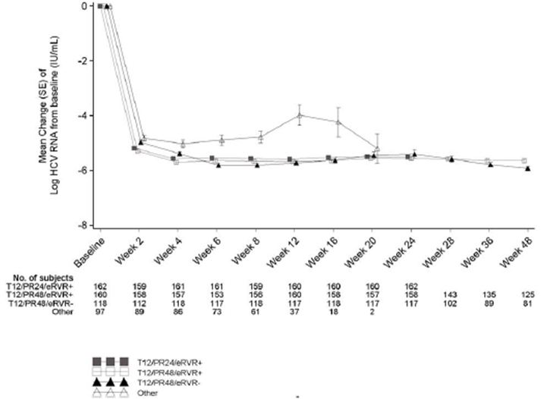
Figure 16: Kaplan Meier estimates for time to undetectable HCV RNA during the overall treatment phase, FA set (Study VX08-950-111).
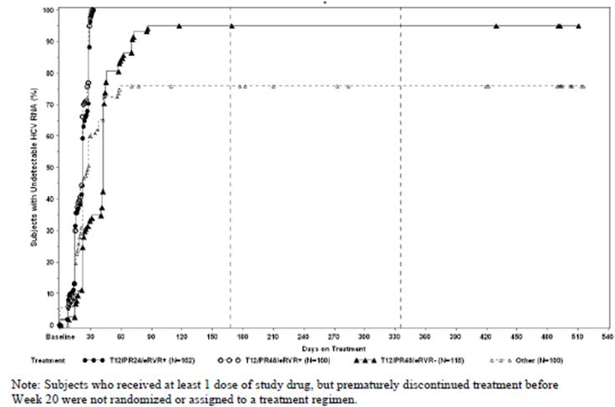

Pharmacokinetic analyses
Telaprevir plasma concentrations from the population PK sub study are shown in Figure 17. The majority of telaprevir plasma concentrations were within the 2000 to 4000 ng/mL range in all treatment arms. Telaprevir plasma concentrations were relatively constant between Week 1 and Week 8 indicating constant telaprevir exposure at steady state.

Figure 17: Observed telaprevir plasma concentrations (Study VX08-950-111).
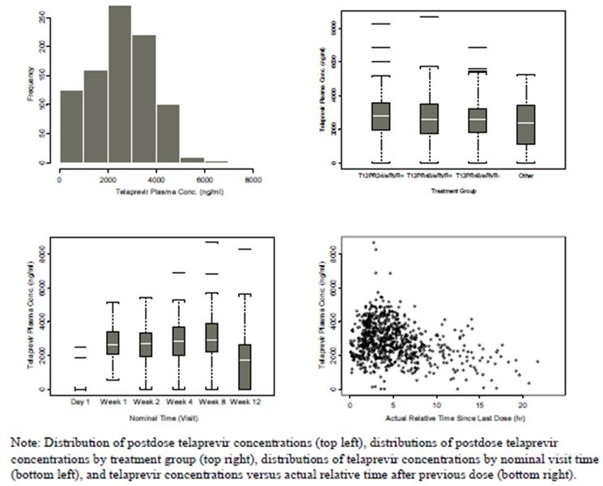

Comments
The primary objective of this study was to compare SVR rates between a 24 week and a 48 week treatment regimen in treatment naïve patients. The study met this objective, showing NI of the T12/PR24 regimen compared with the T12/PR48 regimen in patients who had achieved eRVR. The SVR24_{planned} rate was 71.9% across the entire population compared with a historical standard care rate of approximately 50%. Similar rates were observed in patient groups with historical low SVR rates, including Blacks, patients with cirrhosis and patients with high baseline HCV RNA. The key secondary endpoint of NI for SVR Week 72 was also met. SVR72 rates were 87% in the T12/PR24 group and 87.5% in the T12/PR48 group in patients with eRVR. Only one patient in the T12/PR24 group had HCV RNA detectable after Week 72. SVR24_{planned} rates were only marginally lower in patients who did not complete their telaprevir dosing regimen; however, the majority of these patients discontinued telaprevir after eight weeks of treatment. On-treatment virologic failure occurred in only 8.1% of patients and virologic relapse occurred in only 6.7% of patients: the numbers who did not achieve SVR were too low for meaningful comparison between groups.
The total eRVR rate was 65.2% and relapse rates were low in the T12/PR24 group. As was observed in Study 108, regimens containing telaprevir are effective and there appears to be no reason to continue PR treatment beyond 24 weeks in patients who have achieved eRVR.

Study VX-950-TiDP24 C216 (216)
This was a randomised, double blind, placebo controlled, Phase 3 trial of two regimens of telaprevir (with and without delayed start) combined with Peg-IFNα-2a (Pegasys) and RBV in subjects with chronic genotype 1 hepatitis C infection who failed prior Peg-IFNα plus RBV treatment.

Methods
This study was designed to compare the efficacy and safety of two regimens of telaprevir (with and without delayed start [DS] of telaprevir) combined with PR versus standard treatment with PR. The study had a 48 week treatment period and a 24 week follow up period (schematic overview shown below). Patients were eligible to enrol in the study if they had an undetectable HCV RNA at the end of a previous course of PR but did not achieve SVR (prior relapsers); or if they never had undetectable HCV RNA levels with a prior course of PR (prior non responders). Approximately 650 patients (350 prior relapsers and 300 prior non responders) were planned to be randomised 2:2:1 to one of three treatment groups: two telaprevir (Group A: without DS of telaprevir, and Group B: with DS of telaprevir) and one control treatment group (Group C). In both telaprevir treatment groups (A and B), patients received telaprevir for 12 weeks in combination with PR for 48 weeks at standard doses. Patients in treatment group B had a delayed start with telaprevir treatment started 4 weeks after PR treatment. In the control group C, patients received PR for 48 weeks. The study schematic is shown in Figure 18.
Figure 18: Schematic for Study VX-950-TiDP24 C216.

Objectives
The primary objective was to demonstrate the superior efficacy of telaprevir combined with PR compared to standard treatment with PR in patients who had failed previous treatment with PR. The aim was to achieve this primary objective for both prior relapsers and prior non responders. Secondary objectives included: the effect of DS telaprevir on the efficacy of T/PR; the efficacy of T/PR versus PR on prior null responders (defined by <2 log drop in HCV RNA) versus prior partial responders (defined by ≥2 log drop in HCV RNA); safety and tolerability of telaprevir in combination with PR; and telaprevir PK.

Study participants
The study was conducted in EU, North and South America and Australia. Key inclusion criteria included males or females, aged 18 to 70 years inclusive; to have genotype 1 chronic hepatitis C infection with HCV RNA levels ≥1,000 IU/mL; to have failed at least one previous course of PR; to have completed the last course of PR at least 3 months before the screening visit; to have a liver biopsy report within 18 months of screening; and to have no evidence of hepatocellular carcinoma. Key exclusion criteria included: co infection with another HCV subtype; prior therapy discontinued due to tolerance issues; significant concomitant illness; decompensated liver disease or significant liver disease in addition to hepatitis C; suspected illicit drug or alcohol abuse and Grade 3 laboratory abnormalities with the exception of LFTs.

Treatments
The treatments administered are shown in Table 54.
Table 54: Treatments groups in Study VX-950-TiDP24 C216.

Treatment compliance and withdrawals
Compliance was assessed by returned tablet counts and by patient dose diary cards. Discrepancies were recorded and the patients were withdrawn for continued non compliance. Patients could be withdrawn for an SAE. Patients were required to be withdrawn in the event of consent withdrawal; pregnancy; significant concomitant illness or medications; contraindications to continued PR treatment; Grade 3 AE or toxicity thought to be related to telaprevir; a Grade 3 rash, including Stevens-Johnson syndrome. Treatment discontinuation or modifications were permitted if predefined protocol criteria were applied.

Outcomes/endpoints
The primary efficacy endpoint was the proportion of patients in each treatment group achieving SVR24_{planned}, defined as having undetectable plasma HCV RNA levels 24 weeks after the last planned dose of study drug, that is, at Week 72. These included patients who achieved SVR24_{planned} after completing their assigned treatment regimen, and subjects who discontinued treatment, for reasons other than virologic failure, and who achieved SVR24planned. In the primary analysis, SVR24_{planned} rates in treatment Groups A and B were each compared to the SVR24_{planned} rates in the control Group C.
Key secondary endpoints included: the proportion of patients in each group achieving undetectable HCV RNA levels 4 weeks after the start of telaprevir or placebo; the proportion of patients in each group achieving eRVR; the proportion of patients who had undetectable HCV RNA at the end of treatment (Week 48 or early discontinuation); the proportion of patients who relapsed during the follow up period; and the change with time in log₁₀ HCV RNA compared with baseline.

Randomisation and blinding
The patients were randomised 2:2:1 treatment groups A, B and C respectively using IVRS/IWRS (interactive voice/web response system) central randomisation. Randomisation was stratified according to screening HCV RNA levels (<800,000 IU/mL or ≥800,000 IU/mL) and prior relapser or non responder status. Treatment was blinded to the investigator, patient and sponsor until all patients had reached Week 72 or had discontinued earlier. Results of HCV RNA tests up to and including Week 24 were blinded to the investigator and patient until all subjects had reached Week 72 and the study database was locked. HCV RNA test results after Week 24 were communicated to the investigator on a continuous basis.

Sample size and statistical methods
The planned enrolment was 650 patients. Statistical analyses were performed by SGS-LSS (Mechelen, Belgium) using SAS version 9.1. The primary efficacy variable was the proportion of patients in each treatment group achieving SVR, defined as undetectable HCV RNA 24 weeks after the last planned dose of study drug. The primary objective was to demonstrate superior efficacy of Treatment A and/or Treatment B to control Treatment C, separately in both prior non responders and relapsers. Sample size calculations were based on the Phase 2 Study 106. For prior relapsers, a response rate of 55% was assumed in Groups A and B, and a 29% response rate was assumed in Group C. This required a sample size of 140 patients in each of Groups A and B and 70 patients in Group C providing 90% power to detect a statistically significant difference. For prior non responders, a response rate of 30% was assumed for treatment Groups A and B and an 8% response assumed for the control Group C. This required a sample size of 120 patients in each of Groups A and B and 60 patients in Group C. The two telaprevir arms were pooled into a population of null responders which resulted in 80% power to detect a statistically significant difference by assuming an SVR rate of 29% and 4% in the combined telaprevir and control arms respectively. NI of non delayed (A) versus delayed (B) telaprevir start was tested with a NI margin of 10% with 95% confidence interval of the difference between A and B to be estimated from the logistic regression.

Results

Recruitment

A total of 833 patients were screened and 662 patients were treated: 266 patients in the T12/PR48 group, 264 patients in the T12(DS)/R48 group and 132 patients in the Placebo/PR48 group. Of the 662 patients in the FA set, 354 (53.5%) patients were prior relapsers and 308 (46.5%) were prior non responders. Among the non responder patients, 184 (59.7%) patients were prior null responders and 124 (40.3%) patients were partial responders.

Protocol deviations
In the FA set, major protocol deviations were reported for 19.5% of patients in the T12/PR48 group, 15.9% of the patients in the T12(DS)/PR48 group and 11.4% of the subjects in the Placebo/PR48 group. The most frequent major deviations were related to PR intake and procedure deviations. Disallowed drug intake (mostly systemic steroids) was reported as a major protocol deviation in 12 (1.8%) patients. Protocol deviations likely to affect the primary efficacy endpoint resulted in the exclusion of 73 patients from the PP analysis set.

Compliance
In each treatment group, ~95% patients were at least 95% adherent to telaprevir/placebo dosing. Adherence to RBV dosing was lower in both telaprevir groups than in the Placebo/PR48 group, probably related to discontinuations or dose reductions of RBV due to AE in the telaprevir groups. Treatment adherence for all treatment groups was similar between the subpopulations defined by prior response.

Baseline data
The majority of patients were male (69.5%) and Caucasian (92.9%). The median age was 51 years and most were aged between 45 and 65 years (73.0%). The median BMI was 26.6 kg/m². The demographics were similar in each treatment group and each subpopulation based on prior response. The mean log₁₀ HCV RNA level at baseline was 6.6 log₁₀ IU/mL. The majority of subjects (88.5%) had high baseline viral load defined as HCV RNA levels ≥800,000 IU/mL. More patients in the prior non responder population (94.5%) had high baseline HCV RNA levels than in the prior relapse population (83.3%). The mean time since HCV diagnosis was 9.6 years.

Numbers analysed
Of the 662 patients in the full analysis set, 354 (53.5%) patients were prior relapsers and 308 (46.5%) were prior non responders. Among the non responder patients, 184 (59.7%) patients were prior null responders and 124 (40.3%) patients were partial responders.

Outcomes

Primary efficacy endpoints
The primary efficacy endpoint was the proportion of patients in each treatment group achieving SVR24_{planned}, defined as having undetectable plasma HCV RNA levels 24 weeks after the last planned dose of study medication. For prior relapsers and for prior non responders, the proportion of patients achieving SVR24_{planned} was statistically significantly higher in each of the telaprevir treatment groups than in the control group (p <0.001 for all comparisons).
SVR24_{planned} rates were similar between the T12/PR48 and T12(DS)/PR48 groups. The difference in SVR24_{planned} rates (T12/PR48 versus T12(DS)/PR48) with 95% CI was:
- -4.3% (-12.6% to 3.9%) for prior relapsers;
- -0.4% (-13.6% to 12.9%) for prior non responders;
- -4.3% (-19.6% to 11.0%) for prior null responders;
- 4.1% (-15.6% to 23.9%) for prior partial responders; and
- -3.0% (-13.0% to 7.0%) for the overall population.
The lower bounds of the 95% CI for the difference between the T12/PR48 and T12(DS)/PR48 groups crossed the NI margin of -10%, indicating that NI for the telaprevir arm without DS was not established. Pooled data from the two telaprevir treatment groups were compared to the Placebo/PR48 group. For the two subgroups of prior non responders, the proportion of patients achieving SVR24_{planned} was significantly higher in the pooled telaprevir treatment groups than in the placebo group (p <0.001 for both groups).
SVR24_{planned} rates for the PP set were similar to the FA set for all five populations assessed (data not shown). The proportion of patients achieving SVR24_{planned} rates was higher in each of the telaprevir treatment groups compared with the placebo group (p<0.001 for all comparisons).

Secondary efficacy endpoints
The proportion of patients with undetectable HCV RNA at Week 72 was statistically significantly higher in each of the telaprevir treatment groups than in the placebo group for prior relapsers, prior non responders, prior null responders, prior partial responders and for the overall population. Prior relapsers had consistently better virologic response rates, with less on treatment virologic failure than prior non responders. RVR was defined as having undetectable HCV RNA after 4 weeks of treatment with all active drugs in each treatment regimen. eRVR was defined as having undetectable HCV RNA 4 and 12 weeks after the start of treatment with all active drugs in each treatment regimen. For patients who did not achieve RVR or eRVR, SVR24_{planned} rates were higher in each telaprevir group than in the Placebo/PR48 group in all populations based on prior response. SVR24_{planned} rates were higher in patients who achieved RVR or eRVR than among patients who did not achieve RVR or eRVR in all treatment subgroups based on prior response.
In patients not achieving SVR, there were no differences in resistant viral strains between the T12/PR48 and T12(DS)/PR48 arms. On treatment virologic failure occurred in 97/530 patients (18.3%) and this was more frequent in prior null responders and genotype 1a patients.

Pharmacokinetic results
A summary of a PK substudy performed after 6-8 weeks of telaprevir treatment is shown in Table 55. In the PK enriched study, exposure was slightly higher in the T12(DS)/PR48 group than in the T12/PR48 group. However, in the larger population PK study in 191 patients, exposure and trough telaprevir plasma levels were similar. Exposure was slightly higher in females and there was an inverse relationship between body weight and plasma levels (Table 56).
Table 55: Summary of telaprevir PK parameters in Study VX-950-TiDP24 C216.
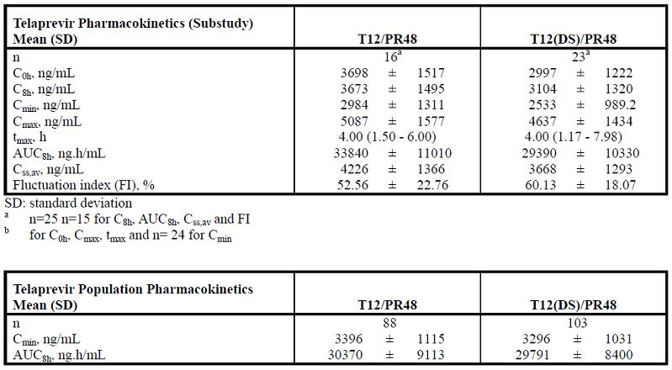
Table 56: Summary of telaprevir population PK based on pooled telaprevir arms by subgroups (Study VX-950-TiDP24 C216).
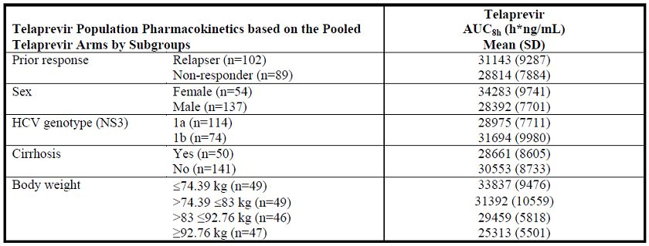

Ancillary analyses
There were no consistent differences in SVR24_{planned} rates in subgroups defined by gender, race, ethnicity, region, BMI or body weight.

Comments
The primary objective of this study was to demonstrate superiority of telaprevir combined with PR compared to PR alone in patients who had failed previous treatment with PR. This objective was met in prior relapsers and prior non responders. SVR24_{planned} rates in the prior relapse groups were 83.4% and 87.9% in the T12/PR48 and T12(DS)/PR groups compared with 23.5% in the Placebo/PR48 group (p <0.001 for both groups compared to control). SVR24_{planned} rates in the prior non responders were 41.3% and 41.5% in the T12/PR48 and T12(DS)/PR48 groups compared to 9.4% in the Placebo/PR48 group (p<0.001 for both groups compared with control). The low SVR rate in the control group was similar to those observed in published studies. In general, SVR rates were higher in patients who achieved RVR and eRVR, in patients with low baseline HCV RNA and in prior non-responders who did not have cirrhosis. Race, ethnicity and body weight did not appear to influence outcome although the number of Asian patients was too few to draw conclusions. For prior relapsers, on treatment virologic failure was infrequent in the telaprevir groups (<1.5%) compared with the control group (26.5%). For prior non-responders, virologic failure occurred in approximately 40% of the telaprevir groups compared with 78% in the control group.
T12/PR48 and T12(DS)/48 were significantly superior to standard treatment in prior relapsers and prior non responders. Despite the fact that NI was not met, there were no clinically meaningful differences between groups given a simultaneous start of telaprevir with PR and those in whom the start of telaprevir was delayed.

Clinical studies in special populations
Clinical efficacy and safety studies have not been conducted in special populations. In particular, no studies in patients with HCV/HIV co infection have been reported in the clinical trial program presented.
Population PK study G190 indicated that subject age and race were unlikely to have a clinically relevant effect on telaprevir exposure. By contrast, subject weight was identified as having the potential for a clinically relevant impact on telaprevir exposure. However, evaluation of the exposure response results reported previously show the magnitude of the effect of weight on telaprevir exposure did not have a clinically relevant impact on the safety or efficacy of telaprevir within the weight range of 51-120 kg.
The telaprevir C_{max} and AUC in subjects with severe renal impairment, were approximately 10% and 21% higher, respectively, than in healthy control subjects and the sponsor believes these differences in telaprevir exposure are unlikely to be clinically relevant.
Subjects with mild hepatic impairment (CPA) had ∼10% and 15% lower C_{max} and AUC values, respectively, than healthy subjects and following multiple doses. In subjects with moderate hepatic impairment (CPB) steady state telaprevir C_{max} and AUC_{8h} were reduced by approximately 49% and 46%, respectively. It must be noted that the appropriate dose of telaprevir in subjects with CPB has not been determined and therefore telaprevir is not recommended in these subjects.
Telaprevir has not been studied in subjects with severe hepatic impairment (Child-Pugh Class C), and is not recommended in this population.

Analysis performed across trials (pooled analyses and meta analysis)
Study data were not pooled for efficacy analysis because of differences in the study populations (treatment naïve and treatment failure patients) and study designs (treatment regimens, treatment duration, stratification factors and virologic stopping rules). However, some study endpoints can be compared. SVR rates were significantly higher in the telaprevir treatment groups than in the control group with p values ranging from <0.0001 to <0.024. All Phase 3 studies met the primary endpoints in treatment naïve patients. SVR rates were significantly higher in the telaprevir treatment groups compared with the control group (p <0.001). The difference in SVR rates between each telaprevir treatment group compared with the control group in the Phase 2 and Phase 3 studies in treatment naïve patients is shown in Figure 19, and for the treatment failure population in Figure 20. In all studies, there was a clear efficacy benefit in favour of the T/PR regimens.Treatment outcomes in the Phase 3 studies in treatment naïve patients are shown in Table 57 and for treatment failure patients in Table 58. The most common reason for not achieving SVR was virologic failure.
Figure 19: Absolute differences in SVR rates between telaprevir and control groups and 95% CI for the difference in treatment naive population, FA set.
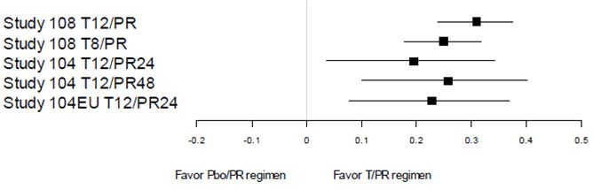
Figure 20: Absolute differences in SVR rates between telaprevir and control groups and 95% CI for the difference in overall treatment failure population, FA set.
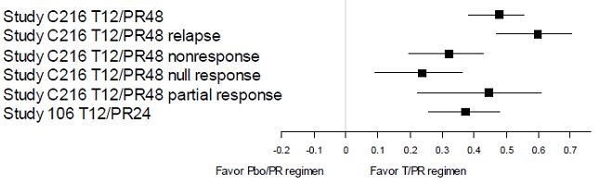
Table 57: SVR rates by baseline liver disease status and HCV genotype in treatment naive population across Phase 3 studies, FA set.
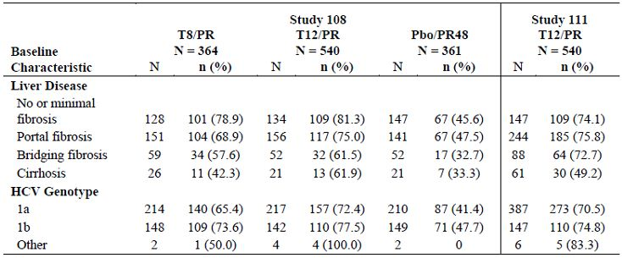
Table 58: Treatment outcome in treatment naive population across Phase 3 studies, FA set.
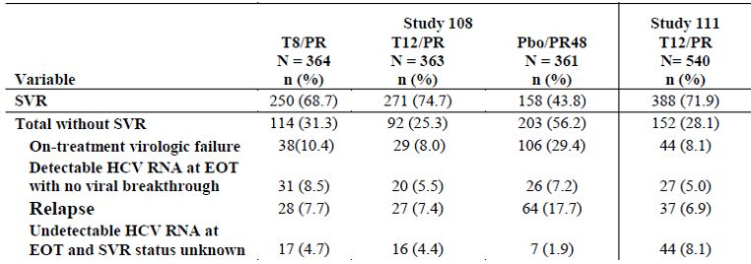
In patients assigned to telaprevir treatment, there was a rapid and marked decrease in HCV RNA in all studies in treatment naïve and in treatmentfailure patients as shown in Figure 21. The rates of viral response including RVR and eRVR were consistently higher in the telaprevir treatment groups compared with the control groups. On treatment virologic failure was categorised as patients who met the specific stopping rule of each study, or by patients who had detectable HCV RNA at the end of treatment. In treatment naïve patients in the Phase 3 studies, virologic failure rates were low in the T12/PR groups (8.0-8.1%) and marginally higher in the T8/PR group. On treatment virologic failure rates in the treatment failure patients ranged between 17.0-19.5%, lowest in prior relapse patients and highest in prior non response patients. In treatment naïve patients in the Phase 3 studies, virologic relapse rates were low (4.2-7.3% in patients who completed dosing). In treatment failure patients, relapse rates in patients who completed dosing were 3.9-4.5% in prior relapse patients and 17.4-24.2% in prior non response patients.
Figure 21: Mean (SE) change in HCV RNA levels from baseline to Week 12 in treatment naive and treatment failure populations, T12/PR treatment groups.
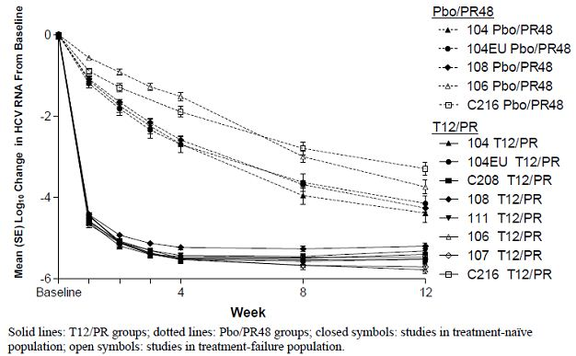
SVR rates were consistently higher across studies in both treatment naïve and treatment failure patients in the telaprevir treatment groups compared with controls. This efficacy benefit occurred regardless of baseline demographics and disease characteristics, including Black and Hispanic patients, patients with cirrhosis, patients with high baseline HCV RNA and prior treatment non responders (Figures 22-23). SVR rates following T/PR treatment were significantly higher than in controls regardless of liver fibrosis status although cirrhotic patients in both groups had lower SVR rates than patients with less advanced liver disease (Table 59). In treatment failure patients, SVR rates in T/PR groups were significantly higher than in controls regardless of the stage of liver disease and prior treatment failure category.
Figure 22: Absolute differences in SVR rates between T12/PR and control groups and 95% CI for the difference by subpopulations in subjects with prior relapse, FA set (Study VX-950-108).
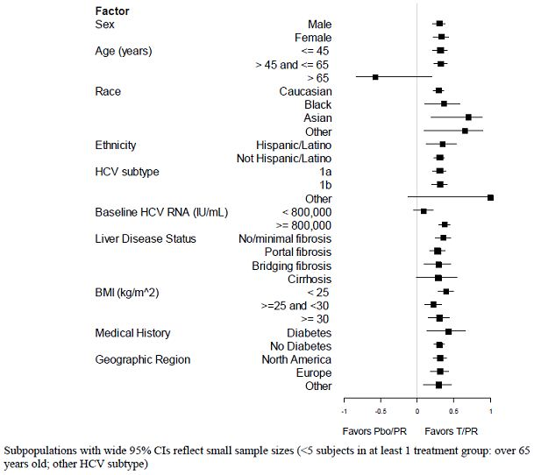

Figure 23: Absolute differences in SVR rates between T12/PR and control groups and 95% CI for the difference by subpopulations in subjects with prior relapse, FA set (Study VX-950-TiDP24 C216).
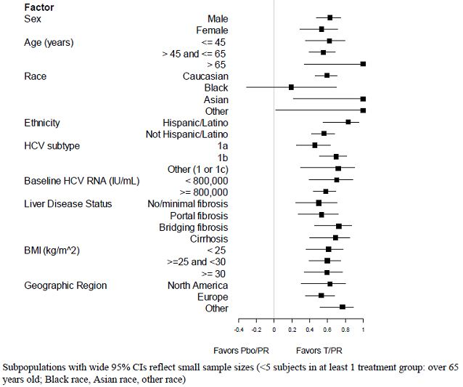
Table 59: On treatment virologic failure across Phase 3 studies, FA set.
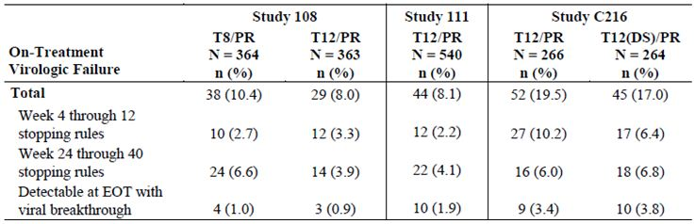
Standard PR treatment is given for 48 weeks. Response guided therapy was investigated in the Phase 3 Studies 108 and 111 in treatment naïve patients who achieved undetectable HCV RNA at Weeks 4 and 12. In Study 108, SVR rates were 89.2% in patients in the T12/PR group who had undetectable HCV RNA at Weeks 4 and 12. Relapse rates were low (6.4%) in patients who completed treatment and achieved eRVR in the T12/PR group. In Study 111, SVR rates were 92.0% in the T12/PR24 group and 87.5% in the T12/PR48 group in patients with eRVR at Weeks 4 and 12. These observations support the use of T/PR for 24 weeks in treatment naïve patients with undetectable HCV RNA at Weeks 4 and 12; and for 48 weeks in treatment naïve patients with detectable HCV RNA at Weeks 4 and 12. Response guided therapy was not evaluated in treatment failure patients. However, it is likely that prior relapse patients may have similar SVR24 rates compared with treatment naïve patients as shown in Table 60. SVR rates were high (>89.2%) and comparable in both treatment naïve and prior relapse patients, and relapse rates were low in the prior relapse group.
Table 60: SVR and relapse in subjects with undetectable HCV RNA at Weeks 4 and 12 (eRVR), FA set.
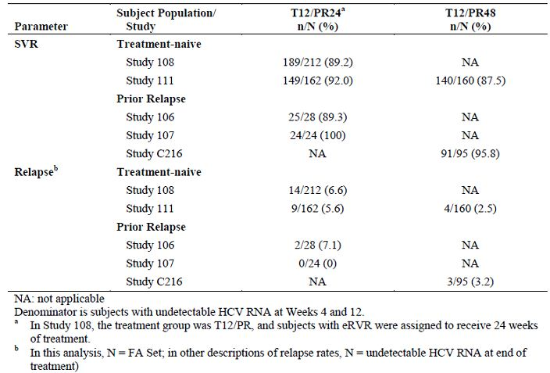
Durability of SVR was assessed in 167 patients who were followed for up to 1.5 years from the end of treatment in the Phase 2 studies. Only two of these patients had late relapse; one had received treatment for less than 10 weeks and one had received treatment without RBV. In the Phase 3 Studies 108 and 111, patients with SVR24 were followed for up to one year from the end of planned treatment and six of 491 patients had a late relapse. SVR was also durable after telaprevir based treatment in treatment failure patients. There was no late relapse in any of 203 patients in Phase 2 studies in the treatment failure population.

Supportive studies

Study VX-950-104 (104)
This was a Phase 2 study of VX-950 in combination with Peg-IFNα-2a (Pegasys), with RBV (Copegus) in subjects with genotype 1 hepatitis C who had not received prior treatment.

Methods
This was a 48 week, multicentre, randomised, placebo controlled, double blind study of treatment naïve male and female patients. Patients received placebo or telaprevir for 12 weeks in combination with Peg-IFNα and RBV for 12, 24 or 48 weeks as shown in Table 61.
Table 61: Treatment groups in Study VX-950-104.
Randomisation was stratified by race (Black or non Black). Patients in the T12/PR12 and T12/PR24 groups were required to meet RVR criteria:
- undetectable HCV RNA from Weeks 4-10 inclusive in the T12/PR12 group; and
- undetectable HCV RNA from Weeks 4-20 inclusive in the T12/PR24 group.
The RVR criterion did not apply to the T12/PR48 or the Placebo12/PR48 groups. Subjects with undetectable HCV RNA at the end of dosing were followed for up to 24, 48 or 60 weeks depending on their treatment group.
The study planned to include sparse data sampling and population PK to describe the exposure response relationship in a population of patients who were naïve to anti HCV therapy.

Objectives
The primary objective was to assess the proportion of patients in each group with undetectable HCV RNA 24 weeks after the completion of the assigned study drug treatment. Secondary objectives included assessments of: the proportion of patients in each group with undetectable HCV RNA 12 weeks after the completion of study treatment; the proportion of patients with undetectable plasma HCV RNA at the completion of study treatment; and telaprevir PK profiles.

Study participants
Key inclusion criteria included: male and female patients aged 18-65 years inclusive; genotype 1 chronic hepatitis C confirmed by standard criteria; and good general health with no marked laboratory abnormalities. Key exclusion criteria included: contraindications to Peg-IFNα or RBV therapy; decompensated liver disease; any other cause of significant liver disease in addition to hepatitis C; suspected hepatocellular carcinoma; histological evidence of hepatic cirrhosis; use of prohibited medications; a history of confounding illness; and suspected alcohol abuse.

Treatments
The study treatments are shown in Table 61.

Treatment compliance and withdrawals
Treatment compliance was assessed at each visit by counting returned drugs and by reviewing patient dosing diary cards. Discrepancies were recorded and patients were withdrawn for continued non compliance. Patients could also be withdrawn for concomitant illness requiring a prohibited medication; a medical illness endangering safety; pregnancy or withdrawal of consent.

Outcomes and endpoints
Efficacy evaluations were related to plasma HCV RNA levels measured on Days 1, 4, 8, 15, 22, 29, 43, 57, 71 and 85 (Week 12). Patients in the T12/PR24 group also had HCV RNA measurements at Weeks 16, 20 and 24. Patients in the T12/PR48 and Placebo/PR48 groups also had HCV RNA levels measured at Weeks 16, 20, 24, 28, 36 and 48. The main efficacy endpoint was the proportion of patients with SVR. The secondary efficacy endpoints were: the proportion of patients with undetectable HCV RNA levels; log₁₀ HCV RNA levels; and maximum decrease from baseline in log₁₀ HCV RNA levels.

Sample size and statistics
The FA set used for all efficacy analyses included all randomised patients who received at least one dose of study drug. The PP set consisted of all randomised patients without any major protocol violations. Categorical data were presented using counts and percentages. Continuous variables were presented using conventional descriptive statistics. Measurements regarded as spurious or invalid were excluded from the analysis. All statistical analyses were performed using version 9.1.3 of the SAS System (SAS Institute Inc.).

Randomisation and blinding
Randomisation was performed via IVRS in blocks and stratified by race (Black versus any other race). Patients were randomised to the four treatment groups 1:1:1:1 for the first 80 patients. For the remaining 180 patients, randomisation was 1:1:1 for the T12/PR24, T12/PR48 and Placebo12/PR48 groups. The study was double blind through to Week 10. After the Week 10 visit, patients in the T12/PR12 group were unblinded for treatment and HCV RNA levels to permit appropriate treatment based on the RVR criterion. Patients in the other three treatment groups remained blinded until Week 20, at which point they were unblinded to treatment assignment and HCV RNA levels. Monitoring of viral breakthrough occurred from Weeks 1-12 inclusive by an independent reviewer and the information was given to the investigator if the investigator thought it was clinically necessary.

Results

Recruitment
A total of 263 patients was enrolled and randomised. The FA set included all patients who received at least one dose of study drug. Thirteen patients did not receive study drug so the final FA set was 250 patients.

Protocol violations
A total of 33 patients was enrolled by exemption; 19 in the T/PR groups and 14 in the Placebo/PR group. In addition, 4 patients did not meet entry laboratory criteria. None of the exemptions were considered to affect the primary efficacy analysis.

Baseline data
Demographics and baseline characteristics were similar in all four treatment groups. The majority of patients were male (63%) and Caucasian (77%) with a mean age of 48 years. The median baseline HCV RNA was log₁₀ 6.6 IU/mL and most patients (87%) had HCV RNA ≥800,000 IU/mL. 32% patients had no or minimal fibrosis, 47% had portal fibrosis and 20% had bridging fibrosis. The majority of patients had genotype 1a.

Numbers analysed
A total of 250 patients were included in the FA set.

Outcomes

Primary efficacy endpoint
The primary efficacy endpoint was SVR (undetectable HCV RNA levels 24 weeks after the completion of study drug dosing). SVR rates were 35.3% in the T12/PR12 group, 60.8% in the T12/PR24 group, 67.1% in the T12/PR48 group and 41% in the Placebo12/PR48 group. The primary analysis was a comparison of the T12/PR24 group with the Placebo12/PR48 group. The SVR rate of 61% in the T12/PR24 group was significantly higher than the 41% SVR rate in the Placebo12/PR48 group (p <0.02). The SVR rate of 67% in the T12/PR48 group was also significantly higher than the SVR rate of 41% in the Placebo12/PR48 group (p <0.001).

Secondary efficacy endpoints
The secondary efficacy endpoint was undetectable HCV RNA 12 weeks after completion of study drug dosing. At each time point, the proportion of patients with undetectable HCV RNA was higher in each T/PR group than in the Placebo/PR group. RVR rates (undetectable HCV RNA at Week 4) were 79% in the combined T/PR group compared with 11% in the Placebo/PR group. The percentage of patients with undetectable HCV RNA at the end of assigned treatment was 71% in the T12/PR12 group, 57% in the T12/PR24 group, 65% in the T12/PR48 group and 47% in the Placebo12/PR48 group.

Ancillary analyses
During the first 12 weeks of treatment, the incidence of viral breakthrough was 7% in the combined T/PR group with 75% of these events occurring in the first 4 weeks. In the combined T/PR groups, 10/12 (83%) patients with breakthrough never achieved undetectable HCV RNA levels. The incidence of viral breakthrough at Week 12 was 2/75 (3%) in the Placebo/PR group.
The population PK analysis was performed in 4518 samples from 175 patients administered telaprevir 750mg q8h for up to 85 days. The majority of test results were in the range 2,000-4,000 ng/mL.

Comments
The addition of telaprevir to PR significantly improved SVR rate for patients infected with HCV genotype 1 compared with standard PR therapy. SVR was 61% in the T12/PR24 group and 67% in in the T12/PR48 group compared with 41% in the control group (p <.02 and <0.001, respectively). The observed SVR rate in the Placebo/PR48 group was similar to rates observed in published HCV trials. The SVR rate for T12/PR12 (35%) was lower than the SVR rate in the Placebo12/PR48 group (41%). Improved SVR rates were associated with a marked increase in RVR at Week 4 with telaprevir based treatments. Relapse rates of 2-6% for telaprevir based therapy compared with 23% for the control group, which was within the 18-30% rates reported for standard PR therapy. Relapse was associated with telaprevir resistant viral variants in nearly all cases. The viral response rates were higher in the T/PR groups than in the Placebo/PR group. The incidence of viral breakthrough during the first 12 weeks of treatment was 7% in the telaprevir groups and 3% in the control group.

Study VX-950-104EU (104EU)
This was a Phase 2 study of VX-950 in combination with Peg-IFNα-2a (Pegasys), with and without RBV (Copegus) in subjects with chronic hepatitis C.

Methods
This was a 48 week, randomised, partially placebo controlled, partially double blinded study. Patients received placebo or telaprevir in combination with Peg-IFNα, with and without RBV for 12 weeks, followed by PR for 0, 12 or 36 weeks. Randomisation was stratified by race (Black or any other race) and by baseline weight (>75 kg or ≤75 kg). The four treatment groups are shown in Table 62.
Table 62: Treatment groups in Study VX-950-104EU.
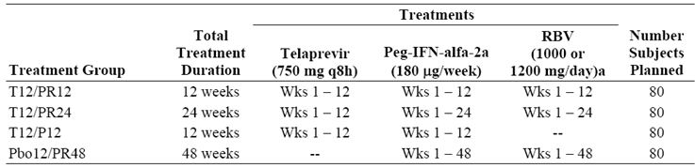
The control group (Placebo12/PR48) received treatment for 48 weeks in line with current standard PR treatment for genotype 1 hepatitis C.

Objectives
The primary objective was to assess the proportion of patients in each treatment group with undetectable HCV RNA 24 weeks after completion of their assigned study treatment.
The secondary objectives included: to assess the proportion of patients in each treatment group with undetectable HCV RNA 12 weeks after completion of their assigned study drug: to assess the proportion of patients who received telaprevir with undetectable HCV RNA at the completion of their assigned study treatment; and to examine the PK profile of telaprevir.

Study participants
Inclusion criteria included male and female patients aged 18-65 years inclusive; patients with genotype 1 chronic hepatitis C confirmed by conventional diagnostic criteria; patients in otherwise good general health. Key exclusion criteria included: contraindications to PR therapy; decompensated liver disease; any other cause of significant liver disease in addition to hepatitis C; suspected hepatocellular carcinoma; histological evidence of hepatic cirrhosis; use of prohibited medications; a history of confounding illness; and suspected alcohol abuse.

Treatments
Study treatments are shown in Table 62.

Treatment compliance and withdrawals
Treatment compliance was assessed at each visit by counting returned drugs and by reviewing patient dosing diary cards. Discrepancies were recorded and patients were withdrawn for continued non compliance. Patients could also be withdrawn for concomitant illness requiring a prohibited medication; a medical illness endangering safety; pregnancy or withdrawal of consent.

Outcomes and endpoints
Efficacy outcomes were based on plasma HCV RNA levels. For all patients, HCV RNA levels were measured at Days 1, 4, 8, 15, 22, 29, 43, 57, 71 and 85. Patients in the T12/PR24 group who met viral response criteria had HCV RNA levels measured from Week 16 to 48 weeks after study drug dosing; patients in the T12/PR12 and T12/P12 groups who met viral response criteria had HCV RNA levels measured from Week 1 to 48 weeks after completion of study drug dosing. Patients in the Placebo12/PR48 group had HCV RNA measurements at Weeks 16 through to Week 48 after the completion of study dosing. Patients in the T12/PR12 and T12/P12 groups who did not meet the viral response criteria had HCV RNA measurements from Week 16 through to Week 48 after completion of study treatment.

Sample size and statistics
There were no sample size calculations and descriptive statistics were reported by conventional methods. The FA set included all patients who received at least one dose of study drug. Five interim analyses were conducted to monitor on treatment safety and antiviral efficacy. The primary efficacy variable was the proportion of patients with SVR, undetectable HCV RNA 24 weeks after completing study treatment. The primary analysis was a comparison of the Placebo12/PR48 group with the T12/PR24, T12/PR12 and T12/P12 groups. The proportion of patients with SVR was evaluated using logistic regression with treatment, race, baseline weight and baseline HCV RNA levels as factors. Results were presented as SVR rates and p values for the differences between the Placebo/PR48 group and the T12/PR24, T12/PR12 and T12/P12 groups. Viral relapse was defined as having detectable HCV RNA during antiviral follow up in patients who completed their assigned study drug treatment with undetectable HCV RNA at the completion of treatment. Viral breakthrough was defined as an on treatment increase in HCV RNA of >1 log₁₀ or an on treatment HCV RNA level of >100 IU/mL in a patient who had undetectable HCV RNA at a prior time point. Relapse was defined as a transition from undetectable to detectable HCV RNA during the follow up period in a patient with undetectable HCV RNA at the end of the dosing period. All statistical analyses were performed using version 9.1.3 of the SAS System (SAS Institute Inc.).

Randomisation and blinding
Randomisation was performed by blocks and stratified by race (Black or any other race) and baseline body weight. Patients were randomised by IVRS to the four treatment groups in a 1:1:1:1 ratio. During study drug dosing to Week 10, the study was partially double blinded. The patients and investigators did not know whether patients were enrolled in the T12/PR12, T12/PR24 or Placebo12/PR48 groups although assignment to the T12/P12 was not blinded. The results of HCV RNA measurements were also blinded until Week 10 although they were made available to the investigator if this was considered medically necessary. Before Week 12, the investigator was made aware of the assigned treatment and the results of all HCV RNA tests.

Results

Recruitment
A total of 334 patients was recruited and randomised. Eleven patients were discontinued before receiving a dose of study drug so the FA set included 323 patients. A total of 24 patients were enrolled by exemption, balanced between the treatment groups.

Protocol violations
Protocol deviations related to the timing of virologic testing excluded 26 patients from the PP analysis. Another three patients were excluded for other reasons.

Baseline data
Demographic data and baseline characteristics were similar in the four treatment groups. The majority of patients were male (59%) and White (94%) with a mean age of 44 years. The median baseline log₁₀ HCV RNA was 6.4 IU/mL. Of the patients 323 in the FA set, 38% had no or minimal fibrosis, 53% had portal fibrosis, 8% had bridging fibrosis and one subject had cirrhosis.

Numbers analysed
A total of 323 patients were included in the FA set.

Outcomes

Primary efficacy endpoint
The primary efficacy endpoint was the proportion of patients with SVR 24 weeks after the last dose of study drug. The SVR rate for the Placebo/PR48 group was 46% compared with 69% for the T12/PR24 group (p <0.003), 60% for the T12/PR12 group (p <0.1) and 36% (lower than the control group) in the T12/P12 group. The SVR rate for the combined T12/PR12 and T12/P12 groups was 48%, similar to the 46% SVR rate in the control group.

Secondary efficacy endpoints
The key secondary endpoint was the proportion of patients with undetectable HCV RNA 12 weeks after the last dose of study drug. The proportions of patients with undetectable HCV RNA at Weeks 4, 12, 24 and 48 are shown in Table 63. RVR rates at Week 4 were 75% in the combined T/PR groups, 50% in the T12/P12 group and 13% in the Placebo/PR48 group. At Week 12, 81% of patients in the T12/PR12 group, 70% of patients in the T12/PR24 group and 62% of patients in the T12/P12 group had undetectable HCV RNA compared with 55% in the Placebo/PR48 group (at Week 48).
Table 63: On treatment viral response rates (undetectable HCV RNA), FA set (Study VX-950-104EU).
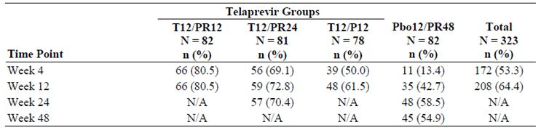

Ancillary analyses
Viral breakthrough during the first 12 weeks of treatment occurred in 1/82 (1%) patients in the Placebo/PR48 group compared with 5/163 (3%) patients in the combined T/PR groups with 80% occurring in the first 4 weeks of treatment. In the T12/P12 group, the incidence of viral breakthrough at Week 12 was 19/78 (24%) patients with 9/19 (47%) occurring in the first 4 weeks of treatment. The mean change in HCV RNA from baseline to Week 12 was log₁₀ -5.6 in the T12/PR12 group, -5.4 in the T12/PR24 group, -4.3 in the T12/P12 group and -4.2 in the Placebo/PR48 group. Viral relapse rates were 30% in the T12/PR12 group, 14% in the T12/PR24 group, 48% in the T12/P12 group and 22% in the Placebo/PR48 group.
In the PK population substudy, the majority of telaprevir trough concentrations were in the 2,000-4,000 ng/mL range.

Comments
The observed SVR rate of 46% in the Placebo12/PR48 group is consistent with SVR rates in previous studies with standard current therapy. The results of this study showed that the addition of 12 weeks of telaprevir treatment significantly improved SVR rates when added to PR treatment for 24 weeks (p <0.003). A similar trend was observed for treatment with telaprevir for 12 weeks and PR for 12 weeks. In the combined T/PR groups, SVR rates were 75% compared with 13% in the control group after 12 weeks treatment. The RVR rate in the T12/P12 group was higher than in the control group but lower than in the T/PR groups.
The relapse rate was 14% in the T12/PR24 group, 30% in the T12/PR12 group, 48% in the T12/P12 group and 22% in the control group, suggesting that a treatment duration of 24 weeks has the potential to significantly improve SVR relapse rates compared with 48 weeks standard therapy. The high relapse rate in the T12/P12 group suggests that RBV should be included in a combination with T/P to achieve optimal SVR rates.

Study VX-950-106 (106)
This was a Phase 2 study of telaprevir in combination with Peg-IFNα-2a (Pegasys), and RBV (Copegus) in subjects with genotype 1 hepatitis C who had not achieved sustained viral response with a prior course of IFN based therapy.

Methods
This was a 48 week, randomised, stratified, partially placebo controlled, partially double blinded study in which patients were randomised to one of four treatment groups: PR for 4 weeks; T/PR for 24 weeks followed by 24 weeks of PR given alone; telaprevir in combination with Peg-IFNα for 24 weeks; and T/PR for 12 weeks followed by 12 weeks PR given alone. The study enrolled patients with genotype 1 HCV infection who did not achieve SVR when previously treated with standard PR therapy. The patient group included prior non responders, patients who had viral breakthrough during the course of prior treatment and patients who relapsed after achieving negative HCV RNA levels at the end of their previous treatment. Randomisation was stratified with regard to race and previous viral response.
The treatment groups are shown in Table 64.
Table 64: Treatment groups in Study VX-950-106.
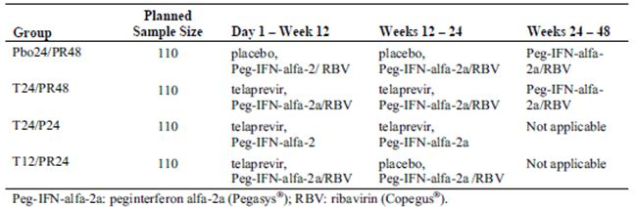

Objectives
The primary objective was to compare the proportion of patients who achieved SVR (undetectable HCV RNA 24 weeks after completion of treatment) when given telaprevir in combination with: PR for 24 weeks followed by PR alone for 24 weeks; Peg-IFNα alone for 24 weeks; and PR for 12 weeks followed 12 weeks PR given alone.
Key secondary objectives included a comparison of the proportion of patients with undetectable HCV RNA levels at the end of treatment in each telaprevir group with the control Placebo24/PR48 group; a comparison of the proportion of patients with SVR (undetectable HCV RNA 48 weeks after the end of treatment) in each telaprevir group compared with the control group; and the PK profile of telaprevir at steady state.

Study participants
Key inclusion criteria included: male and female patients aged 18-70 years inclusive; chronic genotype 1 HCV infection; detectable plasma HCV >10,000 IU/mL; liver biopsy in the previous three years; good general health; acceptable laboratory parameters; and previous treatment with at least one adequate course of PR without achieving SVR. Key exclusion criteria included: significant concurrent illness; contraindications to PR therapy; non compliance with previous PR therapy; a history of or current decompensated liver disease; other significant liver disease in addition to HCV; suspected hepatocellular carcinoma; and suspected drug or alcohol abuse.

Treatments
A single loading dose of 1125 mg telaprevir was administered to the Patients on Day 1. Thereafter, they received a dose of 750 mg telaprevir q8h. Pegasys and Copegus were administered according to the information in the package inserts.

Treatment compliance and withdrawals
Compliance was assessed by counting returned dosage units and by reviewing patient dosing diary cards. Patients with continued poor compliance were withdrawn from the study. Other withdrawal criteria included significant medical illness; prohibited concomitant medications; and pregnancy.

Outcomes and endpoints
The efficacy endpoint was plasma HCV RNA levels measured at Day 1 and Weeks 1, 2, 3, 4, 8, 12, 16, 20 and 24. In addition, plasma HCV RNA levels were measured at Weeks 32, 36, 40, 44 and 48 for patients in the T24/PR48 and Placebo24/PR48 groups. HCV RNA levels in patients who completed drug treatment and who had undetectable HCV RNA were also measured at 4, 12 and 24 weeks after the last dose of study drug to assess the durability of the virologic response. Telaprevir PK assessments were performed in 220 patients at selected sites.

Sample size and statistics
The FA set included all patients who received at least one dose of study drug. The PP analysis set was only used to provide a supportive analysis of the primary efficacy variables. Conventional descriptive statistics were used for all parameters. Assuming 45% response rate in a telaprevir group and 20% response in the control group, 110 evaluable patients in each group provided approximately 90% power to demonstrate a statistically significant difference. This sample size was based on a two sided continuity corrected χ² test with an overall significance level of 5% using the Bonferroni correction.

Randomisation and blinding
Patients were randomised 1:1:1:1 to the four treatment groups by IVRS. Randomisation was performed in blocks and stratified by race and viral response to previous therapy. Treatment assignments were double blinded for the first 24 weeks in patients receiving Placebo/PR48, T24/PR48 and T12/PR24 but the T24/P24 group was not blind. For all groups, HCV RNA levels were double blinded until Week 24. During this period, an independent reviewer assessed individual HCV RNA levels to determine if patients met any treatment discontinuation criteria. Patients were not informed of treatment assignments until the last subject had reached Week 72. The investigator was unblinded only in the event of a medical emergency.

Results

Recruitment
A total of 465 patients were enrolled and randomised. Twelve patients discontinued before receiving study drug. Therefore, the FA set included 453 patients.

Protocol violations
Protocol deviations resulted in the exclusion of 18 patients from the PP analysis set. A total of 46 patients were enrolled by exemption for reasons considered unlikely to affect the primary endpoint. No patients were discontinued because of non-compliance.

Baseline data
Most patients were male (68%) and White (89%) with a mean age of 51 years. The median log₁₀ HCV RNA was 6.7 IU/mL. Of the 453 patients in the FA set, 21% had no or minimal fibrosis, 36% had portal fibrosis, 27% had bridging fibrosis and 16% had cirrhosis. Female patients comprised 28% of prior non responders and 38% of prior relapsers. Black patients comprised 12% of prior non responders and 6% of prior relapsers. Other baseline characteristics were similar in incidence between non responders and prior relapsers. Patient demography for the PP analysis set was similar to the FA set.

Numbers analysed
A total of 453 patients were included in the FA set.

Outcomes

Primary efficacy endpoint
The primary efficacy endpoint was the number and proportion of patients with SVR, including all patients in the FA set who completed assigned treatment as well as patients who discontinued prematurely. The SVR rates in each of the telaprevir treatment groups were significantly higher than the SVR rates in the Placebo24/PR48 group. SVR rates were 51% in the T12/PR24 group (p <0.001 compared to the control group), 53% in the T24/PR48 group (p <0.001 compared to the control group), 24% in the T24/P24 group (p = 0.024 compared to the control group) and 14% in the Placebo24/PR48 control group. Achieving undetectable HCV RNA during prior PR therapy was significantly associated with SVR (p<0.001). SVR rates in prior non responders and prior relapsers were significantly higher in each of the T/PR groups than in the control group. SVR rates were generally comparable in the T12/PR24 and T24/PR48 groups.

Secondary efficacy endpoints
SVR rates, overall and by prior response, were higher in the telaprevir treated patients with RVR than in patients without RVR. Overall SVR rates in patients with RVR versus patients without RVR were 74% versus 16% in the T12/PR24 group, 73% versus 33% in the T24/PR48 group and 46% versus 5% in the T24/P24 group. These results show that RVR is associated with SVR. Among patients with undetectable HCV RNA at the end of dosing, SVR rates were higher in patients who completed study drug treatment than inpatients who prematurely discontinued all study drugs: 71% versus 29% in the T12/PR24 group, 94% versus 44% in the T24/PR48 group and 49% versus none in the Placebo24/PR48 group.
A summary of the telaprevir PK is shown in Figure 24. The median trough plasma telaprevir concentration was 2,259 ng/mL, with a range 616 to 6624 ng/mL (Table 65).

Figure 24: Observed RBV plasma concentrations (Study VX-950-106).
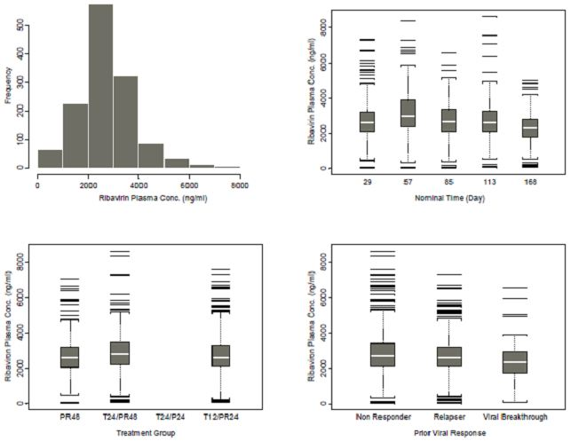
Table 65: Summary of model predicted telaprevir PK parameters (Study VX-950-106).
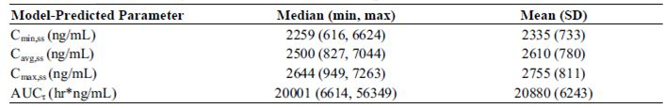

Ancillary analyses
Racial response rates in Black patients appeared to be similar to response rates in Whites but the number of Black patients was too small to make meaningful comparison. SVR rates in patients with cirrhosis were 53% in the T12/PR24 group, 45% in the T24/PR48 group, 18% in the T24/P24 group, and 8% in the Placebo24/PR48 control group. SVR rates overall and in prior relapsers were comparable among patients in the T/PR groups with and without cirrhosis. SVR rates in prior non responders were lower among patients in the T/PR groups with cirrhosis than in patients without cirrhosis.

Comments
The primary study objective was to compare the SVR rate with standard PR treatment with each of three telaprevir treatment regimens in HCV patients with prior non response, prior relapse or prior viral breakthrough. SVR rates in the control group were similar to those reported for PR therapy in the literature. The results of the study suggest that patients who have failed to achieve SVR with prior PR therapy have a substantial benefit when treated with T/PR, regardless of their previous pattern of virologic response. The benefit was larger in prior relapsers but it was also apparent in non responders, patients who are usually refractory to further courses of PR. In common with treatment naïve patients, patients who had undetectable HCV RNA at Weeks 4 and 12 had the highest SVR rates.
Viral breakthrough occurred in approximately 12% of patients in the T/PR groups, mostly in prior non-responders. Relapse rates were lower in the T/PR groups compared with controls although rates were similar in the T24/P24 group. In each telaprevir treatment group, the relapse rate was higher in prior non responders than in prior relapsers and higher in patients who prematurely discontinued study treatment. The results of the study show that SVR rates are higher in patients treated with telaprevir and that RBV treatment is also required to increase virologic response.

Study VX-950-107 (107)
This was a Phase 2 rollover protocol of telaprevir in combination with Peg-IFNα-2a (Pegasys) and RBV (Copegus) in subjects enrolled in the control groups of Studies VX06-950-106, VX05-950-104 and VX05-95-104EU who did not achieve or maintain an undetectable HCV RNA level through sustained viral response.

Methods
This was an open label study of 12 weeks of T/PR dosing followed by dosing with PR for 12 or 36 weeks, based on prior and current treatment response, in control group patients from Studies 104, 104EU and 106 who did not achieve SVR following Placebo24/PR48. Prior viral response was defined as:
- Null response: <1 log₁₀ decrease in HCV RNA at Week 4 or <2 log₁₀ decrease at Week 12.
- Partial response: >2 log₁₀ decrease in HCV RNA at Week 12, but detectable HCV RNA at Week 24.
- Viral Breakthrough: Detectable HCV RNA during treatment after achieving undetectable HCV RNA.
- Relapse: Undetectable HCV RNA at the end of treatment followed by detectable HCV RNA during viral follow up.
Patients with prior partial response, prior viral breakthrough, or prior relapse during the parent study were treated according to their response at Weeks 4 and 12 in the present study, as follows:
- If HCV RNA was undetectable at Week 4 and Week 12 (achieved eRVR) in the present study, patients received an additional 12 weeks of PR therapy (T12/PR24).
- If HCV RNA was detectable at Week 4 or week 12 (did not achieve eRVR), patients received an additional 36 weeks PR therapy (T12/PR48).
Patients with a partial response, viral breakthrough or relapse in the parent study, and who discontinued treatment before Week 12, were included in the ‘Other’ treatment group.
The investigator reviewed HCV RNA from each on treatment visit to determine if patients should discontinue study treatment based on pre determined stopping rules.

Objectives
The primary objectives were: to provide access to a telaprevir based treatment for patients who had inadequate response to Placebo12/PR 48 in previous studies, and to demonstrate the efficacy of T/PR in treatment experienced patients with chronic HCV infection.
The secondary objectives were: to compare intra subject antiviral response to T/PR treatment and antiviral response to prior PR treatment, and to assess anti viral response to T/PR treatment in patients categorised as null response, partial response, having viral breakthrough or relapse during PR treatment in previous studies.

Study participants
Patients randomised in the control arms of Studies 104, 104EU or 106 were eligible provided additional inclusion criteria based on prior virologic response and safety assessments were also met. The key exclusion criterion was patients who discontinued treatment in the parent studies due to AE or for any other reason other than failure to respond to therapy. Other general exclusion criteria were similar to those in the parent studies.

Treatments
Patients received telaprevir 750 mg (two 375mg tablets) q8h, Peg-IFNα 180µg weekly by SC injection, and oral RBV with the dose based on weight (1,000 mg for patients <75 kg or 1,200 mg for patients >75 kg).

Treatment compliance and withdrawals
Drug accountability was performed at each study visit by counting returned dosage units. Withdrawal from the study was required for continued non compliance. Patients could also be withdrawn for virologic non response based on pre determined criteria; for illness requiring prohibited concomitant medication; for concurrent illness affecting the safety of the patient; and pregnancy.

Outcomes and endpoints
Efficacy was based on HCV RNA levels. HCV RNA levels were measured in all patients who completed study drug treatment and had undetectable HCV RNA levels at Weeks 4, 12, 24 and 48 after the last dose of study drug. Plasma HCV RNA levels were measured in patients who prematurely discontinued treatment for reasons other non response, and who had undetectable HCV RNA levels at the time of discontinuation, at Weeks 4, 12 and 48 after the completion of study drug dosing or until HCV RNA became detectable.

Sample size and statistics
The FA set included all patients who received at least one dose of study drug. The primary efficacy variable was the proportion of patients who completed treatment or prematurely discontinued treatment, and who had undetectable HCV RNA at end of treatment and at 24 weeks after the last dose of study drug. The primary efficacy analysis was a point estimate with a 95% CI for the SVR24 rate for each treatment group, ‘Other’ and the ‘Total’ group which combined all enrolled and treated patients. Viral breakthrough was defined as an on treatment increase in HCV RNA of >1 log₁₀ or an on treatment HCV RNA level of >100 IU/mL in a patient who had undetectable HCV RNA at a prior time point. Relapse was defined as a transition from undetectable to detectable HCV RNA during the follow up period in a patient with undetectable HCV RNA at the end of the dosing period. All statistical analyses were performed using version 9.1.3 of the SAS System (SAS Institute Inc.).

Results

Recruitment
There were 117 patients in the FA set with 18 (15%) from Study 104, 17 (14.5%) from study 104EU and 82 (70.1%) from Study 106.

Protocol violations
Four patients continued treatment despite meeting a stopping rule. Two of these patients completed the full originally assigned treatment duration. Four patients were withdrawn for non compliance. A total of 79 (67.5%) patients completed treatment and 38 (32.5%) discontinued treatment. A total of 26 (22.2%) patients were withdrawn when they met a protocol defined virologic stopping rule and 10 (8.5%) were withdrawn because of an AE.

Baseline data
The mean elapsed time between the end of the parent study and entry into study 107 was 6.8 months. In the parent studies, 51 (43.6%) patients had prior non response, 29 (24.8%) had a partial response and 8 (6.8%) had prior viral breakthrough. The majority were male (69.2%) and Caucasian (90.6%) with a mean age of 50.3 years. Thirty four (29.1%) patients had bridging fibrosis and 10 (8.5%) had cirrhosis. Sixty nine (59.0%) patients were infected with HCV genotype 1a and 38 (32.5%) with genotype 1b. The median HCV RNA levels at baseline for all patients was log₁₀ 6.6 IU/mL. Most patients (82.9%) had high baseline HCV RNA levels defined as HCV RNA >800,000 IU/mL.

Numbers analysed
A total of 117 patients were included in the FA set.

Outcomes

Primary efficacy endpoint
The primary efficacy endpoint was SVR24, defined as undetectable HCV RNA 24 weeks after the end of treatment, including all patients who completed treatment as well as patients who discontinued treatment prematurely. SVR24 was achieved in 69/117 (59%) patients (95% CI: 49.5-68.0). SVR24 was achieved in 49/81 (60.5%) patients (95% CI: 49.0-71.2) in the T12/PR24 group; in 18/34 (52.9%) patients (95% CI: 35.1-70.2) in the T12/PR48 group; and in both patients in the ‘Other’ group.

Secondary efficacy endpoints
Subgroup analysis of SVR by prior response is shown in Table 66. SVR24 was achieved by 28 (96.6%) patients with prior relapse; 6 (75%) patients with prior viral breakthrough; 16 (55.2%) patients with prior partial response; and 19 (37.3%) patients who were prior non responders. Response rates in Blacks and Whites were similar although there were only 9 Black patients in the data set. Patients without cirrhosis had higher SVR24 rates than patients with cirrhosis (60.7% and 40% respectively).
Table 66: SVR24 rates overall and by prior response, FA set (Study VX-950-107).
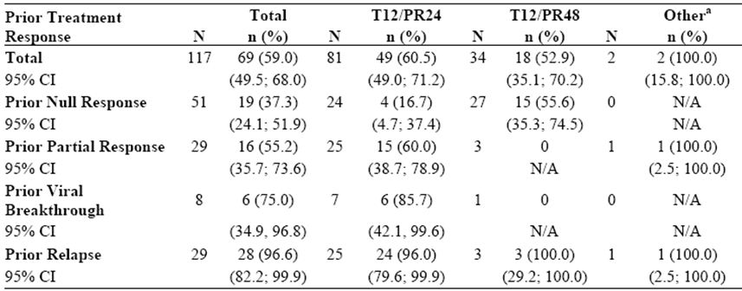

Ancillary analyses
SVR24 was achieved in 51 (52.6%) patients with high baseline viral load (≥800,000 IU/mL) and by 18 (90.0%) patients with low baseline viral load. SVR24 was achieved by 60 (75.0%) patients with RVR and 9 (24.3%) patients without RVR. SVR24 was achieved by 57 (82.6%) patients with eRVR and 12 (25.0%) patients without eRVR. SVR24 was achieved by 64 (81%) patients who completed treatment and 5 (13.2%) who prematurely discontinued treatment.
Undetectable HCV RNA was observed in 80 (68.4%) patients at Week 4 (RVR), 86 (73.5%) patients at Week 12, 80 (69.6%) patients at Week 24; and 18 (52.9%) patients at Week 48. A total of 69 (59.0%) patients achieved eRVR: 17 (33.3%) patients who were prior non responders, 22 (75.9%) patients with prior partial response, 6 (75.0%) patients with prior viral breakthrough, and 24 (82.8%) patients with prior relapse. Relapse occurred in 12 (16.4%) patients with RVR: in 8 (12.3%) patients who completed treatment, and in 4 (50.0%) patients who discontinued treatment. Relapse occurred in 9 (13.4%) patients: in 8 (12.5%) patients who completed treatment, and in 1 (33.3%) patient who discontinued treatment. In patients without eRVR, relapse occurred in 4 (25.0%) patients: in 1 (10.0%) patient who completed treatment, and in 3 (50.0%) who discontinued treatment.

Comments
The primary objective of this study was to evaluate telaprevir in patients with a well characterised failed prior response to standard therapy in the previous Phase 2 studies. Overall, 59.0% of patients in this study achieved SVR24; 37.3% in patients with prior null response; 55.2% in patients with prior partial response; 75.0% in patients with prior viral breakthrough; and 96.6% in patients with prior relapse. The study was open label, non randomised and not controlled but the SVR response in all response categories was approximately twice that reported in published studies of standard therapy. The results are also similar to those observed in Study 106 which showed that the addition of telaprevir to PR was markedly superior to PR alone in treatment experienced patients.

Evaluator’s overall conclusions on clinical efficacy
Eight Phase 2 and 3 efficacy studies were conducted in patients with genotype 1 chronic hepatitis C. There were 2362 treatment naïve and 1232 treatment failure patients and 2830/3594 of these patients received at least one dose of telaprevir. Randomisation was centrally assigned and stratified for demographics and baseline disease characteristics. Blinding and control processes were adequate. The inclusion criteria were similar in all studies, ensuring that all patients had detectable HCV RNA and liver histology consistent with chronic hepatitis C. Patients with concurrent HBV and HIV or any other cause of liver disease were excluded. Patients with cirrhosis were permitted as long as there was no evidence of hepatic decompensation. Treatment naïve patients had received no previous therapy while treatment failure patients had received at least 12 weeks of Peg-IFNα without achieving SVR. Treatment failure patients were well characterised by treatment response (prior null, partial or relapse). The primary efficacy endpoints were consistent across studies; SVR 24 weeks after the last dose of study drug in the Phase 2 studies, and the more conservative SVR 24 weeks after the last planned dose of study drug in the Phase 3 studies. The definitions of virologic failure were less consistent but predetermined in each study protocol as either viral breakthrough or as meeting a selection of virologic stopping rules.
The Phase 2 studies evaluated telaprevir treatment durations of 12 and 24 weeks, Peg-IFNα for 12, 24 or 48 weeks and telaprevir in combination with Peg-IFNα, with and without RBV. The highest SVR rates were achieved with T/PR combinations with PR given for at least 24 weeks while the optimal telaprevir treatment duration was 12 weeks. On treatment viral response patterns after 4 and 12 weeks of treatment also led to response guided treatment duration of 24 or 48 weeks in the Phase 3 studies. To improve the tolerability of the T/PR combination, a treatment duration of 8 weeks was tested but found to be less effective than the 12 week telaprevir treatment regimen.
In the pivotal Phase 3 studies, the primary efficacy endpoint was SVR 24 weeks after the last planned dose of study drug. These studies also included a 72 week follow up of SVR so that all patients in all trials could be compared at the same time point. SVR rates in the control groups ranged from 41.3% to 46.3% which were similar to rates reported in the literature for Peg-IFNα treatment. In treatment naïve and treatment failure patients in the Phase 3 studies, SVR rates were significantly higher in the telaprevir treatment groups compared with the Placebo/PR group (p <0.0001 to <0.024). The absolute differences between each telaprevir group and controls ranged from 19.4% to 30.9%. In treatment naïve patients in the Phase 3 study 108, the difference in SVR rates between the T12/PR group and the Placebo/PR48 group was 30.9% (95% CI: 24.1-37.7%, p <0.0001). SVR rates were also significantly higher in the telaprevir groups compared with controls in treatment failure patients in the Phase 2 and 3 studies (p <0.001). The differences between each telaprevir treatment group and controls ranged from 37.3-49.6%. However, SVR results in the treatment failure population were not uniform. In the pivotal Phase 3 study C216, SVR rates in patients with prior relapse were 83.4% to 87.9% compared with 41.3% to 41.5% in patients with prior nonresponse. The differences in SVR rates between the T/PR groups and control groups were 60.5% to 64.9% in patients with prior relapse compared with 35.0-35.3% in patients with prior nonresponse. Patients with prior nonresponse are refractory to retreatment with standard therapy and SVR rates were lowest in this patient group (29.2% to 33.3%). However, the differences in SVR rates between prior non responders and the Placebo/PR groups were 27.4% to 29.0%, representing a very significant efficacy benefit in favour of T/PR combination therapy.
Viral response, including RVR, eRVR, end of treatment response and SVR, was consistently higher in patients who received telaprevir therapy compared with controls. On treatment virologic failure rates were low in the T12/PR groups in treatment naïve patients (8.0-8.1%) and highest in the treatment failure patients (17.0-19.5%). Virologic failure rates were low in the T12/PR patients with prior relapse (0.7-1.4%) and significantly higher in patients with prior nonresponse (35.8-41.3%). In patients who completed dosing, relapse rates were low in treatment-naïve patients in the Phase 3 studies (4.2-7.3%). Relapse rates in treatment failure patients were 3.9% to 4.5% in patients with prior relapse and 17.4-24.2% in patients with prior nonresponse. Telaprevir resistant HCV variants were detected in most patients with virologic failure or relapse. These resistant variants are replaced by wild type virus when telaprevir treatment is withdrawn. Long term virologic follow up was conducted in Study 112. A total of 123 patients who achieved SVR were followed for a median time of 22 months. SVR was confirmed in 122 (99.2%) of these patients confirming the durability of virologic response in patients who receive telaprevir treatment.
Response guided therapy was evaluated in Study 108 in which patients with eRVR at Weeks 4 and 12 were treated with PR for 24 weeks. SVR rates were 82.6% in the T8/PR group and 89.2% in the T12/PR group in patients who achieved eRVR at Weeks 4 and 12 and were treated for 24 weeks. In Study 111, SVR rates were 92.0% in T12/PR24 patients with undetectable HCV RNA at Weeks 4 and 12, and 87.5% in patients in the T12/PR48 group. This study showed strong statistical evidence for NI of the T12/PR24 treatment regimen compared with the extended T12/PR48 regimen.
As shown in Figure 22, efficacy was generally superior in patients treated with telaprevir regimens compared with controls in subgroups defined by age, gender, race, ethnicity, BMI, medical history, geographic region, HCV genotype, liver disease status and baseline levels of HCV RNA. Patients with cirrhosis had less overall benefit than patients without cirrhosis but those who received telaprevir had higher SVR rates than control patients.
The Phase 2 and 3 study program explored a series of treatment durations for telaprevir and Peg-IFNα/RBV. The study results strongly support the use of telaprevir for 12 weeks. Treatment for 8 weeks was not as effective as treatment for 12 weeks and there was no additional benefit by extending treatment beyond 12 weeks. In treatment naïve and prior relapse patients who have undetectable HCV RNA at Weeks 4 and 12, the evidence supports the use of Peg-IFNα/RBV for 24 weeks. All other treatment failure patients should receive Peg-IFNα/RBV for 48 weeks. Late relapse after achieving SVR with standard therapy is <1%. In patients who achieved SVR with telaprevir based therapy, late relapse occurred in <1% of patients, all within the first 6 months of achieving SVR. All other patients who achieved SVR had undetectable HCV RNA at 72 weeks, confirming the durability of SVR in patients who had received telaprevir.
In summary, the response guided combination of T12/PR24 or T12/PR48 offers a substantial efficacy benefit compared with standard treatment in treatment naïve and treatment failure patients of all categories in patients with genotype 1 chronic hepatitis C infection. SVR rates are consistently higher with telaprevir based therapy and durable with <1% relapse.

Safety

Introduction
The safety of telaprevir was assessed in combination with the Peg-IFNα/RBV combination which is associated with several common side effects. Peg-IFNα frequently causes a flu-like illness when starting therapy, with neutropaenia, thrombocytopaenia and anaemia, depression and other psychiatric symptoms. Alopecia occurs later and progresses with time. The incidence of pruritus and rash is 13-23%. RBV causes dose dependent haemolytic anaemia in most patients. The anaemia associated with the Peg-IFNα/RBV combination is typically mixed with marrow suppression caused by Peg-IFNα and haemolysis caused by RBV.
Telaprevir is a selective inhibitor of HCV NS3-4A protease. Safety was assessed in adults with genotype 1 chronic hepatitis C who received telaprevir for 8, 12 or 24 weeks in combination with Peg-IFNα and RBV given for either 24 or 48 weeks. Safety was assessed in treatment naïve patients and patients who had previously failed a previous course of standard treatment consisting of Peg-IFNα/RBV for 48 weeks. In the studies of patients with HCV, all patients were administered telaprevir 750 mg q8h orally with food, sometimes with a loading dose of 1125 mg or 1250 mg.
The safety population consisted of five placebo controlled studies (104, 104EU, 106, 108, C216) and three uncontrolled studies (C208, 107, 111). Five studies were performed in treatment naïve patients:
- Studies 104 and 104EU were conducted in 250 and 323 patients respectively.
- Study C208 was an uncontrolled study conducted in 161 patients.
- Study 108 was a placebo controlled, Phase 3 study conducted in 1088 patients.
- Study 111 was an active controlled, Phase 3 study conducted in 540 patients.
Three studies were performed in prior treatment failure patients:
- Study 106 was a placebo controlled, Phase 2 study conducted in 453 patients.
- Study 107 was an uncontrolled Phase 2 study conducted in 117 patients.
- Study C216 was a placebo controlled, Phase 3 study conducted in 662 patients.
Data from the Phase 2 studies suggested that the safety profile of telaprevir was similar in treatment naïve and prior treatment failure patients. Because of this observation, safety data from these two populations were pooled, although they were analysed individually in a separate subgroup analysis.
The most relevant safety data are taken from the pooled placebo controlled Phase 2/3 studies (104, 104EU, 106, 108, C216), all of which allow direct comparison between the proposed regimen (T12/PR) and standard treatment (Placebo/PR). Since telprevir was only included in the first 12 weeks of therapy, data from the telaprevir/placebo phase allow direct assessment of the additive toxicity of telaprevir to the standard Peg-IFNα/RBV therapy. These data are the only set discussed unless otherwise stated.

Patient exposure
In five placebo controlled studies, 2012/2776 patients received at least one dose of telaprevir. In eight controlled and uncontrolled studies, 2830/3594 patients received at least one dose of telaprevir. In completed Phase 1 studies, 209/217 healthy subjects and 103/139 patients with HCV received at least one dose of telaprevir. The number of healthy subjects and HCV patients exposed to telaprevir at any dose and duration is shown in Table 67.
Table 67: Healthy subjects and HCV patients exposed to telaprevir in clinical safety studies.
In the pooled placebo controlled studies, 1346 patients received telaprevir 750 mg q8h for 12 weeks in combination with Peg-IFNα/RBV (T12/PR group); and 1823 patients received telaprevir for 8, 12 or 24 weeks in combination with Peg-IFNα/RBV (Any T/PR group). In the pooled control group, Placebo/PR was administered to 764 patients. In the primary safety analysis, 1346 patients from the T12/PR group were compared with 764 patients in the Placebo/PR group. A total of 73.0% of patients in the T12/PR group and 49.1% in the Placebo/PR group completed treatment with at least one study drug.

Adverse events
AE scores were reported in most studies, including the Phase 3 studies, as Grade 1 (mild), Grade 2 (moderate) and Grade 3 (severe). Some earlier studies also reported Grade 4 (life threatening) AEs and these are reported in pooled study data as ‘at least Grade 3’.
The majority of patients were European and North American White males aged from 45-65 years. Nearly all patients had AEs during the telaprevir/placebo period and most of these were at least possibly related to telaprevir/Placebo as shown in Table 68. AEs of at least Grade 3 occurred in 321 (23.8%) patients in the T12/PR group; in 417 (22.9%) patients in the Any T/PR group; and in 94 (12.3%) patients in the Placebo/PR group. The most frequently reported AE in the T12/PR group were fatigue, pruritus, nausea, headache, flu like illness, rash, anaemia, insomnia, diarrhoea and pyrexia, each reported in >20% of patients (Table 69). The incidence of pruritus, anaemia, diarrhoea, rash, haemorrhoids and nausea was ≥5.0% higher in the T12/PR group than in the Placebo/PR group. Anorectal discomfort, anal pruritus, dysgeusia and generalised pruritus occurred in at least twice as many patients in the T12/PR group than in the Placebo/PR group. The incidence of AE in the overall treatment phase was similar to the T12/PR phase.
Table 68: Placebo controlled Phase 2/3 studies: Summary of AEs – telaprevir/placebo treatment phase.
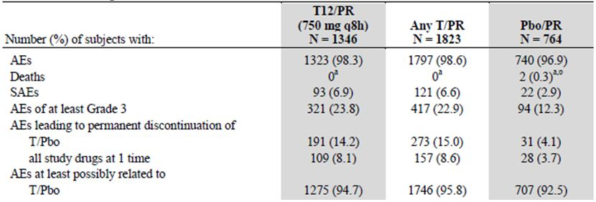
Table 69: Placebo controlled Phase 2/3 studies: Incidence of AEs (regardless of severity and drug relatedness) that occurred in more than 5.0% of subjects in any treatment group by System Organ Class and Preferred Term – telaprevir/placebo treatment phase.
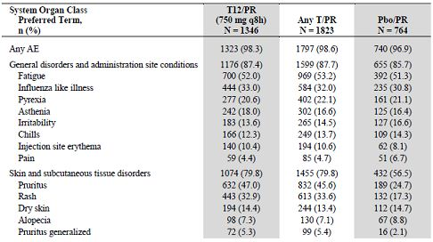
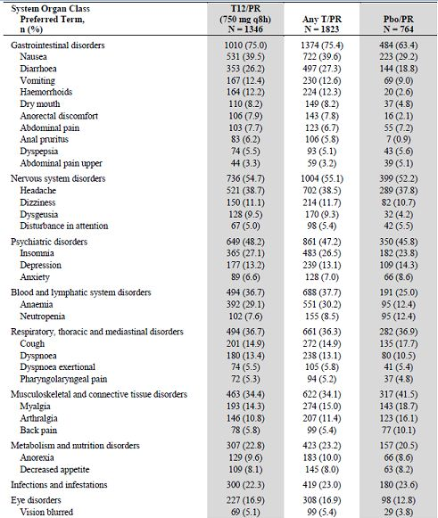
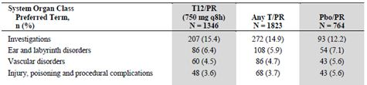
The most frequently reported AE of at least Grade 3 severity (≥1%) were anaemia, neutropaenia, leucopaenia, rash, pruritus, fatigue, thrombocytopaenia and nausea. With the exception of neutropaenia and leucopaenia, the incidence of Grade 3 AE was higher in the T12/PR group than in the Placebo/PR group (Table 70). In the telaprevir/placebo phase, the onset of new AE was in general highest in the first four weeks of treatment in both the T12/PR and Placebo/PR groups, and substantially lower during subsequent periods (Table 71). However, the incidence of anaemia in the T12/PR group was highest during Weeks 5-8 as shown in Figure 25. With this exception there were no significant differences in incidence over time between the T12/PR and Placebo/PR groups. Subgroup analysis in the T12/PR and Placebo/PR groups showed that anaemia was comparable regardless of region, race, prior treatment status and fibrosis category. However, anaemia occurred more frequently in female patients compared with male patients, in patients older than 45 years compared with younger patients and in patients with lower rather than higher BMI. The risk difference for anaemic events between the T12/PR and Placebo/PR groups in these subgroup categories is shown in Figure 26.
Table 70: Placebo controlled Phase 2/3 studies: Incidence of AEs of at least Grade 3 that occurred in more than 0.5% of subjects in any treatment group by System Organ Class and Preferred Term – telaprevir/placebo treatment phase.
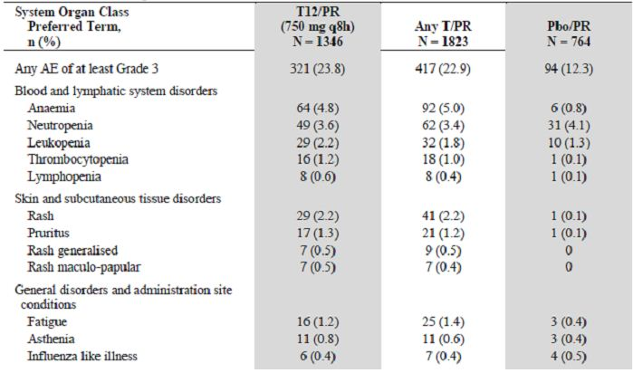
Table 71: Placebo controlled Phase 2/3 studies: Incidence of AEs by 4-week periods for AEs observed in >10.0% of subjects in any 4-week period in the T12/PR and Pbo/PR groups – telaprevir/placebo treatment phase.
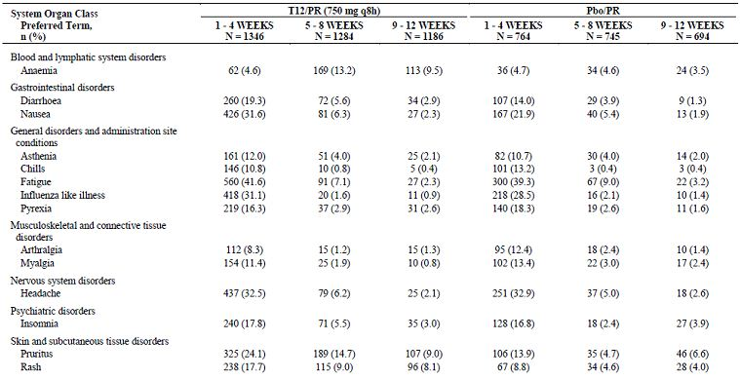

Figure 25: Placebo controlled Phase 2/3 studies: Time to onset of first anaemia SSC event – overall treatment phase.
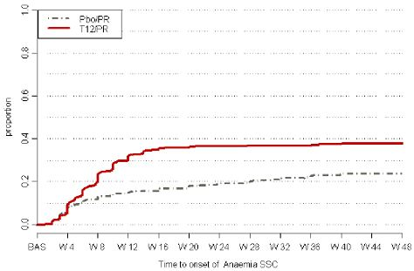
Figure 26: Placebo controlled Phase 2/3 studies: Difference in anaemia SSC incidence between the T12/PR and Pbo/PR groups.
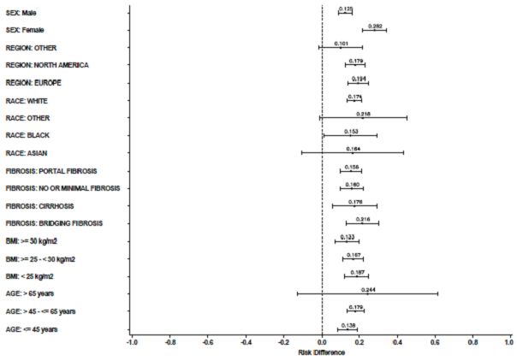
Anorectal events were more common in the T12/PR group than in the Placebo/PR group (Table 72). Most anorectal events were mild and did not result in treatment discontinuation. Serious anorectal events occurred in <1% of patients in the T12/PR group and did not occur in the Placebo/PR group. The most frequently reported anorectal events in the T12/PR and Placebo/PR groups were haemorrhoids (12.2% versus 2.6%), anorectal discomfort (7.9% versus 2.1%) and anal pruritus (6.2% versus 0.9%). During the telaprevir/placebo treatment phase, generalised pruritus occurred more commonly in the T12/PR group than in the Placebo/PR group (Table 73).
Table 72: Placebo controlled Phase 2/3 studies: Summaery of anorectal SSC events – telaprevir/placebo treatment phase.
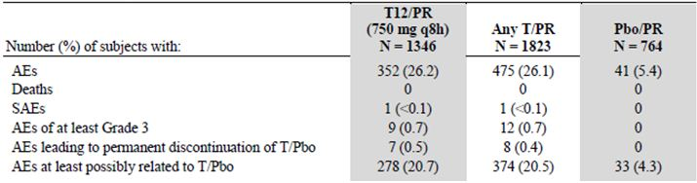
Table 73: Placebo controlled Phase 2/3 studies: Summaery of pruritus SSC events – telaprevir/placebo treatment phase.
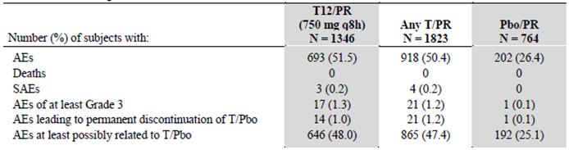
To minimise the impact of AE related to rash, a rash assessment and management plan was implemented during the Phase 2 program and it was modified progressively into the Phase 3 studies. In Phase 2, the investigator was required to discontinue all drugs if a Grade 3 rash occurred. In Phase 3, investigators were required to discontinue telaprevir/placebo but they were allowed to continue Peg-IFNα/RBV. This management plan had no effect on the frequency of rash but it resulted in fewer treatment discontinuations in the Phase 3 program. In the Phase 2 studies, discontinuation of all study drugs because of rash occurred in 28/450 (6.2%) patients in the T12/PR group compared with 10/893 (1.1%) in the Phase 3 studies. The same pattern of discontinuations occurred in the Any T/PR group but there was only one discontinuation in the Placebo/PR groups. Rash events were reported more frequently in the T12/PR group (55.4%) than in the Placebo/PR group (32.7%) during the telaprevir /placebo phase. The majority of skin rashes in both treatment groups were of Grade 1 or 2 severity (Table 74). Serious rashes occurred in 1.7% of patients in the T12/PR group while none occurred in the Placebo/PR group. Rash events of at least Grade 3 in severity were reported in 4.8% of patients in the T12/PR group compared with 0.4% in the Placebo/PR group. Rash leading to permanent discontinuation of telaprevir/placebo occurred more frequently in the T12/PR group (5.8%) than in the Placebo/PR group (0.3%). Of the 807 patients who experienced a rash in the T12/PR group, 621 (77%) received concomitant medication: 53.7% received a topical steroid; 39.5% received a systemic antihistamine and 6.2% received a systemic steroid. Of the 323 patients in the Placebo/PR group who experienced a rash, 22 (70%) received concomitant medication: 42.4% received a topical steroid; 24.1% received a systemic antihistamine and 2.5% received a systemic steroid.
Table 74: Placebo controlled Phase 2/3 studies: Summaery of rash SSC events – telaprevir/placebo treatment phase.
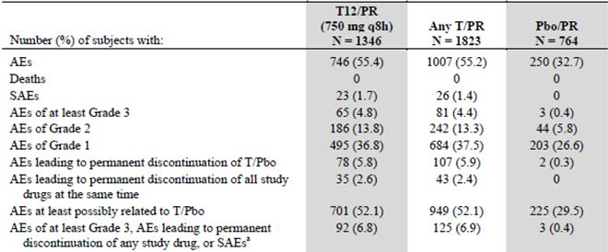
The time to onset of the first rash of any severity was shorter in the T12/PR group than in the Placebo/PR group. The first rash occurred shortly after the start of treatment in approximately one third of patients. New rashes then occurred at a reduced rate up to Week 12 in the T12/PR group as shown in Figure 27. Subgroup analysis demonstrated that the frequency of rash was similar in the T12/PR and Placebo/PR groups regardless of sex, age, BMI, region, prior treatment status and baseline fibrosis category. Compared with White patients, rashes occurred more commonly in Asians and less commonly in Blacks; however, the patient numbers were small in both groups (Table 75). There was no relationship between the occurrence and severity of rash and telaprevir exposure during the telaprevir/placebo phase.
Figure 27: Placebo controlled Phase 2/3 studies: Time to onset of first rash SSC event – overall treatment phase.
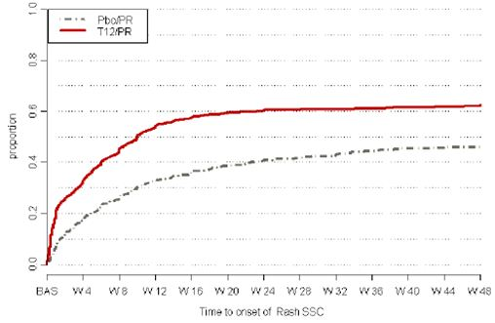
Table 75: Placebo controlled Phase 2/3 studies: Subgroup analyses of rash SSC events – telaprevir/placebo treatment phase.
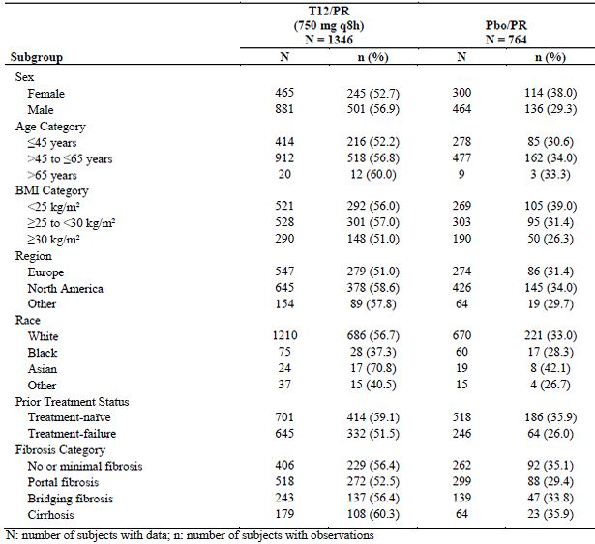
A Dermatology Expert Panel (DEP) was formed during the development program to review and characterise cases of rash. It consisted of four independent academic dermatologists with the remit to describe cases of rash occurring during the Phase 3 program. They examined clinical data, SAE report forms, skin photographs, skin biopsies and dermatologist reports from the investigator site. The DEP was not involved in individual patient management and their reviews were not reported to the investigators or patients. The DEP reviewed 221 cases of rash. The majority (208/221 or 94%) were reported in patients who received a telaprevir based regimen. Skin photographs were available for 151 cases, skin biopsy reports were available in 84 cases, central histopathology review was performed in 53 cases and a site dermatologist report was available in 151 cases. Pruritus was present in 95% of cases, absent in 3% of cases and not reported in 1% of cases.
Based on the review of 221 cases, the DEP concluded:
- Rashes associated with telaprevir treatment are generally pruritic and eczematous although some have a maculopapular component.
- There was no evidence of vasculitis based on clinical appearance or histology.
- Urticaria was very infrequent and there were no cases of life threatening hypersensitivity reactions and/or anaphylaxis.
- BSA (body surface area) involvement was established in 83 cases; 86.7% had ≤30% BSA involvement, 10.8% had >30-50% BSA involvement and 2.4% had >50% BSA involvement.
- The rash associated with telaprevir differed from a typical drug related rash based on the following observations:
- There was a high incidence of rash of all severities.
- Rash could begin at any time after starting drug, from days to weeks.
- The rash improves when telaprevir is stopped but it may take weeks to resolve.
- The typical histopathology is dermal spongiotic dermatitis with lymphocytic perivascular infiltration.
- The rash associated with telaprevir is more severe than the rash associated with Peg-IFNα/RBV and it occurs more frequently. However, with the exception of greater severity and BSA involvement, the visual appearance and histopathological appearance of the rash associated with telaprevir was indistinguishable from the rash associated with Peg-IFNα/RBV treatment.
The DEP used established criteria to identify suspected cases of SCAR (severe cutaneous adverse reaction). Six case of SCAR were reported by the investigator; three cases of SJS and three cases of DRESS. The DEP assessed one case of SJS as definite; one case as possible; and one case as not SJS. Of the three reported cases of DRESS, the DEP adjudicated one case as definite, one case as possible and one case not to be DRESS. The DEP identified nine further cases with suspected SCAR: one further case of possible DRESS; one probable and seven possible cases of DRESS; and one possible case of AGEP (also scored as possible DRESS). The DEP did not consider the diagnosis of TEN in any of the 221 patients evaluated. An analysis of HLA and MDR1 genotypes was performed in 114 patients with rash and 73 patients without rash but no associations were found.
The Thorough QTc Study 008 in healthy subjects showed no effect of telaprevir on QTcF interval following administration of the normal treatment dose of telaprevir 750mg q8h. When telaprevir was administered at the supratherapeutic dose of 1875mg for 8 days (leading to a 40% higher exposure), there was an increase in placebo adjusted QTcF of 8.0 msec (90% CI: 5.1-10.9). However, during the telaprevir/placebo treatment phase the incidence of potential proarrhythmic events was low and similar in the T12/PR and Placebo/PR groups. Events leading of at least Grade 3 severity occurred in ≤0.2% of patients in the T12/PR group and in ≤0.5% of patients in the Placebo/PR group.

Serious adverse events and deaths
In the pooled controlled and non controlled Phase 2 and 3 studies, there were seven deaths in patients who had received telaprevir but only one of these deaths occurred while receiving telaprevir. In Study 111, one patient died of head trauma following a fall and this was considered unrelated to study drug administration. Serious rash (1.9%) and anaemia (0.6%) were the only SAE reported during the telaprevir/placebo treatment phase in more than 0.5% of patients in the Any T/PR group in the pooled controlled and uncontrolled studies.

Laboratory findings
Standard haematology and biochemistry investigations were performed at screening and at multiple on treatment visits. Most abnormalities occurring on treatment were Grade 1 or 2. The most frequently reported abnormalities (≥10%) of Grade 2 or higher in the T12/PR group were: decreases in haemoglobin, neutrophil count, WBC count, lymphocyte count and platelet count; hyperuricaemia; increased bilirubin; and increased total cholesterol. With the exception of neutrophil count, these abnormalities were observed with higher frequency in the T12/PR group than in the Placebo/PR group.
Mean WBC count decreased from baseline with the largest decrease occurring in the first four weeks. The changes in WBC were similar in the T12/PR and Placebo/PR groups (Figure 28). Mean lymphocyte count fell in both groups and this was more pronounced in the T12/PR group compared with the Placebo/PR group (Figure 29). Decreases in lymphocyte count of Grade 2 or higher occurred in 29.7% of patients in the T12/PR group and 10.9% of patients in the Placebo/PR group. There was a similar decrease in mean neutrophil count over time in the T12/PR and Placebo/PR groups (Figure 30). Neutrophil count decreases of grade 2 or more occurred in 31.5% of patients in the T12/PR group and 40.1% of patients in the Placebo/PR group. There was a marked reduction in mean platelet count which was larger in the T12/PR group than in the Placebo/PR group (Figure 31). Platelet count decreases of Grade 2 or higher occurred in 27.3% of the T12/PR group and in 16.7% of the Placebo/PR group. Changes from baseline in these parameters with severity grading are summarised in Table 76.
Figure 28: Placebo controlled Phase 2/3 studies: Mean (SE) values of white blood cell count (giga/L) over time – overall treatment phase.
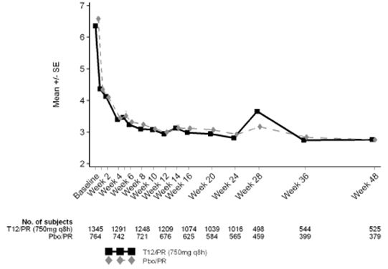
Figure 29: Placebo controlled Phase 2/3 studies: Mean (SE) values of lymphocyte count (giga/L) over time – overall treatment phase.
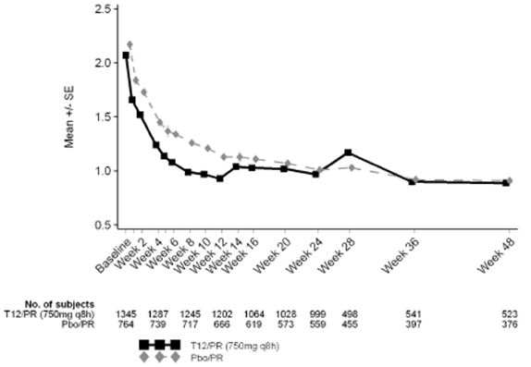
Figure 30: Placebo controlled Phase 2/3 studies: Mean (SE) values of neutrophil count (giga/L) over time – overall treatment phase.
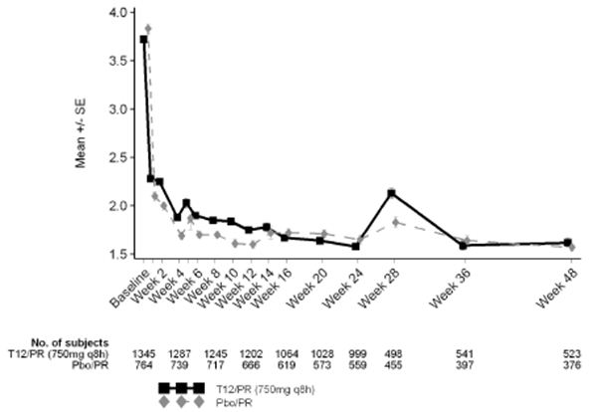
Figure 31: Placebo controlled Phase 2/3 studies: Mean (SE) values of platelet count (giga/L) over time – overall treatment phase.
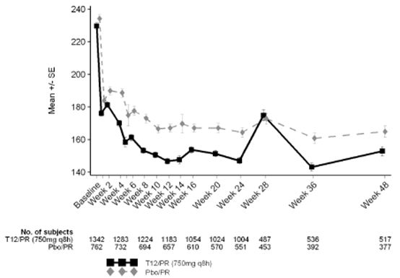
Table 76: Placebo controlled Phase 2/3 studies: Treatment emergent laboratory abnormalities of Grade 2 or higher for selected haematology related parameters (worst grade) – telaprevir/placebo treatment phase.
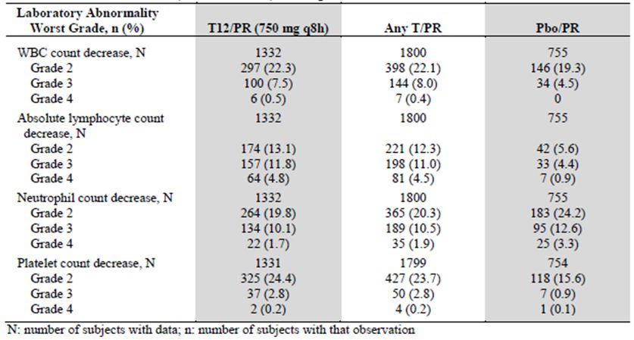
There was a mean increase in uric acid of 105 µmol/L in the first week of treatment in the T12/PR group compared with a smaller mean increase of 49 µmol/L in the Placebo/PR group. The elevated uric acid levels had returned to baseline values after Week 20 (Figure 32). During the telaprevir/placebo phase, hyperuricaemia of Grade 2 or higher occurred in 23.6% of patients in the T12/PR group and in 3.2% of patients in the Placebo/PR group. Gout was reported in three patients in the T12/PR group and in no patients in the Placebo/PR group. Mean serum creatinine increased slightly (2.36-7.26 µmol/L) in the T12/PR group from Weeks 1 to 12 and decreased to baseline values by Week 16. Mean creatinine decreased slightly in the Placebo/PR group. Creatinine increases of greater than Grade 2 severity occurred in 1.1% of patients in the T12/PR group and in 0.4% of patients in the Placebo/PR group. Serum potassium fell in both the T12/PR and Placebo/PR groups. The decreases were small and not clinically significant but the magnitude was greater in the T12/PR group. There was a slight increase in mean TSH (Thyroid Stimulating Hormone) in the T12/PR group during treatment but this was not clinically significant.

Figure 32: Placebo controlled Phase 2/3 studies: Mean (SE) values of uric acid (μmol/L) over time – overall treatment phase.
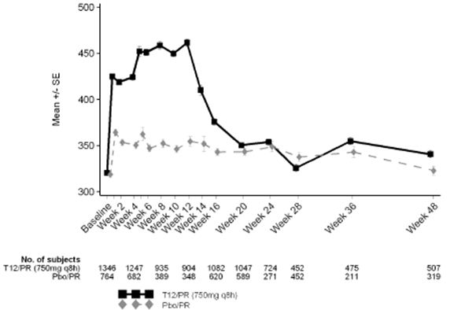
Consistent with their underlying liver disease, mean baseline ALT and AST (aspartate aminotransferase) were high in patients in the T12/PR and Placebo/PR groups. After the start of treatment, mean ALT and AST fell in both groups (Figure 33). The fall was more pronounced in the T12/PR group than in the Placebo/PR group, consistent with the greater fall in HCV RNA in the T12/PR group. There was an initial rise in total bilirubin (both direct and indirect) in the first four weeks in the T12/PR and Placebo/PR groups but the rise was larger in the T12/PR group. This was considered to be related to RBC (red blood cell) haemolysis occurring at the start of treatment. Hyperbilirubinaemia of Grade 2 severity or higher was observed in 17.5% of patients in the T12/PR group and in 7.9% of patients in the Placebo/PR group (Table 77).
Figure 33: Placebo controlled Phase 2/3 studies: Mean (SE) values of alanine aminotransferase (U/L) over time – overall treatment phase.
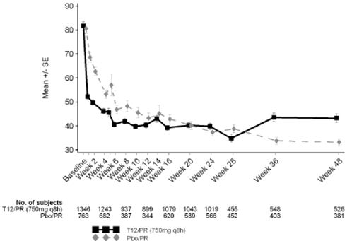
Table 77: Placebo controlled Phase 2/3 studies: Treatment emergent laboratory abnormalities of Grade 2 or higher for selected liver related parameters (worst grade) – telaprevir/placebo treatment phase.
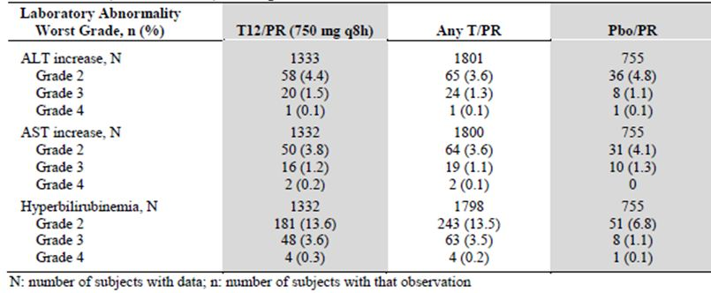
Total cholesterol increased slightly in the T12/PR group and fell slightly in the Placebo/PR group during treatment. The increase in the T12/PR group resolved at the completion of telaprevir dosing.

Immunological events
Not applicable.

Safety related to drug-drug interactions and other interactions
In a single dose study in healthy subjects, telaprevir AUC increased more than dose proportionately for doses ranging from 750 mg to 1875 mg. Following multiple doses of telaprevir 1875 mg q8h, AUC was 40% higher than following telaprevir 750 mg q8h.
Moderate hepatic impairment decreases steady state telaprevir C_{max} and AUC_{8h} by ∼49% and 46%, respectively and as the appropriate dose of telaprevir in subjects with CPB has not been determined, telaprevir is not recommended in these subjects. In addition, telaprevir has not been studied in subjects with severe hepatic impairment (Child-Pugh Class C), and is also not recommended in this population.
Co-administration of ritonavir with telaprevir increased the C_{max} and AUC_{0-tlast} of VX-950 by 1.3 and 1.8 fold, respectively. Ketoconazole increased the C_{max} and AUC_{0-8h} by approximately 20%. Following a single dose of 750 mg telaprevir under fed conditions, the AUC_{0-last} of telaprevir increased from 6995 ng.h/mL when it was administered alone to 22367 ng.h/mL when it was administered in combination with ritonavir. Therefore co administration of these drugs may increase the side effect profile of telaprevir.

Discontinuation due to AEs
A total of 145/1346 (10.8%) patients in the T12/PR group discontinued study treatment because of AE compared with 211/1823 (11.6%) in the Any T/PR group and 53/764 (6.9%) in the Placebo/PR group. The mean number of weeks on study drug was similar between groups: 12.5 weeks in the telaprevir groups and ∼30 weeks for Peg-IFNα and RBV (Table 78). In the pooled Phase 2 and 3 studies, AE leading to permanent discontinuation of telaprevir/placebo occurred in 191/1346 (14.2%) patients, 273/1823 (15.0%) patients in the Any T/PR group and in 31/764 (4.1%) patients in the Placebo/PR group. The most common reasons for withdrawal were anaemia, rash and pruritus.
Table 78: Placebo controlled Phase 2/3 studies: Number of weeks on study drug.
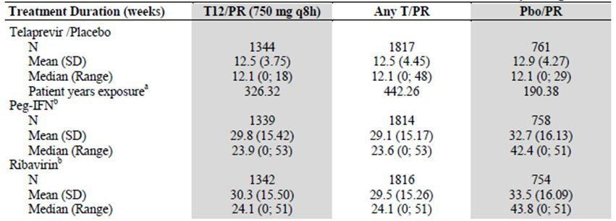

Post marketing experience
Telaprevir is not marketed in any country.

Evaluator’s overall conclusions on clinical safety
The proposed telaprevir treatment regimen is T12/PR24 for treatment-naive and prior relapse patients and T12/PR48 for prior non or partial responders. The AE profile was similar in both T12/PR24 and T12/PR48 groups with the great majority of AE occurring within the first 24 weeks of treatment. Therefore, pooled safety data were compared in 1346 patients in the T12/PR group and 764 patients in the Placebo/PR group. Data from the Placebo/PR group were similar to those recorded in previous published studies.
Over 96% of patients in each treatment group recorded at least one AE during the course of the study. Most AE were Grade 1 or 2, non serious and did not result in treatment discontinuation. The frequency of SAE, AE of at least Grade 3 and treatment discontinuations was significantly higher in the telaprevir group. In the T12/PR group, the most common AE were pruritus, rash, nausea, diarrhoea and anaemia which occurred more frequently than in the Placebo/PR group. AE typically reported in patients receiving Peg-IFNα/RBV (fatigue, headache, flu like illness, insomnia and pyrexia) occurred with similar frequency in the T12/PR and Placebo/PR groups. Less common AE, including haemorrhoids, pruritus ani and anorectal discomfort, generalised pruritus and dysgeusia occurred more frequently in the T12/PR group than in controls. Few new AE were recorded after the first 24 weeks of treatment but many AE classically related to Peg-IFNα/RBV persisted after 24 weeks in patients who continued with PR treatment. Seven deaths occurred in patients who had received telaprevir but none occurred while on treatment. Two deaths (due to lung carcinoma and pulmonary embolus) were considered possibly related by the investigators (but not by the sponsors) while the other five were considered unrelated.
Rash is a well described AE occurring in 13-23% of patients receiving Peg-IFNα/RBV. However, the incidence of rash was significantly higher in patients receiving the T/PR combination than in control patients receiving PR alone. The incidence of rash was 55.4% in the T12/PR group compared with 32.7% in the Placebo/PR group. Serious rash occurred in 1.7% of patients in the T12/PR group compared with none in controls. Rash of at least Grade 3 severity occurred in 4.8% of patients in the T12/PR group and in 0.4% of controls. Rash leading to permanent discontinuation of telaprevir/placebo occurred in 5.8% of patients in the T12/PR group and in 0.3% of controls. Most cases of rash occurred in the first 4 weeks after treatment. Most rashes did not progress in severity and most had resolved by Week 24. A total of 621/807 (77.0%) patients in the T12/PR group who developed rash required concomitant medication including topical steroids and systemic antihistamines. Systemic steroids were administered in 50 (6.2%) patients. The incidence of rash appeared to be uninfluenced by age, race, gender, region, BMI, previous treatment status or exposure to telaprevir. In 221 cases of rash assessed by the DEP, the severity and extent of rash was indistinguishable from rash associated with Peg-IFNα/RBV therapy, namely eczematous with spongiosis on biopsy. However, the rash was not typical of allergic drug reactions based on time of onset and delayed resolution after stopping treatment. The frequency of severe skin reactions was low but occurred more commonly in the T12/PR group compared with controls. Pruritus, mostly Grades 1 and 2, was reported more commonly in the T12/PR group (51.5%) than in the Placebo/PR group (26.4%). Anorectal events were also reported more commonly in the T12/PR group (26.2%) than in controls (5.4%).
Anaemia with haemoglobin decreases of Grade 2 or more occurred in 79.2% of patients in the T12/PR group and in 51% of patients in the Placebo/PR group. The decrease in haemoglobin occurred rapidly in the first 4 weeks of treatment and continued to fall, reaching its nadir at approximately Week 12. In the T12/PR group, haemoglobin fell to <100 g/L in 33.7% of patients and < 85 g/L in 8.3% of patients. The fall in haemoglobin was greater in the T12/PR group than in the Placebo/PR group but the additional effect of telaprevir resolved when telaprevir was discontinued after 12 weeks treatment. There was a corresponding increase in reticulocyte count suggesting a haemolytic component to the anaemia. However, in the T12/PR group there was a slightly higher incidence of thrombocytopaenia and lymphopaenia which might also suggest mild bone marrow suppression. Despite the severity of the anaemia in some patients, only 2.7% were withdrawn from the T12/PR group and few required blood transfusion or treatment with erythropoetic agents.
The main AE related to laboratory abnormalities were haematological as discussed above. In addition, abnormalities of Grade 2 or higher occurred more frequently in the T12/PR group than in the Placebo/PR group for uric acid, total bilirubin, total cholesterol and LDL (low density lipoprotein). The mechanism of the rise in uric acid is unknown but may be related to renal tubular effects associated with telaprevir. The rise was significant but it resolved when telaprevir treatment was concluded and acute gout was unusual. The rise in bilirubin was considered to be related to haemolysis and the rise in cholesterol is unexplained. However, both parameters returned to baseline at the end of study treatment and are unlikely to have long term clinical sequelae.
The incidence of AE was significantly higher in patients who received telaprevir based treatment compared with standard treatment. Most AE occurred in the first 4 weeks and most resolved after the 12 week telaprevir treatment period. The incidence of AE, particularly rash, anaemia and rectal symptoms was high but the majority of patients completed their planned treatment. Despite the increased burden of AE, significantly more patients who received T12/PR achieved RVR and were able to shorten the period of PR treatment from 48 weeks to 24 weeks.

List of questions

Pharmacokinetics / Pharmacodynamics
(Q1) Is there any data available which examines the PK/PD of telaprevir in subjects with both HCV and HIV or HCV and hepatitis B?
(Q2) Although the sponsor states that it is unlikely that smoking and/or alcohol are unlikely to affect the PK/PD of telaprevir, is there any population PK data available to support this claim?
(Q3) Is there any data available on the effects of CYP3A/4 mutations upon telaprevir PK/PD?
(Q4) As drug injecting is the primary route of hepatitis C transmission in Australia, have any studies examined the effects of illicit drug use (heroin, amphetamines, cocaine, anabolic steroids etc) on the PK/PD of telaprevir?

Efficacy
No questions.

Safety
(Q5) Rash is a major risk of treatment with telaprevir and the PI recommends treatment discontinuation if the rash involves >50% BSA. In the clinical programme there was poor concordance between physicians and dermatologists in the assessment of rashes. How does the sponsor propose to educate non dermatologist physicians on accurate rash grading?

Sponsor’s responses to evaluator’s questions

(Q1) Are there any data available which examines the PK/PD of telaprevir in subjects with both HCV and HIV or HCV and hepatitis B?
Tibotec’s response:
A pilot study of telaprevir in subjects with HCV/human immunodeficiency virus (HIV) co infection (Study VX08-950-110) is ongoing. PK data of telaprevir is being collected in this study and will be used to explore pharmacokinetic/pharmacodynamic (PK/PD) relationships in this population. A final study report is expected to be completed by the fourth quarter of 2012. A third interim analysis was conducted including all relevant data, representing complete data, through Week 24 and incomplete data for efficacy beyond Week 24. Exposure safety analysis showed lack of relationship between telaprevir exposure and indirect bilirubin in atazanavir/ritonavir treated subjects. Exposure efficacy analysis showed lack of relationship between telaprevir exposure and HCV RNA declines at Week 1. For more information, refer to the Clinical Study Synopsis of the third interim analysis, VX-950-VX08-110-CRSI-29Apr2011.
Evaluator’s comments:
The interim analysis (IA) is a Phase 2a, two part, randomised, double blind, placebo controlled, parallel group, multicentre study, which examines the PK of telaprevir when given in combination with Peg-IFNα-2a and RBV as well as the efficacy of telaprevir, when used in combination with Peg-IFNα-2a, RBV, and highly active antiretroviral therapy (HAART).
The IA includes 60 subjects who received at least one dose of study drug; of which 13 (3 female) were from Part A (subjects who were not receiving HAART), who had a mean age of 45.2 years; and 47 (5 female) from Part B (24 subjects were receiving HAART Regimen 1- Atripla; 23 subjects were receiving HAART Regimen 2 - ritonavir boosted atazanavir, TDF, and emtricitabine or lamivudine), who had a mean age of 46.1 years. A total of 44 of the 60 subjects had reached Week 24 at the time of the IA.

Pharmacodynamics
In patients co infected with HIV/HCV but not receiving HAART, 71.4% achieved a RVR, that is, HCV RNA could not be detected, following 4 weeks administration of telaprevir in combination with PR- Peg-IFNα-2a + RBV (T/PR) compared with 0% for patients administered placebo/PR (Placebo/PR) (Table 79). When patients also receiving HAART were included in the analysis 68.4% of patients receiving T/PR achieved RVR, whereas only 4.5% achieved RVR in the Placebo/PR group. Extended rapid viral response (eRVR) was examined over two time periods: (a) between 4 and 12 weeks; and (b) 4 and 24 weeks; and it indicated that no HCV RNA could be detected over this period. Between 4 and 12 weeks, eRVR was achieved in 63.2% of patients treated with T/PR compared with 4.5% of patients receiving Placebo/PR. Similarly, between 4 and 24 weeks eRVR was achieved in 55.3% of patients receiving T/PR.13 compared with 4.5% of patients who received Placebo/PR.¹³
Table 79: Subjects with undetectable HCV RNA (Study VX08-950-110).
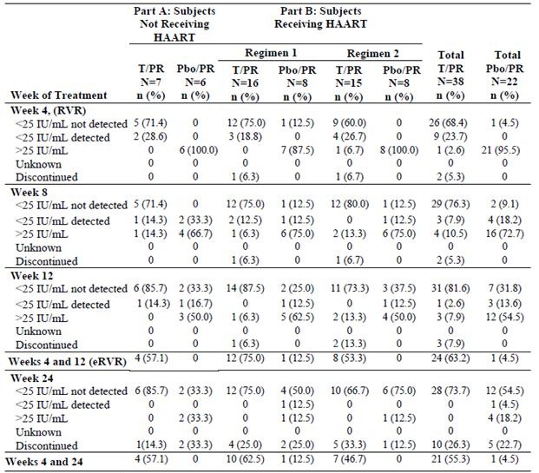
Additional table notes - PR: Peg-IFNα2a + RBV
There was an approximately one log reduction in HIV RNA in Part A over the first 12 weeks, possibly due to the effect of IFN (Table 80), whereas in Part B there were occasional low level variations in viral load (maximum of 0.29). Overall, CD4 counts declined similarly in both the T/PR¹³ and Placebo/PR¹³ treated patients (Table 81).
Table 80: Mean (SD) changes from baseline in HIV viral load (HIV RNA base log₁₀) (Study VX08-950-110).
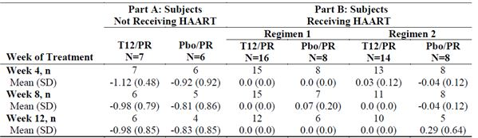
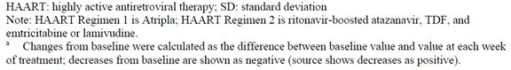
Table 81: Mean (SD) changes from baseline in CD4 counts (cells/mm³) (Study VX08-950-110).
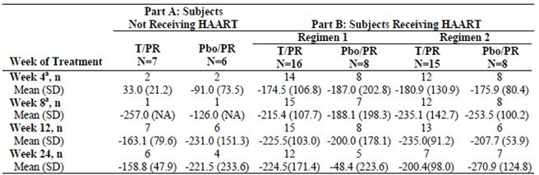
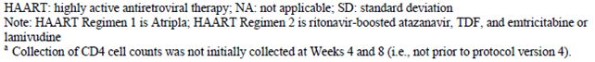

Pharmacokinetics
It must be noted that the full pharmacokinetic profiles for telaprevir when given in combination with the other drugs administered in this study have not been provided (for example, AUC, t_{max}, t_{1/2}) in the summary tables as part of the IA. However, information has been provided: C_{avg}, C_{min} and C_{max}. Based on this limited information the telaprevir PK in HIV/HCV co infected subjects are comparable to those in HCV monoinfected subjects and are also comparable for the different HAART regimens (Table 82-83).
Table 82: Telaprevir average concentration in monoinfected and co infected subjects (Study VX08-950-110).
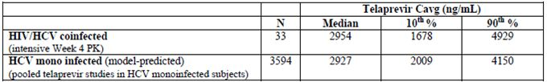
Table 83: Comparison of Week 4 telaprevir PK by HAART regimens (Study VX08-950-110).
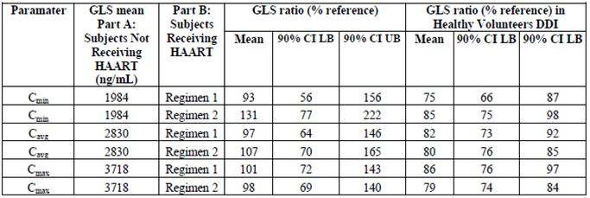
The effect of TVR/PR compared with Placebo/PR on the C_{min} of various HAART medications is shown in Table 84. Although the change in C_{min} for each of the HAART medications did not exceed 22% when T/PR was administered and is therefore unlikely to have a clinically significant effect; compared to the effects of Placebo/PR, telaprevir induced changes of up to 41% in C_{min} (for example, atazanavir).
Table 84: Effect of TVR/PR compared with Placebo/PR on the C_{min} of various HAART medications (Study VX08-950-110).
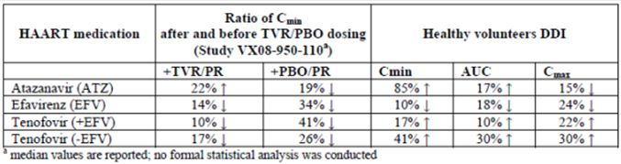

(Q2) Although the sponsor states that it is unlikely that smoking and/or drinking alcohol are unlikely to affect the PK/PD of telaprevir, is there any population PK data available to support this claim?
Tibotec’s response:
The effect of smoking and/or alcohol on the PK of telaprevir has not been formally evaluated in the population pharmacokinetic analysis.
Telaprevir is extensively metabolized in the liver, involving hydrolysis, oxidation, and reduction and in vitro studies using recombinant human cytochrome P450 (CYP) isoforms indicated that CYP3A4 was the major CYP isoform responsible for telaprevir metabolism, in addition to non CYP mediated pathways. Smoking and alcohol are known to induce CYP1A2 and CYP2E1 activity, respectively, and are therefore not expected to significantly influence telaprevir PK/PD.
Evaluator’s comments:
Although no studies have directly examined the effects of smoking or alcohol on the PK of telaprevir they have adequately responded to the evaluator’s question.

(Q3) Is there any data available on the effects of CYP3A/4 mutations upon telaprevir PK/PD?
Tibotec’s response:
The effect of CYP3A/4 polymorphism on the PK of telaprevir has not been evaluated.
Several genetic variations in and around the CYP3A locus have been shown to lead to functional changes in the amino acid sequence of the enzyme and/or the expression of the enzyme. However, most of these are at a relatively low frequency and do not account for the wide variability seen in CYP3A phenotypes. With regard to CYP3A/4 mutations specifically, early in vitro work showed increased transcription with the CYP3A4*1B allele. No correlation however was observed between CYP3A4*1B genotype and the pharmacokinetic parameters of sensitive CYP3A4 substrates such as midazolam, erythromycin or dextromethorphan1. A significant effect of CYP3A/4 mutations on telaprevir PK/PD is therefore unlikely.
Evaluator’s comments:
“The effect of CYP3A/4 polymorphism/phenotype on the PK...” was also posed to ascertain whether the study subjects had undergone tests, such as the erythromycin breath test, to determine the nature of their CYP3A4 phenotype and whether differences in CYP activity had a direct effect on the PK of telaprevir.
Suggestion of addition to the PI is as follows:
“As telaprevir is primarily metabolised by CYP3A4, patients who are known to possess atypical CYP3A4 metabolic activity require increased levels of monitoring during treatment.”

(Q4) As drug injecting is the primary route of hepatitis C transmission in Australia, have any studies examined the effects of illicit drug use (heroin, amphetamines, cocaine, anabolic steroids etc) on the PK/PD of telaprevir?
Note to TGA:
This question was not sent to the sponsor. TGA considered it was inappropriate because of associated legal and ethical issues in relation to illict drug use.
Evaluator’s comments:
This drug is a special case as if registered the primary target population for its use will be subjects with a history of or ongoing illicit intravenous drug use or multi illicit drug users. As this question was not passed onto the sponsor, the evaluator suggests an additional statement in the PI as follows:
“The PK interaction between Incivio and illicit IV drugs including heroin, cocaine, anabolic steroids, etcetera is not known.”
Clinical Questions:
- Criteria for SVR have been amended in line with the analyses approved by the FDA and EU. The result is a net increase in efficacy rates in favour of telaprevir. However, in general the differences are small and do not affect the overall conclusions of the Phase 3 trials as presented originally.
- The guidance to physicians for the identification and management of rash has been substantially upgraded and it is now more than acceptable.
- The PI has undergone numerous revisions. The format of AE, clinical trial data and laboratory abnormalities has been changed to make the document more consistent with the EU SPC. HCV RNA detection limits monitored by PCR have been brought into line with Australian practice and Medicare reimbursement guidelines. Rash management guidelines have been substantially extended. Some minor inaccuracies in conmed interactions have been corrected.
- Responses by the sponsor to (my) questions are satisfactory.
- EU RMP and ongoing trial program reviewed and no further questions are warranted.

Clinical summary and conclusions

Clinical aspects

Pharmacokinetics
The recommended dose of telaprevir is 750 mg every 8 h with food, in combination with Peg-IFNα/RBV, for both treatment naïve and prior treatment failure patients.
Based on PK/PD simulations it would appear that a loading dose of 1250 mg has no effect on either the decline in HCV RNA over time and HCV RNA log drop observed at 48 and 144 h post first dose.
The FDA and the CHMP concurred that the studies examining the bioequivalence of coated and uncoated tablets support introducing the 375 mg film coated tablet as the commercial product.
Compared to administration following a standard normal caloric meal (21 g fat, 561 kcal), telaprevir exposures decreased by 73% when taken in the fasted state, by 39% following a low calorie low fat meal (3.6 g fat, 249 kcal), and by 26% following a low calorie high protein meal (9 g fat, 260 kcal). The exposure to telaprevir increased by 20% when taken following a high fat high caloric meal (56 g fat, 928 kcal) compared to an intake following a standard normal caloric meal.
Following a single dose of [¹⁴C] VX-950 (750 mg/2.84 MBq), the CL/F and Vz/F for VX-950 were 1153 L/h and 7394 L.
Telaprevir is ∼59% to 76% bound to plasma proteins and has a large Vz/F estimated from population PK analyses of Phase 2 and Phase 3 studies to be 252 L, with inter individual variability on Vz/F estimated to be 72.2%.
Telaprevir is orally available and likely to be absorbed in the small intestine with no evidence for absorption in the colon.
It is a substrate of P-gp and it is both a substrate and inhibitor of CYP3A.
Telaprevir is extensively metabolised in the liver via hydrolysis, oxidation, and reduction.
Following repeated oral administration of telaprevir in combination with Peg-IFNα/RBV in subjects with chronic hepatitis C, the main metabolites of telaprevir were VRT-127394 (R diastereomer of telaprevir, 30 fold less active), pyrazinoic acid (not active), and VRT-0922061 (M3 isomer metabolite, reduction at the α ketoamide bond of telaprevir, not active).
Telaprevir is predominantly eliminated in the faeces with minimal renal excretion. Following administration of a single oral dose of 750 mg [¹⁴C] telaprevir in healthy subjects, the median recovery of the administered radioactive dose was approximately 82% in faeces, 9% in exhaled air, and 1% in urine. The CL/F of telaprevir was estimated from population PK analyses of Phase 2 and Phase 3 studies to be 32.4 L/hr, with inter individual variability estimated to be 27.2%.
In a single dose study in healthy subjects, telaprevir AUC increased more than dose proportionately for doses ranging from 750 mg to 1875 mg. Following multiple doses of telaprevir 1875 mg q8h AUC was 40% higher than following telaprevir 750 mg q8h.
When telaprevir was dosed as 750 mg q8h, steady state was reached by 3 to 7 days with an accumulation ratio (ratio of the AUC at steady state to the AUC after the first dose) of ∼2.2.
Following a single dose, the mean half life of telaprevir was approximately 4 h. At steady state, the effective half life was approximately 9 to 11 h.
Population PK studies indicate that a subject’s age, sex, and race had no impact on the clearance and average steady state exposure of telaprevir. By contrast, the subject’s weight did affect telaprevir clearance (with weight being positively correlated with clearance) but there was no clinically relevant impact on safety or efficacy of a telaprevir containing regimen.
No telaprevir dose adjustment is required for subjects with mild hepatic impairment or mild, moderate, or severe renal impairment.
Moderate hepatic impairment decreases steady state telaprevir C_{max} and AUC_{8h} by ∼49% and 46%, respectively. The appropriate dose of telaprevir in subjects with CPB has not been determined, therefore, telaprevir is not recommended in these subjects. In addition, telaprevir has not been studied in subjects with severe hepatic impairment (Child-Pugh Class C), and is also not recommended in this population.
Drug interaction studies indicate that steady state doses of telaprevir decreased the exposure of co administered EE, zolpidem, escitalopram, and methadone, and increased the exposure to amlodipine, atorvastatin, and alprazolam. As such, telaprevir may affect the PK of any co administered drugs that are CYP3A substrates and/or transported by P-gp. In addition, telaprevir PK may also be severely affected by inhibitors and inducers of CYP3A and/or P-gp.
Co-administration of telaprevir and LPV/rtv results in a ~60% decrease in telaprevir exposure; therefore, co administration of the two drugs is not recommended.
ATV/rtv and telaprevir can be administered concomitantly without the need for dose adjustment as the changes in telaprevir exposure seen with ATV/rtv co administration are unlikely to be clinically significant.
Co-administration of telaprevir and DRV/rtv or fAPV/rtv is not recommended as it results in decreased exposure to telaprevir, darunavir and amprenavir.
TDF has little effect on the steady state PK of telaprevir, whereas, telaprevir co administration increased the AUC of TDF by approximately 30%. Therefore, the two drugs can be co administered on the proviso that increased clinical and/or laboratory monitoring for AEs is undertaken.
Although co administration of telaprevir and EFV did not affect the steady state AUC or Cmin of EFV, EFV decreased the steady state C_{min} and AUC of telaprevir by approximately 46% and 26%, respectively. Therefore, the sponsor recommends that the dosage of telaprevir should be increased from 750 mg q8h to 1125 mg q8h, whereas EFV can be administered without dose adjustment.
Following co administration with telaprevir, digoxin C_{max} and AUC increased 1.5 and 1.85 fold, respectively, and digoxin t_{1/2} increased from 28 to 50 h.
Co administration of telaprevir decreased the mean plasma C_{max}, C_{min}, and AUC_{ss} of EE by ∼26%, 33%, and 28%, respectively, while it had no effect on NE exposure. These results suggest that alternative methods of non hormonal contraception should be used when estrogen based contraceptives are co administered with telaprevir and that subjects using estrogens as hormone replacement therapy should be clinically monitored for signs of estrogen deficiency.
When amlodipine and atorvastatin were co administered with telaprevir, the AUC of amlodipine increased ∼2.8 fold and the AUC of atorvastatin increased 7.9 fold. The median t_{1/2} of amlodipine increased from 41 to 95 h, whereas the t_{1/2} of atorvastatin decreased from ∼9.5 hours to 6.8 h.
Alprazolam AUC increased by ∼35% and mean t_{1/2} increased from 13.4 to 18.7 h when administered with steady state telaprevir.
Zolpidem C_{max} and AUC were reduced by 42% and 47%, respectively, when multiple doses of telaprevir were co administered with zolpidem compared to zolpidem alone.
Telaprevir at steady state decreased steady state escitalopram C_{min}, C_{max} and AUC_{24h} by 42%, 30% and 35%, respectively, compared to escitalopram alone.
Co administration of esomeprazole did not affect telaprevir exposure, indicating that telaprevir and esomeprazole can be administered concomitantly without dose adjustment.
When normalised for cyclosporine dose, cyclosporine AUC∞ was increased approximately 4.1 to 4.6 fold and C_{max} 1.3 to 1.4 fold after either single dose or steady state co administration of telaprevir.
When normalised for tacrolimus dose, tacrolimus AUC∞ was increased approximately 70 fold and C_{max} 9.4 fold after co administration with steady state telaprevir.

Pharmacodynamics
Using HCV RNA levels as a measure of anti viral activity, telaprevir induced a significantly greater and more sustained decrease in HCV RNA levels than placebo. This inhibitory effect was further enhanced by co administration of telaprevir and Peg-IFNα.
The effectiveness of VX-950 was positively correlated with the plasma concentration of telaprevir.
The estimated VX-950 target concentration range (IC_{99.9}) is 1198 to 3092 ng/mL (median 2007 ng/mL).
HCV RNA levels decline rapidly between the first and fourth days of dosing with VX-950. A second, sustained phase of viral decline may occur following dosing with VX-950 alone. The incidence of this second phase is increased when VX-950 is given in combination with Peg-IFNα.
Exposure to the standard dose of telaprevir (750 mg q8h) was not associated with a clinically relevant effect on QTcF interval in two thorough QT trials (that is, a placebo corrected mean increase of at least 5 ms above baseline values as evidenced by the upper limit of the two sided 90% CI ≥ 10 ms). By contrast, supratherapeutic exposure to telaprevir resulted in an observed QTcF prolongation in placebo corrected observed values (that is, the upper limit of the 90% CI exceeded 10 ms).
Therapeutic doses of telaprevir may induce increases in heart rate which persist up until 24 h following dosing.
Telaprevir may reduce the contraceptive effectiveness of oral contraceptives containing EE.

Efficacy
Various drug combinations and treatment periods were explored in the Phase 2 study program which evaluated telaprevir treatment durations of 8, 12 and 24 weeks, Peg-IFNα for 12, 24 or 48 weeks and telaprevir in combination with Peg-IFNα, with and without RBV. The highest SVR rates were consistently achieved with T/PR combinations, and the optimal regimen was clearly PR given for 24 or 48 weeks in combination with telaprevir treatment given for 12 weeks. Rapid viral response patterns after 4 and 12 weeks of treatment also led to response guided treatment duration of 24 or 48 weeks in the Phase 3 studies. In an attempt to improve tolerability, telaprevir treatment for 8 weeks was tested but overall SVR rates were 6.8% lower than those the 12 week regimen.
In the pivotal Phase 3 studies, the primary efficacy endpoint was SVR 24 weeks after the last planned dose of study drug with additional 72 week follow up of SVR. SVR rates in the Placebo/PR groups were similar to rates reported in the literature for standard therapy but they were significantly higher in the telaprevir treatment groups (p <0.0001 to <0.024). The absolute differences between each telaprevir group and controls ranged from 19.4-30.9%, representing a clinically meaningful benefit in favour of T/PR. In treatment naïve patients in the Phase 3 Study 108, the difference in SVR rates between the T12/PR group and the Placebo/PR48 group was 30.9% (95% CI: 24.1-37.7%, p<0.0001). There was also a marked benefit in favour of telaprevir in treatment failure patients. The differences between each telaprevir treatment group and controls ranged from 37.3-49.6% (p <0.0001). SVR results in the treatment failure population were encouraging but not uniform. In Study C216, SVR rates in patients with prior relapse were 83.4-87.9% compared with 41.3-41.5% in patients with prior non response. The differences in SVR rates between the T/PR groups and control groups were 60.5% to 64.9% in patients with prior relapse compared with 35.0% to 35.3% in patients with prior non-response. SVR rates were lowest in this patient group but the differences in SVR rates between prior non-responders and the Placebo/PR groups were 27.4% to 29.0%, representing a very significant efficacy benefit in favour of T/PR in a patient group who respond very poorly to retreatment with standard therapy.
In Study 108, response guided therapy was evaluated in patients with eRVR at Weeks 4 and 12 by treating with PR for 24 weeks rather than the standard treatment period of 48 weeks. SVR rates were 82.6% in the T8/PR group and 89.2% in the T12/PR group in patients who achieved eRVR at Weeks 4 and 12 and were treated for 24 weeks. In Study 111, SVR rates were 92.0% in T12/PR24 patients with undetectable HCV RNA at Weeks 4 and 12, and 87.5% in patients in the T12/PR48 group. NI of the T12/PR24 treatment regimen compared with the extended T12/PR48 regimen was confirmed. While SVR rates were similar in both treatment groups, there is a significant tolerability benefit in favour of the shorter treatment period. Efficacy was superior in telaprevir treated patients compared with controls irrespective of age, gender, race, geographic region, HCV genotype, liver disease status and baseline levels of HCV RNA. Patients with cirrhosis (without hepatic decompensation) benefitted less than patients with fibrosis but those who received telaprevir had higher SVR rates than control patients.
Viral response was consistently higher in patients who received telaprevir therapy compared with controls. On treatment virologic failure rates were lower in the T12/PR groups in treatment naïve patients (∼8.0%) and higher in the treatment-failure patients (∼18%). Virologic failure rates were low in the T12/PR patients with prior relapse (0.7-1.4%) and significantly higher in patients with prior non response (35.8-41.3%). In patients who completed dosing, relapse rates were low in treatment naïve patients in the Phase 3 studies (4.2-7.3%). Relapse rates in treatment failure patients were 3.9-4.5% in patients with prior relapse and 17.4-24.2% in patients with prior non response. Telaprevir resistant HCV variants were detected in most patients with virologic failure or relapse but they were replaced by wild type virus when telaprevir treatment was discontinued.
Various treatment durations for telaprevir and Peg-IFNα/RBV were explored in the Phase 2 and 3 studies and the results strongly support the use of telaprevir for 12 weeks. Treatment for 8 weeks was not as effective as treatment for 12 weeks and there was no additional benefit by extending treatment beyond 12 weeks. In treatment naïve and prior relapse patients who have undetectable HCV RNA at Weeks 4 and 12, the evidence supports the use of Peg-IFNα/RBV for 24 weeks. All other treatment failure patients should receive Peg-IFNα/RBV for 48 weeks. Late relapse after achieving SVR with standard therapy is <1% and this was no different in patients who achieved SVR with telaprevir based therapy. Late relapse occurred in <1% of patients, all within the first 6 months of achieving SVR. All other patients who achieved SVR had undetectable HCV RNA at 72 weeks, confirming the durability of SVR in patients who had received telaprevir.
The combination of T12/PR24 or T12/PR48 is significantly more effective than standard PR therapy in treatment naïve and treatment failure patients of all categories in patients with genotype 1 chronic hepatitis C infection. SVR rates are consistently higher with telaprevir based therapy and durable with <1% relapse. There is an efficacy benefit in favour of telaprevir based treatment even in patients with cirrhosis and prior non response, a patient group noted for its resistance to retreatment with standard therapy.

Safety
AEs occurred in nearly all patients and the pattern was similar in both T12/PR24 and T12/PR48 groups. Most occurred within the first 24 weeks of treatment and those in the PR group were similar to those encountered in previous studies. Most AEs were of mild to moderate severity and did not result in treatment discontinuation. However, the frequency of SAEs and treatment discontinuations because of AEs was significantly higher in the telaprevir treatment group. In the T12/PR group, ∼50% of patients developed rash and the frequency of pruritus, anaemia, nausea and diarrhoea was higher than in the Placebo/PR group. AEs typically reported in patients receiving Peg-IFNα/RBV (fatigue, headache, flu like illness, insomnia and pyrexia) occurred with similar frequency in the T12/PR and Placebo/PR groups. Anorectal AEs, including haemorrhoids, pruritus ani and anorectal discomfort, occurred more frequently in the T12/PR group than in controls, possibly related to a direct irritant effect of non absorbed telaprevir in stool. Seven deaths occurred in patients who had received telaprevir but none occurred during treatment and none could plausibly be related to telaprevir treatment.
Significant anaemia occurred in almost 80% of patients in the T12/PR group compared with ∼50% of the patients in the Placebo/PR group. The decrease in haemoglobin occurred rapidly in the first 4 weeks of treatment and continued to fall until Week 12. In the T12/PR group, haemoglobin fell to <100 g/L in 33.7% of patients and < 85 g/L in 8.3% of patients. The fall in haemoglobin was greater in the T12/PR group than in the Placebo/PR group but the additional effect of telaprevir resolved when telaprevir was discontinued after 12 weeks treatment. The mechanism of anaemia suggests a combination of haemolysis and direct mild bone marrow suppression. Only 2.7% were withdrawn from the T12/PR group and few required active treatment. However, caution will have to be observed in patients with borderline left ventricular function or other conditions likely to be exacerbate by low haemoglobin levels.
Rash is the most common and characteristic AE related to telaprevir. The incidence of rash was 55.4% in the T12/PR group compared with 32.7% in the Placebo/PR group. Serious rash occurred in 1.7% of patients in the T12/PR group compared with none in controls. Rash of at least Grade 3 severity occurred in 4.8% of patients in the T12/PR group and in 0.4% of controls. Rash leading to permanent discontinuation of telaprevir/placebo occurred in 5.8% of patients in the T12/PR group and in 0.3% of controls. Most cases of rash occurred in the first 4 weeks after treatment. Most rashes did not progress in severity and 95% had resolved by Week 24. The majority of patients in the T12/PR group who developed rash were given concomitant medication, including topical steroids and systemic antihistamines, although it is unclear how effective these treatments were. Systemic steroids were administered in 50 (6.2%) patients. The incidence of rash appeared to be uninfluenced by age, race, gender, region, BMI, previous treatment status or the extent of exposure to telaprevir. While the frequency of rash was much higher in the telaprevir group, the severity and extent of rash was indistinguishable from rash associated with Peg-IFNα/RBV therapy. The rash was not typical of allergic drug reactions or other typical drug reactions based on time of onset and delayed resolution after stopping treatment. The frequency of severe skin reactions was low but occurred much more commonly in the T12/PR group compared with controls. Pruritus, mostly mild or moderate, was reported more commonly in the T12/PR group (51.5%) than in the Placebo/PR group (26.4%).
In addition to anaemia and mild pancytopaenia, AE related to laboratory abnormalities occurred more frequently in the T12/PR group than in the Placebo/PR group for uric acid, total bilirubin, total cholesterol and LDL. The mechanism of the rise in uric acid is unknown but may be related to renal tubular effects associated with telaprevir. The rise was significant but it resolved when telaprevir treatment was concluded and acute gout occurred in only three patients. The rise in bilirubin was considered to be related to haemolysis and the mechanism of the rise in cholesterol is unexplained. However, both parameters returned to baseline when study drug was discontinued and adverse clinical sequelae are unlikely.
The incidence of AE was significantly higher in patients who received telaprevir-based treatment compared with standard treatment. Most AE occurred in the first 4 weeks and most resolved after the 12 week telaprevir treatment period. The incidence of AE, particularly rash, anaemia and rectal symptoms was high but the majority of patients completed their planned treatment. Despite the increased burden of AE, significantly more patients who received T12/PR achieved RVR and were able to shorten the period of PR treatment from 48 weeks to 24 weeks. Standard PR treatment is associated with a significant frequency of ongoing rather than new AE in the 24-48 week treatment period, including alopecia, anaemia and psychiatric disturbance. There is an obvious tolerability benefit in patients who achieve RVR with telaprevir based therapy compared with patients who require 48 weeks treatment with standard treatment.

Benefit risk assessment

Benefits
Chronic hepatitis C infection is associated with progressive hepatic fibrosis, cirrhosis, hepatic decompensation and hepatocellular carcinoma. Patients with hepatic fibrosis who achieve SVR with standard Peg-IFNα therapy are ten times less likely to require transplant or to die of liver related disease than patients who fail on standard therapy. SVR rates in patients who received 12 weeks telaprevir in addition to standard therapy were significantly higher than in patients who received conventional therapy alone. This benefit was achieved in treatment naïve and treatment failure patients and in subgroups defined by race, gender, BMI and severity of liver disease at baseline. Although long term benefit has not been tested, it is likely that increased SVR rates with telaprevir therapy will lead to significantly improved outcomes and survival in patients with all severities of chronic liver disease associated with HCV. In a substantial number of patients who achieve eRVR, the standard treatment period of 48 weeks for PR can be reduced to 24 weeks.

Risks
The significant risks associated with telaprevir therapy are rash and anaemia. Both may require premature discontinuation of therapy but both are reversible. Discontinuation rates are low but patients with severe skin or haematological reactions who discontinue treatment will suffer significant morbidity and will not achieve SVR. The risks associated with telaprevir therapy do not appear to be influenced by race but risk cannot be quantified in Asians because of under representation in the clinical study program.
The risks for patients who develop viral resistance to telaprevir are not known and their response to future antiviral treatments is also unknown.
With the exceptions of rash and anaemia, the risk of AE or laboratory AE of Grade 3 or greater is low. Pruritus and rectal discomfort are common but usually mild to moderate in severity. There is a consistent rise in serum uric acid during the treatment period but the incidence of treatment emergent clinical gout is low. There is a small but transient rise in TSH (indicating hypothyroidism) and small rises in serum creatinine and LDL cholesterol. These elevations are unlikely to pose long term risk for patients exposed to telaprevir therapy. There was a mean increase in QTc of 8 msec in the TQTc study. The proposed Product Information advises caution when telaprevir is prescribed with other drugs known to cause QT prolongation. It contraindicates drugs which are dependent on CYP3A for clearance and which have a narrow therapeutic index, and Class I and III anti arrhythmics. The risks of malignant tachy arrhythmias should be very low if these precautions are observed.
As with other antivirals, there is a risk of development of drug resistance. The dose of telaprevir should not be reduced and compliance should be stressed. HCV RNA levels should be monitored and telaprevir discontinued in patients who do not have an adequate virologic response during treatment. The risks associated with drug resistance should be low and minimised if these precautions are observed.

Safety specification
The safety assessment is based on the T12/PR groups of five pooled, placebo controlled Phase 2 and 3 studies. A total of 1346 patients received telaprevir in these studies with a median exposure of 12.1 weeks or 326.32 patient years. 65.5% were male, and 67.8% were aged >45 to ≤65 years. Twenty patients were aged >65 years and none were older than 70 years. 89.9% of patients were White, 5.6% were Black and 4.5% were Asian or other races. 91.1% of patients had normal renal function and no patient had severe renal impairment. All patients had compensated liver disease: 30.2% had no or minimal fibrosis, 38.5% had portal fibrosis, 18.1% had bridging fibrosis, and 13.3% had cirrhosis. Additional safety data were assessed in eight pooled controlled and uncontrolled Phase 2 and 3 studies in the Any T/PR group in addition to the five randomised, controlled studies. Total exposure in this Any T/PR group was 2641 patients or 612.49 patient years. Patient demographics and baseline characteristics were similar in the T12/PR and Any T/PR groups. Another 854 healthy subjects were exposed to telaprevir in single or multiple doses in 28 Phase 1 studies. Small studies were conducted in subjects with severe renal impairment, mild hepatic impairment and in a Thorough QTc study in healthy subjects. Telaprevir is not marketed so there is no post marketing exposure.
Populations not yet studied include: paediatric patients, elderly patients, HIV and/or HBV co infection, non genotype 1 infection, pregnancy, decompensated liver disease, patients with chronic HCV infection and impaired renal function and patients with low platelet or white cell counts. A Phase 2 study in children with HCV infection is currently being discussed with the EMA and a study of HCV/HIV combined infection is planned. Data in other populations will be assessed by routine pharmacovigilance.
Projected telaprevir usage is shown in Table 85.
Table 85: Projected post authorisation telaprevir usage data 2012-2015.
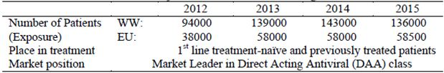
WW: worldwide
EU: European Union
Risks identified in the Phase 2/3 program include primarily rash and anaemia, and lymphopaenia, thrombocytopaenia, elevated blood creatinine, hypothyroidism and hyperuricaemia. Monitoring of risks other than rash will be via routine pharmacovigilance practices. The risks are highlighted throughout the PI. No further risk minimisation activities are proposed by the sponsor and this seems reasonable.
In the pooled, controlled T12/PR studies in 1346 patients, there was a risk difference for rash of 22.7% (95% CI: 18.4-27.0%). Severe (Grade 3) rash occurred in 4.8% of patients in the T12/PR group compared with 0.4% in controls who received Placebo/PR. There will be continued evaluation of rash in Study C211. The sponsor will also participate in the European RegiSCAR study to monitor SCARs in patients who receive telaprevir. Individual case reports and twice yearly reports will be provided to the sponsor. Analysis of rash data and skin biopsies will be used to assess possible mechanisms of telaprevir related rash in mild and moderate rash and to assess SCAR. The PI will be updated with new information and data from the European RegiSCAR will be included in PSURs (Period Safety Update Reports). The proposed PI provides a detailed summary of the risks of rash with recommendations for monitoring and management. The sponsor suggests no further risk management activities and this seems reasonable.

Balance
Up to 170 million people or up to 3% of the world population have HCV infection and it becomes chronic in 55-85%. Chronic infection is associated with hepatitis and progressive fibrosis. The main risk associated with chronic HCV infection is hepatic cirrhosis which develops in 4% to 20% of patients within 20 years of infection. Up to 29% of patients with cirrhosis develop decompensated liver disease and up to 30% of patients develop hepatocellular carcinoma within 20 years. Up to 50% of patients achieve SVR with the standard current therapy of Peg-IFNα/RBV given for 48 weeks. Retreatment with Peg-IFNα/RBV in patients who do not achieve SVR is successful in 4-21% of patients with prior non-response and 23-31% of patients with prior relapse. Peg-IFNα/RBV therapy is associated with significant morbidity (including rash, anaemia, psychiatric disturbance and alopecia) which may persist throughout the treatment period of 48 weeks. The addition of telaprevir for a treatment period of 12 weeks is associated with significant additional morbidity with an increased frequency of rash, anaemia, pruritus and anal discomfort. However, few patients need to have treatment withdrawn. The majority of treatment naive and prior relapse patients with eRVR may expect to achieve SVR when telaprevir is combined with PR for a period of 24 weeks. SVR rates are also significantly higher in patients with prior null or partial response when telaprevir is combined with PR for 48 weeks.
Telaprevir for 12 weeks in combination with PR for either 24 or 48 weeks is associated with an efficacy benefit which is statistically and clinically highly significant. Chronic HCV infection is a life threatening illness but patients who achieve SVR have a marked reduction in risk for liver related morbidity and mortality. In the prospective HALT-C study published in 2010, at 7.5 years, the adjusted cumulative rate of death/liver transplantation and of liver related morbidity/mortality in the SVR group (2.2% and 2.7%, respectively) was significantly lower than that of the no response group (21.3% and 27.2%, respectively [p <0.001 for both]). Laboratory tests related to severity of liver disease improved following SVR. There was a trend towards a reduction in the rate of hepatocellular carcinoma in patients with SVR but this was not statistically significant.
Telaprevir is tolerated less well than conventional therapy alone but the overall balance is strongly in favour of combined T/PR therapy.

Conclusions
The overall risk balance of telaprevir 750 mg given q8h for 12 weeks is positive, the decisive factor being increased SVR rates of 30-40% compared with standard therapy when telaprevir is used in combination with PR for 24 or 48 weeks. Viral relapse following T/PR in treatment naive patients is 5% and only 10% in treatment experienced patients. It is recommended that telaprevir, in combination with Peg-IFNα/RBV given for 24 or 48 weeks, be approved for the treatment of adults with genotype 1, chronic HCV infection.

V. Pharmacovigilance findings

Risk management plan
The sponsor submitted a Risk Management Plan that was reviewed by the TGA’s Office of Product Review (OPR).

Safety specification
The sponsor provided a summary of Ongoing Safety Concerns which are shown at Table 86.
Table 86: Important identified and potential risks for which specific pharmacovigilance activities are proposed.
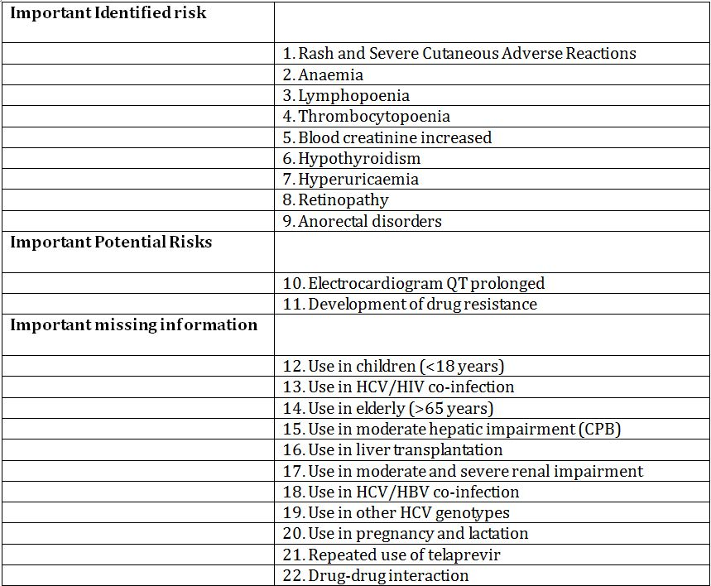

OPR reviewer comment:
Pursuant to the evaluation of the nonclinical and clinical aspects of the safety specification, it is noted that this product is to always be prescribed in combination with Peg-IFNα and RBV. The sponsor has made mention of some possible additive effects of this combination on the safety specification outlined for telaprevir. However, the safety specifications, pharmacovigilance and risk management plans for Peg-IFNα and RBV were not submitted as part of this application and have not been evaluated in combination with telaprevir.

Pharmacovigilance plan
The sponsor provides a very detailed account of the pharmacovigilance plan and routine activities.
Important identified risk:
- Rash and Severe Cutaneous Adverse Reactions
Planned pharmacovigilance actions:
- Routine pharmacovigilance.
- Participation in the ongoing European RegiSCAR study. Individual case assessment report and biannual reports will be included with PSURs.
- Continued evaluation and characterisation through a rash substudy of Study C211 (a substudy to investigate telaprevir related rash in a selected number of subjects enrolled in Study VX-950-C211).
- Evaluation of rash in two studies in HCV/HIV co infection (Study 110 and the planned Phase 3 study).
- A GWAS (genome wide association study) is planned to identify potential genetic risk factors associated with severe rash and SCAR in subjects receiving telaprevir combination therapy.
- Anticipated milestones: Clinical study report for Study 110 – Q4 2012, Study C211 – Q1 2013, GWAS – protocol planned for Q4 2011 and final report Q2 2013, planned Phase 3 study HCV/HIV co infection – Q2 2014.
Important identified risk:
- Anaemia
Planned pharmacovigilance actions:
- Routine pharmacovigilance.
Important identified risk:
- Lymphopenia
Planned pharmacovigilance actions:
- Routine pharmacovigilance.
- Analyses of changes in lymphocyte subsets in Study C211.
- Analyses of changes in total lymphocyte and lymphocyte subsets, and of AEs relating to possible opportunistic infections in Study 110 and the planned Phase 3 study in HCV/HIV co infection.
- Anticipated milestones: Study 110 – Q4 2012, Study C211 – Q1 2013, planned Phase 3 study HCV/HIV co-infection - Q2 2014.
Important identified risk:
- Thrombocytopenia
Planned pharmacovigilance actions:
- Routine pharmacovigilance.
Important identified risk:
- Blood creatinine increased
Planned pharmacovigilance actions:
- Routine pharmacovigilance.
- Evaluation of the effect of telaprevir on the OCT2 creatinine transporter protein.
- Continued evaluation in ongoing and planned clinical studies (110, C211, C219, HPC3006 and the planned Phase 3 study in HCV/HIV co infection).
- Anticipated milestones: Study 110 – Q4 2012, Study C211 – Q1 2013, planned Phase 3 study HCV/HIV co infection - Q2 2014, preclinical study Q1 2012, Study HPC3006 – Q2 2014.
Important identified risk:
- Hypothyroidism
Planned pharmacovigilance actions:
- Routine pharmacovigilance.
Important identified risk:
- Hyperuricaemia
Planned pharmacovigilance actions:
- Routine pharmacovigilance.
Important identified risk:
- Retinopathy
Planned pharmacovigilance actions:
- Routine pharmacovigilance.
Important identified risk:
- Anorectal disorders
Planned pharmacovigilance actions:
- Routine pharmacovigilance.
Important potential risk:
- Electrocardiogram QT prolonged
Planned pharmacovigilance actions:
- Routine pharmacovigilance.
- Continued evaluation through two ongoing clinical studies (Studies 110, C211 and C219).
- Anticipated milestones: Study 110 – Q4 2012, Study C211 – Q1 2013.
Important potential risk:
- Development of drug resistance
Planned pharmacovigilance actions:
- Routine pharmacovigilance.
- Continued evaluation through Study 112 (nonrandomised, three year virology follow up design to evaluate durability of virologic response, (changes in) HCV variants, and clinical outcomes related to severe liver disease in subjects with chronic hepatitis C who achieved SVR (Cohort A) or did not achieve SVR (Cohort B) with telaprevir based treatment in a previous study (Study 104, 104EU, 106, 107, 108, 111 or C216).
- The sponsor is evaluating options to assess the adherence to recommended stopping rules through a drug utilisation study.
- Anticipated milestones: Clinical study report – Q1 2014, planned protocol availability for drug utilisation study – Q4 2011.

Important missing information:
- Use in children (<18 years)
Planned pharmacovigilance actions:
- Routine pharmacovigilance.
- A PIP (Paediatric Investigation Plan), including a Phase 2 study in children has been proposed and agreed by the EMA (EMEA-00196-PIP01-08, P/127/2008, 23 December 2008).
Important missing information:
- Use in HCV/HIV co infection
Planned pharmacovigilance actions:
- Routine pharmacovigilance.
- Continued evaluation through:
  - Ongoing Study 110.
  - Planned Phase 3 study in HCV/HIV co infection.
  - Multicentre, open label EAP (expanded access program) of telaprevir in combination with Peg-IFNα and RBV in HIV/genotype 1 chronic hepatitis C co infected subjects with compensated cirrhosis(HPC3005)
- Also, ongoing drug-drug interaction studies with raltegravir (Study HEP1001), etravirine and rilpivirine (Study TMC125-1FD1001) and from the results made available from the US study TELAPREV11 sponsored ANRS (Agence Nationale de Recherche sur de Sida) submission of company sponsored studies.
- Evaluating options to assess the use of telaprevir in patient sith HCV/HIV co infection through a drug utilisation study.
- Anticipated milestones: Study 110 – Q4 2012, planned Phase 3 study HCV/HIV co infection – Q2 2014, planned protocol availability for drug utilisation study – Q4 2011, drug-drug interaction studies – anticipated between Q3 2011 and Q1 2012.
Important missing information:
- Use in the elderly (>65 years)
Planned pharmacovigilance actions:
- Routine pharmacovigilance.
Important missing information:
- Use in moderate hepatic impairment (CPB)
Planned pharmacovigilance actions:
- Routine pharmacovigilance.
Important missing information:
- Use in liver transplantation
Planned pharmacovigilance actions:
- Routine pharmacovigilance.
- Evaluation of the safety of telaprevir treatment in liver transplant subjects with genotype 1 chronic hepatitis C in Study 1IPC3006.
- Evaluating options to assess the use of telaprevir in liver transplant recipients through a drug utilisation study.
- Anticipated milestones: Study HPC3006 – Q2 2014, planned Phase 3 study HCV/HIV co infection - Q2 2014, Study HPC3006 – Q2 2014, planned protocol availability for drug utilisation study Q4 2011.
Important missing information:
- Use in moderate and severe renal impairment
Planned pharmacovigilance actions:
- Routine pharmacovigilance.
Important missing information:
- Use in HCV/HBV co infection
Planned pharmacovigilance actions:
- Routine pharmacovigilance.
- Evaluating options to assess the use of telaprevir in patient sith HCV/HBV co infection through a drug utilisation study.
- Anticipated timelines: planned protocol availability for drug utilisation study – Q4 2011.
Important missing information:
- Use in other HCV genotypes
Planned pharmacovigilance actions:
- Routine pharmacovigilance.
Important missing information:
- Use in pregnancy and lactation
Planned pharmacovigilance actions:
- Routine pharmacovigilance.
- Targeted follow up of spontaneous reports of exposure to telaprevir during pregnancy, including pregnancy outcome.
- All cases of pregnancy after exposure to telaprevir combination therapy in female patients, or in partners of male patients, to the Ribavirin Pregnancy Registry.
Important missing information:
- Repeated use of telaprevir
Planned pharmacovigilance actions:
- Routine pharmacovigilance.
Important missing information:
- Drug-drug interactions
Planned pharmacovigilance actions:
- Routine pharmacovigilance.
- Continuing evaluation through in vitro studies and the clinical drug-drug interaction study with buprenorphine/naloxone.
- Anticipated timelines: clinical study reports of the non CYP metabolism study including aldo keto reductases – Q1 2012, studies on CYP induction and CYP2C8 metabolism of telaprevir and VRT-127394 – Q4 2011; the UGI isoenzymes study – Q1 2012, study of transporter proteins – Q1 2012 (protocols for these studies no yet available), Study 024 - Q4 2011.

OPR reviewer comment:
The routine pharmacovigilance activities outlined are within TGA requirements and are acceptable.
The additional pharmacovigilance plan is comprehensive. The sponsor notes some studies are in the protocol development phase. The sponsor is requested to provide the protocols/synopses of these studies when they become available. The sponsor is requested to provide a summary of findings of each study (when the clinical report becomes available) in the PSUR that follows.
The proposed studies which comprise the agreed PIP with the EMA do not inform the safety of telaprevir for the proposed indication. These studies have not been evaluated.

Risk minimisation activities

Sponsor’s conclusion in regard to the need for risk minimisation activities
Routine risk minimisation is planned via the PI for all safety concerns. Additional risk minimisation activities are planned for ‘Rash and Severe Cutaneous Reactions’.
An education strategy is proposed for the Important Identified Risk of Rash and SCAR, which is described as being embedded in the standard medical education programs of the sponsor. The sponsor indicates the program provided to HCV treating physicians will also be provided to local healthcare organisation and nurses including nurse practitioners associated with these physicians and involved in the management of HCV patients.
OPR reviewer comment:
Although cutaneous reactions are the major focus of the educational materials, there is a section in the Safety overview that the sponsor indicates will be provided to prescribing physicians covering anaemia and the recommended strategy for its management. In addition, the summary table of adverse reactions from the PI is presented. Sample material is provided. It is well presented and very readable. The sponsor has also provided a sample questionnaire to be used to obtain follow up information for any individual reports of SCAR.

Potential for medication errors
The sponsor states it has conducted multifaceted research for Incivo, and has concluded there is limited risk of confusion between product names with this and other medicinal products.
Incivo is only indicated for use in combination with Peg-IFNα (administered once weekly by subcutaneous [SC] injection) and RBV (administered orally twice daily). The initiation and monitoring of this regimen should be by a physician experienced in the management of patients with hepatitis C. This information also appears in the PI in the dosage and administration section. There is only one dosage form and one recommended dose which the sponsor states should reduce prescriber error.
The presentation of Incivo differs from other products in the combination (which are taken together) in shape, colour and size of the tablets; as a result, the sponsor states they are unlikely to be confused with each other. The dosage regimen is different for RBV (twice daily) and telaprevir (three times daily). The tablets are housed in a child resistant container which is designed to reduce the risk of exploratory ingestions in children.
The common listed events in the overdose section of the PI are nausea, headache, diarrhoea, decreased appetite, dysgeusia and vomiting in patients taking 2.5 times the prescribed dose.
OPR reviewer comment:
Possible medication error may occur if the RBV is taken three times daily instead of twice daily and telaprevir is taken twice daily. The potential is for more anaemia and reduced SVR. Patient education by care providers at the initiation of treatment will be important to mitigate this potential error.
Both the RMP and PI note that ‘elimination of unabsorbed substance is to be achieved by emesis or gastric lavage’. These recommendations do not represent usual Australian clinical practice. As absorption occurs rapidly with peak concentrations within 2 h (30 minutes to 2 h), the sponsor is requested to provide justification for the inclusion of these recommendations in the Australian PI. No comment is made regarding ECG abnormalities, specifically prolonged QT interval in this information. It is suggested to the Delegate that this potential side effect in overdose be added to the overdose section of the PI as it may be helpful to clinicians treating patients with overdoses where telaprevir may be one substance in a polypharmacy overdose.

Summary of recommendations
The OPR provides these recommendations in the context that the submitted RMP is supportive to the application; the implementation of a RMP Version 1.3 dated 29 July 2011 is imposed as a condition of registration with the following qualification:

The Pharmacovigilance Plan:
The sponsor notes some studies are in the protocol development phase. The sponsor is requested to provide the protocols/synopses of these studies when they become available. The sponsor is requested to provide a summary of findings of each study (when the clinical report becomes available) in the PSUR that follows.
The proposed studies that comprise the agreed PIP with the EMA do not inform the safety of telaprevir for the proposed indication. These studies have not been evaluated.

The risk minimisation plan:
The sponsor has not provided any indication of how it intends to evaluate the education strategy to ensure its success. The education plan whilst comprehensive in content is considered incomplete without mention of an evaluation strategy. The sponsor is requested to provide this information after registration.

VI. Overall conclusion and risk/benefit assessment
The submission was summarised in the following Delegate’s overview and recommendations:

Quality
Telaprevir is manufactured as a single stereoisomer; however, it epimerises in vitro and in vivo. The film coated tablet proposed for registration has an 11-13% higher AUC than the uncoated tablet used in Phase 3 clinical studies. Food increases the bioavailability of telaprevir significantly, with highest bioavailability seen with a high fat meal. There are no objections to registration on Chemistry, Manufacturing and Controls grounds, subject to nonclinical clearance of the limits applied to impurities.

Nonclinical
A comprehensive nonclinical submission was provided. Telaprevir (single S diastereomer) inhibits HCV replication by inhibiting the HCV NS3 4A serine protease essential for HCV polyprotein processing. Inhibition was demonstrated in vitro and in a HCV protease model in mice. The R diastereomer (VRT-127394) has very little pharmacological activity. The dominant telaprevir resistance mutation in serial passage of HCV replicons was A156S. Telaprevir resistant HCV variants with mutations at residues 155, 156 or double substitutions 36 and 155 showed cross resistance to all NS3 inhibitors. A well defined toxicity profile was established for telaprevir with haematopoetic effects observed at potential therapeutic doses and liver effects also seen. There were no nonclinical safety concerns that would preclude registration, although there were no studies to support use in combination with PegIFN-α and RBV.

Clinical
The submission included forty completed clinical studies including five Phase 2 studies and three Phase 3 studies in subjects with genotype 1 chronic hepatitis C, and three ongoing studies.

Pharmacokinetics
There were 26 pharmacokinetic studies involving 815 healthy subjects and patients with hepatitis C (n=34) severe renal impairment (n=12), mild hepatic impairment (n=10), moderate hepatic impairment (n=10) and stable methadone therapy (n=16).
In a single dose study in health subjects in fed state, telaprevir AUC increased more than dose proportionately for doses ranging from 750 mg to 1875 mg. In an ascending multiple dose (450 mg q8h, 750 mg q8h, 1250 mg q12h) study of telaprevir in healthy volunteers and subjects with hepatitis C, AUC increased with increased dose with a mean accumulation index of 2.8 in healthy subjects and 1.7 in subjects with hepatitis C. The median exposure of VRT-127394 (R diastereomer) over telaprevir was 31% (range 18-43%).
Food had a substantial effect on bioavailability. Compared to administration following a standard normal caloric meal (21 g fat, 561 kcal), telaprevir exposures decreased by 73% when telaprevir was taken in the fasted state, by 39% following a low calorie low fat meal (3.6 g fat, 249 kcal), and by 26% following a low calorie high protein meal (9 g fat, 260 kcal). The exposure to telaprevir increased by 20% when taken following a high fat high caloric meal (56 g fat, 928 kcal) compared to an intake following a standard normal caloric meal.
Following a single dose of [¹⁴C] telaprevir (750 mg/2.84 MBq) radioactivity in plasma increased with a mean lag time of 4 h and with C_{max} 0.46 μg/mL and T_{max} of 18.5 h. The CL/F and Vz/F were 1153 L/hr and 7394 L.
Telaprevir is ∼59-76% bound to plasma proteins and has a large Vz/F estimated from population PK analyses of Phase 2 and Phase 3 studies to be 252 L, with inter individual variability of Vz/F estimated to be 72.2%.
Telaprevir is extensively metabolised in the liver via hydrolysis, oxidation, and reduction. Following repeated oral administration of telaprevir in combination with Peg-IFNα and RBV in subjects with chronic hepatitis C, the main metabolites of telaprevir were VRT-127394 (R diastereomer of telaprevir, 30 fold less active), pyrazinoic acid (not active), and VRT-0922061 (M3 isomer metabolite, reduction at the α-ketoamide bond of telaprevir, not active). Telaprevir is a substrate of P-gp and it is both a substrate and inhibitor of CYP3A.
Following a single 750 mg dose, the mean half life was approximately 4 h and at steady state the effective half life was approximately 9 to 11 h.
Telaprevir is predominantly eliminated in the faeces with minimal renal excretion. Following administration of a single oral dose of 750 mg [¹⁴C] telaprevir in healthy subjects, the median recovery of the administered radioactive dose was ∼82% in faeces, 9% in exhaled air, and 1% in urine. The clinical evaluation report noted the proportions of unchanged [¹⁴C] telaprevir and metabolites excreted.
The CL/F of telaprevir was estimated from population PK analyses of Phase 2 and Phase 3 studies to be 32.4 L/hr, with inter individual variability estimated to be 27.2%.
No telaprevir dose adjustment is required for subjects with renal impairment. In subjects with severe renal impairment the AUC was ∼21% higher than in health controls.
In subjects with mild hepatic impairment (CPA), there was no evidence of accumulation of doses following telaprevir 750 mg q8h for 5 days fed. In a study in CPB subjects, telaprevir C_{max} and AUC were unexpectedly reduced after first dose and 5 days compared to healthy controls. An appropriate telaprevir dose has not been determined for moderate or severe hepatic impairment.
Telaprevir may affect the PK of co administered drugs that are CYP3A substrates and/or transported by P-gp. Inhibition of CYP3A4 by telaprevir was both concentration and time dependent. In addition, telaprevir PK may also be severely affected by inhibitors and inducers of CYP3A and/or P-gp. Additional drug-drug interaction studies are identified in the RMP evaluation.

Pharmacodynamics
Dose response and viral kinetics were assessed in two Phase 1b and one Phase 2 clinical studies. In vitro studies had identified that a telaprevir concentration of 476 ng/mL inhibited 90% WT HCV mRNA replication (IC₉₀). A target concentration in liver was set as 10 fold greater.
Study 101 is a Phase 1b study which included assessment of HCV RNA levels to 450 mg q8h, 750 mg q8h and 1250 mg q12h. All dose levels showed similar decline in HCV RNA to Day 3. In the 750 q8h group, median HCV RNA continued to decline to Day 14, while in the 450 mg q8h and 1250 mg q12h goups there HCV RNA rebound during the dosing period. A median reduction >3 log₁₀ in HCV RNA was seen in the three dose groups and reduction >4 log₁₀ was seen in the 750 mg q8h group. A total of 3 of 34 patients achieved undetectable HCV RNA levels but all had detectable HCV RNA within 12 weeks of end of treatment. Highest steady state trough plasma concentration was reached with 750 mg q8h dose.
Study 102 is a Phase 2 study which assessed telaprevir (1250 mg initial dose followed by 750 mg q8h for 28 days) given in combination with Peg-IFNα and RBV in treatment naive adult subjects with HCV genotype 1 infection. All subjects had undetectable HCV RNA (<10 IU/mL) by the end of 28 day dosing. The median change in HCV RNA was -5.7 log₁₀ IU/mL (range -6.9 to -4.6). At Week 12 follow up with ongoing Peg-IFNα and RBV, one subject had detectable HCV RNA and 11 subjects had no detectable HCV RNA.
Study 103 is a Phase 1b study which assessed telaprevir (1250 mg initial dose followed by 750 mg q8h for 14 days) alone or given in combination with Peg-IFNα in treatment naive adults with HCV genotype 1 infection. In all subjects who received telaprevir, HCV RNA levels declined between Days 1 to 4 of dosing. A second sustained decline was seen in 4/8 telaprevir subjects and all 8 telaprevir + Peg-IFNα subjects.
The presence of Peg-IFNα and C_{trough} of telaprevir were predictors of response during the second phase of viral decline.
Secondary pharmacology effects on QT interval were assessed in Study 008. Exposure to standard dose of telaprevir (750 mg q8h) was not associated with clinically relevant effect on QTcF, while supratherapeutic exposure to telaprevir was associated with QTcF prolongation over placebo corrected values (90% CI ≥ 10 ms).

Efficacy
Efficacy for telaprevir, measured by sustained virological response, in adult patients with chronic HCV genotype 1 infection was assessed in two Phase 2b clinical studies in treatment naive patients (Studies 104 and 104EU) and in treatment failure patients (Studies 106 and 107).
The three Phase 3 efficacy studies were Studies 108 and 111 in treatment naive patients and Study 216 in treatment failure subjects.
Study 108 is a randomised double blind study of two regimens of telaprevir dosed with PR compared with standard treatment with PR. Telaprevir was given in combination with PR for either the first 8 weeks or the first 12 weeks of therapy. PR were continued for a total of 24 weeks or for 48 weeks, determined by extended rapid viral response (undetectable HCV RNA at 12 weeks). The comparator arm received PR for 48 weeks. The study participants were male or female adults aged 18-70 years with chronic hepatitis C genotype 1 infection who were treatment naive. Key exclusion criteria were decompensated liver disease, other significant liver disease, patients requiring corticosteroids, and patients with HBV or HIV infection. The dose of oral telaprevir was 750 mg q8h after food. Peg-IFNα-2a was given SC once weekly at dose of 180 μg. The dose of oral RBV was 1000 mg/day for patients <75 kg and 1200 mg/day for patients ≥ 75 kg. There were treatment stopping rules based on viral failure (HCV RNA > 1000 IU/mL) assessed at Weeks 4 and 12. The primary efficacy outcome was SVR 24 weeks after end of planned treatment in FAS. Subjects were randomised 1:1:1 to the three treatments with 350 planned for each group. Subjects were stratified among treatment groups with regard to genotype 1 subtypes and baseline viral load (HCV RNA < 800000 IU/mL or ≥ 800000 IU/mL).
A total of 1095 patients were randomised and 1088 received study medications. In the T8/PR group, 260/364 (71.4%) patients completed treatment, in the T12/PR group 268/363 (73.8%) patients completed treatment, and in Placebo/PR group 202/361 (56%) patients completed treatment. Virological failure was reported in 11% of T8/PR group, 10.5% of T12/PR group, and 32.7% of Placebo/PR group; this was the predominant reason for discontinuation. AEs were the second most common reason for discontinuation and were reported in 10.2% of T8/PR group, 9.9% of T12/PR group, and 7.2% of PR group. Treatment adherence to telaprevir/Placebo was at least 95% in each treatment group.
Demographics and baseline disease characteristics were balanced between treatment groups. Approximately 55% were male and 88% were Caucasian. Median log₁₀ HCV RNA was 6.4 IU/mL and 77.1% had baseline HCV RNA ≥ 800000 IU/mL. A 6.3% fraction of patients had cirrhosis, 41.2% had portal fibrosis, and 15% had bridging fibrosis.
The primary efficacy endpoint SVR24_{planned} rates in FAS were 68.7% for the T8/PR group and 74.7% for the T12/PR group compared with 43.8% for the Placebo/PR48 group (p <0.0001 for both comparisons). The differences in SVR24_{planned} for T8/PR and T12/PR groups compared with the Placebo/PR48 group were 24.9% (95% CI: 17.9-31.9%) and 30.9% (95% CI: 24.1-37.7%) respectively. The SVR24_{planned} rate for Placebo/PR48 was similar to SVR reported in other studies. There was a 6% point estimate benefit in SVR24 for T12/PR compared to T8/PR. Results in the SVR24_{planned} in PP data set were similar to the FAS dataset.
It was found that 66.6% of patients in the T8/PR group and 67.8% of patients in the T12/PR group achieved RVR and were eligible for 24 weeks of therapy. This compared with 9.4% with RVR in the Placebo/PR48 group. 56.9% of patients in the T8/PR and 58.4% in the T12/PR group achieved extended RVR compared with 8.0% of patients in the Placebo/PR48 group. eRVR rates were strongly predictive of SVR with a positive predictive value of 82.6% in T8/PR group, 89.2% in T12/PR group and 96.6% in the Placebo/PR group.
Relapse_{planned} rates were lower in the TPR groups than in the Placebo/PR48 group: 9.5% in the T8/PR group, 8.6% in the T12/PR group and 27.9% in the Placebo/PR48 group. Virologic failure rates were lower in the T/PR groups than in the Placebo/PR48 group: 12.9% in the T8/PR group, 8.3% in the T12/PR group and 31.9% in the Placebo/PR48 group.
Patients with age <45 years had higher SVR rates in all treatment groups as did Caucasian patients compared to black patients, and non diabetic compared to diabetic patients. BMI <25 showed higher SVR rates compared to BMI ≥ 25 in the T12/PR group.
Study 111 is a randomised, open label study in treatment naive subjects with genotype 1 chronic hepatitis C which compared 24 or 48 weeks of PR among patients who had achieved extended rapid viral response with telaprevir in combination with PR. Telaprevir was given in combination with PR for first 12 weeks of therapy. Patients who achieved eRVR (undetectable HCV RNA levels at Week 4 and Week 12 on treatment) and completed the Week 20 visit on PR were randomised to stop all study treatment at Week 24 or to continue PR until Week 48. Patients who did not achieve eRVR continued PR until Week 48. Study participants were male or female adults aged 18-70 years with chronic hepatitis C genotype 1 infection who were treatment naive. Key exclusion criteria were decompensated liver disease, other significant liver disease, patients requiring corticosteroids, and patients with HBV or HIV infection. The dose of oral telaprevir was 750 mg q8h after food. Peg-IFNα-2a was given SC once weekly at dose of 180 μg. The dose of oral RBV was 1000 mg/day for patients <75 kg and 1200 mg/day for patients ≥ 75 kg. The primary efficacy outcome was SVR 24 weeks after end of planned treatment. Subjects were stratified with regard to genotype 1 subtype and baseline viral load.
A total of 544 patients enrolled and 540 received study medications. A total of 100 subjects prematurely discontinued the treatment regimen before week 20. A total of 162 subjects with eRVR were randomised to T12/PR24 and 161 completed treatment at Week 24. A total of 156 subjects were included in the PPA; 160 subjects with eRVR were randomised to T12/PR48 and 119 completed treatment at Week 48. A total of 158 subjects were included in the PPA, while 118 subjects who did not achieve eRVR were assigned to T12/PR48 and 79 completed treatment at Week 48. A total of 115 subjects were included in PPA.
Demographics and baseline disease characteristics were similar in randomised groups. The majority of patients were male (60.2%), Caucasian (79%), and from North America (94.3%). Mean age was 49.3 years.
The primary efficacy endpoint SVR24_{planned} rates in FAS were 92.0% in the randomised T12/PR24/eRVR+ group and 87.5% in the randomised T12/PR48/eRVR+ group. The difference in the SVR24_{planned} rate (T12/PR24/eRVR+ minus T12/PR48/eRVR+) was +4.5% (two sided 95% CI: -2.1-11.1%). Therefore, the T12/PR24/eRVR+ treatment regimen was NI to the T12/PR48/eRVR+ treatment regimen as the lower bound of the 95% CI (-2.1%) was entirely to the right of the pre defined NI margin of -10.5%. Analysis of the PP set showed similar results: the difference in SVR_{planned} rates (T12/PR24/eRVR+ minus T12/PR48/eRVR+) was 4.3% (CI: -2.2% to 10.9%). The key secondary endpoint of NI for SVR at Week 72 was also met. SVR72 rates were 87% in the T12/PR24 group and 87.5% in the T12/PR48 group in patients with eRVR. There was no difference in the viral breakthrough rates between the eRVR+ randomised groups (1.9% in both groups) and the total cumulative breakthrough rate for the overall study population was 7.4%. The SVR24_{planned} rate was 71.9% across the entire population compared with a historical standard care rate of ∼50%.
Study 216 is a randomised, double blind, placebo controlled study in subjects with genotype 1 chronic hepatitis C who failed prior Peg-INFα plus RBV therapy, including evaluation of a delayed start of telaprevir. The treatment groups were:
- telaprevir in combination with PR for 12 weeks followed by placebo plus PR for 4 weeks then followed by PR for a further 32 weeks;
- placebo plus PR for 4 weeks followed by telaprevir plus PR for 12 weeks followed by PR for a further 32 weeks;
- placebo plus PR for 16 weeks followed by PR for a further 32 weeks.
The study participants had either undetectable HCV RNA at the end of a previous course of PR but did not achieve SVR (prior relapsers), or never had undetectable HCV RNA levels with a prior course of PR (prior non responders) and were male or female adults aged 18-70 years with chronic hepatitis C genotype 1 infection and HCV RNA > 1,000 IU/mL. Key exclusion criteria included decompensated liver disease, other significant liver disease, significant concomitant illness and prior PR discontinuation for tolerance issues. The primary objective was to demonstrate the superior efficacy of telaprevir combined with PR compared to standard treatment with PR in patients who had failed previous treatment with PR. The aim was to achieve this primary objective for both prior relapsers and prior non responders. Secondary efficacy objectives included: the effect of DS telaprevir on the efficacy of T/PR; the efficacy of T/PR versus PR on prior null responders (defined by <2 log drop in HCV RNA) versus prior partial responders (defined by ≥2 log drop in HCV RNA). The primary efficacy outcome was SVR 24 weeks after end of planned treatment in FAS. Patients were to be randomised to treatment groups A, B, and C in a 2:2:1 ratio. Subjects were stratified with regard to baseline viral load (<800,000 IU/mL or ≥ 800,000 IU/mL) and prior relapse or non responder status.
A total of 662 patients were included in the full analysis dataset. Demographic characteristics were similar across treatment groups with the majority of patients male (69.5%) and Caucasian (92.9%) and with median age 51 years. Baseline disease characteristics were also similar in treatment groups with mean viral load of 6.6 log₁₀ HCV RNA, 88.5% had viral load >800,000 IU/mL and 25.5% had cirrhosis. A 53.5% fraction of subjects were prior relapsers and 46.5% were prior non responders. The primary endpoint SVR24_{planned} rate overall in FAS was 64.3% in T12/PR48 group, 66.3% in T12(DS)/PR48 and 16.7% in Placebo/PR48 group, with both telaprevir groups demonstrating superiority over placebo. The point difference SVR24_{planned} rates between T12/PR48 and T12(DS)/PR48 groups was -3.0% (95% CI: -13%, 7%). The lower 95% CI boundary exceeded the equivalence margin and NI of T12(DS) was not established. Both telepravir arms showed superiority over Placebo/PR48 in each of these populations with point estimate of differences between telaprevir arms in the range -4.3% to +4.1%. SVR24_{planned} rates were considerably higher in telaprevir arms in the prior relapse population than in the prior non responder population, and SVR24_{planned} rates were higher in telaprevir arms in the prior partial responder population compared to prior null responder population.
For patients who did not achieve RVR or eRVR, SVR24_{planned} rates were higher in each telaprevir group than in the Placebo/PR48 group in all populations based on prior response. SVR24_{planned} rates were higher in patients who achieved RVR or eRVR than among patients who did not achieve RVR or eRVR in all treatment subgroups based on prior response. In patients not achieving SVR, there were no differences in resistant viral strains between the T12/PR48 and T12(DS)/PR48 arms. On treatment virologic failure occurred in 97/530 patients (18.3%) and this was more frequent in prior null responders and genotype 1a patients. There were no consistent differences in SVR24_{planned} rates in subgroups defined by gender, race, ethnicity, region, BMI, or body weight.

Safety
In eight controlled and uncontrolled studies, 2830/3594 patients received at least one dose of telaprevir. The most relevant safety data are taken from the pooled placebo controlled Phase 2/3 studies (104, 104EU, 106, 108, 111, C216) in which 1346 patients received telaprevir 750 mg q8h for 12 week in combination with PR, 1823 received any telparevir/PR regimen and 764 received Placebo/PR. Since telaprevir was included in the first 12 weeks of therapy in these studies, data from the telaprevir/placebo phase allow direct assessment of the additive toxicity of telaprevir to standard PR therapy.
The incidence of SAEs, AEs of at least Grade 3, and AEs leading to permanent treatment discontinuation was higher in the T12/PR group than in the Placebo/PR group. SAE were reported in 6.9% in T12/PR group, 6.6% in any T/PR group and 2.9% of Placebo/PR group. During the telaprevir/placebo treatment phase, individual SAE preferred terms were reported in less than 0.5% of the subjects in the T12/PR group, except for serious anemia (1.6%) and rash (0.7%). AE leading to permanent discontinuation of telaprevir/placebo occurred in 14.2% of patients in the T12/PR group, 15.0% in the Any T/PR group and in 4.1% in the Placebo/PR group. The most common reasons for withdrawal were anaemia, rash and pruritus. In the pooled controlled and non controlled Phase 2 and 3 studies, there were seven deaths in patients who had received telaprevir but only one of these deaths occurred while receiving telaprevir (head trauma following a fall considered unrelated to study drug).
Nearly all patients had AEs during the telaprevir/placebo period and most of these were at least possibly related to telaprevir/Placebo. The incidence of pruritus, anaemia, diarrhoea, rash, haemorrhoids and nausea was ≥ 5.0% higher in the T12/PR group than in the Placebo/PR group. Anorectal discomfort, anal pruritus, dysgeusia and generalised pruritus occurred in at least twice as many patients in the T12/PR group than in the Placebo/PR group.
AEs of at least Grade 3 occurred in 321 (23.8%) patients in the T12/PR group; in 417 (22.9%) patients in the Any T/PR group; and in 94 (12.3%) patients in the Placebo/PR group. The most frequently reported AEs of at least Grade 3 severity were anaemia, neutropaenia, leucopaenia, rash, pruritus, fatigue, thrombocytopaenia and nausea, with higher incidence in T12/PR group than in the Placebo/PR group for all with exception of neutropaenia.
The main laboratory abnormalities were haematological. Laboratory abnormalities of Grade 2 or higher occured more frequently in the T12/PR group than in Placebo/PR group for uric acid, total bilirubin, total cholesterol and LDL. Mean serum creatinine and mean TSH increased slightly during treatment but decreased to baseline after telaprevir was ceased.
Most AEs occurred in the first 4 weeks with the great majority occurring in the first 24 weeks. The incidence of rash, anaemia and rectal symptoms was higher in T12/PR group than Placebo/PR group. The incidence of rash was 55.4% in the T12/PR group compared with 32.7% in the Placebo/PR group. Serious rash occurred in 1.7% of patients in the T12/PR group compared with none in controls. Rash of at least Grade 3 severity occurred in 4.8% of patients in the T12/PR group and in 0.4% of controls. Rash leading to permanent discontinuation of telaprevir/placebo occurred in 5.8% of patients in the T12/PR group and in 0.3% of controls. Most cases of rash occurred in the first 4 weeks after treatment. Most rashes did not progress in severity and most had resolved by Week 24. A total of 621/807 (77.0%) patients in the T12/PR group who developed rash required concomitant medication including topical steroids and systemic antihistamines. Systemic steroids were administered in 50 (6.2%) patients. The incidence of rash appeared to be uninfluenced by age, race, gender, region, BMI, previous treatment status or exposure to telaprevir. In 221 cases of rash assessed by a DEP, the severity and extent of rash was indistinguishable from rash associated with PR therapy, namely eczematous with spongiosis on biopsy. However, the rash was not typical of allergic drug reactions based on time of onset and delayed resolution after stopping treatment. Pruritus, mostly Grades 1 and 2, was reported more commonly in the T12/PR group (51.5%) than in the Placebo/PR group (26.4%). Anorectal events were also reported more commonly in the T12/PR group (26.2%) than in controls (5.4%). Anorectal events were mild and did not result in treatment discontinuation. The most frequently reported anorectal events in the T12/PR and Placebo/PR groups were haemorrhoids (12.2% versus 2.6%), anorectal discomfort (7.9% versus 2.1%), and anal pruritus (6.2% versus 0.9%).
Anaemia with haemoglobin decreases of Grade 2 or more occurred in 79.2% of patients in the T12/PR group and in 51% of patients in the Placebo/PR group. The decrease in haemoglobin occurred rapidly in the first 4 weeks of treatment and continued to fall, reaching its nadir at approximately Week 12. In the T12/PR group, haemoglobin fell to <100 g/L in 33.7% of patients and < 85 g/L in 8.3% of patients. The fall in haemoglobin was greater in the T12/PR group than in the Placebo/PR group but the additional effect of telaprevir resolved when telaprevir was discontinued after 12 weeks treatment. There was a corresponding increase in reticulocyte count suggesting a haemolytic component to the anaemia. However, in the T12/PR group there was a higher incidence of thrombocytopaenia and lymphopaenia which also suggests mild bone marrow suppression. Despite the severity of the anaemia in some patients, only 2.7% were withdrawn from the T12/PR group and few required blood transfusion or treatment with erythropoetic agents.

Conclusion
The clinical evaluation report concludes that telaprevir for 12 weeks in combination with PR for either 24 or 48 weeks is associated with an efficacy benefit which is statistically and clinically highly significant. SVR rates were increased 30-40% compared with standard therapy when telaprevir is used in combination with PR for 24 or 48 weeks. Viral relapse following T/PR in treatment naive patients is 5% and only 10% in treatment experienced patients. The majority of treatment naive and prior relapse patients with eRVR may expect to achieve SVR when telaprevir is combined with PR for a period of 24 weeks. SVR rates are also significantly higher in patients with prior null or partial response when telaprevir is combined with PR for 48 weeks. It is likely that increased SVR rates with telaprevir will lead to significantly outcomes and survival in patients with chronic liver disease associated with HCV. The significant risks associated with telaprevir therapy are rash and anaemia. Both may require premature discontinuation of therapy but both are reversible. Severe (Grade 3) rash occurred in 4.8% of patients in the T12/PR group compared with 0.4% in controls who received Placebo/PR. The selection of drug resistant variants in patients failing to reach SVR has potential consequences for further treatment. There is high potential for drug interactions with telaprevir and potential for interactions which increase QT prolongation. Telaprevir is tolerated less well than conventional therapy alone but the clinical evaluation report concludes overall balance is strongly in favour of combined T/PR therapy. The clinical evaluation report recommends approval of telaprevir, in combination with Peg-IFNα/RBV given for 24 or 48 weeks, for the treatment of adults with genotype 1, chronic HCV infection.

Risk management plan
The sponsor provides a detailed account of the pharmacovigilance plan and routine activities to address important identified and potential risks. Routine risk minimisation is planned via the PI for all safety concerns. Risk minimisation activities are planned which involve an educational strategy focused on ‘Rash and Severe Cutaneous Reactions’. The RMP evaluation recommends some changes to PI and CMI.

Risk-benefit analysis

Delegate considerations
There are no current Module 3 (chemical) or Module 4 (nonclinical) objections to registration of telaprevir. The nonclinical evaluation requested a statement under the ‘Contraindications’ section in the PI that Incivo combination therapy is contraindication in women who are or may become pregnant and in men whose female partners are pregnant. The ‘Use in Pregnancy’ statement in PI was also recommended Category X-Use with RBV and Peg-IFNα. I support these PI recommendations in the nonclinical report. However, I disagree with the submitted response that local PI should only represent data for telaprevir and not RBV and Peg-IFNα, given that Incivo must not be administered as monotherapy and must only be prescribed with both Peg-IFNα and RBV.
I agree with the clinical evaluation report’s conclusion that telaprevir for 12 weeks in combination with PR for either 24 or 48 weeks is associated with an increase in SVR rates of 30-40% over standard therapy. Telaprevir is tolerated less well than current standard therapy alone, with rash and anemia the principal AEs. The overall benefit risk balance is considered strongly in favour of combined T/PR therapy for the treatment of genotype 1 chronic hepatitis C in adult patients with compensated liver disease.
There are numbers of populations for which clinical data are not available. Treatment in patients with decompensated liver disease has not been studied, with Peg-IFNα and RBV contraindicated in this population. In moderate hepatic impairment (CPB), a pharmacokinetic study unexpectedly showed decrease in exposure compared to healthy individuals, and an appropriate telaprevir dose has not been determined. A study is HIV/HCV co infected patients is ongoing. A PIP has been agreed with EMA, and a study is planned in liver transplant patients with genotype 1 chronic hepatitis C.
In the prior null responder population the SVR rates to telaprevir in combination with PR were modest with SVR reported in 31% in Study 216, and 14% in prior null responders with cirrhosis. Telaprevir treatment emergent resistance substitutions emerged in the majority of isolates from subjects who did achieve SVR in Phase 3 studies. Potential for emergence of resistance is a consideration of treatment of prior null responders. Resistance information on treatment emergent substitutions in pooled Phase 3 clinical trials presented in the US PI should also be included in the Australian PI.
The sponsor proposes a stopping rule for patients with inadequate response that recommends that patients with HCV RNA >1000 IU/ml at week 4 should discontinue Peg-IFNα and RBV. In Phase 3 studies, none of the patients with HCV RNA >1000 IU/mL at either Week 4 or Week 12 achieved SVR with continued PR therapy. In treatment naive patients in Phase 3 studies, 4/16 with HCV RNA levels between 100 IU/mL and 1000 IU/mL at week 4 achieved SVR.
The clinical studies of telaprevir submitted predominantly involved administration of Peg-IFNα-2a in combination with RBV and telaprevir. Peg-IFNα-2b, administered in combination with RBV and telaprevir, was assessed only in Study C208. Study C208 compared Peg-IFNα-2a and Peg-IFNα-2b, in combination with telaprevir and RBV, in treatment naive chronic hepatitis C subjects. Although the study is underpowered and involved telaprevir arms dosed at 750 mg q8h and 1250 mg q12h, the SVR exceeded 80% in all treatment arms.
In Phase 2 and 3 studies, anaemia was managed with RBV dose reduction. Use of erythropoietin was not generally permitted and use was reported in 2.5% of patients who received T/PR and 0.7% of patients who received PR.
The clinical evaluation report has not commented on IL28 genotype influence on the response to T/PR combination therapy.
The RMP evaluation commented in relation to the Rash and SCAR education plan that while comprehensive in content, the plan is considered incomplete without mention of an evaluation strategy.

Delegate considerations
I propose to register telaprevir (Incivo) 375 mg tablets. Incivo, in combination with Peg-IFNα and RBV, is indicated for the treatment of genotype 1 chronic hepatitis C in adult patients with compensated liver disease (including cirrhosis):
- who are treatment naive;
- who have previously been treated with IFNα (pegylated or non-pegylated) alone or in combination with RBV, including relapsers, partial responders and null responders (see Pharmacodynamics: Clinical Experience, Efficacy in Previously treated Adults).
The recommended dose is 750 mg taken orally every 8 h with food. Treatment with Invico must be initiated in combination with Peg-IFNα and RBV and is recommended for administration for 12 weeks.
The advice of ACPM is requested.
The consideration and comment of ACPM is specifically requested on the following aspects:
- Telaprevir combination therapy with ribavrin and Peg-IFNα should have “Use in Pregnancy - Category X” and a statement of contraindication in women who are or may become pregnant and in men whose female partners are pregnant,
- An appropriate telaprevir dose has not been determined in moderate hepatic impairment. The sponsor does not plan further clinical studies to determine an appropriate telaprevir dose in patients with moderate hepatic impairment,
- Limited clinical study assessment of telaprevir used in combination with Peg-IFNα-2b and RBV.
- The adequacy of the PI and proposed risk minimisation proposed for management of severe rash, anaemia and drug-drug interactions.

Response from sponsor
The sponsor agrees with the Delegate's recommendation to approve Incivo (telaprevir) 375 mg tablets for:
Incivo, in combination with Peg-IFNα and RBV, is indicated for the treatment of genotype 1 chronic hepatitis C in adult patients with compensated liver disease (including cirrhosis):
    - who are treatment naive;
    - who have previously been treated with IFNα (pegylated or non pegylated) alone or in combination with RBV, including relapsers, partial responders and null responders (see Pharmacodynamics: Clinical Experience, Efficacy in Previously Treated Adults).
The recommended dose is 750 mg taken orally every 8 h with food. Treatment with Incivo must be initiated in combination with Peg-IFNα and RBV and is recommended for administration for 12 weeks.
However, we wish to comment on the following items.
Delegate’s comment 1:
‘Telaprevir in combination therapy with RBV and Peg-IFNα should have “use in Pregnancy - Category X” and a statement of contraindication in women who are or may become pregnant and in men whose female partners are pregnant.’
Sponsor’s response:
Pregnancy Category X as defined by the TGA is used for drugs which have such a high risk of causing permanent damage to the foetus that they should not be used in pregnancy or when there is a possibility of pregnancy. Telaprevir has shown no teratogenic potential in rats and mice and is not considered a developmental toxicant in these species. However, the proposed indication is for telaprevir used in combination with Peg-IFNα and RBV. Therefore, the sponsor can accept the Delegate’s recommendation that telaprevir + Peg-IFNα/RBV combination therapy be considered Pregnancy Category X and has modified the PI as requested. To clarify further, the drug telaprevir by itself remains category B2 since it meets the following definition of a Category B2 drug: “Drugs which have been taken by only a limited number of pregnant women and women of childbearing age, without an increase in the frequency of malformation or other direct or indirect harmful effects on the human foetus having been observed and studies in animals are inadequate or may be lacking, but available data show no evidence of an increased occurrence of foetal damage.”
In addition, we want to take this opportunity to comment on the proposed amendment to the current Poisons Standard contained in the notice Invitation for public comment - ACMS (Advisory Committee on Medicines Scheduling) and ACCS (Advisory Committee on Chemicals Scheduling) meetings, February 2012. In particular, the ACMS is asked to provide advice on the following proposal:
Consideration of inclusion of telaprevir in Appendix L, including a proposal for a requirement for labelling with warning statement 77 "WARNING - May cause birth defects" and/or warning statement 67 "Do not use if pregnant or likely to become pregnant".
The sponsor is working on a response that will be forwarded to the Secretary of Scheduling Secretariat to advise the sponsor does not believe that the proposed product container label warnings for telaprevir are appropriate for the following reasons:
- Telaprevir, as noted above, meets the TGA definition of a Category B2 drug.
- The Pregnancy Category X only refers to the combination of telaprevir, Peg-IFNα and RBV based on the teratogenicity of RBV.
- Telaprevir is only to be packaged as a single product and is not co-packaged with Peg-IFNα or RBV.
- In the Poisons Standard 2011, both Peg-IFNα and RBV are classified as Schedule 4 drugs. Neither are included in Appendix D with additional controls. They are not listed in Appendix L, Part 2.
- The product container labeling for telaprevir should reflect the characteristics of the product contained within the packaging. In fact, the Standard for the Uniform Scheduling of Medicines and Poisons No.2, Part 2 Labels and Containers, notes that “a label used in connection with any poison must not include any expression or device which is false or misleading in any particular concerning the safety of the poison or any of its ingredients”. Further, it notes “a label used in connection with any poison must not include any trade name or description that misrepresents the composition or any property or quality of the poison”.
Based on this information, the sponsor believes that the proposed product container label warnings for telaprevir "WARNING - May cause birth defects" and/or "Do not use if pregnant or likely to become pregnant" are inappropriate because they misrepresent the safety of the poison contained within the telaprevir product container. The risk described by the proposed product container label warnings above is associated with the poison RBV, not telaprevir. The proposed PI clearly distinguishes and describes the risks of telaprevir combination therapy, but the product container label warning should reflect the risk and safety of the product contained within the product container.
Delegate’s comment 2:
‘An appropriate telaprevir dose has not been determined in moderate hepatic impairment. The sponsor does not plan further clinical studies to determine an appropriate dose in patients with moderate hepatic impairment.’
Sponsor’s response:
As discussed in the Category 1 application for registration, the lower exposure to telaprevir in subjects with moderate hepatic impairment (CPB) as observed in Study VX08-950-012 (Study 012), may be related to lower plasma protein concentrations which could result in lower total telaprevir concentrations without an impact on the unbound (pharmacologically effective) telaprevir concentration. If this is confirmed, the observed reduction in total telaprevir exposure in plasma in subjects with moderate hepatic impairment would not be clinically relevant. The sponsor has committed to the EMA to further investigate this hypothesis in a study of telaprevir in HCV negative subjects with moderate hepatic impairment. The study design will likely be comparable to Study 012, but with additional analyses to investigate the proposed hypothesis. It is anticipated that a final protocol will be available by April 2012. A final Clinical Study Report is expected to be available by April 2013.
Delegate’s comment 3:
‘Limited clinical study assessment of telaprevir used in combination with Peg-IFNα-2b and RBV.’
Sponsor’s response:
Two pegylated IFNα (Peg-IFNα-2a and Peg-IFNα-2b) are globally approved for the treatment of chronic hepatitis C.
All clinical studies in the sponsor’s development program used Pegasys/Copegus, except Study VX-950-TiDP24-C208 (Study C208). Study C208 compared two different dosing regimens of telaprevir (750 mg q8h and 1125 mg q12h) in combination with Pegasys/Copegus or with PegIntron/Rebetol in treatment naïve subjects, and found no clinically or statistically significant differences in SVR rates between any of the treatment groups. The difference in SVR rates between the pooled Peg-IFNα-2a and Peg-IFNα-2b arms was 2.3% (95% CI: -10.8; +12.1). There were slight differences in outcome based on the type of Peg-IFNα used in terms of the proportion of subjects who met criteria for shorter treatment duration. However, even with Peg-IFNα-2b, greater than 60% of subjects were eligible for the shorter treatment duration. Among those who met criteria for shorter treatment duration (undetectable HCV RNA Weeks 4-20), 98.3% of the Peg-IFNα-2a subjects and 94.0% of the Peg-IFNα-2b subjects achieved an SVR. There was a slightly higher rate of viral breakthrough seen among the Peg-IFNα-2b subjects.
The sponsor is of the opinion that the differences seen in Study C208 are consistent with those seen in previous studies that have compared Peg-IFNα-2a and Peg-IFNα-2b when used in a regimen in the absence of a direct acting antiviral agent (DAA)-3,4,5. There are intrinsic differences in the PK of the Peg-IFNs which may lead to slight differences in outcomes during treatment. This is manifest in the longer time to achieve an undetectable HCV RNA level with Peg-IFNα-2b, the smaller proportion of subjects who meet criteria for a shorter duration of therapy with Peg-IFNα-2b, and the slight increase in viral breakthrough rate in subjects treated with Peg-IFNα-2b. However, despite these on treatment differences, relapse rates are very low, and both relapse rates and SVR rates are similar with Peg-IFNα-2b and Peg-IFNα-2a when used with telaprevir. The low relapse rate and the SVR rate that can be achieved with telaprevir in combination with Peg-IFNα-2b and RBV is favourable to that which can be achieved with a standard Peg-IFNα-2b/RBV regimen based on the greater than 80% SVR rate seen in the pooled Peg-IFNα-2b arms of Study C208. While Study C208 did not provide a standard Peg-IFN/RBV control arm, regardless of the IFN used in combination with telaprevir the SVR rates were quite high at over 80%. This is a response rate that has not been achieved in a population of genotype 1 HCV infected subjects with Peg-IFNα and RBV alone.
While telaprevir should preferentially be used in combination with Peg-IFNα-2a, given that some patients in telaprevir to a Peg-IFNα-2b/RBV regimen provides a beneficial treatment option to such patients, the sponsor proposes to amend the PI in line with the Delegate’s comments to provide information to prescribers by relocating this information from the Indication to the ‘Precautions’ section.
Delegate’s comment 4:
‘The adequacy of product information and proposed risk minimisation proposed for management of severe rash, anaemia and drug-drug interactions.’
Sponsor’s response:
The sponsor is of the belief that the current PI and risk minimisation proposed for the management of severe rash, anaemia and drug-drug interactions is adequate. During the course of the review of the Category 1 application for registration, the sponsor has significantly modified the PI to more clearly describe the risks of telaprevir combination therapy, to provide clearer information to prescribers about how to manage these adverse reactions and to appropriately monitor these risks. The information provided in the PI and the RMP is derived directly from the telaprevir clinical development program and reflects the outcomes of the clinical trials and the adverse event management that was proscribed within the clinical trial protocols.
Specific additions to the PI made in relation to rash include a table of recommendations for monitoring of rash and for discontinuation of telaprevir, RBV and Peg-IFNα. Text has also been added to reinforce the requirement for prescribers to ensure that patients are fully informed about the risk of severe rashes, and to consult with the prescriber immediately if they develop a new rash or worsening of an existing rash.
Rash and SCAR are identified as Important Identified Risks in the RMP. Ongoing monitoring with routine pharmacovigilance practices is planned and the RMP further describes plans to gather close follow up information for SCAR cases, to characterise rashes within ongoing/planned studies and to perform a GWAS to identify potential genetic risk factors associated with severe rash and SCAR in subjects receiving telaprevir combination therapy. Additional risk minimisation activities including physician education on the risk of severe rash and SCAR are proposed to improve prescriber awareness and provide guidance on appropriate management of the risk.
Anaemia has been described within the ‘Adverse Effects’ as well as the ‘Precautions’ sections of the PI. The prescriber is alerted to the incidence, timing and severity of anaemia, and recommendations are made for monitoring of haemoglobin and for management of anaemia. The frequency of transfusions and use of erythropoiesis stimulating agents in the Phase 2 and 3 clinical trials is described. RBV dose reduction is noted as the first line management of anaemia (as was the case in the telaprevir clinical trials) and the prescriber is referred to the RBV PI. Anaemia is an Important Identified Risk and this risk is detailed in the RMP. Ongoing monitoring of anaemia with routine pharmacovigilance practices is planned.
The telaprevir clinical development program has included an extensive exploration of drug-drug interactions and the mechanism of such interactions. Specific guidance is described for a large number of drugs in the ‘Contraindications’ and ‘Drug interactions’ sections of the PI. Furthermore, general mechanistic guidance and the implications it may have for other drugs which have not been studied is elucidated. The RMP extensively outlines the known drug-drug interactions, drug-drug interactions is captured as ‘Important Missing Information’ and there are plans for ongoing routine pharmacovigilance, further in vitro drug transporter studies as well as additional clinical drug-drug interaction studies.
These actions and activities are undertaken to assure that the risks of severe rash, anaemia and drug-drug interactions are monitored and assessed appropriately and that prescribers are provided clear information and guidance to assess and appropriately manage the risks of telaprevir combination treatment. The sponsor therefore purports that the information within the Australian PI appropriately represents information relevant to the risks associated with severe rash, anaemia, and drug-drug interactions.

Advisory committee considerations
The ACPM advised that the overall benefit-risk profile for this product has been sufficiently demonstrated for indication as proposed by the Delegate:
Incivo, in combination with Peg-IFNα and RBV, is indicated for the treatment of genotype 1 chronic hepatitis C in adult patients with compensated liver disease (including cirrhosis):
    - who are treatment naive;
    - who have previously been treated with IFNα (pegylated or non pegylated) alone or in combination with RBV, including relapsers, partial responders and null responders (see Pharmacodynamics: Clinical Experience, Efficacy in Previously Treated Adults).
The recommended dosage is 750 mg taken orally every 8 h with food. Treatment with Incivo must be initiated in combination with Peg-IFNα and RBV and is recommended for administration for 12 weeks.
The ACPM noted the dense cross resistance possible between this product and other HCV NS3A protease inhibitors. While resistance emergence and long term toxicity is of importance, these are largely not quantified.
The risk of use of this product in pregnancy is substantial and while Category B2 was appropriate for this single agent for use in pregnancy and lactation; the ACPM agreed with the delegate, that Category X must be applied to use of this agent in combination with Peg-IFNα and RBV, and recorded in the PI, as the product must not be administered as monotherapy.
The ACPM commented that the contraindications, side effect profile and drug interaction profile for this product have been well documented.
The ACPM supported the amendments proposed by the delegate to the PI and Consumer Medicines Information (CMI) and the additional inclusion of:
- Statements across all appropriate sections in the documents to ensure the descriptions of non responders and responders are thoroughly and consistently defined in these documents;
- A statement in the ‘Precautions’ section to warn prescribers and patients of the absence of data to support dosage recommendation, in populations with moderate or severe hepatic impairment;
- Clarification ‘On the statement on the risk of anaemia’ should be expanded; and
- If data is available, include in the appropriate section information on the clinical considerations for concomitant use of this product with erythropoietin.
ACPM noted correspondence on molecular HCV testing guidelines for telaprevir therapy but considered the Australian PI should include information on the frequency of molecular HCV testing that was undertaken in patients in the pivotal clinical studies.
The ACPM supported the specific conditions of registration proposed by the Delegate and suggested including:
- A requirement for more data in patients with hepatic impairment.
The ACPM advised that the implementation by the sponsor of the recommendations outlined above to the satisfaction of the TGA, in addition to the evidence of efficacy and safety provided would support the safe and effective use of this product.

Outcome
Based on a review of quality, safety and efficacy, TGA approved the registration of Incivo (telaprevir) 375 mg film coated tablets (oral administration). The approved indication reads as follows:
Incivo, in combination with Peg-IFNα and RBV, is indicated for the treatment of genotype 1 chronic hepatitis C in adult patients with compensated liver disease (including cirrhosis):
    - who are treatment naïve;
    - who have previously been treated with IFNα (pegylated or non pegylated) alone or in combination with RBV, including relapsers, partial responders and null responders (see Pharmacodynamics: Clinical Experience, Efficacy in Previously Treated Adults).

Specific conditions of registration applying to these therapeutic goods:
- The implementation in Australia of the telaprevir tablet RMP version 1.3, dated 29 July 2011 included with submission, and any subsequent revisions, as agreed with the TGA and its OPR (refer OPR Report dated 7 October 2011).

Attachment 1. Product Information
The following Product Information was approved at the time this AusPAR was published. For the current Product Information please refer to the TGA website at <http://www.tga.gov.au/hp/information-medicines-pi.htm>.

European Medicines Agency. Committee for the Medicinal Products for Human Use (CHMP): Guideline on the Non-Clinical Development of Fixed Combinations of Medicinal Products (CHMP/EMEA/CHMP/SWP/258498/2005). 13 October 2005, accessed 4 September 2012 <http://www.ema.europa.eu/docs/en_GB/document_library/Scientific_guideline/2009/10/WC500003975.pdf>.
https://www.lhasalimited.org/derek_nexus/
European Medicines Agency. Committee for the Medicinal Products for Human Use (CHMP): Guideline on the Limits of Genotoxic Impurities (EMEA/CHMP/QWP/251344/2006). 28 June 2006, accessed 4 September 2012 <http://www.emea.europa.eu/docs/en_GB/document_library/ Scientific_guideline/2009/09/WC500002903.pdf>.
European Medicines Agency. Committee for Medicinal Products for Human Use (CHMP): Questions and answers on the ‘Guideline on the limits of genotoxic impurities’ (EMA/CHMP/SWP/431994/2007 Rev. 3). 23 September 2010, accessed 4 September 2012 <http://www.ema.europa.eu/docs/en_GB/document_library/Scientific_guideline/2009/09/WC500002907.pdf>.
Food and Drug Administration. Guidance for Industry, Genotoxic and Carcinogenic Impurities in Drug Substances and Products: Recommended Approaches. December 2008, accessed 4 September 2012 <http://www.fda.gov/downloads/Drugs/.../Guidances/ucm079235.pdf>.
European Medicines Agency. ICH Topic Q3C (R4) Impurities: Guideline for Residual Solvents Step 5 (CPMP/ICH/283/95). February 2009, accessed 4 September 2012 <http://www.ema.europa.eu/ docs/en_GB/document_library/Scientific_guideline/2009/09/WC500002674.pdf>.
European Medicines Agency. ICH Topic Q 3 B (R2) Impurities in New Drug Products Step 5: Note For Guidance on Impurities in New Drug Products (CPMP/ICH/2738/99). June 2006, accessed 4 September 2012 <http://www.ema.europa.eu/docs/en_GB/document_library/ Scientific_guideline/2009/09/WC500002676.pdf>.
The regular breakfast (non high fat) consisted of 632 kcal. This was made up of 16.5% protein, 34.3% fat and 49.2% carbohydrates.
Fraeyman NF, et al. (1988) Alpha 1-acid glycoprotein concentration and molecular heterogeneity: relationship to oxprenolol binding in serum from healthy volunteers and patients with lung carcinoma or cirrhosis. Br. J. Clin. Pharmacol. 25: 733-740.
A standard breakfast was defined as a meal containing approximately 500 calories, including any beverage.
A standard breakfast is defined as a meal containing approximately 500 calories that should not include any fruit juice.
European Medicines Agency. Committee for the Medicinal Products for Human Use (CHMP): Guideline on the Clinical Evaluation of Direct Acting Antiviral Agents Intended for Treatment of Chronic Hepatitis C (EMEA/CHMP/EWP/30039/2008). 23 April 2009, accessed 7 September 2012 <http://www.ema.europa.eu/docs/en_GB/document_library/Scientific_guideline/2009/09/WC500003461.pdf>.
Including those administered HAART.
Morgan TR, et al. (2010) Outcome of sustained virological responders with histologically advanced chronic hepatitis C. Hepatology 52:833-844.

