May 2016

Australian Public Assessment Report for Talimogene Laherparepvec
  - Proprietary Product Name: Imlygic
  - Sponsor: Amgen Australia

About the Therapeutic Goods Administration (TGA)
- The Therapeutic Goods Administration (TGA) is part of the Australian Government Department of Health and is responsible for regulating medicines and medical devices.
- The TGA administers the Therapeutic Goods Act 1989 (the Act), applying a risk management approach designed to ensure therapeutic goods supplied in Australia meet acceptable standards of quality, safety and efficacy (performance) when necessary.
- The work of the TGA is based on applying scientific and clinical expertise to decision-making, to ensure that the benefits to consumers outweigh any risks associated with the use of medicines and medical devices.
- The TGA relies on the public, healthcare professionals and industry to report problems with medicines or medical devices. TGA investigates reports received by it to determine any necessary regulatory action.
- To report a problem with a medicine or medical device, please see the information on the TGA website <https://www.tga.gov.au>.
About AusPARs
- An Australian Public Assessment Report (AusPAR) provides information about the evaluation of a prescription medicine and the considerations that led the TGA to approve or not approve a prescription medicine submission.
- AusPARs are prepared and published by the TGA.
- An AusPAR is prepared for submissions that relate to new chemical entities, generic medicines, major variations and extensions of indications.
- An AusPAR is a static document; it provides information that relates to a submission at a particular point in time.
- A new AusPAR will be developed to reflect changes to indications and/or major variations to a prescription medicine subject to evaluation by the TGA.
Copyright
© Commonwealth of Australia 2016
This work is copyright. You may reproduce the whole or part of this work in unaltered form for your own personal use or, if you are part of an organisation, for internal use within your organisation, but only if you or your organisation do not use the reproduction for any commercial purpose and retain this copyright notice and all disclaimer notices as part of that reproduction. Apart from rights to use as permitted by the Copyright Act 1968 or allowed by this copyright notice, all other rights are reserved and you are not allowed to reproduce the whole or any part of this work in any way (electronic or otherwise) without first being given specific written permission from the Commonwealth to do so. Requests and inquiries concerning reproduction and rights are to be sent to the TGA Copyright Officer, Therapeutic Goods Administration, PO Box 100, Woden ACT 2606 or emailed to <tga.copyright@tga.gov.au>.

Contents
Common abbreviations 5
Introduction to product submission 8
Submission details 8
Product background 8
Regulatory status 12
Product Information 13
II. Quality findings 13
Drug substance (active ingredient) 13
Drug product 14
Quality summary and conclusions 16
III. Nonclinical findings 17
Introduction 17
Pharmacology 18
Pharmacokinetics 24
Toxicology 26
Nonclinical summary and conclusions 35
Nonclinical conclusions and recommendation 37
IV. Clinical findings 38
Introduction 38
Pharmacokinetics 39
Pharmacodynamics 40
Dosage selection for the pivotal studies 41
Efficacy 42
Safety 45
First Round Benefit-Risk Assessment 50
First round recommendation regarding authorisation 50
Clinical questions 51
Second round evaluation of clinical data submitted in response to questions 52
Second round benefit-risk assessment 52
Second round recommendation regarding authorisation 52
V. Pharmacovigilance findings 52
Risk management plan 52
VI. Overall conclusion and risk/benefit assessment 74
Introduction 74
Quality 74
Nonclinical 74
Clinical 75
Risk-benefit analysis 89
Outcome 111
Attachment 1. Product Information 111
Attachment 2. Extract from the Clinical Evaluation Report. 111

Common abbreviations

Abbreviation | Meaning
ALP | Alkaline phosphatase
ALQ | Above the limit of quantitation
ALT | Alanine aminotransferase
AST | Aspartate aminotransferase
BLQ | Below the limit of quantitation
CDMS | Clinical data management system
CMV | Cytomegalovirus
CR | Complete response
CRF | Case report form
CRO | Contract research organization
CT | Computed tomography
CTCAE | Common Toxicity Criteria for Adverse Events
DLST | Dose Level Review Team
DRR | durable response rate
EAC | Endpoint Assessment Committee
ECG | Electrocardiogram
ECOG | Eastern Cooperative Oncology Group
ELISA | Enzyme-linked immunosorbent assay
EU | European Union
EUS | Endoscopic ultrasound
FIH | First-in-Human
FNI | Fine needle injection
GCP | Good Clinical Practice
GM-CSF | Granulocyte macrophage colony stimulating factor
GMO | Genetically modified organism
HCMV IE | Human cytomegalovirus immediate early promoter
hGM-CSF | Human granulocyte macrophage colony stimulating factor
HIV | Human immunodeficiency virus
HLA | Human lymphocyte antigen
HSV | Herpes simplex virus
HSV-1 | Herpes simplex virus, type 1
ICH | International Conference on Harmonization
Ig | Immunoglobulin
IRB | Institutional review board
ITT | Intent to treat
LDH | Lactate dehydrogenase
MCHC | Mean corpuscular hemoglobin concentration
MCV | Mean corpuscular volume
MedDRA | Medical Dictionary for Regulatory Activities
MHC | Major histocompatibility complex
MRI | Magnetic resonance imaging
OECD | Organization for Economic Cooperation and Development
OGTR | Office of Gene Technology Regulator
ORR | Objective response rate (=[PR+CR])
OS | Overall survival
PCR | Polymerase chain reaction
PD | Progressive disease
PFU | Plaque forming units
PR | Partial response
qPCR | Quantitative polymerase chain reaction
RECIST | Response evaluation criteria in solid tumours
SCCHN | Squamous cell carcinoma of the head and neck
SC | Subcutaneous
SD | Stable disease
SD | Standard deviation
SOC | Standard of care
TL | Talimogene laherparepvec
UK | United Kingdom
ULN | Upper limit of normal range
US | United States
WBC | White blood cell count
WHO | World Health Organisation
WT | Wild-type

Introduction to product submission

Submission details
Type of submission: | New biological entity
Decision: | Approved
Date of decision: | 18 December 2015
Date of entry onto ARTG | 21 December 2015

Active ingredient(s): | Talimogene laherparepvec
Product name(s): | Imlygic
Sponsor’s name and address: | Amgen Australia Pty Ltd  Level 7, 123 Epping Road, North Ryde, NSW 2113
Dose form(s): | Injection, Solution
Strength(s): | 1 mL containing 1 x 10⁶ plaque forming units (PFUs)/mL;  1 mL vial containing 1 x 10⁸ PFU/mL
Container(s): | Vial
Pack size(s): | 1
Approved therapeutic use: | Imlygic is indicated as monotherapy for the treatment of melanoma in patients with un-resectable cutaneous, subcutaneous or nodal lesions after initial surgery.
Route(s) of administration: | Intralesional
Dosage: | The total injection volume for each treatment visit should be up to a maximum of 4 mL. The initial recommended dose is up to a maximum of 4 mL of Imlygic at a concentration of 10⁶ (1 million) PFU/mL. Subsequent doses should be administered up to 4 mL of Imlygic at a concentration of 10⁸ (100 million) PFU/mL. The same lesion(s) may be injected in more than one treatment visit. The recommended dosing schedule for Imlygic is shown in Table 4 in the attached Product Information (PI).
ARTG number (s): | 232296, 232297

Product background
This AusPAR describes the application by the sponsor to register Imlygic, talimogene laherparepvec (TL), a replication competent genetically modified herpes simplex virus type 1 (HSV-1). TL is a new biological entity proposed for use as an oncolytic immunotherapy for the treatment of melanoma that is regionally or distantly metastatic. Imlygic is to be administered by intra-lesional injection.

Melanoma staging and natural history
The proposed indication refers to regionally or distantly metastatic melanoma. Staging according to the 7th edition of the American Joint Committee on Cancer (AJCC) is explained in Figure 14 of this AusPAR.
Regional metastasis refers to nodal lesions (either micro or macro metastatic) and/or in-transit metastases or satellite lesions. From Tanabe and Tyler (2015):
In-transit metastases are located within regional dermal and subdermal lymphatics, prior to reaching regional nodes (defined by the AJCC as any skin or subcutaneous metastases that are more than 2 cm from the primary lesion but are not beyond the regional nodal basin). Typically they appear as erythematous nodules 0.2 to 2 cm in size. According to a study of 11, 614 patients treated at the Melanoma Institute of Australia between 1994 and 2009, 4.3% of patients develop in-transit metastases.
Satellite lesions are skin or subcutaneous lesions within 2 cm of the primary tumour, that are considered intralymphatic extensions of the primary mass.
The term loco regional metastases is not included in the AJCC staging but is as per above with the addition of local recurrence.
In theory, local recurrence is excluded from the proposed indication (‘treatment of melanoma that is regionally or distantly metastatic’). The distinction between a local recurrence (tumour regrowth within 2 cm of the surgical scar after definitive excision of the primary with appropriate margins) and in-transit metastases may be difficult.
Distant metastases can refer to ‘distant skin, subcutaneous or nodal metastasis’ (M1a if serum lactate dehydrogenase (LDH) is normal), lung metastasis (M1b if serum LDH is normal) or other visceral metastasis (M1c). M1c also applies if there are any distant metastasis and serum LDH is elevated. (In the case of M1a, distant metastases are potentially ‘injectable’.)
Disease is Stage IV if there are distant metastases and Stage III if there are only regional metastases. In Stage III, pathological staging results in subgroups A-C (lesions in italics are, in the Delegate’s opinion, ‘injectable’ [setting aside the primary lesion]):
- IIIA (primary lesion without ulceration and mitosis <1/mm² and 1-3 nodes with only micro metastases)
- IIIB (primary lesion with ulceration or mitoses ≥1/mm² and 1 to 3 nodes with only micro metastasis; or primary lesion without ulceration and mitosis <1/mm² and either 1-3 nodes with macro metastasis or in-transit metastasis without metastatic nodes) and
- IIIC (primary lesion with ulceration or mitoses ≥1/mm² and 1-3 nodes with macro metastasis or in-transit metastasis; or any primary lesion with 4+ metastatic nodes, matted nodes, or in transit metastasis (or satellites) with metastatic nodes)
The sponsor summarised the continuum of melanoma disease for the relevant US FDA Advisory Committee as shown in Figure 1 below.
Figure 1: Melanoma disease
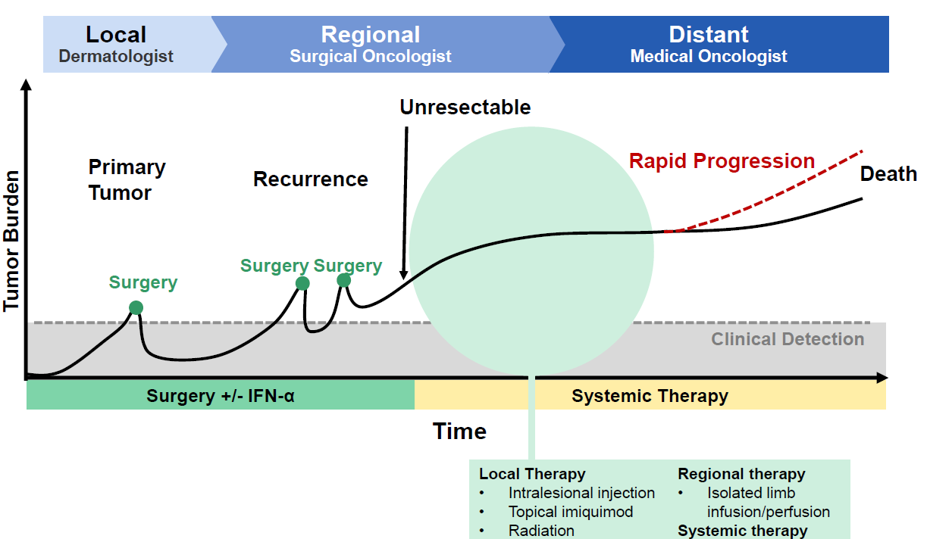

Recent therapeutic advances
Table 1 lists recent medicine approved medicines for melanoma and these are generally for advanced disease. There is no consensus on treatment of locally advanced disease, with options including surgery, radiotherapy and trial participation (for example, testing adjuvant therapies).
Table 1: Recently approved (and some other) medicines for treatment of melanoma
Generic | Tradename | Sponsor | TGA-approved indication related to melanoma
Ipilimumab | Yervoy | BMS | Yervoy, as monotherapy, is indicated for the treatment of patients with unresectable or metastatic melanoma.
Trametinib | Mekinist | Novartis | Mekinist in combination with dabrafenib is indicated for the treatment of patients with BRAFV600 mutation positive unresectable Stage III or metastatic (Stage IV) melanoma.  Mekinist as a monotherapy is indicated for the treatment of patients with BRAFV600 mutation positive unresectable Stage III or metastatic (Stage IV) melanoma and in whom either there is intolerance to BRAF inhibitors or BRAF inhibitors cannot be used.  Mekinist as monotherapy has not demonstrated clinical activity in patients who have progressed on BRAF inhibitor therapy (see CLINICAL TRIALS).
Dabrafenib | Tafinlar | Novartis | Tafinlar in combination with trametinib is indicated for the treatment of patients with BRAFV600 mutation positive unresectable Stage III or metastatic (Stage IV) melanoma.  Tafinlar as monotherapy is indicated for the treatment of patients with BRAF V600 mutation positive unresectable Stage III or metastatic (Stage IV) melanoma.
Vemurafenib | Zelboraf | Roche | Zelboraf is indicated for the treatment of unresectable stage IIIC or stage IV metastatic melanoma positive for a BRAF V600 mutation.
Pembrolizumab | Keytruda | MSD | Keytruda (pembrolizumab) is indicated as monotherapy for the treatment of unresectable or metastatic melanoma in adults.
Interleukin-2 (high dose) | na | na | Unregistered (except for export)
Dacarbazine (± combination chemo) | several | several | Chemotherapy of metastatic malignant melanoma… Note. The use of dacarbazine is restricted to hospitals with an oncology service.
Fotemustine | Muphoran | Servier | The indication ‘disseminated malignant melanoma’, including cerebral metastases, is currently the preferential indication for fotemustine, administered alone or in combination with other anticancer agents.
Temozolomide (± combination chemo) | Temodal | MSD | …first line treatment for patients with advanced metastatic malignant melanoma.
Interferon alfa-2b | Intron A | MSD | Intron A is indicated as an adjuvant therapy of malignant melanoma following surgery in patients who are at high risk of recurrence. The potential benefit to the patient should be assessed carefully. Although toxicity of the treatment may be substantial, for most patients, the benefit of therapy outweighed the risk.
Peginterferon alfa-2b | Peg-Intron | MSD | Not indicated
Imatinib for c-KIT mutated tumours | Glivec | Novartis | Not indicated
Paclitaxel ± carboplatin | Taxol Et Al | several | Not indicated
Nanoparticle albumin-bound paclitaxel | Abraxane | Abraxis | Not indicated
Clinical Practice Guidelines for management of melanoma in Australia and New Zealand date from 2008. These guidelines suggest acceptable approaches in some scenarios relevant for patients enrolled in the pivotal study OPTiM. For example, in the context of loco regionally recurrent melanoma:
Where there are multiple, rapidly growing or progressive lesions in a limb, isolated limb perfusion or infusion achieves response rates approaching 90%, including complete response rates of 60 to 70%. ‘Response rates may be sustained for periods approaching a year in approximately 50% of responders’ (this seems relevant given the choice of durable response rate as the primary endpoint in OPTiM; see below).
It is equally relevant that management of extensive or rapidly progressive lesions where regional drug therapy cannot be tried (for example, proximal limb; trunk; head; neck) ‘is difficult and must be individualised… Options include combinations of systemic drug therapies and local therapies’.

Regulatory guidelines
The TGA has adopted the EU Guideline on the evaluation of anticancer medicinal products in man, EMA/CHMP/205/95/Rev.4 (and relevant appendices).
Some other EU guidelines are TGA adopted and relevant, for example ‘Points to consider on application with 1) meta-analysis; 2) single pivotal study’ (CPMP/EWP/2330/99).
Also relevant are guidelines that relate to the product’s status as a genetically modified organism. Several of these are formally adopted by the TGA:
- Note for Guidance on the Quality, Preclinical and Clinical Aspects of Gene Transfer Medicinal Products (CPMP/BWP/3088/99)
- ICH Considerations: Oncolytic viruses (EMEA / CHMP / ICH / 607698/2008)
Several further TGA adopted guidelines are:
- Guideline on the non-clinical studies required before first clinical use of gene therapy medicinal products (EMEA/CHMP/GTWP/125459/2006)
- Guideline on non-clinical testing for inadvertent germline transmission of gene transfer vectors
- Guidelines are not legally binding but variation from recommendations in such guidelines may suggest a need for close examination of particular quality, efficacy and/or safety issues.

Regulatory status
This is an application to register a new biological entity for Australian regulatory purposes.
At the time the TGA considered this application a similar application had been approved in the USA, received a positive opinion by the Committee for Medicinal Products for
Human Use (CHMP) of the European Medicines Agency (EMA) (see Table 2 below).
Table 2: International regulatory status
Country | Status
USA | Approved 27 October 2015
EU Centralised procedure | Pending: On the 22 October the CHMP adopted a positive opinion for the Imlygic MAA [market authorisation application]. Approved 17 December 2015.

Product Information
The approved Product Information (PI) current at the time this AusPAR was prepared can be found as Attachment 1. For the most recent PI, please refer to the TGA website at <https://www.tga.gov.au/product-information-pi>.

II. Quality findings

Drug substance (active ingredient)
Talimogene laherparepvec is produced in Vero cells by recombinant deoxyribonucleic acid (DNA) technology.
The talimogene laherparepvec drug substance container closure system is a single use, triple film 3 L bag with a ported tubing assembly.

Structure
Talimogene laherparepvec is a human HSV-1 modified for tumour selective replication and immune stimulation. The modifications to derive talimogene laherparepvec from the wild HSV-1 (new isolate JS1) and the resulting phenotypic changes include:
- Functional deletion of both copies of the ICP34.5 gene enabling suppression of virus replication in normal tissue.
- Deletion of ICP47 gene enabling upregulation of the US11 gene, resulting in increased replication of ICP34.5 deleted HSV, without reducing tumour selectivity.
- Insertion of the GM-CSF expression cassette into the ICP34.5 loci, causing production and release of biologically active hGM-CSF stimulating a systemic cytotoxic immune response against tumour cells at distal locations.
Each hGM-CSF expression cassette consists of the major immediate early promoter from cytomegalovirus (CMV), the cDNA encoding hGM-CSF and a bovine growth hormone polyadenylation signal (pA).
Figure 2: Schematic representation of talimogene laherparepvec genome
The talimogene laherparepvec genome is shown with the positions of the ICP34.5 and ICP47 deletions marked as Δ34.5 and Δ47, respectively. The genome is composed of unique long region (U_{L}) flanked by long repeats (R_{L}) and a unique short region (U_{S}) flanked by short repeats (R_{S}). The site of the hGM-CSF cassette insertion is shown in pink and expanded to show the composition of the hGM-CSF expression cassette: the CMV promotor, hGM-CSF cDNA and a pA signal.
The following electron micrograph and schematic figure (Figure 3) are from the sponsor’s presentation to the FDA Advisory Committee.
Figure 3: Electron micrograph and description
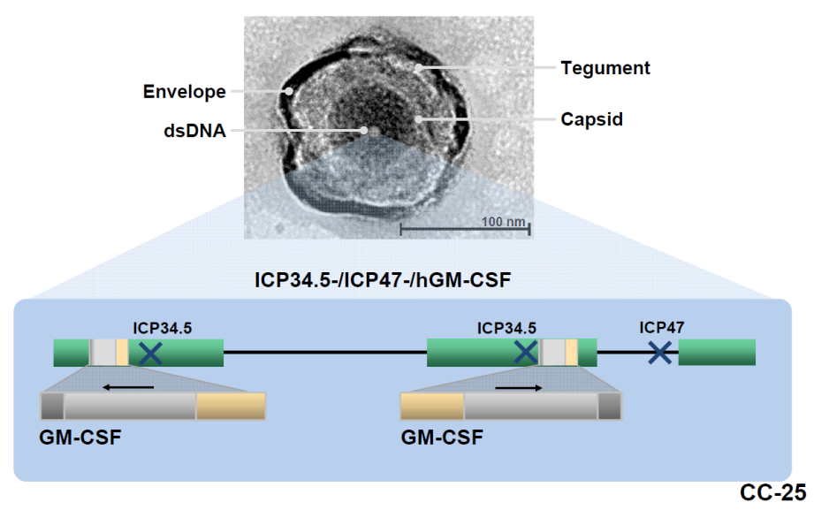

Manufacture
The HSV-1 DS is propagated in Vero cells grown in culture medium containing fetal bovine serum (FBS).
Cell banking processes are satisfactory.
All viral/prion safety issues have been addressed, including use of animal derived materials in Vero cell banking, virus seed stocks and commercial manufacturing process.

Physical and Chemical Properties
Based on its genetic construction and expected biological mechanism of action, potency for talimogene laherparepvec relies upon the following three key functions:
- The ability of the virus to infect and lyse cells
- The expression of human GM-CSF and
- The ability of expressed hGM-CSF to induce precursor immune cell proliferation, differentiation, recruitment and stimulation of mature antigen-presenting cells, and hence improving the ability of GM HSV-1 to induce tumour cell death.
The addition of hGM-CSF gene structure is confirmed by Southern blotting. The expression of hGM-CSF is confirmed by enzyme-linked immunosorbent assay (ELISA).
The data demonstrate that process related impurities are adequately controlled and cleared to acceptable levels by the talimogene laherparepvec commercial manufacturing process.

Specifications
Appropriate validation data have been submitted in support of the test procedures.

Drug product
Imlygic is a sterile preservative free frozen liquid for intra-lesional injection. Following thaw the liquid is clear to semi-translucent (10⁶ PFU/mL) or semi-translucent to opaque (10⁸ PFU/mL) and may contain white, visible, variously shaped, virus containing particles.
Each single-use vial contains 1mL deliverable volume of Imlygic at a nominal concentration of 1 x 10⁶ (1 million) PFU/mL or 1 x 10⁸ (100 million) PFU/mL Imlygic, and 15.4 mg sodium phosphate - dibasic dihydrate, 2.44 mg sodium phosphate monobasic dihydrate, 8.5 mg sodium chloride, 40.0 mg inositol, 20 mg sorbitol, in Water for injections.
Imlygic is provided in single-use vials of 1 mL each in two different concentrations:
- 10⁶ (1 million) PFU/mL - For initial dose only
- 10⁸ (100 million) PFU/mL - For all subsequent doses.
Imlygic
- must be transported and stored at -90°C to -70°C.
- should be protected from light.
- should be stored in the carton until use.
- should be thawed immediately prior to administration. See thawing instructions below.
Imlygic does not contain any antimicrobial preservative or bacteriostatic agent. To reduce microbiological hazard, Imlygic should not be drawn into a syringe until immediately prior to administration.
The finished product is supplied in 2 mL 13 mm cyclic olefin polymer (COP) plastic resin vial. The closure is a 13 mm elastomeric stopper (with a fluoropolymer laminated plug and a cross-linked silicone top) sealed with an aluminium seal with a flip-off dust cover.

Specifications
The proposed specifications, which control identity, potency, purity, dose delivery, safety and other physical, chemical and microbiological properties relevant to the clinical use of the product were described. The same specifications are applied for both product strengths except for clarity, virus infectivity, viral protein content and specific activity.

Stability
Stability data have been generated under stressed and real time conditions to characterise the stability profile of the product. Photostability data demonstrate the product is not photostable. Warning is in place on carton label to reflect this.
- The proposed shelf life for 10⁶ PFU/mL and 10⁸ PFU/mL DP is 48 months when stored at -80˚C.
Post thaw stability data have also been submitted. The proposed shelf life and storage conditions for the thawed product are
- 10⁸ PFU/mL drug product: for up to 48 hours at 2℃ to 8°C
- 10⁶ PFU/mL drug product: for up to 12 hours at 2℃ to 8°C
The thawed product stored for this period is also affected by light and warning is in place on carton label to reflect this.

Good Manufacturing Practice
All necessary sites have relevant current GMP clearances/licences in place.

Quality summary and conclusions
The administrative, product usage, chemical, pharmaceutical, microbiological data submitted in support of this application have been evaluated in accordance with the Australian legislation, pharmacopoeial standards and relevant technical guidelines adopted by the TGA.
There are no further objections from a microbiological perspective to the approval for the application to register Imlygic talimogene laherparepvec 1 x 10⁶ PFU/mL and 1 x 10⁸ PFU/mL Injection Solution.
There are no outstanding issues regarding the Manufacture and Quality Control including Viral Safety Aspects of Imlygic (talimogene laherparepvec).
The quality evaluator(s) recommend that
- Imlygic 1x10⁶ PFU/mL Injection Solution vial
- Imlygic 1x10⁸ PFU/mL Injection Solution vial
should be approved with the inclusion of the following Specific conditions.
- All independent batches of Imlygic (talimogene laherparepvec) 1x10⁶ PFU/mL and 1x10⁸ PFU/mL injection, solution vial imported into Australia are not to be released for sale until the following have been supplied, assessed and endorsed by the TGA Laboratories Branch:
  - Complete summary protocols for manufacture and QC, including all steps in production.
  - Number of doses to be released in Australia from each shipment
  - Evidence of the maintenance of the registered transport conditions during importation into Australia, such as graphs of temperature recordings, and a statement that the approved conditions have been met.
  - Three doses of the first consignment of product with the Australian approved labels, PI and packaging. 3 doses of further consignments of the product (including diluents) with the Australian approved labels, PI and packaging may be requested to support the release of those batches.
  - A copy of the certificate of release and testing related information from the regulatory agency acting for the country of origin (where this exists).
Distribution of each shipment of each batch of vaccine is subject to the fulfilment of this condition and the receipt of a letter from the Laboratories Branch indicating release.
Samples and supporting data should be forwarded to the Immunobiology Section, Laboratories Branch [at TGA] before release of each batch and with sufficient lead time to allow for Laboratories Branch assessment.
You [the sponsor] are required to provide any reagents, reference material and standards required to undertake testing, as requested by Laboratories Branch [at TGA], prior to supply of the vaccine in Australia.
These batch release conditions will be reviewed and may be modified on the basis of actual batch quality and consistency. The conditions remain in place until you [the sponsor] are notified in writing of any variation.
- Certified Product Details
An electronic draft of the Certified Product Details (CPD), as described in Appendix 7 of the Australian Regulatory Guidelines for Prescription Medicines (ARGPM), should be provided upon registration of these therapeutic goods. In addition, an updated CPD should be provided when changes to finished product specifications and test methods are approved in a Category 3 application or notified through a self-assessable change.

III. Nonclinical findings

Introduction
The nonclinical program for talimogene laherparepvec (TL; JS1/34.5-/47-/GM-CSF) was conducted primarily in BALB/c mice using TL and a virus modified in the same manner as TL, except that it expresses murine GM-CSF instead of hGM-CSF (JS1/34.5-/47-/mGM-CSF; ‘OncoVex^{mGM-CSF}’). The murine GM-CSF gene was used in place of the human gene, which does not bind to murine receptors and lacks biological activity in this species.
The mouse is a suitable model for the nonclinical program since there are well established mouse models of HSV-1 infection,, and reactivation of latent virus although the pathogenesis of HSV infection may not be identical in mice and humans. The BALB/c nude mouse model was used to evaluate the direct oncolytic action of TL against human tumour xenografts, while the syngeneic A20 lymphoma model was used in immune competent BALB/c mice to investigate the pharmacodynamics, biodistribution, viral shedding and toxicity in an animal with normal host immunity. Pharmacodynamic studies used the clinical, intra-tumoural route of administration. This route of administration was also used for some exploratory biodistribution and toxicity studies. However, long term studies are often not feasible in tumour bearing animals, so the pivotal studies used subcutaneous (SC) injection as this most closely mimics the clinical route in tumour free animals. This approach is appropriate and is in accordance with the International Conference on Harmonisation of Technical Requirements for
Registration of Pharmaceuticals for Human Use (ICH) considerations on oncolytic viruses. However, the SC route has some limitations, since TL has been engineered to selectively replicate in tumour tissue (see ‘Biodistribution’). Additional regulatory guidance documents that have been followed in developing the nonclinical program address issues including virus and vector shedding, the use of gene therapy products, nonclinical evaluation of anticancer pharmaceuticals and biotechnology-derived therapeutics.

Pharmacology

HSV-1 and infection
HSV-1 is a non-integrating virus consisting of double stranded DNA contained within an icosahedral capsid, which is itself surrounded by a membrane envelope. A layer of protein, the tegument, forms a layer between the capsid and the envelope. The first step in infection involves the binding of glycoproteins on the surface of the enveloped virus with heparin sulfate proteoglycans on the surface of the host cell. The viral envelope thus fuses with the host cell membrane, delivering its contents into the cytosol. The capsid is transported to the nucleus, where it is injected through nuclear pores, enabling the viral genome to be translated. The newly formed viral capsid buds through the nuclear membrane and leaves the cell through the Golgi complex, acquiring its tegument and envelope during this process. The host cell dies as the virus is released.
The virus replicates initially in epithelial cells, producing a characteristic vesicle on an erythematous base. It then ascends sensory nerves to the dorsal root ganglia, where, after an initial period of replication, it establishes latency. During reactivated infection, the virus spreads distally from the ganglion to initiate new cutaneous and/or mucosal lesions.
HSV-1 affects approximately 40% to 80% of the adult population worldwide, and is primarily an infection of the mouth, pharynx, face, eye and central nervous system (CNS) in humans. Transmission is primarily through exposure to mucous membranes or skin with active lesions, or from mucosal secretions from an infected individual. The virus can remain stable in saliva outside of the host for short periods of time. HSV can also be transmitted through respiratory droplets or by exposure to mucocutaneous secretions from an asymptomatic person who is shedding the virus. The incubation period for the primary infection is usually approximately 4 days but can range from 2 to 12 days. During the active infection viral shedding lasts for one week up to several weeks, and most patients are asymptomatic during this period. An epidemiological study of more than 3,500 individuals found that at least 70% of the population shed HSV-1 asymptomatically at least once a month, and many shed virus more than 6 times a month.
The clinical presentation of HSV infection is variable and depends on factors including method of transmission, age and immune competency. Cutaneous lesions consist of small vesicles on an erythematous base that rupture into painful erosions or ulcerations with or without crusting. Prodromal symptoms include burning, paraesthesia, lymphadenopathy, fever, malaise, myalgia, loss of appetite and headaches. Potential complications of HSV infection include herpetic keratoconjunctivitis (HSV infection, predominantly caused by HSV-1, is the second most common cause of blindness worldwide) and herpes encephalitis and meningitis. HSV encephalitis can be a manifestation of primary or recurrent infections, and is associated with nonspecific CNS symptoms including altered mental status, personality changes, seizures and focal neurological findings. Symptoms of HSV meningitis include CSF pleocytosis, with lymphocyte predominance and red blood cells in the CSF. HSV infections tend to last longer and be more widely disseminated in immunocompromised individuals and are less responsive to treatment.
A latent HSV-1 infection may also develop, through retrograde viral transport along axons of sensory neurones of the autonomic nervous system. During latency, lytic gene expression is restricted, with viral genes forming closed circular molecules from which only a small subset of viral genes is expressed. The precise mechanism for reactivation of HSV-1 from cellular latency is not fully understood but it can be mediated by diverse stimuli including illnesses such as colds and influenza, stress, fatigue or ultra violet (UV) exposure, and involves anterograde transportation back along the sensory neuronal axons to infect epithelial cells.

Talimogene laherparepvec virus construct and mechanism of action
Talimogene laherparepvec is a genetically modified HSV-1 derived from clinical isolate, JS1, which has increased oncolytic activity towards tumour cells compared to the serially passaged laboratory strain 17+. The proposed mechanism of action of talimogene laherparepvec is:
- To produce a direct oncolytic effect in injected lesions by replication of the virus in tumour cells, resulting in tumour cell lysis (whilst sparing normal tissue); and
- To induce a sustained systemic anti-tumour immune response, enhanced by the local expression of GM-CSF.
by deletion of ICP34.5 and ICP47 genes, increased expression of the US11 gene and insertion of the human GM-CSF gene.
A schematic diagram of the talimogene laherparepvec genome is shown Figure 2.

Deletion of both copies of the ICP34.5 gene
Normal cells respond to the production of double stranded RNA during HSV-1 infection by producing type 1 interferons (interferon α/β (IFNα/β)), which initiate a signalling cascade that activates the antiviral Protein Kinase R (PKR) by autophosphorylation. This in turn inactivates the eukaryotic translation initiation factor e1F2α, shutting down protein synthesis and preventing viral replication. Autophagy is a second important defence pathway for the host cell and is also mediated by PKR-dependent phosphorylation of e1F2α, (see Figure 4 below, signalling pathways in blue).
The HSV-1 virus evades these host defence mechanisms through a protein encoded by the ICP34.5 gene, which recruits protein phosphatase 1 (PP1), leading to dephosphorylation of e1F2α, thereby restoring protein translation and hence viral replication (see Figure 4, signalling pathways in red). ICP34.5 also binds to the autophargy promoting protein Beclin 1, interfering with autophargy and immune mediated clearance of virally infected cells. The ICP34.5 gene was identified as coding for HSV-1 neurovirulence in mice following intracerebral inoculation,, Inactivation mutants of this gene show markedly reduced replication in trigeminal and dorsal root ganglia as well as diminished replication in non-neuronal tissues and impaired latency establishment^{27,}. The deletion of ICP34.5 has been shown to reduce neurovirulence by 25 to 90 fold for strain 17syn+²⁷ and by greater than 1,000,000 fold for strain F²². The tropism of TL in non-neuronal cells in vitro was shown to be comparable to that of wild type virus (Study 4648-00063).
Tumour cells have an impaired PKR activation pathway, which may be due to a number of different mutations including an active form of MAP/ERK kinase or MEK or through dysregulation of phosphatidyl inositol (PI) 3-kinase.,,,, In addition, tumour cells may have decreased expression of Beclin 1. Owing to these dysregulated pathways, ICP34.5 deleted HSV-1 virus is able replicate in tumour cells resulting in their lysis.
Figure 4: Normal host cell interferon/Protein Kinase R response to wild type HSV-1 infection (Blue) and HSV-1 defence mechanisms (Red), ICP34.5 restores cellular protein translation and blocks autophargy to restore viral replication and limit viral clearance
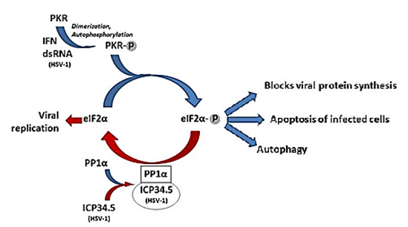
Heterogeneity of tumour responses to ICP34.5 deleted HSV-1 are possible due to the variability in the expression of MEK activity.^{,34} This could pose a potential limit to the efficacy of treatment with TL but it could also enable the treatment to be better targeted, for example by measuring MEK activity in tumour biopsies.

Deletion of the ICP47 gene
Deletion of the ICP47 gene is proposed to increase the generation of T cell adaptive immune responses. The ICP47 gene encodes an immediate early protein which blocks the presentation of viral peptides to MHC class I restricted cells by binding to transporter associated with antigen processing (TAP) and preventing peptide translocation to the endoplasmic reticulum. Through this mechanism the virus inhibits the expression of viral antigens on the cell surface and hence is able to avoid detection by CD8⁺ T cells. The latter authors found that ICP47 deleted HSV-1 showed reduced neurovirulence in normal mice and in T-cell deficient nude mice after reconstitution with CD8⁺ T cells.
Removal of ICP47 also increases the expression of US11, which comes under the early promotor for ICP47. The US11 protein has some functional redundancy with ICP34.5 and this increased expression also favours replication of ICP34.5-deleted virus in tumour cells, without restoring neurovirulence.
Viral constructs containing both ICP 34.5 and ICP 47 deletions showed greater anti-tumour efficacy compared with virus containing the ICP 34.5 deletion alone (tested in nude mice with U-87 or FaDu tumour xenografts; Studies 4648-004, 4648-0065).

Insertion of the human GM-CSF gene
Two copies of the gene encoding hGM-CSF have been inserted in place of the 2 deleted copies of ICP34.5, driven by the non-coding viral promotor from cytomegalovirus (CMV). This is a well characterised constitutive promotor that is not able to induce CMV infection. The bovine growth hormone polyadenylation signal is also used to achieve polyadenylation of the human GM-CSF messenger RNA (mRNA) and help facilitate transcriptional termination. It is a non-coding DNA sequence that is commonly used for optimised gene expression in pharmaceutical protein production, transgenic animal research and gene therapy applications. The aim of inducing local GM-CSF expression is to cause influx and activation of dendritic cells to process and present tumour associated antigens. These dendritic cells are proposed to prime tumour specific CD4⁺ and CD8⁺ T-cells to stimulate a systemic and specific anti-tumour immune response.
In immunocompetent mice implanted with mouse reticulum cell sarcoma A20 and mouse colon carcinoma CT-26, comparison of viral constructs with and without the murine GM-CSF gene showed a tendency for the systemic response to be greater when the murine GM-CSF gene was present but in most studies the differences were modest and did not reach statistical significance. However, the magnitude of tumour specific secretion of interferon-γ by splenocytes isolated from mice whose tumours had been injected with OncoVex^{mGM-CSF} was approximately 2 fold greater than from mice treated with TL backbone (a virus similar to TL but not expressing GM-CSF), suggesting an increased tumour specific T-cell mediated response. This result is supportive of an enhanced adaptive immune response due to the expression of murine GM-CSF in the viral construct.
Figure 5: Proposed mechanism of action for talimogene laherparepvec
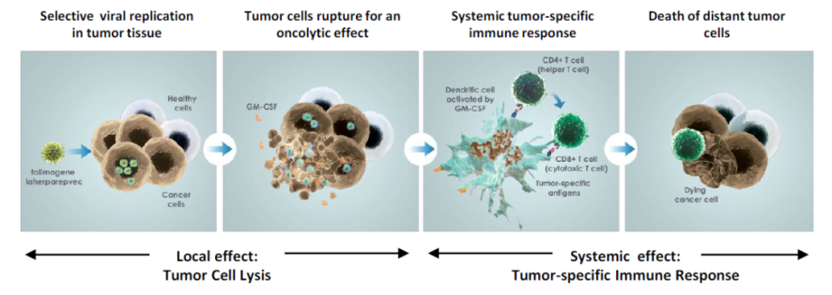

Primary pharmacodynamics
In vitro studies in 5 different cell lines confirmed that the tropism of talimogene laherparepvec was comparable to that of JS1, the wild type strain from which it was engineered and also to the 17syn+ strain. All three viruses replicated in human FaDu squamous carcinoma cells and to a lower level, in mouse embryo fibroblast NIH-3T3 cells. None of the viruses replicated in human Negroid Burkitt’s lymphoma cells (Daudi cells, in which low activation of the Ras signalling pathway is thought to inhibit HSV-1 growth), Chinese hamster ovary (CHO) cells (lacking HSV-1 entry receptors), undifferentiated human histiocytic lymphoma cells (U937; viral RNA synthesis is blocked) or murine melanoma cells (B16-F10). In addition, the oncolytic effect of talimogene laherparepvec was examined in a wide range of human and animal tumour cell lines in vitro, including melanoma (SK-MEL 28), colorectal (SW620, COLO 205, HT29 and HCT116), breast (MDA-MB-231), pancreatic (BxPC-3, PANC-1, CAPAN-1, MIA PA CA-2), lung (A549, H460, CALU-1), prostate (PC3, DU145, LNCaP), pharynx (FaDu) and glioblastoma astrocytoma (U-87). A dose and time dependent cytotoxic effect was observed in all tumour types. There was a variable level of sensitivity to talimogene laherparepvec among a panel of 31 paediatric tumours, with a Ewing’s sarcoma cell line being the most sensitive, while leukaemia and lymphoma cell lines were relatively insensitive. The secretion of GM-CSF was confirmed in one study. Another study using human breast adenocarcinoma cells confirmed the role of the ICP47 gene in viral evasion of host immune responses by reducing viral antigen expression on the host cell surface.
In vivo studies were conducted in mice, based on their similar susceptibility to HSV-1 infection and pathogenesis compared with humans and due to the availability of the BALB/c nude mouse model. The lack of T cell dependent immune responses in this strain of mouse affords human tumour engraftment without complications arising due to tumour rejection by the host immune system. The BALB/c nude mouse model enables the direct oncolytic effect of the virus to be investigated. Injection of TL, or viral constructs containing one or more genetic modifications of TL in isolation, into human-derived tumours in BALB/c nude mice was intended to dissect the contributions of each of these genetic modifications in the direct oncolytic effect. These results can then be considered in the light of the results of tumour regression studies in immunocompetent BALB/c mice, which are able to address the systemic effects of an adaptive immune response in addition to the local oncolytic action of the virus. In vivo pharmacodynamic studies discussed below used virus doses of 5x10⁶ PFU (majority studies) or 2x 10⁶ PFU (a few studies), and the oncolytic virus was administered 3 times with 2 day dosing intervals.
The studies in nude mice provided supportive evidence for the role of ICP 34.5 and ICP 47 deletion as well as U11 up-regulation in the direct anti-tumour response. Tumour shrinkage or clearance was observed following injection of TL or TL variants into tumours in xenografts of U-87, FaDu or HT29 tumour cell lines.
Studies of the anti-tumour effects of TL virus in nude mice also included a panel of 5 paediatric human tumour cells lines (Ewing’s Sarcoma, A-673; neuroblastoma, SK-N-AS; rhabdoid, G-401; osteosarcoma, SJSA-1, and rhabdomyosarcoma and SJCRH30). In addition to the moderate to marked tumour regression, adverse effects related to TL administration were observed in all 5 studies. Clinical signs consisted of hunched posture, wasting, lethargy and distended abdomen and reduced body weight gain, necessitating early termination for a proportion of mice. Histopathological findings in affected mice were consistent with viral replication in the myenteric neurones of the gastrointestinal tract, adrenal gland, tumour and overlying skin. The viral infection in the myenteric neurones was considered to have been responsible for impaired gastrointestinal function, which resulted in the adverse clinical signs.
Studies with immunocompetent BALB/c mice showed regression or clearance of syngeneic A20 lymphoma or CT26 colorectal carcinomas following intra-tumoural injection with TL, TL backbone or TL in which the human GM-CSF gene was replaced with the murine gene (‘OncoVex^{mGM-CSF}’), including in mice that had previously been infected with wild type HSV-1. Evidence of a systemic adaptive anti-tumour response was provided by studies in which tumours were induced in both flanks but virus was injected into tumours on one side only. The partial regression of tumours on the un-injected side confirms the ability of the virus to generate such a response. A more marked adaptive immune response against A20 tumours was obtained in mice whose tumours had been cleared by injection with TL backbone or OncoVex^{mGM-CSF} and who were subsequently rechallenged with A20 tumours injected SC into the contralateral flank or by intravenous (IV) administration. The development of liver metastases (by IV challenge with A20 cells) was not observed in mice whose tumours had completely regressed six months previously as a result of their injection with TL backbone or OncoVex^{mGM-CSF}u p to six months after the original injected tumours. These findings suggest the induction of anti-tumour immune responses following administration of TL.
Tumour regression was also observed when A20 tumours of HSV-1 immunised mice (serum positive for HSV-1 antibodies) were injected with OncoVex^{mGM-CSF} (Study 4648-00003). The degree of tumour regression seen in these animals was comparable to that observed in mice without prior exposure to HSV-1 (Study 4648-00002), indicating that prior HSV-1 infection does not impair the anti-tumour response.
Combination studies of TL injection into A20 or CT26 syngeneic tumours in BALB/c mice together with other anti-cancer therapies (radiation, anastrozole or 5-flurouracil plus cisplatin) did not indicate any inhibitory pharmacodynamic effect or exacerbated toxicity. Interestingly, in 2 of 3 studies, no tumour suppression was observed for TL.

Secondary pharmacodynamics and safety pharmacology
Secondary pharmacodynamic studies were not conducted but conventional studies of this type would not be expected to provide useful information.
No dedicated safety pharmacology studies have been conducted with TL. The results of biodistribution studies indicated that viral DNA was present in brain, lung or the gastrointestinal or urinary tracts at very low frequency and generally at a low concentration. As discussed above, wild type HSV-1 often persists in a latent state in autonomic ganglia and will reactivate occasionally to produce repeated outbreaks of active infection. TL was shown to establish a latent infection that was able to reactivate in an accepted mouse model for the study of the neuropathogenesis and latency of HSV-1. The potential for TL to exhibit neurovirulence is discussed below.

Pharmacokinetics

Biodistribution
Biodistribution studies investigated the presence, persistence and clearance of virus following administration of TL by the IV, SC and intra-tumoural routes in accordance with the relevant guidelines, and taking into consideration the tropism of wild type HSV-1. These studies used a validated quantitative polymerase chain reaction (PCR) assay (qPCR) to detect the presence of viral DNA in blood, urine and tissues of BALB/c mice following injection of single and multiple doses of TL into tumours or via SC or IV administration. It is important to note that qPCR may not provide information on the infectious potential of the detected viral DNA as indicated by the sponsor. Mice treated with TL developed anti-HSV-1 antibodies, which provided additional confirmation of exposure.
Viral DNA was detected in blood and in most major tissues following IV administration of TL, including the brain, eyes, heart, kidney, liver, lungs, spleen, trigeminal ganglia and ovaries. The amount of viral DNA in these tissues had declined after 28 days, and by 56 days only trace amounts were present in the blood, spleen, liver, heart and trigeminal ganglia with all other tissues testing negative. In general, the presence of viral DNA in tissues correlated with the extent of their vascularisation. TL DNA was detected in 16/24 (67%) of trigeminal ganglia samples (up to 56 days post-dose), being above the lower limit of quantification (LLoQ) in 4 (17%) of all trigeminal ganglia samples. TL DNA was detected in 12/24 (50%) of brain samples 24 h to 55 days following IV administration, and was above the LLoQ in 1/24 (4%) of samples.
When TL was administered by the SC route for the majority of animals there was minimal tissue distribution, and viral DNA could not be detected in tissues 28 days after administration. Evidence of disseminated viral infection was obtained for one female mouse that had received five SC injections of TL and was euthanised on Day 14 in poor condition. Viral DNA was detected in the brain, injection site, spleen, duodenum and trigeminal ganglion of this mouse. The remaining 34 trigeminal ganglion samples tested after SC administration of TL were negative for TL DNA.
A single study investigated the biodistribution of viral DNA following multiple injections of TL into A20 lymphomas in mice. The highest concentrations of viral DNA were in the tumours, with levels declining over 24 days post injection, and then increasing again, so that 20% of tumours were positive at Day 91. This finding confirms that the virus is able to replicate in tumour tissue. Over the 84 day post-dose period, viral DNA was detected in 38% of tumour samples. Viral DNA was also detected in blood from 13% of animals, with the last positive sample 43 days post dose. Viral DNA was also detected in the brain, heart, liver, kidneys, lungs, lymph node, spleen (≤ 20% of tissue samples) and in single tissue samples of ovary and salivary gland (1%), with brain, liver, lymph node and spleen of a small number of mice still testing positive for viral DNA at Day 91. The presence of viral DNA in liver, lymph node and spleen may reflect the role of the immune system in clearance of virus and viral components.
In the same study, the viral DNA detected in the brain of two mice occurred in the absence of concurrent blood or tumour expression. TL DNA was detected in 26/92 (28%) of tumours in the absence of any detectable DNA in any other tissues analysed, while 10/92 (11%) of animals had TL DNA detected in one or more tissue in the absence of concurrent tumour expression. Trigeminal ganglia or other peripheral nerve samples were not examined in this study. The salivary gland of one animal tested positive for TL DNA 42 days after administration. The sponsor noted that this animal had relatively high levels of viral DNA in blood and other organs and suggested that the viral DNA detected in salivary gland could be related to blood contamination. However, a low risk of TL shedding via saliva is also possible, given the relatively high frequency of asymptomatic shedding of wild type HSV-1 in humans. It is not known whether saliva was tested for the presence of viral DNA in the clinical studies.
The overall rate of detection of viral DNA in the brains of mice in the biodistribution studies (regardless of the route of administration) was approximately 13% (21/165).
The production of human GM-CSF was confirmed following injection of a single dose of TL into A20 tumours in mice. Within the tumour tissue itself, GM-CSF levels peaked 24 h after treatment, and declined over 7 days, with no GM-CSF detected by Day 15. Serum concentrations of GM-CSF peaked at 24 h and could not be detected 4 days after treatment. These data suggest that the production of GM-CSF within tumour cells may only be transient following injection with TL.
The sponsor also submitted a biodistribution study in dogs after a single dose of TL into the prostate. Blood and urine had no detectable viral DNA 24 h after dosing. Viral DNA was detected in 5/48 tissue samples 14 days after dosing (prostate, 2 epididymide samples, lumbar and cervical spinal cord).
The biodistribution findings in mice suggest low potential of TL to persist in tissues following intra-lesional injection. Following IV administration, which is expected to maximise non-target tissue exposure, TL DNA was detected with a high frequency in trigeminal ganglia and brain tissue. It is not known whether this corresponds to infectious virus. A very low frequency of detection in salivary gland could be indicative of possible viral shedding via saliva.

Metabolism
Formal drug metabolism studies were not submitted and are not required, as TL would be cleared by immune mediated viral clearance mechanisms such as autophargy.

Excretion and Viral Shedding
Limited urinary data indicated that viral DNA was present at low concentrations in the urine of mice up to 24 h after IV or SC administration of TL. Urinary data following injection into A20 tumours in mice could not be analysed but viral DNA could not be detected in the eyes, lachrymal glands, nasal mucosa or faeces in this study. Viral DNA was detected in a single salivary gland sample. This may be reflective of blood contamination in the tissue but this animal had viral DNA in heart, kidney, liver, lung, lymph node, spleen and whole blood at the same time point. It is also possible that the presence of viral DNA could be indicative of the potential for TL, like wild type HSV-1, to be excreted in saliva.⁴⁴
The infective potential of TL due to viral shedding from tumour injection sites was examined in one study using a plaque assay. This study found no evidence that infectious virus was leaking from the injection site. However, viral DNA was detected at injection sites using qPCR in biodistribution studies using the IV, SC and intra-tumoural routes. The available data indicate a low potential for viral shedding. Assessment of viral shedding from clinical studies would provide further information. In view of the high frequency of asymptomatic shedding of wild type HSV-1 in saliva⁴⁴, it would be of value to investigate saliva samples from patients during clinical use of TL.

Toxicology

Acute toxicity
Single dose studies evaluated the safety and tolerability of TL administration by intra-arterial injection (into the hepatic artery) in the rat and by intra-prostatic injection in the dogs, as these routes were considered to be possible future routes of clinical administration. These studies were of little value in assessing the safety of TL for the proposed indication. Acute toxicity was adequately assessed in repeat dose toxicity studies at SC doses up to 60 times the clinical dose on a PFU/kg basis (discussed below).

Repeat-dose toxicity
The toxicology program evaluated the safety of TL following repeated SC injection for up to 12 weeks in BALB/c mice. As previously discussed, the mouse is a suitable model for these studies as the pathogenesis of HSV-1 infection and the reactivation of latent virus has similarities with HSV-1 infection in humans. The SC route most closely mimics the clinical route in tumour free animals and the frequency and duration of treatment was appropriate. The tolerability of TL in tumour bearing mice, including in immune deficient tumour bearing mice, was also investigated. Viral biodistribution studies were conducted in parallel, which enabled virus distribution and shedding in tissue, blood and excreta to be evaluated. Pivotal studies were in accordance with Good Laboratory Practice (GLP) regulations. Although the longest (12 week) study used TL, there were 3 studies (one of which was GLP compliant) that examined the safety of OncoVex^{mGM-CSF} (that is, a virus modified in the same manner as TL, except that it expresses the murine form of GM-CSF instead of the human form), 2 of which compared it with TL. One of these comparative studies also compared TL and OncoVex^{mGM-CSF}produced with manufacturing processes ‘B’ and ‘C’.
Additional studies evaluated the neurovirulence of TL following direct intra-cerebral injection or intranasal administration, and the in vitro sensitivity of TL to acyclovir. The approach taken in the toxicology program was appropriate and is in accordance with the ICH considerations on oncolytic viruses.

Relative exposure
Exposure ratios have been calculated based on dose per kg of body weight, which is the most appropriate comparison for TL (Table 3). However, it should be noted that since TL is a replication competent virus the capacity of the virus to replicate and persist in tumour and other tissues is also relevant. As shown in the biodistribution study in BALB/c mice, the amount of viral DNA detected in the injected tumours declined over the first 24 days post injection, being undetectable at 50 and 70 days, but it could be detected in 15 to 25% of tumours after 84 days. A simple comparison of dose per unit of body weight also fails to take into account the capacity of TL to activate the host immune system against tumour antigens. TL was administered in animal studies at the same concentration as in the clinical formulation (10⁸ PFU/mL) and the maximum dose administered represents the upper limit volume for administration to a mouse (5 mL/kg, or 100 μL in a 20 g mouse). While the relative doses administered (in terms of PFU/kg) indicate that the doses of TL administered in the animal studies were appropriate, the actual dose ratios do not reflect inter-species differences in virus replication and persistence in certain tissues and latency and reactivation as indicated above.
Table 3: Relative exposure in repeat dose toxicity studies
Species | Study number | ª High Dose PFU/kg | Number of doses dosing frequency | Route | Dosing/Study duration | #Dose ratio
Mouse  (CD-1) | 4648-00027 | 4 X 10⁸ | 5 (every 3 days) | SC | 13/42 days | 60
Mouse  (CD-1) | 4648-00028 | 4 X 10⁸ | 12 (weekly) | SC | 12/12 weeks | 60
Mouse  (CD-1) | 4648-00029 | 4 X 10⁸ | 5 (every 3 days) | SC | 13/41 days | 60
Human | - | ^{b}6.7 X 10⁶ |  |  |  | –
# = animal: human dose (PFU/kg); ªmouse weight = 0.025 kg, TL dose = 1x10⁷ PFU/mouse; ^{b}Based on a maximum clinical dose of 4 X 10⁸ PFU in a 60 kg individual.

Major toxicities
TL was well tolerated by mice in repeat dose studies administered by the SC or intra-tumoural routes. The overall mortality rates (deaths plus unscheduled euthanasia) for studies in which TL was administered to mice by the SC route were 5/194 (2.6%) for control mice, while the mortality rates for ascending doses of 10⁵, 10⁶ and 0.6 to 1.0 x10⁷ PFU were 6/132 (4.5%), 2/124 (1.6%) and 11/406 (2.7%), respectively (repeat-dose toxicity and biodistribution Studies 4648-00030, 4648-00026, 4648-00027, 4648-00028, 4648-00029 and 4648-00007). Based on these data the sponsor concluded that there was no evidence of treatment related mortality in repeat dose toxicity studies by the SC route. However, one animal in the biodistribution arm of Study 4648-00027 (a female dosed SC with TL at a dose of 10⁷ PFU) was sacrificed in poor condition on Day 14, one day after the last TL dose. This animal had clinical signs consistent with HSV-1 infection, including body weight loss, hunched posture, thin appearance, sluggishness, abnormal respiration, hypothermia, pallor and swollen/blue abdomen. Vector DNA was detected in this animal’s brain, trigeminal ganglia and duodenum, as well as in trace amounts in the spleen and at the injection site. This is considered to be a treatment-related mortality. The No observable adverse effect level (NOAEL) in this study was 4 X 10⁷ PFU/kg or 6 times the clinical dose on a PFU/kg basis. Mortalities (including premature sacrifice) occurred more frequently in SCID mice treated with intra-tumoural injections of TL (5x10⁶ PFU/animal), and were associated with pathological findings indicative of viral replication in tissues including neurones. Two mortalities in the high dose (HD) group of biodistribution Study 4648-00030 could possibly have been related to treatment with TL although an incomplete set of tissue qPCR data were provided for one of these mice only (with the testes testing positive for vector DNA).
In contrast to the studies in immunocompetent mice, TL or its variants were poorly tolerated by immune deficient mice (see below).
The main toxicological findings in the repeat-dose studies included injection site reactions and changes in the spleen and bone marrow. There were also minimal decreases in red cell numbers in some studies.

Injection site reactions
Injection site reactions were evident within 24 h following SC administration of the final dose of TL in repeat dose toxicity studies. The injection volume was kept constant between groups (in most studies it was 100 μL), so the different dose levels were achieved by varying the concentration of virus administered. The highest strength at the high dose was equivalent to the higher strength clinical formulation of 10⁸ PFU/mL. The vehicle used was not consistent across studies but the clinical formulation was used in the pivotal 12 week study.
In a small number of animals, injection site reactions were evident macroscopically by red appearance but generally they were only apparent microscopically. Inflammation at the injection sites was described as cellulitis, characterised by mononuclear and polymorphonuclear inflammatory cell infiltration of the subcutis, or fasciitis (mixed inflammatory cell infiltration with occasional necrotic debris, together with condensation of collagen or increased fibrosis). Dermatitis (polymorpholeucocyte and lymphoid infiltration of the dermis), acanthosis and myositis or myopathy also commonly observed. These reactions were evident 24 h after the final dose of TL had been administered but had almost completely resolved by four weeks after the final injection, indicating that the changes were reversible. Only a very low incidence of very mild injection site inflammation was reported with the clinical vehicle formulation. No formal local tolerance studies were submitted with the clinical formulation. The injection site reactions were consistent with local irritation and the development of an immune response but were not characteristic of local herpetic lesions.

Spleen and Bone Marrow changes
Histopathological changes in the spleen and bone marrow of mice treated with TL were consistent with transient activation of the immune system. These effects included increased spleen weight, associated with lymphoid hyperplasia in the white pulp. In addition, increased myeloid haematopoiesis was observed in the bone marrow. These effects were reported 24 h after the final dose of TL and were essentially reversed after 4 weeks. Occasional transient increases in blood white blood cell (WBC) and lymphocyte counts were also likely to be related to the development of anti-viral immunity.

Red blood cells
In some repeat dose studies there were minimal transient reductions in erythrocyte numbers, variable changes in bone marrow erythroid cell production and minimal extramedullary haematopoiesis. These effects are not considered to be toxicologically important.

Neurovirulence
The potential for infection of the CNS is one of the most serious potential complications of treatment with TL, for the patient and also possibly for others in close contact with the patient if the virus is transmissible. Wild type HSV-1 infections may very rarely infect the CNS and result in herpes encephalitis and meningitis. HSV-1 encephalitis in humans most commonly presents clinically with alterations in mood, memory and behaviour but may also exhibit additional clinical manifestations such as weakness, lethargy, ataxia and seizures. Morphologically, HSV-1 encephalitis affects the inferior and medial regions of the temporal lobes and the orbital gyri of the frontal lobes, with necrosis and haemorrhage in the affected regions. Perivascular inflammatory infiltrates are usually present and intranuclear viral inclusion bodies may be found in both neurones and glia. HSV-encephalitis in mice can be produced by intracerebral, intranasal, neuronal or IV administration of the virus, with the pattern of CNS involvement following intranasal inoculation supporting the theory that the olfactory pathway is a frequent route of entry in HSV-1 encephalitis in man.
As already discussed, deletion of ICP34.5 TL was intended to reduce its neurovirulence, while allowing replication in tumour tissue. It is claimed that when combined with increased early expression of US11, viral replication in PKR-deficient tumour cells will be further favoured but the increase in viral replication due to increased early expression of US11 is not expected to be associated with restoration of neurovirulence.
Two studies submitted to directly examine the neurovirulence of TL had some limitations. The intranasal route of administration for HSV-1 strain 17syn+ (2.5 X 10⁵ PFU/mouse) produced fatal encephalitis in 40% of BALB/c mice in the study of Armien et al (2010), with the remaining mice exhibiting chronic lesions and severe spatial memory deficits. Clinical signs of infection included dehydration, dermatitis, kerato-conjunctivitis, tremors, excitability, hunched posture, abnormal gait, stupor and death (after 7 to 12 days post administration). There were no systemic lesions but inflammatory lesions were present in the cortex and brain stem, with neutrophils present exclusively in the olfactory bulb and brain stem regions during the acute phase of infection. Although no adverse effects were seen following intranasal administration of TL to BALB/c mice, the sponsor’s study did not include a control group treated with wild type HSV-1. In the absence of any evidence that the animals were exposed (such as the development of antibodies to HSV-1) this study is considered to be inadequately controlled. There were a number of deaths following intracerebral injection of TL and related viral constructs in the second study investigating the neurovirulence of TL but necropsies were not conducted and no biodistribution evaluation was performed. In the absence of any evidence to the contrary it is assumed that these deaths were related to treatment. The 50% lethal dose (LD₅₀) for OncoVex^{mGM-CSF}administered by the intracerebral route in this study was approximately 10⁵ PFU, which is approximately 10,000-fold higher than the LD₅₀ for HSV-1 strain 17syn+ (<10 PFU) reported in the published literature and lower than the LD₅₀ (approximately 7x10⁶ PFU) for two low neurovirulent strains (strain 1714 and 1716) of 17syn+ with the deletion of four XbaI sites and a TK- phenotype.
In the biodistribution studies described above viral DNA was detected in approximately 13% of brain samples regardless of the route of administration, although it was only detected in 2% of samples following intra-tumoural injection. Trigeminal ganglion samples of IV treated mice had a 67% frequency of TL detection and the frequency of detection in brain tissue was 50%, suggesting that TL may localise in neuronal tissue under conditions designed to maximise systemic exposure. Only 1 out of 35 (approximately 3%) of trigeminal nerve samples tested positive for TL DNA following SC administration but peripheral nervous tissue was not examined for the presence of TL DNA in the single biodistribution study using the intra-tumoural route. Thus the potential for TL to localise to peripheral nerves following intra-lesional dosing has not been well studied in animals. However, it should be noted that the PCR technique to detect viral DNA cannot distinguish between intact, infectious virus and viral fragments. There was no clear evidence of treatment-related CNS or neuronal infection in the single and repeat dose toxicity studies with TL or OncoVex^{mGM-CSF}, except for one animal in the biodistribution arm of Study 4648-00027 (one female dosed with 10⁷ PFU TL). This animal was sacrificed in poor condition on Day 14 (one day after the last TL dose), and had clinical signs consistent with HSV-1 infection (body weight loss, hunched posture, thin appearance, sluggishness, abnormal respiration, hypothermia, pallor and swollen/blue abdomen). Vector DNA was detected in this animal’s brain, trigeminal ganglia and duodenum, as well as in trace amounts in the spleen and at the injection site. There was no evidence of disseminated HSV-1 infection in any other animal that had viral DNA detected in the CNS or peripheral nerves. Thus the detection of vector DNA in the brains and trigeminal ganglia of immunocompetent mice treated with TL is poorly correlated with the observed incidence of HSV-1 infection.
It is concluded that the data submitted support the sponsor’s claim that the neurovirulence of TL is markedly attenuated compared with wild type HSV-1 virus. The frequency of CNS or disseminated infection in immunocompetent animals was very low, although it was not completely eliminated. This reduced neurovirulence of TL is shared with other ICP34.5 deleted HSV-1 viruses investigated clinically in malignant glioma,, and malignant melanoma. There was no explanation for the reported case of disseminated HSV-1 infection in the mouse study described above. Lieb et al (1999) have suggested that host factors may influence the neurovirulence of ICP 34.5 deleted mutants of HSV-1. These authors found that ICP 34.5 deleted HSV-1 showed near normal replication in the trigeminal ganglion and exhibited wild type neurovirulence in mice carrying null mutations for interferon α and β receptors.
TL was shown to be sensitive to the thymidine kinase inhibitor acyclovir in an in vitro study and therefore standard clinical treatments for HSV-1 infection are expected to be effective.

Latency and reactivation
Infection with HSV can result in a lifelong infection by establishing a dormant state (latency) in sensory neurones and replicating in epithelial cells during primary infection and reactivation. The mouse is a suitable model to study latency of infection, although reactivation rarely occurs spontaneously in this species. The mouse hind footpad inoculation model is an accepted model for the study of the neuropathogenesis and latency of HSV-1 infection, and using this model the sponsor found that TL recovered from dorsal root ganglia established a latent infection that was able to reactivate in a reactivation medium in vitro.
Early studies investigating the role of ICP 34.5 in the establishment of latency and reactivation indicated that such mutants were able to establish a latent infection but with diminished reactivation kinetics. Whitley et al (1993) reported that deletion of the ICP34.5 gene abolished the capacity of HSV-1 to spread from the peripheral mucosa of rodents to the CNS and to replicate in the CNS. In addition, its capacity to replicate at mucosal sites was diminished, as was its capacity to establish latency and to be able to be reactivated ex vivo. It is proposed that deletion of ICP 34.5 reduces the amount of virus available to enter latency, which indirectly reduces the likelihood of reactivation. Nonetheless, the mouse study suggests that TL has the potential to become latent and reactivated in patients.

Effects in immunodeficient mice
Studies in immunodeficient mice indicated that TL was able to replicate outside the tumour more easily than in immunocompetent mice. The mortality rate was 100% for the SCID mice (lacking T and B cells) treated with TL. The overall mortality for nude mice (T cell deficient) treated with TL or TL backbone was 27 out of 200 (13.5%; Studies 118737, 4648-00040, 64 and 65, and R20140001-5). One study conducted in immunodeficient mice bearing HT-29 human colorectal tumours found that while TL was generally well tolerated by nude mice, SCID mice showed signs consistent with wild-type HSV infection, including loss of body weight, hypoactivity and mortality, with necropsy findings including flaccid, fluid-distended distal small intestine, caecum and large intestine. Histologically, this correlated with marked myenteric neurone necrosis and the presence of intranuclear inclusion bodies (presumed to be virus) in the jejunum, ileum, caecum and colon. The skin overlying the flank tumours was ulcerated, as a result of marked necrosis with intranuclear inclusion bodies and mild skin ulcers with intranuclear inclusion bodies were also observed in the dorsal and perineal skin. In addition, there was a moderate to severe necrosis with intranuclear inclusion bodies in the tumours themselves. Focal necrosis with intranuclear inclusion bodies was also observed in the pineal gland, adrenal cortex, pancreatic Islets of Langerhans and in the retina, and mild, focal neuronal intranuclear inclusion bodies were seen in brainstem neurones of one mouse.
BALB/c nude mice are athymic and therefore have very low numbers of T cells. Their antibody response is confined to the IgM class, but CD8+ cells are active and they have increased NK cell activity. The CB17 SCID mouse strain is more severely immunodeficient, lacking both B and T cells. The difference in TL sensitivity of immunocompetent, BALB/c nude and SCID mice may be explained by the increase in viral load associated with their immunodeficiency, and the combined effect of increased NK cell activity and residual T and B cell activity in the nude mouse. It is noted that the sponsor proposes that TL is contraindicated in patients who are severely immunocompromised and this is appropriate.

Safety considerations for GM-CSF
GM-CSF is a haematopoietic growth factor and immune system modulator that is secreted by macrophages, T cells, mast cells, NK cells, endothelial cells and fibroblasts in response to bacterial endotoxin or pro-inflammatory cytokines. It also stimulates growth and differentiation of haematopoietic precursor cells, and was one of the first haematopoietic regulators to be administered clinically. Historically, GM-CSF has been used to treat chemotherapy-induced neutropenia and to enhance haematopoietic recovery after bone marrow transplantation.
Recombinant GM-CSF is not registered in Australia, but it is available elsewhere. In the US, sargramostim (Leukine®) was originally licensed by the FDA in 1991 for use following autologous bone marrow transplantation, with the indications extended in 1995 to include prevention of early death from infection following induction chemotherapy for older subjects suffering from acute myelogenous leukaemia. According to the prescribing information for sargramostim, pharmacology and toxicology studies supporting its registration were conducted in cynomolgus monkeys. An acute toxicity study showed no treatment related toxicity following a single IV bolus injection at a dose of 300 μg/kg. Two short term repeat dose studies were performed using IV injection (maximum dose 200 μg/kg/day for 14 days) and SC injection (maximum dose 200 μg/kg/day for 28 days). No major visceral organ toxicity was documented. Notable histopathology findings included increased cellularity in haematological organs and heart and lung tissues. A dose dependent increase in leukocyte count, which consisted primarily of segmented neutrophils, occurred during the dosing period, and increases in monocytes, basophils, eosinophils and lymphocytes were also noted. Leukocyte counts decreased to pre-treatment values over a 1 to 2 week recovery period.
Confirmation that human GM-CSF was produced following injection of TL into A20 tumours in mice was discussed above (see ‘Biodistribution’). GM-CSF was detected only transiently within tumour cells and in serum in this study, which would limit the risk of systemic toxicity.
One potential theoretical risk from transgene derived GM-CSF is that a humoural immune response could develop against endogenous GM-CSF, as has been reported for some patients receiving the recombinant product by the SC or IV route. The development of anti-GM-CSF antibodies was not investigated in the nonclinical studies. The sponsor has advised that a clinical anti-GM-CSF antibody assay will be available for physicians upon request to characterise spontaneous adverse events for suspected immunogenic reactions.
The toxicological profiles of TL and OncoVex^{mGM-CSF} were unable to be distinguished in the repeat-dose toxicity studies, indicating that the inclusion of a biologically active form of GM-CSF did not have any notable toxicological effect.

Recombination
No nonclinical data were provided to examine the potential for TL to recombine with wild type virus (which could potentially result in generation of a GM-CSF producing virus having wild type neurovirulence and replication kinetics). Recombination between attenuated avian herpesvirus vaccines resulting in restoration of virulence and disease outbreak has been reported for vaccines used to prevent infectious laryngotracheitis virus (avian herpesvirus 1) in poultry. In order for recombination to occur between TL and wild-type HSV-1, an individual would have to be infected with both viruses at the same time, and the infection would have to reside in the same cell. The sponsor considered the possible recombinations which could occur in theory if this situation arose:
- Recombination at the ICP 34.5 site: This would result in a wild-type virus (ICP47+) expressing GM-CSF but deleted for ICP34.5 and therefore having the same reduced neurovirulence and tropism as TL. Simultaneously, an ICP34.5+ variant would be produced without GM-CSF, and having the ICP47 deletion, with upregulated US11 expression; this virus would be comparable to wild-type virus in terms of replication competency.
- Recombination at the ICP 47 site: This could produce a version of TL containing GM-CSF in place of ICP34.5, and with a repaired copy of ICP47; this virus would be expected to possess the reduced neurovirulence of TL but would be slightly less likely to replicate in tumour cells, since US11 expression would not be increased; the virus would be less visible to the immune system than TL due to ICP47 expression. Simultaneously, an ICP47-deleted virus would be produced, which would be less able to evade the immune system that wild-type virus.
- Homologous recombination at both ICP34.5 and ICP47 would result in either wild-type HSV-1 or TL.
- Recombinant virions could be produced containing one copy of ICP34.5 and one copy of GM-CSF but these virions would not be stably propagated.
Potential recombination between TL and wild type HSV could have been conducted in cell cultures. The absence of such a study is considered a deficiency of the nonclinical data package. The probability of genetic recombination might be low and the resulting virus is probably of low clinical safety concern. The main safety issue would be the production of excessive amount of GM-CSF and thus the development of anti-GM-CSF antibodies. The resulting virus is expected to be treatable with acyclovir as for TL and wild type HSV.

Genotoxicity
No genotoxicity studies were submitted with TL, which is in accordance with the relevant guideline. As already discussed, TL is a genetically modified HSV-1 virus. HSV-1 is an enveloped, double stranded non-integrating DNA virus, and forms stable, circular episomes within an hour of infection, which form the template for viral replication. The sponsor reports that a review of the literature using the terms ‘HSV-1’, ‘Herpes’ and ‘genotoxicity’ yielded no relevant results. However, it has been reported that HSV-1 impairs the DNA damage response during lytic infection.

Carcinogenicity
No carcinogenicity studies with TL were conducted. Like all human herpes viruses, HSV-1 is able to evade the immune system, and two family members (Epstein-Barr virus and Karposi’s Sarcoma-associated virus) are recognised to be oncogenic viruses. A literature search conducted by the sponsor found no clear epidemiological evidence for an association between HSV-1 and increased risk of cancers of the head and neck. A review published after this literature search cited a report of HSV-1 being detected in benign and malignant thyroid tumours, but this is due to an increased susceptibility to HSV and does not imply a causal link between HSV-1 infection and the development of thyroid cancer.
Of the genetic modifications to HSV-1 that have been made to produce TL, none are anticipated to increase its oncogenic potential and some may potentially decrease it. Deletion of ICP 47 restores the host cell’s immune surveillance for the virus, while deletion of ICP 34.5 will also reduce viral evasion of host immunity in normal cells. Increased expression of US11 is not expected to have any impact on the oncogenic potential of TL. Insertion of the human GM-CSF gene is expected to enhance local anti-tumour immune responses.
In the absence of any evidence suggesting a carcinogenicity risk for TL, the absence of dedicated carcinogenicity studies is acceptable, based on the relevant guideline.

Reproductive toxicity
In accordance with the EMA guideline on nonclinical evaluation for anticancer pharmaceuticals¹⁰, the sponsor conducted an embryofetal toxicology study in BALB/c mice using the IV route and included an assessment of the placental transfer of TL. The IV route is appropriate as it is well tolerated and provides a high level of systemic exposure. A single species is acceptable for investigation of the potential reproductive toxicity of a biotechnology product and studies of fertility and early embryonic development and pre- and postnatal toxicology are not considered to be warranted for pharmaceuticals intended to treat patients with advanced cancer.¹⁰
In repeat dose toxicity studies, no effects on reproductive tissues were observed in mice dosed with TL at doses up to 60 times the clinical dose.
In the embryofetal development study in mice, a transient reduction in maternal body weight gain during dosing at the high dose (10⁷ PFU/mouse) was the only sign of maternal toxicity. Treatment with TL had no adverse effects on pregnancy or litter parameters. Virus was detected in the blood of all dams but there was negligible placental transfer of virus (viral DNA detected in blood of one out of 4 pooled litter samples, with the number of copies just above the detection limit). Maternal treatment with TL had no effect on fetal development. The NOAEL embryofetal development was the highest dose tested, 10⁷ PFU/mouse (4 x 10⁸ PFU/kg), which is 60 times the maximum proposed clinical dose in a 60 kg person.

Pregnancy classification
The sponsor has proposed Pregnancy Category C. Although the mouse embryofetal toxicology study found no harmful effects, infections with wild-type HSV-1 have been associated with serious adverse consequences for the fetus or neonate and so a pregnancy Category of C is appropriate.

Local tolerance
Injection site reactions are discussed above under Repeat dose toxicity.

Antigenicity
Anti-HSV-1 antibodies were shown to develop in mice given single or multiple SC injections of TL or OncoVex^{mGM-CSF}, or following TL administration by the IV or intra-cranial route. Seroconversion was demonstrated in all mice with the exception of the low dose group in Study 4648-00027 (2 week SC study with 6 weeks of observation, 10⁵ PFU/mouse). In general, the antibody titre increased with dose. The pre-existence of anti-HSV-1 antibodies following prior exposure to wild-type HSV-1 did not reduce the ability of TL to halt and reverse the growth of syngeneic tumours in mice (Study 4648-00003).
The immunogenicity of human GM-CSF was not evaluated in nonclinical studies.

Impurities
Exposure ratios for process and product related impurities in the repeat-dose toxicity studies were adequate multiples of the maximum anticipated clinical exposure.

Paediatric use
TL is not proposed for paediatric use and no specific studies in juvenile animals were submitted.

Nonclinical summary and conclusions
- The genetic modifications of the wild-type virus (Strain JS1) include: (i) deletion of both copies of the ICP34.5 gene; (ii) deletion of the ICP47 gene; and (iii) replacement of ICP34.5 by 2 copies of the human gene for GM-CSF. These modifications are intended to selectively favour viral replication in tumour tissue and the development of host cell anti-viral and anti-tumour immune responses, resulting in tumour cell lysis and the generation of a sustained systemic anti-tumour immune response, enhanced by the local expression of GM-CSF.
- The nonclinical submission was developed with due consideration of EMA and FDA guidelines addressing issues relating to the development of oncolytic viruses, virus and vector shedding, use of gene therapy products and the development of anti-cancer pharmaceuticals and biotechnology derived products. The data submitted are considered adequate to support an application of this type, and the pivotal safety studies complied with Good Laboratory practice (GLP) guidelines.
- In vitro culture showed replication/tropism of TL comparable with that of the wild type parent JS1 strain and 17syn+ strain, with replication in human squamous carcinoma cells (FaDu cell line) and at a lower level in mouse fibroblast cells (3T3 cell line). Evidence was presented for a dose and time dependent cytotoxic effect of TL in a range of different human and animal tumour cell types in vitro. Variable sensitivity was observed among a panel of 31 paediatric tumours in vitro, indicating that tumour specific factors may influence the direct cytotoxic effect. Additional in vitro studies confirmed that infected cells secreted GM-CSF. Evidence for the role of ICP47 deletion in overcoming viral evasion of host immune responses (by allowing viral expression on the host cell surface) was provided.
- The direct oncolytic effect of TL or the TL viral backbone (lacking the gene for human GM-CSF) was demonstrated in T-cell deficient nude mice bearing human-derived tumours. Three injections of TL or TL backbone (on Days 1, 4 and 7) resulted in significant regression of tumours for up to 28 days. These studies in nude mice provided supportive evidence for the role of ICP 34.5 and ICP 47 deletion as well as U11 up-regulation in the direct oncolytic effect.
- Studies with syngeneic tumours in immunocompetent mice showed tumour regression or complete clearance following their injection with TL, TL backbone or TL in which the human GM-CSF gene was replaced with the murine gene (‘OncoVex^{mGM-CSF}’), including in mice that had previously been infected with wild type HSV-1.
- Evidence of a marked systemic adaptive anti-tumour response was obtained in mice whose tumours had completely regressed following their injection with TL. Tumours failed to grow in these mice when they were rechallenged either by SC or IV injection of tumour cells either immediately (SC) or 6 months (IV) after clearance of the injected tumours. However, in other studies the systemic anti-tumour response was more modest. Limited evidence was provided for a modestly enhanced adaptive immune response due to the expression of murine GM-CSF in the viral construct.
- Combination studies of the anti-tumour efficacy of TL together with other anti-cancer therapies (radiation, anastrozole or 5-flurouracil plus cisplatin) did not indicate any additive pharmacodynamic effect or exacerbated toxicity.
- TL biodistribution and shedding risk was investigated used a validated quantitative PCR assay (qPCR) to detect the presence of viral DNA in blood, urine and tissues following TL injection into tumours or by the SC or IV routes. Mice treated with TL developed anti-HSV-1 antibodies, which provided additional confirmation of exposure. Following intra-tumoural injection, virus was predominantly localised in the tumour, but was also detected in ≤ 20% of blood and organ tissue samples (spleen, lymph node, liver, heart, and kidneys) and in ≤ 2% of samples of brain, ovary, and salivary gland. Viral DNA was not detected in bone marrow, eyes, shedding tissues (lachrymal glands, nasal mucosa) or faeces. Viral DNA was detected in injected tumours through to 84 days after the last dose, with an increase in the incidence of detection between 70 and 84 days after dosing, suggestive of active viral replication in the target tissue. TL is likely to be cleared by immune mediated viral clearance mechanisms such as autophargy. Following IV administration of TL viral DNA was detected in approximately 67% of trigeminal ganglion samples, with approximately 17% of all samples above LLoQ. It was also detected in 50% of brain samples (4% above the LLoQ).
- Limited nonclinical data indicate a low potential for viral shedding from lesions or shedding tissues and urine.
- The toxicology program evaluated the safety of TL following repeated SC injection for up to 12 weeks in mice, with biodistribution studies conducted in parallel. The tolerability of TL in tumour bearing mice, including in immune deficient tumour bearing mice, was also investigated. Exposure ratios (up to 60) calculated based on dose per kg of body weight indicates that the doses of TL administered in the animal studies were appropriate.
- TL was well tolerated by immunocompetent mice when administered by the SC or intra-tumoural routes, with no evidence of treatment-related mortality. The main toxicological findings included reversible inflammation at the injection site and transient changes in the spleen and bone marrow. The injection site reactions were consistent with local irritation and the development of an immune response but were not characteristic of local herpetic lesions. Lymphoid hyperplasia was observed in the white pulp of the spleen and increased myeloid haematopoiesis was observed in the bone marrow, consistent with an antiviral immune response. Occasional transient increases in neutrophils and lymphocytes were also likely to be related to the development of anti-viral immunity.
- TL showed markedly reduced neurovirulence compared with wild-type HSV-1. The LD₅₀ for OncoVex^{mGM-CSF} administered to mice by the intracerebral route was approximately 10,000 fold lower than values cited in the published literature for wild-type virus. The frequency of CNS or disseminated infection in immunocompetent animals was very low, although it was not completely eliminated. The detection of vector DNA in the brains and trigeminal ganglia of immunocompetent mice treated with TL was poorly correlated with the observed incidence of clinical and pathological signs of HSV-1 infection (seen in only one immunocompetent mouse out of all repeat dose toxicity studies).
- TL was shown to be sensitive to acyclovir in an in vitro study and therefore standard clinical treatments for HSV-1 infection are expected to be effective.
- TL was shown to establish a latent infection that was able to reactivate in an accepted mouse model for the study of the neuropathogenesis and latency of HSV-1 infection.
- Severely immune deficient SCID mice (lacking T and B cells) bearing HT-29 tumours showed signs consistent with severe disseminated wild-type HSV infection following tumour injection with TL, including loss of body weight, hypoactivity and mortality with necropsy findings including flaccid, fluid-distended distal small intestine, caecum and large intestine. Histologically, this correlated with marked myenteric neurone necrosis and the presence of presumed viral particles in the gastrointestinal tract, tumour, skin overlying the tumour, pineal gland, adrenal cortex, pancreas, retina and brainstem. A proportion of nude mice (T cell deficient) showed similar signs of HSV-1 infection following treatment with TL. The sponsor proposes that TL be contraindicated in patients who are severely immunocompromised and this is appropriate.
- The potential for genetic recombination between TL and wild-type HSV-1 was not studied but it is considered to be very low, and if it did occur, the resulting virus is probably of low clinical concern and should be treatable.
- The absence of genotoxicity and carcinogenicity studies is acceptable based on the relevant guidelines and the viral characteristics. Like all human herpes viruses, HSV-1 is able to evade the immune system but a literature search conducted by the sponsor found no clear epidemiological evidence for an association between HSV-1 and increased risk of cancers of the head and neck. The genetic modifications of TL are not considered to increase its oncogenic potential.
- Investigation of reproductive toxicity was adequate for a biotechnology product intended for the treatment of advanced cancer. Virus was detected in the blood of pregnant mice injected IV with TL during organogenesis but there was negligible placental transfer of virus. Treatment with TL had no adverse effects on pregnancy or litter parameters, and no effect on fetal development.

Nonclinical conclusions and recommendation
- The nonclinical studies provide evidence for a direct oncolytic effect of TL when injected into tumours. In addition, evidence has been provided for the development of a systemic adaptive immune response to tumour cells. Thus the proposed indication for treatment of melanoma that is regionally or distantly metastatic is supported.
- Viral biodistribution studies found that in addition to the injected tumour TL was also detected at lower levels in blood and major organs. Virus was detected infrequently in brain and salivary gland. Limited data indicate a low potential for viral shedding from lesions or shedding tissues and urine. Virus was detected in 67% of trigeminal ganglion and 50% of brain samples following IV administration.
- The predominant toxicological findings in repeat-dose studies by the SC or intra-tumoural route included reversible inflammation at the injection sites and transient changes in the spleen and bone marrow consistent with the development of an antiviral immune response.
- The neurovirulence of TL was approximately 10,000 fold lower than that of wild-type virus. Consistent with this, the frequency of CNS or disseminated infection in immunocompetent animals was very low, although it was not completely eliminated.
- Severely immune deficient mice did not tolerate intra-tumoural treatment with TL and developed signs consistent with severe disseminated HSV infection. The frequency and severity of these adverse effects correlated with the degree of immunodeficiency. The proposal for contraindication in patients who are severely immunocompromised is appropriate.
- TL was able to establish a latent infection that was able to be reactivated in an accepted mouse model.
- TL was shown to be sensitive to acyclovir in vitro and therefore standard clinical treatments for HSV-1 infection are expected to be effective in the treatment of potential systemic infection by TL.
- The genetic recombination between TL and wild-type HSV-1 was not studied but the potential for recombination is considered to be very low, and if it did occur, the resulting virus is probably of low clinical concern and should be treatable.
- TL is not considered to pose a genotoxic or carcinogenic hazard.
- There are no nonclinical objections to the registration of TL.
- Amendments to the draft Product Information were also recommended but these are beyond the scope of this AusPAR.

IV. Clinical findings
A summary of the clinical findings is presented in this section. Further details of these clinical findings can be found in Attachment 2.

Introduction

Clinical rationale
The sponsor’s Clinical Overview states:
In Australia 12,500 people (50 per 100,000) are diagnosed with melanoma and 1560 people (6 per 100,000) die of melanoma annually. Melanoma is responsible for 3.6% of total cancer deaths in Australia and the number of new cases of melanoma in Australia has been increasing for the last 30 years.
Recently, several novel therapies for advanced melanoma have been approved: a v-raf murine sarcoma viral oncogene homolog Bl (BRAF) inhibitor, vemurafenib (Zelbora®); an immune stimulatory agent, ipilimumab (Yervoy; a BRAF inhibitor in the same class as vemurafenib dabrafenib (Tafinlar) and trametinib (Mekinist), a MEK inhibitor indicated in BRAFV600 mutant melanoma without prior BRAF inhibition.
While the approval of these agents represents a clear advance in the treatment of advanced melanoma, they have inherent limitations. Results for all 4 treatments demonstrate a low percentage of complete responses. In addition, vemurafenib, dabrafenib, and trametinib are indicated in patients with BRAFV600 mutations, which are found in between 25-46% of melanoma depending on age (Menzies et al., 2012). These treatments are commonly associated with resistance and responses are rarely durable.
Comment: The introduction of immunotherapy with monoclonal antibodies (MAbs) against immune checkpoints on lymphocytes has been a major advance in treatment of melanoma. Responses are seen in patients irrespective of the mutation status of the melanoma and the stage of melanoma including the most advanced Stage IV M1c., The MSD MAb ‘Keytruda’ against programmed death receptor 1 (PD1) on T cells was approved for treatment of melanoma by the FDA in September 2014. It induced responses in approximately 38% of patients and 1 year survivals of approximately 70%. Similarly the BMS MAb ‘Opdivo’ against PD1 induced responses in approximately 40% of patients and 1 year survivals of 72%. It was approved for treatment of melanoma by the FDA in December 2014. Grade 3 to 4 toxicities were minimal during treatment with either of these agents. Investigators treating melanoma now regard these agents as the standard of care in treatment of melanoma. Keytruda (Merck) was approved 20 January 2015.
There remains an important need to offer additional therapies to melanoma patients that are both safe and effective. In particular, a high unmet medical need exists among patients with disease that is limited to regional metastases, non-visceral distant metastases, and low volume and/or stable visceral metastases, to attain local and distant disease control and regression without the toxicities associated with systemically administered therapies.
Comment: The introduction of treatments against PD1/PD-L1 has reduced the unmet need so that the need now is for treatments that increase the percentage of patients that respond to these agents or which increase the duration of responses to them. It is unlikely that Imlygic would be used in preference to the anti PD1/PD-L1 agents but after future study may have a role to increase and maintain responses to them when given in combination.

Contents of the clinical dossier

Scope of the clinical dossier
The clinical dosser documented a full clinical development program of pharmacology, efficacy and safety studies.
The submission contained the following clinical information:
- 1 clinical pharmacology study that provided bio distribution and biological activity (rather than pharmacokinetic) data; Study 001/01.
- 1 pivotal efficacy/safety study (plus extension) Study 005/05 and Study 005/05e comparator GM-CSF.
- 1 safety study (plus extension) in Melanoma Study 002/03 and Study 002/03e.
- 5 other efficacy/safety studies including 3 related to other cancers (head and neck, gastrointestinal (GI)), 1 Phase 1b related to Melanoma, plus 1 registry study.

Paediatric data
The submission did not include paediatric data.

Good clinical practice
Clinical studies were conducted under Good Clinical Practices as described in International Conference on Harmonization (ICH) Tripartite Guideline E6 (ICH, 1996), under the principles of the Declaration of Helsinki, and in accordance with local and regional regulations.

Pharmacokinetics

Studies providing pharmacokinetic data
Table 4 shows the submitted pharmacokinetic (PK) studies relating to the pharmacokinetic topic.
Table 4: Submitted pharmacokinetic studies
PK topic | Subtopic | Study ID
Bio-distribution/biological activity in special populations | Target population § - Single dose | 001-01
Bio-distribution/biological activity in special populations | - Multi-dose | 001-01
Bio-distribution/biological activity in special populations | Target population | 001-01
§ Subjects who would be eligible to receive the drug if approved for the proposed indication.

Evaluator’s conclusions on pharmacokinetics
The overall conclusion is that the modified herpes virus does not appear to pose a risk to patients when injected into individual melanoma metastases. There also appears no or very little risk of secondary transmission to caregivers or healthy adult people in contact with the patient.

Pharmacodynamics

Summary of pharmacodynamics
Traditional pharmacokinetic studies investigating absorption, distribution, metabolism, elimination and drug-drug interactions are not relevant in evaluating oncolytic virus therapies such as talimogene laherparepvec.
The clinical pharmacology assessments of talimogene laherparepvec included optimisation of the dosing regimen, assessment of the kinetics of viral clearance through biodistribution in the blood and urine, shedding from the tumour and exterior of the dressing, anti-HSV-1 serostatus and GM-CSF expression in tumour tissue and serum.
Oral absorption studies have not been conducted because talimogene laherparepvec is administered by injection. In addition, hepatic impairment and drug interaction studies (for example, with cytochrome P450 enzyme inhibitors) have not been conducted because talimogene laherparepvec is not eliminated via hepatic metabolic mechanisms (for example by cytochrome P450 enzymes). Talimogene laherparepvec is cleared through mechanisms including autophagy and adaptive immune response and is expected to be degraded by typical endogenous protein and DNA catabolic pathways.
Table 5 summarises the biodistribution and shedding tests conducted during each clinical study. Based on the comprehensive nonclinical results, assessment of biodistribution in clinical studies evaluated the presence of talimogene laherparepvec DNA in blood and urine and the presence of virus using swabs of the injected tumour site(s).
Table 5: Overview of Biodistribution and Viral Shedding, Data Obtained in each clinical study of talimogene laherparepvec
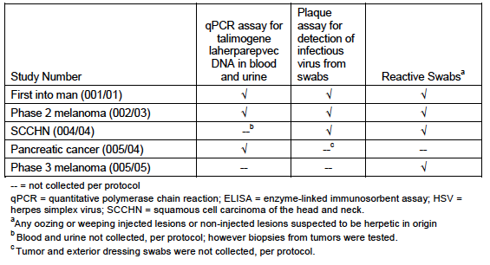

Evaluator’s conclusions on pharmacodynamics
Enthusiasm for use of oncolytic viruses in treatment of cancer has centred on their ability to selectively destroy cancer cells either because the cancer cell (but not normal cells) express receptors for the virus (as for Coxackie A21) or because normal cells but not cancer cells can kill the virus as proposed for the genetically modified HSV described in this application. Increasingly proponents of treatments with oncolytic viruses see them as agents that stimulate immune responses against the tumour (or even viral antigens expressed in tumour cells) rather than as direct oncolytic agents.
The genetically modified virus in this study attempted to increase this aspect by incorporating production of a cytokine believed to increase antigen presentation by adjacent dendritic cells (GM-CSF) and deletion of a gene that inhibited antigen processing in the cancer cell. Given these features it is surprising that very little information was provided as to the effectiveness on this aspect of pharmacodynamic effects of the treatment on anti-tumour effects against the tumour. (Only one study appears to have been conducted). Such studies are difficult and debate continues on immune correlates with clinical responses. Nevertheless simple assessments of the effect of the treatment on T cell infiltration into injected and non-injected metastases might have been expected. The pharmacodynamics study is incomplete without such information. There is no mention of biomarkers that might be helpful in patient selection.

Dosage selection for the pivotal studies
The dosing regimen selected for evaluation in the Phase II and III studies was based on results from the First-in-Human (FIH) study (Study 001/01) which included subjects with melanoma. The dosing regimen consisted of an initial dose of talimogene laherparepvec of up to 4 mL of 10⁶ PFU/mL followed by 4 mL of 10⁸ PFU/mL administered 3 weeks later; thereafter, subsequent doses of 4 mL of 10⁸ PFU/mL are administered every 2 weeks.
This dosing regimen was based on biological activity of the virus observed in the FIH study. In Study 001/01, talimogene laherparepvec was administered in single ascending doses of 10⁶, 10⁷ or 10⁸ PFU/mL (up to 4 mL). In the first 2 single dose cohorts, subjects who were HSV-1 seronegative at study entry experienced more adverse events, including febrile influenza like syndromes associated with symptoms of fatigue, rigors, erythematous skin rashes and small vesicles in the skin. At the highest dose (10⁸ PFU/mL), only HSV-1 seropositive subjects received talimogene laherparepvec and no rashes or rigors were observed. Virus was also detected on the surface of some of the injected tumours. However, virus was never detected on the exterior of the dressing covering the injection site. In the subsequent multi dose part of Study 001/01, talimogene laherparepvec was well tolerated in HSV-1 seronegative or seropositive subjects who received a first dose of 10⁶ PFU/mL, followed by 2 doses of 10⁸ PFU/mL. Febrile responses were minimal, there was no detection of virus on the surface of the injected tumours and vesicles were not seen. Of the 17 subjects, 7 subjects were HSV-1 seronegative at baseline and after given an initial dose of 10⁶ PFU/mL before higher doses of 10⁸ PFU/mL, 6 of the 7 subjects seroconverted within 3 weeks. Human GM-CSF expression levels appeared to increase with the increasing dose and were generally higher in subjects who were seronegative at baseline.

Efficacy

Studies providing efficacy data
The following efficacy studies were submitted:
- One pivotal efficacy/safety study (plus extension): Study 005/05 and Study 005/05e; with the comparator GM-CSF
- Five other efficacy/safety studies, including three related to other cancers (head and neck, gastrointestinal (GI)), one Phase 1b related to melanoma and one registry study.

Evaluator’s conclusions on clinical efficacy for melanoma
In assessing the clinical efficacy of Imlygic against melanoma there are several points in the design that potentially limit the significance of the findings. These are listed below:

Choice of comparator: Was the comparator known to have activity against melanoma?
The selection of GM-CSF given at a dose of 125 µg/m² each day for 14 of 28 days has received considerable criticism as there is no evidence that such a regime would have any beneficial treatment effects. There are no background studies suggesting that such a regime would be efficacious in un-resectable Stage III/IV melanoma. The protocol of administration was adopted from that used in adjuvant studies (that is, after surgical resection of melanoma) by Spitler et al., (2000) which suggested it was of benefit in this clinical setting. A recent review has summarised studies with GM-CSF in an adjuvant setting and in treatment of patients with metastatic melanoma. The one large randomised study (743 patients) conducted by ECOG (E4697) using GM-CSF at 250 µg/m² for 14 days each 28 days reported by Lawson et al did not show any benefit compared to placebo in patients following surgical removal of their melanoma. Exactly similar studies have not been carried out in patients with measurable disease but the large Phase II trial on 120 patients (ECOG 1696) did not show any benefit in patients receiving a vaccine plus GM-CSF compared to vaccine alone. GM-CSF was given at 250 µg/m² for 14 of 28 days in that trial.
GM-CSF given intra-lesionally has been associated with clinical responses in several small studies. For example, Si et al., (1996) reported that GM-CSF given intra-lesionally at 15 to 50 µg dose was associated with regression of injected and non-injected lesions in 3 of 13 patients and 6 of 7 patients given 400ug peri-lesionally had reduced lesion size. The intra-lesional studies are interesting but not relevant to the choice of parental GM-CSF used in the 005/05 OPTiM study which was given SC.
Overall the evidence cited above suggests that the comparator used in the OPTiM trial was likely to be no better than a placebo.
[Note: Combinations of immunotherapy with GM-CSF appear more promising particularly with Ipilimumab as reported in the Phase II ECOG study. Previously treated patients (N245) were randomised to treatment with Ipi alone (10 mg/kg) or Ipi combined with GM-CSF 250 µg/m² for 14 of 28 days. Overall survival (OS) was 12.7 months for iPi alone compared to 17.5 months for the combination. There were no differences in progression free survival (PFS). It was concluded that larger confirmatory studies with longer follow up were needed. This study is not relevant to the choice of control arm in the OPTiM study but does indicate combinations may be worth exploring in future studies. Similarly the suggestion that combinations of Imlygic() with Ipilimumab or anti PD1 may be efficacious but is not relevant for the present application. They would properly be the subject of separate applications when large studies with these combinations have been completed]

Endpoints used to assess efficacy in 005/05 studies: Were these standard endpoints?
The primary endpoint in the 005/05 OPTiM study was durable response rate (DRR) (defined as the percent of patients with complete response (CR) or partial response (PR) maintained continuously for a minimum of 6 months). Lesions were studied individually and collectively. Modified World Health Organization (WHO) criteria were used to take into account variable shape of lesions. The investigator assessment was reviewed by an independent endpoint assessment committee. The secondary endpoints included OS, objective response rate (ORR) [PR+CR], time to response, duration of response and time to treatment failure (time from randomisation until the first episode of clinically relevant disease progression where there is no response achieved after the progression event or until death).
DRR and ORR were determined according to tumour responses determined using modified WHO criteria by a blinded, independent Endpoint Assessment Committee (EAC).
Comment: The introduction of biologic therapies that depend on responses by the patient’s immune system has given rise to new endpoints that take into account the time taken for host immune responses to develop. The primary endpoint used in this study, DRR, is one such measure and varies only in allowing the DRR to commence at any time in the first 12 months of therapy. Minimum treatment was for 24 weeks and maximum of 18 months. The main reservations in such a design is the bias likely to result in the period on treatment in the 2 arms with patients discontinuing in the GM-CSF arm at earlier periods than those receiving intra-lesional therapy even though similar degrees of progression may be involved. This was reflected in median times on treatment of 10 weeks in the GM-CSF arm compared to 23 weeks in the talimogene laherparepvec arm. In practice it is also doubtful whether a clinician will wait 12 months for such responses to occur. Another difficulty is comparing results across studies particularly when other studies have fixed landmarks such as percent PFS at 6 months as used in some studies. The secondary endpoints are less controversial. A clear increase in OS from randomisation would dispel many of the doubts about efficacy of the treatment. Time to ORR and duration of response will be of value in assessing the cost of the treatment as these measures will indicate the approximate amount of Imlygic used and the number of visits to medical personnel

Subgroup Analyses: Were the responders in subgroups of patients with more advanced disease that are difficult to treat by other treatments?
It is well established that patients with melanoma metastases at different sites have different outcomes. This has been captured in the staging systems used for assessing prognosis such as the American joint committee on cancer (AJCC; described in Figure 14 on page 99). Patients with Stage IIIB/IIIC survive longer than those with Stage IV and those with Stage IV,M1a (skin and lymph nodes (LNs)) survive longer than those with Stage IV, M1b (lung metastases) and Stage IV, M1c (visceral metastases). Patients with brain metastases have poorer survival. Given that there are a number of treatment options available for M1a disease the unmet need has been for treatments that are effective on visceral metastases.
In Study 005/05, 57% of subjects had Stage IIIB to Stage IV M1a disease. Some 47% of subjects were receiving talimogene laherparepvec [Imlygic] as first-line therapy. From the presentation by Kaufman et al at ASCO in 2014 and the data above it is evident that the patients in the 005/05 studies were highly selected to have low tumour burdens, for example, LDH enzyme levels were ≤ 1.5 times the upper limit of normal (ULN), they were to have ≤ 3 visceral metastases (lung lesions excepted) and no lesion > 3 cm. Liver lesions had to have been stable for at least 1 month. Brain lesions must have been treated and stable for at least 2 months. Patients with bone metastases were excluded. The majority of Stage IV disease patients entered had M1a disease (25 to 30%) with 18 to 22% having M1b and 21 to 23 % the unfavourable M1c stage. The latter usually accounts for most of the patients in previous studies. Nine percent had Stage IIIB and 22% had Stage IIIc disease.
The treatment effect of Imlygic was highly dependent on stage of disease and previous treatment status. In exploratory analyses improvement in the primary endpoint DDR was only seen in patients with Stage IIIB/C and Stage IVM1a disease and only in previously untreated patients (that is, nominal p ≤ 0.05, not adjusted for multiplicity). Analysis of overall survival showed that benefit appeared to be confined to patients with Stage IIIB/C and Stage IV M1a melanoma (P< 0.001) and only in patients who had not had any previous systemic treatments (P<0.001) At the primary survival analysis, the median OS was 23.3 months with talimogene laherparepvec compared with 18.9 months for GM-CSF (hazard ratio (HR) = 0.787; 95% CI, 0.62-1.00; P =0.051). This examination occurred after 290 events and was powered to detect a HR of 0.67, with a P value of 0.05 representing significance.
The patients entered into the study appeared well balanced between the 2 arms and it was reported subsequently that following progression on the trial patients between the two arms received similar therapies so the results were not due to subsequent cross over therapies favouring the GM-CSF arm. (This conclusion is from a talk by Dr Andtbacka at ASCO 2014. Andtbacka et al. ASCO 2013; LBA9008 and, in part, from information in the sponsor’s clinical overview).
Dr Kaufman (2014)⁸⁶ presented data on changes in individual lesions during treatment with Imlygic. In the 2116 injected lesions there was a 33% response rate with 15% CR. In 981 non-injected skin lesions OR was 18% with 6% CR. In 177 non injected visceral lesions response was 14% with 3% CR. The latter is evidence of systemic effects from the injections but compare this with responses after treatment with to MAbs against PD1 referred to above where rates were approximately 40%. Progression of metastases was evident in 20% of injected lesions and 40 to 60% of non-injected lesions.
The subgroup analyses indicate that a relatively small number of patients would benefit from this form of intra-lesional therapy. They would be patients with minimal disease who have injectable lesions and who for some reason or other could not be treated with monoclonal antibodies against checkpoint inhibitors or BRAFi targeted therapy and who live close to clinicians willing to give frequent injections over prolonged periods. The present evidence also does not support a role for talimogene laherparepvec in second line treatment. This is an important point as otherwise it may have been useful in treating patients who had failed these first line therapies.

Method of application of the vaccine: Treatment procedures are not simple and may be difficult outside of clinical trials
The sponsors describe the basis for choosing the dose of the virus used for injection starting at a low dose of 10⁶ PFU for the first dose escalating to 10⁸ PFU for the second and subsequent doses at 2 week intervals for at least 24 weeks, irrespective of whether there was progression in size or number of the injectable lesions. Injections into lymph nodes (LNs) were allowed but ultrasound guidance was recommended for deep SC lesions and LNs. A fanning technique by which the needle is moved back and forth from one site to evenly distribute the virus through the lesion is recommended. In most centres the injections are administered by surgeons or medical oncologists but injection by trained nursing staff is possible for simple cutaneous or SC lesions. Use of local anaesthetics is usually needed. The product needs to be stored at -80ºC which restricts it use to large facilities with such storage and monitoring facilities.
This description indicates a degree of complexity which would restrict its use to major centres and administration by well trained staff. The need for ultrasound guidance and dressings would add to the costs. Injection by untrained staff without adequate imaging could pose risks of damage to blood vessels or adjacent nerves as in the axilla.

Safety

Studies providing evaluable safety data
The primary analysis of safety is based on the Primary Melanoma Analysis set, which consisted of 419 subjects in Study 005/05 (n = 292 talimogene laherparepvec, n = 127 GM-CSF). This analysis is supported by data from the Supportive Melanoma Analysis set, which consisted of 342 subjects treated with talimogene laherparepvec: 292 subjects in the Primary Melanoma Analysis Set and 50 subjects in Study 002/03, including 30 subjects (27 from Study 005/05 and 3 subjects from Study 002/03) who ‘rolled over’ into their respective extension Studies 005/05-E and 002/03-E. Analyses of exposure, fatal adverse events and drug induced liver toxicity were performed on the Program-Wide Analysis Set consisting of 408 subjects treated with talimogene laherparepvec in the Primary and Supportive Melanoma Analysis Sets, as well as in Studies 001/01, 004/04 and 005/04.

Pivotal efficacy and safety Study 005/05
In the pivotal efficacy and safety studies, the following safety data were collected:
- General adverse events (AEs) were assessed by collection of adverse events throughout the studies.
- The subject incidence of potential cases of hepatotoxicity was retrieved using the standardised Medical Dictionary for Regulatory Activities (MedDRA) query (SMQ) drug related hepatic disorders - comprehensive search. In addition, a listing of potential Hy’s Law cases identified from the Program-wide Analysis Set is provided. Potential hepatotoxicity was identified by application of Hy’s Law as: alanine aminotransferase (ALT) or aspartate aminotransferase (AST) > 3.0 ULN, total bilirubin (TBL) ≥ 2.0 ULN, alkaline phosphatase (ALP) < 2.0 ULN, and no other confounding factors including pre-existing or acute liver disease.
- The subject incidence of potential cases of nephrotoxicity was retrieved using the SMQ acute renal failure.
- The subject incidence of potential cases of bone marrow toxicity was retrieved using the SMQ hematopoietic cytopenias.
- The subject incidence of potential cases of QT prolongation was retrieved using the SMQs of Torsade de pointes/QT prolongation and cardiac arrhythmias. Electrocardiogram (ECG) findings (normal, abnormal but not clinically significant, abnormal and clinically significant) at baseline were summarised.
- Adverse events of special interest in the context of talimogene laherparepvec administration have been identified by the sponsor and include: immune mediated adverse events (autoimmune disorders), cellulitis at the injection site, flu like symptoms, HSV infections, hypersensitivity reactions, injection site reactions and vitiligo. Impaired wound healing at the injection site, plasmacytoma and other neoplastic events were added as events of interest during the review of integrated clinical trial data.

Dose-response and non-pivotal efficacy studies
The dose-response and non-pivotal efficacy studies provided safety data, as follows:
- Studies 001/01and 004/04 provided data on biodistribution of shed virus in blood and urine
- Study 002/03 provided data on efficacy and viral shedding into investigative swabs
- Studies 001/01, 002/03 provided data on ‘reactive swabs’’ from injected and non-injected melanoma lesions.

Patient exposure
The following tables (Tables 6-8) summarise patient exposure to talimogene laherparepvec and GM-CSF.
Table 6: Number of subjects receiving talimogene laherparepvec by duration of cumulative exposure
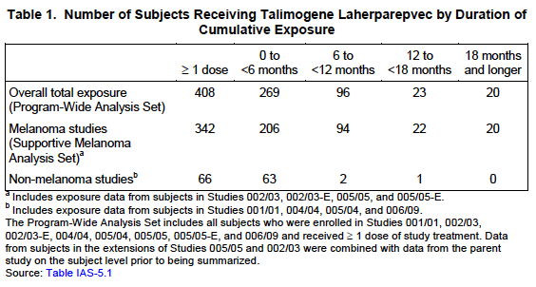
Study 005/05 (the Primary Melanoma Analysis Set) provides up to 18.2 months of exposure to talimogene laherparepvec. The extension Study 005/05-E provides up to 14.1 months of additional exposure to talimogene laherparepvec or GM-CSF in a limited number of subjects (n = 27 and n =3, respectively).
Table 7: Summary of talimogene laherparepvec exposure (Safety population)
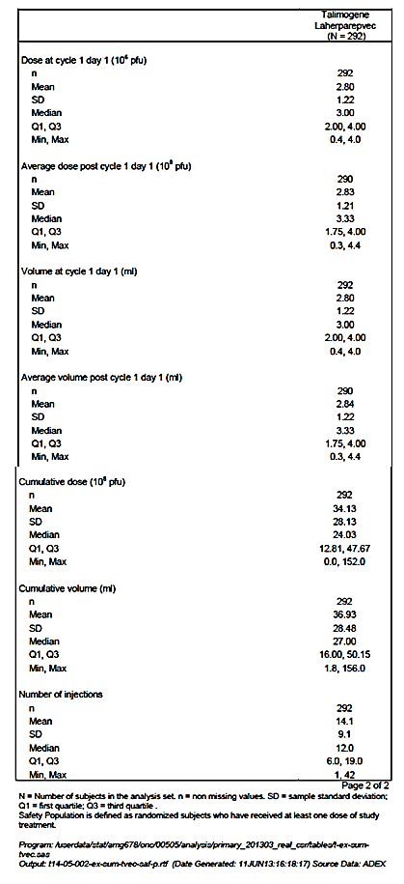

Table 8: Summary of GM-CSF exposure (Safety population)
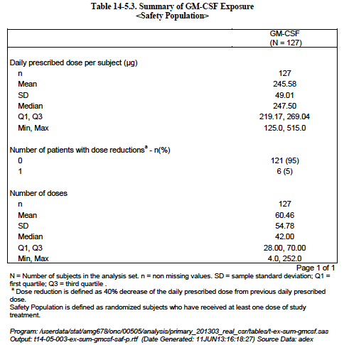

Post-marketing data
Not applicable as Study 20130193 had not been started at the time of this evaluation.

Evaluator’s conclusions on clinical safety
Data provided by the sponsor and from presentations at ASCO by Kaufman documented a long list of reported side effects which were usually minor Grade 1 or 2 side effects. Nevertheless flu like symptoms were reported in most patients (90%) and the treatment is clearly not without side effects that could adversely affect the quality of life for long periods given the long periods that some patients were treated for. The sponsor’s Clinical Overview indicates that common (>20%) side-effects in the Imlygic treated patients were fatigue, fever, chills and injection site pain. Serious adverse events were recorded in 25.7% of patients and 6.5% of these were attributed to treatment with Imlygic (cellulitis, pyrexia and tumour pain) There were 10 fatalities all of which could be attributed to disease progression or unrelated events such as myocardial infarction in 1 and sepsis in 1. Twenty-nice patients (9.9%) discontinued treatment, 7 patients discontinued due to treatment issues such as cellulitis (1), Herpetic keratitis (1). Immune related events of interest were patients with glomerulonephritis (1) pneumonitis (1), psoriasis (1) renal failure (1) and vasculitis (2). In general the side effects were tolerable but nevertheless could be expected to have had adverse effects on the quality of life of the patients.

Is there a risk of herpetic infection from the injected tumour of genetically engineered HSV virus to normal body tissues?
This issue was studied by examining swabs from exudative lesions or herpetic looking lesions (‘Reactive swabs’) in all the studies except in studies on pancreatic cancer. It was stated that no HSV were detected from these swabs.

Is secondary spread a risk, that is, spread of the genetically engineered HSV virus to health care personnel or to contacts of the patient by shedding of the virus from injected lesions?
This was tested by examining the dressings covering the lesions and the surface of dressings covering the injected sites in Studies 001/01 (30 patients), 002/03 and 004/04 (SCC). Swabs were not examined in Study 005/05. In total HSV was detected in swabs from 11% of the tests in the 3 studies. No positive tests were recorded from the surface dressings covering the injected lesions. It is reasonable to conclude that the risk of secondary spread of the genetically altered virus is low.
There was one reported incident where a health care worker had accidental exposure and developed a whitlow requiring treatment with acyclovir. It would appear therefore prudent to continue to recommend that patients should avoid contact with infants, pregnant women and immunosuppressed patients and that care be taken in disposal of dressings from treated patients.

First Round Benefit-Risk Assessment

First round assessment of benefits
The benefits of Imlygic in the proposed usage are:
- Regression of some SC metastases in approximately 15% of patients, partial regression in about 15% and durable for 6 months in 19%. See limitations below.

First round assessment of risks
The risks of Imlygic in the proposed usage are:
- Reduced quality of life due to frequency of injections and side effects such as fatigue, flu like symptoms and pain at tumour sites.
- Open lesions are a potential source of systemic infections and septicaemia especially during treatment outside of trials.
- Effects in patients with compromised renal or liver function unknown.

First round assessment of benefit-risk balance
The benefit-risk balance of Imlygic is unfavourable given the proposed usage but may become favourable if the changes recommended below (combination with other systemic treatments) are adopted.

First round recommendation regarding authorisation
It is recommended that approval not be granted for use of Imlygic as monotherapy in melanoma.
- Although the modified virus is novel the use of intra-lesional therapies for melanoma is not. Advantages over other forms of intra-lesional therapies or surgical removal have not been shown.
- The treatment is not filling an unmet need as such patients would likely be treated by immune checkpoint inhibitors or MEK pathway inhibitors that are more effective.
- Its efficacy is modest and restricted to a small subgroup of patients in a first line setting. Some 70 % of patients do not appear to have significant benefit from even prolonged treatments. It appears to have minor effects on visceral metastases.
- Evidence suggests (as monotherapy) it would not be useful as salvage therapy in patients failing existing treatments.
- The need for transport and storage at -80ºC would limit its applicability to large centres.
- Its administration would require trained personnel and facilities. Treatment may be needed over long periods of time at frequent intervals. These factors would likely impact on its cost effectiveness. These issues are likely to be important outside clinical trial settings.
- Preliminary evidence suggests that it may have a role in combination with other treatments and the sponsors should be encouraged to continue to evaluate the product with other treatments such as anti PD1 or Ipilimumab.

Clinical questions
Many aspects of the so called OPTiM study have received widespread criticisms, for example:
- The choice of a control with no proven activity against melanoma.
- No comparison with intra-lesional injection of GM-CSF or other agents.
- Selection of patients with minimal disease.
- Use of non-standard outcome criteria.
- Poor assessment of quality of life issues.
- These issues raise credibility problems that count against its value in treatment of melanoma. Comments on these issues were invited from the sponsor.
- What evidence do they have that immune responses mediated the effects on melanoma? Or that it was due to the oncolytic virus?
- Given the introduction of immunotherapy with immune checkpoint inhibitors what role do the sponsors now see for their product? Can the sponsor’s provide information about ongoing studies?

Efficacy
- If the sponsor has more recent data on combinations with Ipilimumab or PD1 it would be relevant to report them to support a possible future role.

Second round evaluation of clinical data submitted in response to questions
The sponsor provided responses to the clinical questions; see Attachment 2 for details of these and the evaluator’s comments on these responses.

Second round benefit-risk assessment

Second round assessment of benefits
After consideration of the responses to clinical questions, the benefits of Imlygic in the proposed usage are unchanged from those identified in the first round evaluation.

Second round assessment of risks
After consideration of the responses to clinical questions, the benefits of Imlygic in the proposed usage are unchanged from those identified in the first round evaluation.

Second round assessment of benefit-risk balance
The benefit-risk balance of Imlygic is unfavourable given the proposed usage but would become favourable if the changes recommended in the second round evaluation are adopted (below).

Second round recommendation regarding authorisation
The clinical evaluator recommended the following:
- That Imlygic usage is restricted to patients with Stage IIIB/C and IV1a melanoma.
- That administration with immune checkpoint inhibitors is restricted to approved clinical trials.

V. Pharmacovigilance findings

Risk management plan
The sponsor submitted a Risk Management Plan (dated 23 July 2014, data lock point (DLP) 6 June 2013) and Australian-specific annex (ASA) Version 1.0 (dated 29 October 2014) which were reviewed by the RMP evaluator.

Safety specification
The sponsor provided a summary of ongoing safety concerns which are shown at Table 9.
Table 9: Summary of ongoing safety concerns
Important identified risks | Important potential risks | Missing information
Disseminated herpetic infection in severely immunocompromised individuals (those with any severe congenital or acquired cellular and/or humoral immune deficiency). | Disseminated herpetic infection in immunocompromised individuals (such as those with HIV/AIDS, leukemia, lymphoma, common variable immunodeficiency, or those who require high-dose steroids or other immunosuppressive drugs. | Additional clinical biodistribution and shedding data in melanoma.
Accidental exposure of HCP to talimogene laherparepvec. | Symptomatic talimogene laherparepvec infection in non-tumour tissue in treated patients. | Recombination of talimogene laherparepvec with wild-type HSV-1.
Cellulitis at the site of injection. | Transmission of talimogene laherparepvec from patient to close contacts or HCP via direct contact with injected lesions or body fluids resulting in symptomatic infection (primary of reactivation). | Pregnant and lactating women.
 | Symptomatic herpetic infection due to latency and reactivation of talimogene laherparepvec or wild-type HSV-1 in patients. | Paediatric patients.
 | Immune-mediated adverse events. | Patients with renal or hepatic impairment.
 | Plasmacytoma at the injection site. | Long-term safety data.
 | Impaired wound healing at the site of injection.
 | Talimogene laherparepvec-mediated anti-GM-CSF antibody response.

Pharmacovigilance plan
The sponsor proposes routine pharmacovigilance activities for important identified and potential risks and missing information.
Furthermore, additional activities involving additional studies are planned for some of the risks and safety concerns such as Long-term safety data, Disseminated herpetic infection in severely immuno-compromised individuals (those with any severe congenital or acquired cellular and/or humoral immune deficiency) and Accidental exposure of health care professionals (HCP) to talimogene laherparepvec (see Table 9 above).

Risk minimisation activities
Routine risk minimisation activities are proposed for all safety concerns and additional risk minimisation activities are proposed for some safety concerns of Imlygic.
The sponsor is proposing additional risk minimisation activities, including a physician education brochure, patient alert card and a patient safety brochure.
It is noted that the sponsor is proposing a managed distribution program in the EU but not in Australia.

Reconciliation of issues outlined in the RMP report
Table 10 summarises the TGA’s first round evaluation of the RMP, the sponsor’s responses to issues raised by the evaluator and the TGA’s evaluation of the sponsor’s responses.’
Table 10: Reconciliation of issues outlined in the First round RMP evaluation report
Recommendation in RMP evaluation report | Sponsor’s response (or summary of the response) | RMP evaluator’s comment
- ‘Pyrexia’ should be added as an Important Identified Risk. | The sponsor proposes not to add pyrexia as an important identified risk. Pyrexia is an identified risk and is listed in the Adverse Events section of the PI. Most events of pyrexia were non-serious and resolved within 72 hours of onset. Pyrexia is monitored as an event of clinical interest. | The response has been noted.  Routine pharmacovigilance still applies.
- ‘Influenza-like illness’ should be added as an Important Identified Risk. | The sponsor proposes not to add influenza-like illness as an important identified risk.  Influenza-like illness is an identified risk and is listed in the Adverse Events section of the PI. Most events of influenza-like illness were non-serious and resolved within 72 hours of onset. Influenza-like illness is monitored as an event of clinical interest. | The response has been noted.  Routine pharmacovigilance still applies.
- ‘Hypersensitivity’ should be added as an Important Identified Risk. | The sponsor considers hypersensitivity should not be added as an Important Identified Risk. No cases of anaphylaxis were reported in the Primary Melanoma Analysis Set and acute hypersensitivity does not appear to be a relevant safety issue concerning talimogene laherparepvec. In addition, hypersensitivity events in the Primary Melanoma Analysis Set were almost equal in both treatment arms, with a slightly higher proportion in the GM-CSF arm (talimogene laherparepvec n= 53; 18.2%; GM-CSF n=25; 19.7%). Furthermore, hypersensitivity events will continue to be monitored by the sponsor an Event of Interest (EOI). Upon further review of the hypersensitivity standardised MedDRA query (SMQ), the exposure-adjusted incidence rates were driven by the preferred terms (PTs) of rash and dermatitis. The above PTs have been added to the updated PI in the Adverse Effects section. | This is considered acceptable in the context of this application at present.
- ‘Transmission of disease from adventitious agents’ should be added as an Important Potential Risk. | Conclusions:  The Risk Assessment document concluded that the adventitious agent safety of talimogene laherparepvec was assured by control of raw materials in accordance with relevant ICH, FDA and European Pharmacopoeia guidance, control of the manufacturing environment and appropriate testing of adventitious agents). No further actions regarding disease transmission from adventitious viruses were required based on the outcomes of the risk based approach.  Based on the conclusions of the risk based approach the sponsor concludes that transmission of disease from adventitious agents does not remain a risk, is not a safety concern and therefore does not need to be added as an Important Identified Risk. | This is considered acceptable in the context of this application at present.
- ‘Traceability issues’ should be added as an Important Potential Risk. | The sponsor considers that traceability issues is not a risk that relates directly to the patient but is related to the medicine, its tracking and delivery. An identified risk or potential risk is one that could have an impact on the risk-benefit balance of the product or have implications for public health. What constitutes an important risk will depend upon several factors, including the impact on the individual, the seriousness of the risk and the impact on public health. Normally, any risk that is likely to be included in the contraindications or warnings and precautions section of the product information should be considered important. The sponsor considers that traceability issues do not fulfil this criterion.  The sponsor has control over the cold chain and delivery of its medicines from manufacture to the point of distribution to the hospital. Furthermore the sponsor is undertaking a distribution program which includes traceability measures. Further information on how the sponsor will undertake traceability is covered in response to Recommendation 16. Therefore the sponsor considers that adding ‘traceability issues’ as an Important Potential Risk is not warranted. | This is considered acceptable in the context of this application at present, if the issue can be sufficiently mitigated with additional risk minimisation activities, as determined by TGA.
- ‘Off-label use’ should be added as an Important Potential Risk. | The sponsor considers ‘Off-label use’ should not to be added as an important potential risk to the Australian specific annex (ASA) or the EU-RMP. Imlygic is a live attenuated HSV-1 virus modified by functional deletion of 2 genes (ICP 34.5 and ICP 47), which result in tumour-selective replication and enhancing antigen presentation. The product information and educational material will emphasise to HCPs on proper usage of Imlygic as well as the approved indication. However in the unlikely event that it is administered in the ‘off- label use’ setting, given the well characterised safety profile for Imlygic, it is not anticipated that there would be new emergent risks. | This is considered acceptable in the context of this application at present, if the issue can be sufficiently mitigated with additional risk minimisation activities, as determined by TGA.
- ‘Migration of malignant cells into systemic circulation or to distal sites’ should be added as an Important Potential Risk. | The risk of tumour seeding along the needle tract is a rare complication of biopsies and fine needle aspirations of lesions of malignant melanoma. Risk of seeding during diagnostic procedures appears to be directly related to the diameter of the needle, being higher for larger needles. Since talimogene laherparepvec is injected through needles with 22 to 25 G diameter, which is significantly smaller than used for biopsies or fine needle aspirations, the potential risk of tumour spread with the procedure of intra-lesional injection is assessed as very low. Administration instructions for Imlygic specifically instruct on changing any used needles before injecting the new lesion (refer to PI). The use of fine needle gauges and the precautionary measures in the PI will limit any possible migration of malignant cells beyond the tumour that was injected with Imlygic. The sponsor considers that adding ‘migration of malignant’ cells into systemic circulation or to distal sites’ as an Important Potential Risk is not warranted. | As stated by the sponsor in their response, there is potential for migration of malignant cells into systemic circulation or to distal sites. As a result, the recommendation remains.
- ‘Non-Caucasian patients’ should be added as Missing Information. | The sponsor has added ‘patients with race or ethnic differences other than white or Caucasian’ as Missing Information to the Australian Specific Annex (ASA) and the EU- RMP version 1.1. | This is considered acceptable in the context of this application.
- Updates from Study 20120139 (Registry study) should be provided with PSURs. | The sponsor commits to providing the TGA with updates from Study 20120139 (Registry study) with Periodic Safety Update Reports (PSURs). | This is considered acceptable in the context of this application.
- The sponsor should conduct the same or equivalent risk minimisation activities in Australia as planned in the EU, including the use of a managed distribution program. | The sponsor plans to conduct risk minimisation activities in Australia that reflect the current understanding of product’s safety risk profile. Many of the proposed activities are equivalent to those planned for the EU including routine pharmacovigilance, for example targeted activities for suspected herpetic illness or transmission and clinical studies.  The sponsor also plans to conduct an Australian distribution program which shares many of the features of the program planned for the EU such as a traceability program and educational materials, which will be equivalent to those in the EU.  The sponsor disagrees with the TGA’s assessment that the successful completion of the educational activities should be a prerequisite for prescription and use of Imlygic which is a feature of the proposed managed distribution program in Europe. This assessment appears to be due to the RMP reviewer’s view that the product has many safety issues for both HCPs and patients, a view not shared by the sponsor or the clinical evaluator who concluded that the risk of secondary spread of the genetically altered virus is low.  Furthermore, the Office of the Gene Technology Regulator (OGTR, 2015) has concluded that there was ‘no substantive risk’ related to exposure of clinical staff to the GM virus during waste disposal, and exposure due to shedding of virus by treated patient or due to unintentional release. In outlining their reasoning, the OGTR considered there was no substantive risk as current controls (such as well-established clinical procedures), limited shedding of virus, attenuation of the virus, exclusion of immunocompromised healthcare personnel and the fact that virus is susceptible to anti-viral medicine, were sufficient to reduce potential for harm. The sponsor concurs with this assessment that current controls around the virus ensure that there is no substantive risk of secondary transmission to close contacts or HCPs via shedding or through accidental exposure.  Additionally to date the safety experience with Imlygic has consisted primarily of non- serious adverse events and anticipated events such as flu like symptoms and cellulitis.  Most adverse events were mild or moderate (63.4% talimogene laherparepvec, 74.0% GM-CSF). The most frequently reported adverse events were flu like symptoms such as pyrexia, chills and influenza-like illness. The incidence of these adverse events was more frequent during the first 3 cycles of treatment.  The incidence of serious adverse events was 25.7% in the talimogene laherparepvec arm and 13.4% in the GM-CSF arm. The most frequently reported serious adverse events (talimogene laherparepvec, GM-CSF) were disease progression (3.1%, 1.6%) and cellulitis (2.4%, 0.8%).  The incidence of fatal adverse events was 3.4% in the talimogene laherparepvec arm and 1.6% in the GM-CSF arm. The most frequently reported fatal adverse event was disease progression, with the remaining events due to other underlying disease processes; no treatment-related fatal adverse events were reported in either treatment arm.  Adverse events were the primary reason for discontinuing study treatment in 11 subjects (3.8%) in the talimogene laherparepvec arm and 3 subjects (2.4%) in the GM-CSF arm.  Herpetic events, primarily oral herpes, were reported in 5.5% of subjects in the talimogene laherparepvec arm. No serious herpes complications were reported.  Among 1217 Family Surveillance Questionnaires and 82 Health Care Staff Questionnaires completed during Study 005/05, no events of secondary transmission of talimogene laherparepvec were documented. In 4100 treatment visits, there were 5 accidental exposures in 4 individuals, which were asymptomatic or resolved with acyclovir.  Thirty subjects (27 talimogene laherparepvec; 3 GM-CSF) continued into an extension study with a maximum total duration of treatment of 30.8 months. No new safety signals were identified.  Nonclinical and clinical biodistribution data indicated that talimogene laherparepvec DNA is generally cleared from blood and urine by 1 week after dosing, and was only sporadically detected in low copy numbers at later time points. Talimogene laherparepvec DNA was infrequently detected on the surface of injected lesions in clinical studies, and was not detected in any tissues studied in shedding studies conducted in experimental animals in the nonclinical studies. In an ongoing clinical biodistribution and shedding study (Study Protocol 20120324), the limited shedding ability of the virus has been demonstrated which is consistent with previous clinical studies that found transient and limited viral shedding of the GM virus from the injection site and the urine, and GM virus shedding was not routinely detectable more than a few days after administration. ,,  Furthermore, in Study 20120324 talimogene laherparepvec DNA has been detected via qPCR in blood and urine samples, as well as on the surface of injected lesions, the exterior of occlusive dressings, and in 1 oral mucosa swab. Testing for viral infectivity was positive for 3 samples (1.9%) from injected lesions; all other samples tested (including the exterior of the occlusive dressings) were negative for infectious virus [Note blood and urine which were only tested via PCR only as these samples were part of the biodistribution component of the study)].  The sponsor’s proposal for the Australian distribution program which is equivalent to the EU program except for the completion of educational activities as a prerequisite for prescription and use which is based on the updated shedding data, safety experience to date (as described above) and the recent public consultation document containing the OGTR’s assessment. The sponsor does not believe the risks posed by this product are substantially greater than other therapeutics that are live attenuated viruses. Further discussion on this is included in our response to Recommendation 15.  Proposed Risk Management Plan  As outlined in the updated ASA submitted with this response, a comprehensive risk management plan is proposed that will include pharmacovigilance activities and risk minimization measures that closely resemble those planned for the EU.  Proposed risk minimization measures common to Australia and the EU include communication in product labelling (Product Information (PI) in Australia) to HCPs regarding the potential risk of disseminated herpetic infection in severely immunocompromised patients, accidental exposure, herpetic infection, cellulitis at the injection site, impaired healing at the injection site, immune-mediated adverse events, and the observed development of a plasmacytoma at the injection site.  The PI will also instruct health care professionals on the safe use of the product and storage requirements. It will also communicate to prescribers on instructing patients on the risks. The patient information will provide additional communication to patients on the risk of secondary transmission, what patients/caregivers can do to mitigate this risk and measures for management of accidental exposure.  The sponsor proposes to use equivalent educational materials in Australia and the EU which are supplemental to the prescribing and patient information documents. The advice within these documents does not surpass well-established clinical procedures. | TGA may consider safety issues for persons that may be exposed to the virus through patients, that is, healthcare workers and family members of patients. Imlygic is a first in class oncolytic virus and much missing information remains, including use in a real-world setting. Restrictions and education are necessary initially to ensure safe use of the product. This includes but is not limited to appropriate patient selection, care and follow-up, advice to patients about the risks, considerations of transmissibility and disposal.  The successful completion of the educational activities should be a prerequisite for prescription and use of Imlygic. This is to ensure that HCPs administering or prescribing the product have sufficient demonstrated knowledge and training to mitigate the risk associated with it. Without such a program these risk cannot be sufficiently mitigated.  If the TGA is satisfied at a later stage that not all of the restrictions are necessary, for example, when the safety concerns are evaluated further or when there is less missing information or where there is additional sufficient data on use in a real world setting, the conditions may be relaxed.  The recommendation remains.  The sponsor should conduct the same or equivalent risk minimisation activities in Australia as planned in the EU, including the use of a managed distribution program.
- The sponsor should provide information on the proposed duration of the additional risk minimisation activities. | The sponsor will undertake the traceability and the Australian distribution program. The sponsor will continue to evaluate these programs (traceability, distribution, education) and if the sponsor concludes they are no longer needed or applicable (for example, HCPs understand the risks, storage requirements, good compliance or updated biodistribution/shedding data), then the sponsor would consider altering or removing these programs in consultation with the TGA.  Specifically for education of key site personnel training will occur for new site initiations, any major changes in benefit-risk of the product or if the measures of effectiveness study indicates poor outcomes. | The sponsor’s response has been noted.  The additional risk minimisation activities will be part of the conditions of registration and any change will need to be TGA approved.
- The physician education booklet should consider all safety concerns, and not only selected concerns. Consequently, the Physician Education Booklet (PEB) should be assigned to all safety concerns as additional risk minimisation activity and the risk minimisation plan be updated accordingly. | The PEB (renamed the HCPs Education Booklet) is designed to highlight key relevant information for HCPs and therefore mitigate risks specific to HCPs when administering and handling Imlygic and is supplemental to the PI. For this reason the booklet is a targeted document and therefore all risks are not relevant in this proposed format.  Additionally there is a patient education brochure and alert card which are specific to inform patients about Imlygic risks, to themselves and their close contacts and is supplemental to the Consumer Medicine Information. These materials will be provided to HCPs as a resource to educate patients.  The sponsor considers that the HCP Brochure should not be assigned to all safety concerns as not all potential and identified risks in the EU-RMP are relevant to the HCP, the PI is the initial source of information and the HCP brochure provides supplemental risk information for HCPs in a booklet format. | The response has been noted.  The following safety concerns are specifically related to oncolytic HSV virus use and should be included in the PEB:  Recombination of talimogene laherparepvec with wild-type HSV-1 virus may occur. Loss of efficacy in patients treated with systemic acyclovir for complications
- The education program should be accredited by a relevant Australian Learned College. Due to its importance, it is recommended to the Delegate that formulation of an education program acceptable to the TGA is imposed as a condition of registration for this product. Prior to approval, the sponsor should provide the TGA with the following details for agreement:  All draft education materials;  A clear distribution plan; and  A clear plan to measure the effectiveness of the education programme as an additional risk minimisation activity. | The sponsor plans to conduct an Australian distribution program which shares many of the features of the program planned for the EU such as a traceability program and educational materials which will be equivalent to those in the EU (refer to response to Recommendation 11 and the updated Australian Specific Annex for further details on education materials, distribution plan and measures of effectiveness).  As outlined in Recommendation 11, based on the updated shedding data, safety experience to date and the recent pubic consultation document containing the OGTR’s assessment, the sponsor does not consider the risks posed by this product are substantially greater than other therapeutics that are live, attenuated viruses. The sponsor therefore is proposing not to undertake an education program accredited by a relevant Australian Learned College.  The sponsor recognises that Imlygic will be a specialty product. Due to the consideration that the product does not provide substantive risks the sponsor considers that providing education through an Australian Learned College will be impractical and potentially unviable. The sponsor is proposing that education will be provided by the appropriately trained Amgen employee and will cover the important safety information regarding Imlygic contained in the HCPs Education Booklet / Product Information. | The sponsor should qualify what constitutes an ‘appropriately trained Amgen employee’, that is, whether someone with medical qualifications will deliver the training.  It may be acceptable for the education program not to be accredited by a Learned College, if TGA is satisfied that the additional risk minimisation activities (including, but not limited to accreditation of centres and quality of the education materials as assessed by TGA) will sufficiently mitigate the risks.  Prior to approval, the sponsor should provide the TGA with the following details for agreement:  All draft education materials;  A clear distribution plan; and  A clear plan to measure the effectiveness of the education programme as an additional risk minimisation activity.
- The successful completion of the education program, as measured by a relevant assessment item, should be a prerequisite for the use of Imlygic by HCPs. | The sponsor proposes implementation of a distribution program for Australia which will ensure appropriate education is provided to health care professionals as outlined in the ASA. As outlined in the ASA this will ensure education will be provided by an appropriately trained Amgen employee and that key site personnel will notify the sponsor that they have received appropriate education and the sponsor will keep a record of this notification. The sponsor will provide education to key personnel at sites approximate to commencement of commercial supply.  However the sponsor does not agree that prequalification of the site or completion of the education program should be a prerequisite for the use of Imlygic by HCPs.  As detailed in Recommendation 11, the sponsor disagrees that there are many safety issues for both HCPs and patients associated with the use of this product. This has not been borne out in clinical studies to date and the sponsor considers that current controls around the virus ensure that there is no substantive risk of secondary transmission to close contacts or HCPs via shedding or through accidental exposure. The education materials that the sponsor will provide (the HCP brochure and patient brochure) are supplemental to the PI and CMI and do no surpass well-established clinical procedures.  The sponsor agrees that education is an important for this product and commits to undertaking additional education. However the sponsor does not believe the risks posed by this product are substantially greater than other live attenuated viruses and therefore the successful completion of the educational activities should not be a prerequisite for prescription and use of Imlygic. | Imlygic is a first in class oncolytic virus and much missing information remains, including use in a real-world setting. Restrictions are necessary initially to ensure safe use of the product.  The successful completion of the educational activities should be a prerequisite for prescription and use of Imlygic.  If the TGA is satisfied at a later stage that not all of the restrictions are necessary, for example, when the safety concerns are evaluated further or when there is less missing information or where there is additional sufficient data on use in a real world setting, the conditions may be relaxed.  The recommendation remains.  The sponsor should conduct the same or equivalent risk minimisation activities in Australia as planned in the EU, including the use of a managed distribution program.
- The sponsor has no provided any information on how they plan to ensure traceability of this product. The sponsor should provide those details. | The requirement for traceability is a specific European requirement for Advanced Therapeutic Medical Products (ATMP). This requirement is applicable to all categories of ATMP, that is, cell based, tissue-engineered and gene therapies. Imlygic was classified as an ATMP in August 2012 by the European Committee on Advanced Therapies (CAT) (EMA/CAT/451866/2012)). To date most ATMPs are cell-based or tissue-engineered ATMPs.  As an oncolytic virus, talimogene laherparepvec is manufactured using well-established biotechnological manufacturing processes and will be supplied via the sponsor’s established distribution systems for other pharmaceutical products. Importantly, unlike cell-based or tissue-engineered ATMPs which are the main focus of the traceability requirement, talimogene laherparepvec is not prepared using a patient’s specific cells nor is it intended for autologous transplant.  However the sponsor provides the following information on how we plan to ensure traceability.  The main components of this approach are:  -A distribution programme  -education provided by Amgen will include the requirement for recording batch level information in patients’ charts and for the provision of batch number when reporting adverse drug reactions  -To assist in this process a peelable vial label, incorporating batch details which allow the batch details to be easily added to the patient’s paper record, is proposed  -Good Manufacturing Practice and Good Distribution Practice. The key features of these are:  -Raw materials are sourced from suppliers who maintain cGMP requirements and the materials themselves are controlled within Amgen in compliance with cGMP  -All drug substance and drug product lots are fully traceable back to the raw material lots, working cell banks and working virus seed stocks used in manufacture  -Amgen’s Quality Management System is capable of monitoring batch delineation and retention samples from each batch of finished product and starting materials will be kept for the required periods of time. Records of traceability will be maintained for Competent Authority review  -Amgen’s quality system will ensure that a consistent level of quality and traceability will be maintained throughout the internal and external distribution network. | The sponsor’s response has been noted.
- In the ‘Precautions’ section, in a separate paragraph, the PI should contain information on talimogene laherparepvec-mediated anti-GM-CSF antibody response. | Talimogene laherparepvec mediated anti-GM-CSF antibody response is described in the Imlygic Risk Management Plan as an ‘Important Potential Risk: Talimogene laherparepvec-mediated Anti-GM-CSF Antibody Response’ based on theoretical concerns. The particular clinical sequelae hypothesised to accompany this event have not been reported in clinical trials.  Antibodies against GM-CSF have been detected in the general population (up to 9.6%). Theoretically, the body could produce an antibody response to GM-CSF after administration of talimogene laherparepvec. It is not known whether such phenomena could be expected with the exposure anticipated with transgene expression of GM-CSF from talimogene laherparepvec.  There are case reports of an association between neutralizing anti-GM-CSF autoantibody responses and cryptococcal meningitis or pulmonary alveolar proteinosis . Furthermore, auto-antibodies to GM-CSF were demonstrated to reproduce the disease of pulmonary alveolar proteinosis in nonhuman primates(. Importantly, these particular clinical sequelae associated with anti-GM-CSF antibody production have not been reported among subjects treated with talimogene laherparepvec to date.  The sponsor will continue to monitor these varieties of events that could potentially be associated with an anti-GM-CSF antibody response through its global safety program. In addition, the sponsor will facilitate testing for anti-GM-CSF antibodies for patients with reported adverse events potentially suggestive of the presence of anti-GM-CSF antibodies. Assays for detection of binding and neutralizing anti-GM-CSF antibodies are presently being validated. However the sponsor proposes that, as this is a theoretical concern not observed in clinical trials, a separate paragraph in the Precautions’ section of the PI is not warranted at this time. | It is recommended to the Delegate for the PI to at least contain the known information on talimogene laherparepvec-mediated anti-GM-CSF antibody response.
- In the ‘Precautions’ section, in a separate paragraph, the PI should contain information on recombination of talimogene laherparepvec with wild-type HSV-1. | The sponsor has reviewed the likelihood of viral recombination between talimogene laherparepvec and wildtype HSV-1 (wtHSV-1) based on the available literature. At this time, the development of such recombinant viruses remains a theoretical concern. Therefore the sponsor considers a precaution in the PI containing information on recombination of talimogene laherparepvec with wild-type HSV-1 is not warranted.  The summary below reviews the likelihood of non-homologous or homologous recombination between talimogene laherparepvec and wtHSV-1.  Non-homologous recombination  A virus containing both GM-CSF and ICP34.5 could theoretically arise by non- homologous recombination. However, non-homologous recombination events between HSV-1 genomes have not been detected experimentally. Although non-homologous recombination has shaped the HSV-1 genome evolutionarily, at the sequence level, the unique long and short regions appear highly similar (>90%) between clinical strains isolated from geographically distinct regions, demonstrating that grossly distinct viral structures, should they arise from non- homologous recombination, are neither prevalent nor likely persistent should they arise.  Homologous recombination  Homologous recombination of virus genomes occurs when two viruses co-infect the same cell and interact during replication to generate progeny whose genomes consist of genetic segments obtained from both parental strains. Homologous recombination requires incoming DNA to be highly similar to the recipient genome.., In the context of treatment with talimogene laherparepvec, there are several factors that reduce the likelihood of the appearance of any chimeric virus with properties that could pose a risk to the human population, namely the development of distinct pools of infected cells, tumour-selective replication, resistance to super- infection, and low clinical consequence of recombined viral products.  First, for homologous recombination to occur talimogene laherparepvec and wild-type HSV would need to co-infect and replicate in the same cell, which is unlikely based on the intratumoural route of administration of talimogene laherparepvec. HSV-1 primarily infects epithelial cells in the oral and genital mucosa and the trigeminal or sacral ganglia then harbour latent virus.,  Using the route of administration employed in clinical studies with talimogene laherparepvec (direct intratumoural injection), talimogene laherparepvec would be very unlikely to encounter wild-type HSV.  Talimogene laherparepvec would need to be administered into a cold sore, genital herpes lesion, or other cell in which wild-type HSV was replicating for recombination to occur, or following administration, traffic to a site of latent wild type HSV and then replicate, all of which are unlikely. This supposition is supported by available biodistribution data (Study 115857), which shows low distribution of talimogene laherparepvec outside the tumour as expected for a HSV-1 virus attenuated for replication in normal tissues, discussed below. | A review of the ‘available literature’ is unlikely to yield real-life data so soon after commencement of use outside of clinical trials.  The potential of Imlygic cells and wild-type HSV-1 cells meeting remains a possibility.  It is noted that recombination of talimogene laherparepvec with wild type HSV-1 virus was added as an Important Potential Risk in the updated RMP. This should be adequately reflected in the PI by including the known information on recombination.  The recommendation to the Delegate remains.
- In the ‘Precautions’ section, in a separate paragraph, the PI should contain information on transmission of disease from adventitious agents. | Please refer to response to Recommendation 5 on the context and conclusions of the risk based approach to ATMPs. As noted the approach to viral safety in the talimogene laherparepvec manufacturing process is based on multiple layers of risk mitigation, including rigorous control of raw and starting materials, use of a cell substrate (Vero) with a proven safety profile, appropriate cGMP procedures and facility design features, extensive viral testing of cell banks, virus seed stocks, end of production cells and viruses at the limit of manufacturing age, and viral testing at strategic points in the manufacturing process.  The sponsor has provided the relevant information within the marketing application and concluded that the adventitious agent safety of talimogene laherparepvec was assured by complementary prevention, control, and testing strategies.  Based on the conclusions of the risk based approach the sponsor concludes that transmission of disease from adventitious agents does not remain a risk, is not a safety concern and therefore a separate paragraph in the Precautions’ section of the PI containing information on transmission of disease from adventitious agents is not warranted. | This is considered acceptable in the context of this application for RMP purposes subject to Delegate approval.
- In the ‘Adverse events’ section, in a separate paragraph, the PI should provide information on influenza-like illness. | The following text will be added in the ‘Adverse events’ section regarding influenza-like illness:  Description of selected Adverse Reactions  Influenza-like symptoms  Pyrexia, chills, and influenza like illness, which can occur any time during Imlygic treatment, generally resolved within 72 hours. These events were reported more frequently during the first 3 cycles of treatment, particularly in patients who were HSV-1 negative at baseline. | This is considered acceptable in the context of this application for RMP purposes subject to Delegate approval.
- In the ‘Adverse events’ section, in a separate paragraph, the PI should provide information on pyrexia. | The sponsor proposes to use the same text in the ‘Adverse events’ section as for the response to Recommendation 20 with reference to pyrexia, namely:  ‘Pyrexia, chills, and influenza-like illness, which can occur any time during Imlygic treatment, generally resolved within 72 hours. These events were reported more frequently during the first 3 cycles of treatment, particularly in patients who were HSV-1 negative at baseline.’ | This is considered acceptable in the context of this application for RMP purposes subject to Delegate approval.
- In the ‘Adverse events’ section, in a separate paragraph, the PI should contain the known information on long-term exposure to Imlygic (or absence of such information). | The following text will be provided in the ‘Adverse events’ section in a separate paragraph:  ‘The safety of Imlygic was evaluated in 419 patients (292 Imlygic, 127 GM-CSF) in Study 1 that received at least 1 dose of study treatment. The median duration of exposure to Imlygic was 23 weeks (5.3 months). Twenty six patients were exposed to Imlygic for at least one year.’ | This is considered acceptable in the context of this application for RMP purposes subject to Delegate approval.
- In the ‘Dosage and Administration’ section, in the table that correlates injection volume with lesion size, the table should contain the actual dose in PFU as provided in the proposed US product label. | The sponsor has reviewed the dosage table in the US PI as proposed by the TGA.  Talimogene laherparepvec vials come at a fixed concentration, which are not changed/diluted or altered before injection. A clinician would not dose or target a particular amount of PFU, as described in the label 10⁶ PFU is used only at first administration. Starting from the second administration 10⁸ will be used. In both cases the volume of talimogene laherparepvec administered is determined by lesion size as described in the current Product Information (PI). In clinical practice the clinician would order the number of vials required (up to volume of 4 mL) for the requirements of each particular patient based on their lesions size. Patients would be injected intra-lesionally per lesion size.  Therefore the sponsor considers the proposed additional information on dose in PFU in the dosage table does not add further benefit and the information provided was adequate to explain the dosing requirements. The information provided in the Australian PI is in alignment with the sponsor’s core data sheet and the sponsor proposing to keep the simplified format. | The RMP Evaluator appreciates the sponsor’s commitment to a simplified format.  However, adding the actual dose will allow an additional assessment whether the right dose is given, hence further reducing medication errors.  The recommendation remains.
- In the ‘Dosage and Administration’ section, the PI should contain information on HCP actions necessary to ensure traceability of the product. | HCPs Education Brochure will contain the appropriate information on HCPs actions necessary to facilitate traceability of the product. Education on the HCPs Brochure will be provided and will cover a number of areas including:  - education on recording batch level information in patients’ charts and for the provision of batch number when reporting adverse drug reactions  -a peelable vial label incorporating batch details which allow the batch number and expiry to be easily added to the patient’s paper record  As noted the requirement for traceability in the EU-RMP is an ATMP driven requirement under European legislation and no such requirement exists in Australia. The sponsor considers the above activities are sufficient to facilitate the traceability of this product and are in alignment with current practice. For these reasons the sponsor considers that further information on traceability in the Dosage and Administration’ section of the PI is unwarranted. | The sponsor states that ‘no such requirement exists in Australia’.  The requirements for Australia are individualised for each product and in this case communicated to the sponsor through evaluation reports.  Appropriate information in HCP education program may be considered adequate.
- In the ‘Overdosage’ section, the PI should contain the Poisons Information contact number. | The sponsor has added the following text to the Overdosage section of the PI:  ‘For information on the management of overdose, contact the Poison Information Centre on 131126 (Australia).’ | This is considered acceptable in the context of this application for RMP purposes subject to Delegate approval.
- In the ‘Overdosage’ section, the PI should contain additional information on overdosage (for example, the information on overdosage given in the RMP). | The additional information around experimental animal data provided in the RMP serves to further supplement the total scientific and experimental knowledge around overdosage in this product. These animal studies indicate that the potential for harm from overdose is low. Thus this animal data may not be significant in clinical practice to add to the overdosage section of the PI. Additionally in clinical practice this product will be intensively managed. To date the nature of the product:  -being a single 1 mL vial with a maximum of 4 mL for injection;  -requirement for specialised storage (for example, storage at -80°C) and limited patient population, means that hospitals will hold minimal stock. Hospitals will carefully manage inventory and will only thaw the amount of vials needed for any particular treatment.  Given the low risk of overdose due to practical considerations, intensive inventory management and the low potential for harm, the sponsor believes the current information on overdosage is sufficient in the PI. | This is considered acceptable in the context of this application for RMP purposes subject to Delegate approval.
- It is recommended to the Delegate that the draft CMI document be revised to accommodate the changes made to the product information document. | An updated draft CMI document has been submitted with the response to questions. | This is considered acceptable in the context of this application for RMP purposes subject to Delegate approval.

Summary of recommendations
It is considered that the sponsor’s response to the TGA has not adequately addressed all of the issues identified in the RMP evaluation report. Additional recommendations have been made.

Outstanding RMP issues
- ‘Migration of malignant cells into systemic circulation or to distal sites’ should be added as an Important Potential Risk.
- ‘Resistance to aciclovir’ should be added as an Important Potential Risk.
- Cohort Study 20130193 should be improved by including consideration of:
  - the modes of transmission, not just estimates of incidence rates
  - long term individual reactivation risks
  - CNS infections
  - live viral shredding from injection sites
  - the pathogenesis of the virus in non-patients
  - monitoring of close contacts and healthcare providers for asymptomatic infection
  - treatment outcomes in non-patients who become infected with talimogene laherparepvec.
- Amendments to the registry Study 20120139 should be made:
  - All patients in Australia receiving Imlygic should be part of the registry.
  - The registry should include active surveillance of close contacts.
- The sponsor should conduct the same or equivalent risk minimisation activities in Australia as planned in the EU, including the use of a managed distribution program.
- The following safety concerns are specifically related to oncolytic HSV virus use and should be included in the PEB:
  - Recombination of talimogene laherparepvec with wild-type HSV-1 virus may occur.
  - Loss of efficacy in patients treated with systemic acyclovir for complications.
- It may be acceptable for the education program not to be accredited by a Learned College, if TGA is satisfied that the additional risk minimisation activities (including, but not limited to accreditation of centres and quality of the education materials as assessed by TGA) will sufficiently mitigate the risks. Prior to approval, the sponsor should provide the TGA with the following details for agreement:
  - All draft education materials;
  - A clear distribution plan; and
  - A clear plan to measure the effectiveness of the education programme as an additional risk minimisation activity.
- The sponsor should qualify what constitutes an ‘appropriately trained Amgen employee’, that is, whether someone with medical qualifications will deliver the training.
- The successful completion of the education program, as measured by a relevant assessment item, should be a prerequisite for the use of Imlygic by HCPs.

Key changes to the updated RMP
- EU-RMP Version 1 (dated 23 July 2014, DLP 6 June 2013) and Australian-specific annex (ASA) Version 1.0 (dated 29 October 2014)
has been superseded by:
- EU-RMP Version 1.1 (dated 15 April 2015, DLP 6 June 2013) and Australian-specific annex (ASA) Version 2.0 (dated 16 July 2015).
Key changes between the two versions are summarised in the following table (Table 11).
Table 11: Summary of key changes between EU-RMP versions 1 and 1.1
Section | Key change
Safety specification | Important Identified Risk changes:  Immune-mediated adverse events were renamed to immune-mediated adverse reactions and added as an important identified risk.  Deep vein thrombosis was added as an important identified risk.  The following were added as Important Potential Risks:  Combination with other therapies like chemotherapy or immunosuppressive agents;  Recombination of talimogene laherparepvec with wild type HSV-1 virus may occur;  Delayed next line treatment in non-responders;  Loss of efficacy in patients treated with systemic acyclovir for complications.  The following were added as Missing Information:  Patients below the age of 40 years;  Treatment of patients with cardiac impairment;  Patients of race or ethnic origin other than white;  Long-term efficacy data;  Treatment of patients with bone metastases;  Treatment of patients with active cerebral metastases;  Treatment of patients with more than 3 visceral lesions;  Treatment of patients with metastatic lesions greater than 3 cm;  Treatment of patients with ocular melanoma;  Treatment of patients with mucosal melanoma.
Pharmacovigilance activities | Updates to accommodate changes to Safety Concerns/Missing Information.
Risk minimisation activities | Updates to accommodate changes to Safety Concerns/Missing Information.
ASA | Updates to accommodate changes to Safety Concerns/Missing Information.

Suggested wording for conditions of registration

RMP
Any changes to which the sponsor agreed become part of the risk management system, whether they are included in the currently available version of the RMP document, or not included, inadvertently or otherwise.
The suggested wording is:
Implement EU-RMP Version 1.1 (dated 15 April 2015, DLP 6 June 2013) and Australian-specific annex (ASA) Version 2.0 (dated 16 July 2015) and any future updates as a condition of registration.

VI. Overall conclusion and risk/benefit assessment
The submission was summarised in the following Delegate’s overview and recommendations:

Introduction

Naming of talimogene laherparepvec
The name of this product follows the International Nonproprietary Name (INN) two word scheme:
- Word 1 has a random prefix (ta-), an infix that identifies the type of modified gene (-lim- for immunomodulator) then a suffix indicating gene therapy (-ogene)
- Word 2 has a random prefix (la-), an infix that identifies the vector (-herpa-) then a suffix indicating ‘replicating viral vector’ (repvec).
The product is also referred to as T-Vec, OncoVEX^{GM-CSF} and AMG 678 (naming used during development).

Quality
There are no outstanding issues regarding manufacturing or quality control.
It is noted that normal viral clearance steps would inactive or remove talimogene laherparepvec, so are not performed. Instead, ‘adventitious agent safety is assured by control of raw materials, control of the manufacturing environment, and adventitious agents testing at the appropriate stages in the manufacturing process’.
No manufacturing or quality control issues preclude registration. Because of the nature of the product, the risk of it carrying adventitious agents has been addressed by control of the raw materials and manufacturing environment and by microbial testing.

Recommended condition of registration for quality issues
There is ongoing consideration of the need for suitable batch release conditions.

Nonclinical
There were no nonclinical objections to registration.
A general observation was that pivotal non clinical studies used SC injection, since long term studies are often not feasible in tumour bearing animals. Studies based on SC administration have some limitations since the virus is designed to replicate in tumour tissue.
As with clinical data, qPCR results in nonclinical data did not inform about the infectious potential of detected viral DNA. That is, the pPCR cannot distinguish between intact (infectious) virus and viral fragments.
Another issue raised in the nonclinical report and not mentioned elsewhere by the Delegate is the risk of generation of anti-GM-CSF antibodies.
The nonclinical report emphasises that viral biodistribution varied depending on the route of administration. With IV administration, there was more distribution than with SC administration. The product is proposed for injection of lymph nodes, for example axillary or inguinal, as well as cutaneous and subcutaneous melanoma lesions. A risk of inadvertent intravascular injection must be present. Any such error may considerably increase the risk of clinical sequelae.

Pregnancy category C
The sponsor proposed Pregnancy Category C. This was accepted.
The evaluator noted negligible placental transfer in pregnant mice injected IV with talimogene laherparepvec. ‘Treatment with TL had no adverse effects on pregnancy or litter parameters, and no effect on fetal development’.

Clinical
There was a single pivotal study (Study 005/05; OPTiM).
The pivotal study used a novel primary endpoint, durable response rate (traditional efficacy endpoints such as ORR, PFS and OS were also reported).
The patients enrolled in OPTiM had low burden of disease relative to patients enrolled in studies of recently approved systemic anti-melanoma drugs.
The study was controlled but the comparator was experimental (SC GM-CSF).
Extent of efficacy depended on disease stage and (or) line of therapy. The efficacy of talimogene laherparepvec was highest in patients with Stage III disease, falling away in Stage IV M1a disease and worse again in Stage IV M1b and M1c. There was a similar effect in subgroups defined by line of therapy (first-line subjects did better), although stage and line of therapy may be correlated.
Patients were treated through progression unless there was overt deterioration but this approach may be less acceptable now several effective treatments are available for un-resectable/advanced disease.
Adverse reactions were not pronounced, at least in a crude comparison with recently approved systemic therapies for melanoma.
There is a potential for herpetic disease, for example keratitis. Disseminated herpetic disease could be life-threatening or fatal and the risk of dissemination would be considerable in patients or exposed contacts who are immunosuppressed for whatever reason. There is no indication Imlygic ‘disease’ cannot be ‘treated’ with antiviral drugs.
There is a risk of accidental exposure to healthcare workers involved in preparation and administration of Imlygic.
There is a risk of secondary spread, that is infection with talimogene laherparepvec after contact with a treated and infectious patient (for example, via exposure to blood, injected lesions, the external surface of occlusive dressings or saliva).
Some other risks are more difficult to quantify and/or theoretical:
- There is a risk of latency, supported by nonclinical data.
- There is a risk of recombination, for example, with wild-type HSV-1.
- There is a risk that anti-GM-CSF antibodies may be induced.
- The risk of integration into the host genome seems negligible.
The clinical evaluator writes in the first round report:
…a relatively small number of patients would benefit from this form of intra-lesional therapy. They would be patients with minimal disease who have injectable lesions and who for some reason or other could not be treated with monoclonal antibodies against checkpoint inhibitors or BRAFi targeted therapy and who live close to clinicians willing to give frequent injections over prolonged periods. The present evidence also does not support a role for T-Vec in second line treatment. This is an important point as otherwise it may have been useful in treating patients who had failed these first line therapies.
The evaluator’s recommendation in the first round was that approval not be granted for use of Imlygic as a monotherapy in melanoma.
After review of the sponsor’s response to various questions, the evaluator’s recommendations in the second round report were:
Imlygic usage be restricted to patients with Stage IIIB/C and IV1a melanoma
…administration with immune checkpoint inhibitors be restricted to approved clinical trials.
The second round report recommended that the indication be:
Treatment of melanoma that is regionally or distantly metastatic to skin and/ or lymph nodes.
There was a further recommendation that the indication note the product should not be given to patient groups excluded from the pivotal trial (for example, patients with brain or bone metastases, ocular or mucosal melanoma, >3 visceral metastasis or visceral metastasis >3 cm).

Overview of data
Of most direct relevance to the clinical evaluation:
There was a single pivotal study in melanoma, Study 005/05 (OPTiM). This was a randomised comparison of talimogene laherparepvec (intra-lesional) and GM-CSF (SC, on Days 1 to 14 of a 28 day cycle). Patients were Stage IIIB/C or Stage IV. Study drug could be first- or later-line for treatment of that stage of disease; 437 adults were studied. A novel primary endpoint, durable response rate, was used.
Phase II Study 002/03 (n=50) contributed some melanoma efficacy/safety data.
Study 001/01 was the first-in-human study, focusing on biodistribution/safety.
Study 20120234 is ongoing (interim data are available) but of interest because its completion may provide more detailed biodistribution and shedding data.
The clinical evaluator notes manufacturing changes (Processes A/B/B1/C). Study 005/05 used Process C; this is the process proposed for supply of commercial product. Analytical and nonclinical comparability studies found that the change from Process A to B and from Process B to C did not affect efficacy or tolerability.

Pharmacology
There were no conventional PK studies. Clinical studies informing about viral biodistribution and viral shedding are set out in Table 12.
Table 12: Biodistribution and shedding studies
Study | Design | Biodistribution | Shedding
001/01 | First-time-in-human study; n=30. Patients with various tumours (including melanoma). | Urine  Viral DNA | Swab samples from surface of injected tumours and from exterior of dressings (after each injection):  Plaque assay  Also: reactive samples (such as herpes labialis, oozing injected tumours)
002/03 | Phase II melanoma study; n=50. | Urine and blood  Viral DNA | As per 001/01
004/04 | SCC of head and neck study; n=17. | Tumour biopsy  Viral DNA | As per 001/01
005/04 | Pancreatic cancer study (using direct injection via endoscopic ultrasound guided fine needle); n=17. | Urine and blood  Viral DNA | Nil
005/05 | Phase III study; OPTiM | Nil | Reactive samples (such as herpes labialis, oozing injected tumours)
20120324 | Ongoing, Phase II study of melanoma patients. Interim results with data cut-off 23 February 2015 (n=31 patients). | Urine and blood  Viral DNA | Details as per CER; swabs of dressings and of oro-labial and anogenital areas and of other lesions suspected to be herpetic. Viral DNA and plaque assays.

Biodistribution
The clinical evaluator writes:
The biodistribution pattern of talimogene laherparepvec in blood and urine demonstrated consistently across studies that low copy numbers of viral DNA were sporadically detected in blood samples from 33% of subjects and urine samples from 22% of subjects from 1 hour to 1 week after intra-lesional injection. Blood and urine samples were negative by 2 weeks post-injection in those subjects for whom additional samples were available. The copy numbers of virus detected in blood and urine in all subjects at all collection time points was far lower than the doses administered during treatment.
A summary of positive qPCR assay results for blood and urine by time point from Study 001/01 is included in the CER Attachment 2. The highest frequency of positive results was for samples taken 1 hour post-injection (at least for Injections 2 and 3).
In Study 001/01, subjects who were HSV-1 seronegative at baseline were more likely to have viral DNA -positive blood and urine samples after the first injection than subjects who were HSV-1 seropositive. This was clear in those given >10⁶ PFU/mL as a first dose (the first dose ranged from 1 x 10⁶ to 1 x 10⁸ PFU/mL).
In Study 004/04 (SCCHN), viral DNA was detected in a neighbouring, not injected tumour in 1 subject (of 17).

Viral shedding
The clinical evaluator writes:
The most comprehensive set of samples (ie, in terms of the number of time points tested) was obtained from Study 001/01. Overall, at any time point, a low percentage of subjects (13% [4/30]) had swabs that were positive for virus at the tumour site. These samples were further tested by a specific custom polymerase chain reaction (PCR) assay to distinguish between talimogene laherparepvec and WT HSV; it was determined that the virus detected in 3 of the swab samples was talimogene laherparepvec and not WT HSV…
All swabs of the exterior of the dressing were negative at all time points tested across all studies.
In Study 001/01, shedding of live virus from the injection site in association with local injection site reactions, or in association with fever, chills and flu-like symptoms after injection was more frequent in baseline HSV-1 seronegative patients and patients treated with initial doses of 10⁷ PFU/mL.
The clinical evaluator’s conclusions about shedding are that secondary spread from injected lesions is unlikely but that care is recommended in disposal of dressings and that there should be avoidance of contact with infants, pregnant females and people with immunosuppression.
The evaluator also notes that in Study 005/05, 18 reactive swabs from 12 people were collected; none were positive for infectious HSV in a plaque assay. Some 11 out of 18 were from previously injected tumours, 4 out of 18 from un-injected tumours and 3 out of 18 from other or unknown sites.
The plaque assay used to test swabs did not distinguish between WT HSV-1 and talimogene laherparepvec.
In Study 20120324, there was reference to viral DNA being detected in one patient from oral mucosa. Viral DNA was detected in 55% of swabs from injected lesions in 90% of patients. Most of the positive samples were after the second dose.

Anti-HSV serostatus
Some 63.4% of all subjects entering talimogene laherparepvec trials were HSV-1 antibody positive at baseline. Most baseline seronegative subjects seroconverted after treatment with talimogene laherparepvec.

Drug-drug interactions
Drug-drug interactions were not studied. Perhaps of relevance:
Immunomodulation can affect pharmacokinetics of tyrosine kinase inhibitors, for example Pautier et al (2013) found that imatinib’s the area under the concentration versus time curve (AUC) increased 61% with concomitant Interleukin 2 (IL-2).
High levels of cytokines (for example, IL-6) can affect CYP450 enzyme activity. This may be relevant, for example BRAF inhibitors may be metabolised via CYP3A4 and other CYPs.

Efficacy
Selection of the dosing regimen for the Phase III study is discussed in Attachment 2.

Pivotal efficacy study 005/05
This study, called OPTiM, was a Phase III, open label comparison of intra-lesional talimogene laherparepvec and SC GM-CSF in 437 adults with un-resectable Stage IIIB, IIIC or IV melanoma. It was conducted at 64 centres in the USA, Canada, South Africa and the UK. Enrolment was from 2009 to 2011; there was a data cut-off date of December 2013.

Inclusion and exclusion criteria
Of note:
- for inclusion a patient required injectable disease (defined as ≥ 1 cutaneous, subcutaneous or nodal lesion ≥10 mm in longest diameter, or multiple injectable lesions which in aggregate have a longest diameter ≥10 mm);
- serum LDH, a surrogate for tumour bulk, was to be ≤1.5 x ULN (patients with elevated LDH and distant metastasis of any type are classified as having M1c disease, so this criterion would enrich for subjects with M1a or M1b disease);
- patients with clinically active cerebral metastasis or any bone metastasis were excluded;
- patients with >3 visceral metastasis (excluding lung metastasis or nodal metastasis associated with viscera) were excluded, and so were patients with ≤3 visceral metastasis if any lesion was >3 cm or if liver lesions were not stable;
- immunosuppressed patients were excluded, as were patients with open herpetic skin lesions.

Randomisation and interventions
Subjects were randomised 2:1 to receive either intra-lesional talimogene laherparepvec (n=295) or SC GM-CSF (125 µg/m² daily for 14 consecutive days per 28 day cycle) (n=141). Only n=291 and n=127 subjects respectively received an investigational product.
Randomisation was stratified by site of first recurrence, stage of disease, presence of liver metastases and prior non-surgical (other than adjuvant) treatment.
Administration of talimogene laherparepvec was every 2 weeks (except for the second dose, given 3 weeks after the initial dose). The initial dose was up to 4 mL of 1 x 10⁶ PFU/mL (this is claimed to minimise flu-like illness), with further doses of up to 4 mL of 1 x 10⁸ PFU/mL.
Subjects received treatment until:
- Week 24, even in the presence of disease progression (unless there was clinical deterioration, that is, worsening performance status or subsequent therapy was required), to allow for development of anti-tumour immunity; or
- achievement of CR (or if all injectable lesions disappeared); or
- intolerable toxicity / investigator’s decision / withdrawal of consent
If subjects remained in response or with stable disease at 12 months, they could receive therapy for another 6 months (or disease progression, whichever was earlier).
Lesions that progressed on treatment could be treated on a weekly basis at the investigator’s discretion for up to 12 weeks. Subjects who received 2 doses less than 9 days apart were considered to have received ‘accelerated dosing’.
There was a large disparity in the proportion of patients who never received allocated treatment: 10% (14/141) for GM-CSF patients versus 1% (4/295) for talimogene laherparepvec. Furthermore, in 9% versus 3% respectively, consent was withdrawn. Some censoring in calculation of overall survival is likely to have been informative, increasing the uncertainty about efficacy of talimogene laherparepvec relative to GM-CSF.

Demographic and baseline characteristics
These are also summarised in Attachment 2.
Mean age was 63 years (range 22 to 94); 26.6% of subjects were < 55 years and 22.5% were ≥ 75 years old; 57% were male; 98% were White.
Some 30% had Stage IIIB-IIIC, 27.1% had Stage IVM1a, and 42.6% had Stage IVM1b-c (at time of enrolment). Treatment was first-line in 46.6%, second or later line in 53.4%. BRAF status was not usually known, but, where known, was split evenly across BRAF WT and mutant.
Prior management of disease was summarised.

Efficacy assessment methodology
The primary endpoint was durable response rate (DRR), defined as the rate of objective responses (complete or partial) lasting continuously for ≥ 6 months. This was measured in the intention-to-treat cohort, that is, all subjects randomised to treatment. An independent Evaluation Assessment Committee (EAC) confirmed response status.
Tumour response was evaluated using modified WHO criteria (due to variable/irregular shape of lesions) by central review and also by investigator assessment. There is a comment in the clinical evaluation that RECIST was used for non-injected visceral lesions. The evaluator also notes that in general, WHO criteria have fallen out of favour due to the time involved and inaccuracy of measurement.
There was an imbalance in the important protocol deviation of ‘no confirmatory scans’, with this occurring in 6.1% of talimogene laherparepvec and 0.7% of GM-CSF patients.

Efficacy outcomes

Durable response rate
Some 16.3% of patients in the talimogene laherparepvec arm had a durable response versus 2.3% of GM-CSF arm patients (as per EAC). There were similar results with investigator-assessed responses.
Duration of response (per investigator) is illustrated in Figures 6A and 6B.
Figure 6A: Per investigator, at time of durable response primary analysis; from Amgen’s presentation to the FDA Advisory Committee:
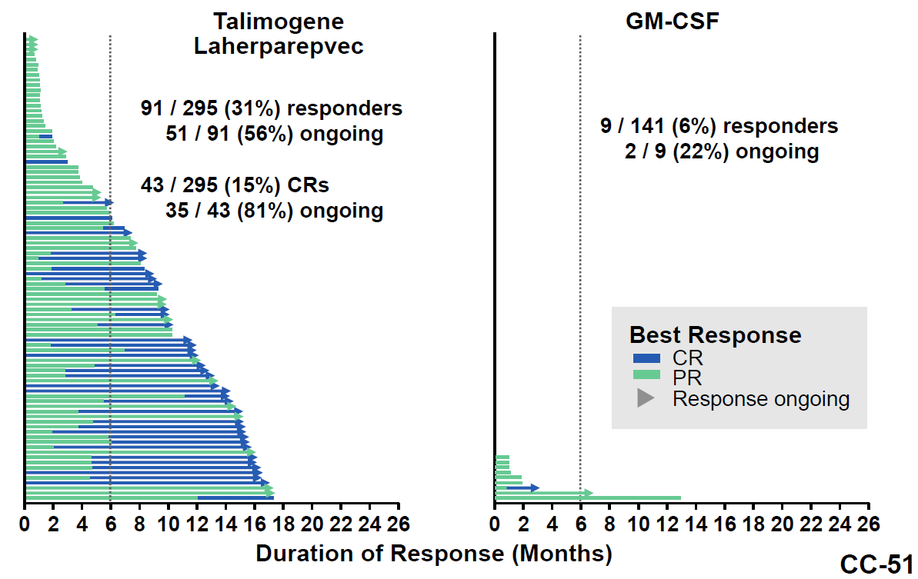
Figure 6B: Analogous outcomes at time of the final overall survival analysis
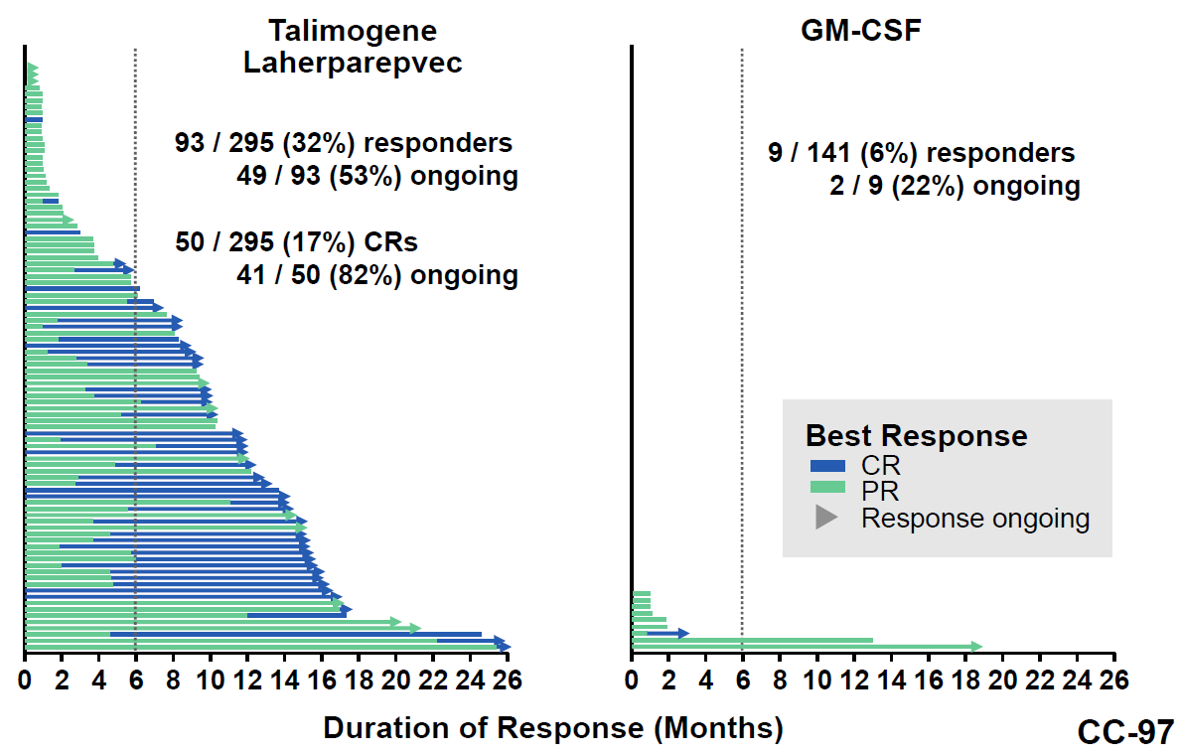
In 78 objective responders who received talimogene laherparepvec, median duration of response had not been reached, with 56 (72%) in response at last tumour assessment.
Among 8 objective responders who received GM-CSF, the median duration of response was 2.8 months.
Mixed outcomes were seen for DRR in subgroup analysis. The Forrest Plot for DRR is copied in Figure 7 below.
Figure 7: Study 005/05 subgroup analysis of durable response rate per EAC (ITT population)
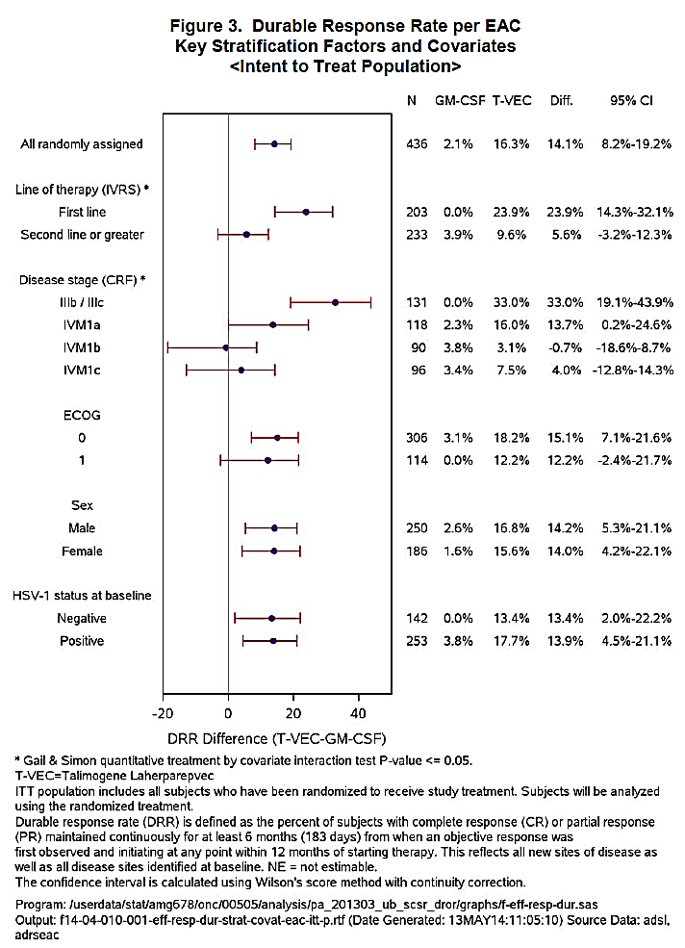

Overall survival
The HR for OS was 0.79 (95% CI 0.62 to 1.00), at the primary OS analysis data cut-off (31 March 2014), in favour of talimogene laherparepvec. Formally this does not indicate statistical significance, as the upper limit of the confidence interval (CI) includes 1.
Median OS was 23.3 months for talimogene laherparepvec and 18.9 months for GM-CSF. Survival at 12 months was similar across arms but at 24 months the rates were 50% for talimogene laherparepvec and 40% for GM-CSF.
Heterogeneous outcomes were seen by subgroup for overall survival:
- In patients receiving study treatment as first-line therapy for advanced disease, median OS was 33.1 months for talimogene laherparepvec versus 17 months for GM-CSF.
- In patients receiving study treatment as second or later–line therapy, median OS was 17.1 months for talimogene laherparepvec versus 23.2 months for GM-CSF.
Similar heterogeneity was seen in sub-groups defined by stage:
For Stage IIIB/C, median OS was not reached for talimogene laherparepvec versus 24.3 months for GM-CSF. The Kaplan Meier plot was as follows in Figure 8:
Figure 8: Kaplan Meier plot
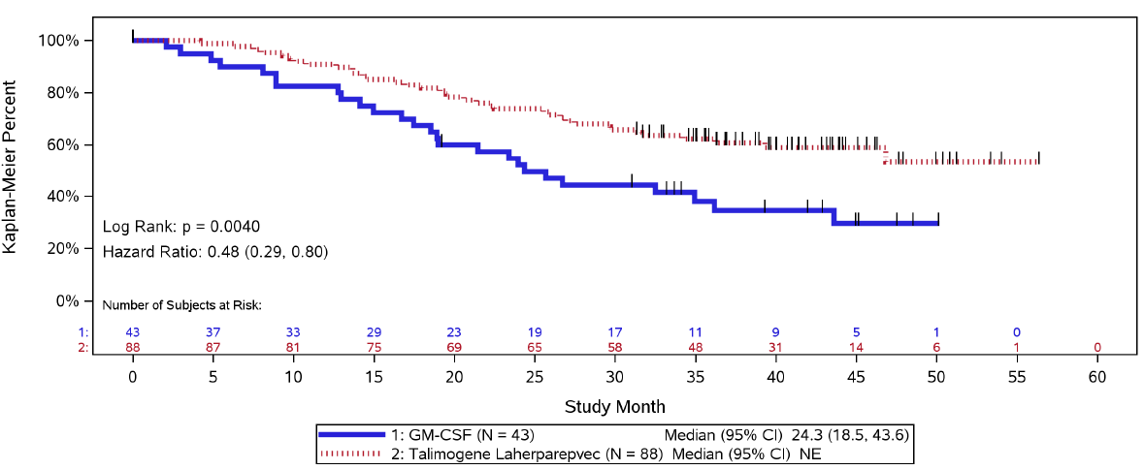
For Stage IV M1a, median OS was 29.9 months for talimogene laherparepvec versus 19 months for GM-CSF. The Kaplan-Meier plot was shown in Figure 9.
Figure 9: Kaplan Meier plot
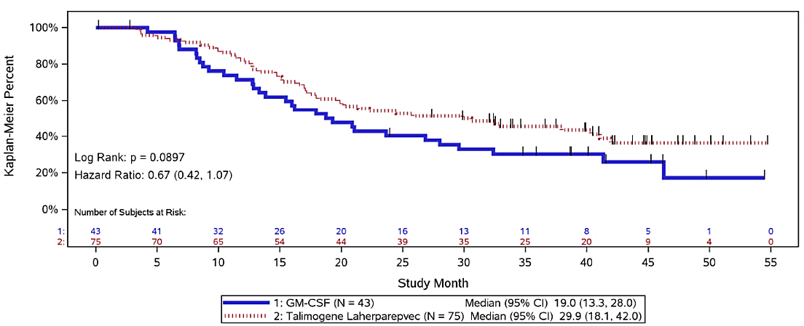
For Stage IV M1b, median OS was 13.6 months for talimogene laherparepvec versus 12.9 months for GM-CSF; the Kaplan-Meier curves were fairly superimposable.
For Stage IV M1c, median OS was 12.6 months for talimogene laherparepvec versus 16.2 months for GM-CSF; the Kaplan-Meier curves were fairly superimposable.
Subsequent anti-cancer therapy is of interest, because OPTiM was conducted at a time when promising anti-melanoma agents were in clinical development (with active trials) or recently approved. The company’s sensitivity analysis (censoring OS at first dose of ipilimumab, vemurafenib, dabrafenib or trametinib) revealed an overall OS HR of 0.70 remaining in favour of talimogene laherparepvec. IPI was used in 13.9% of talimogene laherparepvec and 17% of GM-CSF subjects; vemurafenib was used in 5.8% and 9.9% respectively.

Objective response rate
The objective response rate was 26.4% for talimogene laherparepvec (78/295) versus 5.7% for GM-CSF (8/141). Complete response rates were 10.8% and 0.7% respectively, by EAC. Median time to response was about 4 months in each arm, that is, long compared to some systemic treatment approaches.
Subgroup analysis of objective response rates revealed some disparities, for example, responses were better in talimogene laherparepvec patients with Stage III disease than with Stage IV disease (and patients with M1b or c had outcomes no better than with GM-CSF). The ORR difference between the treatments was more pronounced in first-line patients (38% versus 5%) than in other line patients (17% versus 7%).

Time to treatment failure
Median time to treatment failure was 8.2 months for talimogene laherparepvec and 2.9 months for GM-CSF (HR 0.42, 95% CI 0.32-0.54).

Progression prior to response
Of 78 overall responders in the talimogene laherparepvec arm, 42 (54%) progressed before achieving a response. Of 8 objective responders in the GM-CSF arm, 3 (38%) progressed before responding.

Subgroup analysis
The difference in outcomes across sub-groups was robust across endpoints. DRR and OS are plotted by key subgroups below.
Figure 10: DRR and OS by subgroup
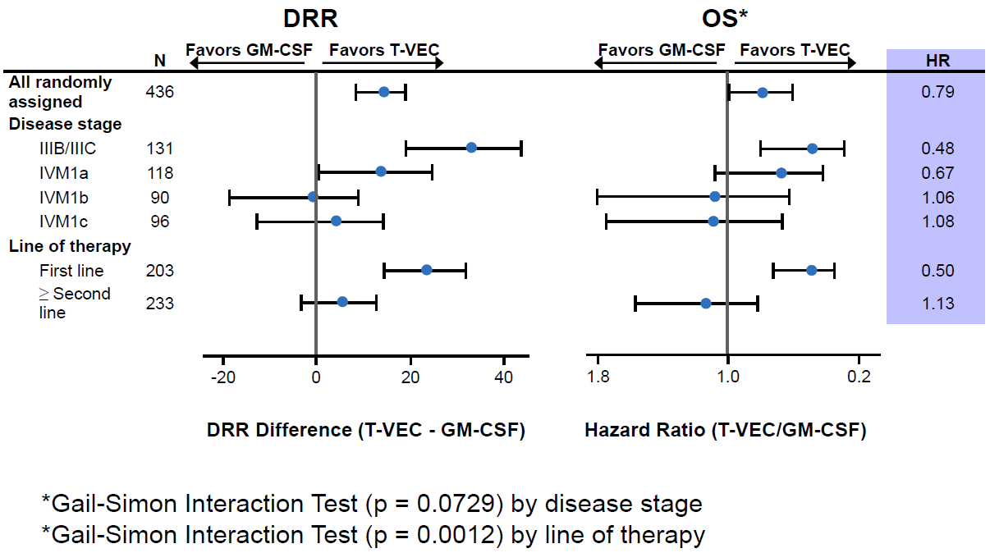
It was also noted by FDA reviewers that patients with low disease burden were over-represented amongst responders (this in a trial recruiting patients with generally low disease burden anyway), as shown in Table 13 below.
Table 13: Disease burden versus treatment response
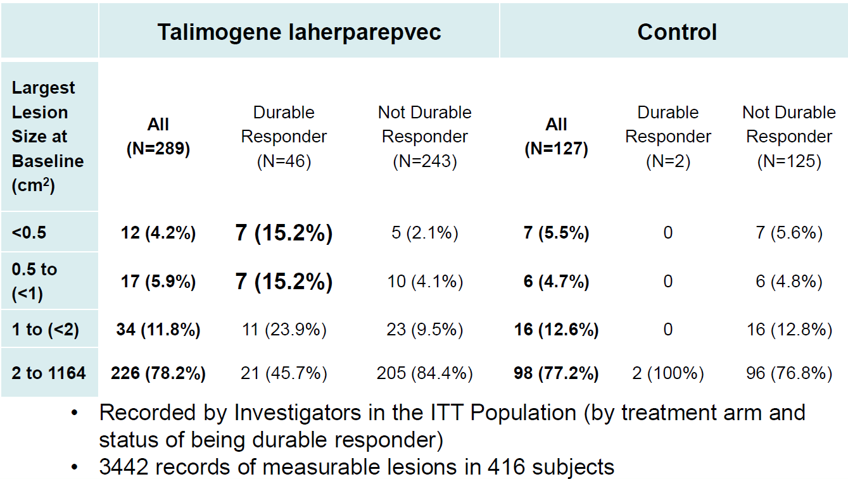
For example, for talimogene laherparepvec, 4.3% of subjects had a largest lesion of <0.5 cm² but these subjects made up 15.2% of all durable responders.
Subgroup analysis by BRAF tumour genotype is of interest. Only a minority had definitive BRAF genotyping. There is no unambiguous signal of an interaction.
Table 14: Subgroup analysis by BRAF tumour genotype
 | Imlygic | GM-CSF
BRAF wild-type | N=45  DRR = 11.1%  Median OS, 27.3 months  42.3% OS at Month 36 | N=23  DRR = 4.3%  Median OS, 32.4 months  45.4% OS at Month 36
BRAF mutant | N=46  DRR = 10.9%  Median OS, 22.2 months  32.5% OS at Month 36 | N=23  DRR = 0%  Median OS, 29.6 months  40.4% OS at Month 36

Systemic activity
This is discussed in Attachment 2. Talimogene laherparepvec had activity against non-injected lesions but activity (for example, as suggested by a more than 50% overall decrease in lesions) was lower against visceral lesions.
A key graphic showing the degree of systemic activity used at the FDA Advisory Committee meeting is reproduced below (Figure 11). Thus:
- 47% of injected lesions regressed fully;
- 22% of un-injected but non-visceral lesions regressed fully
- 9% of un-injected but visceral lesions regressed fully.
Figure 11: Degree of systemic activity
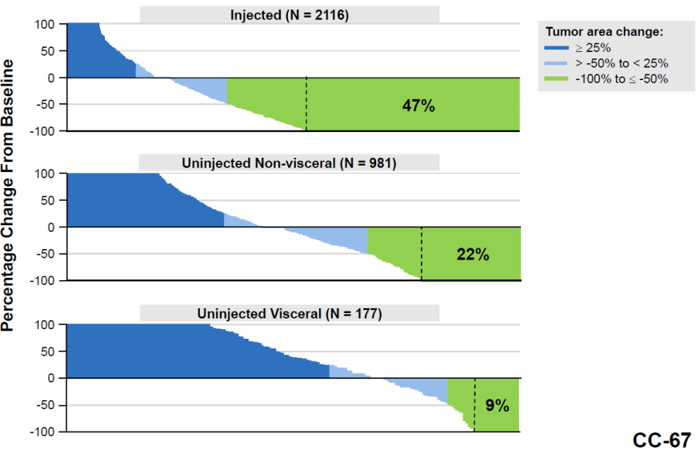
The clinical relevance of lesion level analysis is debatable, though if locoregional control is thought to be valuable in and of itself, then lesion-level analysis may be useful.

Quality of life
The evaluator notes ‘treatment is clearly not without side effects that could adversely [affect] the quality of life for long period’ and on page 57 that quality of life is likely to suffer due to ‘frequency of injections and side effects such as fatigue, flu-like symptoms [and] pain at tumour sites’.
Quality of life is discussed by the clinical evaluator:
Since the prespecified QoL analysis was inconclusive, Amgen conducted an alternative analysis on detrimental QoL. There were no statistically significant associations between durable response/overall response (DR/OR) and detrimental QoL change. Results suggest that achieving a DR or OR is usually associated with a neutral to lower likelihood to report detrimental QoL. Disease stage was a significant predictor for detrimental QoL change in that subjects with early stage disease had a lower risk of experiencing a detrimental QoL change as compared those with late stage disease.
The expected association between DRR and improvement in QoL (see previous bullet) was demonstrated in Study 005/05 based on the Functional Assessment of Cancer Therapy-Biological Response Modifier (FACT-BRM; including the Trial Outcome Index [TOI]). Further, a greater proportion of subjects who achieved a durable response per the Endpoint Assessment Committee (EAC) reported improvements in TOI when compared to those who did not achieve a durable response.

Phase II melanoma Study 002/03
Some data pooled from Study 002/03 and Study 005/05 is discussed in the main body of the clinical evaluation (Attachment 2).
Study 002/03 enrolled 50 adults with Stage IIIC or Stage IV melanoma, ineligible for curative surgery, from 2006 to 2008. The regimen for talimogene laherparepvec was as per Study 005/05 but in this study initial treatment was 8 doses over 15 weeks (with a further 16 doses if activity was seen).
Of 50 subjects, 14 (28%) had an objective response, including 8 (16%) with a CR. Median OS was 14.7 months. New lesions sometimes preceded responses.

Safety

Exposure
The number of individuals exposed to talimogene laherparepvec is summarised in Table 15 below.
Table 15: Exposure to talimogene laherparepvec
It is noted in the clinical evaluation that the mean volume of injection is 2.8 mL, with a range from 0.3 to 4.0 mL. Post-dose 1, the interquartile range is 1.75 to 4 mL, indicating that in a quarter of injections, the volume was <1.75 mL. (Subcutaneous GM-CSF exposure in Study 005/05 is summarised in the clinical evaluation.)
As noted earlier, in Study 005/05, median treatment duration was 23 weeks for talimogene laherparepvec versus 10 weeks for GM-CSF. This influences the interpretation of AE frequencies.

Study 005/05
The clinical evaluation summarises treatment-emergent and treatment-related AEs. The talimogene laherparepvec arm had a consistently higher frequency of severe or life-threatening AEs; also, there were more fatal AEs (3.4% versus 1.6%; though no fatal AEs were considered treatment-related and most were due to melanoma progression).
Common AEs in the talimogene laherparepvec arm were fatigue (50.3%), chills (48.6%), pyrexia (42.8%), nausea (35.6%), flu-like illness (30.5%), injection site pain (27.7%) and vomiting (21.2%). A list of treatment-emergent AEs is given in the clinical evaluation (Attachment 2). These AEs were often considered treatment-related.
Treatment discontinuation due to AEs occurred in 9.9% of talimogene laherparepvec subjects (n=29) and 6.3% of GM-CSF subjects.
Selected AEs of interest are presented in the clinical evaluation.
Cellulitis at the injection site was reported in 6.2% of talimogene laherparepvec subjects and this was a serious AE in 2.4%.
Flu-like symptoms were reported in 90% of subjects who received talimogene laherparepvec, and in 3.1% this was a serious AE. The clinical evaluation report gives a breakdown of AEs considered ‘flu-like’ (chills, headache and so on) (Attachment 2).
HSV infections were reported in 5.5% of talimogene laherparepvec subjects (versus 1.6% for GM-CSF) (Table 16) and there were no serious adverse events (SAEs). It was claimed that the incidence was lower than the background population rate.
Table 16: HSV infections
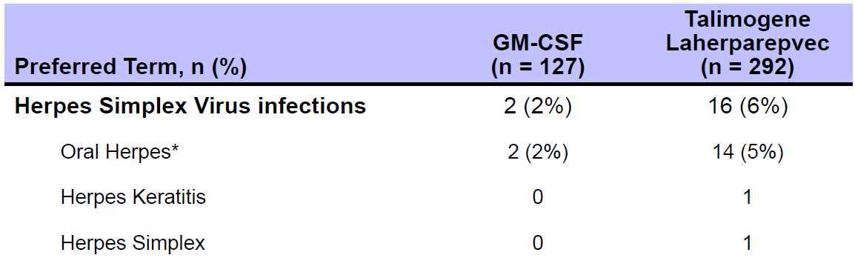
Vitiligo was reported in 5.1% of talimogene laherparepvec subject versus 1.6% of GM-CSF subjects.
There were two serious AEs of hypersensitivity (asthma, resolving with treatment; and recurrent bronchial hyper-reactivity forcing discontinuation).
There was one report of plasmacytoma in the talimogene laherparepvec arm, in close proximity to an injected lesion, developing after 9 cycles of treatment.
Immune mediated AEs were not prominent in the talimogene laherparepvec arm (relative to checkpoint inhibitors), with two cases of glomerulonephritis reported and single cases of pneumonitis, vasculitis and worsening psoriasis.
Injection site pain was reported in 28% of patients injected with talimogene laherparepvec (3 severe events were reported), presumably despite local anaesthesia.
One patient given talimogene laherparepvec in the left foot reported pain and oedema; 6 months after the last dose, the patient required below knee amputation to manage a non-healing infected wound in the left foot.
Safety in subgroups is considered in the clinical evaluation. The incidence rate for AEs was higher in baseline HSV-1 seronegative subjects than in baseline HSV-1 seropositive subjects, with more (and more severe) flu-like symptoms (at least in the initial few cycles of treatment).

Pregnancy
The evaluator notes that treatment of pregnant women with talimogene laherparepvec has not been studied and that there is a potential in the case of wild-type HSV for viral transmission across the placenta or transmission during birth due to viral shedding. The evaluator notes that ‘fetal and perinatal infections with wild-type HSV-1 (including primary infection and reactivation) have been associated with disseminated viral infection, multi-organ failure and death’.

Secondary spread
The evaluator concludes that this risk is low.

Risk management plan
The Risk Management Plan is generally acceptable to the TGA’s RMP Evaluation area but one point of contention is whether healthcare professionals should have to ‘sign off’ on education modules before the product can be accessed. Also, it is recommended that there be specific acknowledgement in the RMP of risks in neonates and risk in patients/contacts with active eczema and other inflammatory or ulcerating skin conditions.
As background, the sponsor states that expected use initially would be at approximately 15 centres in approximately 100 patients per year in Australia.
As part of the RMP evaluation, the application has been considered by two expert TGA committees:
- Advisory Committee on the Safety of Medicines (ACSOM).
- Advisory Committee on the Safety of Vaccines (ACSOV).
The Delegate’s summary of the discussion follows:
  - it will be critical to mandate interaction between oncology units and infectious disease departments or infection control units in supplying hospitals, that is, there needs to be appropriate induction, education and policies in place, for example relating to inadvertent exposure;
  - there should be a suitable Precaution in the PI about not just use in patients with active aczema but also patients with any other inflammatory/ulcerating skin lesions (presumably this extends to contacts with such conditions);
  - there should be public access at least to the PCR primers and methodology specific for Imlygic;
  - there should be strengthened communication about the very significant risk to neonates via accidental exposure or secondary spread; and
  - prophylaxis with anti-virals in the case of subsequent chemotherapy will require case-by-case judgement, so prescriptive instructions in the PI may not be helpful.

Non-routine pharmacovigilance activities in the proposed RMP include:

Clinical trials
- Study 20120324 of biodistribution/shedding
- Several planned paediatric studies

Pharmacoepidemiology studies
- Study 20130193 of herpetic events; and
- Patient registry
- Study 20120139 for long-term data.
- The sponsor has subsequently clarified that this study’s inclusion criterion is that patients must have received Imlygic in an Amgen sponsored clinical trial that this is not a post-marketing registry of all patients receiving Imlygic.

Non-routine risk minimisation activities in the proposed RMP include:
- Patient education (alert card; safety brochure)
- Healthcare professional education (education booklet)
The sponsor’s approach to traceability, as per second round RMP Evaluation is noted.
The RMP evaluator argues that, as is the case in the EU, the sponsor should have a managed distribution program in Australia. This is discussed in the first round evaluation and the evaluator’s position is re-iterated in the second round report. The sponsor states the Australian distribution program is equivalent to the EU program ‘except for the completion of educational activities as a prerequisite for prescription and use’. This is noted in sponsor’s response to the RMP evaluation (Recommendation 15).
It would seem that a managed distribution program is well placed to consolidate practices that reduce risk, for example practices enforced by protocol during trials (exclusion of immunocompromised healthcare personnel and so on). Post-registration, the program could increase confidence that best practice is widely/universally used.
Based on discussion at ACSOV, the sponsor will be encouraged to update its RMP to include, as potential risk, accidental exposure or secondary spread to patients with active eczema or inflammatory/ulcerating skin conditions; and accidental exposure or secondary spread to neonates. It is not sufficient to consider these groups ‘covered’ by broader categories within the RMP safety specification.
Also, based on ACSOV discussion, the sponsor is encouraged to ensure education materials emphasise the need for strong interaction between oncology and infectious disease units of supplying hospitals, for example there should be policies in place explaining the steps to be taken if there is inadvertent exposure or secondary spread.

Risk-benefit analysis

Delegate’s considerations

Efficacy

Single pivotal study
Formal guidance where confirmatory evidence is provided by only one pivotal study is that the study has to be very compelling, with close attention paid to:
- Internal validity (no indication of bias)
- External validity (study population should be suitable for extrapolation to the treatment population)
- Clinical relevance (clinical significance of the effect size)
- Degree of statistical significance (‘statistical evidence considerably stronger than p<0.05 is usually required…’)
- Data quality
- Internal consistency (similar effects demonstrated in different pre-specified sub-populations; all important endpoints showing similar findings)
- Centre effect (no single study centre should dominate results)
- Plausibility of the hypothesis tested
These issues are brought out in discussion below.

Novel primary endpoint
The primary endpoint in Study 005/05 was durable response rate. Those who achieved a durable response had at least 6 months of objective tumour shrinkage (and enough shrinkage to qualify as having at least ‘partial response’).
Anticancer guidelines already note that in regard to Phase III, confirmatory trials, ‘irrespective of the chosen primary endpoint… magnitude of the treatment effect on all relevant outcome measures’ is relevant. Also, when overall survival is a secondary endpoint, the estimated effect on OS should show trends towards superiority.

Type of advanced melanoma patient studied
Patients in 005/05 were highly selected to have low tumour burdens as evidence by exclusion criteria relating to LDH and visceral metastases. This was reflected in the low percentage of subjects with Stage IV, M1c disease (22%). By way of comparison, from some recent influential studies shown in Table 17:
Table 17: Summary of published references
Paper ˅ | Stage > | III / M0 | IV M1a | IV M1b | IV M1c
Ipilimumab, Hodi et al 2010* |  | 1.5% | 9.2% | 17.9% | 71.4%
Pembrolizumab, Robert et al 2015* # |  | 5% | 10.8% | 18.7% | 63.7%
Nivolumab, Larkin et al 2015* |  | 42% |  |  | 58%
Vemurafenib, Chapman et al 2011* |  | 4% | 12% | 19% | 65%
Dabrafenib + trametinib, Robert et al 2015b* |  | 6% | 15% | 18% | 61%
Imlygic (OPTiM)* |  | 30% | 27% | 21% | 22%
* Total study population; #A further 1.8% had Stage IV disease not otherwise specified.
Of interest is whether these highly active agents had good complete response rates in patients with stage M1a disease. Published papers do not uniformly analyse the M1a subgroup separately. Chapman et al (2011) did, as follows for PFS (Figure 12):
Figure 12: Disease stage versus treatment response rates
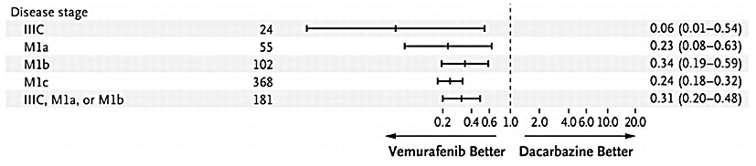
At least in this example, a highly active agent’s efficacy is even more pronounced in Stage IIIC but PFS outcomes in IV M1a are broadly similar to outcomes for M1b/c.
In OPTiM, even patients with M1c disease had relatively low burden disease, at least as reflected by LDH levels and adherence to exclusions.
Patients could enrol if their stage ≥IIIB disease was not surgically resectable. In OPTiM ‘this was defined as disease for which resection would not provide clinical benefit to the subject’. It is unclear whether investigators applied a uniform approach in this regard, for example, some lesions may be resectable but in the presence of visceral metastasis for example, resection would not be for overall ‘cure’.

Choice of comparator
The choice of GM-CSF as comparator caused problems with the interpretation of results in Study 005/05. This is discussed in the clinical evaluation (Attachment 2). GM-CSF is not approved for treatment of melanoma, so the study has two experimental arms and the benefit of direct comparison with an accepted, standard-of-care therapy is missing. The evaluator compares the design to a placebo-controlled study.
Because the study was open label, there is a possibility investigators may have persevered with talimogene laherparepvec more than with GM-CSF after progression.
The clinical evaluator notes that ‘advantages [of Imlygic] over other forms of intra-lesional therapies or surgical removal have not been shown’. While an enrolment criterion was that disease was not resectable, other local therapies exist.

Heterogeneity of efficacy outcomes – disease stage and line of therapy
There was evidence in Study 005/05 that efficacy of talimogene laherparepvec was greatest in Stage III(B-C), falling away in Stage IV, M1a, and no better than GM-CSF (likened above to placebo) in Stage IV, M1b-c. This was evident across all key efficacy endpoints examined, for example, DRR, OS and PFS.
There was also a signal that efficacy was better when talimogene laherparepvec was given as first line than when it was given as second or later line therapy.
Disease stage and line of therapy are correlated: patients with a more advanced stage of disease are more likely to have already tried therapy for advanced disease. The sponsor stated in its presentation to the FDA Advisory Committee that after adjusting for disease stage, line of therapy was not an independent predictor of durable response. However, it is difficult to disentangle which is the driver of varying efficacy.
To what extent study outcomes can be sub grouped usefully is debatable. A TGA adopted EU concept paper flags this: ‘a common misuse of subgroup analysis is to rescue a trial which formally fails based on the pre-specified primary analysis in the full analysis set’. Adopted guidelines, note the need for pre-specification of sub-group analysis; and for a sub-group analysis to carry more weight, there should also be consistency across endpoints and across studies, as well as biological plausibility.

Outcomes in Stage IV disease
There was no pronounced effect for patients with visceral metastases, relative to GM-CSF (which is not an accepted treatment for distant disease). Comparison of results in the talimogene laherparepvec arm with historical outcomes for accepted treatments is limited by enrolment criteria in OPTiM that selected patients with low disease burden (and by other problems associated with cross-study comparison).
Some patients with Stage IV M1b-c disease may have had local benefit, discussed further below.
Efficacy in Stage IV M1a patients was intermediate. Here, distant metastases are limited to skin, subcutaneous tissue or lymph nodes. These sites are injectable. Efficacy in some such patients might be due to injection into distant lesions, in which case, Stage IV M1a outcomes should not be taken as evidence of systemic activity.

Treatment through progression
Treatment through progression is endorsed in the PI but the ‘accelerated dosing’ regimen used in OPTiM is not. Presumably, accelerated dosing had some influence on efficacy outcomes in those patients who had some form of response after progression.
How to use this product in patients with progression (prior to response) is a key issue. In OPTiM, patients continued on therapy unless there was clinical deterioration. Now, there are more options for treatment in melanoma, so to continue on treatment in the hope of a response post-progression may be less appealing than when OPTiM was conducted. This might be a case-by-case decision. If progression is with the appearance of a single lung metastasis, the decision to push ahead with talimogene laherparepvec may differ from where progression is with the appearance of multiple brain metastases.

Consistency of administration technique
This is discussed in the clinical evaluation: administration may be difficult outside of clinical trials. Also, interpretation of the results of Study 005/05 (and other studies) is clouded by difficulty in knowing how clinicians went about selecting the volume of injection and priority of lesions, in practice. It would appear impractical, for example, to inject more than 4 to 5 lesions at any one patient visit.
The FDA presentation to the FDA Advisory Committee meeting noted ‘product administration varied depending on the number of injectable lesions, lesion size, whether a new lesion occurred since the last injection, whether an injected lesion had progressed, and the investigator’s choice’.

Safety

Accidental exposure
There is a risk of accidental exposure during preparation and administration of the product (risk to health-care workers, for example from needle stick injury); and there is a risk of accidental exposure after administration, for example, from contact with the lesion, or with the sterile occlusive dressing, or with improperly disposed-of dressings (risk to family members and other cancer patients).
In some people the consequences of this accidental exposure may be greater than in others, for example, pregnant women, neonates and people with immunosuppression or on immunosuppressive medicines (including other cancer patients).
The risk of accidental exposure via contact with a patient’s blood, urine and so on seems low, based on the biodistribution data discussed elsewhere.
The sponsor in its presentation to the FDA Advisory Committee noted 4 reports of accidental exposure in 3 health-care workers. These were: 3 needle-stick injuries and 1 splash to the eye. This was in the context of ‘over 4000 treatment visits’.
In one needle stick injury, a herpetic whitlow developed, which was qPCR positive for talimogene laherparepvec. The whitlow was treated with an antiviral.
It appears there was no systematic screening of close contacts for evidence of exposure, although a questionnaire tool did not pick up any secondary spread.
It is noted that the OGTR’s RARMP states ‘unused GM virus or waste material would be disposed according to normal clinical biohazardous waste procedures within the clinical facilities and following conditions, if any, imposed by the TGA’ (in clinical facilities) and via household waste (in a sealed plastic bag) otherwise (RARMP).

Viral shedding and secondary spread
Data on viral shedding are limited, and this was reflected in the discussion at the FDA Advisory Committee meeting where the focus was on the initial data received from an ongoing study of shedding and transmission (Study 20120324, due to finish at the end of 2015). The interim results as presented there are included in Table 18. An interesting finding was that in one patient, the modified virus was found in one swab of oral mucosa, suggesting the possibility of transmission via saliva in rare cases. Another interesting finding was that in 14/20 subjects Imlygic DNA was found on the outside of occlusive dressings. Viral DNA positivity on the outside of occlusive dressing indicates issues with maintaining complete occlusion, or transmission through the dressing. The tests for viral infectivity were negative.
Table 18: Ongoing Study 20120324 to evaluate the potential risk of shedding and transmission – Percent of subjects or samples qPCR positive
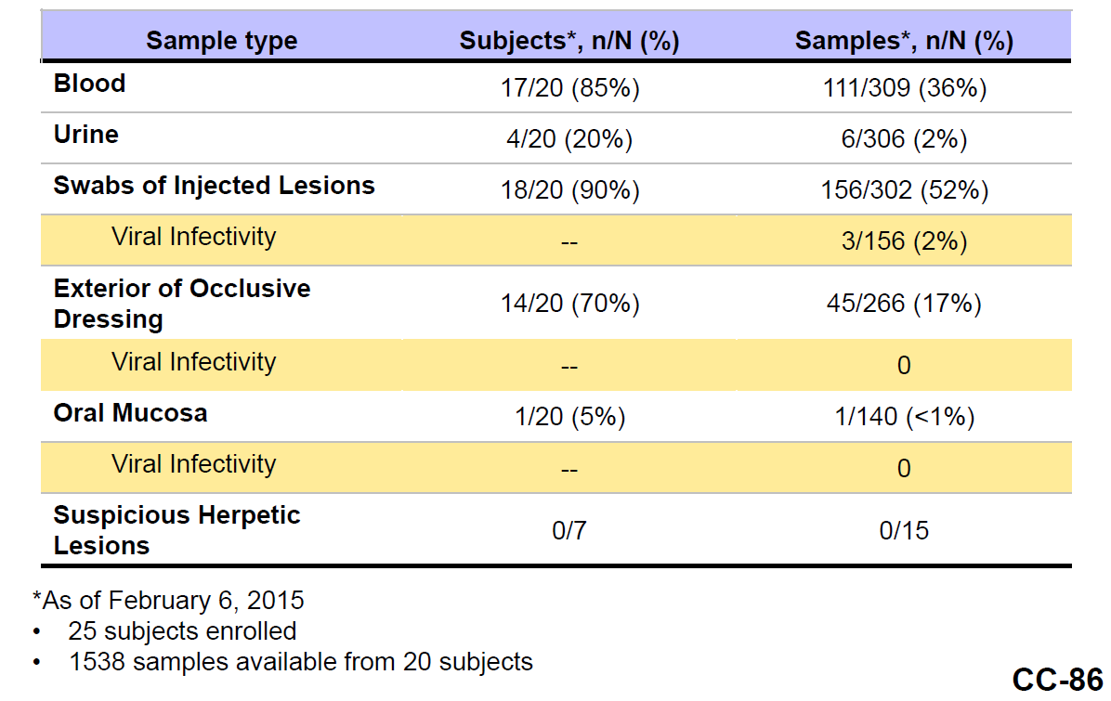
Every sample type was tested using a quantitative PCR assay for talimogene laherparepvec DNA. If the QPCR testing was positive, we also tested swabs of injected lesions, occlusive dressings and from the oral labial region for live virus.’ Thus, blood and urine positive for viral DNA was not tested for live virus (‘viral infectivity’ in the above table).
Some FDA analysis of data received to date from Study 20120324 is included in Figure 13. A broad conclusion is that other than at the injection site (including the exterior of the occlusive dressing), where virus persists, only low levels of virus are detectable in body fluids. It is reasonable to consider blood as potentially infectious.
Figure 13: FDA analysis of interim data from Study 20120324
FDA analysis of data received to date from Study 20120324, for the injection site, shows the following results:
Figure 13A: DNA copies versus Cycle
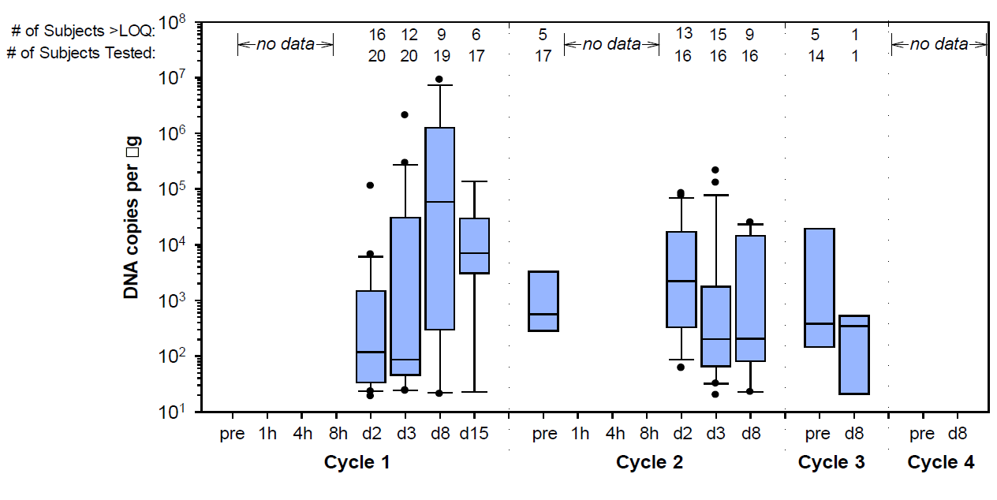
Y-axis units are talimogene laherparepvec DNA copies of per µg of total DNA. The pattern in cycle 1 suggests replication and amplification of viral numbers.
(The TGA nonclinical evaluation report notes that, in mice, there was an upswing in viral load at the injection site by Day 91 after the last injection, despite a decline over the initial 24 days).
A similar FDA analysis for blood (with a different - lower y-axis scale) indicates:
Figure 13B: DNA copies versus Cycle
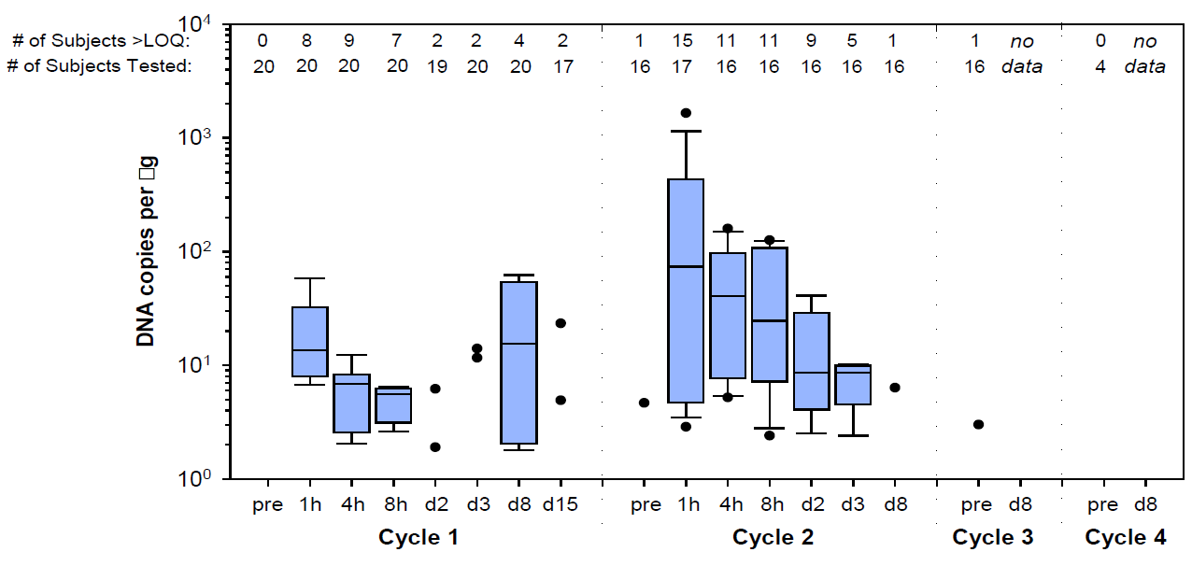
Y-axis units are talimogene laherparepvec DNA copies of per µg of total DNA
A similar analysis of urine showed lower amounts of viral DNA again.
It is not clear how the ‘accelerated dosing’ schedule impacts viral shedding. (The proposed PI does not recommend accelerated dosing).

Planned or ongoing studies
These are described in the clinical evaluation. Of some interest are studies of the product in combination with checkpoint inhibitors:
- Study 20110264 Phase Ib/II. The study examined talimogene laherparepvec in combination with ipilimumab (4 infusions of 3 mg/kg). Some interim data from the Phase Ib part of the study were mentioned in the clinical evaluation, based on a data cut-off of May 22, 2015. 67% of patients were alive at 18 months. Objective response rate was 50%; complete response rate was 22%.
- Study 20110265 (combination with pembrolizumab) is of interest. Its design was Phase Ib/II but because of ‘promising’ preliminary results from 20110264, this has been replaced with a Phase Ib/III design (the Phase III component to randomise 660 subjects to pembrolizumab or pembrolizumab and talimogene laherparepvec).

Overall risk-benefit and indication
The sponsor has proposed the following indication:
Imlygic is an oncolytic immunotherapy indicated for the treatment of melanoma that is regionally or distantly metastatic
The following issues arise in relation to this indication:

Injectable disease
In OPTiM, for enrolment, patients required injectable disease (≥ 1 cutaneous, subcutaneous or nodal lesion ≥10 mm in longest diameter, or multiple injectable lesions which in aggregate have a longest diameter ≥10 mm). By specifying in the indication what is considered injectable, it would be very clear that injection of visceral metastasis is off-label and not recommended. However, other parts of the PI (for example, the Dosage and Administration section) can also serve that purpose.

Unresectable disease
Should the indication limit use to patients with un-resectable disease? Or, is there a role for the product in patients who, for example, have distant metastases yet in which locoregional control might provide clinical benefit (without necessarily offering overall disease control)? In that scenario, can the use of talimogene laherparepvec be endorsed with concomitant anti-melanoma therapies, in the absence of data?
Even if distant metastasis are present, locoregional control is important for quality of life because of pain and wound complications from ulcerating tumours. On the other hand, there are other approaches to locoregional control (see discussion on choice of comparator, above). Is there any suggestion that talimogene laherparepvec offers distinct advantages over other approaches, for example via prevention of mutilating operations for facial/scalp disease?

Paediatric use
There are no paediatric data. Melanoma is rare in children, accounting for 1 to 4% of all melanomas and 1 to 3% of all paediatric malignancies. Genetic alterations may differ somewhat from those seen in adult melanoma. However, positive sentinel nodes at diagnosis are more common in children than adults.

Restriction to exclude patients with visceral/M1b/M1c disease
Patients with visceral/Stage IV M1b/c disease did no better with talimogene laherparepvec than with GM-CSF. Also, such patients were not representative of typical Stage IV M1b/c patients because they had low burden of disease. Further, there are now various products that offer perhaps more hope of efficacy in such patients than GM-CSF does and there have been no head-to-head studies against such agents.
These factors might suggest exclusion of such patients. On the other hand, there might be a role in:
- locoregional control (separate from systemic disease control);
- ‘last line’ therapy (or post- anti-PD-1 ± BRAFi therapy);
- patients unable to tolerate other therapies

Restriction to exclude patients with high burden of disease
Patients with a high disease burden were not studied in OPTiM (for example, almost all patients had normal LDH; exclusion criteria limited the number of visceral metastases). There is a view that such patients are more at risk of rapid deterioration and do not have ‘time’ to allow anti-tumour immunity to develop.

Restriction by line of therapy
Almost half of patients in OPTiM received the product as a first-line treatment of their advanced disease. Results with talimogene laherparepvec were better when it was used first-line, relative to second and later lines.
Would it be appropriate to restrict the indication to first-line use?
- This overlaps with restriction by stage.
- Also, assuming that combination with checkpoint inhibitors should not be endorsed until benefit is shown, restriction to first-line presents a dilemma: use talimogene laherparepvec first-line (forgoing, for example, checkpoint inhibitors as first-line therapy), or use alternative agents first-line and lose the opportunity to try out this product (at least as per label).
- Current lines of therapy probably differ quite markedly from lines available when OPTiM was conducted, so any indication restricted by line of therapy may reflect a past treatment landscape but not the current one.

Proposed action: Pre ACPM preliminary assessment
The application to register Imlygic is approvable but with a modified indication for example:
Imlygic is indicated for the treatment of un-resectable cutaneous, subcutaneous, and nodal lesions in patients with melanoma recurrent after initial surgery.

Recommended conditions of registration
The following wording is recommended:
- Implement EU-RMP Version 1.1 (dated 15 April 2015, DLP 6 June 2013) and Australian-specific annex (ASA) Version 2.0 (dated 16 July 2015) and any future updates as a condition of registration.
- Specific conditions of registration for additional risk minimisation activities include are likely to be imposed. Details are under consideration.

Request for ACPM advice
The committee is requested to provide advice on the following specific issues:
- Given the nature of this product, its intended use and the design, conduct and results of Study 005/05, is it acceptable for registration to be based on only one pivotal study (Study 005/05)?
- Does the novel primary endpoint ‘durable response rate’ sufficiently capture clinical benefit? Or, must the establishment of clinical benefit also rely on other endpoints for example overall survival and quality of life?
- Are any regional therapies for un-resectable, advanced melanoma registered or available and well established? Should Imlygic be registered for regional control of un-resectable disease in the absence of direct comparison with any such therapies?
- Should treatment continue beyond progression in those patients without clinically significant deterioration or the ‘need’ for subsequent therapy? If advice is to allow such continued therapy through progression, can the committee also advise:
  - How this should be communicated in the PI; and
  - Whether ‘accelerated dosing’ should be recommended in the PI (as per OPTiM).
- Is there sufficient characterisation of the risk of secondary spread? Or, should more detail be sought prior to authorisation (for example, via results of Study 20120324)?
  - What is the committee’s interpretation of the high rate of viral DNA detection from the outside of occlusive dressings in Study 20120324?
  - If characterisation is considered to be sufficient, is there an adequate approach to risk minimisation, for example, education for users (clinicians, patients) about risks, use of gloves/goggles/gowns, avoidance of auto-inoculation (for example, of eyes) and so on.
  - Is access to qPCR specific for the virus (or a public methodology for the test) necessary for diagnostic or public health purposes, if the product is registered? (The OGTR requires a written methodology for this test. Also, ACSOV endorsed the need for public access to Imlygic-specific PCR methods.)
- Does the ACPM consider that talimogene laherparepvec has a positive benefit/risk balance in the proposed population? If not, is there any population where the ACPM considers benefit / risk to be positive?
- Should completion of educational activities be a prerequisite for prescription and (/or) use of Imlygic?
- Can the ACPM suggest improvements to the PI/CMI documents?
- The committee is also requested to provide advice on any other issues that it thinks may be relevant to a decision on whether or not to approve this application.
Please also note that the sponsor has been asked additional questions (see below). Some responses have been received as of 23 October 2015; it is hoped the full responses will be part of the materials able to be considered at the ACPM’s meeting.

Questions to sponsor

Overseas status
There is reference in the Office of Gene Technology (OGTR) Risk assessment and Risk Management Plan (RARMP) to an application being withdrawn elsewhere. Can the sponsor comment on this, providing detailed reasons if the Imlygic application has in fact been withdrawn in.
Summary of answer: This related to participation in OPTiM, as required conditions were considered by the sponsor to be too stringent.

Mechanism of action: MAPK pathway
If in tumours an active MAPK pathway impairs PKR activation (that is, impairs anti-viral response, allowing replication), might replication differ in BRAF mutant and wild-type melanomas? Might BRAF/MEK inhibitors affect replication?
Summary of answer: The specific mechanisms underlying tumour-selective replication of ICP34.5-deficient HSV-1 viruses have not been fully established; some pre-clinical work on the topic has been conducted; OPTiM suggested efficacy was not affected by tumour BRAF V600 status. [One comment is that use of BRAFi/MEKi will presumably impact on this pathway systemically, that is, across tumour and non-tumour cells.]

Mechanism of action: local anaesthesia
Before administration, anaesthetic is infiltrated near the lesion (and this would be in close proximity to surface lesions). Fraser et al (2014) have suggested that local anaesthetics benefit patients needing cancer surgery, for example, via reducing subsequent tumour recurrence, or less use of opioids (which may interfere with immunity). Melanomas express voltage-gated sodium channels (a target of local anaesthetics). Is interaction between local anaesthetics, Imlygic and efficacy plausible? Were data collected on the extent of use of local anaesthetics in OPTiM?
Response provided as part of the sponsor’s pre-ACPM response and therefore is not captured here as part of the Delegate’s overview.

Biodistribution
Were differences in biodistribution seen in patients where administration was (a) to skin or subcutaneous lesions only versus (b) to nodal lesions only?
Response provided as part of the sponsor’s pre-ACPM responseand therefore is not captured here as part of the Delegate’s overview.

Efficacy: conversion to resectable
Did treatment allow some patients to ‘become’ resectable? If so, did subsequent resection contributed to good efficacy outcomes?
Summary of answer: 33 Imlygic arm subjects underwent 35 surgeries, however 21 resections were ‘palliative’; in the 14 non-palliative resections, 3 procedures in 2 subjects contributed to a best response of CR or PR, that is, impact was not pronounced.

Efficacy: subgrouping by age
The main subgroup analysis in the OPTiM CSR for the primary endpoint of DRR looked at efficacy in patients <50 years of age and those ≥50 years of age. Given that immunity in the elderly may wane, can the sponsor also point to analyses of key efficacy endpoints by age <75 years and ≥75 years?
Summary of answer: DRR and OS benefit relative to subcutaneous GM-CSF was retained in patients ≥ 75 years.

Efficacy: staging system
Was AJCC7 the staging system in use at the time of OPTiM? In other words, do the Stages IIIB, IIIC and so on referred to in OPTiM’s CSR translate faithfully to the staging system shown in Figure 14.
Figure 14: Melanoma staging (AJCC, 7th edition)
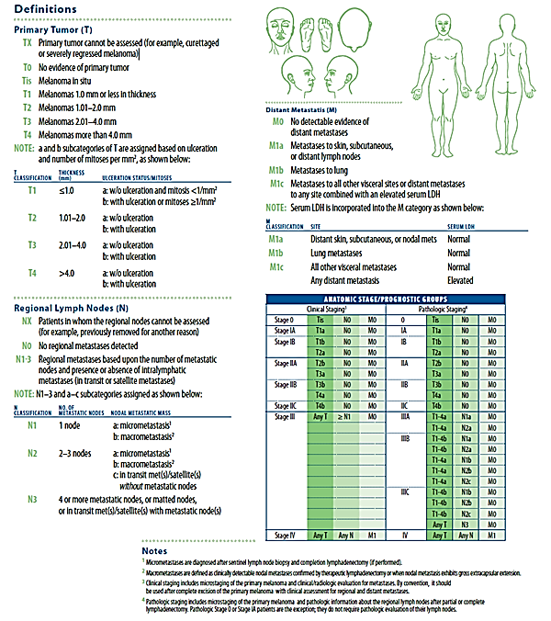
Summary of answer: The staging system used in OPTiM (AJCC v6) translates to the current system.

Efficacy: subgrouping by stage of disease and line of therapy
Present key efficacy outcomes stratified by stage and line, for example Stage IIIB, first line; Stage IIIB, second or later line. It is accepted this approach is exploratory and will reduce sample size in the resulting groups, limiting interpretability.
A summary of the answer is shown in Table 19 below.
Table 19: Durable response rate per EAC in subgroup defined by the combination of disease stage per CRF and line of therapy per IVRS Intent-to-Treat population.
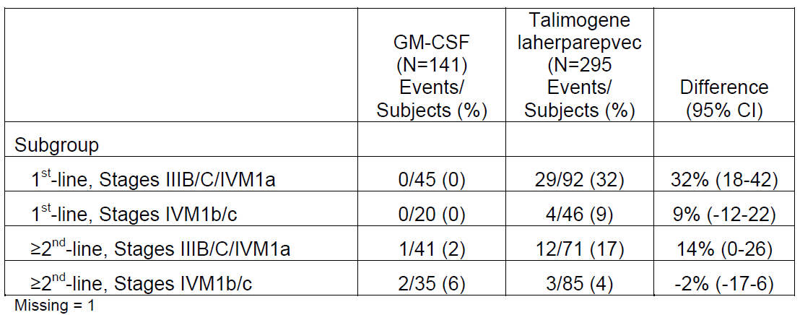
ORR and OS outcomes were also provided.

Efficacy: size of lesion
Were ‘small’ injected lesions more likely to respond than ‘big’ injected lesions, and are there are any implications for the selected dose scheme?
Response provided as part of the sponsor’s pre-ACPM response and therefore is not captured here as part of the delegate’s overview.

Efficacy: local recurrences
Were locally recurrent, satellite or in-transit lesions injected? Did efficacy vary in these situations?
Response provided as part of the sponsor’s pre-ACPM response and therefore is not captured here as part of the delegate’s overview.

Efficacy: ultrasound
In what fraction of patients where nodes were injected was ultrasound guidance required?
Summary of answer: 103/292 had at least one nodal injection; of these, 45/103 had at least one nodal lesion measured by ultrasound; this might approximate use of US as guidance for injection.

Efficacy: injection into distant metastasis
In how many patients with durable response were all distant metastasis injected?
[Subsequent clarification: Distant metastasis include IV M1a metastasis, that is, skin, subcutaneous and nodal. This question bears on evidence of systemic immune response. The Delegate would like to explore whether/to what extent patients with IV M1a disease were counted towards durable response by virtue of regression of ‘distant metastasis’ that is, distant skin/subcut/nodal lesions where such lesions were actually injected (as opposed to where such lesions regressed through a systemic immune response).]
Response provided as part of the sponsor’s pre-ACPM response and therefore is not captured here as part of the delegate’s overview.

Efficacy: accelerated dosing (I)
Why is accelerated dosing not recommended in the PI? Can results of OPTiM be generalised to a setting where accelerated dosing is not used?
Response provided as part of the sponsor’s pre-ACPM response and therefore is not captured here as part of the delegate’s overview.

Efficacy: accelerated dosing (II)
In what proportion of ‘progressors’ who received Imlygic through progression was there a durable response? How many of these patients had accelerated dosing?
Response provided as part of the sponsor’s pre-ACPM response and therefore is not captured here as part of the delegate’s overview.

Efficacy and safety: baseline serostatus
In those baseline seronegative subjects who did not seroconvert, was there any obvious difference in anti-tumour activity or in safety?
Response provided as part of the sponsor’s pre-ACPM response and therefore is not captured here as part of the delegate’s overview.

Safety: Herpes simplex infection
With regard to the imbalance in AEs of herpes simplex infection, did all infections resolve? Was response to treatment normal? Was the time-course of any infection unusual, for example longer than normal? Were infections known to be wild-type or not?
Summary of response: One patient with Grade 2 HSV keratitis (who had a prior history of such keratitis) had not resolved at the time of data cut-off. Also, median time to resolution was reported at 10.4 days. [Comment – this is perhaps high, since the sponsor also states that literature suggests most lesions spontaneously heal within 10 days in immunocompetent patients.]

Safety: route of administration
Were any differences noticed in tolerability between cutaneous, subcutaneous and nodal injections?
Summary of response: Such specific analysis was not conducted; overall tolerability was acceptable.

Safety/RMP: eczema
Were subjects with eczema studied in the clinical programme? Was there any sign of an exaggerated reaction to injection, analogous to eczema herpeticum? If few or no eczema subjects were studied, why is use in patients with eczema not thought a potential risk?
Response provided during as part of the sponsor’s pre-ACPM response and therefore is not captured here as part of the delegate’s overview.

Risk management plan: training
Is active training of doctors, nurses and so on planned (distinct from passive provision of educational materials)? Does training extend to ultrasonographers/radiologists, given these staff may provide ultrasound guidance and must understand the risks involved with use of this product?
Summary of response: Active training is via education, and will be tailored by site, so if the institution identifies ultrasonographers/ radiologists as needing support, then training would be offered.

Risk management plan: neonates
Why is disseminated herpetic infection in neonates not considered a risk?
The sponsor notes the PI states under the ‘Use in Pregnancy’ precaution that ‘If Imlygic is used during pregnancy, or if the patient becomes pregnant while taking Imlygic, the patient should be apprised of the potential hazards to the fetus and/or neonate.’ Also, the sponsor notes reference to ‘infants less than 3 months old’ in the Precaution about accidental exposure. The sponsor considers neonates captured by broader groups in the RMP safety specification.

General: Dosage volume
Could the sponsor clarify how many subjects consistently received substantially < 4 mL? Were there consistent reasons? Did this group fare any differently in terms of efficacy or safety?
Response provided as part of the sponsor’s pre-ACPM response and therefore is not captured here as part of the Delegate’s overview.

General: Preparation
In how many clinical sites were biosafety hoods used routinely for preparation of Imlygic?
Summary of response: Use of microbiological safety hoods was governed by local procedures/regulations. In current Australian clinical trials, 2 sites use biosafety hoods and 1 does not. The sponsor noted the OGTR RARMP does not mandate use of a biosafety hood. [Comment: ACSOV also noted that aerosol exposure is less of a risk than splash and needle stick exposure.]

Safety: Infectious dose
Is it known whether the infectious dose for talimogene laherparepvec is similar to that of HSV-1? How do the viral loads recorded in Study 20120324 relate to infectious dose? In other words, on the conservative assumption that viral DNA reflects infectious virus, what viral load detected on the injected lesion and so on would be enough to infect another person in accidental contact with such sites?
Summary of response: The minimum infectious dose is not known.

Response from sponsor

Introduction
Melanoma is a complex cancer that requires the use of multiple treatment modalities for patients over the evolution of their disease. Imlygic has the potential to be an important treatment option for patients with melanoma confined to un-resectable regional or distant cutaneous, subcutaneous or lymph node metastases. Although a number of systemically administered therapies have been approved recently for melanoma, not all patients currently benefit. There is need for additional treatment options since complete responses with the immune checkpoint inhibitors are uncommon and the duration of responses with the targeted agents (indicated for patients with melanoma with activating mutation in B-raf) are limited. There are also specific toxicities associated with these 2 classes of agents. Based on Imlygic's anti-tumour efficacy, including significant improvement in durable response rate, prolonged overall survival in the proposed indicated population (based on a credible evidence of enhanced effects in exploratory subset analysis), and low incidence of high grade adverse events, Imlygic has a positive benefit-risk profile for the treatment of melanoma in patients with un-resectable cutaneous, subcutaneous or nodal lesions after surgery. This patient group is typically not at imminent risk of death from melanoma and would particularly benefit from effective treatment that has low toxicity and is associated with durable response.

Indication Statement
Proposed Indication
The Delegate has proposed an indication as follows:
Imlygic is indicated for the treatment of un-resectable cutaneous, subcutaneous, and nodal lesions in patients with melanoma recurrent after initial surgery.
This revised indication statement includes patients with Stage IIIB, IIIC or Stage IV M1a melanoma (that is, patients with cutaneous, subcutaneous, or nodal lesions, according to AJCC melanoma staging). The indication therefore reflects a sub-population of the patients enrolled in Study 005/05 for which the benefit-risk of Imlygic was more pronounced (results discussed in detail below). The sponsor suggests the following minor modifications (in bold):
Imlygic is indicated for the treatment of melanoma in patients with un-resectable cutaneous, subcutaneous or nodal lesions after initial surgery.
The sponsor’s justifications for these changes are:
Use of ‘or’ in cutaneous, subcutaneous or nodal lesions: By definition patients could have Stage III disease and not have nodal lesions. Also in the Study 005/05 there were subjects with only nodal lesions who responded to the treatment with Imlygic. The use of ‘or’ would remove the need for patients to require all forms of lesions to receive Imlygic.
The sponsor proposes to shift ‘patients with melanoma’ to reduce ambiguity, that is so the treatment is reflective of patients with Stages IIIB/C and IV1a melanoma.
The sponsor proposes to delete the term ‘recurrent’ as it is redundant with ‘after initial surgery’.
- Given the nature of this product, its intended use and the design, conduct and results of Study 005/05, is it acceptable for registration to be based on only one pivotal study (Study 005/05)?
The sponsor believes that the robust dataset provided by Study 005/05 is sufficient to allow registration of Imlygic for the proposed indication. Guidance does not preclude registration based on a single pivotal study with the consideration that the study is compelling and close attention is paid to data quality, consistency and validity of the trial results. The sponsor will address these considerations in the responses below.

Pivotal Study 005/05
The proposed use of Imlygic is primarily supported by data from pivotal Study 005/05, a Phase III, multicentre, open-label, randomised clinical study comparing Imlygic and GM- CSF in 436 subjects with Stage IIIB, Stage IIIC and Stage IV melanoma that was not surgically resectable.
The trial demonstrated compelling evidence of statistical significance in the primary endpoint of DRR. It also demonstrated effect on overall survival based on a credible evidence of enhanced effects in exploratory subset analysis. Study design aspects or potential sources of bias that could have affected the observed treatment effect of Imlygic in Phase III Study 005/05 were evaluated:
- Clinical relevance of DRR as the primary endpoint: DRR was selected as the primary endpoint as it reflects both the occurrence of an anti-tumour effect and the sustainability of this effect. DR was shown to be closely associated with other measures of patient benefit, such as survival, treatment-free interval, and quality of life (discussed below).
- Consistency across Secondary Efficacy Endpoints: The anti-tumour effects of Imlygic were consistent across overall response rate, time to treatment failure and duration of response. Furthermore, the anti-tumour effect of Imlygic was sustained, with a clinically meaningful > 4 month difference in median overall survival in subjects receiving Imlygic compared with GM-CSF in the ITT population, emergence of a plateau in the Kaplan-Meier survival curve with more than one-third of subjects still alive in the Imlygic arm at 3 years and maintenance of the separation in the survival curves by treatment group through 5 years of follow up.
- Robustness of effect: In subgroup analyses conducted by disease stage (a pre- specified stratification factor in Study 005/05), there was credible evidence for a pronounced effect of Imlygic in subjects with Stage IIIB to IVM1a disease, including:
  - internal consistency across all endpoints including overall survival,
  - robust statistical evidence for treatment-by-stage quantitative interactions,
  - replication of differences observed in the Phase II study (Study 002/03),
  - the large magnitude of treatment effects in this sub-population,
  - and biological plausibility consistent with Imlygic’s mechanism of action, that is, higher and faster rate of regression of injected lesions due to direct oncolytic effect, while effects of a systemic anti-tumour immune response in non-injected lesions, including visceral lesions, which were expected to take longer to establish.
Although differences were observed with respect to line of therapy, a biologically plausible hypothesis does not exist for this factor. In addition, results for subgroups by line of therapy were confounded by disease stage; approximately two-thirds of treatment-naïve patients had IIIB to IVM1a disease stage. Line of therapy was therefore determined not to be an independent predictor for durable response in a multivariate analysis after inclusion of disease stage. Among subjects with earlier stage disease (Stage IIIB/C and IVM1a), consistent treatment benefit was observed by line of therapy. For subjects receiving ≥ second-line therapy, Imlygic was associated with an improvement in DRR (17% versus 2%), objective response (28% [11% complete response] versus 2%) and a 21% reduction in the risk of death relative to GM-CSF.
- Use of GM-CSF as the comparator: GM-CSF was selected as the comparator as at the time of Study 005/05, as GM-CSF was considered a potential immunologically active and well tolerated agent. Furthermore it was considered to be a relevant comparator, as it allowed treatment to continue in both arms possibly long enough for
- The development of an anti-tumour immune response. Based on the available evidence suggesting anti-tumour activity in melanoma, it is unlikely that GM-CSF treatment at the dose specified in Study 005/05 accelerated disease progression or shortened survival. Moreover, any favourable effect of GM-CSF on tumour response or survival in Study 005/05 would raise the threshold for demonstration of superiority relative to a placebo comparison.
- Potential sources of bias were controlled through use of the blinded External Assessment Committee (EAC) to evaluate data for subjects with a response per investigator assessment and non-responders followed for at least 9 months. A high degree of correlation for DRR was observed between the EAC and investigator assessments (kappa statistic 0.78; 95% CI: 0.69, 0.87). Additionally, a post hoc sensitivity analysis indicated a reliable treatment effect of Imlygic on DRR that was robust to potential bias due to early treatment discontinuation in the open-label design.
- Does the novel primary endpoint ‘durable response rate’ sufficiently capture clinical benefit? Or, must the establishment of clinical benefit also rely on other endpoints, for example, overall survival and quality of life?
The use of DRR, defined as the percentage of subjects with complete response or partial response maintained continuously for a minimum of 6 months, as the primary endpoint is valid because responses to anti-cancer therapy lasting at least 6 months are expected to more likely be associated with meaningful benefits to the patient, including improvement in symptoms or quality of life, achievement of a disease-free or treatment-free interval and extended survival. The longer the duration of response, the more likely these benefits are to be experienced. Such benefits were demonstrated in Study 005/05.
A statistically significant improvement was demonstrated in subjects receiving Imlygic with a 14% difference compared to GM-CSF (16.3% versus 2.1%, P < 0.0001).
The clinical relevance of achieving a DR in Study 005/05 is supported by the observation of its strong association with other important measures of benefit in patients with melanoma, such as overall survival, treatment-free interval, and quality of life:
  - Achieving a DR (per EAC) in the ITT population of Study 005/05 was associated with an approximate 90% reduction in the risk of death in a pre-specified landmark analysis among subjects alive at 9, 12 and 18 months.
  - In a post hoc exploratory landmark analysis in subjects with tumour assessments for at least 9 months, achievement of DR (per EAC) was found to be associated with a prolonged treatment-free interval (p = 0.0007), with an approximate 67% reduction in the risk of initiating a new subsequent systemic anti-cancer therapy ([HR] 0.33; 95% CI: 0.17, 0.65), as well as a reduced risk of initiating subsequent systemic therapy at 36 months (probability of not initiating with DR, 76.5% [95% CI: 61.4, 86.2] versus without DR, 49.0% [95% CI: 36.9, 60.0]).
  - In a landmark analysis of subjects with ≥ 9 months of follow-up for tumour response, adjusting for stage and line of treatment, subjects who had a DR had better quality of life as measured by the validated Functional Assessment of Cancer Therapy–Biologic Response Modifier (FACT-BRM) questionnaire and the Trial Outcome Index (TOI; a subset of the FACT-BRM). Among subjects who achieved a DR, 58.1% had a clinically meaningful TOI improvement (≥ 5-point increase from baseline for ≥ 28 days) versus 30.0% of subjects who did not achieve a DR (p = 0.025).
- Does the ACPM consider that Imlygic has a positive benefit/risk balance in the proposed population? If not, is there any population where the ACPM considers benefit/risk to be positive?
The benefit/risk is favourable in the proposed population. Based on Imlygic’s clinically meaningful anti-tumour efficacy, overall survival results, and minimal incidence of Grade 3 adverse events observed in the Phase III study, Imlygic has a positive benefit-risk profile for the treatment of patients with un-resectable cutaneous, subcutaneous or nodal lesions.

Clinical Evaluation Benefits
Analyses conducted by disease stage (a pre-specified stratification factor in the Phase III 005/05 study) demonstrated that the treatment effect of Imlygic was particularly pronounced in subjects who had Stage IIIB/C and Stage IV M1a disease (57% of the Phase III study population).
The DRR in subjects with Stage IIIB/C and IVM1a disease at the time of the primary analysis was 25.2% in the Imlygic arm and 1.2% in the GM-CSF arm. Consistent results were observed for objective response rate (40.5% Imlygic versus 2.3% GM-CSF) and complete response rate (16.6% Imlygic versus 0% GM-CSF). At the time of the final analysis, the objective response rate per investigator assessment was 46.0% in the Imlygic arm and 4.7% in the GM-CSF arm; complete responses were observed for 28.2% and 1.2% of subjects, respectively. The OS hazard ratio (95% CI) in subjects with Stage IIIB/C and IVM1a disease was 0.57 (0.40, 0.80), with a 19.6 month difference in median OS in favour of Imlygic (41.1 versus 21.5 months).
In conclusion, the results in subjects who had Stage IIIB/C and Stage IV M1a disease show a large and clinically meaningful magnitude of effect. These results support the clinical evaluator’s recommendation for Imlygic usage in patients with Stages IIIB/C and IV1a melanoma and the Delegate’s proposed indication in the treatment of un-resectable cutaneous, subcutaneous and nodal lesions.

Clinical Evaluation Risks
Safety results for Imlygic have demonstrated a low incidence of Grade 3 or higher adverse events and no treatment-related deaths. The most frequently reported adverse events included pyrexia, chills and influenza-like illness, which were of low grade and generally resolved within 72 hours. The majority of adverse events (74% Imlygic versus 87% GM-CSF) were non-serious. The most frequently reported serious adverse events (Imlygic, GM-CSF) were disease progression (3.1% versus 1.6%) and cellulitis (2.4% versus 0.8%). Importantly, the incidence of immune-mediated adverse events was low (1.7% Imlygic versus 1.6% GM-CSF). The potential for herpetic events in patients due to Imlygic and for secondary transmission to close contacts and health care providers are recognised, although there have been no confirmed cases of transmission to close contacts reported to date. The incidence of herpetic infection (primarily oral herpes) observed in clinical studies was approximately 5% and no serious herpes complications were reported.
Importantly, adverse events did not adversely impact on the patients continuing on study, with discontinuation rates due to adverse events low across both study arms; 4% with Imlygic and 2% with GM-CSF.
- Are any regional therapies for un-resectable, advanced melanoma registered or available and well established? Should Imlygic be registered for regional control of un-resectable disease in the absence of direct comparison with any such therapies?
Imlygic should be registered for regional control of un-resectable disease in the absence of direct comparison with any such therapies. Direct comparison of Imlygic and such therapies is not possible since these therapies are highly specialised and useful in limited disease states, such as disease limited to extremities. These therapies, such as isolated limb infusion/perfusion (ILP), are invasive therapies that require careful patient selection and necessitate dedicated equipment available at centres of excellence. ILP is performed in an operating room setting, usually under general anaesthesia and is associated with considerable toxicity and morbidity, which include limb loss in 0.8% of patients and treatment-related mortality in 0.6% of patients. In contrast, Imlygic has the potential to be an important treatment low toxicity option for patients with difficult-to-treat cutaneous, subcutaneous or nodal un-resectable disease including areas not suitable for other regional therapies (such as melanoma in the head and neck region) or recurrent in-transit disease following multiple attempts at surgical resection. The sponsor has not considered direct comparison with any above such therapies, due to the differing complexity and treating requirements of these regimens rendering any comparison unviable.
Furthermore in contrast to ILP, the sponsor has demonstrated that the anti-tumour effect of Imlygic extended beyond injected lesions, as evidenced by a decrease in the size (including full resolution) of un-injected lesions (including visceral lesions) in subjects in Study 005/05, consistent with the development of systemic anti-tumour response. The sustained systemic anti-tumour effect of Imlygic is supported by a 59% reduction in the risk (HR 0.41; 95% CI: 0.19-0.89, p = 0.024) of developing visceral metastases in a post hoc exploratory analysis of subjects without clinically evident visceral lesions at baseline (but with a very high risk of harbouring micro metastatic disease) compared to GM-CSF. As a visual example a case study of response observed in un-injected (visceral and non-visceral) lesions is shown. This patient has melanoma located in the head and neck region with metastases present in subcutaneous tissue of the neck, the abdominal wall, and the abdomen. By Cycle 10, there is a complete resolution of injected lesions and of one deep abdominal un-injected lesion and a decrease in size of the other deep abdominal un-injected lesion.
- Should treatment continue beyond progression, in those patients without clinically significant deterioration or the ‘need’ for subsequent therapy? Whether ‘accelerated dosing’ should be recommended in the PI (as per OPTiM).
Similar to other immunotherapies, Imlygic treated patients may experience disease progression prior to response. The sponsor has communicated in the PI that ‘Imlygic treatment should be continued for at least 6 months unless other treatment is required or until no injectable lesions are remaining’, in alignment with treatment in the pivotal study. Amgen notes that in clinical practice the management of Imlygic treatment would be based on the physician’s assessment of the clinical benefit-risk for an individual patient and the proposed use is in a population where there is time for non-responders to receive additional treatments. The median time to response with Imlygic treatment was approximately 4.0 months in the proposed indication, while among the non-responders, the median time to treatment failure was 5.5 months and the median overall survival was 19.6 months. These results suggest that there would be approximately 14 months, following Imlygic treatment, for additional therapeutic strategies to be considered. The sponsor considers discontinuing treatment prematurely, that is, on first sign of progression may deprive patients from otherwise beneficial therapy.
Early data do not indicate any safety signals to suggest that Imlygic could not be safely administered in sequence with checkpoint inhibitors (for example, Phase Ib studies of Imlygic with ipilimumab (Study 20110264) or with pembrolizumab (Study 20110265). There is, however, strong scientific rationale that treatment with Imlygic, through the promotion of antigen presentation, could enhance the effect of the checkpoint inhibitors based on early clinical data. The Phase II study of Imlygic with ipilimumab began enrolment in 2013 and reports in 2017. With promising results in a Phase Ib study with pembrolizumab, the sponsor is also initiating a combination Phase III Study, projected to report in 2018.
The sponsor does not recommend accelerated dosing in the PI as there was insufficient evidence to conclude that there is a positive benefit-risk ratio with its use.
- Is there sufficient characterisation of the risk of secondary spread?
What is the ACPM’s interpretation of the high rate of viral DNA detection from the outside of occlusive dressings, in Study 20120324?
If characterisation is considered to be sufficient, is there an adequate approach to risk minimisation, e.g. education for users (clinicians, patients) about risks, use of gloves/goggles/gowns, avoidance of auto-inoculation (for example of eyes) and so on.
Is access to qPCR specific for the virus (or a public methodology for the test) necessary for diagnostic or public health purposes, if the product is registered? (The OGTR requires a written methodology for this test. Also, ACSOV endorsed the need for public access to Imlygic-specific PCR methods.)
The sponsor supports the clinical evaluator’s conclusions that secondary spread from injected lesions is unlikely, that care is recommended in disposal of dressings, and there should be avoidance of contact with infants, pregnant women and immunosuppressed individuals.
- In 4100 treatment visits, there were 5 accidental exposures to Imlygic in 4 individuals, which were asymptomatic or resolved with aciclovir. Secondary transmission to either Health Care Providers (HCPs) or close contacts of the study subjects was not reported. Herpetic events were reported for 5.5% of Imlygic treated subjects (4.8% oral herpes) and no serious herpes complications were reported. Additionally, the OGTR examined both the risk of accidental exposure during preparation and administration of the product to health-care workers from needle stick injury; and the risk of accidental exposure with the sterile occlusive dressing or with improperly disposed-of dressings (that is, risk to family members and other cancer patients) and concluded there was no substantive risk. This risk can be managed through pharmacovigilance and risk minimisation measures, including appropriate product labelling.
- The sponsor’s interpretation of the high rate of viral DNA detection from the outside of occlusive dressings is that this is a result of cross-contamination during administration of Imlygic. Occlusive dressings have been shown to be an effective barrier to prevent viral spread and no live virus was detectable on the swabs taken from the outside of occlusive dressings. In response to the detection of viral DNA (but not live virus), to prevent cross contamination from the administrator to the occlusive dressing, the sponsor now recommends changing gloves after administration and before applying the occlusive dressing and also wiping the exterior of occlusive dressing with alcohol (to which live virus is sensitive) in the PI. These steps are expected to further minimise any potential unintended transmission from the injection sites.
- In addition the sponsor will undertake post marketing qPCR testing of Imlygic DNA in Imlygic patients, HCPs and close contacts who report signs or symptoms of suspected herpetic illness.
- Should completion of educational activities be a prerequisite for prescription and (/or) use of Imlygic?
Amgen notes the diverse opinions regarding the completion of educational activities as a prerequisite for prescription and use of Imlygic. In the US, the FDA has not mandated this, while in Europe, this has been primarily driven by Imlygic’s status as an ‘Advanced Medical Therapeutic Product’, which relates more to gene and cellular therapies. Given the first in class status of this therapeutic, the sponsor notes the view that completion of educational activities would be well placed to consolidate practices that reduce risk and commits to completion of educational activities as a prerequisite for supply and use of Imlygic.

Advisory Committee Considerations
The Advisory Committee on Prescription Medicines (ACPM), having considered the evaluations and the Delegate’s overview, as well as the sponsor’s response to these documents, advised the following:
The ACPM resolved to recommend to the TGA delegate of the Minister and Secretary that:
The ACPM, taking into account the submitted evidence of efficacy, safety and quality, agreed with the Delegate and considered Imlygic plaque forming units (PFUs)/mL containing 1 x 10⁶ PFU/mL; and 1 x 10⁸ PFU / mL PFU of talimogene laherparepvec to have an overall positive benefit–risk profile for the amended indication;
Imlygic is indicated as monotherapy for the treatment of melanoma in patients with un-resectable cutaneous, subcutaneous, and nodal lesions after initial surgery.

Proposed conditions of registration
The ACPM agreed with the Delegate on the proposed conditions of registration.

Proposed Product Information (PI)/Consumer Medicine Information (CMI) amendments
The ACPM agreed with the Delegate to the proposed amendments to the Product Information (PI) and Consumer Medicine Information (CMI).

Specific Advice
The ACPM advised the following in response to the Delegate’s specific questions on this submission:
- Given the nature of this product, its intended use and the design, conduct and results of Study 005/05, is it acceptable for registration to be based on only one pivotal study (Study 005/05)?
Strictly speaking the ACPM considered this is a very limited dataset on which to base safety and efficacy. DRR is a novel endpoint, though it was supported by secondary outcomes and the comparator was also experimental and certainly not standard of care. The OS outcomes are not robust, particularly due to choice of comparator.
However, there does appear to be real activity and the toxicity is low, with the risk of herpetic events in patients or spread to others really very low (with the proposed precautions in place).
- Does the novel primary endpoint ‘durable response rate’ sufficiently capture clinical benefit? Or, must the establishment of clinical benefit also rely on other endpoints, e.g. overall survival, quality of life, etc?
While DRR is a clinically beneficial endpoint the establishment of clinical benefit would need to rely on or be supported by other endpoints. If not OS, then at least Quality of Life (QoL) data or Overall Response Rate (ORR) should be provided. ORR and CR rate were supportive; QoL data were less clear. OS was perhaps suggestive, but also perhaps less relevant where loco-regional control is the main aim and subsequent treatments will cloud OS assessment in real world.
- Are any regional therapies for un-resectable, advanced melanoma registered or available and well established? Should Imlygic be registered for regional control of un-resectable disease in the absence of direct comparison with any such therapies?
The ACPM agreed with the sponsor that a comparative study with regional therapy (such as isolated limb perfusion) would be difficult to do. These procedures are not common place and do have significant toxicities associated. They also only suit a small subgroup of patients with disease in a region amenable to such therapy. Radiotherapy can be used but is considered palliative.
Other intra-lesional agents that have been studied include the cytokines IL-2, interferon gamma, and interferon alpha. Generally, these agents are associated with high response rates locally at the site of injection but no systemic response.
- Should treatment continue beyond progression, in those patients without clinically significant deterioration or the ‘need’ for subsequent therapy? If advice is to allow such continued therapy through progression, can the ACPM also advise:
  - How this should be communicated in the PI; and
As per other immunotherapies, the ACPM advised that it seems reasonable to continue treatment beyond progression where this would be of clinical benefit.
A statement to this effect in PI is considered adequate.
  - Whether ‘accelerated dosing’ should be recommended in the PI (as per OPTiM).
The sponsor states there is insufficient data to include accelerated dosing. The sponsor should provide supporting data for such dosing before it can be added to the PI.
- Is there sufficient characterisation of the risk of secondary spread? Or, should more detail be sought prior to authorisation (e.g. via results of Study 20120324)?
  - What is the ACPM’s interpretation of the high rate of viral DNA detection from the outside of occlusive dressings, in Study 20120324?
The ACPM was satisfied with the sponsor’s comments that it likely represents cross contamination and they now recommend nurses change gloves between injection and applying dressing and also swab dressing with alcohol.
  - If characterisation is considered to be sufficient, is there an adequate approach to risk minimisation, e.g. education for users (clinicians, patients) about risks, use of gloves/goggles/gowns, avoidance of auto-inoculation (e.g. of eyes), etc.
The ACPM noted that the sponsor has committed to making completion of educational activities a prerequisite for supply and use. The safety protocol needs to be emphasised, so as to prevent secondary infections as per Study 20120324.
  - Is access to qPCR specific for the virus (or a public methodology for the test) necessary for diagnostic or public health purposes, if the product is registered? (The OGTR requires a written methodology for this test. Also, ACSOV endorsed the need for public access to Imlygic-specific PCR methods.)
The ACPM was of the view that it is necessary for a PCR assay to be developed and validated; however this was not considered a prerequisite for approval.
- Does the ACPM consider that talimogene laherparepvec has a positive benefit/risk balance in the proposed population? If not, is there any population where the ACPM considers benefit/risk to be positive?
The ACPM considered that talimogene laherparepvec has a positive benefit-risk profile for the modified indication:
Imlygic is indicated as monotherapy for the treatment of melanoma in patients with un-resectable cutaneous, subcutaneous, and nodal lesions after initial surgery.
The ACPM advised that Imlygic should be used as monotherapy as there are currently no data on combination use.
- Should completion of educational activities be a prerequisite for prescription and (/or) use of Imlygic?
As advised in Q5, the ACPM was of the view that completion of educational activities be a prerequisite for prescription and (/or) use of Imlygic
- Can the ACPM suggest improvements to the PI/CMI documents?
No further PI/CMI amendments were suggested.
The ACPM advised that implementation by the sponsor of the recommendations outlined above to the satisfaction of the TGA, in addition to the evidence of efficacy and safety provided would support the safe and effective use of this product.

Outcome
Based on a review of quality, safety and efficacy, TGA approved the registration of Imlygic talimogene laherparepvec 1x10⁶ PFU/mL and 1x10⁸ PFU/mL injection, solution vial, indicated for:
Imlygic is indicated as monotherapy for the treatment of melanoma in patients with un-resectable cutaneous, subcutaneous or nodal lesions after initial surgery.

Specific conditions of registration applying to these goods
- The Imlygic EU-RMP Version 1.1 (dated 15 April 2015, DLP 6 June 2013) and Australian-specific annex (AsA) Version 2.0 (dated 16 July 2015) and any future updates, as agreed with the TGA will be implemented in Australia.
- All independent batches of Imlygic (talimogene laherparepvec) 1x10⁶ PFU/mL and 1x10⁸ PFU/mL injection, solution vial imported into Australia are not to be released for sale until the following have been supplied, assessed and endorsed by the TGA Laboratories Branch:
  - Complete summary protocols for manufacture and QC, including all steps in production. Number of doses to be released in Australia from each shipment
  - Evidence of the maintenance of the registered transport conditions during importation into Australia, such as graphs of temperature recordings, and a statement that the approved conditions have been met.
  - Three doses of the first consignment of product with the Australian approved labels, PI and packaging. 3 doses of further consignments of the product (including diluents) with the Australian approved labels, PI and packaging may be requested to support the release of those batches.
  - A copy of the certificate of release and testing related information from the regulatory agency acting for the country of origin (where this exists).
- An electronic draft of the Certified Product Details (CPD), as described in Appendix 7 of the Australian Regulatory Guidelines for Prescription Medicines (ARGPM), should be provided upon registration of these therapeutic goods. In addition, an updated CPD should be provided when changes to finished product specifications and test methods are approved in a Category 3 application or notified through a self-assessable change.

Attachment 1. Product Information
The PI approved for Imlygic at the time this AusPAR was published is at Attachment 1. For the most recent PI, please refer to the TGA website at <https://www.tga.gov.au/product-information-pi>.

Attachment 2. Extract from the Clinical Evaluation Report.

Therapeutic Goods Administration
PO Box 100 Woden ACT 2606 Australia
Email: info@tga.gov.au Phone: 1800 020 653 Fax: 02 6232 8605
https://www.tga.gov.au

Tanabe and Tyler. Cutaneous melanoma: in transit metastases. Up-To-Date topic 7608 version 15.0, last updated Feb 03, 2015
http://www.fda.gov/downloads/AdvisoryCommittees/CommitteesMeetingMaterials/BloodVaccinesandOtherBiologics/CellularTissueandGeneTherapiesAdvisoryCommittee/UCM446630.pdf page CC-14
http://www.cancer.org.au/content/pdf/HealthProfessionals/ClinicalGuidelines/ClinicalPracticeGuidelines-ManagementofMelanoma.pdf
http://www.fda.gov/downloads/AdvisoryCommittees/CommitteesMeetingMaterials/BloodVaccinesandOtherBiologics/CellularTissueandGeneTherapiesAdvisoryCommittee/UCM446630.pdf
BALB/c is an albino, laboratory-bred strain of the House Mouse from which a number of common sub strains are derived.
Rasko, J.E.J. & Gough, N.M. (1994). Granulocyte-macrophage colony stimulating factor. Chapter 19, The Cytokine Handbook Second edition, Ed. A.W. Thomson. Academic Press.
Anderson, J.R. & Field, H.J. (1983). The distribution of herpes simplex type 1 antigen in mouse central nervous system after different routes of inoculation. Journal of the Neurological Sciences 60: 181-95.
Armien, A.G. et al (2010). Chronic cortical and subcortical pathology with associated neurological defecits ensuing experimental herpes encephalitis. Brain Pathology 20(4). 24 pages.
Webre, J.M. et al (2012). Rabbit and mouse models of HSV-1 latency, reactivation and recurrent eye diseases. Journal of Biomedicine and Biotechnology 2012: doi:10.1155/2012/612316.
Cheng, S.-H. et al (2006). Efficient reactivation of latent herpes simplex virus from mouse central nervous system tissues. Journal of Virology 80(24): 12387-92.
Mester, J. and Rouse, B.T. (1991). The mouse model and understanding immunity to herpes simplex virus. Reviews of Infectious Diseases 13(S11): S935-45.
ICH considerations. Oncolytic viruses. EMEA/CHMP/ICH/607698/2008
ICH considerations. General Principles to Address Virus and Vector Shedding. EMEA/CHMP/ICH/449035/2009
Guideline on the Non-clinical studies required before first clinical use of Gene Therapy Medicinal Products. EMEA/CHMP/GTWP/125459/2006; Guideline on scientific requirements for the environmental risk assessment of gene therapy medicinal products. EMEA/CHMP/GTWP/125491/2006; Gene therapy clinical trials: Observing subjects for delayed adverse events. CBER, US FDA, November, 2006; Guidance for Industry: Preclinical Assessment of Investigational Cellular and Gene Therapy Products. Draft Guidance, CBER, US FDA, Nov 2012.
ICH S9: Nonclinical Evaluation of Anticancer Pharmaceuticals. EMEA/CHMP/ICH/646107/2008.
ICH Guideline S6 (R1). Preclinical safety evaluation of biotechnology-derived pharmaceuticals. EMEA/CHMP/ICH/731268/1998.
Whitley, RJ: Herpesviruses. In Medical Microbiology. 4th edn. Baron S, editor. Galveston (TX): University of Texas Medical Branch at Galveston; 1996. (http://www.ncbi.nlm.nih.gov/books/NBK8157/)
Chayavichitsilp, P. (2009). Herpes Simplex. Pediatrics in Review 30(4): 119-130.
Miller, C.S. et al (2008). Asymptomatic shedding of herpes simplex virus (HSV) in the oral cavity. Oral surgery, oral medicine, oral pathology, oral radiology and endodontology 105(1): 43-50.
Liu, BL et al (2003). ICP34.5 deleted herpes simplex virus with enhanced oncolytic, immune stimulating, and anti-tumour properties. Gene Therapy 10: 292-303.
Gale, M. & Katze, M.G. (1998). Molecular mechanisms of interferon resistance mediated by viral-directed inhibition of PKR, the interferon-induced protein kinase. Pharmacological Therapeutics 78(1): 29-46.
Chou J, Kern ER. (1990). Mapping of herpes simplex virus-1 neurovirulence to gamma 134.5, a gene nonessential for growth in culture. Science; 250(4985): 1262-6.
Talloczy, Z. et al (2006). PKR-dependent autophargic degradation of herpes simplex virus type 1. Autophargy 2:(1) 24-29.
Orvedahl, A. et al (2007). HSV-1 ICP34.5 confers neurovirulence by targeting the Beclin 1 autophargy protein. Cell Host and Microbe 1: 23-35.
Alexander, D.E. & Lieb, D.A. (2008). Xenophargy in herpes simplex virus replication and pathogenesis. Autophargy 4:(1) 101-3.
Chou J, Kern ER. (1990). Mapping of herpes simplex virus-1 neurovirulence to gamma 134.5, a gene nonessential for growth in culture. Science; 250(4985): 1262-6.
Bolovan CA, Sawtell NM, Thompson RL. (1994). ICP34. 5 mutants of herpes simplex virus type 1 strain 17syn+ are attenuated for neurovirulence in mice and for replication in confluent primary mouse embryo cell cultures. J Virol.; 68(1): 48-55.
Campadelli-Fiume, G. et al (2011). Rethinking herpes simplex virus: the way to oncolytic agents. Reviews in Medical Virology 21: 213-226.
Whitley, R.J. et al (1993). Replication, establishment of latency, and induced reactivation of herpes simplex virus γ₁ 34.5 deletion mutants in rodent models. Journal of Clinical Investigation 91: 2837-43.
Meurs, E.F. et al (1993). Tumor suppresor function of the interferon-induced double-stranded RNA-activated protein kinase. Proceedings of the National Academy of Sciences 90: 232-236.
Haus, O. (2000). The genes of interferons and interferon-related factors: localisation and relationships with chromosome aberrations in cancer. Archivum Immunologiae et Therapiae Experimentalis 48: 95-100.
Farassati, F. et al (2001). Oncogenes in Ras signalling pathway dictate host-cell permissiveness to herpes simplex virus 1. Nature Cell Biology 3: 745-50.
Sarinella, F. et al (2006). Oncolysis of pancreatic tumour cells by a γ34.5-deleted HSV-1 does not rely upon Ras-activation, but on the PI-3 kinase pathway. Gene Therapy 13: 1080-7.
Smith, K.D. et al (2006). Activated MEK suppresses activation of PKR and enables efficient replication and in vivo oncolysis by Δγ₁34.5 mutants of herpes simplex virus 1. Journal of Virology 80(3): 1110-20.
Liang, X.H. et al (1999). Induction of autophagy and inhibition of tumorigenesis by beclin1. Nature 402:672-6.
Campadelli-Fiume, G. et al (2011). Rethinking herpes simplex virus: the way to oncolytic agents. Reviews in Medical Virology 21: 213-226.
Veerapong, J. et al (2007). Systemic delivery of γ134.5-deleted herpes simplex virus-1 selectively targets and treats distant human xenograft tumours that express high MEK activity. Cancer Research 67(17): 8301-6.
Hill, A. et al (1995). Herpes simplex virus turns off the TAP to evade host immunity. Nature 375: 411- 415.
Goldsmith, K. et al (1998). Infected cell protein (ICP)47 enhances herpes simples virus neurovirulence by blocking the CD8⁺ T cell response. Journal of Experimental Medicine 187(3): 341-8.
Mohr, I. et al (2001). A herpes simplex virus type 1 γ34.5 second-site suppressor mutant that exhibits enhanced growth in cultured glioblastoma cells is severly attenuated in animals. Journal of Virology 75(11): 5189-5196.
OGTR Risk Assessment and Risk Management Plan for talimogene laherparepvec. http://www.ogtr.gov.au/internet/ogtr/publishing.nsf/Content/dir132/$FILE/Risk%20Assessment%20and%20Risk%20Management%20Plan%20(consultation%20version).pdf Accessed 22 May 2015.
Human GM-CSF does not bind to the murine GM-CSF receptor and has no biological activity in the mouse. Rasko, J.E.J. & Gough, N.M. (1994). Granulocyte-macrophage colony stimulating factor. Chapter 19, The Cytokine Handbook Second edition, Ed. A.W. Thomson. Academic Press.
ICH considerations. Oncolytic viruses. EMEA/CHMP/ICH/607698/2008; Guideline on the non-clinical studies required before first clinical use of gene therapy medicinal products. EMEA/CHMP/GTWGP/125459/2006
Miller, C.S. et al (2008). Asymptomatic shedding of herpes simplex virus (HSV) in the oral cavity. Oral surgery, oral medicine, oral pathology, oral radiology and endodontology 105(1): 43-50.
ICH considerations. Oncolytic viruses. EMEA/CHMP/ICH/607698/2008
Kumar, V. et al (2010). In: Pathological Basis of Disease Eds. Robbins & Cotran. Philadelphia, PA, Saunders.
Anderson, J.R. & Field, H.J. (1983). The distribution of herpes simplex type 1 antigen in mouse central nervous system after different routes of inoculation. Journal of the Neurological Sciences 60: 181-95.
Mohr, I. et al (2001). A herpes simplex virus type 1 γ34.5 second-site suppressor mutant that exhibits enhanced growth in cultured glioblastoma cells is severly attenuated in animals. Journal of Virology 75(11): 5189-96.
Armien, A.G. et al (2010). Chronic cortical and subcortical pathology with associated neurological defecits ensuing experimental herpes encephalitis. Brain Pathology 20(4). 24 pages.
Maclean, A.R. (1991). Herpes simplex virus type 1 deletion variants 1714 and 1716 pinpoint neurovirulence-related sequences in Glasgow strain 17+ between immediate early gene 1 and the ‘a’ sequence. Journal of General Virology 72: 631-9.
Markert, J.M. et al (2000). Conditionally replicating herpes simplex virus mutant, G207 for the treatment of malignant glioma: results of a phase I trial. Gene Therapy 7: 867-74. Markert, J.M. et al (2009). Phase Ib trial of mutant herpes simplex virus G207 incoculated pre- and post-tumour resection for recurrent GBM. Molecular Therapy 17(1): 199-207.
Rampling, R. et al (2000). Toxicity evaluation of replication competent herpes simplex virus (ICP 34.5 null mutant 1716) in patients with recurrent malignant glioma. Gene Therapy 7: 859-66.
Harrow, S. et al (2004). HSV1716 injection into the brain adjacent to tumour following surgical resection of high grade glioma: safety data and long-term survival. Gene Therapy 11: 1648-58.
Mackie, R.M. et al (2001). Intralesional injection of herpes simplex virus 1716 in metastatic melanoma. The Lancet 357: 525-6.
Lieb, DA et al (1999). Interferons regulate the phenotype of wild-type and mutant herpes simplex viruses in vitro. Journal of Experimental Medicine 189(4): 663-72.
Preston, C.M. & Efstathiou, S. (2007). Molecular basis of HSV latency and reactivation. Chapter 33 in: Human Herpesviruses: Biology, Therapy and Immunoprophylaxis. Ed. A. Arvin et al. Cambridge University Press.
Engel, J.P. et al (1997). The transneuronal spread phenotype of herpes simplex virus type 1 infection of the mouse hind footpad. Journal of Virology 71(3): 2425-35.
Webre, J.M. et al (2012). Rabbit and mouse models of HSV-1 latency, reactivation and recurrent eye diseases. Journal of Biomedicine and Biotechnology 2012: doi:10.1155/2012/612316.
Robertson LM, MacLean AR, Brown SM. Peripheral replication and latency reactivation kinetics of the non-neurovirulent herpes simplex virus type 1 variant 1716. J Gen Virol. 1992; 73 ( Pt 4):967-970.
Whitley, RJ: Herpesviruses. In Medical Microbiology. 4th edn. Baron S, editor. Galveston (TX): University of Texas Medical Branch at Galveston; 1996. (http://www.ncbi.nlm.nih.gov/books/NBK8157/)
Belizario, J.E. Immunodeficient mouse models: an overview. The Open Immunology Journal 2: 79-85.
Shi, Y. et al (2006). Granulocyte-macrophage colony-stimulating factor (GM-CSF) and T cell responses: what we do and don’t know. Cell Research 16: 126-33.
Rasko, J.E.J. & Gough, N.M. (1994). Granulocyte-macrophage colony stimulating factor. Chapter 19, The Cytokine Handbook Second edition, Ed. A.W. Thomson. Academic Press.
https://www.centerwatch.com/drug-information/fda-approved-drugs/drug/20/leukine-sargramostim; accessed on 2 June 2015.
http://products.sanofi.us/Leukine/Leukine.html; accessed on 2nd June 2015.
Lee, S-W (2012). Attenuated vaccines can recombine to form virulent field viruses. Science 337: 188.
ICH guideline S6 (R1) – preclinical safety evaluation of biotechnology-derived pharmaceuticals. EMA/CHMP/ICH/731268/1998
PubMed (US National Library of Medicine, National Institutes of Health), November 2, 2013
Wilkinson, D.E. and Weller, S.K. (2006). Herpes simplex virus type I disrupts the ATR-dependent DNA-damage response during lytic infection. Journal of Cell Science 119: 2695-2703.
Alibek, K. et al (2014). Implication of human herpesviruses in oncogenesis through immune evasion and suppression. Infectious Agents and Cancer 9(3): 8 pages.
Jensen, K. et al (2010). Human herpes simplex viruses in benign and malignant thyroid tumours. Journal of Pathology 221: 193-200.
ICH Topic S9. Note for guidance on nonclinical evaluation for anticancer pharmaceuticals. EMA/CHMP/ICH/646107/2008
Category C: Drugs which, owing to their pharmacological effects, have caused or may be suspected of causing, harmful effects on the human fetus or neonate without causing malformations. These effects may be reversible. Accompanying texts should be consulted for further details.
Menzies, Alexander M, Georgina V Long, and Rajmohan Murali. ‘Dabrafenib and Its Potential for the Treatment of Metastatic Melanoma.’ Drug Design, Development and Therapy 6 (2012): 391–405.
Hamid, O., Robert, C., Daud, A., Hodi, F. S., Hwu, W.-J., Kefford, R., … Ribas, A. (2013). Safety and Tumor Responses with Lambrolizumab (Anti–PD-1) in Melanoma. The New England Journal of Medicine, 369(2), 134–144. doi:10.1056/NEJMoa1305133
Robert C, Karaszewska B, Schachter J, Rutkowski P, Mackiewicz A, Stroiakovski D, et al. Improved Overall Survival in Melanoma with Combined Dabrafenib and Trametinib. The New England journal of medicine. 2014.
US FDA. Preclinical Assessment of Investigational Cellular and Gene Therapy Products (Draft Guidance). November 2012.
Kaufman HL, Kim DW, DeRaffele G, Mitcham J, Coffin RS, Kim-Schulze S. Local and distant immunity induced by intralesional vaccination with an oncolytic herpes virus encoding GM-CSF in patients with stage IIIc and IV melanoma. Ann Surg Oncol. 2010;17:718–730. doi: 10.1245/s10434-009-0809-6.
SpitlerLE, Grossbard ML, Ernstoff MS, et al. Adjuvant therapy of stage III and IV malignant melanoma using granulocyte-macrophage colony-stimulating factor. J Clin Oncol. 2000; 18(8):1614-1621.
Kaufman HL, Ruby CE, Hughes T, Slingluff CL. Current status of granulocyte–macrophage colony-stimulating factor in the immunotherapy of melanoma. Journal for Immunotherapy of Cancer. 2014;2:11.
Lawson DH, Lee SJ, Tarhini AA, Margolin KA, Ernstoff MS, Kirkwood JM. E4697: Phase III cooperative group study of yeast-derived granulocyte macrophage colonystimulating factor (GM-CSF) versus placebo as adjuvant treatment of patients with completely resected stage III-IV melanoma. J Clin Oncol. 2010;28:abstr 8504.
Kirkwood JM, Lee S, Moschos SJ, Albertini MR, Michalak JC, Sander C, et al. Immunogenicity and antitumour effects of vaccination with peptide vaccine+/-granulocyte-monocyte colony-stimulating factor and/or IFN-alpha2b in advanced metastatic melanoma: Eastern Cooperative Oncology Group Phase II Trial E1696. Clinical cancer research: an official journal of the American Association for Cancer Research. 2009;15(4):1443-51.
Si Z, Hersey P, Coates AS. Clinical responses and lymphoid infiltrates in metastatic melanoma following treatment with intralesional GM-CSF. Melanoma Res. 1996;6(3):247-55.
Wolchok JD, Hoos A, O'Day S, Weber JS, Hamid O, Lebbe C, et al. Guidelines for the evaluation of immune therapy activity in solid tumours: immune-related response criteria. Clinical cancer research : an official journal of the American Association for Cancer Research. 2009;15(23):7412-20.
Thompson JF, Soong SJ, Balch CM, Gershenwald JE, Ding S, Coit DG, et al. Prognostic significance of mitotic rate in localized primary cutaneous melanoma: an analysis of patients in the multi-institutional American Joint Committee on Cancer melanoma staging database. Journal of clinical oncology : official journal of the American Society of Clinical Oncology. 2011;29(16):2199-205.
Kaufman HL, Kim DW, DeRaffele G, Mitcham J, Coffin RS, Kim-Schulze S. Local and distant immunity induced by intralesional vaccination with an oncolytic herpes virus encoding GM-CSF in patients with stage IIIc and IV melanoma. Ann Surg Oncol. 2010;17:718–730. doi: 10.1245/s10434-009-0809-6.
Andtbacka RHI et al OPTiM: A randomized phase III trial of talimogene laherparepvec (T-VEC) versus subcutaneous (SC) granulocyte-macrophage colony-stimulating factor (GM-CSF) for the treatment (tx) of unresected stage IIIB/C and IV melanoma. Journal of Clinical Oncology, 2013. and
A herpetic whitlow, or whitlow finger, is an abscess of the end of the finger caused by infection with the herpes simplex virus.
PD-1 is a cell surface protein which, when blocked by an anti PD-1 drug, encourages the T cells to recover their ability to react to the tumours and in many cases kill the bulk of the tumour cells in desperately ill patients.
ICH-E2F Guideline, Volume 10 of the Rules Governing Medicinal Products in the EU.
Guidelines on good pharmacovigilance practices (GVP) Annex 1 Definitions, EMA/876333/2011 Rev 3, 15 April 2014
Rodrigues LKE. et al (2000). Fine needle aspiration in the diagnosis of metastatic melanoma. Am Acad Dermatol 42: 735-740.
Senzer NN, Kaufman HL, Amatruda T, et al. Phase II clinical trial of a granulocyte macrophage colony-stimulating factor-encoding, second-generation oncolytic herpesvirus in patients with unresectable metastatic melanoma. J Clin Oncol. 2009;27:5763-5771.
Hu JC, Coffin RS, Davis CJ, et al. A phase I study of OncoVEXGM-CSF, a second generation oncolytic herpes simplex virus expressing granulocyte macrophage colony stimulating factor. Clin Cancer Res. 2006; 12:6737-6747.
Harrington K, Hingorani M, Tanay MA, et al. Phase I/II study of oncolytic HSVGM-CSF in combination with radiotherapy and cisplatin in untreated stage III/IV squamous cell cancer of the head and neck. Clin Cancer Res. 2010; 16:4005-4015.
Meager A. et al (1999). Spontaneously occurring neutralizing antibodies against granulocyte–macrophage colony-stimulating factor in patients with autoimmune disease Immunology 97 526–532
Rosen LB. et al (2013). Anti-GM-CSF Autoantibodies in Patients with Cryptococcal Meningitis. J ImmunoI 2013; 190:3959-3966
TrapneIl BC et al Pulmonary alveolar proteinosis, a primary immunodeficiency of impaired GM-CSF stimulation of macrophages (2009).Current Opinion in Immunology 21:514-521
Smith J et al (2003). Examination of the potential interactions between herpes simplex virus vectors and repJication .. competent virus in vitro and in vivo * Gene Therapy and Regulation 2:29-43
Szpara ML et la (2014). Evolution and Diversity in Human Herpes Simplex Virus Genomes. Journal of Virology 88(2): 1209–1227
Kolb AW et al (). Using HSV-1 Genome Phylogenetics to Track Past Human Migrations. PLOS ONE October 2013 Volume 8 Issue 10 e76267
Bataille D and Epstein AL (1995). Herpes simplex virus type 1 replication and recombination. Biochimie 77. 787-795
Umene K. (1999).Mechanism and Application of Genetic Recombination in Herpesviruses. Rev. Med. Virol. 9: 171-182
Fatahzadeh M and Schwartz RA (2007). Human herpes simplex virus infections: Epidemiology, pathogenesis, symptomatology, diagnosis, and management. J Am Acad Dermatol 737-763.
Arduinol PG and Porter SR (). Herpes Simplex Virus Type I infection: overview on relevant clinico-pathological features. J Oral Pathol Med (2008) 37: 107-121.
http://www.who.int/medicines/services/inn/StemBook_2011_Final.pdf
T-vec=talimogene laherparepvec
Pautier P et al. Phase I clinical trial combining imatinib mesylate and IL-2 in refractory cancer patients – IL-2 interferes with the pharmacokinetics of imatinib mesylate. Oncoimmunology 2013; 2 (2): e23079
http://www.ema.europa.eu/docs/en_GB/document_library/Scientific_guideline/2009/09/WC500003657.pdf
http://www.ema.europa.eu/docs/en_GB/document_library/Scientific_guideline/2013/01/WC500137128.pdf
Chapman PB et al. Improved survival with vemurafenib in melanoma with BRAF V600E mutation. NEJM 2011; 364: 2507-2516
http://www.ema.europa.eu/docs/en_GB/document_library/Scientific_guideline/2010/05/WC500090116.pdf
http://www.ema.europa.eu/docs/en_GB/document_library/Scientific_guideline/2010/05/WC500090116.pdf
http://www.ema.europa.eu/docs/en_GB/document_library/Scientific_guideline/2009/09/WC500003639.pdf
Tanabe and Tyler. Cutaneous melanoma: in transit metastases. Up-To-Date topic 7608 version 15.0, last updated Feb 03, 2015
Mills O and Messina JL. Paediatric melanoma: a review. Cancer Control 2009; 16 (3): 225-33
Fraser S et al. Local anaesthetic use in cancer surgery and disease recurrence: role of voltage-gated sodium channels? British Journal of Anaesthesia 2014; 113 (6): 899-902 and correction
Allen D et al. Ion channel phenotype of melanoma cell lines. J Membr Biol 1997; 155: 27-34
EMA. Guideline on the investigation of subgroups in confirmatory clinical trials, EMA/CHMP/539146/2013, Jan 2014.
Hodi FS et al. Ipilimumab plus sagramostim vs ipilimumab alone for treatment of metastatic melanoma: a randomised clinical trial. JAMA 2014; 312 (17): 1744
Daud AI, Mirza N, Lenox B, et al. Phenotypic and Functional Analysis of Dendritic Cells and Clinical Outcome in Patients With High-Risk Melanoma Treated With Adjuvant Granulocyte Macrophage Colony-Stimulating Factor. J Clin Onc. 2008. 26:3235-3241
Yost KJ, Sorensen MV, Hahn EA, et al. Using multiple anchor- and distribution-based estimates to evaluate clinically meaningful change on the Functional Assessment of Cancer Therapy-Biologic Response Modifiers (FACT-BRM) instrument. Value Health. 2005;8:117-127.
Polk HC and Edwards MJ. Isolated limb perfusion for malignant melanoma. In Surgical Treatment: Evidence-Based and Problem-Oriented, by Holzheimer RG and Mannick JA, ed. Munich: Zuckschwerdt; 2001.
Wolchok JD, Hoos A, O'Day S, et al. Guidelines for the evaluation of immune therapy activity in solid tumours: immune-related response criteria. Clin Cancer Res 2009;15:7412- 7420
Office of the Gene Technology Regulator. Risk Assessment and Risk Management Plan for DIR132 Consultation version Commercial Supply of a tumour-selective genetically modified virus for cancer therapy. April 2015.
Talbot, TR, Peters, J, Yan, L, Wright, P.F., Edwards, K.M., Optimal Bandaging of Smallpox Vaccination Sites to Decrease the Potential for Secondary Vaccinia Transmission Without Impairing Lesion Healing, Infect Control Hosp Epidemiol 2006; 27:1184-1192)

