First round CER Report: 31 March 2014

AusPAR Attachment 2

Extract from the Clinical Evaluation Report for Tafluprost / timolol (as maleate)
  - Proprietary Product Name: Taptiqom 15/5
  - Sponsor: Merck Sharp & Dohme Australia Pty Ltd

About the Therapeutic Goods Administration (TGA)
- The Therapeutic Goods Administration (TGA) is part of the Australian Government Department of Health, and is responsible for regulating medicines and medical devices.
- The TGA administers the Therapeutic Goods Act 1989 (the Act), applying a risk management approach designed to ensure therapeutic goods supplied in Australia meet acceptable standards of quality, safety and efficacy (performance), when necessary.
- The work of the TGA is based on applying scientific and clinical expertise to decision-making, to ensure that the benefits to consumers outweigh any risks associated with the use of medicines and medical devices.
- The TGA relies on the public, healthcare professionals and industry to report problems with medicines or medical devices. TGA investigates reports received by it to determine any necessary regulatory action.
- To report a problem with a medicine or medical device, please see the information on the TGA website <https://www.tga.gov.au>.
About the Extract from the Clinical Evaluation Report
- This document provides a more detailed evaluation of the clinical findings, extracted from the Clinical Evaluation Report (CER) prepared by the TGA. This extract does not include sections from the CER regarding product documentation or post market activities.
- The words [Information redacted], where they appear in this document, indicate that confidential information has been deleted.
- For the most recent Product Information (PI), please refer to the TGA website <https://www.tga.gov.au/product-information-pi>.
Copyright
© Commonwealth of Australia 2015
This work is copyright. You may reproduce the whole or part of this work in unaltered form for your own personal use or, if you are part of an organisation, for internal use within your organisation, but only if you or your organisation do not use the reproduction for any commercial purpose and retain this copyright notice and all disclaimer notices as part of that reproduction. Apart from rights to use as permitted by the Copyright Act 1968 or allowed by this copyright notice, all other rights are reserved and you are not allowed to reproduce the whole or any part of this work in any way (electronic or otherwise) without first being given specific written permission from the Commonwealth to do so. Requests and inquiries concerning reproduction and rights are to be sent to the TGA Copyright Officer, Therapeutic Goods Administration, PO Box 100, Woden ACT 2606 or emailed to <tga.copyright@tga.gov.au>.

Contents
List of abbreviations 5
1. Background 8
1.1. Submission type 8
1.2. Drug class and therapeutic indication 8
1.3. Dosage forms and strengths 8
1.4. Dosage and administration 9
2. Clinical rationale 9
3. Contents of the clinical dossier 10
3.1. Scope of the clinical dossier 10
3.2. Paediatric data 10
3.3. Good clinical practice 10
4. Pharmacokinetics 10
4.1. Studies providing pharmacokinetic data 10
4.2. Summary of pharmacokinetics 10
4.3. Evaluator’s overall conclusions on pharmacokinetics 13
5. Pharmacodynamics 13
5.1. Studies providing pharmacodynamic data 13
5.2. Summary of pharmacodynamics 13
5.3. Evaluator’s overall conclusions on pharmacodynamics 14
6. Dosage selection for the pivotal studies 14
7. Clinical efficacy 14
7.1. Reduction of IOP in OAG or OH 14
8. Clinical safety 34
8.1. Studies providing evaluable safety data 34
8.2. Pivotal studies that assessed safety as a primary outcome 34
8.3. Patient exposure 34
8.4. Adverse events 34
8.5. Laboratory tests 46
8.6. Post-marketing experience 55
8.7. Safety issues with the potential for major regulatory impact 56
8.8. Other safety issues 56
8.9. Evaluator’s overall conclusions on clinical safety 56
9. First round benefit-risk assessment 56
9.1. First round assessment of benefits 56
9.2. First round assessment of risks 57
9.3. First round assessment of benefit-risk balance 57
10. First round recommendation regarding authorisation 57
11. Clinical questions 57
11.1. Pharmacokinetics 57
11.2. Pharmacodynamics 57
11.3. Efficacy 57
11.4. Safety 57

List of abbreviations
Abbreviation | Meaning
AE | Adverse event
ALT | Alanine aminotrasferase
AST | Aspartate aminotransferase
ATC | Anatomical Therapeutic Chemical (Classification)
BAK | Benzalkonium chloride
CAI | Carbonic anhydrase inhibitor
CCA | Concomitant administration (of preservative-free tafluprost 0.0015% and timolol 0.5%)
CCT | Central corneal thickness
C/D | Cup to disc
CI | Confidence interval
CMH | Cochran-Mantel-Haenszel test
CRO | Contract research organization
DAE | Discontinuation due to adverse event
DDD | Defined Daily Dose
DE-111 | A preservative containing fixed dose combination of tafluprost 0.0015% and timolol 0.5%
DoSM | Documentation of Statistical Methods (in Appendix 16.1.9)
DSU | Drug safety unit
eCRF | Electronic case report form
EDC | Electronic data capture
EMA | European Medicines Agency
EOT | End of treatment
ETDRS | Early Treatment Diabetic Retinopathy Study
FDC | Fixed-dose combination (of preservative-free tafluprost 0.0015% and timolol 0.5%)
Abbreviation | Meaning
GCP | Good clinical practice
GGT | Gamma-glutamyltransferase
GMP | Good manufacturing practice
ICH | International Conference on Harmonisation
IMP | Investigational medicinal product
IEC | Independent Ethics Committee
IWRS | Interactive Voice/Web Response System
IOP | Intraocular pressure
ITT | Intention-to-treat
LOCF | Last observation carried forward imputation method
LogMAR | Logarithm of the minimum angle of resolution
MedDRA | Medical Dictionary for Regulatory Activities
MI | Multiple imputation method
mmHg | Millimetres of mercury
NA | Not applicable
OAG | Open-angle glaucoma
OH | Ocular hypertension
PD | Pharmacodynamics
PG | Prostaglandin
PG stratum | Prior prostaglandin users’ stratum
PK | Pharmacokinetics
POAG | Primary open-angle glaucoma
PP | Per protocol
PT | Preferred term
RM AN(C)OVA | Repeated measurements analysis of (co)variance
(R)QA | (Research) quality assurance
Abbreviation | Meaning
SAE | Serious adverse event
SAP | Statistical analysis plan (in Appendix 16.1.9)
SD | Standard deviation
SmPC | Summary of product characteristics
SOC | System organ class
SUSAR | Suspected unexpected serious adverse reaction
TAF | Preservative free tafluprost 0.0015%
TIM | Preservative free timolol 0.5%
TM stratum | Prior timolol users’ stratum
UN | Unstructured covariance matrix

Background

Submission type
This is a Category 1, Type B (new combination of active ingredients) application to register a new Fixed Dose Combination (FDC) product Taptiqom (tafluprost 15 micrograms/mL and timolol [as maleate] 5 mg/mL).

Drug class and therapeutic indication
Tafluprost is a fluorinated analogue of prostaglandin F2alpha. Tafluprost acid, the biologically active metabolite of tafluprost, is a highly potent and selective agonist of the human prostanoid FP receptor. Tafluprost acid has a 12-fold higher affinity for the FP receptor than latanoprost.
Timolol maleate is a non-selective beta-adrenergic receptor blocking agent that does not have significant intrinsic sympathomimetic, direct myocardial depressant, or local anaesthetic (membrane-stabilising) activity. Timolol maleate combines reversibly with a part of the cell membrane, the beta-adrenergic receptor, and thus inhibits the usual biologic response that would occur with stimulation of that receptor.
Figure 1: Chemical structures
The proposed indication is:
Taptiqom is indicated for the reduction of intraocular pressure (IOP) in adult patients with open angle glaucoma or ocular hypertension when concomitant therapy is appropriate.

Dosage forms and strengths
The submission proposes registration of the following dosage forms and strengths:
- Tafluprost 15 micrograms/mL and timolol (as maleate) 5 mg/mL Fixed Dose Combination - Single dose eye drop ampoule

Dosage and administration

General
Taptiqom is a preservative free sterile solution packaged in a single-dose container. For single use only, one container is sufficient to treat both eyes. Any unused solution should be discarded immediately after use.
If one dose is missed, treatment should continue with the next dose as planned. The dose should not exceed one drop in the affected eye(s) daily.

Adults
Recommended therapy is one eye drop in the conjunctival sac of the affected eye(s) once daily.

Geriatric Patients
No dosage alteration in elderly patients is necessary.

Administration
To reduce the risk of darkening of the eyelid skin the patients should wipe off any excess solution from the skin.
When using nasolacrimal occlusion or closing the eyelids for 2 minutes, the systemic absorption is reduced. This may result in a decrease in systemic side effects and an increase of local activity.
If more than one topical ophthalmic medicinal product is being used, each one should be administered at least 5 minutes apart.
Contact lenses should be removed before instillation of the eye drops and may be reinserted after 15 minutes.

Clinical rationale
The Sponsor states the rationale for the new fixed dose combination product to be:
Options for the treatment of glaucoma include: a non-selective beta-adrenoceptor blocking agent such as timolol, carbonic anhydrase inhibitor such as dorzolamide and prostaglandin analogues such as tafluprost, latanoprost, travaprost and bimatoprost as individual agents. Where the IOP reduction by a single agent has not been considered clinically adequate, combinations have been used since the individual products act via different mechanisms of action to illicit the IOP lowering effect. It is generally believed that prostaglandins reduce IOP by increasing uveoscleral outflow of aqueous humour and timolol reduces the aqueous formation. The combination of a beta-adrenoceptor blocking agent and a prostaglandin as proposed in this new combination is not uncommon. At present there are already similar combinations that are registered on the ARTG: latanoprost + timolol as Xalacom (AUST R 80311) and Latanocom (AUST R 183346); travoprost + timolol as Duotrav (AUST R 125607, 177772); and bimatoprost + timolol as Ganfort (AUST R 147830). The concentrations used in the combination products are generally the same as those used in the individual mono-component products.
A single container with a fixed combination of tafluprost and timolol has multiple advantages. First, the well-known 'washout' effect resulting in decreased efficacy of the combination will be reduced; this occurs when a second topical drop is administered to the eye within five minutes of the first administered drop causing a washout loss of the latter. Second, by reducing the number of daily drops administered from three to one, patient compliance is expected to improve due to a simplified drug regimen. Reducing the number of daily drops a glaucoma patient must administer may improve compliance. Poor compliance with topical medications in glaucoma patients is associated with elevated lOP and progressive disease.

Contents of the clinical dossier

Scope of the clinical dossier
The submission contained the following clinical information:
- One clinical pharmacology study that provided pharmacokinetic data.
- Two pivotal efficacy/safety studies.
- Four other efficacy/safety studies using a related product in a Japanese population (DE-111).

Paediatric data
The submission did not include paediatric data. The Sponsor has been granted a waiver for a Paediatric Investigation Plan: EMEA-002116-PIP01-12. The waiver covers all subsets of the paediatric population from birth to < 18 years of age. The waiver was granted ‘on the grounds that the specific medicinal product does not represent a significant therapeutic benefit over existing treatments’.

Good clinical practice
The clinical data presented in the submission were stated to have been, and appeared to have been, obtained using GCP.

Pharmacokinetics

Studies providing pharmacokinetic data
Table 1 shows the studies relating to each pharmacokinetic topic.

Table 1: Submitted pharmacokinetic studies.
PK topic | Subtopic | Study ID
PK interactions | Tafluprost and Timolol | Study 201150
PK interactions | Tafluprost and Timolol | Study 01111002
Neither of the pharmacokinetic studies had deficiencies that excluded their results from consideration.

Summary of pharmacokinetics
The information in the following summary is derived from conventional pharmacokinetic studies unless otherwise stated.

Physicochemical characteristics of the active substance
The following information is derived from the Sponsor’s summaries in Module 2.
Timolol is an unselective beta-adrenergic receptor antagonist used for treatment of glaucoma and ocular hypertension, and has been on the market in different parts of the world since the late 1970’s/ early 1980’s.
Tafluprost is a prodrug. Its molecular formula is C₂₅ H₃₄ F₂ O₅ and the molecular weight is 452.53. Upon hydrolysis of the isopropyl ester moiety, tafluprost acid is generated with a molecular weight of 410.46. The main pharmacological activity resides in tafluprost acid.

Pharmacokinetics in healthy subjects

Absorption
Both tafluprost and timolol had limited absorption by the intraocular route (Table 2 and Table 3).

Table 2: Summary of study 201150
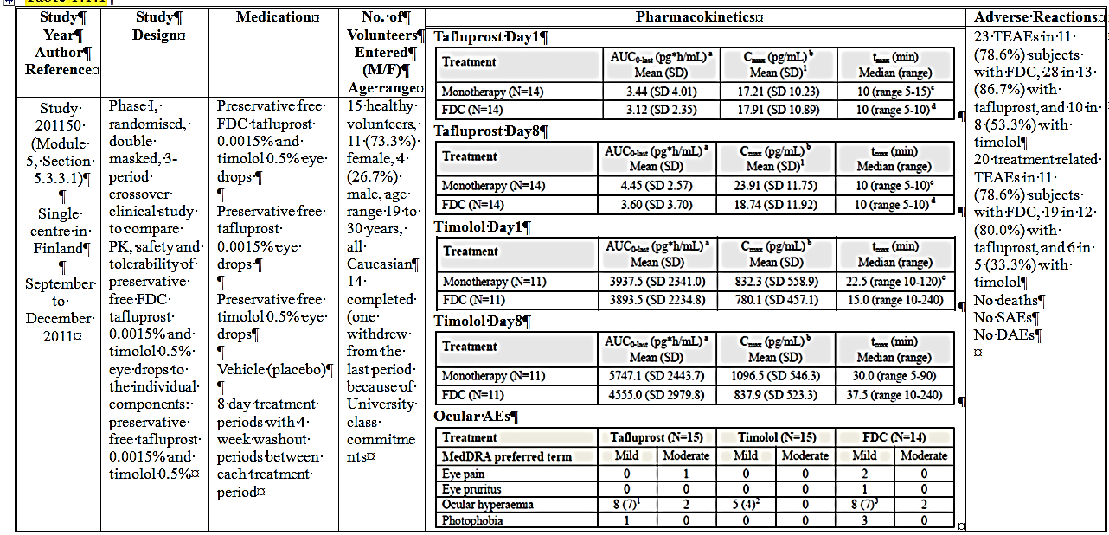

Table 3: Summary of study 01111002
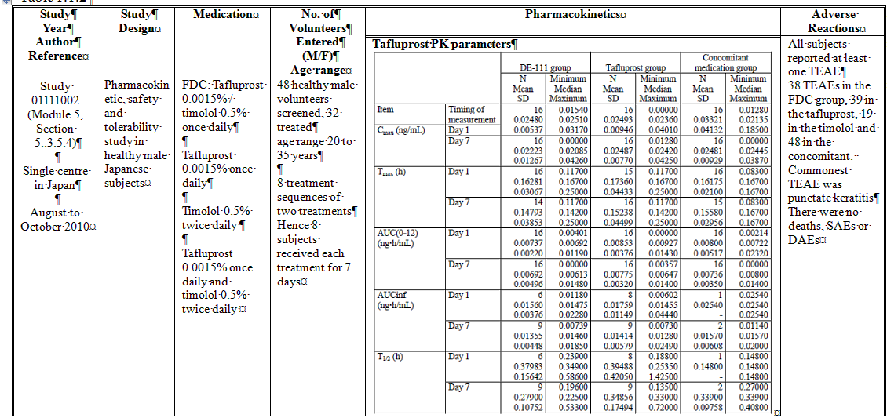

Bioavailability
The Sponsor provided the following justification for not providing bioavailability studies: ‘ As this product is simple solution for ophthalmic use and acts locally, no bioavailability studies are required as per Appendix 15 of the ARGPM (CPMP/EWP/QWP/1401/98 Rev. 1/ Corr).’

Distribution
No new data were submitted with regard distribution.

Metabolism
No new data were submitted with regard metabolism.

Excretion
No new data were submitted with regard excretion.

Pharmacokinetics in the target population
No new data were submitted with regard to PK in the target population.

Pharmacokinetics in other special populations
No new data were submitted with regard PK in special populations.

Pharmacokinetic interactions

Pharmacokinetic interactions demonstrated in human studies
The PK parameters of both tafluprost and timolol were similar for the FDC and the individual components administered separately (Table 2). Overall systemic exposure was low for both components. For tafluprost on Day 8, for the FDC mean AUC_{0-last} was 3.60 pg•hour/mL and C_{max} was 18.74 pg/ml; and for tafluprost alone mean AUC_{0-last} was 4.45 pg•hour/mL and C_{max} was 23.91 pg/ml. For timolol on Day 8, for the FDC mean AUC_{0-last} was 4555.0 pg•hour/mL and C_{max} was 837.9 pg/ml; and for timolol alone mean AUC_{0-last} was 5747.1 pg•hour/mL and C_{max} was 1096.5 pg/ml. These data were also supported by the results from Study 01111002 conducted in healthy male Japanese volunteers using a preservative containing formulation (Table 3 and Table 4).

Table 4: Plasma pharmacokinetic parameters of Timolol
The assay was performed using LC/MS/MS using liquid extraction (Study P09-25601). For tafluprost the assay was calibrated in the range 0.0100 to 10.0 ng/mL; the LLOQ was 0.0100 ng/mL and recovery was 87.3% to 94.3%. For timolol the assay was calibrated in the range 0.0100 to 10.0 ng/mL; the LLOQ was 0.0100 ng/mL and recovery was 84.8% to 87.9%.

Evaluator’s overall conclusions on pharmacokinetics
Both tafluprost and timolol have low systemic bioavailability when administered by the ocular route. Neither compound influenced the PK of the other.

Pharmacodynamics

Studies providing pharmacodynamic data
Table 5 shows the studies relating to each pharmacodynamic topic.

Table 5: Submitted pharmacodynamic studies.
PD Topic | Subtopic | Study ID
Primary Pharmacology | Effect on IOP | Study 201150
None of the pharmacodynamic studies had deficiencies that excluded their results from consideration.

Summary of pharmacodynamics
The information in the following summary is derived from conventional pharmacodynamic studies in humans unless otherwise stated.

Mechanism of action
No new data were submitted with regard mechanism of action.

Pharmacodynamic effects

Primary pharmacodynamic effects
In Study 201150, summarised in Table 2, here appeared to be greater reduction in IOP for the FDC than either individual component on Day 8 at pre-dose, 2 hours post-dose and 12 hours post-dose.
The difference between treatments was greatest at 2 hours post-dose: change from baseline -4.61 mmHg for FDC, -3.95 mmHg for tafluprost and -3.02 mmHg for timolol (Table 6). The greatest reduction in IOP was at 12 hours post-dose: change from baseline -5.25 mmHg for FDC, -5.22 mmHg for tafluprost and -4.37 mmHg for timolol (Table 6).

Table 6: Intraocular pressure on days 1 and 8 (mean over the eyes)

Secondary pharmacodynamic effects
No new data were submitted with regard secondary pharmacodynamic effects.

Time course of pharmacodynamic effects
No new data were submitted with regard time course of pharmacodynamic effects.

Relationship between drug concentration and pharmacodynamic effects
No new data were submitted with regard the relationship between drug concentration and pharmacodynamic effects.

Genetic-, gender- and age-related differences in pharmacodynamic response
No new data were submitted with regard genetic, gender and age related differences in pharmacodynamic effects.

Pharmacodynamic interactions
See Section Primary pharmacodynamic effects above.

Evaluator’s overall conclusions on pharmacodynamics
Tafluprost and timolol in combination have an additive pharmacodynamic effect.

Dosage selection for the pivotal studies
The doses used in the Pivotal studies were selected on the basis of the approved dosing for tafluprost and timolol as individual treatments.

Clinical efficacy

Reduction of IOP in OAG or OH

Pivotal efficacy studies

Study 201050

Study design, objectives, locations and dates
Study 201050 was a multicentre, randomised, double masked, 6 month, parallel group efficacy and safety trial of tafluprost/timolol FDC compared with tafluprost and timolol as individual monotherapies in subjects with OAG or OH. The study was conducted at 60 centres in ten countries from February 2011 to September 2012.

Inclusion and exclusion criteria
The inclusion criteria included
- Subject of any race and either sex aged ≥ 18 years
- Diagnosis of OH or OAG (either POAG, capsular glaucoma or pigmentary glaucoma) in one or both eyes, for which the patient had been regularly using prostaglandin (for example Xalatan, Lumigan, Travatan, Taflotan) or timolol 0.5% monotherapy for at least two weeks
- Clinical need for additional IOP lowering medication and had at the Screening visit evaluation in either treated eye:
- IOP measurement of ≥ 22 mmHg at any time of the day for prior timolol users (TM stratum), or
- IOP measurement of ≥ 20mmHg at any time of the day for prior prostaglandin users (PG stratum)
- Had at the End-of-run-in visit, after 2-week treatment with preservative-free timolol 0.5% (TM stratum) or preservative-free tafluprost 0.0015% (PG stratum), in either treated eye:
- IOP measurement of ≥ 22 mmHg at 8:00 for prior timolol users (TM stratum)
- IOP measurement of ≥ 20 mmHg at 8:00 for prior prostaglandin users (PG stratum)
- Had at the Baseline visit, after a washout period of at least 4 weeks, in either eye, an increase of at least 2 mmHg in the average diurnal IOP (measured at 8:00, 10:00, 16:00 and 20:00) as compared to the average diurnal IOP at the End-of- run-in visit
- Had a best corrected ETDRS visual acuity score of + 0.6 logMAR or better in both eyes (i.e. monocular patients were not eligible)
The exclusion criteria included:
- Pregnant, nursing or planning pregnancy, or was not using a reliable method of contraception
- Had anterior chamber angle of < 2 grades (according to Schaffer classification as measured by gonioscopy) in either eye to be treated
- Had any corneal abnormality or other condition preventing reliable applanation tonometry in the eyes to be treated, including prior refractive eye surgery
- Had IOP of > 35 mmHg at any time point in either eye at the Screening or End-of-run-in visit
- Had diagnosis of angle-closure glaucoma or secondary glaucoma other than capsular or pigmentary glaucoma in either eye
- Had suspected contraindication to tafluprost or timolol therapy:
- hypersensitivity to tafluprost/timolol or any of the excipients
- low heart rate of < 50 bpm at screening or clinically relevant low blood pressure for age, chronic obstructive pulmonary disease, bronchial asthma, strong tendency to bronchospasm, certain cardiac arrhythmias (the most common of which are second or third degree AV block and bradycardia) or uncontrolled congestive heart failure
- hypersensitivity to brinzolamide or any of the excipients, known hypersensitivity to sulphonamide, severe renal insufficiency or hyperchloraemic acidosis (concerning the washout medication Azopt, which was used only by the judgment of the investigator)
- Had undergone glaucoma filtration surgery or any other ocular surgery (including ocular laser procedures) within 6 months prior to Screening in eye(s) to be treated with study medication
- Had used contact lenses at Screening or during the study
- Had advanced visual field defect in either eye or anticipated progression during the study as judged by the investigator
- Had inability to safely discontinue the use of ocular hypotensive medications during the washout period
- Had any ocular (for example aphakia, pseudophakia with torn posterior lens capsule or anterior chamber lenses, known risk factors for cystoid macular oedema or iritis/uveitis) systemic or psychiatric (for example uncontrolled arterial hypertension, diabetes) disease/ condition that could have put the patient at a significant risk or confounded the study results or interfered significantly with the patient’s participation in the study as judged by the investigator
- Had changed existing chronic therapy (that could have substantially affected the IOP or the study outcomes) within the last 30 days prior to Screening, or such change was anticipated during the study
- Had current alcohol or drug abuse

Study treatments
There were two treatment strata, depending upon whether the subject had previously been treated with timolol (TM) or prostaglandin (PG) drops.
TM strata: during the run-in phase subjects were treated with preservative free timolol 0.5% eye drops at 08:00 and 20:00 for 2 weeks. Following a 4 week washout phase, subjects were randomised to:
- FDC tafluprost 0.0015% and timolol 0.5% preservative free eye drops at 08:00 and vehicle at 20:00
- Timolol 0.5% preservative free eye drops at 08:00 and 20:00
PG strata: during the run-in phase subjects were treated with preservative free tafluprost 0.0015% eye drops at 08:00 for 2 weeks. Following a 4 week washout phase, subjects were randomised to:-
- FDC tafluprost 0.0015% and timolol 0.5% preservative free eye drops at 08:00
- Tafluprost 0.0015% preservative free eye drops at 08:00

Efficacy variables and outcomes
The primary efficacy outcome measure was the change from baseline in average diurnal IOP at 3 months. The secondary efficacy outcome measures were:
- Proportion of responders at 3 months (for example change from baseline in IOP of 20% or more by steps of 5%)
- Change from baseline in the average diurnal IOP at 2 and 6 weeks and 6 months
- Change from baseline in the time-wise IOPs (at 8:00, 10:00, 16:00 and 20:00) at 2 and 6 weeks, and 3 and 6 months
The safety outcome measures were: ocular safety variables (best corrected visual acuity, central corneal thickness, biomicroscopy, conjunctival redness, ophthalmoscopy, visual field test), AEs, vital signs and drop discomfort.
Best corrected visual acuity was measured at each visit using an ETDRS chart. LogMAR scores were calculated using the following algorithm, where the Base LogMAR value was the logMAR value of the last line in which a letter was read correctly:
LogMAR score = Base LogMAR value + (0.02 x the total number of letters missed)
Deteriorations from baseline of at least 0.2 LogMAR scores (two lines of letters) were identified.

Randomisation and blinding methods
Randomisation was stratified by prior timolol or prostaglandin usage. Treatment allocation was by IWRS.

Analysis populations
The ITT population included all randomized subjects who received at least one dose of the masked study treatment and had at least one post-baseline efficacy measurement available. The safety population included all randomized subjects who received at least one dose of the masked study medication and had a subsequent safety measurement.

Sample size
The sample size calculation was performed for a test of superiority. For the timolol strata the calculation used a difference of 2 mmHg between treatments, a SD of 4.0 mmHg, a drop out rate of 20%, a power of 90% and a level of significance of 0.05. For the prostaglandin strata the calculation used a difference of 1.5 mmHg between treatments, a SD of 4.0 mmHg, a drop out rate of 20%, a power of 90% and a level of significance of 0.05. Hence the required sample size was 110 subjects per group in the timolol strata and 190 subjects per group in the prostaglandin strata: overall 600 subjects.

Statistical methods
Hypothesis tests were performed using 95% CIs constructed using a repeated measures covariance model (RM ANCOVA) to evaluate the time-wise changes from baseline in diurnal IOP at 3 months. Tests of the secondary outcome measures also used the Exact Cochran-Mantel-Haenszel (CMH) test stratified by center.

Participant flow
In the timolol strata there were 223 subjects screened, and 189 randomised to treatment: 95 to FDC and 94 to TM. There were 48 subjects with OH and 141 with OAG. Overall 172 (91.0%) subjects completed. Five subjects in the FDC group and one in the TM discontinued due to AEs.
In the PG strata there were 488 subjects screened, and 375 randomised to treatment: 188 to FDC and 187 to tafluprost (Figure 2). There were 78 subjects with OH and 297 with OAG. Overall 348 (92.8%) subjects completed. Six subjects in the FDC group and two in the tafluprost discontinued due to AEs.
Figure 2: Disposition of patients – PG stratum

Major protocol violations/deviations
In the TM strata there were major protocol violations for 19 subjects in the in the FDC group and 17 in the TM. In the PG strata there were major protocol violations for 17 subjects in the in the FDC group and 16 in the tafluprost. The most common major protocol violation was misuse of study medication.

Baseline data
For the TM strata, there were 109 (57.7%) females, 80 (42.3%) males and the age range was 23 to 87 years. In the FDC group were 51 (53.7%) females, 44 (46.3%) males and the age range was 23 to 84 years. In the TM group were 58 (61.7%) females, 36 (38.3%) males and the age range was 40 to 87 years. All subjects were Caucasian. Ocular diagnosis was similar for the treatment groups (Table 7). Gonioscopic evaluation was similar for the two treatment groups (Table 8). Medical history was similar for the two treatment groups. Four subjects in the FDC group and none in the TM group used concomitant ophthalmologic medications. One subject in the FDC group and two in the TM group used concomitant systemic corticosteroids.

Table 7: Ocular diagnosis – TM stratum

Table 8: Gonioscopic evaluation –TM stratum
For the PG strata, there were 244 (65.1%) females, 131 (34.9%) males and the age range was 25 to 87 years. In the FDC group were 118 (62.8%) females, 70 (37.2%) males and the age range was 27 to 85 years. In the tafluprost group were 126 (67.4%) females, 61 (32.6%) males and the age range was 25 to 87 years. All subjects were Caucasian. Ocular diagnosis was similar for the treatment groups (Table 9). Gonioscopic evaluation was similar for the two treatment groups (Table 10). Medical history was similar for the two treatment groups. Eight subjects in the FDC group and seven in the tafluprost group used concomitant ophthalmologic medications. Two subjects in the TM group used prohibited medications: one used an anti-glaucoma preparation (dorzolamide and timolol) and one used concomitant systemic corticosteroids.

Table 9: Ocular diagnosis – PG stratum

Table 10: Gonioscopic evaluation – PG stratum

Results for the primary efficacy outcome
For the TM strata, the mean difference (95% CI), FDC - TM, in change from baseline in average diurnal IOP at 3 months was -0.885 (-1.745 to -0.044), p = 0.044.
For the PG strata, the mean difference (95% CI), FDC - TM, in change from baseline in average diurnal IOP at 3 months was -1.516 (-2.044 to -0.988), p < 0.001.

Results for other efficacy outcomes
For the TM strata:
- There was no significant difference in response rates at 3 months (Table 11).
- There was no significant difference between treatments in average diurnal IOP at Week 2, but there was a significant improvement in the FDC group relative to TM at Week 6 and Month 6 (Table 12). At Week 2 the mean difference (95% CI), FDC - TM, in change from baseline in average diurnal IOP was -0.457 (-1.120 to 0.206), p = 0.064. At Week 6 the mean difference (95% CI), FDC - TM, in change from baseline in average diurnal IOP was -0.892 (-1.527 to -0.257), p = 0.001. At Month 6 the mean difference (95% CI), FDC - TM, in change from baseline in average diurnal IOP was -0.838 (-1.522 to -0.154), p = 0.017.

Table 11: Proportion of responders at 3 months – TM stratum

Table 12: Overall treatment differences at 2 and 6 weeks, and 6 months – TM stratum
- At Week 6, there was a significantly greater reduction in IOP at all-time points with FDC, but at Month 3 and Month 6 there was significantly greater reduction at 1600 and 2000 but not at 0800 or 1200 (Table 13 and Figure 3). At Week 2 there was no significant difference between the treatments at any time point.

Table 13: Time-wise treatment differences at all visits – TM stratum
Figure 3: Mean (SD) IOPs in the worse eye for the ITT dataset – TM stratum
For the PG strata:
- At 3 months response rates in the FDC group were greater than in the tafluprost for ≥ 20% response, ≥ 25% response, ≥ 30% response, and ≥ 35% response but not for ≥ 15% response (Table 14). For ≥ 20% response there were 166 (89.2%) subjects in the FDC group and 142 (78.0%) in the tafluprost, p = 0.002.
- There was a significant improvement in the FDC group relative to TM at Week 2, Week 6 and Month 6 (Table 15). At Week 2 the mean difference (95% CI), FDC - tafluprost, in change from baseline in average diurnal IOP was -1.417 (-1.929 to -0.904), p < 0.001; at Week 6 -1.465 (-1.957 to -0.974), p < 0.001; and at Month 6 -1.118 (-1.626 to -0.610), p < 0.001.
- At all-time points for Week 2, Week 6, Month 3 and Month 6 there was a significantly greater reduction in IOP with FDC (Table 16 and Figure 4). The greatest relative reduction in IOP was at 0800 at Month 6: mean difference (95% CI) FDC-tafluprost -1.884 (-2.500 to -1.267) p < 0.001.

Table 14: Proportion of responders at 3 months – PG stratum

Table 15: Overall treatment differences at 2 and 6 weeks, and 6 months – PG stratum

Table 16:Time-wise treatment differences – PG stratum
Figure 4: Mean (SD) IOPs in the worse eye for the ITT dataset – PG stratum
There were no subgroup effects for either strata for age, gender, ocular diagnosis, corneal thickness or prior medication.

Study 201051

Study design, objectives, locations and dates
Study 201051 was a randomised, double blind, 6 month, parallel group non-inferiority study to compare the efficacy and safety of preservative free FDC tafluprost 0.0015% and timolol 0.5% eye drops with tafluprost 0.0015% and timolol 0.5% eye drops administered concomitantly in subjects with OAG or OH. The study was conducted at 35 centres in seven countries from March 2011 to May 2012.

Inclusion and exclusion criteria
The inclusion criteria included:
- Subjects aged ≥ 18 years with a diagnosis of OH or OAG (either POAG, capsular glaucoma or pigmentary glaucoma) in one or both eyes
- A clinical need for additional IOP lowering medication as judged by the investigator and an untreated (after washout if applicable) IOP of ≥ 23 mmHg at the 8:00 measurement of baseline visit in one or both eyes
- Had at least the following washout if on prior glaucoma medication:
- ≥ 4 weeks for beta-adrenergic antagonists (beta-blockers)
- ≥ 4 weeks for prostamides or prostaglandin analogues
- ≥ 3 weeks for alpha-adrenergic agonists (alpha-agonists)
- ≥ 7 days for carbonic anhydrase inhibitors (CAIs)
- ≥ 5 days for miotics
- A best corrected ETDRS visual acuity score of +0.6 logMAR or better in both eyes (i.e. monocular patients were not eligible)
The exclusion criteria were the same as for Study 201050 except for:
- Had IOP of > 36 mmHg at any time point in either eye at screening or baseline

Study treatments
The study treatments were:
- Preservative free FDC tafluprost 0.0015% and timolol 0.5% eye drops at 8:10 and vehicle for timolol eye drops at 08:00 and 20:00 (FDC)
- Preservative free tafluprost 0.0015% eye drops at 08:10, and preservative free timolol 0.5% eye drops at 08:00 and 20:00 (concomitant)
The study treatments were administered in the affected eye(s). The use of all ocular medication that had an effect on IOP (other than the masked study medication) was prohibited. Treatment duration was for 6 months.

Efficacy variables and outcomes
The primary efficacy outcome measure was the change from baseline in the average diurnal IOP in the worse eye at 6 months. The secondary efficacy outcome measures were based on the mean value for both eyes if both were treated, and on the values for one eye if only one were treated. The secondary efficacy outcome measures were:
- Proportion of responders at 6 months (for example change from baseline in IOP of 20% or more by steps of 5%)
- Change from baseline in the average diurnal IOP at 2 and 6 weeks and 3 months
- Change from baseline in the time-wise IOPs (at 8:00, 10:00, 16:00) at 2 and 6 weeks, and 3 and 6 months
The safety variables included AEs, ocular AEs (for treated eyes only), ocular safety variables (Best corrected visual acuity, central corneal thickness, biomicroscopy, conjunctival redness, ophthalmoscopy and visual field test).

Randomisation and blinding methods
Randomisation was by IWRS with stratification by ocular diagnosis (OH or OAG) and average diurnal baseline IOP in the worse eye. Masking was performed using vehicle to substitute for the timolol dosing in the FDC group.

Analysis populations
The primary efficacy analysis was for non-inferiority and was performed on the PP population. The PP dataset was a subset of the ITT dataset excluding patients or measurements for a given patient with major protocol violation(s) expected to alter the treatment outcome. The ITT dataset included all randomized patients who received at least one dose of the masked study treatment and had at least one post-baseline efficacy measurement available. The safety dataset included all randomized patients who received at least one dose of the masked study medication and has a subsequent safety measurement.

Sample size
The pre-specified margin for non-inferiority was 1.5 mmHg. The margin was chosen for the reasons that IOP can only be measured to a precision of 1 mmHg, and a difference of 2 mmHg was considered to be clinically significant. The calculation for sample size also used a SD of 4 mmHg, a power of 90%, a level of significance of 0.05 and a drop-out rate of 20%. This resulted in 190 subjects per treatment group

Statistical methods
The hypothesis test for non-inferiority was based on the 95% CI for the difference in the change in IOP from baseline between treatments not including 1.5 mmHg. The 95% CIs were calculated using a repeated measures ANCOVA model. Differences in proportions were tested using a Cochran-Mantel-Haenszel test stratified by center.

Participant flow
There were 454 subjects screened of whom 400 were randomised to treatment: 201 to FDC and 199 to concomitant (Figure 5). There were 183 (91%) subjects in the FDC group that completed compared to 190 (95.5%) in the concomitant group.
Figure 5: Disposition of patients

Major protocol violations/deviations
There were 28 (13.9%) subjects with major protocol violations in the FDC group and 24 (12.1%) in the concomitant group. The most common major protocol violation was non-compliance: 15 (7.5%) subjects in the FDC group and 13 (6.5%) in the concomitant group. At Month 6 the PP population included 175 (87.1%) subjects in the FDC group and 181 (91.0%) in the concomitant.

Baseline data
There were 248 (62.0%) females, 152 (38.0%) males and the age range was 19 to 85 years. In the FDC group were 126 (62.7%) females, 75 (37.3%) males and the age range was 19 to 84 years. In the concomitant group were 122 (61.3%) females, 77 (38.7%) males and the age range was 29 to 85 years. Ethnicity in 398 (99.5%) subjects was Caucasian. Ocular diagnosis was similar for the treatment groups (Table 17). Gonioscopic evaluation was similar for the two treatment groups (Table 18). Medical history was similar for the two treatment groups. Eight (4.0%) subjects in the FDC group and nine (4.5%) in the concomitant group used concomitant ophthalmologic medications. Four subjects in the FDC group and three in the concomitant group used concomitant systemic corticosteroids.

Table 17: Ocular diagnosis

Table 18: Gonioscopic evaluation

Results for the primary efficacy outcome
Non-inferiority was demonstrated by the pre-defined criteria. For the PP dataset the between treatment difference in IOP at Month 6 was 0.308 (-0.194 to 0.810) mmHg. For the ITT population the between treatment difference was 0.315 (-0.187 to 0.817). The treatment difference was not clinically significant.

Results for other efficacy outcomes
- In the ITT population, at Month 6, there were a greater proportion of subjects with ≥ 30% response in the concomitant group: 109 (55.9%) subjects in the FDC group and 131 (67.2%) in the concomitant, p = 0.028. There were no other significant differences between the treatment groups in responder categories (Table 19).

Table 19: Proportion of responders at 6 months
- There were no significant differences in IOP at Week 2, Week 6 or Month 3. For the ITT population the mean (95% CI) treatment difference was 0.551 (0.059 to 1.042) mmHg at Week 2, 0.344 (-0.113 to 0.801) mmHg at Week 6 and 0.356 (-0.124 to 0.836) mmHg at Month 3 (Table 20).

Table 20: Overall treatment difference at 2 and 6 weeks, and 3 months
- At Week 2, at the 08:00 time point, the mean IOP was significantly lower in the concomitant group: treatment difference 0.657 (0.088 to 1.225) mmHg. There were no significant differences in IOP at other time points (Table 21).

Table 21: Time-wise treatment differences at 2 and 6 weeks, and 3 and 6 months
- There were no subgroup effects for age, gender, ocular diagnosis, corneal thickness or prior medication.

Other efficacy studies

Study 01111004
Study 01111004 was a double masked, parallel group, efficacy and safety study comparing DE-111 (a preservative containing formulation of tafluprost 0.0015% and timolol 0.5%) with tafluprost (superiority) and concomitant tafluprost and timolol (non-inferiority). The study was conducted at 59 study sites in Japan from May 2011 to March 2012. The study included Japanese subjects with POAG or OH who at the end of run-in period, had IOP for either eye of ≥ 18mmHg, and ≤ 34mmHg in both eyes. The study treatments were:
- DE-111, once daily
- Tafluprost 0.0015% solution once daily
- Tafluprost 0.0015% solution once daily and timolol 0.5% solution twice daily
Treatment duration was for 4 weeks. The efficacy outcome measures were: change in mean diurnal IOP at EOT; change in IOP at Week 4; IOP at each time point; and rate of change in IOP. The study used the same criterion for non-inferiority as for Study 201051. A total of 558 subjects entered the run-in, 489 were randomised and 484 completed the study. There were 252 (51.7%) females, 235 (48.3%) males, the age range was 23 to 85 years and the treatment groups were similar in demographic characteristics (Table 22). DE-111 was superior to tafluprost: mean (SE) difference in change in IOP at Week 4 -1.5 (0.2) mmHg p < 0.000 (Table 23) and non-inferior to concomitant: -0.3 (-0.7 to 0.1) mmHg (Table 24). At the other time points DE-111 was also superior to tafluprost alone, and there was no significant difference compared to concomitant (Table 25). The mean rate of change in IOP was greater for DE-111 compared to taflupost alone but there was no significant difference compared to concomitant (Table 26 and Table 27).

Table 22: Demographics and other baseline characteristics (Population: FAS)

Table 23: Changes in mean diurnal IOP (Population: FAS)

Table 24: Changes in mean diurnal IOP (Population: PPS)

Table 25: Changes in IOP (Population: FAS)

Table 26: Mean rate of change in diurnal IOP (Population: FAS)

Table 27: Change rate in IOP (Population: FAS)

Study 01111005
Study 01111005 was a double masked, parallel group, superiority study comparing the efficacy and safety of DE-111 (a preservative containing formulation of tafluprost 0.0015% and timolol 0.5%) with timolol. The study was conducted at 16 study sites in Japan from May 2011 to February 2012. The study included Japanese subjects aged ≥ 20 years with POAG or OH who, at the end of the run-in period, had IOP for either eye of ≥ 18mmHg, and ≤ 34mmHg in both eyes. The study treatments were:
- DE-111, once daily
- Timolol 0.5% solution twice daily
Treatment duration was for 4 weeks. The efficacy outcome measures were: change in mean diurnal IOP at EOT; change in IOP at Week 4; IOP at each time point; and rate of change in IOP. The study included 166 subjects: 82 treated with DE-111 and 84 with timolol. There were 90 (54.2%) females, 76 (45.8%) males, the age range was 24 to 81 years and the treatment groups were similar in demographic characteristics (Table 28). DE-111 was superior to timolol: mean difference (95% CI) in change in IOP at Week 4 -1.6 (-2.2 to -0.9) mmHg, p < 0.001 (Table 29). At the other time points DE-111 was also superior to timolol (Table 30). The mean rate of change in IOP was greater for DE-111 compared to timolol (Tables 31-32).

Table 28: Demographics and other baseline characteristics (Population: FAS)

Table 29: Changes in mean diurnal IOP (Population: FAS)

Table 30: Changes in IOP (Population: FAS)
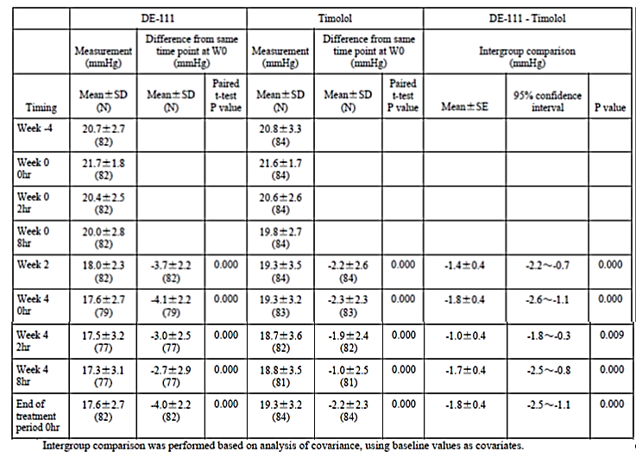

Table 31: Mean rate of change in diurnal IOP (Population: FAS)

Table 32: Rate of change in IOP (Population: FAS)

Study 01111006
Study 01111006 was an open label, long term safety study in subjects with OAG or OH. The study was conducted at 11 study sites in Japan from May 2011 to May 2012. The study enrolled Japanese subjects with POAG, exfoliation glaucoma, pigmentary glaucoma or OH in both eyes; requiring administration of drugs in both eyes, IOP in both eyes ≥ 13 mmHg and ≤ 34 mmHg under treatment with two or fewer drugs or without treatment. The study treatment was DE-111 in both eyes once daily for 52 weeks. There were 162 subjects enrolled, and 136 analysed for efficacy and safety. There were 81 (59.6%) females, 55 (40.4%) males, and the age range was 25 to 85 years. To the end of Week 28, the mean (SD) change from baseline in IOP was -1.5 (2.2), p < 0.001, and mean (SD) IOP change rate was -8.8 (12.3) %, p < 0.001.

Analyses performed across trials (pooled analyses and meta-analyses)
There were no pooled analyses or meta-analyses.

Evaluator’s conclusions on clinical efficacy for reduction of IOP
Taptiqom (tafluprost 15 micrograms/mL and timolol [as maleate] 5 mg/mL) was superior to either active component administered as monotherapy, and non-inferior to both active components administered concomitantly. In comparison with timolol as monotherapy the mean difference (95% CI), FDC - TM, in change from baseline in average diurnal IOP at 3 months was -0.885 (-1.745 to -0.044), p = 0.044. In comparison with tafluprost as monotherapy the mean difference (95% CI), FDC - TM, in change from baseline in average diurnal IOP at 3 months was -1.516 (-2.044 to -0.988), p < 0.001. In comparison with timolol and tafluprost administered concomitantly the treatment difference in IOP at Month 6 was 0.308 (-0.194 to 0.810) mmHg.
The secondary efficacy outcome measures supported the primary efficacy outcome measures. The data from a similar product (preservative containing FDC tafluprost 0.0015% and timolol 0.5%) were also supportive of the pivotal studies.
The criterion for non-inferiority was clinically significant and the statistical analysis was appropriate. The population included in the pivotal studies was similar to the patient population intended for marketing in Australia.

Clinical safety

Studies providing evaluable safety data
The following studies provided evaluable safety data: two pivotal studies, one PK study and four supportive studies.

Pivotal efficacy studies
In the pivotal efficacy studies, the following safety data were collected:
- AEs
- Ocular safety measures and local tolerability
- Laboratory tests
- Vital signs

Pivotal studies that assessed safety as a primary outcome
There were no pivotal studies that assessed safety as a primary outcome.

Patient exposure
Study 201150, there were 14 healthy volunteers treated with FDC once daily for 8 days.
In Study 01111002, 16 healthy Japanese male volunteers were exposed to DE-111 for one week.
In Study 201050, there were 283 subjects treated for up to 6 months with FDC.
In Study 201051, there were 201 subjects exposed to FDC for up to 6 months. There were 198 subjects treated in the left eye and 192 in the right eye.
In Study 01111004, there were 161 subjects exposed to DE-111 for up to 4 weeks.
In Study 01111005, there were 82 subjects treated with DE-111 for up to 4 weeks.
In Study 01111006, there were 136 subjects exposed to DE-111 for up to 52 weeks, with 115 exposed for > 180 days.

Adverse events

All adverse events (irrespective of relationship to study treatment)

Pivotal studies
In Study 201050, in the TM strata, ocular TEAEs were reported in 23 (24.2%) subjects in the FDC group and ten (10.6%) in the TM. The most common ocular TEAE was hyperaemia, occurring in five subjects in the FDC group (Table 33). Non-ocular TEAEs were reported in 24 (25.3%) subjects in the FDC group and 31 (33.0%) in the TM group (Table 34).

Table 33: Ocular adverse events by preferred term, causality and severity¹ – TM stratum

Table 34:Non-ocular adverse events by preferred term, causality and severity¹ – TM stratum
In the PG strata, ocular TEAEs were reported in 49 (26.1%) subjects in the FDC group and 41 (21.9%) in the tafluprost. The pattern of TEAEs was similar for the two treatment groups (Table 35). Non-ocular TEAEs were reported in 54 (28.7%) subjects in the FDC group and 44 (23.5%) in the tafluprost group (Table 36). Headache was reported in seven (3.7%) subjects in the FDC group and three (1.6%) in the tafluprost.

Table 35: Ocular adverse events by preferred term, causality and severity¹ – PG stratum

Table 36: Non-ocular AEs by preferred term, causality and severity¹. PG stratum
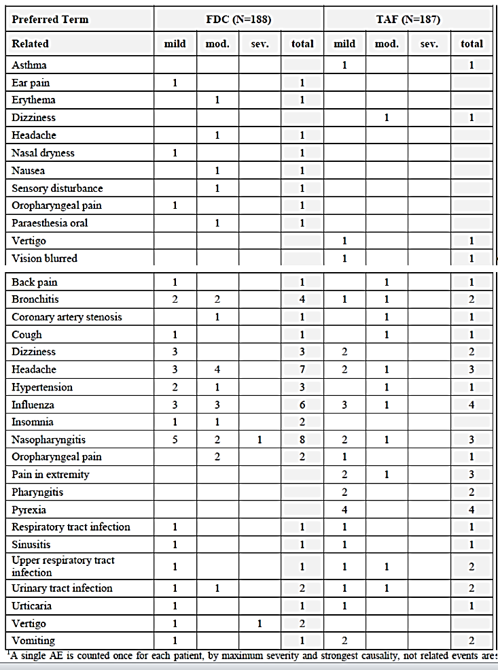
In Study 201051 there were 169 TEAEs reported in 84 (41.8%) subjects in the FDC group and 175 reported in 88 (44%) in the concomitant. There were 89 ocular TEAEs reported in 51 (25.4%) subjects in the FDC group and 98 reported in 55 (27.6%) in the concomitant. The commonest ocular TEAE was ocular hyperaemia, occurring in 13 subjects in the FDC group and 10 in the concomitant (Table 37). There were 80 non-ocular TEAEs reported in 49 (24.4%) subjects in the FDC group and 77 reported in 51 (25.6%) in the concomitant. The commonest non-ocular TEAEs were hypertension, occurring in four subjects in the FDC group and three in the concomitant, and rhinitis, occurring in three subjects in the FDC group and four in the concomitant (Table 38).

Table 37: Ocular adverse events by preferred term, causality and severity (patient count; reported for 2 or more patients per term)

Table 38: Non-ocular adverse events by preferred term, severity and causality (patient count; not related events are reported for 2 or more patients per term)

Other studies
In Study 201150 there were 23 TEAEs in eleven (78.6%) subjects with FDC, 28 in 13 (86.7%) with tafluprost, and 10 in eight (53.3%) with timolol. The commonest TEAE was ocular hyperaemia, reported in nine (64.3%) subjects with the FDC, nine (60.0%) with tafluprost alone and four (26.7%) with timolol alone. The most common non-ocular TEAE was headache, reported in three (21.4%) subjects with the FDC, two (13.3%) with tafluprost alone, and one (6.7%) with timolol alone.
In Study 01111002 all subjects reported at least one TEAE. There were 38 TEAEs in the FDC group, 39 in the tafluprost, 19 in the timolol and 48 in the concomitant. The commonest TEAE was punctate keratitis (Table 39).

Table 39: Adverse events by causal relationship (safety analysis set)
In Study 01111004 TEAEs were reported in 37 (23.0%) subjects in the DE-111 group, 32 (19.5%) in the tafluprost and 20 (12.3%) in the concomitant (Table 40). Ophthalmic TEAEs were reported in 21 (13.0%) subjects in the DE-111 group, 20 (12.2%) in the tafluprost and 18 (11.0%) in the concomitant. The commonest TEAE was punctuate keratitis: seven (4.3%) subjects in the DE-111 group, five (3.0%) in the tafluprost and seven (4.3%) in the concomitant.

Table 40: AE incidence rates by causality (Population: Safety analysis set)

Table 40 continued: AE incidence rates by causality (Population: Safety analysis set)
In Study 01111005 TEAEs were reported in 21 (25.6%) subjects in the DE-111 group and 12 (14.3%) in the timolol. The commonest TEAEs were: ocular hyperaemia, occurring in six (7.3%) subjects in the DE-111 group and one (1.2%) in the timolol; and conjunctival hyperaemia, occurring in five (6.1%) subjects in the DE-111 group and one (1.2%) in the timolol (Table 41).

Table 41: AE incidence rates by causality (Population: Safety analysis set)
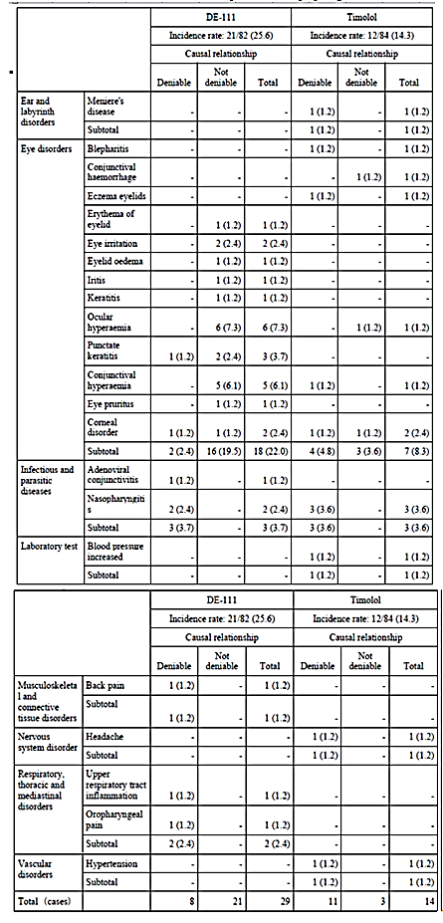
In Study 01111006 TEAEs were reported in 81 (69.6%) subjects. Growth of eyelashes was reported in 29 (21.3%) subjects (Table 42).

Table 42: ADR Incidence rates by severity (Population: Safety analysis set)
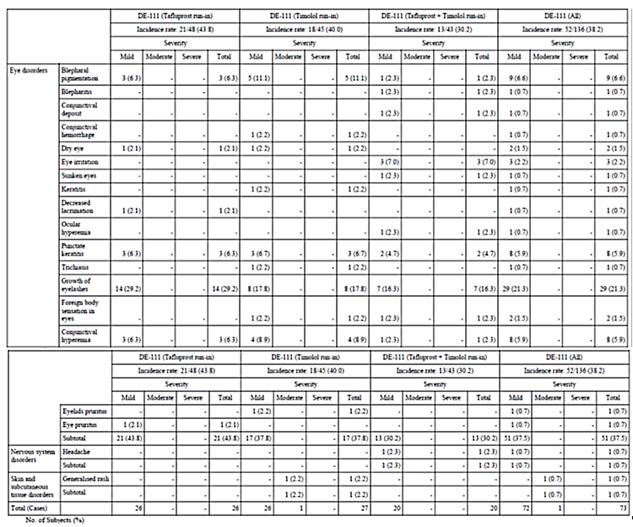

Treatment-related adverse events (adverse drug reactions)

Pivotal studies
In Study 201051 the commonest ocular TEAE attributed to treatment was ocular hyperaemia, occurring in 13 subjects in the FDC group and 7 in the concomitant (Table 43).

Table 43: Non-ocular adverse events by preferred term, severity and causality (patient count; not related events are reported for 2 or more patients per term

Other studies
In Study 201150 there were 20 treatment related TEAEs in 11 (78.6%) subjects with FDC, 19 in 12 (80.0%) with tafluprost, and 6 in 5 (33.3%) with timolol.

Deaths and other serious adverse events

Pivotal studies
In Study 201050 there were no deaths. In the TM strata, there were two subjects in the FDC group with SAEs (ischaemic stroke, wrist fracture) and four in the TM (retinal vein occlusion, lung squamous cell carcinoma, acute myocardial infarction, vertigo). In the PG strata, there were five subjects in the FDC group with SAEs (hepatic cirrhosis / anaemia / toxic encephalopathy, coronary artery stenosis, adenolymphoma, vertigo, transient ischaemic attack) and four in the tafluprost (coronary artery stenosis, arthralgia, endometrial cancer, benign soft tissue neoplasm).
In Study 201051 there were no deaths. SAEs were reported in six (3.0%) subjects in the FDC group and six (3.0%) in the concomitant (Table 44). None of the SAEs were ocular. One SAE was attributed to treatment: asthma in a subject in the concomitant group.

Table 44: Summary of Serious adverse events

Other studies
In Study 201150, Study 01111002 and Study 01111004 there were no deaths and no SAEs.
In Study 01111005 there were no deaths. There was one SAE during the run-in period: intestinal carcinoma, considered to be unrelated to study treatment.
In Study 01111006 there were no deaths. SAEs were reported in six (4.4%) subjects: bile duct cancer, corpus uteri cancer, small cell lung cancer, acute myocardial infarction, and femur fracture.

Discontinuation due to adverse events

Pivotal studies
In Study 201050, in the TM strata, DAE occurred for five subjects in the FDC group and two in the TM. Four of the DAEs in the FDC group were due to ocular TEAEs. In the PG strata, DAE occurred for eight subjects in the FDC group and four in the tafluprost. The AEs leading to discontinuation were predominantly ocular.
In Study 201051 there were seven (3.5%) subjects in the FDC group and four (2.0%) in the concomitant that discontinued because of AEs. The DAEs were predominantly ocular.

Other studies
In Study 201150 and Study 01111002 there were no DAEs.
In Study 01111004 there was one DAE in the DE-111 group: punctuate keratopathy.
In Study 01111005 there were five (6.1%) subjects in the DE-111 group that discontinued due to AE: iritis, conjunctival hyperaemia, ocular hyperaemia / eye irritation / blepharal oedema, erythema of the eyelid and adenoviral conjunctivitis.
In Study 01111006 DAE was reported for two (1.5%) subjects: generalized rash and headache.

Laboratory tests

Liver function

Pivotal studies
There were no clinically significant abnormalities in liver function in the pivotal studies.

Other studies
In Study 01111002 one subject had elevated ALT.
In Study 01111005, ALT, AST and GGT were each increased in one (1.2%) subject in the DE-111 group.

Kidney function
There were no clinically significant abnormalities in renal function.

Other clinical chemistry

Pivotal studies
There were no clinically significant abnormalities in other clinical chemistry in the pivotal studies.

Other studies
In Study 01111002 one subject had proteinuria.

Haematology

Pivotal studies
There were no clinically significant abnormalities in haematology in the pivotal studies.

Other studies
In Study 201150 six subjects had low haemoglobin post-study.
In Study 01111002 one subject had elevated monocytes.

Vital signs

Pivotal studies
In Study 201050, in both strata, there were no significant changes in vital signs. There were no apparent differences between the treatment groups.
In Study 201051 there were no apparent differences between the treatment groups in SBP, DBP or pulse rate.

Ocular examinations

Pivotal studies
In Study 201050, in the TM strata, at the end of the treatment period (Month 6), one (1.1%) subject in the FDC group and two (2.3%) in the TM group had a worsening of at least > 0.2 LogMAR units in best-corrected visual acuity. There was a slight decrease in corneal thickness of approximately 2 μm in the FDC group (Table 45). Biomicroscopy findings were similar for the two treatment groups (Table 46). There were no clinically significant changes in opthalmoscopy.

Table 45: Central corneal thickness in treated eyes – TM

Table 46: Biomicroscopy: Overview of new findings and increases in severity¹. TM stratum
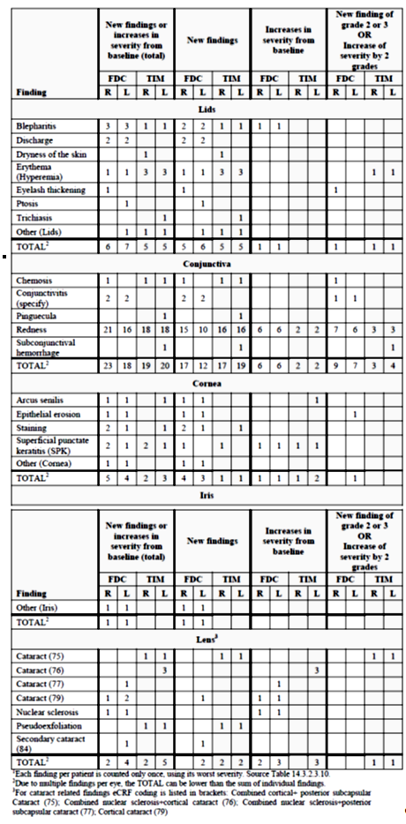
In the PG strata, there were 8 subjects in each treatment group with a worsening of at least > 0.2 LogMAR units in best-corrected visual acuity at the Month 6 visit. There was also a slight decrease of approximately 2 μm in corneal thickness in both treatment groups (Table 47). The only biomicroscopy finding of possible significance was an increase in iris pigmentation in three subjects in the FDC group (Table 48). There were few new opthalmoscopic findings, with similar numbers in each group (Table 49).

Table 47: Central corneal thickness in treated eyes – PG stratum

Table 48: Biomicroscopy: Overview of new findings and increases in severity¹.PG stratum

Table 48 continued: Biomicroscopy: Overview of new findings and increases in severity¹.PG stratum

Table 49: Ophthalmoscopy: New findings and increases in severity (patient count)¹. PG stratum
In Study 201051 the changes in visual acuity were similar for the two treatment groups. At Month 6 four (2.0%) subjects in the FDC group and seven (3.6%) in the concomitant showed a worsening of at least > 0.2 LogMAR units. Nine (4.6%) subjects in the FDC group and 15 (7.7%) in the concomitant had an improvement of at least > 0.2 LogMAR. The change in corneal thickness over 6 months was approximately 5 μm for both treatment groups (Table 50). On biomicroscopy, there were more changes in eyelash growth in the concomitant group (Table 51). There was one new cataract finding in the FDC group. The frequency of new ophthalmoscopic findings was similar for the two treatment groups (Table 52). Visual field testing was similar for the two groups (Table 53).

Table 50: Central corneal thickness in treated eyes

Table 51: Biomicroscopy: Overview of new findings and increases in severity

Table 51 continued: Biomicroscopy: Overview of new findings and increases in severity

Table 52: Opthalmoscopy: Overview of new findings and increases in severity (patient count)

Table 53: Results of visual field tests

Other studies
In Study 201150 biomicroscopy revealed there were no changes in the lids, cornea, anterior chamber and iris. Conjunctival redness was observed on Day 1 in one subject with FDC and one with timolol. On Day 8 pre-dose, four subjects had conjunctival redness with tafluprost.; and post-dose conjunctival redness was recorded for two subjects with the FDC, five with tafluprost and three with timolol. There were no ophthalmoscopic changes.

Local tolerability

Pivotal studies
In Study 201050 in the TM strata, measures of drop discomfort were similar in the two treatment groups (Figure 6). Also in the PG strata, measures of drop discomfort were similar in the two treatment groups (Figure 7).
Figure 6: Proportion of patients by severity of drop discomfort – TM stratum (the number of patients is shown on top of the bars)
Figure 7: Proportion of patients by severity of drop discomfort – PG stratum (the number of patients is shown on top of the bars)
In Study 201051 at least 75% of subjects experienced drop discomfort, and the measures of drop discomfort were similar for the two treatment groups (Figure 8).
Figure 8: Proportion of patients by severity of drop discomfort (the number of patients is shown on top of the bars)

Other studies
In Study 201150, there was no drop discomfort reported for seven (50%) subjects with the FDC, eleven (73.3%) with tafluprost and nine (60.0%) with timolol (Table 54).

Table 54: Drop discomfort on Day 8

Post-marketing experience

Post-marketing data
No post-marketing data were included in the submission.

Risk Management Plan (RMP)
Important Identified Risks:
- Hyperpigmentation
- Reactive airway disease including bronchial asthma / a history of bronchial asthma
- Severe chronic obstructive pulmonary disease
- Sinus bradycardia
- Sick sinus syndrome (including sino-atrial block)
- Second or third degree atrioventricular block not controlled with pace-maker
- Overt cardiac failure
- Cardiogenic shock
Important Potential Risks:
- Vascular disorders
- Masking of hypoglycemic symptoms in patients with diabetes mellitus
- Masking of thyrotoxicosis
- Surgical anesthesia
- Choroidal detachment
- Anaphylaxis
Important Missing Information:
- Children and adolescents have not been studied in clinical trials. Therefore, TT-FDC is not recommended for use in children or adolescents below age 18
- Use in renal impairment
- Use in hepatic impairment
- Use in pregnancy and in breast-feeding women
The Sponsor intends to address these safety issues with routine pharmacovigilance.

Safety issues with the potential for major regulatory impact
There were no safety issues with the potential for major regulatory impact.

Other safety issues

Safety in special populations
There were no safety issues in special populations.

Safety related to drug-drug interactions and other interactions
There were no safety issues related to drug-drug interactions or other interactions.

Evaluator’s overall conclusions on clinical safety
The safety profile of the FDC combination product is similar to that for the individual products administered concomitantly. The adverse event profile for the FDC reflects that of the individual components. The safety data did not identify any new safety issue as a result of concomitant administration.
The majority of AEs were ophthalmic (ocular hyperaemia, eyelash lengthening, eyelid discolouration). There were few SAEs and no deaths during the development program.

First round benefit-risk assessment

First round assessment of benefits
Taptiqom (tafluprost 15 micrograms/mL and timolol [as maleate] 5 mg/mL) was superior to either active component administered as monotherapy, and non-inferior to both active components administered concomitantly. In comparison with timolol as monotherapy the mean difference (95% CI), FDC - TM, in change from baseline in average diurnal IOP at 3 months was -0.885 (-1.745 to -0.044), p = 0.044. In comparison with tafluprost as monotherapy the mean difference (95% CI), FDC - TM, in change from baseline in average diurnal IOP at 3 months was -1.516 (-2.044 to -0.988), p < 0.001. In comparison with timolol and tafluprost administered concomitantly the treatment difference in IOP at Month 6 was 0.308 (-0.194 to 0.810) mmHg.
The secondary efficacy outcome measures supported the primary efficacy outcome measures. The data from a similar product, preservative containing FDC tafluprost 0.0015% and timolol 0.5%, were also supportive of the pivotal studies.
The criterion for non-inferiority was clinically significant and the statistical analysis was appropriate. The population included in the pivotal studies was similar to the patient population intended for marketing in Australia.

First round assessment of risks
The safety profile of the FDC combination product is similar to that for the individual products administered concomitantly. The adverse event profile for the FDC reflects that of the individual components. The safety data did not identify any new safety issue as a result of concomitant administration.
The majority of AEs were ophthalmic (ocular hyperaemia, eyelash lengthening, eyelid discolouration). There were few SAEs and no deaths during the development program.

First round assessment of benefit-risk balance
The benefit-risk balance of Taptiqom (tafluprost 15 micrograms/mL and timolol [as maleate] 5 mg/mL), given the proposed usage, is favourable.

First round recommendation regarding authorisation
The Evaluator would have no objection to the approval of Taptiqom (tafluprost 15 micrograms/mL and timolol [as maleate] 5 mg/mL) for the indication of:
Taptiqom is indicated for the reduction of intraocular pressure (IOP) in adult patients with open angle glaucoma or ocular hypertension when concomitant therapy is appropriate.

Clinical questions

Pharmacokinetics
The Evaluator does not have any questions relating to pharmacokinetics.

Pharmacodynamics
The Evaluator does not have any questions relating to pharmacodynamics.

Efficacy
The Evaluator does not have any questions relating to efficacy.

Safety
The Evaluator does not have any questions relating to safety.

Therapeutic Goods Administration
PO Box 100 Woden ACT 2606 Australia
Email: info@tga.gov.au Phone: 1800 020 653 Fax: 02 6232 8605
https://www.tga.gov.au

