April 2019

Australian Public Assessment Report for Tafenoquine succinate
  - Proprietary Product Name: Kodatef
  - Sponsor: Biocelect Pty Ltd

About the Therapeutic Goods Administration (TGA)
- The Therapeutic Goods Administration (TGA) is part of the Australian Government Department of Health and is responsible for regulating medicines and medical devices.
- The TGA administers the Therapeutic Goods Act 1989 (the Act), applying a risk management approach designed to ensure therapeutic goods supplied in Australia meet acceptable standards of quality, safety and efficacy (performance) when necessary.
- The work of the TGA is based on applying scientific and clinical expertise to decision-making, to ensure that the benefits to consumers outweigh any risks associated with the use of medicines and medical devices.
- The TGA relies on the public, healthcare professionals and industry to report problems with medicines or medical devices. TGA investigates reports received by it to determine any necessary regulatory action.
- To report a problem with a medicine or medical device, please see the information on the TGA website <https://www.tga.gov.au>.
About AusPARs
- An Australian Public Assessment Report (AusPAR) provides information about the evaluation of a prescription medicine and the considerations that led the TGA to approve or not approve a prescription medicine submission.
- AusPARs are prepared and published by the TGA.
- An AusPAR is prepared for submissions that relate to new chemical entities, generic medicines, major variations and extensions of indications.
- An AusPAR is a static document; it provides information that relates to a submission at a particular point in time.
- A new AusPAR will be developed to reflect changes to indications and/or major variations to a prescription medicine subject to evaluation by the TGA.
Copyright
© Commonwealth of Australia 2019
This work is copyright. You may reproduce the whole or part of this work in unaltered form for your own personal use or, if you are part of an organisation, for internal use within your organisation, but only if you or your organisation do not use the reproduction for any commercial purpose and retain this copyright notice and all disclaimer notices as part of that reproduction. Apart from rights to use as permitted by the Copyright Act 1968 or allowed by this copyright notice, all other rights are reserved and you are not allowed to reproduce the whole or any part of this work in any way (electronic or otherwise) without first being given specific written permission from the Commonwealth to do so. Requests and inquiries concerning reproduction and rights are to be sent to the TGA Copyright Officer, Therapeutic Goods Administration, PO Box 100, Woden ACT 2606 or emailed to <tga.copyright@tga.gov.au>.

Contents
Common abbreviations 5
I. Introduction to product submission 7
Submission details 7
Product background 8
Regulatory status 12
Product Information 12
II. Registration time line 12
III. Quality findings 13
Introduction 13
Drug substance tafenoquine succinate 13
Biopharmaceutics 15
Quality recommendations 15
IV. Nonclinical findings 15
Introduction 15
Pharmacology 16
Pharmacokinetics 19
Toxicology 21
Nonclinical summary 27
Nonclinical conclusions and recommendation 29
V. Clinical findings 29
Introduction 29
Pharmacokinetics 36
Pharmacodynamics 38
Dosage selection for the pivotal studies 39
Efficacy 40
Safety 42
First round benefit-risk assessment 50
First round assessment of risks 51
First round assessment of benefit-risk balance 52
Second round evaluation 52
Second round benefit-risk assessment 52
Second round recommendation regarding authorisation 53
VI. Pharmacovigilance findings 53
Risk management plan 53
VII. Overall conclusion and risk/benefit assessment 56
Quality 56
Nonclinical 56
Clinical 57
Risk management plan 73
Risk-benefit analysis 73
Outcome 79
Attachment 1. Product Information 79
Attachment 2. Extract from the Clinical Evaluation Report 79

Common abbreviations
Abbreviation | Meaning
ACR | Adequate Clinical Response
ADF | Australian defence force
AE | Adverse event
BMI | Body mass index
CI | Confidence intervals
CL/F | Total clearance of the drug from plasma after oral administration
CRU | Clinical research unit
ED₅₀ | 50% effective dose
EOS | End of study
ETF | End of therapy failure
FCT | Fever Clearance Time
FDA | Food and Drug Administration
G6PD | Glucose-6-phosphate deficiency
GCT | Gametocyte clearance time
GORD | Gastro-oesophageal reflux disorder
Hb | Haemoglobin
HPLC | High performance liquid chromatography
IBSM | induced blood stage malaria
IC₅₀ | 50% inhibitory concentration
IDMC | Independent Data Monitoring Committee
ITT | Intention to treat
MHb | Methaemoglobinaemia
NAMRU-2 | Naval Medical Research Unit-2
Pf | Plasmodium falciparum
Pk | Plasmodium knowlesi
Pm | Plasmodium malariae
Po | Plasmodium ovale
Pv | Plasmodium vivax
PCT | Parasite clearance time
PK | Pharmacokinetics
PD | Pharmacodynamics
PE | Protective efficacy
PO | Per oral
PP | Per protocol
qPCR | Quantitative Polymerase Chain Reaction
SC | Subcutaneous
SD | Standard deviation
USAMRU-K | USA Medical Research Unit Kenya
V/F | Volume of distribution
%CV | Coefficient of variation

I. Introduction to product submission

Submission details
Type of submission: |  | New chemical entity
Decision: |  | Approved
Date of decision: |  | 13 September 2018
Date of entry onto ARTG: |  | 19 September 2018
ARTG number: |  | 293438
Black Triangle Scheme |  | Yes. This product will remain in the scheme for 5 years, starting on the date the product is first supplied in Australia.
Active ingredient(s): | Tafenoquine succinate
Product name: | Kodatef
Sponsor’s name and address: | Biocelect Pty Ltd  51 Rawson Street, Epping NSW 2121
Dose form: | Film coated, immediate release tablets
Strength: | 125.5mg, equivalent to 100 mg tafenoquine base
Container: | Blister packs
Pack sizes: | 8 and 16 tablets
Approved therapeutic use: | Malaria Prophylaxis  Kodatef (tafenoquine) is an antimalarial indicated for the prevention of malaria in adults 18 years of age and above for up to 6 months of continuous dosing. See subsection 5.1 Pharmacodynamic Properties – Clinical trials.
Route of administration: | Oral (PO)
Dosage: | All patients must be tested for glucose-6-phosphate dehydrogenase (G6PD) deficiency prior to prescribing tafenoquine (subsection 4.3 Contraindications and subsection 4.4 Special Warnings and Precautions for Use). Malaria prophylaxis with Kodatef consists of loading, maintenance and terminal dosing. Kodatef should only be used for a maximum of 6 months of continuous dosing. No more than a total of 28 doses should be consumed in a 6 month period. See the Product Information (PI) available as Attachment 1 for details.

Product background
This AusPAR describes the application by the sponsor to register a new chemical entity tafenoquine tablets as Kodatef for the prevention of malaria in adults for up to 6 months of continuous dosing with the following wording:
Kodatef (tafenoquine) tablets are indicated for the primary prevention of malaria in adults for up to 6 months of continuous dosing.
The proposed dosing regimen involves: (i) a loading regimen, involving administration of 200 mg once daily for three days before travel to a malarious area; (ii) a maintenance regimen, involving 200 mg once weekly, to start seven days after the last one while in the malarious area and (iii) a terminal prophylaxis regimen involving 200 mg one time in the week following exit from a malarious area.
The proposed dosing is as follows in Table 1.
Table 1: Proposed dosing schedule
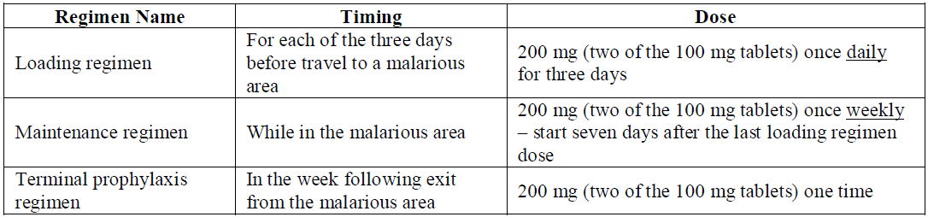
The recommendations include that ‘no more than 28 doses be consumed in 6 months period’ and Kodatef can be taken with or without food.
The recommendations further describe how to manage missed doses (Table 2, of the PI, Attachment 1).
Table 2: Missed doses of Kodatef
Dose(s) Missed | How to Replace Missed Dose(s):
1 Loading dose | 1 dose of 200 mg (2 of the 100 mg tablets) so that a total of 3 daily loading doses have been taken. Begin maintenance dose 1 week after the last loading dose.
2 Loading doses | 2 doses of 200 mg (2 of the 100 mg tablets) on 2 consecutive days so that a total of 3 daily loading doses have been taken. Begin maintenance dose 1 week after the last loading dose.
1 Maintenance (weekly) dose | 1 dose of 200 mg (2 of the 100 mg tablets) on any day up to the time of the next scheduled weekly dose.
2 Maintenance (weekly) doses | 1 dose of 200 mg (2 of the 100 mg tablets) on any day up to the time of the next scheduled weekly dose.
3 or more Maintenance (weekly) doses | 2 doses of 200 mg (2 of the 100 mg tablets), taken as 200 mg (2 of the 100 mg tablets) once daily for 2 days up to the time of the next weekly dose.
Terminal prophylaxis dose | 1 dose of 200 mg (2 of the 100 mg tablets) as soon as remembered.
Furthermore ‘Dosage adjustment for persons with renal impairment, hepatic impairment and dialysis has not been studied in clinical trials. Kodatef is not recommended for treating clinical malaria as a monotherapy because the drug is a slow acting blood schizonticide.’

Malaria
Malaria is a potentially fatal illness caused by protozoal infection of red blood cells (RBC) with parasites belonging to the genus Plasmodium, transmitted to humans by the bite of a Plasmodium infected female Anopheline mosquito, usually between dusk and dawn. Five species of Plasmodium infect humans, namely, Plasmodium falciparum (Pf), Plasmodium vivax (Pv), Plasmodium ovale (Po), Plasmodium malariae (Pm) and Plasmodium knowlesi (Pk).
Malaria remains a major global disease and in 2015, an estimated 212 million cases of malaria occurred worldwide. 90% of the cases were due to infection with Pf in the WHO African Region; 7% were in the South-East Asia Region and 2% were in the Eastern Mediterranean Region.
The huge number of Pf cases in sub Saharan Africa means that only about 4% of cases globally are caused by Pv but outside the African continent the proportion of Pv increases to 41% and this still represents a very large burden of disease in terms of absolute numbers outside the African continent. Of the total of 14,400,000 cases in the South-East Asia Region, 4,900,000 were due to Pv. For the Eastern Mediterranean Region, total cases were 3,800,000 and Pv cases were 1,400,000. For the Americas, total cases were 800,000 with Pv comprising the majority (500,000).
In 2015, an estimated 429,000 deaths from malaria occurred. Most deaths were estimated to have occurred from Pf in the African Region (92%), followed by the South-East Asia Region (6%) and the Eastern Mediterranean Region (2%). Although almost all deaths resulted from Pf malaria in Africa, Pv is estimated to have been responsible for 3100 deaths with most (86%) occurring outside Africa.

Current treatment options
Malaria prophylaxis in chloroquine resistant Pf regions can be undertaken with atovaquone/proguanil (Malarone) combination (daily), doxycycline (daily) or mefloquine (weekly). Chloroquine prophylaxis (weekly) can be used for forms other than the resistant Pf. The dosing regimens also take into account whether an agent kills the initial liver stage of the parasite (liver schizontocidal agent) or the subsequent blood stage of parasite (blood schizontocidal agent). None of these drugs eradicate the dormant/persisting hepatic hypnozoite stage of the parasite which requires an 8-aminoquinoline agent such as primaquine. All of these drugs are registered in Australia for prophylaxis and can also be used (except for doxycycline and primaquine) for the treatment of acute malaria as appropriately indicated. Artemisinin based combination therapies, standard of treatment for Pf malaria, are not suitable for prophylaxis.
The duration of dosing after leaving the endemic region is based on whether the agent kills the initial liver stage of the parasite (a causal agent) in which case the duration is 7 days, or kills the subsequent blood stage of the parasite (a blood schizonticidal agent) in which case the duration is 28 days.
Atovaquone/proguanil (Malarone) prophylaxis should begin 1 to 2 days before travel to malarious areas and should be taken daily, at the same time each day, while in the malarious area and, since this agent is causally active, daily for 7 days after leaving the area. Malarone prophylactic efficacy is approximately 98%. Adverse effects reported in persons using atovaquone/proguanil for prophylaxis or for treatment include abdominal pain, nausea, vomiting and headache.
Doxycycline prophylaxis should begin 1 to 2 days before travel to malarious areas. It should be continued once a day, at the same time each day, during travel in malarious areas and daily for 4 weeks after the traveller leaves such areas. Efficacy is thought to be between 92 to 96%. Doxycycline frequently causes mild-moderate nausea, vomiting, abdominal pain, photosensitivity, and vaginitis; and uncommonly can cause the severe reactions of esophagitis and oesophageal ulceration.
Mefloquine prophylaxis should begin 1 to 2 weeks before travel to malarious areas. It should be continued once a week, on the same day of the week, during travel in malarious areas and for 4 weeks after a traveller leaves such areas. Mefloquine prophylactic efficacy is approximately the same as that of Malarone. Mefloquine resistance, where present, will diminish that efficacy rate. Mefloquine has been associated with rare serious adverse reactions (such as psychoses or seizures) at prophylactic doses; these reactions are more frequent with the higher doses used for treatment. Other side effects that have occurred in chemoprophylaxis studies include gastrointestinal disturbance, headache, insomnia, abnormal dreams, visual disturbances, depression, anxiety disorder, and dizziness. Other more severe neuropsychiatric disorders occasionally reported during post marketing surveillance include sensory and motor neuropathies (including paraesthesia, tremor, and ataxia), agitation or restlessness, mood changes, panic attacks, forgetfulness, confusion, hallucinations, aggression, paranoia, and encephalopathy. Psychiatric symptoms have been reported to continue long after mefloquine has been stopped. Mefloquine is contraindicated for use by travellers with a known hypersensitivity to mefloquine or related compounds (for example, quinine and quinidine) and in persons with active or a history of major psychiatric disorders, or seizures. It should be used with caution in persons with psychiatric disturbances or a previous history of depression. Mefloquine is not recommended for persons with cardiac conduction abnormalities.
These drugs are all registered and available in Australia for malaria prophylaxis.

Malaria infection in Australia
Malarial parasite transmission is not endemic in Australia although the malaria vector, anopheles mosquito is present is northern Australia (above 19˚S latitude) and the area remains malaria receptive. Malaria is a notifiable disease in Australia. The annual numbers of malaria cases notified in Australia between the years 2000 to 2018 were as follows in Table 3, below.
Table 3: Number of malaria cases in Australia 2000 to 2018
Year | Number of cases
2000 | 966
2001 | 714
2002 | 467
2003 | 584
2004 | 544
2005 | 812
2006 | 771
2007 | 565
2008 | 528
2009 | 504
2010 | 406
2011 | 422
2012 | 344
2013 | 422
2014 | 325
2015 | 234
2016 | 304
2017 | 357
2018 | 46
The cases reported in Australia are mostly attributable to acquisition of infection from exposure during overseas travel (see Table 4, below).
Table 4: Malaria cases in Australia 2010 to 2014 by year, state/territory reporting and by place of acquisition (local or overseas)
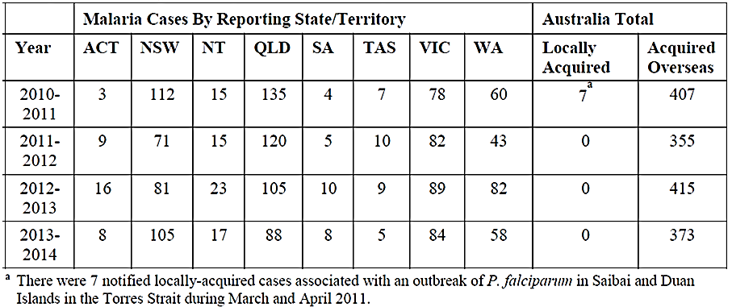
In Australia, most patients diagnosed with malaria (87%) are treated in-hospital. The distribution of malaria cases by plasmodia species in the last 2 reporting periods was as follows (Table 5).
Table 5: Hospital admission time for malaria cases in Australia
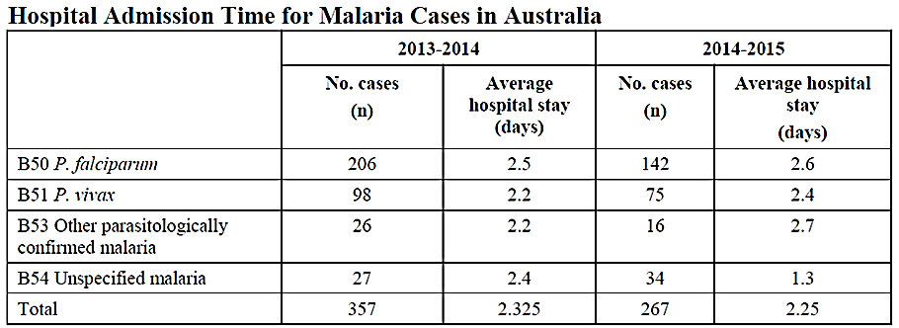
The incidence of malaria in Australia is thus approximately 1.4 cases/100,000 population overall. Queensland has higher incidence (2.7 cases/100,000). These Australian rates (national and Queensland) are about 3 and 5 times respectively the incidence of malaria in the United States (0.5 cases/100,000 population).

Regulatory status
Tafenoquine was registered on the Australian Register of Therapeutic Goods (ARTG) for the malaria prevention indication on the 19 September 2018 (Kodatef). The US Food and Drug Administration (FDA) undertook a concurrent review of tafenoquine for the malaria prevention indication and approved the malaria prevention indication (under priority review) on the 8 August 2018. Tafenoquine is approved as Arakoda in the USA for the prevention of malaria. Tafenoquine is also registered on the ARTG for the single dose, radical cure (prevention of relapse) of Plasmodium vivax (Pv) malaria in combination with another antimalarial drug for acute Plasmodium vivax (Pv) infection under the brand name Kozenis (GlaxoSmithKline is the sponsor for this treatment indication in Australia).
The US FDA also undertook a concurrent review of tafenoquine for the single-dose, radical cure indication concurrent to the TGA review and approved this treatment indication (under priority review) on the 20 July 2018. Tafenoquine is approved as Krintafel in the USA for the treatment of malaria.
Tafenoquine is not approved in any other jurisdiction.

Product Information
The Product Information (PI) approved with the submission which is described in this AusPAR can be found as Attachment 1. For the most recent PI, please refer to the TGA website at <https://www.tga.gov.au/product-information-pi>.

II. Registration time line
The following table captures the key steps and dates for this application and which are detailed and discussed in this AusPAR and Attachment 2.
Description | Date
Submission dossier accepted and first round evaluation commenced | 30 September 2017
First round evaluation completed | 28 February 2018
Sponsor provides responses on questions raised in first round evaluation | 31 March 2018
Second round evaluation completed | 29 May 2018
Delegate’s Overall benefit-risk assessment and request for Advisory Committee advice | 3 July 2018
Sponsor’s pre-Advisory Committee response | 17 July 2018
Advisory Committee meeting | 2 August 2018
Registration decision (Outcome) | 13 September 2018
Completion of administrative activities and registration on ARTG | 19 September 2018
Number of working days from submission dossier acceptance to registration decision* | 201
*Target time frame for statutory applications is 255 working days
Evaluations included under Quality findings and Nonclinical findings incorporate both the first and second round evaluations.

III. Quality findings

Introduction
The sponsor has submitted an application to register tafenoquine (as succinate) 100 mg tablets on the ARTG under the trade name Kodatef.

Drug substance tafenoquine succinate
Tafenoquine succinate is a white to pale brown powder.
Tafenoquine is an 8-aminoquinoline and an analogue of the currently registered (ARTG number226430) anti-malarial agent primaquine. A comparison of the chemical structures of both is shown in Figure 1, below.
Figure 1: Chemical structures of primaquine and tafenoquine
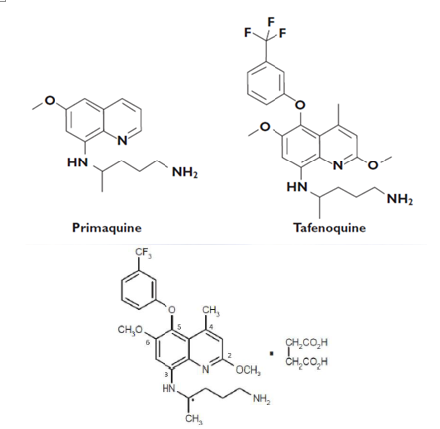
Molecular formula: C₂₄H₂₈F₃N₃O₃.C₄H₆O₄ ; molecular weight: 463.49 g/mol (free base); 581.58 g/mol (succinate); pKa: 6.7 and 9.5; Octanol/water partition coefficient (Kow): approximately 3.1.
Tafenoquine succinate drug substance is produced by chemical synthesis. The drug substance specifications are sufficient to ensure the quality and consistency of the substance.
Tafenoquine succinate is practically insoluble in water (< 0.1 mg/mL) and is soluble in methanol.
The drug substance shows good solid state stability.
Drug product
The proposed tafenoquine (as succinate) 100 mg tablets are unscored, immediate release, dark pink, capsule-shaped, film-coated tablets debossed with ‘tafenoquine100’ on one side and plain on the other.
The tablets are to be marketed in blister packs of 8 and 16.
The tablets are manufactured by a typical direct compression technique, using excipients which are commonly used in this type of product.
The finished product specifications include tests for appearance, identification, assay, content uniformity, control of related impurities, dissolution and microbial quality. After some tightening of initially proposed limits, the finished product specifications are considered sufficient to ensure the quality of the finished product at release and throughout the shelf life. A shelf life of 24 months, stored below 30ºC, is supported by the stability data.
All issues raised with the sponsor regarding chemistry and quality control aspects have been satisfactorily resolved.
Chemistry and quality control aspects are acceptable.

Biopharmaceutics
Clinical Study 022 compared fed and fasted state exposures of the 200 mg Phase III capsule formulation used in the majority of the Phase III clinical studies. Study TQ-2016-01 compared the pharmacokinetic parameters of the commercial 100 mg tablets with the 200 mg Phase III capsule formulation. Both of these studies were considered most pertinent.
Study 022 was a randomised, parallel group study to compare the bioavailability of tafenoquine from the 200 mg capsule formulation, used in the majority of the Phase III clinical studies, under fasted and fed conditions. The investigators concluded that administration of tafenoquine 200 mg capsules after a high-fat meal resulted in peak plasma concentration (C_{max}) and area under the plasma concentration versus time curve (AUC) values 1.31 and 1.41 times higher respectively than under fasted conditions.
The results support the recommendation in the PI to take the tablets with or without food, although it is noted that this is based only on the Phase III 200 mg capsule formulation and no separate study examining the effect of food on the tablet formulation proposed for registration was performed
Study TQ-2016-01 was a single treatment study to determine the pharmacokinetic parameters of the 100 mg tablet formulation proposed for registration and to compare them with fed state data (high fat meal) for the 200 mg Phase III capsule formulation from Study 022.
Confidence intervals could not be calculated due to the differing numbers in the groups used for each study. However, the results for the ratios of parameters C_{max} (96.7%) and AUC_{(0-t)} (103.0%) for the two studies, indicate that bioequivalence between the proposed 100 mg tablet formulation and the Phase III capsule formulation is likely.
No studies have been performed to directly compare the 100 mg tablet formulation proposed for registration directly with the Phase III capsule formulation. The dossier states that this is because the Phase III capsule is no longer being manufactured and no remaining samples are available.

Quality recommendations
Approval of the registration of the proposed tafenoquine (as succinate) 100 mg tablets is recommended from a chemistry and quality control perspective.

IV. Nonclinical findings

Introduction
Pivotal core safety pharmacology, toxicokinetic and repeat dose toxicity studies were Good Laboratory Compliant (GLP) compliant and were generally conducted in accordance with the International Conference on Harmonisation (ICH) of Technical Requirements for Registration of Pharmaceuticals for Human Use guideline.
Overall the nonclinical submission was adequate.

Pharmacology

Primary pharmacology

In vitro susceptibility of malaria parasites
A preliminary in vitro study showed blood schizonticidal activity of tafenoquine (50% inhibitory concentration (IC₅₀) 1130 nM against Sierra Leone clone D6 resistant to mefloquine, 150 nM against Indochina clone W-2 resistant to chloroquine and pyrimethamine) was 4 to 15 fold greater than primaquine against drug resistant clones of the malaria parasite Pf.
In a published study investigating the activity of tafenoquine and 12 other 8-aminoquinoline compounds against seven Pf clones and isolates, tafenoquine was more effective than primaquine against all isolates with an average 50% inhibitory concentration (IC₅₀) (436 nM, range 59 to 1470 nM) approximately 3 fold lower than primaquine. It would be relevant to note in this same study no cross resistance was observed between tafenoquine and chloroquine or tafenoquine and mefloquine; however, tafenoquine cross resistance correlated significantly with primaquine against blood stage parasites in culture (r = 0.783, p= 0.037). The submission did not include any studies predicting the expected drug resistance, which would have been useful in understanding the likelihood of the emergence of general resistance to tafenoquine. 50% effective concentration (EC₅₀) of tafenoquine (209 nM) against the most drug resistant Pf schizont maturation was in the same range as quinine and 2.4 and 10 times greater than the EC₅₀ for chloroquine and mefloquine, respectively. Tafenoquine (mean IC₅₀ 4430 nM) was either equal to or approximately 2 fold more potent than primaquine but less potent than chloroquine and mefloquine against multi-drug resistant Pf isolates from Djibouti (East Africa), Gabon (Central Africa) and Senegal (West Africa). The IC₅₀ of tafenoquine and primaquine were comparable (2189.9 nM and 1990 nM, respectively) against Pf clone HB3 (Honduras, chloroquine-sensitive). In the same study tafenoquine against Pf clone Dd2 (Indochina, chloroquine-resistant), exhibited IC₅₀ of 2092 nM which was 2 fold lower than the IC₅₀ of primaquine (4695 nM). Ghanaian Pf isolates (160 from 3 sentinel sites: Cape Coast, Hohoe and Navrongo representing three distinct epidemiological zones) were highly sensitive to tafenoquine (pooled IC₅₀ value of 93.6 nM). These in vitro studies demonstrated schizonticidal activity of tafenoquine and that sensitivity of Pf asexual forms to tafenoquine was greater than to primaquine. The in vitro IC₅₀ values were considerably higher than the expected clinical unbound C_{max} (6.47 nM).

Susceptibility of different life cycle stages to tafenoquine in vivo

Blood schizonticidal activity in mice and monkeys
In mice, subcutaneous (SC) administration of tafenoquine at doses of 16 to 128 mg/kg 72 h after infection with the blood stages of Plasmodium berghei (a rodent malaria), enabled survival of animals for at least 60 days post infection demonstrating the blood schizonticidal activity of tafenoquine (untreated animals died 6 to 8 days after infection). Tafenoquine demonstrated different effects against different malaria strains in Panamanian Aotus trivirgatus monkeys. An oral dose of 1 mg/kg/day tafenoquine (approximately 0.1 times human dose on a μg/m² body surface area basis) administered for 3 days had no effect or a slight suppressive effect against the Uganda Palo Alto or Vietnam Smith strain Pf. An oral dose of 4 mg/kg/day (approximately 0.4 times human dose on a μg/m² body surface area basis) administered for 3 days cleared primary parasitemia (Uganda Palo Alto) or recrudescent parasitemia (Vietnam Smith), but cured (defined as no evidence of blood parasitemia for 100 days) only a small number of recrudescent animals infected with Pf (Vietnam Smith strain only). An improved response was seen after 3 daily doses of 16 mg/kg which did offer cure in a higher proportion of primary and recrudescent infections with Pf. These data are in contrast to effects against Pv (Chesson strain), where tafenoquine doses of 1, 4 or 16 mg/kg/day (approximately 0.1, 0.4 or 1.5 times human dose on μg/m² body surface area basis respectively) administered orally for 3 days cleared primary parasitemia in Aotus trivirgatus monkeys, with cures at doses ≥ 4 mg/kg/day in some primary and recrudescent animals. A combination study investigating tafenoquine and chloroquine showed 100% tissue schizonticidal cures in monkeys. These studies collectively show the schizonticidal potential of tafenoquine.

Prophylaxis in mice and monkeys
Prophylactic activity of tafenoquine (that is, preventing the schizogony of liver parasites thus preventing entry of erythrocytic forms into the blood), was demonstrated in mice when oral or subcutaneous (SC) doses of tafenoquine given 4 h prior to infection with sporozoites of Plasmodium berghei yoelii (rodent malaria), and prevented parasitemia when administered at doses greater than 8 mg/kg. In another study, prophylactic activity in mice was demonstrated when 24 mg/kg tafenoquine was administered SC to mice, 2 h following inoculation with the sporozoites of Plasmodium yoelii nigeriensis. Duration of action of tafenoquine administered at doses of 64 mg/kg on Day 0 followed by challenge with Plasmodium yoelii yoelii sporozoites in mice was determined to be 3 days, and no to limited activity was reported 7 to 21 days prior to challenge. In Rhesus monkeys tafenoquine at oral doses of ≥ 0.3 mg/kg/day (≥ approximately 0.02 times human dose on a μg/m² body surface area basis) given for 3 days was found to be effective at preventing Plasmodium cynomolgi sporozoite-induced infection in and a single dose of 5.68 mg/kg (approximately 0.5 times human dose on μg/m² body surface area basis) was fully protective when given 3 days prior to challenge (studied in 3 animals only), but not when given 4 days prior to challenge. These findings indicate that tafenoquine is active against the initial liver stage of malaria infection, consistent with higher levels of tafenoquine found in the liver in the tissue distribution studies.

Sporontocidal activity in mosquitoes ingesting blood of treated mice
Tafenoquine had no impact on ookinete production; however, oocyst numbers were significantly reduced in mosquitoes fed on Plasmodium berghei infected mice, 90 mins after treatment with a single intraperitoneal (IP) dose of 5-25 mg/kg tafenoquine. Subsequent salivary gland infection rates were significantly reduced in mosquitoes fed on mice treated with 10-25 mg/kg tafenoquine. In another study Pv infected Anopheles dirus mosquitoes (4 days post infection) were fed on uninfected mice treated 90 mins earlier with 100 mg/kg of primaquine or tafenoquine by IP injection. Tafenoquine significantly reduced sporozoite production while primaquine had no effect on sporozoite production.
Administration of tafenoquine (that is, fed on mice 90 min after IP injection of 25 to 100 mg/kg tafenoquine) 4 days after the infectious feed inhibited sporozoite invasion of mosquito salivary glands, but had no impact on sporozoite invasion of the salivary glands when tafenoquine was given 8, 11 or 16 days post-infection. Doses of 6.25 to 100 mg/kg tafenoquine did not affect either the percentage of mosquitoes with oocysts or the number of oocysts per infected mosquito. These studies demonstrated that tafenoquine affects sporogenic development (that is, it inhibits the development of the parasite to sporozoites in the mosquito) of Plasmodium berghei and Pv in mosquitoes at doses of ≥ 25 mg/kg IP in mice, but does not affect oocyst production.

Possible mechanisms of action against malaria parasites in vivo
Mechanism of action is not fully understood. Possible tafenoquine mechanism of action that have been alluded to include: (i) tafenoquine inhibits detoxification of haem to haemozin in the parasite;, (ii) tafenoquine pro-oxidant properties may have blood schizonticidal activity;¹⁰ and (iii) tafenoquine causes destruction of internal structures of the mitochondria causing the organelles to swell and possible disruption of mitochondrial function in Leishmania promastiogotes, leading to apoptosis death.
Nonclinical data have demonstrated that tafenoquine is active against the liver and blood stages of malaria infections in mice and monkeys and also has activity against sporozoite development in mosquitos. The mechanisms of action are unclear.

Safety pharmacology
Safety pharmacology studies covered the central nervous (CNS), respiratory and the cardiovascular systems. No CNS drug related effects (including microscopic findings of the brain) were observed at doses up to 500 mg/kg (approximately 11 times the clinical dose based on C_{max}) in rats. Tafenoquine inhibited potassium (hERG) current with an IC₅₀ of 0.51 µg/mL (> 300 times the expected clinical C_{max} of tafenoquine (unbound)). In isolated dog Purkinje fibres, exposure to tafenoquine at concentrations of 0.46 and 4.64 μg/mL showed no potential to prolong QT interval; (although nonspecific effects were observed at the highest concentration of 46.4 µg/mL). IV infusion of tafenoquine at doses of 18.6 to 64.8 mg/kg for 20 mins produced dose-related effects on cardiopulmonary parameters (which included decrease in blood pressure, increase in stroke volume, mean pulmonary artery and pulmonary wedge pressures, rise in respiratory rate and volume and depressed tidal volume and death of one dog) in anaesthetised dogs. Tafenoquine is not intended to be given by the IV route and when administered orally at doses up to 16 mg/kg (3 times the clinical dose based on C_{max}) to conscious dogs, there were no treatment-related effects on either cardiovascular or electrocardiogram (ECG) parameters up to 170 h (7 days) after dosing. Therefore, cardiovascular effects may not be of potential clinical significance given that no effects were observed when dogs were dosed orally.

Pharmacokinetics

Absorption
Oral bioavailability was high in dogs (approximately 80%). Tafenoquine levels were observed to peak relatively slowly after oral dosing in all species tested (with T_{max} in the mouse being 6 to 12 h; in the rat 8 to 12 h; and in the dog 4 to 12 h). There were no observed differences in absorption parameters between male and female animals. The half-life (t_{½}) following oral dosing of tafenoquine to dogs was highly variable between animals but was not affected by dose, showing mean elimination t_{½} ranging from 2.25 to 6.9 days and in the monkey mean t_{½} was 2.3 days. The elimination in animal species is much faster than in humans after a single dose (14 days in males).)

Distribution
Tafenoquine is highly protein bound (generally >99%) across animal species. There was also a high uptake of circulating tafenoquine and metabolites into red blood cells (RBC) in vivo in dogs (blood/plasma ratio: 2 to 4 based on blood and plasma AUC for tafenoquine and 1.2 in vitro incubation in blood) and rats (blood/plasma ratio 2.6 in vitro incubation in blood) but not monkeys (blood/plasma ratio: 1.1 based on AUC for total radioactivity), and moderate uptake of tafenoquine to human RBC (blood/plasma ratio: 1.4 in vitro incubation in blood). Tissue distribution was studied in rats where orally administered radio-labelled tafenoquine was distributed relatively slowly but was widespread as shown by measureable peak exposure around 12 to 24 h across a large number of body tissues. The decline in radioactivity was slow with tissue radioactivity still measureable at 10 days after a single PO dose of 0.5 mg/kg. Apart from the intestines, exposure was highest in the lung, liver, spleen, kidney, adrenal cortex, pituitary, ovary and Harderian gland and lowest in the brain, spinal cord and white fat. Concentrations of radioactivity in the body tissues were generally higher than those in the blood with the exception of the brain and the spinal cord that had similar levels to those measured in blood.

Metabolism
No metabolism of tafenoquine could be detected in in vitro systems (rat, dog and human microsomes or human hepatocytes) mainly due to analytical issues and lack of sensitivity of assays, which prevented simple cross species comparison. In rats and dogs, tafenoquine was found to be the primary circulating component in rat and dog plasma at all time points examined as reported in humans, and unchanged tafenoquine was the primary extractable drug-related component observed in extracts of rat and dog liver homogenate. Absorbed tafenoquine eliminated via the bile was primarily in the form of desaryl metabolites, with low levels of detectable tafenoquine. Metabolites in urine were predominantly in the form of desaryl metabolites, where the trifluoromethyl benzene group had been removed accounting for 1 to 2% of the dose in total in the dog and rat. Routes of Phase 1 metabolism in the rat and dog also included O-demethylation, oxidation (to alcohols, ketones and carboxylic acids) and deamination, similar the pathways in humans. Phase 2 metabolism consisted of N-glucuronidation, carbamyl glucuronidation and possibly glucuronidation of hydroxyl groups, which also occur in humans. The structure of metabolites in rat faeces was not obtained. As far as dog faecal metabolites, the majority were identified but structural identity was unclear. Faecal metabolite profiles in the rat and dog were less complex than those in bile. Detection of predominantly unchanged tafenoquine in the plasma of nonclinical species and metabolism and excretion in bile and urine is also similar between animal species.

Excretion
The major route of excretion in the rat, dog and monkey was via the faeces and to a lesser extent via the urine. In the dog, the approximate ratio of faecal to urinary excretion was 3:1 to 7:1, while in the rat was approximately 10:1. Overall excretion of radioactivity was slow; approximately 60% and 80% of a single dose was excreted in faeces and urine within 10 days of administration in the dog and monkey respectively and 90% and 79% was excreted within 7 to 5 days in the rat following a single oral dose of 2 or 25 mg/kg respectively. Biliary excretion was demonstrated in bile-cannulated rats and dogs, with approximately 5% of dose in bile in rats (compared to 75% in faeces in 4 days) and equal amount in bile and faeces in dogs (approximately 20% of dose in 7 days) following oral dosing. Human radiolabelled mass balance studies have not been conducted to characterise the clinical excretion of tafenoquine.
Considering the metabolic profiles of tafenoquine in rats, dogs and humans, the similarity in protein binding and RBC uptake of tafenoquine in humans and these nonclinical species, rats and dogs are adequate animal models for the toxicological assessment of tafenoquine.

Pharmacokinetic drug interactions
Oral administration of tafenoquine to rats at dose levels up to 9.0 mg/kg/day for 56 consecutive days did not affect total cytochrome P450 (CYP450) proteins and had no marked effect on isozymes CYP1A, CYP2E, or CYP4A; however induction of CYP3A (approximately 2 fold increase) was observed in male rats at the highest dose level of 9.0 mg/kg/day (approximately 0.4 times clinical exposure based on AUC). In vitro tafenoquine (up to 50 µM) failed to activate the human pregnane-X-receptor relative to the positive control rifampicin, thus based on this assay it might not cause induction of CYP3A4 genes. Oral administration of tafenoquine to dogs at 4.0 mg/kg/day (1-5 times clinical exposure based on AUC) for 56 consecutive days, decreased the activities of a number of enzymes, including CYP2C and/or CYP2B, CYP2E, CYP3A and CYP4A. Decreased CYP3A and 4A activities were also observed at 1 mg/kg/day. Given the conflicting results of CYP3A induction/inhibition in rats and dogs, the effects on CYP3A activity in patients are uncertain. In vitro studies using human hepatocytes would provide further information on the potential for effects on CYP450 enzymes.
In vitro studies suggest tafenoquine is an organic anion transporter protein (OATP) 1B1 substrate and weak substrate of OATP1B3 and P-gp. Tafenoquine was not an inhibitor of OAT1, OAT3, OATP1B1, OATP1B3 or breast cancer resistance protein (BCRP) but inhibited P-glycoprotein with an IC₅₀ of 8.49 µM. This is >1000 times the expected maximum clinical unbound C_{max}, and therefore unlikely to be clinically relevant. In vitro tafenoquine inhibited the renal transporters organic cation transporter 2 (OCT2) and multidrug and toxin extrusion transporters 1 and 2-K (MATE1 and MATE2-K) with IC₅₀ values approximately 44-307 times the expected clinical unbound C_{max} indicating a potential clinical risk of interactions with OCT2 and MATE substrates. In dogs there was evidence of minor interactions when tafenoquine was co-administered with chloroquine (51% increase in tafenoquine AUC and 45% increase in C_{max}) or quinine and doxycycline (approximately 35% decrease in tafenoquine AUC and C_{max}), suggesting potential interactions in humans.

Toxicology

Acute toxicity
Single-dose toxicity studies were conducted in mice, rats, guinea pigs and rabbits (IP and PO), with limited observations performed over 14 days (which was sufficient to observe delayed toxicity effects and recovery). The maximum non-lethal oral dose for male and female mice was 84 mg/kg, for male and female rats it was 172 and 220 mg/kg respectively, for male guinea pigs it was 242 mg/kg and for female rabbits < 332 mg/kg (mortality at all doses). The maximum non-lethal IP dose for male and female mice was 36.8 mg/kg, for male and female rats was <28 and 28 mg/kg respectively, for male guinea pig was 10.9 mg/kg and female rabbits was 18.4 mg/kg. The mouse was the species most sensitive to tafenoquine (showing 3 to 4 fold lower 50% lethal dose (LD₅₀), followed by the guinea pig and the rat). High single doses at or near lethal doses produced non-specific clinical signs of toxicity across species and dosing routes. These generally included observations of rough coat, nasal/ocular discharge, hyperactivity, abnormal/laboured respiration, lethargy, hunched posture, tremors, bloated/distended abdomen (IP route), prostration and paralysis. The rabbit also showed signs of soft stools, diarrhoea and reduction in food and water consumption. In the guinea pig, oral doses causing lethality caused a pale liver, a fluid-filled abdomen and distended caecum. Death and/or clinical signs were generally noted at high doses within the first few days following dosing and if animals survived, recovery was seen after 1 week. In all species, acute IP dosing was associated with greater toxicity and lower LD₅₀ values; however this is of limited relevance as tafenoquine is intended for oral administration and the oral route showed moderate acute toxicity.

Repeat-dose toxicity
Studies of up to 52 weeks duration were conducted in mice, rats, and dogs, with pivotal GLP compliant studies of 13 weeks in mice, 1 to 6 months in rats and 1-12 months in dogs. Tafenoquine was administered orally by daily gavage, consistent with the route of administration in humans. Group sizes and study duration were adequate. The studies conducted were generally consistent with relevant guidelines on repeated dose toxicity studies.

Relative exposure
Exposure ratios were calculated based on animal: human plasma steady state AUC_{0–1week} for pivotal repeat-dose studies. Human reference values are from demographic population pharmacokinetics (PK) analysis from 10 healthy volunteers studies (866 participants). The human PK parameters provided in this PK analysis were anticipated for the clinical regimen (200 mg/day x 3 days followed by 200 mg weekly). The AUC_{0-1 week} in the nonclinical studies was extrapolated from values derived from AUC₀₋₂₄ values (both sexes combined as they were similar).
Exposures were low due to the sensitivity of the animal species to the treatment related effects of tafenoquine. Exposures achieved in studies of 13 weeks or longer were up to 0.9 in mice, 8 in rats and 9 in dogs.
Table 6: Comparative assessment of relative exposure in repeat-dose toxicity and carcinogenicity studies
Species | Study duration  [Study no.] | Dose  mg/kg/day | AUC_{0–1 week}^(ng∙h/mL) | Exposure ratio#
Mouse  (CD) | 13 week^{A}  [Study G99554] | 0.1 | 1435 | 0.03
Mouse  (CD) | 13 week^{A}  [Study G99554] | 0.3 | 4221 | 0.09
Mouse  (CD) | 13 week^{A}  [Study G99554] | 1.0 | 14252 | 0.3
Mouse  (CD) | 13 week^{A}  [Study G99554] | 3 | 42756 | 0.9
Rat  (SD) | 13 weeks^{B}  [Study 098] | 0.5 | 6650 | 0.1
Rat  (SD) | 13 weeks^{B}  [Study 098] | 6 | 119467 | 2.5
Rat  (SD) | 13 weeks^{B}  [Study 098] | 18 | 358400 | 7.5
Rat  (SD) | 26 weeks^{B}  [Study SBF 152] | 0.5 | 6650 | 0.1
Rat  (SD) | 26 weeks^{B}  [Study SBF 152] | 2 | 27965 | 0.6
Rat  (SD) | 26 weeks^{B}  [Study SBF 152] | 9 | 179200 | 3.7
Rat  (SD) | 2 years^{C}  [carcinogenicity; data collected at 12 months  Study 9200-02-04] | 0.1 | 1267 | 0.03
Rat  (SD) |  | 0.5 | 12362 | 0.3
Rat  (SD) |  | 1.0 | 33887 | 0.7
Rat  (SD) |  | 2.0 | 74778 | 1.6
Dog  (Beagle) | 13 weeks^{D}  [Study 097] | 0.1 | 6839 | 0.1
Dog  (Beagle) | 13 weeks^{D}  [Study 097] | 2.0 | 208600 | 4.4
Dog  (Beagle) | 13 weeks^{D}  [Study 097] | 6.0 | 418950 | 8.7
Dog  (Beagle) | 52 weeks^{D}  [Study 219] | 0.1 | 6839 | 0.1
Dog  (Beagle) | 52 weeks^{D}  [Study 219] | 1 | 104300 | 2.2
Dog  (Beagle) | 52 weeks^{D}  [Study 219] | 4 | 279300 | 5.8
Human  (healthy volunteers) | Demographic population PK analysis from 10 healthy volunteers studies (866 participants) | [200 mg] | 48 000* | –
^{A} Based on pharmacokinetic data from an 8 week PK study (802-589) assuming linear pharmacokinetics between 1 and 3 mg/kg/day; ^{B} Based on pharmacokinetic data from an 8 week PK study (SBF/232) assuming linear pharmacokinetics between 6 and 18 mg/kg/day; ^{C} Pharmacokinetic data at 12 months; ^{D} Based on pharmacokinetic data from an 8 week PK study (SBF/233); ^ AUC_{0-1 week} values were calculated by multiplying AUC_{0-24h} by 7; # animal: human plasma AUC_{0–1 week}; * AUC calculated by dividing dose by clearance (CL/F).

Major toxicities
The major target organs for tafenoquine were the lung (phospholipidosis), liver (centrilobular inflammation, apoptosis and fatty change and increased plasma transaminases) and kidney (tubular nephrosis, necrosis and dilation at 13 weeks in the rat; not present in the dog). Mortalities occurred in mice at ≥ 3 mg/kg/day and in rats at ≥9 mg/kg/day. Other principal and consistent recurrent toxicological findings included poor clinical conditions, reduced food consumption and weight gain, increased methaemoglobin (MetHb), the appearance of blue tongue or gums in the dog, blue skin/ears and pallor in rats, mild anaemia associated with compensatory erythropoiesis, increased deposition of brown/haemosiderin pigment in a number of tissues, bone marrow hyperplasia in rats and dogs, increased spleen weight (all species) and splenic hyperplasia, as well as splenic congestion and pooling of red blood cells in rats and dogs, increased adrenal weight, pigmentation and congestion in the rat, and lymphocyte depletion/necrosis in lymphoid tissues in rats and dogs. These effects were both time and dose dependent and showed partial or complete reversibility.
Lung phospholipidosis was observed in all pivotal repeat dose toxicity studies in mice, rats and dogs, and was characterised by increases in the number of foamy macrophages, presence of eosinophilic material in lung alveolar spaces and alveolar proteinosis. Generally functional consequences to the pathology were observed (except in the case of one dog receiving 4.0 mg/kg/day (exposure ratio 6) in the 52 week study which showed increased respiratory rate and also showed the largest lung weight increase compared to other similarly dosed males). In rats and dogs these effects were reversed during the recovery period; however, chronic inflammation of minimal severity in alveolar macrophages of the lungs developed. Phospholipidosis was also seen in kidneys of rats by electron microscopy in a 13 week study. Phospholipidosis has been associated with this class of drugs, including chloroquine and other cationic amphiphilic drugs (for example, amiodarone, fluoxetine), in animal species and humans.
Tafenoquine-related liver changes were observed in dogs and rats. The dog appeared more sensitive to the liver changes. A minimal to mild chronic inflammation of the liver was seen in treated dogs with an increase in haptoglobin levels, haemosiderin deposits and minimal subacute inflammation with the addition of Kupffer cell hypertrophy or Kupffer cell pigmentation and in severe cases hepatocellular necrosis (> 6 exposure ratios). All changes in dogs showed reversibility over 13 weeks except haemosiderin deposits which remained. Mild hepatic effects were evident in the rat, shown by an increase in serum aspartate aminotransferase at ≥ 9.2 mg/kg/day (exposure ratio 4) and increased liver weight in males only at 27.7 mg/kg but with no associated pathology. The liver pathology of male rats dosed for 26 weeks at 9.0 mg/kg/day (exposure ratio 4) showed apoptosis, brown pigmentation and fatty change, the fatty change also being evident in males at 2.0 mg/kg (exposure ratio 0.6).
Tafenoquine related changes were also observed in the kidneys and included brown pigment (haemosiderin), eosinophilic droplets (consistent with haemoglobin and haemoglobin related material), focal cortical tubular basophilia in the cortical tubular cells, and diffuse cytoplasmic basophilia and karyomegaly in the outer strip of renal medulla in rats dosed with 2 or 18 mg/kg/day in a 13 week study. There was also diffuse medullary epithelial vacuolation and single cell necrosis at 18 mg/kg/day. In the 26 week study, pigment was noticed in kidney tubules at 2 and 9 mg/kg/day, but eosinophilic droplets were not described. Renal tumours were observed in the carcinogenicity study (discussed below).
Haematological changes were observed across the studies. In rats a mild anaemia (up to approximately 15% reduction in red blood cell count, haematocrit, haemoglobin concentration, mean cell haemoglobin and/or mean cell haemoglobin concentration) was evident, probably as a result of haemolysis induced by tafenoquine. In the dog a mild dose-related anaemia was similarly seen and changes included a decrease in red blood cell count, haemoglobin levels, haematocrit, mean cell haemoglobin and/or mean cell haemoglobin concentration up to a maximum of approximately 20%. MetHb level increase was observed in both rats and dogs and recovery was evident in both species. The red blood cell changes, MetHb, bone marrow and spleen hyperplasia, and haemosiderin deposition are consistent with oxidative red cell damage and death and are known effects of 8-aminoquinoline compounds and so would need to be monitored in clinical studies. Other observations that could possibly be secondary changes as a result of anaemia include splenic and bone marrow hyperplasia, haemosiderin deposits in the kidney and bone marrow, and protein nephropathy.
Lymphocyte depletion in the spleen (but not in other lymphoid tissues) was observed in the 4 week rat study at ≥ 27.7 mg/kg/day. In dogs, lymphocyte depletion and/or necrosis were seen in spleen, lymph nodes and thymus at ≥ 3.1 mg/kg/day for 4 weeks, and lymphocyte depletion in thymus (not in spleen or lymph nodes) at ≥ 2 mg/kg/day for 13 weeks. There was no lymphocyte depletion in rats in the 3- and 6-month studies or in dogs in the one-year study, and peripheral lymphocyte counts were unaffected in all toxicity studies.
In vitro tafenoquine had minimal effect on the heart (unlike primaquine). Heart pathology was only observed in the mouse after 13 week dosing (related myocardial degeneration with or without inflammation) and was not seen in the 2 year mouse carcinogenicity study. In rats a decrease in the heart weight was observed at ≥ 2 mg/kg/day with no associated pathology. No heart weight change or heart pathology was observed in dogs in any of the studies. Animal studies predict low risks of myocardial effects in humans.

Genotoxicity
The genotoxic potential of tafenoquine was tested in bacterial reverse mutation assays, in gene mutation assays in mammalian cells (mouse lymphoma cells and Chinese hamster ovary cells), in vitro chromosome aberration assays in Chinese hamster ovary cells and in vivo mouse micronucleus test. This testing strategy was consistent with the ICH guideline S2 (R1). All the studies were negative except for a weakly positive result in the mouse lymphoma cell assay with metabolic activation. The in vitro studies indicated that tafenoquine was not mutagenic or clastogenic however generally these assays were limited to very low test concentrations of tafenoquine (5 to 10 µg) due to cytotoxicity. A single dose of 400 mg/kg tafenoquine (approximately relative exposure of 9 based on body surface area) did not increase micronucleus formation in mice.
A GLP bacterial Ames assay was also performed with GSK3172964A, an N-nitroso metabolite of tafenoquine. GSK3172964A was not mutagenic in the bacterial mutation assay.
Overall, tafenoquine is not considered to present a genotoxic risk to humans.

Carcinogenicity
The carcinogenic potential of tafenoquine by the oral route was assessed in mice and rats in conventional 2 year oral carcinogenicity studies as per the relevant ICH guidelines. In the mice study, the group sizes used (60/sex) and the duration of dosing (2 years) were appropriate. However, the selection of the dose tested was based on maximum tolerated dose (1 mg/kg) in a dose range finding study and was limited to only approximately 0.3x the clinical AUC. There were no treatment-related increases in tumour development in the mice study at these low doses. In the lungs there was a higher incidence of eosinophilic histiocytes (indicative of phospholipidosis) and alveolar crystals in mice given 1.0 mg/kg/day which were also reported and discussed in the repeat dose studies.
In the rat carcinogenicity study, tafenoquine was given daily, by oral gavage, to rats at doses of 0, 0.1, 0.5, 1 or 2 mg/kg/day (equivalent to approximately 0.03. 0.26, 0.71 and 1.6 times the clinical AUC) for 2 years. Incidence of renal tumours (renal cell adenoma at 1 and 2 mg/kg/day with only one incidence of carcinoma at 2 mg/kg/day) and cortical hyperplasia in male rats at 2 mg/kg/day were observed. Chronic progressive nephropathy (CPN) was also increased in male rats at these doses. Chronic progressive nephropathy is a common renal lesion in male rats with no counter-part in humans, is exacerbated by many chemicals and drug substances, and is considered a risk factor for renal tubular hyperplasia and tumours. In a 13 week study, immunostaining of kidney sections showed increased Ki67 and proliferating cell nuclear antigen, both of which are markers of cell proliferation, in both sexes at 18 mg/kg/day and in males at 2 mg/kg/day. In the same 13 week study there were also karyomegaly in the outer strip of renal medulla at 2 or 18 mg/kg/day and diffuse medullary epithelial vacuolation and single cell necrosis in both sexes at 18 mg/kg/day. The above findings, together with the absence of genotoxicity, point to a non-genotoxic mechanism of renal carcinogenicity. The renal tumours in rats probably resulted from chronic cellular damage leading to cell regeneration, proliferation, hyperplasia and finally renal tumours. The exact mechanism is unclear but CPN might be a contributing factor since renal tumours were observed only in male rats. The renal tumours in rats are considered clinically relevant. However, the risk of renal tumours in humans is low given (i) proposed treatment duration of 6 months compared with the life time exposure in the rat carcinogenicity study, (ii) the absence of tumours in the 6 month rat study and in the mouse carcinogenicity, study and (iii) the absence of hyperplasia of renal tubule cells in the one year dog study.

Reproductive toxicity
A GLP fertility and embryonic development study in rats was submitted where tafenoquine was administered to males for 67 to 69 days and to pregnant females for 15 days before cohabitation, during cohabitation and from Day 0 to 6 of pregnancy. Embryofetal development was studied in rats and rabbits. Tafenoquine was administered daily during organogenesis (gestation Days (GD) 6 to 15 in rats or GD 6 to 18 in rabbits). Caesarean sectioning was performed on GD 20 in rats and GD 29 in rabbits. A GLP postnatal development study was performed in rats where tafenoquine was administered to pups from GD6 to postnatal Day (PND) 21 and terminated on PND 21. These studies were consistent with the ICH guidelines S5 (R2). Pharmacokinetics data was not provided and placental transfer and excretion of tafenoquine into milk were also not assessed.
In the fertility study no effects on mating and fertility indices, oestrous cycles, sperm motility, sperm count or morphology were observed, when tafenoquine was given at doses 1.5, 5 or 15 mg/kg/day (up to approximately 6 times the clinical exposure based on AUC). Females dosed with 15 mg/kg/day showed a statistically significant decrease (p<0.05) in the number of corpora lutea, the number of implantations and ultimately the number of viable fetuses compared to control animals, which suggest that dosing with 15 mg/kg/day for 15 days prior to mating affected oocyte maturation but not ovulation, mating behaviour, implantation or embryonic development. Maternal and paternal toxicity was observed at 15 mg/kg/day and to a lesser extent at 5 mg/kg/day and was characterised clinical signs (piloerection, rough coat and audible breathing or increased respiratory rate) and by significantly decreased body weight gain. The No observable adverse effect level (NOAEL) for effects on female fertility was 5 mg/kg/day (approximately 2 times the clinical exposure). It was also noted that no gross or histopathology findings were noted in the testes or prostate of the male rats administered tafenoquine at doses up to 18 mg/kg/day for thirteen weeks.
Pregnant rats at doses of up to 30 mg/kg/day and rabbits at doses of up to 25 mg/kg showed maternal toxicity at ≥ 10 mg/kg in the rat and 25 mg/kg in the rabbit. These maternally toxic doses did not cause fetal toxicity, and tafenoquine was not teratogenic in either species at any dose. The highest dose in the rat and rabbit embryo-fetal development studies was 10 times (rat) and 16 times (rabbit) the clinical dose on an mg/m²/week basis.
In the pre/postnatal development study, tafenoquine had no effect on pregnancy, parturition, and lactation in rats at up to 18 mg/kg/day in spite of maternal toxicity observed at this dose level. However, alterations in pup body weights, slight developmental and functional delays in offspring including delayed eye opening and decreased rearing activity was observed at this dose. There were no postnatal effects at 6 mg/kg/day.

Pregnancy classification
The sponsor proposed Pregnancy Category D. The absence of embryo-foetal effects in the rat and rabbit embryofetal development studies would suggest a Pregnancy Category B1. Placental transfer of tafenoquine in rats and rabbits was not determined. Anaemia (haemolysis) and methaemoglobinaemia may occur in the foetus due to pharmacological activity of the drug, although there was no evidence of these effects in pups born from rats dosed with up to 18 mg/kg/day tafenoquine during gestation and lactation. However, fetuses with glucose-6-phosphate dehydrogenase (G6PD) deficiency in patients may be susceptible to haemolysis induced by tafenoquine. Therefore, Pregnancy Category C is considered appropriate ..

Juvenile studies
Tafenoquine was generally well tolerated by juvenile rats when dosed orally every 5 days from PND 7 at doses of 5, 15 or 25 mg/kg and from PND 27 to 62 at 10, 20 or 50 mg/kg. Tafenoquine related effects were similar to those seen in adults and they included decreased body weight gain and food consumption, anaemia, increases in methaemoglobin formation, minimal/slight microscopic changes in the spleen, lung and kidney associated with macroscopic pathology and increased weight in the spleen, liver and kidney with some associated minor disturbances in clinical chemistry and urine analysis in males and/or females. These changes were generally reversible. There was no tafenoquine-related effect on growth or development, including pre-weaning body weight gain, long bone length, sexual maturation, and neuro-behavioural function.

Phototoxicity
The phototoxicity of tafenoquine was assessed in a validated in vitro assay (3T3 Neutral Red uptake). Tafenoquine was considered ‘probably phototoxic’ after producing a photo-irritation factor (PIF) of 4, calculated from IC₅₀ of Neutral Red uptake into Balb/c 3T3 fibroblast cells in the presence and absence of ultra-violet A. A tissue distribution study in albino rats showed minimal distribution to skin and uveal tract (pigmented tissue). No further testing for phototoxicity was performed which is consistent with the relevant ICH guidance.

Nonclinical summary
- Pivotal core safety pharmacology, toxicokinetic and repeat dose toxicity studies were GLP compliant and were generally conducted in accordance with ICH guidelines (ICH M3 (R2)).⁴
- Tafenoquine affects multiple aspects of the malaria life cycle. In vitro blood schizonticide activity of tafenoquine was demonstrated to be 2 to 15 folds greater than primaquine. In vivo blood schizonticidal and prophylaxis activity was demonstrated in mice. In monkeys tafenoquine showed slow acting schizonticide activity in the treatment of malaria infection. Together these studies demonstrated that tafenoquine kills the early hepatic stages of the parasite that result from sporozoite infection of the liver after a mosquito bites the host and is also a slow acting blood schizonticide. However the actual mechanism of action of tafenoquine was not defined.
- Safety pharmacology studies assessed effects on the cardiovascular, respiratory and CNS. No adverse effects were seen on CNS function (including microscopic findings of the brain) in rats or respiratory function in dogs. Significant tafenoquine inhibition of potassium (hERG) channel tail current was observed in a dose dependent manner in vitro (IC₅₀ > 300 times the expected clinical C_{max} of tafenoquine (unbound)). However, when administered orally at doses up to 16 mg/kg (3 x the clinical dose based on C_{max}), there were no treatment related effects on either cardiovascular or ECG parameters and therefore tafenoquine is not predicted to prolong the QT interval in patients.
- Single doses of tafenoquine in mice, rats and dogs demonstrated slow absorption and elimination with T_{max} of 4 to 12 h (similar to humans) and elimination t_{1/2} of 2 to 7 days, compared with 14 days in humans. Tafenoquine is highly protein bound (generally >99%) across animal species. Minimal metabolism of tafenoquine occurred in all species and generally only tafenoquine was extracted in the plasma of all species. The major route of excretion in the rat, dog and monkey was via the faeces (with biliary excretion) and to a lesser extend via the urine.
- Single dose toxicity studies in rats, guinea pigs and rabbits (by the oral route) showed moderate to acute toxicity.
- Pivotal repeat dose studies were conducted in mice, rats and dogs with low exposures. The major target organs for tafenoquine were the lung (phospholipidosis), liver (centrilobular inflammation, apoptosis, fatty change and increased plasma transaminases) and kidney (tubular nephrosis, necrosis and dilation at 13 weeks in the rat; not present in the dog). Mortalities occurred in mice at ≥ 3 mg/kg/day and in rats at ≥9 mg/kg/day. Other principal and consistent recurrent toxicological findings included poor clinical conditions, reduced food consumption and weight gain, decreased red cell parameter values, increased MetHb, the appearance of blue tongue or gums in the dog, blue skin/ears and pallor in rats, mild anaemia associated with compensatory erythropoiesis, increased deposition of brown/haemosiderin pigment in a number of tissues, bone marrow hyperplasia in rats and dogs, increased spleen weight (all species) and splenic hyperplasia, as well as splenic congestion and pooling of red blood cells in rats and dogs, increased adrenal weight, pigmentation and congestion in the rat, and lymphocyte depletion/necrosis in lymphoid tissues in rats and dogs. These effects were both time and dose dependent and showed partial or complete reversibility.
- Tafenoquine was not mutagenic in bacterial reverse mutation assays, in vitro chromosome aberration assays in Chinese hamster ovary cells, in vivo micronucleus test, in gene mutation assays in Chinese hamster ovary cells but was weekly positive in a mouse lymphoma cell gene mutation assay with metabolic activation. Overall, tafenoquine is not considered to present a genotoxic risk to humans.
- In a two year rat carcinogenicity study, an increase in the incidence of renal tumours and hyperplasia in male rats was observed following oral administration of 1.0 and/or 2.0 mg/kg/day (clinical exposures of 0.7 and 1.6 respectively based on AUC). Increased cell proliferation, karyomegaly and diffuse medullary epithelial vacuolation and single cell necrosis were observed in both sexes in a 13 week study at 2 and/or 18 mg/kg/day. The above findings together with the absence of genotoxicity point to a non-genotoxic mechanism of renal carcinogenicity. The renal tumours in rats probably resulted from chronic cellular damage leading to cell regeneration, proliferation, hyperplasia and finally renal tumours. The exact mechanism is unclear but CPN was increased in male rats at these doses, suggesting CPN might be a contributing factor since renal tumours were observed only in male rats. CPN is a common renal lesion in male rats with no counter-part in humans, and is not considered relevant to human risk assessment. Considering other findings described above in both sexes in the 13 week study and that the exact mechanism is unclear, renal tumours in male rats treated with tafenoquine are clinically relevant. Tafenoquine was not carcinogenic in a life time study in mice at up to 1 mg/kg/day for 2 years. There is a low risk of carcinogenicity in humans from the proposed short term dosing regimen.
- In fertility studies female rats dosed with 15 mg/kg/day (approximately 6 times the clinical exposure based on AUC) showed a statistically significant decrease (p<0.05) in the number or corpora lutea, resulting in decreased number of implantations and viable fetuses. There was no effect on male fertility in rats. In embryo-fetal development studies tafenoquine was not teratogenic in rats or rabbits. In a postnatal development study, developmental and functional delays were observed in rat offspring at the highest dose of 18 mg/kg/day (> 6 times the clinical AUC).
- In vitro inhibition of renal transporter OCT2, MATE1 and MATE2‐K (based on unbound C_{max} and IC₅₀ values) indicate a weak potential interaction of tafenoquine with OCT2 and MATE.
- Tafenoquine showed low potential to be phototoxic in a validated in vitro assay (3T3 Neutral Red uptake). The in vitro phototoxicity results and low distribution to skin in rats suggest low risk of phototoxicity in humans.

Nonclinical conclusions and recommendation
- Overall the nonclinical submission was adequate.
- The primary pharmacology studies support the use of tafenoquine for the proposed indication.
- The major target organs for tafenoquine in repeat dose studies were the lung (phospholipidosis), liver (centrilobular inflammation, apoptosis, fatty change and increased plasma transaminases) and kidney (tubular nephrosis, necrosis and dilation at 13 weeks in the rat; not present in the dog). These findings are clinically relevant.
- Tafenoquine does not pose a genotoxic hazard but caused renal tumours in male rats through a non-genotoxic mechanism, probably as result of chronic cellular damage leading to cell regeneration, proliferation, hyperplasia and finally renal tumours. There is a low risk of developing renal tumours in humans from the proposed short term use.
- Tafenoquine is not teratogenic. Postnatal developmental and functional delays were observed in the offspring of rats at 8 times the clinical exposure based on AUC.
- Pregnancy Category C is considered appropriate based on the expected haemolytic effects on fetuses with G6PD deficiency in women taking tafenoquine. Use during pregnancy and breastfeeding is not recommended.
- Provided the above effects are adequately monitored or managed during clinical use and that the benefit/risk profile seems acceptable from a clinical perspective, there are no objections on nonclinical grounds to the proposed registration of tafenoquine succinate (Kodatef).
- The nonclinical evaluator recommended amendments to the draft Product Information but these are beyond the scope of this AusPAR.

V. Clinical findings
A summary of the clinical findings is presented in this section.

Introduction

Clinical rationale
The wide range of side effects with both doxycycline and mefloquine, as well adherence to dosing regimens and prescribed chemoprophylaxis after leaving the country of exposure, are the major issues with these drugs being used effectively. Daily administration of drugs is a problem in relation to compliance (doxycycline and Malarone). There is better adherence with weekly regimens (such as mefloquine) but the neuropsychiatric adverse effects of mefloquine have curtained its use as a chemoprophylactic agent.
The unmet medical need for malaria chemoprophylaxis while in endemic regions is an effective, weekly drug without the neuropsychiatric adverse reactions of mefloquine.
In relation to post-exposure prophylaxis to kill Pv dormant forms (thus preventing relapse) the unmet medical need is a 1 dose regimen that will be inherently superior to 7 daily doses of Malarone, 4 weekly doses of mefloquine, and either of those regimens combined with 14 daily doses of primaquine. Po malaria can also relapse but is rarely seen in Australia.

Guidance
The major guidance comes from the FDA draft guidance on development of prophylactic antimalarial drugs; lists all of the following possible study designs. There are 3 alternatives for a pivotal trial, each with advantages and disadvantages:
- A comparator-controlled study can be performed in non-immunes. Historic placebo infection rates can be used to address this difficulty, and are required for a non-inferiority analysis of the study.
- A placebo-controlled study can be performed in a semi-immune population who, through repeated prior exposure to parasites, will tolerate infection well during the study. However, interpretation of the study data is difficult because of the unknown contribution of immunity to drug effect.
- A placebo-controlled study in non-immunes can be performed in the malaria challenge model in a clinical laboratory where subject safety is tightly monitored, but the precise relevance of this model to parasite challenge in the real world is uncertain but protective efficacy can be shown.
It further states that prophylaxis applications can be significantly strengthened by studies involving treatment of established infection.
The submission includes the comparator-controlled pivotal Study 033 (with Australian Defence Force personnel stationed in East Timor), supported by a placebo controlled prophylaxis study in semi-immunes in East Africa; Study 045), and by a placebo controlled prophylactic study in non-immunes in a human challenge model (TQ-2016-02).
The primary efficacy endpoints and primary efficacy analytic endpoints are based on the cumulative incidence of parasitaemia, with incidence density (parasitology per unit time) being used for secondary analyses, in conformity with the FDA Guidance document.

Evaluator’s commentary on the background information
The background information is adequate. The rationale for needing a prophylaxis medication that can be taken weekly and is free of neuropsychiatric side effects is good. The information about the global impact of malaria and the available prophylaxis in Australia is accurate.

Contents of the clinical dossier
The dossier documented a development program of pharmacology, dose-finding, pivotal and other clinical trials.
Included in this dossier is data from 22 clinical trials, including eight Phase I pharmacokinetics (PK) and safety studies in healthy volunteers; 2 Phase I drug-drug interaction studies in healthy volunteers; 3 Phase I malaria challenge studies; 7 Phase II/III studies for malaria prophylaxis and 2 Phase II studies for the treatment of Pv malaria. These are summarised by phase in Tables 7 to 9 (Phase I) and Phase II/III (Tables 10 and 11) along with the publication references. Table 12 summarises the submitted studies and designs, specifies the numbers in the cohorts and contains PK summary data.
The Phase II studies that support the key trials listed above consist of the following:
- Studies 053 and 054: Prophylactic efficacy of single-dose (Study 053) and early multiple-dose (Study 054) tafenoquine regimens in the human Pf challenge model.
- Study 006: Different loading doses for semi-immunes in Africa.
- Study 043: Different loading doses and ‘full prophylactic regimens’ (loading dose followed by weekly or monthly dosing) for semi-immunes in Africa.
- Study 044: ‘Full prophylactic regimen’ with a higher dose than the final clinical dose for non-immunes in Southeast Asia (Thailand).
- Study 030: The anticipated clinical regimen (200 mg per day x 3 days followed by 200 mg weekly) compared to placebo and positive control (mefloquine).
- Study 049 compares tafenoquine to primaquine in non-immunes.
- Studies 047 and 058 compare tafenoquine to primaquine in Thai people with variable immunity.
- Study 046 enrolled only 1 subject and is not considered further.
For ‘Prophylaxis of malaria after leaving the endemic region,’ 5 relevant studies provide data.
- Study 033: Upon exit of non-immunes from the endemic region, mefloquine subjects received primaquine while tafenoquine subjects were not further treated (that is, did not receive a post-exposure dose of tafenoquine, they received 14 days of placebo).
- Study 045: Prophylaxis in semi-immunes in East Africa.
- Study 047: Wide range of short tafenoquine regimens for Thai people in Southeast Asia.
- Study 049: Several short tafenoquine regimens for Australian non-immunes.
- Study 058: In addition to evaluating the treatment effect of tafenoquine against Pv already present in the blood of semi-immune Thai people, follow-up was extended to 120 days to assess relapse up to that time.
These can be summarised as:
- 14 studies providing PK, pharmacodynamics (PD) and safety pharmacology data.
- 1 one population PK data study
- 6 studies that use varying doses.
- 1 Population PK (popPK) analyses.
- 2 Pivotal efficacy/safety studies.
- 10 Other efficacy/safety studies.
Although a number of studies performed more than one function (for example, dose finding, efficacy and safety data).
Table 7: Phase I studies in healthy volunteers
Study No. | Study design | Study objectives | Tafenoquine doses administered | Population
Single-dose studies
050 | R, DB, PC | PK and Safety in fasted state | 400-600 mg | N=75; 75M/0F
052 | R, PG | PK and Safety in fasted state | 100, 200, or 400 mg | N=18; 18M/0F
003 | R, O, PG | PK and Safety in fed versus fasted state. Gender effects. | 400 mg | N=32;16M/16F
022 | R, PG | PK and Safety in fed versus fasted state. Gender effects. | 200 mg | N=40; 20M/20F
TQ-2016-01 | O | Compare PK parameters of the new tafenoquine clinical formulation (100 mg tablets) to PK of the 200 mg capsule used in previous tafenoquine trials (specifically Study 022). Also, compare AEs, vital signs and haematology parameters. | 200 mg (dosed as two 100 mg tablets) | N=70
Multiple-dose studies
051 | R, DB, PC | PK and Safety in fasted state | 200, 400, or 600 mg weekly x 10 weeks |  | N=36; 30M/6F
014 | R, O, PG | Relative bioavailability of 3 different oral formulations. | 400 mg daily x 3 days |  | N=58; 43M/15F
057 | R, PC | Renal and ocular Safety. | 200 mg daily x 3 days, then weekly x 23 weeks |  | N=120; 73M/47F
^{(a)}R=Randomised; DB=Double-blind; P=Placebo-controlled trial; PG=Parallel-group; O=Open-label.
Table 8: Phase I drug-drug interaction studies in healthy volunteers
Study No. | Study design | Study objectives | Tafenoquine doses administered | Population
015 | O, SS | Study PK and DDI of tafenoquine + desipramine | 400 mg daily x 3 days | 34; 20M/14F
040 | O, TP, NR, C | Study PK and DDI of tafenoquine + midazolam, flurbiprofen, caffeine | 400 mg daily x 3 days | 28; 18M/10F
^{design(a)}O=Open-label; SS=Single sequence; TP=Two-period; NR=Non-randomised; C=Crossover; DDI = Drug-drug interaction.
Table 9: Phase I malaria challenge studies in healthy volunteers
Study No. | Study design |  | Study objectives | Tafenoquine doses administered | Population
Single-dose studies
053 | R, DB, PC |  | Determine prophylactic efficacy of tafenoquine against Pf malaria in non-immune fasted subjects when given prior to mosquito inoculation | 600 mg | N=6; 4M/2F
Multiple-dose studies
054 |  | R, DB, PC | Determine whether tafenoquine was prophylactic against Pf malaria.  Gather PK (tafenoquine co-administered with food) and Safety data. | 600 mg daily x 2 days, then 300 mg weekly x 4 weeks; or  600 mg daily x 2 days, then 300 mg one week later | N=10; 10M/0F
TQ-2016-02 |  | R, DB, PC | Evaluate the prophylactic activity of tafenoquine against challenge with Pf asexual blood stage parasites in non-immune participants; characterise the exposure-response relationship for tafenoquine; and provide safety and tolerability data for tafenoquine in a controlled disease-like setting. | 200 mg daily x 3 days, then 200 mg one week later | N=16
^{design(a)}RCT=Randomised; DB=Double-blind; PC=Placebo-controlled. O=open label
Table 10: Malaria prophylaxis studies (Phase II and III)
Study No. | Study design | Study objectives | Tafenoquine doses administered | Population
006 | R, DB, PC | Malaria prevention in semi-immune subjects of Lamaréné, Gabon (highly endemic Pf) | 25, 50, 100 or 200mg daily x 3 days | N=415;  194 M/221 F
030 | R, DB, PC, AC (mefloquine) | Prevention of malaria in semi-immune subjects of Nyanza Province, Kenya (area holoendemic for Pf) | 200 daily x 3 days then 200 mg weekly for 24 weeks | N=300;  195 M/105 F
033 | R, DB, AC (mefloquine) | Prevention of malaria in non-immune members of the Australian Defence Force (ADF) deployed to Bobanaro District, Timor Leste (area mesoendemic for Pf and Pv) | 200 mg daily x 3 days, then 200 mg weekly throughout deployment | N=654;  632 M/22 F
043 | R, DB, PC, PG | Determine the chemosuppressive effectiveness of weekly regimens of tafenoquine in preventing falciparum parasitemia compared with placebo in semi-immune Kenyan subjects. | 400 mg daily x 3days or 200 mg daily x 3 days, then 200mg weekly for 10 to 15 weeks or 400 mg daily x 3 days, then 400 mg weekly for 10 to 25 weeks | Tafenoquine groups 174; 109 M/ 65 F
044 | R, DB, PC | Determine the efficacy of monthly doses of tafenoquine v. placebo in the chemoprophylaxis of multi-drug resistant Pf and Pv in Thailand. | 400 mg daily x 3d, then 400 mg monthly | Tafenoquine n=104  Placebo n=101
049  Post-exposure prophylaxis | O, R, PG, AC PQ | Compare the effectiveness and tolerability of tafenoquine with PQ in preventing Pv malaria in non-immune ADF after leaving malarious areas of Papua New Guinea and East Timor. | 200 mg daily x 3 days; or  200 mg twice daily x 3 days; or  400 mg daily x 3 days | N=1512;  1431 M/ 81 F
R=Randomised; DB=Double-blind; PC=Placebo Control; AC=Active Comparator; PG=Parallel Group; O=Open label
Table 11: Pv treatment studies (Phase II)
Study No. | Study design | Study objectives | Tafenoquine doses administered | Population
047 | R, O, NC (CQ) | Determine efficacy of various dosing regimens of tafenoquine when combined with chloroquine in preventing relapse of Pv malaria in Thailand.  Safety and PK of tafenoquine in normal and infected subjects. | 500 mg once or 500 mg x 3 days, repeated 1 week later or 300 mg daily x 7 days | N=79;  38M/41F
058 | R, DB, AC, | Assess whether treatment with tafenoquine alone could radically cure Pv malaria in adults. | 600 mg once or 400 mg daily x 3 days | N=120; 60M/60F
^{(a)}R=Randomised; O=Open label; DB=Double blind; NC=Negative control; CQ=Chloroquine; AC=Active control.
Table 12: Summary of studies and design

Paediatric data
There were 229 adolescent subjects (ages 12 to 17 years) and 1 paediatric subject (age 4 years) received various doses of tafenoquine in 6 studies (Studies 006, 030, 036, 043, 045, and 047). The majority of these subjects (n=216) were enrolled in Study 006, with only 1 or 2 subjects included in each of the remaining 5 studies. Only one subject was under age 12; the remaining 223 subjects were 12 to 17 years of age.
This application is not for use in children, only in adults, as the sponsor believes additional paediatric data are required to confirm the safety and tolerability of the approved adult dose in children. Further paediatric studies are planned under an FDA approved paediatric study plan

Good clinical practice
Most studies state that they have complied with Guidance on Good Clinical Practice in the study report. For Studies 051, 052, 053, 054 there is no statement about compliance with good clinical practice. These were conducted in the 1990s (which may be the explanation). The other studies have a statement of being conducted in accordance with good clinical practice.

Pharmacokinetics

Studies providing pharmacokinetic data
The safety and PK of single tafenoquine doses in healthy individuals were assessed in Studies 050, 052, 003 and 022. Studies 050 and 052 assessed the safety and tolerability of single-dose tafenoquine and the kinetics of the study drug as secondary and primary objectives respectively. Effect of food on the PK of single dose tafenoquine was assessed in Study 022. Different loading doses in healthy individuals were evaluated in Studies TAF114582 and 014; different weekly regimens in healthy individuals were evaluated in Study 051. In each, the safety, tolerability and PK of the drug were assessed. Pharmacological parameters were examined in a number of studies that were performed to determine efficacy of tafenoquine. PK data from prophylactic, treatment and challenge studies were assessed in Studies 053, 054, 006, 030, 033, 044, 049, 047, 043, and 058. Because prophylaxis is indicated for healthy individuals, all of these studies except study 058 were performed in healthy populations. Study 058 was conducted in participants with confirmed symptomatic Pv. PK-PD data was reported in Study TAF112582. In 3 other studies (Studies 001, 036, 043) PK data could not be obtained for procedural reasons, even though it was intended.
Table 13: Submitted pharmacokinetic studies
PK topic | Subtopic | Study ID | *
PK in healthy adults | General PK (single dose) | 050  052  022 | *  *  *
PK in healthy adults | General PK (multi-dose) | 051  TAF114582  014  033  TAF112582 (201393)  TQ-2016-02  044 | *  *  *  *  *  *  *  *
PK in healthy adults | Bioequivalence † (single dose) | TQ-2016-01 | *
PK in healthy adults | Bioequivalence (multi-dose) | 014 | *
PK in healthy adults | Food effect | 022  003 | *
PK in healthy adults | Other special population | TAF114582 | *
Genetic/gender related PK | Males versus females | 014  003 | *  *
PK interactions | Desipramine | 015 | *
PK interactions | Midazolam, flurbiprofen, caffeine | 040 | *
PK interactions | Chloroquine | TAF106491 | *
Population PK analyses | Healthy subjects | 044-033 | *
* Indicates the primary PK aim of the study. † Bioequivalence of different formulations. § Subjects who would be eligible to receive the drug if approved for the proposed indication.
Table 14: Pharmacokinetic results excluded from consideration.
Study ID | Subtopics | PK results excluded
Study 003 | Effect of food and gender | No results

Evaluator’s conclusions on pharmacokinetics
The PK data for tafenoquine was adequate, although specific excretion studies were not performed in humans.

Pharmacodynamics

Studies providing pharmacodynamic data
As mentioned above, many of the dose ranging, PK studies were also clinical efficacy studies.
Table 15: Submitted pharmacodynamic studies
PD Topic | Subtopic | Study ID | *
Primary Pharmacology | Effect on Prophylaxis against Pf | 053  054  030  006  043 | *§  *§  *§  *§‡  *§
Primary Pharmacology | Parasite challenge | TQ-2016-02 | *§
Primary Pharmacology | Effect on ECG (QTc prolongation) | Study TAF114582 | *§
 | Malaria treatment | Study 047 | *
* Indicates the primary PD aim of the study. § Subjects who would be eligible to receive the drug if approved for the proposed indication. ‡ And adolescents if applicable. # Study 058 contributed a small amount of PK data to the population PK modelling. This is data is not documented in the study report.

Evaluator’s conclusions on pharmacodynamics
It appears to be on the basis of Study 054, that the target trough plasma concentration of tafenoquine of 80 ng/mL was chosen.
It was difficult to assess which groups of patients developed parasitemia in Study 054. This is however, an old study (on 12 individuals) and many larger studies have been done subsequently.
Data on PD and efficacy from Study 030 is unreliable because of problems with reliability of smears read locally in Kenya where the study was conducted. When these slides were re-read at a reference centre, there was a positive concordance value of only 12.4%.
Study TQ-2016-02, is a very small but well conducted study of a malaria challenge in which tafenoquine was 100% effective in prevented Pf. The mean plasma concentration in this study however was well above the proposed threshold. It would be useful to have a study of this nature for Pv, to examine efficacy against relapse from the exo-erythrocytic phases.
Study 043 was the first major well-designed field study which showed ‘proof of concept’ of the current recommended dosing regimen, with good evidence of prophylactic efficacy. PK data was also planned from this study, but the samples taken for this were unable to be processed, so there is no PK data. A threshold dose of 200 mg daily x3 days followed by 200 mg weekly was shown in Study 043 to provide a dosage regimen at which adequate malaria prophylaxis was seen.

Dosage selection for the pivotal studies

Pharmacokinetics and pharmacodynamics dose finding studies
Phase I studies that determined if tafenoquine had prophylactic activity against Pf malaria and examined the utility of tafenoquine against challenge with Pf asexual blood stage parasites in non-immune participants; characterise the exposure-response relationship for tafenoquine were Studies 053, 054 and TQ-2016-02.
For the indication ‘prophylaxis of malaria’ while in the endemic region, subjects were randomly assigned to one or more tafenoquine groups, and to a placebo control and/or mefloquine positive control group. In some early studies (Studies 006, 043, 058) only a 3 day loading dose was administered. In most studies, the loading dose was followed by weekly (or monthly; Study 044) drug administration. The individual dose used on each day of treatment varied between 25 mg to 400 mg. Studies 030, 033, 043 and 045 evaluated the 200 mg-based anticipated clinical regimen: a loading dose of 200 mg per day x 3 days followed by administration of 200 mg weekly.
Studies in non-immune persons, the main population for which prophylaxis is intended, showed that symptomatic breakthrough of malaria occurred when tafenoquine plasma concentrations were < 50 ng/mL (Study 053). This was also confirmed by logistic regression in Study TAF112582. Consequently, a plasma concentration of 80 ng/mL was selected as the minimum target trough value for prevention of symptomatic malaria development in non-immune individuals. Population PK analysis predicted that the recommended prevention regimen will achieve trough levels >80 ng/mL in >95% of subjects.

Phase II dose finding studies
This included the following: Studies 044, 006, 049, 047 and TAF112582.

Phase III pivotal studies investigating more than one dose regimen
Study 045 (Phase II/III), evaluated weekly doses of 25 mg, 50 mg, 100, 200 mg and 250 mg.

Evaluator’s conclusions on dose finding for the pivotal studies
Data from Study 045 indicated that administration of 25 mg (for each loading and weekly dose) did not provide sufficient protection. In contrast, protection with 50 mg, 100 mg, and 200 mg was similar to each other and to the mefloquine comparator, for the semi-immunes in this study. Protective efficacy (PE) for the 200 mg based regimen was 86%, the same as the PE for mefloquine, the standard of care.

Efficacy

Studies providing efficacy data
For prophylactic studies, the subjects do not have disease, prior to accrual into the study. For malaria prophylactic studies, subjects are either healthy volunteers (when studies are performed on persons who do not live in the endemic region) or individuals who are healthy other than having asymptomatic parasitaemia which is cured with standard malaria treatment agents before the subject is randomised to a study treatment group (when studies are performed in the endemic regions on local populations. The baseline health characteristics in these field studies are representative of the general population who will utilise anti-malarial prophylaxis with tafenoquine.
For the indication ‘prophylaxis of malaria’ post exposure, subjects received malaria prophylaxis or treatment with a standard agent in the endemic area, and then upon exiting the endemic region were randomised to post-exposure anti-hypnozoite prophylaxis with either standard primaquine or tafenoquine (Study 049).
The primary efficacy endpoint and primary efficacy analytic endpoints are based the cumulative incidence of parasitaemia, with incidence density (parasitology per unit time) being used for secondary analyses, in conformity with the FDA Guidance document.³

Studies providing evaluable efficacy data
The pivotal efficacy trial in this submission is Study 033, a Phase III, randomised, double-blind, comparator controlled prophylactic trial in non-immunes to evaluate the anticipated clinical regimen of tafenoquine in comparison with mefloquine for the prophylaxis of Pf and Pv malaria in non-immune Australian soldiers deployed to East Timor (now Timor-Leste). Study 045 was added as a second ‘pivotal’ study to show efficacy in ‘semi-immunes’ living in a malaria endemic area of Ghana.
For ‘Prevention of Malaria while in the endemic region’, the sponsor’s designated key trials consist of at least one study with each of the above FDA recommended designs.
- Study 033: Active comparator-controlled prophylactic trial in non-immunes returning from an endemic area.
- Study 045: A Phase II/III placebo controlled prophylactic trial in semi-immunes. This was a randomised, double-blind, placebo controlled evaluation of tafenoquine compared to mefloquine for chemoprophylaxis in northern Ghana. One of the regimens was the anticipated clinical regimen.
- Study 043: Placebo-controlled prophylactic trial in semi-immunes in Africa. One of the regimens was the anticipated clinical regimen.
- Study TQ-2016-02: A Phase II/III placebo-controlled prophylactic study versus Pf in non-immunes in a human challenge model.
- Study 058: A Phase II/III treatment study of Pv in semi-immune Thai people, which also produced prophylaxis data.
Other studies that preceded and are submitted to support the key trials listed above consist of the following:
- Studies 053 and 054: Prophylactic efficacy of single-dose (Study 053) and early multiple-dose (Study 054) tafenoquine regimens in the human Pf challenge model.
- Study 006: Different loading doses for semi-immunes in Africa.
- Study 044: ‘Full prophylactic regimen’ with a higher dose than the final clinical dose for non-immunes in Southeast Asia.
- Study TAF-112582, a treatment/prophylaxis study in patients with Pv malaria in endemic areas.
- Study 030: The anticipated clinical regimen (200 mg per day x 3 days followed by 200 mg weekly) compared to placebo and positive control (mefloquine).
For the part of the indication ‘Prophylaxis of malaria after leaving the endemic region’, 5 relevant studies have been submitted. Pivotal Study 033 fulfils regulatory criterion-a comparison of tafenoquine to an active comparator (primaquine) in non-immunes. Supporting Study 049 also compares tafenoquine to primaquine in non-immunes. Supporting Studies 047 and 058 compare tafenoquine to primaquine in Thai people who are of mixed immunity. Study 046 was an open label study that failed to enrol.
- Study 033: Upon exit of non-immunes from the endemic region, mefloquine subjects received primaquine while tafenoquine subjects were not further treated, thus permitting a comparison between primaquine and tafenoquine for post-exposure prophylaxis.
- Study 058: In addition to evaluating the treatment effect of tafenoquine against Pv already present in the blood of semi-immune Thais, follow-up was extended to 120 days and thus assesses relapse of the tafenoquine regimen used compared to primaquine up to that time.
- Study 047: Wide range of short tafenoquine regimens compared to primaquine for Thai people in Southeast Asia.
- Study 049: Several short tafenoquine regimens compared to primaquine for Australian non-immunes.
In the tafenoquine efficacy studies, males (3,232 subjects) predominated overall; however, 771 females also participated. The mean age was 29 years, mean weight was 69 kg; the mean body mass index (BMI) of 23 signified a healthy young adult population. Subjects ranged in age from 12 years to 70 years. Drop-outs were few (approximately 2.5%).
The primary efficacy endpoint in all clinical trials was confirmed parasitaemia. Confirmed parasitaemia signifies that the presence of parasites in the blood smears had to be confirmed by two independent microscopists. The primary efficacy analytic parameter (the primary efficacy variable that was calculated from the parasitemia data) in studies that contained a placebo group (Studies 006, 043, 044, 045, 030) was ‘Protective Efficacy’ (PE). PE versus placebo was defined as follows: PE = (attack rate of placebo – attack rate of tafenoquine) / (attack rate of placebo) = (1 - relative risk of developing parasitaemia tafenoquine: placebo) x 100%. Where attack rate = number of subjects who developed parasitaemia / number of subjects.
The primary efficacy analytic parameter in studies that did not contain a placebo group (Studies 033, 047, 049, and 058) was ‘parasitaemia’ or ‘no parasitaemia,’ or the synonymous terms ‘prophylactic failure’ or ‘prophylactic success’.

Evaluator’s conclusions on efficacy
There are a variety of clinical efficacy studies although only Study 033 was originally submitted as the pivotal study for the indication requested. Study 045 was subsequently added to provide additional data in semi-immunes. The other studies are supportive and include both immune and non-immune individuals. The data from the other studies is discussed above and although there is good evidence of efficacy of tafenoquine similar to standard of care for prophylaxis (except Study 030), the supportive studies all used different dosage regimens, are not directly comparable and so cannot be used to exactly support the proposed regimen. Even the most recent challenge study, although it shows very good efficacy, it is not a similar environment to the indication being requested. Study 033 is the only one that specifically reflects the main situation for use of this drug in Australia (non-immunes going to endemic countries). Only Study 033 reflects the relevant population and usage being requested and the size of this study is quite small and homogenous, not necessarily reflective of Australian non-immunes travelling to endemic areas. Study 049 also shows efficacy post-exposure prophylaxis (after return from an endemic area).
Study 045 shows efficacy in a semi-immune group (in whom it is used after malaria eradication therapy). Study 043 also shows efficacy in semi-immunes when used for prophylaxis, although this is a dose ranging study and the numbers of participants treated with the same dose as currently being recommended is small. Study TQ-2016-02 is a powerful little study in terms of showing the prophylactic efficacy of tafenoquine against Pf, but in a very controlled exposure setting. Study 058 was unable to show it primary efficacy outcome-tafenoquine was inferior in primary treatment of Pv, but did show good prophylactic efficacy (a secondary outcome).
Although Pf and Pv are the most commonly acquired forms of malaria from South East Asia, in the field studies, it is impossible to comment as to the efficacy of tafenoquine against the different forms seen globally.
Other issues include the unreliability of the efficacy data from Study 030 because of overcalling of positive smears and only a low correlation with expert review of blood smears for malaria diagnosis with a specificity of less than 70%.

Safety

Studies providing safety data
Tafenoquine has undergone clinical evaluation under a variety of development programs, including malaria chemoprophylaxis, post-exposure prophylaxis, malaria treatment and malaria relapse prevention. All of the efficacy studies and a number of the PK studies (Studies 050, 051) also collected tolerability and safety data as detailed in Table 16. The safety Studies 001 and 057 are outlined below.
Table 16: Phase I studies in healthy volunteers
Study No | Study Design |  | Study Objectives | Tafenoquine Doses Administered | Population
Single dose studies
050 | R, DB, PC |  | PK and Safety in fasted state | 400-600 mg | N=75; 75M/0F
052 | R, PG |  | PK and Safety in fasted state | 100, 200, or 400 mg | N=18; 18M/0F
003 | R, O, PG |  | PK and Safety in fed versus fasted state. Gender effects. | 400 mg | N=32;16M/16F
022 | R, PG |  | PK and Safety in fed versus fasted state. Gender effects. | 200 mg | N=40; 20M/20F
TQ-2016-01 | O |  | Compare PK parameters of the new tafenoquine clinical formulation (100 mg tablets) to PK of the 200 mg capsule used in previous tafenoquine trials (specifically Study 022). Also, compare AEs, vital signs and hematology parameters. | 200mg (dosed as two 100 mg tablets) | N=70
Multiple dose studies
051 |  | R, DB, PC | PK and Safety in fasted state | 200, 400, or 600 mg weekly x 10 weeks |  | N=36; 30M/6F
014 |  | R, O, PG | Relative bioavailability of 3 different oral formulations. | 400 mg daily x 3 days |  | N=58; 43M/15F
057 |  | R, PC | Renal and ocular Safety. | 200 mg daily x 3 days, then weekly x 23 weeks |  | N=120; 73M/47F
^{(a)}R=Randomised; DB=Double-blind; P=Placebo-controlled trial; PG=Parallel-group; O=Open-label.

Patient exposure
The safety database included in this dossier for tafenoquine includes data from 3184 subjects who were exposed to tafenoquine, of whom 825 (most of which were healthy volunteers) were administered the ACR of 200 mg daily for 3 consecutive days, followed by 200 mg once weekly for up to 6 months. Supportive information regarding the safety of tafenoquine is primarily drawn from healthy volunteers (not only in Phase I studies but also in Phase II and III prophylaxis studies), with prophylaxis populations including subjects with varying levels of inherent malaria immunity (non-immune Australian military personnel to semi-immune African residents). In these studies, safety was assessed through vital sign measurements, monitoring of clinical signs/symptoms, physical examinations, clinical laboratory testing, and monitoring of AEs. Selected studies have also included targeted assessments for effects on renal, ocular, pulmonary or cardiac function as well as for methaemoglobin level.
Table 17: Exposure to tafenoquine and comparators in clinical studies
Study type/ Indication | Controlled studies |  |  |  |  | Uncontrolled studies | Total Medicine
Study type/ Indication | Tafenoquine |  | Placebo | Mefloquine | primaquine | Tafenoquine | Total Medicine
Clinical pharmacology  050  003  022  TQq-2016-01  014  057  015  040  Study TAF106491 | 45  70  81 |  | 30  59 |  |  | 32  20  48  34  28  70 | 75  32  20  70  48  140  34  28  70
Dose finding  052  051 | 18  36 |  |  |  | 12 |  | 18  48
Phase I malaria challenge
Single dose  053 | 6 |  | 6 |  |  |  | 12
Multiple dose  054  TQ-2016-02 | 10  16 |  | 10  16 |  |  |  | 20  32
Total | 282 |  | 121 |  | 12 | 232
Phase II and III Indication
Malaria prophylaxis  006  030  033  043  044  045 |  | 205  100  492  109  104  369 | 205  100  101  104 | 100  162  140 |  |  | 410  300  654  210  208  509
Post-exposure prophylaxis 049 |  | 1013 |  |  | 499 |  | 1512
P vivax treatment  047  058 |  | 81  46 |  |  | 34  24 |  | 115  70
Total |  | 2519 | 530 | 402 | 557
* Control = Comparator

Short-term exposure dataset safety of the 200 mg loading dose
The short-term exposure studies (Table 18) included a total of 12 studies (Studies 003, 006, 014, 022, 040, 043, 047, 049, 050, 052, 053, and 058) that had dosage groups in which tafenoquine was administered to subjects for periods ranging from 1 to 7 days. Of these 12 studies, there were 6 studies in which a specific dose of tafenoquine was administered as a single dose only (Studies 003, 022, 047, 050, 052, 053), 7 studies where tafenoquine dosing was administered for 3 days (Studies 006, 014, 040, 043, 047, 049, 058) and one study where dosing duration was 7 days (Study 047). Exposure for 4 studies (Studies 006, 043, 049, and 058) utilising these doses is presented in Table 19 and Table 20. In these pooled studies, a total of 491 subjects were exposed to the 200 mg loading dose, while 713 were exposed to the 400 mg loading dose. An additional 161 subjects received 400 mg daily as a split dose of 200 mg twice daily (BID). The most common adverse events reported in this group are summarised in Table 21 and were similar to the ACR set. The clinical studies that used the ACR and drug exposure are summarised in Table 22.
Table 18: Pooled analysis groups of clinical trials; safety analysis of tafenoquine
Pooled Analysis Group | Population of Analysis Group | Studies Contributing
Short Term Exposure Data Set | Subjects receiving daily tafenoquine for a period of only 1-3 days. Group includes the majority of Phase I studies and 4 Phase II studies. Study doses ranged from 2 mg (single dose) to 500 mg daily x 3 days. | 003, 006, 014, 022, 040, 043, 047, 049, 050, 052, 053, 058
ªClinical Use Studies | Phase II-III prophylaxis and treatment studies (006, 030, 033, 043, 044, 045, and 049) plus Phase I Study 057 (the Renal-ocular Safety Study) which utilised the ACR of Tafenoquine. | 006, 030, 033, 043, 044, 045, 049, 057 and 058
^{b} Extended Dosing Safety Set | Subjects receiving a 3 day loading dose of tafenoquine followed by weekly or monthly exposure in controlled trials. All studies that utilised extended (weekly or monthly) dosing regimens of tafenoquine were included in this group, including the anticipated clinical regimen (ACR). Group consists of the majority of Malaria Prophylaxis Studies (Studies 030, 033, 043, 044, and 045) and the Phase I Renal-ocular Safety Study (Study 057). | 030, 033, 043, 044, 045, 057
a) Included studies relevant to tafenoquine dose response; b) included all comparator controlled studies that utilised the tafenoquine anticipated clinical regimen (ACR) of 200 mg daily for 3 days followed by once weekly dosing of 100 mg for up to 26 weeks.
Table 19: Numbers of subjects exposed to tafenoquine short-term exposure dataset
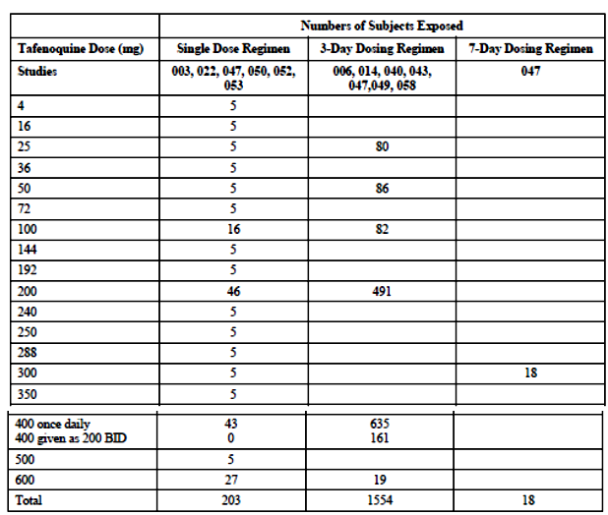
Table 20: Short-term studies tafenoquine drug exposure
Table 21: Adverse events (AE) reported in the short term used studies
Table 21 (continued): Adverse events reported in the short term used studies
Table 22: Drug exposure in studies that utilised the tafenoquine ACR; tafenoquine ACR, placebo, and mefloquine groups

Safety issues with the potential for major regulatory impact

Geriatric subjects
Only one subject over age 65 received tafenoquine in any of the sponsor’s clinical trials. The subject successfully completed the study and experienced no adverse events.

Race/ethnicity
Tafenoquine safety data were not segregated by race/ethnicity as race and ethnicity are not relevant for preventing malaria.

Glucose-6-phosphate dehydrogenase (G6PD) deficiency
G6PD deficient individuals are at risk of haemolysis when exposed to tafenoquine. Although almost all tafenoquine studies have excluded subjects with G6PD deficiency, 8 subjects with G6PD deficiency or other haemoglobinopathies were inadvertently recruited in 5 of the tafenoquine clinical trials and received tafenoquine regimens. Many of the subjects showed no signs or symptoms of haemolysis, and any who were symptomatic ultimately recovered, typically after receiving outpatient oral treatments. Only one subject (Study 043) required hospitalisation and transfusions. This subject had received 400 mg tafenoquine in the 3 day load-only group, a dose that is twice that of the 200 mg loading dose used in the tafenoquine ACR. Some of these subjects had initial negative genotypic testing for G6PD and were phenotypically negative. The only study specifically designed to investigate the use of tafenoquine in people with G6PD (Study 001) did not recruit and was abandoned.

Psychiatric history
Early clinical trials of tafenoquine did not exclude subjects based on previous psychiatric history. However, once it was identified that mefloquine carried a risk for psychiatric AEs any tafenoquine trial with a mefloquine comparator included a psychiatric exclusion. There were 6 subjects (Table 21) with known or suspected psychiatric history at baseline among 21 clinical trials of tafenoquine prior to 2013. Four of these subjects experienced neuropsychiatric AEs, while two subjects did not. In 3 of these 4 cases the AE was considered to be either unrelated or remotely related to tafenoquine. One episode of psychosis was considered ‘possibly’ related to tafenoquine, although the subject had an undisclosed history of two prior psychiatric admissions.

Effect of military deployment
For specific AEs, the increased incidence in deployed Australian defence force (ADF) subjects versus non-deployed subjects was evident for: motion sickness (4.3% versus 0%); gastroenteritis (37.2% versus 7.8%), nasopharyngitis (19.7% versus 3.3%), tinea pedis (4.9% versus 0%), diarrhoea (18.1% versus 4.8%), soft tissue injury (12.2% versus 0.6%), joint injury (3.7% versus 0.9%), laceration (5.9% versus 2.4%), joint injury (3.7% versus 0.9%), muscle strain (2.8% versus 0.9%), arthropod bite (2.4% versus 0.6%), heat illness (2.2% versus 0%), thermal burn (1.8% versus 0.3%), insomnia (1.6% versus 0.6%), and abnormal dreams or nightmares (1.6% versus 0%). Overall, the AE profile of deployed ADF subjects who received the tafenoquine ACR reflected the impacts of the following extrinsic factors: the subjects’ susceptibility to travellers’ illnesses (gastroenteritis, diarrhoea, nasopharyngitis); the jungle setting (tinea pedis, heat illness, arthropod bite); physical encounters with a hostile enemy (soft tissue injury, laceration, joint injury, muscle strain, thermal burn), and the stress of peacekeeping operations (insomnia, abnormal dreams, nightmares).These findings are consistent with evidence from other studies in military populations, that showed that the adverse effect profiles of antimalarial drugs were negatively impacted by deployment, especially combat deployment.

Postmarketing data
None reported.

Evaluator’s conclusions on safety
From the safety data provided it appears that the most common side effects seen in the group treated with tafenoquine (compared to placebo) were gastrointestinal-diarrhoea, Gastro oesophageal reflux disease (GORD), vomiting, which did not require drug discontinuation. Other AEs reported were unlikely to be related to study drug and more likely to be related to the conditions/context of the studies, such as ear pain, motion sickness, vortex keratopathy (corneal deposits) chest pain, seasonal allergy, body tinea, gastroenteritis, impetigo, nasopharyngitis, back pain. Gastro-intestinal side effects appear to be the most common treatment related AEs and are more common with higher doses.
Ocular changes, particularly asymptomatic, vortex keratopathy (corneal deposits), were also seen in Study 057, but were not serious and resolved.
The biggest potential safety issue, as with primaquine, seems to be the potential for haemolytic crisis in patients with G6PD deficiency. This group was largely excluded from these studies but the use of tafenoquine in people genetically more likely to have this deficiency. Neuropsychiatric adverse events were recorded in a small number of subjects (mainly in Study 033) but most were not thought to be related to study drug. There were no other red flag AEs but the safety data group is not very large.
Post-marketing safety data will be important and there is none available yet. There is no data for more than 26 weeks of use.

First round benefit-risk assessment

First round assessment of benefits
Table 23: Assessment of benefits
Indication
Benefits | Strengths and Uncertainties
An effective weekly drug for prophylaxis against malaria during potential exposure in endemic countries.  Evidence of post-exposure prophylaxis.  Efficacy against malaria generally and specifically against both Pv and Pf  Efficacy has been shown in different populations in different geographical locations.  Does not seem to have the AEs related to the other weekly malaria prophylaxis option (mefloquine).  Has good post-exposure efficacy due to long half-life.  Side effects similar to primaquine. | There is good data in non-immunes who took this drug regularly weekly (in Australian army volunteers). There is also good data for efficacy in two regions (studies conducted in Thailand and Ghana). A number of the other studies also showed good efficacy but had different dosages and regimens. Also, some studies had major logistical and reliability problems (such as with the malaria smears).  The neuropsychiatric side effects seen with mefloquine are not seen with tafenoquine generally, although there were some reported in Study 033 (conducted on ADF personnel during deployment).  A number of the studies were conducted 1 to 2 decades ago and the standards may be different to studies conducted more contemporaneously.  There are no studies comparing this drug against Malarone (now a commonly used malaria prophylaxis drug) and rapidly replaced mefloquine as standard of care.  No data about the long-term ocular effects of long term use (past 26 weeks).

First round assessment of risks
Table 24: Assessment of risks
Risks | Strengths and Uncertainties
Studies have been on small numbers and a number of them conducted decades ago.  Compliance in army studies has been very high this may not be so in reality.  There are no post-marketing data.  Local background malaria incidence data to really assess what kind of impact tafenoquine would have is lacking.  Because of the long half-life, the loading dose is important otherwise blood levels may not be sufficient by the time of exposure (one week after starting).  It is also important for post-exposure prophylaxis, that one dose is taken after leaving the endemic area.  Gastro-intestinal side effects are quite common, particularly diarrhoea (13% of subjects), GORD (2%) and vomiting (4%).  This drug is contra-indicated in people with G6PD but may also have adverse haematological effects in other people as well. Haemoglobin frequently decreases by 0.66 g/dL. Methaemoglobin characteristically increases to >1% but does not increase to as much as 10%, a level associated with hypoxia.  In Study 033, vortex keratopathy (corneal deposits) occurred in >8% of tafenoquine subjects. | Post-marketing data needs to be submitted to further assess the incidence of potentially serious side effects, particularly haematological and ocular.  Gastrointestinal AEs can be ameliorated to some extent by taking tafenoquine with food.  There were no changes in tests of visual fields, visual acuity, or colour vision in these subjects, and all subjects experienced complete resolution of their vortex keratopathy (corneal deposits) within 1 year after the end of tafenoquine dosing.  Vortex keratopathy (corneal deposits) resolved by the Week 48 follow-up visit in all tafenoquine ACR subjects.

First round assessment of benefit-risk balance
This assessment is very difficult to make. Statistically, Study 033 achieved its primary outcome; that tafenoquine was non-inferior to mefloquine. This prophylactic efficacy was also shown in Study 045 (in semi immunes in Africa). The well conducted challenge Study TQ-2016-02, reinforces the efficacy of tafenoquine against the asexual stages of malaria (but obviously is not a comparable environment or duration). Overall, the benefit-risk balance of tafenoquine for the proposed usage is favourable.
Tafenoquine is a drug that fills a gap in relation to malaria prophylaxis need. It may prove to be very useful, as a once weekly option. It doesn’t have the neuropsychiatric side effects that mefloquine does but it does have potential for serious haematological side effects and the ocular side effects also need to be studied further in the Risk Management Plan (RMP). There is also no post-marketing data to confirm safety or data past 26 weeks. It would also have been ideal to see some studies comparing tafenoquine to Malarone, which is being increasingly used but does require daily therapy.
Although, on balance, the clinical evaluator thinks this drug fills a need, more safety data is needed, particularly in relation to use in heterozygotes for G6PD and the ocular side effects. There should be an undertaking to collect this.

First round recommendation regarding authorisation
Whilst it would be nice to see the licensing of a new drug that obviously has efficacy against malaria and allows weekly rather than daily dosing, the clinical evaluator believes that more data is needed. Given that Malarone is now the preferred option for malaria prophylaxis in Australia, it would be good to see a comparative trial against this medication.
Whilst it would be nice to see the licensing of a new drug that obviously has efficacy against malaria and allows weekly rather than daily dosing, the clinical evaluator believes that more data is needed. Given that Malarone is now the preferred option for malaria prophylaxis in Australia, it would be good to see a comparative trial against this medication.

Second round evaluation
The second round evaluation including the issues raised by the evaluator (Clinical questions), the sponsor’s responses and the evaluation of these responses please see Attachment 2.

Second round benefit-risk assessment

Second round assessment of benefits
There is only one additional benefit that can be documented from the additional information. Up to 5% of ADF personnel returning to Australia after deployment to South East Asia develop malaria, probably due to compliance problems with compliance with current post-exposure prophylaxis regimens (mefloquine and doxycycline). Tafenoquine has potential to prevent this with one post-exposure dose according to the data presented.

Second round assessment of risks
No new clinical information was submitted in response to questions. Accordingly, the risks of tafenoquine are unchanged from those identified in the first round evaluation (see above).

Second round assessment of benefit-risk balance
The changes recommended should be adopted (see recommendations regarding authorisation below).

Second round recommendation regarding authorisation
The ADF data about the risk of malaria in returned ADF personnel is the strongest argument so far for the licensing of this drug in Australia.
Unfortunately, there is still no comparative data with Malarone. The clinical evaluator would however support licensing of tafenoquine for use in military personnel (or other personnel at high risk of malaria) in whom other, licensed prophylaxis drugs are contra-indicated or not tolerated (this would require a change in the wording of the indication).

VI. Pharmacovigilance findings

Risk management plan
The sponsor has submitted EU-RMP version 1.0 (dated 28 August 2017; Data Lock Point (DLP) 28 August 2017) and Australian Specific Annex (ASA) version1.0 (dated 3 July 2017) in support of this application. In the sponsor’s response to TGA’s request for further information, the sponsor has submitted EU-RMP version 2.0 (dated 30 January 2018; DLP 21 August 2017) and ASA version 2.0 (dated 30 January 2018).
The proposed Summary of Safety Concerns and their associated risk monitoring and mitigation strategies are summarised below (Table 25).
Table 25: Summary of ongoing safety concerns
Summary of safety concerns* |  | Pharmacovigilance |  | Risk Minimisation
 |  | Routine (R) | Additional (A) | R | A
Important identified risks | Haemolytic anaemia in G6PD deficiency |  | – |  | –
Important identified risks | Methaemoglobinaemia |  | – |  | –
Important identified risks | Use in pregnancy |  | – |  | –
Important potential risks | Hyperplasia (renal) |  | – |  | –
Important potential risks | Hyperplasia (other) |  | – |  | –
Important potential risks | Renal function test abnormal |  | – |  | –
Important potential risks | Pulmonary function test decrease |  |  | – | –
Important potential risks | Anaemia |  | – |  | –
Important potential risks | Use in lactation |  | – |  | –
Important potential risks | Haemolytic anaemia due to use in combination with dapsone in G6PD normal individuals** |  | – |  | –
Important potential risks | Ophthalmic safety (impaired vision due to long-term macular and retinal changes) |  |  |  | –
Important potential risks | Psychiatric adverse events |  |  |  | –
Missing information | Safety in paediatric populations |  |  |  | –
Missing information | Use in patients with severe renal impairment |  | – |  | –
Missing information | Use in patients with hepatic impairment |  | – |  | –
Missing information | Use in patients 65 years of age or older |  | – |  | –
Missing information | Long term safety > 6 months continuous use |  |  |  | –
*Information regarding routine and additional pharmacovigilance and risk minimisation activities has been obtained from Table 3 of the ASA not Table 4 of the Summary of the RMP. ** Recommended by the RMP evaluator in the second round evaluation and agreed to by the sponsor
Additional pharmacovigilance activities include:
- Study 60PH04, currently ongoing, to assess long-term macular and retinal changes as well as long term safety (see table above for applicable safety concerns).
- A planned paediatric study (Study TQ-20XX 04: A dose range placebo-controlled, double-blind study of oral tafenoquine for prophylactic efficacy, safety and tolerability in subjects resident in a malarious area of Africa) is not scheduled to start until 2022 after a paediatric formulation is developed and is found to be bioequivalent to the adult tablet formulation, and after the results of Study 60PH04 are known.
No additional risk minimisation activities are proposed but the sponsor has committed to the distribution of a Dear Doctor Letter regarding the risk of haemolytic anaemia in G6PD deficiency, the effectiveness of which will be assessed by a survey. Whilst a Dear Healthcare Provider Letter (DHCPL) is a useful reminder to HCPs about avoiding AEs, information about the distribution of this letter (that is, how recipients were identified, a summary of who it was distributed to and how) would suffice for evaluation and a survey is not considered necessary from a regulatory perspective.

New and outstanding recommendations
The revised ‘Dear Dr letter’ should be reviewed by the TGA when available prior to circulation.

Issues to be addressed in the ASA when revised
- The Important Potential Risk should state ‘Haemolytic anaemia due to use in combination with dapsone in G6PD normal individuals’ to be consistent with the PI.

Issues regarding tables in ASA
- It is unclear if Study 60PH04 (additional pharmacovigilance) is collecting information on all identified important risks including pregnancy (which is probably not the case). The sponsor should use the pharmacovigilance column to indicate which safety concern has routine pharmacovigilance as well as which will have additional pharmacovigilance assigned and what the study number is; that is, what safety concerns are the ongoing study and the proposed study collecting information for. The risk minimisation column should include whether each safety concern and missing information has routine risk minimisation as there are no additional risk minimisation activities. The Dear Doctor letter is considered a routine activity. (Probably all the safety concerns and Missing Information will have routine risk minimisation except ‘decrease in pulmonary function’ (if it remains as an Important Potential Risk) as this is not mentioned in the PI).
- The bioequivalence study is not considered to be an additional pharmacovigilance study and should be removed from Table 2.

Other advice to the delegate
The evaluator recommended amendments to the PI and Consumer Medicine Information (CMI) documents but the details of these are beyond the scope of this AusPAR.

Wording for conditions of registration
Any changes to which the sponsor has agreed should be included in a revised RMP and ASA. However, irrespective of whether or not they are included in the currently available version of the RMP document, the agreed changes become part of the risk management system.
The suggested wording is:
The Kodatef EU-Risk Management Plan (RMP) (version 2.0, dated 30 January 2018, data lock point 21 August 2017), with Australian Specific Annex (version 2.0, dated 30 January 2018), included with submission PM-2017-02418-1-2, and any subsequent revisions, as agreed with the TGA will be implemented in Australia.
The following wording is recommended for the PSUR requirement:
An obligatory component of risk management plans is routine pharmacovigilance. Routine pharmacovigilance includes the submission of Periodic Safety Update Reports (PSURs).
Unless agreed separately between the supplier who is the recipient of the approval and the TGA, the first report must be submitted to TGA no later than 15 calendar months after the date of this approval letter. The subsequent reports must be submitted no less frequently than annually from the date of the first submitted report until the period covered by such reports is not less than three years from the date of this approval letter. The annual submission may be made up of two PSURs each covering six months. If the sponsor wishes, the six monthly reports may be submitted separately as they become available.
The reports are to at least meet the requirements for PSURs as described in the European Medicines Agency’s Guideline on good pharmacovigilance practices (GVP) Module VII-Periodic Safety Update Report (Rev 1), Part VII.B Structures and processes. Note that submission of a PSUR does not constitute an application to vary the registration. Each report must have been prepared within ninety calendar days of the data lock point for that report.
As Kodatef is a new chemical entity it should be included in the Black Triangle Scheme as a condition of registration. The following wording is recommended for the condition of registration:
Kodatef (tafenoquine) is to be included in the Black Triangle Scheme. The PI and CMI for Kodatef must include the black triangle symbol and mandatory accompanying text for five years, which starts from the date that the sponsor notifies the TGA of supply of the product.

VII. Overall conclusion and risk/benefit assessment
The submission was summarised in the following Delegate’s overview and recommendations:

Quality
All quality issues have been satisfactorily resolved. Overall, chemistry, quality control, manufacture and Good Manufacturing Practice (GMP) aspects are acceptable from a quality perspective and approval is supported.

Nonclinical
The nonclinical studies were compliant with the applicable guidelines and GLP requirements and the dataset was overall considered adequate for evaluation.
Based on the pivotal repeat dose studies in mice, rats and dogs (low exposures compared to the intended clinical dosing) the major target organs for tafenoquine were the lung (phospholipidosis), liver (centrilobular inflammation, apoptosis, fatty change and increased plasma transaminases) and kidney (tubular nephrosis, necrosis and dilation at 13 weeks in the rat; not present in the dog).
The relevant studies did not indicate significant potential for mutagenicity or teratogenicity. The sponsor has proposed Pregnancy Category D. The nonclinical evaluators consider the data consistent with Pregnancy Category C.
The carcinogenic potential of tafenoquine by the oral route was assessed in mice and rats in conventional 2 year carcinogenicity studies as per relevant ICH guidelines.
In the mice carcinogenicity study, group sizes (60/sex) and duration of dosing (2 years) were appropriate. The selection of tafenoquine doses in the 2 year study was based on the maximum tolerated dose (1 mg/kg) in a previous 13 week dose ranging mice study. Tafenoquine was not carcinogenic at up to 1 mg/kg/day dose (approximately 0.3x the clinical AUC) in mice. The NOAEL in this study was 1 mg/kg.
In the rat carcinogenicity study, tafenoquine was given daily by oral gavage, at doses of 0, 0.1, 0.5, 1 or 2 mg/kg/day (equivalent to approximately 0, 0.03. 0.26, 0.71 and 1.6 times the clinical AUC respectively) for 2 years. Incidence of renal tumours (renal cell adenoma at 1 and 2 mg/kg/day with only one incidence of carcinoma at 2 mg/kg/day) and cortical hyperplasia in male rats at 2 mg/kg/day were observed. CPN was also increased in male rats at these doses. The selection of tafenoquine doses for the 2 year study was based a previous 6 month toxicity study in which 0.5, 2.0 and 9 mg/kg tafenoquine doses were administered to CD rats and 2 and 9 mg/kg doses showed decreased body weight, alterations in haematology and pathology changes. A NOAEL was not established in the rat carcinogenicity study as there was an increase in the incidence of cholesterol clefts and chronic interstitial pneumonia in rats at the low dose of 0.1 mg/kg/day.
In another 13 week rat study, immunostaining of kidney sections showed increased Ki67 and proliferating cell nuclear antigen, both of which are markers of cell proliferation, in both sexes at 18 mg/kg/day and in males at 2 mg/kg/day. In the same 13 week study there were also karyomegaly in the outer strip of renal medulla at 2 or 18 mg/kg/day and diffuse medullary epithelial vacuolation and single cell necrosis in both sexes at 18 mg/kg/day.
The nonclinical evaluator note as follows:
The above findings, together with the absence of genotoxicity, point to a non-genotoxic mechanism of renal carcinogenicity. The renal tumours in rats probably resulted from chronic cellular damage leading to cell regeneration, proliferation, hyperplasia and finally renal tumours. The exact mechanism is unclear but CPN might be a contributing factor since renal tumours were observed only in male rats. The renal tumours in rats are considered clinically relevant. However, the risk of renal tumours in humans is low given (i) proposed treatment duration of 6 months cf. the life time exposure in the rat carcinogenicity study, (ii) the absence of tumours in the 6-month rat study and in the mouse carcinogenicity, study and (iii) the absence of hyperplasia of renal tubule cells in the one year dog study.
The sponsor has also commented on the observed changes in its proposed text for the PI as follows:
[Information redacted]
The nonclinical evaluators however also note as follows:
The renal tumours in rats probably resulted from chronic cellular damage leading to cell regeneration, proliferation, hyperplasia and finally renal tumours. The exact mechanism is unclear but chronic progressive nephropathy (CPN) was increased in male rats at these doses, suggesting CPN might be a contributing factor since renal tumours were observed only in male rats. CPN is a common renal lesion in male rats with no counter-part in humans, and is not considered relevant to human risk assessment. Considering other findings described above in both sexes in the 13 week study and that the exact mechanism is unclear, renal tumours in male rats treated with tafenoquine are clinically relevant.
The recommendation from the nonclinical evaluator is as follows:
Provided the above effects are adequately monitored or managed during clinical use and that the benefit/risk profile seems acceptable from a clinical perspective, there are no objections on nonclinical grounds to the proposed registration of tafenoquine succinate (Kodatef).

Clinical
The clinical dossier supporting this submission comprised of full clinical development program for tafenoquine, including a number of Phase I PK/PD studies, 3 Phase II studies (Study 006 dose ranging study; Study 043 proof of concept study; Study 044 400 mg dosing study in semi-immune population), 3 malaria challenge studies (Studies 053, 054 and Study TQ-2016-02; all in non-immune subjects), 2 Phase III studies in malaria prophylaxis (Study 033 pivotal active-controlled study in non-immune population; Study 045 placebo controlled study in semi-immune population), 2 malaria treatment studies (Studies 048 and 057) and clinical safety only studies including the Study 057.
The sponsor’s response to the second round clinical evaluation has also been reviewed in preparation of this overview.

Pharmacokinetics
The proposed formulation for marketing is tafenoquine immediate release tablets for oral administration containing active ingredient 125.5mg tafenoquine succinate equivalent to 100 mg tafenoquine base.
The Study TQ-2016-01 showed that following administration of 200 mg (2 x 100 mg) of the marketing formulation, the PK parameters (AUC, C_{max} and t_{½}) were equivalent to the historic values with 200 mg capsule formulation used in prior clinical work.
Dose proportionality was demonstrated in Study 050 as follows in Figure 2.
Figure 2: Dose C_{max} proportionality of tafenoquine (Study 050)
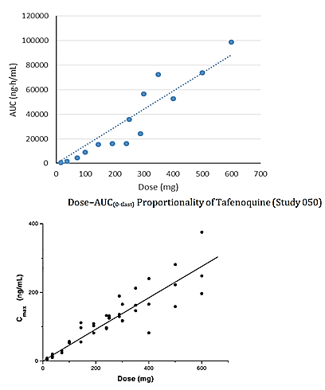
In Study 051, healthy volunteers received 10 weekly administrations of 200 or 400 mg tafenoquine. The accumulation ratio for the 200 mg dose was approximately 4. The PK features were as follows (Table 26).
Table 26: PK profile of tafenoquine
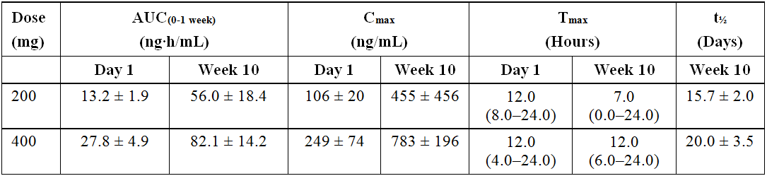
Tafenoquine is >99.5% plasma protein bound and concentrations in blood and RBC were 2.0 and 3.4 times higher than in plasma (Study 052).
The consolidated PK data from various studies were used to determine population PK parameters (clearance and volume of distribution) as follows:
- CL/F: 4.17 L/h
- Vd/F: 2470 L
After administration of a single dose of tafenoquine in fed and fasted states (Study 022), a food effect of 41% higher AUC and 31% higher C_{max} was demonstrated.
In Study 014, following oral tafenoquine 400 mg daily for 3 days, small amounts of > 18 drug-related components were detected in urine. These were thought to be the result of metabolism or degradation via O-demethylation, O-dearylation, N-dealkylation, deamination, oxidation, N-carbamylation, N-acetylation and glucuronide conjugation pathways. None of these drug-related compounds were identified in plasma that is, only parent drug was extractable from plasma.
Human radiolabelled mass balance studies have not been conducted due to long half-life of the drug. Animal data suggested extensive reabsorption of biliary excreted radioactivity and enterohepatic circulation of drug and/or metabolites.
There are no studies in patients with hepatic or renal impairment.
Tafenoquine does not significantly inhibit or induce CYP2D6, CYP3A4, CYP2C9 or CYP1A2 in vivo. Tafenoquine was shown to be an inhibitor of renal multidrug and toxin extrusion transporters (MATE 1 and 2) and organic cation transporter (OCT2) in in vitro studies. The effect of tafenoquine on drug transporter proteins has not been studied in vivo.

Pharmacodynamics
The molecular target of tafenoquine is unknown. Tafenoquine mainly kills the developing asexual, exoerythrocytic (liver) form of malarial parasite (causal prophylaxis) but a level of erythrocytic stage activity as a blood schizontocide (suppressive prophylaxis) also likely plays a role in its efficacy during continuous prophylaxis.
In a non-sponsor clinical study (Study TAF114582, N=260), there was no effect on corrected QT prolongation after a single tafenoquine dose of 300 mg or 600 mg. A mean 6.6 ms prolongation of QTcF compared to placebo was seen at 72 hours post final dose in a group that received a total tafenoquine dose of 1200 mg over 3 days (400 mg x 3 days).

Dose selection
In human malaria challenge Study 053, one subject became parasitaemic on study Day 31. This subject had a peak parasitemia of 192/mm³ with onset of clinical symptoms on study Day 28. The subject had a peak tafenoquine concentration of 182 ng/mL and this had declined to 48 and 18 ng/mL at 31 and 44 days respectively.
In Phase II Study 044, tafenoquine 400 mg daily loading for 3 days followed by 400 mg monthly resulted in 3 symptomatic breakthroughs at 6 to 12 weeks following prophylaxis. Of these, 2 subjects had Pv relapse with tafenoquine plasma concentrations between 20 and 21 ng/mL, and one participant had Pf relapse with tafenoquine concentration 38 ng/mL. Additionally, one subject had Pv relapse during the prophylaxis phase with tafenoquine concentration of 40 ng/mL. This level was a third of the mean trough level of subjects who were compliant with medication and did not contract malaria during the same period. Measured trough concentrations were never <54.5 ng/mL amongst a sample of the 96 individuals who completed a 6 month course of medication and who did not contract malaria.
Based on this information a target plasma concentration of 80 ng/mL as the minimum target trough value for prevention of symptomatic malaria in non-immune individuals was proposed. Population PK analysis predicted that the proposed prevention regimen (200 mg daily x 3 days, then 200 mg weekly) will achieve trough levels >80 ng/mL in >95% subjects.

Efficacy
The pivotal efficacy trial in this submission is Study 033.

Pivotal efficacy Study 033
The Study 033 was a randomised, double-blind, Phase III trial to investigate prophylactic efficacy of tafenoquine compared with mefloquine in adult, non-immune population during extended overseas stay in a malaria endemic area (Australian soldiers deployed to East Timor from 2000 to 2001).
The study was approved by the Australian Defence Human Research Ethics Committee. All participating subjects gave written informed consent.
Subjects with documented G6PD enzyme deficiency or a history of psychiatric disorders and/or seizures were excluded, among others. In addition, subjects with any significant medical history or concurrent conditions were excluded. All subjects were considered healthy at baseline. The study was conducted in 2 phases (prophylactic phase and post-prophylaxis relapse follow-up phase).
A total of 654 subjects were randomised (3:1) to 2 parallel treatment groups (492 in tafenoquine arm and 162 in mefloquine arm). The subject accountability during the prophylactic phase was as follows in Table 27.
Table 27: Subject disposition; all screened subjects (number of subjects)
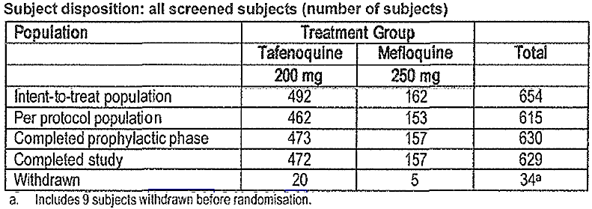
The study treatments during the 2 phases of the study were as follows (all study drugs were to be taken with food):
- Prophylactic phase: 24 ± 2 weeks of treatment during deployment when subjects received the randomised study treatments in the respective groups (tafenoquine or mefloquine) as follows:
  - Loading dose: tafenoquine 200 mg or mefloquine 250 mg once daily for 3days
  - Maintenance dose: tafenoquine 200 mg or mefloquine 250 mg once a week for 24 weeks
- Relapse follow-up phase: After exit from malaria endemic area, the subjects entered a 24 week relapse follow-up phase (later extended to 1 year) during which they received the study drugs in the respective groups as follows:
  - Primaquine 15mg twice daily for 14 days in mefloquine group
  - Placebo twice daily for 14 days in tafenoquine group
At Baseline, the 2 groups were generally comparable with respect to main demographic characteristics. Nine subjects (1.8%) in tafenoquine compared to 1 subject (0.6%) in mefloquine group had history of malaria in the past 6 months prior to the study (Table 28):
Table 28: Baseline characteristics
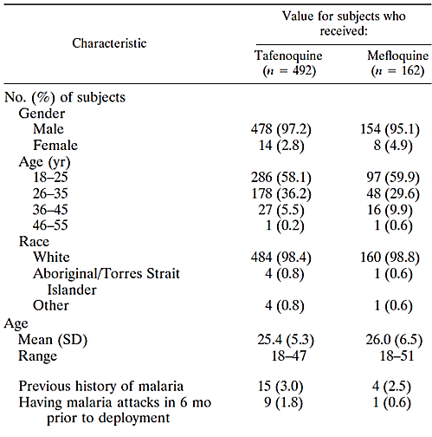
Thick and thin blood smears were collected from all subjects at screening and at Weeks 4, 8 and 16 during prophylactic phase, and at Weeks 2 and 12 during the relapse follow-up phase or if symptoms suggestive of malaria developed.
The times (days) from last dose of study drug to departure from deployment in East Timor were as follows in Table 29.
Table 29: Time from last dose to departure from East Timor; Intent-to-treat and Per protocol populations
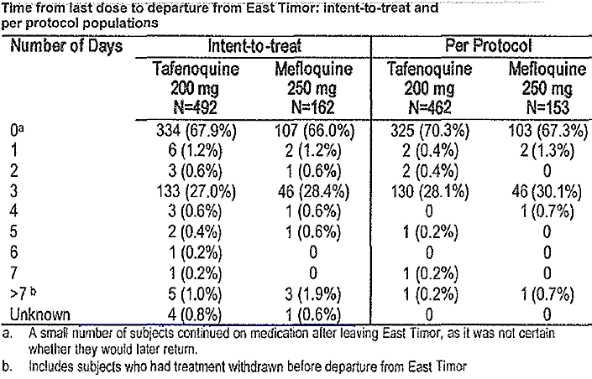
The primary efficacy analysis was to be based on Per protocol (PP) population (subjects who met the inclusion criteria, were protocol compliant, and completed the prophylactic and relapse follow-up phases). The reasons for protocol violation leading to exclusion from the PP analysis were as follows (Table 30).
Table 30: Number (%) of subjects with protocol violations leading to exclusion from the per protocol population; Intent-to-treat population
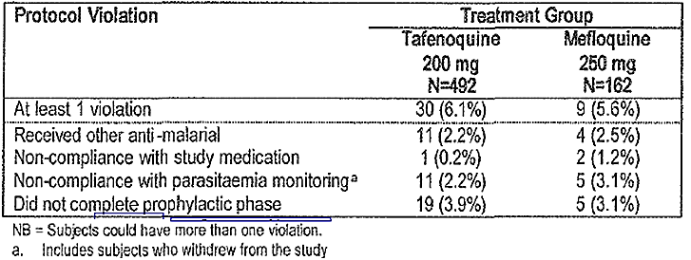
A very high compliance was reported in the study-100% for the loading dose, 99% for the weekly regimens and 96% during the relapse follow-up phase. The results were as follows (Table 31):
Table 31: Prophylactic outcome by treatment group, prophylactic phase (Study 033)
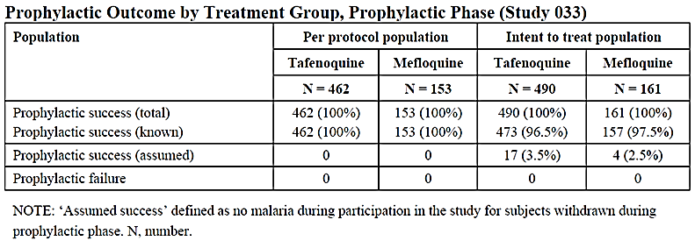
Thus there was no case of parasitemia/symptomatic malaria (all species) in either group during the prophylactic phase using both PP and ITT populations.
The historical data indicate that 7.9% subjects (6.9%Pv, 1.0%Pf) would have been expected to contract malaria in the absence of treatment under the conditions of deployment in East Timor at that time. On this basis, both drugs were highly efficacious in preventing malaria (100%) and had equivalent (non-inferior) prophylactic efficacy (nil case reported in either arm).
A total of 4/462 cases (0.9%) of malaria in tafenoquine group and 1/153 case (0.7%) of malaria in mefloquine/primaquine group were reported during the 6 months relapse follow-up phase as follows (Table 32).
Table 32: Prophylactic status by treatment group, prophylactic and follow-up phases (Study 033)
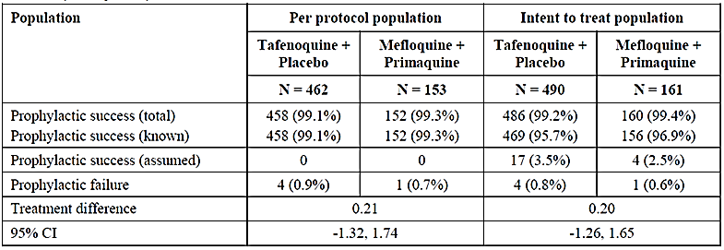
All 5 cases were Pv malaria and occurred between 12 and 20 weeks after the end of study treatments in the prophylactic phase. Any relationship to the timing of the last dose from departure from the malarious area was not reported (Table 33):
Table 33: Time to relapse for Study 033
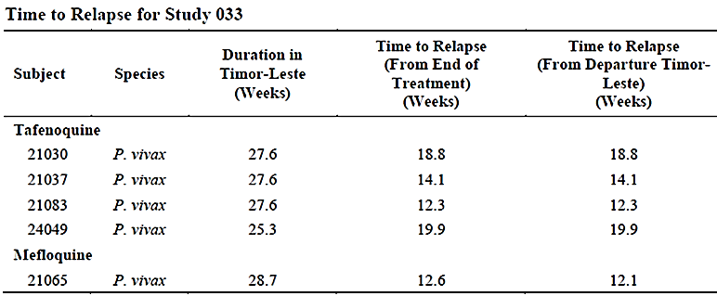
The relapse follow-up was extended for another 6 months (a total of 12 months post-prophylactic phase). There were 3 more cases of malaria in tafenoquine group and one case of malaria in mefloquine/primaquine group during this 6 months extension, bringing to a total of 7 Pv relapses in tafenoquine group and 2 Pv relapses in mefloquine/primaquine group during the 12 months relapse follow-up after the end of prophylactic phase.

Other efficacy studies
A number of additional efficacy studies have been included in dossier. None of these were in the intended target population (non-immune individuals from non-endemic areas with expected high risk exposure to malaria during temporary stay in endemic regions). In general, these studies in semi-immune populations included presumptive treatment of malaria to eradicate existing parasitemia before the start of the prophylaxis study:
- Study 030, a randomised, double-blind, placebo-controlled study (N=36) in western Kenya with 3 treatment arms (tafenoquine 200 mg once daily for 3 days, then 200 mg once weekly or mefloquine 250 mg once daily for 3 days followed by 250 mg once weekly or placebo for 24 weeks).
- Study 043, a ‘proof-of-concept’, randomised, double blind, placebo-controlled study (N=229) in Western Kenya with 4 treatment arms (tafenoquine 400 mg for 3 days only or tafenoquine 200 mg for 3 days followed by 200 mg weekly or tafenoquine 400 mg then 400 mg weekly or placebo for 10 to 15 weeks).
- Study 044, a Phase II randomised, double-blind, placebo-controlled study (N=205) in Thai soldiers with 2 treatment arms (tafenoquine 400 mg daily for 3 days followed by 400 mg monthly or placebo for 5 months).
- Study 045, a randomised, double-blind, placebo-controlled study (N=509) in northern Ghana with 4 treatment groups (tafenoquine 25, 50, 100 or 200 mg) or mefloquine (250 mg), or placebo (daily for 3 days, then weekly for 12 weeks). In the placebo group, 91.5% subjects had a positive smear. Although some protection was offered by tafenoquine 25mg dose, the greatest protection was obtained with the 3 highest doses of tafenoquine (50, 100, 200 mg). For confirmed parasitemia (2 consecutive positive smears), there were no subjects in the 2 highest tafenoquine dose groups (100 or 200 mg) or in mefloquine group. Analysis of incidence density demonstrated an attack rate of approximately 9/PY in placebo arm compared with approximately 4/PY in the tafenoquine 25mg and <1/PY in tafenoquine 50, 100 or 200 mg or mefloquine 250 mg arms.
An overview of estimated prophylactic efficacy in the 5 efficacy studies (Studies 030, 033, 043, 044 and 045) is as follows in Figure 3.
Figure 3: Estimated prophylactic efficacy in the 5 efficacy studies (Studies 030, 033, 043, 044 and 045)
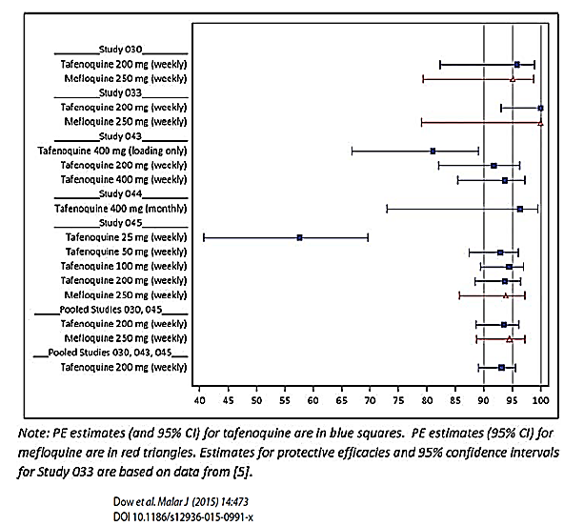
Other studies include shorter term prophylaxis Study 006, acute treatment Study 058, radical cure Study TAF112582, dose ranging anti-relapse Studies 047 and 049 and the recent human malaria challenge Study TQ-2016-02.

Safety
Overall, the safety database in this submission includes data on 3184 subjects comprising both non-immune and semi-immune populations from various geographical regions.
Of those, a total of 825 received tafenoquine in the anticipated clinical regimen (ACR) in 5 studies (Studies 030, 033, 043, 045, 057), 104 subjects received tafenoquine 400 mg weekly in one study (Study 044), 309 subjects received mefloquine in 3 studies (Studies 030, 033, 045) and 396 subjects received placebo in 5 studies (Studies 030, 043, 044, 045, 057) (ACR dataset).
In addition, a total of 491 subjects have been exposed to tafenoquine 200 mg daily x 3 days loading dose only (Studies 006, 049) and 713 have been exposed to tafenoquine 400 mg daily x 3 day loading dose only (Studies 043, 049 and 058).
The demographic characteristics of the pooled safety set (ACR dataset) were as follows (Table 34).
Table 34: Demographic characteristics; Pooled safety data set
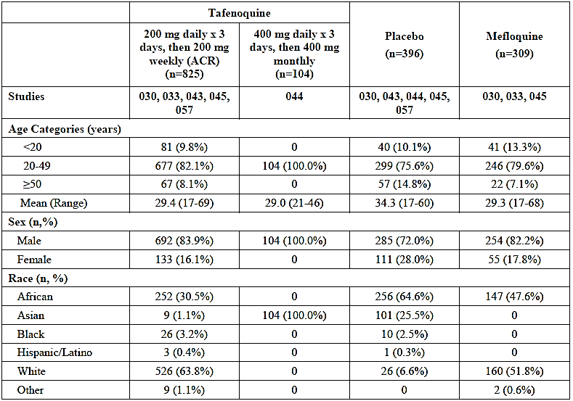
An overview of adverse effects profile of the tafenoquine ACR population compared to the active comparator mefloquine and placebo is as follows (Table 35).
Table 35: Adverse effects profile of the tafenoquine ACR population compared to the active comparator mefloquine and placebo
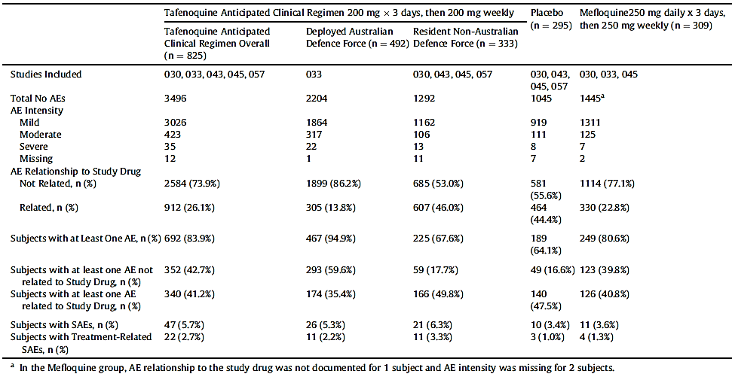
Incidence of selected AEs in the ACR data set was a follows (Table 36).
Table 36: Incidence of selected AEs in the ACR data
AE | tafenoquine (n=825) | Placebo (n=396) | mefloquine (n=309)
Keratopathy | 8.2% | 0% | 0%
Diarrhoea | 12.7% | 5.8% | 10.7%
Gastroenteritis | 25.3% | 4.3% | 22.7%
GERD | 1.7% | 0.3% | 1.9%
Vomiting | 3.8% | 1.5% | 3.6%
Nasopharyngitis | 13.1% | 2.3% | 8.7%
Viral infection | 5.8% | 1.5% | 7.4%
Chest Pain | 2.2% | 1.3% | 3.6%
Soft tissue injury | 7.5% | 0% | 6.1%
Arthralgia | 7.4% | 3.8% | 9.7%
Back Pain | 14.1% | 6.6% | 13.3%
Lethargy | 2.9% | 0% | 3.6%
Insomnia | 1.2% | 0.8% | 0.3%
Heat Rash | 6.4% | 0% | 5.8%
Rash | 3.0% | 0.5% | 2.3%
Note that in ACR studies, keratopathy was documented as AE in Study 033 only. A summary of ophthalmic AEs in ACR dataset is as follows in Table 37.
Table 37: Summary of ophthalmologic adverse events tafenoquine ACR group versus placebo and mefloquine
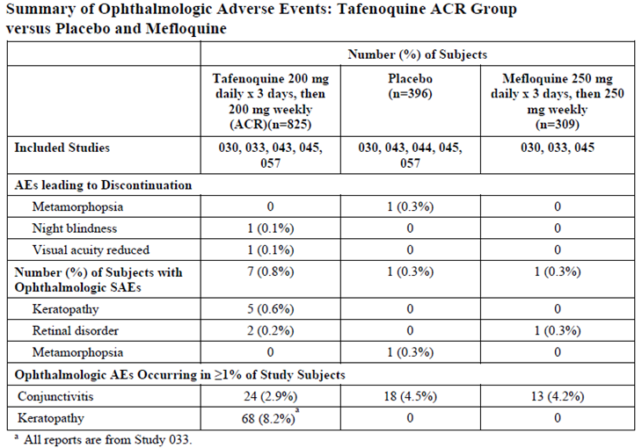
The incidence of haemoglobin decrease, haemolytic anaemia and methaemoglobin in tafenoquine ACR population was higher than in placebo subjects indicative of a causal effect (Table 38).
Table 38: Incidence of specific haematological findings tafenoquine ACR group versus placebo
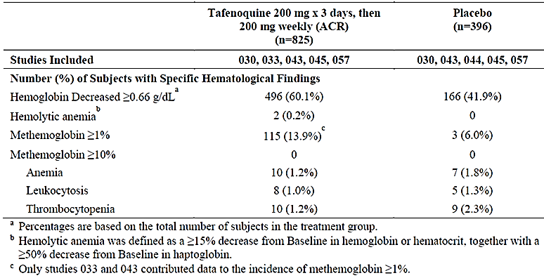
Once it was identified that mefloquine carried a risk for psychiatric AEs, any tafenoquine trial with a mefloquine comparator required a psychiatric exclusion. There were 6 subjects with known or suspected psychiatric history at baseline among 21 clinical trials of tafenoquine prior to 2013. Four of these subjects experienced neuropsychiatric AEs. In addition, one episode of psychosis in tafenoquine subject was reported in a subject with an undisclosed history of prior psychiatric admissions. A summary of neuropsychiatric AEs in the ACR dataset is as follows (Table 39).
Table 39: Summary of neuropsychiatric AEs in the ACR dataset tafenoquine versus placebo and mefloquine
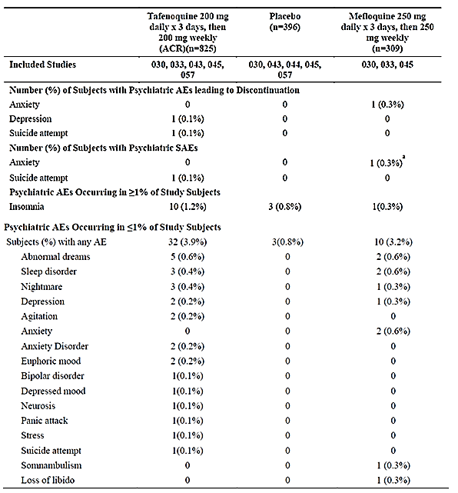
A summary of laboratory investigation in the ACR dataset is as follows (Table 40).
Table 40: Laboratory investigation in the ACR dataset
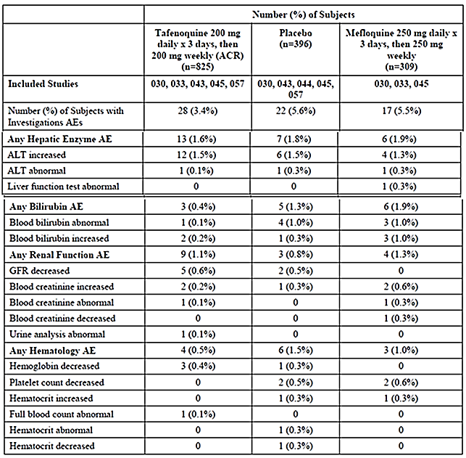
One death has been reported in the ACR dataset (Study 045) but was not considered study drug-related.
The safety outcomes reported in Study 033 are of most interest for direct comparison of tafenoquine with mefloquine. The AEs reported in Study 033 during prophylactic phase were as follows.
Table 41: Number (%) of subjects with the most frequently reported adverse events (greater than or equal to 5% of subjects in either treatment group) during prophylactic phase; Safety population
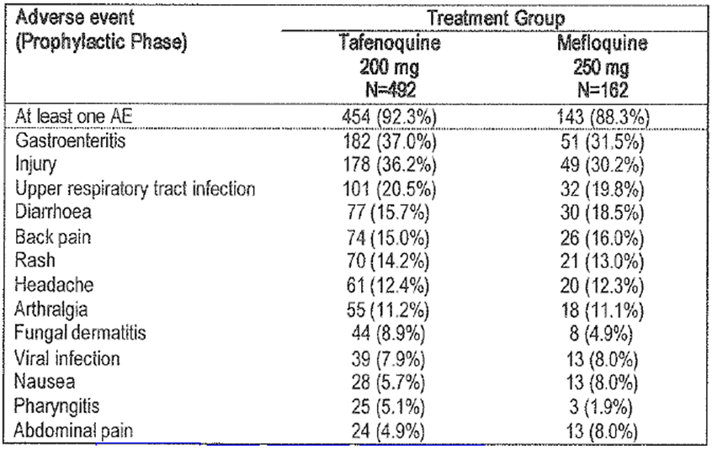
The AEs reported in Study 033 during relapse follow-up phase were as follows (Table 42).
Table 42: Number (%) of subjects with the most frequently reported adverse events (greater than or equal to 2% of subjects in either treatment group) during relapse follow-up phase; Safety population
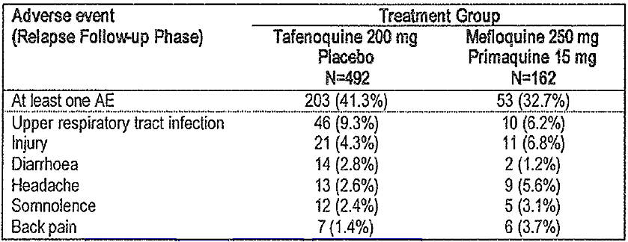
SAEs reported in Study 033 during prophylactic phase were as follows (Table 43).
Table 43: Number (%) of subjects with serious adverse events; Safety population
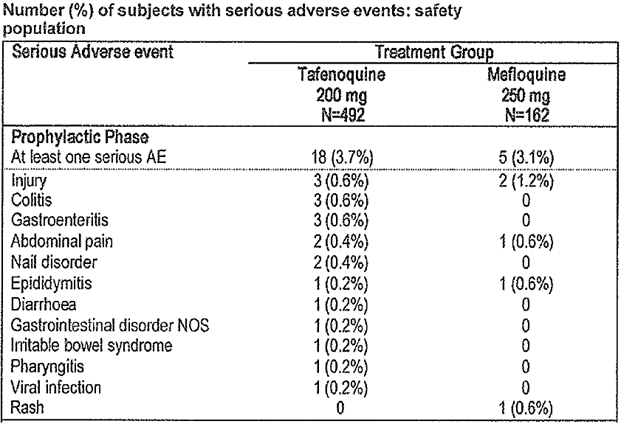
SAEs reported in Study 033 during relapse follow-up phase were as follows (Table 44):
Table 44: Number (%) of subjects with serious adverse events; Safety population
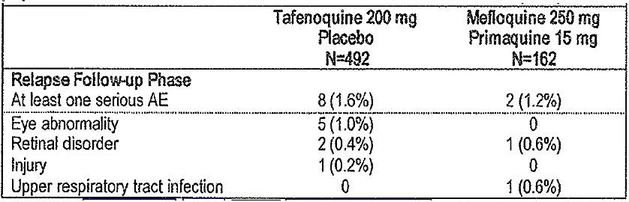
In a subset of subjects recruited for detailed safety assessments, treatment-related vortex keratopathy was detected in 69/74 (93%) tafenoquine subjects but none of the 21 mefloquine subjects. There were no reported changes to visual acuity, colour vision or visual fields in these keratopathy subjects. All subjects were reported to have achieved resolution of keratopathy within 1 year after the end of tafenoquine dosing (Table 45).
Table 45: Number of patients with keratopathy within 1 year after the end of tafenoquine dosing
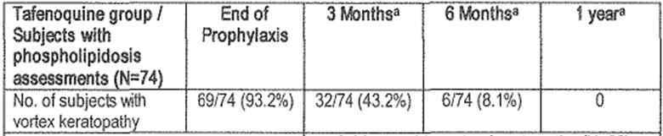
An expert ophthalmology advisory panel concluded that vision had not been affected in any persons but that the relevance of minor retinal findings, in the absence of baseline assessments could not be ascertained.
To further characterise renal and eye findings in Study 033, another exclusive safety Study 057 (randomised, double-blind study of 6 months duration, in non-immune population in UK/USA for the assessment of renal and ophthalmic effects of tafenoquine (200 mg daily for 3 days then weekly for 23 weeks n=81 versus placebo n=39) has been carried out. The outcomes have been reported as follows.
No difference was shown in mean change in GRF in tafenoquine subjects compared to placebo subjects (Treatment difference -0.061mL/s/1.73m²) in this study (Table 46).
Table 46: Mean change in glomerular filtration rate from Baseline to Week 24 in the renally evaluable population
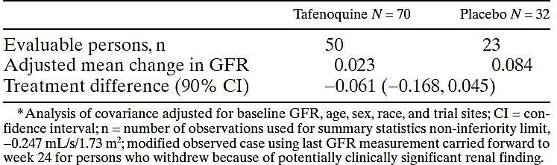
Various ophthalmic indices, in particular assessing function in terms of night vision, were reported as follows (Table 47).
Table 47: Forward light scatter test (FLST) results in the ophthalmically evaluable population
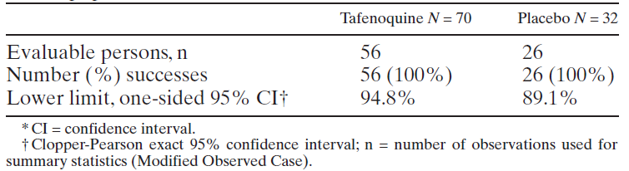
Table 48: Assessment of night vision by low contrast visual acuity test (LCVA), mesopic contrast threshold (MCT) tests and scotopic contrast threshold (SCT) test in the ophthalmically evaluable population
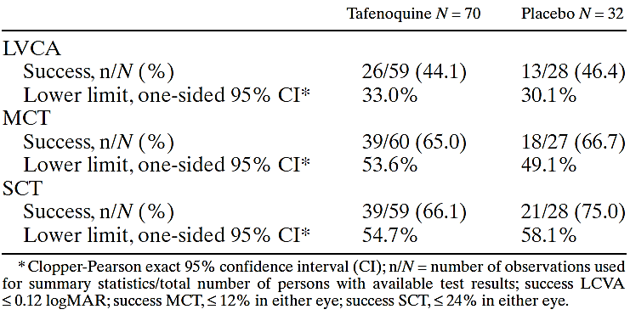
At screening, corneal deposits were detected in 10/70 (14.3%) and 7/32 (21.9%) in tafenoquine and placebo groups respectively. Treatment-emergent corneal deposits were reported in 15/60 (25%) tafenoquine subjects and 4/25 (16%) placebo subjects. In tafenoquine group, 14 new-onset corneal deposits are reported to have resolved within 12 weeks of onset. In the remaining one subject the corneal deposits resolved by 24 weeks post-dosing. In the 4 placebo subjects, the corneal deposits resolved within 6 weeks of onset.
Retinal abnormalities detected with digital photography were detected in subject in each group. This included a case of retinal hyperpigmentation in tafenoquine group not associated with visual disturbance and showed no change 11 months after cessation of therapy.
The AEs reported in this study were as follows (Table 49).
Table 49: Adverse events occurring in >5% of persons in the Safety population
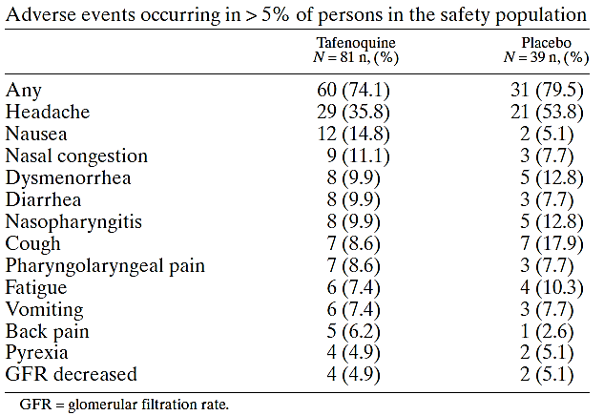
The SAEs reported in this study were as follows (Table 50).
Table 50: Serious AEs in the Safety population
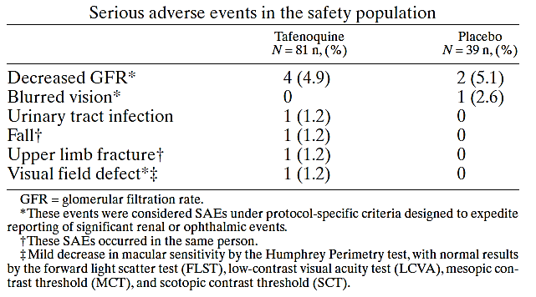
Another placebo-controlled, long-term ophthalmic safety study in non-immune population with larger sample size (expected enrolment of approximately 600 subjects) and longer treatment (expected weekly treatment with tafenoquine for 52 weeks) and follow-up (104 weeks) has been notified to be undertaken in Australia.
No post-marketing data are yet available for tafenoquine.

Risk management plan
This submission is supported by the Kodatef EU-Risk Management Plan (RMP) (version 2.0, dated 30 January 2018, data lock point 21 August 2017), with Australian Specific Annex (version 2.0, dated 30 January 2018).
The implementation of the submitted RMP, including any modifications agreed with the TGA post-market surveillance area, will be a condition of registration.
Renal hyperplasia and hyperplasia (other) are identified as important potential risks. Routine pharmacovigilance and risk minimisation activities are proposed.

Risk-benefit analysis

Delegate’s considerations
This is a submission for general marketing in Australia of tafenoquine succinate. Tafenoquine is a new chemical entity for the purposes of entry into the ARTG.
First reported in 1978, tafenoquine is a primaquine congener synthesised by adding a methoxy group at the 2 position, a methyl group at the 4 position, and a 3-trifluoromethylphenoxy substitution at the 5 position of the quinoline ring.
Tafenoquine is currently not registered in any overseas jurisdiction. A submission for use in malaria prophylaxis, based on similar data as in this submission, is [at the time of this overview] under review by the FDA in the USA.
The proposed product (Kodatef) is a film coated, immediate release, oral tablet containing 125.5 mg tafenoquine succinate salt equivalent to 100 mg tafenoquine base. The proposed therapeutic indication is:
Primary prevention of malaria in adults for up to 6 months of continuous dosing’. The proposed dosing is ‘loading dose of 2x100 mg tablets once daily for 3 days before travel, followed by 2x100 mg weekly maintenance doses while in malarious area, followed by single dose of 2x100 mg in the week following exit from the malarious area.
There are no outstanding chemistry/quality/manufacture/GMP issues preventing registration.
In the nonclinical report, renal tumours (renal cell adenoma at 1 and 2 mg/kg/day with one incidence of carcinoma at 2 mg/kg/day) and cortical hyperplasia at 2 mg/kg/day were observed in male rats in association with development of CPN in the 2 year rat carcinogenicity study. A NOAEL could not be established in this study.
In a 13 week rat study, immunostaining of kidney sections showed increased Ki67 and proliferating cell nuclear antigen in both sexes at 18 mg/kg/day and in males at 2 mg/kg/day. These (Ki67 and proliferating cell nuclear antigen) are markers of cell proliferation. Karyomegaly in the outer strip of renal medulla at 2 or 18 mg/kg/day and diffuse medullary epithelial vacuolation and single cell necrosis in both sexes at 18 mg/kg/day were also reported.
The nonclinical evaluators observe that ‘considering other findings described above in both sexes in the 13 week study and that the exact mechanism is unclear, renal tumours in male rats treated with tafenoquine are clinically relevant’.
Overall recommendation from the nonclinical evaluator is that ‘Provided the above effects are adequately monitored or managed during clinical use and that the benefit/risk profile seems acceptable from a clinical perspective, there are no objections on nonclinical grounds to the proposed registration of tafenoquine succinate (Kodatef)’.
There are no outstanding RMP issues preventing approval. Renal hyperplasia and hyperplasia (other) are noted as important potential risks. Routine pharmacovigilance is proposed.
The clinical evaluator considers that Study 033 (‘ADF data about the risk of malaria in returned ADF personnel’) is the strongest argument for marketing this drug in Australia and recommends approval of tafenoquine for use in ‘military personnel (or other personnel at high risk of malaria) in whom other, licensed prophylaxis drugs are contra-indicated or not tolerated’.
The dose selection for the pivotal Study 033 was based on the malaria challenge in Study 053 and the subsequent Phase II Study 044. The plasma tafenoquine threshold of 54.5 ng/mL was found to be related to occurrence of malaria relapses. The subsequent selection of a target plasma concentration of 80 ng/mL was arbitrary. The population PK analysis predicted that the proposed prevention regimen (200 mg daily x 3 days, then 200 mg weekly) will achieve trough levels >80 ng/mL in >95% subjects.
The Study 033 was the pivotal, malaria prophylactic efficacy trial of tafenoquine versus mefloquine conducted in Australian army personnel deployed in East Timor between 1999 and2001. The trial participants were fit, healthy, adults (mean age 25 years; range 18 to 51 years) without any history of psychiatric disorders and/or seizures or G6PD deficiency. All were serving, deployed military personnel from ADF.
In this study, following 6 months of treatment with tafenoquine (200 mg daily for 3 days then weekly) or mefloquine (250 mg daily for 3 days then weekly), no parasitemia/clinical malaria was reported in tafenoquine group (0/492) or mefloquine group (0/163) over the 6 months duration of continuous weekly prophylaxis with either study drug.
During 6 months of follow-up after the completion of study treatments in the prophylactic phase, 4 cases of Pv malaria were reported in tafenoquine group (received placebo for 14 days in this follow-up phase after exiting the prophylactic phase) compared to 1 case of Pv malaria in mefloquine group (received primaquine for 14 days in this follow-up phase after exiting the prophylactic phase).
During the observation period of additional 6 months (total of 12 months follow-up post-prophylaxis phase), 3 more cases of Pv malaria were reported in tafenoquine group compared to 1 more case in mefloquine/primaquine group.
The objectives of the study, the study population, comparator groups, study outcomes, execution and analysis of this head to head (active-controlled tafenoquine versus mefloquine) trial were appropriate. Nearly complete compliance and follow-up was achieved in this study. Therefore the estimates of prophylactic efficacy (no case of malaria reported with either tafenoquine or mefloquine) obtained during the continuous dosing phase are considered robust and reliable. The post-exposure prophylactic efficacy was numerically in favour of mefloquine/primaquine treatment compared to tafenoquine/placebo.
Efficacy data from a number of other clinical trials (Phase II Studies 006, 043 and 044; and Phase III Studies 030 and 045) was also included in the dossier. These trials were carried out in different populations/regions in various malaria endemic geographical locations. These trials have been reviewed but are not required for regulatory decision making as they have were not conducted in the intended target population. The clinical utility of investigating continuous, long-term, malaria chemoprophylaxis in semi immune populations permanently resident in endemic areas is questionable.
The Delegate, however, notes that these trials provided a measure of estimate of clinical effect of tafenoquine against Pf malaria which could only have been assumed from Study 033 and therefore provide a justification for the claim of broad spectrum activity/efficacy of tafenoquine.
Efficacy of tafenoquine for treatment of acute malaria could also not be satisfactorily demonstrated in the treatment clinical trials. This is also not a regulatory requirement from the TGA’s point of view.
The clinical data from the single pivotal Study 033 is considered acceptable for regulatory decision making for the purpose of determining prophylactic efficacy of the proposed use of tafenoquine.
The dossier also included 3 challenge studies involving experimental inoculation of viable Pf schizonts to human volunteers. All studies were in non-immune population. The 2 initial studies (Study 053 which played a part in determining PK/PD/dose selection and Study 054) were done in the US and the third recent study (Study TQ-2016-02) was carried out in Australia. Again, human challenge studies are a tool in basic mechanistic research but are not a required part of clinical dossier.
In Study 033, the adverse effects profile of tafenoquine and mefloquine was generally comparable including neuropsychiatric effects, noting that subjects with any history of neuropsychiatric symptoms were excluded from the study.
Corneal deposits (keratopathy) were almost universally observed in a subset of tafenoquine group (69/74; 93%) and nil (0/21) in mefloquine group in the pivotal Study 033. There was no apparent adverse effect on visual acuity or night vision or visual fields. The corneal deposits were reported to have cleared by 12 months. The significance minor retinal changes or any long-term consequences of corneal deposits (in unselected general population) in the presence of existing eye pathology are unknown. Note that Study 033 was conducted in a highly selected fit and healthy adult single occupational group.
In summary the risk/benefit balance of the proposed use of tafenoquine is based on clinical efficacy and safety demonstrated in Study 033 and the toxicology findings in the 2 year carcinogenicity study in rats and the 13 week rat study.
Tafenoquine demonstrated equivalent efficacy (non-inferior) to mefloquine in preventing parasitemia/clinical malaria during 6 months of treatment in non-immune subjects at high risk of exposure to malaria during extended stay in an endemic area. The post-prophylactic (exposure) efficacy was better with mefloquine/primaquine compared to tafenoquine with 2 reports of Pv malaria relapse versus 7 reports of Pv malaria relapse in mefloquine/primaquine and tafenoquine groups respectively during a 12 months follow-up period.
The clinical safety/adverse effects profile in Study 033 did not demonstrate an advantage of tafenoquine over mefloquine with respect to neuropsychiatric events noting that subjects with any history of neuropsychiatric events were excluded from this trial. Corneal deposits were specific to tafenoquine and can be considered causal and were not reported in mefloquine.
The renal tumours reported in the 2 year rat study could be considered secondary to CPN as these were confined to male rats. tafenoquine was also shown to be non-mutagenic. However, No observable effect level (NOEL) could not be established in the 2 year rat carcinogenicity study and markers of cell proliferation and Karyomegaly were reported in both sexes in the 13 week rat study.
Together these findings point to the possibility of additional mechanisms for tumours reported in male rats in the carcinogenicity study separate from the secondary development as a consequence of CPN. The clinical implication of a wider use and consequences of tafenoquine in unselected general population such as with baseline renal pathology is also a concern. At best the findings are of undetermined significance and a non-trivial, significant effect in humans cannot be ruled out based on the available toxicology data.
In the Delegate’s opinion, the safety signal in toxicology data does not allow a conclusion of a clear benefit in favour of the proposed, long-term (maximum of 6 months), continuous (weekly) use for malaria prophylaxis in unselected, non-immune, healthy individuals. It is also not an effect, given the expected latency period, which can be captured in pre-market studies or adequately managed through post-market surveillance. This is a regrettable situation but indicative of the limited progress that has been achieved in this important disease over last many decades.

Summary of issues
Overall risk/benefit balance for the use of tafenoquine in prevention of malaria in non-immune individuals during high risk exposure to contracting malaria during temporary but extended stay in malaria endemic areas.
Advice is sought from the TGA’s ACM.

Request for ACM advice
The Advisory Committee on Medicine (ACM) is requested to provide advice on the following specific issues:
- [information redacted] The ACM is requested advice on the validity and significance of the carcinogenicity findings reported in the toxicology data relative to the benefit (prophylactic efficacy) demonstrated in the pivotal clinical Study 033.
- An ophthalmic (and neuropsychiatry) safety trial in Australia (and USA) investigating the long-term use of tafenoquine has been notified. This is a pre-market trial which involves weekly tafenoquine treatment for 1 year versus placebo in non-immune residents with no risk of exposure to malaria. Does the ACM consider the trial objectives and design appropriate and expected to add usefully to the knowledge of the drug? Any comments from ACM will be provided to the TGA Experimental Products Section for liaison with the Ethics Committee concerned.
- The committee is (also) requested to provide advice on any other issues that it thinks may be relevant to a decision on whether or not to approve this application.

Pre ACM preliminary assessment
The Delegate was not in a position to say, at this time, that the application for Kodatef should be approved for registration.

Advisory Committee Considerations
The Advisory Committee on Medicines (ACM) taking into account the submitted evidence of efficacy, safety and quality, considered Kodatef film-coated, immediate release tablet containing 125.5 mg (equivalent to 100 mg tafenoquine base) of tafenoquine succinate to have an overall positive benefit-risk profile for the proposed indication:
Kodatef (tafenoquine) tablets are indicated for the prevention of malaria in adults for up to 6 months of continuous dosing.
In providing this advice the ACM noted the following:
- The importance and benefits of malaria prophylaxis in travellers and military personnel to endemic countries.
- The clinical need for new agents for malaria prophylaxis, noting issues with resistance, adherence and tolerability with currently available medicines.
- The data from the pivotal study (Study 033) demonstrated that tafenoquine succinate has similar efficacy in malaria prophylaxis compared with mefloquine.
- In Study 033, the adverse effect profile of tafenoquine succinate and mefloquine were generally comparable. In a subset of patients assessed for the possible effects/signs of phospholipidosis, corneal deposits; keratopathy) were evident or suspected in 93% of tafenoquine-treated subjects and nil in mefloquine-treated subjects. The corneal deposits were reported to have resolved by twelve months.
- On 26 July 2018, the United States Food and Drug Administration’s Antimicrobial Drugs Advisory Committee voted in favour of tafenoquine for prevention of malaria in adults.

Proposed conditions of registration
The ACM advised on the inclusion of the following as proposed conditions of registration:
- Satisfactory implementation of the Risk Management Plan most recently negotiated by the TGA, with relevant emphasis on risks of ³⁶keratopathy and neuropsychiatric adverse events.
- Negotiation of the Product Information and Consumer Medicine Information to the satisfaction of the TGA.

Proposed Product Information (PI)/ Consumer Medicine Information (CMI) amendments
The ACM proposed amendments to the PI and CMI and specifically advised on the inclusion of the following:
- Further information regarding keratopathy;³⁶ as an adverse event in the PI and CMI.
- Information regarding neuropsychiatric adverse events in the PI and CMI.
- Inclusion of history of neuropsychiatric disorders as a contraindication, as per the exclusion criteria in Study 033. Noting that ‘neuropsychiatric’ was a broad term; the ACM advised to specify more closely the particular conditions that would be considered contraindications.

Specific advice
The ACM advised the following in response to the Delegate’s specific questions on the submission:
- [information redacted]. The ACM is requested advice on the validity and significance of the carcinogenicity findings reported in the toxicology data relative to the benefit (prophylactic efficacy) demonstrated in the pivotal clinical Study 033.
The ACM noted that in a two year rat carcinogenicity study, an increase in the incidence of renal tumours and hyperplasia in male rats was observed at the higher doses of tafenoquine 1 mg and 2 mg/kg/day. This finding was only in males (not female rats) and only occurred in the context of renal cell damage and old age. There was no evidence of renal tumourigenicity or dose-related renal pathology in either the 2 year mouse study or the 1 year beagle dog study.
The sponsor suggested that the tumourigenicity was associated with progressive renal nephropathy, a pathological change commonly found in ageing rats and a condition not considered to be relevant to humans. The ACM noted that this view was contentious; with Melnick et al.; challenging that dismissing the human relevance of kidney tumours induced by chemicals that also exacerbate chronic progressive nephropathy in rats would be wrong.
A possible alternative mechanism for treatment-related renal tumours occurring only in male rats relates to accumulation of α2µ-globulin in renal tubular epithelial cells. Because humans do not synthesise α2µ-globulin it has been suggested that chemicals that cause renal toxicity associated with α2µ-globulin accumulation do not pose an increased cancer risk to humans. There was no direct evidence that tafenoquine interacts with this relatively male rat specific protein and was therefore considered unlikely to have a role in the observed renal carcinogenicity. The ACM considered that the mechanism behind the renal tumourigenesis was unclear.
However, noting the male rat specific and apparently non-genotoxic tumourigenic response to tafenoquine, occurring relatively late in a long-term feeding study, the ACM considered that this finding is unlikely to be relevant to humans and that for the proposed use of up to six months, risk in humans is likely to be low. The overall benefit-risk profile was therefore considered to be positive.
- An ophthalmic (and neuropsychiatry) safety trial in Australia (and USA) investigating the long-term use of tafenoquine has been notified. This is a pre-market trial which involves weekly tafenoquine treatment for 1 year versus placebo in non-immune residents with no risk of exposure to malaria. Does the ACM consider the trial objectives and design appropriate and expected to add usefully to the knowledge of the drug? Any comments from ACM will be provided to the TGA Experimental Products Section for liaison with the Ethics Committee concerned.
The ACM speculated that the safety trial may be used in future to support registration of a longer (more than six months) duration of prophylaxis therapy, noting however, that there would be no efficacy outcomes. The committee considered it uncertain whether this trial would provide further substantial knowledge of the drug.
The ACM advised that implementation by the sponsor of the recommendations outlined above to the satisfaction of the TGA, in addition to the evidence of efficacy and safety provided would support the safe and effective use of this product.

Outcome
Based on a review of quality, safety and efficacy, TGA approved the registration of Kodatef tafenoquine (as succinate) 100 mg tablet blister pack for oral administration, indicated for:
Malaria Prophylaxis
Kodatef (tafenoquine) is an antimalarial indicated for the prevention of malaria in adults 18 years of age and above for up to 6 months of continuous dosing. See Section 5.1 Pharmacodynamic Properties – Clinical trials.

Specific conditions of registration applying to these goods
- Kodatef (tafenoquine) is to be included in the Black Triangle Scheme. The PI and CMI for Kodatef must include the black triangle symbol and mandatory accompanying text for five years, which starts from the date that the sponsor notifies the TGA of supply of the product.
- The Kodatef EU-Risk Management Plan (RMP) (version 2.0, dated 30 January 2018, data lock point 21 August 2017), with Australian Specific Annex (version 2.0, dated 30 January 2018), included with submission PM-2017-02418-1-2, and any subsequent revisions, as agreed with the TGA will be implemented in Australia.

Attachment 1. Product Information
The PI for Kodatef approved with the submission which is described in this AusPAR is at Attachment 1. For the most recent PI, please refer to the TGA website at <https://www.tga.gov.au/product-information-pi>.

Attachment 2. Extract from the Clinical Evaluation Report

Therapeutic Goods Administration
PO Box 100 Woden ACT 2606 Australia
Email: info@tga.gov.au Phone: 1800 020 653 Fax: 02 6232 8605
https://www.tga.gov.au

World Health Organization (WHO); Guidelines for the treatment of Malaria, 2015.
http://www.cdc.gov/malaria/resources/pdf/treatmenttable.pdf
Tan et al. Doxycycline for Malaria Chemoprophylaxis and Treatment: Report from the CDC Expert Meeting on Malaria Chemoprophylaxis. Am. J. Trop. Med. Hyg., 84(4), 2011, pp. 517–531.
ICH M3 (R2): Non-clinical safety studies for the conduct of human clinical trials for pharmaceuticals
Vennerstrom et al. (1999). 8-Aminoquinolines active against blood stage Plasmodium falciparum in vitro inhibit hematin polymerization. Antimicrob Agents Chemo. 43(3): 598-602
Ramharter et al. (2002). In vitro activity of tafenoquine alone and in combination with artemisinin against Plasmodium Falciparum. Am J Trop Med Hyg. 67(1), 39–43
Pradines et al, (2006). In vitro activity of tafenoquine against the asexual blood stages of Plasmodium falciparum isolates from Gabon, Senegal, and Djibouti. Antimicrob Agents Chemother. 50(9): 3225–3226.
Gorka et al. 2013. Cytostatic versus cytocidal profiling of quinolone drug combinations via modified fixed-ratio isobologram analysis. Malaria Journal 12:332.
Quashie et al. 2013. A SYBR Green 1-based in vitro test of susceptibility of Ghanaian Plasmodium falciparum clinical isolates to a panel of anti-malarial drugs. Malaria Journal 12:450.
Based on C_{max} at around300 ng/ml (647 nM) and 99% plasma protein binding.
Coleman et al., (1992). Gametocytocidal and sporontocidal activity of antimalarials against Plasmodium Berghei anka in ICR mice and Anopheles Stephensi mosquitoes. Am J Trop Med Hyg. 46(2):169-182
Ponsa et al., (2003). Transmission-blocking activity of tafenoquine and artelinic acid against naturally circulating strains of Plasmodium Vivax in Thailand. Am J Trop Med Hyg 69(5): 542–547
Tekwani et al. (2005). Targeting the hemozin synthesis pathway for new antimalarial drug discovery: Technologies for in vitro β-Hematin formation assay. Combinational Chemistry and High Throughput Screening 8:63-79.
Vennerstrom et al. (1999). 8-aminoquinolines active against blood stage Plasmodium falciparum in vitro inhibit hematin polymerization. Antimicrob Agents Chemo 43:598-602
Lanners H. N. (1991). Effect of the 8-aminoquinoline primaquine on culture-derived gametocytes of the malaria parasite Plasmodium falciparum. Parasitol Res 77:478-481
The QT interval is the time from the start of the Q wave to the end of the T wave. It represents the time taken for ventricular depolarisation and repolarisation, effectively the period of ventricular systole from ventricular isovolumetric contraction to isovolumetric relaxation. The QT shortens at faster heart rates. An abnormally prolonged QT is associated with an increased risk of ventricular arrhythmias, especially Torsades de Pointes.
Brueckner et al. 1998. First time in humans safety and pharmacokinetics of WR238605, a new antimalarial. Am J Trop Med Hyg., 58(5):645–649
Sponsor comment: These studies were done prior to the availability of assays such as LC/MS/MS.
Sponsor comment: Human drug-drug interaction data did not support a separate in vitro analysis of CYP enzymes.
Reasor et al. 2001. Drug induced phospholipidosis: are there functional consequences? Exp Biol Med 226(9):825-830
ICH S2 R1: Guidance on genotoxicity testing and data interpretation for pharmaceuticals intended for human use
Hard G C. 2013. Consideration of rat chronic progressive nephropathy in regulatory evaluations for carcinogenicity. Toxicol Sci. 132: 268-275.
ICH S5 R2: Detection of toxicity to reproduction for medicinal products & toxicity to male fertility
Category D: Drugs which have caused, are suspected to have caused or may be expected to cause, an increased incidence of human fetal malformations or irreversible damage. These drugs may also have adverse pharmacological effects. Accompanying texts should be consulted for further details.
Sponsor comment: The sponsor proposed Category D because the G6PD status of the foetus cannot easily be assessed.
Category B1: Drugs which have been taken by only a limited number of pregnant women and women of childbearing age, without an increase in the frequency of malformation or other direct or indirect harmful effects on the human fetus having been observed. Studies in animals have not shown evidence of an increased occurrence of fetal damage.
Category C: Drugs which, owing to their pharmacological effects, have caused or may be suspected of causing, harmful effects on the human fetus or neonate without causing malformations. These effects may be reversible. Accompanying texts should be consulted for further details.
ICH S10: Photosafety evaluation of pharmaceuticals
https://www.fda.gov/OHRMS/DOCKETS/98fr/07d-0212-gdl0001.pdf
Sponsor comment: Malarone is given daily. Mefloquine is given weekly. Malarone was not approved for chemoprophylaxis when these studies were conducted.
Nasveld et al (2010), Randomized, Double-Blind Study of the Safety, Tolerability, and Efficacy of Tafenoquine versus Mefloquine for Malaria Prophylaxis in Nonimmune Subjects, Antimicrobial Agents and Chemotherapy, American Society for Microbiology (2010) p. 792–798; doi:10.1128/AAC.00354-09.
Novitt-Moreno A, et al., Tafenoquine for malaria prophylaxis in adults: An integrated safety analysis, Travel Medicine and Infectious Disease (2017), http://dx.doi.org/10.1016/j.tmaid.2017.05.008.
Leary et al (2009), A Randomized, Double-Blind, Safety and Tolerability Study to Assess the Ophthalmic and Renal Effects of Tafenoquine 200 mg Weekly versus Placebo for 6 Months in Healthy Volunteers, Am. J. Trop. Med. Hyg., 81(2), 2009, pp. 356–362.
Sponsor comment: This was due to mefloquine only. No other of the 15 studies in the package without mefloquine had such an exclusion. The submission supports the assertion that this exclusion criteria was only because of mefloquine.
The ACM provides independent medical and scientific advice to the Minister for Health and the Therapeutic Goods Administration (TGA) on issues relating to the safety, quality and efficacy of medicines supplied in Australia including issues relating to pre-market and post-market functions for medicines. The Committee is established under Regulation 35 of the Therapeutic Goods Regulations 1990. Members are appointed by the Minister. The ACM was established in January 2017 replacing Advisory Committee on Prescription Medicines (ACPM) which was formed in January 2010. ACM encompass pre and post-market advice for medicines, following the consolidation of the previous functions of the Advisory Committee on Prescription Medicines (ACPM), the Advisory Committee on the Safety of Medicines (ACSOM) and the Advisory Committee on Non-Prescription Medicines (ACNM). Membership comprises of professionals with specific scientific, medical or clinical expertise, as well as appropriate consumer health issues relating to medicines.
Vortex keratopathy [corneal deposits])
Hard GC, Betz LJ, Seely JC. Association of Advanced Chronic Progressive Nephropathy (CPN) with Renal Tubule Tumours and Precursor Hyperplasia in Control F344 Rats from Two-Year Carcinogenicity Studies. Toxicol Pathol 2012; 40: 473-481.
Melnick RL, Burns KM, Ward JM, Huff J; Chemically Exacerbated Chronic Progressive Nephropathy Not Associated with Renal Tubular Tumor Induction in Rats: An Evaluation Based on 60 Carcinogenicity Studies by the National Toxicology Program, Toxicological Sciences, Volume 128, Issue 2, 1 August 2012, Pages 346–356, https://doi.org/10.1093/toxsci/kfs156

