Date of first round report: 23 May 2018

AusPAR Attachment 2

Extract from the Clinical Evaluation Report for Tafenoquine
  - Proprietary Product Name: Kozenis
  - Sponsor: GlaxoSmithKline Australia Pty Ltd

About the Therapeutic Goods Administration (TGA)
- The Therapeutic Goods Administration (TGA) is part of the Australian Government Department of Health, and is responsible for regulating medicines and medical devices.
- The TGA administers the Therapeutic Goods Act 1989 (the Act), applying a risk management approach designed to ensure therapeutic goods supplied in Australia meet acceptable standards of quality, safety and efficacy (performance), when necessary.
- The work of the TGA is based on applying scientific and clinical expertise to decision-making, to ensure that the benefits to consumers outweigh any risks associated with the use of medicines and medical devices.
- The TGA relies on the public, healthcare professionals and industry to report problems with medicines or medical devices. TGA investigates reports received by it to determine any necessary regulatory action.
- To report a problem with a medicine or medical device, please see the information on the TGA website <https://www.tga.gov.au>.
About the Extract from the Clinical Evaluation Report
- This document provides a more detailed evaluation of the clinical findings, extracted from the Clinical Evaluation Report (CER) prepared by the TGA. This extract does not include sections from the CER regarding product documentation or post market activities.
- The words [Information redacted], where they appear in this document, indicate that confidential information has been deleted.
- For the most recent Product Information (PI), please refer to the TGA website <https://www.tga.gov.au/product-information-pi>.
Copyright
© Commonwealth of Australia 2018
This work is copyright. You may reproduce the whole or part of this work in unaltered form for your own personal use or, if you are part of an organisation, for internal use within your organisation, but only if you or your organisation do not use the reproduction for any commercial purpose and retain this copyright notice and all disclaimer notices as part of that reproduction. Apart from rights to use as permitted by the Copyright Act 1968 or allowed by this copyright notice, all other rights are reserved and you are not allowed to reproduce the whole or any part of this work in any way (electronic or otherwise) without first being given specific written permission from the Commonwealth to do so. Requests and inquiries concerning reproduction and rights are to be sent to the TGA Copyright Officer, Therapeutic Goods Administration, PO Box 100, Woden ACT 2606 or emailed to <tga.copyright@tga.gov.au>.

Contents
List of abbreviations 5
1. Introduction 7
1.1. Identifying information 7
1.2. Submission Type 7
1.3. Drug class and therapeutic indication 7
1.4. Dosage for ms and strengths 7
1.5. Dosage and administration 7
1.6. Proposed changes to the product documentation 7
2. Background 7
2.1. Information on the condition being treated 7
2.2. Current treatment options 8
2.3. Clinical rationale 8
2.4. Formulation 8
2.5. Guidance 9
2.6. Evaluator’s commentary on the background information 9
3. Contents of the clinical dossier 9
3.1. Scope of the clinical dossier 9
3.2. Paediatric data 10
3.3. Good clinical practice 10
3.4. Evaluator’s commentary on the clinical dossier 10
4. Pharmacokinetics 10
4.1. Studies providing pharmacokinetic information 10
4.2. Summary of pharmacokinetics 11
4.3. Evaluator’s overall conclusions on pharmacokinetics 21
5. Pharmacodynamics 22
5.1. Studies providing pharmacodynamic information 22
5.2. Summary of pharmacodynamics 22
5.3. Evaluator’s overall conclusions on pharmacodynamics 27
6. Dosage selection for the pivotal study 27
6.1. Pharmacokinetics and pharmacodynamics: dose finding studies 27
6.2. Evaluator’s conclusions on dose finding for the pivotal studies 29
7. Clinical efficacy 30
7.1. Studies providing evaluable efficacy data 30
7.2. Analyses performed across trials pooled and meta analyses 50
7.3. Evaluator’s conclusions on clinical efficacy 55
8. Clinical safety 56
8.1. Studies providing evaluable safety data 56
8.2. Patient exposure 59
8.3. Adverse events 60
8.4. Evaluation of issues with possible regulatory impact 67
8.5. Post marketing experience 77
8.6. Evaluator’s overall conclusions on clinical safety 77
9. First round benefit-risk assessment 78
9.1. First round assessment of benefits 78
9.2. First round assessment of risks 79
9.3. First round assessment of benefit-risk balance 80
9.4. First round recommendation regarding authorisation 80
10. Second round evaluation 80
11. Second round benefit-risk assessment 80
11.1. Second round assessment of benefits 80
11.2. Second round assessment of risks 81
11.3. Second round assessment of benefit-risk balance 81
12. Second round recommendation regarding authorisation 81
13. References 81

List of abbreviations
Abbreviation | Meaning
≥ | At or greater than
≤ | At or lesser than
< | Less than
> | Greater than
90% CI | Ninety per cent confidence interval
ACT | ACT Artemisinin combination therapy
ADR | Adverse drug reaction
AE | Adverse event
AL | Artemether/lumefantrine
ALT | Alanine transaminase
AST | Aspartate transaminase
AUC | Area under the curve
BP | Blood pressure
CI | Confidence interval
CQ | Chloroquine
CSR | Clinical Study Report
CYP | Cytochrome P450
DBP | Diastolic blood pressure
DHA | Dihydroartemisinin
EU | European Union
FAF | Fundus autofluorescence
FDA | Food and Drug Administration
g Hb | Gram of haemoglobin
G6PD | Glucose‐6‐phosphate dehydrogenase
GCP | Good Clinical Practice
Hb | Haemoglobin
HPLC | High Pressure Liquid Chromatography
L | Litre
MATE | Multi antimicrobial extrusion protein
mITT | Microbiologic Intent-to-Treat
mL | Millilitre
OCT2 | Organic Cation Transporter 2
OR | Odds ratio
Pf | Plasmodium falciparum
Pv | Plasmodium vivax
PC | Placebo-controlled
PD | Pharmacodynamic
PI | Product Information
PK | Pharmacokinetic or pharmacokinetics
PP | Per-protocol
PQ | Primaquine
PQP | Piperaquine
QTc | Corrected QT interval
QTcF | Fridericia-corrected QT interval
RBC | Red blood cell
SAE | Serious adverse event
SBP | Systolic blood pressure
SD | Standard Deviation
SD-OCT | Spectral domain optical coherence tomography
SIL | Stable Isotope Labelled
SMQ | Standardised MedDRA queries
SOC | System Organ Class
t_{1/2} | Half-life
TGA | Therapeutic Goods Administration
TQ | Tafenoquine
U | Unit
ULN | Upper limit normal
WHO | World Health Organisation
μg | Microgram

Introduction

Identifying information
Submission number | PM-2017-04578-1-2
Sponsor | GlaxoSmithKline Australia Pty Ltd
Trade name | Kozenis
Active substance | Tafenoquine

Submission Type
This is a submission to register a new chemical entity, tafenoquine (TQ).

Drug class and therapeutic indication
Tafenoquine is a novel 8-aminoquinoline anti-malarial drug. It is a synthetic analogue of primaquine. The molecular target of tafenoquine is not known.
The proposed indication is ‘for the radical cure (prevention of relapse) of Plasmodium vivax (Pv) malaria in patients aged 16 years and older’.

Dosage for ms and strengths
The submission proposes registration of the following dosage form and strength:
Tafenoquine 150 mg film‐coated tablets for oral administration.

Dosage and administration
The proposed dosing regimen is a single oral dose of 300 mg, administered as two 150 mg tablets. Tafenoquine should be co‐administered with chloroquine on the first or second day of the three day chloroquine administration.

Proposed changes to the product documentation
Not applicable.

Background

Information on the condition being treated
Plasmodium vivax (Pv) malaria is a parasitic infection of the red blood cell that is transmitted by mosquitoes. Pv infection can have debilitating or life-threatening complications leading to hospitalisations or deaths, such as acute respiratory distress syndrome and renal failure. According to the World Health Organization (WHO), there were an estimated 8.5 million cases of Pv malaria, and 3100 associated deaths in 2015. The highest case numbers of Pv malaria occur in the South East Asia region (4.9 million estimated cases in 2015), with the highest burden in India, Indonesia, and Papua New Guinea.
Pv has been eradicated from Australia, but suitable vectors are present in northern Australia and the area remains malaria-receptive. Malaria in Australia is a disease associated primarily with residing in or travelling to overseas areas with endemic transmission. In 2013/2014, there were 373 cases of malaria (all species) notified through the Australian national surveillance system.
Pv infection in humans consists of both blood and liver stages. Treatment of the blood stage infection with quinine, chloroquine or artemisinin combination therapy does not clear the liver stage (hypnozoites). The latent liver hypnozoite may then cause relapses days, months or years later.

Current treatment options
The aim of any Pv treatment regimen is to both treat the blood stage infection causing symptoms, and also remove the hypnozoite burden in the liver, which will remain a source of recurrent infection if ineffective treatment is used. Currently, only the 8-aminoquinoline class of drugs (for example, primaquine) can treat the liver hypnozites and prevent relapse. Using these drugs in combination with standard blood-stage anti-malarial drugs (for example, chloroquine) is called ‘radical cure’ since both the blood and liver stages of Pv are then eliminated.
Primaquine (PQ) is the only treatment currently registered in Australia for the radical cure of Pv malaria. It is widely used globally for the radical cure of Pv malaria, in combination with chloroquine or artemisinin combination therapy. The licensed dose for PQ is oral daily dose of 15 mg for 14 days.

Clinical rationale
According to the sponsor, compliance with the 14 day PQ dosing regimen in the real world is poor, resulting in a decrease in efficacy. Tafenoquine (TQ) is proposed to be administered as a single dose for the radical cure of Pv malaria. The simple dosing regimen is anticipated to provide higher treatment adherence in the real-world setting, resulting in improved individual and public health outcomes.

Formulation

Formulation development
A capsule formulation was used in earlier clinical studies, including Study TAF112582 Part 1 (Phase IIb dose-ranging study; a supportive efficacy/safety study in this submission), to determine the appropriate therapeutic dose for Phase III clinical studies. When the dose for Phase III clinical studies was confirmed as 300 mg, this dose was considered too large to proceed with a capsule formulation due to the density of the powder blend and the volume capacity of typical capsule shells.
A direct compression tablet formulation was therefore developed for Phase III clinical studies and for the proposed commercial supply. The commercial TQ formulation is 2 x 150 mg immediate-release tablets to support the recommended 300 mg single dose regimen whilst ensuring the tablets are easy to swallow. Equivalent TQ exposures between the tablet formulation used in Phase III studies and the capsule formulation used in the Phase IIb dose-ranging study were bridged via a population PK analysis approach as agreed by the FDA. The formulation used in the pivotal Phase III trial in this submission (TAF112582 Part 2) is the same as the proposed commercial formulation.

Excipients
The proposed formulation contains the following excipients: microcrystalline cellulose, mannitol, magnesium stearate, purified water, hypromellose, titanium dioxide, iron oxide red, polyethylene glycol.

Guidance
The sponsor has confirmed that issues identified in the pre-submission meetings had been addressed.

Evaluator’s commentary on the background information
Evaluation of the background information did not raise any major concerns. The clinical rationale is sound. Primaquine is currently approved in Australia for radical cure of malaria caused by Pv. The approved indications for primaquine in Australia are:
- ‘prevention of relapses (radical cure) of malaria caused by Pv and P. ovale
- adjunctive therapy in the treatment of gametocytemia due to Pf in patients resident in areas receptive to malaria’.

Contents of the clinical dossier

Scope of the clinical dossier
The submission contains the following clinical information relevant to the proposed indication:
- 1 pivotal efficacy/safety study (TAF112582 Part 2; Phase III study)
- 2 supporting efficacy/safety studies (TAF112582 Part 1 (dose-ranging Phase IIb study); TAF116564 (Phase III study investigating the incidence of haemolysis of tafenoquine versus primaquine))
- 21 biopharmaceutical, PK and PD studies
- 13 other studies
  - Studies 047 and 058 (investigating different dosing regimens of tafenoquine in Pv malaria));
  - Study 201807 (healthy volunteer study assessing ophthalmic safety);
  - Other studies mostly on the investigation of tafenoquine in unrelated indication of malaria prophylaxis.
In this evaluation report, TAF112582 Part 2 will be evaluated as the pivotal efficacy/ safety study and Studies TAF112582 Part 1 and TAF116564 will be evaluated as supportive efficacy/ safety studies. Studies 047 and 058 were evaluated for the purpose of this submission with regards to providing supporting efficacy/safety data, and did not raise any additional concerns. Study 201807 (ophthalmic safety study) was evaluated and safety results will be discussed in the safety section of this report.

Paediatric data
This submission does not include paediatric data (< 16 years of age). According to the sponsor, tafenoquine was granted orphan drug designation in the US on 15 January 2013 and so is exempt from the requirement for a Paediatric Plan in the US.

Good clinical practice
The clinical studies reviewed in this evaluation were in compliance with CPMP/ICH/135/95 Note for Guidance on Good Clinical Practice.

Evaluator’s commentary on the clinical dossier
Evaluation of the scope of the clinical dossier did not raise any concerns.

Pharmacokinetics

Studies providing pharmacokinetic information
Table 1: Submitted pharmacokinetic studies
PK topic | Subtopic | Study ID
PK in healthy adults | General PK- Single dose | 052
PK in healthy adults | - Multi-dose
PK in healthy adults | Bioequivalence †- Single dose | 014
PK in healthy adults | Relative Bioavailability -Single dose | 201780
PK in healthy adults | - Multi-dose | No studies
PK in healthy adults | Food effect | 022
PK in special populations | Target population §- Single dose
PK in special populations | - Multi-dose
PK in special populations | Hepatic impairment/Renal impairment/Neonates/Infants/ Children/Adolescents/Elderly | No studies
PK in special populations | G6PD deficiency | TAF110027
Genetic/gender related PK | Males versus females
Genetic/gender related PK | Other genetic variable
PK interactions | Desipramine | 015
PK interactions | Multiple Cytochrome P450 Substrates | 040
PK interactions | Chloroquine | TAF106491
 | Artemisinin-based Combination Therapies | 200951
Population PK analyses | Healthy subjects
Population PK analyses | Target population | TAF112582 Part1, Part 2, TAF116564, TAF114582, 200951, 201780
Population PK analyses | Target population | TAF112582 Part 1
* Indicates the primary PK aim of the study. † Bioequivalence of different formulations. § Subjects who would be eligible to receive the drug if approved for the proposed indication.
Table 2: Pharmacokinetic results excluded from consideration.
Study ID | Subtopics | PK results excluded
050 | PK in healthy subjects | Original PK data were contained in an appendix with no formal analysis presented; numbers per group too small to be reliable; Subsequent paper available but lacked PK details
051 | Multiple dose PK | PK data not reported
UM2006/00240/00 | Multiple dose study | PK data not reported (safety study)
RSD-100R7H/1 | Effect of food and gender | Plasma data inadequate for PK determinations

Summary of pharmacokinetics

Pharmacokinetics in healthy subjects

Absorption

Sites and mechanism of absorption
TQ is slowly absorbed from the gut with T_{max} being achieved between 6 and 48 h with the median value around 12-15 h. Comparable values for T_{max} were observed between capsule and tablet formulations in healthy volunteer studies (2012N145359_00, 2016N293712/00, and 2015N231384/00). The slow absorption is consistent with preclinical studies where highest TQ concentrations were generally observed after 6-8 h following single or repeated oral dosing.
The P-glycoprotein (Pgp) substrate status of TQ was not reliably established. It was suggested that there may be a potential increase in the systemic exposure to TQ when co-administered with strong Pgp inhibitor(s).
There was no effect of food on the time to absorption of TQ, although systemic availability was generally increased (see below).

Bioavailability

Absolute bioavailability
Absolute bioavailability was not determined as there was no suitable intravenous formulation of TQ.

Bioavailability relative to an oral solution or micronised suspension
No studies were performed.

Bioequivalence of clinical trial and market formulations
The tablets used in Phase III studies are those proposed for commercial use. Phase III tablets demonstrated bioequivalence to other formulations used in clinical studies (see below).

Bioequivalence of different dosage for ms and strengths
An open label, randomised, parallel-group study in healthy male and female volunteers assessed the relative bioavailability of TQ Phase II capsule (existing formulation), Phase III capsule (novel formulation) and Phase III tablet (novel formulation) (SB-252263/RSD-1019MN/1). All subjects received TQ (2X 200 mg) on Days 1-3 of the study and detailed PK samples were collected following the Day 1 dose, up to 168 h post dose. Point estimates for the ratios of AUC _{0-inf} and C_{max} for the three comparisons were close to unity; 95% CIs were within accepted range of bioequivalence: 0.80 to 1.25. The three formulations were regarded as bioequivalent.
The relative bioavailability of TQ from tablets exhibiting different dissolution profiles, caused by tablet ageing, was determined in healthy subjects using randomised open label, parallel-group study (2016N293712/00). Subjects received a single oral dose of 300 mg of TQ tablets together with 30 mg TQ stable isotope labelled (SIL) solution. TQ 300 mg Aged and TQ 300 mg control treatment regimens had similar exposure, for each PK measure: AUC_{(0-inf)}, AUC_{(0-t)} C_{max} from venous samples. The ratio of geometric least square means and their 90 % CIs for AUC and C_{max} were within bioequivalence limits (Table 3). There was a high correlation between the TQ (venous) and TQ SIL PK parameters.
Table 3: Relative Bioavailability of Tafenoquine Formulations
The relative bioavailability of tablets (intended-for commercial supply) employed in Phase III studies was compared to the capsule formulation studied in the dose ranging and other clinical studies via a population PK approach. The capsule formulation was utilised in clinical studies conducted prior to the Phase III studies, such as the dose ranging Phase IIb study, and the thorough QT study. The relative bioavailability of the two formulations was assessed via three different approaches employing the population PK model with non-linear mixed effects modelling software NONMEM. The three approaches employed:
- Estimation of the relative bioavailability parameter and its precision by bootstrapping the POP PK model;
- The systemic TQ exposures computed via the individual post hoc PK parameters obtained from the final POP PK model and compared across studies;
- Exposures (AUC and Cmax) based on the population PK model predictions compared between capsules and tablets.
Each of these approaches demonstrated that there was no clinically relevant difference across the capsule and tablet formulation (intended commercial formulation).

Bioequivalence to relevant registered products
There are no registered TQ products.

Influence of food
The effect of food on TQ kinetics was examined in healthy male and female volunteers in an open, randomised, single dose, parallel-group study (252263/RSD/101VNK/1). A total of forty subjects (20M, 20F) entered and completed the study. The fasted group received 1 X 200 mg capsule TQ. The fed group received 1 X 200 mg capsule TQ taken orally, immediately (within 5 minutes) after completion of a standard FDA high-fat meal consumed within 30 minutes. Plasma concentrations were generally higher following co-administration of TQ with a high-fat meal as compared to fasted state. AUC and C_{max} increased, on average, by 41% and 31%, respectively, following TQ administration with a high-fat breakfast compared to the fasted state. There was no apparent change in T_{max} or t_{½} under fed conditions.
TQ is recommended to be administered with food to increase systemic absorption and minimise gastrointestinal side effects.

Dose proportionality
TQ demonstrated linear PK in two single dose studies.
A randomised, double-blind, placebo-controlled, rising dose study was performed in healthy male volunteers (Study 050). TQ was administered at doses ranging from 4 to 600 mg in the fasted state. PK samples were collected at frequent intervals up to 888 h post-dose. A total of 75 male subjects completed the study: 30 subjects received placebo and 45 subjects received active treatment. Dose proportional increases in both plasma AUC and C_{max} were observed across the dose range 36 to 600 mg (as reported in Appendix X of the study).
Comment: No formal statistical analysis of the PK data was undertaken by the sponsors. The correlation coefficient of dose versus mean AUCs values [in Appendix X] returned 0.94 which suggest linear kinetics in the dose range studied. However the number of subjects at each dose level was small (n=3) and therefore the strength of the association is suspect. Subsequently the sponsor has supplied a paper (Brueckner et. al., 1998) which reports primarily on plasma PK data and a small number of whole blood PK samples. It demonstrated linear PK based on dose versus C_{max} but AUC data were not reported in the paper, but as noted above were available from the appendix and demonstrated linearity.
A second open label study administered TQ doses of 100, 200 and 400 mg to healthy male volunteers in the fasted state (Study 052). Blood samples for PK were collected at frequent intervals up to 44 days post-dose. A total of 18 subjects completed the study. Dose proportional increases in both plasma AUC and C_{max} were observed across the dose range 100 to 400 mg (Table 4).
Table 4: Non-Compartmental PK Parameters for Tafenoquine after Single Oral Doses*
Parameter | 100mg | 200mg | 400mg
C_{max} ng/mL | 46.7 (12.6) | 96.5 (12.2) | 183.8 (29.5)
T_{max} h | 20.1 (6.1) | 19.2 (17.2) | 21.8 (17.2)
AUC_{0-inf} mg/L-h | 18.02(2.61) | 39.55 (4.25) | 82.76 (17.51)
CL/F L/h | 5.65 (0.86) | 5.11 (0.57) | 5.01 (1.04)
Vd/F L | 2716 (789) | 2427 (623) | 2334 (582)
t_{½} h | 336 (40) | 340 (70) | 363 (44)
* Data are Mean and SD
In female patients with G6PD deficiency and those without a deficiency, PK in the range 100 to 300 mg was not linear (2013N172577/00). As male subjects showed linear PK this suggests a possible gender difference. The only study specifically planned to examine gender differences was a failed study (RSD-100R7H/1). Population PK analysis did not identify gender as a variable influencing clearance.
In a study to determine the effect of TQ on the ECG, the drug was administered to healthy volunteers as single doses from 300 to 1200 mg (2012N145359/00). Mean values for AUC and C_{max} increased proportionately with the increase in TQ dose.

Bioavailability during multiple-dosing
Bioavailability during multiple dosing was not assessed.

Effect of administration timing
The effect of timing of the dose was not assessed. Given the slow absorption and long plasma elimination t_{1/2} there is unlikely to be any clinically relevant differences.

Distribution

Volume of distribution
In an open label, ascending dose study in healthy males the apparent volume of distribution was >2000L suggesting extensive distribution of the drug to the tissues (Study 052). In the single dose study of Brueckner et. al., (1998) the mean volume of distribution was 2550 L with an inter-individual variability of 26%. The population PK analyses characterised TQ with a high total apparent volume of distribution (>1500L).

Plasma protein binding
Protein binding has been determined in vitro using equilibrium dialysis. At 550 and 2000 ng/ml the per cent TQ bound was ≥ 99.5%.

Erythrocyte distribution
Whole blood concentrations of TQ were 1.8 times higher than corresponding plasma concentrations (Brueckner et. al., 1998). Assuming a normal haematocrit of 45%, the drug concentration in the erythrocytes is 2.8 times that of plasma. There was no change in red cell accumulation over time. Concentration independent blood to plasma partition ratios in rat, dog and human were determined as 2.6, 1.2 and 1.4, respectively.

Tissue distribution
Based on the very high volume of distribution determined from the PK studies, TQ is extensively distributed to the tissues.

Metabolism

Interconversion between enantiomers
A randomised double-blind, placebo-controlled, multiple-dose prophylaxis study against Pf in non-immune volunteers was conducted and included PK evaluations (Study 054). Although the protocol suggests that individual isomers would be determined the PK results did not include the data from this analysis. Appendix 13 of the study report shows a correlation between the R- and S-isomer concentrations. As this was linear with a slope not significantly different from 1, it suggests a lack of any inter-conversion between the isomers and no differences in PK behaviour between the R- and S-enantiomers.

Sites of metabolism and mechanisms / enzyme systems involved
In vitro hepatocyte and microsomal studies demonstrate negligible TQ metabolism. In humans, following administration of single doses (up to 300 mg) of TQ to G6PD normal and G6PD deficient female subjects, drug related material identified in blood and plasma was almost exclusively in the form of unchanged drug. TQ undergoes very slow metabolism with no major metabolite observed in humans.

Non-renal clearance
In pre-clinical studies the main route of elimination was in the faeces. Bile elimination appears to be the main route of excretion for TQ in humans.

Metabolites identified in humans: active and other
Human urine and plasma were obtained from a clinical study (RSD-1019MN/1/014) where an oral dose of 400 mg/ day TQ was administered for three consecutive days. Metabolites were characterised by HPLC. At least 18 drug related components were detected in human urine, many of which resulted from multiple sites of metabolism or degradation. The identified components resulted from O-demethylation, O-dearylation, N-dealkylation, deamination, oxidation, N-carbamylation, N-acetylation and glucuronide conjugation. Of these, O-dearylation and O-demethylation were the two most common routes forming metabolites containing a quinone moiety. Unchanged TQ was the only notable drug related component detected in human plasma.
The metabolism of TQ was further investigated in human blood, plasma and urine following single oral doses of up to 300 mg to healthy, G6PD normal and G6PD deficient, female subjects (2013N172577/00). Individual and pooled samples, representative of a 6 day collection period, were analysed by LC-MS. Drug related components were characterised by nuclear magnetic resonance spectroscopy (NMR). There were no obvious differences in metabolism for G6PD normal and deficient subjects at doses up to 300 mg. TQ was the primary drug related component in plasma and blood. All other circulating components were minor, the most notable being a carboxylic acid metabolite, which represented ≤6% of the parent concentration. Other drug related components included quinones and N-nitroso diastereoisomers. Over the 6 day collection period, drug related material in urine was primarily as products of O-demethylation, oxidation, dearylation and glucuronidation. Very low levels of TQ were detected. An N-nitroso metabolite comprising two chromatographically separable E- and Z-isomers, was detected at very low levels (1-10 ng/mL) in some urine samples from the 200 and 300 mg dose groups.
It was not possible to determine whether several of the observed drug related components were formed by ex vivo degradation and/or in vivo metabolism. In addition, other drug related components may also have been present in the samples analysed but were not detected under the conditions used during this study.

Pharmacokinetics of metabolites
Metabolites concentrations in plasma are low making a full PK analysis unreliable.

Consequences of genetic polymorphism
The consequences of polymorphisms in the CYP450 system on the PK of TQ were not examined. Given that there appears to be hepatic metabolism it is unlikely that there will be any clinically significant differences in PK due to such polymorphisms.

Excretion

Routes and mechanisms of excretion
In non-human species the main route of elimination is via the faeces. In the absences of mass balance studies in humans the routes of elimination are not clear. Slow elimination of drug related material in urine is evident.

Mass balance studies
Due to the long t_{1/2} of the drug and concerns about radioactive exposure, no mass balance studies were performed in humans.

Renal clearance
A very low apparent oral clearance for TQ (approximately 3 L/h) was identified from the population PK analysis. The healthy volunteer studies resulted in an average terminal t_{1/2} of 300h or more. Following single oral doses of different formulations of TQ mean elimination half-lives of >400hr were reported (Study RSD-1019MN/1). Similarly, after single doses of intermediate aged and control tablets, elimination t_{1/2} of TQ ranged from 306-419 h (Study 2016N293712/00). Overall TQ has an elimination t_{1/2} of approximately 15 days.

Intra and inter individual variability of pharmacokinetics
Evaluation of intra-individual variability of PK parameters by repeat single dosing of an individual subject has not been performed.
Inter-individual variability of PK parameters was available from single dose studies in healthy volunteers. In a dose ranging study healthy male volunteers received doses of 100, 200 or 300 mg (Study 052). Based on the CV% calculated from the data for AUC_{0-inf} the inter-individual variability was up to 21%. Variability for T_{max} was higher (up to approximately 90%). Breuckner et. al., (1998) reported similar inter-individual variability for V_{d} (26%) and somewhat higher variability for Cl (approximately 45%). In subjects receiving different formulations of TQ the variability in AUC_{0-inf} was 15-27% (Study 2016N293712/00). Taking TQ with food did not appear to alter the inter-individual variability with up to 40% variance noted in values for AUC_{0-inf} (Study 252263/RSD/101VNK/1).

Pharmacokinetics in the target population
The single dose radical cure for Pv clinical studies employed sparse PK sampling. The exposure in these patient populations was primarily characterised with a population PK analysis. Data for the analysis came from Study TAF112582 Part 1 and Part 2 as well as Study TAF116564. The latter two studies used tablet formulations whereas the former used capsules. Based on this population analysis the PK parameters of TQ were similar across patients and healthy volunteers, except for apparent volume of distribution. Health status (healthy or Pv infection) was identified as a covariate on the apparent volume of distribution. Possible explanations for the difference in volume of distribution between the healthy subjects and patients were ongoing exposure to CQ in patients; varying levels of dehydration in patients.

Pharmacokinetics in special populations

Pharmacokinetics in subjects with impaired hepatic function
TQ has not been studied in patients with hepatic impairment.

Pharmacokinetics in subjects with impaired renal function
TQ has not been studied in patients with renal impairment.

Pharmacokinetics according to age
There were no specific studies to examine the single or multiple dose PK of TQ in elderly versus young patients. The effect of age on PK was examined as a covariate in the population PK analysis (see below). In this analysis age was not identified as a covariate with a clinically significant effect on the PK of TQ.

Pharmacokinetics related to genetic factors
No studies were conducted in patients having specific sub-types of cytochrome P450 enzymes that is, extensive, intermediate, ultrarapid or poor metabolisers by a specific enzyme.

Pharmacokinetics in glucose-6-phosphate dehydrogenase deficiency
The PK of TQ in subjects with G6PD deficiency was compared to that in subjects without the deficiency (Study 2013N172577/00). Following administration of TQ 100 mg, 200 mg and 300 mg via oral capsule, TQ was slowly absorbed. Mean AUC and C_{max} values increased with dose in a greater than proportional manner for both G6PD normal and G6PD deficient females. Mean TQ AUC and C_{max} values were generally similar for G6PD normal and G6PD deficient females. Mean data are presented in Table 5.
Table 5: Summary of selected plasma tafenoquine pharmacokinetic parameters

Population pharmacokinetics

Pop PK meta-pharmacokinetic analysis
A population based study was performed to characterise the PK of TQ following oral administration to subjects with Pv malaria as well as to assess the effects of formulations on systemic TQ exposure (Study 2017N331946_00). The potential effect of selected subject covariates on systemic TQ exposure was also evaluated. Data from 5 studies (TAF112582 part 1; TAF112582 part 2; 200951; 201780 and TAF114582) were included in the analysis. Data from Study TAF116564 was used for external model validation. The population PK analysis was performed using NONMEM software. Records from 675 subjects receiving TQ comprised the data set. About 30% were healthy volunteers and approximately 70% patients and approximately 50% each of the subjects received a capsule or tablet formulation. The results of the analysis showed that a two-compartment model adequately described the PK data. The final model included body weight on CL/F, V2/F, Q/F and V3/F, formulation on F1, K_{a} and health status on V2/F and V3/F. Final parameter estimates obtained from the model are reported in Table 6. The final model demonstrated no clinically relevant difference in the relative bioavailability between the tablet and capsule formulations. Furthermore the model demonstrated that it was able to predict systemic exposure in the test set. The external dataset validation provides high confidence in the predictive power of the final POP PK model.
Table 6: Population PK parameters for the final model and bootstrap results

Pop PK modelling report for tafenoquine Phase IIb protocol
A second population study aimed to characterise the PK of TQ following single dose oral administration to subjects with Pv malaria and to evaluate the potential effect of selected subject covariates on key PK parameters (Study 2013N184996_00). Data for the analysis were taken from Study TAF112582. TAF112582 was a multi-centre, double-blind, double-dummy, parallel-group, randomised, active-controlled study conducted in two parts (Part 1 and Part 2). Sparse PK sampling was incorporated in the protocol with five sample time points selected: two sample windows (4 h to 8 h and 24 h to 48 h post-TQ dosing), and on Days 8, 29 and 60 (one sample obtained at each time point per subject). Using these concentration data, a population PK model was developed for TQ. The results showed that a two-compartment open model adequately described TQ concentration-time data in Pv patients. The mean plasma oral CL/F of TQ was low (3.21 L/h for males and 2.91 L/h for females) with moderate variability. Final parameter estimates from the model are reported in Table 7. Body weight explained a significant portion of the variability observed in V2/F. The population PK model was subsequently used to obtain individual CL/F values for subjects receiving TQ for the PK/PD analyses.
Table 7: Population PK parameters for the final model and bootstrap results

Pharmacokinetic interactions

Desipramine
An open label study examined the effect of TQ on the PK of the CYP2D6 test substrate desipramine in healthy male and female volunteers (Study RSD-101636/1). Administration of TQ 400 mg once daily for 3 days did not affect desipramine PK (Table 8). TQ is not a notable inhibitor of CYP2D6 and therefore is unlikely to affect metabolism of drugs dependent on CYP2D6.
Table 8: PK Parameters of desipramine alone and with tafenoquine

Midazolam
In an open label, two-period, non-randomised, crossover study the effect of TQ on the CYP3A4 substrate midazolam was examined in healthy male and female volunteers (Study UM2006/00057/00). TQ 400 mg administered once daily for three days had no clinically significant effect on the single-dose PK of midazolam and its major metabolite. The 90% CIs for the ratio of AUC and C_{max} of midazolam and 1-hydroxymidazolam with and without TQ were within the 0.8-1.25 bioequivalence limits.

Flurbiprofen
In an open label, two-period, non-randomised, crossover study the effect of TQ on the CYP2C9 substrate flurbiprofen was examined in healthy male and female volunteers (Study UM2006/00057/00). TQ 400 mg administered once daily for three days had no clinically significant effect on the single-dose PK of flurbiprofen. The 90% CIs for the ratio of AUC and C_{max} of flurbiprofen with and without TQ were within the 0.8-1.25 bioequivalence limits.

Caffeine
In an open label, two-period, non-randomised, crossover study the effect of TQ on the CYP1A2 substrate caffeine was examined in healthy male and female volunteers (Study UM2006/00057/00). TQ 400 mg administered once daily for three days had no clinically significant effect on the single-dose PK of caffeine and its major metabolite, paraxanthine. The 90% CIs for the ratio of AUC and C_{max} of caffeine and its metabolite with and without TQ were within the 0.8-1.25 bioequivalence limits.

Chloroquine
The potential for a drug-drug interaction between chloroquine and TQ was assessed in a two part study in healthy volunteers (Study ZM2009/00084/00). Part 1 was a pilot study to evaluate the safety, tolerability, and PK of the co-administered regimen using low doses of chloroquine. Subjects were randomised to receive either chloroquine (300 mg x 3 days)/TQ (450 mg x 2days), chloroquine (300 mg x 3 days) alone or TQ (450 mg x 2 days) alone in the ratio of 2:1:1. TQ AUC₍₀₋₂₄₎ and C_{max} increased 34% and 41% on Day 2 and 22% and 20% on Day 3, respectively, when co-administered with chloroquine. AUC_{(0-t)} and AUC_{(0-inf)} values were similar in both groups. However the small number of subjects suggests caution in accepting the data at face value.
Part 2 was a double-blind study in which 58 healthy subjects were randomised into one of the three cohorts: Cohort 1 received chloroquine 600 mg Days 1,2 and 300 mg Day 3; Cohort 2 received placebo Day 1, TQ 450 mg Days 2,3: Cohort 3 received 600 mg chloroquine days 1,2 and 300 mg day 3 together with placebo Day 1 and TQ 450 mg Days 2, 3. TQ AUC₍₀₋₂₄₎ and C_{max} increased on average 24% and 38% on Day 2 and 12% and 13% on Day 3 respectively when co-administered with chloroquine compared to TQ alone. The co-administration of TQ and chloroquine demonstrated statistically significantly higher AUC₍₀₋₂₄₎ and C_{max} on Day 2 relative to TQ taken alone. Compared to TQ alone, there were no statistically significant changes in TQ AUC₍₀₋₂₄₎, C_{max} and T_{max} on Day 3 and AUC_{(0-t)}, AUC_{(0-∞)} and t_{1/2} when co-administered with chloroquine. Additionally, the 90% CI’s for the ratios of TQ/chloroquine to TQ alone for AUC_{(0-t)}, AUC_{(0-∞)}, and t_{1/2} were completely contained within the 0.8 to 1.25 equivalence limits. As chloroquine is metabolised by cytochrome CYP3A4 and CYP2C8 enzymes the data suggest no clinically significant effects of TQ on these isozymes.

Artemisinin based combination therapies
The effect of a single dose of TQ on the PK of dihydroartemisinin (DHA)+ piperaquine tetraphosphate (PQP) and artemether + lumefantrine (AL) and the effects of these medications on TQ PK was examined in a five-cohort, randomised, open label, parallel-group study in healthy volunteer subjects (Study 2015N231384/00). The five cohorts were 1: TQ co-administered with DHA+PQP on Day 1; DHA+PQP alone was administered at 24 h and 48 h post first dose; 2: TQ administered with AL on Day 1; AL was administered alone at 8 h, 24 h, 36 h, 48 h and 60 h post first dose; 3: DHA+PQP administered on Day 1 at 24 h and 48 h post first dose; 4: AL administered on Day 1 and 8 h, 24 h, 36 h, 48 h and 60 h post first dose; Cohort 5: TQ administered on Day 1. The dose of TQ was 300 mg in each of the cohorts receiving this drug. TQ co-administration had no clinically relevant effects on dihydroartemisinin, piperaquine, artemether or lumefantrine PK. The only significant interaction was between dihydroartemisinin-piperaquine co-administration and TQ. In this case DHA + PQP increased TQ C_{max} by 38% (90% CI 1.25 to 1.52), AUC _{(0–∞)} by 12% (90% CI 1 to 26) and t_{1/2} by 29% (90% CI 19 to 40); T_{max} was approximately halved (6.0 h versus 12.1 h), with no effect on AUC _{(0–last)}.

Clinical implications of in vitro findings
In human liver microsomes, TQ inhibited CYP1A2, CYP2A6, CYP2C8, CYP2C9 and CYP3A4 with Ki values ranging from 2 to 10 µM. Despite these observations, in vivo studies suggest that TQ has negligible effects on cytochrome P450 enzymes. Nevertheless there is the potential for the metabolism of some agents to be affected by co-administration with TQ.
The effect of TQ on drug transporter proteins has not been studied in vivo. TQ was shown to be an inhibitor of [¹⁴C]-metformin transport via human OCT2, MATE1 and MATE2-K in vitro. Potentially this may be related to transient small increases in serum creatinine in clinical studies. Based on concentrations of TQ observed at therapeutic doses there is a small potential risk of drug interaction risk with OCT2 and MATE substrates. Blockade of the transporters may increase metformin exposure leading to secondary lactic acidosis. TQ should be used cautiously with metformin. Drugs with a narrow therapeutic index which are also substrates of the renal transporters OCT2 and MATEs should not be co-administered with TQ. TQ may be an inhibitor of Pgp.

Evaluator’s overall conclusions on pharmacokinetics
Tafenoquine is an 8-aminoquinoline anti-malarial drug. The compound exhibits optical isomerism and the drug will be marketed as a racemate. PK of the individual isomeric for ms has not been evaluated. A preliminary analysis showed that plasma concentrations of the R- and S-isomer of TQ were equal. The activity of the individual isomers does not seem to have been evaluated in the pre-clinical or clinical studies. The PK of all studies refers to the racemate.
Some Phase I and Phase II studies were performed with a capsule formulation whereas the intended market formulation is a tablet, which was used in Phase III studies. Strict bioequivalence between the capsule and tablet formulations was established in healthy volunteers. A population PK analysis also established bio-equivalence between capsule and tablet formulation in patients with Pv, the intended target population.
At doses from 36 to 1200 mg the drug exhibited linear PK. The drug is very slowly absorbed. Food increases the extent of exposure by 30-40% compared to the fasted state but does not increase the rate of absorption (T_{max} values about the same for fasted and fed state). The drug is widely distributed the tissues and highly protein bound. Blood concentrations on average are 67% higher than plasma concentrations. TQ undergoes negligible metabolism using various in vitro systems. It is eliminated unchanged via very slow metabolism. Intra-individual variability in most PK parameters was approximately 20-30%, but was higher for T_{max}. No major metabolites were observed in blood or plasma following dosing in clinical studies. TQ is eliminated mainly in the faeces. The elimination t_{1/2} is approximately 15 days. The drug has not been studied in renal or hepatic disease nor was there a mass balance study. The sponsor has justified this on the basis of radiation exposure and safety.
Although TQ inhibited CYP1A2, CYP2A6, CYP2C8, CYP2C9 and CYP3A4 enzymes with Ki values ranging from 2 to 10 µM in in vitro studies, clinical studies with selective substrates generally demonstrated a lack of clinically relevant effect of TQ on those enzymes. TQ was administered with a number of other antimalarial compounds (chloroquine, artemisinin-based combination therapies (ACTs) such as dihydroartemisinin, piperaquine, artemether, lumefantrine) without a clinically significant drug-drug interaction. Based on population PK analysis, the apparent oral volume of distribution was different between the healthy subjects and subjects with Pv malaria. This might be attributable to the disease condition that is, dehydration in an acute febrile condition (malaria) or study design that is, minor increase in tafenoquine C_{max} on co-administration of TQ with chloroquine in patient populations. There was no impact of any other covariates studied such as age or ethnicity on PK of TQ. Similarly, TQ exposure was similar in subjects with and without G6PD deficiency.
For the most part the PK studies presented by the sponsor were well designed and adequately powered.
The PK section of the draft PI adequately covers the main findings of the studies submitted by the sponsor for evaluation of the product.

Pharmacodynamics

Studies providing pharmacodynamic information
Table 9: Submitted pharmacodynamic studies
PD Topic | Subtopic | Study ID
Primary Pharmacology | Prophylactic effect against P falciparium | 053
Primary Pharmacology | Prophylactic effect against P falciparium | 054
Secondary Pharmacology | Effect on Renal, ophthalmic function | 057
Secondary Pharmacology | Effect on ophthalmic function | 201807
Secondary Pharmacology | Effect on QTc interval | TAF114582
Gender other genetic and Age Related Differences in PD Response | Effect of gender
 | G6PD deficiency | 001
 | G6PD deficiency | TAF110027
 | Effect of age | No studies
PD Interactions | Drug A | No studies
Population PD and PK-PD analyses | Healthy subjects
Population PD and PK-PD analyses | Target population | TAF112582 Part 1
* Indicates the primary PD aim of the study. § Subjects who would be eligible to receive the drug if approved for the proposed indication. ‡ And adolescents if applicable.

Summary of pharmacodynamics

Mechanism of action
TQ eradicates Pv liver hypnozoites, preventing the relapse of malaria. The molecular target of TQ is not known.

Pharmacodynamic effects

Primary pharmacodynamic effects
Study 053: A randomised, double blind, placebo-controlled dose-finding study was conducted to determine whether TQ, given prior to mosquito inoculation, is a prophylactic drug against Pf malaria in non-immune subjects (Study 053).
The regimen was not effective in preventing malaria at the 600 mg dose given one day prior to inoculation in all 4 subjects so the protocol was halted after the first phase. Subjects who received placebo developed parasitaemia and clinical malaria ten days after inoculation. Three TQ patients were protected by the single dose, the fourth subject developed malaria on Day 30.
Study 054: A randomised, double-blind, placebo-controlled multiple-dose study to examine the prophylactic effect of TQ in non-immune individuals against Pf malaria, in both a suppressive mode and ‘causal’ mode (Study 054).
Six of ten drug treated individuals developed asymptomatic parasitaemia. The study suggested that if TQ has causal prophylactic activity, the dosing regimen used may not kill all of the tissue stage parasites of this strain. Five of six individuals were treated with chloroquine, the remaining sixth volunteer was not treated, but observed, and his parasitaemia spontaneously cleared.

Secondary pharmacodynamic effects

Thorough QT interval study
A randomised, single blind, placebo controlled parallel-group study (Study 2012N145359_00) evaluated the effect of a supra-therapeutic dose of TQ on the ECG with a focus on cardiac repolarisation (QTc interval). The primary pharmacodynamic endpoint was the time matched change from baseline QTcF for a supra-therapeutic dose of 1200 mg TQ compared to placebo. The study consisted of five groups of subjects who received oral administration of either placebo, 400 mg moxifloxacin (active control), 300 mg, 600 mg or 1200 mg doses of TQ. All doses were administered as single doses except the 1200 mg TQ dose which was administered as 400 mg once daily for three days. All subjects who completed the study and had Holter ECG data (251/260 subjects) were included in the analyses. At dose to be employed clinically (300 mg and 600 mg) there was no clinically significant effect on corrected QTc interval (QTcF) prolongation as determined by the Fridericia method. The maximum effect on QTcF at the 1200 mg compared to placebo was <10 ms. The largest effects in this 1200 mg dose group were observed at 36 h post final dose (mean 6.39 ms, 90% CI: 2.86, 9.92) and at 72 h post final dose (mean 6.39 ms, 90% CI; 2.85, 9.94) (Table 10). Assay sensitivity of the study was demonstrated by virtue of the expected moxifloxacin induced QT effect compared to placebo.
Table 10: Repeated measures statistical analysis of QTcF Change from Baseline
In two other studies (Studies ZM2009/00084/00 and 2015N231384/00), ECG data were assessed in healthy volunteers when TQ was administered with other anti-malarial agents. The change from baseline in QTc over time did not indicate any apparent trend for increased QTc intervals in those treated with TQ alone (450 mg/ day for two days) (ZM2009/00084/00). On Day 3 where the average T_{max} of both chloroquine and TQ occurs, there were estimated mean increases in change from baseline QTcF interval of up to 5 ms in the combination arm compared to chloroquine alone, and 20-26 ms increase in the combination arm compared to TQ alone. No subjects had a change from baseline in QTcF values that was ≥ 60 ms or had a QTcF value which exceeded 480 ms when TQ was administered with 300 mg of chloroquine.
TQ had no effect on QTcF prolongation and there was no clinically relevant effect on QTcF of artemether + lumefantrine (AL) with or without co-administration of TQ (Study 2015N231384/00). Consistent with its known QT prolongation effect, QTcF prolongation was observed in the dihydroartemisinin + piperaquine tetraphosphate arm (DHA/PQP). There was a small increase in QTcF (4.55 – 5.63 ms) at 12, 24 and 48 h post-dose when TQ was co-administered with DHA/PQP as compare to DHA/PQP alone.
TQ does not appear to have any effect on QT at clinically relevant doses of 300 and 600 mg compared to placebo. An exposure-response analysis also demonstrated lack of relationship between changes in QTcF and TQ plasma concentrations.

Glucose-6-phosphate dehydrogenase deficiency
The haemolytic potential of TQ was assessed in subjects with G6PD enzyme deficiency (Study 2013N172577_00). TQ was administered to female volunteers with moderate G6PD deficiency (40- 60% G6PD enzyme activity of site median normal value) and G6PD normal controls (enzyme activity >80% of the site median) at different dose levels starting with 100 mg dose level until highest non-haemolytic dose (HND) was identified. HND was defined as having ≤2 of 6 subjects experiencing dose-limiting toxicity. The study was not placebo controlled. Two additional cohorts were recruited once the HND had been defined and included female subjects (18 to 45 years of age) with 61% to 80% G6PD enzyme and 81%+ G6PD enzyme. A primaquine arm was added as a positive control to assess the effects of a known haemolytic agent in the study population. Twelve female healthy volunteers (six G6PD normal and up to six heterozygous G6PD deficient) were planned to be enrolled and complete a 14 day primaquine (15 mg OD x14 days) treatment regimen with the cohort stopping criteria defined as ≤2 of 6 subjects experiencing dose-limiting toxicity. A total of 51 healthy females (with moderate G6PD deficiency + normal controls) completed the study. Overall the higher the G6PD activity, the smaller the haemoglobin (Hb) decline observed, that is, there may be less haemolysis in subjects with >60% G6PD activity as compared to those with 40% to 60% activity. No subjects demonstrated any clinical symptoms related to the Hb decline. Hb declines in the G6PD deficient primaquine cohort were more variable than in the G6PD deficient TQ 300 mg cohort but the maximum and median declines were broadly similar.

Renal and ophthalmic safety
In a randomised, double-blind, placebo-controlled study, the safety and tolerability of TQ compared with placebo, administered over a 6 month period was evaluated in healthy male and female volunteers (Study UM2006/00240/00). TQ had no apparent adverse effect on renal function as assessed by GFR and serum creatinine concentrations. Mild subclinical increases in serum creatinine were observed that were less than the pre-specified protocol criteria of ≥0.3mg/dL. Mean change in GFR from baseline to Week 24 of treatment is shown in Table 11. TQ had no apparent adverse effects on night vision. Although corneal deposits were reported more frequently in the TQ group, there were no apparent trends with respect to time of onset and there was no evidence that they impaired night vision. There were no retinal abnormalities observed during the dosing phase of the study. Results of the forward light scatter test are shown in Table 12.
Table 11: Primary renal endpoint: mean change in GFR from Baseline to Week 24
Table 12: Primary ophthalmic endpoint: impaired night vision due to corneal deposits
A second study was submitted by the sponsor evaluating the ophthalmologic safety of a single 300 mg dose of TQ in healthy adult volunteers (Study 2018N362440/00). Eye examinations were performed at baseline and 90 days after the dose. Assessments of central retinal lesion thickness, central retinal thickness, central subfield thickness, total macular volume and ellipsoid zone disruption determined from spectral domain optical coherence tomography (SD-OCT) as well as the retinal appearance on fundus auto fluorescence (FAF) were used for primary analyses. There did not appear to be any significant ocular risk from the use of 300 mg TQ single dose treatment. The risk of retinal toxicity was <1%, and was consistent with that in placebo treated subjects.

Relationship between drug concentration and pharmacodynamic effects
Due to the limited number of subjects studied no clear relationship can be established between TQ drug exposure, as measured by AUC and C_{max} and Hb decline (Study 2013N172577_00). There is weak association between G6PD activity and haemolysis risk.

Pop PK/PD modelling for tafenoquine
The population PK (see above) and PK/PD of TQ was characterised following oral administration in subjects with Pv (Study 2013N185050_00). Data were taken from Study TAF112582 (Part 1 and Part 2) which used sparse PK sampling. Estimates of individual oral clearance (CL/F) values were generated from the final Pop-PK model and used to determine TQ exposure based on ‘AUC = Dose/(CL/F)’. Logistic regression modelling was performed using the numerical Laplace method in NONMEM. The analysis was used to determine whether TQ exposure (AUC) and other subject covariates (age, weight, BMI, gender, country (Brazil, Peru, and Thailand), and baseline parasitaemia count (≤7500 µL or >7500 µL)) are associated with response (defined as relapse-free at 4 months or 6 months). A goodness-of-fit test was performed for the final logistic regression model and the predictive ability of the model was assessed using the area under the receiver operating characteristic (ROC) curve. Classification and regression tree (CART) analysis was performed to identify a potential breakpoint within the continuous independent exposure variable (AUC) predictive of response. The statistical significance of the CART derived breakpoint was determined by the χ2 test. The result was used to group AUC into categories for subsequent evaluation in logistic regression and time to event analysis. The final PK/PD model was evaluated by a Kaplan-Meier visual predictive check (at least 200 replications), where the observed time to recurrent infections was overlaid with the 95% prediction interval of the simulated time to recurrent infections.
The CART analysis identified that a TQ exposure (AUC) of 56.4 μg.hr/mL as a breakpoint threshold which was a significant predictor of relapse. When AUC was ≥56.4 μg.hr/mL, 89% were recurrence-free at 6 months (72 success, 9 failure), whereas when AUC was < 56.4 μg.hr/mL, only 48% were recurrence-free at 6 months (40 success, 43 failure) (χ2 test: p<0.001). Based on simulations of the time-to-relapse model, the probability of being relapse-free at 6 months for subjects with an AUC above and below 56.4 μg.hr/mL are:
- 85% (95% CI: 80% to 90%) in subjects with an AUC ≥56.4 μg.hr/mL; and
- 52% (95% CI: 44% to 61%) in subjects with an AUC <56.4 μg.hr/mL.
Population PK model simulations were undertaken to assess doses that provided adequate exposure with a high probability of being relapse free at the end of 6 months. The CART analysis identified an AUC of 56.4 µg.hr/mL as the target exposure. The initial population PK model predicted that 93% of subjects would have an AUC value exceeding the CART derived breakpoint of 56.4 μg.hr/mL with a 300 mg TQ dose; the dose which was evaluated in Phase III studies.
The 5th percentile of AUC across the two Phase III studies in the final population PK model is greater than the previously identified CART breakpoint exposure of 56.4 μg.hr/mL, providing most (>95%) subjects with exposures that have high likelihood of being relapse-free. These data collectively support the 300 mg TQ dose for the radical cure of Pv malaria.

Pharmacodynamic interactions
TQ did not produce any clinically significant interaction when co-administered with the artemisinin-based combination therapies (ACT), artemether + lumefantrine (AL) and dihydroartemisinin + piperaquine tetraphosphate (DHA/PQP) as measured by the effects on the QTc interval of the ECG.

Evaluator’s overall conclusions on pharmacodynamics
TQ as a prophylactic agent against Pf was evaluated in two studies in healthy volunteers but was regarded as ineffective in preventing malaria. A study to examine the safety and haemolytic potential in females with G6PD deficiency was abandoned due to low recruitment. A later study found a dose response relationship between Hb declines in subjects with 40% to 60% G6PD enzyme activity. The clinical dose of 300 mg is expected to cause less haemolysis in subjects with >60% G6PD activity as compared to that observed in subjects with 40% to 60% G6PD activity. No major clinical symptoms relating to the observed Hb decline have been reported in G6PD normal or deficient subjects.
The effect of TQ on renal function and night blindness was investigated in one study. The 300 mg TQ single dose was associated with small reversible increases in creatinine, which were consistent with the known renal transporter inhibition effect. TQ had no apparent adverse effects on night vision. Although corneal deposits were reported more frequently in the TQ group, there were no apparent trends with respect to time of onset and there was no evidence that they impaired night vision. There were no retinal abnormalities observed during the dosing phase of the study.
TQ did not cause QT prolongation at clinically relevant doses of 300 and 600 mg compared to placebo. The 90% CI maximum effect on QTcF prolongation with the supra-therapeutic dose of TQ 1200 mg compared to placebo was within the safety margin of 10 ms.
The PK/PD relationship for TQ was conducted based on TQ exposure and Pv malaria relapse at the end of 6 months. TQ exposure (AUC) of 56.4 μg.hr/mL as a breakpoint exposure threshold was a significant predictor of relapse outcome with lower probability of relapse for patients above the threshold AUC.
The PD section of the draft PI covers the majority of the main findings of the studies submitted by the sponsor for evaluation of the product.

Dosage selection for the pivotal study

Pharmacokinetics and pharmacodynamics: dose finding studies
TQ systemic exposure (AUC) was characterised from the individual post hoc estimate from the population PK model (Study TAF112582 Part 1 Table 13). The exposures were linear between 50 mg to 600 mg doses. Disease recurrence at the end of 6 months was the primary response endpoint. Exposure-response analyses were conducted based on the exposure and Pv recurrence from the same dose ranging Study TAF112582 Part 1 (Figure 1). This was undertaken to provide additional support for the dose to be carried forward in the Phase III studies.
Table 13: Population PK parameters for the final model and bootstrap results
Figure 1: Probability of being relapse-free below and above tafenoquine exposure breakpoint
A classification and regression tree (CART) analysis identified 56.4 μg.hr/mL TQ exposures as a breakpoint which significantly predicted recurrence outcome. An AUC >56.4 μg.hr/mL had a recurrence-free rate of 89% while AUC < 56.4 μg.hr/mL resulted in a success rate of only 48%.

Phase II dose finding studies
TQ dose ranging Study TAF112582 Part 1 evaluated single dose treatments of 50, 100, 300 and 600 mg TQ co-administered with chloroquine in subjects with Pv malaria as compared to chloroquine only treatment. The study also included a primaquine 14 day treatment arm. Based on the primary efficacy of the recurrence rates at the end of 6 months, 89% and 92% recurrence-free efficacy rates were obtained in the 300 mg and 600 mg TQ treatment arms as compared to the 58%, 54% and 38% recurrence-free rates in the TQ 50 mg, 100 mg and chloroquine only arm respectively. Similar high recurrence-free rates were observed based on the efficacy analysis at the end of 4 months. The 300 and 600 mg doses were significantly better than chloroquine.
Overall, dose selection for the pivotal Study TAF112582 Part 2 was based mainly on this Phase IIb dose-finding Study TAF112582 Part 1. Study design and efficacy results are described in detail in the Efficacy section below. In this dose-finding study, TQ doses that achieved a statistically significant difference in 6 month recurrence efficacy relative to CQ alone were to be considered as potential Phase III doses for Part 2 of the study if the point estimate of the treatment difference was at least 30%. Efficacy results showed that among the 4 TQ doses studied in this study, TQ 300 mg and 600 mg met the efficacy criteria for selection to Part 2 (that is, p≤0.05, TQ - CQ≥30%). The treatment differences versus CQ alone for TQ 300 mg and TQ600 mg were 52% and 55%, respectively (p<0.0001).
Once these 2 doses meeting the efficacy requirements were identified, criteria based on an acceptable safety profile were applied. All safety data, including those generated in subjects with inherited G6PD deficiency in another Study TAF110027 were assessed. No new safety concerns were identified at any of the 4 TQ dose levels in TAF112582 Part 1. Study TAF110027 was an open label, single dose, dose-escalation study, where TQ (100, 200 and 300 mg doses) was administered to female healthy volunteers without and with heterozygous G6PD deficiency (40–60% of site median normal that is, intermediate levels of G6PD activity). This study also evaluated PQ15 mg once daily x 14 days as a positive control. Results showed that in contrast to the G6PD normal subjects, there was a dose dependent decline in Hb (Hb) in heterozygous G6PD deficient subjects with intermediate levels of G6PD activity with increasing doses of TQ. The highest median Hb declines were observed in G6PD deficient females in the TQ 300 mg group and the PQ group. The haemolytic potential of TQ 300 mg single dose was found to be comparable to that of PQ 15 mg daily for 14 days. No subjects reported any major clinical symptoms relating to their observed Hb decline.
On the basis of the haemolytic safety findings in subjects with G6PD deficiency from Study TAF110027, the TQ 300 mg dose was selected as the preferred dose for further study in Phase III due to the potential for increased levels of haemolysis in G6PD deficient subjects at the higher 600 mg dose and the minimal increase in efficacy between 300 mg and 600 mg found in Study TAF112582 Part 1.

Evaluator’s conclusions on dose finding for the pivotal studies
The rationale for the dose selection for the pivotal Phase III trial is sound.

Clinical efficacy

Studies providing evaluable efficacy data
Evidence for the clinical efficacy of TQ for the radical cure of Pv malaria is provided by one pivotal efficacy Study TAF112582 Part 2 and two supportive studies (TAF112582 Part 1 and TAF116564).

Pivotal or main efficacy study

Study TAF112582 Part 2

Study design, objectives, locations and dates
Study TAF112582 Part 2 was a multi-centre, double-blind, double-dummy, randomised, parallel-group, active-controlled study conducted to evaluate the efficacy, safety and tolerability of tafenoquine in subjects with Pv malaria. Subjects were screened to confirm eligibility for study participation and were randomised to 1 of 3 treatment arms (CQ alone, TQ+CQ, and PQ+CQ) in a 1:2:1 ratio. Following randomisation, the study consisted of a treatment period of 15 days. Subjects stayed in the clinic and received directly observed therapy from Days 1 to 3 or until parasite clearance was confirmed. Subjects were treated as outpatients for the remainder of the study. The total follow-up period was 180 days. During the 180 day study period, subjects attended screening and randomisation to treatment (Day 1), three in-hospital days (Days 1-3), and four out-patient visits while on treatment with study medication (Days 5, 8, 11 and 15). Subjects attended 7 follow-up visits (Days 22, 29, 60, 90, 120, 150 and 180).
The primary objective of the study was to determine the efficacy of TQ as a radical cure for Pv malaria relative to CQ alone with reference to the endpoint of recurrence-free efficacy at six months post-dosing. Secondary objectives included to determine the efficacy of TQ as a radical cure for Pv malaria relative to CQ alone based on several secondary endpoints (recurrence-free efficacy at 4 months post-dosing; time to recurrence; parasite clearance time; fever clearance time), and to assess the safety and tolerability of TQ when administered to subjects with Pv malaria.
Study TAF112582 Part 2 was a multi-centre study where subjects were enrolled in 8 centres across 6 countries (Brazil, Peru, Ethiopia, Cambodia, Philippines, and Thailand). The study start date and end dates were 24 April 2014 and 18 November 2016, respectively.

Inclusion and exclusion criteria
Eligible subjects were male or female subjects aged 16 years or older (18 years or older in Ethiopia) with positive malarial smears for Pv and parasite densities of >100 and <100,000/µL. Subjects were required to have G6PD enzyme activity values of at least 70% of the site median for G6PD normal. Subjects with mixed malaria infections or severe Pv malaria infections were excluded. A full list of inclusion and exclusion criteria was presented.
All subjects were permitted to be given paracetamol during the study. Allowable antibiotics were penicillins, cephalosporins, carbapenems, and aminoglycosides.
Comment: The inclusion and exclusion criteria were appropriate. Overall, the study aimed to recruit subjects that were ≥16 years of age with Pv malarial infections. Drugs which are 8-aminoquinolines (for example, TQ and PQ) have a potential to cause drug-induced haemolysis in patients with a deficiency in G6PD enzyme activity. Therefore, the exclusion of patients with G6PD deficiency and screening Hb concentration <7 g/dL is appropriate.

Study treatments
Study drugs were TQ 150 mg tablets, matching TQ placebo, CQ tablets, PQ 15 mg capsules and matching PQ placebo. The total duration of treatment was 15 days. All subjects received open label CQ (600 mg single dose on Days 1 and 2; 300 mg single dose on Day 3) for the first 3 days of the study to treat the blood stage of the infection. Beginning on Day 1 or Day 2, subjects received TQ 300 mg as a single dose or the active comparator (PQ 15 mg once daily for 14 days) and the corresponding placebos for treatment of the liver stage of infection.
Compliance with study medication was assessed by directly observing the taking of study medication for Days 1 to 3 of the study. Compliance with respect to PQ medication/placebo was assessed for Days 4 to 15 by pill count and was also evaluated using details of dose administration recorded in the electronic Case Record Form (eCRF). Additionally, PQ compliance was assessed by measuring blood levels of PQ and carboxy-PQ from PK samples collected at Days 1 to 3, 8, and 15.
Comment: The study dose regimen is appropriate. The sponsor’s rationale for the dose selection in this study has been described in Section 6.1 and is considered acceptable. The choice of chloroquine monotherapy as a control is appropriate. The sponsor has provided the rationale for the choice of chloroquine as a control. Chloroquine, with or without primaquine, is the standard of care for the treatment of Pv malaria in most endemic countries. Chloroquine monotherapy was chosen as the control arm as it does not have any activity in preventing the recurrence of hypnozoites once blood levels have declined sufficiently. Therefore, it provided a placebo-like control arm, allowing a test of superiority to confirm and quantify recurrence-free efficacy. A 3 day course of chloroquine was expected to clear the initial blood stage infection.
The sponsor also explained that a primaquine comparator arm was included to provide a concurrent benchmark against a treatment that has activity against liver-stage hypnozoites and which is expected to have comparable efficacy to TQ. The dosing regimen of primaquine 15 mg for 14 days is the usual recommended prescribed dose for countries with endemic Pv malaria and is the US FDA approved dose. Therefore inclusion of this arm provided a context against which to interpret the observed TQ efficacy rate. The study was not designed to have sufficient power to make formal comparisons of efficacy (for example, non-inferiority) of TQ to primaquine. Therefore, statistical comparisons between TQ and primaquine were not performed, but superiority tests of primaquine versus chloroquine were performed.

Efficacy variables and outcomes
The primary efficacy outcome was recurrence-free efficacy at 6 months post-dosing with TQ+CQ versus CQ alone. Subjects for whom initial clearance of parasitaemia was confirmed and who did not present with Pv asexual stage parasites at any point in the study and had a negative Pv smear for the 6 month assessment were considered as treatment successes.
Secondary efficacy outcomes were comparison of TQ+CQ versus CQ alone for recurrence-free efficacy at 4 months post-dosing; time to recurrence; parasite clearance time; and fever clearance time.
Comment: Overall, the primary and secondary endpoints of this study are appropriate. According to the sponsor the endpoint of recurrence-free efficacy at 6 month had previously been discussed with and agreed to by the FDA. As the study was conducted in areas where it was believed tropical Pv strains prevailed, and as these strains are characterised by early hypnozoite activation (typically within 17 to 45 days following the initial infection), it was expected that recurrences were likely to occur within 2 to 3 months of the initial infection. However, the primary outcome assessment was at 6 months to ensure that all recurrences were captured.

Randomisation and blinding methods
Eligible patients were randomised in a 1:2:1 ratio to receive CQ alone, TQ+CQ, or PQ+CQ. The randomisation schedule utilised centre-based allocation but did not employ any type of stratification. This was a double-blind study and both subject and study staff were blinded to treatment.

Analysis populations
Several analysis sets were defined in the study. The microbiologic Intent-to-Treat (mITT) Population was defined as all randomised subjects who had received at least 1 dose of study medication, who had at least one Pv parasite assessment after randomisation, and who had a positive parasite smear for Pv at baseline. Subjects were analysed according to their randomised treatment. This population was the primary population for all efficacy analyses.
The Per Protocol (PP) Population was defined as all subjects in the mITT population for whom there were no major protocol violations. This population was used for sensitivity/supporting analyses of efficacy data.
The Safety Population included all randomised subjects who had received at least 1 dose of study medication. If subjects received a treatment different to their randomised treatment, they were analysed according to the treatment actually received. This population was the primary population for all safety analyses. The Ophthalmic Safety Population included all subjects in the Safety Population who had results from any eye assessments.
Comment: The definitions of the analysis populations and the efficacy analyses on the mITT population are in keeping with the TGA adopted ICH E9 Statistical Principles for Clinical Trials, and with the intent-to-treat principle of efficacy analyses.

Sample size
It was estimated that if 300 subjects receive TQ+CQ and 150 subjects receive CQ alone, and as many as 20% of the subjects were lost to follow-up, at least 90% power would be maintained for the primary treatment comparison. This is based on the assumption that the efficacy on TQ+CQ was as low as 76% and CQ efficacy was 60%.
Due to slower than anticipated recruitment, the final sample size was reduced from a total of 600 to a target of 522 subjects, following agreement with regulatory agencies. Following this adjustment, >90% power was maintained for the primary treatment comparison under the above assumptions.

Statistical methods
For the primary efficacy analysis, a subject was considered to be recurrence-free at 6 months if all of the following criteria were true: subject had a non-zero Pv asexual parasite count at baseline (subjects with no asexual Pv parasites at this time point were censored with time to recurrence = 0 days); subject demonstrated initial clearance of Pv parasitaemia (defined as 2 negative asexual Pv parasite counts, with at least 6 h between counts, and no positive counts in the interval; subjects who did not meet these criteria were censored with time to recurrence = 0 days); subject had no positive asexual Pv parasite count at any assessment prior to or on Day 201 following initial parasite clearance (subjects who had a positive count were classified as recurrences, with time to recurrence = (date of first positive count) – (date of Day 1) days); subject did not take a concomitant medication with antimalarial activity at any point between Day 1 and the last parasite assessment; subject was parasite-free at 6 months (defined as a negative asexual Pv parasite count at the first parasite assessment performed on or after Day 166).
Two primary analyses were performed on the primary efficacy endpoint. One was the WHO preferred methodology of survival analysis using Kaplan-Meier and Cox proportional hazards methodology (the Cox proportional hazards model was fitted with region and treatment as covariates). The other was the FDA preferred methodology of categorical analysis using proportions (logistic regression). In this analysis, subjects who did not demonstrate initial clearance, or took a concomitant medication with antimalarial activity, or did not have a 6 month parasite assessment were assumed to have had a recurrence (that is, missing=failure analysis). The logistic regression model included terms for treatment and region.
Robustness of the primary analyses was evaluated by various sensitivity analyses, including PP population analysis, logistic regression model (subjects censored prior to 6 months excluded), and missing on or after Day 29 = failure mITT logistic regression analysis.
For the secondary efficacy analyses, subjects were evaluated for recurrence-free efficacy at 4 months using criteria similar to those defined for the primary endpoint, and the results were summarised and analysed using the same methods as for the primary endpoint analysis. Time to Pv recurrence, time to parasite clearance, and time to fever clearance were analysed using the Kaplan-Meier method.

Participant flow
A total of 522 subjects were randomised into the study and treated. As a region, South America enrolled the largest proportion of subjects (70%). The sponsor proposed that the initiation of successful malaria control programs in some South East Asian nations might have contributed to the lower enrolment in this region. Overall, 133 subjects were randomised to receive CQ alone, 260 to receive TQ+CQ, and 129 to receive PQ+CQ. The proportions of study withdrawal or study treatment discontinuation were comparable among treatment groups (Table 14 and Table 15). The most common reasons for withdrawal from the study were lost to follow-up (2%) or withdrawal by the subject (2%). There were no AEs that resulted in withdrawal from the study. The most common reason for discontinuation of study treatment in the TQ+CQ group was AEs, due primarily to subjects who met the protocol-defined stopping criteria for decreased Hb.
The distribution of patients in the analysis datasets is presented in Table 16.
Table 14: Subject Disposition (mITT population) Study TAF112582 Part 2
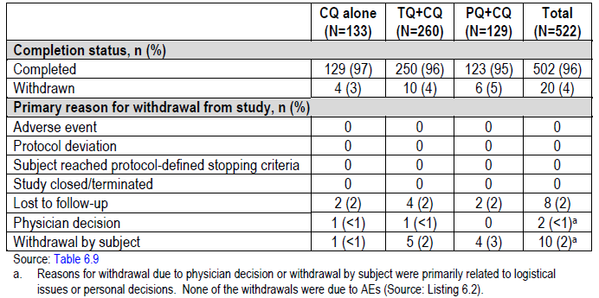
Table 15: Discontinuation of study medication (mITT Population) Study TAF112582 Part 2
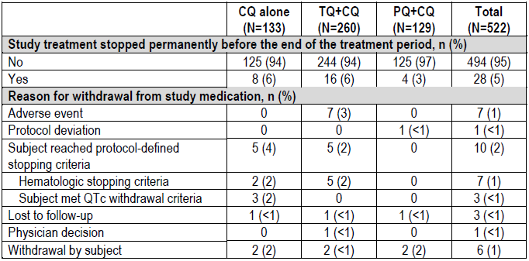
Table 16: Analysis Populations (All Subjects Screened) Study TAF112582 Part 2
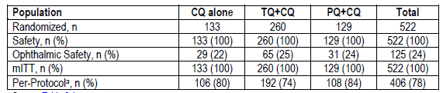
a. Subjects who were excluded from the mITT population due to major protocol deviations

Major protocol violations/deviations
The proportion of subjects with important protocol deviations was comparable across the treatment groups (Table 17). The most common protocol deviations involved missed assessments/procedures or assessments that were not performed according to the protocol.
Table 17: Important protocol deviations (mITT Population), Study TAF112582 Part 2
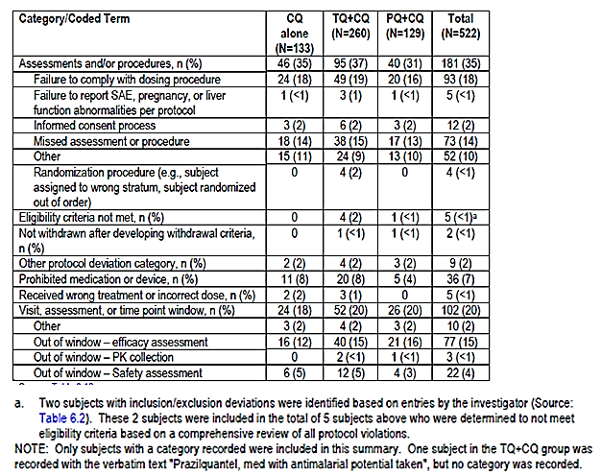

Baseline data
Baseline demographic characteristics were generally comparable among treatment groups (Table 18). The majority of subjects were male (75%; 392/522) and were of mixed race or American Indian (68%; 356/522). The mean (standard deviation (SD)) age was 35.0 (14.29) years.
Baseline disease characteristics were also generally comparable among treatment groups (Tables 19 and 20). The most common symptoms (≥50% of subjects) were headache, chills and rigors, dizziness, anorexia, and nausea. Baseline Pv parasite and gametocyte counts were also similar across the treatment groups.
Comment: Overall, the baseline demographic and disease characteristics were comparable among treatment groups, and were generally consistent with the target patient population.
Table 18: Demographic characteristics (mITT Population), Study TAF112582 Part 2
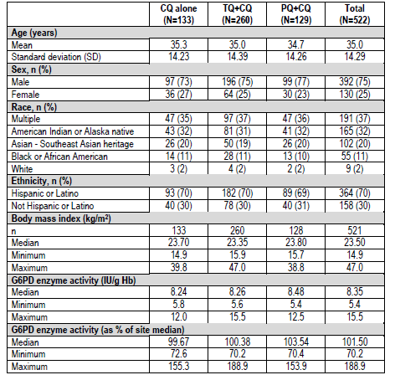
Table 19: Malarial signs and symptoms (mITT Population), Study TAF112582 Part 2
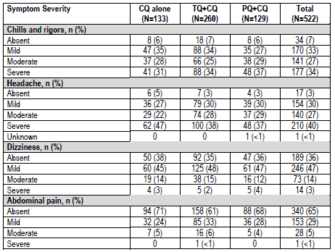
Table 19: Malarial signs and symptoms (mITT Population), Study TAF112582 Part 2 continued
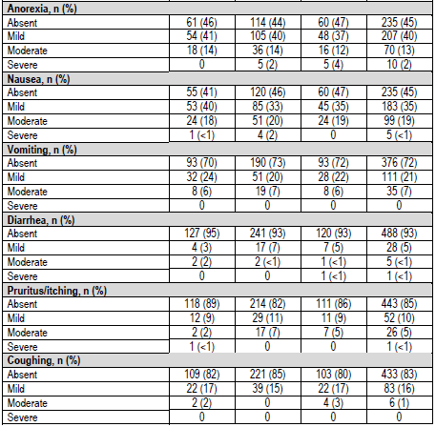
Table 20: Splenomegaly, previous malarial episode, and Pv parasite counts at Baseline (mITT Population), Study TAF112582 Part 2
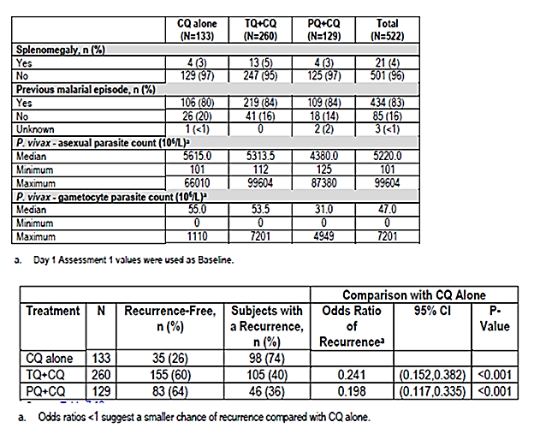

Results for the primary efficacy outcome
Treatment with TQ+CQ resulted in a statistically significant reduction in the risk of recurrence over 6 months by 70.1% (95% confidence interval (CI): 59.6%, 77.8%; p<0.001) compared with CQ alone (Table 21; Figure 2). The estimate of recurrence-free efficacy rate at 6 months was 62.4% in the TQ+CQ group compared with 27.7% in the CQ alone group. The risk of recurrence was also significantly reduced in the PQ+CQ group (73.8%) compared with CQ alone (p<0.001).
The alternative logistic regression analysis yielded similar results. A larger proportion of subjects treated with TQ+CQ (60%) were recurrence-free during the first 6 months compared with CQ treatment alone (26%) (Table 22). There was a statistically significant reduction in the odds of recurrence by 75.9% (95% CI: 61.8%, 84.8%; p<0.001) with TQ+CQ treatment compared with CQ alone. Similar results were observed in the PQ+CQ group compared with CQ alone (statistically significant reduction in the odds of recurrence by 80.2% in favour of PQ+CQ versus CQ alone; p<0.001).
Table 21: Survival analysis of recurrence-free efficacy over 6 Months (mITT Population), Study TAF112582 Part 2
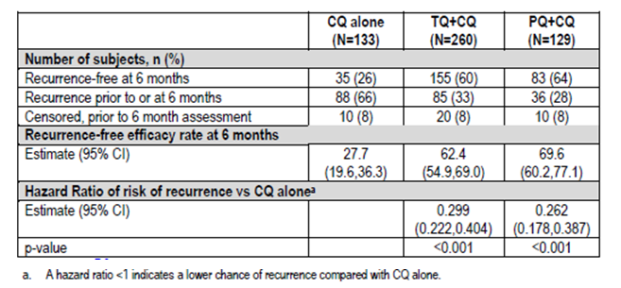
Figure 2: Kaplan Meier curves for recurrence-free efficacy over 6 Months (mITT Population), Study TAF112582 Part 2
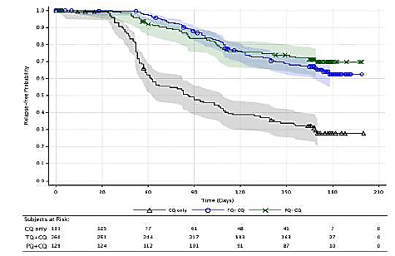
Table 22: Analysis of recurrence-free efficacy at 6 Months (Logistic Regression) Missing = Failure Analysis (mITT Population), Study TAF112582 Part 2
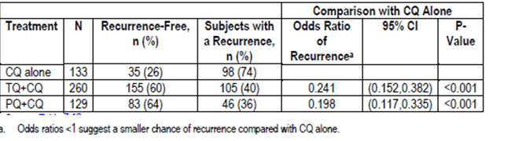

Results for other efficacy outcomes

Other analyses on the primary efficacy endpoint
The results of sensitivity analyses of the primary endpoint were consistent with those of the primary analyses. In the PP population, the risk of recurrence at 6 months was statistically significantly reduced by 68.5% with TQ+CQ compared to CQ alone (p<0.001) (Table 23). Analysis excluding subjects censored prior to 6 months yielded similar results (78.4% reduction in risk of recurrence; p<0.001) as did the missing on or after Day 29 = failure mITT logistic regression analysis (73.2% reduction in risk of recurrence; p<0.001).
Estimates for recurrence-free efficacy at 6 months in the TQ+CQ group were consistent across geographic regions (range: 59.4% to 69.0%) and better than CQ treatment alone (range: 21.2% to 30.8%) (Figure 3). There was no statistically significant effect of region on efficacy results and no interaction between treatment and region in this analysis.
Table 23: Sensitive analyses on primary efficacy endpoint, Study TAF112582 Part 2

(i) Survival analysis of relapse-free efficacy over 6 Months, PP population
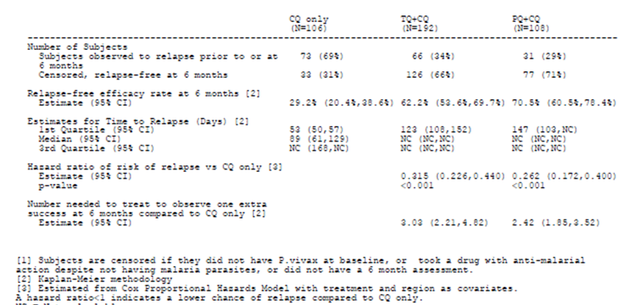
Table 23 continued: Sensitive analyses on primary efficacy endpoint, Study TAF112582 Part 2

(ii) Analysis of relapse-free efficacy at 6 months (logistic regression), subjects censored prior to 6 months excluded
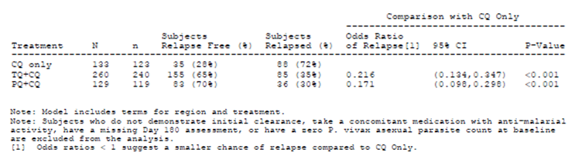
(iii) Analysis of relapse-free efficacy at 6 months (logistic regression), missing on or after study day 29 = failure analysis
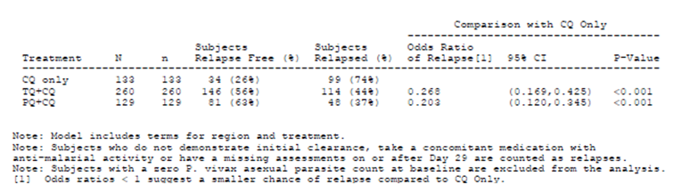
Figure 3: Kaplan-Meier estimate for recurrence-free efficacy at 6 months by region (mITT Population), Study TAF112582 Part 2
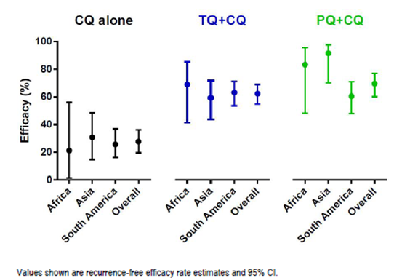

Secondary efficacy analyses
Estimates of recurrence-free efficacy rate at 4 months were consistent with the primary endpoint results at 6 months. Treatment with TQ+CQ resulted in a statistically significant reduction in the risk of recurrence in the first 4 months by 72.9% (95% CI: 62.4%, 80.5%; p<0.001) compared with CQ alone (Table 24). The risk of recurrence was also significantly reduced in the PQ+CQ group compared with CQ alone (74.5%; p<0.001).
Table 24:Study TAF112582 Part 2: Analysis of recurrence-free efficacy over 6 months and 4 months (mITT Population), Study TAF112582 Part 2
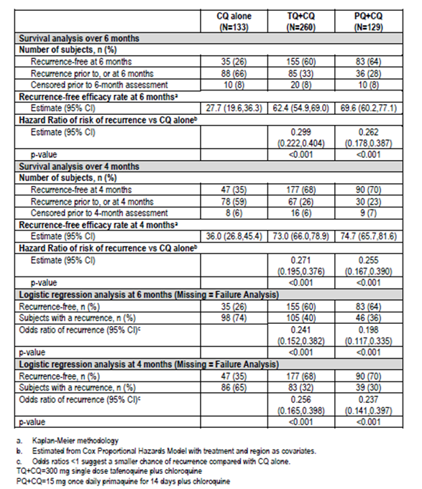
The logistic regression analysis (missing=failure) yielded similar results. A larger proportion of subjects treated with TQ+CQ (68%) were recurrence-free during the first 4 months compared with CQ alone (35%) (Table 25). There was a statistically significant reduction in the odds of recurrence by 74.4% (95% CI: 60.2%, 83.5%; p<0.001) with TQ+CQ treatment compared with CQ alone. Similar results were observed in the PQ+CQ group compared with CQ alone (statistically significant reduction in the odds of recurrence by 76.3% in favour of PQ+CQ versus CQ alone; p<0.001).
Analyses of time to recurrence showed that median estimate for time to recurrence was 86 days (95% CI: 63, 109) with CQ alone, but times to recurrence were not calculable for both TQ+CQ group and PQ+CQ group (Table 23).
Parasite and fever clearance times were similar across treatment groups (Table 26). Median time to parasite clearance was 45 h with TQ+CQ, compared with 43 h with CQ alone and 42 h with PQ+CQ. Median parasite counts were rapidly reduced to zero by Day 3 in all 3 treatment groups. Fever clearance time was 7 h with TQ+CQ, compared with 7 h with CQ alone and 8 h with PQ+CQ. The use of paracetamol in the study was high (87%) and well-balanced across all 3 treatment groups (87%, 86% and 88% in the TQ+CQ group, CQ alone group and PQ+CQ group, respectively).
The frequency of early treatment failures was low and similar between the TQ+CQ (1.2%) and CQ alone (1.5%) groups (0% in the PQ+CQ group).
Table 25: Analysis of recurrence-free efficacy at 4 months (logistic regression); missing = failure analysis (mITT Population), Study TAF112582 Part 2
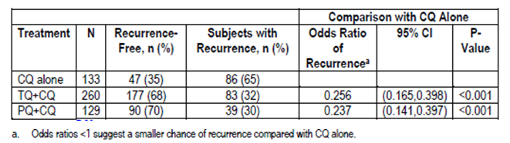
Table 26: Analysis of time to parasite, fever, and gametocyte clearance (mITT Population), Study TAF112582 Part 2
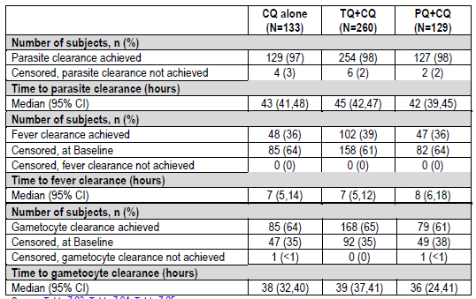

Other efficacy studies

Study 112582 Part 1
Study 112582 Part 1 was a multi-centre, double-blind, double-dummy, randomised, parallel-group, active-controlled, dose-ranging study to evaluate the efficacy, safety and tolerability of tafenoquine in subjects with Pv malaria. The primary objective was to determine the efficacy of chloroquine (CQ) and tafenoquine (TQ) as a radical cure for Pv malaria, relative to a CQ-only control. Secondary objectives included assessment of the safety and tolerability of TQ+CQ in subjects with Pv malaria. Study TAF112582 Part 1 was a multi-centre study where subjects were enrolled in 7 centres across 4 countries (Brazil, India, Thailand and Peru).
Eligible subjects were male or female subjects aged 16 years or older with positive malarial smears for Pv and parasite densities of >100 and <100,000/µL. Subjects with mixed malaria infections or severe Pv malaria infections were excluded. A full list of inclusion and exclusion criteria was presented.
Subjects were screened to confirm eligibility to the study and were treated with CQ on Days 1 to 3 (600 mg, 600 mg, and 300 mg, respectively) to treat the blood stage malaria infection. Once all screening results were known, eligible subjects were randomised in a 1:1:1:1:1:1 ratio to one of six treatment groups as shown in Table 27. The randomisation schedule utilised centre-based allocation and was stratified by baseline parasite count (≤7500/µL and >7500/µL). Following randomisation, the study consisted of a treatment period of 15 days. Subjects stayed in the clinic and received directly observed therapy for Days 1 to 3, and were treated as outpatients for the remainder of the study. Subjects were followed up to Day 180.
Table 27: Treatment groups, Study TAF112582 Part 1
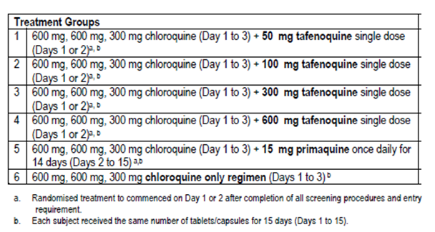
Study drugs were TQ 50 mg, 100 mg and 150 mg capsules, matching TQ placebo, CQ 300 mg tablets, PQ 15 mg capsules and matching PQ placebo. The total duration of treatment was 15 days. CQ was dosed orally once daily for three days starting on Day 1 of the study. TQ was dosed orally once on either Day 1 or Day 2 of the study as soon as all screening test results were known and entry criteria met. PQ was administered orally once daily for 14 days starting from Day 2 of the study.
The primary efficacy endpoint was the recurrence-free efficacy at 6 months post-dosing. Subjects for whom initial clearance of parasitaemia was confirmed (parasite numbers fell below the limit of detection in thick blood smear and remained undetectable at the second smear collected 6 to 12 h later) and who did not present with Pv asexual stage parasites within 6 months were considered treatment successes. Secondary endpoints included recurrence-free efficacy at 4 months post-dosing, time to recurrence, parasite clearance time, and fever clearance time.
Following completion of Part 1, it was planned that one of the four TQ doses would be selected for the pivotal Part 2 study (Phase III). It was planned that potential Phase III doses would be identified according to the observed relapse efficacy results, as defined by the schematic in Figure 4. Doses that achieved a statistically significant difference in 6 month relapse efficacy relative to CQ would be considered for Part 2 if the point estimate of the treatment difference was at least 30%. However, if the actual loss to follow-up/withdrawal rate was substantially higher than the 10% assumed for the sample size calculations, statistical significance would not be required for dose selection as the power of the study was likely to be impacted. Additionally, TQ doses which failed to achieve a 30% point estimate difference versus CQ would not necessarily be deselected if the PQ point estimate difference versus CQ was also <30% or the point estimate difference between PQ and TQ was <5%.
Figure 4: Schema for selection of dose for Phase III study, Study TAF112582 Part 1
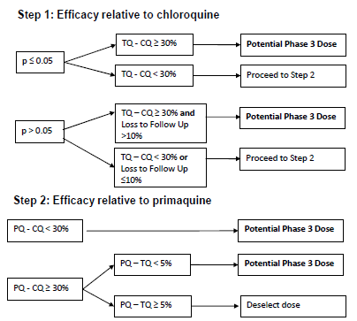
A total of 329 subjects were recruited and received study medication (55 in the TQ 50 mg group, 57 in the TQ 100 mg group, 57 in the TQ 300 mg group, 56 in the TQ 600 mg group, 50 in the PQ group and 54 in the CQ alone group). Overall, 319 subjects (97% overall; 94% to 100% across treatment groups) completed the study.
Baseline demographic characteristics were generally comparable among treatment groups (Table 28). The majority of subjects were male (74%). The mean (SD) age was 35.4 (13.94) years. Baseline disease characteristics were also generally comparable among treatment groups. The most common symptoms at baseline were chills and rigours (93% of subjects), and headache (89%).
Table 28: Summary of demographic characteristics (Intent-to-Treat Population), Study TAF112582 Part 1
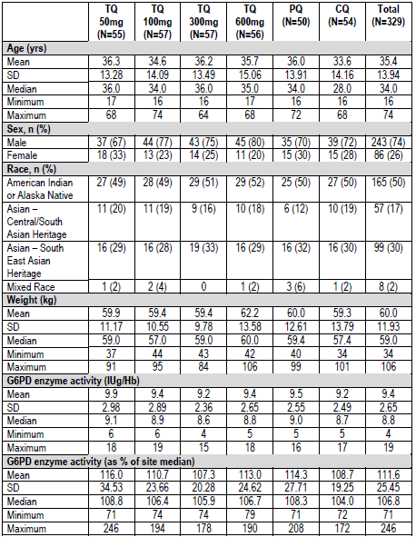
Primary efficacy analysis showed that recurrence-free efficacy rates at 6 months were 89% and 92% for the TQ 300 mg and 600 mg treatment groups, respectively, compared with 38% for CQ alone (Tables 29). The treatment differences versus CQ alone for TQ 300 mg and TQ 600 mg were statistically significant (52% and 55%, respectively; p<0.0001). The improvements in recurrence-free efficacy relative to CQ alone for the TQ 50 mg and TQ 100 mg treatment groups were 20% and 17%, respectively. The treatment difference for the TQ 100 mg dose versus CQ was not statistically significant and therefore a p-value was not generated for the 50 mg dose comparison. The improvement in efficacy for PQ relative to CQ alone was smaller than that observed for both TQ 300 mg and TQ 600 mg but was statistically significant (40%; p=0.0004).
Table 29: Analysis of relapse-free efficacy at six months (Kaplan-Meier methodology) (Intent-to-Treat Population), Study TAF112582 Part 1
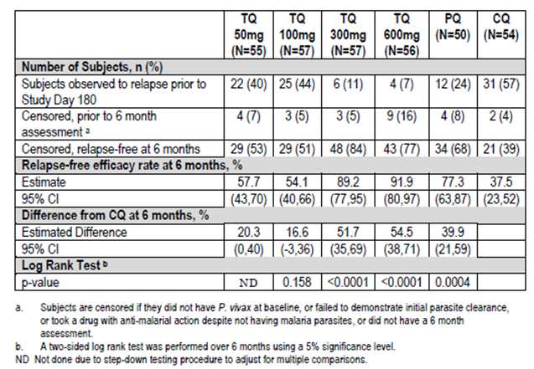
Secondary efficacy analysis showed that recurrence-free efficacy rates at 4 months were 89% and 98% for the TQ 300 mg and 600 mg treatment groups, respectively, compared with 46.5% for CQ alone (Table 30). The treatment differences versus CQ alone for TQ 300 mg and TQ 600 mg were statistically significant (43% and 52%, respectively; p<0.0001). The improvements in recurrence-free efficacy relative to CQ alone for the TQ 50 mg and TQ 100 mg treatment groups were 16% and 14%, respectively. The treatment difference for the TQ 100 mg dose versus CQ alone was not statistically significant and therefore a p-value was not generated for the 50 mg dose comparison. The improvement in efficacy for PQ relative to CQ alone was smaller than that observed for both TQ 300 mg and TQ 600 mg but was statistically significant (32%; p=0.002).
Table 30: Analysis of relapse-free efficacy at four months (Kaplan-Meier methodology) (Intent-to-Treat Population), Study TAF112582 Part 1
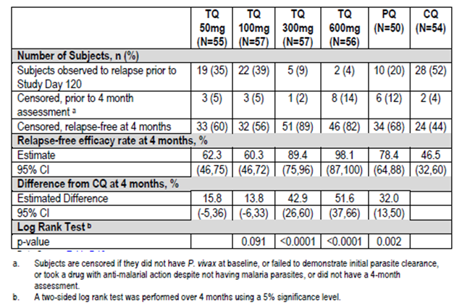
Analysis of time to recurrence showed that recurrences began earlier on CQ than for all other treatment groups, and were more frequent at all time points (Figure 5). TQ 50 mg, TQ 100 mg and PQ were more efficacious than CQ, but showed little differentiation from one another until Day 90. There were very few relapses on PQ after this time point, but subjects treated with TQ 50 mg and TQ 100 mg continued to relapse. TQ 300 mg and TQ 600 mg showed better efficacy than all other treatments at all time points, with similar time to recurrence profiles.
Figure 5: Kaplan-Meier survival curves for time to P. vivax relapse (Intent-to-Treat Population), Study TAF112582 Part 1
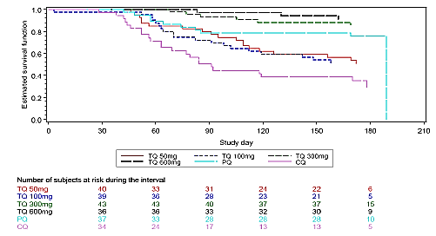
Parasite clearance times were similar across treatment groups. Median time to parasite clearance was 42 to 47 h across treatment groups, with no clear dose related effect in the TQ groups. There was no statistically significant difference in median fever clearance time with any of the TQ groups versus CQ alone groups (11.0 hr, 6.5 hr, 15.0 h and 19.0 h in the TQ 50 mg, 100 mg, 300 mg and 600 mg groups, respectively, versus 8.0 h with CQ alone; PQ: 19.5 hr).

Study TAF116564
Study TAF116564 was a multi-centre, randomised, double-blind, double-dummy, comparative study to assess the incidence of haemolysis, safety and efficacy of tafenoquine (TQ) versus primaquine (PQ) in the treatment of subjects with Pv malaria. The primary objective was to investigate the occurrence of clinically relevant haemolysis in adult subjects with Pv treated with TQ or PQ. The incidence of haemolysis in the subgroup of female patients with moderate (40% to 70%) G6PD activity was of particular interest. Secondary objective was to compare the clinical and parasitological efficacy, safety and tolerability of TQ to PQ as a radical cure for adult subjects with Pv malaria when co-administered with CQ. Study TAF116564 was a multi-centre study where subjects were enrolled in 7 centres across 5 countries (Brazil, Colombia, Peru, Thailand and Vietnam).
Eligible subjects were male or female subjects aged 16 years or older with positive malarial smears for Pv and parasite densities of >100 and <100,000/µL. Females were required to have G6PD values of at least 40% of the site median for G6PD normal males, and males were required to have values of at least 70% of the site median for G6PD normal males. Subjects with mixed malaria infections or severe Pv malaria infections were excluded. A full list of inclusion and exclusion criteria was presented.
Subjects were randomised in a 2:1 ratio to receive TQ+CQ or comparator PQ+CQ on Day 1. All subjects received CQ on Days 1 to 3 (600 mg, 600 mg, 300 mg, respectively) followed by TQ or PQ and matching placebo beginning on Day 1 or 2. TQ, or matching placebo, was given as a single, 300 mg dose. PQ, or matching placebo, was given at a dose of 15 mg once daily for 14 days. Subjects remained in the hospital for a minimum of the first 3 days of the study to monitor study medication compliance and infection status, and continued on treatment as an outpatient for an additional 12 days. The duration of the study was 180 days, including screening and randomisation to treatment (Day 1), 3 in-hospital days (Days 1 to 3), 4 outpatient visits while on treatment with study medication (Days 5, 8, 11 and 15) and 7 follow-up visits (Days 22, 29, 60, 90, 120, 150 and 180).
Primary endpoints were 2 co-primary safety endpoints: occurrence of clinically relevant haemolysis in all subjects; occurrence of clinically relevant haemolysis in female subjects with moderate (40% to 70%) G6PD deficiency. Clinically relevant haemolysis was defined as a decrease in Hb of ≥30% or >30 g/L from baseline or an overall drop in Hb below 60 g/L. Secondary endpoints included other safety assessments and efficacy endpoints of: recurrence-free efficacy at 6 months post-dosing; recurrence-free efficacy at 4 months post-dosing; time to recurrence; parasite clearance time; fever clearance time.
Efficacy results will be presented in this section and safety results in Section 8. Overall, 251 subjects were randomised (166 to TQ+CQ, and 85 to PQ+CQ) and 243 subjects (97% overall; 96% and 98% in the TQ+CQ and PQ+CQ groups, respectively) completed the study. This study was designed to include a minimum of 50 female subjects with moderate G6PD deficiency (enzyme activity ≥40% to <70% of the site median value for G6PD normal males). This number of subjects was not achieved and only 1 female subject with G6PD enzyme activity ≥40% to <70% of the site median normal was enrolled out of the target of at least 50 female subjects.
Baseline demographic characteristics were generally comparable between treatment groups (Table 31). The majority of subjects were male (67%). The mean (SD) age was 37.6 (14.39) years. Baseline disease characteristics were also generally comparable between treatment groups. The most common (>50% of subjects) symptoms at baseline were headache, chills and rigors, dizziness and nausea.
Table 31: Demographic characteristics (Safety Population), Study TAF116564
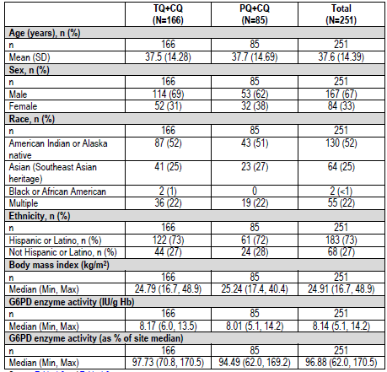
Efficacy analyses showed that recurrence-free efficacy rates at 6 months were comparable between treatment groups (72.7% with TQ+CQ and 75.1% with PQ+CQ), with hazard ratio close to 1 (hazard ratio: 0.984) (Table 32; Figure 6). Results of analyses of recurrence-free efficacy over 4 months were also comparable between treatment groups (82.3% with TQ+CQ and 79.7% with PQ+CQ; hazard ratio: 0.815) (Table 33).
Median time to recurrence was not calculable for both treatment groups. Results were similar between treatment groups in time to parasite clearance, time to fever clearance, and time to gametocyte clearance (Table 34). Median time to parasite clearance was 41 and 44 h in the TQ+CQ and PQ+CQ groups, respectively. Median fever clearance time was 10 and 13 hr, respectively, and median time to gametocyte clearance was 38 and 41 hr, respectively.
Table 32: Survival analysis of recurrence-free efficacy over 6 months (mITT Population), Study TAF116564
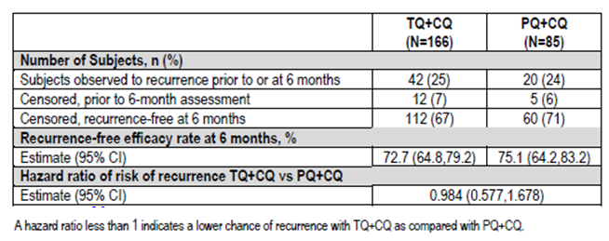
Figure 6 Kaplan Meier Survival Curves for Recurrence-Free Efficacy over 6 Months (mITT Population), Study TAF116564
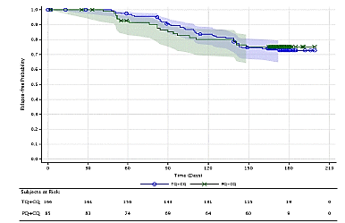
Table 33: Survival analysis of recurrence-free efficacy over 4 months (mITT Population), Study TAF116564
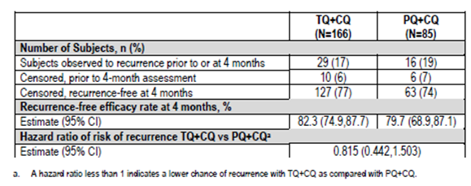
Table 34: Analysis of time to parasite, fever, and gametocyte clearance (mITT Population), Study TAF116564
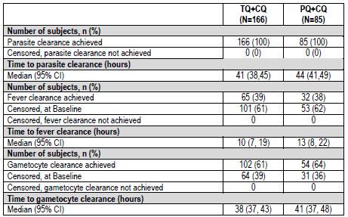

Analyses performed across trials pooled and meta analyses
Pooled TAF112582 Part 1 and Part 2
The sponsor performed integrated efficacy analyses on pooled data from Study TAF112582 Part 1 and Part 2 (‘placebo-controlled dataset’; PC dataset). This consists of a total of 187 subjects on CQ alone (54 from Part 1 and 133 from Part 2) and 317 subjects on 300 mg TQ+CQ (57 from Part 1 and 260 from Part 2).
Recurrence-free efficacy results at 6 months in the pooled PC dataset were consistent with those of the pivotal efficacy study. Analyses of recurrence-free efficacy over 6 months in the individual studies (TAF112582 Part 1, TAF112582 Part 2 and TAF116564) are presented in Table 35 for ease of reference. In the pooled PC dataset, Kaplan-Meier analysis of time to recurrence showed that estimated recurrence-free efficacy rates at 6 months was 67.5% in the 300 mg TQ+CQ group compared with 30.2% in the CQ alone group (Table 36; Figure 7). In the logistic regression analysis (missing = failure) in the pooled dataset, a larger proportion of subjects treated with 300 mg TQ+CQ (64%) were recurrence-free during the first 6 months compared with CQ alone (30%) (Table 37). There was a reduction in the odds of recurrence by 78.9% (95% CI: 68.3%, 86.0%) with 300 mg TQ+CQ treatment compared with CQ alone.
Analyses of recurrence-free efficacy over 4 months in the pooled PC dataset were also consistent with those of the pivotal efficacy study. Recurrence-free efficacy over 4 months in the individual studies (TAF112582 Part 1, TAF112582 Part 2 and TAF116564) are presented in Table 38) for ease of reference. In the pooled PC dataset, logistic regression analysis (missing = failure) of recurrence-free efficacy over 4 months showed that a larger proportion of subjects treated with 300 mg TQ+CQ (71%) were recurrence-free during the first 4 months compared with those treated with CQ alone (38%) (Table 39). There was a reduction in the odds of recurrence by 77.5% (95% CI: 66%, 84.8%) with TQ+CQ treatment compared with CQ alone.
Table 35: Recurrence-free efficacy over 6 months, individual efficacy studies
(i) Recurrence-Free Efficacy over 6 Months (Kaplan-Meier Methodology) (mITT Population), individual efficacy studies
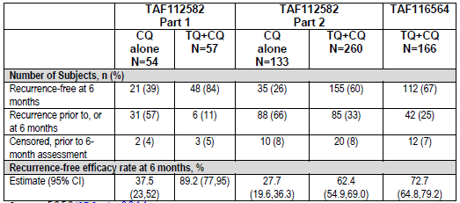
(ii) Recurrence-free efficacy over 6 months in Study TAF112582 Part 2 by logistic regression
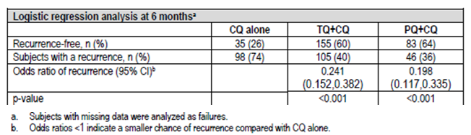
Table 36: Kaplan-Meier analysis of time to recurrence (PC Dataset, mITT Population), pooled Study TAF112582 Part 1 and Part 2
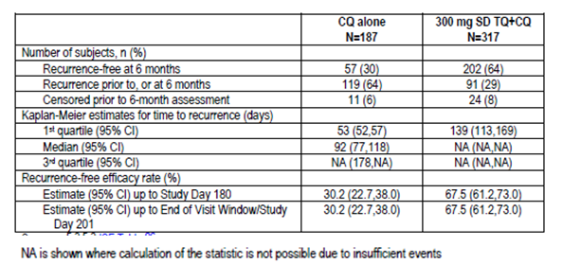
Figure 7: Kaplan Meier curves for time to recurrence pc dataset, mITT Population, pooledTAF112582 Part 1 and Part 2
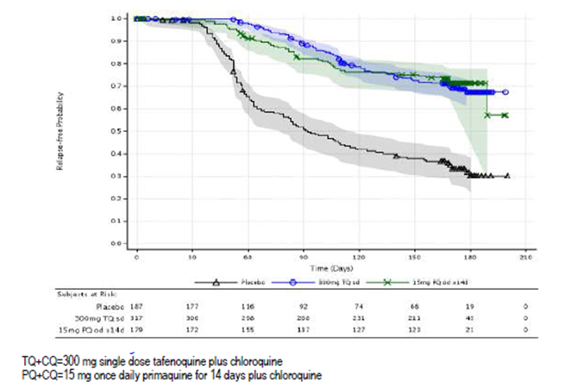
Table 37: Logistic regression analysis of recurrence-free efficacy over 6 months, missing=failure analysis (pc dataset, mitt population), pooled Study TAF112582 Part 1 and Part 2
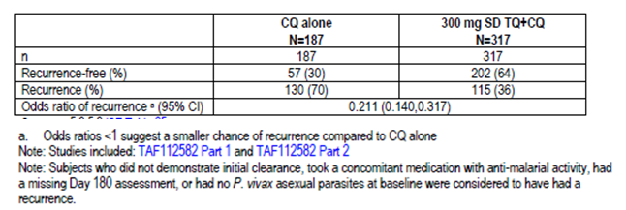
Table 38: Summary of the proportion of subjects recurrence-free at 4 months, individual studies
(i) Summary of the proportion of subjects recurrence-free at 4 months (Kaplan-Meier Methodology), individual studies
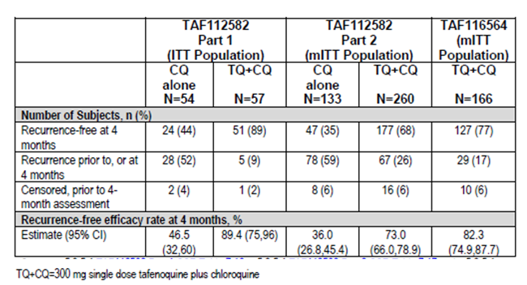
(ii) Recurrence-free efficacy over 4 months in Study TAF112582 Part 2 by Logistic Regression
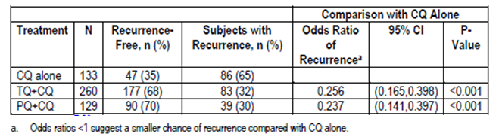
Table 39: Logistic Regression Analysis of Recurrence-Free Efficacy over 4 Months, Missing=Failure Analysis (PC Dataset, mITT Population), pooled TAF112582 Part 1 and Part 2
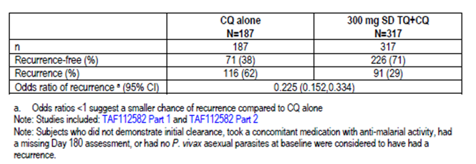
Exploratory non-inferiority analysis
After sponsor discussion with the WHO, an exploratory non-inferiority analysis was conducted to compare TQ (300 mg single dose) to PQ (15 mg once daily for 14 days) when co-administered with standard doses of CQ. Individual patient data from Study TAF112582 Part 2 and TAF116564 were used in this meta-analysis with the PP population as the primary analysis population (‘non-inferiority (NI) dataset’). The non-inferiority margin of 1.45 was used. The overall estimate of the odds ratio and 95% CI were obtained from a logistic regression model including study, region, treatment and the treatment by region interaction. Non-inferiority comparison was based on the logistic regression model with non-inferiority assessed based on the upper bound of the 95% CI surrounding the odds ratio.
Overall, the non-inferiority of TQ+CQ to PQ+CQ could not be demonstrated from this meta-analysis (Table 40). In the NI dataset, 69% of subjects in the TQ+CQ group did not have a recurrence of malaria during the 6 month post-dosing period, compared with 73% of subjects in the PQ+CQ group. The odds ratio for the overall risk of recurrence from the meta-analysis was 1.81 (95% CI: 0.824, 3.960) after adjusting for region, study and treatment by region interaction. The upper bound of the 95% CI was 3.96 for the NI dataset and therefore, based on the pre-determined non-inferiority margin of 1.45, non-inferiority was not demonstrated.
Table 40: Analysis of recurrence during the 6 month post dosing period, censored subjects excluded (NI Dataset, PP Population), pooled Study TAF112582 Part 2 and TAF116564
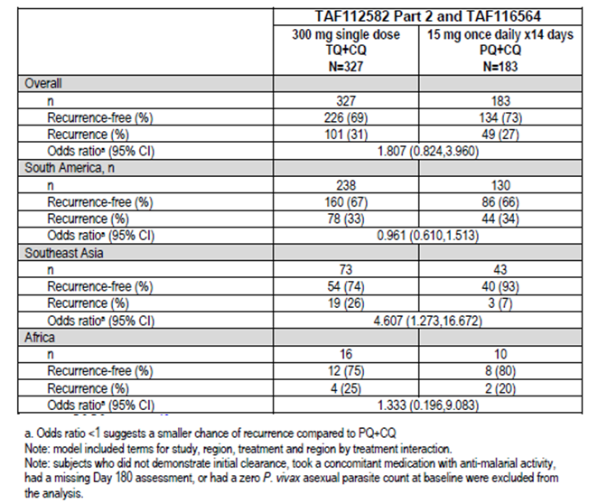
Figure 8: adjusted odds ratio and 95% ci forest plot (censored subjects excluded) by region, study, and overall (NI dataset, per protocol population), pooled Study TAF112582 Part 2 and TAF116564
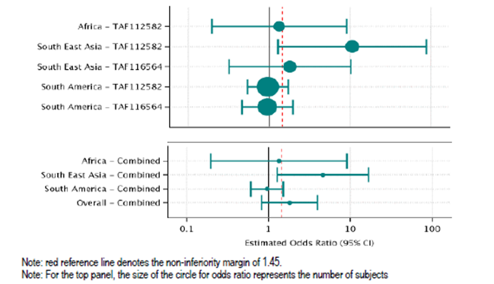
The sponsor noted that the efficacy analyses showed variation in efficacy across the regions, most notably with increased efficacy observed in the PQ+CQ treatment group in South East Asia and Africa, although the numbers of subjects from these regions were relatively small compared to those from South America (Table 40; Figure 8). In addition, the sponsor highlighted that PQ treatment compliance was very high in the study population (>99% of subjects received ≥12 doses of PQ) and that the non-inferiority analysis results reflected this high compliance rate which may not be attainable outside of a clinical study. The sponsor cited published data from South East Asia showing that real-life PQ compliance rate (24%) was lower compared with that observed in the pivotal and supportive efficacy studies.

Evaluator’s conclusions on clinical efficacy
Overall, the study design, inclusion and exclusion criteria, and study endpoints of the pivotal Phase III study (TAF112582 Part 2) were appropriate. The primary and secondary efficacy endpoints allowed assessment of the effect of TQ+CQ compared to CQ alone on recurrence-free efficacy at 6 months and 4 months post-dosing. Baseline demographic and disease characteristics were comparable among treatment groups, and were consistent with the target patient population.
Efficacy results were generally supportive of a positive treatment effect of TQ+CQ over CQ alone in reducing the risk of recurrence at 6 months and 4 months post-dosing. Analysis of the primary efficacy endpoint (Kaplan-Meier and Cox proportional hazards methodology) showed that treatment with TQ+CQ resulted in a statistically significant reduction in the risk of recurrence over 6 months by 70.1% (p<0.001) compared with CQ alone (recurrence-free efficacy rate at 6 months of 62.4% in the TQ+CQ group versus 27.7% in the CQ alone group). Alternative logistic regression analysis yielded similar results, showing a statistically significant reduction in the odds of recurrence by 75.9% (p<0.001) with TQ+CQ treatment compared with CQ alone.
Secondary efficacy analysis showed that treatment with TQ+CQ resulted in a statistically significant reduction in the risk of recurrence in the first 4 months by 72.9% (p<0.001) compared with CQ treatment alone (recurrence-free efficacy rate at 4 months of 73.0% in the TQ+CQ group versus 36.0% in the CQ alone group). Alternative logistic regression analysis yielded similar results, showing a statistically significant reduction in the odds of recurrence by 74.4% (p<0.001) with TQ+CQ treatment compared with CQ alone.
Efficacy results in the supportive Studies TAF112582 Part 1 and TAF116564 were generally consistent with results in the pivotal Phase III study. In Study TAF112582 Part 1, there was a statistically significant improvement in recurrence-free efficacy rate at 6 months with 300 mg TQ+CQ over CQ alone of 52% (p<0.0001; recurrence-free efficacy rate of 89.2% with 300 mg TQ+CQ versus 37.5% with CQ alone). There was also a statistically significant improvement in recurrence-free efficacy rate at 4 months with 300 mg TQ+CQ over CQ alone of 43% (p<0.0001; recurrence-free efficacy rate of 89.4% with 300 mg TQ+CQ versus 46.5% with CQ alone). In Study TAF116564, recurrence-free efficacy rate at 6 months and 4 months post-dose with 300 mg TQ+CQ was 72.2% and 82.3%, respectively.
Comparison between TQ+CQ and PQ+CQ in TAF116564 showed that recurrence-free efficacy rates at 6 months and at 4 months were numerically comparable between the 2 treatment groups (6 months: 72.7% with TQ+CQ and 75.1% with PQ+CQ; 4 months: 82.3% with TQ+CQ and 79.7% with PQ+CQ). Exploratory non-inferiority analysis using pooled data from TAF112582 Part 2 and TAF116564 showed that the non-inferiority of TQ+CQ to PQ+CQ could not be demonstrated (proportion of recurrence-free subjects during 6 month post-dosing period: 69% with TQ+CQ versus 73% with PQ+CQ; odds ratio: 1.81 (95% CI: 0.824, 3.960)). However, it is noted that PQ treatment compliance was very high in the study population (>99% of subjects received ≥12 doses of PQ) and that this high compliance rate may not be attainable outside of a clinical study environment.
Efficacy sections of the proposed Product Information are evaluated and found to be appropriate.

Clinical safety

Studies providing evaluable safety data
The safety data to support this submission were drawn mainly from the pivotal study (TAF112582 Part 2), with supportive data from Studies TAF112582 Part 1 and TAF116564. In addition, two individual studies in healthy volunteers, Study 201807 (ophthalmic safety study) and Study TAF114582 (a pharmacodynamic QTc study) provided ophthalmic safety data and cardiac safety data, respectively.
The sponsor has also provided several pooled safety datasets. The placebo controlled primary studies (PC) dataset includes data from Studies TAF112582 Part 1 and TAF112582 Part 2 and evaluates the safety of TQ+CQ versus CQ alone in the proposed indication. The All Primary studies (AP) dataset includes all 3 efficacy/safety studies (that is, TAF112582 Part 2, TAF112582 Part 1 and TAF116564) and provides additional safety data for TQ+CQ in Pv malaria compared with the current standard of care, PQ+CQ. Other pooled safety databases include pooled data from all TQ studies in the clinical development program, pooled data of studies involving different dosing regimens of TQ in Pv malaria, and pooled data of studies on other indications (for example, malaria prophylaxis). Study groupings for the various pooled safety datasets are presented in Table 41.
Table 41: Study groupings for the pooled safety datasets
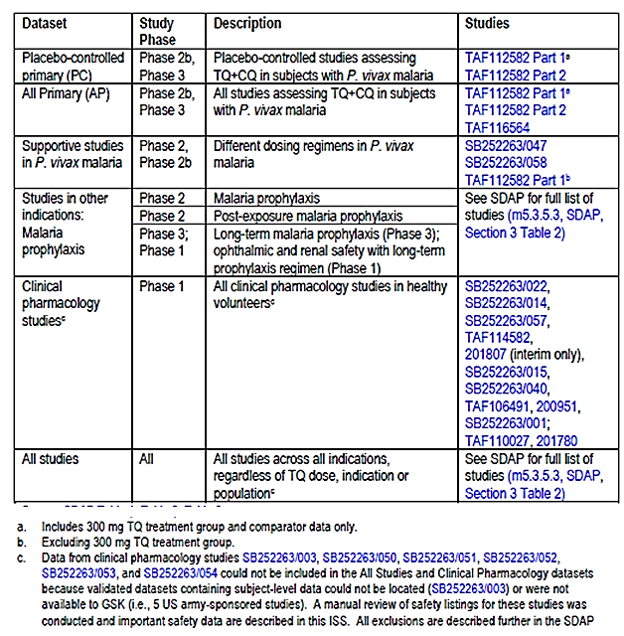
In this evaluation report, safety data from Study TAF112582 Part 2 will be evaluated as providing pivotal safety data, with supportive data from Studies TAF112582 Part 1 and TAF116564. Findings of the ophthalmic safety study will be described in section 84.6.1. The QTc study was evaluated and did not raise any safety concerns.
Comment: The various pooled safety data as well as the safety data of the individual studies in the pooled datasets were also evaluated and were found to be consistent with the safety findings in the pivotal study, and did not raise any additional safety concerns. Table 42 presents an overview of adverse events in the pooled placebo controlled dataset (PC dataset; pooled Studies TAF112582 Part 1 and TAF112582 Part 2) and All Primary dataset (AP dataset; pooled Studies TAF112582 Part 1, TAF112582 Part 2 and TAF116564), alongside those of the pivotal Study TAF112582 Part 2, showing that results in the pooled datasets were consistent with those in the pivotal study. Incidence of drug related adverse events in the pooled PC dataset is presented in Table 43, alongside those of the pivotal Study TAF112582 Part 2, showing that results were also consistent with those in the pivotal study.
Table 42: Adverse events overview (i) PC and AP safety populations (ii) safety population, Study TAF112582 Part 2
(i) PC and AP Safety Population
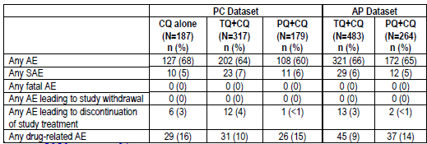
(ii) TAF112582 Part 2
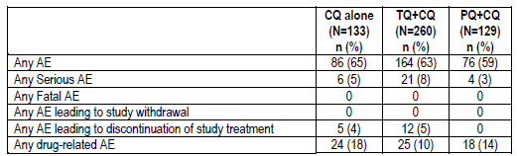
Table 43: Summary of drug-related adverse events reported in at least 1% of subjects in any treatment group by Preferred Term (i) PC safety population (ii) safety population, Study TAF112582 Part 2
(i) PC Safety Population
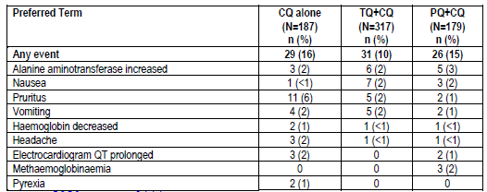
(ii) Safety Population, study TAF112582 Part 2
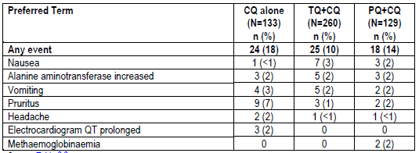

Pivotal studies that assessed safety as the sole primary outcome
Not applicable.

Pivotal and/or main efficacy studies
In the pivotal efficacy study, the following safety data were collected:
- Adverse events (AEs) from the time of informed consent through to the end of study participation. AEs were coded using Medical Dictionary for Regulatory Activities (MedDRA, version 18.0 or higher).
- Safety laboratory tests (standard haematology and chemistry tests; metHb levels)
- Other safety variables included vital signs, 12-lead electrocardiograms (ECGs) and physical examinations (including eye examination at selected sites)
- AEs of special interests included Hb-associated events, neuropsychiatric events, ophthalmic events, hepatobiliary disorders and renal and urinary disorders.
Safety assessments were performed according to the schedule presented.

Other studies

Other efficacy studies
Study TAF112582 Part 1 provided data on AEs, safety laboratory assessments, vital signs, 12-lead ECGs, and physical examinations (including eye examination at selected sites)
The primary endpoint of Study TAF116564 was a safety endpoint: occurrence of clinically relevant haemolysis in adult subjects with Pv treated with TQ+CQ or PQ+CQ (defined as a decrease in Hb of ≥30% or >30 g/L from baseline or an overall drop in Hb below 60 g/L). Other safety assessments are AEs, safety laboratory assessments, vital signs, 12-lead ECGs, and physical examinations (including eye examination at selected sites).

Studies evaluable for safety only
Study 201807 (ophthalmic safety study) was an ongoing, multi-centre, randomised, single-blind, placebo-controlled, parallel-group study of a single 300 mg oral dose of TQ in healthy adult subjects. The primary objective of this study was to assess the pharmacodynamics effects of TQ on the retina via spectral domain optical coherence tomography (SD-OCT) and fundus auto-fluorescence (FAF). The secondary objective was to assess the overall ophthalmic safety of TQ compared with placebo.
Following initial screening assessments, eligible subjects underwent baseline ophthalmic examinations. Subjects were then randomised in a 2:1 ratio to 300 mg TQ or matched placebo within 7 days of the screening ophthalmic examinations. Subjects were followed for safety assessments and return to the clinic for follow-up ophthalmic evaluations at approximately 90 days post-dose. Ophthalmic assessments included key SD-OCT measurements of central retinal thickness and appearance of the retina on FAF at screening and Day 90. Visual acuity was measured using Early Treatment Diabetic Retinopathy Study (ETDRS) chart reading. Additional retinal morphology was assessed by SD-OCT and fundus photography captured at screening and Day 90.
The primary endpoint was the proportion of subjects treated with TQ who developed significant protocol-defined retinal changes from baseline to Day 90. A subject was considered to have a clinically significant retinal change if any of the following 5 parameters indicated a change from baseline in either eye: SD-OCT central subfield thickness, SD-OCT total macular volume, SD-OCT central retinal lesion thickness, SD-OCT ellipsoid zone disruption (EZD), or abnormal auto-fluorescence patterns.
A sample size of 300 subjects was planned to be treated with TQ based on 95% probability of detecting an event when the underlying risk of clinically significant retinal findings at 90 day follow-up was 1%. The results of Study 201807 presented in this submission were from a planned interim analysis, done after approximately 100 TQ subjects and 50 placebo subjects had completed baseline and Day 90 ophthalmic assessments. The interim sample size of 100 subjects treated with TQ was expected to allow for detection of a 3% risk of clinically significant retinal findings at 90 days after a single 300 mg dose of TQ.

Studies that assessed safety as the sole primary outcome
Not applicable.

Patient exposure
Across the TQ development program, more than 4000 subjects have been exposed to TQ, including >800 subjects exposed to a 300 mg total dose (Table 44). A total of 483 Pv infected subjects have been treated with TQ 300 mg single dose plus CQ in the 3 efficacy/safety Studies TAF112582 Part 2, TAF112582 Part 1 and TAF116564.
In the pivotal Study TAF112582 Part 2, all subjects received their scheduled in-clinic single dose of TQ/TQ placebo, according to randomisation.
Comment: Overall, the study drug exposure is adequate to assess the safety profile of TQ in patients with Pv malaria infection.
Table 44: Summary of exposure across the tafenoquine development program, by dataset
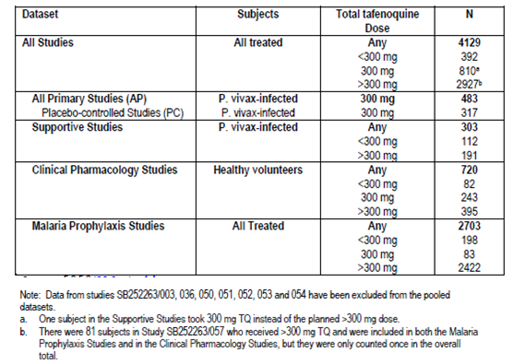

Adverse events

All adverse events (irrespective of relationship to study treatment)

Pivotal and/or main efficacy study
The percentage of patients with any AEs was similar among treatment groups (63% with TQ+CQ versus 65% with CQ alone; 59% with PQ+CQ) (Table 45). AEs that occurred in >1% of patients in the TQ+CQ group are presented in Table 46). The most commonly reported AEs with TQ+CQ were pruritus (13% versus 15% with CQ alone versus 11% with PQ+CQ), headache (10% versus 14% versus 8%) and dizziness (10% versus 8% versus 7%). The majority of subjects with AEs had events that were mild or moderate in severity. Few severe AEs (≥Grade 3) were reported (1% with TQ+CQ versus 3% with CQ alone; <1% with PQ+CQ).
Analysis of AEs with onset on or prior to Day 29 showed that within the first 29 days, pruritus was the most common AE in all 3 treatment groups (Table 47). Pruritus is a known effect of CQ, and the incidence of pruritus was similar across the treatment groups (11% with TQ+CQ versus 13% with CQ alone versus 11% with PQ+CQ).

Table 45: Adverse Events Overview (Safety Population) Study TAF112582 Part 2
Table 46: Summary of treatment-emergent adverse events by preferred term (events occurring in >1% of subjects in TQ+CQ group, Safety population), Study TAF112582 Part 2
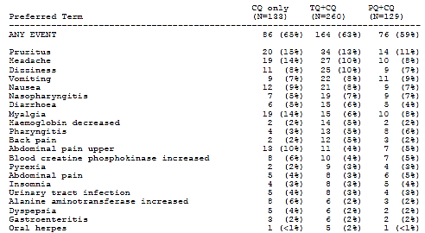
Table 47: Treatment-emergent adverse events with onset on or prior to Day 29 reported in at least 5% of subjects in any treatment group by Preferred Term (Safety Population), Study TAF112582 Part 2
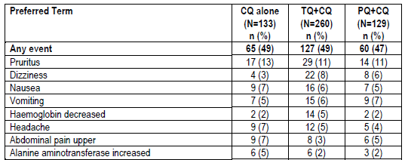

Other studies

Study TAF112582 Part 1
The percentage of patients with any AEs was similar among treatment groups and there was no clear dose related trend among the TQ+CQ groups (64% to 76% across treatment groups) (Table 48). The percentage of patients with any AEs was 67% with TQ300 mg +CQ versus 76% with CQ alone (64% with PQ+CQ). The most commonly reported AEs with TQ300 mg+CQ were headache (18% versus 37% with CQ alone versus 28% with PQ+CQ) and pruritus (14% versus 13% versus 6%). The majority of subjects with AEs had events that were mild or moderate in severity. Few severe AEs (≥Grade 3) were reported. In the TQ300 mg+CQ group, only 2 AEs were of ≥Grade 3 severity (both of Grade 3 severity; one of AST raised and one of pruritus).
Table 48: Summary of all treatment-emergent adverse events occurring in greater than or equal to 5% subjects in any treatment group (excluding Pv) (safety population), Study TAF112582 Part 1
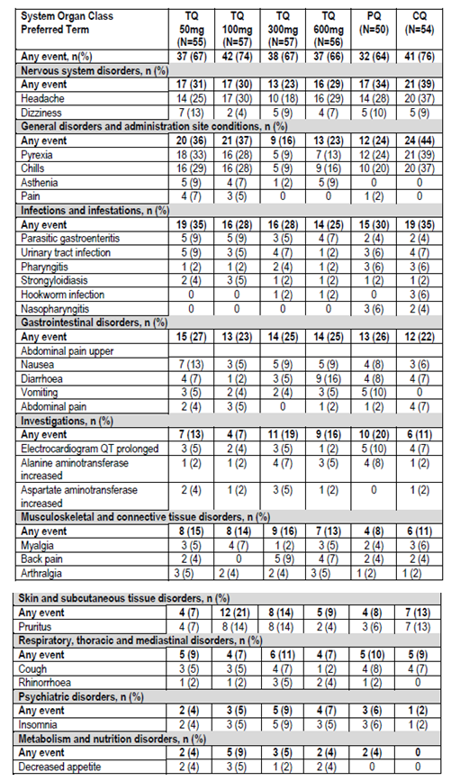

Study TAF116564
The percentage of patients with any AEs was comparable between the TQ+CQ group and the PQ+CQ alone group (72% versus 75%) (Table 49). AEs that occurred in ≥5% in any treatment group are presented in Table 50). The most commonly reported AEs with TQ+CQ were dizziness (17% versus 19% with PQ+CQ) and headache (16% versus 19%). The majority of subjects with AEs had events that were mild or moderate in severity. No subjects experienced Grade 4 or 5 AEs. Two subjects in each treatment group experienced a Grade 3 AE (TQ+CQ group: one AE of increased blood bilirubin (unrelated to study medication) and one AE of pruritus (related to study medication); PQ+CQ group: two AEs of pruritus (both considered related to study medication)).
Table 49: Overview of Treatment-Emergent Adverse Events (Safety Population), Study 116564
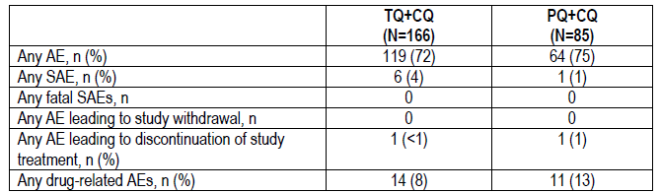
Table 50: Summary of Common Treatment-Emergent Adverse Events (≥5% in any Treatment Group) by Preferred Term, Study 116564
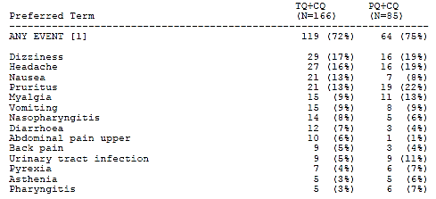

Treatment related adverse events (adverse drug reactions)

Pivotal and/or main efficacy study
The percentage of patients with at least one treatment related AE was lower in the TQ+CQ group compared with the CQ alone group (10% versus 18%; 14% with PQ+CQ) (Table 51). The most commonly reported treatment related AE with TQ+CQ was nausea (3% versus <1% with CQ alone and 2% with PQ+CQ).
Table 51: Treatment-emergent drug-related adverse events reported in at least 1% of subjects in any treatment group by preferred term (safety population), Study TAF112582 Part 2

Other studies

Study TAF112582 Part 1
The percentage of patients with at least one treatment related AE was comparable between the TQ300 mg+CQ group and the CQ alone group (11% versus 9%; 16% with PQ+CQ) (Table 52). There was no clear dose related trend among the TQ+CQ groups. The most commonly reported treatment related AE with TQ300 mg+CQ was pruritus (4% versus 4% with CQ alone and 0% with PQ+CQ).
Table 52: Summary of treatment-emergent drug-related adverse events occurring in more than one subject in any treatment group by treatment (excluding Pv) (safety population), Study TAF112582 Part 1
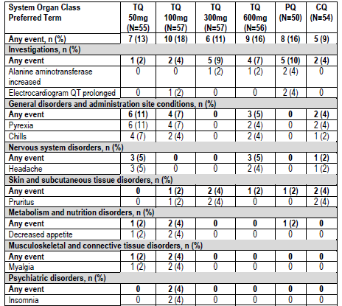

Study TAF116564
The percentage of patients with at least one treatment related AE was lower in the TQ+CQ group compared to the PQ+CQ group (8% versus 13%) (Table 53). The most commonly reported treatment related AE with TQ+CQ was pruritus (3% versus 9% with PQ+CQ).
Table 53: Drug-related treatment-emergent adverse events reported in at least 1% of subjects in either treatment group by treatment by Preferred Term (Safety Population), Study 116564
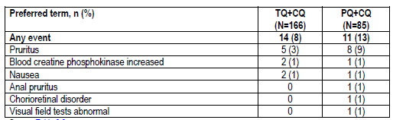

Deaths and other serious adverse events

Pivotal and/or main efficacy study
No deaths were reported in this study.
The percentage of patients with any SAE was comparable among treatment groups (8% with TQ+CQ versus 5% with CQ alone; 3% with PQ+CQ) (Table 54). Decreased Hb was the most common SAE with TQ+CQ, and the only SAE reported in >1 subject in the TQ+CQ group (5% with TQ+CQ versus 2% with CQ alone; 2% with PQ+CQ). There were no treatment related SAEs in the TQ+CQ group (vs. 3% with CQ alone and <1% with PQ+CQ) (Table 554.
Table 54: Treatment-Emergent Serious Adverse Events by Preferred Term (Safety Population), Study TAF112582 Part 2
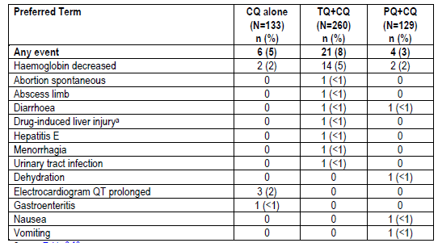
a. Subject [information redacted] had an SAE of hepatitis due to herbal medicine that was coded to the MedDRA preferred term of drug-induced liver injury
Table 55: Summary of Drug-Related Treatment-Emergent Serious Adverse Events by Preferred Term Study TAF112582 Part 2
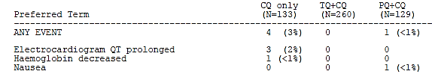

Other studies

Study TAF112582 Part 1
No deaths were reported in this study. The percentage of patients with any SAE was low and comparable between TQ300 mg+CQ and CQ alone groups (4% (2/57) versus 7% (4/54); 14% (7/50) with PQ+CQ) (Table 56). There was no clear dose related trend among the TQ+CQ groups. The 2 SAEs in the TQ300 mg+CQ group were ECG QT prolongation (2% versus 4% with CQ alone and 8% with PQ+CQ) and anaemia (2% versus 0% with CQ alone and 0% with PQ+CQ).
Table 56: Summary of Treatment-Emergent Serious Adverse Events (Excluding P. vivax) (Safety Population), Study TAF112582 Part 1
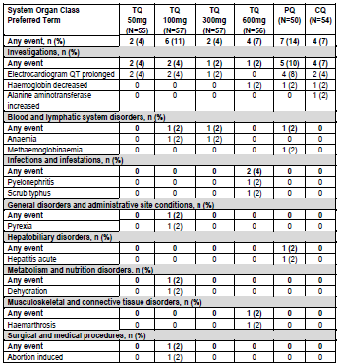

Study TAF116564
No deaths were reported in this study. The percentage of patients with any SAE was low and comparable between TQ+CQ and PQ+CQ groups (4% (6/166) versus 1% (1/85)) (Table 57). The most common SAE in the TQ+CQ group was Hb decreased (2% (4/166) versus 1% (1/85) with PQ+CQ). None of the SAEs were considered by the investigator to be treatment related.
Table 57: Treatment-Emergent SAEs by Preferred Term (Safety Population), Study 116564
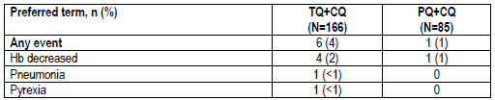

Discontinuations due to adverse events

Pivotal and/or main efficacy study
No subject had an AE leading to withdrawal from the study. The incidence of all-causality AEs leading to discontinuation of study drug was low and comparable among treatment groups (5% with TQ+CQ versus 4% with CQ alone; 0% with PQ+CQ) (Table 58). The most commonly reported AEs leading to discontinuation of study drug with TQ+CQ was Hb decreased (4% with TQ+CQ versus 2% with CQ alone; 0% with PQ+CQ).
Table 58: Treatment-Emergent Adverse Events Leading to Discontinuation of Study Treatment (Safety Population), Study TAF112582 Part 2
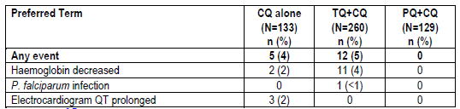

Other studies

Study TAF112582 Part 1
No subject had an AE leading to withdrawal from the study. The incidence of all-causality AEs leading to discontinuation of study drug was low: overall three subjects discontinued study treatment due to an AE, one each in the TQ50 mg+CQ, PQ+CQ and CQ alone groups, and all were reports of ECG QT prolongation.

Study TAF116564
No subject had an AE leading to withdrawal from the study. The incidence of all-causality AEs leading to discontinuation of study drug was low: one subject in each treatment group discontinued study medication early due to decreased Hb.

Evaluation of issues with possible regulatory impact

Liver function and liver toxicity

Pivotal and/or main efficacy study
Analysis of laboratory liver parameters did not raise any safety concerns. The incidences of raised ALT and AST outside the reference range were low and comparable across treatment groups (raised ALT: 4% with TQ+CQ versus 8% with CQ alone and 4% with PQ+CQ; raised AST: 3% with TQ+CQ versus 4% with CQ alone and 2% with PQ+CQ) (Table 59).
The proportion of subjects with AEs in the hepatobiliary disorders System Organ Class (SOC) was low and similar across the treatment groups (2% with TQ+CQ versus 2% with CQ alone; <1% with PQ+CQ) (Table 60). Of the 4 subjects in the TQ+CQ group with hepatobiliary disorders AEs, 2 were considered SAEs but neither of these was considered treatment related (one case of hepatitis E and one case of drug-induced liver injury due to herbal medications). The other 2 AEs were considered treatment related but both were of Grade 1 or Grade 2 in severity, and neither was an SAE.
Table 59: Chemistry laboratory data outside the reference range at any time on-study (Safety Population), Study TAF112582 Part 2
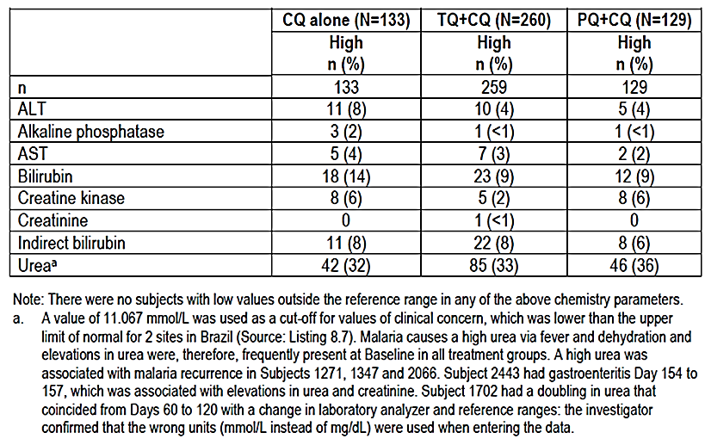
Table 60: Treatment emergent AEs in the hepatobiliary disorders System Organ Class (Safety Population), Study TAF112582 Part 2
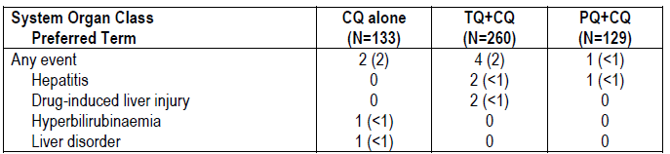

Other studies

Study TAF112582 Part 1
Analysis of laboratory liver parameters did not raise any safety concerns. The incidences of post-baseline raised ALT and AST outside the reference range were low and comparable across treatment groups (raised ALT: 7% with TQ300 mg+CQ versus 6% with CQ alone and 4% with PQ+CQ; raised AST: 5% with TQ300 mg+CQ versus 2% with CQ alone and 2% with PQ+CQ). There was no clear dose related trend among the TQ+CQ groups.

Study TAF116564
Analysis of laboratory liver parameters did not raise any safety concerns. The incidences of raised ALT and AST outside the reference range were low and comparable between treatment groups (raised ALT: 5% with TQ+CQ versus 0% with PQ+CQ; raised AST: 4% with TQ+CQ versus 4% with PQ+CQ) (Table 61).
Table 61: Subjects with clinical chemistry laboratory data outside the reference range at any visit post-baseline (Safety Population), Study 116564
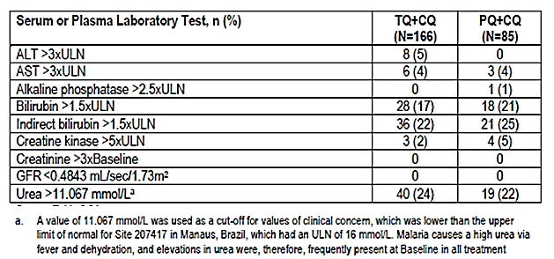
The proportion of subjects with AEs in the hepatobiliary disorders SOC was low and similar between the treatment groups: one subject in each treatment group reported AE of hyperbilirubinemia (both of severity Grade 2).

Renal function and renal toxicity

Pivotal and/or main efficacy study
Analysis of laboratory renal parameters did not raise any safety concerns. The incidence of post-baseline raised creatinine outside the reference range was low (<1% (n=1) with TQ+CQ versus 0% with CQ alone and 0% with PQ+CQ) as was that of low eGFR (<1% (n=1) with TQ+CQ versus 0% with CQ alone and 0% with PQ+CQ).
The proportion of subjects with AEs in the renal and urinary disorders SOC was low and similar across the treatment groups (2% of subjects in each treatment group) (Table 62).
Table 62: Treatment emergent AEs in the renal and urinary disorders System Organ Class (Safety Population), Study TAF112582 Part 2
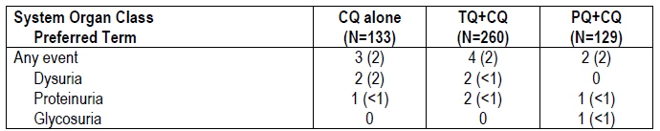

Other studies

Study TAF112582 Part 1
Analysis of laboratory renal parameters did not raise any safety concerns. The incidence of post-baseline raised creatinine outside the reference range was low (2% (n=1) each in the TQ50 mg+CQ and TQ600 mg+CQ groups; 0% in the other treatment groups) as was that of low eGFR (5% (n=3) in the TQ600 mg+CQ group; 2% (n=1) each in the TQ50 mg+CQ and TQ300 mg+CQ groups 0% in the other treatment groups).
Study TAF116564
Analysis of laboratory renal parameters did not raise any safety concerns. No subjects in either treatment group had post-baseline raised creatinine >3x baseline or low eGFR outside the reference range.
The proportion of subjects with AEs in the renal and urinary disorders SOC was low and similar between treatment groups (3% (5/166) in the TQ+CQ group versus 2% (2/85) in the PQ+CQ group). There were 4 AEs of dysuria (2%) and 1 AE of nephrolithiasis (<1%) in the TQ+CQ group, and 2 AEs of dysuria (2%) in the PQ+CQ group.

Haematology and haematological toxicity

Pivotal and/or main efficacy study
Analysis of laboratory haematology parameters did not raise any safety concerns. The incidences of decreases in Hb that fell to below the lower limit of normal were low (Figure 9). Two subjects (both in the PQ+CQ group) had Hb values of <80 g/L during the study and both subjects fully recovered without medical intervention. Changes from baseline in Hb over time were similar across the treatment groups and showed recovery following treatment for the underlying disease (Figure 10). The majority of patients had maximal decrease in Hb from baseline over the first 29 days of ≤20g/L (83% with TQ+CQ, 90% with CQ alone, and 88% with PQ+CQ) (Table 63). None of the subjects with decreased Hb in the TQ+CQ group were symptomatic and no subject required a blood transfusion. All subjects fully recovered without blood transfusion or other medical intervention.
Figure 9: Hb Values by Visit (Safety Population) Study TAF112582 Part 2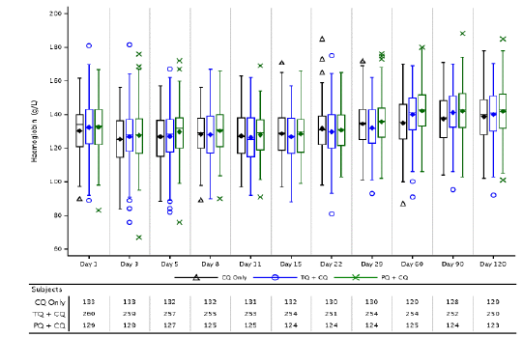
Figure 10: Change from Baseline in Hb by Visit (Safety Population) Study TAF112582 Part 2
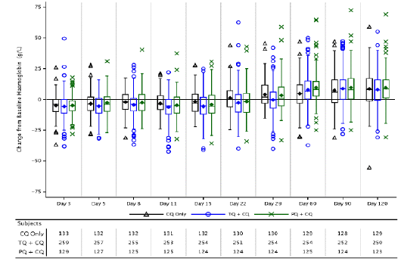
Table 63: Haemoglobin declines over first 29 Days (Safety Population), Study TAF112582 Part 2
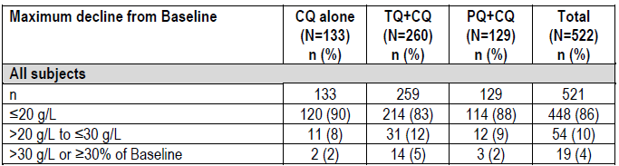
The incidence of AEs that were potentially related to Hb decreases was low across treatment groups (6% with TQ+CQ versus 4% with CQ alone and 2% with PQ+CQ) (Table 64). Among these AEs, the preferred term of Hb decreased was the most common AE in all 3 treatment groups (5% with TQ+CQ versus 2% with CQ alone and 2% with PQ+CQ). The incidence of protocol-defined SAEs of decreased Hb was 5% with TQ+CQ (versus 2% with CQ alone and 2% with PQ+CQ). None of these SAEs in subjects who received TQ+CQ treatment were considered to be related to study medication and all subjects recovered without specific medical intervention.
Table 64: Treatment emergent AEs potentially related to haemoglobin decreases (Safety Population), Study TAF112582 Part 2
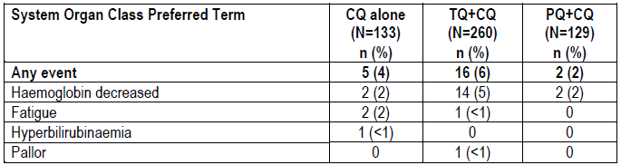
The proportions of subjects with abnormal values in other haematology parameters were generally comparable among treatment groups, except raised metHb levels which was higher in the PQ+CQ group (9%; versus 2% with TQ+CQ and 3% with CQ alone). A higher proportion of subjects in the PQ+CQ group had a metHb of >10% compared with the other treatment groups. Methaemoglobinaemia is a known effect of PQ.

Other studies

Study TAF112582 Part 1
Analysis of laboratory haematology parameters did not raise any safety concerns. Changes from baseline in Hb over time were similar across the treatment groups (Figure 11). At Day 3, all treatment groups showed a post-baseline decline in Hb. Subsequently, all groups improved with no discernible dose related trends. The majority of patients had maximal decrease in Hb from baseline of ≤15g/L over the first 29 days (67% with TQ300 mg+CQ, 70% with CQ alone, and 68% with PQ+CQ) (Table 65). The incidence of maximal decrease in Hb from baseline of >25g/L or ≥ 25% drop from baseline was low (4% with TQ300 mg+CQ, 2% with CQ alone, and 2% with PQ+CQ). No subject received a blood transfusion during the course of the study.
Figure 11: Box Plot change in Hb from baseline by Visit and Treatment Group (Safety Population), Study TAF112582 Part 1
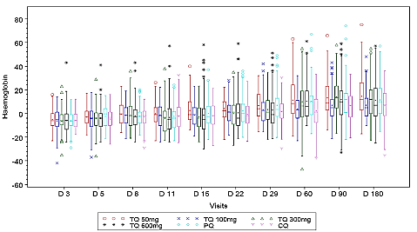
Table 65: Summary of haemoglobin declines over first 29 Days (Safety Population), Study TAF112582 Part 1
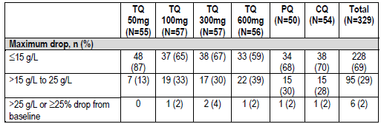
Raised metHb levels was highest in the PQ+CQ group (24%; versus 9% with TQ300 mg+CQ and 11% with CQ alone). A dose related increase in metHb levels across the TQ+CQ groups was observed (5%, 5%, 9% and 20% in the TQ50 mg+CQ, TQ100 mg+CQ, TQ300 mg+CQ, TQ600 mg+CQ groups, respectively). Across treatment groups, raised metHb peaked at around Day 11 and resolved by Day 60.

Study TAF116564
The overall incidence of clinically relevant haemolysis (primary safety endpoint; defined in the protocol as a decrease in Hb of ≥30% or >30 g/L from Baseline or an overall drop in Hb below 60 g/L) was low and comparable in both treatment groups (2.4% with TQ+CQ versus 1.2% with PQ+CQ) (Table 66).
The incidences of decreases in Hb that fell to below the lower limit of normal were low (Figure 12). Changes from baseline in Hb over time were similar between the treatment groups and showed recovery following treatment for underlying disease (Figure 13). The majority of patients had maximal decrease in Hb from baseline of ≤20g/L over the first 29 days (78% with TQ+CQ and 82% with PQ+CQ) (Table 67). The incidence of maximal decrease in Hb from baseline of >30g/L or ≥30% drop from baseline was low (4% (2/166) with TQ+CQ and 1% (1/85) with PQ+CQ). No subjects received blood transfusions in the study.
Table 66: Incidence of clinically relevant haemolysis (Safety Population), Study 116564
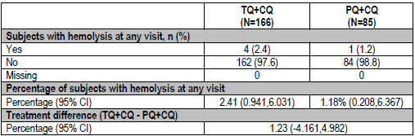
Figure 12: Boxplot of Hb by Visit and Treatment Group (Safety Population), Study 116564
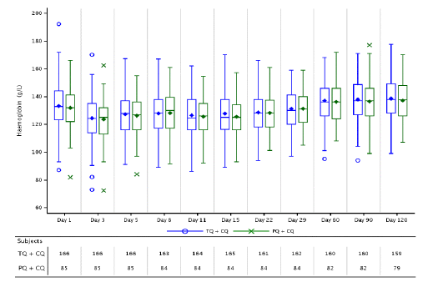
Figure 13: Boxplot of Change from Baseline in Hb by Visit and Treatment Group (Safety Population), Study 116564
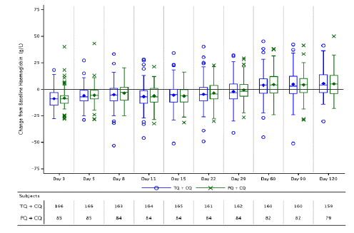
Table67: Summary of Hb Declines over First 29 Days (Safety Population)
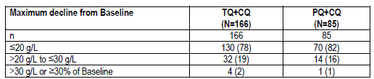
The incidence of AEs that were potentially related to Hb decreases was low and comparable between treatment groups (5% with TQ+CQ versus 4% with PQ+CQ) (Table 68).
Table 68: Treatment emergent AEs potentially related to haemoglobin decreases (Safety Population), Study 116564
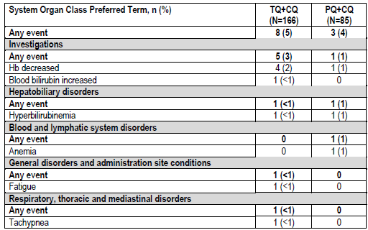
The proportions of subjects with abnormal values in other haematology parameters were generally comparable among treatment groups. The proportion of subjects with post-baseline metHb of >10% was low in both treatment groups (1% with TQ+CQ and 4% with PQ+CQ).

Electrocardiograph findings and cardiovascular safety

Pivotal and/or main efficacy study
Analysis of electrocardiography did not raise any safety concerns.

Other studies

Study TAF112582 Part 1
Analysis of electrocardiography did not raise any safety concerns. QTcF changes were comparable among treatment groups and there were no dose related trends among the TQ+CQ groups.

Study TAF116564
Analysis of electrocardiography did not raise any safety concerns.

Vital signs

Pivotal and/or main efficacy study
Analysis of vital signs did not raise any safety concerns.

Other studies

Study TAF112582 Part 1
Analysis of vital signs did not raise any safety concerns.

Study TAF116564
Analysis of vital signs did not raise any safety concerns.

Other safety parameters

Pivotal and/or main efficacy study

Neuropsychiatric events
The most common neuropsychiatric AEs with onset on or prior to Day 29 in the TQ+CQ group was dizziness (8% with TQ+CQ versus 3% with CQ alone and 6% with PQ+CQ) and headache (5% with TQ+CQ versus 7% with CQ alone and 4% with PQ+CQ). All these neuropsychiatric AEs were of mild to moderate severity and none were considered SAEs.

Ophthalmic events
Approximately 25% of randomised subjects in this study had available results for eye assessments. Assessments included visual acuity measurements, anterior segment examination with evaluation for vortex keratopathy, posterior segment examination including fundus photographs, colour perception assessment, and Humphrey visual field perimetry. Analyses of ophthalmic assessments did not raise any major concerns. Findings associated with changes in visual acuity, vortex keratopathy, and retinal examination findings are presented in Table69. The incidence of new post-baseline vortex keratopathy was low (2% with TQ+CQ versus 0% with CQ alone and 0% with PQ+CQ), as was that for retinal changes from baseline (3% with TQ+CQ versus 4% with CQ alone and 3% with PQ+CQ).
Table 69: Keratopathy, Best Corrected Visual Acuity Classification, and Retinal Changes from Baseline (Ophthalmic Population) Study TAF112582 Part 2
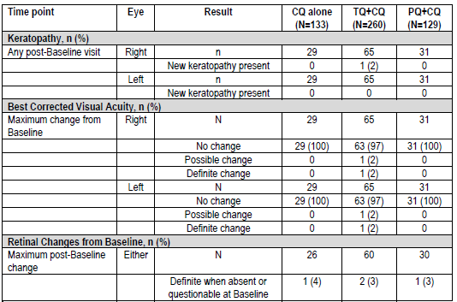

Other studies

Study TAF112582 Part 1
The incidence of treatment related psychiatric AEs was low. Only 2 subjects reported treatment related psychiatric AEs (both in the TQ100 mg+CQ group, both are for AE of insomnia).
Overall, 93 subjects underwent ophthalmic investigations in this study. Analyses of ophthalmic data did not raise safety concerns. Results showed that there were no reports or observations of keratopathy. No change from baseline was observed on review of slit lamp examination data.

Study TAF116564
The most common neuropsychiatric AEs in the TQ+CQ group were dizziness (17% with TQ+CQ versus 19% with PQ+CQ) and headache (16% with TQ+CQ versus 19% with PQ+CQ) (Table 70).
Table 70: Summary of Neuropsychiatric Adverse Events by System Organ Class and Preferred Term (Safety Population), Study 116564
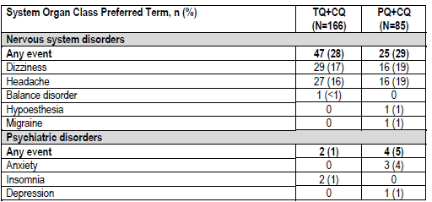
In this study, one centre performed ophthalmic safety assessments at selected visits to monitor subjects for changes in the eye. Assessments included visual acuity measurements, anterior segment examination including evaluation for vortex keratopathy, posterior segment examination including color fundus photographs, color perception assessments and Humphrey perimetry assessments. Analyses of ophthalmic safety assessments did not raise any concerns. No subjects in either treatment arm developed vortex keratopathy at any time point.

Study 201807 (Ophthalmic safety study)
Interim analysis results in this study did not identify any safety signal for retinal toxicity with use of a single 300 mg dose of TQ in healthy subjects. The proportion of subjects with retinal findings in either eye as defined in the primary endpoint was low (1% (1/101) with TQ 300 mg and 0% with placebo) (Table 71). There was no evidence of development of vortex keratopathy seen in any subject.
Table 71: Proportion of subjects in the primary ophthalmic safety population with retinal findings in either eye as defined in the primary endpoint, Study 201807
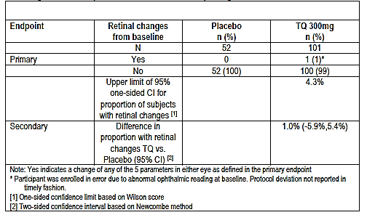

Other safety issues

Safety in special populations

Safety related to drug-drug interactions and other interactions
TQ is an inhibitor of human transporters OCT2 and MATE in vitro. There may be a potential, but low risk of lactic acidosis in subjects who receive TQ concomitantly with substrates of these renal transporters.
Drug-drug interaction studies demonstrated no clinically relevant inhibition of CYP1A2, CYP2A6, CYP2C8, CYP2C9, and CYP3A4 enzymes. Mild to moderate side effects of headache, abdominal pain and fatigue were reported in these studies. Generally there were no clinically significant changes in ECG or routine lab tests in these studies. In Study 040 the multi-substrate cytochrome P450 trial, four subjects experienced transient increases in total bilirubin, without evidence of haemolysis. One subject with elevated metHb level was symptomatic, hospitalised and required treatment with methylene blue.
In Study 200951, with the co-administration of TQ with artemisinin based combination therapies, one subject experienced a cardiac arrest while receiving the combination of DHA +PQP. Another subject receiving AL treatment alone experienced ventricular tachycardia. This was attributed to an undiagnosed Wolff-Parkinson-White syndrome in this subject.
There were no serious adverse events in subjects receiving TQ alone or with other medications in these studies.

Post marketing experience
Not applicable

Evaluator’s overall conclusions on clinical safety
Overall, safety analyses in the pivotal Phase III Study TAF112582 Part 2 showed that a single-dose of TQ300 mg with CQ did not raise any major safety concerns. Results showed that incidences of all-causality AEs and SAEs were comparable among treatment groups of TQ300 mg+CQ, CQ alone and PQ+CQ. The incidence of all-causality AEs was 63% with TQ+CQ versus 65% with CQ alone and 59% with PQ+CQ. The most commonly reported AEs with TQ+CQ were pruritus (13% versus 15% with CQ alone versus 11% with PQ+CQ), headache (10% versus 14% versus 8%) and dizziness (10% versus 8% versus 7%). Few severe AEs (≥Grade 3) were reported (1% with TQ+CQ versus 3% with CQ alone; <1% with PQ+CQ). The incidence of SAEs was low (8% with TQ+CQ versus 5% with CQ alone and 3% with PQ+CQ). The most common SAE with TQ+CQ was decreased Hb (5% with TQ+CQ versus 2% with CQ alone and 2% with PQ+CQ).
The incidence of treatment related AEs was lower in the TQ+CQ group compared with the CQ alone group (10% versus 18%; 14% with PQ+CQ), and the most commonly reported treatment related AE with TQ+CQ was nausea (3% versus <1% with CQ alone and 2% with PQ+CQ).There were no treatment related SAEs in the TQ+CQ group (vs. 3% with CQ alone and <1% with PQ+CQ). There were no deaths reported in the study.
Analysis of liver, renal and haematological parameters and AEs did not raise any safety concerns. The incidence of AEs that were potentially related to Hb decreases was low across treatment groups (6% with TQ+CQ versus 4% with CQ alone and 2% with PQ+CQ). No subject required a blood transfusion.
The incidence of neuropsychiatric AEs was low and the most common neuropsychiatric AEs with onset on or prior to Day 29 in the TQ+CQ group was dizziness (8% with TQ+CQ versus 3% with CQ alone and 6% with PQ+CQ) and headache (5% with TQ+CQ versus 7% with CQ alone and 4% with PQ+CQ). All these neuropsychiatric AEs were of mild to moderate severity and none were considered SAEs.
Safety results in the other studies were consistent with those of the pivotal study. Safety sections of the proposed Product Information are evaluated and found to be appropriate.

First round benefit-risk assessment

First round assessment of benefits
Table 72: Assessment of benefits
Indication
Benefits | Strengths and Uncertainties
Potential benefit is in the radical cure (prevention of relapse) of Plasmodium vivax malaria in patients. | Efficacy results were generally supportive of a positive treatment effect of TQ+CQ over CQ alone in reducing the risk of recurrence at 6 months and 4 months post-dosing.  Treatment with TQ+CQ resulted in a statistically significant reduction in the risk of recurrence over 6 months by 70.1% (p<0.001) compared with CQ alone (recurrence-free efficacy rate at 6 months of 62.4% in the TQ+CQ group versus 27.7% in the CQ alone group).  Treatment with TQ+CQ also resulted in a statistically significant reduction in the risk of recurrence in the first 4 months by 72.9% (p<0.001) compared with CQ treatment alone (recurrence-free efficacy rate at 4 months of 73.0% in the TQ+CQ group versus 36.0% in the CQ alone group).
Additional benefit is the ease of administration of a single oral dose of two 150 mg tablets. This confers an advantage over the alternative currently approved radical cure treatment with primaquine which has a posology of oral daily dose of 15 mg for 14 days. Efficacy of tafenoquine in the radical cure of Pv malaria appears to be comparable with that of primaquine.  A single dose posology could increase dosing convenience to patients, reduce the risk of medication non-compliance, as well as reduce the potential risk of adverse effects. | In Study TAF116564, recurrence-free efficacy rates at 6 months and at 4 months were numerically comparable between TQ+CQ and PQ+CQ (6 months: 72.7% with TQ+CQ and 75.1% with PQ+CQ; 4 months: 82.3% with TQ+CQ and 79.7% with PQ+CQ).  However, exploratory non-inferiority analysis using pooled data from Studies TAF112582 Part 2 and TAF116564 showed that the non-inferiority of TQ+CQ to PQ+CQ could not be demonstrated.  It is noted that PQ treatment compliance was very high in this study population (>99% of subjects received ≥12 doses of PQ) and that this high compliance rate may not be attainable outside of a clinical study environment.

First round assessment of risks
Table 73: Assessment of risks
Risks | Strengths and Uncertainties
Safety analyses showed that single-dose of TQ300 mg with CQ did not raise any major safety concerns. AEs were largely limited to mild to moderate symptoms such as nausea, headache and dizziness. Safety profile was generally comparable with CQ alone and with PQ+CQ. | In the pivotal study, the incidence of treatment related AEs was lower in the TQ+CQ group compared with the CQ alone group (10% versus 18%; 14% with PQ+CQ).  The most commonly reported treatment related AE with TQ+CQ was nausea (3% versus <1% with CQ alone and 2% with PQ+CQ).There were no treatment related SAEs in the TQ+CQ group.  The incidence of dizziness with TQ+CQ was comparable with that of PQ+CQ (8% with TQ+CQ versus 6% with PQ+CQ) as was that of headache (5% versus 4%). These AEs were of mild to moderate severity and none were considered SAEs.
The main safety concern with tafenoquine is drug-induced haemolysis in patients with G6PD deficiency. This is also a safety liability for primaquine.  Safety results showed that excluding patients with a G6PD activity <70% of normal could protect patients from clinically significant Hb declines. | Across the 3 efficacy/safety studies (TAF112582 Parts 1 and 2, TAF116564) where patients with a G6PD activity <70% of normal were excluded, the incidences of decreases in Hb that fell to below the lower limit of normal were low in all treatment groups.  Changes from baseline in Hb over time were similar across the treatment groups.  The amount of Hb decreases was small. The majority of patients had maximal decrease in Hb from baseline over the first 29 days of ≤20g/L. No subjects required blood transfusions or other medical interventions.

First round assessment of benefit-risk balance
Overall, the benefit-risk balance for the use of tafenoquine for the radical cure (prevention of relapse) of Pv malaria in patients aged 16 years and older is positive. Compared with CQ alone, treatment with TQ+CQ resulted in a statistically significant reduction in the risk of recurrence by 70.1% over 6 months and by 72.9% over 4 months.
Efficacy of tafenoquine in the radical cure of Pv malaria appears to be comparable with that of primaquine. The posology of a single oral dose of two TQ 150 mg tablets confers an advantage over the alternative currently approved radical cure treatment with primaquine, which requires oral dosing of 15 mg daily for 14 days. A single dose posology could increase dosing convenience to patients, reduce the risk of medication non-compliance as well as reduce the potential risk of adverse effects.
Safety analyses showed that single dose of TQ 300 mg with CQ did not raise any major safety concerns. Safety profile of TQ 300 mg single dose was generally comparable with PQ 15 mg once daily for 14 days.

First round recommendation regarding authorisation
It is recommended that the application for the registration of tafenoquine for the radical cure (prevention of relapse) of Plasmodium vivax (Pv) malaria in patients aged 16 years and older be approved.

Second round evaluation
Not applicable.

Second round benefit-risk assessment

Second round assessment of benefits
Not applicable.

Second round assessment of risks
Not applicable.

Second round assessment of benefit-risk balance
Not applicable.

Second round recommendation regarding authorisation
Not applicable.

References
Brueckner et al. Prophylaxis of plasmodium falciparum infection in a human challenge model with WR 238605, a new 8-aminoquinoline antimalarial prophylaxis of plasmodium falciparum infection in a human challenge model with WR 238605. antimicrobial agents and chemotherapy. 1998; 5:293–1294.
Khantikul N et al. Adherence to antimalarial drug therapy among vivax malaria patients in northern Thailand. J Health Popul Nutr, 27:4–13, 2009.
Rahimi BA, et al. Severe vivax malaria: a systematic review and meta-analysis of clinical studies since 1900. Malar J, 13:481, 2014
World Health Organisation. Assessment and monitoring of antimalarial drug efficacy for the treatment of uncomplicated falciparum malaria. 2003.
World Health Organisation. Guidelines for the treatment of malaria. Third edition. 2015 World Health Organization: Geneva, Switzerland.
World Health Organisation. World Malaria Report 2016. World Health Organization: Geneva, Switzerland.
Therapeutic Goods Administration
PO Box 100 Woden ACT 2606 Australia
Email: info@tga.gov.au Phone: 1800 020 653 Fax: 02 6232 8605
https://www.tga.gov.au

Proposed Australian Product Information, tafenoquine.
Product Information for primaquine, Feb 2017
TQ is an 8-aminoquinoline, a class of drugs known to be a haemolysis risk factor in subjects with G6PD deficiency. The distribution of G6PD enzyme activity in males is bimodal and individuals are either normal or deficient, since they carry only one copy of the G6PD gene. Females carry two copies of the gene, and can therefore be heterozygous for G6PD deficiency. Females who are heterozygous for G6PD deficiency have varying levels of X-chromosome inactivation, resulting in a spectrum of G6PD enzyme activity ranging from fully deficient, to intermediate levels of deficiency, through to normal levels of enzyme activity.
Study TAF112582 was conducted in 2 parts (Part 1 and Part 2). Although conducted under the same protocol, each part of the protocol represented distinct and independent studies, with different subjects recruited to each part.
Ophthalmic safety assessments were planned to be done at selected sites. In this study, only one centre (in Brazil) had the necessary equipment and capability to conduct ophthalmic assessments during the study.
Protocol-defined stopping criteria for decreased Hb: a ≥2.5 g/dL or 25% decline in Hb from baseline value associated with clinical evidence of haemolysis and no other explanation for fall in Hb.
Defined as subjects who did not demonstrate initial clearance of P. vivax parasitaemia or demonstrated initial clearance and had a subsequent non-zero asexual P. vivax parasite count on or before Day 32
Compliance rate for TQ was 100%: all subjects in the PP population of the NI dataset received their scheduled in-clinic single dose of TQ
Full study results were provided to TGA in May 2018.
Hb decreases from baseline of ≥30% or >30 g/L, or an overall drop to below 60 g/L in the first 15 days of the study were protocol-defined SAEs
In the primary endpoint, a subject was considered to have a clinically significant retinal change if any of the following 5 parameters indicated a change from Baseline in either eye: SD-OCT central subfield thickness, SD-OCT total macular volume, SD-OCT central retinal lesion thickness, SDOCT ellipsoid zone disruption (EZD), or abnormal autofluorescence patterns

