This medicinal product is subject to additional monitoring in Australia. This will allow quick identification of new safety information. Healthcare professionals are asked to report any suspected adverse events www.tga.gov.au/reporting-problems.
▼

AUSTRALIAN PRODUCT INFORMATION - VYNDAQEL® (tafamidis meglumine) soft capsules

1. NAME OF THE MEDICINE
Tafamidis meglumine

2. QUALITATIVE AND QUANTITATIVE COMPOSITION
The drug product is a soft capsule containing 20 mg of micronised tafamidis meglumine (equivalent to 12.2 mg tafamidis).
Each soft capsule contains no more than 44 mg of sorbitol.
The soft capsules contain sulfites.
For the full list of excipients, see Section 6.1 List of excipients.

3. PHARMACEUTICAL FORM
Soft capsule.
Yellow, opaque, oblong (approximately 21 mm) capsule printed with “VYN 20” in red.

4. CLINICAL PARTICULARS

4.1 Therapeutic indications
VYNDAQEL is indicated for the treatment of adult patients with wild-type or hereditary transthyretin amyloid cardiomyopathy (ATTR-CM).

4.2 Dose and method of administration
Treatment should be initiated and remain under the supervision of a physician knowledgeable in the management of patients with transthyretin amyloid cardiomyopathy (ATTR-CM).

Dosage
The recommended dose of VYNDAQEL is 80 mg tafamidis meglumine (administered as four 20 mg capsules) once daily.
A dose of 80 mg VYNDAQEL (tafamidis meglumine) (administered as four 20 mg VYNDAQEL capsules) is bioequivalent to a single 61 mg VYNDAMAX (tafamidis) capsule and is not interchangeable on a per mg basis (see Section 5.1 Pharmacodynamic properties and Section 5.2 Pharmacokinetic properties).
No dose ranging studies have been undertaken.

Method of administration
Oral use.
The capsule(s) should be swallowed whole and not crushed or cut. VYNDAQEL may be taken with or without food.
If a dose is missed, the patient should take the dose as soon as remembered. If it is almost time for the next dose, the patient should skip the missed dose and take the next dose at the regularly scheduled time. Do not double the dose.

Dosage adjustment

Renal or hepatic impairment
No dosage adjustment is required for patients with renal impairment, or mild or moderate hepatic impairment. VYNDAQEL has not been studied in patients with severe hepatic impairment (see Section 5.2 Pharmacokinetic properties).

Elderly
No dosage adjustment is required for elderly patients (≥ 65 years) (see Section 5.2 Pharmacokinetic properties). Of the total number of patients in the clinical study (n=441), 90.5% were 65 and over, with a median age of 75 years.

Paediatric
The safety and effectiveness of VYNDAQEL have not been established in paediatric patients.

4.3 Contraindications
Hypersensitivity to the active substance or to any of the excipients of VYNDAQEL listed in Section 6.1 List of excipients.

4.4 Special warnings and precautions for use

Women of childbearing potential
Studies in animals have shown developmental toxicity (see Section 4.6 Fertility, pregnancy and lactation). The potential risk for humans is unknown. VYNDAQEL is not recommended during pregnancy. Women of childbearing potential should use appropriate contraception when taking VYNDAQEL and continue to use appropriate contraception for 1-month after stopping treatment with VYNDAQEL (see Section 4.6 Fertility, pregnancy and lactation).

Organ transplant patients
A study has not been conducted in organ transplant patients. The efficacy and safety of VYNDAQEL in organ transplant patients has not been established.

Sorbitol
This medicinal product contains no more than 44 mg sorbitol in each capsule.
The additive effect of concomitantly administered products containing sorbitol (or fructose) and dietary intake of sorbitol (or fructose) should be taken into account.
The content of sorbitol in medicinal products for oral use may affect the bioavailability of other medicinal products for oral use administered concomitantly.

Liver function tests
Increase in liver function tests may occur (see Section 4.8 Adverse effects (undesirable effects)).

Use in hepatic impairment
Tafamidis meglumine has not been studied in patients with severe hepatic impairment and caution is recommended (see Section 5.2 Pharmacokinetic properties).

Use in renal impairment
Limited data are available in patients with severe renal impairment (creatinine clearance less than or equal to 30 mL/min).

Use in the elderly
See Section 4.2 Dose and method of administration.

Paediatric use
See Section 4.2 Dose and method of administration.

Effects on laboratory tests
Tafamidis meglumine may decrease serum concentrations of total thyroxine, without an accompanying change in free thyroxine (T4) or thyroid stimulating hormone (TSH). This observation in total thyroxine values may likely be the result of reduced thyroxine binding to or displacement from transthyretin (TTR) due to the high binding affinity tafamidis meglumine has to the TTR thyroxine receptor. No corresponding clinical findings consistent with thyroid dysfunction have been observed (see Section 4.8 Adverse effects (undesirable effects).
The incidence of thyroxine abnormality <0.8 x Lower Level of Normal (LLN) was greater in the tafamidis meglumine 80 mg group (29.7%) than in the tafamidis meglumine 20 mg (12.3%) and placebo (4.5%) groups.

4.5 Interactions with other medicines and other forms of interactions
In a clinical study in healthy volunteers, tafamidis meglumine did not induce or inhibit the cytochrome P450 enzyme CYP3A4.
In vitro data also indicated that tafamidis meglumine does not significantly inhibit cytochrome P450 enzymes CYP1A2, CYP3A4, CYP3A5, CYP2B6, CYP2C8, CYP2C9, CYP2C19, and CYP2D6. In addition, tafamidis meglumine did not induce CYP1A2, but did induce CYP2B6 in vitro, however based on the negative clinical CYP3A4 induction results, it can be concluded that the likelihood of CYP2B6 clinical induction is low.
In vitro studies suggest that it is unlikely tafamidis meglumine will cause drug interactions at clinically relevant concentrations with substrates of UDP-glucuronosyltransferase (UGT) systemically. Tafamidis meglumine may inhibit intestinal activities of UGT1A1.
Tafamidis meglumine showed a low potential to inhibit Multi-Drug Resistant Protein (MDR1) (also known as P-glycoprotein; P-gp) systemically and in the gastrointestinal (GI) tract, organic cation transporter 2 (OCT2), multidrug and toxin extrusion transporter 1 (MATE1) and MATE2K, organic anion transporting polypeptide 1B1 (OATP1B1) and OATP1B3 at clinically relevant concentrations.
Tafamidis meglumine has the potential to inhibit the efflux transporter BCRP (breast cancer resistant protein) and may increase systemic exposure of substrates of this transporter (e.g. methotrexate, rosuvastatin, imatinib) following 80 mg tafamidis meglumine daily dose. Dose adjustment may be needed for these substrates.
Tafamidis meglumine may have the potential to inhibit organic anion transporter 1 (OAT1) and OAT3 and may cause drug-drug interactions with substrates of these transporters (e.g. non-steroidal anti-inflammatory drugs, bumetanide, furosemide, lamivudine, methotrexate, oseltamivir, tenofovir, ganciclovir, adefovir, cidofovir, zidovudine, zalcitabine). However, additional risk assessments based on the R-value model (AUCi/AUC =1+(C_{max},u/Ki)) were performed and the maximal predicted changes in AUC of OAT1 and OAT3 substrates were determined to be less than 1.25 for the 80 mg tafamidis meglumine daily dose, therefore, inhibition of OAT1 or OAT3 transporters by tafamidis meglumine is not expected to result in clinically significant interactions.
Patients receiving substrates of both BCRP and OAT with tafamidis meglumine should be assessed as exposure of these drugs may be increased e.g. methotrexate AUC might be increased by ~50%.
No interaction studies have been performed evaluating the effect of other medicinal products on tafamidis meglumine.
No significant effect was observed on the pharmacokinetics of midazolam (a CYP3A4 substrate) or on the formation of its active metabolite (1-hydroxymidazolam), when a single 7.5 mg dose of midazolam was administered prior to and after a 14-day regimen of 20 mg once-daily tafamidis meglumine. The overall systemic exposure (AUC_{0-∞}) and total clearance (CL/F) of midazolam were shown to be equivalent. In addition, tafamidis meglumine did not induce CYP3A4 activity in either male or female subjects.

4.6 Fertility, pregnancy and lactation

Effects on fertility
There were no effects of tafamidis meglumine on fertility, reproductive performance, or mating behavior in the rat at any dose. Rats were dosed daily (5, 15, and 30 mg/kg/day) prior to cohabitation (for at least 15 days for females and 28 days for males), throughout the cohabitation period to the day prior to termination of males and through to implantation of females (Gestation Day 7). No adverse effects were noted on male rats in toxicity, fertility and mating behaviour at any dose. Because no reproductive effects occurred at the highest dose tested, the paternal and maternal no observed effect level for reproductive toxicity of tafamidis meglumine is greater than 30 mg/kg/day (estimated to be greater than 9.7-times the clinical AUC at the MRHD of 80 mg tafamidis meglumine per day).

Developmental toxicity
In pregnant rabbits increased skeletal variations were observed at ≥0.5 mg/kg/day (exposures approximately equivalent to clinical exposures at the MRHD of 80 mg tafamidis meglumine), while increased skeletal malformations, reduced embryo-fetal survival and reduction in fetal body weights were observed at 8 mg/kg/day (AUC exposures 9.3 times clinical AUC at the MRHD). In pregnant rats, oral administration of tafamidis meglumine (15, 30, and 45 mg/kg/day) from Gestation Day 7 through 17 resulted in decreased fetal weights at ≥30 mg/kg/day (approximately ≥9.7-times the human AUC at the clinical dose of 80 mg tafamidis meglumine).
In the rat pre- and post-natal development study with tafamidis meglumine, pregnant rats were orally administered tafamidis meglumine at doses of 5, 15, or 30 mg/kg/day from Gestation Day 7 through Lactation Day 20. Decreased pup survival, reduced pup weights and malformations (microphthalmia, enophthalmos, domed head) were noted at doses ≥15 mg/kg/day (≥6.6-times the clinical AUC at the MRHD of 80 mg tafamidis meglumine per day). Decreased pup weights in males were associated with delayed sexual maturation (preputial separation) at 15 mg/kg/day. Impaired performance in a water-maze test for learning and memory was observed at 15 mg/kg/day. The no observable adverse effect level (NOAEL) for viability and growth in the F1 generation offspring following maternal exposures to tafamidis meglumine was 5 mg/kg/day (human equivalent dose of 0.8 mg/kg/day), a dose approximately 1.2-times the clinical dose of 80 mg tafamidis meglumine for a 70 kg adult.

Use in pregnancy – Pregnancy Category D

Women of childbearing potential
Contraceptive measures should be used by women of childbearing potential during treatment with VYNDAQEL, and, due to the prolonged half-life, for one month after stopping treatment.
VYNDAQEL is not recommended in women of childbearing potential not using contraception.

Pregnancy
There are no adequate data on the use of VYNDAQEL in pregnant women. Based on findings from animal studies, VYNDAQEL may cause fetal harm when administered to pregnant women (see above). The potential risk for humans is unknown. VYNDAQEL is not recommended during pregnancy.
To monitor outcomes of pregnant women exposed to VYNDAQEL, a Tafamidis Enhanced Surveillance for Pregnancy Outcomes (TESPO) program has been established. If a pregnancy occurs in a woman being treated with VYNDAQEL, medical or healthcare professionals are encouraged to report the pregnancy to the Sponsor (see Section 8 Sponsor).

Use in lactation
Nonclinical data demonstrate that tafamidis meglumine is secreted in the milk of lactating rats. While the effect of VYNDAQEL on nursing infants after administration to the mother has not been studied, a risk to infants cannot be excluded. Breastfeeding is not recommended during treatment with VYNDAQEL.

4.7 Effects on ability to drive and use machines
No studies on the effects of VYNDAQEL on the ability to drive or use machines have been performed.

4.8 Adverse effects (undesirable effects)
The data across clinical trials reflect exposure of 377 ATTR-CM patients to either 20 mg or 80 mg (administered as four 20 mg capsules) of tafamidis meglumine daily for an average of 24.5 months (ranging from 1 day to 111 months). The population included adult patients diagnosed with ATTR-CM, the majority (approximately 90%) of whom had a baseline NYHA (New York Heart Association) classification of Class II or Class III. The mean age was approximately 75 years (ranging from 46 years to 91 years of age); a majority were male (>90%), and approximately 82% were Caucasian.
Adverse events were assessed from ATTR-CM clinical trials with tafamidis meglumine including a 30-month placebo-controlled trial in patients diagnosed with ATTR-CM (see Section 5.1 Pharmacodynamic properties). The frequency of adverse events in patients treated with 20 mg or 80 mg tafamidis meglumine was similar and comparable to placebo.
The most commonly reported treatment-emergent adverse events (>15%) for the patients treated with tafamidis meglumine (pooled tafamidis meglumine 20 mg + 80 mg) compared to placebo in the pivotal phase 3 Study B3461028 are shown in Table 1.
Table 1: Most Common Treatment-Emergent Adverse Events (>15%) for Patients Treated With Tafamidis Meglumine in Study B3461028
 | Pooled tafamidis meglumine (20 mg + 80 mg) (N=264) | Placebo  (N=177)
Cardiac failure | 28.8% | 33.9%
Fall | 26.5% | 23.2%
Atrial fibrillation | 18.9% | 18.6%
Dyspnoea | 18.9% | 30.5%
Peripheral oedema | 17.8% | 17.5%
Fatigue | 17.0% | 18.6%
Dizziness | 15.9% | 20.9%
Constipation | 15.2% | 16.9%
The treatment-emergent adverse events with a greater incidence in patients treated with tafamidis meglumine (pooled tafamidis meglumine 20 mg + 80 mg) than placebo in the pivotal phase 3 Study B3461028 are shown in Table 2.
Table 2: Treatment-Emergent Adverse Events with a Greater Incidence in Patients Treated With Tafamidis Meglumine than Placebo in Study B3461028*
 | Pooled tafamidis meglumine  (20 mg + 80 mg)  (N=264)  n (%) | Placebo  (N=177)  n (%)
Asthenia | 29 (11.0) | 11 (6.2)
Balance disorder | 17 (6.4) | 2 (1.1)
Sinusitis | 15 (5.7) | 1 (0.6)
Cataract | 12 (4.5) | 2 (1.1%)
Flatulence | 10 (3.8) | 3 (1.7%)
Myalgia | 10 (3.8) | 2 (1.1)
Skin ulcer | 10 (3.8) | 1 (0.6)
Arthritis | 8 (3.0) | 1 (0.6)
Cystitis | 8 (3.0) | 0
Hyperhidrosis | 6 (2.3) | 0
* Adverse events are presented, regardless of causality, with an incidence at least twice placebo and at least four patients reporting the event.
A lower proportion of VYNDAQEL treated patients compared to placebo discontinued due to an adverse event in the 30-month placebo-controlled trial in patients diagnosed with ATTR-CM [40 (22.7%), 16 (18.2%), and 51 (28.8%) from the tafamidis meglumine 80 mg (administered as four 20 mg capsules), tafamidis meglumine 20 mg, and placebo groups, respectively].
Incidence of hypothyroidism was reported in 6.8%, 5.7% and 5.6% patients in the tafamidis meglumine 80 mg, 20 mg and placebo groups, respectively (see Section 4.5 Special warnings and precautions for use).
Liver function test increased were more frequent in the tafamidis meglumine 80 mg group (3.4%) than in the tafamidis meglumine 20 mg (2.3%) and placebo (1.1%) groups. A causal relationship has not been established (see Section 4.4 Special warnings and precautions for use).
Low neutrophil count (<0.8 x LLN) was more frequent with tafamidis meglumine treatment than with placebo (1.9% tafamidis meglumine 80 mg, 1.2% tafamidis meglumine 20 mg, 0.6% placebo).

Reporting suspected adverse effects
Reporting suspected adverse reactions after registration of the medicinal product is important. It allows continued monitoring of the benefit-risk balance of the medicinal product. Healthcare professionals are asked to report any suspected adverse reactions at http://www.tga.gov.au/reporting-problems.

4.9 Overdose

Symptoms
There is minimal clinical experience with overdose. During clinical trials, two patients diagnosed with ATTR-CM accidentally ingested a single tafamidis meglumine dose of 160 mg without the occurrence of any associated adverse events. The highest dose of tafamidis meglumine given to healthy volunteers in a clinical trial was 480 mg as a single dose. There was one reported treatment-related adverse event of mild hordeolum at this dose.

Management
In case of overdose, standard supportive measures should be instituted as required.
For information on the management of overdose, contact the Poisons Information Centre on 13 11 26 (Australia).

5. PHARMACOLOGICAL PROPERTIES

5.1 Pharmacodynamic properties
Pharmacotherapeutic group: Other nervous system drugs, ATC code: N07XX08

Mechanism of action
Tafamidis meglumine is a selective stabiliser of TTR. Tafamidis meglumine binds with negative cooperativity to the two thyroxine binding sites on the native tetrameric form of TTR preventing dissociation into monomers, the rate-limiting step in the amyloidogenic process. The inhibition of TTR tetramer dissociation forms the rationale for the use of VYNDAQEL to reduce all-cause mortality and cardiovascular-related hospitalisation in ATTR-CM patients.
No studies have been undertaken to establish a direct relationship between this dissociation and an effect on reduction of amyloid deposition in the heart.

Pharmacodynamic effects
A TTR stabilisation assay was utilised as a pharmacodynamic marker and assessed the stability of the TTR tetramer under denaturation conditions. The TTR stabilisation assay quantifies immunoturbidimetric measurement of the stable TTR tetramer in plasma pre- and post-treatment with 2-day in vitro denaturation with urea. Using this assay, a dose-dependent trend for greater TTR tetramer stabilisation is observed for tafamidis meglumine 80 mg compared to tafamidis meglumine 20 mg. However, the clinical relevance of a higher TTR tetramer stabilisation towards cardiovascular outcomes is not known.
VYNDAQEL stabilised both the wild-type TTR tetramer and the tetramers of 14 TTR variants tested clinically after once-daily dosing. Tafamidis meglumine also stabilised the TTR tetramer for an additional 25 variants tested ex vivo, thus demonstrating TTR stabilisation of 40 amyloidogenic TTR genotypes.
A population PK/PD analysis was conducted with a database consisting of 3,662 observations from 102 healthy subjects and 558 patients with transthyretin amyloidosis.
None of the following parameters were found to modify the VYNDAQEL pharmacodynamic response: race (non-Japanese vs. Japanese), patient type, or genotype.

Clinical trials
Efficacy was demonstrated in a multicentre, international, double-blind, placebo-controlled, randomised 3-arm study in 441 patients with wild-type or hereditary ATTR-CM.
Eligible patients were between 18 and 90 years old at the time of randomisation with a medical history of heart failure and documented ATTR-CM (variant or wild-type). Patients had documented presence of amyloid deposits in biopsy tissue and demonstration of TTR precursor protein at screening or previously, end-diastolic intraventricular septal wall thickness >12 mm by echocardiography, N-terminal prohormone B-type natriuretic peptide (NT-proBNP) ≥ 600 pg/mL and 6-Minute Walk Test (6MWT) >100 m at screening. Patients with NYHA Class I-III were enrolled, whilst patients with NYHA Class IV or transplant patients were excluded.
Patients were randomised to either tafamidis meglumine 20 mg (n=88) or 80 mg [administered as four 20 mg tafamidis meglumine capsules] (n=176) or matching placebo (n=177) once daily, in addition to standard of care (e.g. diuretics) for 30 months. Treatment assignment was stratified by the presence or absence of a variant TTR genotype as well as by baseline severity of disease (NYHA Class).
Table 3 describes the patient demographics and baseline characteristics.
Table 3: Patient demographics and baseline characteristics
Characteristic | Pooled tafamidis meglumine  N=264 | Placebo  N=177
Age — year
Mean (standard deviation) | 74.5 (7.2) | 74.1 (6.7)
Median (minimum, maximum) | 75 (46, 88) | 74 (51, 89)
Sex — number (%)
Male | 241 (91.3) | 157 (88.7)
Female | 23 (8.7) | 20 (11.3)
TTR genotype — number (%)
ATTRm | 63 (23.9) | 43 (24.3)
ATTRwt | 201 (76.1) | 134 (75.7)
NYHA Class — number (%)
NYHA Class I | 24 (9.1) | 13 (7.3)
NYHA Class II | 162 (61.4) | 101 (57.1)
NYHA Class III | 78 (29.5) | 63 (35.6)
Abbreviations: ATTRm=variant transthyretin amyloid, ATTRwt=wild-type transthyretin amyloid, NYHA=New York Heart Association.
The primary analysis used the Finkelstein-Schoenfeld (F-S) method to perform a hierarchical combination of all-cause mortality and frequency of cardiovascular-related hospitalisations, which is defined as the number of times a subject is hospitalised (i.e. admitted to a hospital) for cardiovascular-related morbidity. The F-S method compared each patient to every other patient within each stratum in a pair-wise manner to determine which member of the pair had experienced a more favourable outcome (i.e. “won”), proceeding in a hierarchical fashion using all-cause mortality followed by frequency of cardiovascular-related hospitalisations when patients could not be differentiated based on mortality.
This analysis demonstrated a significant reduction (p=0.0006) in all-cause mortality and frequency of cardiovascular-related hospitalisations in the pooled tafamidis meglumine 20 mg and 80 mg dose group versus placebo (Table 4).
Table 4: Primary analysis using Finkelstein-Schoenfeld (F-S) Method of all-cause mortality and frequency of cardiovascular-related hospitalisations
Primary analysis | Pooled Tafamidis meglumine  N=264 | Placebo  N=177
Number (%) of subjects alive* at month 30 | 186 (70.5) | 101 (57.1)
Average cardiovascular-related hospitalisations during 30 months (per patient per year) among those alive at month 30† | 0.297 | 0.455
p-value from F-S Method | 0.0006
* Heart transplantation and cardiac mechanical assist device implantation are considered indicators of approaching end stage. As such, these subjects are treated in the analysis as equivalent to death. Therefore, such subjects are not included in the count of “Number of Subjects Alive at Month 30” even if such subjects are alive based on 30 month vital status follow-up assessment.
† Descriptive mean among those who survived the 30 months.
Analysis of the individual components of the primary analysis (all-cause mortality and cardiovascular-related hospitalisation) also demonstrated significant reductions for tafamidis meglumine versus placebo.
The hazard ratio from the all-cause mortality Cox-proportional hazard model for pooled tafamidis meglumine was 0.698 (95% CI 0.508, 0.958), indicating a 30.2% reduction in the risk of death relative to the placebo group (p=0.0259). Approximately 80% of total deaths were cardiovascular-related in both treatment groups. A Kaplan-Meier plot of time to event all-cause mortality is presented in Figure 1.
Figure 1: All-cause mortality*
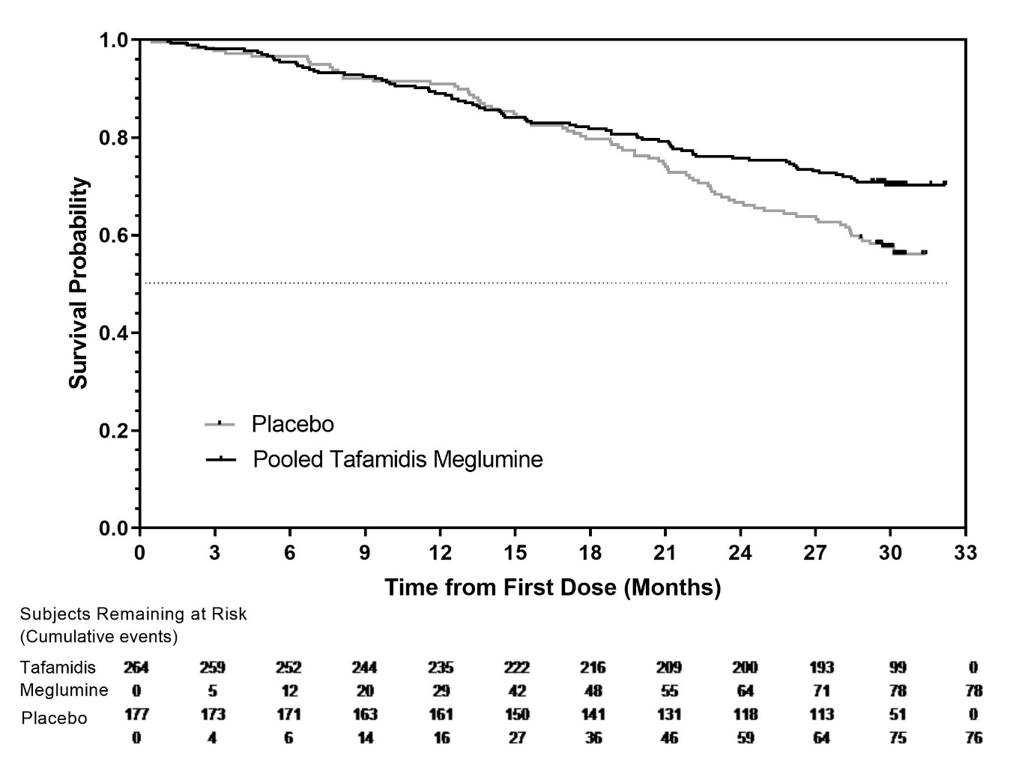
* Heart transplants and cardiac mechanical assist devices treated as death. Hazard ratio from Cox-proportional hazards model with treatment, TTR genotype (variant and wild-type), and New York Heart Association (NYHA) Baseline classification (NYHA Classes I and II combined and NYHA Class III) as factors.
There were significantly fewer cardiovascular-related hospitalisations with tafamidis meglumine compared with placebo with a reduction in risk of 32.4% (Table 5).
Table 5: Cardiovascular-related hospitalisation frequency
 | Pooled Tafamidis meglumine  N=264 | Placebo  N=177
Total (%) number of subjects with cardiovascular-related hospitalisations | 138 (52.3) | 107 (60.5)
Cardiovascular-related hospitalisations per year* | 0.4750 | 0.7025
Pooled tafamidis meglumine versus placebo treatment difference (relative risk ratio)* | 0.6761
p-value* | <0.0001
* This analysis was based on a Poisson regression model with treatment, TTR genotype (variant and wild-type), New York Heart Association (NYHA) Baseline classification (NYHA Classes I and II combined and NYHA Class III), treatment-by-TTR genotype interaction, and treatment-by-NYHA Baseline classification interaction terms as factors.
The treatment effect of tafamidis meglumine on functional capacity and health status was assessed by the 6-Minute Walk Test (6MWT) and the Kansas City Cardiomyopathy Questionnaire-Overall Summary (KCCQ-OS) score, respectively. A significant treatment effect favouring tafamidis meglumine was first observed at Month 6 and remained consistent through Month 30 on both 6MWT distance and KCCQ-OS score (Figure 2 and Table 6).
Figure 2: Change from Baseline to Month 30 in 6MWT distance and KCCQ-OS score
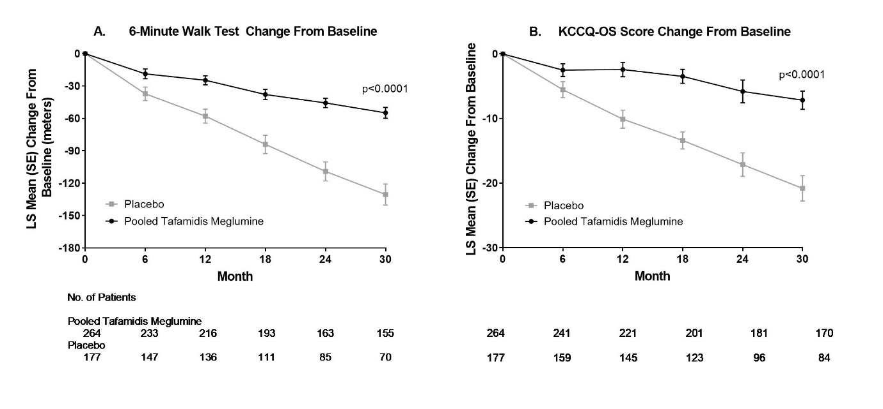
Abbreviations: 6MWT=6-Minute Walk Test, KCCQ-OS=Kansas City Cardiomyopathy Questionnaire-Overall Summary.
Panel A shows change from Baseline to Month 30 in pooled tafamidis meglumine compared with placebo-treated patients in 6MWT distance.
Panel B shows change from Baseline to Month 30 in pooled tafamidis meglumine compared with placebo-treated patients in KCCQ-OS score.
The KCCQ-OS score is composed of four domains including Total Symptom (Symptom Frequency and Symptom Burden), Physical Limitation, Quality of Life, and Social Limitation. All four domains favoured tafamidis meglumine compared to placebo at Month 30 (Figure 2 and Table 6). KCCQ-OS and domain scores range from 0-100 with higher scores representing better health status. The cumulative distribution and distribution for change from Baseline to Month 30 for KCCQ-OS (Figure 3) show that the proportion of patients with declining KCCQ-OS scores was lower for the pooled tafamidis meglumine treated group compared to placebo (Figure 3).
Figure 3: Histogram of change from Baseline to Month 30 in KCCQ-OS
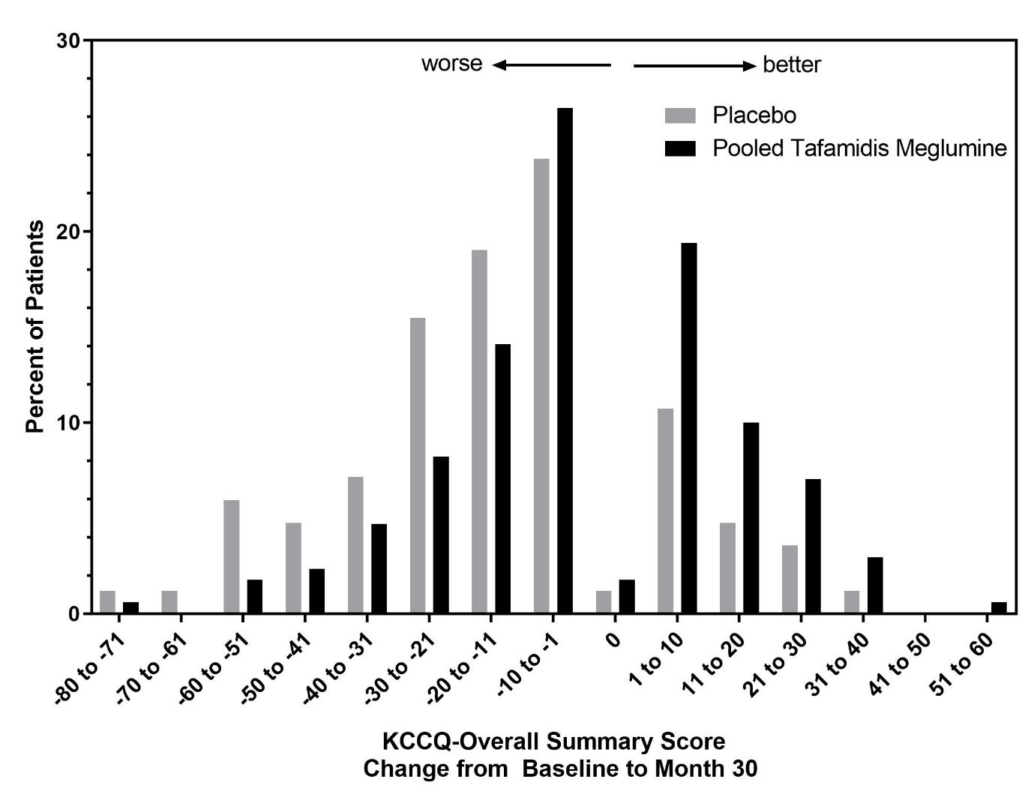
Abbreviation: KCCQ-OS=Kansas City Cardiomyopathy Questionnaire-Overall Summary.
Table 6: 6MWT and KCCQ-OS and component domain scores
Endpoints | Baseline Mean (SD) |  | Change from Baseline to Month 30, LS mean (SE) |  | Treatment difference from placebo  LS mean (95% CI) | p-value
Endpoints | Pooled tafamidis meglumine  N=264 | Placebo  N=177 | Pooled tafamidis meglumine | Placebo | Treatment difference from placebo  LS mean (95% CI) | p-value
6MWT (metres) | 350.55  (121.30) | 353.26  (125.98) | -54.87  (5.07) | -130.55  (9.80) | 75.68  (57.56, 93.80) | p<0.0001
KCCQ-OS | 67.27  (21.36) | 65.90  (21.74) | -7.16  (1.42) | -20.81  (1.97) | 13.65  (9.48, 17.83) | p<0.0001
Abbreviations: 6MWT=6-Minute Walk Test; KCCQ-OS=Kansas City Cardiomyopathy Questionnaire-Overall Summary; LS=least squares; CI=confidence interval.
In the pivotal study, patients who exhibited >32% TTR stabilisation were considered stabilised. At Month 1, a significantly greater proportion of patients in the pooled tafamidis meglumine group (211/245 [86.1%] patients) demonstrated TTR stabilisation than was observed for patients in the placebo group (6/170 [3.5%] patients) (p<0.0001).
Results from F-S method represented by win ratio for the combined endpoint and its components (all-cause mortality and frequency of cardiovascular-related hospitalisation) consistently favoured tafamidis meglumine versus placebo across all subgroups (wild-type, variant and NYHA Class I & II, and III) except for cardiovascular-related hospitalisation frequency in NYHA Class III (Figure 4) which is higher in the tafamidis meglumine group versus placebo. Win ratio is the number of pairs of treated-patient “wins” divided by number of pairs of placebo patient “wins”. Analyses of 6MWT and KCCQ-OS also favoured tafamidis meglumine relative to placebo within each subgroup.
Figure 4: Results from F-S Method and components by subgroup and dose

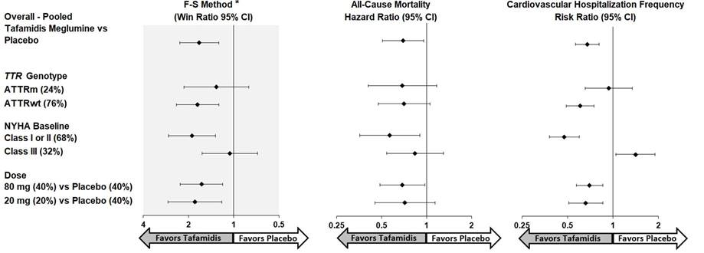
Abbreviations: ATTRm=variant transthyretin amyloid, ATTRwt=wild-type transthyretin amyloid, F-S=Finkelstein-Schoenfeld, CI=Confidence Interval.
* F-S results presented using win ratio (based on all-cause mortality and frequency of cardiovascular hospitalisation).
Heart transplants and cardiac mechanical assist devices treated as death.
“Tafamidis” is referring to tafamidis meglumine
Results of the primary analysis, 6MWT at Month 30 and KCCQ-OS at Month 30 were statistically significant for both the 80 mg and 20 mg doses of VYNDAQEL vs. placebo, with similar results for both doses.
Biomarkers associated with heart failure (NT-proBNP and Troponin I) differentiated between the 80 mg and the 20 mg doses. For NT-proBNP, the LS mean difference in change from Baseline to Month 30 from placebo for 20 mg tafamidis meglumine was -1417.02 pg/mL (SE=743.38) and for 80 mg was -2587.54 pg/mL (SE=570.25). Further, the LS mean difference between the 20 mg and 80 mg doses was 1170.51 pg/mL (SE=587.31) (p=0.0468), favouring the 80 mg dose group. Similar results were observed for Troponin I where the LS mean difference in change from Baseline to Month 30 from placebo for 20 mg tafamidis meglumine was -0.06 ng/mL (SE=0.045) and for 80 mg was -0.10 ng/mL (SE=0.018). The LS mean difference between the 20 mg and 80 mg doses for Troponin I was 0.05 ng/mL (SE=0.04) (p=0.2479), favouring the 80 mg dose group numerically, but not statistically.
A supra-therapeutic, single, 400 mg oral dose of tafamidis meglumine solution in healthy volunteers demonstrated no effect on the QTc interval.

5.2 Pharmacokinetic properties
The pharmacokinetic profile of VYNDAQEL was determined in Phase I studies in healthy volunteers and patients with ATTR-CM.

Absorption
After oral administration of VYNDAQEL once daily, the maximum peak concentration (C_{max}) is achieved at a median time (t_{max}) within 4 hours after dosing in the fasted state. Concomitant administration of a high fat, high calorie meal altered the rate of absorption, but not the extent of absorption. These results support the administration of VYNDAQEL with or without food.

Distribution
Tafamidis meglumine is highly protein bound (>99%) in plasma. The apparent steady-state volume of distribution is 16 litres in a 75 kg adult.

Metabolism and Excretion
While there is no explicit evidence of biliary excretion of tafamidis meglumine in humans, based on preclinical data, it is suggested that tafamidis meglumine is metabolised by glucuronidation and excreted via the bile. This route of metabolism and excretion is likely in humans, as approximately 59% of the total administered dose is recovered in faeces mostly as unchanged drug, and approximately 22% recovered in urine mostly as the glucuronide metabolite. Based on population pharmacokinetic results, the apparent oral clearance of tafamidis meglumine is 0.228 L/h (0.263 L/h for tafamidis) and the population mean half-life is approximately 49 hours.
Exposure from once-daily dosing with tafamidis meglumine increased with increasing dose up to 480 mg single dose and multiple doses up to 80 mg/day. In general, increases were proportional or near proportional to dose.
Mean half-life and oral clearance were similar after single and repeated administration of a 20 mg dose of tafamidis meglumine, indicating a lack of induction or inhibition of tafamidis meglumine metabolism.
Results of once-daily dosing with tafamidis meglumine 15 mg to 60 mg oral solution for 14 days demonstrated that steady-state (ss) was achieved by Day 14.

Comparative Pharmacokinetics
Tafamidis 61 mg provides steady-state exposures (C_{max} and AUC) equivalent to 80 mg tafamidis meglumine (administered as four 20 mg capsules), which was administered to patients with ATTR-CM in the double-blind, placebo-controlled, randomised study (Table 7) (see Section 5.1 Pharmacodynamic properties).
Table 7: Comparative pharmacokinetics of tafamidis 61 mg capsule to tafamidis meglumine 80 mg (administered as four 20 mg capsules)
Parameter  (units) | Comparison  (test versus reference) | Adjusted geometric means |  | Test versus reference
Parameter  (units) | Comparison  (test versus reference) | Test | Reference | Ratio (%)ª  (test/reference) | 90% CIª  for ratio
AUC_{tau}  (µg.hr/mL) | Tafamidis 61 mg capsule (Test) versus Tafamidis meglumine Four 20 mg capsules (Reference) | 170.0 | 166.2 | 102.28 | (97.99, 106.76)
C_{max} (µg/mL) |  | 8.553 | 9.087 | 94.12 | (89.09, 99.42)
Abbreviations: CI=confidence interval; mg=milligram; µg=microgram; mL=millilitre; AUC_{tau}=area under curve from time 0 to time tau, the dosing interval, where tau=24 hours for daily dosing; C_{max}=maximum serum concentration.
ª The ratios and 90% CIs are expressed as percentages.

Special populations

Hepatic impairment
No dose adjustment is necessary in mild or moderate hepatic impairment. Pharmacokinetic data indicated decreased systemic exposure (approximately 40%) and increased total clearance (0.52 L/h versus 0.31 L/h) of tafamidis meglumine in subjects with moderate hepatic impairment (Child-Pugh Score of 7-9 inclusive) compared to healthy subjects. As TTR levels are lower in patients with moderate hepatic impairment than in healthy subjects, the exposure of VYNDAQEL relative to the amount of TTR would be sufficient for stabilisation of the TTR tetramer in these patients. Exposure to VYNDAQEL was similar between subjects with mild hepatic impairment and healthy subjects.
The exposure to VYNDAQEL in patients with severe hepatic impairment is unknown.

Renal impairment
VYNDAQEL has not specifically been evaluated in patients with renal impairment. Tafamidis meglumine is primarily metabolised by glucuronidation and is likely excreted via the hepatobiliary pathway. The influence of creatinine clearance on tafamidis meglumine pharmacokinetics (PK) was evaluated in a population PK analysis in patients with creatinine clearance >18 mL/min. Pharmacokinetic estimates indicated no difference in apparent oral clearance of tafamidis meglumine in patients with creatinine clearance <80 mL/min compared to those with creatinine clearance ≥80 mL/min. No dosage adjustment is required in patients with renal impairment. Limited data are available in patients with severe renal impairment (creatinine clearance ≤30 mL/min).

Elderly
Based on population pharmacokinetic results, patients ≥ 65 years of age had an average 15% lower estimate of apparent oral clearance at steady-state when compared with patients under the age of 65. However, the difference in clearance results in <20% increases in mean C_{max} and AUC compared to younger subjects and is not clinically significant.

5.3 Preclinical safety data

Genotoxicity
Tafamidis meglumine was not genotoxic in a bacterial reverse mutation assay, in an in vitro human lymphocyte chromosomal aberration assay or in an in vivo rat bone marrow micronucleus test. Nonclinical data demonstrated no special hazard for humans based on conventional studies of genotoxicity.

Carcinogenicity
There was no evidence of increased incidence of neoplasia in a 2-year carcinogenicity study in rats at exposures up to 18-times the human AUC at the clinical dose of 80 mg tafamidis meglumine. There was no evidence of an increased incidence of neoplasia in the transgenic (Tg)-rasH2 mouse following repeat daily administration for 26 weeks at exposures up to 9.9-times the human AUC at the clinical dose of 80 mg tafamidis meglumine. In this study, significant non-neoplastic lesions were noted in the kidneys (nephrosis) and liver (centrilobular hypertrophy and single cell necrosis) in the Tg-rasH2 mice at exposures ≥2.9-times the clinical AUC at 80 mg tafamidis meglumine.

6. PHARMACEUTICAL PARTICULARS

6.1 List of excipients
Macrogol 400
Polysorbate 80
Sorbitan mono-oleate
Gelatin shell (116678)
- Gelatin
- Glycerol
- Iron oxide yellow
- Partially dehydrated liquid sorbitol
- Sorbitol
- Mannitol
- Titanium dioxide
Opacode Purple S-1-10011-N (PI 3413)
- Ethanol
- Isopropyl alcohol
- Macrogol 400
- Polyvinyl acetate phthalate
- Propylene glycol
- Carmine
- Brilliant Blue FCF
- Strong ammonium solution

6.2 Incompatibilities
See Section 4.5 Interactions with other medicines and other forms of interaction.

6.3 Shelf life
In Australia, information on the shelf life can be found on the public summary of the Australian Register of Therapeutic Goods (ARTG). The expiry date can be found on the packaging.

6.4 Special precautions for storage
Do not store above 25°C.

6.5 Nature and contents of container
Not all presentations may be available.
Cartons containing Aluminium/Aluminium blisters of 30 soft capsules.

6.6 Special precautions for disposal
In Australia, any unused medicine or waste material should be disposed of by taking to your local pharmacy.

6.7 Physicochemical properties

Chemical structure
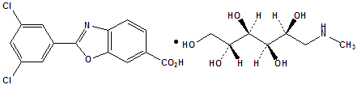

CAS number
951395-08-7

7. MEDICINE SCHEDULE (POISONS STANDARD)
Schedule 4

8. SPONSOR
Pfizer Australia Pty Ltd
Level 17, 151 Clarence Street
Sydney NSW 2000
Toll Free Number: 1800 675 229
www.pfizer.com.au

9. DATE OF FIRST APPROVAL
16 March 2020

10. DATE OF REVISION
Not applicable.

Summary Table of Changes
Section changed | Summary of new information
All | New PI

