January 2013

Australian Public Assessment Report for strontium ranelate
  - Proprietary Product Name: Protos
  - Sponsor: Servier Laboratories (Australia) Pty Ltd
About the Therapeutic Goods Administration (TGA)
- The Therapeutic Goods Administration (TGA) is part of the Australian Government Department of Health and Ageing, and is responsible for regulating medicines and medical devices.
- The TGA administers the Therapeutic Goods Act 1989 (the Act), applying a risk management approach designed to ensure therapeutic goods supplied in Australia meet acceptable standards of quality, safety and efficacy (performance), when necessary.
- The work of the TGA is based on applying scientific and clinical expertise to decision-making, to ensure that the benefits to consumers outweigh any risks associated with the use of medicines and medical devices.
- The TGA relies on the public, healthcare professionals and industry to report problems with medicines or medical devices. TGA investigates reports received by it to determine any necessary regulatory action.
- To report a problem with a medicine or medical device, please see the information on the TGA website <www.tga.gov.au>.
About AusPARs
- An Australian Public Assessment Record (AusPAR) provides information about the evaluation of a prescription medicine and the considerations that led the TGA to approve or not approve a prescription medicine submission.
- AusPARs are prepared and published by the TGA.
- An AusPAR is prepared for submissions that relate to new chemical entities, generic medicines, major variations, and extensions of indications.
- An AusPAR is a static document, in that it will provide information that relates to a submission at a particular point in time.
- A new AusPAR will be developed to reflect changes to indications and/or major variations to a prescription medicine subject to evaluation by the TGA.
Copyright
© Commonwealth of Australia 2013
This work is copyright. You may reproduce the whole or part of this work in unaltered form for your own personal use or, if you are part of an organisation, for internal use within your organisation, but only if you or your organisation do not use the reproduction for any commercial purpose and retain this copyright notice and all disclaimer notices as part of that reproduction. Apart from rights to use as permitted by the Copyright Act 1968 or allowed by this copyright notice, all other rights are reserved and you are not allowed to reproduce the whole or any part of this work in any way (electronic or otherwise) without first being given specific written permission from the Commonwealth to do so. Requests and inquiries concerning reproduction and rights are to be sent to the TGA Copyright Officer, Therapeutic Goods Administration, PO Box 100, Woden ACT 2606 or emailed to <tga.copyright@tga.gov.au>.

Contents
I. Introduction to product submission 4
Submission details 4
Product background 4
Regulatory status 5
Product Information 5
List of abbreviations 6
II. Quality findings 8
III. Nonclinical findings 8
Introduction 8
Pharmacology 8
Pharmacokinetics 9
Toxicology 9
Nonclinical summary and conclusions 10
IV. Clinical findings 11
Introduction 11
Pharmacokinetics 13
Pharmacodynamics 14
Dosage selection for the pivotal studies 16
Efficacy 16
Safety 26
List of questions 32
V. Pharmacovigilance findings 32
Risk management plan 32
VI. Overall conclusion and risk/benefit assessment 37
Introduction 37
Quality 40
Nonclinical 40
Clinical 40
Risk management plan 43
Risk-benefit analysis 43
Outcome 47
Attachment 1. Product Information 47

I. Introduction to product submission

Submission details
Type of Submission | Extension of indications
Decision: | Approved
Date of Decision: | 4 May 2012
Active ingredient(s): | Strontium ranelate
Product Name(s): | Protos
Sponsor’s Name and Address: | Servier Laboratories (Australia) Pty Ltd  PO Box 196  Hawthorn VIC 3122
Dose form(s): | Powder for suspension
Strength(s): | 2 g sachets
Container(s): | Sachets
Approved Therapeutic use: | Treatment of osteoporosis in men at increased risk of fracture.
Route(s) of administration: | Oral
Dosage: | 1 sachet daily
ARTG Number | 99978

Product background
This AusPAR describes an application by the sponsor, Servier Laboratories (Australia) Pty Ltd, to extend the indications of Protos (strontium ranelate). The current approved indication is:
“Treatment of postmenopausal osteoporosis to reduce the risk of fracture.”
The proposed additional indication is:
“Treatment of osteoporosis in men at increased risk of fracture.”
This application is thereby to extend the indication of strontium ranelate to both sexes.
Strontium ranelate is currently in a unique class of drug that substitutes skeletal apatite crystalline calcium with strontium or coats the crystal. This results in claimed increases in bone formation by increasing osteoblast precursor replication and collagen synthesis, and reducing bone resorption by altering osteoclast ultrastructure. Strontium ranelate (S12911) is composed of two atoms of stable strontium and the organic ranelic acid as the anion representing 34% and 66% of the compound, respectively (Figure 1).
Figure 1: Structure of strontium ranelate.
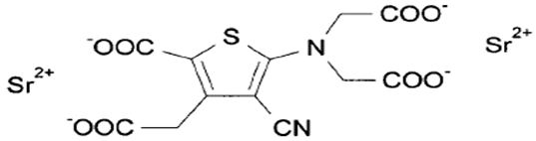

Regulatory status
In Australia, strontium ranelate was originally approved in 2005 for postmenopausal women at high risk of osteoporotic fracture.
At the time of the review of this AusPAR, strontium ranelate was approved for the treatment of osteoporosis in men in Europe on 27 June 2012 with the indication:
“Treatment of osteoporosis in adult men at increased risk of fracture.”

Product Information
The approved Product Information (PI) current at the time this AusPAR was prepared can be found as Attachment 1.

List of abbreviations
AE adverse event
ALP alkaline phosphatase
AUC area under the plasma concentration-time curve
AUC_{t1-t2} area under the plasma concentration-time curve within time span t1 to t2
bALP bone specific alkaline phosphatase
BMD Bone Mineral Density
BMI Body Mass Index
C_{max} maximum (peak) plasma drug concentration
Ca calcium
CHMP Committee for Medicinal Products for Human Use
CI confidence interval
CMI Consumer Medicine Information
CNS central nervous system
CPK creatine phosphokinase
DRESS Drug Rash with Eosinophilia and Systemic Symptoms
DXA dual energy X ray absorptiometry
E estimate
EAE emergent adverse event
ECG electrocardiogram
EMA/EMEA European Agency for the Evaluation of Medicinal Products
FAS Full Analysis set (according to Intent To Treat principle)
GCP Good Clinical Practice
GGT gamma glutamyl transpeptidase
GLP Good Laboratory Practice
HB hepatitis B
HCV hepatitis C virus
HIV human immunodeficiency virus
Hologic a manufacturer of bone densitometer
ICH International Conference on Harmonisation
IRIS Institut de Recherches Internationales Servier
IU International Unit
L2 lumbar vertebra number 2 (etc.)
Lunar a manufacturer of bone densitometer
M month
NHANES National Health And Nutrition and Examination Survey
ORX orchidectomised
Osseor European trade name of strontium ranelate
OVX ovariectomised
PD pharmacodynamic(s)
PE pulmonary embolism
PK pharmacokinetic(s)
PI Product information document
PINP serum procollagen I N-terminal propeptide
PMO post menopausal osteoporosis
PO oral administration (per os)
PPS Per Protocol set
Protos Australian trade name of strontium ranelate
Protelos European trade name of strontium ranelate
PSUR Periodic Safety Update Report
PTH parathormone
QoL Quality of Life
RMP Risk Management Plan
RS Randomised Set
S12911 strontium ranelate
sCTX serum type I collagen C telopeptides cross links
SAE serious adverse event
SD standard deviation
SE standard error
SJS Stevens-Johnson Syndrome
SmPC Summary of Product Characteristics
SOC System Organ Class
sOCN serum osteocalcin
SOTI Spinal Osteoporotic Therapeutic Intervention
STRATOS S12911 Phase 2 study in curative treatment of vertebral osteoporosis
T score young normal BMD result expressed as standard deviations away from mean
t_{1/2} elimination half life
T_{max} time to reach maximum (peak) plasma concentration following drug administration
TEN toxic epidermal necrolysis
TROPOS treatment of peripheral osteoporosis
ULN Upper Limit of Normal
VPC visual predictive check

II. Quality findings
There was no requirement for a quality evaluation in a submission of this type.

III. Nonclinical findings

Introduction
Strontium ranelate (Protos) is currently registered for the treatment of postmenopausal osteoporosis. The sponsor has now applied to extend the indications to include treatment of male osteoporosis. The nonclinical dossier contained two new long term in vivo primary pharmacology studies conducted in an animal model of male osteoporosis, the orchidectomised rat. The studies were conducted according to GLP, and in keeping with EU guideline on the evaluation of medicinal products in the treatment of primary osteoporosis investigated effects of strontium ranelate on bone mass/density, architecture and strength in both long bones and vertebrae.

Pharmacology
As established in the original nonclinical evaluation of the application to register Protos, strontium is incorporated into the bone mineral where it is able to replace calcium and impacts bone turnover by both enhancing bone formation and reducing bone resorption. Improvements in bone volume, architecture and strength were previously shown with strontium ranelate treatment in the ovariectomised rat, a model of postmenopausal osteoporosis.
The orchidectomised rat is an established animal model of hypogonadism induced male osteoporosis. In the studies submitted here, gonadal resection in adult animals resulted in bone loss at predominantly trabecular sites in the spine, femur and tibia, with enhanced bone turnover indicated by increases in biochemical markers of bone formation (serum osteocalcin) and bone resorption (urinary deoxypyridinoline). Decreased cortical thickness and lack of periosteal expansion were observed. Although there was a reduction in bone density, biomechanical testing revealed no striking effect of orchidectomy on bone strength. Extrinsic strength parameters were mildly reduced in the femur (consistent with effects on bone geometry), but intrinsic strength parameters in the femur as well as the strength of the vertebral body were unaffected. Effects of orchidectomy on bone strength have been variably reported in the literature as either a reduction in strength or no effect.
Male rats were treated with strontium ranelate by daily oral administration for 52 weeks commencing at the time of orchidectomy (preventative study; 250, 625 and 900 mg/kg/day), or for 44 weeks commencing 8 weeks after orchidectomy (to induce initial bone depletion; curative study; 625 mg/kg/day). Trabecular and cortical/subcortical BMD and content were significantly increased at all dose levels tested, with the two highest dose levels completely preventing the decreases induced by orchidectomy. Strontium ranelate’s activity to inhibit the increase in bone turnover induced by orchidectomy was indicated by decreases in serum osteocalcin and urinary deoxypyridinoline, and increased serum ALP indicated increased bone formation. Curative and preventative treatment increased both trabecular number and thickness, decreased trabecular separation, and increased bone volume. An increase in cortical thickness was observed at 900 mg/kg/day in the preventative study (this dose was not assessed in the curative study). Notably, strontium ranelate did not affect trabecular or cortical bone strength in either study (neither positively nor adversely) at any dose tested.

Pharmacokinetics
Plasma and bone levels of strontium in treated male rats were dose dependent and comparable in the curative and preventative studies. Uptake of strontium was greater in trabecular bone compared with cortical bone; this was seen in female rats in previous studies and is consistent with the quicker turnover of trabecular bone.
Exposure to strontium in male rats in the current studies was slightly greater than that seen previously in female animals at the same dose level, but the correlation between plasma and bone strontium concentrations was maintained. The overview of the clinical evaluation report states that exposure to strontium was comparable in elderly men and postmenopausal women at the clinical dose. Plasma AUC_{0-24 h} values for strontium in male rats were approximately 1.3-2.1 times higher at the dose levels tested here compared with in osteoporotic men treated at the proposed clinical dose (2 g/day; AUC_{0-24 h}, 288 µg∙h/mL). Bone strontium content ranged from 1.24-2.91% in treated male rats, which is below the level of 4% associated with bone and tooth abnormalities in mice and rats identified in previously evaluated studies.

Toxicology
Male animals were included in the toxicity studies with strontium ranelate submitted and evaluated as part of the drug’s original registration. Of relevance to the current application, no effects were found particular to males compared with females, and the male reproductive tract was not identified as a target for toxicity in repeat dose studies (conducted in mice, rats, dogs and monkeys). Furthermore, fertility and sperm parameters were unaffected in male rats treated with strontium ranelate at up to 1000 mg/kg/day PO.

Comments on the Safety Specification of the Risk Management Plan
The nonclinical safety specification of the draft RMP (version 7; submitted with the sponsor’s Section 31 response) is considered to be generally acceptable with the exception of the following statement:
“The safety margin is about 38 times the human therapeutic dose.”
The basis for this figure is not explained but it appears to be the ratio of the highest animal dose cited (1250 mg/kg/day in monkeys) and the human dose (2 g/day) in a 60 kg subject. Exposure margins based on plasma AUC, rather than ones based on direct animal:human mg/kg bodyweight doses, are considered to be more appropriate for the assessment of safety. Considering plasma AUC_{0-24h} values cited in the original Nonclinical Evaluation Report for Protos (672, 517 and 733 µg∙h/mL for male rats, dogs and monkeys, respectively, at the specified doses) and a clinical AUC_{0-24h} of 288 µg∙h/mL in men, the statement should be replaced with the following text:
“These doses are up to about 38 times the human therapeutic dose on a mg/kg body weight basis and yielded systemic exposure to strontium (plasma AUC) up to 2.5 times higher.”

Nonclinical summary and conclusions

Summary
- The sponsor has applied to extend the indications for strontium ranelate (Protos) to include treatment of osteoporosis in men at increased risk of fracture. The product is currently registered for the treatment of postmenopausal osteoporosis. The dosing regimen (2 g PO once daily) to be used in men is the same as in women.
- Two new relevant nonclinical studies were submitted in the nonclinical evaluation report. These were long term (44-52 week) primary pharmacology studies investigating the efficacy of strontium ranelate in orchidectomised rats, an accepted model of hypogonadism induced male osteoporosis. The studies were conducted according to GLP, used curative and preventative designs, and were in keeping with the relevant EU guideline on the development of medicinal products for the treatment of primary osteoporosis.
- Treatment with strontium ranelate (administered PO) increased trabecular and cortical/subcortical BMD and content, and improved bone micro and macro architecture. Observed changes in biochemical markers indicated inhibition of the increase in bone turnover induced by orchidectomy and also increased bone formation. No change in trabecular and cortical bone strength was seen with drug treatment, but orchidectomy itself had no striking effect on strength parameters either.
- Plasma AUC values for strontium at the dose levels employed in the pharmacology studies in male rats were 1.3-2.1 times higher compared with at the clinical dose in osteoporotic men. Bone strontium content ranged from 1.24% to 2.91%. Slightly higher exposure to strontium was evident in male cf. female rats, but exposure is reported to be comparable between the sexes in humans, according to the clinical overview.
- Previously evaluated toxicity studies did not identify any effects specific to males (mice, rats, dogs and monkeys), nor were there adverse effects on male fertility (rats).

Conclusions
- The nonclinical report was adequate in scope.
- While improvements in bone mass/density and architecture were shown in male animals treated with strontium ranelate in the submitted pharmacology studies, no enhancement of strength was able to be demonstrated. This may reflect a deficiency of the animal model though, given that orchidectomy did not lead to any significant reduction in bone strength. No completely satisfactory animal models of human osteoporosis exist.
- Previously evaluated toxicology studies identify no concerns particular to males compared with females.
- There are no nonclinical objections to the extension of indications for Protos to include use in men provided that efficacy in reducing fractures is adequately established from the clinical data set.
- The draft RMP and PI documents should be revised as outlined.

IV. Clinical findings

Introduction
This submission is for a drug which has the intended purpose of reducing the incidence of osteoporotic fractures in men.
Osteoporotic fracture in men occurs less commonly than in women, but nevertheless accounts for approximately one third of all fractures in the elderly. Osteoporosis has been somewhat arbitrarily divided into primary osteoporosis and secondary osteoporosis (known causes); secondary osteoporosis is said to be more common in men.
Risk factors in male osteoporosis include: hypogonadism, smoking, alcohol consumption, low calcium intake, vitamin D deficiency, and inadequate level of physical exercise
Osteoporosis becomes an important issue only when a low impact fracture occurs. The prognosis after osteoporotic fractures, particularly of the hip, is poor with increased mortality (in men, there is greater aged matched mortality than in women), but these fractures also are much more common in frail patients who have a poorer life expectancy from other contributing conditions.
BMD has a similar predicative value for subsequent fractures in both men and women. The increased prevalence of vertebral fractures in women corresponding with their lower BMD at all ages. Two other epidemiological studies have also shown that low BMD, increased bone resorption and prevalent vertebral fractures are independent risk factors for increased risk of vertebral fracture in men.
Hip BMD is more strongly associated with hip and peripheral fractures, and spine BMD more with spinal fractures. The usual definition of osteoporosis using sex specific reference ranges for BMD suggests the prevalence of osteoporosis to be between 4% and 17% in men aged over 50 years.
Although biochemical estimates of bone turnover can assess bone formation and resorption and the effect of therapies, these are not a good discriminator of future fracture. Strontium ranelate shows biochemical changes of increased bone formation and decreased bone resorption in both sexes.
Once secondary causes have been excluded, the current Australian approved treatments for osteoporosis in men (with conditions for Pharmaceutical Benefits Scheme subsidy) include adequate calcium and vitamin D intake, improvement of lifestyle factors (exercise, alcohol and tobacco intake), oral and IV bisphosphonates, and teriparatide. Raloxifene, denusomab, and strontium ranelate are not approved for use in men.
The claimed rationale for the use of strontium ranelate is the assumption that the human male skeleton would not respond any differently to the female skeleton to non hormonal anti osteoporotic treatments. PK data showed comparable results in men and women.
The SOTI and TROPOS trials in women showed a reduction in fracture rate.
The development program of strontium ranelate in male patients with osteoporosis was based on the European guideline. The principal basis of the submission is that:
- Strontium ranelate has been shown to be safe and efficacious in preventing osteoporotic fractures in women;
- That the pivotal trial has shown PK equivalence between men and women;
- That PD equivalence has been demonstrated between ovariectomised and orchidectomised rats;
- That PD equivalence (on the basis of BMD, not subsequent fracture) has been shown in the pivotal trial; and
- That the side effect profile in the pivotal trial on men is similar to that of the more extensive experience in women.
These principals are in accordance with the European guidelines for approval of treatment in osteoporosis in force in November 2006.
The anti fracture efficacy of strontium ranelate was assessed in two placebo controlled pivotal 5 year studies involving nearly 8,000 post menopausal women with main analyses performed at 3 years. These results were completed with data obtained at 4 and 5 years (placebo controlled) and further up to 8 years (open labelled extension study).
The submission contained the following clinical information:
- One clinical pharmacology study that provided PK data in men (Study PKH-12911-012-FRA);
- Two population PK analyses: one each in males (the pivotal Study CL3-12911-032) and females (Study CL3-12911-009/010);
- Two population PD analyses: one each in males (the pivotal Study CL3-12911-032) and females (Study CL3-12911-009/010);
- One pivotal efficacy/safety study (again the above Study CL3-12911-032); and
- Clinical study reports including safety committee.
The submission did not include paediatric data, which is not relevant for the proposed indication. The EMA has waived the obligation to submit the results of studies with Protelos (the European trade name for strontium ranelate) in all subsets of the paediatric population in osteoporosis.
The aforementioned studies complied with the note for guidance on GCP (as annotated with TGA comments) including appropriate ethical standards.

Pharmacokinetics
The PK in healthy adults was assessed in Study PKH-12911-012-FRA. Bioequivalence, hepatic and renal impairment, and elderly subjects were assessed in Study CL3-12911-032. Males versus females were compared in Studies CL3-12911-032 and CL3-12911-009/010. Population PK analyses were examined in Study CL3-12911-032.
PK of strontium and ranelic acid were evaluated after single oral administration of 3 different doses of strontium ranelate in healthy elderly (>65 years) male volunteers. Strontium PK and systemic exposure to strontium at steady state were also assessed in the pivotal Phase 3 Study CL3-12911-032 involving osteoporotic men treated with 2 g per day of strontium ranelate. Creatinine clearance, calcemia and phosphoremia have a negligible influence on the apparent clearance of strontium and therefore need not be considered in dose selection.
None of the PK studies had deficiencies that excluded their results from consideration.
PK data was evaluated in the original approval. On this occasion, absorption, bioavailability, different dosage strength (in the clinical study), bioequivalence, food, bioavailability after multiple dosing, tissue distribution (assumed by BMD data in PD), metabolism, intra individual variability, hepatic function, age, genetic factors, and PK interactions were not systematically addressed.
The supplied data shows no significant differences between the standard dosage form in men and women as evidenced by blood and urine assay. As the mechanism of action of this compound appears to be related to its retention in the skeleton, which is presumably very long lasting, no balance studies comparing retention with excretion have been performed in humans (as far as can be determined). The retention function thus seems to best estimated by the BMD. The BMD for strontium ranelate, unlike other active anti osteoporotic treatments, is directly affected by the retention of this metal ion (more attenuating than the calcium it replaces), as well as any increase in bone “quality”.

Overall conclusions on pharmacokinetics
The submission has satisfied the clinical evaluator that the PK of 2 g per day strontium ranelate is equivalent between the sexes in elderly subjects.

Pharmacodynamics
PD studies were of primary pharmacology to examine the effect on BMD and safety in orchidectomised rats (Study PHA-12911-178) and the effect of gender in humans and other age related differences in PD (Study CL3-12911-032).
The submitted rat PD data was included as no in vitro studies on bone concentration/strength have been included in men. It is understood that similar data in a small number of women was included in the original submission.
There is no guideline for the male orchidectomised rat model, hence the guideline for the female ovariectomised rat was used. This guideline requests that in vivo pharmacological studies included effects of drugs on bone quantity and quality parameters such as bone mass, bone architecture, bone strength and bone safety. None of the PD studies had deficiencies that excluded their results from consideration.

Mechanism of action
The exact mechanism of action of strontium ranelate is unclear. A considerable proportion of the drug (34% by weight) is strontium, which is in the periodic table an analogue of calcium. This strontium is claimed to be incorporated into the matrix of bone by adsorption onto the surface rather than incorporation into the crystalline structure. The end result is reduced bone resorption, increased bone formation, and in large trials on postmenopausal women has been associated with reduced peripheral and spinal fracture risk.

Pharmacodynamic effects

Primary pharmacodynamic effects
The claimed efficacy in this study is the surrogate end point for fracture, the lumbar spine (L2-L4) BMD change over time in placebo and strontium ranelate treated group in osteoporotic men. The submission investigates potential relationship between strontium exposure and lumbar spine BMD after repeated administration of strontium ranelate (2 g per day). This change is in part presumably the incorporation of strontium into bone. In itself, this results in the increased of measured BMD by DXA. Confounding with this is the favoured method of assessment of alteration in bone mineralisation as a surrogate for bone strength, which for other anti osteoporotic drugs is also BMD is a direct measurement of calcium and phosphorus metabolism (each of which element attenuates the X ray beam less than strontium). There is no practical, non invasive way of separating the effects of strontium versus calcium/phosphate on the measured BMD. In my BMD practice, the increased BMD is a sign of compliance.

Secondary pharmacodynamic effects
A further exploration is the response to strontium ranelate, that is, the percentage change from baseline in BMD in both men and women through simulations (Figure 1).
Figure 1: Simulated change in density with therapy between sexes.
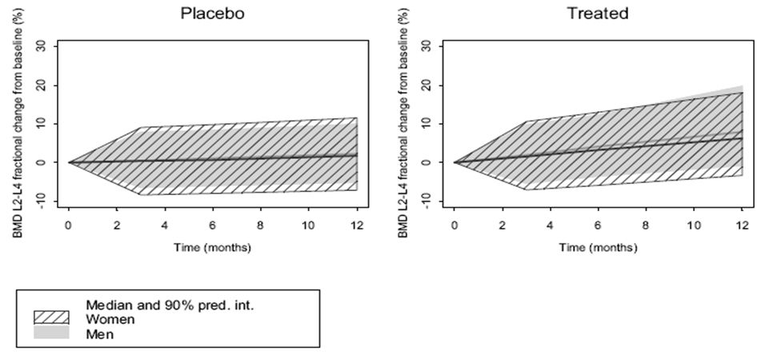

Time course of pharmacodynamic effects
Strontium ranelate is taken chronically and its effect on both BMD and fracture risk extends over years. There is presumably a long interval of reduced fracture risk after cessation of therapy.

Relationship between drug concentration and pharmacodynamic effects
There is a weak association between increases in BMD and total exposure to strontium (Figure 2). The PD effect is very delayed from the acute administration of the drug and multiple different doses have not been used long term in men. Plasma concentration-effect curves have not been defined in men, nor is there comprehensive therapeutic window/plasma concentration or dose finding studies.
Figure 2: Dose response chronically.
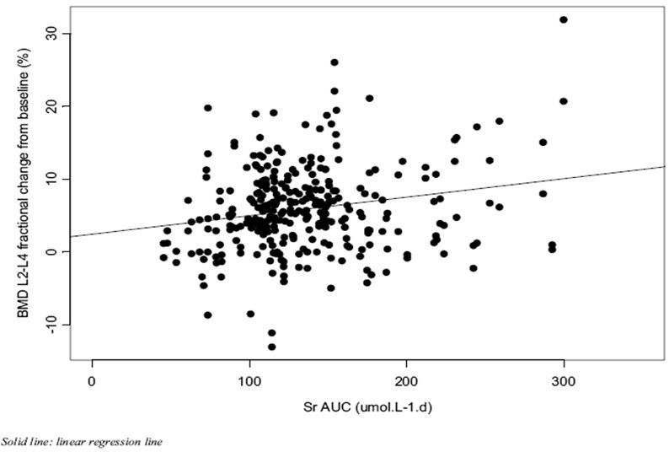

Genetic, gender and age related differences in pharmacodynamic response
No comparative data are presented regarding genetics and age. The PK and effects on bone density are similar between middle aged to elderly women and men.

Pharmacodynamic interactions
None formally presented. Presumably there may be some competition between calcium and strontium for incorporation in the skeleton. No effect was apparent in the PK data (calcium replete subjects).

Evaluator’s overall conclusions on pharmacodynamics
There is an equivalent response between orchidectomised and ovariectomised rats in a 44 week study. There is no consensus that human male osteoporosis is generally due to hypogonadism, and the orchidectomised rat has not been generally accepted as a comprehensive model. The response of BMD as a surrogate end point for fracture risk is very similar in elderly men and women over a one year period.

Dosage selection for the pivotal studies
This was identical to the approved dose in post menopausal women.

Efficacy

Pivotal efficacy studies

Pivotal efficacy Study CL3-12911-032
The efficacy and safety of 2 g strontium ranelate in the treatment of male osteoporosis was examined in Study CL3-12911-032, a prospective multicentre international double blind placebo controlled study with a treatment duration of 2 years and the main study analysis after 1 year.

Study design, objectives, locations and dates
This was a randomised, double blind, two parallel group, unbalanced (2:1), placebo controlled trial performed at 54 actives centres in 14 countries. The initiation date was December 2007 and the last patient visit at M24 was March 2011.

Inclusion and exclusion criteria
Inclusion:
- Mean lumbar spine (L2-L4) ≤ 0.840 g/cm² (Hologic densitometer) or ≤ 0.949 g/cm² (Lunar), femoral neck ≤ 0.600 g/cm² (Hologic) or ≤ 0.743 g/cm² (Lunar);
- Caucasian males ≥65 years old;
- Having at least one risk factor for osteoporotic fracture: which could be either age > 75 years, prevalent vertebral fracture grade I, previous low trauma fracture, family history of osteoporotic fracture, heavy smoker > 15 cigarettes/day, known low BMD, low body weight with a BMI < 20 kg/m²;
- Ambulatory;
- Capable of understanding study and having given informed consent; and
- Life expectancy > 2 years.
Exclusion:
- BMD T score < -4.0 at one or more sites;
- More than two prevalent mild and/or moderate osteoporotic vertebral fractures;
- Severe osteoporotic vertebral fracture;
- Simultaneously participating or having participated in another clinical trial in month preceding;
- Progressive major illness;
- History of increased risk of venous thromboembolism;
- History of severe alcohol abuse;
- Severe malabsorption;
- Severe liver insufficiency;
- Severe renal insufficiency;
- Clinical hyperthyroidism diagnosed within the previous 2 years (stable not excluded);
- Severe hypogonadism (stable androgen replacement for > 6 months not excluded);
- Skeletal diseases;
- Lumbar spine abnormalities or bilateral hip prostheses affecting densitometric assessment;
- Documented carriers of HB antigen, anti HCV antibodies or anti HIV antibodies;
- Unexplained significant weight loss (>10%) within last year;
- Previous corticoid treatment and bone metabolism treatment (bisphosphonates, fluoride, calcitonin, calcitriol and parathyroid hormone);
- Phenylketonuria; or
- Known allergy and/or intolerance to any excipients in study drug.

Study treatments
- Strontium ranelate sachet of 2 g orally once daily at bedtime plus daily calcium 1000 mg and vitamin D 800IU taken at lunch time.
- Placebo group: Similar sachet taken at bedtime plus daily Calcium 1000 mg and Vitamin D 800 IU taken at lunch time.
- Run in period of 2 weeks with calcium and vitamin D only. Active treatment period 24 months.

Efficacy variables and outcomes
The main efficacy variables were:
- BMD of lumbar spine by DXA at recruitment, 6, 12 18 and 24 months.
- Hip BMD (femoral neck and total hip) by DXA at recruitment, 6, 12 18 and 24 months.
- Biochemical markers sCTX, bALP, PINP, sOCN at recruitment 3, 6, 12 18 and 24 months.
The primary efficacy outcome was relative change BMD of lumbar spine by DXA from recruitment to the last available post baseline value until 12 month visit (that is, 24 month visit not included in this analysis)
Other efficacy outcomes included femoral neck and total hip BMD as above and biochemical bone markers as above.
Pharmacoeconomic aspects were evaluated by assessing back pain by using the corresponding items from Qualiost at the following visits: at inclusion, 6, 12, 18 and 24 months.

Randomisation and blinding methods
The randomisation of treatment was unbalanced with a 2:1 ratio and stratified by country. The randomisation list was designed by the Biometry Department of IRIS. Perceptive Informatics was responsible for the centralised randomisation. Therapeutic units were allocated to patients by an Interactive Voice System. S12911 and placebo granules had the same aspect (yellowish colour) and the same weight. All pack material and the labelling used was strictly identical between the placebo and the study drug. The code for any study participant could be broken by the investigator or an authorised person only if it was necessary to ascertain the type of treatment given to ensure the safety of the participant.
To maintain the blind, DXA scans were analysed by an independent central reading (with appropriate cross calibration of densitometers) and strontium in serum and in urine and bone markers were assessed by an independent central laboratory. These data were kept strictly confidential and transferred to the sponsor when all patients had completed the M12 visit. No strontium data were unblinded to the sponsor until the database was frozen.

Analysis populations
The FAS was assessed for the efficacy variables. The population studied was appropriate for the proposed indication amendment in elderly men with osteoporosis (although the exclusion criterion of hypogonadism was somewhat surprising when the animal model was the orchidectomised rat, albeit young rats). The results should be generally applicable.

Sample size
The 161 active and 82 control subjects were sufficient to show statistical significance in the primary and secondary efficacy variables (BMD). The numbers were small to consider safety. Assuming a 6% common standard deviation, and taking into account the 2:1 randomisation ratio, 127 patients were deemed necessary in the S12911 group and 64 in placebo group (191 patients overall) to establish a statistically significant difference of >3% between the two groups (using a two sided Student t test for independent samples at 5% type I error) with at least 90% power. Under the hypothesis of a withdrawal rate and/or a protocol violation rate of 15%, a total of 221 patients (147 into the strontium ranelate group and 74 into the placebo group) were to be included. The statistical methods used to analyse data from the CL3-032 study are standard, appropriate, and in conformity with published guidelines. The main statistical analysis was performed after 12 months of treatment, in accordance with the duration recommended by the CHMP guideline. The change in BMD over one year was chosen as the main efficacy criteria; therefore, the magnitude of the changes in BMD versus placebo in men from Study CL3-032 and in PMO women from the pivotal Phase 3 studies could be compared.

Statistical methods
The statistical methods used for Study CL3-032 were the same as those used in the Phase 3 studies in PMO women. The main efficacy analysis was based on the ITT principle. The strontium ranelate and placebo groups were compared on the relative change in BMD from baseline to 6 months and 12 months under treatment in the FAS using a linear model with treatment and country as factors. The same tests were applied for absolute changes in BMD from baseline to each visit and to the last assessable post baseline value over 12 months. The RS was defined as all included patients to whom a therapeutic unit was randomly assigned using the interactive randomisation system, and the FAS was defined as:
- all randomised patients who had taken at least one dose of study treatment;
- had at least one value of lumbar L2-L4 BMD available at baseline; and
- had at least one value of lumbar L2-L4 BMD available at a post baseline visit (until 12 months).
The FAS represented 93.1 % of the RS. In the FAS, lumbar L2-L4 BMD value at 12 months was missing for 46 patients (19%). In the main analysis, missing data was managed following a conservative approach by taking into account the last value (End) under treatment or the first value after randomisation in case no value under treatment was available. To further investigate the impact of missing data on the treatment effect estimate, results were confirmed using a multiple imputation method. In order to compare changes in BMD in men from Study CL3-032 and changes in BMD in women from the pivotal Phase 3 studies in postmenopausal osteoporosis, a post hoc analysis was done on the pooled BMD data from SOTI and TROPOS studies using the same tests as those performed in Study CL3-032, including relative changes and changes from baseline to one year of treatment as compared to placebo.
The 24 month data have not been presented.

Participant flow
A total of 261 patients were included and randomly assigned to one of the two treatment groups: 174 patients in the S12911 group, and 87 in the placebo group. As planned in the protocol, the distribution of patients between the two groups was unbalanced with a ratio 2:1.
Reasons for non inclusion of selected patients (123 patients) are listed below:
- Biological abnormality: 42 patients (most of them for a high level of intact parathyroid hormone);
- Patient’s decision (mainly withdrawal of informed consent): 33 patients;
- Severe osteoporosis (one grade III, or more than two grade I or II prevalent vertebral fractures, or BMD T score below -4.0 at one or more of the measured sites): 28 patients;
- Patients not considered as osteoporotic according to the protocol: 13 patients;
- Forbidden medical history: 5 patients;
- Forbidden medication: 1 patient; or
- Other non inclusion criteria: 1 patient.

Major protocol violations/deviations
Overall, 49 patients had at least one protocol deviation at inclusion with a similar percentage in both groups: 32 patients (18.4%) in the S12911 group, and 17 patients (19.5%) in the placebo group.
Most protocol violations/deviations were methodological and minor, with incomplete/inadequate bone densitometric results, or exclusion criteria being defined after entry. Two were excluded with history of previous disease (pulmonary embolism and retinal vein thrombosis), both in the treatment group. Two patients and one placebo subject were excluded because of absent baseline platelet count.

Baseline data
The different analysis sets were defined before study unblinding according to published guidelines and are presented in Table 1.
Table 1: Analysis sets.
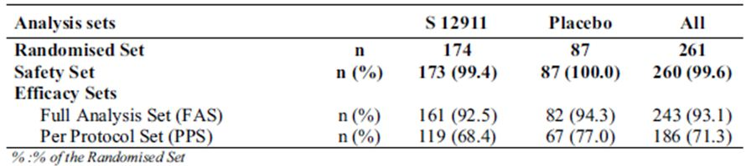
All patients were ambulatory. There were no significant differences between blood pressure and heart rate between the groups. Incomplete data was available for smoking and alcohol consumption. There were no differences of these data between the groups.
The baseline bone densities were similar, and no significant differences between the groups were noted for bone markers, pharmacoeconomics and the previous treatments for osteoporosis.
The following concomitant treatments were more frequently reported in the S12911 group than in the placebo group:
- Antithrombotic agents: 35.1% in the S12911 group and 26.4% in the placebo group;
- Agents acting on the rennin angiotensin system: 32.2% and 23.0%, respectively;
- Beta blocking agents: 22.4% and 16.1%, respectively; and
- Cardiac therapy: 16.7% and 10.3%.
Tables 2-3 show the characteristics of the baseline BMD.
Table 2: Characteristics of the randomised set.
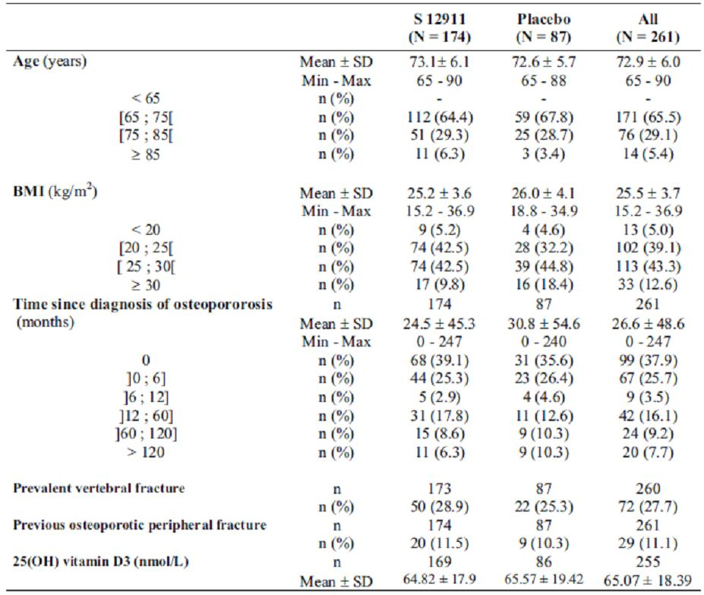
Table 3: Baseline lumbar L2-L4, femoral neck and total hip BMD and T scores in the randomised set.
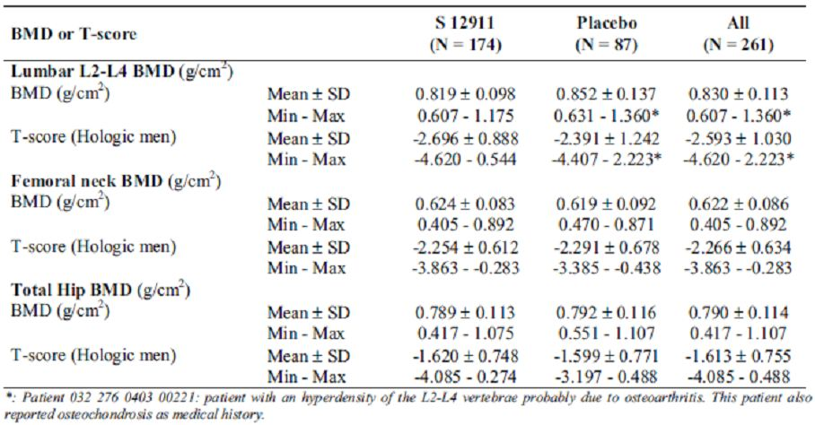

Study outcomes
Treatment compliance was a mean of 91.3% in the S12911 treated group versus 92.3% in the placebo group. Premature discontinuation of study treatment concerned 57 patients (21.8%): 42 in the S12911 group (24.1%) and 15 (17.2%) in the placebo group. The reasons for stopping were:
- AE for 24 patients (13.8%) in the S12911 group and 9 patients (10.3%) in the placebo group;
- Non medical reason for 14 patients (8.0%) in the S12911 group and 6 patients (6.9%) in the placebo group; and
- Protocol deviations for 4 patients (2.3%) in the S12911 group.

Results for the primary efficacy outcome
Change in lumbar BMD is shown in Table 4 and Figure 3.
Table 4: Change in lumbar BMD.
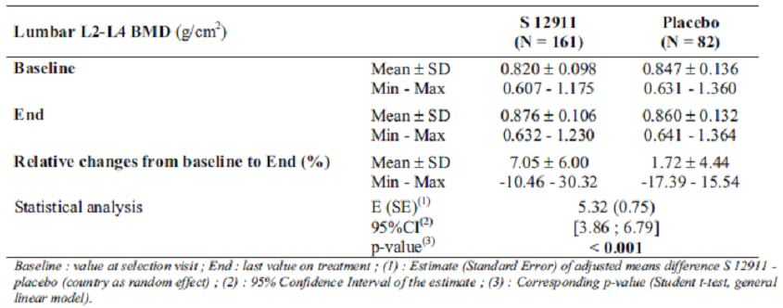
Figure 3: Change in lumbar BMD.
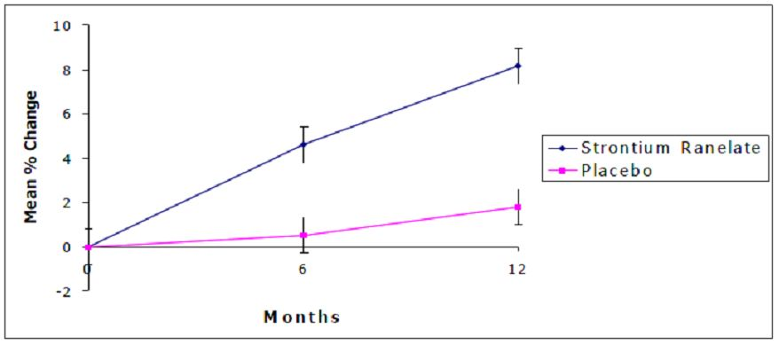
As with the previous section, the results were very similar in the PPS.
Change in femoral neck BMD and bone markers from baseline are shown in Tables 5-6.
Table 5: Change in femoral neck BMD: relative changes (%) from the baseline to last value in the FAS.
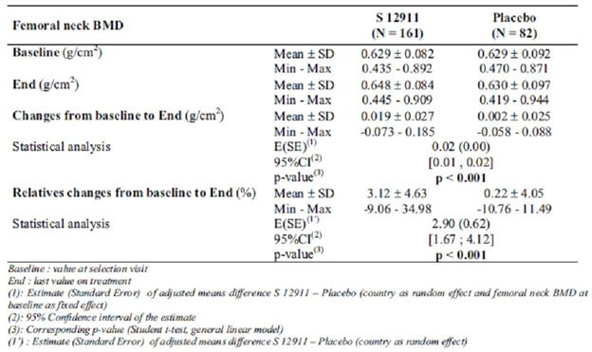
Table 6: Bone markers relative changes (%) from baseline to last value in the FAS.
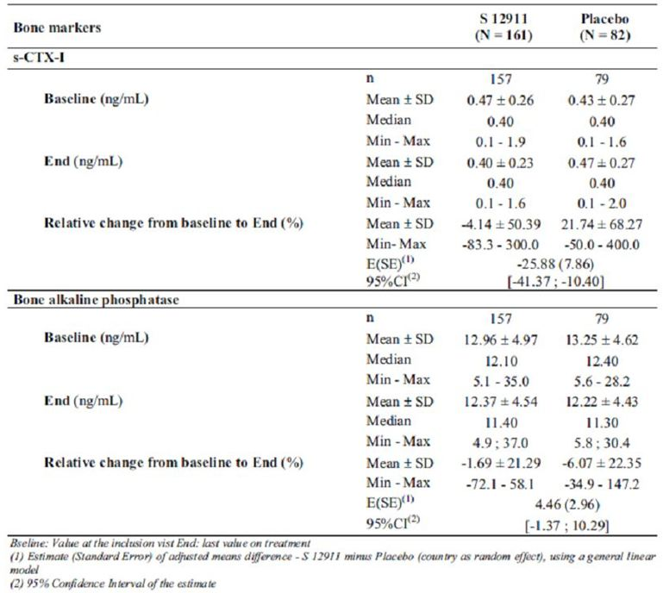
‘Pain interfered with patient sleep’ was the only significantly different value (p=0.016) in the quality of life questionnaire (Table 7).
Table 7: Change in quality of life: Evolution of the scores for the four items of Qualiost from baseline to last value in the FAS.
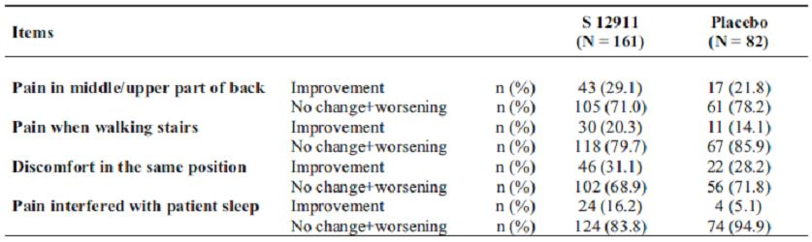

Analyses performed across trials (pooled analyses and meta analyses)
Table 8 compares the baseline data of males and females and Table 9 the efficacy in women.
Table 8: Comparison of male and pooled female data at baseline: Baseline characterictics of men in Study CL3-032 (FAS) and women in SOTI/TROPOS (FAS peripheral).
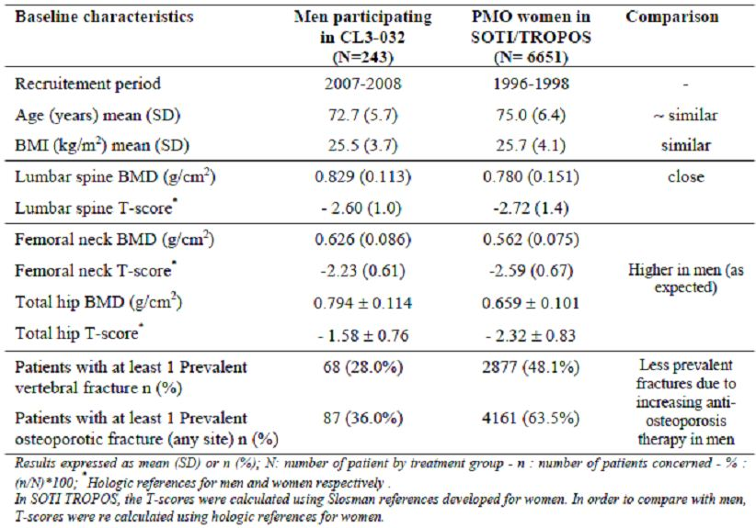
Table 9: Efficacy in combined trial women.
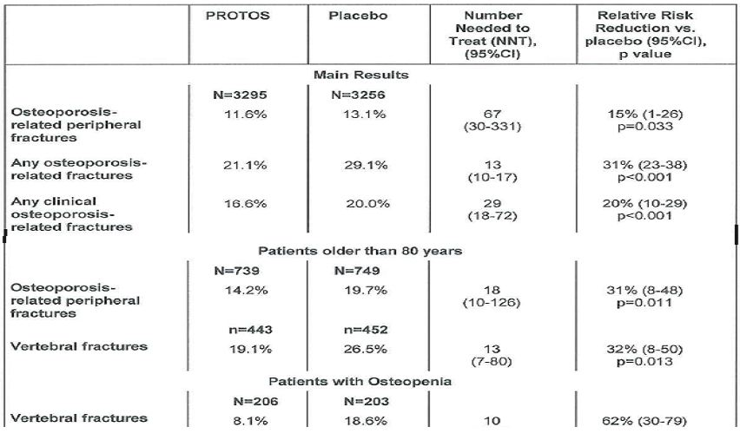
Post hoc analysis with data from SOTI and TROPOS (FAS population) showed there is a relationship between increase in measured BMD and reduction in the risk of new osteoporotic vertebral and hip fractures in strontium ranelate treated patients. After 3 years of strontium ranelate treatment, every 1% increase in femoral neck BMD was associated with a 3% (95% adjusted CI = 1-5%) reduction in risk of a new vertebral fracture.
The 3 year changes in femoral neck BMD explained 76% of the reduction in vertebral fractures observed during treatment. An increase in femoral neck BMD after 1 year was significantly associated with the reduction in incidence of new vertebral fractures observed after 3 years (p=0.04)
Regarding peripheral fractures, the relationship between change in femoral neck BMD and hip fractures was established in patients considered most at risk of hip fracture, that is, patients aged ≥ 74 years with femoral neck BMD ≤ 2.4 (NHANES normative value). For every 1% increase in femoral neck BMD observed after 3 years of treatment, there was a 7% decrease in the risk of having a hip fracture (95% CI = 1-14%, p=0.04).
During 3 year strontium ranelate treatment, an increase in femoral neck BMD is associated with a proportional reduction in incidence of new vertebral or hip fractures.

Evaluator’s conclusions on clinical efficacy
The primary efficacy criterion was the lumbar L2-L4 BMD expressed as the relative change from baseline to last value (End) in the FAS. The relative change from baseline to End in L2-L4 BMD was 7.1 ± 6.0% with S12911 and 1.7 ± 4.4% with placebo, with a statistically significant difference between groups: E (SE) = 5.3 (0.7), 95% CI = 3.9-6.8, p < 0.001. These results were consistent with those defined in the protocol (that is, the measured mean BMD in strontium ranelate treated patients should increase from baseline by 5% the first year at the lumbar spine).
From baseline to 12 months, the relative increase in the strontium ranelate group for lumbar L2-L4 BMD was 8.18 ± 5.92%. During the same period, an increase of low magnitude was observed in the placebo group (calcium and vitamin D are probably not inactive): 1.79 ± 4.55%. The difference between groups was significant: E (SE) = 6.38 (0.81), 95% CI = 4.78-7.98, p < 0.001. These results were confirmed by the sensitivity analyses.
The other BMD measurements included femoral neck BMD and total hip BMD, which were secondary efficacy parameters. In the FAS, femoral neck BMD increased by 3.1 ± 4.6% in the S12911 group and by 0.2 ± 4.1 % in the placebo group. The estimate of the difference between groups was E (SE) = 2.9 (0.6), 95% CI = 1.7-4.1, p < 0.001. Total hip BMD increased by 2.4 ± 4.9% in the S12911 group and by 0.5 ± 2.5 % in the placebo group. The estimate of the difference between groups was E (SE) = 2.0 (0.6), 95% CI = 0.8-3.1, p < 0.001. Results at 12 months on femoral neck BMD were also in accordance with the aim defined in the protocol.
As shown in studies performed in women, a significant decrease in sCTX was observed in the strontium ranelate group.
bALP was maintained at a high level with strontium ranelate as compared to placebo, but the difference did not reach the significant threshold. The effect on bone formation was lower in men than in postmenopausal women probably due to the lower sample size resulting in a higher variability.
The sample size was not calculated to establish statistical significance for the bone markers; however, the results were consistent with those observed in post menopausal women, reaching statistical significance for sCTX.
The quality of life results (Qualiost questionnaire) indicate an improvement in patients treated with S12911 as compared to placebo treated patients, in particular regarding the “pain interfering with patient sleep”, improved in 16.2% of the patients in the S12911 group versus 5.1% in the placebo group. However, until fracture occurs, symptoms might not be expected with osteoporosis.
In male patients treated with S12911 and with mean blood strontium levels reaching comparable values as in treated women, a marked increase in the mean lumbar L2-L4 BMD (main efficacy criterion) was observed as compared to placebo. The magnitude of the effect was consistent with expected results based on the large SOTI/TROPOS Phase 3 studies, where a clear relationship between the increase in BMD and anti fracture efficacy was shown.

Safety

Studies providing evaluable safety data
The data in these studies have already been considered in the submission for use of strontium ranelate in women. They are not strictly part of this application and are not tabulated later in the report.
The applicant chose to use the 5 year extension of Studies CL2-12911-009 and CL2-12911-010, both in postmenopausal women as the comparator for the pivotal trial supplied. There does not appear to be unique data in the safety profiles of the other trials.
- CL2-12911-003 (1992-96) 160 female subjects, dose ranging, "Prevos"
- CL2-12911-004 (1992-95) 353 female subjects , dose effects and acceptability, "Stratos"
- CL2-12911-005 (1994-97) 113 female subjects, chewable tablets, "Prevos 005"
- CL2-12911-009 (1996-2002) 1649 female subjects, incidence of vertebral fractures, "SOTI", extended to an open label 5 year follow up
- CL2-12911-010 (1996-2001) 5091 female subjects, incidence of peripheral fractures, "TROPOS", extended to an open label 5 year follow up
- CL2-12911-015 (2004-2006) 320 Chinese Asian subjects, 12 months efficacy and safety in Asian women
- CL2-12911-017 (2004-2006) 155 Korean women, 12 months efficacy and safety in Korean women

Pivotal efficacy studies
In the pivotal efficacy Study CL3-032, general AEs were assessed by interview at the regular review at recruitment (3 6, 9 and 12 months; 24 month data not reported).
- Laboratory tests, including routine biochemistry and serum markers of bone turnover (sCTX and bALP), were performed.
- ECG data were gathered in a subset of 19 Canadian patients at recruitment and at 12 months.

Dose response and non pivotal efficacy studies
The dose response and non pivotal efficacy studies provided safety data as follows:
- Study PKH-12911-012-FRA provided data on 18 men in a dose escalation single administration PK study.

Pivotal studies that assessed safety as a primary outcome
Not applicable.

Patient exposure
Patient exposure to strontium ranelate in clinical studies is shown in Tables 10-11.
Table 10: Exposure to strontium ranelate and comparators in clinical studies in men.
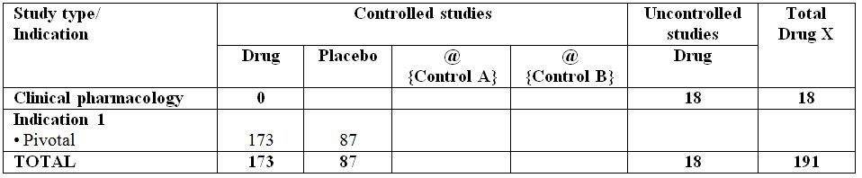
Table 11: Exposure to strontium ranelate in clinical studies according to dose and duration in men.
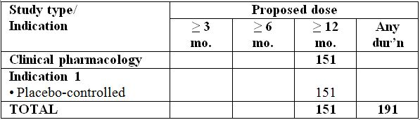
The index trials to assess safety were those submitted for the acceptance of this drug in post menopausal women:
- “SOTI”: 828 “active” patients (821 placebo); and
- “TROPOS”: 2554 “active” patients (2537 placebo).

Adverse events
AEs are shown in Tables 12-14.
Table 12: AEs male: Overall summary of AEs over one year – Safety set (CL3-032).
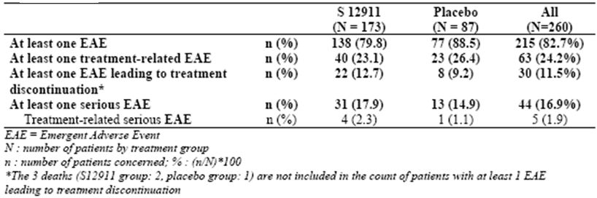
Table 13: Treatment related AEs: analysis by SOC in safety set.
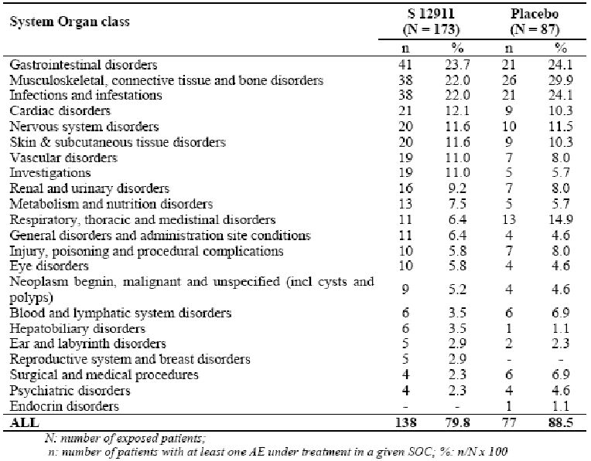
Table 14: AEs associated with the use of strontium ranelate in Phase 3 studies over an eight year period (frequencies versus placebo).
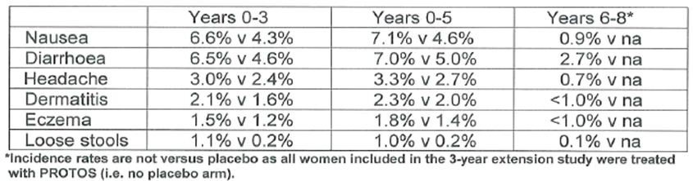

Deaths and other SAEs
Three patients died while they were receiving the study treatment: 2 patients (1.2%) in the strontium ranelate group (in both cases sudden death in patients with a history of advanced cardiovascular disease), and 1 patient (1.1%) in the placebo group (cerebral haemorrhage after a thrombolytic treatment for a myocardial infarction). None of these deaths were considered related to the study treatment by the investigators.
Other emergent SAEs:
- Angina pectoris: 2 in strontium ranelate group, 1 in placebo;
- Prostate cancer: 2 in strontium ranelate group, 1 in placebo;
- Iron deficiency anaemia: 2 in strontium ranelate group, 0 in placebo; and
- Deep vein thrombosis: 2 in strontium ranelate group, 0 in placebo.

Discontinuation due to AEs
24 of 42 treatment discontinuations in strontium ranelate group (9 of 15 in placebo) were due to AEs (as listed above). 14 treatment discontinuations in the strontium ranelate group were due to non medical reasons (6 in placebo) and 4 to protocol deviations (0 in placebo).

Laboratory tests

Liver function
ALP, transaminases, GGT, and total bilirubin for patients in the strontium ranelate group had a potentially clinically significant abnormal (PCSA) value in the following instances:
- elevated transaminase in 2 cases reported as AEs;
- an isolated increase in total bilirubin in one patient who had an out of reference range value for total bilirubin at baseline which increased to PCSA values at M6 and M12 (an AE was reported: blood bilirubin increased of mild intensity, not related to the study treatment, and which the patient recovered from); and
- increase in GGT in one patient who had an out of reference range value at baseline and M6, which increased to PSCA values at M12.
None of these abnormalities were associated with clinical symptoms. No relevant changes over time of the mean values were observed for these parameters over 1 year in either group.

Kidney function
Mean creatinine serum levels slightly increased from baseline to last value under treatment in both groups over 1 year (5.2 ± 9.6 µmol/L versus 1.5 ± 13.9 μmol/L). More patients in the strontium ranelate group (16 patients, 11.4%) than in the placebo group (4 patients, 5.5%) presented emergent out of reference range values. Those increases were reported as AEs in 2 patients However, no patient had treatment emergent PCSA values (>180µmol/L) and no relevant changes in creatinine clearance (calculated with the Cockroft formula) were observed in any group.

Haematology
The number of patients with emergent low haemoglobin values was slightly higher in the strontium ranelate group (9.6%) than in the placebo group (6.2%). However, no relevant changes over time in the mean values or differences between groups were detected.

Creatinin kinase
There was no difference in out of reference range for active (3.8%) versus placebo.

Calcium and phosphate
Slight changes without clinical relevance were observed in phosphocalcic homeostasis parameters: a slight decrease in blood calcium (-0.05 ± 0.09 mmol/L) and an increase in blood phosphorus (0.15 ± 0.16 mmol/L). For blood phosphorus, 15/157 patients (9.6%) in the strontium ranelate group versus 1/81 (1.1%) in the placebo group had potentially clinically significant abnormal values. None were associated with any clinical symptoms. These results are on line with those observed in the PMO women.

Electrocardiograph
There was no change in the ECG in a subset of 19 patients over 1 year.

Vital signs
No clinically relevant difference between groups were observed in the mean values of systolic blood pressure (SBP), diastolic blood pressure (DBP), and heart rate (HR)over time, as well as in the number of patients with emergent out of reference range values.

Post marketing experience
Further to the Urgent Safety Restriction (USR) procedure, a Direct Healthcare Professional Communication (DHPC) was sent in November 2007 to target doctors (defined in coordination with EMEA) to inform them on cases of hypersensitivity syndromes in post menopausal women treated with strontium ranelate (PROTELOS, OSSEOR). Subsequently, an updated SmPC and patient information leaflet was circulated worldwide in 2007, and in 2009, 419 doctors in France, Germany Italy and Spain were contacted by telephone and questionnaire to determine their awareness of this.
Some of these questions could be regarded as “push polling”, for example:
- “Do you regard Protelos to be an innovation? Why?”
- “Do you know that the hypersensitivity skin manifestations usually appear at the beginning of the treatment and are resolved in most cases when the treatment is stopped and/or corticotherapy is prescribed?”
This was in direct response to post marketing surveillance identifying a rare occurrence of DRESS syndrome. An expert committee was set up and met on nine occasions (bi-annual meetings).
The recommendation in the PI is for patients to immediately and permanently stop treatment with strontium ranelate when a rash occurs or if treatment has been stopped because of hypersensitivity reactions.

Haematological toxicity
The frequency of haematological toxicity is unknown beyond bone marrow failure and eosinophilia in association with hypersensitivity skin reactions.

Serious skin reactions
Serious skin reactions are very rare: hypersensitivity including rash, pruritis, urticaria, angiooedema, SJS, DRESS, TEN, and alopecia. Dermatitis and eczema have a relative risk of 1.1 in the treated group. Nevertheless, skin disorders are the most commonly reported AEs.

Cardiovascular safety
An increased incidence of deep venous thromboembolism was noted, and the 5 year Phase 3 data suggests a relative risk of 1.4 (95% CI = 1.0-2.0) of treated versus placebo.

Unwanted immunological events
No specific issues were identified.

Other safety issues
Other safety issues include peripheral oedema and bronchial hyperactivity (frequency unknown).

Evaluator’s overall conclusions on clinical safety
Considering AEs listed in current SmPC in PMO women (Table 13), findings in the male population of Study CL3-032 were the following:
- The incidence of Gastrointestinal and Musculoskeletal Disorders reported in strontium ranelate and in placebo groups was similar: 23.7% versus 24.1%, respectively, for Gastrointestinal disorders, and 22.0% versus 29.9%, respectively, for Musculoskeletal disorders.
- The overall incidence of Skin and Subcutaneous Disorders was slightly higher in the strontium ranelate group than in the placebo group: 11.6% versus 10.3%, respectively.
- Regarding Vascular Disorders, two patients (1.2%) experienced a deep vein thrombosis. The overall incidence in the general male population over 65 years is 0.96% (General Practice Research Database).
- Regarding Nervous System Disorders, no cases of disturbance in consciousness, memory loss or seizure were reported in men.
- In the General Disorders SOC, there were slightly more patients with peripheral oedema in the strontium ranelate group than in the placebo group: 2.3% versus 1.1%, respectively.
- Hepatobiliary disorders, liver enzymes: 1.2% in the strontium ranelate group versus none in the placebo group. Two patients experienced an increase in the hepatic enzymes 6 months after the first drug intake without any clinical symptom. Values normalised in both cases.
- Over one year, 44 patients experienced at least one serious AE during the study, 17.9% in the strontium ranelate group versus 14.9% in the placebo group. The most frequently affected SOC were Cardiac Disorders (3.5% versus 4.6%, respectively) and Neoplasms (2.3% versus 1.1%, respectively).
- Discontinuation of treatment due to AEs occurred in 13.9% of patients in strontium ranelate group versus 10.3% in the placebo group. Most of the AEs leading to treatment withdrawal were listed in the SmPC of strontium ranelate. Discontinuation of therapy was mainly due to Gastrointestinal disorders similarly reported in both groups (3.5% versus 3.4%). Emergent AEs that led to treatment discontinuation more frequently in the strontium ranelate group were Skin and Subcutaneous Tissue disorders, headache and deep vein thrombosis. The clinical safety seems very similar in this group of men than in the larger group of women in the previous trial.

First round benefit-risk assessment

First round assessment of benefits
The benefits of strontium ranelate in the proposed usage are:
- Inferred from the BMD changes and clinical efficacy in post menopausal women. Fracture reduction in men has not been directly proven, nor has the change in biomechanical properties in bone in orchidectomised rats.

First round assessment of risks
The risks of strontium ranelate in the proposed usage are:
- Acceptable and of the same order of magnitude as in women in the ~180 men who received the active substance in trial.

First round assessment of benefit-risk balance
The benefit-risk balance of strontium ranelate, given the proposed usage, is favourable.

First round recommendation regarding authorisation
The EMEA 2006 document states:
“...once an initial marketing authorisation has been granted to a NCE (new chemical entity) for the treatment of postmenopausal osteoporosis in women at high risk of fracture, a separate bridging study of the same NCE, using the same formulation, dose, and route of administration in male osteoporotic patients could be sufficient for being granted a marketing authorisation with the indication ‘treatment of osteoporosis in men at increased risk of fracture’ provided that:
- The duration of the study is at least one year;
- The dosage is justified;
- The applicant justifies that the cut off of BMD, age and any other risk factor chosen for men in the pivotal study will generate a fracture risk of similar magnitude compared with postmenopausal women that were recruited in the studies used to obtain the indication ‘treatment of postmenopausal osteoporosis in women at increased risk of fracture’;
- The magnitude of the changes in BMD versus placebo is similar to that observed in postmenopausal osteoporotic women treated with the same compound and is proportional to the decreased incidence of fractures in treated women.
With the exception of the last requirement (that is, the proportionality of BMD changes and fracture incidence which may not have been proved), this submission has met these requirements and should be authorised.

List of questions
No further questions.

V. Pharmacovigilance findings

Risk management plan
The sponsor submitted the RMP version 7 dated 21 November 2011 that was reviewed by the TGA’s Office of Product Review (OPR).

Safety specification
The sponsor provided a summary of Ongoing Safety Concerns, which are shown at Table 15.
Table 15: Ongoing Safety Concerns for Protos.
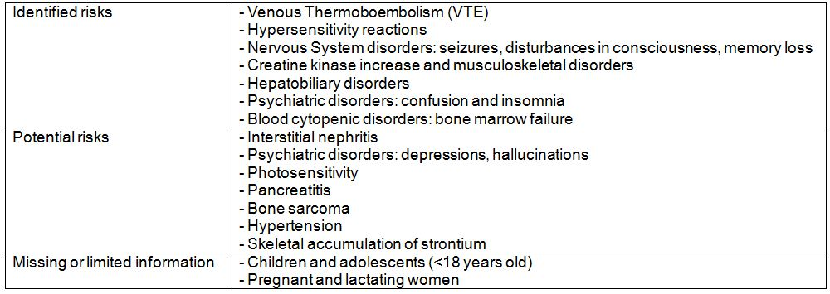
DRESS is a syndrome fever, rash (typically maculopapular beginning on the upper trunk and face and associated with facial oedema) with systemic (internal organ such as interstitial nephritis, hepatitis and interstitial lung disease) involvement. The time to onset is also typically more than 2 weeks but within 3 months after the introduction of the suspected drug. The sponsor provides the information that the global annual incidence of DRESS is 1 in 47,168 patient years and the incidence of SJS and TEN is 1 in 268,859 when all possible cases are included in the calculation. These data are on a background of a patient exposure of 2,688,588 patient years.

OPR reviewer comment:
Pursuant to the evaluation of the nonclinical and clinical aspects of the safety specifications, it is recommended that the above summary of the Ongoing Safety Concerns is considered acceptable.

Pharmacovigilance plan

Safety concern: Important identified risks

1. Hypersensitivity reactions including SJS and DRESS
Planned Actions:
- For all patients experiencing a severe hypersensitivity reaction:
  - Careful monitoring of these events using a specific questionnaire in ongoing and planned strontium ranelate studies (including epidemiological studies) as well as in post marketing experience. All PSURs focus on this issue and analysis of cases are collected whatever the source.
  - Submission of all cases to a group of experts in order to assess the diagnosis of DRESS.
  - In all patients experiencing severe hypersensitivity reaction type DRESS, TEN and SJS, practitioners in charge of them receive from the Market Authorisation Holder a letter in which they are strongly recommended to organise and perform blood samplings and cutaneous tests.

2. Venous Thromboembolic events (VTE)
Planned Actions:
- In ongoing and planned strontium ranelate trials:
  - VTE (including deep vein thrombosis and pulmonary embolism) are considered as related medically important events and are notified immediately to the sponsor, together with available results of clinical and additional investigations confirming the diagnosis.
  - Specific questionnaires are filled in for each patient experiencing a VTE in order to search for some specific risks. Haemostasis biological tests are performed in patients experiencing a VTE and in some studies systematically in all patients.
- For spontaneous cases:
  - All VTE spontaneous cases are considered as related important medical events and are reported to local regulatory authorities and for non EU cases to EMEA.
  - All PSURs focus on this issue and analysis of all cases are collected whatever the source.

3. Central nervous system disorders
Planned Actions:
- In ongoing and planned strontium ranelate trials:
  - Seizures are considered as related medically important events and are notified immediately to the sponsor together with available results of clinical and additional investigations confirming the diagnosis.
  - Specific questionnaires are filled in for each patient experiencing seizures, memory loss or disturbances in consciousness in order to search for some specific risks.
- For spontaneous cases:
  - Seizures are considered as related important medical events and are reported to local authorities and for non EU cases to EMEA.
  - Memory loss and disturbances in consciousness classified as serious are notified to the local authorities.
  - All PSURs focus on this issue and analysis of all cases are collected whatever the source.

4. Creatine kinase increase and musculoskeletal disorders
Planned Actions:
- In ongoing and planned strontium ranelate trials:
  - Creatine kinase will be monitored as safety parameter, in case of creatine kinase elevation subanalysis of creatine kinase for isoenzymes will be done. Monitoring of musculoskeletal AE.
- For spontaneous cases:
  - Careful monitoring of all cases
  - All PSURs focus on this issue and analysis of all cases are collected whatever the source.

Safety concern: Potential identified risks

1. Interstitial nephritis, psychiatric disorders (depression and hallucination), photosensitivity, pancreatitis, bone sarcoma, hypertension
Planned Actions:
- Routine pharmacovigilance activities collecting all reports whatever the source.

2. Skeletal accumulation of strontium
Planned Actions:
- Study CL3-12911-012: collection of trans iliac bone biopsy data during the 2 additional years of the extension study (after 9-10 years of strontium treatment).

Safety concern: Missing information

1. Paediatric age group (<18 years), pregnancy, lactation
Planned Actions:
- Routine pharmacovigilance in post marketing surveillance.

OPR reviewer comment:
The sponsor states via Section 31 question responses that that no post authorisation safety studies are planned. The sponsor has provided information regarding the Study CL3-12911-012, including a report and synopsis. This study is has concluded. The sponsor provided the summary of the evaluation of the EMA of this study being:
“The incidence of vertebral and peripheral fractures was stable over the 10 year follow up, and did not show the age expected increase over the 5 year extension study, suggesting that the efficacy of strontium ranelate persisted over time. The safety profile of strontium ranelate in the patients treated for 10 years was similar to previous studies and no new safety signals were detected during the extension study.”
The sponsor also has provided the final clinical study report for Study CLE-12911-021. This observational study also did not demonstrate new safety concerns.
Both these studies were conducted on post menopausal women. The sponsor has not identified any ongoing pharmacovigilance activity specific to the extension of indication into men with osteoporosis at increased risk of fracture. It is noted that 173 male patients using strontium for this indication are included in the safety data presented in the RMP. Two years is the longest duration of exposure in male patients from the clinical trials presented, compared with 10 years in PMO women. As it appears, the additional pharmacovigilance activities mentioned in the RMP have concluded routine pharmacovigilance activities remain the only activity in the Pharmacovigilance Plan for the safety specifications as listed. It is therefore recommended that special consideration be given in the PSURs to AEs in males with osteoporosis to further inform the safety profile of strontium when used in this population in Australia.
The pharmacovigilance activities for the safety concern ‘Hypersensitivity reactions’ includes an indication that there will be a strong recommendation to organise and perform blood samplings and cutaneous testing. In their Section 31 question responses regarding the investigations that would be required, the sponsor has indicated that in Europe the Market Authorisation Holder may direct doctors to arrange tests however this can only be recommended in Australia. It is therefore suggested that the language of this section of the RMP be modified to better reflect the interaction with Australian clinicians. This could be done in an Australian specific annexe to the RMP.

Risk minimisation activities

Sponsor’s conclusion in regard to the need for risk minimisation activities
The sponsor has indicated it believes routine risk minimisation is adequate for the management of all risks. However, the sponsor is providing additional risk minimisation activities in the form of educational materials for the Important identified risk - “Hypersenstivity reactions - including DRESS, TEN and SJS”.

OPR reviewer comment:
As the prescriber base is likely to be similar for the patients with the previous indication, the extension of indication in this application reliance on routine risk minimisation via the language in the PI is reasonable. Hypersensitivity syndromes such as DRESS represent a rare but potentially life threatening AE where early recognition and management are important. Thus, the additional risk minimisation activities to raise awareness among the prescriber base are supported.

Potential for medication errors, overdose, drug-drug interactions and off label use
The sponsor states that medication errors are unlikely with this medication, as there is only one dosage strength (2 g) and the medication presents as a sachet (and is unlikely to be confused with a tablet).
There is no specific antidote to strontium. Calcium decreases its bioavailability, as do aluminium and magnesium, so milk and antacids could be used in an overdose situation. This information is conveyed in the PI.
There is a potential for off label use in children with severe osteoporosis (which in children is very rare). The sponsor indicates it is aware of two instances of use in children - one child had severe familial osteoporosis and the other had osteoporosis following a renal transplant. The sponsor also notes the possible use if premenopausal women. They state that experience in this group is limited but no specific safety concerns have been identified.
Food and calcium decrease the oral bioavailability of strontium. The AUC was decreased 57% by calcium, 63% by food, and 71% by calcium and food. It is thought the interaction with calcium is due to competitive inhibition of the active transport mechanism. There is a potential interaction with co administered oral tetracycline or quinolone antibiotics. Strontium is a divalent cation which can form complexes with these antibiotics in the gastrointestinal tract and reduce their absorption. No other drug interactions have been observed by the sponsor in clinical trials, and specifically there is no interaction with oral supplementation of vitamin D.

OPR reviewer comment:
The sponsor’s assessment of the potential for medication errors is reasonable. The potential for off label use as an uncommon event is acknowledged and the sponsor’s evaluation is reasonable.

Summary of recommendations
The OPR provides these recommendations in the context that:
- the submitted RMP is supportive to the application;
- the implementation of a RMP satisfactory to the TGA is imposed as a condition of registration; and
- the submitted EU RMP is applicable without modification in Australia unless so qualified.

General recommendations
From the RMP, the nonclinical evaluator has recommended a wording change in the nonclinical section of the RMP from
“The safety margin is about 38 times the human therapeutic dose.”
to
“These doses are up to about 38 times the human therapeutic dose on a mg/kg body weight basis and yielded systemic exposure to strontium (plasma AUC) up to 2.5 times higher.”
It is recommended the sponsor update the RMP to incorporate this change.

Pharmacovigilance plan
As it appears the additional pharmacovigilance activities mentioned in the RMP have concluded routine pharmacovigilance activities remain the only activity in the Pharmacovigilance Plan for the safety specifications as listed. It is therefore recommended that special consideration be given in the PSURs to AEs in males with osteoporosis to further inform the safety profile of strontium when used in this population in Australia. Furthermore, the RMP should be updated to indicate there are no planned post authorisation studies for strontium ranelate for this indication. This could be achieved via an Australian specific annexe for the current RMP.
The pharmacovigilance activities for the safety concern ‘Hypersensitivity reactions’ includes an indication that there will be a strong recommendation to organise and perform blood samplings and cutaneous testing. In their Section 31 question responses regarding the investigations that would be required, the sponsor has indicated that in Europe the Market Authorisation Holder may direct doctors to arrange tests however this can only be recommended in Australia. It is therefore suggested that the language of this section of the RMP be modified to better reflect the interaction with Australian clinicians. This could be done in an Australian specific annexe to the RMP.

Risk minimisation plan
The additional risk minimisation activity, for the Important Identified Risk ‘Hypersensitivity reactions’, should be included in the RMP section of the RMP. The RMP should be updated accordingly. This could be achieved via an Australian specific annexe to the current RMP.
The use of the uptake of the patient support programme is not considered an adequate tool for measuring the effectiveness of the strategy for educating health care professionals regarding the recognition and management of hypersensitivity reactions.
Proposed educational materials to be provided to patients in addition to the CMI have not been provided by the sponsor and no further comment can be made in this regard. The sponsor is requested to provide sample materials after the finalisation of the CMI, and prior to supply, for information for the TGA.

VI. Overall conclusion and risk/benefit assessment
The submission was summarised in the following Delegate’s overview and recommendations:

Introduction
This submission was conventional and it included nonclinical and clinical data. Individual patient data were present in the electronic version. A RMP was also submitted.
The letter of application states that the new indication is supported by Study CL3-032, a 12 month, placebo controlled, bone densitometric study in 261 male patients with primary osteoporosis of whom 28% had a prevalent vertebral fracture and whose mean lumbar T score was -2.6. An improvement in bone densitometry is claimed at 12 months, consistent with the results found in studies in postmenopausal women in which fractures were an endpoint.
The applicant’s clinical summary included this tabulation of two clinical studies and three population PK/PD analyses (Table 16).
Table 16: Tabular listing of all clinical studies (all reports completed).
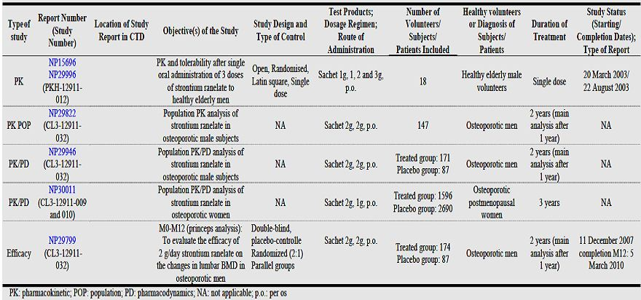

Regulatory History
At the time of lodgement of the submission, the outcome of an application in the EU was pending.
The Advisory Committee on Prescription Medicines (ACPM) considered strontium ranelate as a new chemical entity at its 239th meeting on 31 March 2005. Matters of interest to the ACPM were:
- There was very limited clinical evidence in relation to bone toxicity. While there was no osteomalacia or mineralisation delay observed in 103 assessable bone biopsies, the possibility of adverse bone effects was not excluded. Changes to the brittleness of bone had not been investigated.
- The clinical data supported the indication of treatment of post menopausal osteoporosis to decrease the risk of fracture for therapy of 1-3 years duration. There were insufficient data to specify vertebral fracture and/or composite peripheral fracture in the indication.
- There was a limited correlation between the effect on BMD and the effect on fracture, that is, the women with bone density improvements were not necessarily the women without fractures. Also, measured changes in BMD were partly an artefact due to the atomic weight of strontium compared to calcium and did not directly indicate a benefit of therapy.
- There was no direct evidence to allow the indication to specifically claim a reduction in hip fracture.
- There was limited evidence of safety and efficacy in relation to use beyond 3 years. More data were required and the sponsor should be requested to provide details of ongoing trials, which should include bone biopsy data. There was insufficient information on whether benefit was maintained or reached a plateau with continuing therapy, and whether benefit continued after stopping treatment.
- The recommended duration of therapy was a practical issue in an elderly population.
Registration was recommended (Resolution Number 8745).
A relevant recommendation of the Committee is Resolution Number 7078:
“Resolution Number 7078
Having considered correspondence relating to the treatment of osteoporosis in males and the desirability of minimising gender specific indications whenever possible, the ADEC would be prepared to recommend approval of a drug in a gender group if the sponsor has submitted an acceptable justification for the undertaking a clinical trial in that gender. The justification would require:
- that the drug was recommended for approval in the other gender on the basis of adequate conventional studies showing efficacy and safety;
- evidence of similar or identical disease pathogenesis;
- evidence of prevalence of the disease to show that an expectation of trials in this gender is unrealistic;
- evidence that toxicology studies were adequate to exclude gender specific differences of clinical significance;
- human clinical data to show that there are not clinically significant gender differences in PK or PD; and
- presentation of all identifiable evidence of safe use in the gender under consideration.
Points (i), (iv) and (v) would require data and usually would require studies to have been conducted by the sponsor.
Points (ii) and (iii) might be based on a bibliographic submission.
Point (vi) would require submission of any studies and also all literature reports.”
Guidelines that are applicable include:
- the relevant EMA guideline;
- Clinical Investigation of Medicinal Products in Geriatrics; and,
- Points to Consider on Application with 1. Meta Analyses; 2. One Pivotal Study.
The first of these guidelines suggests:
“Taking into consideration the different pathophysiology of osteoporosis in males and in females and the limited knowledge of the mechanism of action of products that have demonstrated efficacy in women, the gold standard for being granted a marketing authorisation for the treatment of osteoporosis in men at increased risk of fracture remains the demonstration of anti fracture efficacy (spine and/or non spine fractures) during a 2 year minimum, placebo controlled, prospective study. However, once an initial marketing authorisation has been granted to a NCE for the treatment of postmenopausal osteoporosis in women at high risk of fracture, a separate bridging study of the same NCE, using the same formulation, dose, and route of administration in male osteoporotic patients could be sufficient for being granted a marketing authorisation with the indication ‘treatment of osteoporosis in men at increased risk of fracture’ provided that:
- the duration of the study is at least one year;
- the dosage is justified
- the applicant justifies that the cut off of BMD, age and any other risk factor chosen for the inclusion of men in the pivotal study will generate a fracture risk of a similar magnitude compared with postmenopausal women that were recruited in the studies used to obtain the indication “Treatment of postmenopausal osteoporosis in women at increased risk of fracture”
- the magnitude of the changes in BMD versus placebo is similar to that observed in postmenopausal osteoporotic women treated with the same compound and is proportional to the decreased incidence of fractures in treated women.”
The guideline regarding geriatrics advises that there be PK characterisation in older versus younger patients to detect age related PK differences. Both suggested approaches have been followed to some extent in this application. The guideline on Points to Consider on Application with 1. Meta Analyses; 2. One Pivotal Study does expect compelling clinical evidence.

Quality
There was no requirement for a quality evaluation in a submission of this type.

Nonclinical
The nonclinical evaluator describes two, new long term GLP compliant nonclinical studies that were submitted. The studies were conducted in orchidectomised male rats. They were not intended as toxicity studies.
The first study was a preventive study in the sense that strontium ranelate was given for 52 weeks starting at the time of orchidectomy. The study was controlled and the active dose levels were 250, 625 and 900 mg/kg/day, 20 animals/group.
The second study was a curative study in the sense that strontium ranelate was given for 44 weeks starting eight weeks after orchidectomy. The active treatment group received strontium ranelate 625 mg/kg/day, 20 animals/group.
The observed effects of strontium ranelate are tabulated in the nonclinical report. Changes in bony strength were not seen in control or treated groups in either study. In both studies 3-6 additional animals per group supplied PK data.
The evaluator recommends some presentational changes to the draft product information document. A correction was made to the toxicokinetic statement in the risk management plan’s safety specification.
Approval of the indication would depend on clinical data.

Clinical
The clinical evaluator noted that the risk factors for male osteoporosis include: hypogonadism, smoking, alcohol consumption, low calcium intake, vitamin D deficiency and inadequate level of physical exercise and that osteoporosis becomes an important issue only when a low impact fracture occurs.
The applicant’s claimed rationale for the use of strontium ranelate is the assumption that the human male skeleton would not respond any differently to the female skeleton to non-hormonal anti osteoporotic treatments.

Pharmacokinetics and Pharmacodynamics:
As listed by the evaluator, the data package included:
- One clinical pharmacology study that provided PK data in men (Study PKH-12911-012-FRA);
- Two population PK analyses. One each in males (the pivotal Study CL3-12911-032) and females (Study CL3-12911-009/010); and
- The population PD study in males was the same Study CL3-12911-032 as supplied the PK data. This was similar for Study CL3-12911-009/010.
Study PKH-12911-012-FRA (Table 17) was a non comparative study (it enrolled 18 healthy elderly >60 Caucasian male volunteers [63 to 73, mean 68.9 years], taking no drugs which would interfere with strontium ranelate PK). Three doses of strontium ranelate (1 g, 2 g and 3 g) were taken 28 days apart as single doses. Some lack of dose proportionality was seen.
Table 17: PK results (analyses were performed on the randomised population, n = 18).
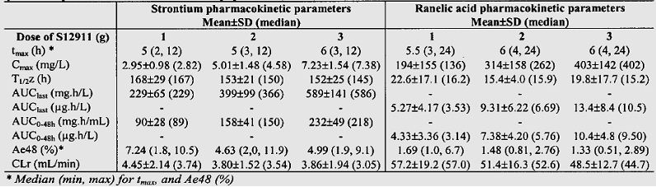
A total of 147 subjects had at least one plasma concentration of strontium included in the PK analysis. A total of 379 concentration-time points were included in the population PK analysis. Blood samples were collected ~12 h after dosing at months 0 (pre dose), 3, 6, and 12 (that is, one sample per subject for each month). The daily dose of 2 g of strontium ranelate corresponds to 682.6 mg/day of strontium (that is, 7781.64 μmol/day). The evaluator reports that:
“The PK of strontium under steady state conditions after administration of 2 g of strontium ranelate in osteoporotic men from Study CL3-12911-032 study were described with robustness with a similar structural model as the one used in a previous population PK analysis in osteoporotic postmenopausal women.”

Comment:
It is not possible to say that Study PKH-12911-012-FRA was an acceptable study. It did not directly compare the PK of strontium ranelate in men versus women or the elderly versus middle aged patients. It was non comparative, so indirect cross study comparisons must have informed the clinical evaluator’s view.
The population PK analysis suggests similarity between men and women with regard to the PK of strontium ranelate. An effect of creatinine clearance based on the pooled studies was not reported but renal impairment was examined in the original data set.
The original Delegate’s summary remarked:
“The absorption of strontium was found to be dose dependent; the increase in C_{max} and AUC were less than dose proportional … T_{max} was ~ 3.5 h. C_{max} for the 2 g sachet, which is proposed for marketing, was 4.8 ± 1.6 µg/mL ...
The evaluator mentions that the volume of distribution was 58L (approx 1L/kg) in the combined analysis of the Phase 1 studies. This differed in Phase 3 studies ... The clinical summary also mentions that the human protein binding is low being 25% with binding to albumin being 10%. Total clearance is low (~12 mL/min…). Renal clearance was ~5mL/min... The evaluator mentions that the t_{1/2} for single dose administration was shorter (60-120 h) compared with that observed in relation to multiple dose (185-200 h…). However, this discrepancy may have been due to infrequent collection times. A clinically significant effect was seen when Maalox (containing aluminium hydroxide and magnesium hydroxide) was administered concomitantly ... It is mentioned that no interaction was observed in Phase 3 studies in relation to anti H2, anti reflux, proton pump inhibitors, analgesics, NSAIDS and vitamin D…
One Phase 1 study was conducted … on renally impaired subjects. The number of subjects recruited with renally impaired was low being 11. This study showed that when creatinine clearance was changed from 110 mL/min to 40 mL /min, strontium exposure would increase by 38%. This was also seen from data collected from Phase 3 studies ... Severe renal impairment has not been studied. No data are submitted on hepatic impairment; however, based on the PK of strontium, no effect is expected.”
It is not likely that these observations would be, in principle, different in men.

Phase 3 study in men:
Study CL3-12911-032 is the pivotal study of this submission. It was of a randomised, double blind, two parallel group, unbalanced (2:1), placebo controlled design. It was multi centric (n = 60 active centres) and was conducted in 14 countries.
The patient numbers recruited and dropouts are described in the applicant’s tabulation in Table 18.
Table 18: Disposition of randomised patients by group.
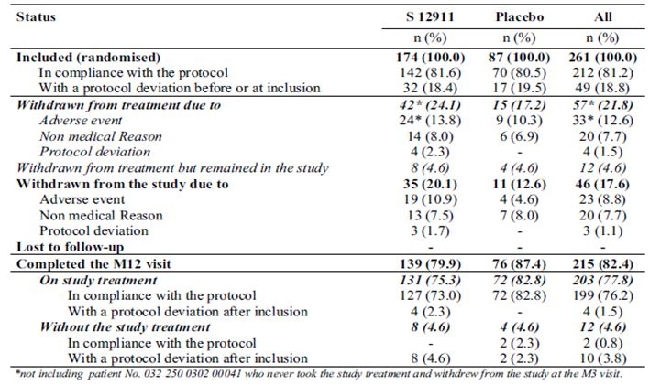
The subjects enrolled had marked osteopoenia or osteoporosis (Table 3).
The primary efficacy criterion was the lumbar L2-L4 BMD expressed as the relative change from baseline to last value (End) in the FAS. Results at 12 months are presented below; the study numbers (just) met the a priori sample size calculations (Table 4).
As noted by the evaluator:
“The relative change from baseline to End in L2-L4 BMD was 7.1 ± 6.0% with S12911 and 1.7 ± 4.4% with placebo, with a statistically significant difference between groups (E [SE] = 5.3 [0.7]; 95% CI = [3.9-6.8]; p < 0.001). These results were consistent with those defined in the protocol (that is, the measured mean BMD in strontium ranelate treated patients should increase from baseline by 5% the first year at the lumbar spine).”
Bone turnover markers suggested a treatment effect (Table 6).
The evaluator was satisfied with the conduct of the study and was of the view that the results obtained for primary and secondary endpoints were comparable to those obtained from pivotal studies in postmenopausal women.
No new safety signals emerged. The evaluator concluded, “The clinical safety seems very similar in this group of men than in the larger group of women in the previous trial.”
The evaluator supports registration but notes that the proportionality of BMD changes and fracture incidence which may not have been proven. No significant changes to the PI were recommended.

Risk management plan
Specific recommendations have been made:
“Two years is the longest duration of exposure in male patients from the clinical trials presented, compared with 10 years in PMO women. As it appears, the additional pharmacovigilance activities mentioned in the RMP have concluded routine pharmacovigilance activities remain the only activity in the Pharmacovigilance Plan for the safety specifications as listed. It is therefore recommended that special consideration be given in the PSURs to AEs in males with osteoporosis to further inform the safety profile of strontium when used in this population in Australia.”
“Hypersensitivity syndromes such as DRESS represent a rare but potentially life threatening AE where early recognition and management are important, thus the additional risk minimisation activities to raise awareness among the prescriber base is supported.”
In regard to the PI:
“In regard to the proposed routine risk minimisation activities, it is recommended to the Delegate that the draft PI document be revised as follows:
The sponsor has indicated that in the EU it has proposed an additional contraindication in patients with a past history of VTE. It is recommended to the delegate that consideration be given to the same change to the PI for Australian patients.
The PI states Protos is only indicated in post menopausal women. This contradicts the proposed indication and is presumed to be an oversight by the sponsor; however, it is recommended to the Delegate that this be corrected.
In regard to the proposed routine risk minimisation activities, it is recommended to the Delegate that the draft CMI document be revised to reflect any changes in the PI. It should be noted that an updated draft CMI was not provided with the updated draft PI provided with Version 7 of the RMP.”

Risk-benefit analysis
The study in men is therefore at least consistent with the previous findings. Some of the increase in BMD is artefactual but bone turnover markers are supportive of a treatment effect. No fracture data are available to support efficacy in males and the description of the clinical trial in the PI would have to disclose this.
The RMP evaluator’s recommendations all appear to be reasonable and are supported.
The advice of the ACPM is requested.

Proposed actions
The application by the sponsor to register Protos 2 g, powder for oral suspension containing 2 g strontium ranelate for the treatment of osteoporosis in men at increased risk of fracture, should be approved.

Response from sponsor
We are pleased to respond to the Delegate. For ease of review, the issues raised by the Delegate have been reproduced in bold text preceding the company’s response.

1. Proportionality of BMD changes and fracture incidence
“The evaluator supports registration but notes that the proportionality of BMD changes and fracture incidence which may not have been proven.” DO (Delegate’s Overview) p.8
“The study in men is therefore at least consistent with the previous findings. Some of the increase in BMD is artefactual but bone turnover markers are supportive of a treatment effect. No fracture data are available to support efficacy in males and the description of the clinical trial in the PI would have to disclose this” DO p.8
The proportionality between BMD changes and reduction in fracture risk was demonstrated in PMO women.
A post hoc analysis with data from SOTI and TROPOS (FAS population) showed a relationship between increases in measured BMD and reduction in the risk of new vertebral and hip osteoporotic fractures in strontium ranelate treated patients. After 3 years of strontium ranelate treatment, each percentage point increase in femoral neck BMD was associated with a 3% (95% adjusted CI= [1-5%]) reduction in risk of a new vertebral fracture.
The 3 year changes in femoral neck BMD explained 76% of the reduction in vertebral fractures observed during treatment. An increase in femoral neck BMD after 1 year was significantly associated with the reduction in incidence of new vertebral fractures observed after 3 years (p=0.04).
Regarding peripheral fractures, the relationship between change in femoral neck BMD and hip fractures was established in patients considered most at risk of hip fracture, that is, patients aged ≥ 74 years with femoral neck BMD ≤ 2.4 (NHANES normative value). Over 3 years of treatment, each 1% increased in femoral neck BMD was associated with a 7% reduction of hip fractures (95% CI = [1-14%], p=0.04).
Taken together, these results observed in PMO women confirm that, the change in BMD is an appropriate end point to predict the effect of strontium ranelate on the fracture risk reduction.
In the MALEO study, the magnitude of the changes in lumbar spine and femoral neck BMD in the male population over one year is similar to that observed in the pivotal Phase 3 studies carried out in postmenopausal women, in whom the fracture risk reduction obtained with strontium ranelate was proportional to the increase in femoral neck BMD. Thus, the efficacy of strontium ranelate to decrease the fracture risk in men with primary osteoporosis can be anticipated from the BMD results.
The primary efficacy endpoint of the study in men indicating that it was a bridging BMD trial will be mentioned in the PI as follows: “The primary efficacy endpoint was the percentage change from baseline to end of lumbar L2-L4 BMD”.

2. Study PKH-12911-012-FRA
“It is not possible to say that Study PKH-12911-012-FRA is an acceptable study. It did not directly compare the PK of strontium ranelate in men versus women or the elderly versus middle aged patients. It was non comparative, so indirect cross study comparisons must have informed the clinical evaluator’s view.” DO p.5
In the Study PKH-12911-010 study (study in women), the age of the PMO women included ranged between 52 to 65 years with a mean ± SD age of 57.4 ± 4.1 years, while in men in the Study PKH-12911-012-FRA trial mean ± SD age was 68.9 ± 2.8 years (range 63-73 years).
Primary osteoporosis occurs about ten years later in men than in women, and as the goal of Study PKH-12911-012-FRA was mainly to help to the choice of the dose for the Phase 3 study performed in men, strontium PK was assessed in Study PKH-12911-012-FRA in healthy elderly men of the same age as the target population.
Therefore, 18 healthy elderly men (mean age: 68.9 years) were included in an open, randomised, three period crossover study and received a single oral administration of 1 g, 2 g and 3 g of strontium ranelate as sachet(s).
PK parameters following single oral administration of 2 g of strontium ranelate in healthy elderly men are presented in Table 19.
Table 19: Strontium PK parameters in plasma after single oral administration of strontium ranelate 2 g to healthy elderly men (mean ± SD, median).
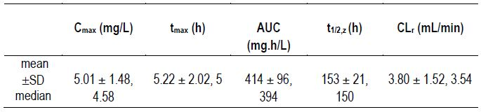
Strontium AUC values obtained in healthy elderly men (median [range]: 394 [290-683] mg.h/L) were in the same range as the AUC previously obtained in post menopausal women (median [range]: 375 [286-521] mg.h/L) when administered in the same conditions (same formulation, same dose, 3 h after dinner, in Study PKH-12911-010).
These results were further confirmed by the population PK analysis performed in the Phase 3 study which compared the PK of strontium in men and women with osteoporosis using a VPC methodology based on a population PK model previously developed in women.
The population PK model was qualified and validated and was shown to accurately describe the strontium concentration-time data observed during the study. Three covariates were shown to have a statistically significant influence on strontium apparent clearance (that is, creatinine clearance, calcemia and phosphoremia). However, they only explain a negligible part of the variability in the apparent clearance of strontium and do not justify any dose adjustment.
The structure of the population PK models obtained for the male and female populations was the same with no statistically significant differences between population apparent clearances of strontium. Influence of co variates was also similar in both populations. Moreover, the strontium exposures predicted with the population PK models are within the same range for both populations.
In overall, Study PKH-12911-012-FRA allowed to determine the dose to be tested in the Phase 3 study in osteoporotic men (MALEO Study CL3-12911-032). The PK data collected in the Phase 3 study allowed to demonstrate that PK of strontium were the same in osteoporotic men and women.

3. Australian specific annex to the RMP
“The applicant appears to have acceded to the RMP evaluator’s requests/recommendations” DO p.8
The sponsor is now providing the Australian annex to the RMP version 7. This annex gather all the responses already submitted:
- Section 31 responses (23 December 2011),
- Response to Clinical Evaluation Report (14 February 2012).

Advisory committee considerations
The ACPM, taking into account the submitted evidence of efficacy, safety and quality, considered this product to have an overall positive benefit-risk profile. The application seeks to register an extension of indications for a currently registered product.
Treatment of osteoporosis in men at increased risk of fracture.
In making this recommendation the ACPM considered that the efficacy data showed no difference between male and female outcomes, however noted the absence of concentration effect and dose finding studies in males.
The central issue for consideration for the ACPM was how best to define the population that is at increased risk of fracture, agreeing that BMD is not the sole indicator for efficacy. The absence of clinical guidelines to define absolute fracture risk at this time does not, however, negate the need for vigilance in assessing the appropriate population for use of this product.
Further, the ACPM considered the safety profile warrants the mentioning of the duration of treatment.
The ACPM agreed with the delegate to the proposed amendments to the PI and CMI and specifically advised on inclusion of the following:
- Statements in the Dosage and Administration / Clinical Trials sections of the PI and CMI to ensure prescriber and consumer guidance on the population at risk of fracture and the need for ongoing review of duration of therapy.
- Statement in the appropriate section of the PI to remind prescribers to exclude a differential diagnosis of secondary osteoporosis in men such as hypogonadism.
The ACPM agreed with the Delegate on the proposed conditions of registration.
The ACPM advised that the implementation by the sponsor of the recommendations outlined above to the satisfaction of the TGA, in addition to the evidence of efficacy and safety provided would support the safe and effective use of these products.

Outcome
Based on a review of quality, safety and efficacy, TGA approved the registration of Protos (strontium ranelate) 2 g granules for oral suspension sachet indicated for:
Protos is indicated for the treatment of osteoporosis in men at increased risk of fracture.
The approved full indications now read as follows:
Protos is indicated for the treatment of:
- postmenopausal osteoporosis to reduce the risk of fracture; and
- osteoporosis in men at increased risk of fracture.

Specific conditions of registration applying to these therapeutic goods:
1. Details of the distribution of the drug including quantities and forms of products distributed and related batch numbers should be supplied on request while the drug remains on the Australian Register of Therapeutic Goods.
2. The implementation in Australia of the Protos (strontium ranelate) RMP version 7, dated 21 November 2011, included with the submission, and any subsequent revisions, as agreed with the TGA and its OPR.

Attachment 1. Product Information
The following Product Information was approved at the time this AusPAR was published. For the current Product Information please refer to the TGA website at <http://www.tga.gov.au/hp/information-medicines-pi.htm>.

European Medicines Agency, “Committee for Medicinal Products for Human Use (CHMP): Guideline on the Evaluation of the New Medicinal Products in the Treatment of Primary Osteoporosis (CPMP/EWP/552/95 Rev. 2)”, 14 December 2005, Web, accessed 14 November 2012 <www.ema.europa.eu/docs/en_GB/document_library/Scientific_guideline/2009/09/ WC500003406.pdf>.
Danielsen CC, et al. (1992) Long-term effect of orchidectomy on cortical bone from rat femur: bone mass and mechanical properties. Calcif. Tissue Int. 50: 169-174; Peng Z, et al. (1994) The mechanical strength of bone in different rat models of experimental osteoporosis. Bone 15: 523-532; Diaz-Curiel M, et al. (2008) Effect of risedronate on bone mass, remodelling and biomechanical strength in orchidectomized rats. Horm. Res. 70: 93-99; Morrow R, et al. (2009) Feeding orange pulp improved bone quality in a rat model of male osteoporosis. J. Med. Food. 12: 298-303.
Khosla S, et al. (2008) Osteoporosis in men. Endocr. Rev. 29: 441-464; Cooper C, et al. (1992) Hip fractures in the elderly: a world-wide projection. Osteoporos. Int. 2: 285-289.
Center JR, et al. (1999) Mortality after all major types of osteoporotic fracture in men and women: an observational study. Lancet 353: 878-882; Forsen L, et al. (1999) Survival after hip fracture: short- and long-term excess mortality according to age and gender. Osteoporos Int. 10: 73-78; Kanis JA, et al. (2003) The components of excess mortality after hip fracture. Bone 32: 468-473.
Cummings SR, et al. (2006) BMD and risk of hip and nonvertebral fractures in older men: a prospective study and comparison with older women. J. Bone Miner. Res. 21: 1550-1556; Berger C, et al. (2009) Association between change in BMD and fragility fracture in women and men. J. Bone Miner. Res. 24: 361-370.
European Prospective Osteoporosis Study (EPOS) Group. (2002) Incidence of vertebral fracture in Europe: results from the European Prospective Osteoporosis Study (EPOS). J. Bone Miner. Res. 17: 716-724.
Meier C, et al. (2005) Bone resorption and osteoporotic fractures in elderly men: the dubbo osteoporosis epidemiology study. J. Bone Miner. Res. 20: 579-587; Szulc P, et al. (2005) Bone mineral density predicts osteoporotic fractures in elderly men: the MINOS study. Osteoporos Int. 16: 1184-1192.
Cummings SR, et al. (2006) BMD and risk of hip and nonvertebral fractures in older men: a prospective study and comparison with older women. J. Bone Miner. Res. 21: 1550-1556.
Cawthon PM, et al. (2009) Loss of hip BMD in older men: the osteoporotic fractures in men (MrOS) study. J. Bone Miner. Res. 24: 1728-1735.
Delannoy P, et al. (2002) Long-term treatment with strontium ranelate increases vertebral bone mass without deleterious effect in mice. Metabolism 51: 906-911; Hott M, et al. (2003) S12911-2 reduces bone loss induced by short-term immobilization in rats. Bone 33: 115-123; Ammann P, et al. (2004) Strontium ranelate improves bone resistance by increasing bone mass and improving architecture in intact female rats. J. Bone Miner. Res. 19: 2012-2020.
European Medicines Agency, “Committee for Medicinal Products for Human Use (CHMP): Guideline on the Evaluation of the New Medicinal Products in the Treatment of Primary Osteoporosis (CPMP/EWP/552/95 Rev. 2)”, 14 December 2005, Web, accessed 14 November 2012 <www.ema.europa.eu/docs/en_GB/document_library/Scientific_guideline/2009/09/ WC500003406.pdf>.
Meunier PJ, et al. (2004) The effects of strontium ranelate on the risk of vertebral fracture in women with postmenopausal osteoporosis. N. Engl. J. Med. 350: 459-468; Reginster JY, et al. (2005) Strontium ranelate reduces the risk of nonvertebral fractures in postmenopausal women with osteoporosis: Treatment of Peripheral Osteoporosis (TROPOS) study. J. Clin. Endocrinol. Metab. 90: 2816-2822.
Reginster JY, et al. (2008) Effects of long-term strontium ranelate treatment on the risk of nonvertebral and vertebral fractures in postmenopausal osteoporosis: Results of a five-year, randomized, placebo-controlled trial. Arthritis Rheum. 58: 1687-1695; Reginster JY, et al. (2009) Long-term treatment of postmenopausal osteoporosis with strontium ranelate: results at 8 years. Bone 45: 1059-1064.
Not described in submitted data but implied in SOTI and STRATOS studies.
Quality of Life Questionnaire in Osteoporosis.
European Medicines Agency, “ICH Topic E 9 Statistical Principles for Clinical Trials Step 5: Note for Guidance on Statistical Principles for Clinical Trials (CPMP/ICH/363/96)”, September 1998, Web, accessed 23 November 2012 <www.emea.europa.eu/docs/en_GB/document_library/ Scientific_guideline/2009/09/WC500002928.pdf>.
European Medicines Agency, “ICH Topic E 9 Statistical Principles for Clinical Trials Step 5: Note for Guidance on Statistical Principles for Clinical Trials (CPMP/ICH/363/96)”, September 1998, Web, accessed 23 November 2012 <www.emea.europa.eu/docs/en_GB/document_library/ Scientific_guideline/2009/09/WC500002928.pdf>.
No record of the outcomes of these meetings could be found in the dossier, although the RMP indicated that no further such cases had occurred.
European Medicines Agency, “Committee for Medicinal Products for Human Use (CHMP): Guideline on the Evaluation of the New Medicinal Products in the Treatment of Primary Osteoporosis (CPMP/EWP/552/95 Rev. 2)”, 16 November 2006, Web, accessed 26 November 2012 <http://www.tga.gov.au/pdf/euguide/ewp055295enrev2.pdf>.
Sponsor comment: At the time of publication of this AusPAR, the RMP version 7 has been superseded. Consequently, some of the information presented in this AusPAR has been updated (including risks and post authorisation safety study in men).
European Medicines Agency, “Committee for Medicinal Products for Human Use (CHMP): Guideline on the Evaluation of the New Medicinal Products in the Treatment of Primary Osteoporosis (CPMP/EWP/552/95 Rev. 2)”, 16 November 2006, Web, accessed 26 November 2012 <http://www.tga.gov.au/pdf/euguide/ewp055295enrev2.pdf>.
Bruyere O, et al. (2007) Relationship between bone mineral density changes and fracture risk reduction in patients treated with strontium ranelate. J. Clin. Endocrinol. Metab. 92: 3076-3081.
Bruyere O et al. (2007) Relationship between change in femoral neck bone mineral density and hip fracture incidence during treatment with strontium ranelate. Curr. Med. Res. Opin. 23: 3041-3045.
PK study to assess the influence of Maalox on strontium bioavailability after single administration of S12911 in healthy postmenopausal volunteers: Protocol PKH-12911-010 (NP08405), Submitted in the initial registration dossier Submission ID 2004-394-5.
PK and tolerability of strontium ranelate after single oral administration of 1g, 2g and 3g S12911 as sachet to healthy elderly men: protocol PKH-12911-012-FRA (NP15696 and NP29996).
Population PK analysis of strontium ranelate in osteoporotic male subjects: Protocol CL3-12911-033 (NP29822).
Combined analysis of strontiemia: strontium pharmacokinetic analysis after repeated oral administration of 2g strontium ranelate in osteoporotic postmenopausal women. Population PK analysis: Protocol CL3-12911-009 (NP08514). Submitted in the initial registration dossier Submission ID 2004-394-5.

