March 2019

Australian Public Assessment Report for Sofosbuvir / Velpatasvir / Voxilaprevir
  - Proprietary Product Name: Vosevi
  - Sponsor: Gilead Sciences Pty Ltd

About the Therapeutic Goods Administration (TGA)
- The Therapeutic Goods Administration (TGA) is part of the Australian Government Department of Health and is responsible for regulating medicines and medical devices.
- The TGA administers the Therapeutic Goods Act 1989 (the Act), applying a risk management approach designed to ensure therapeutic goods supplied in Australia meet acceptable standards of quality, safety and efficacy (performance) when necessary.
- The work of the TGA is based on applying scientific and clinical expertise to decision-making, to ensure that the benefits to consumers outweigh any risks associated with the use of medicines and medical devices.
- The TGA relies on the public, healthcare professionals and industry to report problems with medicines or medical devices. TGA investigates reports received by it to determine any necessary regulatory action.
- To report a problem with a medicine or medical device, please see the information on the TGA website < https://www.tga.gov.au> .
About AusPARs
- An Australian Public Assessment Report (AusPAR) provides information about the evaluation of a prescription medicine and the considerations that led the TGA to approve or not approve a prescription medicine submission.
- AusPARs are prepared and published by the TGA.
- An AusPAR is prepared for submissions that relate to new chemical entities, generic medicines, major variations and extensions of indications.
- An AusPAR is a static document; it provides information that relates to a submission at a particular point in time.
- A new AusPAR will be developed to reflect changes to indications and/or major variations to a prescription medicine subject to evaluation by the TGA.
Copyright
© Commonwealth of Australia 2019
This work is copyright. You may reproduce the whole or part of this work in unaltered form for your own personal use or, if you are part of an organisation, for internal use within your organisation, but only if you or your organisation do not use the reproduction for any commercial purpose and retain this copyright notice and all disclaimer notices as part of that reproduction. Apart from rights to use as permitted by the Copyright Act 1968 or allowed by this copyright notice, all other rights are reserved and you are not allowed to reproduce the whole or any part of this work in any way (electronic or otherwise) without first being given specific written permission from the Commonwealth to do so. Requests and inquiries concerning reproduction and rights are to be sent to the TGA Copyright Officer, Therapeutic Goods Administration, PO Box 100, Woden ACT 2606 or emailed to < tga.copyright@tga.gov.au> .

Contents
Common abbreviations 5
I. Introduction to product submission 11
Submission details 11
Product background 12
Regulatory status 12
Product Information 13
II. Registration time line 13
III. Quality findings 14
Introduction 14
Drug substance (active ingredients) 14
Drug product 16
Biopharmaceutics 17
Quality summary and conclusions 20
IV. Nonclinical findings 20
Introduction 20
Pharmacology 21
Pharmacokinetics 24
Toxicology 26
Nonclinical summary and conclusions 32
V. Clinical findings 35
Introduction 35
Pharmacokinetics 40
Pharmacodynamics 46
Dosage selection for the pivotal studies 47
Efficacy 49
Safety 53
First round benefit-risk assessment 85
First round recommendation regarding authorisation 90
Clinical questions and second round evaluation 90
Second round benefit-risk assessment 92
VI. Pharmacovigilance findings 92
Risk management plan 92
VII. Overall conclusion and risk/benefit assessment 95
Background 95
Quality 98
Nonclinical 98
Clinical 99
Risk management plan 119
Risk-benefit analysis 119
Outcome 130
Attachment 1. Product Information 131

Common abbreviations
Abbreviation | Meaning
~ | Approximately
AASLD | American Association for the Study of Liver Diseases
ACM | Advisory Committee on Medicines
ADME | Absorption, distribution, metabolism and elimination
AE | Adverse event
AHR | Aryl hydrocarbon receptor
ALT | Alanine aminotransferase
ARTG | Australian Register of Therapeutic Goods
ARV | Antiretroviral
AST | Aspartate aminotransferase
ATV/r | Ritonavir-boosted atazanavir
AUC | Area under the plasma/serum concentration versus time curve
AUC₀₋₂₄ | Partial area under the plasma/serum concentration versus time curve from 0 to 24 hours
AUC_{inf} | Area under the plasma/serum concentration versus time curve extrapolated to infinite time, calculated as AUC_{-last} + (Clast/_{λz})
AUC_{last} | Area under the plasma/serum concentration versus time curve from time zero to the last quantifiable concentration
AUC_{tau} | Area under the plasma/serum concentration versus time over the dosing interval
BCRP | Breast cancer resistance protein
BCS | Biopharmaceutics Classification System
BIC | Bictegravir
BMI | Body mass index
C24 | Plasma/serum concentration at 24 hours
CAR | Constitutive androstane receptor
CC₅₀ | 50% cytotoxic concentration
CFR | Code of Federal Regulations
CI | Confidence interval
CL | Clearance
CL/F | Apparent oral clearance after administration of the drug
C_{last} | Last observed quantifiable plasma/serum concentration of the drug
CLcr | Creatinine clearance
C_{max} | Maximum observed plasma/serum concentration of drug
CNS | Central nervous system
COBI | Cobicistat
CsA | Cyclosporin A
C_{tau} | Observed drug concentration at the end of the dosing interval
CYP | Cytochrome P450 enzyme
CYP3A4 | Cytochrome P450 3A4
DAA | Direct acting antiviral
DAB | Dabigatran etexilate
DCV | Daclatasvir (drug development name: BMS-790052)
DDI | Drug-drug interaction
DILI | Drug-induced liver injury
DRV | Darunavir
DRV/r | Ritonavir-boosted darunavir
EASL | European Association for the Study of the Liver
EC₅₀ | Half-maximal effective concentration
EE | Ethinyl estradiol
eGFR | Estimated glomerular filtration rate
E_{max} | Maximum (pharmacodynamics) effect
EU | European Union
EVG | Elvitegravir
EVG/c | Cobicistat-boosted elvitegravir
FDA | Food and Drug Administration
FDC | Fixed dose combination
FTC | Emtricitabine
GI | Gastrointestinal
GLP | Good Laboratory Practice
GLSM | Geometric least-squares mean
GT | Genotype
H2RA | H2-receptor antagonist
HCC | Hepatocellular carcinoma
HCV | Hepatitis C virus
HIV; HIV-1 | Human immunodeficiency virus, type 1
IAC | Independent Adjudication Committee
ICH | International Council for Harmonisation (of Technical Requirements of Pharmaceuticals for Human Use)
IDSA | Infectious Diseases Society of America
IL28B | IL28B gene
INF | Interferon
INSTI | HIV integrase strand transfer inhibitor
Ka | Absorption rate constant
LDV | Ledipasvir/sofosbuvir (co-formulated; product name: Harvoni) Ledipasvir (drug development name: GS-5885)
LDV/SOF | Ledipasvir/sofosbuvir (co-formulated; Harvoni)
LLOQ | Lower limit of quantitation
MAA | Marketing authorisation application
MATE1 | Multidrug and toxin extrusion 1
MRP2 | Multidrug resistance associated protein 2
N or n | Number of subjects in a population (N) or subset (n)
NGM | Norgestimate
NI | Nucleotide inhibitor
NS | Non-structural
NS3/4 | Nonstructural protein 3/4
NS5A | Nonstructural protein 5A
NS5B | Nonstructural protein 5B
OAT | Organic anion transporter
OATP | Organic anion transporting polypeptide
OCT | Organic cation transporter
PD | Pharmacodynamics(s)
Peg-IFN | Pegylated interferon
P-gp | P-glycoprotein
Pi | Protease inhibitor
PK | Pharmacokinetic(s)
popPK | Population pharmacokinetics
PPI | Proton pump inhibitor
PRA | Pravastatin
PXR | Pregnane X receptor
Q | Distribution clearance
Q/F | Apparent inter-compartmental clearance
QD | Once daily
QT | Electrocardiographic interval between the beginning of the Q wave and termination of the T wave, representing the time for both ventricular depolarization and repolarization to occur
QTc | QT interval corrected for heart rate
RAV | Resistance-associated variant
RBV | Ribavirin
RIF | Rifampin
RNA | Ribonucleic acid
ROSU | Rosuvastatin
RPV | Rilpivirine
RTV | Ritonavir
SAE | Serious adverse event
SmPC | Summary of product characteristics
SMV | Simeprevir (drug development name: TMC435)
SOF | Sofosbuvir (Sovaldi)
SOF/VEL | Sofosbuvir/velpatasvir (co-formulated; product name: Epclusa)
SOF/VEL/VOX | Sofosbuvir/velpatasvir/voxilaprevir (co-formulated; product name: Vosevi)
SVR | Sustained virologic response
SVRxx | Sustained virologic response at ‘xx’ weeks following completion of all treatment
t_{1/2} | Estimate of the terminal elimination half-life
TAF | Tenofovir alafenamide
TFV | Tenofovir
T_{lag} | Absorption lag time
T_{max} | Time (observed time point) of C_{max}
UGT1A1 | Uridine diphosphate glucuronosyltransferase 1A1
ULN | Upper limit of normal
US | United States
Vc | Central volume
Vc/F | Apparent central volume
VEL | Velpatasvir (drug development name: GS-5816)
Vosevi | Sofosbuvir/velpatasvir/voxilaprevir
VOX | Voxilaprevir (drug development name: GS-9857)
Vp | Peripheral volume
Vp/F | Apparent peripheral volume
Vz/F | Apparent volume of distribution

I. Introduction to product submission

Submission details
Type of submission: | New chemical entity in fixed dose combination
Decision: | Approved
Date of decision: | 13 March 2018
Date of entry onto ARTG: | 16 March 2018
ARTG number: | 286358
Black Triangle Scheme | Yes  This product will remain in the scheme for 5 years, starting on the date the product is first supplied in Australia.
Active ingredients: | Sofosbuvir/Velpatasvir/Voxilaprevir
Product name: | Vosevi
Sponsor’s name and address: | Gilead Sciences Pty Ltd  Level 6 / 417 St Kilda Rd  Melbourne VIC 3004
Dose form: | Tablet
Strength: | 400 mg (sofosbuvir)/100 mg (velpatasvir)/100 mg (voxilaprevir)
Container: | Bottle
Pack sizes: | 28
Approved therapeutic use: | Vosevi (sofosbuvir/velpatasvir/voxilaprevir fixed dose combination) is indicated for the treatment of chronic hepatitis C virus (HCV) infection in adult patients, without cirrhosis or with compensated cirrhosis, who have:  - genotype 1, 2, 3, 4, 5, or 6 infection and have previously been treated with an HCV regimen containing an NS5A inhibitor;  - genotype 1a or 3 infection and have previously been treated with an HCV regimen containing sofosbuvir without an NS5A inhibitor;  (see Sections 4.2 Dose and method of administration and 5.1 Pharmacodynamic properties, Clinical trials).
Route of administration: | Oral
Dosage: | One tablet taken orally once daily with food. Please see the Product Information for further details for the duration of the recommended treatment regimen.

Product background
This AusPAR describes the application by Gilead Sciences Pty Ltd (the sponsor) to register Vosevi; sofosbuvir 400 mg/velpatasvir 100 mg/voxilaprevir 100 mg fixed dose combination tablet for the following indication:
Vosevi (sofosbuvir/velpatasvir/voxilaprevir fixed dose combination) is indicated for the treatment of chronic hepatitis C virus (HCV) infection in adults.
Vosevi is a fixed dose combination tablet containing a new chemical entity, voxilaprevir with agent’s sofosbuvir and velpatasvir that have already been approved for treatment of chronic hepatitis C virus (HCV) infection in adults. The recommended treatment is one oral tablet (sofosbuvir/velpatasvir/ voxilaprevir 400 mg/100 mg/100 mg) once daily with food for a maximum of 12 weeks to patients regardless of HCV genotype without cirrhosis or with compensated cirrhosis who have failed prior treatment with HCV direct acting antivirals (DAA).
Treatment for hepatitis C infection has evolved rapidly in recent years, with the development and approval of DAAs superseding interferon based therapies. While significant progress has been made in achieving sustained virological response in treatment naïve, peg-interferon alfa (peg-IFN)/ribavirin (RBV) and nonstructural protein 3/4 (NS3/4A) protease inhibitor experienced patients, there remains a treatment gap for patients who have failed DAA only therapy, including nonstructural protein 5A (NS5A) inhibitor or nonstructural protein 5B (NS5B) polymerase inhibitor containing regimens. Vosevi has the potential to fulfil this treatment gap, with the advantages of being a RBV free, single tablet given once daily.

Regulatory status
The product received initial registration on the Australian Register of Therapeutic Goods (ARTG) on 16 March 2018.
At the time the TGA considered this application, a similar application had been approved in the countries as outlined in Table 1.

Table 1: International regulatory status
Country | Dates | Indications
USA | Submitted: 8 December 2016 Approved: 18 July 2017 | Vosevi is a fixed dose combination of sofosbuvir, a hepatitis C virus (HCV) nucleotide analog NS5B polymerase inhibitor, velpatasvir, an HCV NS5A inhibitor, and voxilaprevir, an HCV NS3/4A protease inhibitor, and is indicated for the treatment of adult patients with chronic HCV infection without cirrhosis or with compensated cirrhosis (Child-Pugh A) who have (1, 2.2, 14):  genotype 1, 2, 3, 4, 5, or 6 infection and have previously been treated with an HCV regimen containing an NS5A inhibitor.  genotype 1a or 3 infection and have previously been treated with an HCV regimen containing sofosbuvir without an NS5A inhibitor.  No Additional benefit of Vosevi over sofosbuvir/velpatasvir was not shown in adults with genotype 1b, 2, 4, 5, or 6 infection previously treated with sofosbuvir without an NS5A inhibitor.
European Union (Centralised Procedure) | Submitted: 16 December 2016 Approved: 26 July 2017 | Vosevi is indicated for the treatment of chronic hepatitis C virus (HCV) infection in adults
Canada | Submitted: 27 January 2017 Approved: 16 August 2017 | Vosevi (sofosbuvir/velpatasvir/voxilaprevir) is indicated for the treatment of chronic hepatitis C virus (HCV) infection in adult patients, without cirrhosis or with compensated cirrhosis, who have:  genotype 1, 2, 3, 4, 5, or 6 infection and have previously been treated with an HCV regimen containing an NS5A inhibitor;  genotype 1, 2, 3, or 4 infection and have been previously treated with an HCV regimen containing sofosbuvir without an NS5A inhibitor.

Product Information
The Product Information (PI) approved with the submission which is described in this AusPAR can be found as Attachment 1. For the most recent PI, please refer to the TGA website at < https://www.tga.gov.au/product-information-pi> .

II. Registration time line
Table 2 captures the key steps and dates for this application and which are detailed and discussed in this AusPAR.

Table 2: Timeline for Submission PM-2016-04442-1-2
Description | Date
Submission dossier accepted and first round evaluation commenced | 31 March 2017
First round evaluation completed | 28 September 2017
Sponsor provides responses on questions raised in first round evaluation | 19 October 2017
Delegate’s Overall benefit-risk assessment and request for Advisory Committee advice | 31 October 2017
Second round evaluation completed | 8 December 2017
Sponsor’s pre-Advisory Committee response | 15 January 2018
Advisory Committee meeting | 1-2 February 2018
Registration decision (Outcome) | 13 March 2018
Completion of administrative activities and registration on ARTG | 16 March 2018
Number of working days from submission dossier acceptance to registration decision* | 222
*Statutory timeframe for standard applications is 255 working days
Evaluations included under Quality findings and Nonclinical findings incorporate both the first and second round evaluations.

III. Quality findings

Introduction
Voxilaprevir is a new chemical entity whereas velpatasvir is registered in a fixed dose combination (FDC) tablet (Epclusa; sofosbuvir 400 mg/velpatasvir 100 mg tablet; bottle ARTG 266823); sofosbuvir is also registered in a tablet (Sovaldi; sofosbuvir 400 mg tablet; bottle ARTG 211019) and a second FDC (Harvoni; sofosbuvir 400 mg/ledipasvir 90 mg tablet; bottle ARTG 222848).

Drug substance (active ingredients)

Voxilaprevir
Voxilaprevir (VOX; Gilead Code Number: GS-9857) is a pan-genotypic inhibitor of the NS3/4A protease. The skeletal structure is shown in Figure 1, below.
Figure 1: Structure of voxilaprevir
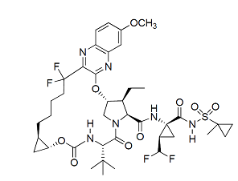
It has eight chiral centres and is produced as a single stereoisomer. Voxilaprevir drug substance is slightly hygroscopic to hygroscopic. Amorphous voxilaprevir exhibits increasing aqueous solubility over the pH range of 1 to 8, . It is hygroscopic, while the ethyl acetate solvate, Form VI, Form VIII, and Form X are slightly hygroscopic. Polymorphism is not a critical quality attribute for the drug substance because of the downstream processing.
The degradation kinetics and the product distribution of voxilaprevir hydrolysis are pH-dependent; voxilaprevir is most stable at pH 2 where t₉₀ (time required for 10% degradation) was estimated to be > 2 years at 50 °C. Voxilaprevir in aqueous solutions at pH 2 was not susceptible to oxidative degradation, and it is not subject to photo-degradation in the solution or solid states.
Based on the high apparent permeability and low solubility, voxilaprevir is a Class 2 drug with respect to the Biopharmaceutics Classification System (BCS).
The proposed drug substance specification complies with TGA requirements and is considered adequate to ensure the quality and consistency of manufacture of the finished product.

Velpatasvir
Velpatasvir (VEL) is a HCV inhibitor targeting the HCV NS5A protein, which is essential for both ribonucleic acid (RNA) replication and the assembly of HCV virions. The structure is shown in Figure 2, below.
Figure 2: Structure of velpatasvir
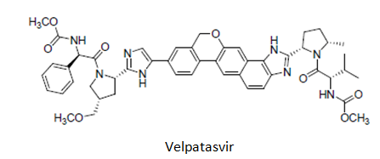
It has six chiral centres and is produced as a single isomer. The drug substance is obtained as an amorphous powder; it is soluble at pH 1.2 slightly soluble at pH 2 and practically insoluble above pH 5.
Particle size and polymorphic form are not considered critical in this case because the drug substance is [information redacted].
Based on its low apparent permeability and low solubility, velpatasvir is considered a Class 4 drug with respect to the Biopharmaceutics Classification System (BCS).
The proposed drug substance specification complies with TGA requirements and is considered adequate to ensure the quality and consistency of manufacture of the finished product. Polymorphism is not a critical quality attribute for the drug substance because of the downstream processing.

Sofosbuvir
Sofosbuvir (SOF), a prodrug of nucleotide monophosphate, is ultimately converted within the hepatocyte to the active triphosphate form, as shown below (Figure 3). This is an HCV NSSB directed inhibitor that has displayed potent in vitro inhibition of HCV replicon RNA replication.
Figure 3: Conversion of sofosbuvir to the active triphosphate form
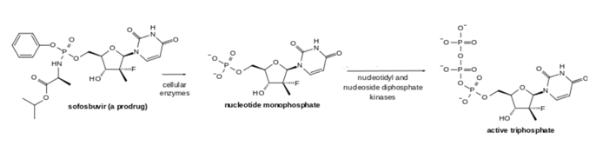
Sofosbuvir (anhydrous, crystal form II) is a white to off-white powder which is slightly soluble across the physiological pH range (pH 2 to 7.7). Sofosbuvir has six stereo-centres and is chirally pure. Based on the low apparent permeability and high solubility, sofosbuvir is a Class 3 drug with respect to the Biopharmaceutics Classification System (BCS).
Data relating to sofosbuvir is identical to that previously submitted for registration of the sofosbuvir monotherapy tablet (Submission PM-2013-01283-1-2).
The previously agreed drug substance specifications comply with TGA requirements and are considered adequate to ensure the quality and consistency of manufacture of the combination tablets.

Drug product
The proposed product is a fixed dose combination of three active substances formulated as beige, capsule shaped, film coated tablet, debossed with “GSI” on one side and “3”on the other side. The tablets are approximately 20 mm in length x 10 mm in width.
A conventional immediate release formulation is used for the product, with velpatasvir and voxilaprevir added to the formulation of the active substances with copovidone. Inactive excipients selected are conventional for a film coated tablet.
Mutual compatibility of the 3 active substances was demonstrated as no significant degradation was observed. Compatibility with excipients was monitored during formulation development and all three active substances were found to be stable with the excipients used in the proposed commercial formulation.
The proposed finished product specifications have been adequately justified and comply with TGA requirements. They are considered adequate to ensure the quality of the finished product at release and throughout the shelf-life.
Tablet dissolution is tested (information redacted) and sampling times of 30 minutes and 60 minutes (additional sampling for voxilaprevir). Butylated hydroxytoluene is added to the medium to inhibit oxidation of the polysorbate. The dissolution method was shown to be discriminatory for low voxilaprevir/velpatasvir assay, presence of voxilaprevir polymorphs, amorphous velpatasvir and voxilaprevir, and the absence of disintegrant are included with the annexes.
Twenty-eight tablets are packaged in a 100 mL white, high density polyethylene (HDPE) bottle containing one gram of desiccant and polyester coil. Each bottle is capped using a white, continuous thread, child-resistant polypropylene screw cap with an induction sealed, aluminium faced liner.
The tablets show good stability and a shelf life of 24 months when stored below 30°C, has been established.

Formulation development
A FDC tablet was chosen as the dosage form for the product due to previous experience in developing single agent and combination tablets containing sofosbuvir and velpatasvir.
Voxilaprevir was originally formulated as a single agent tablet for use in Phase I and Phase II clinical trials. The designated commercial voxilaprevir drug substance was the only form used to produce VOX throughout drug product development. The VOX single agent tablet formulation, 100 mg strength, was modified to include 400 mg sofosbuvir and 100 mg velpatasvir. The 400 mg sofosbuvir dose is the same as that used in Sovaldi, Harvoni, and Epclusa tablets. The 100 mg velpatasvir dose is the same as that used in Epclusa tablets. In relative bioavailability Study GS-US-367-1176, the selected FDC tablet formulation, 400/100/100 mg, demonstrated similar pharmacokinetic performance to co-administered Epclusa tablets, 400/100 mg, and VOX single agent tablets, 100 mg and with no need for dose adjustment.
The FDC table formulation , 400/100/100 mg, was subsequently used in all pivotal Phase III clinical trials and stability studies, and are the proposed commercial formulation.

Biopharmaceutics
Sofosbuvir was absorbed quickly and the peak median plasma concentration was observed ~ 0.5 to 1 hour post dose. Median peak plasma concentration of the active metabolite of sofosbuvir was observed ~ 2 hours post dose. Median peak plasma concentration of velpatasvir, and voxilaprevir were each observed 4 hours post dose.
Very little metabolism of velpatasvir occurs, with > 98% of a (¹⁴C)-labelled 100 mg dose present in plasma as unchanged drug.
Voxilaprevir is primarily a substrate of cytochrome P450 3A4 (CYP3A4) with slow turnover. Following a single dose of (¹⁴C)-voxilaprevir 100 mg, the majority (approximately 91%) of radioactivity in plasma was parent drug. Hydrolysed and dehydrogenated voxilaprevir were the metabolites identified in human plasma. Unchanged voxilaprevir is the major species present in faeces. After a single 100 mg dose of (¹⁴C)-voxilaprevir in healthy male subjects, the blood to plasma ratio of (¹⁴C)-radioactivity ranged between 0.5 and 0.8.
Sofosbuvir is extensively metabolised in the liver to form the pharmacologically active nucleoside triphosphate analogue (as shown above) which is dephosphorylated to the inactive nucleoside metabolite. After a single 400 mg oral dose of (¹⁴C)-sofosbuvir, the nucleoside triphosphate active metabolite accounted for approximately > 90% of total systemic exposure.

Biostudy GS-US-367-1176; relative bioavailability and the effect of food
Study GS-US-367-1176 was a Phase I, randomised, open label, single dose study to evaluate the relative bioavailability and the effect of food on sofosbuvir/GS-5816/GS-9857 fixed dose combination tablet in healthy subjects.
The first part examined the relative bioavailability of concurrent administration of single doses of a fixed dose combination of sofosbuvir 400 mg and velpatasvir 100 mg (1 x 400/100 mg tablet) and voxilaprevir 100 mg (1 x 100 mg tablet) administered orally under fed (moderate fat) conditions (Treatment A) against a single dose of the FDC tablet containing sofosbuvir 400 mg, velpatasvir 100 mg and voxilaprevir 100 mg (1 x 400/100/100 mg tablet) under fed (moderate fat) conditions (Treatment B).
The second part examined the relative bioavailability of a single dose of the FDC tablet containing sofosbuvir 400 mg, velpatasvir 100 mg and voxilaprevir 100 mg under fasted conditions (Treatment C) against the same dose under orally fed conditions, using a high fat/high calorie meal (Treatment D).

Relative bioavailability
The reported pharmacokinetic (PK) parameters for the two cohorts administered with SOF/VEL/GS-9857 and SOF/VEL+GS-9857 are shown below in Table 3.
Table 3: Reported PK parameters for the two cohorts administered with SOF/VEL/GS-9857 and SOF/VEL+GS-9857
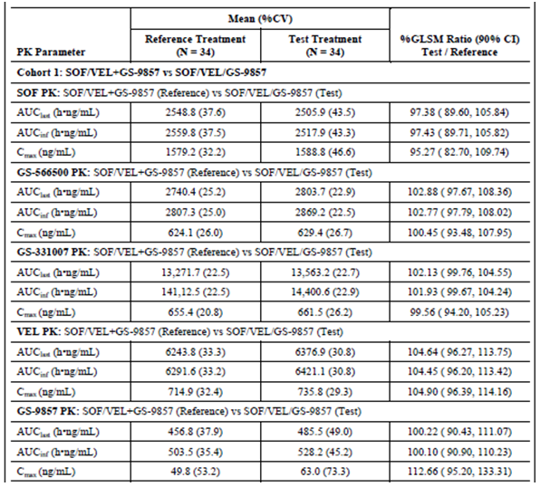
SOF/VEL/GS-9857 and SOF/VEL+GS-9857 resulted in PK equivalent exposures (90% confidence intervals (Cis) of geometric least squares means (GLSM) ratios for all primary PK parameters were contained within the PK equivalence bounds of 70% to 143%) of SOF, GS-566500, GS-331007, VEL, and GS-9857 when administered after a moderate fat meal.

Effect of food
The reported PK parameters for the two cohorts administered SOF/VEL/GS-9857 FDC (1 x 400/100/100 mg tablet single dose) administered orally under fasted conditions and administered orally within 5 minutes of completing a high fat/high calorie meal are shown below in Table 4.
Table 4: Reported PK parameters for the two cohorts administered SOF/VEL/GS-9857 FDC (1 x 400/100/100 mg tablet single dose)
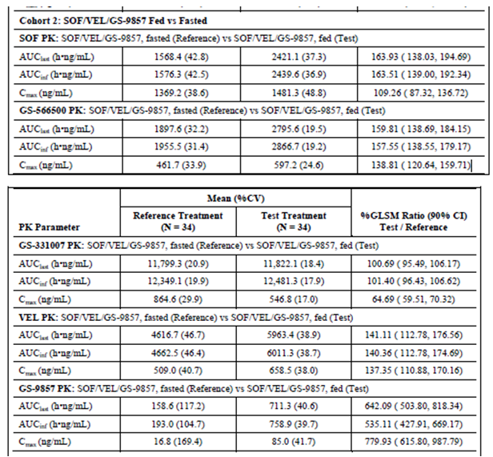
Administration of SOF/VEL/GS-9857 following a high fat/high calorie meal resulted in substantially increased GS-9857 exposure, and modestly increased SOF, GS-566500, and VEL exposures compared with exposures achieved under fasted conditions. GS-331007 area under the plasma/serum concentration versus time curve (AUC) was unchanged, and maximum observed plasma/serum concentration of drug (C_{max}) was modestly reduced when SOF/VEL/GS-9857 was administered following a high fat/high calorie meal compared to fasted administration. These data are consistent with the known effect of food on the PK of SOF, GS-566500, GS-331007, VEL, and GS-9857.
The large increase in GS-9857 exposure following administration of SOF/VEL/GS-9857 under fed conditions compared with fasted conditions was expected based upon the combination of a positive food effect and the known drug-drug interaction (significantly reduced GS-9857 exposure) that occurs between SOF/VEL and GS-9857 administered in the fasted state.
The PI recommends Vosevi should be administered with food.

Absolute bioavailability
An absolute bioavailability study has not been performed. The sponsor’s justification asserts that:
- the pharmacokinetics and clinical pharmacology of sofosbuvir have been extensively characterised through in vitro, nonclinical, and clinical studies;
- nonclinical and clinical studies have shown that systemic bioavailability of sofosbuvir is low due to extensive hepatic metabolism;
- development of a parenteral velpatasvir formulation was difficult due to its poor solubility profile;
- oral bioavailability of velpatasvir in nonclinical studies was low (~ 25 to 30%);
- an absolute bioavailability study would be difficult to conduct due to the low solubility of velpatasvir and is unnecessary as estimates of bioavailability from existing data are sufficient;
- development of a parenteral voxilaprevir (VOX) formulation was difficult due to its poor solubility profile;
- the absorption, distribution, metabolism and elimination (ADME) properties, and the clinical pharmacology of VOX have been extensively characterised using in vitro/nonclinical studies and clinically, through pharmacokinetic and drug interaction studies;
- a comprehensive set of clinical studies provides support to the preclinical characterisation of VOX bioavailability and suggest that VOX bioavailability is moderate; and
- an absolute bioavailability study is unnecessary as estimates of bioavailability from existing data are sufficient.

Quality summary and conclusions
There are no outstanding quality issues of consequence. The TGA’s Pharmaceutical chemistry section is currently awaiting a response from the sponsor to address a small number of outstanding issues; it is anticipated that these matters will be resolved to the TGA’s satisfaction following receipt of the sponsor’s response.

IV. Nonclinical findings

Introduction
Gilead Sciences Pty Ltd has applied to register Vosevi, a fixed dose combination tablet containing new chemical entity, voxilaprevir with sofosbuvir and velpatasvir, which are already approved for treating chronic hepatitis C virus (HCV) infection in adults. Sofosbuvir and velpatasvir were also included in this submission, and since they were previously assessed in submissions PM-2013-01283-1-2 and PM-2015-03984-1-2, this assessment only covers voxilaprevir. Note nonclinical virology studies were described and full reports were located in the clinical module. The nonclinical dossier was of high quality, with pivotal core safety pharmacology, toxicokinetic and repeat dose toxicity studies performed in accordance with Good Laboratory Practice GLP, and the studies were in agreement with ICH guidelines. Combination toxicity studies were not provided and are not generally warranted for antiviral agents of hepatitis C., Carcinogenicity studies are not warranted for treatment < 24 weeks and were not provided for voxilaprevir.

Pharmacology

Primary pharmacology
Voxilaprevir has been proposed to act as a noncovalent, reversible inhibitor of the NS3/4A protease, which is essential for proteolytic cleavage of the HCV encoded polyprotein (into mature forms of NS3, NS4A, NS4B, NS5A and NS5B proteins) and hence for viral replication. In vitro demonstrations of proteolytic and antiviral activity of voxilaprevir are discussed below.

Inhibition of NS3 proteolytic activity in enzymatic assays and crystal structure
Voxilaprevir inhibited both genotype 1b and 3a wild-type NS3 in enzymatic assays using recombinant NS3 protease domains (K_{i} of 0.038 to 0.066 nM). Voxilaprevir demonstrated competitive binding against the synthesised form of peptide substrate of NS3. X-ray co-crystallographic structural analyses demonstrated that voxilaprevir bound non-covalently to the active site of NS3 protease at a resolution of 1.4 angstroms. Voxilaprevir exhibited minimal inhibitory activity when tested against a panel of mammalian proteases (selectivity indices > 400000 fold above NS3 protease), indicating a very low likelihood of affecting mammalian host proteases.

Activity against HCV replicon or infectious systems
The antiviral actions of voxilaprevir were conducted entirely in vitro using HCV replicons (including chimeric replicons carrying HCV NS3 genes from clinical isolates) or in cells infected with genotype 2a J6/JFH-1 infectious virus. Voxilaprevir had antiviral activity against HCV genotypes 1 to 6 with mean half-maximal effective concentration (EC₅₀) values ranging from 0.33 to 6.6 nM when tested in absence of human serum. In a tissue culture-adapted genotype 2a J6/JFH infectious virus assay the EC₅₀ value was 0.8 nM. When tested in 40% human serum the EC₅₀ values of voxilaprevir on genotype 1a was reduced by 7 fold, which is consistent with its high plasma protein binding (see Pharmacokinetics section). The resultant plasma protein binding-adjusted EC₅₀ values ranged from 3.96 to 72 nM for HCV genotypes 1 to 6. Voxilaprevir did not reveal any notable cytotoxicity when evaluated in multiple human cell lines (Huh-7, HepG2, PC-3, MT-4, MRC-5) in vitro, providing a selectivity indices of > 1000 fold relative to the antiviral activity observed in genotype 1-6 HCV replicons.

Effects of voxilaprevir on clinical isolates in vitro
Median voxilaprevir EC₅₀ values against the chimeric replicons encoding NS3 protease genes from clinical isolates of 332 direct acting antiviral (DAA naïve) and DAA experienced subjects with genotypes 1 through 6, including 30 different subtypes were generally similar to the results of laboratory replicons. However genotypes 1 and 3 median EC₅₀ for DAA experienced subjects were 2 to 3.7 fold higher than the DAA naïve subjects.
NS3 protease sequences containing different patterns of resistance associated polymorphisms were also synthesized and tested against voxilaprevir. Generally genotype 1 variants (21, genotype 1a and 8, genotype 1b) showed no resistance or low resistance to voxilaprevir. However 2 genotype 1a variants, Q80K+D168Y and Q41H+F43L+Q80K+D168Y, showed high levels of resistance to voxilaprevir with 116.5 and 232.7 fold increase in EC₅₀, respectively. Genotype 2b (R155M+D168Y), genotype 4 (R155Q+D168V, Q80K+D168Y), and genotype 6a (L80K+D168E) variants showed no resistance to voxilaprevir.

Effects of voxilaprevir on polymorphism in and near NS3
Naturally occurring amino acid substitutions in the NS3protease domain, also referred to as polymorphisms, can reduce antiviral activity. When antiviral activity of voxilaprevir was assessed for polymorphism in and near the NS3 protease active site for HCV genotypes 1a, 1b, 2a, 2b, 3a, 4a, and 6a, voxilaprevir retained full activity against the major polymorphism in genotype 1a, Q80K (no shift in EC₅₀). All polymorphisms assessed across HCV genotypes 1b, 2a, 3b, 3a, 4a, and 6a also remained susceptible to voxilaprevir (< 3 fold shift) with the exception of the D168E polymorphism in genotype 6a, which showed 6 fold reduced susceptibility compared with the parent replicon. These data indicate that individual sequence polymorphisms in the NS3 protease active site do not significantly impact the anti-HCV activity of voxilaprevir across and within HCV genotypes and subtypes.

In vitro resistance selection
Amino acid substitutions at positions 155, 156 and 168 are common resistance conferring mutations for NS3/4A protease inhibitors. The primary in vitro resistance mutations to voxilaprevir in the NS3 protease domain was demonstrated at amino acid positions 41, 156 and 168. To determine the in vitro resistance profile of voxilaprevir, drug-resistant colonies were selected with voxilaprevir in HCV genotypes 1a, 1b, 2a, 3a, 4a, 5a, and 6a replicon cells. Significant resistance to voxilaprevir at NS3 positions 156 and 168 in genotypes 1 - 6 was observed. Genotypes 1a, 1b (Con-1), 2a (JFH-1 and J6), 3a (S52), and 4a (ED43) replicon cells selected A156L, A156V, or A156T substitutions. Replicon clones with A156L, A156V, or A156T demonstrated > 253 fold reduced susceptibility to voxilaprevir. Variants at position 168 were selected in genotype 2a replicons (D168E in genotype 2a JFH-1 and J6 cells), genotype 5a (D168A/H/R/Y), and genotype 6a (D168H/Y) replicon cells. These variants conferred no-to-low levels of resistance (1.5 to 17.8 fold). In genotypes 5 and 6, double variants Q41R+D168H/Y and Q41R+D168H were predominantly selected, respectively. The double variants conferred higher levels of resistance to voxilaprevir (35 to 39 fold) compared with the single variants (2.7 to 13.5 fold). Less common single variants with low resistance were identified in the NS3-4A (which included Q9R, P67S, Q89R, V113L, A200G, A200D, D249A, I359V, K583E, and S332P).
In HCV replicon colony reduction assays, voxilaprevir showed a higher resistance barrier (across genotypes 1 to 4 and genotype 6), compared with other inhibitors requiring lower drug concentrations (10 x EC₅₀). It is worth noting the resistance barrier of voxilaprevir across multiple genotypes was comparable to grazoprevir (MK-5172), however in genotype 3a replicon cells, voxilaprevir was 9 fold more potent than grazoprevir.

In vitro activity of voxilaprevir against known NS3/4A protease inhibitor resistance-associated variants
In vitro activity of voxilaprevir was determined against known NS3/4A protease inhibitor, in genotypes 1 to 6 NS3 resistance-associated variants (RAVs) (347 replicons cloned, including 236 single, 86 double, and 25 triple variants). The single variants conferring high-level of resistance were A156T and A156L with 2532 and 581 fold change, respectively, to voxilaprevir. Although A156 RAVs are generally an issue for all protease inhibitors they are also prone to reduced viral fitness and therefore remain as a minor component in HCV-infected patients.
Of the 44 genotype 1a variants tested for voxilaprevir, 28 (64%) demonstrated ≤ 2.5 fold reduced susceptibility, and only 1 (2%), showed high-level resistance (> 100 fold). The only double variant that conferred > 100 fold resistance to voxilaprevir was Q41R+A156T. The majority of the triple variants tested in genotype 1a did not confer resistance to voxilaprevir; these same triple variants conferred moderate to high levels of resistance to several other tested NS3/4A protease inhibitors, including paritaprevir, asunaprevir and simeprevir.
In genotype 1b, ≤ 2.5 fold resistance to voxilaprevir, was observed for 69% (22 of 32) single variants. Variants at position 168 (D168A/V/Y) which demonstrate high level resistance to earlier generation protease inhibitors (including paritaprevir, asunaprevir and simeprevir) showed < 3.5 fold resistance to voxilaprevir. A156T and A156V demonstrated high levels of resistance to voxilaprevir. All genotype 1b double variants tested demonstrated < 3.4 fold reduced susceptibility to voxilaprevir.

Cross-resistance to NS5A inhibitors, and nucleoside and nonnucleoside NS5B inhibitors RAVs
Voxilaprevir maintained full activity against replicons encoding a variety of NS5A inhibitors, NS5B NI, and NS5B NNI resistance mutations. It was fully active against all RAVs selected by active site nucleos(t)ide NS5B inhibitors (S282T or M289L), allosteric non-nucleoside NS5B inhibitors (palm site III M414T; thumb site II L419M, M423T, or A486V; and palm site IV C316Y; palm site III/IV Y448, or C316Y/C445F/Y452H), NS5A inhibitors (L31V andY93H), or cyclophilin A inhibitors (D320E). These results indicate that voxilaprevir can be administered with multiple classes of NS5B polymerase inhibitors, NS5A inhibitors, or cyclophilin A inhibitors for the treatment of chronic hepatitis C.

Secondary pharmacodynamics and safety pharmacology

Activity against other viruses
Voxilaprevir was tested for antiviral activity against related Flaviviridae virus (bovine viral diarrhoea virus, BVDV) and unrelated viruses (respiratory syncytial virus (RSV); human rhinovirus (HRV); influenza virus; hepatitis B virus (HBV); and human deficiency virus, HIV). Voxilaprevir showed no significant antiviral activity against any of the other viruses at drug concentrations below the 50% cytotoxic concentration (CC₅₀) values.

In vitro cytotoxicity
In vitro cytotoxicity of voxilaprevir was evaluated in 5 human cell lines (including T-lymphoblastoid MT-4 cells, two hepatic cell lines (HepG2 (sensitive to mitochondrial toxicity) and Huh-7), the prostate carcinoma cell line PC-3 (sensitive to mitochondrial toxicity), and the normal diploid lung-derived MRC-5 cell line). Voxilaprevir showed a low level of cytotoxicity (CC₅₀ values between 6,530 and 16,400 nM).

In vitro receptor binding potencies
Potential off target activity was screened in a panel of mammalian ion channels, receptors and transporters. Significant binding (IC₅₀ 0.74 µM) was observed to the tachykinin neurokinin (NK) 1 receptor, and showed weak antagonism in a cell based functional assay under in vitro conditions (33% inhibition at 10 μM).

Safety pharmacology
Safety studies covered hERG channel inhibition in vitro and cardiovascular, respiratory and central nervous system (CNS) studies in vivo. Voxilaprevir significantly inhibited hERG currents by (Mean ± SEM) 8.4 ± 0.3% at 10 µM (n = 3) and 20.8 ± 1.1% at 30 µM (n = 4) versus 0.5 ± 0.3% (n = 3) in the control. In conscious dog experiments a single dose of voxilaprevir at concentrations up to 20 mg/kg had no effect on any cardiovascular parameters including QT interval. Plasma levels were ascertained at 6 hours post dose in which voxilaprevir levels were measured at up to 8905 ± 7915 ng/mL (10.25 nM), which is 46 folds above the clinical C_{max}. Single doses of voxilaprevir up to 100 mg/kg had no effect on any CNS or respiratory parameters.

Pharmacodynamic drug interactions
Since voxilaprevir is likely to be used in combination with other anti-HCV and HIV agents, combination studies were performed testing the activity of voxilaprevir with a variety of HCV inhibitors (including sofosbuvir and velpatasvir) and anti-HIV agents. Voxilaprevir generally showed additive antiviral activity when tested in combination with these agents. The only exception was in the combination with ribavirin, where minor synergistic effect on antiviral activity was observed. No antiviral antagonism or cellular toxicity was observed when voxilaprevir was combined with any of the tested HCV or HIV agents. These results support the use of voxilaprevir in combination with other classes of anti-HCV and HIV agents for the treatment of chronic HCV infection.

Pharmacokinetics

Absorption
In vitro voxilaprevir showed high forward (apical to basolateral) permeability through Caco-2 monolayers which indicates high intestinal absorption potential for voxilaprevir in vivo. The reverse permeability of voxilaprevir was 3 fold higher than the forward permeability, indicating efflux transportation. The in vivo pharmacokinetic profile was characterised by rapid absorption following oral administration to mouse, rat and dog (time (observed time point) of C_{max} (T_{max}) approximately 1 to 2 hours). Oral bioavailability was high in rats (83%), and low in dogs (27%) and monkeys (7.4%). Systemic clearance was low in all species with values ranging from 0.19 to 0.81 L/h/kg. The repeat dose pharmacokinetics of voxilaprevir showed no marked sex differences in exposure (generally < 2 fold). Exposures were less than dose proportional at high doses in all species and therefore the doses selected for repeat dose toxicology studies were generally limited to doses that were generally greater than dose proportional.

Distribution
Plasma protein binding by voxilaprevir was high in humans and laboratory animal species at greater than 99% plasma protein bound in all species in vitro. Limited red blood cell partitioning was evident in dog and human with blood plasma ratios of 0.59 and 0.78, respectively. Distribution of voxilaprevir was high in the liver of rat, dog and monkeys, corresponding to 970, 34 and 41 fold higher than respective plasma concentrations at 6 hours post dose. In a separate study in rat, concentrations in the liver were > 165 fold higher than levels in the kidney and lung. After oral administration of (¹⁴C) voxilaprevir to pigmented and non-pigmented rats, drug related material preferentially distributed to the liver. Low levels of radioactivity were detected in brain, eyes and testis(es), suggesting that (¹⁴C)voxilaprevir derived radioactivity poorly crossed the blood: brain, blood: eye, and blood: testis(es) barriers. Distribution trends in pigmented and non pigmented rats suggested that voxilaprevir did not preferentially associate with melanin.

Metabolism
Under in vitro conditions voxilaprevir exhibited moderate metabolic stability in monkey microsomes and high metabolic stability in mouse, rat, dog, human microsomes and human primary human hepatocytes. The metabolism of (³H) voxilaprevir in hepatic microsomes from mouse, rat, dog, and human yielded a total of 9 identified metabolites. Metabolites were formed by oxidation, dehydrogenation, and combinations leading to secondary metabolites. Only two metabolites (hydrolysed metabolites M25 and M26) unique to human were identified and CYP1A2, CYP2C8, and CYP3A were involved in the metabolic turnover of voxilaprevir, with CYP3A enzymes showing the highest turnover rate in vitro. Unchanged voxilaprevir was the only circulating species in plasma of humans (91% plasma AUC) and laboratory animals (100% plasma AUC). In faeces unchanged voxilaprevir accounted for approximately 70% of (¹⁴C) voxilaprevir-derived material in rats and dogs and 40% in humans. Major metabolites identified in faeces including voxilaprevir hydrolysed at the methylcyclopropyl-sulfonamide moiety (M19) which was further oxidised into M21 or M25 and a dehydrogenation metabolite (M9).

Excretion
The major route of excretion in rats and dogs was the faecal route (> 80%) with very little renal excretion evident (< 0.3%). The faecal excretion of orally administered voxilaprevir consisted of both unabsorbed drug and un-metabolised biliary excretion products. Studies on bile-cannulated rats and dogs indicated a role for biliary excretion.

Conclusion
Considering the metabolic profiles of rat, dogs and humans and the similarity in disposition of voxilaprevir in humans and these nonclinical species, an adequate model for the assessment of voxilaprevir toxicity has been employed in the present submission.

Pharmacokinetic drug interactions

Cytochrome P450 and UGT1A1 inhibition
Voxilaprevir showed no significant inhibition of cytochrome P450 enzymes (CYPs) 1A2, 2B6, 2C8, 2C9, 2C19, 2D6 and 3A4 (IC₅₀ > 11 µM) and is therefore not expected to affect metabolic clearance of drugs by these enzymes. Voxilaprevir showed an inhibitory effect on human Uridine diphosphate glucuronosyltransferase 1A1 (UGT1A1), in vitro (IC₅₀ of 4.75 µM). Since the IC₅₀ value is greater than 1000 fold the unbound C_{max} in human plasma (< 3 nM), voxilaprevir is unlikely to be a clinically relevant inhibitor of UGT1A1.

Assessment of induction liability
Voxilaprevir showed minimal potential to induce UGT1A1, P-glycoprotein (P-gp) and CYP mRNA or CYP activity when assessed in cultural human hepatocytes. Small mRNA increases were observed in P-gp (2.08 fold increase at 3 µM) and mRNA decreases were observed in CYP and UGT1A19 (0.3 to 0.98 fold at 1 to 3 µM). CYP3A activity decreased from 0.94 to 0.33 fold at 3 µM. These modest changes occurred at concentrations in large excess of unbound voxilaprevir in human plasma (~ 300 to 1000 fold the unbound C_{max} in human plasma) and therefore voxilaprevir is unlikely to be clinically relevant in its induction potential. In vitro voxilaprevir also showed low likelihood of inducing pregnane X receptor (PXR), constitutive androstane receptor (CAR) or aryl hydrocarbon receptor (AHR) mediated pathways at the concentrations that could be achieved in humans.

Interactions with transporters
Voxilaprevir was shown to be a substrate for intestinal efflux transporters P-gp and breast cancer resistance protein (BCRP) in vitro and therefore intestinal absorption could potentially be decreased by inducers of P-gp and BCRP or increased by inhibitors of P-gp and BCRP. Both of the other components of Vosevi, sofosbuvir and velpatasvir, are also substrates of P-gp and BCRP. Increased hepatic uptake and systemic exposures to voxilaprevir in the presence of organic anion transporting polypeptide (OATP) OATP1B1 or 1B3 inhibitors indicate that it is a substrate of these hepatic transporters.
Voxilaprevir in vitro inhibited intestinal BCRP and hepatic OATP1B1 and OATP1B3 with IC₅₀ values of 1.5, 0.18 and 0.70 μM, respectively exceeded the C_{max} unbound to plasma protein (2.21 nM; assuming 1% protein binding) by greater than 50 fold. Voxilaprevir was not identified to be an inhibitor of P-gp at the solubility limit in the in vitro assay (10 µM) however potential inhibition of intestinal P-gp, BCRP and hepatic OATP1B1 and OATP1B3 at higher concentrations achievable in the gastrointestinal tract (at the site of absorption) cannot be ruled out. Therefore the involvement of voxilaprevir in drug interactions by inhibition of P-gp, BCRP, OATP1B1 and OATP1B3 is limited to the process of absorption where high unbound concentrations of voxilaprevir are likely to be found. Voxilaprevir was not an inhibitor of the hepatic transporter organic cation transporter (OCT) OCT1 or any of the assessed renal transporters (organic anion transporter (OAT) OAT1, OAT2, OCT2 and multidrug and toxin extrusion 1(MATE1)).

Toxicology

Acute toxicity
No acute toxicity studies were submitted.

Repeat dose toxicity
Repeat dose toxicity studies with voxilaprevir alone were conducted in two species: rat and dog. All studies were conducted using the clinical (oral) route. Voxilaprevir was administered to rats daily at doses of up to 100 mg/kg/day for 2 and 13 weeks and up to 70 mg/kg/day for 26 weeks and in dogs at doses of up to 20 mg/kg/day for 2 weeks and 15 mg/kg/day for 13 and 39 weeks. The dog study employed a different vehicle (polyethylene glycol 400) from the organic solution employed in rat studies (13.34% ethanol, 8.88% propylene glycol, 33.34% Labrasol, and 44.44% Kolliphor HS-15) as dogs were found to have more frequent gastrointestinal reaction (vomiting and diarrhoea) with the organic solution resulting in variable AUC and C_{max} values. The durations of the pivotal studies, the species used and the group sizes were consistent with ICH guidelines.
As already noted, combination toxicity studies were not provided and are not generally warranted for antiviral agents of hepatitis C.,

Relative exposure
Exposure ratios have been calculated on animal: human plasma AUC₀₋₂₄ voxilaprevir values. Human reference values are from demographic population PK analysis set from Phase II and III studies. The AUC data used for animals is the mean of male and female values on the last sampling occasion. The relative exposure achieved in rats and dogs were high relative to the anticipated clinical exposure.
Table 5: Relative exposure in repeat dose toxicity studies
Species | Study duration (Study no.) | Dose ( mg/kg/day) | C_{max} (ng/mL) | AUC0–24 h or 0-T^ (ng∙h/mL) | Exposure ratio#
 |  |  |  |  | C_{max} | AUC
Rat (SD) | 5 Days (Study TX-230-2001) | 10 | 1690 | 8900 | 9 | 3
Rat (SD) | 5 Days (Study TX-230-2001) | 25 | 9840 | 85000 | 51 | 33
Rat (SD) | 5 Days (Study TX-230-2001) | 100 | 48500 | 670000 | 252 | 260
Rat (SD) | 2 weeks (Study TX-230-2006) | 10 | 388 | 3110(T = 12) | 2 | 1
Rat (SD) | 2 weeks (Study TX-230-2006) | 15 | 1150 | 8380 | 6 | 3
Rat (SD) | 2 weeks (Study TX-230-2006) | 30 | 4490 | 32700 | 23 | 13
Rat (SD) | 2 weeks (Study TX-230-2006) | 100 | 46900 | 535000 | 244 | 208
Rat (SD) | 13 weeks (Study TX-338-2001) | 10 | 505 | 4500 | 3 | 2
Rat (SD) | 13 weeks (Study TX-338-2001) | 30 | 9450 | 73600 | 49 | 29
Rat (SD) | 13 weeks (Study TX-338-2001) | 100 | 45800 | 558000 | 239 | 217
Rat (SD) | 26 weeks (Study TX-338-2006) | 10 | 762 | 5480 | 4 | 2
Rat (SD) | 26 weeks (Study TX-338-2006) | 30 | 16400 | 130000 | 85 | 50
Rat (SD) | 26 weeks (Study TX-338-2006) | 70 | 56100 | 631000 | 292 | 245
Dogs (Beagle) | 2 weeks (Study TX-230-2007) | 3 | 720 | 2080(T = 14) | 4 | 1
Dogs (Beagle) | 2 weeks (Study TX-230-2007) | 10 | 4550 | 47500 | 24 | 18
Dogs (Beagle) | 2 weeks (Study TX-230-2007) | 20 | 10800 | 410000 | 56 | 159
Dogs (Beagle) | 13 weeks (Study TX-338-2002) | 3 | 396 | 2330(T = 17.5) | 2 | 1
Dogs (Beagle) | 13 weeks (Study TX-338-2002) | 10 | 9390 | 94200 | 49 | 37
Dogs (Beagle) | 13 weeks (Study TX-338-2002) | 15 | 18600 | 246000(T = 22.5) | 97 | 95
Dogs (Beagle) | 39 weeks (Study TX-338-2007) | 3 | 761 | 3200 | 4 | 1
Dogs (Beagle) | 39 weeks (Study TX-338-2007) | 10 | 8610 | 78200 | 45 | 30
Dogs (Beagle) | 39 weeks (Study TX-338-2007) | 15 | 20700 | 253000 | 108 | 98
Human (HCV positive patients ± cirrhosis) | Demographic Population PK Analysis Set from phase 2 and 3 studies (Studies GS-US-337-1468, GS-US-367-1168, GS-US-367-1169, GS-US-367-1871, GS-US-367-1170, GS-US-367-1171, GS-US-367-1172, or GS-US-367-1173) | 100 mg | 192 | 2577 | – | -
# = animal: human plasma AUC_{0–24};T = last time when quantifiable drug was measured that was not 24 h ^ = data are for the sexes combined at the last sampling occasion

Major toxicities
The major target organs identified with voxilaprevir were the GI tract (non-glandular stomach) and bile duct in the rat, and the gall bladder in the dog. Mild haematological changes indicative of mild blood loss in the non-glandular stomach and regenerative response was also observed in the rat.
Microscopic findings in the rat studies were mainly confined to non-glandular stomach and included minimal to moderate mixed cell infiltrates and submucosal oedema with epithelial hyperplasia/ hyperkeratosis at the highest dose of voxilaprevir tested in each of the rat studies.
In the 5 day dose finding study in rats adverse findings in the high dose group (100 mg/kg/day ~ 260 x clinical AUC) included microscopic findings of epithelial hyperplasia/hyperkeratosis and inflammation ± erosion/ulceration and haemorrhage in the non-glandular portion of the stomach that led to decreases in red cells and an inflammatory leukogram with decreased total protein, albumin and globulin. Since the non-glandular stomach is a rodent specific organ not present in humans, these changes were not considered clinically relevant. Additional microscopic changes observed included minimal bile duct hyperplasia in female rats in both the 13 week (at 100 mg/kg/day, ~ 217x clinical AUC) and 26 week (at ≥ 30 mg/kg/day, ~ 50 x clinical AUC) studies. Changes in the bile duct were still present at the recovery sacrifice in the high dose group of the 26 week study. The toxicological significance of this is uncertain.
Treatment related haematology changes included mild blood loss, erythroid regenerative and inflammatory response and were observed in all the rat repeat dose studies. Secondary changes consistent with increased haematopoiesis included extramedullary haematopoiesis in the spleen, associated with increased spleen weight and minimal to slight increases in cellularity of the bone marrow of the femur and/or sternum in the 2 and 13 week studies. An increase in rat liver weights at 100 mg/kg/day in the 2 and 13 week studies and 70 mg/kg/day in the 26 week study was associated with minimally to mildly higher bilirubin concentrations (0.6 to 0.7 mg/dL versus 0.1 mg/dL in controls), which was likely to be associated with organic anion transporting polypeptide inhibition or with the observed minimal bile duct hyperplasia observed in females and was not considered adverse. High urine volumes and lower urine specific gravity in the 2, 13, and 26 week studies were associated with increased kidney weights in males in the 2week study and females in the 13 week study at 100 mg/kg/day; however lack of microscopic correlates was indicative of non-adverse effect. Similar changes in kidney weights were not observed in the 26 week study.
In dogs vomitus containing food was observed in all the repeat dose studies (2, 13 and 39 week), mainly at the high dose. In the 2 weeks study vomitus was associated with reduced food intake and weight loss in female animals only and was considered an adverse reaction. However no effects on body weight were seen in the other two studies (even though in the 39 week study low qualitative food consumption was noted at the high dose). Minor non adverse clinical pathology findings included higher total bilirubin (0.1 mg/dL versus ≤ 0.1 mg/dL in controls) in both males and females and increased urobilinogen (5 fold) concentration in females in the high dose group in the 2 week study.
Treatment related microscopic findings were mainly observed in the gall bladder in all three dog studies and included minimal to slight epithelial vacuolation in animals administered ≥ 3 mg/kg/day (~ ≥ 1x the clinical AUC) and minimal to slight epithelial hyperplasia observed in animals administered ≥ 10 mg/kg/day (~ ≥ 30 x the clinical AUC) which was only partially reversed at the end of recovery. The rat does not have a gall bladder, so is not a suitable model for investigating gall bladder toxicity and no studies were provided in mice. High liver to plasma concentration ratio of voxilaprevir is likely to be the cause of this lower severity adverse gall bladder toxicity.
Other findings in the 13 week dog study included minimal increase in tubule epithelial cell vacuolation in kidneys of animals administered 10 to 15 mg/kg/day. Minimal to slight neutrophilic infiltrate, haemorrhage and erosion were also observed in the cecum and rectum. Interestingly none of the findings in kidney, cecum and rectum were observed in the 39 week study. Since the finding in the, kidney, cecum or rectum had no impact on the health of the dogs and due absence of correlating clinical pathology findings these finding were considered non adverse.

Genotoxicity
Voxilaprevir was evaluated for its potential to induce reverse mutations in S. typhimurium and E. coli, its mutagenic potential in vitro in primary human lymphocytes, and its mutagenic potential in vivo in a mice bone marrow micronucleus study. Voxilaprevir was negative in all the tests and is unlikely to pose a mutagenic or clastogenic risk to humans.

Carcinogenicity
No carcinogenicity studies on voxilaprevir were submitted or required, and as treatment with voxilaprevir containing regimens is for less than 6 months, it is acceptable according to the ICH S1A guidelines. A 26 week carcinogenicity study of velpatasvir in transgenic mice showing absence of carcinogenicity was provided in response to a request for information.

Reproductive toxicity
Reproductive toxicity was assessed in rats and rabbits in GLP compliant studies. The studies investigated potential effects on male and female fertility in rats, embryofetal toxicity (rats and rabbits) and pre-/postnatal development (rats). Adequate animal numbers were used in the pivotal studies and treatment periods were appropriate.

Relative exposure
Table 6: Relative exposure in reproductive toxicity studies
Species | Study  (Study no.) | Dose  (mg/kg/day) | AUC0–24 h  (ng∙h/mL) | Exposure ratio#
Rat (SD) | Fertility (TX-338-2010) Male | 10 | 3610 | 1
Rat (SD) | Fertility (TX-338-2010) Male | 30 | 64000 | 25
Rat (SD) | Fertility (TX-338-2010) Male | 100 | 333000 | 129
Rat (SD) | Fertility (TX-338-2010) Female | 10 | 2300 | 1
Rat (SD) | Fertility (TX-338-2010) Female | 30 | 37300 | 14
Rat (SD) | Fertility (TX-338-2010) Female | 100 | 438000 | 170
Rat (SD) | Embryofetal development (Study TX-338-2004) | 10 | 8220 | 3
Rat (SD) | Embryofetal development (Study TX-338-2004) | 30 | 53600 | 21
Rat (SD) | Embryofetal development (Study TX-338-2004) | 100 | 365000 | 142
Rat (SD) | Prenatal and postnatal developmental (Study TX-338-2011) LD10 | 10 | 2400 | 1
Rat (SD) |  | 30 | 43000 | 17
Rat (SD) |  | 300 | 613000 | 238
Rabbit (NZW) | Preliminary tolerability studies (Study TX-338-2003) | 100 | 817t = 12 | 0.3
Rabbit (NZW) | Preliminary tolerability studies (Study TX-338-2003) | 300 | 13100t = 20 | 5
Rabbit (NZW) | Preliminary tolerability studies (Study TX-338-2003) | 600 | 3630 | 1.4
Rabbit (NZW) | Embryofetal developmental (Study TX-338-2005) | 100 | 438 | 0.2
Rabbit (NZW) | Embryofetal developmental (Study TX-338-2005) | 200 | 672 | 0.3
Rabbit (NZW) | Embryofetal developmental (Study TX-338-2005) | 300 | 4090 | 2
Rabbit (NZW) | Embryofetal development (StudyTX-338-2009) | 100 | 363 | 0.1
Rabbit (NZW) | Embryofetal development (StudyTX-338-2009) | 300 | 2450 | 1
Rabbit (NZW) | Embryofetal development (StudyTX-338-2009) | 600 | 9060 | 4
Human (HCV positive patients ± cirrhosis) | Demographic Population PK Analysis Set from phase 2 and 3 studies (Studies GS-US-337-1468, GS-US-367-1168, GS-US-367-1169, GS-US-367-1871, GS-US-367-1170, GS-US-367-1171, GS-US-367-1172, or GS-US-367-1173) | (100 mg) | 2577 | –
# = animal: human plasma AUC_{0–24 h}; T = last time when quantifiable drug was measured that was not 24 h
The level of the relative exposure achieved in the studies was sufficiently high in rats but low in rabbits.
Placental transfer and excretion in milk studies were not submitted, however exposure in nursing pups during the prenatal and postnatal development study in rats suggest voxilaprevir is excreted in the breast milk of lactating females. The AUC in pups was approximately half of maternal levels.
Voxilaprevir had no adverse effects on fertility in rats. Embryofetal development was not affected in rats. Despite low exposures in rabbits, voxilaprevir treatment was associated with decreases in maternal body weight gain and lower food consumption in the high dose group (300 mg/kg/day, 2 folds the clinical AUC). However, there were no corresponding adverse effects on litter parameters or on fetal development. In the rat pre-/postnatal development study there were no adverse maternal findings or effects on gestation and parturition. Slightly lower pup birth weights seen at high dose were within the historical range and did not correspond to any subsequent effects on development (growth milestones, motor development, sexual maturity, reproductive performance).

Pregnancy classification
The sponsor has proposed Pregnancy Category B1 for Vosevi. This category is appropriate for voxilaprevir, given no adverse effects were observed in the embryo fetal developmental; and pre/postnatal studies. There are no studies on the effects of voxilaprevir in combination with sofosbuvir and velpatasvir on reproduction; however, sofosbuvir and velpatasvir have been classified as Pregnancy Category B1 and was previously accepted.

Local tolerance
Voxilaprevir was classified as a non-irritant to the eye in the bovine cornea opacity/permeability (BCOP) assay and a non-irritant and non-corrosive to the skin in the dermal irritation and dermal corrosion test.

Antigenicity
Voxilaprevir showed no potential for sensitisation in local lymph node assays in mice. Antigenicity studies in combination with sofosbuvir, velpatasvir and voxilaprevir have not been conducted as they all individually lack antigenic properties and are acceptable.

Impurities
The proposed specifications for impurities have been adequately qualified. All identified impurities have been assessed for potential mutagenicity and are considered non-mutagenic.

Phototoxicity
Voxilaprevir was phototoxic under in vitro conditions in the Balb/c3T3 neutral red uptake assay. However, there was no evidence of phototoxicity in a multiple dose phototoxicity study in Long-Evans pigmented rats at oral doses up to 100 mg/kg/day, hence no further phototoxicity testing was warranted.

Paediatric use
Voxilaprevir is not proposed for paediatric use and no specific studies in juvenile animals were submitted.

Comments on the Nonclinical Safety Specification of the Risk Management Plan
Results and conclusions drawn from the nonclinical program for voxilaprevir detailed in the sponsor’s draft Risk Management Plan (RMP) are in general concordance with those of the nonclinical evaluator.

Nonclinical summary and conclusions
- The nonclinical dossier was of high quality. Pivotal core safety pharmacology, toxicokinetic and repeat dose toxicity studies were GLP compliant and were generally conducted in accordance with ICH guideline.
- Primary pharmacology studies were conducted entirely in vitro using HCV replicons (including chimeric replicon carrying HCV NS3 genes from clinical isolates) or in cells infected with genotype 2a J6/JFH-1 infectious virus. Voxilaprevir inhibited proteolytic activity of recombinant NS3/4a enzymes from clinical isolates of HCV genotypes 1b and 3a with K_{i} values of 38 and 66 pM, respectively. Mode of inhibition was determined to be competitive and binding to NS3 active site was noncovalent.
- Voxilaprevir demonstrated pan-genotypic inhibition with median EC₅₀ values of 0.2 to 6.6 nM against full length or chimeric laboratory isolates and clinical isolates from subtypes 1a, 2a, 2b, 3a, 4a, 4d, 4r, 5a, 6a, 6e and 6n and infectious genotype 2a J6/JFH-1. In presence of 40% human serum the voxilaprevir activity was reduced by 7 fold and in 40% human plasma it was reduced by 12 fold.
- Polymorphisms in the NS3 protease active site did not significantly impact anti-HCV activity of voxilaprevir.
- The primary in vitro resistance mutations to voxilaprevir were located in the NS3 protease domain and occurred at amino acid positions 41, 156 and 168. Substitutions conferring a greater than 100 fold reduction in voxilaprevir susceptibility were A156L/T in genotype1a, A156T/V in genotype 1b, A156L/T/V in genotype 2a, A156T/V in genotype 3a, and A156 L/T/V in genotype 4. Variants at position 168 showed no to low levels of resistance (1.5 to 17.8 fold). In genotypes 5 and 6, double mutants Q41R+D168H/Y and Q41R+D168H conferred higher levels of resistance to voxilaprevir (35 to 39 fold) compared with single mutants (2.7 to 13.5 fold).
- Voxilaprevir demonstrated improved antiviral activity against other currently approved protease inhibitors and was active against major clinically significant resistant associated variants (RAVs), including Q80K (< 1 fold resistance), R155K (< 2 fold resistance) and D168A/E/V (2 to 20 fold). Voxilaprevir was fully active against NS5A inhibitor and nucleoside and nonnucleoside NS5B inhibitor RAVs.
- Voxilaprevir showed: no significant antiviral activity against unrelated viruses; low level cytotoxicity in vitro; no off target activity and no notable safety pharmacodynamic activity in a battery of safety pharmacology studies that included the CNS, cardiovascular and respiratory systems.
- Voxilaprevir generally showed additive antiviral activity when tested in combination with other anti-HCV inhibitors (including sofosbuvir and velpatasvir) and anti HIV agents. The only exception was in combination with ribavirin, where minor synergistic effect was observed.
- Overall, the pharmacokinetic profile in animals is comparable to that in humans although inter species differences were observed. Voxilaprevir was absorbed quickly following oral solution administration, reaching maximal plasma concentrations (C_{max}) between 1.3 to 2.0 hours post dose in all species. The oral bioavailability was variable, being high in rats, moderate to low in dogs and monkeys. Systematic clearance was low in all the animals.
- Plasma protein binding of voxilaprevir was high in all animal species and humans. Voxilaprevir accumulated in the liver, with limited distribution to extra hepatic tissues. Elimination of voxilaprevir occurs predominantly via faeces as unchanged voxilaprevir. Biliary excretion of parent drug was the major route of elimination for voxilaprevir in all species.
- Based on in vitro studies voxilaprevir is an inhibitor of drug transporters P-gp, BCRP, OATP1B1 and OATP1B3, OATP2B1 and its involvement in drug interactions with these transporters clinically is primarily limited to the process of absorption. At clinically relevant concentrations, voxilaprevir is not an inhibitor of hepatic transporters OCT1, renal transporters OCT2, OAT1, OAT3 or MATE1 or CYP or UGT1A1 enzymes.
- No acute toxicity studies were conducted with voxilaprevir.
- Repeat dose toxicity studies by the oral route were conducted in rats (up to 26 weeks) and dogs (up to 39 weeks). Maximum exposures were high in all species. Target organs for toxicity were GI tract (non-glandular stomach) and bile duct in the rat and gall bladder in the dog. In rats, minimal to moderate mixed cell infiltrates and submucosal oedema were commonly observed in the non-glandular stomach and minimal bile duct hyperplasia was observed which was not always reversible. Mild haematological changes indicative of mild blood loss in the glandular stomach and regenerative response was also observed in the rats. In dogs vomitus containing food was observed in all studies. Other findings included higher total bilirubin and urobilinogen. Epithelial vacuolation and slight epithelial hyperplasia (which was only partially reversible) was observed in the gall bladder in dogs.
- The potential genotoxicity of voxilaprevir was investigated in a standard battery of tests. The results were negative in all tests and voxilaprevir is unlikely to pose a mutagenic or clastogenic risk to humans. No carcinogenicity studies with voxilaprevir were submitted which is acceptable based on lack of genotoxicity and the proposed duration of treatment.
- Fertility was unaffected in male and female rats treated with voxilaprevir at exposure levels 150 times the exposure in humans at the recommended clinical dose. No effects on fetal development were observed in rats and rabbits at the highest doses tested (142 and 4 times the exposure in humans at the recommended clinical dose). Voxilaprevir had no adverse effects on behaviour, reproduction or development of the offspring in the rat pre and post-natal development study at AUC exposures ~ 238 fold higher than the human exposure at the recommended clinical dose.
- The proposed limits for impurities have been adequately qualified. All identified impurities have been assessed for potential mutagenicity and are considered non-mutagenic.

Conclusions and recommendation
- There are no deficiencies in the nonclinical data for voxilaprevir.
- Primary pharmacology studies established anti-HCV activity in vitro against HCV genotypes 1 to 6.
- No clinically relevant hazards were identified in safety studies.
- Voxilaprevir is an inhibitor of drug transporters P-gp, BCRP, OATP1B1 and OATP1B3, OATP2B1 and its involvement in drug interactions with these transporters clinically is primarily limited to the process of absorption. At clinically relevant concentrations, voxilaprevir is not an inhibitor of hepatic transporters OCT1, renal transporters OCT2, OAT1, OAT3 or MATE1 or CYP or UGT1A1 enzymes.
- Repeat dose toxicity studies identified the gall bladder as the potential target for toxicity, but effects on these are not expected in patients.
- Voxilaprevir was not genotoxic, and carcinogenicity studies are not warranted.
- There was no evidence of reproductive toxicity with voxilaprevir and Australian Pregnancy category B1 is appropriate.¹³
- There are no nonclinical objections to registration of voxilaprevir.
- Based on the nonclinical data provided in this submission for voxilaprevir and evaluated in the previous submission for sofosbuvir and velpatasvir there are no nonclinical objections to the registration of Vosevi.
The nonclinical evaluator also made comments on the draft PI but these are beyond the scope of the AusPAR.

V. Clinical findings
A summary of the clinical findings is presented in this section.

Introduction

Drug class and therapeutic indication
Sofosbuvir is a nucleotide analogue nonstructural protein 5B (NS5B) polymerase inhibitor approved in Australia for use in combination with other agents for the treatment of chronic HCV infection in adults (Sovaldi (sofosbuvir) tablets (AUST R 211019), Harvoni (sofosbuvir/ ledipasvir) tablets (AUST R 222848)) and Epclusa (sofosbuvir/ velpatasvir) tablets (AUST R 266823). Velpatasvir is a novel HCV nonstructural protein 5A (NS5A) inhibitor that has been developed in combination with SOF for the treatment of HCV infection. Voxilaprevir is a novel pan-genotypic HCV NS3/4A protease inhibitor (Pi) with potent antiviral activity across HCV genotypes and an improved resistance profile compared with other developed HCV NS3/4A protease inhibitors.
The proposed indication is:
Vosevi (sofosbuvir/velpatasvir/voxilaprevir fixed dose combination) is indicated for the treatment of chronic hepatitis C virus (HCV) infection in adults.

Information on the condition being treated
Hepatitis C virus infection is a global health challenge with an estimated 200 million individuals infected worldwide. Approximately 80% of infections are related to IV drug use, with lesser numbers attributed to sexual transmission, blood transfusions and tattoos. Acute infections become chronic in 70% to 90% of cases and this leads commonly to cirrhosis, chronic liver failure, hepatocellular carcinoma, liver transplantation and death. After 20 years of infection, 20 to 30% of patients will have progressed to cirrhosis, 5 to 10% will have developed end stage liver disease and 4 to 8% will have died of liver related causes. In Australia, hepatitis C is a significant public health problem and one of the most commonly reported notifiable diseases. It is estimated that over 280,000 people have been exposed to the hepatitis C virus and there are approximately 10,000 new infections each year (since testing began in 1990).
HCV has six genotypes (GT) and multiple. Genotypes 1a and 1b account for 60% of global HCV infections. The incidence of HCV genotype 4 infection is low in the US (~ 1%) and in Europe (~ 5% on average). However, in North Africa and the Middle East, it has a prevalence of ~ 50% (up to 90% in Egypt). It is spreading to Europe and the rest of the world through immigration and IV drug use. In Australia, genotype 1 is the most common followed by genotype 3 and genotype 2 which account for 49.6%, 42.2% and approximately 5.6% of all HCV infections, respectively; other genotypes (that is 4, 6) account for the remaining 2.6%.

Current treatment options
Until recently, the standard of care treatment for chronic HCV infection was the combination of pegylated interferon and ribavirin (pegIFN/RBV) for 48 weeks. The response to this treatment varies according to HCV genotype and host IL28B genotypic subtypes (CC, CT and TT). Patients with the IL28B CC genotype are able to mount stronger immune responses to the HCV virus and spontaneous viral clearance rates and responsiveness to antiviral therapy are enhanced. In patients with HCV GT1 infection, sustained viral response (SVR) rates following pegIFN/RBV therapy are only 45% in treatment naïve patients and significantly lower in prior relapsers and non-responders. Moreover, the side effect profile of pegIFN/RBV is unfavourable with a high incidence of lethargy, fatigue, depression and anaemia.
PegIFN/RBV therapy has now been superseded and replaced by DAA combinations with or without RBV. Within the last 5 years, HCV treatment has been transformed by the development and approval of DAAs that target viral proteins and cellular processes essential to HCV replication, such as those that contain SOF, an HCV NS5B directed inhibitor with potent, broad genotypic activity. Harvoni (lepidasvir and sofosbuvir) is well tolerated and effective in HCV genotype 1 infection; and sofosbuvir with RBV is effective in HCV genotypes 2 and 3 infections. It is also approved for use in genotype 4, 5 and 6 infected patients who are not suitable for pegIFN treatment. In the European Union (EU), Harvoni with RBV for 24 weeks is approved for the treatment of genotypes 1 and 4 infection in patients with decompensated cirrhosis, who are either awaiting liver transplantation or during the post-transplant period.
Velpatasvir is a novel HCV NS5A inhibitor with potent antiviral activity in vitro against GT1-6 replicons. Compared with first generation NS5A inhibitors, VEL has an improved in vitro resistance profile, with increased coverage of common NS5A resistance associated variants (RAVs). Velpatasvir and sofosbuvir have been formulated in a FDC tablet as Epclusa for once daily use. Epclusa is a well-tolerated, once daily, single dose, 12 week treatment for patients with HCV infection of any genotype, in non-cirrhotic patients and in those with compensated or decompensated cirrhosis (in combination with RBV). This and other recently approved DAA based treatment regimens are well tolerated and highly effective, resulting in the cure of HCV infection in ≥ 95% of treated patients. Large registrational clinical studies have demonstrated that subjects previously treated with Peg-IFN and RBV and who failed treatment can be retreated in a manner similar to the initial treatment of naive subjects; thus, currently approved DAA regimens are recommended for use in patients who failed treatment with Peg-IFN and RBV., Additionally, there are approved regimens, including Harvoni (an FDC of ledipasvir (LDV; an NS5A inhibitor) and SOF) and Epclusa, which are indicated for treatment in patients who previously failed treatment with a NS3/4A protease inhibitor with Peg-IFN and RBV. However, retreatment options are limited for patients who fail DAA only treatment, particularly regimens that include an NS5A inhibitor.

Clinical rationale
Curing HCV infection is associated with numerous health benefits, including more than 70% reduction in the risk of hepatocellular carcinoma (HCC) and 90% reduction in the risk of liver related mortality and liver transplantation.,,, Despite high SVR rates following DAA treatment in both clinical studies and ‘real-world‘ cohorts, there is a population of patients who fail DAA based therapies.,,,,, As more patients are treated for HCV infection with DAAs, the number of patients who fail will increase; by 2020, it is estimated that 117,000 patients in the US will have failed to achieve SVR with DAA based therapies, 58% of which have included an NS5A inhibitor. In the US and Canada, patients who have failed treatment with an NS5A and/or NS5B inhibitor have no approved retreatment option. In the EU; there are limited treatment options for those patients who have failed treatment with DAAs.
There have been no Phase III clinical studies to date which have enrolled subjects who have failed an NS5A inhibitor containing regimen. Limited data on retreatment of these patients come from Phase II clinical studies. In one study, subjects with genotype 1 HCV infection who failed 8 or 12 weeks of Ledipasvir/sofosbuvir (co-formulated; Harvoni) (LDV/SOF) containing regimens and were retreated with 24 weeks of LDV/SOF had an SVR12 rate of 71% and in this population, the presence of baseline NS5A RAVs was associated with virologic failure. A second small study evaluated retreatment with Sofosbuvir/velpatasvir (co-formulated; Epclusa) (SOF/VEL) +RBV for 24 weeks in subjects who failed prior treatment with SOF+VEL (most of whom had received VEL 25 mg and/or durations < 12 weeks); these subjects achieved a higher overall SVR12 rate of 91%, with an SVR12 rate of 76% for a subset of subjects with genotype 3 HCV infection, most of whom had NS5A RAVs at baseline.
Similarly, there are currently limited clinical data supporting approved treatment options for patients who have failed a prior HCV treatment regimen that included an NS5B inhibitor, such as SOF. Sofosbuvir has a high barrier to resistance and data have demonstrated that HCV variants associated with NS5B polymerase, including the SOF signature mutation S282T, are relatively unfit and rapidly revert to wild type. This suggested that successfully retreating patients, who have failed a SOF regimen with an intensified SOF containing regimen, either by extension of therapy or addition of drugs to the regimen, may be possible. A small retreatment study supported this through retreatment of subjects who failed SOF+RBV±Peg-IFN with regimens containing SOF and another DAA; specifically, 12 weeks of LDV/SOF+RBV led to SVR12 in 98% of subjects (50 of 51) who failed prior treatment with regimens that included SOF. As DAA regimens increase in efficacy, the patients who fail treatment may be increasingly difficult to cure due to the intrinsic host factors that led to an inability to achieve SVR with the initial regimen.
A highly potent DAA regimen that combines 3 drug classes may offer improved, broad efficacy for patients who failed prior DAA treatment and an FDC tablet combining SOF 400 mg, VEL 100 mg and VOX 100 mg (SOF/VEL/VOX) was developed as a salvage regimen for this patient population. Voxilaprevir is an HCV NS3/4A protease inhibitor with antiviral activity across HCV genotypes and an improved resistance profile compared with previously developed HCV NS3/4A protease inhibitors. Phase II clinical studies demonstrated that the combination of SOF/VEL and VOX for 12 weeks resulted in high SVR12 rates across HCV genotypes in DAA experienced subjects, including those with compensated cirrhosis and prior NS5A inhibitor experience. The Phase III clinical studies in this submission evaluated if the proposed FDC of SOF/VEL/VOX could provide an effective, well tolerated, pan-genotypic, single tablet regimen for the treatment of patients with HCV infection who have failed prior DAA treatment, including those who have failed prior therapy with an NS5A and/or NS5B inhibitor.

Formulation

Formulation development
Epclusa, the FDC tablet form of sofosbuvir (SOF)/velpatasvir (VEL), 400 mg/100 mg, has been previously approved for marketing in Australia (ARTG ID 266823). Hence, the following discussion on formulation development will focus on the previously unapproved active component, voxilaprevir (VOX), which is contained in the triple combination FDC of SOF 400 mg, VEL 100 mg and VOX 100 mg (Vosevi), as well as the to be marketed formulation of Vosevi.

Vosevi formulation for marketing
SOF/VEL/VOX FDC tablets were developed and utilised in Phase I, II and III clinical studies. The formulation composition and manufacturing processes for the SOF/VEL/VOX tablets used in Phase III studies are identical to the proposed to be marketed formulation. The results of the Phase I relative bioavailability study (GS-US-367-1176) demonstrated that the pharmacokinetic (PK) performance of the SOF/VEL/VOX FDC (400/100/100 mg) tablets was similar to that of the co-administered SOF/VEL (400/100 mg) and VOX single agent (100 mg) tablets.

Guidance
Advice on the development of SOF/VEL/VOX for the treatment of HCV was sought from the US Food and Drug Administration (FDA) and national regulatory authorities in the EU. In response to requests from the FDA (and as discussed with national regulatory authorities in the EU as part of scientific advice), the sponsor agreed to the following:
- Conduct a dedicated study to compare the efficacy and safety of SOF/VEL/VOX for 12 weeks and SOF/VEL for 12 weeks in DAA experienced subjects who have not received an NS5A inhibitor (Study GS-US-367-1170 (also known as the POLARIS-4 trial)).
- Conduct a dedicated study to compare the efficacy and safety of SOF/VEL/VOX for 8 weeks and SOF/VEL for 12 weeks in subjects with genotype 3 HCV infection and cirrhosis (Study GS-US-367-1173 (also known as the POLARIS-3 trial)).
All study designs were evaluated and approved by the regulatory agencies of the countries in which the studies were conducted.

Contents of the clinical dossier

Clinical Pharmacology
The current submission consists of 17 studies that contain PK data, which includes 13 Phase I, 3 Phase II and 1 Phase III studies/trials. Two of these studies also contain Pharmacodynamics (PD) data. In addition, four population pharmacokinetic (popPK) analyses and two Integrated Virology Reports are also included as part of the current submission.

Pivotal efficacy/ safety studies
Four Phase III pivotal studies providing the principal clinical efficacy data for the proposed SOF/VEL/VOX treatment regimen.
- GS-US-367-1171 (POLARIS-1 trial) evaluated SOF/VEL/VOX for 12 weeks or placebo for 12 weeks in NS5A inhibitor DAA experienced GT 1, 2, 3, 4, 5 or 6 patients.
- Study GS-US-367-1172 (POLARIS-2 trial) evaluated SOF/VEL/VOX for 8 weeks or SOF/VEL for 12 weeks in DAA-naïve GT 1, 2, 3, 4, 5, or 6 patients.
- Study GS-US-367-1173 (POLARIS-3 trial ) evaluated SOF/VEL/VOX for 8 weeks or SOF/VEL for 12 weeks in DAA-naïve GT 3 patients.
- Study GS-US-367-1170 (POLARIS-4 trial) evaluated SOF/VEL/VOX for 12 weeks or SOF/VEL for 12 weeks in non-NS5A inhibitor DAA experienced GT 1, 2, 3, or 4 patients.

Other efficacy/ safety studies
Four Phase II studies providing key supporting clinical dosing or efficacy data:
- Study GS-US-367-1168 evaluated SOF/VEL/VOX for 6, 8 (with or without RBV), or 12 weeks in treatment-naive and DAA experienced genotype (GT) 1 patients.
- Study GS-US-367-1169 evaluated SOF/VEL/VOX for 6, 8 or 12 weeks in treatment-naive and treatment experienced (including DAA experienced) GT 1, 2, 3, 4, or 5 patients.
- Study GS-US-367-1871 (TRILOGY-3) evaluated SOF/VEL/VOX with or without RBV for 12 weeks in DAA experienced GT 1 patients.
- GS-US-337-1468 (LEPTON trial) evaluated SOF/VEL+VOX for 4, 6, or 8 weeks in treatment naive and treatment experienced (including DAA experienced) GT 1 or 3 patients.
The submission also contained an integrated summary of efficacy and safety.
In addition to the studies outlined above the application to register SOF/VEL/VOX was also supported by cross reference to the clinical and nonclinical data previously evaluated and approved by the TGA for the sofosbuvir single agent tablet Sovaldi (AUST R 2011019) as well as the two sofosbuvir combination tablets Harvoni (AUST R 222848) and Epclusa (AUST R 266823). A list of previously evaluated studies along with a cross-reference to the relevant TGA application was provided.

Paediatric data
Not applicable.

Good clinical practice
All studies conducted in the SOF/VEL/VOX development program met the requirement for International Council for Harmonisation (ICH) guidelines. For studies conducted under a United States investigational new drug (IND) application, investigators were required to ensure that the basic principles of Good Clinical Practice (GCP) were adhered to, as outlined in 21 Code of Federal Regulations (CFR) 312, subpart D, ‘Responsibilities of Sponsors and Investigators’; 21 CFR, part 50, ‘Protection of Human Subjects’’ and 21 CFR, part 56, ‘Institutional Review Boards’. These standards are consistent with the requirements of the European Community Directive 2001/20/EC.

Pharmacokinetics

Studies providing pharmacokinetic information
Table 7: Submitted pharmacokinetic studies
PK topic | Subtopic | Study ID | *
PK in healthy adults | General PK  Single dose | GS-US-338-1123 | Therapeutic and supratherapeutic doses of VOX and effect on QTc
PK in healthy adults | General PK  Single dose | GS-US-338-1124 | Mass balance of VOX using a dose of radiolabelled (¹⁴C)VOX
PK in healthy adults | Relative bioavailability | GS-US-367-1176 | PKs of Vosevi relative to tablet formulations of SOF/VEL FDC and individual agent VOX
PK in healthy adults | Escalating single and multiple oral doses | GS-US-338-1120 | Characterise the single and multiple dose PKs of VOX
PK in special populations | Target population Multi dose | GS-US-367-1171 | Vosevi steady state PKs in direct acting antiviral experienced subjects with chronic HCV infection
PK in special populations | Target population Multi dose | GS-US-338-1121 | PKs of multiple oral doses of VOX alone or with SOF/VEL FDC in subjects with HCV infection
PK in special populations | Target population Multi dose | GS-US-367-1169 | Steady-state PKs of SOF/VEL FDC + VOX in patients with non-genotype 1 chronic HCV infection
PK in special populations | Hepatic impairment | GS-US-337-1468 | Comparison of steady state PKs in genotype 1 HCV infected patients with and without cirrhosis
PK in special populations | Hepatic impairment | GS-US-367-1168 | Comparison of steady state PKs in genotype 1 HCV infected patients with and without cirrhosis
PK in special populations | Other genetic variable | GS-US-367-1905 | Steady state PKs of SOF/ VEL/ VOX FDC + VOX in healthy Japanese and Caucasian subjects
PK interactions | VOX and SOF/VEL FDC | GS-US-338-1130 | PKs of VOX upon co-administration with SOF/VEL FDC
PK interactions | Famotidine or omeprazole | GS-US-367-1726 | PK of SOF/VEL/VOX FDC upon co-administration with a representative H2RA or PPI
PK interactions | OATP/BCRP and P-gp substrates and anti-retrovirals (ARVs) | GS-US-367-1727 | Effect of SOF/ VEL/ VOX FDC + VOX on OATP/BCRP and P-gp substrates using phenotypic probes and the effect of ARVs that inhibit OATP (HIV Pis: DRV/r, ATV/r and INSTI EVG/c) on SOF/VEL/VOX PKs
PK interactions | FTC/RPV/TAF, EVG/COBI/FTC/TAF or DRV/RTV/FTC/TDF | GS-US-367-1657 | DDI between Vosevi and a range of antiviral drugs and combinations
PK interactions | B/F/TAF FDC | GS-US-380-1999 | Effect on steady state PKs of BIC, FTC, TAF and TFV upon administration of B/F/TAF FDC with Vosevi
PK interactions | Hormonal contraception | GS-US-367-1909 | DDI between Vosevi + VOX and the hormonal contraceptive Ortho Tri-Cyclen Lo
PK interactions | CsA, RIF, gemfibrozil or grapefruit juice | GS-US-338-1417 | To evaluate the effect of a mixed OATP/P-gp/MRP2 inhibitor, selective OATP1B1/1B3 inhibitor, CYP3A and CYP2C8 inhibitors, CYP3A/CYP2C8/P-gp induction or intestinal uptake transport inhibition on the PK of VOX
Population PK analyses | Target population | QP-2016-1012 | PopPK analysis of VOX PKs in HCV-infected subjects
Population PK analyses | Target population | QP-2016-1009 | PopPK analysis of SOF PKs in HCV-infected subjects
Population PK analyses | Target population | QP-2016-1011 | PopPK analysis of VEL PKs in HCV-infected subjects
Population PK analyses | Target population | QP-2016-1010 | PopPK analysis of GS-331007 PKs in HCV-infected subjects
* Indicates the primary PK aim of the study. † Bioequivalence of different formulations. § Subjects who would be eligible to receive the drug if approved for the proposed indication. ATV/r: Ritonavir-boosted atazanavir; BIC: bictegravir; COBI: Cobicistat; CsA: Cyclosporin A; DDI: drug-drug interaction; DRV: Darunavir; DRV/r: ritonavir-boosted darunavir; EVG: elvitegravir; EVG/c: cobicistat-boosted elvitegravir; FTC: Emtricitabine; H2RA: H2-receptor antagonist; INSTI: HIV integrase strand transfer inhibitor; MRP2: Multidrug resistance associated protein 2; PPI: proton pump inhibitor; QTc: QT interval corrected for heart rate; RIF: Rifampin; RPV: rilpivirine; RTV: Ritonavir; TAF: Tenofovir alafenamide; TFV: Tenofovir.

Evaluator’s conclusions on pharmacokinetics

Absorption, distribution, metabolism and excretion (ADME)
- A single, dose strength of the Vosevi FDC oral tablet, which contains 400 mg SOF/100 mg VEL/100 mg VOX, is proposed for marketing.
- Following administration of a single, oral dose of Vosevi to healthy subjects after a moderate fat breakfast, the median T_{max} values for SOF and its 2 inactive circulating metabolites GS-566500 and GS-331007 were 2.0 hours, 3.0 hours and 4.0 hours, respectively, whereas, for VEL and VOX the T_{max} values were 4.0 hours and 3.5 hours, respectively.
- Following a 100 mg dose, VOX AUC_{inf}; and C_{max}values were approximately 172% and 306% higher following administration of the solution formulation compared to the tablet form.
- The to be marketed formulation of Vosevi was bioequivalent to the existing tablet formulations of SOF/VEL (400/100 mg) FDC + VOX (100 mg ) following a moderate fat meal as the 90% confidence intervals (Cis) of GLSM ratios for all primary PK parameters were contained within the PK equivalence bounds of 70% to 143%.
- Under fasted conditions, the two formulations of VOX primarily used in the clinical trials were bioequivalent in terms of their AUC but the C_{max} of the modified formulation (SSD) was approximately 40% higher than that of the conventional formulation.
- Administration of Vosevi following a high fat/high calorie meal resulted in a 5.35 fold increase in VOX AUC_{inf} and modest increases in SOF, GS-566500 and VEL exposures (a 1.64 fold increase in AUC_{inf} values) compared with exposures achieved under fasted conditions.
- Following administration of single VOX doses ranging from 100 mg to 900 mg after a moderate fat meal, VOX AUC_{inf} and C_{max} increased in a greater than dose proportional manner.
- Steady state concentrations of VOX were achieved after 7 days of once daily (QD) dosing with 100 mg in the fasted-state. Under these conditions the accumulation ratios for AUC_{tau}, C_{max} and C_{tau} were 3.83, 2.95 and 4.22, respectively.
- Following a 100 mg dose of radiolabeled (¹⁴C) VOX the apparent volume of distribution (Vz/F) for VOX was 8011 L (%CV = 42%).
- VOX plasma protein binding was high (99.6%) and protein binding in human plasma was 12 fold higher than in cell culture medium, whereas, erythrocyte binding was low.
- Following administration of (¹⁴C) VOX, systemic exposure was almost exclusively parent drug (91.0%) and approximately 94% of all the radioactivity recovered was contained in the faeces, whereas, none was recovered in the urine.
- No circulating metabolites for VEL or VOX have been identified, whereas, two, circulating SOF metabolites have been identified in humans. Neither of the SOF metabolites has anti-HCV activity against the HCV genotype 1a, 1b and 3a replicons.
- VOX was the major species identified in faeces, accounting for a mean of 39.8% of the administered dose. One known hydrolysis metabolite, M19 (des-(methylcyclopropylsulphonamide)-VOX, 22.1%) was identified and could be further oxidised into M21 (des-(methylcyclopropylsulphonamide)-oxy-VOX-1, 5.4%) or M25 (des-(methylcyclopropylsulphonamide)-oxy-VOX-2, 3.87%) and one dehydrogenation metabolite, M9 (dehydro-VOX-2, 7.50 %) was identified.

Variability
Based on popPK analyses, the inter-individual variability on apparent oral clearance after administration of the drug (CL/F), apparent central volume (Vc/F) and absorption rate constant (Ka) for SOF were 41.9%, 34.2% and 131%, respectively and the residual variability was 97.2%. For VEL, inter-individual variability on CL/F, Vc/F and Ka were 54.7%, 77.8% and 110.3%, respectively, and the residual variability was 57.6%. For VOX, inter-individual variability was 70.1% for clearance (CL), 109.0% for Vc and 83.6% for Ka and the residual variability was 60.2%.

Pharmacokinetics in the target population
- At steady state, following QD dosing with Vosevi to treatment experienced subjects with chronic HCV infection, SOF C_{max} and AUC_{tau} values were 1371 ng/mL and 1799 ng.h/mL, respectively, VEL C_{max} and AUC_{tau} values were 501 ng/mL and 4004 ng.h/mL, respectively, and the corresponding values for VOX were 339 ng/mL and 2770 ng.h/mL.
- VOX plasma PKs were similar in subjects with genotype 1a, 1b, 2, 3 or 4 HCV infection. VOX showed dose proportional increases in exposure across the dose range of 50 to 300 mg when administered in the fasted state and the accumulation ratios for VOX AUC₀₋₂₄, C_{max} and C₂₄; values were 2.6, 2.0 and 2.5, respectively.
Pharmacokinetics in special populations
- Two Phase II trials identified that following doses of SOF/VEL FDC (400/100 mg) + VOX 100 mg in patients with genotype 1 HCV infection, VOX exposure was almost 2 fold higher in subjects with cirrhosis compared to subjects without cirrhosis.
- In healthy, fed, Japanese and Caucasian subjects administered a single dose of Vosevi FDC + VOX, VOX AUC₀₋₂₄ and C_{max} values were approximately 108% and 194% higher, respectively, in Japanese than in Caucasian subjects, whereas, at steady state, VOX AUC_{tau} and C_{max} were approximately 75% and 123% higher, respectively, in Japanese subjects. By contrast, for both SOF and VEL, no clinically significant changes were seen in regards to AUC in Japanese subjects following either single doses or at steady state.
Population pharmacokinetics
- The plasma PKs of SOF were described by a one compartment model with first order absorption, first order elimination from the central compartment and a lag time. The PK model was parameterised in CL, Vc, ka and absorption lag time (T_{lag}). Females exhibited 24.4% lower CL/F and 28.6% lower Vc/F compared to males. A 10% decrease in creatinine clearance (CLcr) resulted in 2.24% decreased CL/F.
- The plasma PKs of VEL were described by a two-compartment model with first order absorption, first order elimination from the central compartment and an absorption lag time. The PK model was parameterised in CL, Vc, Q, peripheral volume (Vp), ka and T_{lag}. Estimated CL/F for females was 35.6% lower, at 21.2 L/hour. Estimated Vc/F was 19.3% higher for cirrhotic compared to non-cirrhotic subjects.
- The plasma PKs of VOX were described by a two compartment model with first order absorption, first order elimination from the central compartment and an absorption lag time. The PK model was parameterised in CL, Vc, Q, Vp, ka and T_{lag}. Estimated CL/F for subjects with cirrhosis, females, or subjects on calcium channel blockers were 42.6%, 10.6% and 13.8% lower than the typical subject. Estimated Vc/F for subjects with cirrhosis was 44.7% lower than non-cirrhotic subjects.

Pharmacokinetic interactions

Drug-drug interaction (DDI) between the active components of Vosevi
Co-administration of VOX with SOF/VEL FDC resulted in 63%, 72% and 41% reduction in VOX AUC_{tau}, C_{max} and C_{tau}, respectively, whereas, there was no change in SOF, GS-566500, GS-331007 or VEL exposure.

Effects of other drugs on the PKs of one or more of the active components of Vosevi
- When the gastric inhibitor omeprazole 20 mg was administered either 2 hours prior or 4 hours after Vosevi exposure to SOF and VOX were unchanged, whereas, VEL AUC and C_{max} were 54% and 57% lower, respectively, when omeprazole was administered prior to Vosevi and 51% lower when omeprazole was administered after Vosevi.
- Following co-administration with DRV/r, VOX mean AUC_{inf} and C_{max} were 57% and 25% higher, respectively, relative to Vosevi alone, whereas, the PKs of VEL, SOF, GS-566500 and GS-331007 were not affected.
- Following co-administration with ritonavir-boosted atazanavir (ATV/r), the AUC_{inf} values for VOX, VEL and SOF were 331%, 93% and 40% higher, respectively, than when Vosevi was given alone.
- Following co-administration with EVG/c, the AUC_{inf} values for VOX, VEL and SOF increased by 36%, 30% and 31%, respectively, whereas, there were no changes in C_{max}.
- VOX AUC_{tau}, C_{max} and C_{tau} were 171%, 92% and 350% higher, respectively, following administration of Vosevi+VOX with EVG/COBI/FTC/TAF compared with Vosevi+VOX alone. VEL AUC_{tau} and C_{max} were unchanged and C_{tau} was 46% higher following co-administration and SOF AUC_{tau} was unchanged, while C_{max} was 27% higher, following co-administration.
- Following co-administration with DRV+RTV+FTC/TDF, VOX AUC_{tau}, C_{max} and C_{tau} were 143%, 72% and 300% higher, respectively, compared with Vosevi+VOX alone, whereas, there was no effect on SOF or VEL exposure.
- AUC and C_{max} values for SOF, GS-566500, GS-331007, VEL, or VOX were unchanged following administration of SOF/VEL/VOX with famotidine 40 mg, simultaneously or staggered by 12 hours, relative to SOF/VEL/VOX alone.
- Co-administration of Vosevi + VOX with FTC/RPV/TAF had no effect on SOF, VEL or VOX exposure.
- SOF, VEL and VOX exposure were similar in the presence and absence of BIC/FTC/TAF or a hormonal contraceptive containing NGM and EE.

Effects of Vosevi on the PKs of other drugs
- Co-administration of Vosevi with pravastatin (PRA), an OATP substrate, reduced PRA C_{max} and AUC_{inf} by 89% and 116%, respectively.
- Co-administration of Vosevi, with rosuvastatin (ROSU), an OATP/BCRP substrate, resulted in a 639% and 1788% increase in ROSU AUC_{inf} and C_{max}, respectively.
- Co-administration of Vosevi + VOX, with dabigatran etexilate (DAB), a P-gp substrate, resulted in a 161% and 121% increase in the AUC_{inf} values for free and total DAB, respectively.
- Co-administration with Vosevi+VOX had no effect on FTC or RPV exposure compared with FTC/RPV/TAF alone. However, mean TAF and TFV AUC values were 52% and 79% higher, respectively.
- Following co-administration with Vosevi + VOX, EVG AUC_{tau} and C_{max} were unchanged, whereas, C_{tau} was 32% higher compared to when EVG/COBI/FTC/TAF was given alone. COBI AUC_{tau} and C_{tau} were 50% and 250% higher, respectively, while C_{max} was unchanged, whereas, there were no clinically significant changes in FTC, TAF or TFV exposure following co-administration.
- There was no effect on DRV exposure following co-administration with Vosevi + VOX compared to when DRV+RTV+FTC/TDF was given alone, whereas, RTV AUC_{tau} and C_{max} were 45% and 60% higher, respectively. FTC exposure was similar following both treatments, whereas, TFV AUC_{tau}, C_{max} and C_{tau} values were 39%, 48% and 47% higher, respectively, following co-administration.
- At steady state following administration of BIC/FTC/TAF and Vosevi + VOX, BIC and FTC exposure were similar in the presence and absence of Vosevi + VOX, whereas, TAF AUC_{last} and C_{max} were 58.0% and 28.1% higher, respectively, and TFV AUC_{tau}, C_{max} and C_{tau} were 67.4%, 51.4% and 73.6% higher, respectively.

Effects of other drugs on VOX PK
- Co-administration of VOX with cyclosporin A (CsA), a mixed OATP/P-gp/MRP2 inhibitor, increased VOX AUC_{inf} by 9.4 fold and C_{max} by 19 fold in the fasted state.
- Single dose RIF, a potent hepatic OATP inhibitor, increased VOX AUC_{inf} by 7.9 fold and C_{max} by 11 fold in the fasted state.
- Multiple doses of RIF, a potent inducer of CYP3A/CYP2C8/P-gp, reduced VOX AUC_{inf} by 73% and median estimate of the terminal elimination half-life (t_{1/2}) from 31 hours to 8 hours.
- Voriconazole, a CYP3A inhibitor, increased VOX AUC_{inf} by 1.8 fold.
- Co-administration of VOX with grapefruit juice, an intestinal inhibitor of OATP, or gemfibrozil, a CYP2C8 inhibitor, had no effect on VOX exposure.

Effects of VOX on the PKs of other drugs
Co-administration of VOX with CsA, a CYP3A substrate, did not alter the PK of CsA.
Limitations of the PK studies
- No studies examined dose proportionality following increasing doses of Vosevi.
- No studies examined Vosevi accumulation following multiple doses.
- No studies directly examined the effect of renal impairment on the PK of Vosevi.
- Clinical aspects of the proposed PI related to the PK of Vosevi, in particular clinically relevant interactions with other drugs, are not satisfactory.

Pharmacodynamics

Studies providing pharmacodynamic data
All of the studies described in the Pharmacodynamics section of this report contain PK data, they have been previously summarised in Table 7.

Evaluator’s conclusions on pharmacodynamics
Vosevi is a FDC tablet formulation for oral dosing, which contains three active DAA agents: SOF, a pan-genotypic inhibitor of the HCV NS5B RNA-dependent RNA polymerase; VEL, a potent, pan-genotypic, next-generation HCV NS5A inhibitor; and VOX, a pan-genotypic HCV NS3/4A protease inhibitor.

Primary pharmacodynamic effects; HCV RNA
- In vitro anti-viral activity of Vosevi is unaffected by the signature mutations that may develop following treatment as mutations that affect the activity of one component of Vosevi remain fully sensitive to the other 2 classes of anti-HCV drugs contained in the FDC.
- Following 3 days of treatment with QD doses of VOX ranging from 50 to 300 mg, there was a rapid reduction in HCV RNA load for all genotypes, except in subjects with genotype 3a HCV infection who received 50 mg VOX. Forty-eight weeks post-treatment HCV RNA levels had returned to near baseline.

Secondary pharmacodynamic effects

Integrated virology
Integrated virology studies based on the results of Phase II or III trials identified that the existence of baseline RAVs for NS3 and/or NS5A had little to no impact on treatment outcome following treatment with Vosevi for 8 weeks or 12 weeks in DAA naive or DAA experienced subjects, respectively. Virological failure was low (85 out of 1303 subjects or 6.5%) in subjects treated with Vosevi at any duration and baseline or treatment-emergent RAVs were rare in subjects who experienced treatment failure (3 out of 1303 subjects).

NS3 resistance
In a Phase I trial, which examined HCV virology following 3 days treatment with QD doses of VOX ranging from 50 to 300 mg, 26% of subjects developed NS3 RAVs during VOX treatment, which reduced virus susceptibility to VOX by ≤ 1.6 fold; however, the appearance of RAVs did not appear to be dose related. The majority of treatment-emergent NS3 RAVs could no longer be detected 12 weeks after treatment; however, new RAVs were detected in 10.4% of subjects at weeks 12 and 24. NS3 RAVs were detected at baseline in approximately 20% of subjects with HCV genotype 1a, 1b and 3, whereas, no RAVs were identified in subjects with HCV genotype 2 or 4. No significant differences in viral load reduction were observed for subjects with and without NS3 RAVs at baseline.

Time course of pharmacodynamic effects
There was a rapid reduction in HCV RNA across all genotypes following QD dosing with VOX for 3 days, with decreases in HCV RNA compared to placebo occurring as early as 4 hours to 6 hours following the first administration of VOX.

Relationship between drug concentration and pharmacodynamic effects
- Following administration of VOX doses ranging from 50 to 300 mg no exposure response relationships were observed for subjects with genotype 1a, 1b, 2, or 4 HCV infection. By contrast, in subjects with genotype 3 HCV infection, an exposure response relationship was identified and adequately described by a simple maximum (pharmacodynamics) effect (E_{max}) model utilising VOX AUC₀₋₂₄ on Day 3 of treatment.
- The E_{max} model predicted that the exposures achieved following administration of SOF/VEL FDC in combination with VOX 100 mg would provide > 90% of maximal antiviral response in subjects with genotype 1a, 1b, 2, 3, or 4 HCV infection.

Dosage selection for the pivotal studies

Pharmacokinetics and pharmacodynamics: dose finding studies
Collectively, data from dose-ranging studies within the SOF single agent development program and the SOF/VEL development program supported selection of SOF 400 mg for the treatment of chronic HCV infection in combination with RBV or Peg-IFN+RBV. The combined efficacy and safety data from the SOF Phase II dose finding Studies P7977-0221 and P7977-0422 supported the selection of the SOF 400 mg dose in the SOF/VEL/VOX development program.
Using PK and antiviral response data following VEL monotherapy, E_{max} modelling predicted VEL exposures at a 100 mg dose would achieve near maximal (≥ 99.5%) antiviral effect, and doses above 100 mg are unlikely to cause further meaningful reductions in HCV RNA. Phase II studies were conducted evaluating antiviral efficacy (SVR at 12 weeks following completion of all treatment (SVR12)) following administration of SOF 400 mg with VEL 25 mg or 100 mg. High SVR12 rates were achieved across all HCV genotypes in subjects receiving SOF 400 mg + VEL 100 mg for 12 weeks; these results supported evaluation of SOF/VEL 400/100 mg in Phase III studies and the selection of the VEL 100 mg dose in the SOF/VEL/VOX development program.
Using PK and antiviral response data following VOX monotherapy, E_{max} modelling predicted VOX exposures at a 100 mg dose when administered as SOF/VEL/VOX with food would achieve near maximal (≥ 90%) antiviral effect, and doses above 100 mg are unlikely to cause further meaningful reductions in HCV RNA. Phase II studies were conducted evaluating antiviral efficacy (SVR12) following administration of SOF/VEL 400/100 mg with VOX 100 mg. High SVR12 rates were achieved across all HCV genotypes in subjects receiving SOF/VEL 400/100 mg + VOX 100 mg; these results supported evaluation of SOF/VEL/VOX 400/100/100 mg in Phase III studies.
The Phase I Study GS-US-367-1176 established the PK of SOF/VEL/VOX 400/100/100 mg FDC to be similar to co-administered SOF/VEL+VOX. The SOF/VEL/VOX FDC was administered to subjects with HCV infection in all Phase III studies (GS-US-367-1171 (POLARIS-1), GS-US-367-1170 (POLARIS-4), GS-US-367-1172 (POLARIS-2) and GS-US-367-1173 (POLARIS-3)). Based on population-based PK for SOF, GS-331007, VEL and VOX, model-predicted percentage of E_{max} for HCV RNA suppression from SOF/VEL/VOX Phase III studies resides in the near-maximal portion of the exposure response curves for each analyte, with mean (%CV) predicted maximal HCV RNA suppression (% of E_{max}) estimated as 87.4% (3.67%) for SOF, 94.9% (2.62%) for GS-331007, 99.6% (0.26%) for VEL, and at least 87.4% (8.82%) for VOX. These data further support the use of SOF 400 mg, VEL 100 mg and VOX 100 mg doses as components of the SOF/VEL/VOX FDC tablet.

Phase II dose finding studies
The efficacy and safety of SOF/VEL+VOX or SOF/VEL/VOX were evaluated in four Phase II studies in DAA experienced and DAA naive subjects with HCV infection with or without cirrhosis (Studies GS-US-337-1468 (LEPTON, Cohorts 4 and 5), GS-US-367-1168, GS-US-367-1169 and GS-US-367-1871 (TRILOGY-3)). Results of the Phase II studies confirmed the selection of the VOX dose of 100 mg and treatment duration of 8 or 12 weeks as the most efficacious and appropriate for evaluation in the Phase III studies. Across the four Phase II studies, the SVR12 rates in these specifically defined populations were 97.0% (131 of 135 subjects) in DAA naïve subjects receiving 8 weeks of treatment and 99.2% (124 of 125 subjects) in DAA experienced subjects receiving 12 weeks of treatment (Table 8).

Table 8: SOF/VEL+VOX or SOF/VEL/VOX Phase II study results for 8 weeks of treatment in DAA-naïve subjects and 12 weeks of treatment in DAA experienced subjects
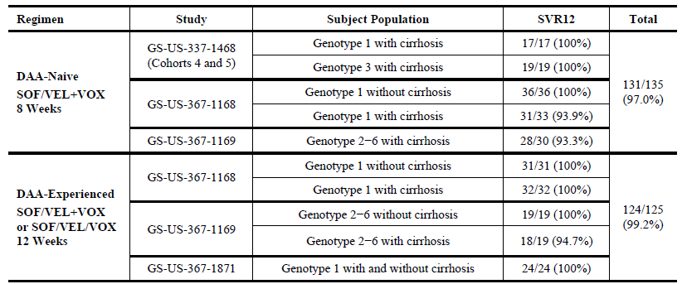

Phase III pivotal studies investigating more than one dose regimen
The pivotal Phase III POLARIS-1 and POLARIS-4 trials evaluated 12 weeks duration of treatment with proposed FDC of SOF/VEL/VOX in DAA experienced HCV patients while the Phase III POLARIS-2 and POLARIS-3 trials evaluated efficacy of 8 weeks treatment with SOF/VEL/VOX in DAA-treatment naïve HCV patients.

Evaluator’s conclusions on dose finding for the pivotal studies
The proposed rationale for selection of doses of individual components for the proposed FDC of SOF/VEL/VOX (400/100/100 mg) is justified.

Efficacy

Studies providing efficacy data

Four pivotal Phase III studies
- Study GS-US-367-1171 (POLARIS-1 trial): A Phase III, global, multicentre, randomised, double blind, placebo controlled study to investigate the safety and efficacy of sofosbuvir/velpatasvir/GS-9857 fixed dose combination for 12 weeks in direct acting antiviral experienced subjects with chronic HCV infection.
- Study GS-US-367-1170 (POLARIS-4 trial): A Phase III, global, multicentre, randomised, open label study to investigate the safety and efficacy of sofosbuvir/velpatasvir/GS-9857 fixed dose combination for 12 weeks and sofosbuvir/velpatasvir for 12 weeks in direct acting antiviral experienced subjects with chronic HCV infection who have not received an NS5A inhibitor.
- Study GS-US-367-1172 (POLARIS-2 trial): A Phase III, global, multicentre, randomised, open label study to investigate the safety and efficacy of sofosbuvir/velpatasvir/GS-9857 fixed dose combination for 8 weeks compared to sofosbuvir/velpatasvir for 12 weeks in direct acting antiviral naïve subjects with chronic HCV infection.
- Study GS-US-367-1173 (POLARIS-3 trial): A Phase III, global, multicentre, randomised, open label study to investigate the safety and efficacy of sofosbuvir/velpatasvir/GS-9857 fixed dose combination for 8 weeks and sofosbuvir/velpatasvir for 12 weeks in subjects with chronic genotype 3 HCV infection and cirrhosis.

Four supportive Phase II studies
- Study GS-US-337-1468 (LEPTON trial): A Phase II, multicentre, open label study to assess the efficacy and safety of oral regimens for the treatment of chronic HCV infection.
- Study GS-US-367-1168: A Phase II, global, multicentre, open label study to investigate the safety and efficacy of GS-9857 plus sofosbuvir/GS-5816 fixed dose combination in subjects with chronic genotype 1 HCV infection.
- Study GS-US-367-1169: A Phase II, global, multicentre, open label study to investigate the safety and efficacy of GS-9857 plus sofosbuvir/GS-5816 fixed dose combination in subjects with chronic non-genotype 1 HCV infection.
- Study GS-US-367-1871: A Phase II, open label study to investigate the safety and efficacy of sofosbuvir/GS-5816/GS-9857 fixed dose combination with or without ribavirin in subjects with chronic genotype 1 HCV infection previously treated with a direct acting antiviral regimen.

Evaluator’s conclusions on efficacy
Efficacy of SOF/VEL/VOX (400/100/100 mg) fixed dose combination was evaluated in 1760 patients with chronic HCV infection in four pivotal Phase III studies. Two studies evaluated the proposed 12 week dosing in 597 DAA experienced HCV patients (Studies GS-US-367-1171 (POLARIS-1 trial) and GS-US-367-1170 (POLARIS-4 trial )) while 2 other Phase III studies evaluated a shorter 8 week dosing with proposed FDC of SOF/VEL/VOX (compared with 12 week treatment with SOF/VEL) in 1163 DAA-naïve HCV patients (Study GS-US-367-1172 (POLARIS-2 trial) and Study GS-US-367-1173 (POLARIS-3 trial)). The study design, efficacy endpoints and patients enrolled in the pivotal Phase III studies complied with the TGA adopted CHMP guidelines.
Results from the four Phase II studies provided evidence to support the duration for treatment with SOF/VEL/VOX in the Phase III efficacy studies: 8 weeks for subjects who were DAA naive (treatment naive or treatment experienced with an IFN based regimen) and 12 weeks for subjects who were DAA experienced (failed DAA based regimen with or without an NS5A inhibitor, excluding those whose only DAA exposure was an NS3/4A Pi). Across the four Phase II studies, the SVR12 rates in these specifically defined populations were 97.0% (131 of 135 subjects) in DAA-naïve subjects receiving 8 weeks of treatment and 99.2% (124 of 125 subjects) in DAA experienced subjects receiving 12 weeks of treatment (Table 8).
Overall, more than 2000 subjects have been treated with SOF/VEL/VOX or SOF/VEL+VOX in Phase II and Phase III studies in the US, France, Germany, the United Kingdom, Canada, Australia and New Zealand.

Efficacy in DAA experienced subjects
Overall, 445 DAA experienced subjects were treated with SOF/VEL/VOX for 12 weeks in two pivotal Phase III studies (POLARIS-1 and POLARIS-4 trials), including 263 who failed prior treatment with an NS5A inhibitor. Subjects with genotypes 1, 2, 3, 4, 5 and 6 HCV infection were enrolled in the POLARIS-1 trial and subjects with genotypes 1, 2, 3 and 4 HCV infection were enrolled in the POLARIS-4 trial. An additional 125 DAA experienced subjects, including 55 NS5A inhibitor experienced subjects, were treated with 12 weeks of SOF/VEL+VOX or SOF/VEL/VOX in three Phase II studies (Studies GS-US-367-1168, GS-US-367-1169 and GS-US-367-1871(the TRILOGY-3 trial)). The POLARIS-1 trial included subjects who had previously received an NS5A inhibitor and POLARIS-4 trial included DAA experienced subjects who had not previously received an NS5A inhibitor. In these studies, subjects whose only DAA exposure was an NS3/4A protease inhibitor were excluded, given the availability of approved regimens to treat these individuals (for example, LDV/SOF and SOF/VEL).
Treatment with SOF/VEL/VOX for 12 weeks in DAA experienced subjects demonstrated consistently high SVR12 rates across genotypes and regardless of cirrhosis status or prior treatment regimen (see Table 9). In both studies, the SOF/VEL/VOX 12 Week group met the primary efficacy endpoint. The contribution of VOX to the regimen was demonstrated in the POLARIS-4 trial where overall and across subgroups SOF/VEL/VOX for 12 weeks led to higher SVR12 rates compared to SOF/VEL for 12 weeks. The SVR12 rates were consistent between the Phase II and Phase III studies.

Table 9: Studies GS-US-367-1171 and GS-US-367-1170; SVR12 by HCV genotype and by cirrhosis status (Full analysis set)
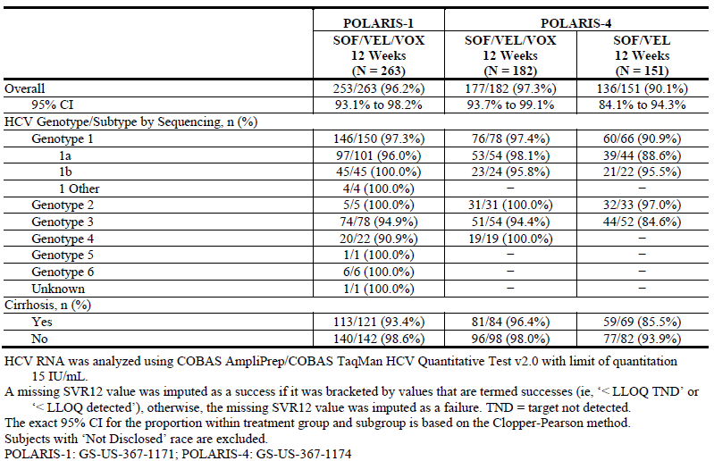

Efficacy in DAA-naïve subjects
A total of 611 DAA naive subjects were treated with SOF/VEL/VOX for 8 weeks in the POLARIS-2 and POLARIS-3 trials including 233, 63, 202, 63, 18, 30, and 2 subjects with genotype 1, 2, 3, 4, 5, 6, or unknown HCV infection, respectively. An additional 135 DAA naive subjects were treated with 8 weeks of SOF/VEL+VOX in 3 Phase II studies, Studies GS-US-337-1468 (LEPTON trial; Cohorts 4 and 5), GS-US-367-1168 and GS-US-367-1169. The POLARIS-2 trial included DAA naive subjects with genotype 1, 2, 3, 4, 5, or 6 HCV infection without cirrhosis or with compensated cirrhosis (excluding subjects with genotype 3 HCV infection and cirrhosis) and the POLARIS-3 trial included DAA naive subjects with genotype 3 HCV infection with compensated cirrhosis. In these studies, subjects were treatment naive or failed prior treatment with an IFN-based regimen.
SOF/VEL/VOX for 8 weeks in DAA naïve subjects demonstrated high SVR12 rates, but did not demonstrate non-inferiority to 12 weeks of treatment with SOF/VEL (Table 10). This difference between the regimens was primarily due to a lower SVR12 rate (91.7%) in subjects with genotype 1a HCV infection treated with SOF/VEL/VOX for 8 weeks. In subjects with HCV genotypes other than genotype 1a treated for 8 weeks with SOF/VEL/VOX, the pooled SVR12 rate was 96.6%. In general, the SVR12 rates were consistent between the Phase II and Phase III programs. Across studies, SOF/VEL/VOX for 8 weeks among subjects with genotype 3 HCV infection without cirrhosis or with cirrhosis resulted in an SVR12 rate of 97.5% (197 of 202 subjects), comparable to that of SOF/VEL for 12 weeks (96.5% (191 of 198 subjects)). Efficacy of 12 weeks treatment with SOF/VEL/VOX in DAA treatment naïve HCV patients was not evaluated. The efficacy results demonstrate that 8 weeks of treatment with SOF/VEL/VOX in DAA naïve subjects with genotype 3 HCV infection without cirrhosis or with compensated cirrhosis achieves similar SVR12 rates to 12 weeks of treatment with SOF/VEL which may be relevant in regions of the world where genotype 3 HCV infection is prevalent. However, there was inadequate evidence to support 8 weeks treatment with SOF./VEL/VOX over currently approved treatment with SOF/VEL in HCV patients with other genotypes.

Table 10: StudiesGS-US-367-1172 and GS-US-367-1173; SVR12 by HCV genotype and by cirrhosis status (FAS)
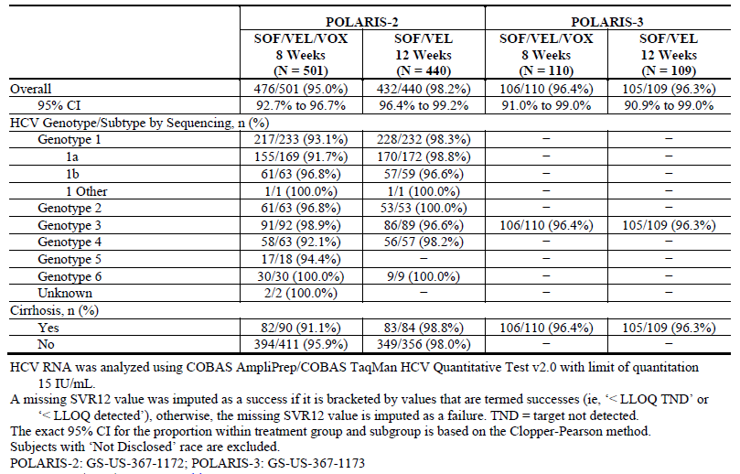

Persistence of effects and/or tolerance effects
Historically, SVR has been defined at 24 weeks following completion of treatment. However, recently SVR12 has been adopted by regulatory authorities as the primary efficacy endpoint for evaluation of HCV treatments and has been accepted to support the recent marketing authorisations of HCV treatments. Data evaluating the concordance between SVR12 and SVR24 from the Phase III studies of the SOF/VEL/VOX development program (POLARIS-1, POLARIS-4, POLARIS-2 and POLARIS-3 trials) will be reported in the final report for each study and was not provided in the current submission. An analysis was performed to evaluate the concordance between SVR12 and SVR24 in subjects receiving SOF/VEL+VOX or SOF/VEL/VOX in the Phase II Studies GS-US-337-1468 (LEPTON trial; Cohorts 4 and 5), GS-US-367-1168, GS-US-367-1169 and GS-US-367-1871 (TRILOGY-3 trial). Across these 4 studies, of the 476 subjects who achieved SVR12, 475 subjects also achieved SVR24. The 1 subject who relapsed between post treatment Weeks 12 and 24 had received SOF/VEL+VOX for 4 weeks (Study GS-US-367-1468).

Efficacy conclusions
Overall, the Phase II and III efficacy data support the proposed dosing regimen of SOF/VEL/VOX (400/100/100 mg) one tablet daily with food for 12 weeks in DAA experienced adult patients with HCV infection. SOF/VEL/VOX administered for 12 weeks in the POLARIS-1 and POLARIS-4 trials resulted in SVR12 rates of 96.2% and 97.3%, respectively. There are no currently approved regimens for patients who have not achieved SVR following treatment with the DAA containing regimens as defined in these studies. Hence, the cumulative efficacy data support the use of SOF/VEL/VOX for 12 weeks for the treatment of HCV infection in patients who have failed treatment with at least one prior DAA, regardless of genotype, in patients without cirrhosis or with compensated cirrhosis.
There is inadequate evidence to support use in DAA treatment naïve patients with HCV infection of all genotypes (POLARIS-2 trial). However, there was some evidence to suggest efficacy of 8 weeks of SOF/VEL/VOX in DAA-treatment naïve patients with HCV genotype 3 and compensated cirrhosis (POLARIS-3 trial).

Limitations of the efficacy data
- Despite the positive results from the Phase II studies regarding concordance between the SVR12 and SVR24, it is imperative that the sponsors provide results of the SVR24 in the four pivotal Phase III studies and this could a condition following approval of proposed FDC. It is noted that the sponsors are conducting 3 registry studies, in which subjects are being followed for up to 3 or 5 years after their initial treatment study in accordance with both US and European Union guidelines. These long term data should also enable assessment of efficacy/ safety of the proposed SOF/VEL/VOX FDC.
- Lack of unequivocal evidence of efficacy of 8 week treatment with SOF/VEL/VOX in DAA treatment naïve HCV patients; the proposed 12 week treatment with SOF/VEL/VOX was not evaluated in DAA treatment naïve patients.
- The proposed PI only provides dosing recommendations in HCV patients who have failed treatment with at least one prior DAA. There are no dosing recommendations for DAA treatment naïve HCV patients in the PI although the proposed indication is for all adult patients with chronic HCV.
- Proposed FDC of SOF/VEL/VOX was not evaluated in HCV patients with HBV or HIV co-infection or in patients with liver transplants.

Safety

Studies providing safety data
Overall, 15 clinical studies provided the main safety data for SOF/VEL/VOX , including 4 Phase III studies of SOF/VEL/VOX as an FDC tablet, 4 Phase II studies of SOF/VEL+VOX (with VOX as an individual agent) or SOF/VEL/VOX (with VOX in the FDC) with or without RBV, and 7 Phase I studies of SOF/VEL/VOX as an FDC tablet or SOF/VEL as an FDC tablet plus VOX as an individual agent. Supportive safety data was provided from the Phase I and II studies and from 11 clinical studies of SOF/VEL FDC or SOF+VEL as individual agents, 31 clinical studies of SOF, 9 clinical studies of VEL and 8 clinical studies of VOX as individual agents (Table 11).
Table 11: Safety data supporting the proposed indication for SOF/VEL/VOX
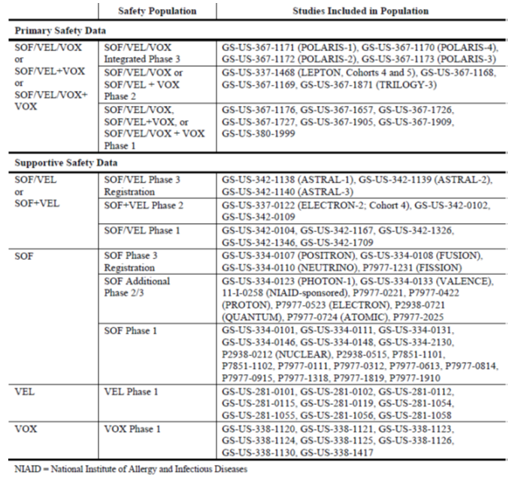

Patient exposure
A total of 2,869 subjects were evaluated as part of the primary safety data, including 1,908 subjects in the integrated Phase III safety population, 543 subjects in the Phase II safety population and 418 subjects in the Phase I safety population. Table 12 (provides overview of studies providing safety data for the SOF/VEL/VOX Integrated Phase III Safety population. The Integrated Phase III Safety Population data have been pooled by treatment regimen as follows: SOF/VEL/VOX 8 Week Group (includes subjects who received SOF/VEL/VOX for 8 weeks in Studies GS-US-367-1172 and GS-US-367-1173); SOF/VEL/VOX 12 Week Group (includes subjects who received SOF/VEL/VOX for 12 weeks in Studies GS-US-367-1171 and GS-US-367-1170); SOF/VEL 12 Week Group (includes subjects who received SOF/VEL for 12 weeks in Studies GS-US-367-1170, GS-US-367-1172 and GS-US-367-1173); Placebo 12 Week Group (includes subjects who received SOF/VEL/VOX placebo for 12 weeks in Study GS-US-367-1171). Tables 13 and 14 provide overview of studies providing safety data for the Phase II and Phase I safety populations, respectively.

Table 12: Overview of studies providing safety data for the SOF/VEL/VOX integrated Phase III safety population
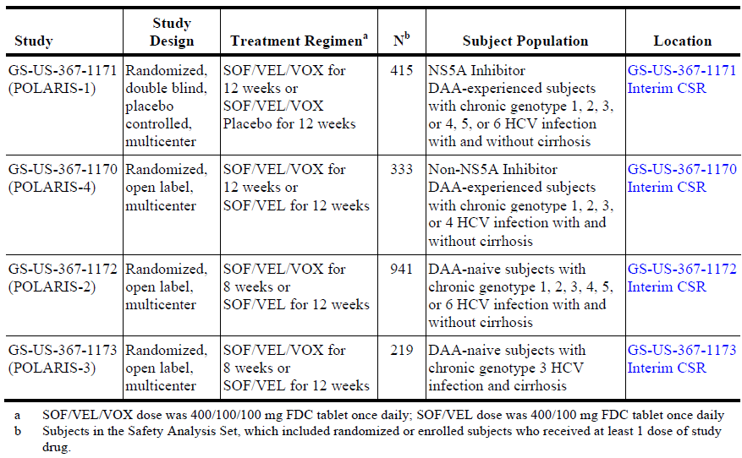

Tables 13: Overview of studies providing safety data for SOF/VEL/VOX Phase II safety population
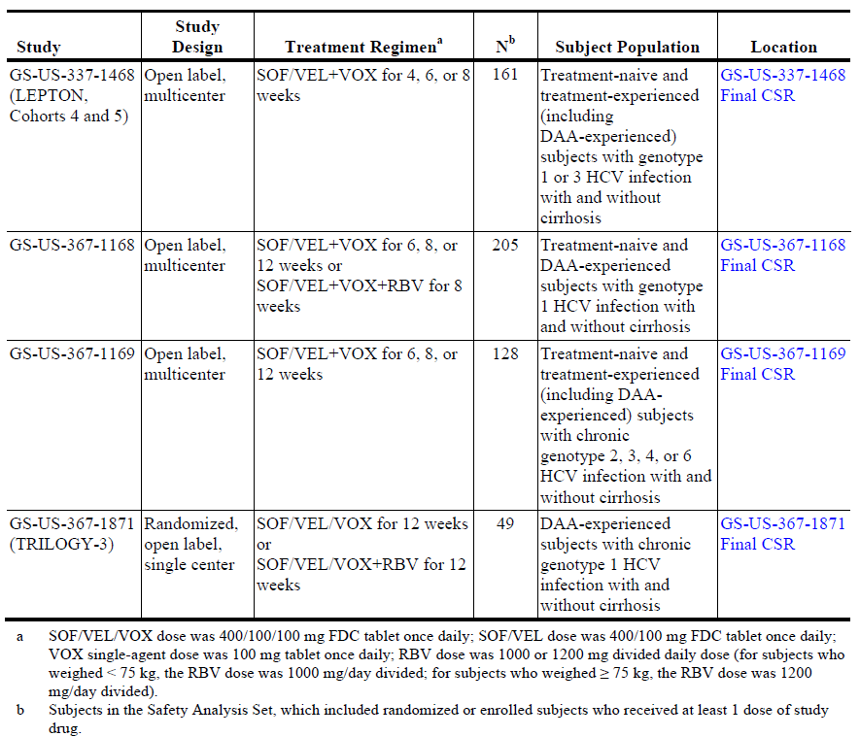

Table 14: Overview of Studies Providing Safety Data for the SOF/VEL/VOX Phase I Safety Population
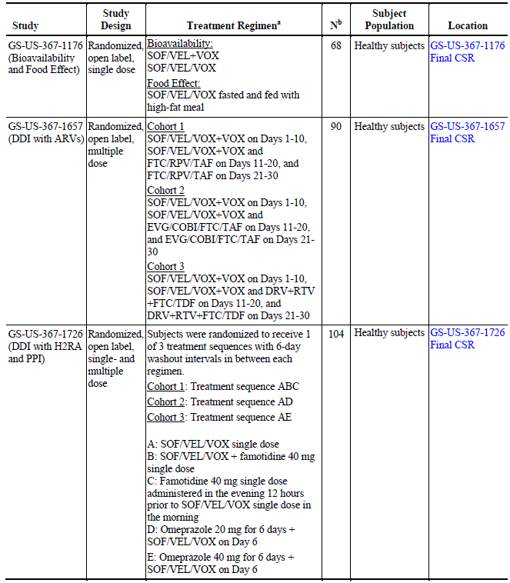

Table 14: (continued) Overview of Studies Providing Safety Data for the SOF/VEL/VOX Phase I Safety Population
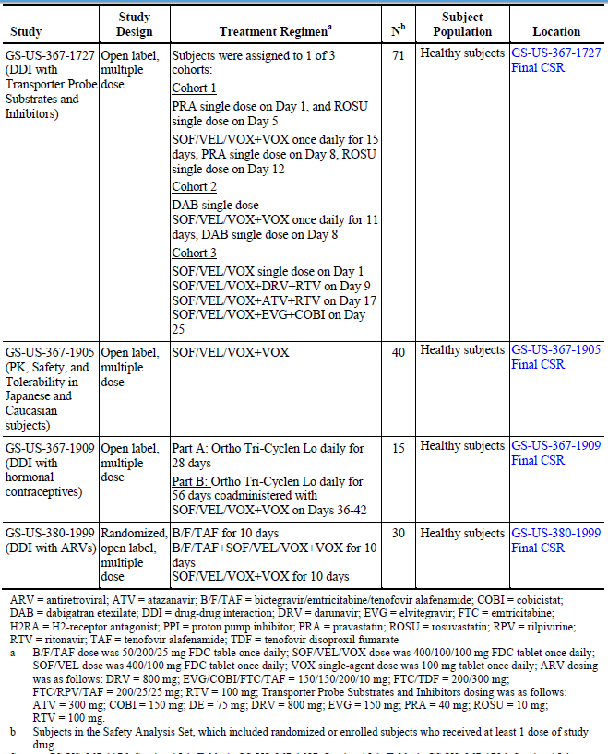
A total of 2,017 subjects have received at least 1 dose of SOF/VEL/VOX or SOF/VEL+VOX, including 1056 subjects in 4 SOF/VEL/VOX Phase III studies, 543 subjects in 4 SOF/VEL/VOX or SOF/VEL+VOX Phase II studies and 418 subjects in 7 SOF/VEL/VOX, SOF/VEL+VOX, or SOF/VEL/VOX+VOX Phase I studies (Table 15). Among the subjects in the Phase III and Phase II studies who received the 8 week treatment regimens, 99.4% (804 of 809 subjects) received SOF/VEL/VOX or SOF/VEL+VOX for at least 8 weeks. Among the subjects in the Phase III and Phase II studies who received the 12 week treatment regimens, 99.4% (626 of 630 subjects) received SOF/VEL/VOX or SOF/VEL+VOX for at least 12 weeks.

Table 15: Subjects treated with SOF/VEL/VOX, SOF/VEL+VOX or SOF/VEL/VOX+VOX in Phase I, II and III clinical studies
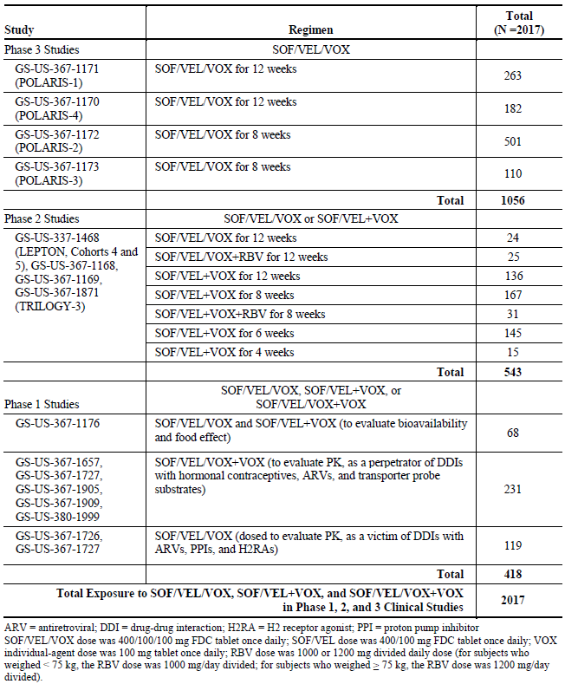
Of the 1,912 subjects who were randomised or enrolled into the 4 Phase III studies that comprise the Integrated Phase III Safety Population, 1,908 received at least 1 dose of study drug and were included in the Safety Analysis Set. This Safety Analysis Set included 611 subjects who received at least 1 dose of the SOF/VEL/VOX 8 week regimen, 445 subjects who received at least 1 dose of the SOF/VEL/VOX 12 week regimen, 700 subjects who received at least 1 dose of the SOF/VEL 12 week regimen, and 152 subjects who received at least 1 dose of the Placebo 12 week regimen. The demographics and baseline characteristics of subjects in the Integrated safety population were representative of the broad HCV infected population, taking into consideration the DAA experienced subjects who received SOF/VEL/VOX or placebo for 12 weeks. Demographics in the SOF/VEL/VOX, SOF/VEL and Placebo groups were generally consistent with each other with respect to sex, race, body mass index (BMI) and HCV RNA levels. Subjects enrolled in the SOF/VEL/VOX 12 Week group from Studies GS-US-367-1171 and GS-US-367-1170 and the Placebo group from Study GS-US-367-1171 were DAA experienced; these subjects were older, more likely to have IL28B non-CC genotypes and more likely to be cirrhotic (SOF/VEL/VOX 12 Week group only) (Table 16).

Table 16: Baseline characteristics in the SOF/VEL/VOX integrated Phase III safety population (safety analysis set)
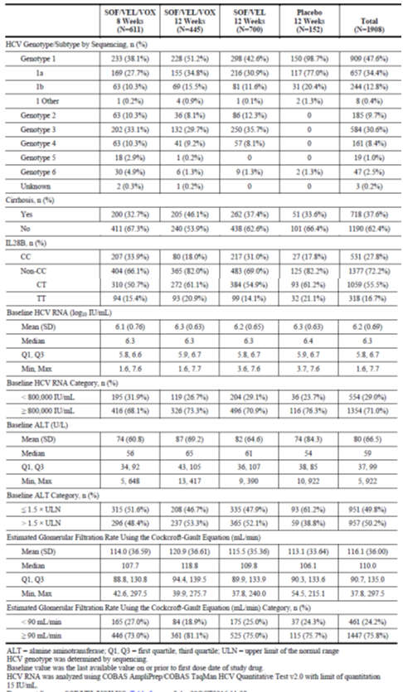

Safety issues with the potential for major regulatory impact

Liver function and liver toxicity

Integrated safety analyses
For subjects receiving SOF/VEL/VOX for 8 or 12 weeks, there was a higher rate of Grade 1 hyperbilirubinemia compared with subjects receiving SOF/VEL or placebo. Similar to other NS3/4A Pis, VOX is an inhibitor of organic anion transporting polypeptide (OATP)1B1 and OATP1B3 which is likely responsible for the increase in Grade 1 total bilirubin in subjects receiving SOF/VEL/VOX. This increase is observed more often in subjects with cirrhosis (9.9%, 40 subjects) than in subjects without cirrhosis (3.7%, 24 subjects). The change in total bilirubin during treatment with SOF/VEL/VOX was similar between subjects with and without cirrhosis. No adverse events (AEs) of jaundice were reported. In all treatment groups, the incidence of Grade 3 elevations in total bilirubin was low with only 1 subject in the SOF/VEL/VOX 12 Week group (0.2%) and 1 subject in the SOF/VEL 12 Week group (0.1%) reporting a Grade 3 elevation. Both of these cases were assessed by the Independent Adjudication Committee (IAC) to be unlikely to be related to study drug. No subjects in any treatment group reported Grade 4 increases in total bilirubin (Table 17). Decreases from baseline in median total bilirubin values during treatment were observed in the SOF/VEL 12 Week group, but not in the SOF/VEL/VOX or Placebo groups. This comparative lack of decrease in the SOF/VEL/VOX group, compared to the SOF/VEL group, is likely due to VOX inhibition of OATP1B1 and OATP1B3 which transports bilirubin into hepatocytes. However, 4 weeks post-treatment, total bilirubin values for the SOF/VEL/VOX and SOF/VEL groups were similar, consistent with a transporter-mediated effect of VOX (Figure 4). The median (Q1, Q3) change from baseline in total bilirubin at the end of treatment was 0.0 (-0.1, 0.1), 0.0 (-0.2, 0.1), -0.1 (-0.2, 0) and 0 (-0.2, 0.1) mg/dL in the SOF/VEL/VOX 8 week, SOF/VEL/VOX 12 week, SOF/VEL 12 week and placebo 12 week groups, respectively.

Table 17: Total bilirubin graded abnormalities in the SOF/VEL/VOX integrated Phase III safety population (safety analysis set)
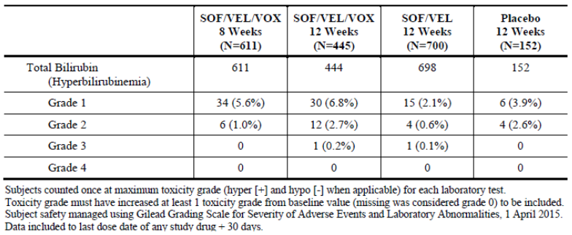
Figure 4: Median (Q1, Q3) total bilirubin (mg/dL) by visit in the SOF/VEL/VOX integrated Phase III safety population (safety analysis set)
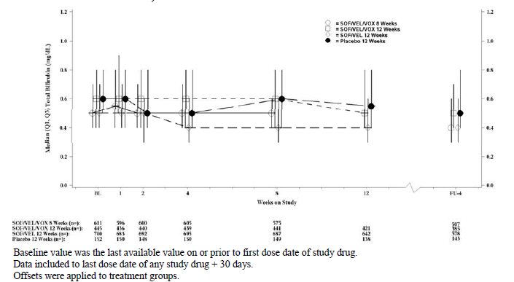
For subjects receiving placebo for 12 weeks, the rate of graded alanine aminotransferase (ALT) elevations was higher than for subjects receiving SOF/VEL/VOX or SOF/VEL, consistent with untreated HCV infection. The incidence of graded ALT elevations was similar and low across all SOF/VEL/VOX and SOF/VEL groups (Table 18). Overall, there were decreases in ALT coincident with viral suppression for subjects receiving SOF/VEL/VOX and SOF/VEL (Figure 5). One subject in the SOF/VEL/VOX 12 Week group and 1 subject in the SOF/VEL 12 Week group had a Grade 3 elevation in ALT.

Table 18: ALT graded abnormalities in the SOF/VEL/VOX integrated Phase III safety population (safety analysis set)
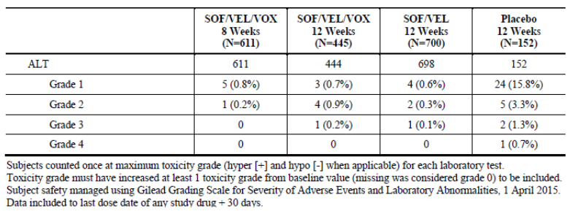
Figure 5: Median (Q1, Q3) ALT (U/L) by visit in the SOF/VEL/VOX integrated Phase III safety population (safety analysis set)
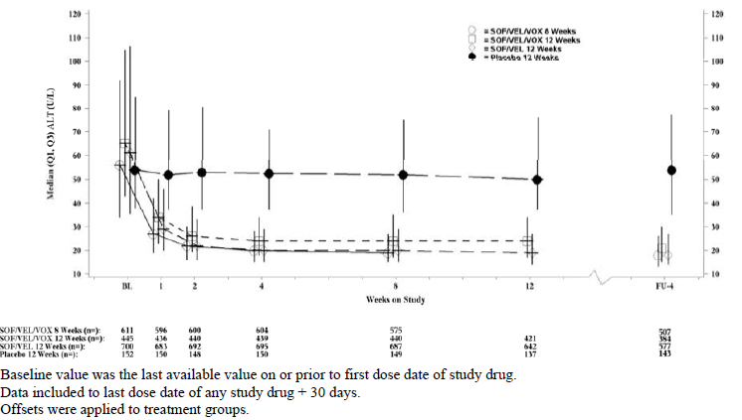
Similar to the graded elevations observed in ALT, the rate of graded aspartate aminotransferase (AST) elevations for subjects receiving placebo for 12 weeks was higher than for subjects receiving SOF/VEL/VOX or SOF/VEL, consistent with untreated HCV infection. The incidence of graded AST elevations was similar and low across all SOF/VEL/VOX and SOF/VEL groups (Table 19). Overall, there were decreases in AST coincident with viral suppression for subjects receiving SOF/VEL/VOX and SOF/VEL (Figure 6). Two subjects in the SOF/VEL/VOX 8 Week group, 2 subjects in the SOF/VEL/VOX 12 Week group, and 1 subject in the SOF/VEL 12 Week group had Grade 3 elevations in AST. For all 5 of these subjects across the treatment groups, the Grade 3 elevation in AST was associated with Grade 3 or 4 elevations in creatine kinase in the context of exercise. None of these subjects had Grade 3 or 4 elevations in ALT.

Table 19: AST graded abnormalities in the SOF/VEL/VOX integrated Phase III safety population (safety analysis set)
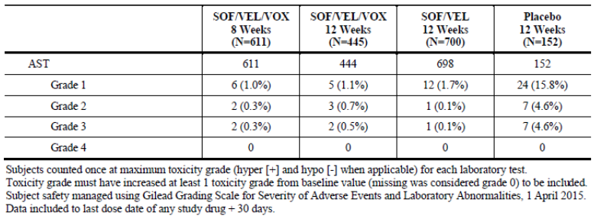
Figure 6: Median (Q1, Q3) AST (U/L) by visit in the SOF/VEL/VOX integrated Phase III safety population (safety analysis set)
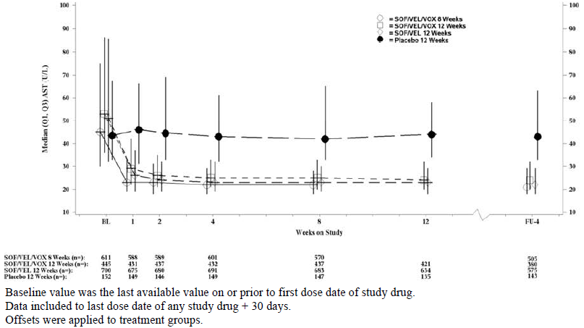
Thirty-five cases from the SOF/VEL/VOX Phase III studies (SOF/VEL/VOX: 18 cases, SOF/VEL: 8 cases, Placebo: 9 cases) and 11 cases from the SOF/VEL/VOX Phase II studies (SOF/VEL/VOX with RBV: 6 cases, SOF/VEL/VOX: 5 cases) were reviewed by the Independent Adjudication Committee (IAC) members. Overall, 42 cases were assessed unanimously by the IAC as “Unlikely” prior to the meeting. The remaining 4 cases were discussed by the group during the meeting. Of these 4 cases, the IAC identified 2 cases as “Unlikely” drug-induced liver injury (DILI), 1 case as “Probably” DILI and 1 case as “Possibly” DILI. The case identified as possibly DILI was that of the subject above who met multiple laboratory criteria; although the subject was hospitalised in the post treatment period for “binge drinking”, the IAC noted that the laboratory abnormalities occurred during treatment. The case identified as probably DILI was that of a woman with cirrhosis taking oral contraceptives who experienced an unexplained increase in ALT and AST at Week 2 of treatment with SOF/VEL+VOX+RBV in the Phase II Study GS-US-367-1168. The ALT and AST decreased when study drugs were discontinued after specified stopping criteria were met, and there was no alternative explanation for the laboratory abnormalities.

Pivotal studies in DAA experienced subjects
Study GS-US-367-1171 (POLARIS-1): Grade 3 or 4 increased ALT was reported in 3 subjects in the Placebo 12 Week group, which was consistent with untreated, chronic HCV infection (Table 20). No subjects in the SOF/VEL/VOX 12 Week group had Grade 3 or 4 ALT elevations. Grade 3 increases in AST were reported in 2 subjects (0.8%) in the SOF/VEL/VOX 12 Week group (both were transient and isolated and concurrent with elevations in creatine kinase) and 7 subjects (4.6%) in the Placebo 12 Week group which were consistent with untreated, chronic HCV infection. A Grade 3 increase in total bilirubin was reported in 1 subject (0.4%) in the SOF/VEL/VOX 12 Week group. No subjects in the Placebo 12 Week group had Grade 3 or 4 total bilirubin elevations. Coincident with suppression of viral replication, the SOF/VEL/VOX 12 Week group had a decrease from baseline in median ALT for the duration of the treatment period and at the post treatment Week 4 visit. No relevant changes in ALT were observed in the Placebo 12 Week group (Figure 7). No notable changes in median total bilirubin values were observed in the SOF/VEL/VOX 12 Week group or Placebo 12 Week group.

Table 20: GS-US-367-1171. Grade 3 or above coagulation and chemistry laboratory abnormalities (safety analysis set)
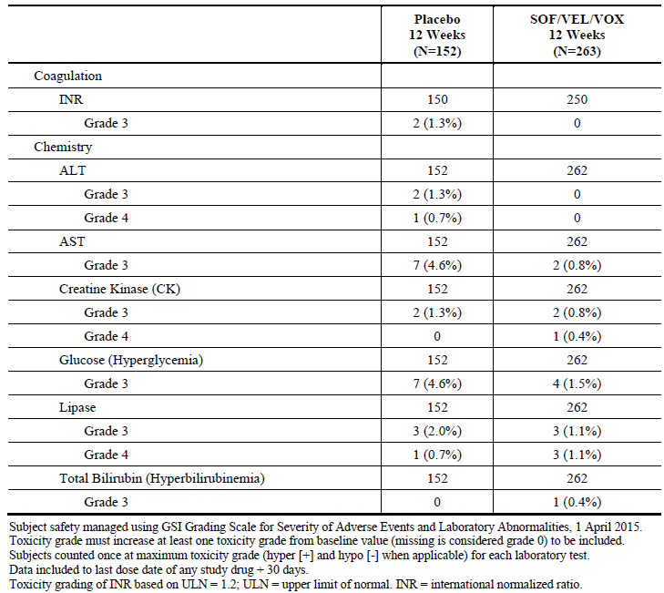
Figure 7: GS-US-367-1171. Median (Q1, Q3) ALT (U/L) by visit (safety analysis set)
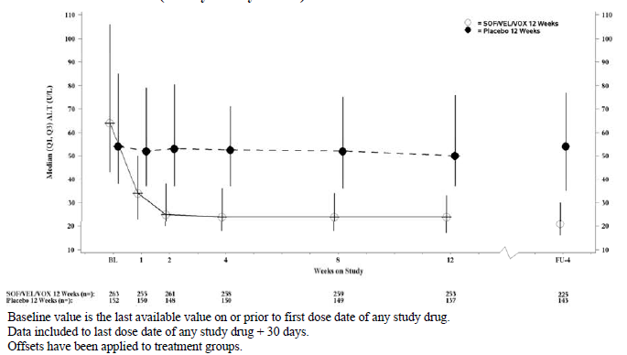
Study GS-US-367-1170 (POLARIS-4): One subject had Grade 3 increased ALT in the SOF/VEL/VOX 12 Week Group, while no Grade 3 or 4 increased ALT was observed in the SOF/VEL 12 Week group. Coincident with decreases in HCV RNA, reductions from baseline in median ALT values were observed in both treatment groups for the duration of treatment and at the post treatment Week 4 visit. Median changes from baseline to post treatment Week 4 ranged from −40 to −38 U/L across both treatment groups (Figure 8). No Grade 3 or 4 increased total bilirubin was observed in either treatment group. Decreases from baseline in median total bilirubin values during treatment were observed in the SOF/VEL 12 Week group during treatment, but not observed during treatment in the SOF/VEL/VOX 12 Week group. This difference was likely due to VOX inhibition of OATP1B1 and OATP1B3 which transports bilirubin into hepatocytes. At post treatment Week 4, this difference resolved and the median total bilirubin values were similar in both treatment groups.
Comment: DAA experienced subjects reported low incidence of Grade 3 or 4 increase in ALT following treatment with SOF/VEL/VOX for 12 weeks as only 1 of the 445 subjects treated with SOF/VEL/VOX for 12 weeks reported a Grade 3 increase in ALT (Grade 4 increase in ALT was not reported).
Figure 8: GS-US-367-1170. Median (Q1, Q3) ALT (U/L) by visit (safety analysis set)
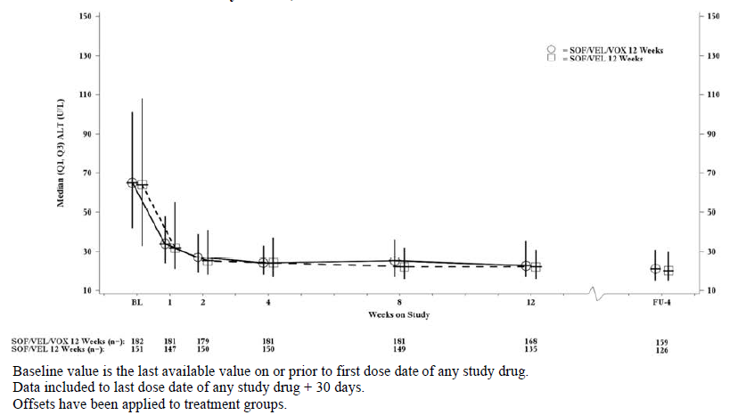

Pivotal studies in DAA naïve subjects
Study GS-US-367-1172 (POLARIS-2): No Grade 3 or 4 ALT elevations were reported for subjects in the SOF/VEL/VOX 8 Week group. One subject in the SOF/VEL 12 Week group had a Grade 3 ALT elevation (this subject without cirrhosis and with baseline BMI 28.4 kg/m² had Grade 3 increased ALT at Week 12). Coincident with decreases in HCV RNA, reductions from baseline in median ALT values were observed in both treatment groups for the duration of treatment and at the post treatment Week 4 visit. During treatment, median changes from baseline ranged from −24 to −34 U/L, with no notable differences between the groups (Figure 9). One subject (0.2%) in the SOF/VEL 12 Week group had Grade 3 increases in total bilirubin.
Figure 9: GS-US-367-1172. Median (Q1, Q3) ALT (U/L) by visit (safety analysis set)
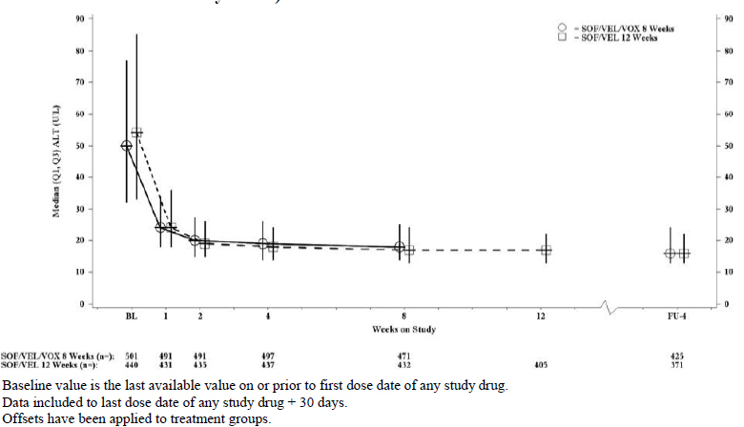
Study GS-US-367-1173 (POLARIS-3): There were no Grade 3 or 4 elevations in ALT or total bilirubin in either treatment group. Coincident with decreases in HCV RNA, reductions from baseline in median ALT values were observed in both treatment groups for the duration of treatment and at the post treatment Week 4 visit. Median changes from baseline ranged from −41 to −106 U/L for both treatment groups, with no notable differences between the groups (Figure 10). Decreases from baseline in median total bilirubin values during treatment were observed in the SOF/VEL 12 Week group, but not in the SOF/VEL/VOX 8 Week group. This difference is likely due to VOX inhibition of OATP, which transports bilirubin into hepatocytes. At post treatment Week 4, this difference had resolved and the median total bilirubin values were similar in both treatment groups.
Figure 10: GS-US-367-1173. Median (Q1, Q3) ALT (U/L) by visit (safety analysis set)
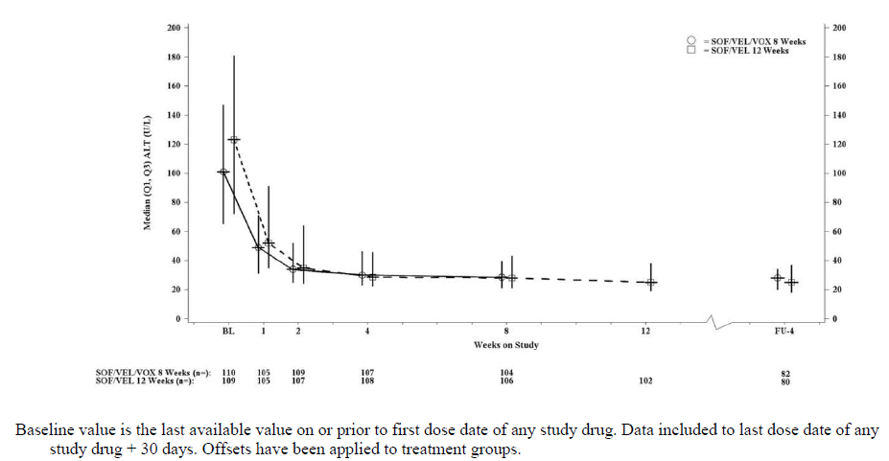Other studies
Study GS-US-337-1468 (LEPTON, Cohorts 4 and 5): There were no clinically meaningful increases in ALT or total bilirubin values during treatment with SOF/VEL+VOX.
Study GS-US-367-1168: The only Grade 3 or 4 laboratory abnormality reported as an AE was the Grade 3 elevated ALT in the subject who met the protocol defined stopping criteria.
Study GS-US-367-1169: No clinically meaningful increases in ALT or total bilirubin values were observed during treatment with SOF/VEL+VOX.
Study GS-US-367-1871 (TRILOGY-3): No clinically meaningful increases in ALT or total bilirubin values were observed during treatment with SOF/VEL/VOX.

Renal function and renal toxicity

Integrated safety analyses
For subjects in all treatment groups, median creatinine and estimated glomerular filtration rate (eGFR) values remained stable from baseline through the end of treatment and at post-treatment Week 4.
No events of renal failure were reported for any subjects in the Phase III Integrated Safety Population.

Pivotal studies in DAA experienced subjects
No clinically significant changes in renal function parameters were observed in the four pivotal Phase III studies.

Other studies
No clinically significant changes in renal function parameters were observed in the four Phase II studies.

Other clinical chemistry

Integrated safety analyses
Overall, in the Phase III Integrated Safety Population, graded laboratory abnormalities were observed more often in the Placebo 12 Week group (75.7%) and SOF/VEL/VOX 12 Week group (68.9%) compared to the SOF/VEL/VOX 8 Week group (57.8%) and SOF/VEL 12 Week group (58.7%), most likely reflecting the higher percentage of subjects with cirrhosis in the Placebo 12 Week and SOF/VEL/VOX 12 Week groups.
The majority of subjects in the SOF/VEL/VOX 8 Week group had at least 1 graded laboratory abnormality (57.8%, 353 subjects). For 51.6% of subjects, these laboratory abnormalities were Grade 1 or 2. Subjects had low rates of Grade 3 (5.4%, 33 subjects) and Grade 4 (0.8%, 5 subjects) laboratory abnormalities. Among subjects in the SOF/VEL/VOX 12 Week group, 68.9% (306 subjects) had at least 1 graded laboratory abnormality. Compared to the SOF/VEL/VOX 8 Week group, the higher incidence of graded laboratory abnormalities in the SOF/VEL/VOX 12 Week group was mostly due to more subjects in the SOF/VEL/VOX group with Grade 1 or 2 laboratory abnormalities (62.4%), notably in decreased platelets and increased total bilirubin, consistent with more subjects with cirrhosis enrolled in the 12 week duration regimen. Similar to those receiving 8 weeks of SOF/VEL/VOX, subjects receiving 12 weeks of SOF/VEL/VOX had low rates of Grade 3 and 4 laboratory abnormalities: 5.2% (23 subjects) had at least 1 Grade 3 laboratory abnormality and 1.4% (6 subjects) had at least 1 Grade 4 laboratory abnormality. The rate of subjects with at least 1 graded laboratory abnormality in the SOF/VEL 12 Week group (58.7%, 410 subjects) was similar to the SOF/VEL/VOX 8 Week group. Most of the laboratory abnormalities were Grade 1 or 2 (53.7%). The rate of Grade 3 (4.2%) and Grade 4 (0.9%) lab abnormalities was lower. Of all the treatment groups, the Placebo 12 Week group had the highest rate of subjects with at least 1 graded laboratory abnormality (75.7%, 115 subjects), largely due to the higher rates of graded ALT and AST abnormalities consistent with untreated HCV infection.
Across the treatment groups, the most common Grade 3 or 4 laboratory abnormalities were increased glucose, increased lipase and increased creatine kinase (Table 21). Elevations in glucose were observed primarily among subjects with a history of diabetes or subjects who had glucose elevations prior to initiation of study drug. Elevations in lipase were asymptomatic and were generally isolated or transient and intermittent; there were no AEs of pancreatitis and no trends in lipase elevations over time. All elevations in creatine kinase, except for 2, were related to exercise or physical exertion, according to the investigator. The Grade 3 increases in INR were not confirmed or were related to concurrent warfarin dosing. The Grade 3 decreases in sodium were observed in subjects who had Grade 2 decreased sodium at baseline and were related to diuretic intake or excessive intake of water, according to the investigator.

Table 21: Grade 3 or 4 chemistry laboratory abnormalities in the SOF/VEL/VOX integrated Phase III safety population (safety analysis set)
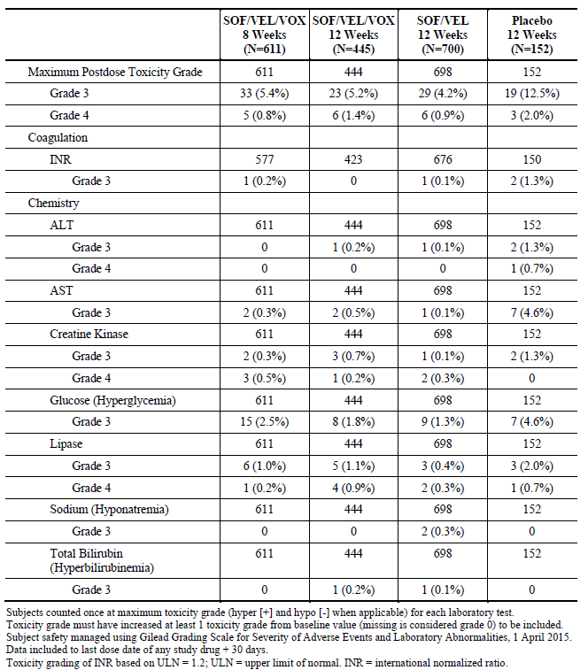

Pivotal studies in DAA experienced subjects
Study GS-US-367-1171 (POLARIS-1): Most subjects had at least 1 laboratory abnormality with majority being Grade 1 (39.5%, 164 of 415 subjects) or Grade 2 (22.2%, 92 of 415 subjects). Overall, the incidence of Grade 3 and 4 laboratory abnormalities was low (9.6%, 40 of 415 subjects). The incidence of Grade 3 and 4 coagulation and chemistry laboratory abnormalities was similar for both treatment groups. Grade 3 chemistry laboratory abnormalities were reported for ALT, AST, creatine kinase, serum glucose (hyperglycaemia), lipase and total bilirubin (hyperbilirubinemia). Grade 4 chemistry laboratory abnormalities were reported for ALT, creatine kinase and lipase (Table 20).
Grade 3 increases in serum glucose were reported for 4 subjects (1.5%) in the SOF/VEL/VOX 12 Week group and 7 subjects (4.6%) in the Placebo 12 Week group. All subjects with increased serum glucose had a history of diabetes or impaired glucose tolerance, with the exception of 3 subjects in the Placebo 12 Week group. No Grade 4 increases in serum glucose were reported.
Grade 3 increases in lipase were reported for 3 subjects (1.1%) in the SOF/VEL/VOX 12 Week group and 3 subjects (2.0%) in the Placebo 12 Week group. All of the Grade 3 lipase elevations were isolated events or intermittent and transient and all were asymptomatic, with no cases of clinical pancreatitis. Grade 4 increases in lipase were reported for 3 subjects (1.1%) in the SOF/VEL/VOX 12 Week group and 1 subject (0.7%) in the Placebo 12 Week group, none of which were associated with clinical pancreatitis.
Grade 3 increases in creatine kinase were reported for 2 subjects (0.8%) subjects in the SOF/VEL/VOX 12 Week group and 2 subjects (1.3%) in the Placebo 12 Week group. None of the Grade 3 creatine kinase elevations were reported as AEs, all were associated with exercise and all were considered not related to study drug by the investigators.
Study GS-US-367-1170 (POLARIS-4): Most subjects had at least 1 laboratory abnormality with majority of them being Grade 1 (36.6%, 122/ 333) or Grade 2 (22.2%, 74/ 333). A similar percentage of subjects had Grade 3 laboratory abnormalities in the SOF/VEL/VOX 12 Week (5.5%, 10 of 182 subjects) and SOF/VEL 12 Week (6.0%, 9 of 151 subjects) groups. One subject had a Grade 4 laboratory abnormality in each treatment group (Table 22).

Table 22: GS-US-367-1170. Grade 3 or 4 coagulation and chemistry laboratory abnormalities (safety analysis set)
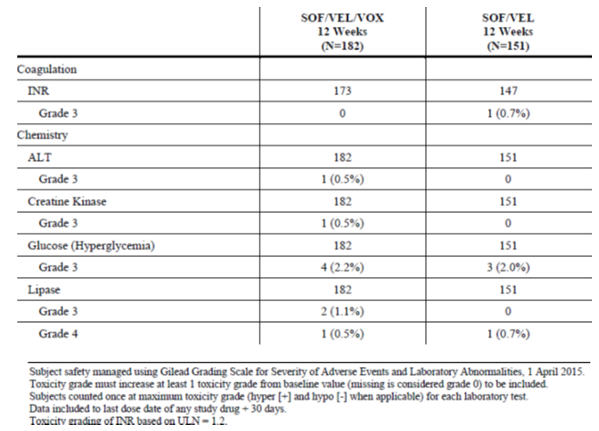
Increased lipase was the only Grade 4 chemistry laboratory abnormality observed in this study. Grade 4 increased lipase was observed in 2 subjects (1 in each treatment group) Two subjects in the SOF/VEL/VOX 12 Week group had a Grade 3 increased lipase; all these grade 3 and 4 lipase abnormalities were asymptomatic and not associated with any cases of clinical pancreatitis.
Increased serum glucose was the most commonly observed Grade 3 chemistry laboratory abnormality, with 4 subjects (2.2%) in the SOF/VEL/VOX 12 Week group and 3 subjects (2.0%) in the SOF/VEL 12 Week group and all these subjects had medical history of diabetes. Additional Grade 3 chemistry laboratory abnormalities of increased creatine kinase (transient and related to heavy exercise) and increased ALT (heavy alcohol use during study) were observed in 1 subject each in the SOF/VEL/VOX 12 Week group.

Pivotal studies in DAA-naïve subjects
Study GS-US-367-1172 (POLARIS-2): Most subjects had at least 1 laboratory abnormality but most were Grade 1 (35.7%, 336 of 940 subjects) or Grade 2 (14.8%, 139 of 940 subjects). Overall, the incidence of Grade 3 and 4 laboratory abnormalities was low (4.3%, 40 of 940 subjects). The most common Grade 3 or 4 chemistry laboratory abnormalities across both treatment groups were increased serum glucose (hyperglycaemia), increased lipase and increased creatine kinase. Grade 3 increases in serum glucose (hyperglycaemia) were reported for 7 subjects (1.4%) in the SOF/VEL/VOX 8 Week group and 3 subjects (0.7%) in the SOF/VEL 12 Week group and all subjects had history of diabetes. Grade 3 increased lipase was reported for 4 subjects (0.8%) in the SOF/VEL/VOX 8 Week group and 2 subjects (0.5%) in the SOF/VEL 12 Week group. One subject in each group (0.2%) had a Grade 4 increase in lipase. All of the Grade 3 and 4 lipase elevations were isolated events or intermittent and transient and none were associated with clinical symptoms, clinical pancreatitis or related gastrointestinal AEs. Grade 3 increase in creatine kinase was reported for 2 subjects (0.4%) in the SOF/VEL/VOX 8 Week group. Grade 4 increase in creatine kinase was reported in 2 subjects (0.4%) in the SOF/VEL/VOX 8 Week group and 2 subjects (0.5%) in the SOF/VEL 12 Week group. All of the Grade 3 and 4 creatine kinase elevations were isolated events and all but 1 of the 6 events were attributed to rigorous physical activity.
Study GS-US-367-1173 (POLARIS-3): Most subjects had at least 1 laboratory abnormality, majority of which were Grade 1 (36.7%, 80/218) or Grade 2 (24.3%, 53/218). Overall, the incidence of Grade 3 and 4 laboratory abnormalities was low (10.6% (23/218). There was no Grade 3 or 4 coagulation laboratory abnormalities in the study. Grade 3 chemistry laboratory abnormalities were reported for AST, creatine kinase, serum glucose (hyperglycaemia), lipase and sodium (hyponatremia). One Grade 4 chemistry laboratory abnormality was reported for creatine kinase. The most common Grade 3 chemistry laboratory abnormalities across both treatment groups were increased serum glucose and elevated lipase (Table 23). Grade 3 increases in serum glucose were reported for 8 subjects (7.3%) in the SOF/VEL/VOX 8 Week group and 3 subjects (2.8%) in the SOF/VEL 12 Week group. All but 1 of the subjects with Grade 3 increased serum glucose had a medical history of diabetes. Grade 3 elevated lipase was observed in 2 subjects (1.8%) in the SOF/VEL/VOX 8 Week group and 1 subject (0.9%) in the SOF/VEL 12 Week group; these elevations were isolated events or transient and all were asymptomatic, with no cases of clinical pancreatitis. A Grade 3 increase in creatine kinase was reported for 1 subject (0.9%) in the SOF/VEL 12 Week group and a Grade 4 increase in creatine kinase was reported for 1 subject (0.9%) in the SOF/VEL/VOX 8 Week group; both these cases were attributed by the respective investigators to rigorous physical activity and both subjects had concurrent Grade 3 elevated AST levels.

Table 23: GS-US-367-1173. Grade 3 or 4 chemistry laboratory abnormalities (safety analysis set)

Other studies
In Phase II Study GS-US-337-1468 (Cohorts 4 and 5), the most commonly observed Grade 3 or 4 chemistry abnormalities were increased lipase (7 subjects; 4.3%) and increased glucose (6 subjects; 3.7%). Grade 4 chemistry laboratory abnormalities were observed for increased creatine kinase and increased lipase. In addition, 1 subject experienced a Grade 3 elevation in AST. The majority of the Grade 3 and Grade 4 lipase elevations were intermittent and transient and none were associated with an AE of pancreatitis. All of the Grade 3 glucose elevations were intermittent and all but 1 subject had a medical history of diabetes. No AEs were associated with the elevations in glucose. Two subjects experienced increased creatine kinase levels, both of which were associated with exercise.
In Study GS-US-367-1168, across the SOF/VEL+VOX treatment groups, the most common (> 1 subject) Grade 3 or 4 chemistry laboratory abnormalities were increased serum glucose (4 subjects, 3 of whom had a history of diabetes), asymptomatic elevated lipase (6 subjects) and elevated total bilirubin (4 subjects, 3 of whom received RBV). The only Grade 3 or 4 laboratory abnormality reported as an AE was an Grade 3 elevated ALT in a subject who met the protocol-defined stopping criteria of elevation of ALT and/or AST > 5 x baseline/Day 1 value.
In Study GS-US-367-1169, chemistry laboratory abnormalities included 1 subject with Grade 3 increased glucose, 1 subject with Grade 4 increased creatine kinase and 4 subjects with Grade 3 (n = 1) or Grade 4 (n = 3) increased lipase. All of the Grade 3 and Grade 4 lipase elevations were transient and none were associated with pancreatitis or any other AEs. None of the other Grade 3 or 4 laboratory abnormalities was reported as an AE. No clinically meaningful changes in ALT or elevations in total bilirubin values were observed during treatment with SOF/VEL+VOX.
In Study GS-US-367-1871, chemistry laboratory abnormalities included 1 subject with Grade 3 increased ALT and 1 subject with Grade 3 increased glucose. No Grade 4 chemistry laboratory abnormalities were reported. None of the Grade 3 laboratory abnormalities were reported as AEs.

Haematology and haematological toxicity

Integrated safety analyses
Across groups, few subjects had Grade 3 or 4 haematology laboratory abnormalities (< 1% for each parameter) (Table 24). None of the Grade 3 or 4 haematology abnormalities were considered clinically important with regard to study treatment; in all cases, subjects had either 1) graded abnormalities at baseline and at various treatment assessments or 2) isolated Grade 3 or 4 abnormalities, with graded assessments at all other on-treatment time points, or 3) clinical explanation for the abnormality with concurrent AEs (for example, gastrointestinal bleeding or surgery).
No events of pancytopenia were reported in the Phase III Integrated Safety Population.

Table 24: Grade 3 or 4 haematology laboratory abnormalities in the SOF/VEL/VOX integrated Phase III safety population (safety analysis set)
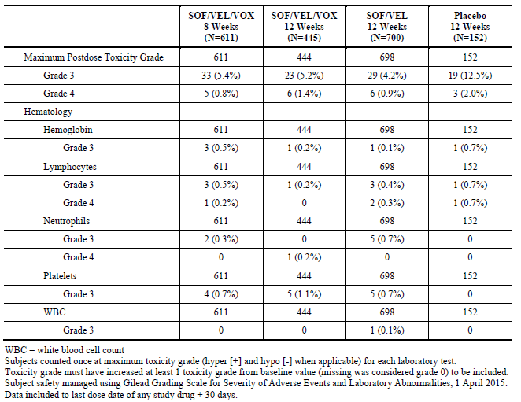

Pivotal studies in DAA experienced subjects
Study GS-US-367-1171 (POLARIS-1): In the SOF/VEL/VOX 12 Week group, Grade 3 haematology laboratory abnormalities were reported for decreased haemoglobin (0.4%, 1 subject) and decreased platelets (0.8%, 2 subjects). One subject (0.4%) had a Grade 4 haematology laboratory abnormality of decreased neutrophils: In the Placebo 12 Week group, Grade 3 haematology laboratory abnormalities were reported for decreased haemoglobin (0.7%, 1 subject) and decreased lymphocytes (0.7%, 1 subject); a Grade 4 haematology laboratory abnormality was reported for decreased lymphocytes (0.7%, 1 subject. The only Grade 3 coagulation laboratory abnormality was for INR: a Grade 3 INR was reported for 2 subjects (1.3%) in the Placebo 12 Week group and none in the SOF/VEL/VOX 12 Week group.
Study GS-US-367-1170 (POLARIS-4): Ten subjects had Grade 3 haematology laboratory abnormalities: 4 subjects (2.2%) in the SOF/VEL/VOX 12 Week group and 6 subjects (4.0%) in the SOF/VEL 12 Week group. No AEs were associated with any of these Grade 3 haematology laboratory abnormalities. No meaningful changes in median haemoglobin or median platelets were observed in either treatment group. One Grade 3 coagulation laboratory abnormality was observed in a subject in the SOF/VEL 12 Week group; this increased INR was not confirmed upon retest. No Grade 4 coagulation laboratory abnormality was observed in either treatment group.

Pivotal studies in DAA-naïve subjects
Study GS-US-367-1172 (POLARIS-2): In general, Grade 3 decreases in haemoglobin, lymphocytes and neutrophils were similar in both groups (either isolated events or intermittent and transient and none were assessed as AEs. All of the subjects with Grade 3 decreased platelets had cirrhosis and all had graded decreases in platelets at screening, baseline/Day 1 and during treatment. The only reported Grade 4 haematology laboratory abnormality was decreased lymphocytes (0.2%, 1 subject in the SOF/VEL 12 Week group).
Study GS-US-367-1173 (POLARIS-3): In general, haematology laboratory abnormalities were either isolated events or intermittent and transient and none were reported as AEs. The most commonly reported Grade 3 or 4 AEs were decreased haemoglobin, lymphocytes, platelets or neutrophils with no significant differences between treatment groups. There were no clinically meaningful changes in median haemoglobin or median platelet values during treatment with SOF/VEL/VOX or SOF/VEL.

Other studies
There were no clinically relevant changes in haematology parameters in the four Phase II studies.

Electrocardiograph findings and cardiovascular safety

Integrated safety analyses
Cardiac safety assessments included analysis of cardiac failure events, cardiac arrhythmia/ bradycardia events, the effect of beta blockers and calcium-channel blockers on heart rate and any safety events in subjects with amiodarone use during treatment.
Seven subjects in the Integrated Phase III Safety Population had cardiac arrhythmias/ bradycardia events: 1 subject in the SOF/VEL/VOX 8 Week group, 2 subjects in the SOF/VEL/VOX 12 Week group, 2 subjects in the SOF/VEL 12 Week group, and 2 subjects in the Placebo 12 Week group. One 85 year old male with history of hypertension, chronic AF and GI bleed receiving SOF/VEL/VOX for 12 weeks had a Grade 3 serious adverse event (SAE) of congestive heart failure on baseline/Day 1 prior to starting treatment with SOF/VEL/VOX. The AE was resolved and led to interruption of study drug for only 2 days; it was considered unrelated to study drug.
For subjects who received a beta blocker, a calcium-channel blocker with chronotropic effects (diltiazem or verapamil), or neither at any time during the first 2 weeks of study treatment, an analysis was performed to identify subjects with (1) any AE in the SOC of cardiac disorders and/or (2) the preferred terms of syncope and dizziness during that time. There were no subjects in the SOF/VEL/VOX 8 and 12 Week groups who received calcium channel blockers during the first 2 weeks of treatment and the data are presented only for the subjects who were or were not on beta blockers. Two subjects in the SOF/VEL 12 Week group and 1 subject in the Placebo 12 Week group received a calcium channel blocker during the first 2 weeks of study treatment, however no AEs of interest were reported during that time.
The number and percentage of subjects with AEs of interest during the first 2 weeks of treatment who were or were not using beta blockers during that time showed similar AE profile regardless of beta blocker use.
Of the 65 subjects in the SOF/VEL/VOX 8 Week group who used a beta blocker during the first 2 weeks of treatment, 5 subjects (7.7%) reported AEs of interest: 2 subjects experienced palpitations, 2 subjects experienced dizziness and 1 subject experienced acute myocardial infarction. All AEs were Grade 1 or Grade 2 in severity and only the event of acute myocardial infarction was considered serious. All events of palpitations and dizziness were considered related to study drug. None of these AEs resulted in an interruption or modification of dosing and all subjects completed study treatment. Of the 546 subjects in the SOF/VEL/VOX 8 Week group who did not take beta blockers during the first 2 weeks of treatment, 16 subjects (2.9%) experienced at least 1 of the defined AEs of interest, including dizziness (12 subjects, 2.2%), palpitations (3 subjects, 0.5%) and tachycardia (1 subject, 0.2%) during that time. Most of these (94%, 15 subjects) were Grade 1 events and none were considered serious.
Of the 56 subjects in the SOF/VEL/VOX 12 Week group who used a beta blocker during the first 2 weeks of treatment, 3 subjects (5.4%) had AEs of interest during that time: 2 subjects experienced dizziness and 1 subject experienced congestive cardiac failure, all of whom completed study treatment. The 2 AEs of dizziness were Grade 1 in severity, considered unrelated to study drug and did not result in an interruption or modification of dosing. The AE of congestive cardiac failure was Grade 3 in severity, and considered serious and unrelated to study drug. Of the 389 subjects in the SOF/VEL/VOX 12 Week group who did not take beta blockers during the first 2 weeks of treatment, 11 subjects (2.8%) experienced at least 1 of the defined AEs of interest, including dizziness (9 subjects, 2.3%), palpitations (1 subject, 0.3%) and ECG QT prolongation (1 subject 0.3%) during that time. Most of these (73%, 8 subjects) were Grade 1 events and none were considered serious.
Of the 64 subjects in the SOF/VEL 12 Week group who used a beta blocker during the first 2 weeks of treatment, none experienced an AE of interest during that time. Of the 634 subjects in the SOF/VEL 12 Week group who did not take beta blockers during the first 2 weeks of treatment, 13 subjects (2.1%) experienced at least 1 of the defined AEs of interest, including dizziness (11 subjects, 1.7%), palpitations (1 subject, 0.2%) and cardiac discomfort (1 subject, 0.2%) during that time. All of these (100%, 13 subjects) were Grade 1 events and none were considered serious.
Of the 26 subjects in the Placebo 12 Week group who used a beta blocker during the first 2 weeks of treatment, 1 subject (3.8%) with a family history of sudden cardiac death, had 2 AEs of interest during that time of ventricular fibrillation and atrial fibrillation. Of the 126 subjects in the Placebo 12 Week group who did not take beta blockers during the first 2 weeks of treatment, 8 subjects (6.3%) experienced at least 1 of the defined AEs of interest, including dizziness (8 subjects, 6.3%) during that time. Most of these (75%, 6 subjects) were Grade 1 events and none were considered serious.
Analysis of heart rate at baseline and during study treatment was performed for subjects who were taking a stable regimen of beta blocker or calcium-channel blocker (diltiazem or verapamil) and for subjects who were not taking a stable regimen of beta blocker or calcium-channel blocker during treatment. There were no subjects in any treatment group in the Integrated Phase III Safety Population taking stable calcium channel blockers and the data are presented for the subjects who were or were not taking beta blockers. The heart rate analyses did not reveal any trend of decreased heart rate for subjects using beta blockers during treatment with SOF/VEL/VOX, SOF/VEL, or placebo. The observed pulse decreases across the 4 groups were similar whether compared by median, 90th percentile or maximal on-treatment decrease, and none were clinically relevant; there was no difference in maximum on-treatment pulse rate in subjects who were or were not on stable beta-blocker use.
As symptomatic bradycardia has been reported in patients taking amiodarone with SOF in combination with another DAA, an analysis of AEs for subjects who received amiodarone while on study treatment was conducted. Only 1 subject in the Placebo 12 Week group received amiodarone during treatment.

Pivotal and/or main efficacy studies
There were no clinically relevant changes in the ECG in the individual pivotal Phase III studies with exception of one subject in the SOF/VEL 12 Week group in Study GS-US-367-1172 (POLARIS-2) who had an ECG with atrial flutter considered clinically significant at the Week 12 visit. The subject was asymptomatic.

Other studies
No clinically significant changes in ECG were reported in the four Phase II studies.

Vital signs and clinical examination findings
No clinically relevant changes from baseline in mean SBP. DBP, pulse or BMI were observed in the Phase III Integrated safety population, during the four Phase III studies or during the four Phase II studies.

Immunogenicity and immunological events

Integrated safety analyses, Pivotal and/or main efficacy studies, and Other studies
None.

Serious skin reactions

Integrated safety analyses
No dermatologic events were reported for any subjects in the Integrated Phase III Safety Population receiving SOF/VEL/VOX for 8 weeks, SOF/VEL for 12 weeks, or placebo. One subject in the SOF/VEL/VOX 12 Week group developed angioedema attributed by the investigator to ramipril initiated the day prior to the onset of the AE (one day prior to treatment discontinuation). This event led to premature discontinuation of study drug and was resolved on post treatment Day 4. The AE was considered unrelated to study drug by the investigator.

Pivotal and/or main efficacy studies
There was no serious skin reactions except one case of angioedema.

Other studies
No serious skin reactions were reported in the Phase II studies.

Other safety parameters
Besides the cardiac events, other adverse events of special interest (AESI) included Dermatologic events, pancytopenia (including aplastic anaemia) events, psychiatric events relevant to suicide ideation or attempt, pancreatitis events, rhabdomyolysis/myopathy events and renal failure.
No events of pancreatitis, rhabdomyolysis or myopathy were reported for any subjects in the Phase III Integrated Safety Population. No psychiatric events relevant to suicidal ideation/ attempt were reported for any subjects in the SOF/VEL/VOX 8 Week or 12 Week groups, or the Placebo 12 Week group. One subject receiving SOF/VEL for 12 weeks reported a psychiatric event.

Other safety issues

Safety in special populations
Adverse Events and Clinical Laboratory Evaluations by Demographics and Baseline Characteristics for the Integrated Phase III Safety Population.

Gender
The incidence of overall AEs was greater (≥ 10%) for female subjects compared with male subjects in the SOF/VEL/VOX 8 Week group (79.4% versus 66.9%) and the SOF/VEL/VOX 12 Week group (87.3% versus 74.9%) mainly due to a higher incidence of nausea and headache in females. In the Placebo 12 Week group, the incidence of overall AEs was slightly higher for female subjects compared with male subjects (74.2% versus 69.4%) primarily due to higher incidence of nausea and diarrhoea in females. In the SOF/VEL 12 Week group, the incidence of overall AEs was similar for female subjects compared with male subjects (72.6% versus 69.6%). The incidence of Grade 3 or 4 AEs and SAEs was similar for both females and males receiving SOF/VEL/VOX for 8 weeks (2.8% and 3.5%, respectively, for females and 1.8% and 2.1%, respectively, for males) or SOF/VEL/VOX for 12 weeks (3.9% and 2.9%, respectively, for females and 0.9% and 1.7%, respectively, for males). Similar percentages of females and males in the SOF/VEL/VOX 8 and 12 Week groups had Grade 3 or above laboratory abnormalities (4.6% and 7.6%, respectively, in the 8 Week group; and 5.0% and 7.0%, respectively, in the 12 Week group), and the most frequent Grade 3 or 4 laboratory abnormalities for both sexes were elevated glucose and elevated lipase.

Race
Across all treatment groups overall, the percentage of non-Black subjects with AEs (74.3%) was greater (> 10%) than the percentage of Black subjects with AEs (60.5%). This trend for more AEs in non-Black subjects compared to Black subjects was also seen within each treatment group, except for the Placebo group. This difference was mainly due to a greater overall incidence of general disorders and administration site conditions, gastrointestinal disorders, and infections and infestations in non-Black subjects (34.0%, 35.6% and 16.4%, respectively) compared with Black subjects (20.5%, 28.6% and 7.0%, respectively). Overall, the percentage of subjects with Grade 3 or 4 AEs or SAEs did not differ across race categories. Across treatment groups, there was a higher percentage of Grade 3 or above laboratory abnormalities in non-Blacks compared with Blacks (range: 5.3% to 16.2% compared with 1.6% to 4.5%, respectively)

Age
Overall, the percentage of AEs was similar for subjects < 65 years and ≥ 65 years of age (72.9% and 73.5%, respectively). Similar percentages of AEs were also seen between the age categories within the SOF/VEL/VOX 12 Week group and the SOF/VEL 12 Week group. The SOF/VEL/VOX 8 Week group had a higher percentage of AEs in subjects < 65 years than ≥ 65 years of age (73.6% and 63.2%, respectively), whereas the Placebo group had a lower percentage of AEs in subjects < 65 years of age (67.8% and 80.6%, respectively). Overall, the incidence of subjects with Grade 3 or 4 AEs or SAEs was low and did not differ across age categories. Across treatment groups, there was a slightly higher percentage of the number of Grade 3 or above laboratory abnormalities in subjects < 65 years of age compared with subjects ≥ 65 years of age (range: 5.1% to 16.5% compared with 3.5% to 6.5%, respectively).

BMI
Overall, the percentage of AEs was similar for subjects with a baseline BMI < 30 kg/m² and ≥ 30 kg/m² (73.0% and 72.7%, respectively). Similar percentages of AEs were also seen between the BMI categories within each treatment group. The rates of Grade 3 or above AEs and SAEs were low for both BMI groups: 1.4% and 1.9%, respectively, for subjects with BMI < 30 kg/m²; and 3.4% and 3.9%, respectively for subjects with BMI ≥ 30 kg/m²). Across treatment groups, there was a slightly higher percentage of the number of Grade 3 or above laboratory abnormalities in subjects with a baseline BMI ≥ 30 kg/m² compared with subjects with a baseline BMI < 30 kg/m² (range: 6.2% to 19.2% and 4.1% to 12.0%, respectively).

eGFR
Overall, the percentage of AEs was similar for subjects with a baseline eGFR < and > 90 mL/min (71.8% and 73.3%, respectively). Similar percentages of AEs were also seen between the eGFR categories within each treatment group. The rates of Grade 3 or above AEs and SAEs were low for both eGFR groups: 1.3% and 2.2%, respectively, for subjects with eGFR < 90 mL/min; and 2.1% and 2.6%, respectively for subjects with eGFR ≥ 90 mL/min. Across treatment groups, there was a higher percentage of the number of Grade 3 or above laboratory abnormalities in subjects with a baseline eGFR ≥ 90 mL/min compared with subjects with a baseline eGFR < 90 mL/min (range: 6.1% to 16.5% compared with 1.7% to 8.1%, respectively)

History of sulfa allergy
Safety was evaluated in subjects with or without a history of sulfa allergy in the Integrated Phase III Safety Population because the structure of VOX contains a sulphonamide. Overall, the percentage of AEs was similar for subjects with and without a history of sulfa allergy (77.8% and 72.8%, respectively). Across treatment groups, there were a total of 54 subjects with a history of sulfa drug allergy, 25 of who received SOF/VEL/VOX for either 8 of 12 weeks. Among subjects receiving SOF/VEL/VOX, the percentage of AEs was similar for subjects with or without a history of sulfa allergy (76.0% and 74.8%). The percentage was also similar for subjects with a history of sulfa allergy and receiving SOF/VEL/VOX, SOF/VEL, or placebo (76.0%, 83.3% and 60.0%, respectively). Among subjects with and without a history of sulfa allergy, AEs in skin and subcutaneous tissue disorders, including rash, were reported similarly by subjects taking SOF/VEL/VOX, SOF/VEL or placebo. There was one subject in the SOF/VEL/VOX 12 Week group without a history of sulfa allergy that reported a Grade 1 AE of urticaria on study Day 3 which resolved on study Day 55. This event was considered related to study drug by the investigator and did not result in a change in dosing.

Hepatic impairment
The SOF/VEL/VOX Phase III program included subjects with compensated cirrhosis (37.6%), but excluded subjects with a history of hepatic decompensation. Overall, the percentage of AEs was approximately the same for subjects with and without cirrhosis (72.8% and 73.0%, respectively). Similar percentages of AEs were also seen in subjects with and without cirrhosis within each treatment group, except for the Placebo group in which subjects with cirrhosis had fewer AEs (62.7%) compared to those without cirrhosis (74.3%). Overall, the rates of Grade 3 or above AEs and SAEs were similar for subjects with and without cirrhosis: 2.4% and 2.5%, respectively, for subjects with cirrhosis; and 1.7% and 2.4%, respectively for subjects without cirrhosis. The SAEs reported for more than 1 subject included cerebral haemorrhage in 2 subjects with cirrhosis, and road traffic accident in 2 subjects without cirrhosis, none of which were considered related to study drug by the investigator. Compared to other groups, subjects who received 12 weeks of placebo had more Grade 3 or 4 laboratory abnormalities consistent with untreated HCV infection and, within that group, more Grade 3 or 4 laboratory abnormalities were reported in subjects with cirrhosis (33.3%) compared to subjects without cirrhosis (5.0%). Across treatment groups with SOF/VEL/VOX and SOF/VEL, Grade 3 or above laboratory abnormalities were lower overall, but reported for a higher percentage of subjects with cirrhosis (range: 7.7% to 12.0%) than without cirrhosis (range: 3.4% to 5.4%). Overall, the primary Grade 3 or 4 laboratory abnormalities leading to the difference between cirrhotic and non-cirrhotic subjects were increased glucose (4.2%, 30 of 716 subjects; and 0.8% 9 of 1189 subjects, respectively) and decreased platelets (2.0%, 14 of 716 subjects; and 0.0%, respectively). A slight increase in Grade 1 total bilirubin was observed in subjects receiving SOF/VEL/VOX.

Renal impairment
The Phase III studies included in the Integrated Phase III Safety Population excluded subjects with eGFR < 50 mL/min. However, 24.2% of subjects in the Integrated Phase III Safety Population had mild renal impairment. The 461 subjects having eGFR < 90 mL/min at baseline in the Integrated Phase III Safety Population had similar percentages of AEs, Grade 3 or 4 AEs, SAEs, and graded laboratory abnormalities compared to the 1447 subjects with baseline eGFR ≥ 90 mL/min.

Pregnancy and lactation
Nonclinical studies of SOF/VEL/VOX as an FDC were not performed, as co-administration of SOF, VEL and VOX in the SOF/VEL/VOX FDC tablet is not expected to alter the effect of any component during pregnancy or lactation. Therefore, the studies conducted with SOF, VEL and VOX as individual agents support the use of SOF/VEL/VOX.
There are no adequate and well controlled clinical studies in pregnant women. Pregnant and breastfeeding women were excluded in all clinical studies conducted to date with SOF, VEL, SOF/VEL and SOF/VEL/VOX. Women of childbearing potential included in studies were required to use 2 highly effective methods of birth control. Pregnancy, once determined required withdrawal of the subject from the study.
Overall, 2 pregnancies were reported for subjects who received SOF/VEL/VOX or SOF/VEL+VOX in the clinical development program. In Study GS-US-367-1172 (POLARIS-2) in DAA naïve patients, 2 subjects in the SOF/VEL/VOX 8 Week group became pregnant during the study; (1) a 29 year old female without cirrhosis, prematurely discontinued study drug on Day 28 following confirmation of pregnancy. The pregnancy ended in an elective abortion. (2) a 43 year old female without cirrhosis, had pregnancy confirmed on post treatment Day 55, after completing 8 weeks of treatment. The pregnancy ended in a miscarriage, which was reported as a non-treatment emergent SAE.

Overdose, drug abuse, withdrawal/rebound, effects on ability to drive or operate machinery or impairment of mental ability
There is no known antidote for SOF/VEL/VOX. If an overdose with SOF/VEL/VOX occurs, standard supportive treatment should be given as necessary, including observation of the clinical status of the patient and monitoring of vital signs. Haemodialysis can efficiently remove the predominant circulating SOF metabolite, GS-331007, with an extraction ratio of 53%. Haemodialysis is unlikely to result in significant removal of VEL or VOX, as they are highly bound to plasma proteins.
SOF, VEL and VOX are not pharmacologically or structurally related to drugs known to have abuse potential; therefore, drug abuse with SOF/VEL/VOX is unlikely. There have been no reports of SOF/VEL/VOX dependence from any clinical study.
No formal clinical studies for withdrawal or rebound effects of SOF/VEL/VOX have been conducted. However, there were no discernible patterns of AEs occurring after treatment discontinuation from a SOF/VEL/VOX-containing regimen.
No studies have been conducted to evaluate the effects of SOF/VEL/VOX on the ability to drive or operate machinery.

Safety results from dose finding clinical pharmacology studies
As the SOF/VEL FDC has been previously approved for marketing in Australia, two dose finding studies were undertaken as part of the current application to examine the safety and tolerability of VOX.
Study GS-US-338-1120 investigated escalating single and multiple oral doses of VOX ranging from 30 mg to 300 mg in healthy subjects. A total of 16 of 81 subjects had an AE in this study. The most frequently reported AEs across all subjects were headache (7 subjects), constipation (3 subjects) and nausea (3 subjects). In the single and multiple ascending dose part of the study there was no difference in the incidence of subjects with AEs with increasing doses of VOX. In addition, no notable differences in laboratory abnormalities were observed between the VOX 30 mg, 100 mg, 300 mg or placebo treated groups.
Study GS-US-338-1121 was undertaken in subjects with genotype 1a and genotype 3 HCV and examined VOX doses ranging from 50 to 300 mg or placebo administered QD for three days. The most commonly reported AEs included diarrhoea and headache and there was no evidence of dose-dependency with respect to the incidence of any AEs. In addition, there was no evidence of a dose dependent relationship between the incidence of Grade 3 and Grade 4 laboratory abnormalities and VOX dose, nor were Grade 3 or Grade 4 laboratory abnormalities associated with AEs.

Safety related to drug-drug interactions and other interactions
In the four DDI studies in which subjects were co-administered with either Vosevi or Vosevi + VOX, 62 of 183 subjects experienced AEs. There were no Grade 3 or 4 AEs, SAEs or deaths and the most commonly occurring AEs across all studies were headache and constipation. In the single DDI study in which VOX alone was co-administered, 55 of 98 subjects experienced AEs. There were no Grade 3 or 4 AEs, SAEs or deaths and the most commonly occurring AEs were nausea (n = 4) and headache (n = 2).

Post-marketing data
Sofosbuvir/velpatasvir/voxilaprevir has not been marketed in any country at the time of this marketing application.
In accordance with both US and European Union guidelines, Gilead is conducting 3 registry studies, in which subjects are being followed for up to 3 or 5 years after their initial treatment study. Subjects who do not achieve SVR are eligible for enrolment in the Sequence Registry Study (GS-US-248-0123), which is monitoring the persistence of resistance mutations for up to 3 years. Subjects who achieve SVR are eligible for enrolment in the SVR Registry Study (GS-US-248-0122), which is evaluating durability of SVR for up to 3 years post treatment. Subjects with cirrhosis who achieve SVR following treatment with a SOF-based regimen without IFN are eligible for enrolment in the SVR Cirrhosis Registry Study (GS-US-337-1431), which is evaluating durability of SVR and clinical progression or regression of liver disease (including the incidence of HCC) for up to 5 years.

Evaluator’s conclusions on safety
A comprehensive nonclinical pharmacology and virology, PK and toxicology program was undertaken to support SOF/VEL/VOX for the treatment of HCV. No specific safety findings from the nonclinical program have been identified as safety events of interest in the clinical development program. A total of 2017 subjects have received at least 1 dose of SOF/VEL/VOX or SOF/VEL+VOX, including 1056 subjects in 4 SOF/VEL/VOX Phase III studies, 543 subjects in 4 SOF/VEL/VOX or SOF/VEL+VOX Phase II studies and 418 subjects in 7 SOF/VEL/VOX, SOF/VEL+VOX, or SOF/VEL/VOX+VOX Phase I studies. Of the 1912 subjects who were randomised or enrolled into the 4 Phase III studies that comprise the Integrated Phase III Safety Population, 1,908 received at least 1 dose of study drug and were included in the Safety Analysis Set. This Safety Analysis Set included 611 subjects who received at least 1 dose of the SOF/VEL/VOX 8 week regimen, 445 subjects who received at least 1 dose of the SOF/VEL/VOX 12 week regimen, 700 subjects who received at least 1 dose of the SOF/VEL 12 week regimen and 152 subjects who received at least 1 dose of the Placebo 12 week regimen.
The demographic and baseline disease characteristics of the 1056 HCV infected subjects who were treated with SOF/VEL/VOX in the Integrated Phase III Safety Population are representative of the broad HCV infected population, taking into consideration that subjects who received 12 weeks of treatment were DAA experienced subjects enrolled in Study GS-US-367-1171 (POLARIS-1) and Study GS-US-367-1170 (POLARIS-4), and those who received 8 weeks of treatment were DAA naive subjects enrolled in Study GS-US-367-1172 (POLARIS-2) and Study GS-US-367-1173 (POLARIS-3). Compared to the DAA naive subjects receiving 8 weeks of SOF/VEL/VOX, the DAA experienced subjects who received 12 weeks of SOF/VEL/VOX (12 weeks versus 8 weeks) were more likely to be male (77.1% versus 53.8%), older (mean age (range): 58 years (24 to 85 years) versus 53 years (18 to 78 years)), cirrhotic (46.1% versus 32.7%) and infected with HCV genotype 1 (51.2% versus 38.1%), consistent with the population of patients who have been prioritised for and failed prior treatment with DAAs to date.
Overall, the number and characteristics of patients evaluated in the SOF/VEL/VOX clinical study was adequate to assess safety of the proposed FDC in treatment of chronic HCV infection.
Treatment with SOF/VEL/VOX for 8 or 12 weeks in the Integrated Phase III Safety Population was safe and well tolerated, irrespective of age, sex, race and cirrhosis status, with no drug related SAEs and 1 treatment discontinuation due to AE. In general, the AE profile was similar between subjects receiving SOF/VEL/VOX, SOF/VEL and placebo. Across all groups, there was a low frequency of Grade 3 or 4 AEs, SAEs and AEs leading to discontinuation. Overall, in the Integrated Phase III safety population, the AE profile was similar between subjects receiving SOF/VEL/VOX, SOF/VEL and placebo. Across all groups, 1.9% of subjects had Grade 3 or 4 AEs, 2.5% had SAEs and 0.4% had AEs leading to discontinuation (Table 25). The only SAE reported in more than 1 subject was cerebral haemorrhage, which was reported for 2 subjects, 1 of whom had poorly controlled hypertension and another who had hypertension as well as diabetes and hyperlipidaemia. There were two deaths, 1 treatment-emergent illicit drug overdose and 1 non-treatment emergent death due to complications from pre-existing hypertension.

Table 25: Overall summary of adverse events in the SOF/VEL/VOX integrated Phase III safety population (safety analysis set)
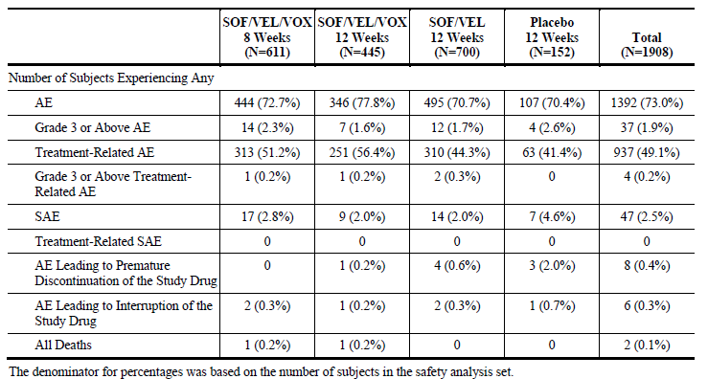
Subjects treated with SOF/VEL/VOX for 8 or 12 weeks had a higher incidence of gastrointestinal AEs (mainly diarrhoea and nausea) compared with subjects treated with SOF/VEL for 12 weeks which was consistent with the known effects of some NS3/4A Pis. The incidence of diarrhoea was 17.2%, 18.7%, 6.3% and 12.5% in the SOF/VEL/VOX 8 week, SOF/VEL/VOX 12 week, SOF/VEL 12 week and placebo groups, respectively; corresponding incidence of nausea was 16.9%, 13.3%, 8.9% and 7.7%, respectively. However, the diarrhoea and nausea reported in subjects receiving SOF/VEL/VOX were mostly mild and were not treatment-limiting with no subject discontinuing or interrupting treatment due to diarrhoea or nausea.
Although the structure of VOX contains a sulphonamide which is known to be a frequent cause of allergic drug reactions, there was no signal for allergic reaction among subjects receiving SOF/VEL/VOX with or without a history of sulfa allergy. The incidence of AEs for subjects with a history of sulfa allergy receiving SOF/VEL/VOX was not different from the incidence for subjects receiving SOF/VEL/VOX without a history of sulfa allergy or the incidence for subjects with a history of a sulfa allergy receiving SOF/VEL or placebo. Interpretation may have been limited by small number of subjects with sulfa allergy.
A comprehensive analysis of safety events historically associated with some antiviral nucleoside/nucleotide inhibitors was performed for SOF/VEL/VOX in the Integrated Phase III Safety Population, including cardiac events, dermatologic events, pancytopenia events, psychiatric events related to suicide ideation or attempt, pancreatitis events, rhabdomyolysis/ myopathy events and renal events. Cardiac safety was assessed by an analysis of AEs related to cardiac failure or arrhythmias/bradycardia. One subject had a Grade 3 SAE of congestive heart failure and 3 subjects who received SOF/VEL/VOX experienced cardiac arrhythmias. Heart rate analyses among subjects taking a stable beta blocker did not reveal any trend of decreased heart rate during treatment with SOF/VEL/VOX. Notably, no treatment-emergent pancytopenia events, psychiatric events related to suicide ideation or attempt, pancreatitis events, rhabdomyolysis/myopathy events or renal failure were observed in subjects receiving SOF/VEL/VOX. One subject experienced a dermatologic event of angioedema that led to discontinuation of SOF/VEL/VOX. The angioedema was assessed as unrelated to study drug and attributed to ramipril initiated the day prior to the onset of the AE (one day prior to treatment discontinuation).
In the Phase III Integrated Safety Population, graded laboratory abnormalities were observed more often in the Placebo 12 Week group (75.7%) and SOF/VEL/VOX 12 Week group (68.9%) compared to the SOF/VEL/VOX 8 Week group (57.8%) and SOF/VEL 12 Week group (58.7%), largely due to the higher rates of graded ALT and AST abnormalities consistent with untreated HCV infection. The higher incidence of graded laboratory abnormalities in the SOF/VEL/VOX 12 Week group compared to the 8 Week group was mostly due to more subjects in the 12 week group with Grade 1 or 2 laboratory abnormalities (62.4%), notably in decreased platelets and increased total bilirubin, consistent with more subjects with cirrhosis enrolled in the 12 week duration regimen in the studies for DAA experienced subjects.
The rate of Grade 3 or 4 laboratory abnormalities in the SOF/VEL/VOX groups was similar to the SOF/VEL group and lower than the Placebo group. A similar pattern of Grade 3 or 4 laboratory abnormalities was seen across the groups. In the SOF/VEL/VOX groups, Grade 3 elevations in glucose were seen in a small number of subjects (2.2%), all of whom had diabetes and/or elevations in glucose prior to dosing. Grade 4 elevations observed during treatment with SOF/VEL/VOX included lipase (5 subjects with asymptomatic, single isolated or transient, intermittent events) and creatine kinase (4 subjects with elevations related to exercise with no cases of rhabdomyolysis).
The overall safety profile for the Phase II Safety Population was similar to that of the Integrated Phase III Safety Population. Treatment with SOF/VEL/VOX and SOF/VEL+VOX was generally safe and well tolerated. Overall, SOF/VEL/VOX, SOF/VEL+VOX were generally well tolerated in the Phase I studies, and no safety signal was identified.
Due to the known association of some NS3/4A Pis with hepatotoxicity, particular attention was given to hepatic events and liver related abnormalities in the SOF/VEL/VOX clinical development program. The rates of Grade 3 or 4 elevations in total bilirubin, ALT and AST among subjects receiving SOF/VEL/VOX were low and similar to those receiving SOF/VEL. Slight increases in total bilirubin values were observed, consistent with VOX inhibition of OATP1B1 and OATP1B3. No pattern of VOX-associated ALT elevation was observed; of the 1056 subjects receiving SOF/VEL/VOX in the Integrated Phase III Safety Population, 1 subject had a Grade 3 elevation in ALT (0.1%) and none had a Grade 4 elevation in ALT.
Seventeen subjects (1.6%) met prespecified criteria for on-treatment elevations in liver related laboratory parameters (for example, total bilirubin, ALT and AST). This rate was comparable to that in the SOF/VEL group (8 subjects, 1.1%) and lower than that in the Placebo group (8 subjects, 5.2%). Of these 17 subjects meeting the prespecified criteria in the SOF/VEL/VOX groups, 8 subjects with ALT > 5 x upper limit of normal (ULN) had elevated values at screening and/or baseline, with a subsequent decline on treatment with viral suppression, 8 subjects with total bilirubin > 2 x ULN had cirrhosis and/or elevated values at screening or baseline and 1 subject met all criteria who had cirrhosis and heavy alcohol use confirmed during post treatment.
Overall, potential hepatotoxicity of the proposed SOF/VEL/VOX was adequately evaluated in the clinical studies and of the 46 cases reviewed by the IAC in the Integrated Phase III and Phase II Safety Population; the IAC determined 1 case to be “Possibly” DILI and 1 case to be “Probably DILI”.
Overall, treatment with SOF/VEL/VOX for 8 or 12 weeks in HCV-infected subjects in the Integrated Phase III Safety Population was well tolerated with a low frequency of Grade 3 or 4 AEs, SAEs and AEs leading to discontinuation of SOF/VEL/VOX; no SAEs were assessed as related to SOF/VEL/VOX. Compared to SOF/VEL and placebo, there are similar rates of AEs overall, with the only notable difference being increased rates of mild (Grade 1) nausea and diarrhoea.
Limitations of safety data:
- In DAA-treatment naïve HCV patients, addition of VOX in the proposed FDC did not offer any tolerability or safety advantage compared to 12 weeks treatment with the SOF/VEL FDC.
- Safety of SOF/VEL/VOX FDC was not evaluated in HCV patients with HBV or HIV co-infection or in patients with liver transplants.

First round benefit-risk assessment

First round assessment of benefits

Table 26: First round assessment of benefits
Benefits | Strengths and Uncertainties
Treatment with SOF/VEL/VOX for 12 weeks in DAA experienced subjects demonstrated consistently high SVR12 rates. | SOF/VEL/VOX administered for 12 weeks in Studies GS-US-367-1171 (POLARIS-1) and GS-US-367-1170 (POLARIS-4) resulted in SVR12 rates of 96.2% and 97.3%, respectively. The contribution of VOX to the regimen was demonstrated in POLARIS-4, where overall and across subgroups SOF/VEL/VOX for 12 weeks led to higher SVR12 rates compared to SOF/VEL for 12 weeks. The SVR12 rates were consistent between the Phase II and Phase III studies.  No SVR24 data were provided in this submission, although sponsors have assured that these will be provided on completion of the studies.
There are no currently approved regimens for patients who have not achieved SVR following treatment with the DAA-containing regimens as defined in these studies. The SOF/VEL/VOX FDC was granted Breakthrough Therapy designation by the FDA for the treatment of chronic genotype 1 HCV patients who previously failed an NS5A inhibitor containing regimen. | In POLARIS-1, 61% of patients had failed prior treatment with NS5B+NS5A inhibitor (SOF+LDV was most common prior treatment); 31% had failed prior treatment with NS5A inhibitor + NS3 inhibitor with or without another DAA. In POLARIS-4, 73% of patients had received prior treatment with a NS5B inhibitor and 25% had received NS5B+NS3 inhibitor.
Efficacy of proposed FDC of SOF/VEL/VOX for 12 weeks was shown in HCV adult DAA experienced patients across genotypes. | POLARIS-1: SVR12 rates following Vosevi treatment for 12 weeks by HCV genotype were:  GT-1a = 96% (97/101), GT1b = 100% (45/45), GT-2 = 100% (5/5), GT-3 = 95% (74/78), GT-4 = 91% (20/22), GT-5 = 100% (1/1), GT-6 = 100% (6/6). None of subjects in placebo groups achieved SVR4. SVR12 rate was 92.9% in subjects with genotype 3 HCV infection and cirrhosis.  POLARIS-4: SVR12 rates by HCV genotypes following 12 weeks treatment with Vosevi versus SOF/VEL were:  - GT1a = 98% (53/54) versus 89% (39/44  - GT-1b = 96% (23/24) versus 95% (21/22)  - GT-2 = 100% (31/31) versus 97% (32/33)  - GT-3 = 94% (51/54) versus 85% (44/52)  - GT-4 = 100% (19/19) versus 0/0.
Efficacy of proposed FDC of SOF/VEL/VOX for 12 weeks was shown in HCV adult DAA experienced patients with and without compensated cirrhosis. | POLARIS-1: SVR12 rate with Vosevi was:  - Without cirrhosis = 98.6% (140/142)  - With compensated cirrhosis = 93.4% (113/121).  POLARIS-4 Vosevi versus SOF/VEL:  Without cirrhosis: 98% (96/98) versus 93.9% (77/82) With compensated cirrhosis: 96.4% (81/84) versus 85.5% (56/69).
Efficacy of proposed FDC of SOF/VEL/VOX for 12 weeks in HCV adult DAA experienced patients was not affected by type of prior DAA treatments. | POLARIS-1: SVR12 rates by prior HCV treatment regimens were high regardless of prior DAA class combinations: NS5A+NS5B inhibitor = 93.8% (151 of 161), NS5A+NS3 inhibitor±NS5B inhibitor = 100.0% (83 of 83) or specific DAA combinations: LDV+SOF = 94.7% (107 of 113), DCV+SOF = 94.3% (33 of 35).  POLARIS-4: SVR12 rates were higher in the Vosevi group compared with the SOF/VEL group for all subgroups of prior DAA exposure:  Non NS5A+DAAs = 97.3% versus 90%  NS5B only = 97% versus 90.8%  NS5B+NS3 = 97.8% versus 86.8%
Simple once daily oral dosing. | This may help improve treatment compliance.
Baseline RAV status did not affect efficacy of proposed SOF/VEL/VOX FDC and it was effective against substitutions associated with resistance to other classes of DAAs with different mechanisms of action. | In POLARIS-1, SVR12 was achieved for 97% (199/205) and 98% (42/43) with or without any NS3 or NS5A RAVs, respectively; SVR12 was achieved in 95% (18/199) patients with baseline NS5B RAVs.  In POLARIS-4, SVR12 was achieved for 100% (83/83) and 99% (84/85) with or without any NS3 or NS5A RAVs, respectively; SVR12 was achieved in 100% (14/14) patients with baseline NS5B RAVs.
SVR12 rates following treatment with 8 weeks of Vosevi and 12 weeks of SOF/VEL were similar in DAA-treatment naïve patients with HCV genotype 3 and compensated cirrhosis (POLARIS-3).  The reduced duration of treatment could potentially help to improve treatment adherence in regions of the world where genotype 3 HCV is more prevalent. | However, there was inadequate evidence to support 8 weeks treatment with SOF/VEL/VOX over currently approved treatment with SOF/VEL (for 12 weeks) in HCV patients with other genotypes (POLARIS-2).  Efficacy of 12 weeks treatment with SOF/VEL/VOX in DAA-treatment naïve HCV patients was not evaluated.
DCV: Daclatasvir (BMS-790052)

First round assessment of risks

Table 27: First round assessment of risks
Risks | Strengths and Uncertainties
Treatment with SOF/VEL/VOX FDC for 8 or 12 weeks was associated with higher incidence of diarrhoea and nausea compared to SOF/VEL or placebo treatment groups. This may potentially affect treatment compliance. | Diarrhoea and nausea reported in subjects receiving SOF/VEL/VOX were mostly mild and were not treatment-limiting with no subject discontinuing or interrupting treatment due to diarrhoea or nausea.
Important identified risk of severe bradycardia and heart block when used with concomitant amiodarone.  Risks of other drug interactions with moderate and potent inducers of Pgp, CYP3A4, CYP2C8 and/or CYP2B6, PPis, rosuvastatin, pravastatin, Pgp substrates with a narrow therapeutic window (for example, digoxin), TDF. | Adequate instructions and warnings provided in the proposed PI, CMI and RMP.
Risk of development of resistance
Increased lipases most common grade 3/ 4 laboratory abnormality | However, none of the Grade 3/ 4 AEs of increased lipases was associated with pancreatitis.
Increased serum glucose was common laboratory abnormality. | Almost all patients with increased serum glucose had medical history of diabetes.
Increased total bilirubin | Grade 1 elevations in total bilirubin were not associated with AEs of jaundice and were not clinically significant. These effects of VOX were similar to other NS3/4A Pis (which are inhibitors of OATP1B1 and OATP1B3 which transport bilirubin into hepatocytes, likely resulting in the small observed increase in total bilirubin).
Lack of SVR24 data following treatment with proposed FDC in the pivotal Phase III studies. | Sponsors have assured that the SVR24 data will be provided in the final CSRs.
No efficacy/ safety data in HCV patients with HBV or HIV co-infection or in liver transplant patients.
No efficacy/ safety data in children, patients with severe renal impairment, moderate to severe hepatic impairment, pregnancy.

First round assessment of benefit-risk balance
Chronic hepatitis C virus (HCV) infection is a major public health challenge for Australia and is the most common cause of liver disease requiring liver transplantation in Australia. The burden of liver disease due to HCV is projected to triple by 2030. However, HCV infection is curable, and viral eradication is associated with multiple clinical benefits, including improvement in quality of life, loss of infectivity, regression of cirrhosis, lower risk of liver failure and HCC, and reduction in mortality. Until recently, the treatment of HCV involved interferon therapy, which had limited efficacy and was poorly tolerated. The introduction of direct acting antiviral (DAA) therapies for HCV that are highly effective and well tolerated is a major medical advance.
The proposed Vosevi regimen combines 400 mg of sofosbuvir, a nucleotide analogue NS5B polymerase inhibitor, with 100 mg of velpatasvir, an NS5A inhibitor, and 100 mg of voxilaprevir, an investigational pan-genotypic NS3/4A protease inhibitor (SOF/VEL/VOX). Vosevi has been evaluated in a diverse range of subjects with respect to demographic characteristics including prior HCV treatment experience, cirrhosis status and HCV genotype which is representative of the target patient population in all geographic areas.
The main evidence to support the proposed SOF/VEL/VOX FDC was provided by two pivotal Phase III studies (POLARIS-1 and POLARIS-4), which evaluated 12 weeks of the fixed dose combination in DAA experienced patients with HCV genotypes 1-6, including those who failed prior treatment with an NS5A inhibitor containing regimen. Across the two pivotal Phase III studies, 97% of patients treated with SOF/VEL/VOX (n = 430/445) achieved the primary efficacy endpoint of SVR12. In DAA experienced subjects without cirrhosis or with compensated cirrhosis, treatment with SOF/VEL/VOX for 12 weeks was a highly efficacious treatment for HCV infection regardless of genotype or prior DAA treatment. There was a low rate of virologic failure following treatment with SOF/VEL/VOX administered for 12 weeks and no impact of baseline RAVs on treatment outcome.
In these studies, subjects whose only DAA exposure was an NS3/4A protease inhibitor were excluded, given the availability of approved regimens to treat these individuals (for example, LDV/SOF and SOF/VEL).
The marketing authorisation application (MAA) also includes data from two additional Phase III studies (POLARIS-2 and POLARIS-3), which evaluated 8 weeks of SOF/VEL/VOX in 611 DAA-naïve patients with genotypes 1-6. In POLARIS-3, 96 percent of patients with genotype 3 infection and cirrhosis treated with SOF/VEL/VOX (n = 106/110) achieved the primary efficacy endpoint of SVR12. In POLARIS-2, SOF/VEL/VOX for 8 weeks in DAA-naïve subjects demonstrated high SVR12 rates, but did not demonstrate non-inferiority to 12 weeks of treatment with SOF/VEL (Table 10). This difference between the regimens was primarily due to a lower SVR12 rate (91.7%) in subjects with genotype 1a HCV infection treated with SOF/VEL/VOX for 8 weeks. Overall, there was inadequate evidence to support 8 weeks treatment with SOF./VEL/VOX over currently approved treatment with SOF/VEL in HCV patients with the exception of GT3 with compensated cirrhosis. Furthermore, the proposed PI only provides dosing recommendations in HCV patients who have failed treatment with at least one prior DAA. There are no recommendations regarding DAA-treatment naïve HCV in the proposed PI although the proposed indication is for all adult patients with chronic HCV.
The SOF/VEL/VOX clinical development program has allowed extensive characterisation of the safety of the proposed FDC especially the high number of subjects with cirrhosis enrolled in the Integrated Phase III Safety Population provides evidence for safety of the proposed SOF/VEL/VOX FDC in this more vulnerable population. Overall, treatment with SOF/VEL/VOX for 8 or 12 weeks in HCV-infected subjects in the Integrated Phase III Safety Population was well tolerated with a low frequency of Grade 3 or 4 AEs, SAEs and AEs leading to discontinuation of SOF/VEL/VOX; no SAEs were assessed as related to SOF/VEL/VOX. Compared to SOF/VEL and placebo, there are similar rates of AEs overall, with the only notable difference being increased rates of mild (Grade 1) nausea and diarrhoea.
Direct acting antiviral treatments have transformed the treatment of chronic hepatitis C. However, for some patients who have failed to achieve a cure with these regimens, effective and well tolerated therapies are still needed. The proposed Vosevi FDC of SOF/VEL/VOX has the potential to fill that need by offering single tablet dosing and high cure rates across all HCV genotypes for patients with and without cirrhosis, who have failed prior treatment with other highly effective regimens. Vosevi is proposed as a salvage therapy for patients with HCV genotypes 1 through 6 who were not cured with previous treatments of direct acting antivirals. The FDA has granted the investigational drug breakthrough therapy designation for the treatment of patients with chronic genotype 1 hepatitis C who have previously failed an NS5A inhibitor containing regimen.
Overall, the cumulative efficacy data support the use of SOF/VEL/VOX for 12 weeks for the treatment of HCV infection in patients who have failed treatment with at least one prior DAA, regardless of genotype, in patients without cirrhosis or with compensated cirrhosis. However, there is inadequate evidence to support use in all DAA-treatment naïve HCV patients; the only definite evidence of efficacy of SOF/VEL/VOX (8 weeks treatment) was in DAA-naïve patients with HCV GT3 infection and compensated cirrhosis. Furthermore, the proposed 12 week treatment with SOF/VEL/VOX was not evaluated in DAA-treatment naïve patients. The pivotal studies are still on-going and detailed resistance data will be available in the final study reports. The impact of drug resistant HCV variants in patients who do not achieve SVR12 cannot be quantified, but it is a potential risk for the wider community. However, the overall risk is low because the percentage of patients with virologic failure and relapse following treatment with Vosevi is extremely low. The proposed FDC of SOF/VEL/VOX was not evaluated in HCV patients with HBV or HIV co-infection or in patients with renal/ liver transplants and patients with decompensated cirrhosis. Hence, the generalised proposed indication which implies that Vosevi can be used in all adult patients with chronic HCV is not justified.
The benefit-risk balance of Vosevi is unfavourable for the proposed usage (treatment of chronic hepatitis C virus (HCV) infection in adults) but may become favourable if changes recommended below are adopted.

First round recommendation regarding authorisation
Approval is not recommended for Vosevi (SOF/VEL/VOX 400/100/100 mg) for proposed indication:
Vosevi (sofosbuvir/velpatasvir/voxilaprevir fixed dose combination) is indicated for the treatment of chronic hepatitis C virus (HCV) infection in adults.
Overall, the cumulative efficacy data support the use of SOF/VEL/VOX for 12 weeks for the treatment of HCV infection in adult patients who have failed treatment with at least one prior DAA, regardless of genotype, in patients without cirrhosis or with compensated cirrhosis. However, there is inadequate evidence to support use of 8 weeks of treatment with SOF/VEL/VOX in DAA-treatment naïve patients and efficacy of 12 weeks treatment with proposed FDC in DAA-treatment naïve patients was not evaluated. Hence, the wording of the proposed indication should specify that Vosevi can only be used in patients who have failed at least one prior DAA treatment.
Furthermore, the proposed indication should provide reference to ‘dosing and administration’ and ‘clinical trials’ sections of PI.
Hence, it is recommended that Vosevi be approved for the following modified indication:
Vosevi (sofosbuvir/velpatasvir/voxilaprevir fixed dose combination) is indicated for the treatment of chronic hepatitis C virus (HCV) infection in adults who have failed treatment with at least one prior DAA, regardless of genotype, in patients without cirrhosis or with compensated cirrhosis (see dosage and administration and clinical trials)
Approval for the above modified indication is also subject to the following:
- Incorporation of suggested changes to the proposed PI and CMI.
- Satisfactory response to clinical questions.
- Provision of data evaluating the concordance between SVR12 and SVR24 from the final reports of each of the Phase III studies of the SOF/VEL/VOX development program (GS-US-367-1171 (POLARIS-1), GS-US-367-1170 (POLARIS-4), GS-US-367-1172 (POLARIS-2) and GS-US-367-1173 (POLARIS-3)).

Clinical questions and second round evaluation

Question 1 (Efficacy):
Could you please provide SVR24 data from the 4 pivotal Phase III studies, if it has been completed.

Sponsor’s response
SVR24 data by post-treatment visit for POLARIS-1, POLARIS-2, POLARIS-3 and POLARIS-4 was provided in the response.
Gilead proposes to update the data from POLARIS-4 and POLARIS-2 in (SVR12 in DAA-Experienced and DAA-Naive Patients With or Without Baseline RAVs) and in (SVR12 by HCV Genotype and Virologic Outcome in POLARIS-4 and POLARIS-2 based on a post-treatment Week 24 analysis of virologic outcome. In these two studies, there were subjects who were initially counted as not having achieved SVR12 because of a missed post treatment Week 12 visit who then returned for the post-treatment Week 24 visit and had an HCV RNA < lower limit of quantitation (LLOQ); as per the statistical analysis plan, these subjects were imputed as having achieved SVR12 in the final analysis. These updates have been incorporated into the United States Prescribing Information, the EU Summary of Product Characteristics and Canadian Product Monograph. Similar post-treatment Week 24 analyses of SVR12 and virologic outcome were also conducted for POLARIS-1 and POLARIS-3; however, no revisions were needed.

Evaluator’s comments on sponsor’s response:
Review of this SVR24 data indicates maintenance of long term efficacy over 24 months in all 4 studies (Refer Table 43).

Question 2 (Safety)
There is lack of data on safety in patients with HBV or HIV co-infection or in those with liver transplants. Do you plan to conduct any studies in these patient populations?

Sponsor’s response:
Gilead is not planning further studies with Vosevi in these specific patient populations, as described further below.
HCV/HBV Coinfection: Gilead has conducted clinical studies treating subjects with untreated chronic HBV infection with ledipasvir/sofosbuvir (GS-US-337-0122 and GS-US-337-1655). Given there is no data suggesting that the risk of HBV reactivation differs among DAA regimens, Gilead does not plan to study SOF/VEL/VOX in HCV/HBV coinfection. The current PI provides information on the screening for HBV and risk and monitoring for HBV reactivation during HCV treatment with DAAs.
HCV/HIV Coinfection: Given that HCV/HIV coinfection is no longer considered a special population outside management of drug-drug interactions and that results from the Phase I drug-drug interaction studies (GS-US-367-1657 and GS-US-380-1999) provide information in the PI on safe concomitant use of HIV medications with SOF/VEL/VOX, Gilead does not plan to conduct a study in subjects with HCV/HIV coinfection.
Liver Transplant: There are no plans to conduct a study with SOF/VEL/VOX in patients following liver transplant. Relevant Phase I data on drug-drug interactions with tacrolimus and cyclosporine are included in the current PI and provide relevant information on the safe concomitant use of immunosuppressants in this patient population.
Further information on the safety of SOF/VEL/VOX use in HCV/HBV, HCV/HIV co-infected and liver transplant patients will be obtained through routine pharmacovigilance.

Evaluator’s comments on sponsor’s response:
The sponsor’s response is satisfactory.

Second round benefit-risk assessment

Second round assessment of benefits
After consideration of the responses to clinical questions, the benefits of Vosevi in the proposed usage are unchanged from those identified in the first round assessment of benefits.

Second round assessment of risks
After consideration of the responses to clinical questions, the risks of Vosevi in the proposed usage are unchanged from those identified in the first round assessment of risks.

Second round assessment of benefit-risk balance
The benefit risk balance of Vosevi is favourable for the following proposed indication:
Vosevi (sofosbuvir/velpatasvir/voxilaprevir fixed dose combination) is indicated for the treatment of chronic hepatitis C virus (HCV) infection in adults who have failed treatment with at least one prior DAA, regardless of genotype, in patients without cirrhosis or with compensated cirrhosis (see dosage and administration and clinical trials).

Second round recommendation regarding authorisation
Approval of Vosevi is recommended for the proposed indication (above in the second round assessment of benefit risk balance).
The approval is subject to incorporation of suggested changes to proposed PI.

VI. Pharmacovigilance findings

Risk management plan
- The sponsor submitted EU-RMP version 1.0 (dated 26 July 2017, final sign-off 12 May 2017; data lock point (DLP) 12 October 2016) and Australian Specific Annex (ASA) version 0.2 (September 2017) in support of this application.
- The proposed Summary of Safety Concerns and their associated risk monitoring and mitigation strategies are summarised below.

Table 28: Summary of Safety Concerns and their associated risk monitoring and mitigation strategies
Summary of safety concerns (ASA v0.2) |  | Pharmacovigilance |  | Risk Minimisation
 |  | Routine | Additional | Routine | Additional
Important identified risks | Severe bradycardia and heart block when used with concomitant amiodarone | * | – |  | -
Important identified risks | HBV Reactivation in HCV/HBV coininfected patients |  | - |  | -
Important potential risks | Recurrence of HCC |  | 5 | - | -
Important potential risks | Emergence of HCC |  | 5 | - | -
Important potential risks | Drug-drug interactions:  - with moderate and potent inducers of P-glycoprotein (Pgp), cytochrome P450 (CYP) CYP3A4, CYP2C8 and/or CYP2B6  - with proton pump inhibitors (PPis)  - with rosuvastatin  - with pravastatin†  - with Pgp substrates with a narrow therapeutic window (for example, digoxin, dabigatrian)  - with potent inhibitors of organic anion-transporting polypeptide (OATP)  - with tenofovir disoproxil fumarate (TDF) |  | – |  | –
Missing information | Safety in children† |  | 1 |  | –
Missing information | Safety in pregnant or breastfeeding women | * | - |  | -
Missing information | Safety in patients with HCV/ HIV coinfection |  | - |  | -
Missing information | Safety in HCV patients with severe renal impairment or end-stage renal disease |  | 2 |  | -
Missing information | Safety in patients with moderate or severe hepatic impairment |  | - |  | –
Missing information | Development of resistance |  | 3 | - | –
Missing information | Safety in post liver transplant patients |  | - | - | -
Missing information | Safety in patients with previous HCC |  | 5 | - | -
Changes in EU-RMP v1.0 with ASA v0.2 are shown in bold. Key: * Enhanced routine pharmacovigilance using structured follow-up questionnaires for these concerns † indicates an Australian specific safety concern. The EMA has requested the removal of these concerns from the EU-RMP. The pharmacovigilance and risk minimisation activities for these concerns are described in the ASA.

Pharmacovigilance plan
Routine pharmacovigilance is proposed to monitor all the safety concerns, including the use of structured follow up questionnaires to investigate reports of ‘severe bradycardia with concomitant amiodarone’, and ‘exposure in pregnancy’.
Additional pharmacovigilance activities described in the ASA include:
- Study GS-US-367-1175 (planned, includes 5 year extension) clinical study of SOF/VEL/VOX in children and adolescents with chronic HCV infection; no Australian patients.
- Study GS-US-334-0154 (ongoing) clinical study to assess the safety, efficacy and pharmacokinetics of SOF+RBV in subjects with chronic genotype 1 or 3 HCV infection and severe renal impairment; no Australian patients.
- Study GS-US-248-0123 (ongoing, includes Australian patients); a long term follow-up registry study of subjects who did not achieve sustained virologic response in Gilead-sponsored trials in subjects with chronic hepatitis C infection; to evaluate HCV viral sequences and the persistence or evolution of treatment-emergent viral mutation.
- Study GS-US-334-1113 (ongoing, includes Australian patients) Long term follow-up registry for adolescent and paediatric subjects who received a Gilead hepatitis C virus direct acting antiviral (DAA) in Gilead-sponsored chronic hepatitis C infection trials.
- A (planned) study to assess the impact of DAA treatment on the incidence of HCV recurrence.

Risk minimisation plan
Routine risk minimisation activities (PI and CMI) only are proposed. This is considered acceptable, in line with proposed EU-activities and other DAA drugs in Australia.

Conclusions
The Vosevi RMP is acceptable.
The sponsor has provided a commitment to collect Australian specific patient ethnicity information for all case reports that require targeted follow-up.

Proposed wording for conditions of registration
Any changes to which the sponsor has agreed should be included in a revised RMP and ASA. However, irrespective of whether or not they are included in the currently available version of the RMP document, the agreed changes become part of the risk management system.
The suggested wording is:
Implement the Vosevi EU-RMP version 1.0, dated 26 July 2017, final sign-off 12 May 2017, DLP 12 October 2016 with Australian Specific Annex version 0.2, September 2017 and any future updates as a condition of registration.

Other advice to the delegate
The Delegate’s attention is drawn to one change to the draft PI, in response an RMP recommendation, as follows:
The sponsor has amended the Precaution for HBV/HCV co-infected patients to include the following statement:
‘There are no data on the use of VOSEVI in patients with HCV/hepatitis B virus (HBV) co-infection.’
In the context of the RMP, it is recommended to the Delegate that this Precaution should state the important warning that ‘fatal cases of HBV reactivation have occurred’ first, to give prominence to this information. The inserted text regarding lack of data should not precede the statement beginning with ‘Cases of HBV reactivation, including fatal cases …’ rather, it should be a separate paragraph.

VII. Overall conclusion and risk/benefit assessment
The submission was summarised in the following Delegate’s overview and recommendations:

Background
Treatment for hepatitis C has evolved rapidly in recent years, with the development and approval of direct acting antiviral therapies (DAAs) superseding interferon-based therapies. While significant progress has been made in achieving sustained virological response in treatment naïve, peg-interferon alfa (peg-IFN)/ribavirin (RBV) and NS3/4A protease inhibitor experienced patients, there remains a treatment gap for patients who have failed DAA only therapy, including NS5A inhibitor or NS5B polymerase inhibitor containing regimens. Vosevi has the potential to fulfil this treatment gap, with the advantages of being a RBV free, single tablet given once daily.
This application seeks to register Vosevi (sofosbuvir (SOF, GS-7977), velpatasvir (VEL, GS-5816) and voxilaprevir (VOX, GS-9857)) as an oral fixed dose combination (FDC) tablet, for the treatment of chronic hepatitis C virus (HCV) infection. Voxilaprevir is the new unapproved chemical entity contained in the triple fixed dose combination tablet. It is a pan-genotypic HCV NS3/4A protease inhibitor with potent antiviral activity across HCV genotypes and an improved resistance profile compared to other HCV NS3/4A protease inhibitors.
Sofosbuvir (Sovaldi), an NS5B polymerase inhibitor, was approved in 2014 by the TGA, to be used in combination with other agents for the treatment of HCV infection. It is also available as a fixed dose combination with ledipasvir (Harvoni); (see Table 29).
Table 29: Oral direct-acting antiviral therapies for HCV registered in Australia
Medicine | Product | Sponsor | Mechanism of action | HCV genotype | Treatment regimens
Boceprevir | Victrelis | Merck Sharp & Dohme | NS3 inhibitor | 1 | BOC/pegINF/RBV
Sofosbuvir | Sovaldi | Gilead | NS5B inhibitor | 1,2,3,4,5,6 and patients awaiting liver transplant | SOF/pegINF/RBV (1,4,5,6) SOF/RBV (2,3, liver transplant)
Ledipasvir / Sofosbuvir | Harvoni | Gilead | NS5A inhibitor (LDV) NS5B inhibitor (SOF) | 1, 4,5,6 | LDV/SOF, LDV/SOF/RBV
Daclatasvir | Daklinza | Bristol-Myers Squibb | NS5A inhibitor | 1,3,4 | DCV/SOF (1, 3) DCV/ASV (1b) DCV/ASV/pegINF/ RBV (1, 4)
Asunaprevir | Sunvepra | Bristol-Myers Squibb | NS3/4A inhibitor | 1,4 | DCV/ASV (1b) DCV/ASV/pegINF/RBV (1, 4)
Paritaprevir/Ritonavir/Ombitasvir; Dasabuvir | Viekira Pak,  Viekira Pak-Rbv | Abbvie | NS3/4A inhibitor (PAR)/ NS5A inhibitor (OMB)/ NS5B inhibitor (DAS) | 1a,1b | PAR/RTV/OMB/DAS ± RBV
Paritaprevir/Ritonavir/Ombitasvir | Technivie | Abbvie | NS3/4A inhibitor (PAR)/NS5A inhibitor (OMB) | 4 | PAR/RTV/OMB + RBV
Elbasvir/Grazoprevir | Zepatier | Merck Sharp & Dohme | NS5A inhibitor (EBR) NS3/4A inhibitor (GZR) | 1,4 | EBR/GZR
Sofosbuvir/velpatasvir | Epclusa | Gilead | NS5B (SOF) NS5A inhibitor (VEL) | All genotypes | SOF/VEL ± RBV
Glecaprevir/ pibrentasvir* | Maviret | Abbvie | NS3/4A inhibitor (GLE) NS5A inhibitor (PIB) | All genotypes | GLE/PIB
INF: Interferon
Epclusa, the fixed dose combination tablet form of sofosbuvir (SOF)/velpatasvir (VEL), 400 mg/100 mg, was approved by the TGA in December 2016, and was the first pan-genotypic inhibitor to be approved internationally. Velpatasvir is a novel HCV nonstructural protein 5A (NS5A) inhibitor that was developed in combination with SOF for the treatment of HCV infection.
The TGA approved indications for Epclusa are:
Epclusa (sofosbuvir/velpatasvir fixed dose combination) is indicated for the treatment of chronic hepatitis C virus (HCV) infection (genotype 1, 2, 3, 4, 5 or 6) in adults.
(see Dosage And Administration section for the recommended regimens for different patient subgroups).
At the time, the ACPM noted that there was a lower level of efficacy in patients with genotype 3 HCV and compensated cirrhosis, and in decompensated liver disease. Addition of ribavirin was recommended in all patients with decompensated cirrhosis and recommended for consideration in genotype 3 infected patients with compensated cirrhosis. GT3 treatment experienced patients were also observed to have lower SVR12 rates. The treatment experienced population studied with Epclusa included those who had failed prior therapy with peg-IFN and ribavirin (RBV) ± HCV NS3/4A protease inhibitors (boceprevir, telaprevir or simeprevir).
Vosevi was approved by the FDA and the EMA in July 2017 and by Health Canada in August 2017. The application was granted breakthrough designation by the FDA for the treatment of HCV GT1 infection, due to preliminary evidence demonstrating activity in patients who previously failed an NS5A inhibitor containing DAA regimen.
The wording of the approved indication varies between regulators. The revised indication for Australia (below) was accepted by the sponsor following the response to questions raised.

Table 30: Australian proposed and revised indications and international approved indications for Vosevi
Country | Indication
Australia (proposed indication) | Vosevi (sofosbuvir/velpatasvir/voxilaprevir fixed dose combination) is indicated for the treatment of chronic hepatitis C virus (HCV) infection in adults.
Australia (revised Indication) | Vosevi (sofosbuvir/velpatasvir/voxilaprevir fixed dose combination) is indicated for the treatment of chronic hepatitis C virus (HCV) infection in adults who have failed treatment with at least one prior DAA, regardless of genotype, in patients without cirrhosis or with compensated cirrhosis (see Dosage and Administration and clinical trials).
European Union-centralised procedure | Vosevi is indicated for the treatment of chronic hepatitis C virus (HCV) infection in adults (see sections 4.2, 4.4 and 5.1).
USA | Vosevi is a fixed dose combination of sofosbuvir, a hepatitis C virus (HCV) nucleotide analog NS5B polymerase inhibitor, velpatasvir, an HCV NS5A inhibitor, and voxilaprevir, an HCV NS3/4A protease inhibitor, and is indicated for the treatment of adult patients with chronic HCV infection without cirrhosis or with compensated cirrhosis (Child-Pugh A) who have:  - genotype 1, 2, 3, 4, 5, or 6 infection and have previously been treated with an HCV regimen containing an NS5A inhibitor.  - genotype 1a or 3 infection and have previously been treated with an HCV regimen containing sofosbuvir without an NS5A inhibitor.  Additional benefit of Vosevi over sofosbuvir/velpatasvir was not shown in adults with genotype 1b, 2, 4, 5, or 6 infection previously treated with sofosbuvir without an NS5A inhibitor.
Canada | Vosevi (sofosbuvir/velpatasvir/voxilaprevir) is indicated for the treatment of chronic hepatitis C virus (HCV) infection in adult patients, without cirrhosis or with compensated cirrhosis, who have:  - genotype 1, 2, 3, 4, 5, or 6 infection and have previously been treated with an HCV regimen containing an NS5A inhibitor;  - genotype 1, 2, 3, or 4 infection and have been previously treated with an HCV regimen containing sofosbuvir without an NS5A inhibitor.

Quality
There were no objections to registration from a chemistry perspective. It is anticipated that minor outstanding issues will be resolved by the sponsor to the satisfaction of the TGA.

Nonclinical
There were no nonclinical objections to registration of Vosevi, based on the nonclinical data provided in this submission for voxilaprevir and evaluated in the previous submission for sofosbuvir and velpatasvir. There was no evidence of reproductive toxicity with voxilaprevir and Australian Pregnancy category B1;⁹ was deemed to be appropriate.
Changes to the PI were recommended. The sponsor was requested to address these with the pre-ACM response.

Clinical

Pharmacology
The submission included 17 studies that contained pharmacokinetic data, including thirteen Phase I trials, three Phase II trials and one Phase III trial. Two of these studies also contained pharmacodynamic data. Four population pharmacokinetic (popPK) analyses and two integrated virology reports were also included as part of the current submission. (Table 7). The following discussion will focus on voxilaprevir, as the clinical pharmacology of sofosbuvir and velpatasvir have been discussed with previous submissions. The pharmacokinetics summary included in this Overview is based on the CER, the European Public assessment report; the FDA Summary, and Clinical Pharmacology reviews.^{54,}
A single dose strength of the Vosevi FDC oral tablet, which contains 400 mg SOF/100 mg VEL/100 mg VOX, is proposed for marketing. The FDC tablet formulation, 400/100/100 mg, was used in all pivotal Phase III clinical trials and stability studies. The 400 mg sofosbuvir dose is the same as that used in Sovaldi, Harvoni, and Epclusa tablets. The 100 mg velpatasvir dose is the same as that used in Epclusa tablets. Table 31, from the FDA Clinical Pharmacology and Biopharmaceutics review, summarises the important PK profiles of the three components of Vosevi (SOF/VEL/VOX).
Table 31: Absorption, distribution, metabolism and excretion (ADME) profiles of the components of SOF/VEL/VOX⁵⁶
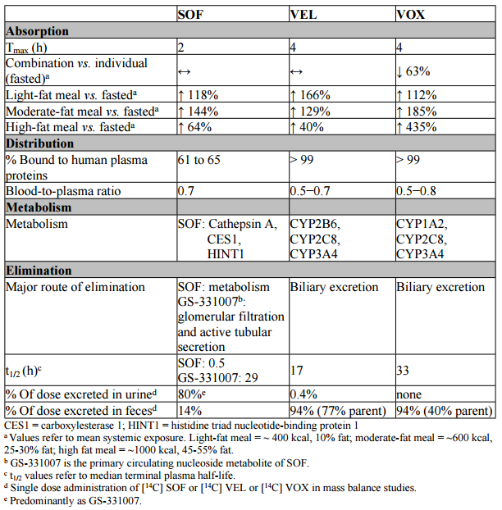
No circulating metabolites for VEL or VOX have been identified, whereas two circulating SOF metabolites have been identified in humans, neither of which have anti-HCV activity against the HCV genotype 1a, 1b and 3a replicons.

Population pharmacokinetics
Population PK (PopPK) analyses describing effects of covariates on the PK for SOF, VEL and VOX were summarised in the CER and overseas assessment reports. Review by the FDA and EMA suggested that the PopPK model adequately described the profile of each drug and the predominant sofosbuvir metabolite, GS-331007.^{55,56}

Bioavailability
The absolute bioavailability of Vosevi was not assessed. The formulation of Vosevi to be marketed was bioequivalent to the existing tablet formulations of SOF/VEL (400/100 mg) FDC + VOX (100 mg ) following a moderate fat meal.

Food effect
There was a significant influence of food on the exposure of VOX. Administration of Vosevi following a high fat/high calorie meal resulted in a 5.35 fold increase in VOX AUC_{inf} and modest increases in SOF, GS-566500(an inactive metabolite of SOF) and VEL exposures (1.64 fold increase in AUC_{inf} values) compared with exposures achieved under fasted conditions, hence all studies were performed in the presence of food and it is recommended that Vosevi be given with food in the PI.

Hepatic impairment
The PK sub-studies of two Phase II trials, GS-US-337-1468 and GS-US-367-1168 examined the steady state PKs of SOF/VEL FDC (400/100 mg) + VOX 100 mg in patients with genotype 1 HCV infection and cirrhosis. The results indicated that while SOF and VEL exposures were similar in subjects regardless of cirrhosis status, VOX exposure was almost 2 fold higher in subjects with cirrhosis compared to subjects without cirrhosis.
The effect of compensated cirrhosis was also examined in the population PK analysis of the Phase II and III studies.
The PK of VOX was also studied in a dedicated hepatic study; following a single dose of 100 mg VOX in HCV negative subjects with moderate (n = 10) and severe (n = 9) hepatic impairment. Compared to subjects with normal hepatic function, VOX plasma exposures (AUC_{inf} and C_{max}) were 299% and 238% higher in subjects with moderate hepatic impairment, and 500% and 614% higher in subjects with severe hepatic impairment.⁵⁵

Renal impairment
Renal clearance of VOX is negligible. The pharmacokinetics of voxilaprevir were studied;⁶⁵ with a single dose of 100 mg voxilaprevir in HCV negative patients with severe renal impairment (n = 10) matched to those with normal renal function (n = 10), with no clinically relevant differences observed.
While no dose adjustment of voxilaprevir (or velpatasvir) is required for patients with mild, moderate, or severe renal impairment, dosing recommendations cannot be made for patients for severe renal impairment or end stage renal disease, due to the higher exposure (up to 20 fold) of the predominant sofosbuvir metabolite, GS-331007 in these patients.⁵⁴

Drug-drug interactions
A number of drug-drug interaction studies were conducted by the sponsor to evaluate the possible drug interactions with SOF/VEL/VOX as a perpetrator or victim of interactions with medicines frequently used by patients with HCV infection.⁵⁴ A summary of the mechanism of these interactions is included below, from the FDA Summary and Clinical Pharmacology reviews.^{56,54}
SOF, GS-331007(the primary metabolite of SOF), VEL and VOX are not inhibitors or inducers of CYP or IGT1A1 enzymes.⁵⁶
Clinically important drug interactions include inducers of P-gp and moderate or potent inducers of CYP2B6, 2C8 and 3A4 (for example, rifampicin, carbamazepine and St John’s Wort) leading to reduced therapeutic effect of Vosevi. Use of OATP inhibitors such as cyclosporine is not recommended, due to increased concentration of voxilaprevir.
The clinical evaluator was not satisfied with the presentation of the drug-drug interaction data in the proposed PI, including Tables 5 and 12. Following the second round evaluation, most issues were clarified by the sponsor. The Delegate requests that the sponsor addresses the outstanding concerns of the evaluator and that drugs which are contraindicated with Vosevi be made consistent with overseas regulators.
Table 32: Substrate and inhibition profiles of VOX, VEL, SOF and GS-331007 for enzymes and transporters;^{54,56}
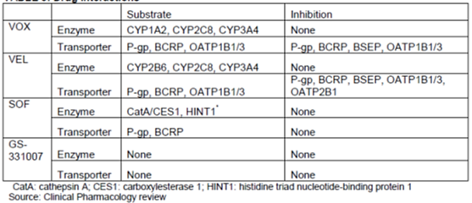

Efficacy
Four Phase III pivotal studies provided the principal efficacy data for the proposed SOF/VEL/VOX treatment regimen. The POLARIS-1 and POLARIS-4 trials evaluated 12 weeks duration of treatment with the proposed fixed dose combination of SOF/VEL/VOX in DAA experienced HCV patients while the POLARIS-2 and POLARIS-3 trials evaluated efficacy of 8 weeks treatment with SOF/VEL/VOX in DAA treatment naïve HCV patients. Each of these pivotal studies shared a number of common inclusion and exclusion criteria and endpoints.
Four supportive Phase II studies were also provided:
- Study GS-US-337-1468 (LEPTON trial): A Phase II, multicentre, open label study to assess the efficacy and safety of oral regimens for the treatment of chronic HCV infection.
- Study GS-US-367-1168: A Phase II, global, multicentre, open label study to investigate the safety and efficacy of GS-9857 plus sofosbuvir/GS-5816 fixed dose combination in subjects with chronic genotype 1 HCV infection.
- Study GS-US-367-1169: A Phase II, global, multicentre, open label study to investigate the safety and efficacy of GS-9857 plus sofosbuvir/GS-5816 fixed dose combination in subjects with chronic non-genotype 1 HCV infection.
- Study GS-US-367-1871: A Phase II, open label study to investigate the safety and efficacy of sofosbuvir/GS-5816/GS-9857 fixed dose combination with or without ribavirin in subjects with chronic genotype 1 HCV infection previously treated with a direct acting antiviral regimen
Table 33: Overview of Phase III trials
Study and dates | Design | Population | Number of subjects randomised and treated | Study duration | Status
GS-US-367-1171 (POLARIS-1), Nov 2015 to Oct 2016 | Randomised, double blind, placebo controlled, multicentre | NS5A inhibitor DAA experienced GT 1-6 patients without cirrhosis or with compensated cirrhosis | 416 | 12 weeks treatment, up to 24 weeks post-treatment follow-up | Completed
GS-US-367-1170 (POLARIS-4) Dec 2015 to Oct 2016 | Randomised, open label, multicentre, active-controlled | Non-NS5A inhibitor DAA experienced* GT 1, 2, 3, or 4 patients | 333 | 12 weeks treatment, up to 24 weeks post-treatment follow-up | Completed
GS-US-367-1172 (POLARIS-2): Nov, 2015 to Oct, 2016 | Randomised, open label, multicentre | DAA naïve GT 1-6 patients without cirrhosis or with compensated cirrhosis | 943 | 8 or 12 weeks treatment, up to 24 weeks post-treatment follow-up | Completed
GS-US-367-1173 (POLARIS-3): Dec 2015 to Oct 2016 | Randomised, open label, multicentre | DAA naïve GT 3 patients with cirrhosis | 220 | 8 or 12 weeks treatment, up to 24 weeks post-treatment follow-up | Completed
*Patients who had DAA exposure to a NS3/4A protease inhibitor (Pi) only were excluded from the POLARIS-4 study as there are registered treatments available.

Study GS-US-367-1171 (POLARIS-1 trial)
This was a Phase III, randomised, double blind, placebo controlled, multicentre, international study to assess the antiviral efficacy, safety and tolerability of 12 weeks of SOF/VEL/VOX treatment compared with 12 weeks of placebo treatment in direct acting antiviral experienced subjects with chronic HCV infection who have previously been treated with a non-structural protein (NS)5A inhibitor.
The primary objectives were to determine the efficacy of treatment with the proposed SOF/VEL/VOX (400/100/100 mg) FDC for 12 weeks as measured by the proportion of subjects with sustained viral response 12 weeks after cessation of treatment (SVR12) and to evaluate the safety and tolerability of SOF/VEL/VOX treatment. Secondary objectives included the proportion of subjects who achieved SVR at 4 and 24 weeks after cessation of treatment (SVR4 and SVR24); the proportion of subjects with virologic failure, kinetics of circulating HCV RNA during treatment and after cessation of treatment and to evaluate the viral resistance to SOF, VEL and VOX during treatment and after cessation of treatment. Further objectives were described in the CER.
The evaluator commented that the original protocol was amended for the definition of treatment experience from DAA experienced to NS5A inhibitor experienced.
Patients with genotype 1 HCV infection were randomised in a 1:1 ratio to the SOF/VEL/VOX 12 Week group or placebo 12 Week group. Patients with other genotypes were all enrolled in the active SOF/VEL/VOX 12 Week group, as this group comprised a relative minority of those with virologic failure following treatment with a DAA.

Baseline data
In the SOF/VEL/VOX 12 Week group, the majority of subjects had genotype 1 HCV infection (57.0% (1a = 38.4%, 1b = 17.1%, 1 other = 1.5%)) or genotype 3 HCV infection (29.7%) and most of the subjects (82.1%) had a non-CC IL28B genotype. A greater number of subjects with genotype 1 HCV infection and fewer subjects with genotype 2, 3, 4, 5, 6 and unknown HCV infection were enrolled into the SOF/VEL/VOX 12 Week group than planned according to protocol specification (Table 34). This may have been due to the current genotype distribution of patients with ongoing HCV infection who have been exposed to an NS5A inhibitor. In the SOF/VEL/VOX 12 Week group, 121 subjects (46.0%) had cirrhosis, greater than the incidence in the placebo group, 51 subjects (33.6%) and may have reflected the higher prevalence of cirrhosis in the DAA experienced population.

Table 34: GS-US-367-1171. Planned number of subjects by treatment group and genotype

Participant flow
Of the 416 randomised or enrolled subjects, 415 received at least 1 dose of study drug and were included in the safety analysis and full analysis sets (263 in the SOF/VEL/VOX 12 week group and 152 in the 12 Week group). The majority of subjects completed study treatment (98.8%, 410 subjects).
Of the 263 subjects in the SOF/VEL/VOX 12 Week group, 99.6% had been previously treated with an NS5A inhibitor, with the most common NS5A inhibitors being ledipasvir(51%), daclatasvir(27%), ombitasvir(11%), velpatasvir(7%) and elbasvir (3%) (Table 35). ⁵⁷

Table 35: GS-US-367-1171.Prior HCV DAAs (at least 5% subjects per genotype) for subjects with genotype 1, 3 or 4 HCV infection in the SOF/VEL/VOX 12 week group (safety analysis set)
Table 36: Virologic outcomes for subjects in the SOF/VEL/VOX 12 week group, POLARIS-1 (full analysis set)
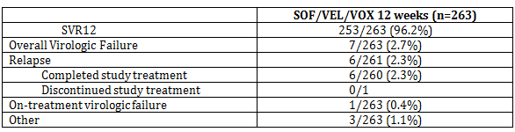
Table 37: SVR12 by genotype and cirrhosis status, POLARIS-1⁶ (modified from Table 6, FDA Medical Review)
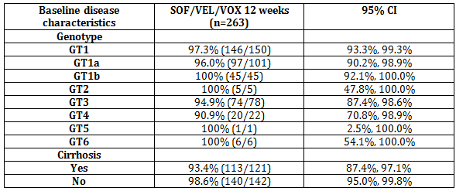
SVR24 results were provided by the sponsor as part of the response to questions, with 253/263 (96.2%) achieving SVR24 (95% CI 93.1% to 98.2%), and updates accordingly included in the local and overseas product information. Results of the study demonstrated consistent efficacy across genotypes, irrespective of cirrhosis status.
As predicted, no patients in the placebo group achieved a sustained virologic response.
A placebo controlled study design was unusual, but was used to assess safety and to compare frequencies of adverse events.

Impact of baseline NS5A resistance associated substitutions (RAS)
Of the 263 SOF/VEL/VOX subjects with baseline NS5A deep sequence data, 78% (206/263) had baseline NS5A RAS. SVR12 rates for GT1a, GT1b, GT3a and GT4 subjects with NS5A RAS were comparable to subjects without baseline NS5A RAS. SVR12 results were not affected by the presence of NS3 RAS or NS5B RAS at baseline.

Study GS-US-367-1170 (POLARIS-4 trial)
HCV treatment experienced subjects who had not received an NS5A inhibitor.⁵⁷
This was a randomised, open label, multicentre study assessing efficacy and safety of SOF/VEL/VOX treatment for 12 weeks and SOF/VEL treatment for 12 weeks in DAA experienced subjects with chronic HCV infection who had not previously been treated with the NS5A inhibitor. Subjects who had DAA exposure to a NS3/4A protease inhibitor (Pi) only were excluded.
The primary objectives were to determine the efficacy of treatment with the proposed SOF/VEL/VOX (400/100/100 mg) FDC for 12 weeks and SOF/VEL FDC for 12 weeks as measured by the proportion of subjects with sustained virologic response 12 weeks after cessation of treatment (SVR12) and also to evaluate the safety and tolerability of each treatment regimen. Secondary objectives were similar to the POLARIS-1 study and described in the CER. The primary endpoint was the same for both trials: SVR12, defined as HCV RNA < LLOQ (that is, < 15 IU/mL) 12 weeks after cessation of treatment in the Full Analysis Set.
The POLARIS-4 trial was not designed for direct statistical comparison between the study groups, but rather a pre-specified SVR12 goal of 85%.^{53,56}

Participant flow
333 subjects were randomised or enrolled and all received at least one dose of study drug and were included in the full analysis set and safety analysis set (182 in the SOF/VEL/VOX 12 week group and 151 in the SOF/VEL 12 week group). The majority of subjects completed study treatment (99.4%, 331 of 333 subjects).

Baseline data
Baseline characteristics were generally balanced across treatment groups (Table 38). Most subjects had genotype 1 (43.2% (1a, 29.4%; 1b, 13.8%)) or genotype 3 (31.8%) HCV infection. Subjects with genotype 4 HCV infection (5.7%) were enrolled into the SOF/VEL/VOX 12 Week group according to the study protocol specification. No subjects with genotype 5 or 6 HCV infection were enrolled. 45.9% of subjects had cirrhosis, which was higher than the minimum enrolment target of 30% and reflects the higher prevalence of cirrhosis in the DAA experienced subject population.
Most subjects (73.0%) had been previously treated with a NS5B inhibitor only; 25.2% of subjects had been previously treated with a combination of a NS5B inhibitor and NS3 inhibitor. For subjects with genotype 1 HCV infection, the majority of subjects had prior exposure to SOF or SOF+ simeprevir (SMV). For subjects with genotype 2, 3 or 4 HCV infection, the majority of subjects had prior exposure to SOF. Despite being an exclusion criterion, five DAA experienced subjects (1.5%) whose only DAA exposure was with an NS3/4A protease inhibitor were enrolled or randomised.

Table 38: Study GS-US-367-1170 Baseline characteristics by treatment group and overall (safety analysis set)
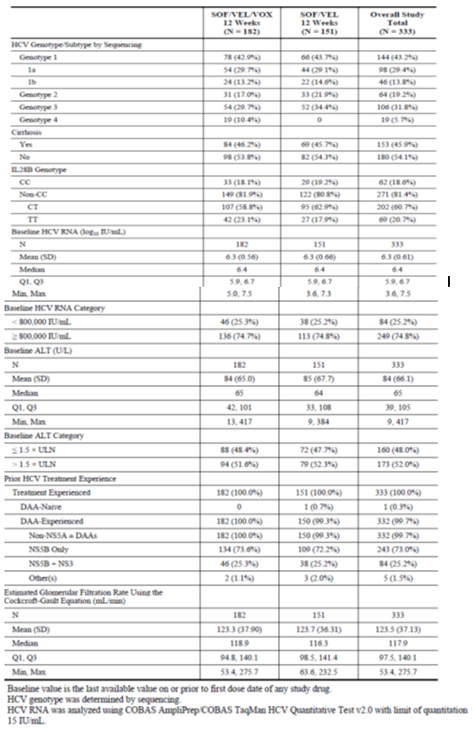

Results
The SOF/VEL/VOX 12 week group met the primary efficacy endpoint with a significantly higher SVR12 rate of 97.3% (95% CI: 93.7% to 99.1%; 177 of 182 subjects) compared with the performance goal of 85% (p < 0.001). The SOF/VEL 12 Week group did not meet the primary efficacy endpoint with a SVR12 rate of 90.1% (95% CI: 84.1% to 94.3%; 136/151) compared with the performance goal of 85% (p = 0.092).
Post-hoc analyses performed by the FDA to compare SVR12 rates between groups demonstrated a 7% treatment difference in favour of SOF/VEL/VOX (95%CI 1.9%, 12.5%, p = 0.006, based on Chi-square test), with the lower relapse rate the main factor driving the higher SVR12 rate in the SOF/VEL/VOX group. No comparison data were available for HCV 4, 5 and 6, as all GT4 subjects received SOF/VEL/VOX and no subjects with HCV 5 and 6 were enrolled in the study.
Table 39: POLARIS-4 trial, SVR12 by HCV genotype and virologic outcome⁵⁵
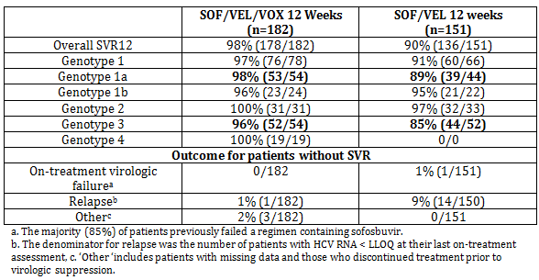
The SVR12 rate in the SOF/VEL 12 Week group for subjects with cirrhosis was lower (59/69, 85.5%) compared to subjects without cirrhosis (77/82, 93.9%)(Table 40). SVR12 rates were not affected by the presence of NS3 or NS5B RAS at baseline.⁵⁹

Table 40: Study GS-US-367-1170 SVR12 by baseline characteristics subgroups (Full analysis set)
The evaluator concluded that these results demonstrated the contribution of VOX to the potent regimen of SOF/VEL for 12 weeks for retreatment of the DAA experienced patients who have not previously received an NS5A inhibitor containing regimen especially in those with cirrhosis, with genotype 1a HCV infection, genotype 3 and 4 HCV infection. SVR24 results were provided by the sponsor as part of the sponsor’s post-first round response and demonstrated that SVR was sustained (178/182, 97.8% in the SOF/VEL/VOX 12 Week group and 136/151,90.1%, in the SOF/VEL 12 week group).
The FDA review;⁵⁷ concluded that the contribution of VOX was most apparent for GT1a and GT3 infection and that the contribution of VOX has not been established for GT1b, 2,4,5 and 6. This is reflected in the FDA labelling and indication.

Study GS-US-367-1172 (POLARIS-2 trial)
This was a multicentre, randomised, open label study. The primary objectives were to compare the efficacy of treatment with SOF/VEL/VOX (400/100/100 mg) FDC for 8 weeks with that of SOF/VEL for 12 weeks as measured by SVR12 in patients who were naïve to DAAs and to evaluate the safety and tolerability of each treatment regimen. The secondary and exploratory objectives were similar to those described for Study GS-US-367-1170 (POLARIS-4 trial).
The non-inferiority of the SVR among patients receiving SOF/VEL/VOX was compared to those receiving SOF/VEL, with a non-inferiority margin of 5%.
A target of at least 30% of subjects with genotype 1, 2, or 4 HCV infection were to have cirrhosis. Subjects with genotype 3 HCV infection with cirrhosis were not eligible for participation. Efficacy variables and outcomes were the same as those for the POLARIS-1 trial.

Participant flow
Of the 943 randomised or enrolled subjects, 941 received at least 1 dose of study medication and were included in the safety analysis set and the full analysis set. The majority of subjects (99.6%) completed study treatment; (Table 41) Baseline characteristics and demographics were generally balanced between treatment groups.

Table 41: Study GS-US-367-1172 Disposition of subjects by treatment group and overall (screened subjects)
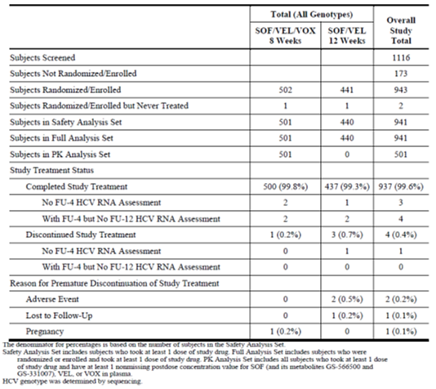

Results
The SVR12 rate for the SOF/VEL/VOX 8 Week group (476/501, 95.0%; 95% CI: 92.7% to 96.7%) did not demonstrate non-inferiority to the SVR12 rate for the SOF/VEL 12 Week group (432/440, 98.2%; 95% CI: 96.4% to 99.2%). The difference (95% CI) in the stratum-adjusted Mantel-Haenszel proportions was −3.4% (−6.2% to −0.6%), the lower bound of which was greater than the pre-specified non-inferiority margin of -5%.
In the SOF/VEL/VOX 8 week group, SVR12 rates were notably lower for subjects who were black (43/48, 89.6%, 43 of 48 subjects), had HCV genotype 1a (155/169, 91.7%) or genotype 4 (59/63, 94%), or had cirrhosis (82/90, 91.1%). Reasons other than virologic failure (that is, lost to follow-up, no post treatment Week 12 visit) substantially contributed to the lower SVR rates for the subgroups of black race and genotype 4.
21/498 (4%) patients who received SOF/VEL/VOX for 8 Weeks experienced relapse, compared to 3/439(1%) patients who received SOF/VEL for 12 Weeks. Of these, 14 had GT1a, two had GT1b, two had GT2, two had GT4 and one had GT5.⁷
The higher rate of relapse in patients with HCV GT1a infection receiving SOF/VEL/VOX for 8 Weeks is noteworthy. It was observed that the presence of the Q80K polymorphism at baseline was associated with lower rates of SVR12 for patients with HCV GT1a treated with SOF/VEL/VOX for 8 Weeks. An 8 week SOF/VEL arm was not available for comparison.^{55,60}
Table 42: POLARIS-2 trial SVR12 by HCV genotype and virologic outcome⁵⁵
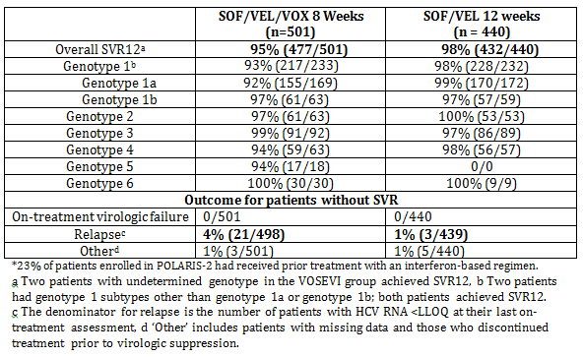
SVR24 results demonstrated durability of virological response (Table 43).

Table 43: SVR 24 results of the 4 Phase III studies (POLARIS-1 trial, and POLARIS-4 trial in DAA-experienced HCV patients)
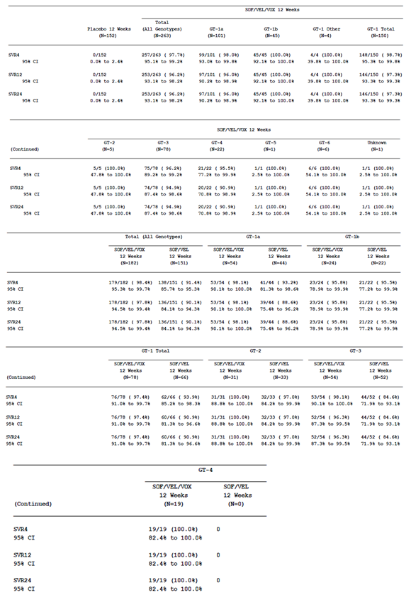

Table 43 (continued): SVR 24 results of the 4 Phase III studies; POLARIS-2 trial and POLARIS-3 trial in DAA-naïve HCV patients
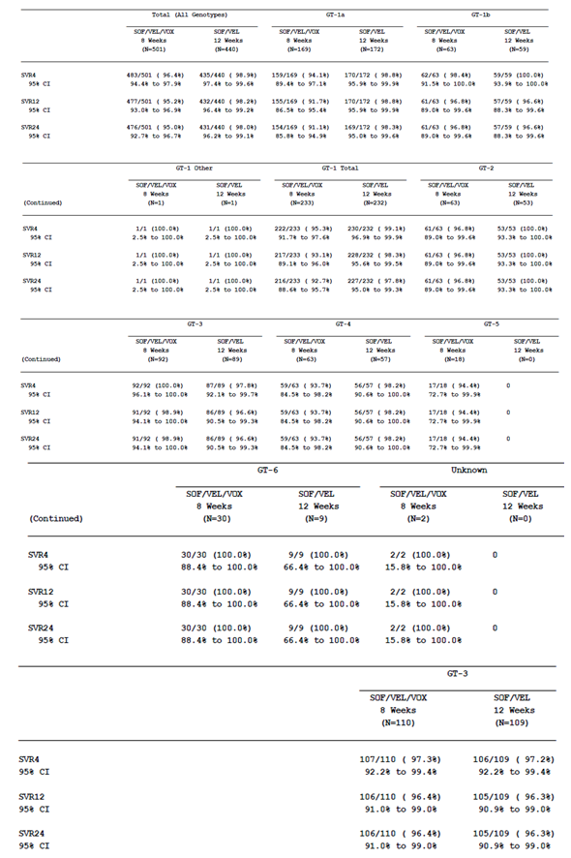

Study GS-US-367-1173 (POLARIS-3 trial) HCV GT3, cirrhosis, DAA-naïve ⁵⁹
This was a randomised, open label, multicentre study evaluating the antiviral efficacy, safety and tolerability of SOF/VEL/VOX for 8 weeks and SOF/VEL for 12 weeks in subjects with chronic genotype 3 HCV infection and cirrhosis who are naive to direct acting antiviral (DAA) treatment
The primary, secondary and exploratory objectives were identical to those described for the POLARIS-2 trial.
The SVR12 rate for the SOF/VEL/VOX 8 Week and SOF/VEL 12 week groups were compared with the performance goal of 83% using a 2 sided exact 1 sample binomial test following a sequential testing procedure. If primary test for SVR12 rate in the SOF/VEL/VOX 8 week group comparing with 83% was statistically significant at the 0.05 significance level, the SVR12 rate in SOF/VEL 12 week group was compared to 83% at the 0.05 significance level. The performance goal of 83% was based on prior results of SOF/VEL in this patient population in the ASTRAL 3 study.⁵⁹
Demographics were generally balanced across both treatment groups, except there were more females in the SOF/VEL/VOX 8 Week group compared with the SOF/VEL 12 week group (32.7%, versus 23.9%)(Table 44). Overall, 30.6% (67 of 219 subjects) of subjects had received prior treatment with an IFN based regimen.

Table 44: Study GS-US-367-1173 Demographics by treatment group and overall (safety analysis set)
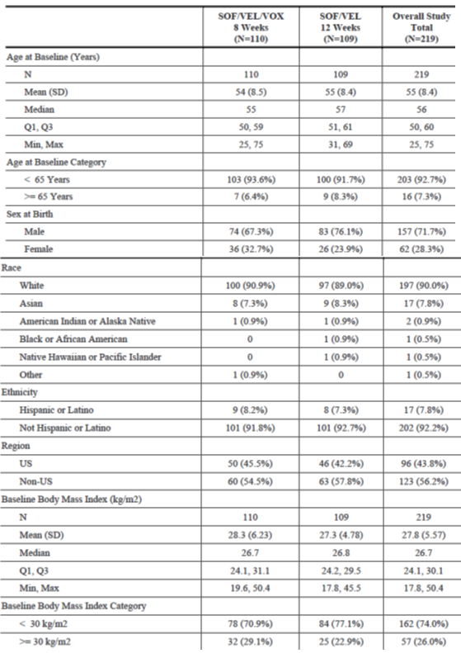

Results
The SVR12 rate for both the SOF/VEL/VOX 8 Week group (106/110, 96.4% ;95% CI: 91.0% to 99.0%) and the SOF/VEL 12 Week group (105/109, 96.3%; 95% CI: 90.9% to 99.0%) groups were statistically superior relative to the pre-specified SVR12 performance goal of 83% (p < 0.001 for both groups), however the study size was small and the limited numbers of virologic failures in each group made subgroup comparisons difficult.⁵³
Results for other efficacy outcomes are summarised in the CER [not included here].
Table 45: SVR12 and virologic outcome in the POLARIS-3 trial (HCV genotype 3 with compensated cirrhosis)
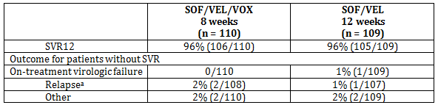
SVR24 results provided with the response to questions results confirmed durability of virologic response.
The evaluator was of the opinion that results from the POLARIS-3 trial provided evidence to suggest that the addition of VOX to SOF/VEL would maintain high efficacy with a shorter duration of treatment and offer an additional option for initial DAA treatment of HCV-infected patients with genotype 3 and cirrhosis.
The EU summary of product characteristics (SmPC) recommends in their Dosage and Administration table that 8 weeks of therapy may be considered for genotype 3 patients with compensated cirrhosis who are DAA naïve, while the FDA and Health Canada have recommended 12 weeks for all patient groups and have not included the results of POLARIS-2 or 3 trials in the PI.

Phase II studies
These studies have been discussed in detail in the CER [not included here]. The EU Public assessment report also provides a succinct summary;⁵⁵ of the Phase II studies and includes the following table (modified for the Overview, Table 46). For all four studies, approximately 50% of patients had compensated cirrhosis.
Table 46: Phase II studies of SOF/VEL+VOX or SOF/VEL/VOX (modified from Table 16, EU Public assessment report and CER)
Study number | Treatment Regimens | HCV Genotype (n) | Prior HCV Treatment | Main findings
GS-US-337-1468 (LEPTON: cohorts 4 and 5) | SOF/VEL+VOX for 4, 6, or 8 weeks | 1 or 3 (Genotype 1: 120; Genotype 3: 40; Indeterminate: 1) | Treatment-naive and treatment-experienced (including DAA experienced) subjects | Relapse was more common with shorter treatment durations. (4 or 6 weeks)
GS-US-367-1168 | SOF/VEL+VOX for 6, 8 (with or without RBV), or 12 weeks | 1(205) | Treatment-naive and DAA experienced subjects | Addition of RBV did not improve SVR12 rates.
GS-US-367-1169* | SOF/VEL+VOX for 6, 8, or 12 weeks | 1, 2, 3, 4, or 6 (Genotype 1: 1; Genotype 2: 33; Genotype 3: 74; Genotype 4: 17; Genotype 6: 3) | Treatment-naive and treatment-experienced (including DAA experienced) subjects | The presence of baseline RAVs# had no impact on SVR12 in the 8 or 12 week groups.
GS-US-367-1871 (TRILOGY) | SOF/VEL/VOX with or without RBV for 12 weeks | 1 (49) | DAA experienced subjects | Addition of RBV did not improve SVR12 rates
* GS-US-367-1169 was intended to include non-GT1 infection #Resistance associated variants, RBV: ribavirin, SOF: sofosbuvir, VEL: velpatasvir, VOX: voxilaprevir

Safety
A total of 2,017 subjects received at least 1 dose of SOF/VEL/VOX or SOF/VEL+VOX, including 1056 subjects in 4 SOF/VEL/VOX Phase III studies, 543 subjects in four SOF/VEL/VOX or SOF/VEL+VOX Phase II studies and 418 subjects in seven SOF/VEL/VOX, SOF/VEL+VOX, or SOF/VEL/VOX+VOX Phase I studies. Of the 1912 subjects who were randomised or enrolled into the four Phase III studies that comprised the Integrated Phase III Safety Population, 1908 received at least 1 dose of study drug and were included in the Safety Analysis Set, which included subjects who had received at least one dose of VOX as either an 8 or 12 week regimen.
Subjects treated with SOF/VEL/VOX for 8 or 12 weeks had a higher incidence of gastrointestinal AEs (mainly diarrhoea and nausea) compared with subjects treated with SOF/VEL for 12 weeks which was consistent with the known effects of some NS3/4A Pis. These symptoms were not treatment limiting with no subject discontinuing or interrupting treatment due to diarrhoea or nausea.
A comprehensive analysis of safety events historically associated with certain antiviral nucleoside/nucleotide inhibitors was performed for SOF/VEL/VOX in the Integrated Phase III Safety Population, including cardiac events, dermatologic events, pancytopenia events, psychiatric events related to suicide ideation or attempt, pancreatitis events, rhabdomyolysis/ myopathy events and renal events. SOF/VEL/VOX, SOF/VEL+VOX were generally well tolerated in the Phase I studies, and no safety signal was identified.
The overall safety profile for the Phase II Safety Population was similar to that of the Integrated Phase III Safety Population.
Due to the known association of some NS3/4A Pis with hepatotoxicity, particular attention was given to hepatic events and liver related abnormalities in the SOF/VEL/VOX clinical development program. An independent review committee was convened by the sponsor to review possible cases of drug-induced liver injury. The FDA reviewers reached similar conclusions to the committee in regards to hepatic safety.⁵⁸ The rates of Grade 3 or 4 elevations in total bilirubin, ALT and AST among subjects receiving SOF/VEL/VOX were low and similar to those receiving SOF/VEL. Slight increases in total bilirubin values were observed, consistent with VOX inhibition of OATP1B1 and OATP1B3. No pattern of VOX-associated ALT elevation was observed.
Comment Post-marketing data are available for SOF and VEL, given they are currently registered. The clinical evaluator, FDA and EMA were satisfied with the adequacy of the safety database available for Vosevi, including patients with compensated cirrhosis. Nonclinical evaluation did not identify specific safety concerns. The EU has contra indicated concomitant use of ethinyl-estradiol-containing products, in relation to previous experience with macrocyclic Pis (for example, paritaprevir) and the risk of hepatotoxicity in combination with ethinyl-estradiol, and due to the increased ALT noted in two patients concomitantly exposed to SOF/VEL/VOX and ethinyl-estradiol.
Safety of SOF/VEL/VOX FDC was not evaluated in HCV patients with HIV co-infection or in patients with liver transplantation or hepatic decompensation.

Risk management plan
Following the second round evaluation, the RMP for Vosevi was deemed to be acceptable. The evaluator recommended one change in relation to patients with HBV/HCV co-infection.
The suggested wording for conditions of registration is:
Implement the Vosevi EU-RMP version 1.0, dated 26 July 2017, final sign-off 12 May 2017, DLP 12 October 2016 with Australian Specific Annex version 0.2, September 2017 and any future updates as a condition of registration.

Risk-benefit analysis

Discussion
Vosevi has demonstrated efficacy in a group of patients for which options are limited (NS5A experienced patients and sofosbuvir experienced patients) with a single tablet, ribavirin free therapy, which can be given once daily. The submitted studies suggest that Vosevi will be an important re-treatment option, particularly for NS5A experienced patients.⁶¹
A number of direct acting antiviral therapies for HCV are now registered, with pan-genotypic DAA therapies now available internationally. SVR12 rates of greater than 90% were achieved with ‘first generation’ DAAs and represent a significant improvement over interferon based therapies. As more potent and pan-genotypic DAAs therapies become available, these need be used judiciously with clear guidance in the PI reflecting submitted data for each genotype and patient population.
Studies have not been conducted with Vosevi in patients with HIV co-infection, hepatic decompensation or liver transplantation. Other DAAs are currently approved for use in these patient groups, to be co-administered with RBV in patients with decompensated cirrhosis.
The Delegate acknowledges the sponsor’s agreement to the modified indication recommended by the evaluator following the sponsor’s response, noting that the evaluator was of the opinion that there was inadequate evidence to support use of 8 weeks treatment with SOF/VEL/VOX in DAA treatment naïve patients and efficacy of 12 weeks treatment of SOF/VEL/VOX was not evaluated in DAA treatment naïve patients. The Delegate is of the opinion that the indication should be made more specific and reflect the benefit of adding voxilaprevir for individual genotypes and treatment groups, compared to SOF/VEL, consistent with the approach of the FDA. Vosevi should not be used in patient groups for which existing DAAs, including Epclusa, are efficacious. Vosevi was not compared to Epclusa for 8 weeks duration as Epclusa was not intended to be given for 8 weeks.⁵³
There is inconsistency in the presentation of dosing and administration section of the PI between regulators. The FDA has approved use of Vosevi in GT1a and 3 only for patients with prior experience with sofosbuvir without an NS5A inhibitor. Health Canada has approved use in GT 1,2,3,4 for this patient group. The dosing and administration section in the EU SmPC reflects the results of the POLARIS-2 and 3 trials. The Delegate agrees with the sponsor, that recommending 8 weeks of Vosevi for DAA naïve patients with GT3 and cirrhosis is potentially confusing, but seeks comment from the ACM, given the prevalence of GT3 in Australia.
The safety profile of SOF and VEL has been previously characterised, with post-marketing data also available. The safety profile of VOX based on the submitted clinical studies does not raise major safety concerns.
Pending ACM advice, the Delegate proposes to register Vosevi for:
The treatment of adult patients with chronic HCV infection without cirrhosis or with compensated cirrhosis who have:
- genotype 1, 2, 3, 4, 5, or 6 infection and have previously been treated with an HCV regimen containing an NS5A inhibitor.
- genotype 1a or 3 infection and have previously been treated with an HCV regimen containing sofosbuvir without an NS5A inhibitor.
Additional benefit of Vosevi over sofosbuvir/velpatasvir was not shown in adults with genotype 1b, 2, 4, 5, or 6 infection previously treated with sofosbuvir without an NS5A inhibitor.
Approval is subject to implementation of the Vosevi EU-RMP version 1.0, dated 26 July 2017, final sign-off 12 May 2017, DLP 12 October 2016 with Australian Specific Annex version 0.2, September 2017 and any future updates as a condition of registration and satisfactory resolution of the product information.

Issues for the sponsor
- In regards to the POLARIS-1 trial, please explain why three patients with GT4 who had previously been treated with SOF, VEL and VOX were included in this study. (Table 35)
- The results of the POLARIS-2 and 3 trials and the Phase II studies have not been included in the FDA PI, Canadian Product Monograph or FDA Medical and Summary reviews. These studies formed part of the safety database only. Please comment on the reasoning for this.

Delegate’s considerations

Summary of issues
Epclusa, the fixed dose combination tablet form of sofosbuvir (SOF)/velpatasvir (VEL), 400 mg/100 mg was the first pan-genotypic inhibitor to be approved by the TGA.
Voxilaprevir is the new unapproved active component contained in Vosevi, the triple fixed dose combination tablet of SOF 400 mg, VEL 100 mg and VOX 100 mg, proposed for marketing. Voxilaprevir is an HCV NS3/4A protease inhibitor with activity across all HCV genotypes.
Sofosbuvir (Sovaldi) was initially approved in 2014, to be used in combination with other agents. It is also available as a fixed dose combination with ledipasvir (Harvoni).
Submitted data for Vosevi demonstrate the contribution of voxilaprevir for NS5A treatment experienced patients with or without compensated cirrhosis and for patients with certain genotypes who have prior experience with sofosbuvir without an NS5A inhibitor.

Proposed action
The Delegate had no reason to say, at this time, that the application for Vosevi should not be approved for registration.
Registration is recommended for the amended indication:
Vosevi (sofosbuvir/velpatasvir/voxilaprevir) is indicated for the treatment of chronic hepatitis C virus (HCV) infection in adult patients, without cirrhosis or with compensated cirrhosis, who have:
- genotype 1, 2, 3, 4, 5, or 6 infection and have previously been treated with an HCV regimen containing an NS5A inhibitor;
- genotype 1a or 3 infection and have previously been treated with an HCV regimen containing sofosbuvir without an NS5A inhibitor.
Additional benefit of Vosevi over sofosbuvir/velpatasvir was not shown in adults with genotype 1b, 2, 4, 5, or 6 infection previously treated with sofosbuvir without an NS5A inhibitor.

Request for ACM advice
The committee is requested to provide advice on the following specific issues:
- The wording of the proposed indication, noting the variation in the wording of the approved indications overseas and the Delegate’s proposal for wording consistent with the FDA-approved indication.
- Related to point 1, the proposed dosage and administration tables, noting the format proposed by the FDA, EMA and Health Canada. The FDA and Health Canada have not included results of the POLARIS-2 and 3 trials in their product information, while the EU SmPC dosage and administration section reflects the results of these studies. The FDA has approved use of Vosevi in GT1a and 3 only for patients with prior experience with sofosbuvir without an NS5A inhibitor. Health Canada has approved use in GT 1, 2, 3, 4 for this patient group.
Please comment on the Delegate’s proposal for adoption of the FDA dosage and administration table.
Proposed dosage and administration for Australia:
Administer Vosevi for 12 weeks to patients, regardless of HCV genotype without cirrhosis or with compensated cirrhosis who have failed prior treatment with a HCV DAA.
EU SmPC Dosage and administration:
Table 47: Recommended treatment durations for Vosevi for all HCV genotypes
Patient population | Treatment duration
DAA naïve patients without cirrhosis | 8 weeks
DAA naïve patients with cirrhosis | 12 weeks  8 weeks may be considered in genotype 3 infected patients (see section 5.1)
DAA experienced patients* without cirrhosis or with compensated cirrhosis | 12 weeks
* In clinical trials the DAA experienced patients had been exposed to combination regimens containing any of the following: daclatasvir, dasabuvir, elbasvir, grazoprevir, ledipasvir, ombitasvir, paritaprevir, sofosbuvir, velpatasvir, voxilaprevir (administered with sofosbuvir and velpatasvir for less than 12 weeks)

Table 48: FDA Dosage and administration
Genotype | Patients Previously Treated with an HCV Regimen Containing: | Vosevi duration
1, 2, 3, 4, 5, or 6 | A NS5A inhibitorª | 12 weeks
1a or 3 | sofosbuvir without a NS5A inhibitor^{b} | 12 weeks
a. In clinical trials, prior NS5A inhibitor experience included daclatasvir, elbasvir, ledipasvir, ombitasvir, or velpatasvir b. In clinical trials, prior treatment experience included sofosbuvir with or without any of the following: peginterferon alfa/ribavirin, ribavirin, HCV NS3/4A protease inhibitor (boceprevir, simeprevir, or telaprevir).

Table 49: Health Canada Dosage and administration
Genotype | Patients previously treated with an HCV regimen containing the following | Vosevi duration
1, 2, 3, 4, 5, or 6 | A NS5A inhibitorª | 12 weeks
1,2,3 or 4 | Sofosbuvir without an NS5A inhibitor^{b} | 12 weeks
a. In clinical trials, prior NS5A inhibitor experience included daclatasvir, elbasvir, ledipasvir, ombitasvir, or velpatasvir b. In clinical trials, prior treatment experience included sofosbuvir with or without any of the following: peginterferon alfa/ribavirin, ribavirin, HCV NS3/4A protease inhibitor (boceprevir, simeprevir, or telaprevir).
- Related to point 2, please comment on the data for 8 weeks of therapy with Vosevi for certain patient groups for example, GT3 with cirrhosis and those who are DAA naïve, in light of the EU approval and the prevalence of GT3 in Australia.
- The presentation of the drug interaction information in the PI at the meeting, given the list of drugs which are ‘contra-indicated’ versus ‘not recommended’ varies between regulators.
The committee is (also) requested to provide advice on any other issues that it thinks may be relevant to a decision on whether or not to approve this application.

Response from sponsor

Summary
Within the last 5 years there has been a transformation in the treatment of HCV infection with the development of direct acting antivirals (DAAs) targeting viral proteins essential to viral replication, such as those containing the sofosbuvir (SOF), an HCV NS5B inhibitor with potent, broad genotypic activity (Sovaldi (submission PM-2013-01283-1-2,), Harvoni (submission PM-2014-00469-1-2) and Epclusa (submission PM-2015-03984-1-2)). Epclusa, a combination of SOF and velpatasvir (VEL), a potent, pan-genotypic, next-generation HCV NS5A inhibitor, was approved by TGA in December 2016, and was the first, 12 week, once daily, all oral pan-genotypic treatment option for all HCV patients in Australia.
In 2016, the World Health Organization (WHO) issued its first ever global hepatitis strategy document which calls for HCV elimination by 2030, defined as a 90% reduction in incidence and 65% reduction in mortality. Australia has embraced these goals by ensuring wide access to highly effective HCV treatments throughout the country, irrespective of genotype, HIV coinfection or stage of fibrosis. The prevalence of HCV in Australia is estimated to be approximately 1.3%; and in just the last 2 years, over 50,000 HCV infected patients have been treated with DAA therapy in Australia. Even with an anticipated 95% sustained virologic response (SVR), there remains a need for treatment to address the small percentage of patients who are not cured with first-line therapy.
The sponsor has developed Vosevi, a fixed dose combination tablet combining three drugs, SOF, VEL and voxilaprevir (VOX), as a salvage therapy regimen for this patient population. Voxilaprevir is an HCV NS3/4A protease inhibitor (Pi) with antiviral activity across HCV genotypes and an improved resistance profile compared with previously developed HCV NS3/4A Pis. In large, Phase III registrational studies, 12 weeks of SOF/VEL/VOX was shown to be a highly efficacious, well tolerated, pan-genotypic, simple, single-tablet regimen for the treatment of patients with HCV infection who have failed prior DAA treatment, including those who have failed prior therapy with an NS5A and/or NS5B inhibitor.
The remainder of this response is separated into 3 sections to directly address the Delegate’s comments concerning the application to register Vosevi tables and includes the sponsor’s responses to advice sought by the Delegate, issues for the sponsor raised by the Delegate and other comments on the PI.

Advice sought by the TGA delegate
The Delegate’s comments/requests for ACM advice from the Delegate’s Overview are presented in italics, and are followed by the sponsor’s response.
- The wording of the proposed indication, noting the variation in the wording of the approved indications overseas and the Delegate’s proposal for wording consistent with the FDA-approved indication.
- Related to point 1, the proposed dosage and administration tables, noting the format proposed by the FDA, EMA and Health Canada. The FDA and Health Canada have not included results of the POLARIS-2 and 3 trials in their product information, while the Eu SmPC dosage and administration section reflects the results of these studies. The FDA has approved use of Vosevi in GT 1a and 3 only for patients with prior experience with sofosbuvir without an NS5A inhibitor. Health Canada has approved use in GT 1, 2, 3, 4 for this patient group. Please comment on the Delegate’s proposal for adoption of the FDA dosage and administration table.
The difference in the indication statements for Vosevi reflects a difference in the goals across the regions. In the US, Gilead’s goal for the clinical development of SOF/VEL/VOX was focused on providing a salvage regimen for DAA experienced patients and interactions with the FDA throughout the development and review process led to the final language in the US label limiting the use of SOF/VEL/VOX to certain genotypes within the sub-populations. In the EU, there was interest in SOF/VEL/VOX for DAA naive patients to provide another HCV treatment option in the region potentially shortening treatment duration and improving treatment access. Additionally, there was recognition of the benefit of simplifying treatment algorithms and a request by EMA for new analyses of clinical data to be submitted and considered during the MAA review process which supported a broader label in that region.
In Australia, the SOF/VEL/VOX single tablet regimen fulfils the substantial unmet medical need for a potent salvage regimen with demonstrated efficacy in large, Phase III registrational trials including a high percentage of patients across genotypes including those with cirrhosis and advanced fibrosis. The sponsor does not agree with alignment of the Australian PI with the US PI and requests to retain the indication and dosage as proposed by the clinical evaluator:
Indications:
Vosevi (sofosbuvir/velpatasvir/voxilaprevir fixed dose combination) is indicated for the treatment of chronic hepatitis C virus (HCV) infection in adults who have failed treatment with at least one prior DAA, regardless of genotype, in patients without cirrhosis or with compensated cirrhosis (see Dosage and Administration and Clinical Trials).
Dosage and administration:
The recommended dose of Vosevi is one tablet, taken orally, once daily with food. Administer Vosevi for 12 weeks to patients, regardless of HCV genotype without cirrhosis or with compensated cirrhosis who have failed prior treatment with a HCV DAA.
In contrast to the indication statement in the US PI, this proposed indication and dosage and administration information is pan-genotypic and simple. The totality of the data from the Phase III SOF/VEL/VOX clinical trials included in the original dossier submitted to TGA supports its use for the treatment of subjects who have failed prior therapy with DAAs, irrespective of genotype, and is summarized below.
Study GS-US-367-1171 (POLARIS-1 trial) is a Phase III, randomised, double blind study assessing the antiviral efficacy, safety, and tolerability of SOF/VEL/VOX compared with placebo for 12 weeks in NS5A inhibitor experienced subjects with chronic HCV infection. To date, POLARIS-1 is the only Phase III registrational trial to enrol NS5A inhibitor experienced subjects. Overall and across all HCV genotypes and subgroups in the POLARIS-1 trial, SOF/VEL/VOX for 12 weeks led to high efficacy with 96.2% of all enrolled subjects (253 of 263) achieving SVR12.
Study GS-US-367-1170 (POLARIS-4 trial) is a Phase III, randomised, open label study assessing the antiviral efficacy, safety, and tolerability of 12 weeks of SOF/VEL/VOX and 12 weeks of SOF/VEL in DAA experienced subjects with chronic HCV infection with or without cirrhosis who had not previously received an NS5A inhibitor. The use of SOF/VEL/VOX and SOF/VEL within the same study allows for the assessment of the contribution of VOX to efficacy, and, as such, the information demonstrating the benefit of VOX to the SOF/VEL/VOX regimen.
In the POLARIS-4 trial, treatment with SOF/VEL/VOX resulted in an SVR12 rate of 97.8%, which was statistically superior to the performance goal of 85% at the pre-specified 0.025 significance level (p < 0.001), meeting the primary efficacy endpoint. Treatment with SOF/VEL for 12 weeks resulted in an SVR12 rate of 90.1%, which was not statistically superior to the performance goal of 85% at the pre-specified 0.025 significance level (p = 0.092).
Although not pre-specified in the POLARIS-4 trial statistical analysis plan, an ad hoc evaluation of the superiority of SOF/VEL/VOX treatment for 12 weeks compared with SOF/VEL treatment for 12 weeks was performed in subjects with genotype 1, 2, or 3 HCV infection (no subjects with genotype 4 HCV infection were enrolled into the SOF/VEL treatment group). Treatment with SOF/VEL/VOX for 12 weeks was statistically superior to treatment with SOF/VEL for 12 weeks (p = 0.005).
Importantly, there was only one subject with virologic failure in the SOF/VEL/VOX group whereas 15 subjects experienced virologic failure in the SOF/VEL group, with these failures distributed across all the genotypes enrolled. POLARIS-4 was not statistically powered to compare the efficacy of SOF/VEL/VOX versus SOF/VEL within genotypes or subgroups. Nevertheless, higher SVR12 rates were observed among subjects receiving SOF/VEL/VOX as compared to SOF/VEL across all genotypes assessed in both groups (Table 50).
Table 50: Study GS-US-367-1170 (POLARIS-4 trial) SVR12 by HCV genotype
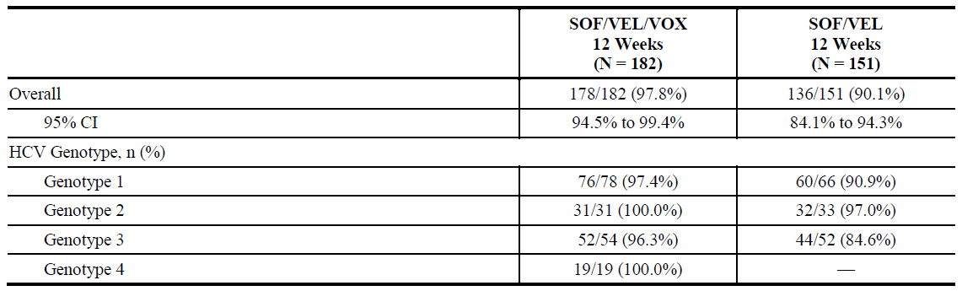
The contribution of VOX to the efficacy of SOF/VEL/VOX in each HCV genotype is directly demonstrated by the difference in the SVR12 rates and number of subjects with virologic failure in the two treatment groups (Table 50). There were greater numerical differences in the SVR12 rates between the SOF/VEL/VOX and SOF/VEL groups for the HCV genotypes with the most subjects, specifically genotype 1 and genotype 3 where the differences in SVR12 rates were 6.5% and 11.7%, respectively. For subjects with genotype 2 HCV infection, no virologic failures occurred in the SOF/VEL/VOX 12 Week group, whereas one subject in the SOF/VEL 12 Week group experienced virologic breakthrough with treatment emergent resistance with the infrequently seen SOF signature mutation S282T in addition to Y93H.
Since subjects with genotype 4, 5, or 6 HCV infection were not enrolled into the SOF/VEL group of POLARIS-4, the contribution of VOX to the efficacy of SOF/VEL/VOX can only be indirectly demonstrated for these rarer genotypes. Across the Phase III clinical program, SOF/VEL/VOX demonstrated pan-genotypic efficacy, including genotype 4, 5 or 6. In POLARIS-4, all 19 subjects with genotype 4 HCV infection enrolled in the SOF/VEL/VOX 12 Week group achieved SVR12. In POLARIS-1, treatment with SOF/VEL/VOX for 12 weeks led to high SVR12 rates in subjects enrolled with genotype 5 or 6, with all 7 NS5A inhibitor experienced subjects (one with genotype 5, and six with genotype 6) achieving SVR12. Additionally, in Study GS-US-367-1172 (POLARIS-2 trial), 97.9% of the DAA naïve subjects with genotype 5 or 6 (17 of 18 subjects with genotype 5, and 30 of 30 subjects with genotype 6) treated with 8 weeks of SOF/VEL/VOX achieved SVR12. Thus, for genotype 5 or 6 DAA experienced subjects who have not received an NS5A inhibitor, it is reasonable to assume that SOF/VEL/VOX would result in SVR12 rates within the range of those observed in subjects with genotype 1, 2, 3, or 4 in POLARIS-4 (that is, 96 to 100%).
Data from the ASTRAL trial (Epclusa Submission No: PM-2015-03984-1-2) and POLARIS Phase III programs support the pan-genotypic efficacy of SOF/VEL. As such, the predicted efficacy of SOF/VEL in subjects with genotypes 4, 5 or 6 HCV infection may be estimated based on the assumption that SOF/VEL would be no more efficacious in these genotypes than in the more difficult to cure subjects with genotypes 1, 2 or 3 that were enrolled in POLARIS-4 (that is, 85 to 97%). Taken together, SOF/VEL/VOX is anticipated to provide an improvement in efficacy over SOF/VEL for patients with genotype 4, 5, or 6 HCV infection with SVR12 rates ranging from that observed in genotype 2 HCV infected subjects to that observed in genotype 1 or 3 HCV-infected subjects.
Restriction of the indication to DAA experienced subjects who have not received an NS5A inhibitor to only those with genotype 1a or genotype 3 HCV infection as is in the US PI leaves those with genotypes 1b, 2, 4, 5 and 6 without a treatment option. Further, the language in the US PI may lead to confusion and errors in use of the drug in Australia given the unique prescribing environment. Unlike the US, the new DAAs have a very wide prescriber base in Australia which includes general practitioners. The proposed indication is simple, inclusive and does not include the potentially confusing statement regarding the lack of additional benefit of SOF/VEL/VOX over SOF/VEL in specific genotypes.
In summary, SOF/VEL/VOX is a fixed dose combination developed as a treatment for chronic HCV, specifically as a pan-genotypic salvage regimen for DAA experienced patients. The POLARIS-1 and POLARIS-4 Phase III registrational studies support the proposed use of SOF/VEL/VOX in DAA experienced patients, irrespective of genotype, and establish the clinical value of the three drug combination regimen. The proposed wording in the PI is consistent with the simplification of treatment in Australia where access to HCV therapy has been maximized in order to achieve the WHO of goal of HCV elimination.
- Related to point 2, please comment on the data for 8 weeks of therapy with Vosevi for certain patient groups; for example GT3 with cirrhosis and those who are DAA naïve, in light of the EU approval and the prevalence of GT3 in Australia.
The sponsor believes that SOF/VEL/VOX for 12 weeks fulfils the remaining, substantial unmet medical need in Australia for DAA experienced patients by providing a highly efficacious and safe pan-genotypic salvage therapy. This is reflected clearly in the proposed indication and dosage and administration. The sponsor does not recommend inclusion of an indication or dosing recommendation for 8 weeks of therapy for DAA naïve patients with genotype 3 and cirrhosis which may introduce confusion for prescribers.

Issues for the sponsor
The Delegate’s comments presented in italics, and are followed by the sponsor’s response.
- In regards to the POLARIS-1 trial, please explain why three patients with GT4 who had previously been treated with SOF, VEL and VOX were included in this study. (Table 35)
Study GS-US-367-1171 (POLARIS-1 trial) required that subjects have prior treatment with a DAA regimen containing an NS5A inhibitor, without specific criteria for the components of the regimen.
As such, subjects who had received SOF/VEL + VOX in Phase II trials were eligible to participate in POLARIS-1. Overall, nine patients previously treated with SOF/VEL + VOX were enrolled to receive SOF/VEL/VOX for 12 weeks in GS-US-367-1171 (three of whom had genotype 4 infection and are included in the referenced table), all of whom achieved SVR12.
- The results of the POLARIS-2 and 3 trials and the Phase II studies have not been included in the FDA PI, Canadian Product Monograph or FDA Medical and Summary reviews. These studies formed part of the safety database only. Please comment on the reasoning for this.
The same data from the Phase III registrational studies (POLARIS-1, POLARIS-2, POLARIS-3 and POLARIS-4 trials) were submitted in all the original marketing applications as they are supportive of the safety and the efficacy of the regimen across patient populations. The review of the efficacy data for SOF/VEL/VOX in both the US and Canada focused on the results from the Phase III registrational studies conducted with DAA experienced subjects, POLARIS-1 and POLARIS-4, consistent with the population included in the indication statements for the regions.

Conclusion
The data from the POLARIS program demonstrate that all patients with DAA experience, with or without compensated cirrhosis and regardless of HCV genotype, would derive clinical benefit from treatment with SOF/VEL/VOX for 12 weeks. The proposed Australian PI for Vosevi addresses the substantial unmet medical need for this patient population without other treatment options and is supported by the safety and efficacy data from the registrational Phase III studies. The simplicity of the label appropriately provides the opportunity for all patients to be cured of HCV in Australia consistent with the national commitment to elimination. The sponsor agrees to align with the US PI in other sections as requested by the Delegate, including contraindications, drug-drug interactions and presentation of safety.
The sponsor also provided an updated PI and CMI with the response.

Advisory Committee Considerations
The Advisory Committee on Medicines (ACM), having considered the evaluations and the Delegate’s overview, as well as the sponsor’s response to these documents, advised the following:
The ACM taking into account the submitted evidence of efficacy, safety and quality, agreed with the Delegate and considered Vosevi tablet containing; sofosbuvir 400 mg/ velpatasvir 100 mg/ voxilaprevir 100 mg to have an overall positive benefit-risk profile for the Delegate’s amended indication:
Vosevi (sofosbuvir/velpatasvir/voxilaprevir) is indicated for the treatment of chronic hepatitis C virus (HCV) infection in adult patients, without cirrhosis or with compensated cirrhosis, who have:
- genotype 1, 2, 3, 4, 5, or 6 infection and have previously been treated with an HCV regimen containing an NS5A inhibitor;
- genotype 1a or 3 infection and have previously been treated with an HCV regimen containing sofosbuvir without an NS5A inhibitor.
Additional benefit of Vosevi over sofosbuvir/velpatasvir was not shown in adults with genotype 1b, 2, 4, 5, or 6 infection previously treated with sofosbuvir without an NS5A inhibitor.
In making this recommendation the ACM was of the view that:
- in patients who were previously treated with a HCV regimen containing sofosbuvir without an NS5A inhibitor, Vosevi showed a benefit over Epclusa for genotypes 1a and 3. Vosevi may provide an option for genotypes 1b, 2, 4, 5, or 6; however the published clinical studies do not support this over the available data for Epclusa, which appeared to be effective for these genotypes.
- POLARIS trials 2 and 3 did not add to the data set in treatment experienced patients, and the FDA did not include these studies. The results from the POLARIS-2 trial pointed to a higher risk of relapse with an 8 week duration of therapy, particularly for genotype 1a. The 12 week duration of therapy may increase response rate in complicated patients with cirrhosis (and/or relapse), and was preferred. The decision to use Vosevi for 8 weeks is best determined by the treating specialist.
- a less specific indication (when compared to the FDA indication) may provide flexibility to prescribers, however the indication requires additional information to convey the limitations of the evidence supporting the application, noting that the small numbers of patients in the POLARIS trials do not support the broader claims for all genotypes in this patient population.

Proposed conditions of registration
The ACM agreed with the Delegate on the proposed conditions of registration.

Proposed Product Information (PI)/ Consumer Medicine Information (CMI) amendments
The ACM agreed with the Delegate to the proposed amendments to the PI and CMI and specifically advised on the inclusion of the following:
- the results should include the comparator arm for sofosbuvir/velpatasvir for POLARIS-2, 3 and 4 trials, stratified by NS3 or NS5A RAVS in Tables 3 and 4 of the PI.
- The ACM agreed that there are likely to be a number of complex drug interactions. A statement should be included in the ‘Interactions with other medicines’ section to highlight that drug interactions with Vosevi are complex and substantial; the list of interactions is not all inclusive, and a drug interaction database or specialist pharmacist should be consulted.
- a statement that recommending resistance testing may assist in determining the likely effectiveness for Vosevi in patients who have failed a regimen containing sofosbuvir without an NS5A inhibitor.

Specific advice
The ACM advised the following in response to the Delegate’s specific questions on the submission:
- The wording of the proposed indication, noting the variation in the wording of the approved indications overseas and the Delegate’s proposal for wording consistent with the FDA-approved indication.
A less specific indication (when compared to the FDA indication) may provide flexibility to prescribers, however the indication requires additional information to convey the limitations of the evidence supporting the application, noting that the small numbers of patients in the POLARIS trials do not support the broader claims for all genotypes in this patient population
As such, the ACM recommended the adoption of the Delegate’s proposed indication:
Vosevi (sofosbuvir/velpatasvir/voxilaprevir) is indicated for the treatment of chronic hepatitis C virus (HCV) infection in adult patients, without cirrhosis or with compensated cirrhosis, who have:
- genotype 1, 2, 3, 4, 5, or 6 infection and have previously been treated with an HCV regimen containing an NS5A inhibitor;
- genotype 1a or 3 infection and have previously been treated with an HCV regimen containing sofosbuvir without an NS5A inhibitor.
Additional benefit of Vosevi over sofosbuvir/velpatasvir was not shown in adults with genotype 1b, 2, 4, 5, or 6 infection previously treated with sofosbuvir without an NS5A inhibitor.
- Related to point 1, the proposed dosage and administration tables, noting the format proposed by the FDA, EMA and Health Canada. The FDA and Health Canada have not included results of the POLARIS-2 and 3 trials in their PI, while the EU SmPC dosage and administration section reflects the results of these studies. The FDA has approved use of Vosevi in GT 1a and 3 only for patients with prior experience with sofosbuvir without an NS5A inhibitor. Health Canada has approved use in GT 1, 2, 3, 4 for this patient group.
Please comment on the Delegate’s proposal for adoption of the FDA dosage and administration table.
Consistent with the above advice provided to adopt the FDA approved indication, the ACM was of the view that the FDA approved Dosage and Administration table should be adopted.
- Related to point 2, please comment on the data for 8 weeks of therapy with Vosevi for certain patient groups; for example, GT3 with cirrhosis and those who are DAA naïve, in light of the EU approval and the prevalence of GT3 in Australia.
The ACM advised that the EUSmPC, which refers to 8 weeks treatment duration, makes prescribing more complicated and should be only done by very experienced practitioners. As such, 12 weeks treatment duration was recommended in line with the FDA approved dosage and administration wording.
- The presentation of the drug interaction information in the PI at the meeting, given the list of drugs which are ‘contra-indicated’ versus ‘not recommended’ varies between regulators.
The ACM advised that patients with treatment failure managed with Vosevi will likely be used by, or in consultation with, specialists, although there in the future a wider range of prescribers is possible. Due to the substantial risk and complexity of interactions, the PI should include advice that a drug interaction database (or experienced pharmacist) should be consulted.
The ACM advised that implementation by the sponsor of the recommendations outlined above to the satisfaction of the TGA, in addition to the evidence of efficacy and safety provided would support the safe and effective use of this product.

Outcome
Based on a review of quality, safety and efficacy, TGA approved the registration of Vosevi (sofosbuvir 400 mg/velpatasvir 100 mg/voxilaprevir 100 mg fixed dose combination tablet for oral administration, indicated for:
Vosevi (sofosbuvir/velpatasvir/voxilaprevir fixed dose combination) is indicated for the treatment of chronic hepatitis C virus (HCV) infection in adult patients, without cirrhosis or with compensated cirrhosis, who have:
- genotype 1, 2, 3, 4, 5, or 6 infection and have previously been treated with an HCV regimen containing an NS5A inhibitor;
- genotype 1a or 3 infection and have previously been treated with an HCV regimen containing sofosbuvir without an NS5A inhibitor;
(see Sections 4.2 Dose and method of administration and 5.1 Pharmacodynamic properties, Clinical trials).

Specific conditions of registration applying to these goods
- Vosevi is to be included in the Black Triangle Scheme. The PI and CMI for Vosevi must include the black triangle symbol and mandatory accompanying text for five years, which starts from the date that the sponsor notifies the TGA of supply of the product.
- Any changes to which the sponsor has agreed should be included in a revised RMP and ASA. However, irrespective of whether or not they are included in the currently available version of the RMP document, the agreed changes become part of the risk management system.
The Vosevi EU-Risk Management Plan (RMP) (version 1.0, dated 26 July 2017, final sign-off 12 May 2017, DLP 12 October 2016), with Australian Specific Annex (version0.2, September 2017), included with submission PM-2016-04442-1-2, and any subsequent revisions, as agreed with the TGA will be implemented in Australia. Reports are to be provided in line with the current published list of EU reference dates and frequency of submission of PSURs until the period covered by such reports is not less than three years from the date of this approval letter.

Attachment 1. Product Information
The PI for Vosevi approved with the submission which is described in this AusPAR is at Attachment 1. For the most recent PI, please refer to the TGA website at < https://www.tga.gov.au/product-information-pi> .

Therapeutic Goods Administration
PO Box 100 Woden ACT 2606 Australia
Email: info@tga.gov.au Phone: 1800 020 653 Fax: 02 6232 8605
https://www.tga.gov.au

Centre for Drug Evaluation and Research 209195Orig1s000 Summary Review, VOSEVI
ICH: International Council for Harmonisation (of Technical Requirements of Pharmaceuticals for Human Use)
EMA /CHMP /ICH(2012) ICH guideline M3 (R2)-question and answers (p 15)
2013 US Dept of Health and Human Services FDA Centre for Drug Evaluation and Research (CDER) Chronic Hepatitis C Virus Infection: Developing Direct-Acting Antiviral Drugs for Treatment Guidance for Industry (May 2016 Revision 2)
Gotte, M. and Feld, J.J. (2016). Direct-acting antiviral agents for hepatitis C: structural and mechanistic insights. Nature Reviews (Gastroenterology&Hepatology)13:338-351
Tong X, et al. Identification and analysis of fitness of resistance mutations against the HCV protease inhibitor SCH 503034. Antiviral Res 2006; 70: 28-38.
QT: Electrocardiographic interval between the beginning of the Q wave and termination of the T wave, representing the time for both ventricular depolarization and repolarization to occur.
EMA /CHMP /ICH(2012) ICH guideline M3 (R2)-question and answers (p 15)
2013 US Dept of Health and Human Services FDA Centre for Drug Evaluation and Research (CDER) Chronic Hepatitis C Virus Infection: Developing Direct-Acting Antiviral Drugs for Treatment Guidance for Industry (May 2016 Revision 2)
AUC₀₋₂₄: Partial area under the plasma/serum concentration versus time curve from 0 to 24 hours
Option 1 in ICH S2(R1) International Conference on Harmonisation of technical requirements for registration of pharmaceuticals for human use. Guidance on genotoxicity testing and data interpretation for pharmaceuticals intended for human use.
ICH S1A(R1) International conference on harmonisation of technical requirements for registration of pharmaceuticals for human use. Guideline on the need for carcinogenicity studies of pharmaceuticals.
Pregnancy Category B1 is classified as Drugs which have been taken by only a limited number of pregnant women and women of childbearing age, without an increase in the frequency of malformation or other direct or indirect harmful effects on the human fetus having been observed. Studies in animals have not shown evidence of an increased occurrence of fetal damage.
ICH Photosafety Evaluation of Pharmaceuticals S10 (13 November 2013).
ICH M3(R2; Guidance on nonclinical safety studies for the conduct of human clinical trials and marketing authorization for pharmaceuticals M3(R2).
World Health Organization (WHO) 2015
Gidding HF et al. The epidemiology of hepatitis C in Australia: Notifications, treatment uptake and liver transplantations, 1997-2006. Journal of Gastroenterology and Hepatology. 2009; 24: 1648-1654
Foster GR, et al. Sofosbuvir and Velpatasvir for HCV Genotype 2 and 3 Infection. The New England Journal of Medicine 2015; 373: 2608-2617
Feld JJ, et al. Sofosbuvir and Velpatasvir for HCV Genotype 1, 2, 4, 5 and 6 Infection. N Engl J Med 2015; 373: 2599-2607
European Association For The Study of the Liver. EASL Recommendations on Treatment of Hepatitis C - SUMMARY. September. 2016.
AASLD-IDSA. Recommendations for Testing, Managing and Treating Hepatitis C. Available at: http://www.hcvguidelines.org/full-report-view. Updated 06 July. 2016
Morgan RL, et al. Eradication of Hepatitis C Virus Infection and the Development of Hepatocellular Carcinoma. Ann Intern Med 2013;158 (5 (Part I)).
van der Meer AJ, et al. Association between sustained virological response and all-cause mortality among patients with chronic hepatitis C and advanced hepatic fibrosis. JAMA 2012; 308: 2584-2593
Veldt BJ, et al. Sustained virologic response and clinical outcomes in patients with chronic hepatitis C and advanced fibrosis. Ann Intern Med 2007; 147:677-684.
Poynard T, et al. Impact of pegylated interferon alfa-2b and ribavirin on liver fibrosis in patients with chronic hepatitis C. Gastroenterology 2002; 122: 1303-1313
Nelson DR. HCV-TARGET International Registry Do Phase III Trials Translate into Real World [Presentation]. 15th International Symposium on Viral Hepatitis and Liver Disease (ISVHLD); 2015 26-28 June; Berlin, Germany.
Welzel TM, et al. Safety and Efficacy of Sofosbuvir and Ribavirin for the Treatment of HCV Genotype 2 and 3: Results of the HCV-TARGET Study [Abstract 1057]. 66th Annual Meeting of the American Assoication for the Study of Liver Diseases (AASLD); 2015 13-17November; San Francisco, CA. pp. 727A-8A.
Dieterich DT, et al. Ledipasvir/Sofosbuvir +/- Ribavirin in Patients Co-infected with HCV and HIV: Real-World Heterogeneous Population from the TRIO Network [Poster #SAT-134]. European Association for the Study of the Liver (EASL); 2016 13-17 April; Barcelona, Spain.
Dieterich D, et al. Final evaluation of 955 HCV patients treated with 12 week regimens containing sofosbuvir +/-simeprevir in the trio network: Academic and community treatment of a real-world, heterogeneous population [Abstract P0775]. 50th Annual Meeting of the European Association for the Study of the Liver (EASL); 2015a 22-26 April; Vienna, Austria. p. S621.
Dieterich DT, et al. Final Evaluation of 955 HCV Patients Treated with 12 Week Regimens Containing Sofosbuvir +/- Simeprevir in the Trio Network: Academic and Community Treatment of a Real- World, Heterogeneous Population [Abstract P0775]. Digestive Disease Week (DDW); 2015b 17-19 May; Washington, DC.
Younossi ZM, et al. Evaluation of Access to Care in Patients Prescribed Sofosbuvir-Containing Regimens: Data From the TRIO Network [Abstract Tu1033]. Digestive Disease Week 2015 (DDW); 2015 17-19 May; Washington, DC. p. S1090.
Chhatwal J, et al. Patients who Fail Treatment in the era of DAAs: Projections from HEP-SIM Model [Abstract 839]. American Association for the Study of Liver Diseases (AASLD); 2016 11-15 November; Boston, MA.
The EU summary of product characteristics (SmPC) for Epclusa does provide a recommendation for use in patients who have failed treatment with DAAs, but this is accompanied by a “Special warning and precaution for use” (Section 4.4 of the EU SmPC), which highlights the lack of clinical data to support optimal use and that the use should be reserved for a specific subset of patients (deemed at high risk for clinical disease progression and who do not have alternative treatment options).
Lawitz E, et al. Retreatment of Patients Who Failed 8 or 12 Weeks of Ledipasvir/Sofosbuvir-Based Regimens With Ledipasvir/Sofosbuvir for 24 Weeks. European Association for the Study of the Liver (EASL). The 50th International Liver Congress; 2015 April 22-26; Vienna, Austria.
Gane EJ, et al. Sofosbuvir/Velpatasvir in Combination With Ribavirin for 24 Weeks Is Effective Retreatment for Patients Who Failed Prior NS5A-Containing DAA Regimens: Results of the Retreatment Study [Presentation PS-024]. European Association for the Study of the Liver (EASL); 2016 13-17 April; Barcelona, Spain
Gane EJ, et al. The Emergence of the NS5B Resistant Associated Variant S282T after Sofosbuvir-Based Treatment [Presentation]. American Association for the Study of Liver Diseases (AASLD); 2015 13-17 November; San Francisco, CA
Wyles D, et al. Ledipasvir-sofosbuvir plus ribavirin for patients with genotype 1 HCV previously treated in clinical trials of sofosbuvir regimens [Accepted Article]. Hepatology 2015:1-17.
AUC_{inf}: Area under the plasma/serum concentration versus time curve extrapolated to infinite time, calculated as AUC_{-last} + (C_{last}/_{λz})
AUC_{tau}: Area under the plasma/serum concentration versus time over the dosing interval; C_{tau}: Observed drug concentration at the end of the dosing interval. Vc: Central volume
C₂₄: plasma/serum concentration at 24 hours
BIC: Bictegravir; EE: Ethinyl estradiol; NGM: Norgestimate
EMEA/CHMP/EWP/30039/2008 Guideline on the clinical evaluation of direct acting antiviral agents intended for treatment of chronic hepatitis C.
Any subjects who met any of the following 5 criteria were to be reviewed by the IAC. 1. Serious hepatic failure events, defined as SAEs with preferred terms of hepatic failure, acute hepatic failure, hepatotoxicity, liver injury, or drug-induced liver injury that occurred at any time after the first dose date of study drug and up to 30 days after last dose of study drug, in any subject group. 2. Treatment-emergent deaths, defined as deaths occurring after the first dose of any study drug and within 30 days of the last dose of any study drug. 3. Any subject requiring liver transplantation within 30 days of the last dose of any study drug. 4. Any hepatic AEs (preferred terms of hepatic failure, acute hepatic failure, hepatotoxicity, liver injury, or drug-induced liver injury) leading to discontinuation of study drug. 5. Prespecified laboratory criteria for any subject during study treatment, identical to the on-treatment liver related laboratory abnormalities criteria ALT and/or AST > 3 × ULN and total bilirubin > 2 × ULN; or ALT > 5 × ULN; or Total bilirubin > 2 × ULN
A 50 year old Black female with chronic genotype 1a HCV infection and liver cirrhosis who was treatment naïve and enrolled in study GS-US-367-1168 received OL treatment with SOF/VEL + VOX+RBV for 8 weeks and elevation in ALT and AST observed 2 at week 2 visit leading to discontinuation of study drug. Values decreased by week 4 of follow-up visit and were within normal limits 4 months later.
54-year-old white, non-Hispanic male with chronic genotype 3 HCV infection and liver cirrhosis, who was DAA experienced and enrolled in Study GS-US-367-1170; The subject started open-label treatment with SOF/VEL/VOX for 12 weeks ALT and AST were elevated at baseline, improved overall during the first 4 weeks of treatment, and then increased again at Week 8. At the Week 4 follow-up visit on post treatment Day 8, ALT and AST decreased. The transient ALT and AST elevation in the setting of HCV suppression may be related to concurrent alcohol use.
The 2 subjects with Grade 3 ALT elevations had graded elevated ALT at screening, baseline/Day 1, and during treatment. The other subject had a Grade 4 elevated ALT at post treatment Week 4, which the investigator attributed to a newly initiated concomitant medication, diclofenac.
This subject did not have cirrhosis, had Grade 2 total bilirubin levels at screening and baseline/Day 1 that increased to Grade 3 at Week 1 and then was Grade 1 for the remaining visits.
The subject denied symptoms, and all other liver function tests, including alkaline phosphatase, albumin, and total and direct bilirubin were within normal limits
A stable regimen was defined as the same regimen used prior to or on the first dose date of study drug administration and continued through the entire study treatment period.
This placebo subject with family history of sudden cardiac death, had AEs of ventricular fibrillation and atrial fibrillation and was treated for these events with amiodarone on study Day 14. These AEs were considered unrelated to study drug.
The subject had sinus bradycardia and first-degree atrioventricular block at screening, baseline/Day 1, and on-treatment Week 1 that were assessed as not clinically significant; The subject had an echocardiogram performed during screening to further evaluate a cardiac murmur which demonstrated mild/moderate aortic stenosis and left atrial enlargement. Atrial flutter at Week 12 was reported as a Grade 2 AE and was assessed as unrelated to study drug and was attributed to pre-existing structural heart disease by the investigator. The subject began treatment with the antithrombotic agent, dabigatran, and the event was considered resolved at the post treatment Week 4 assessment (the subject had spontaneously reverted to sinus rhythm).
This subject had a medical history of bipolar disorder, depression, psychosis, post-traumatic stress disorder, schizophrenia, and previous suicide ideation attempted suicide by motor vehicle accident on post treatment Day 30. The AE of suicide attempt was resolved on the same day and was considered unrelated to study drug by the investigator.
Food & Drug Administration (FDA) 2010
U.S. Department of Health and Human Services Food and Drug Administration Centre for Drug Evaluation and Research (CDER) 2013
European Medicines Agency (EMEA) 2011
This subject had a history of atrial fibrillation and hypertension and had a new finding of decreased ejection fraction on baseline/Day 1 prior to starting treatment with SOF/VEL/VOX.
1 atrial fibrillation in a subject with no cardiac history and 1 Grade 1 QT prolongation on ECG which was not deemed clinically significant by the investigator, and 1 Grade 1 sinus tachycardia
Routine risk minimisation activities may be limited to ensuring that suitable warnings are included in the product information or by careful use of labelling and packaging. Routine pharmacovigilance practices involve the following activities: - All suspected adverse reactions that are reported to the personnel of the company are collected and collated in an accessible manner; - Reporting to regulatory authorities; - Continuous monitoring of the safety profiles of approved products including signal detection and updating of labeling; - Submission of PSURs; - Meeting other local regulatory agency requirements.
Centre for Drug Evaluation and Research 209195Orig1s000 Summary Review, VOSEVI
Epclusa Overview and ACPM 313, 1-2 December 2016 ratified minutes
Product information. EPCLUSA
Centre for Drug Evaluation and Research 209195Orig1s000 Summary Review, VOSEVI
European Medicines Agency. Committee for Medicinal Products for Human Use. Assessment report, VOSEVI. 22 June 2017, EMA/441550/2017
Centre for Drug Evaluation and Research 209195Orig1s000 Clinical Pharmacology and Biopharmaceutics review(s)
Delegate’s comment (in the Delegate’s Overview): These studies do not appear to have been evaluated in the second round CER.
Bourlière M, et al. Sofosbuvir, Velpatasvir, and Voxilaprevir for Previously Treated HCV Infection. N Engl J Med 2017;376: 2134-46.
Centre for Drug Evaluation and Research 209195Orig1s000 Medical Review, VOSEVI
Centre for Drug Evaluation and Research 209195Orig1s000 Medical Review, VOSEVI
Jacobson IM, et al. Efficacy of 8 Weeks of Sofosbuvir, Velpatasvir, and Voxilaprevir in Patients With Chronic HCV Infection: 2 Phase 3 Randomized Trials. Gastroenterology 2017;153:113-122
European Medicines Agency. Committee for Medicinal Products for Human Use. Assessment report, VOSEVI. 22 June 2017, EMA/441550/2017
Dore GJ, et al. Epidemiology of hepatitis C virus infection in Australia. J Clin Virol 2003;26 :171-184.
The ACM provides independent medical and scientific advice to the Minister for Health and the Therapeutic Goods Administration (TGA) on issues relating to the safety, quality and efficacy of medicines supplied in Australia including issues relating to pre-market and post-market functions for medicines. The Committee is established under Regulation 35 of the Therapeutic Goods Regulations 1990. Members are appointed by the Minister. The ACM was established in January 2017 replacing Advisory Committee on Prescription Medicines (ACPM) which was formed in January 2010. ACM encompass pre and post-market advice for medicines, following the consolidation of the previous functions of the Advisory Committee on Prescription Medicines (ACPM), the Advisory Committee on the Safety of Medicines (ACSOM) and the Advisory Committee on Non-Prescription Medicines (ACNM). Membership comprises of professionals with specific scientific, medical or clinical expertise, as well as appropriate consumer health issues relating to medicines.

