August 2014

Australian Public Assessment Report for sofosbuvir
  - Proprietary Product Name: Sovaldi
  - Sponsor: Gilead Sciences Pty Ltd
About the Therapeutic Goods Administration (TGA)
- The Therapeutic Goods Administration (TGA) is part of the Australian Government Department of Health and is responsible for regulating medicines and medical devices.
- The TGA administers the Therapeutic Goods Act 1989 (the Act), applying a risk management approach designed to ensure therapeutic goods supplied in Australia meet acceptable standards of quality, safety and efficacy (performance), when necessary.
- The work of the TGA is based on applying scientific and clinical expertise to decision-making, to ensure that the benefits to consumers outweigh any risks associated with the use of medicines and medical devices.
- The TGA relies on the public, healthcare professionals and industry to report problems with medicines or medical devices. TGA investigates reports received by it to determine any necessary regulatory action.
- To report a problem with a medicine or medical device, please see the information on the TGA website <http://www.tga.gov.au>.
About AusPARs
- An Australian Public Assessment Record (AusPAR) provides information about the evaluation of a prescription medicine and the considerations that led the TGA to approve or not approve a prescription medicine submission.
- AusPARs are prepared and published by the TGA.
- An AusPAR is prepared for submissions that relate to new chemical entities, generic medicines, major variations, and extensions of indications.
- An AusPAR is a static document, in that it will provide information that relates to a submission at a particular point in time.
- A new AusPAR will be developed to reflect changes to indications and/or major variations to a prescription medicine subject to evaluation by the TGA.
Copyright
© Commonwealth of Australia 2014
This work is copyright. You may reproduce the whole or part of this work in unaltered form for your own personal use or, if you are part of an organisation, for internal use within your organisation, but only if you or your organisation do not use the reproduction for any commercial purpose and retain this copyright notice and all disclaimer notices as part of that reproduction. Apart from rights to use as permitted by the Copyright Act 1968 or allowed by this copyright notice, all other rights are reserved and you are not allowed to reproduce the whole or any part of this work in any way (electronic or otherwise) without first being given specific written permission from the Commonwealth to do so. Requests and inquiries concerning reproduction and rights are to be sent to the TGA Copyright Officer, Therapeutic Goods Administration, PO Box 100, Woden ACT 2606 or emailed to <tga.copyright@tga.gov.au>.

Contents
List of abbreviations 5
I. Introduction to product submission 8
Submission details 8
Product background 8
Regulatory status 10
Product information 10
II. Quality findings 11
Drug substance (active ingredient) 11
Drug product 11
Biopharmaceutics 11
Quality summary and conclusions 13
III. Nonclinical findings 13
Introduction 13
Pharmacology 14
Pharmacokinetics 16
Toxicology 18
Nonclinical summary and conclusions 23
IV. Clinical findings 25
Introduction 25
Pharmacokinetics 29
Pharmacodynamics 30
Dosage selection for the pivotal studies 31
Efficacy 31
Safety 34
First round benefit-risk assessment 38
First round recommendation regarding authorisation 41
Clinical questions 41
Second round benefit-risk assessment 41
Second round recommendation regarding authorisation 43
V. Pharmacovigilance findings 43
Risk management plan 43
VI. Overall conclusion and risk/benefit assessment 50
Quality 50
Nonclinical 50
Clinical 51
Risk management plan 63
Risk-benefit analysis 64
Outcome 74
Attachment 1. Product Information 75
Attachment 2. Extract from the Clinical Evaluation Report 75

List of abbreviations
Abbreviation | Meaning
AE | adverse event
ALP | alkaline phosphatase
ALT | alanine transaminase
AST | aspartate aminotransferase
AUC | area under the plasma concentration-time curve
AUC∞ | area under the plasma concentration-time curve from time zero to infinity
AUC_{last} | area under the plasma concentration-time curve from time zero to time of last measurable concentration
AUC_{t1-t2} | area under the plasma concentration-time curve within time span t1 to t2
BLoQ | below the limitation of quantitation
BOC | boceprevir
CC50 | half maximal cytotoxic concentration
CHC | chronic hepatitis C
CI | confidence interval
CL/F | apparent total clearance of the drug from plasma after oral administration
CLr | renal clearance of the drug from plasma
Cmax | maximum plasma drug concentration
CMI | Consumer Medicine Information
CNS | central nervous system
DAA | direct-acting antiviral agent
EC50 | half maximal effective concentration
ECG | electrocardiogram
EMA | European Medicines Agency
ESLD | end stage liver disease
ESRD | end stage renal disease
FDA | Food and Drug Administration (US)
FDC | fixed dose combination
GD | gestational day
GLP | good laboratory practice
GLSM | geometric least squares means
GT | genotype
HBV | hepatitis B virus
HCC | hepatocellular carcinoma
HCV | hepatitis C virus
HD | high dose
HIV | human immunodeficiency virus
IC50 | half maximal inhibitory concentration
IC90 | 90% maximal inhibitory concentration
ICH | International Conference on Harmonisation
IFN | interferon
IVDU | injecting drug use
LLOQ | lower limit of quantification
MELD | model for end-stage liver disease
MHRA | Medicines and Healthcare products Regulatory Agency (UK)
MPA | Medical Products Agency (Sweden)
NMT | not more than
NOAEL | no observed adverse effect level
PEG | pegylated interferon alfa
Pgp | P-glycoprotein
PI | product information
PO | oral administration
PPK | population pharmacokinetic
PSP | primary safety population
PSUR | periodic safety update report
RAP | resistance analysis population
RBV | ribavirin
RNA | ribonucleic acid
SAE | serious adverse event
SC | subcutaneous
SOC | standard of care
SOF | sofosbuvir
SSP | secondary safety population
SVR | sustained virologic response
t_{1/2} | half life
Tmax | time to reach maximum plasma concentration following drug administration
TEAE | treatment emergent adverse event
TPV | telaprevir
Vc/F | apparent volume of the central compartment

I. Introduction to product submission

Submission details
Type of submission: | New chemical entity
Decision: | Approved
Date of decision: | 30 June 2014
Active ingredient: | Sofosbuvir
Product name: | Sovaldi
Sponsor’s name and address: | Gilead Sciences Pty Ltd  Level 6, 417 St Kilda Road  Melbourne VIC 3004
Dose form: | Tablet
Strength: | 400 mg
Container: | High density polyethylene (HDPE) bottle
Pack size: | 28 tablets
Approved therapeutic use: | Sovaldi is indicated for the treatment of adults with chronic hepatitis C (CHC) infection as a component of a combination antiviral treatment regimen.  (see CLINICAL TRIALS and DOSAGE AND ADMINISTRATION section for detailed information on the studied combinations, dose regimens, and treatment durations for different subgroups of CHC patients)
Route of administration: | Oral
Dosage: | One tablet daily, with or without food
ARTG number: | 211019

Product background
This AusPAR describes the application by Gilead Sciences Pty Ltd to register a new chemical entity, sofosbuvir (SOF) with the trade name Sovaldi. SOF is to be used in combination with other agents for the treatment of chronic hepatitis C (CHC) infection in adults. The 400 mg tablet is to be taken orally with or without food.
Globally, 130-150 million people have CHC infection. The prevalence of hepatitis C virus (HCV) is highest in Egypt at >10% of the general population; China has the most people overall with HCV (29.8 million); approximately 3.2 million are infected in the US. Of those with CHC, ≤20% develop serious morbidities ± mortality, that is, cirrhosis, end stage liver disease (ESLD), hepatocellular carcinoma (HCC). CHC infection leads to approximately 10,000 deaths per year in the US and has surpassed human immunodeficiency virus (HIV) as a cause of death.
HCV is a single stranded ribonucleic acid (RNA) virus transmitted primarily through blood/blood product exposure in particular through injecting drug use (IVDU). HCV has significant genetic (RNA sequence) variability and is classified on this basis into at least 6 genotypes (GTs). Genotype 1 (GT-1) is the most common in North America (70-75%), Europe (69%) and Australia (55%). Until recently, the standard of care (SOC) treatment for GT-1 was 48 weeks of therapy with maximum doses of weight based dosing of ribavirin (RBV) in combination with weekly subcutaneous (SC) pegylated interferon alfa (PEG). However, <50% of patients with CHC GT-1 achieve sustained virologic response (SVR) after initial PEG+RBV. Moreover, non responders or relapsers retreated with PEG+RBV had low SVR (8-42%).
In 2011, two new HCV non structural protein 3/4A (NS3/4A) protease inhibitors, telaprevir (TPV) and boceprevir (BOC), were approved for treatment of CHC GT-1. The rationale was the improvement in SVR rates to 63% and 79% when these drugs were combined with PEG+RBV. These regimens also allow treatment options for patients previously failing to achieve SVRs, with SVR approximately 70-86% for prior relapsers, 40-59% for partial responders, and 32% for null responders (TPV only). Despite the efficacy of these combined regimens, downsides are additional toxicities: anaemia for BOC, and rash for TPV. In addition, BOC and TPV are approved only for GT-1, leaving PEG+RBV as the treatment for GT-2, 3, 4, 6.
SOF is a novel nucleotide prodrug inhibitor of the HCV non structural protein 5B (NS5B) RNA dependent RNA polymerase, essential for HCV replication; as such, it is a direct-acting antiviral agent (DAA). SOF is a component of the first all oral, interferon (IFN) free regimen approved for treating CHC infection. IFN free therapy for treatment of hepatitis C reduces the side effects associated with use of IFN. SOF treatment regimens last 12 weeks for GT-1, 2 and 4, and 24 weeks for treatment of GT-3, in combination with PEG+RBV, or with RBV alone. This is typically half the time as with prior treatments.

Regulatory status
The international regulatory status for Sovaldi at the time of the Australian submission to the TGA is shown in Table 1. Approved indications in the major markets for Sovaldi tablets are shown in Table 2.
Table 1: International regulatory status for Sovaldi (sofosbuvir) tablets at the time of Australian submission.
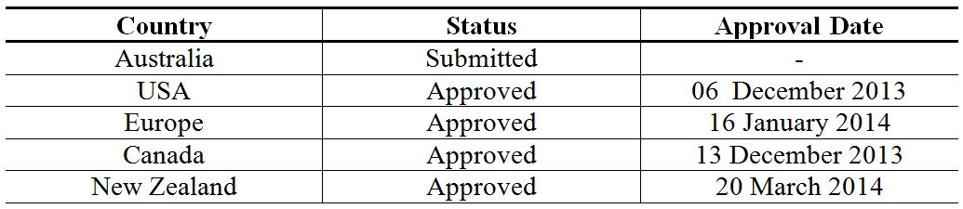
Table 2: Approved indications in the major markets for Sovaldi (sofosbuvir) tablets.
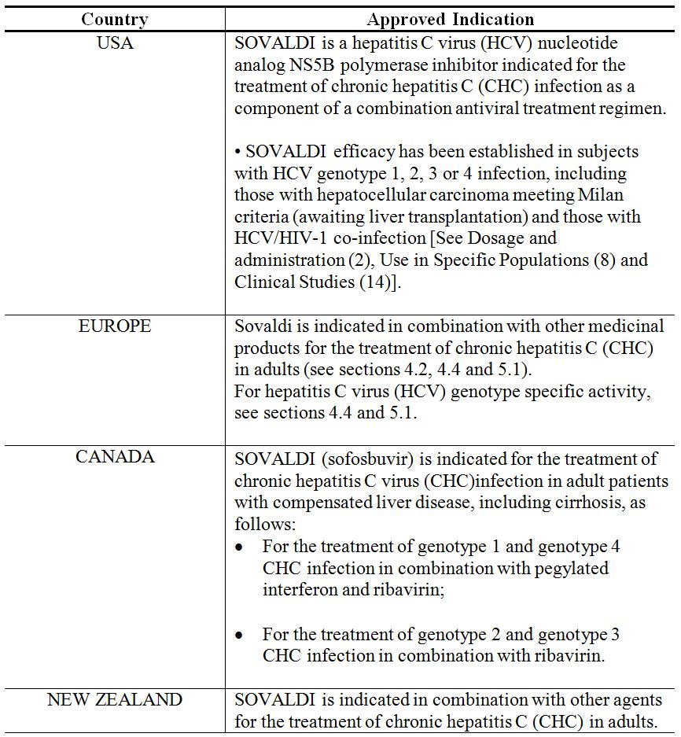

Product information
The approved Product Information (PI) current at the time this AusPAR was prepared can be found as Attachment 1. For the most recent PI please refer to the TGA website at <http://www.tga.gov.au/hp/information-medicines-pi.htm>.

II. Quality findings

Drug substance (active ingredient)
The structure of SOF is depicted in Figure 1.
Figure 1: Structure of sofosbuvir.
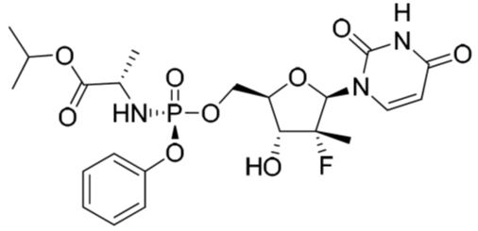
It is manufactured as the thermodynamically stable unsolvated polymorphic Form II. Several polymorphs are known (unsolvated and solvated forms). The desired form is controlled by differential scanning calorimetry.
SOF is a weak acid with a pKa of 9.3. It is considered highly soluble according to the Biopharmaceutics Classification System (BCS) criteria in aqueous solutions of pH 2-7.7 (~2 mg/mL). Particle size is adequately controlled.
The drug substance specifications include a limit of 0.5% for each of the specified impurities and a limit of 0.15% for individual unspecified impurities.

Drug product
The drug product is a conventional immediate release oral tablet. The tablets are yellow, capsule shaped, with ‘GSI’ on one side and ‘7977’ on the other side. SOF tablets are manufactured conventionally by dry granulation and are packed in white HDPE bottles with a polypropylene child resistant closure with an aluminium foil liner.
The finished product specifications include expiry limits of Not More Than (NMT) 0.50% for six specified degradation products and a limit of NMT 0.20% for any unspecified degradation product.
The tablets show very good stability and a shelf life of 24 months when stored below 30°C has been assigned.

Biopharmaceutics
SOF is a prodrug and is extensively metabolised in the liver to form the pharmacologically active nucleoside analog triphosphate GS-461203.
The active triphosphate GS-461203 was undetectable in plasma during both nonclinical and clinical studies.
The two major metabolites are GS-331007 and GS-566500. Metabolite GS-331007 is the primary circulating metabolite and accounts for 90% of the drug related material systemic exposure by area under the plasma concentration-time curve (AUC). As such, metabolite GS-331007 was selected as the analyte of interest for the bioequivalence studies. Pharmacokinetic data for SOF and metabolite GS-566500 were provided as supportive information only.
A total of four SOF tablet formulations were used in the clinical trials.
The following biopharmaceutic studies were submitted.

Study GS-US-334-0131
Study GS-US-334-0131 assessed drug-drug interactions between SOF Form I and co-administered antiretroviral agents. In a subset of subjects, tablets containing SOF Form II, the proposed commercial tablet formulation, were compared to tablets containing SOF Form I, the purple tablet formulation used in Phase III clinical trials, under fasting conditions. Apart from the polymorphic form of the active and the colour of the coating, the formulations of the tablets were otherwise identical.
A statistical comparison of the pharmacokinetic parameters of the three analytes is reproduced in Table 3.
Table 3: GS-US-334-0131: statistical comparisons of sofosbuvir, GS-566500 and GS-331007 pharmacokinetic parameters following administration of sofosbuvir Form I in Cohorts 1 and 3 and sofosbuvir Form II in Cohort 5 (SOF, GS-566500 and GS-331007 PK Analysis Sets).
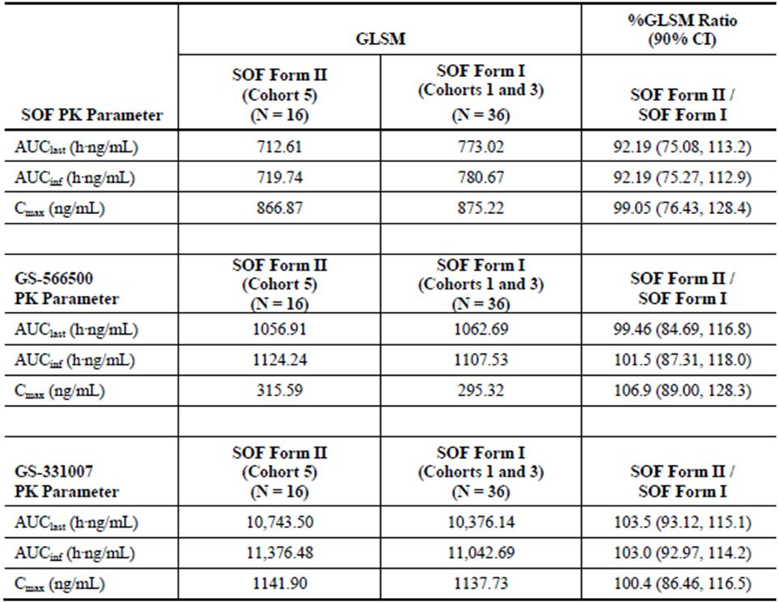
The 90% confidence interval (CI) for maximum plasma drug concentration (Cmax) and AUC for the primary analyte, GS-331007 demonstrated equivalent plasma exposures between the tablets containing Form I and Form II SOF.
The 90% CI for Cmax and area under the plasma concentration-time curve from time zero to infinity (AUC∞) for the supportive analyte GS-566500 demonstrated equivalent plasma exposures between the tablets containing Form I and Form II SOF.
The supportive PK parameters of the prodrug SOF showed that the 90% CIs were outside the normally accepted defined bounds to determine equivalence. However, the study was not designed or powered to determine bioequivalence of this analyte. SOF geometric least squares means (GLSM) ratios for AUC_{last}, AUC∞ and Cmax ranged from 92.2-99.1%.

Study P7977-1318
Study P7977-1318 compared 2 x 200 mg SOF Form I tablets, used in Phase II and Phase III clinical trials, with the 400 mg SOF Form I purple tablet, used in Phase III clinical trials. The 400 mg tablet used in the study has the same quantitative formulation as the proposed commercial tablet except that the commercial tablet contains Form II SOF and is a different colour.
Under fasting conditions the 2 x 200 mg tablets were shown to be bioequivalent to the 400 mg tablets for the pharmacokinetic parameters of GS-331007. The 90% CI for Cmax and AUCs were within the pre specified bounds of 80.00 to 125.00.
The supportive pharmacokinetic data for metabolite GS-566500 also showed that the 90% CIs for Cmax and AUCs met the normally accepted criteria 80.00-125.00 to establish bioequivalence.
The supportive data for SOF gave the GLSM ratios (and 90% CI) for Cmax, AUC_{0-∞} and AUC_{0-t} as: 90.0 (71.9, 112.7), 87.6 (78.5, 97.8) and 87.4 (77.1, 99.1), respectively.

Effect of food
Study P7977-1318 also investigated the effect of food on the 400 mg SOF Form I tablet.
For metabolite GS-331007, a high fat meal prolonged the time to reach maximum plasma concentration following drug administration (Tmax) by an hour. Cmax decreased by 24% and the 90% CI for Cmax did not meet the pre-defined equivalence criteria of 80-143 for a lack of food effect. However, the consumption of food did not change the AUCs of GS 331007 and the 90% CIs for AUCs met the pre-defined equivalence criteria for a lack of food effect.
The company considers the differences of Tmax and Cmax to be clinically insignificant and recommends that the tablet be taken without regard to food.
The supportive data for SOF and metabolite GS-566500 also showed that a high-fat meal prolonged Tmax. However, Cmax increased slightly for both analytes and AUC increased by 2 and 1.5 fold for SOF and GS-566500, respectively. The company suggests that this is due to food increasing the oral bioavailability of SOF but with minimal effect on GS-331007.

Study P7977-0111
Study P7977-0111 compared a capsule formulation containing an isomeric mixture enriched in Form I SOF against a tablet formulation used in early Phase I studies that contained a mixture of SOF and its diastereoisomer. This study was not evaluated as the formulations were not relevant to that proposed for registration in Australia.

Quality summary and conclusions
A number of relatively minor issues were raised with the sponsor following the initial evaluation of this application. The company satisfactorily addressed all issues, and there are no objections to registration from a pharmaceutical chemistry perspective.

III. Nonclinical findings

Introduction
The sponsor has applied to register SOF, a new chemical entity for use in the treatment of CHC in adults. SOF is proposed to be used for the treatment of CHC in adults in combination with RBV with or without PEG.
The overall quality of the nonclinical dossier was good with all pivotal studies conducted according to Good Laboratory Practice (GLP). One concern, however, was that some toxicity studies at the highest doses and the genotoxicity and safety studies were conducted only with the diastereomeric mixture (GS-9851) of SOF and GS-491241 (~1:1), noting that GS-491241 is barely present in the proposed clinical formulation.
SOF is a diastereomer (the S-diastereomer) which occurs in mixtures with the R-diastereomer (GS-491241). Much of the early development work on SOF was done using the diastereomeric mixture GS-9851 which contains SOF and GS-491241 in approximately equal amounts. SOF is highly hepatically extracted and the active metabolite GS-461203 predominantly remains in the liver and so they are not readily detected in plasma particularly in rodents. The nucleoside derivative GS-331007 which is the primary metabolite in all species was used as a marker for exposure comparisons. Table 4 can be used a reference.
Table 4: Reference table for key metabolites of sofosbuvir.
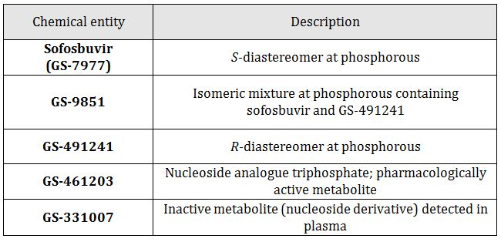

Pharmacology

Primary pharmacology
All pharmacodynamic (PD) studies (primary, secondary and interaction) submitted were in vitro studies. Most of the PD studies submitted were conducted using HCV subgenomic replicons. One study was conducted on the action of SOF against infectious HCV genotypes 1a (H77) and 2a (JFH-1) in human hepatoma cells. Some studies were performed using GS-9851.
Primary PD studies established conversion of SOF to GS-461203 in human primary hepatocytes and in clone A cells. Levels of GS-461203 were higher after incubation with SOF than with either GS-9851 or GS-491241 in clone A cells. In human hepatocytes, SOF and GS-491241 were converted to similar levels of GS-461203. Inhibition of HCV NS5B polymerases isolated from various HCV GTs (1b, 2a, 3a, 4a) by GS-461203 was demonstrated in vitro with similar half maximal inhibitory concentration (IC50) values (0.7-2.6 µmol/L) in all cases. In stable HCV replicon antiviral assays, SOF had half maximal effective concentration (EC50) values ranging from 0.014 to 0.11 µmol/L across stable GT-1a, 1b, 2a, 3a and 4a full length replicons and GT-2b, 5a, and 6a NS5B chimeric replicons. SOF had similar potency in transient replicons (GT 1a, 1b, 2a, 2b, 3a, 4a, 5a and 6a).
In infectious cell culture systems SOF was active against GT-1a (H77) and 2a (JFH-1 with EC50 values of 0.03 and 0.02 µmol/L respectively. These results indicated that SOF is active against infectious virus systems as well as against sub genomic replicons. Chimeric replicon assays were used to assess SOF against replicons encoding NS5B sequences from the quasispecies found at baseline in 217 patients enrolled in Phase II and Phase III trials. Chimeras were derived from GT-1a, 1b, 2a, 2b and 3a. EC50 values were comparable to the results with laboratory replicons and no significant differences in susceptibility of the different genotypes were observed. Although SOF is not highly protein bound, the effects of human serum and human serum albumin on replicon activity of SOF were investigated. Human serum up to 40% and human serum albumin up to 20 mg/mL had no effect on IC50 or IC90 values in these assays.
The in vitro resistance profile of SOF was evaluated by selecting for resistance to SOF in full length GT-1b, 2a, 3a, and 4a replicons and chimeric replicons encoding the genotype 2b, 5a, or 6a NS5B sequence in a GT-1b backbone. Sequencing analyses and subsequent phenotypic analyses of mutations emerging in the NS5B gene identified S282T as the primary NS5B mutation conferring reduced susceptibility to SOF. S282T caused an 8-24 fold increase in GS-461203 IC50 values in different genotypes. The fold increase in SOF EC50 for S282T ranged from 2.4 to 18.1 compared with the wild type from the corresponding genotypes. Across all 8 genotypes S282T replicons were 3-10 fold more sensitive to RBV than the corresponding wild type. No cross resistance to SOF was observed for replicons encoding NS5A mutations or NS5B mutations conferring resistance to non nucleoside inhibitors. There was also no evidence of cross resistance to SOF in replicons with NS5A inhibitor, protease inhibitor, or nucleoside inhibitor mutations. The NS5B F415Y mutation has been reported to emerge in patients infected with GT-1a and treated with RBV. This mutation does not confer resistance to SOF.
In both animals and humans, the metabolites GS-331007 and GS-566500 account for most of the total systemic exposure following an oral dose of SOF. No significant activity was observed for GS-331007 against the GT-1a, 1b, or 3a replicons or for GS-566500 against the GT-1b replicon.

Pharmacodynamic drug interactions
The antiviral effects of SOF with RBV against GT-1a and 1b replicons were additive to slightly synergistic. SOF in combination with other antiviral agents (HCV-796, ITMN-191, ACH-406, GS-9190, GS-9669, GS-945, TPV, BOC or IFNα) showed additive to synergistic activity against GT-1a and 1b. Combination of SOF with GS-5816 and GS-5885 (ledipasvir) showed additive to synergistic activity against GT-1b, 2a, 3a, and 4a replicons. No antagonism was observed for any of the combinations tested.
GS-9851 was tested in combination with anti HIV drugs. Combination of GS-9851 with azidothymidine (AZT), stavudine (d4T), lamivudine (3TC), emtricitabine (FTC), tenofovir disoproxil fumarate (TDF), zalcitabine (ddC) and abacavir (ABC) had no effect on the anti HIV activity of these drugs or on the anti HCV activity of GS-9851. These same drugs had no effect on the anti HCV activity of SOF.

Secondary pharmacodynamics and safety pharmacology
Potential off target activity was tested by screening GS-9851 on 171 receptors, enzymes, and ion channels, including cytochrome P450. No significant inhibition or stimulation was seen in any case. Additional secondary pharmacodynamic studies investigated activity of SOF against other viruses, in vitro cytotoxicity and activity of GS-461203 against host polymerases.

Activity against other viruses
SOF was selective for HCV in in vitro assays. No effects were seen at concentrations up to 100 µmol/L on HIV-1, human rhinovirus (HRV) types 10 and 14, or RSV. A concentration of 100 µmol/L GS-9851 had no effect on HIV-1 but caused 18% inhibition of hepatitis B virus (HBV) at this concentration.

In vitro cytotoxicity
The cytotoxicity of SOF, GS-7976, GS-9851, GS-566500 and GS-331007 was evaluated in a number of cell lines (Huh7, HepG2, BxPC3, CEM and PANC-1). No cytotoxicity was observed at the highest concentrations of each compound tested with the exception of SOF in Huh 7 (CC50 95.9 µmol/L) and HepG2 (CC50 90.6µmol/L) lines. The CC50 for GS-9851 on human erythroid and myeloid progenitor cell proliferation was > 50 µmol/L, the highest dose tested.

In vitro mitochondrial toxicity
Nucleoside inhibitors as a class have the potential to inhibit host DNA and RNA biosynthesis. The potential for SOF to exert effects on host DNA was assessed by examining effects on mitochondrial and ribosomal DNA in HepG2 and CEM cells. SOF had no effect on mitochondrial or ribosomal DNA at concentrations up to 100 µmol/L for 14 days in CEM cells and in HepG2 cells up to 50 µmol/L. GS-9851 and GS-491241 had no effect on mitochondrial or ribosomal DNA at concentrations up to 100 µmol/L in either cell type and GS-9851 was also without effect in BxPC3 cells. SOF and GS-9851 did not inhibit cytochrome C oxidase in PC-3 cells and GS-9851 did not affect this enzyme in Hep G2 cells.

Effects on host polymerases
The IC50 value for GS-461203 inhibition of human DNA polymerases β and γ was > 1 mmol/L for human DNA polymerase α 550 µmol/L and for RNA polymerase II >200 µmol/L. GS-461203 was not incorporated into human mitochondrial RNA polymerase.
Overall, the secondary pharmacology studies suggest that SOF acts specifically on HCV NS5B polymerase and does not affect host cellular or mitochondrial polymerases. SOF also acts specifically against HCV with no effects on the other viruses tested. SOF showed minimal or no cytotoxic effects on a variety of cell lines.

Safety pharmacology
Single doses up to 1000 mg/kg in rats had no effects on central nervous system (CNS) function evaluated by a functional observational battery and no effects on respiratory function.
Cardiovascular risks were evaluated in vitro and in vivo. GS-9851, GS-566500, GS-606965 and GS-331007 had no effects on human Ether-à-go-go-Related Gene (hERG) currents in vitro at the highest concentrations tested. In conscious dogs, single oral doses of GS-9851 up to 1000 mg/kg had no effects on any cardiovascular parameters (see ‘Repeat-dose Toxicity’ below for further discussion of cardiac toxicity).

Pharmacokinetics
Absorption was rapid in all nonclinical species following oral administration of SOF or GS-9851. Cmax values for SOF in dogs reached 34.5 and 43 µg/mL in male and females respectively following repeat dosing at 500 mg/kg/day (13 week study). The corresponding Cmax values for the primary metabolite GS-331007 were 23 and 29 µg/mL. In rodent species, SOF or GS-9851 was rapidly metabolised to reveal GS-331007 and minor metabolites in plasma. However, the plasma profile of SOF could not be elucidated in rodent species due to the rapid disappearance of SOF and concomitant appearance of metabolites. In dogs SOF was rapidly absorbed and excreted with Tmax values mostly around one hour (up to 3.3 h) and t_{1/2} values were generally 1-2 h. The time profile of GS-566500 was essentially similar to SOF with lower plasma concentrations and smaller t_{1/2} values than the primary metabolite GS-331007, which was the most persistent chemical species detected in plasma from all animals. In dogs, the fraction absorbed into the portal vein was estimated to be 39.7% and hepatic extraction was high, estimated at 74 %. Oral bioavailability of SOF was estimated to be 9.89%. Exposure to SOF and metabolites generally increased proportionally with dose and no sex differences in exposure were detected in these studies.

Distribution
Plasma protein binding was low in humans and nonclinical species (<70 %) irrespective of drug concentration up to 100 µg/mL. In humans, SOF was approximately 61-65% bound to plasma proteins. Plasma protein binding of the major circulating metabolite GS-331007 was very low in humans and nonclinical species (<11 %) at concentrations up to 100 µg/mL. Following oral administration of ¹⁴C-SOF in albino and pigmented rats, ¹⁴C-SOF derived radioactivity was rapidly and widely distributed. Drug derived radioactivity was detected in CNS tissues and testes at the 1 h time point in both albino and pigmented rats but was below the limitation of quantitation (BLoQ; 0.073 µg equiv/g) in both of these tissues by 12 and 48 h in SD and LE rats respectively. The penetration of the blood-brain and blood-testes barriers appeared limited as the concentrations of drug derived radioactivity in these tissues were among the lowest along with bone, eye lens, and white adipose tissue. The highest concentrations of SOF related material were detected in alimentary canal, lymphatic and excretory systems. There was no evidence of specific association with melanin. Drug derived radioactivity was transferred through the placenta and was found in amniotic fluid and absorbed into foetuses. Drug related material was detected in foetal CNS and blood at levels higher than those observed in dams. In contrast, foetal liver tissue levels were approximately 10% those observed in the livers from pregnant dams and exposure to the foetal kidney was not detected. ¹⁴C-SOF related material was detected in milk and was transferred to nursing pups but only resulted in relatively low levels of exposure in nursing pups. Whole body tissue distribution studies after repeated dosing were not done, and therefore it is not known if drug accumulates in particular tissues with repeated dosing.

Metabolism
The metabolism of SOF in rodents and dogs followed a similar pattern to humans with respect to metabolite formation (with the exception of SOF’s rapid disappearance in rodents). The active metabolite GS-461203 was detected in rat and dog liver but not in mouse or monkey liver. In dog liver, in vivo GS-461203 was efficiently formed reaching Cmax of 47.5 µmol/L (23.8 µg/mL) and persisting with a t_{1/2} of 17.8 h. PD studies in vitro showed an IC50 value for GS-461203 against GT-1b, 3a, and 4a of ~2 µmol/L. The proposed metabolic pathway involves hydrolysis by Cathespin A or Carboxylesterase 1 to remove the ester. This is then followed by a chemical step that releases the phenol producing GS-566500, and cleavage of the phosphoramidate bond by histidine triad nucleotide binding protein 1 liberating the nucleoside analogue monophosphate (GS-606965) and alanine. Finally, phosphorylation by resident kinases UMP-CMP kinase and NDP kinase produces the active triphosphate GS-461203. De-phosphorylation of the nucleoside analogue monophosphate results in formation of the primary metabolite GS-331007 (inactive) which cannot be efficiently re-phosphorylated.

Excretion
In mass balance studies, ¹⁴C-SOF associated radioactivity was predominantly excreted via the urine accounting for 66%, 72%, and 81% of the administered dose of radioactivity in mice, rats and dogs, respectively. In humans, the urine accounted for 76% of ¹⁴C-SOF associated radioactivity. The faeces were a minor route of excretion in animals and humans accounting for 14%, 18%, and 2% in mice, rats and dogs, respectively. In humans, the faecal route accounted for 14% of excreted ¹⁴C-SOF associated radioactivity and the majority of the SOF dose recovered in urine was GS-331007 (78%) while 3.5% was recovered as SOF.

Conclusion
The pharmacokinetic profiles in the laboratory animal species were sufficiently similar to the clinical pharmacokinetics to allow them to serve as appropriate models for the assessment of drug toxicity in humans. Dogs were the most relevant species for toxicity comparisons since they displayed similar SOF disposition and the ability to produce the active triphosphate form GS-461203 in liver at concentrations well above the in vitro IC50 for several HCV genotypes. SOF was metabolised rapidly in rodent plasma and the active triphosphate form GS-461203 failed to be detected in mouse and monkey liver. The primary metabolite GS-331007 was similarly predominant across all species tested.

Pharmacokinetic drug interactions
SOF and metabolites GS-331007, GS-566500, GS-606965, GS-607596, GS-461203 showed no inhibitory activity against cytochrome P450 enzymes 1A2, 3A4, 2C8, 2C9, 2C19 and 2D6, or against UGT1A1. SOF caused small increases in CYP2B6 and CYP3A4 mRNA levels (<15 % positive control effects) and no other induction effects. SOF is activated by hydrolase and nucleotide phosphorylation pathways generally not inhibited by other drugs (at pharmacologically relevant concentrations). Incubation with the HCV inhibitors GS-5816, GS-5885, BMS790052 (daclatasvir), tegobuvir, GS-9451, or GS-9669, or the CYP inhibitors ritonavir or ketoconazole did not markedly affect the formation of GS-461203 in primary human hepatocytes. SOF was revealed to be transported by P-glycoprotein (Pgp) and breast cancer resistance protein (BCRP), and SOF absorption may be increased by co-administration with inhibitors of these transporters. Inducers of these transporters may decrease SOF exposure. SOF was not an inhibitor of transporters in kidney or bile.

Toxicology

Acute toxicity
Acute oral toxicity of GS-9851 was assessed in single dose studies in rats. GS-9851 has a low order of acute toxicity. Single doses up to 1800 mg/kg caused no mortality and had no treatment related effects. This dose gave exposure margins for the metabolite GS-331007 of 28 and 24 for males and females, respectively. There were a number of unscheduled deaths in the repeat dose toxicity studies in rats with both GS-9851 and SOF, but the sponsor attributed these to problems with aspiration of the vehicle in recently fed animals. There was no dose dependency of these deaths and a number occurred in control animals; a direct effect of SOF seems unlikely but cannot be completely excluded.

Repeat dose toxicity
Repeat dose toxicity studies were conducted in three species: mouse, rat, and dog. All studies were conducted using the clinical (oral) route and some studies were conducted with the diastereomeric mixture GS-9851. Pivotal studies were conducted with SOF. The durations of the pivotal studies, the species used and the group sizes were consistent with ICH guidelines.

Relative exposure
Exposure ratios have been calculated based on animal:human plasma AUC_{0-24h}. Human reference values for SOF and its primary metabolite GS-331007 are from nonlinear mixed effects modelling of pharmacokinetic data from clinical studies including healthy (n = 284) and infected individuals with HCV genotypes 1 to 6 (n = 986). The steady state AUC_{human} is based on HCV positive subjects since infection status was revealed to be a significant predictor of SOF disposition in population PK studies. No other patient demographics were shown to significantly effect SOF disposition (for example, gender). SOF is not stable in plasma of rodent species due to high esterase activity and thus exposure comparisons in rodent species rely on plasma GS-331007 concentrations. This is considered adequate since GS-331007 is the primary metabolite in all nonclinical species and humans.
The levels of exposure achieved in nonclinical species were adequate to reveal toxicity related to SOF or its primary metabolite (GS-331007). Animal:human exposure ratios for SOF reached 178 in female dog following 500 mg/kg SOF and for GS-331007 exposure reached 124 times anticipated clinical AUC in female dog following 1500 mg/kg GS-9851 (Table 5).
Table 5: Relative exposure in repeat-dose toxicity studies using GS-9851 or sofosbuvir.
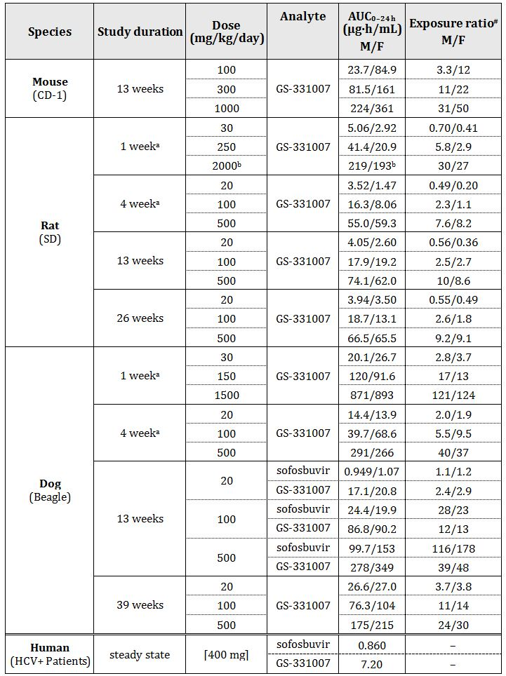
# = animal:human plasma AUC_{0-24h} ; ª Dose administered as GS-9851; ^{b} Day 1 values only.

Major toxicities
The repeat dose toxicity of SOF was low and potentially serious organ toxicities were seen only following short exposures at the highest doses and were not seen in any of the pivotal long term toxicity studies. In the 13 week study in mice, decreases in bodyweight were observed at 300 and 1000 mg/kg/day in males, and 1000 mg/kg/day in females, exposure ratios for GS-331007 were 3.3 (male) and 22 (female) at the respective NOAELs. Apart from a possible effect on the heart in rats, no major organ toxicities were identified in either mice or rats. In the dog, two organs were identified as toxicity targets: liver and gastrointestinal tract.
There were effects on the heart in two studies conducted with GS-9851: one in dogs at 1500 mg/kg/day, and one in rats at 2000 mg/kg/day. However, the effects in the two species were different and in neither case was there evidence of any dose relation. A fraction of 3/10 male and 6/10 female deaths occurred at 2000 mg/kg/day in a 1 week repeat dose study in rats (GS-331007 exposure ratio [AUC] of 29 in combined sexes). The deaths were associated with histopathological evidence of degeneration of cardiac myofibres in all 3 of the male deaths and in 3 of the female deaths. There was evidence of similar degeneration in one of the surviving females at the end of dosing and in two of the surviving females at the end of recovery. No evidence of similar degeneration was seen in any of the other surviving animals at any dose. The animals that died also had various degrees of lymphocyte depletion, increased necrosis of individual lymphocytes, and/or increased tingible body macrophages seen in lymphoid tissues. No comparable changes were seen with longer exposures at lower doses in rats or in other species. The exposure ratio at the SOF NOAEL of 500 mg/kg/day in the 26 week study in rats was 9.2 (males and females combined).
In male dogs receiving 1500 mg/kg/day for 1 week, there was a slight prolongation (19%) of the QT and QTc interval. There was no corresponding effect in females and there were no histopathological changes accompanying this effect. QT and QTc intervals returned to baseline in the one recovery male. The GS-331007 Cmax at 1500 mg/kg/day was 23 µg/mL (sexes combined), or 34x the human Cmax of 682 ng/mL at the clinical dose. In safety studies there was no evidence of effects of GS-9851, GS-566500, GS-606965 and GS-331007 on hERG currents in vitro, nor were cardiovascular effects observed by telemetry in dogs given a single dose up to 1000 mg/kg by oral administration (PO, per os). A direct effect of SOF on the heart cannot be ruled out but on the balance of the evidence such an effect seems unlikely.
In dogs there was a slight (<2x) increase in mean alkaline phosphatase (ALP) activity in males at 1500 mg/kg/day, and a slight (≤3x) increase in mean alanine transaminase (ALT) and aspartate aminotransferase (AST) activities and bilirubin concentration in both sexes at 1500 mg/kg/day (GS-331007 exposure ratio 123 in combined sexes). These changes were reversible and were reduced or resolved completely by the end of the recovery period. These changes may have been secondary to histopathological liver findings at the same dose which included hepatocellular hypertrophy, reduced intracellular glycogen and apoptosis. None of these histopathological findings were present in dogs in either high dose (HD) at the end of the recovery period and were not generally seen at longer exposures at lower doses. Small elevations in ALP levels were reported in females given 500 mg/kg SOF or 500 mg/kg GS-9851 in a 2 week bridging study and in females given 100 and males and females given 500 mg/kg/day GS-9851 in a 4 week study. There were no histopathological changes noted in the liver in either of these studies. These results suggest that at HD, SOF may have some potential to cause adverse effects on the liver. However, the effects may be transient as they were not reported in any of the long term toxicity studies. Problems at the anticipated clinical exposures are unlikely.
There were some signs of gastrointestinal irritation in dogs. These were soft faeces and emesis. These effects were seen in all treatment groups including animals receiving vehicle only and showed weak dose dependence. There were no accompanying pathological changes and all signs reversed when dosing stopped.
Minor effects on red cell indices were also observed in dogs. There were decreases in red cells, haemoglobin and haematocrit seen at doses ≥100 mg/kg/day with SOF and 500 mg/kg/day with GS-9851. The effects were reversed when dosing stopped.

Combination toxicity studies
Justification for the lack of toxicology studies with the combination was adequately addressed in the Section 31 response. SOF is proposed for use with RBV, with or without PEG. No toxicity studies were conducted with SOF in combination with RBV or PEG. RBV and PEG have well characterised toxicity profiles, and may elicit haematological effects. A slight decrease in erythropoiesis was observed only at high drug exposures in dogs, and not in rodents. SOF has not been observed to increase the frequency or severity of the haematological effects of RBV or SOF in clinical studies (Clinical Overview). The lack of nonclinical combination studies is consistent with a draft US Food and Drug Administration (FDA) guidance for direct acting antiviral drugs for HCV treatment.

Genotoxicity
SOF and the process intermediates generated during manufacture were evaluated in silico for potential genotoxicity using two predictive toxicity software programs, DEREK for Windows (Lhasa Ltd) and FDA Model Applier (Leadscope). DEREK did not report any structural alerts for SOF but Leadscope did give a positive genotoxicity prediction for SOF.
The diastereomeric mixture GS-9851 was evaluated for its potential to induce reverse mutations in S. typhimurium and E. coli, its mutagenic potential in vitro in primary human lymphocytes, and its mutagenic potential in vivo in a mouse bone marrow micronucleus study (Option 1 in ICH S2[R1]). GS-9851 was negative in all the tests and is unlikely to pose a mutagenic or clastogenic risk to humans.

Carcinogenicity
Studies in mice (20/60, 60/200, 200/600 mg/kg/day [male/female]) and rats (75, 250, 750 mg/kg/day) showed no evidence of carcinogenicity. Systemic exposure (AUC) ratios (GS-331007) at the HD were 7/24x (male/female mice) and 11/15x (male/female rats) higher than the clinical exposure at 400 mg SOF.

Reproductive toxicity
Reproductive toxicity was assessed in rats and rabbits in GLP compliant studies. The studies investigated potential effects on male and female fertility in rats, embryofoetal toxicity (rats and rabbits) and pre/postnatal development (rats). Adequate animal numbers were used in the pivotal studies and treatment periods were appropriate. Toxicokinetic data were obtained either from animals in the studies or from similarly treated animals in accompanying studies.

Relative exposure
The animal:human AUC exposure ratios achieved in these studies are adequate with respect to SOF (10 times) and GS-331007 (28 times). Placental transfer and excretion in milk were demonstrated in rats (Table 6).
Table 6: Animal:human AUC exposure ratios.
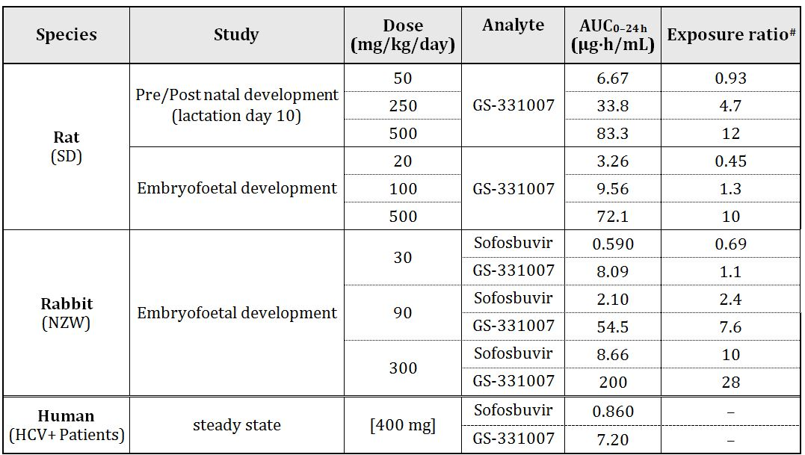
# = animal:human plasma AUC_{0–24 h}
SOF had no effects on fertility in rats. The NOAEL values were 500 mg/kg/day in both males and females. At this dose the mean GS-331007 Cmax and AUC_{last} were 3.5 µg/mL and 72.1 µg·h/mL, respectively on gestational day (GD) 18.
SOF had no effects on embryofoetal development in rats. The maternal and foetal NOAEL values were 500 mg/kg/day. SOF was also without effect on embryofoetal development in rabbits (NOAEL 300 mg/kg/day). There were unscheduled deaths (12%) of rabbit dams treated with vehicle (PEG 400) and SOF in the same vehicle compared to water controls (0%). The cause of these deaths was not clear but the numbers were highest in vehicle alone and did not appear related to SOF.
SOF had no effects on postnatal development in rats including reproductive function and there were no effects in F2 pups. The NOAEL for effects on post-natal development was 500 mg/kg/day.

Australian pregnancy classification
The sponsor has proposed Pregnancy Category B2 for SOF. Based on the results of the studies in rats and rabbits in this submission, B1 would seem more appropriate as the statement “Studies in animals have not shown evidence of an increased occurrence of foetal damage” would seem to apply in the case of SOF. The US FDA category for SOF is B. RBV has an Australian Pregnancy Category of X, based on teratogenicity in multiple animal species, and this category will be applicable to the combination of SOF and RBV.

Local tolerance
SOF showed no evidence of skin irritation following topical application to the skin of rabbit and no evidence of ocular irritation in the in vitro bovine corneal opacity and permeability assay. There was no evidence of skin sensitisation by SOF following topical application to the ears of mice.

Skin sensitisation
There was no evidence of skin sensitisation by SOF in the local lymph node assay in mice.

Impurities
A number of impurities in SOF drug substance and product required toxicological qualification.

Paediatric use
SOF is not proposed for paediatric use and no specific studies in juvenile animals were submitted.

Comments on the safety specification of the risk management plan
Results and conclusions drawn from the nonclinical program for SOF detailed in the sponsor’s draft Risk Management Plan (RMP) are in general concordance with those of the nonclinical evaluator.

Nonclinical summary and conclusions

Summary
- Gilead Sciences Pty Ltd has applied to register a new chemical entity, SOF (Sovaldi), a nucleoside analogue, for use with other agents in the treatment of CHC in adults. Sovaldi is proposed to be used for the treatment of CHC in adults in combination with RBV, with or without PEG. The proposed dosing regimen involves oral administration of one tablet (400 mg) once daily. The proposed treatment duration is 12 weeks for patients with GT-1, 2, 4, 5 or 6 CHC, 16 weeks for patients with GT-3 CHC, and until transplantation for patients awaiting a liver transplant.
- The overall quality of the nonclinical dossier was good with all pivotal studies conducted according to GLP. However, one concern was that some toxicity studies at the highest doses and the genotoxicity and safety studies were conducted only with the diastereomeric mixture (GS-9851) of SOF and GS-491241 (~1:1), GS-491241 is barely present in the proposed clinical formulation.
- Primary pharmacology studies were conducted entirely in vitro. Most studies were conducted using HCV subgenomic replicons. SOF is converted in liver cells to an active triphosphate metabolite (GS-461203). Primary pharmacology studies established the inhibition of HCV NS5B polymerases isolated from HCV GT-1b, 2a, 3a, 4a by the active metabolite GS-461203, and inhibition of stable GT-1a, 1b, 2a, 3a and 4a full length replicons and GT-2b, 5a, and 6a NS5B chimeric replicons by SOF. One study established the efficacy of SOF against infectious HCV GT-1a (H77) and 2a (JFH-1) in human hepatoma cells.
- Overall, the secondary pharmacology studies indicated that SOF acts specifically on HCV NS5B polymerase and does not affect host cellular or mitochondrial polymerases. SOF also acts specifically against HCV with no effects on the other viruses tested. SOF showed minimal or no cytotoxic effects on a variety of cell lines. SOF demonstrated additive effects with other antiviral agents including RBV. SOF did not interact with the anti HIV drugs AZT, d4T, 3TC, FTC, TDF, ddC and ABC.
- SOF did not have any notable effects on CNS, cardiovascular or respiratory function following oral administration and had no effects on hERG channels in vitro.
- Absorption was rapid in all nonclinical species following oral administration of SOF or GS-9851. Cmax values for SOF in dogs reached 34.5 and 43 µg/mL in male and females respectively following repeat dosing at 500 mg/kg/day (13 week study). The corresponding Cmax values for the primary metabolite GS-331007 were 23 and 29 µg/mL. Hepatic extraction of SOF was high (74% in dog) and the oral bioavailability was low (9.89% in dog). Exposure to SOF and metabolites generally increased proportionally with dose and no sex differences in exposure were detected in these studies. Plasma protein binding to SOF and GS-331007 in vitro was low in humans and nonclinical species. Following oral administration of 14C-SOF in albino and pigmented rats 14C-SOF derived radioactivity was rapidly and widely distributed, including the CNS and testes to a limited extent. There was no evidence of specific association with melanin. Drug derived radioactivity was transferred through the placenta and was found in amniotic fluid and absorbed into foetuses. Drug related material was detected in foetal CNS and blood at levels higher than those observed in dams. In dog liver in vivo, GS-461203 was efficiently formed reaching Cmax of 47.5 µmol/L (23.8 µg/mL) and persisting with a half life of 17.8 h. Pharmacodynamic studies in vitro showed an IC50 value for GS-461203 against GT-1b, 3a, and 4a of ~2 µmol/L. The proposed metabolic pathway involves hydrolysis by Cathespin A or Carboxylesterase 1 to remove the ester followed by a chemical step that releases the phenol, producing GS-566500, and cleavage of the phosphoramidate bond by histidine triad nucleotide-binding protein 1 liberating the nucleoside analogue monophosphate (GS-606965) and alanine and finally phosphorylation by resident kinases UMP-CMP kinase and NDP kinase to produce the active triphosphate GS-461203. The primary metabolite GS-331007 was similarly predominant across all species tested. There was no evidence of intreconversion of the diastereomers in vitro or in vivo. The main route of excretion in humans (76%) and nonclinical species is via the urine. Limited excretion occurs via the faeces (14% in humans). SOF is unlikely to participate in drug-drug interactions involving CYP or UGT1A1 metabolism and was not an inhibitor of transporters in kidney or bile. SOF absorption may be increased by co-administration with inhibitors of Pgp and BCRP.
- Acute oral toxicity was assessed in a single dose study with GS-9851 in rats. Single doses up to 1800 mg/kg caused no mortality and had no notable effects indicating a low order of acute toxicity.
- Repeat dose toxicity studies were performed in mice, rats and dogs. The relative HD exposures achieved in the pivotal studies in these respective species were 31/50 (male/female), 9 and 11/14 (male/female) the anticipated clinical exposure based on AUC0-24h. The pivotal studies were of 6 months duration in rats and 9 months duration in dogs. No major organ toxicities were observed with SOF in any species. In a 1 week toxicity study with GS-9851 in rats, deaths occurred in animals dosed at 2000 mg/kg. The deaths were associated with histopathological evidence of degeneration of cardiac myofibres in all the male deaths and in some of the female deaths. No evidence of this effect was seen at any exposure to SOF in rats or in other species.
- The potential genotoxicity of GS-9851 was investigated in a standard battery of tests. The results were negative in all tests and SOF (as a component of GS-9851) is unlikely to pose a mutagenic or clastogenic risk to humans.
- Long term carcinogenicity studies at adequate exposure multiples of the human dose in mice and rats were negative.
- SOF had no effects on fertility, embryofoetal or postnatal development in rats or on embryofoetal development in rabbits.
- SOF did not produce skin or ocular irritation and did not cause skin sensitisation.

Conclusions and recommendation
- There are no major deficiencies in the nonclinical submission. Some toxicity studies at the highest doses and the genotoxicity and safety studies were conducted only with the diastereomeric mixture GS-9851.
- Primary pharmacology studies established the inhibition of HCV NS5B polymerases isolated from various HCV genotypes and the efficacy of SOF against infectious HCV genotypes in vitro.
- Secondary pharmacology studies indicated that SOF acts specifically on HCV NS5B polymerase and does not affect host cellular or mitochondrial polymerases and is not cytotoxic. No clinically relevant hazards were identified in safety studies.
- SOF is transported by Pgp and BCRP and absorption may be increased by co-administration with inhibitors of these transporters. Inducers of these transporters may decrease SOF exposure.
- No major organ toxicities were observed with SOF in repeat dose studies in any species, at clinically relevant exposures.
- Based on results obtained with GS-9851, SOF is unlikely to pose a genotoxic hazard.
- Long term carcinogenicity studies in mice and rats were negative.
- There was no evidence of reproductive toxicity of SOF. Pregnancy category B1 would be appropriate.
- There are there no nonclinical objections to the registration of SOF.

IV. Clinical findings
A summary of the clinical findings is presented in this section. Further details of these clinical findings can be found in Attachment 2.

Introduction

Guidance
Pre-submission meetings with TGA highlighted issues including discussions between the sponsor and other regulatory authorities (US FDA, Swedish Medical Products Agency [MPA], UK Medicines and Healthcare products Regulatory Agency [MHRA]) in regards to:
- Using an historical control for HCV therapeutic studies, rather than an active comparator, that is, current SOC. Outcome: definitive agreement reached that historical controls could be used in the SOF Phase III Study GS-US-334-0110 (NEUTRINO). This feedback is consistent with a publicly available presentation in which the FDA specifically recognised that in the development of DAA for HCV treatment in naïve patients, an IFN free regimen could use a single arm/historical control design. MPA also indicated this study design would be acceptable for registration of SOF assuming SVR rates were high. Similarly, FDA accepted the ongoing design of GS-US-334-0108 (FUSION) in GT-2 and 3 treatment experienced subjects. This study has no control arm; instead, it compares SVR rates to an assumed spontaneous response rate
- The sponsor to provide FDA guidance and abstract data on SVR12, as the submission in the US will be filed containing SVR12 data (actioned 4 February 2013) and provide SVR24 data to TGA upon request
- TGA requested a justification for the absence of combination toxicology studies and absolute bioavailability. Gilead to provide final carcinogenicity studies on request.

Contents of the clinical dossier
The clinical submission was presented in Common Technical Document format and contained 81 volumes not the original 110 planned. The sponsor has given assurance to the TGA that there is no impact on the integrity or quality of data of the data submitted as a consequence of this reduction in the amount of information submitted. The submission contained the following clinical information:
- 25 clinical pharmacology studies, including 12 that provided pharmacokinetic data and
- 17 that provided pharmacodynamic data, that is, healthy volunteer pharmacokinetic studies (n = 4).
These included:
- Module 5.3.1:
  - P7977-0111: A Single Dose, Randomised, 3-Period, Crossover Study to Evaluate the Relative Bioavailability of a PSI-7851 Capsule Formulation to a PSI-7977 Tablet Formulation and Food Effect
  - P7977-1318: A Single-Dose, Randomised, 3-Period, Crossover Study to Evaluate the Relative Bioavailability of a 200 mg PSI-7977 Tablet Formulation to a 400 mg PSI-7977 Tablet Formulation and the Effect of Food on the Bioavailability of the 400 mg Tablet
  - P7977-0312: An Open Label, Non-Randomised, Single Dose, Mass Balance Study to Investigate the Pharmacokinetics, Excretion and Recovery of [14C]PSI-7977 Administered as a Single Oral Dose to Healthy Adult Subjects
  - P7851-1101: A Double-Blind, Parallel, Randomised, Placebo-Controlled, Single Ascending Dose Study to Investigate the Safety, Tolerability and Pharmacokinetics Following Oral Administration of PSI-7851 to Healthy Volunteers
- Module 5.3.4.1
  - P7977-0613: A Single-Dose, Randomised, Blinded, Placebo- and Positive-Controlled, Four-Period Cross-Over Study to Investigate the Effect of PSI-7977 at a Projected Therapeutic and Supratherapeutic Dose on the QT/QTc Interval in Healthy Volunteers
- Module 5.3.3.2 Patient pharmacokinetics/pharmacodynamics and dose finding (n = 2)
  - P7851-1102: A Double-Blind, Parallel, Randomised, Placebo-Controlled, Multiple Ascending Dose Study to Investigate the Safety, Tolerability, Pharmacokinetics and Pharmacodynamics following Oral Administration of PSI-7851 to Patients with Chronic Hepatitis C Infection of Genotype 1
- Module 5.3.3.3 Intrinsic Factor Pharmacokinetic Study Reports (n = 2)
  - P7977-0915: An Open-Label Study of Pharmacokinetics of Single Oral Doses of PSI-7977 in Subjects with Varying Degrees of Renal Function
  - P2938-0515: An Open-Label Study to Characterize the Pharmacokinetics and Pharmacodynamics of Multiple Oral Doses of PSI-7977 or PSI-352938 in HCV-infected Subjects with Varying Degrees of Hepatic Impairment
- Module 5.3.3.4 Extrinsic Factor Pharmacokinetic Study Reports (n = 4)
  - GS-US-334-0131: A Phase I, Open-label, Pharmacokinetic Drug-Drug Interaction Study Between GS-7977 and antiretrovirals efavirenz/emtricitabine/tenofovir Disoproxil Fumarate (TDF/FTC/EFV), a Boosted Protease Inhibitor, darunavir/ritonavir (DRV/r), an Integrase Inhibitor (II), raltegrevir (RAL), and Non-Nucleoside Reverse Transcriptase Inhibitor (NNRTI), Rilpivirine (RPV)
  - P7977-0814: A Phase I, Open-Label, Single-Sequence Drug-Drug Interaction Trial in Healthy Subjects Receiving Stable Methadone Maintenance Therapy to Investigate the Potential Interaction at Steady State between PSI-7977 400 mg QD and Methadone
  - P7977-1819: An Open-Label, Randomised, Three Period, Cross-Over, Drug Interaction Study to Assess the Effect on Pharmacokinetics of Co-administration of PSI-7977 and Cyclosporine or Tacrolimus in Healthy Subjects
  - P7977-1910: Part A: Drug Interaction Study between GS- 7977 and Antiretroviral Therapy (ARV) Combinations of efavirenz, tenofovir and emtricitabine; efavirenz, zidovudine and lamivudine; atazanavir/ritonavir, tenofovir and emtricitabine; darunavir/ritonavir, tenofovir and emtricitabine; raltegravir, tenofovir and emtricitabine in HIV and Hepatitis C Virus (HIV/HCV) Co-infected Patients
- Module 5.3.3.5.
  - A population pharmacokinetic analyses
- Module 5.3.5.1 4 pivotal efficacy/safety studies (n = 4)
  - P7977-1231 (FISSION): A Phase III, Multicenter, Randomised, Active-Controlled Study to Investigate the Safety and Efficacy of PSI-7977 and Ribavirin for 12 Wks Compared to PEGylated Interferon and Ribavirin for 24 Wks in Treatment-Naïve Patients with Chronic Genotype 2 or 3 HCV Infection
  - GS-US-334-0107 (POSITRON): A Phase III, Multicenter, Randomised, Double-Blind, Placebo-Controlled Study to Investigate the Efficacy and Safety of GS-7977 + Ribavirin for 12 Wks in Subjects with Chronic Genotype 2 or 3 HCV Infection who are Interferon Intolerant, Interferon Ineligible or Unwilling to Take Interferon
  - GS-US-334-0108 (FUSION): A Phase III, Multicenter, Randomised, Double-Blind Study to Investigate the Efficacy and Safety of GS-7977 + Ribavirin for 12 or 16 Wks in Treatment Experienced Subjects with Chronic Genotype 2 or 3 HCV Infection
  - GS-US-334-0110 (NEUTRINO): A Phase III, Multicenter, Open-Label Study to Investigate the Efficacy and Safety of GS-7977 with PEGinterferon Alfa 2a and Ribavirin for 12 Wks in Treatment-Naïve Subjects with Chronic Genotype 1, 4, 5, or 6 HCV Infection
- Module 5.3.4.2 – Dose finding studies (n = 6)
  - P2938-0212 (NUCLEAR): A Two-Part, Double-Blind, Parallel, Randomised, Placebo-Controlled Study to Assess the Safety, Tolerability, Pharmacokinetics, and Pharmacodynamics of Multiple Ascending Doses of PSI-352938 and the Combination of PSI-352938 and PSI-7977 in Patients with Genotype 1 Chronic Hepatitis C Infection
  - P7977-0221: A Multi-center, Double-Blind, Parallel Group, Randomised, Placebo-Controlled, Dose Ranging Study to Investigate the Safety, Tolerability, Pharmacokinetics and Pharmacodynamics following Oral Administration of PSI-7977 in Combination with Standard of Care (PEGylated Interferon and Ribavirin) in Treatment-Naïve Patients with Chronic HCV Infection Genotype 1
  - P7977-0422 (PROTON): A Multi-center, Placebo-Controlled, Dose Ranging Study to Investigate the Safety, Tolerability, Pharmacokinetics and Pharmacodynamics following Oral Administration of PSI-7977 in Combination with PEGylated Interferon and Ribavirin in Treatment-Naïve Patients with Chronic HCV Infection Genotype 1, and an Open Label Assessment of PSI-7977 in Patients with HCV Genotypes 2 or 3
  - P7977-0724 (ATOMIC): A Multicenter, Open-label, Randomised, Duration Finding Study to Investigate the Safety, Tolerability, Pharmacokinetics and Pharmacodynamics following Oral Administration of PSI-7977 in Combination with PEGylated Interferon and Ribavirin in Treatment-Naïve Patients with Chronic HCV Infection Genotype 1, 4, 5, or 6
  - P7977-0523 (ELECTRON): A Multi-center, Open-Labeled Exploratory Study to Investigate the Safety, Tolerability, Pharmacokinetics and Pharmacodynamics following Oral Administration of PSI-7977 400 mg and Ribavirin for 12 Wks With and Without Pegylated Interferon in Treatment-Naïve Patients with Chronic HCV Infection Genotype 2 or Genotype 3
  - P2938-0721 (QUANTUM): An International, Multicenter, Blinded, Randomised Study to Investigate Safety, Tolerability, Pharmacokinetics and Pharmacodynamics following Administration of Regimens Containing PSI-352938, PSI-7977, and Ribavirin in Patients with Chronic HCV Infection
- Module 5.3.5.4. Other efficacy/safety studies (n = 3)
  - P7977-2025: An Open-Label Study to Explore the Clinical Efficacy of PSI-7977 with Ribavirin Administered Pre-Transplant in Preventing Hepatitis C Virus (HCV) Recurrence Post-Transplant
  - GS-US-334-0123 (PHOTON-1): A Phase III, Open-label Study to Investigate the Efficacy and Safety of GS-7977 plus Ribavirin in Chronic Genotype 1, 2 and 3 Hepatitis C Virus (HCV) and Human Immunodeficiency Virus (HIV) Co-infected Subjects
  - NIH Study 11-I-0258 (IND 112,681): A Randomised Controlled Study to Assess Safety, Tolerability and Efficacy of GS-7977 in Combination with full or low dose RBV in HCV Genotype 1, Monoinfected Treatment Naive Participants (NIAID Study)
- Integrated Summaries of Virology, Efficacy, Safety

Paediatric data
The submission did not include paediatric data.

Good clinical practice
All included studies were conducted in accordance with good Clinical Practice Guidelines (ICH-GCP), considerations for the ethical treatment of human subjects were in place at the time the trials were performed and informed consent was obtained from all trial participants.

Pharmacokinetics

Studies providing pharmacokinetic data
Table 7 shows the studies relating to each pharmacokinetic topic and the location of each study summary.
Table 7: Submitted pharmacokinetic studies.
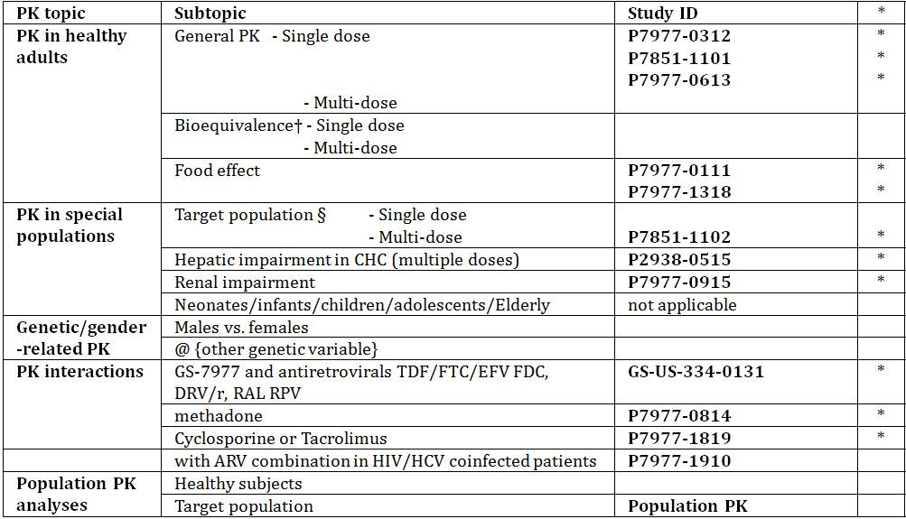
* Indicates the primary aim of the study; † Bioequivalence of different formulations; § Subjects who would be eligible to receive the drug if approved for the proposed indication.
None of the pharmacokinetic studies had deficiencies that excluded their results from consideration.

Evaluator’s conclusions on pharmacokinetics
The submission includes a comprehensive pharmacokinetic programme. Overall, SOF exhibits a very favourable Absorption, Distribution, Metabolism, Elimination (ADME) profile. These data support the oral dosing ± food of SOF once daily. The only real cautions are in end stage renal disease (ESRD) where the drug should be avoided as SOF dose would have to be reduced at least 2-4 fold to provide lower GS-331007 exposures. These sorts of dose reduction would risk inadequate levels of the active moiety, GS-461203. While hepatic impairment does impact on SOF and metabolite pharmacokinetics, these changes do not appear to impact pharmacodynamics and no dose adjustments are required. In terms of likely drug-drug interactions, there is relatively little potential for this; this bodes well for SOF co-administration with CYP inhibitors/inducers. The issue of CYP inhibiton has been particularly problematic in HIV-HCV co-infected subjects because of ARV-BOC/TPV interactions via CYP. However, SOF is susceptible to Pgp and/or BCRP transporter based drug interactions, but its main metabolite, GS-331007, is not. Taken together, avoidance of co-administration with the very potent inducers of Pgp is prudent.

Pharmacodynamics

Studies providing pharmacodynamic data
Table 8 shows the studies relating to each pharmacodynamic topic and the location of each study summary
Table 8: Submitted pharmacodynamic studies.
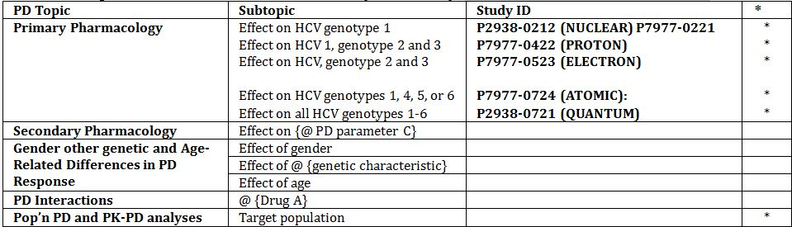
* Indicates the primary aim of the study; § Subjects who would be eligible to receive the drug if approved for the proposed indication; ‡ And adolescents if applicable.
None of the pharmacodynamic studies had deficiencies that excluded their results from consideration.

Evaluator’s conclusions on pharmacodynamics
A comprehensive ongoing SOF PD programme is being conducted. The rationale for the 400 mg dose is justified based on the slightly lower rates of virologic failure (relapse) than with lower doses especially as the drug appears to have a wide safety margin. The drug is very potent, with rapid virological suppression and no apparent cross reactivity with other HCV antivirals in the event of viral resistance.

Phase II studies in subjects with GT-2 or 3
In Study P7977-0422, SOF+PEG+RBV 12 weeks resulted in SVR24 rate of 92.0%. Study P7977-0523 (ELECTRON) demonstrated antiviral potency and 100% SVR12 in treatment naïve subjects with GT-2 or 3, regardless of the presence/absence of PEG. SOF monotherapy was less efficacious, resulting in SVR12 of only 60.0% of treatment naive GT-2 or 3, thus indicating RBV should be included. In P7977-0523, SOF+RBV had SVR12 of 68.0% in treatment experienced GT-2 or 3 HCV infected subjects, a population with limited treatment options. These data supported the initiation of the Phase III Studies P7977-1231, GS-US-334-0107, and GS-US-334-0108 (with SOF+RBV).

Phase II studies in subjects with GT-1, 4, 5, or 6
In Study P7977-0422, 12 weeks of SOF+PEG+RBV in treatment naive subjects with GT-1 resulted in SVR24 rate of 91.5%. Study P7977-0523 confirmed 12 weeks of SOF+RBV could effectively treat treatment naïve GT-1, with SVR12 rate of 84.0% (n = 25, so numbers were small). Study P2938-0721 (QUANTUM) assessed 12 and 24 weeks of SOF+RBV treatment. In this study, 12 weeks of SOF+RBV was as effective as 24 weeks of SOF+RBV in achieving SVR12 (56.0% and 52.0%, respectively) in GT-1 (n = 38), 2 (n = 5), or 3 (n = 7), but note the very small numbers for GT-2 and 3. In Study P7977-0724 (ATOMIC), 12 weeks of SOF+PEG+RBV in treatment naives with GT-1, 4, or 6 resulted in SVR12 rate of 90.4%. This very high SVR rate, along with added bonuses of a shorter treatment regimen, that is, only 12 weeks of PEG provided further support for the Phase III Study GS-US-334-0110 with SOF+PEG+RBV.

Dosage selection for the pivotal studies
Based on the lower rates of virologic failure in SOF 200 and 400 mg groups versus 100 mg in Study P7977-0221, 200 and 400 mg were subsequently evaluated further in combination with PEG+RBV in Study P7977-0422 (PROTON). In PROTON, on-treatment failures occurred in SOF 200 mg + PEG + RBV group (n = 3) but not in SOF 400 mg + PEG + RBV group during the second 12 week phase (PEG+RBV). These data suggest that SOF 400 mg may provide more pronounced viral suppression and the 400 mg dose once daily was selected for Phase III. The SOF 400 mg tablets containing SOF Form II (planned for commercial use) is the formulation used in GS-US-334-0110 (NEUTRINO) and GS-US-334-0108 (FUSION).

Efficacy

Studies providing efficacy data
Four pivotal Phase III studies are presented in the submission:
- P7977-1231 (FISSION)
- GS-US-334-0107 (POSITRON)
- GS-US-334-0108 (FUSION)
- GS-US-334-0110 (NEUTRINO)
Three of these studies assessed SOF+RBV in GT-2 or 3 HCV infected subjects (Studies P7977-1231, GS-US-334-0107, GS-US-334-0108), and Study GS-US-334-0110 assessed SOF+PEG+RBV in treatment naive GT-1, 4, 5, or 6 HCV infected subjects.
Other efficacy studies:
- Study P7977-2025: An Open-Label Study to Explore the Clinical Efficacy of PSI-7977 with Ribavirin Administered Pre-Transplant in Preventing Hepatitis C Virus (HCV) Recurrence Post-Transplant
- Study GS-US-334-0123 (PHOTON-1): A Phase III, Open-label Study to Investigate the Efficacy and Safety of GS-7977 plus Ribavirin in Chronic Genotype 1, 2 and 3 Hepatitis C Virus (HCV) and Human Immunodeficiency Virus (HIV) Co-infected Subjects
- Study 11-I-0258: A Randomised Controlled Study to Assess Safety, Tolerability, and Efficacy of GS-7977 in Combination with full or low dose RBV in HCV Genotype 1, Monoinfected Treatment Naive Participants

Evaluator’s conclusions on efficacy
The proposed indication for SOF is for use in combination with other agents for treatment of chronic hepatitis C virus infection in adults. The sponsor has provided a comprehensive Phase I to III development programme for SOF, a novel nucleotide prodrug that inhibits HCV RNA replication across all genotypes in vitro and in vivo. The drug has a number of favourable attributes confirmed through the Phase I and II studies namely: rapid suppression of HCV RNA in all genotypes; high SVR (at Week 12 post treatment) when combined with RBV±PEG; a favourable tolerability and viral resistance profile. This has meant the focus of the Phase III SOF studies has been the evaluation of PEG free regimens, the latter potentially of enormous benefit, as they would avoid the unpleasant, albeit manageable (for the most part) toxicities of PEG.

HCV GT- 2 and 3 and SOF
- For SOF+RBV, 3 studies were conducted in 3 different GT-2 and 3 HCV populations: P7977-1231 (FISSION; treatment-naive subjects); GS-US-334-0107 (POSITRON; subjects who were IFN-intolerant or -ineligible or -unwilling); and GS-US-334-0108(FUSION; treatment-experienced subjects). All studies included a subset of 15.8% to 34.0% cirrhotics.
- Phase II programme: In addition, 65 treatment naive GT- 2 or 3 HCV received SOF+PEG+RBV for up to 12 wks. SOF+RBV also evaluated in subjects with GT- 2 or 3 HCV co-infected with HIV-1 (Study GS-US-334-0123 [PHOTON-1]).

Efficacy of SOF+RBV regimen in subjects with GT-2 or 3 HCV infection
All the Phase III efficacy studies achieved their primary endpoints:
- Study P7977-1231 showed the non inferiority of SOF+RBV for 12 weeks versus SOC, PEG+RBV for 24 weeks with ~67% of subjects achieving a SVR12 for both treatments
- Study GS-US-334-0107 met its primary efficacy endpoint of superiority for 12 weeks of SOF+RBV versus placebo, with 77.8% of subjects achieved SVR12 versus 0% in placebo group
- Study GS-US-334-0108 met its primary efficacy endpoint of superiority of SOF+RBV for both 12 and 16 weeks versus a historic control SVR12 rate of 25%, with 50.0% and 72.6% of subjects achieving SVR12 in the SOF+RBV 12 and 16 Week groups, respectively.
While there was no genotypic or phenotypic resistance to SOF or RBV detected in subjects not achieving SVR12 in these 3 Phase III studies, it became clear that there were treatment response differences related to whether the genotype being treated was GT-2 or 3.

GT- 2
A high level of efficacy was demonstrated with SOF+RBV for 12 weeks and in treatment naives (Study P7977-1231), SVR12 rates were 97.1% and compare more than favourably with those with PEG+RBV (77.6%). In Study GS-US-334-0107, SVR12 rates were 92.5% in treatment naives. In prior limited treatment exposed (<3 months IFN) in Study GS-US-334-0107, SVR rates were 92.7%. For treatment experienced subjects with GT- 2 (Study GS-US-334-0108), SVR rates were also high with SOF+RBV for 12 and 16 wks (86.1% and 93.8%, respectively) and this SVR12 rates in the 12 Week group is only marginally lower than the SVR12 in treatment naïve subjects. Although the number of GT- 2 cirrhotics was limited (11, 17, and 19 subjects in Studies P7977-1231, GS-US-334-0107, and GS-US-334-0108, respectively), efficacy (SVR12) was high: SVR12 rates of 90.9%, 94.1%, 68.4% in Studies P7977-1231 (treatment naïve), GS-US-334-0107 (limited treatment exposed), GS-US-334-0108 (treatment experienced), respectively. In addition, a bridging analysis using Bayesian SOF logistic regression analysis was performed for treatment naive subjects with GT-2 HCV infection and showed minimal differences in SVR12 rates between 12 and 16 weeks of SOF+RBV treatment.

GT- 3
For treatment naives with GT- 3 HCV infection, SOF+RBV treatment for 12 weeks had a similar SVR12 rate to PEG+RBV treatment for 24 weeks (55.7% versus 62.5%) (Study P7977-1231). For treatment experienced subjects with GT-3, the SVR12 rates in Study GS-US-334-0108 clearly demonstrated that subjects derive greater benefit from a 16 week treatment duration (61.9%) as SVR12 with a 12 week treatment duration was only 29.7%. The SVR12 rate following 16 weeks of SOF+RBV treatment was similar to the SVR12 rates observed with 12 weeks of SOF+RBV treatment in Studies P7977-1231 and GS-US-334-0107. The results of a bridging analysis using Bayesian logistic regression indicate that for GT-3 treatment naive subjects increasing SOF+RBV treatment duration from 12 to 16 weeks may increase the SVR12 rate by 22.5%. Overall, these response rates for GT-3 HCV subjects treated with SOF+RBV are generally consistent with data published for those treated with PEG+RBV, where overall responses rates for GT-3 are lower than those with GT-2.

Other factors
Drug exposure (GS-331007 AUC_{tau}) was shown to have a significant relationship on SVR12 rates in subjects with GT-3, specifically in the SOF+RBV group in Study GS-US-334-0107 (upper quartile [PQ4] of exposure outperformed the overall mean SVR12 rate) and the SOF+RBV 16 Week group of Study GS-US-334-0108 (the lowest quartile [PQ1] of exposure underperformed the overall study mean SVR12 rate).

Cirrhosis
Results of bridging analyses indicate that for cirrhotic and noncirrhotic GT-3 treatment naives increasing SOF+RBV treatment duration from 12 to 16 weeks may increase SVR12 rate by 42.1% and 17.3%, respectively.

HCV GT- 1, 4, 5, or 6 and SOF
The Phase III study, GS-US-334-0110 (NEUTRINO) using SOF+PEG+RBV, in treatment naive subjects with GT-1, 4, 5, or 6 HCV; in this study, 16.7% cirrhotic, 89.3% GT-1. In the Phase II study, P7977-2025, ~75% GT-1a or 1b HCV infection and baseline Child-Pugh Turcotte (CPT) scores of 5 or 6 (72.1%). The US National Institute of Allergy and Infectious Diseases (NIAID) sponsored Study 11-I-0258 is evaluating efficacy, safety, and tolerability of SOF+RBV (full or low dose RBV) in GT-1 treatment naïve subjects. The Janssen-sponsored Study HPC2002 and Bristol-Myers Squibb (BMS) sponsored Study AI444040 are evaluating efficacy and safety of SOF in combination with other DAA±RBV. Study P7977-2025) is using SOF-RBV pre-transplant in HCV all genotypes and HCC.

Efficacy of SOF+PEG+RBV regimen in subjects with GT-1, 4, 5, or 6 HCV infection
Study GS-US-334-0110 met its primary efficacy endpoint for superiority of SOF+PEG+RBV treatment for 12 weeks (90.2% SVR12) compared with a predefined historic control SVR rate of 60%. The SVR rate of 89.4% for treatment naïve subjects with GT-1 HCV infection was higher than any currently available HCV treatments. Although those with GT-1a (91.6%) had a numerically higher response than subjects with GT-1b HCV infection (81.8%), the GT-1b subjects had higher rates of several baseline characteristics typically associated with lower treatment response rates (for example, IL28B non-CC genotypes, Black race, older age) which probably contributed to this difference. Among subjects with GT-4, 5, or 6 HCV infection (note numbers are quite small), 34 achieved SVR12 (1 cirrhotic subject with GT-4 HCV infection did not achieve SVR12). A high level of efficacy was demonstrated for all subgroups for subjects, with >80% of subjects achieving SVR12 across all subgroups (including cirrhosis). An ad hoc multivariate logistic regression analysis highlighted that IL28B GT (as expected for an IFN containing regimen) and cirrhosis status were important characteristics associated with SVR12 for subjects receiving the SOF+PEG+RBV regimen. Weight based RBV dose also remained in the multivariate regression model, consistent with the results from the combined GT-2 or 3 and GT-3 multivariate regression analyses and the results of NIAID Study 11-I-0258. When the impact of exposure (GS-331007 AUC_{tau}) on SVR12 rate was evaluated by multivariate logistic regression analyses, no statistically significant relationships were observed. Comprehensive analyses showed that genotypic or phenotypic resistance to SOF or RBV was not detected in any of the subjects not achieving SVR12 in this Phase III study.

In summary
SOF represents an important new drug in the armamentarium of DAA compounds for the treatment of CHC. Across all the most common HCV genotypes, SOF, in combination with RBV with or without PEG, has demonstrated similar or superior efficacy to currently available treatment for the most common HCV genotypes across multiple patient populations. The data derived to date suggests that while a PEG free combination of SOF+RBV for 12 weeks is highly effective for GT-2 HCV, those with GT-3 should receive SOF+RBV treatment for longer, that is, 16 weeks. Subjects with GT-1, 4, 5, or 6 show high response rates in treatment naïve patients with 12 weeks of SOF+PEG+RBV combination therapy. However, there is still a relative paucity of data for the use of SOF as part of combination therapy in treatment experienced patients with GT-1.

Safety

Studies providing safety data
Safety data to support the proposed SOF indication for the treatment of chronic HCV from 27 clinical studies comprising 4 pivotal Phase III (3 supporting), 6 Phase II, and 13 Phase I studies. There are 2 other studies using SOF that are not Gilead sponsored shown in Table 9 and safety data is included for these.
Table 9: Non Gilead sponsored studies using SOF.
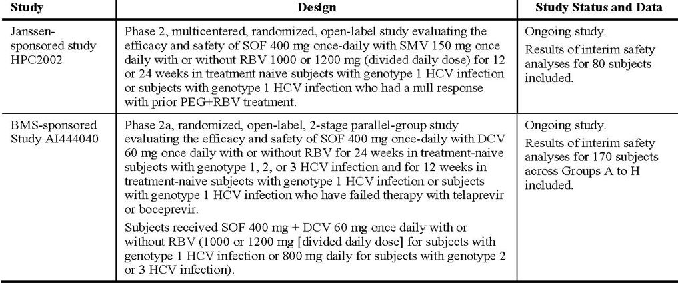
Due to differences in treatment regimens, durations and the subject populations studied, pooling of safety data was limited to the 4 pivotal Phase III studies (primary safety population [PSP]) with data presented by treatment regimen. There is safety data presented in this section from the so called, secondary safety population (SSP), with safety data from P2938-0721, P7977-0523 and NIAID 11-I-0258 studies (for SOF+RBV), P7977-0422, P7977-0724, P7977-0221 (for SOF+PEG+RBV or SOF/placebo).

Pivotal efficacy studies
In the pivotal efficacy studies, safety data for SOF+PEG+RBV in subjects with GT-1, 4, 5, 6 are presented from Study GS-US-334-0110 (NEUTRINO). Safety data for SOF+RBV in GT-2 and 3 HCV infection are presented from P7977-1231 (FISSION), GS-US-334-0107 (POSITRON), and GS-US-334-0108 (FUSION). For GT-2 and 3, the SOF+RBV 12 Week group comprises pooled data from this regimen across Studies P7977-1231, GS-US-334-0107, GS-US-334-0108. All other treatment regimens (SOF+RBV 16 Week, placebo, PEG+RBV, SOF+PEG+RBV) were not pooled. Treatment groups for the PSP:
- Placebo SOF: 12 Weeks placebo exposure data in Study GS-US-334-0107 (POSITRON)
- SOF+RBV 12 Weeks: 12 Week exposure data - Studies P7977-1231 (FISSION), GS-US-334-0107 (POSITRON), and GS-US-334-0108 (FUSION)
- SOF+RBV 16 Weeks: 16 Week exposure data from Study GS-US-334-0108 (FUSION)
- PEG+RBV 24 Weeks: 24 Week PEG+RBV exposure data - Study P7977-1231 (FISSION)
- SOF+PEG+RBV 12 Weeks: 12 Weeks exposure data for triple therapy (SOF+PEG+RBV) in Study GS-US-334-0110 (NEUTRINO).
The following safety data were collected:
- General adverse events (AEs) assessed by active questioning at study visits and by patient report; all AEs were graded and coded using the Medical Dictionary for Regulatory Activities; standard criteria for the definition of an SAE were applied and reporting of SAE was expedited
- AEs of particular interest, including markers of liver disease/damage and loss of synthetic function (transaminases, coagulation markers, albumin; other metabolic markers including glucose; clinical AEs: signs and symptoms/signs of decompensated liver disease, assessed clinically and through laboratory monitoring)
- Laboratory tests: routine biochemistry including liver function tests, lipase, metabolic; haematology; HCV RNA; HCV GT-/phenotype. Performed at regular timepoints as per protocol
- Vital signs, physical exam, electrocardiogram (ECG).

Classification of AEs
AEs are defined as treatment emergent adverse events (TEAEs) if they were events with onset dates on/after start of treatment and ≤30 days after permanent discontinuation of study regimen from each specified study phase, and continuing AEs if diagnosed prior to start of treatment with worsening severity grade after treatment start.

Pivotal studies that assessed safety as a primary outcome
There were 2 pivotal studies that assessed safety as a co-primary outcome.

Dose response and non pivotal efficacy studies
The dose response and non pivotal efficacy studies provided safety data, and comprise the SSP:
- SOF+RBV: In P2938-0721, P7977-0523 and NIAID 11-I-0258 studies, 135 subjects randomised to receive SOF+RBV for 12 Weeks; 85 to receive 24 Weeks SOF+RBV. In Study P2938-0721 (QUANTUM), 50 subjects received ≥1 dose of SOF+RBV. Median durations of exposure to SOF+RBV were 12.1 and 24.1 Weeks for the 12 and 24 Week groups, respectively
- SOF+PEG+RBV: In the P7977-0422 and P7977-0724 studies, 176 subjects randomised to receive 12 Weeks of SOF+PEG+RBV and 280 subjects randomised to receive 24 Weeks of SOF+PEG+RBV for ≥12 Weeks. Subjects in P7977-0221 received 28 days of SOF+PEG+RBV. In Study P7977-0422 (PROTON), subjects received 12 Weeks of SOF or placebo plus PEG+RBV for 12 or 24 through 48 Weeks depending on GT and response; 121 GT-1 HCV infected subjects and 25 GT-2 or 3 HCV infected subjects received ≥1 dose study drug and were included in the SAS. Median duration of exposure to SOF or placebo was 12 Weeks in all treatment groups.

Other studies evaluable for safety only
None, as all Phase I and Phase II studies assessed safety as a co-primary or secondary endpoint.

Patient exposure
The patient exposure and disposition in the primary safety analysis set is shown in Tables 10 and 11.
Table 10: Duration of exposure to study regimen in PSP.
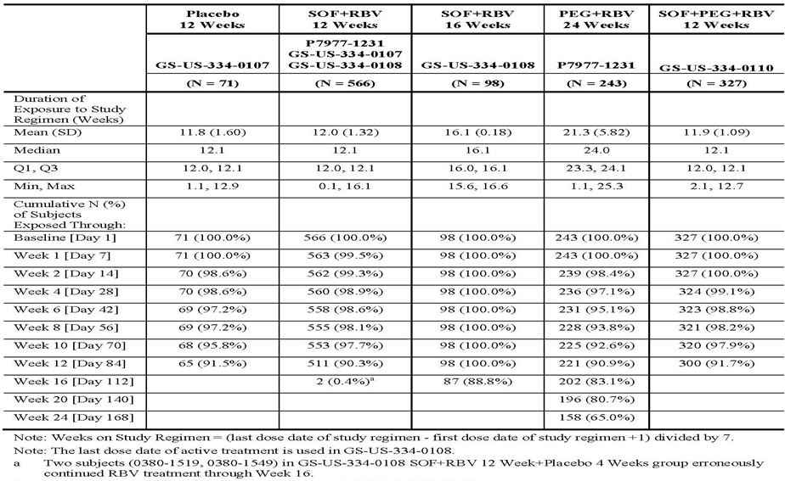
Table 11: Subject disposition in the PSP.
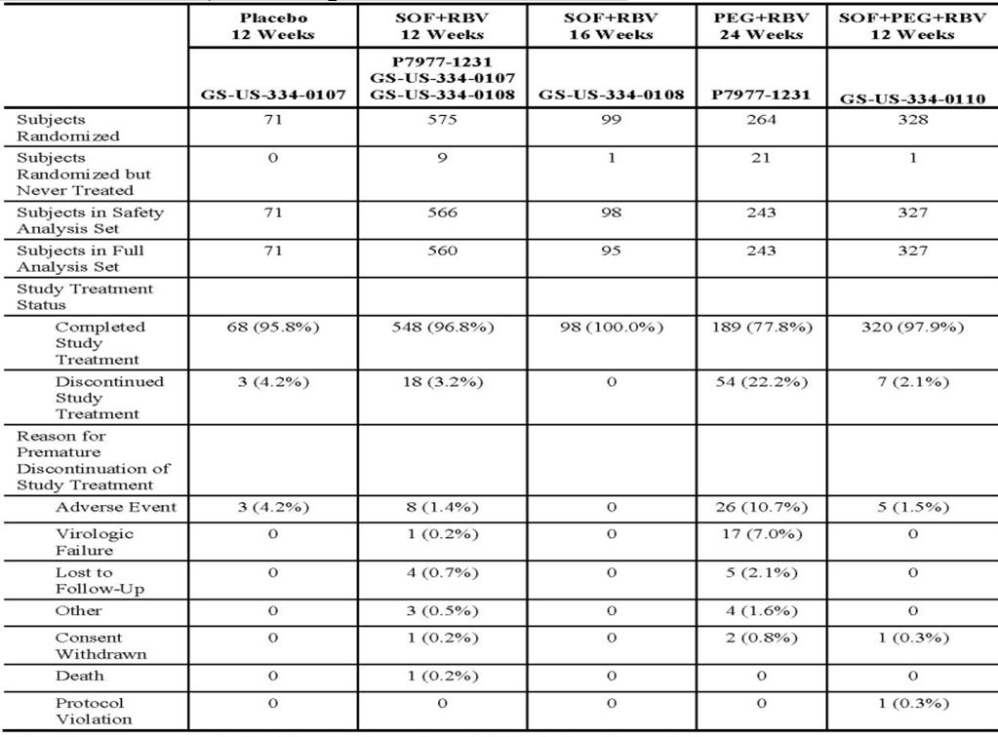

Safety issues with the potential for major regulatory impact
None.

Postmarketing data
SOF has not been marketed in any country at the time of this marketing application.

Evaluator’s conclusions on safety
This Clinical Safety summary for the Phase I-III data for SOF is comprehensive and detailed especially in regards to exploring whether SOF compounds the toxicities of either PEG or RBV. In all, 2885 subjects have been treated in 27 studies in which, 2443 subjects have received ≥1 dose of a SOF containing regimen. At the proposed therapeutic oral dose of 400 mg once daily, 1732 HCV infected subjects have been exposed, in combination with PEG+RBV or RBV, for durations of 12 weeks (n = 1088), 16 weeks (n = 98), 24 weeks (n = 421). In terms of the enrolment into the pivotal studies, males and females constituted 63.4% and 36.6%, respectively. The lack of an upper age limit for enrolment allowed older adults to enrol, but despite this only 5.1% were ≥65 years of age. In addition, while subjects of Black race were reasonably well represented (16.5% in Study GS-US-334-0110), this was not the case in GT-2 and 3 studies, but as expected based on known epidemiology of these genotypes. Baseline characteristics were also pretty representative in regards to non-CC (CT or TT) IL28B allele in 61.8%, high baseline HCV RNA ≥ 6 log₁₀ IU/mL (67.5%), and elevated ALT >1.5 ULN (55.8%). Moreover, cirrhotics could and did enrol, ranging from 16.7 to 32.7% of enrolment. Overall, SOF combined with RBV±PEG appears well tolerated. Specifically, for the treatment of GT-2 and 3 when compared to PEG+RBV for 24 weeks, SOF+RBV for 12 weeks was characterised by:
- Fewer AEs leading to treatment discontinuation (1.4% versus 0%. versus 10.7%, of SOF+RBV 12 Week group, SOF+RBV 16 Week group, PEG+RBV group, respectively)
- Lower severity of AEs (≥Grade 2 and higher AEs were reported in 42.0%, 41.8% and 68.7% of SOF+RBV 12 Week, SOF+RBV 16 Week groups, PEG+RBV group, respectively)
- Grade 3 or 4 AEs lower incidence (7.2%, 4.1%, 18.5% in the SOF+RBV 12 Week and SOF+RBV 16 Week group, PEG+RBV group, respectively)
- Reduced rates of treatment emergent depression and depression requiring treatment (7.2%, 6.1%, 17.3% in the SOF+RBV12 Week group, SOF+RBV16 Week group, PEG+RBV group). However, Grade 3 and 4 decreases in haemoglobin were seen in ~10%.
The current SOC for CHC GT- 1 HCV infection is a RBV-PEG+HCV PI. There are many problems associated with these regimens not least the long treatment duration, toxicities and drug-drug interactions. GS-US-334-0110 provides definitive data, in a single arm study (with historical controls) of the benefits of 12 weeks of SOF+RBV+PEG- GT- 1 treatment naïves.
In summary, triple therapy for 12 weeks resulted in:
- Higher rates of treatment completion: triple therapy versus PEG+RBV for 24 weeks (Study P7977-1231) 97.9% versus 77.8%, respectively
- Fewer AEs that led to study drugs discontinuation: 1.5% versus 10.7% in the triple for 12 weeks versus dual therapy for 24 weeks, respectively
- Lower severity of AEs: Grade 2+ and Grade 3 or 4 AEs both lower with triple therapy for 12 weeks versus dual therapy for 24 weeks, 59.3% versus 68.7% and 14.7% versus 18.5%.
- Laboratory abnormalities consistent with PEG+RBV: Consistent with the expected bone marrow suppressive effects of PEG and the haemolytic effects of RBV, reductions in haemoglobin and polymorphonuclear leukocytes (= neutrophil; PMN) count were the most frequently reported Grade 3 or 4 lab abnormalities by subjects receiving the SOF+PEG+RBV and PEG+RBV regimens. But, importantly, the numbers of subjects in both groups, with very low haemoglobin <8.5 g/dL was small but similar (2.4 and 1.7%, respectively); nevertheless, there were more subjects in receipt of triple therapy for 12 weeks with moderate reduction, that is, haemoglobin <10 g/dL than in the PEG-RBV group (22.6% versus 14.5%, respectively). A possible explanation for this is the lower RBV doses used in the PEG-RBV group, whereas weight based (and therefore higher) dosing with RBV (1000-1200 mg/day) was given as part of triple therapy. The alternate explanation is that SOF does indeed make a contribution, albeit small, to haemoglobin reduction. Overall, and taken together with the efficacy findings, SOF in combination with RBV±IFN appears safe and well tolerated without any signature toxicity of its own and without convincingly amplifying the known toxicity profiles of either PEG or RBV.

First round benefit-risk assessment

First round assessment of benefits
The benefits of oral SOF 400 mg once daily in the proposed usage “in combination with other agents for treatment of CHC virus infection in adults” are:
- Shortened duration of treatment (that is, 12 weeks), with superior SVR12 rates compared to historical SVR rates of SOC regimens (SVR rate ~60%) when combined with RBV+PEG for treatment-naïve CHC Genotype 1
- Shortened duration of RBV+PEG regimens, translates into reduced toxicity, not of the acute toxicities such as influenza like illness (with PEG) and the haematological AEs (PEG+RBV) which still occur, but of the later onset toxicities including depression and depression requiring specific treatment. These toxicities can impact on the ability of patients to tolerate full treatment which in turn impacts negatively on SVR rate
- High SVR12 rates using PEG free regimens (SOF+RBV over relatively short treatment periods = 12 weeks for GT-2 and 16 weeks for GT-3) for treatment naïve, limited prior treatment (<3 months IFN) and treatment experienced (had failed prior treatment with an IFN based regimen) CHC subjects with genotypes 2 and 3
- The drug fills a potential niche for patients with CHC GT-2 or 3, who cannot take/tolerate IFN for whatever reason
- Low risk for drug-drug interactions
- Potential for partnering with other DAA, such that CHC treatment regimens could be both PEG and RBV free
- Safe and well tolerated at the proposed therapeutic dose.

First round assessment of risks
The risks of SOF in the proposed usage are:
- The paucity of data on the efficacy and safety of the drug when used in combination with PEG+RBV for the treatment of HCV GT-4, 5, 6 as there were only 35 people with these genotypes represented in the NEUTRINO study. While 34 of these 35 achieved SVR12, nonetheless this is still a very small cohort and may well not be representative. The paucity of data for GT-4, 5, 6 is potentially problematic
- There are very few subjects of Asian ethnicity enrolled in the Phase III programme for SOF, with only 117 subjects of Asian ethnicity enrolled (6740 person days). The very small representation of Asian subjects coupled with the small numbers of subjects with HCV GT-4 and 6 enrolled in trials of SOF is potentially problematic for the Australian setting because Australia has a large and expanding Asian population and HCV infection in migrants may reflect the GT-4 and 6 that predominate in their country of origin
- There are very few Indigenous subjects enrolled across the programme
- There are no data in subjects coinfected with hepatitis B (Hepatitis B Surface Antigen +ve) or in regards to D-D interactions with drugs used for the treatment of hepatitis B such as entecavir. The evaluator acknowledges that there are data on co-administration of SOF and antiretroviral drugs, that is, tenofovir and emtricitabine, used for HBV and HIV
- There are hardly any data on patients with HIV-HCV co-infection who are not on antiretrovirals (87.1% of the 31 enrolled in PHOTON were on antiretrovirals), and hence the impact of SOF as part of combination therapy for CHC, on HIV viraemia and immunological markers such as CD4+ T cell count is as yet, unknown. Enrolment of antiretroviral naïve HIV-HCV subjects (with high CD4+ T cells) into PHOTON should be encouraged
- While the sponsor goes to some lengths to demonstrate the inclusiveness of the SOF access programme in regards to “no upper age limit” in Phase III, there is still a paucity of data in older patients, with just over 60 patients ≥65 year old enrolled. As older patients are more likely to have many concurrent co-morbidities such as impaired renal function, subclinical cardiovascular disease and diabetes mellitus, it is important that the Sponsor highlights this. Moreover, analysis of the AEs in this group showed higher rates, that is, a two fold or greater incidence of Grade 3 haemoglobin abnormalities in both SOF+RBV and triple therapy treatment groups. In summary, elderly patients are more vulnerable to the known side effects of SOF+RBV±PEG. Moreover, their ability to withstand the predicted decline in haemoglobin with RBV-SOF or SOF+PEG+RBV, is probably less, in so much as these sorts of declines may unmask subclinical cardiovascular disease (CVD) (as an example). Moreover, while SOF is deemed safe without the need for dose modification in mild moderate renal impairment, these data are derived from single dose exposure in a very small numbers of subjects. The Phase III programme did not add much in terms of the safety of multi dosing of SOF in those with moderate renal impairment, as an entry criteria for all Phase III studies, was a creatinine clearance >60 mL/min (calculated by Cockcroft-Gault or Chronic Kidney Disease Epidemiology Collaboration [CKD-EPI] equations)
- There is no pivotal study data provided on SOF in treatment experienced patients with GT-1 CHC, the only real data is provided in the small group of patients with HCC pre transplant
- The only combination data for SOF presented in this submission is when partnered with RBV±PEG, hence the broad request for approval of SOF “in combination with other agents for treatment of hepatitis C virus infection in adults” is not supported by the data provided in this submission. While there are currently other ongoing studies of SOF in combination with other DAA, these studies are still enrolling and no data is available yet
- The 2 year oral gavage carcinogenicity studies with SOF in mice and rats are awaited, (expected in December 2013), hence there is no long term pre-clinical carcinogencity data provided in this Application
- While the drug appears safe in standard fertility and embryofoetal developmental toxicity studies, given there is a paucity of data in pregnant women it is unclear how the B2 category is assigned
- There is no data provided on the potential interactions (or not) with other illicit substances, or opiate replacement therapy other than methadone
- There is no data on the use of SOF in acute hepatitis C infection
- The paediatric development programme is ongoing and as identified in the AU-RMP version 0.1 but there is no data in those <18 years of age
- The supratherapeutic dose trialled was 1200 mg as a single dose only in healthy volunteers
- There is no specific information given on the potential drug interaction between a representative OCP and SOF, these data should be forthcoming, but are not presented in this submission. These data are important as pregnancy should be avoided when using RBV. The results of this drug-drug interaction study should be provided as soon as possible
- There is no specific drug-drug interaction data on drugs that are moderate inducers of PgP
- There is no drug-drug interaction data on other immunosuppressants that might be used post liver transplantation, for example, mycophenolate. The evaluator acknowledges the drug-drug interaction data for tacrolimus and cyclosporine.

First round assessment of benefit-risk balance
The benefit-risk balance of SOF, given the proposed usage, is favourable, with the caveat that the evaluator thinks the approval should be given with a number of important provisos as listed below.

First round recommendation regarding authorisation
The evaluator recommends authorisation but the indication needs to be narrowed. The sponsor requests approval “in combination with other agents for treatment of chronic hepatitis C virus infection in adults”. The evaluator thinks this is too broad an indication and should be narrowed to define more clearly which agents SOF can be combined with; as per the data provided in this submission, the only drugs are RBV±PEG. Giving a broad approval in the absence of data could potentially allow use of SOF with HCV protease inhibitors (as an example). Next, the evaluator thinks the term “chronic hepatitis C” needs to be clearly defined. Not all forms of chronic hepatitis C can be treated with SOF, in so much as there is no pivotal study presented in this submission that supports the use of SOF in CHC GT-1 treatment experienced patients. In addition, there is a paucity of data for SOF for treatment of HCV GT- 4, 5 and 6.

Clinical questions
Details of clinical questions and sponsor responses are included in the Extract from the Clinical Evaluation Report in Appendix 2.

Second round benefit-risk assessment

Second round assessment of benefits
After consideration of all the responses to clinical questions, the benefits of SOF in the proposed usage are:
- Proven efficacy for GT-1, 2, 3 and 4. Data from ongoing studies (Table 12) will inform further in regards to the following genotypes:
Table 12: Summary of planned SOF studies for Asia, Russia and Egypt.
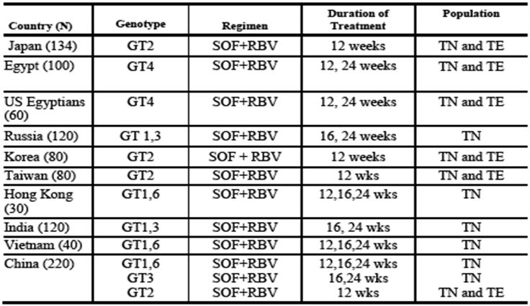
- Improved SVR12 rates with longer exposure to SOF+RBV, that is, 24 weeks for GT-3 without a significant toxicity cost of extending treatment duration; moreover the specific effects of hepatitis steatosis on treatment response is being explored in GS-US-334-0153
- Clear efficacy in the setting of HIV-HCV co-infection for treatment naïve patients with GT-1 and treatment naïve or experienced with GT-2 and 3
- Very well tolerated drug. The AE profile might be better still if partnered with other drug(s) other than RBV and there are current ongoing studies with ledipasvir, daclatasvir, and telaprevir.

Second round assessment of risks
After consideration of responses to clinical questions, the risks of SOF in the proposed usage are:
- No specific data in treatment experienced patients with GT-1: HCV mono-infected. Modelling data is provided in the sponsor’s response dated 2 January 2014. The reviewer notes that US FDA and European Medicines Agency (EMA) have used language in the Sovaldi PI to enable treatment of GT-1 treatment experienced patients based on this approach. However, the evaluator notes there are now ongoing studies in treatment experienced patients with GT-1;
- No specific data on treatment responses to GT-4 in HIV-HCV co-infected patients;
- Minimal efficacy and safety data in HIV-HCV co-infected subjects not on antiretrovirals and with uncontrolled HIV viraemia. It is not known whether uncontrolled HIV viraemia might blunt efficacy as measured by rates of SVR12. Moreover, there might be clinical consequences of the reduced absolute CD4+ T cell count when SOF+RBV are used, when this is coupled with ongoing HIV viral replication;
- Minimal to no data for CHC GT-5 and 6;
- In regards to the paucity of data in those with moderate severe renal impairment exposed to multi-dosing, the evaluator notes a study that is now recruiting in this patient population and will inform further;
- No drug-drug interaction data for illicit substances. This is a group of patients who are highly likely to use illicit substances. The evaluator does not classify methadone as an ‘illicit substance’. The evaluator thinks this issue of illicit substance use is a particularly problematical in HIV-HCV co-infection where rates of illicit substance use are particularly in high and middle income countries. Is SOF safe when taken concurrently with methamphetamine, ketamine, ecstasy and sildenafil?
- The evaluator noted that the RBV tablets used in the SOF clinical trials was Ribasphere which is not registered in Australia. The sponsor was asked to clarify the source of PEG and RBV used in the clinical trials. Moreover, in Australia, there is no currently standalone RBV available on the market and the marketed RBV products in Australia (Rebetol capsule and Copegus tablets) are co-packaged with pegylated or nonpegylated interferons and are indicated for use in combination with pegylated or nonpegylated interferons. In response to these issues, the sponsor provided a summary document of RBV therapeutic equivalents (US FDA). On review of this the evaluator is satisfied that the generic RBV used in the registration studies of SOF, Ribasphere, is equivalent to Copegus. The sponsor also explained that it has partnered with a company to register standalone RBV in Australia.

Second round assessment of benefit-risk balance
The benefit-risk balance of SOF, given the proposed usage, is favourable.

Second round recommendation regarding authorisation
Following the review of further data presented and sponsor’s response to clinical questions arising from first round review, and in light of ongoing studies (in GT-4, 5 and 6) which will provide further data on the efficacy of SOF as part of combination therapy for treatment of CHC, the evaluator recommends that SOF be authorised as follows:
Sovaldi is a hepatitis C virus (HCV) nucleotide analog NS5B polymerase inhibitor indicated for the treatment of chronic hepatitis C (CHC) infection as a component of a combination antiviral treatment regimen. The drug has proven efficacy as part of combination therapy for genotypes 1, 2, 3 and 4.

V. Pharmacovigilance findings

Risk management plan

Contents
The sponsor submitted a Risk Management Plan (RMP for Australia Version 0.1 [dated 31 May 2013; Data Lock Point 1 March 2013]) which was reviewed by the TGA’s Office of Product Review (OPR).
In the Round 1 RMP Evaluation Report (dated 24 December 2013), the sponsor proposes routine and additional pharmacovigilance activities for identified risks, important potential risks, and missing information.
The sponsor proposes only routine risk minimisation activities for identified risks, important potential risks, and missing information.
The presentation of the written submission is only considered partially acceptable. It is noted that the sponsor has not submitted an EU-RMP, but a RMP for Australia that only follows the current EU-RMP format in some instances. Missing sections that could not be evaluated include, but are not limited to: potential for overdose, potential for transmission of infectious agents, potential for misuse for illegal purposes, potential for off-label use, and potential for off-label paediatric use. Furthermore, the submitted materials do not contain a risk assessment of viral resistance. The bookmark index in the electronic form of the document is non-functional. Even though the index points to an attached EU-RMP Version 0.1, it is not actually attached. The study protocols in relation to the additional pharmacovigilance activities are absent.
As a result, this Round 1 Evaluation Report will not be able to address all issues. Additional recommendations may be made in the Round 2 RMP Advice document.
Given the potentially complex issues associated with this first in class medicine, the sponsor is advised to submit the most recent version of the EU-RMP that contains the abovementioned missing information, including an Australian Specific Annex (ASA) and a risk assessment of viral resistance.
In light of the submitted RMP, the sponsor should submit the evaluation report of the risk management document plan submitted by the sponsor in the EU.

Ongoing safety concerns
The sponsor provided a summary of Ongoing Safety Concerns which are shown at Table 13.
Table 13: Ongoing safety concerns for Sovaldi.
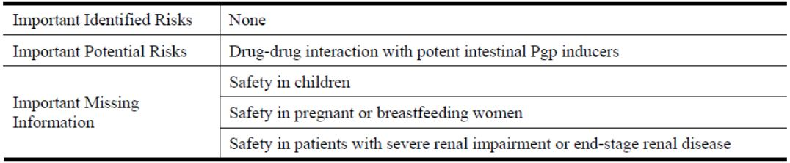

OPR evaluator comment
Notwithstanding the evaluation of the nonclinical and clinical aspects of the Safety Specification, this is not considered acceptable. The sponsor seems to indicate that there are no known risks associated with the first in class new chemical entity.

Mitochondrial toxicity
Mitochondrial toxicity is a known side effect of nucleoside inhibitors. Its pathophysiology is not entirely clear. There is no evidence that SOF inhibits mitochondrial polymerases, but other pathways may induce toxicity. Mitochondrial toxicity should remain as a potential risk.
The following should be added as Ongoing Safety Concerns and become part of the pharmacovigilance plan:
- Important identified risk
  - Teratogenicity (in combination therapy)
  - Anaemia (in combination therapy)
  - Neutropaenia (in combination therapy)
  - Thrombocytopaenia (in combination therapy)
  - Pancytopaenia (in combination therapy) and
  - Depression (in combination therapy).
- Important potential risk
  - Hypersensitivity
  - Mitochondrial toxicity
  - Suicidal ideation and
  - Drug resistance (including cross resistance).
- Important missing information
  - Patients over 75
  - Treatment experienced patients (antiviral medicines)
  - History of solid organ transplantation
  - Long term safety
  - Patients with hepatic cirrhosis
  - Patients with portal hypertension
  - Patients awaiting liver transplantation
  - Patients after liver transplantation
  - Patients with HIV co-infection
  - Patients with HBV co-infection
  - Non Caucasian patients (including Asian or Australian Indigenous populations)
  - Interaction with HIV drugs
  - Interaction with HBV drugs
  - Interaction with illicit substances
  - Patients with GT-5 or 6 HCV infection and
  - Effectiveness of hormonal contraception.

Reconciliation of issues outlined in the RMP report
Following the Round 1 RMP Evaluation Report (dated 24 December 2013), numerous documents followed seeking to reconcile issues identified:
- Sponsor’s response to TGA Section 31 Request (dated January 2014)
- Sponsor’s response to TGA Round 2 RMP advice (dated April 2014) and
- Sponsor’s pre Advisory Committee on Prescription Medicines (ACPM) response (RMP evaluation section only) (dated 16 May 2014).
Final reconciliation of issues was outlined in the Round 3 RMP Evaluation Report and is as follows.

Outstanding issues
The following should be added as ongoing safety concerns:
- Important potential risk
  - Drug resistance (including cross-resistance) and
- Missing information
  - Treatment experienced patients (antiviral medicines) (as indicated by the sponsor in the revised PI)
  - History of solid organ transplantation (post-liver transplant patients indicated by the sponsor in the revised PI)
  - Long term safety (as indicated by the sponsor in the revised PI)
  - Patients with portal hypertension
  - Patients awaiting liver transplantation
  - Patients with untreated HIV co-infection (as indicated by the sponsor in the revised PI)
  - Patients with HBV co-infection (as indicated by the sponsor in the revised PI) and
  - Effectiveness of hormonal contraception.
It is noted that the sponsor has agreed to add the following to the list ongoing safety concerns:
- Patients with GT-5 or 6 HCV infections
- Asian patients
- Patients over 65 and
- Use with agents other than RBV and PEG.
Additional pharmacovigilance activities are necessary to investigate the additional Ongoing Safety Concerns further. It is noted that the sponsor is already planning to undertake additional pharmacovigilance activities that address some of the concerns. Existing activities can be assigned to these concerns, if applicable. The identified concerns are summarised in Table 14.
Table 14: Additional pharmacovigilance activities necessary to investigate the additional ongoing safety concerns further.
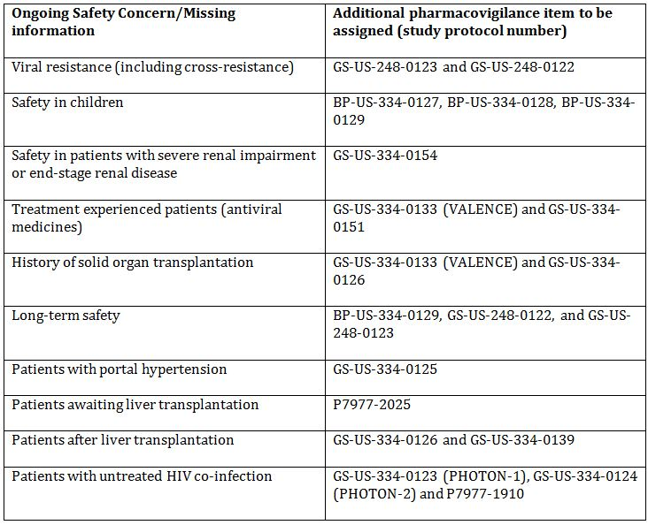
The abovementioned concerns with additional pharmacovigilance activities should become part of the pharmacovigilance plan.

Advice from the Advisory Committee on the Safety of Medicines (ACSOM)
ACSOM advice was ratified, and was made available to the sponsor.

Suggested wording for conditions of registration
The suggested wording is:
Implement RMP for Australia Version 0.1 (dated 31 May 2013; Data Lock Point 1 March 2013), including agreed changes, and any future updates (where TGA approved), and the changes to the risk management plan requested by the OPR evaluator as a condition of registration.

RMP section response to the sponsor milestone 5 response

Sponsor response item
- Page 3 of the report states “Even though some data appears promising, sofosbuvir cannot be exempt from safety requirements for new drugs in Australia’.
The sponsor has never suggested that SOF would be exempt from safety requirements for new drugs in Australia. Gilead has provided the TGA:
- Comprehensive nonclinical and clinical data to support the efficacy and safety of SOF
- Proposed RMP, that is in compliance with the European RMP guidelines adopted in Australia (this EU-RMP has been approved by the EMA)
- Proposed PI and Consumer Medicine Information (CMI) clearly highlighting the efficacy and safety profile of SOF
- Standard commitment to submit Periodic Safety Update Reports (PSURs) for the first three years of commercial launch or longer as agreed to by TGA and
- Standard pharmacovigilance practice in line with TGA pharmacovigilance requirements which are applicable to all marketed products in Australia (whether new drugs or not).
This is an error and we ask that this statement be revised.

OPR evaluator response
The wording did not suggest that the sponsor intended to be exempt from safety requirements.
It was merely to indicate that the guidelines given to sponsors are minimum requirements and each submission will be evaluated individually, and that these individual recommendations are the safety requirements for these particular submissions. And even though some data appears promising, SOF needs to subject to the same process as comparable medicines.
Given that the wording provided may be misunderstood, the wording has been changed.

Sponsor response item
- Page 13 of the report states ‘The sponsor is advised that the risk management plan is a standalone document, Annex 1 of Module 1 of the submission states ‘Annex I: Antibiotic Resistance Data (Not Applicable), i.e. resistance data has not been attached. There has been no reference made to a document that provides a risk assessment of viral resistance worldwide or in an Australian context’.
The sponsor did not provide Annex I, antibiotic resistance data in either the initial Category 1 filing or the Section 31 response as it is not a mandatory requirement. The current TGA guidelines advise that Annex I applies to the following:
- both topical and systemic antibacterial medicines
- combination products containing antibacterial medicines
- composite packs that contain one or more antibacterial medicines.
SOF is not an antibacterial, therefore this section is not applicable. TGA requested as part of the Section 31 request ‘a risk assessment of viral resistance’ which was provided. We were not asked to complete Annex 1 and therefore advise that this comment is incorrect and should be removed.

RMP evaluator response
The guidelines given to sponsors are minimum requirements and each submission will be evaluated individually. In this case, the RMP evaluator requested resistance data.
Resistance analysis should be part of any medicine that may be associated with potential resistance regardless whether specifically mentioned in guidelines.
It is noted that clinical studies P7977-1231, GS-US-334-0107, GS-US-334-0108 all consisted of a resistance analysis population (RAP) with HCV GT-2 or 3. There seems to be no resistance data on GT-1, 4, 5, and 6. Many subpopulations were not included in the RAP and it is unknown whether they would react differently. Most of the RAP was exposed to SOF and RBV, not SOF as monotherapy.
Furthermore, no long term data is available that could exclude a potential risk of viral resistance in long term use.
It is noted that the sponsor is conducting a Sequence Registry Study (GS-US-248-0123) to monitor the persistence of resistant mutations for up to 3 years, and a SVR Registry Study (GS-US-248-0122) to evaluate durability of SVR for up to 3 years post treatment. These studies should become part of the pharmacovigilance plan.

Sponsor response item
- Page 17 of the report states that ‘Mitochondrial toxicity is an IDENTIFIED RISK for ribavirin’. Given that the sponsor, in the data here, did not seem to have any cases of mitochondrial toxicity in patients receiving ribavirin, it cannot be concluded that sofosbuvir is not associated with this safety concern.
TGA accepted the sponsor’s response excluding any further ‘Important Identified Risks’ from being listed in the RMP related to other products as the sponsor advised that the Sovaldi RMP is not related to other separate and distinct goods, that is, PEG and/or RBV, and risks identified with these products should not be listed.
As stated by the sponsor and agreed by the TGA, no cases of mitochondrial toxicity have been seen with SOF. The sponsor therefore believes including mitochondrial toxicity as a safety concern is an error and the same rationale should be applied; it is not an identified risk for SOF but for RBV and as such should not be listed in the Sovaldi RMP. Gilead therefore asks that this statement be revised before it is made public.

OPR evaluator response
The sponsor states:
As stated by Gilead and agreed by TGA, no cases of mitochondrial toxicity have been seen with sofosbuvir.
A more accurate representation would be that it appears in the studies referred to by the sponsor, no apparent cases of mitochondrial toxicity occurred in the combination of SOF with RBV. From this information, the sponsor appears to conclude that SOF is not associated with mitochondrial toxicity.
If this reasoning were followed with regard to RBV, one could likewise conclude that RBV will also not cause mitochondrial toxicity, as it had not occurred in the combination of SOF with RBV. But mitochondrial toxicity is a known AE of RBV.
The OPR evaluator agrees that uridine nucleotides are less likely to cause mitochondrial toxicity and that the nonclinical data seems to indicate that mitochondrial effects are unlikely to occur. However, in vitro data does not necessarily correlate with in vivo effects. Concerning adequate reporting of cases in a post market environment, the presence of ‘mitochondrial toxicity’ as a potential risk could be regarded as advantageous.
The inclusion of ‘mitochondrial toxicity’ was not supported by nonclinical data, the ACPM and by the Delegate, and was removed.

Sponsor response item
- Page 30 of the report concerning patients with HIV co-infection, ‘with regard to this issue, the sponsor has identified that no data is available and has deemed the issue important enough to investigate it with additional pharmacovigilance activities’.
The sponsor advises that this statement is incorrect. As part of the Section 31 response concerning Patient with HIV co-infection, the sponsor provided an update from PHOTON-1 (GS-US-334-0123), providing the updated clinical study report in Section 5.3.5.1 and revising the PI with the latest efficacy and safety information for this study. This was discussed in the Section 31 RMP Response. This is an error and we ask that this statement be revised before it is made public.

OPR evaluator response
Regarding the term ‘no data’, the OPR evaluator was referring to a point in time before PHOTON-1 had been commenced. The statement was to indicate that the sponsor had identified ‘Patients with HIV co-infection’ as missing information and deemed it necessary to investigate this further. After a further review, the missing information item should be changed to ‘Patients with untreated HIV co-infection’.
Adding ‘Patients with untreated HIV co-infection’ as missing information follows the approach taken by the sponsor and will ensure the results of the study will be adequately and formally reported in PSURs or otherwise.
Given that the wording provided may be misunderstood, the wording has been changed.

Sponsor response item
- Page 31 of the report regarding patients with HBV co-infection, ‘the absence of evidence does not constitute the evidence of absence. The sponsor essentially states that no data is available’.
The sponsor advises that this statement is incorrect. As part of the Section 31 response and Category 1 application, Phase I drug-drug interaction data was provided investigating the interaction between SOF and tenofovir disoproxil fumarate, a TGA approved product for HIV and HBV infection. In addition, in vitro data was also provided investigating the interaction between SOF and anti HIV nucleosides like lamivudine (3TC), which is also a TGA approved product for HBV infection. The sponsor never stated that no data was available. This is an error.

OPR evaluator response
The OPR evaluator recommended adding ‘Patients with HBV co-infection’ as missing information, not drug interactions between SOF and anti-HBV medicines. The quoted Phase I study participants were not HCV/HBV co-infected. ‘Patients with HBV co-infection’ remains missing information.

Sponsor response item
- Page 34 of the report regarding effectiveness of hormonal contraception, ‘This may not be a significant issue in other drugs, but given that effective contraception is vital when using sofosbuvir and ribavirin, the results are not sufficient to remove this as important missing information’
TGA accepted the sponsor’s response excluding any further “Important Identified Risks’ from being listed in the RMP related to other products as the sponsor advised that the Sovaldi RMP is not related to other separate and distinct goods, that is, PEG and/or RBV, and important missing information with these products should not be listed.
Therefore, the sponsor believes including effectiveness of hormonal contraception as important missing information, is an error and the same rationale should be applied; the Sovaldi PI requests prescribers to refer to the RBV PI for information on contraception/use in pregnancy, and as such should not be listed in the Sovaldi RMP. This is an error and we ask that this statement be revised.

OPR evaluator response
The sponsor has not conducted a drug-drug interaction study with a hormonal contraceptive available in the Australian market. This constitutes missing information.
The reference to RBV has been removed.

VI. Overall conclusion and risk/benefit assessment
The submission was summarised in the following Delegate’s overview and recommendations:

Quality
The supporting data relating to the composition, development, manufacture, quality control and stability of the product have been assessed and checked for compliance, as applicable, with Australian legislation and requirements for new medicine and in accordance with pharmacopoeia standards and technical guidelines adopted by the TGA.
The company was requested to justify why the inactive metabolite GS-331007 was the analyte of interest, rather than the parent compound, SOF. The company states that SOF is extensively metabolised to 2 major metabolites, GS-566500 and GS-331007. The active intrahepatic triphosphate (GS-461203) was undetectable in plasma. GS-331007 is the primary circulating metabolite and accounted for >90% of the drug related material. Exposure response relationships for dose selection, pharmacokinetics, and pharmacodynamics (HCV viral load reduction) were performed based upon the reliably measured, primary circulating analyte of interest, GS-331007. The sponsor states that this approach has been accepted by the US, Canada and the EU. The company will further investigate the interrelation of SOF and its metabolites as an additional pharmacovigilance activity.
The sponsor was also requested to comment on the differences in the effect of food on tested analytes. It was noted that Cmax decreased for GS-331007 but increased for both SOF and GS-566500; no change was observed for AUC for GS-331007 but this parameter almost doubled for SOF and GS-566500. The clinical evaluator is of the view that the food effect is unlikely a significant issue and the SOF can be administered without regard to food as instructed in Phase III clinical trials.
At the early stages of development, SOF drug substance was prepared and isolated as the anhydrous crystalline Form I polymorph (SOF Form I). Early Phase II studies used SOF Form I tablets (100 and 200 mg). Based on the data from Phase II studies, SOF 400 mg once daily was selected for Phase III studies. Initial Phase III studies (P7977-1231 and GS-US-334-0107) also used SOF Form I. The SOF Form II was shown to have superior physicochemical properties versus SOF Form I; Form II were used in the Phase III studies GS-US-334-0110 (NEUTRINO) and GS-US-334-0108 (FUSION). Study GS-US-334-0131 confirmed the equivalence in terms of GS-331007 between SOF Form I and II. The company was asked to comment on why the pharmacokinetic parameters for SOF and Cmax for GS-566500 do not meet the normally accepted bioequivalence criteria, noting the only differences between the formulations are the SOF polymorphic form and film coat. The company notes that Cohort 5 of Study GS-US-334-0131 was not designed or powered to test the bioequivalence boundaries of 80.00-125.00 for SOF or GS-566500. The sample size and power to tell 20% difference in PK between formulations was built around GS-331007.
Overall, there are no objections from a pharmaceutical chemistry perspective regarding approval of SOF tablets for registration.

Nonclinical
There are no major deficiencies. Some toxicity studies at the highest doses and the genotoxicity and safety studies were conducted only with the diastereomeric mixture GS-9851.
Primary pharmacology studies established the inhibition of HCV NS5B polymerases isolated from various HCV genotypes and the efficacy of SOF against infectious HCV genotypes in vitro. Secondary pharmacology studies indicated that SOF acts specifically on HCV NS5B polymerase and does not affect host cellular or mitochondrial polymerases and is not cytotoxic. No clinically relevant hazards were identified in safety studies.
SOF is transported by Pgp and BCRP and absorption may be increased by co-administration with inhibitors of these transporters. Inducers of these transporters may decrease SOF exposure.
No major organ toxicities were observed with SOF in repeat-dose studies in any species, at clinically relevant exposures. Based on results obtained with GS-9851, SOF is unlikely to pose a genotoxic hazard. Long term carcinogenicity studies in mice and rats were negative. There was no evidence of reproductive toxicity of SOF and Pregnancy Category B1 would be appropriate.
There are there no nonclinical objections to the registration of SOF. The draft PI may be amended as directed.

Clinical
Clinical dossier included 25 clinical pharmacokinetic and pharmacodynamics studies, 6 dose finding studies, 5 pivotal clinical studies, and 3 supportive clinical studies.

Pharmacokinetics
The overview of the submitted pharmacokinetic studies is summarised in the first round clinical evaluation report. The absolute bioavailability SOF was not assessed. The pharmacokinetic properties of SOF and its main metabolite (GS-331007) have been studied in healthy adults and CHC subjects.
Following oral dose, SOF was absorbed with a Cmax observed at ~0.5-2 h post dose, regardless of dose level. Cmax of the main metabolite (GS-331007) was observed between 2-4 h post dose. Based on population pharmacokinetic (PPK) analysis in subjects with GT-1 to 6 HCV infection who were co-administered RBV (with or without PEG), geometric mean steady state AUC_{0-24h} for SOF and GS331007 were 828 ng•h/mL and 6790 ng•h/mL, respectively. Compared to healthy subjects administered SOF alone, the SOF AUC_{0-24h} was 39% higher and GS-331007 AUC_{0-24h} was 39% lower, respectively, in HCV infected subjects.
Evaluation of food effect showed that a high fat meal resulted in a slower SOF absorption with no substantial alteration in the extent of absorption. When evaluated as GS-331007, prolonged Tmax and modestly lower Cmax were observed with AUC_{0-last} and AUC_{0-∞} of GS-331007 unaltered. The equivalence criterion for a lack of food effect was not met; however, Cmax decrease was not considered clinically significant. Moreover, in Phase II and III studies, SOF dosing was recommended without regard to food. In Phase III studies, when co-administered with RBV, SOF was dosed with food as required in the RBV prescribing information.
A cross study PK analysis of SOF and GS-331007 AUC_{0-∞} and Cmax was performed to assess the dose linearity of SOF. The power model mean slope and 90% CIs indicated that near dose linearity was observed for SOF AUC_{0-∞} and Cmax, and GS-331007 AUC_{0-∞} with GS-331007 Cmax showing modestly less than dose proportional increases.
Metabolism pathway for SOF was proposed on the basis of nonclinical and clinical studies. SOF is extensively metabolised in the liver to form nucleoside analog triphosphate, GS-461203. Dephosphorylation leads to formation of the nucleoside analog, GS-331007, which cannot be efficiently rephosphorylated and lacks anti HCV activity in vitro. The primary metabolic route of SOF was hydrolase cleavage, ultimately leading to GS-331007 formation. GS-331007 is the primary circulating metabolite in humans. No new metabolites were identified in humans.
Following a single 400 mg dose of ¹⁴C-SOF in healthy subjects, the blood to plasma ratio of ¹⁴C-radioactivity was approximately 0.7, indicating SOF and its metabolites were predominantly distributed to plasma. The mean total recovery of the dose was greater than 92%, consisting of approximately 80%, 14%, and 2.5% recovered in urine, faeces, and expired air, respectively. The majority of the SOF dose recovered in urine was GS-331007 (78%) while 3.5% was recovered as SOF. These data indicate that renal clearance is the major elimination pathway for GS-331007. The median terminal half lives of SOF and GS-331007 were 0.4 and 27 h, respectively.
Data from the mass balance study confirm mean apparent total clearance of the drug from plasma after oral administration (CL/F) and renal clearance of the drug from plasma (CLr) values for SOF were 7.32 and 0.238 L/min, respectively, indicating that the majority of its elimination was potentially via the non renal route. The majority of the dose recovered in the urine was GS-331007 (77.7%) with 3.5% as SOF; confirming renal clearance was a major pathway for elimination of the nucleoside. Renal clearance for GS-331007 was estimated as 0.242 L/min, approximately 2 fold higher than the GFR (0.120 L/min), suggesting a role of active secretion in renal elimination of GS-331007 (study P7977-0312). Consistent with substantial elimination of GS-331007 in urine, clinically significant changes in its pharmacokinetics noted with declining renal function (Study P7977-0915).
Apart from SOF, the pharmacokinetics of GS-331007 and GS-566500 has been measured and partly characterised. The pharmacokinetics of GS-461203 has not been characterised. The company will further investigate the interrelation of SOF and its metabolites as an additional pharmacovigilance activity.

Pharmacokinetics in the target population (CHC)
The pharmacokinetics of SOF and its metabolites after multiple dose of SOF were evaluated in HCV infected subjects under a variety of treatment regimens. The results have shown little evidence of a relationship between SOF Cmax and safety or efficacy parameters given the low and transient exposure of SOF. As such, the primary parameter for interpretation of data from SOF population pharmacokinetic analyses was AUC_{tau}. The typical values of SOF CL/F and apparent volume of the central compartment (Vc/F) were estimated to be 652 L/h, and 127 L, respectively. Covariate analyses indicated relevant effects of HCV infection status (that is, healthy subjects versus HCV infected) on the CL/F of SOF. All other covariates (age, gender, race, BMI, cirrhosis status) were not considered relevant covariates for the pharmacokinetics of SOF. The Phase III PPK dataset included all subjects with evaluable pharmacokinetic parameters. The typical values of GS-331007 CL/F and Vc/F were estimated to be 39.5 L/h, and 218 L, respectively. For GS-331007, the primary parameters for data interpretation from PPK analyses were AUC_{tau} and Cmax. Based on PPK modelling, HCV infection status and baseline CLr were significant covariates for CL/F of GS-331007. All other covariates were not considered relevant. Mean AUC_{tau} and Cmax for GS-331007 in HCV infected subjects were lower (39% and 49%, respectively) than in healthy subjects; mean SOF AUC_{tau} was higher (36%) in HCV infected versus healthy subjects. The differing effect of patient status has not been explained.

PK in subjects with renal impairment
The plasma exposures of SOF and GS-331007 were moderately higher in subjects with mild and moderate renal impairment versus subjects with normal renal function, that is, SOF AUC_{0-∞} was 61% and 107% higher in mild and moderate renal impairment, while the GS-331007 AUC_{0-∞} was 55% and 88% higher, respectively. However, for SOF the increase in exposure was unlikely a result of decrease in CLr as renal SOF excretion is a minor elimination pathway. These results were consistent with those of PPK analyses in HCV infected subjects that identified Clr as the statistically significant determinant of CL/F of GS-331007 and not SOF. SOF dose adjustment is not warranted in mild/moderate renal impairment. However, markedly higher GS-331007 levels were observed in severe renal impairment or ESRD. Relative to normal renal function, SOF AUC_{0-∞} was 171% higher, while GS-331007 AUC_{0-∞} was 451% higher, respectively. In subjects with ESRD, SOF and GS-331007 AUC_{0-∞} was 28% and 1280% higher when SOF was dosed 1 h before haemodialysis versus 60% and 2070% higher when SOF was dosed 1 h after haemodialysis. The safety and efficacy of SOF have not been established in patients with severe renal impairment or ESRD.

Pharmacokinetics in patients with hepatic impairment
The multiple dose pharmacokinetics of GS-331007 and SOF were evaluated in HCV infected subjects with moderate and severe hepatic impairment after administration of SOF 400 mg (2 × 200 mg tablet formulation) for 7 days. Relative to subjects with normal hepatic function, the SOF AUC_{0-24h} were 126% and 143% higher in moderate and severe hepatic impairment, while the GS-331007 AUC_{0-24h} were 18% and 9% higher, respectively. PPK analysis in HCV infected subjects indicated that cirrhosis had no clinically relevant effect on the exposure of SOF and GS-331007.

Pharmacokinetic interactions
Drug interaction studies were discussed in first round clinical evaluation report. It appears that there is relatively little potential for drug-drug interaction, and this bodes well for SOF co-administration with CYP inhibitors/inducers. Interactions between SOF and cyclosporine, darunavir/ritonavir, efavirenz, emtricitabine, methadone, raltegravir, rilpivirine, tacrolimus, tenofovir have been assessed, and no dose adjustment is required for either of these drugs. However, SOF is susceptible to Pgp and/or BCRP transporter based drug interactions (GS-331007 is not); SOF should be avoided to be used with the very potent inducers of Pgp. Study GS-US-334-0146 evaluated the effect of SOF on the PK of the combined hormonal oral contraceptive pill (OCP), norgestimate/ethinyl estradiol. The results (provided with Section 31 response) indicate that SOF administered with the combined OCP is safe and does not impact on the efficacy of norgestimate/ethinyl estradiol.

Pharmacodynamics and dose finding studies
The primary pharmacodynamic effect of SOF is inhibition of HCV replication in the liver. No concerning secondary pharmacodynamic effects were revealed. Study P7977 0613 demonstrated a lack of effect of SOF on QTcF prolongation. Moreover, the Phase II and III programme evaluated ECG changes with no safety signal revealed. Overall, pharmacokinetic and pharmacodynamic analyses of the GS-331007 and SOF exposure safety relationships revealed no relevant trends in exposure-safety parameters across all GS-331007 (AUC_{tau} and Cmax) and SOF (AUC_{tau}) quartiles.
The Phase II dose finding studies revealed an exposure-response relationship supporting the SOF 400mg dose. Pharmacokinetic and pharmacodynamic analyses of GS-331007 and SOF exposure-efficacy from Phase III studies were performed in GT-2 or 3 HCV infection (Rx. SOF+RBV) and GT-1, 4, 5 or 6 HCV (Rx. SOF+PEG+RBV). The pharmacokinetic and pharmacodynamic dataset included all subjects in the full analysis set (n = 982). In general, univariate logistic regression analysis of GS-331007 AUC_{tau} and SVR12 across studies indicated a statistically significant (p <0.05) pharmacokinetic/pharmacodynamic relationship. However, closer interrogation of these data revealed a statistically significant (p <0.05) pharmacokinetic/pharmacodynamic relationship in GT- 3 but not GT- 2 treatment experienced patients. Moreover, due to lower SVR12 in treatment experienced GT-3 subjects, HCV RNA reductions at the earliest measured time point (Week 1) were examined to rule out early kinetic differences; these showed equivalent HCV RNA reduction for GT-2 and 3, respectively, and in agreement with the on-treatment pharmacokinetic/pharmacodynamic analysis conducted to support Phase III dose selection irrespective of treatment experience status. Overall, these data suggest on-treatment antiviral potency was optimal at 400 mg but that genotype (GT-3) and treatment duration drive SVR12. The reason for lower SVR rate with GT-3 was not fully explained. Hepatic steatosis, a known important predictor of GT-3 treatment response, was not formally assessed at enrolment.

Phase II studies in GT-2 or 3
In P7977-0422, SOF+PEG+RBV 12 weeks resulted in SVR24 rate of 92.0%. Study P7977-0523 (ELECTRON) demonstrated antiviral potency and 100% SVR12 in treatment naïve subjects with GT-2 or 3, regardless of the presence/absence of PEG. SOF monotherapy was less efficacious resulting in SVR12 of only 60.0% of treatment naive GT-2 or 3, thus indicating RBV should be included. In P7977-0523, SOF+RBV had SVR12 of 68.0% in treatment experienced GT- 2 or 3 HCV infected subjects, a population with limited treatment options. These data supported the initiation of the Phase III Studies P7977-1231, GS-US-334-0107, and GS-US-334-0108 with SOF+RBV.

Phase II studies in GT-1, 4, 5 or 6
In P7977-0422, 12 weeks of SOF+PEG+RBV in treatment naive subjects with GT-1 resulted in SVR24 of 91.5%. Study P7977-0523 confirmed 12 weeks of SOF+RBV could effectively treat treatment naïve GT-1, with SVR12 of 84.0% (n = 25, so numbers were small). Study P2938-0721 (QUANTUM) assessed 12 and 24 weeks of SOF+RBV treatment. In this study, 12 weeks of SOF+RBV was as effective as 24 weeks of SOF+RBV in achieving SVR12 (56.0% and 52.0%, respectively) in GT-1 (n = 38), 2 (n = 5), or 3 (n = 7), but note the very small numbers for GT-2 and 3. In Study P7977-0724 (ATOMIC), 12 weeks of SOF+PEG+RBV in treatment naives with GT-1, 4 or 6 resulted in SVR12 rate of 90.4%. This very high SVR rate, along with a shorter treatment regimen (only 12 weeks of PEG), provided further support for the Phase III Study GS-US-334-0110 with SOF+PEG+RBV.
Based on the lower rates of virological failure in SOF 200 mg and 400 mg groups versus 100 mg in Study P7977-0221, 200 and 400 mg were subsequently evaluated further in combination with PEG+RBV in Study P7977-0422 (PROTON). In PROTON, on-treatment failures occurred in SOF 200 mg + PEG + RBV group (n = 3) but not in SOF 400 mg + PEG + RBV group during the second 12 week phase (PEG+RBV). These data support the selection of SOF 400 mg for Phase III studies.
The clinical evaluator considers that the rationale for the 400 mg dose is justified based on the slightly lower rates of virological failure (relapse) with the 400 mg dose and the drug appears to have a wide safety margin.

Clinical efficacy

Pivotal clinical studies
Five pivotal and three supportive clinical studies were evaluated. Four pivotal studies (FISSION, POSITRON, FUSION, and NEUTRINO) were provided in the initial submission and one study (study synopsis for VALENCE study) was provided with the Section 31 response. In addition, Study GS-US-334-0123 (PHOTON-1) in HCV/HIV co-infected subjects (interim analysis), Study P7977-2025 in subjects HCC waiting for transplantation (interim analysis), and the NIAID sponsored 11-I-0258 study were provided to support this submission.
In the 5 studies listed below, the SOF was dose at 400 mg once daily and RBV dose was weight based at 1000-1200 mg daily in two divided doses:
- P7977-1231 (FISSION)
- GS-US-334-0107 (POSITRON)
- GS-US-334-0108 (FUSION)
- GS-US-334-0110 (NEUTRINO)
- GS-US-334-0133 (VALENCE)
The dose for PEG, where applicable, was 180 µg per week. Treatment duration was fixed in each trial. Sustained virological response (SVR12) was the primary endpoint which was defined as HCV RNA less than the lower limit of quantification (LLOQ) at 12 weeks after the end of treatment.

GT-2 or 3 treatment naïve adults: FISSION (P 7977-1231)
FISSION was a multicentre, randomised, open label, active controlled trial. The primary objective was to compare the efficacy of SOF+RBV administered for 12 weeks compared with PEG+RBV for 24 weeks in treatment naïve subjects with GT-2 and 3 HCV. The RBV doses used in the SOF+RBV and PEG+RBV arms were weight based 1000-1200 mg per day and 800 mg per day regardless of weight, respectively. Subjects were randomised in a 1:1 ratio and stratified by cirrhosis (presence versus absence), HCV genotype (GT-2 versus 3) and baseline HCV RNA level (<6 log₁₀ IU/mL versus ≥6 log₁₀ IU/mL). Subjects with GT-2 or 3 HCV were enrolled in an approximately 1:3 ratio.
The primary endpoint was SVR12. Other efficacy outcomes included SVR24, SVR48, change in HCV-RNA, ALT normalisation, quality of life (QoL), virological failure/resistant variants, safety and tolerability. A total of 499 subjects were randomised and received treatments. The study subjects had a median age of 50 years (19 to 77); 66% of the subjects were male; 87% were White, 3% were Black; 14% were Hispanic or Latino; mean body mass index was 28 kg/m²; 57% had baseline HCV RNA levels > 6 log₁₀ IU per mL; 20% had cirrhosis; 72% had HCV GT-3. Of the 499 treated subjects, 434 completed study treatment as planned (SOF+RBV 95.7%, 245 subjects; PEG+RBV 77.8%, 189 subjects).
The study met the predefined primary efficacy endpoint, demonstrating overall SVR12 rate (67.2%) with SOF+RBV for 12 weeks was non inferior to SVR12 (66.7%) obtained with PEG+RBV for 24 weeks (strata adjusted difference in proportions: 0.3; 95% CI for difference -7.5% to 8.0%) (Table 15). The lower limit of the 2 sided 95% CI was greater than the pre-specified non inferiority margin of -15%. Moreover, SOF+RBV for 12 weeks versus 24 weeks of PEG+RBV, resulted in higher response rates in GT-2 HCV and similar response rates in GT-3 HCV.
Table 15: Primary efficacy outcome in FISSION (Study P7977-1231, FAS).
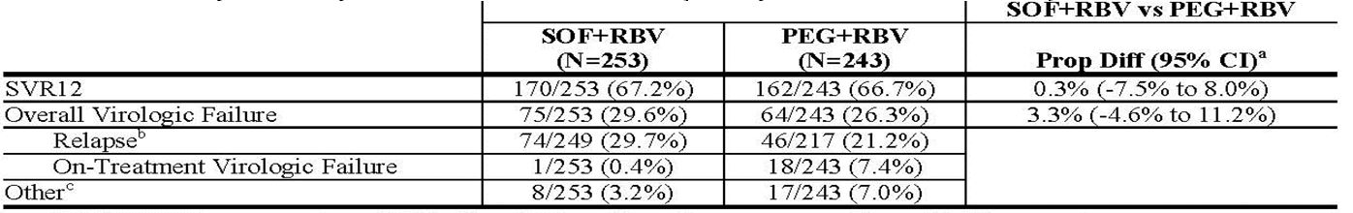

GT-2 or 3 IFN intolerant, ineligible or unwilling subjects: POSITRON
POSITRON was a multicentre, randomised, double blinded, placebo controlled trial that evaluated 12 weeks of SOF+RBV (n = 207) compared to placebo (n = 71) in GT-2 or 3 CHC subjects who are IFN intolerant, ineligible or unwilling.
The primary objective was to determine the efficacy of SOF+RBV versus placebos as measured by the proportion of subjects with SVR12. Subjects were randomised in 3:1 ratio and stratified by cirrhosis (presence versus absence). A total of 278 subjects were treated with study drugs (207 received SOF+RBV and 71 received placebos). The study subjects had a median age of 54 years; 54% were male; 91% were White, 5% were Black; 11% were Hispanic or Latino; mean BMI was 28 kg/m²; 70% had baseline HCV RNA levels greater than 6 log₁₀ IU per mL; 16% had cirrhosis; 49% had HCV GT-3. The proportions of subjects who were IFN intolerant, ineligible, or unwilling were 9%, 44%, and 47%, respectively. Most subjects had no prior HCV treatment (81%). Adherence was 87.4% in SOF+RBV and 90.1% in placebo.
The results (Table 16) showed that:
- 77.8% (CI: 71.5-83.2%) versus 0% (CI: 0.0-5.1%) of SOF+RBV versus placebo groups respectively achieved SVR12 (p < 0.001)
- 42 (20.3%) subjects relapsed in the SOF+RBV group, with most relapses (32 of 42) occurring by the post treatment Week 4. No subjects in the SOF+RBV group had on-treatment virological failure
- None of the 71 subjects in the placebo group achieved SVR4 or SVR12
- Subgroup analyses demonstrated GT-2 had higher SVR12 than GT-3 (92.7% versus 61.2%, respectively) and non-cirrhotics versus cirrhotics had SVR12 of 80.7% versus 61.3%, respectively. Difference in SVR12 in cirrhotics was attributable to differences only in GT-3 subjects as GT-2 cirrhotic subjects and non-cirrhotic subjects had similarly high SVR12 rates, that is, 94.1% and 92.4%, respectively.
Table 16: Primary efficacy outcome in POSITRON (GS-US-334-0107).
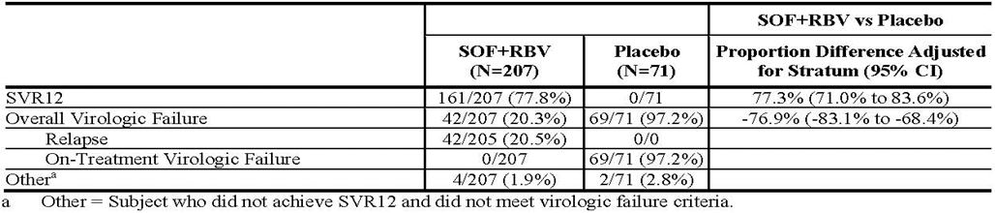

GT-2 or 3 previously treated adults: FUSION
FUSION was a Phase III, multicentre randomised, double blinded trial that evaluated 12 or 16 weeks of treatment with SOF+RBV in CHC GT-2 or 3 subjects who did not achieve SVR with prior IFN based treatment (relapsers and non-responders). Subjects were randomized in a 1:1 ratio and stratified by cirrhosis (presence versus absence) and HCV genotype (GT-2 versus 3).
A total of 201 subjects received study drugs and the study subjects had a median age of 56 years (range: 24 to 70); 70% of the subjects were male; 87% were White; 3% were Black; 9% were Hispanic or Latino; mean body mass index was 29 kg/m²; 73% had baseline HCV RNA levels greater than 6 log₁₀ IU per mL; 34% had cirrhosis; 63% had HCV GT-3; 75% were prior relapsers. The full analysis set included 195 subjects (100 subjects in the SOF+ RBV 12 Week group and 95 subjects in the SOF+RBV 16 Week group).
The results (Table 17) showed that:
- 50.0% in the 12 Week group and 72.6% in the 16 Week group achieved SVR12
- SOF+RBV for 16 weeks resulted in higher SVR12 versus 12 weeks treatment, the difference was -23.4% (-35.4% to -11.4%) and statistically significant (p <0.001)
- No subject in either treatment group had on-treatment virological failure
- Relapse: in the 12 Week group, 47.0% relapsed; in the 16 Week group, 27.4% relapsed
- GT-2 had similar SVR12 in the 12 and 16 Week groups (86.1% and 93.8%), whereas GT-3 had higher SVR12 with 16 weeks of therapy (61.9% versus 29.7%)
- Within each group, analyses of SVR12 by subgroup revealed similar SVR12 for the age, ethnicity, body mass index, IL28B genotype, and response to prior HCV treatment subgroups. In both the 12 and 16 Week groups, there was higher SVR12 in GT-2 versus 3, and higher SVR12 in females. In the 12 Week group, higher SVR12 was seen in non-cirrhotics (60.9%) than cirrhotics (30.6%); this difference was less pronounced in the 16 Week group (76.2% versus 65.6%).
Table 17: Primary efficacy results for FUSION (GS-US-334-0108).
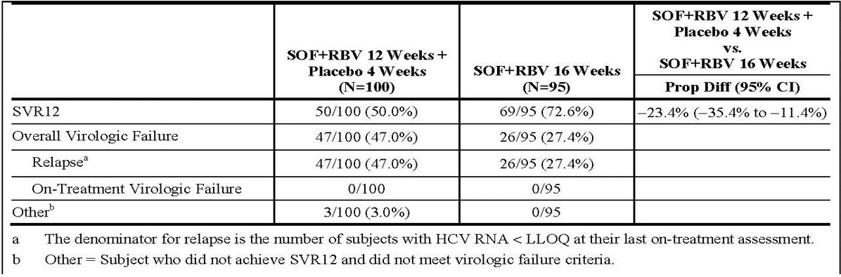

GT-1 or 4 treatment naïve adults: NEUTRINO (Study 110)
NEUTRINO was a Phase III, multicentre open label, non randomised single arm trial that evaluated 12 weeks of SOF+PEG+RBV in treatment naïve subjects with GT-1, 4, 5 or 6 HCV infection compared to pre-specified historical control.
A total of 327 subjects enrolled and received treatments. The median age was 54 years; 64% of the subjects were male; 79% were White, 17% were Black; 14% were Hispanic or Latino; mean BMS was 29 kg/m²; 78% had baseline HCV RNA > 6 log₁₀ IU per mL; 17% had cirrhosis; 89% had GT-1 (n = 292); 9% had HCV GT-4 (n = 28) and 2% had HCV GT-5 (n = 1) or 6 (n = 6).
Adherence: SOF 97.2%, PEG 95.0%, RBV 91.1%; ≥95% adherence rate for SOF (93.3%); PEG (77.1%); RBV (67.3%) reflecting dose modification permitted for PEG and RBV toxicity. Overall, 76.8% had ≥80% adherence to each study drug.
The results (Table 18) showed that:
- SVR12 is much higher (90.2%, 95% CI: 86.5-93.2%, p <0.001) versus historical control (60%). There were no on-treatment virological failures (VF), all VF being relapses. In total, 8.6% relapsed; 22 of these 28 relapsed within 4 weeks of stopping treatment
- Pre-specified subgroup analyses demonstrated all subgroups had SVR12 of ≥80% and these did not differ greatly by genotype (91.6% for GT-1a, 81.8% for GT-1b, 96.4% for GT-4). The one GT-5 subject and six GT-6 subjects achieved SVR12. Subjects with IL28B CC genotype had higher SVR12 than non CC genotype (97.9%, 95% CI: 92.6-99.7% versus 87.1%, 95% CI: 82.1-91.1%, respectively). Higher response rates in non-cirrhotics versus cirrhotics (92.3%, 95% CI: 88.5-95.2% versus 79.6%, 95% CI: 66.5-89.4%, respectively). In all other subgroups, SVR12 differences were <10%.
Table 18: SVR12 in NEUTRINO (GS-US-334-0110, FAS).
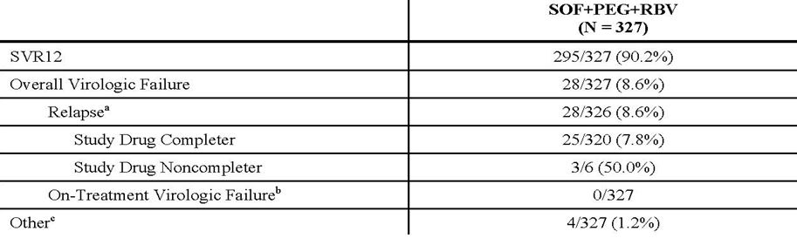

GT-2 or 3 treatment naïve adults: VALENCE (Study 133)
The study synopsis for VALENCE study was provided with Section 31 response. The detailed evaluation of this study is presented in the second round clinical evaluation report. VALENCE study is an ongoing Phase III, randomised, double blind, placebo controlled study examining the safety and efficacy of SOF+RBV in treatment naive or treatment-experienced subjects with GT-2 or 3. In all, 419 treatment naive and treatment experienced subjects with GT-2 or 3 were randomised and received ≥1 dose study drug/placebo. The SVR12 was the primary endpoint and the result is presented in Table 19.
Table 19: Virological results for VALENCE study.
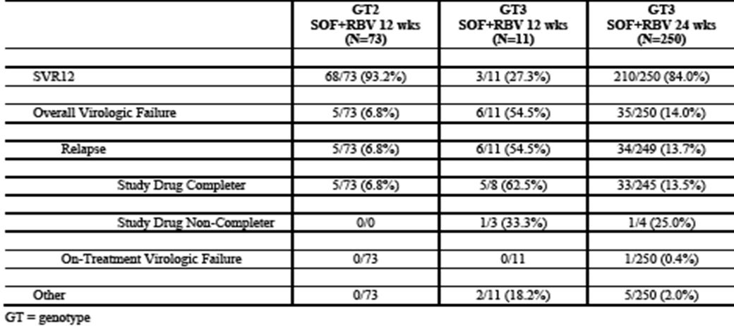
For the GT-2 group treated with 12 weeks of SOF+RBV, SVR12 was 93.2%, and these results are consistent with prior studies in GT-2 CHC treated with 12 weeks of SOF+RBV. In the GT-3 group treated with 12 weeks of SOF+RBV, SVR12 was very low (27.3%), but the number of patients in this group was small (n = 11); 6 subjects (54.5%) experienced virologic relapse and 2 subjects (18.2%) withdrew consent during treatment with their last HCV RNA <LLOQ. For the GT-3 group treated with 24 weeks of SOF+RBV, SVR12 was 84.0%. The relapse rate was lower (13.7%) versus other Phase III studies (FUSION), with SOF+RBV for 12 or 16 weeks in subjects with CHC GT-3 (range 37.8-68.9%).
This study demonstrate that increase the SOF+RBV treatment duration to 24 weeks for GT-3 patients is associated with an increase in SVR rates.

Resistance analysis from Phase II and III studies
Resistance analyses were attempted on plasma HCV isolates from all subjects with HCV RNA >1000 IU/mL at the virologic failure time point or early discontinuation time point for those who had a plasma sample available. Among all SOF treated subjects in the Phase II and III studies, a total of 302/1662 subjects qualified to be part of the RAP with NS5B sequences available from 300/302 subjects in the RAP (deep sequencing from 294 with >1000 X coverage at NS5B 282 position in 272 of 294 subjects; population sequencing from 6 subjects). The S282T substitution was only detected in 1 subject who received SOF monotherapy in a Phase II study, not in any of the remaining 299 subjects in the RAP with sequence data.

Other supportive efficacy studies
Other supportive studies on the use of SOF+RBV include Study GS-US-334-0123 (PHOTON-1) in HCV/HIV co-infected subjects, interim results from Study P7977-2025 in subjects with HCC who were eligible for transplantation, and the NIAID sponsored 11-I-0258 study in which SOF+RBV, the latter at standard or low dose, was given for 24 weeks to treatment naïve patients with GT-1 infection.

HCV and HIV-1 co-infection Study GS-US-334-0123: PHOTON-1
PHOTON-1 was a Phase III, open label multicentre study that evaluated the safety and efficacy of 12 or 24 weeks of therapy with SOF+RBV in subjects with GT-1, 2 or 3 CHC co-infected with HIV-1. The primary objective were to assess the efficacy (SVR12) and safety of SOF+RBV therapy and the secondary objectives include the assessment of SVR4, SVR24 rates, and viral/resistance kinetics. This is the first larger study of an IFN free regimen in patients with HCV/HIV co-infection.
GT-2 and 3 subjects were either HCV treatment naïve or experienced, whereas GT-1 subjects were all treatment naïve. Subjects in these trials had compensated liver disease including cirrhosis. Treatment naïve patients with GT-2 and 3 were treated for 12 weeks. Treatment experienced patients with GT-2 and 3 received 24 weeks of therapy, as did treatment-naïve patients with GT-1. Subjects received 400 mg SOF and weight based RBV daily.
The results of an updated interim analysis were provided with the Section 31 response, with preliminary SVR12 efficacy data available for 210 subjects.
For subjects in the SOF+RBV 12 Week GT-2/3 group (Group 1), the SVR12 was 75.0% and consistent with that observed in a Phase III study in subjects with GT-2/3 HCV infection receiving SOF+RBV for 12 weeks (POSITRON) (Table 20). For subjects in the SOF+RBV 24 Week Treatment experienced GT-2/3 group, the SVR12 was high (92.9%), and higher than rates seen in a Phase III study evaluating 12 or 16 week treatment regimens of SOF+RBV (FUSION). For subjects in the SOF+RBV 24 week GT-1 group, the SVR12 rate was 76.3%.
Table 20: Virological outcome (Full Analysis Set) in GS-US-334-0123.
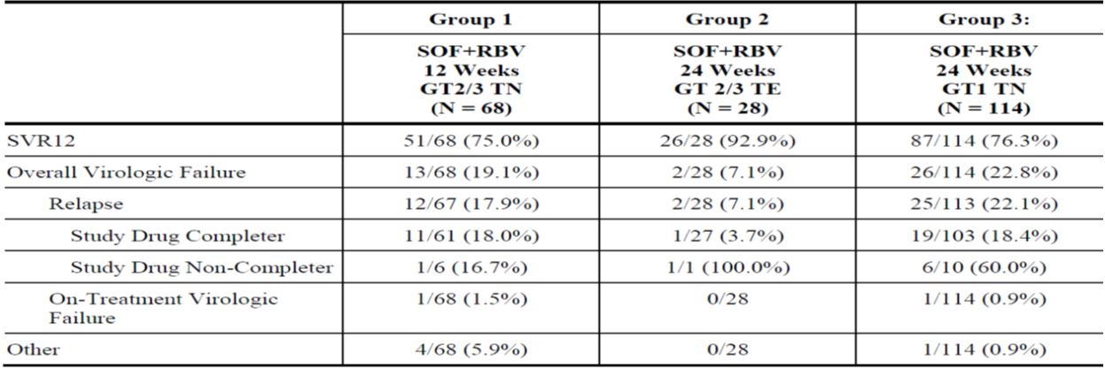
Table 21: SVR12 by genotype (2/3), prior treatment history, and cirrhosis status (FAS).
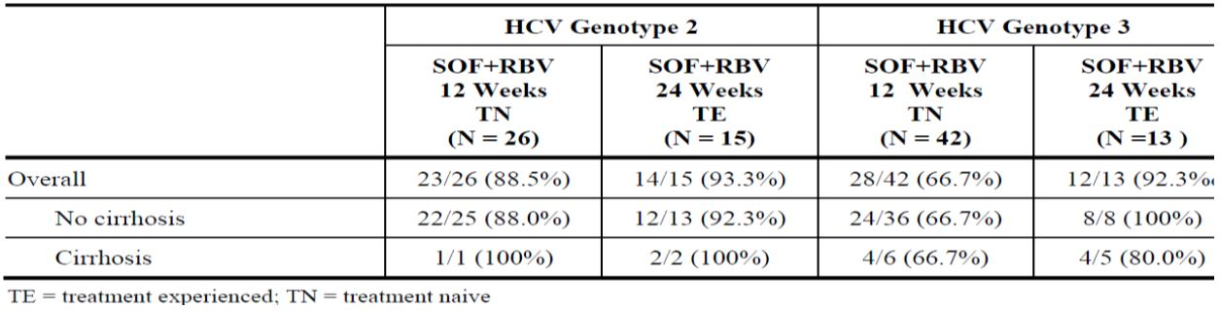
The study showed that co-infection with HIV does not seem to greatly impact the response to treatment with SOF based IFN free therapy. A finding of interest is a considerably higher response rate in GT-1a compared to GT-1b.

Study P7977-2025: GT-1 to 4 hepatocellular carcinoma (HCC) waiting transplantation
This is a Phase II, single arm, open label study. The study was to explore whether SOF+RBV (≤ 24 weeks) given to CHC subjects with hepatocellular carcinoma (HCC, Milan criteria) prior to liver transplantation could prevent post transplant re-infection. The primary efficacy endpoint was the proportion of subjects with pTVR (post transplant virological response; defined as HCV-RNA < LLOQ 12 weeks after transplant). The treatment prior to transplantation was 24 weeks of SOF+RBV. Treatment discontinued within 24 h prior to liver transplantation if this occurred before 24 weeks treatment completed.
An interim analysis was conducted on 61 subjects (GT-1 to 4) received at least 1 dose of study drug and were included in the safety analysis set. Treatment with SOF+RBV resulted in a rapid suppression of HCV RNA, with a 3.87 log₁₀ IU/mL mean decrease in HCV RNA after 1 week of treatment. A total of 93.1% (54 of 58) of subjects had HCV RNA < LLOQ by Week 4 of treatment. With the exception of 5 subjects who had on-treatment virologic failures, all subjects had HCV RNA < LLOQ for the duration of therapy or until the time of transplantation. The duration of therapy with SOF+RBV pre transplant did not appear to influence treatment outcome.
A total of 28 subjects have been transplanted following 3-24 weeks of SOF+RBV. Of the 28 subjects, 25 are part of the full analysis set (any treatment duration) with HCV RNA < LLOQ at liver transplantation; 3 subjects were not included due to HCV RNA > LLOQ at liver transplantation (1 had on-treatment virological breakthrough, 1 had post treatment relapse, and 1 was transplanted with an HCV positive liver).
The post transplant viral response rates of those 25 subjects who had HCV RNA < LLOQ at the time of liver transplantation are presented in Table 22. At 12 weeks post-transplantation, the majority of subjects (61.5%) still had HCV RNA < LLOQ irrespective of treatment duration. This interim analysis appears to show that therapy with SOF+RBV prior to transplantation prevented post transplant reinfection.
Table 22: Virological response in post transplant subjects with last observed HCV RNA < LLOQ prior to transplant (Full Analysis Set with any treatment duration).
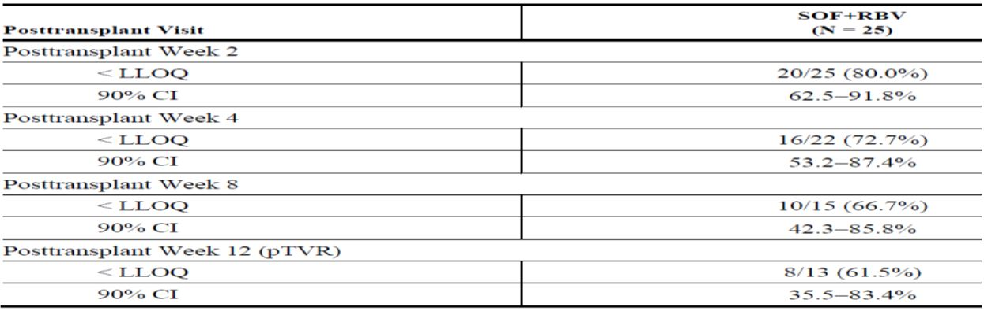

GT-1 treatment naïve CHC patients (Study 11-I-0258)
This study was an open label, Phase I/IIa study for HCV GT-1 treatment naïve patients. The patients were enrolled in 2 parts: 10 patients with early/moderate stage fibrosis enrolled in Part 1, and received 24 weeks of SOF+weight based RBV (WBR); in Part 2, 50 patients with all stages of fibrosis randomised to 24 weeks therapy with SOF + either WBR or low dose RBV (600 mg daily). Interim data showed that lower dose of RBV associated with higher failure in regards to non achievement of SVR12 in this PEG regimen for treatment patients with CHC GT-1.

Clinical safety
The safety database for SOF is relatively limited both in terms of size and duration.
Overall, a total of 2885 subjects have been treated in 27 studies in which, 2443 subjects have received ≥1 dose of a SOF containing regimen. At the proposed dose of SOF 400 mg once daily, 1732 HCV infected subjects have been exposed, in combination with PEG+RBV or RBV, for durations of 12 weeks (n = 1088), 16 weeks (n = 98), 24 weeks (n = 421). In terms of the enrolment into the pivotal studies, males and females constituted 63.4% and 36.6%, respectively. The lack of an upper age limit for enrolment allowed older adults to enrol; despite this, only 5.1% were ≥65 years of age. In addition, while subjects of Black race were reasonably well represented (16.5% in Study GS-US-334-0110), this was not the case in GT-2 and 3 studies, but as expected based on known epidemiology of these genotypes. Baseline characteristics were also representative in regards to non CC (CT or TT) IL28B allele in 61.8%, high baseline HCV RNA ≥ 6 log₁₀ IU/mL (67.5%), and elevated ALT >1.5 ULN (55.8%). Moreover, cirrhotic patients could and did enrol, ranging from 16.7 to 32.7% of enrolment.
The Primary Safety Population included safety data from four Gilead sponsored pivotal Phase III studies (POSITRON, FISSION, FUSION, and NEUTRINO) (Table 23). The Secondary Safety Population included individual (not pooled) data from five Phase II studies and one Phase I/IIa NIAID sponsored study. The Special HCV Population included individual (not pooled) data from study in pre transplant patients and study in HIV-HCV co-infected patients.
Table 23: Overall summary of AEs in the primary safety population (safety analysis set).
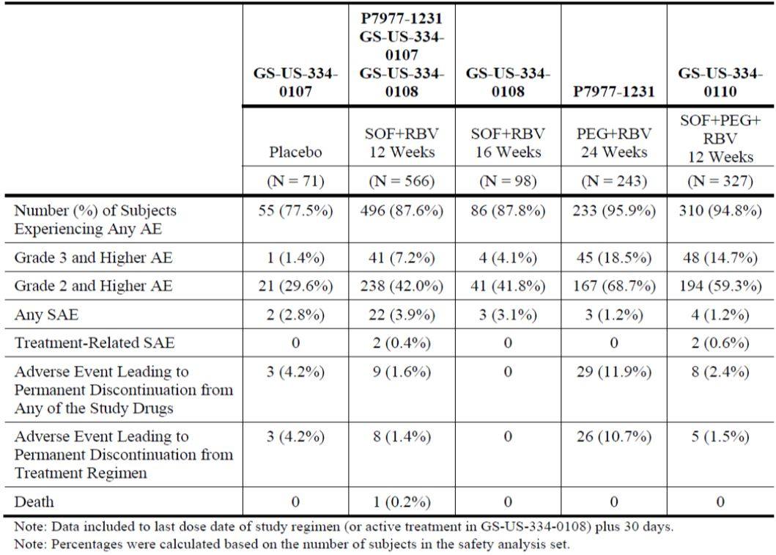
The clinical AE and laboratory safety profiles of SOF+RBV are similar to that expected with RBV treatment; no new safety issues were identified in Phase II or III studies. Hematologic abnormalities were largely Grade 1-2 and managed successfully through RBV dose reduction, discontinuation or transfusion. Co-administration of SOF with PEG+RBV was associated with the expected clinical AEs and laboratory abnormalities observed with PEG+RBV treatment. The addition of SOF did not appear to increase the frequency or severity of any AEs, though this analysis was limited by the lack of a direct comparator group in Phase III Study (GS-US-334-0110). On-treatment reductions in neutrophils and haemoglobin requiring dose adjustment of PEG or RBV occurred in 15.6% and 18.6% of subjects, respectively, in Study GS-US-334-0110. However, transfusions and/or discontinuation of study drugs due to these effects were rare (1% for both).
For the treatment of GT-2 and 3 when compared to PEG+RBV of 24 weeks, 12 weeks of SOF+RBV therapy was characterised by:
- Fewer AEs leading to treatment discontinuation (1.4% versus 0%. versus 10.7%, of SOF+RBV 12 Week group, SOF+RBV 16 Week group, PEG+RBV group, respectively)
- Lower severity of AEs (≥Grade 2 and higher AEs were reported in 42.0%, 41.8% and 68.7% of SOF+RBV 12 Week, SOF+RBV 16 Week groups, PEG+RBV group, respectively; Grade 3 or 4 AEs lower incidence, that is, 7.2%, 4.1%, 18.5% in the SOF+RBV 12 Week and SOF+RBV 16 Week group, PEG+RBV group, respectively)
- Reduced rates of treatment emergent depression and depression requiring treatment (that is, 7.2%, 6.1%, 17.3% in the SOF+RBV12 Week group, SOF+RBV16 Week group, PEG+RBV group). However, Grade 3 and 4 decreases in haemoglobin were seen in ~10%
- Laboratory abnormalities consistent with the haemolytic anaemia associated with RBV treatment were observed.
For the treatment of GT-1 patients, the current standard of care is a RBV-PEG+HCV protease inhibitor. There are many problems associated with these standard regimens including the long treatment duration, toxicities, and drug-drug interactions. GS-US-334-0110, a single arm study with historical controls, provides the data showing the benefits of 12 weeks of SOF+RBV+PEG (triple therapy) in GT-1 treatment naive CHC patients. The SOF+RBV+PEG for 12 weeks resulted in:
- Higher rates of treatment completion: SOF+RBV+PEG versus PEG+RBV for 24 weeks (Study P7977-1231) 97.9% versus 77.8%, respectively
- Fewer AEs that led to study drugs discontinuation: 1.5% versus 10.7% in the triple for 12 weeks versus dual therapy for 24 weeks, respectively
- Lower severity of AEs: Grade 2, 3 or 4 AEs both lower with SOF+RBV+PEG for 12 weeks versus PEG+RBV for 24 weeks (59.3% versus 68.7% and 14.7% versus 18.5%)
- Laboratory abnormalities consistent with PEG+RBV: consistent with the expected bone marrow suppressive effects of PEG and the haemolytic effects of RBV, reductions in haemoglobin and PMN count were the most frequently reported Grade 3 or 4 lab abnormalities by subjects receiving the SOF+PEG+RBV and PEG+RBV regimens. However, the number of subjects in both groups with very low haemoglobin <8.5 g/dL was importantly small but similar (2.4 and 1.7%, respectively); nevertheless, there were more subjects in receipt of SOF+RBV+PEG for 12 weeks with moderate reduction, that is, haemoglobin <10 g/dL than in the PEG+RBV group (22.6% versus 14.5%, respectively). A possible explanation for this is the lower RBV doses used in the PEG-RBV group, whereas weight based, and therefore higher, dosing with RBV (1000-1200mg/day) was given as part of SOF+PEG+RBV therapy. The alternate explanation is that SOF does indeed make a contribution, albeit small, to haemoglobin reduction.

Safety in special population

Safety in hepatic impairment
Study P2938-0515 demonstrated that no dose adjustment of SOF is required for patients with mild, moderate, or severe hepatic impairment and established the safety of short term dosing (7 days) in subjects with advanced liver disease; thereby, enabling ongoing studies in this population. The safety of SOF is currently being studied in subjects with chronic HCV infection with cirrhosis and portal hypertension with or without liver de-compensation (GS-US-334-0125); results from this study are not available for this submission.

Safety in pre-transplant patients
Based on limited data from Study P7977-2025, no specific safety signal has been identified in the pre transplant patients.

Safety in HIV-HCV co-infection
Data from PHOTON-1 included safety data on 31 patients, most of who were on ARVs. The data is preliminary in regards to safety, and moreover, there is hardly any safety data on SOF in HIV-HCV co-infected patients with uncontrolled HIV viraemia. Treatment with SOF+RBV for 12 or 24 weeks was generally well tolerated in HCV/HIV co-infected subjects who were on ARVs and had controlled HIV viraemia. Low rates of treatment discontinuation due to AEs were observed in both 12 and 24 week treatment and commonly occurring and Grade 3 or higher AEs were reported with similar frequency to that in the mono-infected population. Subjects taking ATV as part of their ARV regimen had higher rates of Grade 3 or 4 hyperbilirubinaemia due to RBV associated haemolysis in the setting of ATV mediated UGT1A1 inhibition that necessitated a change in ARV regimen in 11% of subjects. However, for most subjects taking ATV, the bilirubin increases had no clinical consequences. There is still a paucity of safety data in HIV-HCV co-infected patients not on ARVs receiving SOF+RBV for any length of time, as more than 95% of patients enrolled in PHOTON-1 were on ARVs. There is no efficacy and safety data for co-infected patients who are treatment experienced with CHC GT-1.

Safety in renal impairment
No dose adjustment is required for SOF in HCV infected patients with mild or moderate renal impairment (Study P7977-0915). The SOF safety has not been assessed in subjects with severe renal impairment (estimated Glomerular Filtration Rate [eGFR] < 30 mL/min/1.73m²) or ESRD requiring hemodialysis.
RBV is a known teratogen with significant effects observed in all animal studies at ~0.01 times the maximum recommended daily human dose. Since SOF should not be administered without RBV, it is critical to avoid use in pregnancy or in women who plan to become pregnant during treatment. Effective contraception during therapy and for at least 6 months beyond treatment cessation, as per the RBV labelling guidelines, is recommended.
Overall, SOF in combination with RBV±PEG, appears safe and well tolerated without any signature toxicity of its own and without convincingly amplifying the known toxicity profiles of either PEG or RBV.

Risk management plan
The RMP evaluator commented that the risk-benefit profile of SOF seems favourable. However, SOF is a first in class new chemical entity with a multitude of missing information items and only limited post market experience. Many issues remain as the sponsor does not agree with the evaluator in terms of “missing information items” for the RMP. Please see the RMP evaluation report for details. The RMP evaluator suggested the following as the condition of registration:
Implement RMP for Australia Version 0.1 (dated 31 May 2013; Data Lock Point 1 March 2013), and any future updates (where TGA approved), and the changes to the risk management plan requested by the OPR evaluator as a condition of registration.
ACSOM supported the OPR evaluator’s recommendation to include patients with GT-5 or 6 HCV infection as important missing information. ACSOM members further advised that there was also limited data in patients with GT-4 HCV infection, it was appropriate that this patient group also be included as important missing information. ACSOM considers that there was a lack of data in patients of Asian ethnicity (n = 117), patients > 65 years old, and use with agents other than RBV and PEG. ACSOM advised that these should be included in the list of important missing information. The committee is also of the view that complete information on all important safety concerns and planned pharmacovigilance activities should be included in the RMP.
ACSOM advised that, consideration should be given to reconciling the indication for use in Australia with the clinical trial data. In the clinical trials SOF was only studied in combination with RBV and PEG, and therefore there did not seem to be data to support the proposed indication for use in ‘combination with other agents’. ACSOM also advised that the Australian PI should clearly communicate the safety concerns associated with the use of RBV and PEG.
The sponsor should discussion these relevant issues with the OPR to resolve relevant issues and to reach an agreed RMP.

Clinical evaluator’s recommendation
Based on the above analysis and in light of ongoing studies (in GT-4, 5 and 6) which will provide further data on the efficacy of SOF as part of combination therapy for treatment of CHC, the clinical evaluator considers that the benefit-risk balance of SOF, given the proposed usage, is favourable, and recommends that SOF be authorised for the revised indications below:
SOVALDI is a hepatitis C virus (HCV) nucleotide analog NS5B polymerase inhibitor indicated for the treatment of chronic hepatitis C (CHC) infection as a component of a combination antiviral treatment regimen. The drug has proven efficacy as part of combination therapy for genotypes 1, 2, 3 and 4.

Risk-benefit analysis

Delegate’s considerations
A comprehensive development programme for SOF is provided with this submission. SOF, in combination with RBV with or without PEG, has demonstrated similar or superior efficacy to currently available treatment for the most common HCV genotypes across multiple patient populations. The submitted data suggests that while a PEG free combination of SOF+RBV for 12 weeks is highly effective for GT-2 HCV, those with GT-3 should receive SOF+RBV treatment for longer duration (16 -24 weeks). Treatment naïve patients with GT-1 (and small number of patients with GT-4, 5 or 6) show good SVR12 with 12 weeks of SOF+PEG+RBV therapy. However, there is still a relative paucity of data for the use of SOF as part of combination therapy in treatment experienced patients with GT-1, 4, 5 and 6. There are also some data in HIV-HCV co-infection and in hepatocellular carcinoma patients waiting for liver transplant.
The benefits of oral SOF in combination with other agents for treatment of chronic hepatitis C virus infection include:
- Shortened duration of treatment (12 weeks), with superior SVR12 rates compared to historical SVR rates of Standard-of-Care regimens (SVR rate ~60%) when combined with RBV+PEG for treatment naive CHC GT-1
- High SVR12 rates (SOF+RBV, PEG-free regimens) for GT-2 and 3 patients who were treatment naive and treatment experienced (that is, had failed prior treatment with an IFN based regimen)
- Improved SVR12 rates with longer exposure to SOF+RBV (that is, 24 weeks, for GT-3 without a significant toxicity cost of extending treatment duration) and
- Good SVR rate in the setting of HCV-HCV co-infection for treatment naive patients with GT-1 and treatment naïve or experienced patients with GT-2/3; co-infection with HIV does not seem to greatly impact the response to treatment with SOF based IFN free therapy
- Low risk for drug-drug interactions.
The limitations of the submitted data include:
- No specific data in treatment experienced patients with GT-1 HCV mono-infected or HIV-HCV co-infected patients. In the Section 31 response dated 29 January 2014, modelling data is provided to show the likely SVR for treatment experienced GT-1 CHC patients. The evaluator notes that US FDA and EMA have used language in the Sovaldi PI to enable treatment of GT-1 treatment experienced patients based on this modelling approach. However, the evaluator note there are now ongoing studies in treatment experienced patients with GT-1
- No specific data on treatment responses to GT-4 in HIV-HCV co-infected patients
- Minimal data in HIV-HCV co-infected subjects not on ARVs and with uncontrolled HIV viraemia. It is not known whether uncontrolled HIV viraemia might blunt efficacy. Moreover, there might be clinical consequences of the reduced absolute CD4+ T cell count when SOF+RBV are used, when this is coupled with ongoing HIV viral replication
- Minimal data for CHC GT-5 and 6
- No data for patients with HCV-HBV co-infection
- The paucity of data in those with moderate-severe renal impairment and
- No drug-drug interaction data for illicit substances, this is a group of patients who are highly likely to use illicit substances. The issue of illicit substance use is particularly problematical in subjects with HIV-HCV co-infection.
The other issue identified during evaluation is that the RBV used in the SOF clinical trials was Ribasphere, which is not registered in Australia. Currently no stand-alone RBV is available on Australia market and the marketed RBV products in Australia (Rebetol capsule and Copegus tablets) are co-packaged with pegylated or nonpegylated interferons and are indicated for use in combination with pegylated or nonpegylated interferons. Based on the “Summary document of ribavarin therapeutic equivalents (US FDA)”, the clinical evaluator is satisfied that Ribasphere is equivalent to Copegus. The sponsor has partnered with a company to register stand alone RBV in Australia. The RBV submission is now filed with TGA. In view of the benefit of SOF and the unmet medical need for some CHC patients, the Delegate considers that the issue with stand alone RBV should not delay the decision with regards to the registration of SOF.
The sponsor has proposed a broader indication in which no specific qualifiers statements are included. The sponsor states that this approach is similar to the approved indications in other therapeutic area such as HIV or hepatitis B. The indication does not specifically state which agents Sovaldi can be used in combination with and such information are included in the CLINICAL TRIALS and DOSAGE AND ADMINISTRATION section of the PI.
It is noted that although the indication (see below) approved by the EMA appears to be a broader statement, cross references are made to other sections of the SPC where detailed information are available:
Sovaldi is indicated in combination with other medicinal products for the treatment of chronic hepatitis C (CHC) in adults (see sections 4.2, 4.4 and 5.1).
For hepatitis C virus (HCV) genotype specific activity, see sections 4.4 and 5.1.
In view of the rapidly evolving HCV therapeutic landscape and emerging therapeutic goods that may potentially be used in combination with Sovaldi, the Delegate considers that it may be acceptable to have a broader indication statement providing that there is also statement referring to other sections of the PI where the detailed information on studied combination (SOF+RBV, SOF+PEG+RBV), subgroups of CHC patients (various genotypes/disease characteristics/ prior treatment history), and treatment duration are available. The Delegate therefore proposes a revised indication below for ACPM discussion:
Sovaldi is a hepatitis C virus (HCV) nucleotide analog NS5B polymerase inhibitor indicated for the treatment of chronic hepatitis C (CHC) infection as a component of a combination antiviral treatment regimen (see CLINICAL TRIALS and DOSAGE AND ADMINISTRATION sections for detailed information on the studied combinations, dose regimens, and treatment durations for different subgroups of CHC patients).
The Delegate requests advice from ACPM for a number of specific issues (see the summary cover sheet). The final wording of the indication will be decided following the ACPM discussion.
The condition of registration is to implement RMP for Australia Version 0.1 (dated 31 May 2013; Data Lock Point 1 March 2013), and any future updates (where TGA approved), and the changes to the risk management plan requested by the OPR evaluator.

Summary of issues
Five pivotal studies and three supportive studies were submitted to support this submission.
The clinical evaluation identified the following limitations/issues:
- No pivotal study data for GT-1 treatment experienced CHC patients. In response to this concern, the sponsor has included in the PI (DOSAGE AND ADMINSTRATION section) that there is no data available for previous treated patients with GT-1 infection
- Minimal Phase III data for CHC patients with GT-5 and 6
- No specific data on HIV-HCV co-infected patients with GT-4 and minimal data in HIV-HCV co-infected subjects not on ARVs and with uncontrolled HIV viraemia
- The paucity of data in those with moderate/severe renal impairment
- Only interim data from a small study on CHC patients with liver carcinoma waiting for transplantation and
- No data on patients with HCV and HBV co-infection.

Proposed action
The Delegate has no reason to say, at this time, that SOF should not be approved for the treatment of CHC in adults when used as a component of combination therapy. The final wording of the indication will be decided following the ACPM discussion.
Implement RMP for Australia Version 0.1 (dated 31 May 2013; Data Lock Point 1 March 2013), and any future updates (where TGA approved), and the changes to the risk management plan requested by the OPR evaluator as a condition of registration.

Request for ACPM advice
The committee is requested to provide comments and advice on the following issues:
- The committee is requested to advise on the acceptable indication statement, whether the ACPM considers the indication proposed by the Delegate is appropriate
- Given that limited number of GT-5 and 6 patients studied (one GT-5 and six GT-6 patients), what is the view of the committee with regards to the dosing recommendation proposed for CHC GT-5 and 6?
- What is the view of the committee with regards to the proposed dosing recommendation (treatment duration) for CHC GT-3?
- What is the view of the committee with regards to the benefit risk balance of SOF+RBV in HCC patients waiting for liver transplant? Does the committee agree with the proposed dose recommendation for this subpopulation?
- The committee is also requested to provide advice on any other issues that it thinks may be relevant to a decision on whether or not to approve this application.

Response from sponsor

Summary
CHC infection is a serious, progressive, and potentially life threatening disease and a major public health concern globally. Asymptomatic liver disease progression can occur over several decades. Depending on several cofactors, 10% to 40% of patients with CHC will develop cirrhosis of the liver and will be at risk for developing HCC, the most common type of liver cancer. Worldwide, an estimated 180 million people have CHC. The prevalence of HCV in Australia is estimated to be approximately 1.3%.
Current options for the treatment of CHC infection vary by viral genotype, but all include PEG for at least 24 weeks and are therefore associated with significant toxicities that pose significant challenges for patient management.
The sponsor has developed SOF, a DAA agent, for the treatment of CHC infection. SOF has the potential to address a significant unmet medical need in the treatment of HCV infected patients. SOF will provide a safe and effective alternative to the current standard of care regimens that are used for the treatment of CHC infection and where no other treatment options exist. The efficacy, differentiated safety/tolerability profile, shortened treatment regimens and high barrier to resistance over existing standard of care regimens, and reduced (GT-1, 4, 5 and 6) or eliminated (GT-2 and 3) PEG exposures for the proposed SOF regimens will ideally increase patient eligibility for treatment as well as improve adherence to and completion of the SOF treatment regimen. Together, these attributes of the proposed SOF treatment regimens will change the treatment paradigm of CHC treatment.
The sponsor is encouraged by the Delegate’s recommendation to approve a broad indication for SOF in light of the rapidly evolving HCV therapeutic landscape and emerging therapeutic goods that could potentially be used in combination with SOF, aside from PEG and/or RBV. This approach is aligned with the other global regulatory agencies such as FDA and EMA that have also supported a broad SOF indication for use in combination with other agents for the treatment of chronic HCV infection.
In addition, it is important to note that although SOF is used in combination therapy, SOF is a separate and distinct therapeutic good to the other agents it is used with, and the sponsor believes the PI and Australian Risk Management Plan (AU-RMP) should reflect the risk/benefit of SOF and should not include risks specific to another agent. The TGA has routinely accepted this approach for other single agents used in combination therapy (for example, in the HIV therapeutic area, Viread tablets), and this should also be the case for new single tablet regimens containing SOF. However, the sponsor has updated the SOF PI to clearly highlight the PEG and/or RBV pregnancy category, contraindication and precautions, by cross reference back to their respective PI.
SOF is already approved in the US, EU, Switzerland, Turkey, Canada, and New Zealand.

Discussion of Delegate’s comments
- The committee is requested to advise on the acceptable indication statement, whether the ACPM considers the indication proposed by the Delegate is appropriate.
The sponsor is encouraged by the Delegate’s recommendation to approve a broad indication for SOF in light of the rapidly evolving HCV therapeutic landscape and emerging therapeutic goods that could potentially be used in combination with SOF, aside from PEG and/or RBV. This approach is aligned with the other global regulatory agencies such as FDA and EMA that have also supported a broad SOF indication for use in combination with other agents for the treatment of chronic HCV infection.
Since the approval of SOF, global liver disease guidelines have been updated to recommend SOF treatment for all HCV genotypes. The recently published EASL (European Association for the Study of Liver), American Association for the Study of Liver Disease (AASLD) and Infectious Diseases Society of America (IDSA) also recommend the use of SOF in combination with agents other than PEG and/or RBV. HCV prescribers in Australia would look to this guidance as a source prescribing text in the absence of specific Australian HCV prescribing guidance. The sponsor therefore supports the indication proposed by the delegate with one minor change. The sponsor considers that the description of what SOF is has been clearly presented in the SOF PI and does not warrant being further stated in the indication.
As such the sponsor proposes to remove the qualifying description of SOF from the indication and SOF should therefore be approved for the proposed indication:
Sovaldi is a hepatitis C virus (HCV) nucletotide analog NS5B polymerase inhibitor indicated for the treatment of chronic hepatitis C (CHC) infection as a component of a combination antiviral treatment regimen (see CLINICAL TRIALS and DOSAGE AND ADMINISTRATION sections for detailed information of the studied combinations, dose regimens, and treatment durations for difference subgroups of CHC patients).
- Given the limited number of GT-5 or 6 patients studies (one GT-5 and six GT-6 patients), what is the view of the committee with regards to the dosing recommendation proposed for CHC GT-5 and 6?
SOF has demonstrated potent in vitro antiviral activity across HCV GT-1 through 6 in several assay systems, has demonstrated a similar resistance profile in vitro, has demonstrated similar viral kinetics in patients and high rates of SVR in a limited number of patients in studies that included these less prevalent HCV GTs such as 5 and 6. To note, ~2% of HCV patients in Australia are classified GT-5 or 6.
Evidence from nonclinical virology studies showed that SOF had similar antiviral inhibitory activity (IC50 values ranging from 0.7-2.6 μM) across all HCV genotypes tested. SOF also displayed pangenotypic antiviral activity with EC50 values ranging from 0.014 to 0.11 μM across GT-1 to 6 replicons and a similar resistance profile across HCV GT-1 to 6 in vitro.
These findings have been confirmed in the clinical development program, with the limited number of GT-5 (n = 1), and GT-6 (n = 6) HCV infected patients achieving similarly high on-treatment virologic suppression and SVR rates to GT-1, 2 and 3 HCV infected patients.
The only available treatment option for patients with chronic GT-4, 5, or 6 HCV infection is 48 weeks of PEG+RBV with response rates of 50% to 80% reported in small clinical studies. Real world experience with both PI+PEG+RBV and PEG+RBV treatments consistently reported lower SVR rates and higher rates of premature treatment discontinuations than those observed in the settings of large, carefully controlled clinical studies. Even with the limited number of GT-5 or 6 patients studied in the SOF clinical development program, it is important to note that 100% of patients achieved SVR12.
The sponsor believes that the totality of evidence suggests benefit in these less prevalent HCV genotypes that are underrepresented in clinical studies. An approach of including rather than excluding them from the potential benefit of SOF based regimens seems most reasonable and prudent. The proposed PI has also been updated to include the statement ‘there is only very limited data available for patients with HCV GT-5 or 6’.
- What is the view of the committee with regards to the proposed dosing recommendation (treatment duration) for CHC GT-3?
The Phase III clinical study, GS-US-334-0133 (VALENCE) showed that extending treatment duration to 24 weeks in GT-3 HCV infected patients substantially improved the SVR12 response rate in both treatment naive and treatment experienced patients. In recognition of the importance of these data, both FDA and EMA recommend 24 weeks of SOF+RBV for GT-3 HCV infected patients. Table 24 provides a comparison of GT-3 patients by study.
Table 24: Comparison of results in GT-3 by subgroups in Study P7977-1231 (FISSION), GS-US-344-0108 (FUSION) and GS-US-334-0133 (VALENCE).
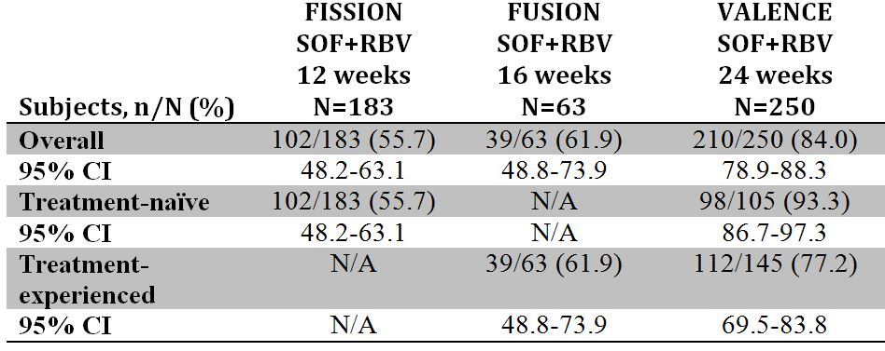
In response to these results, the sponsor included an additional footnote (e) in the dosing recommendation section:
Consideration should be given to potentially extending the duration of therapy beyond 16 weeks and up to 24 weeks guided by an assessment of the potential benefits and risks for the individual patient (these factors may include cirrhosis status and treatment history).
The Delegate has now requested to include the clinical trial information relating to VALENCE study in the PI and this has been accepted by the sponsor. The dosing recommendation provided for GT-3 patients is consistent with the clinical trial information now provided in the proposed PI. Please note, the approved European and New Zealand dosing for GT-3 CHC patients is provided below in Table 25.
Table 25: Approved European and New Zealand dosing for GT-3 CHC patients.
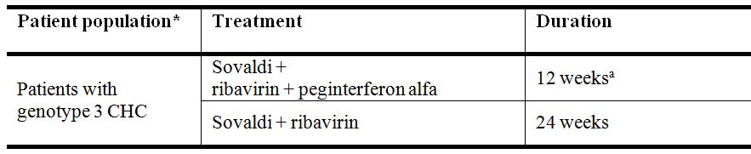
A consideration should be given to potentially extending the duration of therapy beyond 12 weeks and up to 24 weeks; especially for those subgroups who have one or more factors historically associated with lower response rates to IFN based therapies (for example, advanced fibrosis/cirrhosis, high baseline viral concentrations, black race, IL28B non CC genotype, prior null response to PEG+RBV therapy).
What is the view of the committee with regards to the benefit risk balance of SOF+RBV in hepatocellular carcinoma patient waiting for liver transplant? Does the committee agree with the proposed dose recommendation for this subpopulation?
Current therapeutic options for patients with HCV on the transplant list are limited due to the inability to utilise full doses of PEG/RBV due to side effects and cytopenias, and the risk of complications related to deteriorating liver function. PEG is contraindicated in patients with hepatic decompensation. When treatment with PEG/RBV in patients on the liver transplant list has been attempted despite the contraindications, the results demonstrate on-treatment clearance of HCV RNA from the blood in 30-40% of patients with HCV GT-1 and 70-90% of patients with GT-2 or 3. Suppression of HCV RNA at the time of transplant has the potential to render 20-30% of PEG/RBV treated patients HCV infection free post transplant.
As there is currently no standard of care therapy available for HCV patients awaiting liver transplantation, and there is substantial unmet medical need in this patient population for effective, well tolerated IFN free treatments. To address this unmet medical need, Study P7977-2025 (which was included in the Category 1 filing) was undertaken as a Phase II, open label study of SOVALDI+RBV in 61 patients with HCV and HCC meeting the MILAN criteria for liver transplantation. All patients enrolled in the study were cirrhotic, and most were fully compensated. This particular group of patients waiting for liver transplantation with an HCC weighted Model for End-stage Liver Disease (MELD) score of 22 was chosen because the anticipated time to transplantation would be within one year, leading to an earlier proof of principle for the first study with SOF within the special population of pre transplant patients with HCV.
Results showed that approximately two-thirds of the patients who underwent liver transplantation with HCV RNA <LLOQ at the time of transplant remain uninfected during the post transplant follow up period, regardless of the duration of therapy prior to transplantation. Therefore, the sponsor believes there is a favourable benefit-risk balance of the use of SOF in combination with RBV in patients waiting for liver transplants and HCC.
The dose recommendation for patients awaiting liver transplantation in the proposed PI is:
Sovaldi in combination with ribavirin was administered for up to 24 weeks to 28 patients with hepatocellular carcinoma awaiting liver transplantation to prevent post transplant HCV reinfection. The duration of administration of Sovaldi in patients awaiting liver transplantation should be guided by an assessment of the potential benefits and risks for the individual patient.
Given the promising data from Study P7977-2025 and with no additional safety concerns, the sponsor believes it is in the best interests of HCV patients awaiting liver transplantation to have access to SOF to prevent recurrence post transplant which is otherwise universal.

RMP
The sponsor notes the proposed condition of registration as suggested by the RMP evaluator is to implement RMP for Australia Version 0.1 (dated 31 May 2013; Data Lock Point 1 March 2013) and any future updates (where TGA approved) and the changes to the risk management plan requested by the OPR evaluator. The sponsor therefore wishes to address some of the outstanding issues raised in the Delegate’s Overview with regard to RMP to ensure there is no delay in the registration of SOF, ensuring that Australian prescribers and HCV patients will be able to access this important treatment quickly.

Important missing information
The proposed AU-RMP version 0.1 (dated 31 May 2013) is consistent with the EMA approved EU-RMP version 1.0. With regards to important missing information, the sponsor advises that the following will be included as important missing information in the SOF AU-RMP as requested in the Delegate’s overview:
- Patients with GT-5 or 6 HCV infections
- Asian patients
- Patients over 65 and
- Use with agents other than RBV and PEG.

Important identified risks
ACSOM has recommended haematological abnormalities (decreased haemoglobin) be included in the Sovaldi AU-RMP as an important identified risk however, as this has not been attributed to Sovaldi and is a laboratory abnormality associated with RBV, Gilead does not propose to include this in the Sovaldi AU-RMP.
The sponsor believes it is important to note that during the evaluation of the AU-RMP Gilead provided robust justifications that any ‘Important Identified Risks” specific to PEG and/or RBV should be reflected in the PEG and/or RBV AU-RMP and not within the SOF AU-RMP. SOF is a separate and distinct therapeutic good, and therefore “Important Identified Risks” related to PEG and/or RBV and should be reflected in their respective RMP. This is also the case for the SOF PI. Although SOF is used in combination therapy, SOF is a separate and distinct therapeutic good and the PI should reflect the risk/benefit of SOF and should not include risks specific to another agent. The TGA has routinely accepted this approach for other single agents used in combination therapy in the HIV therapeutic area (for example, Viread tablets), and this should also be the case for new single tablet regimens containing SOF. However, the sponsor has updated the SOF PI to clearly highlight the PEG and/or RBV pregnancy category, contraindication and precautions, by cross reference back to their respective PI.

Important potential risks
ACSOM has also recommended the inclusion of the following ‘important potential risks’:
- Mitochondrial toxicity
- Drug resistance.
The sponsor has provided robust justification for not including both mitochondrial toxicity and drug resistance as important identified risk as part of the Section 31 response, which is summarised below.
There has been no evidence of mitochondrial toxicity in the comprehensive clinical and non-clinical program with Sovaldi. As such this is not included in the proposed Sovaldi PI or AU-RMP.
In addition, the Sovaldi based regimens demonstrated a favourable resistance profile. Resistance to SOF has only been observed in one subject following SOF monotherapy, and this regimen is not proposed for registration. Across the four pivotal Phase III studies, no genotypic or phenotypic resistance to SOF or RBV was detected in HCV variants from the subjects who relapsed; potentially giving subjects the option for receiving SOF as part of a future regimen.
As such, the sponsor does not propose to include mitochondrial toxicity and drug resistance as important identified risks in the AU-RMP.

Indication
The sponsor does not agree with the ACSOM advice that consideration should be given to reconciling the indication for use in Australia with the clinical trial data. As noted by the Delegate, the HCV therapeutic landscape is rapidly evolving and new therapeutic goods are emerging that may potentially be used in combination with SOF. The sponsor cannot envisage all of the upcoming therapeutic goods that may potentially be used in combination with SOF. As such, an indication based solely on the clinical trial data will restrict other future TGA registrations.
A broad indication is therefore recommended to allow prescribers a full range of treatment options, once these are TGA approved and available in Australia. This advice is further supported by recently released HCV EASL guidelines which includes recommendations for the use of SOF in combination with agents other than PEG and/or RBV.

Conclusion
SOF has the potential to address a significant unmet medical need in the treatment of HCV infected patients. SOF will provide a safe and effective alternative to the current standard of care regimens that are used for the treatment of CHC infection and where no other treatment options exist. The efficacy, differentiated safety/tolerability profile, shortened treatment regimens and high barrier to resistance over existing standard of care regimens, and reduced (GT-1, 4, 5 and 6) or eliminated (GT-2 and 3) PEG exposures for the proposed SOF regimens will ideally increase patient eligibility for treatment as well as improve adherence to and completion of the SOF treatment regimen. Together, these attributes of the proposed SOF treatment regimens will change the treatment paradigm of CHC treatment.

Advisory committee considerations
The ACPM, taking into account the submitted evidence of efficacy, safety and quality, agreed with the Delegate and considered Sovaldi tablet containing 400 mg of sofosbuvir to have an overall positive benefit-risk profile for the amended indication:
Sovaldi is indicated for the treatment of adults with chronic hepatitis C (CHC) infection as a component of a combination antiviral treatment regimen.
(see CLINICAL TRIALS and DOSAGE AND ADMINISTRATION sections for detailed information on the studied combinations, dose regimens, and treatment durations for different subgroups of CHC patients).

Proposed conditions of registration
The ACPM agreed with the Delegate on the proposed conditions of registration.

Proposed Product Information (PI)/Consumer Medicine Information (CMI) amendments
The ACPM agreed with the delegate to the proposed amendments to the Product Information (PI) and Consumer Medicine Information (CMI) and specifically advised on the inclusion of the following:
- A statement in the Interactions with other medicines section of the PI and relevant sections of the CMI precluding didanosine (DDI) and RBV concurrent treatment in HIV/HCV
- A statement in the PI providing weight based dosage for RBV as well as cross referencing
- A statement in the PI and relevant section of the CMI on lack of information regarding efficacy and safety in the paediatric population
- A statement in the CLINICAL TRIALS section on the minimal data available on the efficacy and safety of Sovaldi in HIV-HCV co-infected patients with untreated HIV as >95% of subjects in the PHOTON-1 study were on ARVs
- ACPM also requested that the sponsor regularly updates the PI as emerging clinical trial data become available on studied combinations, dose regimens, and treatment durations for different subgroups of CHC patients.

Specific advice
The ACPM advised the following in response to the Delegate’s specific questions on this submission.
- The committee is requested to advise on the acceptable indication statement, whether the ACPM considers the indication proposed by the Delegate is appropriate.
The ACPM agreed substantially with the Delegate and advised that the indication should be as follows:
- Sovaldi is indicated for the treatment of adults with chronic hepatitis C (CHC) infection as a component of a combination antiviral treatment regimen
- (see CLINICAL TRIALS and DOSAGE AND ADMINISTRATION sections for detailed information on the studied combinations, dose regimens, and treatment durations for different subgroups of CHC patients)
- Given that limited numbers of GT-5 and 6 patients were studied (one GT-5 and six GT-6 patients), what is the view of the committee with regards to the dosing recommendation proposed for CHC GT-5 and 6?
The ACPM was of the view that systematic collection of specific trial data for GT-5 and 6 was difficult, and noted potent in vitro antiviral activity across HCV genotypes and that the small number of patients with these genotypes achieved SVR12. However, data should be provided once it is available. The extremely limited data available suggest GT-5 and 6 patients should be given standard treatment and monitored for clinical response.
- What is the view of the committee with regards to the proposed dosing recommendation (treatment duration) for CHC GT-3?
The ACPM agreed there is some evidence that supports the longer treatment duration of up to 24 weeks in patients with CHC GT-3. Therefore, treatment duration of 24 weeks should be considered. The suggestion of a footnote for treatment of this population was considered a reasonable compromise.
- What is the view of the committee with regards to the benefit risk balance of SOF+RBV in hepatocellular carcinoma patients waiting for liver transplant? Does the committee agree with the proposed dose recommendation for this subpopulation?
The ACPM agreed with the dose recommendation for this subpopulation; however, it was noted that there is limited evidence, but the natural history of untreated HCV in these patients is well described, so it seems reasonable to include this indication. The sponsor should be asked to provide data from the ongoing study once it becomes available to confirm safety and efficacy in this population.
The ACPM supported the moderations of the risk management plan as proposed by the delegate.
The ACPM advised that the implementation by the sponsor of the recommendations outlined to the satisfaction of the TGA, in addition to the evidence of efficacy and safety provided would support the safe and effective use of this product.

Outcome
Based on a review of quality, safety and efficacy, TGA approved the registration of Sovaldi tablet containing sofosbuvir 400 mg for the following indication:
Sovaldi is indicated for the treatment of adults with chronic hepatitis C (CHC) infection as a component of a combination antiviral treatment regimen.
(see CLINICAL TRIALS and DOSAGE AND ADMINISTRATION section for detailed information on the studied combinations, dose regimens, and treatment durations for different subgroups of CHC patients)

Specific conditions of registration applying to these goods
- For the Sovaldi tablet containing sofosbuvir 400 mg, Australian RMP, Version 0.1 (dated 31 May 2013; Data Lock Point 1 March 2013), and any future updates (where TGA approved), and the changes to the risk management plan requested as agreed with the TGA RMP evaluator will be implemented in Australia.

Attachment 1. Product Information
The Product Information approved for Sovaldi at the time this AusPAR was published is at Attachment 1. For the most recent PI, please refer to the TGA website at <http://www.tga.gov.au/hp/information-medicines-pi.htm>.

Attachment 2. Extract from the Clinical Evaluation Report

Therapeutic Goods Administration
PO Box 100 Woden ACT 2606 Australia
Email: info@tga.gov.au Phone: 1800 020 653 Fax: 02 6232 8605
http://www.tga.gov.au

World Health Organization, “Fact sheet No. 164: Hepatitis C”, April 2014.
Hajarizadeh B, et al. (2013) Epidemiology and natural history of HCV infection. Nat Rev Gastroenterol Hepatol. 10: 553-562.
Naggie S, et al. (2010) Hepatitis C virus directly acting antivirals: current developments with NS3/4A HCV serine protease inhibitors. J Antimicrob Chemother. 65: 2063-2069.
Naggie S, et al. (2010) Hepatitis C virus directly acting antivirals: current developments with NS3/4A HCV serine protease inhibitors. J Antimicrob Chemother. 65: 2063-2069.
Naggie S, et al. (2010) Hepatitis C virus directly acting antivirals: current developments with NS3/4A HCV serine protease inhibitors. J Antimicrob Chemother. 65: 2063-2069.
Ly KN, et al. (2012) The increasing burden of mortality from viral hepatitis in the United States between 1999 and 2007. Ann Intern Med. 156: 271-278.
Naggie S, et al. (2010) Hepatitis C virus directly acting antivirals: current developments with NS3/4A HCV serine protease inhibitors. J Antimicrob Chemother. 65: 2063-2069.
Carey W. (2003) Tests and screening strategies for the diagnosis of hepatitis C. Cleve Clin J Med. 70 (Suppl 4): S7-S13.
Fattovich G, et al. (2001) Hepatitis C virus genotypes: distribution and clinical significance in patients with cirrhosis type C seen at tertiary referral centres in Europe. J Viral Hepat. 8: 206-216.
Hajarizadeh B, et al. (2013) Epidemiology and natural history of HCV infection. Nat Rev Gastroenterol Hepatol. 10: 553-562.
Ghany MG, et al. (2009) Diagnosis, management, and treatment of hepatitis C: an update. Hepatology 49: 1335-1337.
Dienstag JL, McHutchison JG. (2006) American Gastroenterological Association technical review on the management of hepatitis C. Gastroenterology 130: 231-264; quiz 214-217.
Jacobson IM, et al. (2005) A randomized trial of pegylated interferon alpha-2b plus ribavirin in the retreatment of chronic hepatitis C. Am J Gastroenterol. 100: 2453-2462.
Victrelis (boceprevir) Product Information; Incivek (telaprevir) Product Information.
Victrelis (boceprevir) Product Information; Incivek (telaprevir) Product Information.
Ghany MG, et al. (2011) An update on treatment of genotype 1 chronic hepatitis C virus infection: 2011 practice guideline by the American Association for the Study of Liver Diseases. Hepatology 54: 1433-1444.
Ghany MG, et al. (2009) Diagnosis, management, and treatment of hepatitis C: an update. Hepatology 49: 1335-1337; Ghany MG, et al. (2011) An update on treatment of genotype 1 chronic hepatitis C virus infection: 2011 practice guideline by the American Association for the Study of Liver Diseases. Hepatology 54: 1433-1444.
Johnson AA, et al. (2001) Toxicity of antiviral nucleoside analogs and the human mitochondrial DNA polymerase. J Biol Chem. 276: 40847-40857; Arnold JJ, et al. The human mitochondrial RNA polymerase as an off-target for antiviral ribonucleosides [Oral Presentation]. 16th International Symposium on HCV and Related Viruses; 3-7 October 2009; Nice, France.
In cardiology, the QT interval is a measure of the time between the start of the Q wave and the end of the T wave in the heart’s electrical cycle.
US Food and Drug Administration, “Guidance for Industry Chronic Hepatitis C Virus Infection: Developing Direct-Acting Antiviral Drugs for Treatment”, October 2013.
These studies were not submitted by the sponsor but the results are referred to in SECTION 3.2.S.2.6—MANUFACTURING PROCESS DEVELOPMENT.
TGA Pregnancy Category B2: “Drugs which have been taken by only a limited number of pregnant women and women of childbearing age, without an increase in the frequency of malformation or other direct or indirect harmful effects on the human foetus having been observed. Studies in animals are inadequate or may be lacking, but available data show no evidence of an increased occurrence of foetal damage.”
TGA Pregnancy Category B1: “Drugs which have been taken by only a limited number of pregnant women and women of childbearing age, without an increase in the frequency of malformation or other direct or indirect harmful effects on the human foetus having been observed. Studies in animals have not shown evidence of an increased occurrence of foetal damage.”
FDA Pregnancy Category X: “Studies in animals or humans have demonstrated foetal abnormalities and/or there is positive evidence of human foetal risk based on adverse reaction data from investigational or marketing experience, and the risks involved in use of the drug in pregnant women clearly outweigh potential benefits.”
TGA Pregnancy Category X: “Drugs which have such a high risk of causing permanent damage to the foetus that they should not be used in pregnancy or when there is a possibility of pregnancy.”
Carter W. (2012) FDA Perspective on Direct Acting Antiviral Trials. HCV Drug Development Workshop, Baltimore MD, US Food and Drug Administration Division of Antiviral Products.
ClinicalTrials.gov NCT02032875: “Phase III Daclatasvir, Sofosbuvir, and Ribavirin in Cirrhotic Subjects and Subjects Post-liver Transplant (ALLY 1)”.
ClinicalTrials.gov NCT01994486: “Open-Label Safety Study of Telaprevir and Sofosbuvir in Chronic Hepatitis C Genotype 1 (STEADFAST)”.
ClinicalTrials.gov NCT01958281: “Sofosbuvir Plus Ribavirin in Subjects With HCV Infection and Renal Insufficiency”.
Craxi A. (2011) EASL Clinical Practice Guidelines: Management of hepatitis C virus infection. J Hepatol. 55: 245-264.
Ghany MG, et al. (2009) Diagnosis, management, and treatment of hepatitis C: an update. Hepatology 49: 1335-1374.
Dore GJ, et al. (2003) Epidemiology of hepatitis C virus infection in Australia. J Clin Virol. 26: 171-184.
Pegasys (peginterferon alfa-2a) Injection for Subcutaneous Use. US Prescribing Information. Roche Pharmaceuticals. Nutley, NJ. Revised September 2011; Copegus (ribavirin, USP) Tablets. US Prescribing Information. Roche Laboratories Inc., Nutley, NJ. Revised August 2011; Victrelis (boceprevir) Capsules. US Prescribing Information. Schering Corporation, Whitehouse Station, NJ. Revised December 2012; Incivek (telaprevir) Film Coated Tablets for oral use. US Prescribing Information. Vertex Pharmaceuticals Incorporated. Cambridge, MA. May 2011 Revised December 2012.
Hui C-K, et al. (2003) Interferon and ribavirin therapy for chronic hepatitis C virus genotype 6: a comparison with genotype 1. J Infect Dis. 187: 1071-1074; Lam KD, et al. (2010) Randomized controlled trial of pegylated interferon-alfa 2a and ribavirin in treatment-naive chronic hepatitis C genotype 6. Hepatology 52: 1573-1580; Chen J, et al. (2013) Earlier sustained virologic response end points for regulatory approval and dose selection of hepatitis C therapies. Gastroenterology 144: 1450-1455; El-Zayadi AR, et al. (2005) Response of hepatitis C genotype-4 naive patients to 24 weeks of Peg-interferonalpha2b/ribavirin or induction-dose interferonalpha2b/ribavirin/amantadine: a non-randomized controlled study. Am J Gastroenterol. 100: 2447-2452; Kamal SM, et al. (2005) Peginterferon {alpha}-2b and ribavirin therapy in chronic hepatitis C genotype 4: impact of treatment duration and viral kinetics on sustained virological response. Gut 54: 858-866; Pegasys (peginterferon alfa-2a) Injection for Subcutaneous Use. US Prescribing Information. Roche Pharmaceuticals. Nutley, NJ. Revised September 2011; Ribasphere (ribavirin, USP) Tablets. US Prescribing Information. Manufactured by DSM Pharmaceuticals, Inc., Greenville, NC 27834 for Kadmon Pharmaceuticals, LLC., Warrendale, PA 15086. Revised February 2012.
Zayed N, et al. Theraputic Outcome in 6198 Interferon-Naive Egyptian Patients with Chronic Hepatitis C genotype-4: A Real Experience [Poster 1767]. 63rd Annual Meeting of the American Association for the Study of the Liver (AASLD); 9-13 November 2012; Boston, MA; Hezode C, et al. Safety and efficacy of telaprevir or boceprevir in combination with peginterferon alfa/ribavirin, in 455 cirrhotic non responders. Week 16 analysis of the French early access program (ANRS CO20-CUPIC) in real-life setting [Abstract 51]. AASLD; 9-13 November 2012; Boston, MA; Backus LI, et al. (2011) A sustained virologic response reduces risk of all-cause mortality in patients with hepatitis C. Clin Gastroenterol Hepatol. 9: 509-516.
Navasa M, Forns X. (2007) Antiviral therapy in HCV decompensated cirrhosis: to treat or not to treat? J Hepatol. 46: 185-188; Carrion JA, et al. (2009) Antiviral therapy increases the risk of bacterial infections in HCV-infected cirrhotic patients awaiting liver transplantation: A retrospective study. J Hepatol. 50: 719-728; Everson GT, et al. (2005) Treatment of advanced hepatitis C with a low accelerating dosage regimen of antiviral therapy. Hepatology 42: 255-262.
Everson GT, et al. (2013) A randomized controlled trial of pretransplant antiviral therapy to prevent recurrence of hepatitis C after liver transplantation. Hepatology 57: 1752-1762.
Everson GT, et al. (2013) A randomized controlled trial of pretransplant antiviral therapy to prevent recurrence of hepatitis C after liver transplantation. Hepatology 57: 1752-1762.

