February 2018

Australian Public Assessment Report for Sodium zirconium cyclosilicate hydrate
  - Proprietary Product Name: Lokelma
  - Sponsor: AstraZeneca Pty Ltd

About the Therapeutic Goods Administration (TGA)
- The Therapeutic Goods Administration (TGA) is part of the Australian Government Department of Health and is responsible for regulating medicines and medical devices.
- The TGA administers the Therapeutic Goods Act 1989 (the Act), applying a risk management approach designed to ensure therapeutic goods supplied in Australia meet acceptable standards of quality, safety and efficacy (performance) when necessary.
- The work of the TGA is based on applying scientific and clinical expertise to decision-making, to ensure that the benefits to consumers outweigh any risks associated with the use of medicines and medical devices.
- The TGA relies on the public, healthcare professionals and industry to report problems with medicines or medical devices. TGA investigates reports received by it to determine any necessary regulatory action.
- To report a problem with a medicine or medical device, please see the information on the TGA website <https://www.tga.gov.au>
About AusPARs
- An Australian Public Assessment Report (AusPAR) provides information about the evaluation of a prescription medicine and the considerations that led the TGA to approve or not approve a prescription medicine submission.
- AusPARs are prepared and published by the TGA.
- An AusPAR is prepared for submissions that relate to new chemical entities, generic medicines, major variations and extensions of indications.
- An AusPAR is a static document; it provides information that relates to a submission at a particular point in time.
- A new AusPAR will be developed to reflect changes to indications and/or major variations to a prescription medicine subject to evaluation by the TGA.
Copyright
© Commonwealth of Australia 2018
This work is copyright. You may reproduce the whole or part of this work in unaltered form for your own personal use or, if you are part of an organisation, for internal use within your organisation, but only if you or your organisation do not use the reproduction for any commercial purpose and retain this copyright notice and all disclaimer notices as part of that reproduction. Apart from rights to use as permitted by the Copyright Act 1968 or allowed by this copyright notice, all other rights are reserved and you are not allowed to reproduce the whole or any part of this work in any way (electronic or otherwise) without first being given specific written permission from the Commonwealth to do so. Requests and inquiries concerning reproduction and rights are to be sent to the TGA Copyright Officer, Therapeutic Goods Administration, PO Box 100, Woden ACT 2606 or emailed to <tga.copyright@tga.gov.au> .

Contents
Common abbreviations 5
I. Introduction to product submission 7
Submission details 7
Product background 7
Regulatory status 8
Registration timeline 8
II. Quality findings 8
Introduction 8
Drug substance (active ingredient) 9
Drug product 10
Biopharmaceutics 11
Quality summary and conclusions 11
III. Nonclinical findings 12
Introduction 12
Pharmacology 12
Pharmacokinetics 13
Toxicology 15
Nonclinical summary and conclusions 18
IV. Clinical findings 19
Introduction 19
Pharmacokinetics 20
Pharmacodynamics 21
Dosage selection for the pivotal studies 21
Efficacy 22
Safety 22
First round benefit-risk assessment 23
First round recommendation regarding authorisation 24
Clinical questions and second round evaluation of clinical data submitted in response to questions 24
Second round benefit-risk assessment 24
V. Pharmacovigilance findings 24
Risk management plan 24
VI. Overall conclusion and risk/benefit assessment 26
Background 26
Quality 26
Nonclinical 27
Clinical 27
Risk management plan 36
Risk-benefit analysis 37
Outcome 42

Common abbreviations
Abbreviation | Meaning
ACE | angiotensin converting enzyme
ACPM | Advisory committee for prescription medicines
AE | adverse event
ASA | Australian Specific Annex
BP | blood pressure
BUN | blood urea nitrogen
CKD | chronic kidney disease
ECG | Electrocardiograph
FDA | United States Food and Drug Administration
g | grams
GCP | good clinical practice
GFR | glomerular filtration rate
GI | gastrointestinal
HIV | Human Immunodeficiency Virus
IP | investigational product
ITT | intention to treat
KEC | potassium exchange capacity
LLOQ | lower limit of quantification
ml | millilitres
mmol/L | millimoles per litre
NOAEL | No observable adverse effect level
PDE | Permitted Daily Exposure
PXRD | Powder X-ray diffraction
QD | once daily
QTc | corrected QT interval on ECG
RAAS | renin-angiotensin aldosterone system
SAE | serious adverse event
SK | serum potassium
SPS | sodium polystyrene sulfonate
TEAE | treatment-emergent adverse event
TDS | three times daily
ZS | sodium zirconium cyclosilicate

I. Introduction to product submission

Submission details
Type of submission: | New chemical entity
Decision: | Withdrawn
Date of decision: | 13 April 2017
Date of entry onto ARTG | NA
Active ingredient: | Sodium zirconium cyclosilicate hydrate
Product name: | Lokelma
Sponsor’s name and address: | AstraZeneca Pty Ltd  PO Box 131  North Ryde NSW 1670
Dose form: | Powder, oral
Strengths: | 5 g and 10 g
Container: | Sachet
Pack sizes: | 3 (sample pack) and 30 sachets
Approved therapeutic use: | Not applicable
Route of administration: | oral
Dosage: | Not applicable
ARTG number: | Not applicable

Product background
This AusPAR describes the application by AstraZeneca Pty Ltd¹ (the sponsor) to register Lokelma, sodium zirconium cyclosilicate hydrate 5 g and 10 g powder for oral suspension for the following indication:
For the treatment of hyperkalaemia in adult patients, acute and extended use.
Sodium zirconium cyclosilicate (ZS) is an insoluble, non-absorbable inorganic cation exchange agent with a high capacity to selectively entrap monovalent cations, including potassium ions, in exchange for sodium ions, as it traverses the gastrointestinal (GI) tract. It does not selectively trap divalent cations such as calcium and magnesium.
The rate of onset of the effect of ZS on serum potassium commences upon entrapment of potassium ions in the upper GI tract. Serum potassium concentration is closely correlated with potassium concentration of intestinal fluid.
The currently most used therapy for hyperkalaemia, sodium polystyrene sulfonate, (SPS) which has its effect within the colon, not in the upper GI tract.

Regulatory status
At the time the TGA considered this applications were under consideration in Europe (submitted December 2015; evaluation ongoing) and USA (initial submission May 2015, a complete resubmission in October 2016; evaluation ongoing).

Registration timeline
Table 1: Registration timeline
Description | Date
Submission dossier accepted and 1st round evaluation commenced | 23 December 2015
1st round evaluation completed | 31 May 2016
Sponsor provides responses on questions raised in 1st round evaluation | 31 August 2016
2nd round evaluation completed | 30 September 2016
Delegate’s overall risk-benefit assessment and request for Advisory Committee advice | 24 October 2016
Sponsor’s pre-Advisory Committee meeting response | 14 November 2016
Advisory Committee meeting | 1 February 2017
Registration decision/ Withdrawal by sponsor | 13 April 2017

II. Quality findings

Introduction
The sponsor has submitted an application to register a new chemical entity Lokelma, sodium zirconium cyclosilicate hydrate powder for suspension for oral administration Sodium zirconium cyclosilicate hydrate is a non-soluble, non-absorbed, inorganic crystalline white powder with a uniform micropore structure of approximately 3Å (0.3 nm) that entraps potassium in exchange for hydrogen and sodium cations. Each particle is a single crystal of the material. The powder has a high affinity for potassium ions, which is not influenced by the presence of other biological cations such as calcium and magnesium. It does however have an affinity to ammonium ions similar to that of potassium ions, although the powder has a 1.25 fold higher affinity for K⁺ compared to NH⁴⁺ ions.
The exchange with potassium ions occurs through the entire gastrointestinal tract, with onset in the upper part of the gastrointestinal tract. The trapped potassium ions are excreted from the body via the faeces, thereby reducing any excess and resolving hyperkalaemia.
The 3-D structure of sodium zirconium cyclosilicate hydrate is depicted below in a number of ways. The chemical formula of sodium zirconium cyclosilicate hydrate is Na~1.5H~0.5ZrSi₃O₉.2-3H₂O.
Figure 1: The 3D structure of zirconium cyclosilicate hydrate
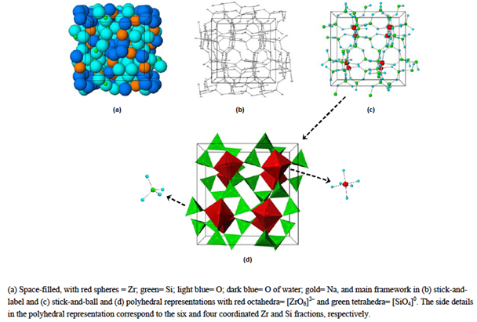
The drug product proposed for registration is composed solely of the drug substance with no excipients and is a non-soluble, crystalline powder designed as a powder for suspension in water for oral administration. The drug product is administered as a slurry in water and two dose strengths are proposed for registration that is, 5 g and 10 g. The drug product is to be packaged in high barrier PET/LDPE/LLDPE/aluminium foil laminate sachets with pack sizes of 3 sachets (sample pack) and 30 sachets per cardboard carton proposed for registration.
Lokelma is indicated for the treatment of hyperkalaemia in adult patients for acute and extended use. The recommended dose regimen of Lokelma involves a starting dose of up to 10 g administered three times a day orally (maximum daily dose of 30 g/day) as a slurry suspension in water to achieve normokalaemia. A maximum of three days dosing should not be exceeded and an alternative therapy sought if normokalaemia has not been achieved. The dose is then reduced to a maintenance dose of 5 g, with possible titration up to 10 g as needed. No more than 10 g should be used for extended once daily therapy.

Drug substance (active ingredient)
The drug substance ‘sodium zirconium cyclosilicate hydrate’ (abbreviated to ZS) is a white crystalline powder. The structure of ZS is summarised as a cubic cell arrangement of octahedrally coordinated zirconium Zr ([ZrO₆]²⁻) and tetrahedrally coordinated silicon Si ([SiO₄]0) units that interconnect through oxygen bridges as Zr-O-Si and Si-O-Si. The two types of units are observed in a ratio of 1:3, respectively, and repeat orderly to form a three dimensional framework characteristic of the compound. The framework acquires its negative charge from the octahedral fractions, [ZrO₆]²⁻ and features channels and cavities that interconnect and locate the positive ions (sodium, Na⁺, and hydrogen, H⁺) that counter balance the negative charge of the framework.
The manufacturing process is tightly controlled in terms of order of addition of starting material, reaction and crystallisation temperatures, mixing speeds and times, and minimum number of rinses, in order to meet expected yields of the drug substance of an expected quality. In process quality control tests [information redacted] are applied during the manufacturing process to ensure the formation of the correct crystalline structure and batch to batch consistency.
Sodium zirconium cyclosilicate hydrate is completely insoluble.
The drug substance forms part of a family of zirconium silicates that have specific ion exchange properties. Its mechanism of action is based on the cations within its porous crystalline structure, and their ability to freely exchange with a select group of monovalent cations, most specifically the potassium (K⁺) and ammonium (NH⁴⁺) cations. The pore size within the three dimensional crystalline structure has been measured at ~3Å (2.4 x 3.5 Å), which is sufficiently wide enough to trap the potassium monovalent cations which have an approximate ionic diameter of 2.98Å.
The particle size of the drug substance is controlled to maintain a non-systemic mode of action. The sponsor adequately justified not routinely controlling the size of larger particles in the drug substance as differences in particle size were shown to not affect performance as measured by potassium ion exchange capacity (KEC), and there was no correlation between KEC and D90 for clinical lots manufactured.
There are two alternate zirconium silicate crystalline phases which may be formed in the reaction process; Crystalline Phase A (CPA) and Crystalline Phase B (CPB). These layered, two-dimensional structures also exhibit ion exchange properties, although their ion selectivity is less specific for the potassium K⁺ cations compared to the desired drug substance. PXRD techniques are used to differentiate between the desired drug substance and levels of CPA and CPB. Appropriate limits are applied in the drug substance specification to limit the content of these crystalline phases in the drug substance/drug product.
The quality of the drug substance is controlled by an acceptable specification that includes test and limits for Appearance, Identification (by FTIR and PXRD), KEC , Crystalline Phase A , Crystalline Phase B , Zirconium content , Silicon content , Hafnium content , Moisture content , Particle Size , and Elemental Impurities.
Impurity levels of fifteen elements are routinely controlled at limits which have been found to be toxicologically acceptable [information redacted].

Drug product
The drug product formulation is the neat (100%) sodium zirconium cyclosilicate hydrate with no excipients used. Two dose strengths are proposed that is 5 g and 10 g. The drug product is intended to be packaged into high barrier PET/LDPE/LLDPE/aluminium foil laminate sachets with pack sizes of 3 sachets (sample pack) and 30 sachets per cardboard carton proposed for registration.
A study was conducted to investigate the ion exchange capacity and selectivity of sodium zirconium cyclosilicate hydrate in the presence of potassium (K⁺), ammonium (NH⁴⁺), calcium (Ca²⁺), and magnesium (Mg²⁺) cations, either alone or in combination. At individual ion ratios of 1:1, the drug substance was shown to be 1.25 fold and 15 fold more selective for K⁺ than for NH⁴⁺ and Ca²⁺ respectively, with no uptake of Mg²⁺ detected. When all four ions were present in equal concentrations, the drug substance was shown to have an equal affinity for K⁺ and NH⁴⁺ ions, and to be approximately 54 fold and 172 fold more selective for K⁺ over Ca²⁺ and Mg²⁺, respectively.
The quality of the drug product is controlled by an acceptable specification that includes tests and limits for Appearance, Identification (by FTIR and PXRD), Potassium Exchange Capacity (KEC), Crystalline Phase A, Crystalline Phase B, Zirconium content, Silicon content, Sodium content, Hafnium content, Moisture content, Particle size, and Average Delivered Weight. The potassium ion exchange capacity (KEC) is controlled to [information redacted]. The sponsor was requested to include a microbial purity test and acceptance criteria to demonstrate compliance with Therapeutic Goods Order (TGO) 77. This matter was resolved quickly. The drug product specifications were finalised to the satisfaction of the TGA (25th October 2016).
The analytical methods used to analyse the product were adequately described and validated.
The stability data supplied supported a shelf life of 24 months for the unopened product in PET/LDPE/LLDPE/aluminium foil laminate sachets when stored below 30°C.
GMP Clearances have not yet been granted for the majority of the proposed manufacturers, including the API manufacturing and drug product testing and release site located at [information redacted].

Biopharmaceutics
Sodium zirconium cyclosilicate hydrate is an inorganic, insoluble compound that is not subject to enzymatic metabolism. Clinical studies have shown it not to be systemically absorbed and therefore, biopharmaceutic studies are therefore not applicable.
Drug product used in the pivotal Phase III studies (ZS-003 and ZS-004) is the same as proposed for marketing.

Quality summary and conclusions
Approval is recommended from a pharmaceutical chemistry and quality control aspect.
However there are outstanding GMP issues related to most of the proposed manufacturing and testing sites, the most critical of which is highlighted below.
- There is an outstanding issue which relates to the acceptability of the GMP clearance for the sodium zirconium cyclosilicate hydrate API manufacturing and drug product testing site [information redacted].
Updated information was provided in the sponsor’s response to the second round quality report; however, it is unlikely that evidence of GMP will be provided for this critical site prior to the decision date for the submission.
The application has not been considered by the Pharmaceutical Sub-Committee of the ACPM because no issues requiring their expertise were identified during the chemistry and quality evaluation.

III. Nonclinical findings

Introduction
The proposed dosing regimen involves initial oral administration as a slurry/suspension in water at up to 10 g three times a days for a maximum of 3 days to achieve normokalaemia, and then between 5 g once every other day and up to 10 g once daily for maintenance therapy.
The nonclinical module was of high quality, with all pivotal safety-related studies conducted according to good laboratory practice (GLP) conditions.

Pharmacology

Primary pharmacology
Sodium zirconium cyclosilicate is a non-soluble, non-absorbed, inorganic crystalline powder. Constituent silicon, oxygen and zirconium atoms are regularly co-ordinated throughout the crystal lattice, giving rise to regular microporosity within the structure. Sodium (Na⁺) and hydrogen (H⁺) cations are located within the pores (balancing the negative framework charge) and are able to be exchanged for potassium (K⁺) cations. The trapped potassium ions are excreted from the body via the faeces, thereby preventing potassium absorption into the circulation and resolving hyperkalaemia.
Sodium zirconium cyclosilicate was shown to sequester K⁺ in vitro, reducing the potassium ion concentration in media formulated to mimic the ionic composition and pH of gastric and intestinal fluids. Potassium binding capacity was reduced or absent at the low pH (1.2) of gastric fluid cf. the higher pH of small intestinal fluid (pH 4.5) and large intestinal fluid (pH 6.8). At low pH, protonation of sodium zirconium cyclosilicate is favoured over K⁺ uptake due to the higher concentration of H⁺ cf. K⁺ ions. The ion exchange process was seen to occur rapidly and be maintained.
The ability of sodium zirconium cyclosilicate to lower serum K⁺ in vivo was investigated in a pharmacology study in rats, and in repeat dose toxicity studies in rats and dogs. Oral administration of sodium zirconium cyclosilicate reduced urinary K⁺ excretion and (where studied) increased faecal K⁺ excretion, consistent with reduced potassium absorption. Decreased serum K⁺ was demonstrated in the two laboratory animal species, but not in all studies, and mostly only at the highest dose levels tested and after weeks of treatment. It should be noted, though, that all of these studies were performed in normokalaemic rather than hyperkalaemic animals and resistance of serum K⁺ changes reflects homeostasis

Secondary pharmacodynamics and safety pharmacology
The ion selectivity of sodium zirconium cyclosilicate is determined by the size and chemical configuration of the micropores. As well as K⁺, sodium zirconium cyclosilicate can bind ammonium (NH⁴⁺) and calcium (Ca²⁺) ions. The substance was shown to have 1.25 fold selectivity for K⁺ over NH⁴⁺ and 15 fold selectivity for K⁺ over Ca²⁺ in in vitro experiments. There is no significant binding of magnesium (Mg²⁺).
No specialised safety pharmacology studies were submitted. This is acceptable since sodium zirconium cyclosilicate is not systemically absorbed. As well, cardiovascular safety was examined in dogs in a number of the general repeat dose toxicity studies, with no direct effect on electrocardiograph (ECG) seen with oral dosing up to 1,300 mg/kg TDS or on blood pressure at up to 2000 mg/kg QD. A slight increase in QTc interval (≤ 8%) was seen with dosing at 1000 mg/kg TDS in one of the dog studies, but was associated with hypokalaemia (being prevented by K⁺ supplementation) and is not considered to reflect a direct effect of the drug on the heart.

Pharmacokinetics
A single dose study in rats and a repeat dose study in dogs demonstrated that sodium zirconium cyclosilicate was not absorbed from the GI tract: it was not detected in plasma (dog study) and was excreted entirely via the faecal route (rat study). Accordingly, distribution and metabolism studies were not conducted. Sodium zirconium cyclosilicate is an insoluble inorganic compound and not subject to enzymatic degradation.

Pharmacokinetic drug interactions
Enzyme and transporter interaction studies were not conducted; no interaction is expected given the nature of the compound.
A series of in vitro studies were performed to examine interactions with likely co-administered drugs. In the most comprehensive study, drug products were incubated with sodium zirconium cyclosilicate (50 mg/mL) in media reflecting physiological conditions along the GI tract; simulated gastric fluid (pH 1.2), acetate buffer (pH 4.5) and sodium phosphate buffer (pH 6.8); for 2 hours at 37°C with constant agitation.
The presence of sodium zirconium cyclosilicate had no significant effect on the concentration of the following drugs in the three media:
- allopurinol
- aspirin
- captopril
- cyclosporine
- magnesium carbonate
- lisinopril
- metformin
- phenytoin
- prednisone
- propranolol
- quinapril
- spironolactone
- digoxin.
Changes in concentration of > 10% following the addition of sodium zirconium cyclosilicate were seen in one or more of the media for the following drugs, but this was linked to effects of sodium zirconium cyclosilicate on pH, affecting drug solubility, and not to drug binding:
- aluminium hydroxide
- atorvastatin
- clopidogrel
- dabigatran
- docusate sodium
- erythromycin
- furosemide
- glipizide
- ketoconazole
- levothyroxine
- losartan
- valsartan.
For these, approximately 60% of the observed changed were reductions in concentration (by an average of 50%) and approximately 40% were increases (by an average of approximately 130%). The addition of sodium zirconium cyclosilicate (50 mg/mL) raised the pH of simulated gastric fluid by approximately 2 pH units and raised the pH of acetate buffer (pH 4.5) by approximately 0.7 pH units [due to H⁺ uptake], and lowered the pH of sodium phosphate buffer (pH 6.8) by approximately 0.5 pH units [attributed to uptake of Na⁺ in exchange for H⁺].
Sodium zirconium cyclosilicate is not expected to significantly alter intestinal pH with clinical use: the maximum expected concentration of sodium zirconium cyclosilicate in the intestinal lumen on the apical side of the enterocytes is 4 mg/mL, 12.5 times lower than the tested concentration here. However, effects on stomach pH are predicted, with the tested concentration being physiologically relevant (for example, the maximum dose of one occasion, 10 g, in a volume of 250 mL yields a concentration of 40 mg/mL). Because drug absorption occurs mostly in the small intestine rather than the stomach, the clinical impact is likely limited in most cases, but interactions similar to those caused by antacids can be reasonably expected.
Reductions in drug concentration in the presence of sodium zirconium cyclosilicate that were not related to altered solubility secondary to altered pH were seen for:
- amlodipine
- warfarin
- calcium carbonate
- lithium
The concentration of amlodipine in pH 6.8 sodium phosphate buffer was reduced by almost 50% in the presence of sodium zirconium cyclosilicate (50 mg/mL). There was no significant effect in the other two media tested. No notable interaction with amlodipine is expected in patients given the maximum expected intestinal concentration is much lower than the concentration tested in vitro.
The concentration of warfarin in simulated gastric fluid was reduced by approximately 75% (with only approximately 15% of the effect attributable to altered pH). There was no significant effect in the other two media tested (mimicking intestinal conditions). The in vitro data indicate that co-administration of sodium zirconium cyclosilicate is likely to reduce stomach absorption of warfarin, lowering systemic exposure to the drug.
Reductions in calcium and lithium concentrations (by approximately 50 to 80% and 20 to 40%, respectively) were observed in simulated gastric fluid and pH 4.5 acetate buffer and are attributed to Ca²⁺ and Li+ binding by sodium zirconium cyclosilicate. No significant interaction with these agents is expected in patients, however, with the in vitro binding occurring under conditions where there was no or very limited competition with K⁺ and at high Ca²⁺ or Li+ concentrations, which drives uptake.
Increases in phosphate binding capacity in the presence of sodium zirconium cyclosilicate were seen for lanthanum carbonate (in pH 6.8 sodium phosphate buffer) and sevelamer carbonate (in simulated gastric fluid and pH 6.8 sodium phosphate buffer), in line with effects on pH. With pH effects expected in the stomach but not the small intestine of patients, some reduction in the efficacy of sevelamer carbonate may be encountered.
The potassium-binding capacity of sodium zirconium cyclosilicate was reduced by lithium (due to competition with K⁺ for binding at high concentrations), lanthanum carbonate (attributed to K⁺ binding by hydrated dextrates as an excipient in the drug product), clopidogrel (with a 300 mg but not a 75 mg tablet, and due to reduced pH) and dabigatran (due to excipients in the drug capsules); the other tested drugs had no significant effect. No clinically significant reduction in efficacy is predicted in in patients however.

Toxicology

Acute toxicity
The acute oral toxicity of sodium zirconium cyclosilicate was investigated in rats and dogs. Administration of a single 2,000 mg/kg dose resulted in no deaths or other overt toxicity over the monitoring period (4 to 5 days). Coupled with the findings in the repeat dose toxicity studies, sodium zirconium cyclosilicate was demonstrated to have a low order of acute toxicity by the oral route.

Repeat-dose toxicity
Repeat dose toxicity studies were conducted in rats (up to 6 months duration) and dogs (up to 9 months) using the proposed clinical route (PO). The frequency of administration was once or three times daily, in accordance with the proposed clinical dosing regimen. The pivotal studies were adequately conducted in terms of species used, duration, dose selection, and monitoring and analyses performed

Relative exposure
Exposure ratios have been calculated based on animal:human mg/kg dose comparisons. Dose comparisons based on adjustment for body surface area (mg/m²) are not considered appropriate for sodium zirconium cyclosilicate given the absence of systemic exposure/distribution outside the GI tract, and that cross-species differences in metabolic capacity are not of importance for this compound.

Table 2: Relative exposure in pivotal repeat dose toxicity studies
Species | Study duration [Study No.] | Frequency of administration | Dose (mg/kg/day) | Estimated exposure ratio#
Rat (SD) | 6 months [524942] | TDS | 1000 | 1.7
Rat (SD) | 6 months [524942] | TDS | 3000 | 5
Rat (SD) | 6 months [524942] | TDS | 6000 | 10
Dog (Beagle) | 9 months [1959-008] | QD | 300 | 0.5
Dog (Beagle) | 9 months [1959-008] | QD | 1000 | 1.7
Dog (Beagle) | 9 months [1959-008] | QD | 2000 | 3.3
Human | [maximum recommended human dose] | 600* (10 g TDS) |  | –
# = animal:human mg/kg/day dose; * = 50 kg patient body weight assumed as a conservative measure

Major toxicities
The pivotal rat study established a no observable adverse effect level (NOAEL) of 6,000 mg/kg/day, representing 10 times the maximum recommended clinical dose (based on body weight). Notable findings were limited to electrolyte changes in serum and urine (consistent with the pharmacology of the compound), and pale faeces (representing excretion of the test article), with no histopathological changes in the GI tract or systemic tissues observed.
The kidney and adrenal glands were identified as target organs in dog studies. Renal tubule-interstitial inflammation (featuring vacuolation/degeneration/regeneration of tubules), increased interstitial matrix and fibrosis were observed with dosing at 2,000 mg/kg/day in the pivotal 9 month study. Adrenal gland changes in the pivotal study comprised vacuolation (increased lipid, associated with altered steroidogenesis; seen at all dose levels [≥ 300 mg/kg/day]), and atrophy (at ≥ 1,000 mg/kg/day), and were accompanied by an increase in pituitary weight and increased incidence/severity of pituitary cysts. Along with potassium, serum aldosterone was reduced with dosing at 2,000 mg/kg/day. Other than one instance of tubule-interstitial inflammation in a high dose male (graded moderate), all microscopic lesions were of minimal to mild severity, and were shown to be reduced in incidence/severity after a 4 week treatment free period. These findings are consistent with prolonged potassium depletion, rather than a direct toxic effect of the drug. They were shown to be ameliorated with potassium supplementation, and are not considered clinically relevant in the context of therapy to achieve and maintain normokalaemia.

Genotoxicity
The potential genotoxicity of sodium zirconium cyclosilicate was investigated in the standard battery of tests, conducted in accordance with ICH guidelines. All assays were suitably validated. The set of bacterial strains used in the Ames test, and the concentrations/doses used across studies were appropriate. Sodium zirconium cyclosilicate was not mutagenic in the bacterial mutation assay, nor clastogenic in vitro (in CHO cells) or in vivo (in the rat micronucleus test).

Carcinogenicity
No carcinogenicity studies were submitted. This is acceptable, and in accordance with relevant TGA adopted guideline given that sodium zirconium cyclosilicate is not absorbed and distributed systemically, is not genotoxic, is not in a class of compounds with known carcinogenic potential, and given that the general repeat dose toxicity studies revealed no hyperplastic or preneoplastic lesions to give cause for concern.

Reproductive toxicity
Reproductive toxicity studies with sodium zirconium cyclosilicate covered all stages. Adequate animal numbers were used, and dose selection and the timing/duration of treatment were appropriate. No adverse effects on male or female fertility (rats), embryofetal development (rats and rabbits) and pre/postnatal development (rats) were observed with sodium zirconium cyclosilicate up to the highest dose tested (6,000 mg/kg/day PO in all studies), associated with an exposure multiple of 10 (based on animal:human mg/kg dose comparisons).

Pregnancy classification
The sponsor has not nominated a pregnancy category. Based on the absence of adverse effects on embryofetal development seen in rats and rabbits in the studies described above, Pregnancy Category B1 is recommended.

Local tolerance; antigenicity
No dermal irritation or skin sensitisation was observed with sodium zirconium cyclosilicate in guinea pigs.
Gastrointestinal irritation was not observed in the general repeat dose toxicity studies where rats and dogs were administered oral doses of sodium zirconium cyclosilicate of up to 2,000 mg/kg per occasion, 6.7 times greater the maximum clinical dose per occasion (15 g) on a mg/kg basis (assuming a patient body weight of 50 kg).

Immunotoxicity
No specialised immunotoxicity studies were submitted. This is acceptable, with no cause for concern (effects on immune cells and tissue) was identified in the general repeat dose toxicity studies.

Phototoxicity
No phototoxicity studies were submitted. This is acceptable given that sodium zirconium cyclosilicate does no distribute to the skin or the eyes.

Paediatric use
Sodium zirconium cyclosilicate is not proposed for paediatric use and no specific studies in juvenile animals were submitted.
The proposed impurity specification for the drug substance is considered to be toxicologically acceptable.

Comments on the nonclinical safety specification of the Risk Management Plan
Results and conclusions drawn from the nonclinical program for sodium zirconium cyclosilicate detailed in the sponsor’s draft Risk Management Plan (RMP)(Part II: Module SII) are in general concordance with those of the nonclinical evaluator.

Nonclinical summary and conclusions
- AstraZeneca Pty Ltd seeks to register Lokelma; containing the new chemical entity, sodium zirconium cyclosilicate, as the active ingredient; for the treatment of hyperkalaemia in adult patients. The proposed dosing regimen involves oral administration of powder (as a slurry or suspension in water) at up to 10 g three times a day for a maximum of 3 days to achieve normokalaemia followed by between 5 g once every other day and 10 g once daily for maintenance therapy.
- The overall quality of the nonclinical dossier was high, with all pivotal safety related studies GLP compliant. The nonclinical module contained no major deficiencies.
- Sodium zirconium cyclosilicate was shown to sequester K⁺ ions in vitro. It lowered serum K⁺ in rats and dogs, but not consistently, reflecting that the studies were performed in normokalaemic animals. Decreased absorption of potassium was chiefly evident as reduced urinary K⁺ excretion instead.
- Studies examining ion selectivity revealed that sodium zirconium cyclosilicate also binds ammonium (K⁺:NH⁴⁺ selectivity, 1.25 fold) and calcium (K⁺:Ca²⁺ selectivity, 15 fold). Lithium binding was also apparent.
- Sodium zirconium cyclosilicate is not absorbed systemically, and, as an insoluble inorganic compound, is not subject to enzymatic degradation. Excretion is entirely by the faecal route.
- In vitro studies indicate a likely increase in stomach pH of up to 2 pH units with administration of sodium zirconium cyclosilicate, giving rise to potential pharmacokinetic interactions with co-administered drugs similar to those encountered with antacids. Direct binding of other drugs by sodium zirconium cyclosilicate was not seen, except for calcium and lithium. This occurred at high concentrations of these cations and under conditions where there was no or little competition by K⁺; no clinically relevant interaction with calcium or lithium is predicted.
- Sodium zirconium cyclosilicate displayed a low order of acute toxicity by the oral route in rats and dogs.
- Repeat dose toxicity studies by the oral route were conducted in rats (up to 6 months) and dogs (up to 9 months). No treatment-related microscopic lesions were observed in rats treated with sodium zirconium cyclosilicate at up to 6,000 mg/kg/day for 6 months (10 times the maximum recommended clinical dose on a mg/kg basis). Treated dogs showed inflammatory and degenerative changes in the kidney, and atrophy and vacuolation in the adrenal gland, but these were shown to be secondary to hypokalaemia rather than a direct toxic effect of the drug. As such, they are not expected in patients.
- Sodium zirconium cyclosilicate was not genotoxic in the standard battery of tests. Carcinogenicity studies were not conducted, in line with ICH guidance where there is no or minimal systemic exposure and general repeat dose toxicity studies give no cause for concern.
- Fertility (rats), embryofetal development (rats and rabbits) and pre/post-natal development (rats) were unaffected by treatment with sodium zirconium cyclosilicate at oral doses up to 10 times higher than the maximum recommended clinical dose. No pregnancy category has been nominated by the sponsor; placement in Pregnancy Category B1 is recommended.
- There are no nonclinical objections to the registration of Lokelma for the proposed indication.
The nonclinical evaluator also made recommendations regarding the PI but these are beyond the scope of the AusPAR.

IV. Clinical findings
A summary of the clinical findings is presented in this section. Further details of these clinical findings can be found in Attachment 1.

Introduction

Clinical rationale
Sodium zirconium silicate (ZS) is an insoluble, non-absorbable inorganic crystalline compound that binds potassium ions in exchange for hydrogen and sodium cations. It binds potassium ions throughout the gastrointestinal tract, and the trapped potassium ions are excreted from the body, together with the ZS, in the faeces. Serum potassium concentration is closely correlated with potassium concentration of intestinal fluid. The binding of potassium within the GI tract, and its subsequent elimination from the body, therefore results in a reduction in serum potassium concentration. In vitro, it has been shown to absorb approximately ten fold the amount of potassium as the currently most used therapy for hyperkalaemia (sodium polystyrene sulfonate, SPS). It is also proposed that the rate of onset of the effect of ZS on serum potassium is more rapid than that of SPS because it commences entrapment of potassium ions in the upper GI tract, unlike SPS, which has its effect within the colon.
The formulation consists of the active ZS only, with no excipients.

Guidance

Contents of the clinical dossier
The submission contained the following clinical information:
- two clinical pharmacology studies, including none that provided pharmacokinetic data and two that provided pharmacodynamic data:
  - one Phase I study (ZS-006) to characterize the effects of ZS on sodium and potassium excretion in 30 healthy subjects on a fixed, low-sodium and high-potassium diet
  - one double blind, placebo controlled Phase II study (ZS-002)
- one completed pivotal Phase III efficacy/safety double blind, placebo controlled study (EUZS-003) and one open label, non comparative acute phase study (ZS-004) with a pivotal double blind, placebo controlled maintenance phase; ZS-004 also included urine and blood sampling to demonstrate lack of systemic absorption of ZS.
- one uncontrolled efficacy/safety open label, long term extension of ZS-004 (ZS-004E)
- one ongoing long term open label Phase III study of efficacy and safety up to 12 months, with a randomized, double blind, placebo controlled, withdrawal study in a subset of patients (ZS-005); interim data as of 15 July 2015 are available in the dossier
The submission also included a Clinical Overview, Summary of Clinical Efficacy, Summary of Clinical Safety and literature references.

Paediatric data
The submission did not include paediatric data, and the currently requested indication is for the treatment of hyperkalaemia in adult patients. No formal justification as to why the product is not appropriate for use in children has been included. The sponsor has an agreed Paediatric Investigation Plan (PIP) in Europe, which requires submission of a report of a study conducted in paediatric patients by January 2021. An agreed Paediatric Plan in the USA requires submission of a Phase I study in 2017. Therefore, no such studies are included in this dossier.

Good clinical practice
Certification is included that indicates that all clinical studies were undertaken according to good clinical practice (GCP).

Pharmacokinetics

Studies providing pharmacokinetic data
ZS is an inorganic, insoluble compound that is not systemically absorbed following oral administration. A study in dogs demonstrated that there was no significant absorption of ZS or zirconium following dosing up to 2 g/kg/day for 9 months. An in vivo mass balance study in rats showed that ZS was recovered in the faeces at > 99% of administered dose. Non-absorption was confirmed in the acute phase of clinical study ZS-004. The site of action of ZS is within the GI tract, and its activity does not require absorption or distribution. Pharmacokinetic studies in human subjects, apart from the demonstration that systemic absorption does not occur, are therefore not required.
Subjects from Study ZS-004 at selected sites within the US, receiving placebo (n = 17) or ZS at doses of 5 g, 10 g or 15 g QD (n = 9, 10 and 10 respectively) had collections of urine and blood for analysis of zirconium (Zr). These results have been analysed and referred to as Study BR-01519. The urinary Zr concentrations were below the lower level of quantification (LLOQ) in all but two subjects, one receiving placebo, and one receiving 5 g once daily (QD). Retesting of these samples returned a result < LLOQ in both cases. The assay was appropriately sensitive. Similarly, the Zr concentration in blood samples were below the LLOQ in all but one subject (receiving ZS 10 g QD). These data provide confirmation that there is negligible systemic absorption of ZS during administration to humans.

Evaluator’s conclusions on pharmacokinetics
Adequate evidence is provided to support the conclusion that the compound is not absorbed systemically, and that the site of action is within the gastrointestinal lumen. Therefore, there is no requirement for any further consideration of pharmacokinetics, and no pharmacokinetic data have been provided.

Pharmacodynamics

Studies providing pharmacodynamic data
Summaries of the pharmacodynamic studies were provided. Table 2 shows the studies relating to each pharmacodynamic topic.

Table 3: Submitted pharmacodynamic studies
PD Topic | Subtopic | Study ID
Primary Pharmacology | Effect on sodium and potassium excretion in healthy subjects  Acute effect on serum potassium in hyperkalaemic patients  Acute effect on serum potassium in hyperkalaemic patients | ZS-006  ZS-002 (Acute phase)  EUZS-003 (Acute phase)
Primary Pharmacology | Maintenance of normokalaemia | EUZS-003 (Maintenance phase)
Primary Pharmacology |  | ZS-004 (Maintenance Phase)
Secondary Pharmacology | Effect of food on activity of ZS | ZS-002 (Acute phase)
Gender, age related, and other differences in PD response | Effect of gender | EUZS-003, ZS-004
Gender, age related, and other differences in PD response | Effect of age | EUZS-003, ZS-004
Gender, age related, and other differences in PD response | Effect of baseline SK | EUZS-003, ZS-004
None of the pharmacodynamic studies had deficiencies that excluded their results from consideration.

Evaluator’s conclusions on pharmacodynamics
Sufficient evidence has been submitted to demonstrate that ZS has its effect by binding potassium in intestinal fluid, causing it to be excreted bound to the ZS in faeces. This results in a rapid reduction in SK. There are no clinically relevant differences in the pharmacodynamics effect of ZS in different subgroups of patients divided by age, gender or other characteristics. There is a clear dose response relationship in the maintenance phase of management of hyperkalaemia.

Dosage selection for the pivotal studies
Dose ranging studies were carried out in the acute phases of three clinical studies. Given that the compound is not absorbed and there is therefore no issue of systemic toxicity, this is a reasonable approach. The choice of initial doses in Study ZS-002 was based on the in vitro finding that ZS was approximately 10 times more effective than sodium polystyrene sulfonate (SPS), a potassium binding resin used for the management of hyperkalaemia, in exchanging potassium cations in the presence of physiological levels of magnesium and calcium. It also took into account the results of 14 day oral toxicity studies performed in rats and dogs. The recommended oral dose of SPS in mild hyperkalaemia is 15 g once daily, and the extrapolated dose of ZS for initial investigation in hyperkalaemic subjects (0.3 g TDS) is therefore less than 10% of the daily dose of SPS, thus providing an adequate safety margin. The additional doses tested in ZS-002 were 3 g and 10 g TDS.
Subsequent doses investigated in the pivotal studies were based on the results of the early dose ranging studies. In Study ZS-002, doses of 0.3 g TDS, 3 g TDS and 10 g TDS were used. All subjects were mildly hyperkalaemic for a variety of reasons, and all (n = 12 in the first cohort, and 24 in each of the other two) completed the study. Only the highest dosage resulted in statistically significantly greater mean reductions in SK (the primary outcome) compared with placebo. Secondary outcomes supported the results of the primary outcome. The time to first reduction in SK by 0.5 mmol/L was significantly lower for the high dose group than placebo, but not so for the other two dosage groups. Following administration of the fourth dose, a statistically significantly larger number of subjects in the high dose group (58.3%) had achieved a ≥ 0.5 mmol/L reduction in SK, compared to the placebo (17.2%), lowest dose (16.7%) and middle dose (26.1%) groups (Table 5 in Attachment 1). The pivotal efficacy studies used a range of doses, from 1.25 g to 10 g TDS in Study EUZS-003 and 10 g TDS in Study ZS-004. This dose is adequately supported by the early phase studies.

Efficacy

Studies providing efficacy data
There were two 2 pivotal (double blind, placebo controlled) studies assessing the clinical efficacy of ZS in the acute lowering of SK with TDS dosing (Studies ZS-002 and EUZS-003) and two pivotal (double blind, placebo controlled, randomized withdrawal studies for maintenance of normokalaemia with once daily dosing (EUZS-003, ZS-004). An open label, non-comparative, long term (11 months) study provided supportive efficacy data but is not considered in detail in this section and is more applicable to consideration of safety (ZS-004E).

Evaluator’s conclusions on efficacy
Conclusions on clinical efficacy for treatment of hyperkalaemia (acute and extended).
The two pivotal trials assessing the clinical efficacy of ZS at a dose of 10 g TDS for 2 days have provided evidence that ZS treatment leads to a rapid lowering of SK in patients with hyperkalaemia (Studies ZS-002 and EUZS-003). This was confirmed in the acute phase of Study ZS-004. Lower doses of ZS are also effective, but have a smaller effect than the proposed dose, 10 g TDS.
The two pivotal trials (EUZS-003, ZS-004) assessing the clinical efficacy of ZS in the maintenance of normokalaemia in patients who have received acute treatment have demonstrated that ZS in a dose of 5 to 10 g OD is effective in maintaining normokalaemia in the majority of subjects.

Safety
The safety of ZS was expected to be favourable because of its non-absorbability and therefore its very low likelihood of causing systemic adverse effects. The major potential issues of interest were therefore effects that could be caused during transit of ZS through the GI tract, either through an influence on overall GI function causing GI-related symptoms, or by alterations in the absorption or excretion of potassium or other cations (including sodium, calcium and magnesium).

Studies providing safety data
The following studies provided evaluable safety data: ZS-002, EUZS-003, ZS-004, ZS-004E (an open label extension of ZS-004), ZS-005 (interim results) and ZS-006 (healthy subjects).

Patient exposure
A total of 1,592 subjects had been exposed to ZS during the clinical trials as at 15 July 2015. Of these, 1,102 subjects had received ZS once daily during extended dosing phases, with 579 treated for at least 30 days, 264 for at least 6 months, 98 for at least 9 months and 40 for 12 months.
In terms of dose exposure, in the acute phase clinical studies, 331 patients were exposed to ≤ 3 g TDS, 157 to 5 g TDS, and 425 to 10 g TDS (the proposed acute phase dose). In the extended phase studies, 199 subjects were exposed to ≤ 2.5 g QD, 110 to 5 g QD, 114 to 10 g QD and 56 to 15 g QD.
For the full clinical evaluation of safety aspects please see Attachment 1.

Evaluator’s conclusions on safety
The combined safety data, including from studies using long term dosing for up to twelve months, indicate that ZS is well tolerated in the acute lowering of SK in patients with hyperkalaemia, and in the longer term maintenance of normokalaemia. The characteristics of the population studied explain the majority of TEAEs, serious AEs and withdrawals. There are no specific safety concerns related to this submission, with the exception of the risk of hypokalaemia if patients receiving treatment are inadequately monitored in relation to their SK. This is particularly important during the acute phase of treatment, when ZS is administered three times daily.

First round benefit-risk assessment

First round assessment of benefits
The benefits of ZS in the proposed usage are:
- Rapid and effective lowering of SK in patients with hyperkalaemia
- Maintenance of normokalaemia for up to twelve months.

First round assessment of risks
The risks of ZS in the proposed usage are:
- Hypokalaemia, requiring regular monitoring of SK
- Hypertension exacerbation, requiring regular monitoring of blood pressure
- Peripheral oedema
- Prolongation of QT interval in individuals with pre-existing QT abnormalities.

First round assessment of benefit-risk balance
The benefit-risk balance of ZS, given the proposed usage, is favourable.

First round recommendation regarding authorisation
It is recommended that the application for registration of sodium zirconium cyclosilicate be granted and that the drug be registered for the treatment of hyperkalaemia (acute and extended use).

Clinical questions and second round evaluation of clinical data submitted in response to questions
For the details of clinical questions raised, the sponsor’s response and the evaluation of the response please see Attachment 1.

Second round benefit-risk assessment

Second round assessment of benefits
After consideration of the responses to clinical questions, the benefits of sodium zirconium in the proposed usage are unchanged from those identified in the first round.

Second round assessment of risks
After consideration of the responses to clinical questions, the risks in the proposed usage are better characterised

Second round assessment of benefit-risk balance
The benefit-risk balance of sodium zirconium for the treatment of hyperkalaemia is positive.

Second round recommendation regarding authorisation
The clinical data submitted would support the registration of sodium zirconium to treat hyperkalaemia in adults. However, the final decision would also need to take in to accounts reports from chemistry, toxicology and RMP evaluators.
As this is a new chemical entity with limited efficacy and safety data, however a broad indication, the evaluator would recommend some changes to the PI to optimise safe use of this product with an awareness of the limitations of the clinical trial data available.

V. Pharmacovigilance findings

Risk management plan
- Lokelma is proposed to be for the treatment of hyperkalaemia in adult patients, for acute and extended use. Treatment should only be initiated and supervised by a physician experienced in treating hyperkalaemia. The proposed dosing regimen involves oral administration of 5 to 10 g administered three times a day orally as a slurry/suspension in water, to achieve normokalaemia. The maintenance dose is no more than 10 g/day for extended use.
- The sponsor submitted EU-RMP version 0.1 (dated 13 November 2014, DLP 12 July 2015) and an accompanying Australian Specific Annex (ASA) (no version or date) with the original submission of the application. The S31 response did not include a revised EU-RMP or ASA. In February 2017, the sponsor advised that a change in the summary of safety concerns had been agreed with the EMA. As requested by the TGA, the sponsor submitted EU-RMP version 1 edition 5 with ASA version 2. An updated ASA version 3 dated 20 March 2017 was submitted to include use in children as missing information.
- The proposed Summary of Safety Concerns and their associated risk monitoring and mitigation strategies are summarised in Table 3 below. This is the Summary of Safety Concerns agreed with the EMA with the additional Australian-specific safety concerns identified by the TGA.

Table 4: Summary of safety concerns
Summary of safety concerns |  | Pharmacovigilance |  | Risk Minimisation
 |  | Routine | Additional | Routine | Additional
Important identified risks | Hypokalaemia |  | - |  | -
Important identified risks | Fluid overload |  | - |  | -
Important potential risks | Arrhythmia |  | - |  | -
Important potential risks | Intestinal perforation |  | - |  | -
Missing information | Long term use beyond one year |  |  |  | -
Missing information | Use in pregnancy |  | - |  | -
Missing information | Use in patients on dialysis |  | - |  | -
Missing information | Use in patients with severe hyperkalaemia |  | - |  | -
Missing information | Use in children1 |  | - |  | -
Missing information | Use in Aboriginal and Torres Strait islanders |  | - | - | -
- The pharmacovigilance plan includes a category 3 study (required by the EMA) ZS-005 to monitor the long term safety of the product. This study will include Australian patients and findings will be reflected in future RMP updates.

Post-ACPM meeting
The sponsor has included ‘use in children’ as missing information in the ASA version 3. There is no further outstanding RMP issue with this submission.

Wording for conditions of registration
The suggested wording is: The EU-RMP version 1 edition 5 dated 30 January 2017 (DLP 19 September 2016), with Australian Specific Annex version 3 dated 20 March 2017, and future updates as a condition of registration.

VI. Overall conclusion and risk/benefit assessment
The submission was summarised in the following Delegate’s overview and recommendations.

Background
Zirconium Sodium (ZS) is an insoluble, non-absorbable inorganic crystalline compound that binds potassium ions in exchange for hydrogen and sodium cations in the intestines. The 3D structure is depicted in Figure 1.
In vitro, it has been shown to absorb approximately ten fold the amount of potassium as the currently available oral therapies for hyperkalaemia (sodium polystyrene sulfonate, SPS).
ZS forms part of a family of microporous zirconium (Zr) silicates. The mechanism of action of ZS is based on the ability of cations (hydrogen and sodium), contained within its crystalline structure to freely exchange with a select group of other monovalent cations, specifically potassium and ammonium.
It is also proposed that the rate of onset of the effect of ZS on serum potassium is more rapid than that of SPS because it commences entrapment of potassium ions in the upper GI tract, unlike SPS, which has its effect within the colon. Serum potassium concentration is closely correlated with potassium concentration of intestinal fluid.
There was no paediatric data. A paediatric investigation plan has been submitted for Europe and the USA.

Quality
The manufacturing process is tightly controlled in terms of order of addition of starting material, reaction and crystallisation temperatures, mixing speeds and times, and minimum number of rinses, in order to meet expected yields of the drug substance of an expected quality. In-process quality control tests including Potassium exchange capacity (KEC), Powder x-ray diffraction (PXRD), Wave dispersive x-ray fluorescence (WD-XRF), Particle size analysis, pH and Loss on Drying are applied during the manufacturing process to ensure the formation of the correct crystalline structure and batch-to-batch consistency.
Sodium zirconium cyclosilicate hydrate is completely insoluble.
The quality of the drug substance is controlled by an acceptable specification that includes test and limits for Appearance, Identification (by FTIR and PXRD), KEC , Crystalline Phase A , Crystalline Phase B , Zirconium content , Silicon content , Hafnium content , Moisture content , Particle Size , and Elemental Impurities.
The drug product formulation is the neat (100%) sodium zirconium cyclosilicate hydrate with no excipients used. Two dose strengths are proposed that is5 g and 10 g. The drug product is intended be packaged into high barrier PET/LDPE/LLDPE/aluminium foil laminate sachets with pack sizes of 3 sachets (sample pack) and 30 sachets per cardboard carton proposed for registration.
A study was conducted to investigate the ion exchange capacity and selectivity of sodium zirconium cyclosilicate hydrate in the presence of potassium (K⁺), ammonium (NH⁴⁺), calcium (Ca²⁺), and magnesium (Mg²⁺) cations, either alone or in combination. At individual ion ratios of 1:1, the drug substance was shown to be 1.25 fold and 15 fold more selective for K⁺ than for NH⁴⁺ and Ca²⁺ respectively, with no uptake of Mg²⁺ detected. When all four ions were present in equal concentrations, the drug substance was shown to have an equal affinity for K⁺ and NH⁴⁺ ions, and to be approximately 54 fold and 172 fold more selective for K⁺ over Ca²⁺ and Mg²⁺, respectively.
The quality of the drug product is controlled by an acceptable specification that includes tests and limits for Appearance, Identification (by FTIR and PXRD), Potassium Exchange Capacity (KEC), Crystalline Phase A, Crystalline Phase B, Zirconium content, Silicon content, Sodium content, Hafnium content, Moisture content, Particle size, and Average Delivered Weight. The potassium ion exchange capacity (KEC) is controlled.
Approval was recommended from a pharmaceutical chemistry and quality control aspect.

Nonclinical
- There were no nonclinical objections to the registration of Lokelma for the proposed indication provided that the impurity specification is revised so that patients will not receive doses of elemental impurities in excess of those specified in ICH Q3D.
- In vitro studies indicate a likely increase in stomach pH of up to 2 pH units with administration of sodium zirconium cyclosilicate, giving rise to potential pharmacokinetic interactions with co-administered drugs similar to those encountered with antacids. Direct binding of other drugs by sodium zirconium cyclosilicate was not seen, except for calcium and lithium. This occurred at high concentrations of these cations and under conditions where there was no or little competition by K⁺; no clinically relevant interaction with calcium or lithium is predicted.

Clinical

Pharmacology
There is no systemic absorption. This was confirmed by a study in dogs, rats and humans.
Study ZS-006: In healthy subjects, ZS lead to a significant increase in faecal potassium excretion. The reduction is serum potassium was greater with 10 g than 5 g. The reduction in serum potassium occurs within 1 hour and is maximal in the first 4 hours.
Subpopulation analysis was performed for age, gender, race, baseline renal function, concomitant disease, use of renin- angiotensin-aldosterone inhibitors. There were no relevant differences in the responses for acute or maintenance phases.

Drug and other cations
Sodium zirconium silicate is selective for drugs at a size of 3Å.

Table 5: Ionic radius of selected cations
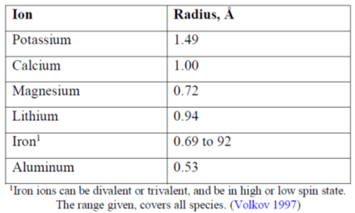
In vitro, binding of calcium only occurred at high concentrations. There was no effect on calcium in clinical trials.

Other drugs
It is unlikely that digoxin or thyroxine will fit through the pores as these molecules are too big. An in vitro study with lithium carbonate showed no interaction.
No clinical studies examined the effect of gastric pH on ZC, however in-vitro studies showed that the potassium exchange capacity (KEC) is unaffected by pH except at very acidic condition (pH 1.2).
A Phase I study was conducted to examine the potential for drug interactions in-vivo with 9 compounds.

Table 6: Summary of pharmacokinetic changes with ZS
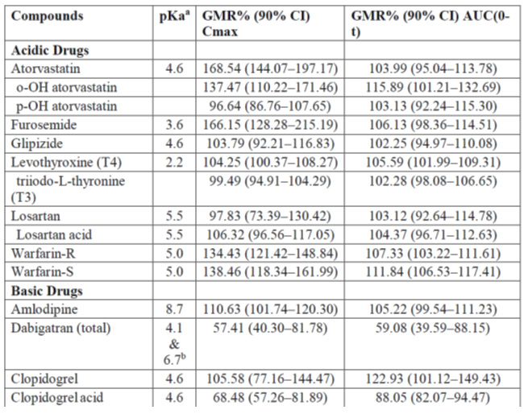
The sponsor concluded that there was no significant change in any of the drug levels with ZS. However the Delegate is concerned of the clinical significance of the change in dabigatran concentration.

Efficacy
Dose finding studies used doses extrapolated from those of SPS based on in-vivo measurements of relative efficacy. These were subsequently used to inform the clinical studies
The efficacy studies included subjects with a range of underlying diseases such as chronic kidney disease (no minimal glomerular filtration rate (GFR) to be included in the study), heart failure, treatment with renin-angiotensin -aldosterone inhibitors, diabetes.

Use in acute hyperkalaemia

Study ZS-002
Randomized, placebo controlled, double blind, dose-escalating study, investigating safety, tolerability and pharmacodynamics of three different doses of ZS administered 3 times daily to patients with mild hyperkalaemia and moderate kidney dysfunction.
Patients: had serum potassium 5 to 6mmol/L and moderate kidney dysfunction (GFR 40 to 60ml/min). Patients with ECG changes were excluded.

Treatment
ZS 0.3g, 3 g , 10 g or placebo three times a day. The placebo was a silicated microcrystalline cellulose (a common excipient).
Fasting day 1, then ZS administered with meals. Duration of treatment 48-96 hours or until K normalised. Patients had blood taken at baseline, then every 30 minutes for 2 hours then every 4 hours until K normalised. They were monitored in a clinic setting. They had daily ECGs.

Efficacy endpoints
Serum K

Results
Figure 2: Mean serum potassium over 48 hours (ITT population). Study ZS-002
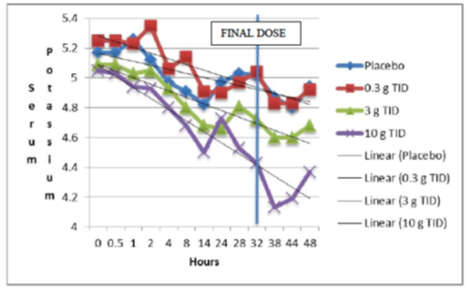
Other efficacy outcomes supported the result of the primary outcome. At 48 hours, the mean reduction in SK (placebo-subtracted) was 0.15 and 0.48 mmol/L for the medium and high dose groups, respectively. The proportion of subjects with a > 1 mmol/L reduction in SK was 41.7% for the high dose group, compared with 3.4% of the placebo subjects at the 38 hour time point. The time to a decrease of 0.5mmol/L in SK was significantly shorter in the high dose group compared with the placebo group, such that by 24 hours, over 70% of the ZS subjects had achieved this, compared with about 55% of the placebo group. Normalization of SK levels also occurred statistically significantly more rapidly in the ZS 10 g group compared with the placebo group.

Study ZS-003
This study was designed to examine both the acute lowering of SK (using a TDS dose for 48 hours) and the maintenance of normokalaemia (using a daily dose). It had a randomized, double blind, placebo controlled design for the acute phase, with four different doses of ZS being given, and a randomized, double blind, placebo controlled withdrawal design for the subacute phase, again testing four different doses of ZS. The subacute phase included subjects who had completed the acute phase and were normokalaemic after 48 hours of treatment with ZS or placebo. Those subjects who had received ZS in the acute phase were randomized to receive the same dose of ZS once daily or placebo, while those who had received placebo in the acute phase were randomized to receive ZS at a dose of either 1.25 g or 2.5 g daily.
Inclusion criteria were similar to study ZS-002. Monitoring was also similar to ZS-002.

Results
Table 7: Acute Phase: percentage of normokalaemic subjects at 48 hours (ITT population) Study ZS-003
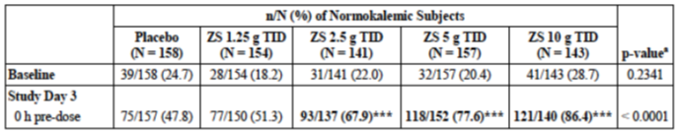
Acute phase
The percentage of subjects in each group who achieved normokalaemia at 48 hours showed a dose-response relationship and was statistically significantly different for the three higher ZS dosing groups compared with placebo (see Table 8).
Subacute Phase

Table 8: Subacute phase: total number of days normokalaemic; Subjects receiving ZS in acute phase
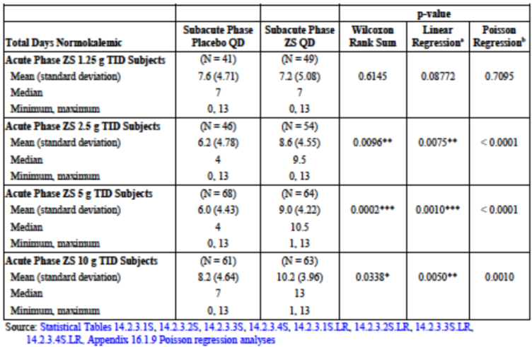

Table 9: Mean change in serum potassium from baseline at 48 hours overall and by baseline S-K (acute phase for Study EUZS-003, ITT population)
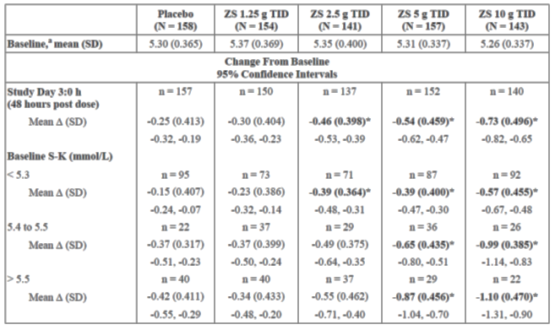
Figure 3: Mean change in serum potassium from baseline at selected time points for ZS 10 g TDS in subjects with baseline serum potassium ≥ 6.0 mmol/L (acute phase for studies EUZS-003 and ZS-004, ITT population)
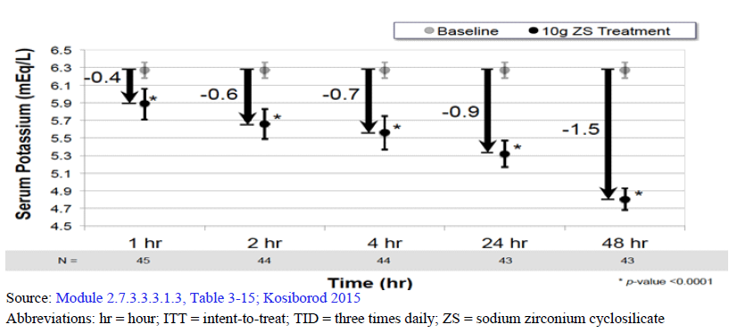
Subacute phase
The total number of days of normokalaemia during the subacute phase was statistically significantly higher for the three higher ZS dosing groups compared with the corresponding placebo group. Patients with higher baseline K have greater reductions in K with ZS.

ZS-004
This study had an open-label design in the acute phase to allow the safe enrolment of subjects with more severe hyperkalaemia than had been possible in the studies with a placebo group. In the acute phase, patients had daily bloods and ECG. Patients who had serum K over 6.1mmol/L were not able to leave the clinic, and were discontinued if the K had not responded to ZS after 48 hours. Subjects with serum K > 5.1mmol/L (no maximum) were enrolled in the study under the same entry criteria as described in Attachment 1. All were treated with ZS 10 g three times a day for 2 days (6 doses). Results showed that 66.1% of subjects had normal SK values by 24 hours after the first dose of ZS, and 88% had normal SK values at 48 hours after the first dose of ZS. The median time to normalization of SK values was approximately 2.2 hours after the first dose of ZS.

Extended treatment of hyperkalaemia

ZS-004
The study design to assess ongoing therapy was a randomized, placebo controlled, double blind withdrawal approach. The objectives of the study were to evaluate the safety and efficacy of three different doses of ZS administered daily for 28 days in maintaining normokalaemia (3.5 to 5.0 mmol/L) in subjects who had achieved normokalaemia following 2 days of acute therapy with ZS 10 g TDS. The dose in the chronic phase was randomised as 5, 10 or 15 g once daily. The dose was decreased to every second day if serum potassium was 3 to 3.4mmol/L. Patients were withdrawn if the potassium was > 6.1 or < 3.0 or there were ECG changes or arrhythmias.
Mean age ranged from 61.5 to 64.9 years, 51.8 to 71.4% male, 58.8 to 70.6% had chronic kidney disease, 57.8 to 74.5% had diabetes mellitus, 58.9 to 73.3% on renin-angiotensin aldosterone system (RAAS) inhibitor medication.
The main efficacy endpoint was the mean change in serum potassium from Day 8 to 29.
The mean SK for the period between Days 8 and 29 of the Maintenance phase was statistically significantly lower in all ZS groups compared with placebo (Table 10), with an apparent dose-response relationship (Table 10 and Figure 4).

ZS-004E
This study was available to subjects who completed Study ZS-004, and continued treatment for up to eleven months. The initial protocol specified treatment duration of 56 days, and 15 subjects terminated at this point. An amendment increased the duration to 140 days, and 7 completed the study at this point, and 57 subjects completed 336 days of treatment under a third amendment.
The primary efficacy endpoint was the proportion of subjects with average SK ≤ 5.1 during Study Days 8 to 337. A total of 88.3% of subjects maintained an average SK of ≤ 5.1mmol/L throughout the study.
Table 10: Mean SK between Study Days 8 to 29 (ITT population)
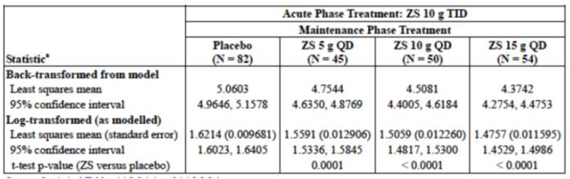
Figure 4: Mean serum potassium over time in three dosing groups compared with placebo (Study ZS-004). Note that all patients received active treatment in the acute phase and were then randomized to four dosing groups (Placebo, ZS 5g, ZS 10g, ZS 15g daily)
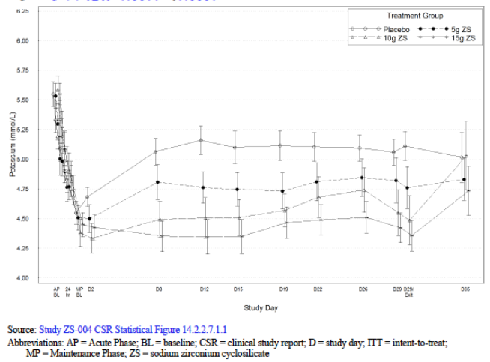

Safety
A total of 1,592 subjects had been exposed to ZS during the clinical trials as at 15 July 2015. Of these, 1,102 subjects had received ZS once daily during extended dosing phases, with 579 treated for at least 30 days, 264 for at least 6 months, 98 for at least 9 months and 40 for 12 months.
In the acute phase clinical studies, 331 patients were exposed to ≤ 3g TDS, 157 to 5 g TDS, and 425 to 10 g TDS (the proposed acute phase dose). In the extended phase studies, 199 subjects were exposed to ≤ 2.5 g daily, 110 to 5 g daily, 114 to 10 g daily and 56 to 15 g daily.

Acute phase treatment
In Study ZS-002, the overall incidence of TEAEs was 20% in the combined ZS groups compared with 10% in the placebo group. The commonest TEAE in both groups were GI disorders, including nausea, vomiting, diarrhoea and constipation. Combining the acute phase groups from Studies ZS-002, EUZS-003 and ZS-004 gave the following rates for any event by dose group: Placebo (n = 188) 10.6%; ZS ≤ 3g TDS (n = 331) 12.4%; ZS 5 g TDS (n = 157) 14.0%, ZS 10 g TDS (n = 425) 10.4%. The commonest reported event in all groups was diarrhoea, with the reported rates being 2.1%, 2.4%, 1.9% and 1.2% respectively. Thus there was little difference between the ZS treated groups and the placebo group.

Extended treatment
The overall incidence of TEAEs in the combined safety populations of Studies EUZS-003 and ZS-004 was 26.6% for the placebo group (n = 310), 23.6% for the ZS ≤ 2.5 g daily group (n = 199), 34.5% for the ZS 5 g daily group (n = 110), 31.6% for the ZS 10 g daily group (n = 114) and 44.6% for the ZS 15 g daily group. Thus there appeared to be a higher incidence in the 15 g group, with a higher incidence of peripheral oedema, infections and infestations. The latter were primarily nasopharyngitis and influenza and were not regarded as related to study drug.
Table 11: Combined data: extended dosing. Overall summary of treatment emergent adverse events by system organ class (Safety population Studies EUZS-003 and ZS-004)
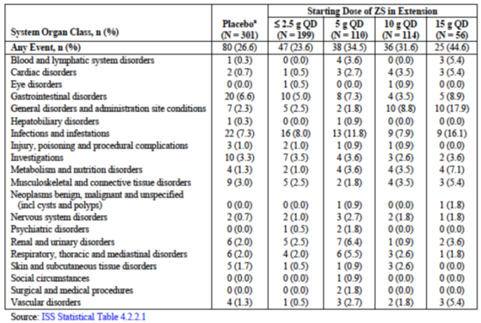

ECG
A thorough study of heart rate corrected QT (QTc) interval in healthy volunteers was not considered necessary by the CHMP. However, comprehensive measurements of QTc intervals were performed throughout the clinical studies. As ZS is not systemically absorbed, a direct effect of ZS on cardiac conduction is extremely unlikely and the minor dose-dependent change in QTc phase in several studies, consistent with the lowering of SK; however, the increase was minor and no cases of cardiac arrhythmias or sudden unexpected cardiac deaths were observed. There were no changes in QTc during extended dosing.
Pooled results from the pivotal studies showed no clinically significant dose related changes in the acute phase in PR interval, QRS duration or heart rate. There were mean increases in QTc interval, with an apparent dose-related effect. The mean increases were 0.1 msec for the placebo group, 4.2 msec for the ZS 5 g TDS group, and 9.1 msec for the ZS 10 g TDS group. Further analysis of subjects with potentially clinically significant changes in QTc was carried out, finding only one subject in the placebo group and five (1.2%) in the ZS 10 g TDS group reaching a maximum QTc interval > 500 msec. A total of four subjects (one in the placebo group and 3 in the ZS 10 g TDS group) reached the ECG criteria for withdrawal (increase from baseline in QTc of > 30 msec, with a corresponding QTc interval of > 500 msec). Overall the changes in QTc were very small and unlikely to be clinically significant except in the presence of pre-existing abnormalities.

Peripheral oedema
Peripheral oedema was reported during extended dosing in Studies EUZS-003 and ZS-004, and was most frequent in the ZS 15 g daily group (14.3%) compared with rates in the placebo (1.7%), ZS ≤ 2.5 g daily (1.0%), ZS 5 g daily (0.9%) and ZS 10 g daily (5.3%). It is speculated that release of sodium from the ZS matrix may contribute.

Hypokalaemia
An increased incidence of hypokalaemia was observed with ZS compared to placebo, although the rate was generally low (2.5% in the combined population receiving ZS in studies ZS-002, EUZDS-003, ZS-004 and ZS-004E [n = 913]). Only one of these subjects developed moderate hypokalaemia (SK < 3.0 mmol/L), and no cases of severe hypokalaemia were reported.

Risk management plan
The RMP for ZS was discussed at ACSOM. Table 12 shows a summary of the identified safety concerns.
Table 12: Summary of safety concerns.
Summary of safety concerns |  | Pharmacovigilance |  | Risk Minimisation
 |  | Routine | Additional | Routine | Additional
Important identified risks | Hypersensitivity to sodium zirconium cyclosilicate |  | - |  | -
Important identified risks | Transient hypokalaemia |  | - |  | -
Important identified risks | Oedema “Fluid overload”@ |  | - |  | -
Important potential risks | Changes in diet or concomitant medications that affect serum potassium levels |  | - |  | -
Missing information | Long term use beyond one year |  | - |  | -
Missing information | Use in pregnancy or breast feeding |  | - |  | -
Missing information | In vivo drug interaction studies |  | - |  | -
Missing information | Use in children* |  | - |  | -
@ = Change in terminology in the EU-RMP; * = Added to ASA subsequent to round 1 recommendation
Additional changes to the summary of safety concerns are recommended:
Important potential risk: overdose, intestinal necrosis, interference with interpretation of abdominal x-rays.
Missing Information: use in patients with acute hyperkalaemia and ECG changes.
Routine pharmacovigilance and risk minimisation was proposed.

Ongoing studies
- ZS-005: 12 month efficacy and safety
- Paediatric Studies

Risk-benefit analysis

Efficacy
- The potassium lowering effect of ZS 10 g is observed 1 hour after administration of the first dose. ZS 10 g TDS producing normokalaemia in Study ZS-004 in 84% after 24 hours and 98% after 48 hours. Median time to normokalaemia was 2.17 hours.
- Greater reductions in serum potassium occur with higher baseline potassium values, suggesting that ZS is self-equilibrating in its efficacy Establishment of normokalaemia occurred independent of starting serum potassium so, even in subjects with severe hyperkalaemia, normokalaemia was established.
- Continued control of serum potassium was demonstrated with extended dosing of ZS 5 g, 10 g and 15 g administered daily in separate, double blind, randomized, placebo controlled withdrawal studies. In addition, data for ZS from a long term, open label extension study showed maintenance of normokalaemia as 88.3% of subjects had average potassium values ≤ 5.1 mmol/L across extended dosing for up to 1 year.
- Reductions in serum potassium have not been associated with severe episodes of hypokalaemia (< 2.5 mmol/L) or other clinically significant changes in electrolytes in completed studies. Mild hypokalaemia (3.0 and 3.4 mmol/L) observed was manageable with modification of the extended dosing regimen from daily to every second day.

Safety
- Analysis of events somewhat difficult due to underlying diseases that may also cause AE.
- Limited long term safety data; only 40 patients so far have been treated for > 1 year. But overall, 1,500 patients have had some exposure.
- Not systemically absorbed. Therefore ECG changes most likely to be due to electrolyte changes or underlying disease than the investigational drug.
- In vivo and in-vitro studies do not suggest significant drug interactions. Is this sufficient to be sure?
- Fluid overload was reported; presumably due to sodium retention. However Phase I studies did not demonstrate changes in urinary sodium with treatment. This is adequately addressed in the PI.
- ACSOM had concern about potential ‘overdose’ or excessive therapeutic effect in long term use with depletion of total body potassium. The Delegate does not share this concern.
- Other potassium binding products have been associated with intestinal complications such as bowel obstruction and intestinal necrosis. This has not been reported with sodium zirconium, and GIT motility disorders were not exclusion criteria for clinical trials.

Questions for the sponsor:
- What is the status for EMA and FDA applications?
- Did the placebo have any activity on blinding potassium?
- What is the proposed effect of calcium supplements; the Delegate is aware that there have been no concerns raised in the clinical studies and the binding of potassium is over 50 times greater than calcium. The question relates to the use of Lokelma in patients who would have a high concentration of calcium in their stomach after taking calcium supplements (or as binding agents in renal impairment), and if at this high concentration Lokelma may have an effect.

Delegate’s considerations
The main current issues relate to the lack of GMP clearance at the manufacturing/testing site. This is being addressed by the sponsor.

Proposed action
The Delegate had no reason to say, at this time, that the application for Lokelma should not be approved for registration.

Request for ACPM advice
The committee is requested to provide advice on any other issues that it thinks may be relevant to a decision on whether or not to approve this application

Response from sponsor
AstraZeneca’s responses to the questions put forward within the Delegate’s Request for ACPM’s Advice, dated 24 October 2016, are presented below.

Question 1
What is the status for EMA and FDA applications?
AstraZeneca response:
An updated foreign regulatory status has been provided.

Question 2
Did the placebo have any activity on blinding potassium?
AstraZeneca response:
The potassium binding capacity (KEC) for the placebo is 0.062 mmol of potassium per gram of placebo as determined in an in vitro experiment [information redacted]. Given that the average dietary intake of potassium is approximately 100 mEq per day and therefore, the amount of potassium that can be bound by the placebo is not clinically meaningful. The amount of potassium bound by placebo would not have a clinically meaningful impact on serum potassium concentrations.

Question 3
What is the proposed effect of calcium supplements; the Delegate is aware that there have been no concerns raised in the clinical studies and the binding of potassium is over 50 times greater than calcium. The question relates to the use of Lokelma in patients who would have a high concentration of calcium in their stomach after taking calcium supplements (or as binding agents in renal impairment), and if at this high concentration Lokelma may have an effect.
AstraZeneca response:
ZS is a microporous zirconium silicate with 3A pore sizes that was designed to be selective for potassium over larger or smaller cations. Study TD15-018 investigated the ion selectivity of ZS between potassium and calcium, magnesium and ammonium. In a series of competition experiments, ZS was incubated with potassium and increasing concentrations of the other cations. Across all test conditions, the amount calcium bound to ZS ranged from undetected at low calcium concentrations to 0.37 mEq per gram of ZS at the highest tested calcium concentration. The presence of calcium had no significant effect on the potassium exchange capacity of ZS.
The potential for calcium ions to bind to ZS was also evaluated in the absence of competing potassium in studies TR-111413-DDI-P0072 and TR-081115-DDI-P0118. In these studies, the solubility of calcium carbonate tablets (TUMS) was determined in different aqueous media with and without ZS. The results are summarised below in Table 13.

Table 13: The solubility of calcium carbonate tablets (TUMS) in different aqueous media with and without ZS
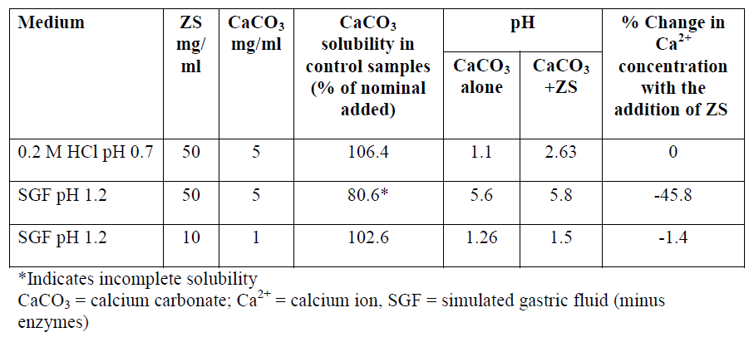
In simulated gastric fluid (SGF) containing 50 mg/ml ZS and 5 mg/ml CaCO₃, a 45.8% decrease in calcium ion concentration was observed compared to the control sample without ZS. This difference can partly be attributed to decrease in CaCO₃ solubility that occurred with the increase in pH when ZS was added to the system. No appreciable change in calcium ion concentration was observed in the two other experiments were the CaCO₃ was fully dissolved.
All three studies show that ZS has a very low capacity to bind calcium ions as would be predicted by the microporous nature of ZS and the large hydration sphere of Ca ions. Furthermore, any small amount of calcium that may bind to ZS will be released as the calcium concentration in the surrounding media decreases due to either absorption or binding to phosphate.
Based on these data, concomitant administration of ZS with calcium containing products would not be expected to interfere with the potassium binding capacity of ZS or the effects of calcium in the gastrointestinal tract.

Advisory committee considerations
The Advisory Committee on Prescription Medicines (ACPM), having considered the evaluations and the Delegate’s overview, as well as the sponsor’s response to these documents, advised the following:
The ACPM resolved to recommend to the TGA Delegate of the Secretary that:
The ACPM, taking into account the submitted evidence of efficacy, safety and quality, agreed with the Delegate and considered Lokelma powder for oral suspension containing 5 g and 10 g of sodium zirconium cyclosilicate hydrate to have an overall positive benefit-risk profile for the modified indication;
Lokelma is indicated in the treatment of hyperkalaemia in adults
In making this recommendation the ACPM
- noted hyperkalaemia is not a diagnosis but a metabolic situation and the aetiology of the hyperkalaemia should be investigated
- noted evidence for safety and efficacy is acceptable
- was of the view that the PI required considerable amendment.

Proposed conditions of registration
The ACPM proposed the following conditions of registration
- Subject to satisfactory implementation of the Risk Management Plan most recently negotiated by the TGA,
- Negotiation of Product Information and Consumer Medicines Information to the satisfaction of the TGA.

Proposed Product Information (PI)/Consumer Medicine Information (CMI) amendments
The ACPM agreed with the Delegate to the proposed amendments to the Product Information (PI) and Consumer Medicine Information (CMI) and specifically advised on the inclusion of the following:
- Statements in the precautions section of the PI and relevant sections of the CMI to reference that there are many causes of hyperkalaemia and that these must be investigated in conjunction with this acute treatment.
- A statement in the dosage and administration and precautions sections of the PI to accurately reflect the that treatment should not be initiated until blood potassium levels are greater than 5.5 or 6 and treatment should cease when potassium levels fall to 4.5 or below
- statements in the PI and relevant sections of the CMl, to ensure that all long term Lokelma patients
  - Receive formal dietary advice
  - have an evaluation of the need for medication such as ACE inhibitors and diuretics
  - where possible treat acidosis
  - patients with heart failure be warned of risk of fluid overload
  - consider the possibility of K depletion with long term use
- The terminology for Chronic Kidney Disease stages should be included in the PI when referring to degrees of renal impairment and there should be more informative statements on use in dialysis, or statements to the effect that there is limited information about use in dialysis.

Specific advice
The ACPM advised the following in response to the Delegate's specific questions on this submission:
- The main current issues relate to the lack of GMP clearance at the manufacturing/testing site. This is being addressed by the sponsor.
The ACPM noted GMP clearance would be required prior to registration and that Lokelma was not registered by EMA or FDA.
The ACPM expressed concern about appropriate use of Lokelma by prescribers without considering aetiology, use in mild hyperkalaemia which may not be therapeutically necessary if irreversible causes are treated or long term use as this has not previously been an accepted therapy. The limited nature of the long term studies was noted.
The ACPM advised that implementation by the sponsor of the recommendations outlined above to the satisfaction of the TGA, in addition to the evidence of efficacy and safety provided would support the safe and effective use of these products.

Post ACPM negotiations

Delegate request to sponsor
The Delegate requested amendments to the PI and CMI based on the advice from the ACPM and to the RMP and ASA based on advice from ASCOM, ACPM and the Delegate.
The Delegate also noted that the application cannot be approved without a satisfactory GMP clearance for all relevant manufacturing sites.

Sponsor response to Delegate’s post ACPM requests
On the 1 February the sponsor provided a response to the Delegate’s post ACPM requests.

Further review by TGA
The information and amended documents provided in the sponsor’s response were reviewed by the TGA.

RMP
The sponsor has included ‘use in children’ as missing information in the ASA version 3. There is no further outstanding RMP issue with this submission.
Wording for conditions of registration
The suggested wording is: The EU-RMP version 1 edition 5 dated 30 January 2017 (DLP 19 September 2016), with Australian Specific Annex version 3 dated 20 March 2017, and future updates as a condition of registration.

PI and CMI
The Delegate reviewed the Post ACPM versions of the PI and CMI provided to the TGA on 30 March 2017 and found these versions acceptable.

GMP
Resolution of matters arising from the FDA inspection of one of the manufacturing facilities was anticipated to occur by mid-March 2017.

Outcome
In a letter dated 10 April 2017 the sponsor withdrew the application “Due to the current challenges associated with the GMP aspects of the application, and the uncertain timeline for which these can be resolved, the sponsor regrettably withdraws this application.”

Therapeutic Goods Administration
PO Box 100 Woden ACT 2606 Australia
Email: info@tga.gov.au Phone: 1800 020 653 Fax: 02 6232 8605
https://www.tga.gov.au

During the evaluation of this submission sponsorship was transferred from Ballia Holdings Pty Ltd to AstraZeneca Pty Ltd.
1 Å = 0.1 nm.
Refer to pages 21–22 of this report for full evaluation of this study (Study TR-08115-DDI-P0118).
Calculated as 0.1 fold the maximum dose on one occasion [= 10 g] / 250 mL, in accordance with the formula given in the EMA Guideline on the Investigation of Drug Interactions [CPMP/EWP/560/95/Rev. 1 Corr. 2]
ICH S1A, ICH harmonised tripartite guideline on the need for carcinogenicity studies of pharmaceuticals S1A Current Step 4 version dated 29 November 1995.
Pregnancy Category B1 “Drugs which have been taken by only a limited number of pregnant women and women of childbearing age, without an increase in the frequency of malformation or other direct or indirect harmful effects on the human fetus having been observed. Studies in animals have not shown evidence of an increased occurrence of fetal damage”.
Microcrystalline cellulose: Is a bulking agent used in supplements to fill capsules when the medicinal agents are too small. It is ideal filler as it is naturally occurring and derived primarily from wood pulp. It is glucose units bound together by a beta 1-4 linkage which creates cellulose a fibre indigestible to humans. It enters and leaves the digestive tract unchanged and is chemically inert.

