December 2019

Australian Public Assessment Report for Siponimod
  - Proprietary Product Name: Mayzent
  - Sponsor: Novartis Pharmaceuticals Australia Pty Ltd

About the Therapeutic Goods Administration (TGA)
- The Therapeutic Goods Administration (TGA) is part of the Australian Government Department of Health and is responsible for regulating medicines and medical devices.
- The TGA administers the Therapeutic Goods Act 1989 (the Act), applying a risk management approach designed to ensure therapeutic goods supplied in Australia meet acceptable standards of quality, safety and efficacy (performance) when necessary.
- The work of the TGA is based on applying scientific and clinical expertise to decision-making, to ensure that the benefits to consumers outweigh any risks associated with the use of medicines and medical devices.
- The TGA relies on the public, healthcare professionals and industry to report problems with medicines or medical devices. TGA investigates reports received by it to determine any necessary regulatory action.
- To report a problem with a medicine or medical device, please see the information on the TGA website <https://www.tga.gov.au>.
About AusPARs
- An Australian Public Assessment Report (AusPAR) provides information about the evaluation of a prescription medicine and the considerations that led the TGA to approve or not approve a prescription medicine submission.
- AusPARs are prepared and published by the TGA.
- An AusPAR is prepared for submissions that relate to new chemical entities, generic medicines, major variations and extensions of indications.
- An AusPAR is a static document; it provides information that relates to a submission at a particular point in time.
- A new AusPAR will be developed to reflect changes to indications and/or major variations to a prescription medicine subject to evaluation by the TGA.
Copyright
© Commonwealth of Australia 2019
This work is copyright. You may reproduce the whole or part of this work in unaltered form for your own personal use or, if you are part of an organisation, for internal use within your organisation, but only if you or your organisation do not use the reproduction for any commercial purpose and retain this copyright notice and all disclaimer notices as part of that reproduction. Apart from rights to use as permitted by the Copyright Act 1968 or allowed by this copyright notice, all other rights are reserved and you are not allowed to reproduce the whole or any part of this work in any way (electronic or otherwise) without first being given specific written permission from the Commonwealth to do so. Requests and inquiries concerning reproduction and rights are to be sent to the TGA Copyright Officer, Therapeutic Goods Administration, PO Box 100, Woden ACT 2606 or emailed to <tga.copyright@tga.gov.au>.

Contents
Common abbreviations 4
I. Introduction to product submission 8
Submission details 8
Product background 9
Regulatory status 10
Product Information 11
II. Registration timeline 11
III. Submission overview and risk/benefit assessment 12
Quality 12
Nonclinical 14
Clinical 16
Risk management plan 36
Risk-benefit analysis 38
Outcome 41
Attachment 1. Product Information 42

Common abbreviations
Abbreviation | Meaning
9-HPT | Nine Hole Peg Test
ACM | Australian Committee on Medicines
ADEM | Acute disseminated encephalomyelitis
AE | Adverse event(s)
ALC | Absolute lymphocyte count
ALT | Alanine aminotransferase
ARR | Annualised relapse rate
ARTG | Australian Register of Therapeutic Goods
ASA | Australian Specific Annex
AUC | Area under the plasma concentration-time curve
AUC∞ | Area under the plasma concentration-time curve from time 0 to infinity
AUC_{last} | Area under the plasma concentration-time curve from time 0 to the time of the last quantifiable concentration
AUC_{ss} | Steady state area under the plasma concentration-time curve
AUC_{tau,ss} | Steady state area under the concentration-time curve over a uniform dosing interval tau
AV | Atrioventricular
BA | Bioavailability
BAF312 | Siponimod (drug development name)
BID | Twice daily
bpm | Beats per minute
BVMT-R | Brief Visuospatial Memory Test-Revised
CD52 | Cluster of differentiation 52
CDP | Confirmed disability progression
CHMP | Committee for Medicinal Products for Human Use (EU)
CI | Confidence interval
CL/F | Apparent oral clearance
C_{max} | Maximum plasma concentration
C_{max,ss} | Maximum steady state plasma concentration
CMI | Consumer Medicines Information
CNS | Central nervous system
COPD | Chronic obstructive pulmonary disease
CUAL | Combined unique active lesion
CYP450 | Cytochrome P450
DDI | Drug-drug interaction
EC₅₀ | Half maximal effective concentration
EDSS | Expanded disability status scale
EM | Extensive metaboliser
EMA | European Medicines Agency (EU)
E_{max} | Maximum effect
EQ-5D | EuroQoL (European Quality of Life)–5 dimensions (questionnaire)
EU | European Union
EU-RMP | European Union-Risk Management Plan
FEV1 | Forced expiratory volume in 1 second
FMI | Final market image
Gd | Gadolinium
GGT | Gamma-glutamyl transferase
GLP | Good Laboratory Practice
GMP | Good Manufacturing Practice
GMR | Geometric mean ratio
GPCR | G-protein-coupled receptors
h | Hour(s)
HCP | Healthcare professional
hERG | Human ether-à-go-go-related gene
HR | Hazard ratio
IC₅₀ | Half maximal inhibitory concentration
ICH | International Conference on Harmonisation
IIV | Inter-individual variability
I_{max} | Maximum effect
IV | Intravenous
K+ | Potassium
LC-MS/MS | Liquid chromatography-tandem mass spectrometry
LCVA | Low contrast visual acuity
LFT | Liver function test
MABP | Mean arterial blood pressure
MF | Market formulation
MRI | Magnetic resonance imaging
MS | Multiple sclerosis
msec | Milliseconds
MSFC | Multiple Sclerosis Functional Composite
MSIS-29 | Multiple Sclerosis Impact Scale 29
MSWS-12 | Multiple Sclerosis Walking Scale-12
nM | Nanomolar
NOAEL | No observed adverse effect level
PASAT | Paced Auditory Serial Addition Test
PBVC | Percent brain volume change
PD | Pharmacodynamic(s)
PK | Pharmacokinetic(s)
PM | Poor metaboliser
PML | Progressive multifocal leukoencephalopathy
PO | By mouth (Latin: per os)
PPMS | Primary progressive multiple sclerosis
PRES | Posterior reversible encephalopathy syndrome
PRMS | Progressive relapsing multiple sclerosis
QD | Once daily
QTc | Corrected QT interval
QTcF | QT interval corrected for heart rate using Fridericia’s formula
Racc | Accumulation ratio
RRMS | Relapsing-remitting multiple sclerosis
S1P | Sphingosine-1-phosphate
S1P1-5 | Sphingosine-1-phosphate receptor isoforms 1-5
SPMS | Secondary progressive multiple sclerosis
t_{1/2} | Biological half-life
T25W | Timed 25-Foot Walk test
T_{max} | Time to maximum plasma concentration
ULN | Upper limit of normal
VAS | Visual Analogue Scale
Vc/F | Apparent volume of central compartment
Vz | Apparent volume of distribution (of siponimod after oral administration during the terminal elimination phase)
VZV | Varicella zoster virus
WT | Wild type
ΔΔQTcF | Placebo corrected, baseline adjusted mean QT interval corrected for heart rate using Fridericia’s formula effect

I. Introduction to product submission

Submission details
Type of submission: | New chemical entity
Decision: | Approved
Date of decision: | 25 October 2019
Date of entry onto ARTG: | 1 November 2019
ARTG numbers: | 310498, 310499
Black Triangle Scheme | Yes  This product will remain in the scheme for 5 years, starting on the date the product is first supplied in Australia
Active ingredient: | Siponimod
Product name: | Mayzent
Sponsor’s name and address: | Novartis Pharmaceuticals Australia Pty Ltd  54 Waterloo Rd,  North Ryde NSW 2113
Dose form: | Film coated tablet
Strengths: | 0.25 mg and 2 mg
Container: | Blister pack
Pack sizes: | 0.25 mg: 12 film coated tablets (titration pack) and 120 film coated tablets.  2 mg: 28 film coated tablets.
Approved therapeutic use: | Mayzent is indicated for the treatment of adult patients with secondary progressive multiple sclerosis (SPMS).
Route of administration: | Oral
Dosage: | Before initiation of treatment with Mayzent the CYP2C9 genotype of the patient should be determined. Mayzent should not be used in patients with a CYP2C9*3*3 genotype.  Treatment has to be initiated with a titration pack that lasts for 5 days. The dose titration starts with 0.25 mg once daily on Day 1 and 2, followed by once daily doses of 0.5 mg on Day 3 (two tablets of 0.25 mg), 0.75 mg on Day 4 (three tablets of 0.25 mg), and 1.25 mg on Day 5 (five tablets of 0.25 mg), to reach the maintenance dose of 2 mg Mayzent starting on Day 6.  Note: The recommended maintenance dose is 1 mg daily for patients with CYP2C9 *2*3 or *1*3 genotype (for further information on maintenance dosing, please see the Product Information). During the first 6 days of treatment initiation the recommended daily dose should be taken once daily in the morning with or without food.  For further information refer to the Product Information.

Product background
This AusPAR describes the application by Novartis Pharmaceuticals Australia Pty Ltd (the sponsor) to register Mayzent (siponimod) film coated tablets for the following proposed indication:
Mayzent is indicated for the treatment of patients with secondary progressive multiple sclerosis (SPMS).
Multiple sclerosis (MS) is an inflammatory condition which damages myelin in the central nervous system (CNS) causing neurological impairment and disability. MS affects more than two million people worldwide with prevalence rates varying between regions and races. In Australia, more than 25,000 patients live with MS and approximately ten new cases are diagnosed each week. MS is the leading cause of neurologic disability in young and middle-aged adults and typically presents between the ages of 20 and 40 years with a 2:1 female to male ratio.
The aetiology of MS is unclear but it is assumed to be an autoimmune process possibly triggered by an infection in subjects with a genetic predisposition. The disease is characterised by acute inflammatory lesions, gliosis, demyelination, impaired re-myelination, and neuronal and axonal loss. Relapses are ascribed to acute inflammatory lesions, and progression is ascribed to demyelination and neuronal loss. Typical symptoms associated with these pathological findings are spasticity and ataxia leading to walking disability, bladder and bowel disturbance, weakness and fatigue and cognitive disturbance.
Approximately 85% of patients present with relapsing-remitting MS (RRMS) which is characterised by unpredictable episodes of acute neurological dysfunction (relapses) followed by variable intervals of recovery and disease stability (remissions). Within ten years of diagnosis, more than half of patients with RRMS develop sustained disability with or without superimposed relapses. Secondary progressive MS (SPMS) presents with steady progression in disability with fewer inflammatory episodes and more degenerative symptomatology;, that is, deterioration in the absence of relapses. Approximately 15% of patients present with sustained neurological dysfunction known as primary progressive MS (PPMS). Some patients present with progressive deterioration with unresolved relapses known as progressive relapsing MS (PRMS).
Patients with SPMS are characterised by reduced ambulation, bulbar dysfunction, visual impairment, impaired arm function, fatigue, pain, depression and loss of sphincter control. Cognitive impairment and reduced cognitive processing speed are also common. The diagnosis of SPMS is made retrospectively based on evidence that disability progression has occurred independently of relapses, although some relapses may continue to be experienced.,,,
The term relapsing MS (RMS) is applied to patients with RRMS or SPMS with superimposed relapses. There are no agreed criteria defining the transition from RRMS to SPMS.
Several disease modifying treatments which suppress or modulate the immune responses associated with MS are approved for use in Australia. These include older beta-interferon products which regulate the immune system and slow down disease activity although their exact mechanism of action is unclear. Aubagio (teriflunomide) is a pyrimidine synthesis inhibitor which acts as an immunomodulatory agent with anti-inflammatory properties. Tecfidera (dimethyl fumarate) is an immunotherapy with an unclear mechanism of action for use in patients with RRMS. Copaxone (glatiramer) blocks myelin-specific autoimmune responses in patients with RRMS. Mavenclad (claciribine) is oral nucleoside analogue affecting B and T lymphocyte DNA synthesis and function in patients with RRMS. Effective specific biologic therapies have recently been developed including three monoclonal antibodies approved in Australia. Lemtrada (alemtuzumab) binds to the cell surface glycoprotein cluster of differentiation 52 (CD52) on B and T lymphocytes and is approved for use in RRMS. Ocrevus (ocrelizumab) is an anti CD20 B cell inhibitor approved for use in RRMS and PPMS. Tysabri (natalizumab) is one of a family of leucocyte selective adhesion molecule inhibitors for use in RRMS.
Gilenya (fingolimod) is the first of the class of oral sphingosine-1-phosphate (S1P) receptor modulators acting on lymphocytes which destroy the myelin sheath. Fingolimod blocks the egress of lymphocytes from lymph nodes causing a re-distribution rather than depletion of lymphocytes. It was approved for use in patients with RRMS and SPMS with superimposed relapses to delay the progression of physical disability and reduce the frequency of relapse. Following approval of the paediatric indication, it is now approved for the treatment of adult and paediatric patients of 10 years of age and above with relapsing forms of MS to reduce the frequency of relapses and to delay the progression of disability.
The sponsor proposes that therapeutic options for the treatment of SPMS are limited to agents approved for RMS but which have limited efficacy in slowing disease progression in SPMS. There is a high unmet medical need in patients with SPMS. Siponimod is a new member of class of S1P receptor modulators. S1P is a natural ligand with key roles in the immune, cardiovascular and central nervous systems via five G-protein coupled receptors (G-protein-coupled receptors), sphingosine-1-phosphate 1-5 (S1P1-5) receptors. Siponimod is an orally active selective inhibitor of S1P1 and S1P5 receptors with a half-life of approximately 30 hours. This submission sought to demonstrate that Mayzent (siponimod) may offer clinically meaningful efficacy on disability progression with an acceptable safety profile in patients with SPMS.

Regulatory status
Mayzent (siponimod) is considered a new chemical entity for Australian regulatory purposes.
At the time the TGA considered this application, a similar application had been approved in the United States of America (USA; approved 26 March 2019) and was under consideration in the European Union (EU), Switzerland, and Canada (see Table 1).
Table 1: International regulatory status of Mayzent (siponimod) as of 6 September 2019
Region | Submission date | Status | Indications
USA | 26 July 2018 | Approved 26 March 2019 | Mayzent is indicated for the treatment of relapsing forms of multiple sclerosis, to include clinically isolated syndrome, relapsing-remitting disease, and secondary progressive multiple sclerosis with active disease, in adults.
EU (via the Centralised Procedure) | 13 September 2018 | Under evaluation | Under evaluation
Switzerland | 23 October 2018 | Under evaluation | Under evaluation
Canada | 20 December 2018 | Under evaluation | Under evaluation

Product Information
The Product Information (PI) approved with the submission which is described in this AusPAR can be found as Attachment 1. For the most recent PI, please refer to the TGA website at <https://www.tga.gov.au/product-information-pi>.

II. Registration timeline
Table 2 captures the key steps and dates for this application and which are detailed and discussed in this AusPAR.
Table 2: Timeline for Submission PM-2018-04434-1-1
Description | Date
Submission dossier accepted and first round evaluation commenced | 30 November 2018
First round evaluation completed | 5 June 2019
Sponsor provides responses on questions raised in first round evaluation | 27 June 2019
Second round evaluation completed | 22 August 2019
Delegate’s Overall benefit-risk assessment and request for Advisory Committee advice | 3 September 2019
Sponsor’s pre-Advisory Committee response | 16 September 2019
Advisory Committee meeting | 4 October 2019
Registration decision (Outcome) | 25 October 2019
Completion of administrative activities and registration on the ARTG | 1 November 2019
Number of working days from submission dossier acceptance to registration decision* | 209
*Statutory timeframe for standard applications is 255 working days

III. Submission overview and risk/benefit assessment
The submission was summarised in the following Delegate’s overview and recommendations.

Quality
Summary of the quality evaluation:
- Siponimod hemifumarate is described as a white to almost white, non-hygroscopic crystalline powder, and exists as a siponimod [Information redacted] co-crystallised with fumaric acid rather than as the fumarate salt. The drug substance is insoluble or practically insoluble in water (< 0.0006 mg/mL at 25°C) and acidic media and only slightly soluble in basic media.
- There are no products currently registered on the Australian Register of Therapeutic Goods (ARTG) containing siponimod.
- The proposed products are pale red (0.25 mg) or pale yellow (2 mg), round, film coated tablets debossed with a company logo on one side and ‘T’ (0.25 mg) or ‘II’ (2 mg) on the other. The tablets are not scored.
- The tablets are to be packaged in blisters, in packs of 12 and 120 tablets for the 0.25 mg strength and, in pack of 28 tablets for the 2 mg strength. The 12 tablet pack for the 0.25 mg strength is labelled as the ‘titration pack’ to be used for the initiation of treatment.
- The maximum daily dose stated in the proposed PI is 2 mg, taken as one tablet of the 2 mg strength, once daily.
- All test and limits proposed for the drug substance specification are considered acceptable.
- The analytical methods used for the routine quality control assessment of the drug substance were all adequately validated and appropriate for use.
- A bioequivalence study (Study CBAF312A2111) compared the 0.25 mg and 4 mg strengths of the market formulation (MF) and final market image (FMI) formulations in order to demonstrate that the two formulations were bioequivalent.
- Good Manufacturing Practice (GMP) clearances for all drug substance and drug product manufacturing sites are considered acceptable.
- The analytical methods used to analyse the drug products were adequately described and validated.
- A shelf life of 18 months for the Mayzent siponimod (as hemifumarate) 0.25 mg and 2 mg is supported when stored under refrigerated conditions at 2 to 8°C in the proposed container closure system described above. Additional storage conditions of ‘Refrigerate. Do not freeze’ and ‘Store in original container’ are also proposed for registration.
- The PI document has been finalised from a pharmaceutical chemistry and quality control perspective.
- The product labelling has been finalised from a pharmaceutical chemistry perspective and complies with the requirements of TGO 91.
- Regarding biopharmaceutics, the liquid chromatography-tandem mass spectrometry (LC-MS/MS) bioanalytical method used for the analysis of siponimod concentrations in study plasma samples, taken during the absolute bioavailability (BA) study and the food effect study was, adequately validated and found to be acceptable for use.
- Study A2126 was on absolute BA: a randomised, open label, 2 part study to measure the absolute BA, safety, tolerability, and pharmacodynamics of oral and intravenous (IV) siponimod in healthy subjects.
  - The ‘Test’ formulation, 0.25 mg tablet batch 1010004141 is identical to the 0.25 mg tablet formulation proposed for commercialisation and distribution in Australia, that is, the FMI formulation.
  - The absolute BA of siponimod as a single 0.25 mg dose (Treatment A) administered orally was 84%, as compared with a single 0.25 mg siponimod IV dose (Treatment B) administered over 3 hours in healthy subjects. Mean peak exposure of oral siponimod was approximately 48% lower than that of IV siponimod (both at 0.25 mg). Median oral siponimod time to maximum plasma concentration (T_{max}) was observed 8 hours after dosing, while median IV siponimod (T_{max}) was observed at the end of the 3 hour infusion.
- Study A2111 was on the BA of market and clinical trial formulations and food effect: a randomised, open label, three period crossover study to assess both the BA of the siponimod FMI tablet formulation as compared to the siponimod MF and the effect of food on the relative BA of the FMI after single 0.25 mg and 4 mg doses in healthy volunteers.
  - The ‘Test’ formulation (Treatment B; fasted; Treatment C; fed), 0.25 mg tablet batch X198 0811 is identical to the 0.25 mg tablet formulation proposed for commercialisation and distribution in Australia, that is, the FMI formulation. The siponimod 4 mg tablet is not intended for registration in Australia at this point in time.
  - Results of this study showed that the FMI and MF formulations of siponimod were bioequivalent for both 0.25 mg and 4 mg doses in terms of maximum plasma concentration (C_{max}), area under the plasma concentration-time curve from time 0 to the time of the last quantifiable concentration (AUC_{last}) and area under the plasma concentration-time curve from time 0 to infinity (AUC_{0-∞}). Similarly, FMI fasted and FMI fed fulfilled the bioequivalence criteria at both doses.
  - The slightly increased T_{max} in both dose groups and the 10% lower C_{max} in the 4 mg FMI fed group were considered clinically non relevant.
- On recommendation, approvability is supported from a pharmaceutical chemistry and quality control perspective. The acceptability of the pharmacokinetic data is a matter for the Delegate.
The Delegate commented that the PK data is acceptable from the clinical point of view.

Nonclinical
Summary of the nonclinical evaluation:
- The proposed maintenance dose of Mayzent is 2 mg per day by mouth (per os, PO) for an indefinite period.
- The submitted nonclinical dossier was in accordance with the relevant International Conference on Harmonisation (ICH) guideline. The overall quality of the nonclinical dossier was high. All pivotal safety-related studies were Good Laboratory Practice (GLP) compliant.
- In vitro, siponimod showed half maximal effective concentration (EC₅₀) values for activation of the S1P receptor isoforms S1P1 and S1P5 of 0.39 nanomolar (nM) and 0.98 nM, respectively. Siponimod showed little or no activity towards the other S1P receptor isoforms. In support of the proposed clinical indication, siponimod showed therapeutic efficacy against experimental autoimmune encephalomyelitis induced in mice and rats and dose dependent lymphopaenic effects in monkeys of similar amplitude and kinetics to those induced by fingolimod (the prototype S1P receptor inhibitor).
- Screening against 98 different protein targets failed to reveal further high affinity targets for siponimod.
- Safety pharmacology studies, assessing effects on the cardiovascular, respiratory, and central nervous systems, showed no significant adverse effects aside from the known transient bradyarrythmic effects of this class of drugs. No significant inhibition of human ether-à-go-go-related gene (hERG) potassium ion (K⁺) channel tail current was observed at clinically-relevant concentrations. Siponimod is not predicted to prolong the QT interval in patients.
- Siponimod was fairly slowly absorbed in all species. Half-life values for plasma clearance were quite variable between species. Plasma protein binding of siponimod was very high (> 99.9%) in all animal species and humans. Tissue distribution of siponimod in mice and rats was wide, and included brain, spinal cord, and reproductive organs. The major human metabolites were also identified in one or more animal species, although levels could differ significantly between species. Drug related material was excreted predominantly via faeces in humans and animals. Overall, the pharmacokinetic results for the laboratory animal species suggested sufficient similarity to allow them to act as appropriate models for the assessment of siponimod toxicity in humans.
- Siponimod showed no significant inhibition of or ability to induce the activity of a panel of clinically significant cytochrome P450 (CYP450) enzymes. Siponimod is therefore not expected to alter the exposure of co-administered drugs that are CYP450 substrates. Siponimod also showed no significant inhibitory activity towards various uptake transporters and efflux pumps.
- Siponimod showed a low level of acute oral toxicity in mice, rats, and cynomolgus monkeys.
- Repeat dose toxicity studies by the oral route were conducted in mice (up to 13 weeks), rats (up to 6 months), and cynomolgus monkeys (up to 1 year). Exposure ratios (AUC) at the no observed adverse effect level (NOAEL) doses in these studies were generally high in the three species used. Various target organs for toxicity were noted: kidney in mouse, lung and vascular system in rats, intestinal tract in monkeys, however, the high exposure ratios at which these toxicities were noted made their relevance for humans appear doubtful. There were no significant adverse effects on the ocular system.
- Siponimod was not mutagenic in the bacterial mutation assay or clastogenic in vitro (human lymphocytes) or in vivo (mouse and rat micronucleus test). Two year oral carcinogenicity studies, performed using mice and rats, showed induction of haemangiosarcomas and haemangiomas in male and female mice and of lymphomas in female mice, whilst male rats showed an increase in the incidence of thyroid follicular cell adenoma/carcinoma. The induction of haemangiosarcomas/haemangiomas was linked with siponimod-induced proliferation of mouse vascular endothelial cells, the lymphomas were linked to a very high spontaneous incidence of lymphoma in the particular mouse strain, and the thyroid tumours were ascribed to xenobiotic-induced compensatory thyroid hypertrophy in rats. Accordingly, it was concluded that these findings were unlikely to be of relevance to human use of siponimod.
- Fertility in male and female rats was unaffected by dosing with siponimod at exposure levels > 50 times (males) or ≥ 16 times (females) the clinical AUC. Embryofetal development studies in rats showed embryotoxic, fetotoxic, and teratogenic (skeletal and limb malformations) effects at ≥ 1 mg/kg/day (a NOAEL was not determined), whilst in rabbits, siponimod produced embryotoxicity/fetotoxicity and skeletal variations at ≥ 1 mg/kg/day (NOAEL = 0.1 mg/kg/day). The exposure levels producing adverse effects in animals may be comparable with those in patients taking the recommended dose of siponimod. Therefore, Australian Pregnancy Category D is recommended.
- Studies with rats and cynomolgus monkeys showed that although siponimod dosing can induce a profound lymphopaenia, the effects on B and T cell subsets in peripheral blood and lymphoid organs can be completely or partially reversed following a drug free recovery period.
- The proposed specifications for impurities/degradants in the drug substance/product are below the ICH qualification thresholds or have been adequately qualified. All identified impurities have been assessed for potential mutagenicity and are considered non-mutagenic or are below the threshold of toxicological concern.
- The sponsor has proposed Pregnancy Category D for siponimod;10 which is acceptable and consistent with the nonclinical data and the previous categorisation of fingolimod.
- There are no nonclinical objections to the registration of siponimod.
- The draft PI accompanying the sponsor’s response to TGA questions is acceptable from a nonclinical viewpoint.

Clinical
The clinical dossier consisted of:
- 20 clinical pharmacology studies:
  - All of which contain pharmacokinetic (PK) data.
  - 12 of which contain pharmacodynamic (PD) data.
- Three modelling studies, which assess population PK/PD data and the influence of smoking on siponimod exposure.
- One pivotal Phase III study (Study A2304) conducted in patients with SPMS.
- One Phase II, dose-ranging study (Study A2201) in patients with RRMS with a long term extension study (Study A2201E1).
- A clinical overview and summary of clinical efficacy and safety.

Pharmacokinetics
Studies identified by the clinical evaluator as containing PK data are shown in Table 3.
Table 3: Studies containing pharmacokinetic data
PK topic | Subtopic | Study ID | Primary PK aim of the study
PK in healthy adults | General PK  Single dose | A2126 | Absolute BA, safety, tolerability and PD of oral and IV siponimod in healthy subjects
PK in healthy adults | General PK  Single dose | A2101 | First in human study to explore the safety, tolerability, PK and PD of oral siponimod in healthy volunteers
PK in healthy adults | General PK  Single dose | A2104 | Absorption, PK, distribution, metabolism, and elimination of 10 mg of [¹⁴C]BAF312 in healthy male subjects
PK in healthy adults | Multi-dose | A2102 | Time lagged, ascending, multiple dose, PK, PD, safety and tolerability study of siponimod
PK in healthy adults | Multi-dose | A2105 | Ascending, multiple dose, PK, PD, safety and tolerability study of siponimod
PK in healthy adults | Bioequivalence†  Single dose | A2111 | Bioequivalence of the FMI tablet formulation as compared to the MF and the effect of food on the relative BA of the FMI after single 0.25 mg and 4 mg doses
PK in healthy adults | Bioequivalence†  Single dose | A2119 | Tolerability, PD and PK of two modified release siponimod tablets compared to the immediate release tablet and placebo
PK in special populations | Hepatic impairment | A2122 | Siponimod PK in subjects with mild, moderate and severe hepatic impairment compared to healthy control subjects
PK in special populations | Renal impairment | A2129 | Siponimod PKs in subjects with renal impairment compared to subjects with normal renal function
PK in special populations | Other special population | A1101 | Safety, tolerability, PK and PD of siponimod in Japanese healthy male subjects
Genetic related PK | Other genetic variable | A2128 | PK, safety and tolerability of siponimod in healthy subjects with CYP2C9 extensive metaboliser (EM) and poor metaboliser (PM) phenotype
PK  interactions | Itraconazole | A2124 | Effect of the CYP3A4 inhibitor itraconazole on siponimod single dose PK, safety, and tolerability in healthy subjects with CYP2C9*1*2 and *1*3 genotypes
PK  interactions | Rifampin | A2125 | Study in healthy subjects with the CYP2C9*1*1 (wild type) genotype to evaluate the effect of the CYP2C9/3A4 inducer rifampin on siponimod PK
PK  interactions | Fluconazole | A2108 | PK, safety and tolerability of siponimod when given alone and in combination with chronic fluconazole treatment in healthy volunteers
PK  interactions | Oral contraceptive | A2121 | Effect of oral siponimod on the PK and PD of a monophasic oral contraceptive in healthy female volunteers
PK  interactions | Propranolol | A2116 | PD and/or PK interaction of siponimod and propranolol when co-administered in healthy subjects
Population PK analyses | Target population | BAF312 Modelling Report | Population PK of siponimod in MS patients/healthy volunteers
Population PK analyses | Target population | BAF312A Modelling Report | Population PK and PK-PD analyses of siponimod effect on lymphocytes, Expanded Disability Status Scale (EDSS) and infections in SPMS Patients
Population PK analyses | Other | A2304 | Investigation of the influence of smoking status on siponimod exposure in MS patients
† Bioequivalence of different formulations.

Summary of pharmacokinetics
As outlined in the clinical evaluation report:
- The conduct of the studies that were provided in support of the current submission was satisfactory, the data analyses undertaken were appropriate and the analytical methods used to measure exposure levels were validated.
- Siponimod is to be administered orally, once daily (QD) with or without food.
- Following a single dose of either 0.25 mg or 4 mg of the FMI under fasted conditions, the T_{max} occurred at 4 hours post dose. The absolute BA of siponimod was 84%.
- In healthy subjects who were of the homozygous CYP2C9*1 genotype, the MF and FMI formulations were bioequivalent at the 0.25 mg and 4 mg dose strengths.
- Dose normalisation of the PK parameters for 0.25 mg and 4 mg doses of the to be marketed formulation indicates, that siponimod C_{max} and AUC increase in a dose proportional manner.
- A high fat breakfast had no effect on the C_{max} and AUC values of siponimod, whereas, median T_{max} was slightly delayed in the fed group for both doses by 2 hours to 3 hours compared to the fasted. The Delegate commented that at steady state, the effect of food on T_{max} should not be clinically significant.
- When administered as a single oral dose of the clinical service formulation, siponimod AUC values increased dose proportionately over the dose range 0.1 mg to 75 mg.
- Following 6 days of QD doses of the clinical service formulation, ranging from 0.3 mg to 20 mg, the mean accumulation ratio (R_{acc}) ranged from 1.88 to 2.72 and biological half-life (t_{1/2}) ranged from approximately 69 hours to 110 hours. In addition, across the dose range, C_{max} and AUC values increased approximately dose proportionally following both single and multiple doses.
- Following a single dose of 0.25 mg or 4 mg of the FMI formulation, the apparent volume of distribution (Vz) of siponimod was estimated to be 156 L and 256 L, respectively.
- Siponimod was highly bound to plasma proteins (≥ 99.8%) and estimates of the mean blood/plasma AUC ratio ranged from 0.67 to 0.77.
- Ex vivo and in vitro studies indicated that siponimod displayed little to no affinity for erythrocytes.
- The primary metabolic pathway for siponimod was via hydroxylation to form metabolites M5, M6 and M7 and subsequent glucuronidation of M5 yields M3. A further cholesterol ester metabolite, M17, was also identified in humans.
- In vitro studies indicated that CYP2C9 was involved in the formation of the 3 hydroxylated metabolites M5, M6 and M7 and that CYP2C9 was primarily responsible for the oxidative metabolism (79.3%) of siponimod, with a contribution from CYP3A of 18.5%.
- M3 and M17 are the main circulating metabolites of siponimod in humans and unbound C_{max} and EC₅₀ values, suggest that M3 and M17 systemic exposure are unlikely to translate into a significant increase in pharmacological activity.
- In vitro studies showed that compared to CYP2C9*1*1, substantially lower metabolic rates of siponimod were observed for CYP2C9*2*2 (2.9 fold reduction) and CYP2C9*3*3 (up to 10 fold reduction) donors.
- Siponimod was primarily excreted via the biliary/faecal route with the bulk of the dose recovered within 216 hours in faeces and urine.
- In special populations:
  - Siponimod C_{max} and AUC values were only marginally affected in hepatically impaired subjects compared to healthy matched subjects, with maximum increases of 16% and 15%, respectively.
  - Severe renal impairment had little effect on siponimod C_{max} and AUC, with slightly lower C_{max} (8%) and a 23 to 24% increase in AUC compared to healthy matched subjects.
  - Siponimod AUC∞ and AUC_{last} were approximately 2 and 4 fold higher, whereas, C_{max} was only 21% and 16% greater in subjects with the CYP2C9*2/*3 and CYP2C9*3/*3 genotype respectively, compared to subjects with the wild type CYP2C9*1/*1 genotype.
  - In healthy Japanese males, as in healthy Caucasians, siponimod T_{max} occurred at 4 hours post dose. In addition, dose proportionality was demonstrated over a dose range of 0.5 to 10 mg, for AUC_{0-24h}, whereas, although the slope estimates were close to 1.0, it was not shown for C_{max}, AUC_{last} and AUC∞. Moreover, population PK analysis indicated that ethnicity was not a significant covariate for siponimod PK.
- Drug-drug interaction (DDI) assessments revealed that:
  - In healthy subjects with CYP2C9*1*2 and *1*3 genotypes, itraconazole 100 mg twice daily (BID) had no effect on siponimod C_{max} in either CYP2C9 genotype, whereas, co-administration resulted in relatively small decreases, 10% and 24%, regarding siponimod AUC in subjects with the *1*2 and *1*3 genotypes, respectively.
  - Co-administration of rifampin significantly decreased exposure to siponimod with geometric mean ratios (GMR) for siponimod maximum steady state plasma concentration (C_{max,ss}) and steady state area under the plasma concentration-time curve (AUC_{ss}) of 0.55 and 0.43, respectively.
  - There was no apparent difference in mean steady-state siponimod concentrations between smokers and non-smokers across all the GMR CYP2C9 genotypes.
  - Co-administration with fluconazole led to an approximately 2 fold increase in siponimod AUC_{last} and AUC∞. Moreover, t_{1/2} was increased by 50% and C_{max} by 10%.
  - Co-administration of siponimod had no effect on the PK of ethinylestradiol, whereas, the steady state area under the concentration-time curve over a uniform dosing interval tau (AUC_{tau,ss} ) and C_{max,ss} values for levonorgestrel were increased by 28% and 18%, respectively.
  - Co-administration of siponimod and propranolol resulted in a decrease in siponimod AUC_{tau,ss} and C_{max,ss} by approximately 7% and a decrease in propranolol AUC_{tau,ss} and C_{max,ss} of approximately 18% and 15% respectively.
- Overall, the proposed PI appears to accurately reflect the PK data related to siponimod.

Assessment of population pharmacokinetics
The clinical evaluator’s assessment of population PK follows:
- Population PK analyses indicated that siponimod PK in healthy subjects and subjects with MS could be described by a two compartment disposition model with first order elimination and mixed zero and first order absorption. For the target population, population PK analysis indicated that there was little difference in the PK of siponimod in healthy subjects and patients with MS.
- Estimates for siponimod apparent oral clearance (CL/F) and apparent volume of central compartment (Vc/F) were 3.11 L/h and 126 L, respectively.
- As for inter-individual variability (IIV), a population PK analysis which included data from a Phase III study, provided IIV estimates for CL/F and Vc/F of 24% and 33% respectively and, a residual error of 0.32.
- Of the evaluated covariates, only weight and CYP2C9 genotypes were significant predictors of siponimod PK. For instance, over the weight range of 40 to 142 kg, Vc/F ranged from 43% lower to 101% higher and CL/F ranged from 35% lower to 69% higher compared to a 70.5 kg individual.
- Compared to CYP2C9 genotypes wild type/wild type (WT/WT) and WT/*2 in the analysis population, siponimod CL/F was 48% lower (95% confidence interval (CI): 42% to 53% lower) for CYP2C9 genotype *2/*3, 38% lower (95% CI: 35% to 41% lower) for CYP2C9 genotype WT/*3 and 20% lower (95% CI: 9% to 30% lower) for CYP2C9 genotype *2/*2. Siponimod CL/F for CYP2C9 genotypes WT/WT and WT/*2 were found not to be significantly different.
- There was no evidence that other covariates (gender, age, co-medications affecting CYP2C9 or CYP3A4 enzymes and ethnicity) influenced siponimod PK.
- The Delegate commented that in their response to the risk management plan (RMP) second round report, the sponsor stated ‘Upon EU-RMP approval and availability of education material, Novartis Australia will prepare local material and provide to TGA for review and approval prior to launch’. It is suggested that such educational material specially highlights the possibility of phenoconversion and, the need for monitoring.

Pharmacodynamics
Many of the submitted clinical pharmacology studies that examined the PD of siponimod also included PK data; therefore, the following table (Table 4) only includes studies not previously summarised in the table of PK studies, above (Table 3).
Table 4: Studies containing pharmacodynamic data
PD Topic | Subtopic | Study ID | Primary PD aim of the study
Secondary pharmacology | Chronotropic effects | A2110 | Effect of siponimod treatment re-initiation on the initial negative chronotropic effect in healthy subjects
Secondary pharmacology | Chronotropic effects | A2107 | Study to investigate two different dose titration regimens of siponimod on the negative chronotropic effect in healthy subjects
Secondary pharmacology | QT interval | A2118 | Placebo and moxifloxacin controlled multiple dose study to assess the QT interval after oral administration of siponimod in healthy subjects
Secondary pharmacology | Immune response | A2130 | Modulation of immune response to T cell dependent and T cell independent antigen stimuli by preceding, concomitant and interrupted administration of multiple therapeutic doses of siponimod in healthy subjects

Overall conclusions on pharmacodynamics
Clinical evaluator’s overall conclusions on PD:
- Siponimod is a S1P receptor modulator, which binds selectively on two out of five G-protein coupled receptors (GPCR) for S1P, namely S1P1 and S1P5 to prevent the egress of lymphocytes from lymph nodes.
- In healthy subjects, siponimod reduces absolute lymphocyte count (ALC) dose-dependently.
- Population PK/PD analysis indicates that in both healthy subjects and patients with MS, inhibition of ALC increases as siponimod concentrations increase; however, inhibition of ALC was saturable and the maximum decrease in production rate that may be achieved with siponimod, maximum inhibition (I_{max}), was estimated to be 79% (95% CI: 78% to 80%). The siponimod concentrations at which half of the maximum effect was attained, half maximal inhibitory concentration (IC₅₀), was estimated to be 4.94 ng/mL.
- In contrast to moxifloxacin, the upper bounds of the two sided 90% CIs for the time matched, placebo corrected, baseline adjusted mean QT interval corrected for heart rate using Fridericia’s formula (QTcF) effect (ΔΔQTcF) at therapeutic and supratherapeutic doses of siponimod were below the threshold of 10 milliseconds at all on-treatment time points. The time profile of the effect of siponimod was in line with the concentration-time profile of siponimod with a median T_{max} (range) at therapeutic and supratherapeutic doses of 4.03 hours (2.02 to 12.1 hours) and 4.02 hours (2.02 to 6.05 hours) on Day 10 and Day 18, respectively.
- Immune response to T cell dependent antigen was not affected by pre-treatment with siponimod. However, when siponimod treatment was interrupted (that is, paused from 10 days prior to 14 days after vaccination) or when siponimod was administered concomitantly there was a modest impairment of influenza vaccination efficacy, with responder rates approximately 15% to 30% lower, respectively, than on placebo. By contrast, PPV-23 vaccine; which mediates a T cell independent response, can be co-administered with siponimod without compromising immune response and vaccination efficacy.
- The magnitude of the negative chronotropic effects following siponimod re-initiation appeared to be dependent on both the dose and the duration of treatment discontinuation. However, the negative chronotropic effects of siponimod can be circumvented by dose titration.
- For ALC response, relevant covariates were identified as population type, gender and ethnicity. For instance, both RRMS and SPMS patients had a 17% (95% CI: 15% to 19%) lower baseline lymphocyte count than healthy volunteers, Japanese patients had a 10% (95% CI: 7% to 13%) higher I_{max} than non-Japanese, females had lower (37% (95% CI: 31% to 43%)) IC₅₀ than males and, SPMS patients had lower (39% (95% CI: 34% to 45%)) IC₅₀ than both RRMS patients and healthy volunteers.
- Siponimod co-administration with a monophasic contraceptive had no effect on the contraceptives efficacy.
- Following co-administration of siponimod with propranolol, mean maximum effect (E_{max}) heart rate decreased by an additional 6.21 beats per minute (bpm) at steady state, compared to when propranolol was administered alone. In addition, combination treatment at steady state displayed an additional E_{max} mean arterial blood pressure (MABP) decrease of 2.93 mmHg and an increase of PR interval by 2.45 milliseconds at 2.5 hours post-dose and 7.06 milliseconds at 6.5 hours post dose, in comparison to when propranolol was administered alone.

Dose selection

PK and PD studies
Studies A2101 and A2105 indicated that:
- Mean ALC values demonstrated a dose-dependent decline following siponimod doses ranging from 0.3 mg to 10 mg and an ALC reduction of at least 80% was reached at the 10 mg dose or higher.
- Although population PK/PD analysis confirmed that the effect of siponimod on ALC is dose- dependent, it also identified that the effect is saturable, and the concentration at which the IC₅₀ was attained was estimated to be 4.94 ng/mL.
- Studies also indicate that although siponimod induces negative chronotropic effects, these effects can be minimised by dose titration when first initiating the drug.

Phase II studies
Phase II dose ranging studies in patients with SPMS were not feasible due to the slowly progressive nature of the disease and lack of predictive efficacy biomarkers.
The 2 mg siponimod dose in the pivotal study was based on the Phase II Study A2201in patients with RRMS, who were given siponimod doses ranging from 0.25 mg to 10 mg. The primary outcome was the number of combined unique active lesions (CUALs). Findings:
- Multiple comparison procedures with modelling techniques demonstrated an 80% reduction in CUALs for siponimod compared with placebo.
- The magnetic resonance imaging (MRI) dose response curve indicated near maximal activity for the 2 mg dose, compared with the 0.5 mg dose which showed suboptimal efficacy (approximately 50% CUAL reduction versus placebo).
- The annualised relapse rate (ARR) was significantly lower with siponimod 2 mg compared with placebo (0.20 versus 0.58; p = 0.044). The ARR was only 0.61 for the 0.5 mg dose and no greater efficacy was seen at the 10 mg dose level..
- Bradyarrhythmic events were observed during the early phase of the study, so initial dose titration was introduced. Following initial dose titration, no symptomatic bradyarrhythmic events or asymptomatic atrioventricular (AV) blocks of concern were noted.

Conclusions
The clinical evaluator’s conclusion on dose finding studies follows:
- The dose finding studies were satisfactory.
- Dose-ranging studies in SPMS patients are not feasible due to slow disease progression and the lack of predictive biomarkers.
- There was a dose-related response in RRMS patients treated with siponimod 0.25 to 10 mg daily, with a plateau of effect in the 2 to 10 mg range.
- In conjunction with the safety and tolerability data discussed below, the dose of 2 mg daily is considered appropriate.

Efficacy

Pivotal study: Study A2304
One pivotal Phase III study (Study A2304) was conducted in 1651 SPMS patients.
Study A2304 was a Phase III, multicentre, randomised, double blind, parallel group, placebo controlled and variable treatment duration (event-driven design), of the efficacy and safety of siponimod in patients with SPMS, followed by an extension period of open label treatment with siponimod. The study was performed in two parts, a randomised core part (CP) and an open extension part (EP, no data yet available for evaluation at the time this submission was under consideration).
The Delegate commented that the EP data on efficacy and safety should be submitted to the TGA when available, to justify the prolonged use of siponimod in clinical practice.
For the CP, a screening period was followed by a double-blind treatment period of variable duration of exposure to study drug (< 1 month to 37 months) for the individual patients, and a post-treatment follow-up period. The median study duration across all patients in the CP was 21 months (range < 1 to 37 months).
The primary endpoint was to demonstrate the efficacy of siponimod, compared with placebo, in delaying the time to 3 month confirmed disability progression (CDP) in patients with SPMS, as measured by the EDSS. There are two tiers: 1 point increase in EDSS for patients with baseline EDSS of less than 5.5 and, 0.5 point increase in EDSS for patients with baseline EDSS of 5.5 or more.

Results: primary endpoints
There was a statistically significant 21.2% risk reduction for siponimod compared with placebo for time to 3 month CDP, based on EDSS (hazard ratio (HR) 0.79 (95% CI: 0.65, 0.95; p = 0.0134)).
The Kaplan Meier estimates for the percentage of patients free of 3 month CDP events at Months 12, 24 and 36 are shown in Figure 1.
Figure 1: Study A2304 Patients free of 3 month CDP based on EDSS, Kaplan Meier curves, Full Analysis Set
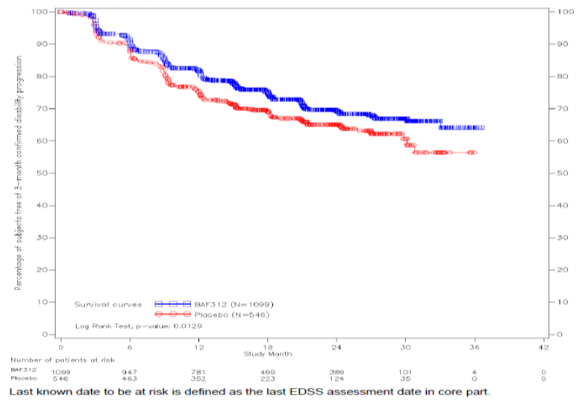
There was a significant difference in favour of siponimod compared with placebo (p = 0.0129) with the curves showing a treatment effect emerging at approximately six months after starting treatment. The curves were still divergent at study Month 36 although, only six patients were exposed to siponimod for ≥ 36 months.
The primary analysis was confirmed by multiple sensitivity analyses as shown in Table 5.
Table 5: Study A2304 Primary analysis and sensitivity analysis for the 3 month CDP, Cox proportional hazards model
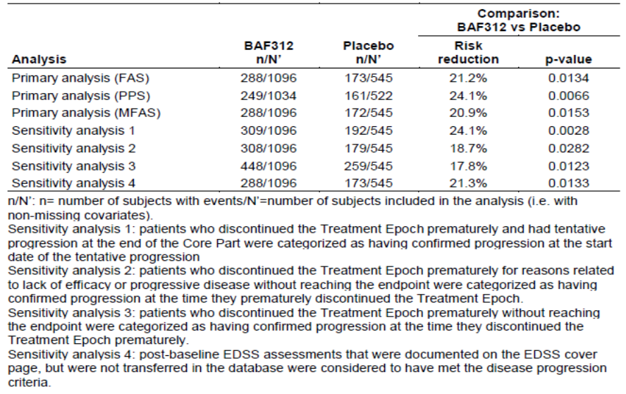
In each sensitivity analysis, there was a statistically significant risk reduction in favour of siponimod. Time to 3 month CDP sustained until last observation showed a statistically significant (p = 0.0060) risk reduction of 25.1% in favour of siponimod compared with placebo as per Figure 2.
Figure 2: Study A2304 Patients free of 3 month CDP based on EDSS and sustained until the end of core part of study, Kaplan Meier curves, Full Analysis Set
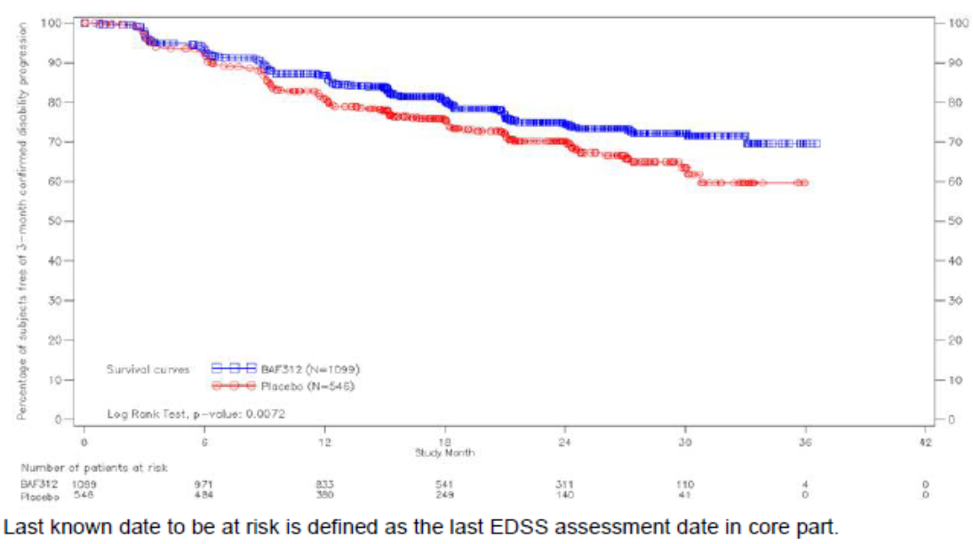

Results: secondary (key) endpoints
The time to 3 month confirmed worsening in Timed 25 Foot Walk test (T25W) of at least 20% from Baseline is shown in Table 6.
Table 6: Time to 3 month confirmed worsening in T25W test of at least 20% from Baseline, Cox proportional hazards model, Full Analysis Set
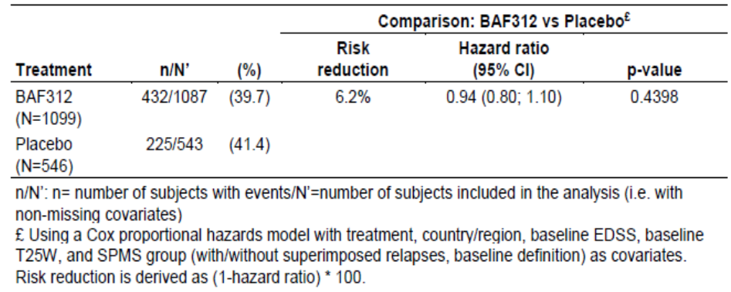
There was a 6.2% risk reduction in favour of siponimod compared with placebo, which did not achieve statistical significance (HR 0.94 (95% CI: 0.80, 1.10; p = 0.4398)). Additional exploratory analyses were performed to explain the failure to achieve this key secondary endpoint. However, all the exploratory analyses confirmed the primary analysis.
The sponsor suggested a possible explanation for the lack of statistically significant benefit in favour of siponimod for the time to 3 month confirmed worsening in T25W test scores; more than half of the SPMS patients had an EDSS 6.0 or higher (requiring a walking aid) at baseline, with the T25W test covering a broad range of durations (including durations above three minutes). This high variability in T25W would be expected to confound the statistical analyses of the key secondary endpoint and composite endpoints. The clinical evaluator considered the sponsor’s explanation is plausible.
The changes from baseline in T2 lesion volume at study Months 12 and 24 are summarised in Table 7.
Table 7: Study A2304 Change from Baseline in T2 lesion volume (mm³) by time point (Month 12 and 24), repeated measures model, Full Analysis Set
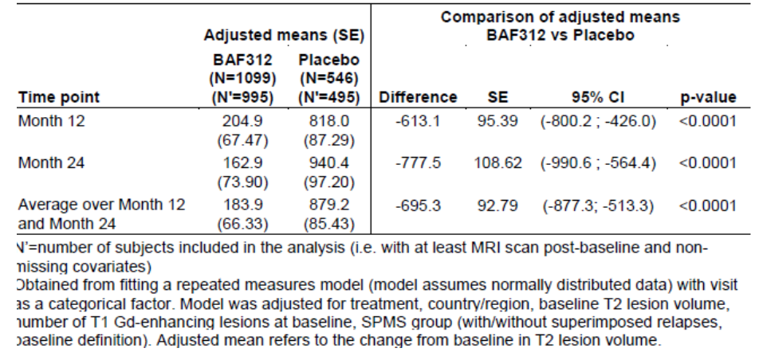
Averaged over study Months 12 and 24, there was a statistically significant reduction in lesion volume of -695.3 mm3 in favour of siponimod compared with placebo (95% CI: -877.3, -513.3; p < 0.0001).

Results: secondary (additional) endpoints
Compared with placebo, siponimod significantly delayed the time to 6 month CDP with a risk reduction of 25.9% (HR 0.74 (95% CI: 0.60, 0.92; p = 0.0058)) as per Table 8.
Table 8: Time to 6 month CDP based on EDSS, Cox proportional hazards model, Full Analysis Set
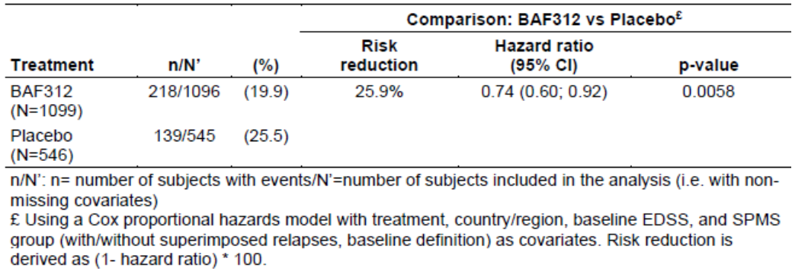
When siponimod was compared to placebo regarding variables related to relapse, there was a statistically significant 55.5% rate reduction in annualised relapse rate (ARR) in favour of siponimod (ARR 0.445 (95% CI: 0.337, 0.587; p < 0.0001) as shown in Table 9.
Table 9: Study A2304 Annualised relapse rate for confirmed relapses, negative binomial regression, Full Analysis Set
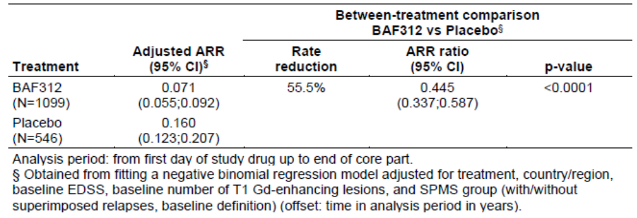
When siponimod was compared to placebo regarding variables related to risk reduction, there was a statistically significant reduction of 46.4% for time to first confirmed relapse in favour of siponimod (HR 0.54 (95% CI: 0.41, 0.70; p < 0.0001)) as per Table 10.
Table 10: Study A2304 Time to first confirmed relapse, Cox proportional hazards model, Full Analysis Set
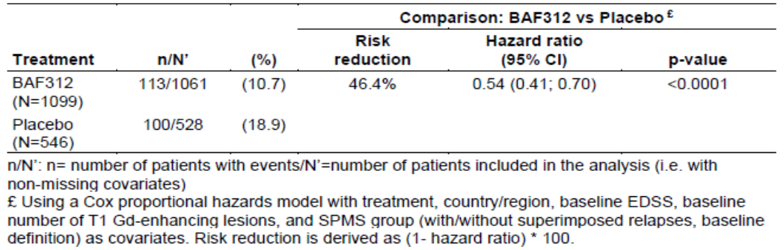
Kaplan Meier curves showed a difference between siponimod and placebo in the percentage of patients free of relapse (p < 0.0001) as shown in Figure 3.
Figure 3: Study A2304 Percentage of relapse-free (confirmed relapse) subjects, Kaplan Meier curves, Full Analysis Set
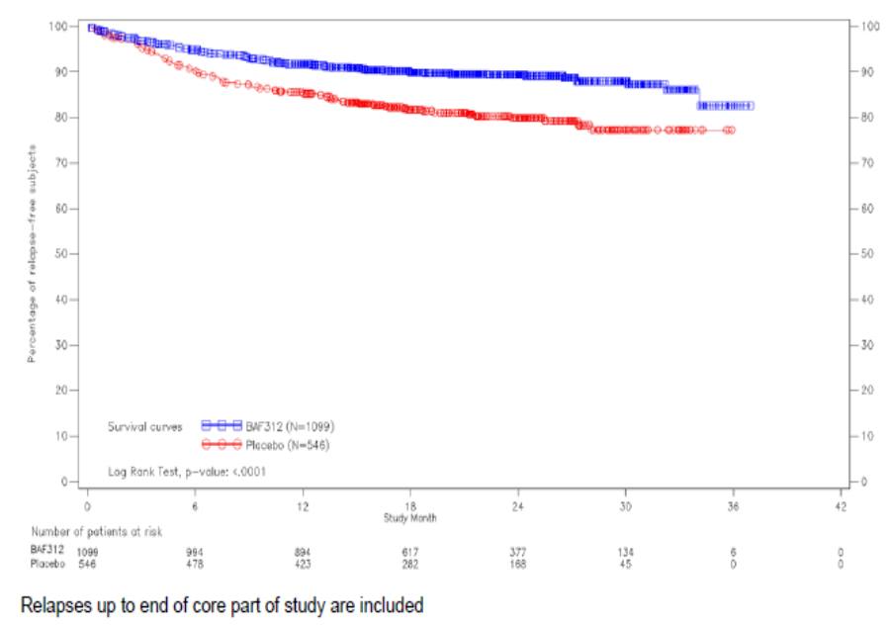
The proportion of patients with relapse is shown in Table 11.
Table 11: Study A2304 Proportion of patients with relapse, Full Analysis Set
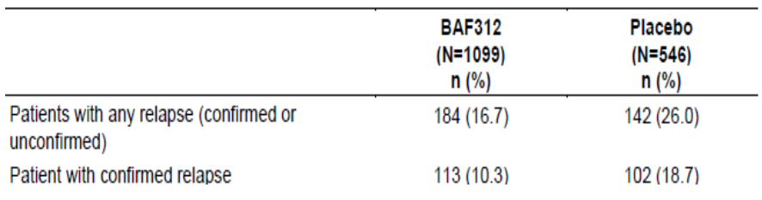
Relapses (confirmed and unconfirmed) were observed in fewer patients in the siponimod group compared with placebo (16.7% versus 26.0%).
Changes from Baseline in Multiple Sclerosis Walking Scale-12 (MSWS-12) at study Months 12 and 24 are shown in Table 12.
Table 12: Change from Baseline in MSWS-12 concerted score, by time point (Months 12 and 24) repeated measures model, Full Analysis Set
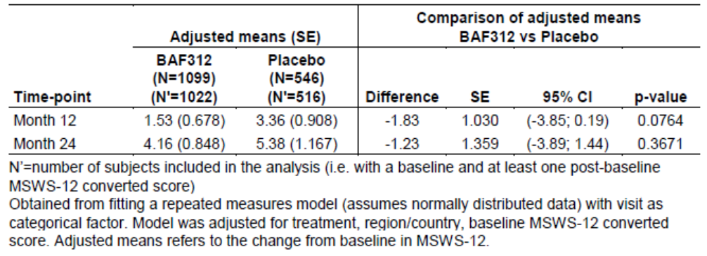
The table shows that patients in the siponimod group showed smaller increases from baseline compared with placebo; however, the treatment difference was not statistically significant.
Regarding MRI related variables, the proportion of patients free of T1 gadolinium (Gd)-enhancing lesions is summarised in Table 13.
Table 13: Study A2304 Proportion of patients free of T1 Gd-enhancing lesions, by time point (Month 12 and 24), summary statistics, Full Analysis Set
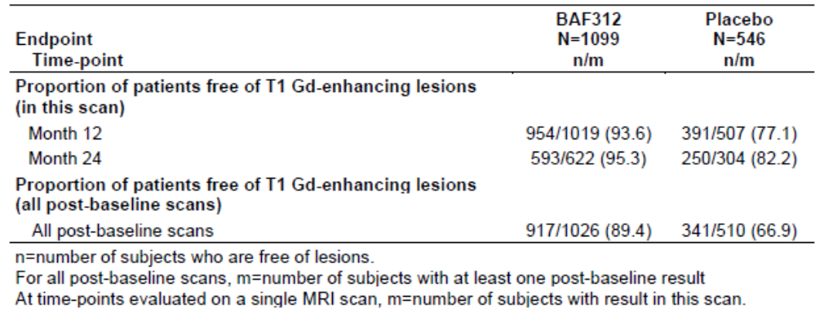
At Baseline, approximately 75% of patients did not have T1 Gd-enhancing lesions. In all post-baseline scans, 89.4% of siponimod patients and 66.9% of placebo patients were free of T1 Gd-enhancing lesions. The proportion of patients with new or enlarging T2 lesions is shown in Table 14.
Table 14: Study A2304 Proportion of patients free of new or enlarging T2 lesions, by time point (Month 12 and 24 relative to previous time point), summary statistics, Full Analysis Set
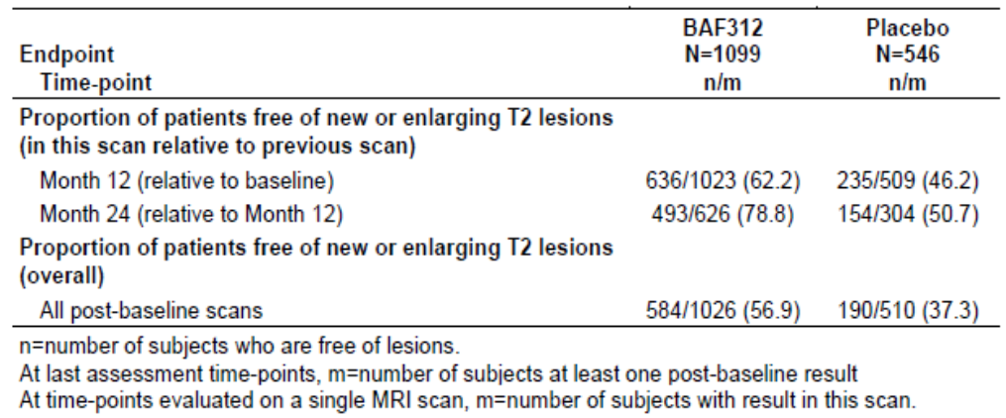
The proportions of patients free of new or enlarging T2 lesions compared to the previous scan were 62.2% and 78.8% at study months 12 and 24, respectively for siponimod, and 46.2% and 50.7%, respectively for placebo. For all post- baseline scans, 56.9% of siponimod patients and 37.3% of placebo patients were free of new or enlarging T2 lesions.
Increase from baseline in the volume of T1 hypo-intensive lesions, was smaller in the siponimod group at study month 12 (541 mm3) than in the placebo group (635.7 mm3). The difference between groups was also sustained at study months 24 and 36.
The analysis of percent brain volume change (PBVC) relative to baseline is provided by time-point as per Table 15.
Table 15: Study A2304 Percent brain volume change relative to Baseline, by time point (Month 12 and 24), repeated measures model, Full Analysis Set
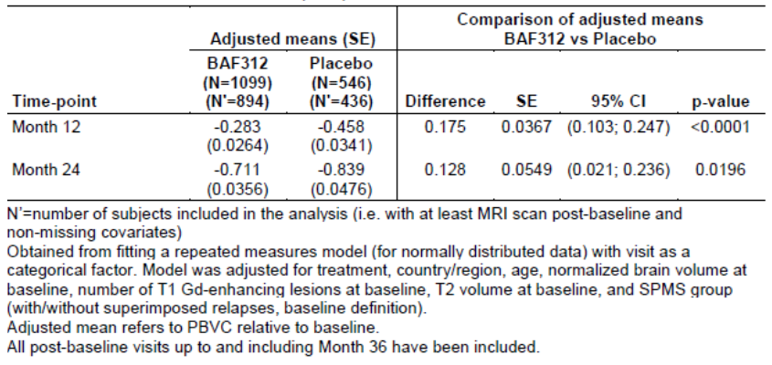
PBVC decreased at a lower rate in the siponimod group compared with placebo over study Months 12 (-0.5%) and 24 (-0.65%) with an adjusted mean difference between groups of 0.15% (95% CI: 0.07, 0.23; p < 0.001).

Results (exploratory)
Efficacy in subgroups (incorporating SPMS group, previous treatment, severity of disease, age, gender, MRI status at Baseline and duration of MS) is summarised below as per the forest plot (Figure 4).
Figure 4: Study A2304 Time to 3 month CDP based on EDSS, forest plot displaying hazard ratios, by subgroup, Full Analysis Set
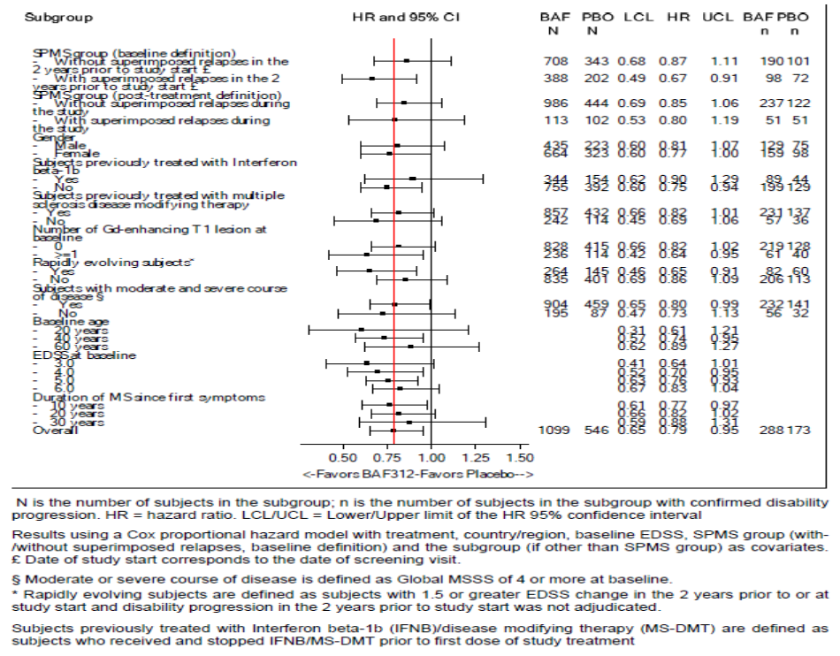
As shown above, the reduction in the risk of disability progression with siponimod in all subgroups was comparable with the treatment effect in the overall population. Of relevance for the proposed indication, there were no meaningful differences in outcomes between patient subgroups with and without superimposed relapses during the study (using the post-treatment definition).
- The composite endpoint for 3 month CDP was derived from disability progression events, based on EDSS, T25W test and Nine Hole Peg Test (9-HPT) scores. There was a risk reduction of 9.1% in favour of siponimod but the difference between treatment groups was not statistically significant (p = 0.1775).
- The impact of relapses on 3 month CDP based on EDSS, showed a similar benefit in favour of siponimod in subgroups of patients with and without confirmed relapses during the study. Only 10.3% of patients in the siponimod group and 18.7% of patients in the placebo group had confirmed relapses. In 215 patients with superimposed relapses during the study, the HR in favour of siponimod compared with placebo was 0.80 (95% CI: 0.53, 1.19). In 1430 patients without superimposed relapses during the study, the HR in favour of siponimod compared with placebo was 0.85 (95% CI: 0.69, 1.06).
- For the evolution of acute lesions into chronic black holes, the average patient level rates of T1 Gd-enhancing lesions that evolved into hypo-intense lesions were similar in each group, at study Month 12 (siponimod 0.63; placebo 0.60).
- There were no meaningful differences in MS Functional Composite (MSFC) z-scores (composites of T25W test, 9-HPT and Paced Auditory Serial Addition Test (PASAT)) between the siponimod and placebo groups.
- Cognitive function tests revealed a small benefit in favour of siponimod compared with placebo for Symbol Digit Modalities Test (SDMT) oral score. The differences in score were 1.085 (p = 0.0132) at study Month 12 and 2.303 (p = 0.0002 ) at study Month 24. There were no statistically significant differences between treatment groups for PASAT score or Brief Visuospatial Memory Test-Revised (BVMT⁻R). For low contrast visual acuity (LCVA), there was a small benefit in favour of siponimod but the treatment differences were not statistically significant at study Months 12 or 24.
- For patient reported outcomes, there was a treatment benefit in favour of siponimod for the physical scores of the MS Impact Scale-29 (MSIS-29). For physical scores, the adjusted mean treatment difference was-2.89 at study Month 12 (p = 0.0034) but the difference was not statistically significant at study Month 24. Between group differences for psychological impact scores were not significantly different at study Month 12 (p = 0.0604) or study Month 24 (p = 0.6703). For the EuroQoL (European Quality of Life)-5 dimensions (EQ-5D) utility scores, there was a small adjusted mean difference in favour of siponimod compared with placebo of 0.026 at study Month 12 (p = 0.0368). However, the treatment difference was not statistically significant at study Month 24 (p = 0.0877). There were no statistically significant treatment differences for the Visual Analogue Scale (VAS) score.

Other efficacy studies

Study A2201
This was a Phase II, double blind, randomised, multicentre, adaptive dose ranging, placebo controlled, parallel group study evaluating the efficacy and safety of siponimod on MRI lesion parameters in 297 patients with RRMS.
The Delegate commented the following in relation to this study:
- As stated by the clinical evaluator, the relevance of the study to the proposed indication is questionable. The latter will be in line with the Committee for Medicinal Products for Human Use (CHMP)’s advice on the pivotal study design.
- It is noted however, that the 2 mg siponimod dose in the pivotal study was based on the Phase II Study A2201in patients with RRMS, who were given siponimod doses ranging from 0.25 mg to 10 mg.
- Phase II dose ranging studies in patients with SPMS were not feasible, as acknowledged by the CHMP, due to the slowly progressive nature of the disease and lack of predictive efficacy biomarkers.
- The study might provide safety data.

Study A2201E1
This was an extension study to the A2201 study, to evaluate the long-term efficacy and safety of Siponimod given orally once daily in patients with RRMS.
The Delegate commented the following in relation to this study:
- As stated above, for Study A2201E1.

Conclusions on clinical efficacy
Clinical evaluator’s conclusions on clinical efficacy:
- The submission is based on the Phase III Study A2304 in patients with the target indication of SPMS. A supportive Phase II, dose ranging study was conducted in RRMS patients. The selected dose of 2 mg daily is considered appropriate despite the different patient population and efficacy endpoints.
- The European Medicines Agency (EMA) guideline on clinical investigation of medicinal products for the treatment of multiple sclerosis recommends large scale, long term, placebo controlled, parallel group trials. The revised McDonald’s criteria (2010); incorporating MRI criteria for dissemination in time and space are widely accepted. The target population of SPMS patients should show evidence of recent progression without recent relapses and no MRI activity suggestive of active inflammation. Any occurrence of relapse activity should be assessed during the study and taken into account when determining confirmed progression of disability.
- The primary efficacy parameter in confirmatory trials should be a clinically measured prevention or delay of the disability progression. For an SPMS indication, a relapse-based primary endpoint cannot be taken as a surrogate for disability progression. It is also highly desirable to evaluate if the effect on progression is maintained on a long-term basis which may need 5 years or even longer follow-up. However, these data might be generated post-approval. The Kurtzke’s Expanded Disability Status Scale (EDSS) is the most widely used and well known scale to assess changes in disability in MS with limited inter- and intra-observer variability. Acceptable secondary endpoints include relapses, MRI derived parameters, absence of disease activity, cognitive and other efficacy scales, and patient and physician reported outcomes.
- The pivotal study design was consistent with the EMA guideline published at the time.9 The population of ambulatory SPMS patients was similar to populations in other SPMS trials, but different from those of RRMS and RMS studies. As discussed in the clinical evaluation report, the primary efficacy endpoint of time to 3 month CDP based on EDSS had been superseded by time to 6 month CDP in the updated guideline. However, time to 6 month CDP was a pre-defined secondary endpoint and the result (25.9% risk reduction in favour of siponimod) was consistent with the 3 month CDP analysis (21.2% risk reduction in favour of siponimod).
- The results were supported by sensitivity analyses and were consistent in key subgroups. Relapses were reported less commonly in siponimod patients compared with placebo and clinical outcomes were comparable in SPMS patients with or without superimposed relapses. The benefit in 3 month CDP was higher in relapsing patients (HR 0.85) than in non-relapsing patients (HR 0.87). The benefit in 6 month CDP was also higher in relapsing patients (HR 0.76) than in non-relapsing patients (HR 0.82).
- These positive outcomes were supported by a treatment benefit in favour of siponimod compared with placebo for MRI secondary and exploratory endpoints, and for cognitive function. As discussed previously, there was only a 6.2% benefit in favour of siponimod compared with placebo for the T25W test. However, this negative outcome does not invalidate the overall conclusions of the study.
- Overall, the results of the study of siponimod treatment for up to 37 months support the proposed indication for use in SPMS patients. The benefit in favour of siponimod compared with placebo was statistically significant and clinically meaningful. However, efficacy data beyond the Core part should be provided to confirm sustained long-term efficacy as data from the Study A2304 extension emerge.11

Safety
Regarding the overall conclusions on clinical safety, the clinical evaluator stated that:
- Safety was assessed in the pivotal Phase III study in patients with SPMS and in the Phase II Study A2201/A2201E1 in patients with RRMS.
- In the efficacy studies, including RRMS patients, a total of 1784 MS patients received doses of siponimod ranging from 0.25 to 10 mg daily. Of these, 1737 patients were treated with at least one dose of siponimod 2 mg (or higher). The cumulative exposure to siponimod was more than 4000 patient years.
- Overall, siponimod was well tolerated. The safety profile was comparable to the first in class S1P receptor inhibitor fingolimod (Gilenya), which, at the time this submission was under consideration, was approved for use in patients with RRMS and SPMS with superimposed relapses., Fingolimod and siponimod cause a dose dependent reduction in peripheral lymphocyte count to 20-30% of baseline values by reversible sequestration of lymphocytes in lymphoid tissues. Their mechanism of action increases the risk of infections, including opportunistic infections, and these were monitored throughout the siponimod development program. There were no meaningful differences in the incidence of infection in siponimod patients. However, the incidence of herpes zoster reactivation was higher in siponimod patients compared with placebo (2.5% versus 0.7%). There were no fungal or other opportunistic infections and no cases of progressive multifocal leukoencephalopathy or cryptococcal meningitis.
- Specific adverse events (AE) of interest including bradycardia, macular oedema and raised liver function test (LFT) values were reported in line with the known safety profile of fingolimod. No unexpected safety signals were detected.
- In the controlled pool, most AEs were reported with similar frequency in the siponimod 2 mg group compared with placebo. AEs reported more frequently (≥ 2%) in the siponimod 2 mg group compared with placebo included headache, hypertension, nausea, diarrhoea, increased alanine aminotransferase (ALT), bradycardia, peripheral oedema and increased gamma-glutamyl transferase (GGT). The majority of AEs were mild to moderate in severity. Grade 3 AEs were reported in 11.0% of the siponimod group and 9.2% of the placebo group. Grade 4 AEs were reported in only 2.0% and 1.2% of the respective groups.
- In the long-term pool, the most commonly observed events were nasopharyngitis, urinary tract infection, headache and fall. Exposure-adjusted incidence rates of AEs were consistent in the controlled and long-term pools, although different trial population.
- The overall safety profile of siponimod was consistent with that of S1P modulation as observed with fingolimod. In patients treated with siponimod 2 mg, there was an increased incidence of LFT abnormalities (in particular ALT), macular oedema, hypertension, bronchoconstriction AEs and seizures.
  - The incidence of increased liver transaminases was higher in siponimod patients compared with placebo (5.6% versus 1.3% for ALT 3 x upper limit of normal (ULN)). Most elevations were mild and most occurred within one month of starting treatment. Treatment discontinuation resulted in normalisation of LFT abnormalities within 1 to 3 months and there were no cases meeting Hy’s Law criteria.
  - Macular oedema was reported in 1.7% of siponimod patients compared with 0.2% of placebo patients. Most events occurred in the first 3 months of treatment and were non-serious. Most resolved spontaneously when treatment was discontinued and there was no evidence of an increased incidence over time. Approximately half of patients experienced recurrence after rechallenge with siponimod.
  - There was a minor increase in blood pressure during the first year of treatment with siponimod. Mean systolic blood pressure/diastolic blood pressure rose by 3.73 mmHg/1.36 mmHg, but there were no further increases with long term treatment through Month 36. The incidence of hypertension was 12.2% in siponimod patients compared with 8.7% in placebo patients. The incidence of the AE of hypertension was higher in patients receiving siponimod compared with placebo.
  - The incidence of bronchoconstriction AEs (mainly asthma) was low in both treatment groups (< 1%). In the first 6 months of treatment, there was a mean reduction in forced expiratory volume in 1 second (FEV1) of -0.1 L at each time point in the siponimod group compared with none in the placebo group. The decrease in FEV1 may be clinically meaningful in patients with asthma but there was no increase in pulmonary events during long-term treatment.
  - Treatment emergent seizure AEs were reported in 1.5% and 0.5% of patients treated with siponimod 2 mg and placebo, respectively.
- There were no meaningful safety signals relating to infections, malignancies, or thromboembolic events.
- In the dose ranging study involving RRMS patients, significant dose related bradycardia was observed with a nadir (that is, lowest point) approximately three hours after the first siponimod dose (full dose without titration was administered). This was associated with first and second degree AV block in some cases and these events were sometimes symptomatic.
- In the pivotal study involving SPMS, a dose titration regimen was introduced with a starting dose of 0.25 mg daily reaching the maximal siponimod 2 mg dose after six days. Using the dose titration regimen, there was a transient bradycardia of up to 5 bpm in most patients, with first degree AV blocks in some patients (8.8% siponimod, 4.3% placebo). The initial events were typically asymptomatic and transient and no clinically significant AV block events were experienced. With chronic treatment, no additional effects on heart rate or AV conduction were observed and no QTc prolongation was observed. The risk of significant bradycardia (< 40 bpm) was low in siponimod and placebo patients, with a slightly higher incidence in patients with a prior history of cardiac disease.

Recommendations post second round evaluation
After consideration of the responses to questions and comments in the first round evaluation, approval is recommended for the amended indication:
Mayzent is indicated for the treatment of adult patients with secondary progressive multiple sclerosis (SPMS).
Approval is conditional on the identification of asthma as an important identified risk in the PI and RMP.
The sponsor has now included a statement on the line recommended by the clinical evaluator, regarding use in asthma and chronic obstructive pulmonary disease (COPD) patients, under ‘Special Warnings and Precautions for Use’ of the PI.
In its response to the risk management plan (RMP) second round report, ‘Novartis now commits to revise the Australian Specific Annex to include ‘asthma exacerbations’ as an important identified risk’.

Risk management plan
- The sponsor has submitted European Union-Risk Management Plan (EU-RMP) version 1.0 (dated 3 September 2018; data lock point 31 December 2017) and Australian Specific Annex (ASA) version 1.0 (dated 17 October 2018) in support of this application.
- In its response to TGA questions, the sponsor has submitted EU RMP version 1.1 (dated 18 March 2019; data lock point 31 December 2017) and ASA version 2.0; date 17 June 2019
- The proposed summary of safety concerns and their associated risk monitoring and mitigation strategies which have been agreed during evaluation are summarised below.
Table 16: Summary of safety concerns
Summary of safety concerns |  | Pharmacovigilance |  | Risk Minimisation
 |  | Routine | Additional | Routine | Additional
Important identified risks | Varicella zoster virus (VZV) infection reactivation |  | ¹ |  | ²
Important identified risks | Cryptococcal meningitis |  | ¹ |  | ²
Important identified risks | Bradyarrhythmia (including conduction defects) during treatment initiation |  | ¹ |  | ²
Important identified risks | Macular oedema |  | ¹ |  | ²
Important identified risks | Potential long-term safety implications in CYP2C9 poor metabolizers |  | ¹ |  | ²
Important identified risks | Asthma exacerbations⁶
Important potential risks | Reactivation of chronic viral infections (other than VZV), progressive multifocal leukoencephalopathy (PML), other opportunistic infections and opportunistic infections, other than cryptococcal meningitis | ^{3, 5} | ¹ |  | ²
Important potential risks | Thromboembolic events |  | ¹ | – | –
Important potential risks | Malignancies | ³ | ¹ |  | –
Important potential risks | Reproductive toxicity | ^{3, 4} | – |  | ²
Important potential risks | Unexpected neurological or psychiatric symptoms/sign (for example; posterior reversible encephalopathy syndrome (PRES), acute disseminated encephalomyelitis (ADEM), atypical MS relapse) | ³ | ¹ |  | –
Important potential risks | Drug-drug Interaction with Class Ia or Class III antiarrhythmic medical products |  | – |  | –
Missing information | Safety in patients over 60 years old (including elderly) |  | – |  | –
Missing information | Use during lactation |  | – |  | –
Missing information | Long-term safety risks |  | ¹ | – | –
Missing information | Safety of siponimod following switch from other disease modifying therapy |  | – |  | –
1 Study CBAF312A2304 (EXPAND trial) Phase III study extension part. 2 Healthcare professional (HCP) checklist & Patient reminder card. 3 Adverse event follow-up checklists. 4 Routine pharmacovigilance including pregnancy outcomes intensive monitoring. 5 Independent expert risk adjudication committee process for clinical trial and spontaneous case reports. 6 Sponsor agrees to include this risk in the ASA along with the supporting RMP activities
- During the second round evaluation, an important identified risk has been added as a safety concern ‘Cryptococcal meningitis’ based on the results of the extension phase of Phase III clinical trial Study CBAF312A2304 (Expand trial) and adverse effects reported after treatment with another member of the S1P modulator class (fingolimod). Safety in paediatric patients (≤ 18 years of age) has been removed as missing information as the proposed indication has been revised for adult use only in second round evaluation. During post-second round evaluation, the sponsor has agreed to the clinical evaluator’s requested inclusion of important identified risk ‘asthma exacerbations’ in the ASA and commits to the provision of information that is relevant and necessary to address the issue in a revised RMP.
- Routine pharmacovigilance and risk minimisation activities are proposed for most safety concerns. During second round evaluation the sponsor has agreed to include information on malignancies in the PI. Specifically, the potential for cutaneous neoplasms have been addressed in PI as a routine risk minimization measure given the high incidence of skin cancers in Australia and due to a potential long-term immunomodulatory effects of siponimod.
- Enhanced routine pharmacovigilance activities to be implemented by sponsor include use of follow-up adverse event forms, a pregnancy outcomes intensive monitoring program to examine frequency of congenital malformations and a risk adjudication review process to further characterize the potential risk of opportunistic infections (including PML). The risk adjudication activity will be conducted by an independent expert committee who will review any potential PML cases referred by sponsor from clinical trial and spontaneous case reports.
- There is an ongoing Phase III study extension proposed as additional pharmacovigilance to allow patients to continue treatment in trial conditions with open label siponimod up to 7 years with the aim of providing additional long-term safety data as well as additional information on efficacy measures.
- Additional risk minimisation activities are proposed including use of a Healthcare professional (HCP) checklist and Patient Reminder Card as educational materials. The sponsor commits to provide final local Australian materials to the TGA for review and approval prior to launch. The minimum requirements on the key safety messages to be addressed in the materials are outlined in the EU RMP. The sponsor has provided particulars of the distribution strategy for provision of materials to HCP and patients and evaluation plan for examining effectiveness of additional risk materials; and commits to undertaking these activities post-approval to show materials effectiveness. During post-second round evaluation the sponsor has agreed to provide TGA with the post-approval HCP survey protocol and timelines for examining effectiveness of the educational materials.

Risk-benefit analysis

Delegate’s considerations

Discussion
Although the aetiology of MS is unclear, it is assumed to be an autoimmune cellular process, possibly triggered by an infection in subjects with a genetic predisposition. The disease is characterised by acute inflammatory lesions, gliosis, demyelination, impaired re-myelination, and neuronal and axonal loss. Relapses are ascribed to acute inflammatory lesions, and progression is ascribed to demyelination and neuronal loss.
SPMS presents with steady progression in disability, with fewer inflammatory episodes and more degenerative symptomatology that is, deterioration in the absence of relapses.1 2
Patients with SPMS are characterised by reduced ambulation, bulbar dysfunction, visual impairment, impaired arm function, fatigue, pain, depression and loss of sphincter control. Cognitive impairment and reduced cognitive processing speed are also common.3
The diagnosis of SPMS is made retrospectively based on evidence that disability progression has occurred independently of relapses, although some relapses may continue to be experienced.4,5,6,7
Gilenya (fingolimod) is the first of the class of oral S1P receptor modulators, acting on lymphocytes which destroy the myelin sheath and, which, at the time this submission was under consideration, had ARTG approval for use in patients with SPMS to delay the progression of physical disability. 13
Mayzent (siponimod) is an orally active selective inhibitor of S1P1 and S1P5 receptors on lymphocytes, inhibiting the migration of lymphocytes to the location of the inflammation in MS. Like fingolimod, siponimod is being proposed for the indication of:
[…] treatment of patients with secondary progressive multiple sclerosis (SPMS).
As previously stated, the pivotal study design was consistent with the EMA guideline published at the time;9 and the population of ambulatory SPMS patients was similar to populations in other SPMS trials. Although the primary efficacy endpoint of time to 3 month CDP based on EDSS chosen for the pivotal study, had been superseded by time to 6 month CDP in the updated guideline, the latter was however a pre-defined secondary endpoint in the study. The result finding of 25.9% risk reduction in favour of siponimod was consistent, with the 3 month CDP analysis of 21.2% risk reduction in favour of siponimod.
The primary efficacy outcomes were supported by sensitivity analyses and were consistent in key subgroups. Relapses were reported less commonly in siponimod patients compared with placebo and, clinical outcomes were comparable in SPMS patients with or without superimposed relapses. The benefit in 3 month CDP was higher in relapsing patients (HR 0.85) than in non-relapsing patients (HR 0.87). The benefit in 6-month CDP was also higher in relapsing patients (HR 0.76) than in non-relapsing patients (HR 0.82).
These positive outcomes were supported by a treatment benefit in favour of siponimod compared with placebo for MRI secondary and exploratory endpoints, and for cognitive function. There was only a 6.2% benefit in favour of siponimod compared with placebo for the T25W test. However, this negative outcome does not necessarily invalidate the overall positive efficacy outcome of siponimod over placebo, in SPMS management over 48 months.
Although the submission is based on the Phase III Study A2304 in patients with the target indication of SPMS, a supportive Phase II, dose ranging study (Study A2201) was conducted in RRMS patients. The selected dose of 2 mg daily from that study is considered appropriate, despite the different patient population and efficacy endpoints. Dose ranging studies in SPMS patients are not feasible due to slow disease progression and the lack of predictive biomarkers. SPMS studies are often retrospective as the primary efficacy parameter in confirmatory trials, should be a clinically measured prevention or delay of the disability progression. For an SPMS indication, a relapse based primary endpoint cannot be taken as a surrogate for disability progression.
According to the revised McDonald’s criteria (2010);11 it is also highly desirable to evaluate if the effect on progression is maintained on a long term basis which may need 5 years or even longer follow-up. As these data might be generated post-approval, the EP data on efficacy and safety should be submitted to the TGA when available, to justify the prolonged use of siponimod in clinical practice.
Regarding safety, siponimod was well tolerated. The safety profile was comparable to the first in class S1P receptor inhibitor fingolimod (Gilenya) which was approved for use in patients with SPMS.

Proposed indication
As per the sponsor, initial:
Siponimod is indicated for the treatment of patients with secondary progressive multiple sclerosis (SPMS).
As per the clinical evaluator, acceptable to both the sponsor and Delegate):
Siponimod is indicated for the treatment of adult patients with secondary progressive multiple sclerosis (SPMS).

Deficiencies of the data
Lack of sufficient availability of EP data to properly ascertain prolonged use justification of siponimod, in terms of safety and efficacy.

Conditions of registration
Fulfilment of commitments by the sponsor prior to product launch to the RMP’s recommendations as suggested by the clinical evaluator, regarding asthma as a risk factor and, specific inclusion of phenoconversion and monitoring in the educational materials proposed for the healthcare prescribers, as mooted by the Delegate.

Outstanding issue
Fulfilment of the sponsor’s commitment to the RMP issues stated above, prior to the product launch.

Conclusion
There is sufficient efficacy data that siponimod is superior to placebo in the management of SPMS and, that it is satisfactorily tolerated.

Summary of issues
- Sponsor’s agreed modification to the proposed indication from:
  - ‘Siponimod is indicated for the treatment of patients with secondary progressive multiple sclerosis (SPMS)’ to
  - ‘Siponimod is indicated for the treatment of adult patients with secondary progressive multiple sclerosis (SPMS)’.
- Lack of sufficient availability of EP data to properly ascertain prolonged use justification of siponimod, in terms of safety and efficacy.
- As yet to be fulfilled sponsor’s commitment to not launch the product until the accomplishment of the RMP recommendations as suggested by the clinical evaluator, regarding asthma as a risk factor and, specific inclusion of phenoconversion and monitoring in the educational materials proposed for the healthcare prescribers, as mooted by the Delegate.

Proposed action
Approvable, provided all the stated RMP issues are complied with prior to product launch, especially the asthma and phenoconversion issues.

Request for ACM advice
The ACM is requested to consider the approvability or not of the submission, based on the gamut of the available evidence and the stated condition of registration.

Advisory Committee Considerations
The Advisory Committee on Medicines (ACM), having considered the evaluations and the Delegate’s overview, as well as the sponsor’s response to these documents, advised the following.
The ACM considered the referral for advice from the TGA Delegate in relation to the submission to register Mayzent film-coated tablets, containing 0.25 mg and 2 mg of siponimod.
The ACM considered this product to have an overall positive benefit-risk profile for the proposed indication:
Siponimod is indicated for the treatment of adult patients with secondary progressive multiple sclerosis (SPMS).

Specific advice
The ACM advised the following in response to the Delegate’s specific request for advice.
- The ACM is requested to consider the approvability or not of the submission, based on the gamut of the available evidence and the stated condition of registration.
The ACM was of the view that the available evidence regarding safety and efficacy supports registration of this product for the Delegate’s revised indication.

General advice
The ACM agreed with the Delegate that the proposed HCP educational materials should highlight how to identify or test patients at risk of phenoconversion issues, noting that siponimod is contraindicated in patients with the CYP2C9*3*3 genotype.
The ACM noted that it is stated in the PI that the majority of cases of macular oedema occurred within the first 3 to 4 months of therapy and that ophthalmologic evaluation is therefore recommended at 3 to 4 months after initiation of treatments. However, the ACM agreed with the Delegate that the PI should be amended to further advise that all patients should have a baseline ophthalmological review prior to initiation of treatment and further review at any time during treatment if changes in vision are noticed.

Outcome
Based on a review of quality, safety and efficacy, the TGA approved the registration of Mayzent (siponimod) 0.25 mg and 2 mg film coated tablets, indicated for:
Mayzent is indicated for the treatment of patients with secondary progressive multiple sclerosis (SPMS).

Specific conditions of registration applying to these goods
- Mayzent (siponimod) is to be included in the Black Triangle Scheme. The PI and Consumer Medicines Information (CMI) for Mayzent must include the black triangle symbol and mandatory accompanying text for five years, which starts from the date that the sponsor notifies the TGA of supply of the product.
- The Mayzent (siponimod) EU-Risk Management Plan (RMP) (version 1.1; date 18 March 2019; data lock point 31 December 2017), with Australian Specific Annex (version 2.0; date 17 June 2019), included with submission number PM-2018-04434-1-1, to be revised to the satisfaction of the TGA, will be implemented in Australia.
- An obligatory component of risk management plans is routine pharmacovigilance. Routine pharmacovigilance includes the submission of periodic safety update reports (PSURs).
- Unless agreed separately between the supplier who is the recipient of the approval and the TGA, the first report must be submitted to TGA no later than 15 calendar months after the date of this approval letter. The subsequent reports must be submitted no less frequently than annually from the date of the first submitted report until the period covered by such reports is not less than three years from the date of this approval letter. The annual submission may be made up of two PSURs each covering six months. If the sponsor wishes, the six monthly reports may be submitted separately as they become available.
- The reports are to at least meet the requirements for PSURs as described in the European Medicines Agency’s Guideline on Good Pharmacovigilance Practices (GVP) Module VII-periodic safety update report (Rev 1), Part VII.B Structures and processes. Note that submission of a PSUR does not constitute an application to vary the registration. Each report must have been prepared within ninety calendar days of the data lock point for that report.

Attachment 1. Product Information
The PI for Mayzent approved with the submission which is described in this AusPAR is at Attachment 1. For the most recent PI, please refer to the TGA website at <https://www.tga.gov.au/product-information-pi>.

Therapeutic Goods Administration
PO Box 100 Woden ACT 2606 Australia
Email: info@tga.gov.au Phone: 1800 020 653 Fax: 02 6232 8605
https://www.tga.gov.au

Lublin, F.D. et al. (1996). Defining the clinical course of multiple sclerosis: results of an international survey. Neurology, 1996; 46: 907-911.
Lublin, F.D. et al. (2014). Defining the clinical course of multiple sclerosis: the 2013 revisions. Neurology, 2014; 83: 278-286.
Chiaravalloti, N.D. and DeLuca, J. (2008). Cognitive impairment in multiple sclerosis. Lancet Neurol, 2008; 7: 1139-1151.
Confavreux, C. et al. (2000). Relapses and progression of disability in multiple sclerosis. N Eng J Med, 2000; 343: 1430-1438.
Tremlett, H. et al. (2008). Impact of secondary-progressive multiple sclerosis. Multiple Sclerosis, 2008; 14: 314-324.
Scalfari, A. et al. (2010). The natural history of multiple sclerosis: a geographically based study 10: relapses and long-term disability. Brain, 2010; 133: 1914-1929.
Novotna, M. et al. (2015). Poor early relapse recovery affects onset of progressive disease course in multiple sclerosis. Neurology, 2015; 85: 722-729.
Therapeutic Goods Order No. 91, Standard for labels of prescription and related medicines, F2018C00437, 2 July 2018.
European Medicines Agency (EMA), CPMP, ICH M3 (R2), Guideline on non-clinical safety studies for the conduct of human clinical trials for pharmaceuticals, CPMP/ICH/286/95, 11 January 2013.
Pregnancy Category D: Drugs which have caused, are suspected to have caused or may be expected to cause, an increased incidence of human fetal malformations or irreversible damage. These drugs may also have adverse pharmacological effects. Accompanying texts should be consulted for further details.
PPV-23 vaccine; pneumococcal vaccine volyvalent. PPV-23 is a vaccine for active immunisation for the prevention of pneumococcal disease caused by the 23 serotypes of Streptococcus pneumoniae contained in the vaccine (1, 2, 3, 4, 5, 6B, 7F, 8, 9N, 9V, 10A, 11A, 12F, 14, 15B, 17F, 18C, 19F, 19A, 20, 22F, 23F, and 33F).
The sponsor clarified that there was efficacy and safety data from EP up to data cut off 31 December 2017 included in the submission, and reported in the Summary of Clinical Efficacy and Summary of Clinical Safety. There was no stand-alone clinical study report on the EP data.
Polman, C.H. et al. (2011). Diagnostic criteria for multiple sclerosis: 2010 Revisions to the McDonald criteria, Ann Neurol, 2011; 69: 292-302.
Gilenya (fingolimod) was subsequently approved for the treatment of adult and paediatric patients of 10 years of age and above with relapsing forms of multiple sclerosis to reduce the frequency of relapses and to delay the progression of disability.
The sponsor clarified that a case of cryptococcal meningitis (CM) has been reported in a patient receiving siponimod in the Extension Part of Study A2304 (post data lock point Summary of Clinical Safety 31 December 2017). However, no cases of progressive multifocal leukoencephalopathy (PML) or other rare or opportunistic infections were reported.
Hy’s Law: ALT > 3 x upper limit of normal (ULN) and total bilirubin > 2 x ULN.
Routine risk minimisation activities may be limited to ensuring that suitable warnings are included in the product information or by careful use of labelling and packaging. Routine pharmacovigilance practices involve the following activities: - All suspected adverse reactions that are reported to the personnel of the company are collected and collated in an accessible manner; - Reporting to regulatory authorities; - Continuous monitoring of the safety profiles of approved products including signal detection and updating of labelling; - Submission of PSURs; - Meeting other local regulatory agency requirements.
The ACM provides independent medical and scientific advice to the Minister for Health and the Therapeutic Goods Administration (TGA) on issues relating to the safety, quality and efficacy of medicines supplied in Australia including issues relating to pre-market and post-market functions for medicines. The Committee is established under Regulation 35 of the Therapeutic Goods Regulations 1990. Members are appointed by the Minister. The ACM was established in January 2017 replacing Advisory Committee on Prescription Medicines (ACPM) which was formed in January 2010. ACM encompass pre and post-market advice for medicines, following the consolidation of the previous functions of the Advisory Committee on Prescription Medicines (ACPM), the Advisory Committee on the Safety of Medicines (ACSOM) and the Advisory Committee on Non-Prescription Medicines (ACNM). Membership comprises of professionals with specific scientific, medical or clinical expertise, as well as appropriate consumer health issues relating to medicines.

