Date of CER:
First round: 19 December 2013
Second round: 21 March 2014

AusPAR Attachment 2

Extract from the Clinical Evaluation Report for Simeprevir
  - Proprietary Product Name: Olysio/Janssen Simeprevir
  - Sponsor: Janssen-Cilag Pty Ltd

About the Therapeutic Goods Administration (TGA)
- The Therapeutic Goods Administration (TGA) is part of the Australian Government Department of Health, and is responsible for regulating medicines and medical devices.
- The TGA administers the Therapeutic Goods Act 1989 (the Act), applying a risk management approach designed to ensure therapeutic goods supplied in Australia meet acceptable standards of quality, safety and efficacy (performance), when necessary.
- The work of the TGA is based on applying scientific and clinical expertise to decision-making, to ensure that the benefits to consumers outweigh any risks associated with the use of medicines and medical devices.
- The TGA relies on the public, healthcare professionals and industry to report problems with medicines or medical devices. TGA investigates reports received by it to determine any necessary regulatory action.
- To report a problem with a medicine or medical device, please see the information on the TGA website <http://www.tga.gov.au>.
About the Extract from the Clinical Evaluation Report
- This document provides a more detailed evaluation of the clinical findings, extracted from the Clinical Evaluation Report (CER) prepared by the TGA. This extract does not include sections from the CER regarding product documentation or post market activities.
- The words [Information redacted], where they appear in this document, indicate that confidential information has been deleted.
- For the most recent Product Information (PI), please refer to the TGA website <http://www.tga.gov.au/hp/information-medicines-pi.htm>.
Copyright
© Commonwealth of Australia 2014
This work is copyright. You may reproduce the whole or part of this work in unaltered form for your own personal use or, if you are part of an organisation, for internal use within your organisation, but only if you or your organisation do not use the reproduction for any commercial purpose and retain this copyright notice and all disclaimer notices as part of that reproduction. Apart from rights to use as permitted by the Copyright Act 1968 or allowed by this copyright notice, all other rights are reserved and you are not allowed to reproduce the whole or any part of this work in any way (electronic or otherwise) without first being given specific written permission from the Commonwealth to do so. Requests and inquiries concerning reproduction and rights are to be sent to the TGA Copyright Officer, Therapeutic Goods Administration, PO Box 100, Woden ACT 2606 or emailed to <tga.copyright@tga.gov.au>.

Contents
List of abbreviations 5
1. Introduction 11
2. Clinical rationale 11
2.1. Guidance 11
3. Contents of the clinical dossier 12
3.1. Scope of the clinical dossier 12
3.2. Paediatric data 12
3.3. Good clinical practice 12
4. Pharmacokinetics 12
4.1. Studies providing pharmacokinetic data 12
4.2. Summary of pharmacokinetics 15
4.3. Evaluator’s overall conclusions on pharmacokinetics 30
5. Pharmacodynamics 33
5.1. Studies providing pharmacodynamic data 33
5.2. Summary of pharmacodynamics 34
5.3. Evaluator’s overall conclusions on pharmacodynamics 40
6. Dosage selection for the pivotal studies 42
6.1. Study C205 42
6.2. Study C206 44
7. Clinical efficacy 46
7.1. Treatment of HCV G1 infected patients 46
7.2. Evaluator’s conclusions on clinical efficacy 70
8. Clinical safety 71
8.1. Studies providing evaluable safety data 71
8.2. Pivotal studies that assessed safety as a primary outcome 72
8.3. Adverse events 72
8.4. Laboratory tests 75
8.5. Post-marketing experience 77
8.6. Safety issues with the potential for major regulatory impact 77
8.7. Other safety issues 78
8.8. Evaluator’s overall conclusions on clinical safety 79
9. First round benefit-risk assessment 80
9.1. First round assessment of benefits 80
9.2. First round assessment of risks 80
9.3. First round assessment of benefit-risk balance 81
10. First round recommendation regarding authorisation 81
11. Clinical questions 81
11.1. Pharmacokinetics 81
11.2. Pharmacodynamics 82
11.3. Efficacy 82
11.4. Safety 82
12. Second round evaluation of clinical data submitted in response to questions 82
12.1. Pharmacokinetics 82
12.2. Pharmacodynamics 84
12.3. Efficacy 85
13. Second round benefit-risk assessment 87
13.1. Second round assessment of benefits 87
13.2. Second round assessment of risks 87
13.3. Second round assessment of benefit-risk balance 88
14. Second round recommendation regarding authorisation 88
15. References 88

List of abbreviations
Abbreviation | Meaning
AE |  | adverse event
AFP |  | alpha-fetoprotein
ALT |  | alanine aminotransferase
ANA |  | anti-nuclear antibody
ANCOVA |  | analysis of covariance
AST |  | aspartate aminotransferase
AUC |  | area under the curve
AUC_{24h} |  | area under the curve over a 24 hour dose interval
AUC_{inf} |  | area under the plasma concentration-time curve from time of intake until infinity
AUC_{last} |  | area under the plasma concentration-time curve from time of intake until the last measurable or measured concentration
AUC_{th} |  | AUC from time of administration up to t hours post dosing, calculated by linear trapezoidal summation.
b.i.d. |  | twice a day
BID |  | twice daily
BMI |  | body mass index
BQL |  | below quantification level
C_{0h} |  | pre-dose plasma concentration or minimum concentration
CHC |  | chronic hepatitis C
CI |  | confidence interval
CL/F |  | apparent clearance
Cmax |  | maximum plasma concentration.
CMH |  | Cochran-Mantel-Haenszel analysis
Cmin |  | minimum plasma concentration between 0 hour and τ (τ = dosing interval. For RBV, between 0 and 10 h instead of full dosing interval).
CrCl |  | creatinine clearance
C_{ss,av} |  | average steady-state plasma concentration.
CT |  | Computed Tomography
DBP |  | diastolic blood pressure
DDQ |  | desires for drugs questionnaire
DNA |  | deoxyribonucleic acid
DRV |  | darunavir
DSMB |  | Data Safety Monitoring Board
EBE |  | empirical Bayes estimate
ECG |  | electrocardiogram
eCRF |  | electronic case report form
eGFR |  | estimated glomerular filtration rate
EMEA |  | European Medicines Agency
EOT |  | end of treatment
EQ-5D |  | EuroQol-5 dimensions
eRVR |  | undetectable HCV RNA at Week 4 and Week 12 of treatment
EVR |  | early virologic response
F1 |  | relative bioavailability
FDA |  | Food and Drug Administration (US)
FI% |  | fluctuation index, i.e., percentage fluctuation (variation between maximum and minimum plasma concentration at steady-state), calculated as: 100 x ((Cmax-Cmin)/Css,av).
FSH |  | follicle-stimulating hormone
Ft |  | relative oral bioavailability
G007 |  | Phase III capsule formulation of simeprevir
GAM |  | generalised additive modelling
HbsAg |  | hepatitis B surface antigen
HCV |  | hepatitis C virus
HDL |  | high density lipoprotein
HIV-1 |  | human immunodeficiency virus type 1
HLA |  | human leucocyte antigen
HPMC |  | hydroxypropylmethylcellulose
HR |  | heart rate
ICF |  | informed consent form
ICH |  | international conference on harmonisation
IFN |  | interferon
IgM |  | immunoglobulin
IIV |  | inter-individual variability
IL |  | interleukin
INR |  | international normalised ratio
ITT |  | intent to treat
IWRS/IVRS |  | Interactive Web Response System/Interactive Voice Response System
Ka |  | absorption rate constant
LDL |  | low density lipoprotein
LH |  | luteinizing hormone
LLOQ |  | lower limit of quantification
LOCF |  | last observation carried forward
LR |  | likelihood ratio
LS |  | least squares
MedDRA |  | medical dictionary for regulatory activities
METAVIR |  | a scoring system for liver biopsies that assigns two standardised numbers: one to represent the degree of inflammation and the other the degree of fibrosis.
MRI |  | Magnetic Resonance Imaging
MS |  | metavir score
MTD |  | maximum tolerated dose
Na |  | sodium
NK |  | natural killer
NOAEL |  | no observed adverse effect level
NtRTI |  | nucleotide reverse transcriptase inhibitor
PBMC |  | peripheral blood mononuclear cell
PCR |  | polymerase chain reaction
PD |  | pharmacodynamics
PegIFN |  | peginterferon
PegIFNα-2a |  | peginterferon alfa-2a
PI |  | protease inhibitor
PK |  | pharmacokinetics
PP |  | per protocol
PPK |  | population pharmacokinetic
PR interval |  | on ECG, time in seconds from the beginning of the P wave to the beginning of the QRS complex.
PR |  | PegIFN/RBV
PT |  | prothrombin time
PTT |  | partial thromboplastin time
q.d. |  | quaque die; once daily
QA |  | quality assurance
QC |  | quality control
QD |  | once daily
QOL |  | quality of life
QTc |  | QT interval corrected for heart rate
QTcB |  | QT interval corrected for heart rate according to Bazett
QTcF |  | QT interval corrected for heart rate according to Fridericia
Ratio AUCth |  | test/ref ratio of mean AUC_{th} values between test and reference treatment.
Ratio Cmax |  | test/ref ratio of mean Cmax values between test and reference treatment.
Ratio Cmin |  | test/ref ratio of mean Cmin values between test and reference treatment.
RBC |  | red blood cell
RBV |  | ribavirin
RGT |  | response guided therapy/treatment
Rilpivirine |  | TMC278
RNA |  | ribonucleic acid
RTV |  | ritonavir
RVR |  | rapid virologic response (at Week 4)
SAE |  | serious adverse event
SBP |  | systolic blood pressure
sc |  | subcutaneous
SD |  | standard deviation
SE |  | standard error
SJS |  | Stevens-Johnson syndrome
SOC |  | standard of care
SOWS |  | short opiate withdrawal scale
SVR |  | sustained virologic response
SVR12 |  | sustained virologic response at 12 weeks after planned end of treatment
SVR24 |  | SVR 24 weeks after planned end of treatment
SVR4 |  | SVR 4 weeks after planned end of treatment
SVRW72 |  | SVR at Week 72
t_{½} |  | half life
TB |  | total bilirubin
TDF |  | tenofovir disoproxil fumarate
TEN |  | toxic epidermal necrolysis
Th |  | helper T cell
Tmax |  | time to reach the maximum plasma concentration.
TMC |  | Simeprevir
TMC435 |  | Simeprevir
ULN |  | upper limit of normal
ULOQ |  | upper limit of quantification
UV |  | ultraviolet
Vc/F |  | apparent volume of distribution of the central compartment
Vp/F |  | apparent volume of distribution of the peripheral compartment
VPC |  | visual predictive check
WBC |  | white blood cell
WHO |  | World Health Organisation
WT |  | body weight
λ_{z} |  | elimination rate constant, determined by linear regression of the terminal points of the ln linear plasma concentration time curve.

Introduction
Simeprevir is a novel NS3/4A protease inhibitor for the treatment of chronic hepatitis C.
The proposed indication is
‘for the treatment of chronic hepatitis C (CHC) genotype 1 or genotype 4 infection, in combination with peginterferon alfa and ribavirin, in adults with compensated liver disease (including cirrhosis) with or without human immunodeficiency virus-1 (HIV-1) co-infection who are treatment-naïve or who have failed previous interferon therapy (pegylated or non-pegylated) with or without ribavirin’.

Clinical rationale
It is estimated that 130 to 210 million people worldwide are infected with HCV with 2 to 4 million new infections annually. Approximately 300,000 Australians were infected with HCV in 2011. Acute infections become chronic in 70% to 90% of cases and this leads commonly to cirrhosis, chronic liver failure, hepatocellular carcinoma, liver transplantation and death. Approximately 30% of patients with HIV-1 worldwide have HCV co-infection although only 13% of HIV-1 patients in Australia are co-infected. Highly active antiretroviral therapy (HAART) has revolutionised the treatment of HIV. However, co-infection increases the progression of HCV liver disease which remains a largely unmet medical need.
HCV has six genotypes (G) and multiple subtypes with genotypes 1 to 3 distributed worldwide. Genotypes 1a and 1b account for 60% of global HCV infections. In Australia, the most common genotypes are 1a and 1b (54% prevalence) and 3a (37% prevalence). G4 is most prevalent in North Africa and the Middle East but it is spreading to Europe and the rest of the world through immigration and IV drug use. Until recently, the standard of care treatment for chronic HCV infection for all genotypes was the combination of pegylated interferon and ribavirin (PegIFN/RBV) for 48 weeks. The response to treatment varies according to HCV genotype and host IL28B genotypic subtypes (CC, CT, TT). However, in patients with G1 infection, sustained viral response (SVR) rates are only 45% in treatment-naïve patients and significantly lower in prior relapsers and non-responders. Moreover, the side effect profile of PegIFN/RBV is unfavourable with a high incidence of lethargy, fatigue, depression and anaemia. The NS3/4A protease inhibitors telaprevir and boceprevir in combination with PegIFN/RBV have improved SVR rates in treatment-naïve and treatment-experienced patients, and shortened treatment duration to 24 weeks in many patients. However, these combinations are associated with increased rates and severity of AEs, including rash in addition to the common side effects of PegIFN/RBV. Moreover, telaprevir and boceprevir both require TID therapy.
It is hoped that simeprevir (TCM) will increase SVR rates, shorten treatment duration, provide once daily dosing and improve safety and tolerability.

Guidance
The sponsors had a pre-submission meeting with the TGA on 13 April 2013. Issues discussed included the validity of SVR12 rather than SVR24 data; the use of interim data in certain studies; the interchangeable use of PegINFα-2a or PegIFNα-2b in certain studies; the data required to support the use of simeprevir in HIV-1/HCV co-infected patients; and the low numbers of patients with HCV G4 studied. The sponsors state that they have addressed all outcomes from the TGA meeting in the current application.

Contents of the clinical dossier

Scope of the clinical dossier
The submission contained the following clinical information:
Module 5:
- 33 clinical pharmacology studies, including 23 that exclusively provided pharmacokinetic data and a further 10 that provided both pharmacokinetic and pharmacodynamic data.
- 10 population pharmacokinetic analyses.
- Three pivotal efficacy/safety studies, C208, C216 and HPC3007.
- Two dose-finding studies, C205 and C206.
- Five other efficacy/safety studies, C201, C202, C213, C212 and HPC3011.
Module 1:
- Application letter, application form, draft Australian PI and CMI.
Module 2:
- Clinical Overview, Summary of Clinical Efficacy, Summary of Clinical Safety and literature references.

Paediatric data
The submission did not include paediatric data.

Good clinical practice
All studies were conducted to the principles of GCP.

Pharmacokinetics

Studies providing pharmacokinetic data
Table 1 below shows the studies relating to each pharmacokinetic topic.

Table 1. Submitted pharmacokinetic studies.
PK topic | Subtopic | Study ID | *
PK in healthy adults | General PK | C102 | BA of 3 different capsule formulations.
PK in healthy adults | General PK | C106 | BA of 4 solid formulations cf powder blend Na-salt capsule.
PK in healthy adults | General PK | HPC1002 | 2 different liquid formulations cf Phase III 150 mg capsule in fed and fasted state.
PK in healthy adults | General PK | C119 | Potential Phase III formulations (G006, G007) cf Phase IIb capsule (F021).
PK in healthy adults | General PK | C116 | HPMC capsule (G011) cf gelatin capsule (G007) in fed and fasted state.
PK in healthy adults | General PK | C121 | Potential Phase III formulations (G002, G004) cf Phase IIb capsule (F021) in fed and fasted state.
PK in healthy adults | General PK | C101 | PKs after single oral doses from 50 mg up to 1200 mg in fed and fasted state.
PK in healthy adults | General PK | C109 | PKs after oral doses of 100 mg, 200 mg, and 400 mg in healthy Japanese males
PK in healthy adults | General PK | HPC1004 | PKs after oral doses of 100 and 200 mg in healthy Chinese subjects
PK in healthy adults | General PK | C103 | Mass balance study
PK in special populations | Target population | C201 | 4 different regimens, given alone or with PegIFNα-2a and RBV in treatment-naïve and experienced genotype 1 HCV-infected subjects.
PK in special populations | Target population | C202 | PK after 200 mg q.d. for 7 days in treatment-naïve, genotype 2 to 6 HCV-infected subjects.
PK in special populations | Target population | C205 | PK of 4 different regimens with PegIFNα-2a and ribavirin RBV.
PK in special populations | Target population | C215 | PKs with PegIFNα-2a and RBV in treatment-naïve Japanese with genotype 1 HCV.
PK in special populations | Target population | C206 | PKs of 6 different regimens with PegIFNα-2a and RBV.
PK in special populations | Hepatic impairment | C113 | Steady-state PKs in subjects with moderate and severe hepatic impairment.
PK in special populations | Renal impairment | C126 | Steady-state PKs in subjects with severe renal impairment cf matched subjects with normal renal function.
Extrinsic factors | Drug- drug interaction | C107 | CYP Substrates (CYP1A2, CYP2C9, CYP2D6, CYP3A and CYP2C19)
Extrinsic factors | Drug- drug interaction | C104 | RTV
Extrinsic factors | Drug- drug interaction | C115 | Erythromycin and Darunavir/RTV
Extrinsic factors | Drug- drug interaction | HPC1005 | BMS-790052
Extrinsic factors | Drug- drug interaction | C114 | Rilpivirine and tenofovir disoproxil fumarate
Extrinsic factors | Drug- drug interaction | C124 | Ethinylestradiol and norethindrone
Extrinsic factors | Drug- drug interaction | HPC1006 | Atorvastatin and simvastatin
Extrinsic factors | Drug- drug interaction | C112 | Escitalopram
Extrinsic factors | Drug- drug interaction | C110 | Methadone
Extrinsic factors | Drug- drug interaction | C120 | Cyclosporine and tacrolimus
Extrinsic factors | Drug- drug interaction | HPC1001 | TMC647055
Extrinsic factors | Drug- drug interaction | C123 | Efavirenz and raltegravir
Extrinsic factors | Drug- drug interaction | C105 | Rifampin
Extrinsic factors | Drug- drug interaction | C108 | Digoxin and rosuvastatin
Extrinsic factors | Drug- drug interaction | GS-US-256-0129 | GS-5885
Population PK analyses |  | Simeprevir Global PPK Study | Population PK meta-analysis
Population PK analyses |  | C205-C206 PPK | Bayesian estimation
Population PK analyses |  | C208 PPK | Bayesian estimation
Population PK analyses |  | C216 PPK | Bayesian estimation
Population PK analyses |  | HPC3007 PPK | Bayesian estimation
Population PK analyses |  | C212 PPK | Bayesian estimation
Population PK analyses |  | HPC3011 PPK | Bayesian estimation
Population PK analyses |  | C201-C205 PPK | Effect of bilirubin
Population PK analyses |  | C215 PPK | Effect of bilirubin
* Indicates the primary aim of the study.
† Bioequivalence of different formulations.
§ Subjects who would be eligible to receive the drug if approved for the proposed indication.
Cf: Compared with.
None of the pharmacokinetic studies had deficiencies that excluded their results from consideration.

Summary of pharmacokinetics
The information in the following summary is derived from conventional pharmacokinetic studies unless otherwise stated.

Pharmacokinetics in healthy subjects

Absorption

Sites and mechanisms of absorption
Following a single oral 200 mg dose of the Phase IIa (F007) or IIb (F020) capsule formulations in healthy subjects the median Tmax occurred 6.0 h following dosing and the mean t_{½} values were 10.5 h to 10.94 h, respectively.

Bioavailability
- Absolute bioavailability
The absolute bioavailability of simeprevir is not known; however, an absolute bioavailability study (C118) is currently in progress.
Comment: The evaluator requests that if Study C118 has now been completed, the sponsor provides details from this study regarding the absolute bioavailability of simeprevir.
- Bioavailability relative to an oral solution or micronised suspension
Study C102 compared the oral bioavailability of 3 different capsule formulations of simeprevir relative to an oral solution after a single dose of 200 mg. Relative to the oral solution the Cmax and AUC_{inf} values for the Phase IIa capsule formulation (G007) were 15% and 20% lower, respectively, whereas, the shapes of the plasma concentration-time profiles were similar for all 4 formulations tested.
- Bioequivalence of clinical trial and market formulations
No studies directly examined the bioequivalence of the various clinical trial formulations and the to-be-marketed formulation. However, a number of studies examined the bioequivalence of the various clinical trial formulations (i.e. F007 [Phase IIa formulation], F020 and F021 [Phase IIb formulations], G007 [Phase III formulation] and G019 [identical to intended market formulation with the exception of colour and print]) with each other.
Study HPC1002 compared the PKs of a single 150 mg dose of 2 concept formulations of G019, which had been manufactured under worst-case process conditions to confirm the appropriateness of the proposed design space for the commercial spray-drying and encapsulation processes, with the G007 formulation in healthy subjects following a high fat breakfast. The results of this study indicated that both concept formulations of G019 were bioequivalent with the Phase III trial formulation (G007) in regards to AUC and Cmax and the median Tmax and mean t_{½} were similar for all three formulations (approximately 6.0 h and 8.8 h, respectively).
Study C119 compared the PKs of simeprevir (given as 150 mg single dose) following administration of the Phase III formulation (G007) and the Phase IIb capsule (F021) in healthy subjects following a standard breakfast. The G007 and F021 formulations were bioequivalent in regards to AUC and Cmax and the median Tmax and mean t_{½} were similar (approximately 5.0 h and 9.4 h, respectively).
Study C106 compared the PKs of the F007 Phase IIa formulation with the F020 Phase IIb formulation following a 200 mg oral dose in healthy fed subjects. The 2 formulations were bioequivalent in regards to Cmax and AUC and had similar Tmax and t_{½} values.
Study C102 compared the PKs following a single oral 200 mg dose of the F007 capsule formulation and F002 liquid formulation, which had been used in the early clinical studies, in healthy subjects under fed conditions. The results indicated that although the two formulations were bioequivalent in regards to Cmax, the LS ratio for AUC was just outside the lower bound of the level of bioequivalence (0.80 – 1.25).
- Bioequivalence of different dosage forms and strengths
A number of other formulations of simeprevir were investigated during the development process; however, none of these were used routinely during clinical trials. In addition, only a single dosage strength has been applied for (150 mg) in the current application.
- Bioequivalence to relevant registered products
Not applicable.
- Influence of food
A number of studies examined the effect of food on the PKs of simeprevir. The first of these, Study C116, compared the PKs of a 150 mg dose of simeprevir (G007) following a standard breakfast (21g fat, 533 kcal), a high fat breakfast (56 g fat, 928 kcal) and under fasted conditions in healthy subjects. Under fed conditions, the Cmax, AUC_{last} and AUC_{inf} of the Phase III trial formulation were 1.60-, 1.70-, and 1.69-fold higher, respectively, following a standard breakfast and 1.49-, 1.66-, and 1.61-fold higher, respectively, following a high-fat breakfast compared to the PKs under fasted conditions. Under fed conditions, Tmax was also shorter, with a treatment difference of 1.0 h observed after a high-fat breakfast and 1.5h for a standard breakfast.
Study C121 compared the PKs following 150 mg oral dose of the Phase IIb capsule (F021) in fed (following a standard breakfast) and fasted states in healthy subjects. The results indicated that the Cmax, AUC_{last} and AUC_{inf} values of simeprevir were decreased by 19% after intake under fasted conditions compared to intake under fed conditions, based on the ratios of the LS means.
Study HPC1002 also examined the PKs following a single 150 mg dose of 2 proposed paediatric oral suspensions of simeprevir (G025 and G026) under high-fat and fasted conditions in healthy subjects. For the G026 formulation under fasted conditions, simeprevir plasma concentrations remained BQL (i.e. below 2.00 ng/mL) at all sampling time points in 13/24 subjects, whereas, under fed conditions, quantifiable plasma concentrations were observed for some of the sampling time points, however, all were relatively close to the LLOQ. By contrast for the G025 paediatric formulation, the Cmax and AUC were bioequivalent under fed and fasted conditions; however, Tmax occurred approximately 8 h later under fed conditions.
- Dose proportionality
Three studies examined dose proportionality in healthy subjects. The first of these (C101), examined PKs of simeprevir after single, oral, solution doses from 50 mg up to 1200 mg or up to maximum tolerated dose (MTD), whichever came first in healthy, predominantly Caucasian subjects under fed conditions. The mean Cmax and AUC values for simeprevir increased with increasing dose. However, the mean values did not increase dose-proportionally across the entire dose range, for instance, individual Cmax and AUC values increased more than dose-proportionally for the dose increases from 100 to 200 mg (approximately 5-fold increase for both Cmax and AUC_{inf}) and from 300 to 450 mg (2- and 3.3- fold for Cmax and AUC_{inf}, respectively). The median Tmax was 5 or 6 hours across the dose range tested and the mean t_{½,term} was approximately 10 to 13 hours.
A second study (Study C109) examined the PKs following single, oral, solution doses of 100 mg, 200 mg and 400 mg simeprevir in healthy Japanese males. Administration of a single dose of simeprevir resulted in more than dose-proportional increases in systemic exposure with Cmax and AUC_{inf} increasing approximately 3.3-fold between 100 mg and 200 mg and 4.1-fold between 200 mg and 400 mg. As in the Caucasian subjects, Tmax and t_{½} were similar (6 to 7 h and 9.7 to 11.4 h, respectively) for all three doses.
Study HPC1004 compared the PKs of simeprevir after single oral doses of 100 and 200 mg F020 capsules in healthy Chinese subjects. As in the previous studies, the dose increase from 100 to 200 mg simeprevir in Chinese subjects resulted in a more than dose-proportional increase in simeprevir Cmax and AUC_{inf} (3.9- and 3.3-fold, respectively), whereas, Tmax and t_{½}term were not affected by dose.
- Bioavailability during multiple-dosing
The previous three studies (C101, C109 and HPC1004) also examined the effect of 5-days multiple dosing on the PKs of simeprevir in the three racial groups.
In Study C101, the Cmin, Cmax, and AUC_{24h} values for simeprevir after multiple-dose administration for 5 days increased more than dose-proportionally, particularly for the dose increase from 100 to 200 mg q.d., for which the mean AUC_{24h} increased approximately 4-fold on Day 1 and 10-fold on Day 5. On Day 5, the median Tmax was 4 hours for all dose groups. Mean t_{½,term} increased with dose for the q.d. dosing groups. For the 200-mg b.i.d. group, the mean t_{½,term} was almost double that of the 400-mg q.d. group. For the 100-mg q.d. dose group, minor accumulation was observed (mean accumulation ratio for AUC_{24h} of 1.20). For the higher dose groups, more substantial accumulation was observed, with mean accumulation ratios of 3.16, 4.32, and 10.73 for the 200-mg q.d., 400-mg q.d., and 200-mg b.i.d. dose groups, respectively. Similar results were also seen in the Japanese and Chinese subjects.
- Effect of administration timing
No studies specifically examined the effect of administration timing on the PKs of simeprevir.

Distribution

Volume of distribution
The results of the Simeprevir Global PPK study, which were based on a final model consisting of a two-compartment model with first order absorption (with lag time), saturable clearance described using Michaelis-Menten kinetics and a dose-dependent relative bioavailability indicated that the volume of distribution of the central and peripheral compartment was 38.4 L and 250 L, respectively.

Plasma protein binding
The in vitro binding of simeprevir to human plasma proteins was >99.9%. Simeprevir was extensively bound to human serum albumin (≥99.8%), but less bound to α1-acid glycoprotein (30.2% to 81.5%). In humans, irrespective of hepatic or renal function, the plasma protein binding of simeprevir was also very high (> 99.9%).

Erythrocyte distribution
The blood to plasma ratios for total radioactivity were time-independent, with mean values ranging from 61% to 69% indicating that simeprevir was not bound or distributed to blood cells to any significant extent.

Tissue distribution
The distribution of simeprevir into compartments other than plasma (e.g., liver, cerebrospinal fluid, or genital tract secretions) has not been evaluated in humans. Tissue distribution studies in animals indicate that the highest concentrations of simeprevir were observed in the gastrointestinal tract and liver.

Metabolism

Interconversion between enantiomers
Not applicable.

Sites of metabolism and mechanisms / enzyme systems involved
In vitro studies indicated that the metabolism of simeprevir was low to moderate in human liver microsomes and hepatocytes. In vitro CYP reaction phenotyping demonstrated that simeprevir metabolism to the M18, M23, and M25 metabolites was mainly catalysed by CYP3A enzymes, although involvement of CYP2C8 and CYP2C19 could not be excluded.

Non-renal clearance
Almost all 14C-simeprevir-related radioactivity from a single 200-mg dose administered as an oral solution was excreted in faeces (approximately 91%).

Metabolites identified in humans
Study C103 was a mass balance study that characterised the absorption and metabolic pathways of simeprevir, and the excretion of the compound and its metabolites, after a single oral dose of 200 mg 14C-simeprevir in 6 healthy males. For radioactivity recovered, the major simeprevir-related circulating substance in plasma was unchanged drug. Only one minor metabolite was identified in plasma, which corresponded to metabolite M21, which results from oxidation of simeprevir on the macrocyclic moiety. The mean plasma-AUC_{0-24h} of metabolite M21 represented 7.96% of the mean plasma AUC_{0-24h} of the parent drug. In faeces the most abundant metabolites were M21 and M22 (mean of 25.9% of the dose; M21/M22 ratio of 60/40). Four other metabolites (M11, M16, M18, and M27) each accounted for >1% of the dose. Other minor metabolites included M5, M14, M23, M24, M25, and M26. The proposed metabolic pathway of simeprevir was provided.
- Active metabolites
The PKs of the simeprevir metabolites in plasma were not assessed.
- Other metabolites
This was not assessed.
- Pharmacokinetics of metabolites
This was not assessed.
- Consequences of genetic polymorphism
A pharmacogenomic analysis (Study C205-C206 PGx) was conducted to identify potential genetic variations in 10 candidate genes that would help explain differences in plasma exposure in subjects participating in two Phase IIb clinical studies (Studies C205 and C206). Subjects with high (upper 90th percentile) and low (lower 10th percentile) simeprevir exposure were selected for the analysis, as well as all non-Caucasian subjects in both studies and subjects with elevated total bilirubin levels (grade 3 or 4). The candidate genes selected were those with known or assumed involvement in hepatic metabolism of simeprevir and included genes encoding for CYP enzymes (CYP3A4, CYP3A5, and CYP2C19), transporters involved in hepatic uptake (solute carrier organic anion transporter family [SLCO]1B1, SLCO2B1, SLCO1B3, and solute carrier family 10 [SLC10]) and elimination (ABCG2, ABCB1, and ABCC2). Overall, no meaningful differences in allele frequency were observed for any of the 10 genes examined and no marker was identified to explain the observed inter-subject variability in simeprevir plasma exposure.

Excretion

Routes and mechanisms of excretion
Following a single, 200-mg, oral solution dose of simeprevir approximately 91%was excreted in faeces.

Mass balance studies
Based on mean Cmax, AUC_{last} and AUC_{inf} values calculated in Study C103, the simeprevir plasma concentration represented 87%, 83%, and 84%, respectively, of the corresponding total 14C-radioactivity, whereas, the median Tmax was the same for total 14C-radioactivity and simeprevir. A mean of 91% of the dose was recovered, based upon total radioactivity in faeces and urine with the major radioactivity component recovered in faeces. Unchanged simeprevir in faeces accounted for a mean of 31.0% of the administered dose.

Renal clearance
In Study C103, the total radioactivity excreted in urine was very low, ranging from 0.009 to 0.138% of dose.

Intra- and inter-individual variability of pharmacokinetics
The inter-subject variability of simeprevir PKs was generally moderate to high, which the sponsor indicates reflects the nonlinear drug disposition of simeprevir.

Pharmacokinetics in the target population
A number of studies examined the PKs of simeprevir in the target population under a variety of conditions including simeprevir as a monotherapy and as part of combination therapy in both treatment-naive and treatment experienced subjects. Therefore, the following studies have been split into sub-categories in this section based upon the conditions under which the studies were performed.

Monotherapy

HCV-genotype 1 -Treatment-naïve
One of the objectives of Study C201 was to examine the PKs of simeprevir following 1 week of monotherapy in treatment-naïve genotype 1 HCV-infected subjects. In these subjects, a more than dose proportional increase in simeprevir plasma concentrations was observed for the dose increase from 75 mg to 200 mg q.d. For the dose increase from 25 mg to 75 mg q.d., a dose proportional increase was generally observed. Steady-state conditions appeared to have been reached by Day 7 for simeprevir in treatment-naïve subjects and inter-subject variability in pre-dose concentrations was generally large.

HCV-genotype 1 - Treatment- experienced
Study C101 examined the PKs of simeprevir after 5 days of consecutive dosing in treatment-experienced HCV-genotype 1 infected patients under fed conditions. In healthy subjects and subjects infected with HCV genotype 1, the plasma concentration-time profiles on Day 1 showed a clear absorption phase, followed by a decrease in plasma concentrations, resulting in a single peak in the PK profiles. For HCV-infected subjects, a decrease in plasma concentrations was observed immediately after dosing on Day 5, indicating an absorption lag-time after multiple dosing. Plasma concentrations were higher in HCV-infected subjects relative to healthy subjects. On Day 1, mean Cmax and AUC_{24h} values for simeprevir were approximately 1.8- and 2.3-fold higher in HCV-infected subjects than in healthy subjects. On Day 5, the mean Cmax and AUC_{24h} values were approximately 1.9- and 2.6-fold higher, respectively, in HCV-infected subjects than in healthy subjects. The median Tmax was 4 hours in both treatment groups. The mean accumulation ratios for AUC_{24h} were 3.16 and 3.45 for healthy subjects and HCV-infected subjects, respectively.

HCV genotype 2 to 6 - Treatment-naïve
Study C202 examined the PKs of simeprevir 200 mg q.d. following 7 days monotherapy in treatment-naïve, genotype 2 to 6 HCV-infected subjects. For genotypes 4, 5 and 6, PK parameters for simeprevir were consistent with values previously reported for genotype 1 infected subjects, while a trend for lower exposures was observed in subjects with genotype 2 and 3 infection. The reason for these lower exposures is not currently known.

Combination therapy with PegIFN and RBV
- HCV Genotype 1 - Treatment-naïve
Study C201 also examined the PKs of simeprevir following 7 days monotherapy at doses of 25 mg, 75 mg and 200 mg simeprevir followed by 21 days of triple therapy with PegIFNα-2a and RBV (Panel A) or 28 days of the triple therapy (Panel B) in treatment-naïve genotype 1 HCV-infected subjects. On Day 1, for all dose levels, both for simeprevir monotherapy and the combination therapy mean Tmax was achieved by 6 hours after dosing. For each dose level, the mean plasma concentration-time profiles obtained for simeprevir monotherapy were comparable to the profiles obtained for the combination therapy, especially when considering the high inter-subject variability in plasma concentrations. On Day 28, also considering the high inter-subject variability observed, no particular differences were observed between Panel A and B with respect to the mean simeprevir plasma concentrations. In addition, on Day 28 both groups experienced a more than dose proportional increase in simeprevir plasma concentrations following the dose increase from 75 mg to 200 mg q.d.
Study C205 examined the PKs of simeprevir following 12 and 24 weeks treatment with simeprevir at doses of 75 or 150 mg q.d. in combination with PegIFN (180 μg once weekly) and RBV b.i.d. (totalling 1000 mg q.d. or 1200 mg q.d. if body weight was ≥75 kg) in treatment naive subjects. Consistent with previous studies simeprevir exposure following administration at 75 and 150 mg q.d. increased more than dose-proportionally. A 2-fold increase in simeprevir dose resulted in an approximately 4-fold increase in the median AUC_{24h}. Simeprevir exposure was not affected by treatment duration (12 vs. 24 weeks). In a PK sub-study, data from different treatment groups were combined by dose level and the shape of the mean simeprevir plasma concentration-time profiles was generally similar following administration of simeprevir at 75 or 150 mg q.d. Plasma concentrations increased immediately after dosing followed by a slow decline. Mean maximum plasma concentrations after administration of simeprevir at 150 mg q.d. were considerably higher than after administration at 75 mg q.d. When administered at 150 mg q.d., mean Cmin, Cmax, and AUC_{24h} values for simeprevir were considerably higher (more than dose-proportional) relative to administration of simeprevir at 75 mg q.d.. There was no relevant difference in the median Tmax of simeprevir between the 2 dose levels.
Study C215 examined the PKs of simeprevir (50 mg or 100 mg q.d.) in combination with PegIFNα-2a and RBV in treatment-naïve Japanese subjects (i.e. no prior treatment with interferon [IFN] formulations or PegIFN formulations). Simeprevir exposure following administration at 50 and 100 mg q.d. increased more than dose-proportionally. Within each dose group, the mean C0h values for simeprevir at Weeks 4, 12, and 24 were similar. However, at all time points, the mean C0h values following administration of simeprevir at 100 mg q.d. were considerably higher than following administration at 50 mg q.d. As in the previous study data were combined by dose level and the shape of the mean simeprevir plasma concentration-time profiles was generally similar following administration of simeprevir at either 50 or 100 mg q.d. Mean maximum plasma concentrations after administration of simeprevir at 100 mg q.d. were considerably higher than after administration at 50 mg q.d. simeprevir exposure following administration at 50 and 100 mg q.d. increased more than dose-proportionally. Once again there was no relevant difference in the median Tmax of simeprevir between the 2 dose levels.
- HCV-genotype 1 - Treatment- experienced - Non-Responders and Relapsers
Cohorts 4 and 5 of Study C201 were comprised of subjects classified as non-responders/relapsers to previous treatment regimens (IFN/RBV or PegIFN/RBV). These subjects were administered 75 mg to 200 mg simeprevir q.d. in combination with PegIFN/RBV for 28 days and demonstrated a tendency towards than a more than dose proportional increase in simeprevir concentrations for the 75 mg to 200 mg q.d. dose range. Apart from a few subjects in the higher dose groups, t_{½,term} values were in general in the same range (approximately 10 hours). In addition, simeprevir exposure was similar for both the treatment-naïve and treatment-experienced HCV-infected subjects.
Study C206 examined the PK of 6 different regimens of simeprevir in combination with PegIFNα-2a and RBV. As in previous studies, simeprevir exposure following administration at 100 and 150 mg q.d. increased more than dose-proportionally. However, a significant overlap in simeprevir exposures was observed following administration of simeprevir at 100 and 150 mg q.d. Simeprevir exposure was not affected by treatment duration (12, 24, or 48 weeks). Subgroup analyses revealed no difference in the PKs of simeprevir by genotype 1 subtype, METAVIR score, race, sex, prior response to PegIFN/RBV, or presence of Q80K polymorphism at baseline; however, the number of subjects in some of these subgroups was small. A PK subs-study was also undertaken where data from different treatment groups were combined by dose level and the shape of the mean simeprevir plasma concentration-time profiles was generally similar following administration of simeprevir at 100 or 150 mg q.d. Plasma concentrations increased immediately after dosing, reaching a maximum at 6 hours, followed by a slow decline. When administered at 150 mg q.d., mean Cmin, Cmax, and AUC_{24h} values for simeprevir were about 1.5-fold higher than following administration of 100 mg q.d.. However, due to the presence of several outliers, it was considered more appropriate to compare geometric mean values of the parameters between the dose groups. When simeprevir was administered at 150 mg q.d., the geometric mean Cmin, Cmax, and AUC_{24h} values for simeprevir were about 1.8-fold higher than following the intake of 100 mg q.d. There was no relevant difference in the median Tmax of simeprevir between the 2 dose levels.

Pharmacokinetics in other special populations

Pharmacokinetics in subjects with impaired hepatic function
Study C113 examined the steady-state PKs of simeprevir following 150 mg q.d. for 7 days in subjects with normal hepatic function and subjects with moderate and severe hepatic impairment. Following administration of simeprevir at 150 mg q.d. in subjects with moderate hepatic impairment, the mean Cmax and AUC_{24h} values for simeprevir were 1.71- and 2.44-fold higher, respectively, relative to matched subjects with normal hepatic function. In subjects with severe hepatic impairment, the mean Cmax and AUC_{24h} values for simeprevir were 3.13- and 5.22-fold higher, respectively, relative to (non-matched) subjects with normal hepatic function. The median Tmax was 6 hours for all treatment groups.

Pharmacokinetics in subjects with impaired renal function
Study C126 assessed the steady-state PKs of simeprevir following 150 mg q.d. for 7 days in subjects with severe renal impairment and compared these with the PKs in matched subjects with normal renal function. Following administration of simeprevir at 150 mg q.d. in subjects with severe renal impairment, the mean Cmin, Cmax, and AUC_{24h} values for simeprevir were increased 1.71-, 1.34-, and 1.62-fold, respectively, relative to matched subjects with normal renal function. The median Tmax was 6 hours in both treatment groups.

Pharmacokinetics according to age
The simeprevir Global PPK Study identified that age was a significant covariate of bioavailability, whereby bioavailability increased with age. However, when the impact of age was explored in combination with other covariates the simulated high and low extremes fell within the 90% prediction intervals of the whole study population. Moreover, the level of random variability in exposure of simeprevir was larger than the variation induced by the significant covariates. Therefore the sponsor concluded that age had no clinically relevant effect on the PKs of simeprevir in HCV-infected patients and no dose adjustment was necessary in elderly patients. It must be noted that no studies have examined the PKs of simeprevir in paediatric subjects.

Pharmacokinetics related to genetic factors
See Consequences of genetic polymorphism, above.

Pharmacokinetics in other special population / according to other population characteristic

Sex
Subgroup analyses in the Phase IIb studies C205 and C206 and the Phase III studies C208, C216, and HPC3007 identified no sex related differences in the PKs of simeprevir.
The simeprevir Global PPK Study identified sex as a significant covariate, with relative bioavailability being higher in female than in male subjects. However, as for age, when sex was examined in combination with other covariates the simulated “high” and “low” extremes still fell within the 90% prediction intervals of the whole study population and the level of random variability in simeprevir exposure was larger than the variation induced by the significant covariates. Therefore, the sponsor concluded that sex had no clinically relevant effect on simeprevir PKs and that no dose adjustment was necessary based on sex.

Effect of race
Following multiple dosing of 100 mg q.d. simeprevir for 5 days, the mean AUC_{24h} of simeprevir was 2.3- and 1.9-fold higher in Japanese and Chinese subjects, respectively (see Studies C101, C109 and HPC1004). By contrast, following multiple dosing with 200 mg q.d. simeprevir, the mean simeprevir AUC_{24h} was similar in Japanese and Caucasian subjects, whereas, it was approximately 20% lower in Chinese subjects compared with Caucasian subjects.
Following multiple dosing in HCV-infected subjects with 100 mg q.d. simeprevir, the mean AUC_{24h} was 1.5-fold higher in Japanese than in Caucasian HCV-infected subjects (see Table 2 below). The mean exposure in Japanese subjects with 50 mg q.d. simeprevir was 15% lower than the mean exposure in Caucasian subjects with 75 mg q.d. Simeprevir, and the mean exposure in Japanese subjects with 100 mg q.d. simeprevir was 14% lower than the mean exposure in Caucasian subjects with 150 mg q.d.

Table 2: Pharmacokinetics of TMC435 after multiple-dose administration of TMC435 in Caucasian and Japanese subjects infected with HCV Genotype 1 (Studies C205, C206, and C215)
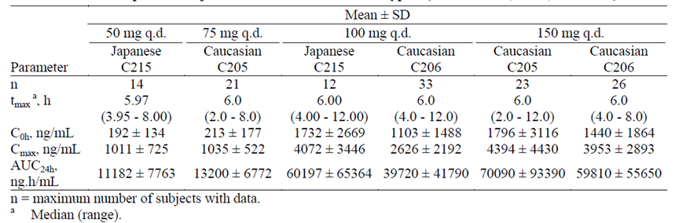
These findings were consistent with PPK estimates indicating that following 100 mg q.d. simeprevir, the median AUC_{24h} was 2.3- to 2.4-fold higher in Japanese HCV-infected subjects than in Caucasian HCV-infected subjects (Table 3 below). The median AUC_{24h} in Japanese subjects administered 50 mg q.d. simeprevir was similar to the median AUC_{24h} in Caucasian subjects administered 75 mg q.d. simeprevir. The median AUC_{24h} of Japanese subjects administered 100 mg q.d. simeprevir was between 18% lower and 1.2-fold higher than the median AUC_{24h} of Caucasian subjects administered 150 mg q.d.

Table 3: Individual posthoc population pharmacokinetic estimates of TMC435 after administration of TMC435 for 12 and 24 weeks in Caucasian and Japanese subjects infected with HCV Genotype 1 (Studies C205, C206, and C215)
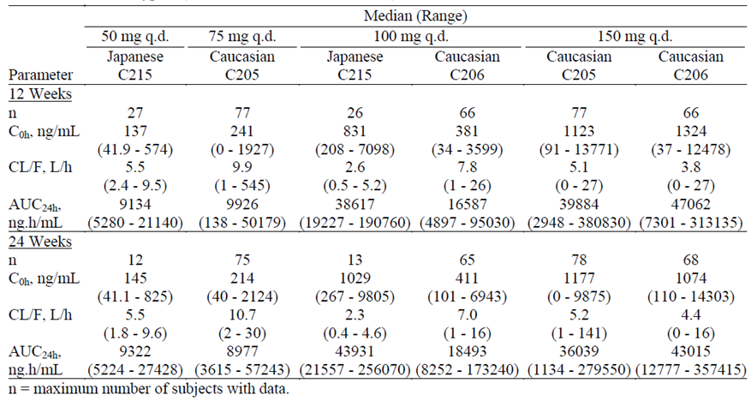
PPK estimates also indicated that, following administration of 100 mg q.d., simeprevir exposure was higher in healthy Chinese (2.2-fold) than in healthy Caucasian subjects. By contrast, no conclusions on the effect of race on subjects infected with HCV genotypes 2 to 6 could be made due to the small number of subjects in the racial sub-groups.
In a pooled analysis of the Phase III PPK estimates, which included data from Studies C208, C216, and HPC3007, the median exposure of simeprevir in Asian subjects, following administration of 150 mg q.d., was 5.7- to 6.4-fold higher than in other races (White, Black, or Other); however, the number of Asian subjects included in the analysis was low (N=14) and this result should be interpreted with caution.

Other factors
A number of other factors were also examined as covariates in the simeprevir Global PPK Study. These included: body weight, where the relative bioavailability and maximum elimination rate both increased with decreasing body weight; total bilirubin at baseline, where the maximum elimination rate decreased with increasing total bilirubin; and METAVIR score, where relative bioavailability was increased in subjects with a METAVIR score of 3 or 4 compared with subjects with a METAVIR score of 1 or 2. However, when these factors were examined in combination with other covariates the sponsor concluded that they had no clinically relevant effects on the PKs of simeprevir.

Pharmacokinetic interactions

Pharmacokinetic interactions demonstrated in human studies
A wide range of studies examined the potential for interaction between simeprevir and other drugs either likely to be used in combination or metabolised through similar pathways.
The first of these, Study C107, examined the CYP substrates responsible for the in vivo metabolism of simeprevir using a drug cocktail containing substrates for CYP3A (midazolam, administered orally and i.v. to investigate the effect on intestinal and hepatic CYP3A activity, respectively), CYP2D6 (dextromethorphan), CYP1A2 (caffeine), CYP2C19 (omeprazole), and CYP2C9 (warfarin). Based on the parent/metabolite ratios for AUC_{last} following co-administration with simeprevir relative to administration of the probe substrates alone, simeprevir was identified as a mild inhibitor of intestinal CYP3A activity and a mild CYP1A2 inhibitor. By contrast, simeprevir did not affect hepatic CYP3A activity and had no relevant effect on the activity of CYP2C9, 2C19, or 2D6.

CYP3A and P-gp inhibitors
Study C104 investigated the effect of steady-state ritonavir (RTV) on the PKs of simeprevir after the first and last dose of a multiple dosing regimen of simeprevir 200 mg q.d. administered alone and in combination with RTV 100 mg b.i.d. in healthy subjects. RTV is a protease inhibitor, which is used in the treatment of HIV and it is a potent CYP3A inhibitor and an inhibitor of P-gp and MRP2. Following co-administration of a single dose of both drugs, the mean Cmax and AUC_{24h} values for simeprevir were increased 1.30- and 1.83-fold, respectively, relative to administration of simeprevir alone. After multiple doses of simeprevir co-administered with RTV, the mean Cmax and AUC_{24h} values for simeprevir were increased 4.70- and 7.18-fold, respectively, relative to administration of simeprevir alone. The mean C0h and Cmin were increased 14.78- and 14.35-fold, respectively. By contrast, there was no change in the median Tmax of simeprevir. When co-administered with multiple doses of simeprevir for 7 days, the mean Cmin, Cmax, and AUC_{12h} values for RTV were higher (approximately 1.79-, 1.66- and 1.66-fold, respectively) relative to co-administration with a single dose of simeprevir.
Study C115 examined the effect of steady-state erythromycin on the steady-state PKs of simeprevir 150 mg q.d. in healthy subjects (Panel 1) and the effect of steady-state darunavir (DRV) and RTV on the steady-state PKs of simeprevir 50 mg q.d. in healthy subjects (Panel 2). Erythromycin is a macrolide antibiotic used to treat various bacterial infections, and is a moderate CYP3A inhibitor and a P-gp inhibitor. Darunavir is an HIV protease inhibitor used in the treatment of HIV-1 infections, and is a strong CYP3A inhibitor. In Panel 1 the mean Cmin, Cmax, and AUC_{24h} values for simeprevir were increased 12.74-, 4.53-, and 7.47-fold, respectively, when simeprevir was co-administered with erythromycin relative to administration of simeprevir alone. The median treatment difference for Tmax of simeprevir was 2.50 hours. The mean Cmin, Cmax, and AUC_{8h} values for erythromycin were increased 3.08-, 1.59-, and 1.90-fold, respectively, when erythromycin was co-administered with simeprevir relative to administration of erythromycin alone. There was no relevant change in the median Tmax of erythromycin. In Panel 2, the mean Cmin, Cmax, and AUC_{24h} values for simeprevir were increased 4.58-, 1.79-, and 2.59-fold, respectively, when simeprevir was co-administered with DRV/RTV relative to administration of simeprevir alone. The median Tmax of simeprevir was decreased by 1.0 hour. The mean Cmax and AUC_{24h} values for DRV were not affected by simeprevir co-administration. However, the mean Cmin of DRV was increased 1.31-fold, whereas, there was no relevant change in the median Tmax. The mean Cmin, Cmax, and AUC_{24h} values for RTV were increased 1.44-, 1.23-, and 1.32-fold, respectively, when DRV/RTV was co-administered with simeprevir relative to administration of DRV/RTV alone. By contrast, there was no change in the median Tmax of RTV.

CYP3A substrates and P-gp inhibitors
Study HPC1005 examined the effects of steady-state simeprevir on the steady-state PKs of BMS-790052 in healthy subjects and the steady-state BMS-790052 on the steady-state PKs of simeprevir in healthy subjects. BMS-790052 (daclatasvir) is an NS5A replication complex inhibitor in development for the treatment of chronic HCV infection currently in Phase III development. BMS-790052 inhibits replication of HCV genotypes 1a and 1b in a cell-based replication assay and is a CYP3A substrate and a P-gp inhibitor and substrate. The mean Cmin, Cmax, and AUC_{24h} values for simeprevir were increased 1.49-, 1.39-, and 1.44-fold respectively, when simeprevir was co-administered with BMS-790052 relative to administration of simeprevir alone. The mean Cmin, Cmax, and AUC_{24h} values for BMS-790052 were increased 2.68-, 1.50-, and 1.96-fold, respectively, when BMS-790052 was co-administered with simeprevir relative to when BMS-790052 was administered alone. There were no relevant changes in the median Tmax values of either simeprevir or BMS-790052 following co-administration.
Study C114 comprised 2 panels of healthy subjects. Panel 1 investigated the effect of steady-state simeprevir on the steady-state PKs of TMC278 (rilpivirine) and the effect of steady-state rilpivirine on the steady-state PKs of simeprevir. Panel 2 investigated the effect of steady-state simeprevir on the steady-state PKs of tenofovir and the effect of steady-state tenofovir on the steady-state PKs of simeprevir. Rilpivirine, a second-generation non-nucleoside reverse transcriptase inhibitor (NNRTI), and tenofovir disoproxil fumarate (TDF), a nucleotide reverse transcriptase inhibitor (NtRTI) are antiretroviral agents used in the treatment of HIV. Rilpivirine is a substrate of CYP3A. Tenofovir has been shown to be taken up by human OAT1 (hOAT1), hOAT3, and MRP4 and is also an inhibitor of MRP2. In Panel 1, the mean Cmin, AUC_{24h} and median Tmax values for simeprevir were not affected by rilpivirine co-administration. By contrast, the mean Cmax of simeprevir was increased 1.10-fold, and the upper limit of the 90% CI was just outside of the predetermined limit of 1.25. The mean Cmax, AUC_{24h} and median Tmax values for rilpivirine were not affected by simeprevir co-administration, whereas, the mean Cmin was increased by 1.25-fold. In Panel 2, in an exploratory analysis, which excluded 2 subjects due to considerably higher plasma concentration values, the 90% CIs of the LS means ratios of Cmin, and AUC_{24h} were within the 0.80 to 1.25 interval, while the lower limit of the CI of Cmax was just below the 0.80 limit. There was no relevant change in the median Tmax of simeprevir. The mean Cmin, Cmax, and AUC_{24h} values for tenofovir were increased 1.24-, 1.19-, and 1.18-fold, respectively, when TDF was co-administered with simeprevir relative to administration of TDF alone. There was no relevant change in the median Tmax of tenofovir.
Study C124 examined the effect of steady-state simeprevir (150 mg q.d.) on the steady-state PKs of ethinylestradiol (35 μg q.d.) and norethindrone (1 mg q.d.) in healthy female subjects. Ethinylestradiol is primarily metabolised by CYP3A and CYP2C9, and to a lesser extent by CYP2C8, and 2C19.In addition, ethinylestradiol is an inhibitor of CYP3A, 2B6, and 2C19. The metabolism of norethindrone is mediated via CYP3A. The mean Cmin, AUC_{24h} and median Tmax values for ethinylestradiol and norethindrone were not affected by simeprevir co-administration as the 90% CIs of the LS means ratios were within the 0.80 to 1.25 interval. The mean Cmax valuess of ethinylestradiol and norethindrone were increased by 1.18-and 1.24-fold, respectively.
Study HPC1006 examined the effect of steady-state simeprevir in healthy subjects on the single dose PKs of atorvastatin and its active metabolites ortho- and parahydroxylated atorvastatin and on the single dose PKs of simvastatin and the active metabolite simvastatin acid. Atorvastatin and simvastatin are hydroxy-3-methylglutaryl coenzyme A (HMG-CoA) reductase inhibitors used for the treatment of high blood cholesterol and are metabolised by CYP3A and are substrates of OATP1B1. The mean Cmin, Cmax, and AUC_{24h} values for simeprevir were slightly higher (1.02- to 1.16-fold) after co-administration of simeprevir with atorvastatin or simvastatin, whereas, there was no change in the median Tmax of simeprevir. The mean Cmax, AUC_{last}, and AUC_{inf} values for atorvastatin were increased 1.70-, 2.33-, and 2.12-fold, respectively, when simeprevir was co-administered with atorvastatin relative to administration of atorvastatin alone. There was no change in the median Tmax of atorvastatin. The mean Cmax and AUC_{last} values for the active orthohydroxylated metabolite of atorvastatin were increased 1.98- and 2.29-fold, respectively, when simeprevir was co-administered with atorvastatin relative to administration of atorvastatin alone. The median Tmax was increased by 2.00 hours following simeprevir co-administration. For the active parahydroxylated metabolite of atorvastatin, for the majority of the subjects, the entire PK profile was below the limit of quantification when atorvastatin was administered alone. When atorvastatin was co-administered with simeprevir, exposure (Cmax and AUC_{last}) of parahydroxylated atorvastatin was increased, and there was a 6.00 hour decrease in the median Tmax. The mean Cmax, AUC_{last}, and AUC_{inf} values for simvastatin were increased 1.46-, 1.54-, and 1.51-fold, respectively, when simeprevir was co-administered with simvastatin relative to administration of simvastatin alone , whereas, there was no relevant change in the median Tmax. The mean Cmax, AUC_{last}, and AUC_{inf} values for the active metabolite, simvastatin acid, were increased 3.03-, 2.40-, and 1.88-fold, respectively, when simeprevir was co-administered with simvastatin relative to administration of simvastatin alone, whereas, there was no change in the median Tmax.
Study C112 evaluated the effects of steady-state simeprevir in healthy subjects on the steady-state PKs of escitalopram (10 mg q.d.) and the effect of steady-state escitalopram on the steady-state PKs of simeprevir. Escitalopram is an antidepressant of the selective serotonin reuptake inhibitor class, which is metabolised by CYP3A and CYP2C19 in vitro. As treatment with PegIFN/RBV for HCV infection is associated with a high rate of depression the interaction with simeprevir was assessed. The mean Cmin, Cmax, and AUC_{24h} values for simeprevir were decreased by 32%, 20%, and 25%, respectively, when simeprevir was co-administered with escitalopram relative to administration of simeprevir alone, whereas, was no relevant change in the median Tmax of simeprevir. By contrast, the mean Cmin, Cmax, and AUC_{24h} values for escitalopram were unaffected by simeprevir co-administration.
Although methadone metabolism is variable and not fully understood, CYP3A and to a lesser extent CYP2D6 have been associated with methadone metabolism in vitro; therefore, Study C110 examined the effect of steady-state simeprevir (150 mg q.d.) on the steady-state PKs of R- and S-methadone and the effect of steady-state methadone on the steady-state PKs of simeprevir (150 mg q.d.) in otherwise healthy subjects on stable methadone maintenance therapy. The mean Cmin, Cmax, and AUC_{24h} values for simeprevir when co-administered with methadone were considerably lower compared with historical data from Study C107 (approximately 5.4- to 7.8-fold,), whereas, the median Tmax of simeprevir was 5 hours in both studies. By contrast, the Cmin, Cmax and AUC_{24h} values for R(−) methadone and S(+) methadone were not affected by co-administration of simeprevir; however, the Tmax values for R(−) methadone and S(+) methadone decreased by 1.0 h and 1.5 h, respectively.
As simeprevir is a mild inhibitor of intestinal CYP3A and cyclosporine and tacrolimus are extensively metabolised by CYP3A, Study C120 examined whether a PK interaction occurred when simeprevir and cyclosporine or tacrolimus were co-administered. Cyclosporine is a potent immunosuppressive agent that prolongs survival of allogenic transplants, including liver transplants. Tacrolimus is also an immunosuppressive agent and is known to prolong survival of the host and transplanted graft in a variety of animal transplant models, including liver transplant models. When cyclosporine was co-administered with simeprevir the mean Cmax and AUC_{last} values for cyclosporine were increased 1.16- and 1.19-fold, respectively, relative to administration of cyclosporine alone. By contrast, the mean Cmax and AUC_{last} values for tacrolimus were decreased by 24% and 17%, respectively, when tacrolimus was co-administered with simeprevir relative to administration of tacrolimus alone There were no changes in the median Tmax values for either cyclosporine or tacrolimus following co-administration with simeprevir.

CYP3A-inducers
Study HPC1001 examined the PK interaction between TMC647055 and simeprevir following 10 days of co-administration in subjects infected with CHC-genotype 1. TMC647055, a non-nucleoside inhibitor of the HCV NS5B polymerase in development for the treatment of CHC, is a CYP3A substrate, a moderate inducer of CYP3A at high concentrations and also shows weak inhibition potential towards CYP3A-mediated metabolism. When simeprevir was co-administered with TMC647055 for 6 days, relative to 1 day of co-administration, the mean Cmax and AUC_{24h} values for simeprevir were decreased by 44% and 60%, respectively. After 10 days of co-administration, the mean Cmax and AUC_{24h} values for simeprevir were decreased by 58% and 74%, respectively, relative to 1 day of co-administration. The median Tmax was decreased by 2.0 hours on Day 6 and Day 10 relative to Day 1. When TMC647055 was co-administered with simeprevir for 1 day, the mean Cmax and AUC_{12h} values for TMC647055 were increased 1.65- and 1.85-fold, respectively, relative to administration of TMC647055 alone. After 6 days of co-administration, the mean Cmax and AUC_{12h} values for TMC647055 were increased 1.45- and 1.87-fold, respectively, relative to administration of TMC647055 alone. The median Tmax was increased by 2.0 hours following 1 day of co-administration of TMC647055 and simeprevir and 1.5 hours following 6 days of co-administration of TMC647055 and simeprevir. The mean Cmax and AUC_{12h} values for TMC647055 after 6 days of co-administration with simeprevir were decreased 50% and 65%, respectively, relative to after 1 day of co-administration; Cmax and AUC_{12h} were decreased 64% and 77% after 10 days of co-administration relative to after 1 day of co-administration. There was no relevant change in the median Tmax of TMC647055.
Study C123 comprised two panels of healthy subjects. In Panel 1 the drug-drug interaction between simeprevir and efavirenz was assessed, whereas in panel 2, the PK interaction between simeprevir and raltegravir was examined. Efavirenz, an NNRTI, and raltegravir, a first-in-class integrase inhibitor, are antiretroviral agents used in the treatment of HIV. Efavirenz is an inducer of both CYP3A and CYP2B6 and an inhibitor of MRP2. The mean Cmin, Cmax, and AUC_{24h} values for simeprevir were decreased by 91%, 51%, and 71%, respectively, when simeprevir was co-administered with efavirenz relative to administration of simeprevir alone. There was no change in the median Tmax of simeprevir. By contrast, the mean Cmin, Cmax, and AUC_{24h} and median Tmax values for efavirenz were not affected by co-administration with simeprevir. The mean Cmin of simeprevir was decreased by 14% when simeprevir was co-administered with raltegravir relative to administration of simeprevir alone, whereas, the mean Cmax and AUC_{24h} and median Tmax values for simeprevir were not affected by co-administration. When raltegravir was co-administered with simeprevir the mean Cmin and AUC_{12h} values of raltegravir were increased 1.14- and 1.08-fold, respectively, relative to administration of raltegravir alone. By contrast, mean Cmax and median Tmax values of raltegravir were not affected by simeprevir co-administration.
Study C105 investigated the effect of steady-state rifampin on the PKs of simeprevir and the effect of simeprevir on the PKs of rifampin and its active metabolite, 25-desacetyl-rifampin in healthy subjects. Rifampin is an inducer of CYP enzymes including CYP3A and P-gp and is also a substrate and inhibitor of OATP1B1. The mean Cmin and AUC_{24h} values for simeprevir were decreased by 92% and 48%, respectively, when simeprevir was co-administered with rifampin relative to administration of simeprevir alone, whereas, the mean Cmax of simeprevir was increased 1.31-fold. There was no relevant change in the median Tmax of simeprevir. All individual C0h and Cmin values were below the LLOQ with and without simeprevir co-administration, whereas, the mean Cmax and AUC_{24h} values for rifampin and the mean Cmax values for 25-desacetylrifampin were unaffected by simeprevir co-administration. By contrast, the mean AUC_{24h} values for 25-desacetylrifampin was increased 1.24-fold when simeprevir was co-administered with rifampin relative to administration of rifampin alone. There was no change in the median Tmax of rifampin or 25-desacetylrifampin.

P-gp substrates
Study C108 examined the PK interactions between simeprevir and digoxin and simeprevir and rosuvastatin. Digoxin, a P-gp substrate, is a cardiac glycoside used clinically in the treatment of heart failure, whereas, rosuvastatin, an OATP1B1, OATP1B3, and BCRP substrate, is used clinically in the treatment of high blood cholesterol. When digoxin and simeprevir were co-administered, the mean Cmax and AUC_{24h} values for digoxin were increased 1.31- and 1.39-fold, respectively, relative to administration of digoxin alone. The mean Cmax and AUC_{24h} values for rosuvastatin were increased 3.17- and 2.81-fold, respectively, when rosuvastatin was co-administered with simeprevir relative to administration of rosuvastatin alone. By contrast, there was no relevant change in the median Tmax of either digoxin or rosuvastatin when the drugs were co-administered with simeprevir.

Other drugs likely to be used in combination
GS-5885 is an NS5A replication complex inhibitor in development for the treatment of HCV genotype 1 infection. Although GS-5885 does not inhibit or induce CYP enzymes and does not inhibit MRP2 or OATP1B1, potential drug-drug interactions between simeprevir and GS-5885 were investigated in Study GS-US-256-0129 as combinations of the two antiviral agents are expected to be used in the future. The mean Cmax and AUC_{24h} values for simeprevir were increased 2.61- and 2.69-fold, respectively, when simeprevir was co-administered with GS-5885 relative to when simeprevir was administered alone. The mean Cmax and AUC_{24h} values for GS-5885 were increased 1.81-, and 1.92-fold, respectively, when GS-5885 was co-administered with simeprevir relative to administration of GS-5885 alone. There were no relevant changes in the median Tmax values of either simeprevir or GS-5885 when the two drugs were co-administered.

Clinical implications of in vitro findings
Simeprevir metabolism in vitro was mainly catalysed by CYP3A enzymes and to a lesser extent by CYP2C8 and 2C19. In vitro drug transporter studies indicated that simeprevir is a substrate of P-gp, MRP2, BCRP, OATP1B1, OATP2B1, and OATP1B3

Population pharmacokinetic studies (PPK)
The evaluation materials contained 9 PPK studies. The most important of these was the Simeprevir Global PPK Study, which was a meta-analysis that included covariate analysis of simeprevir in two Phase II (C205 and C206) and three Phase III global trials (C208, C216 and HPC3007). Many of the results of this analysis are discussed in earlier sections of this report. The final base model consisted of a two-compartment model with first order absorption (with lag time), saturable clearance, described using Michaelis-Menten kinetics and a dose-dependent relative bioavailability (F1). When examined individually body weight (WT) was a statistically significant covariate for Vmax but not for F1. Moreover, age, sex and metavir score (MS) had an effect on F1 and total bilirubin (TB) on Vmax. F1 decreased with increasing WT and decreasing age, while Vmax decreased with increasing WT and increasing TB. Moreover, a higher F1 was observed for females versus males and subjects with MS score 3 or 4 versus lower scores. The impact of the identified covariate effects were then explored using simulations. However, when the individual covariates were examined in combination with other covariates the sponsor concluded that these factors had no clinically relevant effects on the PKs of simeprevir.
A number of studies examined the PK parameters of simeprevir using the empirical Bayesian estimation method. The first of these, Study C205-C206 PPK attempted to describe the PK behaviour of simeprevir following once daily administration in both treatment-naïve and treatment-experienced subjects based on the results of two Phase IIb studies (C205 and C206) and to identify possible covariates. Consistent with the findings of the non-compartmental analyses, the PPK estimates indicated that the exposure of simeprevir (based on C0h and AUC_{24h}) increased more than dose-proportionally. A 2-fold increase in simeprevir dose in Study C205 resulted in an approximately 4-fold increase in the median AUC_{24h}, whereas, in Study C206, a significant overlap in simeprevir exposures was observed following administration of simeprevir at 100 and 150 mg q.d. Treatment duration (12, 24, or 48 weeks) did not affect the estimated exposure of simeprevir.
Further PPK studies utilised Bayesian feedback analyses to examine and compare the C0h and AUC_{24h} of simeprevir in three individual Phase III studies (C208 PPK, C216 PPK and HPC3007). A pooled individual post-hoc analysis of population pharmacokinetic estimates for these 3 studies indicated that simeprevir exposure was similar across all 3 studies (Table 4 below).

Table 4: Pooled individual posthoc estimates of TMC435 pharmacokinetics after multiple-dose administration of TMC435 at 150 mg q.d. with PegIFN/RBV in subjects infected with HCV Genotype 1 (Studies C208, C216, and HPC3007
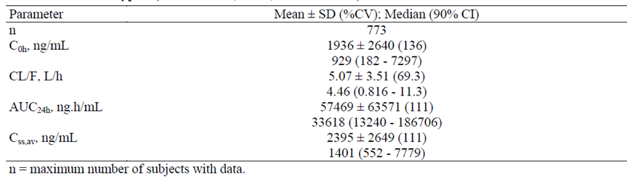
The estimates of the median simeprevir exposure in these studies were slightly lower than estimates of median simeprevir exposure for the Phase IIb studies (Study C205-C206 PPK). By contrast, in the global PPK analysis, the observed concentrations of simeprevir for the Phase II and Phase III studies were similar.
In subjects co-infected with HCV genotype 1 and HIV-1 (Study C212 PPK), the estimates for simeprevir exposure were slightly lower than the estimates in subjects infected with HCV genotype 1 without HIV-1 co-infection (Studies C208, C216 and HPC3007); however, due to the high inter-subject variability they were considered to be comparable.
Simeprevir exposure in subjects infected with HCV genotype 4 (Study HPC3011 PPK) appeared to be higher than estimates of simeprevir exposure in subjects infected with HCV genotype 1. However, as the number of subjects in Study HPC3011 PPK was relatively low compared with the pooled analysis, the sponsor believes that this finding should be interpreted with caution.
Two final PPK studies (Study C201-C205 PPK and Study C215 PPK) examined the relationship between bilirubin and simeprevir.

Evaluator’s overall conclusions on pharmacokinetics

PK in healthy subjects
- Following single, oral, 200 mg doses of either the Phase IIa (F007) or IIb (F020) capsule formulations in healthy subjects the median Tmax of simeprevir was 6.0 h and the mean t_{½} values were 10.5 h to 10.94 h, respectively.
- The absolute bioavailability of simeprevir is not known at this time.
- Note: The evaluator requests that, if Study C118 has now been completed, the sponsor provides details from this study regarding the absolute bioavailability of simeprevir.
- Relative to an oral solution formulation of simeprevir the Cmax and AUC_{inf} values for the Phase III trial formulation (G007) were 15% and 20% lower, respectively whereas, the shape of the simeprevir plasma concentration-time profiles were similar.
- No studies directly examined the bioequivalence of the various clinical trial formulations and the to-be-marketed formulation.
- The G007 capsule and the Phase IIb capsule (F021) were bioequivalent in regards to AUC and Cmax values and the median Tmax and mean t_{½} were similar (approximately 5.0 h and 9.4 h, respectively).
- The F007 and F020 capsules were bioequivalent following a 200 mg oral dose in healthy fed subjects.
- Although the F007 capsule formulation and F002 liquid formulation, which had been used in the early clinical studies, were bioequivalent in regards to Cmax, the LS ratio for AUC was just outside the lower bound of the level of bioequivalence.
- Following a 150 mg dose of the G007 capsule in healthy subjects the Cmax, AUC_{last} and AUC_{inf} values for simeprevir were 1.60-, 1.70-, and 1.69-fold higher, respectively, following a standard breakfast and 1.49-, 1.66-, and 1.61-fold higher, respectively, following a high-fat breakfast compared to the PKs under fasted conditions. Under fed conditions, Tmax was also shorter, with a treatment difference of 1.0 h observed after a high-fat breakfast and 1.5 h following a standard breakfast.
- In healthy, predominantly Caucasian subjects under fed conditions, the mean Cmax and AUC values for simeprevir increased with increasing dose; however, at higher doses the Cmax and AUC values increased more than dose-proportionally, e.g. from 100 to 200 mg there was approximately a 5-fold increase for both Cmax and AUC_{inf}. By contrast, the median Tmax was 5 or 6 hours across the dose range tested and the mean t_{½},_{term} was approximately 10 to 13 hours.
- The Cmin, Cmax, and AUC_{24h} values for simeprevir following administration for 5 days increased more than dose-proportionally, e.g. from 100 to 200 mg q.d. the mean AUC_{24h} increased approximately 4-fold on Day 1 and 10-fold on Day 5. On Day 5, the median Tmax was 4 hours for all dose groups. Mean t_{½,term} increased with dose for the q.d. dosing groups.
- No studies specifically examined the effect of administration timing on the PKs of simeprevir.
- The volume of distribution of the central compartment was estimated to be 38.4 L and for the peripheral compartment was 250 L.
- The in vitro binding of simeprevir to human plasma proteins was >99.9%, primarily human serum albumin
- In humans, irrespective of hepatic or renal function, the plasma protein binding of simeprevir was very high (> 99.9%).
- Blood to plasma ratios for total radioactivity were time-independent, with mean values ranging from 61% to 69% indicating that simeprevir did not bind to nor was it distributed to blood cells to any significant extent.
- The distribution of simeprevir into compartments other than the plasma has not been evaluated in humans, whereas in animals, the highest concentrations of simeprevir were observed in the gastrointestinal tract and liver
- In vitro studies indicated that the metabolism of simeprevir was low to moderate in human liver microsomes and hepatocytes. In vitro CYP reaction phenotyping of simeprevir metabolism demonstrated that simeprevir metabolism to the M18, M23, and M25 metabolites was mainly catalysed by CYP3A enzymes, although involvement of CYP2C8 and CYP2C19 could not be excluded.
- Almost all 14C-simeprevir-related radioactivity from a single 200-mg dose administered as an oral solution was excreted in faeces (approximately 91%). Unchanged simeprevir in faeces accounted for a mean of 31.0% of the administered dose.
- The major simeprevir-related circulating substance in plasma was unchanged drug and only one minor metabolite peak was observed, which represented metabolite M21.
- In faeces the most abundantly detected metabolites were M21 and M22 (mean of 25.9% of the dose; M21/M22 ratio of 60/40). Four other metabolites (M11, M16, M18, and M27) each accounted for >1% of the dose.
- The PKs of the simeprevir metabolites in plasma were not assessed.
- No meaningful differences in allele frequency were observed for 10 genes, including genes encoding for CYP enzymes and transporters involved in hepatic uptake and solute carrier family and elimination, and no marker was identified to explain the high inter-subject variability in simeprevir exposure.
- Simeprevir excreted in urine was very low, ranging from 0.009 to 0.138% of the dose.
- The inter-subject variability of simeprevir PKs is generally moderate to high, which the sponsor indicates reflects the non-linear drug disposition of simeprevir.

Target population
- Following 1 week of simeprevir monotherapy in treatment-naïve genotype 1 HCV-infected subjects a more than dose proportional increase in simeprevir plasma concentrations was observed for the dose increase from 75 mg to 200 mg q.d.
- Steady-state conditions were reached by Day 7 for simeprevir in treatment-naïve subjects.
- Following the initial simeprevir dose the mean Cmax and AUC_{24h} values for simeprevir were approximately 1.8- and 2.3-fold higher in treatment-experienced HCV-infected subjects than in healthy subjects. On Day 5, the mean Cmax and AUC_{24h} were approximately 1.9- and 2.6-fold higher in HCV-infected subjects relative to healthy subjects, respectively. The median Tmax was 4 hours in both groups. The mean accumulation ratios for AUC_{24h} were 3.16 and 3.45 for healthy subjects and HCV-infected subjects, respectively.
- In treatment-naïve, genotype 2 to 6 HCV-infected subjects, the PKs of simeprevir were consistent for genotypes 4, 5 and 6 with values previously reported for genotype 1 infected subjects, whereas a trend for lower exposure was observed in subjects infected with genotypes 2 and 3. The reason for these lower exposures is currently unknown.
- On day 1 following administration of simeprevir as either a monotherapy or in combination with PegIFNα-2a and RBV, Tmax occurred at 6 hours post-dose and the mean plasma concentration-time profiles obtained for simeprevir monotherapy were comparable to the profiles obtained for the combination therapy, especially when considering the inter-subject variability in plasma concentrations.
- When given in combination with PegIFN and RBV, simeprevir exposure was similar following both 12 and 24 weeks treatment.

Intrinsic factors
- Following administration of simeprevir at 150 mg q.d. in subjects with moderate hepatic impairment, the mean Cmax and AUC_{24h} values for simeprevir were 1.71- and 2.44-fold higher, respectively, relative to matched subjects with normal hepatic function.
- In subjects with severe hepatic impairment, the mean Cmax and AUC_{24h} values for simeprevir were 3.13- and 5.22-fold higher, respectively, relative to subjects with normal hepatic function.
- Following administration of simeprevir at 150 mg q.d. in subjects with severe renal impairment, the mean Cmin, Cmax, and AUC_{24h} values for simeprevir were increased 1.71-, 1.34-, and 1.62-fold, respectively, relative to matched subjects with normal renal function, whereas, the median Tmax was 6 hours for both treatment groups.
- PPK studies identified that age, sex, body weight, total bilirubin at baseline and METAVIR score were significant covariates for simeprevir exposure. However, when the covariates were examined in combination the simulated high and low extremes fell within the 90% prediction intervals of the whole study population. Moreover, the level of random variability in exposure of simeprevir was larger than the variation induced by the significant covariates.
- It must be noted that no studies have examined the PKs of simeprevir in paediatric subjects.
- Following multiple dosing of 100 mg q.d. simeprevir for 5 days in healthy subjects, the mean AUC_{24h} of simeprevir was 2.3- and 1.9-fold higher in Japanese and Chinese subjects, respectively than in a predominantly Caucasian population.
- Following multiple dosing in HCV-infected subjects with 100 mg q.d. simeprevir, the mean AUC_{24h} was 1.5-fold higher in Japanese than in Caucasian subjects.
- In a pooled analysis of the Phase III individual post-hoc PPK estimates, the median exposure of simeprevir in Asian subjects, following administration of 150 mg q.d., was 5.7- to 6.4-fold higher than other races (White, Black, or Other).
- Simeprevir is a mild inhibitor of intestinal CYP3A activity and a mild CYP1A2 inhibitor in healthy subjects, whereas, it did not affect hepatic CYP3A activity and had no relevant effect on the activity of CYP2C9, 2C19, or 2D6.

Extrinsic factors
- In vivo, simeprevir is both a substrate for and mild inhibitor of CYP3A as well as being a substrate for P-gp, MRP2, BCRP, OATP1B1, OATP2B1, and OATP1B3.
- Drug-drug interaction studies in healthy subjects clearly indicate that steady-state simeprevir exposure increases dramatically when simeprevir is co-administered with drugs that are moderate or strong inhibitors of CYP3A, which are also inhibitors of P-gp, such as erythromycin (Cmin increased by 12.74-fold) and ritonavir (Cmin increased by 14.35-fold). Simeprevir generally increased the exposure of other CYP3A inhibitors when the CYP3A inhibitors were co-administered with simeprevir.
- When simeprevir was co-administered with other CYP3A substrates, such as rilpivirine and ethinylestradiol, there was little to no effect on the PKs of simeprevir, nor were the PKs of the other CYP3A substrates unduly affected.
- When co-administered with daclatasvir, a CYP3A substrate and a P-gp inhibitor, there was a 1.5- to 2.68-fold increase in exposure to both drugs possibly suggesting that although co-administration with CYP3A substrates has little effect on the PKs of simeprevir, P-gp inhibitors may induce moderate increases in simeprevir exposure.
- When co-administered with HMG-CoA reductase inhibitors, such as atorvastatin and simvastatin, which are substrates for CYP3A and OATP1B1 there was little to no effect on the PKs of simeprevir, whereas simeprevir increased exposure to both atorvastatin and simvastatin and their active metabolites by 1.5- to 3.0-fold.
- CYP3A inducers, such as TMC647055, rifampin and efavirenz, significantly decrease simeprevir exposure by up to 90%, whereas simeprevir has little effect on the PKs of efavirenz and rifampin. By contrast, exposure to TMC647055, which is a moderate inducer of CYP3A at high concentrations, a CYP3A substrate and a weak inhibitor of CYP3A, increased by up to 1.87-fold when co-administered with simeprevir.
- Simeprevir co-administration increased exposure to P-gp substrates, inducing moderate increases in digoxin exposure (1.4-fold) and greatly increasing rosuvastatin exposure (approximately 3-fold). The effects of these drugs on the PKs of simeprevir are not reported.
- GS-5885, which does not inhibit or induce CYP enzymes, MRP2 or OATP1B1, increased simeprevir exposure by approximately 2.6-fold. Similarly, GS-5885 exposure was increased by approximately 1.8-fold when co-administered with simeprevir. This finding suggests that pathways other than those previously identified are in part responsible for the metabolism of simeprevir and that the PKs of other drugs that are not metabolised by these previously identified pathways may be affected by co-administration with simeprevir.
- Overall these drug-drug interactions are well documented in the proposed PI. However, if daclatasvir or GS-5885 are approved for marketing in the future a suitable caution should be included in the PI regarding interactions with these drugs. In addition, as GS-5885 does not appear to be metabolised by the same pathways as simeprevir a more general warning regarding the possible PK effects of simeprevir on non-CYP3A or P-gp metabolised drugs may need to be included in the PI.
- PPK studies indicated that the PKs of simeprevir could be characterised by a two-compartment model with first order absorption (with lag time), saturable clearance, described using Michaelis-Menten kinetics and a dose-dependent relative bioavailability (F1).
- Empirical Bayesian estimation methods indicated that simeprevir exposure (based on C0h and AUC_{24h}) increased more than dose-proportionally.
- In subjects co-infected with HCV genotype 1 and HIV-1, the estimates for simeprevir exposure were slightly lower than the estimates in subjects infected with HCV genotype 1 without HIV-1 co-infection.
- Simeprevir exposure in subjects infected with HCV genotype 4 appeared to be higher than estimates of simeprevir exposure in subjects infected with HCV genotype 1.

Pharmacodynamics

Studies providing pharmacodynamic data
Table 5 below shows the studies relating to each pharmacodynamic topic.

Table 5: Submitted pharmacodynamic studies.
PD Topic | Subtopic | Study ID | *
Primary Pharmacology | Effect on anti-viral activity | C101 | Anti-viral activity of simeprevir
Primary Pharmacology | Effect on anti-viral activity | C201 | Dose-dependency of anti-viral effect using 4 dosing regimens
Primary Pharmacology | Effect on sustained virological response | C205 | Sustained virologic response at Week 72 in treatment-naïve HCV infected subjects
Primary Pharmacology | Effect on sustained virological response | C206 | Proportion of treatment-experienced, HCV-infected subjects achieving SVR24
Secondary Pharmacology | Effect on QTc | C117 | Thorough QT study
Secondary Pharmacology | Effect on photosensitivity | C125 | Cutaneous photosensitizing potential of multiple doses
PD Interactions | Norethindrone and ethinylestradiol | C124 | Effect of simeprevir on hormone levels after co-administration of norethindrone and ethinylestradiol
PD Interactions | Atorvastatin and simvastatin | HPC1006 | HMG-CoA reductase inhibitory activity in the presence and absence of simeprevir
PD Interactions | Methadone | C110 | PD effects of concurrent use of simeprevir and methadone
PD Interactions | TMC647055 | HPC1001 | Anti-viral activity following the co-administration of TMC647055 and simeprevir
Population PD and PK-PD analyses | Target population | C208-C216 PPD | Multivariate analysis of prognostic factors
* Indicates the primary aim of the study.
§ Subjects who would be eligible to receive the drug if approved for the proposed indication.
‡ And adolescents if applicable.
None of the pharmacodynamic studies had deficiencies that excluded their results from consideration.

Summary of pharmacodynamics
The information in the following summary is derived from conventional pharmacodynamic studies in humans unless otherwise stated.

Mechanism of action
Simeprevir is an inhibitor of the HCV NS3/4A protease, which is essential for viral replication. In a biochemical assay, simeprevir inhibited the proteolytic activity of recombinant genotype 1a and 1b HCV NS3/4A proteases, with median Ki values of 0.5 nM and 1.4 nM, respectively.

Pharmacodynamic effects

Primary pharmacodynamic effects

Antiviral activity
Two Phase IIa studies examined the anti-viral activity of simeprevir as proof-of-principal studies. The first of these, Study C101 examined the anti-viral activity in 6 subjects infected with HCV genotype 1 who received simeprevir 200 mg q.d. for 5 days under fed conditions. Median log10 viral load was 6.75 log10 IU/mL at baseline. Sixteen hours after the first simeprevir intake, viral load values had decreased to 4.43 log10 IU/mL. At Day 6, viral load values were further decreased to 2.89 log10 IU/mL and remained low at Days 7 and 8 (2.98 and 3.04 log10 IU/mL, respectively). During follow-up, median log10 viral load values returned to levels observed before treatment.
Study C201 examined the dose-dependency of antiviral effect of simeprevir using 4 different dosing regimens ( 25 mg q.d., 75 mg q.d, 150 mg q.d., and 200 mg q.d.), given alone or in combination with PegIFNα-2a and RBV (standard of care [SOC] treatment) in treatment-naïve and treatment-experienced genotype 1 HCV-infected subjects for up to 28 days. Cohorts 1 and 2 of the study represented treatment-naïve patients. After 7 days monotherapy with simeprevir (Panel A), a clear dose-dependent antiviral activity was observed with greater mean changes in plasma HCV RNA levels (log10 IU/mL) with 200 mg simeprevir q.d. (-4.18) compared to 25 mg simeprevir q.d. (-2.63) and 75 mg simeprevir q.d. (-3.48). By contrast, following 7 days monotherapy with placebo, no change in mean plasma HCV RNA levels was observed: -0.08 in Cohort 1 and 0.30 in Cohort 2.
When SOC treatment was administered in combination with simeprevir from Day 1 onwards (Panel B), a greater mean change in plasma HCV RNA levels was observed on Day 7 compared to 1-week of simeprevir monotherapy in all simeprevir dose groups (25 mg q.d.; -3.47, 75 mg q.d.; -4.55, and 200 mg q.d.; -4.68) and the placebo group (-1.73 in Cohort 1 and -1.64 in Cohort 2). On Day 28 (Week 4), changes from baseline in HCV RNA in Panel B were -4.74, -5.52, and -5.44 in the 25 mg, 75 mg, and 200 mg simeprevir q.d. dose groups, respectively. Mean changes from baseline in plasma HCV RNA on Day 28 in the control group (placebo + SOC) were smaller compared to the simeprevir dose groups: -3.74 in Cohort 1 and -3.26 in Cohort 2.
In Panel B, the proportion of subjects achieving plasma HCV RNA levels < 25 IU/mL (detectable or undetectable) on Day 28 was 66.7%, 100%, and 100% in the 25 mg, 75 mg, and 200 mg simeprevir q.d. dose group, respectively, and 42.9% and 33.3% in the placebo group (i.e. SOC only group) of Cohort 1 and 2, respectively. The proportion of subjects with undetectable plasma HCV RNA on Day 28 (i.e., with RVR) was 33.3%, 88.9%, and 66.7% in the 25 mg, 75 mg, and 200 mg simeprevir q.d. dose group, respectively, and 28.6% in the placebo group of Cohort 1.
The presence of a Q80K mutation at baseline had no clear effect on the response to simeprevir treatment at doses of 75 mg and 200 mg q.d. at Week 4. Two out of 8 simeprevir-treated subjects with a Q80K mutation at baseline (both in the 25 mg simeprevir q.d. dose group) did not achieve < 25 IU/mL plasma HCV RNA levels on Day 28.
Viral breakthrough was observed in 10 (13.5%) subjects, whereas, viral breakthrough did not occur in the placebo groups (i.e. SOC only group). Five of the 10 subjects had viral breakthrough during the simeprevir/placebo treatment phase (2 subjects each in the 25 mg and 75 mg simeprevir q.d. dose group and 1 subject in the 200 mg simeprevir q.d. dose group). Nine out of 10 subjects with viral breakthrough had emerging mutations in the NS3 protease domain known to confer reduced susceptibility to simeprevir in vitro (mainly R155K and/or D168V or D168E). Viral relapse was observed in 4 out of 47 simeprevir-treated subjects who had undetectable plasma HCV RNA at EOT (i.e., 2, 1, and 1 subjects in the 25 mg, 75 mg, and 200 mg simeprevir q.d. dose groups, respectively). Three out of 4 simeprevir-treated subjects with viral relapse had emerging mutations in the NS3 protease domain. In the placebo groups, 2 out of 17 subjects with undetectable plasma HCV RNA at EOT had a viral relapse. The majority of subjects achieved SVR24 and no relevant difference was observed in SVR24 rate between the simeprevir dose groups (Panel A and B combined: 55.6%, 78.9%, and 66.7% in the 25 mg, 75 mg, and 200 mg simeprevir q.d. dose groups, respectively) and placebo groups (73.7%).
Cohorts 4 and 5 of Study C201 examined treatment-experienced HCV-infected subjects following 28 days of triple therapy. In Cohort 4, a dose-dependent reduction in plasma HCV RNA from baseline was observed on Day 28 (Week 4) with greater changes in plasma HCV RNA levels with 150 mg simeprevir q.d. (-5.46) and 200 mg simeprevir q.d. (-5.26) compared to with 75 mg simeprevir q.d. (-4.28), whereas, on Day 28, the mean change in plasma HCV RNA levels was smaller in the placebo group (-1.53) compared to the simeprevir dose groups.
On Day 28, the majority of subjects in the simeprevir dose groups of Cohort 4 achieved plasma HCV RNA levels < 25 IU/mL with a greater proportion of subjects in the 150 mg (77.8%) and 200 mg (70.0%) simeprevir q.d. dose groups than in the 75 mg simeprevir q.d. dose group (44.4%). Plasma HCV RNA levels < 25 IU/mL on Day 28 were not observed in any of the subjects in the placebo group (SOC only). The proportion of subjects with undetectable plasma HCV RNA on Day 28 (i.e., with RVR) was 22.2%, 55.6%, and 30.0% in the 75 mg, 150 mg, and 200 mg simeprevir q.d. dose groups, respectively.
In Cohort 5 (200 mg simeprevir q.d.), mean change from baseline in plasma HCV RNA on Day 28 was -5.86 log10 IU/mL and 3 out of 4 (75.0%) subjects who were treated for 4 weeks achieved RVR with the remaining subject achieving plasma HCV RNA levels < 25 IU/mL detectable.
The presence of a Q80K mutation at baseline had no clear effect on the response to simeprevir treatment at Week 4. Two out of 4 simeprevir-treated subjects with a Q80K mutation at baseline had < 25 IU/mL plasma HCV RNA levels on Day 28.
In Cohort 4, viral breakthrough during the entire trial period was observed in 11 simeprevir-treated subjects and in 1 subject in the placebo group. Three of the 11 simeprevir-treated subjects had viral breakthrough during the simeprevir/placebo treatment phase (2 subjects in the 75 mg simeprevir q.d. dose group and 1 subject in the 150 mg simeprevir q.d. dose group). Emerging mutations in the NS3 protease domain, were detected in 10 out of 11 simeprevir-treated subjects with viral breakthrough.
In Cohort 4, viral relapse was observed in 4 out of 15 simeprevir-treated subjects with undetectable plasma HCV RNA at EOT (i.e., 3 and 1 subjects in the 75 mg and 200 mg simeprevir q.d. dose groups, respectively). In the placebo group, all 3 subjects with undetectable plasma HCV RNA at EOT had a viral relapse. Emerging mutations in the NS3 protease domain were detected in 3 out of 4 simeprevir-treated subjects with viral relapse. One subject without emerging mutations in the NS3 protease domain at time of viral relapse had a R155K mutation at baseline.
In Cohort 5, viral breakthrough was observed in 1 subject during SoC treatment. This subject had emerging mutations in the NS3 protease domain. None of the 3 subjects with undetectable plasma HCV RNA at EOT in Cohort 5 had a viral relapse.
In Cohort 4, the SVR24 rate was higher in the 150 mg (33.3%) and 200 mg (50.0%) simeprevir q.d. dose groups than the 75 mg simeprevir q.d. dose group (11.1%). No subjects in the placebo group achieved SVR24. In Cohort 5, 3 out of 5 (60.0%) subjects achieved SVR24.

Sustained virological response
The primary endpoint of Study C205 was to examine the sustained virologic response at Week 72 (SVRW72 [i.e. subjects with undetectable plasma HCV RNA]) in treatment-naïve HCV genotype 1 infected subjects who had been administered either regimens of simeprevir in combination with PegIFNα-2a /RBV or receiving PegIFN/RBV in combination with simeprevir-matched placebo. In this study, the majority of subjects achieved SVRW72, and a larger proportion of subjects in the simeprevir treatment groups (70.7% to 84.8%) achieved SVRW72 compared with the placebo group (64.9%).
Part of Study C206 examined the proportion of treatment-experienced, genotype 1 HCV-infected subjects in each treatment group achieving SVR24, defined as having undetectable HCV RNA levels at the end of treatment and 24 weeks after the planned end of treatment, i.e., Week 72. In this study, subjects in groups 1 and 2 received 12 weeks of triple therapy with simeprevir at 100 or 150 mg q.d. plus PegIFN and RBV b.i.d., followed by 36 weeks of PegIFN/RBV and simeprevir-matched placebo, and 24 weeks of post-therapy follow-up. In groups 3 and 4, subjects received 24 weeks of triple therapy with simeprevir at 100 or 150 mg q.d. plus PegIFN/RBV, followed by 24 weeks of PegIFN/RBV and simeprevir-matched placebo, and 24 weeks of post-therapy follow-up. In groups 5 and 6, subjects received 48 weeks of triple therapy with simeprevir at 100 or 150 mg q.d. and 24 weeks of post-therapy follow-up. In group 7 (control group), subjects received 48 weeks of simeprevir-matched placebo plus PegIFN/RBV and 24 weeks of post-therapy follow-up. The majority of subjects treated with simeprevir achieved SVR24, and a larger proportion of subjects with SVR24 were observed in the simeprevir treatment groups (60.6% to 80.0%) compared with the placebo group (22.7%). A trend for higher SVR rates was observed in the 150-mg q.d. dose group compared with the 100-mg q.d. dose group in partial and null responders, as well as across multiple subgroups (including subjects with Q80K polymorphism, higher BMI, and advanced fibrosis). There was a trend for lower SVR in subjects infected with HCV genotype 1a compared to subjects with HCV genotype 1b.

Secondary pharmacodynamic effects

QT Interval
Study C117 was a thorough QT study, which examined the effect of therapeutic (150 mg q.d.) and supratherapeutic (350 mg q.d.) doses of simeprevir for 7 days on the QT/QTc interval and other ECG parameters in 60 healthy subjects. The largest upper limit of the 90% CIs of the differences between simeprevir and placebo in changes from baseline in QTcF on Day 7 was observed at 3 h post-dose for the 150 mg-dose (mean difference: 0.8 ms, 90% CI: [-1.26, 2.79]) and at 1 h post-dose for the 350 mg-dose (mean difference: 1.2 ms, 90% CI: [-0.95, 3.32]). By contrast, for moxifloxacin (400 mg) and placebo the largest change from baseline in QTcF on Day 7 was observed at 4 h (mean difference: 11.3 ms, 97.5% CI: [8.09, 14.49]). No consistent or clinically relevant changes over time were observed in HR, PR interval or QRS width. No differences were observed between treatment groups. This study indicates that supratherapeutic doses of simeprevir have no effect on QT interval.

Photosensitivity
Study C125 assessed the cutaneous photosensitizing potential of multiple oral daily doses of simeprevir 150 mg q.d. and compared it to that of ciprofloxacin 500 mg b.i.d (a known photosensitizing agent) in 36 healthy subjects. Mean phototoxicity indices were below the pre-defined limit of 2.0 at all wavebands tested, and on the solar simulator in the simeprevir and placebo groups, and were similar between simeprevir and placebo groups. By contrast, the mean phototoxicity index in the ciprofloxacin group reached 3.24 and 2.87 at the 335 ± 30 and 365 ± 30 nm wavebands, respectively (Study C125). Results of this study indicate that simeprevir does not act as a cutaneous photosensitizing agent.

Time course of pharmacodynamic effects
In Study C201 in treatment-naïve and experienced genotype 1 HCV-infected subjects, anti-viral response (measured as a decrease in HCV RNA levels) could be detected following 7-days of treatment for all simeprevir dose groups with anti-viral activity peaking following 28 days of dosing. By week 12, anti-viral response was similar or slightly lower than at the 28 day time point.

Relationship between drug concentration and pharmacodynamic effects

Primary
Study C201 indicated that there was no clear relationship between simeprevir exposure and change in plasma HCV RNA from baseline following triple therapy with simeprevir at 75 mg q.d. or higher doses in treatment-naïve and treatment-experienced subjects (i.e., 150 mg and 200 mg q.d. doses). In contrast, an exposure-response relationship was observed following simeprevir monotherapy for 1 week where higher exposures to simeprevir were associated with a greater decrease in plasma HCV RNA. In treatment-naïve and treatment-experienced subjects, a trend for mild increases from baseline in direct, indirect, and total bilirubin was observed with higher exposure to simeprevir. No consistent relationship was observed between simeprevir exposures and changes from baseline in ALP, AST or ALT.

Secondary
Results of studies C117 and C125 indicated that there was no relationship between simeprevir exposure and QT and simeprevir exposure and photosensitivity.

Genetic-, gender- and age-related differences in pharmacodynamic response
Study C208-C216 PPD was a multivariate modelling study, which attempted to identify baseline characteristics that were prognostic for RVR and SVR in treatment-naïve subjects treated with simeprevir and PegINF/RBV. This analysis identified that IL28B genotype and combination of HCV geno/subtype with baseline Q80K polymorphism were the most important baseline characteristics for predicting the probability of achieving SVR12. Whereas, in subjects treated with placebo and PegINF/RBV, IL28B genotype and baseline HCV RNA were the most important factors for predicting the probability of achieving SVR12. By contrast, combination of HCV geno/subtype with baseline Q80K polymorphism was not predictive of outcome.
RVR and meeting the RGT criteria were the most important on-treatment factors in predicting the probability of achieving SVR12, with or without considering baseline characteristics, suggesting that once a patient is on-treatment, the most important predictor for achieving SVR12 is on-treatment response to therapy.
This was confirmed by a multivariate analysis on SVR12 with baseline characteristics and on-treatment response at Week 4. Subjects with HCV RNA < 25 IU/mL at Week 4 had the highest probability of achieving SVR12, and subjects with HCV RNA > 25 IU/mL had the lowest probability of achieving SVR12.
Baseline characteristics combination of HCV geno/subtype with baseline Q80K polymorphism and IL28B genotype were important factors for predicting the probability of achieving RVR, achieving HCV RNA < 25 IU/mL at Week 4 and meeting the RGT criteria.
The direction of the effect of the important factors was consistent in all multivariate GAM analyses irrespective of the response parameter analysed, although the extent of the effect varied. More specifically, subjects with IL28B genotype CC, and to a lesser extent genotype CT had a higher probability of achieving (early) response than subjects with genotype TT. Also, with increasing baseline HCV RNA the probability of achieving (early) response decreased. Subjects with HCV geno/subtype 1b or HCV geno/subtype 1a without baseline Q80K polymorphism had a higher probability of achieving (early) response than subjects with HCV geno/subtype 1a and baseline Q80K polymorphism. Furthermore, subjects meeting the RGT criteria, who achieved RVR and/or having HCV RNA < 25 IU/mL at Week 4 had a high predicted probability of achieving SVR12.

Pharmacodynamic interactions

Norethindrone and ethinylestradiol
Study C124 examined the effect of steady-state concentrations of simeprevir 150 mg q.d. on hormone levels (progesterone, luteinizing hormone [LH], and follicle-stimulating hormone [FSH]) after co-administration with the combination of norethindrone and ethinylestradiol at steady-state in healthy female subjects. There was no relevant difference in the extent of decrease relative to baseline of FSH, LH, and progesterone serum levels when ethinylestradiol and norethindrone were administered alone or when co-administered with simeprevir.

Atorvastatin and simvastatin
Study HPC1006 examined HMG-CoA reductase inhibitory activity of atorvastatin (40 mg) and simvastatin (40 mg) in the presence and absence of steady-state simeprevir (150 mg q.d.) in healthy subjects. The mean Cmax and AUC12h values for HMG-CoA reductase inhibitory activity were increased 2.23- and 2.55-fold, respectively, when atorvastatin was co-administered with simeprevir relative to administration of atorvastatin alone. The mean Cmax and AUC12h values for HMG-CoA reductase inhibitory activity were increased 1.54- and 1.83-fold, respectively, when simvastatin was co-administered with simeprevir relative to administration of simvastatin alone. There was no change in the median Tmax of either atorvastatin or simvastatin when co-administered with or without simeprevir.

Methadone
Study C110 evaluated the potential PD effects of concurrent use of simeprevir and methadone, i.e., symptoms of methadone toxicity or withdrawal via pupillometry and the “Short Opiate Withdrawal” and “Desires for Drugs” questionnaires in opioid-dependent healthy subjects. One subject was observed with a withdrawal symptom (mild muscular tension), which emerged during methadone + simeprevir intake. Overall, craving for opiates was low during methadone + simeprevir intake. Changes, i.e., increases in one or more DDQ item scores were reported in 6 subjects (50.0%). These changes were generally mild (increase of 1 point) and not considered clinically relevant. No relevant changes in median resting pupil diameter (mm) were noted during the treatment period.

CYP3A-inducers
Study HPC1001 examined the antiviral activity following the co-administration of TMC647055, a CYP3A-inducer, and simeprevir, as measured by the change in HCV RNA over time, and compared it with the administration of each compounds alone. During TMC647055 monotherapy, a dose-dependent decrease in HCV RNA from baseline was observed in genotype 1a infected patients with a median maximum decrease in HCV RNA from baseline of 1.4 log10 IU/mL at 500 mg q12h and 2.4 log10 IU/mL at 1000 mg q12h. In genotype 1b infected patients, a potent antiviral activity was observed which was similar in the two doses tested: the median maximum decrease in HCV RNA from baseline was 3.3 log10 IU/mL at 500 mg q12h and 3.4 log10 IU/mL at 1000 mg q12h. No subjects in Panels 6 and 7 achieved HCV RNA levels < 25 IU/mL during or at the end of the 6-day dosing period. The combination of TMC647055 at 1000 mg q12h with simeprevir at 150 mg q24h, administered for 10 days to a population with a majority of genotype 1a infected patients (7 genotype 1a, 1 genotype 1b), substantially increased the antiviral activity with a median maximum decrease from baseline in HCV RNA of 4.67 log10 IU/mL, a continuous suppression of HCV RNA levels during dosing, and the ability to achieve HCV RNA levels below 25 IU/mL in 3 subjects at the end of the 10-day treatment period. No viral breakthroughs were observed. A similar antiviral activity was obtained in the genotype 1b infected subject (maximum decrease from baseline in HCV RNA: -4.83 log10 IU/mL) as compared to the genotype 1a infected subjects (range in maximum decrease from baseline in HCV RNA for genotype 1a: -3.99 to -5.32 log10 IU/mL).

Evaluator’s overall conclusions on pharmacodynamics
Simeprevir is an inhibitor of the HCV NS3/4A protease, which is essential for viral replication.

Primary PD

Antiviral-activity
- Following a single dose of simeprevir 200 mg q.d. under fed conditions in HCV genotype 1 infected subjects, viral load values decreased to 4.43 log10 IU/mL. Following 6 days of dosing, viral load values were further decreased to 2.89 log10 IU/mL and remained low at Days 7 and 8 (2.98 and 3.04 log10 IU/mL, respectively). During follow-up, viral load values returned to levels observed before treatment.
- After 7 days monotherapy with simeprevir, a clear dose-dependent antiviral activity was observed with greater mean changes in plasma HCV RNA levels (log10 IU/mL) with 200 mg simeprevir q.d. (-4.18) compared to 25 mg simeprevir q.d. (-2.63) and 75 mg simeprevir q.d. (-3.48). By contrast, following 7 days monotherapy with placebo, no change in mean plasma HCV RNA levels (log10 IU/mL) was observed: -0.08 in Cohort 1 and 0.30 in Cohort 2.
- When PegIFN/RBV were administered in combination with simeprevir, a greater mean change in plasma HCV RNA levels (log10 IU/mL) was observed on Day 7 compared to the 1-week simeprevir monotherapy for all simeprevir dose groups (25 mg q.d.; -3.47, 75 mg q.d.; -4.55, and 200 mg q.d.; -4.68) and the placebo group (-1.73 in Cohort 1 and -1.64 in Cohort 2). On Day 28, changes from baseline in HCV RNA (log10 IU/mL) were -4.74, -5.52, and -5.44 in the 25 mg, 75 mg, and 200 mg simeprevir q.d. dose groups, respectively. Mean changes from baseline in plasma HCV RNA (log10 IU/mL) on Day 28 in the control group (placebo + SoC) were smaller compared to the simeprevir dose groups: -3.74 in Cohort 1 and -3.26 in Cohort 2.
- The proportion of subjects achieving plasma HCV RNA levels < 25 IU/mL on Day 28 was 66.7%, 100%, and 100% in the 25 mg, 75 mg, and 200 mg simeprevir q.d. in combination with PegIFN/RBV dose groups, respectively, and 42.9% and 33.3% in the placebo in combination with PegIFN/RBV groups in Cohort 1 and 2, respectively.
- The presence of a Q80K mutation at baseline had no clear effect on the response to simeprevir treatment at doses of 75 mg and 200 mg q.d. at Week 4.
- Viral breakthrough was observed in 10 (13.5%) subjects, whereas, viral breakthrough did not occur in the placebo groups (i.e. PegIFN/RBV only group). Nine out of 10 subjects with viral breakthrough had emerging mutations in the NS3 protease domain known to confer reduced susceptibility to simeprevir in vitro (mainly R155K and/or D168V or D168E).
- Viral relapse was observed in 4 out of 47 simeprevir-treated subjects who had undetectable plasma HCV RNA at EOT (i.e., 2, 1, and 1 subjects in the 25 mg, 75 mg, and 200 mg simeprevir q.d. dose groups, respectively). Three out of 4 simeprevir-treated subjects with viral relapse had emerging mutations in the NS3 protease domain. In the placebo groups, 2 out of 17 subjects with undetectable plasma HCV RNA at EOT had a viral relapse.
- Following 28 days of administration of simeprevir in combination with PegIFN/RBV a dose-dependent reduction in plasma HCV RNA from baseline was observed with greater changes in plasma HCV RNA levels with 150 mg simeprevir q.d. (-5.46) and 200 mg simeprevir q.d. (-5.26) compared to with 75 mg simeprevir q.d. (-4.28). By contrast, on Day 28, the mean change in plasma HCV RNA levels were smaller in the placebo group (-1.53).
- On Day 28, the majority of subjects in the simeprevir dose groups achieved plasma HCV RNA levels < 25 IU/mL with a greater proportion of subjects in the 150 mg (77.8%) and 200 mg (70.0%) simeprevir q.d. dose groups than in the 75 mg simeprevir q.d. dose group (44.4%).
- Plasma HCV RNA levels < 25 IU/mL on Day 28 were not observed in any of the subjects in the placebo group (SOC only).
- In subjects treated with 200 mg simeprevir q.d. in combination with SoC, the mean change from baseline in plasma HCV RNA on Day 28 was -5.86 log10 IU/mL and 3 out of 4 (75.0%) subjects who were treated for 4 weeks achieved RVR with the remaining subject achieving plasma HCV RNA levels < 25 IU/mL detectable.

Sustained virological response (SVR)
- In subjects treated with the triple therapy (simeprevir/PegIFN/RBV) or placebo (placebo/PegIFN/RBV), a larger proportion of subjects in the simeprevir treatment groups (70.7% to 84.8%) achieved SVRW72 compared with the placebo group (64.9%).
- In subjects treated with the triple therapy (simeprevir/PegIFN/RBV) or placebo (placebo/PegIFN/RBV), a larger proportion of subjects with SVR24 were observed in the simeprevir treatment groups (60.6% to 80.0%) compared with the placebo group (22.7%).
- A trend for higher SVR rates was observed in the 150-mg q.d. simeprevir dose group compared with the 100-mg q.d dose group in partial and null responders, as well as across multiple subgroups (including subjects with Q80K polymorphism, higher BMI, and advanced fibrosis).
- There was a trend for lower SVR in subjects infected with HCV genotype 1a compared to subjects with HCV genotype 1b.

Secondary pharmacodynamic effects
- Supratherapeutic doses of simeprevir have no effect on QT interval.
- Simeprevir (150 mg q.d.) does not act as a cutaneous photosensitizing agent.

Time course of PD effects
- In treatment-naïve and experienced genotype 1 HCV-infected subjects, anti-viral response could be detected following 7-days of treatment and anti-viral activity peaked following 28 days of dosing. By week 12, anti-viral response was similar or slightly lower than at the 28 day time point.

Relationship between drug concentration and pharmacodynamic effects
- There was no clear relationship between simeprevir exposure and change in plasma HCV RNA from baseline following triple therapy with simeprevir at 75 mg q.d. or higher doses in treatment-naïve and treatment-experienced subjects (i.e., 150 mg and 200 mg q.d. doses).
- In contrast, an exposure-response relationship was observed following simeprevir monotherapy for 1 week where higher exposures to simeprevir were associated with a greater decrease in plasma HCV RNA.
- In treatment-naïve and treatment-experienced subjects, a trend for mild increases from baseline in direct, indirect, and total bilirubin was observed with higher exposure to simeprevir. No consistent relationship was observed between simeprevir exposures and changes from baseline in ALP, AST, or ALT.
- There was no relationship between simeprevir exposure and QT and simeprevir exposure and photosensitivity.

Prognostic factors for determining PD effectiveness
- In subjects treated with simeprevir and PegINF/RBV, IL28B genotype and combination of HCV geno/subtype with baseline Q80K polymorphism were the most important baseline characteristics for predicting the probability of achieving SVR12.
- Combination of HCV geno/subtype with baseline Q80K polymorphism was not predictive of outcome.
- RVR and meeting the RGT criteria were the most important on-treatment factors in predicting the probability of achieving SVR12.
- Baseline characteristics combination of HCV geno/subtype with baseline Q80K polymorphism and IL28B genotype were important factors for predicting the probability of achieving RVR, achieving HCV RNA < 25 IU/mL at Week 4 and meeting the RGT criteria.

Pharmacodynamic interactions

Norethindrone and ethinylestradiol
Co-administration of steady-state concentrations of simeprevir (150 mg q.d.) had no effect on norethindrone and ethinylestradiol induced changes in FSH, LH, and progesterone serum levels.

Atorvastatin and simvastatin
The mean Cmax and AUC12h values for HMG-CoA reductase inhibitory activity were increased 2.23- and 2.55-fold, respectively, when atorvastatin was co-administered with steady state simeprevir relative to the PD effects of atorvastatin when given alone.
The mean Cmax and AUC12h values for HMG-CoA reductase inhibitory activity were increased 1.54- and 1.83-fold, respectively, when steady-state simvastatin was co-administered with simeprevir relative to the PD effects of simvastatin when given alone.

Methadone
Co-administration of simeprevir with methadone had little to no effect on craving for opiates, DDQ item scores and median resting pupil diameter.

TMC647055
Co-administration of TMC647055 (1000 mg q12h) and simeprevir (150 mg q24h) for 10 days to a population with a majority of genotype 1a infected patients (7 genotype 1a, 1 genotype 1b), substantially increased the antiviral activity compared to monotherapy with TMC647055, provided a continuous suppression of HCV RNA levels during dosing, and reduced HCV RNA levels below 25 IU/mL in 3 subjects. No viral breakthroughs were observed.

Dosage selection for the pivotal studies

Study C205

Study design and objectives
This was a Phase 2b, randomised, 5-arm, double-blind, placebo-controlled study of different regimens of TMC/PR versus PR alone in treatment-naïve patients with HCV genotype 1 infection. It was conducted from May 2009 to April 2011 at 79 sites in 13 countries. In total, 506 patients were screened, 388 were randomised and 386 were treated. There was a RGT 24-48 week (TMC/PR) or 48 week (PBO/PR) treatment period with a follow-up period of up to 72 weeks. The primary endpoint was the proportion of patients in each group achieving SVR at Week 72. Patients were randomised to one of five treatment arms:
- TMC12/PR24 75 mg arm: 12 weeks TMC 75 mg QD plus PR followed by PBO/PR for 12 weeks and 48 weeks post-therapy follow-up.
- TMC24/PR24 75 mg arm: 24 weeks TMC 75 mg QD plus PR with 48 weeks post-treatment follow-up.
- TMC12/PR24 150 mg arm: 12 weeks TMC 150 mg QD plus PR followed by PBO/PR for 12 weeks and 48 weeks post-therapy follow-up.
- TMC24/PR24 150 mg arm: 24 weeks TMC 150 mg QD plus PR with 48 weeks post-treatment follow-up.
- Control arm: 48 weeks of PR with TMC placebo for the first 24 weeks followed by 24 weeks of post-therapy follow-up.
The study schematic is shown below in Figure 1.
Figure 1: Study C205 schematic
In total, 92.5% of the patients completed the study. In the 7.5% of patients who discontinued the study early, the most common reasons were loss to follow-up and withdrawal of consent. Overall, the baseline disease characteristics were comparable across treatment groups. The median baseline log10 HCV RNA level was 6.58 IU/mL (range 3.5-8.1) and the majority of patients (85.8%) had HCV RNA >800,000 IU/mL. At baseline, 11.7% of the patients had Metavir score F0, 40.9% had Metavir score F1, 33.4% had Metavir score F3 and one patient had Metavir score F4. At baseline, 57.5% of patients had an increased ALT of any grade. IL28B CC, CT and TT genotypes were present in 29.8%, 58.0% and 12.2% of patients, respectively.

Efficacy results
The majority of patients achieved SVR72 with higher proportions in the TMC groups compared with the control groups. Overall, similar SVR24 rates were observed between the different TMC doses (75 mg and 150 mg) and the different TMC treatment duration groups (12 or 24 weeks). SVR72 rates in the pooled TMC 150 mg QD and placebo groups were statistically significant (p<0.025) but the difference between the pooled TMC 75 mg and placebo groups did not achieve statistical significance (p=0.051). There were no meaningful differences in response rates between the TMC 12, 24 and 72 week treatment duration groups. There were trends towards higher SVR24 rates in the TMC 150 mg dose groups compared to the 75 mg dose groups among patients infected with HCV genotype 1a (66.7% versus 55.0%), among patients with Metavir score F3 (75% versus 63.0%), among patients aged >45 years (82.1% versus 70.4%), among patients with BMI ≥30 kg/m² (90.0% versus 66.7%), among male patients (86.2% versus 75.9%) and among Black patients (100% versus 60.0%). A higher SVR24 rate was also achieved by patients in the 150 mg dose groups compared to the 75 mg dose groups (81.8% versus 54.5%) and in patients with <25 IU/mL HCV RNA detectable at Week 4 who met RGT criteria and subsequently completed their planned 24 week treatment period. SVR24 rates were 83.9%, 78.1% and 50% for patients with IL28B CC, CT and TT genotypes in the pooled TMC 75 mg group, respectively. In the pooled TMC 150 mg treatment group, the SVR24 rates were 97.1%, 80.0% and 66.7% for the CC, CT and TT genotypes, respectively. Viral breakthrough occurred in 5.2% of the placebo arm compared with 2.5% to 7.8% in the TMC/PR groups. Viral relapse occurred in 11.8% of all TMC patients with undetectable HCV RNA at end of treatment compared with 17.7% of placebo patients.
Comment: This was a well-designed study with adequate treatment-naïve patient numbers to detect meaningful differences between a range of TMC dose and time treatment regimens. The majority of patients in each treatment group achieved SVR, and the SVR12, SVR24 and SVR72 rates were similar in the TMC groups. There were no major differences in efficacy between TMC 75 mg and 150 mg doses or duration in treatment although there were some trends in favour of the 150 mg dose. TMC was generally well tolerated and the data support use of the TMC 150 mg dose for 12 weeks in the Phase 3 studies.

Study C206

Study design and objectives
This was a Phase 2b, randomised, 7-arm, double-blind, placebo-controlled study comparing the efficacy and safety of different regimens of TMC/PR in patients with HCV genotype 1 infection who had failed at least one previous course of PR therapy. It was conducted from September 2009 to August 2011 at 89 sites in 14 countries. In total, 463 patients were randomised and 462 were treated. There was a 48 week treatment period with a follow-up period of up to 72 weeks. Patients were randomised 1:1:1:1:1:1:1 to one of 7 treatment arms. Randomisation was stratified by HCV genotype 1 subtype (1a, 1b, and other) and previous response to PR (null responders, partial responders, and relapsers).
- TMC12PR48 100 mg arm : 12 weeks TMC 100 mg QD plus PR followed by 36 weeks of PBO/PR (N=66)
- TMC12PR48 150 mg arm: 12 weeks TMC 150 mg QD plus PR followed by 36 weeks of PBO/PR (N=65)
- TMC24PR48 100 mg arm: 24 weeks TMC 100 mg QD plus PR followed by 24 weeks of PBO/PR (N=66)
- TMC24PR48 150 mg arm: 24 weeks TMC 150 mg QD plus PR followed by 24 weeks of PBO/PR (N=66)
- TMC48PR48 100 mg arm: 48 weeks TMC 100 mg QD plus PR (N=68)
- TMC48PR48 150 mg arm: 48 weeks TMC 150 mg QD plus PR (N=65)
- Control arm: 48 weeks of PBO/PR therapy (N=66)
The study schematic is shown below in Figure 2.

Figure 2: Study C206 schematic
In total 91.6% of patients completed the study and 8.4% discontinued. The majority of patients (>70%) in each TMC treatment group and 39.4% in the placebo group completed 48 weeks of treatment. The main reasons for discontinuation were withdrawal of consent (4.5%) and loss to follow-up (2.6%). Baseline and disease characteristics were comparable across treatment group. The median baseline HCV RNA level was 6.60 log10 IU/mL (range 3.5-7.7) and the majority of patients (86.4%) had HCV RNA >800,000 IU/mL. At baseline, 18.9% of patients had Metavir score F3 and 18.2% had Metavir score F4. At baseline. IL28B CC, CT and TT genotypes were present in 17.7%, 64.6% and 17.7% of patients, respectively.

Efficacy results
The majority of patients achieved SVR24, the primary endpoint with higher proportions in the TMC groups compared with the control group. In the TMC treatment arms, SVR24 was achieved in 69.7%, 66.2%, 60.6%, 66.7%, 72.1% and 80% in the TMC12PR48 100 mg, TMC24PR48 100 mg, TMC48PR48 100 mg, TMC12PR48 150 mg, TMC24PR48 150 mg and TMC48PR48 150 mg treatment arms, respectively. SVR24 was achieved in 22.7% of the control arm with a treatment difference in favour of TMC observed in prior null responders, partial responders and relapsers. The differences in SVR rates between the pooled TMC 100 mg and 150 mg groups and the placebo group were each statistically significant (p<0.025). The differences in SVR rates in each individual TMC treatment group were also statistically significant (p<0.017). All but one patient who achieved SVR24 also achieved SVR12. Overall, similar SVR rates were observed between the different TMC doses (100 mg and 150 mg) and the different TMC treatment duration groups (12, 24 or 48 weeks). There was a trend to higher SVR rates in null and partial responders treated with TMC 150 mg compared to 100 mg. There were no consistent differences between the different TMC treatment durations. Subgroup analyses showed that SVR rates and on-treatment virologic response rates were higher in the TMC arms compared with placebo independent of HCV genotype and subtype and Metavir score. Within each IL28B genotype, higher response rates were observed in the TMC arms compared with placebo. Overall, virologic failure occurred in 13.8% to 30.3% in the TMC groups compared with 72.7% in the placebo group. Viral breakthrough occurred in 7.7% to 13.8% in the TMC groups compared with 1.5% in the placebo group.
Comment: This was a well-designed study with adequate patient numbers to allow meaningful comparison of different TMC dose and treatment durations in patients who failed on previous PR treatment. A response guided optional TMC12PR24/48 arm was not included, presumably because low SVR rates were predicted after 24 weeks PR therapy. SVR24 rates were seen in all TMC treatment groups compared to placebo irrespective of whether the patients were previous null or partial responders, or relapsers. A trend for higher SVR24 rates was seen in the TMC 150 mg group compared with the TMC 100 mg group. TMC was generally well tolerated and the data support use of TMC 150 mg in Phase 3 trials in treatment- experienced patients.

Clinical efficacy

Treatment of HCV G1 infected patients

Pivotal efficacy studies

Study C208 (QUEST-1)

Study design, objectives, locations and dates
The study commenced in January 2011 and it was still on-going at the cut-off date for the primary analysis (October 2012). At the time of the primary analysis, all randomised patients had completed the Week 60 visit or discontinued earlier. At the time of the analysis, 22.8% of patients had completed the study at Week 72. It was conducted at 71 sites in 13 countries (Australia, Canada, Germany, Italy, Mexico, New Zealand, Puerto Rico, Romania, Russia, Spain, Ukraine, UK and USA). It was a multi-centre, Phase 3, randomised, double-blind, parallel-group, controlled trial of simeprevir (TMC435, TMC) 150 mg or placebo combined with PR (PegIFN/RBV) in treatment-naïve, HCV G1 infected patients with compensated liver disease including cirrhosis. The primary objective was to demonstrate the superiority of TMC versus placebo measured as the proportion of patients with SVR after 12 weeks treatment. The study schema is shown below in Figure 3.
Figure 3: Study C208 (QUEST-1) schematic
There was a screening period of up to 6 weeks followed by a response-guided treatment (RGT) period of 24 or 48 weeks (TMC group) or 48 weeks (control group), and a follow-up period for up to 72 weeks following the start of treatment. A total of 375 patients were planned to receive TMC or placebo in a randomised 2:1 ratio, stratified by genotypic subgroup and IL28B genotype. Patients were to receive TMC 150 mg or placebo QD plus PR for 12 weeks followed by PR for a further 12 weeks. As part of a RGT duration, HCV therapy was to be stopped at Week 24 in the TMC group when they achieved HCV RNA levels <25 IU/mL (detectable or undetectable) at Week 4 and <25 IU/mL undetectable HCV RNA levels at Week 12. All other patients in the TMC and control groups were required to continue PR until Week 48, unless virologic stopping rules or discontinuation criteria were met. Sparse blood sampling was performed in all patients for population PK analyses.

Inclusion and exclusion criteria
The key inclusion criteria were males or females aged ≥18 years; liver biopsy performed within 3 years prior to screening; no evidence of HCC; HCV G1 infection; plasma HCV RNA >10,000 at screening; and no prior treatment with approved or investigational HCV drugs. Key exclusion criteria were evidence of hepatic decompensation; any liver disease of non-HCV aetiology; infection or co-infection with HCV non-G1; co-infection with HIV-1 or HIV-2; co-infection with HBV; medical contra-indications to PR therapy; history of malignancy within 5 years; platelet count <90,000 mm³; ANC <1,500 cells/mm³; haemoglobin below LLN; creatinine >1.5 mg/dL; ALT and/or AST >10xULN; total serum bilirubin >1.5xULN; AFP >50 ng/mL; clinically significant concomitant medical conditions; and drug or alcohol abuse.

Study treatments
Study treatments were TMC 150 mg capsules given orally QD or matching placebo. PegIFNα-2a and RBV were given as Pegasys and Copegus, respectively, with dosage based on body weight according to the manufacturer’s PI. Dose adjustments or treatment interruptions of PegIFNα-2a and RBV were permitted for tolerability and toxicity issues.

Efficacy variables and outcomes
The main efficacy variables were:
- Changes in HCV RNA levels with time
- Resistance determinations
The primary efficacy outcome was the proportion of patients in each treatment group achieving SVR at 12 weeks after the planned end of treatment (SVR12), defined as having HCV RNA <25 IU/mL undetectable at the end of treatment and HCV RNA <25 IU/mL detectable or undetectable 12 weeks after the planned end of treatment.
Other efficacy outcomes included:
- SVR at Week 24 (SVR24)
- SVR at Week 72 (SVR72)
- the incidence of on-treatment failure in the TMC and control groups
- the relapse rate following treatment in the TMC and control groups
- the viral NS3/4A sequence in patients not achieving SVR in the TMC group
- the relationship between PK and efficacy and safety parameters

Randomisation and blinding methods
Central randomisation was implemented using IWRS/IVRS. Patients were randomly assigned to TMC or placebo in a 2:1 ratio and block stratified by HCV genotype subtype (1a, 1b, or other) and IL28B genotype. The investigators were blind to the randomisation schedule but emergency unblinding was permitted.

Analysis populations
The analysis population was the ITT set defined as all randomised patients who took at least one dose of investigational drug. A PP analysis on the primary endpoint was mandated if more than 10% of patients had major protocol deviations.

Sample size
The primary efficacy endpoint was SVR12, defined as undetectable HCV RNA levels at the end of treatment and HCV RNA <25 IU/mL 12 weeks after the planned end of treatment. Sample size calculations were based on the TMC Phase 2b studies and published telaprevir and boceprevir Phase 3 study data. Based on published data, SVR24 in the control group was expected to be approximately 45%. With 125 patients in the control group and 250 patients in the TMC group, the study had >90% power to detect a difference of at least 20% between groups.

Statistical methods
The statistical analyses were performed using SAS version 9.1. The primary analysis compared SVR12 rates in the two treatment groups using the Cochran-Mantel-Haenszel test controlling for the stratification factors. The 95% CI was constructed around the response rate in each group. A sensitivity analysis was also performed using a logistic regression model. Additional sensitivity analyses were performed by applying imputation rules for missing data. Other efficacy parameters were analysed by descriptive statistics, frequency tabulations, cross-tabulations, Kaplan-Meier estimates, ANOVA, logistic regression and mixed models.

Participant flow
A total of 394 patients were included in the ITT, 130 in the placebo group and 264 in the TMC group. At the interim lock date, 90 (22.8%) patients in the total group had completed Week 72 and 273 (69.3%) patients were still ongoing. In the placebo group, 10 (7.7%) of patients had discontinued, mainly lost to follow-up. In the TMC group, 21 (8%) patients had discontinued, due mainly to withdrawal of consent or lost to follow-up. Details are shown in Figure 4.
Figure 4: Study C208 Subject disposition
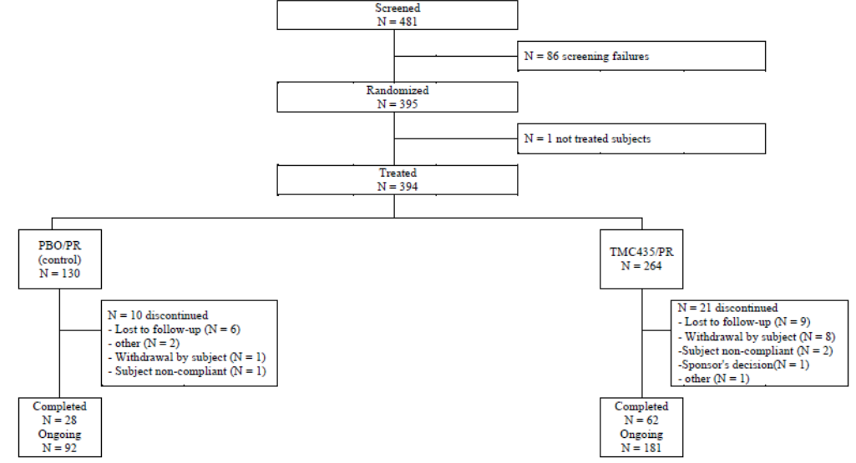

Major protocol violations/deviations
Overall, 14 (3.6%) patients had major protocol violations at 12 weeks (3.8% placebo, 3.4% TMC). There were no significant differences between the treatment groups. In the TMC/PR arm, 99.1% of patients who completed treatment were ≥97% compliant with the planned dose of TMC, 79.4% to the planned dose of RBV and 81.7% to the planned dose of PegIFN. In the PBO/PR treatment arm, 95.6% of patients who completed treatment were ≥97% compliant with the dose of TMC placebo, 79.7% to the planned dose of RBV and 91.1% to the planned dose of PegIFN.

Baseline data
Baseline demographics are shown in Table 6.

Table 6: Study C208 Demographic Characteristics; Intent-to-treat
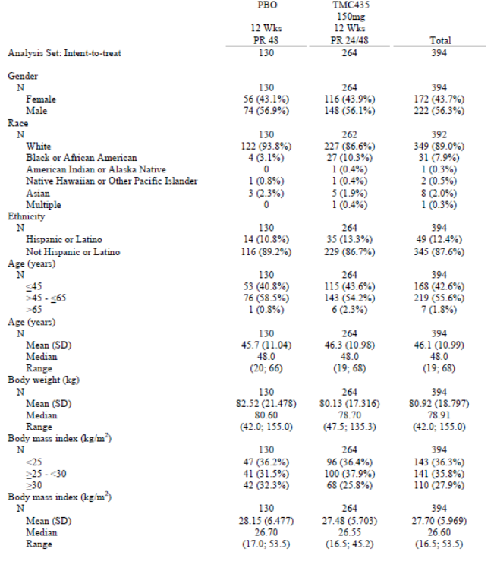
The majority of patients were male (56.3%) and White (89.0%). There were more Black patients in the TMC group (10.3%) than in the control group (3.1%). The median age was 48.0 years (range 19-68) and the median BMI was 26.6 kg/m². Overall, the median log10 plasma HCV RNA at baseline was 6.48 IU/mL (range 1.4-7.6) and the majority (79.7%) had high baseline HCV RNA defined as HCV RNA >800,000 IU/mL. All patients had HCV G1 infection (56.1% 1a, 43.9% 1b) with a median time since diagnosis of 3.3 years (range 0.2-35.5). At baseline, 43.1% had a Metavir fibrosis score F0 or F1, 26.9% had Metavir score F2, 17.7% had Metavir score F3, and 12.3% had Metavir score F4. At baseline, ALT elevations, mainly grade 1 and 2, were present in 62.7% of patients. The genotypic stratification factors were evenly balanced in the two treatment groups.

Results for the primary efficacy outcome
In the primary ITT analysis (CMH), the proportion of patients with SVR12 was 79.5% (95% CI: 74.7, 84.0) in the TMC/PR group compared with 50.0% (95% CI: 42.1%, 58.1) in the PBO/PR group. The treatment difference in favour of the TMC/PR group was 29.3% (95% CI: 20.1, 38.6, p<0.001). Similar response rates were observed in a sensitivity logistic regression analysis. The difference in proportions in favour of the TMC/PR group was 34.6% (95% CI: 23.7, 45.6, p<0.001). The proportions adjusted for stratification factors including HCV genotype or subtype and IL28B status did not affect the treatment difference p-values. SVR12 was not achieved in 20.5% of patients in the TMC/PR group compared with 50.0% in the PBO/PR group. SVR12 was not achieved most commonly because of detectable HCV RNA at the end of treatment (9.1% TCM/PR, 33.8% PBO/PR).

Results for other efficacy outcomes
The treatment duration with PegIFN/RBV (24 or 48 weeks) was guided by RGT criteria based on HCV RNA results. The majority of patients in the TMC/PR group (84.8%) met the RGT criteria of whom 90.6% achieved SVR12. In patients who had HCV RNA <25 IU/mL undetectable at Week 4, 92.3% achieved SVR12. In the group of patients with HCV RNA <25 IU/mL detectable at Week 4, 78.6% achieved SVR12. Most patients (97.8%) in the TMC/PR group who met the RGT criteria completed treatment with PegIFN and/or RBV at Week 24 and the overall SVR12 rate was 91.8%. Patients with undetectable HCV RNA at Week 4 had higher SVR12 rates (93.7%) than completers with HCV RNA <25 IU/mL detectable at Week 4 (78.6%). A total of 28 patients in the TMC/PR group did not meet the RGT criteria. In this group, SVR12 was achieved by 6/11 (54.5%) of the patients who completed treatment with PegIFN and/or RBV at Week 48.
The SVR4, SVR24 and SVR72 rates are shown in Table 7.

Table 7: Sustained virologic response at 4 and 24 weeks after the planned end of treatment (SVR4 and SVR24) and at week 72 (SVRW72) – Stratified Cochran-Mantel-Haenszel approach – Intent-to-treat
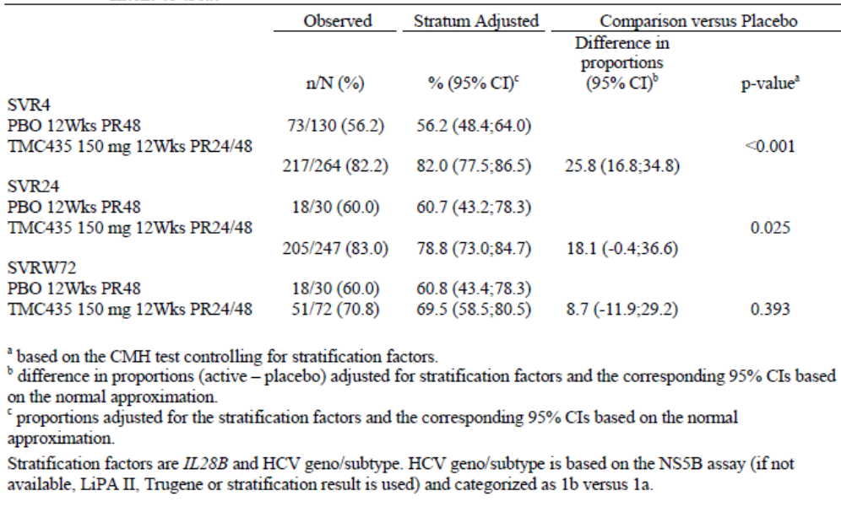
SVR24 rates were available for 247 of the 264 patients in the TMC/PR group but only 30 of 130 patients in the PBO/PR group (all patients in the TMC/PR group have met the RGT criteria compared with a smaller proportion in the PBO/PR group). The proportion of patients achieving SVR24 was 83.0% in the TMC/PR group compared with 60.0% in the PBO/PR group. The adjusted difference between treatment groups was 18.1% (95% CI: -0.4, 36.6). SVR4 was achieved by 82.2% of patients in the TMC/PR group versus 56.2% in the PBO/PR group. The adjusted treatment difference was 25.8% (95% CI: 16.8, 34.8, p<0.001). At the cut-off point, SVR24 was achieved by all TMC/PR patients with SVR12. The treatment difference in SVR72 rates was not statistically significant.
Data for on-treatment virologic response rates over time were provided. In the TMC/PR group, 79.5% of patients achieved undetectable HCV RNA at Week 4 compared with 11.8% in the PBO/PR group. Undetectable HCV RNA at Week 12, Week 24 and end of treatment was achieved by 92.8%, 94.0% and 90.5%, respectively, in the TMC/PR group versus 50.8%, 83.3% and 65.4%, respectively, in the PBO/PR group. For time to virologic response: in the TMC/PR group, the median time to achieve HCV RNA <25 IU/mL detectable or undetectable was 14 days and 28 days to achieve undetectable HCV RNA <25 IU/mL. The median times in the PBO/PR group were 85 and 111 days, respectively. In the TMC/PR group, 20.5% of patients experienced treatment failure (9.1% on-treatment, 11.4% post-treatment). In the PBO/PR group, treatment failure was experienced by 50.0% of patients (33.8% on-treatment, 16.2% post-treatment). The majority of patients (92.1%) with virologic failure had emerging mutations at the time of failure. For all IL28B genotypes, higher virologic response rates were observed in the TMC/PR group compared with the PBO/PR group. Both HCV 1a and 1b genotypes had higher virologic response rates in the TMC/PR group compared with the PBO/PR group although SVR12 rates were lower in G1a than G1b patients. SVR12 rates in patients with the Q80K polymorphism at baseline were lower (52.5%) than in patients without the Q80K polymorphism (87.6%) and similar to patients in the placebo group.
Comment: This pivotal study in treatment-naïve patients was well designed. The primary efficacy endpoint was achieved with an SVR12 adjusted treatment difference of 29.5% in favour of TMC compared with placebo, irrespective of IL28B genotype or HCV geno/subtype. SVR12 rates were also higher in TMC patients with cirrhosis compared with placebo. Treatment failure occurred less frequently in the TMC group compared with placebo. Failure was associated with emerging mutations in 92.1% of patients.

Study C216 (QUEST-2)

Study design, objectives, locations and dates
This is an on-going Phase 3 study which commenced in January 2011 with the primary analysis conducted October 2012. It is a randomised, double-blind, placebo controlled study to investigate the efficacy, safety and tolerability of TMC versus placebo as part of a treatment regimen including PegIFNα-2a (Pegasys) and ribavirin (Copegus) or PegIFNα-2b (PegIntron) and ribavirin (Rebetol) in treatment-naïve, genotype 1, HCV infected patients. The primary efficacy endpoint was to demonstrate superior SVR12 rates for TMC versus placebo combined with PegIFNα-2a/RBV or PegIFNα-2b/RBV. The primary analysis was conducted when all randomised patients had completed the Week 60 visit or discontinued earlier. At the time of the analysis, 41.4% had completed the study at Week 72. It was conducted at 76 sites in 14 countries (Argentina, Austria, Belgium, Brazil, Bulgaria, France, Germany, Netherlands, Poland, Portugal, Slovakia, Spain, Turkey and the USA).
A screening period of up to 6 weeks was followed by a response-guided 24 or 48 week (TMC group) or 48 week (placebo control group) treatment period, with a post-treatment follow-up period of up to 72 weeks as shown below in the study schema (Figure 5).
Figure 5: Study C216 (QUEST-2) schematic
Treatment-naïve patients with HCV G1 infection were randomly assigned 2:1 to receive TMC or placebo, stratified by HCV genotype subtype and IL28B genotype. In the first 24 weeks of treatment, patients received 12 weeks TMC 150 mg or placebo QD plus PegIFNα-2a/RBV or PegIFNα-2b/RBV followed by a further 12 weeks of treatment with PegIFNα-2a/RBV or PegIFNα-2b/RBV. As part of response-guided treatment duration, HCV therapy was stopped at Week 24 in TMC patients when they achieved HCV RNA <25 IU/mL (detectable or undetectable) at Week 4, and HCV RNA <25 IU/mL undetectable at Week 12. All other TMC patients continued PegIFNα-2a/RBV or PegIFNα-2b/RBV until Week 48. In the control group, all patients continued PegIFNα-2a/RBV or PegIFNα-2b/RBV until week 48. Virologic stopping rules ensured that patients with a suboptimal response were discontinued early.
Sparse blood sampling was performed in all patients for a TMC population PK analysis. Investigators were blind to individual patient HCV RNA levels and treatment was guided by an unblinded HCV RNA monitor. Virologic stopping rules were applied after repeat testing within 2 weeks. HCV RNA levels after Week 48 levels were communicated to the investigators. Patients in the control group who experienced virologic failure were given the opportunity to be treated with TMC in a separate study (C213).

Inclusion and exclusion criteria
The key inclusion criteria were male or female patients aged 18 years or above; liver biopsy within 3 years of screening; bridging fibrosis (Metavir score F3) or cirrhosis (Metavir score F4) required an ultrasound to exclude HCC; HCV G1 confirmed at screening; plasma HCV RNA >10,000 IU/mL at screening; and treatment-naïve for approved or investigational HCV therapies. The key exclusion criteria included evidence of hepatic decompensation; any liver disease of non-HCV aetiology; infection or co-infection with HCV non-G1; co-infection with HIV-1 or HIV-2; co-infection with HBV; medical contraindications to PegIFNα-2a, PegIFNα-2b or RBV; history of malignancy within 5 years of screening; laboratory abnormalities including platelet count <90,000/mm³, neutrophils <1,500/mm³, haemoglobin <12 g/dL, creatinine >1.5 mg/dL; ALT and/or AST >10xULN, total serum bilirubin >1.5xULN; AFP >50 ng/mL in patients with cirrhosis; and disallowed concomitant medications.

Study treatments
- TMC (simeprevir) 150 mg oral capsules given QD
- PegIFNα-2a in combination with RBV given as Pegasys and Copegus, respectively.
- PegIFNα-2b in combination with RBV given as PegIntron and Rebetol, respectively.
Pegasys, PegIntron, Copegus and Rebetol were administered according to the approved manufacturers’ prescribing information. Pegasys (180 µg once weekly) or PegIntron (pre-filled pens with dose based on body weight) were administered once weekly by sc injections. The total daily dose of Copegus (1000-2000 mg/day) or Rebetol (800-1400 mg/day) was based on body weight. RBV was administered as Copegus 200 mg oral tablets and Rebetol 200 mg oral capsules were administered BID. The doses of PegIFNα-2a, PegIFNα-2b and RBV were allowed to be adjusted for tolerability and toxicity issues based on the manufacturers’ recommendations and investigator judgement.

Efficacy variables and outcomes
The main efficacy variables were:
- SVR12
- Virologic response and the incidence of viral breakthrough and relapse
- NS3/4A sequencing in patients who did not achieve SVR
The primary efficacy outcome was to demonstrate the superiority of TMC versus placebo combined with PegIFNα-2a/RBV or PegIFNα-2b/RBV measured as the proportion of patients with SVR12.
Other efficacy outcomes included:
- The proportion of patients with SVR24
- The proportion of patients with SVR72
- The antiviral activity of TMC versus placebo at Weeks 4, 12, 24, 36, 48, 60 and 72
- The incidence of on-treatment failure and relapse rates in the TMC and placebo groups
- The viral NS3/4A sequence in TMC patients who did not achieve SVR
- TMC population PK

Randomisation and blinding methods
Patients were randomised using IWRS/IVRS in a 2:1 ratio (TMC: placebo) stratified by HCV genotype (1a, 1b, other) and IL28B genotype (CC, CT, TT). Investigators were blind to the randomised treatment but emergency unblinding was permitted. Patients were required to meet end of study requirements before being unblinded and rolling over to C213 or HPC3002.

Analysis populations
The primary analysis population was the ITT population which included all randomised patients who took at least one dose of investigational drug (TMC or placebo). Separate analyses were performed for patients receiving PegIFNα-2a/RBV (EMEA countries), PegIFNα-2b/RBV (EMEA countries) and PegIFNα-2a/RBV (countries outside EMEA). A PP analysis was to be performed if more than 10% of patients had a major protocol deviation likely to affect the primary endpoint.

Sample size
The primary efficacy endpoint was SVR12. A strong correlation between SVR12 and SVR24 was observed in published data from the telaprevir and boceprevir Phase 3 program, and in the TMC Phase 2b studies, C205 and C206. Based on these data, sample size calculations were based on an expected SVR24 response rate of approximately 45% in the control group. With a 5% 2-sided significance level, 125 patients in the control group and 250 patients in the TMC group had >90% power to detect a significant difference of at least 20% between the two treatment groups.

Statistical methods
SVR12 rates in the treatment groups were compared using the Cochran-Mantel-Haenszel test controlling for the type of PegIFN and the stratification factors HCV genotype subtype and IL28B genotype. A sensitivity analysis was also performed to compare the SVR12 response rates using a logistic regression model. The 95% CIs around the difference in proportions were constructed for both analyses. Additional sensitivity analyses were performed by applying different imputation rules for missing data. The same statistical methods were applied for the analysis of other response parameters. The time to achieve undetectable HCV RNA was estimated using Kaplan-Meier plots. Subgroup analyses were performed based on baseline log10, early virologic response, baseline Metavir score, race, age, PegIFN type, and the genotypic stratification factors.

Participant flow
A total of 474 patients were screened, 393 were randomised and 391 received treatment (the ITT population). In the PBO/PR group, 134 patients were treated, 51 (38.1%) completed, 66 (49.3%) are still ongoing and 17 (12.7%) have discontinued. In the TMC/PR group, 257 patients were treated, 111 (43.2%) completed, 134 (52.1%) are ongoing and 12 (4.7%) have discontinued. The most common reasons for withdrawal were loss to follow up and withdrawal by the patient. Details are shown in Figure 6.
Figure 6: Study C216 Subject disposition
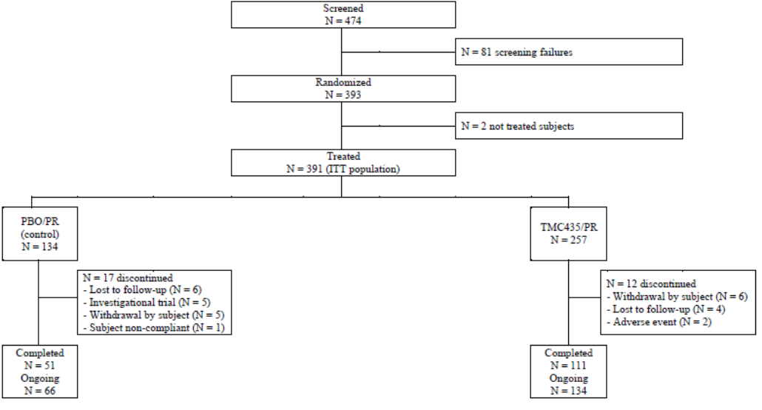

Major protocol violations/deviations
Major protocol deviations were observed for 25 (6.4%) patients, 18 (7.0%) in the TMC/PR group and 7 (5.2%) in the PBO/PR group. The most common deviation was continuation of treatment despite non-compliance with contraception requirements. In the TMC/PR group, 97.6% of patients who completed treatment were ≥97% compliant with the planned TMC dose, 79.7% to the planned RBV dose and 82.2% to the planned dose of PegIFN. In the PBO/PR group, 98% of patients who completed treatment were ≥97% compliant with the planned placebo TMC dose, 69.1% to the planned RBV dose and 80.2% to the planned PegIFN dose. RBV dose reductions occurred in 24.1% of patients in the TMC/PR group compared with 30.6% in the PBO/PR group. PegIFN dose reductions occurred in 16.7% of the TMC/PR group and 17.9% in the PBO/PR group.

Baseline data
The patient demographics were generally balanced across treatment groups (Table 8).

Table 8: Study C216 Demographic Characteristics; Intent-to-treat
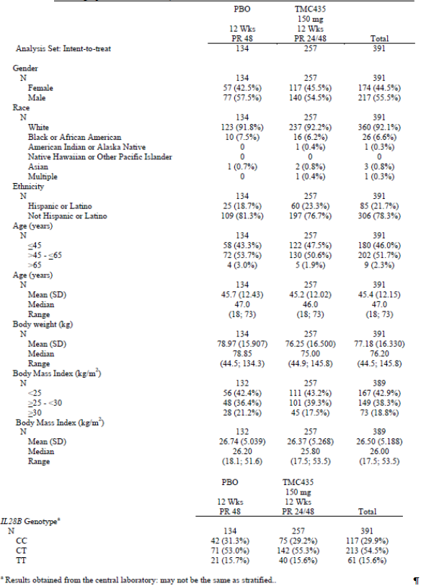
The majority of patients were male (55.5%) and White (92.1%) with a median age of 47.0 years (range 18–73). The median BMI was 26.0 kg/m² (range 17.5–53.5). Overall, 29.9% of patients had the IL28B CC genotype, 54.5% had the CT genotype and 15.6% had the TT genotype. The baseline disease characteristics were generally well balanced across treatment groups. Overall, the median log10 plasma HCV RNA level at baseline was 6.51 IU/mL (range 4.0–7.6). The median time since diagnosis of HCV infection was 2.0 years (range 0.1-31.3). The majority of patients (76.0%) had high baseline plasma HCV RNA levels defined as >800,000 IU/mL. All patients were infected with HCV G1 (40.7% genotype 1a, 58.1% genotype 1b and <1% each of genotype 1e, 1g or other). At baseline, 49.7% of patients had Metavir score F0 or F1, 28.0% had Metavir score F2, 13.9% had Metavir score F3 and 8.4% had Metavir score F4. At baseline, increased ALT of any grade was observed in 62.4% of patients, mainly grade 1 (39.4%) and grade 2 (18.2%).

Results for the primary efficacy outcome
In the primary analysis, the proportion of patients with SVR12 was 81.3% in the TMC/PR group compared with 50.0% in the PBO/PR group. The stratum adjusted benefit in favour of the TMC/PR group was 32.2% (95% CI: 23.3, 41.2) which was statistically significant (p<0.001) after controlling for the type of PegIFN/RBV and the stratification factors. The results of the logistic regression sensitivity analysis confirmed the primary analysis with a 41.2% difference in favour of the TMC/PR group (p<0.001). Irrespective of the type of PegIFN/RBV, HCV genotypic subtype and IL28B genotype, the SVR12 rate was statistically significantly higher in the TMC/PR group compared with the PBO/PR group (p≤0.003). SVR12 was not achieved in 18.7% of patients in the TMC/PR group compared with 50.0% in the PBO/PR group. The reasons for not achieving SVR12 are shown in Table 9. In the PBO/PR group, 32.1% of patients had detectable HCV RNA at the end of treatment compared with 7.0% in the TMC/PR group.

Table 9: Study C216. Reasons for not achieving sustained virologic response 12 weeks after the planned end of treatment (SVR12); Intent-to-treat
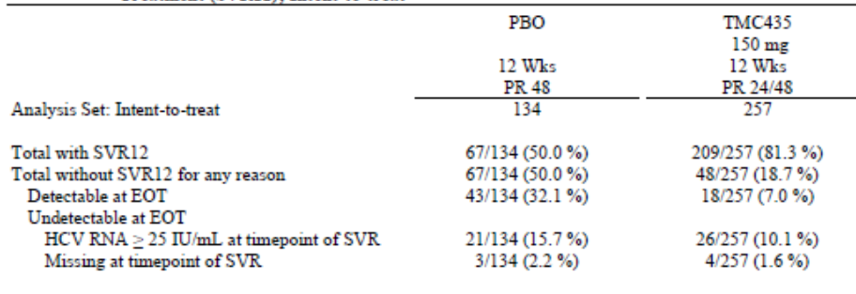

Results for other efficacy outcomes
The treatment duration with PegIFN/RBV (24 or 48 weeks) was guided by RGT criteria based on HCV RNA results. The majority of patients in the TMC/PR group (91.4%) met the RGT criteria of whom 86.0% achieved SVR12. In patients who had HCV RNA <25 IU/mL undetectable at Week 4, 91.3% achieved SVR12. In the group of patients with HCV RNA <25 IU/mL detectable at Week 4, 60.0% achieved SVR12. Most patients (98.3%) in the TMC/PR group who met the RGT criteria completed treatment with PegIFN and/or RBV at Week 24 and the overall SVR12 rate was 91.8%. Patients with undetectable HCV RNA at Week 4 had higher SVR12 rates (91.7%) than completers with HCV RNA <25 IU/mL detectable at Week 4 (61.5%). A total of 16 patients in the TMC/PR group did not meet the RGT criteria. In this group, SVR12 was achieved by 4/6 (66.7%) of the patients who completed treatment with PegIFN and/or RBV at Week 48.
The SVR rates at Weeks 4, 24 and 72 are shown in Table 10.

Table 10: Sustained virologic response at 4 and 24 weeks after the planned end of treatment (SVR4 and SVR24) and at week 72 (SVRW72) – Stratified Cochran-Mantel-Haenszel approach – Intent-to-treat
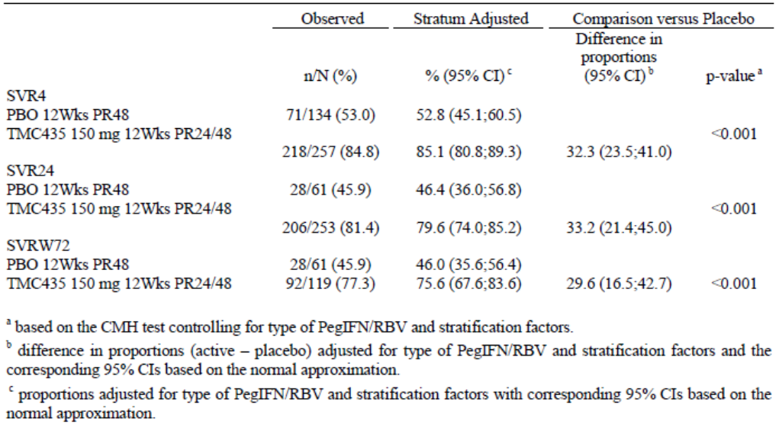
SVR24 rates were available for 253 of the 257 patients in the TMC/PR group and 61 of 134 patients in the PBO/PR group (all patients in the TMC/PR group met the RGT criteria compared with a smaller proportion in the PBO/PR group). The proportion of patients achieving SVR24 was 81.4% in the TMC/PR group compared with 45.9% in the PBO/PR group. The adjusted difference between treatment groups was 33.2% (95% CI: 21.4, 45.0, p<0.001). SVR4 was achieved by 84.8% of patients in the TMC/PR group versus 53.0% in the PBO/PR group. The adjusted treatment difference was 32.3% (95% CI: 23.5, 41.0, p<0.001). SVR72 was achieved by 77.3% of the TMC/PR group compared with 45.9% in the PBO/PR group. The adjusted treatment difference was 29.6% (95% CI: 16.5, 42.7). With the exception of two patients, all patients who achieved SVR12 in the TMC/PR group also achieved SVR24. In the PBO/PR group, SVR24 was achieved by all patients with SVR12.
On-treatment virologic response rates over time were provided. In the TMC/PR group, 79.2% of patients achieved undetectable HCV RNA at Week 4 compared with 12.8% in the PBO/PR group. Undetectable HCV RNA at Week 12, Week 24 and end of treatment was achieved by 96.8%, 95.4% and 93.4%, respectively, of patients in the TMC/PR group versus 44.9%, 74.3% and 67.9%, respectively, in the PBO/PR group. For time to virologic response: in the TMC/PR group, the median time to achieve HCV RNA <25 IU/mL detectable or undetectable was 14 days and 29 days to achieve undetectable HCV RNA <25 IU/mL. The median times in the PBO/PR group were 85 and 113 days, respectively. In the TMC/PR group, 20.2% of patients experienced treatment failure (7.0% on-treatment, 13.2% post-treatment). In the PBO/PR group, treatment failure was experienced by 50.0% of patients (32.1% on-treatment, 17.9% post-treatment). The majority of patients (97.6%) with virologic failure had emerging mutations at the time of failure. For all IL28B genotypes, higher virologic response rates were observed in the TMC/PR group compared with the PBO/PR group. Both HCV 1a and 1b genotypes had higher virologic response rates in the TMC/PR group compared with the PBO/PR group although SVR12 rates were lower in G1a than G1b patients. SVR12 rates were similar in patients with the Q80K polymorphism at baseline (76%) compared with patients without the polymorphism (82%).
Comment: This study in treatment-naïve patients was well-designed. The primary efficacy endpoint was achieved with a SVR12 treatment benefit of 32.2% (95% CI: 23.3, 41.2, p<0.001) and the treatment benefit was similar to that demonstrated in study C208. The majority (91.4%) of TMC patients met the RGT criteria of whom 86.0% achieved SVR12. The endpoints were SVR24 in study C208 and SVR12 in study C216. However, the results of both studies showed that SVR12 closely predicts SVR24. The superiority of TMC compared with placebo was confirmed irrespective of the type of PegIFN/RBV used although there were trends in favour of PegIFNα-2a/RBV compared with PegIFN/α2b/RBV. TMC was also superior to placebo irrespective of HCV geno/subtype or IL28B genotype.

Study HPC3007 (PROMISE)

Study design, objectives, locations and dates
This is an ongoing Phase 3 comparison of TMC and placebo in HCV genotype 1 patients who relapsed after previous PegIFN therapy with documented undetectable HCV RNA at the end of treatment. The study commenced in January 2011 and the cut-off date for the primary analysis was October 2012. The primary analysis includes all randomised patients who completed the Week 60 visit or discontinued earlier. The study was conducted at 81 sites in 14 countries (Australia, Austria, Belgium, Canada, France, Germany, Israel, Italy, New Zealand, Poland, Russia, Puerto Rica, UK and the USA). It was a randomised, double-blind, placebo-controlled, 2-arm study to compare the efficacy and safety of TMC versus placebo combined with PegIFNα-2a and RBV in patients with HCV genotype 1 who received at least 24 weeks of PegIFN based therapy and relapsed within one year after the end of treatment. The primary efficacy endpoint was the proportion of patients in each treatment group achieving SVR12. There was a maximum screening period of 6 weeks, a response guided 24 week (TMC patients) or 48 week (control) treatment period, and a follow-up period of up 72 weeks. The schematic overview is shown below in Figure 7. Patients were randomly assigned in a 2:1 fashion to receive TMC or placebo, stratified by HCV genotype1 subtype and IL28B genotype. In the first 24 weeks, patients received TMC 150 mg or placebo QD plus PR, followed by 12 weeks of PR. As part of a response-guided treatment (RGT) regimen, HCV therapy was stopped at Week 24 in the TMC group when they achieved HCV RNA levels <25 IU/mL (detectable or undetectable) at Week 4 and <25 IU/mL undetectable HCV RNA levels at Week 12. All other patients in the TMC group and in the placebo group continued PR until Week 48, unless virologic stopping rules or discontinuation criteria were met. In both treatment groups, there was a post-therapy 72 week follow-up period. Sparse blood sampling was performed in all patients to determine the TMC PK.
Figure 7: Study HPC3007 (PROMISE) schematic

Inclusion and exclusion criteria
The key inclusion criteria were male or female patients aged 18 years or above; liver biopsy within 3 years of screening; bridging fibrosis (Metavir score F3) or cirrhosis (Metavir score F4) required an ultrasound to exclude HCC; HCV G1 confirmed at screening; plasma HCV RNA >10,000 IU/mL at screening. Patients were required to have had previous PegIFN based therapy for at least 24 weeks with documented undetectable HCV RNA at the end of treatment or an undetectable HCV RNA within 2 months after the actual end of treatment and a subsequent detectable HCV RNA level within one year after the last drug intake. The key exclusion criteria included evidence of hepatic decompensation; any liver disease of non-HCV aetiology; infection or co-infection with HCV non-G1; co-infection with HIV-1 or HIV-2; co-infection with HBV; medical contraindications to PegIFNα-2a, PegIFNα-2b or RBV; history of malignancy within 5 years of screening; laboratory abnormalities including platelet count <90,000/mm³, neutrophils <1,500/mm³, haemoglobin <12 g/dL, creatinine >1.5 mg/dL; ALT and/or AST >10xULN, total serum bilirubin >1.5xULN; AFP >50 ng/mL in patients with cirrhosis; and disallowed concomitant medications.

Study treatments
Study treatments were simeprevir 150 mg capsules given orally QD or matching placebo. PegIFNα-2a and RBV were given as Pegasys and Copegus, respectively, with dosage based on body weight according to the manufacturer’s PI. Dose adjustments or treatment interruptions of PegIFNα-2a and RBV were permitted for tolerability and toxicity issues.

Efficacy variables and outcomes
The main efficacy variables were:
- Changes in HCV RNA levels with time
- Resistance determinations
The primary efficacy endpoint was the proportion of patients in each treatment group achieving with SVR at 12 weeks after the planned end of treatment (SVR12), defined as having HCV RNA <25 IU/mL undetectable at the end of treatment and HCV RNA <25 IU/mL detectable or undetectable 12 weeks after the planned end of treatment.
Other efficacy outcomes included:
- SVR at Week 24 (SVR24)
- SVR at Week 72 (SVR72)
- the incidence of on-treatment failure in the TMC and control groups
- the relapse rate following treatment in the TMC and control groups
- the viral NS3/4A sequence in patients not achieving SVR in the TMC group
- the relationship between PK and efficacy and safety parameters

Randomisation and blinding methods
Central randomisation was implemented using IWRS/IVRS. Patients were randomly assigned to TMC or placebo in a 2:1 ratio and block stratified by HCV genotype subtype (1a, 1b, or other) and IL28B genotype. The investigators were blind to the randomisation schedule but emergency unblinding was permitted.

Analysis populations
The analysis population was the ITT set defined as all randomised patient who took at least one dose of investigational drug. A PP analysis on the primary endpoint was mandated if more than 10% of patients had major protocol deviations.

Sample size
The primary efficacy endpoint was SVR12, defined as undetectable HCV RNA levels at the end of treatment and HCV RNA <25 IU/mL detectable or undetectable 12 weeks after the planned end of treatment. Sample size calculations were based on the TMC Phase 2b studies and published telaprevir and boceprevir Phase 3 study data. Based on published data, SVR24 in the control group was expected to be approximately 20%. With 125 patients in the control group and 250 patients in the TMC group, the study had >90% power to detect a difference of at least 20% between groups.

Statistical methods
The statistical analyses were performed using SAS version 9.1. The primary analysis compared SVR12 rates in the two treatment groups using the Cochran-Mantel-Haenszel test controlling for the stratification factors HCV genotype 1 subtype and IL28B genotype. The 95% CI was constructed around the response rate in each group. A sensitivity analysis was also performed using a logistic regression model. Additional sensitivity analyses were performed by applying imputation rules for missing data. Other efficacy parameters were analysed by descriptive statistics, frequency tabulations, cross-tabulations, Kaplan-Meier estimates, ANOVA, logistic regression and mixed models.

Participant flow
A total of 462 patients were screened, 394 were randomised and 393 were included in the ITT, 133 in the PBO/PR group and 260 in the TMC/PR group. At the interim lock date, 184 (46.8%) patients in the total group had completed and 185 (47.1%) patients were still ongoing. In the placebo group, 14 (10.5%) patients had discontinued, mainly lost to follow-up. In the TMC group, 24 (6.1%) patients had discontinued, due mainly to withdrawal of consent or loss to follow-up. Additional details are shown in Figure 8.
Figure 8: Study HPC3007 (PROMISE) Subject disposition
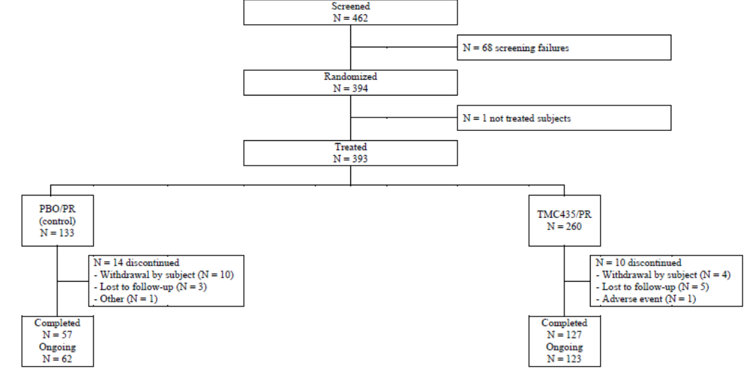

Major protocol violations/deviations
Overall, 20 (5.1%) patients had major protocol violations at 12 weeks (6.0% placebo, 4.6% TMC). There were no significant differences between the treatment groups. In the TMC/PR group, 98.8% of patients who completed treatment were ≥97% compliant with the planned TMC dose, 83.5% to the planned RBV dose and 88.1% to the planned dose of PegIFN. In the PBO/PR group, 100% of patients who completed treatment were ≥97% compliant with the planned placebo TMC dose, 80.0% to the planned RBV dose and 80.2% to the planned PegIFN dose. RBV dose reductions occurred in 19.6% of patients in the TMC/PR group compared with 20.3% in the PBO/PR group. PegIFN dose reductions occurred in 11.9% of the TMC/PR group and 17.3% in the PBO/PR group.

Baseline data
Baseline demographics are shown in Table 11.

Table 11: Study HPC3007 (PROMISE) Demographic Characteristics; Intent-to-treat
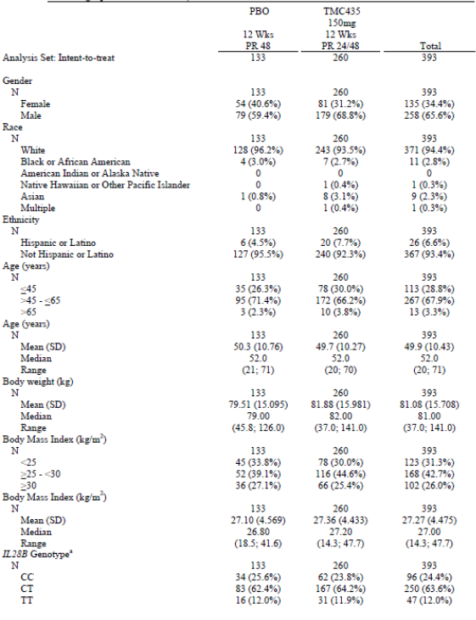
The majority of patients were male (65.6%) and White (94.4%). The median age was 52.0 years (range 20-71) and the median BMI was 27.0 kg/m². Overall, the median log10 plasma HCV RNA at baseline was 6.49 IU/mL (range 3.1-7.7) and the majority (83.7%) had high baseline HCV RNA defined as HCV RNA >800,000 IU/mL. All patients had HCV G1 infection (41.7% 1a, 58% 1b) with a median time since diagnosis of 9.3 years (range 1.3-33.1). At baseline, 35.1% had a Metavir fibrosis score F0 or F1, 34.3% had Metavir score F2, 15.4% had Metavir score F3, and 15.2% had Metavir score F4. At baseline, ALT elevations, mainly grade 1 and 2, were present in 61.3% of patients. The genotype stratification factors were evenly balanced in the two treatment groups.

Results for the primary efficacy outcome
In the primary ITT analysis (CMH), the stratum adjusted proportion of patients with SVR12 was 79.6% (95% CI: 74.8, 84.4) in the TMC/PR group compared with 36.6% (95% CI: 28.7, 44.5) in the PBO/PR group. The treatment difference in favour of the TMC/PR group was 43.0% (95% CI: 33.8, 52.3, p<0.001). Similar response rates were observed in a sensitivity logistic regression analysis. The difference in proportions in favour of the TMC/PR group was 49.0% (95% CI: 38.8, 59.2, p<0.001). The proportions adjusted for stratification factors including HCV genotype or subtype and IL28B status did not affect the treatment difference p-values. SVR12 was not achieved in 20.8% of patients in the TMC/PR group compared with 63.2% in the PBO/PR group. Detectable HCV RNA at the end of treatment was present in 3.1% of the TCM/PR group compared with 27.1% in the PBO/PR group.

Results for other efficacy outcomes
The treatment duration with PegIFN/RBV (24 or 48 weeks) was guided by RGT criteria based on HCV RNA results. The majority of patients in the TMC/PR group (92.7%) met the RGT criteria of whom 83.0% achieved SVR12. In patients who had HCV RNA <25 IU/mL undetectable at Week 4, 87.3% achieved SVR12. In the group of patients with HCV RNA <25 IU/mL detectable at Week 4, 63.6% achieved SVR12. Most patients (97.1%) in the TMC/PR group who met the RGT criteria completed treatment with PegIFN and/or RBV at Week 24 and the overall SVR12 rate was 83.3%. Patients with undetectable HCV RNA at Week 4 had higher SVR12 rates (87.9%) than completers with HCV RNA <25 IU/mL detectable at Week 4 (63.6%). A total of 15 patients in the TMC/PR group did not meet the RGT criteria. In this group, SVR12 was achieved by 5/9 (55.6%) of the patients who completed treatment with PegIFN and/or RBV at Week 48.
The SVR4, SVR24 and SVR72 rates are shown in Table 12.

Table 12: Sustained virologic response at 4 and 24 weeks after the planned end of treatment (SVR4 and SVR24) and at week 72 (SVRW72) – Stratified Cochran-Mantel-Haenszel approach – Intent-to-treat
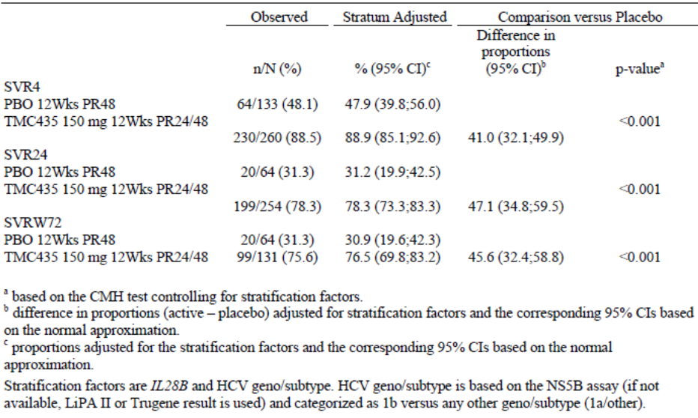
SVR24 rates were available for 254 of the 260 patients in the TMC/PR group and 64 of 133 patients in the PBO/PR group (all patients in the TMC/PR group have met the RGT criteria compared with a smaller proportion in the PBO/PR group). SVR72 rates were available for 131 and 64 patients in the TMC/PR and PBO/PR groups respectively. The proportion of patients achieving SVR24 was 78.3% in the TMC/PR group compared with 31.3% in the PBO/PR group. The adjusted difference between treatment groups was 47.1% (95% CI: 34.8, 59.5). SVR4 was achieved by 88.5% of patients in the TMC/PR group versus 48.1% in the PBO/PR group. The adjusted treatment difference was 41.0% (95% CI: 32.1, 49.9, p<0.001). SVR72 was achieved by 75.6% versus 31.3% of patients, respectively. The adjusted difference was 45.6% (95% CI: 32.4, 58.8). All but five patients in the TMC/PR group with SVR12 achieved SVR24.
On-treatment virologic response rates over time were provided. In the TMC/PR group, 77.2% of patients achieved undetectable HCV RNA at Week 4 compared with 3.1% in the PBO/PR group. Undetectable HCV RNA at Week 12, Week 24 and end of treatment was achieved by 98.0%, 99.6% and 96.9%, respectively of patients in the TMC/PR group versus 27.4%, 78.6% and 72.0%, respectively, in the PBO/PR group. For time to virologic response: In the TMC/PR group, the median time to achieve HCV RNA <25 IU/mL detectable or undetectable was 14 days and 28 days to achieve undetectable HCV RNA <25 IU/mL. The median times in the PBO/PR group were 110 and 141 days, respectively. In the TMC/PR group, 22.7% of patients experienced treatment failure (3.1% on-treatment, 19.6% post-treatment). In the PBO/PR group, treatment failure was experienced by 64.7% of patients (27.1% on-treatment, 37.6% post-treatment). The majority of patients (92.3%) with virologic failure had emerging mutations at the time of failure. For all IL28B genotypes, higher virologic response rates were observed in the TMC/PR group compared with the PBO/PR group. Both HCV 1a and 1b genotypes had higher virologic response rates in the TMC/PR group compared with the PBO/PR group with no meaningful difference between the two genotypes.
Comment: The primary endpoint of the study was met with an SVR12 adjusted treatment difference of 43.0% (33.8, 52.3, p<0.001) in favour of the TMC/PR arm. The treatment benefit was achieved irrespective of HCV geno/subtype, IL28B genotype or Metavir score at baseline. The majority (92.7%) of TMC patients met the RGT criteria of whom 83.0% achieved SVR12. TMC was generally well tolerated so the results support the use of TMC in treatment-experienced patients. However, the claimed indication includes patients ‘who have failed previous interferon therapy (pegylated or non-pegylated) with or without ribavirin’. It is unclear why prior null and partial PR responders were excluded from this study and the sponsors should justify this apparent anomaly.

Other efficacy studies

Study 212

Study design, objectives, locations and dates
This is an ongoing, open label, single arm study of TMC/PR in patients infected with HCV and HIV-1 co-infection. The study commenced in October 2011 and an interim analysis was performed on 18 September 2012. At that time, all patients were in the study for 24 weeks or had discontinued early. A total of 39 sites in 7 countries in Europe and North America screened 160 patients. Patients were HCV treatment-naïve, prior HCV relapsers or prior HCV non-responders and to be either on HAART or not. HCV treatment-naïve patients and prior HCV relapsers received a RGT 24 or 48 week treatment period with a post-treatment follow-up period of 24 weeks. This group were given TMC 150 mg QD plus PR for 12 weeks followed by PR. For prior HCV non-responders (null and partial) there was a 48 week treatment period with a post-treatment follow-up period of 24 weeks. This group received TMC 150 mg plus PR for 12 weeks followed by 36 weeks of PR. No control group was included in the study. Instead, the data are compared to historical SVR data obtained from Phase 3 studies in patients infected with HCV alone. A study schematic is shown in Figure 9 below:
Figure 9: Study 212 schematic
Dose adjustments of TMC were not allowed but adjustments were permitted for PegIFN and RBV for tolerability or toxicity issues. Temporary interruption of HAART was permitted in the event of toxicity but changes in ARV during the TMC treatment period were not permitted.
Comment: This study does not meet the criteria for a pivotal study as it is open-label with historical controls and the data analysis is preliminary. However, it is summarised here in some detail because the data are used to support the proposed HIV-1 co-infection indication.

Inclusion and exclusion criteria
Key inclusion criteria were male and female patients aged 18 to 70 years, inclusive; chronic HCV genotype 1 infection with a plasma HCV RNA level >10,000 IU/mL; a liver biopsy within 3 years of screening; HCV treatment-naïve or prior non-responders or relapsers (prior viral breakthrough patients were not eligible); documented HIV-1 infection at least 6 months before screening; stable HAART; for patients not on HAART, CD4+ cell count >500 cells/µL. Key exclusion criteria included hepatic decompensation; liver disease of non-HCV aetiology; non-genotype1 HCV; co-infection with HBV; medical contra-indications to PR therapy; HIV-2 infection; Changed ARV therapy within the previous 4 weeks; current AIDS defining illness; life expectancy <12 months; laboratory abnormalities including platelets <90,000/mm³, neutrophils <1500 cells/mm³, haemoglobin <12.0 g/dL, creatinine >1.5 mg/dL, ALT and/or AST >10xULN, total serum bilirubin >1.5xULN, AFP >50 ng/mL.

Study treatments
Study treatments were simeprevir 150 mg capsules given orally QD. PegIFNα-2a and RBV were given as Pegasys and Copegus, respectively, with dosage based on body weight according to the manufacturer’s PI. Dose adjustments or treatment interruptions of PegIFNα-2a and RBV were permitted for tolerability and toxicity issues.

Efficacy variables and outcomes
The primary efficacy endpoint was SVR12 assessed by prior HCV treatment response and by HIV treatment experience at baseline. Other variables included SVR4, the proportion of patients meeting RGT criteria and completing 24 weeks of study therapy, and virologic response with time.

Randomisation and blinding methods
The study was open label.

Analysis populations
The analysis population was the ITT set defined as all randomised patient who took at least one dose of investigational drug. A PP analysis on the primary endpoint was mandated if more than 10% of patients had major protocol deviations.

Sample size
The primary objective was to evaluate the proportion of patients with SVR12 using historical HCV data in treatment-naïve and prior null responders, assumed to be 29% in treatment-naïve patients and 5% in prior null responders. The target SVR12 rates in this study were 50% for treatment-naïve patients and 25% for prior null responders. With 53 HCV treatment-naïve patients, the study had 90% power to detect a treatment difference of at least 21% at the 1-sided 5% significance level. With 28 prior null responders, the study had 94% power to detect a treatment difference of at least 20% at the 1-sided 5% significance level.

Statistical methods
The primary analysis compared SVR12 rates in this study with the SVR rates previously reported for PR alone in Phase 3 studies using a single-sided z-test. The 95% CI was constructed around the response rate in each group. Subgroup analyses were planned based on previous HCV treatment responses and HIV-1 treatment experience (HAART or no HAART).

Participant flow
Of the 160 patients screened, 106 patients with chronic HCV genotype 1 with HIV-1 co-infection received at least one dose of study drug (the ITT population). Patients enrolled and treated by HIV treatment experience (on HAART, not on HAART) at baseline are shown in Table 13.

Table 13: Subjects screened, enrolled, treated, by HIV treatment experience at baseline; All subjects (Study C212)
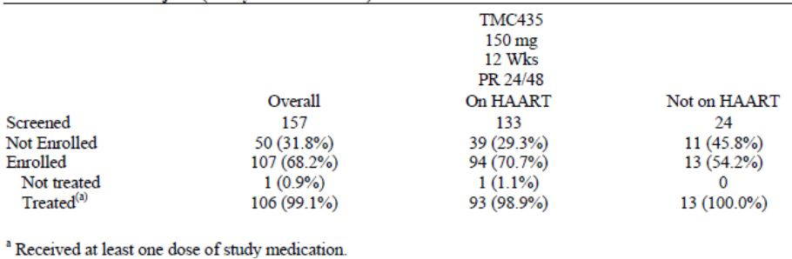
A summary of completions and discontinuations by prior HCV treatment response was provded. Overall, 96.2% of patients are ongoing and 4 (3.8%) patients had discontinued at the time of data base lock. In total, 90.6% of patients completed the planned 12 weeks of TMC treatment and 51 patients (48.1%) have completed all study therapy. The reasons for not completing TMC therapy are shown in Table 14. A total of 10 (9.4%) patients discontinued due to AEs or they reached a virologic endpoint.

Table 14: Completions and discontinuations of TMC435 and reasons for discontinuations, by prior HCV treatment response; Intent-to-treat
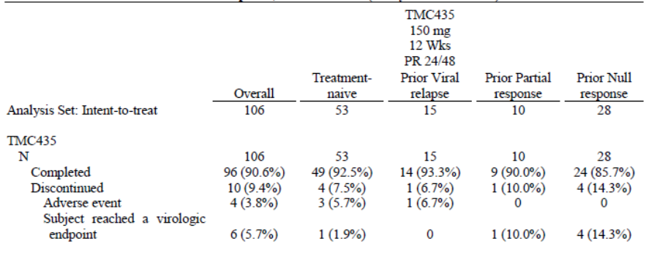

Major protocol violations/deviations
Not reported in this interim analysis.

Baseline data
Baseline demographics were provided. The majority of patients were male (84.9%) and White (82.1%). The median age was 48 years (range 27-67) and the median BMI was 25.15 kg/m² (range 17.2-39.9). Overall, the median log10 plasma HCV RNA at baseline was 6.51 IU/mL log10 IU/mL) (range 4.9-7.5) and the majority (85.8%) had high baseline HCV RNA defined as HCV RNA >800,000 IU/mL. All patients had HCV G1 infection (82.1% 1a, 17.0% 1b) with a median time since diagnosis of 9.90 years (range 0.4-37.0). At baseline, 22.6% had a Metavir fibrosis score F0 or F1, 20.8% had Metavir score F2, 12.3% had Metavir score F3, and 8.5% had Metavir score F4. At baseline, ALT elevations, mainly grade 1 and 2, were present in 62.3% of patients.

Results for the primary efficacy outcome
In the interim analysis, the primary endpoint (SVR 12 weeks after the planned end of treatment) was only available for patients who met RGT criteria for shorter treatment duration, that is, treatment-naïve and prior relapser patients. Data were shown for SVR12 rates compared with historical PR control data; SVR12 responses by prior HCV treatment response; and by HIV treatment experience at baseline. In the ITT analysis, the overall SVR12 rate was 76.9% (10/13 patients). The SVR12 rate for treatment-naïve patients was 75.0% (6/8 patients) and for prior viral relapsers it was 80.0% (4/5 patients).

Results for other efficacy outcomes
The overall SVR4 rate was 85.7% (30/34 patients), 84.0% (21/25 patients) in the treatment-naïve group and 90% (9/10 patients) in the prior viral relapsers. The majority of eligible patients met the RGT criteria (52/59, 88.1%) and 47/52 (90.4%) of these patients completed treatment at Week 24. For on-treatment virologic responses: Rapid virologic response was achieved in 66.4% of the overall population, 71.2% of treatment-naïve patients, 93.3% of prior relapsers, and 80% of prior partial responders. RVR was achieved in 37.0% of the prior null responders. On-treatment virologic failure was encountered in 16 (15.1%) patients; 5 (9.4%) treatment-naïve patients, none of the prior relapsers, 1 (10%) prior partial responder, and 10 (35.7%) prior null responders. The preliminary relapse rate was 12.5% in the overall population. None of the patients had HIV virologic failure defined as ≥200 copies/mL after previous <50 copies/mL.
Comment: In patients with HCV and HIV-1 co-infection, TMC/PR was associated with high virologic response rates (SVR4 85.7%, SVR12 76.9%) in treatment-naïve and prior relapser patients. The patient numbers are small and the data are preliminary. However, the SVR rates are superior to those of historical Phase 3 response rates to PR treatment alone, and similar to response rates to TMC/PR in patients with HCV mono-infection.

Study C202

Study design and objectives
This was a Phase 2b, open-label, proof of concept study to assess the antiviral activity of TMC in patients infected with HCV genotype 2, 3, 4, 5, or 6. Forty patients were divided into 5 cohorts of 8 patients per genotype. All patients were treated with TMC 200mg QD for 7 days as monotherapy, followed by optional PR treatment from Day 8 onwards. Plasma samples were taken at each study visit at baseline and Days 2-11 inclusive. HCV RNA was measured at a central laboratory using the Roche COBAS TaqMan HCV/HPS v2.0 nucleic acid amplification assay. Most patients were White but all patients in Cohort 6 were Asian. The median age was 48 years and 51.4% were male. At baseline, the median HCV RNA level was 6.5 log10 IU/mL (range 4.5-7.3) and 75.7% had HCV RNA levels ≥800,000 IU/mL.

Efficacy results
The mean and median changes from baseline in HCV RNA and virologic response per genotype are shown in Figure 10.

Figure 10: Mean (± SE) change from baseline in plasma HCV RNA (log10 IU/mL) over time by genotype
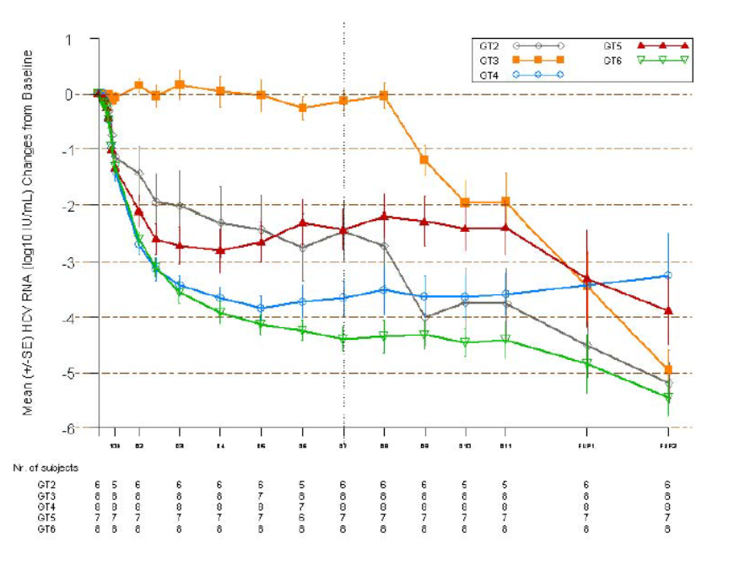
TMC treatment was associated with marked reductions in HCV RNA from baseline at all time points in genotypes 4 and 6 with lesser reductions in genotypes 2 and 5. In patients with genotype 4, there was a mean reduction of 3.66 log10 IU/mL (range -4.4 to -2.9). There was no reduction in patients with genotype 3. The differences in TMC activity across the genotypes were due mainly to different naturally occurring polymorphisms in the NS3 region.
Comment: The inclusion of patients with HCV genotype 1 infection would have permitted a more useful direct comparison of virological activity. In C208, there was a reduction in HCV RNA levels of 4.47 log10 IU/mL at Week 1 although these patients were receiving concomitant PR therapy.

Study C213

Study design and objectives
This is an ongoing exploratory Phase3 , open label trial of TMC/PR for HCV genotype 1 infected patients who participated in the placebo groups of a Phase 2b/3 study (C201, C205, C206, C208, C216 or HPC3007), or who received up to 14 days of direct acting antiviral treatment in Phase 1 studies. An interim analysis of key efficacy data at a cut-off date of September 2012 has been provided at the request of regulatory authorities. Patients in the placebo groups of the Phase 2/3 studies had received response guided treatment for 24 or 48 weeks (and classified as having had viral relapse or viral breakthrough) and 48 weeks for all other patients. The primary analysis set was the ITT population which included all patients who received at least one dose of study medication. Approximately 270 patients are expected to be enrolled and 50 patients have received at least one dose of study medication (34 from Phase 2b/3 studies and 16 from Phase 1 studies). In total, 36/50 patients completed TMC treatment at Week 12. In the Phase 2/3 group, there were 12 viral relapsers, 4 viral breakthroughs, 5 partial responders, 12 null responders and 1 not classifiable. The majority of patients were White (94%) and male (74%) with a median age of 52.5 years. The primary efficacy endpoint was SVR12 but at the time of the interim analysis no data were available for SVR12. Secondary endpoints included SVR4, SVR24 and virological response with time.

Efficacy results
The virologic response in the ITT population were shown: of the 22 patients on treatment at Week 12, 20 (90.9%) had achieved HCV <25 IU/mL undetectable. Virologic failure was encountered in 3/34 (8.8%) patients. Changes in plasma HCV RNA over time are shown in Figure 11. All patients had a steep decline in HCV RNA levels compared with prior PR treatment.
Figure 11: HCV RNA (log10 IU/mL) over time, by subject, other responders to prior treatment with PegIFN/RBV – Phase II/III group; intent-to-treat
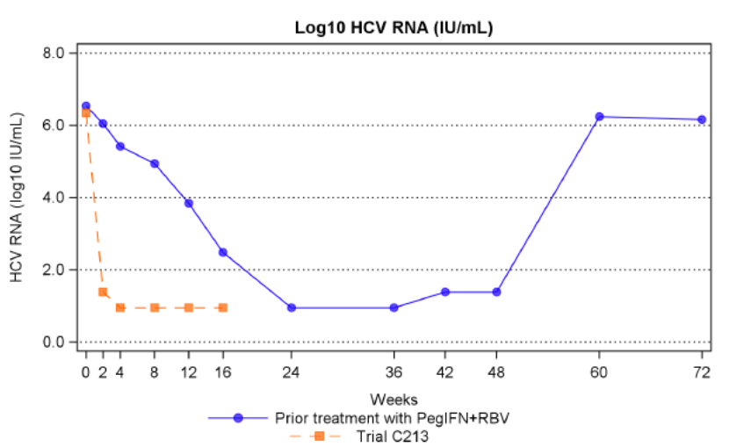

Study HPC3011

Study design and objectives
This is an interim analysis of an on-going multicentre, open-label, single arm, Phase 3 study of TMC/PR in treatment-naïve or treatment-experienced HCV genotype 4 infected patients. Patients were required to have HCV RNA levels >10,000 IU/mL with no other liver disease. Patients received 12 weeks of TMC treatment with response guided PR treatment of 24 or 48 weeks in treatment-naïve and prior relapser patients, or fixed 48 weeks treatment in all other patients (Figure 12, below).
Figure 12: Study HPC3011 schematic
The ITT population is all patients who have received at least one dose of trial drug and the primary endpoint is SVR12 in the different sub-populations (treatment-naïve, previous relapsers and previous non-responders). Major secondary endpoints include SVR4 and SVR24 and the proportion of patients meeting RGT criteria for shortened treatment of 24 weeks. At the time of the interim analysis, 107 patients with HCV genotype 4 infection have been enrolled and treated (35 treatment-naïve, 22 prior relapsers, 10 prior partial responders and 40 prior null-responders). The majority were White (72.0%) and male (78.5%) with a median age of 49 years. Most patients were genotype 4a (42.5%) and 4d (23.6%). At the time of the interim analysis (January, 2013), 86 (80.4%) patients had completed treatment with TMC and 20 (18.7%) had completed their planned PR treatment. No patients had discontinued.

Efficacy results
At the time of the interim analysis, 9 patients had evaluable SVR12 data (3 treatment-naïve, 6 prior relapsers) of whom 7 (77.8%) achieved SVR12 (3/3 treatment-naïve, 4/6 prior relapsers). A total of 20 patients (11 treatment-naïve, 9 prior relapsers) had reached the SVR12 time point of whom 18 (90%) achieved SVR4. In total, 57 patients were eligible for RGT and at the time of the analysis 47 of these patients met the RGT criteria to complete PR treatment at Week 24. Overall, treatment failure occurred in 17 (15.9%) patients, mostly on-treatment and most commonly in the prior null responders.

Analyses performed across trials (pooled analyses and meta-analyses)
A pooled efficacy analysis of studies C208/C216 treatment-naïve patients was performed. A total of 785 patients were treated (521 in the TMC/PR group and 264 in the PBO/PR group). At the time of the pooled analysis at the completion of Week 60, 32.1% of patients had completed the study, 7.6% had discontinued prematurely and 60.3% were still in the follow-up period. There were fewer discontinuations in the TMC/PR group (6.3%) compared with the PBO/PR group (10.2%), most commonly due to loss of follow-up and withdrawal of consent. The baseline demographics and disease characteristics were generally balanced between treatment groups. Most patients were enrolled in Europe (53.2%) and the USA (25.2%). Most patients were male (55.9%) and White (90.5%) with a median age of 47.0 years. At baseline, 46.4% had Metavir score F0 or F1, 27.5% had Metavir score F2, 15.8% had Metavir score F3, and 10.4% had Metavir score F4. Median HCV RNA at baseline was 6.50 log10 IU/mL (range 1.4-7.6) and 77.8% had HCV RNA >800,000 IU/mL. In total 48.4% of patients had genotype 1a and 51.0% had genotype 1b. Overall, 29.4% of patients had IL28B genotype CC, 55.9% had genotype CT and 14.6% had genotype TT.
The proportion of patients who completed treatment with at least one study drug was 89.6% in the TMC/PR group compared with 60.6% in the PBO/PR group. In total, 8.3% of patients in the TMC/PR group discontinued TMC therapy early compared with 63.6% of patients who discontinued placebo early in the PBO/PR group. The most common reason (61.4%) for early discontinuation of placebo was meeting the Week 4 treatment stopping rule. In total, 2.5% of patients in the TMC/PR group discontinued prematurely due to AEs compared with 1.9% in the PBO/PR group. In the TMC/PR group, 98.3% of patients who completed treatment were ≥97% compliant to the planned dose of TMC compared with 79.6% for RBV and 82.0% for PegIFN.
The efficacy of TMC was statistically significantly superior to placebo in combination with PR (p<0.001). SVR12 was achieved in 80.4% (95% CI: 77.2, 83.7) of the TMC/PR group compared with 49.9% (95% CI: 44.4, 55.5) in the PBO/PR group. The SVR24 rate was 82.2% in the TMC/PR group compared with 50.5% in the PBO/PR group. A logistic regression sensitivity analysis, including baseline HCV RNA, HCV genotype and sub-types and IL28B genotypes, confirmed the primary analysis. Most patients (88.1%) in the TMC/PR group met the RGT criteria for shortening of PR treatment to 24 weeks (HCV RNA <25 IU/mL undetectable at Week 4) and 88.2% of these patients achieved SVR12. In the TMC/PR group, 96.4% of patients who achieved HCV RNA <25 IU/mL detectable or undetectable at Week 4 achieved HCV RNA <25 IU/mL undetectable at Week 12. Of these, 88.0% achieved SVR12. Based on a logistic regression model, SVR12 rates were statistically significantly higher in the TMC/PR group compared with the PBO/PR group regardless of gender, race, age, BMI and region. SVR12 rates were statistically significantly higher in the TMC/PR group compared with the PBO/PR group regardless of baseline HCV RNA, HCV genotype and sub-type, IL28B genotype and baseline Metavir score. In both treatment groups, SVR12 rates were lower in patients with high baseline HCV RNA, HCV genotype 1a versus 1b, IL28B genotype TT versus CT and CC, and baseline Metavir score F4 versus F0-F3.
On-treatment virologic response was higher in the TMC/PR group compared with the PBO/PR groups. The proportion of patients with HCV RNA <25 IU/mL undetectable at Week 12 was 94.8% compared with 47.8% in the PBO/PR group. The on-treatment failure rate was 8.1% in the TMC/PR group compared with 33.0% in the PBO/PR group. The proportion of patients who met a treatment stopping rule at Week 12, 24 or 36 was 4.8% in the TMC/PR group compared with 28.0% in the PBO/PR group.
Comment: The results of the pooled efficacy analysis confirm the superiority of TMC compared with placebo in treatment-naïve patients. Overall, the results were similar to the individual study findings.

Evaluator’s conclusions on clinical efficacy
Conclusions are provided on clinical efficacy for the treatment of chronic hepatitis C (CHC) genotype 1 or genotype 4 infection, in combination with peginterferon alfa and ribavirin, in adults with compensated liver disease (including cirrhosis) with or without human immunodeficiency virus-1 (HIV-1) co-infection who are treatment-naïve or who have failed previous interferon therapy (pegylated or non-pegylated) with or without ribavirin.
The combination of TMC/PR in response guided treatment regimens is statistically significantly superior to PR alone in treatment-naïve patients and prior relapsers (p<0.001). The SVR12 benefit in favour of TMC was approximately 30% in treatment-naïve patients and 42% in prior relapsers, both clinically meaningful and important. The treatment benefit in favour of TMC was similar in all subgroups defined by demographics, HCV genotype/subtype, IL28B genotype, baseline HCV RNA or Metavir scores, and the type of PegIFNα used. Prior null and partial responders were included in the controlled dose ranging study C206 with SVR12 rates of 91% and 65%, respectively. No prior null or partial responder patients in the open-label roll-over study C213 had SVR12 data available at the interim analysis. The data are limited in these patient groups and it is unclear why they were excluded from the pivotal study HPC3007.
Current EMEA guidelines state that randomised, controlled trials in HCV/HIV co-infected patients may not be mandated if a clear treatment benefit has been established in patients with HCV mono-infection. Single-arm studies in patients with co-infection may be sufficient for marketing approval if enhanced efficacy compared to historical controls can be convincingly demonstrated. The sponsors adopted this recommendation in C212 and the early data are in line with those observed in patients with HCV mono-infection. However, the results are preliminary and patient numbers with evaluable efficacy data are low. The Phase 1 study C202 confirmed the antiviral activity of TMC 200 mg QD in 8 patients with HCV genotype 4 for 7 days. Efficacy was studied in HPC3011 and the early data were similar to those observed in patients with genotype 1 infection. However, SVR12 rates were evaluable in only 9 patients at the time of the interim analysis.

Clinical safety

Studies providing evaluable safety data
The following studies provided evaluable safety data:
- Two double-blind, placebo-controlled, pivotal Phase 3 studies (C208, C216) in treatment-naïve patients and one double-blind, placebo-controlled, pivotal Phase 3 study (HPC3007) in patients who relapsed after prior PegIFN therapy.
- Three open-label, uncontrolled studies in patients co-infected with HIV-1 (C212), patients previously enrolled in the placebo group of Phase 2 and 3 studies (C213), and in patients with HCV genotype 4 (HPC3011).
- Two double-blind, placebo-controlled, dose ranging studies in treatment-naïve (C205) and treatment-experienced patients (C206).
All studies were on-going at the cut-off date for the safety analysis (18 January 2013).
Pooled safety data are presented as follows:
Primary pooling: An analysis of the 3 double-blind, placebo-controlled, pivotal Phase 3 studies (C208, C216 and HPC3007) at Week 60. A total of 781 patients received 12 weeks of treatment with TMC 150 mg QD followed by 12 or 36 response guided treatment with PR.
Secondary pooling: An analysis of the primary pooling dataset with the addition of the dose ranging Phase 2b studies (C205 and C206). In this pooling, 924 patients were included in the TMC 150 mg QD 12 weeks group, and 1486 patients were included in the all TMC group (TMC at all doses and treatment durations).
A total of 806 healthy subjects received any dose of TMC and 634 of these received TMC 150 mg QD in Phase 1 studies. These are not included in the main poolings.

Pivotal efficacy studies
In the pivotal efficacy studies, the following safety data were collected:
- General adverse events (AEs) and SAEs were defined according to ICH guidelines. AEs were graded according to the WHO grading scale and classified using the MedDRA.
- AEs including hepatobiliary, rash, anaemia, photosensitivity reactions, GI AEs and cardiac AES were initially predefined as AEs of special interest. However, after review of the Phase 2 safety data, only increased bilirubin was retained as an AE of special interest. Events of clinical interest defined by the sponsor included rash, pruritus, anaemia, neutropaenia and photosensitivity reactions.
- Laboratory tests in the Phase 2b and 3 studies were all performed at a central laboratory. Laboratory abnormalities were graded using the WHO scale and clinically relevant abnormalities were reported by the investigator as AEs.

Pivotal studies that assessed safety as a primary outcome
No studies submitted.

Dose-response and non-pivotal efficacy studies
The dose-response and non-pivotal efficacy studies provided safety data, as follows:
- Study C205 and C206 provided data on TMC at different doses in treatment-naïve and –experienced patients, respectively.
- Study C213 provided data in treatment-experienced patients.
- Study C202 was a proof of principle study in patients with genotypes 2-6 inclusive.
- Study C212 provided data on the use of TMC in patients with HCV/HIV-1 co-infection.
- Study HPC3011 provided data on patients with HCV genotype 4 infection.

Other studies evaluable for safety only
None.

Clinical pharmacology studies
Safety data from Phase 1 studies are described in the individual CSRs and not included in the overall analysis.

Pivotal studies that assessed safety as a primary outcome
No studies submitted.

Adverse events

All adverse events (irrespective of relationship to study treatment)

Pivotal studies
The treatment exposure for TMC and placebo in the primary pooling analysis is shown in Table 15.

Table 15: Extent of exposure; ITT (Primary pooling)
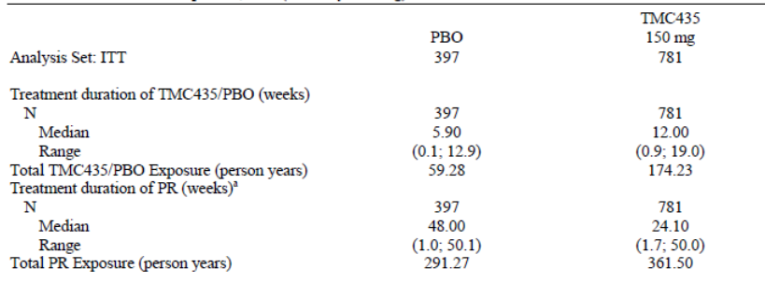
The total TMC exposure was 174.23 patient years and the total median treatment duration was 12.0 weeks for TMC patients and 5.9 weeks for placebo patients (placebo patients were more subject to virologic stopping rules). In the primary pooling of the 3 pivotal studies (C208, C216 and HPC3007) during the first 12 weeks of treatment, at least one AE was reported in 95.3% of patients in the TMC/PR group compared with 94.7% in the PBO/PR group. Most AEs were Grade 1 or 2. AEs of Grade 3 or 4 were reported in 22.9% of the TMC/PR group and in 24.7% of the PBO/PR group. The most frequent AEs were those commonly associated with PR therapy, namely fatigue (35.6% TMC, 39.5% placebo), headache (33.2% TMC, 35.5% placebo), and influenza-like illness (26.0% TMC, 21.2% placebo). Grade 3 AEs were reported in 20.0% of TMC patients and in 21.9% of placebo patients. Grade 4 AEs were reported in 2.9% and 2.8% of TMC and placebo patients, respectively. Grade 3 or 4 AEs were reported in <5.0% of patients with the exception of neutropaenia (9.2% TMC, 8.6% placebo).
The event of special interest was increased bilirubin which was reported in 7.9% of TMC patients compared with 2.8% in placebo patients. Grade 3 events were reported in 1.8% of TMC patients compared with 0.5% in the placebo group. Grade 4 events were reported in 2 (0.3%) TMC patients but none were reported as SAEs. Events of clinical interest included rash (any type), photosensitivity conditions, pruritus, neutropaenia and anaemia. Dyspnoea was initially examined as an event of clinical interest but was not retained when the data did not suggest a link with TMC therapy. The incidence of dyspnoea was 4.9% and 2.5% in the TMC and placebo groups, respectively. All events were Grade 1 or 2 and no events were reported as SAEs. In patients with dyspnoea, 23.9% also experienced anaemia.
In TMC patients during the first 12 weeks of treatment, there was a higher incidence of rash (23.2% versus 16.9%), photosensitivity reactions (3.3% versus 0.5%), pruritus (22.0% versus 14.9%), neutropaenia (16.5% versus 15.1%) and anaemia (13.4% versus 10.8%). The most frequently reported skin events were rash (13.6% TMC versus 11.1% placebo), erythema (3.1% versus 2.8%) and photosensitivity reactions (3.3% versus 0.5%). The incidence of treatment-related rash of any type was 19.1% in the TMC group compared with 9.3% in the placebo group. Grade 3 events of rash were reported in 5 (0.6%) TMC patients but there were no Grade 4 events. There was one (0.1%) Grade 3 photosensitivity reaction in a TMC patient but there were no Grade 4 events. Two (0.3%) patients with photosensitivity reactions required hospital admission and were therefore classified as SAEs. There was one (0.1%) Grade 3 pruritus event in the TMC group but no Grade 4 events and no SAEs. One (0.1%) patient discontinued because of a Grade 2 event. The incidence of treatment-related anaemia was 5.0% in the TMC group compared with 4.3% in the placebo group. Grade 3 events were reported in 1.0% and 1.8% of TMC and placebo patients, respectively. There were no Grade 4 events in TMC patients and no treatment discontinuations. The incidence of TMC treatment-related neutropaenia was 2.7% compared with 2.5% in placebo patients. Grade 3 events were reported in 7.9% and 8.3% of TMC and placebo patients, respectively. Grade 4 events were reported in 2.4% and 1.5% of TMC and placebo patients, respectively.

Other studies
No meaningful differences in the frequency of AEs between TMC and placebo patients were observed between the primary and secondary pooling (including C205 and C206). In C205, 153 patients received TMC 75 mg QD and, in C206, 197 patients received TMC 150 mg QD. The AE profiles in both dose ranging studies were similar to the primary pooling group and there were no apparent dose or treatment duration effects.
In the single-arm study C212, 106 patients (93 patients of whom were on HAART) received TMC 150 mg QD for a median duration of 12 weeks (range 0.4-12.6). A total of 96.2% of patients reported at least one AE and treatment-related AEs were reported in 65.1%. Most AEs were Grade 1 or 2. Grade 3 or 4 AEs were reported in 24.5% and 5.7% of patients, respectively. There were no meaningful differences between patients on HAART or not. The most frequent AEs were fatigue (40.6%), headache (27.4%) and nausea (26.4%). Increased bilirubin was seen in 5 (4.7%) patients. Neutropaenia, anaemia, pruritus, rash and photosensitivity reactions were seen in 27.4%, 20.8%, 19.8%, 17.0% and 1.9% of patients, respectively.
In the open-label roll-over study C213, 50 patients have been treated with TMC/PR. At least one AE was reported by 92.0% of patients and considered related to treatment in 68.0%. The most frequent AEs were fatigue (48.0%), influenza-like illness (30.0%), and nausea (26.0%). Most AEs were Grade 1 or 2. Grade 3 AEs were reported in 16.0% of patients and no Grade 4 events were reported. One (2.0%) patient was discontinued because of a photosensitivity reaction. In HPC3011 in HCV genotype 4 patients, 107 patients are still on study. AEs have been reported in 98.1% of patients, most commonly influenza-like illness (44.9%), asthaenia (40.2%), and fatigue (34.6%).Most AEs were Grade 1 or 2. Grade 3 and 4 AEs were reported in 4.7% and 0.9% of patients, respectively. In C202, 37 patients received TMC 200 mg QD monotherapy for 7 days. AEs were reported by 75.7% of patients, most commonly influenza-like illness (24.3%), headache (13.5%), diarrhoea, fatigue and pruritus (10.8% for each). All AEs were Grade 1 or 2.

Treatment-related adverse events (adverse drug reactions)

Pivotal studies
In the TMC/PR group in the primary pooling, 69.4% of AEs were considered possibly related to treatment compared with 57.7% in the placebo group. The most frequent treatment-related AEs were fatigue (19.8% TMC, 19.9% placebo), nausea (17.5% TMC, 13.1% placebo), pruritus (15.6% TMC, 8.1% placebo), and rash (11.7% TMC, 6.5% placebo) (Table 16).

Table 16: Number (%) of subjects with AEs at least possibly related to TMC435/PBO in at least 5% of subjects in the TMC435 group during the entire treatment phase; ITT (primary pooling)
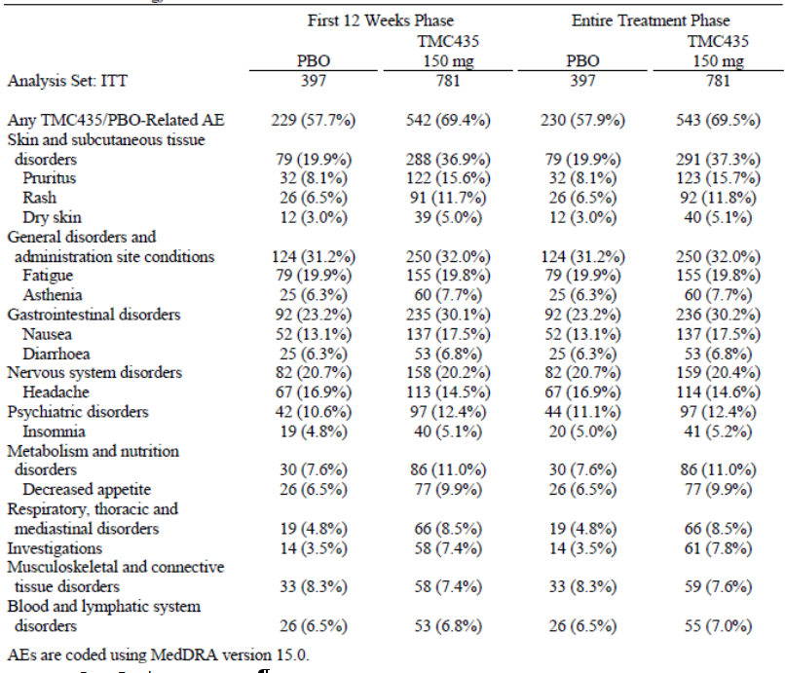

Other studies
In the secondary pooling, treatment-related AEs were reported in 69.7% of TMC patients and 60.4% of placebo patients, most commonly fatigue, nausea and pruritus. Treatment-related AEs were reported in 65.1% of patients in C212, 75.7% of patients in C213, 75.7% of patients in HPC3011, and in 40.5% of patients in C202.

Deaths and other serious adverse events

Pivotal studies
No deaths were reported during the first 12 weeks in the primary pooling. Three patients in the TMC group died after TMC treatment was completed and none were considered related to TMC (colon carcinoma, sudden death, pneumonia with septic shock). SAEs were reported in 2.0% of TMC treated patients and in 2.5% of patients on placebo. Photosensitivity SAEs were reported in two TMC patients compared with none in the placebo group.

Other studies
No deaths were recorded during TMC treatment in the secondary pooling. There was one additional death compared with the primary pooling which occurred after TMC treatment (brain injury and meningitis). The secondary pooling included two additional SAEs, both in the placebo group. No deaths were recorded in C212. SAEs occurred in 5 (4.7%) of patients during TMC treatment and one (0.9%) was considered to be treatment-related. There were no deaths or SAEs in C213, HPC3011 or C202 during the TMC treatment period.

Discontinuation due to adverse events

Pivotal studies
Discontinuations due to AEs were encountered in 1.8% of patients on TMC compared with 1.3% on placebo.

Other studies
In the secondary pooling, there were two additional withdrawals due to AEs. In C212, there was one (0.9%) withdrawal; in C213, there was one (2.0%) withdrawal due to a photosensitivity reaction; in HPC3011, there was one withdrawal due to a drug overdose; and in C202, there was one withdrawal due to unrelated ileitis.

Laboratory tests

Liver function

Pivotal studies
In the primary pooling, mean ALT and AST decreased from baseline in both treatment groups, and the decrease was larger and steeper in the TMC group compared with placebo. During the first 12 weeks of treatment, ALT and AST elevations were mostly Grade 1 or 2 and were reported more frequently in the placebo group compared with TMC. Grade 3 ALT abnormalities occurred in 1.3% of the TMC group compared with 2.0% in the placebo group. Grade 3 AST abnormalities occurred in 1.0% and 1.3% of the TMC and placebo groups, respectively. No Grade 4 ALT or AST abnormalities were reported in either treatment group. There was a higher frequency of GGT abnormalities in the placebo group compared with placebo and most were Grade 1 or 2. There was a higher frequency of hyperbilirubinaemia in the TMC group but most were Grade 1 or 2. Grade 3 abnormalities were reported in 4.1% of the TMC group compared with 1.5% in the placebo group. There were 3 (0.4%) Grade 4 abnormalities in the TMC group compared with none in the placebo group.

Other studies
Changes in LFTs in the secondary pooling were similar to the primary pooling. The frequency of hyperbilirubinaemia was higher in the TMC 150 mg QD group compared with the TMC 100 mg and 75 mg QD groups although the patient numbers were small in the low dose groups. In C212, Grade 3 ALT or AST abnormalities occurred in one (1.0%) and 2 (1.9%) patients, respectively. There were no Grade 4 abnormalities. Grade 1 or 2 hyperbilirubinaemia was experienced by 44.8% of patients. There were 2 (1.9%) Grade 3 abnormalities but no Grade 4 abnormalities. In C213, HPC3011 and C202, modest hyperbilirubinaemia without transaminase elevations was observed.

Kidney function

Pivotal studies
In the primary pooling there were no clinically meaningful changes in mean serum creatinine from baseline in either treatment group.

Other studies
In an open-label study of TMC 150 mg QD for 7 days in 8 patients with severe renal impairment (C126), TMC was generally safe and well tolerated. In the secondary pooling, no patients had severe renal impairment with GFR <30 mL/min at baseline. A total of 33 (2.2%) patients had moderate renal failure (GFR 30-59 mL/min) and 843 (56.7%) had mild renal impairment (GFR 60-89 mL/min). No clinically meaningful changes in renal function from baseline were observed in the secondary pooling, and in a covariate analysis, serum creatinine was not a significant covariate.

Other clinical chemistry

Pivotal studies
In the primary pooling, no clinically meaningful changes from baseline or treatment trends in clinical chemistry were observed in either treatment group.

Other studies
In the secondary pooling and uncontrolled studies, no clinically meaningful changes from baseline or trends in clinical chemistry were observed in either treatment group.

Haematology

Pivotal studies
In the primary pooling during the first 12 weeks of therapy, the incidence of anaemia was 13.4% and 10.8% in the TMC and placebo groups, respectively. In both treatment groups, mean haemoglobin decreased sharply from baseline during the first 4 weeks, and more gradually until Week 12 before stabilizing thereafter. In both treatment groups, mean neutrophil counts decreased sharply from baseline during the first 4 weeks of treatment and remained stable thereafter. Mean values increased towards baseline after completion of PR therapy (at Week 24 in the majority of TMC patients). There were no differences in mean values over time between the treatment groups for platelets, leucocytes and lymphocytes.

Other studies
The haematology changes in the secondary pooling mirrored those of the primary pooling with no evidence of a dose related TMC effect. In C212, there were sharp falls in mean haemoglobin and neutrophils in both treatment groups which mirrored those of the primary pooling. There were no meaningful changes in platelets, leucocytes or lymphocytes. In C213, HPC3011 and C202 the most consistent change in haematological parameters was neutropaenia with a similar pattern to the primary pooling.

Electrocardiograph

Pivotal studies
There were no clinically meaningful changes from baseline in ECG parameters. There were no treatment-emergent QTcF values >480 msec or increases from baseline >60 msec in either treatment group. ECG abnormalities other than QT increases were reported in <2% of patients in any treatment group.

Other studies
There were no dose related ECG changes detected in the secondary pooling. No significant ECG changes or trends were reported in studies C212, C213, HPC3011 and C202.

Vital signs

Pivotal studies
There were no clinically meaningful mean changes from baseline in vital signs in either treatment group. The proportions of patients with significant events were low and similar in both groups.

Other studies
No dose related changes in vital signs were reported in the secondary pooling. There were no significant changes or trends in vital signs observed in studies C212, C213, HPC3011 and C202.

Post-marketing experience
Simeprevir has not been approved for marketing in any jurisdiction.

Safety issues with the potential for major regulatory impact

Liver toxicity
There is no evidence of liver toxicity to TMC in the Phase 2b/3 study program to date. In TMC/PR and PBO/PR groups, mean ALT and AST levels fell from baseline during the first 4 weeks of treatment. The fall was more pronounced in the TMC patient group, presumably reflecting a favourable biochemical response to treatment. During the first 12 week phase, hyperbilirubinaemia (without concomitant rises in ALT/AST) was observed in both treatment groups (7.9% TMC versus 2.8% placebo). Grade 4 events were reported in only 2 (0.3%) TMC patients and there were no SAEs. In the first 2 weeks of treatment, mean total bilirubin increased from baseline in both group and decreased to baseline after completion of TMC treatment. The higher incidence of bilirubin elevations in TMC patients is attributed to decreased bilirubin elimination related to inhibition of the hepatic transporters OATP1B1 and MRP2, and possibly due to RBV-induced haemolysis.

Haematological toxicity
There is no evidence of haematological toxicity to TMC in the Phase 2b/3 study program to date. There is no evidence that TMC increases the incidence of anaemia or worsens its severity. During the first 12 weeks of treatment, the incidence of anaemia was similar in both treatment groups (13.4% TMC, 10.8% placebo). Grade 3 events were reported in 1% and 1.8% of TMC and placebo patients, respectively; and there were no Grade 4 events or SAEs in TMC patients. The incidence of anaemia declined to baseline in TMC patients but remained elevated in PBO/PR patients until Week 52. There is no evidence that TMC increases the incidence of neutropaenia or worsens its severity. During the first 12 weeks of treatment, in the incidence of neutropaenia was 16.5% and 15.1% in the TMC and placebo groups, respectively. Grade 4 events were reported in 2.4% and 1.5% of TMC and placebo patients, respectively. In both treatment groups, there was an immediate reduction in neutrophil count which returned to baseline when TMC/PR treatment was stopped but continued in PBO/PR patients. There were no meaningful changes in other haematological parameters in either treatment group.

Serious skin reactions
There have been no serious skin reactions in the Phase 2b/3 study program to date. During the first 12 weeks of treatment in the primary pooling, the incidence of rash (any type) was 23.2% and 16.9% in the TMC and placebo patients, respectively. Grade 3 events were reported in 5 (0.6%) TMC patients but there were no Grade 4 events. Two (0.3%) TMC patients had SAEs, both photosensitivity reactions requiring hospitalisation (one Grade 2 and one Grade 3). There was a higher incidence of photosensitivity reactions in TMC patients (3.3%) compared with placebo patients (0.5%) but there were no Grade 4 events. The majority of photosensitivity reactions occurred during the first 12 weeks of treatment. The incidence of pruritus was higher in TMC patients (22.0%) than placebo patients (14.9%) but there were no Grade 4 events and no SAEs.

Cardiovascular safety
No cardiovascular safety issues were identified. QTcF values between 450 and 480 msec were observed in 1.5% and 0.5% of TMC and placebo patients, respectively. No QTcF increases >60 msec from baseline were observed. ECG abnormalities other than QT increases were recorded in <2% of either treatment group.

Unwanted immunological events
Not applicable.

Other safety issues

Safety in special populations
AEs were analysed in subgroups defined by age, gender, race, geographical region, BMI and Metavir fibrosis score. There were no age related effects of TMC although there were few patients aged >65 years. A higher incidence of AEs was seen in both treatment groups in patients aged >45 years. In each age category, the incidence of AEs was higher in the TMC group but the difference between the TMC and placebo groups was similar. Pruritus and anaemia were more commonly reported in older patients but the difference between treatment groups did not suggest a TMC treatment effect. The incidence of AEs was similar in male and female patients. Hyperbilirubinaemia was observed more often in males while anaemia and rash were more commonly observed in females. Most patients were White and the number of Black and Asian patients was too low to permit meaningful comparisons. There were no meaningful effects based on geographical region or BMI. During the first 12 weeks of treatment, there was no effect of Metavir score on the incidence of AEs. However, there was an increased incidence of hyperbilirubinaemia and anaemia in patients with Metavir scores F3 and F4.
TMC has not been studied in patients with severe renal impairment but it was well tolerated in patients with mild or moderate renal impairment in the secondary pooling. In C126, TMC was generally well tolerated in patients with severe renal impairment treated with TMC 150 QD for 7 days. At steady state, AUC_{24h} was 1.62 fold higher compared with patients with normal renal function so TMC dose reduction in patients with renal impairment is not considered necessary (RBV is contra-indicated in patients with severe renal impairment). In C113, TMC 150 mg QD for 7 days was well tolerated in patients with moderate or severe hepatic impairment and no meaningful mean changes from baseline were observed in any laboratory parameter. The mean steady state AUC_{24h} of TMC was 2.4 fold and 5.2 fold higher in patients with moderate and severe hepatic impairment, respectively. However, patients with moderate or severe hepatic impairment were excluded from the Phase 2b/3 studies so no long-term data are available in this group. In C212, the safety profile of TMC in patients with HCV/HIV co-infection was similar to patients with HCV mono-infection.

Safety related to drug-drug interactions and other interactions
Simeprevir is both a substrate for and mild inhibitor of CYP3A in vivo as well as being a substrate for P-gp, MRP2, BCRP, OATP1B1, OATP2B1, and OATP1B3.
Drug-drug interaction studies in healthy subjects clearly indicate that steady-state simeprevir exposure increases dramatically when simeprevir is co-administered with drugs that are moderate or strong inhibitors of CYP3A, which are also inhibitors of P-gp, such as erythromycin (Cmin increased by 12.74-fold) and ritonavir (Cmin increased by 14.35-fold). Therefore, administration with drugs such as these would be expected to increase not only the efficacy of simeprevir but also the incidence of AEs and SAEs. Similarly, simeprevir generally increased the exposure of other CYP3A inhibitors when the CYP3A inhibitors were co-administered with simeprevir.
By contrast, when simeprevir was co-administered with other CYP3A substrates, such as rilpivirine and ethinylestradiol, there was little to no effect on the PKs of simeprevir, nor were PKs of the other CYP3A substrates unduly affected.
When BMS-790052 (daclatasvir), which is not only a CYP3A substrate but also a P-gp inhibitor was co-administered with simeprevir there was a 1.5- to 2.68-fold increase in exposure to both drugs possibly suggesting that although co-administration with CYP3A substrates has little effect on the PKs of simeprevir and no dose adjustment is necessary, when co-administered with P-gp inhibitors there is a moderate increase in PK exposure and dose may need to be decreased.
Simeprevir co-administration also affected the PKs of another class of drugs, the HMG-CoA reductase inhibitors, such as atorvastatin and simvastatin, which are used in the treatment of high blood cholesterol and are metabolised by CYP3A and are substrates of OATP1B1. Although, these drugs had little to no effect on the PKs of simeprevir, simeprevir increased exposure to both atorvastatin and simvastatin and their active metabolites by 1.5- to 3.0-fold and therefore an approximate halving of dose of these HMG-CoA reductase inhibitors may be warranted if they are to be co-administered with simeprevir.
CYP3A inducers, such as TMC647055, rifampin and efavirenz, in contrast to CYP3A inhibitors have been shown to significantly decrease simeprevir exposure by up to 90%, whereas, simeprevir had little effect on the PKs of efavirenz and rifampin. By contrast, exposure to TMC647055, which is not only a moderate inducer of CYP3A at high concentrations but also a CYP3A substrate and a weak inhibitor of CYP3A-mediated metabolism, was increased by up to 1.87-fold when co-administered with simeprevir. These studies indicate that when simeprevir is co-administered with CYP3A-inducers the dose of simeprevir may have to be increased to maintain its efficacy.
The PKs of P-gp substrates are also significantly affected by co-administration with simeprevir. For instance, digoxin exposure was moderately increased (approximately 1.4-fold) when given in combination with simeprevir, whereas exposure to rosuvastatin was greatly increased (approximately 3-fold) and therefore, dose adjustment may be necessary when co-administering P-gp substrates with simeprevir. The effects of these drugs on the PK of simeprevir are unknown.
Finally, GS-5885, which does not inhibit or induce CYP enzymes, MRP2 or OATP1B1, increased simeprevir exposure by approximately 2.6-fold when simeprevir was co-administered with GS-5885 relative to when simeprevir was administered alone. Similarly, GS-5885 exposure was increased by approximately 1.8-fold when co-administered with simeprevir and therefore a decrease in dose may be necessary when co-administering these drugs to maintain the efficacy and reduce the potential for AEs.
This final study also suggests that pathways other than those previously identified are in part responsible for the metabolism of simeprevir and that caution should be taken when co-administering simeprevir with other drugs that are not metabolised by these previously identified pathways.

Evaluator’s overall conclusions on clinical safety
In the primary and secondary poolings, TMC 150 mg QD was generally well tolerated and the incidence of AEs by type and PT were similar in the TMC and placebo patient groups. As expected, there was a high frequency of ADRs related to PR therapy (fatigue, headache, influenza-like illness) but the incidence of each was similar in the TMC and control groups. Most AEs were Grade I or 2. The incidence of Grade 3 AEs (20% TMC, 21.9% placebo) and Grade 4 AEs (2.9% TMC, 2.8% placebo) were similar in both treatment groups. The frequency of SAEs was low in both treatment groups (2.0% TMC, 2.5% placebo) and there were no deaths in the TMC groups during the first 12 weeks of treatment. There was a higher frequency of hyperbilirubinaemia in TMC patients, probably related to inhibition of OATP1B1 and MRP2 hepatic transporters. It was not associated with other LFT abnormalities and it can be considered benign. There was a high incidence of anaemia and neutropenia but the rates were similar in the TMC and placebo groups. There was a higher incidence of rash of any type in TMC patients but most events were mild to moderate and there were no serious skin reactions. Photosensitivity reactions occurred in 3.3% of TMC patients compared with 0.5% in the placebo group. The incidence of pruritus was significantly higher (22.0% TMC, 14.9% placebo) but most events were mild. There were no noteworthy differences in AE profiles related to age, gender, race, region, BMI or Metavir fibrosis score. The frequency and type of AEs in patients with HCV/HIV co-infection and genotype 4 were generally in line with the overall population although patient numbers and exposure were low. TMC appears to be well tolerated in patients with moderate to severe hepatic impairment and in patients with severe renal impairment. However, most of the data were recorded in short-term Phase 1 studies.
Overall, TMC appears to be safe and well tolerated and no major safety signals have been identified. There is the potential for significant, multiple drug-drug interactions which are of particular concern in patients with HCV/HIV co-infection.

First round benefit-risk assessment

First round assessment of benefits
The benefits of TMC 150 mg QD in the proposed usage are:
- SVR12 achieved in approximately 80% of treatment-naïve patients and patients with prior relapse.
- Higher SVR12 rates compared with placebo in prior partial and null responders (preliminary data).
- A high rate of patients eligible for a 24 week response guided overall treatment period.
- Similar SVR12 rates compared with telaprevir and boceprevir.
- SVR12 rates strongly predict SVR24 rates allowing prompt treatment decisions.
- Treatment benefits maintained across all demographic subgroups and baseline disease characteristics.
- Benefits observed in patients with cirrhosis, HCV/HIV co-infection and HCV genotype 4 infection (preliminary data).
- Once daily dosing with assumed compliance benefits.
- Generally safe and well tolerated.
- A more favourable safety profile compared with telaprevir with fewer skin rash ADRs.

First round assessment of risks
The risks of TMC 150 mg QD in the proposed usage are:
- Reversible hyperbilirubinaemia.
- Emerging drug resistance.
- Limited efficacy and safety data in treatment-experienced prior partial and null responders.
- Limited efficacy and safety data in patients with HCV/HIV co-infection and patients with genotype 4 infection.
- Limited or no data in elderly patients aged >65 years, paediatric patients, breast-feeding women, patients with decompensated liver disease and patients with severe renal failure.

First round assessment of benefit-risk balance
The benefit-risk balance of simeprevir 150 mg is unfavourable given the proposed usage. However it may become favourable following incorporation of changes recommended in First Round recommendation regarding authorisation, below, and after review of responses to questions raised under Clinical questions, below.

First round recommendation regarding authorisation
Authorisation is not recommended for the proposed indication of ‘the treatment of chronic hepatitis C (CHC) genotype 1 or genotype 4 infection, in combination with peginterferon alfa and ribavirin, in adults with compensated liver disease (including cirrhosis) with or without human immunodeficiency virus-1 (HIV-1) co-infection who are treatment-naïve or who have failed previous interferon therapy (pegylated or non-pegylated) with or without ribavirin’. However, approval is recommended for the modified indication of
‘the treatment of chronic hepatitis C (CHC) genotype 1 infection, in combination with peginterferon alfa and ribavirin, in adults with compensated liver disease (including cirrhosis) who are treatment-naïve or who have relapsed following previous peginterferon therapy with or without ribavirin’.
The fact that only prior relapsers were studied in HPC3007 is highlighted in the proposed PI. However, the claim for efficacy in treatment-experienced patients (which would include null and partial responders) is not supported by the pivotal data. Supportive data in null and partial responders are provided in a Phase 2b study but the patient numbers are small and additional clinical trial data should be provided when available. The data in patients with HCV/HIV co-infection or HCV genotype 4 infection are encouraging but too preliminary to support authorisation. It is recommended that the full CSRs for both indications should be evaluated before authorisation is approved. The sponsors should provide efficacy data in patients who have failed previous therapy with non-pegylated interferon therapy before the claim can be approved.

Clinical questions

Pharmacokinetics
- The evaluator requests that, if Study C118 has now been completed, the sponsor provides details from this study regarding the absolute bioavailability of simeprevir.
- Does co- administration of cyclosporine or tacrolimus affect the PKs of simeprevir?
- Does co-administration of digoxin or rosuvastatin affect the PKs of simeprevir?

Pharmacodynamics
In study C202, the antiviral activity of TMC was compared directly in patients with HCV genotypes 2-6 inclusive. Have the sponsors made direct comparisons in a single study of the antiviral activity of TMC mono-therapy in genotypes 1 and 4?

Efficacy
- It is recommended that the CSRs for the completed studies C212 and HPC3011 be submitted for evaluation to support proposed use for patients with HCV/HIV co-infection and HCV genotype 4 infection.
- It is not clear why prior partial or null responders were excluded from the pivotal study HPC3007. Only 40 such patients (23 prior partial and 17 prior null) were treated with TMC 150 mg for 12 weeks in study C206, and TMC 100 mg data were used in a pooled analysis. Please justify the proposed indication given the paucity of data in prior partial and null responders.
- Please state what studies have been performed in patients who have failed previous non-pegylated interferon therapy (as stated in the indication).

Safety
No questions.

Second round evaluation of clinical data submitted in response to questions

Pharmacokinetics
Question 1: The evaluator requests that, if Study C118 has now been completed, the sponsor provides details from this study regarding the absolute bioavailability of simeprevir.
- Sponsor’s Response:
The full clinical study report of study C118 was provided in the Sponsor’s original submission dossier. A separate Clinical Overview Addendum, that summarized the results of study C118, was provided and this was discussed in our submission cover letter in the subsection “Note to the reviewer” and in the electronic version of the covering letter a hyperlink to the 2.5 Clinical Overview Addendum was provided.
The conclusion of study C118 is that the mean average absolute bioavailability of simeprevir after intake of a single oral 150-mg dose was 62% and after intake of a single oral 50-mg dose was 46%.
- Evaluator’s Response:
The sponsor’s response is acceptable.
Question 2: Does co-administration of cyclosporine or tacrolimus affect the PKs of simeprevir?
- Sponsor’s Response:
Study C120 was designed to evaluate the effect of simeprevir at steady-state on the single-dose pharmacokinetics of cyclosporine or tacrolimus. Pharmacokinetic (PK) profiles of simeprevir were measured only in the presence of cyclosporine or tacrolimus. The data are shown in the original submission dossier. The maximum plasma concentration (Cmax) and area under the plasma concentration-time curve (AUC) for simeprevir in the presence of a single dose of cyclosporine was 4799 ng/mL and 55360 ng.h/mL respectively, and in the presence of tacrolimus was 3151 ng/mL and 38240 ng.h/mL respectively.
A pooled analysis of Phase 1 studies in which pharmacokinetic data were obtained after 7 days of simeprevir administration as the Phase 2b or Phase 3 capsule at 150 mg q.d. is described in the original submission dossier. The inter-subject variability was high for all pharmacokinetic parameters (coefficient of variation [CV] ranges from 73% to 139%).
Following 7 days of simeprevir administration at 150 mg q.d., the geometric mean steady-state Cmax was 1992 ng/mL, and the geometric mean AUC24h was 22850 ng.h/mL. Although the exposure of simeprevir in the presence of cyclosporine and tacrolimus is somewhat higher than the pooled parameters from Phase 1 studies, there were individual studies in which simeprevir dosed alone also gave high AUC values, for example in studies C126 and C115 measured AUCs were 44380 and 43400 ng.h/mL with Cmax values of 3378 and 3788 ng.h/mL respectively (original submission dossier).
In conclusion, although the observed simeprevir exposures in the presence of cyclosporine and tacrolimus are at the high end of those observed in other Phase 1 studies, clear conclusions cannot be drawn from cross-study comparisons of simeprevir PK, due to the large inter-study and inter-subject variability.
- Evaluator’s Response
The evaluator believes that a caution should be included in the “Interactions with other medicines” section of the PI that co-administration of tacrolimus or cyclosporine with simeprevir may result in significant increases in simeprevir exposure and that the monitoring of blood concentrations of simeprevir is recommended.
Question 3 Does co-administration of digoxin or rosuvastatin affect the PKs of simeprevir?
- Sponsor’s Response:
Study C108 was designed to investigate the effect of simeprevir at steady-state on the single dose pharmacokinetics of digoxin and rosuvastatin. PK profiles of simeprevir were measured only in the presence of digoxin or rosuvastatin. The data are shown in the original submission dossier. The Cmax and AUC for simeprevir in the presence of a single dose of digoxin were 1376 ng/mL and 15890 ng.h/mL respectively and in the presence of a single dose of rosuvastatin 1972 ng/mL and 21000 ng.h/mL respectively.
A pooled analysis of Phase 1 studies in which pharmacokinetic data were obtained after 7 days of simeprevir administration as the Phase 2b or Phase 3 capsule at 150 mg q.d. is described in the original submission dossier. The inter-subject variability was high for all pharmacokinetic parameters (CV was 73% to 139%). Following 7 days of simeprevir administration at 150 mg q.d., the geometric mean steady-state Cmax was 1992 ng/mL, and the geometric mean AUC_{24h} was 22850 ng.h/mL.
Considering the high inter-study variability in the exposure of simeprevir, the exposure in the presence of digoxin or rosuvastatin can be considered similar to that observed in other Phase 1 studies in which simeprevir was administered alone.
- Evaluator’s Response:
The sponsor’s response is satisfactory.

Pharmacodynamics
Question: In study C202, the antiviral activity of TMC was compared directly in patients with HCV genotypes 2-6 inclusive. Have the sponsors made direct comparisons in a single study of the antiviral activity of TMC mono-therapy in genotypes 1 and 4?
- Sponsor’s Response:
The sponsor did not perform a direct comparison in a single study of the antiviral activity of simeprevir mono-therapy in genotypes 1 and 4. Patient baseline factors are not expected to affect the response to monotherapy and thus a comparison of antiviral activity across studies was performed.
Antiviral activity of simeprevir monotherapy in genotype 1 and 4 was assessed in 3 different studies. Simeprevir 200 mg once daily (q.d.) was investigated in one Phase 1 study in prior non-responders and prior relapsers infected with HCV genotype 1 (study C101) and in two Phase 2a studies in treatment-naïve subjects infected with HCV genotype 1 (study C201) or HCV genotype 2, 3, 4, 5 or 6 (study C202).
An overview of the changes from baseline in HCV RNA on Days 3, 5 and 7 is provided by study and hepatitis C virus (HCV) genotype in Table 17. The antiviral activity of simeprevir against HCV genotype 1 was similar in study C101 and C201 irrespective of prior treatment history and similar to the antiviral activity seen in treatment-naïve genotype 4 infected subjects. On Day 3, the median change from baseline in HCV RNA was -3.46 log10 IU/mL and -3.78 log10 IU/mL in genotype 1 infected subjects in studies C101 (5-day monotherapy) and C201 (7-day monotherapy), respectively, and -3.55 log10 IU/mL in genotype 4 infected subjects in study C202 (7-day monotherapy). On Day 7, the median change from baseline in HCV RNA was -3.78 log10 IU/mL and -4.32 log10 IU/mL in genotype 1 infected subjects in studies C101 and C201, respectively, and -3.95 log10 IU/mL in genotype 4 infected subjects in study C202.
In summary, the sponsor considers the monotherapy data from study C101, C201 and C202 adequate to conclude that simeprevir displays similar antiviral activity in GT1 and GT4 infected patients. The similar activity seen with simeprevir monotherapy in GT1 and GT4 infected patients is consistent with in vitro data showing similar 50% effective concentration (EC₅₀) values of simeprevir against replicons carrying NS3 sequences from GT4 and GT1 clinical isolates. In addition, the high sustained virologic response 12 weeks after end of treatment (SVR12) rates in genotype 4 infected patients treated with simeprevir in combination with pegylated interferon (PegIFN)/ribavirin (RBV) in the Phase 3 study HPC3011 confirmed the genotype 4 activity of simeprevir (further details were provided in response to recommended changes to PI statements).

Table 17: Changes from baseline in HCV RNA (log10 IU/mL) in HCV-infected subjects receiving monotherapy with simeprevir 200 mg qd; ITT (Studies C101, C201, C202)
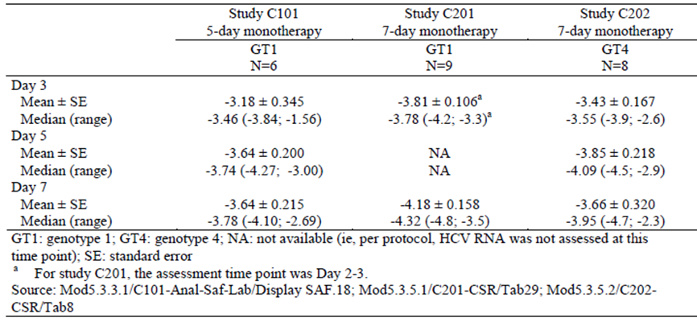
- Evaluator’s Response:
The Sponsor’s response to the Pharmacodynamics Question is satisfactory. The antiviral activity of simeprevir has not been compared directly in patients with GT1 and GT4 HCV infection. However, changes from baseline in HCV RNA in patients receiving monotherapy with simeprevir 200 mg qd were similar in studies C101 and C201 (in treatment-naïve patients with GT1 infection) and study C202 (in treatment-naïve patients with GT4 infection). The results of these studies are in line with in vitro data which demonstrated similar EC50 values of simeprevir against replicons from GT1 and GT4 clinical isolates. Overall, the data support the premise that the antiviral activity of simeprevir is similar in patients with GT1 and GT4 HCV infection.

Efficacy
Question 1: It is recommended that the CSRs for the completed studies C212 and HPC3011 be submitted for evaluation to support proposed use for patients with HCV/HIV co-infection and HCV genotype 4 infection.
- Sponsors Response:
The completed C212 CSR and the Week 60 interim analysis for HPC3011 have been provided.
- Evaluator’s Response
The Sponsor’s response to Efficacy Question 1 is satisfactory. The sponsor has submitted the C212 CSR for the now completed study, and a further interim analysis of HPC3011 with a Week 60 cut-off. The additional data confirm the results of earlier interim analyses and support the use of simeprevir in patients with HCV/HIV co-infection and in patients with HCV GT4 infection.

Study C212
The study design and methodology are described for the interim analysis evaluated in Section 7.1.2.1, above. The disposition data for the expanded set of completed patients were shown. Of the 106 treated patients, 97 (91.5%) patients completed the study and 9 (8.5%) discontinued prematurely.
Overall, SVR12 was achieved in 73.6% (78/106) of patients. SVR12 was achieved in 79.2% (42/53) of HCV treatment-naïve patients, 86.7% (13/15) prior HCV relapsers, 70.0% (7/10) prior HCV partial responders, and 57.1% (16/28) prior HCV null responders. In the final analysis, SVR12 was achieved in 75.35 (70/93) of patients on HAART and in 61.5% (8/13) patients not on HAART.
These data are in line with SVR12 rates recorded in the interim analysis. Overall 76.9% (10/13 total patients), 75.0% (6/8 treatment-naïve patients) and 80.0% (4/5 prior relapsers) of patients achieved SVR12. There were no data available for prior null responders in the interim analysis.
SVR12 rates for simeprevir in combination with PR were higher than in historical controls treated with PR only (79.2% versus 29.0%, p<0.001 for HCV treatment-naïve patients and 57.1% versus 5.4%, p<0.001 for HCV prior non-responders). Of the patients who achieved SVR12, all except one patient achieved SVR24, a prior HCV null responder with confirmed re-infection after entry into the study. RVR was achieved in 65.7% of the overall study population, 71.2% of the treatment-naïve patients, 93.3% of prior HCV relapsers, 80% of the prior partial responders, and 35.7% of prior null responders. Overall, 27.4% of patients experienced treatment failure (17.0% on-treatment, 10.4% post-treatment). Treatment failure was observed in 20.8% of HCV treatment-naïve patients, 13.3% prior HCV relapsers, 30% prior HCV partial responders, and 46.4% prior HCV null responders. Overall, viral breakthrough was observed in 11.4% of patients. A total of 5/93 (5.4%) patients on HAART had HIV virologic failure based on confirmed HIV RNA ≥50 copies/mL after having HIV RNA <50 copies/mL.
A summary of the adverse events was provided. The pattern of AEs was similar to that observed in the interim analysis with few Grade 4 AEs or SAEs and no deaths. There were no unexpected observations with regard to the frequency or severity of AEs of special interest, and the majority of these events were Grade 1 or 2 in severity. During the simeprevir/PR treatment phase, Grade 3 or 4 neutropaenia was reported in 20.8% of patients.
Overall, the results of the final C212 CSR confirm the preliminary results observed in the interim analysis. In patients with HCV and HIV co-infection the combination of simeprevir/PR achieved high SVR12 response rates which were superior to historical controls given PR alone.

Study HPC3011
This study is still on-going and a further top-line interim analysis at Week 60 has been provided. The study design and methodology are described in Section 7.1.2.4. At the Week 60 cut-off, 70.1% of patients had completed the study, 2.8% had discontinued and 27.1% were on-going.
In the ITT population, SVR12 was achieved in 70/107 (65.4%) patients. SVR12 rates by prior HCV treatment response were shown.
In the ITT population, SVR24 was achieved in 55/63 (87.3%) patients and treatment failure was observed in 37/107 (34.6%) patients. Overall, viral breakthrough occurred in 20/107 (18.7%) patients (11.4% in treatment-naïve patients, 4.5% in prior relapsers, 20.0% in prior partial responders and 32.5% in prior null responders).
A summary of AEs and AEs of interest was provided. The majority of AEs were mild to moderate, with a low incidence of SAEs and no deaths. Neutropaenia was observed less frequently than in other studies but the pattern of AEs was otherwise similar to that reported in the first interim analysis and in the overall safety data base.

Evaluator’s conclusion:
The sponsor’s response to Efficacy Question 1 is satisfactory. The sponsor has submitted the C212 CSR for the now completed study, and a further interim analysis of HPC3011 with a Week 60 cut-off. The additional data confirm the results of earlier interim analyses and support the use of simeprevir in patients with HCV/HIV co-infection and in patients with HCV GT4 infection.
Question 2: It is not clear why prior partial or null responders were excluded from the pivotal study HPC3007. Only 40 such patients (23 prior partial and 17 prior null) were treated with TMC 150 mg for 12 weeks in study C206, and TMC 100 mg data were used in a pooled analysis. Please justify the proposed indication given the paucity of data in prior partial and null responders.
- Sponsor’s Response:
Prior partial and null responders were excluded from the pivotal study HPC3007 on regulatory advice. These patient populations had previously relapsed after PR treatment alone and data from the Phase 2 program was still preliminary. This issue is addressed in the Phase 3 study HPC3001, an on-going, non-inferiority study comparing simeprevir/PR with telaprevir/PR without a placebo/PR control group. To date SVR12 data are available to the study DMC from 145 prior partial responders and 234 prior null responders and the sponsor states that the non-inferiority of simeprevir has been observed in the trial to date.
- Evaluator’s Response:
The Sponsor’s response to Efficacy Question 2 is satisfactory although the limited data from C206 remains the only data to support for this indication. The study HPC3001 is still on-going and blinded to the sponsor and investigators. However, the study DMC is unblinded and it has voted to continue the study. From this, the sponsor infers that the data to date are likely to confirm non-inferiority. Overall, it is reasonable to approve the proposed indication in view of the still unmet medical need in this group of patients. However, it would also be reasonable if the TGA delegate prefers to wait for an interim analysis of study HPC3001.
Question 3: Please state what studies have been performed in patients who have failed previous non-pegylated interferon therapy (as stated in the indication).
- Sponsor’s Response:
In the pivotal study HPC3007, only 9 (2.3%) patients had previously received non-pegylated PR therapy. The sponsor acknowledges that the patient numbers are not sufficient to draw conclusions on efficacy but there may now be an insufficient pool of patients who have previously received non-pegylated IFN. However, the sponsor notes that historically SVR rates are significantly higher with pegylated IFN than with non-pegylated IFN combination therapy. Therefore, they predict that the response to simeprevir/PR therapy will be better or at least no worse in patients who have previously failed or relapsed on non-pegylated IFN.
- Evaluator’s Response:
The sponsor’s response to Efficacy Question 3 is satisfactory. The sponsor’s argument that the response to simeprevir/PR therapy will be better or at least no worse in patients who have previously failed or relapsed on non-pegylated IFN is not unreasonable although it is based on supposition without supporting clinical data.

Second round benefit-risk assessment

Second round assessment of benefits
After consideration of the responses to clinical questions, the benefits of OLYSIO (simeprevir) in the proposed usage are unchanged from those identified in Section 9.1.

Second round assessment of risks
After consideration of the responses to clinical questions, the risks of OLYSIO (simeprevir) in the proposed usage are unchanged from those identified in Section 9.2.

Second round assessment of benefit-risk balance
The benefit-risk balance of OLYSIO (simeprevir), given the proposed usage, is favourable.

Second round recommendation regarding authorisation
Authorisation is recommended for the proposed indication of
‘the treatment of chronic hepatitis C (CHC) genotype 1 or genotype 4 infection, in combination with peginterferon alfa and ribavirin, in adults with compensated liver disease (including cirrhosis) with or without human immunodeficiency virus-1 (HIV-1) co-infection who are treatment-naïve or who have failed previous interferon therapy (pegylated or non-pegylated) with or without ribavirin’.
In the first round evaluation, the clinical aspects of the PI were considered satisfactory but the data did not fully support the indication for use in patients with HCV genotype 4 infection, patients with HCV/HIV co-infection, and prior partial and null responders. The main deficiency was the paucity of clinical data in each of these patient groups. The sponsor has addressed these issues with the addition of more clinical trial data which confirm the sparse previous interim data and are in line with efficacy rates in treatment-naïve patients with HCV genotype 1 infection. The sponsor has not provided additional clinical data relating to efficacy in prior partial and null responders over those previously provided in C206. This deficiency is being addressed in the on-going, non-inferiority study HPC3001 comparing simeprevir/PR and telaprevir/PR which is still blinded. On balance, authorisation for use in prior partial and null responders is recommended based on C206 but subject to the results of HPC3001 being provided in a timely manner.

References
None

Therapeutic Goods Administration
PO Box 100 Woden ACT 2606 Australia
Email: info@tga.gov.au Phone: 1800 020 653 Fax: 02 6232 8605
http://www.tga.gov.au

Evaluation and recommendations concerning the PI and CMI are not included in the CER extract.

