First round evaluation: 5 October 2016
Second round evaluation: 31 January 2017

AusPAR Attachment 2

Extract from the Clinical Evaluation Report for Silodosin
  - Proprietary Product Name: Urorec
  - Sponsor: Mayne Pharma International

About the Therapeutic Goods Administration (TGA)
- The Therapeutic Goods Administration (TGA) is part of the Australian Government Department of Health, and is responsible for regulating medicines and medical devices.
- The TGA administers the Therapeutic Goods Act 1989 (the Act), applying a risk management approach designed to ensure therapeutic goods supplied in Australia meet acceptable standards of quality, safety and efficacy (performance), when necessary.
- The work of the TGA is based on applying scientific and clinical expertise to decision-making, to ensure that the benefits to consumers outweigh any risks associated with the use of medicines and medical devices.
- The TGA relies on the public, healthcare professionals and industry to report problems with medicines or medical devices. TGA investigates reports received by it to determine any necessary regulatory action.
- To report a problem with a medicine or medical device, please see the information on the TGA website <https://www.tga.gov.au>.
About the Extract from the Clinical Evaluation Report
- This document provides a more detailed evaluation of the clinical findings, extracted from the Clinical Evaluation Report (CER) prepared by the TGA. This extract does not include sections from the CER regarding product documentation or post market activities.
- The words [Information redacted], where they appear in this document, indicate that confidential information has been deleted.
- For the most recent Product Information (PI), please refer to the TGA website <https://www.tga.gov.au/product-information-pi>.
Copyright
© Commonwealth of Australia 2017
This work is copyright. You may reproduce the whole or part of this work in unaltered form for your own personal use or, if you are part of an organisation, for internal use within your organisation, but only if you or your organisation do not use the reproduction for any commercial purpose and retain this copyright notice and all disclaimer notices as part of that reproduction. Apart from rights to use as permitted by the Copyright Act 1968 or allowed by this copyright notice, all other rights are reserved and you are not allowed to reproduce the whole or any part of this work in any way (electronic or otherwise) without first being given specific written permission from the Commonwealth to do so. Requests and inquiries concerning reproduction and rights are to be sent to the TGA Copyright Officer, Therapeutic Goods Administration, PO Box 100, Woden ACT 2606 or emailed to <tga.copyright@tga.gov.au>.

Contents
List of common abbreviations 5
1. Submission details 10
1.1. Submission type 10
1.2. Dosage forms and strengths 10
1.3. Dosage and administration 10
1.4. Background 10
1.5. Formulation 11
1.6. Guidance 11
1.7. Evaluator’s commentary on the background information 11
2. Clinical rationale 12
3. Contents of the clinical dossier 12
3.1. Scope of the clinical dossier 12
3.2. Paediatric data 13
3.3. Good clinical practice 13
3.4. Evaluator’s commentary on the clinical dossier 13
4. Pharmacokinetics 13
4.1. Studies providing pharmacokinetic information 13
4.2. Summary of pharmacokinetics 15
4.3. Evaluator’s overall conclusions on pharmacokinetics 25
5. Pharmacodynamics 28
5.1. Studies providing pharmacodynamic information 28
5.2. Summary of pharmacodynamics 29
5.3. Evaluator’s overall conclusions on pharmacodynamics 37
6. Dosage selection for the pivotal studies 38
6.1. Pharmacokinetics and pharmacodynamics: dose finding studies 38
6.2. Phase II dose finding studies 38
6.3. Phase III pivotal studies investigating more than one dose regimen 38
6.4. Evaluator’s conclusions on dose finding for the pivotal studies 38
7. Clinical efficacy 39
7.1. Studies providing evaluable efficacy data 39
7.2. Analyses performed across trials 55
7.3. Evaluator’s conclusions on clinical efficacy 58
8. Clinical safety 59
8.1. Studies providing evaluable safety data 59
8.2. Patient exposure 60
8.3. Adverse events 60
8.4. Evaluation of issues with possible regulatory impact 65
8.5. Safety in special populations 72
8.6. Safety related to drug-drug interactions and other interactions 72
8.7. Post marketing experience 73
8.8. Evaluator’s overall conclusions on clinical safety 73
9. First Round Benefit-Risk Assessment 74
9.1. First round assessment of benefits 74
9.2. First round assessment of risks 75
9.3. First round assessment of benefit-risk balance 75
9.4. First Round Recommendation Regarding Authorisation 76
10. Clinical Questions 76
10.1. Pharmacokinetics 76
10.2. Pharmacodynamics 77
10.3. Efficacy 77
10.4. Safety 79
10.5. First Round Evaluation Errata 79
11. Second round evaluation 80
11.1. Pharmacokinetics 80
11.2. Pharmacodynamics 80
11.3. Efficacy 80
11.4. Overall conclusions 87
12. Second round benefit-risk assessment 87
12.1. Second round assessment of benefits 87
12.2. Second round assessment of risks 87
12.3. Second round assessment of benefit-risk balance 87
13. Second round recommendation regarding authorisation 88
14. References 88

List of common abbreviations
Abbreviation | Meaning
5-ARI | 5-α-reductase inhibitors
ACE | Angiotensin-Converting Enzyme
AE | Adverse Event
Ae₀₋₂₄₀ | amount excreted through 240 h post-dose
ANCOVA | Analysis of Covariance
ANOVA | Analysis of Variance
AST(GOT) | aspartate aminotransferase (glutamic oxaloacetic transaminase)
AST(GPT) | aspartate aminotransferase (glutamic pyruvic transaminase)
ATC | Anatomical Therapeutic Chemical classification system
AUA | American Urological Association
AUC | Area Under plasma Concentration time curve
AUC_{BP} | Area Under the linear-linear Curve for blood pressure
BCS | Biopharmaceutics Classification System
bd | Twice daily (bis die)
BMI | Body Mass Index
BP | Blood Pressure
BPH | Benign Prostatic Hyperplasia
bpm | beats per minute
BUN | (Blood) Urea Nitrogen
C2h | Predicted plasma concentration 2 h following drug administration
C12h | Predicted plasma concentration 12 h following drug administration
C_{CR} or CL_{CR} | Creatinine Clearance
CFB | Change From Baseline
CI | Confidence Interval
CL_{tot}/F | Total body clearance
C_{max}, | Maximum plasma concentration
C_{max},_{ss} | Maximum plasma concentrations at steady-state
Cmin_{ss} | Minimum plasma concentrations at steady-state
Cre | Creatinine
CRP | C-reactive protein
CSR | Clinical Study Report
CVA | Cerebro Vascular Accident
DB | Double-Blind
DBP | Diastolic Blood Pressure
EAU | European Association of Urology
ECG | electrocardiogram
EU | Europe (European)
F | Bioavailability
FAS | Full Analysis Set
FDA | Food and Drug Administration
FOE | Failure Of Ejaculation
GCP | Good Clinical Practice
GLS | Geometric Least Squares Mean
GOT | Glutamic Oxaloacetic Transaminase
GPT | Glutamic Pyruvic Transaminase
h | Hour
Hb | Haemoglobin
HLS | Huntingdon Life Sciences, Ltd
HPLC | High Performance Liquid Chromatography
HR | Heart Rate
Ht | Haematocrit
ICH | International Conference on Harmonisation
IPSS | International Prostate Symptom Score- subjective symptoms including nocturia, feeling of residual urine, voiding within 2 h, intermittence of urinary stream, urinary urgency, voiding with weak urinary stream, and straining on voiding
ITT | Intent-To-Treat Population
IV | Intravenous
K_{e} or Kel | Elimination rate constant
KMD-3213 | Silodosin
KMD-3213G | Silodosin glucuronide
LC/MS/MS | HPLC combined with tandem mass spectroscopy
LDH | Lactate Dehydrogenase
LFT | Liver Function Test
LOC | Loss Of Consciousness
LOCF | Last Observation Carried Forward
LUTS | Lower Urinary Tract Symptoms
MedDRA | Medical Dictionary for Regulatory Activities
MFR | Maximum Flow Rate
mITT | Modified Intent-To Treat
mmHg | Millimetres of mercury
MONO | Monocyte
ms | Millisecond
N/A | Not applicable
NAD | Nicotinamide Adenine Dinucleotide
OC | Observed Cases
OL | Open Label
OLE | Open-Label Extension (Study)
PD | Pharmacodynamics
PHI | Protected Health Information
PK | Pharmacokinetics
PopPK | Population Pharmacokinetics
PP | Per Protocol Population
PSA | Prostate Specific Antigen
PT | Preferred Term
Q_{max} | Maximum urine flow
QoL | Quality Of Life
RMS | Root-Mean-Square
SAE | Serious Adverse Event
SAF | Safety Analysis Population
SAS® | Statistical Analysis Software
SBP | Systolic Blood Pressure
SD | Standard Deviation
SEM | Standard Error of the Mean
silodosin-G | Silodosin glucuronide
SOC | System Organ Class
TC | Total Cholesterol
TEAE | Treatment Emergent Adverse Events
TFT | Thyroid Function Test(S)
TG | Triglyceride
td | Drug administration three times daily
T_{max} | Time at which C_{max}, occurred
TURP | Transurethral Resection Of The Prostate
ULN | Upper Limit Of Normal Range
URTI | Upper Respiratory Tract Infection
US | Unites States
UTI | Urinary Tract Infection
Vdss/F or Vd | Volume of distribution
WBC | Caucasian Blood Cell Count
γ-GTP | Gamma-Glutamyltranspeptidase

Submission details

Submission type
This is a Category 1 application for approval of a new chemical entity.
Silodosin is a selective α1a-adrenoreceptor blocker.
The proposed indication is:
‘Treatment of the signs and symptoms of benign prostatic hyperplasia in adult men’.

Dosage forms and strengths
Hard capsules containing 4 mg and 8 mg of silodosin as the active substance.

Dosage and administration
A capsule should be taken with food, preferably at the same time every day. It should not be broken or chewed but swallowed whole, preferably with a glass of water.
The recommended dose is one capsule of Urorec 8 mg daily. For special patient populations, one capsule of Urorec 4 mg daily is recommended (see below).
No dose adjustment is required in the elderly.
No dose adjustment is required for patients with mild renal impairment (CLCR ≥ 50 to ≤ 80 ml/min). A starting dose of 4 mg once daily is recommended in patients with moderate renal impairment (CLCR ≥ 30 to < 50 ml/min), which may be increased to 8 mg once daily after one week of treatment, depending on the individual patient’s response. The use in patients with severe renal impairment (CLCR < 30 ml/min) is not recommended.
No dose adjustment is required for patients with mild to moderate hepatic impairment. As no data are available, the use in patients with severe hepatic impairment is not recommended.

Background

Information on the condition being treated
Between puberty and age 50 years, the normal prostate doubles in size under the influence of testosterone, and it doubles again in size by age 80 years. Enlargement is associated with cellular hyperplasia of glandular and stromal tissue which causes increased pressure on the prostatic urethra. Benign prostatic hyperplasia (BPH) is a common condition affecting up to 50% of men over 50 years and more than 80% of men over 80 years. There is a gradual and progressive obstruction to urine flow and increased muscle tone and resistance within the gland. These factors lead to lower urinary tract symptoms (LUTS) such as hesitancy, impaired flow, frequency, nocturia and eventually urinary retention and upper urinary tract dilatation. Up to 90% of men between 45 and 80 years of age suffer LUTS of some degree. However, prostate size and symptoms are often poorly correlated with considerable variability between subjects. The syndrome of LUTS due to BPH is seldom life-threatening. However, it has significant effects on the patients quality of life, with the symptoms described in treatment guidelines as ‘bothersome’.

Current treatment options
The most widely accepted current management guideline for the treatment of LUTS due to BPH was developed by the American Urological Association (AUA) in 1995 (last updated in 2010; www.auanet.org). The treatment guideline issued by the European Association of Urology (EAU) is generally comparable (https://uroweb.org/guideline). Both organisations recommend assessment of LUTS and treatment follow-up using the IPSS self-administered questionnaire. The IPSS total score grades symptom severity based on seven obstructive and irritative symptoms using a scale of 0-35 points. The AUA and EAU guidelines recommend observation (‘watchful waiting’), including non-pharmacological interventions, for early symptoms of BPH (IPSS 0-7 points). Patients with moderate to severe LUTS secondary to BPH (IPSS ≥ 8 points) may then be offered medical therapy, followed by surgery if symptoms remain severe.
Medical therapy is based on anti-cholinergics, 5-α-reductase (5-ARI) inhibitors and α-adrenoreceptor blockers (α-blockers). 5-ARIs such as finasteride and dutasteride reduce prostate size by their anti-androgenic effects. They are effective but only in patients with confirmed prostatic enlargement. The most widely used treatments are selective α-1 blockers such as doxazosin, terazosin, tamsulosin, and alfuzosin, which aid urinary flow by relaxing urinary tract muscle tone. They share similar efficacy, with an immediate onset and sustained long-term effectiveness. Specific α-1a blockers are claimed to be superior to non-specific α-blockers such as prazosin because they act specifically on the urinary tract smooth muscle with less tendency to cause hypotensive symptoms such as dizziness and syncope. Medical therapies may be used singly or in combination. The combination of an α-blocker and a 5-ARI is currently recommended by the AUA (but not by the EAU).
The combination of watchful waiting and pharmacotherapies are used to control symptoms and many patients will avoid surgery. After 5 years treatment, approximately 35% of patients will have progressed to surgery but the other 65% will not. Changes in IPSS are used to monitor disease progression and response to treatment. The AUA regards an improvement of IPSS ≥ 3 to be clinically meaningful. The EAU recommends IPSS for follow-up, but it is silent on what changes should be regarded as clinically meaningful.

Formulation

Formulations used in Clinical Trials
The early clinical studies used first-generation capsules, which were manufactured [information redacted] using Method A. The second and third generation capsules (Methods B and C) were used in Phase II and Phase III studies. The formulation proposed for marketing is identical to that used for the Phase II and Phase III clinical trials performed by [information redacted], which was manufactured by applying the wet granulation process, that is, method ‘C’.

Guidance
No formal scientific advice was sought from regulatory authorities.

Evaluator’s commentary on the background information
The pathophysiology, epidemiology and symptomatology of BPH are well understood. The use of α1 blockers has been a cornerstone of medical therapy for many years and several inhibitors in the class have been marketed. The efficacy and safety profiles of these agents are well understood and considerable post-marketing experience with silodosin has been gained in the US and EU. Clinical trial methodologies have been refined and standardised with endpoints generally agreed by specialist bodies (notably the AUA and EAU) and regulatory authorities.

Clinical rationale
α-blockers were developed for the treatment of hypertension but their use for BPH is limited by orthostatic hypotension. α-1b receptors are located mainly in the cardiovascular system, while α-1a receptors are located mainly in the lower urinary tract. Silodosin is a α1a blocker which selectively acts on the smooth muscle of the prostate, urethra and trigone of the urinary bladder. It has high selectivity with a α1a:α1b binding ratio of 162:1, with the potential to have fewer effects on systemic blood pressure than non-selective α-blockers. It is marketed in many jurisdictions for the treatment of irritative and obstructive symptoms associated with BPH.

Contents of the clinical dossier

Scope of the clinical dossier
The present submission comprises 31 clinical pharmacology studies, of which 24 contain PK data and a further 10 contained PD data. In addition, a single population PK analysis was included as part of the evaluation materials.
The [clinical] module consists of nine clinical studies consisting of three pivotal, Phase III efficacy studies; a single Phase II efficacy study; three open-label, long-term extension studies (EU and US); and two efficacy and safety studies in Japanese patients.

Pivotal efficacy studies
SI04009: a double-blind, randomised, Phase III comparison of silodosin 8 mg and placebo given for 12 weeks (US)
SI04010: an identical, double-blind, randomised, Phase III comparison of silodosin 8 mg and placebo given for 12 weeks (US)
KMD3213-IT-CL-0215 (IT-CL-0215): a double-blind, randomised, Phase III, non-inferiority comparison of silodosin 8 mg, tamsulosin 0.4 mg and placebo given for 12 weeks (EU)

Other studies
KMD3213-US021-99-99 (US021-99): a double-blind, randomised, Phase II comparison of silodosin 4 mg, silodosin 8 mg and placebo given for 8 weeks (US)
An Integrated Summary of Efficacy (US patients)
SI04011: an open-label, long-term efficacy and safety study of silodosin 8 mg given for 40 weeks (US)
KMD3213-IT-CL-0215 (OLE): an open-label extension study of silodosin 8 mg given for 40 weeks (EU)
KMD-203: a long-term, safety and efficacy study of silodosin 2 mg and silodosin 4 mg given from 28 to up to 52 weeks (Japan)
KMD-303: a Phase III, double-blind, parallel group, active and placebo controlled study of silodosin 8 mg, tamsulosin 0.2 mg and placebo given for 12 weeks (Japan)
KMD-305: a Phase III, open-label, study of silodosin 4 mg (or silodosin 2 mg if not tolerated) given for 52 weeks (Japan)
IT-CL-IT-CL-0376: an open-label Phase 4 study of silodosin 8 mg given for 24 weeks (EU)

Paediatric data
No clinical studies have been performed in children.

Good clinical practice
The US and Europe studies were conducted according to the principles of ICH GCP. Studies performed in Japan were performed according to local regulations.

Evaluator’s commentary on the clinical dossier
The present submission in terms of PK/PD studies is satisfactory, although in some instances the information required for the CER has been difficult to source from the submitted documents. In addition, as the Phase I studies undertaken by Kissei were primarily performed using batches of silodosin formulated using Methods A and B and not the formulation method proposed for marketing (that is, Method C), many of these studies were solely undertaken in Japanese subjects and no dedicated studies examined the bioequivalence of the batches of silodosin manufactured by [information redacted] the discussion of the PKs of silodosin will primarily focus on the studies undertaken by [information redacted].
The clinical dossier is satisfactory. It consists of three large, randomised, placebo-controlled, pivotal studies of silodosin 8 mg in US and EU populations with moderate to severe signs and symptoms of BPH. Dose selection was adequately addressed in a Phase II comparison of silodosin 4 mg and 8 mg in US patients and comparisons of 2 mg and 4 mg in Japanese patients. Safety has been adequately addressed in the efficacy studies, long-term extension studies and in integrated safety summaries of US, EU and Japanese populations.

Pharmacokinetics

Studies providing pharmacokinetic information
Table 1: Submitted pharmacokinetic studies.
PK topic | Subtopic | Study ID | *
PK in healthy adults | General PK | SI07004 | Dose-proportionality of silodosin and silodosin-G and KMD-3293 after one and seven daily doses of 4 and 8 mg
PK in healthy adults | Food and bioavailability | KMD-308 | Effect of food on the PKs of a single, 4 mg oral dose of silodosin and bioavailability compared with a 2 mg, IV dose
PK in healthy adults | Single dose PKs | 95283 | PKs of a single administration of 0.5 to 2.5 mg silodosin in Japanese males
PK in healthy adults | Single dose PKs | 98363 | PKs of silodosin and metabolites in Japanese males
PK in healthy adults | Single dose PKs | UK01-97 | Plasma and urine PKs of single oral doses of silodosin
PK in healthy adults | Multi-dose PKs | UK02-97 | Plasma and urine PKs of multiple oral doses of silodosin
PK in healthy adults | Multi-dose PKs | 98364 | PK and safety following repeat doses in Japanese males
PK in healthy adults | Multi-dose PKs | SI06004 | PKs of silodosin and four metabolites following administration of silodosin 8 mg once daily for 7 days.
PK in healthy adults | Therapeutic and supra-therapeutic doses | SI05014 | Effect of 8 mg or 24 mg on the time-matched changes from baseline in the corrected QT interval
PK in healthy adults | Therapeutic and supra-therapeutic doses | SI05008 | Determine the maximum tolerated dose of silodosin
PK in healthy adults | Time of dosing | 95284 | PKs following administration of 1.5 mg for three times a day
PK in healthy adults | Mass balance | US012-99 | Define plasma and whole blood concentration versus time curves for total radioactivity and mass balance following oral administration of [¹⁴C]- silodosin
PKs in Special Populations | Renal impairment | KMD-309 | PKs of a single oral dose in subjects with impaired renal function
PKs in Special Populations | Renal impairment | IT-PK 0234 | PKs of silodosin in subjects with different degrees of renal impairment and in healthy subjects
PKs in Special Populations | Hepatic impairment | SI05010 | PKs of silodosin and major metabolites in subjects with moderate liver dysfunction
PKs in Special Populations | Elderly | KMD-105 | PKs of silodosin following a single oral administration in elderly male and non-elderly male
PKs in Special Populations | Elderly | IT-PK 0241 | Assess exposure at steady-state of silodosin in 2 groups of elderly subjects, 65-75 and > 75 years of age respectively, in comparison with that of younger subjects
PKs in Special Populations | Elderly | KMD-207 | Assess repeat dosing of 12 mg/day (6 mg/dosing, twice daily) in males from the age group of patients with BPH
PKs in Special Populations | Elderly | US011-98 | Assess multiple oral doses healthy males of the target age (between 50 and 70)
PK interactions | Diltiazem | IT-PK 0242 | Assess the effects of diltiazem on the silodosin PKs in healthy male
PK interactions | Digoxin | IT-PK 0263 | Effect of silodosin at steady-state on the steady-state PKs of digoxin
PK interactions | Digoxin | KMD-307-UK | Effect of steady-state silodosin on the steady-state PKs of digoxin
PK interactions | Ketoconazole | KMD-306-UK | Effect of multiple oral doses of a ketoconazole on the PKs of single oral doses of silodosin
PK interactions | Ketoconazole | SI06008 | Effect of multiple oral doses of 400 mg ketoconazole on the PKs of a single 8 mg oral dose of silodosin
*=indicates the primary PK aim of the study.

Summary of pharmacokinetics
Concentrations of silodosin and its metabolites in human plasma and urine were determined using validated High Performance Liquid Chromatography (HPLC) with fluorescence detection and HPLC combined with tandem mass spectroscopy (LC/MS/MS) [information redacted]. [information redacted] subsequently developed and validated six additional LC/MS/MS methods to support their clinical development programme in human plasma and urine.

Physicochemical characteristics of the active substance
Figure 1: Chemical Structure
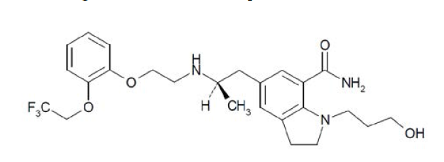
Chemical name: (-)-(R)-1-(3-hydroxypropyl)-5-[2-[[2-(2-(2,2,2-trifluoroethoxy )phenoxy ]ethyl] amino ]propyl]indoline-7-carboxamide
Molecular formula: C2sH3iF3N304
Molecular weight: 495.54
CAS registry number: 160970-54-7
ATC code: G04CA04
Comment: The proposed PI does not contain: a description of chemical formula; MW and physical characteristics such as colour and solubility of the solid.

Pharmacokinetics in healthy subjects

Absorption

Sites and mechanism of absorption
It is proposed that single capsule of either 8 mg or in some circumstances 4 mg silodosin should be taken with food, preferably at the same time every day. The capsule should not be broken or chewed but swallowed whole, preferably with a glass of water.
In Study SI07004 the mean C_{max}, AUC₀₋₂₄, T_{max} and t_{1/2} values were 54.5 ng/mL, 290.6 ng.h/mL, 2.4 h and 13.3 h, respectively following a single oral 8 mg dose of silodosin (2 x 4 mg capsules), formulated according to the proposed method for marketing batches, to 22, healthy and predominantly Caucasian males. For the 4 mg, oral dose the values were 28.7 ng/mL, 144.7 ng.h/mL, 2.3 h and 11.1 h, respectively.

Bioavailability

Absolute bioavailability
Study KMD-308 examined the absolute bioavailability of a 4 mg oral dose of silodosin (formulated using Method C) compared to a 2 mg, intravenous (IV) dose under fasting conditions in 11 Japanese males. The mean ± standard deviation (SD) bioavailability (F) following a 4 mg oral administration under fasted conditions with respect to a 2 mg IV administration was 32.24 ± 11.35%.

Bioavailability relative to an oral solution or micronised suspension
No studies.

Bioequivalence of clinical trial and market formulations
Comment: No dedicated clinical pharmacology studies examined the bioequivalence between batches of silodosin manufactured using the different formulation methods used in the clinical studies. In addition, no studies examined the bioequivalence between batches of silodosin formulated according to Method C from the different companies, that is, [information redacted] or the different strengths of capsules (that is, 4 mg and 8 mg).
Although the bioequivalence of silodosin batches, formulated according to Method C, produced at the different manufacturing sites has not been examined, the sponsor has applied for a biowaiver to conduct a bioequivalence study, stating the following:
‘In vivo investigation of the bioequivalence of the 8 mg capsules and 4 mg capsules utilised in pivotal clinical trials was not performed. According to the ‘Note for Guidance on the Investigation of Bioavailability and Bioequivalence’ CPMP/EWP/QWP/1401/98, silodosin capsules are considered highly water soluble, since the amount contained in the highest strength (8 mg) is dissolved in 250 mL of each of three buffers at pH 1.2, 4.5 and 6.8 at 37°C, and > 85% dissolves within 15 min. Therefore, a biowaiver to conduct a bioequivalence study with the 8 mg and 4 mg capsules is acceptable from the clinical point of view.’
However, the Guideline on the Investigation of Bioequivalence (CPMP/EWP/QWP/1401/98) states the following regarding BCS-biowaiver requirements:
‘BCS-based biowaiver are applicable for an immediate release drug product if:
- the drug substance has been proven to exhibit high solubility and complete absorption (BCS class I; for details see section III) and
- either very rapid (> 85 % within 15 min) or similarly rapid (85 % within 30 min ) in vitro dissolution characteristics of the test and reference product has been demonstrated considering specific requirements (see section IV.1) and
- excipients that might affect bioavailability are qualitatively and quantitatively the same. In general, the use of the same excipients in similar amounts is preferred.’
Clearly, the sponsor has addressed the first two criteria, that is, high solubility and rapid dissolution, in their request for biowaiver but they have not made mention, as required, of the excipients. However, they do state, when discussing formulation, that the commercial 8 mg capsules include twice the amount of each component relative to the 4 mg product. Therefore, in this instance a biowaiver would appear to appropriate.
Providing further support for the application for a biowaiver is the fact that marketing approval for the 4 mg and 8 mg capsules, which have been formulated according to the same method as the proposed Australian product, has been granted by the FDA to [information redacted] in the US in 2008 and by the European Commission to [information redacted] licensee in Europe in 2010.

Question
Can the sponsor please indicate where the proposed product for marketing will be manufactured?

Bioequivalence of different dosage forms and strengths
No dedicated clinical studies examined the bioequivalence between the 4 mg and 8 mg dose strength capsules proposed for marketing. In addition, as stated in the preceding section, no clinical studies examined the bioequivalence between batches of silodosin manufactured using the different formulation methods. By contrast, a number of studies including Studies 95283, 98363, UK01-97 and UK02-97 examined the bioequivalence of different dosage strengths of silodosin ranging 0.1 mg to 4 mg; however, as these dosage strengths were formulated according to Method A and not the proposed formulation method for marketing they will not be discussed here.

Bioequivalence to relevant registered products
Not applicable.

Influence of food
Two studies, KMD-308 and UK01-97 examined the PKs of silodosin following a 4 mg oral dose under fasted and fed conditions. In Study KMD-308, following administration of a 4 mg dose of the proposed formulation to healthy Japanese subjects, the RMS ratio (90%CI) of fasting with respect to non-fasting was 130.38 (102.54, 165.78) for silodosin C_{max} and 106.74 (87.30, 130.51) for AUC₀₋₄₈. Indicating that in the presence and absence of food the C_{max} and AUC₀₋₄₈ values of silodosin were not bioequivalent, as the 90% CIs were not within the typical limits of bioequivalence of 80% to 125%. By contrast, Study UK01-97 examined a predominantly Caucasian population; however, the batch of 4 mg silodosin capsules used was formulated according to Method A. In addition, RMS ratios were not provided for the fasted and fed PKs of silodosin; however, the authors of this study concluded that that there were no significant differences in C_{max} and AUC₄₈ when silodosin was administered with food based on p values (that is, p > 0.05 for both parameters). By contrast, they did identify a decrease in the rate of absorption from 0.212/h to 0.154/h.
Comment: It is interesting to note that the first study (KMD-308) identifies an effect of food on the C_{max} and a small effect on the AUC of silodosin, whereas, the second study (UK01-97) does not identify a food effect on either the C_{max} or AUC of silodosin. This difference may possible result from differences in the method used to formulate silodosin (Method C versus Method A) or from the racial characteristics of the populations examined (Japanese versus predominantly Caucasian). Based on these studies alone, the overall effect of food on silodosin exposure is relatively minor and it could be argued that it is unlikely to be clinically significant. It is therefore perhaps unnecessary for the draft PI to state that silodosin be taken with food.

Question
The PK/PD evaluator has been unable to find any discussion of the type of meal given to the subjects in the KMD-308 Study Report when they were administered silodosin under non-fasting conditions. Can the sponsor please confirm whether the meal could be considered a low-fat, low-calorie, moderate-fat- moderate-calorie or a high-fat, high-calorie meal?

Dose proportionality
A single study, SI07004, examined the dose proportionality of silodosin following treatment with either a single oral dose of 4 mg (1 x 4 mg capsule) or 8 mg (2 x 4 mg) silodosin in 22 healthy males following breakfast using 4 mg capsules formulated according to the proposed method for marketing. The results indicated that the C_{max} and AUC₀₋₂₄ of silodosin increased proportionally with dose from 4 mg to 8 mg. For instance, following a 4 mg dose the C_{max} and AUC₀₋₂₄ values for silodosin were 28.7 ng/mL and 144.7 ng.h/mL, respectively, whereas, following an 8 mg dose the values were 54.5 ng/mL and 290.6 ng.h/mL, respectively.
A number of other studies, including 95283, 98363, UK01-97, UK02-97 and 98364, examined silodosin dose-proportionality following single oral doses ranging from 0.1 mg to 16 mg; however, all of these studies were undertaken using batches of silodosin formulated according to Method A.

Bioavailability during multiple-dosing
Four PK studies examined the PKs of silodosin following multiple doses of silodosin formulated according to Method C. The first of these, Study SI07004, examined the dose-proportionality of silodosin and metabolites silodosin-G and KMD-3293 in healthy males following seven daily doses of 4 mg (1 x 4 mg) or 8 mg (2 x 4 mg capsules). The results indicated that silodosin C_{max} and AUC were dose-proportional following seven daily doses, whereas, there was little difference between the T_{max}, t_{1/2} and Kel values following doses of either strength. For instance, following multiple 8 mg doses, the mean C_{max}, AUC₀₋₂₄, T_{max}, t_{1/2} and Kel values for silodosin were 51.1 ng/mL, 297.3 mg.h/mL, 2.5 h, 14.4 h and 0.055/h, respectively, whereas, following the 4 mg dose the values were 28.4 ng/mL, 159.5 ng.h/mL, 2.4 h, 15.3 h and 0.055/h, respectively. Study SI06004 also examined the PKs of silodosin following administration of silodosin 8 mg once daily for 7 days. On the whole, the C_{max}, AUC₀₋₂₄ and T_{max} values in this study were similar to those seen in preceding study (that is, 61.6 ng/mL, 373.4 ng.h/mL and 2.6 h, respectively). The QT study, SI05014 examined the PKs of silodosin following 5 days of treatment with either 8 mg or 24 mg. Once again following multiple doses of 8 mg silodosin the values of the PKs parameters were similar to those seen in other studies using formulation C. For example, in this study the C_{max}, AUC, T_{max} and t_{1/2} values for silodosin were 42.5 ng/mL, 299.3 ng.h/mL, 2.3 h and 7.6 h, respectively. Following 5 days dosing with 24 mg/day the corresponding PK values were 143.9 ng/mL, 899.2 ng.h/mL, 2.4 h and 6.6 h, respectively. The final study, SI05008, examined multiple doses of formulation C ranging from 16 mg to 64 mg per day for 3 days. Although no formal PK analysis was undertaken in regards to the results of this study, the authors indicate that silodosin appeared to demonstrate linear kinetics over the dose range of 16 to 48 mg.
One study, UK02-97 examined the PKs of silodosin Formulation A following 5 days of dosing with a range of dose strengths (0.1 mg, 1.0 mg and 4 mg) in 36 Caucasian males. In this study, accumulation in AUC₂₄ at day 5 compared to day 1 values was relatively low with accumulation ratios of 1.3- and 1.2-fold following doses of 0.1 and 1.0 mg, respectively.

Effect of administration timing
Two studies (98364 and 95284) examined the PKs of silodosin following multiple-daily doses of formulation A in healthy Japanese males. In Study 98364, subjects were orally administered repeat doses of 4, 6 or 8 mg of silodosin twice daily (bd) for 7 days except for once daily on Days 1 and 7 (a total of 12 doses). ANOVAs were conducted to compare silodosin PKs on Days 1 and 7. For the 4 mg dose the mean differences in silodosin AUC₀₋₂₄, C_{max} and t_{1/2} values between Day 1 and Day 7 were not statistically significant with values of -13.54%, 6.976% and 50.36%, respectively. Similarly for the 6 mg and the 8 mg bd doses, the mean differences between Day 1 and Day 7 in AUC₀₋₂₄, C_{max} and t_{1/2} were also not statistically significant and differences ranged between -15.5% to -22.2%, -21.6% to 11.3% and -2.924% and 50.9% for the 3 PK parameters, respectively. Simulation of silodosin PKs following repeated doses of 4 mg, 6 mg and 8 mg bd revealed that the plasma concentrations of silodosin reached steady-state on Day 3 of treatment with C_{maxss} values of 32.1412, 42.1492 and 70.8592 ng/mL, respectively, C_{minss} values of 3.56196, 3.67408 and 6.85041 ng/mL, respectively and accumulation rates of 1.11612, 1.09949 and 1.136618 times, respectively. Study 95284 examined the PKs following administration of 1.5 mg silodosin three times (td) a day for 7 days. As in the preceding study steady-state was reached within 3 days with a C_{maxss} of 12.63 ± 5.81 ng/mL and C_{minss} of 0.90 ± 0.60 ng/mL. The accumulation rate from the first administration was 1.29-fold. The mean differences in AUC₀₋₂₄, C_{max} and t_{1/2} between the 1st and 7th day of dosing were 17.03%, 20.52% and 61.86%, respectively, but none of the differences in values were identified as being clinically significant.
Comment: It should be noted that neither bd nor td dosing has been examined using the proposed formulation for marketing (that is, formulation C).

Distribution

Volume of distribution
A single study, KMD-309, examined the volume of distribution (Vdss/F) of silodosin in healthy subjects using formulation C. The objective of this study was to compare the PKs and safety of a single oral dose of silodosin in subjects with impaired renal function with those in subjects with normal renal function. Following a single, oral, 4 mg dose in fasted healthy subjects, the Vdss/F was 263.9 L.
Two other studies, UK01-97 and 98363 examined the Vdss/F following a 4 mg dose of silodosin formulated according to Method A. In these studies the Vdss/F values were 203 L and 189 L, respectively.

Plasma protein binding
Plasma protein binding was examined in a number of in vitro studies that utilised human biomaterials, including Studies PK10153, DMPK2003-0053, DMPK2004-0033 and PK10091. The results indicated that the binding rate against human plasma protein was almost constant regardless of the concentration of [¹⁴C]-silodosin added, and was between 94.6 and 95.8%. The binding rates of [¹⁴C]-silodosin for albumin, α1-acid glycoprotein and γ–globulin ranged from 34.7% to 35.4%, 94.3% to 96.0%, and 4.6% to 7.4%, respectively; suggesting that silodosin is predominantly bound to α1-acid glycoprotein.

Erythrocyte distribution
The blood cell transfer ratio determined from the radioactivity concentration in blood and plasma after addition of [¹⁴C]-silodosin to human blood was 2.2 to 3.7%, suggesting that only a small percentage of silodosin is bound to erythrocytes.

Tissue distribution
Given the volume of distribution (263.9 L) it can be assumed that silodosin is highly distributed to the tissues.

Metabolism
Based on the results of a series of in vitro studies the proposed metabolic pathways for silodosin are summarised in Figure 2.
Figure 2: Postulated human metabolic pathways of silodosin and metabolites
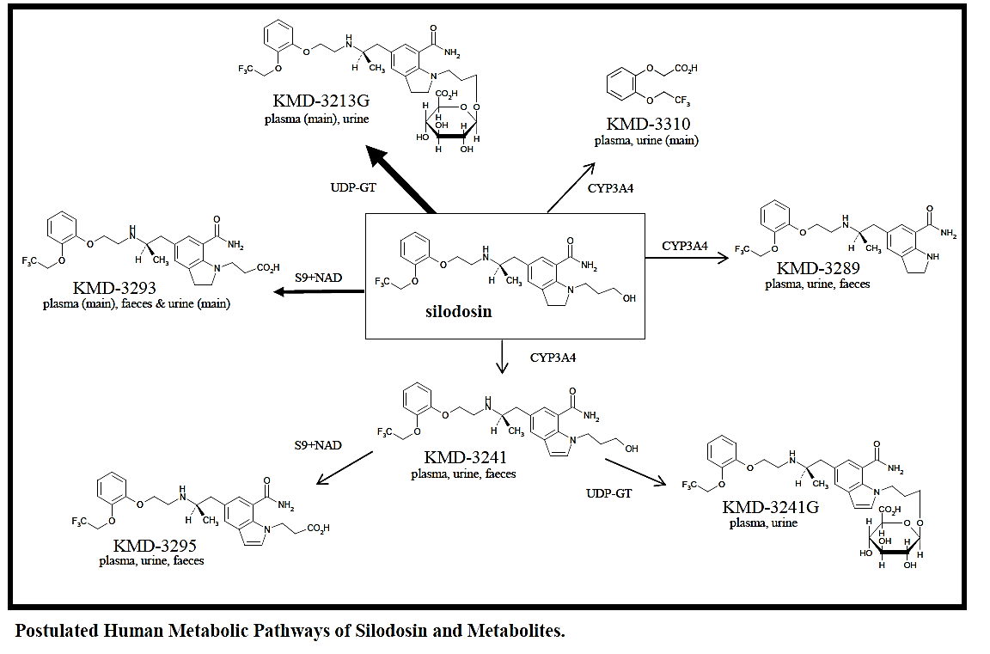

Interconversion between enantiomers
Not applicable.

Sites of metabolism and mechanisms / enzyme systems involved
The mass balance study, US012-99 indicated that in humans silodosin is converted to at least five primary metabolites. Oxidation of the hydroxypropyl side chain of parent drug produces the carboxylic acid derivative KMD-3293, via terminal oxidation, and the amine derivative KMD-3289, via oxidation at the methylene carbon adjacent to the ring nitrogen of silodosin. Oxidation of the methylene carbon adjacent to the central amine nitrogen of silodosin produces the carboxylic acid metabolite KMD-3310. Dehydrogenation of the indoline moiety of parent drug, presumably via oxidation alpha to the ring nitrogen followed by dehydration, generates KMD-3241. A fifth primary metabolite, silodosin-G, is formed by conjugation of parent drug with glucuronic acid.
Two secondary metabolites have also been identified: KMD-3241-G results either from glucuronidation of KMD-3241 or from aromatisation of silodosin-G and KMD-3295 is produced either by terminal hydroxypropyl side chain oxidation of KMD-3241 or from aromatisation of KMD-3293. KMD-3310, the glucuronide metabolites, and several unidentified polar metabolites were excreted almost exclusively via the urine. Parent drug and the remaining identified metabolites were found in both urine and faeces, with faeces containing the majority of each component.
As stated above, a series of in vitro studies were undertaken to identify the mechanisms and enzyme systems involved in the metabolism of silodosin and its metabolites.

Silodosin
Study KMD-OIR001 examined the role of CYP isozymes in the oxidisation and metabolism of silodosin. The results indicated that ketoconazole, a CYP3A4 inhibitor, inhibited the metabolism of silodosin and generation of metabolites by greater than 70%. Other CYP species possibly involved in silodosin metabolism were 1A1/2 and 2D6.

KMD-3310
Study DMPK2003-0037 identified that the formation of the metabolite KMD-3310 primarily occurred via CYP3A4-mediated metabolism of silodosin.

silodosin-G
Study AE-3348 examined whether UGT enzymes played a role in generating metabolite silodosin-G. In this study, seven molecular species (UGT1A1, 1A3, 1A6, 1A9, 1A10, 2B7 and 2B15) were examined, but generation of silodosin-G was noted only with UGT2B7.
KMD-3293
Study PK10126 demonstrated that CYP plays almost no role in the generation of KMD-3293, and NAD is necessary as a coenzyme. The reaction to generate KMD-3293 was inhibited by an alcohol dehydrogenase inhibitor, pyrazole, and its substrate, ethanol. The addition of an aldehyde dehydrogenase inhibitor, disulfiram, and its substrate, acetaldehyde also inhibited the KMD-3293 generation activity. Therefore, both alcohol dehydrogenase and aldehyde dehydrogenase are assumed to be involved in generation of KMD-3293.

Non-renal clearance
The mass balance study, US012-99 examined renal and faecal excretion of silodosin following oral administration of 8 mg of [¹⁴C]-silodosin (99.1 μCi [¹⁴C]-silodosin) as an oral solution in 6 healthy male subjects. The results indicated that the main route of excretion of [¹⁴C]-silodosin-derived radioactivity following oral dosing was via the faeces, with a mean of 54.9% excreted via this route up until 240 h post-dose.

Metabolites identified in humans: active and other
Initial studies assayed for metabolites KMD-3241 and KMD-3289, which over time were identified as minor metabolites in human. Following the completion and review of Studies US012-99 and KMD-105 additional bioassays were developed and validated and subsequent bioanalysis focused on metabolites silodosin-G and KMD-3293, which had plasma concentrations at, or above, those of silodosin. Two additional metabolites, KMD-3295 and KMD-3310, were quantified in Study SI06004, which had been performed to describe all human metabolites with potentially > 1% of total plasma exposure. The silodosin metabolites examined in each of the clinical studies was tabulated by the sponsor.
Of the two main metabolites, silodosin-G and KMD-3293, only the functional activity of silodosin-G for α_{1A}-adrenergic receptors has been determined. To this end, a study of isolated rat prostate, KMD-11004, identified that compared to silodosin, silodosin-G has approximately half of the antagonist effect on noradrenaline-induced prostatic contraction and it has been estimated that the effect of silodosin-G may account for 16 to 28% of the total activity at α_{1A}-adrenergic receptors (that is, from silodosin and silodosin-G).

Pharmacokinetics of metabolites
Following 7 days dosing with 8 mg (2 x 4 mg tablets) silodosin, the C_{max} and AUC₀₋₂₄ values for silodosin were 61.6 ng/mL and 373.4 ng.h/mL, respectively, whereas, for the metabolite silodosin-G they were 102.4 ng/mL and 1661 ng.h/mL, respectively; for KMD-3293 they were 34.3 ng/mL and 373.0 ng.h/mL, respectively; for KMD-3295 they were 3.4 ng/mL and 16.8 ng.h/mL, respectively; and for KMD-3310 they were 1.6 ng/mL and 2.8 ng.h/mL, respectively.

Consequences of genetic polymorphism
Not examined.

Excretion

Routes and mechanisms of excretion
As mentioned previously in this report the mass balance study, US012-99 identified that silodosin is primarily excreted via the faeces and the mean 0 to 240 h recovery of radioactivity in excreta, including faecal wipes, and urine was 88.4%.

Mass balance studies
Following an oral dose of [¹⁴C]-silodosin (Study US012-99), radioactivity excreted in urine consisted primarily of three major metabolites, a large number of minor metabolites, and parent drug. The parent drug (silodosin) and three major metabolites, KMD-3293, KMD-3310 and M-4 accounted for 10.7%, 10.8% 19.9% and 18.9%, respectively, of the urinary radioactivity and 3.6%, 3.6%, 6.5% and 6.5%, respectively, of the dose radioactivity.
[¹⁴C]-Silodosin radioactivity excreted in faeces consisted primarily of KMD-3293 and silodosin with metabolite and parent accounting for 36.9% and 28.0%, respectively, of the faecal radioactivity and 20.5% and 15.4%, respectively, of the dose radioactivity.

Renal clearance
Excretion in the urine accounted for a mean of 33.5% of the administered radioactivity through 240 h post-dose.

Intra and inter individual variability of pharmacokinetics
The %CV values associated with AUC₀₋₂₄ following a single dose of either 4 mg or 8 mg silodosin were 45.4% and 36.3%, respectively. For C_{max} these values were 46.1% and 47.6%, respectively.
Based on the results of 258 patients diagnosed with micturition disorder associated with BPH, a population PK analysis (PopPK) undertaken as part of the Phase III trial KMD-305 estimated that the mean variation on CL was 0.049 and on the Vd was 0.032. The residual sum of the squares was 0.233.

Pharmacokinetics in the target population
No dedicated PK studies examined the silodosin PKs in the target population (that is, males with BPH). However, the PKs of silodosin following long-term administration were examined as part of the Phase III Study KMD-305, which was undertaken in a population of 258 patients, with a mean age (±SD) of 67.5 ± 6.6 years, who had been diagnosed with micturition disorder, which was associated with BPH. As part of this analysis the relationship between the plasma concentration and week after administration was subjected to regression analysis, and the point estimates and 95% CIs were calculated. The results indicated that the slopes of the regression lines were not positive for silodosin, KMD-3293 or silodosin-G, confirming no accumulation of these substances in plasma.
In addition, the PopPK analysis undertaken as part of this study indicated that in the target population the mean CL and Vd were 0.302 L/h/kg and 2.24 L/kg, respectively.

Pharmacokinetics in special populations

Pharmacokinetics in subjects with impaired hepatic function
Study SI05010 assessed the PKs of silodosin and major metabolites in subjects with moderate liver dysfunction and in matched controls after a single 4 mg or 8 mg dose. The results indicated that following a single 8 mg dose, silodosin C_{max} and AUC_{0-inf} values for total concentrations (bound + unbound) were lower (approximately20%) in subjects with liver dysfunction compared to healthy controls (ratios of means were 0.8 and 0.8, respectively), whereas, the C_{max} and AUC values for unbound concentrations were 10 to 20% higher (ratio of means were 1.1 and 1.2, respectively). The bound and unbound ratios for silodosin-G AUC_{0-inf} were 0.8 and 0.5, respectively, and for KMD-3293 were 0.6 and 0.8, respectively.

Pharmacokinetics in subjects with impaired renal function
Study IT-PK 0234 compared the PKs of silodosin, the active metabolites silodosin-G and KMD-3293 in subjects with different degrees of renal impairment and in healthy subjects. Doses of 8 mg were administered to healthy controls and to mild and moderately impaired subjects, whereas, 4 mg was given to severely impaired subjects. Silodosin C_{max} increased by approximately1.5-fold on average (ratio of geometric means) for unbound and by approximately1.6-fold for total concentration in patients with mild to moderate impairment compared to subjects of matched age with normal renal function and by approximately2.2 and 0.9-fold respectively for unbound and total silodosin C_{max} in patients with severe renal impairment. Silodosin AUC_{tlast} increased by approximately1.7 and 2.0-fold respectively for the unbound and total silodosin in patients with mild to moderate impairment compared to control group. A similar increase of about 2-fold was observed for AUC_{tlast} of total silodosin in the patients with severe impairment; while a wider increase by about 3.7-fold was observed for unbound silodosin.
Study KMD-309 compared the PKs of a 4 mg dose of silodosin in subjects with moderate to severe renal impairment (CL_{CR} = 11-50 mL/min) and healthy subjects. In this study, the ratio (impaired/normal) of geometric least squares mean (GLS) for C_{max} and AUC_{inf} [total concentration] of unchanged silodosin was 3.11 and 3.22, respectively. For unbound concentration the ratios for silodosin C_{max} and AUC_{inf} values were 1.49 to 2.01, respectively.

Pharmacokinetics according to age
Three studies, IT-PK 0241and KMD-207, examined the PKs of silodosin according to age using batches of drug formulated according to Method C.
Study IT-PK 0241 assessed the exposure at steady-state of silodosin and its main metabolites, silodosin-G and KMD 3293 in 2 groups of elderly subjects, 65-75 and > 75 years of age respectively, in comparison with that of younger subjects (45-64 years of age), to establish whether a dose adjustment was required following administration of an 8 mg, once-daily, oral dose for 7 days. The levels of silodosin and its main metabolites at steady-state were similar among the different age groups. The ratios of the mean values of elderly groups (A and B) versus the control group (C) for silodosin AUCτ and oral CLss/F were within the 90-100% range and there were no statistically significant differences with the control group being the 90% CIs within the range of ±31%.
Study KMD-105 compared the PKs and safety of silodosin following a single oral administration of 4 mg to elderly male and non-elderly male volunteers. In this study, although the silodosin AUC_{inf} was higher (15.3%) in the elderly subjects and the CLtot/F/kg was lower (-11.2%) neither of these differences were statistically significant.
Study KMD-207 examined repeated administration of silodosin 12 mg/day (6 mg/dosing, twice daily) in healthy Japanese males from the age group of patients with BPH (≥ 50 years). Following a single dose of silodosin (12 mg/day: 6 mg/dosing, twice daily) the C_{max}, T_{max} and AUC_{inf} values were 40.07 ± 26.50 ng/mL, 0.5 to 6 h and 208.94 ± 117.94 ng.h/mL, respectively. Following 7 days of repeat dosing the C_{max}, T_{max} and AUC_{144-154h} values were 52.45 ± 32.23 ng/mL, 0.5 to 4 h after the final administration and 246.22 ± 165.81 ng.h/mL, respectively.
Similarly, Study US011-98 also examined the PKs of silodosin in healthy male volunteers of the target age (≥ 50); however this study did not use a batch of silodosin formulated according to Method C.

Pharmacokinetics related to genetic factors
Not examined.

Pharmacokinetics in other special population / with other population characteristic
Not examined.

Population pharmacokinetics

PopPK analysis
As mentioned previously in this report, a popPK analysis was undertaken using the PK data from 258 target patients with moderate to severe symptoms of BPH (IPSS ≥ 8) that were enrolled in Study KMD-305 who underwent long-term treatment with either 4 mg or 8 mg silodosin per day. In a typical male subject with a mean age and body weight of 67.5 years and 64.01 kg, respectively, the final one compartment model provided estimates of 0.302 L/h/kg and 2.24 L/kg for silodosin CL and Vd, respectively. Significant covariates for CL were identified as CRP, ALT, age and Cre and for Vd were CRP, age and ALT.
At steady-state the predicted plasma concentrations 2 h and 12 h following drug administration (that is, C2h and C12h, respectively) without covariate influence (that is, typical values) were 26.6 ng/mL and 6.9 ng/mL, respectively. When the body weight increased by 10 kg above the typical value, the estimated values of C2h and C12h were 23.0 ng/mL and 6.0 ng/mL, respectively, and the ratios to the typical values were 0.865 and 0.870, respectively. By contrast, when age increased by 10 years above the typical value the estimated values of C2h and C12h were 32.4 ng/mL and 8.0 ng/mL respectively, and the ratios to the typical values were 1.218 and 1.159, respectively.

Pharmacokinetic interactions

Diltiazem - calcium channel antagonist and CYP3A4 inhibitor
Study IT-PK 0242 assessed the effects of a single oral dose of 300mg of prolonged-release diltiazem on the PKs of a single 4 mg or 8 mg dose of silodosin, administered 4 h later, in healthy male subjects. Results indicated that the mean C_{max} and AUC_{inf} values for silodosin increased by 20% and 44%, respectively, and T_{max} was delayed by 1.5 h following administration of the combination compared to silodosin alone. Geometric mean C_{max} and AUC values for the two metabolites were also increased (+32 to 33% for C_{max} and +39 to 57% for AUC). Following an 8 mg dose of silodosin, administration in combination with diltiazem had little effect on silodosin C_{max} (-3%), whereas, there was a 32% increase in AUC and median T_{max} was slightly delayed by 1.25 h compared to when silodosin was administered alone.

Digoxin - P-glycoprotein substrate
Study IT-PK 0263 assessed the effects of silodosin at steady-state on the steady-state PKs of digoxin in healthy male subjects. Based on the results of the study, the geometric mean C_{max},ss and Cmin,ss of digoxin were not affected by co-administration of silodosin as the 90% CI values were within the pre-specified range (of 0.80 to 1.25). Overall exposure to digoxin was slightly decreased after co-administration with silodosin compared to placebo (-8%). However, only the lower boundary of the 90% CI (0.87-0.96) for the AUC ratio was outside the pre-specified range (0.90-1.11).
Study KMD-307-UK also examined the effect of steady-state plasma concentrations of silodosin on the steady-state PKs of digoxin in healthy male subjects. As in the previous study steady-state plasma concentrations of 4 mg bd silodosin had no effect on the steady-state PKs of 0.25 mg once daily digoxin in healthy male subjects.

Ketoconazole – strong CYP3A4 inhibitor
Studies KMD-306-UK and SI06008 examined the effect of multiple oral doses of ketoconazole on the PKs of a single oral dose of silodosin of 4 mg and 8 mg, respectively. The PKs of 8 mg silodosin and its main metabolites were markedly altered when silodosin was administered on the second day of a four day 400 mg ketoconazole once daily regimen. For instance, silodosin AUC_{inf} was increased 3.1-fold and C_{max} was increased 3.7-fold. Silodosin-G AUC was increased 3.0-fold and C_{max} was increased 3.2-fold. KMD-3293 AUC was increased 2.5-fold and C_{max} was increased 2.8-fold. T_{max} and t_{1/2} values were not notably altered for any moiety.

Clinical implications of in vitro findings
A reasonably comprehensive in vitro program examined silodosin and its metabolites for the ability to inhibit and induce various CYP isozymes and also to identify whether these compounds were CYP substrates. For instance, Study PK10049 identified that silodosin exhibited a very small inhibitory action against CYP3A4 and CYP2D6, and the IC₅₀ was 100.3μmol/L (Ki approximately50.2 μM) and 21.7μmol/L (Ki approximately10.8 μM), respectively. Study KMD 3213-IT-PK 0239 indicated silodosin also exhibited a very small inhibitory action upon CYP2B6 and CYP2C8, with Ki values of approximately28.8 μM and approximately68.6 μM, respectively. Study PK-03-010 identified that out of a range of potential CYP3A4 inhibitors, only nifedipine and ketoconazole inhibited the metabolism of silodosin with IC₅₀ values of less than 25 µM. Studies ZXA0002 and KMD 3213-IT-PK0327 indicated that there was little evidence that silodosin induced CYP1A2, CYP3A4/5, CYP2C8, CYP2C9, CYP2C19 and CYP2B6, whereas, Study PK-03-002 suggested that P-gp is involved in the directional transport of silodosin.

Evaluator’s overall conclusions on pharmacokinetics

Absorption, Distribution, Metabolism and Excretion (ADME)
It is proposed that single capsule of either 8 mg or 4 mg silodosin will be taken with food at the same time every day.
- Following administration of a 4 mg dose of the proposed formulation to healthy Japanese subjects, the RMS ratio (90%CI) of fasting with respect to non-fasting was 130.38 (102.54, 165.78) for silodosin Cmax, and 106.74 (87.30, 130.51) for AUC0-48.
- Following a single, 8 mg dose, oral of silodosin to healthy males the mean Cmax, AUC0-24, Tmax and t1/2 values were 54.5 ng/mL, 290.6 ng.h/mL, 2.4 h and 13.3 h, respectively. For the 4 mg, oral dose the values were 28.7 ng/mL, 144.7 ng.h/mL, 2.3 h and 11.1 h, respectively.
- The mean ± SD bioavailability following a 4 mg oral administration under fasted conditions with respect to a 2 mg IV administration was 32.24 ± 11.35%.
- The Cmax and AUC0-24 of silodosin increased proportionally with dose from 4 mg to 8 mg. For instance, following a 4 mg dose the Cmax, and AUC0-24 values for silodosin were 28.7 ng/mL and 144.7 ng.h/mL, respectively, whereas following an 8 mg dose the values were 54.5 ng/mL and 290.6 ng.h/mL, respectively.
- Following seven daily doses of 4 mg (1 x 4 mg) or 8 mg (2 x 4 mg capsules) silodosin the Cmax and AUC were dose-proportional, whereas, there was little difference between the Tmax, t1/2 and Kel values following doses of either strength.
- In subjects administered repeated doses of 4, 6 or 8 mg of silodosin bd, ANOVA analysis indicated that there was no significant difference in silodosin AUC0-24, Cmax, or t1/2 values following 1 and 7 days of dosing.
- Steady-state appeared to be achieved following 3 days of dosing with silodosin.
- Following a single, oral, 4 mg dose in fasted healthy subjects the Vdss/F was 263.9 L. Human plasma protein binding was almost constant regardless of the concentration of [14C]-silodosin added, ranging between 94.6 and 95.8%. Silodosin is predominantly bound to α1-acid glycoprotein. Only a small percentage (2.2% to 3.7%) of silodosin is bound to erythrocytes. Given the volume of distribution (263.9 L) it can be assumed that silodosin is highly distributed to the tissues.
- In humans silodosin is converted to at least five primary metabolites: KMD-3293, silodosin-G, KMD-3289, KMD-3310 and KMD-3241; and 2 secondary metabolites: KMD-3241-G and KMD-3295. In vitro studies indicated that silodosin was primarily metabolised by CYP3A4 and two other CYP species, CYP1A1/2 and 2D6, are also possibly involved. Formation of the metabolite KMD-3310 primarily occurred via CYP3A4-mediated metabolism of silodosin. By contrast, CYP plays almost no role in the generation of KMD-3293, whereas, nicotinamide adenine dinucleotide (NAD) is necessary as a coenzyme and both alcohol dehydrogenase and aldehyde dehydrogenase are assumed to be involved in generation of KMD-3293.
- The main route of excretion of [14C]-silodosin derived radioactivity following oral dosing was via the faeces, with a mean of 54.9% excreted via this route through 240 h post-dose.
- Of the two main metabolites, only the functional activity of silodosin-G for the α1A-adrenergic receptors has been determined. It has been estimated that the effect of silodosin-G may account for 16% to 28% of the total activity at α1A-adrenergic receptors.
- Following 7 days dosing with 8 mg silodosin the Cmax, and AUC0-24 values for silodosin were 61.6 ng/mL and 373.4 ng.h/mL, respectively, whereas, for the metabolite silodosin-G they were 102.4 ng/mL and 1661 ng.h/mL, respectively; for KMD-3293 they were 34.3 ng/mL and 373.0 ng.h/mL, respectively; for KMD-3295 they were 3.4 ng/mL and 16.8 ng.h/mL, respectively; and for KMD-3310 they were 1.6 ng/mL and 2.8 ng.h/mL, respectively.
- The mean 0 to 240 h recovery of radioactivity in excreta, including faecal wipes, and urine was 88.4%. Following an oral dose of [14C]-silodosin, radioactivity excreted in urine consisted primarily of three major metabolites and parent drug. Silodosin, KMD-3293, KMD-3310 and M-4 accounted for 10.7%, 10.8% 19.9% and 18.9%, respectively, of the urinary radioactivity and 3.6%, 3.6%, 6.5% and 6.5%, respectively, of the dose radioactivity.
- [14C]-silodosin radioactivity excreted in faeces consisted primarily of KMD-3293 and silodosin with metabolite and parent accounting for 36.9% and 28.0%, respectively, of the faecal radioactivity and 20.5% and 15.4%, respectively, of the dose radioactivity. Excretion in the urine accounted for a mean of 33.5% of the administered radioactivity through 240 h post-dose.

Intra and inter individual variability of PKs
- The %CV values associated with AUC₀₋₂₄ following a single dose of either 4 mg or 8 mg silodosin were 45.4% and 36.3%. For C_{max}, these values were 46.1% and 47.6%.
- PopPK analysis estimated that the mean variation on CL and Vd in the target population was 0.049 and 0.032, respectively. The residual sum of the squares was 0.233.

Pharmacokinetics in the target population
In patients with BPH there was no silodosin accumulation following multiple-doses. In the target population the estimated mean CL and Vd were 0.302 L/h/kg and 2.24 L/kg, respectively.

Pharmacokinetics in special populations
- Following a single 8 mg dose, silodosin Cmax and AUC0-inf values for total concentrations (bound + unbound) were lower (approximately 20%) in subjects with liver dysfunction compared to healthy controls, whereas, the Cmax, and AUC values for unbound concentrations were 10 to 20% higher. The bound and unbound ratios for silodosin-G AUC0-inf were 0.8 and 0.5, respectively, and for KMD-3293 were 0.6 and 0.8, respectively.
- Silodosin AUCtlast increased by approximately 1.7 and 2.0 fold respectively for the unbound and total silodosin in patients with mild to moderate renal impairment compared to a control group. A similar increase of about 2fold was observed for AUCtlast of total silodosin in the patients with severe impairment; whereas an approximately 3.7 fold increase in unbound silodosin was observed.
- In subjects with moderate to severe renal impairment the GLS mean for Cmax, and AUCinf [total concentration] of unchanged silodosin was 3.11 and 3.22, respectively, compared to healthy subjects. For unbound concentration the ratios for silodosin Cmax and AUCinf values were 1.49 to 2.01, respectively.
- There appeared to be no age-related effects on the PKs of silodosin in healthy elderly and non-elderly subjects.

PopPK
PopPK analysis undertaken using the PK data from 258 target patients who underwent long-term treatment with silodosin identified body weight, age, creatinine, ALT and CRP as significantly influential covariates on both CL and Vd.

Drug-drug interactions
- Administration of a single oral dose of 300mg of the prolonged-release CYP3A4 inhibitor diltiazem with a single 8 mg dose of silodosin had little effect on silodosin Cmax,; however, silodosin AUCinf increased by 32% and median Tmax was delayed by 1.25 h. Similarly, the AUCinf of KMD-3239 and silodosin-G were increased by 28% and 37%, respectively, in the presence of diltiazem.
- Steady-state plasma concentrations of silodosin had no effect on the steady-state PKs of the P-glycoprotein substrate digoxin.
- Following co-administration of multiple oral doses of 400 mg ketoconazole, a potent CYP3A4 inhibitor, and a single dose of 8 mg silodosin, the AUCinf for silodosin, silodosin-G and KMD-3293 increased 3.1, 3.0 and 2.5 fold, respectively, whereas, Cmax values increased 3.7, 3.2 and 2.8 fold, respectively.

In vitro interactions
Silodosin is a weak inhibitor of CYP3A4, CYP2D6, CYP2B6 and CYP2C8. Out of a range of CYP3A4 inhibitors, only nifedipine and ketoconazole inhibited the metabolism of silodosin with IC50 values of less than 25 µM. There is little evidence that silodosin induces CYP1A2, CYP3A4/5, CYP2C8, CYP2C9, CYP2C19 or CYP2B6. P-gp appears to be involved in the directional transport of silodosin.

Limitations of the PK studies
- No dedicated PK studies examined the bioequivalence between batches of silodosin manufactured using the different formulation methods used in the clinical studies. In addition, no studies examined the bioequivalence between batches of silodosin formulated according to Method C from the different companies.
- No dedicated clinical studies examined the bioequivalence between the 4 mg and 8 mg dose strength capsules proposed for marketing.
- Neither bd nor td dosing has been examined using the proposed formulation for marketing (formulation C).
- Although some limited analysis examining drug accumulation was undertaken as part of the Phase III Study KMD-305, no dedicated PK studies examined silodosin PKs in the target population (males with BPH).

Questions regarding the PK studies
- Can the sponsor please indicate where the proposed product for marketing will be manufactured and by whom?
- The PK/PD evaluator has been unable to find any discussion of the type of meal given to the subjects in the KMD-308 Study Report when they were administered silodosin under non-fasting conditions. Can the sponsor please confirm whether the meal could be considered a low- low calorie, moderate fat- moderate calorie or a high fat, high calorie meal?

Pharmacodynamics

Studies providing pharmacodynamic information
Note: Only the studies that have not been previously described in Table 1 (that is, included PK data) have been summarised in Table 2.
Table 2: Submitted pharmacodynamic studies
PD Topic | Subtopic | Study ID | *
Primary Pharmacology§ | Effect on subjective symptoms, objective finding, QOL and IPSS | KMD-201 | Correlation of dose and efficacy patients with dysuria associated with BPH
Primary Pharmacology§ |  | KMD-202 | Efficacy following administration as two divided doses of 4 mg/day or 8 mg/day in patients with micturition disorder associated with BPH
Primary Pharmacology§ |  | KMD-206 | Effect of two-divided doses of 8 mg/day on voiding function in patients with micturition disorder associated with BPH
PD Interactions | Sildenafil or tadalafil | SI0  6002 | Orthostatic effects following co-administration of a single dose of 100 mg sildenafil, 20 mg tadalafil or placebo, after multiple dose doses of 8 mg silodosin in healthy target-aged males
PD Interactions | Metoprolol | SIL  0901 | Orthostatic effects following co-administration of 8 mg silodosin and 50 mg metoprolol
PD Interactions | Amlodipine | SIL  0902 | Orthostatic effects following co-administration of 8 mg silodosin and 10 mg amlodipine.
PD Interactions | Lisinopril | SIL  0903 | Orthostatic effects following co-administration of 8 mg silodosin and 20 mg lisinopril
*=indicates the primary PD aim of the study
§ Subjects who would be eligible to receive the drug if approved for the proposed indication.

Summary of pharmacodynamics

Mechanism of action
Silodosin is a highly selective antagonist for the α_{1A}-adrenoceptor, which plays a prominent role in mediating the contraction of prostate muscle and is important in the regulation of bladder outlet resistance. By contrast, the bladder body expresses negligible levels of α_{1A}-adrenoceptors and therefore, α_{1A}-adrenoceptors blockade decreases bladder outlet resistance without affecting detrusor smooth muscle contractility.

Pharmacodynamic effects
The primary PD effects were assessed as described in Appendix II (not included here).

Primary pharmacodynamic effects
Comment: Three studies, Study KMD-201, KMD-202 and KMD-206 examined the primary PDs of silodosin (for example, effect on dysuria). However, although these studies were undertaken in patients with BPH, all of the cohorts comprised Japanese subjects and in none of the studies was the recommended dose administered (that is, a 8 mg capsule once daily). In addition, in the first study, KMD-201, the drug was formulated according to Method A and not the proposed Method C. Therefore only a brief description of each study will be provided here.

Dysuria
In Study KMD-201 following administration of silodosin at doses of 0.1 mg, 1 mg or 2 mg capsules bd after breakfast and supper, there was a trend for a dose-dependent improvement in subjective symptoms and QoL due to urinary symptoms. However, the improvements observed as dose increased were not statistically significant.
In Study KMD-202 following administration of silodosin as two divided doses of either 2 mg/day (for a total of 4 mg/day) or 4 mg/day (for a total of 8 mg/day), improvement in subjective symptoms compared to placebo, based on a judgement of either a ‘markedly effective’ or ‘effective’ treatment, was high in the 4 mg/day group and even higher in the 8 mg/day group; however, the differences observed were not statistically significant.
In Study KMD-206 following two-divided doses of 8 mg/day, 50% of treated subjects reported an effective rate of improvement. Similarly, the effective rate of QOL score (vs. the observation period) was also 50% according to the judgment criteria, whereas, the effective rate of difference in peak urine flow rate was only 10%.

Secondary pharmacodynamic effects

Effects on cardiac function
Study SI05014 evaluated the effect of therapeutic (8 mg/day) and supratherapeutic doses (24 mg/day) of silodosin (formulation C) for 5 days on the time-matched changes from baseline in the corrected QT interval of the ECG using an individual correction method in healthy males. The results indicated that the mean change from baseline in placebo-corrected heart rate was 2.1 and 0.9 bpm for the clinical and supratherapeutic doses of silodosin, respectively. The mean change from baseline placebo corrected PR was -1.9 and -1.5 ms for the two doses of silodosin, respectively and the mean change from baseline placebo-corrected QRS was -1.8 and -2.3 ms. Overall, the results suggest that silodosin and its two active metabolites have no meaningful effect on heart rate, PR, and QRS interval duration or on cardiac repolarisation.

Orthostatic effects
Studies UK01-97 and UK02-97 examined the incidence of orthostatic effects in healthy subjects following single and multiple doses of silodosin (formulation A) ranging from 0.1 to 16 mg.
In Study UK01-97, 22 positive Type I orthostatic tests occurred in 63 subjects (approximately35%) who were administered silodosin, whereas, only 3 out of 21 (14.33%) subjects receiving placebo had positive tests. Of the subjects with positive orthostatic tests, 9 receiving silodosin had decreases in diastolic blood pressure (DBP) greater than 10 mmHg, compared to 1 subject receiving placebo. In addition, among the subjects with positive orthostatic tests, 6 subjects receiving silodosin in the 12.0 mg or 16.0 mg groups had decreases in DBP pressure greater than 10 mmHg, compared to 3 subjects receiving silodosin in the 5 other active-treatment groups. The largest decrease in DBP among the subjects with positive orthostatic tests (33 mmHg) occurred in the 4.0 mg fasted group, followed by a 25 mmHg decrease in the 16.0 mg group and a 21 mmHg decrease in both the 12.0 mg and 16.0 mg groups. Six of the subjects with pulse rate: ≥ 120 bpm were receiving silodosin and one was receiving placebo, with the majority (5 of 7, 71.43) in the 16.0 mg group. In the Investigator's opinion these were asymptomatic increases in pulse rate and were not considered AEs. Similarly, the majority of the Type II orthostatic tests also occurred in subjects receiving study drug (17 of 63 [27.0%] compared to 2 of 21, [9.5%] receiving placebo). Among the subjects with positive Type II orthostatic tests, 7 subjects receiving study drug had decreases in DBP greater than 10 mmHg, compared to 1 subject receiving placebo. Only 1 subject had a decrease in DBP greater than 20 mmHg (-29 mmHg, subject 136/24 in the 12.0 mg group).
By contrast in Study UK02-97, in which subjects received either 4.0 mg, 1.0 mg or 0.1 mg silodosin once daily for 5 days there was only one positive orthostatic blood pressure test during the study.

Time course of pharmacodynamic effects
Based on the studies described in the primary PD effects section of this report it would appear that improvements in subjective symptoms, QoL and objective findings occur following 2 to 4 weeks treatment with silodosin, with some evidence suggesting that the improvement during the first 2 weeks of treatment was generally larger than that experienced in the second 2 weeks.

Relationship between drug concentration and pharmacodynamic effects
Please see preceding discussion. In addition the sponsor states the following:
‘No rigorous dose-response investigations in humans have been performed with silodosin to investigate short-term pharmacodynamic effects thought to be predictive of therapeutic response since no robust biomarker or procedure is known.’

Genetic, gender and age related differences in pharmacodynamic response
Not examined.

Pharmacodynamic interactions
Study SI06002 examined the orthostatic effects on blood pressure following co-administration of a single dose of either sildenafil (100 mg), tadalafil (20 mg ) (both PDE5 inhibitors) or placebo, when taken after 7, 14 or 21 daily doses of 8 mg silodosin in healthy target-aged male subjects. In general, orthostatic tests of systolic blood pressure (SBP) indicated that SBP tended to decrease following co-administration of either sildenafil or 20 mg tadalafil at both the 1 min and 3 min tests. The largest decreases appeared to occur at around 4 – 6 h following administration of the PDE5 inhibitor and the decrease in SBP tended to be greater following treatment with tadalafil (max decrease =-10.2 mmHg) than with sildenafil (-5.0 mmHg). The results regarding diastolic blood pressure (DBP) were generally more mixed, with increases in DBP generally detected following administration of sildenafil (12 out of 14 tests were increased), whereas, changes in DBP were generally negative following dosing with tadalafil (10 out of 14 tests showed decreases). In addition, changes in DBP were of a smaller magnitude than those seen for SBP. For heart rate (HR), the PDE5 inhibitors appeared to have little effect over and above the increases induced by silodosin seen pre-dose. Overall the changes identified in SBP, DBP and HR were relatively minor and the sponsor argues that the effects seen are not likely to be clinically meaningful.
In the most elderly subjects (> 65 years of age subgroup) compared to the younger subjects, PDE5 inhibition was more commonly associated with larger mean changes from baseline in SBP and DBP pressure, but it was less likely to be associated with larger mean changes from baseline in HR. The mean decrease in SBP in these older subjects on PDE5 inhibitors were between 5-15 mmHg, while those for DBP were between 0-10 mmHg. Even in this most elderly population, the magnitude of these changes is unlikely to suggest a serious risk for concomitant use of PDE5s with silodosin. Of the 272 orthostatic tests performed on subjects aged 45-64 years, only three more positive orthostatic tests were identified in subjects receiving sildenafil and six more in subjects receiving tadalafil in comparison to those co-administered placebo (that is, 52, 55 and 49 positive tests for sildenafil, tadalafil and placebo, respectively). Similarly, of the 112 tests performed in the older subjects, positive test results occurred only 3 more times during sildenafil therapy and 2 more times during tadalafil therapy (12, 11 and 9 times for sildenafil, tadalafil and placebo, respectively).
Study SIL0901 examined the orthostatic effects on BP and HR following co-administration of a single 8 mg dose of silodosin or placebo, with a single 50 mg dose of metoprolol. Overall, following co-administration of silodosin with metoprolol no clinically meaningful changes in SBP, DBP and HR were identified. Both SBP and DBP were slightly lower following co-administration with metoprolol compared to placebo Figures 3 and 4), whereas, mean HRs were slightly higher during the silodosin/metoprolol period than the placebo/metoprolol period (Figure 5). On the whole, positive orthostatic tests were more common during the silodosin/metoprolol period than during the placebo/metoprolol period; however, associated symptoms of orthostasis were rare (11 positive tests versus 3).
Figure 3: Mean systolic blood pressure Study SIL0901
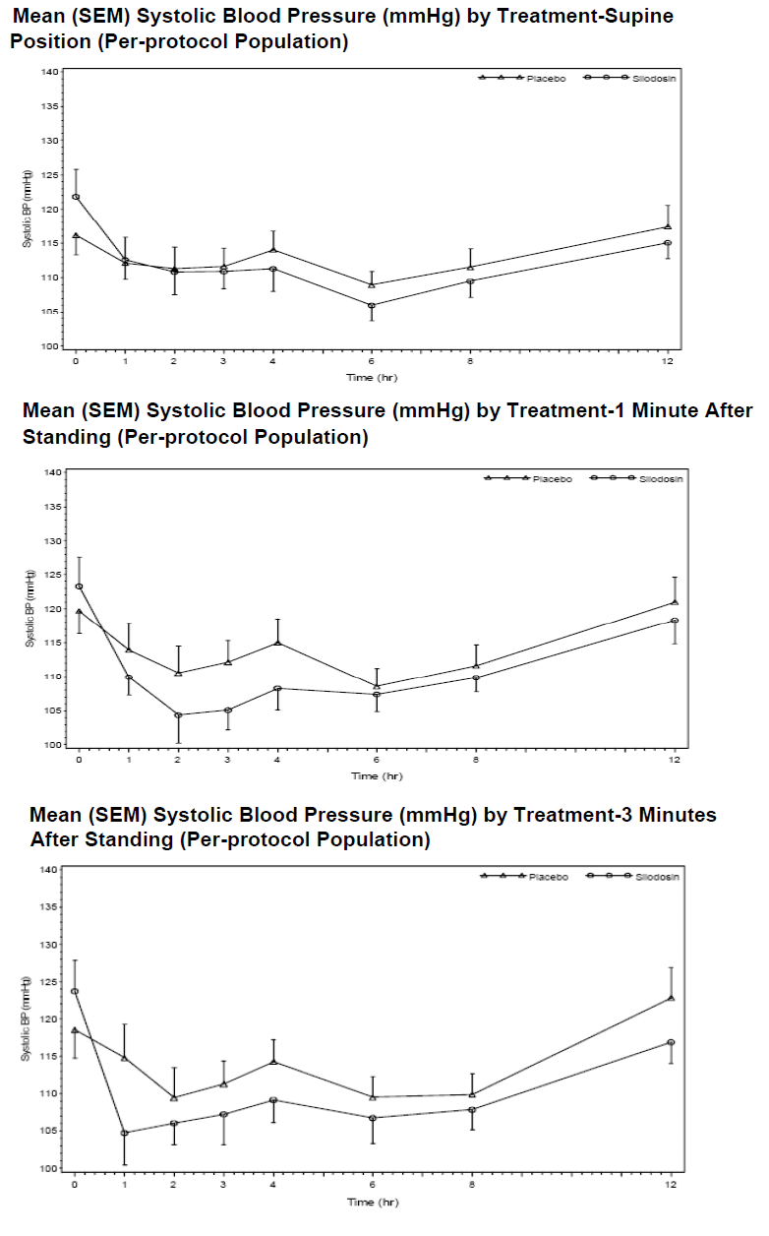
Figure 4: Mean diastolic pressure Study SIL0901
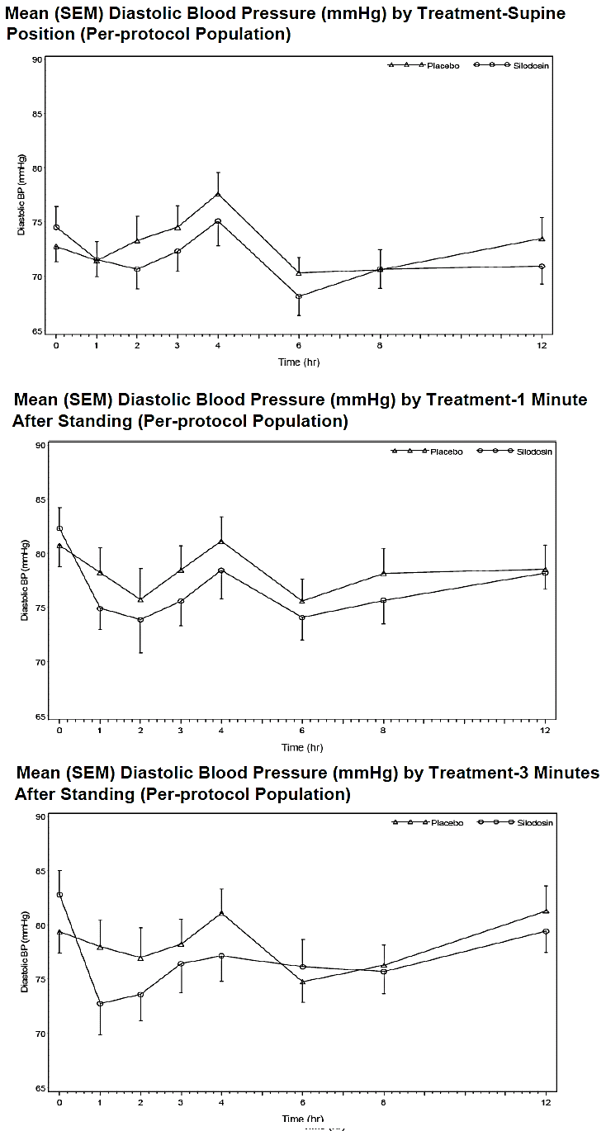
Figure 5: Mean heart rate Study SIL0901
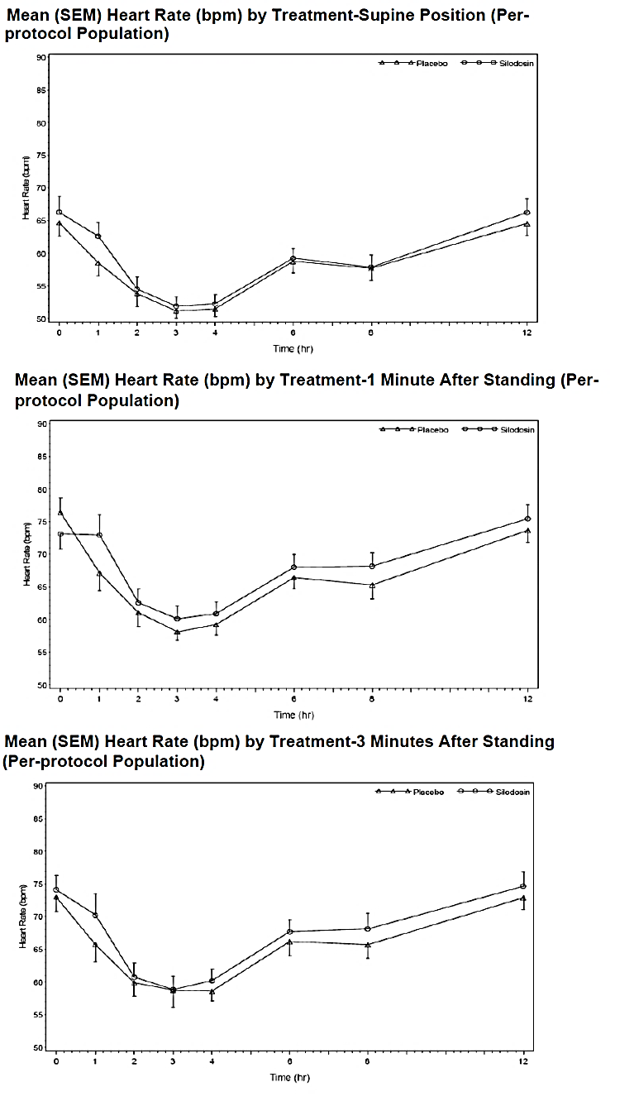
Study SIL0902 examined the orthostatic effects on BP and HR following co-administration of a single 8 mg dose of silodosin or placebo, with a single 10 mg dose of amlodipine. Although the results indicated that, the SBP and DBP were generally slightly lower in the silodosin/amlodipine period than during the placebo/amlodipine period, none of the changes identified were clinically significant (Figures 6 and 7). In regards to mean HR, increases were identified throughout the 12 h testing period during both phases of the study. Mean HRs were slightly higher during the silodosin phase and greater mean increases in HR were observed upon standing during the silodosin phase (Figure 8). Additionally, there were more positive orthostatic tests related to HR increase alone in the silodosin phase than in the placebo phase (35 versus 19). The observed HR changes in both phases, while more pronounced during the silodosin phase, were not considered to be clinically meaningful due to the magnitude of the changes and the lack of orthostatic hypotension AEs reported among the subjects experiencing them. Overall, thirty-nine positive tests were observed during the silodosin/amlodipine phase (39/280, 13.9%), whereas, 19/280 positive tests were observed during the placebo/amlodipine phase (6.8%).
Figure 6: Change from supine in systolic blood pressure Study SIL0902
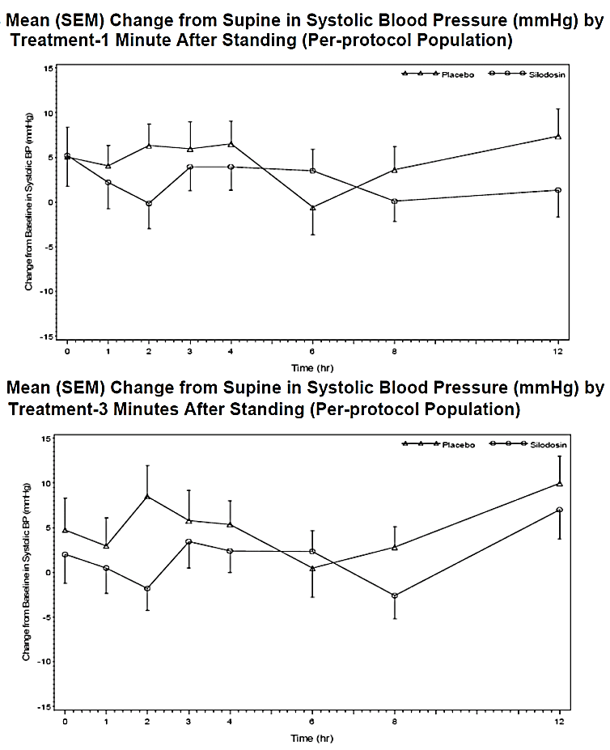
Figure 7: Change from supine in diastolic pressure Study SIL0902
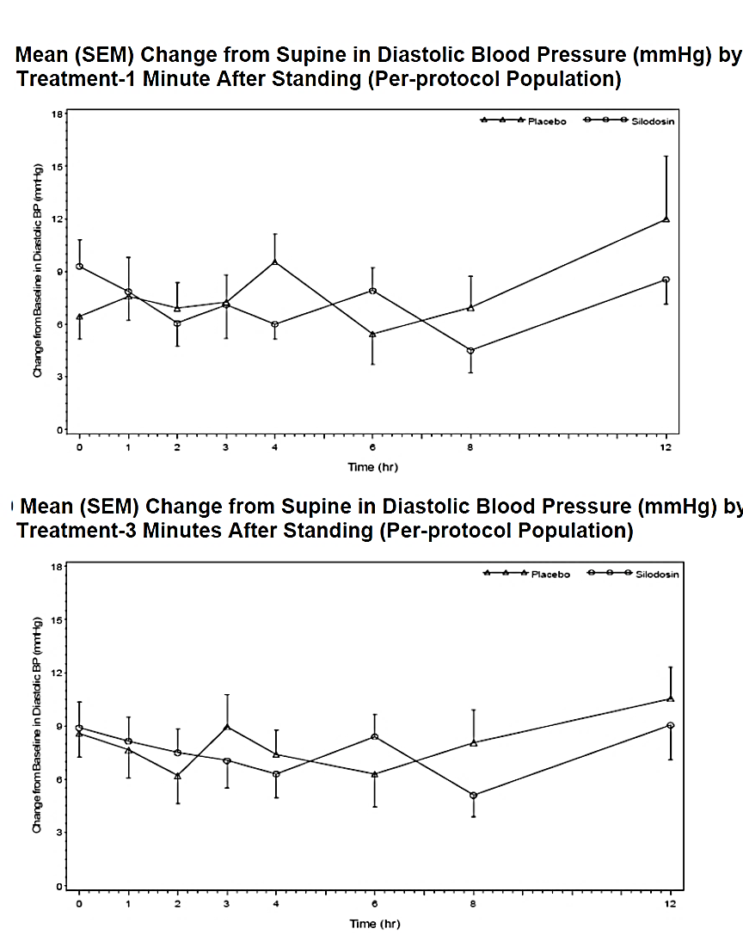
Figure 8: Mean change from baseline in heart rate
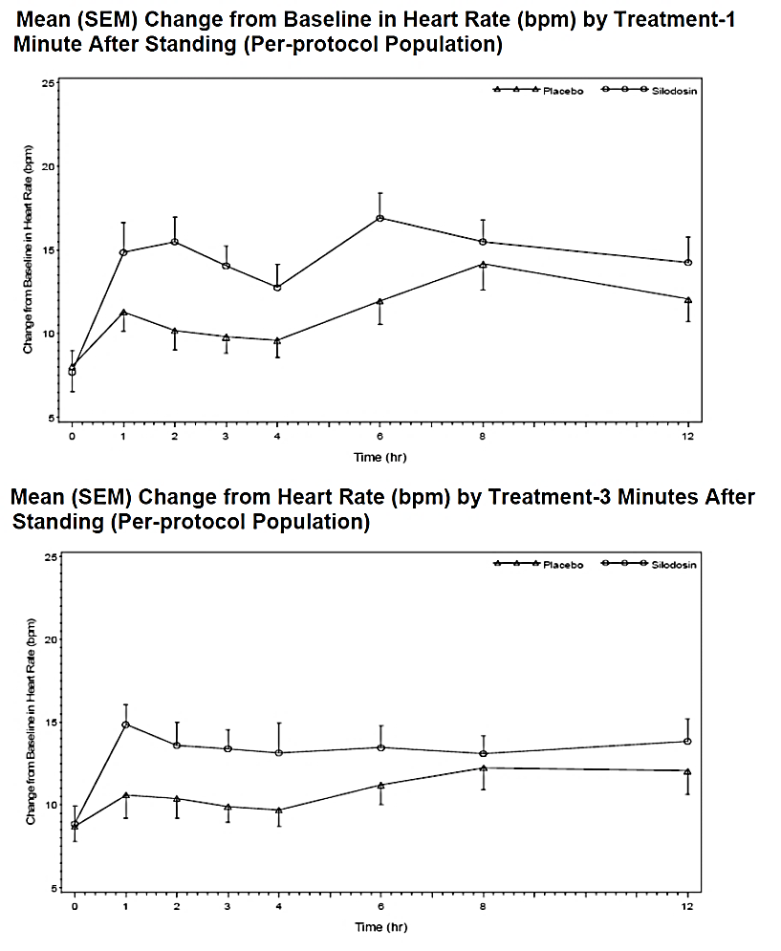
Study SIL0903 evaluated the orthostatic effects on BP and HR following co-administration of a single 8 mg dose of silodosin or placebo, with a single 20 mg dose of lisinopril. As in the previous study, although SBP and DBP were generally lower during the silodosin/lisinopril period than the placebo/lisinopril period, co-administration of silodosin and lisinopril was not associated with clinically meaningful changes in systolic or diastolic blood pressure. By contrast, mean HRs were slightly higher during the silodosin phase and greater mean increases in HR were observed upon standing during the silodosin phase (Figure 9). Additionally, there were more positive orthostatic tests related to HR in the silodosin phase (62 versus 38) than during the placebo phase. Overall, 79 positive tests were observed during the silodosin/lisinopril phase (79/252, 31.3%), whereas, 40/252 positive tests were observed during the placebo/lisinopril phase (15.9%).
Figure 9: Mean change from baseline in heart rate Study SIL0903
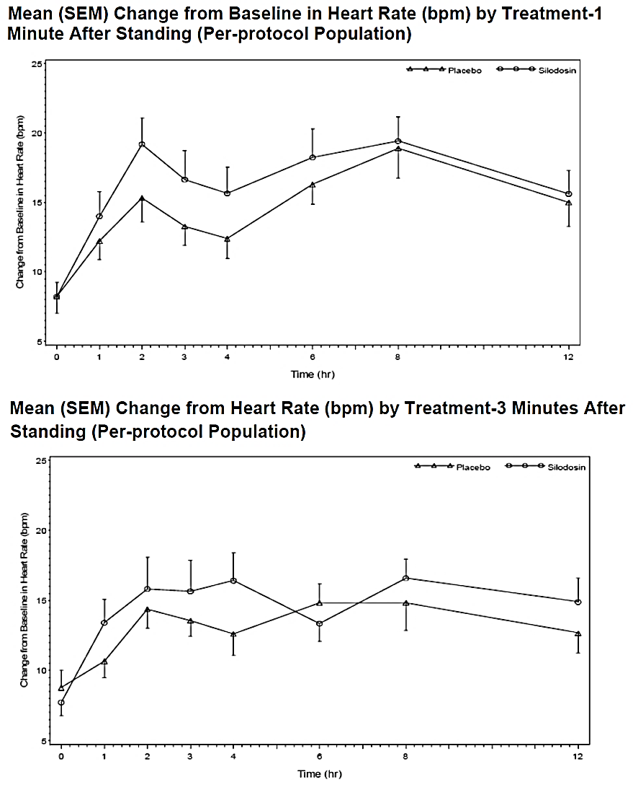

Evaluator’s overall conclusions on pharmacodynamics

Mechanism of action
Silodosin is a highly selective α1A-adrenoceptor antagonist. In the urogenital system α1A-blockade results in decreased bladder outlet resistance without affecting detrusor smooth muscle contractility.

Primary pharmacodynamic effects
All of the primary PD studies only examined cohorts of Japanese patients and none of the studies used the proposed dosing regimen.
- In patients with BPH, silodosin (form A) at doses of 0.1 mg, 1 mg or 2 mg twice a day induced a non-clinically significant, dose-dependent improvement in subjective symptoms and quality of life (QoL) due to urinary symptoms.
- Compared to placebo, administration of silodosin as two divided doses of either 2 mg/day (for a total of 4 mg/day) or 4 mg/day (for a total of 8 mg/day) induced an improvement in subjective symptoms, which was high in the 4 mg/day group and even higher in the 8 mg/day group; however, the differences observed were not statistically significant.
- In patients with micturition disorder associated with BPH, administration of silodosin in two divided doses of 8 mg/day, 50% of treated subjects reported an effective rate of improvement in subjective symptoms and QoL, whereas, only 10% had an effective rate of improvement in peak urine flow rate.

Secondary pharmacodynamic effects
Silodosin and its two active metabolites appear to have no meaningful effect on heart rate (HR), PR and QRS interval duration or on cardiac repolarisation.
Following administration of doses of silodosin ranging from 1 mg to 16 mg, positive orthostatic tests (both Type I and II) were more prevalent in subjects administered silodosin than those given placebo.

Time course of pharmacodynamic effects
Improvements in subjective symptoms, QoL and objective findings occurs following 2 to 4 weeks treatment with silodosin, with some evidence suggesting that the improvement during the first 2 weeks of treatment was generally larger than that experienced in the second 2 weeks.

Pharmacodynamic interactions
Following administration of silodosin in combination with sildenafil (100 mg), tadalafil (20 mg), metoprolol (50 mg) or amlodipine (10 mg), no clinically meaningful changes in systolic blood pressure (SBP), diastolic blood pressure (DBP) and HR were identified.
Although there were no clinically significant changes in SBP or DBP when an 8 mg dose of silodosin was co-administered with 20 mg lisinopril, more positive orthostatic tests relating to HR were identified during the silodosin phase (62 versus 38) than in the placebo phase. Overall, 79 positive tests were observed during the silodosin/lisinopril phase (79/252; 31.3%), whereas, 40/252 positive tests were observed during the placebo/lisinopril phase (15.9%).

Dosage selection for the pivotal studies

Pharmacokinetics and pharmacodynamics: dose finding studies
In regards to dose finding studies, the sponsor states the following:
‘No rigorous dose-response investigations in humans have been performed with silodosin to investigate short-term pharmacodynamic effects thought to be predictive of therapeutic response since no robust biomarker or procedure is known.’

Phase II dose finding studies
The 8 mg once daily dose of silodosin was selected based on efficacy and safety data from 21 previous clinical studies including a comparison of silodosin 4 mg and 8 mg in the Phase II Study US021-99 (see above).

Phase III pivotal studies investigating more than one dose regimen
None submitted.

Evaluator’s conclusions on dose finding for the pivotal studies
The 8 mg dose of silodosin was based on multiple pre-clinical and clinical pharmacology studies. In the dose finding Study US021-99, efficacy was marginally superior in the 8 mg group compared with 4 mg group (see Section 7.3 above), while safety and tolerability were comparable for the two doses. The data support the use of the 8 mg dose, with the option to reduce the dose to 4 mg if necessary.

Clinical efficacy

Studies providing evaluable efficacy data

Pivotal or main efficacy studies

Study SI04009

Study design, objectives, locations and dates
This was a Phase III, randomised, double-blind, placebo-controlled study of the efficacy and safety of silodosin in the treatment of the signs and symptoms of BPH. The study was conducted at 42 sites in the US. It commenced in May 2005 and was completed in August 2006. The primary objective was to demonstrate the superiority of silodosin to placebo for the relief of BPH symptoms assessed by IPSS. Secondary endpoints included urine flow rate measured by Qmax and QoL measured by the eighth question of the IPSS questionnaire. A total of 300 randomised patients in each treatment arm were planned. Informed consent was obtained at screening which was conducted within 4 weeks of Visit 1. At Visit 1, a 4 week single-blind, placebo run-in period was followed by 12 weeks double-blind treatment with silodosin 8 mg od or matching placebo. Significant responders during the placebo run-in period were excluded using protocol defined criteria. Visits were scheduled at Weeks 0, 0.5, 1, 2, 4 and 12. Routine safety monitoring was conducted, including orthostasis testing pre- and post-dose on Visit 3, the first day of the DB period. IPSS questionnaires were completed at each visit. Qmax was measured at Visits 1, 2, 3 (pre and post-dose), 5, 6, 7 and 8 or discharge. Patients who completed the DB period were offered optional enrolment into the OL extension Study SI04011.
Comment: The study design was conventional. A single-blind, 4 week run-in period was included as there is characteristically a significant placebo response in BPH trials. However, the exclusion of placebo responders introduces a significant bias in favour of the active treatment (see Clinical Questions).

Inclusion and exclusion criteria
Key inclusion criteria were: age ≥ 50 years; good general health; Qmax between 4 and 15 mL/sec, with a minimum voided volume of ≥ 125 mL; IPSS ≥ 13 at Visits 1 and 3.
Key exclusion criteria were: post-void bladder residual volume > 250cc determined by ultrasound; intravesical obstruction for any cause other than BPH; bladder calculi; history of any neurological conditions that might affect bladder function; active or recurrent UTI; current or chronic prostatitis; history of urinary retention for a cause other than BPH within previous 3 months; history or suspicion of prostate cancer; prior invasive bladder cancer; previous pelvic radiation; bladder catheterisation or instrumentation within the previous 30 days; a history of (or current) significant postural hypotension; history of significant postural hypotension following treatment with an α-blocker; significant current medical conditions precluding safe participation in the study; confounding concomitant medications, including α-blockers (permitted if washed out 10 days before Visit 1), diuretics, antispasmodics, cholinomimetics or anti-cholinergics; tricyclic antidepressants; potent CYP3A4 inhibitors; androgens or anti-androgens; 5α-reductase inhibitors within previous 6 months; history of inadequate response to the use of α-blockers for BPH; marked placebo response during the run-in period.
Comment: The exclusion criteria introduced bias in favour of silodosin. Patients with an inadequate response to previous α-blockers, or who experienced unacceptable AEs, were excluded. However, the inclusion of a placebo arm mitigates some of this bias.

Study treatments
Two placebo capsules orally, once daily with food at breakfast for 4 weeks, followed by two silodosin 4 mg capsules (8 mg total), or matching placebo capsules, once daily with food at breakfast for 12 weeks.

Efficacy variables and outcomes
The primary objective was to demonstrate the superiority of silodosin to placebo for the relief of BPH symptoms measured by IPSS.
The secondary efficacy objective was to demonstrate the superiority of silodosin to placebo for increased urinary flow rate (Qmax).
The efficacy variables were changes in IPSS and Qmax from study baseline to endpoint.
Quality of life for IPSS was measured using a numerical scale ranging from 0=’delighted’ to 6=’terrible’.
No invasive procedures or evaluations were performed.
Comment: With the exception of Qmax, the efficacy variables were subjective rather than objective. However, LUTS is a subjective syndrome and assessment of severity is an appropriate outcome for patients.

Randomisation and blinding methods
Treatment assignments were made using SAS®, v8.2. Paper-based randomisation was performed in a 1:1 ratio after the single-blind, placebo run-in period. Patient numbers were assigned and numbered medication kits were provided. Identical medication packaging and capsules were provided. Emergency unblinding was permitted but all site personnel remained blind to the randomisation schedule throughout the study.

Analysis populations
The safety population included all randomised patients who received at least one dose of study medication. The ITT population included all randomised patients with data for the primary endpoint at baseline (Visit 3). The mITT population included all randomised patients with data for the primary endpoint at baseline (Visit 3). In this population, the actual treatment given was used in the analysis even if the patient was incorrectly randomised. The evaluable population (OC) included all patients in the mITT who provided data for the primary endpoint at Visit 8 without significant protocol deviations. The mITT and ITT populations were identical at the study end.

Sample size
An assumption was made that a change in IPSS total score of 2 points may be considered clinically significant. The sample size was based on the SD of change from baseline in IPSS estimated as 5.2 in Study US021-99. A total of 240 patients in each treatment arm was estimated to provide 90% power to detect a difference of 1.54 of mean change from baseline in IPSS using a 2-sided t-test, α=0.05. A total of 300 patients in each arm was planned to allow for a 20% drop-out in each group. This drop-out rate was not encountered so the target recruitment was reduced to a total of 460 patients as the study progressed.

Statistical methods
All analyses were conducted using SAS v8.2. All evaluation data were summarised using descriptive statistics for continuous variables and frequency distributions for categorical variables. The primary efficacy endpoint compared the change in IPSS scores from baseline to the last observation carried forward (LOCF) using ANCOVA in the mITT population. Observed case (OC) data were defined as those values obtained at each scheduled visit. LOCF data were defined as the last data recorded, with the final visit denoted as Visit 8 for the purposes of the analysis. Subgroup analyses based on race and age were also planned. Repeated measures, mixed model ANCOVA analyses were used to assess treatment effects and changes over time. Correction for multiplicity was not required as there was only one active treatment group and only one predefined primary endpoint.

Participant flow
A total of 351 patients who entered the placebo run-in period were not randomised, most commonly because they were placebo responders (defined as ≥ 25% decrease of the IPSS score during the run-in period). A total of 461 patients were randomised to the DB treatment period (silodosin 228, placebo 233) and 416 patients (90.2%) completed the study. A total of 45 (9.8%) patients discontinued treatment, most commonly due to AEs (silodosin 8.6%, placebo 2.6%).

Major protocol violations/deviations
Overall, 17% of patients had major protocol deviations, including 9% for lack of compliance, 8% for inclusion/exclusion errors, and 1% for receiving excluded medications. These patients were included in the mITT and safety populations, but not in the evaluable (OC) population. Five patients (silodosin 3, placebo 2) were discontinued because of protocol violations. Mean compliance was 95.4% in the silodosin group and 99.3% in the placebo group.

Baseline data
There were no notable differences between the treatment groups at baseline. Overall, most patients were Caucasian (87.6%) with a mean age of 64.2 years. A total of 42.3% of patients were aged ≥ 65 years and 11.3% were aged ≥ 75 years. The mean weight was 90.2 kg and the mean BMI was 28.8 kg/m². No discussion of baseline disease characteristics is provided in the body of the CSR, although summary tables are provided as an annex. In the overall mITT population at baseline, 53.6% of patients had cardiovascular disease but the incidence of hypertension is not documented. Renal disease was reported in 15.0% of patients but the number of patients with impaired renal function is not reported. In the mITT, 1.3% of patients had failed treatment with α-blockers (and should not have been randomised). With this exception, no history of previous medical therapy is provided. Notably, the number of patients receiving α-blockers before being washed out has not been documented.
Comment: The baseline disease characteristics are not adequately described in the study report (see Clinical Questions).

Results for the primary efficacy outcome
The changes in IPSS by treatment group and visit are shown in Figure 10. IPSS decreased rapidly from baseline in both treatment groups but the decrease was greater in the silodosin group compared with placebo. In the mITT LOCF population at Week 12, the mean reduction from baseline in IPSS total score was -6.5 in the silodosin group and -3.6 in the placebo group. The difference compared with placebo was -2.8 (95% CI: -3.9, -1.7, p< 0.001). The differences between silodosin and placebo were highly statistically significant at all time points (p< 0.001).
Figure 10: SI04009 Change from baseline in IPSS by treatment group and visit

Results for other efficacy outcomes
Changes from baseline and treatment differences were comparable in both the irritative and obstructive subgroups of the IPSS, with significant benefits in favour of silodosin compared with placebo. In the mITT population at Week 12, the mean reduction from baseline in the irritative IPSS subscale was -2.3 in the silodosin group and -1.4 in the placebo group. The difference compared with placebo was -0.9 (95% CI: -1.4, -0.4, p< 0.001). For the obstructive IPSS subscale, the mean reduction from baseline was -4.2 in the silodosin group and -2.2 in the placebo group. The difference compared with placebo was -1.9 (95% CI: -2.6, -1.2, p< 0.001). There were no notable differences in the magnitude of the changes in subgroups analysed by race and age.
The changes in Qmax by treatment group and visit are shown in Figure 11. There were modest increases from baseline in Qmax in both treatment groups but the increase was greater in the silodosin group compared with placebo. In the mITT LOCF population at Week 12, the mean increase in Qmax was 2.2 mL/sec in the silodosin group and 1.2 mL/sec in the placebo group. The differences between silodosin and placebo were highly statistically significant at all time points (p< 0.01) (Table 3).
IPSS QoL increased in both treatment groups with a minor benefit in favour of silodosin at all time points. At Week 12 in the LOCF analysis, 33.4% of patients in the silodosin group were ‘mostly satisfied’ , ‘pleased’, or ‘delighted’ with the treatment, compared with 23.2% of patients in the placebo group.
Figure 11: SI04009 Changes in Qmax (mL/sec) by treatment group and visit
Table 3: SI04009 Changes in Qmax (mL/sec) by treatment group and visit

Evaluator commentary
This study was a conventional, randomised, double-blind, placebo controlled trial in a representative population of patients with moderate to severe BPH (IPSS ≥ 13 points). The mean IPSS total scores at baseline were 21.5 and 21.4 in the silodosin and placebo groups, respectively. Based on the AUA guideline, patients with moderate and severe symptoms of BPH have IPSS scores of 8-19 and 20-35, respectively. As such, the mean IPSS in the overall population was in the severe range.
There was a rapid and sustained improvement in symptoms (measured by IPSS), urinary flow (measured by Qmax) and IPSS QoL in both silodosin and placebo treatment groups. There were improvements in favour of silodosin which were highly statistically significant at all time points. The outcomes were comparable in subgroups based on age and race (although the great majority of patients were White).
The mean decreases in IPSS total score and in the secondary variables were statistically significant, but modest in magnitude compared with placebo. The mean treatment difference between silodosin and placebo for IPSS total score was -2.3 points. The sponsor argues that changes greater than 2 points can be considered clinically relevant, citing the AUA guideline in support. However, this statement is debatable. Moreover, the study design and exclusion criteria introduced significant bias in favour of silodosin compared with placebo. These issues are common to the other pivotal studies and they are discussed together in Sections Evaluator’s conclusions on efficacy and Clinical questions below.

Study SI04010

Study design, objectives, locations and dates
This was a Phase III, randomised, double-blind, placebo-controlled study of the efficacy and safety of silodosin in the treatment of the signs and symptoms of BPH. The study was conducted at 46 sites in the US. It commenced in May 2005 and completed in May 2006. The study design, patient population and statistical analyses were identical to SI4009 and they are not duplicated below.

Participant flow
A total of 264 patients who entered the placebo run-in period were not randomised, most commonly because they were placebo responders. A total of 462 patients were randomised (silodosin 229, placebo 233) and 416 patients (90.0%) completed the study. A total of 46 (10.0%) patients discontinued treatment, most commonly due to AEs (silodosin 4.3%, placebo 1.7%).

Major protocol violations/deviations
Overall, 11% of patients had major protocol deviations, including 5% for lack of compliance, 5% for inclusion/exclusion errors and < 2% for receiving excluded medications. These patients were included in the mITT and safety populations but not in the evaluable population. One patient (0.2%) in the silodosin group was discontinued because of a protocol violation. Mean compliance was 98.6% in the silodosin group and 99.9% in the placebo group.

Baseline data
There were no notable differences between the treatment groups at baseline. Overall, most patients were Caucasian (90.9%) with a mean age of 65.1 years. A total of 47.6% were aged ≥ 65 years and 13.6% were aged ≥ 75 years. The mean weight was 88.6 kg and the mean BMI was 28.2 kg/m². As in SI04009, no discussion of baseline disease characteristics is provided in the body of the CSR, although summary tables are provided as an annex. In the overall mITT population at baseline, 57.6% of patients had cardiovascular disease but the incidence of hypertension is not documented. Renal disease was reported in 9.3% of patients but the number of patients with impaired renal function is not reported. In the mITT, 0.3% of patients had failed treatment with α-blockers (and should not have been randomised). With this exception, no history of previous medical therapy is provided. Notably, the number of patients receiving α-blockers before being washed out has not been documented.

Results for the primary efficacy outcome
The changes in IPSS by treatment group and visit are shown in Figure 12. The IPSS total score decreased rapidly from baseline in both treatment groups but the decrease was greater in the silodosin group compared with placebo. In the mITT LOCF population at Week 12, the mean reduction from baseline in IPSS total score was -6.3 in the silodosin group and -3.4 in the placebo group. The treatment difference was -2.9 (95% CI: -4.0, -1.8, p< 0.001). The differences between silodosin and placebo were highly statistically significant at all time points (p< 0.001).
Figure 12: SI04010 Change in mean IPSS score by treatment group and visit

Results for other efficacy outcomes
Changes from baseline and treatment differences were comparable in both the irritative and obstructive subgroups of the IPSS with significant benefits in favour of silodosin (p< 0.01). In the mITT LOCF population at Week 12, the mean reduction from baseline in the irritative IPSS subscale was -2.4 in the silodosin group and -1.3 in the placebo group. The treatment difference was -1.0 (95% CI: -1.5, -0.6, p< 0.001). For the obstructive IPSS subscale, the mean reduction from baseline was -3.9 in the silodosin group and -2.1 in the placebo group. The treatment difference was -1.8 (95% CI: -2.5, -1.1, p< 0.001). There were no notable differences in the magnitude of the changes in subgroups analysed by race and age.
The changes in Qmax by treatment group and visit are shown in Figure 13. There were modest increases from baseline in Qmax in both treatment groups but the increase was greater in the silodosin group compared with placebo. In the mITT LOCF population at Week 12, the mean increase in Qmax was 2.9 mL/sec in the silodosin group and 1.9 mL/sec in the placebo group. The difference between silodosin and placebo was statistically significant at Week 12 (p=0.043), but not at all other time points.
IPSS QoL increased in both treatment groups with a minor benefit in favour of silodosin at all time points. At Week 12 in the LOCF analysis, 30.5% of patients in the silodosin group and 21.9% of patients in the placebo group reported feeling ‘mostly satisfied’, ‘pleased’, or ‘delighted’.
Figure 13: SI04010 Changes in Qmax by treatment group and visit

Evaluator commentary
This was a randomised, double-blind, placebo controlled trial in a representative population of patients with symptomatic BPH, identical in design to Study SI04009. There were rapid and sustained improvements in symptoms, Qmax and QoL in both silodosin and placebo treatment groups. As in SI04009, the benefits in favour of silodosin were modest but highly statistically significant at all time points. However, improvements in Qmax in the silodosin group were less consistent compared with SI04009. The weaknesses in study design, reporting deficiencies in the study report and clinical significance are the same as those for SI04009.

Study KMD3213-IT-CL-0215 (IT-CL-0215)

Study design, objectives, locations and dates
This was a Phase III, multi-centre, randomised, double-blind study comparing the efficacy and safety of silodosin, tamsulosin and placebo in the treatment of the signs and symptoms of BPH. It included an optional OLE period. The study was conducted at 76 sites in Finland, France, Germany, Italy, the Netherlands, Poland, Romania, Russia, Spain, Ukraine and the UK. It commenced in May 2005 and completed in May 2007. The primary objective was to demonstrate the superiority of silodosin 8 mg od compared with placebo and non-inferiority of silodosin compared with tamsulosin 0.4 mg od given for 12 weeks for the relief of BPH symptoms assessed by IPSS.
The study schematic is shown below in Figure 14 (below). A total of 820 randomised patients were planned (328 silodosin, 328 tamsulosin and 164 placebo). Informed consent was obtained at screening which was conducted within 4 weeks of Visit 1. At Visit 1, after a 14 day wash-out period, a 4 week single-blind, placebo run-in period was followed by 12 weeks double-blind treatment with silodosin 8 mg od, tamsulosin 0.4 mg od, or matching placebo in a ratio of 2:2:1.
Figure 14: Study IT-CL-0215 schematic for the double-blind period
Significant responders during the placebo run-in period were excluded using protocol defined criteria. There were eight visits scheduled at Days -42, -28, 1, 7, 14, 28, 56 and 84 (or premature discontinuation). IPSS questionnaires, Qmax and QoL were assessed at each visit. Orthostasis testing was conducted pre- and post-dose on Visit 3 and ECGs were obtained at baseline and at the final visit.
Comment: Tamsulosin was chosen as an active control as it is considered a standard treatment in its class.

Inclusion and exclusion criteria
Key inclusion criteria were: age ≥ 50 years; good general health; Qmax between 4 and 15 mL/sec, with a minimum voided volume of ≥ 125 mL; IPSS ≥ 13 at Visits 1 and 3; less than 25% decrease of the IPSS at the end of the placebo run-in period.
Key exclusion criteria were: post-void bladder residual volume > 250cc determined by ultrasound; intravesical obstruction for any cause other than BPH; bladder calculi; history of any neurological conditions that might affect bladder function; active or recurrent UTI; current or chronic prostatitis; history of urinary retention for a cause other than BPH within previous 3 months; history or suspicion of prostate cancer; prior invasive bladder cancer; previous pelvic radiation; bladder catheterisation or instrumentation within the previous 30 days; history of, or current, significant postural hypotension; history of significant postural hypotension following treatment with an α-blocker; significant current medical conditions precluding safe participation in the study; confounding concomitant medications, including α-blockers (but permitted after a 2 week wash out period), diuretics, antispasmodics, cholinomimetics or anti-cholinergics; tricyclic antidepressants; potent CYP3A4 inhibitors; androgens or anti-androgens; 5α-reductase inhibitors within previous 6 months; history of inadequate response to the use of α-blockers for BPH; marked placebo response during the run-in period.
Comment: The exclusion criteria were similar to Studies SI04009 and SI04010. Patients with an inadequate response to previous α-blockers, or who experienced unacceptable AEs, were excluded. Placebo responders were also excluded (see Clinical Questions).

Study treatments
One placebo capsule was taken once daily with food at breakfast for 4 weeks. This was followed by one silodosin 8 mg capsule, or one tamsulosin 0.4 mg capsule, or matching placebo, taken once daily with food at breakfast for 12 weeks. The first dose of study medication was taken at Visit 3.

Efficacy variables and outcomes
The primary objective was to demonstrate the superiority of silodosin to placebo and non-inferior to tamsulosin given for the relief of BPH symptoms measured by IPSS.
The secondary efficacy objective was to compare the efficacy of silodosin with tamsulosin and placebo for irritative and obstructive IPSS sub-scores and increased urinary flow rate (Qmax).
The efficacy variables were changes in IPSS and Qmax from study baseline to 12 weeks or endpoint for each treatment.
A responder analysis was planned based on (a) IPSS (decrease ≥ 25% compared with placebo); and (b) Qmax (increase ≥ 30% compared with placebo).
Quality of life for IPSS was measured using a numerical scale ranging from 0=’delighted’ to 6=’terrible’.
No invasive procedures or evaluations were performed.

Randomisation and blinding methods
Treatment assignments were made using a schedule provided by PharmaNet. After the single-blind, placebo run-in period, paper-based randomisation was performed in a 2:2:1 ratio using a block size of five. Patient numbers were assigned and numbered medication kits were provided. Identical medication packaging and capsules were provided. Over-encapsulation of tamsulosin with the same capsules used for silodosin and placebo were provided. Emergency unblinding was permitted but all site personnel remained blind to the randomisation schedule throughout the study.

Analysis populations
The safety population included all randomised patients who received at least one dose of study medication. The ITT population included all randomised patients with data for the primary endpoint at baseline (Visit 3) and at least one evaluable post-baseline IPSS assessment. The PP population was defined as all patients who completed the study without major protocol deviations using pre-defined criteria. For analysis of the primary efficacy endpoint, the PP population was used for the non-inferiority analysis (silodosin versus tamsulosin). The ITT population was used for the superiority analyses (silodosin versus placebo, tamsulosin versus placebo and silodosin versus tamsulosin if applicable).

Sample size
Estimates of sample size assumed a maximum reduction from baseline of 1.5 IPSS points to be not clinically relevant. The sample size assumed a change from baseline in IPSS estimated to have an SD of 5.2 and 1-sided α=0.025 based on data from Study US021-99. With a randomisation ratio of 2:2:1, a total of 260 patients in each active treatment group and 130 patients in the placebo group was estimated to provide 90% power to reject the null hypothesis that the two active treatments were not equivalent, when the difference in mean change from baseline in IPSS was 1.5. It was assumed that 80% of randomised patients would be evaluable for the PP population. A total of 1400 patients were planned to be enrolled to allow for a 40% drop-out rate in the placebo run-in period. This drop-out rate was not encountered (10% screening failure, 11.7% placebo run-in failure) so recruitment was stopped at a total of 1253 patients (977 randomised).

Statistical methods
All analyses were conducted using SAS v8.2. All evaluation data were summarised using descriptive statistics for continuous variables and frequency distributions for categorical variables. Efficacy analyses were performed on the ITT and PP populations in stepwise fashion. Changes from baseline to Week 12 were tested first in the ITT set and then in the PP set using ANCOVA. Missing values for the ITT population were imputed using LOCF based on pre-defined rules. The primary efficacy endpoint of the superiority of silodosin and tamsulosin versus placebo was tested first at the 5% significance level with interactions tested at the 10% level. The adjusted treatment means, the differences between the adjusted treatment means, the 95% CIs for the differences and the associated p-values were estimated. The non-inferiority of silodosin versus tamsulosin was then tested in similar fashion. Non-inferiority of silodosin versus tamsulosin was assumed if the lower limit of the 95% CI for the treatment difference was greater than or equal to -1.5. The superiority of silodosin versus tamsulosin was to be tested if the first endpoints were achieved. The secondary variables were tested in similar fashion. Demographic and baseline variables were summarised by treatment group and comparability was tested by 1-way ANOVA or Fisher’s exact test as appropriate. Correction for multiplicity was not required as there was only one predefined primary endpoint.

Participant flow
A total of 1228 were screened and 1104 patients entered the placebo run-in period. After exclusion of patients from a non-compliant site, a total 955 patients were randomised (silodosin 381, tamsulosin 384 and placebo 190) and 892 patients completed the study (> 90% in each treatment group). Further details are shown in Figure 15. A total of 6.6% of patients discontinued treatment (6.6%, 5.2% and 9.5%, respectively); most commonly due to protocol violations (2.5%), withdrawal of consent (2.4%) and AEs (1.6%).
Figure 15: Study IT-CL-0215 Patient disposition

Major protocol violations/deviations
Overall, major protocol deviations were reported in 7.6% of patients and these were excluded from the PP population (6.7%, 7.7% and 9.2% of the silodosin, tamsulosin and placebo groups, respectively). The most common violations related to entry criteria (1.1% to 1.9%), IPSS questionnaire violations (3.7% to 7.6%) and poor compliance (2.1% to 3.2%). Mean compliance with assigned drug ranged from 95.5% to 97.4% across the treatment groups.

Baseline data
There were no notable differences between the treatment groups at baseline. All patients were Caucasian with an overall mean age of 65.8 years. A total of 46.5% of patients were aged ≥ 65 years and 12.7% were aged ≥ 75 years. The mean weight was 79.9 kg and the mean BMI was 26.59 kg/m². Overall, patients had moderate to severe BPH, with a mean IPSS total score of 19.1 at baseline and a mean Qmax of 10.49 mL/sec. A total of 56.2% of patients had cardiovascular disease and 44% of patients were hypertensive. A total of 8.3% had renal disease but the number with renal impairment was not reported. Overall, 36.1% of patients had received previous medical therapies for BPH, most commonly doxazosin (31.4%) and tamsulosin (11.5%). Only 1.6% of patients had received treatment with finasteride or dutasteride. The number of patients who had α-blockers washed out at screening is not reported (see Clinical Questions).

Results for the primary efficacy outcome
Total IPSS decreased rapidly from baseline in each treatment group, but the decrease at Week 12 was greater in the active treatment groups compared with placebo (-7.1 silodosin, -6.7 tamsulosin and -4.9 placebo). The adjusted mean treatment differences compared with placebo were -2.2 (95% CI: -3.2, -1.3, p< 0.001) for silodosin and -1.9 (95% CI: -2.9, -1.0, p< 0.001) for tamsulosin. The treatment difference between silodosin and tamsulosin was 0.3 (95% CI: -0.4, 1.0). Changes in the PP population were comparable. The statistical superiority of both active treatments compared with placebo was confirmed. The treatment difference between silodosin and tamsulosin was not statistically significant. Non-inferiority was confirmed as the lower bound of the 95% CI in the ITT population was -0.4, greater than the pre-defined limit of -1.5.
Comment: The efficacy of silodosin was statistically superior to placebo but the clinical significance of the benefit is questionable (see Clinical Questions). Silodosin was non-inferior to tamsulosin based on the pre-defined limit of -1.5. This difference is appropriate and clinically relevant as only differences of ≥ 3 are detectable by patients using the IPSS questionnaire.

Results for other efficacy outcomes
Changes from baseline and treatment differences were comparable in both the irritative and obstructive subgroups of the IPSS with statistically significant benefits in favour of silodosin and tamsulosin compared with placebo. In the ITT population at Week 12, the mean reductions from baseline for the irritative IPSS subscores were -2.5 in the silodosin group, with an adjusted mean difference compared with placebo of -0.6 (95% CI:-1.0, -0.2, p=0.008); and -2.4 with a difference compared with placebo of -0.6 (95% CI: -1.0, -0.2, p< 0.007) in the tamsulosin group. In the ITT population at Week 12, the mean reductions from baseline in the obstructive IPSS subscore was -4.6 in the silodosin group, with an adjusted mean difference compared with placebo of -1.7 (95% CI:-2.3, -1.0, p=0.001); and -4.2 in the tamsulosin group, with a difference compared with placebo of -1.4 (95% CI: -2.0, -0.7, p< 0.001). In the ITT population, more patients achieved ≥ 25% reduction in IPSS total scores in the silodosin and tamsulosin groups compared with placebo (66.8%, 65.4% and 50.8%, respectively) (p< 0.001).
There were modest increases from baseline for Qmax in both active treatment groups, but the increase was statistically significant only in the silodosin group. In the ITT population at Week 12, the mean increases from baseline for Qmax were 3.87 mL/sec in the silodosin group, with an adjusted mean difference compared with placebo of 1.15 mL/sec (95% CI: 0.18, 2.11, p=0.02); and 3.56 mL/sec in the tamsulosin group, with a difference compared with placebo of 0.77 mL/sec (95% CI: -0.19, 1.73, p=0.116). In the ITT population, more patients achieved ≥ 30% increase in Qmax in the silodosin and tamsulosin groups compared with placebo, although the differences were not statistically significant (46.6%, 46.5% and 40.5%, respectively).
IPSS QoL improved in each treatment groups with mean reductions from baseline of -1.1, -1.1 and -0.8 in the silodosin, tamsulosin and placebo groups, respectively. Superiority of each active treatment compared with placebo was observed at all visits until the Endpoint visit (p=0.002). At the Endpoint visit in the ITT population, 44.0%, 44.7% and 34.0% of patients were ‘mostly satisfied’, ‘pleased’, or ‘delighted’ in the silodosin, tamsulosin and placebo groups, respectively.

Evaluator commentary
This was a randomised, double-blind, placebo controlled trial in a representative population of patients with moderate to severe symptomatic BPH. At baseline, the overall mean IPSS total score was 19, at the high end of the moderate severity range (IPSS 8-19). There were rapid and sustained improvements in symptoms, urinary flow rate and QoL in the active treatment and placebo groups. There were benefits in favour of silodosin and tamsulosin compared with placebo which were similarly modest but highly statistically significant at all time points. The IPSS treatment difference between silodosin versus tamsulosin was 0.3 (95% CI: -0.4, 1.0). The lower bound of -0.4 was greater than the pre-defined, non-inferiority margin of -1.5. The difference of -1.5 points was clinically appropriate, confirming the non-inferiority of silodosin compared with tamsulosin.
The weaknesses of the study are common to the previous studies. They are discussed together in Section Evaluator’s conclusions on efficacy.

Other efficacy studies

Study SI0411 (OLE, US studies)

Methodology
This was a Phase III, open-label study in patients with BPH who previously participated in SI04009 and SI04010. It was conducted at 77 sites in the US between September 2005 and April 2007. The objectives were to demonstrate the sustained efficacy and safety of silodosin 8 mg given OL for 40 weeks after the previous 12 week DB treatment periods. Visits were scheduled for Weeks 0, 2, 8, 16, 24, 32 and 40, and the first visit coincided with the last visit of the DB period. Efficacy was assessed using the IPSS total score and the irritative and obstructive symptom subscores. Adverse events and routine safety assessments were also recorded at each visit.

Results
A total 661 patients (91% White) entered the OLE period and 65.8% completed the study. A total of 34.2% of patients discontinued, due mainly to AEs (14.1%), lack of efficacy (8.8%), voluntary withdrawal (5%) and loss to follow-up (3.2%). Withdrawals in patients grouped by previous treatment (active or placebo) are not reported in the CSR. The mean age was 65.0 years and 11.9% were aged ≥ 75 years. At Week 40 in the LOCF group, there was a mean decrease in IPSS total score of -3.1 (-4.4 in patients previously given placebo; and -1.6 in patients previously given silodosin). Changes from baseline for the irritative subscore were -1.7 and -0.6, respectively; and changes for the obstructive subscore were -2.7 and -1.0, respectively. Changes in IPSS QoL were tabulated: At Week 40 in the overall PP population (that is, after 9 or 12 months treatment with silodosin), 4.7%, 16.4% and 28.0% of patients reported feeling ‘delighted’, ‘pleased’, or ‘mostly satisfied’, respectively.
Comment: The mean IPSS was sustained or improved slightly in the silodosin group during the OLE period (mean change -1.6 from Weeks 12-40). At Week 40 (after 9 or 12 months treatment with silodosin) 49.1% of patients in the overall population reported QoL as ‘mostly satisfied’ or better. Encouraging or not, these statistics must be measured against the 22.9% of patients who discontinued due to AEs or lack of efficacy during the 40 week extension period (see Clinical Questions).

Study IT-CL-0215 (OLE, EU study)

Methodology
This was an optional, long-term, open-label, extension of the Phase III Study IT-CL-0215. It was conducted between October 2006 and January 2008. The main objectives were long-term safety and efficacy. The total treatment duration was 12 months for patients originally randomised to silodosin and 9 months for patients initially randomised to tamsulosin or placebo. Patients who completed the DB treatment period signed a new consent form. All patients were then treated with OL silodosin 8 mg od, irrespective of their previous randomised treatment. Visits were scheduled at Weeks 14, 26, 39 and 52. At each visit, efficacy was assessed by changes from baseline in IPSS, Qmax and QoL. Adverse events and routine safety assessments were also made at each visit.

Results
A total of 500 patients entered the OLE period; 466 completed 6 months treatment, and 173 completed 12 months. A total of 684 patients received silodosin in the DB and OL treatment periods. In the OLE period, 11.2% of patients discontinued, most commonly due to AEs (3.8%) and lack of efficacy (1.8%). All patients were Caucasian with a mean age of 66 years. A total of 49.8% were aged 65 to 74 years and 11.2% were aged ≥ 75 years. The mean change from baseline (Visit 8, end of DB phase) in IPSS total score is shown in Figure 16.
Figure 16: Study IT-CL-0215 (OLE) Changes from baseline in total IPSS score (open label safety population)
In patients who previously received silodosin or tamsulosin, there was a slight further reduction in mean IPSS at the start of the OL phase (silodosin -0.8; tamsulosin -0.83) and this was maintained for the rest of the treatment period. Patients previously randomised to placebo had an immediate fall in mean IPSS which was sustained at Week 26 (-2.68) and Week 52 (-3.01). Changes in irritative and obstructive IPSS subscores were comparable to the IPSS total score. Changes from baseline in Qmax during the OL period were minimal at Week 52 in each of the previously randomised treatment groups. QoL showed further improvement in all treatment groups during the OL phase, with the greatest improvement in patients previously receiving placebo. At Week 52, the mean changes from baseline in the QoL score were -0.41, -0.31 and -0.72 in the groups previously treated with silodosin, tamsulosin and placebo, respectively. No changes in the efficacy variables were statistically significant.
Comment: Patients treated with silodosin 8 mg od had modest but rapid improvements in IPSS, Qmax and QoL which were sustained with further slight improvements in some variables for at least 9-12 months. During the OLE phase, 11.2% of patients discontinued but there were few withdrawals due to AEs (3.8%), or lack of efficacy (1.8%). Withdrawals due to AEs or lack of efficacy were notably fewer than in the similar US OLE Study SI04011 (see Clinical Questions).

Study KMD-3213-US021-99 (US021-99)

Methodology
This was a pilot Phase II, placebo-controlled, double-blind, dose-adjustment study of silodosin given for 8 weeks to patients with BPH. It was conducted at 30 sites in the US from April 2000 to June 2001. The objectives were efficacy, safety, establishing the effective dose and tolerability. There were three study periods: a 4 week placebo run-in; a 2 week dose adjustment period; and a 6 week stable dosing period. Eligible patients had an IPSS total score of at least 13 and Qmax between 4 and 15 mL/sec. Patients were randomised to receive silodosin 4 mg, silodosin 8 mg, or placebo, each given OD. During the dose adjustment period, patients randomised to active treatment received 4 mg od. Patients randomised to receive 8 mg then had the dose increased from 4 mg to 8 mg after one week. At the end of the dose adjustment period, patients entered the 6 week stable dosing period during which they remained on their randomised dose level. The primary measures of effectiveness were changes from baseline in IPSS total score and Qmax in the ITT population.

Results
A total of 380 patients were screened, 264 were randomised and 29 (11.0%) discontinued early. A total of 261 patients were included in the ITT (90, 88 and 83 patients in the 8 mg, 4 mg and placebo groups, respectively). The patient demographics and baseline characteristics were comparable in each group. The mean age in each group was approximately 60 years and approximately 90% of patients were White. Overall, the patients had moderate to severe symptoms of BPH with mean baseline IPSS total scores of 20.8, 19.7 and 19.7, respectively. Mean baseline Qmax values were 9.6 mL/sec, 9.7 mL/sec and 10.1 mL/sec, respectively.
IPSS fell from baseline to end of study to 14.0, 13.9 and 15.7 points in the 8 mg, 4 mg and placebo groups respectively. The decreases in the 8 mg group (-6.8, p=0.0018) and 4 mg group (-5.7, p=0.0355) were statistically significant compared with placebo. The decrease in the 8 mg group was greater than in the 4 mg group although the difference was not statistically significant (p=0.28).
Mean Qmax increased from baseline to end of study in each group to 13.0 mL/sec, 12.6 mL/sec and 11.6 mL/sec, respectively. The increase in the 8 mg group (3.4, p=0.0174) was statistically significant compared with placebo. The increase in the 4 mg group (2.9, p=0.096) was not statistically significant compared with placebo. The increase in the 8 mg group was greater compared with the 4 mg group although the difference was not statistically significant (p=0.46).
Comment: This was a pilot, dose ranging study of the efficacy and safety of silodosin 4 mg and 8 mg compared with placebo. Both treatments were statistically superior to placebo and the effects of the 8 mg dose were numerically superior to the 4 mg dose. The difference in IPSS between the 4 mg and 8 mg doses was not statistically significant; however, based on efficacy alone, the data justified the use of the 8 mg dose for the Phase III studies.

Study KMD-3213-IT-CL-0376 (IT-CL-0376)

Methodology
This was a Phase IV, open-label, single-arm study of silodosin in patients with signs and symptoms of BPH (The Silodosin in Real-life Evaluation study, SIRE). It was conducted at 107 sites in Europe between May 2011 and March 2013. There was a 4 week screening and wash-out period, followed by a 24 week active treatment period with silodosin 8 mg od. The primary endpoint was the percentage of treatment responders at study end (defined as a decrease ≥ 25% in the IPSS total score). A total of 1036 patients were enrolled, with 994 and 820 patients included in the FAS and PP sets, respectively. Men aged at least 60 years were required to have an IPSS of at least 12 at baseline. Standard exclusion criteria applied but there were no restrictions based on previous medical therapy for BPH.

Results
Nearly all patients were Caucasian (99.6%), with a mean age of 67.8 years. The mean IPSS total score was 18.9 at baseline with 38.3% having severe symptoms (IPSS ≥ 20). A total of 77.1% (95% CI: 74.3, 79.6) of patients were treatment responders in the FAS and 79.9% (95% CI: 77.0, 82.5) were responders in the PP. The decrease in IPSS total score in the FAS was -8.3 (95% CI: -8.7, -8.0), with 80.8% of patients reporting a decrease from baseline of > 3 points. A total of 74.2% of patients reported satisfaction with the study medication at study end.
Comment: The value of this 6 month study is limited by the absence of placebo control. However, the efficacy responses in this large open-label study were comparable with those of the controlled, Phase III studies.

Study KMD-203
This study was performed at multiple centres in Japan from 1997 to 2003. The original CSR was reported in Japanese and a certified translation was provided in 2007. It was a Phase II, double-blind, randomised, placebo-controlled study of efficacy and safety in patients with moderate to severe symptoms of BPH. The exact doses of silodosin administered are unclear but the maximum dose was 8 mg bd. The main endpoints were IPSS, Qmax and QoL. However, the efficacy outcomes were reported in the traditional Japanese manner based on investigator global assessment (markedly effective, effective, slightly effective or not effective).
Comment: The study is not evaluable and it is not considered further.

Study KMD-305

Methodology
This study was performed at 40 centres in Japan from 2001to 2003.The original CSR was reported in Japanese and a certified translation was provided in 2007. It was a Phase III, open-label study of efficacy and safety in 361 patients with moderate to severe symptoms of BPH (IPSS ≥ 8). After a wash-out period of 4-5 weeks, patients were treated for 52 weeks with silodosin 4 mg bd, but down-titration to 2 mg bd was permitted if the higher dose was not tolerated. The main endpoints were IPSS, Qmax and QoL.

Results
All patients were Japanese. Mean age was not reported but 69.5% of patients were aged ≥ 65 years. A total of 87.5% of patients did not require a dose reduction; the remainder (12.5%) were down-titrated to silodosin 2 mg bd. In the FAS, mean IPSS, Qmax and QoL scores improved rapidly and the improvements were sustained long-term. Mean IPSS scores fell from 18.4 at baseline to 13.1, 10.6 and 8.2 at Weeks 4, 12 and 52, respectively. Mean Qmax increased from 9.51 mL/sec at baseline to 11.35, 10.57 and 12.36 mL/sec at Weeks 4, 12 and 52, respectively.
Comment: This was a large, one year, open-label study in a Japanese population, with less severe symptoms compared with the US/EU studies (IPSS ≥ 8). The majority of patients were able to tolerate the higher dose of silodosin 4 mg bd. The efficacy outcomes were encouraging but there were no placebo control data. The results confirm that initial efficacy is sustained long-term.

Study KMD-304

Methodology
This study was performed at 88 centres in Japan from 2002 to 2003 and it was conducted according to Japanese MHW GCP. The CSR was reported in Japanese and a certified translation was provided. It was a double-blind, parallel group, active and placebo-controlled study comparing the efficacy and safety of silodosin 8 mg, tamsulosin 0.4 mg and placebo (randomised 2:2:1) given for 12 weeks. It was conducted in 457 patients with moderate to severe micturition disorder associated with BPH (IPSS ≥ 8). The primary objectives were the superiority and non-inferiority of silodosin compared with tamsulosin. The primary endpoint was change in IPSS from baseline to Week 12 or study endpoint. The main secondary endpoints were Qmax and QoL. There was a one week wash-out period, a one week observation period and a 12 week treatment period. IPSS was measured at Weeks 1, 2, 4, 8 and 12 of the treatment period.

Results
A total of 457 patients were randomised (silodosin 176, tamsulosin 192, placebo 89) and 413 patients completed the study. All patients were Japanese with a mean age of 65.4 years. The mean changes from baseline to completion in IPSS were -8.3 (95% CI: -9.2, -7.3), -6.8 (95% CI:-7.6, -6.0) and -5.3 (95% CI: -6.7, -3.9) in the silodosin, tamsulosin and placebo groups, respectively. Silodosin was superior to placebo and non-inferior to tamsulosin, with p=0.000 (sic) reported for both comparisons. There were no meaningful differences in Qmax between treatment groups.
Comment: There are several study deficiencies and reporting in the CSR is unsatisfactory, possibly due to difficulties in translation. In general, the outcomes support the US/EU studies, with improvements in IPSS with silodosin, tamsulosin and placebo. There was a modest benefit in favour of silodosin. However, the results are not evaluable and they are not considered further.

Evaluator commentary: other efficacy studies
The results of the pilot, dose-ranging Study US021-99 were consistent with those of the pivotal studies. It was not a comprehensive study but it offered reasonable support for the silodosin 8 mg dose selected for the Phase III studies. The US and EU OLE studies, the Phase IV Study IT-CL-0376 and the Japanese Phase III Study KMD-035 were consistent in showing sustained efficacy for all variables with silodosin treatment for up to one year.

Analyses performed across trials
Formal pooled analyses of efficacy were not performed but a series of summaries have been provided to enable cross-study comparisons. Detailed summaries of efficacy and QoL changes for silodosin in the US Phase II/III studies (US021-99, SI04009, SI04010 and SI0411) are shown in Table 4 and Table 5. A detailed summary of efficacy results for the single EU Study IT-CL-0215 is shown in Table 6. The entry criteria, baseline demographics and baseline disease characteristics were comparable across all the studies.
Table 4: Summary of efficacy analyses for the US studies
Table 5: Summary of QoL in US Phase III studies
Table 6: Summary of efficacy for the EU Study IT-CL-0215
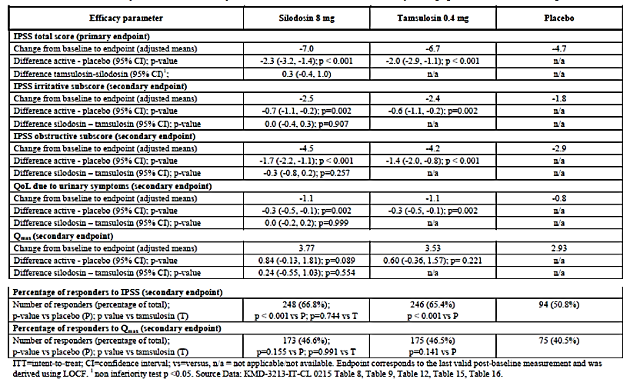

Primary endpoint
Regarding the primary endpoints, an overview of the changes in the IPSS total scores in the US and EU pivotal studies (including more than 1,800 randomised patients) is shown in Table 7 below. There were consistent and highly statistically significant changes in favour of the active treatments compared with placebo after treatment for 12 weeks.
Table 7: A summary of IPSS Total Scores in the ITT population
The non-inferiority of silodosin 8 mg compared with tamsulosin 0.4 mg was demonstrated in the EU Study IT-CL-0215. At Week 12, the difference in IPSS total scores between silodosin 8 mg and placebo was -2.2 (95% CI: -3.2, -1.3, p< 0.001); and the difference was -1.9 (95% CI: -2.8, -0.9, p< 0.001) for tamsulosin compared with placebo. The difference between the silodosin and tamsulosin treatment groups was 0.4 (95% CI: -0.4, 1.1).
Comment: There were consistent improvements in IPSS total scores across studies which were highly statistically significant. However, the clinical relevance of these changes is questionable as discussed in Section Evaluator’s conclusions on efficacy below.

Secondary endpoints

IPSS sub-scores
Changes in the obstructive and irritative IPSS subscores in the US studies are shown in Table 4. In each study, there were statistically significant differences in favour of silodosin 8 mg compared with placebo. In the EU study, there were comparable statistically significant changes in both subscores in the silodosin and tamsulosin groups compared with placebo (Table 6).

Qmax
Mean changes in urine flow rate in SI04009 and SI04010 are shown in Table 8. Compared with placebo, the differences in Qmax from baseline in the silodosin groups were approximately 1 mL/sec (p=0.006 and p=0.043 in the respective studies). In the EU study, the adjusted mean differences from placebo in the silodosin and tamsulosin groups were 0.84 (95% CI: -0.13, 1.81, p=0.89) and 0.60 (95% CI: -0.36, 1.57, p=0.221), respectively.
Comment: Mean Qmax increased by approximately 1 mL/sec in the pivotal studies but the differences for silodosin compared with placebo were not statistically significant in the EU study. The clinical relevance of these changes is also discussed in Section Evaluator’s conclusions on efficacy below.
Table 8: Changes in Qmax in the US pivotal studies

QoL
Changes in QoL in the pivotal studies are compared in Table 9. Approximately 10% more patients reported feeling ‘mostly satisfied’, ‘pleased’, or ‘delighted’ in the silodosin groups compared with placebo (33.4% versus 23.2% in SI04009, 30.5% versus 21.9% in SI04010 and 44.0% versus 34.0% in the EU study).
Table 9: Changes in QoL in the pivotal studies
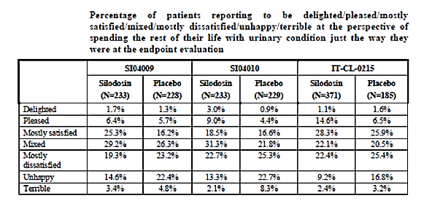

Age and race
No meaningful treatment differences in efficacy were observed in sub-groups based on age, race, or renal function. The great majority of patients in the US and EU studies were Caucasian. Large numbers of Japanese patients were treated in local studies but other races are under-represented in the overall database.

Evaluator’s conclusions on clinical efficacy
The three pivotal silodosin efficacy studies were conducted with a conventional randomised, double-blind, placebo-controlled, parallel group design, with an active control in the EU study. The results were consistent, with decreases in IPSS total score for the primary endpoint of -6.5 to -7.0 in the silodosin groups of the pivotal studies and -6.5 in the tamsulosin group in the EU study. Changes in the placebo groups ranged from -3.4 to -4.7 and the differences compared with the active treatment groups were each highly statistically significant (range -2.3 to -2.9, p< 0.0001). In the EU study there was also convincing statistical evidence for non-inferiority of silodosin compared with tamsulosin.
Analyses for the secondary endpoints were consistent with those for the primary endpoint. There were modest decreases in IPSS irritative and obstructive scores and there were modest improvements in QoL in the active treatment groups compared with placebo. There were modest, statistically significant increases in Qmax and the benefits in favour of silodosin compared with placebo were highly statistically significant. The improvement in the symptoms of BPH were rapid in onset and were sustained for at least one year, as shown in two US and EU OLE studies; in a long-term Phase III study in Japanese patients; and in a Phase IV study in European patients. The outcomes were comparable across all age groups.
Responder analyses (IPSS ≥ 25%, Qmax ≥ 30%) were performed only in the EU study. There were statistically significant improvements in IPSS in both active treatment groups compared with placebo. However, increases in Qmax were inconsistent and not statistically significant. The study outcomes are broadly in line with clinical trial data summarised in the Australian tamsulosin product information. Flomaxtra was superior to placebo given for 12 weeks in two pivotal studies. Treatment differences in IPSS total score were -1.6 (95% CI: -2.5, -0.6, p=0.0016) in study 617-CL-303 and -1.7 (95% CI: -2.5, -1.0, p< 0.0001) in Study 617-CL-307. QoL scores decreased in the first study [Odds ratio -0.4 (-0.6, -0.2), but increased in the second study [OR 1.53 (1.18, 2.0)]. The study entry criteria are not recorded.
Baseline disease characteristics (including medical histories and α-blocker use at screening) are not provided in the body of the US study reports and incomplete data are provided in annex tables. These data should be provided. A significant weakness in the studies was the exclusion of placebo responders from randomisation. The sponsor was asked by the EMA to justify this step which enriched the study population in favour of active treatment. However, a post hoc analysis showed that this did not influence the overall conclusions of the controlled studies.
The modest treatment differences in the placebo controlled studies were highly statistically significant, but the clinical significance of the changes across studies (IPSS -2.3 to -2.9) is questionable. The sponsor proposes that the treatment benefits were clinically meaningful as a decrease in IPSS of 2 points is perceived by patients as slight improvement. In support, the sponsor cites the AUA guideline and a publication on which the guideline was based (Barry, 1995). However, both citations are inaccurate. Basing their opinion on the publication, the AUA guideline states that ‘a three-point improvement in the AUA-SI is considered meaningful’. The AUA guideline is supported by the outcomes of the controlled silodosin studies. In Study SI04009, patients in the silodosin group improved IPSS by -6.5 but only 33.4% of patients reported feeling ‘mostly satisfied’ or better. In the placebo group, the change in IPSS was -3.6, but only 23.2% of patients reported similar benefit.
The clinical relevance of the modest and inconsistent increases in Qmax is not discussed or justified by the sponsor. The sponsor should justify the relevance of the observed differences in the outcomes before the conclusions are accepted (see Clinical Questions).

Clinical safety

Studies providing evaluable safety data

Pivotal studies that assessed safety as the sole primary outcome
Not applicable.

Pivotal and/or main efficacy studies
SI04009 (US), SI04010 (US) and IT-CL-0215 (EU)

Other studies-Efficacy studies

SI04011 OLE (US), IT-CL-0215 OLE (EU), IT-CL-0376 (Phase IV)
Safety in Japanese populations (including study 305) is summarised in Section Postmarketing experience below. These data are not evaluated in conjunction with the US/EU studies because of different reporting conventions and the use of multiple silodosin doses (ranging from 0.2 to 8 mg daily).

Studies with evaluable safety data: dose finding and pharmacology
In general, no SAEs occurred during the PK studies and all AEs identified were of mild to moderate intensity. Common AEs which occurred in more than one study following treatment with silodosin included: orthostatic changes; hypertension; dizziness; feeling bad; headache; diarrhoea; abnormal clinical laboratory tests and retrograde ejaculation. The results of the ‘Thorough QT’ study suggest that silodosin and its two active metabolites have no meaningful effect on heart rate, PR, and QRS interval duration or on cardiac repolarisation at either therapeutic (8 mg/day) or supra-therapeutic doses (24 mg/day). In subjects administered from 1 to 16 mg silodosin, 22 positive Type I orthostatic tests occurred in 63 subjects (approximately35%) who were administered silodosin, whereas, only 3 out of 21 (14.33%) subjects receiving placebo had positive tests. Similarly, the majority of the Type II orthostatic tests also occurred in subjects receiving study drug (17 of 63 or 27.0%) compared to those receiving placebo (2 of 21 or 9.5%).

Studies with evaluable safety data-Dose finding and pharmacology

US021-99 (dose finding)
A summary of the pharmacology safety data is provided.

Studies evaluable for safety only
Not applicable.

Studies that assessed safety as the sole primary outcome
Not applicable.

Patient exposure
A summary of total exposure in all BPH studies is shown in Table 10. Mean exposure in the overall silodosin 8 mg Phase II-IV safety population (n=2,617) was 202.2 days. In the overall Phase II-III safety population (n=1,581), the mean exposure to silodosin was 224.0 days. In the silodosin (n=931) and placebo (n=733) arms of the controlled studies, mean exposures were 77.8 and 78.2 days, respectively. In the overall safety population, 1750 (66.87%) patients were exposed for ≥ 6 months and 393 (15.02%) patients were exposed for ≥ 1 year.
Table 10: Summary of exposure in all clinical studies in LUTS/BPH

Adverse events

All adverse events (irrespective of relationship to study treatment)

Integrated safety analyses
In the pooled safety analysis (Phase II/III studies) of silodosin 8 mg patients (n=1,581), AEs reported in ≥ 1.0% of patients were retrograde ejaculation (23.9%), diarrhoea (3.4%), dizziness (3.0%), nasopharyngitis (2.9%), headache (2.6%), influenza (2.3%), hypertension (2.2%), orthostatic hypotension (1.8%), nasal congestion (1.7%), sinusitis (1.6%), URTI (1.6%), erectile dysfunction (1.4%), PSA increased (1.5%), arthralgia (1.5%), UTI (1.4%), back pain (1.0%), decreased libido (1.0%), bronchitis (1.0%) and rhinitis (1.0%). In the silodosin (n=931) and placebo (n=733) safety populations, retrograde ejaculation was notably more common in the silodosin group (21.6%) compared with placebo (0.8%).

Main/pivotal studies that assessed safety as the sole primary outcome
Not applicable.

Pivotal and/or main efficacy studies

SI04009
During the DB treatment period, 58.4% and 33.8% of patients reported at least one AE in the silodosin and placebo groups, respectively. In the silodosin group, 43.8%, 18.9% and 4.3% of patients reported mild, moderate and severe AEs, respectively. The respective percentages in the placebo group were 23.7%, 12.7% and 2.6%.

The most common AEs by PT
Retrograde ejaculation was reported in 29.2% and 0.9% of silodosin and placebo patients, respectively. Orgasm with no semen was reported in 24.9% and 0.4% of patients, respectively. Other less common AEs were headache (3.4% versus 1.3%), diarrhoea (3.0% versus 0.4%), dizziness (2.6% versus 1.8%), nasal congestion (2.6% versus 0.0%), orthostatic hypotension (2.6% versus 2.2%), insomnia (2.1% versus 0.0%) and sinusitis (2.1% versus 0.9%). AEs were more commonly reported in patients receiving silodosin compared with placebo for cardiac disorders (1.3% versus 0.4%), endocrine disorders (0.9% versus 0.4%), GI disorders (6.4% versus 5.7%), nervous system disorders (6.9% versus 3.9%) and reproductive system and breast disorders (30.5% versus 1.8%). Vascular disorders were reported with comparable frequency (4.4% versus 4.3%).

SI04010
During the DB treatment period, 51.9% and 39.7% of patients reported at least one AE in the silodosin and placebo groups, respectively. In the silodosin group, 42.9%, 15.9% and 1.3% of patients reported mild, moderate and severe AEs, respectively. The respective percentages in the placebo group were 25.3%, 18.8% and 1.3%.

The most common AEs by PT
Retrograde ejaculation was reported in 27.0% and 0.9% of silodosin and placebo patients, respectively. Orgasm with no semen was reported in 21.0% and 0.9% of patients, respectively. Other less common AEs were dizziness (3.9% versus 0.4%), nasopharyngitis (2.6% versus 1.3%), orthostatic hypotension (2.6% versus 0.9%), abdominal pain (2.1% versus 0.0%), diarrhoea (2.1% versus 2.2%) and PSA increased (2.1% versus 0.9%). AEs were more commonly reported in patients receiving silodosin compared with placebo for reproductive system and breast disorders (27.9% versus 3.1%) and nervous system disorders (6.0% versus 1.7%). There were no notable treatment differences for cardiac disorders (0.9% versus 1.3%), endocrine disorders (0.0% versus 0.4%), GI disorders (8.2% versus 8.3%) and vascular disorders (3.4% versus 2.2%).

IT-CL-0215
Overall, 34.9%, 28.9% and 24.2% of patients reported at least one AE during the DB treatment period in the silodosin, tamsulosin and placebo groups, respectively. Mild AEs were reported in 25.2%, 18.2% and 15.8% of the respective groups; moderate AEs were reported in 13.4%, 12.0% and 10.0% of the respective groups; and severe AEs were reported in 1.6%, 1.3% and 0.5% of the respective groups.

The most common AEs by SOC and PT
Retrograde ejaculation was reported in 14.2%, 2.1% and 1.1% of silodosin, tamsulosin and placebo patients, respectively. Other less common AEs were influenza (2.9%, 3.9% and 1.6%), headache (2.9%, 5.5% and 4.7%), dizziness (2.1%, 1.0% and 0.5%), hypertension (2.1%, 1.0% and 1.1%) and nasopharyngitis (2.6% versus 1.3%). AEs reported by selected SOCs included reproductive system and breast disorders (16.0%, 2.6% and 2.1%), respiratory disorders (7.6%, 10.9% and 5.8%), nervous system disorders (6.0%, 7.3% and 5.3%) and vascular disorders (2.6%, 2.1% and 1.6%).
Comment: In general, silodosin was well tolerated with the exception of retrograde ejaculation which was reported in 29.2% and 27.0% of the US studies. The incidence was remarkably less in the EU study with retrograde ejaculation reported in only 14.2% and 2.1% of the silodosin and tamsulosin groups, respectively (see Clinical Questions).

Other studies-Efficacy studies

SI0411 OLE
A summary of AEs reported in the DB period and in the overall population treated with silodosin for 9 or 12 months was provided. In the overall population (n=661), 65.2% of patients reported at least one AE. The most common AEs by PT were retrograde ejaculation (20.9%), diarrhoea (4.1%) and nasopharyngitis (3.6%).

IT-CL-0215 OLE
A summary of AEs reported by PT and SOC during the DB and extension periods was provided. AEs were reported in 33.4% of all patients during the OLE period (n=500), irrespective of the treatment during the DB period. The most common AEs by PT were retrograde ejaculation (9.0%), influenza (2.8%), diarrhoea (1.8%), headache (1.4%) and erectile dysfunction (1.2%).

IT-CL-0376
AEs were reported in 35.3% of the1036 patients in the safety population of this Phase IV OL study. The most common AEs by PT were ejaculation failure (18.1%), dizziness (2.1%), erectile dysfunction (1.8%), diarrhoea (1.6%) and headache (1.4%).

Studies with evaluable safety data-Dose finding and pharmacology

US021-99
AEs were reported in 71.1%, 67.0% and 64.0% of the silodosin 8 mg, silodosin 4 mg and placebo groups, respectively. The differences were not statistically significant. The most common AEs reported by PT during the DB period were tabulated. Retrograde ejaculation was reported in 15.6%, 11.4% and 0% of the respective groups. Other common AEs included ejaculation failure (11.1%, 9.1% and 0%), dizziness (5.6%, 9.1%, and 7.0%) and diarrhoea (5.6%, 0.0% and 4.7%).
Silodosin daily doses of 16 to 48 mg were well tolerated by most healthy subjects in the clinical pharmacology studies. Reversible retrograde ejaculation was the most commonly reported AE, with occasional dizziness and postural hypotension. No deaths or SAEs were reported.

Treatment related adverse events (adverse drug reactions)

Integrated safety analyses
In the pooled safety analysis of the silodosin versus placebo populations, ADRs reported in ≥ 1.0% of patients in the silodosin and placebo treatment groups were retrograde ejaculation (21.5% versus 0.8%), dizziness (1.8% versus 0.8%), orthostatic hypotension (1.2% versus 1.0%), headache (1.1% versus 1.2%), nasal congestion (1.0% versus 0.1%) and diarrhoea (0.6% versus 0.3%).

Pivotal and/or main efficacy studies

SI04009
ADRs were reported in 36.9% and 5.7% of the silodosin and placebo groups, respectively. The most common ADR was retrograde ejaculation (29.2% versus 0.9%). Other ADRs reported more commonly in the silodosin group compared with placebo were headache (2.1% versus 0.0%), nasal congestion (2.1% versus 0.0%), diarrhoea (1.3% versus 0.4%) and dizziness (1.3% versus 0.9%).

SI04010
ADRs were reported in 33.5% and 7.4% of the silodosin and placebo groups, respectively. The most common ADR was retrograde ejaculation (27.0% versus 0.9%). Other ADRs reported more commonly in the silodosin group compared with placebo were dizziness (3.4% versus 0.4%) and orthostatic hypotension (2.1% versus 0.9%).

IT-CL-0215
ADRs were reported in 21.5%, 10.4% and 8.4% of the silodosin tamsulosin and placebo groups, respectively. The most common ADR was retrograde ejaculation (14.2%, 2.1% and 1.1%). Headache was reported less commonly in the silodosin group compared with tamsulosin and placebo (0.8%, 2.3% and 2.1%).

Other studies- Efficacy studies

SI0411 OLE
The most commonly reported ADRs by PT were retrograde ejaculation (20.3%), dizziness (1.8%), diarrhoea (1.5%), orthostatic hypotension (1.4%), nasal congestion (1.4%), libido decreased (1.4%) and headache (1.1%).

IT-CL-0215 OLE
The most commonly reported ADR in the overall population was retrograde ejaculation (9.0%). Other less common ADRs included dizziness (0.8%), headache (0.6%) and erectile dysfunction (0.6%).

IT-CL-0376
ADRs were reported in 26.8% of patients, most commonly were ejaculation failure (17.9%), dizziness (1.9%), erectile dysfunction (1.5%), diarrhoea (1.3%) and headache (1.0%).

Studies with evaluable safety data; Dose finding and pharmacology

US021-99
The most commonly reported ADRs during the DB period were retrograde ejaculation reported in 15.6%, 11.4% and 0% of the silodosin 8 mg, silodosin 4 mg and placebo groups, respectively. Other common ADRs included ejaculation failure (11.1%, 9.1% and 0%) and dizziness (5.6%, 8.0%, and 7.0%).

Deaths and other serious adverse events

Integrated safety analyses
There were seven deaths in the Phase II/III studies and in the EU Phase IV study. Five deaths occurred in patients receiving silodosin 8 mg and one death each occurred in patients receiving tamsulosin and placebo. None of the deaths were considered related to study drug.
In the Phase II/III studies, 75 SAEs were reported in a total of 59 patients (47 silodosin, 4 tamsulosin and 8 placebo). Most SAEs were considered unrelated and all except three events resolved without sequelae. Four SAEs were considered possibly related to treatment by the investigator. There was one case each of syncope, prostatic carcinoma, atrial arrhythmia and myocardial infarction. SAEs were reported in 32 patients (3.1%) in the Phase IV study. There were five SAEs considered at least possibly related to treatment. There was one event each of dizziness, bradycardia, transient ischaemic attack, cerebral ischaemia and sudden hearing loss.

Pivotal and/or main efficacy studies

SI04009
There was a single death due to a hypertensive cerebral haemorrhage in a patient receiving placebo. Six other patients (1.3%) reported SAEs but none were considered drug related.

SI04010
No deaths were reported. SAEs were reported in eight patients (1.7%) but only one (syncope) was considered related to silodosin.

IT-CL-0215
There were two deaths (one silodosin, one tamsulosin) due to malignancies and neither was considered drug related. SAEs were reported in nine patients (1%), four patients each in the silodosin and tamsulosin groups and one in the placebo group. Three SAEs were considered drug related; single cases each of prostatic carcinoma (silodosin), supraventricular tachycardia (silodosin) and anxiety (tamsulosin).

Other studies-Efficacy studies

SI0411 OLE
Two deaths were reported during the study (myocardial infarction and pulmonary embolism) but neither was considered drug related. SAEs were reported in 29 patients but none were considered related to silodosin treatment.

IT-CL-0215 OLE
One death due to lung malignancy was reported but it was considered unrelated to silodosin treatment. Nine further patients reported SAEs but only one event was considered possibly related (myocardial infarction).

IT-CL-0376
Two deaths were reported due to cardiac failure and a road traffic accident. Neither was considered drug related. SAEs were reported in 32 patients, but only one event was considered related to silodosin (dizziness).

Studies with evaluable safety data -Dose finding and pharmacology

US021-99
No deaths or SAEs were reported during the study.

Discontinuations due to adverse events

Integrated safety analyses
In the overall silodosin safety population (n=1,581), 148 patients (9.4%) discontinued study drug because of AEs. In the silodosin 8 mg safety population (n=931), 40 patients (4.3%) discontinued, compared with 14 patients (1.9%) in the placebo set (n=733). Discontinuations were most commonly due to retrograde ejaculation (3.9%, 1.9% and 0.0% in the respective safety sets).

Pivotal and/or main efficacy studies

SI04009
A total of 26 patients discontinued treatment due to AEs. Twenty patients were receiving silodosin and nine of these discontinued because of retrograde ejaculation (all were aged < 65 years).

SI04010
A total of 14 patients discontinued because of AEs. Of ten patients receiving silodosin, four were discontinued because of retrograde ejaculation (three patients were aged < 65 years).

IT-CL-0215
Overall, a total of 15 patients discontinued because of AEs. In the silodosin, tamsulosin and placebo groups, 2.1%, 1.0% and 1.6% of patients, respectively, discontinued. Five patients in the silodosin group and one patient in the tamsulosin group discontinued because of retrograde ejaculation.

Other studies-Efficacy studies

SI0411 OLE
A total of 86 patients (13.0%) discontinued due to an AE during the OL period, most commonly due to retrograde ejaculation (4.8%), diarrhoea (0.8%), libido decreased (0.6%), dizziness (0.5%) and lung malignancies (0.5%).

IT-CL-0215 OLE
A total of 13 patients discontinued due to AEs during the OL period, eight because of retrograde ejaculation.

IT-CL-0376
Treatment was discontinued in 7.4% of patients, most commonly due to ejaculation failure.

Studies with evaluable safety data- Dose finding and pharmacology

US012
A total of ten patients in the silodosin 8 mg group and five patients in the silodosin 4 mg group discontinued because of AEs. The most common reason for discontinuation was retrograde ejaculation.

Evaluation of issues with possible regulatory impact

Liver function and liver toxicity

Integrated safety analyses
There were no clinically meaningful changes in the mean values of any parameter in any of the treatment groups and no safety signals were detected. Shifts in ALT from normal to high were reported in 2.6% of the overall silodosin safety population compared with 2.1% in the placebo safety population. Shifts in AST were reported in 2.0% and 1.1% of the respective populations; and shifts in total bilirubin were reported in 2.4% and 2.4% of patients, respectively. A case of hepatitis was reported as an unrelated AE in a single patient.

Pivotal and/or main efficacy studies

SI04009
Clinical chemistry evaluations were made at baseline, Week 4 and Week 12. Mild, transient elevations in ALT/AST and total bilirubin were reported as AEs in two patients [one silodosin (0.4%) and one placebo (0.2%)].

SI04010
There was a single adverse event (AE) related to AST in a placebo patient.

IT-CL-0215
There was a single AE related to GGT in a tamsulosin patient.

Other studies
A case of hepatitis was reported as an AE in a single patient in IT-CL-0215 OLE. This was attributed to food poisoning and unrelated to study treatment. There were no other notable LFT abnormalities or treatment emergent trends in the other efficacy studies.

Studies with evaluable safety data-Dose finding and pharmacology

US012
There was a single clinically significant AST elevation in the silodosin 8 mg group.

Renal function and renal toxicity

Integrated safety analyses
There were no clinically meaningful treatment emergent changes or trends. Increased creatinine was reported in seven patients but none were reported as AEs. All were considered unrelated to silodosin treatment. No safety signals relating to urinalysis were identified. AEs reported as urinary tract infection (UTI) were reported in 1.4% of the overall silodosin safety population compared with 0.3% in the placebo population.

Pivotal and/or main efficacy studies

SI04009
Clinical chemistry evaluations were made at baseline, Week 4 and Week 12. Mild, transient elevations in serum creatinine were reported as AEs in two patients during the DB period, one silodosin (0.4%) and one placebo (0.2%).

SI04010
Notable increases in blood creatinine were reported as AEs in two patients (0.9%) in the silodosin group (both considered unrelated). In addition, there was a single case of chronic renal failure attributed to multiple myeloma.

IT-CL-0215
There were no notable changes in mean values or AEs related to blood creatinine in any of the treatment groups.

Other studies
In SI0411, a mild, transient increase in blood creatinine was reported in a single patient. One patient in the Phase IV Study IT-CL-0376 had an AE of renal failure with a modest fall in creatinine clearance from baseline (50.83 mL/min) to Visit 5 (45.39 mL/min).

Studies with evaluable safety data- Dose finding and pharmacology

US021-99
There were no notable changes in blood creatinine.

Other clinical chemistry

Integrated safety analyses
There were no clinically meaningful treatment emergent changes or trends in any other clinical chemistry parameter.

Pivotal and/or main efficacy studies
AEs relating to other clinical chemistry were all isolated and mild. None were considered related to silodosin treatment.

Other studies
AEs relating to other clinical chemistry were all isolated and mild. None were considered related to silodosin treatment.

Studies with evaluable safety data-Dose finding and pharmacology

US021-99
There were no AEs relating to other clinical chemistry in the silodosin groups.

Haematology and haematological toxicity

Integrated safety analyses
There were no clinically meaningful treatment emergent changes or AEs in any haematological parameter.

Pivotal and/or main efficacy studies
No notable haematological events were reported.

Other studies
No notable haematological events were reported.

Studies with evaluable safety data- Dose finding and pharmacology
No notable haematological events were reported.

Other laboratory tests

Integrated safety analyses
PSA, HbA1c and TFTs were analysed in addition to the routine clinical chemistry analyses. No safety signals were identified. In the overall silodosin safety population, PSA worsened during treatment in 4.3% and 3.9% of the silodosin and placebo groups, respectively. HbA1c worsened in 6.7% and 4.0% of the respective groups. Increased metabolism of thyroxine was identified in toxicology studies. However, there were no meaningful changes in T3, T4 or TSH, or differences from placebo in the clinical studies.

Electrocardiograph findings and cardiovascular safety

Integrated safety analyses
ECG changes in the Phase II/III safety populations are shown in Table 11. Treatment emergent, clinically significant ECG changes were reported in 1.5% and 2.7% of the silodosin and placebo populations, respectively. No QTc safety signals were identified during a maximum tolerated dose study (SI05008), or in a Thorough QTc study (SI05014). No ECG safety signals were detected during the OLE studies.
Table 11: ECG changes in the overall silodosin and placebo safety populations

Vital signs and clinical examination findings

Integrated safety analyses
Hypertension was reported in 2.2% of the overall silodosin safety population compared with 1.9% in the placebo population. Orthostatic hypotension was reported in 1.8% and 1.1% of the respective populations.
There were no clinically meaningful changes in supine SBP or DBP in the respective groups. Mean SBP fell by -2.5, -1.8, and -0.6 mm Hg and DBP fell by -1.4, -1.0 and -0.8 mm Hg in the respective groups. The mean changes in HR from baseline were 1.6, 1.7 and 1.6 bpm, respectively. Pre-dose positive tests were reported in 0.5% of the silodosin and placebo safety populations. Post-dose positive tests were reported in 2.0% and 0.5% of the respective populations.

Pivotal and/or main efficacy studies

SI04009
Silodosin had no significant effect on supine BP or HR compared with placebo. Positive orthostatic tests at 1 min were reported in 1.3% and 0.4% of the respective groups at each time point.

SI04010
Silodosin had no significant effect on supine BP or HR compared with placebo. Positive orthostatic tests at 1 min and 3 mins were reported in 1.3% and 2.6% of silodosin patients at the respective time points, compared with 0.4% at both time points in the of the placebo group.

IT-CL-0215
There were no clinically meaningful differences in the rates of orthostasis between the silodosin, tamsulosin and placebo treatment groups.

Other studies
There were no meaningful changes in SBP, DBP, or HR during the OLE studies. Orthostasis testing was not performed.

Studies with evaluable safety data-Dose finding and pharmacology

US021-99
Positive orthostasis tests were reported in 3.3%, 4.5% and 2.3% of patients in the silodosin 8 mg, 4 mg and placebo groups, respectively.

Immunogenicity and immunological events
Not applicable.

Serious skin reactions

Integrated safety analyses
There were no serious skin reactions and no safety signals were identified. AEs related to rash were reported in 0.5% of the overall silodosin safety population and in 0.4% of the placebo population.

Liver function and liver toxicity

Integrated safety analyses
There were no clinically meaningful changes in the mean values of any parameter in any of the treatment groups and no safety signals were detected. Shifts in ALT from normal to high were reported in 2.6% of the overall silodosin safety population compared with 2.1% in the placebo safety population. Shifts in AST were reported in 2.0% and 1.1% of the respective populations; and shifts in total bilirubin were reported in 2.4% and 2.4% of patients, respectively. A case of hepatitis was reported as an unrelated AE in a single patient.

Pivotal and/or main efficacy studies

SI04009
Clinical chemistry evaluations were made at baseline, Week 4 and Week 12. Mild, transient elevations in ALT/AST and total bilirubin were reported as AEs in two patients [one silodosin (0.4%) and one placebo (0.2%)].

SI04010
There was a single AE related to AST in a placebo patient.

IT-CL-0215
There was a single AE related to GGT in a tamsulosin patient.

Other studies- Efficacy studies
A case of hepatitis was reported as an AE in a single patient in IT-CL-0215 OLE. This was attributed to food poisoning and unrelated to study treatment. There were no other notable LFT abnormalities or treatment emergent trends in the other efficacy studies.

Studies with evaluable safety data-Dose finding and pharmacology

US012
There was a single clinically significant AST elevation in the silodosin 8 mg group.

Renal function and renal toxicity

Integrated safety analyses
There were no clinically meaningful treatment emergent changes or trends. Increased creatinine was reported in seven patients but none were reported as AEs. All were considered unrelated to silodosin treatment. No safety signals relating to urinalysis were identified. AEs reported as UTI were reported in 1.4% of the overall silodosin safety population compared with 0.3% in the placebo population.

Pivotal and/or main efficacy studies

SI04009
Clinical chemistry evaluations were made at baseline, Week 4 and Week 12. Mild, transient elevations in serum creatinine were reported as AEs in two patients during the DB period, one silodosin (0.4%) and one placebo (0.2%).

SI04010
Notable increases in blood creatinine were reported as AEs in two patients (0.9%) in the silodosin group (both considered unrelated). In addition, there was a single case of chronic renal failure attributed to multiple myeloma.

IT-CL-0215
There were no notable changes in mean values or AEs related to blood creatinine in any of the treatment groups.

Other studies-Efficacy studies
In SI0411, a mild, transient increase in blood creatinine was reported in a single patient. One patient in the Phase IV Study IT-CL-0376 had an AE of renal failure with a modest fall in creatinine clearance from baseline (50.83 mL/min) to Visit 5 (45.39 mL/min).

Studies with evaluable safety data-Dose finding and pharmacology

US021-99
There were no notable changes in blood creatinine.

Other clinical chemistry

Integrated safety analyses
There were no clinically meaningful treatment emergent changes or trends in any other clinical chemistry parameter.

Pivotal and/or main efficacy studies
AEs relating to other clinical chemistry were all isolated and mild. None were considered related to silodosin treatment.

Other studies-Efficacy studies
AEs relating to other clinical chemistry were all isolated and mild. None were considered related to silodosin treatment.

Studies with evaluable safety data-Dose finding and pharmacology

US021-99
There were no AEs relating to other clinical chemistry in the silodosin groups.

Haematology and haematological toxicity

Integrated safety analyses
There were no clinically meaningful treatment emergent changes or AEs in any haematological parameter.

Pivotal and/or main efficacy studies
No notable haematological events were reported.

Other studies-Efficacy studies
No notable haematological events were reported.

Studies with evaluable safety data-Dose finding and pharmacology
No notable haematological events were reported.

Other laboratory tests

Integrated safety analyses
PSA, HbA1c and TFTs were analysed in addition to the routine clinical chemistry analyses. No safety signals were identified. In the overall silodosin safety population, PSA worsened during treatment in 4.3% and 3.9% of the silodosin and placebo groups, respectively. HbA1c worsened in 6.7% and 4.0% of the respective groups. Increased metabolism of thyroxine was identified in toxicology studies. However, there were no meaningful changes in T3, T4 or TSH, or differences from placebo in the clinical studies.

Electrocardiograph findings and cardiovascular safety

Integrated safety analyses
Treatment emergent, clinically significant ECG changes were reported in 1.5% and 2.7% of the silodosin and placebo populations, respectively. No QTc safety signals were identified during a maximum tolerated dose study (SI05008), or in a Thorough QTc study (SI05014). No ECG safety signals were detected during the OLE studies.

Vital signs and clinical examination findings

Integrated safety analyses
Hypertension was reported in 2.2% of the overall silodosin safety population compared with 1.9% in the placebo population. Orthostatic hypotension was reported in 1.8% and 1.1% of the respective populations. There were no clinically meaningful changes in supine SBP or DBP in the respective groups. Mean SBP fell by -2.5, -1.8, and -0.6 mm Hg and DBP fell by -1.4, -1.0 and -0.8 mm Hg in the respective groups. The mean changes in HR from baseline were 1.6, 1.7 and 1.6 bpm, respectively. The proportions of patients with negative or positive orthostatic tests were tabulated. Pre-dose positive tests were reported in 0.5% of the silodosin and placebo safety populations. Post-dose positive tests were reported in 2.0% and 0.5% of the respective populations.

Pivotal and/or main efficacy studies

SI04009
Silodosin had no significant effect on supine BP or HR compared with placebo. Positive orthostatic tests at 1 min were reported in 1.3% and 0.4% of the respective groups at each time point.

SI04010
Silodosin had no significant effect on supine BP or HR compared with placebo. Positive orthostatic tests at 1 min and 3 mins were reported in 1.3% and 2.6% of silodosin patients at the respective time points, compared with 0.4% at both time points in the of the placebo group.

IT-CL-0215
There were no clinically meaningful differences in the rates of orthostasis between the silodosin, tamsulosin and placebo treatment groups.

Other studies-Efficacy studies
There were no meaningful changes in SBP, DBP, or HR during the OLE studies. Orthostasis testing was not performed.

Studies with evaluable safety data-Dose finding and pharmacology

US021-99
Positive orthostasis tests were reported in 3.3%, 4.5% and 2.3% of patients in the silodosin 8 mg, 4 mg and placebo groups, respectively.

Immunogenicity and immunological events
Not applicable.

Serious skin reactions

Integrated safety analyses
There were no serious skin reactions and no safety signals were identified. AEs related to rash were reported in 0.5% of the overall silodosin safety population and in 0.4% of the placebo population.

Other safety parameters

Integrated safety analyses
No other safety issues were identified.

Safety in special populations
Analyses based on race were not performed in the overall safety populations as the great majority of patients were Caucasian. The incidence of treatment emergent AEs in patients of different ages was analysed in the Phase II/III controlled studies. No meaningful differences between age groups were detected with the exception of orthostatic hypotension. The incidence of orthostatic hypotension was higher in silodosin patients aged ≥ 75 years (2.3%) compared with patients aged < 65 years (1.0%). However, the majority of orthostatic events were mild and most resolved with continued treatment.
Safety data in Japanese patients were summarised. The most common ADRs by PT in the silodosin (n=873) and placebo (n=178) populations were ejaculation disorder (11.7% versus 0.0%), diarrhoea (7.7% versus 3.9%), retrograde ejaculation (5.5% versus 0.0%), thirst (5.5% versus 2.8%), dizziness (5.0% versus 1.1%) and dizziness postural (3.6% versus 0.0%). In the Japanese studies, no clear distinction between AEs and ADRs is made. There was a single death due to lung malignancy considered unrelated to silodosin treatment. Other SAEs were reported in 0.2% of patients, all considered unrelated. Silodosin was generally well tolerated with a safety profile comparable to the US and EU populations.
Safety in patients with pre-existing cardiovascular disease (including hypertension) was examined in the Phase III and Phase IV studies. There was no evidence that silodosin increased the risk of hypotension, angina, arrhythmia, myocardial infarction, cerebral ischaemia, or transient cerebral ischaemic attacks in this patient population.

Safety related to drug-drug interactions and other interactions
The PK studies identified a potent drug-drug interaction following a single oral 8 mg dose of silodosin and multiple doses of the strong CYP3A4 inhibitor ketoconazole. Under these conditions, plasma exposure to silodosin and its two metabolites, silodosin-G and KMD-3293, was greatly increased with increases ranging from 2.5-fold to 3.7-fold, which clearly indicates that silodosin should not be co-administered with strong CYP3A4 inhibitors.
The effect of the moderate CYPP3A4 diltiazem on silodosin exposure following co-administration was less pronounced and the mean C_{max} and AUC_{inf} values for silodosin were increased by 20% and 44%, respectively, compared to when silodosin was administered alone. Therefore, by contrast, the effect of co-administration of a single moderate CYP3A4 inhibitor with silodosin in the absence of other medication is unlikely to be clinically significant unless the patient is also suffering from some form of pre-existing condition such as renal impairment.

Post marketing experience
Silodosin has been launched under various trade names in multiple jurisdictions:
2006: Japan in 2006
2009: US and Korea in 2009
2010: Lebanon, Germany, Ireland, Spain and France
2011: Portugal, Belgium, Romania, Italy, Greece, Netherlands, Czech Republic, Slovakia, Taiwan and Russia
2012: Cyprus, Bulgaria, Poland, Canada, Turkey and Ukraine
2013: Georgia, Belarus, Armenia, UAE, Croatia, China and Macau
The greatest single exposure has occurred in Japan with cumulative exposure to silodosin 8 mg of more than 2 million patient years.
In the EU territories, ADRs have been collected by [information redacted] and recorded in the PSUR No: 8 and the EU SmPC. Worldwide post-marketing safety data have been collected by [information redacted] and included in the PSUR No: 18. The pattern of post-marketing ADRs is comparable to that reported in clinical trials. However, new spontaneous and clinical trial reports have led to voluntary updates of national labels in Japan, US, EU and Canada. These include hypersensitivity/allergic reactions; abnormal LFTs; syncope; hypotension following co-administration with PDE-5 inhibitors; tachycardia and palpitations; stomatitis; gynaecomastia; and skin drug eruptions. Based on the clinical trial and post-marketing data, approximate estimates of frequency have been calculated for: orthostatic hypotension (1%), syncope (< 0.1%), tachycardia (0.1%), hypersensitivity reactions (0.1%) and abnormal LFTs (0.1%).
IFIS (intra-operative floppy iris syndrome) during cataract surgery or glaucoma has been identified as an adverse reaction associated with α1a-blockers following reports in patients receiving tamsulosin (Chang, 2005). In patients receiving tamsulosin, the risk of IFIS ranges from 43% to 90%, although the risk appears to be lower in patients receiving terazosin or doxazosin. A single case in a patient receiving silodosin was identified in the Phase II/3 studies and a further 31 cases (three serious) have been identified post-approval. No estimate of the frequency of IFIS in patients treated with silodosin has been provided (see Clinical Questions).
No new safety data have been reported in populations which have not been studied in clinical trials. These include patients aged > 75 years, patients with severe hepatic or renal impairment, patients with mild symptoms of BPH and patients receiving 5-ARIs. Additional data will become available from several post-marketing surveillance studies which are on-going worldwide.

Evaluator’s overall conclusions on clinical safety
Silodosin was generally well tolerated in the clinical trial program. The most common ADR identified in the overall safety population was retrograde ejaculation (23.6%), assumed to be drug related as it occurred in < 1% of the placebo population. Other ejaculatory disorders were less common but they also occurred more commonly in patients receiving silodosin. Loss of libido and erectile dysfunction were infrequent and less obviously causally related given the age of the patient population. Retrograde ejaculation was tolerated by most patients but it was reversible in those who withdrew from treatment. Retrograde ejaculation is likely to reduce fertility temporarily: however, this should be reversible when treatment is withdrawn. In the Phase II/III studies (including the extension studies), only 3.9% of patients withdrew due to retrograde ejaculation. Moreover, treatment compliance rates were consistently > 90% across studies. In the EU study with an active comparator, retrograde ejaculation was reported in 14.2%, 2.1% and 1.1% of the silodosin, tamsulosin and placebo groups. As the efficacy of silodosin and tamsulosin was comparable, there is no obvious explanation for the large difference in the rates of retrograde ejaculation between the groups (see Clinical Questions).
Other less common ADRs in the overall silodosin (n=1,581) and placebo (n=733) populations were dizziness (2.1% versus 0.8%), orthostatic hypotension (1.3% versus 1.0%), nasal congestion (1.3%), headache (1.3% versus 1.2%), diarrhoea (1.0% versus 0.3%), erectile dysfunction (0.9% versus 0.4%), rhinitis (0.8% versus 0.3%), libido decreased (0.8% versus 0.0%) and dry mouth (0.7% versus 0.3%). Most AEs were mild to moderate in intensity. There were seven deaths in the Phase II/III studies but none were considered drug related. Only four SAEs were considered possibly related to silodosin (one case each of syncope, prostatic carcinoma, atrial arrhythmia and myocardial infarction). No significant safety signals relating to clinical chemistry, ECGs or vital signs were identified.
There were trivial falls in mean supine BP and the rate of orthostatic hypotension was low (predicted because of the high specificity of silodosin for the α1a-receptor). In the overall safety analysis, there were only two cases of syncope (0.08%) and one case each of pre-syncope and loss of consciousness (each 0.04%). The overall incidences of dizziness and postural dizziness were 2.03% and 0.04%, respectively. Tachycardia and palpitations were reported in 0.15% and 0.08% of patients, assumed to be reflex responses to blood pressure lowering.
The proposed Australian PI includes post-marketing safety updates relating to uncommon or rare ADRs including tachycardia and palpitations, abnormal LFTs, allergic reactions, syncope, skin rashes and drug eruptions and hypotension. IFIS is a well understood ADR which is highlighted in the proposed PI. In the overall safety analysis, there were only two reports of prostate cancer. Prostate cancer is a cause of LUTS and it should be excluded by ultrasound, rectal examination and/or PSA measurement before silodosin treatment is started. This is also highlighted in the proposed PI.
Retrograde ejaculation is an inconvenience which is reversible in patients who find it more distressing. Other ADRs are much less common and generally mild to moderate in severity. Potentially serious ADRs such as orthostatic hypotension and cardiac events are uncommon and reversible if treatment is withdrawn. Overall, the safety profile of silodosin is acceptable for the treatment of a non-life threatening condition.

First Round Benefit-Risk Assessment

First round assessment of benefits
Indication
Benefits | Strengths and Uncertainties
Silodosin 8 mg daily provides a statistically significant improvement in LUTS associated with moderate to severe BPH.  There are statistically significant improvements in QoL.  There are improvements in urinary flow rate.  The efficacy of silodosin 8 mg is comparable to tamsulosin 0.4 mg daily, another widely used α1a-blocker.The specificity of the α1a-blockers reduces the potential for supine and orthostatic hypotension.  Silodosin acts quickly and efficacy is sustained for at least one year. Large Phase 4 studies have confirmed the results of shorter term controlled studies.  Silodosin is generally well tolerated and safe. | The improvement in symptoms in the controlled trials was substantial in patients treated with silodosin or placebo. There was a statistically significant difference in favour of silodosin but the difference compared with placebo was not clinically meaningful. Mean improvements in QoL were modest.  Improvements in Qmax (the only objective efficacy measure) were generally minor and inconsistent between studies.  Non-inferiority with tamsulosin was confirmed with a high degree of statistical significance.  The safety profile of silodosin has been established with extensive post-marketing experience with several million patient/years of treatment. Uncertainties are outlined in the RMP.

First round assessment of risks
Risks | Strengths and Uncertainties
Ejaculation disorders are very common. However, they are generally bothersome rather than a safety concern. They are reversible if therapy is withdrawn.  Other ADRs are generally mild to moderate although there is the potential for uncommon serious ADRs (for example, IFIS, syncope, hypersensitivity).  Safety has not been established in sub-groups, including patients with severe renal or hepatic impairment and patients receiving concomitant 5-ARIs. | Placebo- controlled studies confirm that retrograde ejaculation is an ADR, predicted by its pharmacological activity on the urinary tract.  The safety profile of silodosin has been established by many years of post-marketing experience. These are addressed in the proposed PI and appropriate pharmacovigilance activities have been identified.

First round assessment of benefit-risk balance
The overall benefit-risk balance for the proposed indication is negative. The benefit-risk is positive in patients with severe LUTS but negative in patients with mild to moderate symptoms.
The pivotal and supportive studies have demonstrated clear statistically significant improvement in IPSS for silodosin compared with placebo in patients with moderate to severe symptoms associated with BPH. However, subjective improvements were not matched by significant objective improvements based on Qmax. The overall decrease in IPSS was less than the 3 points required to demonstrate a minimum clinically meaningful benefit based on the AUA guideline. A borderline benefit was shown only in patients with severe symptoms (IPSS≥ 20) in a post hoc analysis requested by the EMEA. Clinically meaningful benefit in patients with mild or moderate LUTS has not been established.
The risk of mild to moderate ADRs is high although serious ADRs are uncommon. The most common ADR is retrograde ejaculation which occurs in approximately 25% of patients. However, this is reversible without sequelae when treatment is stopped. Less common ADRs include headache, dizziness and postural dizziness. IFIS, hypersensitivity and syncope are rare but serious ADRs. Most ADRs may be regarded as bothersome rather than serious but low tolerability may explain the relatively modest overall improvements in QoL. The pattern of ADRs and the associated risks are shared by other agents in the class and no specific ADRs related to silodosin have been identified. Risks associated with the pharmacology of silodosin, including interactions, are shared by other agents in the class. No ADRs of concern have been identified in subgroups, including elderly patients aged ≥ 75 years. Almost all patients in the clinical trial program were either Caucasian or Japanese and controlled data are limited for other racial groups.
The safety and tolerability of silodosin has been established with extensive worldwide post-marketing experience. Risk has been quantified and the risk of unidentified ADRs is very low. However, risk in patients with severe hepatic or renal failure has not been fully evaluated in post-marketing surveillance data.
LUTS associated with BPH is a bothersome syndrome which affects quality of life. The use of silodosin may improve symptoms but there is no evidence that treatment ameliorates the underlying condition, improves long-term outcomes, or reduces surgical intervention. The risks associated with silodosin are low and arguably acceptable in patients with severe symptoms. However, the risks do not outweigh benefit in patients with mild or moderate symptoms.

First Round Recommendation Regarding Authorisation
Authorisation is not recommended for the proposed indication:
‘Treatment of the signs and symptoms of benign prostatic hyperplasia in adult men’.
- The sponsor suggests that silodosin improves the signs of BPH but it is unclear what these signs are. There should be no implication that silodosin reduces prostate size.
- A clinically meaningful benefit compared with placebo for mild to moderate symptoms of BPH has not been established.
- The benefit-risk is not favourable in patients with mild to moderate symptoms.
However, subject to satisfactory responses to the Clinical Questions below, authorisation is recommended for the indication:
Relief of severe lower urinary tract symptoms (LUTS) associated with benign prostatic hyperplasia in adult men (IPSS≥ 20)’.
Note: The FDA and EMEA both approved the indication proposed by the sponsor based on statistically significant improvements in the signs and symptoms of BPH for silodosin compared with placebo. Clinically meaningful efficacy was accepted without question by the FDA, but it was challenged by the EMA. In a post hoc analysis requested the EMA, only in patients with baseline IPSS ≥ 20 was a threshold for clinically meaningful improvement of three points achieved (see Section 12.1.3, Question 5). The EMA also questioned the study designs which biased the outcomes in favour of the active treatments compared with placebo (see CHMP Assessment Report for Urorec: EMA/793234/2009, 10 January 2010; and CDER/FDA: NDA 22-206, 10 October 2008).

Clinical Questions

Pharmacokinetics

Question 1
Can the sponsor please indicate where the proposed product for marketing will be manufactured and by whom?

Question 2
The PK/PD evaluator has been unable to find any discussion of the type of meal given to the subjects in the KMD-308 Study Report when they were administered silodosin under non-fasting conditions. Can the sponsor please confirm whether the meal could be considered a low- low calorie, moderate fat- moderate calorie or a high fat, high calorie meal?

Pharmacodynamics
No questions.

Efficacy

Question 3
In the pivotal Phase III studies SI04009 and SI04010, some important baseline disease characteristics have not been summarised in the body of the study report. Please provide these data, including renal function, history of cardiac disease and previous use of α-blockers).

Question 4
Responders to placebo during the run-in period were not randomised. Please provide the post hoc analysis provided to the EMEA and used to justify this design.

Question 5
Please justify the statement that a 2 point change in IPSS is clinically meaningful.
As discussed in Section Evaluator’s conclusions on efficacy above, the sponsor proposes that the treatment benefits for silodosin in the controlled trials were clinically meaningful, suggesting that a decrease in IPSS total score of 2 points is perceived by patients as slight improvement. In support, the sponsor cites the AUA BPH treatment guideline and the publication on which the guideline was based (Barry, 1995). However, both references appear inaccurate. Based on the original publication, the AUA guideline states that ‘a three-point improvement in the AUA-SI is considered meaningful’.
The clinical relevance of changes in IPSS in response to pharmacological treatment was examined in a prospective study by Barry (1995). A total of 1,218 evaluable patients were given terazosin, finasteride, both agents in combination, or placebo with a follow-up period of 13 weeks after a two week placebo run-in period. Symptom severity was quantified in 1,165 evaluable patients using the AUA Symptom Index (synonymous with the IPSS for urinary symptoms). In this study, the median AUA total score was 16 at baseline. At 13 weeks, patients were asked to rate their condition as markedly, moderately, or slightly improved, unchanged or worse. As shown below (Table 12), in the overall group, patients who rated themselves as slightly improved achieved a mean decrease in AUA of 3.0 points.
Table 12: Mean absolute and percent changes in subject AUA symptom index (range 0-35) and BPH impact index (range 0 to 13) scores depending on subject 13 week global assessment of degree of change [Table 5 in publication]
It was noted that the minimum perceptible difference in symptoms (corresponding to a perceived ‘slight improvement’) was powerfully influenced by the baseline scores. As shown below (Table 13), the mean decrease in symptom scores among patients reporting slight improvement was -1.9 in patients with baseline scores of < 20 points. However, the mean decrease associated with slight improvement was -6.1 points if the mean baseline value was ≥ 20 points.
Table 13: Mean absolute changes in subject AUA symptom index and BPH impact index scores for each level of self-rated global improvement for subjects with lower versus higher baseline scores [Table 7 in publication]
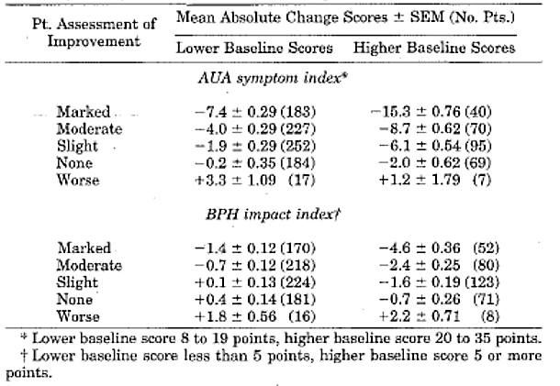
A post hoc analysis provided at the request of the EMA supports Barry’s data. As shown below for the EU study, improvements in IPSS were higher in patients with baseline IPSS ≥ 20. In this subgroup, the change in IPSS in the ITT population was of borderline significance [-3.0 (95% CI: -4.5, -1.4)]. However, the improvement in IPSS was not clinically meaningful in patients with baseline IPSS < 20.
Table 14: Study IT-CL-0215 Post hoc subgroup analysis in patients with moderate and severe symptoms (ITT population)
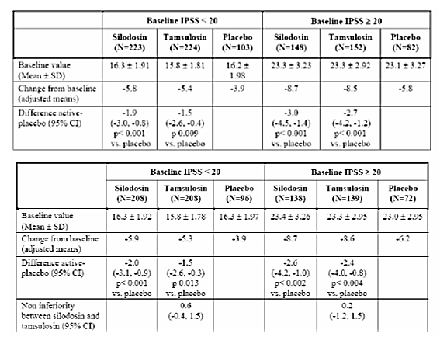

Question 6
In the US OLE Study SI04011, 34.2% of patients withdrew, due mainly to AEs (14.1%) and lack of efficacy (8.8%). The corresponding percentages in the EU OL extension Study IT-CL-0215 were remarkably different (11.2%, 3.8% and 1.8%, respectively). These differences may impact risk/benefit with long-term treatment. Is there an obvious reason for the disparity?

Question 7
Please justify the wording of the proposed indication relating to the treatment of the signs of BPH.

Question 8
The only objective secondary efficacy measure in the pivotal studies was Qmax, but the differences between silodosin and placebo were marginal (approximately 1 mL/sec or less). The treatment benefit was statistically significant in SI04009 and SI04010, but not in IT-CL-0215. Please discuss the clinical relevance of the modest overall increase in Qmax, with literature or specialist body endorsements if available.

Safety

Question 9
The most commonly reported AE in the US and EU pivotal studies was retrograde ejaculation in the silodosin and tamsulosin treatment groups. Although the US and EU studies were comparable in design and duration, the incidences of retrograde ejaculation in the silodosin groups were notably different (29.2% and 27.0% in the US studies, but only 14.2% in the EU study). In the EU study, the incidence of retrograde ejaculation was only 2.1% in patients treated with tamsulosin. Is there a plausible explanation for these marked disparities?

Question 10
Please provide an estimate of the frequency of IFIS in patients undergoing cataract or glaucoma surgery while receiving silodosin therapy. Does stopping silodosin before surgery reduce the risk of IFIS?

First Round Evaluation Errata

Minor editorial changes
None reported by the sponsor.

Minor errors of fact
None reported by the sponsor.

Significant errors of fact
The evaluators mistakenly evaluated version 0.3 of the draft PI rather than version 0.4. Version 0.5 has been evaluated.

Second round evaluation

Pharmacokinetics

Question 1
Can the sponsor please indicate where the proposed product for marketing will be manufactured and by whom?

Sponsor’s Response
[information redacted]

Evaluator’s Response
The PK/PD evaluator is satisfied with the sponsor’s response.

Question 2
The PK/PD evaluator has been unable to find any discussion of the type of meal given to the subjects in the KMD-308 Study Report when they were administered silodosin under non-fasting conditions. Can the sponsor please confirm whether the meal could be considered a low- low calorie, moderate fat- moderate calorie or a high fat, high calorie meal?

Sponsor’s Response
The meal given in the Study KMD-308 was moderate fat-moderate calories, with the following composition: total kcalories 534.7 with fat contributing to 161 kcalories. Please refer to Table 15 below for further information.
Table 15: Description of meal contents and specific amounts of calories from carbohydrate, fat and protein of the meals served prior to silodosin dosing in the food effect portion of Study KMD-308. KMD-3213 clinical pharmacological test-Examination of food effect in single oral administration and PK in single IV administration.
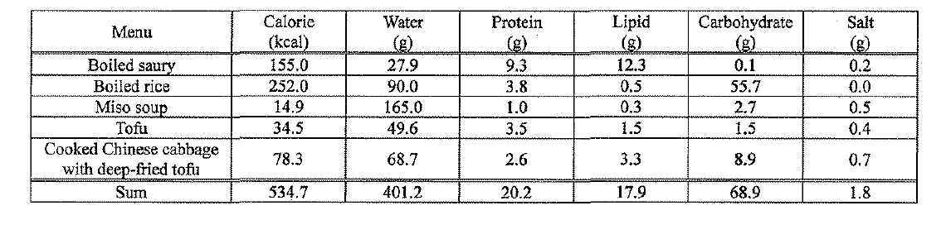

Evaluator’s Response
The PK/PD evaluator is satisfied with the sponsor’s response.

Pharmacodynamics
No questions.

Efficacy

Question 3
In the pivotal US Phase III studies SI04009 and SI04010, some important baseline disease characteristics have not been summarised in the body of the study report. Please provide these data, including renal function, history of cardiac disease and previous use of α-blockers).

Sponsor’s Response
Tabulated summaries of baseline disease characteristics have been provided.

Evaluator’s Response
The sponsor’s response is satisfactory.
In Studies SI04009 and SI04010, the numbers of patients with cardiovascular disease, hypertension, renal disease, and impaired renal function at baseline were comparable in the placebo and silodosin treatment groups (see Table 16 below).
Table 16: Studies SI04009 (top table) and SI04009 (lower table) Summary of patients’ medical history
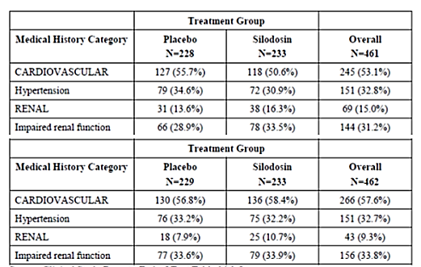
In Study SI04009, the numbers of patients with previous use of α-blockers were similar in the placebo and silodosin groups (15.4% versus 15.9%). In Study SI04010, more patients in the placebo group reported previous use of α-blockers compared with the silodosin group (16.2% versus 11.6%). This may have introduced a minor bias in favour of the silodosin group (assuming that patients who previously used α-blockers were more likely to have failed) (see Table 17 below).
Table 17: Previous use of α-blockers Study SI04009 (top) and SI04010 (lower table)
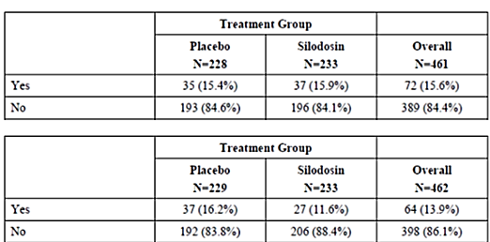

Question 4
Responders to placebo during the run-in period were not randomised. Please provide the post hoc analysis provided to the EMEA and used to justify this design.

Sponsor’s Response
The sponsor has provided a detailed response citing the EAU Guideline and providing a post hoc analysis in support.

Evaluator’s Response
The sponsor’s response is satisfactory.
There is a marked placebo response in clinical studies of patients with LUTS and it justifiable to exclude marked placebo responders from the randomised treatment groups. A summary of the post hoc responder analysis submitted to the EMA is shown below.
Table 18: Study IT-CL 0215 Original and post hoc responder analysis
In addition, the sponsor has provided post hoc responder analyses of the US studies SI040009 and SI04010 as shown below.
Table 19: Post hoc responder analysis Study SI04009 (top) and SI04010 (lower table)
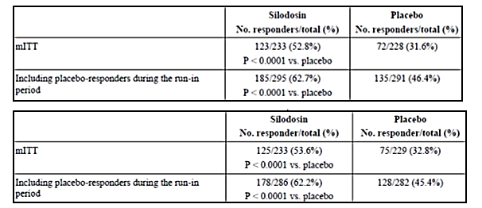
The results of the EU and US post hoc responder analyses do not change the efficacy conclusions. Response rates in favour of silodosin were the same or somewhat higher in the post hoc analyses compared with the primary analyses.

Question 5
Please justify the statement that a 2 point change in IPSS is clinically meaningful.

Sponsor’s Response
The sponsor cites Barry (1995) to support the clinical relevance of a 2 point change in IPSS. Barry et al suggest that a minimum 3 point change in IPSS from baseline is clinically meaningful. However, the authors reported that a 2 point difference from placebo was perceived by patients as slight improvement.

Evaluator’s Response
The sponsor’s response is satisfactory.
As further support, the sponsor has also provided a summary of indirect comparisons with other marketed α-blockers as shown below in Tables 20 and 21.
Table 20: Change in total IPSS score observed in clinical trials with other α-blockers
Table 21: Change from baseline in IPSS total score (primary end point)
In the EU Study IT-CL 0215, a direct comparison of silodosin and tamsulosin showed a modest benefit in favour of silodosin although the difference was not statistically significant (Table 22).
Table 22: Change from baseline in IPSS total score in Study IT-CL 0215 (PP population)
The AUA guideline states that ‘a three-point improvement in the AUA-SI is considered meaningful’. The sponsor points out that this represents change from baseline, and that a difference of 2 points compared with placebo may be considered clinically relevant. The different perspectives are largely academic as the efficacy of silodosin at least matches other marketed products in the class.
There is a high frequency of ADRs (most commonly retrograde ejaculation) and the benefit-risk in patients with IPSS < 20 may be considered neutral at best and negative at worst (for silodosin and others in the class). While this should be noted, it would be unreasonable to restrict the indication for silodosin (based on baseline IPSS score) and not those of comparable products.

Question 6
In the US OLE Study SI04011, 34.2% of patients withdrew, due mainly to AEs (14.1%) and lack of efficacy (8.8%). The corresponding percentages in the EU OL extension Study IT-CL-0215 were remarkably different (11.2%, 3.8% and 1.8%, respectively). These differences may impact risk/benefit with long-term treatment. Is there an obvious reason for the disparity?

Sponsor’s Response
Post hoc logistic regression analyses have identified geographical region, absence of concomitant use of PDE-5, baseline PSA and age as predictors of withdrawal.

Evaluator’s Response
The sponsor’s response is satisfactory.
There is no obvious explanation for the differences observed in the US and EU populations.

Question 7
Please justify the wording of the proposed indication relating to the treatment of the signs of BPH.

Sponsor’s Response
An indication for the signs of BPH is justifiable based on statistically significant increases in Qmax in silodosin patients in the US studies and non-statistically significant changes in the EU study. Furthermore, the changes in Qmax were comparable to published studies of comparable marketed products (Table 23). However, the sponsor accepts the argument that the indication should be restricted to symptoms of BPH.
Table 23: Randomised placebo controlled trials with α1-blockers in men with LUTS

Evaluator’s Response
The sponsor’s response is satisfactory.

Question 8
The only objective secondary efficacy measure in the pivotal studies was Qmax, but the differences between silodosin and placebo were marginal (approximately 1 mL/sec or less). The treatment benefit was statistically significant in SI04009 and SI04010, but not in IT-CL-0215. Please discuss the clinical relevance of the modest overall increase in Qmax, with literature or specialist body endorsements if available.

Sponsor’s Response
As shown below, the EAU guidelines, report increased Qmax in line with the silodosin studies.
According to EAU Guidelines on management of non-neurogenic male LUTS: ‘… controlled studies show that α1-blockers typically reduce IPSS by approximately 30-40% and increase Qmax by approximately 20-25%. However, considerable improvement also occurred in the corresponding placebo areas’ (Gravas 2016 a and Gravas 2016b)

Evaluator’s Response
The sponsor’s response is satisfactory.
The sponsor has not provided an accepted clinically relevant treatment difference for Qmax, possibly because none exists. However, the EAU statement offers a satisfactory perspective.

Question 9
The most commonly reported AE in the US and EU pivotal studies was retrograde ejaculation in the silodosin and tamsulosin treatment groups. Although the US and EU studies were comparable in design and duration, the incidences of retrograde ejaculation in the silodosin groups were notably different (29.2% and 27.0% in the US studies, but only 14.2% in the EU study). In the EU study, the incidence of retrograde ejaculation was only 2.1% in patients treated with tamsulosin. Is there a plausible explanation for these marked disparities?

Sponsor’s Response
Post hoc logistic regression analyses have identified country, age and obstructive IPSS subscores as significant factors (Table 24). The higher incidence of retrograde ejaculation in the US studies may, in part, be explained by a younger population (that is, more sexually active) with more severe symptoms.
Table 24: Statistical analysis of occurrence of retrograde ejaculation logistic regression-analysis of effects

Evaluator’s Response
The sponsor’s response is satisfactory.
The increased incidence of retrograde ejaculation in the US population may be related to a younger population with more severe disease. However, no explanation has been provided for the significant difference between treatment groups in the EU study (silodosin 14.2%, tamsulosin 2.1%).

Question 10
Please provide an estimate of the frequency of IFIS in patients undergoing cataract or glaucoma surgery while receiving silodosin therapy. Does stopping silodosin before surgery reduce the risk of IFIS?

Sponsor’s Response
There are no precise data on the possible reduction of the risk of IFIS by interrupting silodosin treatment.

Evaluator’s Response
The sponsor’s response is satisfactory. However, while no data are available for silodosin, the wording of Precautions in the proposed PI should be strengthened to reflect the incidence of IFIS reported with comparable products.

Overall conclusions
The sponsor has satisfactorily addressed the question of the clinical relevance of changes in IPSS in patients with different disease severity (baseline scores < 20 or > 20). The benefit-risk in patients with IPSS < 20 remains a concern based on marginal benefit and a high risk of ADRs (mainly retrograde ejaculation). However, the following reasons for recommending a broad indication for patients with LUTS of any severity can be proposed:
- most ADRs are ‘bothersome’ rather than a risk to health, and they are reversible if the product is withdrawn. Many patients will choose to stop therapy because of an ADR but most will not.
- the overall efficacy benefit is small in many patients with baseline IPSS < 20; however, a significant proportion will achieve worthwhile benefit. They should have unrestricted access to the product if it is shown to work.
- the efficacy and safety profile of silodosin is generally the same or better than comparable marketed products.
The sponsor has agreed to amend the indication to one based on symptom control rather than signs and symptoms. Some other questions remain unanswered, including differences in the frequency of ADRs in the US and EU studies, the clinical relevance of small changes in Qmax and the incidence of IFIS in patients receiving silodosin. However, none of these issues preclude approval and authorisation can now be recommended for patients with any disease severity based on IPSS.

Second round benefit-risk assessment

Second round assessment of benefits
The second round assessment of benefits is positive following new data provided by the sponsor. The benefits in patients with IPSS< 20 are modest but comparable with other approved products in the class.

Second round assessment of risks
The second round assessment of risks is positive following arguments provided by the sponsor. The frequency of ADRs is high but comparable with other approved products in the class. Most ADRs are ‘bothersome’, reversible and not a risk to health.

Second round assessment of benefit-risk balance
The second round assessment of benefit-risk is positive.

Second round recommendation regarding authorisation
Authorisation is not recommended for the proposed indication:
‘Treatment of the signs and symptoms of benign prostatic hyperplasia in adult men’.
However, authorisation is recommended for the revised indication:
‘Relief of lower urinary tract symptoms (LUTS) associated with benign prostatic hyperplasia in adult men’.

References
Barry M, et al. The American Urological Association symptom index for benign prostatic hyperplasia. The Measurement Committee of the American Urological Association. J Urol 1992; 148:1549-1557
Barry MJ, et al. Benign prostatic hyperplasia specific health status measures in clinical research: how much change in the American Urological Association Symptom Index and the Benign Prostatic Hyperplasia Impact Index is perceptible to patients? J Urol 1995; 154:1770-1774
Chang D, et al. Intraoperative floppy iris syndrome associated with tamsulosin. J Cataract Refract Surg 2005; 31:664

Therapeutic Goods Administration
PO Box 100 Woden ACT 2606 Australia
Email: info@tga.gov.au Phone: 1800 020 653 Fax: 02 6232 8605
https://www.tga.gov.au

The Urological Society of Australia and New Zealand endorses the EAU guideline
See ABBREVIATIONS
Clarification: KMD-203: a long-term, safety and efficacy study of silodosin 4 mg/day (2mg bid) and silodosin 8 mg/day (4mg bid) given from 28 to up to 52 weeks (Japan) KMD-303: a Phase III, double-blind, parallel group, active and placebo controlled study of silodosin 8 mg/day (4mg bid), tamsulosin 0.2 mg/day (0.2 mg qd) and placebo given for 12 weeks (Japan) KMD-305: a Phase III, open-label, study of silodosin 4 mg/day (2 mg bid) and 8 mg/day (4 mg bid) (or silodosin 2 mg/day if not tolerated) given for 52 weeks (Japan)
Centre For Drug Evaluation And Research, Application Number: NDA 22-206; Clinical Pharmacology and Biopharmaceutics Review(s)
The methodologies of the IPSS questionnaire, Qmax measurement, and QoL assessment are summarised in the Appendix.
Any of ΔSBP > 30 mmHg; ΔDBP > 20 mm Hg; ΔHR > 20 BPM; or orthostatic symptoms
> 30% decrease in IPSS, or increase in Qmax of 3 mL/sec
OC is synonymous with PP, the more commonly used term. The term OC is favoured to ensure consistency with the tables.
Overall compliance for double-blind period < 80% or > 120%.
Note: Baseline in Figure 11 is the Week 0 post-dose measurement.
Overall compliance for double-blind period < 80% or > 120%.
Any of ΔSBP > 30 mmHg; ΔDBP > 20 mm Hg; ΔHR > 20 BPM; or orthostatic symptoms
> 30% decrease in IPSS, or increase in Qmax of 3 mL/sec

