PRODUCT INFORMATION

UPTRAVI™ (selexipag)
200, 400, 600, 800, 1000, 1200, 1400 and 1600
microgram film coated tablets

NAME OF THE MEDICINE

Active: selexipag

UPTRAVI (selexipag) is a selective non-prostanoid prostacyclin IP receptor agonist. The chemical name of selexipag is 2-{4-[(5,6-diphenylpyrazin-2-yl)(isopropyl)amino]butoxy}-N-(methylsulfonyl) acetamide.

Structural formula:
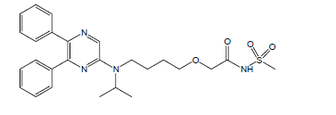
The molecular formula: C₂₆H₃₂N₄O₄S
The molecular weight: 496.62 mg/mol
CAS: 475086-01-2
Pharmacotherapeutic group: Platelet aggregation inhibitors excl. heparin
ACT code: B01AC27.

DESCRIPTION
Selexipag is a pale yellow crystalline powder that is practically insoluble in water. In the solid state selexipag is very stable, is not hygroscopic, and is not light sensitive.
Each round film-coated tablet contains 200 micrograms or multiples thereof (respectively 400, 600, 800, 1000, 1200, 1400, or 1600 micrograms) selexipag. The tablets include the following inactive ingredients: mannitol, maize starch, hydroxypropylcellulose, and magnesium stearate. The tablets are film coated with a coating material containing hypromellose, propylene glycol, titanium dioxide, and carnauba wax. In addition, tablets may contain iron oxide red, iron oxide yellow, or iron oxide black. The film-coated tablets are not light sensitive.

PHARMACOLOGY

Mechanism of Action
The vasculo-protective effects of prostacyclin (PGI₂) are mediated by the prostacyclin receptor (IP receptor). Decreased expression of IP receptors and decreased synthesis of prostacyclin contribute to the pathophysiology of pulmonary arterial hypertension (PAH).
Selexipag is an oral, selective, IP prostacyclin receptor agonist, and is structurally and pharmacologically distinct from prostacyclin and its analogues. Selexipag is hydrolysed by carboxylesterase 1 (CES1) to yield its active metabolite, which is approximately 37-fold more potent than selexipag. Selexipag and the active metabolite are high affinity IP receptor agonists with a high selectivity for the IP receptor versus other prostanoid receptors (EP₁-EP₄, DP, FP and TP). Selectivity against EP₁, EP₃, FP and TP is important because these are well-described contractile receptors in gastro-intestinal tract and blood vessels. Selectivity against EP₂, EP₄ and DP₁ is important because these receptors mediate immune depressive effects.

Stimulation of the IP receptor by selexipag and the active metabolite leads to vasodilatory as well as anti-proliferative and anti-fibrotic effects. Selexipag improves haemodynamic parameters and prevents cardiac and pulmonary remodeling in a rat model of PAH. In these PAH rats, pulmonary and peripheral vasodilation in response to selexipag correlate, indicating that peripheral vasodilation reflects pulmonary pharmacodynamic efficacy. Selexipag does not cause IP receptor desensitisation in vitro nor tachyphylaxis in a rat model.

PAH patients have variable degrees of IP receptor expression. Differences in maintenance dose of selexipag between individuals may be related to differences in IP receptor expression levels.

Pharmacodynamics
Cardiac electrophysiology: In a thorough QT study in healthy subjects, repeated doses of 800 and 1600 micrograms of selexipag twice daily did not show an effect on cardiac repolarisation (the QT_{c} interval) or conduction (PR and QRS intervals) and had a mild accelerating effect on heart rate. The placebo-corrected increase from time-matched baseline heart rate 1.5 to 3 hours post-dose was 6–7 bpm at 800 µg twice daily and 9–10 bpm at 1600 µg twice daily.
Pulmonary Haemodynamics: A Phase 2 double-blind, placebo-controlled clinical study assessed haemodynamic parameters after 17 weeks of treatment in patients with PAH WHO functional classes II–III and concomitantly receiving ERAs and/or PDE-5 inhibitor. Patients titrating selexipag to an individually tolerated dose (200 micrograms twice daily increments up to 800 micrograms twice daily; N=33) achieved a statistically significant mean reduction in pulmonary vascular resistance of 30.3% (95% CL −44.7%, −12.2%; P = 0.0045) and an increase in cardiac index (median treatment effect) 0.41 L/min/m², 95% CL 0.10, 0.71 compared to placebo (N=10).

Pharmacokinetics
The pharmacokinetics of selexipag and its active metabolite have been studied primarily in healthy subjects. The pharmacokinetics of selexipag and the active metabolite, both after single- and multiple-dose administration, were dose-proportional up to a single dose of 800 micrograms and multiple doses of up to 1800 micrograms twice a day. After multiple-dose administration, steady-state conditions of selexipag and active metabolite were reached within 3 days. No accumulation in plasma, either of parent compound or active metabolite, occurred after multiple-dose administration.
In healthy subjects, inter-subject variability in exposure (area under the curve over a dosing interval) at steady-state was 43% and 39% for selexipag and the active metabolite, respectively. Intra-subject variability in exposure was 24% and 19% for selexipag and the active metabolite, respectively.
Exposure to selexipag and the active metabolite at steady-state was 30% and 20% higher, respectively, in PAH patients compared to healthy subjects. The pharmacokinetics of selexipag and the active metabolite in PAH patients were not influenced by the severity of the disease and did not change with time.

Absorption
Selexipag is rapidly absorbed and is hydrolysed by CES1 in the liver to its active metabolite.
Maximum observed plasma concentrations of selexipag and its active metabolite after oral administration are reached within 1–3 h and 3–4 h, respectively.
In the presence of food, the exposure to selexipag after a single dose of 400 micrograms was increased by 10% in Caucasian subjects and decreased by 15% in Japanese subjects, whereas exposure to the active metabolite was decreased by 27% (Caucasian subjects) and 12% (Japanese subjects). More subjects reported adverse events after administration in the fasted than in the fed state.

Distribution
Selexipag and its active metabolite are highly bound to plasma proteins (approximately 99% in total and to the same extent to albumin and alpha1-acid glycoprotein).

Biotransformation
Selexipag undergoes enzymatic hydrolysis of the acylsulfonamide by CES1, to yield the active metabolite. Oxidative metabolism catalysed by CYP3A4 and CYP2C8 leads to the formation of hydroxylated and dealkylated products. UGT1A3 and UGT2B7 are involved in the glucuronidation of the active metabolite. Except for the active metabolite, none of the circulating metabolites in human plasma exceeds 3% of the total drug-related material. Both in healthy subjects and PAH patients, exposure at steady-state to the active metabolite is approximately 3- to 4-fold higher than to the parent compound.

Elimination
Elimination of selexipag is predominantly via metabolism with a mean terminal half-life of 0.8-2.5 h. The active metabolite has a half-life of 6.2-13.5h. The apparent oral clearance of selexipag is on average 35 L/h. Excretion in healthy subjects was complete 5 days after administration and occurred primarily via faeces (accounting for 93% of the administered dose) compared to 12% in urine.

Special populations
No clinically relevant effects of sex, race, age or body weight on the pharmacokinetics of selexipag and its active metabolite have been observed in healthy subjects or PAH patients. In PAH patients, the exposure to selexipag and ACT-333679 decreased 9% and 4%, respectively, with increasing age from 23 to 72 years. PAH patients with body weights of 51 (96) kg showed 30% higher (20% lower) exposure to selexipag and 20% higher (10% lower) exposure to ACT-333679 compared to patients of 70 kg body weight. PAH male patients showed 13% lower exposure to ACT-333679 than female patients. These differences are smaller than the intersubject variability, which is larger than 30%.
Renal impairment
The AUC_{0-∞} values of selexipag and ACT-333679 were increased 1.73-fold and 1.61-fold, respectively, in subjects with severe renal function impairment (SRFI) compared to healthy subjects, and the t_{1/2} of ACT-333679 was prolonged 1.61-fold in patients with SRFI.

Hepatic impairment
In subjects with mild (Child-Pugh A) or moderate (Child-Pugh B) hepatic impairment, exposure to selexipag was 2- and 4-fold higher, respectively, when compared to healthy subjects. Exposure to the active metabolite remained almost unchanged in subjects with mild hepatic impairment and was doubled in subjects with moderate hepatic impairment. Only two subjects with severe (Child-Pugh C) hepatic impairment were dosed with selexipag. Exposure to selexipag and its active metabolite in these two subjects was similar to that in subjects with moderate (Child-Pugh B) hepatic impairment.

Based on pharmacokinetic modelling of data from a study in subjects with hepatic impairment, the exposure to the active metabolite at steady state in subjects with moderate hepatic impairment (Child-Pugh class B) after a once-daily regimen is expected to be similar to that in healthy subjects receiving a twice-daily regimen. The exposure to selexipag at steady state in these patients during a once-daily regimen is predicted to be approximately 2-fold that seen in healthy subjects receiving a twice-daily regimen.

CLINICAL TRIALS

Efficacy in Patients with Pulmonary Arterial Hypertension
The effect of selexipag on progression of PAH was demonstrated in a multi-centre, long-term (mean duration of exposure was approximately 1.5 years up to a maximum of 4.2 years), double-blind, placebo-controlled, parallel group, event-driven Phase 3 study (GRIPHON) in 1156 patients with symptomatic [WHO Functional Class (FC) I–IV] PAH. Patients were randomised to either placebo (N=582), or selexipag (N=574) twice a day in multiples of 200 micrograms. The dose was increased in weekly intervals by increments of 200 micrograms given twice a day to determine the individualised maintenance dose (200 - 1600 micrograms twice a day).
The primary study endpoint was the time to first occurrence of a morbidity or mortality event up to end of treatment defined as a composite of death (all-causes); or hospitalisation for PAH; or progression of PAH resulting in need for lung transplantation or balloon atrial septostomy; or initiation of parenteral prostanoid therapy or chronic oxygen therapy; or other disease progression events (patients in modified NYHA/WHO FC II or III at baseline) confirmed by decrease in 6MWD from baseline (≥ 15%) and worsening of NYHA/WHO FC or (patients in modified NYHA/WHO FC III or IV at baseline) confirmed by decrease in 6MWD from baseline (≥ 15%) and need for additional PAH specific therapy.
All events were confirmed by an independent adjudication committee, blinded to treatment allocation.
The mean age was 48.1 years (range 18–80 years of age) with the majority of subjects being Caucasian (65.0%) and female (79.8%). Approximately 1%, 46%, 53%, and 1% of patients were in WHO FC I, II, III, and IV, respectively, at baseline of whom three patients in WHO FC IV received selexipag.
Idiopathic or heritable PAH was the most common aetiology in the study population (58%) followed by PAH due to connective tissue disorders (29%), PAH associated with congenital heart disease with repaired shunts (10%), and PAH associated with other aetiologies (drugs and toxins [2%] and HIV [1%]). Patients with left ventricular dysfunction, moderate or severe obstructive or restrictive lung disease, moderate or severe hepatic impairment, or severe renal insufficiency were excluded from the study.
At baseline, the majority of enrolled patients (80%) were being treated with a stable dose of specific therapy for PAH, either with an ERA (15%) or with a PDE-5 inhibitor (32%) or both an ERA and a PDE-5 inhibitor (33%).
Patients on selexipag achieved doses within the following groups: 200–400 micrograms (23%), 600–1000 micrograms (31%) and 1200–1600 micrograms (43%).
The overall median double-blind treatment duration was 63.7 weeks for placebo group and 70.7 weeks for the group on selexipag.
Treatment with selexipag 200–1600 micrograms twice a day resulted in a 40% reduction (99% confidence interval [CI]: 22 to 54%; two-sided -sided log rank p-value <0.0001) of the occurrence of morbidity or mortality events up to 7 days after last dose compared to placebo (Figure 1). The beneficial effect of selexipag was primarily attributable to a reduction in hospitalisation for PAH and a reduction in other disease progression events (Table 1).

Figure 1: Kaplan-Meier estimates of the first morbidity-mortality event in GRIPHON
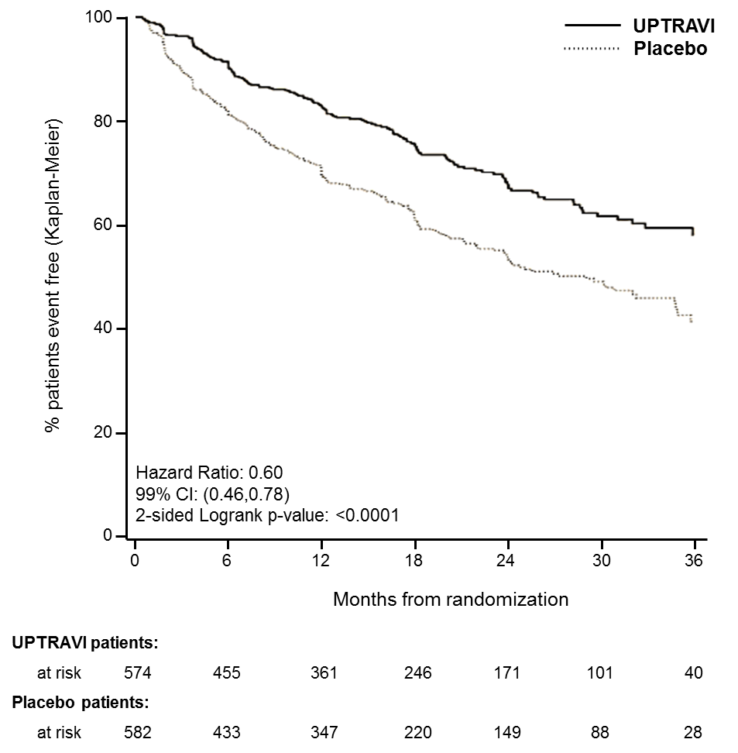

Table 1: Primary Endpoint and Related Components in GRIPHON
 | UPTRAVI  N=574 |  | Placebo  N=582 |  | Hazard Ratio  (99% CI) | p-value
 | n | % | n | %
Primary endpoint events up to the end of treatment
All primary endpoint events  As first event: | 155 | 27.0 | 242 | 41.6 | 0.60 [0.46,0.78] |  | <0.0001
- Hospitalisation for PAH  - Other disease Progression (Decrease in 6MWD plus worsening functional class or need for other therapy)  - Death | 78  38  28 | 13.6  6.6  4.9 | 109  100  18 | 18.7  17.2  3.1
- Parenteral prostanoid or chronic oxygen therapy  - PAH worsening resulting in need for lung transplantation or balloon atrial septostomy | 10  1 | 1.7  0.2 | 13  2 | 2.2  0.3

The observed benefit of selexipag was similar regardless of the dose achieved when patients are titrated to their highest tolerated dose (see Dosage and Administration). This was shown by the hazard ratio for the 3 pre-defined categories (0.60 for 200–400 micrograms twice daily, 0.53 for 600–1000 micrograms twice daily, and 0.64 for 1200–1600 micrograms twice daily), which was consistent with the overall treatment effect (0.60).
It is not known if the excess number of deaths in the selexipag group is drug-related because there were so few deaths and the imbalance was not observed until 18 months into GRIPHON. Figures 2A, B and C show time to first event analyses for primary endpoint components of hospitalisation for PAH (A), other disease progression (B), and death (C)—all censored 7 days after any primary end point event (because many patients on placebo transitioned to open-label UPTRAVI at this point).
Figure 2A: Hospitalisation for PAH as the First Endpoint in GRIPHON
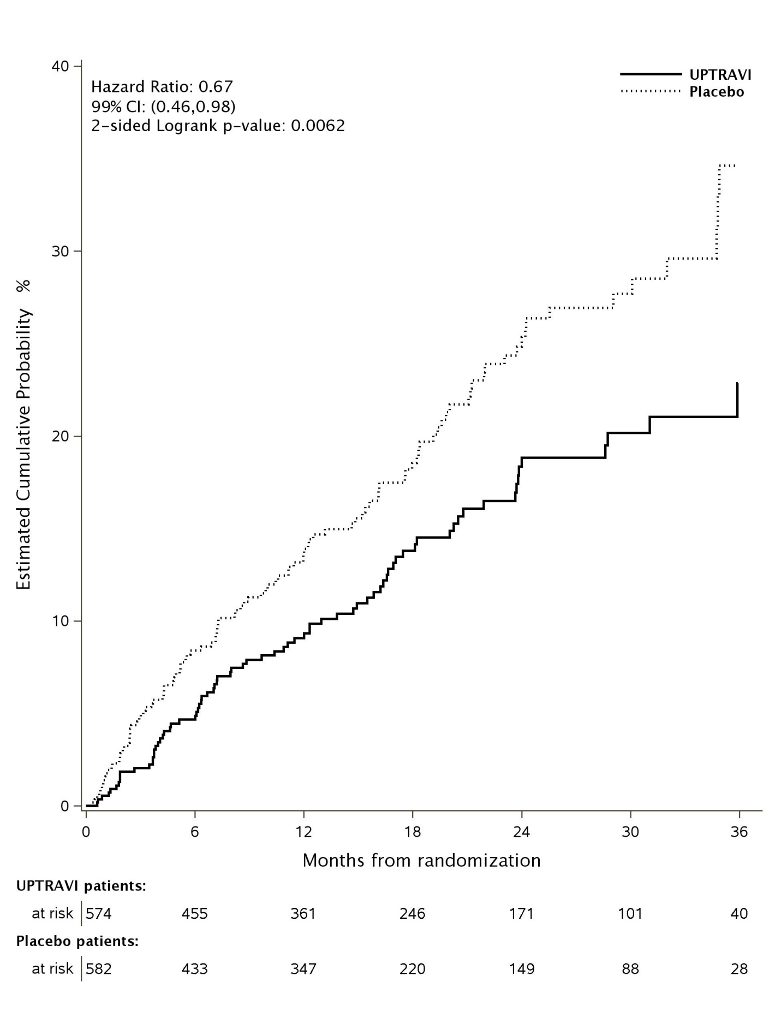
Figure 2B: Disease Progression as the First Endpoint in GRIPHON
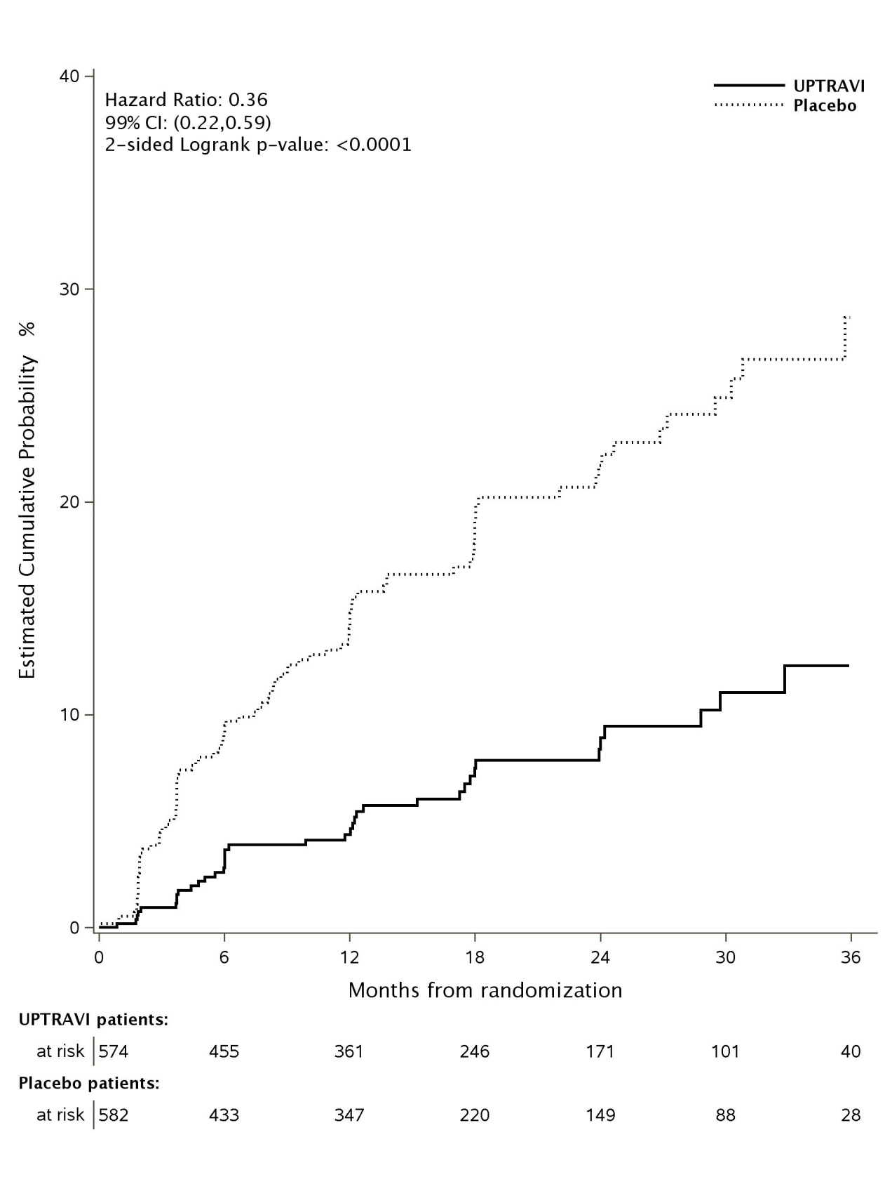
Figure 2C: Death as the First Endpoint in GRIPHON
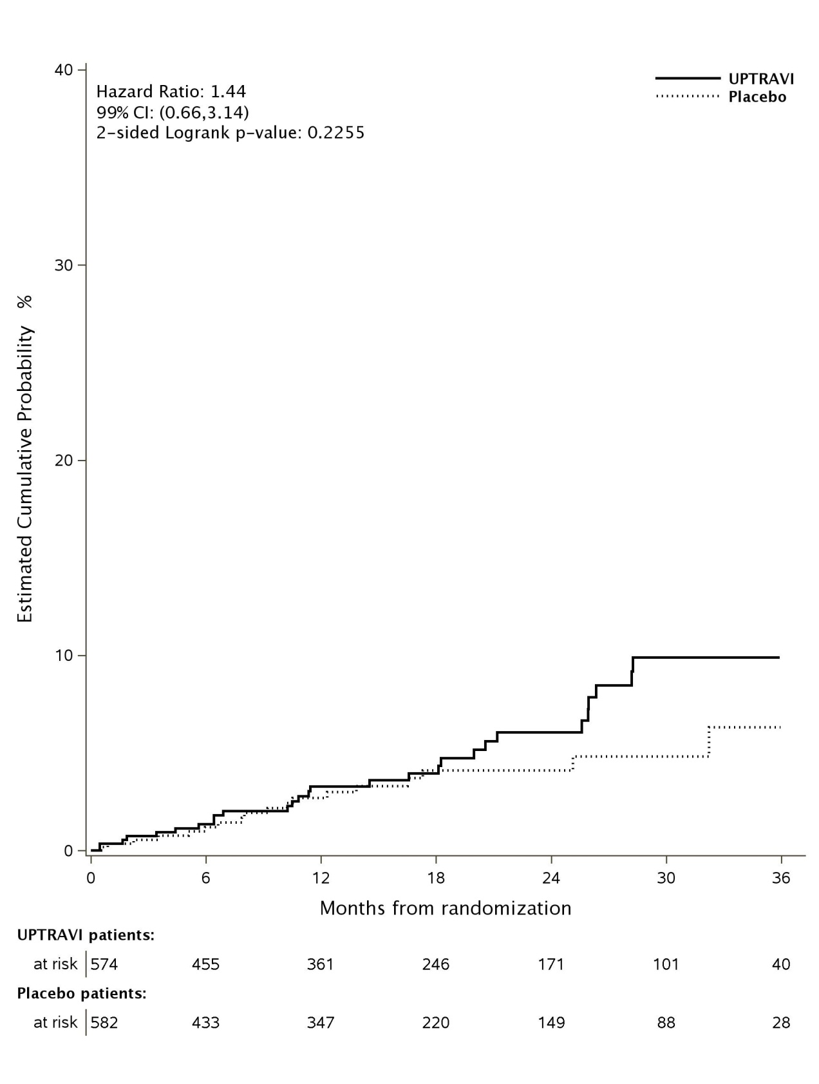

The total number of deaths of all causes up to study closure was 100 (17.4%) for the UPTRAVI group and 105 (18.0%) for the placebo group (HR 0.97, 99% CI: 0.68–1.39).
The number of deaths due to PAH up to study closure was 70 (12.2%) for the UPTRAVI group and 83 (14.3%) for the placebo group.
Subgroup analyses were performed across subgroups of age, sex, race, aetiology, geographical region, WHO Functional Class, and by monotherapy or in combination with ERA, PDE-5 inhibitors or triple combination with both an ERA and a PDE-5 inhibitor. The treatment effect of UPTRAVI on time to first primary event was consistent irrespective of background PAH therapy (i.e., in combination with ERA, PDE-5 inhibitors, or both, or without background therapy) (Figure 4).

Figure 4: Sub-group analyses of the primary endpoint in the GRIPHON study
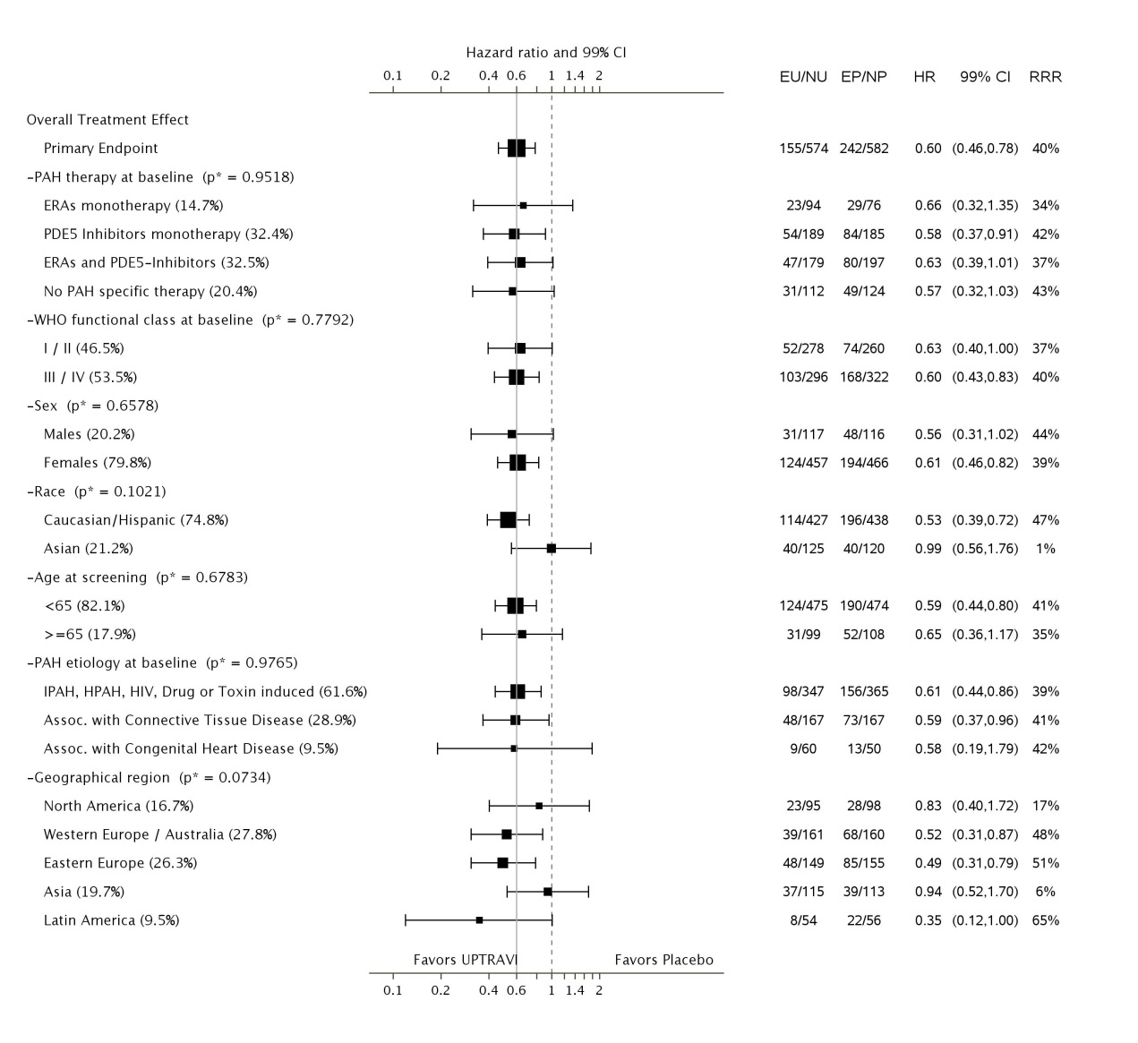

CI = confidence interval; EP = number of placebo patients with events; EU = number of Uptravi patients with events; HR = hazard ratio; NP = number of patients randomised to placebo; NU = number of patients randomised to Uptravi; RRR = relative risk reduction.
The size of the square represents the number of patients in the subgroup.
Note: The figure above presents effects in various subgroups all of which are baseline characteristics and all were pre-specified. The 99% confidence limits that are shown do not take into account how many comparisons were made, nor do they reflect the effect of a particular factor after adjustment for all other factors. Apparent homogeneity or heterogeneity among groups should not be over-interpreted.

Symptomatic endpoint
Exercise capacity was evaluated as a secondary endpoint. Treatment with UPTRAVI resulted in a placebo-corrected median increase in 6MWD measured at trough (i.e., approximately 12 hours post-dose) of 12 metres at Week 26 (99% CI: 1 - 24, two-sided p-value=0.005). In patients without concurrent PAH-specific therapy, the treatment effect measured at trough was 34 metres (99% CI: 10.0 - ,63.0 one-sided p-value:0.0002).

INDICATIONS

UPTRAVI is indicated for the treatment of:
• idiopathic pulmonary arterial hypertension
• heritable pulmonary arterial hypertension
• pulmonary arterial hypertension associated with connective tissue disease
• pulmonary arterial hypertension associated with congenital heart disease with repaired shunts
• pulmonary arterial hypertension associated with drugs and toxins
in patients with WHO functional class II, III or IV symptoms.

CONTRAINDICATIONS

UPTRAVI is contraindicated in patients with:
- known hypersensitivity to the active substance selexipag or to any of the excipients listed in DESCRIPTION.
- Severe hepatic impairment (Child-Pugh class C).
- Severe coronary heart disease or unstable angina.
- Myocardial infarction within the last 6 months.
- Decompensated cardiac failure if not under close medical supervision.
- Severe arrhythmias.
- Cerebrovascular events (e.g., transient ischaemic attack, stroke) within the last 3 months.
- Congenital or acquired valvular defects with clinically relevant myocardial function disorders not related to pulmonary hypertension.

PRECAUTIONS

Additional Information on Special Populations
Studies with selexipag have been mainly performed in PAH patients classified as WHO functional Class II and III. Selexipag has only been studied in a limited number of patients with WHO functional Class IV (see CLINICAL TRIALS). Selexipag has only been studied in a limited number of patients with PAH due to drugs or toxins.

Hypotension
UPTRAVI has vasodilatory properties that may result in lowering of blood pressure. Before prescribing UPTRAVI, physicians should carefully consider whether patients with certain underlying conditions could be adversely affected by vasodilatory effects (e.g., patients on antihypertensive therapy, other PAH therapy or with resting hypotension, hypovolaemia, severe left ventricular outflow obstruction or autonomic dysfunction).Monitoring of blood pressure is recommended in such patients as clinically indicated.

Increase in heart rate:
UPTRAVI may cause a moderate increase in heart rate after each dose.

Hyperthyroidism
Hyperthyroidism has been observed with UPTRAVI (2% patients on selexipag and 0% of placebo-treated patients) and other prostacyclin receptor agonists. Thyroid function tests are recommended as clinically indicated.

Pulmonary veno-occlusive disease
Should signs of pulmonary oedema occur, consider the possibility of associated pulmonary veno-occlusive disease. If confirmed, discontinue UPTRAVI.

Effects on Fertility
Selexipag had no effect on fertility of male and female rats. In the rat pre- and post-natal development study, selexipag induced no effects on maternal and pup reproductive function.

Use in pregnancy (Category B1)
Use in Pregnancy should be avoided. Pregnant women were excluded from the trial and there is no data in human pregnancy. Selexipag was not teratogenic in rats and rabbits.

Use in Lactation
It is unknown whether selexipag or its metabolites are excreted in human milk.
In rats, selexipag and/or its metabolites are excreted in the milk. Breastfeeding is not recommended during treatment with UPTRAVI.

Elderly
There is limited clinical experience with selexipag in patients over the age of 75 years, therefore UPTRAVI should be used with caution in this population.

Paediatric
The safety and efficacy of UPTRAVI in children (<18 years) has not been established.

Genotoxicity
Selexipag and its active metabolite are not genotoxic under in vivo conditions. The weight of evidence from a battery of genotoxicity studies indicates no cause for clinical concern.

Carcinogenicity
In 2-year carcinogenicity studies, selexipag produced possible increases in the incidences of thyroid adenomas in mice and Leydig cell adenomas in rats. The induction of such tumours is thought to reflect unique aspects of rodent biology that are not relevant to humans.

Patients with hepatic impairment
No adjustment to the dosing regimen is needed in patients with mild hepatic impairment (Child-Pugh class A). A once-daily regimen is recommended in patients with moderate hepatic impairment (Child-Pugh class B) due to the increased exposure to selexipag and its active metabolite. There is no experience with UPTRAVI in patients with severe hepatic impairment (Child-Pugh class C). Avoid use of UPTRAVI in patients with severe hepatic impairment. (see CONTRAINDICATIONS).

Patients with renal impairment
In patients with severe renal impairment (estimated glomerular filtration rate <30 mL/min/1.73 m²) caution should be exercised during dose titration. There is no clinical experience with UPTRAVI in patients undergoing dialysis or in patients with estimated glomerular filtration rates <15 mL/min/1.73 m².
Effects on ability to drive vehicles and operate machinery
No studies on the effect of UPTRAVI on the ability to drive and use machines have been performed. UPTRAVI has a minor influence on the ability to drive and use machines. The clinical status of the patient and the adverse reaction profile of selexipag (such as headache or hypotension) should be kept in mind when considering the patient’s ability to drive and use machines.

INTERACTIONS WITH OTHER MEDICINES

In vitro studies
Selexipag is hydrolysed to its active metabolite by hepatic carboxylesterase 1 (CES1) [see PHARMACOKINETICS]. Selexipag and its active metabolite both undergo oxidative metabolism by CYP2C8 and CYP3A4. The glucuronidation of the active metabolite is catalysed by UGT1A3 and UGT2B7. Selexipag and its active metabolite are substrates of OATP1B1 and OATP1B3. Selexipag is a substrate of P-gp, and the active metabolite is a substrate of the transporter breast cancer resistance protein (BCRP).
Selexipag and its active metabolite do not inhibit or induce hepatic cytochrome P450 enzymes at clinically relevant concentrations. Selexipag and its active metabolite do not inhibit hepatic or renal transport proteins.
In vivo studies
PAH-specific therapies: In the Phase 3 placebo-controlled study in patients with PAH, no relevant changes in the exposure (area under the plasma concentration-time curve during a dose interval) to selexipag and its active metabolite were observed when administered in combination with an ERA and/or PDE-5 inhibitor. Patients on combination PAH therapy experienced a greater number of adverse events including anaemia in some patients.
Anticoagulants or inhibitors of platelet aggregation: Selexipag is an inhibitor of platelet aggregation in vitro. In the Phase 3 placebo-controlled study in patients with PAH, no increased risk of bleeding was detected with selexipag compared to placebo, including when selexipag was administered with anticoagulants (such as heparin, coumarin-type anticoagulants) or inhibitors of platelet aggregation. In a study in healthy subjects, selexipag (400 micrograms twice a day) did not alter the exposure to S-warfarin (CYP2C9 substrate) or R-warfarin (CYP3A4 substrate) after a single dose of 20 mg warfarin. Selexipag did not influence the pharmacodynamic effect of warfarin on the international normalised ratio. The pharmacokinetics of selexipag and its active metabolite were not affected by warfarin.
Lopinavir/ritonavir: In the presence of 400/100 mg lopinavir/ritonavir, twice a day, a strong CYP3A4, OATP (OATP1B1 and OATP1B3), and P-gp inhibitor, exposure to selexipag increased approximately 2-fold, whereas the exposure to the active metabolite of selexipag did not change.
Inhibitors of UGT1A3, and UGT2B7: The effect of stronginhibitors of UGT1A3 and UGT2B7 (such as valproic acid), on the exposure to selexipag or its active metabolite has not been studied. Caution is recommended when administering these drugs concomitantly with selexipag.
Inhibitors of CYP2C8: Concomitant administration with strong inhibitors of CYP2C8 may result in a significant increase in exposure to selexipag and its active metabolite. Avoid concomitant administration of UPTRAVI with strong inhibitors of CYP2C8 (e.g., gemfibrozil).

Hormonal contraceptives: Specific drug-drug interaction studies with hormonal contraceptives have not been conducted. Although multiple-dose treatment with selexipag did not affect the exposure to the CYP3A4 substrate R-warfarin and CYP2C9 substrate S-warfarin and no reduced efficacy of hormonal contraceptives is expected, caution should be exercised (See PRECAUTIONS- Use in Pregnancy).

Pharmacodynamic interactions: Reductions in blood pressure may occur when UPTRAVI is administered with diuretics, antihypertensive agents, or other vasodilators.

ADVERSE EFFECTS

The most commonly reported adverse drug reactions related to the pharmacological effects of UPTRAVI are headache, diarrhoea, nausea and vomiting, jaw pain, myalgia, pain in extremity, flushing, and arthralgia. These reactions are more frequent during the dose titration phase. The majority of these reactions are of mild to moderate intensity.

The safety of selexipag has been evaluated in a long-term, Phase 3 placebo-controlled study enrolling 1156 patients with symptomatic PAH. The mean treatment duration was 76.4 weeks (median 70.7 weeks) for patients receiving selexipag versus 71.2 weeks (median 63.7 weeks) for patients on placebo. The exposure to selexipag was up to 4.2 years.

Table 2 presents adverse events over the entire treatment period in the Phase 3 study.
Table 2: Adverse events occurring in ≥ 3% of selexipag treated subjects and with a placebo-corrected difference ≥ 1 % (during treatment and up 7 days after treatment discontinuation)

 | Double blind PAH GRIPHON
System organ class | Selexipag  N = 575 | Placebo  N = 577
Blood and lymphatic system disorders
Anaemia | 8% (48) | 5% (31)
Gastrointestinal disorders
Diarrhoea | 42% (244) | 18% (106)
Nausea | 34% (192) | 18% (105)
Vomiting | 18% (104) | 9% (49)
Abdominal pain | 8% (48) | 6% (33)
Dyspepsia | 4% (25) | 2% (14)
Abdominal discomfort | 4% (21) | 2% (14)
General disorders and administration site conditions
Asthenia | 5% (31) | 4% (24)
Pyrexia | 4% (23) | 3% (17)
Pain | 3% (18) | 1% (3)
Infections and Infestations
Nasopharyngitis | 13% (75) | 11% (63)
Influenza | 4% (20) | 2% (14)
Investigations
Weight decrease | 3% (17) | 1% (8)
Metabolism and nutrition disorders
Decreased appetite | 6% (34) | 3% (19)
Musculoskeletal and connective tissue disorders
Jaw pain | 26% (148) | 6% (36)
Pain in extremity | 17% (97) | 8% (44)
Myalgia | 16% (92) | 6% (34)
Arthralgia | 11% (62) | 8% (44)
Musculoskeletal pain | 3% (18) | 2% (12)
Neck pain | 3% (15) | 1% (6)
Nervous system disorders
Headache | 65% (375) | 32% (182)
Respiratory, thoracic and mediastinal disorders
Nasal congestion | 3% (17) | 2% (11)
Skin and subcutaneous tissue disorders
Rash | 11% (64) | 8% (48)
Vascular disorders
Flushing | 12% (70) | 5% (28)
Hypotension | 5% (29) | 3% (18)

Table 3 presents adverse drug reactions occurring in selexipag-treated subjects at an incidence < 3 % and with a placebo-corrected difference ≥ 1 % (during treatment and up to 7 days after treatment discontinuation). Adverse reactions are listed by system organ class and frequency category, using the convention: common (≥ 1/100 and < 1/10). Frequency determination does not account for other factors including varying study duration, pre-existing conditions, and baseline patient characteristics.

Table 3: Adverse drug reactions occurring in selexipag-treated subjects at an incidence < 3 % and with a placebo-corrected difference ≥ 1% (during treatment and up 7 days after treatment discontinuation)
System Organ Class | Common ≥ 1/100 and ˂ 1/10
Blood and lymphatic system disorders | Hemoglobin decrease*
Cardiac disorder | Sinus tachycardia*
Eye disorders | Eye pain
Endocrine disorders | Hyperthyroidism*  Thyroid-stimulating Hormone decreased*
Gastrointestinal disorders | Ascites
Musculoskeletal and connective tissue disorders | Bone pain
Nervous System Disorders | Burning sensation
Renal disorders | Renal failure acute
Vascular disorders | Hot flush
* see section Description of selected adverse reactions.

Description of selected adverse reactions

Pharmacological effects associated with titration and maintenance treatment
Adverse reactions associated with the pharmacological action of selexipag have been observed frequently, in particular during the phase of individualised dose titration (Table 4). These effects are usually transient or manageable with symptomatic treatment.

Table 4: Adverse reactions associated with pharmacological action of selexipag during titration and maintenance phase (> 3% placebo-corrected incidence in decreasing order)
 | Selexipag
Adverse reaction | Titration phase (≤ 12 weeks)  N = 509 | Maintenance phase  (> 12 weeks)  N = 509
Headache | 36% | 20%
Diarrhoea | 24% | 16%
Jaw pain | 22% | 17%
Nausea | 16% | 10%
Myalgia | 10% | 6%
Vomiting | 10% | 2%
Pain in extremity | 9% | 7%
Flushing | 7% | 7%
Arthralgia | 2% | 4%

Increase in heart rate:
In the Phase 3 placebo-controlled study in patients with PAH a transient increase in mean heart rate of 3–4 bpm at 2-4 hours post-dose was observed. ECG investigations showed sinus tachycardia in 11.3% of patients in the selexipag group compared to 8.8% in the placebo group.
Eye disorders:
Eye disorders in the selexipag and placebo groups occurred in 11.0% and 7.8%, respectively (mostly eye pain at 1.6% vs. 0.3%) and retinal disorders in 3.5% vs. 1.9%. Tortuosity and dilation of retinal arterioles were seen in rats after 2 years of treatment with very high doses (more than 25-fold above human exposure).

Malignancies:
Malignancies occurred in 1.9% (n=11) in the selexipag group and 0.7% (n=4) in the placebo group, mainly due to cutaneous malignancies and blood and lymphatic system malignancies (see PRECAUTIONS - Genotoxicity and Carcinogenicity).

Laboratory abnormalities

Haemoglobin/Anaemia
In a Phase 3 placebo-controlled study in patients with PAH, mean absolute changes in haemoglobin at regular visits compared to baseline ranged from −3.4 to −0.2 g/L in the selexipag group compared to −0.5 to 2.5 g/L in the placebo group. A decrease from baseline in haemoglobin concentration to below 100 g/L was reported in 8.6% of patients treated with selexipag and 5.0% of placebo-treated patients. Median haemoglobin concentrations decreased over the first 3 months of treatment and stabilised thereafter.

Adverse events of anaemia were more frequent in selexipag patients who were taking concomitant treatment for PAH: ERA monotherapy: 14.9% and 9.2% with Selexipag and placebo respectively; PDE5i monotherapy: 11.1% and 5.4%; ERA and PDE5i: 11.2% and 10.7%. The incidence of anaemia AEs in patients who received no concomitant PAH specific therapies were 4.5% in the selexipag group and 6.7% in the placebo group.

Thyroid function tests
In a Phase 3 placebo-controlled study in patients with PAH, a reduction in median thyroid-stimulating hormone (TSH) (up to −0.3 MU/L from a baseline median of 2.5 MU/L) was observed at most visits in the selexipag group. In the placebo group, little change in median values was apparent. There were no mean changes in triiodothyronine or thyroxine in either group.

DOSAGE AND ADMINISTRATION
Treatment should only be initiated and monitored by a physician experienced in the treatment of PAH.
Selexipag can be used in combination therapy in patients insufficiently controlled with an endothelin receptor antagonist (ERA) and/or a phosphodiesterase type 5 (PDE 5) inhibitor, or as monotherapy in patients who are not candidates for these therapies.

Method of administration
The film-coated tablets are to be taken orally in the morning and in the evening. UPTRAVI should be taken consistently with or without food. Tolerability may be improved when taken with food.
The tablets should not be split, crushed or chewed, and are to be swallowed with some water.
Dosage
Individualised dose titration
The goal is to reach the individually appropriate dose for each patient (the individualised maintenance dose).
The recommended starting dose of UPTRAVI is 200 micrograms given twice daily, approximately 12 hours apart. The dose is increased in increments of 200 micrograms given twice daily, usually at weekly intervals, until adverse pharmacological effects that cannot be tolerated or medically managed are experienced, or until a maximum dose of 1600 micrograms twice daily is reached. During dose titration, it is recommended not to discontinue treatment in the event of expected pharmacological side effects since they are usually transient or manageable with symptomatic treatment (see ADVERSE EFFECTS). If a patient reaches a dose that cannot be tolerated the dose should be reduced to the previous dose level.
Individualised maintenance dose
The highest tolerated dose reached during dose titration should be maintained. If the therapy is less tolerated at a given dose over time, symptomatic treatment or a dose reduction to the next lower dose should be considered. PAH patients have variable degrees of IP receptor expression. Differences in maintenance dose of selexipag between individuals may be related to differences in IP receptor expression levels.

Interruptions and discontinuations
If a dose of medication is missed, it should be taken as soon as possible. The missed dose should not be taken if it is almost time for the next scheduled dose (within approximately 6 hours).
If treatment is missed for 3 days or more, UPTRAVI should be re-started at a lower dose and then titrated.
Dosage adjustment in elderly patients
Elderly (≥ 65 years)
No adjustment to the dosing regimen is needed in elderly patients.

Dosage adjustment in patients with hepatic impairment
No adjustment to the dosing regimen is needed in patients with mild hepatic impairment (i.e., Child-Pugh class A). A once-daily regimen is recommended in patients with moderate hepatic impairment (Child- Pugh class B) due to the increased exposure to selexipag and its active metabolite. Avoid use of UPTRAVI in patients with severe hepatic impairment (Child Pugh class C, see CONTRAINDICATIONS).

Dosage adjustment in patients with renal impairment
No adjustment to the dosing regimen is needed in patients with mild or moderate renal impairment.
No change in starting dose is required in patients with severe renal impairment. Dose titration in these patients should be done with caution.

OVERDOSAGE

Isolated cases of overdose up to 3200 µg were reported. Mild, transient nausea was the only reported consequence. In the event of overdose, supportive measures must be taken as required. Dialysis is unlikely to be effective because selexipag and its active metabolite are highly protein bound.

Contact the Poisons Information Centre on 13 11 26 for advice on management of overdose.

PRESENTATION AND STORAGE CONDITIONS

UPTRAVI 200 microgram, light yellow, debossed with '2', round, film-coated tablet.
UPTRAVI 400 microgram, red, debossed with '4', round, film-coated tablet.
UPTRAVI 600 microgram, violet, debossed with '6', round, film-coated tablet.
UPTRAVI 800 microgram, green, debossed with '8', round, film-coated tablet.
UPTRAVI 1000 microgram, orange, debossed with '10', round, film-coated tablet.
UPTRAVI 1200 microgram, dark violet, debossed with '12', round, film-coated tablet.
UPTRAVI 1400 microgram, dark yellow, debossed with '14', round, film-coated tablet
UPTRAVI 1600 microgram, brown, debossed with '16', round, film-coated tablet

UPTRAVI 200 microgram film-coated tablets
Polyamide / aluminium / high density polyethylene / polyethylene with an embedded desiccant agent / high-density polyethylene blister sealed with an aluminium foil (Alu/Alu blister with desiccant) in cartons of either 10, 60 or 140 film-coated tablets.

UPTRAVI 400, 600, 800, 1000, 1200, 1400 and 1600 microgram film-coated tablets
Polyamide / aluminium / high density polyethylene / polyethylene with an embedded desiccant agent / high-density polyethylene blister sealed with an aluminium foil (Alu/Alu blister with desiccant) in cartons of 60 film-coated tablets.

Not all pack sizes may be marketed.

Store UPTRAVI below 30˚C, protect from moisture.

NAME AND ADDRESS OF THE SPONSOR

Actelion Pharmaceuticals Australia Pty Limited
Suite 6,13B Narabang Way
Belrose NSW 2085

POISON SCHEDULE OF THE MEDICINE

Prescription Only Medicine (S4)

DATE OF FIRST INCLUSION IN THE AUSTRALIAN REGISTER OF THERAPEUTIC GOODS: 24 MARCH 2016

