November 2016

Australian Public Assessment Report for secukinumab
  - Proprietary Product Name: Cosentyx / Zafrez
  - Sponsor: Novartis Pharmaceuticals Australia Pty Ltd

About the Therapeutic Goods Administration (TGA)
- The Therapeutic Goods Administration (TGA) is part of the Australian Government Department of Health and is responsible for regulating medicines and medical devices.
- The TGA administers the Therapeutic Goods Act 1989 (the Act), applying a risk management approach designed to ensure therapeutic goods supplied in Australia meet acceptable standards of quality, safety and efficacy (performance) when necessary.
- The work of the TGA is based on applying scientific and clinical expertise to decision-making, to ensure that the benefits to consumers outweigh any risks associated with the use of medicines and medical devices.
- The TGA relies on the public, healthcare professionals and industry to report problems with medicines or medical devices. TGA investigates reports received by it to determine any necessary regulatory action.
- To report a problem with a medicine or medical device, please see the information on the TGA website <https://www.tga.gov.au>.

About AusPARs
- An Australian Public Assessment Report (AusPAR) provides information about the evaluation of a prescription medicine and the considerations that led the TGA to approve or not approve a prescription medicine submission.
- AusPARs are prepared and published by the TGA.
- An AusPAR is prepared for submissions that relate to new chemical entities, generic medicines, major variations and extensions of indications.
- An AusPAR is a static document; it provides information that relates to a submission at a particular point in time.
- A new AusPAR will be developed to reflect changes to indications and/or major variations to a prescription medicine subject to evaluation by the TGA.
Copyright
© Commonwealth of Australia 2016
This work is copyright. You may reproduce the whole or part of this work in unaltered form for your own personal use or, if you are part of an organisation, for internal use within your organisation, but only if you or your organisation do not use the reproduction for any commercial purpose and retain this copyright notice and all disclaimer notices as part of that reproduction. Apart from rights to use as permitted by the Copyright Act 1968 or allowed by this copyright notice, all other rights are reserved and you are not allowed to reproduce the whole or any part of this work in any way (electronic or otherwise) without first being given specific written permission from the Commonwealth to do so. Requests and inquiries concerning reproduction and rights are to be sent to the TGA Copyright Officer, Therapeutic Goods Administration, PO Box 100, Woden ACT 2606 or emailed to <tga.copyright@tga.gov.au>.

Contents
About AusPARs ii
Common abbreviations 4
I. Introduction to product submission 6
Submission details 6
Product background 7
Regulatory status 8
Product Information 8
II. Quality findings 8
III. Nonclinical findings 8
IV. Clinical findings 9
Introduction 9
Pharmacokinetics 14
Pharmacodynamics 17
Dosage selection for the pivotal studies 18
Efficacy 19
Safety 25
First round risk-benefit assessment 36
First round recommendation regarding authorisation 40
Clinical questions 41
Second round evaluation 42
V. Pharmacovigilance findings 44
Risk management plan 44
VI. Overall conclusion and risk-benefit assessment 50
Quality 50
Nonclinical 50
Clinical 50
Risk management plan 59
Risk-benefit analysis 59
Outcome 76
Attachment 1. Product Information 76
Attachment 2. Extract from the Clinical Evaluation Report 77

Common abbreviations
Abbreviation | Meaning
ACPM | Advisory Committee on Prescription Medicines
ACR | American College of Rheumatology
AE | adverse event
ARTG | Australian Register of Therapeutic Goods
AS | ankylosing spondylitis
ASA | Australian Specific Annex
AUC | area under the plasma drug concentration-time curve
AUC_{t1-t2} | area under the plasma drug concentration-time curve from t1 to t2
CHMP | Committee for Medicinal Products for Human Use
Cmax | maximum serum concentration of drug
CMI | Consumer Medicine Information
DMARD | disease-modifying anti rheumatic drug
EMA | European Medicines Agency
FDA | Food and Drug Administration (US)
IR | inadequate responder/s
IV | intravenous
MACE | major adverse cardiac events
MTX | methotrexate
NSAID | non steroidal anti inflammatory drug
NYHA | New York Heart Association
PBO | placebo
PD | pharmacodynamic(s)
PI | Product Information
PK | pharmacokinetic(s)
PsA | psoriatic arthritis
PsO | psoriasis
PSOR | plaque psoriasis
PY | patient years
QOL | Quality of Life
RA | rheumatoid arthritis
RMP | Risk Management Plan
SAE | serious adverse event
SC | subcutaneous
SEK | secukinumab
t½ | elimination half life
Tmax | Time taken to reach the maximum concentration (Cmax)
TNF | tumour necrosis factor
TNF-IR | TNF inadequate responder

I. Introduction to product submission

Submission details
Type of submission: | Extension of indications
Decision: | Approved
Date of decision: | 11 May 2016
Date of entry onto ARTG | 13 May 2016
Active ingredient: | Secukinumab
Product names: | Cosentyx / Zafrez
Sponsor’s name and address: | Novartis Pharmaceuticals Australia Pty Ltd  54 Waterloo Road  Macquarie Park NSW 2113
Dose forms: | 150 mg/1 mL solution for injection (presented in prefilled syringe or prefilled pen) as well as a vial containing 150 mg powder for injection
Container: | Vial, prefilled syringe, prefilled pen
Pack size: | 1 or 2 vials (150 mg powder for injection)  1 or 2 prefilled syringes (150 mg/mL solution for injection)  1 or 2 prefilled pen (150 mg/mL solution for injection)
Approved therapeutic use: | Psoriatic arthritis: Cosentyx/Zafrez is indicated for the treatment of adult patients with active psoriatic arthritis when the response to previous disease-modifying anti rheumatic drug (DMARD) therapy has been inadequate.  Ankylosing spondylitis: Cosentyx/Zafrez is indicated for the treatment of adult patients with active ankylosing spondylitis.
Route of administration: | Subcutaneous
Dosage: | Psoriatic arthritis: 150 mg with initial dosing at weeks 0, 1, 2 and 3, followed by monthly maintenance dose starting at week 4.  For patients who are anti TNFα inadequate responders (IR) or patients with concomitant moderate to severe plaque psoriasis: 300 mg with initial dosing at weeks 0, 1, 2 and 3, followed by monthly maintenance dosing starting at week 4. Each 300 mg dose is given as two injections of 150 mg.  Ankylosing spondylitis: 150 mg with initial dosing at Weeks 0, 1, 2 and 3, followed by monthly maintenance dosing starting at Week 4.
ARTG numbers: | 218798, 218799, 218800, 230438, 230439, 230440

Product background
This AusPAR describes the application by Novartis Pharmaceuticals Australia Pty Ltd to register two new indications for secukinumab (SEK; trade names: Cosentyx and Zafrez) of psoriatic arthritis (PsA) and ankylosing spondylitis (AS). SEK is an immunosuppressant medication. It is a recombinant fully human monoclonal antibody, which binds with high affinity to the pro-inflammatory cytokine, interleukin (IL)-17A, thereby neutralising its effect. The currently approved indication is for plaque psoriasis (PSOR) which was registered in January 2015. The standard proposed dose for both indications is weekly 150 mg injections for weeks 0, 1, 2 and 3 followed by monthly injections starting at Week 4, which is half the dose used in PSOR of 300 mg using the same dosing schedule. A dose of 300 mg has been proposed for PsA patients who also have moderate to severe PSOR or who are inadequate responders to tumour necrosis factor (TNF) treatment.
PsA is a chronic inflammatory arthritis associated with skin psoriasis which typically starts between the ages of 30 and 55 years, and affects men and women equally. It is a multifaceted and heterogeneous disease, which affects the joints, soft tissues (enthesitis and dactylitis) and skin. All of the disease manifestations may affect functional capacity and quality of life (QOL). Peripheral joint involvement with PsA may be polyarticular (35-40%) or oligoarticular (20-35%), and axial involvement (spondylitis) has been reported in 10-25% of patients. Currently approved treatment options in Australia for PsA include leflunomide, apremilast, anti TNF drugs, and ustekinumab.
AS is a chronic inflammatory arthritis, which primarily affects the axial skeleton, but peripheral joints and extra-articular structures may also be involved. It has a prevalence of approximately 1 in 200 adults and the majority (85-90%) of affected individuals carry the HLA-B27 gene. The main clinical symptom of AS is inflammatory back pain, typically starting in the sacroiliac joints (buttock area) and lumbar spine. However, patients may develop musculoskeletal symptoms away from the spine (peripheral joint arthritis and enthesitis), as well as extra-articular manifestations (colitis, uveitis, skin psoriasis). Between 30-60% of AS patients have significant functional loss within 2 years of diagnosis. Five anti TNF drugs (infliximab, etanercept, adalimumab, certolizumab and golimumab) are currently registered in Australia for the treatment of AS.
SEK was considered by the Advisory Committee on Prescription Medicines (ACPM) in December 2014 for its initial registration for PSOR and the committee advised it had an overall positive benefit-risk profile. The Delegate at the time requested specific advice on what extent SEK increases risk of cardiovascular adverse events and how this should be communicated in the Product Information (PI) and Consumer Medicine Information (CMI). The committee advised the following:
The ACPM advised that for cardiovascular risk in particular the data are inconsistent within the submission. The sponsor should explain why the data in the MACE table (major adverse cardiac events) is difficult to reconcile and requested the sponsor to confirm patient numbers and adverse event categories. If the safety signal is confirmed by the sponsor, then the ACPM was of the view that the PI should be adjusted accordingly. Suitable cardio vascular events should be included in the post-market surveillance. There should be a precaution on uncontrolled hypertension and heart failure (both excluded from drug trial inclusion) in any case.
Negotiations with the sponsor post ACPM resulted in updating the Clinical Trials section of the PI to note that pivotal studies excluded patients with uncontrolled hypertension or congestive heart failure (New York Heart Association [NYHA] classes 3-4).
There are two specific EU guidelines adopted by the TGA relevant to this submission, besides the general guidelines.

Regulatory status
At time of TGA submission, Cosentyx had been approved in the USA (January 2016) and EU (November 2015) for both PsA and AS. It is under evaluation in Canada (submitted April 2015), Switzerland (submitted March 2015) and Singapore (submitted April 2015). The approved indications in the US and EU are as follows:
USA
COSENTYX is a human interleukin-17A antagonist indicated for the treatment of:
    - moderate to severe plaque psoriasis in adult patients who are candidates for systemic therapy or phototherapy.
    - adults with active psoriatic arthritis (PsA).
    - adults with active ankylosing spondylitis (AS).
Europe
    - Plague psoriasis: Cosentyx is indicated for the treatment of moderate to severe plaque psoriasis in adults who are candidates for systemic therapy.
    - Psoriatic arthritis: Cosentyx, alone or in combination with methotrexate (MTX), is indicated for the treatment of active psoriatic arthritis in adult patients when the response to previous disease-modifying anti-rheumatic drug (DMARD) therapy has been inadequate .
    - Ankylosing spondylitis : Cosentyx is indicated for the treatment of active ankylosing spondylitis in adults who have responded inadequately to conventional therapy

Product Information
The approved PI current at the time this AusPAR was prepared can be found as Attachment 1. For the most recent PI, please refer to the TGA website at <https://www.tga.gov.au/product-information-pi>.

II. Quality findings
There was no requirement for a quality evaluation in a submission of this type.

III. Nonclinical findings
There was no requirement for a nonclinical evaluation in a submission of this type.

IV. Clinical findings
A summary of the clinical findings is presented in this section. Further details of these clinical findings can be found in Attachment 2.

Introduction
This report will evaluate two complete submissions to extend the treatment indications for SEK to include active PsA and AS. The sponsor’s application letters for each application are dated 4 and 1 May 2015, respectively. SEK is currently registered in Australia for use in adult patients with PSOR. It was approved for this indication in January 2015.
For the requested indication of PsA, the submission contains 2 pivotal Phase III trials (Studies F2306 and F2312), which are of similar design; as well as 1 supporting Phase II trial (Study A2206) of 24 weeks duration followed by an open label extension phase (Study A2206E1) with up to 52 weeks of additional therapy. Both of the pivotal Phase III PsA trials provided efficacy and safety information for up to 52 weeks of treatment. Interim study reports for both studies were provided in this submission. Just over 1000 subjects in total were recruited into the Phase III PsA trials. Both of the pivotal studies are ongoing with a total planned duration of 2-5 years. For the PsA indication, the sponsor has also included data from the subset of patients with PsA as a co-morbidity who were involved in the pivotal PSOR studies. All of the supporting PsA studies are complete and the final study reports have been included in this submission.
In support of the extension of treatment indication for SEK to include AS, this submission contains 2 pivotal Phase III studies (F2305 and F2310) of similar design, as well as 1 supportive Phase II trial (A2209) of 28 weeks duration, which enrolled a total of 60 patients. The Phase II trial also had an open label extension period (A2209E1) of up to 52 weeks duration, which enrolled a total of 39 patients. Both of the Phase III studies are ongoing with interim study reports up to 52 weeks of treatment follow-up being included in this submission. A total of 590 patients were enrolled in the 2 Phase III studies, of which 394 subjects received SEK (either 75 mg or 150 mg injections) in the first 16 weeks (that is, the true placebo controlled period). In total, >90% of subjects completed their week 16 assessment (primary endpoint) and ~85% of patients completed 52 weeks of treatment follow-up in the Phase III AS program.
SEK is currently approved for the treatment of moderate to severe PSOR in adult patients under the registered trade name of “Cosentyx”. The sponsor does not propose a different registered drug name for these indications. No change in the drug formulation or presentation is proposed.

Clinical rationale

Psoriatic arthritis
PsA is a chronic inflammatory arthritis associated with skin psoriasis which typically onsets between the ages of 30 and 55 years, and affects men and women equally. Skin psoriasis has a prevalence in the general population of 2-3%, and it is estimated that approximately 30% of patients with PSOR develop PsA.
PsA is a multifaceted and heterogeneous disease, which affects the joints, soft tissues (enthesitis and dactylitis) and skin. All of the disease manifestations may affect functional capacity and QOL. There is also increased mortality with persistent, severely active PsA. Peripheral joint involvement with PsA may be polyarticular (35-40%) or oligoarticular (20-35%), and axial involvement (spondylitis) has been reported in 10-25% of patients. The PsA radiographic spectrum is highly variable and includes patients with mild, non-destructive disease to those with severe and debilitating deformities due to progressive joint disease. The diverse radiographic findings seen in PsA include erosions and joint space narrowing (JSN), soft tissue changes, and new bone formation.
SEK neutralises the bioactivity of IL-17A, which is a key pro-inflammatory cytokine predominantly secreted by a subset of T-helper cells, known as Th-17 cells. IL-17A is highly expressed in the synovium and entheses of patients with PsA, and patients with PSOR over-express this key pro-inflammatory cytokine in psoriatic plaques. In addition, mouse models of arthritis demonstrate that the injection of IL-17A has the capacity to provoke and maintain entheseal inflammation. By selectively binding IL-17A, SEK appears to have robust biological plausibility in being able to treat both psoriasis and PsA.
Current approved treatment options in Australia for moderately to severely active PsA include NSAIDs; conventional non biological DMARDs such as methotrexate (MTX), sulfasalazine, leflunomide and cyclosporine; apremilast; anti TNF drugs and ustekinumab. Recent literature suggests that conventional DMARDs have modest efficacy in treating the signs and symptoms of PsA. In addition, while anti TNF drugs have been shown to demonstrate significant efficacy in treating active PsA, a substantial proportion of patients are not achieving meaningful American College of Rheumatology (ACR) responses. Based on the current literature for anti TNF therapies, ACR20 response rates range from 50-60% and ACR50 response rates are approximately 30-40%. As such, there is an unmet need for additional therapies for active, treatment refractory PsA. SEK is a monoclonal antibody therapy that has a different mechanism of action to conventional DMARDs, apremilast and anti TNF drugs.

Ankylosing Spondylitis
AS is a chronic inflammatory arthritis, which primarily affects the axial skeleton, but peripheral joints and extra-articular structures may also be involved. It has a prevalence of approximately 1 in 200 adults and the majority (85-90%) of affected individuals carry the HLA-B27 gene. The main clinical symptom of AS is inflammatory back pain, typically starting in the sacroiliac joints (buttock area) and lumbar spine. However, patients may develop musculoskeletal symptoms away from the spine (peripheral joint arthritis and enthesitis), as well as extra-articular manifestations (colitis, uveitis, skin psoriasis). Between 30-60% of AS patients have significant functional loss within 2 years of diagnosis. Early in the disease, disability is determined mainly by inflammatory activity, whereas in long-standing established disease, both inflammation and bony ankylosis contribute to disability.
The modified New York criteria for the diagnosis of AS were developed nearly 30 years ago, and have been widely accepted in clinical practice and trials. The modified New York diagnostic criteria work well in established disease, but have limited utility in detecting early disease. The criteria require clear evidence of sacroiliitis on conventional plain X-rays, but MRI has the ability to reliably detect and follow the radiographic progression of AS over shorter time frames (several months versus 1-2 years with plain X-rays).
The pathogenesis of AS is complex, but one of the key processes involved is the development and differentiation of Th-17 cells, mainly as a result of excess production of IL-23. By selectively targeting the predominant cytokine produced by helper Th-17 cells, IL-17A inhibition with SEK represents a potentially novel approach to interfere with the chronic inflammatory process associated with AS. IL-17A is highly expressed in the spinal facet joints and peripheral joint synovium of patients with AS. Furthermore, in animal models of AS, IL-17A has a direct link to facilitating the structural damage in the axial skeleton by reducing receptor activation of nuclear factor kappa-B ligand (RANKL) dependent osteoclastogenesis. By selectively binding IL-17A, SEK appears to have robust biological plausibility in being able to treat AS, both from a symptomatic and structural viewpoint.
The main treatment options available for AS are NSAIDs and physiotherapy. Non biologic DMARDs such as MTX and sulfasalazine, as well as CS may be tried, but the supporting evidence of efficacy is very limited to non existent. Five anti TNF drugs (infliximab, etanercept, adalimumab, certolizumab and golimumab) are currently registered in Australia, Europe and the USA for the treatment of AS in terms of improving the signs and symptoms of spinal and peripheral arthritis, physical functioning and health related quality of life. In addition, while anti TNF drugs have been shown to demonstrate significant efficacy in treating active AS, a significant proportion of patients are not achieving meaningful Assessment of Spondyloarthritis International Society (ASAS) responses. Based on the current literature for anti TNF therapies, ASAS20 response rates range from 47-61% and ASAS40 response rates range from 40-47%. There is an unmet need for additional therapies for active, treatment refractory AS and SEK is a monoclonal antibody therapy that has a different mechanism of action to NSAIDs, conventional DMARDs and anti TNF drugs.

Guidance

Psoriatic Arthritis
The sponsor states that this submission is consistent with the TGA pre-submission planning form. A pre-submission meeting between Novartis and TGA was held on 12 February 2015, with discussion of the planned registration package for SEK in Australia. The objectives of the meeting were:
- to provide a rationale for conducting placebo controlled studies in PsA when anti TNF therapies are already approved and available in Australia for this indication
- to discuss the proposed treatment indication wording with respect to 3 features: the radiological and physical functional claims, the MTX claim (that is, SEK can be used with or without MTX) and no inclusion of a DMARD failure clause (that is, no statement to suggest that SEK should be considered 2nd line after DMARD failure)
- to comment on potential safety concerns, including risk of major adverse cardiovascular events, infection and malignancy.
Following the pre-submission meeting and in consultation with Australian rheumatologists, the sponsor decided to delete the additional claims of radiographic benefit and physical function improvement. However, the data remains included in the Clinical Trials section of the proposed PI. The additional wording originally submitted for the PsA treatment indication had 1 extra sentence stating:
Cosentyx has been shown to reduce the rate of progression of peripheral joint damage as measured by X-ray and to improve physical function in anti TNF naïve and anti TNF inadequate responder (IR) patients.
In this submission, an interim report with up to 52 weeks of SEK treatment has been provided for 1 of the pivotal Phase III PsA studies (F2306), which assessed the rate of joint damage progression by plain X-ray. TGA has recommended review and consideration of 1 specific EU regulatory guideline (adopted by the TGA) pertaining to the requested extension of indication in PsA.
The EU guideline regarding PsA states that radiographs should be taken at fixed and pre-defined time points, without specifying anything further about these time points. However, for comparative purposes the guideline on RA requires evidence of maintenance of radiographically demonstrated benefit out to 2 years, the first year of which must be blinded data acquisition. The PsA regulatory guideline also recommends that assessment of other important complementary domains such as skin disease activity, enthesitis, inflammatory markers (ESR or CRP), quality of life measures, and global disease assessments (by patients and/or physicians). The Phase III PsA studies submitted in this application for PsA report all of the above complementary disease outcomes, but only plain X-ray data up to 52 weeks of treatment.
The sponsor decided not to have an active comparator arm (such as anti TNF therapy) in the 2 Phase III PsA trials. There is no strict guidance in the TGA adopted regulatory guideline and none of the 5 anti TNF drugs currently registered for PsA have conducted head-to-head studies with other anti TNF therapies. However, both of the Phase III SEK trials did include patients who had previously been exposed to anti TNF drugs (about one third of all subjects) and those who were anti TNF naïve, which accurately reflects the diversity of the PsA treatment population in Australia at present (that is, a mix of biological treatment naïve and refractory patients).
The other issues identified in the pre-submission planning (for example, MTX claim and safety related concerns) will be considered in this clinical evaluation report. PsA is a chronic disease and therefore, symptomatic treatment is expected to be maintained in the long term. The PsA regulatory guideline states that clinical efficacy can be demonstrated over 12-24 weeks, but maintenance of effect requires longer duration studies (for example, 1 year). Furthermore, it is recommended for the provision of an adequate safety database that a minimum of 300 to 600 patients should be exposed to the proposed marketing dose for 6 months, and at least 100 patients be exposed for a minimum of 12 months.
In PsA subjects, there are 5 main domains to assess efficacy (each with recommended instruments):
- Improvement of symptoms and signs of peripheral arthritis (for example, using ACR clinical criteria),
- Improvement of physical function (for example, using HAQ),
- Improvement of symptoms and physical function related to axial disease (for example, using BASDAI),
- Slowing or prevention of structural damage (for example, using modified Sharp score), and
- Prevention of disability.

Ankylosing Spondylitis
The sponsor states that this submission is consistent with the TGA pre-submission planning form. A pre-submission meeting between Novartis and TGA was held on 12 February 2015, with discussion of the planned registration package for SEK in Australia. The objectives of the meeting were to:
- provide a rationale for conducting placebo controlled studies in AS when anti TNF therapies are already approved and available in Australia for this indication
- justify the proposed posology using the available clinical evidence in support of this submission
- explain the choice of primary endpoints
- comment on any SEK development program in patients with the non-radiographic axial spondyloarthritis treatment indication
- comment on potential safety concerns, including risk of major adverse cardiovascular events, infection and malignancy.
Apart from the fourth issue, all of these issues will be considered in this clinical evaluation report. The sponsor states it is currently exploring a development program in the non-radiographic axial spondyloarthritis cohort.
The TGA has recommended review and consideration of 1 specific EU regulatory guideline pertaining to the requested extension of indication in AS. In general, the sponsor has adhered to the TGA adopted EU regulatory guideline in this submission. However, there is 1 issue of contention in this submission relating to the guideline. Both of the Phase III trials in AS did not evaluate anti TNF drugs as the active comparator, which “may be required” according to the TGA adopted EU guideline. However, there is no precedent for the registration of a non anti TNF drug in AS and none of the 5 anti TNF drugs currently registered for AS have conducted head-to-head studies with anti TNF therapies. Furthermore, both of the Phase III SEK trials did include patients who had previously been exposed to anti TNF drugs (~30% of all subjects) and those who were anti TNF naïve, which accurately reflects the diversity of the AS treatment population in Australia at present (that is, a mix of biological treatment naïve and refractory patients).
In the regulatory guideline, there are 4 main domains to assess efficacy in AS (each with recommended instruments):
- Improvement of symptoms and signs such as pain and stiffness,
- Improvement of physical function (for example, using the BASDAI score),
- Slowing or prevention of structural damage, and
- Prevention of disability.
The requested AS indication is non-specific in wording, but appears to be limited to a claim of improving the symptoms and signs, plus improving the physical functioning of active AS in adult patients. Preliminary radiographic data has been presented in this submission, but is not being specifically claimed by the sponsor.

Contents of the clinical dossier

Psoriatic Arthriti
The submission contained the following clinical information:
- No specific clinical pharmacology studies were conducted, but pharmacokinetic (PK) data was collected in the 2 pivotal, efficacy/safety Phase III studies (F2306 and F2312) and the dose finding, proof-of-concept Phase II trial (A2206).
- 1 population PK analysis of pooled data obtained in Studies F2306, F2312 and A2206.
- Meta analysis report of total IL-17A (the same as provided in the AS application).
- 2 pivotal, Phase III efficacy/safety studies (F2306 and F2312).
- 1 supporting Phase II, proof-of-concept study (A2206) and its open-label extension phase (A2206E1).
- Safety data from an additional 35 trials, in which SEK was investigated for the treatment of various other autoimmune conditions (such as PSOR, RA, Crohn’s disease, uveitis, multiple sclerosis, dry eye syndrome and polymyalgia rheumatic).
- Integrated efficacy data analysis by pooling the data from the Phase III and 3 PsA studies.

Ankylosing Spondylitis
The submission contained the following clinical information:
- No specific clinical pharmacology studies were conducted, but PK data was collected in the 2 pivotal, efficacy/safety Phase III studies (F2305 and F2310) and the dose finding, proof-of-concept Phase II trial (A2209).
- 1 population PK analysis of pooled data obtained in Studies F2305, F2310 and A2209.
- Meta-analysis Report of Total IL-17A (the same as provided in the PsA application).
- 2 pivotal, Phase III efficacy/safety studies (F2305 and F2310).
- 1 supporting, Phase II, dose finding study (A2209) and its open label extension phase (A2209E1).
- Safety data from an additional 35 trials, in which SEK was investigated for the treatment of various other autoimmune conditions (such as PSOR, RA, Crohn’s disease, uveitis, multiple sclerosis, dry eye syndrome and polymyalgia rheumatic) – as per the expanded safety dataset provided in the PsA application.
- Integrated efficacy data analysis by pooling the data from the Phase III and 3 AS studies.

Paediatric data
The submission did not include paediatric data.

Good clinical practice
All of the studies in the SEK clinical development program were conducted in accordance with the principles of Good Clinical Practice (GCP) and compliance with ethical requirements were met.

Pharmacokinetics

Studies providing pharmacokinetic data
In both treatment indications, PK data was collected in the pivotal Phase III studies (n = 2 for each treatment indication) as well as the supporting Phase II trial (n = 1 for each indication). The PK data collected in each treatment indication was then used to develop a population PK model for each treatment indication. The population PK model already developed in adult patients with PSOR was used to provide some of the baseline assumptions in each of the new population PK models. None of the PK studies in either treatment indication had deficiencies that excluded their results from consideration. In the Phase III studies in both indications, 2 SEK treatment regimens were investigated. Firstly, SEK was given by SC injection in doses of 75 mg, 150 mg or 300 mg (highest dose only in PsA subjects) using a loading regimen (weekly for the first 4 weeks) followed by a maintenance regimen of every 4 weeks starting at week 4 (Study F2312 in PsA and Study F2310 in AS). The second SEK regimen investigated in the Phase III studies (Study F2306 in PsA and Study F2305 in AS) involved 3 x 10 mg/kg IV loading doses over a 4 weeks period (weeks 0, 2 and 4) followed by a fixed interval dosing with SC SEK 75 mg or 150 mg injections every 4 weeks starting at week 4.
Table 1 provides a summary of the PsA clinical studies that collected PK data, which was used in the population PK analysis of SEK use in adult patients with active PsA. In addition to the 2 Phase III studies in PsA, there was a single, Phase II, proof-of-concept trial (A2206), which investigated the efficacy, safety and PK characteristics of 2 x 10 mg/kg SEK doses given 3 weeks apart.
Table 1. Summary of Clinical Studies providing Pharmacokinetic Data in Psoriatic Arthriti.
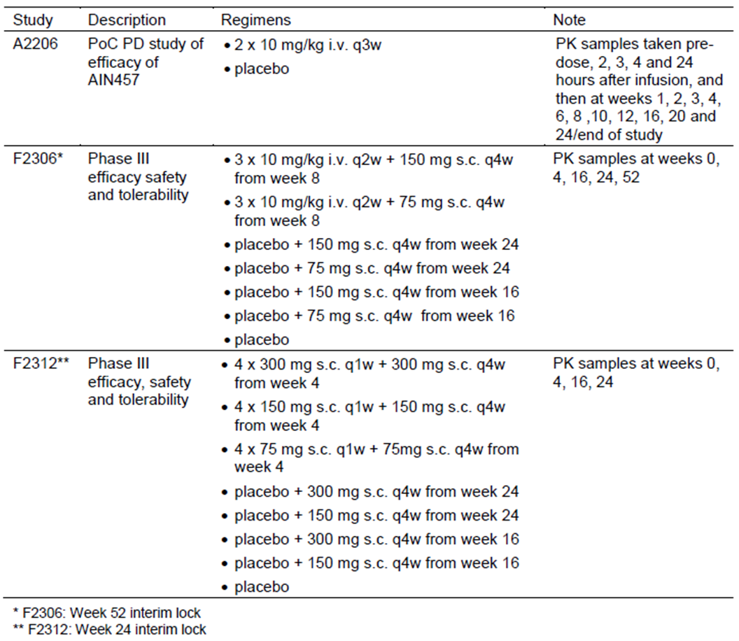
Table 2 provides a summary of the AS clinical studies that collected PK data, which was used in the population PK analysis of SEK use in adult patients with active AS. In addition to the 2 Phase III studies in AS, there was a single, Phase II, proof-of-concept trial (A2209), which investigated the efficacy, safety and PK characteristics of 3 different doses of SEK (0.1 mg/kg, 1.0 mg/kg and 10 mg/kg) given on 2 occasions by IV infusion, 3 weeks apart.
Table 2. Summary of Clinical Studies providing Pharmacokinetic Data in Ankylosing Spondylitis.
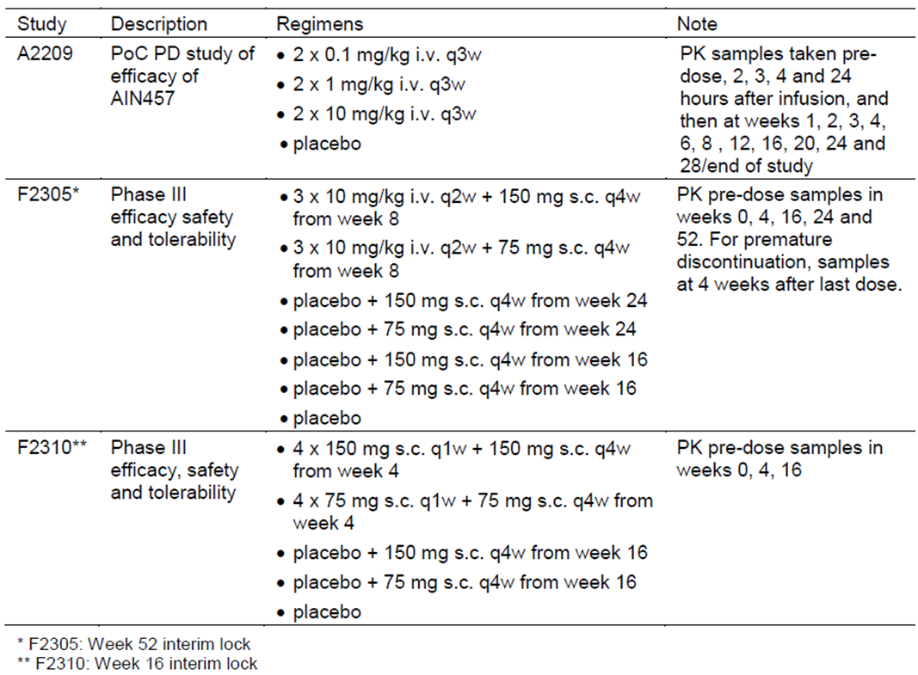

Evaluator’s conclusions on pharmacokinetics
In the PK summary of this report, the 2 new treatment indications (PsA and AS) will be considered together because the interpretation of the results and conclusions are similar with respect to PK characteristics. Overall, the sponsor has provided a sufficient quantity of new PK data (including serum trough SEK concentrations collected at weeks 4, 16, 24 and 52 in each of the pivotal studies for each treatment indication) in this submission for patients with the additional treatment indications of active PsA and AS. The sponsor is proposing minor changes to the PK section of the current PI to include the new PK data.
The key PK findings for SEK use in adult patients with active PsA or AS are:
- The drug exposure parameters of AUC and Cmax in both PsA and AS increase in proportion to dose over the range of 0.1 mg/kg to 10 mg/kg when given by IV infusion and from 75 mg to 300 mg when administered by SC injection;
- SEK exhibits first order absorption following SC injection with the estimated bioavailability being 85% in PsA patients and 79% in AS subjects;
- Typical apparent total volumes of distribution in PsA and AS are 6.1 L and 5.5 L, respectively;
- Clearance from the central compartment in typical subjects is 0.19 L/day in PsA (with 32.5% CV) and 0.16 L/day in AS (with 32.8% CV);
- The apparent elimination half-life is 25 days in PsA (with inter-patient variability [CV] of 27.5%) and 26 days in AS (with inter-patient variability [CV] of 27.0%);
- There is no evidence of a time dependent change in SEK PK in the PsA and AS populations;
- In both the PsA and AS populations, the only covariate factor of potential clinical relevance for alteration in clearance and volume of distribution for SEK is subject body weight. Baseline CRP value and prior anti TNF status did not have a clinically relevant influence on clearance when adjusted for subject weight; and
- Modelling of data in both PsA and AS indicates that loading regimens (IV and SC) increase drug exposure to SEK in the short term (first 12-20 weeks depending on regimen), but there is no additional SEK exposure difference beyond 20-24 weeks of continued therapy.

Pharmacodynamics

Studies providing pharmacodynamic data
The ability of SEK to bind and capture circulating IL-17A has been formally validated in several clinical studies involving healthy volunteers and different disease affected populations, such as adult patients with PSOR and rheumatoid arthritis. Many of these trials were previously evaluated in the original PSOR submission. The PD effect of SEK has been primarily assessed by the measurement of total serum IL-17A. Total IL-17A can be regarded as a biomarker for SEK and is indicative of target engagement. Total IL-17A is defined as free IL-17A plus IL-17A complexed with SEK after drug exposure.
In these 2 submissions, the sponsor has presented additional pharmacodynamic (PD) data in a meta-analysis report evaluating total IL-17A levels in 8 studies (ranging from Phase I-III). The 8 trials were chosen to cover a broad range of dosing regimens across healthy volunteers and different autoimmune conditions. The 8 studies included the 2 supporting trials key to these submissions. Study A2206 in patients with PsA (n = 42) and Study A2209 in patients with AS (n = 60) contributed to the meta-analysis data. The other 6 trials contributing to the meta-analysis dataset were Study A1101 (42 healthy Japanese male volunteers), Study A2212 (100 adult PSOR patients), Study A2220 (125 adult PSOR patients), Study A2309 (182 adult PSOR patients), Study F2201 (237 adult patients with active RA despite stable treatment with MTX) and Study F2208 (190 adult patients with active RA). None of the PD studies had deficiencies that excluded their results from consideration. However, in Study 2206, one of the secondary objectives was to assess the PD of SEK in synovial tissues obtained by biopsy of affected joints at baseline and week 6. However, very few patients consented to synovial biopsy (4 in total; 2 received SEK and 2 were in the PBO arm), so no PD analyses of synovial tissue samples was undertaken.

Evaluator’s conclusions on pharmacodynamics
In the PD summary of this report, the 2 new treatment indications (PsA and AS) will be considered together because the interpretation of the results and conclusions are similar with respect to PD characteristics. The sponsor has provided additional PD data in the form of a meta-analysis report evaluating total IL-17A levels in 8 studies, including 1 study in each newly proposed treatment indication in this submission. The sponsor is proposing minor changes to the PD section of the current PI to include the new PD data.
The key PD findings for SEK use in adult patients with active PsA or AS are:
- Maximal median concentrations of total IL-17A and the total exposure of total IL-17A increased with SEK dose (as seen in the AS Study 2209 plus other trials);
- Median serum concentrations of total IL-17A ranged between 107 and 130 pg/mL with the dosing regimen of 2 IV doses of SEK 10 mg/kg (given 3 weeks), whereas concentrations remained < 30 pg/mL with 2 IV doses of SEK 0.1 mg/kg;
- Total IL-17A concentrations increased over several weeks following 10 mg/kg IV dosing and peak levels were reached after 2-4 weeks;
- Considerable inter-subject variability was observed in total IL-17A profiles across patients with AS and PsA;
- Total IL-17A concentrations lag behind the peak serum concentrations of SEK after IV dosing; and
- There was a trend for improved efficacy response in both AS and PsA with higher C_{min} values but the exposure-response for efficacy parameters flattened at a C_{min} level higher than 25 µg/mL, which corresponds approximately to the mean C_{min} achieved at week 16 with SEK 150 mg SC injections.

Dosage selection for the pivotal studies

Psoriatic arthritis
To select the SEK dose regimens for further investigation in the pivotal Phase III PsA program, input from 4 sources of data were utilised: data from the proof-of-concept study in PsA (A2206), data from the Phase II, dose ranging trial in RA (Study F2201), dose efficacy predictions from the Phase II-III studies in moderate to severe PSOR (that is, the PK and PASI response modelling report) and the dose exposure predictions from the population PK modelling reports of SEK. Study A2206 demonstrated that 2 IV doses of SEK 10 mg/kg was efficacious in improving the signs and symptoms of PsA, but no maintenance dose was evaluated in this short term (primary efficacy assessment of ACR20 response at week 6), proof-of-concept trial. Maintenance doses in the Phase III PsA studies were selected based on the results from Study F2201 in RA. Study F2201 was Phase II, dose-ranging trial involving 236 adult patients with active RA. The trial examined 4 doses of SEK (25 mg, 75 mg, 150 mg and 300 mg) administered by SC injection versus PBO therapy. Study treatment was given at baseline, and then at weeks 4, 8 and 12. The primary endpoint of the trial (ACR20 response rate at week 16) was not achieved. However, the Phase II RA trial suggested that the 75 mg and 150 mg SC regimens could be efficacious for the longer term control of PsA symptoms. The PSOR trials identified that a higher dose of SEK (300 mg injections) may be required to achieve satisfactory clinical benefit. In addition, dosing from the PSOR registration trials supported the decision to examine SEK treatment regimens involving loading doses (IV and SC) to potentially provide a faster onset of arthritic symptom relief.
Both of the pivotal Phase II PsA trials were PBO controlled for the first 16-24 weeks. About 20% of PBO treated patients at week 16 were considered responders and continued with PBO up to week 24. The Delegate requested a rationale for the absence of active comparator, especially considering that established and effective treatment options are registered and available for this indication in Australia. The Phase III data for SEK did not examine anti TNF therapy as an active comparator as “may be required” according to the TGA adopted EU guideline. However, there is no precedent for an approval of a non anti TNF drug in PsA. As blockade of IL-17A presents a novel approach to the treatment of PsA, the sponsor states that it is important to establish efficacy for this new mechanism of action in patients who have failed anti TNF drugs, for whom currently no other biologic therapy is available in Australia. The goal of the Phase III PsA program with SEK was to demonstrate efficacy and safety in both patients who had previously been exposed to anti TNF drugs and those who were anti TNF naïve, which is an acceptable real life experience in Australian practice. In addition, most registration trials with anti TNF did not include patients who had previously failed biologic therapy. The Phase III SEK PsA studies included 31% of patients with the highest unmet treatment need, that is, they have failed anti TNF therapy.

Ankylosing spondylitis
The data from 2 dose ranging Phase II studies, 1 conducted in adult patients with AS (Study A2209) and the other in adult patients with RA (Study F2201), were primarily used to define the dosing regimens of SEK to be examined in the Phase III AS program. Study A2209 demonstrated that 2 IV doses of SEK 10 mg/kg was efficacious in improving the signs and symptoms of AS, but no maintenance dose was evaluated in this short-term (primary efficacy assessment at week 6), proof-of-concept trial. Maintenance doses in the Phase III AS studies were selected based on the results from Study F2201 in RA. Study F2201 was Phase II, dose ranging trial involving 236 adult patients with active RA. The trial examined 4 doses of SEK (25 mg, 75 mg, 150 mg and 300 mg) administered by SC injection versus PBO therapy. Study treatment was given at baseline, and then at weeks 4, 8 and 12. The primary endpoint of the trial (ACR20 response rate at week 16) was not achieved. The Phase II RA trial suggested that the 75 mg and 150 mg SC regimens could be efficacious for the longer term control of AS symptoms, and that a higher dose of SEK, such as 300 mg injections, would not confer any additional clinical benefit. In addition, dosing from the PSOR registration trials supported the decision to examine SEK treatment regimens involving loading doses (IV and SC) to potentially provide a faster onset of arthritic symptom relief.
Both of the pivotal Phase III AS trials were PBO controlled for the first 16-24 weeks. The TGA delegate requested a rationale for the absence of an active comparator given that there are registered treatment options available in Australia, in particular, anti TNF therapy for moderately to severely active AS that has failed to respond to NSAID and exercise therapy. However, the TGA adopted EU guideline suggests that an active comparator “may be required” but does not mandate the issue.
The goal of the Phase III AS clinical program for SEK was to reflect the contemporary AS population, which involves the inclusion of a mixture of anti TNF IR patients as well as anti TNF naïve subjects.

Efficacy

Studies providing efficacy data

Indication 1: PsA
Two pivotal Phase III trials – Studies F2306 (FUTURE-1) and F2312 (FUTURE-2) – investigated the treatment of PsA with SEK.
Meanwhile, Studies A2206 and A2206E1 (Phase II PsA Study and its extension phase) were Phase II, proof-of-concept, randomised, double-blind, PBO-controlled trials in adult patients with active PsA. The primary objective of Study A2206 was to evaluate the efficacy of SEK after two IV doses of 10 mg/kg (given 3 weeks apart – baseline and week 3) compared to PBO based on the proportion of subjects achieving ACR20 response at 6 weeks.

Indication 2: AS
Two pivotal Phase III trials – Studies F2305 (MEASURE-1) and F2310 (MEASURE-2) – investigated the treatment of AS with SEK.
Meanwhile, Studies A2209 and A2209E1 (Phase II AS Study and its extension phase) were 2 part, proof-of-concept, randomised, double blind, PBO controlled trials in adult patients with active AS. The primary objective of Part 1 of Study A2209 was to evaluate the efficacy of SEK after two IV doses of 10 mg/kg (given 3 weeks apart – baseline and week 3) compared to PBO based on the proportion of subjects achieving ASAS20 response at 6 weeks. The main objective of Part 2 was to evaluate the efficacy of lower doses of SEK (2 IV infusions, given 3 weeks apart) at 6 weeks based on the change from baseline in the total BASDAI score.

Evaluator’s conclusions on efficacy

Indication 1: PsA
In support of the extension of treatment indication for SEK to include PsA, this submission contains data from 2 pivotal Phase III studies (F2306 and F2312), which are highly similar in design; as well as 1 supportive Phase II trial (A2206) of 24 weeks duration, which enrolled a total of 42 patients (24 of whom received 2 x IV doses of SEK 10 mg/kg, given 3 weeks apart). The Phase II trial also had an open label extension period (A2206E1) of up to 52 weeks duration, which enrolled a total of 28 patients. In Study A2206E1, all subjects received IV SEK 3 mg/kg every 4 weeks.
Both of the Phase III studies are ongoing with interim study reports up to 52 weeks of treatment follow-up being included in this submission. A total of 1003 patients were recruited into the 2 Phase III studies, of which 703 subjects received any dose of SEK (75 mg, 150 mg or 300 mg injections) in the first 16 weeks (that is, the true PBO controlled period). In both Phase III studies, ~40% of PBO treated patients at week 16 did not meet the EE criteria and continued on PBO injections up to week 24. At weeks 16 or 24, all continuing PBO treated subjects (91.4%; 275/301) were switched to SEK (75 mg, 150 mg or 300 mg SC injections every 4 weeks in the maintenance treatment phase). In total, ~95% of subjects completed their week 24 assessment and ~85% of patients completed 52 weeks of treatment follow up in the Phase III program.
Both of the Phase III studies were randomised, double blinded, PBO controlled in design and enrolled adult patients with a confirmed diagnosis of PsA for at least 6 months according to the CASPAR criteria. Subjects were required to have moderate-severe disease activity at baseline with at least 3 or more swollen and tender peripheral joints, despite at least 3 months of conventional treatment with NSAID and/or conventional DMARD (mainly, MTX) and/or anti TNF therapy. All subjects were required to have either active PSOR lesions at baseline or a documented history of skin and/or nail involvement with PSOR. The Phase III studies were highly similar in design with the main difference being the use of an IV loading dose of SEK in Study F2306 versus a SC loading dose strategy in Study F2312. Both of the Phase III trials examined the effect of 2 doses of SEK (75 mg and 150 mg injections, given every 4 weeks by SC injection in the maintenance treatment phase) compared to PBO. Study F2312 also included a third dose of SEK for evaluation (300 mg injections; given at the same frequency as other SEK doses). The baseline demographic and disease related characteristics of patients in the Phase III trials are similar to those in the anticipated Australian patient cohort, and therefore generalisation of these results to the Australian context is expected. Just over half of all patients were female, predominately of Caucasian ethnicity (>85%), and within the expected age range of 25-65 years (mean age of 49 years). Over one fifth of all recruited subjects were a current smoker and the mean BMI was ~30 kg/m². Current smoking status and obesity are factors associated with a diminished response to treatment in PsA. However, there are some caveats to the general application of the treatment population. For example, both studies excluded patients who were at a significant risk of infection or malignancy, or who had various abnormal laboratory results at baseline (for example, abnormal haematology or liver function tests). At randomisation, patients were stratified on the basis of whether they were anti TNF naïve or anti TNF-IR. In total, 31.7% (318/1003) of all subjects recruited into the Phase III AS program had a history of anti TNF exposure. Randomisation was not stratified by MTX use at baseline and half of all subjects (50.1%; 503/1003) in the Phase III PsA studies were taking MTX during the trials at a median weekly dose of 15 mg.
This submission is seeking an indication in active PsA and is generally consistent with the TGA adopted regulatory guideline pertaining to the requested extension of indication. However, the Phase III trials did not evaluate anti TNF drugs as the active comparator, which was an issue raised by TGA in the pre-submission meeting. Nonetheless, none of the other biological drugs (including ustekinumab and 5 anti TNF drugs) currently registered in Australia for PsA have conducted head-to-head studies with other biological therapies. Furthermore, both of the Phase III SEK trials did include patients who had previously been exposed to anti TNF drugs and those who were anti TNF naive. For both Phase III studies, the choice of efficacy endpoints and statistical analysis were appropriately performed; and strategies to maintain blinding and randomisation procedures were suitable.
The primary efficacy endpoint in both Phase III studies was the ACR20 response rate at week 24. The pre-specified secondary efficacy endpoints (all evaluated at week 24) included measures of skin response (PASI75 and PASI90 response) as well as the change from baseline in disease activity (DAS28-CRP score) and physical functioning (HAQ-DI score); and health related QOL, notably the LS mean change from baseline in the SF-36 PCS score. Study F2306 also included an analysis of sequential plain X-ray data of the peripheral joints taken up to 52 weeks. Both the Phase III studies also provided clinical efficacy data up to week 52 in support of the maintenance of treatment effect.
In Study F2306, where IV loading with SEK 10 mg/kg at baseline, week 2 and week 4 was given to both SEK treatment groups, the primary efficacy endpoint of a statistically superior ACR20 response at 24 weeks was reached with both doses of SEK. Overall, 50.5% (102/202) of patients treated with SC SEK 75 mg every 4 weeks in the maintenance phase and 50.0% (101/202) of subjects treated with SC SEK 150 mg injections achieved this outcome versus 17.3% (35/202) of patients in the PBO group. In addition, both doses of SEK examined in Study F2306 were superior to PBO for all of the pre-specified secondary efficacy measures such as the rates of PASI75 and PASI90 response at 24 weeks, as well as the mean change from baseline in the DAS-28 CRP and HAQ-DI scores plus rate of ACR50 response and the mean change from baseline in the SF36-PCS score. Overall, the study confirmed that SEK is effective in treating the symptoms and signs of active PsA as well as improving physical functioning and health related QOL. There were no significant differences at 24 weeks between the 2 SEK dosing regimens in Study F2306, but this probably reflects the impact of the high dose IV loading regimen in the first 4 weeks of the trial with efficacy endpoint analysis being primarily conducted at week 24.
Similarly, in Study F2312 (that is, where no IV loading dose regimen was included) all 3 evaluated doses of SEK were statistically superior to PBO at week 24 for the primary efficacy endpoint. The rate of ACR20 response at week 24 was 29.3% (29/99) in the SEK 75 mg group, 51.0% (51/100) in the SEK 150 mg arm and 54.0% (54/100) in the SEK 300 mg arm versus 15.3% (15/98) in the PBO group. However, the magnitude of the treatment effect with SEK versus PBO was similar with the 2 higher doses of SEK (150 mg and 300 mg given every 4 weeks by SC injection) but considerably lower (that is, <15% difference in response rates) for SEK 75 mg injection therapy compared to PBO. In addition, the statistical hierarchical testing strategy that controls for multiplicity of testing was terminated at the first ranked secondary efficacy endpoint (PASI75 response rate at 24 weeks) because SEK 75 mg therapy was not statistically better than PBO. Based on adjusted p-values, Study F2312 demonstrated that SEK 300 mg therapy was superior to PBO at week 24 for all pre-specified secondary efficacy endpoints. For SEK 150 mg injections compared to PBO, all secondary efficacy outcomes were met with the exception of the mean change from baseline in the HAQ-DI score and the rate of ACR50 response at 24 weeks. However, the treatment effect of SEK 150 mg injections versus PBO for the rate of ACR50 response (35.0% versus 18.2%) was identical to that observed in the SEK 300 mg cohort (35.0%). Overall, SEK 150 mg therapy given by SC loading (as observed in Study F2312) had a similar magnitude of efficacy for the primary and secondary endpoints compared to the IV SEK loading regimens examined in Study F2306, indicating the optimal response to SEK is achieved with the proposed 150 mg SC dosing posology (every 4 weeks in the maintenance phase) and no additional benefit with SEK was observed with IV loading.
In the Phase III PsA program, the concurrent use of MTX did not appear to impact upon the ACR20 response rate at 24 weeks in subjects receiving SEK 150 mg and 300 mg injections. However, in Study F2312 (but not in Study F2306, where IV loading was given), the ACR20 response was numerically higher when SEK was combined with MTX in those who were given SEK 75 mg injections. This data supports the sponsor claim of using SEK with or without MTX. Furthermore, in the anti TNF-IR subgroup of subjects in Study F2312, a statistically higher rate of ACR20 response was only demonstrated with SEK 300 mg therapy (45.5%; 15/33) compared to PBO (14.3% [5/35]; p = 0.0077). Treatment with SEK 75 mg (14.7%; 5/34) or SEK 150 mg injections (29.7%; 11/37) was not statistically better than PBO in the anti TNF-IR cohort (p = 0.9639 and p = 0.1216, respectively). In the anti TNF naïve subset, the 24 week ACR20 responder rate was statistically better in all 3 SEK dose groups versus PBO (36.9% [24/65] for SEK 75 mg [p = 0.0075], 63.5% [40/63] for SEK 150 mg [p <0.0001] and 58.2% [39/67] for SEK 300 mg [p <0.0001] versus 15.9% [10/63] in the PBO group. This data supports the sponsor request to register the SEK 300 mg dose of therapy for PsA patients who are anti TNF-IR. Although not stratified for at randomisation, high subject weight at baseline (>100 kg versus <100 kg) also appeared to be associated with lower ACR20 response rate and only the 300 mg dose of SEK was able to achieve a statistically higher response compared with PBO. The sponsor has not requested a dosing modification for patients weighing >100 kg in the proposed treatment indication wording.
Although the sponsor at present is not seeking a formal radiographic claim in the SEK indication wording for PsA, the key summary X-ray data from Study F2306 has been included in the proposed PI. Sequential X-rays taken at baseline, week 24 and week 52 of treatment follow-up show that SEK therapy (both the 75 mg and 150 mg dose regimens) is associated with a statistically lower increase (worsening) from baseline in the total vdH-mTSS compared with PBO, which is mainly explained by treatment related differences in the progression of the ES. As such, there is preliminary data to indicate that SEK appears to slow the progression of radiographic damage in the peripheral joints of patients with active PsA at baseline.
The efficacy data available at 52 weeks in both Phase III studies indicated that the majority of responding patients appear to maintain their treatment related benefit with continued SEK up to 52 weeks of follow-up. In addition, for PBO patients who switched to SEK at week 16 or 24, the rate of ACR20 responses observed at 52 weeks (that is, 24-32 weeks after switching to active treatment) were similar to those achieved in the originally treated SEK cohort.
Although the primary efficacy endpoint of the supporting Phase II Study A2206 was not met (that is, treatment with 2 IV doses of SEK 10 mg/kg given 3 weeks apart was not statistically superior to PBO for the ACR20 response rate at week 6 (39% [9/23] for SEK versus 23% [2/13] for PBO), various secondary clinical efficacy outcomes such as the rate of ACR20, ACR50 and PsARC response at other time points up to week 24 were numerically higher with SEK versus PBO in this proof-of-concept trial. Like the Phase III studies, the extension phase of this trial (A2206E1) showed that clinical efficacy was maintained in the majority of subjects up to 52 weeks with continued SEK therapy.
Overall, the data in this submission supports the efficacy of SEK therapy in the treatment of adult patients with moderate-severely active PsA, with or without concurrent NSAID and/or MTX. SEK 150 mg by SC injection (given weekly for the first 4 weeks and then every 4 weeks thereafter) is the optimal dosing regimen for the majority of adult patients with PsA. The sponsor has requested a higher dose of SEK therapy (300 mg injections) in patients who are anti TNF-IR, which is supported by the data observed in Study F2312. In the anti TNF naïve group of patients, the magnitude of response with SEK is similar to that observed in the pivotal studies, which supported the registration of anti TNF therapies in PsA.

Indication 2: AS
In support of the extension of treatment indication for SEK to include AS, this submission contains 2 pivotal Phase III studies (F2305 and F2310) of highly similar design, as well as 1 supportive Phase II trial (A2209) of 28 weeks duration, which enrolled a total of 60 patients (30 of whom received IV SEK 10 mg/kg). The Phase II trial also had an open label extension period (A2209E1) of up to 52 weeks duration, which enrolled a total of 39 patients.
Both of the Phase III studies are ongoing with interim study reports up to 52 weeks of treatment follow-up being included in this submission. A total of 590 patients were enrolled in the 2 Phase III studies, of which 393 subjects received either dose of SEK (75 mg or 150 mg injections) in the first 16 weeks (that is, the true PBO controlled period). In both Phase III studies, ~20% of PBO treated patients at week 16 were considered responders and so continued on PBO up to week 24. At weeks 16 or 24, all continuing PBO treated subjects (90.8%; 178/196) were switched to either SEK 75 mg or 150 mg SC injections every 4 weeks in the maintenance treatment phase. In total, >90% of subjects completed their week 16 assessment and ~85% of patients completed 52 weeks of treatment follow-up in the Phase III program.
Both of the Phase III studies were randomised, double blinded and PBO controlled in design and enrolled adult patients with a confirmed diagnosis of AS according to the modified New York criteria. Subjects were required to have moderate-severe disease activity at baseline with the BASDAI score being ≥4 and spinal pain ≥4 cm, despite at least 3 months of conventional treatment with NSAID and/or conventional DMARD (SSZ or MTX). The Phase III studies were highly similar in design with the main difference being the use of an IV loading dose of SEK in Study F2305 versus a SC loading dose strategy in Study F2310. Both of the Phase III trials examined the effect of 2 doses of SEK (75 mg and 150 mg injections, given every 4 weeks by SC injection in the maintenance treatment phase) compared to PBO. The baseline demographic and disease related characteristics of patients in the Phase III trials are similar to those in the anticipated Australian patient cohort, and therefore generalisation of these results to the Australian context is expected. The majority of patients were male, of Caucasian ethnicity, and within the expected age range of 25- 65 years. Over one quarter of all recruited subjects were a current smoker, which is a factor associated with diminished response to treatment. However, there are some caveats to the general application of the treatment population. For example, both studies excluded patients who were at a significant risk of infection or malignancy, or who had various abnormal laboratory results at baseline (for example, abnormal haematology or liver function tests). In addition, a history of inflammatory bowel disease and uveitis were exclusion criteria, and these conditions are co-morbidities in ~10% of the target population. At randomisation, patients were stratified on the basis of whether they were anti TNF naïve or anti TNF-IR. In total, 31.2% (184/590) of all subjects recruited into the Phase III AS program had a history of anti TNF exposure.
This submission is seeking an indication in active AS and is generally consistent with the TGA adopted regulatory guideline pertaining to the requested extension of indication. However, the Phase III trials did not evaluate anti TNF drugs as the active comparator, which “may be required” according to the TGA adopted EU guideline. However, there is no precedent for the registration of a non-anti TNF drug in AS and none of the 5 anti TNF drugs currently registered for AS have conducted head-to-head studies with anti TNF therapies. Furthermore, both of the Phase III SEK trials did include patients who had previously been exposed to anti TNF drugs and those who were anti TNF naive. For both Phase III studies, the choice of efficacy endpoints and statistical analysis were appropriately performed; and strategies to maintain blinding and randomisation procedures were suitable.
The primary efficacy endpoint in both Phase III studies was the rate of ASAS20 response at week 16. The pre-specified secondary efficacy endpoints (all evaluated at week 16) included various other levels of ASAS response (ASAS40, ASAS 5/6 improvement and ASAS partial remission) as well as the change from baseline in hsCRP levels and the total BASDAI score; and health related QOL measures, notably the LS mean change from baseline in the SF-36 PCS and ASQoL scores. Study F2305 also included an analysis of MRI data of the SI joints in a subset of anti TNF naïve patients (n = 105 subjects). Both the Phase III studies also provided some efficacy data up to week 52 in support of the maintenance of treatment effect.
In Study F2305, where IV loading with SEK 10 mg/kg at baseline, week 2 and week 4 was given to both SEK treatment groups, the primary efficacy endpoint of a statistically superior ASAS20 response at 16 weeks was reached with both doses of SEK. Overall, 59.7% (74/124) of patients treated with SC SEK 75 mg every 4 weeks in the maintenance phase and 60.8% (76/125) of subjects treated with SC SEK 150 mg injections achieved this outcome versus 28.7% (25/122) of patients in the PBO group. Many secondary efficacy measures of clinical relevance such as various rates of ASAS response (40, 5/6 improvement and partial remission) at 16 weeks, as well as mean change from baseline in the BASDAI score confirmed that SEK is effective in treating the symptoms and signs of active AS. Improvements in measures of inflammation (CRP), imaging (MRI parameters), physical functioning (BASFI), spinal mobility (BASMI), and health related QOL were also beneficially attained with SEK therapy. There were no significant differences at 16 weeks between the 2 SEK dosing regimens in Study F2305, but this probably reflects the impact of the high dose IV loading regimen in the first 4 weeks of the trial with efficacy endpoint analysis being primarily conducted at week 16.
In contrast, Study F2310 (that is, where no IV loading dose regimen was included) showed only treatment with SEK 150 mg SC every 4 weeks showed superiority over PBO at week 16 in the primary and ranked secondary endpoints (apart from ASAS partial remission rate) in the hierarchical testing strategy that controls for multiplicity of testing with adjusted p-values. In Study F2310, treatment with SEK 75 mg SC every 4 weeks was not superior to PBO for any efficacy endpoint (primary or secondary) in the testing hierarchy. Furthermore, SEK 75 mg SC injection every 4 weeks demonstrated clinically lower absolute response rates compared to the SEK 150 mg dose arm for all efficacy endpoints at week 16.
Overall, SEK 150 mg therapy given by SC loading (as observed in Study F2310) had a similar magnitude of efficacy for the primary and secondary endpoints compared to the IV SEK loading regimens examined in Study F2305, indicating the optimal response to SEK is achieved with the proposed 150 mg SC dosing posology (every 4 weeks in the maintenance phase) and no additional benefit with SEK was observed with IV loading.
The Phase III study data also shows that SEK 150 mg by SC injection every 4 weeks is effective in treating both anti TNF naïve as well as anti TNF-IR patients. However, in both Phase III trials ASAS20 response rates at week 16 were numerically higher in anti TNF naïve subjects (66-68%) compared with anti TNF-IR patients (45-50%). Although not stratified for at randomisation, high subject weight at baseline (>90 kg versus <90 kg) also appeared to be associated with lower ASAS response rates for SEK 150 mg treatment.
The efficacy data available at 52 weeks in both Phase III studies indicated that the majority of responding patients appear to maintain their treatment related benefit with continued SEK up to 52 weeks of follow-up. In addition, for PBO patients who switched to SEK at week 16 or 24, the rate of ASAS responses observed at 52 weeks (that is, 24-32 weeks after switching to active treatment) were similar to those achieved in the originally treated SEK cohort.
The supporting Phase II Study A2209 showed that treatment with 2 IV doses of SEK 10 mg/kg (3 weeks apart) was superior to PBO for the rate of ASAS20 response at week 6 (60.9% [14/23] for SEK versus 16.7% [1/6] for PBO). Various secondary clinical efficacy outcomes and MRI data supported the benefit of SEK over PBO in this proof-of-concept trial. The study also contained a dose finding analysis for SEK (Part 2), which showed that the various categories of ASAS response were numerically higher for IV SEK 10 mg/kg versus the 2 lower doses of SEK (1.0 mg/kg and 0.1 mg/kg). Like the Phase III studies, the extension phase of this trial (A2209E1) showed that clinical efficacy was maintained in the majority of subjects up to 52 weeks with continued SEK therapy.
Overall, the data in this submission supports the efficacy of SEK therapy in the treatment of AS (diagnosed as per the 1984 modified New York criteria), in those with moderate-severely active disease at baseline, with or without concurrent NSAID or conventional DMARD (MTX or SSZ). SEK 150 mg by SC injection (given weekly for the first 4 weeks and then every 4 weeks thereafter) is the optimal dosing regimen in adult patients with AS. The requested dose of SEK therapy has demonstrated clinically meaningful efficacy in both anti TNF naïve and anti TNF-IR subjects. In the anti TNF naïve group of patients, the magnitude of response with SEK is similar to that observed in the pivotal studies, which supported the registration of anti TNF therapies in AS. Treatment related differences between SEK and PBO are 33% for the ASAS20 response rate (compared with 33% for anti TNF therapy versus PBO) and 25% for the ASAS40 response rate (compared with 30% for anti TNF therapy versus PBO).

Safety

Studies providing safety data
The following studies provided evaluable safety data:

Pivotal efficacy studies
In the pivotal efficacy studies for both treatment indications (Studies F2306 and F2312 for PsA and Studies F2305 and F2310 for AS), the following safety data were collected:
- Adverse Events (AEs) in general were assessed by completion of the AE Case Report Form (CRF) and physical examination performed weekly for the first 4 weeks, every 4 weeks between week 4 and 52, and then every 8 weeks thereafter.
- AEs of particular interest, including hypersensitivity reactions, infections (overall and serious), Major Adverse Cardiovascular Events (MACE), malignancy and the occurrence of inflammatory bowel disease were assessed by CRF and physical examination as per the schedule for general AE evaluation.
- Laboratory tests, including haematology, clinical chemistry and urinalysis were performed at baseline, weekly for the first 4 weeks, every 4 weeks until week 32 and then every 8 weeks thereafter. A fasting lipid profile was collected at baseline, every 8 weeks until week 24 and then at week 52, 76 and 104. Episodes of neutropenia were an AE of special interest as this was an identified risk with SEK.
- Screening tests for tuberculosis (Chest X-ray and QuantiFERON Gold testing; or PPD skin testing in countries without QuantiFeron Gold testing) were taken at baseline, but not routinely collected thereafter.
- Vital signs such as blood pressure, heart rate and temperature were performed at each scheduled study visit. Subject weight was assessed at baseline, week 24 and week 52.
- ECG for central reading was taken at baseline, week 16 and week 52.
- Urine pregnancy testing was performed at baseline and every 4 weeks thereafter in women of reproductive age.
- Serum for anti drug antibodies (ADA) to SEK was collected at baseline, week 24 and week 52.
In all 4 of the Phase III studies (2 for each treatment indication), the focus of the safety data presentation was on the true PBO controlled period up to week 16 because this allowed a direct comparison across the randomised SEK treatment groups as well as the PBO arm prior to early escape for insufficient response. For both PsA and AS, the safety data from the Phase III studies was pooled for each treatment indication. In addition, for each of the treatment indications, the Phase III safety data was presented as analyses of information collected over the entire treatment period (that is, as of the data cut-off date for the interim clinical study report). When comparing the rates of AEs after week 16 in both treatment indications, the interpretation of the findings is clouded as all PBO treated subjects were switched to SEK therapy due to either early escape criteria at week 16 or a mandatory crossover at week 24. As such, the number of subjects as well as lengths of treatment follow-up differed between the different SEK dose groups for the entire treatment period. The safety data was primarily presented over the entire treatment period as an exposure adjusted incidence rate. For the PsA indication only, patient exposure over the entire treatment period in the 2 pivotal Phase III PsA studies was combined with that obtained in subjects with concomitant PsA who were involved in the Phase III PSOR trials. This appropriately expanded the safety dataset in the PsA indication.
AEs were summarised by the MedDRA classification using System Organ Class (SOC) and Preferred Term (PT) nomenclature.

Pivotal studies that assessed safety as a primary outcome
No pivotal studies in either the PsA and AS treatment indications program for SEK assessed safety as the primary outcome.

Dose-response and non-pivotal efficacy studies
The submission contained a single supporting Phase II, dose finding study for each treatment indication (Study A2206 for PsA [24 weeks duration] and Study A2209 for AS [28 weeks duration]). Both of the Phase II trials had open label extension periods of up to an additional 52 weeks of treatment (Study A2206E1 for PsA and Study A2209E1 for AS) which also provided safety data on general AEs, AEs of special interest (for example, infections), blood parameters (haematology and clinical chemistry), physical examination and ADAs. The study reports from these supporting trials will be included in the overall SEK safety dataset in this clinical evaluation report.

Other studies evaluable for safety only
In addition, to the Phase II and 3 studies conducted in adult patients with PsA and AS, the submission contained safety data from the following 35 trials (listed by treatment indication) in support of the overall safety of SEK:
- PSOR – 11 completed trials (A2102, A2103, A2204, A2211, A2212, A2220, A2225, A2302, A2303, A2304 and A2307) plus 7 ongoing trials (A2211E1, A2223, A2302E1, A2304E1, A2308, A2309 and A2317),
- Rheumatoid Arthritis – 4 completed trials (A2101, F2201, F2206 and F2208),
- Multiple Sclerosis – 2 completed trials (B2201 and B2203),
- Crohn’s Disease – 2 completed trials (A2202 and A2202E1),
- Uveitis – 2 completed trials (A2208 and C2303) plus 5 early termination studies (C2301, C2301E1, C2302, C2302E1 and C2303E1),
- Dry Eye Syndrome – 1 completed trial (CPJMR0092202) and
- Polymyalgia Rheumatica – 1 Proof-of-Concept, Phase II study (CPJMR0012201).

Patient exposure

Psoriatic arthritis

Short term period (16 weeks) of phase III studies
The total patient exposure in the first 16 weeks (that is, true PBO controlled period) of the 2 pivotal Phase III trials in PsA is summarised in Table 3. All of the 6 treatment groups (5 SEK dose groups and a PBO arm) had an identical median duration of patient exposure (112 days) to study medication. More than three quarters of all subjects (79.2% [557/703] in the pooled SEK cohort and 72.3% [217/300] in the PBO arm) were exposed to study treatment for at least 16 weeks.
Table 3. Duration of Exposure to Study Treatment (up to 16 Weeks) in Phase III PsA Trials.
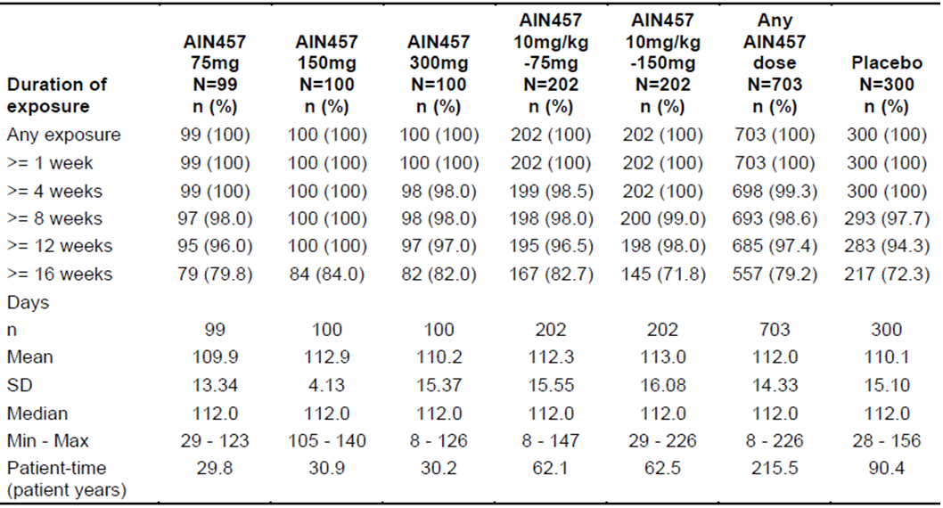
Compliance with the study protocols was high as the vast majority of SEK treated subjects received all 7 doses of SC therapy by week 16 in Study F2312 and the same was true in Study F2306 where >95% of SEK treated patients received all 3 IV infusions plus 2 SC injections by week 16. The overall cumulative exposure to SEK was 215.5 PY and for the PBO group it was 90.4 PY.

Entire treatment period of phase III studies
Patient exposure over the entire treatment period in the 2 pivotal Phase III PsA studies as well in those subjects with concomitant PsA who were involved in the Phase III PSOR trials is summarised in Table 4. The median duration of exposure to SEK was highest in the SEK 75 mg dose group at 413 days and this cohort was only represented by subjects who were involved in the 2 pivotal Phase PsA studies (that is, no additional subjects from the PSOR trials were included in this dose group). The majority of subjects in the SEK 150 mg (64.3%; 438/681) were involved in the 2 Phase III PsA studies, but the converse was true for the SEK 300 mg dose group (63.4% [255/400] were enrolled in the Phase III PSOR trials). The expanded PsA population provides a large pool of safety across the 3 SEK doses of interest in this submission. The total cumulative exposure to SEK 75 mg therapy was 420.0 PY (all from the 2 Phase III PsA studies), 616.5 PY for SEK 150 mg injections (444.9 PY from the 2 Phase III PsA studies) and 278.6 PY for SEK 300 mg therapy (90.1 PY from the 2 Phase III PsA trials). In the 2 pivotal Phase III PsA studies, the vast majority of enrolled subjects received all doses of study treatment up to week 52 (17 injections in Study F2312 and 12 injections in Study F2306).
Table 4. Duration of Exposure to Study Treatment in Phase III PsA Trials as well as Subjects with concomitant PsA enrolled in Phase III Psoriasis Studies.
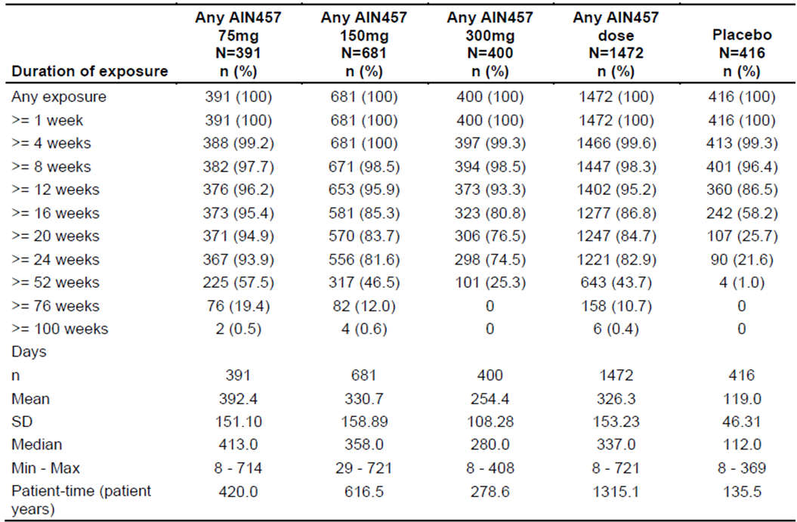

Ankylosing spondylitis

Short term period (16 weeks) of phase III studies
The total patient exposure in the first 16 weeks (that is, true PBO controlled period) of the 2 pivotal Phase III trials in AS is summarised in Table 5. All of the 5 treatment groups (4 SEK treatment groups and the PBO arm) had a near identical median duration of patient exposure (112-113 days) to study medication. More than three quarters of all subjects (78.7% [310/394] in the pooled SEK cohort and 74.0% [145/196] in the PBO arm) were exposed to study treatment for at least 16 weeks.
Table 5. Duration of Exposure to Study Treatment (up to 16 Weeks) in Phase III AS Trials.
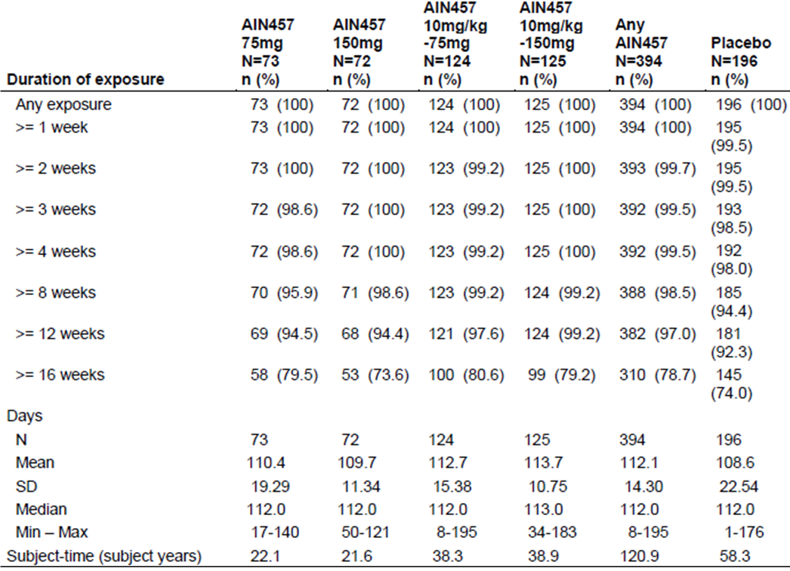
Compliance with the study protocols was high as the vast majority of SEK treated subjects received all 8 doses of SC therapy by week 16 in Study F2310 and the same was true in Study F2305 where >95% of SEK treated patients received all 3 IV infusions plus 2 SC injections by week 16. The overall cumulative exposure to SEK was 120.9 PY and for the PBO group it was 58.3 PY.

Entire treatment period of phase III studies
Patient exposure over the entire treatment period in the 2 pivotal Phase III AS studies is summarised in Table 6. The median duration of exposure to SEK was comparable between the SEK 75 mg and 150 mg groups at 462-468.5 days. The majority of continuing subjects in both dose groups received all doses of study treatment up to week 52 (17 injections in Study F2310 and 12 injections in Study F2305) resulting in a similar cumulative exposure to SEK for both active dose groups (344.6-346.5 PY).
Table 6. Duration of Exposure to Study Treatment in Phase III AS Trials.
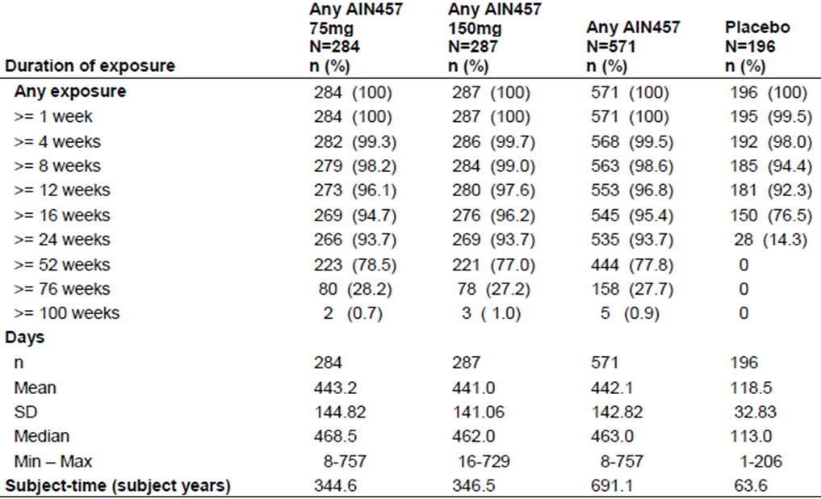

All SEK treatment data pool
The sponsor has pooled and presented the safety data for all SEK treated subjects from a total of 42 Phase I-III clinical studies conducted in adult patients with various autoimmune conditions, for which either an interim or final clinical study report is available. The data pooling maximises the opportunity to observe rare but clinically significant AEs such as Major Adverse Cardiovascular Events (MACE) and malignancy by examining a large volume of data in patients exposed to SEK. Excluded from this large safety dataset are the 6 small trials (A1101, A2104, A2106, A2107, A2224 and A2228) that enrolled healthy volunteers. In addition, to the Phase II and 3 studies for PsA (n = 4) and AS (n = 4), the following trials (listed by treatment indication) were included in this overall safety dataset:
- PSOR – 11 completed trials (A2102, A2103, A2204, A2211, A2212, A2220, A2225, A2302, A2303, A2304 and A2307) plus 7 ongoing trials (A2211E1, A2223, A2302E1, A2304E1, A2308, A2309 and A2317),
- Rheumatoid Arthritis – 4 completed trials (A2101, F2201, F2206 and F2208),
- Multiple Sclerosis – 2 completed trials (B2201 and B2203),
- Crohn’s Disease – 2 completed trials (A2202 and A2202E1),
- Uveitis – 2 completed trials (A2208 and C2303) plus 5 early termination studies (C2301, C2301E1, C2302, C2302E1 and C2303E1),
- Dry Eye Syndrome - 1 completed trial (CPJMR0092202) and
- Polymyalgia Rheumatica – 1 Proof-of-Concept, Phase II study (CPJMR0012201).
In total, 6200 subjects received at least 1 dose of SEK in the overall safety dataset with a cumulative exposure of 6267 PY, in a number of different autoimmune diseases – refer to Table 7. The median duration of exposure to SEK in the data pool was 370 days, with 5287 subjects being exposed to SEK for at least 16 weeks and 3671 patients for at least 52 weeks. Because most of the contributing studies in other autoimmune conditions enrolled fewer PBO treated subjects (as per their design), a significantly shorter duration of exposure was observed in the PBO cohort at 86 days, with a lower total cumulative exposure of 515.5 PY.
Table 7. Duration of Exposure to Treatment in All SEK Clinical Trials.
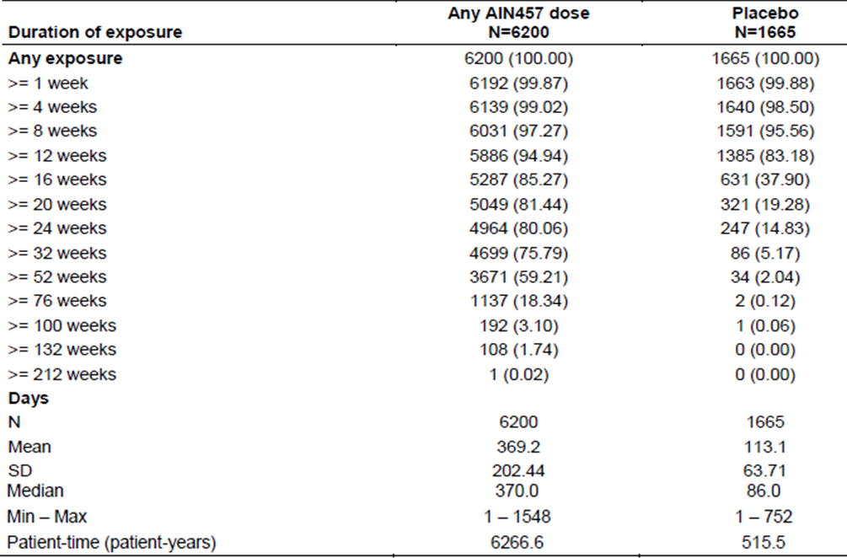

Safety issues with the potential for major regulatory impact

Liver toxicity
SEK therapy appears to be associated with a slightly higher frequency of elevated serum transaminases compared to PBO in the first 16 weeks of therapy in both treatment indications. There does appear to be a consistent dose related relationship between raised serum AST and/or ALT with SEK therapy. The abnormalities of liver function often resolved with continued SEK treatment and none meet the clinical criteria for Hy’s law. Further details regarding abnormal liver function tests are presented.

Haematological toxicity
In the PSOR safety dataset, drug related neutropenia was an identified safety risk with SEK. Based on central laboratory analyses in the Phase III PSOR trials, the incidence of grade 2 neutropenia (1.0-1.5 x 10⁹/L) in the first 12 weeks was higher with SEK treatment (1.6-1.7% for both 150 mg and 300 mg therapy) compared with PBO (0.3%). Over the extended treatment follow-up period in the PSOR dataset, the annual incidence of grade 2 or higher neutropenia was 2.5%, with no dose response relationship being observed.
In the short term period (first 16 weeks) of both pivotal Phase III programs (PsA and AS), the overall incidence of neutropenia was higher in the SEK treated population compared with PBO therapy. The approximate overall incidences of neutropenia were 2.0-4.0% for SEK (with a dose response relationship observed for 75 mg, 150 mg and 300 mg therapy) versus 1.3% for PBO in the PsA studies; and 2.0% for SEK (pooled result; no dose difference) versus 0 for PBO in the 2 pivotal Phase III AS trials. In the short term follow-up phase of the PsA studies, there were 3 cases of grade 3 neutropenia (0.5-1.0 x 10⁹/L), including 1 case in each of the 3 SEK dose groups. No cases of grade 3 or 4 neutropenia were observed in the AS program. The majority of neutropenic episodes were transient and not associated with infection related AEs.
Over the entire treatment period of the Phase III PsA studies, the incidence of grade neutropenia was 3.8-4.3% with SEK (dose independent) and the incidence of grade 3 neutropenia was 0.5% (slightly higher in the 300 mg group at 0.7% versus 0.3% in the SEK 75 mg dose group). Over the entire treatment period of the Phase III AS studies, the incidence of grade 3 neutropenia was higher in the SEK 75 mg group at 3.5% versus 1.7% in the SEK 150 mg arm. The incidence of grade 3 neutropenia was also slightly higher in the SEK 75 mg dose group at 1.1% (3 cases) compared to 0.3% (1 case) in the SEK 150 mg arm. Like the week 16 data, most episodes of neutropenia were transient and not associated with infection; although 1 neutropenic patient treated with SEK in the AS dataset developed a non serious upper respiratory tract infection (URTI).

Risk of infection
Because SEK is an immunomodulatory therapy, there is biological plausibility for an increased risk of overall infection, as well as an increased risk of certain types of infections (for example, Candida) and potentially encapsulated bacteria. The 12 week PSOR dataset showed an increased incidence of overall infection with both the 150 mg and 300 mg doses of SEK (28-29%) compared with PBO (19%). Candida infections were also more frequently reported with SEK (in a dose dependent manner). The extended treatment dataset in PSOR subjects showed a small increase in exposure adjusted infection rates with SEK 300 mg therapy versus 150 mg injections, and this was also observed for some specific infections (notably, Candida and oral herpes infections).
In the short term period (first 16 weeks) of both pivotal Phase III programs (PsA and AS), the overall incidence of infection is higher in the SEK treated population compared with PBO therapy. The approximate overall incidences of infection were 30% for SEK (pooled) versus 25% for PBO in the PsA studies; and 31% for SEK (pooled) versus 18% for PBO in the 2 pivotal Phase III AS trials. In the short term follow-up phase of the PsA studies, the overall incidence of infection was similar in the 2 higher SEK dose groups (29-30% for 150 mg and 300 mg) but lower in the SEK 75 mg dose cohort (23%). In the AS program where only the 2 lower doses of SEK were evaluated in the Phase III studies, the overall incidence of infection was similar in the 75 mg and 150 mg dose groups (30% versus 33%, respectively). The majority of infections in both treatment indications were URTI and nasopharyngitis. However, 5 cases of Candida infection were reported in SEK treated patients in the PsA 16 week dataset, and 2 SEK treated cases were observed in the short term AS cohort (versus zero cases in the PBO group of both indications). The majority of Candida infections involved the oral cavity but there were reports of oesophageal (in 1 patient treated with 300 mg injections) and genital involvement (2 subjects). All cases of Candida infection were non-serious, resolved with antifungal treatment and did not result in permanent discontinuation from SEK. In both treatment indications, there were no other cases of opportunistic infection such as reactivated latent TB in the short term follow-up period (up to 16 weeks).
Over the entire treatment period of the Phase III PsA studies, the exposure adjusted incidence of infection was dose dependent for SEK. The incidence of overall infection was highest in the SEK 300 mg dose group (95 infections per 100 PY) compared to 89 infections per 100 PY in the SEK 150 mg injection cohort and 72 infections per 100 PY in the SEK 75 mg dose group. Respiratory tract infections remained the most common type of infection, but there were 10 additional cases of Candida infection (that is, 15 in total for the PsA dataset) in the entire treatment period. The majority of these cases were oral candidiasis (1 serious), but 3 of the AEs were oesophageal candidiasis. Over the entire treatment period of the Phase III AS studies, the exposure adjusted incidence of infection was similar for both examined doses of SEK. The incidence of overall infection was 68 infections per 100 PY in the SEK 75 mg dose group and 68 infections per 100 PY in the SEK 150 mg arm. Like the PsA data, respiratory tract infections remained the most frequent type of infection over time, but there were 4 additional cases of Candida infection (that is, 6 in total for the AS dataset) in the entire treatment period. Another subject treated with SEK 75 mg injections also experienced an opportunistic infection of disseminated cutaneous herpes zoster.

Cardiovascular safety
Several studies indicate that adult patients with PsA or AS have an increased risk of cardiovascular disease, at least partly explained by chronic systemic inflammation. In addition, published data suggests that IL-17 has a role in vascular inflammation and atherosclerosis. SEK may affect lipid profiles and control of systemic inflammation may potentially reduce the risk of MACE. Over the entire treatment period of the PSOR dataset, there was a very low incidence of MACE (5 events in the SEK 150 mg dose group and 6 events in the SEK 300 mg cohort versus 1 PBO subject suffered a brain stem haemorrhage).
Over the entire treatment period of the Phase III PsA studies, the exposure adjusted incidence of MACE was highest in the SEK 75 mg dose group (1.7 events per 100 PY; 7 patients) compared to 0.2 events per 100 PY in the SEK 150 mg injection cohort (1 case) and no cases in the PBO and SEK 300 mg dose groups. All MACE cases were reported as SAEs and occurred in subjects with a prior history of cardiovascular disease or 2 or more active risk factors for cardiovascular events. Over the entire treatment period of the Phase III AS studies, there were 4 MACE cases (2 in each SEK dose group) resulting in an exposure adjusted incidence of MACE of 0.6 events per 100 PY for SEK 75 mg and 150 mg therapy. All MACE cases in the AS dataset were reported as SAEs and occurred in high risk individuals.

Unwanted immunological events
Across the Phase III study program for both indications, the incidence of new treatment emergent ADA to SEK by 52 weeks of therapy was very low at 0.1% (1/996) in the PsA cohort and 0.3% (2/584) in the AS population. In the PSOR treatment dataset, the corresponding incidence of ADA was slightly higher at 0.7%, but still very low for a monoclonal antibody therapy. In both the PsA and AS populations, the sponsor examined for the potential impact of the presence of ADA (both treatment emergent and overall presence, including positive ADA at baseline) on efficacy, PK parameters and possible immune related AEs, such as hypersensitivity reactions. In both treatment datasets, there was no correlation between altered PK, loss of efficacy and immune related AEs, which is reassuring given the overall small number of subjects with positive ADA results.
In the PSOR dataset, hypersensitivity AEs were reported more commonly in patients treated with SEK (4.5% incidence at week 12) than with PBO (1.3%). The difference was primarily driven by reports of urticaria and eczema. One PSOR patient receiving treatment with SEK 150 mg injections experienced anaphylaxis, confounded by a history of nut allergy. There were also 2 reports of possible angioedema in the PSOR population. Both the PsA and AS datasets included in this submission showed a low and consistent incidence of reported hypersensitivity AEs which was mainly accounted for by urticaria, non-specific rash and dermatitis (each reported at ≤1.5% incidence in the first 16 weeks and <2% over the entire treatment period). In the short term PsA cohort, there was 1 case report of treatment related, moderately severe angioedema in a patient receiving SEK 75 mg injections (after IV loading) that required discontinuation from SEK (patient recovered).
In both the PsA and AS populations, there was a low incidence of Crohn’s disease reported as AEs, which may reflect either an aggravation of an associated autoimmune bowel condition in at-risk population and/or the background incidence of the associated co-morbidity. The current dataset remains unclear on this issue but ongoing surveillance for this potential risk with SEK is recommended.

Post marketing data
At the time of submission, SEK has not been registered anywhere in the world for use in either PsA or AS. Hence, the sponsor has not provided any post-marketing dataset.

Evaluator’s conclusions on safety
In this submission, the total clinical safety dataset for the use of SEK in adult patients with active PsA consists of 974 patients treated with SEK in 2 pivotal Phase III studies (F2306 and F2312) providing 955 PY of exposure, and 1 supporting Phase II trial (A2206) supplemented with additional safety information from patients in the PSOR studies who had concomitant PsA (an additional 498 SEK treated subjects with 360 PY of exposure. In the pivotal Phase III studies, the median duration of exposure to SEK was 48 weeks. In the PsA program, SEK therapy was given by SC injection either at a dose of 75mg, 150 mg or 300 mg. Both of the proposed doses in PsA (150 mg and 300 mg) had more than 300 subjects exposed to SEK for at least 6 months. Approximately half of the patients in the PsA dataset received concurrent MTX, more than 75% were taking concomitant NSAID, and approximately one sixth were taking concurrent low dose oral CS. In the PsA trials, almost one third of all subjects had received prior biologic therapy with anti TNF drugs. Overall, there is a sufficient volume of data to make a meaningful assessment of SEK safety for up to 52 weeks of treatment in the newly proposed treatment indication of active PsA.
In this submission, the total clinical safety dataset for the use of SEK in adult patients with active AS consists of 571 patients treated with SEK in 2 pivotal Phase III studies (F2305 and F2310) providing 691.1 PY of exposure, and 1 supporting Phase II trial (A2209) supplemented with additional safety information from patients with various other autoimmune conditions who received SEK in other studies. In the pivotal Phase III studies, the majority of patients (78%) received SEK for at least 52 weeks and 28% of all subjects have been treated for at least 76 weeks. In the AS program, SEK therapy was given by SC injection either at a dose of 75mg or 150 mg. The proposed maintenance dose in AS is 150 mg every 4 weeks, for which more than 300 subjects exposed to SEK for at least 6 months (that is, the minimum regulatory guideline requirement). Approximately half of the patients in the AS dataset were taking concomitant NSAID and almost one third of all subjects had received prior anti TNF therapy. Overall, there is a sufficient volume of data to make a meaningful assessment of SEK safety for up to 76 weeks of treatment in the proposed treatment indication of active AS.
The safety findings for both newly proposed treatment indications (PsA and AS) are highly similar for the incidence and pattern of AEs, therefore will be considered together in this summary. Moreover, the incidence and profile of AEs observed in the 2 new datasets is highly similar to that reported in the current approved treatment indication of PSOR. No new safety concerns with SEK have been identified in the current submissions.
Infection was the most common AE recognised with SEK in both treatment datasets and these occurred at a higher frequency in the SEK treatment groups versus control during the PBO-controlled treatment periods (16 weeks for both treatment indications). The majority of infections were mild in severity, self limiting, and were predominately either nasopharyngitis or URTI. The use of concurrent MTX or prior exposure to anti TNF therapies did not appear to increase the overall risk of AEs, including infection related AEs. However, subject weight >100 kg was associated with a higher incidence of overall and infection related AEs. SAEs including serious infection related events were reported in a low proportion of SEK treated patients in both treatment indications (<3.0 serious infections per 100 PY of exposure). No patients developed reactivation of latent tuberculosis. However, consistent with the PSOR clinical development program, there was an increased risk of localised (non-invasive) Candida infections with SEK in both treatment indications as well as increased rates of herpes viral infections (mainly, oral or genital in location). This finding may be expected given the role of IL-17A in protective immunity, particularly against fungal infections. A SEK dose effect was frequently observed for the risk of candidiasis. The majority of Candida infections were rated as mild or moderate in severity, responded to standard anti-fungal treatment, and did not result in permanent discontinuation from SEK.
Hypersensitivity reactions were an uncommon type of AE reported at a similar or slightly higher incidence in patients receiving SEK (with no dose response relationship) compared to PBO therapy. Most hypersensitivity AEs were non-specific reports of rash, dermatitis and urticaria, which were rated as mild in severity, resolved without specific intervention and did not result in discontinuation from SEK. Only 1 potential systemic hypersensitivity reaction was reported with SEK in the PSA safety dataset. Discontinuations due to AEs occurred at a low and similar frequency in SEK versus PBO treated subjects. Consistent with PSOR study findings, cases of inflammatory bowel disease (mainly, Crohn’s disease) were reported across the PsA and AS studies (either new onset or exacerbation of pre-existing disease). Some of the cases were also reported in PBO treated subjects and the direct causal relationship between Crohn’s disease and SEK therapy is unclear.
A total of 2 deaths have been reported in patients with PsA up to 52 weeks of treatment, including 1 death due to intracranial haemorrhage in a patient treated with SEK 75 mg injections in Study F2306 and the other fatality occurred in a patient with PSOR and concomitant PsA who received SEK 300 mg SC injections following PBO in a Phase III PSOR trial. In the AS safety dataset, a total of 3 deaths occurred in the pivotal Phase III studies (2 treated with SEK 75 mg therapy [acute myocardial infarction and respiratory failure] and 1 received PBO, who committed suicide). A total of 8 patients (all treated with SEK; 7 of which received 75 mg injections) in the PsA dataset and 4 subjects (all treated with SEK; 2 each in the 75 mg and 150 mg dose groups) in the AS program recorded MACE in the extended follow-up period of up to 60 weeks duration. Across the 2 treatment indications, the MACE episodes included 6 cases each of myocardial infarction and various types of cerebrovascular accident. All of the patients had significant cardiovascular disease risk factor profiles for suffering MACE and the relationship between these types of AEs and SEK remains unclear as the exposure adjusted incidence rate of MACE with SEK therapy in both treatment indications (0.73 per 100 PY in the overall PsA cohort and 0.43 per 100 PY in the AS population) is comparable to the published rate of MACE in the matched populations (0.57 per 100 PY for both indications). Three patients developed malignancies in the PsA studies, which included 2 reports of non melanoma skin cancer and 1 case of intraductal breast cancer. In the AS population, there were 5 reports of malignancy which included 2 cases of B cell lymphoma and 3 individual reports of malignant melanoma, breast cancer and bladder carcinoma. The total safety dataset thus far (including the PSOR experience) does not suggest an increased risk of malignancy with SEK over PBO in matched patients. However, longer periods of treatment follow-up are required to inform about this potential safety signal.
Neutropenia is a recognised safety concern with SEK, which was identified in the PSOR studies. In the short term period (first 16 weeks) of both pivotal Phase III programs (PsA and AS), the overall incidence of neutropenia was higher in the SEK treated population compared with PBO therapy. The approximate overall incidences of neutropenia were 2.0-4.0% for SEK (with a dose response relationship observed for 75 mg, 150 mg and 300 mg therapy) versus 1.3% for PBO in the PsA studies; and 2.0% for SEK (pooled result; no dose difference) versus 0 for PBO in the 2 pivotal Phase III AS trials. In the short term follow-up phase of the PsA studies, there were 3 cases of grade 3 neutropenia (0.5-1.0 x 10⁹/L), including 1 case in each of the 3 SEK dose groups. No cases of grade 3 or 4 neutropenia were observed in the AS program. Over the entire treatment period of the Phase III PsA studies, the incidence of grade neutropenia was 3.8-4.3% with SEK (dose independent) and the incidence of grade 3 neutropenia was 0.5% (slightly higher in the 300 mg group at 0.7% versus 0.3% in the SEK 75 mg dose group). Over the entire treatment period of the Phase III AS studies, the incidence of grade 3 neutropenia was higher in the SEK 75 mg group at 3.5% versus 1.7% in the SEK 150 mg arm. The incidence of grade 3 neutropenia was also slightly higher in the SEK 75 mg dose group at 1.1% (3 cases) compared to 0.3% (1 case) in the SEK 150 mg arm. The majority of neutropenic episodes were transient and not associated with infection related AEs. There were also a few cases of significant thrombocytopenia observed in patients treated with SEK (mainly in the PsA studies) and mild-moderate, asymptomatic lymphopenia has also been observed in association with SEK.
The total safety dataset also identified 2 other abnormalities of laboratory values which occurred at a numerically higher frequency in the SEK treatment cohorts compared with PBO. In both the PsA and AS study programs, elevations in hepatic transaminases and dyslipidaemia have been associated with SEK versus PBO. No dose response relationship with SEK was apparent for these 2 abnormal laboratory findings. In general, patients who developed increases in liver function tests had changes of mild-moderate severity which were transient in nature and without associated clinical sequelae.
The incidence of PsA or AS subjects developing new ADAs to SEK is very low at ≤0.3% at 52 weeks using the combined SEK treated datasets in the pivotal PsA and AS studies, and their clinical relevance for safety outcomes is yet to be defined with no discernible link to the risk of infection, or injection related reactions.
In summary, the safety data indicates that SEK has an acceptable overall safety profile up to 52 weeks of therapy in the treatment of adult patients with moderately to severely active PsA or AS. There is limited long-term safety data in the current submission to assess the risk of some types of AEs such as malignancy and MACE, which will require additional longitudinal safety follow-up. There are some significant identified safety concerns including the risk of infection, opportunistic infection (mainly Candida and herpes infection), potential hypersensitivity related reactions, exacerbation of inflammatory bowel disease and neutropenia. These safety concerns are consistent with the known profile of SEK in the approved indication of PSOR. Significant pharmacovigilance would be required if approval is granted for extension of treatment indications. This would include vigilance for opportunistic infections, MACE and malignancy (particularly, non-melanoma skin cancers).

First round risk-benefit assessment

First round assessment of benefits
The benefits of SEK in adult patients with moderately to severely active PsA in the proposed usage (150 mg injections given by SC injection; initial weekly loading regimen followed by every 4 weeks in the maintenance phase; 300 mg dose recommended in patients who are anti TNF-IR or have concomitant moderate to severe PSOR) are:
- Improvement in the signs and symptoms of peripheral arthritis (as per the ACR clinical response criteria), which appear to be maintained to at least 52 weeks of treatment.
- Improvement in physical functioning (as evidenced by treatment related improvements in the HAQ-DI scale).
- SEK therapy is associated with a lower rate of structural disease progression at 24 and 52 weeks of treatment as measured by serial plain X-rays of the peripheral joints affected by PsA.
- Concurrent use of MTX with SEK did not significantly impact upon the efficacy outcomes (for example, ACR20 response rate at 24 weeks).
- In the anti TNF-IR population of subjects in Study F2312, a statistically higher rate of ACR20 response at 24 weeks was only demonstrated with SEK 300 mg therapy.
- The benefits demonstrated with SEK versus PBO extended to various patient subgroups (age, gender, race, region and baseline disease severity) although subject weight >100 kg was associated with lower ACR response rates.
- In addition to the musculoskeletal features of PsA, SEK is an effective therapy for associated skin psoriasis if present and results in improvements in health related quality of life outcomes.
- Convenient dosing schedule (every 4 weeks in the maintenance phase of therapy) using a convenient mode of administration (SC injection via prefilled syringe or autoinjector device).
The benefits of SEK in adult patients with moderately to severely active AS in the proposed usage (150 mg injections given by SC injection; initial weekly loading regimen followed by every 4 weeks in the maintenance phase) are:
- Rates of ASAS20 response of 61% at 16 weeks of treatment, which is comparable to that seen with anti TNF therapy (treatment related difference of 33% compared with PBO).
- Rates of ASAS40 response of 36% at 16 weeks of treatment, which is comparable to that observed with anti TNF therapy (treatment related difference of 25% compared with PBO).
- Rates of ASAS20 and ASAS40 response with SEK are ~15% higher in anti TNF naïve subjects versus anti TNF-IR patients, which is an expected observation from other active therapies.
- Treatment related benefit with SEK (versus PBO) is seen across all subject weight categories, but subjects weighing >90 kg have a diminished response to treatment than subjects weighing <90 kg. This is a common finding with other drug therapies (including anti TNF drugs) in AS.
- SEK treatment produces reductions in serum inflammation (CRP) and improves disease activity (as measured by changes from baseline in the BASDAI score) over 16-52 weeks of follow-up.
- SEK treatment results in clinically meaningful improvements in health related QOL for AS patients (as measured by changes from baseline in the SF36-PCS and ASQoL scores).
- SEK appears to reduce radiographic inflammation of the spine and SI joints at 24 weeks, which offers the potential of less structural progression of AS over time (however, additional long term data is required before making any definitive conclusions).
- SEK results in improvements in health related quality of life outcomes in patients with active AS.
- Clinical improvements with SEK are maintained for at least 52 weeks of treatment follow-up.

First round assessment of risks
The risks of SEK in the proposed usage (for both treatment indications) are similar and include:
- Increased incidence of infection, which are usually minor in severity (in particular, URTI and nasopharyngitis) compared to PBO therapy.
- Increased risk of localised (non-invasive) Candida and oral herpes infection.
- Increased risk of drug induced neutropenia compared to PBO.
- Risk of precipitation and aggravation of inflammatory bowel disease, which is a common co-morbidity affecting ~5-10% prevalence in patients with PsA or AS.
- Increased frequency of raised serum transaminases and atherogenic serum lipid profiles compared to PBO.
- Potential increased risk of malignancy (particularly, non melanoma skin cancers) and MACE requiring long term surveillance – not evident in the short-medium term safety dataset.
- Live vaccines cannot be given concurrently with SEK.
- SEK has not been studied in patients <18 years of age, in subjects with significant organ dysfunction (including renal, hepatic or cardiac failure) and in pregnant or lactating women.

First round assessment of benefit-risk balance

Psoriatic arthritis
The overall benefit-risk balance of SEK in adult patients with moderately-severely active PsA is favourable. Although there are several new therapies approved for the treatment of PsA, a significant proportion of patients still do not achieve optimal or adequate efficacy when one considers clinically meaningful measures such as ACR20 (at least 20%) and ACR50 response (at least 50%). Other limitations to currently available therapies in Australia include slow onset of action, diminished efficacy over time and drug specific safety concerns such as opportunistic infection (including TB), malignancy (for example, lymphoma) and various laboratory test abnormalities (for example, abnormal liver function tests and cytopenia). Thus, there remains a significant unmet need for new drugs with unique mechanisms that can provide a rapid onset of effect, improved and sustained symptom improvement and a safety profile that allows for long term use.
SEK is a fully human IgG1 monoclonal antibody that selectively binds to and neutralizes the pro-inflammatory cytokine, IL-17A. IL-17A is a naturally occurring cytokine that is involved in normal inflammatory and immune responses. IL-17A plays a key role in the pathogenesis of PsA and PSOR. In this submission, SEK has been evaluated in a large clinical program which complied with CHMP guidelines for evaluation of treatments in PsA. The clinical studies evaluated an adequate number of subjects in the target patient population and demonstrated that SEK is an efficacious treatment in active PsA. For most patients with PsA, the minimum most effective dose of SEK was 150 mg injections, however the 300 mg dose was showed superior efficacy in selected subgroups (that is, those with a history of anti TNF-IR and in those with concomitant moderately severe PSOR). The superior efficacy of SEK versus PBO was consistent in most subgroups, including those taking concomitant MTX or not. Subjects with a baseline body weight >100 kg appeared to have better clinical response to the higher dose of SEK (300 mg injections) but the sponsor has not requested a dose modification in this patient subgroup.
The risk profile of SEK is based on a total of 974 SEK treated patients with PsA involved in the 2 pivotal Phase III studies as well as additional safety information collected from >4000 patients treated with any dose of SEK across a variety of autoimmune diseases. In the PsA clinical program, there was no evidence of an imbalance of SAEs with SEK compared to PBO. There was an increased incidence in overall infections in the SEK dose groups compared to PBO, with a slightly increased frequency of infection with the highest dose of SEK (300 mg therapy). The majority of reported infections were mild or moderate, upper respiratory tract infections. Candida infections were also more frequent with SEK (in a dose dependent relationship) compared to PBO. Most Candida infections were localised mucosal events, consistent with the drug mechanism of action. There was also an increased frequency of herpes infection (mainly, oral or genital) with SEK treatment. A few serious opportunistic infections, such as disseminated cutaneous herpes zoster, were reported with SEK. However, this is included in the proposed PI. No tuberculosis or viral hepatitis reactivation was observed in any PsA trial.
Neutropenia was more frequently observed with SEK than placebo, but most cases were of mild severity (CTCAE grade 1-2), transient and reversible. More severe neutropenia (CTCAE grade 3) was also infrequently observed with SEK, but was not associated with an increase in infection. There was a small increase in incidence of mild hepatic transaminase elevations and dyslipidaemia with SEK versus PBO, which was not clearly dose related.
Malignancy represents a theoretical risk with any immunosuppressive therapy, but there is no evidence that SEK confers an increased risk for malignancy in the current dataset of medium drug exposure. Due to the potential involvement of the IL-17 pathway in the pathogenesis of inflammatory bowel disease, it is not possible to rule out the potential for an increased risk of aggravation or precipitation of Crohn’s disease.
Overall, the benefit-risk balance of SEK for the proposed indication of use in adult patients with moderate to severe PsA is favourable. The recommended dose for most patients is 150 mg given by SC injection with initial dosing at weeks 0, 1, 2 and 3, followed by monthly maintenance dosing starting at week 4. The sponsor has requested a dose modification be approved in patients who are anti TNF-IR or with concomitant moderate to severe PSOR. The recommended dose of SEK in those 2 subgroups is 300 mg by SC injection with initial dosing at weeks 0, 1, 2 and 3 followed by monthly 300 mg injections starting at week 4. The current dataset shows a favourable benefit-risk assessment with the proposed posology. In addition, the use of SEK with or without concurrent MTX has been adequately justified in this submission.

Ankylosing spondylitis
The overall benefit-risk balance of SEK in adult patients with moderately- severely active AS is favourable. AS is a chronic inflammatory arthritis that predominately affects the spine and can result in significant functional loss and disability. The main treatment options available at present are NSAID drugs and physiotherapy. There is limited or no supporting evidence for the use of conventional DMARD drugs such as MTX. Although there are 5 anti TNF drugs approved in Australia for the treatment of active AS, a significant proportion of patients do not achieve optimal or adequate clinically meaningful response. Other limitations to currently available therapies in Australia include slow onset of action, diminished efficacy over time and drug specific safety concerns such as opportunistic infection (including TB), malignancy (for example, lymphoma) and various laboratory test abnormalities (for example, abnormal liver function tests and cytopenia). Thus, there remains a significant unmet need for new drugs with unique mechanisms that can provide a rapid onset of effect, improved and sustained symptom improvement and a safety profile that allows for long term use.
SEK is a fully human IgG1 monoclonal antibody that selectively binds to and neutralizes the pro-inflammatory cytokine, IL-17A. IL-17A is a naturally occurring cytokine that is involved in normal inflammatory and immune responses. IL-17A plays a key role in the pathogenesis of AS. In this submission, SEK has been evaluated in a large clinical program which complied with CHMP guidelines for evaluation of treatments in AS. The clinical studies evaluated an adequate number of subjects in the target patient population and demonstrated that SEK is an efficacious treatment in active AS. The minimum most effective dose of SEK demonstrated in the Phase III study program was 150 mg injections. The superior efficacy of SEK versus PBO was consistent in most subgroups, such as age, gender, race and concomitant therapies. However, subjects with a baseline body weight >90 kg and/or a history of anti TNF-IR had a lower clinical response to SEK compared to other patient subgroups, but still a better response to SEK than PBO.
The risk profile of SEK is based on a total of 571 SEK treated patients with AS involved in the 2 pivotal Phase III studies as well as additional safety information collected from >4000 patients treated with any dose of SEK across a variety of autoimmune diseases. In the AS clinical program, there was no evidence of an imbalance of SAEs with SEK compared to PBO. There was an increased incidence in overall infections in the SEK dose groups compared to PBO, which was not dose dependent. The majority of reported infections were mild or moderate, upper respiratory tract infections. Candida infections were also more frequent with SEK (irrespective of dose) compared to PBO. Most Candida infections were localised mucosal events, consistent with the drug mechanism of action. There was also an increased frequency of herpes infection (mainly, oral or genital) with SEK treatment. A few serious opportunistic infections, such as disseminated cutaneous herpes zoster, were reported with SEK. However, this is included in the proposed PI. No tuberculosis or viral hepatitis reactivation was observed in any AS trial.
Neutropenia was more frequently observed with SEK than placebo, but most cases were of mild severity (CTCAE grade 1-2), transient and reversible. More severe neutropenia (CTCAE grade 3) was also infrequently observed with SEK, but was not associated with an increase in infection. There was a small increase in incidence of mild hepatic transaminase elevations and dyslipidaemia with SEK versus PBO, which was not dose related.
Malignancy represents a theoretical risk with any immunosuppressive therapy, but there is no evidence that SEK confers an increased risk for malignancy in the current dataset of medium drug exposure. Due to the potential involvement of the IL-17 pathway in the pathogenesis of inflammatory bowel disease, it is not possible to rule out the potential for an increased risk of aggravation or precipitation of Crohn’s disease.
Overall, the benefit-risk balance of SEK for the proposed indication of use in adult patients with moderate to severe AS is favourable. The recommended dose in adult patients with active AS is 150 mg given by SC injection with initial dosing at weeks 0, 1, 2 and 3, followed by monthly maintenance dosing starting at week 4.

First round recommendation regarding authorisation

Psoriatic arthritis
The evaluator recommends acceptance of the sponsor’s proposed extension of treatment indication for SEK to include the treatment of adult patients with active PsA. The current submission provides robust evidence of improving the symptoms and signs of active PsA, as well as improving physical functioning and health related QOL. The proposed wording of treatment extension in patients with PsA has an additional element relating to its use as monotherapy or in combination with MTX. The current dataset supports the claim that the concurrent use of MTX does not significantly impact upon either efficacy or safety in the adult PsA population. The sponsor has also requested for PsA patients who are anti TNF-IR or patients with concomitant moderate to severe PSOR, the recommended dose of SEK is 300 mg by SC injection with initial dosing at weeks 0, 1, 2 and 3 followed by monthly 300 mg injections starting at week 4. There is a sufficient volume of data to indicate that the higher dose of SEK (300 mg versus 150 mg injections) is the most efficacious dose in this subset of patients, with a relatively low increased risk of safety concerns. Initially, the sponsor had proposed additional wording for the treatment extension in patients with PsA to include a claim of inhibition of structural progression of peripheral joint damage by X-ray. This has subsequently been withdrawn from the sponsor at this stage, which is appropriate. Although there is preliminary evidence of a radiographic benefit with SEK, this has not been sufficiently proven at this stage, and requires further evidence of justification before registration is approved. In particular, the current X-ray data is limited to 52 weeks of assessment which is an insufficient time frame to evaluate such a claim. It would be important to review the 2 year radiographic data from the pivotal Phase III Study to determine if a robust treatment effect with SEK could be observed.
Should approval of the sponsor’s proposed extension of indication be granted, the evaluator also recommends that approval of the sponsor’s proposed extension of indication be subject to:
- Satisfactory response to the questions in this report,
- Regular periodic safety update reports, and
- When available, the sponsor provides TGA with the final clinical study reports for Studies F2306 and F2312.

Ankylosing spondylitis
The evaluator recommends acceptance of the sponsor’s proposed extension of treatment indications for SEK to include the treatment of adult patients with active AS. The current submission provides robust evidence of improving the symptoms and signs of active AS, as well as improving physical functioning and health related QOL. The sponsor has asked for approval of a single dose strategy in this treatment indication being SEK is 150 mg given by SC injection with initial dosing at weeks 0, 1, 2 and 3 (loading regimen) followed by monthly injection starting at week 4 (maintenance treatment phase). This dosing posology has been demonstrated to be the minimum most effective approach with a comparable safety to the lower dose of SEK (75 mg injections) examined in the AS clinical development program.
The evaluator would also recommend that approval of the sponsor’s proposed extension of indication be subject to:
- Satisfactory response to the questions in this report,
- Regular periodic safety update reports, and
- When available, the sponsor provides TGA with the final clinical study reports for Studies F2305 and F2310.

Clinical questions

Pharmacokinetics
Nil

Pharmacodynamics
Nil

Efficacy

Psoriatic arthritis
1. In the FUTURE-1 trial it was reported that approximately 25% of all enrolled subjects had recorded protocol deviations by week 24, and in the FUTURE-2 study it was reported that approximately 15% of all enrolled subjects had recorded protocol deviations up to week 24. Could the sponsor provide further specific detail on the nature of the protocol deviations beyond the reported categories of “GCP related deviations” and “key procedures not performed as per protocol”, and outline if and how such deviations may have potentially impacted upon the efficacy results.
2. In both Phase III studies in PsA (FUTURE-1 and FUTURE-2), no sensitivity analysis of the primary and secondary efficacy endpoints using the per-protocol populations were provided. Could the sponsor state the reason for this approach and whether or not the primary efficacy hypothesis was still achieved if the per protocol population was investigated in the analysis.
3. In both Phase III PsA (FUTURE-1 and FUTURE-2) studies, the mean change from baseline to week 24 in the SF-36 PCS scores was a pre-specified secondary endpoint. Could the sponsor provide the baseline SF-36 PCS scores for each treatment group in both trials, so the absolute change from baseline can be considered?
4. Can the sponsor provide an analysis of the X-ray data (vdH-mTTS) in the FUTURE-1 study by subject weight (≤100 kg versus >100 kg)? In the PSUMMIT studies investigating the effectiveness of ustekinumab in PsA, subjects weighing >100 kg were observed to have no treatment related benefit in terms of X-ray progression. Was the same observation seen with SEK?
5. For subjects weighing ≥100 kg in the FUTURE-2 trial, only those treated with SEK 300 mg injections (and not the proposed alternative 150 mg dose) were observed to have a statistically higher rate of ACR20 response at 24 weeks compared with placebo. Could the sponsor comment on whether the 300 mg dose posology should be recommended in subjects weighing ≥100 kg?

Ankylosing spondylitis
6. In both pivotal Phase III studies in AS (MEASURE-1 and MEASURE-2), the rate of ASAS20 response at week 16 (primary efficacy endpoint) was numerically lower in subjects weighing >90 kg (versus subjects weighing <90 kg) who received the proposed registration dose of SEK (150 mg injections) for this treatment indication. Could the sponsor comment on the clinical relevance of this observation and whether or not a higher dose of SEK (for example, 300 mg injections) should be investigated in this patient subgroup.

Both treatment indications
7. Presumably, there are differences in the viscosity of SEK and placebo injections for subcutaneous administration. Could the sponsor outline what specific procedures may have been used in the pivotal Phase III PsA and AS studies to overcome this potential bias related to the blinding of SC administered study treatment?

Safety
Nil

Second round evaluation
Details of sponsor’s responses to clinical questions and evaluator’s subsequent comments are contained in Attachment 2.

Second round benefit-risk assessment

Second round assessment of benefits
After consideration of the responses to the clinical questions, the benefits of SEK for the treatment of adult patients with active PsA or AS in the proposed usage are unchanged from those identified in this report. In particular, the Phase III PsA studies (FUTURE-1 and FUTURE-2) are well conducted trials, which demonstrate a robust and clinically meaningful efficacy benefit with SEK versus PBO. Furthermore, the proposed dosing regimens in each treatment indication have been reasonably justified, particularly in the patient circumstance of high body weight (≥90 kg).

Second round assessment of risks
No new clinical safety information was requested of or submitted by the sponsor in response to questions from the first round clinical evaluation. Accordingly, the risks of SEK are unchanged from those identified in this report.

Second round assessment of benefit-risk balance

Psoriatic arthritis
After consideration of the responses to the clinical questions, there is no change to the opinion expressed. The benefit-risk balance of SEK injections in the proposed treatment indication of active PsA in adult patients is favourable. Clinically relevant, robust efficacy has been observed with SEK in the treatment of PsA, particularly in the Phase III studies where the majority of subjects (70-83%) had prior exposure to conventional DMARD therapy. Unfavourable effects consistent with other biologic therapies have been observed with SEK, including infections and cases of mild neutropenia. Although a higher incidence of localised mucosal Candida and herpes virus infections were observed with SEK, there was no increased prevalence of mycobacterial or serious opportunistic infections.

Ankylosing spondylitis
After consideration of the responses to the clinical questions, there is no change to the opinion expressed. The benefit-risk balance of SEK injections in the proposed treatment indication of active AS in adult patients is favourable. Clinically relevant efficacy has been observed with SEK in the treatment of AS, and the nature and risk of side effects with SEK is consistent with other biologic therapies used in adult patients with active AS.

Second round recommendation regarding authorisation

Psoriatic arthritis
The evaluator recommends acceptance of the sponsor’s proposal for an extension of treatment indication for SEK to include active PsA. Based on the data available, SEK alone or in combination with MTX is effective and demonstrates a comparable and an acceptable safety profile to other biologic therapies in the management of active PsA in adult patients, particularly in those who have failed to respond to prior conventional DMARD and/or anti TNF treatment. Furthermore, on the balance of scientific evidence, the sponsor proposed posology for SEK is sufficiently acceptable based on the current available data.
Should approval of the sponsor’s proposed extension of indication be granted, the evaluator also recommends that approval of the sponsor’s proposed extension of indication be subject to:
- Regular periodic safety update reports, and
- When available, the sponsor provides TGA with the final clinical study reports for Studies F2306 and F2312.

Ankylosing spondylitis
The evaluator recommends acceptance of the sponsor’s proposal for an extension of treatment indication for SEK to include active AS. Based on the data available, SEK is effective and demonstrates a comparable and an acceptable safety profile to other biologic therapies in the management of active AS in adult patients, including those who may have failed to respond to anti TNF treatment. Furthermore, the sponsor proposed posology for SEK is acceptable based on the current available dataset.
The evaluator would also recommend that approval of the sponsor’s proposed extension of indication be subject to:
- Regular periodic safety update reports, and
- When available, the sponsor provides TGA with the final clinical study reports for Studies F2305 and F2310.

V. Pharmacovigilance findings

Risk management plan
The sponsor submitted a EU-RMP (Version: 2.0, dated 24 February 2015) with an Australian Specific Annex (ASA) Version: 3.0, dated 30 April 2015, which was reviewed by the RMP evaluator.

Safety specification
The sponsor provided a summary of ongoing safety concerns which are shown at Table 8.
Table 8: Ongoing safety concerns.
Ongoing safety concerns
Important identified risks | Infections and infestations  Neutropenia  Hypersensitivity
Important potential risks | Malignant or unspecified tumours  Major Adverse Cardiovascular Events (MACE)  Immunogenicity  Crohn’s Disease  Hepatitis B reactivation  Interaction with live vaccines
Missing information | Foetal exposure in utero  Long term safety data  Long term efficacy data  Use in paediatric patients  Patients with severe hepatic impairment  Patients with severe renal impairment  Patients with severe cardiac disease or uncontrolled hypertension

RMP reviewer comment
The above summary is the same as that previously accepted for Cosentyx/Zafrez, except for the following:
- The addition of the important potential risk: ‘Hepatitis B reactivation’ as a pharmacological class effect, although no cases have been reported in SEK clinical trials.
- The addition of the missing information: ‘Patients with severe hepatic impairment’, ‘Patients with severe renal impairment’ & ‘Patients with severe cardiac disease or uncontrolled hypertension’.
There are no objections to the above specified changes. However, contrary to expectation the potential risk of medication errors has not been included as a new safety concern. Instead the ASA states:
Novartis proposes to include an additional analysis for medication error in the ‘home treatment setting’ into future PSURs. That is, PSURs will include a sub-analysis of reports of medication error where it has been identified Cosentyx was self-administered and/or in the home treatment setting.
Given TGA did not pursue this matter before approval for registration, it would appear that monitoring via routine pharmacovigilance and the application of routine risk minimisation activities for the potential risk of medication errors in a home treatment setting was considered sufficient. It is noted that when the EMA granted approval for Cosentyx as of 15 January 2015 for the treatment of moderate to severe PSOR in adults who require systemic treatment, the CHMP endorsed the EU-RMP (Version: 1.3) and did not require any additional risk minimisation measures. Furthermore, the US FDA as of 7 October 2014 stated:
In conclusion, risk mitigation measures beyond professional labeling are not warranted for secukinumab at this time.
In this context the sponsor’s handling of this matter using routine pharmacovigilance and routine risk minimisation activities is acceptable.
Notwithstanding the evaluation of the nonclinical and clinical aspects of the Safety Specification, the above summary is considered acceptable.

Pharmacovigilance plan

Proposed pharmacovigilance activities
The ASA states:
Novartis Pharmaceuticals Australia Drug Safety and Epidemiology team will appropriately handle reports of adverse events originating in Australia whether by clinical trial or by spontaneous reporting in line with global and local Novartis procedures and with the ‘Australian requirements and recommendations for pharmacovigilance responsibilities of sponsors of medicines’ Version 1.3, June 2014.
In comparison to the pharmacovigilance plan previously accepted for Cosentyx/Zafrez, the details of the ongoing Psoriasis Registry have been updated including advice that a final protocol (Version: 1.0, dated 24 February 2015) has been developed. However, a copy of this protocol does not appear to have been provided in the EU-RMP or attached to the ASA. Furthermore, advice that a second Paediatric Investigation Plan (PIP) for patients with chronic idiopathic arthritis (age 2-18 years) has been planned (protocol in development) has also been included in the ASA.

RMP reviewer comment
There are no objections to the above specified changes/updates. However, the sponsor should provide the final protocol for the ongoing Psoriasis Registry to TGA as an attachment to a revised ASA until it is included in the EU-RMP.

Risk minimisation activities

Sponsor’s conclusion
The sponsor has concluded that routine risk minimisation activities for all the specified safety concerns and missing information are sufficient, except for the potential risks: ‘Malignant or Unspecified Tumours’, ‘Major Adverse Cardiovascular Events (MACE)’ & ‘Hepatitis B reactivation’; and for the missing information: ‘Long-term safety data’, ‘Long-term efficacy data’, ‘Patients with severe hepatic impairment’, ‘Patients with severe renal impairment’ & ‘Patients with severe cardiac disease or uncontrolled hypertension’ for which no risk minimisation is proposed.

RMP reviewer comment
The sponsor’s conclusion is similar to what was previously accepted for Cosentyx/Zafrez and at this time continues to be acceptable.

Reconciliation of issues outlined in the RMP report
The following section summarises the first round evaluation of the RMP, the sponsor’s responses to issues raised by the TGA RMP reviewer, and the RMP reviewer’s evaluation of the sponsor’s responses.

Recommendation #1 in RMP evaluation report
It is drawn to the Delegate’s attention that the wording of the indications adopted by the CHMP for Cosentyx are different to those sought for in Australia. In justifying these differences, the ASA states:
Psoriatic arthritis and ankylosing spondylitis: Indications were chosen taking into account feedback obtained during TGA pre-submission meeting and also in-line with TGA approved biologics indicated for treatment of psoriatic arthritis and ankylosing spondylitis.
Any change to the proposed indications required during the course of the clinical evaluation by TGA must be accurately reflected in a revised ASA.

Sponsor response
The sponsor states:
Novartis acknowledge the PSAB evaluator’s comments regarding the indication and any change proposed during the clinical evaluation by the TGA will be accurately reflected in a revised ASA. Please note that no change in indications have been proposed as part of Milestone 3.

Evaluator’s comment
This is acceptable.

Recommendation #2 in RMP evaluation report
Safety considerations may be raised by the nonclinical and clinical evaluators through the consolidated Section 31 request and/or the nonclinical and clinical evaluation reports, respectively. It is important to ensure that the information provided in response to these includes a consideration of the relevance for the RMP, and any specific information needed to address this issue in the RMP. For any safety considerations so raised, the sponsor should provide information that is relevant and necessary to address the issue in the RMP.

Sponsor response
The sponsor states:
Novartis provide an assurance that any safety consideration raised during the evaluation will be adequately addressed in the RMP. Please note that no issues with relevance to the RMP were raised by the clinical or non-clinical evaluator as part of these applications.

Evaluator’s comment
'First round comments on clinical aspects of the Safety Specification in the draft RMP’ of the CER states inter alia:
The unsatisfactory elements of the Safety Specification in the draft RMP relate to no mention of a potential increased risk of abnormal liver function tests (mainly, raised serum transaminases) and treatment related changes in lipid profiles
See ‘Comments on the safety specification of the RMP’.
Based on clinical advice provided by the Prescription Medicines Authorisation Branch, the sponsor should include the important potential risks: ‘Elevations in hepatic transaminases’ and ‘Dyslipidaemia’ as new safety concerns. Consideration must be given as to what pharmacovigilance and risk minimisation activities will be proposed for these new safety concerns and only the ASA need be revised accordingly. Alternatively the sponsor should provide to the TGA for review compelling justification for the omission of the important potential risks: ‘Elevations in hepatic transaminases’ and ‘Dyslipidaemia’ from the RMP.

Recommendation #3 in RMP evaluation report
The sponsor should provide the final protocol for the ongoing Psoriasis Registry to the TGA as an attachment to a revised ASA until it is included in Annex 6 of the EU-RMP.

Sponsor response
The sponsor states: “The final protocol for the ongoing Psoriasis Registry has been added as an attachment to the revised ASA as part of this response”.

Evaluator’s comment
This is acceptable.

Recommendation #4 in RMP evaluation report
The summary table in Section 6.1: ‘Routine Risk Minimisation Activities in Australia’ of the ASA should be amended to be consistent with Attachment 10.1: ‘Summary of safety specification, pharmacovigilance plan and planned risk minimisation measures in Australia’ of the ASA (for example, routine risk minimisation under the INDICATIONS section of the PI is applied for the missing information: ‘Use in paediatric patients’ – the statement: “Safety and effectiveness in patients below the age of 18 years have not yet been established” also appears in the ‘PRECAUTIONS’ & ‘DOSAGE AND ADMINISTRATION’ sections of the PI).

Sponsor response
The sponsor states:
Novartis acknowledge the PSAB evaluator’s comments regarding the ‘Routine Risk Minimisation Activities in Australia’ summary table in section 6.1. This table has been updated in line with the ‘Summary of safety specification, pharmacovigilance plan and planned risk minimisation measures in Australia’ in the attached ASA.

Evaluator’s comment
This is acceptable.

Recommendation #5 in RMP evaluation report
Attachment 10.1: ‘Summary of safety specification, pharmacovigilance plan and planned risk minimisation measures in Australia’ of the ASA states that no routine risk minimisation is proposed for the missing information: ‘Patients with severe hepatic impairment’ & ‘Patients with severe renal impairment’. However, statements in relation to these special populations appear in the ‘PRECAUTIONS’ & ‘DOSAGE AND ADMINISTRATION’ sections of the PI. The ASA should be amended accordingly.

Sponsor response
The sponsor states:
The ASA ‘Summary of safety specification, pharmacovigilance plan and planned risk minimisation measures in Australia’ has been amended to reflect routine risk minimization measures in the Australian-PI for the missing information of ‘patients with severe hepatic impairment’, ‘patients with severe renal impairment’ and ‘use in paediatric patients’.

Evaluator’s comment
This is acceptable.

Summary of recommendations
It is considered that the sponsor’s response to the TGA Section 31 Request has not adequately addressed all of the issues identified in the RMP evaluation report.

Outstanding issues

Issues in relation to the RMP
The sponsor was asked to respond to safety considerations raised by the clinical evaluator through the consolidated Section 31 request and/or the clinical evaluation report, in the context of relevance to the RMP. The sponsor states:
Novartis provide an assurance that any safety consideration raised during the evaluation will be adequately addressed in the RMP. Please note that no issues with relevance to the RMP were raised by the clinical or non-clinical evaluator as part of these applications.
However, Section 11.3: 'First round comments on clinical aspects of the Safety Specification in the draft RMP’ of the clinical evaluation report states inter alia:
The unsatisfactory elements of the Safety Specification in the draft RMP relate to no mention of a potential increased risk of abnormal liver function tests (mainly, raised serum transaminases) and treatment related changes in lipid profiles” (see below).
Based on clinical advice provided by the Prescription Medicines Authorisation Branch at TGA, the sponsor should include the important potential risks: ‘Elevations in hepatic transaminases’ and ‘Dyslipidaemia’ as new safety concerns. Consideration must be given as to what pharmacovigilance and risk minimisation activities will be proposed for these new safety concerns and only the ASA need be revised accordingly. Alternatively the sponsor should provide to the TGA for review compelling justification for the omission of the important potential risks: ‘Elevations in hepatic transaminases’ and ‘Dyslipidaemia’ from the RMP.

Advice from the Advisory Committee on the Safety of Medicines (ACSOM)
ACSOM advice was not sought for this submission.

Comments on the safety specification of the RMP

Clinical evaluation report
The total safety dataset also identified 2 other abnormalities of laboratory values which occurred at a numerically higher frequency in the SEK treatment cohorts compared with PBO. In both the PsA and AS study programs, elevations in hepatic transaminases and dyslipidaemia have been associated with SEK versus PBO. No dose response relationship with SEK was apparent for these 2 abnormal laboratory findings. In general, patients who developed increases in liver function tests had changes of mild-moderate severity which were transient in nature and without associated clinical sequelae.
Each submission contained an EU-RMP (RMP-version 2.0; dated 24 February 2015) as well as an ASA (ASA-version 3.0; dated 30 April 2015) relating to the treatment indications of PSOR, PsA and AS. In general, the Safety Specifications in the draft RMP are satisfactory in content. The RMP for Australia outlines the majority of the identified and potential safety concerns with SEK therapy, and are consistent with the adverse event profiles reported in the current submission. The identified risks are increased rates of infection (including Candida infections), neutropenia and hypersensitivity reactions (mainly, urticaria and eczema). The potential risks include MACE, malignancy (particularly, non-melanoma skin cancers), Crohn’s disease aggravation or precipitation and reactivation of Hepatitis B viral infections.
The unsatisfactory elements of the Safety Specification in the draft RMP relate to no mention of a potential increased risk of abnormal liver function tests (mainly, raised serum transaminases) and treatment related changes in lipid profiles.
Should registration for the extension of treatment indications be granted, the pharmacovigilance plan proposed by the sponsor is appropriate. In particular, the majority of the identified and potential safety concerns with SEK are included in the proposed PI.
The sponsor has provided an updated version of the RMP (EU-RMP version 2.1; Australian specific annex version 4.0; dated 8 October and 30 November 2015, respectively) after the first round evaluation. There are several minor changes to the safety specification in the draft RMP including an updated table of potential safety concerns (including use in patients with severe hepatic or renal impairment), inclusion of the final protocol for the psoriasis registry program, and plans for risk minimisation activities. After consideration of the new information, the comments on the safety specification made in this report are unchanged.

Key changes to the updated RMP
In their response to the TGA Section 31 Requests the sponsor provided an updated EU-RMP (Version 2.1, dated 8 October 2015) with an updated ASA (Version 4.0, dated 30 November 2015). Key changes from the versions evaluated at Round 1 are summarised below.
Table 9. Key changes between RMPs.
EU-RMP | Indication wording for ankylosing spondylitis updated and stopping rule statement for psoriatic arthritis and ankylosing spondylitis added.  Table 10-4 and Table 10-11 updated to reflect inclusion of psoriatic arthritis patients in the real-world population of moderate-to-severe psoriasis patients on secukinumab therapy based on preliminary Pharmacovigilance Risk Assessment Committee (PRAC) report.
ASA | Table in Section 5.2: ‘Additional Pharmacovigilance Activities’ has been updated with status for started psoriasis registry.  Table in Section 6.1: ‘Routine Risk Minimisation Activities in Australia’ has been amended to align with the table in Attachment 10.1: ‘Summary of safety specification, pharmacovigilance plan and planned risk minimisation measures in Australia’.  Table in Attachment 10.1 has been amended to reflect routine risk minimization measures in the Australian PI for the missing information of ‘patients with severe hepatic impairment’, ‘patients with severe renal impairment’ and ‘use in paediatric patients’.

Suggested wording for conditions of registration

RMP
Any changes to which the sponsor agreed become part of the risk management system, whether they are included in the currently available version of the RMP document, or not included, inadvertently or otherwise.
At this time no wording can be provided, as it is recommended that an acceptably revised ASA be submitted before this application is approved.

VI. Overall conclusion and risk-benefit assessment
The submission was summarised in the following Delegate’s overview and recommendations:

Quality
There are no new data.

Nonclinical
There are no new data.

Clinical
The clinical evaluator has recommended approval for the two proposed indications and has recommended that final clinical study reports are submitted to TGA when available.
The clinical dossier included the following data:
Psoriatic arthritis
- No specific clinical pharmacology studies were conducted, but pharmacokinetic (PK) data was collected in the 2 pivotal, efficacy/safety Phase III studies (F2306 and F2312) and the dose-finding, proof-of-concept Phase II trial (A2206).
- 1 population PK analysis of pooled data obtained in Studies F2306, F2312 and A2206.
- Meta-analysis Report of Total Interleukin-17A (the same as below).
- 2 pivotal, Phase III efficacy/safety studies (F2306 and F2312).
- 1 supporting Phase II, proof-of-concept study (A2206) and its open-label extension phase (A2206E1).
- Safety data from an additional 35 trials, in which SEK was investigated for the treatment of various other autoimmune conditions (for example, PSOR, RA, Crohn’s disease, uveitis, multiple sclerosis, dry eye syndrome and polymyalgia rheumatic).
- Integrated efficacy data analysis by pooling the data from Phase III PsA studies.
Ankylosing spondylitis
- No specific clinical pharmacology studies were conducted, but pharmacokinetic (PK) data was collected in the 2 pivotal, efficacy/safety Phase III studies (F2305 and F2310) and the dose-finding, proof-of-concept Phase II trial (A2209).
- 1 population PK analysis of pooled data obtained in Studies F2305, F2310 and A2209.
- Meta-analysis Report of Total Interleukin-17A (the same as above).
- 2 pivotal, Phase III efficacy/safety studies (F2305 and F2310).
- 1 supporting, Phase II, dose-finding study (A2209) and its open-label extension phase (A2209E1).
- Safety data from an additional 35 trials, in which SEK was investigated for the treatment of various other autoimmune conditions (for example, PSOR, RA, Crohn’s disease, uveitis, multiple sclerosis, dry eye syndrome and polymyalgia rheumatic) – as per the expanded safety dataset provided above.
- Integrated efficacy data analysis by pooling the data from Phase III AS studies.

Pharmacology

Pharmacokinetics
Some of the findings from the pharmacokinetic studies included:
- The key PK variables observed in adult patients with PSOR are similar and consistent in general with those seen in healthy subjects.
- In general, the PK characteristics of SEK when administered to adult patients with active PsA or AS were highly similar to those observed in other adult patient cohorts such as PSOR and rheumatoid arthritis.
- Based on the population PK analysis, drug clearance in elderly patients (with either PsA or AS) and in patients <65 years of age was similar.
- A doubling of subject body weight could lead up to a nearly 2-fold increase in clearance and distribution volume.
- In both the PsA and PSOR populations, a relatively small difference in SEK clearance is unlikely to be of clinical relevance.
- No studies have examined potential interactions between SEK and other drugs.
- AUC and C_{max} in both PsA and AS increase in proportion to dose over the range of 75 mg to 300 mg when given by SC injection.
- Estimated bioavailability is 85% in PsA patients and 79% in AS subjects.
- Typical apparent total volumes of distribution in PsA and AS are 6.1 L and 5.5 L, respectively.
- The apparent elimination half-life is 25 days in PsA (with inter-patient variability [CV] of 27.5%) and 26 days in AS (with inter-patient variability [CV] of 27.0%).
- In both the PsA and AS populations, the only covariate factor of potential clinical relevance for alteration in clearance and volume of distribution for SEK is subject body weight. Baseline CRP value and prior anti TNF status did not have a clinically relevant influence on clearance when adjusted for subject weight.
- Modelling of data in both PsA and AS indicates that loading regimens (IV and SC) increase drug exposure to SEK in the short term (first 12-20 weeks depending on regimen), but there is no additional SEK exposure difference beyond 20-24 weeks of continued therapy.

Pharmacodynamics
Some of the findings from the pharmacodynamic studies included:
- In these 2 submissions, the sponsor has presented additional pharmacodynamic data in a meta-analysis report evaluating total IL-17A levels in 8 studies (ranging from Phase I-III) including 1 study in each newly proposed treatment indication. The 8 trials were chosen to cover a broad range of dosing regimens across healthy volunteers and different autoimmune conditions.
- In all studied populations, total IL-17A levels rise to a plateau over the first 2 weeks following the first dose of SEK.
- The Phase II-III study data in both PsA and AS indicates that SEK exerts its secondary PD effects upon reducing inflammation (that is, serial CRP values) over a time course of 1-2 weeks following drug administration.
- Maximal median concentrations of total IL-17A and the total exposure of total IL-17A increased with SEK dose.
- Total IL-17A concentrations increased over several weeks following 10 mg/kg IV dosing and peak levels were reached after 2-4 weeks.
- Considerable inter-subject variability was observed in total IL-17A profiles across patients with AS and PsA.
- There was a trend for improved efficacy response in both AS and PsA with higher C_{min} values but the exposure-response for efficacy parameters flattened at a C_{min} level higher than 25 µg/mL, which corresponds approximately to the mean C_{min} achieved at week 16 with SEK 150 mg SC injections.

Efficacy
For the requested indication of PsA, the submission contains 2 pivotal Phase III trials (Studies F2306 and F2312), which are of similar design as well as 1 supporting Phase II trial (Study A2206) of 24 weeks duration followed by an open label extension phase (Study A2206E1) with up to 52 weeks of additional therapy. The pivotal Phase III PsA trials provided efficacy and safety information for up to 52 weeks of treatment for F2306 and 24 weeks for F2312. Interim study reports for both studies were provided in this submission. Both of the pivotal studies are ongoing with a total planned duration of 2-5 years. For the PsA indication, the sponsor has also included data from the subset of patients with PsA in the pivotal PSOR studies.
For the indication of AS, this submission contains 2 pivotal Phase III studies (F2305 and F2310) of similar design as well as 1 supportive Phase II trial (A2209) of 28 weeks duration, which enrolled a total of 60 patients. The Phase II trial also had an open-label extension period (A2209E1) of up to 52 weeks duration, which enrolled a total of 39 patients. Both of the Phase III studies are ongoing with interim study reports up to 52 weeks of treatment follow up being included in this submission.

Dose selection
The dose selected for the PsA indication was based on a phase II study in rheumatoid arthritis which suggested that the 75 mg and 150 mg SC regimens could be efficacious for the longer term control of PsA symptoms. The PSOR trials also identified that a higher dose of SEK (300 mg injections) may be required to achieve satisfactory clinical benefit. The Phase II RA trial also suggested that the 75 mg and 150 mg SC regimens could be efficacious for the longer term control of AS symptoms, and that a higher dose of SEK, such as 300 mg injections, would not confer any additional clinical benefit.

Psoriatic arthritis
Studies F2306 (FUTURE-1) and F2312 (FUTURE-2) were both Phase III, multinational, multicentre, randomised, double blind, parallel group, placebo-controlled trials in adult patients with active PsA assessing an IV loading dose of 10 mg/kg (study F2306) or a SC loading dose of SEK 75mg, 150 mg or 300mg (study F2312) followed by a maintenance dose of SEK 75 mg, 150 mg and 300 mg (study F2312 only) injections. Both studies had a screening phase and pivotal clinical efficacy data up to week 52 for F2306 and week 24 for F2312 were included (total ongoing treatment period of 2 years in Study F2306 and up to 5 years in Study F2312). Radiographic assessment occurred in Study F2306. Patients on placebo could enter an early escape to SEK at week 16, otherwise all placebo patients were re-randomised to SEK 75mg or 150mg SC (Study F2306) or 150mg or 300mg SC (Study F2312) at week 24. Patients were ≥18 years old with active disease (≥3 swollen and ≥3 tender joints) and active PSOR (at least 1 qualifying psoriatic skin lesion ≥2 cm, or nail changes consistent with psoriasis, or a documented history of PSOR) despite current or previous treatment with NSAID, conventional DMARD therapy and/or anti TNF drugs. Biological therapies, other than with anti TNF drugs, were exclusion criteria and prior treatment with anti TNF drugs or DMARDs other than MTX was to have been ceased prior to randomisation. Concomitant treatment with MTX (up to 25 mg/week), oral corticosteroids or NASAIDs were allowed if the dose and route of administration were stable. The primary efficacy outcome in both Phase III studies was the ACR20 response rate at 24 weeks (20% decrease in the combined number of swollen (maximum of 76) and tender (maximum of 78) joint counts, as well as a 20% improvement in any 3 of the 5 core-set measures which include Patient’s Global Assessment of disease activity, Physician’s Global Assessment of disease activity, Patient’s Assessment of Pain score (on 10 cm VAS), Patient’s assessment of physical function as measured by the HAQ-DI, and acute phase reactants (ESR or CRP)). Secondary endpoints examined psoriasis (PASI), disease activity (DAS 28-CRP), quality of life (SF-36), disability (HAQ-DI) and radiographic change (van der Heijde-modified Total Sharp Score in Study F2306 only).
In Study F2306 (FUTURE-1), 606 patients received IV SEK 10 mg/kg loading dose (or placebo) at weeks 0, 2 and 4 followed by either SEK 75 mg or 150mg SC every 4 weeks (or placebo). The study planned to enrol 30% of subjects with therapeutic failure to anti TNF drugs (inadequate responders, IR). Overall, 85.0% of subjects completed 52 weeks of treatment follow-up. Early escape in the placebo group was 65.8% at week 16. 27.4% had documented protocol deviations up to week 24 at a similar incidence in each of the 3 treatment groups. At baseline, patients were on average 49 years old, 52.5% female, 79.4% Caucasian, mean BMI 29-30 kg/m², mean duration of PsA was 7-8 years, 61.4% enthesitis, 53.5% dactylitis, 53.6% had at least 3% BSA involvement with skin psoriasis, mean numbers of tender and swollen joints were similar for both SEK treatment groups at 23.4-23.8 and 12.5-12.7, respectively (placebo slightly higher), 60.7% taking MTX (median weekly dose of 15mg), 29.5% prior anti TNF agent, 72.4% NSAIDs and 16% corticosteroids.
- The primary efficacy endpoint of ACR20 response rate at week 24 was 50.5% in the SEK 75 mg group and 50.0% in the SEK 150 mg arm versus 17.3% in the PBO group (p<0.001 for both SEK comparisons versus PBO). Anti TNF naïve subjects had higher ACR20 response rates (55.6% SEK 75 mg and 54.5% SEK 150 mg) compared to anti TNF-IR subjects (38.3% SEK 75 mg and 39.0% SEK 150 mg) at week 24. Concurrent use of MTX did not appear to impact upon the ACR20 response rate at 24 weeks.
- For all secondary efficacy endpoints in the statistical testing hierarchy, SEK 75 mg and 150 mg were superior to PBO at week 24 . The data from the FAS cohort up to week 52 (using NRI) showed that both doses of SEK maintained the rate of ACR20 response: 56.9% for SEK 75 mg therapy and 59.9% for SEK 150 mg injections. At 52 weeks, continued treatment with SEK (both doses) from randomisation resulted in some progression in structural damage between weeks 24 and 52, but the overall mean change from baseline was relatively small in magnitude.
In Study F2312 (FUTURE-2), 397 patients received SEK 75 mg, 150 mg or 300 mg SC (or placebo) at weeks 0, 1, 2, 3 and 4 and then every 4 weeks thereafter. The study aimed to have ≤40% of randomised subjects as being anti TNF inadequate responders. Patients self administered treatment at 30-44% of study visits up to week 16. Overall, 94.0% of subjects completed 24 weeks of treatment follow up. Early escape in the placebo group was 61.1% at week 16. 16.0% had documented protocol deviations and these occurred at a lower rate in the SEK 75 mg group but at a slightly higher and similar incidence in each of other 3 treatment groups. At baseline, patients were on average 46.5-49.9 years old, females were 52.5% SEK 75 mg, 60.2% PBO and 55% SEK 150 mg, >90% Caucasian, mean BMI 29.4-31.2 kg/m², mean duration of PsA was 6.5-7.4 years, 63.7% enthesitis, 34.8% dactylitis, 48.4% had at least 3% BSA involvement with skin psoriasis, mean numbers of tender and swollen joints were lower on SEK 75 mg and 300 mg at 20.2-22.2 and 10.8-11.2, respectively (PBO and SEK 150 mg groups slightly higher), 45.2% taking MTX on SEK (median weekly dose of 16.1-18.0 mg) versus 51% on placebo, 35% prior anti TNF agent, 79.6% NSAIDs and 20.4% corticosteroids. Hyperlipidaemia was recorded in 20.2-25.5%.
- The primary efficacy endpoint of ACR20 response rate at week 24 was 29.3% in the SEK 75 mg group (p = 0.0200), 51.0% in the SEK 150 mg arm (p<0.0001) and 54.0% in the SEK 300 mg arm (p<0.0001) versus 15.3% in the PBO group. The difference from placebo for 150mg dose was 36% (95% CI 24, 48) and for the 300mg dose was 39% (95% CI 27, 51). In the anti TNF naïve subset, the 24 week ACR20 responder rate was statistically better in all 3 SEK dose groups versus PBO. However, in the anti TNF experienced subset, a statistically higher rate of ACR20 response was only demonstrated with SEK 300 mg therapy (45.5%) compared to PBO (14.3%); p = 0.0077. Treatment with SEK 75 mg (14.7%) or SEK 150 mg injections (29.7%) was not statistically better than PBO in the anti TNF-IR cohort (p = 0.9639 and p = 0.1216, respectively). The concurrent use of MTX did not appear to impact upon the ACR20 response rate at 24 weeks in subjects receiving SEK 150 mg and 300 mg injections. However, in those who were given SEK 75 mg injections, the ACR20 response was numerically higher when SEK was combined with MTX. In the subgroup of patients weighing >100 kg, a statistically higher rate of ACR20 response was only demonstrated with SEK 300 mg therapy (61.1%) compared to PBO (10.0%; p = 0.0029).
- For secondary efficacy endpoints, the statistical testing hierarchical sequence was terminated at the first endpoint analysis due to a non-significant result for 75mg SEK on PASI75 score. Based on adjusted p-values, all secondary efficacy outcomes for SEK 150 mg compared to PBO were met with the exception of the mean change from baseline in the HAQ-DI score and the rate of ACR50 response at 24 weeks. None of the secondary efficacy endpoints were achieved for the comparison between SEK 75 mg therapy and PBO injections but SEK 300 mg therapy appeared better than PBO at week 24 for all secondary efficacy endpoints. At week 24, the percentage of patients with unresolved dactylitis in the pooled SEK treatment group was 53.2% compared with 85.2% in the PBO arm. At week 24, the incidence of enthesitis in the pooled SEK treatment group was 59.6% compared with 78.5% in the PBO arm. Week 52 data were unavailable at the time.
  - Other studies are discussed in the clinical evaluation report in relation to Phase II and psoriasis studies with patients with concomitant PsA. Efficacy responses at week 12 in the subpopulation of patients in Studies A2302 and A2303 with moderate to severe PSOR and concomitant PsA were similar to those reported for the PsA population in Studies F2306 and F2312. Treatment with SEK 300 mg achieved numerically higher outcomes than treatment with SEK 150 mg.

Ankylosing spondylitis
Studies F2305 (MEASURE-1) and F2310 (MEASURE-2) were multinational, multicentre, randomised, double blind, parallel group, placebo controlled trials in adult patients with active AS. Both of the Phase III studies had a screening phase and the pivotal clinical efficacy data up to week 52 was included (total treatment period of 2 years in Study F2305 and up to 5 years in Study F2310). Efficacy and safety assessments occurred up to week 52, including radiographic assessment in Study F2305. Patients in F2305 on placebo could enter an early escape to SEK at week 16 otherwise all placebo patients were re-randomised to SEK 75 mg or 150 mg SC at week 24. Patients on placebo in F2310 were all re-randomised to SEK at week 16. Patients were ≥18 years old with active disease (BASDAI score being >4 (0-10) and spinal pain >4 cm by visual analogue scale (VAS) on a 0 to 10 cm scale) despite current NSAIDs at the highest recommended dose. Stable NSAIDs, sulfasalazine (< 3g daily), MTX (7.5-25 mg weekly) or corticosteroids were allowed during the study but other DMARDs were ceased. Biological therapies, other than anti TNF drugs, were exclusion criteria. Other exclusion criteria were highly similar to that outlined in the PsA studies. The primary efficacy outcome in both Phase III AS studies was the rate of ASAS 20 response at 16 weeks (improvement from baseline of 20%, no single domain worsening of >20% and absolute increase of at least 1 unit on the 0-10 NRS (Numerical Rating Scale) in at least 3 of the following 4 main domains: Patient’s Global Assessment of disease activity, spinal pain score (on 0-10 NRS), function (represented by BASFI), and inflammation (the mean of questions 5 and 6 of the BASDAI, concerning morning stiffness intensity and duration)). Secondary endpoints included hsCRP, BASDAI score (disease activity), BASMAI (spinal mobility), BASFAI (physical function), SF-36-PCS and ASQoL (quality of life), partial remission and radiographic progression (X-ray and MRI).
In Study F2305 (MEASURE-1), 371 patients received IV SEK 10 mg/kg loading dose (or placebo) at weeks 0, 2 and 4 followed by either SEK 75 mg or 150mg SC every 4 weeks (or placebo). The study planned to enrol 30% of subjects with therapeutic failure to anti TNF drugs (IR). Overall, 86.0% of subjects completed 52 weeks of treatment follow-up. Early escape in the placebo group was 65.8% at week 16. 23.7% had documented protocol deviations up to week 16 which were slightly higher on SEK 75 mg. At baseline patients were similar with median age of 41.8 years, 69.3% male, 60.9% Caucasian, mean BMI of 26.5 kg/m², mean duration of AS was 6.54-8.34 years, all but 2 subjects (1 in each of the SEK treatment groups) recorded inflammatory back pain of >3 months duration, 89.2% had limitation of lumbar movement, 68.7% had evidence of limited chest expansion, 20.2% had grade 3-4 unilateral sacroiliitis on plain X-ray, 89.8% had bilateral grade 2-4 sacroiliitis on X-ray and 74.1% HLA-B27 positive. Mean baseline BASDAI, BASMI and BASFI scores were similar for the 3 treatment groups. 27.0% of subjects had received previous treatment with anti TNF drugs, 14.8% on MTX (mean weekly dose was 13.5 mg), 33.4% were taking sulfasalazine, 95% past NSAID use and 13.5% used corticosteroids.
- The primary efficacy endpoint of ASAS20 response at 16 weeks was 59.7% for SEK 75 mg and 60.8% for SEK 150 mg versus 28.7% for PBO (p<0.0001 for both comparisons of SEK versus PBO). Subject weight showed a significant interaction with 75mg showing a mostly consistent effect across weight categories but the 150 mg dose showed a reduced response with increasing weight. Anti TNF naïve subjects generally showed numerically higher rates of ASAS20 response at 16 weeks: 60.0% for SEK 75 mg, 66.3% for SEK 150 mg and 32.6% for PBO) compared with anti TNF experienced subjects 58.8% for SEK 75 mg, 45.5% for SEK 150 mg and 18.2% for PBO.
- For secondary efficacy endpoints, both doses of SEK (75 mg and 150 mg) were superior to PBO at week 16 for all secondary efficacy endpoints in the statistical testing hierarchy. The rates of ASAS20 and ASAS40 response observed for both SEK dose groups at week 16 were sustained through to week 52 (ASAS20 response was 62.1% for SEK 75 mg group and 63.2% for SEK 150 mg arm). The change from baseline to week 16 in all 3 MRI variables was statistically greater for both doses of SEK compared to PBO.
In Study F2310 (MEASURE-2), 219 patients received SEK 75 mg or 150 mg SC (or placebo) at weeks 0, 1, 2, 3 and 4; and then every 4 weeks thereafter. The study aimed to have ≤40% of randomised subjects as being anti TNF inadequate responders. Overall, 82.6% of subjects completed 52 weeks of treatment follow-up. 28.3% had documented protocol deviations up to week 16 at a similar frequency in all groups. At baseline patients were similar at median age of 43.3 years, 69.9% male, 95.4% Caucasian, mean BMI of 27.5 kg/m2, mean duration of AS was 5.3-7 years, all but 3 subjects (1 in 75mg SEK and 2 placebo) recorded inflammatory back pain of >3 months duration, 88.6% had limitation of lumbar movement, 65.3% had evidence of limited chest expansion, 13.7% had grade 3-4 unilateral sacroiliitis on plain X-ray, 92.2% had bilateral grade 2-4 sacroiliitis on X-ray and 76.7% HLA-B27 positive. Mean baseline BASDAI, BASMI and BASFI scores were similar for the 3 treatment groups. 38.8% of subjects had received previous treatment with anti TNF drugs, 11.9% on MTX (mean weekly dose was 13.9 mg), 14.2% were taking sulfasalazine, 98.6% past NSAID use and 8.2% used corticosteroids.
- The primary efficacy endpoint of ASAS20 response at 16 weeks was 61.1% for SEK 150 mg versus 28.4% for PBO (p <0.0001). Although therapy with SEK 75 mg SC every 4 weeks was numerically higher (41.1%) than PBO, but this did not achieve statistical significance (p = 0.0967). The treatment effect was similar by weight category except patients >90kg where it reduced for both dose 75 mg and PBO. Anti TNF naïve subjects generally showed numerically higher rates of ASAS20 response at 16 weeks (51.1% for SEK 75 mg, 68.2% for SEK 150 mg and 31.1% for PBO) compared with anti TNF experienced subjects (25.0% for SEK 75 mg, 50.0% for SEK 150 mg and 24.1% for PBO).
- For secondary efficacy endpoints, only SEK 150 mg therapy was superior to PBO at week 16 for all secondary efficacy endpoints tested in the hierarchical hypothesis testing strategy apart from the rate of ASAS partial remission. The rates of ASAS20 and ASAS40 response observed for both SEK dose groups at week 16 were sustained through to week 52 (ASAS20 response was 63.9% for the SEK 75 mg group and 73.8% for the SEK 150 mg arm).

Safety
In the pivotal phase III PsA studies and the PsA patients enrolled in psoriasis studies, the median duration of exposure to SEK was 337 days (for 150 mg, 317 patients were exposed for ≥52 weeks and for 300 mg, 101 patients were exposed for ≥52 weeks). Both of the proposed doses in the two PsA studies (150 mg and 300 mg) had more than 300 subjects exposed to SEK for at least 6 months. Approximately half of the patients in the PsA dataset received concurrent MTX, more than 75% were taking concomitant NSAID, and approximately one sixth were taking concurrent low dose oral CS. The median duration of exposure for AS patients across the phase III studies was 463 days (for 150mg, 221 patients were exposed for ≥52 weeks). The proposed maintenance dose in AS is 150 mg every 4 weeks, for which more than 300 subjects exposed to SEK for at least 6 months. Approximately half of the patients in the AS dataset were taking concomitant NSAID and almost one third of all subjects had received prior anti TNF therapy. In a pooled analysis of 42 Phase I-III studies across various autoimmune conditions, 6200 subjects received at least 1 dose of SEK with a median duration of exposure to SEK in the data pool was 370 days.

Psoriatic arthritis
The overall incidence of AEs up to week 16 was similar for the SEK 150 mg (57.0%) and 300 mg SC groups (56.0%) but lower for the SEK 75 mg SC therapy (48.5%) compared to PBO (58.3%); treatment related AEs were higher on 300mg. In the study with IV loading the AE rate was higher at 60.4% in the SEK 10 mg/kg-75 mg arm and 64.9% in the SEK 10 mg/kg-150 mg. Most AEs across system organ class types for SEK were similar to placebo except for infections at 29.2% versus 25.7% mainly due to 150mg IV loading dose group and investigations at 5.1% versus 3.7%. The 4 most frequent types of AEs by preferred term in the Phase III PsA studies (SEK versus placebo) up to week 16 were: nasopharyngitis (7.0% versus 5.7%), Upper Respiratory Tract Infection (6.3% versus 5.7%), headache (5.0% versus 3.3%) and nausea (2.8% versus 2.0%). Five patients, all treated with SEK, developed Candida infection in the first 16 weeks of therapy (10 more cases afterwards) but all were rated mild or moderate in severity (except for one) and did not lead to treatment discontinuation. Herpes viral infections were more common in the SEK 300 mg group (5.0%) versus the other two SEK doses (1.0%) and placebo (0.0%). No other opportunistic infections were experienced in the short term of either Phase III study but 3 cases were identified occurring afterwards (disseminated cutaneous herpes zoster infection and 2 cases of oesophageal candidiasis) which did not involve permanent SEK discontinuation. Across the entire treatment period of Phase III studies, infections (including URTI, bronchitis, sinusitis, pharyngitis and oral herpes) and gastrointestinal disorders were the most common with both showing a dose response. No cases of reactivated latent TB were observed in the entire treatment period. One death was reported (unrelated) in the Phase III PsA trials and the incidence of SAEs (mostly infection) was low and similar among the 6 treatment groups (5% on 300mg versus 4% on placebo at week 16) with no clear dose dependent increase. No SAEs of angioedema, anaphylaxis or severe hypersensitivity reactions were reported. Discontinuations due to AEs were low and comparable across the groups but dose interruption was higher on SEK. CTCAE grades 1 and 2 neutropenia were more commonly recorded in the SEK treatment groups (2.1%) than PBO (1.3%); grade 2 neutropenia at 52 weeks was 4.1%. ADAs were low.

Ankylosing spondylitis
The overall incidence of AEs up to week 16 was higher for the SEK 150 mg (65.3%) compared to PBO (58.7%). In the study with IV loading the AE rate was higher at 66.9% in the SEK 10 mg/kg-75 mg arm and 69.6% in the SEK 10 mg/kg-150 mg. Most AEs across system organ class types for SEK were similar to placebo except for infections (30.5% vs 17.9%; similar across the 4 SEK dose groups mainly nasopharyngitis), metabolism and nutrition disorders (11.4% versus 9.2%; mainly dyslipidaemia), abnormal investigations (6.1% versus 5.1%) and blood and lymphatic disorders (5.6% versus 3.1%). The 6 most frequent individual types of AEs by PT (SEK versus placebo) in the Phase III AS studies up to week 16 were: nasopharyngitis (11.2% versus 6.1%), dyslipidaemia (6.6% versus 3.6%), headache (6.6% versus 3.6%), nausea (3.8% versus 2.6%), oropharyngeal pain (3.8% versus 4.1%) and diarrhoea (3.0% versus 3.6%). Three other types of AEs were also more common on SEK: hypertension (2% versus 0%), oral herpes (1.3% versus 0%) and injection site pain (1% versus 0.5%). The most frequent types of infections by preferred term (SEK versus placebo) up to week 16 were: URTI (18.0% versus 10.7%) and nasopharyngitis (11.2% versus 6.1%). Two patients, all treated with SEK 75 mg, developed Candida infection in the first 8 weeks of therapy (4 more cases afterwards) but both were rated mild in severity and did not lead to treatment discontinuation. Herpes viral infections were more common on SEK (2%) versus placebo (0%). No other opportunistic infections were experienced in the short term of either study but 1 case occurred afterwards (disseminated cutaneous herpes zoster infection) which did not involve permanent SEK discontinuation. Across the entire treatment period, infections and gastrointestinal disorders were the most common and a higher rate of adverse drug reactions (ADRs) was observed in the SEK 150 mg dose group (44.9%) compared to PBO group (27.6%). Three PTs within the SOC of skin and subcutaneous disorders were higher in the SEK 150 mg dose group versus the SEK 75 mg cohort: pruritus, dermatitis and dermatosis. Other noteworthy AEs by PT that were reported in the entire treatment period, at an equal incidence in both SEK dose cohorts, were nasopharyngitis, diarrhoea, URTI, influenza, leucopenia, oral herpes, urinary tract infection, neutropenia and increased serum transaminases. No cases of reactivated latent TB were observed in the entire treatment period. Three deaths were reported and the incidence of serious AEs was low and similar among the 5 treatment groups with no dose dependent increase. Five patients had malignancies and one had raised hepatic enzymes (>5-fold). There were 8 cases of inflammatory bowel disease over the entire treatment period of the Phase III AS studies. No SAEs of angioedema, anaphylaxis or severe hypersensitivity reactions were reported. Discontinuations due to AEs at 16 weeks were slightly higher on PBO versus SEK. Over the first 16 weeks of therapy, the incidence of grade 1-2 neutropenia (1.0-1.5 x 109/L) was 3.3% in the SEK 10 mg/kg-75 mg group, 2.4% in the SEK 10 mg/kg-150 mg arm and 1.4% in the SEK 75 mg SC group versus 0 in the PBO and SEK 150 mg SC groups; over the entire treatment period, the incidence of abnormalities in haematology parameters remained low with no dose dependent effect. ADAs were low.

Liver function
In the 16 week PsA studies, mild (> ULN - 3.0 x ULN) elevations in serum transaminases were seen slightly more frequently with SEK treatment (any dose regimen) compared to PBO (18.6% versus 15.8%) and the 150 mg dose was 21.3%. Over the entire treatment period, the incidence of raised serum transaminases was numerically highest in the SEK 150 mg group versus the 2 other SEK doses (75 mg and 300 mg); ALT was 28.8% SEK 150 mg versus 18.3% SEK 300 mg. In the 16 weeks AS studies, mild (> ULN - 3.0 x ULN) elevations in serum transaminases were seen more frequently with SEK treatment (any dose regimen) compared to PBO (16.6% versus 7.1%) and the 150 mg dose was 20.6%. Over the entire treatment period, the incidence of raised serum transaminases was numerically higher in the SEK 150 mg group versus the 75 mg arm; ALT was 28.3% SEK 150 mg group versus 19.8% SEK 75 mg. A small proportion had changes in bilirubin in both studies. Changes in ALT for grade 2 and beyond for the 16 week periods were small and similar to placebo. Abnormalities in LFTs often resolved with continued SEK treatment and none met the clinical criteria for Hy’s law.

Cardiovascular events
A total of 8 major cardiovascular event cases (7 in the SEK 75 mg group, 1 in the SEK 150 mg arm and none in the PBO group) were recorded in the Phase III PsA studies, all patients with ≥2 risk factors. A total of 4 MACE cases (none in the PBO arm) were recorded over the entire treatment period of the Phase III AS studies with all patients having ≥2 risk factors. A total of 30 MACE reports have been recorded in the all SEK treatment database (across 42 studies of various conditions) at an exposure adjusted incidence rate of 0.48 per 100 PY, which is comparable to that observed in the PBO population (0.39 per 100 PY; 2 reports in 1665 patients with a total exposure of 515.5 PY). Myocardial infarction has affected 15 SEK treated subjects at an incidence of 0.24 per 100 PY versus 1 PBO treated patient (incidence of 0.19 per 100 PY). No dose response relationship for the incidence of MACE has been identified with SEK.

Dyslipidaemia and hypercholesterolemia
These appeared to be of similar frequency in the PsA controlled studies but dyslipidaemia was increased in the AS studies (6.6% versus 3.6% placebo) and over the entire treatment period, hypercholesterolemia (2.8% versus 1.4%) and hyperlipidaemia (2.1% versus 1.1%) occurred at a higher frequency on SEK 150 mg versus 75mg. Over the 16 weeks PsA studies, the incidence of cholesterol elevation (grade 1: >ULN -7.75 mmol/L) were higher in the pooled SEK dataset (29.6%) compared to the PBO group (22.7%) and slightly higher for grade 2 (> 7.75-10.34 mmol/L) of 1.6% versus 0.3%. Triglycerides also showed an increase in grade 1 (28.1% versus 20.8%). Over the 16 week AS studies, cholesterol levels > ULN -7.75 mmol/L were comparable between the pooled SEK dataset (20.0%) and the PBO group (19.8%) and so to were triglycerides.

Risk management plan
- An acceptable RMP/ASA has not been provided at this stage and the sponsor will need to satisfactorily address this matter with the RMP section before this submission can be finalised.
- The following were outstanding matters which should be followed up by the sponsor with the RMP evaluator and in the pre ACPM response where required:
  - Important potential risks: ‘Elevations in hepatic transaminases’ and ‘Dyslipidaemia’. The clinical evaluator and RMP evaluator supported the inclusion of both terms to the RMP/ASA for SEK based on the data submitted in PsA and AS patients. Consideration will need to be given as to what pharmacovigilance and risk minimisation activities will be proposed for these new safety concerns and only the ASA need be revised accordingly. The sponsor has disagreed with this request and provided a response document (see agenda papers) which is discussed further below.

Risk-benefit analysis

Delegate’s considerations

Efficacy PsA
SEK has demonstrated efficacy at doses of 75mg, 150mg and 300mg in an adequate number of patients with PsA. In patients given IV loading doses, the 75mg and 150mg doses demonstrated superiority to placebo and similar efficacy to each other at week 24 based on ACR20 response rates possibly due to the effect of high drug exposure achieved by the IV loading and the long half life of the therapy. Secondary efficacy endpoints were all supportive. In the second study which supports the sponsor’s proposed dosing in the PI, all three doses of SEK (75 mg, 150 mg and 300 mg) were superior to placebo with the 150mg dose demonstrating a numerically higher ACR20 response rate than the 75 mg dose (51% versus 29.3%). The 300mg dose in this study had a similar response to the 150mg dose (54% versus 51%). In patients who were anti TNF inadequate responders in this study, only the 300 mg SEK dose was superior to placebo, thus supporting the higher dosing protocol proposed by the sponsor in the PI for this group. Secondary endpoint analysis stopped early due to a non significant result at the first endpoint assessed in the hierarchical procedure. However based on adjusted p-values, all endpoints were met for the SEK 300 mg therapy compared to PBO at week 24 and some of the 150 mg dose endpoints were met, except the pooled SEK dose for enthesitis and dactylitis. Data from studies of psoriasis with patients who had concomitant PsA support the higher dosing protocol requested by the sponsor of 300mg as per the currently approved psoriasis dosage. When comparing studies, there did not appear to be an advantage to using the IV loading dose. The efficacy data available at 52 weeks (in the IV loading study) indicated that the majority of responding patients appear to maintain their treatment related benefit with continued SEK up to 52 weeks of follow up. Both of these studies are ongoing and final reports will be a condition of registration. There is preliminary data on radiographic change but it is limited at this stage to 52 weeks and further data is required.

Efficacy ankylosing spondylitis
SEK has demonstrated efficacy at a dose of 150mg in patients with AS. A dose of 75mg was only superior to placebo in the IV loading dose study in which it had a similar ASAS20 response as the 150 mg dose (possibly due to similar reasons as for the PsA studies). Secondary efficacy endpoints were all supportive. In contrast in the second study, which supports the sponsor’s proposed dosing in the PI, only the 150 mg dose was significantly superior to placebo. Secondary endpoints in this study were also only supportive of the 150mg dose. Weight was a significant covariate with the 150 mg dose showing a reduced response with increasing weight in the IV loading dose study and a similar reduction in effect was observed in the second study at the highest weight category. Anti TNF naïve subjects generally showed numerically higher rates of ASAS20 response at 16 weeks compared with anti TNF experienced subjects in both studies. When comparing studies, there did not appear to be an advantage to using the IV loading dose. Maintenance of effect appeared to be demonstrated to week 52. Both of these studies are ongoing and final reports will be a condition of registration.

Indication
The sponsor is requesting indications that are consistent with the US approved wording that do not include an inadequate response to other treatments. The EU approved wording for patients with PsA includes treatment of patients when the response to previous disease-modifying anti-rheumatic drug (DMARD) therapy has been inadequate. The EU approved wording for AS also includes a statement that treatment is for patients who have responded inadequately to conventional therapy. Most indications approved here for PsA include an inadequate response to DMARDs as a requirement but for AS they mostly haven’t included an inadequate response to conventional therapy.
The indication for PsA is also proposing use as monotherapy or in combination with methotrexate. The concurrent use of MTX did not appear to significantly impact upon the ACR20 response rate at 24 weeks in subjects receiving SEK 150 mg and 300 mg and did not appear to affect the incidence or type of AEs, including the risk of infection. The data therefore support use with or without methotrexate however the studies were not designed to demonstrate superiority of combination use per se. The EU includes combination use in the Indication and the US includes it in the Dosage section. Other drugs approved here for PsA have included this claim in either section but the delegate considers that it is more appropriate in the Dosage section given the lack of significant difference of the combination on efficacy or safety.

Body weight
High subject weight at baseline (>100 kg versus <100 kg) appeared to be associated with lower ACR20 response rate in the PsA studies and only the 300 mg dose of SEK was able to achieve a statistically higher response compared with placebo. Subject weight >100 kg was associated with a higher incidence of overall and infection related AEs. The sponsor has not requested a dosing modification for patients weighing >100 kg in the PI. In the AS studies, subject weight showed a significant interaction with 75mg showing a mostly consistent effect across weight categories but the 150 mg dose showed a reduced response with increasing weight. There appeared to be a reduced radiographic benefit with SEK in patients of increased weight which is similar to that seen with other biological therapies in PsA. The evaluator concluded that clinical data and simulated modelling did not provide evidence to support a weight based posology for SEK in anti TNF experienced adult patients with active PsA, but there was some data to suggest that anti TNF naïve patients weighing >100 kg may require higher doses of SEK (300 mg injections) to achieve satisfactory clinical response. However, this dataset was considered to have several limitations (including small patient numbers) and was not consistently in favour of adopting a weight based posology for SEK in heavier subjects who are anti TNF naive. For the AS studies, the evaluator concluded that clinical data and simulated modelling did not provide sufficient evidence to support a weight based posology for SEK in adult patients with active AS, but there is some preliminary data (based on very small patient numbers) to suggest that patients weighing >90 kg may require higher doses of SEK (300 mg injections) to achieve satisfactory clinical response (for example, ASAS20 response). There is a relatively high prevalence of obesity in adult patients with PsA, less so for AS, so SEK dosing is a significant issue.

Safety
The safety findings for both newly proposed treatment indications were similar for the incidence and pattern of AEs and also similar to that reported in the currently approved psoriasis indication. Infection was the most common AE recognised with SEK in both treatment datasets and these occurred at a higher frequency in the SEK treatment groups versus PBO (16 weeks). The use of concurrent MTX or prior exposure to anti TNF therapies did not appear to increase the overall risk of AEs, including infection related AEs. The majority of infections were mild in severity, self limiting, and were predominately either nasopharyngitis or URTI. SEK has an acceptable overall safety profile up to 52 weeks of therapy in the treatment of adult patients with moderately to severely active PsA or AS. No patients developed reactivation of latent tuberculosis. There was an increased risk of localised (non-invasive) Candida infections with SEK in both treatment indications as well as increased rates of herpes viral infections (mainly oral or genital). A few serious opportunistic infections, such as disseminated cutaneous herpes zoster, were reported with SEK. Hypersensitivity reactions were uncommon and at a similar or slightly higher incidence in patients receiving SEK compared to PBO. Neutropenia was higher in the SEK group compared with PBO. Elevations in hepatic transaminases and dyslipidaemia were seen with SEK versus PBO. There is limited long term safety data in the current submission to assess the risk of some types of AEs such as malignancy and MACE (see below), which will require additional longitudinal safety follow-up. There are some significant identified safety concerns including the risk of infection, opportunistic infection (mainly Candida and herpes infection), potential hypersensitivity reactions, exacerbation of inflammatory bowel disease and neutropenia. These safety concerns are consistent with the known profile of SEK for psoriasis. Pharmacovigilance will be required for opportunistic infections, MACE and malignancy (particularly, non melanoma skin cancers).

Liver function
SEK therapy appears to be associated with a higher frequency of elevated serum transaminases in both PsA and AS populations. The changes in ALT were mostly in the grade 1 group (> ULN - 3.0 x ULN) with minimal changes in higher grades during the 16 week controlled periods. While increases were only slightly higher on SEK in the PsA studies overall they were more than doubled compared to placebo in the AS studies. When comparing the 150mg doses with placebo, the frequencies were higher still in both populations and over the entire treatment duration. Changes in bilirubin were minimal but slightly higher on SEK and there were no cases meeting Hy’s Law criteria. Abnormalities also often resolved with continued treatment. Despite this, elevations have been observed which continue to appear over the duration of the studies. Therefore, the delegate recommends the PI should include information on LFTs and the RMP/ASA should include elevations in hepatic transaminases as an important potential risk. ACPMs advice is requested on this matter.

Cardiovascular events
The previous submission for psoriasis questioned the potential for cardiovascular events in patients taking SEK and the current submission in two populations again raises the same concern. In PsA patients, there were 8 MACE events on SEK and none on placebo. In AS patients there were 4 MACE cases on SEK and none on placebo. Both studies indicated a risk of hypercholesterolemia and/or hypertension. A total of 30 MACE reports have been recorded in the all SEK treatment database (across 42 studies of various conditions) at an exposure adjusted incidence rate comparable to that observed in the PBO population. However, the placebo rate is based on 2 reports, which is small. The Delegate is concerned at 12 MACE events on SEK across PsA and AS and no reports on placebo, along with small increases in cholesterol, reports of dyslipidaemia and previous concerns raised in the psoriasis data. The Delegate recommends information should be included in the PI and in the RMP/ASA as an important potential risk. The sponsor has been requested to provide further information. The ACPM’s advice is requested on this matter.

Dyslipidaemia and hypercholesterolemia
There appears to be no increase in dyslipidaemia and hypercholesterolemia in the PsA studies but a small increase in dyslipidaemia in the AS study. Increases in grade 1 cholesterol (> ULN -7.75 mmol/L) and triglycerides were seen in the PsA studies but not in the AS studies. The data are mixed and it is unclear if this requires it to be included in the RMP/ASA at this stage. At present, the Delegate recommends the PI include these results. The ACPM’s advice is requested on this matter.

RMP
The sponsor will need to address the outstanding RMP/ASA matters with the RMP section before this submission can be finalised.

Overall
The delegate considers the efficacy and safety of SEK at the doses requested to be satisfactorily established for the new indications of PsA and AS pending further advice from ACPM and the PI changes requested herein.

Data deficiencies
Both PsA and AS studies had some caveats to the general application of the treatment population. For example, all studies excluded patients who were at a significant risk of infection or malignancy, or who had various abnormal laboratory results at baseline (for example, abnormal haematology or liver function tests). The AS studies also excluded patients with a history of inflammatory bowel disease and uveitis (conditions which are co-morbidities in ~10% of the target population). SEK has not been studied in patients <18 years of age, in subjects with significant organ dysfunction (including renal, hepatic or cardiac failure) and in pregnant or lactating women.

Conditions of registration
The following are proposed as conditions of registration and the sponsor is invited to comment in the pre ACPM response:
- The implementation in Australia of the EU RMP for Cosentyx (secukinumab), version 2.1, dated 8 October 2015, with the ASA, version 4.0, dated 30 November 2015, and the responses in the pre ACPM response, and any subsequent revisions, as agreed with TGA.
- The following study reports must be submitted to the TGA, in addition to those identified and/or agreed in the RMP/ASA, as soon as possible after completion, for evaluation:
  - Studies F2306 and F2312 for PsA
  - Studies F2305 and F2310 for AS.

Questions for sponsor
The sponsor is requested to address the following issues in the pre ACPM response:
- (Q1) Please provide a discussion and summary table from the Phase III studies of PsA, AS and psoriasis (listed separately and combined) of the frequency of MACE events comparing SEK and placebo and risk factors for MACE, for example, hypercholesterolemia, dyslipidaemia and hypertension. Also include a column for the entire study duration.
- (Q2) Please provide a summary table from the entire duration of the Phase III studies of PsA, AS and psoriasis (listed separately and combined) of changes in liver function tests comparing SEK and placebo.

Proposed action
The primary issues with this submission are as follows with further information in the Discussion section:
- The previous submission questioned the potential for cardiovascular risk when used in a psoriasis population. The current data also raise questions about a potentially increased risk of MACE in both PsA and AS populations.
- Across the PsA and AS studies, there were increases in cholesterol and triglycerides and also adverse events of dyslipidaemia. However, the data is mixed across the populations.
Increases in ALT have been observed on SEK in both PsA and AS studies. These increases were mostly grade 1 (> ULN -3.0 x ULN) and abnormalities of liver function often resolved with continued SEK treatment. None met the clinical criteria for Hy’s law.
The Delegate has no reason to say, at this time, that the applications for SEK should not be approved for registration, pending further advice from ACPM.
The Delegate’s suggested wording for the indications is:
Psoriatic arthritis
Cosentyx is indicated for the treatment of adult patients with active psoriatic arthritis when the response to previous disease-modifying anti-rheumatic drug (DMARD) therapy has been inadequate.
Ankylosing spondylitis
Cosentyx is indicated for the treatment of adult patients with active ankylosing spondylitis.

Request for ACPM advice
The committee is requested to provide advice on the following specific issues:
- Does the committee consider that there is a cardiovascular risk with SEK and if so to what extent and how should this be addressed in the PI/CMI? Should this be added as an important potential risk to the RMP/ASA?
- To what extent is there an increased risk of dyslipidaemia and does the data indicate that it should be included in the RMP/ASA as an important potential risk?
- To what extent is there an increased risk of elevated liver transaminases and how should this be reflected in the PI/CMI? Should this be added as an important potential risk to the RMP/ASA?
The committee is also requested to provide advice on any other issues that it thinks may be relevant to a decision on whether or not to approve this application.

Response from sponsor
Presented here is Novartis’ pre ACPM response to TGA’s Delegate’s Overview and request for ACPM’s advice on issues related to the extension of the indication of SEK to active PsA and active AS.
Novartis welcomes the Delegate’s preliminary assessment to approve these applications and agrees to the TGA proposed revised wording of the PsA indication. Where appropriate, our comments have been cross referenced to the Delegate’s Overview (DO) and to our submissions for marketing authorisation (MA).

Response to the delegate’s questions
- (Q1) Please provide a discussion and summary table from the Phase III studies of PsA, AS and psoriasis (listed separately and combined) of the frequency of MACE events comparing SEK and placebo and risk factors for MACE, for example, hypercholesterolemia, dyslipidaemia and hypertension. Also include a column for the entire study population.
The Delegate acknowledges that the safety profile is similar to that observed with psoriasis. At the time of first registration of SEK for use in psoriasis, the Delegate agreed with Novartis’ conclusion of no major cardiovascular risk and no discussion of MACE in the PI was considered reasonable.
A comprehensive review of cumulative clinical safety data pertaining to MACE across multiple indications with the majority of patients from psoriasis, PsA and AS was comparable to placebo and what is reported in psoriasis, PsA and AS in large population based studies in literature. Thus, the weight of the current evidence does not support an increased risk for MACE. Therefore, adding MACE to the PI is not warranted.
As shown in Table 10, although the safety database has increased significantly in the PsA and AS MAs when compared to the psoriasis MA, the exposure adjusted incidence rate (EAIR) for potential MACE remained consistently low for SEK, which was comparable with placebo (PsA MA) and within the background rate expected in the indicated patient population.
Table 10. Comparison of safety database (Pool C), patient exposure and incidence rate of potential MACE between psoriasis (PsO) MA and PsA/AS MAs.
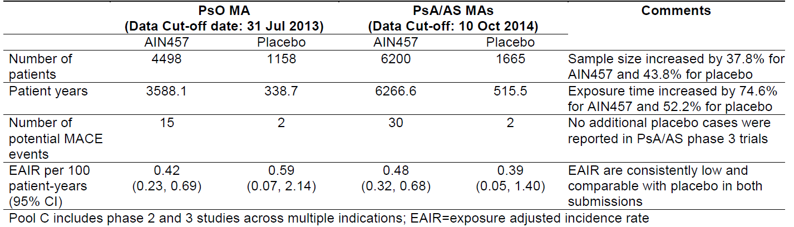
During the Phase III placebo controlled period, in 3,444 patients exposed to SEK across indications, there are 6 (0.2%) MACE cases (Table 11). During the entire treatment period, the overall exposure for SEK across indications is 3,915.6 patient years (PY) and the number of confirmed MACE events is 19. The absence of MACE events in the placebo group in the Phase III program may be explained by the short treatment duration on placebo (12 weeks in PsO and 16/24 weeks in PsA/AS) and relatively much smaller exposure time (351.3 PY) compared to SEK (3,911.6 PY), which is over 11 time greater than placebo. Of note, in the Pool C safety database (safety pool of Phase II and 3 studies across multiple indications), two confirmed MACE cases on placebo were reported.
Table 11. Incidence rate of confirmed MACE cases by indication and combined in Phase III studies.
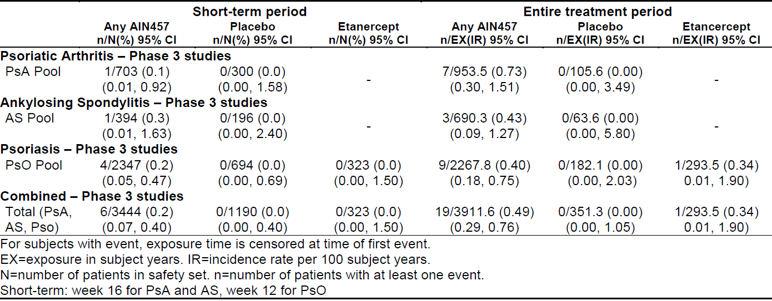
Studies have associated psoriasis, PsA and AS within an increased risk of severe outcomes including an elevated 10 year risk of MACE. Similar to the medical assessment of MACE events in the psoriasis MA, a review of relevant medical information found that all patients with MACE events had one or more common CV risk factors in addition to their underlying inflammatory conditions.
Table 11 shows that the number of MACE cases with SEK in Phase III studies is small and the 95% confidence intervals of the incidence rates (IR) largely overlap with placebo across indications. Therefore, the observed numerical imbalance in the incidence of MACE events is not considered clinically meaningful.
Importantly, even though no additional MACE events on placebo were reported in the Phase III programs during this MA, the EAIR of confirmed MACE events based on the large pooled safety database (Pool C) is comparable between SEK (0.40, 95% CI 0.26-0.59) and placebo (0.39, 95% CI 0.05-1.40), confirming the assessment of no increased risk for MACE, as presented in the psoriasis MA.
In order to put the observed numerical imbalances into proper context, the study design features for SEK programs and the background incidence rates in the disease populations must be considered.
Across PsO, PsA and AS clinical studies, the number of patients randomised to placebo was relatively small and virtually all patients were switched to SEK after 12 weeks (psoriasis) or 16/24 weeks (PsA and AS). Due to this study design, there is a large differential difference in exposure time between SEK and placebo. As shown in Table 11, the amount of patient exposure for SEK is over 11 fold greater than placebo. This difference is important to note for a population that has an increased risk of developing MACE independent of SEK treatment. This artefact was already observed in the psoriasis program due to the nature of study design.
From the clinical epidemiologic perspective, the exposure adjusted incidence rates of MACE (Table 11) are within the expected background incidence rates in this group of patients who are known to have an increased risk for MACE in published literature.
- The observed IR of confirmed MACE in psoriasis patients treated with SEK is 0.40 per 100 PY. No dose dependence for SEK was observed. Specifically, when analysis by event type was conducted, the IR are comparable between SEK and the study by Ogdie et al. (a large population based study involving 138,424 psoriasis patients) for myocardial infarction (MI) (SEK: 0.22 per 100 PY versus 0.23 per 100 PY), for stroke (SEK 0.18 per 100 PY versus 0.25 per 100 PY) and for CV death (SEK 0.00 per 100 PY versus 0.23 per 100 PY).
- The observed IR of confirmed MACE in PsA patients treated with SEK is 0.73 per 100 PY. Specifically, when analysis by event type was conducted, the IR are comparable between SEK and the study by Ogdie et al. (a large population based study involving 8,706 PsA patients) for MI (SEK: 0.31 per 100 PY vs. 0.28 per 100 PY), for stroke (SEK 0.42 per 100 PY vs. 0.26 per 100 PY) and for CV death (SEK 0.10 per 100 PY versus 0.19 per 100 PY).
- The observed IR of MACE in AS patients treated with SEK is 0.43 per 100 PY (95% CIs 0.09-1.27). Of the 3 MACE cases, two are myocardial infarction and one is a case of stroke. Although a systematic search of the literature did not identify any epidemiological studies examining the incidence rate of the composite MACE events in AS patients, a recent meta analysis of 11 studies involving 27,532 AS patients and 1,349,964 controls showed that the incidence rate of MI in AS was 0.36 per 100 PY and the incidence rate of stroke was 0.24 per 100 PY. This is similar to that observed with SEK for MI (0.29 per 100 PY) and stroke (0.14 per 100 PY).
Additionally, based on a review of change in post treatment blood pressure, there is no evidence to suggest that treatment with SEK had any effect on blood pressure when compared to placebo (Table 12).
Table 12. Post baseline changes in cholesterol, triglycerides and blood pressure in psoriasis (PsO), PsA, and AS.
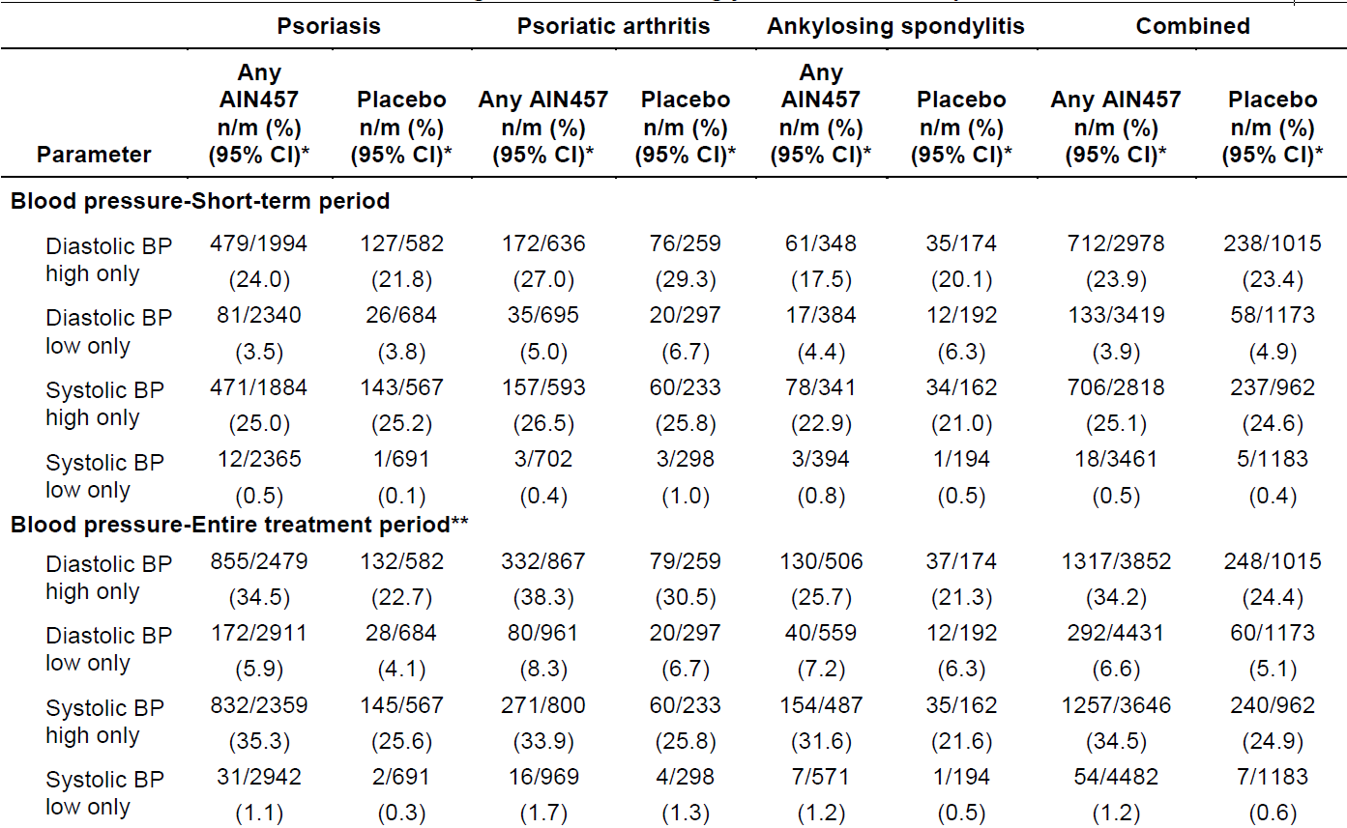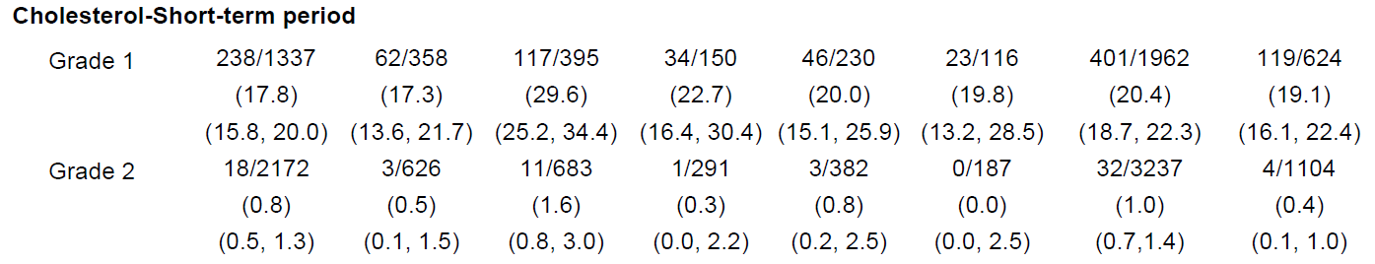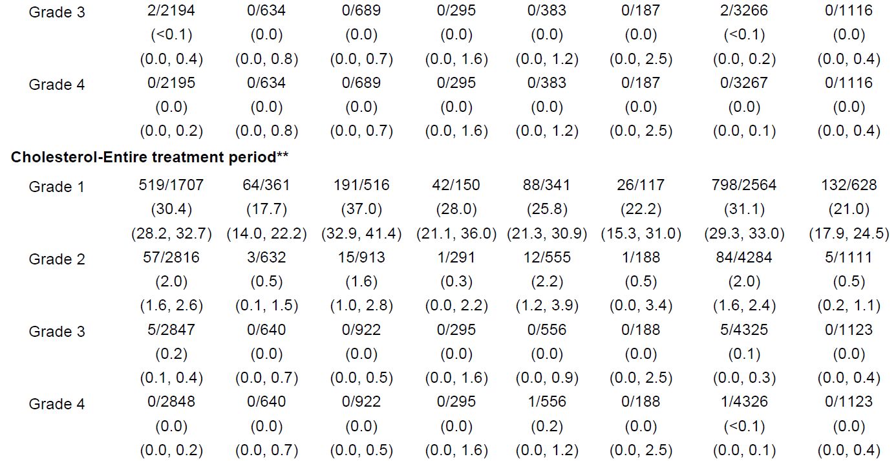
Table 12. Post-baseline changes in cholesterol, triglycerides and blood pressure in psoriasis (PsO), PsA, and AS.
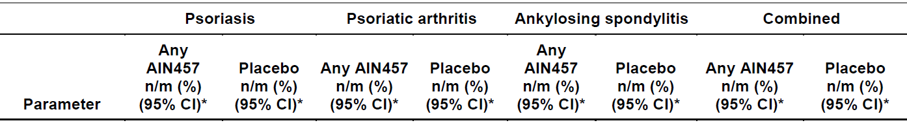
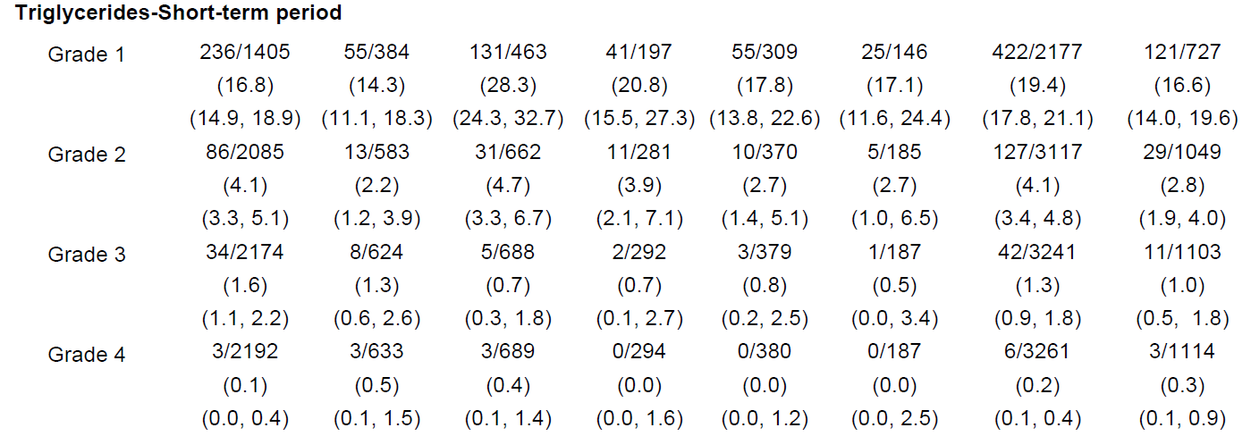
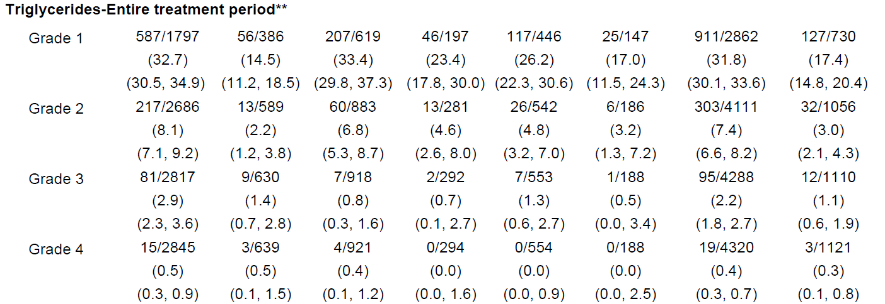
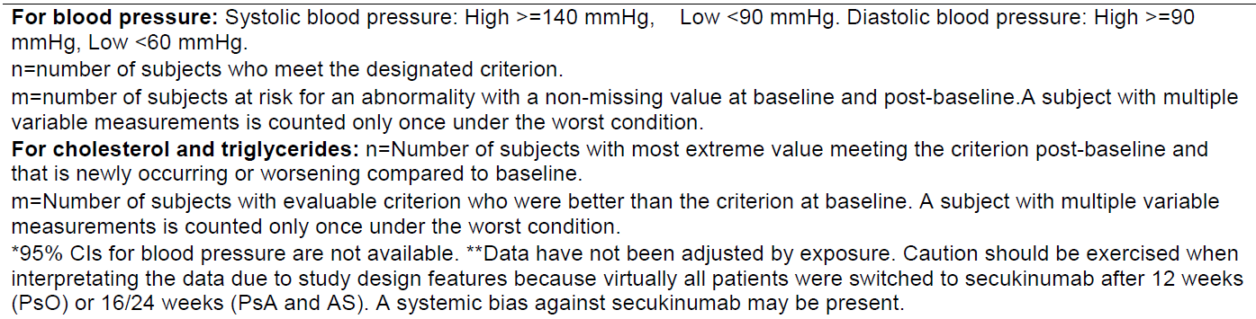
It is important to note that a higher proportion of patients with baseline dyslipidemia/hyperlipidemia and other CV risk factors were randomised to SEK than to placebo in psoriasis trials (Table 13). Although some numerical imbalances in post treatment cholesterol and triglycerides were observed between SEK and placebo (mainly in psoriasis and PsA clinical trials), the differences are not considered clinically meaningful because the 95% confidence intervals largely overlap between the two groups, were inconsistently seen between PsO/PsA and AS and primarily in grade 1 or 2 (Table 12).
Table 13. Presence of CV risk factors at baseline in PsO, PsA and AS phase I clinical trials.
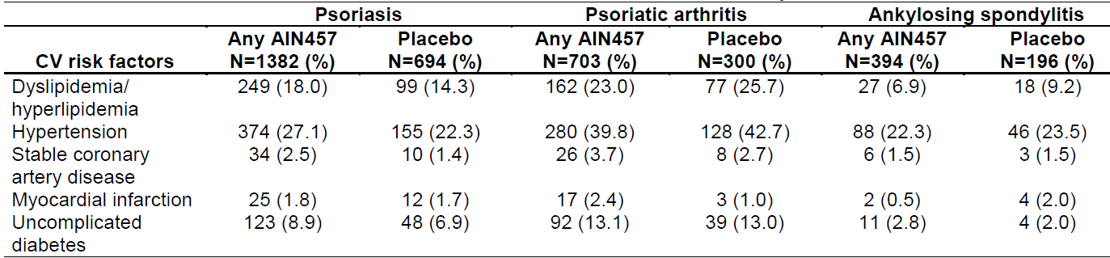
In conclusion, based on a comprehensive review of clinical safety data across indications, the weight of the current evidence does not suggest that SEK increases the risk of MACE. The observed numerical imbalances in the IR of MACE across indications are not considered clinically meaningful, and therefore are not warranted for inclusion in the PI. As an important potential risk in SEK RMP, MACE will continue to be closely monitored, evaluated and presented in PSURs. The assessment of MACE cases from post marketing experience does not reveal any change to the existing safety profile of Cosentyx. In addition to routine pharmacovigilance, Novartis is conducting a large disease registry to assess the long term (>8 years) potential risk of MACE for patients receiving Cosentyx (>3,000) in comparison with cohorts exposed to other biologic and non biologic treatments for psoriasis (including patients with concomitant PsA). The information from this ongoing registry will be included in future SEK PSURs.
Similarly, the observed numerical imbalances in cholesterol/triglycerides seen in PsO/PsA are not considered clinically relevant. The current data do not justify inclusion in the Cosentyx RMP or in the PI. This topic will continue to be routinely monitored, evaluated and presented in ongoing clinical programs and future clinical studies for SEK.
- (Q2) Please provide a summary table from the entire duration of the Phase III studies of PsA, AS and psoriasis (listed separately and combined) of changes in liver function tests comparing SEK and placebo.
A comprehensive analysis of SEK liver function tests (LFT) of the Phase III studies of PsA, AS and psoriasis showed no clinically meaningful differences to placebo in both the shortterm (placebo controlled period) and entire duration compared to placebo. There were no newly occurring or worsening CTCAE Grade 4 elevations with SEK across the threeindications. Importantly, despite approximately 11 fold longer exposure to SEK across the PsA, AS and PsO trials for the entire study periods they were no clinically meaningful differences to placebo for CTCAE Grade 1, 2 or 3 elevations. Importantly none of the CTCAE Grade 1, 2 or 3 elevations translated into a higher incidence of hepatic adverse events (AEs) and no Hy’ s law cases were observed when employing the FDA DILI guidance. The majority of elevations observed with any SEK and placebo regimens were transient Grade 1 (>ULN-3xULN). Grade 1 elevations are recognised as common and nonspecific, thus the mild LFT elevations noted are not considered to have any clinical implications on SEK hepatobiliary safety. In summary, the cumulative data from the Phase III trials does not support the addition of LFT in the adverse reaction section in the PI nor in the list of important potential risks in the RMP. Please note that the topic of patients with severe hepatic impairment is already listed in the EU RMP as important missing information and is subject to close monitoring, evaluation and reporting in future PSURs.
A summary of the LFTs from PsA, AS, PsO individual studies and pooled analysis of the LFT elevations looking at number (%) of subjects with newly occurring or worsening by CTCAE grades during the placebo controlled period and the entire treatment period is presented below.
Overall in the pooled indications dataset and in the individual indications (PsA, AS and PsO), for both the short term placebo controlled period (12 or 16 week) and entire treatment period, no Grade 4 LFT abnormalities were observed on SEK or placebo. Also, there were no clinically meaningful differences between SEK and placebo for Grade 2 and 3.

Pooled PsA, AS and psoriasis
Pool PsA, AS and psoriasis Phase III studies Number (%) of subjects with newly occurring or worsening CTCAE grades short term and over the entire treatment period are presented in Tables 14 and 15. It is noteworthy that comparisons of absolute incidence rates versus placebo over the entire treatment period are to be interpreted in the context of the approximately 10 fold longer exposure time for SEK relative to placebo.
- Although there was slight numerical difference of 3.7% in the incidence rate of Grade 1 for ALT elevations between Any AIN457 and placebo, when Grade 2 or higher 95% CIs were compared, there was a significant overlap between Any AIN457 and placebo suggesting the observed small numerical difference was not statistically significant. For Grade 3 and 4 elevations for the entire treatment period, the incidence rates between Any AIN457 and placebo were identical irrespective of the lower placebo exposure.
Table 14. Number (%) of subjects with newly occurring or worsening Common Terminology Criteria for Adverse Events (CTCAE) grades – Short term period – PsA, AS, PsO Phase III studies.
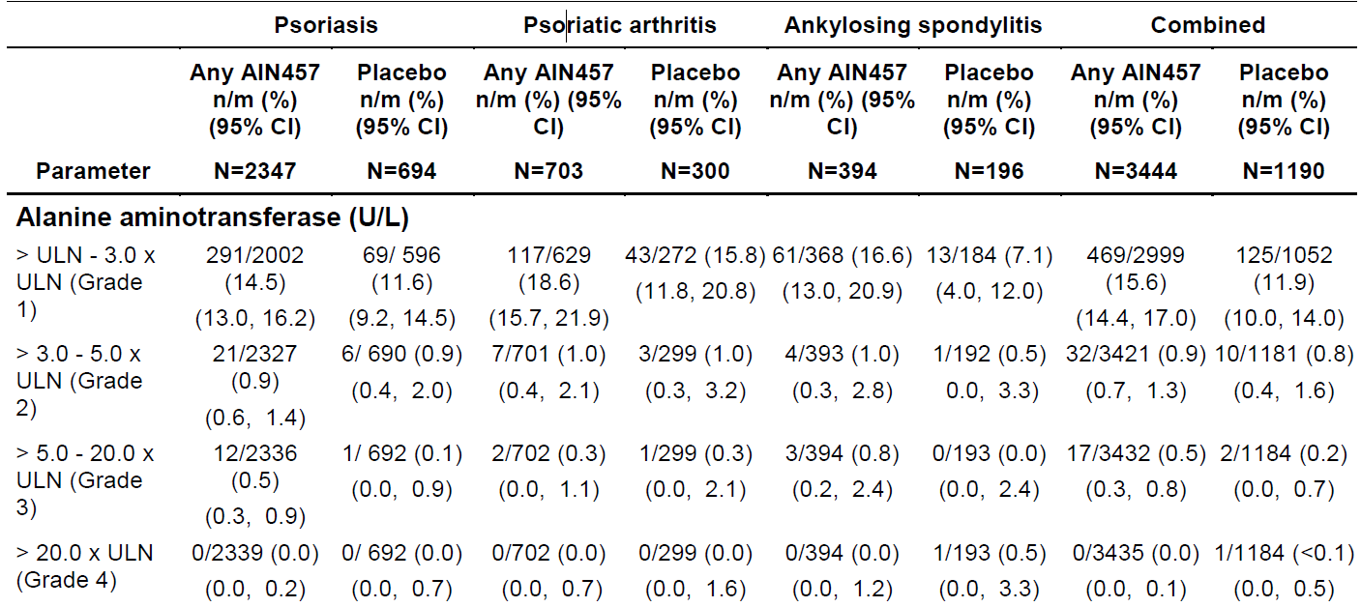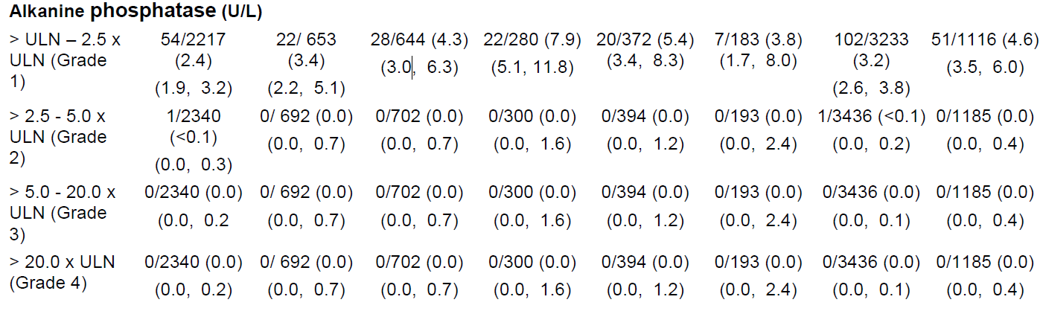
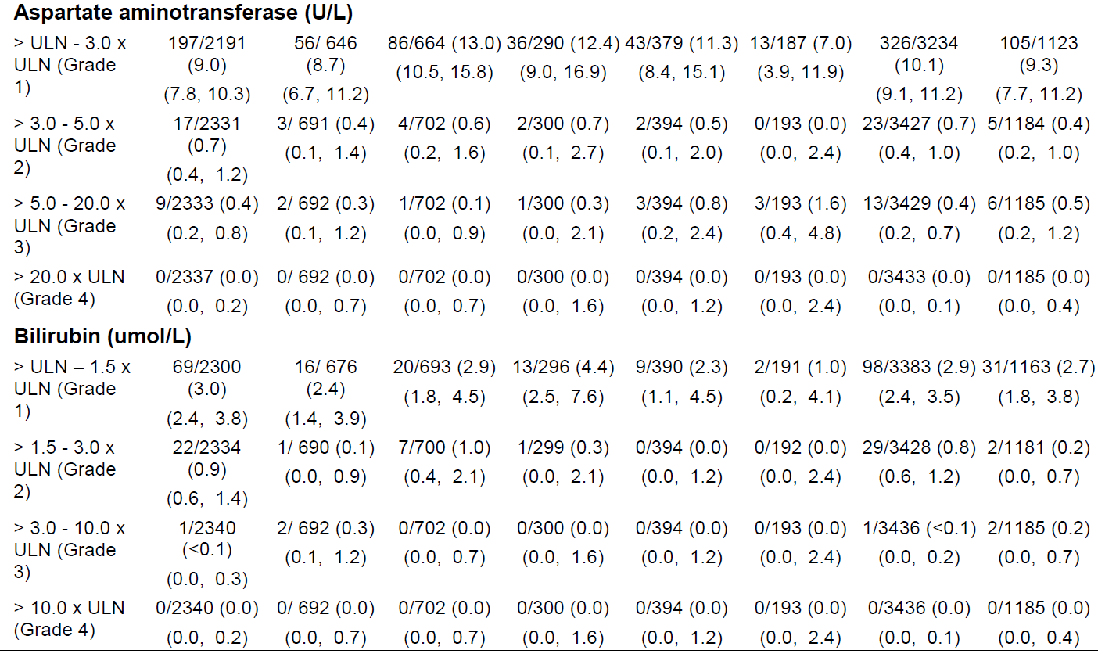
LLN = lower limit of normal, ULN = upper limit of normal.
n = Number of subjects with most extreme value meeting the criterion post-baseline and that is newly occurring or worsening compared to baseline.
m = Number of subjects with evaluable criterion who were better than the criterion at baseline.
A subject with multiple variable measurements is counted only once under the worst condition.
Table 15. Number (%) of subjects with newly occurring or worsening CTCAE grades – Entire treatment period – PsA, AS, PsO Phase III studies.
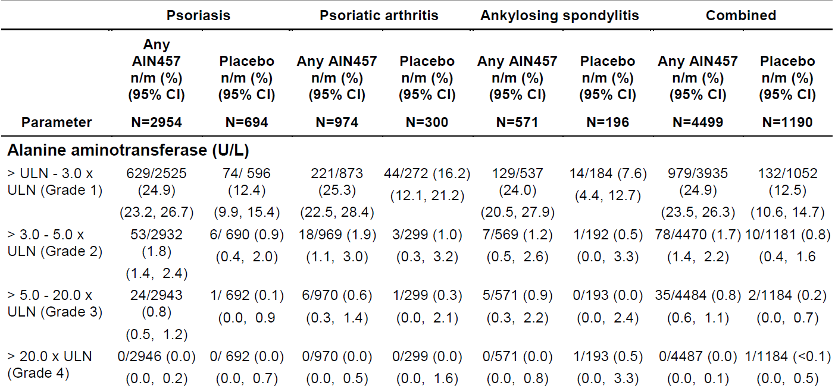
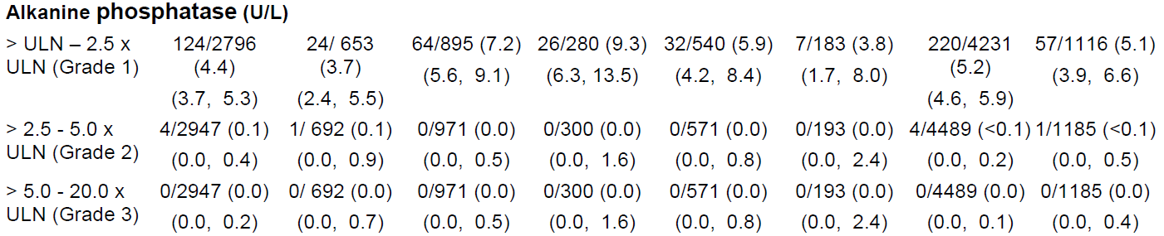
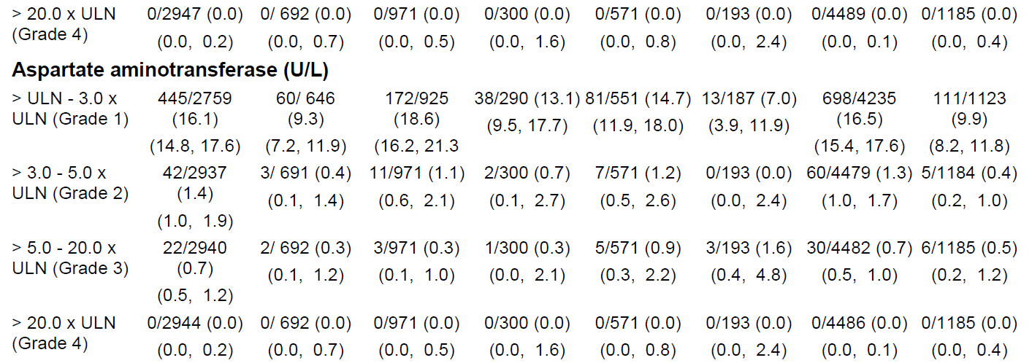
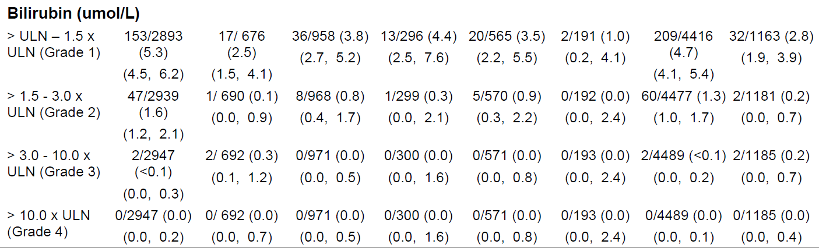
LLN = lower limit of normal, ULN = upper limit of normal.
n = Number of subjects with most extreme value meeting the criterion post-baseline and that is newly occurring or worsening compared to baseline.
m = Number of subjects with evaluable criterion who were better than the criterion at baseline.
A subject with multiple variable measurements is counted only once under the worst condition.

Psoriatic arthritis
Pool A - PsA Phase III studies Number (%) of subjects with newly occurring or worsening CTCAE grades short term and entire treatment period are presented in Tables 14 and 15.
- A thorough review of the Grade 1 or 2 cases either continued as Grade 1 or 2 or returned to normal levels, during SEK treatment.
- Although there was a slight numerical difference of 2.8% in the incidence rate of Grade 1 compared to placebo at short term, the 95% CI overlap suggesting the observed small numerical difference was not statistically significant. For Grade 2 and above, the incidence rates between Any AIN457 and placebo were identical. Similar conclusions can be made for the entire treatment period taking into account the approximately 10-fold longer exposure time for SEK relative to placebo.

Ankylosing spondylitis
- Pool A - AS Phase III studies Number (%) of subjects with newly occurring or worsening CTCAE grades short term and entire treatment period are presented in Tables 14 and 15.
- Grade 1, 2 and higher ALT elevations did not translate into a higher incidence of hepatic AEs. The majority of the Grade 1 ALT elevations in both the Pool A Phase III AS studies either continued as Grade 1 or returned to normal levels, during SEK treatment. The numerical differences seen in the mild ALT elevations are not considered to have any clinical implications on hepatobiliary safety.
- Although there was a difference of 9.5% in the incidence rate of Grade 1 ALT between Any AIN457 and placebo, for the more clinically relevant Grade 2 and above ALT abnormalities, the incidence rates between Any AIN457 and placebo were comparable and the 95% CI overlap suggesting no statistically difference between SEK and placebo (Tables 14 and 15). Similar conclusions can be made for the entire treatment period taking into account the approximately 10 fold longer exposure time for SEK relative to placebo.

Psoriasis
Pool A - PsO Phase III studies Number (%) of subjects with newly occurring or worsening CTCAE grades short term and entire treatment period are presented in Tables 14 and 15.
- Although there was slight numerical difference of 2.9 % in the incidence rate of Grade 1 for ALT between Any AIN457 and placebo, when 95% CIs were compared, there was a significant overlap between Any AIN457 and placebo suggesting the observed small numerical difference was not statistically significant. For Grade 2 and above, the incidence rates between Any AIN457 and placebo were identical. Similar conclusions can be made for the entire treatment period taking into account the approximately 11- fold longer exposure time for SEK relative to placebo.
In conclusion the clinical trial data pertaining to LFTs and specifically the small differences in CTACE Grade 1 and 2 elevations between SEK and placebo which were transient bear no clinical relevance on the overall hepatobiliary safety of SEK in the PsA, AS and psoriasis clinical programs. Since the Grade 1 and 2 LFT elevations did not translate into a higher incidence of hepatic AEs and no Hy’s law cases were observed, the mild LFT elevations are not considered to have any clinical implications on hepatobiliary safety. In summary, the cumulative data from the Phase III trials does not support the addition of LFT abnormalities in the adverse reaction section in the PI nor in the list of important potential risks in the RMP.

Novartis’ comments on other issues raised by the delegate

Data deficiencies
Both PsA and AS studies had some caveats to the general application of the treatment population. For example, all studies excluded patients who were at a significant risk of infection or malignancy, or who had various abnormal laboratory results at baseline (for example, abnormal haematology or liver function tests). The AS studies also excluded patients with a history of inflammatory bowel disease and uveitis (conditions which are co-morbidities in ~10% of the target population). SEK has not been studied in patients <18 years of age, in subjects with significant organ dysfunction (including renal, hepatic or cardiac failure) and in pregnant or lactating women.
Novartis acknowledges the Delegate`s comment. It should be noted that the eligibility criteria for the AS and PsA SEK programs were more inclusive than for biologic development programs already registered in Australia for these indications, in that patients with a prior cardiovascular history or stable inflammatory conditions (e.g. uveitis, IBD or psoriasis) were permitted to enrol. Only patients with active ongoing inflammatory bowel disease (IBD) or uveitis were excluded. In the AS pivotal Phase III studies, 15, 96 and 39 patients with a previous history of IBD, uvetis or psoriasis, respectively, were enrolled. In addition, as requested by TGA, the exclusion and inclusion criteria for the clinical studies were added in the PI to accurately reflect the study populations.
For this reason, we believe that the SEK studies results are more generally applicable to the population requiring such a therapy than other programs from biologics currently approved in these indications.

Proposed ‘conditions of registration’
- The implementation in Australia of the EU RMP for Cosentyx (SEK), version 2.1, dated 8 October 2015, with the ASA, version 4.0, dated 30 November 2015, and the responses in the pre ACPM response, and any subsequent revisions, as agreed with TGA.
Novartis agrees to the implementation in Australia of the EU RMP for Cosentyx version 2.1 amended with the changes agreed upon with TGA during evaluation.
- The following study reports must be submitted to the TGA, in addition to those identified and/or agreed in the RMP/ASA, as soon as possible after completion, for evaluation: Studies F2306 and F2312 for PsA, and Studies F2305 and F2310 for AS.
Novartis herewith commits to submit post approval the final clinical study reports of the abovementioned studies as soon as possible after completion.

Concluding remarks
Based on a comprehensive review of clinical safety data of separate and combined studies across indications, the weight of the current evidence does not suggest that SEK treatment increases the risk of MACE events, the risk factors for MACE, nor clinically significant liver enzyme increases. Novartis believes that the current data reflected in the PI sufficiently address these concerns. Moreover, it is acknowledged that these are important potential risks in the treatment, and these will continue to be routinely monitored, evaluated and presented in ongoing clinical programs, future clinical studies, RMP, and the PSUR for SEK. Novartis welcomes the Delegate’s recommendation to approve the extension of the indication of SEK for use in adult patients with active PsA and active AS, and commits to fulfil any post approval conditions of registration identified this response.

Advisory committee considerations
The ACPM, taking into account the submitted evidence of efficacy, safety and quality, agreed with the Delegate and considered Cosentyx/Zafrez powder for injection, pre-filled syringe and pen containing 150 mg/1mL of SEK to have an overall positive benefit-risk profile for the Delegate’s amended indications:
Psoriatic arthritis:
Cosentyx is indicated for the treatment of adult patients with active psoriatic arthritis when the response to previous disease-modifying anti-rheumatic drug (DMARD) therapy has been inadequate.
Ankylosing spondylitis:
Cosentyx is indicated for the treatment of adult patients with active ankylosing spondylitis.
In making this recommendation, the ACPM:
- was of the view that the statement regarding use of Cosentyx with or without methotrexate in the sponsor’s proposed indication was more appropriate in the Dosage section of the PI. The ACPM noted that the sponsor had agreed in the pre- ACPM response to the Delegate’s amended indication.

Proposed conditions of registration
The ACPM agreed with the Delegate on the proposed conditions of registration and advised on the inclusion of the following:
- major adverse cardiovascular events, dyslipidaemia and elevated transaminases should be added to the RMP/ASA as important potential risks.

Proposed PI/CMI amendments
The ACPM agreed with the delegate to the proposed amendments to the PI and CMI and specifically advised on the inclusion of the following:
- the risk of MACE, dyslipidaemia and elevated transaminases should be added to the PI to inform physicians of the potential risk.

Specific advice
The ACPM advised the following in response to the Delegate’s specific questions on this submission:
- Does the committee consider that there is a cardiovascular risk with SEK and if so to what extent and how should this be addressed in the PI/CMI? Should this be added as an important potential risk to the RMP/ASA?
The ACPM noted that the studies provided by the sponsor were not designed to determine a difference in MACE and cannot be extrapolated from the data. The ACPM noted that the sponsor’s pre ACPM response provided evidence that after adjustment for exposure time to drug/placebo, no significant difference in MACE is observed between placebo and SEK. Further, event rates on SEK were comparable to published data on MACE rates in the studied population generally.
However, the ACPM advised that the numerical difference in observed MACE events between SEK and placebo groups is still an important signal and the submitted trials may underestimate the potential for MACE events as the duration of the placebo controlled period was only 16 weeks. Therefore, this warrants listing MACE as a potential risk in the PI and added as a potential risk to the RMP/ASA for careful monitoring until further evidence is presented that would allay concerns.
- To what extent is there an increased risk of dyslipidaemia and does the data indicate that it should be included in the RMP/ASA as an important potential risk?
The ACPM noted that the sponsor provided evidence in its pre ACPM response that SEK increases the risk of dyslipidaemia but that the sponsor did not consider this to be clinically relevant.
However, the ACPM advised that there is clear evidence that dyslipidaemia-associated cardiovascular risk is present even with mild derangements of lipid levels and that event rates are directly associated with lipid levels. Therefore, the ACPM considered these mild derangements in cholesterol levels to be clinically relevant.
The sponsor’s pre ACPM response also stated that some numerical imbalances in post treatment cholesterol and triglycerides observed between SEK and placebo were inconsistently seen between psoriasis/PsA and AS and were not clinically meaningful.
However, it was the view of the ACPM that this ‘inconsistency’ is most likely related to sample size and not any innate difference between subjects with psoriasis/PsA and AS.
The ACPM advised therefore that the potential risk of dyslipidaemia should be included in the PI as well as the RMP/ASA until further evidence is presented that would allay concerns.
- To what extent is there an increased risk of elevated liver transaminases and how should this be reflected in the PI/CMI? Should this be added as an important potential risk to the RMP/ASA?
The ACPM noted that although some Grade 1 liver function abnormalities resolved with continued treatment or continued as a Grade 1 abnormality and there were no Hy’s law cases observed, the ACPM advised that the PI should mention the potential for rises in transaminases for the information of physicians. The ACPM also advised that elevated liver transaminases should be added as a potential risk to the RMP/ASA.
The ACPM advised that implementation by the sponsor of the recommendations outlined above to the satisfaction of the TGA, in addition to the evidence of efficacy and safety provided would support the safe and effective use of these products.

Outcome
Based on a review of quality, safety and efficacy, TGA approved the registration of both Cosentyx and Zafrez containing secukinumab indicated for:
Psoriatic arthritis
    - Cosentyx/Zafrez is indicated for the treatment of adult patients with active psoriatic arthritis when the response to previous disease-modifying anti rheumatic drug (DMARD) therapy has been inadequate.
Ankylosing spondylitis
    - Cosentyx/Zafrez is indicated for the treatment of adult patients with active ankylosing spondylitis.
The full indications are now:
Plaque psoriasis
    - Cosentyx/Zafrez is indicated for the treatment of moderate to severe plaque psoriasis in adult patients who are candidates for systemic therapy of phototherapy.
Psoriatic arthritis
    - Cosentyx/Zafrez is indicated for the treatment of adult patients with active psoriatic arthritis when the response to previous disease-modifying anti rheumatic drug (DMARD) therapy has been inadequate.
Ankylosing spondylitis
    - Cosentyx/Zafrez is indicated for the treatment of adult patients with active ankylosing spondylitis.

Specific conditions of registration applying to these goods
- The Cosentyx/Zafrez RMP, version 2.1, dated 8 October 2015, with the ASA version 4.0, dated 30 November 2015, and the sponsor's responses in the pre ACPM response (dated 15 March 2016) and the sponsor’s responses to the post ACPM PI negotiations (emails of 20 April 2016 and 28 April 2016) and any subsequent revisions, as agreed with TGA will be implemented in Australia.

Attachment 1. Product Information
The PI approved for Cosentyx/Zafrez at the time this AusPAR was published is at Attachment 1. For the most recent PI, please refer to the TGA website at <https://www.tga.gov.au/product-information-pi>.

Attachment 2. Extract from the Clinical Evaluation Report

Therapeutic Goods Administration
PO Box 100 Woden ACT 2606 Australia
Email: info@tga.gov.au Phone: 1800 020 653 Fax: 02 6232 8605
https://www.tga.gov.au

European Medicines Agency, “Guideline on Clinical Investigation of Medicinal Products for the Treatment of Psoriatic Arthritis (CPMP/EWP/438/04)”, 5 February 2008; European Medicines Agency, “Guideline on Clinical Investigation of Medicinal Products for the Treatment of Ankylosing Spondylitis (CPMP/EWP/4891/03)”, 23 February 2010.
In the submission package, the sponsor provided the Week 52 Clinical Study Report (CSR) for Study F2306, but only the Week 24 CSR for Study F2312.
Mease PJ. Psoriatic Arthritis: update on pathophysiology, assessment and management. Ann Rheum Dis. 70: i77-i84 (2011).
Kirkham BW, et al. Interleukin-17A: a unique pathway in immune-mediated diseases: psoriasis, psoriatic arthritis and rheumatoid arthritis. Immunology 141: 133-42 (2014); McInnes IB, et al. Efficacy and safety of secukinumab, a fully human anti-interleukin-17A monoclonal antibody, in patients with moderate-to-severe psoriatic arthritis: a 24-week, randomised, double-blind, placebo-controlled, phase II proof-of-concept trial. Ann Rheum Dis. 73: 349-56 (2014);
van der Linden S, et al. Evaluation of diagnostic criteria for ankylosing spondylitis. A proposal for modification of the New York criteria. Arthritis Rheum. 27: 361-8 (1984).
European Medicines Agency, “Guideline on Clinical Investigation of Medicinal Products for the Treatment of Psoriatic Arthritis (CHMP/EWP/438/04)”, 14 December 2006.
European Medicines Agency, “Guideline on Clinical Investigation of Medicinal Products for the Treatment of Psoriatic Arthritis (CHMP/EWP/438/04)”, 14 December 2006.
European Medicines Agency, “Points to consider on the clinical investigation of medicinal products other than NSAIDS in rheumatoid arthritis (CPMP/EWP/556/95 Rev. 1)”, 29 January 2007.
European Medicines Agency, “Guideline on Clinical Investigation of Medicinal Products for the Treatment of Ankylosing Spondylitis (CPMP/EWP/4891/03)”, 23 April 2009.
For Study F2312, the Week 24 CSR was included in the submission.
European Medicines Agency, “Guideline on Clinical Investigation of Medicinal Products for the Treatment of Psoriatic Arthritis (CPMP/EWP/438/04)”, 5 February 2008.
In Study F2310, all placebo patients were re-randomized at Week 16 to active treatment.
European Medicines Agency, “Guideline on Clinical Investigation of Medicinal Products for the Treatment of Ankylosing Spondylitis (CPMP/EWP/4891/03)”, 23 February 2010.
Up to Week 16 or Week 24, depending on response status.
Ogdie A, et al. Extended report: Risk of major cardiovascular events in patients with psoriatic arthritis, psoriasis and rheumatoid arthritis: a population-based cohort study. Ann Rheum Dis. 74: 326-32 (2015); Mathieu S, et al. Cardiovascular events in ankylosing spondylitis: an updated meta-analysis. Semin Arthritis Rheum. 44: 551-5 (2015).
Ogdie A, et al. Extended report: Risk of major cardiovascular events in patients with psoriatic arthritis, psoriasis and rheumatoid arthritis: a population-based cohort study. Ann Rheum Dis. 74: 326-32 (2015); Mathieu S, et al. Cardiovascular events in ankylosing spondylitis: an updated meta-analysis. Semin Arthritis Rheum. 44: 551-5 (2015).
Ogdie A, et al. Extended report: Risk of major cardiovascular events in patients with psoriatic arthritis, psoriasis and rheumatoid arthritis: a population-based cohort study. Ann Rheum Dis. 74: 326-32 (2015).
Ogdie A, et al. Extended report: Risk of major cardiovascular events in patients with psoriatic arthritis, psoriasis and rheumatoid arthritis: a population-based cohort study. Ann Rheum Dis. 74: 326-32 (2015).
Mathieu S, et al. Cardiovascular events in ankylosing spondylitis: an updated meta-analysis. Semin Arthritis Rheum. 44: 551-5 (2015).
FDA Guidance for industry, “Drug-Induced Liver Injury: Premarketing Clinical Evaluation”, July 2009.
Baeten D, Secukinumab, an Interleukin-17A Inhibitor, in Ankylosing Spondylitis. N Engl J Med. 373: 2534-48 (2015).

