KANUMA®

NAME OF THE MEDICINE

KANUMA®
Sebelipase alfa rce solution for IV infusion.

Figure 1: Structure of sebelipase alfa rce
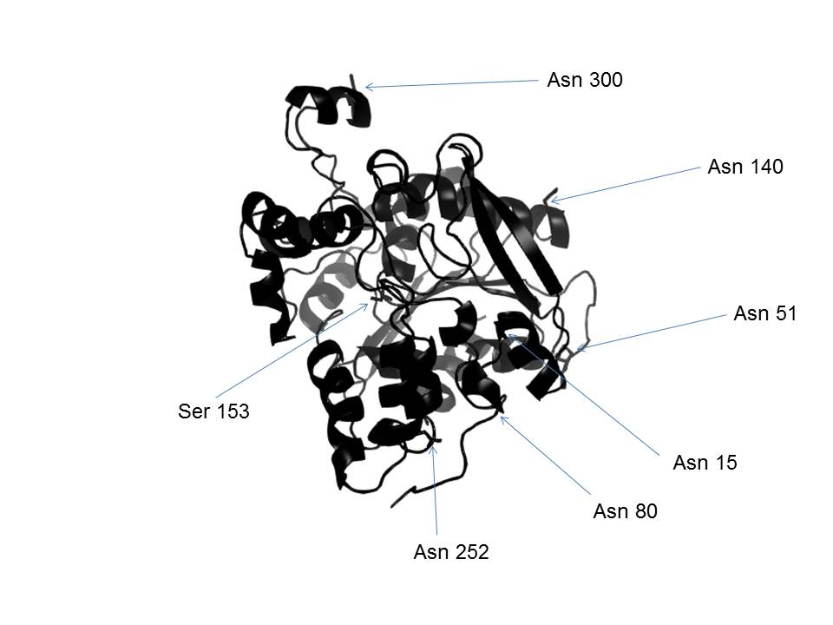
(CAS registry number: 1276027-63-4).
DESCRIPTION
KANUMA is supplied as a single-use vial containing 20 mg of sebelipase alfa rce (2 mg/mL) with the following excipients; sodium citrate, citric acid monohydrate, albumin and water for injections.

Sebelipase alfa rce is a recombinant human lysosomal acid lipase (rhLAL) produced by recombinant DNA technology and purified from the egg white of genetically engineered chickens {transgenic Gallus}. Purified sebelipase alfa rce is a monomeric glycoprotein containing 6 N-linked glycosylation sites with a molecular weight of approx. 55 kDa.
PHARMACOLOGY

Mechanism of Action
Lysosomal Acid Lipase Deficiency (LAL-D) is a rare disease associated with significant morbidity and mortality affecting individuals from infancy through to adulthood. LAL-D presenting in infants is a medical emergency with rapid disease progression over a period of weeks that is typically fatal within the first 6 months of life.

LAL-D is an autosomal recessive lysosomal storage disorder characterised by a genetic defect resulting in a marked decrease or loss in activity of the lysosomal acid lipase (LAL) enzyme. Deficient LAL enzyme activity results in progressive complications due to the lysosomal accumulation of cholesteryl esters and triglycerides in multiple organs, including the liver, spleen, intestine, and the walls of blood vessels. The resulting lipid accumulation in the liver leads to hepatomegaly, increased hepatic fat content, transaminase elevation signaling chronic liver injury, and progression to fibrosis, cirrhosis, and complications of end stage liver disease. In the spleen, LAL deficiency results in splenomegaly, anaemia, and thrombocytopenia. Lipid accumulation in the intestinal wall leads to malabsorption and growth failure. In parallel, dyslipidemia due to impaired degradation of lysosomal lipid is common with elevated low-density lipoprotein cholesterol (LDL-c) and triglycerides, and low high-density lipoprotein cholesterol (HDL-c). In addition to liver disease, patients with LAL-D experience increased risk for cardiovascular disease and accelerated atherosclerosis.

Sebelipase alfa rce is taken up by cells and is subsequently internalized into lysosomes where it catalyzes the lysosomal hydrolysis of cholesteryl esters and triglycerides to free cholesterol, glycerol and free fatty acids. Binding of glycans present on sebelipase alfa rce, to cell surface receptors is implicated in the cellular uptake of sebelipase alfa rce. Treatment with sebelipase alfa rce restores LAL enzyme activity in LAL-D cells, enabling hydrolysis of cholesteryl esters and triglycerides in the lysosome. Sebelipase alfa rce treatment restored hepatic LAL activity and lead to reductions in the fat content of the liver and spleen; reductions in serum transaminases, LDL-c, non-HDL-c, and triglycerides; and increases in serum HDL-c. Improvement in growth was associated with LAL substrate reduction in the intestine.

Pharmacodynamics
In clinical trials, after initiation of dosing with sebelipase alfa rce, breakdown of accumulated lysosomal lipid led to initial increases in LDL-c and triglycerides within the first 2 to 4 weeks of treatment. In general, following increases in LDL-c and triglycerides, these parameters decreased to below pre-treatment values within 8 weeks of treatment with sebelipase alfa rce.

In all patients with elevated alanine aminotransferase (ALT) values at baseline (82 of 84 patients in clinical trials), reductions in ALT values were observed, generally within 2 weeks after initiation of treatment with sebelipase alfa rce. Treatment interruption resulted in increases in LDL-c and ALT values and decreases in HDL-c.

Pharmacokinetics
Based on a non-compartmental analysis of data from adults (LAL-CL01/LAL-CL-04), the pharmacokinetics of sebelipase alfa rce appeared to be nonlinear with a greater than dose-proportional increase in exposure observed between the 1 and 3 mg/kg dosages. No accumulation was seen at 1 mg/kg (once weekly or fortnightly) or 3 mg/kg per week.

The pharmacokinetics of sebelipase alfa rce in children and adults were determined using a population pharmacokinetic analysis of 65 patients with LAL-D who received fortnightly intravenous infusions of 1 mg/kg sebelipase alfa rce in LAL-CL02 (refer to Table 1). Twenty four patients were 4 to 11 years old, 23 were 12 to 17 years old, and 18 were adults (18 years and over). The pharmacokinetic profiles of sebelipase alfa rce were similar between adolescents and adults. The T_{max} and T_{1/2} were similar across all age groups.

Table 1: Mean Pharmacokinetics Parameters at Week 22^
Parameter | Study LAL-CL02 – paediatric and adults  1mg/kg per fortnight
Parameter | 4-11 years old | 12-17 years old | ≥18 years old
Parameter | n=24 | n=23 | n=18
AUC (ng∙hr/mL) | 941.6 | 1453.6 | 1861.0
C_{max} (ng/mL) | 489.6 | 783.6 | 957.0
T_{max} (hr) | 1.3 | 1.1 | 1.3
CL (L/hr) | 31.1 | 37.4 | 38.2
V_{c} (L) | 3.7 | 5.4 | 5.3
T_{1/2} (hr) | 0.1 | 0.1 | 0.1
^ Week 22 for placebo patients reset to Week 0, ie first week of active treatment
AUC = Area under the plasma concentration time curve at steady state. C_{max} = Maximum concentration. T_{max} = Time to maximum concentration. CL = Clearance. V_{c} = Central volume of distribution. T_{1/2} = Half-life.

The volume of distribution was low, consistent with limited distribution of sebelipase alfa rce into tissues. However, the pharmacology of sebelipase alfa rce and results of pharmacodynamic studies in vitro and in LAL-D rats are consistent with the fraction of sebelipase alfa rce that is taken up by cells distributing into a variety of tissues.

Pharmacokinetics in Special Populations
During the covariate analysis of the population pharmacokinetics model for sebelipase alfa rce, age, body weight, and sex were not found to have a significant influence on CL and V_{c} of sebelipase alfa rce. Sebelipase alfa rce has not been investigated in patients 2 to 4 years of age.

There is limited information on the impact of anti-drug antibodies on sebelipase alfa rce pharmacokinetics.

Infants (< 6 months of age)
In LAL-CL03, sebelipase alfa rce was eliminated from the systemic circulation with a median T_{1/2} of 0.1 hr (range: 0.1-0.2) at the 3 mg/kg per week dose (n = 4). The difference in exposures to sebelipase alfa rce between the once weekly 0.35 mg/kg and 3 mg/kg groups was more than dose proportional, with an 8.6-fold increase in dose resulting in a 9.6-fold increase in exposure for AUC and a 10.0-fold increase for C_{max}.

Renal and hepatic impairment
Sebelipase alfa rce is expected to be metabolically degraded through peptide hydrolysis. Consequently, impaired liver function is not expected to affect the pharmacokinetics of sebelipase alfa rce. There is a lack of data in patients with severe hepatic impairment.

Renal elimination of sebelipase alfa rce is considered a minor pathway for clearance. There is a lack of data in patients with renal impairment.
CLINICAL TRIALS
Infants presenting with LAL deficiency [LAL-CL03]
LAL-CL03 was a multicentre, open-label, single-arm study of sebelipase alfa rce in 9 patients with LAL-D with growth failure, or other evidence of rapidly progressive disease prior to 6 months of age. Patients had rapidly progressive liver disease and severe hepatosplenomegaly. The age range at study entry was 1-6 months. Patients received sebelipase alfa rce at 0.35 mg/kg per week for the first 2 weeks, and then 1 mg/kg per week. Based on clinical response, dose escalation to 3 mg/kg per week occurred as early as 1 month and up to 20 months after starting treatment at 1 mg/kg. A further dose escalation to 5 mg/kg per week was allowed.

Efficacy was assessed by comparing the survival experience of sebelipase alfa rce-treated patients who survived past 12 months of age in LAL-CL03 with a historical cohort of untreated infants presenting with LAL-D with similar clinical characteristics. In LAL-CL03, 6 of the 9 sebelipase alfa rce-treated infants survived beyond 12 months (67% 12-month survival; 95% CI: 30% to 93%). With continued treatment beyond 12 months of age, 1 additional patient died at age 15 months. In the historical cohort, 0 of 21 patients survived beyond 8 months of age (0% 12-month survival, 95% CI: 0% to 16%).

Sebelipase alfa rce at doses up to 1 mg/kg per week resulted in improvements in alanine aminotransferase (ALT) and aspartate aminotransferase (AST) levels and weight gain within the first several weeks of treatment. From baseline to week 48, the mean reductions for ALT and AST were -34.0 U/l and -44.5 U/l, respectively. Dose escalation to 3 mg/kg per week was associated with additional improvements in weight gain, lymphadenopathy and serum albumin. From baseline to week 48, mean weight-for-age percentile improved from 12.74% to 29.83% and mean serum albumin levels increased from 26.7 g/l to 38.7 g/l.

One infant was treated with 5 mg/kg per week; no new adverse reactions were reported at this dose. In the absence of more clinical data, this dose is not recommended.

Children and adults with LAL deficiency [LAL-CL02]
LAL-CL02 was a multicentre, double-blind, placebo-controlled study in 66 children and adults with LAL-D. Patients were randomised to receive a fortnightly sebelipase alfa rce dose of 1 mg/kg (n = 36) or placebo (n = 30) for 20 weeks in the double-blind period. The age range at randomisation was 4-58 years old (71% were < 18 years old). For study entry, patients were required to have ALT levels of ≥1.5 x upper limit of normal (ULN). The majority of patients (58%) had LDL-c > 4.91 mmol/L at study entry, and 24% of patients with LDL-c > 4.91 mmol/L were on lipid lowering medications. Of the 32 patients who had a liver biopsy at study entry, 100% had fibrosis and 31% had cirrhosis. The age range of patients with biopsy evidence of cirrhosis was 4-21 years old.

Randomisation was stratified by 1) age at randomisation (<12 years old; ≥12 years old); 2) ALT level at screening (<3 x ULN; ≥3 x ULN); and 3) use of lipid lowering medications (yes; no). The following endpoints were assessed: normalisation of ALT, decrease in LDL-c, decrease in non-HDL-c, normalisation of AST, decrease in triglycerides, increase in HDL-c, decrease in liver fat content assessed by multi-echo gradient echo magnetic resonance imaging (MEGE-MRI), and improvement in hepatic steatosis measured by morphometry.

Through an exploratory analysis, a statistically significant improvement in multiple endpoints was observed in the sebelipase alfa rce-treated group as compared to the placebo group at the completion of the 20-week double-blind period, as shown in Table 2. Normalisation of ALT was achieved in 31% (11/36) of sebelipase alfa rce-treated patients and 7% (2/30) of placebo patients. LDL-c normalisation (<3.36 mmol/L) was achieved in 40.6% (13/32) of sebelipase alfa rce-treated patients and 6.7% (2/30) of placebo patients with abnormal baseline LDL-c (≥3.36 mmol/L).

Patients treated with sebelipase alfa rce had larger reductions from baseline in ALT values and liver fat content (measured by MRI) compared to patients treated with placebo. The absolute reduction in mean ALT level was -57.9 U/l (-53%) in the sebelipase alfa rce-treated group and -6.7 U/l (-6%) in the placebo group.

Table 2: Primary and secondary efficacy endpoints in LAL-CL02
Endpoint | Sebelipase alfa  (n = 36) | Placebo  (n = 30) | P-value^{d}
Primary Endpoint
Normalisation of ALTª | 31% | 7% | 0.0271
Secondary Endpoints
LDL-c, mean % change from baseline | -28% | -6% | < 0.0001
non-HDL-c, mean % change from baseline | -28% | -7% | < 0.0001
Normalisation of AST^{b} | 42% | 3% | 0.0003
Triglycerides, mean % change from baseline | -25% | -11% | 0.0375
HDL-c, mean % change from baseline | 20% | -0.3% | < 0.0001
Liver fat content ^{c}, mean % change from baseline | -32% | -4% | < 0.0001
low-density lipoprotein cholesterol (LDL-c); high-density lipoprotein cholesterol (HDL-c); alanine aminotransferase (ALT); aspartate aminotransferase (AST).
ª Proportion of patients who achieved normalisation defined as 34 or 43 U/l, depending on age and gender.
^{b} Proportion of patients who achieved normalisation defined as 34-59 U/l, depending on age and gender. Evaluated in patients with abnormal baseline values (n = 36 for sebelipase alfa; n = 29 for placebo).
^{c} Evaluated in patients with MEGE-MRI assessments performed (n = 32 for sebelipase alfa; n = 25 for placebo).
^{d} P-values are from Fisher’s exact test for normalisation endpoints and Wilcoxon rank-sum test for all other endpoints.

Paired liver biopsies at baseline and week 20 were available in a subset of patients (n = 26). Of patients with paired liver biopsies, 63% (10/16) of sebelipase alfa rce-treated patients had improvement in hepatic steatosis (at least ≥ 5% reduction) as measured by morphometry compared to 40% (4/10) of placebo patients (Table 3). This difference was not statistically significant. Five of the 10 (50%) placebo patients with paired biopsies worsened from baseline compared to one of 16 (6%) in the sebelipase alfa rce-treated patients (p=0.0184).

Table 3: Change from Baseline to Last Visit in the Double-Blind Treatment Period in Liver Histopathology
Result at Last Visit in the Double-Blind Treatment Period | Sebelipase Alfa  (n = 19)  n (%) | Placebo  (n = 13)  n (%) | Difference (%) | P-valueª
N | 16 | 10
Endpoint improved from Baseline^{b} | 10 (63) | 4 (40) | 23 | 0.4216
Endpoint unchanged from Baseline^{b} | 5 (31) | 1 (10) | 21 | 0.3524
Endpoint worsened from Baseline^{b} | 1 (6) | 5 (50) | -44 | 0.0184
Overall distribution of results^{c} | 0.0454
ª Fisher’s exact test for treatment differences between the percentage of sebelipase alfa – placebo subjects.
^{b} P-value for this row compares proportion of subjects with this result vs any other result.
^{c} P-value for this row compares distribution of 3 possible results across treatment groups.

Open-label period
Sixty-five of 66 patients entered the open-label period (up to 130 weeks) at a fortnightly dose of 1 mg/kg sebelipase alfa rce. In patients who had received sebelipase alfa rce during the double-blind period, reductions in ALT levels during the first 20 weeks of treatment were maintained and further improvements were seen in lipid parameters including LDL-c and HDL-c levels. Four of 65 patients in the open label period were dose escalated to 3 mg/kg (per fortnight) based on clinical response.

Placebo patients had persistently elevated serum transaminase and abnormal serum lipid levels during the double-blind period. Consistent with what was observed in sebelipase alfa rce-treated patients during the double-blind period, initiation of treatment with sebelipase alfa rce during the open-label period produced rapid improvements in ALT levels and in lipid parameters including LDL-c and HDL-c levels (refer to Figure 2 and Figure 3).

Figure 2: Mean Change from Baseline in ALT Values over Time in LAL-CL02

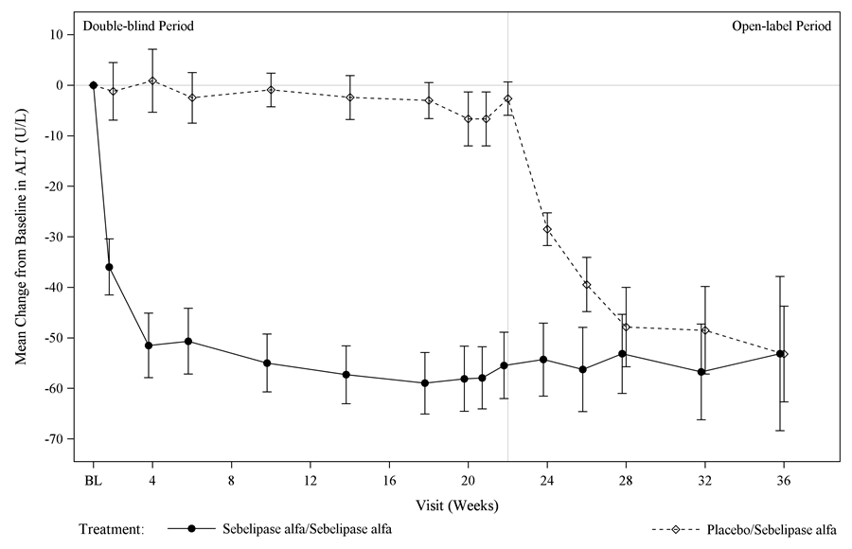

Figure 3: Mean Percent Change in Lipid Levels over Time in LAL-CL02
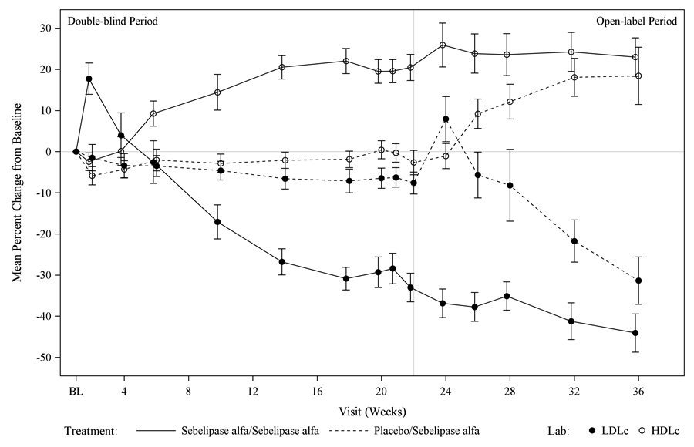
In a separate open-label study in adult patients with LAL-D (LAL-CL01/LAL-CL04; sebelipase alfa rce dosage of 0.35, 1, and 3 mg/kg per week for 4 weeks, followed by a period off treatment before entering an extension period receiving fortnightly dose of 1 or 3 mg/kg), improvements in serum transaminase and lipid levels were sustained through the 104-week treatment period. Increases in serum transaminases and LDL and decreases in HDL were observed during the period in which patients were off treatment with sebelipase alfa rce.
INDICATIONS
KANUMA (sebelipase alfa rce) is indicated for long-term enzyme replacement therapy (ERT) in patients of all ages with lysosomal acid lipase deficiency (LAL-D).
CONTRAINDICATIONS
KANUMA is contraindicated in patients with a life-threatening hypersensitivity (anaphylactic reaction) to the active substance, to egg, or to any of the excipients (see DESCRIPTION), when attempts to rechallenge are unsuccessful.
PRECAUTIONS

Hypersensitivity reactions, including anaphylaxis
Hypersensitivity reactions, including anaphylaxis, have been reported in sebelipase alfa rce-treated patients. In clinical trials, 3 of 106 (3%) patients treated with sebelipase alfa rce, including 1 of 14 (7%) infants and 2 of 92 (2%) children and adults, experienced signs and symptoms consistent with anaphylaxis. These patients experienced reactions during infusion with signs and symptoms including chest discomfort, conjunctival injection, dyspnoea, generalized and itchy rash, hyperaemia, swelling of eyelids, rhinorrhoea, severe respiratory distress, tachycardia, tachypnoea, and urticaria. Anaphylaxis has occurred as early as the sixth infusion and as late as 1 year after treatment initiation.

In clinical trials, 21 of 106 (20%) sebelipase alfa rce-treated patients, including 9 of 14 (64%) infants and 12 of 92 (13%) paediatric patients, 4 years and older, and adults, experienced signs and symptoms either consistent with, or that may be related to a hypersensitivity reaction. Signs and symptoms of hypersensitivity reactions, occurring in 2 or more patients, included abdominal pain, agitation, fever, chills, diarrhoea, eczema, oedema, hypertension, irritability, laryngeal oedema, nausea, pallor, pruritus, rash, and vomiting. The majority of reactions occurred during or within 4 hours of the completion of the infusion. Patients were not routinely pre-medicated prior to infusion of sebelipase alfa rce in these clinical trials.

Appropriate medical support should be readily available when sebelipase alfa rce is administered. If anaphylaxis occurs, immediately discontinue the infusion and initiate appropriate medical treatment. Patients should be closely observed during, and after the infusion. Inform patients of the signs and symptoms of anaphylaxis, and instruct them to seek immediate medical care should signs and symptoms occur.

The risks and benefits of re-administering sebelipase alfa rce following a severe reaction should be considered. For patients who have experienced allergic reactions during infusion, caution should be exercised upon re-administration.

The management of hypersensitivity reactions should be based on the severity of the reaction and may include temporarily interrupting the infusion, lowering the infusion rate, and/or treatment with antihistamines, antipyretics, and/or corticosteroids. If interrupted, the infusion may be resumed at a slower rate with increases as tolerated. Pre-treatment with antipyretics and/or antihistamines may prevent subsequent reactions in those cases where symptomatic treatment was required.

Hypersensitivity to Egg
Sebelipase alfa rce is produced in the egg white of transgenic Gallus by recombinant DNA technology. Patients with a known history of egg allergies were excluded from the clinical trials. Consider the risks and benefits of treatment with sebelipase alfa rce in patients with known life-threatening hypersensitivity (anaphylactic reaction) to egg.

Effects on Fertility
No adverse effects on fertility and reproductive performance were observed in male and female rats given IV doses of sebelipase alfa rce up to 60 mg/kg administered twice weekly (approximately 122 times the adult human AUC of 1861 ng.h/mL at 1 mg/kg dose administered fortnightly).

Use in Pregnancy – Category B1
Sebelipase alfa rce administered during the period of organogenesis to rats (on gestation days 6, 9, 12, 15 and 17) and rabbits (on gestation days 7, 10, 13, 16 and 19) at intravenous doses up to 60 and 50 mg/kg, respectively (approximately 122 and 392 times the human AUC of 1861 ng.h/mL at 1 mg/kg dose administered fortnightly, respectively) did not cause any adverse effects on embryofoetal development. A pre- and postnatal development study in rats showed no evidence of adverse effects on pre- and postnatal development at intravenous doses (administered on gestation days 6, 9, 12, 15, 18, and 20 and days 4, 7, 10, 14, and 17 postpartum) of sebelipase alfa rce up to 60 mg/kg/day (approximately 122 times the human AUC of 1861 ng.h/mL at 1 mg/kg dose administered fortnightly).

There are no available data on sebelipase alfa rce use in pregnant women. Pregnant and lactating women were excluded from sebelipase alfa rce clinical trials. As a precautionary measure, it is preferable to avoid the use of sebelipase alfa rce during pregnancy.

Use in Lactation
There are no data from studies in breast-feeding women. It is not known whether sebelipase alfa rce is excreted in human milk. A decision must be made whether to discontinue breast-feeding or to discontinue/abstain from sebelipase alfa rce treatment taking into account the benefit of breast-feeding for the child and the benefit of therapy for the woman.

Paediatric Use
Fifty six of 84 patients (67%) who received sebelipase alfa rce during clinical studies (LAL-CL01/LAL-CL04, LAL-CL02 and LAL-CL03) were in the paediatric and adolescent age range (1 month up to 18 years).

Use in the Elderly
Safety and efficacy of sebelipase alfa rce in patients older than 65 years have not been established. Therefore, there is no information available to determine whether patients aged 65 years and over respond differently from younger patients.

Genotoxicity
No studies have been conducted to assess the genotoxic potential of sebelipase alfa rce. This is considered acceptable for biotechnology-derived products such as KANUMA.

Carcinogenicity
No studies have been conducted to assess the carcinogenic potential of sebelipase alfa rce. This is considered acceptable for biotechnology-derived products such as KANUMA.

Effects on Laboratory Tests
Unknown.
INTERACTIONS WITH OTHER MEDICINES
Drug interaction studies have not been performed with sebelipase alfa rce.
ADVERSE EFFECTS

Summary of the safety profile
The data described below reflect exposure of sebelipase alfa rce in 84 patients who received sebelipase alfa rce at doses ranging from 0.35 to 3 mg/kg/week in clinical studies. Patients were between 1 month and 59 years old (67% were < 18 years old) at the time of first treatment with sebelipase alfa rce.

The safety of sebelipase alfa rce was evaluated in an open-label, single arm study in infants presenting with LAL-D (LAL-CL03) and a randomised placebo-controlled study in children and adults (LAL-CL02). Additional safety information, including data on 2-year exposure to sebelipase alfa rce is available from an open-label study in adults (LAL-CL01/LAL-CL04) [Refer to CLINICAL TRIALS].

The most serious adverse reactions experienced by 3% of patients in clinical trials were signs and symptoms consistent with anaphylaxis. Signs and symptoms included chest discomfort, conjunctival injection, dyspnoea, generalised and itchy rash, hyperaemia, mild eyelid oedema, rhinorrhoea, severe respiratory distress, tachycardia, tachypnoea and urticaria.

Tabulated list of adverse reactions
Table 4 below summarizes the most common adverse reactions occurring in ≥30% of patients with rapidly progressive LAL-D presenting in the first 6 months of life receiving sebelipase alfa rce (LAL-CL03).

Table 4: Adverse Reactions Reported in ≥ 30% of Patients Receiving Sebelipase Alfa in LAL-CL03
Adverse Reactions | Sebelipase Alfa  n=9
Preferred Term | n (%)
Diarrhoea | 6 (67)
Vomiting | 6 (67)
Pyrexia/body temperature increased | 5(56)
Rhinitis | 5 (56)
Anaemia | 4 (44)
Catheter site/device related infection | 3(33)
Cough | 3 (33)
Nasopharyngitis | 3 (33)
Urticaria | 3 (33)

Table 5 below summarizes the adverse reactions that occurred in ≥ 8% of children or adults receiving sebelipase alfa rce at a fortnightly dose of 1 mg/kg and at a higher incidence than in patients receiving placebo during the 20-week double-blind period of LAL-CL02.

Table 5: Adverse Reactions Reported in ≥ 8% Children or Adults Receiving Sebelipase Alfa and at Higher Incidence than in Patients Receiving Placebo in LAL-CL02

Adverse Reactions | Sebelipase Alfa  n = 36 | Placebo  n = 30
Preferred Term | n (%) | n (%)
Headache | 10 (28) | 6 (20)
Pyrexia/body temperature increased | 9 (25) | 7 (23)
Oropharyngeal pain | 6 (17) | 1 (3)
Nasopharyngitis | 4 (11) | 3 (10)
Asthenia | 3 (8) | 1 (3)
Constipation | 3 (8) | 1 (3)
Nausea | 3 (8) | 2 (7)

Other adverse reactions reported in patients who received sebelipase alfa rce include anxiety, dizziness, hypotension, hypotonia, nasal congestion, oxygen saturation decreased, rash papular, retching, sneezing, and wheezing.

Description of selected adverse reactions

Transient hyperlipidaemia
Consistent with its known mechanism of action, asymptomatic increases in circulating cholesterol and triglycerides have been observed following initiation of sebelipase alfa rce. These increases have generally occurred within the first 2 to 4 weeks and improved within a further 8 weeks of sebelipase alfa rce treatment.

Immunogenicity
Patients have developed anti-drug antibodies (ADA) to sebelipase alfa rce.

In LAL-CL03, 4 of 7 evaluable infants (57%) developed ADA during treatment with sebelipase alfa rce. At the time of initial ADA positivity, 3 patients were receiving a dose of 1 mg/kg per week and 1 patient was receiving a dose of 3 mg/kg per week. Most patients who developed ADA did so within the first 2 months of exposure. ADA titres decreased to undetectable levels during continued treatment in 3 of the 4 patients. Two patients were determined to be positive for antibodies that inhibit in vitro enzyme activity and cellular uptake of the enzyme.

In LAL-CL02, 5 of 35 evaluable children and adults (14%) who were administered sebelipase alfa rce during the 20-week double-blind period of the study developed ADA. All patients were receiving 1 mg/kg every fortnight. Those patients who developed ADA did so within the first 3 months of exposure. ADA titres decreased to undetectable levels during continued treatment in all patients. Two patients were positive at only a single time point. No patients developed antibodies that inhibit in vitro enzyme activity or cellular uptake of the enzyme.

The association between the development of ADA to sebelipase alfa rce and reductions in treatment effect or the occurrence of adverse reactions is not well understood.
DOSAGE AND ADMINISTRATION
It is important to initiate treatment as early as possible.

KANUMA is for intravenous use only. The total volume of the infusion should be administered over approximately 2 hours. Infusion over 1 hour may be considered after patient tolerability is established. The infusion period may be extended in the event of dose escalation.

For instructions on the preventive measures and monitoring of hypersensitivity reactions, see PRECAUTIONS, Hypersensitivity reactions, including anaphylaxis.

Recommended Dose
Infants (< 6 months of age) presenting with LAL-D
The recommended starting dose in infants < 6 months of age presenting with rapidly progressive LAL-D is 1 mg/kg administered as an IV infusion once weekly. Dose escalation to 3 mg/kg once weekly should be considered based on clinical response.

Children and adults presenting with LAL-D
The recommended dose in children and adults presenting with LAL-D is 1 mg/kg administered fortnightly as an IV infusion.

Method of Administration
Dilute KANUMA with 0.9% sodium chloride solution for infusion using aseptic technique.
The diluted solution should be administered to patients using a low-protein binding infusion set equipped with an in-line, low-protein binding 0.2 μm filter with a surface area of greater than 4.5 cm² as available, in order to avoid filter occlusion.

Preparation of the KANUMA infusion
- Determine the number of vials to be diluted for infusion based on the patient’s weight and prescribed dose.
- Dilute the total calculated dose with 0.9% sodium chloride solution for infusion. See Table 6 for recommended infusion volumes by weight range.

Table 6: Recommended Infusion Volumes (1 mg/kg dose)*

Weight range (kg) | Total infusion volume (ml)
1-10 | 10
11-24 | 25
25-49 | 50
50-99 | 100
100-120 | 250
* The infusion volume should be based on the prescribed dose and should be prepared to a final KANUMA concentration of 0.1-1.5 mg/ml.

- Mix gently. Do not shake the vials or the prepared infusion.
- Product is for single use in one patient only. Discard any unused portion left in the vial, as the product contains no preservatives.

Special Populations
Patients with renal and hepatic impairment: No dosing adjustment is recommended in patients with renal or hepatic impairment based on current knowledge of the pharmacokinetics and pharmacodynamics of sebelipase alfa rce.

Adult patients: safety and efficacy data in patients >18 years old are limited.

LAL-D Patient Monitoring Program
Physicians are encouraged to participate and enrol all patients diagnosed with LAL-D in a patient monitoring program.
OVERDOSAGE

The maximum dose of sebelipase alfa rce used in clinical trials was 5 mg/kg/week. No specific signs or symptoms were identified following the higher doses.

For information on the management of overdose, contact the Poison Information Centre on 13 11 26 (Australia).
PRESENTATION AND STORAGE CONDITIONS
KANUMA is a clear to slightly opalescent, colourless to slightly coloured solution.

Storage conditions
KANUMA vials must be stored in a refrigerator (2 to 8º C, Do not freeze) in the original packaging in order to protect from light.

It is recommended to allow KANUMA vials to reach a temperature between 15°C and 25°C prior to reconstitution to minimize the potential for the formation of sebelipase alfa rce protein particles in solution.

To reduce microbiological hazard, use as soon as practicable after dilution. If storage is necessary, hold at 2°-8°C for not more than 24 hours or up to 8 hours below 25°C.

Do not use beyond the expiration date (EXP) stamped on the packaging. Unused or expired medicine should be returned to a pharmacy for disposal.
NAME AND ADDRESS OF SPONSOR
Alexion Pharmaceuticals Australasia Pty Ltd
Suite 401. Level 4. Building A
20 Rodborough Rd
Frenchs Forest NSW 2086

Medical enquiries: 1800 788 189

POISONS SCHEDULE OF THE MEDICINE
S4. Prescription Medicine

Date of First Inclusion in the Australian Register of Therapeutic Goods (the ARTG): 18 May 2017

