First round CER: December 2015

AusPAR Attachment 2

Extract from the Clinical Evaluation Report for saxagliptin / dapagliflozin
  - Proprietary Product Name: Qtern
  - Sponsor: AstraZeneca Pty Ltd

About the Therapeutic Goods Administration (TGA)
- The Therapeutic Goods Administration (TGA) is part of the Australian Government Department of Health, and is responsible for regulating medicines and medical devices.
- The TGA administers the Therapeutic Goods Act 1989 (the Act), applying a risk management approach designed to ensure therapeutic goods supplied in Australia meet acceptable standards of quality, safety and efficacy (performance), when necessary.
- The work of the TGA is based on applying scientific and clinical expertise to decision-making, to ensure that the benefits to consumers outweigh any risks associated with the use of medicines and medical devices.
- The TGA relies on the public, healthcare professionals and industry to report problems with medicines or medical devices. TGA investigates reports received by it to determine any necessary regulatory action.
- To report a problem with a medicine or medical device, please see the information on the TGA website <https://www.tga.gov.au>.
About the Extract from the Clinical Evaluation Report
- This document provides a more detailed evaluation of the clinical findings, extracted from the Clinical Evaluation Report (CER) prepared by the TGA. This extract does not include sections from the CER regarding product documentation or post market activities.
- The words [Information redacted], where they appear in this document, indicate that confidential information has been deleted.
- For the most recent Product Information (PI), please refer to the TGA website <https://www.tga.gov.au/product-information-pi>.
Copyright
© Commonwealth of Australia 2017
This work is copyright. You may reproduce the whole or part of this work in unaltered form for your own personal use or, if you are part of an organisation, for internal use within your organisation, but only if you or your organisation do not use the reproduction for any commercial purpose and retain this copyright notice and all disclaimer notices as part of that reproduction. Apart from rights to use as permitted by the Copyright Act 1968 or allowed by this copyright notice, all other rights are reserved and you are not allowed to reproduce the whole or any part of this work in any way (electronic or otherwise) without first being given specific written permission from the Commonwealth to do so. Requests and inquiries concerning reproduction and rights are to be sent to the TGA Copyright Officer, Therapeutic Goods Administration, PO Box 100, Woden ACT 2606 or emailed to <tga.copyright@tga.gov.au>.

Contents
List of abbreviations 5
1. Introduction 9
2. Clinical rationale 9
3. Contents of the clinical dossier 9
3.1. Scope of the clinical dossier 9
3.2. Paediatric data 10
3.3. Good clinical practice 10
4. Pharmacokinetics 10
4.1. Studies providing pharmacokinetic data 10
4.2. Summary of pharmacokinetics 10
4.3. Evaluator’s conclusions on pharmacokinetics 15
5. Pharmacodynamics 15
6. Dosage selection for the pivotal studies 16
7. Clinical efficacy 16
7.1. Improvement of glycaemic control in T2DM 16
8. Clinical safety 31
8.1. Studies providing safety data 31
8.2. Pivotal studies that assessed safety as a primary outcome 31
8.3. Patient exposure 31
8.4. Adverse events 32
8.5. Laboratory tests 34
8.6. Post-marketing experience 35
8.7. Safety issues with the potential for major regulatory impact 35
8.8. Other safety issues 35
8.9. Evaluator’s overall conclusions on clinical safety 36
9. First round benefit-risk assessment 38
9.1. First round assessment of benefits 38
9.2. First round assessment of risks 38
9.3. First round assessment of benefit-risk balance 38
10. First round recommendation regarding authorisation 40
11. Clinical questions 40
11.1. Pharmacokinetics 40
11.2. Pharmacodynamics 40
11.3. Efficacy 40
11.4. Safety 40
12. References 40

List of abbreviations
Abbreviation | Meaning
5-OH | 5-hydroxy
ACPM | Advisory Committee on Prescription Medicines
ADA | American Diabetes Association
AE | Adverse event
AEoSI | Adverse events of special interest
ALP | Alkaline phosphatase
ALT | Alanine aminotransferase
ANCOVA | Analysis of covariance
AR | Adverse reaction
ARTG | Australian Register of Therapeutic Goods
ASA | Australian Specific Annex
AST | Aspartate aminotransferase
AUC | Area under the plasma concentration-time curve
5-OH | 5-hydroxy
AUC(0-T) | Area under the plasma concentration-time curve from time zero to the time of the last quantifiable concentration
AUCinf | Area under the plasma concentration-time curve from time zero extrapolated to infinity
BCS | Biopharmaceutical Classification System
BE | Bioequivalence
BMI | Body mass index
BP | Blood pressure
CHMP | Committee for Medicinal Products for Human Use
CI | Confidence interval
CK | Creatine kinase
CLT/F | Apparent oral plasma clearance
Cmax | Maximum observed plasma concentration
CMI | Consumer Medicines Information
CrCl | Creatinine clearance
CSP | Clinical study protocol
CSR | Clinical study report
CV | Cardiovascular
CV | Coefficient of variation
CYP | Cytochrome
DDI | Drug-drug interaction
DILI | Drug-induced liver injury
DKA | Diabetic ketoacidosis
DPP4 | Dipeptidyl peptidase 4
EASD | European Association for the Study of Diabetes
ECG | Electrocardiogram
eGFR | Estimated glomerular filtration rate
ESRD | End stage renal disease
FDA | Food and Drug Administration
FDC | Fixed-dose combination
FPG | Fasting plasma glucose
GCP | Good Clinical Practice
GFR | Glomerular filtration rate
GI | Gastrointestinal
GIP | Glucose-dependent insulinotropic peptide
GLP-1 | Glucagon-like peptide-1
GM | Geometric mean
GMR | Geometric mean ratio
HbA1c | Glycosylated haemoglobin
HDL-C | High density lipoprotein-cholesterol
ICH | International Conference on Harmonisation
IR | Immediate release
LC-MS/MS | Liquid chromatography-tandem mass spectrometry
LDL-C | Low density lipoprotein-cholesterol
LT | Long-term
MA | Marked abnormality
MDRD | Modification in Diet and Renal Disease
MI | Myocardial infarction
MOA | Mechanism of action
MRHD | Maximum recommended human dose
MTT | Meal tolerance test
NYHA | New York Heart Association
OH | Hydroxy
OL | Open-label
PD | Pharmacodynamic(s)
PE | Physical examination
PI | Product Information
PIP | Paediatric Investigation Plan
PK | Pharmacokinetic(s)
PPG | Postprandial glucose
PRMP | Patient Risk Management Plan
PT | Preferred term
SAE | Serious adverse event
SAP | Statistical Analysis Plan
SE | Single entity
SGLT2 | Sodium-glucose cotransporter 2
SMQ | Standard MedDRA Query
SOC | System Organ Class
ST | Short-term
SU | Sulphonylurea
T2DM | Type 2 diabetes mellitus
TB | Total bilirubin
TC | Total cholesterol
TG | Triglycerides
TZD | Thiazolidinedione
UGT | Uridine diphosphate glucuronosyl transferase
UKPDS | United Kingdom Prospective Diabetes Study Group
ULN | Upper limit of normal
UTI | Urinary tract infection
XR | Extended-release

Introduction
This is a submission to register QTERN a new fixed dose combination (FDC) tablet containing saxagliptin 5 mg and dapagliflozin 10 mg to improve glycaemic control in adults with type 2 diabetes mellitus.

Clinical rationale
Saxagliptin inhibits the DPP4 enzyme. This inhibition leads to slowing of the inactivation of incretin hormones including glucagon-like peptide 1 (GLP-1) and glucose dependent insulinotropic polypeptide (GIP). Dapagliflozin is an inhibitor of SGLT2 which reduces renal reabsorption of glucose leading to its increased urinary excretion. The two therapies therefore have complementary mechanisms of action in the treatment of T2DM.
Both saxagliptin and dapagliflozin are approved as an adjunct to diet and exercise to improve glycaemic control in adults with T2DM. Saxagliptin was registered in Australia in 2011 and is indicated as a combination therapy with metformin, a sulphonylurea, a thiazolidinedione or insulin. Dapagliflozin was registered in Australia in 2012 and is indicated in conjunction with metformin or other anti-hyperglycaemics. It is also indicated as monotherapy when treatment with metformin is not tolerated.
Diabetes treatment aims to achieve glucose and metabolic control. The sponsor proposes that early intensive diabetes treatment is beneficial but the risk of hypoglycaemia has been an important barrier. Therefore, effective glucose lowering therapies with a low risk of hypoglycaemia are necessary. The sponsor states in the Clinical Overview that the FDC offers a new treatment option to patients with inadequate glycaemic control with the potential to achieve an effective and sustained HbA1c reduction (saxagliptin and dapagliflozin), glucose dependent insulin secretion (saxagliptin), improvement in insulin sensitivity (dapagliflozin), modulation of glucagon response (saxagliptin), and body weight reduction and modest BP lowering (dapagliflozin). At the same time, the glucose sensor like effect of these two agents results in a low risk of hypoglycaemia.
The FDC offers a novel combination in the treatment of T2DM. In the rationale proposed by the sponsor, it is stated that the dual therapy of saxagliptin/dapagliflozin would be an add-on to metformin.
Comment: This use as an add-on to metformin has not been reflected in the proposed indication.

Contents of the clinical dossier

Scope of the clinical dossier
The submission contained the following clinical information:
- Two clinical pharmacology studies undertaken in healthy subjects, which contain pharmacokinetic data (CV181341, and CV181191) and two analytical method reports. There were no population pharmacokinetic analyses.
- Three Phase III efficacy/safety studies (CV181168, MB102129 and CV181169).
- Statistical analysis plan and literature references.

Paediatric data
The submission did not include paediatric data.

Good clinical practice
The sponsor stated in the Clinical Overview that the clinical development programme was conducted in accordance with ICH GCP.

Pharmacokinetics

Studies providing pharmacokinetic data
Table 1shows the studies relating to each pharmacokinetic topic and the location of each study summary.
Table 1: Submitted pharmacokinetic studies.
PK topic | Subtopic | Study ID | *
PK in healthy adults | Bioequivalence† - Single dose | CV181341 | BE of FDC tablet containing 5 mg saxagliptin/10 mg dapagliflozin relative to a free combination of 5 mg saxagliptin and 10 mg dapagliflozin tablets in the fasted and fed state
PK interactions | Active components of the FDC | CV181191 | To assess DDIs between a single 5 mg oral dose of saxagliptin and 10 mg oral dose of dapagliflozin
* Indicates the primary aim of the study; † Bioequivalence of different formulations; DDI - drug-drug interaction
None of the pharmacokinetic studies had deficiencies that excluded their results from consideration.

Summary of pharmacokinetics

Physicochemical characteristics of the active substance

Saxagliptin
Saxagliptin is an orally-active inhibitor of the dipeptidyl peptidase-4 (DPP-4) enzyme.
- Chemical name: (1S,3S,5S)-2-[(2S)-2-amino-2-(3-hydroxytricyclo [3.3.1.13,7] dec-1-yl)acetyl]-2-azabicyclo[3.1.0]hexane-3-carbonitrile, monohydrate.
- CAS number: 945667-22-1
- Molecular formula: C18H25N3O2•H2O
- Molecular weight: 333.43 (monohydrate)
Chemical structure is in Figure 1.
Figure 1: Saxagliptin chemical structure.
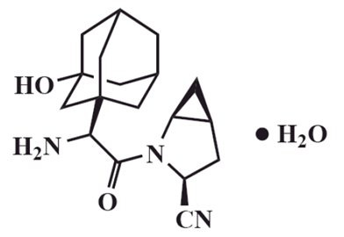
- Description: Saxagliptin is a white to light yellow or light brown powder, non hygroscopic, crystalline. It is soluble in polyethylene glycol 400, acetone, acetonitrile, ethanol, isopropyl alcohol, methanol; sparingly soluble in water and slightly soluble in ethyl acetate.

Dapagliflozin
Dapagliflozin propanediol monohydrate is an orally-active inhibitor of the human renal sodium-glucose co-transporter 2 (SGLT2), the major transporter responsible for renal glucose reabsorption.
- Chemical name: (1S)-1,5-Anhydro-1-C-[4-chloro-3-[(4-ethoxyphenyl)methyl]phenyl]-D-glucitol, (S)-propylene glycol, monohydrate.
- CAS Number: 960404-48-2
- Molecular formula: C21H25ClO6•C3H8O2•H2O
- Molecular weight: 502.98
Chemical structure is in Figure 2.
Figure 2: Dapagliflozin chemical structure.
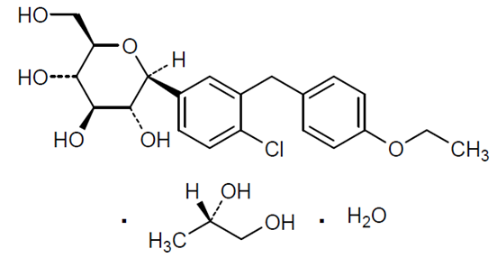
Description: Dapagliflozin drug substance is a white to off-white powder, is non-hygroscopic, crystalline. Dapagliflozin is non-ionisable; thus, its aqueous solubility and partition coefficient are not affected by changes in pH. Dapagliflozin is a Biopharmaceutical Classification System (BCS) Class III drug.

Pharmacokinetics in healthy subjects

Analytical Methods
Two validated liquid chromatography-tandem mass spectrometry (LC-MS/MS) methods were used to detect saxagliptin and its active metabolite 5-hydroxy (OH) saxagliptin in human plasma. Both methods had LLOQ values of 0.10 ng/mL and 0.20 ng/mL for saxagliptin and 5-hydroxy saxagliptin, respectively; however, the method used in Study CV181341 was validated over a wider range of concentrations. By contrast, a single validated LC-MS/MS method was used for the detection of dapagliflozin, which had an LLOQ of 0.2 ng/mL.

Absorption

Sites and mechanisms of absorption
QTERN is to be administered orally, once daily with or without food. Study CV181341 examined PK of saxagliptin and dapagliflozin following a single oral dose of QTERN to healthy subjects under fasted and fed conditions. Under both fasted and fed conditions saxagliptin was rapidly absorbed with median Tmax values (range) of 0.60 h (0.25 – 1.50) and 1.00 h (0.50 – 4.00) under fasted and fed conditions, respectively. For dapagliflozin, the Tmax values (range) were 1.00 h (0.50 – 3.00) and 2.50 h (0.50 – 8.08) for fasted and fed subjects, respectively.

Bioavailability

Absolute bioavailability
Not examined.

Bioavailability relative to an oral solution or micronised suspension
Not examined.

Bioequivalence of clinical trial and market formulations
Not applicable.

Bioequivalence of different dosage forms and strengths
Only a single dosage form of QTERN is proposed for marketing.

Bioequivalence to relevant registered products
Study CV181341 examined the bioequivalence (BE) between the FDC table containing 5 mg saxagliptin/10 mg dapagliflozin and a free combination of 5 mg saxagliptin and 10 mg dapagliflozin tablets following oral administration of a single dose to 36 fasted healthy subjects. The results indicated that the geometric mean ratio (GMR) values (90% CIs) for the free combination/FDC comparisons for dapagliflozin Cmax and AUCinf were 0.946 (0.878, 1.019) and 1.035 (1.008, 1.063), respectively. As the 90% CIs fell within the BE interval (0.80, 1.25) the two formulations were bioequivalent in regards to the dapagliflozin components. Similarly for saxagliptin, the GMR values (90% CIs) for the free combination/FDC comparisons for Cmax and AUC were 1.059 (0.993, 1.129) and 1.003 (0.969, 1.038), respectively and for 5-OH saxagliptin the geometric mean (GM) AUCinf values (%CV) were 323 ng.h/mL (21%) and 336 ng.h/mL (18%) for the free combination and FDC, respectively.
Comment: Given the results of Study CV181341 the FDC tablet containing 5 mg saxagliptin/10 mg dapagliflozin was bioequivalent to the free combination of 5 mg saxagliptin/10 mg dapagliflozin.

Influence of food
Study CV181341 also examined the effect of a high fat breakfast on the PKs of saxagliptin and dapagliflozin following administration of a single oral dose of the FDC tablet containing 5 mg saxagliptin/10 mg dapagliflozin. In the fed state, dapagliflozin exposure was slightly reduced compared to the fasted state as the GMR values (90%CI) for Cmax and AUCinf for the fed/fasted comparison were 0.648 (0.565, 0.743) and 0.943 (0.919, 0.968), respectively. Saxagliptin Cmax was also slightly lower in the fed state, whereas AUCinf was slightly higher as the GMR values (90%CI) values were 0.925 (0.837, 1.022) and 1.155 (1.118, 1.194), respectively, and the 5-OH saxagliptin GM AUCinf values were 336 and 331 ng.h/mL, respectively. The t1/2 values for dapagliflozin and OH-saxagliptin were similar in both the fasted and fed states, whereas, the t1/2 of saxagliptin in the fed state (7.28 h) was slightly delayed compared to the fasted state (5.37 h).
Comment: The small changes in dapagliflozin and saxagliptin exposure seen in the fed and fasted states are unlikely to be clinically significant.

Dose proportionality
Not applicable.

Bioavailability during multiple-dosing
Not examined.

Effect of administration timing
Not examined.

Distribution

Volume of distribution
Not examined for the FDC.

Plasma protein binding
Not examined for the FDC.

Erythrocyte distribution
Not examined for the FDC.

Tissue distribution
Not examined for the FDC.

Metabolism

Inter-conversion between enantiomers
Not applicable.

Sites of metabolism and mechanisms / enzyme systems involved
Not examined for the FDC. However, the Sponsor states in the draft PI that saxagliptin is primarily metabolised by CYP3A4/5, whereas, dapagliflozin is metabolised by UGT1A9 to form the inactive metabolite dapagliflozin 3-O-glucuronide.

Non-renal clearance
Not examined for the FDC.

Metabolites identified in humans
5-OH saxagliptin is the main metabolite of saxagliptin, which like saxagliptin is a selective, reversible, competitive DPP-4 inhibitor; however, it is only half as potent as saxagliptin.

Pharmacokinetics of metabolites
Following a single dose of QTERN to fasted healthy subjects the Cmax, AUCinf, Tmax and t1/2 values for 5-OH saxagliptin were 53.9 ng/mL, 323 ng.h/mL, 1.50 h and 16.3 h, respectively.

Consequences of genetic polymorphism
Not examined.

Excretion

Routes and mechanisms of excretion
Not examined for the FDC.

Mass balance studies
Not examined for the FDC.

Renal clearance
Not examined for the FDC.

Intra- and inter-individual variability of pharmacokinetics
The inter-subject variability in the Cmax and AUCinf of dapagliflozin following a single oral dose of QTERN in the fasted state were 40% and 21%, respectively, for saxagliptin were 32% and 23%, respectively, and for 5-OH saxagliptin were 28% and 18%, respectively.

Pharmacokinetics in the target population
Not examined.

Pharmacokinetics in other special populations
Not examined.

Pharmacokinetics in subjects with impaired hepatic function
Not examined.

Pharmacokinetics in subjects with impaired renal function
Not examined.

Pharmacokinetics according to age
Not examined.

Pharmacokinetics related to genetic factors
Not examined.

Pharmacokinetics in other special population / according to other population characteristic
Not examined.

Pharmacokinetic interactions

Pharmacokinetic interactions demonstrated in human studies
Study CV181191 examined the drug-drug interaction between a single 5 mg oral dose of saxagliptin and a single 10 mg oral dose of dapagliflozin in 42 healthy subjects. The results indicated that saxagliptin had no effect on the PK of dapagliflozin as the GMR values (90%CIs) for Cmax, and AUCinf for the dapagliflozin + saxagliptin/dapagliflozin comparison were 0.943 (0.867, 1.026) and 0.984 (0.691, 1.008), respectively. In addition, the median and the individual range of dapagliflozin Tmax values were not altered by saxagliptin co-administration, nor were the mean t1/2 and CLT/F. Similarly, dapagliflozin co-administration had no effect on the PK or saxagliptin or 5-OH saxagliptin. The GMR values (90% CIs) for saxagliptin Cmax, and AUCinf for the dapagliflozin + saxagliptin/saxagliptin comparison were 0.927 (0.883, 0.972) and 0.991 (0.961, 1.022), respectively and for 5-OH saxagliptin were 1.055 (1.004, 1.109) and 1.085 (1.058, 1.113), respectively. In addition, dapagliflozin co-administration had little to no effect on saxagliptin Tmax, t1/2 or CLT/F.

Clinical implications of in vitro findings
No in vitro interaction studies were undertaken with the FDC tablet.

Evaluator’s conclusions on pharmacokinetics
- Qtern is to be administered orally, once daily with or without food.

ADME
- Under both fasted and fed conditions saxagliptin was rapidly absorbed with median Tmax values (range) of 0.60 h (0.25-1.50) and 1.00 h (0.50-4.00) under fasted and fed conditions, respectively. For dapagliflozin, the Tmax values (range) were 1.00 h (0.50-3.00) and 2.50 h (0.50-8.08) for fasted and fed subjects, respectively.
- Following oral administration of a single dose in healthy subjects, Qtern was bioequivalent with a free combination of 5 mg saxagliptin and 10 mg dapagliflozin tablets.
- The small differences in dapagliflozin and saxagliptin exposure seen following a single oral dose administration of Qtern in the fed and fasted states are unlikely to be clinically significant.
- Following a single dose of Qtern to fasted healthy subjects the Cmax, AUCinf, Tmax and t1/2 values for 5-OH saxagliptin were 53.9 ng/mL, 323 ng.h/mL, 1.50 h and 16.3 h, respectively.

Inter-subject variability
- The inter-subject variability in the Cmax and AUCinf values for dapagliflozin following a single oral dose of Qtern in the fasted state were 40% and 21%, respectively, for saxagliptin were 32% and 23%, respectively, and for 5-OH saxagliptin were 28% and 18%, respectively.

DDIs
- Following a single oral dose of the free combination of 5 mg saxagliptin and 10 mg dapagliflozin the PK parameters of each of the active components were similar to when 5 mg saxagliptin or 10 mg dapagliflozin were administered alone.

Limitations of the PK studies
- No studies examined the PK of Qtern in the target population or in other special populations.
- No studies examined the drug-drug interaction between Qtern and other drugs.

Questions related to the PK studies
- Can the sponsor please confirm that the Onglyza and Forxiga tablets used in Studies CV181341 and CV181191 are identical to the formulations registered in Australia?
- Can the sponsor please confirm that the Qtern formulation used in Study CV181341 is identical to the formulation that is to be marketed in Australia?

Pharmacodynamics
No dedicated PD studies were undertaken as part of this submission.

Dosage selection for the pivotal studies
The dosage selected for the FDC is the approved dosages for saxagliptin (5 mg) and dapagliflozin (10 mg).
Comment: The recommended dose for saxagliptin is 5 mg once daily. However, in patients with moderate to severe renal impairment (CrCl ≤50 mL/min), the recommended dose is 2.5 mg per day (saxagliptin is not recommended for use in patients with severe renal impairment or end-stage disease). A FDC including 2.5 mg saxagliptin has not been proposed.

Clinical efficacy

Improvement of glycaemic control in T2DM
Comment: The three included clinical trials were sponsored by Bristol-Myers Squibb.

Pivotal efficacy studies

Study CV181169

Study design, objectives, locations and dates
CV181169 was a multicentre, randomised, double-blind, active-controlled, parallel group, phase III study to evaluate the safety and efficacy of add-on therapy with saxagliptin and dapagliflozin added to metformin compared to add-on therapy with saxagliptin in combination with metformin or dapagliflozin in combination with metformin in 534 subjects with T2DM who have inadequate glycaemic control on metformin alone.
The study was conducted at 145 sites in 8 countries (USA, Canada, Puerto Rico, Mexico, Poland, Romania, South Korea and South Africa) between June 2012 and January 2014.
The primary objective was to compare the mean change from baseline in glycosylated haemoglobin (HbA1c) achieved with concurrent addition of saxagliptin and dapagliflozin to metformin versus the addition of placebo and saxagliptin to metformin and versus the addition of placebo plus dapagliflozin to metformin after 24 weeks of double-blind treatment.
After a screening period subjects entered a four week lead in period on open label metformin. Subjects on metformin IR and XR were switched to the nearest multiple of metformin XR 500 mg tablet. Eligible subjects were randomised to one of 3 groups in and continued on double-blind treatment for 24 weeks. Visits occurred at weeks 6, 12, 18 and 24.

Inclusion and exclusion criteria
Inclusion criteria were:
- males and females ≥18 years of age;
- T2DM with inadequate glycaemic control defined as central laboratory HbA1c ≥8.0 and ≤12.0 % at the screening visit (a week -4 a check was performed and subjects were excluded if their FPG was >270 mg/dL).
- Stable metformin therapy for ≥8 weeks prior to screening at a dose ≥1500 mg/d.
- C-peptide ≥1.0 ng/mL (0.34 nmol/L).
- Body mass index (BMI) ≤45.0 kg/m².
- Women of childbearing potential (WOCBP) using acceptable contraception and having a negative pregnancy test.
Exclusion criteria were:
- Moderate or severe renal impairment (eGFR <60 mL/min/1.73 m² or serum creatinine ≥1.5 mg/dL for males and ≥1.4 mg/dL for females);
- uncontrolled hypertension (SBP ≥160 mmHg, DBP ≥100 mgHg);
- cardiovascular disease within 3 months, significant hepatic disease (including AST/ALT >3x ULN or total bilirubin >2.5x ULN);
- microscopic haematuria in males with no cause identified;
- malignancy within 5 years;
- hypersensitivity to saxagliptin or dapagliflozin; other anti-hyperglycaemic (apart from metformin) for >14 days within 12 weeks; and current treatment with a cytochrome P450 3A4/5 inhibitor.

Study treatments
Treatment was with saxagliptin 5 mg tablets, dapagliflozin 10 mg tablets and matching placebo tablets. Background medication was open label metformin XR 500 mg tablets with a dose range of ≥1500 mg and ≤2000 mg. The dose could not be altered during the double-blind period. Subjects entering the study on metformin IR were switched to metformin XR which was given according to local product labelling.
Comment: In the next two studies, CV181168 and MB102129, metformin IR was used.
Subjects with inadequate glycaemic control could receive additional open label rescue medication. Rescue medication was based on central laboratory fasting plasma glucose (FPG) levels (FGP >270 mg/dL [15.0 mmol/L] at week 6, >240 mg/dL [13.3 mmol/L] week 6-<12 and >200 mg/dL [11.1 mmol/L] at week 12-24). Prohibited medications included antihyperglycaemics (apart from rescue medication) and systemic corticosteroids for ≥5 days.
All study treatment was taken orally once a day prior to the morning meal.

Efficacy variables and outcomes
The primary efficacy variable was HbA1c. The primary efficacy outcome was the mean change from baseline to 24 weeks in HbA1c.
The secondary efficacy outcomes included:
- The mean change from baseline in 2 hour post-prandial glucose (PPG) during a liquid meal tolerance test (MTT) at week 24.
- Mean change from baseline to week 24 in FPG.
- Percentage of subjects at week 24 with HbA1c <7.0%.
- Mean change in total body weight.
Other efficacy outcomes were:
- Percentage of subjects who required glycaemic rescue medication or discontinued due to lack of efficacy and time to rescue or discontinuation.
- Mean change from baseline to week 24 in AUC glucose, AUC insulin, AUC glucagon during the MTT.
- Mean percent change from baseline in fasting serum lipids.

Randomisation and blinding methods
Subjects were randomised in a 1:1:1 ratio to one of 3 treatment groups via an IVRS. Randomisation was stratified by site. The three groups were:
- Saxagliptin 5 mg, dapagliflozin placebo, plus metformin XR (Saxa+Met)
- Dapagliflozin 10 mg, saxagliptin placebo, plus metformin XR (Dapa+Met)
- Saxagliptin 5 mg plus dapagliflozin 10 mg, plus metformin XR (Saxa+Dapa+Met)
Blinding was achieved by using matching placebo tablets and withholding results of HbA1c, plasma glucose, insulin, C peptide, glucagon MTT values and urine glucose until after study completion.
There was unblinding of one subject with a serious unexpected serious adverse reaction (SUSAR) for regulatory reporting. The information was not provided to the investigator or study staff.

Analysis populations
The Randomised Subjects Data Set included all randomised subjects who took at least one dose of double-blind study medication and was used for efficacy analyses.

Sample size
A sample size of 163 subjects per group gave the study a 90% power to detect a mean HbA1c difference of 0.4% between the Saxa+Dapa+Met group and the Saxa+Met and Dapa+Met groups assuming standard deviation of 1.0%. Allowing for 5% of subjects not having a post-baseline assessment, 172 per group were required.

Statistical methods
The primary efficacy analysis was undertaken using a longitudinal repeated measures analysis. This included terms for baseline value, treatment group, time, the interaction of treatment group and time, and the interaction of baseline value and time. It included only observations prior to rescue. Sensitivity analyses used an ANCOVA with terms for treatment group and baseline value. One ANCOVA analysis used LOCF and another was on all subjects completing double-blind therapy without needing rescue therapy. For secondary endpoints, FPG was analysed using the repeated measures model, the PPG MTT and body weight change were analysed using an ANCOVA with LOCF. Kaplan Meier methods were used for the time to event analyses.
To control the type 1 error rate, a hierarchical closed testing procedure was used for the primary and secondary endpoints (with the following order for secondary endpoints: 2 hour PPG, FPG, percent with HbA1c <7.0%, then body weight).
There were 3 protocol amendments (2 site specific and one global) and two administrative letters. The main change (global amendment) clarified that if subjects discontinued study treatment they could continue in the study.

Participant flow
There were 1282 subjects enrolled of whom 48% did not meet eligibility criteria and 1% withdrew consent. There were 534 subjects randomised, 176 to 179 in each group, and 490 (89.4% to 94.4%) completed 24 weeks treatment. The premature discontinuation rate was highest in the Dapa+Met group (10.6%) followed by Saxa+Met (8.5%) and the Saxa+Dapa+Met group (5.6%). The most common reasons were lost to follow up (3.6%) and consent withdrawal (2.8%).

Major protocol violations/deviations
The rate of protocol deviations leading to exclusion from the Evaluable Subjects dataset was 3.2% (1.7%, 5.1% and 2.8% in the Saxa+Dapa+Met, Saxa+Met and Dapa+Met treatment groups, respectively). As the rate in all groups was <10%, the sponsor used the Randomised Subjects dataset for the primary efficacy analyses. The most frequent deviation was taking no metformin dose or a dose outside the prescribed range (0-2.8%). All subjects were reported to be compliant (took ≥80% to ≤120% of prescribed medication) with study medication and 8 subjects were non-compliant (<80%) with metformin treatment.

Baseline data
The three treatment groups were balanced on baseline demographics and disease characteristics. The average age was 53.8 years, half the subjects were female, 70% White, 11.2% Black/African, 6% Asian and the mean BMI was 31.7 kg/m². The mean duration of T2DM was 7.6 years and was slightly higher in the Saxa+Met group (8.2 years vs 7.1-7.4 years). Baseline HbA1c was 8.92, 9.03 and 8.87 in the Saxa+Dapa+Met, Saxa+Met and Dapa+Met treatment groups, respectively. The mean fasting glucose was 185.7 mg/dL. The rate of hypertension was 53-63% across the groups, approximately one third of subjects had a history of obesity and 34-37% of hyperlipidaemia or dylipidaemia. All subjects were on metformin with two thirds on a dose of >1700 mg.
Concomitant treatments were frequent with 56% on cardiovascular medication (mainly anti-hypertensives 48%) and 42% on lipid reducing medication. The rate of rescue medication was 6%, 10% and 3% in the Saxa+Dapa+Met, Saxa+Met and Dapa+Met treatment groups, respectively. The most frequent medication was glimepiride.

Results for the primary efficacy outcome
The adjusted mean change from baseline to week 24 in HbA1c was -1.47%, -0.88% and -1.20% in the Saxa+Dapa+Met, Saxa+Met and Dapa+Met treatment groups, respectively. The difference between triple therapy and Saxa+Met was -0.59 (95% CI:-0.81, -0.37, p<0.0001) and between triple therapy and Dap+Met was -0.27 (95% CI: -0.48, -0.05, p=0.017) indicating a significant superiority of the triple over dual therapy and thus meeting the studies primary objective. The adjusted mean change in HbA1c over the study duration in the three groups is shown in Figure 3. Analysis using the ANCOVA model with LOCF found similar results.
Figure 3: Longitudinal plot of change from baseline in HbA1c: 24 week double blind period, randomised subjects (CV181169).
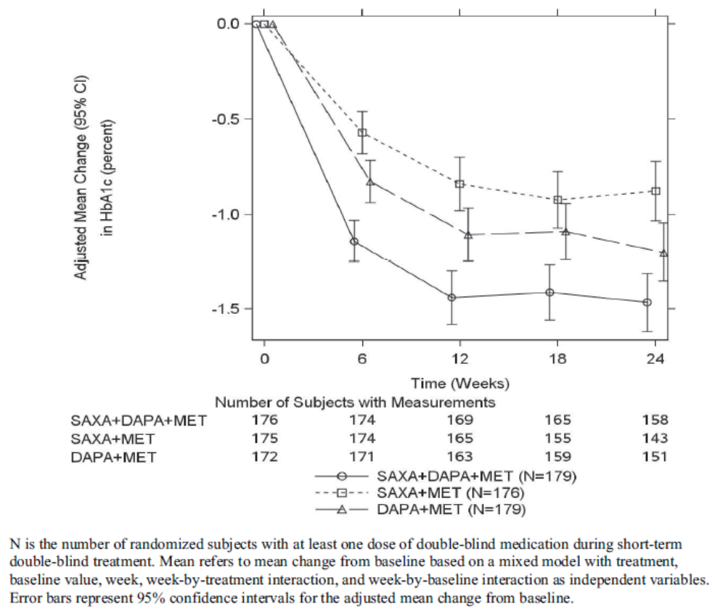
Subgroup analyses found that those with a higher HbA1c at baseline had a greater reduction whether treated with dual or triple therapy. Response was greater in the combinations containing dapagliflozin compared to saxagliptin + metformin (Table 2). Results on the primary endpoint were consistent across subgroups of age, gender and race. Possible interactions were seen for region and female age groups.
Table 2: HbA1c subgroup analysis by baseline HbA1c at 24 weeks (Study CV181169).
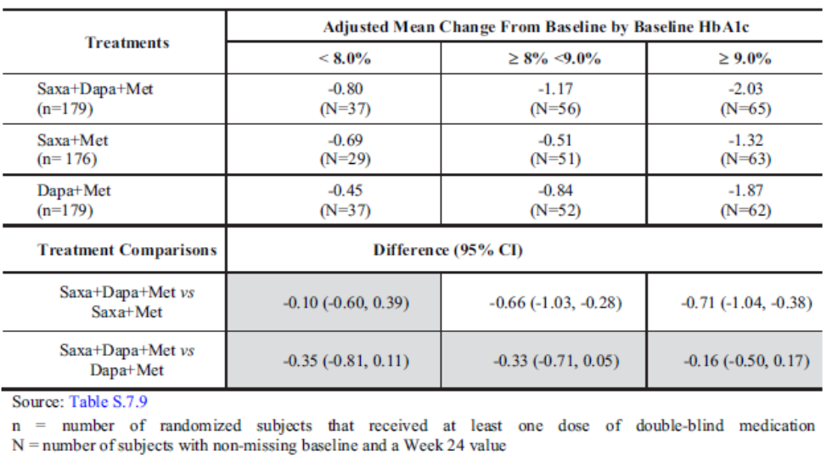

Results for other efficacy outcomes
The adjusted mean change from baseline to week 24 in the 120 minute post prandial glucose (PPG) in the liquid MMT was superior for triple therapy over Saxa+Met (-44.0 mg/dL, 95% CI: -5.37,-34.3, p<0.0001), however was not significantly greater for triple therapy over Dapa+Met (-9.1 mg/dL, 95% CI: -18.8, 0.5, p=0.064). Consequently, significance testing ceased at this endpoint.
The adjusted mean change from baseline to week 24 in FPG was -37.8, -14.0 and -31.7 mg/dL in the Saxa+Dapa+Met, Saxa+Met and Dapa+Met treatment groups, respectively. Again this shows a numerically greater response in combinations containing dapagliflozin compared to saxagliptin plus metformin.
The proportion of subjects achieving an HbA1c of <7.0% after 24 weeks of treatment was notably higher with triple therapy (41.4%) than with saxagliptin+metformin (18.3%) or dapagliflozin+metformin (22.2%).
The adjusted mean change in body weight over 24 weeks was -2.05 kg, 0.0 kg and -2.39 kg in the Saxa+Dapa+Met, Saxa+Met and Dapa+Met treatment groups, respectively.
Comment: This shows the known effect of dapagliflozin on body weight.
The rate of discontinuation for lack of glycaemic control or use of rescue medication was 5.6% with triple therapy compared to 9.7% for saxagliptin+metformin and 3.4% for dapagliflozin+metformin. The differences between triple and dual therapy had 95% confidence intervals crossing zero.
Mean changes in fasting serum lipid results were small and variable. When considering adjusted mean changes from baseline in the AUC (0 to 180 minutes) for glucose, insulin, C peptide and glucagon from the MTT, the three groups demonstrated a reduction in post MTT glucose. There was a reduction in AUC for insulin in the dapagliflozin containing groups, while the AUC for glucagon showed little change in the saxagliptin-containing groups and increased in the dapagliflozin+metformin group.
At week 24 the proportion of subjects with HbA1c >9% or who and rescue medication or who had discontinue for lack of glycaemic control was 14.1%, 26.9% and 13.3% Saxa+Dapa+Met, Saxa+Met and Dapa+Met treatment groups, respectively.
Comment: These results also demonstrate a greater response in the groups who received dapagliflozin.

Summary
Study CV181169 was a phase III randomised controlled study which assessed the triple therapy of saxagliptin+dapagliflozin+metformin versus dual therapy of saxagliptin+metformin or dapagliflozin+metformin. All study medication was taken as free combinations. The study was conducted in 534 adults with T2DM inadequately controlled on metformin monotherapy (HbA1c >8% and ≤12%). The study met its primary endpoint with a statistically significant superior reduction in HbA1c after 24 weeks treatment with triple therapy compared to dual therapy (difference of -0.59% and -0.27%). For the secondary endpoint of PPG, triple therapy was superior to saxagliptin+ metformin but not to dapagliflozin+metformin. Statistical testing was ceased at this point due to the hierarchical testing procedure. In general, the results on secondary endpoints suggested a greater response with triple therapy or dapagliflozin+metformin compared to saxagliptin+metformin.
Saxagliptin+dapagliflozin+metformin resulted in a higher rate of subjects achieving HbA1c <7.0% after 24 week (41% vs 18-22%). There was an approximate 2 kg weight reduction in the dapagliflozin treatment groups compared to none in the saxagliptin+metformin group.

Study CV181168

Study design, objectives, locations and dates
CV181168 was a phase III, double-blind, placebo-controlled, 52 week study in 315 subjects with T2DM. It was conducted at 79 sites (US, Canada, Poland, Russia, Romania, Mexico, Hungary, Czech Republic and Puerto Rico) between June 2012 and July 2014 (for the initial 24 week double-blind period).
The primary objective was to compare the mean change from baseline in HbA1c achieved with saxagliptin added to dapagliflozin plus metformin versus placebo added to dapagliflozin plus metformin after 24 weeks of double-blind treatment. Secondary objectives were the effect on PPG from a liquid MTT, FPG and the proportion of subjects with HbA1c <7.0%.
Following a screening period, subjects on stable doses of metformin IR/XR ≥1500 mg and having inadequate glycaemic control, entered a 16 week open label period where they received treatment with metformin IR (500 mg tablets with dose modified to the nearest multiple of the IR tablets) and dapagliflozin 10 mg. Eligible subjects were then randomised to saxagliptin or placebo (on top of metformin + dapagliflozin) for a 24 week double-blind period. After this, there was a long term (site and subject) blinded treatment period of an additional 28 weeks.
Comment: The report for this extension study was not included in the dossier.

Inclusion and exclusion criteria
Study inclusion criteria were the same as CV181169 apart from the upper limit of HbA1c at screening was 11.5% (rather than 12%). For randomisation subjects needed inadequate glycaemic control as defined as HbA1c of ≥7.0 and ≤10.5%. Women could not be breastfeeding.
Exclusion criteria were the same as CV181169. Enrolment of subjects into the open label treatment period with HbA1c ≥8.0 and ≤9.0% was limited to 50% of the total number of subjects.

Study treatments
Saxagliptin 5 mg tablets, or matching placebo, and dapagliflozin 10 mg tablets were given orally once daily just prior to breakfast. Metformin IR dose remained the same during double-blind treatment. Subjects were treated with the nearest multiple of metformin IR 500 mg tablets. Metformin treatment was give twice daily with food.
Comment: Metformin XR was used in CV181169.
Open label rescue medication was available for subjects not achieving glycaemic control as outlined in study CV181169

Efficacy variables and outcomes
The main efficacy variables were HbA1c, 2 hour post prandial glucose from a MTT and FPG. The primary efficacy outcome was the mean change from baseline to week 24 in the HbA1c. Secondary outcomes were the mean change from baseline to week 24 in PPG and FPG as well as the proportion of subjects achieving glycaemic response of <7.0% at week 24.

Randomisation and blinding methods
Subjects were randomised via an IVRS in a 1:1 ratio to the saxagliptin or placebo groups. Blinding was achieved by using matching placebo tablets, blinding treatment allocation as well as HbA1c and glucose results. No subjects were unblinded during the study.

Analysis populations
Efficacy analysis used the randomised subjects data set (randomised subjects who took at least one dose of double-blind study medication) as in CV181169.

Sample size
A treatment group size of 133 subjects gave the study a 90% power to detect a mean difference in HbA1c of 0.4% between the two treatment groups assuming a standard deviation of 1.0%. Allowing for a 5% drop out rate, 280 subjects were required to be randomised.

Statistical methods
Statistical methods were essentially the same as study CV181169 with the primary analysis using a repeated measures model with ANCOVA for sensitivity analyses. Multiplicity was addressed by the use of a hierarchical closed testing procedure with the following order for secondary endpoints: 2 hour PPG, FPG then percentage achieving HbA1c <7.0%.
There was one site specific and one global amendment to the protocol which were not of a significant nature in terms of efficacy analyses.

Participant flow
There were 857 subjects enrolled with 484 entering and 431 completing open label treatment. The most common reason for not being randomised was no longer meeting entry criteria, specifically HbA1c between 7 and 10.5% (106 subjects with HbA1c <7% at week -2). There were 315 subjects randomised to double-blind treatment, 153 and 162 in the Saxa+Dapa+Met and Dapa+Met groups, respectively, and 94.6% completed the 24 week treatment period. The rate of not completing the 24 week study was higher in the saxagliptin group (7.2% vs 3.7%) with higher rates of consent withdrawal (2.6% vs 1.2%) and lost to follow up (2.6% vs 1.2%).

Major protocol violations/deviations
“Relevant” protocol deviations were reported in 5.2% and 6.8% of the Saxa+Dapa+Met and Dapa+Met groups, respectively. The most frequent deviation was not taking dapagliflozin or taking dose outside the range for ≥2 weeks in the open label or 24 week double-blind period (3.9% vs 2.5%).
Comment: As the relevant protocol deviation rate was <10%, the randomised subject data set was used for the efficacy analysis.
Compliance (80-120%) with study treatment was high (98.8% during open label treatment and 99.4% during double-blind treatment).

Baseline data
The treatment groups were relatively well matched on baseline demographic and disease characteristics. The subject’s mean age was 54.6 years, 47.3% were female, 87.9% White, about half from North America, the mean BMI was 31.4 kg/m² and the mean duration of diabetes was 7.7 years. The mean baseline HbA1c was 7.97% and 7.86% in the Saxa+Dapa+Met and Dapa+Met groups, respectively. Approximately two thirds of subjects had hypertension, 44% obesity and 53% hyperlipidaemia or dyslipidaemia.
The mean number of days exposed to double-blind treatment was 165 and 167 in the Saxa+Dapa+Met and Dapa+Met groups, respectively. Most subjects received concomitant medications which were predominantly antihypertensives (66-67%), lipid reducing agents (38.9-42.5%) and analgesics (37.3-38.3%). Rescue medication use was slightly less in the triple therapy group (2.6% vs 4.3%).

Results for the primary efficacy outcome
The mean change from baseline to week 24 in HbA1c was -0.51% and -0.16% in the Saxa+Dapa+Met and Dapa+Met groups, respectively. The mean treatment difference as -0.35% (95% CI: -0.52, -0.18, p<0.0001) indicating that the triple therapy was superior to dapagliflozin plus metformin in reducing HbA1c. The separation of effect was seen from week 6 (Figure 4). Analyses of the evaluable subject dataset, and with LOCF, were consistent with the primary analysis.
Figure 4: Longitudinal plot of change from baseline in HbA1c: 24 week double blind period, randomised subjects (Study CV181168).
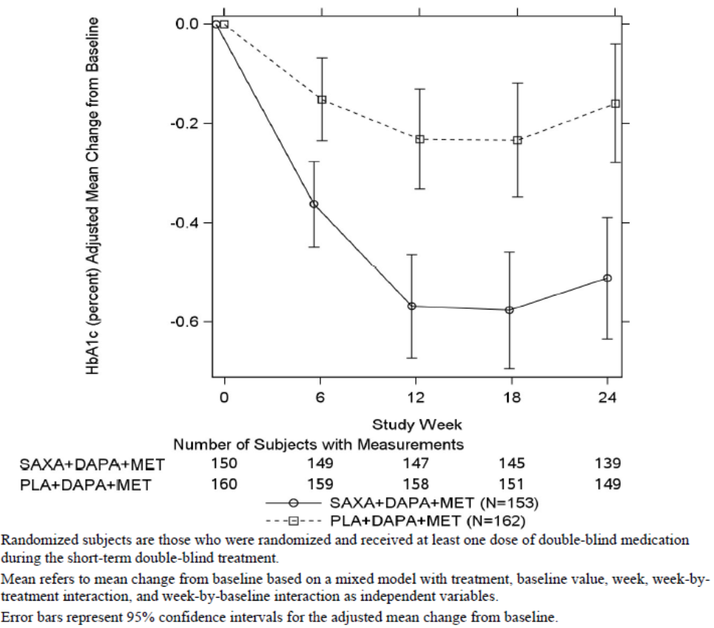
Subgroup analysis found that the treatment difference between triple and dapagliflozin+metformin therapy was largest in those with a baseline HbA1c ≥9.0%: adjusted mean change from baseline of -1.21% vs -0.26, difference of -0.95% (95% CI: -1.48, -0.42). For those with baseline HbA1c <8.0%, or ≥8% to <9.0%, the added benefit of triple therapy in terms of HbA1c reduction was lower (treatment difference of -0.30% for both baseline HbA1c subgroups).
Comment: The number of subjects with baseline HbA1c ≥9.0% were small (n=13 and 15, respectively).
There was a consistent effect of a greater HbA1c reduction with triple therapy across the subgroups of age, gender, race, region and female age.

Results for other efficacy outcomes
The adjusted mean change from baseline to week 24 in the 120 minute post prandial glucose (PPG) (liquid MTT) was -37.1 and -31.1 mg/dL in the Saxa+Dapa+Met and Dapa+Met groups, respectively. The adjusted mean difference of -5.9 mg/dL (95% CI: -14.9, 3.1, p=0.201) was not statistically significant.
The adjusted mean change from baseline to week 24 in FPG was -9.1 and -5.3 mg/dL in the respective groups with a non-significant treatment difference of -3.7 (95% CI: -11.0, 3.6).
A greater proportion of subjects on triple therapy achieved an HbA1c of <7.0% at week 24 (35.3% vs 23.1%). The adjusted difference was 12.2% (95% CI: 3.4, 21.0).
Comment: The result is only nominally significant due to the earlier break in hierarchical testing.
The adjusted rate of discontinuation due to lack of glycaemic control or requirement for rescue medication was 2.5% and 4.4% in the Saxa+Dapa+Met and Dapa+Met groups, respectively.
The adjusted mean change from baseline for the glucose AUC (0-180 minutes) during a MTT was only slightly less with triple therapy (treatment difference -953.6 mg/dL, 95% CI: -2371.0, 463.8). Comparisons between the two groups in changes in fasting serum lipids were unremarkable. Both groups had a small mean weight reduction over the 24 weeks (-0.53 vs -0.51 kg).

Summary
CV181168 was a phase III, randomised, placebo-controlled study which examined the add-on benefit of saxagliptin to dapagliflozin plus metformin in patients with T2DM who were inadequately controlled, as defined by an HbA1c >7.0% (and ≤10.5%), on dapagliflozin and metformin (16 weeks of open label therapy). The study met its primary endpoint with a superior reduction in HbA1c after 24 weeks treatment with the saxagliptin+dapagliflozin+metformin compared to saxagliptin+metformin ( -0.51% vs -0.16%) with a mean treatment difference of -0.35% (95% CI: -0.52, -0.18, p<0.0001). No significant difference between groups was found on secondary endpoints of PPG and FPG. A nominally higher proportion of subjects on triple therapy achieved an HbA1c of <7.0% at week 24 (35.3% vs 23.1%).

Study MB102129

Study design, objectives, locations and dates
MB102129 was a phase III, double-blind, randomised, placebo-controlled parallel group study evaluating the safety and efficacy of dapagliflozin added to saxagliptin plus metformin in 320 adults with T2DM and inadequate control on saxagliptin and metformin. It was conducted between September 2013 and September 2014 at 64 sites in 8 countries.
The primary objective was to compare the mean change from baseline in HbA1c achieved with dapagliflozin added to saxagliptin plus metformin versus placebo added to saxagliptin plus metformin after 24 weeks of oral administration of double-blind treatment.
The design was essentially the same as CV181168. The trial had a 24 week double-blind treatment period at which point the primary efficacy assessment was undertaken and then a long term 28 week subject blinded treatment period.
Comment: Only results to week 24 were included in the dossier.
The initial open label period was slightly different to the previous studies as it comprised of two strata. Stratum A included subjects on stable dose of metformin IR or XR for 8 weeks who received metformin IR (nearest 500 mg multiple) in combination with saxagliptin 5 mg at week -16 (i.e. 16 week open label period). Stratum B included subjects who were on a maximum dose of DPP4 inhibitor and metformin IR or XR who were switched to metformin IR and saxagliptin 5 mg at week -8 (8 week open label period).

Inclusion and exclusion criteria
As with the previous two studies included subjects were male or female, ≥18 years of age with inadequate glycaemic control (as defined for each stratum below), C peptide ≥1.0 ng/mL, BMI ≤45.0 kg/m² and using acceptable contraception.
- For inclusion into Stratum A:
  - HbA1c ≥8.0 and ≤11.5% at screening (week -18), on stable metformin therapy alone for at least 8 weeks at a dose ≥1500 mg/d. FPG between week -10 and -2 needed to be ≤270 mg/dL. Those with an HbA1c ≥8.0 and <9.0% at week -16 were limited to 50% of the total number randomised.
- For inclusion into Stratum B:
  - HbA1c ≥7.5 and ≤10.5% at screening (week -10), on stable metformin therapy at a dose ≥1500 mg/d and a DPP4 inhibitor (free or fixed dose combination) at maximum approved dose for at least 8 weeks. FPG at week -2 needed to be ≤270 mg/dL. Those with an HbA1c ≥7.5% and ≤8.5% at week -8 were limited to 50% of the total number randomised.
For randomisation subjects from both strata needed to have an HbA1c ≥7.0% and ≤10.5% at week -2 (during open label treatment).
Exclusion criteria were the same as previous studies. Antihyperglycaemic therapy, other than metformin and DPP4s for more than 14 days during the 12 weeks before screening, was also an exclusion criterion.

Study treatments
Study treatment was free combination of saxagliptin 5 mg tablets, dapagliflozin 10 mg tablets (or matching placebo) and metformin IR 500 mg tablets. Dapagliflozin 10 mg or placebo and open label saxagliptin 5 mg were given once daily. Open label metformin IR was given twice daily with food.
Comment: Metformin IR was also used in CV181168 while XR was used in CV181169.
Open label rescue medication use was as per previous studies and based on repeated central FPG levels. Prohibited therapies included non-study antihyperglycaemics, weight loss medication, and newly initiated systemic corticosteroids for ≥5 days

Efficacy variables and outcomes
The efficacy variables were the same as previous studies. The primary efficacy endpoint was the mean change from baseline to week 24 in the HbA1c.

Randomisation and blinding methods
Subjects were randomised by an IVRS ion a 1:1 ratio to the dapagliflozin or placebo groups (plus open label saxagliptin 5 mg and metformin IR ≥1500 mg). The study was double-blind to week 24 then during the long term treatment phase sponsor staff were no longer blinded but site staff and subjects remained blinded.

Analysis populations
Primary analysis was on the Randomised Subject dataset (randomised and received at least one dose of double-blind study medication).

Sample size
Sample size calculations were the same as CV181168. It was expected that one third of subjects would be in Stratum B and they would have better glycaemic control due to prior dual therapy therefore the study aimed to enrol for open label therapy 312 subjects to Stratum A and 100 to Stratum B.

Statistical methods
Statistical methods were the same as previous studies. The order of the stepwise testing procedure for secondary endpoints was: FPG, 2 hour PPG, total body weight (all mean change from baseline to week 24) and then the proportion of subjects who achieved therapeutic glycaemic response.
There was one site-specific and one global protocol amendment; neither was significant in terms of efficacy assessment.

Participant flow
There were 818 subject enrolled, 483 entered open label treatment, with 349 in Stratum A and 134 in Stratum B, of whom 286 and 116 completed open label treatment, respectively. There were 320 randomised subjects (219 and 101 in Stratum A and B, respectively) with 160 in each treatment group. The rate of study completion to week 24 was 92.5% and 95.6% in the Dapa+Saxa+Met and Saxa+Met groups, respectively. Premature discontinuation rates were slightly higher with triple therapy (7.5% vs 4.4%) and the most common reason was lost to follow up (2.5% in each group).

Major protocol violations/deviations
The rate of relevant protocol deviations was 6.9% and 8.1% in the dapagliflozin and placebo groups, respectively. Therefore the randomised subject dataset was used for the primary efficacy analysis. The most common relevant protocol deviation was subjects who did not take saxagliptin or took saxagliptin outside of the dose range for ≥2 consecutive weeks in the open label or double-blind period (2.5% vs 3.1%). Treatment compliance was high at >97%.

Baseline data
Treatment groups were balanced on baseline demographic and disease characteristics. As with the previous studies the subjects were predominantly white (93%), 54% were female and the mean age was 55 years. The mean duration of diabetes was 7.6 years, 62% had hypertension, 46% obesity and33% hyperlipidaemia. The mean HbA1c was 8.2% in both groups, FPG was 177-179 mg/dL (9.95 and 9.81 mmol/L) and PPG 241-243 mg/dL (13.41 and 13.49 mmol/L).
Stratum A contained 68.1-68.8% and Stratum B 31.3-31.9% of subjects in each treatment group. Double blind treatment exposure was similar between groups (mean of 164 days).
Concomitant medication use was high (88-89%) particularly for the cardiovascular system (57-67%). Rescue medication use was lower in the saxagliptin+dapagliflozin+metformin than the saxagliptin+metformin group (1.3% vs 14.4%).

Results for the primary efficacy outcome
The adjusted mean change from baseline to week 24 in HbA1c was -0.82% vs -0.10% in the Dapa+Saxa+Met and Saxa+Met groups, respectively, with an adjusted mean difference of -0.72% (95% CI: -0.91, -0.53 p<0.0001) indicating superiority of dapagliflozin+saxagliptin+metformin over saxagliptin+metformin. The separation of effect was seen from week 6 (Figure 5). Results were supported by sensitivity analyses.
Figure 5: Longitudinal plot of change from baseline in HbA1c: 24 week short term double blind treatment period, randomised subjects (Study MB102129).
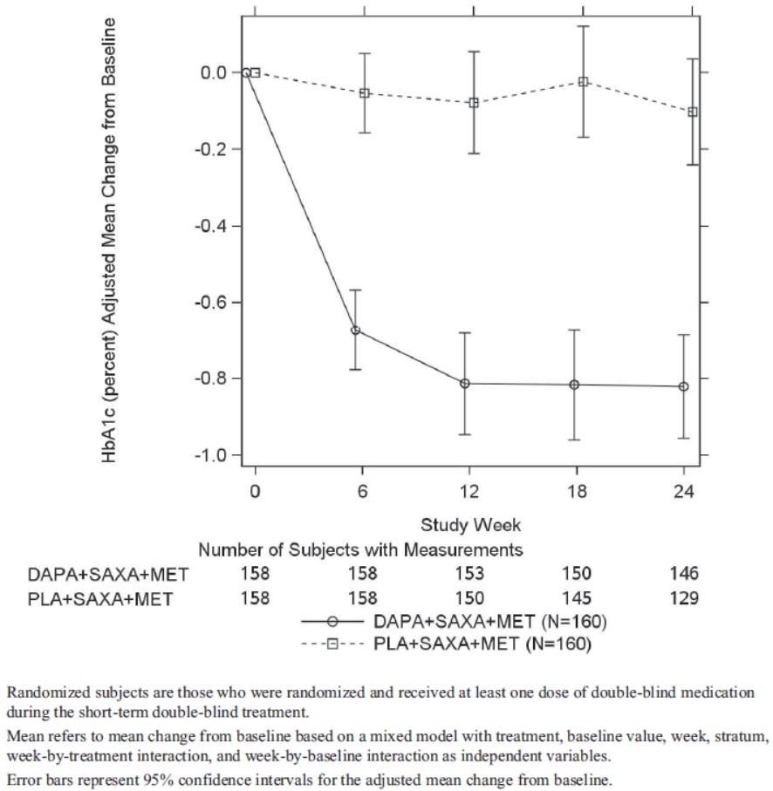
Across the subgroups of age, gender and region the addition of dapagliflozin to saxagliptin plus metformin consistently resulted in a greater reduction in HbA1c. Females ≤50 years had a greater response than those >50 years (treatment difference -1.06% vs -0.41%) due to an increase in HbA1c in younger females treated with saxagliptin plus metformin (0.40%).
Comment: There were too few non-Whites to assess racial subgroups.

Results for other efficacy outcomes
Dapagliflozin+saxagliptin+metformin treatment also resulted in a significant reduction in FPG compared to saxagliptin+metformin. The adjusted mean change from baseline to week 24 in FPG was -32.7 vs -5.3 mg/dL (treatment difference of -27.5 mg/dL, 95% CI: -35.4, -19.6 p<0.0001). A treatment difference was seen from week 6.
A positive effect with dapagliflozin+saxagliptin+metformin was also seen on the mean change from baseline to week 24 in the 120 minute PPG (-73.5 vs -38.0 mg/dL) with a significant treatment difference over Saxa+Met of -35.5 mg/dL (p<0.0001).
The adjusted mean change from baseline to week 24 in body weight was -1.91 kg vs -0.41 kg in the Dapa+Saxa+Met and Saxa+Met groups, respectively. This secondary endpoint was also statistically significant (difference of -1.50 kg (95% CI: -2.12,-0.89, p<0.0001).
The percentage of subjects achieving an HbA1c <7.0% at week 24 was higher with Dapa+Saxa+Met (38.0% vs 12.4%) with a treatment difference of 25.5% (95% CI: 16.7, 34.4).
Exploratory endpoints: There was a lower rate of discontinuation due to lack of glycaemic control or rescue medication use in the Dapa+Saxa+Met group (1.9% vs 15.0%). The glucose AUC derived from the MTT also showed a greater reduction with triple therapy (difference in the mean change from baseline to week 24 of -6191 mg/dL). Changes in serum lipids were small and unremarkable.

Summary
MB102129 was a phase III, randomised, placebo-controlled study which assessed the free combination of dapagliflozin plus saxagliptin and metformin compared to dual therapy with saxagliptin plus metformin in subjects with T2DM inadequately controlled (HbA1c ≥7.0% and ≤10.5%) after at least 8 weeks on saxagliptin plus metformin. After 24 weeks, the triple therapy of dapagliflozin+ saxagliptin+metformin significantly improved glycaemic control as measured by the primary endpoint of HbA1c (adjusted mean change from baseline of -0.82% vs -0.10%). The effect was robust and seen across subgroups, supported by sensitivity analyses and secondary endpoints (FPG, PPG, body weight and proportion achieving HbA1c <7.0%).

Other efficacy studies
None included in the dossier.

Analyses performed across trials (pooled & meta analyses)
None included in the dossier.

Evaluator’s conclusions on clinical efficacy
The dossier included three Phase III clinical efficacy studies (CV181169, CV181168 and MB102129) in adults with T2DM. They were all randomised, double blind, placebo controlled studies with an open label lead in period followed by a 24 week double blind treatment period. Studies CV181168 and MB102129 also have ongoing 28 week blinded extension treatment periods which have not been reported in this dossier.
In all studies, saxagliptin dose was 5 mg daily and dapagliflozin dose was 10 mg daily. The three efficacy studies assessed free combination of therapies rather than the FDC formulation. In Studies CV181168 and MB102129, metformin immediate release (IR) was used, while in CV181169 metformin XR was used. Subjects were on a stable dose of background metformin and the dose in all studies was ≥1500 mg per day.
Study CV181169 compared triple therapy of dapagliflozin 10 mg, saxagliptin5 mg and metformin to dual therapy dapagliflozin + metformin, or saxagliptin + metformin, in those inadequately controlled on metformin monotherapy. CV181168 and MB102129 assessed triple therapy in those inadequately controlled on dual therapy. CV181168 assessed the addition of saxagliptin to dapagliflozin plus metformin compared to dapagliflozin plus metformin dual therapy. MB102129 assessed the addition of dapagliflozin to saxagliptin plus metformin compared to saxagliptin and metformin dual therapy. To aid recruitment this latter study had two strata for screening and open label therapy: those on metformin monotherapy and those on metformin plus a DPP4 inhibitor.
The primary efficacy endpoint for all studies was the adjusted mean change from baseline to Week 24 in HbA1c. Secondary endpoints included 2 hour PPG (from MMT), FPG, body weight and proportion achieving HbA1c <7.0%. Statistical analyses were similar across the studies and multiplicity was controlled using a hierarchical testing procedure. Analysis was conducted on all randomised subjects who took at least one dose of double-blind study medication.
For enrolment subjects were not adequately controlled on metformin monotherapy with an HbA1c ≥8.0% to ≤12.0% in study CV181169, and ≥8.0% to ≤11.5% in studies CV181168 and MB102129 except for stratum B (prior dual therapy) where it was ≥7.5% to ≤10.5%. In these latter two studies subjects needed an HbA1c of 7.0% to ≤10.5% on dual therapy for randomisation.
The studies appeared well conducted with low rates of major protocol deviations, high treatment compliance and high completion rates. The number randomised was 534, 315 and 320 in CV181169, CV181168 and MB102129, respectively and study completion rates were 92-95%. The treatment groups were relatively well balanced in terms of baseline demographics and disease characteristics. Subjects were generally White, with a mean age of 54-55 years, mean BMI of approximately 31-32 kg/m², and the mean diabetes duration was approximately 7 to 8 years. After open label therapy, the mean baseline HbA1c was 8.9% in CV181169, 7.9% in CV181168 and 8.2% in MB102129.
All three studies met their primary endpoint demonstrating a greater reduction in HbA1c after 24 weeks treatment with saxagliptin + dapagliflozin + metformin compared to saxagliptin + metformin (studies CV181169 and MB102129) or dapagliflozin + metformin (studies CV181169 and CV181168). The adjusted mean treatment difference in HbA1c for Saxa + Dapa + Met compared to Dapa + Met was -0.35% in CV181168 and -0.27% in CV181169. The difference for Saxa + Dapa + Met compared to Saxa + Met was -0.59% in CV181169 and -0.72% in MB102129. The addition of dapagliflozin to saxagliptin plus metformin had a greater incremental effect on HbA1c than adding saxagliptin to dapagliflozin plus metformin.
In general, the treatment effect on HbA1c was generally greater in those with higher baseline HbA1c (>9.0%). Subgroup analysis of non-White racial groups was not possible due to small numbers. There was a possible interaction found in two of the studies with women ≤50 years having smaller reduction in HbA1c. The small group size makes assessing this effect difficult; however, the sponsor has been asked to comment on this finding.
In Studies CV181169 and CV181168, no statistically significant difference in the secondary endpoint of PPG was found so hierarchical testing ceased at this point. In MB102129, Saxa + Dapa + Met had a significantly greater effect on PPG than saxagliptin + metformin (difference of -1.97 mmol/L). It was noted that in CV181169 there was a numerically greater reduction in PPG with Saxa + Dapa + Met compared to Saxa + Met of -2.44 mmol/L while this was not evident compared to Dapa + Met (-0.51 mmol/L).
Changes in FPG were similar between Saxa + Dapa + Met and dapagliflozin + metformin and greater than with saxagliptin + metformin. After 24 weeks treatment, the percentage of subjects achieving an HbA1c <7.0% was greater with Saxa + Dapa + Met than dual therapy: 41.4% vs 18.3% (Saxa + Met) and 22.2% (Dapa + Met) in CV181169; 35.3% versus 23.1% (Dapa + Met) in CV181168; and 38.0% versus 12.4% (Saxa + Met) in MB102129.
Analysis of mean change from baseline to Week 24 in body weight found reductions in groups treated with dapagliflozin from 0.51 to 2.39 kg. Weight reduction in CV181168 was less presumably as subjects had already received open label dapagliflozin.
Discontinuation due to lack of glycaemic control or use of rescue medication was highest with saxagliptin plus metformin: 9.4% (CV181169) and 15.4% (MB102129) compared to 3.4%-4.4% with dapagliflozin plus metformin and 1.8%-5.5% with triple therapy.
Efficacy of saxagliptin/dapagliflozin with metformin after 1 year of treatment (studies CV181168 and MB102129) has not been provided. It was stated in the Clinical Overview that the studies will be completed in Q3 2015.
The efficacy studies were designed in accordance with the EMA guidelines on the development of a FDC. Patients insufficiently controlled on metformin or dual therapy (one constituent of the FDC + metformin) were assessed in parallel groups with placebo controls. The design of the studies was also in accordance with EMA guidelines on products for treatment of diabetes. This included use of HbA1c for the primary endpoint, appropriate statistical methods, analysis of HbA1c responders, a representative population, balanced treatment groups, and demonstration of superiority over placebo. While the studies provided confirmatory data to 24 weeks, the requirement of having, at least, one confirmatory study demonstrating maintenance of effect over at least 12 months has not been met.

Clinical safety

Studies providing safety data
Safety data were provided from the three Phase III studies (CV181169, CV181168, MB102129) with some supportive data from two Phase I healthy volunteer studies (CV181341 and CV181191). Safety data collected were: general AEs, AEs of particular interest; clinical laboratory tests, vital signs, 12 lead ECGs and physical examination. Hypoglycaemia was collected on a specific case report form (CRF) page and classified as major, minor and other. Only hypoglycaemia episodes that were SAEs were analysed with the AE data.
Data were pooled from the three phase III studies up to the week 24 efficacy assessment (short term [ST] treatment). This was termed the Integrated ST Pool. Data were based on all treated subjects.
There was a Clinical Event Committee (CEC) which adjudicated suspected cardiovascular events and an independent Hepatic Adjudication Committee which reviewed blinded data on liver-related abnormalities (hepatic disorders and laboratory abnormalities) to determine whether they were drug induced.

Pivotal studies that assessed safety as a primary outcome
None.

Patient exposure
The integrated ST Pool included 1169 subjects: 492, 336 and 341 who received Saxa+Dapa+Met, Saxa+Met and Dapa+Met, respectively. The median treatment duration for both saxagliptin and dapagliflozin was 169 days across the three treatment groups with a range of 1 to 223 days. There were few (n=9) subjects aged 75 years or older in the development program with only 4 receiving saxagliptin+dapagliflozin+metformin therapy.
Comment: All exposure in the clinical efficacy and safety studies was to the free combination of saxagliptin and dapagliflozin.
There were 72 and 42 healthy volunteers in studies CV181341 and CV181191, respectively, who were dosed with study treatment. Of these, 72 subjects in CV181341 received the FDC with 36 receiving the 2.5/5 mg dose and 36 receiving the 5/10 mg dose. Subjects in CV181191 received free combination saxagliptin and dapagliflozin.

Adverse events

All adverse events (irrespective of relationship to study treatment)

Pivotal studies
The AE rates were relatively similar across treatment groups: 50.8%, 55.7% and 46.0% in the Saxa+Dapa+Met, Saxa+Met and Dapa+Met groups, respectively. The AE rates were also similar when examining concomitant addition of saxagliptin and dapagliflozin (study CV181169) compared to sequential addition (CV181168 and MB102129). The exposure adjusted AE rates were 216.2, 295.6 and 228.1 per 100 subject-years in the three respective groups.
The most frequent AEs in the saxagliptin+dapagliflozin+metformin group were nasopharyngitis, headache, UTI, influenza and back pain. For the most common AEs (≥2.0% frequency) the rates with Saxa+Dapa+Met were similar to the dual therapy groups.

Other studies
In the two phase I studies in healthy volunteers (CV181341 and CV181191), nausea and headache were the most frequent AEs.

Treatment-related adverse events (adverse drug reactions)

Pivotal studies
The rate of treatment-related AEs was 6.5%, 6.8% and 6.2% in the Saxa+Dapa+Met, Saxa+Met and Dapa+Met groups, respectively. The most frequent treatment-related AEs in the triple therapy group were renal and urinary disorders (2.4% vs 0.6% and 1.5%) (the most frequent pollakiuria: 1.2% vs 0.3% and 0.6%), gastrointestinal disorders (2.0% vs 2.1% and 0.9%) and infections/infestations (1.4% vs 1.8% and 1.5%) (the most frequent UTI: 1.2% vs 1.5% and 0.3%).

Deaths and other serious adverse events

Pivotal studies
There were no deaths in the double-blind treatment period. There was one subject who died 6 months post treatment due to a gastric neoplasm (CV181169). This subject had a “non-malignant gastric neoplasm” diagnosed on day 137 of treatment and completed the study. There was one subject who died prior to treatment from a rectal adenocarcinoma (CV181168), and one who died during open label dapagliflozin plus metformin treatment from a pulmonary embolism (CV181168). In this last case the subject had a history of hypertension and dyslipidaemia and no further details were provided.
The rate of SAEs was 2.4%, 2.7% and 2.1% in the Saxa+Dapa+Met, Saxa+Met and Dapa+Met groups, respectively. No event was noted to be more frequent with triple than dual therapy combinations. There were two treatment-related SAEs. In one hyperkalaemia in a subject who received saxagliptin plus metformin. Treatment was discontinued. The second was of thrombocytopaenia in a 45 year old female on Saxa+Dapa+Met (day 127). Treatment was discontinued, the subject treated with prednisolone and platelet count returned to normal range. Drug-induced thrombocytopaenia was cited as a possible cause.

Other studies
There were no deaths or SAEs in the two phase I healthy volunteer studies.

Discontinuation due to adverse events

Pivotal studies
Discontinuation of treatment due to an AE was highest with Saxa+Dapa+Met therapy although rates were relatively low overall (2.0% vs 0.6%, 1.2%). In the Saxa+Dapa+Met group there were two discontinuations due to decrease GFR (0.4%) and two due to pollakiuria (0.4%). All other events occurred only as single cases. SAEs leading to discontinuation included cardiac failure, thrombocytopaenia and breast carcinoma (Saxa+Dapa+Met therapy) and ankle fracture and gangrene (saxagliptin plus metformin).

Other studies
There were no discontinuations due to AEs in the two phase I healthy volunteer studies.

Adverse events of special interest
The rate of hypoglycaemia was similar with saxagliptin+dapagliflozin+metformin and dapagliflozin+metformin (1.2% vs 1.8%) and higher than with saxagliptin+metformin (1.2% vs 0.3%). No cases were classed as major (symptomatic requiring external assistance and glucose <3 mmol/L).
The rate of AEs due to renal impairment or failure was 1.4%, 1.8% and 0.6% in the Saxa+Dapa+Met, Saxa+Met and Dapa+Met groups, respectively. There was one case of renal impairment in a 72 year old male which was felt to be treatment-related by the investigator and led to discontinuation of Saxa+Dapa+Met therapy. There were also three subjects (two Saxa+Dapa+Met and one Dapa+Met) who discontinued treatment due to decreased GFR.
The rate of AEs due to infections/infestations was similar between groups (20.7%, 23.8% and 23.2%). There were two infection-related discontinuations: vulvovaginal mycotic infection plus a UTI in a subject who received triple therapy and one of gangrene in a subject who received saxagliptin plus metformin. Genital infections were highest with dapagliflozin plus metformin (4.1%) compared to triple therapy (1.6%) or saxagliptin plus metformin (0.6%). Most cases were vulvovaginal fungal infections. The rate of UTIs was 3.5%, 5.7% and 3.8% in the Saxa+Dapa+Met, Saxa+Met and Dapa+Met groups, respectively. The exposure-adjusted rate for UTIs was 8.2, 14.0 and 8.6 per 100 subject years, respectively.
There were six subjects with malignancies in the integrated safety pool. The cases in the Saxa+Dapa+Met group were “infected neoplasm”, gastric neoplasm, hepatic cancer (metastases from pancreatic carcinoma), and invasive ductal breast carcinoma, the latter three being SAEs. There was also a subject with a melanocytic naevus in the saxagliptin plus metformin group and a subject with a thyroid neoplasm in the dapagliflozin plus metformin group.
There were seven subjects with a reported fracture. The fracture AE rate was 0.2%, 1.2% and 0.6% in the respective treatment groups. No event was considered treatment-related.
Cardiovascular events were adjudicated with 8 confirmed events occurring at a similar rate in the groups (0.8%, 0.6% and 0.6%, respectively).
There were 10 subjects with AEs related to cardiac failure with rates of 1.0%, 0.9% and 0.6% in the Saxa+Dapa+Met, Saxa+Met and Dapa+Met groups, respectively. In the Saxa+Dapa+Met group there were 3 subjects with peripheral oedema, one with cardiac failure (also an SAE) and one with oedema and orthopnoea. In the saxagliptin plus metformin group there were 3 subjects with peripheral oedema, and in the dapagliflozin plus metformin group there was one case of peripheral oedema and one of congestive cardiac failure.
Comment: The sponsor reported that the phase IV cardiovascular outcome study of saxagliptin (SAVOR) found an increased risk compared to placebo of hospitalisation due to cardiac failure (HR 1.27, 95% CI: 1.07, 1.51).
There were 3 subjects with thrombocytopaenia, 2 in the triple therapy group and one in the saxagliptin plus metformin group (0.4% vs 0.3%). One case with triple therapy was an SAE, deemed treatment-related and led to treatment discontinuation.
There was one case of chronic pancreatitis (also an SAE) in a subject treated with Saxa+Dapa+Met. The case was reported to be asymptomatic and detected on abdominal CT scan.
The rate of hepatic-related events (AE or laboratory value) was 1.4%, 0.9% and 0.6% in the respective groups (n=12). Of these, adjudicated and confirmed hepatic events were reported in 9 subjects (0.8%, 0.9% and 0.6%). There were 3 cases (2 saxagliptin plus metformin and one dapagliflozin plus metformin) adjudicated as possibly treatment-related. These cases were all grade 1 hepatocellular injury.
Volume depletion AEs were examined (hypotension, dehydration and hypovolaemia) and there were two cases both in the dapagliflozin plus metformin group (0.6%). Neither was an SAE. There were two AEs of skin exfoliation (non-serious and not treatment-related) with one in each of the dual therapy groups (0.3%). There were also two cases of hypersensitivity, both in the dapagliflozin plus metformin group (0.6%) and neither treatment-related or serious.

Laboratory tests

Liver function
Liver function tests showed little change in the mean values from baseline to week 24 across the groups.

Kidney function
The mean changes from baseline to week 24 in creatinine and estimated GFR were unremarkable across the three groups. The rate of markedly abnormal creatinine, ≥1.5 times pre-treatment levels, no higher with Saxa+Dapa+Met therapy (1.0% vs 0.9% and 1.5%).
Microscopic haematuria was reported in 5.2%, 4.0% and 4.0% of the three respective groups. There were 3 subjects treated with Saxa+Dapa+Met who had an AE of haematuria and one in the dapagliflozin plus metformin group (0.6% vs 0.3%).
The alblumin to creatinine ratio and the urinary albumin increased with saxagliptin plus metformin and decreased in the dapagliflozin containing groups, although changes were small.

Other clinical chemistry
There were no relevant changes from baseline to week 24 in the mean levels of protein, electrolytes, creatine kinase, magnesium, phosphorus or calcium. High creatine kinase was noted in the Saxa+Dapa+Met group with 1.2% and 0.8% of subjects having >5x ULN and >10xULN values, respectively. There were no cases in the dual therapy groups. The rate of markedly high potassium (≥6.0 mEq/L) was also greater with Saxa+Dapa+Met (2.3% vs 0.9%, 1.2%).

Haematology
After 24 weeks treatment, there were no remarkable changes from baseline in haematology parameters in the integrated safety dataset. The Saxa+Dapa+Met and dapagliflozin+metformin groups showed minor increases in haematocrit and haemoglobin. Markedly abnormal haemaoglobin or haematocrit rates were in line with dual therapy groups.

Vital signs
Dapagliflozin-containing groups had a small reduction in systolic and diastolic blood pressure over the 24 weeks treatment. The mean change from baseline to week 24 in DBP was -1.2 mmHg and in SBP was -1.3 to -1.7 mmHg. Heart rate changes were unremarkable.
Comment: This small change in BP known and is consistent with the mild diuretic effect of dapagliflozin.

Post-marketing experience
No post-marketing data were included in the dossier.

Safety issues with the potential for major regulatory impact
The major safety issues with the fixed dose combination are the same as those identified for the individual components.
In the saxagliptin RMP the important identified risks are hypersensitivity reactions, pancreatitis, infections and GI-related AEs. The important potential risks are skin lesions (ulcers, erosions, and necrosis), lymphopaenia, hypoglycaemia , severe cutaneous adverse reactions, opportunistic infections, pancreatic cancer and cardiac failure.
In the dapagliflozin RMP the important identified risks are genital infections and UTIs. The important potential risks are hypoglycaemia, volume depletion and clinical consequences of increased haematocrit, renal impairment/failure, hypersensitivity reactions, bone fracture, liver injury, bladder cancer, breast cancer, prostate cancer and off-label use of dapagliflozin in specific populations.

Other safety issues

Safety in special populations
The AE rates for subjects aged <65 years and ≥65 years treated with Saxa+Dapa+Met were similar. AE rates in males and females were also similar. Females had a higher AE rate than males when treated with saxagliptin plus metformin (63% vs 48%). Rates of AEs in Whites and Blacks were consistent.
Comment: There were too few subjects aged over 75 years or from Asian racial groups to draw conclusions.

Safety related to drug-drug interactions and other interactions
Dapagliflozin is metabolised by UGT1A9 dependent glucuronide conjugation. Saxagliptin is metabolised by cytochrome P450 3A4/5 and therefore would be affected by concomitant administration with CYP3A4 inducers or inhibitors.
Comment: It is noted in the US label that there is a recommendation to reduce the dose of saxagliptin when co-administered with strong CYP3A4 inhibitors such as ketoconazole. This is not possible with the FDC as the 2.5 mg saxagliptin dose is not proposed. There is a difference between the Australian and US labels regarding this drug interaction and the draft PI does not address the lack of the 2.5 mg saxagliptin dose. A question has been raised on these points.
Apart from the study assessing the potential interaction between the FDC components, other drug-drug interactions were not directly assessed in the development program.

Pregnancy
There were three pregnancies reported and all were in CV181169. The one subject in the Saxa+Dapa+Met group withdrew from the study and did not have follow-up. One subject in the dapagliflozin+metformin group had a positive pregnancy test after approximately 6 weeks of treatment, the infant was born about 8 months later and had a congenital cardiac anomaly which was not deemed treatment-related. The final pregnancy was in the partner of a male subject on saxagliptin plus metformin and resulted in a spontaneous abortion 2 weeks after the positive pregnancy test.
Comment: There are no data on saxagliptin, dapagliflozin or the FDC in pregnant women and preclinical data for dapagliflozin suggest foetal risks. Therefore, the FDC treatment must not be used during pregnancy. Similarly saxagliptin/dapagliflozin must not be used while breastfeeding.

Evaluator’s overall conclusions on clinical safety
The three Phase III studies in the dossier assessed a free combination of saxagliptin plus dapagliflozin in conjunction with metformin and compared this triple therapy to dual therapy of saxagliptin plus metformin or dapagliflozin plus metformin. Consequently, the safety of saxagliptin/dapagliflozin combination was only available with concomitant metformin and only in comparison to either dual therapy (Saxa + Met or Dapa + Met). In addition, the safety of the FDC must be extrapolated from that found with the free combination.
Safety data were pooled from the three Phase III studies up to the week 24 efficacy assessment (termed the Integrated Short Term Pool). There was a Clinical Event Committee which adjudicated suspected cardiovascular events and an independent Hepatic Adjudication Committee which reviewed blinded data on liver-related abnormalities.
The integrated ST Pool included 1169 subjects: 492, 336 and 341 who received Saxa + Dapa + Met, Saxa + Met and Dapa + Met, respectively. The median treatment duration for both saxagliptin and dapagliflozin was 169 days across the three treatment groups. There were also 113 healthy volunteers who received saxagliptin plus dapagliflozin in Phase I studies of whom 72 received the FDC, though only 36 received the proposed 5/10 mg strength.
Overall, the safety of the saxagliptin plus dapagliflozin in combination with metformin was in line with the dual therapy combinations. There were no deaths during the 24 weeks of double blind treatment and the SAE rate was similar between groups (2.4%, 2.7% and 2.1%). There were two treatment related SAEs: hyperkalaemia in a subject who received saxagliptin plus metformin and thrombocytopaenia in a subject on saxagliptin plus dapagliflozin and metformin which was considered possibly drug induced.
Treatment discontinuation was slightly higher with the Saxa + Dapa + Met therapy (2.0% vs 0.6%, 1.2%) and the discontinuation events that occurred in more that one patient were decreased GFR and pollakiuria (2 cases each).
The AE rates were similar between groups with the most frequent AEs in the Saxa + Dapa + Met group being nasopharyngitis, headache, UTI, influenza and back pain. Rates of AEs were also similar when examining concomitant addition of saxagliptin and dapagliflozin (Study CV181169) compared to sequential addition (CV181168 and MB102129). Total treatment related AE rates were no higher with Saxa + Dapa + Met, although renal and urinary disorders were higher (2.4% vs 0.6% and 1.5%) (thet frequent pollakiuria: 1.2% versus 0.3% and 0.6%).
The rate of hypoglycaemia was similar with triple therapy and dapagliflozin + metformin (1.2% versus 1.8%), however it was higher than with saxagliptin + metformin (1.2% versus 0.3%). No cases were classed as major (symptomatic requiring external assistance and glucose <3 mmol/L).
Renal impairment or failure occurred at a similar rate to subjects receiving saxagliptin plus metformin and higher than those receiving dapagliflozin plus metformin (1.4%, 1.8% and 0.6%). Compared to dual therapy there was no increased risk of infections including genital or urinary infections.
Adjudicated cardiovascular events also occurred at a similar frequency (0.8%, 0.6% and 0.6%). AEs related to cardiac failure were slightly more frequent in the saxagliptin containing treatment groups (1.0%, 0.9% versus 0.6%). The sponsor reported that the Phase IV cardiovascular outcome study of saxagliptin (SAVOR) found an increased risk compared to placebo of hospitalisation due to cardiac failure (HR 1.27, 95% CI: 1.07, 1.51).
Independent adjudication of hepatic events found similar rates (0.8%, 0.9% and 0.6%). Three cases were deemed possibly treatment related (all in dual therapy groups), were classed a grade I hepatocellular injury, and there were no cases of DILI.
Although there was no relevant mean change in creatine kinase, there was a higher rate of CK >5xULN (1.2% vs 0%) in those treated with saxagliptin plus dapagliflozin and metformin. Similarly, there was a slightly higher rate of potassium (≥6.0 mEq/L) with triple therapy (2.3% versus 0.9%, 1.2%). The sponsor stated these cases were not persistent and were not reflected in treatment discontinuation. The triple therapy and dapagliflozin plus metformin groups showed minor increases in haematocrit and haemoglobin, however the rate of markedly abnormal levels were in line with dual therapy groups. While there were similar rates of microscopic haematuria, there was a slightly higher rate of haematuria AEs with Saxa + Dapa + Met (0.6% versus 0% and 0.3%). Other laboratory assessments were unremarkable.
Subjects treated with dapagliflozin containing regimens were found to have small decreases in mean SBP and DBP (up to -1.7 mmHg) which is consistent with its diuretic effect.
The limitations of the safety data included: a lack of data in subjects aged 75 years or older; insufficient Asian patients to examine safety in this subgroup; no data on pregnancy or lactation; and safety data was only available for up to 24 weeks of treatment.
The safety database was relatively small in size (n = 492) making determination of risks difficult. Nonetheless, the level of knowledge on the constituents is larger and can be directly applied to this product.
There was no indication of a pharmacokinetic interaction between saxagliptin and dapagliflozin. In addition, there was no proposed change in the dosing in the FDC from that approved for the individual components.
The lack of the saxagliptin 2.5 mg dose, together with known dapagliflozin risks, mean that the treatment is unsuitable for patients with a CrCl <60 mL/min.
Overall, within the limitations of a relatively small safety dataset size, the addition of saxagliptin and dapagliflozin to metformin did not appear to result in an increase in safety risks, and in particular the risk of hypoglycaemia, compared to treatment with saxagliptin and metformin or dapagliflozin and metformin after 24 weeks of treatment. The safety data to 52 weeks should to be provided to further elucidate risks with longer term treatment.
It has been noted in the US label for saxagliptin has an included risk of severe disabling arthralgia with DPP4 inhibitors. This has not been included in the proposed PI and a question has been raised.

First round benefit-risk assessment

First round assessment of benefits
The benefits of saxagliptin/dapagliflozin in the proposed usage are:
- When given together with metformin there is a consistent reduction in HbA1c that is greater than with saxagliptin plus metformin or dapagliflozin plus metformin.
- When given together with metformin, a higher proportion of patients achieved glycaemic control of HbA1c <7.0% after 24 weeks treatment than with saxagliptin plus metformin or dapagliflozin plus metformin.
- A complementary mechanism of action of the two therapies.
- No major hypoglycaemia events reported in the development program.
- No new safety signals.

First round assessment of risks
The risks of saxagliptin/dapagliflozin in the proposed usage are:
- Hypoglycaemia, with a greater risk for saxagliptin + dapagliflozin + metformin than with saxagliptin + metformin but in line with dapagliflozin + metformin.
- Other risks as identified for the individual components such as volume depletion, hypotension, electrolyte imbalances, hypersensitivity reactions, UTIs, genital infections, skin disorders, pancreatitis, cardiac failure and increased haematocrit.
- The combination cannot be used in patients with moderate to severe renal impairment, in patients with severe hepatic impairment or during pregnancy or lactation.
- The combination must be used with caution in patients with cardiac failure.
- A lack of data in patients 75 years and older and a greater risk in the elderly of volume depletion.
- A lack of efficacy and safety data beyond 24 weeks.

First round assessment of benefit-risk balance
The FDC of saxagliptin and dapagliflozin combines two anti-hyperglycaemic products with differing modes of action and this complementary action has the potential to be of use to clinicians. Combining two treatments in one tablet also has a possible benefit to patients of increased treatment compliance via convenience, although no data have been presented on this.
The three clinical efficacy and safety studies were conducted with a free combination of saxagliptin and dapagliflozin so it was crucial that the bioequivalence of the free to FDCs was demonstrated. In addition, there was no evidence of drug-drug interactions between the FDC components.
The combination of saxagliptin and dapagliflozin plus metformin resulted in a consistent and statistically significant greater reduction in HbA1c, and a greater proportion of subjects achieving an HbA1c response of <7.0%, than with dual therapy of saxagliptin or dapagliflozin plus metformin. The level of additional benefit, in terms of HbA1c reduction, of the third therapy over dual therapy (saxagliptin + metformin or dapagliflozin + metformin) was however only modest (-0.27% to -0.35% when adding saxagliptin and -0.59% to -0.72% when adding dapagliflozin). The effect on secondary endpoints of FPG and PPG was of variable significance, particularly when saxagliptin + dapagliflozin +metformin therapy was compared to dapagliflozin + metformin. Consistent with known effects, dapagliflozin groups demonstrated the benefit of small levels of weight reduction.
Within the confines of a moderate sized safety dataset, no new safety signals were identified for the combination of saxagliptin plus dapagliflozin and metformin. In particular, the risk of hypoglycaemia was no greater than with dapagliflozin plus metformin. There was also no increased risk of cardiac failure from the analysis of adjudicated CV events. There were no efficacy or safety data beyond 24 weeks treatment and so the data to 52 weeks from the two Studies CV181168 and MB102129 should be submitted to further characterise the longer term safety and efficacy.
The proposed indication is that the FDC should be used as an adjunct to diet and exercise to improve glycaemic control in adults with type 2 diabetes mellitus when treatment with both saxagliptin and dapagliflozin is appropriate.
The evaluator believes that this indication is too broad. Firstly, the clinical trials only assessed efficacy and safety of saxagliptin and dapagliflozin when given in combination with metformin. Therefore, the indication must include metformin to accurately reflect the available clinical data.
Secondly, the sponsor proposes that the FDC could be the next step after metformin, that is, as a concomitant dual add-on second line therapy. The sponsor puts forward an argument that there may be
delays in intensifying treatment which may contribute to poor level of glycaemic control in patients with T2DM.
Therefore, there is a clinical need for a concomitant add-on approach to enable patients to reach glycaemic goals earlier and the proposed FDC would facilitate this.
While it is acknowledged that initial combination therapy may allow patients to achieve HbA1c targets more quickly, the evaluator notes that in the ADA/EASD position statement on management of hyperglycaemia in T2DM, it was stated that:
there is no proven overall advantage to achieving a glycemic target more quickly by a matter of weeks or even months. The article goes on to state that as long as close patient follow-up can be ensured, prompt sequential therapy is a reasonable alternative, even in those with baseline HbA1c levels in this range [≥9%].
The recommendations in the article are that if the HbA1c target is not achieved after 3 months of dual therapy then treatment should proceed to a three drug combination.
Taking these recommendations into account, the relatively modest reduction in HbA1c, the risks of the two therapies, the lack of long term outcome data with dapagliflozin, and the general recommendations on the rational use of prescription therapies, the evaluator believes that use of the saxagliptin/dapagliflozin combination should as third line therapy in conjunction with metformin. As such, the indication should be reworded to reflect this.
In summary, the evaluator finds that the benefit-risk balance of saxagliptin/dapagliflozin FDC is unfavourable given the proposed usage. Should the issues outlined be addressed to the TGA’s satisfaction, then the benefit-risk balance may become favourable.

First round recommendation regarding authorisation
It is currently not recommended to authorise the FDC of saxagliptin/ dapagliflozin 5/10 mg due to the following issues:
- The indication needs to be reworded to reflect the requirement for treatment to be in conjunction with metformin. It is also recommended that the FDC be used as a third line therapy.
- There are a number of recommendations for changes to the draft PI and CMI which should be addressed.
- In addition, if available now, the longer term efficacy and safety data to 52 weeks of treatment should be provided for evaluation. Otherwise, it should be submitted as soon as available.

Clinical questions

Pharmacokinetics
- Question 1: Can the sponsor please confirm that the Onglyza and Forxiga tablets used in Studies CV181341 and CV181191 are identical to the formulations registered in Australia?
- Question 2: Can the sponsor please confirm that the Qtern formulation used in Study CV181341 is identical to the formulation that is to be marketed in Australia?

Pharmacodynamics
Not applicable.

Efficacy
- Question 3: In the efficacy studies a possible interaction was found in women ≤50 years who had a smaller reduction in HbA1c. It is acknowledged that the small group size makes assessing this effect difficult, however could the sponsor please comment on this finding?

Safety
- Question 4: In the US label for saxagliptin, there is a warning for severe disabling arthralgia with DPP4 inhibitors. This risk has not been included in the proposed label for the saxagliptin/dapagliflozin FDC. Please discuss these findings and include relevant data in the proposed PI.

References
- Food and Drug Administration Center for Drug Evaluation and Research. Guidance for Industry: Diabetes Mellitus - Developing Drugs and Therapeutic Biologics for Treatment and Prevention. February 2008. US Department of Health and Human Services, Center for Drug Evaluation and Research.
- Food and Drug Administration Center for Drug Evaluation and Research. Final Guidance for Industry Diabetes Mellitus - Evaluating Cardiovascular Risk in New Antidiabetic Therapies to Treat Type 2 Diabetes. December 2008. US Department of Health and Human Services, Center for Drug Evaluation and Research.
- Inzucchi SE, Bergenstal RM, Buse JB et al. Management of hyperglycaemia in type 2 diabetes, 2015: A patient-centered approach. Diabetes Care 2015; 38: 140-149.
- The European Medicines Agency. Committee for Medicinal Products for Human Use (CHMP). Guideline on clinical investigation of medicinal products in the treatment or prevention of diabetes mellitus. CPMP/EWP/1080/00 Rev 1, 14 May 2012.
- The European Medicines Agency. Committee for Medicinal Products for Human Use (CHMP). Guideline on clinical development of fixed combination medicinal products. CHMP/EWP/240/95, Rev. 1, 19 February 2009.

Therapeutic Goods Administration
PO Box 100 Woden ACT 2606 Australia
Email: info@tga.gov.au Phone: 1800 020 653 Fax: 02 6232 8605
https://www.tga.gov.au

Hypoglycaemia major episode was defined as a symptomatic episode requiring external (3rd party) assistance due to severe impairment in consciousness or behaviour with a glucose value <3 mmol/L (<54 mg/dL) and prompt recovery after glucose or glucagon administration. Minor episode was defined as either a symptomatic episode with a capillary or plasma glucose measurement below 3.5 mmol/L (63 mg/dL), regardless of need for external assistance, or an asymptomatic capillary or plasma glucose measurement below 3.5 mmol/L (63 mg/dL) that does not qualify as a major episode. Other episode of hypoglycaemia was defined as suggestive episode reported but not meeting the criteria for major or minor episodes.
Inzucchi SE, et al. Management of hyperglycaemia in type 2 diabetes, 2015: A patient-centered approach. Diabetes Care 38: 140-149 (2015).

