January 2022

0BAustralian Public Assessment Report for SARS-CoV-2 rS with Matrix-M adjuvant
  - Proprietary Product Name: Nuvaxovid
  - Sponsor: Biocelect Pty Ltd

About the Therapeutic Goods Administration (TGA)
- The Therapeutic Goods Administration (TGA) is part of the Australian Government Department of Health and is responsible for regulating medicines and medical devices.
- The TGA administers the Therapeutic Goods Act 1989 (the Act), applying a risk management approach designed to ensure therapeutic goods supplied in Australia meet acceptable standards of quality, safety and efficacy (performance) when necessary.
- The work of the TGA is based on applying scientific and clinical expertise to decision-making, to ensure that the benefits to consumers outweigh any risks associated with the use of medicines and medical devices.
- The TGA relies on the public, healthcare professionals and industry to report problems with medicines or medical devices. TGA investigates reports received by it to determine any necessary regulatory action.
- To report a problem with a medicine or medical device, please see the information on the TGA website <34TUhttps://www.tga.gov.auU34T>.

About AusPARs
- An Australian Public Assessment Report (AusPAR) provides information about the evaluation of a prescription medicine and the considerations that led the TGA to approve or not approve a prescription medicine submission.
- AusPARs are prepared and published by the TGA.
- An AusPAR is prepared for submissions that relate to new chemical entities, generic medicines, major variations and extensions of indications.
- An AusPAR is a static document; it provides information that relates to a submission at a particular point in time.
- A new AusPAR will be developed to reflect changes to indications and/or major variations to a prescription medicine subject to evaluation by the TGA.

Copyright
© Commonwealth of Australia 2022
This work is copyright. You may reproduce the whole or part of this work in unaltered form for your own personal use or, if you are part of an organisation, for internal use within your organisation, but only if you or your organisation do not use the reproduction for any commercial purpose and retain this copyright notice and all disclaimer notices as part of that reproduction. Apart from rights to use as permitted by the Copyright Act 1968 or allowed by this copyright notice, all other rights are reserved and you are not allowed to reproduce the whole or any part of this work in any way (electronic or otherwise) without first being given specific written permission from the Commonwealth to do so. Requests and inquiries concerning reproduction and rights are to be sent to the TGA Copyright Officer, Therapeutic Goods Administration, PO Box 100, Woden ACT 2606 or emailed to <34Ttga.copyright@tga.gov.au34T>.

Contents
List of abbreviations 4
I. Introduction to product submission 7
Submission details 7
Product background 8
Regulatory status 11
Product Information 12
II. Registration timeline 12
III. Submission overview and risk/benefit assessment 13
Quality 13
Nonclinical 16
Clinical 18
Risk management plan 82
Risk-benefit analysis 84
Outcome 94
Attachment 1. Product Information 98

List of abbreviations
Abbreviation | Meaning
ACE2 | Angiotensin converting enzyme 2
ACV | Advisory Committee on Vaccines
AE | Adverse event
AESI | Adverse event of special interest
ARGPM | Australian Regulatory Guidelines for Prescription Medicines
ARTG | Australian Register of Therapeutic Goods
ASA | Australian specific annex
AusPAR | Australian Public Assessment Report
CDC | Centers for Disease Control and Prevention (United States of America)
CI | Confidence interval
CMI | Consumer Medication Information
COVID-19 | Coronavirus disease 2019
CSR | Clinical study report.
DLP | Data lock point
ELISA | Enzyme-linked immunosorbent assay
EMA | European Medicines Agency (European Union)
EU | European Union
EUA | Emergency Use Authorization (United States of America)
FAS | Full analysis set
FDA | Food and Drug Administration (United States of America)
GMEU | Geometric mean ELISA unit
GMFR | Geometric mean fold rise
GMP | Good Manufacturing Practice
GMT | Geometric mean titres
GVP | Good Pharmacovigilance Practices
hACE2 | Human angiotensin converting enzyme 2
HIV | Human immunodeficiency virus
ICU | Intensive care unit
IgG | Immunoglobin G
IR | Incident rate
ITT | Intent to treat
LBCI | Lower bound of the confidence interval
LLOQ | Lower limit of quantification
MAAE | Medically attended adverse event
MedDRA | Medical Dictionary for Regulatory Activities
MN | Microneutraliastion
NAb | Neutralising antibody
NP | Nucleoprotein
NVX-CoV2373 | Product development code for Nuvaxovid
PCR | Polymerase chain reaction
PI | Product Information
PIMMC | Potential immune mediated medical condition
PP-EFF | Per protocol efficacy
PT | Preferred Term
PY | Patient-years
RD | Risk difference
RMP | Risk management plan
RNA | Ribonucleic acid
RR | Relative risk
rS | Recombinant spike protein
SAE | Serious adverse event
SARS-CoV-2 | Severe acute respiratory syndrome coronavirus 2
SAS | Safety analysis set
SCR | Seroconversion rate
SII | Serum institute of India
SMQ | Standardised MedDRA query
SOC | System Organ Class
TEAE | Treatment emergent adverse event
TGA | Therapeutic Goods Administration
UK | United Kingdom
USA | United States of America
VAED | Vaccine-associated enhanced disease
VAERD | Vaccine-associated enhanced respiratory disease
VE | Vaccine efficacy
VOC | Variant of concern
VOI | Variant of interest
WHO | World Health Organization

I. Introduction to product submission

Submission details
Type of submission: | New biological entity
Product name: | Nuvaxovid
Active ingredient: | Severe acute respiratory syndrome coronavirus 2 (SARS-CoV-2) recombinant spike protein (rS) with Matrix M adjuvant
Decision: | Approved for provisional registration
Date of decision: | 19 January 2022
Date of entry onto ARTG: | 20 January 2022
ARTG number: | 355139
Black Triangle Scheme:P0F | Yes  As a provisionally registered product, this medicine will remain in the Black Triangle Scheme for the duration of its provisional registration

Sponsor’s name and address: | Biocelect Pty Ltd  Suite 502 Level 5  139 Macquarie Street, NSW 2000
Dose form: | Suspension for injection
Strength: | 5 µg/0.5mL
Container: | Multidose vial
Pack size: | Ten vials
Approved therapeutic use: | Active immunisation to prevent coronavirus disease 2019 (COVID-19) caused by SARS-CoV-2 in individuals 18 years of age and older.  The use of this vaccine should be in accordance with official recommendations.  The decision has been made on the basis of short-term efficacy and safety data. Continued approval depends on the evidence of longer term efficacy and safety from ongoing clinical trials post-market assessment
Route of administration: | Intramuscular injection
Dosage: | Nuvaxovid is administered intramuscularly as a course of two doses of 0.5 mL each. It is recommended that the second dose is to be administered three weeks after the first dose, see Section 5.1 of the Product Information (PI).  There are no data available on the interchangeability of Nuvaxovid with other COVID-19 vaccines to complete the primary vaccination course. Individuals who have received a first dose of Nuvaxovid should receive the second dose of Nuvaxovid to complete the vaccination course, see Section 4.4 of the PI.  For precautions for administering the vaccine, see Section 4.4 of PI.  For further information regarding dosage, refer to the PI.
Pregnancy category: | B1  Drugs which have been taken by only a limited number of pregnant women and women of childbearing age, without an increase in the frequency of malformation or other direct or indirect harmful effects on the human fetus having been observed.  Studies in animals have not shown evidence of an increased occurrence of fetal damage.  The use of any medicine during pregnancy requires careful consideration of both risks and benefits by the treating health professional. This must not be used as the sole basis of decision making in the use of medicines during pregnancy. The TGA does not provide advice on the use of medicines in pregnancy for specific cases. More information is available from obstetric drug information services in your State or Territory.

Product background
This AusPAR describes the application by Biocelect Pty Ltd (the sponsor) to register Nuvaxovid (SARS-CoV-2 rS with matrix M adjuvant) 5 µg/0.5mL, suspension for injection, multidose vials, for the following proposed indication:
Active immunisation for the prevention of mild, moderate, and severe disease caused by SARS-CoV-2 in adults ≥ 18 years of age.

Coronavirus disease
Coronavirus disease 2019 (COVID-19) is a disease caused by infection with the pandemic virus known as severe acute respiratory syndrome coronavirus 2 (SARS-CoV-2). Since its emergence, first recognised in late 2019 SARS-CoV-2 has spread rapidly and globally. The World Health Organization (WHO) declared that the outbreak constituted a public health emergency of international concern on 30 January 2020 and declared the outbreak to be a pandemic on 11 March 2020.P1F,2FP As of 17 January 2022, approximately 32.6 million cases and 5.5 million deaths from COVID-19 have been reported worldwide.P3FP Of these, approximately 1.3 million cases and 2600 deaths have been reported in Australia P4F
Respiratory symptoms of COVID-19 typically appear 5 to 6 days following exposure to the virus, but may appear at any time from 2 to 14 days following exposure, with the clinical manifestations ranging from mild symptoms to severe illness or death. Based on surveillance data reported by 22 countries, an estimated 22% (country range: 3 to 60%) of reported COVID-19 cases have been hospitalised. Data from 17 countries show that a total of 9% (country range: 0 to 62%) of hospitalised patients required intensive care unit (ICU) and/or respiratory support. Viral SARS-CoV-2 ribonucleic acid (RNA) has been detected in upper respiratory samples from asymptomatic or pre-symptomatic individuals, with an increasing number of studies demonstrating that asymptomatic individuals can transmit SARS-CoV-2. Although the extent to which asymptomatic transmission occurs remains unknown, it may significantly contribute to the transmission within the community.
Disease severity is mainly related to respiratory manifestations and increases with age. Mortality is rare in childhood but increases steeply beyond 60 years of age.
Emerging mutated SARS-CoV-2 variants of concern (VOC) may pose challenges for current vaccination strategies, which are generally based on inducing immunity to the non-mutated spike protein that was sequenced in the original wild type virus. The latest VOC is Omicron. The Omicron variant is likely more transmissible than the original SAR-CoV-2 strain, however it is unknown if it is more transmissible than the Delta variant that was first designated as a VOC in May 2021.P5FP To understand if Omicron infections, reinfections and breakthrough infections in people who are fully vaccinated, can cause more severe illness or death compare to infection with other variants, more studies and data are required.
In the absence of highly effective prophylactic or therapeutic medicines, active immunisation through vaccination represents the best means of preventing hospitalisation and deaths at an individual level and controlling the pandemic at a societal level.

Nuvaxovid coronavirus disease vaccine
Nuvaxovid is a recombinant spike (rS) protein vaccine. It is based on the first-isolated full length, wild-type SARS-CoV-2 spike glycoprotein. It is formulated in a sterile, preservative free, aqueous buffered suspension of the SARS-CoV-2 rS protein that is co-formulated with Matrix-M adjuvant;P6FP and formulation buffer and presented in a multidose vial containing ten doses.

Current vaccine and treatment options
Australia has four vaccines on the Australian Register of Therapeutic Goods (ARTG) with provisional approval;P7FP for the prevention of COVID-19:
- Comirnaty (tozinameran), also known as the Pfizer/BioNTech COVID-19 vaccine, is an mRNA-based vaccine that was granted provisional registration on 25 January 2021 for active immunisation to prevent COVID-19 caused by SARS-CoV-2, in individuals 16 years of age and older;P8FP. The regimen is two doses, three weeks apart. An extension of indications to include the age group of 12 to 15 years and older was approved on 21 July 2021.P9FP Use in children 5 to 11 years and older was approved on 3 December 2021.P10F
- Spikevax (elasomeran), also known as the Moderna vaccine, is an mRNA-based vaccine that was provisionally approved on 9 August 2021 for active immunisation to prevent COVID-19 caused by SARS-CoV-2 in individuals 18 years of age and older.P11FP An extension of indications to include the age group of 12 years and older was approved on 3 September 2021.P12F
- COVID-19 Vaccine Janssen (Ad26.COV2.S), an adenoviral vectored vaccine, was provisionally approval on 25 June 2021 for active immunisation to prevent COVID-19 caused by SARS-CoV-2 in individuals 18 years of age and older.P13F
- Vaxzevria (ChAdOx1-S), an adenoviral vectored vaccine, was provisionally approved 15 February 2021 for active immunisation of individuals ≥ 18 years old for the prevention of coronavirus disease 2019 (COVID-19) caused by SARS-CoV-2.P14F
Monoclonal antibodies with indications for treatment of COVID-19 that have been granted provisional registration;8P20T in Australia are listed below:
- Xevudy (sotrovimab) was provisionally approved on 20 August 2021 for approval for treatment of adults and adolescents (aged 12 years and over and weighing at least 40 kg) with coronavirus disease 2019 (COVID-19) who do not require initiation of oxygen due to COVID-19 and who are at increased risk of progression to hospitalisation or death.15F
- Ronapreve (casirivimab and imdevimab) was provisionally approved on 15 October 2021 for treatment of COVID-19 in adults and adolescents aged 12 years and older and weighing at least 40 kg who do not require supplemental oxygen for COVID-19 and who are at increased risk of progressing to severe COVID-19 and prevention of COVID-19 in patients of the same age and weight as for treatment who have been exposed to SARS-CoV-2 and who either have a medical condition making them unlikely to respond to or be protected by vaccination, who have not been vaccinated against COVID-19.16F
- Actemra (tocilizumab) was provisionally approved on the 1 December 2021 for treatment of confirmed COVID-19 in hospitalised adults aged 18 years and older who are receiving systemic corticosteroids and require supplemental oxygen or mechanical ventilation.17F
Other medicines with indications for treatment of COVID-19 that have been granted provisional registration in Australia include Veklury (remdesivir), Paxlovid (nirmatrelvir/ritonavir) and Lagevrio (molnupiravir). Veklury was provisionally approved on 10th July 2020 for COVID-19 treatment.18F Paxlovid was provisionally approved on 18 January 2022 for COVID-19 treatment.19F Lagevrio was provisionally approved on 18 January 2022 for COVID-19 treatment.20F

Regulatory status
This product is considered a new biological entity for Australian regulatory purposes.
The provisional determination for Nuvaxovid was granted by the Therapeutic Goods Administration (TGA) on 19 January 2021.
At the time the TGA considered this application, an Emergency Use Listing was granted by WHO on 17 December 2021. European Medicines Agency (EMA) granted conditional approval on the 20 December 2021. In addition, similar applications were under consideration in United States of America (USA), Canada, United Kingdom (UK) and New Zealand.
Table 1: International regulatory status
Region | Submission date | Status | Approved indications
European Union (EU) | 3 February 2021 | Conditional approval on 20 December 2021 | Active immunization for the prevention of mild, moderate, and severe disease caused by SARS-CoV-2 in adults ≥ 18 years of age
United States of America | 11 June 2020 (under IND) | Under consideration | Under consideration
Canada | 29 January 2021 | Under consideration | Under consideration
United Kingdom | 22 January 2021 | Under consideration | Under consideration
New Zealand | 17 February 2021 | Under consideration | Under consideration

Product Information
The Product Information (PI) approved with the submission which is described in this AusPAR can be found as Attachment 1. For the most recent PI, please refer to the TGA website at <34Thttps://www.tga.gov.au/product-information-pi34T>.

II. Registration timeline
The following table captures the key steps and dates for this application and which are detailed and discussed in this AusPAR.
Data was provided as a rolling submission. Under normal circumstances, the TGA's assessment (for both provisional and general registration) begins once all information to support registration is available. As part of the Department of Health's response to the pandemic, the TGA has agreed to accept rolling data for COVID-19 vaccines and treatments, to enable early evaluation of data as it comes to hand.
Table 2: Timeline for Submission PM-2021-00623-1-2
Description | Date
Determination (Provisional);8 | 19 January 2021
Submission dossier accepted and first round of evaluation commenced | 26 February 2021
Evaluation completed | 5 January 2022
Delegate’s Overall benefit-risk assessment and request for Advisory Committee advice | 5 January 2022
Sponsor’s pre-Advisory Committee response | 7 January 2022
Advisory Committee meeting | 7 January 2022
Registration decision (Outcome) | 19 January 2022
Completion of administrative activities and registration on the ARTG | 20 January 2022
Number of working days from submission dossier acceptance to registration decision* | 175
*Statutory timeframe for standard applications is 255 working days

III. Submission overview and risk/benefit assessment
The submission was summarised in the following Delegate’s overview and recommendations.

Quality
Nuvaxovid is a recombinant spike protein vaccine. It is based on the first-isolated full length, wild-type SARS-CoV-2 spike glycoprotein. It is formulated in a sterile, preservative free, aqueous buffered suspension of the SARS-CoV-2 rS protein that is co-formulated with Matrix-M adjuvant and formulation buffer and presented in a multidose vial containing ten doses. A single dose is 0.5 mL. The recommended storage conditions of Nuvaxovid is from 2°C to 8°C and the intended route of administration is intramuscular injection.

Structure
The SARS-CoV-2 viral spike protein envelope consists of multimers of the spike glycoprotein which mediates receptor binding and membrane fusion with the host cell. The S gene was codon-optimised for expression in Spodoptera frugiperda insect cells from a full length, prefusion, stabilised SARS-CoV-2 spike genetic sequence. This recombinant SARS-CoV-2 spike gene encodes a recombinant spike glycoprotein, which is the active component of the vaccine). Purified rS glycoprotein form trimers that assemble into nanoparticles, binding with high affinity to the human angiotensin converting enzyme 2 (ACE2) receptor.

Adjuvant
Matrix-A and Matrix-C complexes contain purified saponin Fraction-A or Fraction-C, respectively, plus cholesterol and phosphatidylcholine. The saponin fractions are obtained by high-performance liquid chromatography purification of saponin enriched purified bark extract from the tree Quillaja saponaria (Molina). The Matrix-A and Matrix-C complexes are regularly shaped, uniform and stable with an average size of approximately 40 nm.

Conclusions and recommendation
The manufacturing quality information submitted by the sponsor support the provisional registration of Nuvaxovid.
However, it should be noted that there are some issues that need to be fully resolved before it is possible to provide assurances that the product is able to meet all of the requirements of the Therapeutics Goods Act 1989 and its associated instruments. The Delegate should review the proposed conditions of registration to ensure the product is fully compliant with all of the previously mentioned instruments, before release into the market.

Proposed quality conditions of registration
- Quality Conditions
  - Medicine labels
a)The medicines must not be supplied with labels other than the labels:
- that were considered and agreed to as part of the s.25 provisional registration decision, i.e. the labels referred to in the category 1 application and email from sponsor dated third quarter of 2021; or
- that are approved following a request to vary the entry in the Register under section 9D of the Act.
b) The sponsor will develop Australian-specific labels for the medicines, that conform with all relevant Australian labelling requirements, and will take all reasonable steps to implement such labelling before the end of the provisional registration period for the medicine (noting that, consistent with paragraph 28(5)(aaa) of the Act, changes to such matters as labels that have been agreed to as part of an evaluation under section 25 of the Act may only occur following submission under section 9D of a 'variation' application and approval by the TGA).
c) The sponsor will provide information to the TGA on the proposed strategies and planned timelines for Australian dedicated supplies, as soon as possible, and no later than first quarter of 2024.
- Good Manufacturing Practice (GMP) clearance for listed manufacturers: the sponsor must maintain the validity of all manufacturer GMP Clearances for the duration of product supply to Australia. Additionally, the conditions of GMP Clearance approval must be complied with at all times.
- Post-approval stability protocol and stability commitment: The manufacturer must continue the ongoing stability studies presented in the stability studies protocol. Additionally, 1 batch of drug product per year must be placed on long term stability program and on accelerated stability testing where significant changes are made to the manufacturing process. The manufacturer must communicate any out of specifications stability test results to the TGA.
- Stability (drug product)
The sponsor must provide updated statistical results of long-term stability data for process validation (PV) and clinical stability batches as they become available to further support 6 months storage at 2 to 8°C with real-time stability data.
NOTE: As per TGA guidelines, the sponsor should submit a formal (Category 3) application along with the supporting real-time (long-term) stability data for evaluation for any proposed extension to the shelf life post-provisional registration approval.
The sponsor must provide updated protein concentration results for clinical long-term stability batches [Information redacted] together with the investigation report into the observed atypical protein concentration results when the report became available.
The sponsor must provide commitment to review and update the stability testing parameters to include saponin integrity and particle size by dynamic light scattering (DLS).
- The sponsor must not supply any batches that have a temperature deviation during shipment.
- Batch Release Testing and Compliance
Independent batches of Nuvaxovid (SARS-CoV-2 rS [NVX-CoV2373]) COVID-19 vaccine imported into Australia must not be released for sale until samples and the manufacturer’s release data have been assessed and sponsor have received notification acknowledging release from the Laboratories Branch, TGA.
For each independent batch of the product imported into Australia, the sponsor must supply the following:
  - A completed Request for Release Form, available from vaccines@health.gov.au.
  - Complete summary protocols for manufacture and QC, including all steps in production in the agreed format.
  - At least a 2 mL sample (as at least 4 × 500 μL aliquots) of each bulk drug substance batch used in the manufacture of the given drug product batch.
  - At least 20 (twenty) vials (samples) of each manufacturing batch of Nuvaxovid (SARS-CoV-2 rS [NVX-CoV2373]) COVID-19 vaccine with the Australian approved labels, PI and packaging (unless an exemption to supply these has been granted) representative of all batches of product seeking distribution in Australia.
  - At least 5 (five) vials (samples) of any further consignments of a manufacturing batch of Nuvaxovid (SARS-CoV-2 rS [NVX-CoV2373]) COVID-19 vaccine with the Australian approved labels, PI and packaging (unless an exemption to supply these has been granted). Further consignments cover batches previously supplied to TGA for the purposes of batch release testing but are seeking to be supplied again)
  - If the manufacturing batch has been released in Europe or United Kingdom a copy of the EU Official Control Authority Batch Release (OCABR) certificate (or equivalent from the UK) must be provided.
  - Any reagents, reference material and standards required to undertake testing, as requested by Laboratories Branch, TGA.
Sponsors must provide all requested samples and data in sufficient time (at least 5 business days) prior to any distribution date to allow the TGA to perform testing and review.
Distribution of each batch of vaccine is conditional upon fulfilment of these conditions and receipt of a letter from the Laboratories Branch acknowledging release.
Samples and data should be forwarded to the Biotherapeutics Section, Laboratories Branch before release of each batch and with sufficient lead time to allow for Laboratories Branch testing.
The shipments (including reagents) to TGA are the responsibility of the Australian sponsor/agent who will be required to facilitate the import and customs clearance process.

Certified Product Details
An electronic copy of the Certified Product Details (CPD) as described in Guidance 7: Certified Product Details of the Australian Regulatory Guidelines for Prescription Medicines (ARGPM) [https://www.tga.gov.au/guidance-7-certified-product-details] should be provided upon registration of the therapeutic good. In addition, an updated CPD, for the above products incorporating the approved changes is to be provided within one month of the date of approval letter. A template for preparation of CPD for biological prescription medicines and Vaccines can be obtained from the TGA website [https://www.tga.gov.au/form/certifiedproduct-details-cpd-biological-prescription-medicines]. The CPD should be sent as a single bookmarked PDF document to Vaccines@health.gov.au as soon as possible after registration/approval of the product or any subsequent changes as indicated above.

Nonclinical
The sponsor has generally conducted adequate studies on pharmacology and toxicity of the vaccine and its adjuvant (Matrix-M). All repeat dose toxicity, genotoxicity and reproductive toxicity studies for the vaccine and adjuvant were performed under Good Laboratory Practice conditions. No pharmacokinetic studies were conducted with the antigen or the adjuvant. One tissue distribution study with the adjuvant is ongoing.
Nuvaxovid was found to be immunogenic in nonclinical studies in mice, rats, hamsters, rabbits and non-human primates. Nuvaxovid induced both humoral and cellular immune response in mice and non-human primates.
One or two boost immunisations approximately 10 months following primary immunisation with a different SARS-CoV-2 spike protein variant (beta variant) with Matrix-M, induced strong humoral and cellular immune response against at least three SARS-CoV-2 spike protein variants in baboons.
The vaccine provided some protection from infection in mice, hamsters and primates when challenged after two immunisation doses, based on viral RNA and subgenomic RNA load and lung histopathology. The immunisation regimen in monkeys was identical to the proposed clinical immunisation regimen (two doses delivered intramuscularly, 21 days apart).
Lung histopathological changes were less severe in challenged immunised primates compared to challenged controls. Primates do not show SARS-CoV-2 infection related clinical signs and generally develop only mild lung pathology. There were no studies on protection of older animals from SARS-CoV-2 infection. In vivo primary pharmacology studies were of short term; two long term immunogenicity studies are still ongoing.
No enhanced lung pathology was evident in immunised, virus challenged animals. Findings in a repeat dose toxicity study with Nuvaxovid by the intramuscular route in rabbits showed local reactions at the injection site and elevated serum levels of fibrinogen, C–Reactive protein and globulin in plasma. While no effects on draining lymph node and spleen were observed in the rabbit with Nuvaxovid, hyperplasia, plasmacytosis and heterophil infiltrates in draining lymph node and/or spleen were observed in rats and rabbits treated with adjuvant with or without an antigen. All the findings were related to immune response to the vaccine and adjuvant and fully or partially reversible a few weeks after the last treatment. Both the Nuvaxovid and the adjuvant alone were well tolerated.
The adjuvant was negative in two in vitro genotoxicity tests. No in vivo genotoxicity study was performed. This is considered acceptable as it was negative in in vitro assays, and the saponin fractions are plant derived and are approved food additives.
In a combined reproductive and developmental toxicity study with Nuvaxovid, and adjuvant alone female fertility, embryofetal development and postnatal development of offspring were unaffected.

Conclusions and recommendation
Nuvaxovid elicited both humoral and cellular immune responses to the spike antigen in mice, hamsters and non-human primates and conferred some protection from SARS-CoV-2 infection.
Primary pharmacology studies investigating the potential long term immunity following immunisation with Nuvaxovid in non-human primates are still ongoing. In baboons, one or two boost immunisations (21 days apart) with a different SARS-CoV-2 antigen (beta variant), 10 months following primary immunisation induced rapid and strong immune response against SARS-CoV-2 US-WA1, the Beta variant (B.1.351) and Alpha (B.1.1.7) variants.
Repeat dose toxicity studies with the proposed vaccine in rabbits and adjuvant in rats and rabbits raised no safety issues. Treatment related findings were limited to immune response related effects.
Nuvaxovid did not adversely affect female fertility, embryofetal development or postnatal development in rats. Pregnancy category B1;21F is considered appropriate.
Adjuvant was found to be not genotoxic.
While mouse immunogenicity studies showed comparability between nonclinical batches, there are no immunogenicity and safety studies to demonstrated comparability between the commercial batches to be marketed in Australia and the nonclinical batches.
The ongoing immunogenicity studies and planned tissue distribution study should be provided for review once they are completed.

Clinical
The clinical dossier consisted of:
- Three Phase I/II clinical trials
- Two Phase III clinical trials
The following three Phase I/II studies began in second and third quarter of 2020 (see Figure 1):
- the pharmacology section of this report covers part one (and two) of Study 2019nCoV-101. Study 2019nCoV-101 is the first in human, dose finding, safety and immunogenicity Phase I clinical trial. Part one of the trial was undertaken in Australia.
- part two of Study 2019nCoV-101 was undertaken in Australia and the USA (also covered in the pharmacology section of this report).
- the supportive, Phase IIa/IIb trial of Study 2019nCoV-501 (based in South Africa) is covered in the first clinical efficacy section of this report.
Two pivotal Phase III trials (see Figure 1):
- Study 2019nCoV-302 that showed efficacy of 96.4% against non-B.1.1.7 variants, 86.3% against the B.1.1.7 (Alpha) variant and 89.7% overall. The interim analysis of the primary endpoint data cutoff 10 January 2021 when 62 blinded endpoints were accrued. The final analysis of the primary endpoint data cutoff 29 January 2021 when 106 blinded endpoints were accrued.
- Study 2019nCoV-301, also known as the PREVENT-19 trial (PRE-fusion protein subunit vaccine efficacy Novavax trial COVID-19) trial began in December 2020. The PREVENT-19 trial showed efficacy of 90.4% overall, 100% against SARS-CoV-2 variants not considered as a VOC/variant of interest (VOI) and 93.2% against SARS-CoV-2 variants considered as VOC/VOI. The final analysis of the primary endpoint data cutoff 1 June 2021 when 77 blinded endpoints were accrued.
Figure 1: Clinical development plan for Nuvaxovid
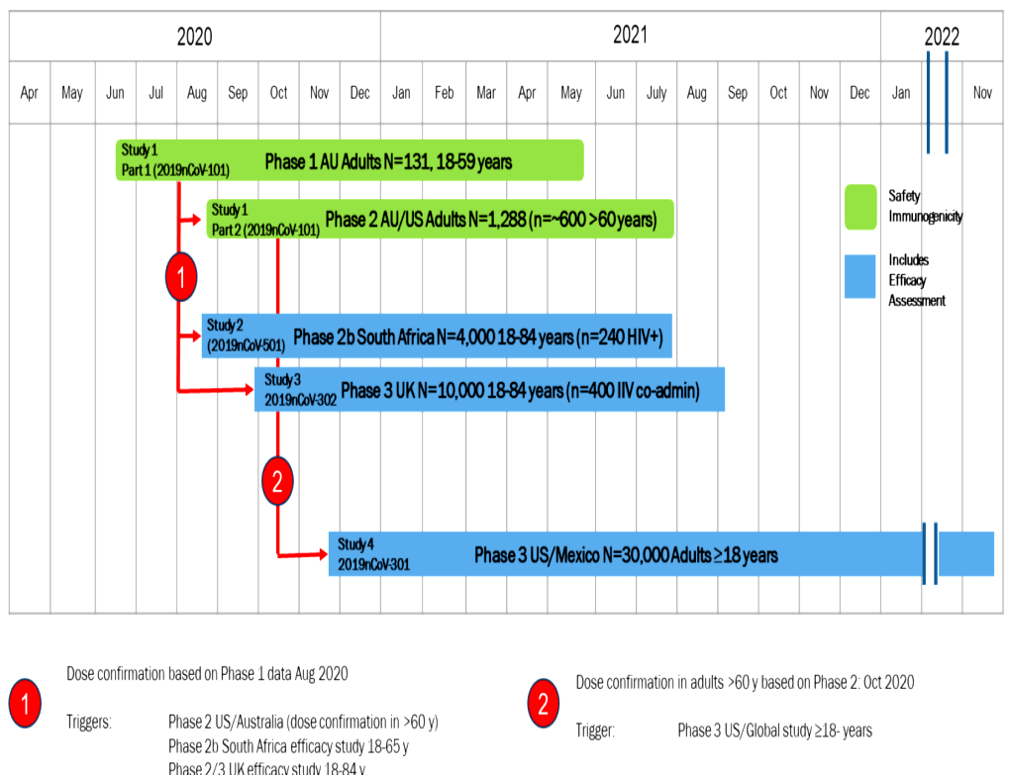
1: Dose confirmation based on Phase I data (August 2020). Triggers: Phase II US/Australia (dose confirmation in > 60 years old); Phase IIb South Africa efficacy study, 18 to 65 years old; Phase II/III United Kingdom efficacy study, 18 to 84 years old.
2: Dose confirmation in adults > 60 years based on Phase II (October 2020). Trigger: Phase III US/Global study ≥ 18 years old.
Source: Novavax presentation.
In addition, the sponsor also submitted interim clinical study report (CSR) for the Indian Council of Medical Research (ICMR)/Serum Institute of India (SII) Covovax trial, which was conducted in India by the SII.22F

Immunogenicity
The immunogenicity data available in this report were generated from Study 2019nCoV-101 Parts one and two; and Studies 2019nCoV-302, 2019nCoV-301, and 2019nCoV-501.

Dose finding studies
Study 2019nCoV-101 is a two part Phase I/II randomised, observer blinded, placebo-controlled study, designed to evaluate the safety and immunogenicity of Nuvaxovid. Part one is the first in human trial evaluating the safety and immunogenicity of SARS-CoV-2 rS with or without Matrix-M adjuvant in healthy adult subjects 18 to 59 years of age at two sites in Australia. Part two commenced after positive results were observed following a formal analysis of the primary endpoints in Part one of the study and was designed to evaluate the safety and immunogenicity of SARS-CoV-2 rS with Matrix-M adjuvant in healthy adult subjects 18 to 84 years of age at multiple sites in the USA and Australia.
Both Part one and two evaluated two dose levels of SARS-CoV-2 rS (5 µg and 25 µg), which were based on the results of nonclinical studies with SARS-CoV-2 rS and on the results of clinical studies with other Novavax based nanoparticle vaccines. Both parts also evaluated a single dose level of Matrix-M adjuvant (50 µg), based on previous clinical experience with Matrix-M adjuvant.

Study 2019nCoV-101 Part one
Subjects in Study 2019nCoV-101 Part one received either one or two doses of either 5 µg or 25 μg recombinant spike protein with or without 50 µg Matrix-M adjuvant (see Table 3)
Table 3: Study 2019nCoV-101 Part one Clinical trial design
Abbreviations: SARS-CoV-2 rS = severe acute respiratory syndrome coronavirus 2 recombinant spike protein nanoparticle vaccine
¹.Construct A (BV2373)
Note: This trial was designed to evaluate up to 2 unique constructs of SARS-CoV-2 rS (Construct A (Cohort 1) and Construct B (Cohort 2)); however, only 1 construct (Construct A) was evaluated in the trial.
Anti-spike protein immunoglobin G (IgG) was measured at Day 0 (Baseline), and Days 7, 21, 35, 49, 105, and 189 using a qualified IgG enzyme-linked immunosorbent assay (ELISA). The reverse cumulative distribution curves showing the responses at Day 0, Day 21 (21 days post first dose), Day 35 (14 days post second dose) and Day 189 (six months post first dose) are presented below in Figure 2. Neutralising antibody (NAb) responses showed a similar pattern.
Part one of the Study 2019nCoV-101 showed that up to two doses of 5 µg and 25 µg SARS-CoV-2 rS with or without 50 µg Matrix-M adjuvant, administered 21 days apart, were immunogenic and well tolerated in healthy adult subjects 18 to 59 years of age.
Figure 2: Study 2019nCoV-101 Reverse cumulative distribution function of serum immunoglobin G antibody levels at Baseline and following first vaccination of SARS-CoV-2 rS with or without Matrix-M adjuvant in healthy adult subjects 18 to 59 years of age (per protocol analysis set)
Figure 2:Study 2019nCoV-101 Reverse cumulative distribution function of serum immunoglobin G antibody levels at Baseline and following first vaccination of SARS-CoV-2 rS with or without Matrix-M adjuvant in healthy adult subjects 18 to 59 years of age (per protocol analysis set), continued.

Study 2019nCoV-101 Part two
Part two of Study 2019nCoV-101 was conducted in healthy males or non-pregnant females 18 to 84 years of age, inclusive, to further identify the optimal dose across age strata based on immune response (IgG antibody to SARS-CoV-2 rS) at Day 35 and whether baseline immune status has an impact. The treatment groups are listed in Table 4.
Table 4: Study 2019nCoV-101 Part two clinical trial design
Abbreviations: SARS-CoV-2 rS = severe acute respiratory syndrome coronavirus 2 recombinant spike.
Immunogenicity assessments comprised serum anti-spike protein binding IgG, angiotensin converting enzyme 2 (ACE2) receptor binding inhibition, NAb, and cell mediated immunity. Neutralising antibody responses comparing the 18 to 59 years stratum and the 60 to 84 years stratum (see Table 5).
Table 5: Study 2019nCoV-101 Part two, comparison of neutralising antibodies specific for SARS-CoV-2 wild type virus following vaccination with SARS-CoV-2 rS and Matrix-M adjuvant regardless of baseline serostatus in subjects 18 to 59 years of age and 60 to 84 years of age (per protocol analysis set)
Abbreviations: GMT = geometric mean titre; SARS-CoV-2 rS = severe acute respiratory syndrome recombinant spike protein nano particle vaccine; SCR = seroconversion
Note: Group B = 5/50 µg x 2; Group D = 25/50 µg x 2
Overall, it can be concluded that the interim results obtained in Study 2019nCoV-101 Part two provide further support for the inclusion of the adjuvant and administration of a second dose, with again no apparent advantage for 25 versus 5 μg antigen doses in the adjuvanted formulations. The humoral immune response analyses by age subgroup show a potent response in both age groups, although the magnitude of the response was consistently lower in the older age stratum. The final CSR should be made available as soon as possible to further evaluate the effect of age on the kinetics, amplitude or durability of vaccine induced immune responses.

Main immunogenicity studies

Study 2019nCoV-301
Study 2019nCoV-301 is an ongoing Phase III, multicentre, randomised, observer blinded, placebo controlled study in subjects 18 years of age and older in United States and Mexico. Upon enrolment, subjects were stratified by age (18 to 64 years and ≥ 65 years) and assigned in a 2:1 ratio to receive Nuvaxovid or the placebo.
The main immunogenicity related endpoints were the analysis of antibodies binding to the SARS-CoV-2 S protein by ELISA, and SARS-CoV-2 neutralisation, both at Day 0 (Baseline) and Day 35 (that is 14 days after second dose).
Demographics and baseline characteristics of subjects in the per-protocol immunogenicity analysis set were well balanced between the Nuvaxovid and placebo groups. Median age was 65 years old (range: 18 to 95 years), with approximately 50% of subjects ≥ 65 years of age. Approximately half the subjects were male (50.1%), while the majority (79.1%) was White, not of Hispanic or Latino origin (80.7%), and located in the United States (93.0%). Black or African Americans (9.9%), American Indians or Alaska Natives (6.2%), and Asians (3.3%) were well represented. The majority of subjects were overweight or obese (74.3%), with more than a third being obese (38.2%).
At two weeks following second dose of vaccination (Day 35), serum IgG antibody geometric mean ELISA units (GMEUs) in the Nuvaxovid group were markedly increased relative to placebo across all age groups (48918 versus 128, respectively, for subjects ≥ 18 years of age; 63890.4 versus 121.9 for subjects 18 to < 65 years of age; and 37594.3 versus 134.1 for subjects ≥ 65 years of age) with no evidence of placebo response. Serum anti-spike protein IgG geometric mean titres (GMT) in the Nuvaxovid group were approximately 1.7 fold higher in the younger age cohort (18 to < 65 years) than in the older age cohort (≥ 65 years). Seroconversion rates (SCR) in the Nuvaxovid groups also were markedly increased relative to placebo across all age groups (97.3% versus 4.5% for subjects ≥ 18 years of age; 98% versus 3.7% for subjects 18 to < 65 years of age; and 96.6% versus 5.3% for subjects ≥ 65 years of age).
Serum anti-spike protein IgG levels at Day 35 in both serologically negative and serologically positive adult subjects were increased relative to placebo and showed similar patterns of response, with higher levels in the placebo group in serologically positive adult subjects. In baseline seropositive individuals, GMTs at Baseline were 7541 and 3062.2 ELISA units/mL in the placebo and Nuvaxovid group, compared to 6174.6 and 119620.4 ELISA units/mL at Day 35.
Neutralising antibody levels in serologically negative adult subjects at Day 35 (see Table 6) were increased relative to placebo across all age groups: ≥ 18 years of age, 18 to < 65 years, and ≥ 65 years of age.
Table 6: Study 2019nCoV-101 Summary on neutralising antibodies for SARS-COV-2 wild-type virus at Day 0 (Baseline) and Day 35 (14 days after second dose) in serologically negative subjects by age groups (per protocol immunogenicity analysis set)
Abbreviations: CI = confidence interval; GMFR = geometric mean fold rise; GMT = geometric mean titre; LLOQ = lower limit of quantification; max = maximum; min = minimum; n1 = number of participants in the per protocol immunogenicity analysis set with non-missing data at visit, n2 = number of participant in the per protocol immunogenicity analysis set with non-missing data at both the baseline and Day 35 visit, n3 = number of participants who reported ≥ 4 fold increase. Percentages were calculated based on n2 as the denominator, NVX-CoV2373 = Nuvaxovid, 5 µg SARS-CoV-2 rS plus 50 µg Matrix-M adjuvant, SCR = seroconversion rate
¹ Day 0 (Baseline) was defined as the last non-missing assessment prior to study vaccine administration
² The 95% confidence interval (CI) for GMT and GMFR were calculated based on the t-distribution of the log transformed values, then back transformed to the original scale for presentation
³ The SCR percentage was defined as percentage of participants at each post vaccination visit with a ≥ 4 fold rise in antibody concentration
⁴ The 95% CI for SCR percentage was calculated using the exact Clopper-Pearson method.
Note: Titre values less than LLOQ (20) were replaced by 0.5 x LLOQ
At two weeks following second dose in most subjects (Day 35), neutralising antibody GMTs in the Nuvaxovid group were markedly increased relative to placebo for all subjects (1156.6 versus 11.8, respectively); for serologically positive subjects (3741.9 versus 190.3) relative to placebo; and for serologically negative subjects (1078.2 versus 10.7), with no evidence of placebo response (Table 7). Neutralising antibody GMTs in the Nuvaxovid group were approximately 3.5 fold higher in the serologically positive cohort than in the serologically negative cohort. Seroconversion rates in the Nuvaxovid group also were markedly increased relative to placebo across all baseline serostatus groups (95.5% versus 2.3% for serologically negative and positive subjects; 96.3% versus 2.1% for serologically negative subjects; and 82.9% versus 8.3% for serologically positive subjects).
Table 7: Study 2019nCoV-101 Summary of neutralising antibodies for SARS-COV-2 wild type virus at Day 0 (Baseline) and Day 35 (14 days after second dose) in adult subjects by baseline status (per protocol immunogenicity 2 analysis set)
Abbreviations: CI = confidence interval; GMFR = geometric mean fold rise; GMT = geometric mean titre; LLOQ = lower limit of quantification; max = maximum; min = minimum; n1 = number of participants in the per protocol immunogenicity 2 analysis set with non-missing data at visit, n2 = number of participant in the per protocol immunogenicity 2 analysis set with non-missing data at both the baseline and Day 35 visit, n3 = number of participants who reported ≥ 4 fold increase. Percentages were calculated based on n2 as the denominator, NVX-CoV2373 = Nuvaxovid, 5 µg SARS-CoV-2 rS plus 50 µg Matrix-M adjuvant, SCR = seroconversion rate
¹ Day 0 (Baseline) was defined as the last non-missing assessment prior to study vaccine administration
² The 95% CI for GMT and GMFR were calculated based on the t-distribution of the log transformed values, then back transformed to the original scale for presentation
³ The SCR percentage was defined as percentage of participants at each post vaccination visit with a ≥ 4 fold rise in antibody concentration
⁴ The 95% CI for SCR percentage was calculated using the exact Clopper-Pearson method
Note: Titre values less than LLOQ (20) were replaced by 0.5 x LLOQ

Study 2019nCoV-302
Study 2019nCoV-302 is an ongoing Phase III, multicentre, randomised, observer blinded, placebo controlled study in subjects 18 to 84 years of age in the UK. Upon enrolment, subjects were stratified by age (18 to 64 years; 65 to 84 years) to receive Nuvaxovid or placebo.
The main immunogenicity related endpoints were the analysis of antibodies binding to the SARS-CoV-2 S protein by ELISA, and SARS-CoV-2 neutralisation, both at Day 0 (Baseline) and Day 35 (14 days after second dose).
At two weeks following second vaccination in all subjects (Day 35), serum anti-spike protein IgG GMTs in the Nuvaxovid group were markedly increased approximately 350 to 400 fold relative to placebo across all age groups (44673.8 versus 113.2 ELISA units/mL, respectively, for subjects 18 to 84 years of age; 47564.3 versus 113.5 ELISA units/mL for subjects 18 to 64 years of age; and 37892.8 versus 112.3 ELISA units/mL for subjects 65 to 84 years of age) with no evidence of placebo response. Serum anti-spike protein IgG GMTs in the Nuvaxovid group were approximately 1.3 fold higher in the younger age cohort (18 to 64 years) than in the older age cohort (65 to 84 years). Seroconversion rates in the Nuvaxovid groups also were markedly increased relative to placebo across all age groups (99% versus 0.7% for subjects 18 to 84 years of age; 99% versus 1% for subjects 18 to 64 years of age; and 99.1% versus 0% for subjects 65 to 84 years of age).
Serum anti-spike protein IgG levels at Day 35 in both serologically negative and serologically positive adult subjects were increased relative to placebo and showed similar patterns of response, with higher levels in the placebo group in serologically positive adult subjects. In baseline seropositive individuals, GMTs at Baseline were 1771.7 and 1698.8 ELISA units/mL in the placebo and Nuvaxovid group, compared to 1756.9 and 125489.8 ELISA units/mL at Day 35.
Neutralising antibody levels in serologically negative adult subjects at Day 35 were increased relative to placebo across all age groups: 18 to 84 years, 18 to 64 years, and 65 to 84 years (Table 8).
Table 8: Study 2019nCoV-302 Summary of neutralising antibodies at Day 0 (Baseline) and Day 35 (14 days after second dose) in serologically negative adult subjects by age group (per protocol immunogenicity neutralisation assay subset)
Abbreviations: CI = confidence interval; GMFR = geometric mean fold rise; GMT = geometric mean titre; LLOQ = lower limit of quantification; max = maximum; min = minimum; n1 = number of participants in the per protocol immunogenicity neutralisation assay subset with non-missing data at visit, n2 = number of participant who reported ≥ 4 fold increase, with percentages calculated as (n2/n1) x 100; NVX-CoV2373 = Nuvaxovid, 5 µg SARS-CoV-2 rS plus 50 µg Matrix-M adjuvant, SCR = seroconversion rate
¹ Baseline was defined as the last non-missing assessment prior to first dose vaccination
² The 95% CI for GMT and GMFR were calculated based on the t-distribution of the log transformed values, then back transformed to the original scale for presentation
³ The SCR was defined as percentage of participants at each post vaccination visit with a titre ≥ 4 fold rise
⁴ The 95% CI for SCR percentage was calculated using the exact Clopper-Pearson method
Note: LLOQ = titre of 20, with titre values less than LLOQ were replaced by 0.5 x LLOQ
At two weeks following second dose (Day 35), neutralising antibody GMTs in the Nuvaxovid group were markedly increased approximately 110 fold relative to placebo for serologically negative subjects (1129.5 versus 10.4); and approximately 70 fold for serologically positive subjects (4373.8 versus 62) with no evidence of placebo response (Table 9). Neutralising antibody GMTs in the Nuvaxovid group were approximately 3.9 fold higher in the serologically positive cohort than in the serologically negative cohort. SCRs in the Nuvaxovid group also were markedly increased relative to placebo across baseline serostatus groups (98.2% versus 0.8% for serologically negative subjects; and 100% versus 15.8% for serologically positive subjects).
Table 9: Study 2019nCoV-302 Summary of neutralising antibody levels at Day 0 (Baseline) and Day 35 (14 days after second dose vaccination) in adult subjects by baseline serostatus (intent to treat neutralisation assay subset)
Abbreviations: CI = confidence interval; GMFR = geometric mean fold rise; GMT = geometric mean titre; LLOQ = lower limit of quantification; max = maximum; min = minimum; n1 = number of participants in the intent to treat neutralisation assay subset, n2 = number of participant who reported ≥ 4 fold increase, with percentages calculated as (n2/n1) x 100; NVX-CoV2373 = Nuvaxovid, 5 µg SARS-CoV-2 rS with 50 µg Matrix-M adjuvant, SCR = seroconversion rate
¹ Baseline was defined as the last non-missing assessment prior to first dose vaccination
² The 95% CI for GMT and GMFR were calculated based on the t-distribution of the log transformed values, then back transformed to the original scale for presentation
³ The SCR was defined as percentage of participants at each post vaccination visit with a titre ≥ 4 fold rise
⁴ The 95% CI for SCR percentage was calculated using the exact Clopper-Pearson method
Note: LLOQ = titre of 20, with titre values less than LLOQ were replaced by 0.5 x LLOQ
A seasonal influenza co-administration substudy was conducted as part of Study 2019nCoV-302 in the first approximately 400 subjects, who met the additional inclusion criteria; 23F for the study.
The objective of the substudy was to evaluate the safety and immunogenicity of Nuvaxovid in the initial set of vaccinations when co-administered with an authorised seasonal influenza vaccine. The endpoint was ‘analysis of the safety and immunogenicity of SARS-CoV-2 rS with Matrix-M adjuvant when co-administered with seasonal influenza vaccine in a subset population’.
An unadjuvanted quadrivalent influenza vaccine (Flucelvax, Seqirus);24F was given to those 18 to 64 years of age, and an adjuvanted trivalent influenza vaccine (Fluad, Seqirus);25F was given to those ≥ 65 years of age, in compliance with UK recommendations. Flucelvax is authorised in the EU but Fluad is not authorised in the EU. However, in the EU a tetravalent version of Fluad is available.
No significant differences were observed in the baseline GMTs of haemagglutination inhibition between those in the substudy co-vaccinated with Nuvaxovid plus influenza vaccine group and those in the placebo plus influenza vaccine group (Figure 3).
Figure 3: Study 2019nCoV-302 Geometric mean titres of haemagglutination inhibition on Day 0 and Day 21 in the quadrivalent influenza cell based vaccine group (A) and in the adjuvanted trivalent inactivated vaccine group (B);26F
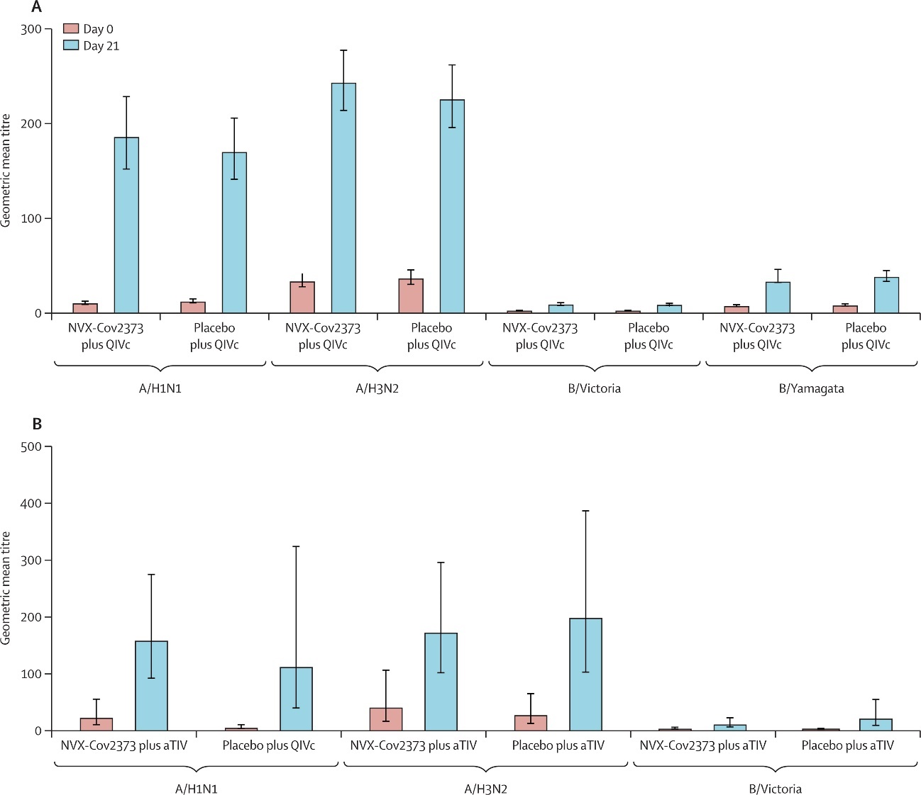
Abbreviations: aTIV=adjuvanted trivalent influenza vaccine. QIVc=quadrivalent influenza cell-based vaccine. Error bars are 95% CIs. Comparison of the geometric mean titres of haemagglutination inhibition at Baseline (Day 0) and 21 days after vaccination with NVX-CoV2373 or placebo with either the QIVc or aTIV influenza vaccine by influenza strain (n = 178 for the NVX-CoV2373 plus QIVc group, n = 179 for the placebo plus QIVc group, n=13 for the NVX-CoV2373 plus aTIV group, and n=11 for the placebo plus aTIV group). Immunogenicity was assessed in the per-protocol immunogenicity population.
No difference was seen in Day 21 GMTs of haemagglutination inhibition between Nuvaxovid plus influenza vaccine group and the placebo plus influenza vaccine group for any individual influenza strain (A/H1N1, A/H3N2, B/Victoria, or B/Yamagata) for either influenza vaccine. Geometric mean fold rise (GMFR) values followed the same pattern. For both the quadrivalent influenza cell based vaccine and adjuvanted trivalent influenza vaccine, haemagglutination inhibition seroconversion rates were generally higher for the influenza A strains than for the influenza B strains (Figure 4).
Figure 4: Study 2019nCoV-302 Haemagglutination inhibition seroconversion rates on Day 21 in the quadrivalent influenza cell based vaccine group (A) and in the adjuvanted trivalent inactivated vaccine group (B)
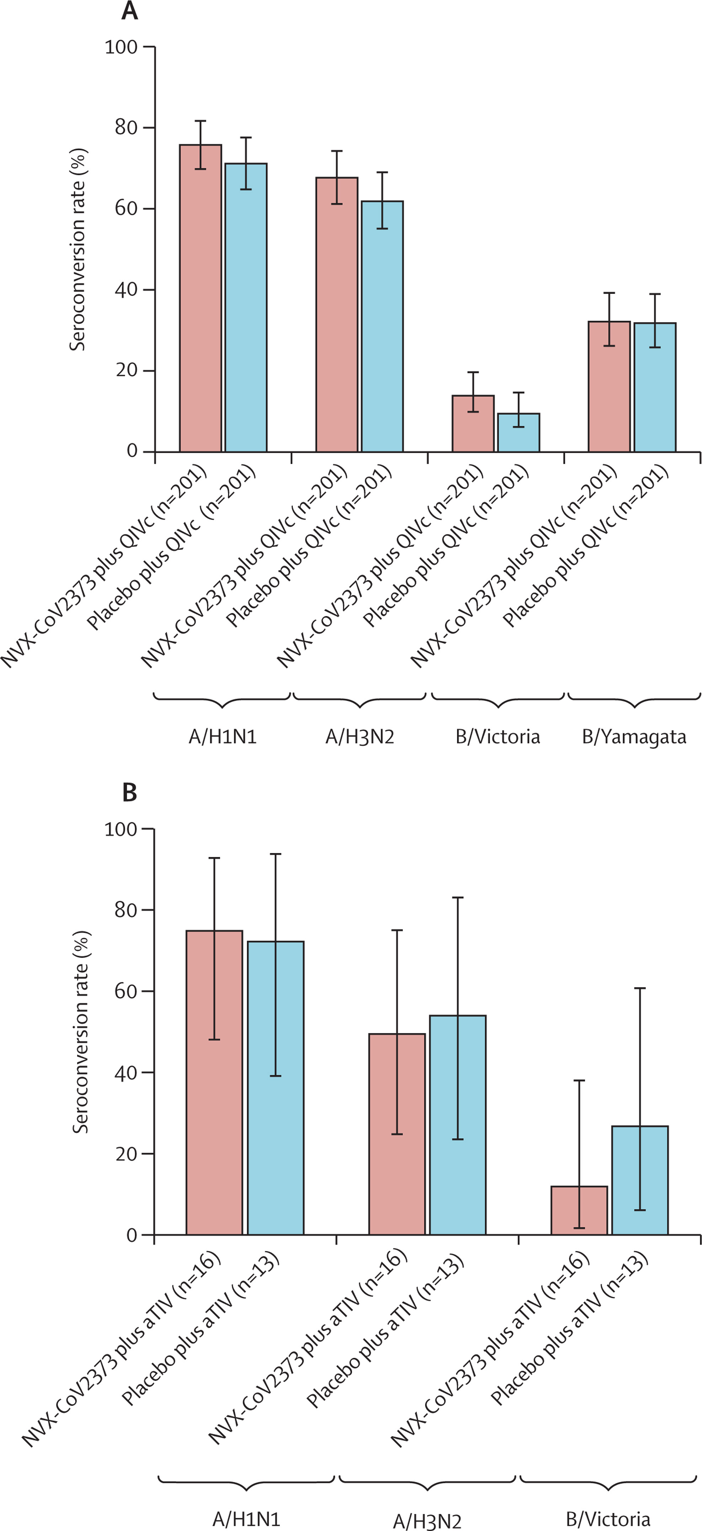
Error bars are 95% CIs. Comparison of the haemagglutination inhibition seroconversion rates 21 days after vaccination with NVX-CoV2373 or placebo with the QIVc or aTIV influenza vaccine by influenza strain. aTIV=adjuvanted trivalent influenza vaccine. QIVc=quadrivalent influenza cell-based vaccine.
Table 10: Study 2019nCoV-302 Summary of haemagglutination inhibition assay by influenza virus strain at Day 0 and Day 21 in adult subjects who were co-administered quadrivalent influenza cell-based vaccine and adjuvanted trivalent influenza vaccine at Day 0 by age group (per protocol immunogenicity hemagglutination inhibition assay serology subset)
Abbreviation: aTIV=adjuvanted trivalent influenza vaccine. QIVc=quadrivalent influenza cell-based vaccine; HAI = hemagglutination inhibition; NVX-CoV2373 = Nuvaxovid, 5 µg SARS-CoV-2 rS with 50 µg Matrix-M adjuvant.
A 30% reduction in antibody responses to Nuvaxovid was noted as assessed by an anti-spike protein IgG assay with seroconversion rates similar to subjects who did not receive concomitant influenza vaccine. Although, it is not a direct statistical comparison; as shown in Table 11, the GMT of anti-spike protein IgG responses in co-administered participants (31236.1 (95% CI: 26295.5, 37104,9) had non-overlapping 95% CIs with Nuvaxovid only recipients (44678.3 (95% CI: 40352.2, 49468.2)). The clinical impact of the reduced response is unknown.
Table 11: Study 2019nCoV-302 Summary of serum anti-spike protein IgG levels at Day 0 (Baseline) and Day 35 (14 days after second dose vaccination) in serologically negative adult subjects who were co-administered quadrivalent influenza cell-based vaccine and adjuvanted trivalent influenza vaccine at Day 0 by age group (per protocol immunogenicity anti-spike protein serology subset of the seasonal influenza vaccine sub study)
Abbreviation: aTIV=adjuvanted trivalent influenza vaccine. QIVc=quadrivalent influenza cell-based vaccine; HAI = hemagglutination inhibition; NVX-CoV2373 = Nuvaxovid, 5 µg SARS-CoV-2 rS with 50 µg Matrix-M adjuvant; ELISA = enzyme-linked immunosorbent assay; PP-IMM = per protocol immunogenicity analysis set.

Study 2019nCoV-501
Study 2019nCoV-501 is an ongoing Phase IIa/b, multicentre, randomised, observer blinded, placebo controlled study in human immunodeficiency virus (HIV) negative subjects 18 to 84 years of age and people living with HIV 18 to 64 years of age in South Africa. These people were medically stable (free of opportunistic infections), receiving highly active and stable antiretroviral therapy, and having an HIV-1 viral load of < 1000 copies/mL. Upon enrolment, subjects were randomly assigned to receive Nuvaxovid or placebo.
Immunogenicity related endpoints considered binding antibody levels and neutralising antibody activity at Day 0, 21 (only for binding antibodies) and 35 in healthy HIV negative and medically stable HIV positive adult subjects with baseline negative serostatus, baseline positive serostatus, or regardless of baseline serostatus.
Regardless of HIV status, anti-spike protein IgG antibody GMTs at Day 0 were higher for subjects who were seropositive at Baseline, across both vaccine and placebo groups, than they were for subjects who were seronegative at Baseline.
In all subjects (HIV seronegative and HIV seropositive subjects together), SARS-CoV-2 seronegative at Baseline, the anti-spike protein IgG antibody GMT at Day 21 was greater for subjects who received Nuvaxovid (1147.4 ELISA units/mL) than it was for those who received placebo (119.2 ELISA units/mL). The anti-spike protein IgG antibody GMT further increased after the second dose, to 30520.6 and 126.0 ELISA units/mL at Day 35.
Among subjects who were SARS-CoV-2 seronegative at Baseline, anti-spike protein IgG antibody GMTs for HIV positive subjects were approximately half of those seen for HIV negative subjects (14420.5 versus 31631.8 ELISA units/mL at Day 35); however, among subjects who were SARS-CoV-2 seropositive at Baseline, anti-spike protein IgG antibody GMTs for HIV positive subjects were comparable to those seen for HIV negative subjects (98399.5 versus 100666.1 ELISA units/mL at Day 35).
In all subjects, regardless of baseline serostatus and regardless of HIV status, subjects who received two doses of Nuvaxovid showed stronger neutralising antibody responses, in terms of amplitude and kinetics, than did those that received placebo. Also in this study, among subjects who were SARS-CoV-2 seropositive at Baseline, neutralising antibody GMTs for HIV positive subjects were comparable to those seen for HIV negative subjects. Regardless of HIV status, SARS-CoV-2 wild type virus neutralising antibody GMTs at Day 35 were markedly higher in seropositive as compared to seronegative subjects. Seroconversion rates at Day 35 ranged from 92.3% to 98.4% for Nuvaxovid versus 2% to 13.5% for placebo for all actively immunised subjects and for HIV negative and HIV positive subjects with baseline negative serostatus, baseline positive serostatus, or regardless of baseline serostatus (see Table 12).
Table 12: Study 2019nCoV-501 Summary of serum neutralising antibody levels at Day 35 following vaccination with SARS-CoV-2 rS and Matrix-M adjuvant in all subjects (HIV negative and HIV positive status) stratified by baseline serostatus, comparison of vaccine and placebo groups (per protocol immunogenicity analysis set)
Abbreviation; CI = confidence interval; GMT = geometric mean titre; GMFR = = geometric mean fold rise

Conclusions on immunogenicity
The immune response data overall support the choice of a two dose schedule of Nuvaxovid, with no apparent advantage for 25 versus 5 µg antigen doses in the adjuvanted formulations.
The interim immunogenicity data indicates that immunogenicity is likely reduced in the elderly and HIV positive subjects; the magnitude of this reduction remains to be determined. Only a few conclusions can currently be reached on (i) durability of immune responses (especially in elderly vaccinees), and concomitant use of Nuvaxovid with influenza vaccines (especially adjuvanted influenza vaccines) noting the Nuvaxovid induced responses were about 30% lower in coadministered participants.

Efficacy

Study 2019nCoV-302 Interim report
A Phase III, randomised, observer blinded, placebo-controlled trial to evaluate the efficacy and safety of a SARS-CoV-2 rS with Matrix-M adjuvant in adult subjects 18 to 84 years of age in the UK.
The study includes a blinded crossover period beginning three months following the second dose during which subjects who initially received Nuvaxovid would be revaccinated with two doses of placebo given 21 days apart. Similarly, subjects who initially received placebo would be revaccinated with 2 doses of Nuvaxovid. The data from the blinded crossover period were not provided in this interim report.

Primary objective
Primary objective: demonstrate efficacy of Nuvaxovid in preventing symptomatic, polymerase chain reaction (PCR) confirmed COVID-19 in serologically negative (to SARS-CoV-2) adults.
Endpoints: the first episode of PCR positive mild, moderate, or severe COVID-19; 27Fwith onset at least seven days after second study vaccination (for example Day 28), in serologically negative (to SARS-CoV-2) adult subjects at Baseline until the endpoint driven efficacy analysis is triggered by the occurrence of a prespecified number of blinded endpoints.

Secondary objective
Secondary objective:
- To demonstrate the efficacy of SARS-CoV-2 rS with Matrix-M adjuvant in the prevention of virologically confirmed (by PCR to SARS-CoV-2), symptomatic COVID-19, when given as a two dose vaccination regimen, as compared to placebo, in adults regardless of their serostatus at Baseline.
- To assess the efficacy of SARS-CoV-2 rS with Matrix-M adjuvant in adult subjects requiring specific medical interventions as compared to placebo.
Endpoints:
- First occurrence of virologically confirmed (by PCR to SARS-CoV-2), symptomatic moderate or severe COVID-19 with onset at least seven days after second study vaccination (for example Day 28) in serologically negative (to SARS-CoV-2) adult subjects at Baseline until the endpoint driven efficacy analysis is triggered by the occurrence of a prespecified number of blinded endpoints.
- First occurrence of virologically confirmed (by PCR to SARS-CoV-2), symptomatic severe COVID-19;28 with onset at least seven days after second study vaccination (for example Day 28) in serologically negative (to SARS-CoV-2) adult subjects at Baseline until the endpoint-driven efficacy analysis is triggered by the occurrence of a prespecified number of blinded endpoints.
- First occurrence of virologically confirmed (by PCR to SARS-CoV-2), symptomatic mild, moderate, or severe COVID-19,28 with onset at least seven days after second study vaccination (for example Day 28) in adult subjects regardless of their serostatus at Baseline.
- First occurrence of COVID-19 requiring hospitalisation, ICU admission or mechanical ventilation linked to any virologically confirmed (by PCR to SARS-CoV-2) COVID-19 with onset at least seven days after second study vaccination (for example Day 28) in adult subjects regardless of their serostatus at Baseline.

Analysis populations
The all screened subjects analysis set included all subjects who were screened, inclusive of screen failures.
The all randomised subjects analysis set included all subjects who were randomised regardless of the receipt of any study vaccine (Nuvaxovid or placebo).
The intent to treat (ITT) analysis set (n = 15,139) included all subjects who were randomised and received at least one dose of study vaccine regardless of protocol violations or missing data.

Sample size
This study was designed to enrol approximately 15,000 subjects, who will be initially randomised 1:1 into the study vaccine groups. The sample size is driven by the total number of events expected to achieve statistical significance for the primary efficacy endpoint. A target of 100 mild, moderate, or severe COVID-19;28 cases was chosen to provide > 95% power for 70% or higher vaccine efficacy (VE). A single interim analysis of efficacy will be conducted based on the accumulation of approximately 50% (50 events) of the total anticipated primary endpoints using Lan-DeMets alpha-spending function for Pocock boundary conditions, with a planned one-sided alpha of 0.0155 at 50% of the data and 0.01387 at the final analysis.

Efficacy analysis
The primary efficacy endpoint was analysed on the per protocol efficacy analysis set and supported by an analysis on the ITT analysis set. Vaccine efficacy was defined as VE (%) = 100 x (1 – RR), where RR was the relative risk of incidence rates between the two study vaccine groups (Nuvaxovid versus placebo). Mean disease incidence rate was reported as incident rate per year in 1000 people. The estimated RR and its CI were calculated with the use of Poisson regression and robust error variance. ‘The main (hypothesis testing) analysis (for example event driven) for the interim and final analyses for the primary objective was carried out at an overall one sided Type I error rate of 0.025 for the primary endpoint.’ The null hypothesis was VE ≤ 30% and rejection of the null hypothesis was accepted if the alpha adjusted lower bound CI was > 30%.
Secondary endpoint efficacy analyses were based on the ITT analysis set using the same methods as the primary efficacy endpoint without adjustment for multiple comparisons (that is two sided alpha of 0.05).
An additional efficacy analysis was performed by repeating primary, secondary and subgroup analyses for events attributable to the alpha variant (B.1.1.7 lineage) of SARS-CoV-2.

Subjects flow
The trial schema for subjects flow is shown in Figure 5. On Day 0, baseline nose/throat samples were taken for SARS-CoV-2 PCR (including the alpha variant) and blood was taken to detect any existing SARS-CoV-2 antibodies at Baseline. Also, methods for nose/throat sample collection (that is self swabbing) were demonstrated to subjects.
Figure 5: Study 2019nCoV-302 Trial schema with blinded crossover
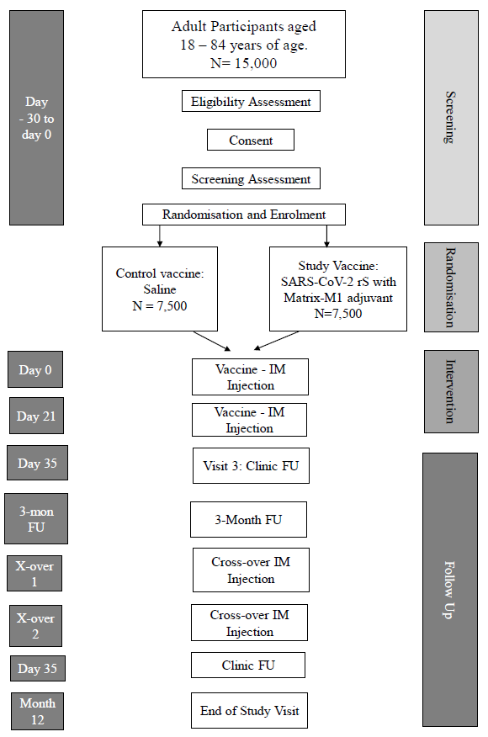
FU = follow-up; IM = intramuscular; N = number of participants. Note: The 3-month follow-up and Day 1 Crossover visits can be consolidated if they occur within 30 days of each other. The Day 35 Crossover visit is only for participants in the anti-S immunogenicity subgroup.
The screening and enrolment of subjects is shown in Table 13. The most frequent reason for screen failure was failure to meet inclusion/exclusion criteria.
Table 13. Study 2019nCoV-302 Subjects screening and enrolment (all screened subjects analysis set)
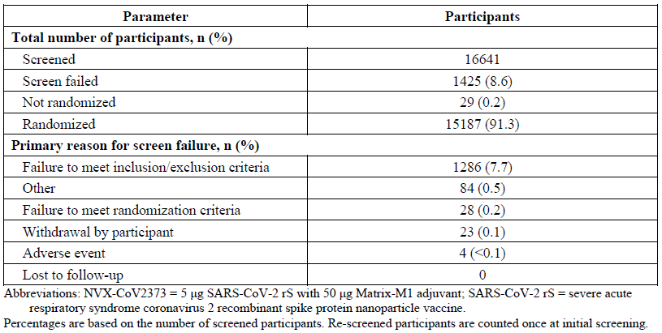
Abbreviations: NVX-CoV2373 = Nuvaxovid, 5 µg SARS-CoV-2 rS with 50 µg Matrix-M adjuvant; Percentages are based on the number of screened participants. Re-screened participants are counted once at initial screening.
The discontinuation rate was 2.3% and 2.7% in vaccine and placebo groups respectively. The most frequent ‘other reason’ for discontinuation was receipt of an approved COVID-19 vaccine.

Baseline data
Per protocol, baseline serostatus was negative for all subjects in whom this was available (13908/14039 (99.1%)) but was missing for 131 (0.9%) subjects. Similarly, baseline PCR was negative for all subjects in whom this was available (13232/14039 (94.3%)) but was missing in 807 (5.7%) subjects.
Table 14: Study 2019nCoV-302 Demographic and clinical characteristics of the subjects at Baseline (per protocol efficacy);28F
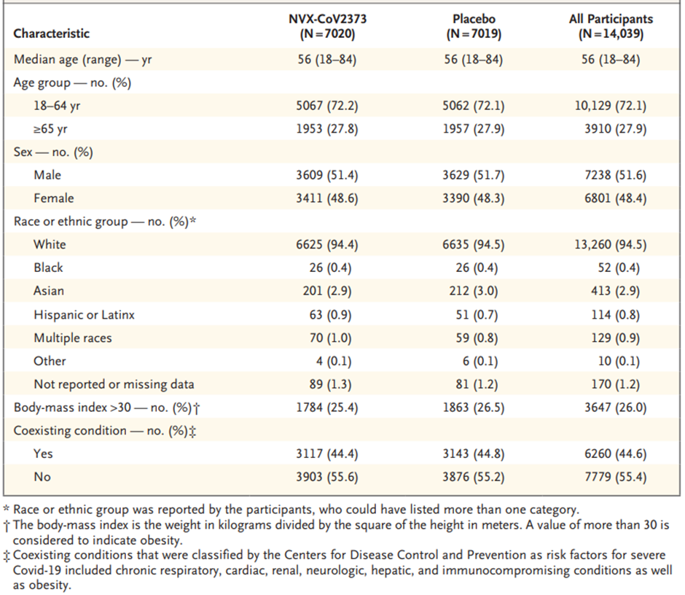

Results
The data cutoff date of the interim efficacy analysis was 10 January 2021, the data cutoff date for the final efficacy analysis was 29 January 2021, and the data cutoff date for all other analyses was 23 February 2021. All data were fully cleaned and locked on 26 January 2021 for the interim analysis and on 15 March 2021 for the final analysis. The study remains ongoing through approximately 1 year follow up from the Day 21 injection.
Of the 15,187 subjects randomised, 15139 (99.7%) were in the ITT and safety analysis sets with 7569 in the Nuvaxovid group and 7570 in the placebo group.
The per protocol efficacy (PP-EFF) analysis set included 14039 (92.4%) randomised subjects, with 7020 in the Nuvaxovid group and 7019 in the placebo group. A total of 1100 (7.3%) subjects were excluded from the PP-EFF analysis set, the most frequent (incidence > 1.0%) reasons for exclusion from the PP-EFF analysis set were positive serostatus before seven days after second vaccination, missed one dose of study vaccine, and positive PCR test before seven days after second vaccination.
Approximately one third of subjects (35%) were unblinded to study vaccine assignment during the course of the study. The most frequent reason was receipt of an authorised vaccine. Most (98.2%) unblinded subjects continued to be followed up in the study.

Primary endpoint
Confirmatory interim analysis: There were 62 cases accrued for the prespecified interim analysis of the primary endpoint, with 6 (< 0.1%) in the Nuvaxovid group and 56 (0.8%) in the placebo group. The resultant estimated VE was 89.3% (alpha adjusted 96.9% CI: 73.0, 95.8; p < 0.0001), with an alpha adjusted lower bound of the confidence interval (LBCI) > 30% meeting the prespecified study success criterion.

Final primary efficacy analysis
There were 106 cases for the final prespecified analysis of the primary endpoint, with 10 (0.1%) in the Nuvaxovid group and 96 (1.4%) in the placebo group. All but four cases were mild or moderate in severity, with all four severe cases, including one hospitalisation and one person with a pulmonary embolism, occurring in the placebo group. The resultant estimated VE was 89.7% (95% CI: 80.2, 94.6; p < 0.001), with an LBCI > 30% meeting the prespecified study success criterion. These findings confirmed the results of the interim analysis of the primary endpoint (see Table 15).
Table 15: Study 2019nCoV-302 Final analysis of vaccine efficacy against polymerase chain reaction confirmed symptomatic mild, moderate, or severe COVID-19 with onset from at least seven days after second vaccination in serologically negative adult subjects (per protocol efficacy analysis set)
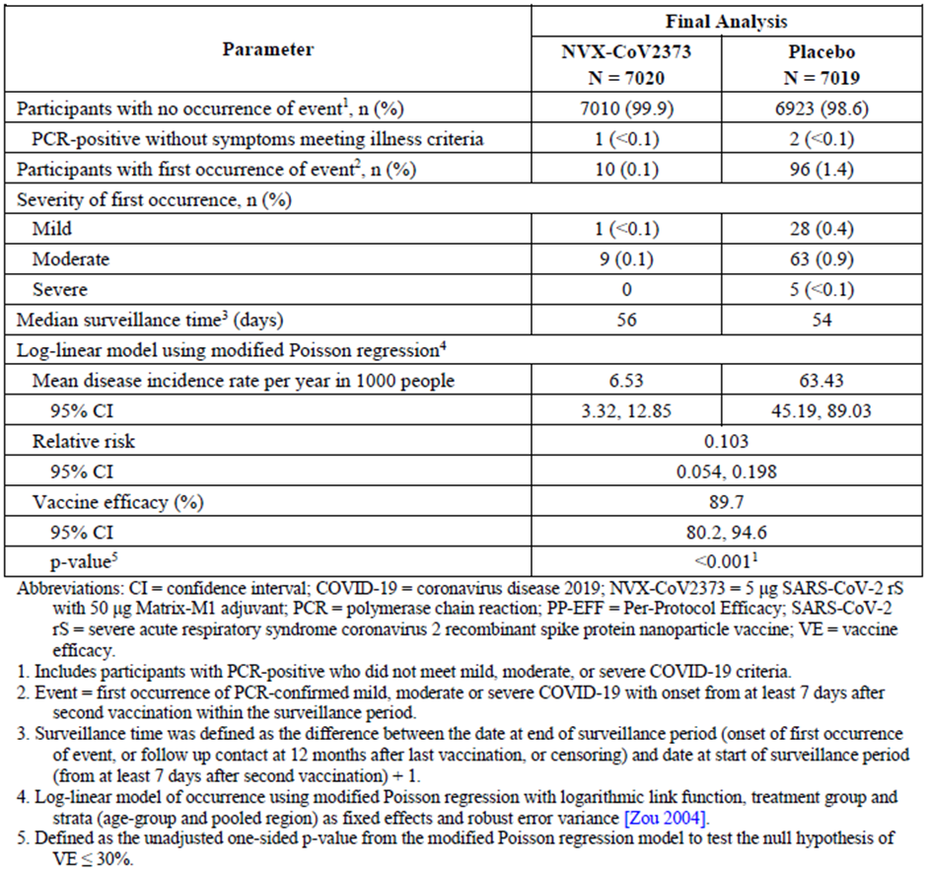
Abbreviations: CI = confidence interval; COVID-19 = coronavirus disease 2019; NVX-CoV2373 = Nuvaxovid, 5 µg SARS-CoV-2 rS plus 50 µg Matrix-M adjuvant; PCR = polymerase chain reaction; VE = vaccine efficacy.
¹ Includes participant with PCR positive who did not meet mild, moderate or severe COVID-19 criteria
² Event = first occurrence of PCR confirmed mild, moderate or severe COVID-19 with onset from at least seven days after second dose vaccination within the surveillance period
³ Surveillance time was defined as the difference between the date at end of surveillance period (onset of first occurrence of event, or follow up contact at 12 months after last vaccination, or censoring) and date at start of surveillance period (from at least 7 days after second vaccination) + 1
⁴ Log-linear model of occurrence using modified Poission regression with logarithmic link function,30 treatment group and strata (age-group and pooled region) as fixed effects and robust error variance
⁵. Defined as the unadjusted one-sided p value from the modified Poisson regression model to test the null hypothesis of VE ≤ 30%
The cumulative incidence curve demonstrated clear separation of cases beginning early following second dose of study vaccine (see Figure 6).
Figure 6: Study 2019nCoV-302 Cumulative incidence curve of polymerase chain reaction-confirmed symptomatic mild, moderate, or severe COVID-19 with onset from seven days after second vaccination in serologically negative adult subjects (per protocol efficacy analysis set)
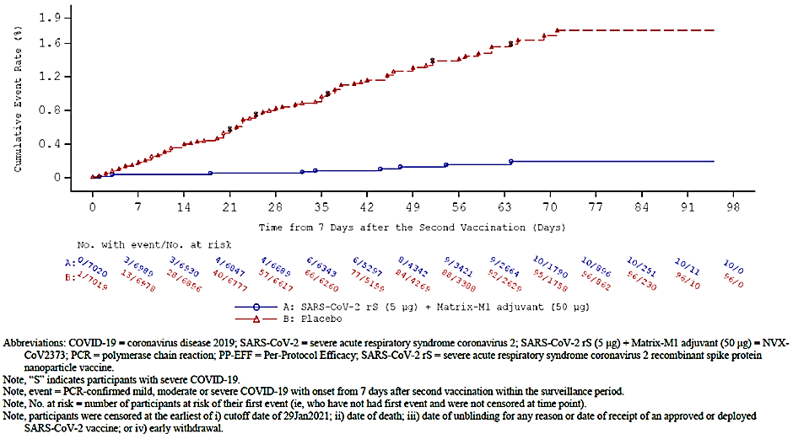
Abbreviation: Nuvaxovid, 5 µg SARS-CoV-2 rS plus 50 µg Matrix-M adjuvant; PCR = polymerase chain reaction; PP-EFF = per protocol efficacy.
Note: ’S’ indicates participants with severe COVID-19
Note: event = PCR confirmed mild, moderate or severe COVID-19 with onset from 7 days after second vaccination within surveillance period
Note: No. at risk = number of participants at risk of their first event (that is who have not had first event and were not censored at time point).
Note: participants were censored at the earliest of i) cutoff date of 29 January 2021; ii) date of unblinding for any reason or date of receipt of an approved or deployed SARS-CoV-2 vaccine; iv) early withdrawal.

Secondary endpoint results
- Efficacy by strain (per protocol efficacy analysis set)
  - PCR results of the final analysis by SARS-CoV-2 strain showed estimated VEs of Nuvaxovid to prevent symptomatic mild, moderate, or severe COVID-19;28 in baseline seronegative (to SARS-CoV-2) subjects were 86.3% (95% CI: 71.3, 93.5) for the Alpha variant (B.1.1.7 lineage) and 96.4% (95% CI: 73.8, 99.5) for non-B.1.1.7 variants.
- Protection against symptomatic moderate or severe COVID-19 with onset at least seven days after second study vaccination (for example Day 28) in baseline seronegative subjects (defined as key by the sponsor)
  - There were 77 out of 106 cases of PCR confirmed symptomatic moderate or severe COVID-19 with onset from at least seven days after second vaccination, with 9 (0.1%) in the Nuvaxovid group and 68 (1%) in the placebo group. The resultant estimated VE of Nuvaxovid to prevent symptomatic moderate or severe COVID-19 in baseline seronegative (to SARS-CoV- 2) adult subjects was 86.9% (95% CI: 73.7, 93.5).
- Protection against symptomatic severe COVID-19 with onset at least seven days after second study vaccination (for example Day 28) in baseline seronegative subjects.
  - At the time of the final analysis there were five cases classified as severe in the placebo group and none in the Nuvaxovid group occurring at least seven days after the second dose in serologically negative adult subjects in the per protocol efficacy analysis set analysis set.
- Protection against hospitalisation, ICU admission or mechanical ventilation linked to any virologically confirmed COVID-19 with onset at least seven days after second study vaccination (for example Day 28) in adult subjects regardless of their serostatus at Baseline.
  - There were one case of PCR confirmed symptomatic moderate or severe COVID-19;28 requiring hospitalisation, ICU admission, or mechanical ventilation with onset from at least seven days after second vaccination in serologically negative adult subjects, with 0 in the Nuvaxovid group and one in the placebo group.
- Protection against COVID-19 in adults regardless of baseline serostatus:
  - There were 107 cases of PCR confirmed symptomatic mild, moderate, or severe COVID-19;28 with an onset from at least seven days after second vaccination in subjects regardless of baseline serostatus, with 10 (0.1%) in the Nuvaxovid group and 97 (1.3%) in the placebo group. VE of Nuvaxovid to prevent symptomatic mild, moderate, or severe COVID-19;28 in adult subjects regardless of baseline serostatus was estimated to be 89.8% (95% CI: 80.5, 94.7).
  - There were 183 cases of PCR confirmed mild, moderate, or severe COVID-19;28 with onset from first vaccination through the data cutoff date of the final analysis of the primary endpoint. PCR confirmed COVID-19 occurred in 42 (0.6%) subjects (1.742/1000 patient-years) in the Nuvaxovid group and 141 (1.9%) cases (1.728/1000 patient-years) in the placebo group at the time of the final analysis of the primary endpoint (median surveillance time 85 days), with no subjects having more than one episode of COVID-19. The resultant estimated VE of Nuvaxovid to prevent symptomatic mild, moderate, or severe COVID-19;28 from first vaccination in adults regardless of baseline serostatus was 70.5% (95% CI: 58, 79.6; Clopper-Pearson method). The VE against confirmed mild, moderate or severe COVID-19;28 with onset after first vaccination in adults regardless of baseline serostatus is shown in Table 16 for different time periods.
Table 16: Study 2019nCoV-302 Vaccine efficacy against polymerase chain reaction-confirmed symptomatic mild, moderate, or severe COVID-19 with onset from first vaccination in adult subjects regardless of baseline serostatus (intent to treat analysis set)
¹ CIT for vaccine efficacy was derived from the Clopper-Pearson method. The 95% CI was calculated using the Clopper-Pearson exact binomial method adjusted for the total surveillance time.
² Total surveillance time in 1000 patient-years for the given endpoint across all participant within each group at risk for the endpoint.
³ Event = first occurrence of PCR confirmed mild, moderate or severe COVID-19 with onset from first vaccination within the surveillance period.
Vaccine efficacy adjusted for surveillance time was 24.0% (-38.1, 58.1), 42.8% (-16.2, 71.9) and 57.1% (-18.8, 86.5) when onset was from at least seven days, 10 days and 14 days after first dose vaccination and an observation period up to the second dose vaccination. The median duration of illness was 12.5 days in the vaccine group and 13 days in the placebo group.
The cumulative incidence curve of PCR confirmed COVID-19 cases over time since first vaccination in both groups is displayed in Figure 7 below.
Figure 7: Study 2019nCoV-302 Cumulative incidence curve of polymerase chain reaction-confirmed symptomatic mild, moderate, or severe COVID-19 with onset from first vaccination in adult subjects regardless of baseline serostatus (intent to treat analysis set)

Subgroup analyses
The VEs of Nuvaxovid at the time of the final analysis of the primary endpoint, for which an adequate number of cases were identified, were consistent across major demographic and baseline characteristic subgroups (see Table 17).
Table 17: Study 2019nCoV-302 subgroup analyses of vaccine efficacy against polymerase chained reaction confirmed symptomatic (per protocol efficacy analysis set)
Abbreviations: BMI = body mass index; CI = confidence interval; Nuvaxovid, 5 µg SARS-CoV-2 rS plus 50 µg Matrix-M adjuvant; PCR = polymerase chain reaction; PP = per protocol
¹ Event = First occurrence of PCR confirmed mild, moderate or severe COVID-19 with onset from seven days after second vaccination within the surveillance period.
² Based on Log linear model of occurrence using modified Poission regression with logarithmic link function,29F treatment group and strata (age group and pooled region) as fixed effects and robust error variance
³ The Clopper-Pearson model replaced the log-linear model using the modified Poisson regression because few events were observed in at least 1 of the study vaccine group (or at least 1 stratum) and Poisson regression analysis failed to converge. The 95% Cis calculated using the Clopper-Pearson exact binomial method adjusted for the total surveillance time.
⁴ Comorbid participants were those who had at least 1 of the comorbid conditions reported as a medical history or had a screening BMI > 30kg/m²

Study 2019nCoV-301 Interim report
Study 2019nCoV-301 is a Phase III, multinational, multicentre, randomised, observer blinded, placebo controlled study evaluating the efficacy, safety, and immunogenicity of 5 µg SARS-CoV-2 rS with 50 µg Matrix-M adjuvant (the Nuvaxovid vaccine) in adult subjects ≥ 18 years of age in the USA and Mexico with a paediatric expansion in adolescents 12 to < 18 years of age.
The adult part of the trial also includes a blinded crossover period in which subjects were re-vaccinated with 2 injections of alternative study product 21 days apart following accrual of sufficient efficacy and safety data to support application for Emergency Use Authorization (EUA) by the US Food and Drug Administration (FDA). The blinded crossover period commenced on 20 April 2021. The paediatric expansion commenced on 26 April 2021 and initial vaccination is ongoing. Efficacy, safety, and immunogenicity follow-up in all subjects through two years post immunisation is ongoing.
The interim report only included data from adult subjects that were prior to the blinded crossover. Subjects were stratified in two age cohorts (18 to ≤ 64 years of age and ≥ 65 years of age) and randomised 2:1 to Nuvaxovid or placebo. The data extraction for analysis of the primary endpoint was conducted on 1 June 2021 and included 77 endpoints. The interim report also describes safety data on 29,582 subjects who received at least 1 dose of study vaccine or placebo and on 28,526 subjects who received both doses of study vaccine or placebo, with at least 50% of subjects followed for at least 60 days after their second vaccination.

Primary objective
Primary objective: to evaluate efficacy of Nuvaxovid against PCR confirmed symptomatic COVID-19 diagnosed ≥ 7 days after completion of a two dose regimen in adults ≥ 18 years of age for the initial set of vaccinations (that is prior to blinded crossover).
Endpoints: the first episode of PCR positive mild, moderate, or severe COVID-19 with onset at least seven days after second study vaccination (for example Day 28), in serologically negative (to SARS-CoV-2) adult subjects at Baseline until the endpoint-driven efficacy analysis is triggered by the occurrence of a prespecified number of blinded endpoints.

Secondary objectives
The key secondary objective was:
- to assess VE (as above) against a SARS-CoV-2 variant not considered a VOC/VOI according to the Centers for Disease Control and Prevention (CDC) US variants classification.30F
Other secondary objectives are:
- to evaluate the efficacy of a two dose regimen of SARS-CoV-2 rS adjuvanted with Matrix-M compared to placebo against PCR confirmed moderate to severely symptomatic COVID-19 illness diagnosed ≥ seven days after completion of the second injection in the initial set of vaccinations of adult subjects ≥ 18 years of age.
- to assess VE against any symptomatic SARS-CoV-2 infection.
- to assess VE according to race and ethnicity.
- to assess VE in high risk adults versus non-high risk adults.31F
The eendpoints are:
- the first episode of PCR positive COVID-19, as defined under the primary endpoint, shown by gene sequencing to represent a variant not considered as a VOC /VOI according to the CDC US variants classification.31
- the first episode of PCR positive moderate;32F or severe;33F COVID-19, as defined under the primary endpoint.
- any symptomatic SARS-CoV-2 infection, defined as: PCR positive nasal swab and ≥ 1 of any of the symptoms considered qualifying for COVID-19.

Analysis populations
The ITT analysis set included all subjects who were randomised, regardless of protocol violations or missing data. The ITT analysis set was used for subjects’ disposition summaries.
The full analysis set (FAS) included all subjects who were randomised and received at least one dose of study vaccine/placebo, regardless of protocol violations or missing data (see Table 18). The FAS was analysed according to the treatment arm to which the subjects was randomised. The FAS was used for supportive analyses, ignoring baseline SARS-CoV-2 PCR or serological positivity.
The safety analysis set (SAS) included all subjects who received at least one dose of study vaccine/placebo (see Table 18). The SAS was analysed according to treatment actually received, and according to the Nuvaxovid group if both were inadvertently received.
The PP-EFF analysis set included all subjects who received the full prescribed regimen of trial vaccine and had no major protocol deviations that occurred before the first COVID-19 positive episode and were determined to affect the efficacy outcomes (see Table 18). The PP-EFF was the primary set for all efficacy endpoints.
A second PP-EFF 2 analysis set was defined to allow for evaluation of the impact of the baseline serostatus analysis on VE, following the same methodology for the PP-EFF (with the exception that it included all subjects regardless of baseline serostatus) (see Table 18).

Sample size
The sample size was initially powered to ensure the sponsor could fulfil the FDA mandated VE of ≥ 50% for EUA with a lower bound of the 95% CI being ≥ 30%. This led to an estimate that approximately 30000 subjects ≥ 18 years of age would be needed to provide a target of 144 PCR confirmed, symptomatic COVID-19 illnesses (that is primary endpoints). Two formal interim analyses for efficacy and futility were to be conducted after accumulation of about 50% and 75% of the total anticipated primary endpoints.
However, the US government mandated that all adults would be eligible for an EUA vaccine from 1 May 2021 and the prevalence of COVID-19 was decreasing in the US around that time. This meant the trial was unlikely to be able to accrue sufficient primary endpoints. Rather than continue accrual, it was decided to commence the blinded crossover on 20 April 2021, following the accumulation of the median two month safety follow up.
This led to the sponsor revising the clinical protocol to one single final efficacy analysis based on the number of cases accumulated prior to crossover of subjects (the final number of cases was 77 rather than the 144 intended). Based on 75 endpoints, it had been calculated that a VE of 56.2% would be needed to ensure a lower bound of the 95% CI > 30%.

Efficacy analysis
Vaccine efficacy was calculated following the initial set of vaccinations (that is not including blinded crossover data) both overall and for each age cohort (that is 18 to ≤ 64 years of age versus ≥ 65 years of age). The RR of incidence rates of COVID-19 infection in the Nuvaxovid versus placebo groups was calculated using a Poisson regression model, including the age strata as a covariate. For each subject, the log of follow up time from the start of the observation period to the diagnosis of COVID-19 (or other censoring endpoint) was calculated and used as an offset in the model. This accounted for variability of follow up time between subjects and allowed ‘the modelling of count data in rate rather than just count data.’
VE was calculated using the formula: VE% = (1 – RR) x 100.
A Cox proportional hazard model using the same explanatory variables was developed as a supportive analysis, where time to event was equal to the follow up variable described above. The time from seven days post second dose to the event of interest or end of observation period (using other censoring endpoints) was used as the predictive variable. VE was defined as 1 minus the hazard ratio of the treatment group.
The analysis of the key secondary endpoint was carried out using a one sided alpha of 0.025 only after the successful demonstration of the primary endpoint, to preserve the Type I error rate. Analysis of other selected secondary endpoints used a hierarchical sequential analysis against the null hypothesis that the lower bound of the 95% CI for VE was ≤ 0% based on the PP-EFF analysis set. Analysis of remaining efficacy endpoints was performed descriptively without adjustment for multiple comparisons and formal hypothesis testing.

Subject flow
There were 31,588 subjects screened, 1639 (5.2%) who failed the screen (mainly related to inclusion/exclusion criteria) and 29,949 (94.8%) randomised: 19,965 in the Nuvaxovid group and 9984 in the placebo group (see Table 18 and Figure 8).
Of the 29,949 randomised, 3010 (10.1%) discontinued the study, with a higher proportion in the Nuvaxovid group (8.1%) than the placebo group (13.9%). The main reason was subject withdrawal unrelated to COVID-19 (see Figure 8).
Unblinding occurred in 5376 (18%) of the 29,949 randomised subjects, with obvious imbalance, 5.2% of Nuvaxovid and 23.4% of placebo recipients. This was almost exclusively related to request for an EUA approved vaccine. The sponsor speculates that lack or reactogenicity symptoms and/or serological testing outside of the study led to the imbalance.
Table 18: Study 2019nCoV-301 Analysis sets, all randomised subjects
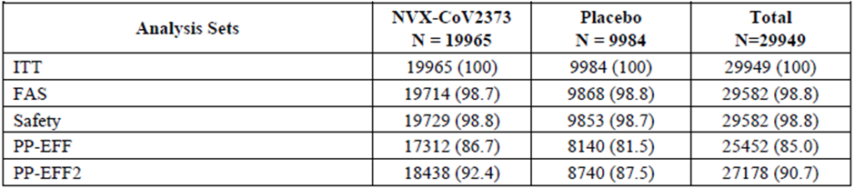
Abbreviations: FAS = full analysis set; ITT = intent to treat; Nuvaxovid, 5 µg SARS-CoV-2 rS plus 50 µg Matrix-M adjuvant; PP-EFF = per protocol efficacy
Figure 8: Study 2019nCoV-301 Subject flow
Protocol deviations leading to censoring from PP-EFF and PP-EFF-2 analysis sets were more frequent in the placebo group (12.3%) than in the Nuvaxovid group (2.8%), with the most frequent reason being receipt of an EUA approved COVID-19 vaccine.

Baseline data
Demographics and baseline characteristics of subjects in the PP-EFF analysis set were well balanced between the Nuvaxovid and placebo groups. Median age was 47 years, with all subjects ranging in age from 18 to 95 years. Approximately 11.8% of subjects were ≥ 65 years of age, with 10.7% aged ≥ 65 to ≤ 74 years and 1.7% (n = 405) aged ≥ 75 to ≤ 84 years. Approximately half the subjects were male (51.8%), while the majority (75.9%) were White, and not of Hispanic or Latino origin (78.3%) and located in the USA (94.0%) (Table 19). The majority of subjects were overweight or obese (69.9%), with more than a third being obese (37.2%). Most subjects (95.2%) were categorised as high risk adults for acquiring or experiencing complications of COVID-19. A breakdown of underlying comorbidities at Baseline in the study population is presented in Table 20. Baseline characteristics were similar between the PP-EFF analysis set and the safety population.
Within the safety population, most subjects (93.5%) had a seronegative (based on anti-nucleoprotein (NP) serology) and PCR negative (based on negative nasal swab PCR) baseline status prior to randomisation.
Table 19: Study 2019nCoV-301 Demographic and clinical characteristics of the subjects at Baseline (Per-protocol efficacy analysis population)
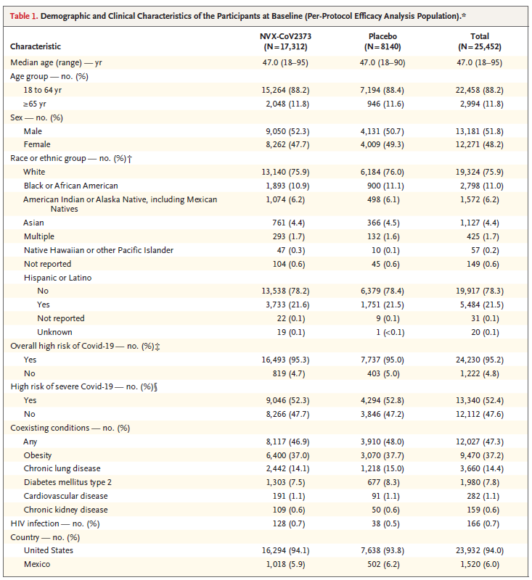
* The per protocol efficacy analysis population included all participants who underwent randomisation and received both doses as assigned, were seronegative for anti–SARS-CoV-2 nucleoprotein and had a severe acute respiratory syndrome coronavirus 2 (SARS-CoV-2) RNA real time (RT) PCR negative nasal swab at Baseline, and did not have a censoring event at any time before seven days after the second injection. HIV denotes human immunodeficiency virus.
† Race and ethnic group were reported by the participants.
‡ Participants at overall high risk included those 65 years of age or older and those of any age with chronic health conditions or an increased risk for Covid-19 because of work or living conditions.
§ Participants were classified as having a high risk of severe Covid-19 if they had one or more of the following coexisting conditions: obesity (defined as a body-mass index of ≥ 30), chronic lung disease, diabetes mellitus type 2, cardiovascular disease, or chronic kidney disease.
Table 20: Studies 2019nCoV-301 and 2019nCoV-302 Summary of severe obesity and specified high risk baseline comorbidities from medical history by comorbidity category and Preferred Terms (safety analysis set)
Abbreviations: BMI = body mass index, MedDRA = Medical Dictionary for Regulatory Activities;34F Nuvaxovid, 5 µg SARS-CoV-2 rS plus 50 µg Matrix-M adjuvant.
Notes: Medical history is coded using MedDRA, version 23.1.

Results
The FAS excluded 289 (1%) subjects (195 (1%) in the Nuvaxovid group and 94 (0.9%) in the placebo group). Study discontinuation occurred in 1619 (8.1%) in the Nuvaxovid group and 1391 (13.9%) in the placebo group, most frequently due to withdrawal by subjects (Nuvaxovid 5.5%, placebo 11%). Fourteen subjects were excluded due to having received Nuvaxovid from single dose vials rather than the multidose vial.
The PP-EFF analysis set excluded 4497 (15%) subjects (2653 (13.3%) in the Nuvaxovid group and 1844 (18.5%) in the placebo group). The most frequent (incidence > 2% in any vaccine group) reasons for exclusion were baseline positive anti-NP result (5.6%), censored prior to observation period (4.5%), did not complete vaccination schedule (4.0%), and protocol deviation (3.3%).
The final data cutoff date of the efficacy analysis was 1 June 2021. The study remains ongoing through approximately two years follow up from the Day 21 injection.

Primary endpoint results
After the protocol revision one single primary analysis was performed.
For the primary analysis of the primary endpoint, there were 77 cases. Of these cases, 14 (0.1%) were in the Nuvaxovid group and 63 (0.8%) were in the placebo group; all 14 cases in the Nuvaxovid group were mild in severity; 59 cases in the placebo group were mild or moderate and five were severe. There were three hospitalisations due to COVID-19 among the 77 per protocol COVID-19 cases in this study. The resultant VE was 90.4% (95% CI: 82.88, 94.62), with a p value of < 0.001 confirming the lower bound of the two sided 95% CI > 30% and meeting the prespecified study success criterion of the study.
Table 21: Study 2019nCoV-301 Vaccine efficacy against polymerase chain reaction confirmed symptomatic mild, moderate, or severe COVID-19 with onset from at least seven days after second vaccination in serologically negative adult subjects (per protocol efficacy analysis set)
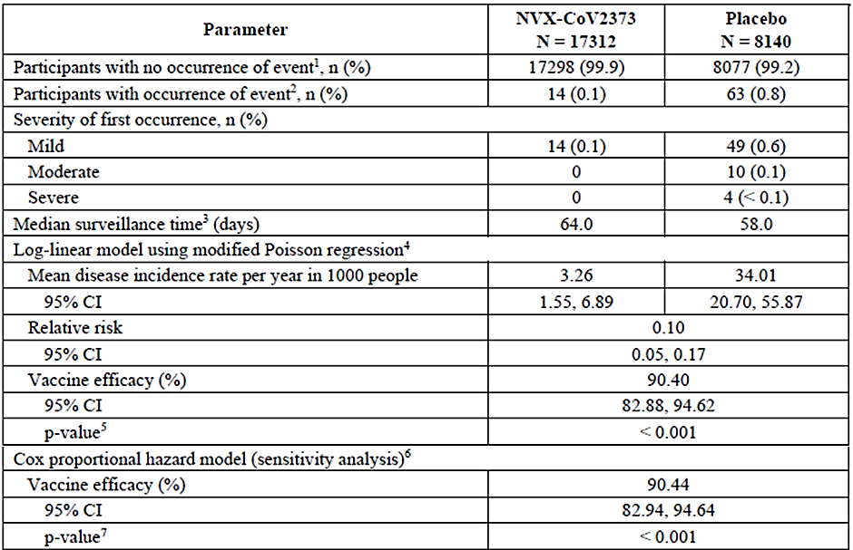
Abbreviations: CI = confidence interval; COVID-19 = coronavirus disease 2019; NVX-CoV2373 = Nuvaxovid, 5 µg SARS-CoV-2 rS plus 50 µg Matrix-M adjuvant; PCR = polymerase chain reaction; VE = vaccine efficacy.
¹ Include participants with PCR confirmed infection who did not meet mild, moderate or severe COVID-19 criteria.
² Event = first occurrence of PCR confirmed mild, moderate or severe COVID-19 with onset of illness episode from at least seven days after second vaccination within the surveillance period.
³ Surveillance time was defined as the difference between the date at end of surveillance period (onset of first occurrence of event/censoring) and date at start of surveillance period (7 days after second injection) + 1.
⁴ Modified Poisson regression with logarithmic link function,30 treatment group and strata as fixed effects and robust error variance
⁵ This p value corresponded to a one sided hypothesis test with significance level 0.025. If VE p value < 0.025, then reject H0: vaccine efficacy ≤ 30%.
⁶ Cox-proportional hazard model with Efron’s method for tie handling with vaccine group and age strata. Hazard ratio was used to estimate relative risk.
⁷ This p value corresponded to a one-sided hypothesis test with significance level 0.025. If the VE p < 0.025, then reject H0: VE ≤ 0%

Secondary endpoint results
Results for the secondary endpoints were:
- for the first episode of PCR positive COVID-19, as defined under the primary endpoint, shown by gene sequencing to represent a variant not considered as a VOC/VOI according to the CDC variants classification:31
  - viral genetic sequences were available for 54 of 77 primary endpoint cases in the PP-EFF.
  - ten of these cases (zero in the Nuvaxovid group and ten (0.1%) in the placebo group) were prototype like and did not contain any of the mutations that would identify them as a VOC/VOI, including three that were moderate or severe. Resequencing of the PCR positive cases that had not initially yielded sequencing results resulted in an additional three mild cases with non-VOC/VOI sequences in the placebo group (for a total of 13 (0.2%) cases).
  - the VE of Nuvaxovid to prevent symptomatic mild, moderate, or severe COVID-19 due to a SARS-CoV-2 variant not considered as a VOC/VOI in serologically negative (to SARS-CoV-2) adult subjects was 100% (95% CI: 80.8, 100; p < 0.001), and 100% (95% CI: 85.8, 100) with the three additional sequenced cases.
- for the first episode of PCR positive moderate or severe COVID-19, as defined under the primary endpoint:
  - there were 14 cases of PCR confirmed symptomatic moderate or severe COVID-19 with onset from at least seven days after second vaccination accrued for this analysis, with zero in the Nuvaxovid group and 14 (0.2%) in the placebo group. The resultant VE of Nuvaxovid to prevent symptomatic moderate or severe COVID-19 in baseline seronegative (to-SARS-CoV-2) adult subjects was 100% (95% CI: 87, 100).
- for the first episode of PCR positive COVID-19, as defined under the primary endpoint, shown by gene sequencing to represent a VOC/VOI according to the CDC variants classification:31
  - of the 276 cases with onset from first vaccination, 14 were virologically confirmed with at least one COVID-19 symptom and 262 were mild, moderate, or severe COVID-19.33,34 Of the 262 PCR positive cases of mild, moderate, or severe COVID-19, 203 had sequence data available as summarised. Of these, 82 were identified as VOC/VOI clades, lineages, or variants of SARS-CoV-2. The most common VOC were B.1.1.7 (Alpha), which occurred in 46 cases. During the period of case accrual, no cases of infection due to the B.1.617.2 (Delta) variant were identified.
  - the cumulative incidence curve for any symptomatic infection following initial vaccination (that is first dose) in the FAS is shown in Figure 9. This includes an additional 14 cases (eight Nuvaxovid group and six placebo group) compared to those classified as mild, moderate or severe COVID-19. Cumulative rates begin to diverge 14 to 21 days after first dose.
Figure 9: Study 2019nCoV-301 Cumulative incidence curve of any symptomatic SARS-CoV-2 infection with onset from first vaccination (full analysis set)
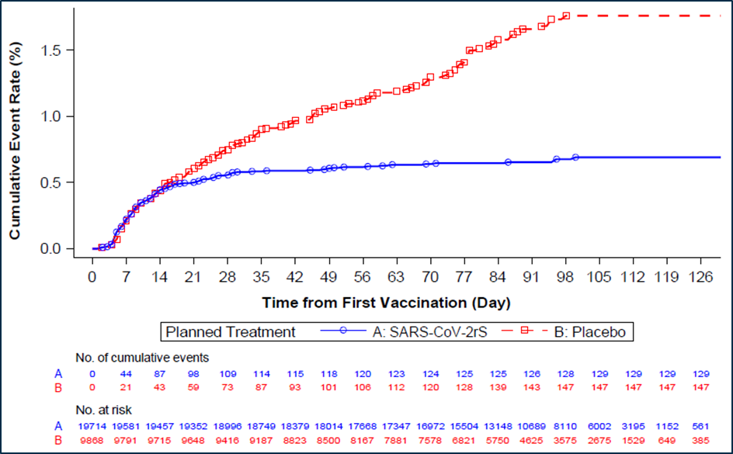
Event = Any PCR confirmed symptomatic SARS-COV-2 infection with onset after the first vaccination within the surveillance period. Surveillance period from first vaccination and up to 12 months after the last vaccination. Subjects are censored at the earliest of (i)cut-off date(I June 2021), (ii)date of death, (iii)date of unblinding (including for intended receipt of alternative COVID-19 vaccine), (iv)early withdrawal, or (v) crossover.
In the PP-EFF analysis set, 44 cases (six in the Nuvaxovid group and 38 in the placebo group) had mutations that would identify them as a VOC or VOI. In the Nuvaxovid group, all six cases were mild in severity; in the placebo group, 9 of 38 cases were moderate or severe. The resultant VE of Nuvaxovid to prevent symptomatic mild, moderate, or severe COVID-19 due to a SARS-CoV-2 variant considered a VOC or VOI in baseline seronegative adult subjects was 93. 2% (95% CI: 83.9, 97.1), with a p value < 0.001 confirming the lower bound of the one sided 95% CI > 0%.

Subgroup analyses
The VEs of Nuvaxovid at the time of the final analysis of the primary endpoint, for which an adequate number of cases were identified, were consistent across major demographic and baseline characteristic subgroups and are shown in the Table 22. The relatively lower VE of 67.3% (95% CI: 18.7, 86.8) for subjects of Hispanic or Latino ethnicity was noted.
Table 22: Study 2019nCoV-301 Subgroup analyses of vaccine efficacy against polymerase chain reaction confirmed symptomatic mild, moderate, or severe COVID-19 with onset from at least seven days after second vaccination in serologically negative adult subjects (per protocol efficacy analysis set)
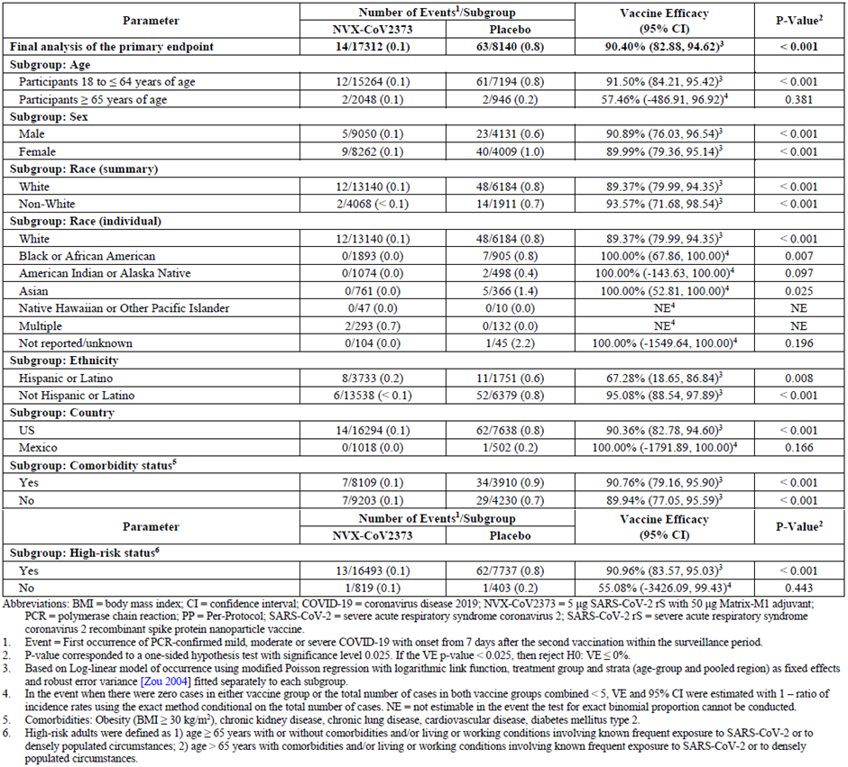
Abbreviations: BMI = body mass index; CI = confidence interval; COVID-19 = coronavirus disease 2019; NVX-CoV2373 = Nuvaxovid, 5 µg SARS-CoV-2 rS plus 50 µg Matrix-M adjuvant; PCR = polymerase chain reaction; VE = vaccine efficacy.
¹ Event = first occurrence of PCR confirmed mild, moderate or severe COVID-19 with onset of illness episode from at least seven days after second vaccination within the surveillance period.
² P value corresponded to a one sided hypothesis test with significance level of 0.025. If VE p value < 0.025, then reject H0: VE ≤ 0%.
³ Based on log linear model of occurrence using modified Poisson regression with logarithmic link function,30 treatment group and strata (age-group and pooled region) as fixed effects and robust error variance fitted separately to each subgroup.
⁴ In the event when there were zero cases in either vaccine group or the total number of cases in both vaccine groups combined < 5, VE and 95% CI were estimated with 1-ratio of incidence rates using the exact method conditional on the total number of cases, NE = not estimate in the event the test for exact binomial proportion cannot be conducted.
⁵ Comorbidities: Obesity (BMI ≥ 30kg/m²), chronic kidney disease, chronic lung disease, cardiovascular disease, diabetes mellitus type 2.
⁶ High risk adults were defined as 1) age ≥ 65 years with or without comorbidities and/or living or working conditions involving known frequent exposure to SARS-CoV-2 or to densely populated circumstances; 2) ages > 65 years with comorbidities and/or living or working conditions involving known frequent exposure to SARS-CoV-2 or to densely populated circumstances.

Study 2019nCoV-501
Study 2019nCoV-501 is an ongoing Phase IIa/b, randomised, observer blinded, placebo controlled trial evaluating the efficacy, immunogenicity, and safety of Nuvaxovid (in two doses, given 21 days apart) in adult HIV negative or HIV positive subjects conducted in South Africa.
Subjects who were HIV positive had to be medically stable, free of opportunistic infections in preceding year, HIV-1 viral load < 1000 copies/mL.

Primary objectives
The primary objectives are:
- to evaluate the efficacy of Nuvaxovid in preventing symptomatic, PCR confirmed COVID-19 in serologically negative (to SARS-CoV-2) adults, in a population inclusive of HIV negative and HIV positive individuals.
- to describe the safety experience for Nuvaxovid based on solicited short term reactogenicity (by toxicity grade) and by adverse event (AE) profile through Day 35 in all subjects regardless of baseline serostatus (stratified by baseline serostatus) (initial vaccination period).
The primary endpoints are:
- polymerase chain reaction confirmed SARS-CoV-2 infection with symptomatic mild, moderate or severe COVID-19 from seven days after second dose, analysed overall, until the endpoint event driven efficacy analysis is triggered by the occurrence of a pre-specified number of blinded endpoints and/or at pre-specified time points during the initial vaccination period.
- the numbers and percentages of subjects with solicited AEs (local and systemic) for seven days following each vaccination by severity score, duration and peak intensity.
- the numbers and percentages of subjects with unsolicited AEs (inclusive of serious adverse events (SAE), medically attended adverse events (MAAE), adverse event of special interest (AESIs)) through Day 35 (that is two weeks post second dose) by = Medical Dictionary for Regulatory Activities (MedDRA) classification, severity score and relatedness.

Secondary objectives
The key secondary objective are:
- to evaluate efficacy in HIV negative and HIV positive subjects separately.
- to evaluate efficacy against mild or moderate; or moderate or severe COVID-19.
Secondary endpoints are:
- polymerase chain reaction confirmed SARS-CoV-2 infection with symptomatic mild, moderate or severe COVID-19 from seven days after second dose; analysed separately rather than overall.
- Polymerase chain reaction confirmed SARS-CoV-2 infection with either symptomatic mild or moderate; OR symptomatic moderate to severe COVID-19 from seven days after second dose.
This study was primarily event driven for its power calculations. It was calculated that 50 primary endpoints along with an observed minimum VE of ≥ 65% would result in rejecting the null hypothesis of VE ≤ 30% with 90% power (this assumed an incident rate of COVID-19 of 2 to 6% in the placebo group and a 90% evaluability rate in the PP-EFF population) (accounting for attrition and/or baseline positive test for SARS-CoV-2). The study intended to enrol between 3200 and 4404 subjects divided into the two study cohorts (2960 to 4164 HIV negative (cohort one) and about 240 HIV positive (cohort two)).

Statistical methods
The estimated RR and its 95% CI were derived using Poisson regression with robust error variance. Hypothesis testing of the primary efficacy endpoint was carried out sequentially against two pre-specified null hypotheses: VE ≤ 0% first (success criterion for primary endpoint), followed by VE ≤ 30% (more stringent success criterion).
The official event driven analysis of the primary efficacy endpoints was triggered once at least 23 to 50 subjects with symptomatic COVID-19 had accrued. In addition to the official per protocol analysis, it was intended that additional efficacy analyses could be conducted through 6 and 12 months follow up (given the ongoing measurement of immunogenicity and safety endpoints during the study).
Secondary endpoints were accompanied by summaries of numbers and percentages with 95% CIs, both overall and per study cohorts one and two. Cumulative incidence curves were provided as exploratory analyses.

Subject flow
There were 6350 subjects screened, 4419 subjects were randomised (4173 HIV negative and 246 HIV positive) (see Table 23). At the cutoff date, 4325 (97.9%) were continuing in follow up and 94 (2.1%) had discontinued the study. The PP-EFF analysis set included 2770 (62.7%) subjects. The most frequent reasons for exclusion from the PP-EFF analysis set were positive PCR test or PCR confirmed illness episode before seven days after second dose vaccination (n = 1488, 33.7%) and missed one dose of study vaccine (n = 148, 3.3%).
Table 23: Study 2019nCoV-501 Subject screening and enrolment (all screen subjects analysis set)
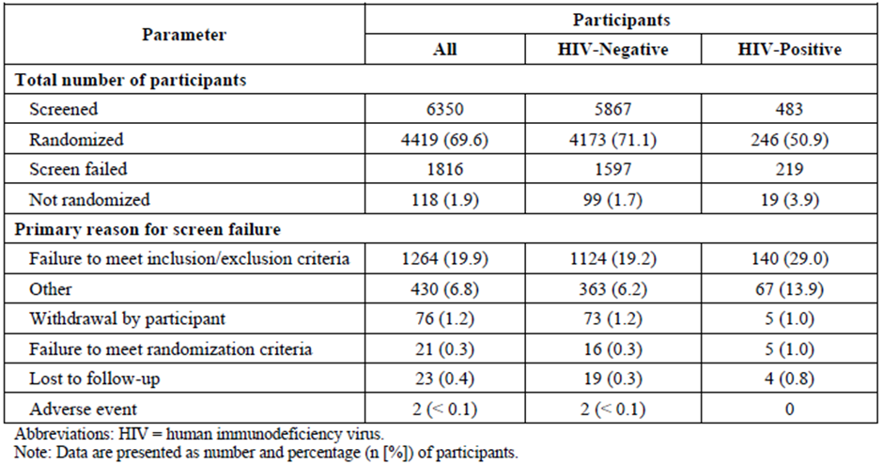
Abbreviations: HIV = human immunodeficiency virus
Note: Data are presented as a number and percentage (n (%)) of participants

Baseline characteristics
Demographic and baseline characteristics were well balanced between the Nuvaxovid and placebo groups, overall and by HIV status. Of subjects, 94% were HIV negative. Median age was 28 years (range: 18 to 84 years); 43% were female; 95% were Black/African American; 4% were White; 2% were multiple races, 1% were Asian; and 2% were Hispanic or Latino. 5.5% were HIV positive. At Baseline, 34.1% of subjects were seropositive for SARS-CoV-2. For HIV positive subjects, the majority (77%) had no co-morbidities. Median baseline CD4 level was 738 cells/µL (range 80 to 2076 cells/µL) and median baseline HIV viral load was 63.5 copies/mL (range 20 to 735 copies/mL).

Results

Primary efficacy endpoint (official event driven analysis)
There were 44 cases of COVID-19 (all severities) that accrued between 23 November 2020 and 30 December 2020 for the official event driven analysis of the primary efficacy endpoint (data extraction 18 January 2021) giving a VE of 49.4% (95% CI: 6.1 to 72.8) in the PP-EFF analysis set (see Table 24). All but one case was mild-moderate in severity, with the one severe case occurring in the placebo group.
Table 24: Study 2019nCoV-501 Vaccine efficacy of polymerase chain reaction confirmed SARS-CoV-2 positivity with symptomatic mild, moderate, or severe COVID-19 from seven days after second dose vaccination (for example Day 28) with Nuvaxovid or placebo in serologically naïve healthy human immunodeficiency virus negative and medically stable human immunodeficiency virus positive subjects analysed overall, official event-driven analysis (per protocol efficacy analysis set)
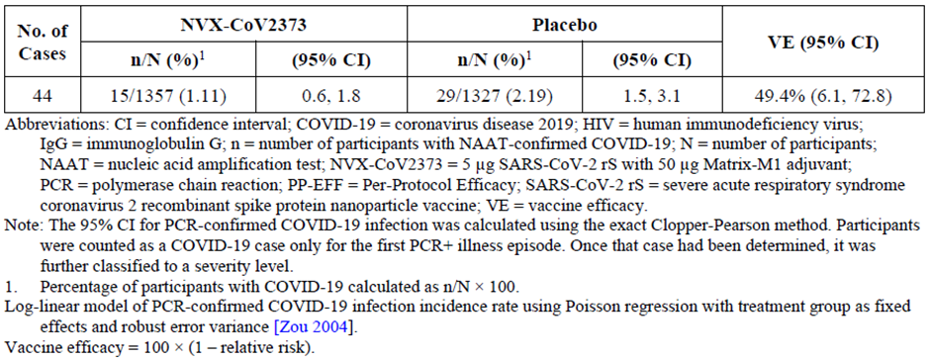
Abbreviations: CI = confidence interval; n = number of participants with nucleic acid amplification test (NAAT)-confirmed COVID-19; N = number of participants; NVX-CoV2373 = Nuvaxovid, 5 µg SARS-CoV-2 rS plus 50 µg Matrix-M adjuvant; PCR = polymerase chain reaction; VE = vaccine efficacy
Note: The 95% CI for PCR confirmed COVID-19 infection was calculated using the exact Clopper-Pearson method. Participants were counted as a COVID-19 case only for the first PCR plus illness episode. Once that case has been determined, it was further classified to a severity level.
¹ Percentage of participants with COVID-19 calculated as n/N x 100.
Log-linear model of PCR confirmed COVID-19 infection incidence rate using Poisson regression;30 with treatment group as fixed effects and robust error variance.
Vaccine efficacy = 100 x (1 – relative risk)

Primary efficacy endpoint (complete analysis)
Primary endpoints were also examined beyond the event driven analysis and out to about six months utilising different start dates: from seven days after second dose; from 14 days after second dose; and from seven days after first dose.
From seven days after second dose: Vaccine efficacy for different sub-groups stratified by baseline serostatus and/or HIV status is shown in Table 25.
Table 25: Vaccine efficacy of polymerase chain reaction confirmed SARS-CoV-2 positivity with symptomatic mild, moderate, or severe COVID-19 from seven days after second dose vaccination (for example Day 28) with Nuvaxovid or placebo overall and in healthy human immunodeficiency virus negative and medically stable human immunodeficiency virus positive subjects stratified by baseline serostatus and regardless of baseline serostatus (per protocol efficacy and second per protocol efficacy analysis sets)
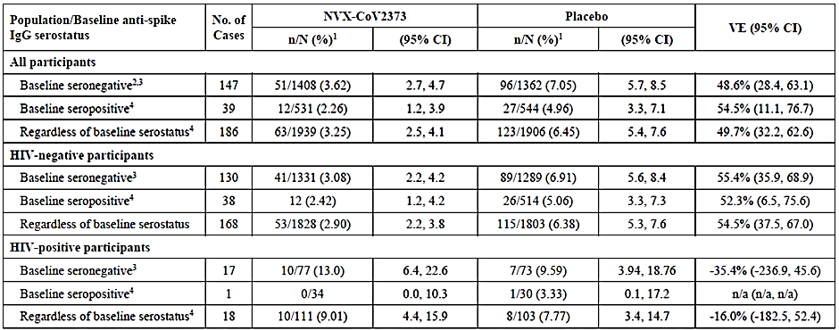
Abbreviation: CI = confidence interval; HIV = human immunodeficiency virus; NVX-CoV2373 = Nuvaxovid, 5 µg SARS-CoV-2 rS plus 50 µg Matrix-M adjuvant; PCR = polymerase chain reaction; VE = vaccine efficacy.
Note: The 95% CI for PCR confirmed COVID-19 infection was calculated using the exact Clopper-Pearson method. Participants were counted as a COVID-19 case only for the first PCR plus illness episode. Once that case has been determined, it was further classified to a severity level.
¹ Percentage of participants with COVID-19 calculated as n/N x 100.
².Primary endpoint
³ Based on PP-EFF analysis set
⁴ Based on second PP-EFF analysis set
Log-linear model of PCR confirmed COVID-19 infection incidence rate using Poisson regression;30 with treatment group as fixed effects and robust error variance.
Vaccine efficacy = 100 x (1 – relative risk)
The cumulative incidence curve for all subjects who were seronegative at Baseline revealed a separation between treatments from seven days following second dose (that is Day 28) that plateaued approximately four and half months post Day 0 for both treatments (Figure 10), likely reflecting a waning wave of the local epidemic.
Figure 10: Study 2019nCoV-501 Cumulative incidence curves for the first polymerase chain reaction confirmed SARS-CoV-2 positivity with symptomatic mild, moderate or severe COVID-19 from seven days after second dose vaccination (for example Day 28) analysed overall in serologically naïve healthy human immunodeficiency virus negative and medically stable human immunodeficiency virus, positive subjects combined (per protocol efficacy analysis set)
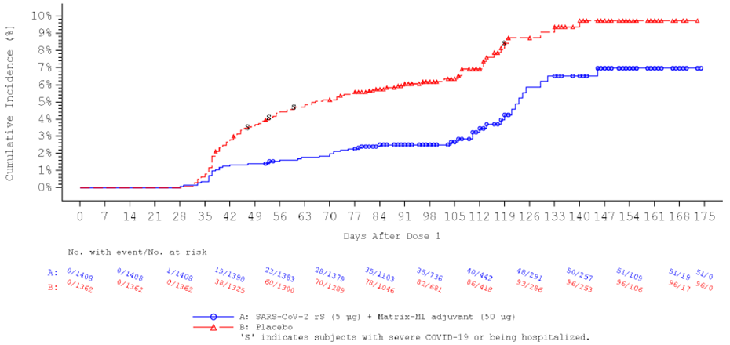

Secondary efficacy endpoints
Prevention of COVID-19 hospitalisation: There were five cases of hospitalisation among all adult subjects seronegative (to SARS-CoV-2) at Baseline, from seven days after second dose vaccination (Day 28). All occurred in the placebo group.
Prevention of COVID-19 stratified by severity: Among all subjects seronegative (to SARS-CoV-2) at Baseline, from seven days after second dose vaccination, the level of prevention of mild COVID-19 was 68.7%, 95% CI: 38.5, 84.1, that of moderate COVID-19 was 32.1%, 95% CI: -1.0, 54.4, and 100%, 95% CI: -5.6, 100 against severe COVID-19.
Efficacy by SARS-CoV-2 variant: Forty-one (93.2%) of 44 subjects with a primary efficacy endpoint had whole genome sequence data available (samples from three cases in the placebo group could not be sequenced), and 38 (92.7%) of 41 were identified as the B.1.351 variant, resulting in a post-hoc VE of Nuvaxovid (PP-EFF analysis set) in prevention of symptomatic mild, moderate, or severe COVID-19 in all adult subjects, seronegative (to SARS-CoV-2) at Baseline, of 43.0% (95% CI: -9.8, 70.4) for the B.1.351 variant.

Subgroup analyses
By SARS-CoV-2 serostatus at Baseline: A total of 147 and 39 symptomatic mild, moderate, or severe COVID-19 cases occurring at least seven days post second dose, among all adult subjects, seronegative (to SARS-CoV-2) or seropositive at Baseline respectively were accrued for analysis. The VEs of Nuvaxovid in prevention of COVID-19 in all adult subjects, seronegative (to SARS-CoV-2) or seropositive at Baseline, were respectively 48.6% (95% CI: 28.4, 63.1) and 54.5% (95% CI: 11.1, 76.7).
By human immunodeficiency virus status: Among HIV negative subjects seronegative (to SARS-CoV-2) at Baseline, the VE of Nuvaxovid in prevention of symptomatic mild, moderate, or severe COVID-19 was 55.4% (95% CI: 35.9, 68.9). Among HIV positive subjects seronegative (to SARS-CoV-2) at Baseline the VE was -35.4% (95% CI: -236.9, 45.6).
Table 26: Study 2019nCoV-501 Vaccine efficacy of polymerase chain reaction confirmed SARS-CoV-2 positivity with asymptomatic, symptomatic virologically confirmed, mild, moderate, or severe COVID-19 from seven days after second vaccination (for example Day 28) with Nuvaxovid or placebo overall and in healthy human immunodeficiency virus negative and medically stable human immunodeficiency virus positive subjects stratified by baseline serostatus and regardless of baseline serostatus (per protocol efficacy and second per protocol efficacy analysis sets)
Abbreviation: CI = confidence interval; HIV = human immunodeficiency virus; IgG = immunoglobulin G; n = number of participants with NAAT-confirmed COVID-19; N = number of participants; NAAT = nucleic acid amplification test; NVX-CoV2373 = Nuvaxovid, 5 µg SARS-CoV-2 rS plus 50 µg Matrix-M adjuvant; PCR = polymerase chain reaction; VE = vaccine efficacy.
Note: The 95% CI for PCR confirmed COVID-19 infection was calculated using the exact Clopper-Pearson method. Participants were counted as a COVID-19 case only for the first PCR plus illness episode. Once that case has been determined, it was further classified to a severity level.
¹ Percentage of participants with COVID-19 calculated as n/N x 100.
². Based on PP-EFF analysis set
³ Based on second PP-EFF analysis set
Log-linear model of PCR confirmed COVID-19 infection incidence rate using Poisson regression;30 with treatment group as fixed effects and robust error variance.
Vaccine efficacy = 100 x (1 – relative risk)

Conclusions on the clinical efficacy
Based on the data available for Nuvaxovid, a robust and high protective efficacy against COVID-19 has been demonstrated in individuals aged 18 years and older in two pivotal observer blinded placebo controlled trials. Efficacy has been established for a median follow up of 90 days in 2019nCoV-302 and 76 days in 2019nCoV-302. The vaccine is efficacious across different high risk groups including older adults, as well as subjects considered at increased risk of severe disease due to underlying chronic disease. Lower vaccine efficacy was observed in a supportive Study2019nCoV-501 in South Africa, which was possibly due to reduced efficacy against the Beta variant; however, other factors cannot be excluded.

Safety (combined and pooled)
Clinical safety was evaluated in the Phase I/II trial, Study 2019nCoV-101, Phase II trial, Study 2019nCoV-501 and the two pivotal Phase III trials, Studies 2019nCoV-302 and 2019nCoV-301.
Safety assessments include monitoring and recording of solicited (local and systemic reactogenicity events), unsolicited adverse events (AE), serious adverse events (SAE), adverse events of special interest (AESI), and vital sign measurements. Safety laboratory values (haematology and serum chemistry) were also evaluated in the first-in-human Study 2019nCoV-101 (Part one).
Solicited local and systemic adverse events were collected for seven days after each vaccine dose. Grading of solicited adverse events was based on FDA toxicity grading scale for clinical abnormalities.35F Unsolicited AEs were recorded from the time of first study vaccination until Day 49 after the initial set of vaccinations (that is 28 days post second dose) in each trial, and for the entire study period in Study 2019nCoV-301. Serious adverse events, medically attended adverse events (MAAE) and AESIs were assessed for the entire study period in all trials.
Adverse events of special interest included potential immune mediated medical conditions (PIMMCs) as well as events relevant to COVID-19.
This combined/pooled safety analysis is based on safety data sets from submitted clinical trials, including all subject data with supporting presentations to exclude the data post-unblinding/post-approved or deployed SARS-CoV-2 vaccine receipt.
For Study 2019nCoV-301, incidence rates for AEs were presented to account for the imbalanced randomisation and imbalanced follow up time between treatment arms. For other trials, numbers of events and % are reported.

Extent of exposure
There were 30,058 recipients of Nuvaxovid and 19892 recipients of placebo across the SARS-CoV-2 rS clinical development program, with over 96% from both study arms (96.4% Nuvaxovid and 96.9% placebo) receiving both doses (see Table 27).
Table 27: Number of subjects by trial included in the pooled analysis of safety data
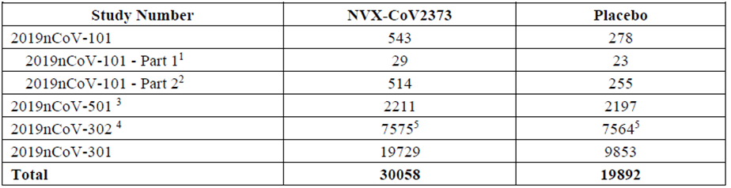
Abbreviations: HIV = human immunodeficiency virus; NVX-CoV2373 = Nuvaxovid, 5 µg SARS-CoV-2 rS plus 50 µg Matrix-M adjuvant.
¹ Included Groups A (placebo) and C (two dose regimen of 5 µg SARS-CoV-2 rS plus 50 µg Matrix-M adjuvant) only.
² Included Groups A (placebo), B (two dose regimen of 5 µg SARS-CoV-2 rS plus 50 µg Matrix-M adjuvant), and C (5 µg SARS-CoV-2 rS plus 50 µg Matrix-M adjuvant at first dose and placebo at second dose) only.
³ Included approximately 240 participants who were HIV-positive in the total population.
⁴.Included approximately 400 participants who were co-administered seasonal influenza vaccine at first dose.
⁵ These numbers differ from those reported in Study 2019nCoV-302 interim report (7569 in Nuvaxovid group and 7570 in the placebo group) because safety data for six participants who received a mixed regimen (placebo at first dose and active vaccine at second dose) were included in the active vaccine group only for the purpose of the pooled analysis of safety data.
The median duration of follow up in the pooled safety database was 70 days post second dose, with 32,993 (66%) subjects completing more than two months follow up post second dose. The shorter median duration of follow up in the pooled data as compared to the individual studies is due to censoring at unblinding.

Demographics
Demographic characteristics of subjects in the pooled analysis were generally well balanced between the Nuvaxovid and placebo groups, with slightly lower frequencies of subjects ≥ 65 years of age and subjects of Black or African American race and a slightly higher frequency of subjects of Hispanic or Latino origin in the Nuvaxovid group.

Adverse events

Solicited local adverse events
Local solicited treatment emergent adverse events (TEAE) in the week following vaccination were more common in Nuvaxovid than placebo recipients across the studies and more common following second dose than first dose in the Nuvaxovid group (59.3% versus 80.2%) (See Table 28). Also, higher frequencies of Grade 3 reactions were reported following the second dose, increasing from 1.1% to 5.2%. Persons reporting moderate to severe reactions following the first dose tended to report similar or less severe reactions following the second dose.
In Study 2019nCoV-302 tenderness and injection site pain were the most frequent solicited local AEs, reported by 705 (54.9%) and 394 (30.7%) subjects, respectively, after the first dose and by 922 (76.6%) and 624 (51.9%) subjects after the second dose (see Table 28). Median durations of tenderness and pain increased with the second dose from 2 to 3 days and 1 to 2 days respectively.
A similar picture emerged in Studies 2019nCoV-301 and 2019nCoV-101. In Study 2019nCoV-501 lower rates of local reactions were reported following the second dose compared to the first and they were less often severe.
Table 28: Solicited local adverse events for 7 days following each vaccination across the SARS-CoV rS clinical development programme
Abbreviations: N1 = number of participants receiving the first dose of trial vaccine; N2 = number of participants receiving the second dose of trial vaccine; NVX = NVX-CoV2373/Nuvaxovid, 5 µg SARS-CoV-2 rS plus 50 µg Matrix-M adjuvant; TEAE = treatment emergent adverse events.
¹ Group C only
² Group B and C only
³ Based on Study 2019nCoV-501 interim report
⁴ Solicited local and systemic TEAEs were evaluated in a subset of 2714 participants in this study
⁵ Excludes three sentinel participants who received active vaccine in an open label manner
⁶ Based on Group B only as participant in Group C received placebo for their second vaccination.
Note: Toxicity grading based on FDA toxicity grading scale;³⁶
Note: Data are presented as number and percentage (n %) of participants.

Solicited systemic reactions
Overall, there were higher frequencies of solicited systemic AEs among Nuvaxovid recipients than among placebo recipients following each vaccination overall and in each age cohort. An overview of solicited systemic AEs after each dose across the clinical trials is presented in Table 29.
Table 29: Solicited systemic adverse events for seven days following each vaccination across the SARS-CoV-2 rS clinical development programme
Abbreviations: TEAE = treatment emergent adverse events; N1 = number of participants receiving the first dose of trial vaccine; N2 = number of participants receiving the second dose of trial vaccine; NVX = NVX-CoV2373/Nuvaxovid, 5 µg SARS-CoV-2 rS plus 50 µg Matrix-M adjuvant; TEAE = treatment emergent adverse events.
¹ Group C only
² Group B and C only
³ Based on Study 2019nCoV-501 interim report
⁴ Solicited local and systemic TEAEs were evaluated in a subset of 2714 participants in this study
⁵ Excludes three sentinel participants who received active vaccine in an open label manner
⁶ Based on Group B only as participant in Group C received placebo for their second vaccination.
Note: Toxicity grading based on FDA toxicity grading scale;³⁶
Note: Data are presented as number and percentage (n %) of participants.
In Study 2019nCoV-302, solicited systemic AEs were reported by 47.6% of Nuvaxovid recipients following the first dose. This increased with the second dose to 64.6%. With the second dose, higher frequencies of Grade 3 reactions were reported, increasing from 1.3% with the first dose to 6.8%. There was a modest increase in the frequency and intensity of reactions with the second dose for those persons who experienced mild (Grade 0, Grade 1) reactions with the first dose. Of participants reporting Grade 1 reactions with the first dose, 55% reported Grade 2 or higher reactions following the second dose. Of participants who reported Grade 3 or 4 reactions following the first dose, 60% reported less severe systemic reactions following the second dose.
Headache, fatigue, and muscle pain were the most frequent solicited systemic AEs. Grade 3 headache, fatigue, and muscle pain were reported in 17 (1.4%), 43 (3.6%), and 34 (2.8%) participants in the Nuvaxovid group and 3 (0.3%), 9 (0.8%), and 3 (0.3%) participants in the placebo group following the second dose. Median durations of headache, fatigue, and muscle pain were one day for each AE for every study vaccine group after both the first as the second dose.
Similar systemic reactogenicity was observed in Studies 2019nCoV-101 and 2019nCoV-301. In Study 2019nCoV-301, 0.1% reported Grade 4 solicited systemic adverse events after the first and second dose in both vaccine arms.
Following first dose vaccination in Study 2019nCoV-301, overall concomitant analgesic medication use was low (< 1%), and rates were balanced between the Nuvaxovid and placebo groups (130 (0.7%) and 57 (0.6%), respectively). Following second dose vaccination, there was an increase in concomitant analgesic medication use in the Nuvaxovid group relative to the placebo group (545 (2.8%) and 63 (0.6%), respectively). In Study 2019nCoV-302, following first vaccination, overall concomitant analgesic medication use was low (1.4%), and rates were balanced between the Nuvaxovid and placebo groups (100 (1.3%) and 112 (1.5%), respectively). Similar results were seen following second vaccination (103 (1.4%) and 119 (1.6%), respectively).

Unsolicited adverse events
The frequencies of unsolicited TEAEs reported from first dose through 28 days post second dose (that is Day 49) in ≥ 0.5% of participants in either group. These were higher in the Nuvaxovid group than the placebo group across both age strata and were dominated by ongoing reactogenicity events continuing beyond the seven day post--injection window. Frequencies were slightly higher in older compared to younger participants. AEs were mostly mild, with severe TEAEs occurring in < 1% of participants.
- Study 2019nCoV-301: up to Day 49, higher rates of AEs in the Nuvaxovid group were reported for the following System Organ Class (SOC):
  - General disorders and administration site conditions (incident rate (IR): 33.7 versus 16.8 per 100 patient-years (PY)) with differences in the Preferred Terms (PT): fatigue (n = 196 versus 69), injection site pain (n = 160 versus 38), pain (n = 68 versus 21), pyrexia (n = 116 versus 23), chills (n = 65 versus 6), malaise (n = 48 versus 14), injection site pruritus (n = 44 versus 2), injection site erythema (n = 29 versus 4), Injection site swelling (n = 26 versus 1), influenza like illness (n = 21 versus 3), oedema peripheral (n = 15 versus 4).
  - Nervous system disorders (IR: 18.7 versus 18.1 per 100 PY) with differences in PTs headache (n = 293 versus130), migraine (n = 18 versus 3).
  - Musculoskeletal and connective tissue disorders (IR: 13.8 versus 11.8 per 100 PY), with a difference in PTs myalgia (n = 109 versus 30), pain in extremity (n = 51 versus 17), tendonitis (n = 11 versus 2).
  - Skin and subcutaneous tissue disorders (IR: 7.9 versus 5.2), with a difference in the PTs rash (n = 61 versus 22), pruritus (n = 25 versus 2), urticaria (n = 17 versus 5), erythema (n = 16 versus 3).
  - Blood and lymphatic disorders (IR: 2.8 versus 1.6), with a difference in the PT lymphadenopathy (n = 53 versus 13).
  - Eye disorders (IR: 2.3 versus 1) with 62 events reported in 51 of 19729 (0.26%) participants receiving active vaccine compared with 13 events in 12 of 9853 (0.12%) placebo treated participants. This explained by minor imbalances in several PTs including diplopia (notably, one SAE of diplopia was reported), dry eye, eye swelling, lacrimation increased, ocular discomfort, photophobia, and swelling of eyelid. Several of these PTs are related or can possibly be caused by inflammation of the eye although there was only a singular report in the PT ‘Eye inflammation’ (in the Nuvaxovid group).
  - Reproductive system and breast disorders (IR: 2 versus 1.25) with 55 events reported in 52 of 19729 (0.26%) participants receiving active vaccine compared with 17 events in 17 of 9853 (0.17%) placebo treated participants; the imbalance is explained by PTs of dysmenorrhoea (12 versus 3) and menstruation irregular (5 versus 0).
There was a higher IR of unsolicited treatment related AEs reported from start of first vaccination through 28 days after second vaccination (for example Day 49) in the Nuvaxovid group (50.92 events/100 PY) than in the placebo group (26.34 events/100 PY). Unsolicited treatment related AEs that had a > 1 event/100 PY higher IR in the Nuvaxovid group than in the placebo group were injection site pain (5.64 versus 2.35), fatigue (4.84 versus 2.72), headache (4.73 versus 3.31), pyrexia (2.76 versus 0.74), myalgia (2.76 versus 0.96), chills (1.86 versus 0.37), and injection site pruritus (1.53 versus 0.15); these events were consistent with the solicited local and systemic TEAEs reported during the reactogenicity period.
- Study 2019nCoV-302: Differences between the treatment arms were largely due to differences in AEs of pain (1.2% versus 0.3%, respectively), injection site pruritus (0.7% versus < 0.1%), and lethargy (1% versus 0.4%). There was a higher frequency of participants with unsolicited treatment related AEs in the Nuvaxovid group (10.9%) than in the placebo group (4.6%); this difference was largely due to treatment related AEs of pain (1.1% versus 0.2%, respectively), influenza-like illness (0.8% versus < 0.1%), injection site pruritus (0.6% versus < 0.1%), and lethargy (0.9% versus 0.3%).
  - Severe AEs: a numerical imbalance was seen for hypertension, with nine reports of hypertension (0.1%) for the Nuvaxovid group compared with two for the placebo group (< 0.1%), in addition to reports of hypertension (n = 2), systolic hypertension (n = 1) and hypertensive crisis (n = 1) in the Nuvaxovid group versus one report of ‘blood pressure systolic increased’ in the placebo group (n = 1). Combined 13 versus 3 severe TEAEs were reported related to hypertension. In the pooled analysis the incidence rates were 0.40 (n = 102) in the Nuvaxovid arm compared to 0.43 (n = 70) in the placebo arm for participants 18 to 64 years. In participants aged 65 or older however, the rates were 0.96 (n = 46) in the Nuvaxovid arm compared to 0.64 (n = 22) in the placebo group during the three days following vaccination.
- Study 2019nCoV-501: Similar rate of unsolicited AEs was observed through 49 days after first vaccination in both vaccine arms. The most frequent (incidence > 1%) TEAEs in the Nuvaxovid group were headache (3.1%) and upper respiratory tract infection (1.2%); headache (2.3%) and influenza-like illness (1.1%) were the most frequent in the placebo group. The most frequent (incidence > 5 participants) treatment-related TEAEs in the Nuvaxovid group were headache (17 (0.8%)), myalgia (9 (0.4%)), lymphadenopathy (9 (0.4%)), and injection site pain (6 (0.3%)).
Table 30: Frequencies of unsolicited adverse events reported from after start of first vaccination through 28 days after second vaccination (for example Day 49) in ≥ 0.5% of participants in the pooled analysis of safety data
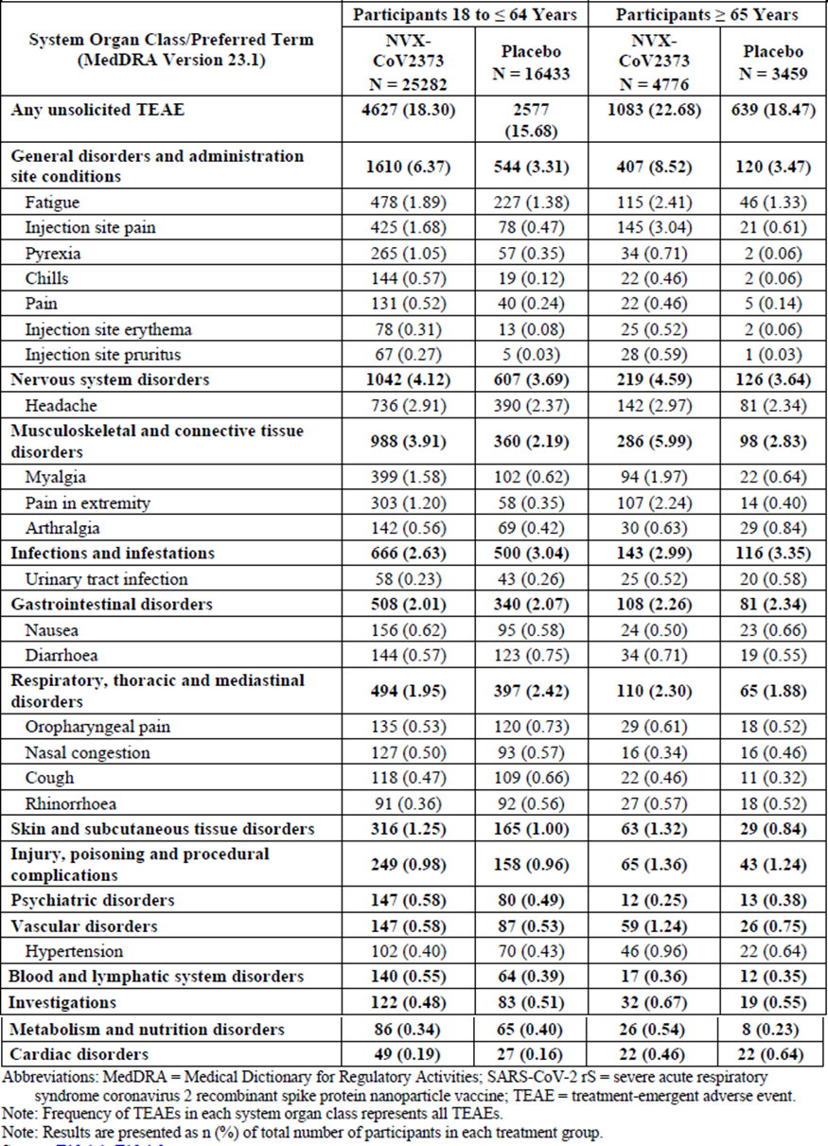
Abbreviations: MedDRA = Medical Dictionary for Regulatory Activities; TEAE = treatment emergent adverse event.
Note: Frequency of TEAEs in each system organ class represents all TEAEs.
Note: Results are presented as n (%) of total number of participants in each treatment group.

Adverse events of special interest
Adverse events of special interest included PIMMCs as well as adverse events related to COVID-19.
- Potential immune-mediated medical conditions
Potential immune-mediated medical conditions were reported in five (< 0.1%) participants in the Nuvaxovid group and eight (0.1%) participants in the placebo group in Study 2019nCoV-302. There were no PIMMCs reported for Studies 2019nCoV-501 and 2019nCoV-101. In Study 2019nCoV-301, for the original analysis of PIMMCs, there was a higher IR of PIMMCs reported from start of first vaccination to blinded crossover or end of study in the Nuvaxovid group (0.4 event/100 PY) than in the placebo group (0.15 events/100 PY). A standardised MedDRA queries (SMQ) based on the protocol defined PIMMC MedDRA preferred terms was applied to the data. This evaluation demonstrated no imbalance of PIMMCs between study groups (0.46 events/100 PY for Nuvaxovid and 0.44 events/100 PY for placebo). A combined analysis of PIMMCs based on protocol defined MedDRA preferred terms or site entered criteria on case report forms demonstrated little imbalance of PIMMCs between study groups (0.62 events/100 PY for Nuvaxovid and 0.54 events/100 PY for placebo) (0.15 events/100 PY) (Table 31). There were no SOCs that had a ≥ 0.05 events/100 PY higher IR in the Nuvaxovid group than in the placebo group.
Apart from uveitis (n = 3 reports) and Basedow’s disease/hyperthyroidism (n = 3), there was only a single report for the PTs listed with no clear patterns emerging aside from the overall imbalance.
A SMQ based on the protocol defined PIMMC MedDRA preferred terms was applied to the data. This evaluation demonstrated no imbalance of PIMMCs between study groups. An overview of PIMMCs based on protocol defined MedDRA preferred terms or site entered criteria on case report forms is provided in the Table 31. There were no SOCs that had a ≥ 0.05 event/100 PY higher IR in the Nuvaxovid group than in the placebo group.
Table 31: Overall summary of potential immune mediated medical conditions based on protocol defined MedDRA Preferred Terms or site entered criteria on the case report form by System Organ Class and Preferred Term reported from after start of first vaccination to blinded crossover or end of study by age strata (safety analysis set)
Abbreviations: E = number of adverse events reported; IR = incident rate is defined as number of events per 100 patient-years = e/100 PY; MedDRA = Medical Dictionary for Regulatory Activities; NVX-CoV2373 = Nuvaxovid, 5 µg SARS-CoV-2 rS plus 50 µg Matrix-M adjuvant.

Other events of special interest
In Study 2019nCoV-302 similar frequencies of participants reported protocol defined AESIs relevant to COVID-19 between the Nuvaxovid and placebo groups, with AESIs reported in eight (0.1%) participants in the Nuvaxovid group and 23 (0.3%) participants in the placebo group. Anosmia and ageusia were the most frequently reported AESIs relevant to COVID-19, reported by 0.1% in the Nuvaxovid group. In Study 2019nCoV-301, there was a numerically higher IR of AESIs relevant to COVID-19 reported from start of first vaccination to blinded crossover or end of study in the placebo group (0.27 events/100 PY)) than in the Nuvaxovid group (0.11 events/100 PY). In Study 2019nCoV-501, there were few reports of AESIs related to COVID-19 through 49 days after first vaccination: 11 (0.5%) participants in the Nuvaxovid group and 14 (0.6%) participants in the placebo group. AESIs related to COVID-19 in the Nuvaxovid group were anosmia, cough, oropharyngeal pain, and pyrexia (3 (0.1%) each).

Serious adverse events and deaths

Deaths
Three (< 0.1%) participants died during Study 2019nCoV-302, two in the Nuvaxovid group and one in the placebo group. In Study 2019nCoV-301, a total of 14 participants died during the study, with nine (0.05%) in the Nuvaxovid group and five (0.05%) in the placebo group. Four deaths occurred in Study 2019nCoV-501, with two deaths (unknown cause, and COVID-19) in the Nuvaxovid group and two deaths (both COVID-19) in the placebo group. There were no deaths reported in Study 2019nCoV-101 (interim report).
All deaths were assessed as not related to trial vaccine.

Other serious adverse events
Serious adverse events occurred at a similar rate across both treatment groups, with slightly higher rates among participants in the older age cohort (≥ 65 years of age).
In Study 2019nCoV-301, 169 (0.86%) participants in the Nuvaxovid group reported 228 SAEs (IR: 4.32 event/100PY). There were 128 SAE reported in the placebo group (IR: 4.89 event/100PY).
Two SAEs (angioedema and central nervous system inflammation) in the Nuvaxovid group were assessed by both the investigator and sponsor as being related to study vaccine. Three additional SAEs (Basedow’s disease, hyperthyroidism, and thrombocytopenia) in the Nuvaxovid group were assessed by the investigator as related to study vaccine but were assessed by the sponsor as not related to study vaccine.
Other SAEs of interest in Study 2019nCoV-301 due to imbalances between the treatment arms or observations in other trials are:
- There were 11 events of hepatobiliary disorders cholecystitis (acute), bile duct stone, and cholelithiasis reported in nine subjects in the Nuvaxovid group and none in the placebo group.
- There were six events of prostate cancer in the Nuvaxovid group and none in the placebo group. These events occurred in five subjects.
- There were seven events of cerebrovascular accident in the Nuvaxovid group and one in the placebo group. These events occurred in eight subjects, including one in the placebo group.
- There were four events of hypertension and two events of hypertensive crisis reported as an SAE in the Nuvaxovid group, and none in the placebo group.
In Study 2019nCoV-302, 44 (0.6%) participants in the Nuvaxovid group reported 54 SAEs versus 44 (0.6%) participants in the placebo group reporting 56 SAEs. One SAE of myocarditis in a 19 year old male with no underlying risk factors was considered related to study vaccine by the investigator; time to onset was three days post second dose vaccination. The event resolved. Further, there was an SAE of pulmonary embolism in a 52 year old male with relevant risk factors. Time to onset was nine days after the second dose vaccination. The event was not considered related to vaccination by the investigator.
In Study 2019nCoV-501, a total of 11 (0.5%) participants reported 11 SAEs in the Nuvaxovid group and 18 (0.8%) participants reported 18 SAEs in the placebo group; none of these events in either group were assessed as related to trial vaccine.
There were no SAEs reported in Study 2019nCoV-101 (Part 1) (interim report). In Study 2019nCoV-101 (Part 2) nine (0.7%) participants had a total of nine SAEs, including an SAE of colitis occurring two days post second dose and assessed as not related by the sponsor.
Table 32: Incidence rates of serious adverse events reported from after start of first vaccination through the respective data cutoff dates of the individual clinical trials with an incidence rate of > 0.1 event/100 PY in the pooled analysis of safety data
Table 32: Incidence rates of serious adverse events reported from after start of first vaccination through the respective data cutoff dates of the individual clinical trials with an incidence rate of > 0.1 event/100 PY in the pooled analysis of safety data, continued
Abbreviations: e/100 PY = events per 100 person-year; MedDRA = Medical Dictionary for Regulatory Activities; SAE = serious adverse event; NVX-CoV2373 = Nuvaxovid, 5 µg SARS-CoV-2 rS plus 50 µg Matrix-M adjuvant.
¹ One event of prostate cancer in the older age cohort was censored from the pooled analysis of safety data because the event occurred after the unblinding data (this event was included in the Study 2019nCoV-301 interim report)
Note: Results are presented as number of events per 100 person-year, with the event rate in parentheses.

Laboratory findings
Clinical laboratory findings were only reported for study 2019nCoV-101 (Part 1).

Haematology
A total of six participants (4.6%) had post-baseline Grade ≥ 2 hematologic laboratory abnormalities: one in Group A (placebo/placebo), 1 in Group B (25/0 μg × 2), 2 in Group C (5/50 μg × 2), and 2 in Group E (25/50 μg, first dose; placebo, second dose). This included five participants (3.8%) with Grade 3 toxicity (1 in Group B; 2 in Group C; and 2 in Group E). All Grade ≥ two hematologic laboratory abnormalities comprised decreased haemoglobin, defined as > 20 g/L decreases from Baseline. These events were predominantly transient in nature. Median haemoglobin values decreased from Baseline across the active vaccine and placebo groups following first vaccination at Day 7 and at Day 21 and following second vaccination at Day 28.

Serum chemistry
A total of two participants (1.5%) had abnormal serum chemistry laboratory values reported as TEAEs (liver function test increased in Group C and transaminases increased in Group D). Both events were mild in severity and assessed as related to active vaccine.
A total of ten participants (7.6%) had post-baseline Grade ≥ 2 serum chemistry abnormalities (one in Group A (placebo/placebo), one in Group B (25/0 μg × 2), two in Group C, five in Group D, and one in Group E (25/50 μg, first dose; placebo, second dose)), which included two participants (1.5%) with Grade 3 toxicity (one each in Groups C and E); no participant had a Grade 4 serum chemistry abnormality.
There were similar rates of laboratory investigation TEAEs for Nuvaxovid compared with placebo. TEAEs in most PTs were infrequent, with less than two events for most PTs in either the Nuvaxovid or placebo groups; there were no clear imbalances between the Nuvaxovid group and placebo.

Subgroup safety

By underlying comorbidities
In Study 2019nCoV-301, participants with co-morbidities of obesity, chronic kidney disease, cardiovascular disease, and diabetes mellitus Type II reported lower frequencies and intensities of solicited local and systemic AEs after each vaccination among Nuvaxovid recipients than the overall study population who received Nuvaxovid and participants with chronic lung disease. The frequencies and intensities in participants with chronic lung disease were similar as the overall study population.

By age
Participants in the older age cohort (≥ 65 years of age) reported lower frequencies and intensities of solicited local and systemic AEs among Nuvaxovid recipients after each vaccination than in participants in the younger age cohort (18 to ≤ 64 years of age). An overview of adverse events reported in Study 2019nCoV-302 stratified by age is presented in Table 33. A similar pattern was observed in Study 2019nCoV-301.
Table 33: Study 2019nCoV-302 Overall summary of adverse events reported (stratified by age)

By human immunodeficiency virus status
In Study 2019nCoV-501, approximately 94% of participants were HIV negative, with a median age of 27 years and 4.4% aged 65 years and older. An overview of unsolicited adverse events by HIV status is presented in Table 34.
Table 34: Study 2019nCoV-501 Overall summary of unsolicited adverse events reported in healthy human immunodeficiency virus negative and medically stable human immunodeficiency virus positive participants regardless of baseline serostatus (safety analysis set)
Abbreviations: AESI = adverse events of special interest; MAAE = medically attended adverse events; NVX-CoV2373 = Nuvaxovid, 5 µg SARS-CoV-2 rS plus 50 µg Matrix-M adjuvant; PIMMC = potential immune-mediated medical conditions; TEAE = treatment-emergent adverse event

By serostatus at Baseline
In Study 2019nCoV-501, negative baseline serostatus and positive baseline serostatus for SARS-CoV-2 were established, respectively, for 65.9% and 34.1% of participants (see Table 35). Rates of solicited and unsolicited adverse events were similar in subjects seropositive or seronegative at Baseline. Similarly, in Study 2019nCoV-302, where only 4.2% of participants was seropositive at Baseline, there was no suggestion of an increase in reactions or TEAEs in seropositive persons versus seronegative persons.
Table 35: Study 2019nCoV-501 Overall summary of adverse events stratified by serostatus at Baseline (safety analysis set)

In pregnancy and during breastfeeding
There is limited experience with Nuvaxovid in pregnancy. A total of 137 pregnancies were reported in the clinical development program as of 26 October 2021. Of these participants, 95 received Nuvaxovid and 42 received placebo. Of the 95 pregnancies reported in participants in the Nuvaxovid group, eight resulted in live births, 11 underwent voluntary termination, 16 resulted in spontaneous abortion, and 60 were either ongoing (55) or the outcome of the pregnancy was unknown (5). There were no foetal deaths or stillbirths reported in the clinical development program. There are no data available on the safety of Nuvaxovid administered during breastfeeding.

Immunological events
Across the studies, 113 (0.38%) vaccine recipients compared to 42 (0.21%) placebo recipients reported AEs under the hypersensitivity standardised MedDRA queries narrow within the three days of vaccination, with a risk difference (RD) of 0.20 (95% CI: 0.11, 0.30).
For the SOC immune system disorders, the frequency was higher for vaccine recipients (0.04%) than for placebo recipients (0%) with 8 (0.03%) recipients reporting of allergy to vaccine and three (< 0.01%) recipients reporting hypersensitivity. None of the three hypersensitivity events are considered related to Nuvaxovid. Upon review of the narratives of the eight reports of ‘allergy to the vaccine’, these were mostly reactogenicity related events rather than clear hypersensitivity reactions to the vaccine. There was one case which may concern true hypersensitivity, namely an erythematous patch on left hand and itchiness as mild in intensity with onset ten minutes after vaccination, which was resolved within three hours. No events of anaphylaxis have been reported.

Safety related to drug-drug interactions and other interactions
Local and systemic reactions were higher in participants included in the seasonal influenza substudy, who received concomitant influenza vaccine, than in participants who did not receive concomitant influenza vaccine.
- Following first dose, where concomitant influenza vaccination did occur, there was a higher frequency of solicited local AEs in the Nuvaxovid group who received concomitant influenza vaccine (70.1%) than in those who received only Nuvaxovid (57.6%). Systemic reactions were reported by 60.1% in the seasonal influenza substudy, compared to 45.7% in those who did not receive concomitant influenza vaccine.
- Following second vaccination (where concomitant influenza vaccination did not occur), the frequency of solicited local AEs in participants in the seasonal influenza substudy was 85%, compared to 79.6% in subjects not included in the seasonal influenza substudy. Systemic reactions were reported by 69.7% compared to 64% respectively.

Discontinuation due to adverse events

Study 2019nCoV-301
Study discontinuations due to adverse events were reported by a total of 24 subjects (0.1%), 17 (0.1%, 65 events) in the Nuvaxovid arm and 7 (0.1%, 14 events) in the placebo arm. Incidence rates of unsolicited TEAEs resulting in study discontinuation reported from start of first vaccination to blinded crossover or end of study with > 0.05 events/100 PY in the Nuvaxovid group was fatigue (0.06 versus 0). Adverse events resulting in vaccine discontinuation were reported by 57 (0.3%) subjects in the Nuvaxovid arm and 16 (0.2%) subjects in the placebo arm.

Study 2019nCoV-302
Treatment emergent AEs leading to study discontinuation were recorded for 27 (0.4%) of subjects in the Nuvaxovid group and 17 (0.2%) subjects in the placebo group. Treatment-related TEAEs leading to study discontinuation were reported in 14 (0.2%) subjects in the Nuvaxovid group and 3 (< 0.1%) in the placebo group. The most frequent (incidence > 1 participant) treatment related TEAEs leading to study discontinuation in the Nuvaxovid group were injection site pain (four participants) and myalgia (two participants).
There were similar frequencies of participants reporting unsolicited TEAEs leading to discontinuation of study vaccine between the two study vaccine groups, with 30 (0.4%) participants in the Nuvaxovid group and 23 (0.3%) participants in the placebo group.

Study 2019nCoV-501
Unsolicited TEAEs resulting in vaccine discontinuation were reported in 0 of 2211 participants in the Nuvaxovid group versus 1 (< 0.1%) of 2197 participants in the placebo group; four (0.2%) of 2211 participants in the Nuvaxovid group and four (0.2%) of 2197 participants in the placebo group reported TEAEs resulting in study discontinuation.

Additional clinical study
The drug product used in clinical trial was manufactured at different site (USA) to the currently proposed manufacturing site Serum institute of India (SII). The quality evaluator has highlighted critical comparability issues between the products from USA sites (used for the trial) and from SII (manufacturing site). An interim clinical study report for the ICMR/SII-Covovax trial is submitted by the sponsor.

ICMR/SII-Covovax trial
This trial is not the part of drug development plan. It was conducted by the manufacturer, the SII, with the aim to establish immunogenicity and safety of the SII-manufactured product.
This trial is a Phase II/III, observer blind, randomised, controlled study to determine the safety and immunogenicity of Covovax (SARS-CoV-2 recombinant spike protein nanoparticle vaccine (SARS-CoV-2 rS) with Matrix-M Adjuvant) in Indian adults.

Study objectives and endpoints
Serum Institute of India used drug substance from Novavax (fill finished by the SII), in the Phase II part of the study.
Subsequently, the SII manufactured both the drug substance and drug product, which was used as a test vaccine (named Covovax) in the Phase III part of the study.
Therefore, the data from Phase II and Phase III parts of the trial were analysed separately.

Primary objectives
The primary objectives were:
- to assess the safety of Covovax, based on the occurrence of causally related solicited AEs throughout the study duration following vaccination.
- to assess immunogenicity as measured by the ratio of anti-spike protein IgG responses at 14 days post-second dose in the active vaccine compared to control arms.
The co-primary objective was:
- to assess immunogenicity of Covovax in comparison with the control vaccine (Novavax-SARS-CoV-2 rS with Matrix-M adjuvant) by ELISA assay, based upon the ratio of GMEUs of anti-spike protein IgG at 14 days after second vaccination (35 days post first dose vaccination).
- Clinical efficacy is an exploratory end point.

Study design
A total of 1600 eligible participants of ≥ 18 years of age were enrolled in this study. Of these, 460 participants were planned to be enrolled in the immunogenicity and reactogenicity cohort and the remaining 1140 participants were planned to be enrolled in the safety cohort. The study included previously unvaccinated healthy Indian adults who may have had stable comorbidities.
The study was conducted in two parts:
- Phase II part: Initial 200 participants were enrolled in the safety cohort with a 3:1 allocation ratio to Covovax (n = 150) or placebo (n = 50). On or after Day 85 visit, unblinding was done for all the participants, and those in the placebo group were offered Covovax (test vaccine used in Phase III part). If participant agreed to receive Covovax, then Covovax was administered as a two dose schedule (each dose of 0.5 mL intramuscularly with minimum interval of 21 days between the doses). Even after unblinding, all the participants will be continued in the study till Day 180 visit.
- Phase III part: Enrolment of remaining 1400 participants (940 from the safety cohort and 460 from the immunogenicity and reactogenicity cohort was to be done.)

Statistical methods
The study was designed to have a 95% probability to detect at least one causally related SAE among 1200 participants administered Covovax, if the frequency of causally related SAE is 1/400.
Noninferiority was to be concluded if the lower limit of the two sided 95% CI for the GMEU ratio for anti-spike protein IgG antibodies against SARS-CoV-2 spike protein between Covovax and the Novavax vaccine is > 0.67.

Baseline characteristics

Baseline data (Phase II)
Baseline characteristics for the Phase II study are shown in Table 36. The median age was 34 years. The Covovax and placebo groups are generally well balanced; however, the proportion of males was 74.0% and 64.0% respectively.
A relatively high proportion (6.5%) of included participants were PCR positive for SARS-CoV-2 at Baseline (presumably all asymptomatic given the exclusion criteria) and the proportion with prior or current evidence of infection was 14%. Only one participant was ≥ 60 years of age. Comorbidities were present in 12.5% of participants.
Table 36: Covovax trial (Phase II part) Demographics and baseline characteristics (safety population)
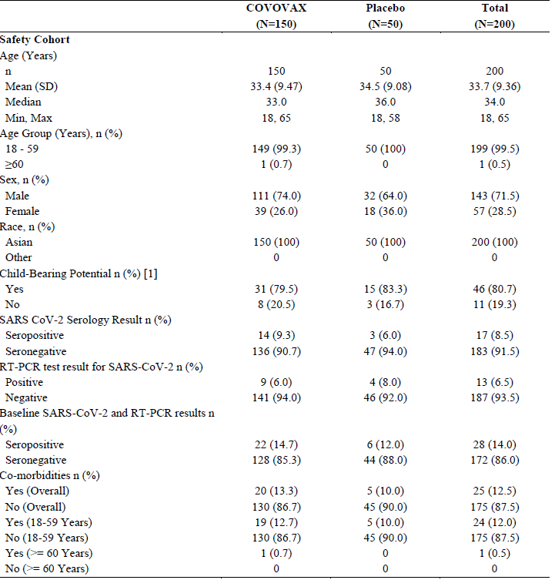
BMI = body mass index, body weight in kilogram/height in meter²; percentages are based on the number of participants in the safety population.
1 Percentages are based on number of female participants in safety population

Baseline data (Phase III)
Baseline characteristics for the Phase III study safety population (inclusive of the safety cohort and immunogenicity and reactivity cohort) are shown in Table 36. The median age was 33 years. The Covovax and Novavax vaccine groups were generally well balanced; however, the proportion of males was higher than females within both groups (58.1% overall).
A much lower proportion (0.5%) of included participants were PCR positive for SARS-CoV-2 at Baseline than in the Phase II study (6.5%) but the proportion with prior or current evidence of infection was more than double at 32.4% (compared to 14%); the baseline seropositivity rate was 32.2%. Like in the Phase II study, very few participants (32 (2.3%)) were ≥ 60 years of age. Comorbidities were present in 12.4% of participants.
Table 37: Covovax trial (Phase III part) Demographics and baseline characteristics (safety population)
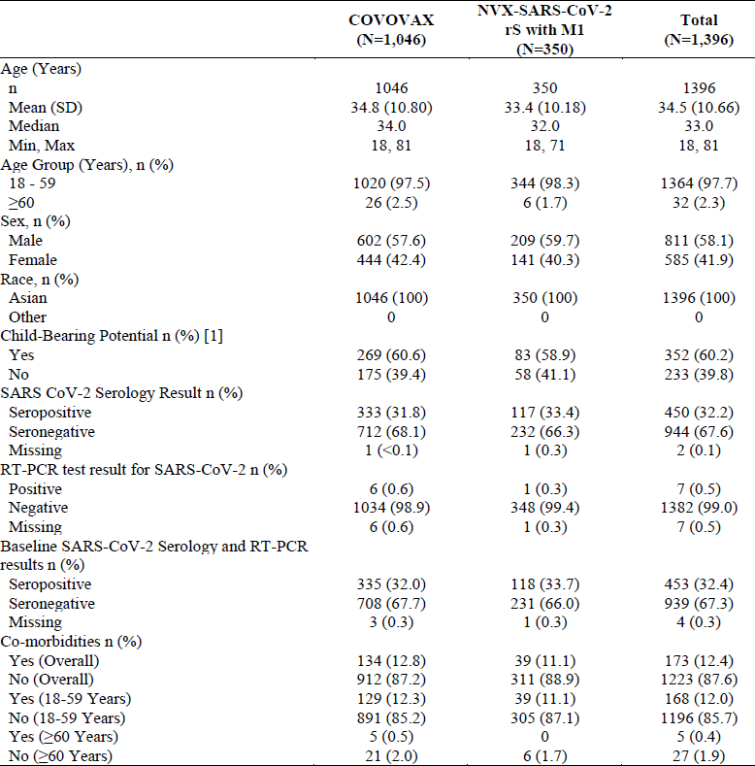
BMI = body mass index, body weight in kilogram/height in meter²; percentages are based on the number of participants in the safety population.
1 Percentages are based on number of female participants in safety population

Results

Primary immunogenicity outcome results
The primary immunogenicity endpoint was to assess immunogenicity as measured by the ratio of anti-spike protein IgG responses (ELISA measured) at 14 days post-second dose in the active vaccine compared to control arms.
The primary endpoint was met for non-inferiority between the Covovax and Novavax vaccines in the immunogenicity population with a lower bound of the 95% CI of > 0.67 (see Table 38).
An expected unadjusted GMEUs at Day 36 in subjects without prior infection were lower in comparison to those with prior infection (in both Covovax and Novavax groups).
In those who were seronegative for prior SARS-CoV-2 infection and PCR negative at Baseline (n = 297), GMFRs from Baseline to Day 36 were 128.7 (95% CI 105.2, 157.4) for Covovax and 148.9 (95% CI 100.8, 220) for Novavax vaccine.
In those who were seropositive for prior SARS-CoV-2 infection and PCR negative at Baseline (n = 152), GMFRs from Baseline to Day 36 were 17.2 (95% CI 13.3, 22.2) for Covovax and 33.6 (95% CI 21.4, 52.8) for Novavax vaccine.
Table 38: Covovax trial Non-inferiority of Covovax to Novavax vaccine in terms of anti-spike protein IgG antibodies at 14 days after second dose (that is Visit 3, Day 36) (immunogenicity analysis population)
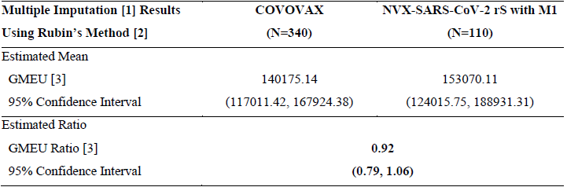
1 Multiple imputation model with classification variables vaccine, age group, sex, comorbidity status and continuous covariates log baseline titre used to impute 50 values for each missing value
2 Rubin’s method in Proc Mianalyza used to pool estimates and standard error across the 50 multiply imputed datasets
3 Pooled analysis of covariance (ANCOVA) results ,least square (LS) mean and it’s 95% CI values by treatment were used to generate the GMEU and 95% CI and the differences in LS means and corresponding 95% CI limits were used to obtain GMEU ratio and 95% CI using back transforming to the original scale.
ANCOVA model includes vaccine group, log baseline titre, co-morbidity, age group and sex.

Secondary and other immunogenicity outcome results
For the measurement of neutralising antibodies in the primary immunogenicity population who were SARS-CoV-2 infection seronegative and PCR negative at Baseline, the microneutralisation (MN) assay NAb titres are shown in Table 39. The GMT ratio for the Covovax/Novavax vaccine groups at day 36 was 3375.8/3602.8 (0.94); this was calculated by the evaluator and a 95% CI was not available.
GMFRs for MN assay NAb titres at Day 36 were 98.4 for Covovax and 78.8 for Novavax vaccine, reflecting higher baseline titres in the Novavax vaccine group. Results for the full analysis population without prior infection were identical.
Table 39: Covovax trial Summary of neutralising antibodies against SARS-CoV-2 by baseline SARS-COV-2 and real time polymerase chain reaction result (immunogenicity analysis population, baseline SARS-COV-2 serostatus and real time polymerase chain reaction result: negative)
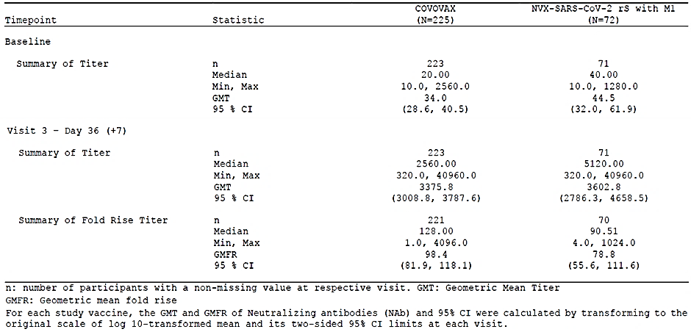
Abbreviation: n = number of participants with a non-missing value at respective visit; GMT = geometric mean titre; GMFR = geometric mean fold rise.
Note: For each study vaccine, the GMT and GMFR of neutralising antibodies and 95% CI were calculated by transforming to the original scale of log 10, transformed mean and its two sided 95% CI limits at each visit
For the analysis of seroconversions in the primary immunogenicity population who were SARS-CoV-2 infection seronegative and PCR negative at Baseline, sing the study definition (that is inclusive of any positive result at Day 36 following a negative result at Baseline, rather than a 4 fold increase in the LLOQ; seroconversion rates were 98.6% for Covovax and 100% for Novavax vaccine) (Table 39). This corresponds to an absolute relative difference of -1.4% for Covovax. 95% CI for this difference was not available and no hypothesis testing for non-inferiority of this secondary outcome was presented.
Table 40: Covovax trial Summary of proportion of participants with seroconversion for neutralising antibodies against SARS-CoV-2 by baseline SARS-COV-2 and real time polymerase chain reaction result, (immunogenicity analysis population, baseline SARS-COV-2 serostatus and real time polymerase chain reaction result: negative)
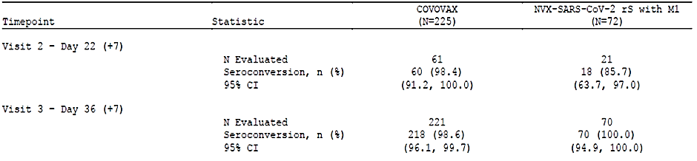
N = the number of participants with a non-missing value evaluated at Baseline and post-baseline visit. The 95% Cis for each vaccine group were calculated by using the Clopper-Pearson method

Safety summary
A summary of unsolicited AEs at Phase II study (Day 36 visit cut off) (see Table 41):
- Any AE: 40.7% versus 18.0% (all mild to moderate; none severe).
- Any related AE: 34.0% versus 16.0% (all mild).
- Any SAE: 1(0.7%) in the Covovax group (‘unrelated’COVID-19 pneumonia, moderate severity.
- Any MAAE: 4.7% versus 0% (none severe and all considered ‘unrelated’).
- No AESIs, AEs leading to discontinuation or deaths.
Table 41: Covovax trial Phase II Summary of adverse events after any vaccination (safety population)
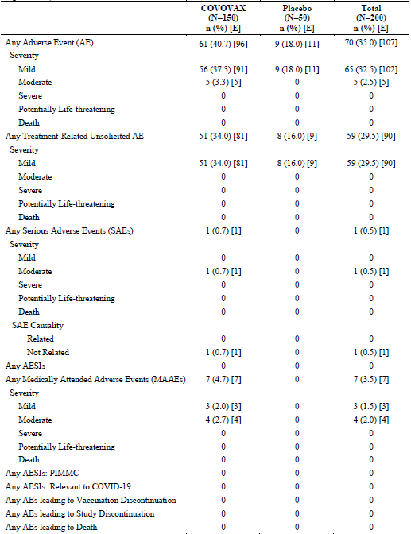

Phase III safety outcome
For the occurrence of causally related solicited AEs throughout the study duration following vaccination, for the immunogenicity and reactogenicity cohort at Day 36 visit cutoff (N = 458):
- overall, 282 participants (61.6%) reported 1047 solicited AEs after any vaccination. Of these 216 participants (63%) in the Covovax group reported 819 solicited AEs and 66 participants (57.4%) in the Novavax vaccine group reported 228 solicited AEs.
- the overall incidence of solicited AEs after the second dose (225 participants (49.8%)) was higher than that after the first dose (172 participants (37.6%)).
- the incidence of all solicited systemic AEs, except nausea and vomiting, increased after the second dose compared with the incidence after the first dose. Majority of these AEs were of mild severity.
- median duration for any solicited AE was two days with minimum duration of one day and maximum duration of eight days.
Unsolicited AEs, SAEs, AESI and MAAEs in the Phase III study (safety cohort (N = 938) plus immunogenicity and reactogenicity cohort (N = 458), Total N = 1396).
For any adverse event:
- overall, 413 participants (29.6%) reported 754 unsolicited AEs after any vaccination with a similar incidence between the Covovax group (310 participants (29.6%) reporting 558 AEs) and Novavax vaccine group (103 participants (29.4%) reporting 196 AEs).
- most of the AEs were mild in severity (518 AEs in 280 participants (26.8%)) in the Covovax group and 184 AEs in 93 participants (26.6%) in the Novavax vaccine group).
- no life threatening AEs were reported in any group.
For vaccine related unsolicited adverse events (reported only in the safety cohort, N = 938):
- the vaccine related AEs were reported in 268 participants (25.6%) in the Covovax group and 91 participants (26.0%) in the Novavax vaccine group with most of the AEs reported as mild in severity.
- the vaccine related AEs were basically those AEs that were solicited from participants in the immunogenicity and reactogenicity cohort.
For serious adverse events:
- overall, five SAEs were reported in five participants (three SAEs in Covovax and two in the Novavax).
- the SAEs in the Covovax group included pyrexia, limb crushing injury, and joint effusion (one participant each).
- the SAEs in the Novavax vaccine group included dengue fever and retinal vein occlusion (one participant each).
- as per the investigator, none of the SAEs were related to the study vaccine. However, the case with retinal vein occlusion had a temporal relation (11 days post-first dose) to Novavax vaccine and the rationale provided for the non-relatedness does not appear satisfactory

Risk management plan
The sponsor initially submitted European Union (EU)- risk management plan (RMP) version 0.1 (dated 15 September 2021; data lock point (DLP) 10 September 2021) and Australian specific annex (ASA) version 0.1 (dated 30 September 2021) in support of the application. Later in the evaluation phase EU-RMP version 0.5 (dated 16 December 2021; DLP 16 December 2021) and ASA version 0.2 (18 December 2021) were provided.
The European Medicines Agency (EMA) approved EU-RMP version 1.0 (date 18 December 2021; DLP 20 December 2021).
The accompanying ASA (version 0.3, date 23 December 2021) were provided to the TGA on 23 December 2021. With the responses to the TGA’s first round RMP recommendations, the sponsor provided an updated ASA (version 0.4; date 29 December 2021). With response to TGA’s second round RMP recommendation, the sponsor provided an updated ASA (version 1.0, dated 19 January 2022).
The summary of safety concerns and their associated risk monitoring and mitigation strategies are summarised in Table 42.36F
Table 42: Summary of safety concerns and their associated risk monitoring and mitigation strategies
Summary of safety concerns |  | Pharmacovigilance |  | Risk Minimisation
 |  | Routine | Additional | Routine | Additional
Important identified risks | None | – | – | – | –
Important potential risks | Vaccine-associated enhanced disease (VAED), including vaccine-associated enhanced respiratory disease (VAERD) | * | ‡≠ | – | –
Important potential risks | Anaphylaxis | * | ‡≠ |  | –
Important potential risks | Myocarditis and pericarditis |  | ‡≠ | – | –
Missing information | Use in pregnancy and while breastfeeding |  |  |  | –
Missing information | Use in immunocompromised patients |  | ‡≠ |  | –
Missing information | Use in frail patients with comorbidities (for example, chronic obstructive pulmonary disease (COPD), diabetes, chronic neurological disease, cardiovascular disorders) |  | ≠ | – | –
Missing information | Use in patients with autoimmune or inflammatory disorders |  | ≠ |  | –
Missing information | Interaction with other vaccines |  | ‡≠ |  | –
Missing information | Long-term safety |  | ‡≠ | – | –
*Follow-up questionnaire
‡Clinical trials
≠Post-authorisation safety study

Pregnancy registry (C-VIPER)
The summary of safety concerns is acceptable. Reports from TGA’s nonclinical and clinical evaluators, the Delegate’s overview and ACV advice have been considered when making this conclusion.
The sponsor has proposed routine and additional pharmacovigilance measures. The Advisory Committee on Vaccines (ACV) emphasised the importance of monitoring events such as hypersensitivity, angioedema, hyperthyroidism, thrombocytopenia, myopericarditis, colitis, central retinal vein thrombosis, hypertension and potential immune-mediated conditions.
The sponsor should closely monitor the above and include all relevant safety information within the monthly summary safety report and periodic safety update reports. Evaluation of potential safety signals that may emerge for these adverse events, including a discussion of the impact on the benefit-risk balance of this vaccine, should be provided in the monthly summary safety report and periodic safety update reports.
Only routine risk minimisation measures have been proposed by the sponsor. This is in line with the other COVID-19 vaccines approved by the TGA.
There are no outstanding issues from an RMP perspective.

Wording for conditions of registration
Any changes to which the sponsor has agreed should be included in a revised RMP and ASA. However, irrespective of whether or not they are included in the currently available version of the RMP document, the agreed changes become part of the risk management system.
The suggest wording is:
The Nuvaxovid COVID-19 vaccine (adjuvanted) EU-Risk Management Plan (RMP) (version 1.0, dated 18 December 2021; DLP 20 December 2021), with Australian Specific Annex (version 1.0, dated 19 January 2022), included with submission PM-2021-00623-1-2, and any subsequent revisions, as agreed with the TGA will be implemented in Australia.
An obligatory component of risk management plans is routine pharmacovigilance. Routine pharmacovigilance includes the submission of periodic safety update reports (PSURs).
Reports are to be provided in line with the current published list of EU reference dates and frequency of submission of PSURs until the period covered by such reports is not less than three years from the date of the approval letter, or the entire period of provisional registration, whichever is longer.
The reports are to at least meet the requirements for PSURs as described in the European Medicines Agency’s Guideline on Good Pharmacovigilance Practices (GVP) Module VII-periodic safety update report (Rev 1), Part VII.B Structures and processes. Note that submission of a PSUR does not constitute an application to vary the registration. Each report must have been prepared within ninety calendar days of the data lock point for that report.
Additional to the routine submission of the routine PSURs, expedited monthly Nuvaxovid COVID-19 Vaccine (adjuvanted) safety summary reports (including both global safety data and safety data for patients in Australia) are to be provided for the first 6 months post registration, and thereafter at intervals specified by the TGA.
Nuvaxovid COVID-19 Vaccine (adjuvanted) is to be included in the Black Triangle Scheme. The PI and Consumer Medication Information (CMI) for Nuvaxovid COVID-19 Vaccine (adjuvanted) must include the black triangle symbol and mandatory accompanying text for the products entire period of provisional registration.

Risk-benefit analysis

Delegate’s considerations

Overview
Data provided by the sponsor, to support the COVID-19 vaccine Nuvaxovid use in adults above 18 years age, showed a robust immunogenicity response in the target age group. The immunogenicity response was consistent across relevant subgroups.
The Phase III studies from the investigational plans (at a median of 90 days for Study 2019nCoV-302 and 76 days in Study 2019nCoV-301) met the primary endpoints. However, these studies were conducted in a setting with low prevalence of the Beta variant and prior to the significant emergence of the Delta or Omicron variants. Vaccine efficacy was in line with the robust immune responses seen in the immunogenicity studies. The duration of protection is unknown at this stage, as the follow up period is short.
Overall safety profile of Nuvaxovid has been well characterised during the clinical development program and appears to be acceptable. However, relatively small sample size and short term follow up may not be sufficient to detect rare events.

Public health need
Australia has had relatively fewer COVID-19 cases in comparison to many other countries; however, significant intermittent surges in the number of cases are still occurring. These COVID-19 outbreaks cause significant disruption to the normal life. The states of New South Wales and Victoria are currently having a surge of COVID-19 cases, caused by the Omicron variant. A safe and effective vaccine is one of the most important tools in containing the COVID-19 pandemic. Four COVID-19 vaccines are currently provisionally registered in Australia. To date, > 90% of Australian population above 16 years age, have been immunised with at least two doses of COVID-19 vaccine. There is still a need for a safe and effective COVID-19 vaccines to deal with the current public health emergency. This will improve the availability of vaccine to the unvaccinated population.

Short-term efficacy and safety data for provisional registration

Immunogenicity
The immune response data overall support the choice of a two dose schedule of Nuvaxovid, with no apparent advantage for 25 over 5 µg antigen doses in the adjuvanted formulations.
There is currently no widely accepted immunological correlate of protection for vaccine induced immunity to SARS-CoV-2. Available data and guidelines suggest a preference for neutralising antibody to spike protein over anti-spike protein IgG binding responses.
Immunogenicity data were generated from Study 2019nCoV-101 Parts 1 and 2 (a dose response study); Studies 2019nCoV-302 and 2019nCoV-301 (main studies); and Study 2019nCoV-501 (a supportive study). Immunogenicity was assessed primarily based on circulating neutralising and spike antigen binding antibodies. A limited amount of T cell immunity data was also included in the interim report of Study 2019nCoV-101.
From Parts 1 and 2 of Study 2019nCoV-101 (Phase I/II) it has been demonstrated that two doses of SARS-CoV-2 vaccine with Matrix-M adjuvant produces a better immune response than a one dose regimen or two vaccine doses without adjuvant.
With regards to the cell mediated immunity, the type 1 T helper cell (TR_{h}R1) response appears to be greater than the type 2 T helper cell response (TR_{h}R2).
In the Phase III sub-study Study 2019nCoV-301 (with about 1200 participants), robust immunogenicity was observed. Seroconversion rates were noted to be higher in the 18 to < 65 years of age cohort than in the ≥ 65 years of age cohort.
Immunogenicity results from the other pivotal trial, Study 2019nCoV-302 showed similar patterns of responses.
In the Phase IIa/IIb Study 2019nCoV-501(conducted in South Africa), anti-spike protein IgG and nAb responses were generally lower as compared to the immunogenicity from other studies. Among the study subjects, immunogenicity was relatively lower in older participants and HIV positive participants.
In the Phase III seasonal influenza vaccine sub-study of Study 2019nCoV-302, anti-spike IgG binding responses to Nuvaxovid were about 30% lower in those given influenza vaccine than were seen in the main study with non-overlapping 95% confidence intervals. The clinical significance of this is uncertain; however, this could potentially lead to reduced protection against severe disease, in subgroups (for example, the elderly) and/or reduced duration of protection (as antibody responses wane over 6 months). There was no evidence of interference by Nuvaxovid on haemagglutination inhibition responses to the influenza vaccines.
Data from the Indian Council of Medical Research (ICMR)/ Serum Institute of India (SII) Covovax trial (non-sponsored) showed non-inferiority of Covovax (manufactured by the SII) to the sponsor-produced Nuvaxovid vaccine. However, anti-spike protein IgG binding antibodies measured by ELISA was chosen as primary end point rather than the neutralising antibody (nAb) responses. Of note, around 30% subjects were seropositive at Baseline in each group.

Efficacy
Clinical efficacy was examined in adults ≥ 18 years of age in two pivotal Phase III clinical trials (Studies 2019nCoV-302 in the UK, and 2019nCoV-301 in the USA and Mexico) and one supportive Phase IIa/IIb trial (Study 2019nCoV-501 in South Africa).
In Study 2019nCoV-302, approximately 15000 participants were randomised 1:1 to Nuvaxovid or placebo and in Study 2019nCoV-301, there were about 30000 participants randomised 2:1 to Nuvaxovid or placebo. There were about 4500 participants in Study 2019nCoV-501.
The primary endpoints were met in both Phase III trials: Study 2019nCoV-302 (89.3% (95% CI: 75.2, 95.4) at the interim analysis and 89.7% (95% CI: 80.2, 94.6) at the final analysis); Study 2019nCoV-301 (90.4% (95% CI: (82.88, 94.62)); and also in the Phase IIa/IIb Study 2019nCoV-501 (51% (95% CI: 6.1, 72.8)).
Due to low number of cases, specific conclusions cannot be drawn for subgroups based on: older age, baseline characteristics, COVID-19 severity, baseline serostatus, HIV status, and SARS-CoV-2 variants; however, wherever subgroup analyses were performed, VE point estimates were generally in line with overall results.
Markedly lower efficacy was observed in Study 2019nCoV-501. As per the sponsor’s response, this was probably due to vaccine escape by the Beta variant that was prevalent in South Africa. However, immune responses were also lower as compared to the Phase III studies for reasons unexplained.

Safety
Safety data were collected in four studies conducted in Australia, the US, South Africa, the UK and Mexico.
At the time of the pooled analysis, a total of 49950 participants age 18 years and older had received at least one dose of Nuvaxovid (n = 30058) or placebo (n = 19892). Over 96% of participants had received two doses. Median exposure from the second dose was 90 days in Study 2019nCoV-302 and 76/77 days in the Nuvaxovid and placebo group respectively in Study 2019nCoV-301, with 66% of participants completing at least two months follow up. The median duration of follow up in the pooled safety database was 70 days post second dose. None of the studies showed an imbalance in the study discontinuations due to adverse events per study group.
Reactogenicity was evaluated in 1364 participants who received a first dose and 1348 participants who received a second dose of Nuvaxovid in Study 2019nCoV-302, and 19729 participants who received a first dose and 17139 participants who received a second dose of Nuvaxovid in Study 2019nCoV-301.
In both studies, there were more solicited local and systemic reactions reported by participants in the Nuvaxovid group compared to placebo, with the frequency and intensity of reactions increasing with the second dose. Pain (First dose 34% and second dose 59%) and tenderness (first dose, 53% and second dose, 74%) were the most commonly reported local reactions. Local reactions were mostly mild to moderate, with 1.1% of subjects in the Nuvaxovid group reporting Grade 3 local reactions after the first dose in either study and 6.6% after the second dose.
Headache, fatigue, and muscle pain were the most frequent solicited systemic AEs, reported by 25%, 25%, and 23% post first dose and 44%, 49%, and 48% post second dose. The median duration of headache, fatigue and muscle pain was one day after each dose in both studies. Fever was reported more with second dose (Study 2019nCoV 302- 5.1%, Study 2019nCoV 301- 5.7%).
Systemic reactions were mostly mild with 1.3% to 2.3% reporting Grade 3 systemic reactions after the first dose, and 6.8% to 12% reporting Grade 3 systemic reactions following the second dose. Grade 4 reactions were reported by 0.1% in Study 2019nCov-301.
Unsolicited AEs were usually mild or moderate (with severe TEAEs occurring in < 1% participants) and mostly associated with reactogenicity reactions. Treatment related injection site pruritus and lymphadenopathy were more common in the Nuvaxovid arm. Other hypersensitivity and/or allergic reactions appeared uncommon.
An imbalance was noted in hypertension events in the Nuvaxovid arm that was noted in subjects ≥ 65 years of age.
Other imbalances were noted in other SOCs including eye disorders; reproductive system and breast disorders; cholecystitis / hepatobiliary disorders; prostate cancer; PIMMCs; and cerebrovascular accidents and/or related conditions.
There were no obvious safety signals noted in relation to AESIs related to COVID-19 or to PIMMCs There were no cases of anaphylaxis observed.

Deaths and other serious adverse events
None of the 20 deaths observed in the clinical development program appeared to be related to vaccination.
Serious adverse events frequencies were similar among treatment arms in Study 2019nCoV-302 and SAE rates were also similar in Study 2019nCoV-301, excepting imbalances in hepatobiliary disorders (mainly cholecystitis), prostate cancer, cerebrovascular accident and hypertension/hypertensive crisis. There were no treatment-related SAEs observed in the Phase I/II (Part 1) or Phase IIa/IIb studies. As determined by the investigator, treatment-related SAEs observed among Nuvaxovid recipients in the Phase III studies included isolated cases of: myocarditis (Study 2019nCoV-302), angioedema (Study 2019nCoV-301), Basedow’s (that is Graves) disease and hyperthyroidism (Study 2019nCoV-301), thrombocytopaenia (Study 2019nCoV-301) and colitis (Study 2019nCoV-101, Part 2). In addition to the solitary myocarditis case listed here, there were additional two cases which the sponsor has reported unrelated. Myocarditis and pericarditis have been added to the EU RMP summary of safety concerns as a ‘potential important risk’.
There were no major safety signals form the non-sponsored study, ICMR/SII-COVOVAX trial. However small sample size and short term follow up make it difficult to draw any definitive conclusion on clinical safety. A case of central retinal vein occlusion was observed in this study in a Novavax vaccine participant and was deemed not to be treatment related by the investigator. However, the response provided by the sponsor for this case is not satisfactory and the clinical evaluator thought this should be considered a related event.

Data limitations
- Data on vaccine efficacy to prevent asymptomatic infection are lacking.
- Data in frail elderly with unstable health conditions and co-morbidities are not available.
- No data on co-administration of Nuvaxovid with other vaccines (except the seasonal flu vaccine)
- There are no data available on the interchangeability of Nuvaxovid with other COVID-19 vaccines to complete the vaccination series or booster use.
- There are no data provided by the sponsor regarding Nuvaxovid efficacy against new VOC, for example Omicron and Delta.
- Duration of protection of Nuvaxovid is uncertain due to limited follow up duration. In Part one of Study 2019nCoV-101, immune response (IgG titre and neutralising antibodies) gradually decreased through Day 189.
- No safety and efficacy data in immunocompromised patients or patients with background autoimmune disease.
- Very limited safety data on pregnant women and breastfeeding women.
- Short-term safety data may not provide information on rare AEs, risk of vaccine-associated enhanced disease (VAED) or vaccine-associated enhanced respiratory disease (VAERD) as the antibodies wane over time, and there may be AEs that have a long latency period including AEs of special interest.

Proposed action
Considering the urgent public health need and noting the high short term efficacy with acceptable safety demonstrated in the submitted studies, the Delegate is of the view that provisional registration of Nuvaxovid is appropriate for the use of this vaccine to prevent COVID-19 disease caused by SARS-CoV-2 virus in individuals 18 years of age and older. The pivotal studies are ongoing for a total of 12/24 months. The longer term efficacy and safety data are to be submitted to the TGA for evaluation before a full registration can be considered.
Since the Nuvaxovid vaccine is evaluated for use through the provisional pathway, a clear statement should be included in the PI with regards to the nature of the registration. It should also be emphasised that the decision of provisional approval is made on the basis of short term efficacy and safety data, and the continued approval depends on the evidence of longer term efficacy and safety from the ongoing and post-market assessment.
The Delegate proposes the provisional approval of this vaccine for a revised indication as following:
Proposed therapeutic indication
Following was the initial proposed indication:
Nuvaxovid has provisional approval for the indication:
Active immunisation to prevent COVID-19 caused by SARS-CoV-2 in individuals 18 years of age and older.
The use of this vaccine should be in accordance with official recommendations.
The decision has been made on the basis of short term efficacy and safety data. Continued approval depends on the evidence of longer term efficacy and safety from the ongoing and post-market assessment.
Recommended therapeutic indication
Following therapeutic indication (minor change, addition of coronavirus disease 2019):
Nuvaxovid has provisional approval for the indication:
Active immunisation to prevent coronavirus disease 2019 (COVID-19) caused by SARS-CoV-2 in individuals 18 years of age and older.
The use of this vaccine should be in accordance with official recommendations.
The decision has been made on the basis of short term efficacy and safety data. Continued approval depends on the evidence of longer term efficacy and safety from the ongoing and post-market assessment.

Questions for the sponsor
The sponsor provided the following response to questions from the Delegate.
- If available, please provide any data generated using a neutralising antibody assay against new variants of concern.
Data on neutralising antibodies against new VOC are available from the Phase I/II clinical Study 2019nCoV-101, which evaluated the safety and immunogenicity of a third, booster dose of the Nuvaxovid administered approximately 5 to 6 months following the primary vaccination series. After the booster was administered, the ability of the vaccine to induce antibody responses that cross react with new variants of concern including the Delta and Omicron variants was assessed, and the results of the analysis, using sera from Study 2019nCoV-101 has been submitted for publication.37F
In this Phase II study, a single booster dose of Nuvaxovid was administered to healthy adult participants 18 to 84 years of age approximately six months following their primary two dose vaccination series. Safety and immunogenicity parameters were assessed, including assays for IgG, MN50, and hACE2 receptor binding inhibition against the ancestral SARS-CoV-2 strain and select variants (B.1.351 (Beta), B.1.1.7 (Alpha), B.1.617.2 (Delta), and B.1.1.529 (Omicron)).
A total of 1610 participants were screened from 24 August 2020 to 25 September 2020, and 1283 participants were enrolled and treated. Participants randomised to Group B (n = 257) received two 5μg doses of Nuvaxovid for their primary vaccination series and were considered for investigation of a single booster dose at the same dose level. Re-randomisation of these participants took place at Day 189, with 210 consenting participants assigned 1:1 to receive a single booster of Nuvaxovid in Group B2 (n = 104) or placebo in Group B1 (n = 106). Immune responses seen 14 days following the primary vaccination series were compared with those observed 28 days following the booster (Day 35 and Day 217, respectively).
For the ancestral SARS-CoV-2 strain, serum IgG GMTs increased about 4.7 fold from 43905 ELISA units (EU) at Day 35 to 204367 EU at Day 217. Neutralisation (MN50) assay GMTs showed a similar increase of about 4.1 fold from 1470 at Day 35 to 6023 at Day 217.38
A functional hACE2 receptor binding inhibition assay analysing activity against ancestral and variant strains of SARS-CoV-2 at Day 189 versus Day 217 found 54.4 fold (Ancestral), 21.9 fold (Alpha), 24.5 fold (Beta), 24.4 fold (Delta), and 20.1 fold (Omicron) increases in titres. An anti-rS IgG activity assay comparing the same time points across the same SARS-CoV-2 strains found titres improved 61.2 fold, 85.9 fold, 65 fold, 92.5 fold, and 73.5 fold, respectively.38
A > 99% wild type neutralisation assay conducted by the University of Maryland against the ancestral/prototype strain, the Delta and Omicron variants found 15.4 fold, 13.9 fold and 3.5 fold increases in titres comparing Day 217 to Day 35, respectively.
In conclusion, for both the prototype strain and all variants evaluated, immune responses following the booster were notably higher than those associated with high levels of efficacy in Phase III studies of the vaccine.
- Please provide, if any update to the drug development plan eg booster, paediatric extension etc
Homologous boosting data:
Studies 2019nCoV-101 and 2019nCoV-501 both evaluated the safety and immunogenicity of a third booster doses of the vaccine administered approximately 5 to 6 months following the primary vaccination series. A brief summary of the results from the study are provided in the response to the question above. Data from these studies are anticipated to be available in early second quarter of 2022 to support a homologous boosting indication. Additional data from the Study 2019nCoV-101 will evaluate the safety and immunogenicity of a second booster dose administered at about 12 months.
Additional boosting data are now being gathered in Study 2019nCoV-301.
Heterologous boosting data:
The main source of heterologous boosting data available for Nuvaxovid is the COV-BOOST trial;38F in which the Novavax vaccine was administered approximately 3 to 4 months after primary vaccination with either the AstraZeneca or the Pfizer vaccines. The authors concluded that the trial demonstrated the potential of all seven vaccines tested (AstraZeneca, Pfizer, Moderna, Novavax, Janssen, CureVac, and Valneva) to boost immunity following an initial course of the AstraZeneca vaccine, and of six vaccines (all except Valneva) following an initial course of Pfizer vaccine. In addition, all vaccines showed acceptable side effect profiles, although some schedules were more reactogenic than others.
Additional data will be gathered from a US based study;39F in which dosing is anticipate to start in first quarter of 2022.
Paediatric data:
The studies described in the EU paediatric investigation plan include:
- Study 2019nCoV-301 – [Information redacted]
- Study 2019nCoV-503 – [Information redacted]
- Study 2019nCoV-504 – [Information redacted]
Safety, immunogenicity as well as efficacy data for adolescents (12 to 17 years) derived from the Study 2019nCoV-301 will be available for submission in first quarter of 2022. It is anticipated that these data would support an indication for the vaccine in this age group.
Younger children will be enrolled in the Study 2019nCoV-503 study following an age de-escalation design (6 to < 12 years, 2 to < 6 years and 6 to 24 months of age). The study is expected to start in first quarter of 2022.
A further paediatric study, Study 2019nCoV-504, in immunocompromised children (6 months to < 18 years) will be conducted following completion of Study2019nCoV-503.
New Variant vaccine data:
Novavax is developing a vaccine based on the Omicron variant with studies anticipated to start in first quarter of 2022.

Advisory Committee considerations40F
The Advisory Committee on Vaccine (ACV), having considered the evaluations and the Delegate’s overview, as well as the sponsor’s response to these documents, advised the following.

Specific advice to the Delegate
- Based on the evidence at this point in time, can the ACV advise whether the benefit-risks balance is positive for the use of Nuvaxovid (SARS-CoV-2 rS) in individuals 18 years and older in the Australian context, to support the provisional registration?
The ACV advised the benefit-risk balance is positive for provisional registration of Nuvaxovid (SARS-CoV-2 rS) in individuals 18 years and older in Australia, based on available immunogenicity and safety data.
The ACV noted that further data are expected to characterise particle size, and other quality issues appeared generally resolved to the satisfaction of the TGA.
The ACV was of the view that there are no significant safety signals of concern shown in the moderate to large Phase III studies, noting that the second dose has been shown to be more reactogenic.
The ACV discussed the importance of having multiple COVID-19 vaccine options available in Australia and also for international vaccine programs.
The ACV emphasised that post-marketing surveillance is required to address potential rare but significant adverse events. The two cases of myocarditis in young males after second doses are concerning but the sponsor has suggested that alternative explanations are possible.
The ACV noted that there may be off-label use of Nuvaxovid as a second dose in a mixed schedule and/or booster dose in patients who decline or are contraindicated for other COVID-19 vaccines. There are limited data from studies (not all led by the vaccine manufacturer) on use in these contexts. The ACV noted that the sponsor is conducting studies of this vaccine as a booster.
- Can the ACV comment on the overall indication?
The ACV supported the Delegate’s proposal to remove the wording ‘mild, moderate or severe’ from the indication initially proposed by the sponsor, and to use similar wording to the indication of other COVID-19 vaccines with provisional registration, namely:
Nuvaxovid has provisional approval for the indication:
Active immunisation to prevent coronavirus disease 2019 (COVID‐19) caused by SARS‐CoV‐2, in individuals 18 years of age and older.
The use of this vaccine should be in accordance with official recommendations.
The decision has been made on the basis of short-term efficacy and safety data. Continued approval depends on the evidence of longer-term efficacy and safety from the ongoing and post-market assessment.
- Can the ACV comment if the overall safety profile is acceptable?
The ACV advised that the overall safety profile of Nuvaxovid is acceptable for provisional registration.
The ACV noted that the rates of common adverse events (AE) following the first dose were comparable with placebo but rates of AEs became much higher following second doses: Grade 3 local AEs observed in 1.1% post first dose versus 6.6% post second dose (Studies 2019nCoV-301 and 2019nCoV-302); Grade 3 systemic AEs observed in 1.3% to 2.3% post first dose versus 6.8% to12.0% post second dose. Common AEs were observed at a lower frequency in older people.
Regarding rare AEs, the ACV discussed the reported cases of myopericarditis from the clinical studies, noting the uncertain relationship to the vaccine.
The ACV emphasised that rare but significant AEs that were reported in the trials will need to be monitored in pharmacovigilance activities, including hypersensitivity, angioedema, hyperthyroidism, thrombocytopenia, colitis, and central retinal vein thrombosis. The ACV noted small numbers of disparate but potentially significant immunologically-mediated AEs in the vaccine compared with placebo recipients. There was no overall imbalance, and ACV believed while this does not constitute a safety signal at this time, that immune-mediated AEs should be monitored in the context of the novel adjuvant (50 µg Matrix-M) used in this vaccine.
The ACV discussed the concern that quality issues still outstanding may impact on reactogenicity. The ACV commented that the SII trial is limited in size and it is difficult to compare reported AEs across different populations/studies.
- The quality evaluator has noted deficiencies related mainly to comparability. Can the ACV advise if this is acceptable for provisional approval, with reference to its possible implications on clinical efficacy and safety?
The ACV noted that the Phase I studies suggest that the immunogenicity of the 5 µg and 25 µg spike protein doses are similar and that within the limits of small studies there does not appear to be a large impact of a dose response relationship.
The ACV was of the view that a proportion of the AEs are likely due to the vaccine adjuvant rather than the antigen and further noted the systemic AE profile also appears relatively high within the placebo arm of Study ICMR/SII-COVOVAX.
- The sponsor has submitted an interim clinical study report for the ICMR/SII Covovax trial, which is not part of the drug development plan. It was conducted by the manufacturer (not the sponsor) with the aim to establish immunogenicity and safety of the Serum Institute of India (SII) manufactured product. Can ACV comment if immunogenicity and safety from this study is acceptable and comparable to the pivotal studies? Efficacy data (exploratory objective) has not been submitted for this study.
The ACV noted that the ICMR/SII-Covovax trial;41F was the only presented study that used the Serum Institute of India manufactured product proposed for supply in Australia.
This Phase II/III study compared SII-manufactured (Covovax) and US-manufactured (Novavax) drug substances. The ACV noted that the provided data were reassuring, although the details provided were not at the usual standard for a regulatory submission.
The ACV noted that the available data show that the SII-manufactured Covovax resulted in slightly lower immunogenicity, with more AEs in the small Phase II study compared with the US-manufactured product (41% versus 18%). Adverse events were similar between vaccines in the larger Phase III study.
Overall, the ACV was of the view that there is insufficient detail from the SII-Covovax trial to fully evaluate the implications of the change of site of manufacture; however, the ACV acknowledged that this study was not conducted by the sponsor and further data may not be available.
- Can the ACV comment on the proposed pharmacovigilance activities? Are any additional risk mitigation strategies required?
The ACV highlighted that surveillance for myopericarditis, hypersensitivity, angioedema, hyperthyroidism, thrombocytopenia, colitis and central retinal vein thrombosis will be important.
The ACV discussed the numerically higher rate of hypertension observed in the clinical studies and recommended any potential signal be monitored in pharmacovigilance activities, noting that the relationship between this AE and the vaccine was not confirmed.
The ACV discussed the potential use of linked data to identify rare immune-mediated conditions related to the vaccine, noting the novel adjuvant used in this product.
The ACV noted that given the range of COVID-19 vaccines now available within Australia there continues to be a need for provider education on each vaccine.
- The committee is also requested to provide advice on any other issues that it thinks may be relevant to a decision on whether to approve this application.
The ACV noted that myocarditis is not mentioned in the PI and recommended that the instances of myocarditis observed in the clinical studies be noted in the PI. However, the ACV noted that a causal relationship of myocarditis to the vaccine is not established.
The ACV recommended that the PI include additional detail on concomitant administration of Nuvaxovid and quadrivalent unadjuvanted influenza vaccine, including a description of the AE profile.
The ACV suggested that expert advice could be sought from an experienced toxicologist regarding host cell protein contamination and allergic reactions.
- Does the ACV agree with the evaluators position that Novavax’s risk assessment of critical quality attributes (CQAs) of several particle characterisation tests (dynamic light scattering, nanoparticle tracking analysis, high-performance size exclusion chromatography) as low risk (due to a low uncertainty score as defined by Novavax as ‘Data is available from clinical studies with this molecule) is not supported given the differences seen between clinical trial batches and SII commercial batches.
The ACV noted that particle characteristics are a critical quality attribute and that differences in characterisation were evident in several test methodologies, but the clinical relevance of the observed laboratory differences is uncertain. The ACV advised that the data from the SII-Covovax trial provided some reassurance that differences in particle characterisation as shown in analytical assays did not lead to identified major differences in immunogenicity or clinical safety when administered in humans.
However, the differences in reactogenicity between Phases II and III of the SII-Covovax trial raises the possibility that there may be batch-to-batch variation.
The ACV noted that the EMA has requested additional data to characterise particle size, and the ACV recommended that the TGA requests the results of these studies.
The ACV noted that the particle characterisation tests will not form part of routine batch release testing.
- Does ACV agree or disagree with Novavax’s position that the differences seen in particle characteristics are not clinically significant as they are supported through the clinical experience with the product?
The ACV noted that the ACE2 activity is higher, but immunogenicity is slightly lower, with the SII product compared to Novavax clinical trial material.
The ACV commented that the Phase I study suggested a lack of dose response over the 5 to 25 µg range, which was somewhat reassuring regarding the impact of any differences in antigen content.
- Does ACV agree that given the differences seen in the comparability studies, a conservative approach should be taken when extrapolating stability data from clinical batches manufactured to the final commercial product at SII?.
The ACV advised that expert advice be obtained from experienced pharmaceutical manufacturers on the issues raised in Questions 8, 9 and 10.

Conclusion
Pending resolution of quality issues to the satisfaction of the TGA, the ACV considered Nuvaxovid to have an overall positive benefit-risk profile and therefore support provisional approval for the following:
Active immunisation to prevent coronavirus disease 2019 (COVID-19) caused by SARS-CoV-2 in individuals 18 years of age and older.
The use of this vaccine should be in accordance with official recommendations
The decision has been made on the basis of short-term efficacy and safety data. Continued approval depends on the evidence of longer term efficacy and safety from ongoing clinical trials and post-market assessment.

Outcome
Based on a review of quality, safety and efficacy, the TGA approved the registration of Nuvaxovid (SARS-CoV-2 rS with matrix M adjuvant) 5 µg/0.5mL, suspension for injection, multidose vials, indicated for:
Active immunisation to prevent coronavirus disease 2019 (COVID-19) caused by SARS-CoV-2 in individuals 18 years of age and older.
The use of this vaccine should be in accordance with official recommendations.
The decision has been made on the basis of short-term efficacy and safety data. Continued approval depends on the evidence of longer term efficacy and safety from ongoing clinical trials and post-market assessment.

Specific conditions of registration applying to these goods
- The Nuvaxovid COVID-19 Vaccine (adjuvanted) EU-risk management plan (RMP) (version 1.0, dated 18 December 2021; DLP 20 December 2021), with Australian specific annex (version 1.0, dated 19 January 2022), included with Submission PM 2021-00623-1-2, and any subsequent revisions, as agreed with the TGA will be implemented in Australia.
An obligatory component of risk management plans is routine pharmacovigilance. Routine pharmacovigilance includes the submission of periodic safety update reports (PSURs).
Reports are to be provided in line with the current published list of EU reference dates and frequency of submission of PSURs until the period covered by such reports is not less than three years from the date of the approval letter, or the entire period of provisional registration, whichever is longer.
The reports are to at least meet the requirements for PSURs as described in the European Medicines Agency’s Guideline on Good Pharmacovigilance Practices (GVP) Module VII periodic safety update report (Rev 1), Part VII.B Structures and processes. Note that submission of a PSUR does not constitute an application to vary the registration. Each report must have been prepared within ninety calendar days of the data lock point for that report.
Additional to the routine submission of the routine PSURs, expedited monthly Nuvaxovid COVID-19 Vaccine (adjuvanted) safety summary reports (including both global safety data and safety data for patients in Australia) are to be provided for the first 6 months post registration, and thereafter at intervals specified by the TGA.
Nuvaxovid COVID-19 Vaccine (adjuvanted) is to be included in the Black Triangle Scheme. The PI and CMI for Nuvaxovid COVID-19 Vaccine (adjuvanted) must include the black triangle symbol and mandatory accompanying text for the products entire period of provisional registration.
- Clinical conditions
The following reports/data must be submitted to the TGA by the dates set out in the table below:
Study Number | Date when next interim clinical study report will be available | Date when final clinical study report will be available
2019nCoV-101 Part 1 | Not applicable | First quarter of 2022
2019nCoV-101 Part 2 | First quarter of 2022 (Day 217 data – including booster with third dose at Day 189) | Fourth quarter of 2022
2019CoV-501 | First quarter of 2022 (Day 236 data – including booster with third dose at Day 201 in about 1500 participants)  Second quarter of 2022 (6 month data in all participants) | Fourth quarter of 2022
2019nCoV-302 | Second quarter of 2022 (6 month data in all participants) | Fourth quarter of 2022
2019nCoV-301 | Second quarter of 2022 (6 month data in all participants) | Third quarter of 2023
  - The sponsor must investigate the need for a booster dose and submit data when available.
  - The sponsor must perform investigations on identifying an immunological correlate of protection.
  - The sponsor must investigate and provide results on the ability of the vaccine to neutralise emerging SARS-CoV-2 variants of concern.
  - The sponsor must provide real world post market global/local efficacy data, when available.
  - Studies addressing important safety concerns/important missing information (use in immunocompromised individual, pregnant women) must be submitted. However, this should be submitted as additional submissions, not as ‘conditions of original submission’.
- Quality conditions
  - Medicine labels
a)The medicines must not be supplied with labels other than the labels:
    - i. that were considered and agreed to as part of the s.25 provisional registration decision, i.e. the labels referred to in the category 1 application and email from sponsor dated third quarter of 2021; or
    - ii. that are approved following a request to vary the entry in the Register under section 9D of the Act.
b) The sponsor will develop Australian-specific labels for the medicines, that conform with all relevant Australian labelling requirements, and will take all reasonable steps to implement such labelling before the end of the provisional registration period for the medicine (noting that, consistent with paragraph 28(5)(aaa) of the Act, changes to such matters as labels that have been agreed to as part of an evaluation under section 25 of the Act may only occur following submission under section 9D of a 'variation' application and approval by the TGA).
c) The sponsor will provide information to the TGA on the proposed strategies and planned timelines for Australian dedicated supplies, as soon as possible, and no later than first quarter of 2024.
- GMP clearance for listed manufacturers: the sponsor must maintain the validity of all manufacturer GMP Clearances for the duration of product supply to Australia. Additionally, the conditions of GMP Clearance approval must be complied with at all times.
- Post-approval stability protocol and stability commitment: The manufacturer must continue the ongoing stability studies presented in the stability studies protocol. Additionally, 1 batch of drug product per year must be placed on long term stability program and on accelerated stability testing where significant changes are made to the manufacturing process. The manufacturer must communicate any out of specifications stability test results to the TGA.
- Stability (drug product)
The sponsor must provide updated statistical results of long-term stability data for process validation (PV) and clinical stability batches as they become available to further support 6 months storage at 2 to 8°C with real-time stability data.
NOTE: As per TGA guidelines, the sponsor should submit a formal (Category 3) application along with the supporting real-time (long-term) stability data for evaluation for any proposed extension to the shelf life post-provisional registration approval.
The sponsor must provide updated protein concentration results for clinical long-term stability batches [Information redacted] together with the investigation report into the observed atypical protein concentration results when the report became available.
The sponsor must provide commitment to review and update the stability testing parameters to include saponin integrity and particle size by dynamic light scattering (DLS).
- The sponsor must not supply any batches that have a temperature deviation during shipment.
- Batch release testing and compliance
Independent batches of Nuvaxovid (SARS-CoV-2 rS [NVX-CoV2373]) COVID-19 vaccine imported into Australia must not be released for sale until samples and the manufacturer’s release data have been assessed and sponsor have received notification acknowledging release from the Laboratories Branch, TGA.
For each independent batch of the product imported into Australia, the sponsor must supply the following:
  - A completed Request for Release Form, available from vaccines@health.gov.au.
  - Complete summary protocols for manufacture and QC, including all steps in production in the agreed format.
  - At least a 2 mL sample (as at least 4 × 500 μL aliquots) of each bulk drug substance batch used in the manufacture of the given drug product batch.
  - At least 20 (twenty) vials (samples) of each manufacturing batch of Nuvaxovid (SARS-CoV-2 rS [NVX-CoV2373]) COVID-19 vaccine with the Australian approved labels, PI and packaging (unless an exemption to supply these has been granted) representative of all batches of product seeking distribution in Australia.
  - At least 5 (five) vials (samples) of any further consignments of a manufacturing batch of Nuvaxovid (SARS-CoV-2 rS [NVX-CoV2373]) COVID-19 vaccine with the Australian approved labels, PI and packaging (unless an exemption to supply these has been granted). Further consignments cover batches previously supplied to TGA for the purposes of batch release testing but are seeking to be supplied again)
  - If the manufacturing batch has been released in Europe or United Kingdom a copy of the EU Official Control Authority Batch Release (OCABR) certificate (or equivalent from the UK) must be provided.
  - Any reagents, reference material and standards required to undertake testing, as requested by Laboratories Branch, TGA.
Sponsors must provide all requested samples and data in sufficient time (at least 5 business days) prior to any distribution date to allow the TGA to perform testing and review.
Distribution of each batch of vaccine is conditional upon fulfilment of these conditions and receipt of a letter from the Laboratories Branch acknowledging release.
Samples and data should be forwarded to the Biotherapeutics Section, Laboratories Branch before release of each batch and with sufficient lead time to allow for Laboratories Branch testing.
The shipments (including reagents) to TGA are the responsibility of the Australian sponsor/agent who will be required to facilitate the import and customs clearance process.
Certified Product Details
An electronic copy of the Certified Product Details (CPD) as described in Guidance 7: Certified Product Details of the Australian Regulatory Guidelines for Prescription Medicines (ARGPM) [https://www.tga.gov.au/guidance-7-certified-product-details] should be provided upon registration of the therapeutic good. In addition, an updated CPD, for the above products incorporating the approved changes is to be provided within one month of the date of approval letter. A template for preparation of CPD for biological prescription medicines and Vaccines can be obtained from the TGA website [https://www.tga.gov.au/form/certifiedproduct-details-cpd-biological-prescription-medicines]. The CPD should be sent as a single bookmarked PDF document to vaccines@health.gov.au as soon as possible after registration/approval of the product or any subsequent changes as indicated above.

Attachment 1. Product Information
The PI for Nuvaxovid approved with the submission which is described in this AusPAR is at Attachment 1. For the most recent PI, please refer to the TGA website at <34Thttps://www.tga.gov.au/product-information-pi34T>.

Therapeutic Goods Administration
PO Box 100 Woden ACT 2606 Australia
Email: 34Tinfo@tga.gov.au34T Phone: 1800 020 653 Fax: 02 6232 8605
34Thttps://www.tga.gov.au34T

The Black Triangle Scheme provides a simple means for practitioners and patients to identify certain types of new prescription medicines, including those being used in new ways and to encourage the reporting of adverse events associated with their use. The Black Triangle does not denote that there are known safety problems, just that the TGA is encouraging adverse event reporting to help us build up the full picture of a medicine's safety profile.
Statement on the second meeting of the International Health Regulations (2005) Emergency Committee regarding the outbreak of novel coronavirus (2019-nCoV). 30 January 2020. Available at: https://www.who.int/news/item/30-01-2020-statement-on-the-second-meeting-of-the-international-health-regulations-(2005)-emergency-committee-regarding-the-outbreak-of-novel-coronavirus-(2019-ncov)
WHO Director-General's opening remarks at the media briefing on COVID-19. 11 March 2020. Available at: https://www.who.int/director-general/speeches/detail/who-director-general-s-opening-remarks-at-the-media-briefing-on-covid-19---11-march-2020
WHO COVID-19 Dashboard (last viewed 6 January 2022). Available at: https://covid19.who.int/)
Australian Government Department of Health, as of 6 January 2022. Available at: https://www.health.gov.au/health-alerts/covid-19/case-numbers-and-statistics#total-covid19-cases-by-source-of-infection
WHO: Tracking SARS-CoV-2 variants. World Health Organization. Available at: https://www.who.int/en/activities/tracking-SARS-CoV-2-variants/
Matrix-M is a saponin-based adjuvant. Matrix-M adjuvant is composed of a mixture of Matrix-A (85%) and Matrix-C (15%), each produced from saponin materials Fraction-A or Fraction-C, respectively.
As part of the provisional approval pathway, the provisional registration process will allow certain medicines to be provisionally registered in the Australian Register of Therapeutic Goods (ARTG) for a limited duration. These medicines are registered on the basis of preliminary clinical data, where there is the potential for a substantial benefit to Australian patients. The TGA will re-assess risks related to the absence of evidence through data provided at a later stage, as part of the confirmatory data. Confirmatory data should confirm the relationship between outcomes predicted by the surrogate endpoint, or other preliminary data, and the clinical benefit as demonstrated by direct clinical outcomes. The sponsor may apply to transition to full registration at any time up until the provisional registration lapse date, once they have completed the obligations outlined for the provisional registration period and complete confirmatory data on safety and efficacy are available.
AusPAR for Comirnaty BNT162b2 (mRNA) Pfizer Australia Pty Ltd PM-2020-05461-1-2 available at: https://www.tga.gov.au/auspar/auspar-bnt162b2-mrna-comirnaty
AusPAR for Comirnaty BNT162b2 (mRNA) Pfizer Australia Pty Ltd PM-2021-02187-1-2 available at: https://www.tga.gov.au/auspar/auspar-bnt162b2-mrna
AusPAR for Comirnaty BNT162b2 (mRNA) Pfizer Australia Pty Ltd PM-2021-05012-1-2 available at: https://www.tga.gov.au/auspar/auspar-tozinameran-mrna-covid-19-vaccine
AusPAR for Spikevax elasomeran Moderna Australia Pty Ltd PM-2021-02994-1-2 available at: https://www.tga.gov.au/auspar/auspar-elasomeran
AusPAR for Spikevax elasomeran Moderna Australia Pty Ltd PM-2021-02994-1-2 https://www.tga.gov.au/auspar/auspar-elasomeran-0
AusPAR for COVID-19 Vaccine Janssen Ad26.COV2.S Janssen-Cilag Pty Ltd PM-2020-06173-1-2 available at: https://www.tga.gov.au/auspar/auspar-ad26cov2s
AusPAR for Vaxzevria ChAdOx1-S AstraZeneca Pty Ltd PM 2020 06115 1-2 available at: https://www.tga.gov.au/auspar/auspar-chadox1-s
AusPAR for Xevudy sotrovimab GlaxoSmithKline Australia Pty Ltd PM-2021-01848-1-2 available at: https://www.tga.gov.au/auspar/auspar-sotrovimab
AusPAR for Ronapreve casirivimab/imdevimab Roche Products Pty Limited PM-2021-03952-1-2 available at: https://www.tga.gov.au/auspar/auspar-casirivimabimdevimab
AusPAR for Actemra tocilizumab Roche Products Pty Ltd, available at: https://www.tga.gov.au/auspar/auspar-tocilizumab-rch-3
AusPAR for Veklury remdesivir Gilead Sciences Pty Ltd PM-2020-01491-1-2 available at: https://www.tga.gov.au/auspar/auspar-remdesivir
AusPAR for Paxlovid nirmatrelvir/ritonavir Pfizer Australia Pty Ltd PM-2021-04880-1-2 to be published soon.
AusPAR for Lagevrio molnupiravir Merck Sharp & Dohme (Australia) Pty Limited PM-2021-03679-1-2 to be published soon.
Drugs which have been taken by only a limited number of pregnant women and women of childbearing age, without an increase in the frequency of malformation or other direct or indirect harmful effects on the human fetus having been observed. Studies in animals have not shown evidence of an increased occurrence of fetal damage.
Covovax is a locally produced version of the Nuvaxoid vaccine in India, manufactured not by the sponsor but by the Serum Institute of India (SII)
Subjects that had not received a current season influenza vaccine, had no contraindication to the specific vaccine to be administered in the study, and had no prior history of allergy or severe reaction to seasonal influenza vaccines
Flucelvax contains surface antigens (hemagglutinin and neuraminidase) detergent-extracted from the 4 strains of influenza virus recommended annually by the WHO for the Northern Hemisphere season (type A H1N1, type A H3N2, type B Yamagata lineage and type B Victoria lineage; 15 µg virus protein of each, 60 µg virus protein in total).
Fluad contains surface antigens (hemagglutinin and neuraminidase) detergent-extracted from type A H1N1, type A H3N2 and type B Victoria virus, adjuvanted with MF59 (oil-in-water emulsion of squalene, a metabolisable oil).
Source: Toback et al., Safety, immunogenicity, and efficacy of a COVID-19 vaccine (NVX-CoV2373) co-administered with seasonal influenza vaccines: an exploratory substudy of a randomised, observer-blinded, placebo-controlled, phase 3 trial, The Lancet Respiratory Medicine, 2021; Nov.
The definitions employed to categorise mild, moderate and severe COVID-19 disease were based on those proposed by the US FDA in their ‘COVID-19: developing drugs and biological produces for treatment or prevention: guidance for industry’. Available at https://www.fda.gov/regulatory-information/search-fda-guidance-documents/covid-19-developing-drugs-and-biological-products-treatment-or-prevention
Heath et al., Safety and Efficacy of NVX-CoV2373 Covid-19 Vaccine, N Engl J Med; 2021; 385:1172-1183
Zou G. (2004). A modified poisson regression approach to prospective studies with binary data. American journal of epidemiology, 159(7), 702–706.
Centers for Disease Control and Prevention (CDC) US variants classification available at https://www.cdc.gov/coronavirus/2019-ncov/variants/variant-classifications.html
High risk is defined by age ≥ 65 years with or without co-morbidities or age < 65 years with co-morbidities. For example obesity (body mass index (BMI) ≥ 30 kg/m²), chronic kidney or lung disease, cardiovascular disease and diabetes mellitus type 2) and/or by life circumstance (living or working conditions involving known frequent exposure to SARS-CoV-2 or to densely populated circumstances).
Endpoint definitions of moderate COVID-19 is defined as having one of more of the following symptoms; high fever ( ≥ 38.4 ºC for ≥ 3 days regardless of use of anti-pyretic medications, need not be contiguous days); any evidence of significant lower respiratory tract infections (LRTI) such as shortness of breath, tachypnoea, SpO₂ [oxygen saturation] of 94% to 95% on room air, abnormal chest X-ray or chest CT consistent with pneumonia or LRTI; adventitious sounds on lung auscultation.
Endpoint definitions of severe COVID-19 is defined as having one of more of the following symptoms: tachypnoea; resting heart rate ≥ 125 beats per minutes; SpO₂: ≤ 93% on room air or PaO₂/FiO₂ [ratio of arterial oxygen partial pressure (PaO2 in mmHg) to fractional inspired oxygen] < 300mmHg.; High flow of O₂ therapy or negative-pressure ventilation (NPV)/noninvasive positive-pressure ventilation (NIPPV); mechanical ventilation or extracorporeal membrane oxygenation (ECMO); one or more major organ system dysfunction or failure to be defined by diagnostic testing/clinical syndrome/interventions, including any of the following: acute respiratory failure, acute renal failure, acute hepatic failure, acute heart failure, septic or cardiogenic shock , acute stroke, acute thrombotic event, admission to ICU, death.
The Medical Dictionary for Regulatory Activities (MedDRA) is a single standardised international medical terminology, developed as a project of the International Council for Harmonisation of Technical Requirements for Pharmaceuticals for Human Use (ICH) which can be used for regulatory communication and evaluation of data pertaining to medicinal products for human use. As a result, MedDRA is designed for use in the registration, documentation and safety monitoring of medicinal products through all phases of the development cycle (that is,, from clinical trials to post-marketing surveillance) supports ICH electronic communication within the ICH’s Electronic Common Technical Document (eCTD) and the E2B Individual Case Safety Report.
FDA USA Guidance for industry, Toxicity grading scale for healthy adult and adolescent volunteers enrolled in preventive vaccine clinical trials. Available at https://www.fda.gov/media/73679/download
Routine risk minimisation activities may be limited to ensuring that suitable warnings are included in the product information or by careful use of labelling and packaging. Routine pharmacovigilance practices involve the following activities: - All suspected adverse reactions that are reported to the personnel of the company are collected and collated in an accessible manner; - Reporting to regulatory authorities; - Continuous monitoring of the safety profiles of approved products including signal detection and updating of labelling; - Submission of PSURs; - Meeting other local regulatory agency requirements.
Mallory et al. (2021) Immunogenicity and safety following a homologous booster dose of a SARS-CoV-2 recombinant spike protein vaccine (NVX-CoV2373): A Phase II randomized placebo-controlled trial. medRxiv. pre-print.
Munro et al.(2021) Safety and immunogenicity of seven COVID-19 vaccines as a third dose (booster) following two doses of ChAdOx1 nCov-19 or BNT162b2 in the UK (COV-BOOST): a blinded, multicentre, randomised, controlled, phase 2 trial. The Lancet,10318:2258-2276
More information about the study is available at https://www.clinicaltrials.gov/ct2/show/NCT04889209
The Advisory Committee on Vaccines (ACV) provides independent medical and scientific advice to the Minister for Health and the Therapeutic Goods Administration (TGA) on issues relating to the safety, quality and efficacy of vaccines supplied in Australia including issues relating to pre-market assessment, post-market monitoring and safe use in national immunisation programs. The Committee is established under Regulation 39F of the Therapeutic Goods Regulations 1990 and the members are appointed by the Minister for Health. The ACV was established in January 2017, following consolidation of previous functions of the Advisory Committee on the Safety of Vaccines (ACSOV) and the pre-market functions for vaccines of the Advisory Committee on Prescription Medicines (ACPM). Membership comprises professionals with expertise in specific scientific, medical or clinical fields, or consumer health issues.
Available at http://ctri.nic.in/Clinicaltrials/pmaindet2.php?trialid=49327&EncHid=&userName=CTRI/2021/02/031554

