April 2019

Australian Public Assessment Report for Sarilumab (rch)
  - Proprietary Product Name: Kevzara
Sponsor: Sanofi-Aventis Australia Pty Ltd

About the Therapeutic Goods Administration (TGA)
- The Therapeutic Goods Administration (TGA) is part of the Australian Government Department of Health and is responsible for regulating medicines and medical devices.
- The TGA administers the Therapeutic Goods Act 1989 (the Act), applying a risk management approach designed to ensure therapeutic goods supplied in Australia meet acceptable standards of quality, safety and efficacy (performance) when necessary.
- The work of the TGA is based on applying scientific and clinical expertise to decision-making, to ensure that the benefits to consumers outweigh any risks associated with the use of medicines and medical devices.
- The TGA relies on the public, healthcare professionals and industry to report problems with medicines or medical devices. TGA investigates reports received by it to determine any necessary regulatory action.
- To report a problem with a medicine or medical device, please see the information on the TGA website <https://www.tga.gov.au> .
About AusPARs
- An Australian Public Assessment Report (AusPAR) provides information about the evaluation of a prescription medicine and the considerations that led the TGA to approve or not approve a prescription medicine submission.
- AusPARs are prepared and published by the TGA.
- An AusPAR is prepared for submissions that relate to new chemical entities, generic medicines, major variations and extensions of indications.
- An AusPAR is a static document; it provides information that relates to a submission at a particular point in time.
- A new AusPAR will be developed to reflect changes to indications and/or major variations to a prescription medicine subject to evaluation by the TGA.
Copyright
© Commonwealth of Australia 2019
This work is copyright. You may reproduce the whole or part of this work in unaltered form for your own personal use or, if you are part of an organisation, for internal use within your organisation, but only if you or your organisation do not use the reproduction for any commercial purpose and retain this copyright notice and all disclaimer notices as part of that reproduction. Apart from rights to use as permitted by the Copyright Act 1968 or allowed by this copyright notice, all other rights are reserved and you are not allowed to reproduce the whole or any part of this work in any way (electronic or otherwise) without first being given specific written permission from the Commonwealth to do so. Requests and inquiries concerning reproduction and rights are to be sent to the TGA Copyright Officer, Therapeutic Goods Administration, PO Box 100, Woden ACT 2606 or emailed to <tga.copyright@tga.gov.au> .

Contents
Common abbreviations 5
I. Introduction to product submission 9
Submission details 9
Product background 9
Product Information 12
II. Registration time line 12
III. Quality findings 13
Drug substance (active ingredient) 13
Drug product 14
Quality summary and conclusions 15
IV. Nonclinical findings 16
Introduction 16
Pharmacology 16
Pharmacokinetics 19
Toxicology 20
Nonclinical summary 28
Nonclinical conclusions and recommendation 30
V. Clinical findings 31
Introduction 31
Pharmacokinetics 33
Pharmacodynamics 42
Dosage selection for the pivotal studies 44
Efficacy 45
Safety 47
First round benefit-risk assessment 54
First round recommendation regarding authorisation 106
Clinical questions 106
Second round evaluation 107
Second round benefit-risk assessment 113
Second round recommendation regarding authorisation 113
VI. Pharmacovigilance findings 114
Risk management plan 114
VII. Overall conclusion and risk/benefit assessment 116
Introduction 116
Quality 117
Nonclinical 117
Clinical 117
Risk management plan 122
Risk-benefit analysis 123
Outcome 140
Attachment 1. Product Information 141

Common abbreviations
Abbreviation | Meaning
ACR | American College of Rheumatology
ACR Core Set | Consists of 7 disease activity measurements
ACR 20/50/70 Responder | A patient who had at least 20%/50%/70% improvement in both tender and swollen joint counts and at least 20%/50%/70% improvement in a minimum of 3 of the 5 specified criteria
ADAs | Anti-drug antibodies
ADCC | Antibody-dependent cell-mediated cytotoxicity
AE | Adverse event
AESI | Adverse event of special interest
AI | Autoinjector
ALP | Alkaline phosphatase
ALT | Alanine aminotransferase
ANC | Absolute neutrophil count
ANCOVA | Analysis of covariance
AST | Aspartate aminotransferase
AUC | Area under the concentration versus time curve extrapolated to infinity
bDMARD | Biologic disease-modifying anti-rheumatic drug(s)
BSA | Body surface area
cDMARD | Conventional disease-modifying anti-rheumatic drug(s)
CAC | Cardiovascular Adjudication Committee
CDC | Complement-dependent cytotoxicity
CEC | Clinical Events Committee
CER | Clinical evaluation report
CI | Confidence interval
C_{max} | Maximum serum concentration
CMH | Cochran-Mantel-Haenszel
CRP | C-reactive protein
CSR | Clinical study report
CTCAE | Common Terminology Criteria for Adverse Events
DAS28-CRP | Disease Activity Score 28 based on diarthrodial joint count and C-reactive protein
DMARDs | Disease-modifying anti-rheumatic drugs
DMC | Data Monitoring Committee, a group specifically established for interim safety monitoring
ECG | Electrocardiogram
eCRF | Electronic case report form
ELISA | Enzyme linked immunosorbent assay
EQ-5D 5L | European Quality of Life-5 Dimensions 5 Level
EULAR | European League Against Rheumatism
FACIT | Functional Assessment of Chronic Ill Health
GCP | Good Clinical Practice
GGT | Gamma glutamyl transferase
HAQ | Health Assessment Questionnaire
HAQ-DI | Health Assessment Questionnaire-Disability Index
HR-QOL | Health Related Quality of Life
HBV | Hepatitis B virus
hs-CRP | High sensitivity (assay) C-reactive protein
ICH | International Council for Harmonisation
Ig | Immunoglobulin
IL | Interleukin (for example, IL-17; a pro-inflammatory cytokine produced by Th17 cells)
LLN | Lower limit of normal
LOCF | Last observation carried forward
LLOQ | Lower limit of quantification
LSM | Least square mean
MCS | Mental Component Summary
MedDRA | Medical Dictionary for Regulatory Activities
MMRM | Mixed-effects model of repeated measures
mTSS | Modified Total Sharp Score
MTX | MTX
NAb | Neutralising antibody
NRI | Non-responder imputation
NRS | Numeric Rating Scale
NSAID | Non-steroidal anti-inflammatory drug
PCS | Physical Component Summary
PFS | Prefilled syringe
PGA | Physician’s Global Assessment of Disease Activity
PI | Product information
PK/PD | Pharmacokinetics/Pharmacodynamics
PRO | Patient Reported Outcome
PY | Patient-year(s)
q2w | Every 2 weeks
q4w | Every 4 weeks
qw | Once every week
QTc | Corrected QT; QTcF corrected QT using Fridericia’s correction factor; QTcLCTPB corrected QT using a large clinical study population based correction factor
RA | Rheumatoid arthritis
REGN844 | Surrogate murine monoclonal antibody against mouse IL-6Rα
RF | Rheumatoid Factor
SAE | Serious adverse event
SAP | Statistical Analysis Plan
SC | Subcutaneous
SCS | Summary of Clinical Safety
SCE | Summary of Clinical Efficacy
SD | Standard deviation
SEM | Standard error of the mean
SF-36 | Medical Outcomes Study 36-Item Short Form Health Survey
SJC | Swollen joint count
SMQ | Standardised Medical Dictionary for Regulatory Activities Query
SOC | System Organ Class
TB | Tuberculosis
TE-ADA | Treatment-emergent anti-drug antibody
TEAE | Treatment-emergent adverse event
t_{1/2} | Terminal half-life
T_{max} | Time required to reach maximum serum concentration
TNF | Tumour necrosis factor
SD | Standard deviation
SE | Standard error
ULOQ | Upper limit of quantification
Vss | Volume of distribution at steady state

I. Introduction to product submission

Submission details
Type of submission: | New biological entity
Decision: | Approved
Date of decision: | 12 September 2018
Date of entry onto ARTG: | 14 September 2018
ARTG numbers: | 293333, 293334, 293335 and 293336
Black Triangle Scheme | Yes. This product will remain in the scheme for 5 years, starting on the date the product is first supplied in Australia]
Active ingredient: | Sarilumab (rch)
Product name: | Kevzara
Sponsor’s name and address: | Sanofi-Aventis Australia Pty Ltd  12-24 Talavera Road,  Macquarie Park NSW 2113
Dose form: | Solution for injection
Strengths: | 150 mg (131.6 mg/mL) and 200 mg (175 mg/mL)
Containers: | Single dose prefilled syringe; single use prefilled pen
Pack sizes: | Packs of 2
Approved therapeutic use: | Kevzara in combination with non-biological Disease-Modifying Anti-Rheumatic Drugs (DMARDs) or as monotherapy is indicated for the treatment of moderate to severe active Rheumatoid Arthritis in adult patients who have had an inadequate response or intolerance to one or more DMARDs.
Route of administration: | Subcutaneous (SC) injection
Dosage: | The recommended dose of Kevzara is 200 mg once every 2 weeks given as a subcutaneous injection.

Product background
This AusPAR describes the application by the sponsor to register a new biological medicine, sarilumab, as Kevzara for the treatment of rheumatoid arthritis (RA) as follows:
Kevzara in combination with non-biologic Disease-Modifying Anti-Rheumatic Drugs (DMARDs) or as monotherapy is indicated for the treatment of moderate to severe Rheumatoid Arthritis in adult patients who have had an inadequate response or intolerance to one or more DMARDs.
Kevzara is to be used as a subcutaneous (SC) injection. The sponsor is requesting two strengths of 200 mg and 150 mg as pre-filled syringes and pens. Choice of a starting dose should be based on an individual patient assessment, taking into consideration potential risks. The recommended dose of Kevzara is 200 mg once every 2 weeks (q2w) given as a SC injection. Reduction of dose from 200 mg once q2w to 150 mg once q2w is recommended for management of neutropaenia, thrombocytopaenia and elevated liver enzymes.
In addition to Kevzara, one additional tradename was initially applied for in this submission; Ilsidex.
Sarilumab is a human immunoglobulin G1 (IgG1) monoclonal antibody that binds specifically to both soluble and membrane-bound interleukin 6 (IL-6) receptors (sIL-6Rα and mIL-6Rα), and has been shown to inhibit IL-6-mediated signalling through these receptors similar to tocilizumab (tradename: Actemra).
IL-6 is a multifunctional cytokine which is produced by variety of cell types, and is involved in the pathogenesis of neoplasia, osteoporosis and various inflammatory diseases, including rheumatoid arthritis (RA) as well as inflammatory bowel disease. Elevated tissue and serum levels of IL-6 have been noted in the disease pathology of RA, thus the inhibition of the biological activity of IL-6 or its receptor can potentially be utilised in the treatment of the disease.
RA is a chronic inflammatory autoimmune disease characterised by polyarticular inflammatory synovitis, which is associated with cartilage breakdown, bony erosion and ultimately loss of function of the affected joints. Systemic involvement may also occur, and there is an increased risk of atherosclerosis and lymphoma over time, particularly if the condition is insufficiently controlled. The over-production of pro-inflammatory cytokines such as tumour necrosis factor (TNF) and IL-6 in the joints and sera of patients with RA are important mediators in the disease pathogenesis primarily via activation of T-lymphocytes, but also through effects on B-lymphocytes. IL-6 can activate hepatocytes to produce acute phase reactants, such as C-reactive protein (CRP).
The most relevant current treatment option is tocilizumab (Actemra), a recombinant humanised monoclonal antibody of the IgG1 subclass which binds to human IL-6 receptors, approved for the treatment of moderate to severe active RA in adult patients in combination with methotrexate (MTX) or other non-biological DMARDs in case of either an inadequate response or intolerance to previous therapy with one or more DMARDs. Tocilizumab has been shown to inhibit the progression of joint damage in adults, as measured by X-ray when given in combination with MTX. Tocilizumab is also approved for polyarticular juvenile idiopathic arthritis and systemic juvenile idiopathic polyarthritis.
The submission is clinically supported by the original two Phase III studies over 24 to 52 weeks, along with some other studies, in adult patients who have had an inadequate response or intolerance to one or more DMARDs, and a new monotherapy study comparing with adalimumab and a study supporting the pen presentation.
This is a re-submission to the TGA by the sponsor. The key differences between the original submission and this re-submission are further justification to support the 200 mg fortnightly starting dose, a broadening of the indications to include monotherapy use in addition to the original indication of combination use with non-biological DMARDs and the registration of pen presentations for both strengths in addition to the original pre-filled syringes.
In the first application to register sarilumab, the sponsor requested a dose of 200 mg fortnightly which could be decreased to 150 mg fortnightly for patients with neutropaenia, thrombocytopaenia and elevated liver enzymes. The clinical evaluator of that application supported 150 mg fortnightly and the TGA’s advisory committee considered sarilumab to have an overall positive benefit-risk profile for the combination use indication but that the recommended starting dose should be 150 mg fortnightly, which can be increased if there is an inadequate response and there are no significant safety issues. Following this, further discussions were held with the sponsor regarding the starting dose and advice was again sought from the TGA’s advisory committee who confirmed a starting dose of 150 mg with an option to increase the dose to 200 mg if clinically appropriate. During negotiations with the sponsor to approve sarilumab with a starting dose of 150 mg, the sponsor withdrew the application. The sponsor states that the ‘[re-submission] package addresses a number of issues raised by the Delegate in relation to the overall benefit-risk assessment to justify 200 mg starting dose to ensure that there is a single dosing recommendation implemented globally’.
There is one specific European Union (EU) guideline adopted by the TGA relevant to this submission, besides the general guidelines:
- CPMP/EWP/556/95 Rev 1: Points to Consider on Clinical Investigation of Medicinal Products other than NSAIDS for Treatment of Rheumatoid Arthritis. Effective: 29 January 2007

Regulatory status
This is an application to register a new chemical entity in Australia. At the time the TGA considered this application, similar applications had been approved in the EU, USA and Canada. The approved indications in these countries which support combination use with MTX or traditional DMARDs and as monotherapy at a dose of 200 mg fortnightly reducing to 150 mg fortnightly for the management of neutropaenia, thrombocytopaenia and elevated liver enzymes are shown in Table 1. The pen is approved in Europe.
Table 1: International regulatory status
Country  Approval date | Indication | Recommended Dose
USA  22 May 2017 | Kevzara is an interleukin-6 (IL-6) receptor antagonist indicated for treatment of adult patients with moderately to severely active rheumatoid arthritis who have had an inadequate response or intolerance to one or more disease-modifying anti-rheumatic drugs (DMARDs). | Monotherapy or in combination with MTX; 200 mg SC once every 2 weeks. Reduction to 150 mg SC once every 2 weeks for management of neutropaenia, thrombocytopaenia, and liver enzyme elevation.
Canada  12 January 2017 | Kevzara (sarilumab) is indicated in the treatment of adult patients with moderately to severely active rheumatoid arthritis (RA) who have had an inadequate response or intolerance to one or more biologic or non-biologic Disease-Modifying Anti-Rheumatic Drugs (DMARDs). | In combination with MTX or other traditional DMARDs. Monotherapy in cases of intolerance or contraindications to MTX or DMARDs; 200 mg SC once every 2 weeks; reduction to 150 mg SC once every 2 weeks for management of neutropaenia, thrombocytopaenia, and liver enzyme elevation.
EU  23 June 2017 | Kevzara in combination with MTX (MTX) is indicated for the treatment of moderately to severely active rheumatoid arthritis (RA) in adult patients who have responded inadequately to, or who are intolerant to one or more disease modifying anti rheumatic drugs (DMARDs). Kevzara can be given as monotherapy in case of intolerance to MTX or when treatment with MTX is inappropriate. | 200 mg SC once every 2 weeks; reduction to 150 mg SC once every 2 weeks for management of neutropaenia, thrombocytopaenia, and liver enzyme elevation.

Product Information
The Product Information (PI) approved with the submission which is described in this AusPAR can be found as Attachment 1. For the most recent PI, please refer to the TGA website at <https://www.tga.gov.au/product-information-pi> .

II. Registration time line
The following table captures the key steps and dates for this application and which are detailed and discussed in this AusPAR.

Table 2: Registration timeline
Description | Date
Submission dossier accepted and first round evaluation commenced | 29 September 2017
First round evaluation completed | 7 March 2018
Sponsor provides responses on questions raised in first round evaluation | 7 May 2018
Second round evaluation completed | 6 June 2018
Delegate’s Overall benefit-risk assessment and request for Advisory Committee advice | 3 July 2018
Sponsor’s pre-Advisory Committee response | 17 July 2018
Advisory Committee meeting | 1-2 August 2018
Registration decision (Outcome) | 12 September 2018
Completion of administrative activities and registration on ARTG | 14 September 2018
Number of working days from submission dossier acceptance to registration decision* | 198 days
*Statutory timeframe for standard applications is 255 working days
Evaluations included under Quality findings and Nonclinical findings incorporate both the first and second round evaluations.

III. Quality findings

Drug substance (active ingredient)

Structure
Sarilumab (IgG1 isotype monoclonal antibody) is a covalent heterotetramer consisting of two disulphide-linked human heavy chains, each covalently linked through a disulphide bond to a human kappa light chain. There is a single N-linked glycosylation site (Asn296) on each heavy chain, located within the CH₂ domain of the Fc constant region in the molecule.
Figure 1: Structure of sarilumab antibody
Representation of the structure of sarilumab depicting the location of each of the intrachain and interchain disulphide bonds (orange). Heavy (green) and light (blue) chains are connected by interchain disulphide bonds; heavy chain dimerisation is achieved through two heavy chain intermolecular disulphide bonds located within the hinge region. The Fc domain glycosylation site is also indicated (cyan).

Physical and chemical properties
The physical and chemical properties are described in the table below (Table 3).
Table 3: Physical and chemical properties of sarilumab
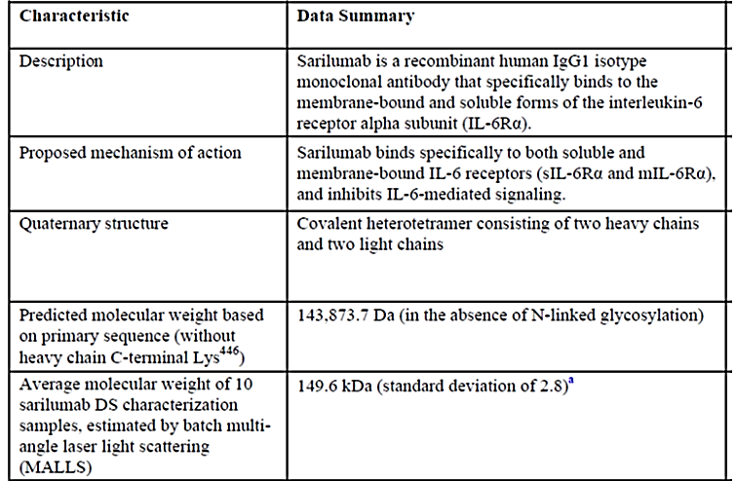
All manufacturing steps have been validated.

Drug product
Apart from the active ingredient sarilumab, the drug product contains the excipients L-histidine, L-arginine, sucrose, polysorbate 20 and water for injection.

Specifications
The release specifications for the pre-filled pen include a complete list of release tests and acceptance criteria covering product solution properties, identity, strength, purity, potency and functional performance. Several specific release tests are performed on the bulk pre-filled syringe intermediate. Results obtained from testing of the bulk pre-filled syringe (PFS) are used to release the final drug product presentation. Release testing performed on the final pre-filled pen (PFP) includes appearance, identity, protein content and functional performance testing. The PFP specification parameters and limits correspond to those for PFS. Additional parameters (activation force, dose accuracy, injection depth and time) were also included and validated for PFP.

Batch analyses
The results from batch analyses are within the release criteria and confirm consistency, uniformity and the device functionality of the PFP.

Stability
Stability studies have been conducted in accordance with relevant International Conference on Harmonisation (ICH) of Technical Requirements for Registration of Pharmaceuticals for Human Use (ICH) guidelines.

Pre-filled syringe (PFS)
Recommended shelf life is 24 months storage at 2 to 8°C, protected from light. It is recommended to use the syringe within 14 days after taking it out of the refrigerator or insulated bag. Real-time stability data through to 30 months for three full-scale primary stability batches of the pre-filled syringe PFS supported the proposed shelf life for PFS.

Pre-filled pen (PFP)
The proposed shelf life is also 24 months when stored at 2-8°C, protected from light. This is based on the shelf life of PFS. The stability data from the PFS was used to determine the shelf life of the PFP. This approach is supported by side-by-side studies examining the stability PFS and PFP when stored at elevated temperature. Real-time stability data through to 18 to 24 months for two clinical batches of PFP for ach strength supported the proposed shelf life for PFP.
Dose accuracy, injection time, injection depth, and activation force, were all within specification limits.

Labelling
Mock-ups for the pre-filled pen 150 mg and 200 mg labels have been provided. Information contained in the pre-filled pen labels is consistent with that for pre-filled syringe. These labels have been assessed to comply with the requirements of the Therapeutic Goods Order (TGO) 69 and TGO 91.

Quality summary and conclusions
There are no issues pertaining to stability of drug substance and drug product.
There are no objections to the registration of this product from sterility; endotoxin, container safety and viral safety related aspects.
Overall, sufficient evidence has been provided to demonstrate that the risks related to the manufacturing quality of Kevzara have been controlled to an acceptable level.

Recommendation regarding approval to the delegate
There are no objections on quality grounds to the approval of Kevzara.

Proposed conditions of registration for delegate

Batch release testing and compliance with Certified Product Details (CPD)
- It is a condition of registration that all batches of Kevzara imported into/manufactured in Australia must comply with the product details and specifications approved during evaluation and detailed in the Certified Product Details (CPD).
- It is a condition of registration that each batch of Kevzara imported into/manufactured in Australia is not released for sale until samples and/or the manufacturer’s release data have been assessed and endorsed for release by the TGA Laboratories Branch. Outcomes of laboratory testing are published biannually in the TGA Database of Laboratory Testing Results.
- The sponsor should be prepared to provide product samples, reference materials and documentary evidence as defined by the TGA Laboratories branch. The sponsor must contact Biochemistry.Testing@health.gov.au for specific material requirements related to the batch release testing/assessment of the product. More information on TGA testing of biological medicines is available [on the TGA website].
This batch release condition will be reviewed and may be modified on the basis of actual batch quality and consistency. This condition remains in place until you are notified in writing of any variation.

Certified product details
The Certified Product Details (CPD), as described in Guidance 7: Certified Product Details of the Australian Regulatory Guidelines for Prescription Medicines (ARGPM), in PDF format, for the above products should be provided upon registration of these therapeutic goods. In addition, an updated CPD should be provided when changes to finished product specifications and test methods are approved in a Category 3 application or notified through a self-assessable change.

IV. Nonclinical findings

Introduction

Overall quality of the nonclinical dossier
The dossier of pharmacology studies consisted of original studies and covered the mechanism of action as well as in vitro and in vivo efficacy in a murine joint inflammation model. Sarilumab does not bind to mouse IL-6Rα, and therefore a surrogate murine monoclonal antibody against mouse IL-6Rα (REGN844) was generated to conduct pharmacology and reproductive and developmental toxicology studies in wild-type (WT) mice.
A murine in vivo pharmacology study with sarilumab was performed in double-humanised (IL-6hu/hu IL-6Rαhu/hu) mice expressing human IL-6 and the human ectodomain of IL-6Rα instead of the equivalent mouse gene products. All toxicology studies were performed in responsive species, either in monkeys (using sarilumab) or mice (using REGN844). The studies were Good Laboratory Practice (GLP) compliant and generally appeared to be concordant with relevant guidelines. The dossier was of adequate quality to enable an assessment of the toxicity of the proposed product to be conducted. In addition, the sponsor provided a number of studies published in the literature describing the role of IL-6/IL-6R in normal cellular processes and in RA.
All of the original sarilumab toxicology studies were conducted with the same formulation buffer and original manufacturing process (P1) used in the Phase I clinical trials. A new process (P3, used in Phase III clinical trials) was only used in a bridging study in monkeys (in which no toxicological differences were observed between process formulations P1 and P3).

Pharmacology

Primary pharmacology
Dysregulation of IL-6-type cytokine signalling contributes to the onset and maintenance of several diseases, including RA, and in fact IL-6 is found in RA synovial tissue. The key studies submitted with this application focussed on the ability of sarilumab (and its murine surrogate) to block the interaction of IL-6Rα with IL-6 (and therefore to block IL-6-induced receptor signalling). Three in vivo pharmacology studies were submitted, one using sarilumab in a double humanised mouse (IL-6^{hu/hu}IL-6a^{hu/hu}), and two using REGN844 in wild type mice.
IL-6 exerts its action through interaction with either a membrane bound or soluble form of the IL-6 receptor (mIL-6R and sIL-6R, respectively). The sarilumab dissociation constant (K_{D}) for human and monkey IL-6Rα was 54 and 123 pM respectively, whereas the dissociation constant of REGN844 for mouse IL-6Rα was 193pM.
Sarilumab bound to monkey and human peripheral blood mononuclear cells (PBMCs), and not to PBMCs of dogs, sheep, mini-pigs, rabbits, hamsters, guinea pigs, rats or mice. Sarilumab also bound to human and monkey tissues with a very similar pattern of immunohistochemistry staining. Specific staining was almost exclusively detected in the cytoplasm and/or cytoplasmic granules in tissues of both species. Membrane staining was not observed in any of the human tissues and only in mammary gland epithelium from one monkey. The potential toxicological impact of the cytoplasmic binding is unknown but of little concern since access to the antibody by the cytoplasm in vivo is not expected. Taken together, the monkey was an appropriate species for the evaluation of the pharmacology, pharmacokinetics and toxicology of sarilumab.
IL-6 is a cytokine from a family of mediators which modulate the immune response, including induction of inflammation, and are involved in the regulation of the acute-phase response to injury and infection. It is produced by T cells, monocytes and fibroblasts and induces B cell and T cell proliferation and differentiation, as well as the differentiation of macrophages, osteoclasts, and megakaryocytes. As anticipated from these functions, IL-6 also has a role in haematopoiesis, but is also implicated in liver and neuronal regeneration, embryonic development and fertility. A pleiotropic effect of IL-6 is to be anticipated, since the signal transducer in both cases is the gp (glycoprotein) 130 protein, the interaction resulting in the activation of the JAK/STAT (Janus kinase/signal transducer and activator of transcription) and MAPK (mitogen-activated protein kinase) cascades.
Sarilumab blocked IL-6 dependent STAT-3 activation in HepG2 human hepatocarcinoma cells (expressing membrane-bound IL-6Rα), and trans-signalling (induced by a combination of IL-6 and soluble IL-6R α) in an engineered human embryonic kidney (HEK)-293 cell line over expressing gp130 but not expressing IL-6Rα. In vitro cell-based assays for antibody-dependent cell-mediated cytotoxicity (ADCC) and complement-dependent cytotoxicity (CDC) did not detect Fc effector function activity associated with sarilumab.
The mouse surrogate IL-6Rα antibody REGN844 bound mouse IL-6Rα (K_{D} 193 pM) with a similar potency to that of sarilumab with human and monkey receptors (54 and 123 pM). REGN844 inhibited the binding of human IL-6 to mouse IL-6Rα (50% inhibitory concentration (IC₅₀): 4 nM) and the (IL-6 induced) proliferation of a mouse B cell hybridoma cell line (IC₅₀: 110 pM).
Turpentine induced elevation of serum amyloid A (SAA; an inflammation biomarker) was inhibited by sarilumab in double humanised (IL-6^{hu}/^{hu}IL-6Rα^{hu}/^{hu}) male mice expressing human IL-6 and the ectodomain of human IL-6Rα, and by REGN844 in wild type mice. In these studies, there was a trend towards increased concentrations of circulating IL-6 (human or mouse), supporting the argument that circulating IL-6 cannot bind the receptors since they are blocked by the antibody.
In the collagen-induced arthritis murine model, in which collagen was administered to cause autoimmunity to collagen and inflammation of synovial joints, prophylactic administration of REGN844 (10 or 30 mg/kg twice weekly) mitigated inflammation and bone erosion.
Taken together, the results from the nonclinical studies described above support the proposed mechanism of action (direct inhibition of the binding between IL-6 and IL-6Rα) and the proposed indication.
In mice, the serum IL-6 level was higher in the presence of the murine anti-IL-6R antibody; REGN844 in this submission and MR16-1 in Mihara et al., (2002).. Intravenous administration of sarilumab increased serum IL-6 levels in monkeys (26 week IV study). The most likely explanation is the displacement of IL-6 from the receptor, but a feedback-mediated change in its synthesis or elimination in the presence of an anti-IL-6R-antibody such as sarilumab may also be possible.
The rapid turnover rate of the IL-6R (half-life (T_{½}) of 2 to 3 h) combined with continuous production of IL-6 during chronic inflammation suggests that a continuous presence of sarilumab is required for effective receptor inhibition. The need for continuous sarilumab presence was not evaluated due to the lack of a study using monkeys experiencing inflammation.
Sarilumab suppressed the IL-6/sIL-6R-induced STAT3 activation in human gp130 overexpressing HEK293 cells, indicating that sarilumab/sIL-6R complexes are not biologically active. Dissociation of IL-6 and sIL-6R from their preformed complex in vitro due to sarilumab, and the effect of sarilumab on the levels or function of other interleukins, were not investigated.
There was evidence in the published literature to suggest that IL-6 is involved in the pathology of RA. Firstly, as reviewed by Wong et al.; IL-6-/- mice are protected against joint inflammation and destruction in both collagen induced arthritis (CIA) and antigen induced arthritis (AIA). While complete protection (no arthritis) was seen in one (CIA) study, amelioration (reduced severity and/or delayed onset) of arthritis was seen in other studies (with both CIA and AIA). This protection was seen despite the expression of both TNF and IL-1 in the inflamed synovium, indicating a particularly important role for IL-6 in these models of disease. In one study, arthritis was reduced and failed to progress to a chronic infiltrate in both AIA and zymogen-induced arthritis models in IL-6-/- mice. These findings suggest that IL-6 is important in either maintaining acute inflammation or converting it into a chronic phase. Secondly, (as also noted in Wong et al, 2003) an IL-6 receptor (IL-6R) neutralising antibody suppressed the onset and reduced the severity of CIA in mice. However, complete suppression of arthritis occurred only when the blocking antibody was administered on Days 0 or 3, indicating that IL-6 is important in the early phase of disease.
The only model of arthritis/inflammation investigated in this submission was in mice, which received the surrogate antibody REGN844. Therefore radiological and histopathological evidence of the therapeutic effect of sarilumab as such is missing in a responsive species.

Secondary pharmacodynamics and safety pharmacology
In vitro and ex vivo studies in humans demonstrated that the decrease in circulating neutrophil numbers following administration of IL-6 inhibitors may be due to these drugs influencing neutrophil margination and/or re-uptake by the bone marrow, without affecting neutrophil function and survival.
The dossier also included two studies which investigated the anti-tumour potential of IL-6. In vitro, sarilumab blocked IL-6-induced STAT3 activation (in two human lung cancer cell lines) and phosphorylation (in human prostate cancer and lung cancer cell lines). Sarilumab also inhibited IL-6-induced proliferation of a human B-cell line dose dependently. In vivo, sarilumab inhibited the growth of human prostate (Du145 cells) and lung (A549, Calu3 and NCI-H1650 cells) tumour xenografts in immunocompromised mice. Immunohistochemistry analysis of prostate cancer xenografts (DU145 cells) revealed inhibition of growth associated with increased cleaved caspase-3 (marker of apoptosis) immunostaining. Based on these results, and since IL-6 and STAT3 signalling play a role in tumour progression, it is possible that sarilumab treatment may exert an inhibitory effect on the growth of some tumours.
Cardiovascular, respiratory, and central nervous system evaluations were integrated into the toxicology studies conducted in cynomolgus monkeys. There were no effects on neurobehavioral parameters (including body temperature), or cardiovascular or respiratory effects (including electrocardiogram (ECG)) in the repeat-dose toxicity studies in monkeys, following doses up to 100 mg/kg/week SC for 13 weeks, or 50 mg/kg/week IV for 26 weeks (dose ratios 25 and 12.5-fold the proposed clinical dose, respectively, on a mg/kg/week basis). No potassium channel (hERG) assay was performed, which is appropriate for biotechnology-derived therapeutic products.

Pharmacokinetics
The pharmacokinetic (PK) profile of sarilumab was assessed following single intravenous (IV) and SC administration of sarilumab to rats and monkeys, and measuring free (rats) or total (monkeys) sarilumab in serum. Toxicokinetic parameters were determined in the general and reproductive, IV and SC toxicology studies in monkeys with sarilumab and in the mice with REGN844. In addition, anti-sarilumab antibodies were also determined in the toxicology studies to assess the impact of anti-sarilumab antibodies on sarilumab exposure and to evaluate any toxicity associated with formation of anti-sarilumab antibodies. Conventional metabolism studies were not conducted with sarilumab and were not required. Plasma protein binding was not evaluated, which is acceptable as sarilumab would not be expected to bind to plasma proteins. IgG molecules do not cross the blood-brain barrier. Standard distribution, metabolism and excretion studies were not conducted and are not required for an antibody. The pharmacological activity of the drug in the species chosen for toxicity testing is the critical factor in the choice of species as the metabolic pathways for antibodies are generally understood and are consistent between species.
Bioavailability after SC dosing was 78% in monkeys after single dosing. The low volume of distribution suggested that sarilumab was largely confined to the vascular compartment, with limited extracellular fluid distribution. There was no evidence, in either rabbits or cynomolgus monkeys, of a gender difference in the pharmacokinetics of REGN844 or sarilumab, respectively.
Sarilumab crossed the placenta and/or was excreted in milk in monkeys, since infants from mothers which received sarilumab up to parturition, had measurable levels of sarilumab up to Day 30 of birth. Sarilumab is expected to be excreted into milk since it has been established (in rodents) that IgG is excreted in milk and transferred to the suckling offspring via the neonatal Fc receptor (FcRn) in the small intestine.
In rats sarilumab showed linear pharmacokinetics which is expected in a species not expressing the target receptor.
Sarilumab exposure was continuous during repeated weekly dosing with sarilumab in most of the monkeys treated. At doses of less than 5 mg/kg/week, continuous exposure to sarilumab was not observed, likely due to the production of anti-sarilumab antibodies. In monkeys, sarilumab exposure increased dose-proportionally between 5 and 100 mg/kg/week, and accumulation was observed. The T_{1/2} of sarilumab was long in monkeys and humans.
Development of anti-sarilumab antibodies was observed in most monkeys receiving 0.5 to 2 mg/kg/week, whereas minimal anti-sarilumab antibodies development was observed in animals receiving ≥ 15 mg/kg/week. The presence of anti-sarilumab antibodies responses was not unexpected due to the foreign (human) nature of the antibody to monkeys, however the draft Product Information document (dated 6 January 2016) states that 9.2% of patients treated with Kevzara monotherapy exhibited an anti-sarilumab antibody response, with 6.9% of patients also exhibiting neutralising antibodies.
Sarilumab concentrations following higher doses were more than dose-proportional, and anti-sarilumab antibodies were not observed at the end of the recovery period, when sarilumab concentrations had reached low levels. Therefore the lack of an anti-sarilumab antibody response at doses ≥ 15 mg/kg/week may reflect the potential for the high circulating drug concentrations to interfere in the anti-sarilumab antibodies assay, or may indicate that high circulating sarilumab concentrations have caused immune tolerance. No toxicities related to anti-sarilumab antibodies were observed.
In humans (RA patients), the population pharmacokinetics of sarilumab (peak plasma concentration (C_{max})), area under the plasma concentration versus time curve (AUC) and lowest plasma concentration reached before the next dose is administered (C_{trough})) were more than dose proportional and accumulation was observed due to the drug’s non-linear clearance and long half-life.
The potential differences in exposure between different sarilumab lots derived from different formulations and manufacturing processes were assessed in a study in monkeys of 13 weeks duration. No significant differences were observed in the different lots used (the formulation used in most nonclinical toxicological studies was also used in Phase I clinical trials, whereas the second formulation was used only in the comparative study but had been used in Phase III clinical trials). There were no nonclinical studies with sarilumab in combination with other drugs (such as MTX) to support its clinical use with other drugs.
Overall, the pharmacokinetic profiles in the laboratory animal species used in the pivotal repeat-dose toxicity studies (monkeys) were sufficiently similar to allow them to serve as appropriate models for the assessment of the drug’s toxicity in humans.

Pharmacokinetic drug interactions
No nonclinical drug interactions studies were conducted. The proposed PI does state that ‘Kevzara has not been investigated in combination with JAK inhibitors or biological DMARDs.’ Clinical pharmacokinetic studies must be evaluated since this drug is indicated to be used concomitantly with other drugs.

Toxicology

Acute toxicity
No studies were submitted, and this is acceptable since acute toxic effects could have been ascertained from the repeat-dose studies. In those studies, the maximum non-lethal dose was the maximum dose administered SC for 13 weeks, that is 100 mg/kg/week. No mortality was observed following IV administration of sarilumab for 26 weeks at 50 mg/kg/week.

Repeat-dose toxicity
Toxicology studies were all conducted in accordance with ICH guidelines, and included repeat-dose studies of up to 6 months duration in cynomolgus monkeys, an embryo-foetal development study in mice (using REGN844), and a pre/postnatal study in cynomolgus monkeys. The formulations in the toxicology studies used excipients similar to those used in the clinical trials. The SC and IV routes of administration were used in the nonclinical studies to support the proposed route of administration of sarilumab to patients (SC).
In mice, REGN844 was used to study the effects of IL-6Rα inhibition in reproductive and developmental toxicology studies, in a fertility study, and in juvenile toxicology studies. The REGN844 chosen for the mouse toxicology study (200 mg/kg/week) was significantly higher than the dose (5 mg/kg) which reduced turpentine-induced inflammation in this species. Continuous exposure to REGN844 was observed in mice in the 4 week studies.
Justification of the use of the cynomolgus monkey as the main species for the nonclinical safety evaluation of sarilumab is discussed under ‘Pharmacology’ above. The clinical (SC) route was used in some of the toxicology studies. The weekly dosing frequency used with the cynomolgus monkey was greater than that proposed for humans (2 weekly), and since the half-life was comparable in cynomolgus monkeys and in humans, this dosing regimen adequately mimicked or exaggerated conditions under which sarilumab is proposed to be used in humans (accumulation was also observed at the higher doses). While the duration of human treatment with sarilumab has not been specified, 6 month studies in monkeys are usually acceptable for toxicity tests of a biotechnology-derived pharmaceutical for chronic indications. The mouse study with REGN844 was of 4 weeks duration but given the length of the pivotal monkey study and the fact that the substance used in the mice was not sarilumab, this was acceptable.

Relative exposure
Doses of sarilumab administered in the repeated-dose toxicity studies ranged from 1 to 50 mg/kg/week IV for up to 26 weeks, and 2 to 100 mg/kg/week SC for 13 weeks. Toxicokinetic data in the SC study were restricted to C_{trough} and mean serum concentration values. As anti-sarilumab antibody formation only occurred at lower doses the AUC data in the table below is considered valid. Although the AUC data were tabulated for comparison purposes, the dose ratios (based on mg/kg/week) are a better indicator of the relative exposure, because molecules as large as sarilumab are likely to be confined to the vasculature.
In cynomolgus monkeys, Day 1 levels were not maintained for the full duration of the study in a number of animals at the low dose (LD) and mid dose (MD), but at the high dose (HD) serum concentrations were maintained throughout the study in all animals as no animal developed anti-sarilumab antibodies, and AUC values were higher on the last sampling day than on Day 1 (Table 4). Therefore, the AUC values from the last sampling period (representing an adequate level of exposure to sarilumab) were used. Exposure to sarilumab was maintained in an adequate number of antibody-negative animals to sufficiently characterise its toxicity.
In summary, the doses administered in the toxicology studies exceed those in the clinical trials and provided substantially higher exposures relative to those achieved clinically. Estimated exposure levels in monkeys during the toxicity studies and a comparison to expected human sarilumab exposure are tabulated below in Table 4.
Anti-sarilumab antibodies were induced in a number of studies, particularly at doses of ≤ 15 mg/kg/week, and resulted in a reduction in exposure to sarilumab in some animals. However, exposure to sarilumab was maintained in an adequate number of negative animals to sufficiently characterise its toxicity.
Table 4: Relative exposure in repeat-dose toxicity studies in monkeys
Study, duration and route | Dose mg/kg/week | AUC_{0-168h} µg.h/mL | AUC for 2 weeks µg.h/mL | Exposure ratio# over 2 weeks
 |  |  |  | Based on AUC | Based on dose
REGN88-TX-06040  (5 weeks)  IV | 5 | 16800 | 33600 | 3.5 | 2.5
REGN88-TX-06040  (5 weeks)  IV | 10 | 28050 | 56100 | 5.9 | 5
REGN88-TX-06040  (5 weeks)  IV | 40 | 159500 | 319000 | 33.6 | 20
REGN88-TX-06037  (13 weeks)  IV | 1 | 389 | 778 | 0.1 | 0.5
REGN88-TX-06037  (13 weeks)  IV | 10 | 61550 | 123100 | 13.0 | 5
REGN88-TX-06037  (13 weeks)  IV | 50 | 258313 | 516626 | 54.5 | 25
REGN88-TX-08031  (26 weeks)  IV | 0.5 | 186 | 372 | 0.04 | 0.3
REGN88-TX-08031  (26 weeks)  IV | 5 | 22892 | 45784 | 4.8 | 2.5
REGN88-TX-08031  (26 weeks)  IV | 15 | 90371 | 180742 | 19.1 | 7.5
REGN88-TX-08031  (26 weeks)  IV | 50 | 381040 | 762080 | 80.4 | 25
REGN88-TX-08030  (145 days; pre/post  natal) IV | 5 | 37260 | 74520 | 7.9 | 2.5
REGN88-TX-08030  (145 days; pre/post  natal) IV | 15 | 124845 | 249690 | 26.3 | 7.5
REGN88-TX-08030  (145 days; pre/post  natal) IV | 50 | 396455 | 792910 | 83.6 | 25
REGN88-TX-06038  (13 weeks)  SC | 2 | ND | - | - | 1
REGN88-TX-06038  (13 weeks)  SC | 10 | ND | - | - | 5
REGN88-TX-06038  (13 weeks)  SC | 30 | ND | - | - | 15
REGN88-TX-06038  (13 weeks)  SC | 100 | ND | - | - | 50
POH0428; (population PK)  RA patients | 2ª | - | 9480^{b} | - | -
# = animal: human; a: 200 mg every 2 weeks to a 50-kg patient; b: AUC0–14 days of 395 mg.day/L was multiplied by 24 to convert to µg.h/mL; ND: not determined; - : not applicable

Major toxicities
There was no indication from the repeat-dose toxicity studies of any target organ toxicity. The only effects observed were due to the pharmacological activity of sarilumab (IL-6Rα inhibitor).
Sarilumab caused moderate and (at least partially) reversible decreases in serum fibrinogen and serum CRP levels. Apart from the effects on fibrinogen, sarilumab did not cause any other effects on haemostasis (platelet counts, prothrombin time and activated partial thromboplastin time (APTT)).
Although IL-6R is expressed on early myeloid progenitors, stem cells and bone marrow stroma cells, the only effect observed in monkeys was neutropaenia and lower primary and secondary IgG responses following an antigen (keyhole limpet haemocyanin) challenge. No instances of pancytopaenia, aplastic anaemia or bone marrow effects were observed. Furthermore, no increased incidences of infection were observed.
According to the sponsor’s Clinical Overview and draft PI, elevations of hepatic transaminases have been observed with sarilumab treatment in clinical trials, but without progression to serious hepatic injury. No elevations of hepatic transaminases were seen in the toxicology studies, even when IL-6 was significantly elevated in the 26 week study in cynomolgus monkeys.
No hypersensitivity reactions (observed in patients), or any effect on organ weights, macroscopic or microscopic pathology, immunophenotypic analysis, or clinical signs, were observed in any of the studies in monkeys. Anti-sarilumab antibodies, developed in monkeys receiving doses of ≤ 15 mg/kg/week, did not cause any apparent toxicological effect. After SC administration, injection sites displayed moderate inflammatory infiltrates (which is not unexpected after SC injection of concentrated human proteins).
Considering the mechanism of action of sarilumab, effects on the immune system may have been anticipated, but there were no sarilumab related effects on the morphology of any organ (including of the immune system). Overall, there was little evidence of toxicity of sarilumab following weekly treatment to monkeys.

Genotoxicity and carcinogenicity
The range and type of genotoxicity studies routinely conducted for small molecule pharmaceuticals are not applicable to biotechnology-derived products¹ and therefore, a full battery of tests was not conducted. It is not expected that a monoclonal antibody such as sarilumab would interact directly with deoxyribonucleic acid (DNA) or other chromosomal material.
The mechanism of action of sarilumab is not expected to be carcinogenic. No preneoplastic lesions were observed in cynomolgus monkeys administered sarilumab for up to 26 weeks, although this time span is relatively short in the lifespan of this species.
Furthermore, in vivo, sarilumab inhibited the growth of human prostate (Du145 cells) and lung (A549, Calu3 and NCI-H1650 cells) tumour xenografts in immunocompromised mice. Immunohistochemistry analysis of prostate cancer xenografts (DU145 cells) revealed inhibition of growth associated with increased cleaved caspase-3 (marker of apoptosis) immunostaining. Based on these results, and since IL-6 and STAT3 signalling play a role in tumour progression, it is possible that sarilumab treatment may exert an inhibitory effect on the growth of some tumours.
Based on the lack of mechanistic concern, and the data described above, carcinogenicity studies with sarilumab were not considered necessary, consistent with the approach in current regulatory guidelines.

Reproductive toxicity
A fertility study was conducted in mice, in which the effects of inhibition of IL-6Rα on fertility were investigated using the murine specific surrogate REGN844 (sarilumab was not pharmacologically active in rats, mice or guinea pigs). Some additional fertility endpoints (such as reproductive hormones, menstrual cycling and sperm analysis) could have been not included in the repeat-dose toxicity studies in cynomolgus monkeys, and an embryofetal development study could have been performed with the surrogate murine antibody.
In the REGN844 study in mice, an increased incidence of implantation site degeneration was observed microscopically at the HD, however no other drug-related effects were observed in reproductive indices (mating, fertility and pregnancy), and the significance of the finding is not known.
There was evidence of cross-reactivity of sarilumab with (cytoplasm and/or cytoplasmic granule in) human reproductive tissues (prostate, oviduct, cervix, endometrium, placenta) but no evidence from the repeat-dose toxicity studies in mice (with REGN844) or cynomolgus monkeys (with sarilumab) of an effect of IL-6Rα block on the reproductive organs of either males or females.
Embryofetal development studies were not conducted in mice or monkeys, and these studies would have been advisable. However a pre/postnatal development study was performed in monkeys and it included dosing from gestational day (GD) 20, which is the beginning of organogenesis in monkeys (equivalent to Week 3 in a human pregnancy), until GD165 (natural delivery). Exposure began at implantation and continued until at least postnatal day (PND) 30 at all doses both in mothers and offspring (offspring were then euthanised).
There was no evidence of teratogenicity, although the number of offspring was limited. Offspring were examined for malformations/variations (organ measurements, macroscopic observations and skeletal examination by X-ray imaging).
Increases in pregnancy loss, premature births, stillbirths, neonate deaths post-birth and a decrease in infants surviving to Days 30 to 32 of birth were observed in the 50 mg/kg/week dose group compared to vehicle control and lower dose groups (see Table 5, below).

Table 5: Adverse events reported from reproductive study in monkeys
Finding | Dose (mg/kg/week)
Finding | 0 | 5 | 15 | 50
Abortion/embryofoetal death ratio (and percentage) | 3/12 (25%) | 3/12 (25%) | 4/12 (33.3%) | 3/12 (25%)
Premature/preterm birth (incidence) | 0 | 0 | 0 | 2
Pregnancy loss (and percentage) | 5/12 (41.7%) | 4/12 (33.3%) | 6/12 (50%) | 6/12 (50%)
Stillbirth ratio (and percentage) | 2/9 (22.2%)ª | 1/9 (11.1%) | 2/8 (25%) | 3/9 (33.3%)
Neonate deaths post birth | 1 (14%) | 1 (12%) | 1 (14%) | 2 (33%)
Infants surviving to BD30-32 | 6 | 7 | 5 | 4
ª = one animal that received emergency C- section due to dystocia and neonate died on Day 2 after birth was included in stillbirth
The study report stated that:
- the stillbirth ratios in the treatment groups were ‘comparable’ to the testing facility’s historical control data (13.6%, ranging from 0 to 33.3%);
- monkeys were observed in a breech delivery position in 1/2 of the stillborn in the control group and in 2/3 of the stillborn in the 50 mg/kg/week group;
- it has been reported that around 66% of cynomolgus monkeys in a breech position 1 day before parturition deliver stillborn neonates (rate is only 1% if the animals are in the correct cephalic position); and therefore
- ‘naturally occurring’ breech deliveries are a major cause of stillbirth in cynomolgus monkeys.
These arguments, as well as the following facts, may suggest the possibility that the higher stillbirth ratio and total pregnancy loss rates observed in the groups given 50 mg/kg/dose sarilumab could be spontaneous:
- differences were not statistically significant;
- the values were within historical control values; and
- the findings occurred at high systemic exposure margins (≥ 26 times that anticipated at the maximum human dose).
However, the low number of animals in the study does not provide sufficient assurance regarding the validity of the results to inform the conclusion on reproductive safety of sarilumab. The apparent dose response relationship in some of the findings in this study means that the possibility that these findings were actually related to treatment with sarilumab cannot be dismissed. Also, there is no evidence that the 2/3 breech position animals were not somehow related to dysregulation of the IL-6 pathways since they are important for the maintenance of pregnancy (see below). The mechanism behind the trend suggesting embryo-foetal toxicity is unclear. Nonetheless, there is evidence to suggest that impaired IL-6 activity may affect human reproduction:
- Unlike the leukaemia inhibitory factor (LIF) and IL-11 members of the IL-6 cytokine family, IL-6 is not essential for successful pregnancy, but is likely to play a modulating role during embryo implantation and placental development.
- Genetic IL-6 deficiency is linked with elevated fetal resorption and a delay in parturition in mice.
- Increased IL-6 trans-signalling is associated with unexplained infertility.
- Recurrent miscarriage is accompanied by evidence of increased IL-6 trans-signalling systemically, but reduced IL-6 expression in the endometrium.
- Preterm birth is associated with elevated maternal serum and amniotic fluid IL-6, and IL-6 trans-signalling may also be increased.
- In preeclampsia, maternal serum levels of IL-6 are often increased, whereas placental IL-6 production appears decreased; and
- IL-6 expression appears to be a determinant of uterine receptivity at embryo implantation.,,
There is a possible contribution of IL-6 to infertility and miscarriage, with evidence that both elevated and diminished IL-6 bioavailability due to altered expression of IL-6 ligand and/or its signalling regulators might contribute to them, perhaps through acting in both stimulating and inhibitory roles in different cell–cell signalling pathways, and presumably depending on the balance of factors, such as IFN and TLR4 ligands.⁷ A complex relationship between IL-6 pathways and reproduction exists, and therefore the apparent absence of (statistically significant) effects on fertility (in mice with REGN844) and pre/postnatal development (in monkeys, with sarilumab) may not necessarily be reflected in humans. In vitro studies indicated that elevated levels of IL-6 impaired implantation and elevated levels were seen in peritoneal fluid of patients with endometriosis, and implicated in impairment of ciliary beat frequency in the human Fallopian tube. In animal studies, elevated IL-6 led to apoptosis of germ cells from rats. There may also be species differences in the complex effects of IL-6 on the reproductive system.
Effects of sarilumab observed in monkeys are reminiscent of those of tocilizumab, another IL-6R inhibitor. Administration of tocilizumab in an embryofetal development study in monkeys caused a dose related (but statistically non-significant) increase in the incidence of abortion or embryo-foetal deaths, at high (≥ 35) relative exposures. This effect was described in the PI document of tocilizumab and that drug was given a Pregnancy Category of C.
In summary, the possibility that due to its pharmacological properties sarilumab causes higher stillbirth ratios and pregnancy loss rates cannot be ruled out. Due to the current uncertainty regarding the causal effects of inhibitors of the IL-6R on stillbirths, embryo-fetal deaths, abortion and/or pregnancy loss observed at high doses, it is envisaged that all drugs of this class will receive a Pregnancy Category of C.¹⁵ This category may be reviewed in the future if sufficient clinical evidence or other mechanistic evidence is available.

Relative exposure
The animal:human relative exposure is summarised in Table 6 below.
Table 6: Relative exposure in reproductive toxicity studies
Study, duration & route | Dose mg/kg/week | AUC_{0-168h} µg.h/mL | AUC for 2 weeks µg.h/mL | Exposure ratio# (over 2 weeks)
 |  |  |  | Based on AUC | Based on dose
TX-08030  Pre-/postnatal development (GD20-GD165) IV | 5 | 37260 | 74520 | 8 | 2.5
TX-08030  Pre-/postnatal development (GD20-GD165) IV | 15 | 124845 | 249690 | 26 | 7.5
TX-08030  Pre-/postnatal development (GD20-GD165) IV | 50 | 396455 | 792910 | 84 | 25
POH0428; (population PK)  Rheumatoid arthritis patients | 2ª | - | 9480^{b} | - | -
# = animal: human; a: 200 mg every 2 weeks to a 50-kg patient; b: AUC_{0–14 days} of 395 mg.day/L was multiplied by 24 to convert to µg.h/mL; - : not applicable
Exposures in pregnant monkeys were very similar to those in monkeys at the same doses (genders combined) in the repeat-dose toxicity study (26 weeks IV). The relative exposure ratios achieved in cynomolgus monkeys were high. In cynomolgus monkeys, serum sarilumab concentrations were not affected by neutralising antibodies: only 3/12 females at the LD developed anti-sarilumab antibodies, so all animals remained adequately exposed throughout the study.

Pregnancy classification
Placental transfer of sarilumab to the foetus was seen in cynomolgus monkeys and this is consistent with the physiological properties of IgG1 antibodies. Although immunoglobulins can be excreted in milk, excretion of sarilumab in milk was not investigated. It is not certain that infants would be exposed during breast feeding because the protein is likely to be metabolised to smaller peptides before absorption in the gut.
The sponsor has proposed Pregnancy Category C, which is consistent with tocilizumab; another drug of the same class. There were no treatment-related adverse findings in foetuses in the cynomolgus monkey infants. Given the long half- life of sarilumab, consideration needs to be given to the newborn if this drug is administered during pregnancy. Although there was no evidence from the monkey study that gestational exposure had an adverse effect on the infants, animal numbers were low.
Since it is likely that owing to its pharmacological effects, sarilumab causes harmful effects on the human fetus or neonate without causing malformations, and in line with the pregnancy category of another drug of the same class displaying similar findings, a Pregnancy Category of C is appropriate.

Local tolerance
The assessment of local tolerance was incorporated in repeat-dose toxicology studies in cynomolgus monkeys by macroscopic and microscopic evaluation of IV infusion and SC injection sites. No findings related to sarilumab administration were observed following IV infusion. In the 3 month SC monkey toxicology study, minimal to moderate perivascular mixed inflammatory cell infiltrates were observed in the dermis and/or the subcutis of sarilumab-treated monkeys. The findings, with sarilumab concentrations between 50 and 70 mg/mL, were partially reversible following a 12 week recovery period, and the incidence and severity were not dose-dependent.
These findings most likely represent a local reaction to the SC injection of concentrated protein rather than a specific adverse effect of sarilumab as such.
In mice, REGN844 caused only a slight increase in the incidence and severity of mixed inflammatory cell infiltrates at the injection site at ≥ 50 mg/kg/week SC. There were no REGN844-related injection site findings at 10 mg/kg/week SC or 25 mg/kg/week IV.

Paediatric use
Sarilumab is not proposed for paediatric use and no specific studies using sarilumab in juvenile animals were submitted. In a study in mice using a murine surrogate of sarilumab (REGN844), administration of up to 200 mg/kg/week SC to 8 to 10 week old mice for 4 weeks did not cause any observable adverse effect. In juvenile mice treated with REGN844 up to 200 mg/kg/week from PND 14 to sexual maturity (for 9 weeks), there were no observable adverse effects apart from reversible effects associated with the injection of proteinaceous material and/or self-trauma secondary to minor inflammation at the injection site. The no observable adverse effect level (NOAEL) in both murine studies was therefore 200 mg/kg REGN844/week.

Nonclinical summary
- An acceptable package of nonclinical studies was submitted, with pivotal toxicology studies conducted in compliance with GLP regulations and with studies broadly in accordance with relevant guidelines.
- Sarilumab (and its murine surrogate) blocked the interaction of IL-6Rα with IL-6, and therefore blocked IL-6-induced receptor signalling. The sarilumab K_{D} for human and monkey IL-6Rα was 54 and 123 pM respectively, whereas the dissociation constant of REGN844 (a mouse surrogate IL-6Rα antibody created to support studies in wild type (WT) mice since sarilumab does not bind to mouse IL-6Rα) for mouse IL-6Rα was 193pM.
- Sarilumab blocked IL-6 dependent activities by blocking membrane bound and soluble IL-6Rα, and did not have any Fc effector function as assessed with ADCC and CDC assays.
- Sarilumab (in IL-6/IL-6Rα humanised mice) and REGN844 (in wild type mice) inhibited the elevation of an inflammation biomarker (turpentine-induced elevation of SAA). REGN844 mitigated inflammation and bone erosion in WT mice with (collagen-induced) arthritis. No monkey models of inflammation were evaluated. Increased concentrations of IL-6 were observed in mice and monkeys, supporting the argument that circulating IL-6 cannot bind the receptors since they are blocked by the antibody. REGN844 inhibited the binding of human IL-6 to mouse IL-6Rα (IC50: 4 nM) and the (IL-6 induced) proliferation of a mouse B cell hybridoma cell line (IC50: 110 pM). Sarilumab/sIL-6R complexes were not biologically active. Dissociation of IL-6 and sIL-6R from their preformed complex in vitro due to sarilumab was not investigated.
- The cynomolgus monkey showed adequate specific cross-reactivity with sarilumab in a panel of normal tissues in tissue binding studies. Based on the binding activity, the cynomolgus monkey was appropriately chosen as the main species for toxicity testing.
- Safety pharmacology studies were incorporated with the repeat-dose toxicity studies in monkeys. No adverse effects were seen on neurobehavioral parameters, body temperature, or cardiovascular or respiratory effects (including ECG) in monkeys after repeated dosing for up to 26 weeks.
- An acceptable range of pivotal toxicity studies with sarilumab was conducted in one species, the cynomolgus monkey, which was adequately confirmed as a relevant human model in terms of both pharmacodynamic response to sarilumab and pharmacokinetics. The formulations used in Phase I clinical trials, with excipient profile similar or identical to that proposed for registration were used for all nonclinical studies. No differences in pharmacokinetics or toxicity were observed in monkeys when Phase I and Phase III formulations were compared.
- Serum pharmacokinetics after IV administration of sarilumab were adequately characterised in cynomolgus monkeys. After a single IV dose in monkeys, sarilumab showed limited distribution, slow clearance and a long terminal T_{1/2}. There were no gender differences. Accumulation with repeated (weekly) dosing was consistent with the drug’s long T_{1/2}. Conventional studies of the distribution, metabolism and excretion of sarilumab were not conducted in animals, which is acceptable. There were no non-clinical drug interaction studies. Sarilumab crosses the placenta and is expected to be excreted into milk. Bioavailability after SC dosing was 78% in monkeys after single dosing.
- Anti-sarilumab antibodies were observed in most monkeys receiving 0.5 to 2 mg/kg/week, but generally not in animals receiving ≥ 15 mg/kg/week. Exposure to sarilumab in monkeys was adequate to ascertain its potential toxicity. The draft PI notes the presence of anti-sarilumab antibodies responses, including neutralising antibodies, in 7 to 9% of patients.
- There was no indication from the repeat-dose toxicity studies of any target organ toxicity. Even at the highest doses tested in monkeys, sarilumab was well tolerated. In monkeys, the maximum doses used in the SC and IV toxicity studies were up to 25 (based on dose) to 80 (based on AUC) times the exposure in patients. The only effects observed were due to the predictable pharmacological activity of sarilumab as an IL-6Rα inhibitor: moderate and (at least partially) reversible decreases in neutrophil levels, lower primary and secondary IgG responses following an antigen (KLH) challenge, moderate and (at least partially) reversible decreases in serum fibrinogen and serum CRP levels, and reversible increases in circulating IL-6.
- There were no nonclinical studies with sarilumab in combination with other drugs, including MTX.
- The range and type of genotoxicity studies routinely conducted for small molecule pharmaceuticals are not applicable to biotechnology-derived products¹ and therefore, a full battery of tests was not conducted. It is not expected that a monoclonal antibody such as sarilumab would interact directly with DNA or other chromosomal material.
- Nonclinical studies investigating genotoxicity or carcinogenicity were not conducted with sarilumab. Sarilumab was not pharmacologically active in mice or rats. Sarilumab dose dependently inhibited IL-6-induced proliferation of a human B-cell line, and in vivo it inhibited the growth of human prostate and lung tumour xenografts in immunocompromised mice. The inhibition of growth in the prostate cancer xenografts was associated with increased cleaved caspase-3 (marker of apoptosis) immunostaining. It is therefore possible that sarilumab treatment may exert an inhibitory effect on the growth of some tumours. No preneoplastic lesions were observed in cynomolgus monkeys administered sarilumab for up to 26 weeks. The mechanism of action of sarilumab is not expected to be carcinogenic.
- The effects of sarilumab on male or female fertility, including implantation, were not investigated (there was no evidence for adverse histopathology in reproductive tissues assessed in the 26 week repeat dose toxicity studies, although sarilumab cross-reacted with some reproductive tissues (to cytoplasm and/or cytoplasmic granules) in tissue cross-reactivity studies). However, no effects on fertility were observed when IL-6Rα block was investigated using the surrogate antibody REGN844 in mice.
- A pre/post-natal development study was performed in pregnant cynomolgus monkeys given IV sarilumab at 5, 15 or 50 mg/kg/week from early organogenesis (GD 20) until natural delivery (GD 165). There was evidence that sarilumab induced stillbirths and pregnancy loss in cynomolgus monkeys when administered during the period of organogenesis (GD an AUC basis). While this finding was inconclusive, it could not be ruled out, and has been noted in the draft PI. Treatment with sarilumab had no effect on in-life maternal parameters and no evidence of teratogenicity at doses up to 50 mg/kg/week IV. No adverse effects were observed in dams or infants (the latter were observed for only 30 days after birth). Sarilumab crossed the placenta (expected for an IgG1 antibody) and remained detectable in infant serum until PND 30 (last measurement day). Excretion into milk was not investigated.
- Studies where REGN844 was administered to juvenile WT mice did not identify particular toxicity related to block of IL-6R in growing animals. Sarilumab is only indicated in adults.

Nonclinical conclusions and recommendation
- The pharmacology, pharmacokinetics and toxicology of sarilumab were adequately investigated in the submission using appropriate in vitro and in vivo nonclinical models.
- The primary pharmacology studies support the drug’s mechanism of action.
- The activity of sarilumab in animal models of RA was not investigated. Demonstration of efficacy for the proposed indication will therefore rely on clinical data.
- Haematological effects were the main toxicologically significant findings in cynomolgus monkeys. These were consistent with an exaggerated pharmacological effect arising from IL-6 receptor blockade. These effects were observed at doses significantly greater than the maximum anticipated human dose.
- No target organs of toxicity were identified. Sarilumab is not considered to pose a genotoxic or carcinogenic hazard and is not teratogenic.
- Sarilumab should be classified as Pregnancy Category C (as proposed by the sponsor), consistent with that of the currently registered IL-6 blocker, tocilizumab. A trend for increasing adverse outcomes in monkey pregnancies has been observed for both tocilizumab (abortions and/or embryo-foetal deaths) and sarilumab (stillbirths and pregnancy loss), albeit at high relative exposures for both drugs. Given these findings and the current lack of full understanding of the complexities of the role of IL-6 role in pregnancy, a Pregnancy Category C and a statement of the animal pregnancy findings in the PI is appropriate.
- No nonclinical data were submitted to support the use of sarilumab in combination with MTX and/or other DMARDs. The safety of the use of sarilumab in combination with DMARDs will therefore rely on clinical data.
- There are no nonclinical objections to registration. Amendments to the draft PI were recommended but these are beyond the scope of this AusPAR.

V. Clinical findings
A summary of the clinical findings is presented in this section.

Introduction
The approach to the evaluation of the current submission has been to fully evaluate the new clinical data (Phase III Study EFC14092 (the MONARCH trial); and the Phase I Study MSC12655), summarise the previously submitted key clinical pharmacology, efficacy and safety data, and prepare an integrated clinical evaluation report (CER) based on the relevant data from the initial submission and the re-submission. The clinical evaluation also includes a detailed integrated first-round benefit-risk assessment based on the new and old data (see below). It is considered that inclusion of a detailed first-round benefit-risk assessment was the most appropriate way to review and evaluate the totality of the efficacy and safety data provided in the initial submission and the re-submission.

Clinical rationale
In the re-submission covering letter of August 2017 the sponsor reviews the current treatment options for RA and concludes that there remains an unmet need for therapies that provide sustained benefit over long periods of time, and for patients who respond inadequately to DMARDs or TNF antagonists or who are intolerant to TNF antagonists.
In addition, as part of its Note to Evaluator, dated 29 August 2017, the sponsor provided a ‘clinical consensus’ statement endorsed by 7 Australian rheumatologists outlining current best Australian clinical practice for the treatment of RA. The ‘clinical consensus’ states that ‘best clinical practice in Australia is to treat [RA] aggressively and early with the same treat to target approach used in Europe and the USA. This is done in order to prevent irreversible joint damage, and optimise disease control’.
The consensus refers to the use of tocilizumab and states that ‘in Australia, tocilizumab is accessible at two different doses for its intravenous (IV) formulation (8 mg/kg or 4 mg/kg) and two doses frequency for its subcutaneous (SC) formulation (weekly or fortnightly). Australian rheumatologists start patients on 8 mg/kg IV or weekly SC to maximize the chance of controlling active disease’. Therefore, it is inferred that ‘sarilumab would also be started at the highest available dose (200 mg) as it is the most effective dose to avoid joint damage based on the clinical data’.
The Australian PI for tocilizumab for adult patients with RA recommends 8 mg/kg IV every 4 weeks or 162 mg SC once every week (qw). In the USA prescribing information for tocilizumab, the recommended starting dose is 4 mg/kg IV every 4 weeks followed by an increase to 8 mg/kg IV every 4 weeks based on clinical response, or 162 mg SC every other week followed by an increase to every week based on clinical response for patients < 100 kg in weight and 162 mg SC every week for patients ≥ 100 kg.
As regards neutropaenia, the consensus states that patients on sarilumab will be managed in the same way as patients receiving other RA treatments (that is, laboratory monitoring, patient education, general practitioner (GP) education). In particular, the consensus notes that monitoring for neutropaenia in patients on sarilumab in remote regions will not differ from current practice for patients on other RA treatments, and will not require additional monitoring from current best practice for the management of neutropaenia and serious infections.
The consensus concludes by stating that ‘despite the availability of a range of treatment options for RA, not all patients achieve a target of remission or low disease activity. The availability of [a] new potent IL-6R inhibitor would be of great benefit for this patient population’.
The clinical rationale for the submission seeking approval of sarilumab for the treatment of RA is acceptable. However, while the consensus statement is of interest the recommendation relating to the most appropriate starting dose will be made based on the totality of the submitted clinical data.

Guidance
In a pre-submission meeting with the TGA, the sponsor agreed that the re-submission of this application would include a Note to Evaluator identifying the key data and rationale supporting the 200 mg q2w dosing regimen and the management of risks associated with neutropaenia. The re-submission would include a Clinical Consensus Statement from experienced rheumatologists across Australia relating to current clinical practice supporting initial aggressive management of RA to protect patients from irreversible joint damage. The consensus statement would also address the practical aspects of the management of remote patients with RA aimed at mitigating the risks of neutropaenia and other potential adverse events associated with sarilumab treatment. The agreed information was provided in the re-submission.
There is a TGA approved EU guideline relating to the treatment of RA, namely:
- Points to Consider on Clinical Investigation of Medicinal Products other than NSAIDs for Treatment of Rheumatoid Arthritis CPMP/EWP/556/95 rev1/Final; London, 17 December 2003.

Contents of the clinical dossier

Scope of the clinical dossier
The submission included the clinical studies provided in the initial submission and the new clinical studies provided for evaluation. The new clinical data for evaluation are summarised below:
- Study EFC14092 (MONARCH trial): a Phase III study assessing the efficacy and safety of sarilumab monotherapy versus adalimumab monotherapy in patients with rheumatoid arthritis. The submitted report covered the 24-week randomised period of the study. The Clinical Study Report (CSR) was dated 17 May 2016 (subsequent to the date of the initial submission).
- Study MSC12655: a Phase III study assessing the usability of the sarilumab autoinjector device and the pre-filled syringe in patients with moderate to severe RA. The study included a 12 week autoinjector assessment phase. The CSR was dated 31 July 2015. The study was included in the original submission but was not evaluated because at that time registration of the pre-filled pen (autoinjector) was not requested by the sponsor.

Paediatric data
No paediatric data were included in the submission.
The sponsor states that it has not submitted paediatric data to the EU, but has an agreed European Paediatric Investigation Plan (PIP). The sponsor indicates that as part of the PIP it is required to submit an appropriate study to the European Medicines Agency (EMA) by June 2022.
The sponsor states that a final PIP Opinion was granted in 26 March 2013 (P/0067/2013 EMA/113206/2013) as follows:
- PIP granted for paediatric populations for treatment of; (1) polyarticular course juvenile idiopathic arthritis (pJIA) in children 2 to less than 18 years and; (2) systemic juvenile idiopathic arthritis (sJIA) in children 1 to less than 18 years.
- Waiver granted for paediatric population (birth - 1 year) for treatment of chronic idiopathic arthritis (including rheumatoid arthritis, spondyloarthritis, psoriatic arthritis and juvenile idiopathic arthritis) on the grounds that disease does not occur in these specified paediatric subsets.
The sponsor states that no paediatric data have been submitted to the US FDA, but that it is required to submit a paediatric assessment by June 2023. The sponsor states that it has been granted a partial waiver by the US FDA from having to submit paediatric studies in (1) patients from birth to 24 months for polyarticular idiopathic arthritis (pJIA); and (2) patients from birth to 12 months for systemic juvenile idiopathic arthritis (sJIA) ‘on the grounds that the disease does not occur in these paediatric subsets’.
The failure to include paediatric data in the submission is acceptable. However, it is recommended that the sponsor should submit the proposed paediatric studies to the TGA at the same time as the studies are submitted to the EMA and/or the US FDA. It is considered that provision of these studies should be a condition of registration of Kevzara.

Good clinical practice
The sponsor stated that the submitted studies have been conducted in accordance with the principles of good clinical practice.

Pharmacokinetics

Studies providing pharmacokinetic data

Previously submitted PK data
The initial CER included evaluation of PK data for sarilumab in healthy subjects and adult patients with RA. It was reported in the initial CER that the PK of sarilumab had been well characterised from the PK data collected from 53 healthy subjects involved in 1 Phase I study, 241 adult patients with RA enrolled in 8 Phase I studies and 2671 patients with RA involved in 7 Phase II/III studies of sarilumab treatment. The clinical pharmacology studies (PK and PD) are summarised in Table 7.
The initial CER stated that the sponsor also conducted 4 pre-specified population PK and population PK/PD analyses using pooled data from Phase I, II and III studies. These studies are summarised in Table 8. It was stated in the initial CER that none of the population PK/PD analyses had deficiencies that excluded their results from consideration.

Table 7: Summary of submitted clinical pharmacology studies (PK and PD) with sarilumab
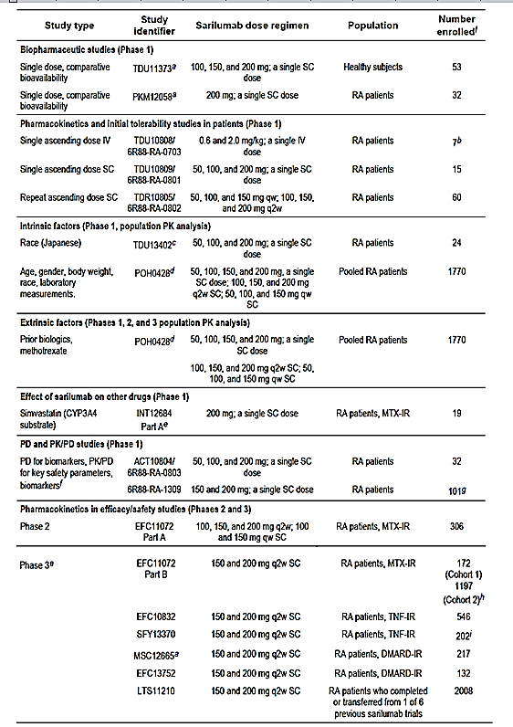
Abbreviations and explanation footnotes as per Table 8 below.

Table 8: Summary of submitted Population PK/PD Studies with sarilumab
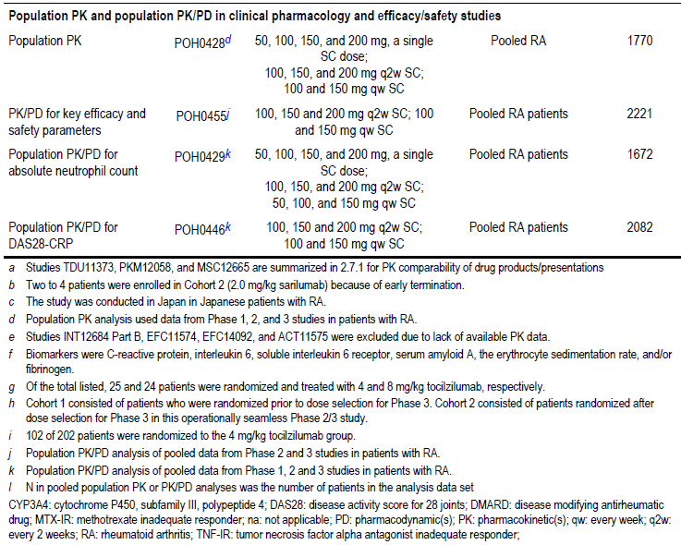
The following summary of the PK of sarilumab is from data provided in the initial CER.
- Sarilumab is well absorbed after a single SC dose in patients with RA, with the maximum serum concentration of functional sarilumab being achieved at a median Tmax of 2 to 4 days, with no apparent dose effect. The bioavailability of sarilumab after SC injection is estimated to be 80% using data from the Population PK Study POH0428.
- Functional sarilumab exposure increases in a greater than dose proportional manner in patients with RA, due to an appreciable contribution by non-linear clearance to the total drug clearance in the therapeutic dose range. The PK parameters of sarilumab after single SC dose administration are summarised in Table 9. After repeated SC doses of sarilumab in the Phase II/III studies, the mean steady state trough serum concentrations (Ctrough) of sarilumab increased by 2.1 to 3.1 fold and AUC0-14 days increased by 2.0-fold with only a 1.33-fold increase in sarilumab dose from 150 to 200 mg q2w. The PK parameters of sarilumab after repeat SC dose administration are summarised in Table 10.

Table 9: Pharmacokinetic parameters of serum functional SAR after a single SC dose
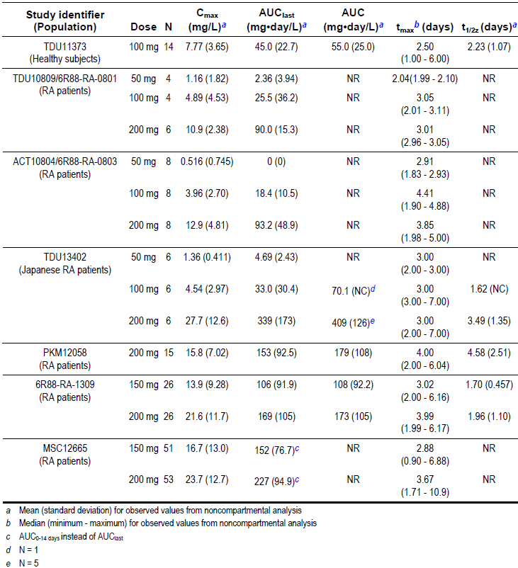

Table 10: Pharmacokinetic parameters of serum functional SAR after repeat SC doses
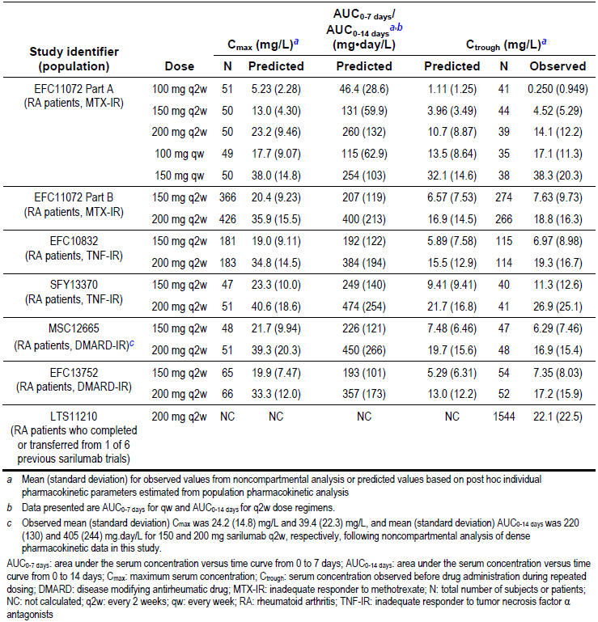
- The population PK Study POH0428 estimated the total volume of distribution of sarilumab to be 7.31 L. This low value suggests that the distribution of sarilumab is primarily limited to the circulatory system, which is a characteristic finding in monoclonal antibodies.
- No specific in vitro or in vivo metabolism studies have been conducted with sarilumab. As a therapeutic protein, sarilumab is considered to be metabolised by the same catabolic pathways as endogenous proteins, which are typically broken down into small peptides and amino acids via proteolysis.
- Overall, sarilumab exhibits non-linear PK characteristics with 2 distinct processes for elimination. There is a slow, linear and non-saturable elimination phase at higher serum concentrations, when target binding is at or near saturation, and a fast, non-linear, target mediated elimination phase at lower serum concentrations. The fast elimination process is presumably a result of internalisation via endocytosis of target-bound sarilumab.
- The population PK analyses support biphasic elimination of sarilumab estimating an initial elimination T_{1/2} of 8 to 10 days and a terminal T_{1/2} of 2 to 4 days at steady state after 150 or 200 mg q2w SC doses (Study POH0428). Serum sarilumab concentrations after the last steady state dose were measurable up to a median time of 28 days for the 150 mg dose and up to 43 days after the 200 mg q2w dose. Based on Study POH0428, target mediated clearance represents a large portion of total clearance, while linear clearance represents only 7 to 26% of total drug clearance at the 150 mg q2w dose and 22 to 40% of total clearance at the 200 mg q2w dose.
- The time to steady state in a typical patient, estimated from population PK Study POH0428 was 14 to 16 weeks for AUC₀₋₁₄ _{days} and 18 to 20 weeks for C_{trough}. The accumulation ratios were determined to be 2.3 and 2.5 for AUC_{0-14 days} and 2.6 and 3.0 for C_{trough} after sarilumab 150 mg q2w and 200 mg q2w dosing regimens, respectively.
- Sarilumab exhibits moderate to high PK variability in patients with RA. The potential effects of several intrinsic and extrinsic sources of variability on the PK of functional sarilumab were evaluated via population PK analysis and/or cross study comparisons. The assessed covariate factors failed to explain the majority of the PK variability of sarilumab.
- No formal studies were conducted in special populations involving patients with renal or hepatic impairment. However, the disposition of sarilumab is not expected to be influenced by impaired renal or hepatic function. The population PK Study POH0428 did not identify any correlation between serum sarilumab concentration and liver function test values (serum aspartate aminotransferase (AST), alanine aminotransferase (ALT) or total bilirubin levels). The majority of patients with RA in the population PK dataset had either normal renal function or mild renal impairment at baseline, while severe renal impairment at baseline was an exclusion criterion. Although creatinine clearance (CrCL) was a statistically significant covariate for clearance in the population PK analysis, the impact of CrCL on clearance did not translate into an appreciable effect on functional sarilumab exposure (AUC_{0-14 days}) at steady state.
- No relationship between functional sarilumab exposure and age was observed in patients with RA in the clinical studies. Ethnicity was not a significant covariate influencing functional sarilumab PK. Individual studies suggested a trend toward lower functional serum sarilumab concentrations in subjects with a body weight ≥ 90 to 100 kg. In agreement with the observed data, the population PK Study POH0428 identified body weight as a significant covariate influencing apparent linear and non-linear drug clearance, with reduced drug exposure (AUC_{0-14 days}) in individuals with higher body weights. PK data relating to steady state exposure based on body weight are summarised in Table 11. The population PK study identified gender as a potentially significant covariate impacting upon apparent linear drug clearance. However, the effect of gender was minimal and translated into 12% and 14% lower sarilumab steady state exposures (AUC_{0-14 days}) after repeated 150 and 200 mg q2w administration, respectively, for a typical male patient as compared to a typical female patient.

Table 11: Functional sarilumab steady state exposure by body weight category in Study POH0428
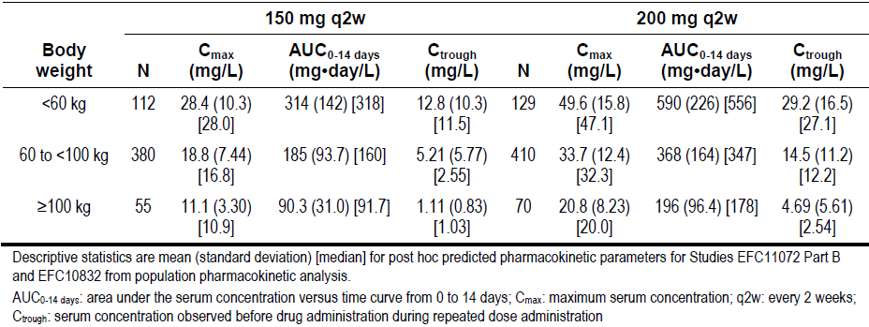
- There was one clinical drug-drug interaction study between sarilumab and simvastatin (a sensitive cytochrome P450 (CYP) isozyme CYP3A4 substrate). Co-administration of the two drugs resulted in a 45% reduction in exposure to simvastatin, which is reported in the initial CER as being similar to the 57% reduction in exposure in simvastatin when tocilizumab is co-administered with simvastatin. The initial CER stated that the results showed that the known inhibitory effect of IL-6 on CYP3A is reversed by sarilumab, leading to increased metabolism of drugs that are CYP3A4 substrates when co-administered with sarilumab. The initial CER stated that the effect of sarilumab on CYP isozymes may be clinically relevant for a CYP substrate with a narrow therapeutic index.
- The immunogenicity of sarilumab was reviewed in the initial CER. It was stated that positive anti-drug antibodies (ADA) status has a significant impact on the PK of sarilumab resulting in a 24 to 28% lower drug exposure when compared with ADA negative patients. If patients exhibit a persistently positive response to ADA then exposure to sarilumab is even lower (by 32 to 41%) than in patients with a transient positive ADA response. In addition, sarilumab exposure in NAb positive patients was lower than in NAb negative patients (by 49 to 59%). No clear impact on the rate of sarilumab treatment discontinuation due to a lack or loss of efficacy was observed in patients who were ADA positive, based on the integrated Phase III studies dataset.

New PK data from the re-submission
The re-submission included two studies providing new PK information, namely, the pivotal Phase III monotherapy Study EFC14092/MONARCH trial which compared sarilumab with adalimumab, and the Phase III usability Study MSC12665 which compared treatment with sarilumab administered by an autoinjector (AI) device with sarilumab administered via a PFS. The PK information from both studies has been evaluated below.

Study EFC14092/MONARCH trial
The pivotal Phase III monotherapy study (Study EFC14092/MONARCH trial) included serum sarilumab PK data from patients treated with sarilumab 200 mg q2w in the 24 week randomised period at pre-dose Week 0 and trough at Weeks 2, 4, 12, 16, 20, and 24 or at early termination visit. The PK population included all 184 patients who were randomised to sarilumab. Serum samples were analysed for functional sarilumab concentrations (sarilumab with 1 or 2 available binding sites for IL-6Rɑ) using a validated enzyme-linked immunosorbent assay (ELISA) method with a lower limit of quantification (LLOQ) of 312.5 ng/mL.
All pre-dose concentrations of functional sarilumab in serum at Week 0 were below the LLOQ. Trough sarilumab concentrations assessed in serum throughout the study are presented below in Figure 2. After multiple SC administrations of sarilumab, the observed serum trough concentrations of functional sarilumab showed that steady state was reached between Week 12 and the next sampling time at Week 16. Mean (SD) C_{trough} of functional sarilumab at Week 24 was 24,200 (17,600) ng/mL for patients in the sarilumab 200 mg q2w group. High inter-subject variability in steady state trough concentrations of functional sarilumab were observed (CV% ranged from 68.6% to 72.5%). Accumulation occurred following SC administration of sarilumab 200 mg q2w, with an accumulation ratio of approximately 4 fold from Week 2 (single dose) to Week 16 (steady state) based on the mean trough concentrations.
Figure 2: Study EFC14092/MONARCH trial Mean (SD) functional serum sarilumab trough concentration at each visit; PK population
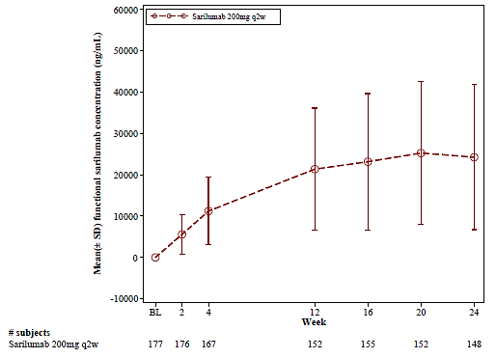
The incidence of ADA in the sarilumab 200 mg q2w group was 7.1% (13/184), with 2.7% (5/184) persistent ADA response. None of the patients exhibited neutralising ADAs. Although the mean functional sarilumab serum concentrations in ADA positive patients were lower than in ADA negative patients there was overlap in concentrations between ADA positive and ADA negative patients (see Figure 3 below).
Figure 3: Study EFC14092/Monarch trial Serum functional sarilumab trough concentration in the sarilumab 200 mg q2w group at each visit by patient ADA status; PK population
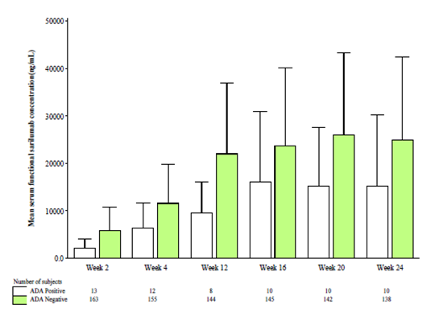

Evaluator’s conclusions on pharmacokinetics
In Study EFC14092/MONARCH trial, after multiple SC administrations of sarilumab 200 mg q2w, the observed trough concentrations of sarilumab indicated that steady state was reached between Week 12 and the next sampling time at Week 16, with about 4 fold accumulation. Although the mean serum functional sarilumab concentration in ADA positive patients were lower than in ADA negative patients, there was overlap in concentrations between ADA positive and ADA negative patients.
In Study MSC12665, in the AI assessment phase (Baseline to Week 12) there were no validated AI associated product technical failures reported among 600 injections. All injections were completed successfully using the AI. The 1 reported product technical complaint with the AI was verified to be due to user error and not due to a device failure. After 12 weeks of treatment, most patients (98%) were satisfied to very satisfied, with the AI, 88% of patients thought that the AI was very easy to use, 98% thought the injection time was normal, short, or very short and 91% were very confident to extremely confident about using the same AI for self-injection in the future.
In Study MSC12665, the AI 150 mg q2w and PFS 150 mg q2w treatments were bioequivalent at Weeks 10 to 12 based on the AUC0-τ values using standard criteria. No other comparisons for the C_{max} or AUC_{0-τ} between the AI and PFS at Weeks 0 to 2 or Weeks 10 to 12 were bioequivalent. However, the study was not powered to demonstrate bioequivalence between the AI and PFS at the 150 mg and 200 mg q2w doses. The totality of the PK data suggests that the observed PK differences between the AI and PFS presentations at the 150 mg q2w and 200 mg q2w doses are unlikely to result in significant clinical differences between the two presentations.

Pharmacodynamics

Studies providing pharmacodynamic data

Previously submitted studies providing pharmacodynamic information
The initial CER evaluated the PD of sarilumab in adult patients aged > 18 years with active RA from data collected from 5 Phase I studies, 3 Phase II/III trials and 3 population PK/PD analyses. The studies involved > 2000 patients who received sarilumab by SC injection across a broad dose range (from a single dose of 50 mg to 150 mg qw). The initial CER stated that none of the PD studies had deficiencies that excluded their results from consideration. The studies providing PD data are summarised in Table 7 and the studies providing population PK/PD data are summarised in Table 8.
The following summary of the PD of sarilumab is from data provided in the initial CER.
- The initial CER notes that the sponsor appropriately nominated mean changes in serum total IL-6R and sIL-6R levels as the primary PD markers of interest for sarilumab. Mean or median serum changes in serum inflammatory markers (CRP, serum amyloid A (SAA), fibrinogen and erythrocyte sedimentation rate (ESR)) were evaluated as the secondary PD biomarkers of relevance
- The initial CER stated that total sIL-6R can be regarded as a biomarker for sarilumab and is indicative of target engagement. Total sIL-6R is defined as free IL-6R plus IL-6R complexed with sarilumab after drug exposure. Free sIL-6R represents the amount of target that is pharmacologically available. The PD data confirmed that, following repeat dosing, sarilumab reduced the mean concentration of free sIL-6R, with the reductions relative to placebo being similar following sarilumab 100 mg qw, 150 mg qw and 200 mg q2w. Although the largest decrease in free sIL-6R was observed at 150 mg qw, the difference from the 200 mg q2w or the 100 mg qw doses was only marginal. The decrease in free sIL-6R appears to plateau at these three doses, presumably because of target saturation. The results are summarised in Figure 4 below.
Figure 4: Study EFC11072 (Part A) Serum concentrations of free sIL-6R following repeat SAR dosing
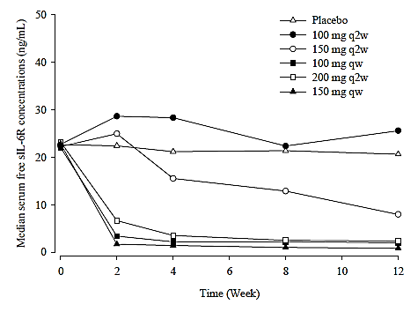
The decrease in free sIL-6R was reported to be accompanied by a corresponding increase in total sIL-6R, the vast majority being in the form of the biologically inert bound complex. When sarilumab is in excess of free IL-6 the target is saturated and any newly formed IL-6R is expected to be immediately complexed. With the elimination of the IL-6R-sarilumab complex being slower than its formation, the concentration of total IL-6R is expected to plateau. Thus, measurement of total sIL-6R serves as a direct and useful marker of target saturation. Consistent with observations of free sIL-6R, measurement of total sIL-6R indicated that target was near saturation after repeated administration of 200 mg q2w. In addition, when the sarilumab dose increased from 150 to 200 mg q2w, the increase in the concentrations of bound sarilumab (completely bound plus partially bound drug) was almost in proportion to dose, while functional sarilumab (completely free plus partially free drug) continued to increase in a greater than dose proportional manner, which further pointed toward a near saturation of the target by the 200 mg q2w dose. The initial clinical evaluator notes that the sponsor asserts that these observations support the selection of the 150 and 200 mg q2w dose regimens for the Phase III studies, and justify the proposed commercial posology of 200 mg q2w as the most effective dose.
- The initial CER stated that reductions in free sIL-6R, CRP and other PD biomarkers are correlated with sarilumab exposure and were accompanied by efficacy improvements. In addition, it was stated that PK/PD analyses supported the conclusion from the dose-response relationships that the 150 and 200 mg q2w doses were appropriate for the Phase III program. The PK/PD relationships for safety endpoints (neutropaenia, elevated serum ALT values and raised low density lipoprotein (LDL) levels) showed a higher rate of adverse effects with an increasing sarilumab concentration, but the effect reached a plateau at the lower concentration range observed with sarilumab 150 mg q2w therapy, apart from neutropaenia. The relationship between mean absolute neutrophil count (ANC) and sarilumab serum trough concentration is summarised in Figure 5.
Figure 5: Study EFC11072 (Part A) Neutrophil count versus serum trough SAR concentration at Week 12
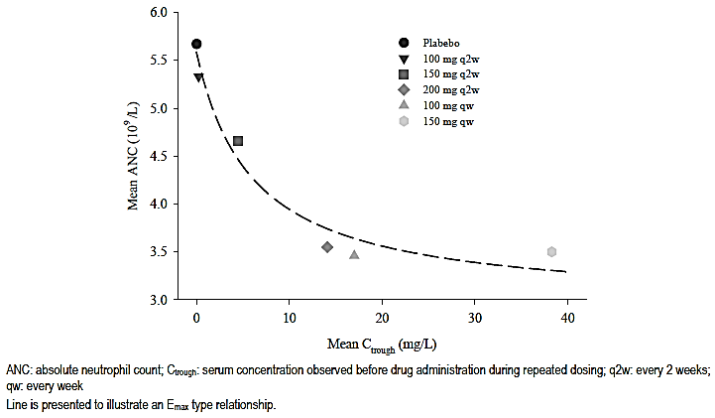
- The initial CER stated that in the pivotal Phase III studies, CRP levels decreased to within the normal range (< 10 mg/L) and SAA levels were < 20 mg/L when the trough concentration of sarilumab was above 1 mg/L. The combined Phase III trial dataset showed that a higher percentage of patients treated with SC sarilumab 200 mg q2w had sarilumab trough concentrations above 1 mg/L by week 24 (86%) than patients treated with SC sarilumab 150 mg q2w (61%). The sponsor considers this finding to be a pivotal piece of evidence justifying the proposed posology of 200 mg q2w.

Evaluator’s conclusions on pharmacodynamics
The PD data relating to neutrophil kinetics and function following sarilumab suggest that:
- ANC levels dropped and rebounded quickly following single-dose sarilumab (Study 6R88-RA-1309) but there were no data from the study assessing ANC levels after repeat-dose sarilumab. However, there are repeat-dose data from the pivotal Phase III monotherapy Study EFC14092/MONARCH trial showing that mean neutrophil counts rapidly decline following sarilumab 200 mg q2w, reaching a lowest point (nadir) at Week 4 and then stabilising through to Week 24 (see Figure 6, below). In the sarilumab 200 mg q2w group, the percent reduction from baseline to Week 24 in the mean neutrophil count was approximately 39%, however, the mean ANC level at each visit remained within normal limits for the study (1.96 to 7.23 Giga/L). The majority of patients treated with sarilumab 200 mg q2w in whom ANC was < 1.0 Giga/L were able to continue treatment with sarilumab 150 mg q2w following treatment interruption.
Figure 6: Study EFC14092/MONARCH trial Mean neutrophil count at each visit from Baseline through to Week 24; Safety population
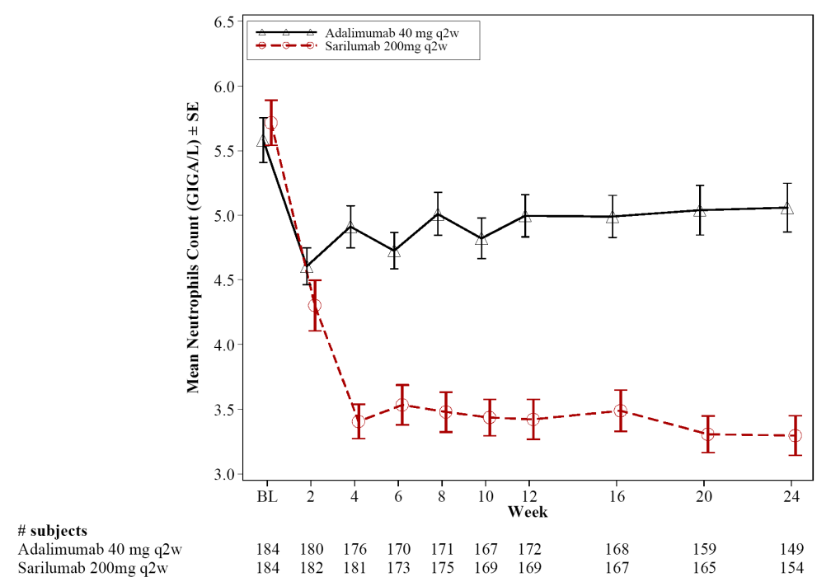
- Sarilumab had no detrimental effect on neutrophil function (Study PM12058). Similar findings have been observed for the IL-6 inhibitor tocilizumab.
- The sponsor reports that the single dose sarilumab data from Study 6R88-RA-1309 were well described by a PD margination model. Neutrophil margination following sarilumab administration provides a possible explanation for the absence of impairment in neutrophil function as well as the lack of an observed association between ANC decrease and infection.

Dosage selection for the pivotal studies
The sponsor states that the sarilumab 200 mg q2w monotherapy dose regimen used in the pivotal Phase III Study EFC14092/MONARCH trial was selected in order to achieve an optimal clinical response. In a prior study with sarilumab, Study EFC11072 (Part B), data showed that, in general, sarilumab 200 mg q2w + DMARD provided superior efficacy compared with sarilumab 150 mg q2w + DMARD. In addition, sarilumab 200 mg q2w was generally well tolerated with no clear dose relationship in overall treatment emergent adverse events (TEAEs) compared with sarilumab 150 mg q2w. Therefore, based on the comparative efficacy and safety data, and to optimise patient benefit, the sponsor selected the 200 mg q2w sarilumab dose over the 150 mg q2w sarilumab dose for the head to head comparison with adalimumab 40 mg q2w in the pivotal Phase III Study EFC14092 MONARCH. The sponsor selected adalimumab as the comparator, given its widespread use in clinical practice and clinical data supporting its use as monotherapy for RA patients who do not respond to MTX or who are MTX intolerant. The standard approved dose of adalimumab is 40 mg q2w when used as monotherapy. The initial dose of adalimumab 40 mg q2w allows for escalation from q2w to qw in case of lack of efficacy.
The sponsor's decision to use sarilumab 200 mg q2w rather than sarilumab 150 mg q2w in the pivotal monotherapy study is acceptable. However, it is considered that it would have been more appropriate to have selected tocilizumab, the only other approved IL-6 inhibitor, as the active comparator in Study EFC14092/MONARCH trial rather than adalimumab. The initial submission included a comparison, primarily assessing safety, between sarilumab + DMARD and tocilizumab + DMARD for the treatment of RA in the Phase III Study SFY13379. The risks of treatment with sarilumab and tocilizumab based on the safety data from Study SFY13379 were reviewed in this current CER. The sponsor is requested to justify why tocilizumab was not selected as the active comparator for the pivotal Phase III monotherapy Study EFC14902 (see Clinical questions, below).

Efficacy

Studies providing efficacy data

Sarilumab in combination with conventional DMARDs (cDMARDs)
The initial submission included 2 pivotal Phase III studies of similar design in support of the application to register sarilumab in combination with cDMARD for the treatment of patients with RA (Part B Study EFC11072; Study EFC10832). Both of these studies have been previously evaluated by the TGA and considered by the TGA’s Advisory Committee on Prescription Medicines (ACM).
Study EFC11072 (MOBILITY trial) was a 2 part, double-blind, placebo-controlled study conducted in patients with an inadequate response to MTX. In this study, sarilumab or placebo was administered SC in combination with MTX. Part A was the 12 week Phase II, dose-ranging part of the study (n = 306) and Part B was the 52 week, Phase III efficacy part of the study (n = 1197).
Study EFC10832 (TARGET trial) was a 24 week, double-blind, placebo-controlled study in patients (n = 546) who had a history of inadequate response to TNF inhibitors or were intolerant to TNFs. In this study, sarilumab or placebo was administered SC in combination with a cDMARD (MTX, sulfasalazine, hydroxychloroquine, or leflunomide).
The initial CER also included an evaluation of the data from the open-label long-term extension study (Study LTS11210). The initial submission also included additional data from this study which was received by the TGA after the initial CER had been completed and the report provided to the sponsor. This additional data consisted of a comparison of radiological progression through to 3 years for patients from Study EFC11072 who had been initially randomised to 52 weeks treatment with placebo + MTX, sarilumab 150 mg q2w + MTX or sarilumab 200 mg q2w + MTX and then enrolled into Study LTS11210 to continue open-label sarilumab + DMARD treatment for 96 weeks (148 weeks of treatment from Study EFC11210 Baseline). This additional data has been reviewed by the Delegate and considered by the ACM. The re-submission included the previously submitted analysis of 3 year radiological data from Study LTS1121 and updated clinical efficacy response and remission data for Study LTS11210 for the sarilumab + DMARD group from Week 0 to Week 264 (data in initial CER was from Week 0 to Week 216), and updated radiological progression data for Study LTS11210 through to Week 96 (148 weeks from baseline in Study ECF11210; data in the initial CER was through to Week 48 (100 weeks from baseline in Study ECF11210)). The updated efficacy data for the sarilumab + DMARD group from Study LTS11210 have been reviewed as part of the consideration of the benefit-risk balance assessment.

New studies providing evaluable efficacy data
The submission included one pivotal Phase III efficacy and safety study comparing sarilumab monotherapy (200 mg q2w; n = 184) with adalimumab monotherapy (40 mg q2w; n = 185) in patients with active RA who were intolerant to DMARDs or were inadequate responders to DMARDs. The CSR included the results for the randomised, double-blind, double-dummy, active-controlled 24 week treatment period. The open-label extension period (Week 24 through to Week 276) is ongoing. The clinical data from the 24 week treatment period have been evaluated in this CER.
The 24 week data from the study was published in 2016.

Evaluator’s conclusions on efficacy
The re-submission included one pivotal Phase III monotherapy study (Study EFC14092/MONARCH trial) comparing sarilumab 200 mg q2w (n = 184) with adalimumab 40 mg q2w (n = 185) in patients with active RA who were considered to be unsuitable candidates for continued treatment with MTX due to intolerance or inadequate response. Comparison of the two treatments in the randomised, double-blind, 24 week period convincingly demonstrated that the efficacy of sarilumab was superior to adalimumab. The study is considered to be of good quality and the results are considered to be reliable. The superior efficacy of sarilumab compared with adalimumab is considered to be clinically meaningful.
The primary efficacy endpoint analysis showed that sarilumab was statistically significantly superior to adalimumab as regards the change from baseline to Week 24 in the DAS28-ESR score, (least square (LS) mean difference = -1.077 (95% CI: -1.361, -0.793), p < 0.0001). The mean difference between the two treatment groups was > 0.6, which was the difference specified by the sponsor as being clinically relevant. The difference between the two treatment groups in DAS28-ESR score was statistically significant at Week 12 (supportive analysis), when the first post-baseline assessment was undertaken (nominal p < 0.0001).
The two pre-specified sensitivity analyses of the change from baseline in the DAS28-ESR score at Week 24 were consistent with the primary analysis. In addition, the pre-specified subgroup analyses showed that the change from baseline to Week 24 in the DAS28-ESR scores consistently favoured the sarilumab group compared with the adalimumab group.
There were 8 secondary efficacy endpoints that, together with the primary efficacy endpoint, were tested in a pre-specified hierarchical testing procedure control the overall alpha rate at the 0.05 level. The 6 secondary efficacy variables that statistically significantly favoured patients in the sarilumab group compared with the adalimumab group, respectively, in the pre-specified hierarchical testing procedure were remission at Week 24 as assessed by the DAS28-ESR < 2.6 (26.6% versus 7.0%, p < 0.0001), American College of Rheumatology (ACR) 50 response at Week 24 (45.7% versus 29.7%, p = 0.0017), ACR70 response at Week 24 (23.4% versus 11.9%, p = 0.0036), ACR20 response at Week 24 (71.1% versus 58.4%, p = 0.0074), improvement from baseline in Health Assessment Questionnaire-Disability Index (HAQ-DI) score at Week 24 (LS mean change -0.61 versus -0.43, p = 0.0037), and improvement from baseline in Medical Outcomes Study 36-Item Short Form Health Survey (SF-36), (PCS) at Week 24 (LS mean change 8.74 versus 6.09, p = 0.0006). The 2 secondary efficacy endpoints in the pre-specified hierarchical testing procedure that numerically, but not statistically significantly, favoured the sarilumab group compared with the adalimumab group were the changes in the Functional Assessment of Chronic Illness Therapy (FACIT) Fatigue and SF-36 (MCS) scores at Week 24 compared with baseline.
There were no efficacy data for sarilumab beyond 24 weeks of treatment. Long-term sarilumab open-label treatment is ongoing. The sponsor is making no claims regarding the ability of sarilumab monotherapy to delay radiological progression, and there were no data in Study EFC14092/MONARCH trial relating to this endpoint. There were no efficacy data in patients with hepatic or renal impairment.

Safety

Studies providing evaluable safety data total safety population
The sponsor stated that a total of 3354 patients have received at least one dose of sarilumab, either as monotherapy or as combination therapy with DMARD in the RA clinical development program. These 3354 patients provide 5981.0 patient-years (PY) of cumulative exposure to sarilumab, with or without combination DMARD.
The global RA clinical development program consists of 9 Phase II and III studies and 9 Phase I PK and clinical pharmacology studies. Of the Phase II and III studies, 6 studies have been completed or terminated, and 3 studies are ongoing. Of the 3 ongoing studies, 2 had randomised treatment periods (main study) which have been completed, with only the open-label extension ongoing. All Phase I studies have been completed. The total safety population is considered to be of adequate size to satisfactorily characterise the safety of sarilumab for the treatment of patients with RA.
Of the 3354 patients in the total safety population, 2887 patients have received sarilumab in combination with conventional DMARD (5681.6 PY of cumulative exposure (updated data re-submission)), and 467 have received sarilumab monotherapy (299.4 PY) of cumulative exposure (updated data re-submission)). Therefore, the majority of patients in the total safety population have received sarilumab in combination with conventional (non-biologic) DMARDs for the treatment of RA rather than as monotherapy. There are no safety data for sarilumab in combination with biologic DMARDs for the treatment of RA.
In the updated safety data provided in the re-submission, of the 2887 patients who received sarilumab plus DMARD, 1960 patients have been exposed to sarilumab for at least 48 weeks, 1298 patients for at least 96 weeks, 906 patients for at least 144 weeks, and 523 patients for at least 192 weeks. Of the 467 patients who received sarilumab monotherapy, 109 patients have been exposed to sarilumab for at least 48 weeks.
In the initial CER, the evaluator considered the safety data from the 2887 patients who received at least 1 dose of sarilumab in combination with cDMARDs. In the initial submission the sponsor proposed registration of sarilumab in combination with cDMARDs. Therefore, safety data for sarilumab monotherapy was not evaluated in the initial CER. Consequently, in the current CER the focus is on the safety data for sarilumab from the monotherapy studies (n = 467), in particular the new pivotal Phase III Study EFC14092 MONARCH comparing sarilumab 200 mg q2w (n = 184) with adalimumab 40 mg q2w (n = 184).
In both the initial submission and the re-submission, the sponsor’s Summary of Clinical Safety (dated 6 October 2015, initial submission and 31 May 2016, re-submission) separated the safety data from the Phase II and III clinical studies into three pools (Pool 1, Pool 2, and Pool 3), and provided an integrated analysis of safety for each of the three pooled populations. The studies contributing to the three pools are summarised below in Table 12.

Table 12: Summary of the safety populations (pools) for Phase II and III studies
The approach to the evaluation of safety in this CER has been firstly to summarise the key previously evaluated safety data provided in the initial submission relating to sarilumab in combination with conventional DMARD and secondly, to evaluate the new safety data provided in the re-submission relating to sarilumab monotherapy.

Studies providing evaluable safety data from the initial clinical evaluation report; sarilumab in combination with DMARD
The initial CER summarised the safety data from:
- Two pivotal Phase III efficacy and safety studies for sarilumab in combination with cDMARDs, namely, Studies EFC11072 (Part B) and EFC10832;
- Three dose-response and non-pivotal efficacy studies, namely, Studies EFC11072 (Part A) (dose-finding), LTS11201 (ongoing, long-term extension) and SFY13370 (comparing sarilumab with tocilizumab over 24 weeks);
- Three studies evaluable for safety only (Studies MSC12655, ACT11575 and EFC11545); and
- 9 clinical pharmacology studies.
The studies evaluated by the initial clinical evaluator are summarised in the initial CER (see Attachment 2 of AusPAR for Kevzara PM-2015-04024-1-3 on the TGA website).

Clinical safety sarilumab monotherapy new data not previously evaluated

Studies providing evaluable safety data monotherapy
In this CER, the approach to the evaluation of the safety of sarilumab monotherapy has been to evaluate the data from the pivotal Phase III sarilumab monotherapy Study EFC14092/MONARCH trial (sarilumab 200 mg q2w (n = 184) versus adalimumab 40 mg q2W (n = 184)) and the data from Pool 3 (n = 467).
Pool 3, which has not been previously evaluated, includes patients who received sarilumab as monotherapy in Studies EFC13752 and EFC14092 (main study and extension), and patients who received sarilumab monotherapy in Study EFC13752 and who continue to receive monotherapy in the long-term Study LTS11210. Pool 3 includes data from the first dose of sarilumab to the end of the study or to the date of data extraction for patients from Study EFC13752 who are continuing in Study LTS11210. The contribution of patients from each of the each of the studies to Pool 3 is provided above in Table 12. The sponsor stated that differences in exposure between the two sarilumab monotherapy groups (150 q2w and 200 mg q2w) in Pool 3 limit the safety comparison between the two groups. Therefore, in the sponsor’s Summary of Clinical Safety (31 May 2016) the ‘any sarilumab dose population’ was selected by the sponsor as the focus of the Pool 3 analysis.
It is considered that the key safety data for sarilumab monotherapy relate to Study EFC14092/MONARCH trial, as this study compares sarilumab 200 mg q2w and adalimumab 40 mg q2w (an approved dosage regimen) for the treatment of RA. The safety profile for the sarilumab monotherapy 200 mg q2w group in Study EFC14092/MONARCH trial was similar to the safety profile for the any sarilumab monotherapy dose group in Pool 3.

Patient exposure

Study EFC14092 MONARCH Pivotal Phase III monotherapy
The cumulative exposure to double-blind treatment was similar for the sarilumab 200 mg q2w and the adalimumab 40 mg q2w treatment groups. There were 184 patients in the safety population for each treatment group, with a cumulative exposure of 78.7 PY in the sarilumab group and 77.3 PY in the adalimumab group. The median duration of treatment was 168 days in both the sarilumab group (range: 14, 175 days) and the adalimumab group (range: 14, 178 days). In the sarilumab group, 165 (89.7%) patients were treated for > 20 weeks and 28 (15.2%) for > 24 weeks, and in the adalimumab group 160 (87.0%) patients were treated for > 20 weeks and 22 (12.0%) patients were treated for > 24 weeks.
In the adalimumab 40 mg q2w group, 16 (8.7%) patients had the adalimumab dose increased (n = 15 at Week 16, n = 1 at Week 20) compared with 8 (4.3%) patients in sarilumab 200 mg q2w group who had the adalimumab placebo control increased (all 8 at Week 16).

Pool 3 sarilumab monotherapy safety population
Patients in Pool 3 (n = 467) had a total exposure to sarilumab monotherapy of 299.4 PY. The median duration of exposure was 225 days (range: 14, 574 days). There were 109 (23.3%) patients exposed to sarilumab for > 48 weeks, 107 (22.9%) patients exposed to sarilumab for > 60 weeks, and 37 (7.9%) patients exposed to sarilumab for > 72 weeks. Exposure to the initial dose of 150 mg q2w ended at the conclusion of the main study period of Study EFC13752 (approximately 24 weeks). The patients who continued in Study LTS11210 from EFC13752 or the EFC14092 extension period received sarilumab 200 mg q2w.

Additional TEAEs of regulatory interest (Study EFC14092/MONARCH trial)

ECG findings
No notable differences were observed between treatment groups in ECG parameters during the study (in cardiac parameters such as heart rate (HR) or PR, QRS or QTcs intervals). There were no notable differences between the two treatment groups as regards potentially clinically significant changes in the QTcF during the study, with QTcF > 450 ms being reported in 4.3% (7/163) of patients in the adalimumab group and 3.1% (5/162) of patients in the sarilumab group. No patients in either treatment group reported QTcF values > 480 ms. Increases in QTcF from baseline of > 30 ms to ≤ 60 ms were reported in 7.7% (9/159) of patients in the adalimumab group and 1.9% (3/159) of patients in the sarilumab group. No patients in either treatment group reported increases from baseline in QTcF of > 60 ms.

Cardiovascular safety
Cardiac disorders (System Organ Class (SOC)) were reported in a small number of patients in both the adalimumab and sarilumab groups (1.6%, n = 3 versus 2.2%, n = 4, respectively). The cardiac disorders in the 3 patients in the adalimumab group were palpitations x 2 and myocardial ischaemia x 1. The cardiac disorders in the 4 patients in the sarilumab group were atrial fibrillation x 2 and 1 x each for cardiac failure acute, coronary artery dissection, palpitations and papillary muscle rupture.
Cardiac disorders serious adverse events (SAEs) were reported in 1 (0.5%) patient in the sarilumab group (1 x each for cardiac failure acute, coronary artery dissection, and papillary muscle rupture) and no patients in the adalimumab group. The cardiac disorder SAEs reported in the 1 patient in the sarilumab group resulted in permanent treatment discontinuation and death.
The study included an independent cardiovascular adjudication committee (CAC), which applied uniform criteria for the evaluation of cardiovascular (CV) events. The CAC reviewed and adjudicated all deaths and serious CV adverse events to identify events of major adverse cardiac events (MACE) which were defined as CV death, myocardial infarction, stroke, hospitalisation for unstable angina, or hospitalisation for transient ischemic attack. Serious cardiovascular adverse events sent for adjudication were identified by a list of Standardised Medical Dictionary for Regulatory Activities (MedDRA) Queries (SMQs) as specified in the CAC Charter. In addition, any non SAE requiring a cardiovascular procedure was sent for adjudication.
The CAC identified 2 patients with MACE (1 in each treatment group). In the adalimumab group, the 1 patient with MACE was adjudicated to have experienced a non-fatal stroke (preferred term cardiovascular accident (CVA)), and in the sarilumab group the 1 patient with MACE was adjudicated to have experienced CV death (preferred terms cardiac failure acute, papillary muscle rupture, coronary artery dissection).

Renal and urinary disorders
Renal and urinary disorders (SOC) were reported in 1 (0.5%) patient in the adalimumab group (1x renal cyst) and 2 (1.1%) patients in the sarilumab group (1x dysuria and 1x renal colic). None of the events were reported as SAEs or resulted in death. None of the TEAEs resulted in permanent treatment discontinuation.
Laboratory changes from baseline in serum creatinine of ≥ 30% was reported in 10.4% (19/183) of patients in the adalimumab group and 12.5% (23/184) of patients in the sarilumab group, while increases of ≥ 100% from baseline were reported in no patients in the adalimumab group and 1 (0.5%) patient in the sarilumab group. Serum creatinine levels of ≥ 150 µmol/L during treatment were reported in no patients in the adalimumab group and 3 (1.6%) patients in the sarilumab group. Severe decrease in glomerular filtration rate (GFR) (≥ 15 mL/min to < 30 mL/min) was reported in no patients in the adalimumab group and 1 (0.5%) patient in the sarilumab group, moderate decrease in GFR (≥ 30 mL/min to < 60 mL/min) was reported in 21 (11.5%) patients in the adalimumab group and 22 (12.0%) patients in the sarilumab group, and mild decrease in GFR (≥ 60 mL/min to < 90 mL/min) was reported in 74 (40.4%) patients in the adalimumab group and 65 (35.3%) patients in the sarilumab group. End stage renal disease (GFR < 15 mL/min) was reported in no patients in either of the two treatment groups. Uric acid levels > 408 µmol/L were reported in 13.7% (n = 25) of patients in the adalimumab group and 19.0% (n = 35) of patients in the sarilumab group.

Skin and subcutaneous tissue disorders
Skin and subcutaneous tissue disorders (SOC) were reported in the same proportion of patients both treatment groups (7.1%, n = 13). TEAEs (preferred terms) reported in ≥ 2 patients in either the adalimumab group or the sarilumab group, respectively, were rash (1.6%, n = 3 versus 0.5%, n = 1), dermatitis allergic (1.1%, n = 2 versus 1.1%, n = 2), and pruritus (0.5%, n = 1 versus 1.1%, n = 2). All other TEAEs were each reported in 1 patient in both or one of the treatment groups. There were no reports of Stevens-Johnson syndrome or toxic epidermal necrolysis.
No Skin or subcutaneous tissue disorders were reported as SAEs or resulted in death. Skin or subcutaneous tissue disorders leading to permanent treatment discontinuation were reported in 1 (0.5%) patient in the sarilumab group (dermatitis allergic) and no patients in the adalimumab group.

Other laboratory assessments (haematological and clinical chemistry)
The normal range for haemoglobin in the study was 116 to 164 g/L. Increases in mean hemoglobin were observed at all time points in the sarilumab group compared with the adalimumab group. At Week 24, a mean increase of 6.0 g/L from baseline was observed in the sarilumab group, compared with a mean increase of 1.1 g/L in the adalimumab group. The mean values of haemoglobin remained within the normal range in both treatment groups from baseline through to Week 24. The proportion of patients with haemoglobin values ≤ 115 g/L (male) or ≤ 95 g/L (female) was greater in the adalimumab group than in the sarilumab group (6.5%, n = 12 versus 3.8%, n = 7, respectively). The proportion of patients with decrease in hemoglobin from baseline ≥ 20 g/L was identical in both treatment groups (2.7%, n = 5).
No abnormalities of note were observed in the other laboratory assessments.

Vital signs in Study EFC14092/MONARCH trial
There were no marked differences between the two treatment groups in the proportion of patients with potentially significant clinical significant abnormalities in vital signs.

Immunogenicity in Study EFC14092/MONARCH trial
ADA was assessed for patients in the sarilumab group in order to explore the potential association between ADA positivity and clinical outcomes. A total of 184 patients had ADA results available. At baseline, 98.9% (174/176) of patients had an ADA negative sample and 1.1% (2/176) of patients had an ADA positive sample (both neutralising antibody (Nab) negative). Of the 184 patients with available ADA results, 13 (7.1%) were treatment-emergent ADA positive, including 5 (2.7%) with a persistent ADA positive response (all NAb negative) and 8 (4.3%) with a transient ADA positive response (all NAb negative).
None of the 13 patients who were ADA positive discontinued treatment from a lack or loss of efficacy. Of the 13 patients who were ADA positive, 3 (23.1%) had a hypersensitivity reaction compared with 7 (4.1%) of the 171 patients who were ADA negative. The hypersensitivity reactions in the 3 ADA positive (transient) patients were described as mild, localised rashes and recovery occurred without treatment interruption or discontinuation. The sponsor stated that there was no evidence of a direct relationship between ADA formation and rash. There were no reported cases of anaphylaxis.

Safety in special groups in Study EFC14092/MONARCH trial
There were no data in the CSR exploring safety of sarilumab 200 mg q2w in special groups (such as age, gender, race, hepatic impairment or renal impairment).

Post marketing data
Not applicable. This is an application to register a new biological entity.

Evaluator’s conclusions on safety
The safety of sarilumab 200 mg q2w as monotherapy for the treatment of RA has been adequately demonstrated in the pivotal Phase III Study EFC14092/MONARCH trial, and is supported by the data from the sarilumab any dose group in the integrated monotherapy safety analysis provided in Pool 3.
In the pivotal Phase III study, the safety of sarilumab 200 mg q2w (n = 184) was compared with the safety of adalimumab 40 mg q2w (n = 184) in a 24-week, randomised, double blind, double-dummy, treatment period. Total exposure was 78.7 PY in the sarilumab group and 77.3 PY in the adalimumab group. The median duration of treatment was 168 days in both the sarilumab group (range: 14, 175 days) and the adalimumab group (range: 14, 178 days). In the sarilumab group, 165 (89.7%) patients were treated for > 20 weeks and 28 (15.2%) patients for > 24 weeks and in the adalimumab group, 160 (87.0%) patients were treated for > 20 weeks and 22 (12.0%) patients were treated for > 24 weeks.
At the Week 16 or 20 visit adalimumab or matching placebo may have been increased to 40 mg every week in case of patients with lack of efficacy defined as less than 20% improvement from baseline in swollen joint count (SJC) and tender joint count (TJC) for 2 consecutive visits. In the adalimumab 40 mg q2w group, 16 (8.7%) patients had a dose increase to adalimumab 40 mg qw (n = 15 (8.2%) at Week 16; n = 1 (0.5%) at Week 20) compared with 8 (4.3%) patients with matched adalimumab placebo in the sarilumab 200 mg q2w group (all 8 (4.3%) patients at Week 20).
In the pivotal Phase III Study EFC14092/MONARCH trial, TEAEs were observed in a similar proportion of patients in the sarilumab 200 mg q2w and adalimumab 40 mg q2w groups (64.1% versus 63.6%, respectively), as were treatment-emergent SAEs (4.9% versus 6.5%, respectively) and TEAEs leading to permanent treatment discontinuation (6.0% versus 7.1% respectively). TEAEs leading to death were reported in 1 (0.5%) patient in the sarilumab group (CV causes) and no patients in the adalimumab group.
In the pivotal Phase III Study EFC14092/MONARCH trial, the most commonly reported adverse events of special interest (AESIs) in both treatment groups were infections, which were occurred in a similar proportion of patients in both the sarilumab 200 mg q2w group and the adalimumab 40 mg q2w group (28.8% versus 27.7%, respectively). Serious infections occurred infrequently and in the same proportion of patients in the two treatment groups (1.1%, n = 2), as did opportunistic infections (0.5%, n = 1), while tuberculosis (TB) occurred in 1 (0.5%) patient in the adalimumab group and no patients in the sarilumab group. AESIs of leukopaenia, injection site reactions and hepatic disorders occurred more frequently in patients in the sarilumab group than in patients in the adalimumab group. AESIs of elevation in lipids occurred more frequently in patients in the adalimumab group than in patients in the sarilumab group. Hypersensitivity reactions occurred in the same proportion of patients in both treatment groups, and there were no reports of anaphylaxis in either of the two treatment groups. All other AESIs occurred infrequently in both treatment groups. Laboratory abnormalities relating to neutropaenia, thrombocytopaenia, increased ALT, increased total bilirubin, increased total cholesterol, increased LDL cholesterol and increased triglycerides were all reported more frequently in the sarilumab group than in the adalimumab group. However, the mean values for the laboratory parameters for both treatment groups were consistently within normal ranges at all post-baseline visits through to Week 24.
In the pivotal Phase III Study EFC14092/MONARCH trial, of the 184 patients with available ADA results, 13 (7.1%) patients were treatment-emergent ADA positive, including 5 (2.7%) patients with a persistent ADA positive response (all NAb negative) and 8 (4.3%) with a transient ADA positive response (all NAb negative). None of the 13 patients who were ADA positive discontinued treatment due to lack or loss of efficacy, while 3 of the ADA positive patients experienced mild, localised, hypersensitivity rashes.
The main limitation of Study EFC14092 MONARCH is the absence of long-term safety data. However, the study is ongoing and patients who complete the initial 24 week treatment period have the option to continue in the open-label extension period where all patients receive sarilumab 200 mg q2w for a maximum of 276 weeks. The lack of long-term safety data in Study EFC14092/MONARCH trial is mitigated by the pooled monotherapy safety data from the integrated safety analysis (Pool 3) in which 467 patients treated with any dose of sarilumab (150 mg q2w (n = 65); 200 mg q2w (n = 251)) had cumulative exposure to active treatment of 299.4 PY, with a median duration of 255 days. In Pool 3, 109 (23.3%) patients were exposed to sarilumab for > 48 weeks, 107 (22.9%) patients for > 60 weeks, and 37 (7.9%) patients for > 72 weeks. Furthermore, pooled long-term safety data for sarilumab + DMARD are available from the integrated safety analysis in Pool 2 in which 2887 patients were exposed to any dose of sarilumab for 5681.6 years with 906 patients being exposed for > 144 weeks, and 523 patients being exposed for > 192 weeks. The long-term combination safety data for sarilumab + DMARD are consistent with the safety data for sarilumab monotherapy provided in the re-submission.
No data relating to the safety of sarilumab monotherapy based on age, gender, race, weight or body mass index (BMI) could be identified in the re-submission. This is a limitation of the monotherapy safety data. The sponsor is requested to provide monotherapy safety data in the subgroups of interest.
The sponsor states that no obvious trend in functional sarilumab exposure with age was observed in patients with RA in clinical studies. The sponsor reports that the population PK analysis (Study POH0428) in patients aged 18 to 88 years did not identify age as a significant covariate influencing the PK of sarilumab (14% of 2186 patients with RA in the data set were aged > 65 years). Therefore, the sponsor recommends no dose adjustments for elderly patients. There were limited data in the sarilumab + DMARD integrated analysis (Pool 1) in patients aged ≥ 75 years of age (n = 17). Serious infections occurred more frequently in patients aged < 65 years than in patients aged ≥ 65 years in the sarilumab 150 mg q2w + DMARD group (1.4% versus 5.1%, respectively) and in the sarilumab + DMARD group (2.6% versus 4.9%, respectively). The sponsor acknowledges that there are limited safety data in patients aged ≥ 65 years.
No data relating to the safety of sarilumab monotherapy or in combination with DMARDs in patients with hepatic or renal impairment were submitted. The sponsor states that no formal studies on the effects of hepatic or renal impairment on the PK of sarilumab have been conducted. Based on population PK analysis, the sponsor reports that mild to moderate renal impairment did not affect the PK of sarilumab, consequently no dosage adjustment is required in patients with mild to moderate renal impairment. This is supported as the sarilumab monotherapy safety data showed that the drug did not cause renal toxicity. Severe renal impairment was an exclusion criterion for all Phase III studies and there are no safety data in patients with severe renal impairment. There are no safety data in patients with hepatic impairment, and the sponsor recommends that sarilumab not be used in patients with active hepatic disease or hepatic impairment. This is supported based on the AESI relating to hepatic disorders and increased ALT levels observed in both the sarilumab monotherapy studies and the sarilumab + DMARD studies.

First round benefit-risk assessment

First round assessment of benefits

Sarilumab monotherapy
The benefits of sarilumab monotherapy are favourable for the treatment of adult patients with moderate to severe RA who have had an inadequate response to, or are intolerant of, one or more DMARDs.
The key data establishing the benefits of sarilumab monotherapy for the proposed indication are based on the results from the pivotal Phase III Study EFC14092/MONARCH trial. The double-blind, 24 week data from this study convincingly support the benefits of monotherapy treatment with sarilumab 200 mg q2w (n = 184) compared with adalimumab 40 mg q2w (n = 185). All randomised patients in this study had received at least one prior non-biological DMARD/immunosuppressive agent, while patients with prior biological DMARD experience were excluded from the study.
Adalimumab 40 mg q2w (alone or in combination with MTX) is approved in Australia for reducing the signs and symptoms, as well as inhibiting the progression of structural damage, in adult patients with moderate to severely active RA. Therefore, the choice of adalimumab 40 mg q2w as the active control selected by sponsor for comparison with sarilumab 200 mg q2w is considered to be clinically appropriate. However, it might have been more appropriate to have selected the IL-6 receptor inhibitor tocilizumab as the control drug, given that it is from the same class of drugs as sarilumab. There were no monotherapy data assessing the effects of sarilumab on inhibiting progression of structural joint damage but the sponsor is not seeking an indication for this outcome. There were no data from Study EFC14092/MONARCH trial supporting the efficacy of sarilumab monotherapy in patients with RA treated with the drug for longer than 24 weeks.
The results from Study EFC14092/MONARCH trial for the primary efficacy endpoint of change from baseline in DAS28-ESR at Week 24 were statistically significantly superior in the sarilumab group compared with the adalimumab group, and the difference between the two groups is considered to be clinically meaningful. In addition, the benefits of sarilumab compared with adalimumab were statistically significantly superior for 6 of the 8 secondary efficacy endpoints assessed using a pre-specified hierarchical testing procedure to control the overall alpha error rate at the 0.05 level. The 6 statistically significant efficacy endpoints demonstrating superiority of the sarilumab group compared with the adalimumab group were DAS28-ESR remission (DAS28-ESR < 2.6) at Week 24, ACR50 response at Week 24, ACR70 response at Week 24, ACR20 response at Week 24, improvement from baseline in HAQ-DI score at Week 24, and improvement from baseline in SF-36 (PCS) at Week 12. The 2 secondary efficacy endpoints showing no statistically significant difference between the two treatment groups using the hierarchical testing procedure were the change from baseline to Week 24 in the FACIT Fatigue score and the change from baseline to Week 24 in the SF-36 (MCS) score. The results for the primary efficacy endpoint and the 8 secondary efficacy endpoints included in the hierarchical testing procedure, listed in the order in which testing proceeded, are provided below in Table 13.

Table 13: Study EFC14092/MONARCH trial Primary and secondary efficacy endpoints pre-specified hierarchical testing order to control for multiplicity, ITT population
Parameter | ADA 40 mg q2w (n = 185) |  | SAR 200 mg q2w (n = 184) | SAR versus ADA (95% CI) |  | p value
Primary efficacy variable
DAS28-ESR score (W24 - BL), LSM (SE) | -2.20 (0.106) | -3.28 (0.105) |  | Δ = -1.077 (-1.361, -0.793) | < 0.0001
Secondary efficacy variables
DAS28-ESR (< 2.6) remission W24, % | 7.0% (n = 13) | 26.6% (n = 49) |  | OR = 4.879 (2.536, 9.389) | < 0.001
ACR50 response W24, % | 29.7% (n = 55) | 45.7% (n = 84) |  | OR = 1.976 (1.289, 3.028) | = 0.0017
ACR70 response W24, % | 11.9% (n = 22) | 23.4% (n = 43) |  | OR = 2.286 (1.300, 4.020) | = 0.0036
ACR20 response W24, % | 58.4% (n = 108) | 71.7% (n = 132) |  | OR = 1.800 (1.168, 2.773) | = 0.0074
HAQ-DI score (W24-BL), LSM (SE) | -0.43 (0.045) | -0.61 (0.045) |  | Δ = -0.182 (-0.305, -0.059) | = 0.0037
SF-36 (PCS) score (W24-BL), LSM (SE) | 6.09 (0.555) | 8.74 (0.555) |  | Δ = 2.650 (1.147, 4.153) | = 0.0006
FACIT Fatigue score (W24-BL), LSM (SE) | 8.41 (0.709) | 10.18 (0.701) |  | Δ = 1.768 (-0.137, 3.674) | = 0.0689 (NS)
SF-36 (MCS) score (W24-BL), LSM (SE) | 6.83 (0.774) | 7.86 (0.773) |  | Δ = 1.036 (-1.061, 3.132) | = 0.3319 (NS)
Notes: ADA 40 mg q2w = adalimumab 40 mg every 2 weeks; SAR 200 mg = sarilumab 200 mg every 2 weeks; W24 = Week 24; BL = Baseline; LSM (SE) = least square mean (standard error) change from baseline to Week 24; Δ = LSM difference (SAR-ADA); OR = odds ratio (SAR/ADA); NS = not statistically significant.
The pre-specified subgroup analyses showed that the change from baseline to Week 24 in the DAS28-ESR scores consistently favoured the sarilumab group compared with the adalimumab group (see Table 14 and Figure 7). There were statistically significant interactions between treatment and baseline CRP (greater treatment effect observed in patients with CRP levels > 15 mg/mL) and treatment and baseline BMI (greater treatment effect in patients with BMI < 25 kg/m²).
Figure 7: Study EFC14092/MONARCH trial DAS28-ESR change from baseline forest plot at Week 24; ITT population
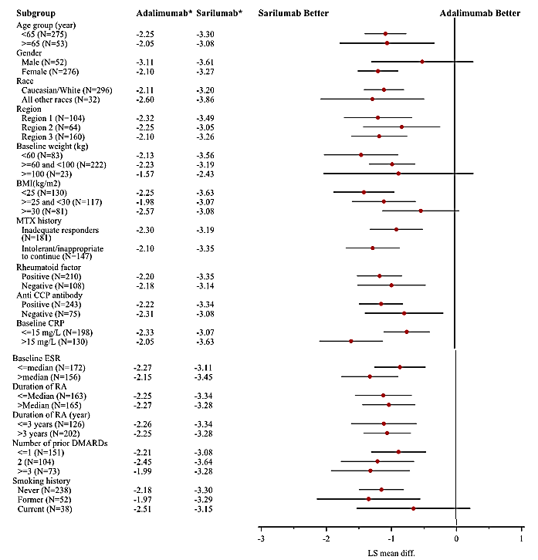

Table 14: Study EFC14092/MONARCH trial Subgroup analyses of change from baseline in DAS28-ESR score to Week 24; ITT population

Table 14 (continued): Study EFC14092/MONARCH trial Subgroup analyses of change from baseline in DAS28-ESR score to Week 24; ITT population

Table 14 (continued): Study EFC14092/MONARCH trial Subgroup analyses of change from baseline in DAS28-ESR score to Week 24; ITT population

Table 14 (continued): Study EFC14092/MONARCH trial Subgroup analyses of change from baseline in DAS28-ESR score to Week 24; ITT population
The strengths of the sarilumab monotherapy benefit data based on Study EFC14092/MONARCH trial are:
- Selection of adalimumab as the active control, given that the drug is approved for treatment of the proposed indication;
- Robust demonstration of the statistically significant superiority of sarilumab compared with adalimumab (p value < 0.0001) based on the primary efficacy endpoint of change from baseline in DAS28-ESR at Week 24;
- Clinically meaningful difference of 1.077 in DAS28-ESR in favour of sarilumab compared with adalimumab, given that the sample size was based on a pre-specified clinically relevant difference between the two treatments of 0.6;
- Benefits of sarilumab compared with adalimumab were statistically significantly better for 6 of the 8 secondary efficacy endpoints assessed using a pre-specified hierarchical testing procedure to control the overall alpha error rate at the 0.05 level;
- Pre-specified subgroup analyses showed that the change from baseline to Week 24 in the DAS28-ESR scores consistently favoured sarilumab compared with adalimumab.
The limitations and uncertainties of the sarilumab monotherapy benefit data based on Study EFC14092/MONARCH trial are:
- No data assessing the benefits of sarilumab compared with adalimumab for treatment lasting longer than 24 weeks;
- No monotherapy data assessing the effects of sarilumab on inhibiting progression of structural joint damage; and
- No data assessing the benefits of sarilumab 150 mg q2w.
The updated results for the long-term Study LTS11210 included efficacy data in 111 patients treated with sarilumab monotherapy at a dose of 200 mg q2w. In Study LTS11210, the assessment of efficacy was a secondary objective and all efficacy analyses were descriptive. All sarilumab monotherapy patients in Study LTS11210 were from Study EFC13752. In Study EFC13752, patients were exposed to 24 weeks treatment with sarilumab monotherapy before being enrolled in the long-term extension Study LTS11210. At enrolment, an almost equal number of patients from Study EFC13752 were receiving sarilumab 150 mg q2w (48.6% (n = 54)) or sarilumab 200 mg q2w (51.4% (n = 57)). The efficacy results from Week 0 through to Week 48 of Study LTS11210 in the 111 patients treated with sarilumab 200 mg q2w are summarised below in Table 15. The open-label data demonstrated that response and remission can be maintained with sarilumab 200 mg q2w for 48 weeks of extension treatment.
Table 15: Study LTS11210 Percentage of patients with ACR response and DAS remission (DAS-CRP < 2.6) in the sarilumab 200 mg q2w monotherapy population
Week | ACR20 | ACR50 | ACR70 | DAS28 remission
Week 0 | 91/111 (82.0%) | 65/11 (58.6%) | 36/11 (32.4%) | 51/110 (46.4%)
Week 24 | 96/109 (88.1%) | 70/109 (64.2%) | 40/107 (37.4%) | 65/109 (59.6%)
Week 48 | 27/30 (90.0%) | 22/30 (73.3%) | 12/28 (42.9%) | 16/30 (53.3%)
Note: The number (n) represents the subset of the total number of patients who had the response. The denominator (/N1) for each parameter within a treatment group is the number of patients for the treatment group who had that parameter assessed. ACR20/50/70 response = at least 20%/50%/70% improvements from baseline in both TJC and SJC, and in at least 3 of the 5 components (HAQ-DI score, CRP and 3 VAS assessments). A patient was not counted at a visit if there were insufficient information to determinate ACR20/50/70 response or non-response.
Overall, it is considered that the strengths of the data supporting the benefits of sarilumab 200 mg q2w as monotherapy for the proposed indication outweigh the limitation and uncertainties of the data.

Sarilumab in combination with conventional DMARDs (cDMARDs)
The benefits of sarilumab in combination with non-biologic DMARDs are favourable for the treatment of adult patients with moderate to severe RA who have had an inadequate response to, or are intolerant of, one or more DMARDs.
The benefits of both doses of sarilumab (150 mg q2w and 200 mg q2w) in combination with MTX and with cDMARD not limited to MTX have been satisfactorily demonstrated in Studies EFC11072 (MOBILITY) and EFC10832 (TARGET), respectively.

Study EFC11072 (MOBILITY)
The efficacy data from the pivotal Phase III Study EFC11072 (MOBILITY), Part B, satisfactorily demonstrated the efficacy of both doses of sarilumab (150 mg q2w [n = 400] and 200 mg q2w (n = 399)) in combination with MTX compared with placebo (n = 398). The results for the three co-primary efficacy endpoints and for the key secondary efficacy endpoint are summarised below in Table 16.

Table 16: Study EFC11072 Part B Results for the three co-primary efficacy endpoints and key secondary efficacy endpoint
The results for the three co-primary and the key secondary efficacy endpoint for both sarilumab doses were supported by the numerous secondary efficacy endpoints, all of which demonstrated numerical superiority of both doses of sarilumab in combination with MTX compared with placebo (see Table 17).

Table 17: Study EFC11072 Part B Summary secondary efficacy endpoints results
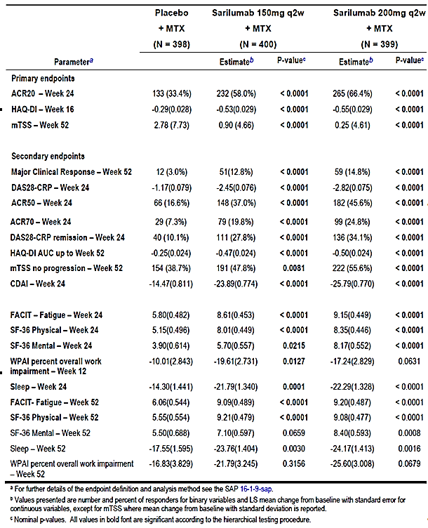

Study EFC10832 (TARGET)
The efficacy data from the pivotal Phase III Study EFC10832 (TARGET trial) satisfactorily demonstrated the efficacy of both doses of sarilumab (150 mg q2w (n = 181) and 200 mg q2w (n = 184)) in combination with DMARD compared with placebo (n = 181). In this study, all patients had previously been treated with TNF-α antagonists, mostly etanercept (32.6%), adalimumab (28.6%), or infliximab (15.9%) and the majority of patients (92.3%) had a history of inadequate response to prior TNF-α antagonist therapy. In addition, at baseline, approximately 21% of patients had been treated with 1 or more DMARDs other than MTX. The results for the two co-primary endpoints are summarised below in Table 18.

Table 18: Study EFC10832 Results for the two co-primary efficacy endpoints
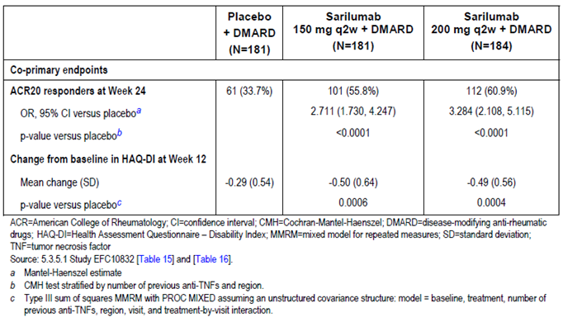
The study included a number of secondary efficacy endpoints, and the results for these endpoints for both doses of sarilumab in combination with DMARDs were consistent with the results for the two co-primary efficacy endpoints (see Table 19).

Table 19: Study EFC10832 Hierarchical testing order for the two co-primary efficacy endpoints and the secondary efficacy endpoints; ITT population
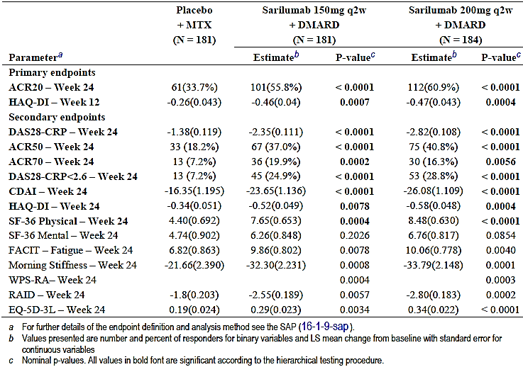

Study LTS11210 Long-term data
Updated long-term response and remission data were provided in the re-submission for treated patients in the sarilumab + DMARD group from the ongoing open-label Study LTS11210 through to the cut-off date of 25 January 2016. In this study, evaluation of efficacy is a secondary objective and all efficacy analyses were descriptive. Patients who were enrolled in this study prior to Phase III dose selection were treated with sarilumab 150 mg qw, which was the highest dose regimen assessed in Study EFC11072. After dose selection for the Phase III program, all patients either switched to, or continued to receive, sarilumab 200 mg q2w. The sarilumab 200 mg q2w dose of sarilumab could have been reduced to sarilumab 150 mg q2w for selected laboratory abnormalities or for other reasons based on the clinical judgement of the investigator.
A total of 1912 patients were enrolled in Study LTS11210, and 1910 patients were treated with sarilumab + DMARD. A total of 537 (28.1%) patients permanently discontinued the study and 326 (17.1%) of these patients discontinued due to AEs. For the sarilumab + cDMARD patients enrolled in this study the response and remission rates were maintained from Week 24 through to Week 264. The sponsor comments that the initial increase in response and remission rates from Week 0 to Week 24 is possibly due to the contribution of patients randomised to placebo + MTX in Study ECF11210 who initiated treatment with sarilumab + DMARD from Week 0 of Study LTS11210. The updated efficacy data are summarised below in Table 20.

Table 20: Study LTS11210 percentage of patients with ACR response and DAS remission (DAS-CRP < 2.6)
Week | ACR20 | ACR50 | ACR70 | DAS28 remission
Week 0 | 1318/1898 (69.4%) | 824/1897 (43.4%) | 435/1901 (22.9%) | 569/1873 (30.4%)
Week 24 | 1482/1787 (82.9%) | 1078/1782 (60.5%) | 690/1781 (38.7%) | 899/1778 (50.6%)
Week 48 | 1379/1662 (83.0%) | 1037/1656 (62.6%) | 673/1654 (40.7%) | 887/1654 (53.6%)
Week 96 | 975/1146 (85.1%) | 749/1145 (65.4%) | 493/1144 (43.1%) | 658/1139 (57.8%)
Week 144 | 519/599 (86.6%) | 391/596 (65.6%) | 268/594 (45.1%) | 335/594 (56.4%)
Week 192 | 179/204 (87.7%) | 141/204 (69.1%) | 102/203 (50.2%) | 123/203 (60.6%)
Week 216 | 163/183 (89.1%) | 132/183 (72.1%) | 88/180 (48.9%) | 114/180 (63.3%)
Week 240 | 110/125 (88.0%) | 89/125 (71.2%) | 64/122 (52.5%) | 85/124 (68.5%)
Week 264 | 37/41 (90.2%) | 25/43 (58.1%) | 18/42 (42.9%) | 23/39 (59.0%)
Note: The number (n) represents the subset of the total number of patients who had the response. The denominator (/N1) for each parameter within a treatment group is the number of patients for the treatment group who had that parameter assessed. ACR20/50/70 response = at least 20%/50%/70% improvements from baseline in both TJC and SJC, and in at least 3 of the 5 components (HAQ-DI score, CRP and 3 VAS assessments). A patient was not counted at a visit if there were insufficient information to determinate ACR20/50/70 response or non-response.
Study LTS1121 included an assessment of radiological progression of joint damage in patients treated with sarilumab based of the Sharp score method modified by van der Heijde (mTSS). The mTSS quantifies the extent of bone erosion for 44 joints and joint space narrowing for 42 joints, with higher scores representing greater damage. The mTSS is the sum of the scores from both the bone erosion score and the joint space narrowing score, for a maximum score of 448. X-ray data were only collected for patients who entered Study LTS1121 from Study EFC11072, as these patients had X-rays performed in the initial study. All of these subjects received MTX in the initial study and were expected to continue to receive MTX in Study LTS11210.
In the updated 3 year analysis of the mTSS, the score increased by 2.14 units from baseline to Year 3. In the 2 year analysis of mTSS provided in the initial CER, the score increased by 1.34 units from baseline to Year 2. Patients who discontinued between Year 1 and 2 were eligible to have data extrapolated for the Year 2 analysis but not the Year 3 analysis. The results for the Year 3 analysis are summarised below in Table 21.

Table 21: Study LTS11210 Change from baseline in the mTSS at Year 3; patients from Study EFC11072, Part B
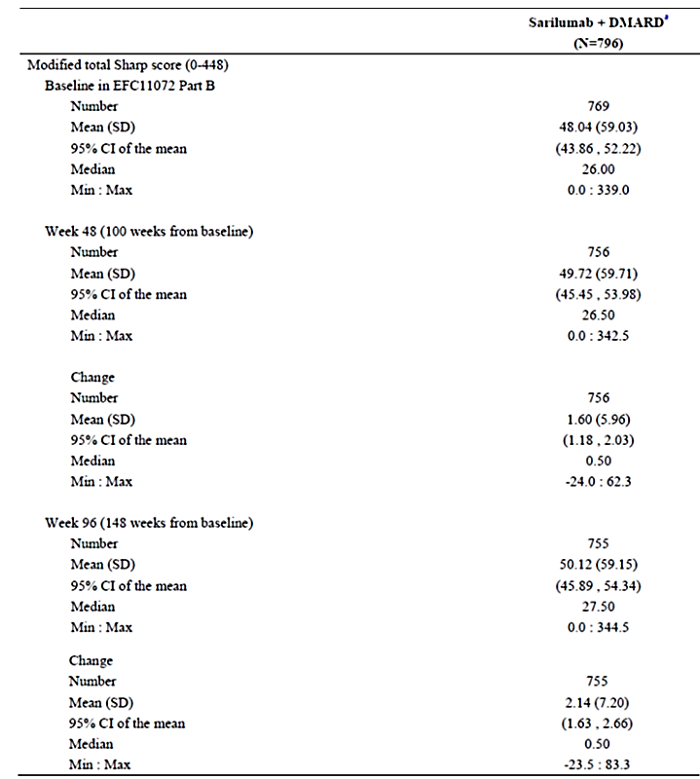
X-ray data are collected for patients from Study EFC11072 Part B Cohort 2 and Cohort 1 selected dose arms only. N = number of patients who had the X-ray data from Campaign 2 with study duration more than 48 weeks in Study LTS11210; a) MTX was the only allowed DMARD received by patients prior to enrolling in Study LTS11210. Modified total Sharp score = the sum of bone erosion scores from 44 joints and joint space narrowing scores from 42 joints, with a maximum score 448. The linear extrapolation method is used to impute missing Week 96 modified total Sharp score. The Year 3 analysis included baseline from Study EFC11072, Weeks 48 and 96 of Study LTS11210 and any unscheduled visits between Week 48 and Week 96.
A change from baseline in the mTSS score of ≤ 0 is considered to represent no progression of radiological joint damage. In the 2 year analysis (Study LTSS11210), the rate of non-progression changed minimally from Year 1 to Year 2 (51.9% and 51.2%, respectively). In the 3 year analysis, the rate of non-progression also changed minimally from Year 2 to Year 3 (46.6% to 44.2%, respectively). The sponsor commented that the results demonstrate a sustained effect of sarilumab on prevention of structural joint damage.
The joint erosion score is a summary of erosion severity in 32 joints of the hands and 12 joints of the feet. Each joint is scored, according to the surface area involved, from 0 to 5 for hand joints and 0 to 10 for foot the joints. The maximum erosion score (5 for the hand and 10 for the foot) indicates extensive loss of bone from more than one half of the articulating bones. A score of 0 in either the hand or foot indicates no erosion. The maximum erosion score is 280 (160 in the hands and 120 in the feet). In the 2 year analysis (Study LTS11210), mean erosion scores changed minimally between Year 1 and Year 2 (21.64 and 21.83, respectively). In the 3 year analysis (Study LTS11210), mean erosion scores also changed minimally between Year 2 and Year 3 (22.46 and 22.56, respectively).
The joint space narrowing score summarises the severity of joint space narrowing in 30 joints of the hands and 12 joints of the feet. Assessment of joint space narrowing for each hand (15 joints per hand) and foot (6 joints per foot), including subluxation, is scored from 0 to 4, with 0 indicating no/normal joint space narrowing and 4 indicating complete loss of joint space, bony ankylosis or subluxation. Thus, the maximum joint space narrowing score is 168. In the 2 year analysis (Study LTS11210), mean joint space narrowing scores increased slightly between Year 1 and Year 2 (25.29 and 25.40, respectively). In the 3 year analysis (Study LTS11210), mean joint space narrowing scores also increased slightly between Year 2 and Year 3 (27.25 and 27.56, respectively).

Comparative benefits of the 150 mg and 200 mg q2w doses
The sponsor has proposed that sarilumab treatment (monotherapy and in combination with DMARD) should be initiated with sarilumab 200 mg q2w and reduced to sarilumab 150 mg q2w in the event of neutropaenia, thrombocytopaenia and ALT increased.
The pivotal monotherapy study (Study EFC14092/MONARCH trial) satisfactorily demonstrated greater efficacy in the sarilumab q2w group than in the adalimumab 40 mg q2w group. However, there were no data in this study evaluating the efficacy of monotherapy 150 mg q2W. Overall, it is considered that the submitted data support initiation of monotherapy treatment with sarilumab 200 mg q2w with dose reduction to 150 mg q2w in the event of toxicity. The long-term extension data from Study LTS11210 showed that patients (n = 111) who had been initially treated with sarilumab 150 mg q2w or 200 mg q2w for 24 weeks could satisfactorily maintain response and remission when treated with sarilumab 200 mg q2w (reducing to 150 q2w in case of toxicity) for up to an additional 48 weeks of open-label treatment.
The two pivotal studies comparing sarilumab (150 mg q2w and 200 mg q2w) in combination with MTX (Study EFC11072, Part B) or cDMARD not limited to MTX (Study EFC10832) showed that both doses of sarilumab had significantly greater efficacy than placebo. Comparison between both sarilumab doses showed that the efficacy of the higher sarilumab dose (200 mg q2w) was numerically better than the efficacy of the lower sarilumab dose (150 mg q2w) for the three co-primary efficacy endpoints and the major secondary endpoint in Study EFC11072 Part B, and for the two co-primary efficacy endpoints in Study EFC10832. This pattern was consistently observed in both studies for the numerous secondary efficacy endpoints. However, in neither of two pivotal studies was the comparative efficacy of the two sarilumab dose regimens formally analysed, with all comparisons between the two dose regimens being descriptive rather than inferential.
In support of initiating treatment with the higher sarilumab dose (200 mg q2w) rather than the lower sarilumab dose (150 mg q2w), the sponsor reviewed the 3 year data from the long-term Study LTS11210 relating to radiological progression of structural joint damage (mean change from baseline in mTSS) in patients from Study EFC11072 Part B (MOBILITY trial) who entered the long-term extension study and continued treatment with sarilumab 200 mg q2w in combination with cDMARD. These data were reviewed by the ACM in April 2017. The sponsor commented that, despite all patients receiving sarilumab 200 mg q2W on entry into Study LTS11210 from Study EFC11072, patients who were initially randomised to 200 mg q2w at baseline (Study EFC11072) continued to have better radiologic outcomes than patients who were initially randomised to 150 mg q2w at baseline (Study EFC11072) at all time-points up to and including Year 3.
Overall, the data showed that progression of radiological structural joint damage was less marked in patients initiating treatment with sarilumab 200 mg q2w and continuing at this dose than in patients initiating treatment with sarilumab 150 mg q2w and subsequently increasing the sarilumab dose to 200 mg q2w. The results for the mean change from baseline through to Week 148 for those patients from Study EFC11072 Part B entering after 52 weeks treatment and continuing treatment in LTS11210 for an additional 96 weeks (total of 148 weeks treatment from baseline) are summarised below in Figure 8.
Figure 8: Study LTS11210 Mean change from baseline in mTSS in the 3 year analysis; ITT population
In Study LTS11210, the mean change from baseline in mTSS at Week 148 (Year 3) was greatest (greatest progression in joint damage) in patients initially treated with placebo + MTX in Study EFC11072, Part B, and smallest (least progression in joint damage) in patients initially treated with sarilumab 200 mg q2w + MTX, with the mean change in patients initially treated with sarilumab 150 mg q2w + MTX falling between the other two treatment groups. The results are summarised below in Table 22.

Table 22: Mean change from baseline in the mTSS at Week 148 from baseline for patients entering Study LTS11210 from Study EFC11072 in the 3 year analysis; ITT population
mTSS (score 0-448) | Placebo + MTX (n = 237) | SAR 150 mg q2w + MTX (n = 228) | SAR 200 mg q2w + MTX (n = 239)
Mean (SD) Week 148 | 52.77 (64.19) | 51.06 (57.80) | 47.03 (57.61)
Mean (SD) change -baseline to Week 148 | 3.30 (7.18) | 1.87 (6.76) | 0.79 (5.38); n = 239
p versus placebo | - | 0.0057 | < 0.0001
mTSS = modified total Sharp score (the sum of bone erosion scores from 44 joints and joint space narrowing scores from 42 joints, with a maximum score 448). Data collected after treatment discontinuation or starting rescue medication are used as observed. The linear extrapolation method is used to impute missing mTSS. Treatment for 148 weeks = treatment for 52 weeks in Study EFC11072 + treatment for 96 weeks in Study LTS11210.
In the Delegate’s request for ACM Advice of March 2017 the Delegate noted that a significant radiographic benefit out to Week 148 was observed for patients initiating treatment with sarilumab 200 mg q2w + MTX compared with either sarilumab 150 mg q2w + MTX or placebo + MTX. However the Delegate commented that the numerical differences across the treatment groups in the change from baseline in mTSS were small, and that the minimum clinically important difference in mTSS is generally stated to be 5 units.
Based on the totality of the data establishing the benefits of sarilumab for the treatment of moderate to severe RA in adult patients who have had an inadequate response to, or intolerance for, one or more DMARDs, it is considered that treatment be initiated with the 200 mg q2w dose with the option to decrease the dose to 150 mg q2w in the event of toxicity at the higher dose.

First round assessment of risks

Sarilumab monotherapy
The risks associated with sarilumab 200 mg q2w monotherapy reviewed in this section are from the pivotal Phase III Study EFC14092/ MONARCH trial. The risks of sarilumab 200 mg q2w observed in this study are consistent with the risks for any sarilumab dose monotherapy from the pooled monotherapy population (Pool 3).
TEAEs were reported in a similar proportion of patients in the sarilumab 200 mg q2w and adalimumab 40 mg q2w groups (64.1% versus 63.6%, respectively). Infections and infestations (SOC) were the most frequently reported TEAEs in both the sarilumab 200 mg q2w group and the adalimumab 40 mg q2w group (28.8% versus 27.7%, respectively), and the TEAEs were predominantly non-serious in both treatment groups. TEAEs reported in ≥ 2% of patients in either treatment group are summarised below in Table 23.

Table 23: Study EFC14092/MONARCH trial TEAEs reported in ≥ 2% of patients in either of the two treatment groups, in descending order of frequency in the sarilumab group; safety population
Preferred term | Adalimumab 40 mg q2w | Sarilumab 200 mg q2w
 | (N = 184); n (%) | (N = 184); n (%)
Any | 117 (63.6%) | 118 (64.1%)
Neutropaenia | 1 (0.5%) | 25 (13.6%)
Injection site erythema | 6 (3.3%) | 14 (7.6%)
Bronchitis | 7 (3.8%) | 12 (6.5%)
Nasopharyngitis | 14 (7.6%) | 11 (6.0%)
Headache | 12 (6.5%) | 7 (3.8%)
ALT increased | 7 (3.8%) | 7 (3.8%)
Accidental overdose | 11 (6.0%) | 6 (3.3%)
Urinary tract infection | 4 (2.2%) | 5 (2.7%)
Diarrhoea | 5 (2.7%) | 5 (2.7%)
Arthralgia | 3 (1.6%) | 5 (2.7%)
Pharyngitis | 5 (2.7%) | 3 (1.6%)
Upper respiratory tract infection | 7 (3.8%) | 3 (1.6%)
Hypertension | 4 (2.2%) | 3 (1.6%)
Rheumatoid arthritis | 7 (3.8%) | 1 (0.5%)
Abdominal pain | 5 (2.7%) | 0
The most notable difference in the incidence of TEAEs between the two treatment groups related to the higher incidence of neutropaenia in the sarilumab 200 mg q2w group compared with the adalimumab 40 mg q2w group (13.6% versus 0.5%, respectively). Other TEAEs reported in ≥ 2% of patients in either of the two treatment groups, and ≥ 2% more frequently in the sarilumab 200 mg q2w group than in the adalimumab 40 mg q2w group were injection site erythema and bronchitis. TEAEs reported in ≥ 2% of patients in either of the two treatment groups, and ≥ 2% more frequently in the adalimumab 40 mg q2w group than in the sarilumab group 200 mg q2w group were headache, accidental overdose, upper respiratory tract infection, and RA (that is, worsening of RA).
In the 24 week double-blind treatment period there was 1 death in the sarilumab 200 mg q2w group (cardiovascular causes) and no deaths in the adalimumab 40 mg q2w group. SAEs were reported more frequently in the adalimumab 40 mg q2w group than in the sarilumab 200 mg q2w group (6.5%, n = 12 versus 4.9%, n = 9, respectively), and no individual SAEs were reported in more than 1 patient in either of the two treatment groups. The SAEs in the adalimumab 40 ng q2w group each reported once were arthritis bacterial, respiratory tract infection, basal cell carcinoma, serum sickness, CVA, multiple sclerosis, syncope, pulmonary embolism, small intestinal obstruction, arthritis, lumbar spinal stenosis, and ALT increased. The SAEs in the sarilumab 200 mg q2w group each reported once were bursitis infective, mastitis, neutropaenia, cerebral ischaemia, demyelinating polyneuropathy, cardiac failure acute, coronary artery dissection, papillary muscle rupture, haematoma, back pain, intervertebral disc protrusion, accidental overdose, concussion, periorbital oedema and wound.
The proportion of patients permanently discontinuing treatment due TEAEs was higher in the adalimumab 40 mg q2w group than in the sarilumab 200 mg q2w group (7.1%, n = 13 versus 6.0%, n = 11). In the sarilumab 200 mg q2w group, TEAEs resulting in permanent treatment discontinuation reported in ≥ 2 patients were neutropaenia (2.7%, n = 5) and injection site erythema (1.1%, n = 2), and all other TEAEs were each reported in 1 patient. In the adalimumab 40 mg q2w group, TEAEs resulting in permanent treatment discontinuation in ≥ 2 patients were RA (1.1%, n = 2), ALT increased (1.1%, n = 2), AST increased (1.1%, n = 2), and all other TEAEs were each reported in 1 patient.
Treatment-emergent adverse events of special interest (AESI) in the two treatment groups are summarised below in Table 24

Table 24: Study EFC14092/MONARCH trial adverse events of special interest (AESI); safety population
Infection was the main AESI reported in both treatment groups, and the incidence of infection was similar in patients in both groups. The main difference in AESI between the two treatment groups related to the notably higher incidence of leukopaenia (SMQ) events in the sarilumab 200 mg q2w group than in the adalimumab 40 mg q2w group, with the difference being primarily driven by the TEAE of neutropaenia. In addition to leukopaenia (SMQ), injection site reactions and hepatic disorders occurred more frequently in the sarilumab 200 mg q2w group than in the adalimumab group 40 mg q2w group, while elevation in lipids occurred more frequently in the adalimumab 40 mg q2w group than in the sarilumab 200 mg q2w group. Apart from Leukopaenia (SMQ), injection site reactions, hepatic disorders and elevation in lipids, all other AESI were reported in a similar proportion of patients in the sarilumab 200 mg q2w and adalimumab 40 mg q2w treatment groups.
Neutropaenia laboratory abnormalities (all grades) were reported more frequently in patients in the sarilumab 200 mg q2w group than in the adalimumab 40 mg q2w group, with most abnormalities in both treatment groups being Grade 1 or 2 in severity. Grade 3 to 4 neutropaenia (< 1 Giga/L) was reported in 10.3% (n = 19) of patients in the sarilumab 200 mg q2w group and 1.1% (n = 2) of patients in the adalimumab 40 mg q2w group. Thrombocytopaenia laboratory abnormalities (< 100 Giga/L) were reported in 1 (0.5%) patient in the sarilumab 200 mg q2w group and no patients in the adalimumab 40 mg q2w group.
LFT laboratory assessment showed that mean ALT increased to a greater extent in the sarilumab 200 mg q2W group than in the adalimumab 40 mg q2w over the 24 week double-blind treatment period, but mean values remained within the normal range at all assessed time-points. In addition, mean values for AST, total bilirubin, and alkaline phosphatase (ALP) all remained within the normal range at all time-points during the study. Potentially clinically significant increases in ALT and AST levels were reported more frequently in patients in the sarilumab 200 mg q2w group than in the adalimumab 40 mg q2w group. However, the increases were mainly in the > 1 x to ≤ 3 x upper limit of normal (ULN) range in both treatment groups. There were no reports of ALT or total bilirubin meeting Hy's law criteria for drug induced liver injury (that is, ALT > 3 x ULN and total bilirubin > 2 x ULN). No cases of hepatic failure were reported.
Lipid laboratory assessment showed that mean LDL and mean triglyceride values were lower in the adalimumab 40 mg q2w group than in the sarilumab 200 mg q2w group at each post-baseline time-point through to Week 24, while mean high density lipoprotein (HDL) levels were lower at Week 24 in the adalimumab 40 mg q2w group than in the sarilumab 200 mg q2w group.
The risks of other TEAEs (not categorised as AESI) of potential regulatory significance do not give rise to concern (that is, cardiovascular disorders [including MACE and ECG changes]; renal and urinary disorders; blood and lymphatic system disorders; skin and subcutaneous tissue disorders; laboratory abnormalities; and changes in vital signs).
Of the 184 patients with available ADA results, 13 (7.1%) patients were treatment-emergent ADA positive, including 5 (2.7%) with a persistent ADA positive response (all NAb negative) and 8 (4.3%) with a transient ADA positive response (all NAb negative). There appeared to be no clinically meaningful association between ADA positive response and increased risk of hypersensitivity reactions. There were no reports of anaphylaxis in patients treated with sarilumab 200 mg q2w in Study EFC14092 MONARCH.
There were no safety data in the CSR exploring safety in special groups based on gender, age, race, hepatic impairment or renal impairment. However, it is considered that the absence of safety data in these groups should not preclude approval of sarilumab for the proposed indication.
The strengths of the sarilumab monotherapy risk data based on Study EFC14092/MONARCH trial are:
- Adequate characterisation of the risks of sarilumab 200 mg q2w monotherapy in 184 patients with a total exposure of 78.7 PY;
- Demonstration of similar risks in the sarilumab 200 mg q2w group and the adalimumab 40 mg q2wgroup of TEAEs, treatment-emergent SAES, TEAEs leading to death and TEAEs leading to permanent treatment discontinuation;
- Identification of infections, leukopaenia (predominantly neutropaenia), injections site reactions, hypersensitivity, and hepatic disorders as the main AESI associated with sarilumab 200 mg q2w treatment; and
- Identification of laboratory abnormalities of neutropaenia, thrombocytopaenia, increased ALT, increased AST, increased total bilirubin, increased mean LDL levels and increased triglyceride levels as the main laboratory identified potential risks associated with sarilumab 200 mg q2w treatment.
The limitations and uncertainties of the sarilumab monotherapy risk data based on Study EFC14092/ MONARCH trial are:
- The small number of patients in Study EFC14092 MONARCH exposed to sarilumab for > 24 weeks (n = 22), gives rise to uncertainties relating to the long-term risks of sarilumab monotherapy. However, this limitation is mitigated, at least to some extent, by the data from the pooled sarilumab monotherapy any dose group in Pool 3. The safety profiles were similar for the 467 patients with a total exposure of 299.4 PY in the any sarilumab dose group (Pool 3) and for the 184 patients with a total exposure of 78.7 PY in the sarilumab 200 mg q2w group (MONARCH). In the any sarilumab dose monotherapy group (Pool 3), 109 (23.3%) patients were exposed to sarilumab for > 48 weeks, 107 (22.9%) patients for > 60 weeks, and 37 (7.9%) patients for > 72 weeks. The total number of patients exposed to any sarilumab dose in the pooled monotherapy studies (n = 477) was sufficient to detect adverse reactions to sarilumab occurring with an incidence of > 0.6%, based on ‘the rule of threes’. However, it is unlikely that the total population exposed to any sarilumab dose in Pool 3 was sufficient to detect adverse reactions with an incidence of < 0.6%.
- No data relating to the safety of sarilumab monotherapy based on age, gender, race, weight or BMI could be identified.

Sarilumab in combination with cDMARD
The risks of sarilumab (150 mg q2w and 200 mg q2w) in combination with cDMARD are similar to the risks sarilumab (200 mg q2w) as monotherapy.
In this section, the risks of treatment with sarilumab 200 mg q2w and 150 mg q2w have been reviewed based on data from Pool 1 (sarilumab + DMARD placebo-controlled population) and from Pool 2 (sarilumab + DMARD long-term safety population). The data are from the sponsor’s Summary of Clinical Efficacy (31 May 2016) included in the re-submission, with the Pool 1 data being the same as that provided in the initial submission while the Pool 2 data have been updated from that provided in the initial submission.

Pool 1 sarilumab + DMARD placebo controlled data up to 52-weks
Pool 1 included safety data collected during the double-blind treatment period of the two pivotal Studies EFC11072 (Part A; Part B, Cohort 1; and Part B, Cohort 2) and EFC10832. Once a patient entered the rescue phase of the two studies, defined as the day the first open-label dose of sarilumab was administered, safety data were no longer included in Pool 1 as the data were no longer placebo-controlled. The duration of treatment for Pool 1 was up to 52 weeks. The disposition data for the two sarilumab + DMARD treatment groups in Pool 1 were similar (see Table 25, below).

Table 25: Patient disposition for Pool 1 (placebo controlled) sarilumab in combination with cDMARD
In Pool 1, the sponsor defined TEAEs as adverse events that developed or worsened in the TEAE period. The TEAE period for the Pool 1 population is defined below in Table 26. Total exposure for the entire TEAE period was 440.7 PY in the 150 mg q2w + DMARD group and 441.4 PY in the 200 mg q2w + DMARD group.

Table 26: Pool 1 Definition of TEAE period
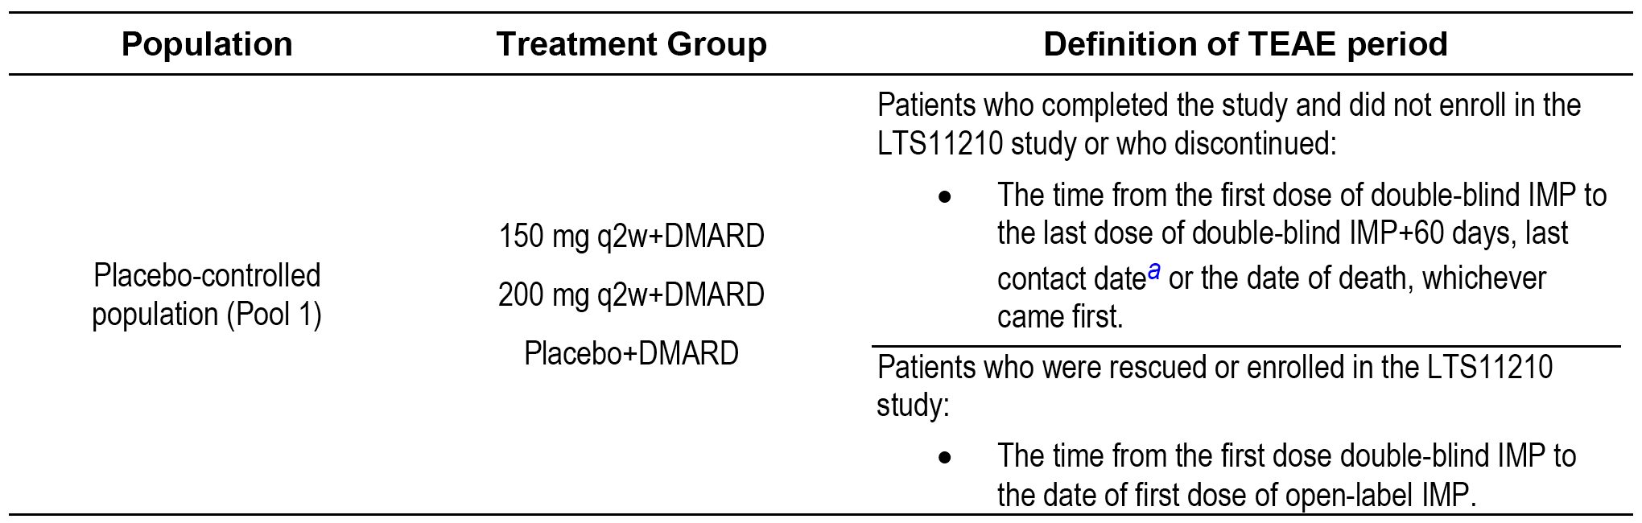
ª Last contact date = maximum (last AE onset date, last visit date, last date on which subject vital status obtained).
The high-level overview of TEAEs during the entire TEAE period for the raw patient incidence rate, the exposure-adjusted patient incidence rate, and the exposure-adjusted event rate are summarised below in Table 27. There were numerical differences in the parameters, with higher adverse event frequencies being generally observed in the higher dose sarilumab group than in the lower dose sarilumab group.

Table 27: Pool 1 High-level overview of TEAEs, raw patient incidence rates, exposure adjusted patient incidence rates, and event rates during the entire TEAE period, placebo-controlled safety population
Event | Raw Patient | Exposure Adjusted Patient | Event Rate
 | Incidence Rate, n/N (%) | Incidence Rate n/PY (rate/100 PYs) | nE (nE/100 PYs)
TEAE
SAR 200 mg q2w + DMARD | 488/661 (73.8%) | 488/193.6 (252.0) | 1703 (385.8)
SAR 150 mg q2w + DMARD | 465/660 (70.5%) | 465/215.5 (215.7) | 1490 (338.1)
Placebo + DMARD | 378/661 (57.2%) | 378/218.2 (173.3) | 994 (260.0)
Serious TEAEs
SAR 200 mg q2w + DMARD | 59/661 (8.9%) | 59/426.5 (13.8) | 81 (18.4)
SAR 150 mg q2w + DMARD | 42/660 (6.4%) | 42/433.8 (9.7) | 67 (15.2)
Placebo + DMARD | 31/661 (4.7%) | 31/375.4 (8.3) | 29 (12.8)
TEAE leading to death
SAR 200 mg q2w + DMARD | 1/661 (0.2%) | 1/442.8 (0.2) | 1 (0.2)
SAR 150 mg q2w + DMARD | 2/660 (0.3%) | 2/442.1 (0.5) | 2 (0.5)
Placebo + DMARD | 3/661 (0.5%) | 3/383.9 (0.8) | 5 (1.3)
TEAE leading to permanent treatment discontinuation
SAR 200 mg q2w + DMARD | 83/661 (12.6%) | 83/428.4 (19.4) | 91 (20.6)
SAR 150 mg q2w + DMARD | 72/660 (10.9%) | 72/429.8 (16.8) | 90 (20.4)
Placebo + DMARD | 31/661 (4.7%) | 31/379.8 (8.2) | 33 (8.6)
Raw patient incidence rate = number of patients with at least 1 event/number of patients in the treatment group. Exposure adjusted incidence rate = number of patients with at least one event per 100 PY, where the exposure time for patients who have experienced the specific adverse experience was defined as the time to first adverse experience of interest whereas the exposure time for those who have not had this adverse experience was total TEAE period duration. Event rate = number of events (nE) per 100 PY, where PY for a treatment group is the total duration of treatment in the entire TEAE period (382.3 PY, placebo = DMARD; 440.7 PY SAR 150 mg + DMARD; and 441.4 PY SAR 200 mg q2w + DMARD).
Death was reported in 3 (0.5%) patients in the placebo group (1 x completed suicide; 1 x brain oedema; 1 x cardiovascular insufficiency); 2 (0.3%) patients in the sarilumab 150 mg q2w group (1x pulmonary oedema; 1 x respiratory distress), and 1 (0.2%) patient in the sarilumab 200 mg q2w group (1 x cerebrovascular accident).
TEAEs reported in ≥ 5% of patients in either the sarilumab 200 mg q2w group or the sarilumab 150 mg q2w group, respectively, in descending order of frequency in the 200 mg q2w group were: neutropaenia (14.2% versus 9.8%); upper respiratory tract infection (7.1% versus 6.4%); ALT increased (6.8% versus 6.7%); accidental overdose (6.1% versus 5.5%); urinary tract infection (5.7% versus 4.4%); injection site erythema (5.3% versus 5.3%); and nasopharyngitis (4.2% versus 5.5%).
SAEs reported in ≥ 2 patients in either the sarilumab 200 mg q2w group or the sarilumab 150 mg q2w group, respectively, in descending order of frequency in the 200 mg q2w group were: neutropaenia (n = 5, 0.8% versus n = 4, 0.6%); erysipelas (n = 3, 0.5% versus n = 0, 0%); pneumonia (n = 3, 0.5% versus n = 1, 0.2%); bronchitis (n = 2, 0.3% versus n = 0, 0%); cellulitis (n = 2, 0.3% versus n = 1, 0.2%); depression (n = 2, 0.3% versus n = 1, 0.2%); hypertensive crisis (n = 2, 0.3% versus n = 0, 0%); osteoarthritis (n = 2, 0.3% versus n = 1, 0.2%); rheumatoid arthritis (n = 2, 0.3% versus 0%); acute kidney injury (n = 2, 0.3% versus n = 1, 0.2%); and chronic obstructive pulmonary disease (n = 1, 0.2% versus n = 2, 0.3%).
TEAEs leading to permanent treatment discontinuation reported in ≥ 2 patients in either the sarilumab 200 mg q2w group or the sarilumab 150 mg q2w group, respectively, in descending order of frequency in the 200 mg q2w group were: neutropaenia (n = 13, 2.0% versus n = 15, 2.3%); ALT increased (n = 9, 1.4% versus n = 11, 1.7%); herpes zoster (n = 5, 0.8% versus n = 3, 0.5%); transaminases increased (n = 4, 0.6% versus n = 2, 0.3%); thrombocytopaenia (n = 3, 0.5% versus n = 1, 0.2%); leukopaenia (n = 2, 0.3% versus n = 0, 0%); cellulitis (n = 2, 0.3% versus n = 2, 0.3%); pneumonia (0.3%, n = 2 versus n = 2, 0.3%); depression (n = 2, 0.3% versus n = 0, 0%); rash erythematous (n = 2, 0.3% versus n = 1, 0.3%); rash generalised (n = 2, 0.3% versus n = 1, 0.2%); RA (n = 2, 0.3% versus n = 0, 0%); and oral herpes (n = 1, 0.2% versus n = 2, 0.3%).
The AESI profiles for the two sarilumab + DMARD treatment groups and the placebo group for the Pool 1 population are summarised below in Table 28. The main difference between the two treatment groups related to the higher incidence of leukopaenia (SMQ) in the sarilumab 200 mg q2w + DMARD group compared with the sarilumab 150 mg q2w + DMARD group. The incidence of infections, hepatic disorders, hypersensitivity reactions, injection site reactions and thrombocytopaenia was similar in the two sarilumab treatment groups, with a small numerical increase in the higher dose group compared with the lower dose group.

Table 28: Pool 1 Adverse events of special interest (AESI) in the sarilumab + DMARD groups and the placebo group, incidence rates for patients in the treatment group and number of events (per 100 PY)
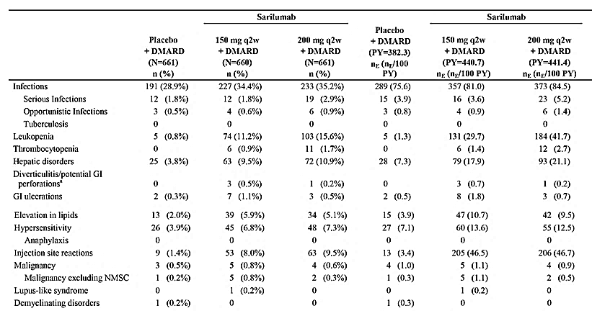
AE = Adverse event; AESI = Adverse event of special interest; NMSC = non-melanoma skin cancer. n (%) = number and percentage of patients with at least one AESI. MEDDRA 18.1 n (%) = number and percentage of patients with at least one AESI. nE (nE /100 PY) = number of events and number of events per 100 PY. PY for a treatment group is the total treatment duration of the treatment group. This AESI table is based on MedDRA SMQ or company defined search criteria. a = Cases will be medically reviewed to identify cases of GI perforation.
Review of the safety data for the adverse events of particular significance (neutropaenia, thrombocytopaenia and ALT increase), which govern the decision to reduce the initial sarilumab 200 mg q2w dose to 150 mg q2w is presented below.

Leukopaenia
The MedDRA SMQ haematopoietic leukopaenia (leukopaenia (SMQ)) was used to identify investigator-reported relevant AE preferred terms. The incidence of leukopaenia (SMQ) was 15.6% (n = 103) in the sarilumab 200 mg q2w group + DMARD, 11.2% (n = 74) in the sarilumab 150 mg q2w + DMARD group, and 0.8% (n = 5) in the placebo group.
Leukopaenia (SMQ) in both the sarilumab + DMARD dose groups was primarily driven by neutropaenia, which was reported in 14.2% (n = 94) of patients in the 200 mg q2w group and 9.8% (n = 65) of patients in the 150 mg q2w group. Leukopaenia (SMQ) in the two sarilumab + DMARD treatment groups analysed by preferred terms are summarised below in Table 29.

Table 29: Pool 1 Leukopaenia (SMQ) in the two sarilumab + DMARD groups over the entire TEAE period
Preferred term | SAR 150 mg q2w + DMARD, n (%) | SAR 200 mg q2w + DMARD, n (%)
Leukopaenia (SMQ) Total | 74 (11.2%) | 103 (15.6%)
Neutropaenia | 65 (9.8%) | 94 (14.2%)
Leukopaenia | 11 (1.7%) | 23 (3.5%)
Lymphopaenia | 1 (0.2%) | 4 (0.6%)
Neutrophil count decreased | 6 (0.9%) | 4 (0.6%)
White blood cell count decreased | 3 (0.5%) | 2 (0.3%)
Lymphocyte count decreased | 1 (0.2%) | 0
Leukopaenia (SMQ) SAEs were reported in 7 (1.1%) patients in the sarilumab 200 mg q2w + DMARD group and 4 (0.6%) patients in the sarilumab 150 mg q2w + DMARD group. Leukopaenia (SMQ) leading to permanent treatment discontinuation was reported in the same proportion of patients in both treatment groups (2.3%, n = 15). There were no deaths due to leukopaenia (SMQ) in either of the two sarilumab treatment groups.
Neutropaenia (preferred term) occurred more frequently in patients in the sarilumab 200 mg q2w + DMARD group than in patients in the sarilumab 150 mg q2w + DMARD group (14.2% versus 9.8%, respectively). The majority of the neutropaenia TEAEs in both treatment groups was not of a serious nature and did not result in permanent treatment discontinuation. The incidence of neutropaenia SAEs was similar in patients in the two sarilumab + DMARD groups (0.8%, 200 mg versus 0.6%, 150 mg, respectively) as was the incidence of patients discontinuing treatment permanently due to neutropaenia (2.0%, 200 mg versus 2.3%, 150 mg). Despite the higher incidence of neutropaenia TEAEs in patients in the higher dose sarilumab group compared with the lower dose sarilumab group, the incidence of infections in patients in the two treatment groups was similar (35.2%, 200 mg versus 34.4%, 150 mg), as was the incidence of serious infections (2.9%, 200 mg versus 1.8%, 150 mg). No cases of febrile neutropaenia were reported in either of the two Pool 1 sarilumab + DMARD treatment groups.
The mean ANC results across the entire TEAE period are summarised below in Figure 9. The baseline ANC in Pool 1 for each of the three treatment groups was 5.98 to 6.17 Giga/L (normal range: 1.96 to 7.23 Giga/L). The decrease in mean ANC in patients in the sarilumab 200 mg q2w + DMARD group was greater than in patients in the sarilumab 150 mg q2W group at each visit, but the mean ANC values remained in the normal range for both groups. The reduction in mean ANC in the two sarilumab + DMARD groups dropped sharply in the first 4 weeks of treatment, and then stabilised over the remainder of treatment. At Week 4, the mean decrease from baseline was 2.3 Giga/L (34%) in the higher dose sarilumab group and 1.5 Giga/L (24%) in the lower dose sarilumab group.
Figure 9: Pool 1 Mean ANC across visits from baseline across the entire TEAE period
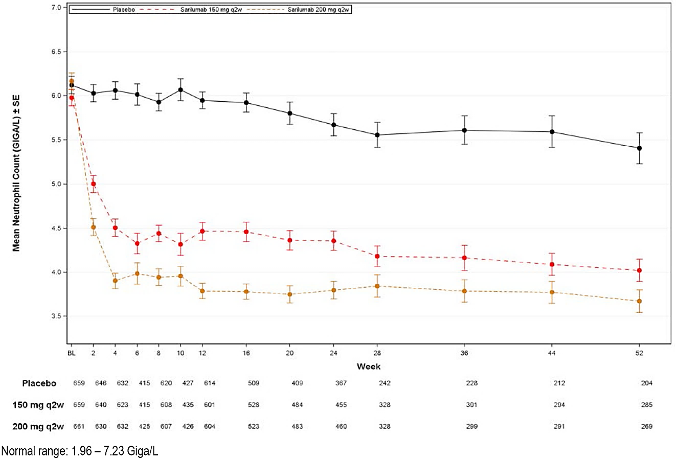
Laboratory abnormalities for decrease in ANC by maximum grade during the entire TEAE period for Pool 1 are summarised below in Table 30. The result indicated that a greater proportion of patients in the higher dose sarilumab group experienced Grades 1, 2, and 3 neutropaenia than patients in the lower dose sarilumab group, with the majority of events in both treatment groups being Grades 1 to 2. Grade 4 neutropaenia was reported in a similar proportion of patients in the two sarilumab groups.

Table 30: Pool 1 Number (%) of patients with decrease in absolute neutrophil count during the entire TEAE period by maximum grade
In Pool 1, the proportion of patients with an ANC < LLN was greater in the sarilumab 200 mg q2w + DMARD group than in the sarilumab 150 mg q2w + DMARD group (40.6%, n = 226, versus 31.9%, n = 221). However, in both sarilumab groups, the incidence of infection (all AEs and SAEs) was similar in patients with ANC ≥ LLN and ANC < LLN (see Table 31, below).

Table 31: Pool 1 Incidence of infection by ANC ≥ LLN and ANC < LLN
Criteria | Placebo + DMARD (n = 661) | SAR 150 mg q2w + DMARD (n = 660) | SAR 200 mg q2w + DMARD (n = 661)
Patients with infection and ANC ≥ LLN | 180/629 (28.6%) | 161/449 (35.9%) | 140/391 (35.8%)
Patients with infection and ANC < LLN | 11/32 (34.4%) | 66 /211 (31.3%) | 93/267 (34.8%)
Patients with serious infection and ANC ≥ LLN | 12/629 (1.9%) | 8/449 (1.8%) | 8/391 (2.0%)
Patients with serious infection and ANC < LLN | 0/32 | 4/211 (1.9%) | 11/267 (4.1%)
In general, infections are uncommon unless the neutrophil count is < 1.0 Giga/L. This level corresponds to Grade ≥ 3 neutropaenia, which was observed in 40 (6.1%) patients in the sarilumab 150 mg q2w + DMARD group and 61 (9.2%) patients in the sarilumab 200 mg q2w + DMARD group. The rate difference between the two groups was 3.2% (95% CI: 0.3, 6.0). In the 40 patients in the higher dose sarilumab group with ANC < 1.0 Giga/L, there were 13 (2.0%) patients with an infection and no patients with a serious infection. In the 61 patients in the lower dose sarilumab group with ANC < 1.0 Giga/L there were 19 (2.9%) patients with an infection and 1 (1.6%) patient with a serious infection. The data suggest no clinically meaningful difference in the incidence of infection (including serious infection) between the two sarilumab groups in patients with ANC < 1.0 Giga/L. The incidence of infection and serious infection by lowest ANC is summarised for the Pool 1 population in Table 32 (infection) and Table 33 (serious infection).

Table 32: Pool 1 Incidence of infection by lowest absolute neutrophil count
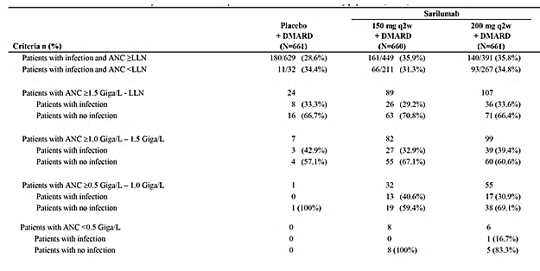

Table 33: Pool 1 Incidence of serious infection by lowest absolute neutrophil count
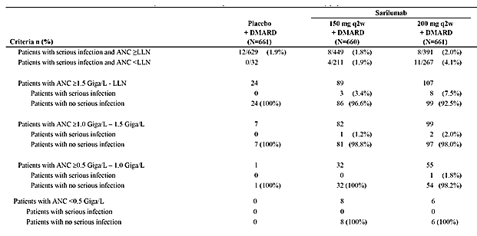

Thrombocytopaenia
The mean platelet counts across the entire TEAE period for Pool 1 are shown below in Figure 10. In Pool 1, thrombocytopaenia AESI (≥ 1 event) were reported in 1.7% (n = 11) of patients in the sarilumab 200 mg q2w + DMARD group and 0.9% (n = 6) of patients in the sarilumab 150 mg q2w + DMARD group, and thrombocytopaenia SAEs were reported in 1 (0.2%) patient in each of the two sarilumab groups. Thrombocytopaenia AESIs resulting in treatment discontinuation were reported in 3 (0.5%) patients in the higher dose sarilumab group and 1 (0.2%) patient in the lower dose sarilumab group, and no deaths due to thrombocytopaenia were reported in either sarilumab group. Platelet count < 100 Giga/L was observed in 11 (1.7%) patients in the higher dose sarilumab group and in 4 (0.6%) patients in the lower dose sarilumab group. The difference between the two sarilumab groups was 1.1% (95% CI: -0.1, 2.2). Overall, no clinically meaningful differences in the incidence of patients with thrombocytopaenia were observed between the two sarilumab groups.
Figure 10: Pool 1 Mean platelet counts across visits from baseline across the entire TEAE period
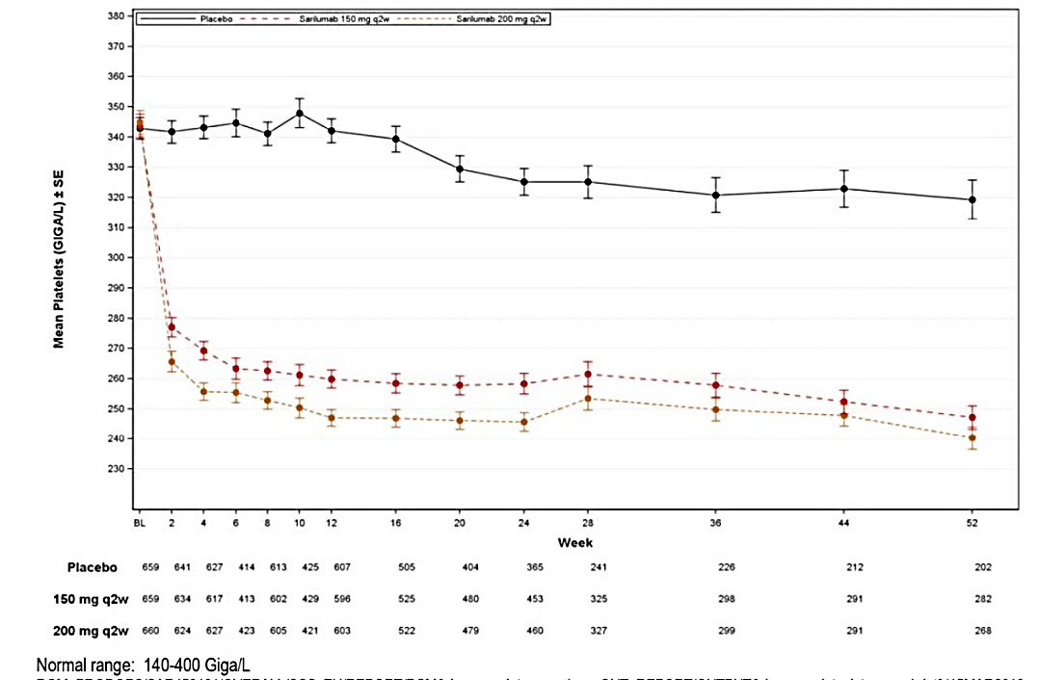

ALT increased
In Pool 1, 6.8% (n = 45) of patients in the sarilumab 200 mg q2w + DMARD group had an ALT increase TEAE compared with 6.7% (n = 44) of patients in the sarilumab 150 q2w + DMARD group, and ALT increase SAEs were reported in 0.2% (n = 1) of patients in both sarilumab groups. Permanent treatment discontinuation due to ALT increased TEAE was reported in a similar proportion of patients in the higher and lower dose sarilumab groups (1.4% versus 1.7%, respectively). There were no deaths due to increased ALT levels in either of the two sarilumab groups.
The mean ALT during the entire TEAE period (Pool 1) is summarised below in Figure 11. Mean increases in ALT and AST were observed in the two sarilumab + DMARD groups compared with placebo. At Week 4, in the two sarilumab groups mean increases in ALT of 7.14 to 8.61 IU/L and AST of 3.58 to 4.22 IU/L were observed. The ALT levels then stabilised from Week 4 through the remainder of treatment, whereas a small increase in AST levels was observed (5.57 to 5.60 at Week 52). The mean values for both the ALT and AST remained within the normal range at each visit throughout the TEAE treatment period in both sarilumab groups.
Figure 11: Pool 1 Mean ALT levels across visits from baseline during the entire TEAE period
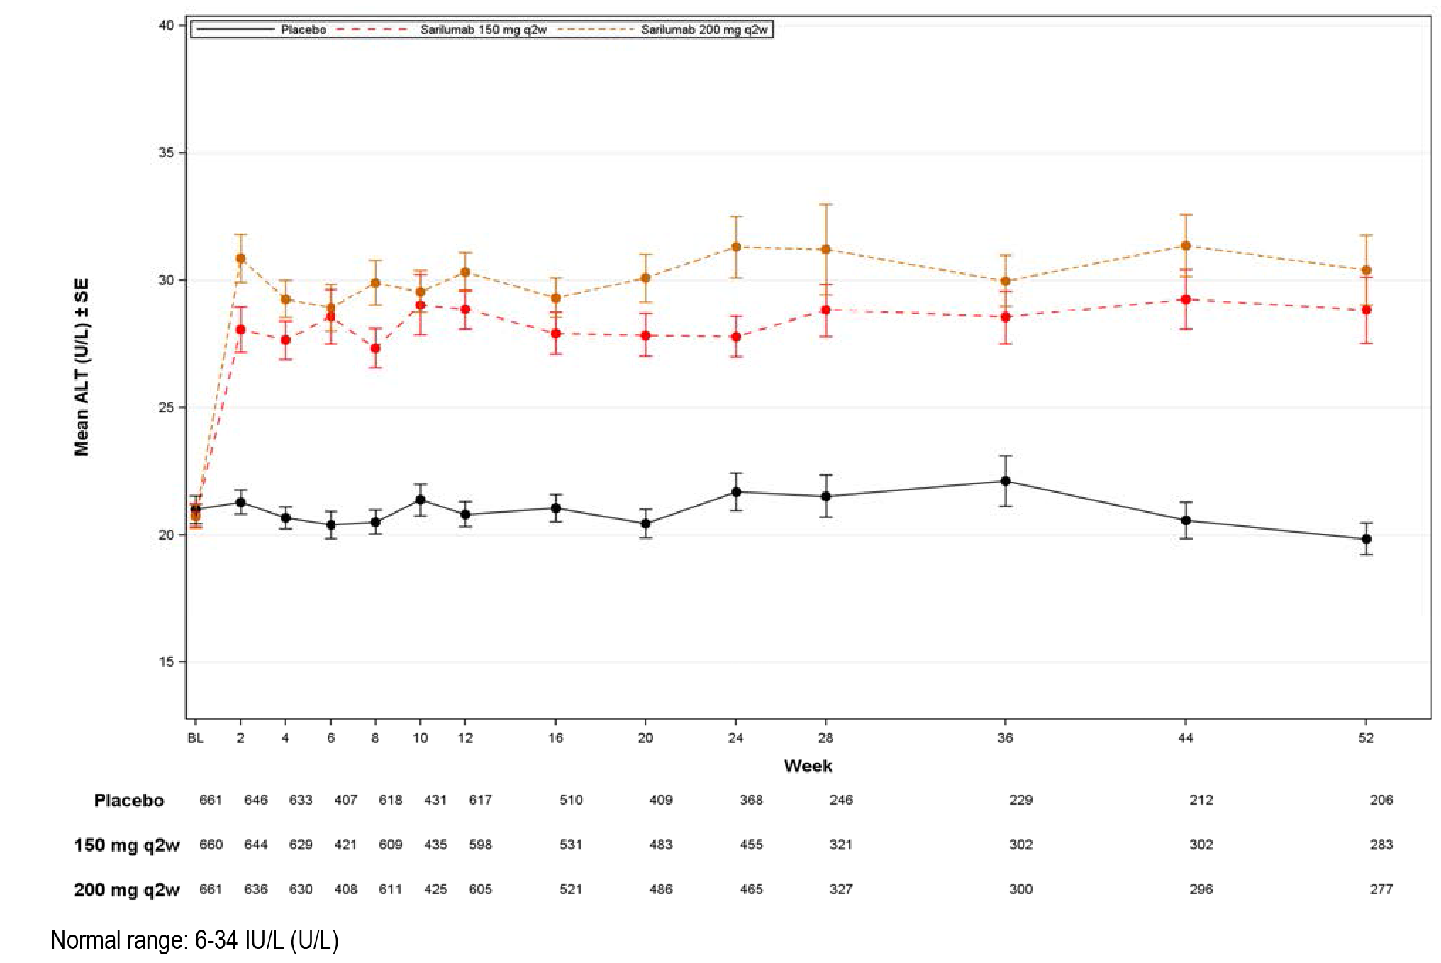

Table 34: Pool 1 Laboratory abnormalities
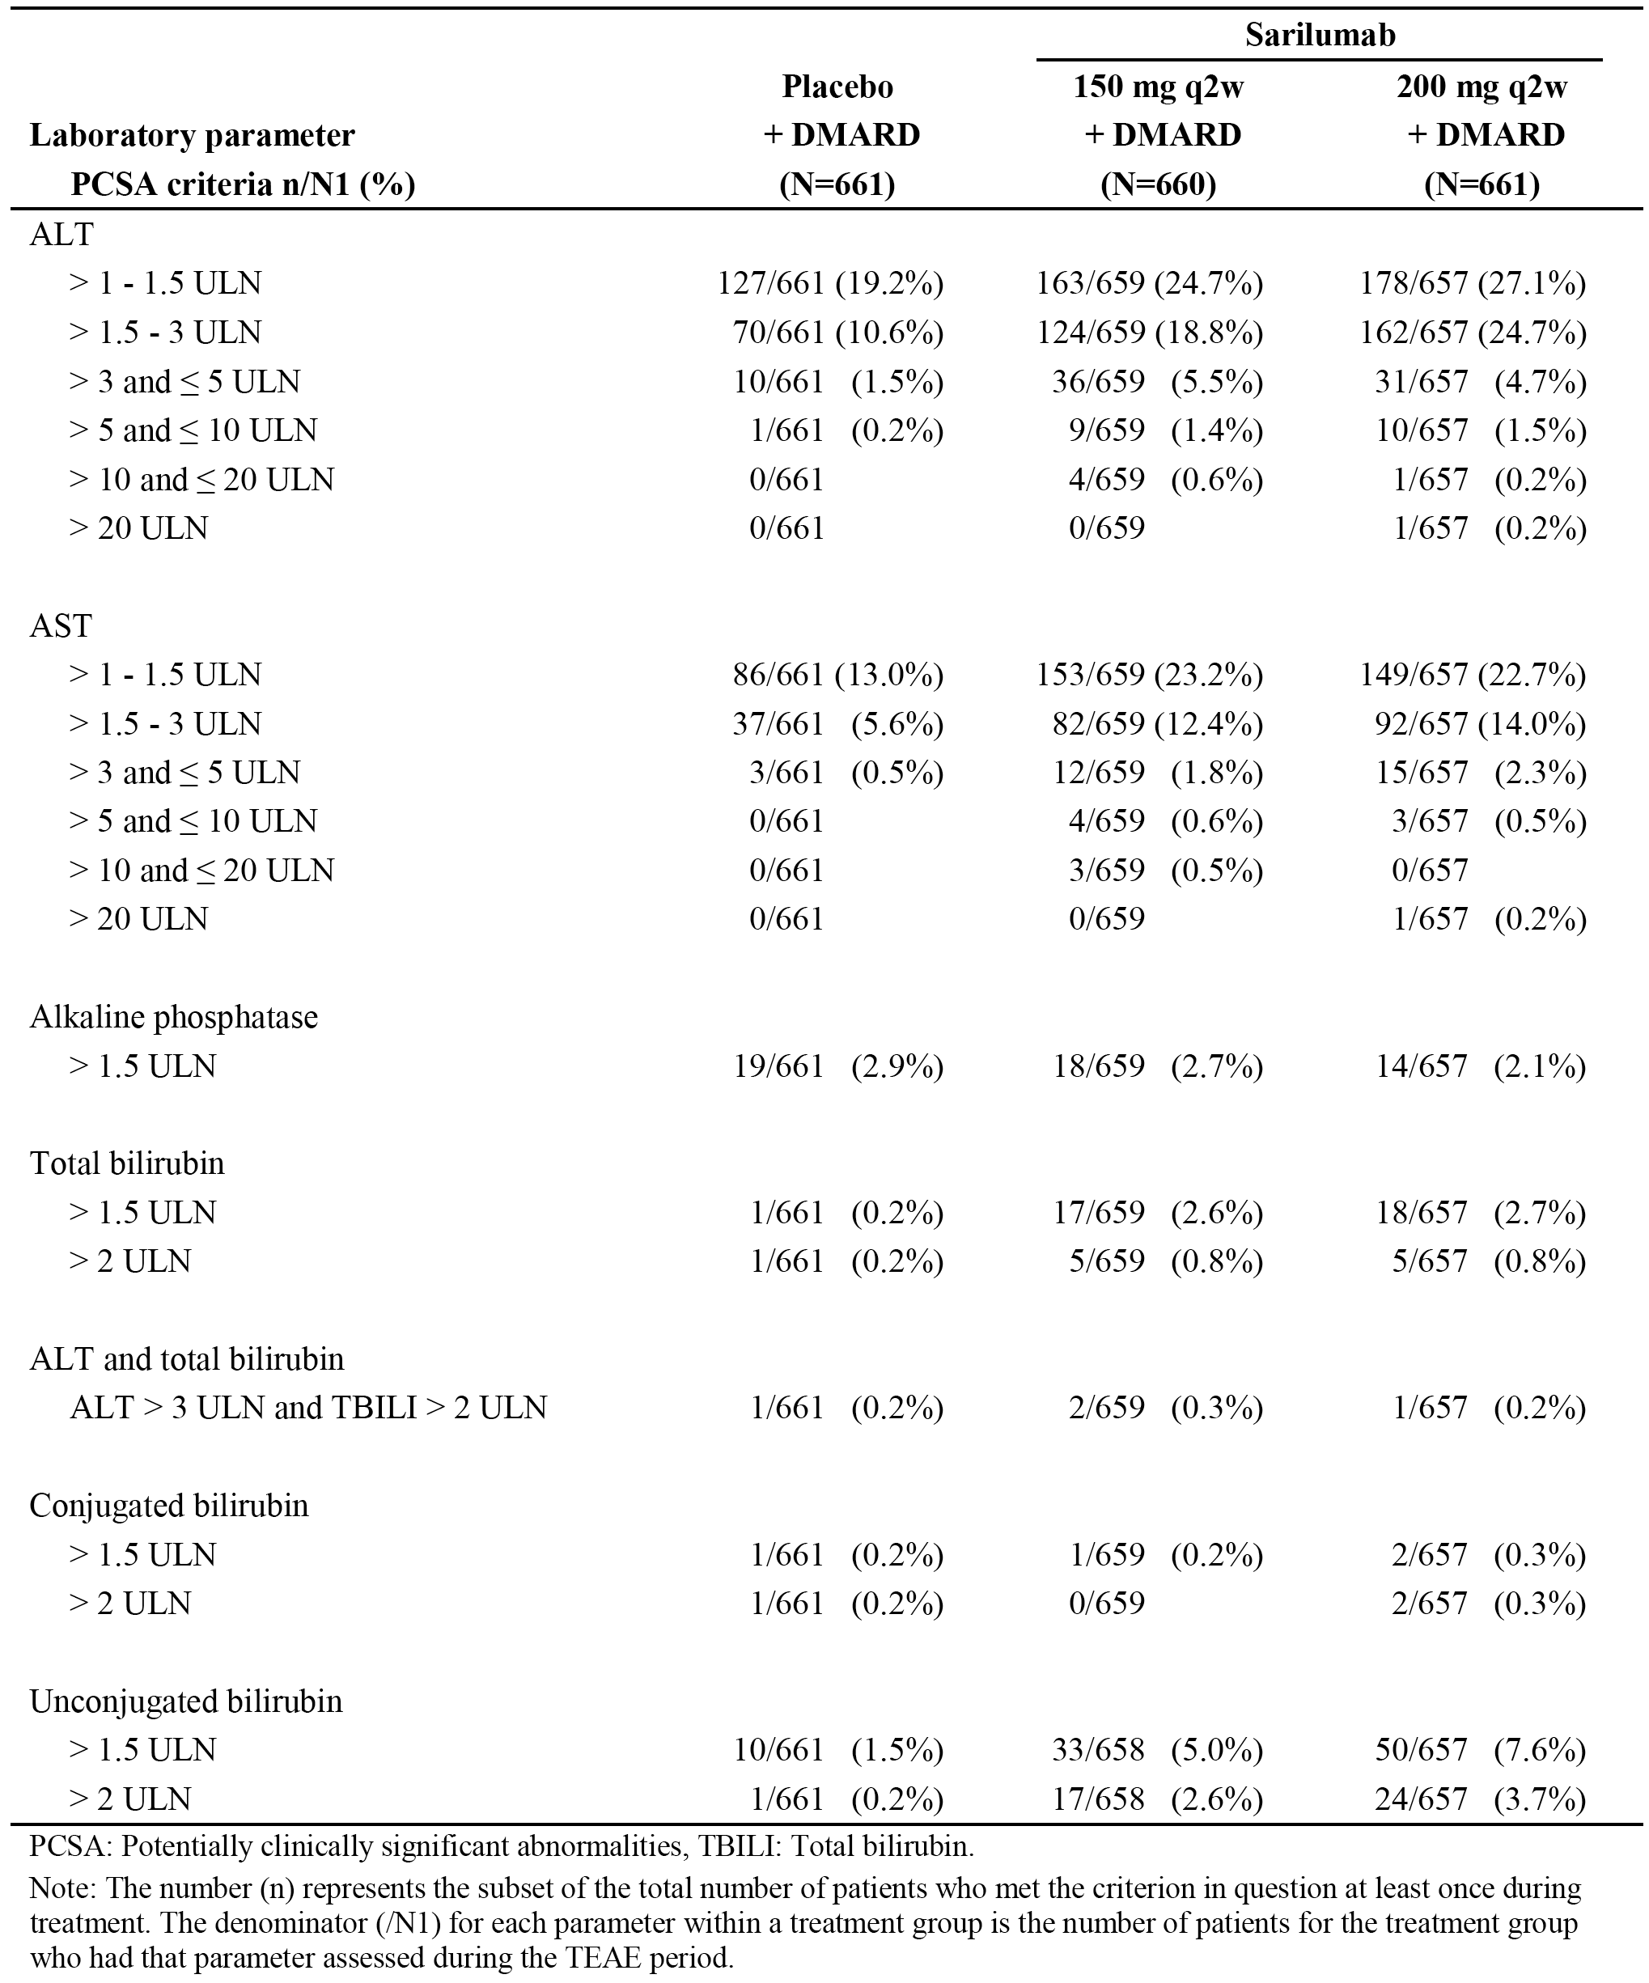
The incidence of patients with LFT laboratory abnormalities in Pool 1 are summarised in Table 34 above, and the results for ALT are summarised below in Table 35. The proportion of patients with ALT > 3 and ≤ 5 x ULN (the levels that would trigger a reduction in sarilumab dose from 200 mg q2w to 150 mg q2w) was similar in the two sarilumab +DMARD groups as was the proportion of patients with ALT levels > 5 x ULN (which would trigger discontinuation of sarilumab). There was 1 (0.2%) patient in the higher dose sarilumab group who met potential Hy’s law criteria for drug induced liver injury (ALT > 3x ULN and total bilirubin > 2 x ULN) compared with 2 (0.3%) patients in the lower dose sarilumab group. Overall, the differences between the two sarilumab groups in the incidence of ALT increases are unlikely to be clinically meaningful.

Table 35: Pool 1 Laboratory ALT abnormalities
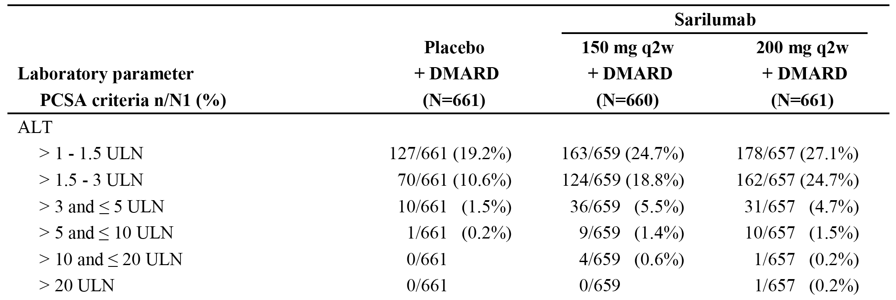

Pool 2 Sarilumab + cDMARD long-term safety population
As of 26 January 2016, Pool 2 included a total of 2887 patients who received any dose of sarilumab + DMARD, comprising 1155 patients initially treated with 150 mg q2w and 1351 patients initially treated with 200 mg q2w until discontinuation or dose modification. The ‘any sarilumab dose + DMARD group’ included safety data from the time of the first dose of sarilumab to the last dose of sarilumab + 60 days, last patient contact date, date of death or the cut-off date, whichever came first.
Total exposure in Pool 2 to any dose of sarilumab was 2887 patients for 5681.6 PY of exposure, with 1960 patients exposed for > 48 weeks, 1298 patients exposed for > 96 weeks, 906 patients exposed for > 144 weeks, and 523 patients exposed for > 192 weeks. Based on exposure at any time during sarilumab treatment, a total of 2157 patients received at least one dose of 200 mg q2w for a total of 3897.2 PY of exposure and 1565 patients received at least one dose of 150 mg q2w for a total of 1505.9 PY of exposure.
Of the 2887 patients in Pool 2 in the any dose sarilumab group, 1341 (46.4%) are receiving on-going treatment, 594 (20.6%) have completed treatment, and 952 (33.0%) have discontinued treatment (primarily due to AEs (n = 601; 20.8%)).
Based on exposure-adjusted patient incidence rates, no clinically meaningful differences were observed between the sarilumab + DMARD long-term safety population (Pool 2) and the sarilumab + DMARD placebo-controlled population (Pool 1). The exposure-adjusted patient incidence rates of TEAEs, SAEs, and discontinuations for sarilumab due to TEAE in the long-term population were generally similar or slightly lower than the rates observed in the placebo-controlled population. The exposure-adjusted patient incidence rate for death in the sarilumab group in the long-term population was similar to the rate observed in the sarilumab placebo-controlled population.
The overview of the AE profile for the any sarilumab dose group from Pool 2 is provided below in Table 36, and the overview of the AE profiles for each sarilumab dose group are summarised in Table 37. The raw patient incidence rates were higher in the sarilumab 200 mg initial dose group than in the initial sarilumab 150 mg dose group for each of the AE categories: that is, any TEAE (85.2% versus 67.4%, respectively); any treatment-emergent SAEs (16.9% versus 5.5%, respectively); any TEAEs leading to death (0.6% versus 0.2%, respectively); and any TEAEs leading to permanent treatment discontinuation (17.2% versus 10.0%, respectively). However, exposure-adjusted event rates in the initial sarilumab 150 mg q2w group were greater than or the same as exposure-adjusted event rates in the initial sarilumab 200 mg q2w group: that is, any TEAEs (326.0 versus 251.6 per 100 PY, respectively); any treatment-emergent SAEs (12.6 versus 14.6 per 100 PY, respectively); any TEAEs leading to death (0.3/100 PY in both groups); and any TEAEs leading to permanent treatment discontinuation (18.7 versus 11.0 per 100 PY, respectively). The exposure-adjusted event rates were similar in the initial sarilumab 200 mg q2w and the any sarilumab dose groups. Therefore, the review of the safety data for Pool 2 provided below focuses on the any sarilumab dose group.

Table 36: Pool 2 Overview of the AE profile
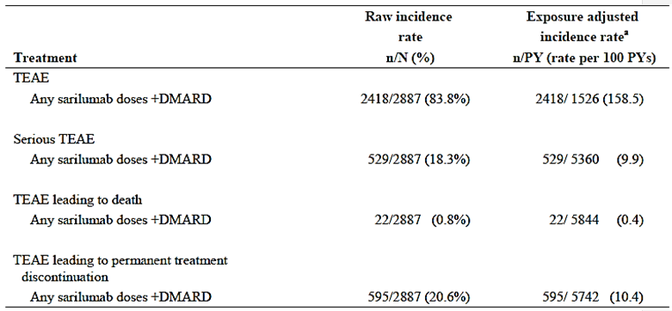
TEAE = Treatment-emergent adverse event, SAE = Serious adverse event. n (%) = number and percentage of patients with at least one TEAE; a) Number of patients with at least one event per 100 PY, where the exposure time for patients who have experienced the specific adverse experience was defined as the time to first adverse experience of interest whereas the exposure time for those who have not had this adverse experience was total TEAE period duration.

Table 37: Pool 2 Adverse event profile of each of the sarilumab dose groups in the long-term safety population
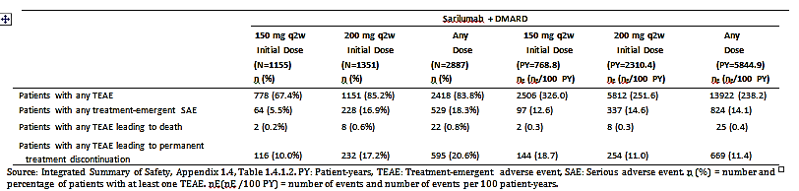
TEAEs (any class) were reported in 2418 (83.8%) patients in the any sarilumab dose group, and the exposure-adjusted event rate was 238.2/100 PY. The most frequently reported TEAEs in patients in the any sarilumab dose group by SOC were Infections and infestations (49.5%). TEAEs (any class), preferred term, reported in ≥ 5% of patients in the any sarilumab dose group, in descending order of frequency were: neutropaenia (17.6%); upper respiratory tract infection (11.3%); accidental overdose (10.9%); ALT increased (10.0%); urinary tract infection (8.7%); nasopharyngitis (8.2%); injection site erythema (7.4%); hypertension (7.1%); bronchitis (6.8%); and RA (6.1%). The most frequently reported TEAEs (any class) reported in the any dose sarilumab group are summarised by patient incidence and exposure-adjusted event rate in Table 38.

Table 38: Pool 2 TEAEs (any) in the any sarilumab dose group
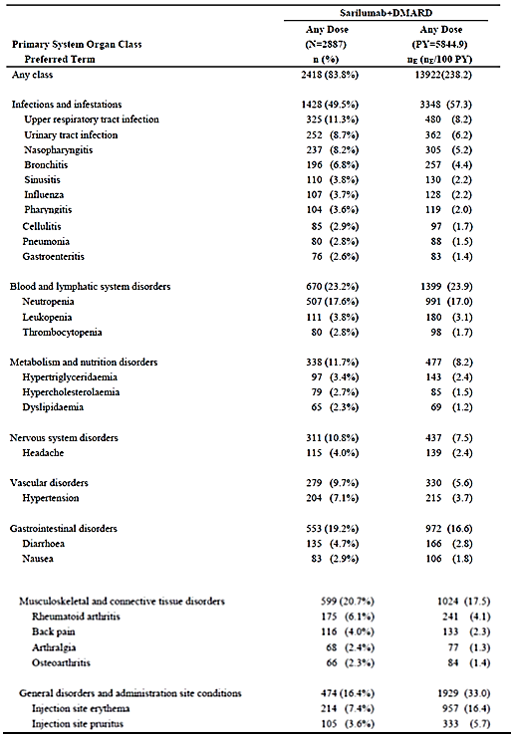

Table 38 (continued): Pool 2 TEAEs (any) in the any sarilumab dose group
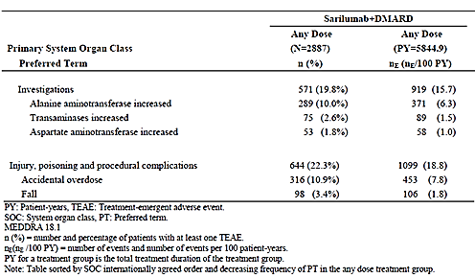
Death was reported in 22 (0.5%) patients in the any sarilumab dose group, including (preferred terms): 2 x pneumonia; 2 x cerebrovascular accident; 2 x cardiac failure; 1 x pneumonia viral; 1 x sepsis; 1 x septic shock; 1 x ductal adenocarcinoma of the pancreas; 1 x cervix cancer metastatic; 1 x metastatic bronchial cancer; 1 x pulmonary oedema; 1 x pulmonary embolism; 1 x acute respiratory distress syndrome; 1 x respiratory distress; 1 x acute respiratory failure; 1 x death; 1 x sudden death; 1 x multi organ failure; 1 x toxicity to various agents; and 1 x alcohol poisoning.
SAEs (any class) were reported in 529 (18.3%) patients in any sarilumab dose group, with an exposure-adjusted event rate of 14.1/100 PY (824 events). The most frequently reported SAEs in patients in the any sarilumab dose group by SOC were Infections and infestations (6.4%), with an exposure-adjusted incident rate of 3.8/100 PY (22 events). SAEs (any class), preferred term, reported in ≥ 0.2% of patients in the any sarilumab dose group are summarised below in Table 39.

Table 39: Pool 2 SAEs (preferred term) any sarilumab dose in combination with DMARD group
Preferred term | Sarilumab any dose (N = 2887), n (%) | Number of events (events/100 PY); 5844.9 PYE
SAE Any class | 529 (18.3%) | 824 (14.1)
Pneumonia | 35 (1.2%) | 36 (0.6)
Osteoarthritis | 28 (1.0%) | 32 (0.5)
Rheumatoid arthritis | 23 (0.8%)) | 24 (0.4
Neutropaenia | 20 (0.7%) | 21 (0.4)
Cellulitis | 15 (0.5%) | 17 (0.3)
Cholelithiasis | 12 (0.4%) | 12 (0.2)
Pulmonary embolism | 10 (0.3%) | 11 (0.2)
Deep vein thrombosis | 9 (0.3%) | 9 (0.2)
Erysipelas | 8 (0.3%) | 8 (0.1)
Diverticulitis | 7 (0.2%) | 7 (0.1)
Acute myocardial infarction | 7 (0.2%) | 7 (0.1)
ALT increased | 7 (0.2%) | 7 (0.1)
Atrial fibrillation | 6 (0.2%) | 7 (0.1)
Bronchitis | 6 (0.2%) | 6 (0.1)
Herpes zoster | 6 (0.2%) | 6 (0.1)
Osteomyelitis | 6 (0.2%) | 6 (0.1)
Subcutaneous abscess | 6 (0.2%) | 6 (0.1)
Foot deformity | 6 (0.2%) | 9 (0.2)
Nephrolithiasis | 6 (0.2%) | 6 (0.1)
Femoral neck fracture | 6 (0.2%) | 6 (0.1)
Femur fracture | 6 (0.2%) | 6 (0.1)
Tendon rupture | 6 (0.2%) | 6 (0.1)
Pancreatitis | 5 (0.2%) | 5 (0.1)
Basal cell carcinoma | 5 (0.2%) | 5 (0.1)
Cerebrovascular accident | 5 (0.2%) | 5 (0.1)
Transient ischaemic attack | 5 (0.2%) | 6 (0.1)
TEAEs (any class) leading to permanent treatment discontinuation were reported in 595 (20.6%) patients in any sarilumab dose group, with an exposure-adjusted event rate of 11.4/100 PY (660 events). The most frequently reported TEAEs leading to permanent treatment discontinuation in patients in the any sarilumab dose group by SOC were Infections and infestations (6.2%), with an exposure-adjusted event rate of 3.3/100 PY (190 events). TEAEs leading to permanent treatment discontinuation reported in ≥ 0.5% of patients in the any sarilumab dose group by descending order of frequency were: neutropaenia (3.0%); ALT increased (2.1%); herpes zoster (1.1%); pneumonia (0.7%); transaminases increased (0.6%); cellulitis (0.5%); thrombocytopaenia (0.5%); injection site reaction (0.5%); and RA (0.5%).
Treatment-emergent adverse events of special interest (AESI) for the sarilumab + DMARD groups are summarised below in Table 40. The most frequently reported AESI in the any sarilumab group was infections (49.5%), followed by leukopaenia (predominantly neutropaenia) (20.2%), hepatic disorders (14.1%), and elevation in lipids (10.1%). AESI occurred consistently more frequently in the higher initial dose sarilumab group (200 mg q2w) than in the lower initial dose sarilumab group (150 mg q2w), but there was no consistent relationship between the two doses for the exposure-adjusted event rates.

Table 40: Pool 2 Adverse events of special interest
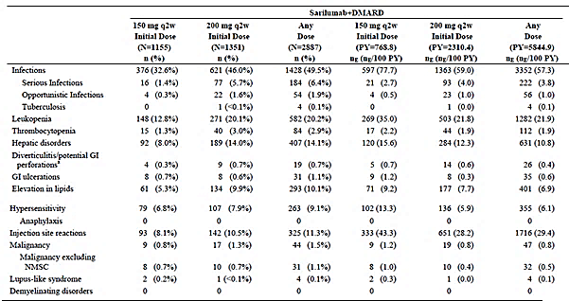
In the any sarilumab dose group, there were 28 (1.0%) patients with adjudicated MACE (primary) events, with an event rate of 0.5/100 PY (31 events). The 31 events were non-fatal myocardial infarction (11 events), non-fatal stroke (9 events), cardiovascular death (7 events), and hospitalisation for non-fatal transient ischaemic attack.
Review of the safety data for the adverse events of particular significance (neutropaenia, thrombocytopaenia and ALT increase), which govern the decision to reduce the initial sarilumab 200 mg q2w dose to 150 mg q2w is presented below.

Neutropaenia
In Pool 2, the incidence of ANC < 1.0 Giga/L in the any sarilumab dose + DMARD group was 11.8% (340/2879), which was numerically higher than the rates in the sarilumab + DMARD groups in Pool 1. The sponsor comments that this finding was not unexpected given that the observation time was longer in Pool 2 compared with Pool 1. The ANC data for Pool 2 are summarised below in Table 41.

Table 41: Pool 2 (sarilumab + DMARD long-term safety population), patients with decrease in ANC during the entire TEAE period
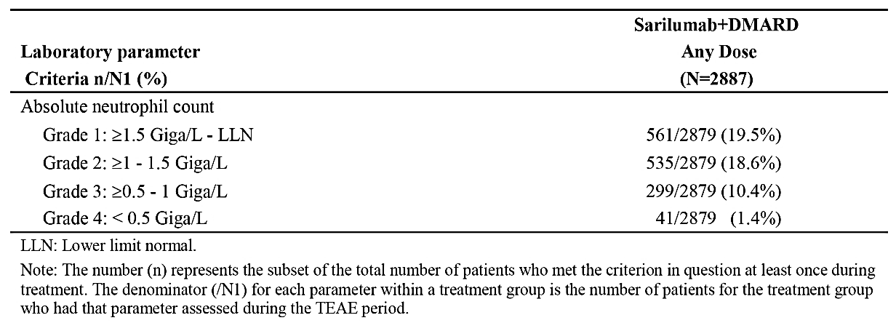
The sponsor provided an assessment of the outcome for patients in Pool 2 with an ANC < 1.0 Giga/L. Per protocol, sarilumab was to be permanently discontinued for Grade 4 neutropaenia, irrespective of associated infection, or Grade 3 neutropaenia associated with infection. In the setting of Grade 3 neutropaenia without associated infection, treatment was to be temporarily withheld and re-initiated after the neutrophil count had recovered to Grade 2 (≥ 1.0 Giga/L). The outcomes for patients with ANC < 1.0 Giga/L are summarised below in Table 42.

Table 42: Pool 2 (sarilumab + DMARD long-term safety population) Overview of outcome in patients with ANC < 1.0 Giga/L
Patient group | Sarilumab (any dose) + DMARD; n = 2887; n/N1 (%)
Patients with ANC <1.0 Giga/L | 340/2879 (11.8%)
Normalised on-treatment ª | 242/2879 (8.4%)
Normalised after the last dose of IMP | 66/2879 (2.3%)
Did not normalise after the last episode | 32/2879 (1.1%)
IMP continuing ^{b} | 16/2879 (0.6%)
IMP discontinued - last value available | 16/2879 (0.6%)
Grade 1: ≥ 1.5 Giga/L – LLN | 2/2879 (<0.1%)
Grade 2: ≥ 1 - 1.5 Giga/L | 10/2879 (0.3%)
Grade 3-4:<1.0 Giga/L | 4/2879 (0.1%)
Note: The number (n) represents the subset of the total number of patients who met the criterion in question at least once during treatment. The denominator (/N1) for each parameter within a treatment group is the number of patients for the treatment group who had that parameter assessed during the TEAE period. ANC = absolute neutrophil count. Note: normalisation/normal is defined as absolute neutrophil count > LLN or return to baseline if baseline is <LLN after the last episode of ANC<1.0 Giga/L. a = End of treatment defined as ≤ 17 days after date of last dose of IMP. b = Patient was still in the study at time of data extraction.
Of the 340 patients in the any sarilumab dose group with an ANC <1.0 Giga/L, 292 patients re-initiated treatment with sarilumab after the initial episode of ANC < 1.0 Giga/L and the majority of these patients were able to continue therapy with no or a single recurrence of ANC < 1.0 Giga/L (n = 139), while 49 patients eventually discontinued due to neutropaenia, decreased neutrophil count or leukopaenia. Overall, the normalisation and re-initiation data for patients in the any sarilumab dose group with an ANC < 1.0 Giga/L showed that neutropaenia associated with sarilumab treatment was reversible.

Thrombocytopaenia
In the any sarilumab dose group, 65 (2.3%) patients had a platelet count of < 100 Giga/L, with 36 patients having one platelet count < 100 Giga/L and 29 patients having more than one platelet count < 100 Giga/L.
Sarilumab was to be discontinued in patients with platelet counts < 50 Giga/L, or in patients with platelet counts < 100 Giga/L and evidence of bleeding. If the platelet count was 50 to 100 Giga/L with no evidence of bleeding, administration of the treatment regimen was to be temporarily withheld and re-initiated once the platelet count was > 100 Giga/L. The outcomes for the 65 patients with platelet counts < 100 Giga/L are summarised below in Table 43.
A total of 5 patients with platelet counts < 100 Giga/L had a bleeding event (TEAE within the SMQ haemorrhages). In 3 patients, the events were not concurrent, and therefore the decrease in platelet count was not considered to be a potential cause for the bleeding event. In the remaining 2 patients, the bleeding events were mild in intensity and non-serious, and consisted of injection site ecchymosis with a platelet count between 58 and 91 Giga/L and left arm hematoma with a platelet count between 60 to 93 Giga/L. The patient with left arm hematoma also had prior AEs of intermittent hematoma in the upper arms which occurred without concurrent decrease in platelet count, making it unlikely that the observed event was related to the platelet count < 100 Giga/L.

Table 43: Pool 2 (sarilumab + DMARD long-term safety population) Overview of outcome in patients with platelet counts < 100 Giga/L
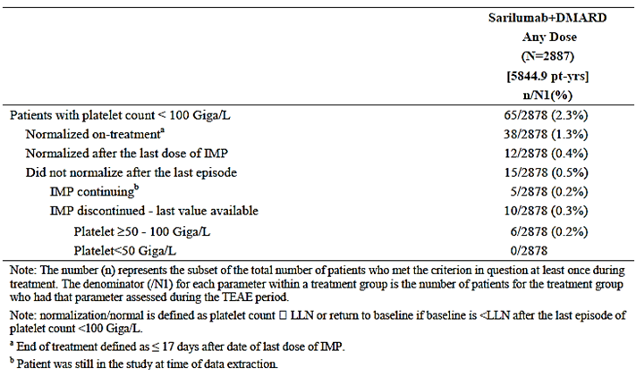

ALT increased
Liver function laboratory abnormalities are summarised below in Table 44. In the any sarilumab dose group, 62.7% (n = 3876) of patients had ALT levels (laboratory) > 1 x ULN, with the majority of these patients having levels ≤ 3 x ULN. There were 279 (9.7%) patients with increased ALT levels (laboratory) > 3 x ULN. There were 8 (0.3%) patients meeting Hy’s law criteria for drug induced liver injury (ALT > 3 x ULN and total bilirubin > 2 x ULN).
Of the 279 patients in the any sarilumab dose group who had an ALT > 3 x ULN, 150 (54%) patients normalised on-treatment (at least 1 ALT value was normal within ≤ 17 days after last dose of sarilumab), 60 (22%) patients normalised after discontinuation of sarilumab, and 69 (25%) patients had not normalised as of the last available assessment. In the 69 patients who had not normalised, 24 (35%) patients were still enrolled in the studies and continued receiving sarilumab therapy.
Of the 279 patients in the any sarilumab dose group who had an ALT > 3 x ULN, 208 (75%) patients re-initiated sarilumab after the initial episode of ALT > 3 x ULN and 107 (51%) patients were able to re-initiate within ≤ 17 days for q2w dosing and ≤ 9 days for qw dosing per protocol. Of the 208 patients who re-initiated sarilumab, 147 (71%) patients had no recurrence of ALT > 3 x ULN, 39 (19%) had 1 recurrence and 22 (11%) had 2 or more recurrences. Of the patients who re-initiated treatment, 35 (17%) patients eventually discontinued due to transaminase or ALT increase, and 22 patients had 1 or no recurrence and 13 patients had 2 or more recurrences prior to discontinuation.
Overall, the reports of ALT > 3 x ULN in patients treated with sarilumab + DMARD were transient with the majority of patients being able to re-initiate treatment.

Table 44: Pool 2 (sarilumab + DMARD long-term safety population), any sarilumab dose group
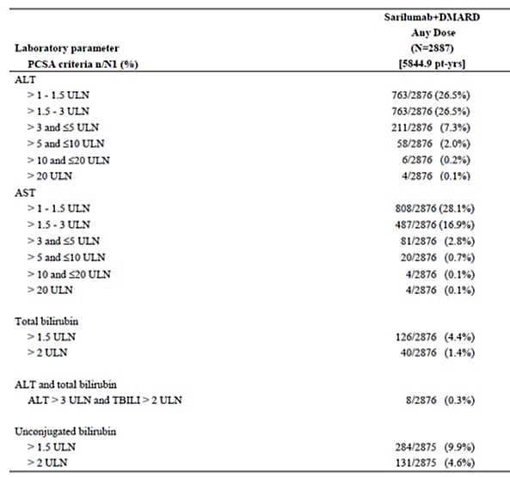
Strengths of the sarilumab in combination with cDMARD risk data
- The sarilumab + cDMARD data allowed the risks of combination treatment to be adequately characterised in the placebo-controlled population (Pool 1). In Pool 1, TEAEs, SAEs, and TEAEs leading to permanent treatment discontinuation were observed in a higher proportion of patients in both sarilumab + cDMARD treatment groups relative to the placebo + DMARD group, while only a small number of deaths were observed in the three treatment groups. In patients treated with the higher sarilumab dose compared with the lower sarilumab dose there were small numerical increase in the risks of TEAEs (difference = 3.4% [95% CI: -1.4, 8.2]), serious TEAEs (difference = 2.6% (95% CI: -0.3, 5.4), and TEAEs leading to permanent treatment discontinuation (difference = 1.7% (95% CI: -1.8, 5.1)).
- The sarilumab + cDMARD data allowed the long-term risks of combination treatment to be adequately characterised in a total of 2887 patients treated with any sarilumab dose + cDMARD, with an exposure of 5681.6 PY (Pool 2). The exposure-adjusted patient incidence rate for TEAEs was lower in the any sarilumab + cDMARD dose group (Pool 2) than in the sarilumab 200 mg q2w and 150 mg q2w groups (Pool 1) (158.5 versus 252.0 versus 215.7 per 100 PY, respectively), while the exposure-adjusted patient incidence rate for serious TEAEs was similar in the three treatment groups (9.9 versus 13.8 versus 9.7 per 100 PY, respectively) as was the exposure-adjusted patient incidence rate for TEAEs leading to death (0.4 versus 0.2 versus 0.5 per 100 PY, respectively). The exposure-adjusted patient incidence rate for TEAEs leading to permanent treatment discontinuation was lower in the any sarilumab + cDMARD dose group (Pool 2) than in the sarilumab 200 mg q2w and 150 mg q2w groups (Pool 1) (10.4 versus 19.4 versus 16.8 per 100 PY, respectively). Overall, the exposure-adjusted patient incidence rates for Pool 2 indicate that adverse events do not increase over time for patients treated with sarilumab + cDMARD. In general, the safety profiles of the sarilumab + cDMARD populations in Pool 2 and Pool 1 were generally consistent. No new safety signals emerged with long-term treatment with sarilumab in combination with cDMARD.

Limitations and uncertainties of the sarilumab in combination with cDMARD risk data
- There was no control group (active or placebo) in the sarilumab + cDMARD long-term safety population. This raises uncertainties relating to interpretation of the long-term risk data.
- The total patient population in Pool 2 (sarilumab + cDMARD long-term safety population) in the any sarilumab dose group (n = 2887) was sufficient to detect adverse reactions to sarilumab occurring with an incidence of > 0.1%, based on ‘the rule of threes’. However, it is unlikely that the total population exposed to any sarilumab dose in Pool 2 is sufficient to detect adverse reactions occurring with an incidence of < 0.1%.
- There are uncertainties associated with the use of long-term sarilumab + cDMARD as regards adverse events that might emerge only after prolonged exposure (for example, malignancies and cardiovascular events). In Pool 2 (sarilumab + cDMARD long-term safety population), 1960 patients had been exposed to any sarilumab dose + cDMARD for > 48 weeks, 1298 for > 96 weeks, 906 for > 144 weeks, 523 for > 192 weeks, 180 for > 240 weeks, and 39 for > 264 weeks.
- In Pool 2 (sarilumab + cDMARD long-term safety population), MACE (primary) occurred in 28 (1.0%) patients in the any sarilumab dose + cDMARD group, with an event-rate of 0.5/100 PY (31 events). In Pool 2, malignancy occurred in 44 (1.5%) patients, with an event-rate of 0.8/100 PY. The event rate for non-melanoma skin cancers (NMSC) was 0.3/100 PY (15 events), the event rate for solid tumours excluding NMSC was 0.5/100 PY (29 events), and the event rate for haematological malignancies was 0.1/100 PY (3 events). The currently available data for MACE and malignancies do not give rise to particular concern relating to these adverse events, but only 523 patients have been exposed for > 192 weeks. Therefore, conclusive data for these adverse events are dependent on post-marketing exposure in a large number of patients.

Key risks associated with sarilumab 200 mg q2w and sarilumab 150 mg q2w
In its consideration of the sponsor’s initial submission to register sarilumab in combination with cDMARD for the treatment of the proposed indication the ACM noted that the safety of sarilumab 150 mg q2w was superior compared with sarilumab 200 mg q2w and that, although there was a trend towards superior efficacy with the higher compared with the lower sarilumab dose, there was no statistically significant difference in efficacy between the two doses. Consequently, based on the safety concerns and the efficacy findings the ACM recommended that treatment be initiated with sarilumab 150 mg q2w and increased to sarilumab 200 mg q2w if considered to be clinically appropriate.
Therefore, based on the initial recommendation by the ACM, it is considered that the key issue in the re-submission centres on whether the totality of the previously evaluated clinical studies and the new clinical studies support the sponsor’s proposal that treatment for the proposed indication be initiated with the sarilumab 200 mg q2w with reduction to sarilumab 150 mg q2w in the event of neutropaenia, thrombocytopaenia, or increased ALT.
In order to address the key safety concerns, the risks of infection, thrombocytopaenia and increased ALT with both doses of sarilumab based on the totality of the submitted data are reviewed below. Of note, there appeared to be no major concerns raised in the initial evaluation relating to the safety of either sarilumab 150 mg q2w or sarilumab 200 mg q2w in combination with cDMARD that would have precluded approval of both doses for the treatment of the initially proposed indication.

Infections
- The most commonly reported treatment-emergent AESIs of concern in the sarilumab monotherapy and sarilumab + DMARD studies related to infections.
- In the pivotal monotherapy Study EFC14092 MONARCH, infections occurred in a similar proportion of patients in the sarilumab 200 mg q2w and the adalimumab 40 mg q2w groups (28.8%, n = 53 versus 27.7%, n = 51, respectively). Serious infections occurred in the same proportion of patients in both treatment groups (1.1%, n = 2), as did opportunistic infections (0.5%, n = 1), while TB was reported in 1 (0.5%) patient in the adalimumab group and no patients in the sarilumab group. Infections reported in ≥ 2% of patients in either of the two treatment groups, sarilumab versus adalimumab, respectively, in decreasing order of frequency in the sarilumab group were bronchitis (6.5% versus 3.8%), nasopharyngitis (6.0% versus 7.6%), urinary tract infection (2.7% versus 2.2%), pharyngitis (1.6% versus 2.7%), and upper respiratory tract infection (1.6% versus 3.8%). Serious infections occurred in 2 (1.1%) patients in the sarilumab group (1x bursitis infective, 1 x mastitis) and 2 (1.1%) patients in the adalimumab group (1x arthritis bacterial, 1 x respiratory tract infection). Infections leading to permanent treatment discontinuation were reported infrequently in both treatment groups (0.5%, n = 1, sarilumab [1x herpes zoster] versus 1.1%, n = 2, adalimumab (1 x arthritis bacterial, 1x pulmonary TB)). There were no deaths due to infections reported in either of the two treatment groups. Overall, it is considered that there were no clinically meaningful differences between sarilumab 200 mg q2w and adalimumab 40 mg q2w in the pattern of infections observed in the pivotal monotherapy study.
- In Pool 1 (sarilumab + DMARD placebo-controlled population), infections occurred in a similar proportion of patients in the sarilumab 200 mg q2w + DMARD and sarilumab 150 mg q2w + DMARD groups (35.2%, n = 233 versus 34.4%, n = 227, respectively), as did serious infections (2.9%, n = 19 versus 1.8%, n = 12, respectively) and opportunistic infections (0.9%, n = 6 versus 0.6%, n = 4). The event rates for the total number of infections in the two treatment groups were 84.5/100 PY in the sarilumab 200 mg q2w + DMARD group (373 events) and 81.0/100 PY in the sarilumab 150 mg q2w +DMARD group (357 events), and the event rates for the number of serious infections were 5.2/100 PY (23 events) and 3.6/100 PY (16 events), respectively.
- In Pool 1 (sarilumab + DMARD placebo-controlled population), infections reported in ≥ 2% of patients in either of the two sarilumab treatment groups (200 mg q2w versus 150 mg q2w, respectively), in decreasing order of frequency in the 200 mg q2w group were upper respiratory tract infection (7.1% versus 6.4%), urinary tract infection (5.7% versus 4.4%), nasopharyngitis (4.2% versus 5.5%), bronchitis (3.8% versus 2.7%), influenza (2.4% versus 2.6%), pharyngitis (2.4% versus 2.3%), and sinusitis (2.4% versus 2.1%).
- In Pool 1 (sarilumab + DMARD placebo-controlled population), serious infections occurred in 19 (2.9%) patients in the sarilumab 200 mg q2w group, and serious infections reported in ≥ 2 patients were erysipelas (x 3), pneumonia (x 3), bronchitis (x 2), and cellulitis (x 2). In the sarilumab 150 mg q2w group, serious infection occurred in 12 (1.8%) patients and no serious infections were reported in ≥ 2 patients.
- In Pool 1 (sarilumab + DMARD placebo-controlled population), infections leading to permanent treatment discontinuation were reported in the same proportion of patients in both sarilumab treatment groups (3.0%, n = 20), and infections reported in ≥ 2 patients in either the 200 mg q2w group or the 150 mg q2w group, respectively, were herpes zoster (0.8%, n = 5 versus 0.5%, n = 3), cellulitis (0.3%, n = 2 versus 0.3%, n = 2), pneumonia (0.3%, n = 2 versus 0.3%, n = 2), oral herpes (0.2%, n = 1 versus 0.3%, n = 2), and urinary tract infection (0.2%, n = 1 versus 0%). There were no deaths due to infection in either of the two sarilumab groups.
- In Pool 2 (sarilumab + DMARD long-term safety population), infections in the sarilumab 200 mg q2w initial dose group were reported more frequently than in the sarilumab 150 mg q2w initial dose group (46.0% versus 32.6%, respectively), but the exposure-adjusted event rates were greater in the 150 mg q2w initial dose group than in the 200 mg q2w initial dose group (77.7/100 PY [597 events] versus 59.0/100 PY (1363 events)).
- In Pool 2 (sarilumab + DMARD long term safety population), in the any sarilumab dose group infections were reported in 49.5% (n = 1428) of patients, and the exposure-adjusted event rate was 57.3/100 PY (3352 events). Infections reported in ≥ 5% of patients in the any sarilumab dose group were upper respiratory tract infection (11.3%), urinary tract infection (8.7%), nasopharyngitis (8.2%) and bronchitis (6.8%). The exposure-adjusted event rates for these commonly reported infections in the sarilumab 150 mg q2w and 200 mg q2w initial dose groups, respectively, were: upper respiratory tract infection (12.3/100 PY (94 events) versus 7.9/100 PY (183 events)); urinary tract infection (6.6/100 PY (51 events) versus 7.0/100 PY (162 events); nasopharyngitis (9.4/100 PY (72 events) versus 4.9 /100 PY (113 events)); and bronchitis (5.5/100 PY (42 events) versus 4.3/100 PY (100 events)). Of note, the exposure-adjusted event rates for the commonly reported infections in the sarilumab 200 mg q2w initial dose group were either lower than or similar to those in the sarilumab 150 mg q2w initial dose group.
- In Pool 2 (sarilumab + DMARD long-term safety population), in the any sarilumab dose group serious infections were reported in 6.4% (n = 184) of patients, and the exposure-adjusted event rate was 3.8/100 PY (222 events). Serious infections were reported more frequently in patients in the sarilumab 200 mg q2w initial dose group than in the sarilumab 150 mg q2w initial dose group (5.7% versus 1.4%, respectively), and the exposure-adjusted event rate was higher in the sarilumab 200 mg q2w dose group than in the sarilumab 150 mg q2w initial dose group (4.0/100 PY (93 events) versus 2.7/100 PY (21 events), respectively). The most commonly reported serious infection in the any sarilumab dose group was pneumonia (1.2%, n = 5), and all other serious infections were reported in < 1.0% of patients.
- In Pool 2 (sarilumab + DMARD long-term safety population), infections leading to permanent treatment discontinuation occurred in 6.2% (n = 179) of patients in the any sarilumab dose group, and the exposure-adjusted event rate was 3.1/100 PY. Infections leading to permanent treatment discontinuation were reported more frequently in patients in the sarilumab 200 mg q2w initial dose group than in the sarilumab 150 mg q2w initial dose group (5.4% versus 2.3%, respectively), but the exposure-adjusted event rate was similar in the two treatment groups (3.1 versus 3.5 per 100/PY, respectively). In the any sarilumab dose group, infections leading to permanent treatment discontinuation and reported in ≥ 0.5% of patients were herpes zoster (1.1%), pneumonia (0.7%) and cellulitis (0.5%). There were 6 (0.2%) patients with infection leading to death in the any sarilumab dose group (2 x pneumonia, 1 x each pneumonia viral, psoas abscess, sepsis and septic shock).
- Overall, it is considered that there were no clinically meaningful differences in the patterns of infection in the sarilumab 200 mg q2w + DMARD and sarilumab 150 mg q2w + DMARD groups.

Neutropaenia
- The sponsor proposes that the treatment with sarilumab 200 mg q2w be interrupted when the ANC is 0.5 to 1.0 Giga/L, and treatment with sarilumab 150 mg q2w be resumed as clinically appropriate. The sponsor proposes that treatment with sarilumab be discontinued when the ANC is < 0.5 Giga/L.
- In the pivotal monotherapy Study EFC14092 MONARCH, neutropaenia TEAEs occurred notably more frequently in the sarilumab 200 mg q2w group than in the adalimumab 40 mg q2w group (13.6%, n = 25 versus 0.5%, n = 1), while neutropaenia SAEs were reported in only 1 patient (sarilumab group). Permanent treatment discontinuation due to neutropaenia TEAEs was reported in 5 (2.7%) patients in the sarilumab group and in 1 (0.5%) patient in the adalimumab group. No deaths occurred due to neutropaenia in either of the two treatment groups.
- In the pivotal monotherapy Study EFC14092 MONARCH, the majority of laboratory assessed ANCs in both treatment groups were Grade 1 or 2 in severity and occurred numerically more frequently in the sarilumab group than in the adalimumab group. Grade 3 neutropaenia was reported more frequently in the sarilumab group than in the adalimumab group (8.7%, n = 16 versus 1.1%, n = 2), as was Grade 4 neutropaenia (1.6%, n = 3 versus 0%, n = 0). Based on the proposed ANC criteria for reducing the dose of sarilumab from 200 mg q2w to 150 mg q2w (Grade ≥ 3 neutropaenia), 19 (10.3%) patients in the sarilumab 200 mg q2w group would have qualified for dose reduction. Despite the higher incidence of neutropaenia in the sarilumab group compared with the adalimumab group there were no clinically meaningful differences between the two groups in the rates of infection, including serious infections, opportunistic infections and TB.
- In Pool 1 (sarilumab + DMARD placebo-controlled population), neutropaenia TEAEs were reported more frequently in the 200 mg q2w group than in the 150 mg q2w group (14.2%, n = 94 versus 9.8%, n = 65, respectively), while neutropaenia SAEs were reported in a similar proportion of patients in the two treatment groups (0.8%, n = 5 versus 0.6%, n = 4, respectively). Neutropaenia TEAEs leading to permanent treatment discontinuation were reported in the same proportion of patients in the sarilumab 200 mg q2w and sarilumab 150 mg q2w groups (2.0%, n = 13 versus 2.3%, n = 15, respectively). There were no deaths due to neutropaenia TEAEs in either of the two sarilumab treatment groups. The exposure-adjusted event rate for the total number of neutropaenia TEAEs was 31.0/100 PY in the sarilumab 200 mg q2w + DMARD group and 22.9/100 PY in the sarilumab 150 mg q2w + DMARD group, and the exposure-adjusted event rate for neutropaenia SAEs was 5.2/100 PY and 3.6/100 PY, respectively.
- In Pool 1 (sarilumab + DMARD placebo-controlled population), the majority of laboratory assessed ANCs in both sarilumab treatment groups were Grade 1 or 2 in severity and occurred numerically more frequently in the 200 mg q2w group than in the 150 mg q2w group. Grade 3 neutropaenia was reported more frequently in the sarilumab 200 mg q2w group than in the sarilumab 150 mg q2w group (8.4%, n = 55 versus 4.8%, n = 32, respectively), while Grade 4 neutropaenia was reported in a similar proportion of patients in both treatment groups (0.9%, n = 6 versus 1.2%, n = 8, respectively). Despite the trend towards a higher incidence of neutropaenia in the sarilumab 200 mg q2w group compared with the sarilumab 150 mg q2w group, the incidence of infections (including serious infections and opportunistic infections) was similar in the two treatment groups.
- In Pool 2 (sarilumab + DMARD long-term safety population), neutropaenia TEAEs in the any sarilumab dose group were reported in 17.6% (n = 507) of patients, and the exposure-adjusted event rate was 17.0/100 PY (992 events). Neutropaenia SAEs were reported in 0.7% (n = 20) of patients in the any sarilumab dose group, and the exposure-adjusted event rate was 0.4/100 PY (21 events). SAEs of neutropaenia were reported in a similar proportion of patients in the sarilumab 150 mg q2w initial dose group and the sarilumab 200 mg q2w initial dose group (0.4% versus 0.7%), and the exposure-adjusted event rate was 0.7/100 PY in the sarilumab 150 mg q2w initial dose group (5 events) and 0.4/100 PY in the sarilumab 200 mg q2w initial dose group (10 events)
- In the long-term Study LTS11210, reduction in dose from sarilumab 200 mg q2w to sarilumab 150 mg q2w due to neutrophil count decreased was reported in 11.3% (187/1652) of patients, with the specific reasons being ANC < 1.0 to ≥ 0.5 Giga/L in 5.7% (n = 94) of patients and precautionary measure to avoid ANC < 1.0 Giga/L in 5.6% (n = 93) of patients. The results indicated that most patients in whom treatment was initiated with sarilumab 200 mg q2w did not require dose reduction to sarilumab 150 mg q2w due to neutropaenia. Dose reductions from sarilumab 200 mg q2w to 150 mg q2w (all causes combined) occurred predominantly in the first 3 months of treatment. The majority of patients being treated with sarilumab 200 mg q2w prior to dose reduction for decreased neutrophil count continued on treatment with sarilumab 150 mg q2w following dose reduction (78.9% (157/199)).
- Based on the totality of the safety data relating to the incidence of neutropaenia it is considered that treatment can be safely initiated with sarilumab 200 mg q2w and reduced to 150 mg q2w based on the ANC criteria provided in the PI.

Thrombocytopaenia
- The sponsor proposes that treatment with sarilumab 200 mg q2w is interrupted when the platelet count is 50 to 100 Giga/L and that treatment with sarilumab 150 mg q2w be resumed as clinically appropriate. The sponsor proposes that treatment with sarilumab is discontinued if the platelet count is < 50 Giga/L, if confirmed by repeat testing.
- In the pivotal monotherapy Study EFC14092 MONARCH, patients with platelets < 150 Giga/L were excluded from the study. Platelet counts < 100 Giga/L were reported as AEs, and treatment was to be permanently discontinued if platelet counts were < 50 Giga/L or < 100 Giga/L with bleeding. No TEAEs of thrombocytopaenia were reported in either the sarilumab 200 mg q2w group or the adalimumab 40 mg q2w group. Laboratory assessments of thrombocytopaenia showed that a greater decrease in mean platelet count was observed at Week 24 in the sarilumab group compared with the adalimumab group (-71.3 Giga/L versus -5.8 Giga/L, respectively). However, mean platelet counts remained within the normal range in both treatment groups during the course of the study. Platelet counts < 100 Giga/L were reported in 1 patient only. This patient was in the sarilumab group and had a count of < 25 Giga/L, but the count was considered to be a laboratory error as all prior and subsequent counts were > 200 Giga/L.
- In Pool 1 (sarilumab + DMARD placebo-controlled population), thrombocytopaenia TEAEs were reported in 11 (1.7%) patients in the sarilumab 200 mg q2w group and 4 (0.6%) patients in the sarilumab 150 mg q2w group, and the exposure-adjusted event rates were 0.2/100 PY in both treatment groups. Thrombocytopaenia SAEs were reported in the same proportion of patients in the two sarilumab treatment groups (0.2%, n = 1), and the exposure-adjusted event rates were also the same in both groups (0.2/100 PY)
- In Pool 1 (sarilumab + DMARD placebo-controlled population), thrombocytopaenia TEAEs leading to permanent treatment discontinuation were reported infrequently and in a similar proportion of patients in the sarilumab 200 mg q2w and 150 mg q2w treatment groups (0.5%, n = 3 versus 0.2%, n = 1, respectively). The decrease in platelet counts in the two sarilumab treatment groups was not associated with bleeding. No deaths due to thrombocytopaenia were reported in either of the two sarilumab treatment groups.
- In Pool 1 (sarilumab + DMARD placebo-controlled population), the mean platelet count declined rapidly in the first 4 weeks of treatment, with mean decreases at Week 4 of 91 Giga/L in the sarilumab 200 mg q2w group and 75 Giga/L in the sarilumab 150 mg q2w group. In both treatment groups, mean platelet counts stabilised from Week 4 throughout the remainder of treatment. Platelet counts <100 Giga/L were observed in 11 (1.7%) patients in the sarilumab 200 mg q2w group and in 4 (0.6%) patients in the sarilumab 150 mg q2w group.
- In Pool 2 (sarilumab + DMARD long-term safety population), thrombocytopaenia TEAEs in the any sarilumab dose group were reported in 2.8% (n = 80) of patients, and the exposure-adjusted event rate was 1.7/100 PY (98 events). Thrombocytopaenia TEAEs was reported more frequently in patients in the sarilumab 200 mg q2w initial dose group than in the sarilumab 150 mg q2w dose group (2.5% versus 1.1%, respectively), but the exposure-adjusted event rates were similar in the two groups (1.6 versus 2.0 per 100 PY, respectively). Thrombocytopaenia SAEs were reported in 0.1% (n = 3) of patients in the any sarilumab dose group, and the exposure-adjusted event rate was 0.1/100 PY.
- In Pool 2 (sarilumab + DMARD long-term population), 2.3% (n = 65) of patients in the any sarilumab dose group had platelet counts of < 100 Giga/L. Platelet counts < 100 Giga/L were reported more frequently in patients the sarilumab 200 mg q2w initial dose group than in the sarilumab 150 mg q2w initial dose group (2.4% (n = 32) versus 0.7% (n = 8), respectively). A total of 5 patients with platelet counts < 100 Giga/L had a TEAE within the SMQ Haemorrhages, but in 3 patients the events were not concurrent and in the other 2 patients the events were categorised as non-serious and mild (1 x injection site ecchymosis, 1 x left arm haematoma which occurred intermittently without concurrent decrease in platelet count).
- In the long-term Study LTS11210, dose reduction from sarilumab 200 mg q2w to sarilumab 150 mg q2w due to platelet count decrease was reported in 1.3% (22/1652) of patients, with the specific reasons being platelet count ≥ 50 to < 100 Giga/L in 0.6% (n = 10) of patients and as a precautionary measure to avoid platelet count < 100 Giga/L in 0.7% (n = 12) of patients. The results indicated that most patients starting treatment on sarilumab 200 mg q2w did not require dose reduction to sarilumab 150 mg q2w due to thrombocytopaenia.
- Overall, the reports of thrombocytopaenia associated with sarilumab 200 mg q2w do not give rise to concern. The sponsor recommends reduction of sarilumab from 200 mg q2w to 150 mg q2w for those patients who meet the criteria for thrombocytopaenia specified in the PI, and this approach is considered to be appropriate.

Liver enzyme abnormalities ALT increased
- The sponsor proposes that dose modification of concomitant DMARDs be considered in patients with ALT > 1 to ≤ 3 x ULN. The sponsor proposes that treatment with sarilumab be interrupted in patients with ALT 3 > to < 5 x ULN, with treatment being resumed with sarilumab 150 mg q2w as clinically appropriate. The sponsor proposes that sarilumab be discontinued in patients with ALT ≥ 5 x ULN.
- In the pivotal monotherapy Study EFC14092 MONARCH, increased ALT TEAEs were reported in the same proportion of patients in the sarilumab 200 mg q2w and adalimumab 40 mg q2w groups (3.8%, n = 7), and increased ALT SAEs were reported in 1 (0.5%) patient in the adalimumab group and no patients in the sarilumab group. Increased ALT TEAEs leading to permanent treatment discontinuation were reported in 2 (1.1%) patients in the adalimumab group and 1 (0.5%) patient in the sarilumab group. There were no deaths in either treatment group due to increased ALT TEAEs or hepatic failure.
- In the pivotal monotherapy Study EFC14092 MONARCH, laboratory assessment showed that ALT > 3-5 x ULN occurred in 2.7% (n = 5) of patients in the sarilumab group and 1.6% (n = 3) of patients in the adalimumab group, while ALT > 5 x ULN occurred in 3.3% (n = 6) of patients in the sarilumab group and 2.7% (n = 6) of patients in the adalimumab group.
- In Pool 1 (sarilumab + DMARD placebo-controlled population), increased ALT TEAEs were reported in a similar proportion of patients in the sarilumab 200 mg q2w and 150 mg q2w groups (6.8%, n = 45 versus 6.7%, n = 44, respectively), as were transaminases increased (2.7%, n = 18 versus 1.8%, n = 12). Increased ALT SAEs were reported in the same proportion of patients in both sarilumab treatment groups (0.2%, n = 1), as were transaminases increased (0.2%, n = 1). There were no deaths in either sarilumab group due to increased ALT or transaminase TEAEs and no deaths occurred due to hepatic failure.
- In Pool 1 (sarilumab + DMARD placebo-controlled population), ALT > 3 to ≤ 5 x ULN laboratory abnormalities occurred in 4.7% (n = 31) of patients in the sarilumab 200 mg q2w group and 5.5% (n = 36) of patients in the sarilumab 150 mg q2w group, while ALT > 5 x ULN laboratory abnormalities occurred in 1.8% (n = 12) and 2.0% (n = 13) of patients, respectively.
- In Pool 2 (sarilumab + DMARD long-term safety population), ALT > 3 to ≤ 5 x ULN laboratory abnormalities occurred in 7.3% (n = 211) of patients in the any sarilumab dose group, while ALT > 5 x ULN laboratory abnormalities occurred in 2.4% (n = 68) of patients. ALT > 3 to ≤ 5 x ULN laboratory abnormalities occurred more frequently in patients in the sarilumab 200 mg q2w initial dose group than in the sarilumab 150 mg q2w initial dose group (6.8% (n = 92) versus 4.6% (n = 53)), as did ALT > 5 x ULN laboratory abnormalities (2.6% (n = 35) versus 1.3% (n = 15)).
- In the long-term Study LTS11210, dose reduction from sarilumab 200 mg q2w to sarilumab 150 mg q2w due to ALT increase was reported in 3.9% (n = 65) of patients, with 3.1% of patients reducing their dose due to increased ALT > 3 to ≤ 5 x ULN laboratory abnormalities and 0.8% of patients as a precautionary measure to avoid increased ALT > 3 to ≤ 5 x ULN laboratory abnormalities. The results indicated that most patients starting treatment on sarilumab 200 mg q2w did not require dose reduction to sarilumab 150 mg q2w due to ALT > 3 to < 5 x ULN laboratory abnormalities.
- Overall, the reports of increased ALT associated with sarilumab 200 mg q2w do not give rise to concern. The sponsor recommends reduction of sarilumab from 200 mg q2w to 150 mg q2w for those patients who meet the criteria for ALT abnormalities specified in the PI, and this approach is considered to be appropriate.

Study LTS11210 (long-term study) Analyses related to dose reduction
Prior to Phase III dose selection, the initial dose in Study LTS11210 was 150 mg qw and after Phase III dose selection, it was 200 mg q2w. Per protocol, investigators could reduce the sarilumab dose to 150 mg q2w for laboratory abnormalities (ANC ≥ 0.5 to 1.0 Giga/L in the absence of infection, platelet count ≥ 50 to 100 Giga/L in the absence of bleeding, or ALT ≥ 3 to 5 x ULN). The data from this study are relevant to the sponsor's recommendation provided in the PI relating to dose reduction from sarilumab 200 mg q2w to sarilumab 150 mg q2w in the event of neutropaenia, reductions in platelet count and increases in ALT levels (see Table 45, below).
Table 45: Proposed dose modifications of sarilumab, sourced from the PI document
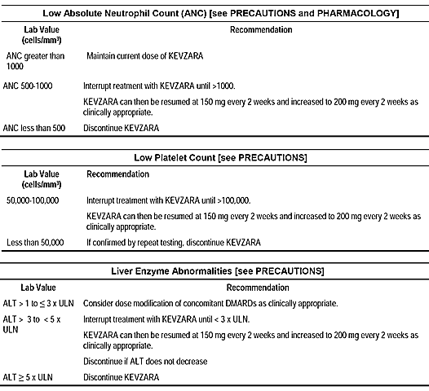
The proportion of patients in Study LTS11210 who had their dose reduced to 150 mg q2w (excluding reductions due to error) and the reasons for those reductions are summarised below in Table 46. Dose reductions from sarilumab 200 mg q2w to sarilumab 150 mg q2w were reported in 17.7% of patients, with the major reason being neutrophil count decreased (11.3%), followed by ALT increased (3.9%). After dose reduction, an improvement in ANC and ALT towards baseline or normal values was observed. No patient increased dose to 200 mg q2w after reducing the dose to 150 mg q2w. Of the patients initiating treatment with sarilumab 200 mg q2w, 82.3% did not require dose reduction to 150 mg q2w.
Table 46: Reason for dose reduction in Study LTS11210
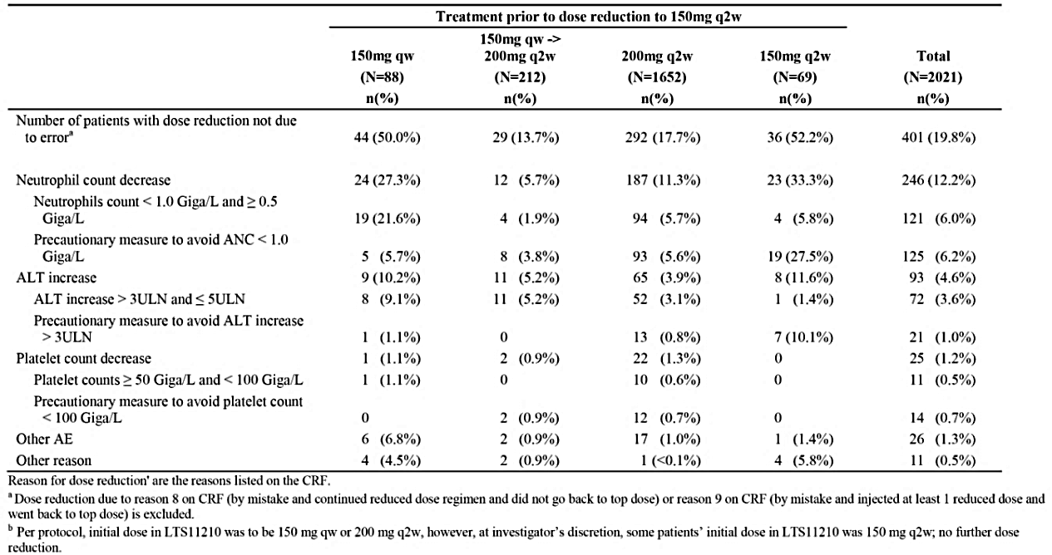
Dose reductions from sarilumab 200 mg q2w to sarilumab 150 mg q2w occurred most frequently in the first 3 months of treatment, with approximately 10% of patients undergoing dose reduction in this time period, and approximately 10% of patients undergoing dose reduction over the next 3 to 48 months at a reasonably constant rate. The time to first dose reduction is summarised below in Figure 12.
Figure 12: Study LTS11210 Time to first dose reduction in patients initiating treatment on sarilumab 200 mg q2W
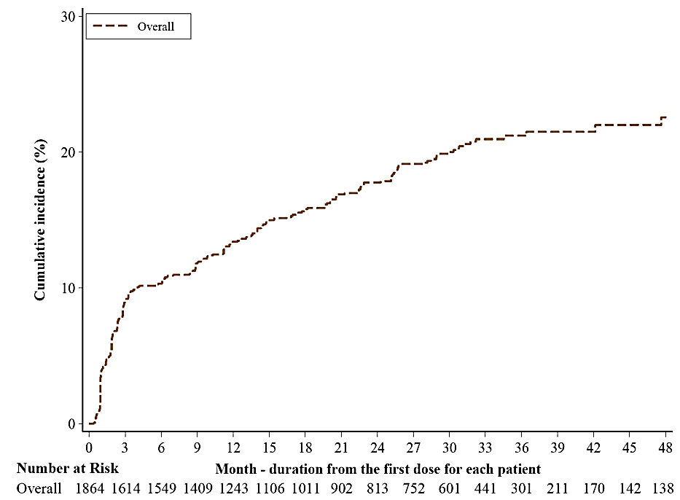
Disposition after dose reduction in patients who were receiving sarilumab 200 mg q2w prior to dose reduction is summarised below in Table 47. Of the total number of patients in the analysis (n = 321), 76.9% (n = 247) continued sarilumab treatment after dose reduction. The sponsor states that, as of 26 January 2016, the mean duration of dose reduction was 770 days.

Table 47: Study LTS11210 Patient disposition after dose reduction for patients who were on sarilumab 200 mg q2w prior to dose reduction
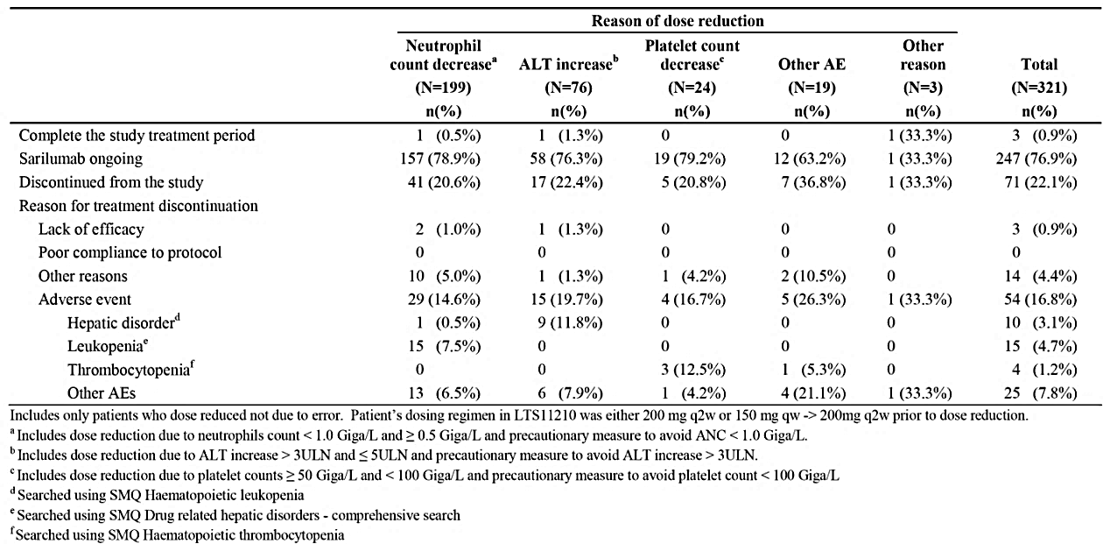
The ANC results by maximum grade for patients on sarilumab 200 mg q2w prior to dose reduction for patients whose reason for dose reduction was neutrophil count decreased (the most common reason for dose reduction) are summarised below in Table 48. For those patients (n = 107) whose reason for dose reduction was Grade 3 neutropaenia (≥ 0.5 to 1.0 Giga/L), improvement in the ANC was present at 1 month after dose reduction in the majority of patients, with only 19 patients still having Grade 3 neutropaenia. The improvement in ANC was still present at 6 months after the dose reduction.
Table 48: Study LTS11210 ANC by maximum grade for patients on sarilumab 200 mg q2w prior to dose reduction whose reason was dose reduction
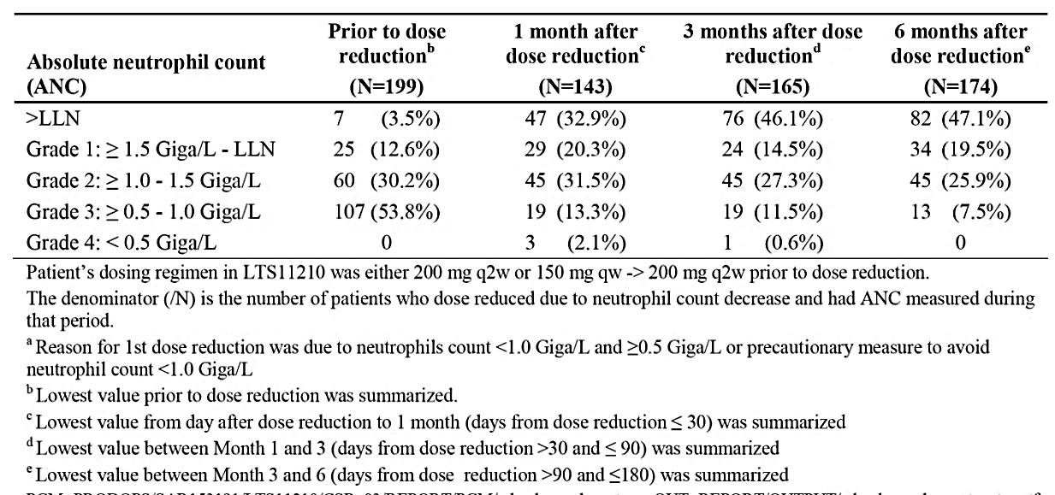

First round assessment of benefit-risk balance
The benefit-risk balance of sarilumab at the proposed dosage for the proposed usage is favourable. The totality of the new monotherapy data for sarilumab 200 mg q2W (versus adalimumab 40 mg q2w) (Study EFC14092/MONARCH trial) and the previously submitted data for sarilumab (150 mg q2w and 200 mg q2w) in combination with DMARD (versus placebo) (Studies EFC11072 and EFC10832) and versus tocilizumab (Study SFY11370) are considered to support the benefits of initiating treatment with sarilumab 200 mg q2w rather than sarilumab 150 mg q2w for both monotherapy and combination therapy.
The data suggest that the majority of patients starting on sarilumab 200 mg q2w + DMARD can safely remain at that dose, with reduction to sarilumab 150 mg q2w + DMARD in the event of toxicity on the higher dose. Following recovery of laboratory abnormalities related to neutropaenia, thrombocytopaenia or increased ALT levels observed with the higher dose of sarilumab 200 mg q2w, the data indicated that treatment can be safely re-initiated at the lower dose of sarilumab 150 mg q2w +DMARD. The monitoring regimens recommended in the PI for identifying neutropaenia, thrombocytopaenia or ALT are considered to be appropriate. There is no reason why the proposed monitoring requirements cannot be safely instituted in remote communities. The monitoring requirements proposed for sarilumab are similar to those required for tocilizumab.
It is noted that the recommended regimen of initiating treatment with the higher sarilumab dose (200 mg q2w) and reducing to the lower sarilumab dose (150 mg q2w) in the event of toxicity has been approved by the FDA (USA), Health Canada and the EMA.

Monotherapy sarilumab 200 mg q2w
The pivotal monotherapy Study EFC14092 MONARCH convincingly demonstrated that the benefits of treatment with sarilumab 200 mg q2w were superior to those for adalimumab 40 mg q2w based on the primary efficacy endpoint (DAS28-ESR score change from baseline at Week 24), and the majority of secondary efficacy endpoints. Overall, the incidence of TEAEs were similar in the two treatment groups, with the major differences being (1) a notably higher incidences of neutropaenia and injection site reactions in the sarilumab group compared with the adalimumab group, (2) a higher incidence of hepatic disorders in the sarilumab group compared with the adalimumab group, and (3) a higher incidence of lipid disorders in the adalimumab group than in the sarilumab group. There were no other notable differences between two treatment groups in TEAEs, including AESI. There were no clinically meaningful differences between the two treatment groups as regards SAEs, including death. TEAEs leading to permanent treatment discontinuation were reported more frequently in the adalimumab group than in the sarilumab. Laboratory abnormalities relating to neutropaenia were reported more frequently in patients in the sarilumab group than in the adalimumab group, as were laboratory abnormalities relating to increased ALT levels. Platelet counts < 100 Giga/L were reported in 1 patient in the sarilumab group but this finding might have been due to laboratory error.
Based on the 24 week double-blind data from Study EFC14092 MONARCH the characteristics of the safety profiles of sarilumab and adalimumab differ, but the safety of sarilumab is considered to be generally comparable with the safety of adalimumab. The benefits and risks of monotherapy treatment with sarilumab 200 mg q2w compared with adalimumab 40 mg q2w have been discussed in detail above under First round assessment of benefits and First round assessment of risks.
Overall, the benefit-risk balance is considered to favour sarilumab relative to adalimumab, based on the greater benefits observed with sarilumab and the generally comparable safety profiles of the two medicines. This is a clinically important finding as adalimumab 40 mg q2w is approved in Australia as monotherapy and in combination with MTX for reducing signs and symptoms, as well as inhibiting the progression of structural damage in adult patients with moderate to severely active RA, including the treatment of patients with recently diagnosed moderate to severely active disease who have not received MTX. It is considered that the monotherapy data from Study EFC14092 MONARCH can be extrapolated to Australian patients with RA.
Sarilumab (150 mg q2w and 200 mg q2w) in combination with cDMARD
The pivotal combination trial Study EFC11072, Part B, convincingly demonstrated that the benefits of treatment with both doses of sarilumab (150 mg q2w and 200 mg q2w) in combination with MTX were superior to placebo in combination with MTX based on the primary efficacy endpoints (ACR20 at Week 24, change from baseline in HAQ-DI at Week 16, and change from baseline in mTSS at Week 52) and the main secondary endpoint (major clinical response at Week 52), supported by the other secondary efficacy endpoints. The long-term data from Study LTS11210 demonstrated that sarilumab had a beneficial sustained effect on preventing radiological structural joint damage based on the mTSS in patients from Study EFC11072 treated with sarilumab in combination with DMARD from baseline through to 3 years (i52 weeks Study EFC11072 plus 96 weeks Study LTS11210). At the end of 3 years treatment, inhibition of radiological progression was greater in those patients who had remained on sarilumab 200 mg q2w + cDMARD for 3 years compared with those patients who had received sarilumab 150 mg q2w + cDMARD for 1 year and then switched to the higher dose of sarilumab 200 mg q2w + cDMARD for 2 years.
The pivotal combination Study EFC10832 convincingly demonstrated that the benefits of treatment with both doses of sarilumab (150 mg q2w and 200 mg q2w) in combination with cDMARD (MTX, sulfasalazine, hydroxychloroquine, or leflunomide) were superior to placebo in combination with cDMARD based on the co-primary efficacy endpoints (ACR20 at Week 24, and change from baseline in HAQ-DI at Week 12), supported by the secondary efficacy endpoints.
The response and remission efficacy data from the long-term safety Study LTS11210 (ACR20, ACR50, ACR70, DAS28) showed that benefits of treatment with sarilumab 200 mg q2w + cDMARD could be maintained for at least 264 weeks of treatment (no data available beyond this time-point).
The most frequently observed risks for sarilumab in combination with cDMARD related to infections, although serious infections, opportunistic infections and TB occurred relatively infrequently. Other risks of note associated with combination treatments included neutropaenia, thrombocytopaenia, injection site reactions, hepatic disorders (including laboratory abnormalities of increased ALT, AST, and total bilirubin levels) and lipid disorders (including laboratory abnormalities of increased LDL, HDL and triglycerides). Of note, there did not appear to be a relationship between neutropaenia and infections, thrombocytopaenia and bleeding, or abnormal lipids and major cardiovascular adverse events.
The safety data for the sarilumab + DMARD placebo-controlled patient population treated for up to 52 weeks (Pool 1) showed that TEAEs, serious TEAEs, and TEAEs leading to permanent treatment discontinuation occurred more frequently in patients in both sarilumab dose groups (150 mg q2w and 200 mg q2w) compared with placebo, and marginally more frequently in the higher dose compared with the lower dose sarilumab group. TEAEs leading to death occurred infrequently in each of the three treatment groups with no clinically meaningful difference across the groups. In Pool 2, the long-term safety of sarilumab was investigated primarily in the any sarilumab dose group (5844.9 PY of exposure) rather than separately in the two sarilumab groups due to the notably longer exposure in the 200 mg q2w initial dose group (2310.4 PY) compared with the 150 mg q2w initial dose group (768.8 PY). The safety data for the long-term open-label sarilumab + cDMARD population (Pool 2) were consistent with the placebo-controlled safety data for sarilumab + cDMARD from Pool 1, and no new risks emerged with long-term treatment with sarilumab + cDMARD. The safety data for Pool 1 and Pool 2 have been reviewed in detail above.
The safety and tolerability data from Study SFY13370 comparing two sarilumab groups (150 mg q2w and 200 mg q2w) in combination with DMARD with tocilizumab in combination with DMARD (24 weeks treatment) showed similar safety profiles for the sarilumab and tocilizumab groups. However, the risks of neutropaenia were numerically higher in the sarilumab groups compared with the tocilizumab group while the risks of elevated lipids were numerically higher in the tocilizumab group than in the sarilumab groups. The risks of hepatic disorders and potentially clinically significant abnormalities associated with increased ALT levels were similar in the sarilumab and tocilizumab groups. Thrombocytopaenia (< 100 Giga/L) was reported in 1 patient in the sarilumab 150 mg q2w group, and this event was clinically insignificant. Hypersensitivity reactions occurred with a similar incidence in patients in the sarilumab and tocilizumab groups, and there were no reports of anaphylaxis. TEAEs leading to permanent treatment discontinuation occurred more frequently in the sarilumab groups than in the tocilizumab group, with the difference appearing to be primarily due to a higher incidence of laboratory abnormalities meeting the pre-specified criteria for permanent treatment discontinuation.
Overall, it is considered that the pivotal safety data for sarilumab in combination with cDMARD from the two pivotal studies (Studies EFC11072, Part B and EFC10832), the long-term safety data from Study LTS11210, the safety data from Pool 1 (sarilumab + cDMARD placebo-controlled population), the safety data from Pool 2 (sarilumab + cDMARD long-term population), and the safety data comparing sarilumab in combination with cDMARD with tocilizumab in combination cDMARD (Study SFY13370) can be extrapolated to Australian patients with RA.
Choice of the sarilumab dose to initiate treatment
The efficacy data supporting initiating treatment with sarilumab 200 mg q2w as monotherapy or in combination with cDMARD have been summarised in detail above (see First round assessment of benefits). The safety data supporting initiating treatment with sarilumab 200 mg q2w as monotherapy or in combination with cDMARD and reducing the dose to 150 mg q2w in the event of neutropaenia, thrombocytopaenia, or ALT increased are summarised in detail above (First round assessment of risks).

First round recommendation regarding authorisation
It is recommended that Kevzara in combination with non-biologic DMARDs or as monotherapy be approved for the treatment of moderate to severe RA in adult patients who have had an inadequate response or intolerance to one or more DMARDs.
- It is recommended that Kevzara be initiated at a dose of 200 mg q2w and reduced to 150 mg q2w based on the dose modifications for neutropaenia, low platelet count and increased ALT recommended in the PI.
- It is recommended that it should be a condition of registration that the sponsor submits the proposed paediatric studies to the TGA at the same time as the studies are submitted to the EMA and/or the US FDA.

Clinical questions

Efficacy
- Please explain why adalimumab rather than tocilizumab was selected as the active control for the pivotal Phase III monotherapy Study EFC14092/MONARCH trial?

Pharmacodynamics
- Please provide a copy of the report of the sponsor’s PD margination model referred to in the re-submission.

Safety
- No data relating to the safety of sarilumab monotherapy based on age, gender, race, weight or BMI could be identified in the re-submission. This is a limitation of the monotherapy safety data. Please submit safety data relating to monotherapy treatment with sarilumab from Study EFC14092/MONARCH trial and Pool 3 based on age, gender, race, body weight, and BMI. The safety data should provide high-level incidence overviews (TEAEs, deaths, SAEs, permanent treatment discontinuations due to AEs), tabulated summaries of AESI, laboratory results for neutropaenia based on Grades 1 to 4, laboratory results for ALT based on the ULN categories, and laboratory results for thrombocytopaenia < 100 Giga/L. Please comment on the safety of sarilumab monotherapy in the subgroups of interest.

Second round evaluation

Overview
The sponsor’s response to the questions raised in first round clinical evaluation report was comprehensive. There are no outstanding issues relating to the first round clinical questions. The sponsor’s responses to the first round clinical questions and the clinical evaluator’s comments on the responses are provided below.
No substantial changes have been made to the first round clinical evaluation report.

Questions sponsor’s response and evaluator’s comment

Efficacy
- Please explain why adalimumab rather than tocilizumab was selected as the active control for the pivotal Phase III monotherapy Study EFC14092/MONARCH trial?

Sponsor response
Adalimumab was selected to be the comparator biologic in the Study EFC14092/MONARCH trial as its use was consistent with the contemporary guidelines for the management of RA patients including ACR 2012 management guidelines (provided with the response), EULAR 2013 (provided with the response), various Royal Australian College of General Practitioners (RACGP) clinical guidelines, Australian Therapeutic Guidelines and the Australian Rheumatology Association treatment guidelines. The choice of adalimumab was also based on its widespread use and extensive clinical data supporting its role as a first line biologic therapy for patients with active RA who do not respond to or are intolerant of MTX.
At the time when Study EFC14092/MONARCH trial was designed and initiated, the prevailing guidelines for the treatment of patients with rheumatoid arthritis and poor prognostic factors, such as those enrolled in this study, recommended anti-TNF agents as the potential therapy for patients who are either non-responders to, or who have contraindications to non-biological DMARDs, including MTX (ACR2012, EULAR 2013). Further, anti-TNF agents have been one of the most commonly used biologics in Australia for the treatment of patients with active RA, and adalimumab has been the most commonly used anti-TNF agent approved for the treatment of RA patients including those who did not respond to non-biological DMARDs. Approximately 50% of the initial prescriptions of adalimumab are used as monotherapy and eventually over half of all adalimumab prescriptions are given as monotherapy.
Additionally, practical considerations related to clinical trial design and feasibility also favoured the use of adalimumab, given the similarity in dosing interval and route of administration, which is administered SC every other week like sarilumab.
Given the aforementioned reasons, the sponsor determined that adalimumab was the more optimal comparator relative to other biologics for Study EFC14092 to provide further context regarding the efficacy and safety of sarilumab when administered as monotherapy.

Evaluator comment
The sponsor’s response is acceptable.

Pharmacodynamics
- Please provide a copy of the report of the sponsor’s PD margination model referred to in the re-submission.

Sponsor response
The sponsor has not yet issued a full report on the neutrophil margination model with sarilumab. The sponsor intends to evaluate the margination of neutrophils with the anti-IL-6 drugs sarilumab and tocilizumab, and to publish a manuscript on the margination of neutrophils with sarilumab.
For the convenience of the evaluator, original abstracts and posters on the neutrophil margination model presented first at Population Approach Group in Europe (PAGE) 2017 meeting, and later at the American Conference on Pharmacometrics (ACoP8) 2017, were provided in as part of this response.

Evaluator comment
The sponsor’s response is considered to be acceptable. The provided references have been examined. Each of the references describes the results for the same study and PD margination model (MM). The most detailed summary of the development of the MM is provided in a poster presented at the 26th Population Approach Group in Europe Meeting, in 2017.
The objectives of the study were to present a PD model that: (1) explains the time course of the decrease and recovery of ANC; (2) that describes potential margination of neutrophils from the circulation; and (3) that accounts for the rapid development of ANC specific tolerance, after a single dose of sarilumab. Observed ANC specific tolerance was manifested by a nadir in ANC that precedes the maximal drug concentrations and counter-clockwise hysteresis in the presence of inhibition or by absence of plateau in nadir when ANC response was saturated. The margination model (MM) was represented by central and margination compartments with neutrophils circulating between these two compartments. An assumption in the MM model was that, after dosing, both production and elimination of neutrophils do not change and, therefore, the total ANC stays constant. Thus, the production and elimination of neutrophils were not modelled to avoid over-parameterisation. The abstract²³ reported that MM is the biologically most plausible model, considering margination of neutrophils to be the underlying mechanism for the decrease in ANC observed with IL-6 inhibitors. Margination and tolerance are consistent with the absence of both impairment in neutrophil activity and lack of association of decrease in ANC with increased risk of infection. The MM was reported to describe the data well and to be consistent with known neutrophil dynamics and potential re-localisation of neutrophils as opposed to a haemopoietic defect, which may take days to manifest as decreased ANC.

Safety
- No data relating to the safety of sarilumab monotherapy based on age, gender, race, weight or BMI could be identified in the re-submission. This is a limitation of the monotherapy safety data. Please submit safety data relating to monotherapy treatment with sarilumab from Study EFC14092/MONARCH trial and Pool 3 based on age, gender, race, body weight, and BMI.
The safety data should provide high-level incidence overviews (TEAEs, deaths, SAEs, permanent treatment discontinuations due to AEs), tabulated summaries of AESI, laboratory results for neutropaenia based on Grades 1 to 4, laboratory results for ALT based on the ULN categories, and laboratory results for thrombocytopaenia < 100 Giga/L. Please comment on the safety of sarilumab monotherapy in the subgroups of interest.

Sponsor response
Summaries of the safety data by subgroups of age, gender, race, weight, and BMI for Pool 3 were provided, and similar analyses were also conducted for the 24 week double blind period of Study EFC14092, and the results were provided. The safety data include high-level incidence overviews (TEAEs, deaths, SAEs, permanent treatment discontinuations due to AEs), AESIs, ANC grades, and ALT elevations. It should be noted that since there was only one patient with (platelet) counts < 100 Giga/L, the subgroup analyses were not conducted. For the same reason, the subgroup analyses were only performed on the AESIs with > 2 patients having at least one event. The demographic characteristics for the patients with these events were provided.
Overall, the incidence rates were generally comparable between subgroups. Some numerical differences were observed but with no consistent trend. It was noted in that for patients on sarilumab+DMARDs (Pool 2), increased risk of serious infections were observed for elderly patients (≥ 65 years old) and for patients with weight > 100 kg; and higher incidence of ANC< 1.0 Giga/L were observed for patients with weight < 60 kg. Similar patterns were not observed for patients on sarilumab monotherapy (Pool 3).
It should also be noted that for rare events and for subgroups where the number of patients is small (such as the age groups of ≥ 75 years, non-White patients), the apparent incidences were subjected to a greater degree of variability and therefore these results should be interpreted with caution.

Evaluator comment
The sponsor’s response is acceptable. The results for the subgroup analyses summarised below are based on the tables taken from the sponsor’s response.
It should be noted that the summarised tables provided do not include results for the ≥ 75 years of age subgroup, race subgroups or ethnic subgroups. The results for these subgroups were presented in the tables provided by the sponsor in its response but it is considered that the small number of subjects aged ≥ 75 years and imbalance in subject numbers across the racial subgroups precludes meaningful conclusions relating to safety to be made in these patient populations. In addition, comparison of safety profiles based on ethnicity (non-Hispanic versus Hispanic) is considered to have limited relevance to the Australian patient population who might be exposed to sarilumab.
The key safety results for the subgroups of gender, age and weight are summarised below.
- Gender:
  - The high-level safety profiles in males and females based on Pool 3 data (sarilumab monotherapy safety population) were generally comparable. TEAEs associated with any sarilumab dose were reported in 60.8% (234/385) of females and 62.2% (51/82) of males and serious TEAEs were reported in 4.4% (17/385) of females and 11.0% (9/82) of males.
  - In the any sarilumab monotherapy dose group (Pool 3), the incidence of patients experiencing each of the summarised AESIs was generally comparable in both males and females, although infections were reported more frequently in females than in males (30.6% (118/385) versus 20.7% (17/82)). Apart from infections, no other AESIs were reported with a difference of ≥ 5% between females and males.
  - In the any sarilumab monotherapy dose group (Pool 3), the majority of decreases in absolute neutrophil count were Grade 1 or Grade 2 in both females and males. Grade 3 decreases in absolute neutrophil count were reported in a similar proportion of females and males (11.2% (43/384) versus 12.2% (10/82), respectively), as were Grade 4 decreases (1.0% (4/384) versus 0% (0/82), respectively).
  - In the any sarilumab monotherapy dose group (Pool 3), the majority of PCSA increased ALT levels were > 1 to ≤ 3 ULN in both females and males, while PCSA increased ALT levels > 3 were reported in a similar proportion of females and males (3.6% (14/383) versus 3.7% (3/82), respectively). There were no reports of ALT levels > 10 ULN in either females or males.
  - In the 24 week double-blind treatment period of Study EFC14092 MONARCH, high-level AE profiles were comparable in both the female and male subgroups in both the adalimumab 40 mg q2w and the sarilumab 200 mg q2w arms.
  - In the 24 week double-blind treatment period of Study EFC14092 MONARCH, the incidence of each of the summarised AESIs in the female subgroup was generally comparable in the adalimumab 40 mg q2w and sarilumab 200 mg q2w arms. There were numerical differences between the adalimumab 40 mg q2w and the sarilumab 200 mg q2w arms in the male subgroup, but these differences should be interpreted cautiously due to the smaller number of patients in the male subgroup compared with the female subgroup.
  - In the 24 week double-blind treatment period of Study EFC14092 MONARCH, decreases in absolute neutrophil counts Grades 1, 2, and 3 occurred more frequently in the sarilumab 200 mg q2w arm than in the adalimumab arm in both female and male subgroups, and the frequency of events in both treatment arms were generally comparable in both female and male subgroups. There were only 3 patients with decreases in absolute neutrophil count Grade 4, and all three were females in the sarilumab 200 mg q2w arm.
  - In the 24 week double-blind treatment period of Study EFC14092 MONARCH, in general PCSA increased ALT occurred more frequently in the sarilumab 200 mg q2w arm than in the adalimumab 40 mg q2w arm in both male and female subgroups, and the majority of abnormalities were increased levels > 1 x ULN to ≤ 3 x ULN. In general, PCSA increased ALT occurred more frequently in the female subgroup than in the male subgroup.
- Age
  - The high-level safety profiles in patients aged < 65 years and ≥ 65 to < 75 years based on Pool 3 data (sarilumab monotherapy safety population) were generally comparable. TEAEs associated with any sarilumab dose were reported in 61.5% (236/384) of patients aged < 65 years and 61.0% (47/77) of patients aged ≥ 65 to < 75 year, while serious TEAEs were reported in 4.4% (17/384) and 10.4% (47/77) of patients in the two age groups, respectively.
  - In the any sarilumab monotherapy dose group (Pool 3), the incidence of each of the summarised AESIs was generally comparable in patients aged < 65 years and ≥ 65 to < 75 years, with the most frequent AESIs in both age groups being infections (29.9% (115/384) versus 23.4% (18/77), respectively). AESIs reported in ≥ 5% more patients aged < 65 years compared with patients aged ≥ 65 to < 75 years were infections (29.9% (115/384) versus 23.4% (18/77), respectively) and injection site reactions (8.9% (34/384) versus 2.6% (2/77), respectively). No AESI were reported in ≥ 5% more patients aged ≥ 65 to < 75 years compared with patients aged < 65 years.
  - In the any sarilumab monotherapy dose group (Pool 3), the majority of decreases in absolute neutrophil count were Grade 1 or Grade 2 in patients aged < 65 years and ≥ 65 to 75 years. Grade 3 decreases in absolute neutrophil count in the any sarilumab dose group were reported in a similar proportion of patients aged < 65 years and ≥ 65 to < 70 years (10.7% (41/383) versus 11.7% (9/77), respectively), while Grade 4 decreases were reported in ≥ 5% more patients aged ≥ 65 to < 75 years compared with patients aged < 65 years (5.2% (4/77) versus 0% (0/383), respectively).
  - In the any sarilumab monotherapy dose group (Pool 3), the majority of PCSA increased ALT levels were > 1 to ≤ 3 ULN in patients aged < 65 years and ≥ 65 to 75 years, while PCSA increased ALT levels > 3 ULN were reported in a higher proportion of patients aged < 65 years than ≥ 65 to 75 years (4.4% (17/382) versus 0% (0/77)). There were no reports of ALT levels > 10 ULN in either of the two age groups.
  - In the 24 week double-blind treatment period of Study EFC14092 MONARCH, high-level AE profiles in patients aged < 65 years were generally comparable in the adalimumab 40 mg q2w and the sarilumab 200 mg q2w arms. However, in patients aged ≥ 65 to < 75 years TEAEs (any) were reported more frequently in the adalimumab 40 mg q2w arm than in the sarilumab 200 mg q2w arm (80.0% (28/35) versus 56.0% (14/25), respectively), as were serious TEAEs (17.1% (6/35) versus 12.0% (3/25)).
  - In the 24 week double-blind treatment period of Study EFC14092 MONARCH, in patients aged < 65 years AESIs of leukopaenia were reported in ≥ 5% more patients in the sarilumab 200 mg q2w arm than in the adalimumab 40 mg q2w arm (13.3% (21/158) versus 2.1% (3/144)) as were AESIs of injection site reactions (10.8% (17/158) versus 4.2% (6/144), respectively). In patients aged ≥ 65 to < 75 years AESIs of infection were reported in ≥ 5% more patients in the adalimumab 40 mg q2w arm than in the sarilumab 200 mg q2w arm (28.6% (10/35) versus 12.0% (3/25), respectively), as were AESIs of hypersensitivity (8.6% (3/35) versus 0% (0/25), respectively) and injection site reactions (5.7% (2/35) versus 0% (0/25), respectively), while AESIs of leukopaenia were reported in ≥ 5% more patients in the sarilumab 200 mg q2w arm than in the adalimumab 40 mg q2w arm (20.0% (5/25) versus 0% (0/35), respectively). Differences in AESIs between the two treatment arms in patients aged ≥ 65 to < 75 years should be interpreted cautiously due to the notably smaller number of patients in this age group compared with patients aged < 65 years.
  - In the 24 week double-blind treatment period of Study EFC14092 MONARCH, decreases in absolute neutrophil counts Grade 1, 2, and 3 occurred more frequently in patients in the sarilumab 200 mg q2w arm than in the adalimumab 40 mg q2w arm in both the < 65 years and ≥ 65 to < 75 years subgroups, and the frequency of events in both treatment arms were generally comparable in both age subgroups. There were only 3 patients with decreases in absolute neutrophil count Grade 4, and all three were in the ≥ 65 years to < 75 years subgroup in the sarilumab 200 mg q2w arm.
  - In the 24 week double-blind treatment period of Study EFC14092 MONARCH, PCSA increased ALT levels generally occurred more frequently in the sarilumab 200 mg q2w arm than in adalimumab 40 mg q2w arm in both the < 65 years and ≥ 65 to < 75 years subgroups. In general, PCSA higher increased ALT levels occurred more frequently in the < 65 years subgroup than in the ≥ 65 to < 75 years subgroup, but levels > 3 x ULN occurred infrequently in both subgroups.
- Weight
  - In the any sarilumab dose group, TEAEs increased in frequency with increasing weight < 60 kg versus ≥ 60 to < 100 kg versus ≥ 100 kg (55.1% (59/107) versus 61.7% (198/321) versus 71.8% (28/39), respectively), as did serious TEAEs (3.7% (4/107) versus 5.9% (10/321) versus 7.7% 3/39) ). However, the results in the ≥ 100 kg subgroup should be interpreted cautiously due to the small number of patients in this subgroup.
  - In the any sarilumab monotherapy dose group (Pool 3), summarised AESIs reported in ≥ 10% of patients in at least one of the three weight groups (< 60 kg versus ≥ 60 to < 100 kg versus ≥ 100 kg, respectively), were infections (24.3% (26/107) versus 30.5% (98/321) versus 28.2% (11/39)), leukopaenia (21.5% (23/107) versus 16.8% (54/321) versus 7.7% (3/39)) and hypersensitivity (7.5% (8/107) versus 2.5% (8/321) versus 12.8% (5/39)). The results in the ≥ 100 kg subgroup should be interpreted cautiously due to the small number of patients in this subgroup.
  - In the any sarilumab monotherapy dose group (Pool 3), the majority of decreases in absolute neutrophil count were Grade 1 or Grade 2 in patients weighing < 60 kg versus ≥ 60 to < 100 kg versus ≥ 100 kg. Grade 3 decreases in absolute neutrophil count in the any sarilumab dose group were reported in a similar proportion of patients in the < 60 kg and ≥ 60 to < 100 kg groups and more frequently in both of these groups than in ≥ 100 kg group (11.3% (12/106) versus 11.5% (37/2321) versus 5.1% (2/39)), and Grade 4 decreases in absolute neutrophil count in the any sarilumab dose group were reported in a similar proportion of patients in the < 60 kg, ≥ 60 to < 100 kg and ≥ 100 kg groups (2.8% (3/106) versus 0.3% (1/321) versus 0% (0/39)). The results in the ≥ 100 kg subgroup should be interpreted cautiously due to the small number of patients in this subgroup.
  - In the any sarilumab monotherapy dose group (Pool 3), the majority of PCSA increased ALT levels were > 1 to ≤ 3 ULN in patients weighing < 60 kg, ≥ 60 to < 100 kg, and ≥ 100 kg, while PCSA increased ALT levels > 3 ULN were generally comparable across the three weight subgroups (0.9% (1/106) versus 4.7% (15/320) versus 2.6% (1/39), respectively). There were no reports of ALT levels > 10 ULN in any of the three weight subgroups.
  - In the 24 week double-blind treatment period of Study EFC14092 MONARCH, high level AE profiles were generally comparable in the adalimumab 40 mg q2w and sarilumab 200 mg q2w arms in the < 60 kg, ≥ 60 to < 100 kg and ≥ 60 kg subgroups.
  - In the 24 week double-blind treatment period of Study EFC14092 MONARCH, AESIs of leukopaenia were reported in ≥ 5% more patients weighing < 60 kg in the sarilumab 200 mg q2w arm than in the adalimumab 40 mg q2w arm (21.4% (9/42) versus 4.0% (2/50), respectively), while AESIs of leukopaenia were reported in ≥ 5% more patients weighing ≥ 60 kg to < 100 kg in the sarilumab 200 mg q2w arm than in the adalimumab 40 mg q2w arm (12.3% (16/130) versus 0.8% (1/121), respectively) as were AESIs of injection site reactions (11.5%, 15/130 versus 3.3% (4/121), respectively). The number of patients in the ≥ 100 kg subgroup was too small to draw meaningful conclusions relating to the observed differences in the frequency of AESIs in the two treatment arms.
  - In the 24 week double-blind treatment period of Study EFC14092 MONARCH, Grade 1, 2, 3, and 4 decreases in absolute neutrophil counts occurred more frequently in patients in the sarilumab 200 mg q2w arm than in the adalimumab 40 mg q2w arm in both the < 60 kg and ≥ 60 kg to < 100 kg subgroups. There were no marked differences in the frequency of decreases in absolute neutrophil counts Grade 1, 2, 3 and 4 between the < 60 kg and the ≥ 60 kg to < 100 kg subgroups in both treatment arms. The number of patients in the ≥ 100 kg subgroup was too small to draw meaningful conclusions relating to the observed differences in the frequency of decreased absolute neutrophil counts.
  - In the 24 week double-blind treatment period of Study EFC14092 MONARCH, PCSA increased ALT levels generally occurred more frequently in the sarilumab 200 mg q2w arm than in adalimumab 40 mg q2w arm in both the < 60 kg and ≥ 60 kg to < 100 kg subgroups. In general, PCSA higher increased ALT levels occurred more frequently in the ≥ 60 kg to < 100 kg subgroup than in the < 60 kg subgroup. The number of patients in the ≥ 100 kg subgroup was too small to draw meaningful conclusions relating to the observed differences in the frequency of increased ALT PCSAs.

Second round benefit-risk assessment

Second round assessment of benefits
No new clinical efficacy data was submitted in the sponsor’s response to the first round clinical questions. Accordingly the benefits of Kevzara (sarilumab) for the proposed usage are unchanged from those identified in the first round of this clinical evaluation report.

Second round assessment of risks
After consideration of the responses to clinical questions relating to safety in special populations (gender, age, race, BMI and weight) submitted in the sponsor’s response to the first round clinical questions, the risks of treatment with Kevzara (sarilumab) for the proposed usage remain favourable and are unchanged from those identified in the first round of this clinical evaluation report.

Second round assessment of benefit-risk balance
The benefit-risk balance of Kevzara (sarilumab) for the proposed usage is favourable and is unchanged for that discussed in the first round of this clinical evaluation report (see above).

Second round recommendation regarding authorisation
- It is recommended that Kevzara (sarilumab) in combination with non-biologic DMARDs or as monotherapy be approved for the treatment of moderate to severe RA in adult patients who have had an inadequate response or intolerance to one or more DMARDs.
- It is recommended that Kevzara be initiated at a dose of 200 mg q2w and reduced to 150 mg q2w based on the dose modifications for neutropaenia, low platelet count and increased ALT recommended in the PI.
- It is recommended that it should be a condition of registration that the sponsor submits the proposed paediatric studies to the TGA at the same time as the studies are submitted to the EMA and/or the US FDA.

VI. Pharmacovigilance findings

Risk management plan
The sponsor has submitted EU-RMP version 1.2 (dated 21 April 2017; data lock point (DLP) 17 February 2016) and Australian Specific Annex (ASA) version 2.2 (dated 29 August 2017) in support of this application. In its response to the TGA’s request for further information, the sponsor has submitted an updated ASA (version 4.0; dated 27 April 2018). In its post-first round response, the sponsor submitted ASA version 4.1 dated 17 July 2018.
The most recently evaluated EU-RMP for the previous application was version 1.0 (dated 9 June 2016; DLP 17 February 2016) and ASA version 2.1 (dated 12 April 2017).
The proposed Summary of Safety Concerns and their associated risk monitoring and mitigation strategies are summarised below (Table 49).
Table 49: Summary of ongoing safety concerns
Summary of safety concerns |  | Pharmacovigilance |  | Risk Minimisation
 |  | Routine (R) | Additional (A) | R | A
Important identified risks | Serious infections
Important identified risks | Hypersensitivity reactions |  | –
Important identified risks | Neutropaenia |  | –
Important identified risks | Gastrointestinal perforations
Important potential risks | Thrombocytopaenia and potential risk of bleeding |  | –
Important potential risks | Clinically evident hepatic injury |  | –
Important potential risks | Lipid abnormalities and increased risk of major cardiovascular events
Important potential risks | Malignancy |  |  |  | –
Important potential risks | Demyelinating disorder* |  | – |  | –
Missing information | Use in pregnant and lactating women |  |  |  | –
Missing information | Use in paediatric patients |  | – |  | –
Missing information | Use in elderly |  | – |  | –
Missing information | Use in Hepatitis B/Hepatitis C infected patients |  | – |  | –
Missing information | Use in HIV infected patients |  | –
Missing information | Immunoglobulins levels following sarilumab treatment |  | –
Missing information | Use of vaccination in patients receiving sarilumab |  | – |  | –
Missing information | Depression* |  | – | – | –
Missing information | Long-term safety in patients switching to/from other drugs in the anti-IL-6 class* |  |  |  | –
* Included in the ASA only.
Additional pharmacovigilance activities include a Pregnancy registry (North America only) and a surveillance program using existing EU rheumatoid arthritis registries which is acceptable. However, it is recommended the sponsor consider a survey to measure effectiveness of additional risk minimisation activities (that is, the Healthcare Provider (HCP) Prescriber Guide).
The sponsor has adequately described their process for monitoring the distribution of additional risk minimisation materials. The sponsor also has proposed routine pharmacovigilance to monitor the effectiveness of the additional risk minimisation activities. This is acceptable as sarilumab is not the first monoclonal antibody used to treat rheumatoid arthritis that has additional risk minimisation activities for similar safety concerns.
Additional risk minimisation activities include a HCP Prescriber Guide (ASA only) which addresses all the Important Identified and Potential Risks except malignancy. A Patient Alert Card is also proposed. In response to RMP recommendations, the prescriber guide has been modified to include further information on dosing and selected risks, and both the guide and patient alert card include information regarding inclusion in the Black Triangle Scheme. Both sets of materials are now acceptable.

Recommendations and proposed wording for conditions of registration
The sponsor has adequately addressed all the first round and second round recommendations.

Wording for conditions of registration
Any changes to which the sponsor has agreed should be included in a revised RMP and ASA. However, irrespective of whether or not they are included in the currently available version of the RMP document, the agreed changes become part of the risk management system.
The suggested wording is:
The Kevzara EU-Risk Management Plan (RMP) (version 1.2, dated 21 April 2017, data lock point 17 February 2016), with Australian Specific Annex (version 4.1, dated 17 July 2018), included with submission PM-2017-03119-1-3, and any subsequent revisions, as agreed with the TGA will be implemented in Australia.
The following wording is recommended for the Periodic Safety Update Report (PSUR) requirement:
An obligatory component of risk management plans is routine pharmacovigilance. Routine pharmacovigilance includes the submission of Periodic Safety Update Reports (PSURs).
Reports are to be provided in line with the current published list of EU reference dates and frequency of submission of PSURs until the period covered by such reports is not less than three years from the date of this approval letter.
The reports are to at least meet the requirements for PSURs as described in the European Medicines Agency’s Guideline on good pharmacovigilance practices (GVP) Module VII-Periodic Safety Update Report (Rev 1), Part VII.B Structures and processes. Note that submission of a PSUR does not constitute an application to vary the registration. Each report must have been prepared within ninety calendar days of the data lock point for that report.
As Kevzara is a new biological entity it should be included in the Black Triangle Scheme as a condition of registration. The following wording is recommended for the condition of registration:
Kevzara (sarilumab) is to be included in the Black Triangle Scheme. The PI and CMI for Kevzara must include the Black Triangle symbol and mandatory accompanying text for five years, which starts from the date that the sponsor notifies the TGA of supply of the product.

VII. Overall conclusion and risk/benefit assessment
The submission was summarised in the following Delegate’s overview and recommendations.

Introduction
This request for ACM advice focuses on the new data, extension to the indications and dosing. A full evaluation of the previous clinical data is located in the initial clinical evaluation report, and a summary is also provided in the current clinical evaluation report. The previous requests for ACM advice also cover the initial submission.

Quality
The quality evaluator has no objections to registration of Kevzara pre-filled syringes and pens on quality grounds including from sterility, endotoxin, container safety and viral safety related aspects. Overall, sufficient evidence has been provided to demonstrate that the risks related to the manufacturing quality of Kevzara have been controlled to an acceptable level. There are no outstanding issues and the sponsor has provided an undertaking that all GMP pre-clearances will be valid at the time of product registration. Batch release testing and compliance with certified product details are recommended conditions of registration.

Nonclinical
The nonclinical evaluator has no nonclinical objections to the registration of Kevzara. The pharmacology, pharmacokinetics and toxicology of sarilumab were adequately investigated in the submission using appropriate in vitro and in vivo nonclinical models. The primary pharmacology studies support the drug’s mechanism of action however the activity of sarilumab in animal models of rheumatoid arthritis was not investigated. Haematological effects were the main toxicologically significant findings in cynomolgus monkeys. These were consistent with an exaggerated pharmacological effect arising from IL-6R blockade. These effects were observed at doses significantly greater than the maximum anticipated human dose. No target organs of toxicity were identified. Sarilumab is not expected to pose a genotoxic or carcinogenic hazard, although specific studies were not conducted, and is not teratogenic. Sarilumab should be classified as Pregnancy Category C consistent with tocilizumab.¹⁵ No nonclinical data were submitted to support the use of sarilumab in combination with MTX and/or other DMARDs.

Clinical
The clinical evaluator has recommended approval of Kevzara as monotherapy and combination treatment with non-biological DMARDs for the treatment of moderate to severe RA in adult patients who have had an inadequate response or intolerance to one or more DMARDs. The evaluator supported the sponsor’s proposed dosage regimen that Kevzara be initiated at a dose of 200 mg q2w and reduced to 150 mg q2w based on the dose modifications for neutropaenia, low platelet count and increased ALT recommended in the PI. The evaluator also recommended that it should be a condition of registration that the sponsor submits the proposed paediatric studies to the TGA at the same time as they are submitted to the EMA and/or the US FDA.
The clinical submission included the clinical studies provided in the initial submission and the new clinical studies provided for evaluation. The new clinical data are:
- Study EFC14092/MONARCH trial: a Phase III study assessing the efficacy and safety of sarilumab monotherapy versus adalimumab monotherapy for 24 weeks in patients with rheumatoid arthritis.
- Study MSC12655: a Phase III study assessing the usability of the sarilumab autoinjector device and the PFS in patients with moderate to severe RA. The study included a 12 week autoinjector assessment phase.
The following sections mainly cover comments by the clinical evaluator on the new studies in this submission. The current CER also covers the previously submitted studies and an update on the long term safety population. The previous CER provides a more detailed evaluation of the original studies.

Pharmacology
The pivotal Phase III Study EFC14092/MONARCH trial which compared sarilumab with adalimumab provided PK data from patients treated with sarilumab 200 mg q2w in the 24 week randomised period. After multiple SC administrations of sarilumab 200 mg q2w, the observed trough concentrations of sarilumab indicated that steady state was reached between Week 12 and Week 16, with about 4 fold accumulation. The incidence of ADA in the sarilumab 200 mg q2w group was 7.1% (13/184), with 2.7% (5/184) persistent ADA response. None of the patients exhibited neutralising ADA. Although the mean serum functional sarilumab concentration in ADA positive patients were lower than in ADA negative patients, there was overlap in concentrations between ADA positive and ADA negative patients.
Study MSC12665 was a 12 week with one year open label extension, multicentre, randomised, open-label, parallel usability study of the sarilumab autoinjector (AI) device and a pre-filled syringe (PFS) in an initial 217 patients with moderate to severe active rheumatoid arthritis. The study was designed to assess the robustness and usability of the AI device and to also collect PK data in comparison with the PFS. Both strengths of sarilumab were assessed using both devices. In the AI assessment phase to Week 12 there were no validated AI-associated product technical failures reported among 600 injections in 108 patients. All AI injections were completed successfully. The 1 reported product technical complaint with the AI was due to user error and not due to a device failure. After 12 weeks of treatment, 98% were ‘satisfied’ to ‘very satisfied’ with the AI; 88% of patients thought the AI was very easy to use, 98% thought the injection time was normal, short, or very short and 91% were very confident to extremely confident about using the same AI for self-injection in the future.
The AI 150 mg q2w and PFS 150 mg q2w treatments were bioequivalent at Weeks 10 to 12 based on the AUC0-τ values using standard criteria. No other comparisons for the C_{max} or AUC0-τ between the AI and PFS at Weeks 0 to 2 or Weeks 10 to 12 were bioequivalent. However, the study was not powered to demonstrate bioequivalence between the AI and PFS at the 150 mg and 200 mg q2w doses. The evaluator considered the observed PK differences between the AI and PFS at the 150 mg q2w and 200 mg q2w doses are unlikely to result in significant clinical differences between the presentations. The incidence of ADA in the sarilumab 150 mg q2w group was 22.6% using the PFS and 28.6% using the AI. The incidence of ADA in the sarilumab 200 mg q2w group was 23.2% using the PFS and 13.5% using the AI. Neutralising antibodies were reported in 2 (3.6%) patients in the AI 150 mg q2w group. TEAEs leading to treatment discontinuation were reported notably more frequently in the AI 200 mg q2w group than in the other three treatment groups, while SAEs were reported more frequently in the two 200 mg q2w groups than in the two 150 mg q2w groups. Infections and leukopaenia (predominantly neutropaenia) were the most frequently reported adverse events of special interest. There were no marked differences in the number of patients in the groups experiencing injection site reactions.

Neutropaenia
The sponsor considers that the mechanism of neutropaenia observed with ILR-6R inhibitors is different from that observed with cytotoxic agents and although not definitely established, is most likely due to margination/neutrophil tracking. ANC levels dropped and rebounded quickly following single-dose sarilumab. Repeat-dose data from the pivotal Phase III monotherapy Study EFC14092 MONARCH showed that mean neutrophil counts rapidly decline following sarilumab 200 mg q2w, reaching a nadir at Week 4 and then stabilising through to Week 24. In the sarilumab 200 mg q2w group, the percent reduction from baseline to Week 24 in the mean neutrophil count was approximately 39%, however, the mean ANC level at each visit remained within normal limits for the study (1.96 to 7.23 Giga/L). The majority of patients treated with sarilumab 200 mg q2w in whom ANC was < 1.0 Giga/L were able to continue treatment with sarilumab 150 mg q2w following treatment interruption. The sponsor reports that neutrophil margination following sarilumab administration provides a possible explanation for the absence of impairment in neutrophil function as well as the lack of an observed association between ANC decrease and infection.

Efficacy
Based on comparative data and to optimise patient benefit, the sponsor selected the 200 mg sarilumab dose over the 150 mg sarilumab dose for the pivotal Phase III Study EFC14092/MONARCH trial. The sponsor selected adalimumab as the comparator, given its widespread use in clinical practice and data supporting its use as monotherapy for RA patients who do not respond to MTX or who are MTX intolerant.
Study EFC14092/MONARCH trial was a multicentre, randomised, double blind, parallel group, double dummy, superiority study assessing the efficacy and safety of 200 mg sarilumab fortnightly monotherapy (no dose reduction) versus 40 mg adalimumab fortnightly monotherapy in 369 patients with active RA who were considered to be unsuitable candidates for continued treatment with MTX due to intolerance or inadequate response, for 24 weeks (open label extension period to week 276 is ongoing). Dosing of adalimumab could have increased to 40 mg weekly if inadequate response. Baseline demographic factors were well balanced between the two treatment groups and disease characteristics were mostly balanced. The primary efficacy endpoint analysis showed that sarilumab was statistically significantly superior to adalimumab as regards the change from baseline to Week 24 in the DAS28-ESR score (LS mean difference = -1.077 (95% CI: -1.361, -0.793), p<0.0001). The mean difference between the two treatment groups was > 0.6, which was the difference specified by the sponsor as being clinically relevant. The pre-specified subgroup analyses showed that the change from baseline to Week 24 in the DAS28-ESR scores consistently favoured the sarilumab group compared with the adalimumab group. There were 8 secondary efficacy endpoints. The 6 secondary efficacy variables that statistically significantly favoured patients in the sarilumab group compared with the adalimumab group, respectively, in the pre-specified hierarchical testing procedure were remission at Week 24 as assessed by the DAS28-ESR < 2.6 (26.6% versus 7.0%, p<0.0001), ACR50 response at Week 24 (45.7% versus 29.7%, p=0.0017), ACR70 response at Week 24 (23.4% versus 11.9%, p=0.0036), ACR20 response at Week 24 (71.1% versus 58.4%, p=0.0074), improvement from baseline in HAQ-DI score at Week 24 (LS mean change -0.61 versus -0.43, p=0.0037), and improvement from baseline in SF-36 (PCS) at Week 24 (LS mean change 8.74 versus 6.09, p=0.0006). The 2 secondary efficacy endpoints in the pre-specified hierarchical testing procedure that were not statistically significant were changes in the FACIT Fatigue and SF-36 (MCS) scores. There were no data in Study EFC14092 MONARCH relating to radiological progression.
Study LTS11210 is an ongoing, open-label, long-term (up to 5 years) extension study in adult patients with RA who completed involvement in earlier trials, with subjects continuing their previous concomitant treatments. The primary objective was to evaluate the long-term safety of sarilumab, but persistence of efficacy response was a secondary objective. Data to 148 weeks (see Figure 13) was provided by the sponsor as part of the initial submission’s second request for ACM advice and in this submission on change in the mTSS showing a benefit for patients initiated on 200 mg compared to 150 mg and placebo however the numerical difference was small (the minimum clinically important difference for mTSS is generally stated to be 5 units).
Figure 13: Study LTS112119 Mean change from Baseline in the modified total Sharp score (mTSS) at each visit; Reading Campaign 2, ITT population
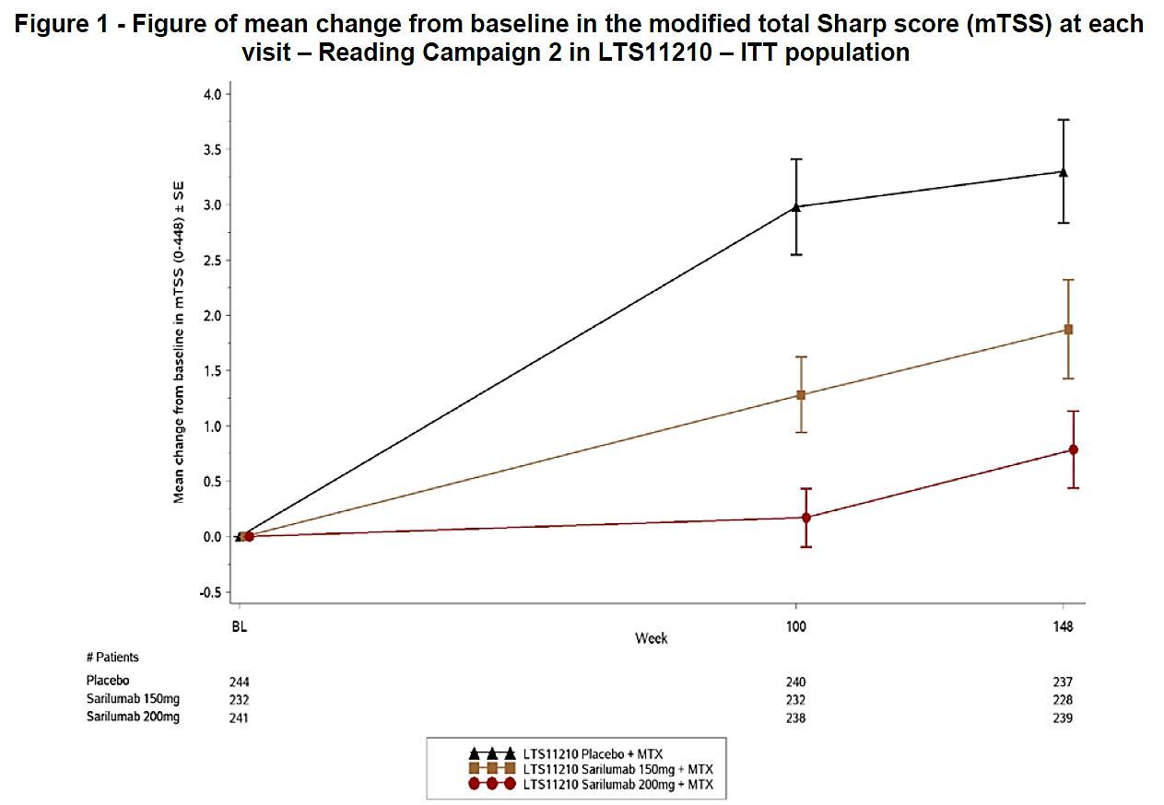

Safety
A total of 3354 patients in the total safety population have received at least one dose of sarilumab, with 2887 patients receiving sarilumab in combination with conventional DMARD (1960 for at least 48 weeks), and 467 receiving sarilumab monotherapy (109 for at least 48 weeks).
New safety data were reported for Study EFC14092 MONARCH and a pool of monotherapy exposure across studies. The CER notes the safety profile for the sarilumab monotherapy 200 mg q2W group in Study EFC14092 MONARCH was similar to the safety profile for the any sarilumab monotherapy dose group pool.
In Study EFC14092 MONARCH, the safety of sarilumab 200 mg q2w (n = 184) was compared with the safety of adalimumab 40 mg q2w (n = 184) over 24-weeks. At the Week 16 to 20 period, 8.7% of adalimumab patients increased to 40 mg every week. TEAEs were observed in a similar proportion of patients in the sarilumab 200 mg q2w and adalimumab 40 mg q2w groups (64.1% versus 63.6%, respectively), as were treatment emergent SAEs (4.9% versus 6.5%, respectively) and TEAEs leading to permanent treatment discontinuation (6.0% versus 7.1% respectively). TEAEs leading to death were reported in 1 (0.5%) patient in the sarilumab group (CV causes) and no patients in the adalimumab group. There was a higher incidence of neutropaenia in the sarilumab group compared with the adalimumab group (13.6% versus 0.5%, respectively). Other TEAEs reported in ≥ 2% of patients in either of the two treatment groups, and ≥ 2% more frequently in the sarilumab group compared with the adalimumab group were injection site erythema and bronchitis. The most commonly reported AESIs in both treatment groups were infections, which occurred in a similar proportion of patients in both the sarilumab 200 mg q2w group and the adalimumab 40 mg q2w group (28.8% versus 27.7%, respectively). Serious infections occurred infrequently and in the same proportion of patients in the two treatment groups (1.1%, n = 2), as did opportunistic infections (0.5%, n = 1), while TB occurred in 1 (0.5%) patient in the adalimumab group and no patients in the sarilumab group. AESIs of leukopaenia (14.1% versus 1.6%), injection site reactions (9.2% versus 4.3%) and hepatic disorders (4.9% versus 3.8%) occurred more frequently in patients in the sarilumab group than in patients in the adalimumab group. No serious infections were noted in patients with ANC < 1 Giga/L (Grade 3 or 4 neutropaenia) in either treatment group. Of the 19 (10.3%) patients in the sarilumab group with ANC < 1.0 Giga/L (Grade 3 or 4 neutropaenia), 11 (6.0%) normalised on treatment, 4 (2.2%) normalised after discontinuation of treatment and 4 (2.2%) did not normalise after discontinuation of treatment with sarilumab. Three of the 4 patients whose neutropaenia did not normalise after the last evaluation in the double-blind treatment enrolled in the open-label treatment period. AESIs of elevation in lipids occurred more frequently in patients in the adalimumab group than in patients in the sarilumab group. Hypersensitivity reactions occurred in the same proportion of patients in both treatment groups, and there were no reports of anaphylaxis in either of the two treatment groups. All other AESIs occurred infrequently in both treatment groups. Laboratory abnormalities relating to neutropaenia, thrombocytopaenia, increased ALT, increased total bilirubin, increased total cholesterol, increased LDL cholesterol and increased triglycerides were all reported more frequently in the sarilumab group than in the adalimumab group. However, the mean values for the laboratory parameters for both treatment groups were consistently within normal ranges at all post-baseline visits through to Week 24. For ADA results, 7.1% patients were treatment-emergent ADA positive, including 2.7% patients with a persistent ADA positive response (all NAb negative) and 4.3% with a transient ADA positive response (all NAb negative). None of the 13 patients who were ADA positive discontinued treatment due to lack or loss of efficacy, while 3 of the ADA positive patients experienced mild, localised, hypersensitivity rashes.
Subgroups based on gender, age and weight are discussed in the CER.
The safety profiles were similar for the 467 patients with a total exposure of 299.4 PY in the any sarilumab dose group (Pool 3) and for the 184 patients with a total exposure of 78.7 PY in the sarilumab 200 mg q2w group (Study EFC14092 MONARCH).
In the long-term sarilumab + DMARD safety population, the evaluator noted 8 patients with LFT laboratory abnormalities meeting Hy’s law criteria for drug induced liver injury including 2 (0.1%) in the sarilumab 150 mg q2w initial dose group and 6 (1.3%) in the sarilumab 200 mg q2w initial dose group. The sponsor has been requested to provide further information.
In the long term safety population for the any sarilumab dose + DMARD group, the incidence of ANC < 1.0 Giga/L was 11.8%, which was numerically higher than the rates in the sarilumab + DMARD groups in the placebo controlled period. The sponsor comments that this finding was not unexpected given that the observation time was longer in long term data compared with the controlled data. The new CER reports that the occurrence of ANC <1.0 Giga/L appeared to be highest within 6 months of initiating therapy, while the time to onset of serious infection appeared to be constant over time, consistent with a lack of association between decrease in neutrophil count and increased risk of serious infection in patients receiving sarilumab.
Study SFY13370 (ASCERTAIN trial) was a randomised, double-blind, double-dummy trial which primarily aimed to assess the safety and tolerability of sarilumab in combination with DMARDs (n = 49 for 150 mg and n = 51 for 200 mg) and IV tocilizumab (n = 102) in combination with DMARDs in adult patients with active RA who were inadequate responders to or intolerant of anti-TNF drugs. The study was previously submitted. The current CER notes that the risks of treatment with sarilumab and tocilizumab appeared to be comparable however the risks of neutropaenia were numerically higher in the sarilumab groups and the risks of elevated lipids were numerically higher in the tocilizumab group. The sponsor stated that these differences were not considered to be clinically meaningful. The risks of hepatic disorders and potentially clinically significant abnormalities relating to increased ALT levels were similar in the sarilumab and tocilizumab groups. Hypersensitivity reactions occurred with a similar incidence and there were no reports of anaphylaxis. TEAEs leading to permanent treatment discontinuation occurred more frequently in the sarilumab groups with the difference appearing to be primarily due to a higher incidence of laboratory abnormalities.

Risk management plan
The TGA has accepted the EU RMP for Kevzara (sarilumab), (version 1.2, dated 21 April 2017, data lock point 17 February 2016), with Australian specific Annex (ASA) (version 4.0, dated 27 April 2018).
The proposed Summary of Safety Concerns and their associated risk monitoring and mitigation strategies are summarised in Table 49.
The RMP evaluator provides the following comments:
- Additional pharmacovigilance activities include a pregnancy registry (North America only) and a surveillance program using existing EU rheumatoid arthritis registries which is acceptable. However, it is recommended the sponsor consider a survey to measure effectiveness of additional risk minimisation activities (the Healthcare Professional (HCP) Prescriber Guide).
- The sponsor has adequately described their process for monitoring the distribution of additional risk minimisation materials. The sponsor also has proposed routine pharmacovigilance to monitor the effectiveness of the additional risk minimisation activities. This is acceptable as sarilumab is not the first monoclonal antibody used to treat rheumatoid arthritis that has additional risk minimisation activities for similar safety concerns.
- Additional risk minimisation activities include a HCP Prescriber Guide (ASA only) which addresses all the Important Identified and Potential Risks except malignancy (however this is included in the PI). A Patient Alert Card is also proposed. Both are acceptable.
- The sponsor has provided a malignancy targeted questionnaire attached to the ASA (version 2.2) with this application. It was considered that if this was implemented then this would provide sufficient surveillance to detect a signal for this potential risk in the Australian context. The questionnaire that has been provided is satisfactory.
- The Consumer Medicine Information (CMI) does not include diagrams of how to inject Kevzara. However, there is an instruction for use (IFU) leaflet which will be included in the packaging. The IFU contains clear instructions on how to use the PFS or pen.
- Kevzara meets the eligibility criteria for the Black Triangle Scheme.
- Depression was previously identified as a potential concern and the sponsor has added it under Missing Information in the ASA which was acceptable to the RMP evaluator as information regarding this risk will be captured by routine pharmacovigilance activities (periodic safety update reports (PSUR)).
There is one new recommendation from the RMP evaluator that the sponsor should follow up with then evaluator and in the sponsor’s Pre-ACM response:
- The additional risk minimisation materials should also include the Black Triangle symbol and a statement relating to the product being under additional monitoring. The PI statement is recommended for the HCP guide but an abridged version of the CMI statement may be proposed for the patient alert card.

Risk-benefit analysis

Delegate’s considerations

Quality
The quality evaluator has no objections to approval on quality grounds and has recommended batch release testing as a condition of registration. Updated GMP clearances will need to be provided prior to registration.

Nonclinical
The nonclinical evaluator has no objections to registration.

Clinical
The clinical evaluator has recommended approval of Kevzara in combination with non-biological DMARDs and as monotherapy at the sponsor’s requested dose of 200 mg fortnightly, decreasing to 150 mg fortnightly based on the dose modifications for neutropaenia, low platelet count and increased ALT as recommended in the PI.

Efficacy
The pivotal monotherapy study demonstrated superiority of 200 mg sarilumab compared to 40 mg adalimumab for the primary efficacy endpoint and 6 of 8 secondary efficacy endpoints over a 24 week period in patients with active RA who was considered to be unsuitable candidates for continued treatment with MTX due to intolerance or inadequate response. No data are available to support radiographic outcomes and the long-term sarilumab open-label study is ongoing. The study did not assess the benefits of a 150 mg dose of sarilumab.
The pivotal combination studies previously submitted demonstrated efficacy of both doses of sarilumab in patients with moderate to severe active RA on a background of non-biological DMARDs (mostly MTX) using validated co-primary efficacy endpoints covering signs and symptoms of active RA, physical functioning and progression of structural joint damage. The pivotal studies covered 24 to 52 weeks duration and are supported by a long term extension study. Both of the Phase III trials included patients who had previously been exposed to anti-TNF drugs and those who were anti-TNF naïve. However both studies excluded patients who were at a significant risk of infection (particularly, TB) or malignancy, or who had various abnormal laboratory results at baseline (abnormal haematology, liver function tests or lipid parameters). In addition, there were many exclusion criteria.

Safety
The safety of sarilumab 200 mg q2w as monotherapy for the treatment of RA has been adequately demonstrated in the pivotal Phase III Study EFC14092/MONARCH trial and is supported by the data from the sarilumab any dose group in the integrated monotherapy safety analysis. Although the study data from Study EFC14092 MONARCH submitted is limited to 24 weeks at this stage, this is mitigated by the pooled monotherapy safety data from the integrated safety analysis in which 467 patients treated with any dose of sarilumab had a median duration of 255 days and pooled long-term safety data for sarilumab + DMARD. The CER notes that the long-term combination safety data for sarilumab + DMARD are consistent with the safety data for sarilumab monotherapy provided in the re-submission. The safety profile of sarilumab and adalimumab differ but were considered to be generally comparable by the evaluator. The overall incidence of TEAEs was similar in the two treatment groups, with the major differences being notably higher incidences of neutropaenia and injection site reactions in the sarilumab group, a higher incidence of hepatic disorders in the sarilumab group and a higher incidence of lipid disorders in the adalimumab group. There were no other notable differences between groups in TEAEs, including AESI. There were no clinically meaningful differences between the two treatment groups as regards SAEs. Laboratory abnormalities relating to neutropaenia and increased ALT levels were reported more frequently in patients in the sarilumab group than in the adalimumab group.
The safety profile for sarilumab in combination with non-biological DMARDs has been demonstrated in the pivotal combination studies and long term extension study. Overall, TEAEs, serious TEAEs, and TEAEs leading to permanent treatment discontinuation occurred more frequently in patients in both sarilumab dose groups (150 mg q2w and 200 mg q2w) compared with placebo, and marginally more frequently in the higher dose compared with the lower dose sarilumab group. TEAEs leading to death occurred infrequently in each of the three treatment groups. The most frequently observed risks for sarilumab in combination with cDMARD related to infections, although serious infections, opportunistic infections and TB occurred relatively infrequently. Other risks of note associated with combination treatments included neutropaenia, thrombocytopaenia, injection site reactions, hepatic disorders (including laboratory abnormalities of increased ALT, AST, and total bilirubin levels) and lipid disorders (including laboratory abnormalities of increased LDL, HDL and triglycerides). The clinical evaluator comments that there did not appear to be a relationship between neutropaenia and infections, thrombocytopaenia and bleeding, or abnormal lipids and major cardiovascular adverse events. Based on exposure-adjusted patient incidence rates, the evaluator notes that no clinically meaningful differences were observed between the sarilumab + DMARD long-term safety population and the sarilumab + DMARD placebo-controlled population.
The safety and tolerability data from Study SFY13370 comparing sarilumab and tocilizumab showed the risks of neutropaenia were numerically higher in the sarilumab groups. The risks of hepatic disorders and potentially clinically significant abnormalities associated with increased ALT levels were similar in the sarilumab and tocilizumab groups.
Neutropaenia, raised liver enzymes and thrombocytopaenia are of concern and the sponsor is proposing dose reductions to 150 mg for these along with laboratory monitoring. Gastrointestinal (GI) perforation/ulceration/diverticulitis was slightly higher on sarilumab and the risk of malignancies needs longer follow-up, as to for MACE events (long term combination safety population: MACE 0.5/100 PY, malignancies 0.8/100 PY). Depression has been included in the RMP.

Dose
Both pivotal combination studies compared two doses of sarilumab with placebo but were not designed or had pre-specified statistical testing to determine superiority of the higher dose over the lower dose. The monotherapy study only tested the higher dose. The previous submission raised concerns with the starting dose but the current clinical evaluator, with the additional data, comments that, ‘the majority of patients starting on sarilumab 200 mg q2w + DMARD can safely remain at that dose, with reduction to sarilumab 150 mg q2w + DMARD in the event of toxicity on the higher dose. Following recovery of laboratory abnormalities related to neutropaenia, thrombocytopaenia or increased ALT levels observed with the higher dose of sarilumab 200 mg q2w, the data indicated that treatment can be safely re-initiated at the lower dose of sarilumab 150 mg q2w +DMARD. The monitoring regimens recommended in the PI for identifying neutropaenia, thrombocytopaenia, or ALT are considered to be appropriate. There is no reason why the proposed monitoring requirements cannot be safely instituted in remote communities. The monitoring requirements proposed for sarilumab are similar to those required for tocilizumab.’ It is also noted that starting with the higher dose and decreasing to the lower dose in the event of toxicity has been approved in the US, Europe and Canada. Although the sponsor has not demonstrated significantly superior efficacy for the 200 mg over the 150 mg, there is a numerical trend to higher efficacy. Data from the long term combination study relating to radiological progression of joint damage are considered by the sponsor to show better radiological outcome for patients initiated on 200 mg than 150 mg up to Year 3. The clinical evaluator comments, ‘overall, the data showed that progression of radiological structural joint damage was less marked in patients initiating treatment with sarilumab 200 mg q2w and continuing at this dose than in patients initiating treatment with sarilumab 150 mg q2w and subsequently increasing the sarilumab dose to 200 mg q2w.’
Neutropaenia is a significant concern, but the clinical evaluator comments that ‘Based on the totality of the safety data relating to the incidence of neutropaenia it is considered that treatment can be safely initiated with sarilumab 200 mg q2w and reduced to 150 mg q2w based on the ANC criteria provided in the PI.’ Despite the higher rate of neutropaenia seen in both combination studies on 200 mg versus 150 mg (pool 1: 14.2% versus 9.8%) and in the monotherapy study for 200 mg compared with adalimumab (13.6% versus 0.5%), the rate of overall infection appeared to be mostly similar between the two doses in the controlled phases and between sarilumab and adalimumab in the monotherapy study. The evaluator also ‘considered that there were no clinically meaningful differences in the patterns of infection in the sarilumab 200 mg q2w + DMARD and sarilumab 150 mg q2w + DMARD groups’ however in the sarilumab + DMARD long-term safety population, infections in the sarilumab 200 mg q2w initial dose group were reported more frequently than in the sarilumab 150 mg q2w initial dose group (46.0% versus 32.6%, respectively), but the exposure-adjusted event rates were greater in the 150 mg q2w initial dose group than in the 200 mg q2w initial dose group. In this same population, serious infections were reported more frequently in patients in the sarilumab 200 mg q2w initial dose group than in the sarilumab 150 mg q2w initial dose group (5.7% versus 1.4%, respectively) with exposure-adjusted event rates of 4.0/100 PY versus 2.7/100 PY respectively. The clinical evaluator also comments that, ‘overall, the reports of increased ALT associated with sarilumab 200 mg q2w do not give rise to concern.’ In the long term study, dose reductions occurred in 17.7% of patients, with the major reason being neutrophil count decreased (11.3%), followed by ALT increased (3.9%). After dose reduction, an improvement in ANC and ALT towards baseline or normal values was observed. No patient increased dose to 200 mg q2w after reducing the dose to 150 mg q2w.

RMP
An acceptable RMP with ASA has been provided with one outstanding matter which the sponsor should address prior to registration. The Delegate supports the RMP evaluator’s recommendations.

Overall
The quality, nonclinical and clinical evaluators have recommended approval, and an acceptable RMP/ASA has been provided, pending satisfactory resolution of GMP and RMP matters and the PI and CMI. The ACM previously advised that sarilumab had an overall positive benefit-risk balance but was concerned with the starting dose. Considering the totality of the data now available, the Delegate is minded to accept the sponsor’s proposed dosing regimen. It is noted that the sponsor has added to the PI in the Dosage section that the ‘choice of the starting dose should be based on an individual patient assessment, taking into consideration potential risks’ which was not included in the previous submission. The ACMs advice is requested on this matter.

Data deficiencies
The pivotal studies were not designed or powered to evaluate significant differences between the two sarilumab doses. Sarilumab has not been studied in patients <18 years of age, in subjects with significant organ dysfunction (including renal, hepatic or cardiac failure), those at risk of reactivated latent TB, in the setting of live vaccines, and in pregnant or lactating women. The pivotal monotherapy study did not assess radiographic progression. There is insufficient long term data on potential risks of malignancy (including non-melanoma skin cancers) and major adverse cardiovascular events which are therefore dependent on post-marketing exposure in a larger number of patients. There are limited data in the elderly.

Conditions of Registration
The following are proposed as conditions of registration and the sponsor is invited to comment in the Pre-ACM response:
- The Kevzara EU-Risk Management Plan (RMP) (version 1.2, dated 21 April 2017, data lock point 17 February 2016), with Australian Specific Annex (version 4.0, dated 27 April 2018), included with submission PM-2017003119-1-3, and any subsequent revisions, as agreed with the TGA will be implemented in Australia.
An obligatory component of risk management plans is routine pharmacovigilance. Routine pharmacovigilance includes the submission of Periodic Safety Update Reports (PSURs).
Reports are to be provided in line with the current published list of EU reference dates and frequency of submission of PSURs until the period covered by such reports is not less than three years from the date of this approval letter.
The reports are to at least meet the requirements for PSURs as described in the European Medicines Agency’s Guideline on good pharmacovigilance practices (GVP) Module VII-Periodic Safety Update Report (Rev 1), Part VII.B Structures and processes. Note that submission of a PSUR does not constitute an application to vary the registration. Each report must have been prepared within ninety calendar days of the data lock point for that report.
- Kevzara (sarilumab) is to be included in the Black Triangle Scheme. The PI and CMI for Kevzara must include the Black Triangle symbol and mandatory accompanying text for five years, which starts from the date that the sponsor notifies the TGA of supply of the product.
- The following study reports must be submitted to the TGA as soon as possible after completion:
- The proposed paediatric studies to the TGA at the same time as the studies are submitted to the EMA and/or the US FDA.
- Batch Release Testing
- It is a condition of registration that all batches of Kevzara imported into/manufactured in Australia must comply with the product details and specifications approved during evaluation and detailed in the Certified Product Details (CPD).
- It is a condition of registration that each batch of Kevzara imported into/manufactured in Australia is not released for sale until samples and/or the manufacturer’s release data have been assessed and endorsed for release by the TGA Laboratories Branch. Outcomes of laboratory testing are published biannually in the TGA Database of Laboratory Testing Results.
- The sponsor should be prepared to provide product samples, reference materials and documentary evidence as defined by the TGA Laboratories branch. This batch release condition will be reviewed and may be modified on the basis of actual batch quality and consistency. This condition remains in place until you are notified in writing of any variation.
- Certified Product Details: The Certified Product Details (CPD), as described in Guidance 7: Certified Product Details of the Australian Regulatory Guidelines for Prescription Medicines (ARGPM), in PDF format, for the above products should be provided upon registration of these therapeutic goods. In addition, an updated CPD should be provided when changes to finished product specifications and test methods are approved in a Category 3 application or notified through a self-assessable change.

Summary of Issues
The primary issues with this submission are as follows with further information in the Discussion section above:
- The previous submission had concerns with the proposed starting dose for sarilumab. The sponsor’s proposed dose was 200 mg fortnightly which could be decreased to 150 mg fortnightly for patients with neutropaenia, thrombocytopaenia and elevated liver enzymes. The clinical evaluator of the initial application supported 150 mg fortnightly, and the TGA’s Advisory Committee also supported it as an appropriate starting dose with an option to increase to 200 mg fortnightly if clinically appropriate. During post-Advisory Committee negotiations, the sponsor withdrew the application. In this application, the evaluator has supported a starting dose of 200 mg fortnightly which can be decreased to 150 mg fortnightly based on additional information provided by the sponsor including new data on use as monotherapy.
- The sponsor has requested to broaden the indication from the initial submission to include monotherapy use in addition to combination use with non-biological DMARDs.

Proposed action
The Delegate had no reason to say, at this time, that the application for Kevzara should not be approved for registration, pending further advice from ACM.

Request for ACM advice
The committee is requested to provide advice on the following specific issues:
- What are the committee’s views on the proposed dosing regimen for sarilumab?
- What are the committee’s views on the use of sarilumab as monotherapy?
The committee is also requested to provide advice on any other issues that it thinks may be relevant to a decision on whether or not to approve this application.
Questions for the sponsor
The sponsor is requested to address the following issues in the Pre-ACM Response:
- Please address the outstanding RMP matter with the RMP evaluator and provide a summary of the sponsor’s response in the Pre-ACM Response.
- Please provide an analysis of potential Hy’s law cases from the entire dataset including any possible explanations.
- Please provide an update, if available, from the ongoing Study LTS11210.

Response from sponsor
The sponsor’s comments on the issues for which the advice of the ACM is sought, as outlined in the Delegate’s Overview are presented below. The sponsor agrees with the indication proposed by the Delegate for combination use with non-biological DMARDs and as monotherapy and the recommended starting dose of 200 mg fortnightly with the option to decrease to 150 mg fortnightly. The following information is provided to assist the committee in its discussions.

Introduction
Sarilumab, is a specific inhibitor of IL-6 signalling, and has been developed as a subcutaneous injection for the treatment of rheumatoid arthritis (RA). Overproduction of IL-6 has been found to play pathological roles in RA and it is well established that targeting the receptor with monoclonal antibodies confers therapeutic benefits in this indication.

Safety
Consistent with current understanding of IL-6 pharmacology and observations from clinical studies with tocilizumab, several clinical findings potentially related to IL-6 inhibition were observed in the sarilumab clinical development program: higher rates of infection, decreases in ANC, and increases in ALT and lipids, in patients receiving sarilumab + DMARD relative to patients receiving placebo + DMARD. In clinical studies, serious infections occurred at rates that were similar to those observed in RA patients treated with other biologic DMARDs. Opportunistic infections were infrequently reported. No clinical consequences of the identified laboratory abnormalities were observed in clinical studies. In particular decreases in ANC did not appear to be associated with an increased risk of infection, including serious infection. Dose modification (delay or reduction) reduced the incidence of decreased in ANC and increased ALT.
The safety profile of sarilumab administered as monotherapy was generally consistent with that of patients receiving sarilumab with concomitant DMARDs.

Efficacy
Reductions in signs and symptoms of RA are greater for patients starting with 200 mg q2w than with sarilumab 150 mg q2w, and improvements are evident earlier during treatment with the higher dose regimen. Inhibition of joint damage as measured by radiographs is evident earlier with sarilumab 200 mg q2w than with sarilumab 150 mg q2w. These data support a recommendation for a starting dose regimen of 200 mg q2w in combination with DMARDs or as monotherapy for the treatment of moderately to severely active RA in adult patients who responded inadequately to or were intolerant of DMARDs or TNF-α antagonists. This starting dose regimen provides patients with a higher chance of inhibiting progression of structural damage as compared to the 150 mg q2w dose regimen.
In the event of certain laboratory abnormalities, the dose may be reduced to 150 mg q2w to give these patients the possibility to continue treatment with a drug that has been proven highly effective in improving signs and symptoms as well as physical function at this dose. Further, when needed, patients can be effectively treated with sarilumab as monotherapy.

Proposed dosing regimen for sarilumab and use as monotherapy
As noted by the Delegate, previous TGA concerns relating to the proposed starting dose of 200 mg q2w for sarilumab have been addressed by the provision of new data including use as monotherapy. These data demonstrate the favourable benefit risk profile of sarilumab as follows:
- The use of sarilumab for the treatment of moderate to severe rheumatoid arthritis in adult patients who have had an inadequate response or intolerance to one or more DMARDs in both combination and monotherapy, is supported by the consistent and durable efficacy demonstrated by reduction in the signs and symptoms of RA, improvement in physical function, and the radiologic evidence of otherwise progressive and irreversible joint destruction.
- The superior efficacy of sarilumab to adalimumab monotherapy and generally similar safety profile provides reassurance on the favourable benefit/risk of the 200 mg q2w dosing regimen compared to an existing approved therapy that is widely used in Australian clinical practice.
- To align with current standards of clinical practice that focus on prevention of irreversible structural damage to the joints, the clinical evidence demonstrates that patients should initiate treatment with 200 mg q2w to derive maximal benefit, and only down-titrate to 150 mg q2w to manage decreases in ANC or platelets or increases in transaminases. This approach supports Quality use of Medicine to achieve the best long term patient outcomes and has been endorsed by experts across Australia.
Post-marketing experience in countries where the product is marketed including in the USA, EU, Japan and Canada provides further confirmation and reassurance that the proposed dosage regimen is safe and effective in clinical practice:
- The proposed monitoring schedule to detect reduced ANC (every 3 months) is conservative compared to that used in the ongoing long term extension study (every 6 months) and is supported by additional risk management tools with a Patient Alert card to support patient awareness of signs and symptoms that require immediate medical attention.
- A well-established infrastructure across Australia for monitoring patients in remote areas is already in place, based on risks associated with existing RA therapies that require the same oversight and management as for sarilumab to ensure safe use.
- The long-term benefit of inhibition of irreversible joint damage demonstrated by sarilumab 200 mg q2w outweighs the short-term risk for decreased ANC, which are transient and manageable with dose modification.
Overall, the totality of data presented and the ongoing post marketing experience supports approval of Kevzara for use as both combination and monotherapy in Australian clinical practice.

Product Information
The sponsor has revised the PI to implement the majority of recommendations proposed by the Delegate or provided alternative wording with a supporting rationale.
In relation to the Dosing and Administration section of the draft PI the sponsor has identified an unintentional error in the submission in relation to inclusion of the statement highlighted with italics below:
Kevzara may be used as monotherapy or in combination with MTX (MTX) or other non-biological DMARDs as a SC injection.
Choice of a starting dose should be based on an individual patient assessment, taking into consideration potential risks.
The recommended dose of Kevzara is 200 mg once q2w given as a SC injection.
Reduction of dose from 200 mg once q2w to 150 mg once q2w is recommended for management of neutropaenia, thrombocytopaenia and elevated liver enzymes.
The italicised statement had been added during the label negotiations for the previous submission as an additional risk mitigation approach to support inclusion of the option for a 200 mg fortnightly starting dose. It should be noted that the submission was subsequently withdrawn on the basis that the sponsor considered that a 200 mg fortnightly starting dose was appropriate for all patients to ensure optimal clinical outcomes.
As previously described, the current submission is based on the original plus additional data and post marketing experience that supports the favourable benefit risk of the 200 mg fortnightly starting dose, which has been endorsed by experienced Key Opinion Leaders across Australia.
The highlighted statement was carried over inadvertently; therefore the sponsor is proposing to delete it. This statement creates confusion and contradicts the recommended dose of 200 mg q2w. This statement implies that there is a choice of starting dose. For use as monotherapy there is no evidence for any other starting regimen other than 200 mg fortnightly. Additionally the body of evidence supports that the 200 mg fortnightly starting dose provides maximal clinical benefit to prevent the irreversible structural damage to the joints.
To further support the dosing recommendations extensive instructions are included in the proposed PI and HCP prescriber guide to manage temporary dosage modifications in case of neutropaenia, thrombocytopaenia or liver enzyme elevations as outlined below in Table 50. These are all based on a starting dose of 200 mg fortnightly with advice on temporary interruption of treatment and restarting at a lower dose of 150 mg fortnightly with subsequent resumption of the 200 mg dosing regimen as clinically appropriate as shown below.

Table 50: Temporary dosage modifications (200 mg dosing regimen)
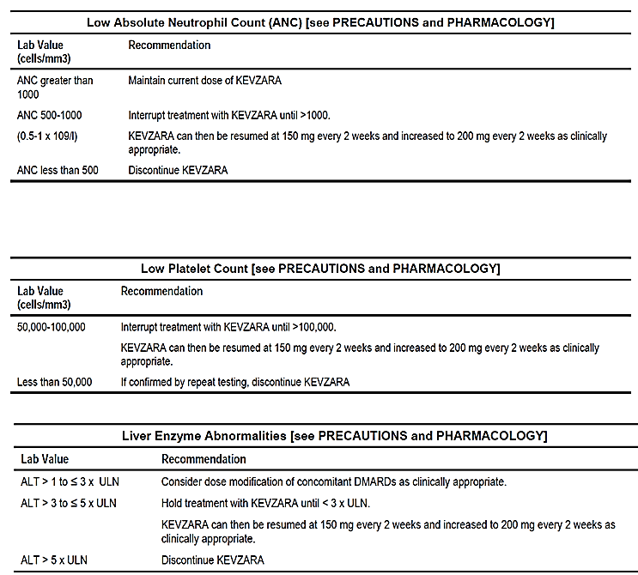
To ensure the information in the PI remains logical and provides clear guidance for prescribers, the sponsor is therefore proposing to remove the highlighted (italicised) text from the proposed PI.

Proposed condition of approval paediatric studies
The sponsor notes the proposed condition of approval such that the sponsor will be required to submit paediatric studies to the TGA at the same time as to the EMA and/or US FDA. The sponsor commits to submitting the paediatric studies to TGA as soon as practicable after their submission to the EMA and/or FDA.

Closing remarks
Given the irreversible nature of joint destruction, and taking into consideration the consistent and durable efficacy demonstrated by associated reduction in signs and symptoms of RA, improvement in physical function and radiologic evidence, the sponsor is requesting approval of initiation at a dose of 200 mg q2w. Dose reduction to 150 mg q2w remains an appropriate option only for management of IL-6 associated laboratory abnormalities (decrease in ANC or platelet count or increase in ALT). As evidenced by the regulatory approvals in a number of countries, the benefit/risk profile of sarilumab is supportive of the sponsor’s recommended 200 mg fortnightly starting dose.

Responses to delegate questions for the sponsor
Responses to the questions raised by the Delegate are provided below.

Question 1
Please address the outstanding RMP matter with the RMP evaluator and provide a summary of the sponsor’s response in the pre-ACM response.
The sponsor has implemented recommendation raised by the RMP evaluator and included the Black triangle symbol and a statement relating to the product being under additional monitoring on the additional risk minimisation materials. A copy of the HCP guide including the PI statement and the patient alert card including an abridged version of the CMI statement were provided in the proposed RMP accompanying this response.

Question 2
Please provide an analysis of potential Hy’s law cases from the entire dataset including any possible explanations.
There were no cases that met the criteria of Hy’s Law since the lab parameters must be taken within the clinical context to determine Hy’s Law cases.
As noted in the summary of sponsor’s Clinical safety, in the sarilumab+DMARD long-term safety population, 8 patients on sarilumab had ALT > 3 x ULN and total bilirubin > 2 x ULN. These patients had other plausible explanations for the elevations: biliary pancreatitis, suspected bile duct stone, recent chemical exposure/hepatic abscess, cholelithiasis/biliary pancreatitis, hepatic steatosis, fatty liver, hepatorenal syndrome, one patient was on leflunomide or the ALT > 3 x ULN and total bilirubin > 2 x ULN did not occur concomitantly. The majority of cases are confounded with the patients’ concurrent diseases and not related to sarilumab. Elevations in transaminases were not associated with meaningful increases in conjugated bilirubin or clinical evidence of hepatitis or hepatic insufficiency.
Therefore, these cases did not meet criteria for Hy’s law.

Question 3
Please provide an update, if available, from the ongoing Study LTS 11210.
The following updated data is available for Study LTS11210.
Long term efficacyLong term data out to 3 years (148 weeks) has been provided in this submission. Long-term efficacy data have been evaluated (data extracted on 30 June 2017) for patients who entered Study LTS11210, the long-term extension study, following treatment in Study EFC11072 or Study EFC10832. Patients were treated with sarilumab 200 mg q2w + DMARDs during the LTS11210 extension study, and were allowed to decrease the dose of DMARD at their discretion and to decrease the dose of sarilumab to 150 mg q2w for certain laboratory abnormalities. Data up to 5.6 and 3.5 years from initial randomisation for these patients in Study EFC11072 Part B and Study EFC10832 respectively is discussed below.
- Signs and symptoms
The efficacy of sarilumab 200 mg administered concomitantly with DMARDs on the signs and symptoms of RA seen in the placebo controlled studies was sustained during the extension study, as shown below with data up to 5.6 and 3.5 years from initial randomisation in Study EFC11072 Part B and Study EFC10832, respectively.
- ACR response rates
The effect of sarilumab in combination with DMARDs on ACR response rates was durable in patients initially randomised in Study EFC11072 and Study EFC10832, respectively. Up to 92.1% of MTX-IR patients and 84.3% of TNF-IR patients maintained an ACR20 response after 5.6 (268 weeks) and 3.5 (168 weeks) years of treatment with sarilumab 200 mg q2w. Figure 14 and Figure 15 show the ACR20 response in patients from Studies EFC11072 and EFC10832, respectively.
The ACR50 and ACR70 responses over time are similarly durable in patients initially randomised in Studies EFC11072 and EFC10832.
Figure 14: Incidence of ACR20 response for patients originally randomised into Study EFC11072 Part B, Cohort 2 and those who continued into Study LTS11210
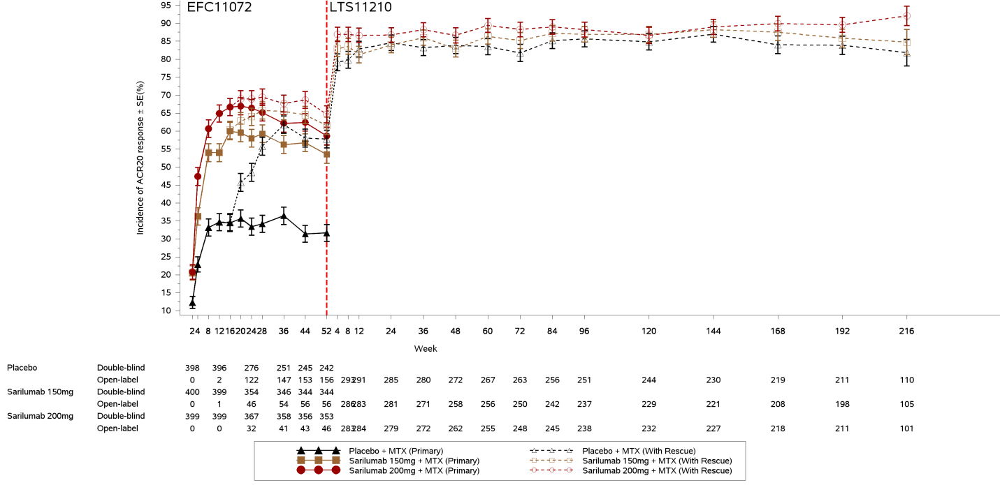
Figure 15: Incidence of ACR20 response for patients originally randomised into Study EFC10832 and those who continued into Study LTS11210
- DAS28-CRP
Reduction in disease activities as measured by change from baseline in DAS28 CRP and percentage of patients with DAS28 CRP < 2.6 at each visit were similar to the analyses of ACR20, 50 and 70, confirming that the durable beneficial effect of sarilumab concomitantly with DMARDs on signs and symptoms of RA over time. Figure 16 and Figure 17 show DAS28-CRP over time in patients from EFC11072 and EFC10832.
Up to 69.3% of MTX-IR patients and 53.8% of TNF-IR patients maintained DAS28-CRP < 2.6 after 5.6 and 3.5 years of treatment with sarilumab 200 mg q2w for patients initially randomised in EFC11072 and EFC10832 respectively.
Figure 16: DAS28 CRP at each visit Study EFC11072 Part B, Cohort 2, Study LTS11210 combination
Figure 17: DAS28 CRP at each visit Study EFC10832 LTS11210 combination
- Physical function
The beneficial effect of sarilumab concomitantly with DMARDs for the improvement of physical function (change from baseline in HAQ DI and proportion of patients reaching an HAQ DI improvement of ≥ 0.3 units from baseline) was sustained over time, up to approximately 5.6 and 3.5 years treatment, in Study LTS11210 for patients initially randomised in Studies EFC11072 and EFC10832, respectively.
Figure 18 and Figure 19 show HAQ DI over time in patients from Study EFC11072 and from Study EFC10832.
Up to 74.2% of patients from Study EFC11072 and 69.8% of patients from Study EFC10832 maintained a clinically meaningful level of improvement in HAQ-DI after 5.6 and 3.5 years, respectively, of treatment with sarilumab 200 mg q2w.
Figure 18: HAQ-DI over time for patients originally randomised into Study EFC11072 Part B, Cohort 2 and those who continued into Study LTS11210
Figure 19: HAQ-DI over time for patients originally randomised into Study EFC10832 and those who continued into Study LTS11210
- Radiographic progression: 5-year radiographic data
The efficacy of sarilumab with concomitant MTX on inhibition of radiographic progression that was assessed using the van der Heijde mTSS as part of the primary endpoints at Week 52 (Year 1) in Study EFC11072 Part B was sustained in analyses of 5 year (Week 244), as shown in Figure 20 below, consistent with the previously presented data following 2 years (Week 100) and 3 years (Week 148) of treatment. Inhibition of progression was most pronounced in patients who had initially been randomised to sarilumab 200 mg and was maintained during the extension study up to 5 years of treatment with sarilumab (Figure 20).
The rate of radiographic progression was lowest in patients who were initially treated in the sarilumab 200 mg q2w group in Study EFC11072 throughout the analysis period, with a mean change from baseline in mTSS of 1.36 at Week 244 (Year 5) from randomisation in Study EFC11072 Part B (Table 51). The rate of radiographic progression was highest in the patients who were initially treated in the placebo group in Study EFC11072 (mean change from baseline in mTSS of 4.19 at Year 5). Patients initially treated with sarilumab 150 mg q2w in Study EFC11072 had less radiographic progression at Week 244 (Year 5) than did patients initially treated with placebo, but the mean change from baseline (2.59) was larger than in the sarilumab 200 mg q2w group.
The proportion of patients with no progression in mTSS at Week 244 (Year 5) was greatest in patients who received sarilumab 200 mg q2w from the time of randomisation in Study EFC11072 , followed by those who were randomised to sarilumab 150 mg q2w and placebo in Study EFC11072 (47.1%, 42.2% and 37.2%, respectively) (Table 52). The findings at Year 5 were consistent with the observed data for Year 2 and Year 3 previously presented.
Patients initially randomised to the sarilumab 150 mg q2w group had less radiographic progression compared with those who had initially been randomised to placebo. However, the treatment difference between 150 mg and 200 mg persisted through Week 244 (Year 5); further demonstrating that initial therapy with sarilumab 200 mg produces better radiographic outcomes.
Figure 20: Study LTS11210 Mean change from Baseline in the modified total Sharp score (mTSS) at each visit; ITT population

Table 51: Mean changes from Baseline in radiographic parameters at Week 244 for patients originally randomised into Study EFC11072 Part B, Cohort 2 who continued into Study LTS11210
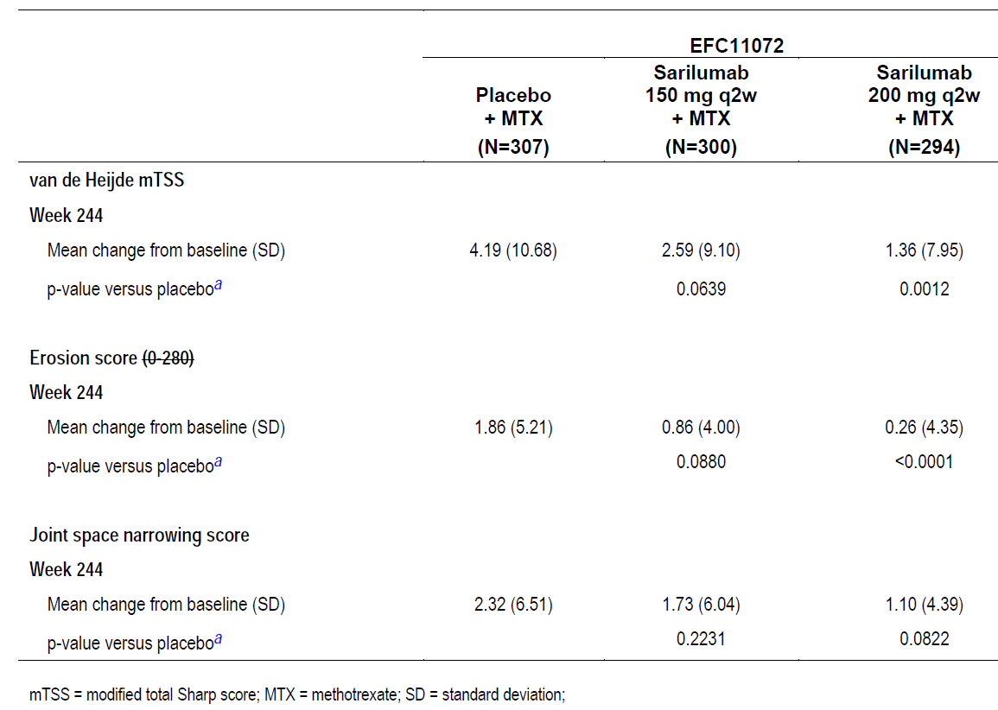
Rank ANCOVA model stratified by prior biologic use and region. Modified total Sharp score = the sum of bone erosion scores from 44 joints and joint space narrowing scores from 42 joints, with a maximum score 448. Data collected after treatment discontinuation or starting rescue medication are used as observed. Linear extrapolation is used to impute missing modified total Sharp scores. Note: Number = Number of patients with assessment at both baseline and the corresponding week.
Table 52: Number and proportion of patients with no radiographic progression at Week 244 for patients originally randomised into Study EFC11072 Part B, Cohort 2 who continued into Study LTS11210
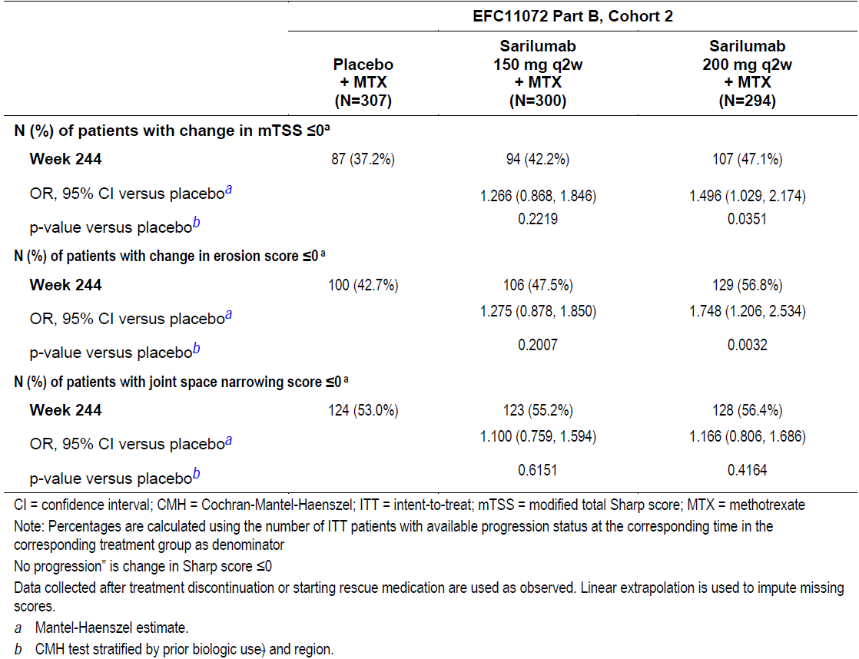

Conclusion long term efficacy
Sarilumab provided clinically meaningful and durable efficacy responses as demonstrated in the long-term follow-up of patients who initially were treated in Studies EFC11072 and EFC10832, and continued open-label treatment with sarilumab 200 mg q2w in Study LTS11210 up to 5 and 3 years, respectively. Patients with moderate to severe RA experienced durable decrease in signs and symptoms and disease activity, and improvement of physical functions. Sarilumab effectively inhibited the radiographic progression of joint damage in patients with up to five years of follow-up, with the greatest benefit being achieved by patients who had been treated with sarilumab 200 mg q2w since the initial randomisation in Study EFC11072 and who then continued this treatment in Study LTS11210.

Long term safety
Overall, the safety findings from Study LTS11210 during the same reporting period are consistent with the expected safety profile of sarilumab in RA patients. Safety data were evaluated in all 2887 patients who received ≥ 1 dose of sarilumab in combination with csDMARDs.
In the overall safety population (n = 2887), mean age at baseline was 51.8 years (standard deviation (SD) 12.2), mean RA duration was 9.4 years (SD 8.4), 81.3% of patients were female, and 38.7% of patients had prior exposure to biologic DMARDs. The total exposure in the sarilumab + DMARD long-term safety population to any dose of sarilumab was 2887 patients for 7412.2 PY. The focus of this review is uncommon AEs and events with longer latency periods: serious infections, GI perforation, major adverse cardiovascular events (MACEs), malignancy, and anaphylaxis.

Table 53: Adverse events
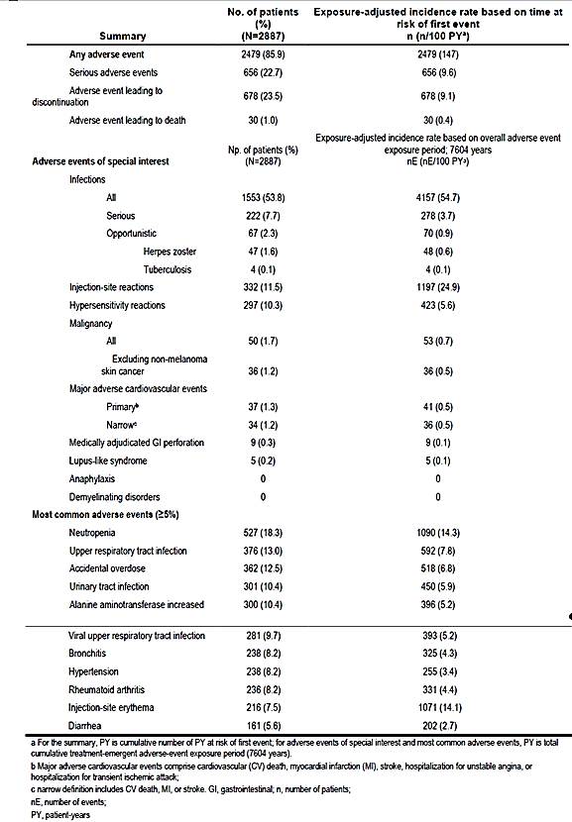

Conclusion long term safety
No new safety findings with long-term administration were identified to date.
The safety profile of sarilumab plus DMARDs remained stable over > 5 years of treatment. The incidence rate of adverse events (AEs) was generally stable over > 5 years of treatment, with no signal for increased rate of any AEs of special interest (including serious AEs and serious infections) over time. The incidences of injection-site reactions, and elevated ALT levels declined overtime.

Advisory Committee considerations
The ACM taking into account the submitted evidence of efficacy, safety and quality, agreed with the Delegate and considered Kevzara solution for injection (pre-filled syringes and pre-filled pens) containing 150 mg in 1.14 mL and 200 mg in 1.14 mL of sarilumab to have an overall positive benefit-risk profile for the proposed indication:
Kevzara in combination with non-biological Disease-Modifying Anti-Rheumatic Drugs (DMARDs) or as monotherapy is indicated for the treatment of moderate to severe active Rheumatoid Arthritis in adult patients who have had an inadequate response or intolerance to one or more DMARDs.
In providing this advice the ACM noted the following:
- This submission provided new clinical data from two Phase III studies: Study EFC14092/MONARCH trial, assessing the efficacy and safety of sarilumab monotherapy versus adalimumab monotherapy for 24 weeks in the patients with rheumatoid arthritis (RA); and Study MSC12655 (EASY trial), assessing the usability of the sarilumab autoinjector device and the pre-filled syringe in patients with moderate to severe RA.
- Updated data up to 5 years (provided with the pre-ACM response) from Study LTS11210, an ongoing long-term study to evaluate the long-term safety of sarilumab in patients with RA, was provided in relation to radiological progression of joint damage. Overall, the data showed that progression of radiological structural joint damage was less marked in patients initiating treatment with sarilumab 200 mg fortnightly and continuing at this dose than in patients initiating treatment with sarilumab 150 mg fortnightly and subsequently increasing the sarilumab dose to 200 mg fortnightly.
- In the USA, Canada and EU, sarilumab for RA has been approved at dosage of 200 mg fortnightly, with reduction to 150 mg fortnightly for management of neutropaenia, thrombocytopaenia, and liver enzyme elevation.

Proposed conditions of registration
The ACM agreed with the Delegate on the proposed conditions of registration and advised that paediatric data should be presented when available.

Proposed Product Information (PI)/ Consumer Medicine Information (CMI) amendments
The ACM agreed with the Delegate to the proposed amendments to the PI and CMI.

Specific Advice
The ACM advised the following in response to the Delegate’s specific questions on the submission:
- What are the committee’s views on the proposed dosing regimen for sarilumab?
The ACM considered that the MONARCH study supports the efficacy of the 200 mg fortnightly dose of sarilumab as monotherapy, noting that a dose of 150 mg was not assessed in the study.
The ACM considered its previous advice on sarilumab (for use in combination with DMARDs): ‘that there was no statistical evidence that the 200 mg dose of sarilumab is superior to the 150 mg for the routine outcome measures such as ACR20 response – but both doses are effective and a trend was seen for greater efficacy with the 200 mg.’ The ACM considered that this was still the case, noting that efficacy endpoints in the EASY trial did not show considerable difference between the 200 mg and 150 mg doses.
However, given overall consideration of the submission, including:
- Efficacy and safety data from the MONARCH trial based on the 200 mg dose;
- The trend in Study EFC11072 (MOBILITY trial) and Study EFC10832 (TARGET trial) towards an efficacy benefit with the 200 mg dose compared to the 150 mg dose;
- Similar exposure-adjusted adverse event rates, except for those requiring a dose reduction, in the sarilumab + DMARD safety population, between patients in the 200 mg fortnightly initial dose group and the 150 mg fortnightly initial dose group; and
- Approval in other jurisdictions for initiating treatment at the 200 mg dose;
- The ACM was of the view that initiating dosage of sarilumab at 200 mg fortnightly (reducing to 150 mg fortnightly for management of neutropaenia, thrombocytopaenia and elevated liver enzymes) would be acceptable.
- What are the committee’s views on the use of sarilumab as monotherapy?
The ACM noted that the MONARCH trial, a direct comparison of sarilumab and adalimumab monotherapy in patients with RA demonstrating superior efficacy of sarilumab to adalimumab for the primary endpoint, sufficiently supports safety and efficacy of sarilumab to be prescribed as monotherapy at a dose of 200 mg fortnightly.
The ACM advised that implementation by the sponsor of the recommendations outlined above to the satisfaction of the TGA, in addition to the evidence of efficacy and safety provided would support the safe and effective use of these products.

Outcome
Based on a review of quality, safety and efficacy, TGA approved the registration of:
- AUST R 293333 Kevzara sarilumab (rch) 200 mg (175 mg/mL) solution for injection prefilled syringe;
- AUST R 293334 Kevzara sarilumab (rch)150 mg (131.6 mg/mL) solution for injection pre-filled syringe;
- AUST R 293335 Kevzara sarilumab (rch) 200 mg (175 mg/mL) solution for injection prefilled pen; and
- AUST R 293336 Kevzara sarilumab (rch) 150 mg (131.6 mg/mL) solution for injection pre-filled pen, for subcutaneous injection; indicated for:
Kevzara in combination with non-biological Disease-Modifying Anti-Rheumatic Drugs (DMARDs) or as monotherapy is indicated for the treatment of moderate to severe active Rheumatoid Arthritis in adult patients who have had an inadequate response or intolerance to one or more DMARDs.

Specific conditions of registration applying to these goods
- Kevzara sarilumab (rch) is to be included in the Black Triangle Scheme. The PI and CMI for Kevzara must include the Black Triangle symbol and mandatory accompanying text for five years, which starts from the date that the sponsor notifies the TGA of supply of the product.
- The Kevzara EU-Risk Management Plan (RMP) (version 1.2, dated 21 April 2017, data lock point 17 February 2016), with Australian Specific Annex (version 4.1, dated 17 July 2018), included with submission PM-2017-03119-1-3, and any subsequent revisions, as agreed with the TGA will be implemented in Australia.
- The following study reports must be submitted to the TGA as soon as possible after completion, for evaluation as Category 1 application(s):
- The proposed paediatric studies to the TGA at the same time as the studies are submitted to the EMA and/or the US FDA.
- Batch Release Testing
  - It is a condition of registration that all batches of Kevzara imported into/manufactured in Australia must comply with the product details and specifications approved during evaluation and detailed in the Certified Product Details (CPD).
- It is a condition of registration that each batch of Kevzara imported into/manufactured in Australia is not released for sale until samples and/or the manufacturer’s release data have been assessed and endorsed for release by the TGA Laboratories Branch. Outcomes of laboratory testing are published biannually in the TGA Database of Laboratory Testing Results http://www.tga.gov.au/ws-labs-index.
- Certified Product Details: The Certified Product Details (CPD), as described in Guidance 7: Certified Product Details of the Australian Regulatory Guidelines for Prescription Medicines (ARGPM) [http://www.tga.gov.au/industry/pm-argpmguidance-7.htm], in PDF format, for the above products should be provided upon registration of these therapeutic goods. In addition, an updated CPD should be provided when changes to finished product specifications and test methods are approved in a Category 3 application or notified through a self-assessable change.

Attachment 1. Product Information
The PI for Kevzara approved with the submission which is described in this AusPAR is at Attachment 1. For the most recent PI, please refer to the TGA website at <https://www.tga.gov.au/product-information-pi> .

Therapeutic Goods Administration
PO Box 100 Woden ACT 2606 Australia
Email: info@tga.gov.au Phone: 1800 020 653 Fax: 02 6232 8605
https://www.tga.gov.au

ICH S6: Preclinical Safety Evaluation of Biotechnology-Derived. Pharmaceuticals.
Mihara M, et al (2002). Influences of anti-mouse interleukin-6 receptor antibody on immune responses in mice. Immunol Lett. 2002; 84: 223-229.
Wong PKK, et al (2003). The role of the interleukin‐6 family of cytokines in inflammatory arthritis and bone turnover. ACR Open Rheumatology 2003; 48: 1177-1189
Alonzi T, et al (1998). Interleukin 6 is required for the development of collagen-induced arthritis. J Exp Med. 1998; 187: 461-468.
de Hooge, A.S.K., et al Involvement of IL-6, apart from its role in immunity, in mediating a chronic response during experimental arthritis. Am J Pathol. 2000; 157: 2081–2091
Israel EJ1, et al (1997). Expression of the neonatal Fc receptor, FcRn, on human intestinal epithelial cells. Immunology 1997; 92: 69-74.
Prins JR, et al. Interleukin-6 in pregnancy and gestational disorders. J Reprod Immunol. 2012; 95: 1–14.
Lim KJ et al (2000). The role of T-helper cytokines in human reproduction. Fertil Steril. 2000; 73: 136–142.
Jasper MJ et al (2006). Reduced expression of IL-6 and IL-1a mRNAs in secretory phase endometrium of women with recurrent miscarriage. J Reprod Immunol. 2006; 73: 74–84.
Sharkey DJ et al (2007). Seminal plasma differentially regulates inflammatory cytokine gene expression in human cervical and vaginal epithelial cells. Molecular Human Reproduction. 2007; 13: 491–501
Smith SK et al (1998). The role of leukaemia inhibitory factor and interleukin-6 in human reproduction. Hum. Reprod. 1998; 13(Suppl. 3):237.
Iwabe T et al (2002). Role of cytokines in endometriosis-associated infertility. Gynecologic and Obstetric Investigation. 2002; 53: 19-25
Papathanasiou A et al (2008). The effect of IL-6 on ciliary beat frequency in the human Fallopian tube. Am Soc Reprod Med. 2008; 90: 391-394
Rival C et al (2006). IL-6 and IL-6 receptor cell expression in testis of rats with autoimmune orchitis. Reprod Immunol. 2006; 164
Australian Pregnancy Category C: Drugs which, owing to their pharmacological effects, have caused or may be suspected of causing, harmful effects on the human fetus or neonate without causing malformations. These effects may be reversible. Accompanying texts should be consulted for further details.
TGA guidance at pre-submission meetings is nonbinding and without prejudice.
Burmester GR, et al. Efficacy and safety of sarilumab monotherapy versus adalimumab monotherapy for the treatment of patients with active rheumatoid arthritis (MONARCH): a randomised, double-blind, parallel-group phase III trial. Ann Rheum Dis 2016; Published Online First: November 17, 2016 doi:10.1136/annrheumdis-2016-210310
Disease Activity Score-28 for Rheumatoid Arthritis with ESR (DAS28-ESR) describes severity of rheumatoid arthritis using clinical and laboratory data. The DAS is based upon treatment decisions of rheumatologists in daily clinical practice
ACR score: Consists of 7 disease activity measurements. A patient who had at least 20%/50%/70% improvement in both tender and swollen joint counts and at least 20%/50%/70% improvement in a minimum of 3 of the 5 specified criteria.
The SF-36 is a multi-purpose, short-form health survey with only 36 questions. It yields an 8-scale profile of functional health and well-being scores as well as psychometrically-based physical and mental health summary measures and a preference-based health utility index. It measures eight domains of health: physical functioning, role limitations due to physical health, bodily pain, general health perceptions, vitality, social functioning, role limitations due to emotional problems, and mental health. It yields scale scores for each of these eight health domains, and two summary measures of physical and mental health. It is a generic measure, as opposed to one that targets a specific age, disease, or treatment group. The SF-36 is available for two recall periods: standard (4-week recall) and acute (1-week recall).
The QT interval is the time from the start of the Q wave to the end of the T wave. It represents the time taken for ventricular depolarisation and repolarisation, effectively the period of ventricular systole from ventricular isovolumetric contraction to isovolumetric relaxation.The QT shortens at faster heart rates. An abnormally prolonged QT is associated with an increased risk of ventricular arrhythmias, especially Torsades de Pointes. The recently described congenital short QT syndrome has been found to be associated with an increased risk of paroxysmal atrial and ventricular fibrillation and sudden cardiac death.
Royal College of Pathologists of Australasia (RCPA) Manual of Use and Interpretation of Pathology Tests, 7th edition, 2015
Kovalenko eta al. Pharmacodynamic (PD) Model of Neutrophil Margination to Describe Transient Effect of Sarilumab on Absolute Neutrophil Count (ANC) in Patients with Rheumatoid Arthritis (RA) After Single-Dose Administration. Poster Number III-58 from the 26th Population Approach Group in Europe Meeting, June 6-9, 2017, Budapest Hungary
See AusPAR for Kevzara PM-2015-04024-1-3 published 20 July 2018. http://www.tga.gov.au/auspar/auspar-sarilumab-rch
The ACM provides independent medical and scientific advice to the Minister for Health and the Therapeutic Goods Administration (TGA) on issues relating to the safety, quality and efficacy of medicines supplied in Australia including issues relating to pre-market and post-market functions for medicines. The Committee is established under Regulation 35 of the Therapeutic Goods Regulations 1990. Members are appointed by the Minister. The ACM was established in January 2017 replacing Advisory Committee on Prescription Medicines (ACPM) which was formed in January 2010. ACM encompass pre and post-market advice for medicines, following the consolidation of the previous functions of the Advisory Committee on Prescription Medicines (ACPM), the Advisory Committee on the Safety of Medicines (ACSOM) and the Advisory Committee on Non-Prescription Medicines (ACNM). Membership comprises of professionals with specific scientific, medical or clinical expertise, as well as appropriate consumer health issues relating to medicines.

