First round CER report: 31 July 2015
Second round CER report: 9 October 2015

AusPAR Attachment 2

Extract from the Clinical Evaluation Report for sacubitril / valsartan salt complex
  - Proprietary Product Name: Entresto / Novartis sacubitril/valsartan
  - Sponsor: Novartis Pharmaceuticals Australia Pty Ltd

About the Therapeutic Goods Administration (TGA)
- The Therapeutic Goods Administration (TGA) is part of the Australian Government Department of Health, and is responsible for regulating medicines and medical devices.
- The TGA administers the Therapeutic Goods Act 1989 (the Act), applying a risk management approach designed to ensure therapeutic goods supplied in Australia meet acceptable standards of quality, safety and efficacy (performance), when necessary.
- The work of the TGA is based on applying scientific and clinical expertise to decision-making, to ensure that the benefits to consumers outweigh any risks associated with the use of medicines and medical devices.
- The TGA relies on the public, healthcare professionals and industry to report problems with medicines or medical devices. TGA investigates reports received by it to determine any necessary regulatory action.
- To report a problem with a medicine or medical device, please see the information on the TGA website <https://www.tga.gov.au>.
About the Extract from the Clinical Evaluation Report
- This document provides a more detailed evaluation of the clinical findings, extracted from the Clinical Evaluation Report (CER) prepared by the TGA. This extract does not include sections from the CER regarding product documentation or post market activities.
- The words [Information redacted], where they appear in this document, indicate that confidential information has been deleted.
- For the most recent Product Information (PI), please refer to the TGA website <https://www.tga.gov.au/product-information-pi>.
Copyright
© Commonwealth of Australia 2016
This work is copyright. You may reproduce the whole or part of this work in unaltered form for your own personal use or, if you are part of an organisation, for internal use within your organisation, but only if you or your organisation do not use the reproduction for any commercial purpose and retain this copyright notice and all disclaimer notices as part of that reproduction. Apart from rights to use as permitted by the Copyright Act 1968 or allowed by this copyright notice, all other rights are reserved and you are not allowed to reproduce the whole or any part of this work in any way (electronic or otherwise) without first being given specific written permission from the Commonwealth to do so. Requests and inquiries concerning reproduction and rights are to be sent to the TGA Copyright Officer, Therapeutic Goods Administration, PO Box 100, Woden ACT 2606 or emailed to <tga.copyright@tga.gov.au>.

Contents
1. List of abbreviations 5
2. Introduction 11
3. Clinical rationale 11
4. Contents of the clinical dossier 12
4.1. Scope of the clinical dossier 12
4.2. Paediatric data 12
4.3. Good clinical practice 12
5. Pharmacokinetics 13
5.1. Summary of pharmacokinetics 14
5.2. Population pharmacokinetic analysis 23
5.3. Evaluator’s overall conclusions on pharmacokinetics 24
6. Pharmacodynamics 25
6.1. Studies providing pharmacodynamic data 25
6.2. Summary of pharmacodynamics 26
6.3. Evaluator’s overall conclusions on pharmacodynamics 32
7. Dosage selection for the pivotal studies 33
7.1. Summary of dose selection studies 33
8. Clinical efficacy 36
8.1. Indication: treatment of HF in patients with systolic dysfunction 36
9. Clinical safety 66
9.1. Studies providing evaluable safety data 66
9.2. Pivotal studies that assessed safety as a primary outcome 67
9.3. Patient exposure 67
9.4. Adverse events 67
9.5. Laboratory tests 72
9.6. Post-marketing experience 81
9.7. Safety issues with the potential for major regulatory impact 81
9.8. Other safety issues 82
9.9. Evaluator’s overall conclusions on clinical safety 85
10. First round benefit-risk assessment 86
10.1. First round assessment of benefits 86
10.2. First round assessment of risks 87
10.3. First round assessment of benefit-risk balance 87
11. First round recommendation regarding authorisation 87
12. Clinical questions 87
12.1. Pharmacokinetics 87
12.2. Pharmacodynamics 87
12.3. Efficacy 87
12.4. Safety 88
13. Second round evaluation of clinical data 88
13.1. Question 1 88
13.2. Question 2 89
13.3. Question 3 90
13.4. Question 4 90
13.5. Question 5 91
14. Second round benefit-risk assessment 91
14.1. Second round assessment of benefits 91
14.2. Second round assessment of risks 92
14.3. Second round assessment of benefit-risk balance 92
15. Second round recommendation regarding authorisation 92
16. References 92

List of abbreviations
Abbreviation | Meaning
AAC | Angioedema Adjudication Committee
ABPM | Ambulatory blood pressure
ACEI | Angiotensin converting enzyme inhibitor
ADME | Absorption, Distribution, Metabolism, and Excretion
ADR | adverse drug reaction
AE | Adverse event
AHA | American Heart Association
AHU377 | the pro-drug sacubitril
ALT | Alanine aminotransferase
AMI | acute myocardial infarction
ANCOVA | analysis of covariance
ANP | Atrial-derived natriuretic peptides
ARB | Angiotensin receptor blockers
ARNI | Angiotensin receptor neprilysin inhibitor
AST | Aspartate aminotransferase
AT1 | Angiotensin type 1
AUC | Area under the serum concentration-time curve
AUC_{0-t} | Area under the serum concentration-time curve from time zero to time t
AUC_{inf} | Area under the serum concentration-time curve from time zero to infinity
AUC_{last} | Area Under the Plasma Concentration-time profile from time zero to the time of the last quantifiable concentration
AUC_{tau} | Area under the plasma concentration-time curve for a dosing interval
AUEC | Area under the effect curve
Aβ | Amyloid beta peptides
BID | Bis in die / Twice a day
BMI | body mass index
BNP | brain natriuretic peptide
BP | blood pressure
CABG | coronary artery bypass graft
CAD | coronary artery disease
CCS | clinical composite score
cGMP | Cyclic guanosine monophosphate
CHF | congestive heart failure
CI | Confidence interval
Cl/F | Apparent clearance
C_{max} | Maximum plasma (or serum, or blood) concentration
CO | cardiac output
CRF | case report form
CSF | Cerebrospinal fluid
CSF | Clinical service form
CT | computed tomography scanning
C_{trough} | Trough plasma concentration observed at the time of dosing interval time
CV | Cardiovascular
CV% | Coefficient of variation
CYP450 | cytochrome P450
DBP | Diastolic blood pressure
DMC | Data Monitoring Committee
ECG | Electrocardiogram
ECHO | echocardiography
EF | ejection fraction
eGFR | Estimated glomerular filtration rate
EMA | European Medicines Agency
ESC | European Society of Cardiology
ESRD | end stage renal disease
ET-1 | Endothelin-1
ETT | exercise tolerance test
FAS | full analysis set
FDA | Food and Drug Administration
FMI | Final market image
GCP | Good Clinical Practice
GMR | Goemetric mean ratio
HbA1c | glycosylated haemoglobin
HCTZ | Hydrochlorothiazide
HF | Heart Failure
HFpEF | Heart failure with preserved ejection fraction
HFrEF | Heart failure with reduced ejection fraction
HTN | hypertension
IC50 | Concentration leading to 50% inhibition
INR | International normalised ratio
ITT | intent to treat (population)
iv | Intravenous(ly)
IVRS | Interactive Voice Response System
KCCQ | Kansas City Cardiomyopathy Questionnaire
LAVI | left atrial volume index
sacubitrilat | Active moiety of AHU377
LCZ696 | r the sacubitril/valsartan combination
LFT | Liver function test
LHFQ | Living with Heart Failure Questionnaire
LLN | lower limit of normal
LSM | least squares mean
LVEDP | left ventricular end diastolic pressure
LVEDV | left ventricular end diastolic volume
LVEF | left ventricular ejection fraction
LVESV | left ventricular end systolic volume
LVM | left ventricular mass
LVMI | left ventricular mass index
maDBP | mean arterial diastolic blood pressure
MAP | Mean arterial pressure
maSBP | mean arterial systolic blood pressure
MDRD | Modification of Diet in Renal Disease (formula)
MedDRA | Medical Dictionary for Regulatory Activities
MI | myocardial infarction
MMP2 | matrix metalloproteinase-2
MPAP | Mean pulmonary artery pressure
MR pro-ANP | mid-regional pro-atrial natriuretic peptide
MRA | mineralocorticoid receptor antagonist
MRI | magnetic resonance imaging
MRP2 | Multidrug resistance protein 2
msDBP | mean sitting diastolic blood pressure
msSBP | mean sitting systolic blood pressure
MUGA | multiple gate acquisition scan
N/A | not applicable
NEP | Neutral endopeptidase
NEPi | neutral endopeptidase inhibitor
NPR-C | Natriuretic peptide clearance receptor
NPs | Natriuretic peptides
NT-proBNP | N-terminal pro-brain natriuretic peptide
NYHA | New York Heart Association
OAT | Organic anion transporter
OATP | Organic anion-transporting polypeptide
OCT | Organic cation transporter
PCI | percutaneous coronary intervention
PCWP | pulmonary capillary wedge pressure
PD | Pharmacodynamic(s)
P-gp | P-glycoprotein
PK | Pharmacokinetic(s)
po | Per os / by mouth / orally
PP | Pulse pressure
PPS | per protocol set
PRA | Plasma renin activity
PRC | Plasma renin concentration
PT | preferred term
PTT | Prothrombin time
QD | Quaque die / every day
QoL | quality of life
RAAS | Renin angiotensin aldosterone system
Racc | Accumulation ratio
RAN | randomised set
RAS | renin angiotensin system
SAE | Serious adverse event
SAF | safety set
SBP | Systolic blood pressure
SNS | Sympathetic nervous system
SOC | System Organ Class
SSH | Salt sensitive hypertension
T1/2 | Estimated terminal half-life
TEAE | treatment emergent adverse event
TIA | transient ischaemic attack
T_{max} | Time to reach maximal drug concentration
TR | tricuspid regurgitation
ULN | upper limit of normal
Vz/F | Apparent volume of distribution during terminal phase (associated with λZ corrected for bioavailability)
WBC | white blood cells
WHO | World Health Organisation

Introduction
This is a submission to register a new fixed dose combination of a new chemical entity (sacubitril) and a previously approved active ingredient (valsartan).
The proposed indication is:
ENTRESTO is indicated for the treatment of heart failure (NYHA class II-IV) in patients with systolic dysfunction. ENTRESTO has been shown to reduce the rate of cardiovascular death and heart failure hospitalisations.
The target dose of ENTRESTO is 200 mg BID taken orally with or without food. The 50 mg and 100 mg strengths are proposed starting doses with the selection dependent on other HF medications and the medical status of the patient.

Clinical rationale
Heart failure is common and the prevalence is increasing worldwide due to increasingly ageing populations. It is associated with progressively severe symptoms, poor quality of life, frequent hospitalisations, and a high mortality rate. According to the National Heart Foundation, approximately 300,000 Australians are living with heart failure, and another 30,000 patients are diagnosed annually. Approximately 20 - 30% of patients with mild-moderate heart failure, and 50% with severe heart failure, die within one year of diagnosis. In patients with heart failure, approximately 80% of deaths are caused by sudden arrhythmias or progressive pump failure, and HF is the most common reason for hospital admissions.
Heart failure is associated with overstimulation of the renin-angiotensin-aldosterone system (RAAS) which promotes vasoconstriction and fluid overload mediated by angiotensin II and aldosterone. ACE inhibitors block the deleterious effects of angiotensin II and, usually combined with a diuretic, they have formed the basis of treatment for many years. Additional complementary therapies include beta-blockers and aldosterone antagonists (MRAs). ACEIs are recommended as first-line treatment in the leading international treatment guidelines as they have been shown to reduce mortality by up to 20% compared with placebo in several major clinical trials. Two early, placebo-controlled, landmark studies of enalapril were particularly encouraging (CONSENSUS, 1987; SOLVD, 1991). In the CONSENSUS study, there was a 27% reduction in overall mortality, and a 50% reduction in deaths due to progressive heart failure in patients with severe CHF (NYHA class IV). In the SOLVD study, there was a 16% reduction in overall mortality and a 22% reduction in deaths due to progressive heart failure in patients with CHF and ejection fractions ≤35%. Beta-blockers (Packer M, 2001) and MRAs (Zannad, 2011) have also been shown to reduce the risk of death when added to ACEIs. ARBs are an alternative treatment used when ACEIs are not tolerated, particularly in the event of angioedema. However, the evidence that ARBs reduce mortality is inconsistent. In the Val-HeFT study in patients with NYHA class II-IV, valsartan was not superior to placebo for reduction in all-cause mortality or cardiovascular deaths. In addition, a meta-analysis of 24 trials (conducted on behalf of the Cochrane Heart Group in 25,051 heart failure patients) demonstrated no reduction in mortality, disability or hospital admissions for ARBs compared with placebo (Heran, 2012).
ANP is a 28 amino acid peptide stored mainly in the right atrium. It is released in response to atrial distension and it promotes diuresis and natriuresis. ANP infusions increase cardiac output with decreases in pulmonary wedge pressure, pulmonary vascular resistance, and plasma renin levels. ANP and other natriuretic peptides such as BNP and CNP are degraded by neutral endopeptidase found in many tissues. Neprilysin is a neutral endopeptidase found in many organs and tissues. It degrades ANP and other endogenous vasoactive peptides including bradykinin. In order to enhance the effects of ANP, NEP inhibitors were developed for potential use in hypertension and heart failure. Highly specific NEP inhibitors including candoxatril and ecadotril were shown to promote natriuresis and diuresis and reduce filling pressures as monotherapy in exploratory studies of patients with mild heart failure. However, they did not improve symptoms and were less effective in patients with severe heart failure, possibly due to decreased renal perfusion (Cleland, 1998).
Omapatrilat is a NEP and ACE inhibitor which reduces the breakdown of endogenous vasodilator peptides, in addition to blocking the generation of angiotensin II. However, it was no more effective than enalapril alone in OVERTURE, a large heart failure trial in 5,770 patients (Packer, 2002). Moreover, its use was associated with an increased risk of angioedema compared with the ACE inhibitor. The main treatment objectives in heart failure are to reduce symptoms, improve quality of life, reduce hospitalisations, and prolong survival. It is postulated that with the use of ENTRESTO, the novel NEP inhibitor sacubitril will promote natriuresis and diuresis, while the compensatory stimulation of angiotensin II will be blocked by the ARB valsartan. It is hoped that the complementary effects of the FDC will lead to improved outcomes compared with ACEIs alone, and that the risk of angioedema associated with ACEIs will be reduced.

Contents of the clinical dossier

Scope of the clinical dossier
The submission contained the following clinical information:
- 31 clinical pharmacology studies.
- 1 population pharmacokinetic analysis.
- One pivotal Phase III efficacy/safety study.
- 2 Phase II efficacy/safety studies of direct relevance to the proposed indication.
- 1 dose response analysis of two biomarkers.
- An integrated summary of efficacy.
- An integrated summary of safety.

Paediatric data
The submission did not include paediatric data.

Good clinical practice
All studies were conducted according to the principles of ICH GCP.

Pharmacokinetics
Summaries of the pharmacokinetic studies are presented. Table 1 below shows the studies relating to each pharmacokinetic topic and the location of each study summary.

Table 1. Submitted Pharmacokinetic Studies
PK topic | Subtopic | Study ID
PK in healthy adults | General PK - Single dose | LCZ696A2101
PK in healthy adults | mass balance | LCZ696B2105
PK in healthy adults | Japanese | LCZ696A2102  LCZ696A1101
PK in healthy adults | Multi-dose | LCZ696A2102
PK in healthy adults | Bioequivalence† - Single dose  - Multi-dose | LCZ696B2114  LCZ696A2103  LCZ696B2126
PK in healthy adults | Food effect | LCZ696B2107
PK in special populations | Target population §- Single dose
PK in special populations | - Multi-dose | LCZ696A2222  LCZ696A2117
PK in special populations | Hepatic impairment | LCZ696B2203
PK in special populations | Renal impairment: mild/moderate | LCZ696A2204
PK in special populations | Severe renal impairment multi-dose | LCZ696A2205
PK in special populations | Elderly | LCZ696B2109
Genetic/gender-related PK | Males vs. females | LCZ696B2109
PK interactions | Atorvastatin (Chinese subjects) | LCZ696B2115
PK interactions | Metformin (Japanese subjects) | LCZ696B2122
PK interactions | Amlodipine | LCZ696A2119
PK interactions | Hydrochlorothiazide | LCZ696A2120
PK interactions | Digoxin | LCZ696B2111
PK interactions | Warfarin | LCZ696B2112
PK interactions | Omeprazole | LCZ696B2113
PK interactions | Carvedilol | LCZ696B2125
PK interactions | Frusemide | LCZ696B2116
PK interactions | Nitroglycerin | LCZ696B2128
PK interactions | Oral Contraceptive | LCZ696A2124
Population PK analyses | Healthy subjects | CLCZ696A2204, CLCZ696A2205, CLCZ696A2117, CLCZ696B2203, CLCZ696B2314
Population PK analyses | Target population | CLCZ696B2223
* Indicates the primary aim of the study.
† Bioequivalence of different formulations.
§ Subjects who would be eligible to receive the drug if approved for the proposed indication.
None of the pharmacokinetic studies had deficiencies that excluded their results from consideration.

Summary of pharmacokinetics
The information in the following summary is derived from conventional pharmacokinetic studies unless otherwise stated.
Thirty LCZ696 clinical pharmacology studies in 1117 subjects evaluated PK of single and multiple oral doses of LCZ696 in healthy subjects, patients with HF, patients with hypertension, and special populations such as elderly subjects and subjects with renal or hepatic impairment.
Following oral administration of LCZ696 systemic concentrations of sacubitril, sacubitrilat (derived from sacubitril by enzymatic cleavage) and valsartan, increased rapidly with a median T_{max} of 0.5 h, 2 h, and 1.5 h for sacubitril, sacubitrilat, and valsartan, respectively. The exposure of sacubitril, sacubitrilat, and valsartan increased dose linearly; with a 2-fold increase in LCZ696 dose, the exposure of sacubitril increased proportionally and sacubitrilat and valsartan exposure increased by 1.87-fold and 1.69-fold, respectively.
The absolute oral bioavailability of sacubitril after administration of LCZ696 is estimated to be ≥ 60%. The systemic exposure of valsartan following administration of 400 mg LCZ696 is bioequivalent to 320 mg valsartan marketed formulation.
Administration of LCZ696 with food has no significant impact on the systemic exposures of sacubitril and sacubitrilat, while valsartan exposure decreased by about 40%. The observed changes in LCZ696 analyte exposure are not clinically relevant and hence no dosage adjustment is required when administered with food.
LCZ696 analytes (sacubitril, sacubitrilat, valsartan) are not significantly metabolised by CYP450 enzymes. Therefore, co-administration with drugs that inhibit or induce CYP450 enzymes is not likely to influence the pharmacokinetics of LCZ696 analytes. LCZ696 analytes do not inhibit or induce CYP450 enzymes significantly at clinically relevant concentrations. Therefore, the drug interaction potential of LCZ696 analytes as an inhibitor or inducer of CYP450 enzymes is low. No clinically relevant PK interactions were demonstrated on co-administration of LCZ696 and digoxin, hydrochlorothiazide (HCTZ), amlodipine, metformin, omeprazole, carvedilol, frusemide or a combination of levonorgestrel/ethinyl estradiol. Co-administration with LCZ696 has no effect on the PK of warfarin. Co-administration of LCZ696 increased the C_{max} of atorvastatin and its metabolites by up to 2-fold and AUC by <1.3-fold. These effects may potentially be due to the OATP1B1 and OATP1B3 inhibitory effects of sacubitril.
In patients with heart failure steady state exposure of sacubitril, sacubitrilat, and valsartan are higher by 55%, 110%, and 132%, respectively, compared to healthy subjects. In patients with mild to moderate renal impairment, the exposure of sacubitrilat is increased by 2-fold, while exposure of sacubitril and valsartan are not affected. In patients with severe renal impairment, the exposure of sacubitrilat is increased by 2.7-fold while exposures of sacubitril and valsartan are not affected.
In patients with mild and moderate hepatic impairment (Child-Pugh classes A and B, respectively), the exposures of sacubitril increased by 1.5- and 3.4- fold, sacubitrilat increased by 1.5- and 1.9-fold, and valsartan increased by 1.2- and 2.1-fold, respectively, compared to matching healthy subjects. No studies have been conducted in patients with severe hepatic impairment. Ethnic origin, gender, and body weight have no significant effect on the PK of LCZ696 analytes. In elderly subjects (> 65 years), the exposure of sacubitrilat and valsartan was higher by 42% and 30%, respectively, compared to young subjects, with no significant change in their terminal elimination half-life values.

Pharmacokinetics in healthy subjects

Absorption
Following oral administration of LCZ696, systemic concentrations of sacubitril, sacubitrilat and valsartan increased rapidly with a median time to peak concentration (T_{max}) of 0.5 h, 2 h, and 1.5 h for sacubitril, sacubitrilat and valsartan, respectively.

Bioavailability

Absolute bioavailability
An absolute bioavailability study was not conducted with LCZ696 due to limitations with its intravenous (i.v.) formulation development. Based on recovery in urine following oral administration of 14C-labelled LCZ696, wherein sacubitril was radiolabelled, the estimated oral bioavailability of sacubitril is ≥ 60% (Study LCZ696B2105).
Valsartan is a registered oral dosage formulation for the treatment of heart failure and hypertension. The absolute bioavailability of valsartan was evaluated following single dose administration of 80 mg (capsule and solution formulations) and 20 mg i.v. bolus injections (Study 15 HPH 9305). The absolute bioavailability of capsule and solution formulations of valsartan was estimated to be 23% and 39%, respectively.

Bioequivalence of clinical trial and market formulations
The relative bioavailability of valsartan AUC following oral administration of LCZ696 400 mg (1 x 300 mg + 2 x 50 mg) clinical service form (CSF) tablets compared with marketed valsartan 320 mg tablets was determined (Study LCZ696A2103). The rate and extent (C_{max} and AUC) of exposure of valsartan is bioequivalent between these two treatments.
A clinical study (Study CLCZ696B2114) was conducted to compare the oral bioavailability between the 50mg final market image (FMI) tablet and the 50mg clinical service form (CSF) tablet. The data indicated that the rate and extent of exposure of LCZ696 analytes are bioequivalent. The geometric mean ratio and the 90% confidence interval for AUC and C_{max} for LCZ696 were within 80-125% range, indicating that the FMI tablet was bioequivalent to the CSF tablet.

Bioequivalence of different dosage forms and strengths
The relative bioavailability of valsartan following administration of LCZ696 (5 mg, 20 mg, and 80 mg) compared to valsartan 40 mg marketed formulation was determined (Study LCZ696A2101). The mean relative bioavailability of valsartan with LCZ696 administration was higher than with the valsartan marketed formulation. The dose-normalised valsartan exposure was higher by 181%, 138%, and 167%, respectively, with administration of LCZ696 5 mg, 20 mg, and 80 mg compared to valsartan 40 mg marketed formulation. Overall, the average exposure of valsartan was higher by 161% when LCZ696 is administered compared to the registered valsartan formulation.
The relative bioavailability of 200 mg of LCZ696 mini-tablets was compared to the 200 mg LCZ696 FMI tablet under fasted conditions (Study LCZ696B2126). Following oral administration of the single oral 200 mg dose, the primary PK parameter variables of sacubitril, sacubitrilat, and valsartan were similar between mini-tablets and FMI tablet. The geometric mean ratio and corresponding 90% CI for both C_{max} and AUC were within 80 – 125%. The T_{max} values were also similar between these two formulations.

Bioequivalence to relevant registered products
Not applicable.

Influence of food
The effect of food on the oral bioavailability of LCZ696 analytes was evaluated following administration of FMI, CSF and mini-tablet formulations.
Following oral administration of LCZ696 FMI formulation with a low fat or high fat meal, no significant changes in sacubitrilat AUC was observed (Study LCZ696B2107). However, the C_{max} of sacubitrilat decreased by 19% and 28%, respectively, and time to reach maximum concentrations was delayed from 2 hours to 4 and 6 hours, respectively, with low fat and high fat meal. In Japanese subjects (Study LCZ696A1101), the AUC of sacubitrilat was decreased marginally by 8% and C_{max} decreased by 17% when 200 mg LCZ696 CSF formulation was administered with a Japanese meal. These changes in sacubitrilat exposure were not considered clinically relevant. When a single dose of LCZ696 200 mg mini-tablets sprinkled on pudding was administered with a high fat meal, the C_{max} of sacubitrilat was decreased by 19% while AUC was unchanged (Study LCZ696B2126). The time to reach maximum concentrations of sacubitrilat was delayed by 2 hrs. The observed effect of food on sacubitrilat exposure is similar to when sacubitril alone was administered with high fat meal (Study VNP489A2102).
Following oral administration of LCZ696 FMI formulation (Study LCZ696B2107), low and high fat meal reduced valsartan AUC by 34% and 9%; and C_{max} by 39% and 40%, respectively. The median T_{max} of valsartan increased from 1.75 hours to 4.0 hours suggesting potential delay in absorption in the presence of low fat or high fat meal. Similarly in (Study LCZ696A1101), the valsartan AUC was decreased by 40% and C_{max} by 51%, when 200 mg LCZ696 CSF formulation was administered with Japanese meal. In the (Study LCZ696B2126), the C_{max} and AUCs of valsartan decreased by 57% and 41%, respectively, when 200 mg LCZ696 mini-tablets were administered with high fat meal. The T_{max} of valsartan was also delayed by 2 hrs. The observed decrease in valsartan AUC in the above three studies are considered not clinically relevant as food is shown to have no impact on pharmacodynamics (blood pressure lowering ability) of valsartan (Protocol 17).

Dose proportionality
Dose linearity of C_{max} and AUC of LCZ696 analytes (sacubitril, sacubitrilat, and valsartan) in healthy subjects was determined by pooling PK data from 11 single dose administration studies across a dose range of 5 mg to 1200 mg (CLCZ696B). Dose proportionality was assessed using power model, Y = α * Dose β, where Y, α, and β correspond to the PK parameter, proportionality constant, and exponent respectively. Based on these results, it was concluded that the exposure of sacubitril, sacubitrilat, and valsartan increased dose linearly; with a 2-fold increase in LCZ696 dose, the exposure of sacubitril increased proportionally and sacubitrilat and valsartan exposure increased by 1.87-fold and 1.69-fold, respectively.
Steady state pharmacokinetics of LCZ696 analytes was evaluated following administration of 100 mg BID and 200 mg BID in HF patients (Study LCZ6962117). The exposure of sacubitril, sacubitrilat, and valsartan increased dose proportionally in HF patients.

Effect of administration timing
No studies were performed.

Distribution

Volume of distribution
The apparent volume of distribution was estimated for sacubitril, sacubitrilat and valsartan from the pooled analysis of single and repeated dose studies (CLCZ696B). After single doses of 200mg of LCZ696 the mean (± SD) Vz/F (L) for sacubitril was 103.41 (46.96); for; for valsartan 75.44 (50).sacubitrilat. For all three analytes, the volume of distribution indicates extensive distribution to the tissues after single or repeated doses, as the values exceed that of total body water.

Plasma protein binding
Plasma protein binding of [14C]-sacubitril (DMPK R1200657) and [14C]-sacubitrilat (DMPK R0301324) was determined in human plasma in vitro over the concentration range of 0.02 to 100 μg/mL. Plasma protein binding for both sacubitril (97%) and sacubitrilat (97%) was high and was independent of concentration. Both sacubitril and sacubitrilat were highly bound to human serum albumin protein (99%) and less extensively to α1-acid glycoprotein (AGP) (DMPK R1200658). Valsartan binds to serum proteins (mainly albumin) to the extent of 93 - 97% in man.
Protein binding of the active LCZ696 analytes (sacubitrilat and valsartan) was also evaluated in subjects with mild and moderately impaired hepatic function (Study LCZ696B2203) using samples collected at predose and 2 h post dose (DMPK R1300065). The average protein binding was estimated to be 98.3% and 97.2% for sacubitrilat and was 99.4% and 99.3% for valsartan, in mild and moderately impaired patients, respectively. The protein binding in healthy volunteers was estimated to be 98.3% for sacubitrilat and 99.3% for valsartan suggesting that protein binding of LCZ696 active analytes is similar between subjects with mild to moderate hepatic impairment and matched healthy subjects.

Erythrocyte distribution
Uptake of sacubitril, sacubitrilat, and valsartan into blood cells was not significant and therefore drug concentrations in plasma were higher than in blood.

Metabolism

Inter-conversion between enantiomers
No studies were reported.

Sites of metabolism and mechanisms / enzyme systems involved
LCZ696 analytes (sacubitril, sacubitrilat, valsartan) do not undergo significant metabolism by cytochrome P450 (CYP450) isozymes. Sacubitril is readily converted to sacubitrilat by non-specific ester hydrolysis following oral administration of LCZ696. sacubitrilat is the only circulating metabolite of sacubitril in the plasma.
Valsartan undergoes CYP2C9 mediated metabolism to form a minor metabolite (9%) valeryl-4hydroxy valsartan.

Metabolites identified in humans

Active metabolites
Sacubitril a component of LCZ696 tablets is rapidly converted in vivo to sacubitrilat the active metabolite. Valsartan the other component of the combination tablet is converted to a minor inactive metabolite. All PK studies have measured parameters for sacubitril (designated AHU377), sacubitrilat and valsartan.

Consequences of genetic polymorphism
No studies were performed.

Excretion

Routes and mechanisms of excretion
Following oral administration of [14C]-LCZ696 (sacubitril was radiolabelled) to four male subjects, similar excretion profiles were seen (Study CLCZ696B2105). The amount of the sacubitril dose excreted in urine was ~60% of the dose while in faeces the amount of dose excreted was ~40%. Most of the dose appeared as sacubitrilat. The most prominent in vivo metabolic pathway of sacubitril in humans involved the ester hydrolysis of sacubitril to yield sacubitrilat, the active metabolite. Two other oxygenated products of sacubitril were detected at low levels in the plasma, urine and faeces. Several other extremely low level peaks were primarily seen in the urine except for one metabolite which was also seen in the faeces. A biotransformation scheme is presented in Figure 1.
Figure 1. Biotransformation scheme of LCZ696 (AHU377 moiety) in humans

Mass balance studies
Following oral administration of [14C]-LCZ696 (sacubitril was radiolabelled), approximately 52% - 68% of the sacubitril dose was recovered in urine (primarily as sacubitrilat) with ~37 - 48% of administered radioactivity was recovered in the faeces, predominantly as sacubitrilat. Unchanged sacubitril accounted for 0.8% - 2.8% of dose in urine and 0.3% - 0.9% of dose in faeces (Study CLCZ696B2105). Mass balance was achieved with ~100% of the administered radioactivity being recovered in the excreta by 7 days.

Clearance
Pooled analysis of single and repeated dose studies (CLCZ696B) indicate an apparent plasma clearance (Cl/F) of 51.07 L/h for sacubitril, 2.3L/h for sacubitrilat and 5.44 L/h for valsartan. The corresponding estimated terminal half-life (t1/2) was 1.43h, 11.48h, and 9.9h respectively, for sacubitril, sacubitrilat, and valsartan in healthy subjects after single oral doses. Repeated dose administration gave pooled estimates not dissimilar to those for single doses: Cl/F 73.6 L/h; 2.1L/h; 9.7L/h for sacubitril, sacubitrilat, and valsartan respectively. Corresponding elimination half-life was 1.55h, 6.9h and 4.9h for sacubitril, sacubitrilat, and valsartan respectively. The later estimates are less reliable as they are based on PK sampling to 12h only.

Intra- and inter-individual variability of pharmacokinetics
Intra-subject variability in PK parameters was not estimated.
Overall, inter-subject variability (CV %) of PK parameters across single dose studies was 13% − 53% for sacubitril, 9% − 22% for sacubitrilat and 20% − 40% for valsartan (Study LCZ696A1101; Study LCZ696B2115).
A similar inter-subject variability (CV%) of PK parameters after multiple dose administration was estimated to be 20% - 56% for sacubitril, 11% - 26% for sacubitrilat, and 17% - 58% for valsartan, (Study LCZ696A2102; Study LCZ696B2115).

Multiple dose pharmacokinetics
Following multiple dose administration of 200 mg LCZ696 twice daily, steady state levels of LCZ696 analytes were achieved by Day 3 (Study LCZ696B2111; Study LCZ696B2112). At steady state, the accumulation of LCZ696 analytes was estimated to be 1.10, 1.61, and 1.30, respectively, for sacubitril, sacubitrilat, and valsartan, respectively (Study LCZ696B2115). The estimated accumulation ratio from pooled non-compartmental analysis data (CLCZ696B pooled analysis) was consistent with that observed in Study LCZ696B2115. This observed accumulation of LCZ696 analytes is consistent with the estimated half-life of LCZ696 analytes following single dose administration. The terminal half-life following multiple dose administration was not determined due to limited pharmacokinetic sampling (12 h post dose).
The population PK of LCZ696 analytes in HF patients estimated a steady state accumulation of 1.14-fold, 3.51-fold, and 1.91-fold for sacubitril, sacubitrilat, and valsartan following 200 mg BID administration. Higher exposure of sacubitrilat is expected in HF patients as many patients have mild to moderate renal impairment and sacubitrilat is primarily excreted via the renal route. The population estimated accumulation of valsartan in HF patients following administration of 200 mg BID LCZ696 is similar to the accumulation observed following administration of 160 mg BID valsartan (VAL489B0105; Protocol 105).

Pharmacokinetics in the target population
Steady state PK data of LCZ696 analytes obtained using non-compartmental analysis was compared between two Phase II clinical studies in HF patients and five clinical pharmacology studies in healthy subjects following 200 mg BID administration (Study CLCZ696B). Based on pooled PK data analysis, AUC_{tau} of sacubitril, sacubitrilat, and valsartan was higher by 55%, 110%, and 132%, respectively, in HF patients compared to healthy subjects. The apparent clearance of sacubitril and valsartan was also reduced by 2-fold and ~3-fold, respectively in HF patients compared to healthy subjects. Consistent with these observations, the terminal half-life of sacubitril, sacubitrilat, and valsartan were increased to 3.9 h, 18.4 h, and 13.7 h, respectively, in HF patients. The population PK analysis of LCZ696 in HF patients indicated that the steady state exposures of sacubitril, sacubitrilat, and valsartan were up to 2-fold higher in HF patients compared to healthy subjects. The observed decrease in apparent clearance and increased exposure of LCZ696 analytes may be due to potential renal and hepatic dysfunction in HF patients. The observed accumulation of valsartan in HF patients following administration of 200 mg BID LCZ696 is similar to the accumulation observed following administration of 160 mg BID valsartan.

Pharmacokinetics in other special populations

Pharmacokinetics in subjects with impaired hepatic function
The effect of mild (N = 8; Child Pugh A classification) and moderate (N = 8; Child Pugh B classification) hepatic impairment on the PK of a single oral dose of 200 mg LCZ696 was evaluated in an open label parallel group study compared to matched healthy subjects (N = 16) (Study CLCZ696B2203). The exposures of sacubitril increased by 1.5- and 3.4-fold, sacubitrilat increased by 1.5- and 1.9-fold, and valsartan increased by 1.2-fold and 2.1-fold, in patients with mild and moderate hepatic impairment, respectively, compared to matching healthy subjects. No studies have been conducted in patients with severe hepatic impairment (Child-Pugh C classification).
Comment: Sacubitril is an inactive pro-drug. Increased exposure is unlikely to be clinically relevant. Increased valsartan exposure is consistent with its hepatic route of elimination. LCZ696 is not recommended for use in this population due to lack of studies in severe hepatic impairment, biliary cirrhosis, or patients with cholestasis (Child-Pugh C classification).

Pharmacokinetics in subjects with impaired renal function
The effect of renal impairment on the PK of LCZ696 analytes was evaluated by administering 400 mg LCZ696 once daily for 5 days in patients with mild or moderate renal impairment (N = 8) and severe renal impairment (N = 6) with appropriate healthy subject matching controls (Study CLCZ696A2204; Study CLCZ696A2205). The steady state PK parameters of sacubitril and valsartan were comparable between patients with mild, moderate, and severe renal impairment and matched healthy subjects (mild and moderate comparison and severe comparison). Steady state exposure of sacubitrilat increased by 2.1-fold, 2.2-fold, and 2.7-fold, respectively, in mild, moderate, and severely impaired renal patients. No studies have been performed in patients undergoing dialysis. Both sacubitrilat and valsartan are highly bound to plasma protein and are unlikely to be removed by dialysis. The data are consistent with sacubitrilat being primarily eliminated through the kidney.
Comment: The number of subjects in all groups is relatively small and even though the studies were well conducted there may be an issue of power of the study to detect differences. Population PK analysis tends to support the conclusions drawn from these two studies.

Pharmacokinetics according to age
Following single oral administration of LCZ696 400 mg, AUCs of sacubitrilat and valsartan were increased by 42% and 30%, respectively in elderly subjects compared to younger subjects, and the C_{max} of valsartan was higher by 24% in elderly subjects compared to younger subjects (Study CLCZ696B2109). The mean terminal half-life of LCZ696 analytes was similar between young and elderly subjects. The population PK analysis, based on phase III study results, were similar. LCZ696 use is unlikely to require dose adjustment in elderly subjects.

Pharmacokinetics related to genetic factors
No studies were performed.

Pharmacokinetics according to race and ethnicity
The effect of race/ethnicity on the PK of LCZ696 analytes (sacubitril, sacubitrilatand valsartan) was evaluated by pooling PK data generated in healthy subjects following single dose administration. The exposure of LCZ696 obtained in Asian (N = 18), Black (N = 11), Caucasian (N = 51), Pacific Islander (N = 1), and others (N = 1) was compared to determine the impact of race on LCZ696 analyte exposure. Similarly, the AUC_{inf} of LCZ696 analytes obtained in Chinese (N = 10), Hispanic/Latino (N = 38), Japanese (N = 8), and others (N = 26) was compared to determine the impact of ethnicity. The exposures of LCZ696 analytes were comparable among different races and ethnicities. Conclusions for the PK of Pacific Islanders in this pooled analysis are obviously limited due to the sample size.

Pharmacokinetics according gender
Following single oral dose administration of 400mg of LCZ696, there was no significant impact of gender on the PK of LCZ696 analytes (Study CLCZ696B2109). The geometric mean ratio and 90% confidence intervals of C_{max} and AUC of both sacubitrilat and valsartan were within 80% − 125% suggesting that the exposures were similar between males and females.

Pharmacokinetics in children
The PK, PD, safety and efficacy have not yet been evaluated in children.

Pharmacokinetic interactions

Pharmacokinetic interactions demonstrated in human studies
LCZ696 analytes are not metabolised by CYP450 enzymes and do not inhibit or induce many of the CYP450 enzymes to any significant level. Both sacubitrilat and valsartan are weak inhibitors of CYP2C9. PK drug-drug interactions with co-medications that are either inhibitors or inducers or substrates of CYP450 enzymes are therefore unlikely. The transporter data indicate potential inhibition of OAT1B1 and OATP1B3 by sacubitril and OAT3 by sacubitril, sacubitrilat, and valsartan at clinically relevant concentrations. Sacubitril is identified as a Pgp substrate; however the role of Pgp in the disposition of sacubitril is expected to be minimal because sacubitril is highly permeable and passive diffusion is therefore thought to contribute to its disposition. Twelve clinical pharmacology studies were conducted to evaluate the drug interaction potential with medicines that are likely co-administered with LCZ696 in HF patients.

Carvedilol
The drug interaction potential between LCZ696 and carvedilol was evaluated in an open label study in healthy subjects (Study LCZ696B2125). Steady state PK of both R(+)-carvedilol and S(-)-carvedilol did not change when administered with LCZ696. While steady state PK of sacubitrilat was not changed, valsartan C_{max} and AUC increased marginally by 12% and 9%, respectively, when administered with carvedilol. No clinically relevant interaction was concluded when LCZ696 was co-administered with carvedilol.

Frusemide
The PK interaction with frusemide was evaluated in an open label study in healthy subjects (Study LCZ696B2116). The geometric mean ratio and 90% confidence interval of C_{max} and AUCs of sacubitril and sacubitrilat were within 80% - 125% suggesting that frusemide has no effect total exposure of sacubritril and sacubitrilat. Both C_{max} and AUC of valsartan increased by 15% (C_{max} 90% CI: 1.02 - 1.32; AUC 90% CI: 1.02 - 1.31) which is not considered clinically relevant. However, the C_{max} and AUC of frusemide decreased significantly by 50% and 26% when co-administered with LCZ696. The amount of frusemide excreted in urine (Ae0-24) was also decreased by 26%. The observed PK interaction is considered not to be clinically relevant and no initial dose adjustment recommendations for the use of frusemide in patients treated with LCZ696 is recommended.

Digoxin
The drug interaction potential between LCZ696 and digoxin was evaluated in an open label study in healthy subjects (Study LCZ696B2111). Digoxin steady state PK did not change when co-administered with LCZ696. Similarly, LCZ696 steady state PK was not changed when co-administered with digoxin. No clinically relevant interaction was concluded between LCZ696 and digoxin.

Warfarin
The drug interaction potential with warfarin was evaluated using a single blind, cross-over study design in healthy subjects (Study LCZ696B2112). The PK of both R-warfarin and S-warfarin were not changed when co-administered with LCZ696. Steady state PK of LCZ696 was not changed when co-administered with warfarin.

Atorvastatin
The drug interaction potential with atorvastatin was evaluated in an open label study in healthy Chinese subjects (Study LCZ696B2115). At steady state, the C_{max} and AUC of atorvastatin increased by 74% and 34%; o-hydroxy-atorvastatin increased by 68% and 22%; and p-hydroxy-atorvastatin increased by 108% and 26%, respectively, when co-administered with LCZ696. Steady state PK of sacubitrilat was not changed, valsartan C_{max} and AUC decreased by 9% and 19%, respectively, when administered with atorvastatin. The data indicate a low risk for a clinically relevant drug interaction when LCZ696 and statins that are OATP1B1/1B3 substrate are co-administered.

Metformin
The drug interaction potential with metformin was evaluated in an open label study in healthy Japanese subjects (Study LCZ696B2122). The C_{max} and AUC of metformin were decreased by 23% when co-administered with LCZ696. LCZ696 steady state PK did not change when administered in combination with metformin. The observed change in the exposure of metformin was smaller than the CV% of estimated PK parameters. No clinically relevant interaction was concluded when LCZ696 is co-administered with metformin.

Omeprazole
The effect of omeprazole on the PK of LCZ696 analytes was evaluated in an open label study in healthy subjects (Study LCZ696B2113). The steady-state PK of sacubitril and sacubitrilat were not changed, and valsartan C_{max} and AUC decreased marginally by 13% and 11%, respectively, when administered with omeprazole. There was no significant change in time to reach peak concentrations (T_{max}) for LCZ696 analytes observed when co-administered with omeprazole. No clinically relevant effect of omeprazole on LCZ696 PK was concluded.

Hydrochlorothiazide
The drug interaction potential with hydrochlorothiazide (HCTZ) was evaluated in an open label study in healthy subjects (Study LCZ696A2120). Steady state C_{max} and AUC of HCTZ decreased by 26% and 16%, respectively, when administered with LCZ696. The C_{max} and AUC of LCZ696 active analytes (sacubitrilat and valsartan) increased by 13.6% to 20%, when co-administered with HCTZ. The observed changes in the exposure of HCTZ and LCZ696 analytes were smaller than the CV% of estimated PK parameters. No clinically relevant interaction was concluded when LCZ696 was co-administered with hydrochlorothiazide.

Amlodipine
The drug interaction potential with amlodipine was evaluated in an open label study in healthy subjects (Study LCZ696A2119). Amlodipine steady state PK was not affected when administered with LCZ696. While steady-state PK of sacubitrilat was not changed, valsartan C_{max} and AUC increased marginally by 17% and 21%, respectively, when administered with amlodipine. No clinically relevant interaction was concluded when LCZ696 was co-administered with amlodipine.

Sildenafil
The effect of LCZ696 on sildenafil PK was evaluated in an open label study in subjects with mild to moderate hypertension (Study LCZ696B2225). Steady state PK of both sildenafil and its principal metabolite N-desmethyl-sildenafil did not change when administered with LCZ696. While steady state PK of sacubitrilat was not changed, valsartan C_{max} and AUC decreased by 39% and 29%, respectively, when administered with sildenafil. A potential interaction may exist (see below PD interaction studies).

Oral contraceptives
The drug interaction potential of LCZ696 on the single dose PK of orally administered contraceptive drugs was evaluated in an open label study in female healthy subjects (Study LCZ696A2124). The steady state PK of ethinyl estradiol was not changed when co-administered with LCZ696. While AUC of levonorgestrel was unchanged, the C_{max} decreased by 15% when co-administered with LCZ696. Similarly, while PK of sacubitrilat was unchanged, the C_{max} and AUC of valsartan decreased by 16% and 14%, respectively, when co-administered with oral contraceptives. No clinically relevant effect of LCZ696 on pharmacokinetics of levonorgestrel and ethinyl estradiol was concluded.

Clinical implications of in vitro findings
In vitro drug metabolism and transporter data suggest that clinically relevant drug-drug interactions may be expected with LCZ696 due to inhibition of OATP1B1 and OATP1B3 by sacubitril and OAT3 by sacubitril, sacubitrilat, and valsartan; whereas drug-drug interactions due to inhibition of other transporters are unlikely. Although sacubitril is a substrate of P-gp, there is a low likelihood for a drug interaction of LCZ696 when co-administered with a Pgp inhibitor because plasma levels of sacubitril are unlikely to reach relevant concentrations and sacubitril is moderately to highly permeable resulting in a high estimated bioavailability of ≥ 60%. Since LCZ696 analytes do not significantly induce or inhibit CYP450 isozymes, drug interaction potential with co-medications that are substrates of CYP450 isozymes are unlikely.

Population pharmacokinetic analysis
Population PK (PPK) analyses were carried out by pooling results from six clinical studies to support the sparse sample collection in the pivotal Phase III PARADIGM-HF study (CLCZ696B2314, CLCZ696A2204, CLCZ696A2205, CLCZ696A2117, CLCZ696B2205, CLCZ696B2223). The total number of quantifiable plasma concentrations of valsartan, sacubitril, and sacubitrilat were 3503, 2931 and 3531, respectively. A total of 448 subjects were used to develop the PPK model of LCZ696 that included patients with heart failure and reduced ejection fraction (HFrEF) from CLCZ696B2314 study (n = 311), healthy subjects (n = 38) as well as independent hepatic (n = 16) and renal (n = 22) impairment studies (potential comorbidities in patients with heart failure). The PK of valsartan, sacubitril and sacubitrilat were described by a 2-compartment PPK model with 1st order absorption and elimination. A parent-metabolite model was successfully developed via sequential PK fitting to describe the prodrug conversion of sacubitril to the active metabolite sacubitrilat. The PPK model identified several statistically significant covariates for PK parameters of the analytes of LCZ696:
- Valsartan: CL/F~AGE0+eGFR+AST+TBIL+NYHA; KA~AGE+NYHA; V2/F~WGT
- sacubitrilat: CLM/F~AGE0+eGFR+TBIL+NYHA; V3M/F~WGT
- No covariates were retained for sacubitril as the univariate analysis confirmed the rapid conversion of sacubitril to sacubitrilat made covariate testing unreliable.
- The apparent clearance of all three analytes of LCZ696 in patients with HFrEF from study with HFrEF: valsartan: 10.75 L/h vs 6.56 L/h; sacubitril: 113 L/h vs 74.2 L/h; sacubitrilat: 1.46 L/h vs 0.84 L/h).
Predicted steady-state exposures of LCZ696 analytes were ~2-fold higher in patients with HFrEF compared to healthy subjects. Patients with HFrEF also had higher accumulation ratios compared to healthy subjects for valsartan (Racc: 1.8 vs 1.2) and sacubitrilat (Racc: 3.1 vs 1.7). There was no accumulation for sacubitril (Racc: 1.1 vs 1.0) in either population. Subgroup analysis of the effects of covariates on steady-state exposures of LCZ696 analytes demonstrated that age was an important covariate resulting in higher exposure in elderly subjects compared to young subjects. The geometric mean ratio and associated confidence interval (GMR (90% CI)) of estimated AUCss for valsartan, sacubitril, and sacubitrilat for patients > 65 years of age compared to patients ≤ 65 years of age was 1.24 (1.2, 1.38), 1.22 (1.09, 1.37), and 1.39 (1.30- 1.49), respectively. Renal and hepatic impairment also influenced the PK variability of LCZ696 analytes with a potential to increase exposures with decreased organ function.

Evaluator’s overall conclusions on pharmacokinetics
LCZ696 is a combination of sacubitril and the registered product valsartan. Sacubitril is converted in vivo by hydrolysis to an active metabolite sacubitrilat. The studies presented characterised the PK parameters for sacubitril (AHU377), the active metabolite sacubitrilat and valsartan. The PK characteristics of valsartan following administration of the combination were not different from those of valsartan given alone. In general the PK studies presented by the sponsor were well designed and for most subject numbers were based on a priori power calculations. Some studies may have limited power as noted in the comments.
Absolute bioavailability was estimated from the mass balance study and not determined with i.v. administration as such a formulation could not be developed. Bioequivalence was established for clinical trial and proposed market formulations. Dose proportionality of kinetics was demonstrated across doses, which included the recommended therapeutic dose. Twice daily dosing is appropriate based on the results of the PK studies.
Generally moderate to severe renal impairment does not appear to require adjustment of the dose LCZ696, despite the fact that compounds are mostly renally excreted. This conclusion was supported by the population PK analysis. Similarly, the effects of mild and moderate hepatic impairment on the PK indicate that dose adjustment is not required. There were no studies in patients with end stage renal impairment undergoing dialysis and there were no studies in severe hepatic impairment.
There was an extensive series of studies examining potential PK drug-drug interactions. Since the two components are only minimally metabolised by hepatic enzymes there was little or no effect on PK parameters when LCZ696 was co-administered with known enzyme inducers or inhibitors. The in vitro data suggested some potential effects on transporter molecules. A relatively modest interaction was demonstrated with atorvastatin. Caution was recommended when LCZ696 is co-administered with atorvastatin or other statins that are substrates of OATP1B1 and OATP1B3. Gender, age and ethnicity/race did not appear to significantly affect the PK parameters of the analytes examined.
In patients with heart failure steady state PK parameters where higher than in healthy controls. An analysis of combined data suggested that PK parameters of valsartan, sacubitril and sacubitrilat were up to two-fold higher than in healthy subjects. The reduced clearance and increased half-life is presumably due to reduced renal blood flow in these patients. No other limitations were noted in the PK studies.

Pharmacodynamics

Studies providing pharmacodynamic data
Table 2 below shows the studies relating to each pharmacodynamic topic and the location of each study summary.

Table 2. Submitted pharmacodynamic studies.
PD Topic | Subtopic | Study ID
Primary Pharmacology | Effect on Neprilysin inhibition | LCZ696A2102
Primary Pharmacology |  | CLCZ696A2117  LCZ696B2223
Primary Pharmacology |  | VNP489A2103
Secondary Pharmacology | Other neprilysin substrates | CLCZ696B2223
Secondary Pharmacology |  | CLCZ696A2117  VNP489A2103
Secondary Pharmacology | Amyloid-β | CLCZ696A2126
Secondary Pharmacology | Renin Angiotensin Aldosterone System  Natriuresis and diuresis  Glucose and fatty acid metabolism  Blood pressure  Thorough QTc Study | CLCZ696A2102  CLCZ696A2117  LCZ696A2222  LCZ696B2223  LCZ696A2222  CLCZ696B2207  LCZ696B2223  CLCZ696B2123
Gender other genetic and Age-Related Differences in PD Response | Effect of gender | No studies
 | Effect of age | No studies
PD Interactions | Warfarin | CLCZ696B2112
PD Interactions | Nitroglycerin | CLCZ696B2128
PD Interactions | Frusemide | CLCZ696B2116
PD Interactions | Sildenafil | CLCZ696B2225
Population PD and PK-PD analyses | Healthy subjects | CLCZ696A2102 CLCZ696B2205
Population PD and PK-PD analyses | Target population
* Indicates the primary aim of the study.
§ Subjects who would be eligible to receive the drug if approved for the proposed indication.
‡ And adolescents if applicable.
None of the pharmacodynamic studies had deficiencies that excluded their results from consideration.

Summary of pharmacodynamics
The information in the following summary is derived from conventional pharmacodynamic studies in humans unless otherwise stated.
The beneficial effects of LCZ696 in patients with heart failure are likely to result from enhancement of protective endogenous systems such as the natriuretic peptide system and other vasoactive neprilysin substrates, and the simultaneous inhibition of organ injury driven by activation of the renin-angiotensin-aldosterone system (RAAS). LCZ696 was associated with a dose-dependent increase of plasma cGMP levels in healthy subjects and increased plasma and/or urinary ANP, BNP and cGMP levels in patients with HF and patients with hypertension. These effects are reflective of neprilysin inhibition and considered beneficial in patients with HF. In healthy subjects, plasma cGMP levels were increased at 4 and 12 h after administration of LCZ696 at doses ranging from 50 - 900 mg QD for 6 days, and returned to baseline levels 24 h after administration of LCZ696, suggesting that twice daily dosing is required for sustained neprilysin inhibition. Changes from baseline in cGMP 24-h area under the effect curve (24h AUEC) were described by an E_{max} dose-response model with a steep dose response at the lower doses up to LCZ696 100 mg QD , and a saturation of the effect at doses at and above LCZ696 200mg QD , suggesting relevant neprilysin inhibition at the proposed therapeutic dose of LCZ696 200 mg twice daily for the treatment of HF. Biomarker data (increased plasma renin activity, plasma renin concentration, and angiotensin II) demonstrate that LCZ696 provides AT1-receptor blockade comparable to valsartan in multiple populations, including patients with heart failure, supporting the proposed mechanism of action of LCZ696. LCZ696 also resulted in a beneficial reduction of aldosterone in multiple patient populations, including patients with HFrEF. LCZ696 resulted in a transient increase in natriuresis and diuresis in patients with HF and hypertension, consistent with the expected effect on natriuretic peptides. Treatment of obese hypertensive patients for 8 weeks with LCZ696 400 mg QD or amlodipine 10 mg QD resulted in improved insulin sensitivity with LCZ696 compared to amlodipine. LCZ696 resulted in a slight increase in local adipose tissue lipolysis without affecting circulating levels of non-esterified fatty acids, whole body lipolysis or oxidative metabolism.
Cardiac repolarization was assessed in a dedicated thorough QT study. Single doses of LCZ696 400 mg (therapeutic dose) and 1200 mg (supra-therapeutic dose) did not affect cardiac conduction or repolarization as evidenced by a lack of effect on the PR interval, QRS duration, QTc interval, and electrocardiogram (ECG) morphology. Co-administration of LCZ696 with sildenafil resulted in a more than additive BP reduction in patients with hypertension, which may be undesired in patients with HF. No clinically relevant PD interactions were identified upon co-administration of LCZ696 and warfarin, frusemide or nitroglycerin.

Mechanism of action
LCZ696 exhibits the novel mechanism of action of an angiotensin receptor neprilysin inhibitor (ARNI) by simultaneously inhibiting neprilysin (neutral endopeptidase; NEP) via sacubitrilat, the active metabolite of the prodrug sacubitril, and blocking the angiotensin II type-1 (AT1) receptor via valsartan. The complementary cardiovascular benefits and renal effects of LCZ696 in heart failure patients are attributed to the enhancement of peptides that are degraded by neprilysin such as natriuretic peptides (NP) by sacubitrilat, and the simultaneous inhibition of the deleterious effects of angiotensin II by valsartan. NPs exert their effects by activating membrane-bound guanylyl cyclase-coupled receptors (NPR-A and -B), resulting in increased concentrations of the second messenger cyclic guanosine monophosphate (cGMP) which was therefore used as one of multiple biomarkers indicative of neprilysin inhibition. NPs have been associated with a wide range of beneficial cardiovascular and renal effects. Concentrations of NPs are increased by LCZ696 thereby increasing and prolonging the action of these peptide hormones. Angiotensin II and aldosterone are the principal effector hormones of the RAAS and are associated with vasoconstriction, renal sodium and fluid retention resulting in increased BP and blood volume, and activation of cellular growth and proliferation of vascular and cardiac cells. LCZ696 inhibits the RAAS by selective and competitive blockade of the binding of angiotensin II to the AT1-receptor. LCZ696 also inhibits the RAAS via the inhibitory effects of NPs on renin and aldosterone release.
In a 7-day valsartan-controlled study in patients with HFrEF, administration of LCZ696 resulted in a significant non-sustained increase in natriuresis, increased urine cGMP, and decreased plasma MR-proANP and NT-proBNP compared to valsartan. In a 21-day, open label, non-controlled study in HFrEF patients, LCZ696 significantly increased urine ANP and cGMP and plasma cGMP, and decreased plasma NTproBNP, aldosterone and endothelin-1 compared to baseline. LCZ696 also blocked the AT1-receptor as evidenced by increased plasma renin activity and plasma renin concentrations.

Pharmacodynamic effects

Primary pharmacodynamic effects: Neprilysin inhibition
Administration of LCZ696 to healthy subjects increases plasma and urine cGMP levels (Study LCZ696A2102). Multiple dose administration of LCZ696 to healthy subjects (with single doses ranging from 200 mg to 1200 mg and multiple doses ranging from 50 mg to 900 mg once daily), plasma ANP levels across post-dose time-points did not show a consistent pattern whereas plasma cGMP levels were significantly increased on Day 12 at 4 h post-dose with all LCZ696 doses. At higher doses of LCZ696 (600 and 900 mg once daily), the increase in cGMP was evident also at 12 h post dose. The cGMP response returned to baseline at 24 h post dose, suggesting that once daily dosing of LCZ696 does not result in a cGMP response that is sustained throughout the dosing interval. Therefore, LCZ696 is dosed twice daily for the treatment of patients with heart failure. All doses of LCZ696 treatment increased 24-hour mean cGMP levels, with a maximum 52% increase in cGMP observed with the 200 mg once daily dose on Day 6, thereby further supporting the dose selection of LCZ696 for the treatment of patients with heart failure.
Following administration of LCZ696 100 mg BID for 1 week and up-titration to 200 mg BID for another 2 weeks, urinary ANP excretion was significantly increased from baseline by 69% and 82%, respectively (Study CLCZ696A2117). Plasma cGMP increased significantly compared to baseline up to 16 h post dose with the highest ratio to baseline (95% CI) of 1.38 (1.16, 1.65) on Day 21 at pre-dose. Significant decreases from baseline were noted for BNP and NT-Pro-BNP at all time-points after dosing of LCZ696 100 mg BID for 7 days and 200mg for 14 days. Endothelin-1 showed statistically significant decreases from baseline at pre-dose on Day 21 after LCZ696 200 mg BID for 14 days. Changes observed in the urinary biomarkers confirmed the plasma changes.
Patients with essential hypertension were treated with LCZ696 400 mg QD or valsartan 320 mg QD for 7 days in a cross-over design (Study CLCZ696B2223). Urinary cGMP excretion was increased by approximately 2-fold on Day 1. This increase with LCZ696 was sustained over the whole dosing period of 7 days and not observed with valsartan.
In addition to increases in ANP and cGMP, treatment of patients with heart failure and hypertension with LCZ696 200 mg BID and 400 mg QD, respectively, also resulted in transient, time-dependent increases in BNP on Day 1 of treatment with LCZ696 compared to valsartan (Study LCZ696B2223). The reasons for the lack of persistence of the effect on BNP at Day 7 in this short term study and the reduction of BNP following administration of LCZ696 at doses up to 200 mg twice daily for up to 3 weeks in patients with heart failure in another short term study (Study LCZ696A2117) are not well understood.
Neprilysin inhibition through multiple dose administration of sacubitril alone or in combination with valsartan in healthy subjects resulted in increased plasma ANP and cGMP concentrations up to approximately 2-fold compared to baseline, confirming the results from studies with LCZ696 in which neprilysin inhibition resulted in enhancement of natriuretic peptide effects (Study VNP489A2103).
The data demonstrate that LCZ696 at proposed therapeutic doses inhibits neprilysin as evidenced by increased plasma and/or urinary ANP, BNP and cGMP levels in the target patient population, thereby supporting the proposed mechanism of action of LCZ696.

Secondary pharmacodynamic effects: Other neprilysin substrates
Endothelin-1 (ET-1) was measured in patients with chronic heart failure and reduced ejection fraction. One week of treatment with LCZ696 100 mg BID led to a 10% (p = 0.062) reduction, and 2 additional weeks of treatment with LCZ696 200 mg BID led to a 20% (p = 0.001) reduction in plasma ET-1 concentrations, demonstrating that neprilysin inhibition did result in a desired reduction of ET-1 concentrations (Study LCZ696A2117). A similar trend with respect to reduction in ET-1 was also observed in healthy subjects (Study VNP489A2103). There were minor but significant decreases in ET-1 following administration of sacubitril at 30 mg and 100 mg doses for 2 weeks in addition to valsartan compared to the administration of valsartan alone.
CT-proET-1 is a precursor to ET-1. Since CT-proET-1 is more stable than ET-1 it has been deemed more suitable for measurement in clinical studies. CT-proET-1 was measured in (Study LCZ696B2223). In patients with HF and reduced ejection fraction, treatment with LCZ696 compared to valsartan was associated with statistically significant increases in plasma CT-proET-1 on Days 1 and 7.
The data suggest that treatment with LCZ696 results in a reduction of ET-1 levels, an effect that is considered to be beneficial in patients with heart failure.

Secondary pharmacodynamic effects: Amyloid-β
Administration of LCZ696 400 mg once daily for 14 days resulted no changes in CSF amyloid-β 1-40 and 1-42 concentrations in healthy subjects, despite having measurable concentrations of sacubitrilat in the CSF sufficient to inhibit neprilysin (Study CLCZ696A2126). The significance of increased CSF amyloid-β 1-38 is unknown. The observed increase in plasma amyloid-β 1-40 with LCZ696 treatment is considered not to be clinically relevant.

Secondary pharmacodynamic effects: Renin Angiotensin Aldosterone System
Multiple dose administration of LCZ696 resulted in significantly increased biomarkers of angiotensin receptor (AT1) blockade (renin concentration, PRA and Ang II) (Study CLCZ696A2102). LCZ696 treatment induced significant, dose-dependent increases in renin concentration (93 – 634% increase vs placebo), PRA (280 – 1768% increase) and Ang II (241 – 1188% increase) on Day 12. All biomarkers showed a maximum increase 4 hours after administration of LCZ696, and significant increases in levels of all RAAS biomarkers relative to placebo were observed 24 hours after dosing.
Administration of LCZ696 100 mg BID for 1 week to patients with heart failure resulted in increased PRA (from 0.69 ng/mL/h at baseline to 2.70 ng/mL/h, p < 0.001) and increased PRC (from 9.92 pg/mL at baseline to 42.64 pg/mL, p < 0.001 (Study CLCZ696A2117). This increase was sustained following administration of LCZ696 200 mg BID for an additional 2 weeks in the same study (PRA 1.64 ng/mL/h, p = 0.014; PRC 34.11 pg/mL, p < 0.001). These results demonstrate AT1-receptor blockade by LCZ696 in patients with heart failure.
Administration of LCZ696 100 mg BID for 1 week to patients with HF resulted in a trend towards decreased aldosterone plasma concentrations (from 237.18 pg/mL at baseline to 220.03 pg/mL, p = 0.458; [Study LCZ696A2117]. This decrease reached statistical significance following administration of LCZ696 200 mg BID for an additional 2 weeks in the same study (189.69 pg/mL, p = 0.017).
Treatment of patients with salt-sensitive hypertension with LCZ696 400 mg once daily or valsartan 320 mg once daily for 4 weeks there was a significant decrease by approximately 25% in plasma aldosterone and by approximately 30% in creatinine-indexed urine aldosterone with both treatments (Study LCZ696A2222). However, there was no difference between LCZ696 and valsartan treatments.

Secondary pharmacodynamic effects: Natriuresis and diuresis
The effect of LCZ696 on natriuresis and diuresis was studied in patients with heart failure and hypertension (Study LCZ696B2223), and Asian patients with salt sensitive hypertension (Study LCZ696A2222). Consistent with the mechanism of action of LCZ696 (concomitant inhibition of neprilysin and the AT1-receptor) both studies demonstrated that LCZ696 was associated with a larger natriuretic and diuretic effect compared to valsartan.
In patients with heart failure (Study LCZ696B2223), treatment with LCZ696 200 mg BID and valsartan 160 mg BID resulted in numerically increased natriuresis on Day 1 compared to baseline. Day 1 natriuresis was numerically larger by 11% with LCZ696 compared to valsartan (220.58mmol/24h vs.198.73mmol/24h NS). LCZ696 compared to valsartan resulted in a trend towards increased fractional sodium excretion on Day 1 up to and including 6 h post-dose, which was not statistically significant. However, treatment with LCZ696 resulted in significantly greater natriuresis compared to valsartan at 2 - 4 h and 4 - 6 h urine collection intervals following dosing on Day 1. Fractional sodium excretion was not statistically significantly larger with LCZ696 compared to valsartan at 4 and 6 h after dosing on Day 1. Increased natriuresis with LCZ696 was not sustained and similar to valsartan on Day 7 of treatment. Similar to natriuresis, treatment with LCZ696 and valsartan resulted in numerically increased diuresis on Day 1 compared to baseline. Day 1 diuresis was numerically larger by 11% with LCZ696 compared to valsartan (3199.37mL/24h vs. 2874.36mL/24h NS). Furthermore, treatment with LCZ696 resulted in numerically but not statistically greater diuresis compared to valsartan at all urine collection intervals following dosing on Day 1. Increased diuresis with LCZ696 was not sustained and similar to valsartan on Day 7 of treatment.
In patients with hypertension (Study LCZ696B2223), treatment with LCZ696 400 mg QD compared to valsartan 320 mg QD resulted in numerically increased 24-h natriuresis by approximately 21% on Day 1 of dosing. This increase was statistically significant for urine fractions collected within the first 12 h after dosing (42% - 108%), with the largest increase in natriuresis (108%) observed at the 2 - 4 h urine collection interval following dosing which corresponds to the highest exposures to LCZ696. LCZ696 compared to valsartan resulted in increased fractional sodium excretion on Day 1 up to and including 12 h after dosing; statistically significant increases were observed at the 4h time point (37%), at the 6h time point (50%), and at the 12 h time point (36%). Increased natriuresis with LCZ696 was not sustained and similar to valsartan on Day 7 of treatment. LCZ696 compared to valsartan also resulted in statistically significantly increased 24 h diuresis on Day 1 by approximately 41%. A statistically significant diuretic response compared to valsartan was also observed for urine fractions collected within 2 - 6 h after dosing (70% - 131%), with the largest increase in diuresis (131%) again observed at the 2 – 4 h urine collection interval following dosing. Although diuresis was not increased as compared to valsartan on Day 7, there was a significantly higher 7-day cumulative diuresis (11%) with LCZ696 which was smaller than Day 1 diuresis.
In Asian patients with salt-sensitive hypertension treatment, LCZ696 400 mg QD resulted in statistically significant increases in urinary sodium excretion by approximately 60% at 0 - 6 h and by approximately 27% at 0 - 24 h (Study LCZ696A2222). Treatment with valsartan 320 mg QD did not show relevant increases in natriuresis on Day 1 compared to baseline. Furthermore, treatment with LCZ696 resulted in an increase in urinary volume on Day 1 by approximately 42% at 0 - 6 h and by approximately 15% at 0 - 24 h. Treatment with valsartan was not associated with any apparent increase in diuresis on Day 1. Again, this effect was not sustained and there were no differences in natriuresis and diuresis between LCZ696 and valsartan following 4 weeks of treatment.

Secondary pharmacodynamic effects: Glucose and fatty acid metabolism
The effects on insulin sensitivity (measured by hyperinsulinemic euglycemic clamp), local adipose tissue lipolysis (measured by adipose tissue microdialysis) and oxidative metabolism (measured by indirect calorimetry) of 8-weeks of treatment with LCZ696 400 mg QD were compared to the effects of amlodipine 10 mg QD, an antihypertensive drug with limited metabolic effects, in obese hypertensive patients (Study CLCZ696B2207). The treatment comparison between LCZ696 and amlodipine after 8 weeks of treatment revealed a trend towards a higher SI with the LCZ696. However, glucose infusion rate (M), glucose infusion rate normalised by body weight (Mbw) and glucose infusion rate normalised by plasma glucose (MCR) showed a significant increase from baseline with LCZ696, which was not observed for amlodipine, and significantly higher values with LCZ696 compared to amlodipine at the end of the treatment. After 8 weeks of treatment, adipose tissue lipolysis was greater with LCZ696 as compared to amlodipine as evidenced by significantly higher interstitial glycerol concentrations by approximately 25% with LCZ696. Data from the study suggest that extended treatment with LCZ696 results in improved insulin sensitivity and a small increase in local adipose tissue lipolysis that is not considered to be relevant with respect to negative impact on insulin sensitivity.

Effects on Blood Pressure (BP)
Overall, LCZ696 was associated with BP reductions in healthy subjects, patients with heart failure and patients with mild to moderate hypertension in the PK/PD studies.
Study LCZ696B2223 enrolled patients with heart failure and hypertension, allowing for the comparison of BP effects between patient populations and doses/administration schedules within one study. In heart failure patients receiving LCZ696 200 mg BID or valsartan 160 mg BID for 7 days, the change from baseline in supine SBP/DBP on Day 7 at the pre-dose time point was −8.75/−4.30 mmHg for LCZ696 and −6.20/−2.93 mmHg for valsartan; the treatment difference between LCZ696 and valsartan was not statistically significant for both SBP and DBP. In patients with hypertension, receiving LCZ696 400 mg QD or valsartan 320 mg QD for 7 days, the change from baseline in supine SBP/DBP on Day 7 at the pre-dose time point was −5.95/−2.06 mmHg for LCZ696 and −3.90/−0.49 mmHg for valsartan; the treatment difference between LCZ696 and valsartan was not statistically significant for both SBP and DBP. On Day 7 at 2 h after dosing (coincident with T_{max} of sacubitrilat and valsartan), there was no treatment difference between LCZ696 and valsartan for BP reduction from baseline in patients with heart failure (SBP: −1.52 mmHg, p = 0.688; DBP: −3.41, p = 0.344), while there was a significantly larger BP reduction from baseline with LCZ696 compared to valsartan in patients with hypertension (SBP: −15.30 mmHg, p = 0.002; DBP: −8.67 mmHg, p < 0.001). This comparison across study cohorts has limitations because of differences in population, concomitant medication, baseline BPs and potential procedural interferences.

Thorough QT study
The effects of LCZ696 on cardiac conduction (PR interval, QRS duration) and repolarization (QT interval) were investigated in a randomised, partially blinded (open label moxifloxacin), placebo and active-controlled (moxifloxacin), single-dose, cross-over study in healthy male subjects using Holter-monitoring (Study CLCZ696B2123) LCZ696 did not delay cardiac repolarization when administered at therapeutic (400 mg) and supra-therapeutic (1200 mg) doses. The upper bounds of the two-sided 90% CI for the placebo-corrected changes from baseline in QTcF (ΔΔQTcF) remained below 10ms at each time point after administration of 400 mg and 1200 mg LCZ696. The same results were obtained for QTcB. In addition to the primary analysis, a categorical outlier analysis of the uncorrected QT interval as well as QTcB and QTcF was performed and confirmed no effect of LCZ696 on cardiac repolarization. The number of subjects with uncorrected or corrected QT interval increases from baseline of more than 30 ms or with new uncorrected or corrected QT intervals more than 450 ms were similar in the LCZ696 (400 mg and 1200 mg) and placebo groups but higher in the moxifloxacin group. There were no treatment-emergent increases from baseline of uncorrected or corrected QT intervals of more than 60 ms or uncorrected or corrected QT intervals > 480 ms in any treatment group. There were relevant treatment-emergent changes in pre-specified ECG parameters for any of the treatment groups. Assay sensitivity was established by demonstrating a statistically significant prolongation of the placebo-corrected change from mean baseline in QTcF (ΔΔQTcF) at 1, 2, 3, and 4 h after administration of the positive control moxifloxacin. At the concentrations achieved following administration of a supra-therapeutic dose of LCZ696 (1200 mg), the upper bounds of the two-sided 90% confidence intervals of the model-predicted regression lines for the relationship between placebo-corrected changes from mean baseline of QTcF (ΔΔQTcF) and concentration of LCZ696 analytes (sacubitril, sacubitrilat, valsartan) were below 10 ms for clinically relevant plasma concentrations of all LCZ696 analytes.

Time course of PD effects:
Natriuretic peptides (ANP, BNP) and their second messenger cGMP have been evaluated across multiple studies in the LCZ696 clinical pharmacology and development program. In healthy subjects, plasma cGMP levels were increased at 4 and 12 h after administration of LCZ696 at doses ranging from 50 - 900mg QD for 6 days, and returned to baseline levels 24 h after administration of LCZ696, suggesting that twice daily dosing is required for sustained neprilysin inhibition.
Multiple dose administration of LCZ696 resulted in maximum increase in biomarkers of angiotensin receptor (AT1) blockade (renin concentration, PRA and Ang II) 4 hours after administration of LCZ696, and significant increases in levels of all RAAS biomarkers relative to placebo were observed 24 hours after dosing.
All studies with LCZ696 demonstrated a transient increase in natriuresis and diuresis upon initiation of treatment across multiple study populations, including patients with heart failure. This effect was not sustained with continued dosing.

Relationship between drug concentration and pharmacodynamic effects
To assess the dose-response relationship of LCZ696 with respect to biomarker response a dose response analysis was performed for cyclic guanosine monophosphate (cGMP), a biomarker of neprilysin inhibition. Plasma levels of cGMP and PRA from the multiple dose part of study CLCZ696A2102 and plasma levels of cGMP from study CLCZ696B2205 were used. Change from baseline (Day -1) in the 24 hour cGMP and PRA area under the effect curve (AUEC) was the endpoint in the analysis, e.g. cGMP AUECDay6 – AUECDay-1. An E_{max} model was used to describe cGMP AUEC changes from baseline, a linear model was used for PRA. Changes from baseline in cGMP AUEC in the dose range of 0 to 900 mg LCZ696 are well described by an E_{max} model with a steep dose response at the lower doses (up to approximately 200mg LCZ696) and a saturation of the effect at the higher doses (at and above 400 mg). Maximum change from baseline (E_{max}) in cGMP AUEC was estimated to be 2.03 and 1.67 nmol/L for Day 6 and Day 12, respectively. The cGMP stimulation relative to this maximum were estimated to be (with 95% confidence intervals): 72% (43%, 100%), 84% (64%, 100%), and 91% (80%, 100%) with 100, 200, and 400mg of LCZ696, respectively. Changes from baseline in PRA AUEC in the dose range of 0 to 900 mg LCZ696 followed a linear trend with no observed saturation at the higher dose levels. For Day 6, mean changes in PRA AUEC with 100mg, 200mg, and 400mg LCZ696 estimated from the model were (with 95% confidence intervals) 11.5 (8.7, 14.3), 23.3 (17.4, 29.1), and 46.7 (34.7, 58.7) ng/mL/h, respectively. For Day 12, mean changes in PRA AUEC were 15.1 (11.3, 18.9), 30.5 (22.9, 38.1), and 61.3 (45.8, 76.7) ng/mL/h, respectively.
The cGMP and PRA AUEC change dose response curves estimated from CLCZ696A2102 data suggest that in terms of biomarker response a dosing regimen with 200mg QD is superior to100mg QD because it produces increased cGMP and PRA stimulation. Increasing the dose from 200mg QD to 400mg QD will further improve biomarker response especially with respect to angiotensin receptor blockade because of the dose proportional increase of PRA in the dose range of 0 to 900 mg.

Genetic-, gender- and age-related differences in pharmacodynamic response
PD responses were not analysed with respect to age, gender or genetic differences between subjects.

Pharmacodynamic interactions
Co-administration of LCZ696 200 mg BID with a 25mg single dose of warfarin in healthy volunteers had no effect on the PD (prothrombin time and INR) effect induced by warfarin (Study CLCZ696B2112).
No clinically relevant PD interaction was noted on co-administration of LCZ696 and nitroglycerin in healthy volunteers (Study CLCZ696B2128). Supine SBP and DBP for PD assessments were measured at Day 5 before initiation of nitroglycerin infusion and throughout the duration of nitroglycerin dosing. Average triplicate supine SBP and DBP measurements performed immediately before the first nitroglycerin infusion (or the placebo infusion) on Day 5 of the corresponding treatment period, was considered as baseline. The change from baseline was calculated for each post baseline time-point. Similar dose- and time-dependent decreases from baseline of SBP and DBP were observed when nitroglycerin was given alone as when given with LCZ696, without a clinically relevant difference. Maximum and overall decrease of SBP and DBP was similar when nitroglycerin was given on top of LCZ696 as compared to nitroglycerin mono-therapy without significant difference. While LCZ696 administration resulted in the expected increase in cGMP plasma concentrations, there was no significant difference in cGMP levels following the co-administration of LCZ696 and nitroglycerin compared to the administration of LCZ696 alone.
Co-administration of frusemide (single dose) and LCZ696 (steady state) compared with frusemide (single dose) alone reduced sodium excretion during the first 4 hours after co-administration of LCZ696 and frusemide of 92.15 mmol versus 128.87 mmol; and of 168.23 mmol versus 198.68 mmol over the collection interval of 24 hours after drug intake (Study CLCZ696B2116). There was significant change in potassium excretion during all collection intervals with a potassium excretion during the first 4 hours after drug intake of 23.20mmol versus 22.87mmol; and 62.56 mmol versus 60.35 mmol over 24 hours after drug intake. There was a reduced urine volume after co-administration of LCZ696 and frusemide during the time intervals of 0 to 4 hours (1521 mL versus 1640 mL), 4 to 8 hours (461 mL versus 585 mL), and an unchanged urine volume over 0 to 24 hours after drug intake (3808 mL versus 3816 mL).
Caution is recommended when administering sildenafil to patients treated with LCZ696. In patients with mild to moderate hypertension 24-h ambulatory blood pressure recording (ABPM) was performed with a portable recording system after single doses of sildenafil 40mg alone or at steady state LCZ696 (Study CLCZ696B2225). Co-administration of LCZ696 and sildenafil had a higher than additive effect on ABPM over daytime, whereas the combination had only a limited additional effect vs. LCZ696 monotherapy during night-time. There were no relevant effects on AUC0-24h of plasma cGMP concentrations and urinary excretion of ANP.

Evaluator’s overall conclusions on pharmacodynamics
LCZ696 is a combination treatment of a neprilysin inhibitor (sacubitril) and an angiotensin II type-1 (AT1) receptor antagonist (valsartan). As a consequence, the mechanism-of-action of LCZ696 is described as an angiotensin receptor neprilysin inhibitor (ARNI). This results in complementary effects on the cardiovascular (CV) system that are beneficial in HF patients. The sponsor has presented a series of PD studies which provide confirmatory evidence for the proposed mechanism of action. A series of surrogate biomarkers have been measured in healthy controls and HF patients and are consistent with simultaneous neprilysin inhibition and RAAS blockade. Neprilysin is one of multiple enzymes involved in the clearance of amyloid-β (Aβ) from the brain and cerebrospinal fluid (CSF). Administration of LCZ696 was associated with an increase in CSF Aβ 1-38 compared to placebo; there were no changes in concentrations of CSF Aβ 1 - 40 and 1 - 42. The clinical relevance of this finding is unknown. In a thorough QTc clinical study in healthy male subjects, single doses of 400 mg and 1200 mg LCZ696 had no effect on cardiac repolarization. A potential PD drug-drug interaction has been identified with LCZ696 and sildenafil with increased effects on BP.

Dosage selection for the pivotal studies

Summary of dose selection studies
No formal Phase II dose ranging clinical trial was performed in HF patients due to the ethical concerns of under- or over-treating vulnerable HF patients not receiving ACEIs. Moreover, due to the nature of HF, efficacy and safety could not be extrapolated from clinical trial data in other patient populations such as HTN.
Final dose selection was based on several factors including biomarker studies, historical valsartan PK data, a single ascending dose PK study of sacubitril in hypertensive subjects, a multiple ascending dose study of sacubitril in mildly hypertensive subjects, the degree of NEP inhibition demonstrated in pharmacology studies, and extrapolation from the Phase II dose ranging hypertension study CLCZ696A2201.
By comparing AUCs, the dose of LCZ696 200 mg BID was shown to deliver similar valsartan exposure as a dose of 160 mg BID, the approved dose for heart failure. The dose of LCZ696 200 mg BID delivers a 97 mg dose of sacubitril which was shown to provide near maximal NEP inhibition.
The half-lives of valsartan and sacubitrilat offer once daily dosing. However, the sponsor opted for a BID dosing regimen to ensure full 24 hour coverage and minimise the risk of PD breakthrough at trough (a possible factor in the failure of the OVERTURE study). The BID regimen also reduces the risk of hypotension in the elderly and patients with more severe cardiac impairment. The CLCZ696B2228 (TITRATION) study compared 3- and 6-week up-titration regimens.

Study VNP489A2102
This was a Phase I, randomised, double-blind, placebo-controlled, parallel group, ascending single dose study of AHU377 in mildly hypertensive patients. It was conducted at two centres in Germany between October 2004 and December 2004. The main objectives were to assess safety and tolerability, and to evaluate the PK of AHU377 and sacubitrilat after single oral doses of AHU377.

Methodology
In Part 1, single ascending doses of AHU377 10, 30, 100 and 200 mg were investigated in cohorts of 12 patients (10 active, 2 placebo). Fed/fasted arms were included in the 100 mg cohort. In Part 2, an exploratory study of the effects of AHU377 200 mg and 30 mg during infusion of nesiritide (recombinant human BNP) was conducted. A total of 68 patients were included and all completed the study (48 in Part 1, 20 in Part 2). Single doses of AHU377 were given under standard conditions to all patients. Male and female patients aged 21-65 years with untreated mild hypertension were included (msSBP between 140 and 160 mm Hg, msDBP between 87 and 95 mm Hg). In Part 1, blood samples were taken at various intervals up to 72 hours post-dose for measurement of plasma AHU377 and sacubitrilat (Table 3). In Part 2, samples were taken at intervals up to 12 hours post-dose.

Table 3. Study schematic VNP489A2102.

Results
After oral administration, AHU377 was rapidly absorbed and converted to sacubitrilat with systemic exposure to sacubitrilat 50-fold higher than for AHU377. AUC and C_{max} for AHU377 and sacubitrilat were dose proportional with an sacubitrilat half-life of approximately 16 hours. Food did not affect sacubitrilat exposure. Urinary recovery of sacubitrilat was approximately 33%.
Comment: The pro-drug AHU377 was rapidly converted to the active compound sacubitrilat in a dose proportional manner with a half-life of approximately 16 hours. Urinary recovery was approximately 33%. Food had no meaningful effect on sacubitrilat exposure.

Study VNP489A2103
This was a Phase I, randomised, double-blind, placebo-controlled, time-lagged, parallel group, multiple ascending oral dose study of AHU377 given alone and in combination with valsartan in healthy volunteers. It was conducted at one centre in Germany between November 2006 and February 2007. The main objectives were the safety, tolerability and PK of multiple doses of AHU377, alone and in combination with valsartan 320 mg.

Methodology
The study design is shown in Table 4. Multiple oral doses of AHU377 (10, 30, 100, 200, 400, and 600 mg), given alone or in combination with valsartan 320 mg were assessed in seven cohorts of 12 healthy subjects over two treatment periods. In Period 1, Cohorts A-E underwent 14 day, multiple dose treatment periods. Cohorts F and G underwent single dose treatment periods followed by 14 day multiple dose treatment periods. In Period 2, the study was repeated with co-administration of valsartan 320 mg. Male and female healthy subjects aged 18 - 50 years were enrolled in 11 cohorts of 12 subjects. Blood samples for measurement of plasma and urine ANU377, sacubitrilat and valsartan were taken at intervals for 24 hours post-dose.

Table 4. Study schematic VNP489A2103.

Results
For AHU377, AUC and C_{max} were less than dose proportional at steady state. ANU377 was rapidly cleared and no accumulation was observed over 14 days. Dose proportionality was observed following the single doses of 400 mg and 600 mg. For sacubitrilat, AUC and C_{max} were dose proportional at steady state with minor accumulation noted over 14 days. Mean AUCτ for sacubitrilat was approximately 30-fold higher than for ANU377, while mean C_{max} was approximately 5-fold higher. The valsartan PK profile was comparable to historical data. Compared with AHU377 alone, valsartan decreased ANU377 AUCτ and C_{max} by 17% and 14%, respectively. Compared with valsartan alone, ANU377 decreased valsartan AUCτ and C_{max} by 7% and 6%, respectively.
Comment: After 14 days multiple doses, exposure for the active compound sacubitrilat was dose proportional with no significant accumulation at steady state. No significant drug-drug interactions were observed between ANU377 and valsartan.
Formal dose ranging studies of the efficacy and safety of LCZ696 were not considered appropriate in HF populations because of the risks of under- or over-treatment in patients not receiving ACEIs. A Phase II study was not performed using surrogate and biomarker endpoints as they do not predict CV outcomes. The optimal dose of the valsartan component of LCZ696 was based on historical pharmacological, efficacy, and safety data in HF patients, incorporating the modest drug-drug interaction data with sacubitril in VNP489A2103. In mildly hypertensive volunteer subjects, single doses of sacubitril 10 - 200 mg were assessed in VNP489A2102, and multiple ascending doses of sacubitril 10 - 600 mg were assessed in VNP489A2103. The PK profile of sacubitril was defined and all doses were well tolerated. In the absence of efficacy markers, the sacubitril dose selected for the LCZ696 200 mg dose was based on effective NEP inhibition. In support, the exploratory Phase II study CLCZ696B2214 in patients with HFpEF showed that LCZ696 was superior to valsartan alone for reduction in NT-pro-BNP and LAVI.
Given the perceived constraints, this best guess approach for dose selection was reasonable, but the dose of sacubitril was based almost entirely on effective NEP inhibition rather than clinical data (see Clinical Questions).

Clinical efficacy

Indication: treatment of HF in patients with systolic dysfunction

Pivotal efficacy studies

Study CLCZ696B2314 (PARADIGM-HF)

Study design, objectives, locations and dates
This was a multi-centre, randomised, double-blind, parallel-group, active-controlled study to compare the efficacy and safety of LCZ696 with enalapril on morbidity and mortality in patients with chronic heart failure and reduced ejection fraction. It was conducted at 984 centres in 47 countries (Argentina, Belgium, Brazil, Bulgaria, Canada, Chile, China, Colombia, Czech Republic, Denmark, Dominican Republic, Ecuador, Estonia, Finland, France, Germany, Guatemala, Hong Kong, Hungary, Iceland, India, Israel, Italy, Korea, Latvia, Lithuania, Malaysia, Mexico, Netherlands, Panama, Peru, Philippines, Poland, Portugal, Romania, Russia, Singapore, Slovakia, South Africa, Spain, Sweden, Taiwan, Thailand, Turkey, UK, US, and Venezuela). It commenced in December 2009 and completed in May 2014.
The primary objective was to demonstrate the superiority of LCZ696 compared with enalapril in delaying the time to first occurrence of the composite endpoint of cardiovascular (CV) death or heart failure (HF) hospitalisation in patients with chronic heart failure (NYHA class II-IV) and reduced ejection fraction (LVEF ≤ 40%). The LVEF criterion was changed to ≤ 35% by protocol Amendment 1 in December 2010 after 1,285 patients had been recruited. The study compared LCZ696 200 mg BID with enalapril 10 mg BID on mortality and morbidity in patients with chronic heart failure (CHF) and reduced ejection fraction (HFrEF). There was a single-blind run-in period of 5 - 10 weeks, during which patients received enalapril 10 mg BID for 2 weeks, followed by LCZ696 100 mg BID for 1 - 2 weeks, and then 200 mg BID for 2 - 4 weeks. This was followed by a double-blind, randomised planned treatment period of 4 to 44 months. During this event-driven period, patients received either LCZ696 200 mg BID or enalapril 10 mg BID. To minimise the potential risk of angioedema, there were two 36 hour washout periods, one after completing the enalapril run-in, and one after completing the LCZ696 run-in prior to starting the randomised treatment.
The target doses for patients randomised at Visit 5 were LCZ696 200 mg BID and enalapril 10 mg BID, with downward titration permitted based on pre-defined safety and tolerability criteria. In addition, guidelines were provided for the management of hyperkalaemia, hypotension and renal dysfunction. Subsequent re-challenge with upward titration was encouraged to re-establish the target doses whenever possible. Patients were evaluated at intervals of 2 to 8 weeks for the first 4 months of double-blind therapy, and every 4 months thereafter.
A total 16,000 screened patients were planned in order to randomise 7,980 patients. To ensure uniform reporting, all pre-determined important clinical endpoints were adjudicated by a blinded Clinical Endpoints Adjudication Committee (CEC). The study was driven by primary events and it was scheduled to continue until 2,410 primary events were reported, or until pre-specified efficacy or safety criteria were met, including a futility analysis. Blinded safety data were reviewed twice a year by an independent DMC. Three interim analyses were planned. The DMC stopped the study after the third analysis on 28 May 2014 after 1,744 adjudicated primary endpoints and 1,027 deaths were recorded. The decision was taken because of convincing efficacy based on pre-specified statistical criteria, including significance p < 0.001 in favour of LCZ696 versus enalapril. This became the cut-off date for the analysis of the primary and secondary endpoints and further event data were not included in the endpoint analyses.
At the cut-off point, the median duration of double-blind treatment in the overall population was 2.26 years with a maximum post-randomisation follow-up of 51 months. Treatment exposure at the final interim analysis cut-off point was similar in both treatment groups (Figure 2). During the double-blind treatment period, median treatment exposures were 24.4 and 23.5 months in the LCZ696 and enalapril groups, respectively, and the majority of patients had achieved the target doses at the last visit (LCZ696 75.7%, enalapril 74.6%).
Figure 2. Study schematic for PARADIGM-HF

Inclusion and exclusion criteria
The main inclusion criteria were: male or female outpatients aged ≥ 18 years; CHF NYHA class II-IV with reduced ejection fraction; LVEF ≤ 40% (amended to ≤ 35%) measured within the previous 6 months by echocardiography, CT scanning, MUGA, MRI, or ventricular angiography; BNP ≥ 150 pg/mL or NT-proBNP ≥ 600 pg/mL at screening; stable doses of an ACEI or an ARB were permitted but not mandatory, with a pre-defined enalapril equivalence of 10 mg/day or more for at least 4 weeks before screening; patients treated with a beta-blocker for at least 4 weeks before screening unless contraindicated or not tolerated; optimised treatment with an MRA unless considered inappropriate by the investigator.
The main exclusion criteria were: the use of other experimental drugs; hypersensitivity or allergy to any study drugs or other ACEIs, ARBs, or NEP inhibitors; previous history of intolerance to target doses of ACEIs or ARBs; history of angioedema; requirement for treatment with both ACEIs and ARBs; current acute decompensated HF; symptomatic hypotension with protocol defined SBP limits; eGFR < 30 mL/min measured by the MDRD formula; serum potassium > 5.2 mmol/L at screening; acute coronary syndrome, stroke or TIA within 3 months of screening; cardiac, carotid or other major CV surgery or investigation within 3 months of screening; potential need for coronary or carotid surgery within 6 months after screening; implantation of pacemaker or defibrillator devices within 3 months of screening; heart transplant or intent to transplant; history of severe pulmonary disease; peripartum or chemotherapy-induced cardiomyopathy within 12 months of screening; documented untreated ventricular arrhythmia with syncopal episodes within 3 months of screening; symptomatic bradycardia or second or third degree heart block without a pacemaker; haemodynamically significant mitral or aortic valve disease (with the exception of mitral regurgitation secondary to LV dilatation); haemodynamically significant ventricular or aortic outflow obstruction; GI conditions likely to affect ADME of the study drugs; other diseases with a life expectancy of < 5 years; bilateral renal artery stenosis; pregnancy or breast feeding.
Comment: High BNP levels are associated with poor outcomes in HF patients and the BNP inclusion criteria ensured that the patient population was at high risk of cardiac endpoints. However, there is a poor relationship between BNP reductions and improved outcomes so BNP levels were not tracked during the study.

Study treatments
During the single-blind, active run-in period, the following study treatments were provided:
- Enalapril 5 mg tablets and matching placebo tablets
- Enalapril 10 mg tablets and matching placebo tablets
- LCZ696 100 mg film-coated tablets and matching placebo tablets
- LCZ696 200 mg film-coated tablets and matching placebo tablets
The study treatments were to be taken BID in addition to the patients’ usual optimal HF therapy. However, ACEIs and ARBs in addition to the study drugs were prohibited.
During the double-blind treatment period, the following study treatments were provided:
- LCZ696 50 mg film-coated tablets and matching placebo tablets
- LCZ696 100 mg film-coated tablets and matching placebo tablets
- LCZ696 200 mg film-coated tablets and matching placebo tablets
- Enalapril 2.5 mg tablets and matching placebo tablets
- Enalapril 5 mg tablets and matching placebo tablets
- Enalapril 10 mg tablets and matching placebo tablets

Efficacy variables and outcomes
The primary efficacy outcome was the composite endpoint of:
- CV death or HF hospitalisation
The secondary efficacy outcomes were:
- CV death alone
- HF hospitalisation alone
- All-cause mortality
- HF symptoms and physical limitation score of the KCCQ
- New onset AF
- Composite renal endpoint defined as a 50% decline in eGFR; a decline in eGFR > 30 mL/min relative to baseline; or reaching ESRD
There were also numerous adjudicated exploratory endpoints including all death events, unplanned hospitalisation for HF, non-fatal MI, non-fatal stroke, successful resuscitation following cardiac arrest, new onset atrial fibrillation, and renal dysfunction.

Randomisation and blinding methods
Patients were randomised 1:1 using IVRS or an internet-based system. During the run-in period, single-blind medications of identical appearance and in identical packaging were provided to match those given during the double-blind treatment period. During the double-blind treatment period, all study personnel with the exception of the DMC, statistician and PK bioanalytical staff remained blind. Only emergency unblinding was permitted.

Analysis populations
The analysis populations were:
- SCR: the screened set included all patients who signed the informed consent
- ENR: the enrolled set included all patients who received at least one dose of run-in study drug
- ERS: the enalapril run-in set included all patients who received at least one dose of run-in enalapril
- LRS: the LCZ696 run-in set included all patients who received at least one dose of run-in LCZ696
- RAN: the randomised set included all randomised patients whether or not they received any study medication
- FAS: the full analysis set included all randomised patients who received at least one dose of study medication (the ITT population)
- PP: the per protocol set included all patients in the FAS who did not have major protocol deviations during the double-blind treatment period

Sample size
The sample size was based on the CHARM-Added trial, in which there was a 7% CV death rate in the placebo + ACEI group, and a 14.5% overall annual event rate (14.1% in the candesartan + ACEI group, 16.6% in the placebo + ACEI group) (McMurray, 2003). With the same enrolment and follow-up durations, a power of 80% required a total of 1,229 CV deaths during an enrolment period of 18 - 21 months and a minimum follow-up period of 21 months. Assuming 15% hazard reduction, an annual 14.5% event rate in the enalapril group, and a total of 2,410 patients with a primary event, the planned sample size of 7,980 patients had 97% power to detect a difference between treatments for the primary composite endpoint.

Statistical methods
The primary endpoint was analysed using the Cox proportional hazards model with treatment and region as fixed-effect factors. Hazard ratios with 2-sided CIs and p-values were calculated for the FAS with a similar sensitivity analysis performed on the PP population. Censoring rules were pre-defined to manage dropouts, protocol deviations, or missing data, and multiple testing procedures were used to control for multiplicity for the secondary endpoints. The overall type 1 error was controlled at 2.5% (one-sided) with a one-sided α=0.001 for the final analysis after planned adjustment for the interim analyses. Survival in each treatment group was estimated by the Kaplan-Meier method for the FAS and PP populations. Subgroup analyses were performed using the same methodologies. The multiple subgroups evaluated included NYHA class at baseline; age group; gender; race region; and renal function at baseline. Four secondary variables were also analysed: time from randomisation to all-cause death; changes from baseline in the clinical summary score for HF symptoms and physical limitations (assessed by KCCQ); time from randomisation to new onset AF; and time from randomisation to the occurrence of pre-defined indices of significant decline in renal function. For theses analyses, all-cause death, AF and renal dysfunction were adjudicated. In addition, exploratory analyses of multiple variables were conducted. These included time to first occurrence of a composite endpoint of CV death, hospitalisation for HF, non-fatal MI, non-fatal stroke, or resuscitated cardiac arrest. Fisher’s exact test was used to compare the rates of adverse events.

Participant flow
A total of 18,071 patients were screened of whom 7,534 (41.7%) were ineligible, most commonly due to low BNP/NT-pro BNP levels. A total of 1,102 (10.5%) patients failed the enalapril run-in period, and 982 (9.3%) patients failed the LCZ696 run-in period, most commonly due to AEs. The run-in period was completed by 8,437 (80.2%) patients and all but one patient were randomised. The FAS comprised 8,399 (99.5) patients of whom 1,603 (19.0%) discontinued from the double-blind treatment period. There were 1,568 (18.6%) discontinuations due to death, 28 (0.33%) patients requested withdrawal, and only 7 (0.08%) patients were lost to follow-up.

Major protocol violations/deviations
Approximately 12% of the FAS had at least one significant protocol deviation (LCZ696 12%, enalapril 11.8%) and 43 (0.5%) patients were excluded from the FAS. Randomisation treatment errors occurred in six patients, and a further 37 patients were prospectively excluded because of serious GCP errors at sites which were subsequently closed.

Baseline data
The demographics were well balanced in each treatment group. The majority of patients were Central European (33.6%), Western European (24.4%), Asian/Pacific (17.6%) or Latin American (17.3%). Most patients were White (66.1%) and male (78.1%) with a mean age of 63.8 years. Mean baseline LVEF was 29.5% and the majority of patients were NYHA class II (70.3%) or class III (24.1%). There were few patients in either class I (4.7%) or class IV (0.71%) (class I patients were excluded at screening but they were eligible at baseline). Mean BMI was 28.2 kg/m2. Mean baseline SBP was 121.4 mmHg and 70.7% of patients had a history of hypertension. Mean baseline eGFR was 67.7 mL/min, and it was < 60 mL/min in 36.5% of patients. Mean baseline BNP was 120.6 pmol/L and mean NT-proBNP was 341.4 pmol/L. At baseline, 34.7% of patients were diabetic.
In the RAN, 62.8% of patients had previous hospitalisations for HF, 43.2% had previous MI, 54.6% had coronary heart disease, and 25.2% had permanent AF. Previous stroke and TIA were reported by 8.6% and 3.3% of patients, respectively. Prior to enrolment, 77.7% and 22.6% of patients were receiving ACEIs and ARBs, respectively. Beta-blockers, MRAs and diuretics were taken by 94%, 58% and 82% of patients, respectively.
Comment: Overall, the patient population of HF patients was receiving optimal HF treatment with the majority treated with ACEIs, beta-blockers, and/or MRAs – all therapies known to improve survival.

Results for the primary efficacy outcome
There was a significant risk reduction in favour of LCZ696 for the composite endpoint of adjudicated death from CV causes or hospitalisation for HF. In the LCZ696 group, 21.8% of patients met the primary composite endpoint compared with 26.5% in the enalapril group (HR 0.80; 95% CI: 0.73, 0.87, p<0.0001) (Table 5). In the FAS, the benefit in favour of LCZ696, occurred soon after starting treatment and it was sustained throughout the double-blind treatment period (Figure 3). A PP sensitivity analysis confirmed the results of the primary analysis with the same statistical significance levels.

Table 5. Primary efficacy analysis of CEC confirmed first primary endpoint (CV death, HF hospitalisation) and its components for double-blind period (FAS).
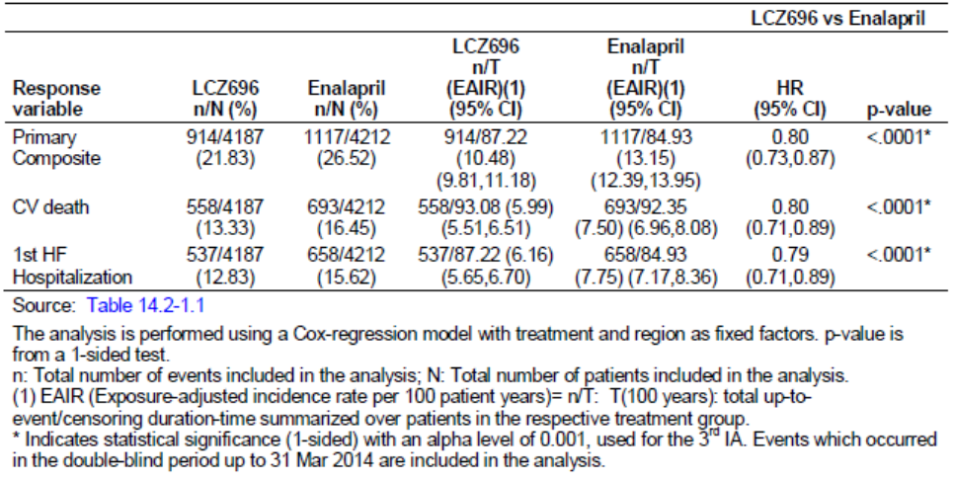
Figure 3. Kaplan-Meier plot for first confirmed primary endpoint by treatment group.
For the primary endpoint, no significant interactions were identified in subgroups including age, gender. The benefit in favour of LCZ696 was significantly less in NYHA class III/IV patients compared with NYHA class I/II (p=0.034). However, the interaction was not significant when adjusted for multiplicity. No meaningful treatment differences related to screening EF were observed.
Comment: In patients taking study medication at their final visit, the mean daily dose of LCZ696 was 374.8 mg and the mean daily dose of enalapril was 18.9 mg. The mean daily dose of enalapril exceeded the minimum dose stipulated by the FDA. There was a treatment benefit in favour of LCZ696 in the small number of patients with baseline EF > 35%, and in the larger group with baseline EF ≤ 35%. This suggests that the amended EF protocol inclusion criterion did not impact the study outcomes in favour of one or other of the study treatments.

Results for other efficacy outcomes
Kaplan-Meier plots for the individual components of CV death and hospitalisation for HF are shown in Figures 4 and 5. Deaths due to CV causes were reported in 13.3% of patients in the LCZ696 group compared with 16.5% in the enalapril group (HR 0.80; 95% CI: 0.71, 0.89, p<0.0001). Adjudicated hospital admissions for HF were reported in 12.8% of patients in the LCZ696 group compared with 15.6% in the enalapril group (HR 0.79; 95% CI: 0.71, 0.89, p<0.0001). The annualised rate ratio for LCZ696 compared with enalapril was RR 0.77 (95% CI: 0.67, 0.89, p=0.0004). There was also a significant reduction in all-cause mortality in favour of LCZ696 (17.0%) compared with enalapril (19.8%) (HR 0.84; 95% CI: 0.76, 0.93, p<0.0005) (Table 6 and Figure 6).
Figure 4. Kaplan-Meier plot for confirmed CV death by treatment group (FAS)
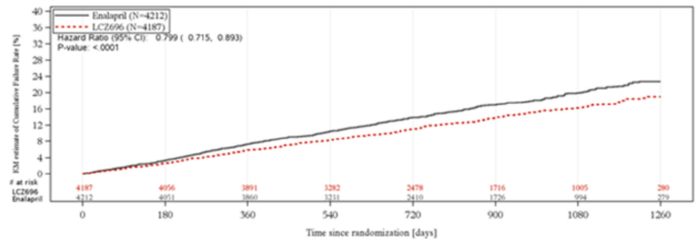
Figure 5. Kaplan-Meier plot of first confirmed hospitalisation for HF by treatment group (FAS).
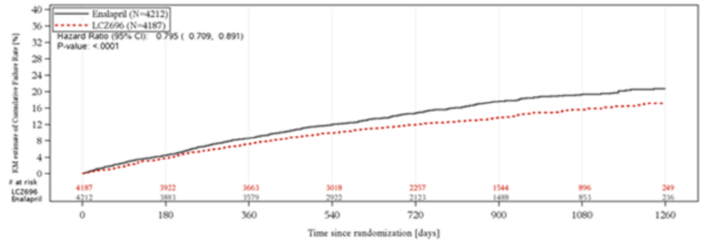

Table 6. Between treatment comparison of all cause mortality (FAS).
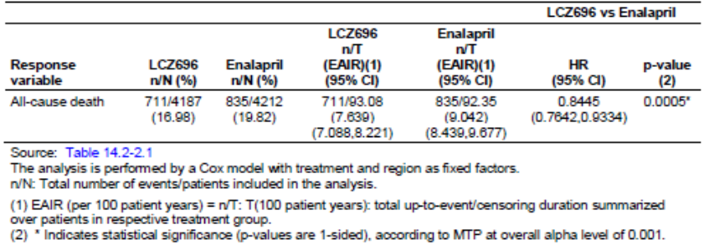
Figure 6. Kaplan-Meier plot for all cause mortality by treatment group (FAS).
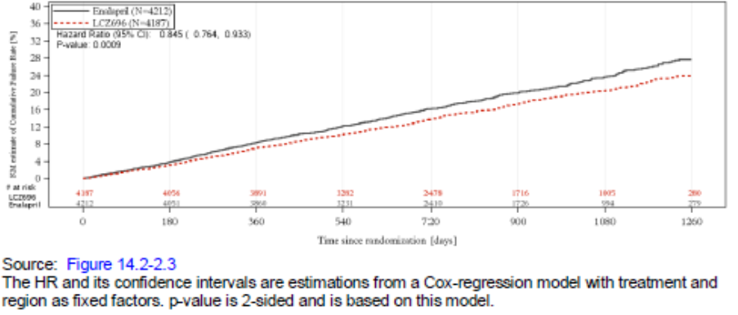
As shown in Figure 7, there were minor improvements in KCCQ summary scores in both treatment groups. There was a mean treatment difference of 1.64 points in the KCCQ summary score from baseline to Month 8 in favour of LCZ696 (p<0.001). However, the difference was not clinically meaningful and not statistically significant after adjustment for repeated measures. There were no significant differences between the treatment groups for the composite renal endpoint (HR 0.86; 95% CI: 0.65, 1.13, p=0.28), or for new onset AF (HR 0.97; 95% CI: 0.72, 1.31, p=0.84). There were no statistically significant differences between the treatments although the number of individual events was low. A post hoc analysis of NYHA classes from baseline to Month 8 showed a statistically significant improvement in functional class in the LCZ696 group (15.8% vs 14.0%, p=0.03) but this was not significant when adjusted for multiple comparisons. However, the status of most patients remained unchanged.
Comment: This is the only study with evaluable efficacy data to support the proposed indication. To avoid repetition, comments are provided as part of the overall efficacy conclusions below.
Figure 7. Between treatment analysis of change from baseline in KCCQ clinical summary score from repeated measures analysis over time during the double-blind period by treatment group (FAS).
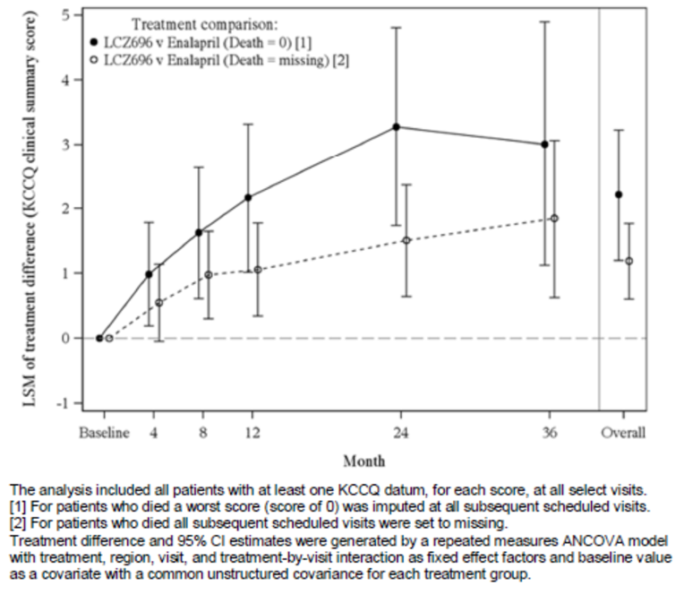

Other HF efficacy studies

Study CLCZ696B2214
This was a randomised, double-blind, multi-centre, parallel group, active controlled, Phase II study to compare the efficacy and safety of LCZ696 and valsartan in patients with chronic heart failure and preserved left-ventricular ejection fraction (LVEF ≥ 45%). It was conducted at 80 centres in 14 countries. The study started in November 2009 and completed in December 2011. The primary objective was to demonstrate that reduction from baseline in NT-pro-BNP in patients treated with LCZ696 was greater than with valsartan after 12 weeks of treatment. Multiple secondary objectives included evaluation of treatment-emergent echocardiographic indices of diastolic dysfunction, signs and symptoms of HF, major CV events, and eGFR.

Methodology
There was a 1 - 2 week, single-blind, placebo run-in period followed by a double-blind, 12 week treatment period, and a further double-blind, 24 week extension period (Figure 8). The change from baseline in NT-pro-BNP was assessed at Week 12 for the primary endpoint, and again at Week 36 to assess durability of response. Structural and functional changes were assessed at Week 12 and Week 36. Eligible patients were randomised 1:1 to receive target doses of either LCZ696 200 mg BID or valsartan 160 mg BID, titrated upwards over an initial 2-4 week period. ACEIs and ARBs were discontinued 24 hours before the randomisation visit, and randomisation was stratified according to the use of either treatment at baseline. A randomised population of 145 patients per arm was planned. A total of 308 patients were randomised to the double-blind treatment period, 152 and 156 patients to the LCZ696 and valsartan groups, respectively. After exclusions due to protocol violations, 149 and 156 patients in the respective arms were included in the RAN. The study population consisted of male or female patients aged ≥ 40 years with stable CHF, NYHA class II/IV, and baseline NT-pro-BNP > 400 pmol/L. The statistical analysis was performed using an ANCOVA model with log-transformed NT-pro-BNP at baseline as a covariate.
Figure 8. Study schematic CLCZ696B2214.
The two treatment groups were well balanced. The majority of patients were female (56.5%) with a mean age of 71.0 years. The mean baseline LVEF was 58%, and 79.4% of patients were in NYHA class II. The median NT-pro-BNP was 828 pg/mL in LCZ696 group and 939 pg/mL in the valsartan group. The mean baseline BMI was 30 kg/m2. Overall, 93.7% of patients had a history of hypertension, 37.5% had ischaemic heart disease, and 38% were diabetic.

Results
For the primary endpoint, there was a reduction in NT-pro-BNP from baseline to Week 12 which was 23% greater in the LCZ696 group than in the valsartan group (p=0.0050). At Week 36 there was a 15% difference in favour of LCZ696 but the difference was no longer statistically significant (p=0.20). The results in subgroups defined by age, gender, diabetes region, baseline NT-pro-BNP, and baseline EF were consistent with the overall population (although patient numbers were small in each group). From baseline to Week 36, there were no significant differences between the treatment groups in LVEF or LVMI although left atrial dimensions (LAVI) improved with a benefit in favour of LCZ696 (-3.14 mL/m2, p=0.0069). From baseline to Week 36, there were reductions in NYHA class in 22.8% and 13.6% of patients in the LCZ696 and valsartan groups, respectively. At Week 12, mean BP was reduced by 7.17/4.50 mm Hg and 1.42/2.60 mm Hg in the respective groups (p=0.0012 for SBP).
Comment: In this exploratory Phase II study, LCZ696 was superior to valsartan alone for reduction in NT-pro-BNP and left atrial volumes measured by LAVI. Both indices are independent predictors of cardiac outcomes in patients with HF-pEF. Although the HF patient population was distinct from that of the pivotal study, the results demonstrated an additive effect of the LCZ696 combination compared with valsartan alone for important surrogate markers of HF.

Study CLCZ696B2228 (TITRATION)
This was a multicentre, randomised, double-blind, parallel group, Phase II study comparing two titration regimens for initiating LCZ696 in heart failure patients. It was conducted at 107 centres in 10 countries. It started in November 2013 and completed in August 2014. The primary objective was to compare the safety and tolerability of LCZ696 with 3- week and 6-week up-titration regimens over 12 weeks. A secondary objective was to evaluate what proportion of patients achieved the target dose of 200 mg BID. The primary variables were specified AEs and laboratory abnormalities.

Methodology
The study design is shown in Figure 9. A one week screening period was followed by an open-label, run-in period of approximately one week during which patients received LCZ696 50 mg BID. Patients who tolerated a dose of 50 mg BID then entered a double-blind treatment period lasting approximately 11 weeks. Patients were randomised 1:1 to receive one of two titration regimens: up-titration to 200 mg BID over two weeks or to 200 mg BID over five weeks. Patients were stratified according to the level of RAAS inhibition. The high RAAS stratum included patients receiving > 160 mg of valsartan or > 10 mg daily dose of enalapril (or equivalent doses of drugs of the same class). The low RAAS stratum included patients receiving lower equivalent doses of ACEIs or ARBs, or who were receiving neither. After the 50 mg BID run-in period, patients in the condensed arm received 100 mg BID for two weeks followed by 200 mg BID for nine weeks. After the 50 mg BID run-in period, patients in the conservative arm received 50 mg BID for a further two weeks, 100 mg BID for three weeks, and 200 mg BID for a further six weeks. Dose reductions or interruptions were permitted at any study visit based on investigator judgement. Throughout the study, patients remained on their current HF medications with the exception of ACEIs and ARBs which were replaced by the study medication.
Figure 9. Study schematic CLCZ696B2228
The study population consisted of a randomised total of 498 hospitalised and outpatient males and females aged ≥ 18 years with HF NYHA class II-IV and LVEF ≤ 35%. The demographic and baseline characteristics were comparable in the two arms. The majority were male (78.7%) and White (92.8%) with mean age 64.0 years and mean BMI 30.8 kg/m2. The great majority of patients were either NYHA class II (70.9%) or class III (28.9%) with mean baseline LVEF 29.7%. Most patients had previous HF hospitalisation (55.6%) and the majority had HF diagnosed more than 2 years previously (61.9%). At screening, 66.5% of patients were receiving an ACEI and 26.9% were receiving an ARB.

Results
For the primary endpoint, there was a comparable incidence of hypotension (9.7% vs 8.4%) and renal dysfunction (7.3% vs 7.6%) in the 3-week and 6-week titration groups. However, hyperkalaemia was more common in the 3-week titration group compared with the 6-week titration group (7.7% vs 4.4%). The rates of AEs related to hypotension, renal dysfunction and hyperkalaemia were higher in the low RAAS stratum compared with the high RAAS stratum irrespective of the titration regimen (Table 7). Angioedema was reported in 2/251 (0.8%) patients (one patient in each RAAS subgroup).

Table 7. Analysis of primary variables: number (%) of patients experiencing hypotension, renal dysfunction, hyperkalemia and angioedema during post randomisation period (FAS).
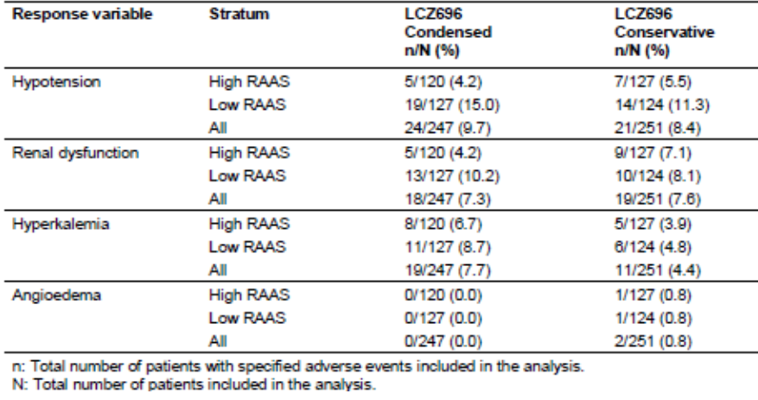
During the run-in period, LCZ696 50 mg BID was well tolerated and only 5.6% of patients discontinued due to an AE. In randomised patients, 81.1% achieved the target dose of 200 mg BID without down-titration or dose interruption during the 12 week treatment period. Excluding patients who discontinued for reasons other than AE or death, 85.2% of patients achieved the target dose for at least two weeks before study completion. In the low RAAS stratum, more patients achieved the target dose with the 6 week regimen compared with the 3 week regimen (84.9% vs 73.6%). However, no differences between the titration regimens were observed in the high RAAS group. In patients who received at least one dose of LCZ696, excluding patients who discontinued reasons other than AE or death, 76.2% achieved 200 mg BID without any dose adjustment or interruption over 12 weeks.
Comment: The starting dose of LCZ696 50 mg BID was well tolerated. More patients achieved the target dose of LCZ696 200 mg BID with no down-titration or dose interruptions with the 6-week conservative regimen compared with the 3-week condensed regimen (85.2% vs 81.1%). The difference was due to a lower incidence of hypotension, renal impairment or hyperkalaemia in the low RAAS stratum in the 6-week titration group. The starting dose of 50 mg BID was well tolerated and only 5.6% of patients withdrew because of an AE. This compares with a withdrawal rate due to AEs of 5.5% during the LCZ696 100 mg BID run-in period of the pivotal study. Both the 3-week and 6-week up-titration regimens are acceptable alternatives to the 100 mg BID starting dose recommended in the proposed PI. The selection should be based on the clinical status of the patient and the HF medications they are currently receiving.

Other studies
Comment: None of the following studies assessed LCZ696 in HF patients. They provide efficacy data for LCZ696 in patients with hypertension, and for valsartan in patients with heart failure or hypertension (some not previously evaluated for the TGA). While the efficacy data are not relevant to the proposed indication, the studies do provide a substantial body of safety data, particularly in Asian patients.

Study LCZ696A1304
This was a multicentre, open-label, Phase II study of LCZ696 in Japanese hypertensive patients with renal dysfunction. It was conducted at 13 centres in Japan between May 2012 and March 2013. The primary objective was to evaluate safety and efficacy, and the secondary objectives assessed blood pressure control.

Methodology
Male or female adult patients with hypertension (≥ 140 msSBP < 180 mm Hg) and renal dysfunction (≥ 15 eGFR < 60 mL/min) were included. Eligible patients entered a run-in period of 3 - 5 weeks during which antihypertensive treatments were stopped or tapered off. Placebo was given during this period but a single antihypertensive agent other than an ACEI or ARB was permitted if required for patient safety. Patients then entered an 8 week treatment period during which they received open-label LCZ696 up-titrated from 100 mg QD to a target dose of 400 mg QD unless target blood pressure was achieved with a lower dose (msDBP < 80 mm Hg, msSBP < 130 mmHg) (Figure 10).
Figure 10. Study A1304.
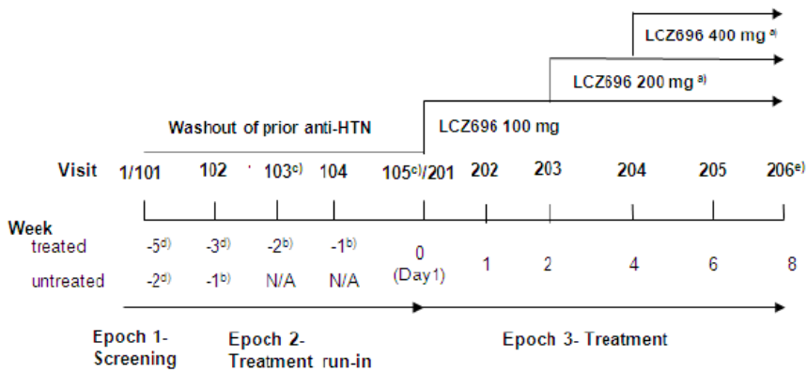
A total of 32 patients were included in the FAS. All were Japanese and the majority were male (75%) with a mean age of 65.8 years. Mean BMI was 25.3 kg/m2. Mean sitting blood pressure at baseline was 151.6/86.9 mm Hg and all patients had renal dysfunction (15 ≤ eGFR < 30 mL/min in 21.9% of patients, 30 ≤ eGFR <60 mL/min in 78.1%).

Results
Target BP was achieved by six and eight patients receiving LCZ696 100 mg QD and 200 mg QD, respectively, and 18 patients were up-titrated to 400 mg QD. At the end of the treatment period, the mean change in msSBP from baseline was -19.71, -27.19, and -17.79 mm Hg in the respective dose groups. The mean change from baseline in msDBP was -7.17, -9.94, and -7.99, respectively. The BP response rates in patients with moderate and severe renal failure were comparable.
Comment: In Japanese patients with hypertension and renal dysfunction, a mean sitting BP reduction of 20.50/8.32 mm Hg was achieved following treatment for 8 weeks with LCZ696 100–400 mg QD. The study was not controlled.

Study LCZ696A1305
This was a multicentre, open-label, Phase II study of LCZ696 in Japanese patients with severe hypertension. It was conducted at 9 centres in Japan between July 2012 and February 2013. The primary objective was to evaluate safety and efficacy, and the secondary objectives assessed blood pressure control.

Methodology
Male or female adult patients with severe hypertension (msSBP ≥ 180 or msDBP ≥ 110 mm Hg) were included. Eligible patients entered a run-in period of 4 weeks during which antihypertensive treatments containing ACEI or ARBs were stopped or tapered off. Other antihypertensive agents were permitted if required for patient safety. Patients then entered an 8 week treatment period during which they received open-label LCZ696 up-titrated from 200 mg QD to a target dose of 400 mg QD unless target blood pressure was achieved with the lower dose (msDBP < 100 mm Hg, msSBP < 140 mmHg) (Figure 11). Patients who had not achieved target BP at Week 4 could receive another class of antihypertensive with the exception of ACEIs and ARBs.
Figure 11. Study A1305.
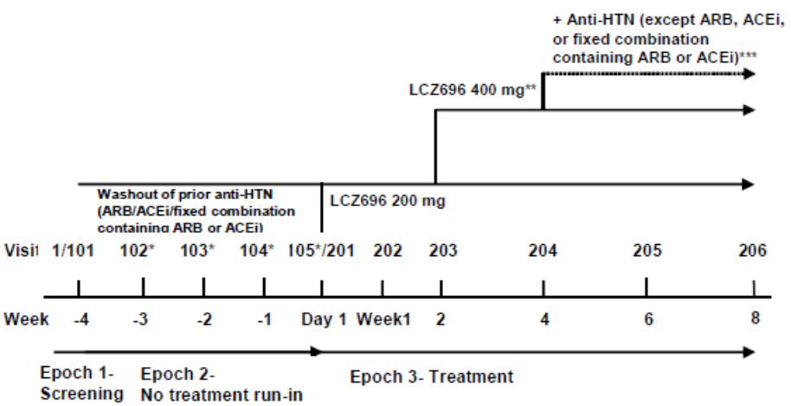
A total of 35 patients were included in the FAS. All were Japanese and the majority were male (94.3%) with a mean age of 51.3 years. Mean BMI was 27.3 kg/m2. Mean sitting blood pressure at baseline was 173.4/112.4 mm Hg and all patients had renal dysfunction.

Results
LCZ696 alone or in combination with other antihypertensives, achieved a significant reduction in BP. In patients receiving LCZ696 200 mg QD alone, there were significant changes in msSBP (-48.83 mm Hg) and msDBP (-34.25 mm Hg). In patients receiving LCZ696 400 mg QD alone, and LCZ696 400 mg QD plus other antihypertensives, there were significant changes in msSBP (-30.34 and -35.98 mmHg, respectively) and msDBP (-16.98 and -23.08 mm Hg, respectively).
Comment: The patient population was Japanese patients with severe hypertension. Although it was not an inclusion criterion, all patients also had renal dysfunction. A mean sitting BP reduction of 35.31/22.12 mm Hg was achieved following treatment for 8 weeks with LCZ696 200 mg QD, LCZ696 400 mg QD alone, or LCZ696 plus other antihypertensives. The study was not controlled.

Study LCZ696A1306
This was a multicentre, randomised, double-blind, active-controlled Phase III study of LCZ696 compared with olmesartan in Japanese patients with essential hypertension. It was conducted at 61 centres in Japan between June 2012 and April 2013. The primary objective was to demonstrate non-inferiority of LCZ696 versus olmesartan for the reduction of msSBP, and to demonstrate superiority if non-inferiority was achieved.

Methodology
Male or female adult patients with mild to moderate hypertension (≥ 180 msSBP < 180 mm Hg), treated or untreated, were included. Eligible patients entered a run-in period of 3 - 4 weeks during which antihypertensive treatments were stopped and single-blind placebo treatment was started. Patients then entered an 8 week treatment period during which they were randomised 1:1:1 double-blind LCZ696 200 mg QD, LCZ696 400 mg QD up-titrated from 200 mg QD, or olmesartan 20 mg QD (Figure 12).
Figure 12. A1306.
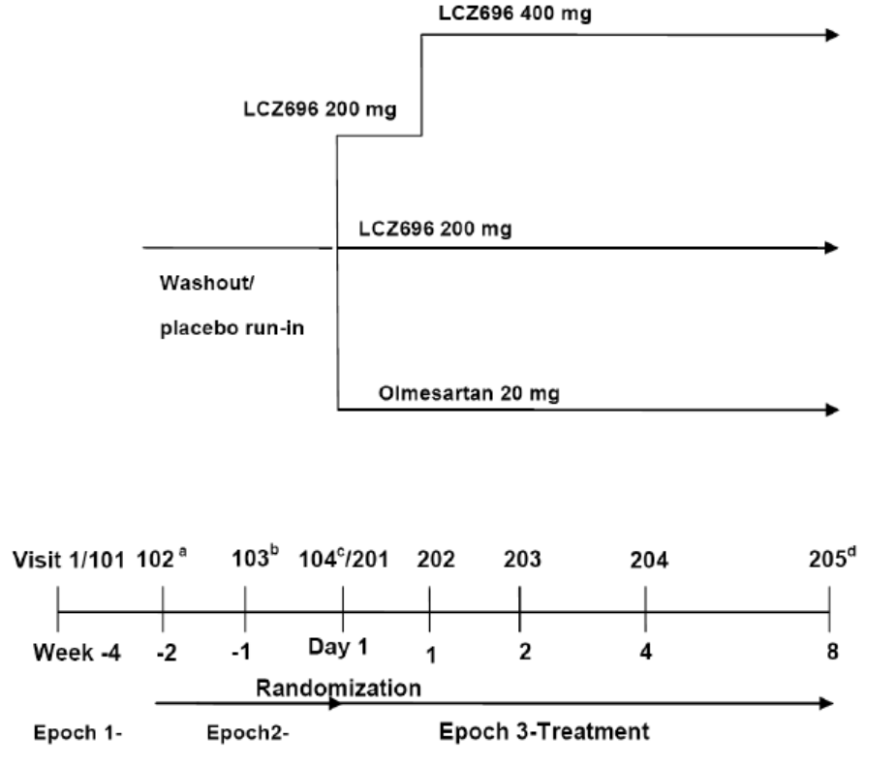
A total of 1,161 patients were included in the FAS (387, 385, and 389 patients in the respective treatment groups). All were Japanese and the majority were male (70.5%) with a mean age of 58.7 years. Mean BMI was 25.4 kg/m2 and mean sitting blood pressure at baseline was 157.9/94.3 mm Hg.

Results
There were significant reductions from baseline in msSBP after 8 weeks treatment with LCZ696 200 mg QD, LCZ696 400 mg QD and olmesartan 20 mg QD (-18.21, -20.18, and -13.20 mm Hg, respectively, p<0.001). Corresponding reductions in msDBP were -7.76, -8.79, and -5.91 mm Hg (p<0.001). Both doses of LCZ696 were also shown to be superior to olmesartan 20 mg QD. After 8 weeks treatment, the differences in msSBP in favour of LCZ696 200 mg QD and 400 mg QD were -5.01 and -6.97 mm Hg, respectively (p<0.001). Corresponding mean differences in msDBP were -1.85 and -2.89 mm Hg (p<0.001).
Comment: In Japanese patients with mild to moderate hypertension, LCZ696 doses of 200 mg QD and 400 mg QD were superior to olmesartan 20 mg QD for BP reduction after 8 weeks treatment (p<0.001). There was no placebo control group.

Study LCZ696A2201
This was a multicentre, randomised, double-blind, placebo- and active-controlled, parallel group, dose ranging study comparing the efficacy and safety of LCZ696 and valsartan, and evaluating AHU377 versus placebo after 8 weeks treatment in patients with mild to moderate essential hypertension. It was conducted at 180 centres in 18 countries. It started in September 2007 and finished in July 2008. The primary objective was to demonstrate superiority of LCZ696 versus valsartan in reducing DBP from baseline to Week 8, with pairwise comparisons of three doses of LCZ696 (100 mg, 200 mg, and 400 mg) and three doses of valsartan (80 mg, 160 mg, and 320 mg). Multiple secondary objectives included demonstrating superiority of LCZ696 versus placebo in reducing SBP and DBP; and superiority of AHU377 versus placebo in reducing msSBP and msDBP from baseline to Week 8.

Methodology
A four week washout and single-blind placebo period was followed by an 8 week double-blind monotherapy treatment period. The treatment period was followed by a one week randomised, placebo-controlled withdrawal period during which patients were randomised to receive placebo or their original assigned treatment (Figure 13). The study population consisted of male or female adults with uncomplicated mild to moderate hypertension with msDBP ≥95 mm Hg and <100 mm Hg at baseline. They were randomised 1:1:1:1:1:1:1:1 to receive one of the six doses of LCZ696 or valsartan; AHU377 200 mg; or placebo; each given once daily. All treatments were identical in appearance. A total of 1,215 patients were randomised and entered the double-blind treatment period, and 91.5% completed the 8 week period. Most withdrawals were due to inadequate antihypertensive effect in the placebo group.
Figure 13. A2201.
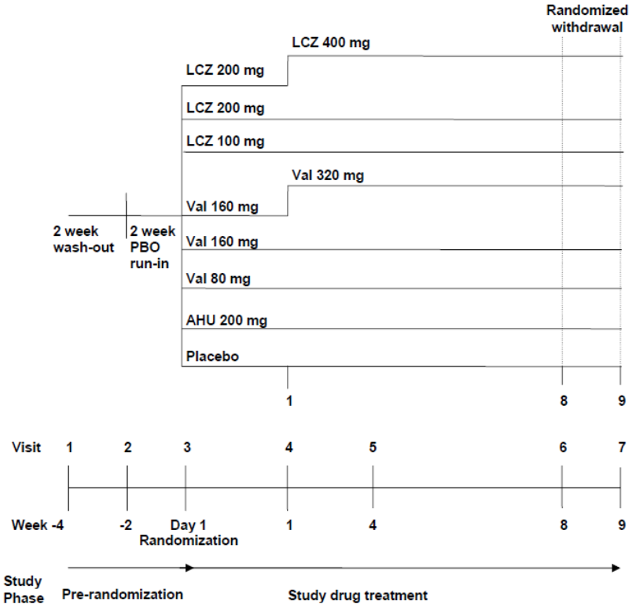
The baseline demographics were comparable in each group. In the overall population, the majority of patients were White (89.6%) and male (54.3%) with a mean age of 54 years. Mean msDBP was 100.9 mm Hg and mean msSBP was 155.1 mm Hg.

Results
The primary endpoint was achieved. The least squares mean (LSM) change in msDBP for the average of the three LCZ696 doses was -12.18 mm Hg compared with -10.01 mm Hg for the average of the three valsartan doses. The treatment difference was -2.17 mm Hg (95% CI: -3.28, -1.06, p<0.0001). The LSM changes in msDBP for AHU377 and placebo were -9.76 mm Hg and -6.78 mm Hg, respectively. The LSM difference in change from baseline in msDBP for LCZ696 200 mg versus AHU377 200 mg was -3.16 (95% CI: -5.06, -1.25), and for LCZ696 400 mg versus AHU377 the difference was -3.87 (95% CI: -5.77, -1.97). No clinically meaningful BP rebound was observed during the rebound period.
Comment: In this placebo-controlled study in a mainly Caucasian population with mild to moderate hypertension, LCZ696 reduced DBP more effectively than valsartan alone, AHU377 alone, or placebo. In this patient population, LCZ696 had an additive effect when compared with its individual components.

Study LCZ696A2219
This was a Phase IIb, multicentre, randomised, double-blind, placebo-controlled, parallel-group, dose ranging study of LCZ696 in Asian patients with essential hypertension. It was conducted at 34 centres in Japan, China, Taiwan, Korea, and Thailand between August 2010 and April 2011. The primary objective was to demonstrate the superiority of three doses of LCZ696 compared with placebo for the reduction of msDBP after treatment for 8 weeks.

Methodology
After screening, eligible patients entered a 2 week washout or treatment tapering period, followed by a single-blind placebo period for a further 2 weeks. This was followed by an 8 week double-blind monotherapy treatment period during which patients received in 1:1:1 ratio, either LCZ696 100 mg QD, 200 mg QD or 400 mg QD after a one week up-titration period. The treatment period was followed by a one week single-blind, placebo withdrawal period (Figure 14).
Figure 14. A2219.
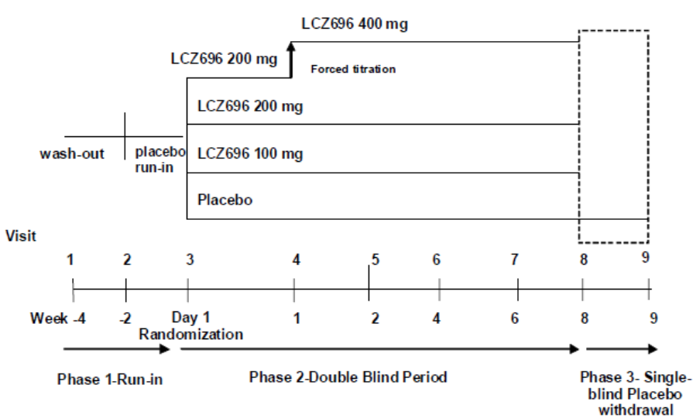
The study population consisted of male or female adult Asian patients, untreated or taking antihypertensive treatment, with mild to moderate essential hypertension with mean DBP ≥95 mm Hg and <110 mm Hg at baseline. A total of 389 patients were randomised and entered the double-blind treatment period, and 93.1% completed the 8 week period.
The baseline demographics were comparable in each group. In the overall population, all patients were Asian, and the majority were male (73.9%) with a mean age of 50.9 years. Mean msDBP was 99.9 mm Hg and mean msSBP was 155.0 mm Hg.

Results
There were significant reductions from baseline in mean msDBP after 8 weeks treatment with LCZ696 100 mg, LCZ696 200 mg QD, and LCZ696 400 mg QD compared with placebo (p<0.0001 for each comparison versus placebo). LSM changes in msDBP from baseline were -11.53, -10.98, -12.45, and -3.69 mm Hg in the respective treatment groups. Corresponding reductions in msSBP were -16.83, -17.54, -20.35, and -4.97 mm Hg (p<0.001 for each comparison versus placebo). Changes in msDBP and msSBP were numerically highest in the LCZ696 400 mg group although the difference was not statistically significant.
Comment: In Asian patients with mild to moderate hypertension, LCZ696 doses of 100 mg, 200 mg QD and 400 mg QD were superior to placebo for BP reduction after 8 weeks treatment (p<0.0001). The BP reduction was numerically highest in the LCZ696 400 mg group.

Study LCZ696A2219E1
This was an open-label, long-term extension to study LCZ696A2219 to assess efficacy and safety in Asian patients with essential hypertension over a 12 month period.

Methodology
At the completion of the core study LCZ696A2219, patients were given open-label LCZ696 200 mg QD. After 2 weeks, if msDBP was ≥90 mm Hg or msSBP was ≥ 140 mm Hg, the dose of LCZ696 was increased to 400 mg QD. Patients who experienced hypotension or symptoms of hypotension had their dose of LCZ696 reduced to 100 mg QD. Patients whose BP was not adequately controlled were allowed additional antihypertensive medications (either amlodipine 5 - 10 mg or hydrochlorothiazide 6.25 - 25 mg) (Figure 15).
Figure 15. A2219E1.
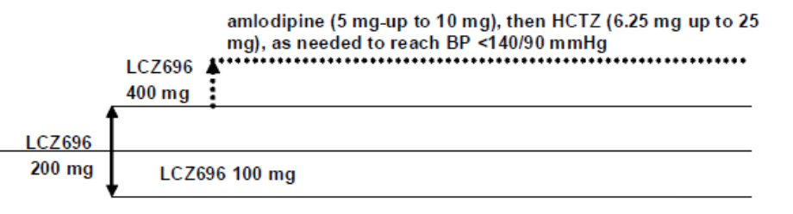

Results
A total of 340 patients completed the study. In the overall population, the mean change from baseline in msDBP was -16.2 mm Hg and the change in msSBP was -24.7 mm Hg. In the LCZ696 monotherapy group (n=228), the mean change was -23.0/-15.7 mm Hg; and in the LCZ696 combined therapy group (n=112), the mean change was -28.2/-17.3 mm Hg.
Comment: LCZ696 was effective throughout the 12 month study period in Asian patients with essential hypertension. The combination of LCZ696/amlodipine/hydrochlorothiazide reduced BP in patients inadequately controlled by LCZ696 alone.

Study LCZ696A2223
This was a Phase IIb, multicentre, randomised, double-blind, placebo- and active-controlled, parallel group study to evaluate the dose response of AHU377 in combination with valsartan in patients with mild to moderate systolic hypertension. It was conducted at 93 centres worldwide between January 2011 and December 2011. The primary objective was to demonstrate the superiority of four doses of AHU377 in combination with valsartan 320 mg compared with valsartan alone for the reduction of msSBP after treatment for 8 weeks.

Methodology
After screening, eligible patients entered a 2 week washout or treatment tapering period, followed by a single-blind placebo period for a further 2 weeks (Figure 16). This was followed by a forced titration period in an 8 week double-blind monotherapy treatment period during which patients received in 2:2:2:2:2:2:1 ratio (6 active, 1 placebo), one of the following treatments given once daily:
- AHU377 400 mg + valsartan 320 mg
- AHU377 200 mg + valsartan 320 mg
- AHU377 100 mg + valsartan 320 mg
- AHU377 50 mg + valsartan 320 mg
- Valsartan 320 mg
- LCZ696 400 mg
- Matching placebo
Figure 16. A2223.
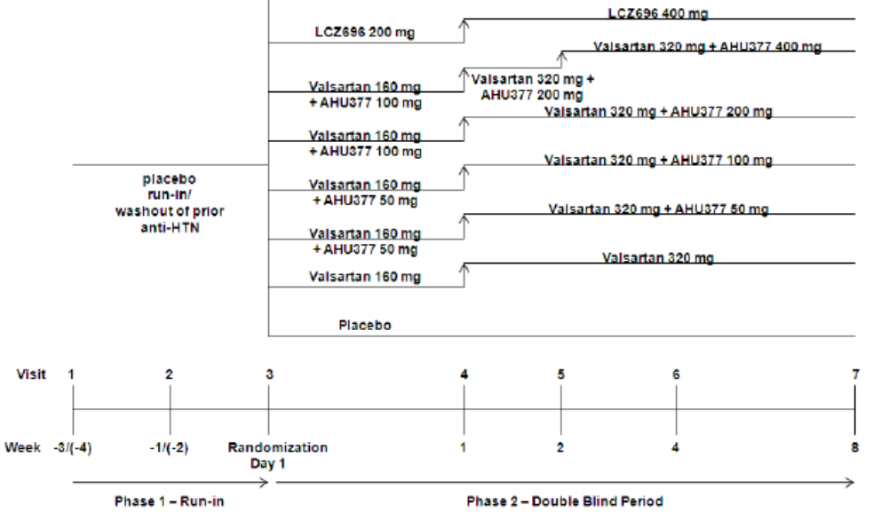
The study population consisted of male or female adult patients with mild to moderate essential hypertension, untreated or taking antihypertensive medication, with msSBP ≥ 150 mm Hg and < 180 mm Hg at baseline. A total of 907 patients were randomised and entered the double-blind treatment period, and 94.0% completed the 8 week period.
The baseline demographics were comparable in each group. In the overall population, the majority of patients were White (68.4%) and male (54.6%) with a mean age of 61.5 years. Mean msSBP was 159.8 mm Hg and mean msDBP was 90.2 mm Hg.

Results
There were significant reductions from baseline in mean msSBP after 8 weeks treatment in all active treatment groups (p<0.0001 for each comparison versus placebo). In the respective AHU377 treatment groups, LSM changes in msSBP from baseline were -20.89, -23.55, -21.26, and -19.31 mmHg, compared with -16.13 mm Hg in the valsartan 320 mg group, -21.78 mm Hg in the LCZ696 400 mg group, and -6.99 mm Hg in the placebo group. A quadratic model for best fit using the MCP-Mod method demonstrated a non-linear dose response for AHU377 in doses of 0 mg to 400 mg in combination with valsartan 320 mg. There were no statistically significant differences between the LCZ696 400 mg and AHU377 200 mg + valsartan 320 mg groups.
Comment: In patients with mild to moderate systolic hypertension, all doses of AHU377 + valsartan 320 mg were superior to placebo for msSBP reduction after 8 weeks treatment (p<0.0001). No meaningful dose-effect response relationship with AHU377 treatment was demonstrated.

Study LCZ696A2316
This was a Phase III, multicentre, randomised, double-blind, active-controlled, parallel group study to compare the efficacy and safety of LCZ696 and olmesartan in elderly Asian patients with essential hypertension. It was conducted at 82 centres in seven Asian countries between August 2012 and July 2013. The primary objective was to demonstrate the superiority of LCZ696 200 mg compared with olmesartan 20 mg for the reduction of msSBP after treatment for 10 weeks.

Methodology
During a 2 - 4 week screening period, patients washed out previous antihypertensive therapy and entered a 2 week single-blind, placebo run-in period. Patients were then randomised in a 1:1 ratio to receive either LCZ696 100 mg QD or olmesartan 10 mg QD for 4 weeks. They were then force titrated to receive LCZ696 200 mg QD or olmesartan 20 mg QD for a further 6 weeks (Figure 17). Patients with uncontrolled BP (SBP ≥ 140 mm Hg or DBP ≥ 90 mm Hg) were up-titrated to receive either LCZ696 400 mg QD or olmesartan 40 mg QD for a final 4 weeks.
Figure 17. A2316.
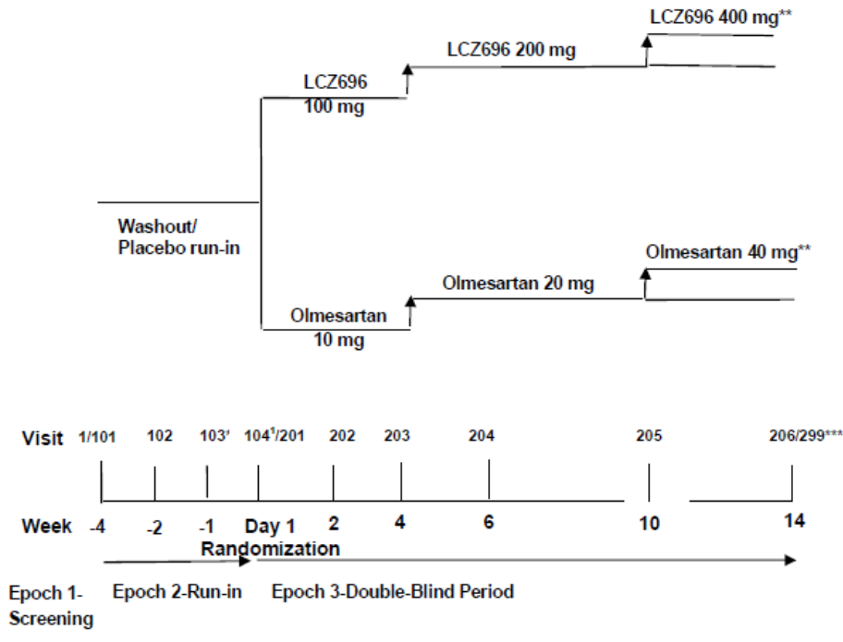
The study population consisted of elderly male or female Asian patients (aged ≥ 65 years), untreated or taking antihypertensive treatment, with mild to moderate essential hypertension with mean SBP ≥ 150 mm Hg and < 180 mm Hg at baseline. A total of 588 patients were randomised and entered the double-blind treatment period, and 92.7% completed the double-blind treatment period.
The baseline demographics were comparable in each group. In the overall population, all patients except one were Asian, and 50% were male (73.9%) with a mean age of 70.7 years. Mean msSBP was 160.3 mm Hg and mean msDBP was 84.9 mm Hg.

Results
There were significant reductions from baseline in mean msSBP after 10 weeks treatment with LCZ696 200 mg or olmesartan 20 mg. LSM changes in msSBP from baseline were -22.71 and -16.11 mm Hg in the respective treatment groups. The LSM difference in change from baseline was -6.60 mm Hg in favour of LCZ696 (95% CI: -9.09, -4.12, p<0.001). Corresponding changes in msDBP were -6.95 and -4.47 mm Hg with a treatment difference of -2.47 mm Hg in favour of LCZ696 (95% CI: -3.30, -1.65, p<0.001).
Comment: In Asian patients with mild to moderate hypertension, LCZ696 200 mg QD was superior to olmesartan 20 mg QD in terms of BP reduction after 10 weeks treatment (p<0.001).

Study LCZ696A2319
This was a Phase III, multicentre, randomised, double-blind, parallel group, active-controlled study to evaluate the safety and efficacy of LCZ696 200 mg + amlodipine 5 mg compared with amlodipine alone in patients with essential hypertension not adequately controlled on amlodipine 5 mg alone. It was conducted at 29 centres in six Asian countries between August 2012 and May 2013. The primary objective was to demonstrate superior reduction in mean 24 hour ambulatory blood pressure monitoring msSBP after treatment for 8 weeks.

Methodology
There was a 1 - 2 week washout period during which previous antihypertensive therapies were stopped. This was followed by a 4 week active, single-blind run-in period during which all patients received amlodipine 5 mg. Patients were then randomised in a 1:1 ratio to receive either LCZ696 200 mg QD + amlodipine 5 mg QD or amlodipine alone for 8 weeks (Figure 18). At the randomisation visit at completion of the amlodipine 5 mg run-in period, patients were required to have uncontrolled BP (msSBP ≥ 145 mm Hg and <180 mm Hg).
Figure 18. A2316.
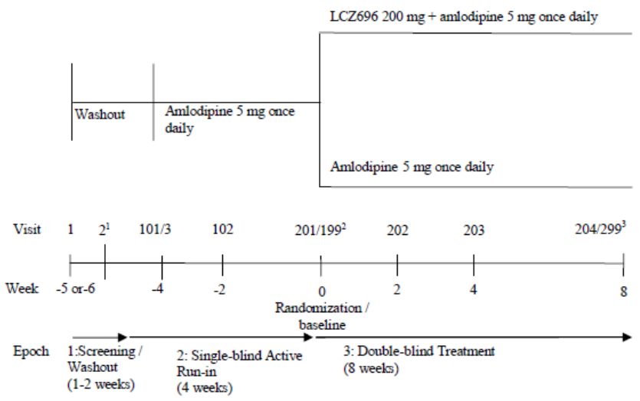
The study population consisted of male or female Asian patients, untreated or taking antihypertensive treatment, with mild to moderate essential hypertension with mean SBP ≥ 150 mm Hg and < 180 mm Hg at screening. A total of 266 patients were randomised and entered the double-blind treatment period, and 95.9% completed the study.
The baseline demographics were comparable in each group. In the overall population, all patients were Asian, and the majority were male (58.6%) with a mean age of 55.4 years. Mean baseline msSBP was 153.7 mm Hg and mean msDBP was 89.7 mm Hg. The mean 24 hour maSBP and maDBP were 139.0 and 86.1mm Hg, respectively.

Results
After 8 weeks treatment, there were reductions of -13.93 and -0.82 mm Hg in maSBP from baseline after treatment with LCZ696 + amlodipine and amlodipine alone, respectively. There was a statistically significant difference of -13.11 mm Hg in favour of the LCZ696 + amlodipine group (95% CI: -14.43, -11.79, p<0.001). Corresponding changes in maDBP were -8.03 and -0.33 mm Hg with a treatment difference of -7.70 mm Hg in favour of the LCZ696 + amlodipine group (95% CI: -8.59, -6.82, p<0.001).
Comment: In Asian patients with mild to moderate hypertension, LCZ696 200 mg + amlodipine 5 mg was superior to amlodipine 5 mg alone in reducing 24 hour mean ambulatory BP after 8 weeks treatment (p<0.001).

Study VAL489B0102
This was a Phase II, open-label, placebo-controlled, dose ranging study to determine the acute central haemodynamic effects of valsartan in patients with stable, chronic, congestive heart failure (NYHA class III-IV). It was conducted at three centres in the USA between March 1993 and April 1994. The main objectives were to evaluate the central haemodynamic effects of single doses of valsartan compared with placebo for up to 24 hours after dosing.

Methodology
There was a screening period of 3 - 14 before dosing. With the exception of digoxin, chronic HF medications were discontinued 3 days before dosing, and diuretics were stopped 24 hours before dosing. Patients were admitted to hospital on the day before dosing, and discharged the next day for out-patient review one week after dosing (Figure 19). Central haemodynamics were measured using a Swan-Ganz catheter inserted into the right atrium. Male and female patients aged 18 - 80 years with chronic, stable HF were eligible. They were NYHA class III or IV with an EF ≤ 35% determined by MUGA. Valsartan 10, 20, 40, 80, and 160 mg or matching placebo were administered and haemodynamic measurements were made at 0, 1, 2, 3, 4, 6, 8, 12, and 24 hours after dosing.
Figure 19. B0102.
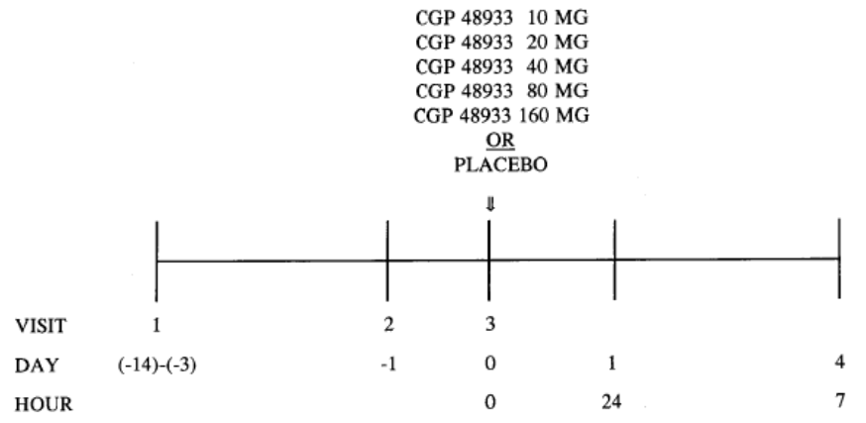
A total of 25 patients were randomised with 3 - 5 patients in each treatment group. Most patients were Black (19/25) and male (22/25) with a mean age of 50.9 years. Mean PCWP at baseline was 25.7 mm Hg and mean CO was 3.99 L/min.

Results
The change from baseline to 24 hours in mean PCWP was -6.75 mm Hg in the placebo group, compared with changes of -2.25 to -4.50 mm Hg in the valsartan treatment groups. There were no meaningful changes in CO in the placebo or valsartan groups.
Comment: There were reductions in PCWP 24 hours following all single doses of valsartan in patients with chronic HF. However, the changes in PCWP were greater in patients given placebo.
The large change in response to placebo was unexpected and overall patient numbers were too small for meaningful interpretation.

Study VAL489B0103
This was a Phase IIa, multicentre, double-blind, randomised, placebo- and active-controlled, between patient trial to assess the cardiac haemodynamic effects of valsartan 40 mg, 80 mg and 160 mg BID in patients with chronic stable congestive heart failure NYHA class II-IV treated for 4 weeks. It was conducted at 10 centres in Russia between April 1995 and March 1996. The main objective was to assess the cardiac haemodynamic effects of valsartan in patients with chronic stable HF NYHA class II-IV after 4 weeks treatment.

Methodology
After screening, there was a 2 - 4 week run-in period to confirm the stability of the patients’ HF. Eligible patients were then randomised 2:2:2:2:1 to receive either valsartan 40 mg, 80 mg, 160 mg or placebo, all BID for 4 weeks, or lisinopril 5 mg QD for one week then 10 mg QD for 3 weeks (Figure 20). A total of 20 - 24 patients were planned for each valsartan and placebo group, and 10-12 patients for the lisinopril group. Patients were aged 18 - 80 years with stable HF NYHA class II-IV and mean PCWP ≥ 15 mm Hg on Day -1. Patients were allowed their usual HF medications with the exception of ACEI which were prohibited in the 6 months prior to dosing. Patients were admitted on Day -1 and a Swan-Ganz catheter was inserted to confirm PCWP ≥ 15 mm Hg. On Day 0, baseline haemodynamics were measured and the first study treatments were given. Haemodynamic measurements were made for 12 hours when the second dose of study medication was given. The catheter was then removed and the patients were discharged on Day 1. On Day 27, the patients were re-admitted and a right heart catheter was again inserted. Repeat haemodynamic measurements were made in the next 12 hours, following which the catheter was removed and the patients discharged.
Figure 20. B0103.
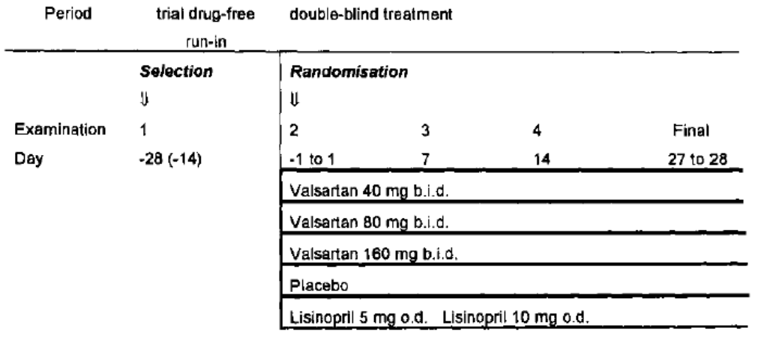
A total of 116 patients were randomised, 24 - 27 in each valsartan group, 26 in the placebo group, and 15 in the lisinopril group. A total of 103 patients completed the study, balanced approximately between groups. Overall, all patients were White and most were male (82.8%) with a mean age of 56.0 years. Mean PCWP at baseline ranged from 19.6 to 22.9 mm Hg, and mean CO ranged from 4.76 to 4.97 L/min in each treatment group.

Results
On Day 28, the LSM mean change from baseline in PCWP ranged from -2.9 to -7.0 mm Hg in the valsartan groups, compared with -0.1 mm Hg in the placebo group and -2.5 mm Hg in the lisinopril group. Compared with the placebo group, the adjusted mean differences in the valsartan 40 mg BID and 160 mg BID groups were -6.0 mm Hg (95% CI: -11.3, -0.7, p=0.007) , and -6.9 mm Hg (95% CI: -11.8, -1.9, p=0.001), respectively. The adjusted mean differences in the valsartan 80 mg BID and lisinopril 10 mg QD groups were not statistically significant. The LSM mean changes from baseline in CO ranged from 0.50 to 0.66 L/min in the valsartan groups, compared with -0.10 L/min in the placebo group, and 0.28 L/min in the lisinopril group. Compared with placebo, the adjusted mean differences in the valsartan groups ranged from 0.69 to 0.88 L/min (p=0.016 to p=0.002) and 0.57 L/min in the lisinopril group (p=0.072).
Comment: In patients with chronic stable HF NYHA class II-IV treated for 4 weeks, valsartan improved haemodynamics in doses of 40 mg-160 mg BID compared with placebo, and with lisinopril 10 mg QD.

Study VAL489B0104
This was a double-blind, placebo-controlled, dose response trial to determine the acute and chronic central haemodynamic effects of valsartan in patients with symptomatic congestive heart failure receiving therapeutic doses of an ACEI. It was conducted at 17 centres in the USA between March 1995 and June 1996. The primary objective was to establish a dose range for valsartan based on haemodynamic effects.

Methodology
There was a two week single-blind run-in period used to confirm stability of the patients’ HF. This was followed by a double-blind treatment period of four weeks to detect chronic changes in central haemodynamic effects from baseline. Male or female patients aged 18 - 80 years with stable congestive HF NYHA class II-IV and PCWP ≥ 15 mm Hg were enrolled. Patients were randomised to receive either valsartan 80 mg BID, 160 mg BID, or placebo. On Day 0, baseline haemodynamics were measured and the first study treatments were given (Figure 21). Haemodynamic measurements were made for 12 hours when the second dose of study medication was given. The catheter was then removed and the patients were discharged on Day 1. On Day 27, the patients were re-admitted and catheterisation was repeated. Repeat haemodynamic measurements were made from 0 - 12 hours, following which the catheter was removed and the patients discharged.
Figure 21. B0104.
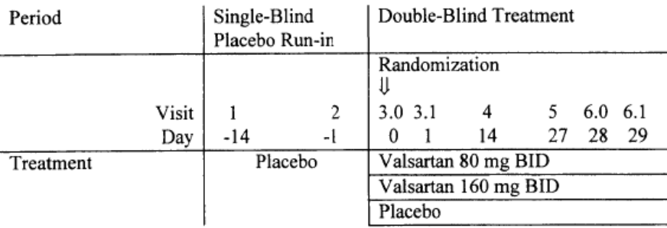
A total of 83 patients were randomised and 74 completed the double-blind treatment period. Overall, the majority of patients were White (65%) and all were male with a mean age of 64.1 years. Mean PCWP at baseline ranged from 20.13 to 23.92 mm Hg in each treatment group.

Results
On Day 28 from 0 - 12 hours, the LSM mean changes from baseline in PCWP were -3.94 and -5.87 mm Hg in the valsartan 80 mg BID and 160 mg BID groups, respectively. Compared with the placebo group, the adjusted mean differences in the valsartan 80 mg BID and 160 mg BID groups were 0.69 mm Hg (95% CI: -1.61, 2.98, p=0.494) , and 2.40 mm Hg (95% CI: 0.09, 4.70, p=0.02), respectively. No meaningful changes from baseline in CO were observed in any treatment group.
Comment: In patients with chronic stable HF NYHA class II-IV treated for 4 weeks, valsartan 160 mg BID but not 80 mg BID improved PCWP compared with placebo (p=0.02).

Study VAL489B0106
This was a Phase III, multicentre, randomised, double-blind, placebo-controlled, parallel group trial to assess the effect of valsartan on exercise capacity, quality of life, and signs and symptoms in patients with stable, chronic congestive heart failure (NYHA class II-IV). It was conducted at 120 centres in North and South America between May 2000 and March 2001. The main objective was to assess the effects on signs and symptoms of HF and EF of four doses of valsartan compared with placebo given for 16 weeks.

Methodology
A 1 - 3 week screening period was followed by a 1 - 2 week single-blind placebo run-in period. Patients were then randomised 1:1:1:1 to receive valsartan 40 mg BID, 80 mg BID, 160 mg BID or matching placebo. The first week of treatment was a forced titration period for the 160 mg BID group (Figure 22). Male or female patients aged 18 years or over with stable congestive HF NYHA II-IV and EF ≤ 40% on MUGA. Exercise capacity was assessed using a modified Naughton protocol (exercise tolerance test, ETT) performed at trough drug level time points. Quality of life was measured by the Minnesota Living with Herat Failure Questionnaire LHFQ. Assessments were made at Week 1, Week 4 and then monthly to Week 16.
Figure 22. B0106.
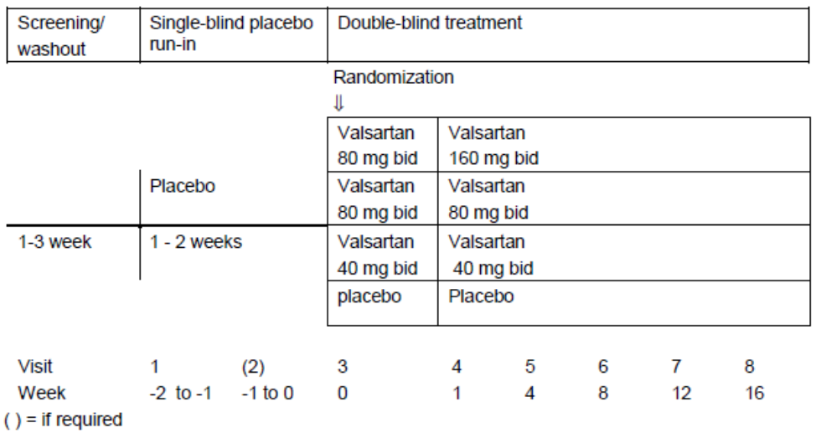
A total of 770 patients were randomised and 650 completed the double-blind treatment period. The baseline demographics were comparable in each treatment group. The majority of patients in each group were White (80.3%-87.7%) and male (78.9%-82.6%) with a mean age of 62.2-63.8 years. All except two patients were NYHA class II or IV, and mean EF ranged from 26.4% to 27.2%.

Results
After 16 weeks treatment, the ETT mean change from baseline increased by 85.1 and 85.4 seconds in the valsartan 40 mg BID and valsartan 80 mg BID groups, respectively, with increases of 68.6 and 65.7 seconds in the valsartan 160 mg BID and placebo groups, respectively. None of the differences for valsartan compared with placebo were statistically significant. There were mean increases in EF from baseline to Week 16 of 2.7% to 4.6% for the valsartan groups compared with 1.4% for placebo. Compared with placebo, the treatment differences for EF were statistically significant for valsartan 40 mg BID (p=0.0437) and 160 mg BID (p=0.0017) but not for valsartan 80 mg BID.
Comment: Compared with placebo, valsartan 40 mg to 160 mg BID did not improve symptoms or QoL in patients with chronic HF NYHA class II-IV, although there were modest increases in EF. The disconnection between haemodynamics and symptoms of heart failure is a common observation.

Study VAL489B0107 (Val-HeFT)
This was a Phase III, multicentre, randomised, double-blind, parallel group, placebo-controlled study to assess the effect of valsartan on morbidity and mortality, signs and symptoms, and quality of life in patients with stable, chronic congestive heart failure (NYHA class II-IV). The study was conducted at 302 centres in 16 countries between March 1997 and October 2000. The primary endpoints were time to death and time to first morbid event (death, sudden death, hospitalisation for HF, and need for inotropic support).

Methodology
A 2 - 4 week screening period was followed by a 2 - 4 week single-blind placebo run-in period. Patients were then randomised 1:1 to receive valsartan 40 mg BID or matching placebo. Randomised patients were stratified according to their use of beta-blockers. After two weeks of treatment, patients were force titrated to valsartan 80 mg BID or placebo, and after a further two weeks they were titrated to 160 mg BID group (Figure 23). Patients who did not tolerate the 160 mg BID dose were down-titrated to 80 mg BID. The targeted treatment period was 24 - 36 months contingent on achieved endpoint numbers. Male or female patients aged 18 years or over with stable congestive HF NYHA II-IV and EF ≤ 40% on echocardiography.
Figure 23. B0107.
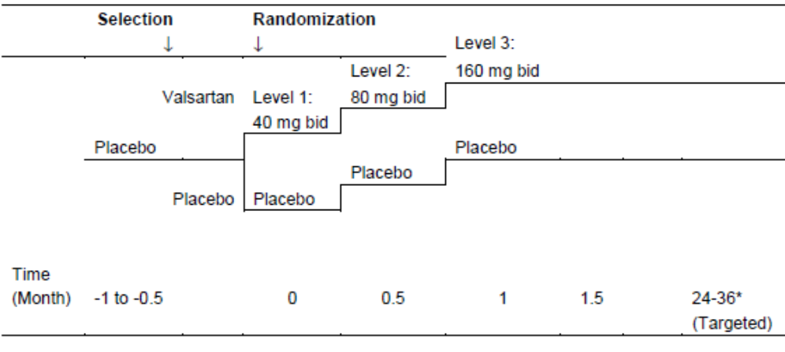
A total of 5,010 patients were randomised and 4,953 completed the double-blind treatment period (to death or study completion). The baseline demographics were comparable in each treatment group. Overall, the majority of patients were White (90.3%) and male (80.0%) with a mean age of 62.7 years. The majority of patients were NYHA class II (61.8%) or IV (36.2%) and the mean EF was 26.7%.

Results
There was a similar incidence of death in the valsartan (19.7%) and placebo groups with a hazard ratio in favour of placebo of 1.017 (95% CI: 0.897, 1.153, p=0.801). However, there were significantly fewer morbid events in the valsartan group (28.8%) compared with placebo with a hazard ratio of 0.868 (95% CI: 0.785, 0.960, p=0.0085). In the valsartan group there were significantly fewer non-fatal morbid events (14.6%) compared with placebo (19.4%) with a hazard ratio of 0.73 (95% CI: 0.63, 0.83). There were also significantly fewer hospitalisations for CHF in the valsartan group (13.9%) compared with placebo (18.5%) with a hazard ratio of 0.725 (95% CI: 0.63, 0.83, p=0.00001). There were no significant treatment differences for cardiovascular deaths, sudden death with resuscitation, or need for inotropic support. NYHA class improved in 20.0% of the valsartan group compared with 18.7% in the placebo group (p<0.001); however, there were no significant treatment-emergent differences in LVEF between groups.
Comment: In this large, controlled study of patients with HF NYHA class II-IV, valsartan was not superior to placebo for reduction in all-cause mortality or cardiovascular deaths. However, compared with placebo, valsartan did reduce the time to first morbid event by 13.2% (p=0.009) and the time to first HF hospitalisation by 27.5% (p=0.0001).

Study VAL489B0107E1
This was a long-term extension study of the primary study VAL489B0107. It started in May 2000 and completed in May 2001. The purpose of the study was to offer continued double-blind treatments until the core study completed and was unblinded. A total of 3,436 patients were eligible for the extension study, 1,598 were enrolled (805 valsartan, 793 placebo) and 1,326 (83.0%) completed. Efficacy was not assessed but safety assessments with monitoring of AEs and SAEs were continued. In the overall population, the majority of patients were White (91.5%) and male (76.8%) with a mean age of 62.1 years. Nearly all patients were NYHA class II (64.8%) or class III (33.7%). Median exposures were 946 and 926 days in valsartan and placebo groups, respectively, and the respective mean daily treatment doses were 275 mg and 298 mg.
Comment: In this extension of study VAL489B0107, no efficacy assessments were made. Safety assessments including AEs and SAEs are described below.

Study VAL489B0110
This was a 12 week, multicentre, randomised, double-blind, active-controlled study to assess the efficacy and safety of valsartan compared to enalapril measured by changes in exercise capacity in patients with stable, moderate, chronic heart failure (NYHA class II-IV). It was conducted at 13 centres in Sweden between August 1999 and April 2000. The main objective was to demonstrate the non-inferiority of valsartan compared with enalapril for exercise tolerance in patients already receiving stable ACEI therapy.

Methodology
Enrolled patients entered a 2 week, single-blind, run-in period during which they continued open-label ACEI therapy. At the end of this period, their ACEI therapies were withdrawn and they were randomised 1:1 to receive either double-blind valsartan or enalapril for 12 weeks (Figure 24). After one week, valsartan was titrated from 80 mg QD to 160 mg QD, and enalapril was titrated from 5 mg BID to 10 mg BID. Exercise capacity was assessed by the 6-minute walk test during which the patient walks as far as possible with rests and stops permitted. The tests were performed at baseline, and at 2 - 4 hours after the morning dose of study medications on Week 6 and Week 12.
Figure 24. B0110.
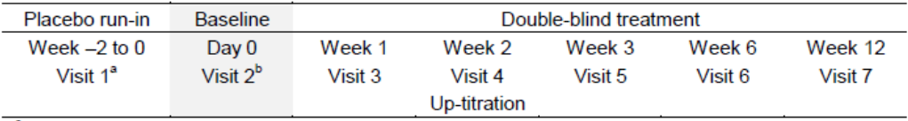
Male and female patients with a minimum age of 18 years, stable chromic HF and LVEF ≤ 45% were enrolled. Overall, 146 patients were enrolled, 141 were randomised and 127 (90%) completed the study. All patients were White and the majority were male (70 - 79%) with a mean age of 67.2 - 68.0 years in the treatment groups. All randomised patients were NYHA class II or III at baseline. There were no meaningful differences in mean walking distance between groups at baseline (valsartan 421.7 m, enalapril 426.0 m).

Results
Valsartan was non-inferior to enalapril for the change from baseline in mean walking distance after 12 weeks. The LSM treatment difference was 1.12 m (95% CI: -21.89, 24.12, p<0.001). Testing for superiority was not statistically significant (p=0.462).
Comment: In this double-blind study of patients with CHF receiving stable ACEI therapy at baseline, exercise tolerance was maintained equally by valsartan and enalapril after 12 weeks treatment.

Study VAL489B0108 (VALIANT)
This was a Phase III, multinational, multicentre, double-blind, randomised, active-controlled, parallel-group study comparing the efficacy and safety of long-term treatment with valsartan, captopril, and their combination in high risk patients after myocardial infarction. It was conducted at 931 centres in 24 countries between December 1998 and May 2003. The primary objectives were to demonstrate the superiority of valsartan compared with captopril for reduction of total mortality after acute myocardial infarction; the superiority of valsartan plus captopril compared with captopril alone for reduction of total mortality; or non-inferiority of valsartan versus captopril if superiority was not demonstrated. A range of secondary endpoints included CV mortality, hospitalisations for HF, recurrent AMI and stroke.

Methodology
Patients were enrolled from 12 hours to 10 days after an AMI. Enrolled patients were randomised in a 1:1:1 ratio either double-blind valsartan 160 mg BID, captopril 50 mg TID, or valsartan 80 mg BID + captopril 50 mg TID. Patients underwent a four step up-titration period after initial doses of valsartan 20 mg BID, captopril 6.25 mg TID, or valsartan 20 mg BID + captopril 6.25 mg TID as shown in Figure 25. The titration period was followed by an indefinite maintenance period until a study endpoint was reached. The planned assumption was that recruitment would take 18 months and the overall study duration would be 4 years. A target population of 14,500 patients with 4,833 in each arm was planned in order to achieve 2,700 patient deaths. The study data were monitored by a DSMB which had the authority to close the study after 6 years if the planned number of endpoints had not been achieved.
Figure 25. B0108.
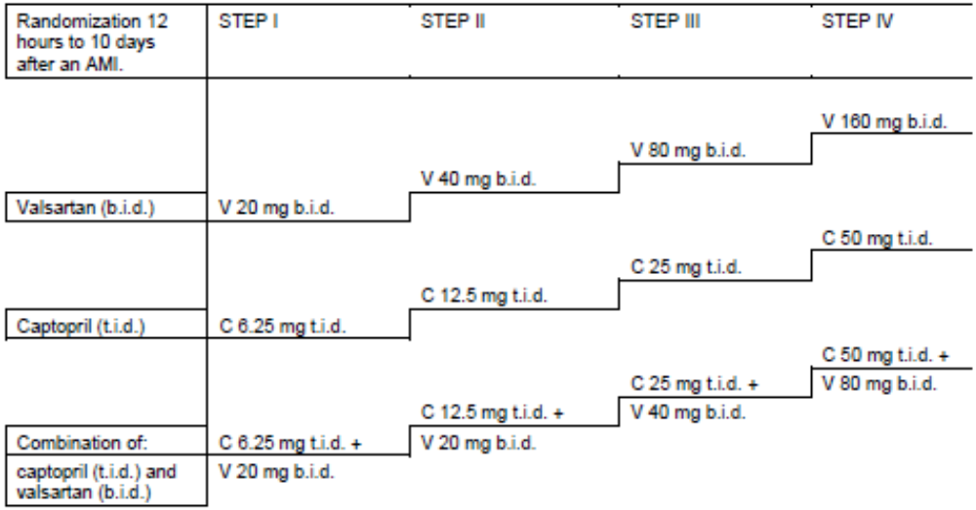
Male and female adult patients with AMI diagnosed by protocol defined criteria were also required to have evidence of heart failure or systolic dysfunction assessed by pre-defined criteria. LVEF was measured by radionuclide ventriculography, ventricular angiography, or echocardiography. A total of 14,703 patients were randomised, 14,030 (95.4%) completed the study, and there were 2,785 (18.9%) deaths. A total of 11,245 (76.5%) patients remained alive when the study was stopped. The baseline demographics were comparable in each treatment group. The majority of patients were White (93.5%) and male (68.9%) with a mean age of 64.3 years. Mean LVEF ranged from 34.4% to 35.6% depending on the method employed. Approximately 28% of patients had a previous myocardial infarction, 40% had angina, and 21% had previous episodes of unstable angina.

Results
All-cause mortality rates were nearly identical in the three treatment groups (valsartan 19.9%, captopril 19.5%, valsartan + captopril 19.3%) with hazard ratios close to 1.0. The non-inferiority analysis of valsartan versus captopril was highly significant (p=0.0023). No meaningful treatment emergent differences were identified in any of the secondary endpoints including CV mortality.

Analyses performed across trials (pooled analyses and meta-analyses)
No pooled analyses or meta-analyses were submitted.

Evaluator’s conclusions on clinical efficacy for the treatment of heart failure (NYHA classII-IV) in patients with systolic dysfunction. ENTRESTO has been shown to reduce the rate of cardiovascular death and heart failure hospitalisations.
Evaluable efficacy data to support the proposed indication were obtained almost exclusively from the pivotal Phase III study CLCZ696B2314 (PARADIGM-HF). The open-label, Phase II study CLCZ696B2228 (TITRATION) compared two titration protocols to initiate LCLZ696 treatment in HFrEF, but the primary endpoint was tolerability and no efficacy assessments were made. The Phase II study CLCZ696B2214 was submitted in support of the pivotal study but the patient population with HFpEF is not relevant to the proposed indication.
PARADIGM-HF was a very large and well controlled Phase III study with clearly defined and widely accepted endpoints. The study design, clinical endpoints and dose selection for the comparator were based on guidance from the US, EU and Canadian authorities. In particular, the acceptability of a single, large, pivotal study was agreed, justified on internal validity, data quality, statistical significance, internal consistency, and applicability to the target population as recommended in the EU Guideline CPMP/EWP/2330/99. An important FDA stipulation was that a minimum mean daily dose of 16.6 mg enalapril should be achieved to match that achieved in the SOLVD study which demonstrated a survival benefit compared with placebo (The SOLVD Investigators, 1991). This target was exceeded with an achieved mean final daily dose of 18.9 mg.
The primary endpoints of CV death and hospitalisations for worsening HF, alone and combined, are those most commonly used in HF outcome trials. To ensure uniform reporting and to reduce potential bias, a blinded adjudicating committee assessed each clinical endpoint. The choice of enalapril as the active comparator was appropriate because it is the standard of care for patients with HFrEF based on proven efficacy compared with placebo (CONSENSUS, 1987; SOLVD, 1991). NYHA class is a generally accepted prognostic indicator of adverse outcomes. In CONSENSUS, a significant efficacy benefit in favour of enalapril was demonstrated in patients with severe CHF of NYHA class IV. In SOLVD, a benefit was also demonstrated in patients with CHF predominantly in NYHA class II or III (mostly with a baseline EF ≤ 35%). Although a small number of patients in PARADIGM-HF had an EF >35%, the great majority of patients were in NYHA class II or III. In general, this population matched that of the SOLVD study, justifying the use of enalapril as a comparator. A placebo control arm was not appropriate for ethical reasons, and valsartan is not as effective as enalapril in HF. In Val-HeFT, a large controlled trial in HF patients, valsartan reduced hospitalisations for HF but it did not reduce mortality compared with placebo (Carson, 2003). Based on these and similar data, valsartan is approved in Australia only for HF patients who are intolerant to ACE inhibitors. Sacubitril alone was not an appropriate study arm. It cannot be added to background ACEI therapy because of the risk of angioedema, and withdrawal of ACEI therapy to permit sacubitril monotherapy would be unethical in HF patients.
The duration of the trial was driven by endpoint targets rather than time and the DMC stopped the study when the primary endpoint was met after the third interim analysis. At this point, the median treatment period (including the run-in) was approximately 27 months. LCZ696 proved superior to enalapril, reducing the risk of the composite endpoint of CV death or HF hospitalisations by 20%. The primary outcome occurred in 914 patients (21.8%) in the LCZ696 group compared with 1,117 patients (26.5%) in the enalapril group (HR 0.80; 95% CI: 0.73 to 0.87, P<0.001). There were 711 (17.0%) deaths from any cause in the LCZ696 group, and 835 (19.8%) deaths in the enalapril group (HR 0.84; 95% CI: 0.76, 0.93, P<0.001). There were 558 (13.3%) deaths from CV causes in the LCZ696 group and 693 (16.5%) in the enalapril group (HR 0.80; 95% CI: 0.71, 0.89, P<0.001).
Compared with enalapril, LCZ696 also reduced the risk of hospitalization for heart failure by 21% (p<0.001) and decreased the symptoms and physical limitations of heart failure (p=0.001).
The LVEF ≤ 40% inclusion criterion was changed to ≤ 35% by protocol amendment following publication of the EMPHASIS-HF trial (Zannad, 2011). In this study in patients with mild heart failure (NYHA class II, EF ≤ 30%), there was a 37% reduction in death from CV causes or hospitalisations for the MRA eplerenone compared with placebo. Increased use of eplerenone was expected to reduce the number of events and the step was taken to increase the incidence rate to complete the trial in the proposed time frame. Relatively few randomised patients had an EF ≥35% and this amendment is unlikely to have introduced bias for or against either trial medication. In addition, the overall study population in PARADIGM-HF is comparable to the target population. The run-in periods ensured that patients were able to tolerate the 20 mg BID dose of enalapril and the LCZ696 200 mg BID dose at least in the short term, and the 36 hour washout periods minimised the risk of angioedema at cross-over points.
In summary, in patients with HFrEF, inhibition of angiotensin II and neprilysin with LCZ696 was 20% more effective than enalapril in reducing the primary composite endpoint of CV death and hospitalisation for HF, and for CV death alone. All-cause mortality was also reduced by 16%. The percentage endpoint reductions were both highly meaningful and statistically significant. LCZ696 also reduced symptoms and physical limitations associated with heart failure, and the benefit was observed in a patient population already receiving other effective HF medications such as beta-blockers and MRAs. No clinically significant differences in subgroups compared with the overall populations were observed. The overall exposure in more than 4,000 patients for approximately 27 months is sufficient to justify life-long treatment, particularly in patients with reduced life expectancy.
The absolute risk reductions compared with enalapril were small (4.7% for the combined endpoint, 3.1% for CV death, and 2.8% for HF hospitalisations). Nonetheless, this novel product is a significant advance in the treatment of patients with systolic dysfunction.

Clinical safety

Studies providing evaluable safety data

Pivotal efficacy study
CLCZ696B2314 (PARADIGM-HF): A pivotal, Phase III, long-term outcomes study in 8,442 randomised patients with a median follow-up time of 27 months.
In the pivotal efficacy study, the following safety data were collected:
- General adverse events (AEs) were assessed by primary SOC and PT according to severity and causality using MedDRA version 17.0.
- AEs of particular interest were identified based on the known safety profiles of valsartan, ACEIs and MRAs. These were hypotension, hyperkalaemia, renal impairment, angioedema, and embryo-foetal and infantile toxicity. Other events of special interest were hepatotoxicity, hypersensitivity and statin drug-drug interaction based on routine pharmacovigilance for NCEs.
- Routine laboratory tests for the pivotal study were processed centrally and collated by Cognizant Technology Solutions (India).

Dose-response and non-pivotal efficacy studies
No formal dose-response study of LCZ696 in heart failure was conducted.
The following non-pivotal efficacy studies provided evaluable safety data:

LCZ696 HF studies
CLCZ696B2214 (PARAMOUNT): A supportive, Phase II, 12 week study in 301 randomised patients.
CLCZ696B2228 (TITRATION): A supportive, Phase II study comparing LCZ696 3- and 6-week titration regimens in 498 patients.

Sacubitril monotherapy studies
Sacubitril monotherapy is not proposed for the treatment of heart failure and no studies have been performed. A sacubitril monotherapy arm of 165 hypertensive patients was included in CLCZ696A2201. These data are included in the pooled HTN analysis.

LCZ696 HTN studies (pooled)
The results of six short-term hypertension studies (CLCZ696A2201, CLCZ696A2219, CLCZ696A2223, LCZ696A1306, LCZ696A2316, and LCZ696A2319) were pooled to support the pivotal LCZ696 safety data set.

LCZ696 HTN studies (non-pooled)
Six LCZ696 hypertension studies were not pooled, either because they were on-going or because of significant differences in study populations or design ((CLCZ696A2219E, LCZ696A1304, LCZ696A1305, CLCZ696A2315, LCZ696A2318, and CLCZ696A2216).

Valsartan HF studies
Safety data from the large Phase III studies CVAL489B0107 (VAL-HeFT) and CVAL489B0108 (VALIANT) are considered with a pooled analysis from five other controlled HF trials (CVAL489B0106, CVAL489B0110, CVA489B0103, CVAL489B0104, and CVALB0107).

Valsartan HTN studies (pooled)
Pooled safety data have been provided for the valsartan 320 mg hypertension indication submitted to the EMA in 2005. A total of 7,228 patients were treated with valsartan of whom over 2,300 received the 320 mg dose. Summarised data are provided from five large controlled, Phase III trials (CVAL489A031, CVAL489H2301, CVAH631B0301, CVAH631C2301, and CVAA489A2201), three controlled Phase IV trials (CVAH631B2401, CVAH631B2403, and CVAH631B2405), two uncontrolled trials and one long-term extension study.

Clinical pharmacology studies
A total of 30 clinical pharmacology studies enrolled 1,117 healthy subjects, patients with HTN and HF, and special populations including the elderly and those with renal or hepatic impairment. Safety data from studies in healthy subjects were pooled. No pooled safety analyses in patients were provided due to small sample sizes, different dose regimens and different populations.

Pivotal studies that assessed safety as a primary outcome
None submitted.

Patient exposure
A total of 14,997 patients were exposed to LCZ696 in the development program (HF 10,106, HTN 3,874, and clinical pharmacology 1,117). In PARADIGM-HF, 4,203 patients were exposed to LCZ696 for at least one day with a total exposure of 8,636 patient years. The median duration of exposure was 27 months for the LCZ696 group, and exposure was ≥6 months in 92.5% of patients. A total of 149 and 497 patients received LCZ696 200 mg BID for at least one day in the HF studies CLCZ696B2214 and CLCZ696B2228, with total exposures of 89.7 and 108.9 patient years, respectively.
In the pooled HTN studies, mean study duration was 8 weeks and median duration of LCZ696 treatment ranged from 56.0 to 61.0 days. In the long-term study CLCZ696A2219E1, the median duration of exposure was 358.0 days and > 90% of patients were exposed for more than 300 days.

Adverse events

All adverse events (irrespective of relationship to study treatment)

Pivotal heart failure study

CLCZ696B2314
During the single blind run-in period (median duration 15 days), 22.5% of enalapril patients reported AEs. Most AEs were mild or moderate, most commonly cough 2.8%, hyperkalaemia (2.7%), renal impairment (2.2%) and hypotension (2.0%). During the LCZ696 run-in period (median duration 29 days), 28.7% of patients reported AEs. The majority of AEs reported during the LCZ696 run-in period were mild or moderate, most commonly hypotension (3.1%), hyperkalaemia (2.8%) and renal impairment (2.3%).
During the double-blind treatment period (approximate median 27 months), AEs were reported in 81.4% of the LCZ696 group compared with 82.8% of the enalapril group (Table 8). The most common AEs by SOC (≥ 10% of patients, LCZ696 vs enalapril) were cardiac disorders (38.3% vs 42.0%), infections and infestations (32.5% vs 33.1%), metabolism and nutrition disorders (27.05% vs 28.45%), vascular disorders (24.72% vs 20.45%), respiratory disorders (21.06% vs 27.0%), gastrointestinal disorders (19.25% vs 19.93%), nervous system disorders (18.32% vs 17.92%), renal and urinary disorders (18.01% vs 19.44%) and musculoskeletal disorders (16.13% vs 15.89%). The most common AEs by PT (≥ 2%) are shown in Table 9. The most common events were hypotension (17.6% vs 12.0%), cardiac failure (17.4% vs 19.7%), hyperkalaemia (11.6% vs 14.0%), renal impairment (10.1% vs 11.5%), cough (8.8% vs 12.6%), and dizziness (6.3% vs 4.9%). Cardiac failure, cough, hyperkalaemia, and renal impairment occurred more commonly in the enalapril group, while hypotension and dizziness occurred more commonly in the LCZ696 group.

Table 8. AEs B2314.
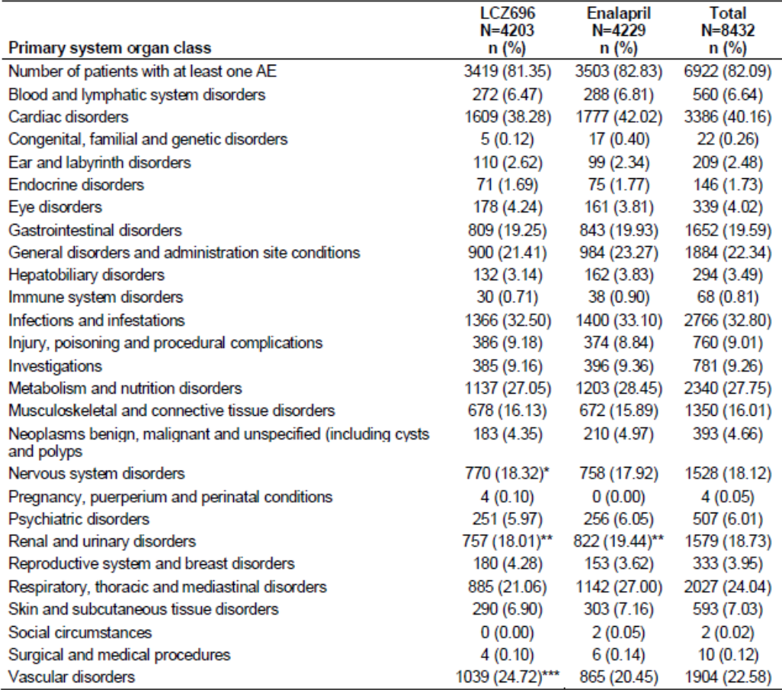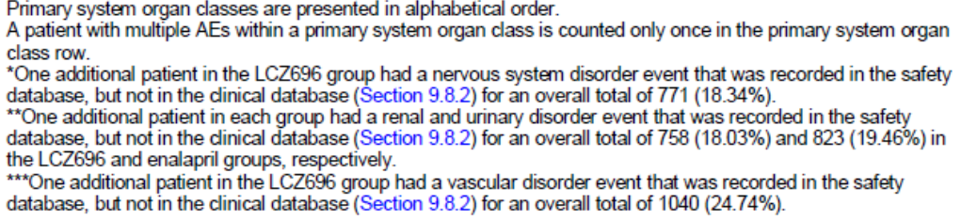

Table 9. AEs B2314.
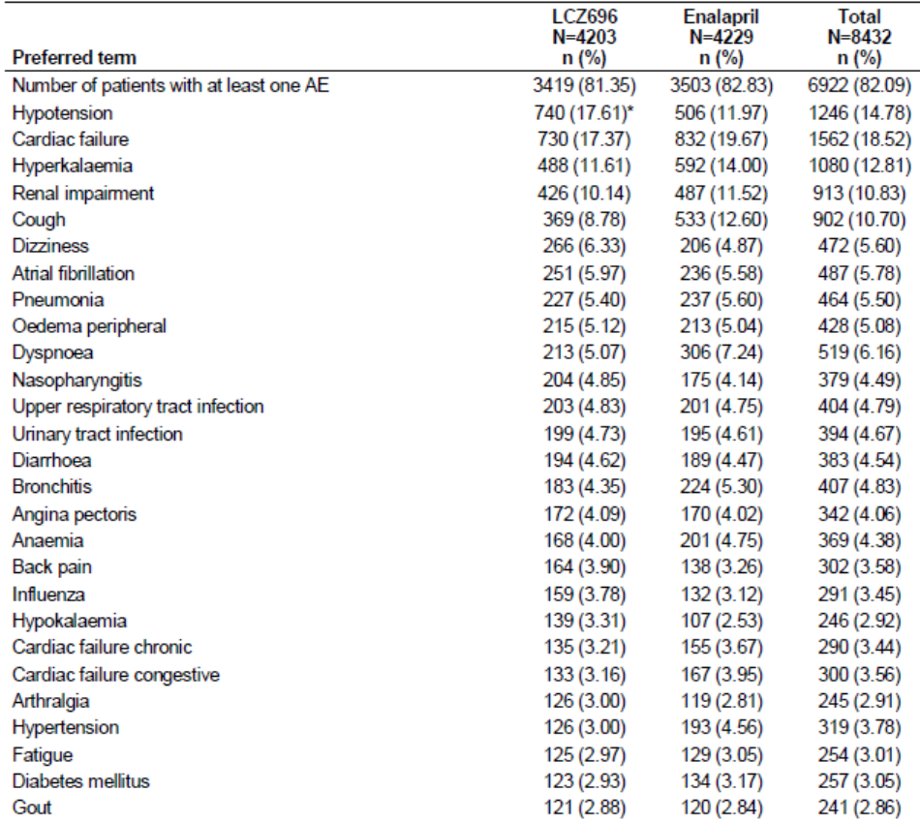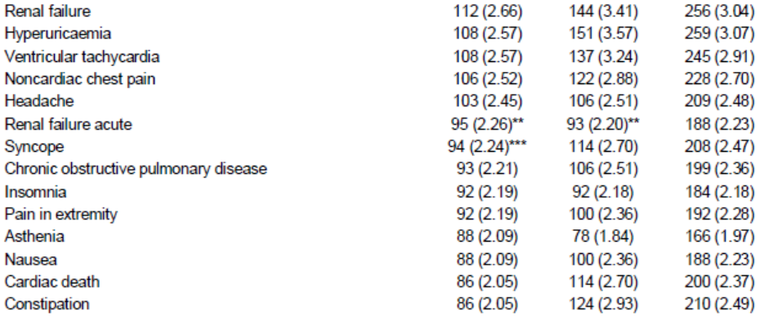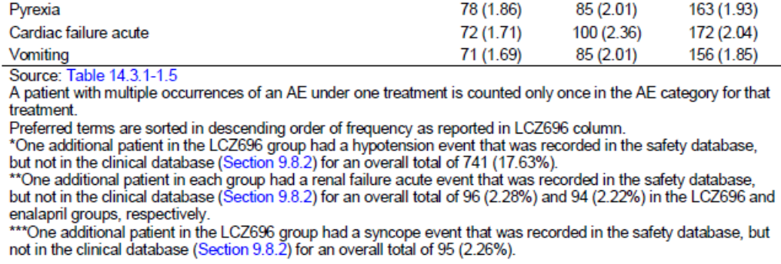

Other heart failure studies

CLCZ696B2214
AEs were reported in 64.4% of patients treated with LCZ696 compared with 73.0% in the valsartan group. Most AEs were mild or moderate. The most commonly reported events by SOC (LCZ696 vs valsartan) were vascular disorders (16.8% vs 22.4%), gastrointestinal disorders (16.8% vs 16.4%), infections and infestations (16.1% vs 24.3%), musculoskeletal disorders (15.4% vs 13.2%), general disorders (14.8% vs 19.7%), cardiac disorders (14.1% vs 22.4%), metabolism and nutritional disorders (13.4% vs 11.8%) and nervous system disorders (12.8% vs 14.5%). The most common events were hypotension (14.1% vs 9.9%), hyperkalaemia (8.1% vs 5.9%), diarrhoea (6.7% vs 2.6%), dizziness (6.7% vs 4.6%), and dyspnoea (4.0% vs 9.2%). Events occurring more commonly in the LCZ696 group included hypotension, hyperkalaemia, diarrhoea and dizziness, while dyspnoea occurred more commonly in the valsartan group.

CLCZ696B2228
During the run-in period, AEs were reported in 12.3% of patients, most commonly hypotension (1.7%), hyperkalaemia (1.5%) and dizziness (1.1%). During the post-randomisation period, AEs were reported by 51.6% of the LCZ696 condensed titration group compared with 42.2% in the LCZ696 conservative titration group. The most commonly reported AEs by SOC in the overall group were vascular disorders (11.3%), cardiac disorders (9.7%), metabolism and nutritional disorders (9.3%), nervous system disorders (7.0%), infections and infestations (6.4%), investigations (6.2%), and gastrointestinal disorders (4.8%). AEs occurred more commonly in the condensed group compared with conservative group. The most common AEs (condensed vs conservative titration groups, respectively) were hypotension (9.8% vs 8.4%), hyperkalaemia (6.5% vs 4.4%), dizziness (3.7% vs 2.4%), renal impairment (4.1% vs 1.6%) and cardiac failure (3.7% vs 1.2%).

Treatment-related adverse events (adverse drug reactions)

Pivotal heart failure study

CLCZ696B2314
During the single blind run-in period, 6.3% of enalapril patients reported AEs suspected by the investigator to be drug related, most commonly hypotension (1.5%), cough 1.3%, hyperkalaemia (1.2%) and renal impairment (1.0%). During the LCZ696 run-in period, 7.3% of patients reported ADRs, most commonly hypotension (2.3%), hyperkalaemia (1.3%) and renal impairment (1.1%).
During the double-blind treatment period, ADRs were reported in 21.7% of the LCZ696 group compared with 23.1% of the enalapril group. The most common ADRs (≥ 2% of patients, LCZ696 vs enalapril) were hypotension (10.2% vs 6.9%), hyperkalaemia (4.6% vs 5.6%), renal impairment (2.8% vs 4.2%) and cough (1.5% vs 3.8%).

Other heart failure studies

CLCZ696B2214
ADRs were reported in 18.8% of patients treated with LCZ696 compared with 22.4% in the valsartan group. The most common events were hypotension (9.4% vs 6.6%), hyperkalaemia (2.7% vs 2.6%), dizziness (2.0% vs 1.3%) and peripheral oedema (1.3% vs 0.0%).

CLCZ696B2228
During the post-randomisation period, ADRs were reported by 17.1% of the LCZ696 condensed titration group compared with 13.1% in the LCZ696 conservative titration group. The most common ADRs (condensed vs conservative titration groups, respectively) were hypotension (7.3% vs 6.4%) and hyperkalaemia (4.5% vs 2.4%).

Deaths and other serious adverse events

Pivotal heart failure study

CLCZ696B2314
During the single blind run-in period, 55 enalapril patients died before being exposed to LCZ696, the great majority due to CV causes (9.4 all-cause deaths per 100 patient years). SAEs were reported in 2.6% of enalapril patients mostly related to cardiac disorders. During the LCZ696 run-in period, 63 patients died before randomisation, the great majority also due to CV causes (8.1 all-cause deaths per 100 patient years). SAEs were reported in 3.5% of patients, most commonly due to cardiac disorders.
During the double-blind treatment period, there were 729 (17.3%) and 848 (20.1%) deaths in the LCZ696 and enalapril groups, respectively. The great majority of deaths were due to cardiovascular causes (78.4% vs 82.9%), most commonly sudden death (35.2% vs 37.2%) and pump failure (20.6% vs 22.1%). There were no clinically relevant differences in the frequency of non-cardiovascular deaths between the groups. There were fewer SAEs in the LCZ696 group (46.1%) than in the enalapril group (50.7%). The difference in incidence was related mainly to cardiac disorders, cardiac death, and pneumonia. The most common SAE was cardiac failure, reported in 14.0% and 15.4% of the respective groups.

Other heart failure studies

CLCZ696B2214
During the double-blind period, there was one (0.7%) death in the LCZ696 group compared with two (1.3%) in the valsartan group. None of the deaths were considered drug related. SAEs were reported in 14.8% and 19.7% of the respective groups. The most common SAEs were unstable angina (2.0% vs 0.7%) and cardiac failure (2.0% vs 1.3%).

CLCZ696B2228
During the post-randomisation period, there were two (0.8%) deaths in the LCZ696 condensed titration group compared with one (0.4%) in the LCZ696 conservative titration group. None of the deaths were considered drug related. SAEs were reported in 8.5% and 5.6% of the respective groups. The most common SAEs (condensed vs conservative titration groups) were cardiac failure (1.2% vs 0.8%), AMI (0.8% vs 0.4%), atrial fibrillation (0.8% vs 0.4%) and cardiogenic shock (1.2% vs 0.0%).

Discontinuation due to adverse events

Pivotal heart failure study

CLCZ696B2314
During the single blind enalapril run-in period, 6.1% of patients withdrew because of AEs, most commonly due to cough (0.5%), hyperkalaemia (1.7%), renal impairment (1.6%) and hypotension (1.4%). During the LCZ696 run-in period, 5.5% of patients withdrew because of AEs, most commonly due to hypotension (1.7%), hyperkalaemia (1.2%) and renal impairment (1.2%).
During the double-blind treatment period, 11.5% of patients permanently discontinued study drug because of AEs. The most common events leading to discontinuation were (LCZ696 vs enalapril) cardiac failure (1.50% vs 1.54%), cardiac death (0.67% vs 0.76%), hypotension (0.62% vs 0.54%), sudden cardiac death (0.59% vs 0.52%) and renal impairment (0.43% vs 0.78%).

Other heart failure studies

CLCZ696B2214
During the double-blind period, withdrawals occurred in 10.1% of the LCZ696 group compared with (11.2%) in the valsartan group, most commonly due to hyperkalaemia (3.4% vs 2.0%), hypotension (1.3% vs 2.6%) and peripheral oedema (1.3% vs 0.0%).

CLCZ696B2228
During the run-in period, 5.6% of patients discontinued due to AEs, most commonly due to hyperkalaemia (1.5%) and hypotension (1.5%). During the post-randomisation period, 8.1% of patients in the condensed group withdrew compared with 5.6% in the conservative group, most commonly due to hypotension (2.0% vs 1.2%) and hyperkalaemia (1.2% vs 0.4%).

Laboratory tests

Liver function

Pivotal heart failure study

CLCZ696B2314
LFT abnormalities were comparable in each treatment group and clinically significant abnormalities were uncommon. ALT abnormalities > 5xULN were reported in 0.40% and 0.25% of the LCZ696 and enalapril groups, respectively. Increases in total bilirubin > 2xULN were reported in 1.2% and 2.1% of the respective groups.

Other heart failure studies

CLCZ696B2214
During the double-blind period, LFT abnormalities were comparable and uncommon in each treatment group (< 1%). Only one patient had a significant LFT abnormality (in the setting of pancreatic carcinoma and biliary obstruction).

CLCZ696B2228
During the post-randomisation period, no patients in either titration group experienced ALT/AST increases > 3xULN.

Kidney function

Pivotal heart failure study

CLCZ696B2314
Reductions in eGFR and increases in serum creatinine from baseline were experienced less frequently in the LCZ696 group compared with the enalapril group. Reductions in eGFR > 50% were reported in 5.5% and 6.4% of the respective groups. Serum creatinine levels > 221 µmol/L were reported in 3.2% and 4.4% of patients, respectively. Changes in eGFR over time are compared for each treatment group in Figure 26.
Figure 26. Kidney function B2314.
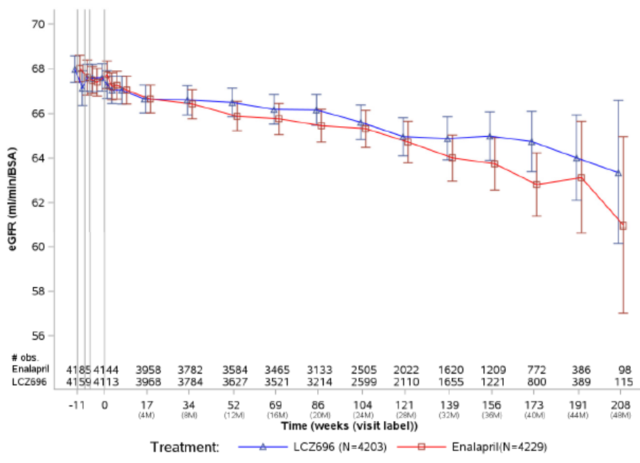

Other heart failure studies

CLCZ696B2214
Reductions in eGFR and increases in serum creatinine were comparable in the LCZ696 and valsartan groups. Reductions in eGFR > 50% from baseline were reported in 3.4% and 2.8% of the respective groups. Serum creatinine levels increased ≥50% from baseline in 11.5% and 13.3% of patients, respectively.

CLCZ696B2228
From baseline to Week 12 during the post-randomisation period, increases in serum creatinine occurred more commonly in the condensed titration group compared with the conservative group. Serum creatinine increases > 50% were experienced by 5.7% and 4.0% of the respective groups. Serum creatinine > 221 µmol/L was experienced by 1.6% and 0.8% of patients, respectively.

Other clinical chemistry

Pivotal heart failure study

CLCZ696B2314
Changes from baseline in clinical chemistry parameters were comparable in each treatment group. Hyperkalaemia with potassium > 5.5 mmol/L at any visit was reported in 15.5% and 16.5% of the LCZ696 and enalapril groups, respectively. At the last visit, the mean changes from baseline in alkaline phosphatase and uric acid were slightly greater in the enalapril group.

Other heart failure studies

CLCZ696B2214
Changes from baseline in clinical chemistry parameters were minor and comparable in each treatment group. Hyperkalaemia with potassium > 5.5 mmol/L at any visit was reported in 16.2% and 11.2% of the LCZ696 and valsartan groups, respectively.

CLCZ696B2228
From baseline to Week 12, changes in clinical chemistry parameters were minor and comparable in each group. Hyperkalaemia with potassium > 5.5 mmol/L at any visit was reported in 7.7% and 6.0% of the condensed and conservative titration groups, respectively.

Haematology

Pivotal heart failure study

CLCZ696B2314
Changes from baseline in haematology parameters in the post-randomisation period were minor and comparable in each treatment group. Clinically significant abnormalities were uncommon and comparable between groups.

Other heart failure studies

CLCZ696B2214
Changes from baseline in haematology parameters in the post-randomisation period were minor and comparable in each treatment group. Clinically significant haematocrit reductions were reported in 8.1% and 14.0% of the LCZ696 and valsartan groups, respectively.

CLCZ696B2228
From baseline to Week 12, there were no clinically meaningful differences in any haematological parameter between the condensed and conservative titration groups.

Electrocardiograph

Pivotal heart failure study

CLCZ696B2314
There were no clinically meaningful changes from baseline in any ECG time interval or heart rate in either treatment group. Multiple cardiac arrhythmias were reported in both groups but most were numerically fewer in the LCZ696 group compared with enalapril. Treatment emergent atrial fibrillation was reported in 4.7% and 5.4% of the respective groups. Clinically significant treatment emergent ECG abnormalities were captured as cardiac AEs.

Other heart failure studies

CLCZ696B2214
There were no clinically meaningful changes from baseline in any ECG time interval or heart rate in the LCZ696 and valsartan groups. The incidence of significant arrhythmias was low and comparable in each group. Treatment emergent atrial fibrillation was reported in 4.5% of each group.

CLCZ696B2228
From baseline to Week 12, there were no clinically meaningful differences in any ECG parameter between the condensed and conservative titration groups.

Vital signs

Pivotal heart failure study

CLCZ696B2314
Low SBP and DBP were experienced more frequently in the LCZ696 group compared with the enalapril group (SBP 4.8% vs 2.7%, DBP 3.1% vs 1.6%). Changes in heart rate were comparable in each treatment group. Low body weight was reported less frequently in LCZ696 group (21.2% vs 25.4%) and high body weight was reported more frequently (27.0% vs 21.9%).

Other heart failure studies

CLCZ696B2214
More patients in the LCZ696 group reported a fall ≥ 30 mm Hg in msSBP compared with the valsartan group (25.0% vs 15.2%); however, falls in msDBP were comparable (4.1% in each group). Decreases in heart rate occurred more frequently in the valsartan group (2.0% vs 6.2%) but increases in body weight were comparable in each group.

CLCZ696B2228
From baseline to Week 12, there were no clinically meaningful differences in SBP, DBP, heart rate or body weight between the condensed and conservative titration groups.

Pooled safety data

LCZ696 Heart failure studies
No pooled LCZ696 HF analysis was performed but an overall summary of the most common AEs by PT is provided in Table 10. The most common AEs across the individual studies were hypotension, cardiac failure, hyperkalaemia, renal impairment, cough, and dizziness. The AE profile of LCZ696 was comparable or more favourable in the LCZ696 groups compared with enalapril or valsartan. However, hypotension was more frequently observed in the LCZ696 groups than in the comparator groups. An overall summary of the most common SAEs is shown in Table 11. The most common SAEs were related to worsening cardiac failure, other cardiovascular events, pneumonia, renal failure and cerebrovascular events. SAEs were generally less frequent in the LCZ696 groups than in the comparator groups. However, the number of SAEs in the supportive studies was too low to make meaningful comparisons.

Table 10. HF AE summary.
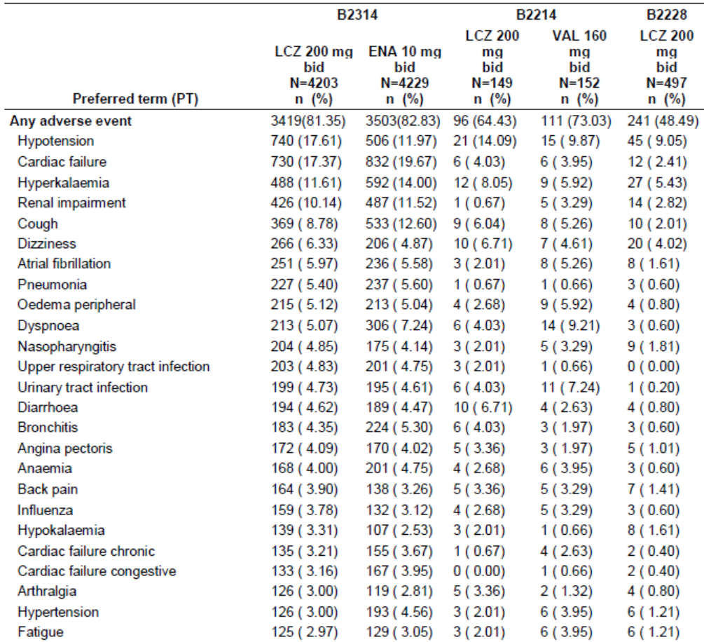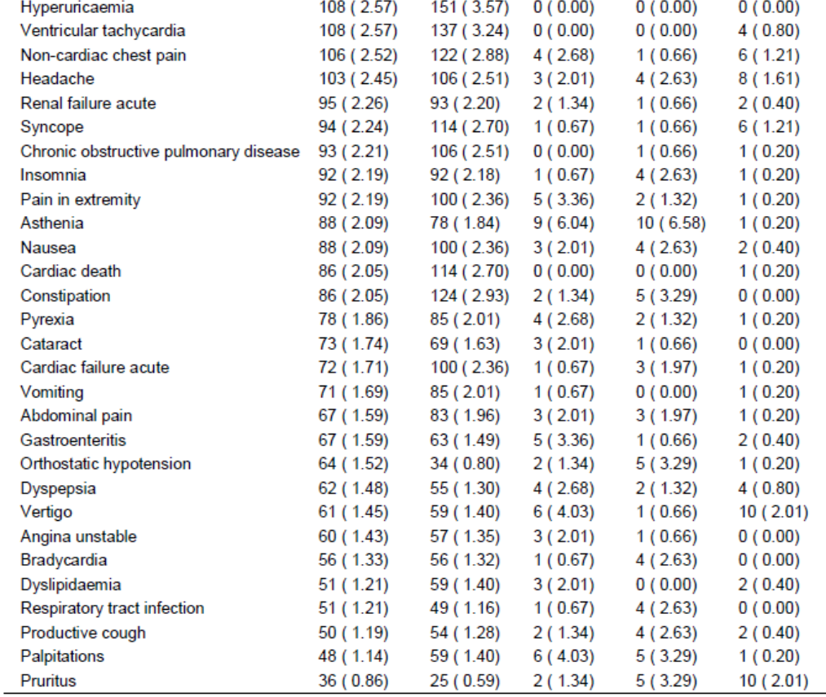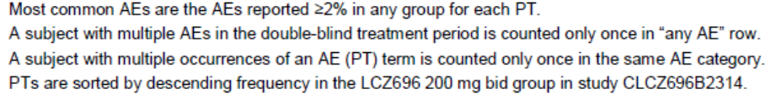

Table 11. SAEs LCZ696 HF studies.
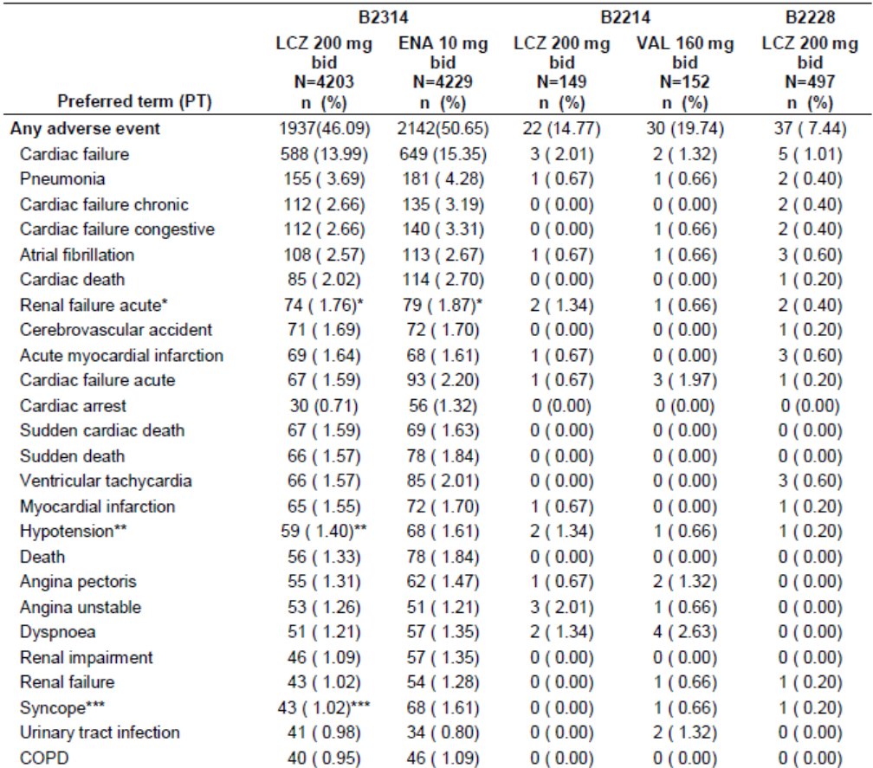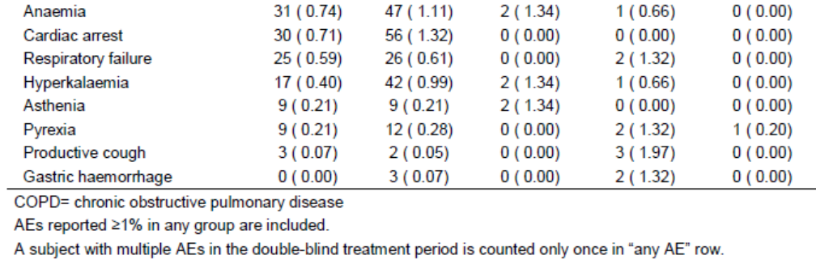

LCZ696 pooled HTN studies
The incidence of AEs in the pooled HTN studies was 34.7% in the LCZ696 group (695/2004 patients) compared with 31.9% in the placebo group (103/323 patients). The most common events by PT in the LCZ696 group were nasopharyngitis (7.5%), headache (1.9%), and upper respiratory tract infections (1.9%). Nasopharyngitis was more common in the LCZ696 group compared with placebo (7.5% vs 3.1%). The incidence of hypotension was low (0.1% vs 0.0%) and the incidence of renal and urinary disorders was also low in each group (0.7% vs 0.6%). In the LCZ696 100 mg, 200 mg and 400 mg groups, the incidence of AEs was 4.3%, 8.5% and 7.4%, respectively. In the long-term HTN study CLCZ696A2219E1, the AE profile was similar to that of the pooled HTN population. The most common events by PT were nasopharyngitis (18.2%), dizziness (8.8%) and upper respiratory infection (7.6%).

Sacubitril monotherapy studies
No sacubitril monotherapy studies were conducted. However, a sacubitril 200 mg monotherapy arm of 165 patients was included in the HTN study CLCZ696A2201. The profiles and incidence of AEs were comparable in the sacubitril (27.3%) and placebo groups (28.3%). No deaths were reported.

LCZ696 clinical pharmacology studies
LCZ696 was well tolerated in 30 clinical pharmacology studies in healthy subjects, patients with heart failure and hypertension, and special populations. In a total of 1,117 healthy subjects and patients, there were no deaths, six SAEs and 23 discontinuations due to AEs. None of the SAEs were considered drug related by the investigators.
AEs experienced by healthy subjects were generally unremarkable. They were mostly mild or moderate and only severe in 0.1% of LCZ696 subjects. The incidence of AEs did not appear to be dose related and there were no meaningful trends in haematology or clinical chemistry values. Blood pressure lowering was observed but no significant ECG abnormalities were reported. There was a single case of adjudicated angioedema in a healthy subject.

Pooled valsartan HF studies
In the double-blind, controlled, short-term trials, 3,282 patients received valsartan, 2,740 received placebo and 86 received an active control (either lisinopril or enalapril). AEs were reported in 72.5% and 68.5% of the valsartan and placebo groups. In the double-blind, placebo-controlled, short-term trials, 5,967 patients received valsartan, 2,740 received placebo, and 15 were treated with lisinopril. AEs were reported in 73% and 68.5% of the valsartan and placebo groups. The AE rates were generally comparable to placebo with the exception of dizziness (17.3% vs 9.3%), hypotension (6.6% vs 2.4%), postural hypotension (2.5% vs 1.2%), fatigue (2.7% vs 1.9%) and hyperkalaemia (2.4% vs 1.1%). Overall, the frequency and profile of the reported AEs was comparable to the primary data set.
In the Val-HeFT study (CVAL489B107), 2,506 patients received valsartan and 2,494 received placebo for a mean treatment duration of 22.4 months. AEs were reported in 91.6% of the valsartan group compared with 89.6% in the placebo group (Table 12). As in the pooled studies, the most common AEs reported by PT were dizziness (25.0% vs 18.1%), and hypotension (13.8% vs 8.1%). With these exceptions, the AE profiles of the valsartan and placebo groups were generally comparable.

Table 12. AEs Val-HeFT study.
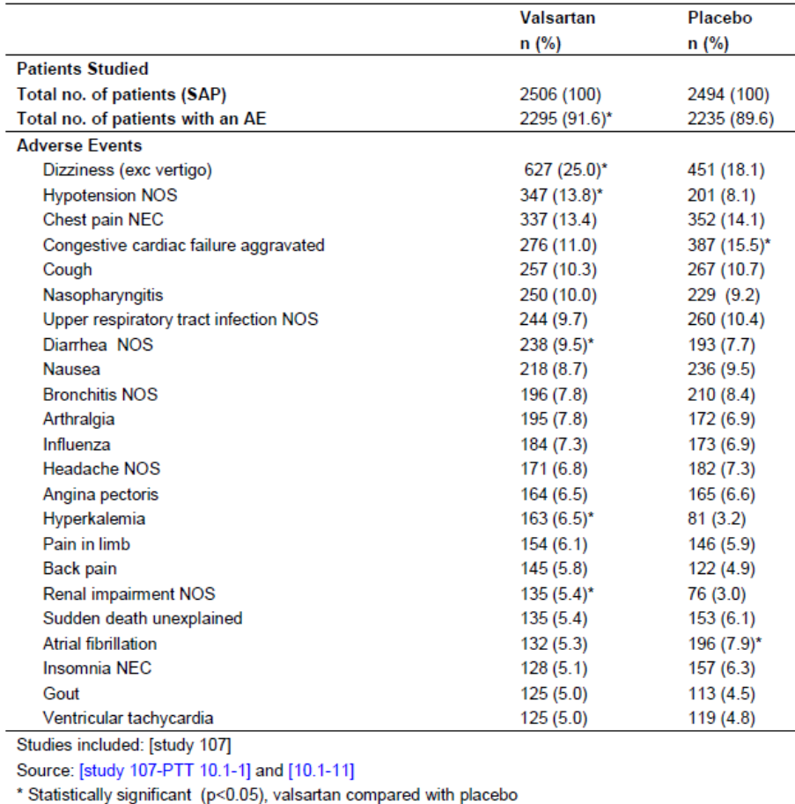

Pooled valsartan HTN studies
In the pooled analysis of valsartan HTN studies, the incidence of AEs reported by PT was comparable in the placebo group and valsartan 80 mg, 160 mg, and 320 mg groups (49.5%, 44.6%, 27.8%, and 53.2%, respectively). The most common events in the placebo and valsartan groups were headache (placebo 12.3%, valsartan 4.7% to 7.8%), and dizziness (placebo 3.9%, valsartan 1.8% to 6.7%). Cough was notably more common in the lisinopril group (7.6%) compared with placebo (0.6%), or valsartan (1.1% to 2.9%).
Comment: The AE profile of valsartan in the pooled HTN studies was comparable to that in the current valsartan PI. Overall, the AE profile is comparable to placebo and no new safety signals have been detected.

AEs of special interest
AEs of special interest were identified based on the known class effects of ARBs, ACEIs and MRAs:
- Hypotension
- Renal impairment
- Hyperkalaemia
- Angioedema
- Embryo-foetal and infantile toxicity (not applicable as no pregnancy related events were reported)
Other AEs of interest were highlighted as part of the routine assessment of new drugs:
- Hepatotoxicity
- QTc prolongation
- Malignancies
- Hypersensitivity reactions (excluding angioedema)
Theoretical AEs or potential AEs identified in the LCZ696 pre-clinical program were assessed:
- Gastric lesions
- Lipolysis
- Changes in bone growth
- Cognitive impairment.

LCZ696 heart failure studies
AEs and SAEs of special interest were assessed in the safety set of the active-controlled pivotal study CLCZ696B2314, the active-controlled study CLCZ696B2214, and the uncontrolled titration study CLCZ696B2228. Data from the pivotal study which included 4,203 patients in the LCZ696 arm are summarised below.

Hypotension
Hypotension-related AEs (including hypotension, orthostatic hypotension, dizziness, and syncope) were reported more frequently in the LCZ696 group compared with enalapril (24.4% vs 18.6%). Most hypotension-related AEs were mild or moderate and most occurred during the early phase of treatment. Symptomatic hypotension was reported in 13.2% and 8.2% of patients in the LCZ696 and enalapril groups, respectively [RR 1.7 (95% CI: 1.5, 1.9)]. Severe events were reported in 1.9% of the LCZ696 group compared with 2.1% of the enalapril group, and SAEs were reported in 2.8% vs 3.5% of the respective groups.

Renal impairment
The incidence of all renal impairment AEs was 16.2% in the LCZ696 group and 17.6% in the enalapril group [RR 0.9 (95% CI: 0.8, 1.0)]. AEs of renal failure and renal impairment was less frequent in the LCZ696 group compared with enalapril (renal failure 2.7% vs 3.4%, renal impairment 10.1 vs 11.5%). The rates of reduced eGFR and increased blood creatinine were low and comparable between groups. SAEs related to renal failure, renal impairment, and acute renal failure were all marginally lower in the LCZ696 group compared with enalapril.

Hyperkalaemia
Hyperkalaemia AEs occurred less commonly in the LCZ696 group compared with enalapril (11.9% vs 14.3%). Severe hyperkalaemia was reported in 0.5% and 0.8% of the respective groups, and SAEs were reported in 0.4% and 1.0% of the respective groups.
The incidence of other AEs of special interest, including cognitive impairment, hypersensitivity reactions, changes in bone growth/bone mineral density, gastric lesions, malignancies, and stimulation of lipolysis were comparable in the LCZ696 and enalapril groups.

LCZ696 pooled HTN studies
The incidence of all events of interest was low and comparable in the placebo and active treatment groups. There were no meaningful differences between the LCZ696 100 mg, 200 mg, and 400 mg doses.

Post-marketing experience
LCZ696 has not been marketed in any jurisdiction.

Safety issues with the potential for major regulatory impact

Liver toxicity
Significant LFT abnormalities were independently reviewed if they met standard pre-defined criteria (AST/ALT > 3xULN and total bilirubin > 2xULN on the same day, or AST/ALT > 5xULN at any visit). All liver-related SAEs by PT were also reviewed. No significant treatment differences or safety signals were detected.
The incidence of hepatic events was low in both treatment groups but marginally higher in the LCZ696 group compared with enalapril. In the LCZ696 group, there were 21 cases of transaminases > 5xULN and four were considered drug related. There was only one case of AST/ALT> 3xULN and total bilirubin > 2xULN at the same visit. Shifts from normal to high transaminase values were reported more frequently in the enalapril group compared with LCZ696 (ALT 10.0% vs 8.0%, total bilirubin 10.4% vs 9.1%). Only one significant hepatic event was reported in the other LCZ696 HF studies, and no events were reported in the sacubitril arm of CLCZ696A2201. In the pooled LCZ696 HTN studies, hepatotoxicity was reported in 1.2% of the LCZ696 monotherapy group and 0.6% in the placebo group. The majority of events were related to increases in transaminases and bilirubin (0.9% vs 0.6%). In CVAL489B0107, the incidence of hepatic events was also low and comparable in the valsartan and placebo groups (hepatic function abnormal 0.12% vs 0.28%, respectively).
Comment: LFT abnormalities are to be expected in patients with HF due to hepatic ischaemia and liver congestion associated with right heart failure. However, the incidence of significant liver events was low in HF patients treated with LCZ696, sacubitril or valsartan.

Haematological toxicity
No issues were identified.

Serious skin reactions
In CLCZ696B2314, skin disorders by SOC were reported in 6.9% and 7.2% of the LCZ696 and enalapril groups, respectively. In CLCZB2214, skin AEs were reported in 4.0% and 6.6% of patients in the LCZ696 and valsartan groups, respectively. The most common events were rash, skin ulcer, eczema, and generalised pruritus. No significant treatment differences or safety signals were identified.

Cardiovascular safety
In a Thorough QTc study (LCZ696B2123), there were no significant changes in QTcF when LCZ696 was given in therapeutic (400 mg) or supra-therapeutic doses (1200 mg).

Unwanted immunological events

Angioedema
In CLCZ696B2314, 147 cases of non-adjudicated angioedema were reported after the start of study medication, 7.1% of the LCZ696 group and 7.4% of the enalapril group. A total of 54 cases were adjudicated, 25 cases during the run-in period, and 29 cases during the double-blind period. During the run-in period, adjudicated angioedema was reported in 10 patients (0.11%) in the LCZ696 group and in 15 patients (0.14%) in the enalapril group. There were no cases of severe angioedema with airway compromise or death. During the double-blind treatment period, adjudicated angioedema was reported in 0.45% and 0.24% of the LCZ696 and enalapril groups, respectively. Most events were mild or moderate. Only three patients (0.07%) in the LCZ696 group experienced severe events but there were no cases of airway compromise. In CLCZ696B2214, angioedema was reported in 4.0% and 6.6% of the LCZ696 and valsartan groups, respectively. Adjudicated angioedema was uncommon in all treatment groups. In CLCZB2314, it was reported more frequently in the LCZ696 group compared with enalapril (0.5% vs 0.2%). In CLCZ696B2214, there was a single event in the LCZ696 group (0.7%) compared with none in the valsartan group. In CLCZ696B2228, there were two cases of adjudicated angioedema, both cases in the conservative titration group.
In the LCZ696 HTN studies, 3/2880 (0.001%) patients experienced adjudicated angioedema. In the 30 clinical pharmacology studies, there was only one report of angioedema in a single dose study. In all studies of the LCZ696 program, approximately 14,000 patients received LCZ696. Of these, 35 patients experienced adjudicated angioedema but the majority were not severe. There were three SAEs but no patients required airway support.

Other safety issues

Safety in special populations

LCZ696 HF studies

Hypotension
In CLCZ696B2314, hypotension was reported more frequently in the LCZ696 group compared with enalapril with RR > 1.0 in all subgroups (Table 13). Hypotension in both treatment groups was reported more frequently in patients elderly patients compared with those aged <65 years, and in patients with low eGFR compared with those with normal renal function. However, there were no meaningful gender or racial differences, or differences related to NYHA class at baseline. Hypotension appeared to be less frequent in patients using MRAs at baseline. Hypotension related to baseline SBP is shown in Table 14. The frequency of hypotension-related AEs was highest in those patients with the lowest SBP at baseline. Subgroup numbers in CLCZ696B2214 and CLCZ696B2228 were too low for meaningful comparisons.

Table 13. Safety in special populations: hypotension by subgroups.
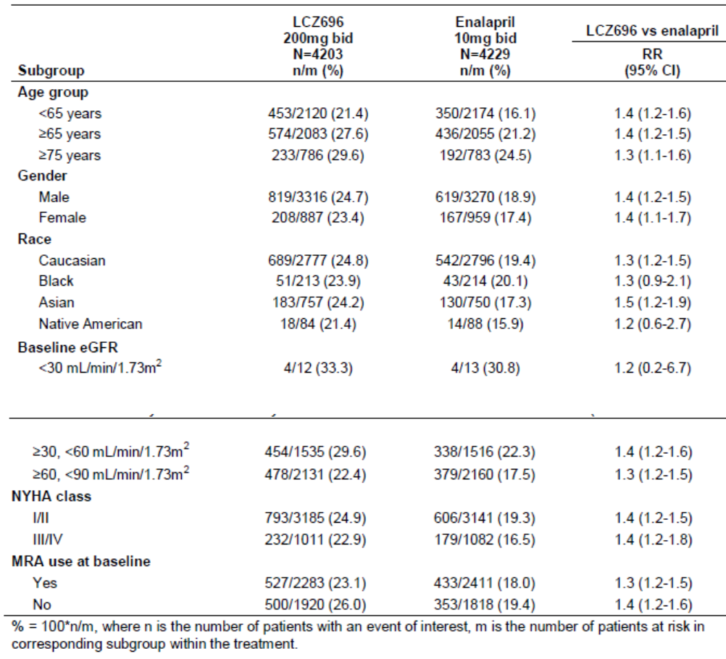

Table 14. Safety in special populations: hypotension related AEs by baseline BP.
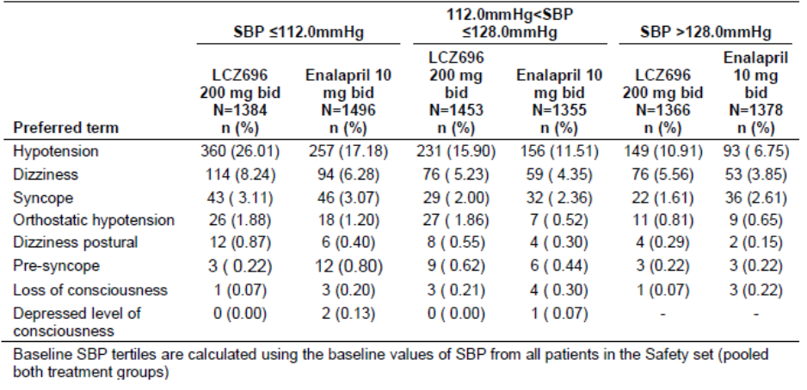

Renal impairment
In CLCZ696B2314, renal impairment was reported in marginally fewer patients in the LCZ696 group compared with enalapril (RR ≤ 0.9 in most subgroups). Renal impairment in both treatment groups was reported more frequently in elderly patients compared with those aged < 65 years, and in patients with low eGFR compared with those with normal renal function. There were too few patients with severe renal failure to make meaningful comparisons. There were no meaningful gender or racial differences, or differences related to NYHA class at baseline. Renal impairment appeared to be more likely in patients with diabetes at baseline in both treatment groups. Subgroup numbers in CLCZ696B2214 and CLCZ696B2228 were too low for meaningful comparisons.

Hyperkalaemia
In CLCZ696B2314, hyperkalaemia was reported in marginally fewer patients in the LCZ696 group compared with enalapril (RR 0.6 – 0.8 in most subgroups). Hyperkalaemia in both treatment groups was reported more commonly in elderly patients compared with those aged <65 years. Hyperkalaemia was more common in patients with renal impairment in both treatment groups. However, there were too few patients with severe renal failure to make meaningful comparisons. There were no meaningful gender or racial differences, or differences related to NSAID use or use of potassium sparing diuretics post-baseline. Subgroup numbers in CLCZ696B2214 and CLCZ696B2228 were too low for meaningful comparisons.

Angioedema
In CLCZ696B2314, angioedema during the double-blind treatment period was reported in more Black patients than in other racial groups in the LCZ696 group [2.3% vs 0.5% (RR 5.3 95% CI: 0.6, 251)] and in the enalapril group [0.4% vs 0.2% (RR 1.5 95% CI: 0.6 – 4.0)]. However, the number of Black patients was relatively low in both treatment groups. No meaningful differences were observed in other subgroups.

Other safety categories in subgroups
Compared with the overall population, no notable differences were observed in other subgroups for hepatotoxicity, cognitive impairment, hypersensitivity reactions, bone growth/bone mineral density, gastric lesions, malignancies, or lipolysis.

LCZ696 HTN and sacubitril studies
No subgroup analyses were performed.

Valsartan HF studies
Subgroup analyses were performed in the main long-term valsartan studies in HF and post-myocardial infarction based on age, gender, and race.
In Val-HeFT (CVAL489B0107), there were no notable differences in the incidence of AEs based on age. AEs were marginally more common in females than males, most notably nausea (15.9% vs 6.9%) and upper respiratory tract infections (13.1% vs 8.9%). There were no notable racial differences although most patients were White (90.3%).
In VALIANT (CVAL489E0108), more AEs occurred in elderly patients compared with those aged <65 years. In each treatment group, cardiovascular SAEs were more common in elderly patients. Cardiac failure was notably more common in elderly patients in the valsartan (30.3% vs 13.6%), valsartan + captopril (27.8% vs 13.5%), and captopril (29.1% vs 12.4%) treatment groups. There were no notable differences between genders in the pattern and frequency of AEs. However, SAEs of cardiac failure were notably more common in females than males in the valsartan (28.9% vs 19.4%), valsartan + captopril (27.0% vs 18.1%) and captopril (28.3% vs 18.1%) treatment groups. No meaningful comparisons between racial groups can be made because the great majority (93.8%) of patients were White.

Safety related to drug-drug interactions and other interactions
There are several medications for which use with LCZ696 is either contraindicated or a caution should be exercised. These are well described in the PI information and may lead to exacerbation of antihypertensive effects of the combined treatment. The PK/PD studies identified an increased BP lowering when sildenafil was added. Thus the use of other PDE-5 inhibitors with LCZ696 may be problematic. Similarly the use of statins and LCZ696 was investigated and leads to increased plasma concentrations of the statin. The PD consequence of the PK interaction, such as lowered lipids, was not investigated in the studies presented. There are a number of other potential safety issues associated with drug-drug interactions noted in the PI which were not investigated in specific PK / PD studies. However, based on the known effects of these drugs (e.g on renal function and reduced lithium clearance) interactions could be anticipated and an appropriate caution is flagged.

Evaluator’s overall conclusions on clinical safety
Overall, the safety profile of LCZ696 was defined by its expected pharmacodynamic properties and no unexpected safety concerns were identified.
To increase the frequency of endpoints in PARADIGM-HF, patients were required to have modestly increased BNP levels and LVEF ≤ 35%. However, the patient population was otherwise comparable to those of other major HF trials. At screening, nearly all patients were in NYHA class II or III, and nearly all were receiving optimal treatment for HF including ACEIs or ARBs, beta-blockers, and MRAs. Approximately 12% of patients withdrew due to AEs in the run-in period. However, the remainder were stabilised on effective doses of LCZ696 or enalapril, permitting a meaningful comparison of the long-term safety and tolerability of each treatment.
In PARADIGM-HF, LCZ696 200 mg BID was well tolerated in more than 4,000 patients with HF treated for a mean duration of 27 months. Compared with enalapril, the LCZ696 treatment group had fewer deaths (17.3% vs 20.1%), SAEs (46.1% vs 50.7%), and AEs leading to study drug discontinuation (10.7% vs 12.2%). AEs leading to dose adjustment or interruptions were more common in the LCZ696 group (27.7% vs 26.8%), due mainly to a higher incidence of hypotension (9.8% vs 7.0%).
Common AEs associated with RAAS inhibition in HF are hypotension, renal impairment, and hyperkalaemia. Compared with enalapril, hypotension was more commonly reported in the LCZ696 group (17.6% vs 12%) due to its greater vasodilator effects, but the number of discontinuations due to hypotension was low in both groups (0.6% vs 0.5%). Despite the higher incidence of hypotension, renal impairment was less common in the LCZ696 group (10.1% vs 11.5%). Hyperkalaemia was reported less frequently in the LCZ696 group (11.6% vs 14.0%), and severe hyperkalaemia was reported infrequently in both groups. These class adverse effects are familiar to clinicians and they can usually be managed with dose reductions or interruptions. Only rarely are they severe or life-threatening.
The incidence of angioedema (including all related MedDRA categories) was similar in both treatment groups (7.1% vs 7.4%), but the incidence of adjudicated angioedema was much lower in both groups (0.5% vs 0.2%). The incidence of adjudicated angioedema was higher in the LCZ696 group, but only three (0.07%) patients in the LCZ696 group experienced severe angioedema. Although no life-threatening angioedema was reported in the LCZ696 group, previous experience with omapatrilat warrants contra-indication for the use of concomitant or over-lapping LCZ696 with any ACEI.
In PARADIGM-HF, there was no valsartan control arm so the safety profile of the sacubitril component of LCZ696 could not be determined. However, with the exception of an increased incidence of hypotension, no safety concerns were apparent. In CLCZ696B2214, some events did occur more commonly in the LCZ696 group compared with the valsartan group; these included hypotension, hyperkalaemia, diarrhoea, and dizziness.
In controlled trials in large numbers of HTN patients, the safety profile of LCZ696 was comparable to placebo, with the exception of nasopharyngitis which occurred more commonly in the LCZ696 group. In CLCZ696A2201, the incidence of AEs was lower in 165 patients in the sacubitril monotherapy arm compared with placebo (23.1% vs 23.7%). ADRs identified in the PI include class effects and other common AEs, including headache, cough, nausea, diarrhoea, fatigue and dyspnoea. However, the incidence of AEs in the HF studies was similar or lower in the LCZ696 group compared with the enalapril group.
Pre-defined AEs of special interest were based on the known class effects of NEP inhibitors and ARBs, potential safety signals identified in the pre-clinical program, and standard regulatory indices of interest. The ADRs related to class effects were reported as expected, but there was no evidence of hepatotoxicity, haematological toxicity or QTc prolongation. No safety signals were detected in relation to other events of interest, including cognitive impairment, hypersensitivity reactions, changes in bone growth and/or bone mineral density, gastric lesions, malignancies, or stimulation of lipolysis.
In PARADIGM-HF, the incidence of adverse events in special populations was comparable to the overall population. As would be predicted, adverse events were more commonly reported in the elderly (≥ 65 years) and very elderly (≥ 75 years) but, with the exception of hypotension, the incidence was comparable or lower than in the elderly enalapril group. Most events in the elderly were mild to moderate and manageable, and no reduction in the target dose is required. There were no meaningful differences based on gender or race, although Blacks had a higher incidence of angioedema (a known racial tendency). No dosage reductions are required for patients with hepatic or renal impairment; however, patients with more severe renal impairment have a higher incidence of adverse reactions.

First round benefit-risk assessment

First round assessment of benefits
Compared with enalapril, the benefits of ENTRESTO in the proposed usage are:
- Approximately 20% reductions in CV death and HF hospitalisations.
- A 16% reduction in all-cause mortality
- Sudden death was reduced by 20%
- Pump failure was reduced by 21%
- Modest improvements in mean symptom scores and NYHA class
- Efficacy and safety benefits applicable to all patient subgroups, including the elderly
- Well tolerated in patients with renal impairment
- Reduced risk of renal impairment
- Reduced risk of hyperkalaemia
- No dose adjustment required in patients with mild to moderate hepatic impairment
- Overall safety profile superior to enalapril
- A treatment alternative for patients who are intolerant of ACEIs
- Low dosage strengths permit gradual up-titration or dose adjustments

First round assessment of risks
Compared with enalapril, the risks of ENTRESTO in the proposed usage are:
- Increased risk of hypotension
- Increased but low risk of severe angioedema
- Risk of severe angioedema if co-prescribed with ACEIs
- Few patients studied in NYHA class I or IV
- No studies have been performed in patients with severe hepatic impairment or in patients on dialysis.

First round assessment of benefit-risk balance
Following publication of the CONSENSUS study, enalapril and other ACEIs have been the cornerstone treatment for CHF. Although HF symptoms were only modestly improved in the pivotal study, ENTRESTO was clearly superior to enalapril for the reduction of all-cause mortality, CV deaths, and HF hospitalisations. The safety profile of ENTRESTO was comparable to enalapril. While hypotension was more frequent, most events were mild or moderate and easily managed without withdrawing therapy. The benefit-risk balance of ENTRESTO, given the proposed usage, is favourable. It is a superior alternative for patients who are already receiving ACEIs, and it is particularly valuable for patients who are ACEI intolerant.

First round recommendation regarding authorisation
Subject to satisfactory responses to the clinical questions, authorisation is recommended for the proposed indication:
ENTRESTO is indicated for the treatment of heart failure (NYHA class II-IV) in patients with systolic dysfunction. ENTRESTO has been shown to reduce the rate of cardiovascular death and heart failure hospitalisations.

Clinical questions

Pharmacokinetics
No Questions

Pharmacodynamics
No Questions

Efficacy

Question 1
At various points in the submission, the sponsor posits the futility of comparing LCZ696 with valsartan or sacubitril alone. This approach is acceptable from the clinical perspective because valsartan is not recommended for first line HF treatment, and sacubitril will not be marketed as monotherapy. The absence of dose-ranging and Phase II studies in vulnerable patients with HFrEF is also justified on ethical grounds. However, the sponsor should be asked to demonstrate at least some clinical evidence that sacubitril has additive haemodynamic effects when combined with valsartan in HFrEF patients (as was demonstrated in HTN and HFpEF patients). Phase II studies, including a dose-ranging study of sacubitril versus placebo, could have been conducted in ACEI intolerant HF patients treated with valsartan alone. Please provide a rationale for not adopting this approach.

Question 2
In the Phase II study CLCZ696B2214, echocardiography was performed at Weeks 0, 12 and 36 in patients with HFpEF, nearly all with hypertension. This was conducted to support CLCZ696D2301 (PARAGON-HF), an ongoing major Phase III study of CLCZ696 in patients with diastolic dysfunction. No such Phase II study was performed in patients with HFrEF, and echocardiographic changes were not assessed in the pivotal study CLCZ696B2314. As such, there appears to be no information relating to acute or chronic haemodynamic or structural changes in HFrEF patients treated with LCZ696. Arguably, it would be useful to understand how LCZ696 affects haemodynamics and cardiac structure compared with valsartan alone, even if the effects of valsartan alone are well described (e.g. VAL489B0102, CLCZ696B0103, and VAL489B0104). In retrospect, it required confidence to embark on a Phase III mega-trial without this basic information. Please explain the rationale for not performing such assessments as part of the HFrEF development program.

Question 3
In relation to the first two questions, there appears to be no clinical evidence that LCZ696 is superior to valsartan alone in patients with HFrEF. As, justifiably, a valsartan monotherapy arm was not included in PARADIGM-HF, the evidence that LCZ696 is superior to valsartan alone depends entirely on comparisons with historical valsartan HF studies. Please comment.

Question 4
At the final visit in CLCZ696B2314, approximately 25% of patients were not receiving the target dose of LCZ696 200 mg BID. However, a dose response analysis was not performed. What evidence is there to support continued treatment in patients who cannot attain or maintain the target dose?

Safety

Question 5
The incidence of sudden death and pump failure is shown in Table 12 - 12 of the CLCZ696B2314 CSR. However, with reference to sudden death and pump failure, the evaluators’ are unable to locate the tables referred to on page 6 of the proposed annotated PI. Nor can they locate these tables in the CLCZ696B2314 CSR, and they are not included in the summary of efficacy. Please provide both sources.

Second round evaluation of clinical data

Question 1
At various points in the submission, the sponsor posits the futility of comparing LCZ696 with valsartan or sacubitril alone. This approach is acceptable from the clinical perspective because valsartan is not recommended for first line HF treatment, and sacubitril will not be marketed as monotherapy. The absence of dose-ranging and Phase II studies in vulnerable patients with HFrEF is also justified on ethical grounds. However, the sponsor should be asked to demonstrate at least some clinical evidence that sacubitril has additive haemodynamic effects when combined with valsartan in HFrEF patients (as was demonstrated in HTN and HFpEF patients). Phase II studies, including a dose-ranging study of sacubitril versus placebo, could have been conducted in ACEI intolerant HF patients treated with valsartan alone. Please provide a rationale for not adopting this approach.

Sponsor’s response to Question 1
In summary, the sponsor suggests that Phase II studies were not relevant based on the following arguments:
- Haemodynamic improvements do not predict outcomes so any changes observed in a Phase II study would not have influenced the design of the Phase III study.
- Cardiac inotropes have been shown to increase mortality in previous studies.
- Compared with an ACEI or an ARB such as valsartan, LCZ696 was not expected to produce marked and immediate haemodynamic effects.

Evaluators’ response
The sponsor has not provided a reason for not performing a Phase II comparison of sacubitril versus placebo in HF patients who are ACEI intolerant. In the absence of such a study, there is no direct clinical evidence that the safety and efficacy of LCZ696 is superior to valsartan alone. The argument that haemodynamic changes are irrelevant as they do not predict survival is in general acceptable. However, while haemodynamic changes might not have influenced the primary outcome, LCZ696 is a novel therapy. If nothing else, haemodynamic changes would have increased our understanding of neuro-humoral responses in HF.
While not fully accepting the sponsor’s arguments, the overall response is satisfactory.

Question 2
In the Phase II study CLCZ696B2214, echocardiography was performed at Weeks 0, 12 and 36 in patients with HFpEF, nearly all with hypertension. This was conducted to support CLCZ696D2301 (PARAGON-HF), an ongoing major Phase III study of CLCZ696 in patients with diastolic dysfunction. No such Phase II study was performed in patients with HFrEF, and echocardiographic changes were not assessed in the pivotal study CLCZ696B2314. As such, there appears to be no information relating to acute or chronic haemodynamic or structural changes in HFrEF patients treated with LCZ696. Arguably, it would be useful to understand how LCZ696 affects haemodynamics and cardiac structure compared with valsartan alone, even if the effects of valsartan alone are well described (e.g. VAL489B0102, CLCZ696B0103, and VAL489B0104). In retrospect, it required confidence to embark on a Phase III mega-trial without this basic information. Please explain the rationale for not performing such assessments as part of the HFrEF development program.

Sponsor’s response to Question 2
In summary, the sponsor repeats and expands on the arguments for not performing haemodynamic studies outlined in their response to Question 1. Given the poor predictive value of Phase II haemodynamic studies, the decision was made to proceed directly with a Phase III study.

Evaluators’ response
In the sponsor’s view, the potential effects of LCZ696 on haemodynamics are largely irrelevant and outdated. Instead they view LCZ696 as “a neuromodulator with the potential to affect natriuresis/diuresis, cardiac hypertrophy and fibrosis, aldosterone levels and sympathetic tone over a longer period of time”. However, the pivotal study was not designed to assess these variables or to explore their relationships. Compared with enalapril, the absolute risk reduction for CV deaths or HF hospitalisation was 4.69%. Despite the clinically significant benefit achieved with enhanced neuro-humoral modulation, the prognosis for HF remains poor and the underlying haemodynamics should not be ignored.
Despite the lack of haemodynamic data, the decision to proceed directly to Phase III was not unreasonable based on the pragmatic arguments proposed by the sponsor. The benefits observed in the pivotal study justify the decision and post-marketing studies will no doubt fill the knowledge gap.
While not fully accepting the sponsor’s arguments, the overall response is satisfactory.

Question 3
In relation to the first two questions, there appears to be no clinical evidence that LCZ696 is superior to valsartan alone in patients with HFrEF. As, justifiably, a valsartan monotherapy arm was not included in PARADIGM-HF, the evidence that LCZ696 is superior to valsartan alone depends entirely on comparisons with historical valsartan HF studies. Please comment.

Sponsor’s response to Question 3
In summary, the sponsor’s principal argument is that valsartan alone is not approved for HF except in patients who are ACEI intolerant. There would be no rationale to compare LCZ696 with valsartan alone as the latter is not a treatment option in the great majority of HF patients.

Evaluators’ response
Given the positive outcome of the pivotal study, the sponsor’s response is satisfactory.

Question 4
At the final visit in CLCZ696B2314, approximately 25% of patients were not receiving the target dose of LCZ696 200 mg BID. However, a dose response analysis was not performed. What evidence is there to support continued treatment in patients who cannot attain or maintain the target dose?

Sponsor’s response to Question 4
In summary, the sponsor has provided a detailed response after making the following points:
- The pivotal study was designed to compare the overall LCZ696 and enalapril treatment regimens rather than specific doses of either medication.
- The target dose of LCZ696 (equivalent to valsartan 160 mg BID based on PK data) was appropriate as it is the valsartan dose recommended in international HF guidelines.
- Every attempt was made to attain or maintain the target dose throughout the pivotal study.
- The majority of patients achieved the target dose.
At the end of the treatment period in the pivotal study, 69.64% of the LCZ696 group were receiving the target dose of 200 mg BID; 6.71% were receiving 100 mg BID; 1.97% were receiving 50 mg BID; and 21.67% were receiving no study medication. Patients taking ≤50% of the target dose tended to be older, to be in NYHA class III rather than class II, to have higher mean NT-proBNP values, and to have lower mean eGFR values. Similar trends were observed in the enalapril group.
Kaplan-Meier plots of first confirmed primary endpoint (CV death or HF hospitalisation) by treatment group in the ≤50% and > 50-75% mean actual dose subgroups are shown below in Figures 27 and 28). The hazard ratios in favour of LCZ696 were 0.442 (95% CI: 0.222, 0.883) and 0.544 (95% CI: 0.371, 0.789), respectively. Although the patient numbers in each group were small, the results were comparable to the overall population.
Figure 27. Confirmed primary endpoint in patients taking ≤50% target dose (B2314).
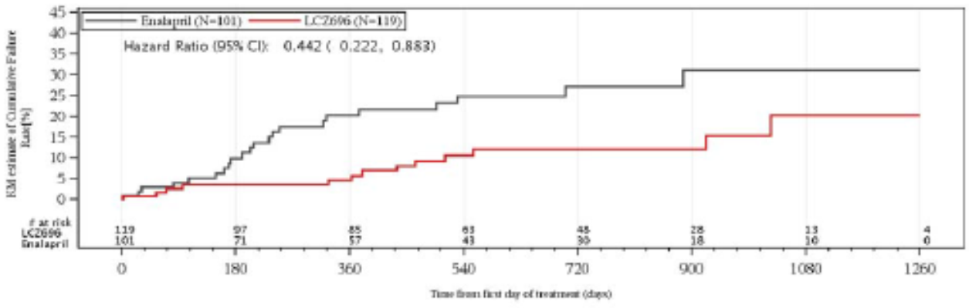
Figure 28. Confirmed primary endpoint in patients taking >50-75% target dose (B2314).
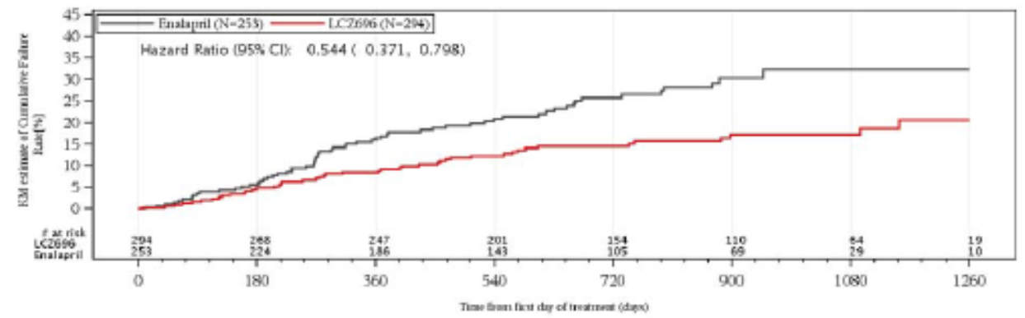

Evaluators’ response
The sponsor’s response is satisfactory.

Question 5
The incidence of sudden death and pump failure is shown in Table 12 - 12 of the CLCZ696B2314 CSR. However, with reference to sudden death and pump failure, the evaluators are unable to locate the tables referred to on page 6 of the proposed annotated PI. Nor can they locate these tables in the CLCZ696B2314 CSR, and they are not included in the summary of efficacy. Please provide both sources.

Sponsor’s response to Question 5
The requested tables and their sources have been provided.

Evaluators’ response
The sponsor’s response is satisfactory.

Second round benefit-risk assessment

Second round assessment of benefits
After consideration of the responses to clinical questions, the benefits of ENTRESTO in the proposed usage are unchanged from those identified in the first round evaluation.

Second round assessment of risks
After consideration of the responses to clinical questions, the benefits of ENTRESTO in the proposed usage are unchanged from those identified in the first round evaluation.

Second round assessment of benefit-risk balance
The benefit-risk balance of ENTRESTO, given the proposed usage, is favourable.

Second round recommendation regarding authorisation
Authorisation is not recommended for the proposed indication:
ENTRESTO is indicated for the treatment of heart failure (NYHA class II-IV) in patients with systolic dysfunction. ENTRESTO has been shown to reduce the rate of cardiovascular death and heart failure hospitalisations.
However, authorisation is recommended for the following indication:
ENTRESTO is indicated in adult patients for treatment of symptomatic chronic heart failure with reduced ejection fraction.
Evaluator’s Comment: The proposed indication for Australia is rejected in favour of the indication approved by the CHMP. The latter is essentially synonymous with the first sentence of the former. However, the second sentence of the proposed Australian version constitutes a claim rather than an indication. On balance, it would be more appropriate to delete it.

References
Carson P, et al. Effect of valsartan on hospitalisation: results from Val-HeFT. J Card Fail 2003; 9(3):164-71.
Cleland JG and Swedberg K. Lack of efficacy of neutral endopeptidase inhibitor ecadotril in heart failure. The International Ecadotril Multi-centre Dose-ranging Study Investigators. Lancet 1998; 351(9116):1657-1658.
Cohn JN, et al. A randomised trial of the angiotensin-receptor blocker valsartan in chronic heart failure. N Engl J Med 2001; 345:1667-1675.
Heran BS, et al. Angiotensin receptor blockers for heart failure. Cochrane Database Syst Rev. 4:CD003040.
McMurray JJV, et al. Effects of candesartan in patients with chronic heart failure and reduced left-ventricular systolic function taking angiotensin-converting-enzyme inhibitors: the CHARM-Added trial. Lancet 2003; 362:767-71.
Packer M, et al. Effect of carvedilol on survival in severe chronic heart failure. N Engl J Med 2001; 344:1651-58.
Packer M, et al. Comparison of omapatrilat in patients with chronic heart failure: the omapatrilat versus enalapril randomised trial of utility in reducing events (OVERTURE). Circulation 2002; 106:920-926.
The CONSENSUS Trial Study Group. Effects of enalapril on mortality in severe congestive heart failure. Results of the Cooperative North Scandinavian Enalapril Survival Study. N Engl J Med 1987; 316(23):1429-35.
The SOLVD Investigators. Effect of enalapril on survival in patients with reduced left ventricular ejection fractions and congestive heart failure. N Engl J Med 1991; 325(5):293-302.
Zannad F, et al. Eplerenone in patients with systolic heart failure and mild symptoms. N Engl J Med 2011; 364(1):11-21
Therapeutic Goods Administration
PO Box 100 Woden ACT 2606 Australia
Email: info@tga.gov.au Phone: 1800 020 653 Fax: 02 6232 8605
https://www.tga.gov.au

KCCQ is a self-administered questionnaire with a score 0-100. Higher scores indicate fewer symptoms and limitations associated with heart failure and the minimally important difference or change in score is 5 points.

