This medicinal product is subject to additional monitoring in Australia. This will allow quick identification of new safety information. Healthcare professionals are asked to report any suspected adverse events at www.tga.gov.au/reporting-problems.
▼
AUSTRALIAN PI – EVENITY® (romosozumab) SOLUTION FOR INJECTION

NAME OF THE MEDICINE
Romosozumab.

QUALITATIVE AND QUANTITATIVE COMPOSITION
EVENITY is a sterile, preservative-free solution for injection containing 105 mg/1.17 mL of romosozumab in pre-filled syringe or pre-filled syringe with autoinjector.
For a full list of excipients, see Section 6.1 List of excipients.

PHARMACEUTICAL FORM
Solution for Injection.
EVENITY is a sterile, preservative-free, clear to opalescent, colourless to light yellow solution, pH 5.2.

CLINICAL PARTICULARS

Therapeutic indications
EVENITY is indicated for the treatment of osteoporosis in postmenopausal women at high risk of fracture (see Section 5.1 Pharmacodynamic properties, Clinical trials).
Treatment to increase bone mass in men with osteoporosis at high risk of fracture.

Dose and method of administration
Dosage (dose and interval)
The recommended dose of EVENITY is 210 mg administered subcutaneously. To administer the 210 mg dose, give 2 subcutaneous injections of EVENITY. Administer EVENITY once every month for 12 doses.
After completing EVENITY therapy, transition to an antiresorptive osteoporosis therapy is required to preserve bone mass (see section 5.1 Pharmacodynamic properties, Pharmacodynamics and Clinical trials).
The efficacy and safety of treatment with EVENITY for longer than 12 months has not been established.
To reduce the risk of hypocalcaemia, patients should be adequately supplemented with calcium and vitamin D (see sections 4.3 Contraindications, 4.4 Special warnings and precautions for use, and 5.1 Pharmacodynamic properties, Clinical trials).
If the EVENITY dose is missed, administer as soon as it can be rescheduled. Thereafter, EVENITY can be scheduled every month from the date of the last dose.
The efficacy and safety of EVENITY in combination with other osteoporosis treatments has not been established (see section 4.5 Interaction with other medicines and other forms of interaction).
Method of administration
Administration should be performed by an individual who has been adequately trained in injection techniques.
To avoid discomfort at the site of injection, allow EVENITY to sit at room temperature for at least 30 minutes before injecting. Do not warm in any other way. Visually inspect the solution for particles and discolouration prior to administration. Do not use if the solution is discoloured, cloudy, or contains particles. Inject the entire contents of the pre-filled syringe.
Administer EVENITY in the abdomen, thigh, or upper arm subcutaneously. If using the same injection site, make sure it is not the same place on the injection site you used for a previous injection. Do not inject into areas where the skin is tender, bruised, red, or hard.
EVENITY is for single-use in one patient only. Dispose of any unused medicinal product (see section 4.6 Special precautions for disposal).
Dosage adjustment
Renal impairment
No dose adjustment is required in patients with renal impairment.

Contraindications
Uncorrected hypocalcaemia (see sections 4.4 Special warnings and precautions for use and 4.8 Adverse effects (Undesirable effects)).
Known hypersensitivity to romosozumab, CHO-derived proteins or any of the excipients found in EVENITY (see section 6.1 List of excipients).

Special warnings and precautions for use
Hypocalcaemia
Transient hypocalcaemia has been observed in patients receiving EVENITY. Correct hypocalcaemia prior to initiating therapy with EVENITY (see sections 4.3 Contraindications and 4.8 Adverse effects (Undesirable effects)).
Monitor patients for signs and symptoms of hypocalcaemia. Patients should be adequately supplemented with calcium and vitamin D (see section 5.1 Pharmacodynamic properties, Clinical trials).
Hypersensitivity
Clinically significant hypersensitivity reactions, including angioedema, erythema multiforme, and urticaria occurred in the EVENITY group in clinical trials. If an anaphylactic or other clinically significant allergic reaction occurs, initiate appropriate therapy and discontinue further use of EVENITY (see sections 4.3 Contraindications and 4.8 Adverse effects (Undesirable effects)).
Myocardial infarction and stroke
In two large, controlled fracture trials of EVENITY for the treatment of osteoporosis in postmenopausal women, cardiovascular events of myocardial infarction (MI) and stroke were prospectively adjudicated.
During the 12-month double-blind treatment period of the active-controlled trial (ARCH), MI occurred in 16 women (0.8%) in the EVENITY arm and 5 (0.2%) in the alendronate arm; stroke occurred in 13 women (0.6%) in the EVENITY arm and 7 (0.3%) in the alendronate arm. These events occurred in patients with and without a history of MI or stroke.
During the 12-month double-blind treatment period of the placebo-controlled trial (FRAME), MI occurred in 9 women (0.3%) in the EVENITY arm and 8 (0.2%) in the placebo arm; stroke occurred in 8 women (0.2%) in the EVENITY arm and 10 (0.3%) in the placebo arm. These events occurred in patients with and without a history of MI or stroke.
A causal relationship between EVENITY and these events has not been established. In both trials, most participants had common risk factors for cardiovascular disease, and within each trial, cardiovascular risk factors were balanced between treatment arms. EVENITY should not be initiated in patients who have had a myocardial infarction or stroke within the preceding year.
Consider the benefit-risk in patients at increased risk for MI or stroke. Patients should be instructed to watch for symptoms of MI and stroke and to seek prompt medical attention if symptoms occur.
Cardiovascular risk factors should be assessed by the treating physician prior to treatment. A patient’s suitability for treatment should be based on individual benefit-risk assessment.
In patients at high cardiovascular risk, consider relative benefits and risks of treatment. If a patient experiences a myocardial infarction or stroke during therapy, EVENITY should be discontinued.
Osteonecrosis of the jaw
Osteonecrosis of the jaw (ONJ), which can occur spontaneously, is generally associated with tooth extraction and/or local infection with delayed healing and has occurred rarely in patients receiving EVENITY in the clinical trials.
Prior to treatment, a dental examination with appropriate preventative dentistry should be considered in patients with possible risk factors.
Before commencing invasive dental procedures, patients and their dentist should be advised of the risks and reports of osteonecrosis of the jaw so that dental symptoms, including toothache, developing during treatment can be fully assessed for cause before treatment of the tooth commences.
Patients who are suspected of having or who develop ONJ while on EVENITY should receive care by a dentist or an oral surgeon. Discontinuation of EVENITY therapy should be considered based on individual benefit-risk assessment.
Atypical femoral fracture
Atypical low-energy or low-trauma fracture of the femoral shaft, which can occur spontaneously, has occurred rarely in patients receiving EVENITY in the clinical trials. Any patient who presents with new or unusual thigh, hip, or groin pain should be suspected of having an atypical fracture and should be evaluated to rule out an incomplete femur fracture. Patients presenting with an atypical femur fracture should also be assessed for symptoms and signs of fracture in the contralateral limb. Interruption of EVENITY therapy should be considered based on individual benefit-risk assessment.
Use in hepatic impairment
No clinical studies have been conducted to evaluate the effect of hepatic impairment.
Use in renal impairment
No dose adjustment is required in patients with renal impairment. There is limited experience in patients with eGFR < 30 mL/min.
Patients with severe renal impairment (estimated glomerular filtration rate [eGFR] 15 to 29 mL/min/1.73 m²) or receiving dialysis are at greater risk of developing hypocalcaemia (see sections 4.3 Contraindications and 4.4 Special warnings and precautions for use). Monitoring of calcium levels is highly recommended. Adequate intake of calcium and vitamin D is important in patients with severe renal impairment or receiving dialysis.
Use in the elderly
Of the 6525 postmenopausal women with osteoporosis treated with EVENITY in clinical studies, 5222 (80%) were ≥ 65 years old and 2385 (36.6%) were ≥ 75 years old. Of the 163 men with osteoporosis treated with EVENITY in clinical studies, 132 (80.9%) were ≥ 65 years old and 70 (42.9%) were ≥ 75 years old. No overall differences in safety or efficacy were observed among these patients and younger patients.
Paediatric use
The safety and efficacy of EVENITY have not been established in paediatric patients. There have been no studies in adolescents or children less than 18 years. EVENITY should not be used in paediatric patients.
Effects on laboratory tests
No interactions with laboratory and diagnostic tests have been identified.

Interaction with other medicines and other forms of interaction
No drug interaction studies have been conducted with EVENITY.

Fertility, pregnancy and lactation
Effects on fertility
No data are available on the effect of EVENITY on human fertility. Animal studies in female and male rats did not show any effects on fertility at subcutaneous doses up to 300 mg/kg/week yielding 54 times the systemic exposure [serum AUC] in patients at the maximum recommended human dose of 210 mg monthly.
Use in pregnancy
Pregnancy Category: B3
There are no studies of EVENITY in pregnant women. Therefore, it is not known whether EVENITY can cause fetal harm when administered to a pregnant woman.
Reproductive and developmental effects of romosozumab were assessed in the rat in a preliminary and definitive embryo-fetal development study, a combined fertility and embryo-development study, and a pre- and post-natal study. Skeletal malformations, including syndactyly and polydactyly, were observed in fetuses of rats given subcutaneous doses of romosozumab at 300 mg/kg/week during gestation. This occurred at a very high multiple of the clinical systemic exposure (with serum AUC in animals at this dose predicted to be at least 30 times higher than in patients at the maximum recommended dose) and at low incidence (1/75 litters across all studies), but the findings exceeded the upper historical control range. A relationship to treatment cannot be excluded. No adverse effects on embryofetal development were observed with romosozumab in rats at 100 mg/kg/week (estimated to yield 16 times the systemic exposure in patients). Placental transfer of romosozumab was shown in rats and, as an IgG, is expected in humans, increasing as pregnancy progresses. There were no adverse effects on post-natal growth and development.
Syndactyly occurs at a high incidence in sclerosteosis but does not occur in patients heterozygous for the genetic mutation. The risk of malformations following romosozumab exposure is expected to be low based on animal data and considering the timing of digit formation in the first trimester in humans, when placental transfer of immunoglobulins is limited.
Use in lactation
It is not known whether EVENITY is present in human milk. Because many drugs are excreted in human milk and because of the potential for adverse effects in nursing infants from EVENITY, a decision should be made whether to discontinue nursing or discontinue EVENITY, taking into account the potential benefit of EVENITY to the mother or the potential benefit of breastfeeding to the infant.

Effects on ability to drive and use machines
The effects of this medicine on a person’s ability to drive and use machines were not assessed as part of this registration.

Adverse effects (Undesirable effects)
Summary of the safety profile
In the overall EVENITY pre-registration clinical programme, 7681 subjects received at least one dose of romosozumab, 6338 subjects received romosozumab for at least 6 months, and 5863 subjects (5712 women and 151 men) received romosozumab for at least 12 months. The safety of EVENITY described below is based on 12-month pooled data from 3695 postmenopausal women with osteoporosis and 163 men with osteoporosis treated with romosozumab in four Phase II and Phase III, placebo-controlled clinical trials, including the FRAME and BRIDGE studies. Of the 7628 subjects who received EVENITY or placebo in these four studies, 78.4% of subjects in the EVENITY group and 80.0% of subjects in the placebo group had at least one treatment-emergent adverse event during the double-blind period (see Table 1). Adverse events leading to discontinuation were reported for 3.0% of subjects in the total EVENITY group and 2.6% of subjects in the placebo group. Adverse events considered treatment-related were reported for 16.1% of subjects in the EVENITY group and 13.5% of subjects in the placebo group.
At least one serious adverse event was reported for 9.7% of subjects in the total EVENITY group and 8.9% of subjects in the placebo group. The only serious adverse event occurring in ≥ 0.5% of subjects in either group was pneumonia (0.5% EVENITY, 0.3% placebo). There were no serious adverse events reported at a ≥ 2% higher incidence in the total EVENITY group compared to the placebo group.
In a placebo-controlled phase 2 study in postmenopausal women with low BMD in the lumbar spine, total hip or femoral neck, 51 subjects received 210 mg romosozumab once a month for 24 months (safety analysis set). The proportion of subjects reporting adverse events, serious adverse events and adverse events leading to discontinuation was similar between the EVENITY and placebo groups.
The adverse reactions in romosozumab-treated patients (n = 2040) in a separate double-blind, Phase III active-controlled study (ARCH) were similar in type to those seen in the placebo-controlled trials. The most common adverse reactions (≥ 1/10) from the pooled safety data were viral upper respiratory tract infection and arthralgia.
Tabulated list of adverse events
Adverse events occurring in patients treated with romosozumab at an incidence rate ≥ 2.0% in placebo-controlled clinical trials are shown in Table 1.
Table 1. Adverse Events Occurring at ≥ 2% in Patients Treated with Romosozumab in Placebo-Controlled Clinical Trials
Preferred Term  Adverse Event | Placebo  (N = 3770)  n (%) | EVENITY  (N = 3858)  n (%)
Nasopharyngitis | 476 (12.6) | 524 (13.6)
Arthralgia | 446 (11.8) | 478 (12.4)
Back pain | 393 (10.4) | 393 (10.2)
Pain in extremity | 305 (8.1) | 290 (7.5)
Fall | 324 (8.6) | 262 (6.8)
Headache | 223 (5.9) | 252 (6.5)
Hypertension | 276 (7.3) | 242 (6.3)
Viral upper respiratory tract infection | 228 (6.0) | 207 (5.4)
Osteoarthritis | 226 (6.0) | 201 (5.2)
Influenza | 187 (5.0) | 177 (4.6)
Musculoskeletal pain | 174 (4.6) | 174 (4.5)
Upper respiratory tract infection | 179 (4.7) | 172 (4.5)
Muscle spasms | 147 (3.9) | 169 (4.4)
Dizziness | 162 (4.3) | 162 (4.2)
Constipation | 169 (4.5) | 151 (3.9)
Cough | 120 (3.2) | 140 (3.6)
Urinary tract infection | 148 (3.9) | 140 (3.6)
Myalgia | 136 (3.6) | 119 (3,1)
Diarrhoea | 143 (3.8) | 117 (3.0)
Confusion | 134 (3.6) | 103 (2.7)
Gastritis | 105 (2.8) | 100 (2.6)
Abdominal pain upper | 104 (2.8) | 95 (2.5)
Spinal osteoarthritis | 90 (2.4) | 91 (2.4)
Bronchitis | 98 (2.6) | 87 (2.3)
Peripheral oedema | 69 (1.8) | 86 (2.2)
Asthenia | 82 (2.2) | 84 (2.2)
Dyslipidaemia | 74 (2.0) | 83 (2.2)
Neck pain | 56 (1.5) | 81 (2.1)
Cataract | 55 (1.5) | 77 (2.0)
Paraesthesia | 63 (1.7) | 76 (2.0)
N = number of patients in the analysis set; n = Number of patients reporting ≥ 1 event

Adverse reactions
Adverse reactions occurring in patients treated with romosozumab in clinical trials are shown by system organ class and frequency in Table 2.
Table 2. Tabulated Summary of Adverse Reactions
System Organ Class | Adverse Reaction | CIOMS Frequency
Infections and infestations | Viral upper respiratory tract infection | Very Common
Immune system disorders | Hypersensitivityª  Rash  Dermatitis  Urticaria  Angioedema  Erythema multiforme | Common  Common  Common  Uncommon  Rare  Rare
Metabolism and nutrition disorders | Hypocalcemia^{b} | Uncommon
Nervous system disorders | Headache | Common
Respiratory, thoracic, and mediastinal disorders | Cough | Common
Musculoskeletal and connective tissue disorders | Arthralgia | Very Common
Musculoskeletal and connective tissue disorders | Neck pain | Common
Musculoskeletal and connective tissue disorders | Muscle spasms | Common
General disorders and administration site conditions | Peripheral edema | Common
General disorders and administration site conditions | Injection site reactions^{c} | Common
- See Contraindications (4.3.2) and Special Warnings and Precautions for Use (4.4.2).
- Defined as albumin adjusted serum calcium that was below the lower limit of normal. See Contraindications (4.3.1) and Special Warnings and Precautions for Use (4.4.1).
- Most frequent injection site reactions were pain and erythema.
Immunogenicity
As with all therapeutic proteins, there is potential for immunogenicity. The immunogenicity of romosozumab has been evaluated using a screening immunoassay for the detection of binding anti-romosozumab antibodies. For patients whose sera tested positive in the screening immunoassay, an in vitro biological assay was performed to detect neutralising antibodies.
In postmenopausal women dosed with 210 mg monthly EVENITY, the incidence of anti-romosozumab antibodies was 18.1% (1072 of 5914) for binding antibodies and 0.8% (50 of 5914) for neutralising antibodies. Across all doses studied in postmenopausal women, the pooled incidence of binding antibodies and neutralising antibodies was similar to the 210 mg monthly dose, respectively. In men with osteoporosis dosed with 210 mg monthly EVENITY, the incidence of anti-romosozumab antibodies was consistent [17.3% (28 of 162) for binding antibodies and 0.6% (1 of 161) for neutralising antibodies] with that observed in postmenopausal women with osteoporosis. The clinical significance of antibodies to romosozumab is unknown. No impact to the efficacy and safety of romosozumab was observed in the presence of anti-romosozumab antibodies.
Withdrawal effects
In the absence of a follow-on antiresorptive therapy, BMD gains trend toward pre-treatment levels following cessation of EVENITY.
The effect on BMD following the discontinuation of romosozumab was prospectively studied in a phase 2 dose-ranging study (Study 20060326) where romosozumab was given for longer duration than the approved posology. After romosozumab completion, BMD levels across measured sites trended towards pre-treatment levels but remained above baseline over a 12 month period.
Post-marketing experience
Not applicable at this time.
Reporting suspected adverse effects
Reporting suspected adverse reactions after registration of the medicinal product is important. It allows continued monitoring of the benefit-risk balance of the medicinal product. Healthcare professionals are asked to report any suspected adverse reactions at http://www.tga.gov.au/reporting-problems.

Overdose
There is no experience with overdosage in clinical trials with EVENITY.
For information on the management of overdose, contact the Poisons Information Centre on 131126 (Australia).

PHARMACOLOGICAL PROPERTIES

Pharmacodynamic properties
Mechanism of action
Romosozumab is a humanised monoclonal antibody (IgG2) that binds and inhibits sclerostin, a negative regulator of bone formation predominantly secreted by mature osteocytes. Romosozumab has a dual effect on bone, increasing bone formation and decreasing bone resorption. Romosozumab increases trabecular and cortical bone mass and improves bone structure and strength.
Pharmacodynamics
EVENITY has a dual effect on bone, increasing bone formation and decreasing bone resorption. In postmenopausal women with osteoporosis, EVENITY increased the bone formation marker procollagen type 1 N-terminal propeptide (P1NP) early in treatment, with a peak increase of approximately 145% relative to placebo 2 weeks after initiating treatment, followed by a return to placebo levels at month 9 and a decline to approximately 15% below placebo at month 12. EVENITY decreased the bone resorption marker type 1 collagen C-telopeptide (CTX) with a maximal reduction of approximately 55% relative to placebo 2 weeks after initiating treatment. CTX levels remained below placebo and were approximately 25% below placebo at month 12.
In men with osteoporosis, similar patterns in bone turnover marker changes were observed.
After discontinuation of EVENITY therapy in postmenopausal women with osteoporosis, P1NP levels returned to baseline within 12 months; CTX increased above baseline levels within 3 months and returned toward baseline levels by month 12, reflecting reversibility of effect. Upon retreatment with EVENITY after 12 months off treatment, the level of increase in P1NP and decrease in CTX by EVENITY was similar to that observed during the initial treatment.
In women transitioning from oral alendronate, EVENITY also increased bone formation and decreased bone resorption.
Clinical trials
In post-menopausal women with primary osteoporosis, EVENITY reduces the risk of vertebral and clinical fractures. EVENITY increases bone mass in men and post-menopausal women with primary osteoporosis.
The primary evidence for the efficacy and safety of romosozumab for the treatment of osteoporosis in postmenopausal women was derived from 2 pivotal fracture studies (Study 20110142; ARCH and Study 20070337; FRAME). In addition, a phase 3b study (Study 20080289; STRUCTURE) in women with osteoporosis transitioning from oral bisphosphonate therapy to romosozumab or teriparatide was conducted to provide supportive efficacy and safety. The primary evidence for the efficacy and safety of romosozumab for the treatment of osteoporosis in men was from a 12-month primary analysis of a pivotal, double-blind, placebo-controlled, phase 3 Study 20110174 (BRIDGE). These studies are described in further detail below.
Treatment of osteoporosis in postmenopausal women
Study 1 (alendronate-controlled)
Active-contRolled fraCture study in postmenopausal women with osteoporosis at High risk of fracture (ARCH):
The efficacy and safety of EVENITY in the treatment of osteoporosis in postmenopausal women was demonstrated in a multicentre, multinational, randomised, double-blind, alendronate-controlled, superiority study of 4093 postmenopausal women aged 55 to 90 years (mean age of 74.3 years). The mean years since menopause was 26.9 years. Prior use of osteoporosis medications was reported in 9% of patients, with oral bisphosphonates the most frequently reported (6.2%). Baseline characteristics were similar between treatment groups. The mean 10-year probabilities of major osteoporotic fractures and of hip fractures calculated with femoral neck BMD were 20.1% and 9.8% respectively. Enrolled women had either:
- BMD T-score at the total hip or femoral neck of ≤ −2.50, and either at least 1 moderate or severe vertebral fracture; or at least 2 mild vertebral fractures OR
- BMD T-score at the total hip or femoral neck of ≤ -2.00, and either at least 2 moderate or severe vertebral fractures; or a fracture of the proximal femur that occurred within 3 to 24 months prior to randomisation.
The mean baseline lumbar spine, total hip, and femoral neck BMD T-scores were -2.96, -2.80, and –2.90, respectively, 96.1% of women had a vertebral fracture at baseline, and 99.8% of women had a previous fracture. Women were randomised (1:1) to receive either monthly subcutaneous injections of EVENITY (N = 2046) or oral weekly alendronate (N = 2047) in a blinded fashion for 12 months. After the 12-month double-blind study period, women in both arms transitioned to alendronate while remaining blinded to their initial treatment. The primary analysis was performed when all women had completed the month 24 study visit and clinical fracture events were confirmed for at least 330 women and occurred after a median follow-up time of 2.7 years on study. Women received at least 500 mg calcium and 600 IU vitamin D supplementation daily and could have received a loading dose of 50,000 to 60,000 IU of vitamin D after randomisation. 89.3% of randomised women completed the 12-month double-blind period and 77% completed the primary analysis period.
The primary efficacy endpoints were the incidence of new vertebral fracture through month 24 and the incidence of clinical fracture (nonvertebral fracture and clinical vertebral fracture) at primary analysis. Vertebral fractures were diagnosed based on lateral spine radiographs (T4-L4) using a semiquantitative scoring method. Secondary efficacy endpoints included the incidence of nonvertebral fractures, hip fractures, and major nonvertebral fractures at the primary analysis, and percent change from baseline in BMD at the lumbar spine, total hip, and femoral neck at month 12 and month 24.
Effect on new vertebral and clinical fractures
As shown in Table 3, EVENITY significantly reduced the incidence of new vertebral fracture through month 24 and the incidence of clinical fracture at primary analysis. The fracture risk was reduced as early as month 12.
Table 3. The Effect of EVENITY on the Incidence and Risk of New Vertebral and Clinical Fractures
 | Proportion of Women With Fracture |  | Absolute Risk Reduction  (%) (95% CI) | Relative Risk Reduction (%) (95% CI) | Nominal p-value | Adjusted  p-valueª
 | Alendronate (%) | EVENITY (%)
New vertebral^{b}
Through Month 12 | 85/1703 (5.0) | 55/1696 (3.2) | 1.84 (0.51, 3.17) | 36 (11, 54) | 0.008 | NA^{c}
Through Month 24 | 147/1834 (8.0) | 74/1825 (4.1) | 4.03 (2.50, 5.57) | 50 (34, 62) | < 0.001 | < 0.001
Clinical^{d}
Primary analysis | 266/2047 (13.0) | 198/2046 (9.7) | NA^{e} | 27 (12, 39) | < 0.001 | < 0.001
Through Month 12 | 110/2047 (5.4) | 79/2046 (3.9) | 1.8 (0.5, 3.1) | 28 (4, 46) | 0.027 | NA^{c}
Through Month 24 | 197/2047 (9.6) | 146/2046 (7.1) | 2.7 (0.8, 4.5) | 26 (9, 41) | 0.005 | NA^{c}
ª Adjusted p-values are based on Hochberg procedure and are to be compared to a significance level of 0.05.
^{b} Absolute risk reduction and relative risk reduction based on Mantel-Haenszel method adjusted for age strata, baseline total hip BMD T-score (≤ -2.5, > -2.5), and presence of severe vertebral fracture at baseline. Treatment comparisons are based on logistic regression model adjusted for age strata, baseline total hip BMD T-score, and presence of severe vertebral fracture at baseline.
^{c} NA: Endpoint was not part of sequential testing strategy; therefore, p-value adjustment is not applicable.
^{d} Clinical fractures include all symptomatic fractures including nonvertebral and painful vertebral fractures. Treatment comparisons are based on Cox proportional hazards model adjusted for age strata, baseline total hip BMD T-score, and presence of severe vertebral fracture at baseline.
^{e} NA: not available as subjects have various exposure at primary analysis.
Figure 1. Effect of EVENITY on Incidence of New Vertebral Fractures Through Month 12 and Month 24
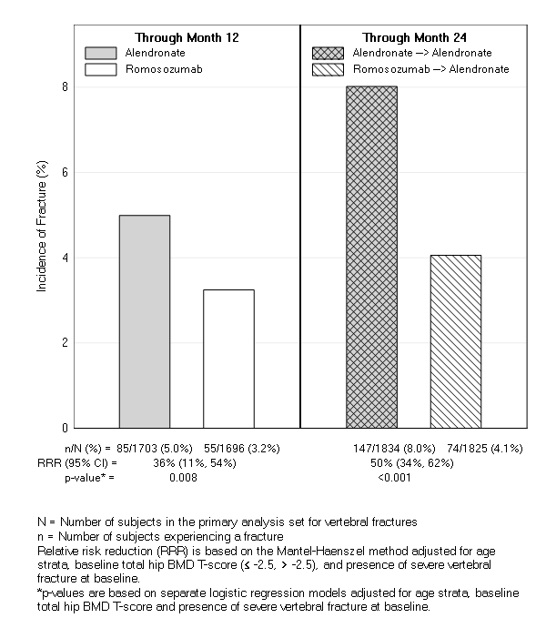
Figure 2. Cumulative Incidence of Clinical, Nonvertebral, and Hip Fractures
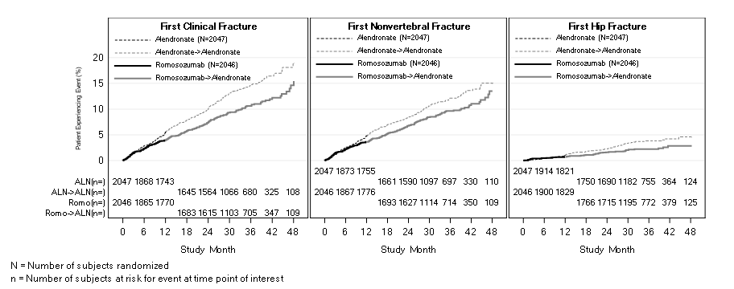
Subgroup analyses of the primary endpoints showed that romosozumab for 12 months followed by alendronate for 12 months demonstrated a consistent treatment effect, as shown by odds ratios that favoured romosozumab/alendronate over alendronate/alendronate in all subgroups of baseline characteristics examined including age, presence or absence of severe vertebral fracture at baseline, number of prevalent vertebral fractures at baseline, race, geographic region, baseline lumbar spine BMD T-score, baseline total hip/femoral neck BMD T-score, baseline BMI, FRAX score, and history of nonvertebral fracture at or after age 55).
Effect on other fracture types/groups
Table 4. The Effect of EVENITY on the Incidence and Risk of Other Fracture Types/Groups Through Primary Analysis
 | Proportion of Women With Fracture |  | Relative Risk Reduction (%) (95% CI) | Nominal p-valueª | Adjusted  p-value^{b}
 | Alendronate (%) | EVENITY (%) | Relative Risk Reduction (%) (95% CI)
Nonvertebral | 217/2047 (10.6) | 178/2046 (8.7) | 19 (1, 34) | 0.040^{c} | 0.019^{d}
Hip | 66/2047 (3.2) | 41/2046 (2.0) | 38 (8, 58) | NA^{e} | 0.015
Major nonvertebral^{f} | 196/2047 (9.6) | 146/2046 (7.1) | 27 (10, 41) | NA^{c} | 0.004
ª Nominal p-values based on Cox proportional hazards model adjusted for age strata, baseline total hip BMD T-score, and presence of severe vertebral fracture at baseline.
^{b} Adjusted p-values are based on a combination of Hochberg, fixed sequential, and group sequential testing procedures and are to be compared to a significance level of 0.05.
^{c} 2-sided
^{d} 1-sided
^{e} NA: Endpoint was not part of sequential testing strategy; therefore, p-value adjustment is not applicable.
^{f} Pelvis, distal femur, proximal tibia, ribs, proximal humerus, forearm, and hip, hip fracture, multiple new or worsening vertebral fracture, and clinical vertebral fracture.
EVENITY reduced the incidence of major nonvertebral fractures compared to alendronate as early as Month 12 and through Month 24.
Effect on bone mineral density (BMD)
In postmenopausal women with osteoporosis, EVENITY significantly increased BMD at the lumbar spine, total hip, and femoral neck compared with alendronate at month 12. At month 24, EVENITY for 12 months followed by alendronate for 12 months, significantly increased BMD compared with alendronate alone at the lumbar spine, total hip, and femoral neck.
Consistent effects on BMD were observed regardless of baseline age, baseline BMD, and geographic region at the lumbar spine and total hip.
Table 5. Mean Percent Change in BMD From Baseline through Month 12 and Month 24
 | Alendronate-to-alendronate  Mean (95% CI)  N = 1757ª | EVENITY-to-alendronate  Mean (95% CI)  N = 1750ª | Treatment Difference From Alendronate-to-alendronate
At Month 12
Lumbar spine | 5.0 (4.73, 5.21) | 13.7 (13.36, 13.99) | 8.7^{b} (8.31, 9.09)
Total hip | 2.8 (2.67, 3.02) | 6.2 (5.94, 6.39) | 3.3^{b} (3.03, 3.60)
Femoral neck | 1.7 (1.46, 1.98) | 4.9 (4.65, 5.23) | 3.2^{b} (2.90, 3.54)
At Month 24
Lumbar spine | 7.2 (6.90, 7.53) | 15.3 (14.89, 15.69) | 8.1^{b} (7.58, 8.57)
Total hip | 3.5 (3.23, 3.68) | 7.2 (6.95, 7.48) | 3.8^{b} (3.42, 4.10)
Femoral neck | 2.3 (1.96, 2.57) | 6.0 (5.69, 6.37) | 3.8^{b} (3.40, 4.14)
ª Number of women randomised
^{b} p-value < 0.001 based on an ANCOVA model
Among women with BMD assessed at baseline and every 6 months, EVENITY significantly increased BMD at the lumbar spine, total hip, and femoral neck compared to alendronate alone through month 24. Following the double-blind period, in patients who transitioned from EVENITY to alendronate and in patients who continued on alendronate, BMD continued to increase through month 24. The differences in BMD achieved at month 12 between patients who initially received EVENITY or alendronate were maintained at month 24 (Figure 3).
Treatment differences in BMD at 6 months were 7.6% at the lumbar spine, 2.2% at the total hip, and 2.9% at the femoral neck. After 12 months, the treatment differences were 8.9% at the lumbar spine, 3.7% at the total hip, and 4.1% at the femoral neck. At 18 months, women who received EVENITY followed by alendronate maintained gains in BMD compared to women who continued on alendronate, with treatment differences of 9.3% at the lumbar spine, 4.3% at the total hip, and 5.4% at the femoral neck. At 24 months, women who received EVENITY followed by alendronate maintained gains in BMD compared to women who continued on alendronate, with treatment differences of 9.4% at the lumbar spine, 4.3% at the total hip, and 5.3% at the femoral neck.
Figure 3. Percent Change in BMD at Lumbar Spine, Total Hip, and Femoral Neck From Baseline Over 24 Months
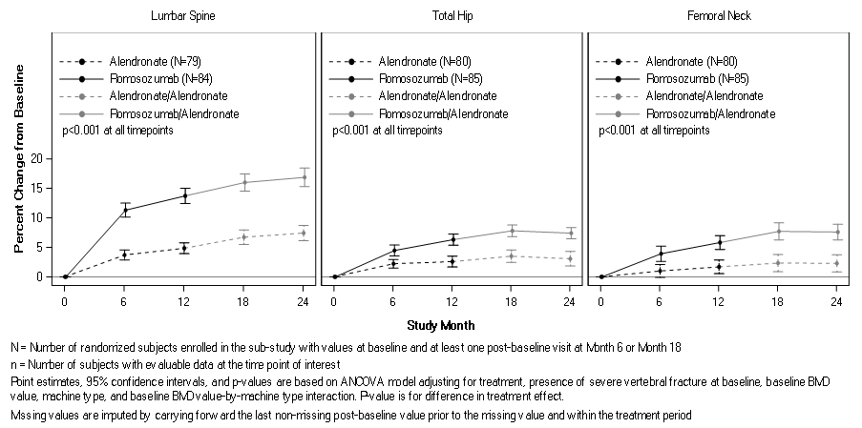
Study 2 (placebo-controlled)
Placebo-controlled FRActure study in postmenopausal woMen with ostEoporosis (FRAME):
The efficacy and safety of EVENITY in the treatment of postmenopausal osteoporosis was demonstrated in a multicentre, multinational, randomised, double-blind, placebo-controlled, parallel-group study of 7180 postmenopausal women aged 55 to 90 years (mean age of 70.9 years), with a mean of 23.0 years since menopause. Prior use of osteoporosis medications was reported in 6.8% of women, with oral bisphosphonates the most frequently reported (4.9%). Enrolled women had a baseline bone mineral density (BMD) T-score at the total hip or femoral neck of ≤ −2.50 to > −3.5. The mean baseline lumbar spine, total hip, and femoral neck BMD T-scores were –2.72, −2.47, and –2.75, respectively, and 18.3% of women had a vertebral fracture at baseline. The mean 10-year probabilities of major osteoporotic fractures and hip fractures calculated with femoral neck BMD were 13.2% and 5.7% respectively. Women were randomised to receive subcutaneous injections of either EVENITY (N = 3589) or placebo (N = 3591) once every month in a blinded fashion for 12 months. After the 12-month double-blind study period, women in both arms transitioned to open-label denosumab 60 mg subcutaneous every 6 months for 12 months while remaining blinded to initial treatment. Women received at least 500 mg calcium and 600 IU vitamin D supplementation daily and could have received a loading dose of 50,000 to 60,000 IU of vitamin D after randomisation. Eighty-nine percent of randomised women completed the 12-month double-blind period and 83.9% completed the 24-month study period.
The co-primary efficacy endpoints were the incidence of new vertebral fractures through month 12 and through month 24. Vertebral fractures were diagnosed based on lateral spine radiographs (T4-L4) using a semi-quantitative scoring method. Secondary efficacy endpoints included the incidence of clinical fractures (all symptomatic fractures including nonvertebral and painful vertebral fractures), nonvertebral fractures, new or worsening vertebral fractures, major nonvertebral fractures, hip fractures, and percent change from baseline in BMD at the lumbar spine, total hip, and femoral neck, and were evaluated through 24 months.
Subgroup analyses of the primary endpoints indicated that the efficacy of romosozumab was consistent regardless of baseline characteristics examined, including age, race, geographic region, baseline lumbar spine BMD T-score, baseline total hip/femoral neck BMD T-score, baseline BMI, fracture history, and FRAX score.
Effect on new vertebral and clinical fractures
EVENITY reduced the incidence of new vertebral fractures by 73% (adjusted p-value < 0.001) through month 12, as shown in Table 6. Additionally, in those women who received EVENITY during the first year, the reduction in fracture risk persisted through the second year in women who transitioned from EVENITY to denosumab compared to those who transitioned from placebo to denosumab (month 24; p < 0.001). EVENITY reduced the risk of new vertebral fracture by 75% (adjusted p-value < 0.001) through month 24.
EVENITY also reduced the incidence of clinical fractures by 36% (p-value = 0.008) through month 12 and by 33% (adjusted p-value = 0.096) through month 24 (see Table 6 and Figure 4 for time to first clinical fracture).
Table 6. The Effect of EVENITY on the Incidence and Risk of New Vertebral and Clinical Fractures Through Month 12 and Month 24
 | Proportion of Women With Fracture |  | Absolute Risk Reduction  (%) (95% CI) | Relative Risk Reduction (%) (95% CI) | Adjusted  p-valueª
 | Placebo (%) | EVENITY (%) | Absolute Risk Reduction  (%) (95% CI) | Relative Risk Reduction (%) (95% CI) | Adjusted  p-valueª
Through Month 12
New vertebral^{b} | 59/3322 (1.8) | 16/3321 (0.5) | 1.30 (0.79, 1.80) | 73 (53, 84) | < 0.001
Clinical^{c} | 90/3591 (2.5) | 58/3589 (1.6) | 1.2 (0.4, 1.9) | 36 (11, 54) | 0.008
 | Placebo-to-denosumab (%) | EVENITY-to-denosumab (%)
Through Month 24
New vertebral^{b} | 84/3327 (2.5) | 21/3325 (0.6) | 1.89 (1.30, 2.49) | 75 (60, 84) | < 0.001
Clinical^{c,d} | 147/3591 (4.1) | 99/3589 (2.8) | 1.4 (0.5, 2.4) | 33 (13, 48) | 0.096
ª Adjusted p-values are based on a sequential testing procedure and are to be compared to a significance level of 0.05.
^{b} Absolute risk reduction and relative risk reduction based on Mantel-Haenszel method adjusting for age and prevalent vertebral fracture stratification factors. Treatment comparisons are based on logistic regression model adjusted for stratification factors.
^{c} Clinical fractures include all symptomatic fractures including nonvertebral and painful vertebral fractures. Treatment comparisons are based on Cox proportional hazards model adjusted for age and prevalent vertebral fracture stratification factors.
^{d} Not significant as a result of failing to achieve statistical significance for an endpoint that was earlier in the testing sequence; nominal p-value: 0.002.
Figure 4. Effect of EVENITY on Incidence of New Vertebral Fractures Through Month 12 and Month 24
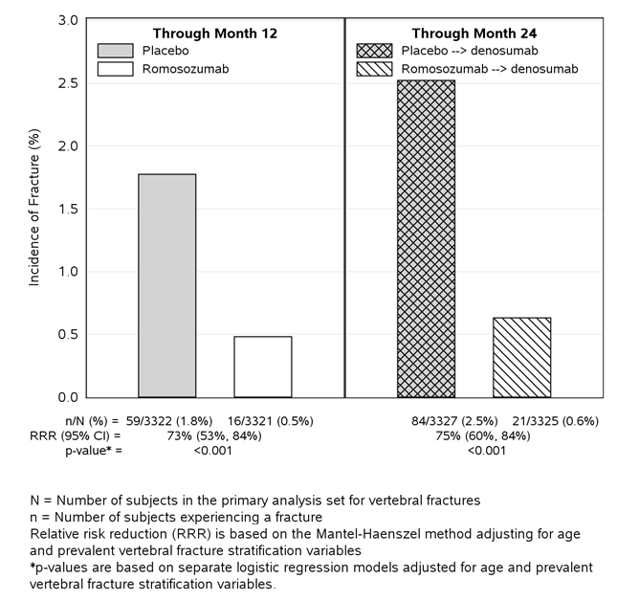
Figure 5. Cumulative Incidence of Clinical Fractures Through Month 24
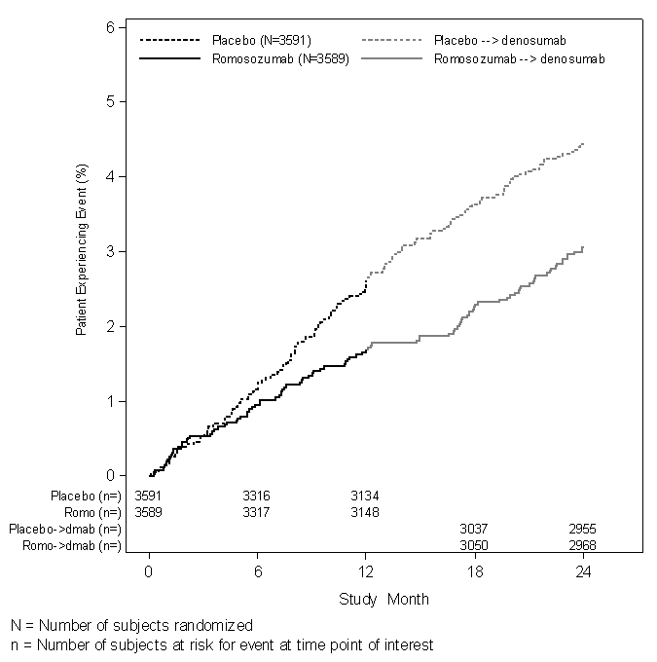
Effect on other fracture types/groups
See Table 7 for effect of EVENITY on other Fracture Types/Groups through Month 24.
Table 7. The Effect of EVENITY on the Incidence and Risk of Other Fracture Types/Groups Through Month 12 and Month 24
 | Proportion of Women With Fracture |  | Absolute Risk Reduction  (%)  (95% CI) | Relative Risk Reduction (%) (95% CI) | Nominal  p-valueª | Adjusted  p-value^{b}
 | Placebo (%) | EVENITY (%)
Through Month 12
New or worsening vertebral | 59/3322 (1.8) | 17/3321 (0.5) | 1.3  (0.76, 1.77) | 71  (51, 83) | < 0.001 | 0.096
Multiple new/worsening vertebral | 9/3322 (0.3) | 1/3321 (< 0.1) | 0.24  (0.05, 0.43) | 89  (13, 99) | 0.011 | NA^{c}
Nonvertebral | 75/3591 (2.1) | 56/3589 (1.6) | 0.8  (0.1, 1.4) | 25  (−5, 47) | 0.096 | 0.096
Major nonvertebral | 55/3591 (1.5) | 37/3589 (1.1) | 0.6  (0.1, 1.2) | 33  (−2, 56) | 0.060 | 0.096
Hip | 13/3591 (0.4) | 7/3589 (0.2) | 0.3  (0.0, 0.6) | 46  (−35, 78) | 0.18 | 0.18
Major osteoporotic | 63/3591 (1.8) | 38/3589 (1.1) | 0.9  (0.3, 1.5) | 40  (10, 60) | 0.012 | NA^{c}
 | Placebo-to- denosumab (%) | EVENITY-to-  Denosumab (%)
Through Month 24
New or worsening vertebral | 84/3327 (2.5) | 22/3325 (0.7) | 1.86  (1.27, 2.46) | 74  (58, 84) | < 0.001 |  | 0.096
Multiple new/worsening vertebral | 17/3327 (0.5) | 1/3325 (< 0.1) | 0.48 (0.23, 0.73) | 94  (56, 99) | < 0.001 |  | NA^{c}
Nonvertebral | 129/3591 (3.6) | 96/3589 (2.7) | 1.0  (0.2, 1.9) | 25  (3, 43) | 0.029 |  | 0.057
Major nonvertebral | 101/3591 (2.8) | 67/3589 (1.9) | 1.1  (0.3, 1.8) | 33  (9, 51) | 0.009 |  | 0.096
Hip | 22/3591 (0.6) | 11/3589 (0.3) | 0.4  (0.0, 0.7) | 50  (−4, 76) | 0.059 |  | 0.12
Major osteoporotic | 110/3591 (3.1) | 68/3589 (1.9) | 1.2  (0.5, 2.0) | 38  (16, 54) | 0.002 |  | NA^{c}
ª Nominal p-values based on logistic regression model (new or worsening and multiple new/worsening vertebral fracture) or Cox proportional hazards model (nonvertebral, major nonvertebral, hip, major osteoporotic) adjusted for age and prevalent vertebral fracture stratification factors.
^{b} Adjusted p-values are based on a sequential testing procedure and are to be compared to a significance level of 0.05.
^{c} NA: Endpoint was not part of sequential testing strategy; therefore, p-value adjustment is not applicable.

The secondary endpoint of nonvertebral fracture did not reach statistical significance at month 12 (p = 0.096) or month 24 (p = 0.057) with EVENITY treatment.
Subgroup analysis showed a significant treatment-by-region interaction was noted for the nonvertebral fracture and clinical fracture endpoints through month 12. In Central/Latin America (accounting for 43.0% of the randomised population in Study 20070337), the nonvertebral fracture rate observed in the placebo group in the first 12 months was low (1.2%), with no reduction seen with romosozumab treatment (1.5%). In addition, lower FRAX 10-year probabilities of major osteoporotic and hip fracture in Central/Latin America reflected a population with a lower than expected fracture risk, despite low baseline BMD T-scores. In the rest-of-world population, the nonvertebral fracture rate was 2.7% in the placebo group and 1.6% in the romosozumab group (relative risk reduction 42% [95% CI: 11, 63], nominal p = 0.012).
Effect on bone mineral density (BMD)
In postmenopausal women with osteoporosis, EVENITY significantly increased BMD at the lumbar spine, total hip, and femoral neck relative to placebo at month 12. Following 12 months of treatment, EVENITY increased BMD at the lumbar spine from baseline in 99% of postmenopausal women. Ninety-two percent of women treated with EVENITY achieved at least a 5% increase from baseline in BMD at lumbar spine by month 12 and 68% gained 10% or more. These effects were sustained with transition to another osteoporosis treatment; women who received EVENITY followed by denosumab had greater increases in BMD at the lumbar spine, total hip, and femoral neck at month 24 compared to women who received placebo followed by denosumab (Table 8).
Consistent effects on BMD were observed regardless of baseline age, baseline BMD, and geographic region at the lumbar spine and total hip.
Table 8. Mean Percent Change in BMD From Baseline through Month 12 and Month 24
 | Placebo  Mean (95% CI)  N = 3591ª | EVENITY  Mean (95% CI)  N = 3589ª | Treatment Difference From Placebo  Mean (95% CI)
At Month 12
Lumbar spine | 0.4 (0.2, 0.5) | 13.1 (12.8, 13.3) | 12.7^{b} (12.4, 12.9)
Total hip | 0.3 (0.1, 0.4) | 6.0 (5.9, 6.2) | 5.8^{b} (5.6, 6.0)
Femoral neck | 0.3 (0.1, 0.5) | 5.5 (5.2, 5.7) | 5.2^{b} (4.9, 5.4)
 | Placebo-to-denosumab  Mean (95% CI)  N = 3591 ª | EVENITY-to-denosumab  Mean (95% CI)  N = 3589 ª | Treatment Difference From Placebo-to-denosumab
At Month 24
Lumbar spine | 5.5 (5.3, 5.7) | 16.6 (16.3, 16.8) | 11.1^{b} (10.8, 11.4)
Total hip | 3.2 (3.1, 3.3) | 8.5 (8.3, 8.7) | 5.3^{b} (5.1, 5.5)
Femoral neck | 2.3 (2.1, 2.6) | 7.3 (7.0, 7.5) | 4.9^{b} (4.7, 5.2)
ª Number of women randomised
^{b} p-value < 0.001 based on an ANCOVA model

Among women with BMD assessed at baseline and every 6 months, EVENITY significantly increased BMD at the lumbar spine, total hip, and femoral neck relative to placebo at 6 and 12 months. Following the transition from EVENITY to denosumab, BMD continued to increase through month 24. In patients who transitioned from placebo to denosumab, BMD also increased with denosumab use. The differences in BMD achieved at month 12 between EVENITY and placebo patients were overall maintained at month 24, when comparing patients who transitioned from EVENITY to denosumab versus patients who transitioned from placebo-to-denosumab (Figure 6). Subgroup analyses of the primary endpoints indicated that the efficacy of romosozumab was consistent regardless of baseline characteristics examined.
Treatment differences in BMD at 6 months were 9.4% at the lumbar spine, 4.3% at the total hip, and 3.6% at the femoral neck. After 12 months, the treatment differences were 13.3% at the lumbar spine, 6.9% at the total hip, and 5.9% at the femoral neck (all p < 0.001). At 18 months, women who received EVENITY followed by denosumab maintained gains in BMD compared to women who received placebo followed by denosumab, with treatment differences of 11.8% at the lumbar spine, 6.8% at the total hip, and 6.8% at the femoral neck. At 24 months, women who received EVENITY followed by denosumab maintained gains in BMD compared to women who received placebo followed by denosumab, with treatment differences of 12.6% at the lumbar spine, 6.0% at the total hip, and 6.0% at the femoral neck (all p < 0.001).
Figure 6. Percent Change in BMD at Lumbar Spine, Total Hip, and Femoral Neck From Baseline Over 24 Months
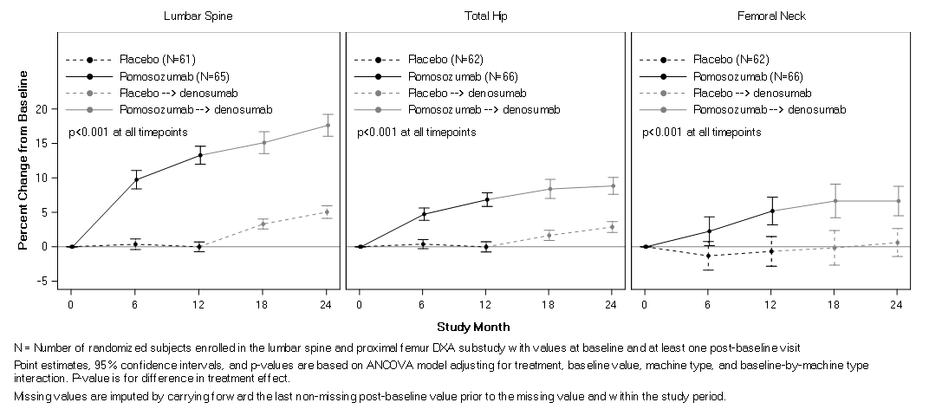
Bone histology and histomorphometry
A total of 154 transiliac crest bone biopsy specimens were obtained from 139 postmenopausal women with osteoporosis at month 2, month 12, and/or month 24. Of the biopsies obtained, 154 (100.0%) were adequate for qualitative histology and 138 (89.6%) were adequate for full quantitative histomorphometry assessment. Qualitative histology assessments from those treated with EVENITY showed normal bone architecture and quality at all time points. There was no evidence of woven bone, mineralisation defects, or marrow fibrosis.
Histomorphometry assessments on biopsies at months 2 and 12 compared the effect of EVENITY with placebo (15 specimens at month 2 and 39 specimens at month 12 in the EVENITY group, 14 specimens at month 2 and 31 specimens at month 12 in the placebo group). In women treated with EVENITY, histomorphometric indices of bone formation were increased and bone resorption were decreased at month 2. At month 12, both bone formation and resorption indices were decreased with EVENITY, while bone volume and trabecular thickness were increased. Biopsies obtained at month 24 compared the effect of EVENITY for 12 months followed by denosumab for 12 months (18 specimens) with placebo followed by denosumab (21 specimens). At month 24, indices of bone remodelling were low and similar in both groups, consistent with the effects of denosumab.
Study 3. Women transitioning from bisphosphonate therapy
STudy evaluating effect of RomosozUmab Compared with Teriparatide in postmenopausal women with osteoporosis at high risk for fracture pReviously treated with bisphosphonatE therapy (STRUCTURE):
The safety and efficacy of EVENITY in postmenopausal women with osteoporosis transitioning from bisphosphonate therapy were evaluated in a multicentre, randomised, open-label study of 436 postmenopausal women aged 56 to 90 years (mean age of 71.5 years). All subjects received oral bisphosphonate therapy in the 3 years immediately prior to screening; the median duration of prior bisphosphonate use was 6.2 years (range 3 to 27 years). This study evaluated safety and BMD changes by dual-energy X-ray absorptiometry (DXA) through 12 months of treatment with EVENITY compared with 12 months of treatment with teriparatide. The study also evaluated hip strength estimated by finite element analysis (FEA) over 12 months using quantitative computed tomography images.
Enrolled women were required to have a baseline BMD T-score at the lumbar spine, total hip, or femoral neck of ≤ −2.50 and any history of nonvertebral fracture after age 50 or vertebral fracture at any time. The mean baseline lumbar spine, total hip, and femoral neck BMD T-scores were –2.85, −2.24, and –2.46, respectively.
At month 12, EVENITY increased BMD from baseline by 9.8% (95% CI: 9.0, 10.5) at the lumbar spine, 2.9% (95% CI: 2.5, 3.4) at the total hip, and 3.2% (95% CI: 2.6, 3.8) at the femoral neck. Treatment differences in BMD at 12 months compared to teriparatide were 4.4% (95% CI: 3.4, 5.4) at the lumbar spine, 3.4% (95% CI: 2.8, 4.0) at the total hip, and 3.4% at the femoral neck (95% CI: 2.6, 4.2; p-value < 0.0001 for all comparisons).
At month 12, EVENITY increased estimated strength from baseline by 2.5% (95% CI: 1.7, 3.2) using finite element analysis (FEA) at the total hip. The treatment difference in estimated strength at the total hip at month 12 compared to teriparatide was 3.2% (95% CI: 2.1, 4.3; p-value < 0.0001).
Adverse reactions observed in this study were generally consistent with those seen in women not transitioning from bisphosphonate therapy (see section 5.1 Pharmacodynamic properties, Women transitioning from bisphosphonate therapy).
Treatment of osteoporosis in men
Study 4
A placeBo-contRolled study evaluatIng the efficacy anD safety of romosozumab in treatinG mEn with osteoporosis (BRIDGE):
The efficacy and safety of EVENITY in men with osteoporosis was demonstrated in a 12-month, multicentre, randomised, double-blind, placebo-controlled study of 245 men aged 55 to 89 years (mean age of 72.1 years). The majority of men did not report previous use of osteoporosis medications before enrolment into the study. Use of calcitrol (1,25 dihydroxy vitamin D) was the most frequently reported (romosozumab vs placebo: 3.1% vs 2.4%), followed by denosumab (1.8% vs 3.7%) and oral bisphosphonates (0.6% vs 6.1%). Enrolled men had a baseline BMD T-score of ≤ −2.50 at the lumbar spine, total hip, or femoral neck. Men with a BMD T-score of ≤ −1.50 at the lumbar spine, total hip, or femoral neck were enrolled if there was a history of fragility fracture. Men with BMD T-score at the total hip or femoral neck of ≤ - 3.5 were excluded from this study. The mean baseline lumbar spine, total hip, and femoral neck BMD T-scores were –2.26, −1.92, and –2.33, respectively. For the total subject population, the mean 10-year probabilities of major osteoporotic fractures and of hip fractures, respectively, (calculated with BMD) were 8.9% and 3.9%. Men were randomised 2:1 to receive SC injections of either EVENITY (n = 163) or placebo (n = 82) once every month. All men received at least 500 mg calcium and at least 600 IU vitamin D supplementation daily and could have received a loading dose of 50,000 to 60,000 IU of vitamin D after randomisation. Ninety-four percent of randomised men completed the 12-month double-blind study.
Effect on bone mineral density (BMD)
The primary efficacy variable was percent change in lumbar spine BMD from baseline at month 12. Secondary efficacy variables included percent change in total hip and femoral neck BMD from baseline to month 12 and percent change in lumbar spine, total hip, and femoral neck BMD from baseline to month 6.
In men with osteoporosis, treatment with EVENITY significantly increased BMD at month 12. The treatment differences in BMD at 6 months were 8.7% at the lumbar spine, 1.4% at the total hip, and 1.3% at femoral neck. At 12 months, the treatment differences were 10.9% at the lumbar spine, 3% at the total hip, and 2.4% at the femoral neck (Table 6).
Consistent effects on BMD were observed regardless of baseline age, baseline BMD, geographic region, and history of vertebral fracture.
Table 9. The Effect of EVENITY on BMD at Lumbar Spine, Total Hip, and Femoral Neck At Month 6 and Month 12
 | Mean Percent Change in BMD From Baseline |  | Treatment Difference From Placebo  Mean (95% CI)
 | Placebo  Mean (95% CI)  N = 79ª | EVENITY  Mean (95% CI)  N = 158ª | Treatment Difference From Placebo  Mean (95% CI)
At Month 6
Lumbar spine | 0.3 (-0.6, 1.2) | 9 (8.2, 9.7) | 8.7^{b} (7.6, 9.7)
Total hip | 0.2 (-0.2, 0.7) | 1.6 (1.2, 2.0) | 1.4^{b} (0.8, 2.0)
Femoral neck | 0.0 (-0.7, 0.7) | 1.2 (0.6, 1.8) | 1.3^{c} (0.4, 2.1)
At Month 12
Lumbar spine | 1.2 (0.2, 2.2) | 12.1 (11.2, 13) | 10.9^{b} (9.6, 12.2)
Total hip | -0.5 (-1.1, 0.1) | 2.5 (2.1, 2.9) | 3^{b} (2.3, 3.7)
Femoral neck | -0.2 (-1.0, 0.6) | 2.2 (1.5, 2.9) | 2.4^{b} (1.5, 3.3)
ª Number of men randomised
^{b} p-value < 0.001 based on an ANCOVA model
^{c} p-value 0.0033 based on an ANCOVA model
Figure 7. Percent Change in Lumbar Spine BMD From Baseline Over 1 year
N = number of subjects in the primary efficacy analysis set for the lumbar spine, total hip or femoral neck BMD
Point estimates and 95% confidence intervals are based on ANCOVA model adjusting for treatment, baseline DXA BMD value, machine type, machine type-by-baseline DXA BMD value, baseline testosterone level, geographic region (stratification factor), and using a variance structure allowing for heterogeneity between treatment groups.
Missing values are imputed by carrying forward the last non-missing post-baseline value prior to the missing value and within the study period.
Bone histology and histomorphometry
A total of 20 transiliac crest bone biopsy specimens were obtained from men with osteoporosis at 12 months (11 specimens in EVENITY group, 9 specimens in placebo group). Of the biopsies obtained, all were adequate for qualitative histology. All biopsies from placebo patients and 9 (81.8%) of biopsies from EVENITY patients were adequate for full quantitative histomorphometry assessment. Qualitative histology assessments showed normal lamellar bone with no evidence of mineralisation defects, woven bone, marrow fibrosis, or clinically significant marrow abnormality in patients treated with EVENITY. The presence of double-labelled surface, as evidence of active bone formation, was observed in the trabecular or cortical compartments for 88.9% (8/9) of patients in the EVENITY group and 77.8% (7/9) patients in the placebo group. In cancellous bone, histomorphometric analyses at month 12 revealed decreases in bone resorption parameters (percent eroded and osteoclastic surfaces) in the EVENITY group with no significant difference noted in bone formation and bone structure parameters compared with the placebo group.

Pharmacokinetic properties
Romosozumab exhibited nonlinear pharmacokinetics across the SC dose range of 0.1 to 10 mg/kg. Exposure increased greater than dose proportionally (e.g., 550-fold increase in mean AUC from time 0 to infinity [AUC_{inf}] for the 100-fold increase in SC dose from 0.1 to 10 mg/kg). Dose-proportional increases in exposure were observed for the doses of 140 mg and higher.
Absorption
Administration of a single dose of 210 mg romosozumab in healthy male and female volunteers (n = 90, age range: 21 to 65 years) resulted in a mean (standard deviation [SD]) maximum serum concentration (C_{max}) of 22.2 (5.8) µg/mL and a mean area under the concentration-time curve (AUC) of 389 (127) µg/day/mL. The median time to maximum romosozumab concentration (T_{max}) was 5 days (range: 2 to 7 days). Steady-state concentrations were achieved by month 3 following the monthly administration of 210 mg to postmenopausal women. Trough serum romosozumab mean concentration values from samples collected prior to dosing at months 3, 6, 9, and 12 ranged from 8050 to 9780 ng/mL.
For a 210 mg SC dose of romosozumab the bioavailability was estimated to be 81%.
Distribution
The population PK analysis estimated volume of distribution at steady-state was approximately 3.92 L.
Metabolism
The metabolic pathway of romosozumab has not been characterised.
Excretion
The clearance of romosozumab decreased as dose increased. Mean systemic clearance (CL/F) of EVENITY was estimated to be 0.383 mL/hr/kg, following a single SC administration of 3 mg/kg. The mean effective half-life was 12.8 days after 3 doses of Q4W 3 mg/kg.
Intrinsic factors
Based on a population pharmacokinetic analysis, no notable difference in pharmacokinetics with age (20 – 89 years), gender, race, or disease state (low bone mass or osteoporosis) was shown. The exposure of romosozumab decreased with increasing body weight.
Development of anti-romosozumab antibodies was associated with reduced serum romosozumab concentrations. In two Phase 2 dose finding studies and the pivotal Phase 3 study, the presence of binding anti-romosozumab antibodies led to a decrease in romosozumab exposure up to 25% at months 3, 6, and 9. The exposures became comparable (approximate 10% difference in mean values) at month 12 between anti-romosozumab antibody-positive and ADA negative subjects (see section 4.8 Adverse effects (Undesirable effects), Immunogenicity).
Special populations
Gender
The pharmacokinetics of EVENITY were similar in postmenopausal women and in men with osteoporosis.
Renal impairment
Following a single 210 mg dose of romosozumab in a clinical study of 16 patients with severe renal impairment (eGFR 15 to 29 mL/min/1.73 m²) or end-stage renal disease (ESRD) requiring haemodialysis, mean C_{max} and AUC were 29% and 44% higher in patients with severe renal impairment as compared to healthy subjects. Mean romosozumab exposure was similar between patients with ESRD requiring haemodialysis and healthy subjects.
A population pharmacokinetic analysis indicated an increase in romosozumab exposure with increasing severity of renal impairment. However, based on both the renal impairment study and population PK analysis, this increase is not clinically meaningful and no dose adjustment is necessary in these patients (see section 4.4 Special warnings and precautions for use, Use in renal impairment).

Preclinical safety data
Genotoxicity
No genotoxicity studies have been conducted. As a monoclonal, antibody, romosozumab is not expected to interact with DNA or other chromosomal material.
Carcinogenicity
Romosozumab did not increase tumour incidence in a carcinogenicity study in rats, involving subcutaneous administration at doses up to 50 mg/kg/week for up to 91 (males) or 98 weeks (females). These doses resulted in systemic exposures that were up to 19 times higher than the systemic exposure observed in humans following a monthly subcutaneous dose of 210 mg romosozumab (based on comparison of serum AUC).

PHARMACEUTICAL PARTICULARS

List of excipients
Each 1.17 mL single-use pre-filled syringe and pre-filled autoinjector (or pen) contains: 0.61 mg calcium, 3.8 mg acetate, 70 mg sucrose, 0.07 mg polysorbate 20, sodium hydroxide for adjusting to pH 5.2, in Water for Injection.

Incompatibilities
Incompatibilities were either not assessed or not identified as part of the registration of this medicine.

Shelf life
In Australia, information on the shelf life can be found on the public summary of the Australian Register of Therapeutic Goods (ARTG). The expiry date can be found on the packaging.

Special precautions for storage
Store refrigerated at 2°C to 8°C in the original carton.
If removed from the refrigerator, EVENITY should be kept at controlled room temperature (up to 25°C) in the original carton and must be used within 30 days. Once removed from the refrigerator for use, it must be used within 30 days or discarded. The date of removal from the refrigerator should be recorded on the syringe label, to allow disposal after the maximum 30 days if not used.
Protect EVENITY from direct light and do not expose to temperatures above 25°C.
Do not store EVENITY in extreme heat or cold.
Do not freeze.
Do not shake.

Nature and contents of container
EVENITY is provided as a:
- 1.17 mL solution in a single-use Crystal Zenith® pre-filled syringe (90 mg/mL PFS); supplied as a 2-pack.
- 1.17 mL solution in a single-use pre-filled autoinjector (or pen) (90 mg/mL AI); supplied as a 2-pack*.
* Autoinjector not available in Australia
The pre-filled syringe/pre-filled autoinjector (or pen) is not made with natural rubber latex.

Special precautions for disposal
In Australia, any unused medicine or waste material should be disposed of by taking to your local pharmacy.

Physicochemical properties
Romosozumab is a humanised monoclonal antibody (IgG2) with high affinity and specificity for sclerostin. Romosozumab has an approximate molecular weight of 145 kDa and is produced in a mammalian cell line (Chinese hamster ovary) by recombinant DNA technology.
Chemical structure
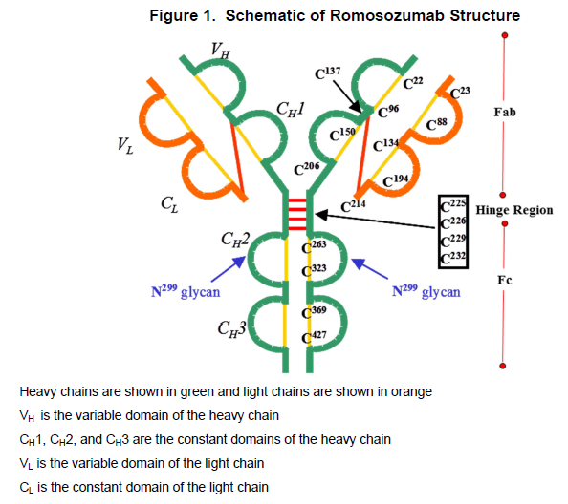
CAS number
909395-70-6

MEDICINE SCHEDULE (POISONS STANDARD)
Prescription Only Medicine (S4)

SPONSOR
Amgen Australia Pty Ltd
ABN 310 051 057 428
Level 7, 123 Epping Road
North Ryde
NSW 2113
Medical Information: 1800 803 638
Email: medinfo.JAPAC@amgen.com

DATE OF FIRST APPROVAL
Date of first inclusion in the Australian Register of Therapeutic Goods: 1 July 2019

DATE OF REVISION
Not applicable at this time.
SUMMARY TABLE OF CHANGES
Section changed | Summary of new information
© 2018, 2019 Amgen Inc. All rights reserved.

