Date of CER: August 2012

AusPAR Attachment 2

Extract from the Clinical Evaluation Report for Romidepsin
  - Proprietary Product Name: Istodax
  - Sponsor: Celgene Pty Ltd

About the Therapeutic Goods Administration (TGA)
- The Therapeutic Goods Administration (TGA) is part of the Australian Government Department of Health, and is responsible for regulating medicines and medical devices.
- The TGA administers the Therapeutic Goods Act 1989 (the Act), applying a risk management approach designed to ensure therapeutic goods supplied in Australia meet acceptable standards of quality, safety and efficacy (performance), when necessary.
- The work of the TGA is based on applying scientific and clinical expertise to decision-making, to ensure that the benefits to consumers outweigh any risks associated with the use of medicines and medical devices.
- The TGA relies on the public, healthcare professionals and industry to report problems with medicines or medical devices. TGA investigates reports received by it to determine any necessary regulatory action.
- To report a problem with a medicine or medical device, please see the information on the TGA website <http://www.tga.gov.au>.
About the Extract from the Clinical Evaluation Report
- This document provides a more detailed evaluation of the clinical findings, extracted from the Clinical Evaluation Report (CER) prepared by the TGA. This extract does not include sections from the CER regarding product documentation or post market activities. Corrections in accordance with the sponsor’s Notification document dated March 2013 have been made to this Extract.
- The words [Information redacted], where they appear in this document, indicate that confidential information has been deleted.
- For the most recent Product Information (PI), please refer to the TGA website <http://www.tga.gov.au/hp/information-medicines-pi.htm>.
Copyright
© Commonwealth of Australia 2013
This work is copyright. You may reproduce the whole or part of this work in unaltered form for your own personal use or, if you are part of an organisation, for internal use within your organisation, but only if you or your organisation do not use the reproduction for any commercial purpose and retain this copyright notice and all disclaimer notices as part of that reproduction. Apart from rights to use as permitted by the Copyright Act 1968 or allowed by this copyright notice, all other rights are reserved and you are not allowed to reproduce the whole or any part of this work in any way (electronic or otherwise) without first being given specific written permission from the Commonwealth to do so. Requests and inquiries concerning reproduction and rights are to be sent to the TGA Copyright Officer, Therapeutic Goods Administration, PO Box 100, Woden ACT 2606 or emailed to <tga.copyright@tga.gov.au>.

Contents
List of abbreviations 4
1. Introduction 7
2. Clinical rationale 7
3. Contents of the clinical dossier 8
3.1. Scope of the clinical dossier 8
3.2. Paediatric data 13
3.3. Good clinical practice 13
4. Pharmacokinetics and pharmacodynamics 13
4.1. Studies providing pharmacokinetic and pharmacodynamic data 13
4.2. Study T-95-0077 13
4.3. Study T-95-0022 16
4.4. Study NCI 1312 17
4.5. Study GPI-06-0005-QT 17
4.6. Study AN10022 19
4.7. Study AN10019 22
4.8. Evaluator’s conclusion on pharmacokinetics and pharmacodynamics 23
5. Dosage selection for the pivotal studies 23
6. Clinical efficacy 24
6.1. Data providing efficacy data 24
6.2. Study GPI-06-0002 (pivotal study) 24
6.3. Study NCI 1312: 40
7. Clinical safety 42
7.1. Studies providing evaluable safety data 42
7.2. Exposure 44
7.3. Adverse events 46
7.4. Safety update 52
7.5. Post-marketing data: 52
8. First round benefit-risk assessment 53
8.1. First round assessment of benefits 53
8.2. First round assessment of risks 53
8.3. First round assessment of benefit/risk balance 54
9. Clinical questions 54
10. Second round evaluation of clinical data submitted in response to questions 54
11. Recommendation regarding authorisation 54

List of abbreviations
Abbreviation | Meaning
AE | Adverse event
AITL | Angioimmunoblastic T-cell lymphoma
ALCL | Anaplastic large cell lymphoma
ALT | alanine transaminase
ASCT | Autologous stem cell transplant
ASHAP | Adriamycin, Solu-Medrol, high-dose ara-C, Platinol
AST | aspartate transaminase
AUC | Area under the curve
BMT | Bone marrow transplant
CHMP | Committee for Medicinal Products for Human Use
CHOP | Cyclophosphamide/hydroxydaunomycin (doxorubicin)/Oncovin vincristine)/prednisone
CHEOP | Cyclophosphamide/hydroxydaunomycin (doxorubicin)/ etoposide/Oncovin vincristine)/prednisone
CI | Confidence interval
CNOP | Cyclophosphamide, mitoxantrone, vincristine, and prednisone
CR | Complete response
CRF | Case report form
CRu | Complete response unconfirmed
CTCL | Cutaneous T-cell lymphoma
CVAD | Cyclophosphamide, doxorubicin, vincristine and dexamethasone
DHAP | Dexamethasone, high-dose ara-C, and cisplatin
DICE | Dexamethasone, ifosfamide, cisplatin etoposide
DLBCL | Diffuse large B-cell lymphoma
DOR | Duration of response
EATL | Enteropathy-type intestinal T-cell lymphoma
ECOG | Eastern Cooperative Oncology Group
EMA | European Medicines Agency
ESHAP | Etoposide, methylprednisolone, cytarabine, and cisplatin
EU | European Union
FCD | Fludarabine, cyclophosphamide and doxorubicin
FN | Febrile neutropenia
GCP | Good Clinical Practice
G-CSF | Granulocyte colony stimulating factor
GDP | Gemcitabine, dexamethasone, cisplatin
GEM-P | Gemcitabine/prednisone
Gem/Ox | Gemcitabine, oxaliplatin
GI | Gastrointestinal
GVD | Gemcitabine/vinorelbine/doxorubicin
HDAC | Histone deacetylase
HDT | High dose therapy
HSCT | Hematopoietic stem cell transplantation
HTLV | Human t-lymphotrophic virus
ICE | Ifosfamide, carboplatin, and etoposide
ICH | International Conference on Harmonisation
IPI | International prognostic index
IRC | Independent Review Committee
IWC | International Workshop Criteria
LDH | Lactate dehydrogenase
MAA | Marketing Authorisation Application
MedDRA | Medical Dictionary for Regulatory Activities
MINE | Mesna, ifosfamide, etoposide
MSKCC | Memorial Sloan Kettering Cancer
NCCN | National Comprehensive Cancer Network
NCI | National Cancer Institute
NE | Not evaluable
NHL | Non-Hodgkin’s lymphoma
NOS | Not otherwise specified
NR | Not reported
ORR | Overall response rate
OS | Overall survival
PD | Progressive disease
PFS | Progression-free survival
PMitCEBO | Prednisone, mitoxantrone, cyclophosphamide, etoposide, bleomycin, Oncovin (vincristine)
PR | Partial response
PS | Performance status
PTCL | Peripheral T-cell lymphoma
R-DHAP | Rituximab, dexamethasone, high-dose ara-C, and cisplatin
RICE | Rituximab-ifosfamide, carboplatin, etoposide
SD | Stable disease
SD90 | Stable disease for 90 days or longer
SOC SPD | System organ class Sum of product diameter
TTP | Time to progression
TRM | Treatment-related mortality
UNMC | University of Nebraska Medical Center
US | United States
V-ACVBP | Velcade (bortezomib)-doxorubicin, cyclophosphamide, vindesine, bleomycin, and prednisone
VGF | Vinorelbine, gemcitabine, filgrastim
VIP-rABVD | Etoposide, ifosfamide, cisplatin, doxorubicin, bleomycin, vinblastine, dacarbazine

Introduction
Romidepsin is an anti-neoplastic agent that belongs to the class of drugs known as histone-deacetylase (HDAC) inhibitors. Nano molar concentrations of romidepsin exhibited anti-cancer activity against both haematological and solid tumour lines. In both in vitro and in vivo systems romidepsin has been shown to have pleiotropic activity including HDAC inhibition, induction or repression of gene expression, cell cycle arrest, cell differentiation and cell growth inhibition, induction of apoptosis, morphological reversion of transformed cells, and inhibition of angiogenesis. Romidepsin exposure has been shown to cause both the induction and repression of a number of key regulatory genes in vitro and in vivo.
The proposed indication for romidepsin is the treatment of adult patients with peripheral T-cell lymphoma (PTCL) who relapsed after or become refractory to at least one prior therapy.

Clinical rationale
PTCL is a rare form of non-Hodgkin’s lymphoma with many sub-types that share an aggressive clinical behaviour and a poor prognosis with high relapse rates following treatment. The overall incidence in Australia is approximately 10% of all lymphomas. Long term survival in patients with this disease is extremely poor with a five year overall survival rate of approximately 7-32% depending on the sub-type of PTCL.
First line therapy presently rests with the utilisation of CHOP type regimens either with or without consideration for subsequent high dose therapy and autologous stem cell infusions. For patients who relapsed or are refractory there is no consensus on standard therapy.
The class of HDAC inhibitors are a novel class of anti-neoplastic drugs that exert their effects and modulation of gene expression; however acetylation of non-histone-proteins is likely also critically important. HDAC inhibitors have wide ranging effects on malignant cells. HDAC inhibitors have activity in various haematological malignancies including Hodgkin’s lymphoma and cutaneous T-cell lymphomas.
Early phase I/phase II studies to be discussed below indicated activity for romidepsin in heavily pre-treated patients with relapsed/refractory PTCL, prompting initiation of further evaluation.

Contents of the clinical dossier

Scope of the clinical dossier
Module 5 contains the full study reports for the various PK and PD studies as indicated in Table 1. It also contains the final report of the pivotal study GPI-06-002 and the supporting NCI 1312 PTCL study.
Module 1 contains the relevant application letter, application form, draft Australian CMI, FDA approved Product Label and European and Canadian summary of product characteristics.
Module 2 contains the relevant clinical overview as well as summaries of clinical pharmacology, clinical efficacy and clinical safety as well as relevant update reports of efficacy and safety.

Table 1. Listing of clinical studies
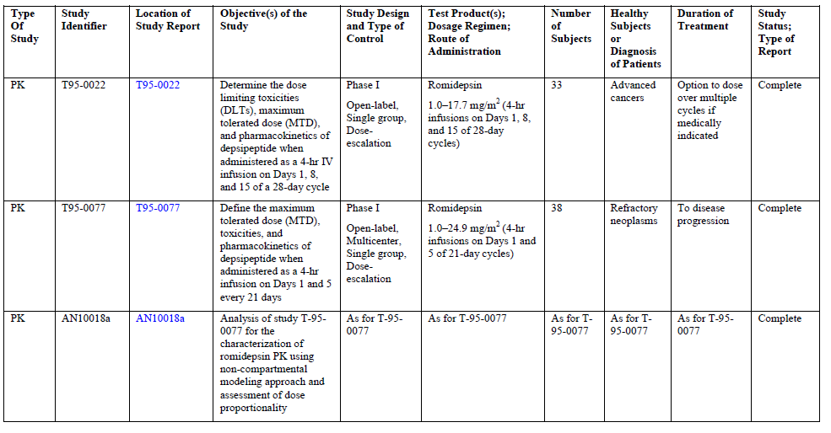
Table 1 continued. Listing of clinical studies.
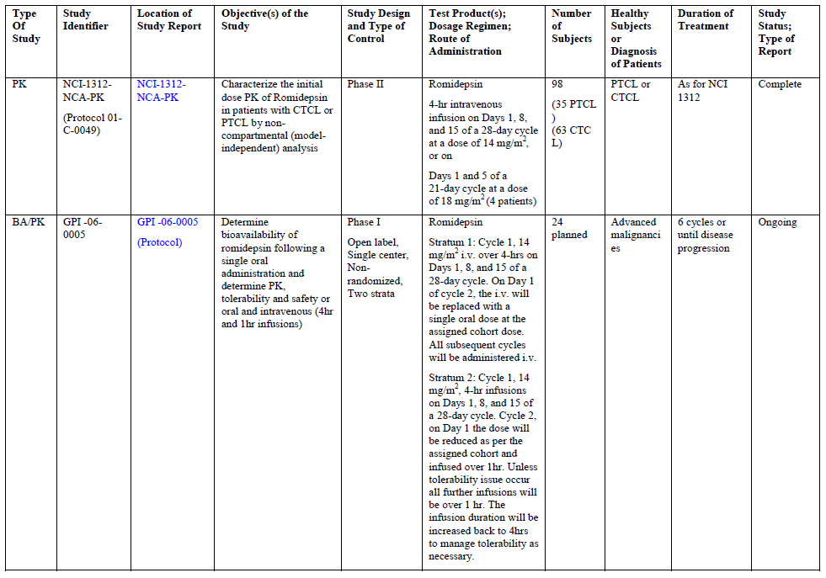
Table 1 continued. Listing of clinical studies
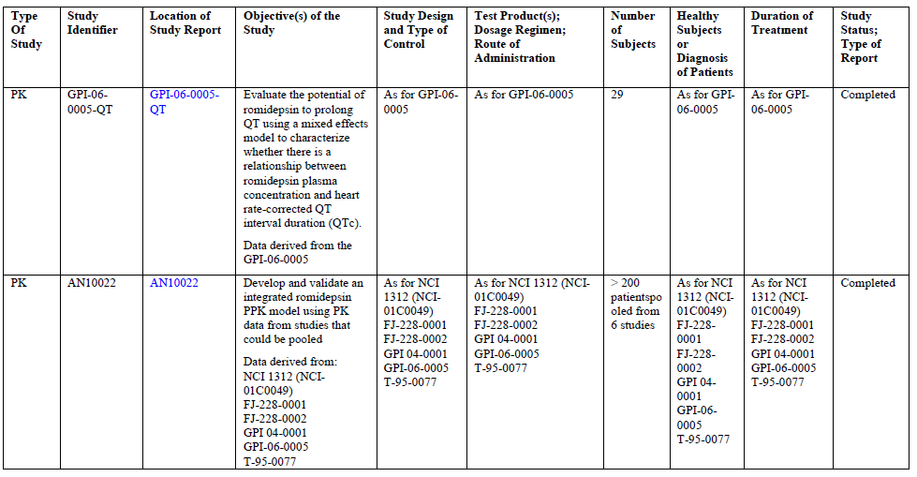
Table 1 continued. Listing of clinical studies

Paediatric data
Not relevant to this application.

Good clinical practice
All aspects of good clinical practice were observed in the pivotal and supportive study.

Pharmacokinetics and pharmacodynamics

Studies providing pharmacokinetic and pharmacodynamic data
The PK and PD of romidepsin have been evaluated in several phase I and II studies involving subjects with various types of cancer including relapsed or refractory cancers. Doses in the various studies range from 1-24.9mg/m² infused for four hours on days 1 and 5 every 21 days and 14mg/m² infused for the same duration on days 1, 8 and 15 every 28 days. A summary of the PK/PD studies is shown in Table 2; results of the individual studies are given below.
Table 2. Summary of clinical studies and analysis

Study T-95-0077
This study was a phase I study with a four hour infusion of romidepsin administered on days 1 and 5 of each 21 day cycle in patients with refractory neoplasm. This study was conducted in two institutions in the United States between August 1997 and November 1999. The principal objective was to define the maximum tolerated dose (MTD) toxicities and PK of Romidepsin when administered as a four-hour infusion.
This was an open-label multicentre single-group dose escalation study with the option to continue dosing over multiple cycles and to move patients to a higher dose level if medically indicated. Patients underwent physical examination prior to treatment on days 1, 4 or 5 of the first cycle and on the first day of subsequent cycles. Performance status, blood collection for biochemistry and haematology and PK analyses together with tumour assessment, ECG, chest x-ray and MUGA scan were undertaken at scheduled times during each treatment cycle. The maximum tolerated dose was defined as the highest dose level which resulted in dose limiting toxicity (DLT) in fewer than 2/6 patients. The DLTs were defined using the NCI Common Toxicity Criteria.
The first three patients were enrolled at dose level 1 observed for at least three weeks and evaluated in clinic before new patients were treated at a higher dose level. If no patient developed a DLT then the next three patients were to be started at dose level 2. If 1/3 patients experienced a DLT an additional three patients were to be started at that dose level. If only 1/6 patients treated at any dose level experienced DLT the next patients were to be started at the next dose level. As soon as two patients at a given dose level experience DLT no additional patients were to be started at that dose level. Tolerance to the MDT level was to be confirmed with the addition of six more patients at that dose level.
Inclusion criteria included patients of at least 18 years of age with histologically confirmed incurable solid tumour malignancy for which there was no known standard therapy.
A total of 38 patients were enrolled and received at least one daily dose of study drug. Three patients were initially enrolled in 1mg dose/m² dose level, three patients at 1.7mg/m², three patients at 2.5mg/m², one patient at 3.5mg/m², three patients at 6.5mg/m², four patients at 9.1mg/m², three patients at 12.7mg/m², 10 patients at 17.8mg/m² and eight patients at 24.9mg/m².
Patients were to be treated until there was evidence of disease progression, if dose limiting toxicity did not resolve within three weeks of terminating treatment, or if the patient or investigator decided it was not in the patient’s best interest to continue treatment.
The majority of patients were Caucasian and most of the underlying malignancies were genitourinary, gastrointestinal or melanomas.
Most patients received more than one dose of study drug and six patients were enrolled in more than one dose level.
The most frequent dose limiting toxicities across all dose levels were asthenia in 17.8%, leukopenia in 17.8% and thrombocytopenia in 8.9%. Three patients were de-escalated. Two patients were de-escalated from 24.9mg/m² to 17.8mg/m² and one patient was de-escalated from 17.8mg/m² to 12.7mg/m².
The incidence of dose limiting toxicities throughout the various dose levels is given in Table 3.
Table 3. Incidence of dose limiting toxicities overall
Table 3 continued. Incidence of dose limiting toxicities overall
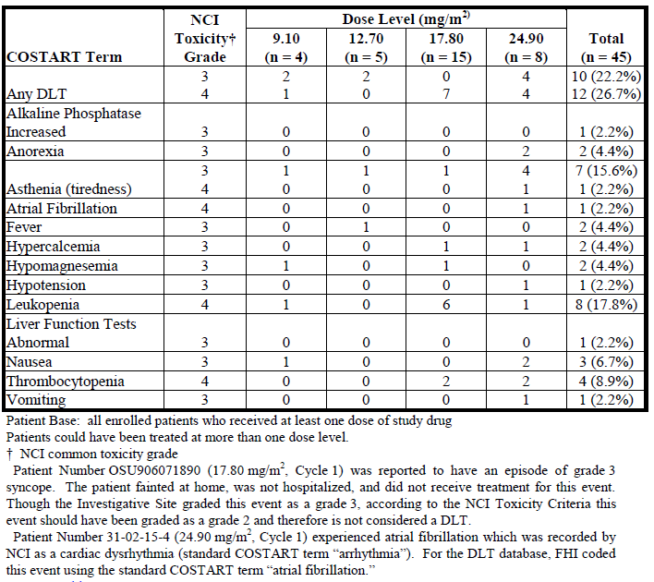
In accordance with the protocol the dose of 17.8mg/m² was identified as MTD and an initial seven patients were enrolled in that study dose to further assess the toxicities. 4/7 patients experienced at least one DLT during cycle 1 or 2 of the drug administration. Accordingly the MTD romidepsin appeared to be 17.8mg/m².
In relation to PK evaluation in this study blood samples for determination of plasma romidepsin concentrations were collected at 0, 1, 2, 3 and 4 hours and subsequently up to 48 hours after the initiation of infusion. PK analysis was undertaken using non-compartmental methods.
The PK profiles of romidepsin were similar across doses as well as between treatment cycles. The T_{max} values ranged from 2-4 hours. The noticeable variability in T_{max} values likely stemmed from technical variations in the collection of samples from central venous access lines as well as from the rapid and extensive distribution of romidepsin in peripheral tissues post-infusion.
Both mean C_{max} and mean AUC_{0-infinity} values were relatively proportional to dose. The mean plasma CL values for romidepsin range from 159-604 ml/m² across the 1-24.9mg/m² dose range investigated. These values approached or exceeded the rate of blood flow to the liver indicating romidepsin was rapidly cleared from the body. The mean volume of distribution (Dss) values range from 7.1 – 76L/m² of the dose range investigated. These values approach or exceed total body water estimates in humans.
COMMENT:
Based on the DLT component of this study the MTD determined was 17.8mg/m² based on a 21 day cycle with drug administered on days 1 and 5.
The data indicated that the PK of romidepsin in cancer patients was linear over the dose range investigated of 1-24.9mg/m². Based on patients with more than one evaluable profile it was evident that the PK did not change appreciably with repeated administration.

Study T-95-0022
Study T-95-0022 was a phase I study of a four-hour infusion of romidepsin administered on days 1, 8 and 15 of each 28-day cycle in patients with advanced cancers. This study was undertaken in a single centre in the United States from February 1997 to June 1999.
The principal objective of the study was to study the DLT, MTD and PK of romidepsin when administered as a four-hour central IV infusion on days 1, 8 and 15 of a 28-day cycle to patients with advanced incurable malignancies.
Methodology and inclusion criteria were similar to that for study T-95-0077.
A total of 33 patients were enrolled and received at least one dose of study drug. Three patients were initially enrolled in the 1mg/m² dose level, four at the 2mg/m², three at the 3.25mg/m², three at 5mg/m², three at 7.5mg/m², seven at 10mg/m², seven at 13.3mg/m² and three at 17.7mg/m².
The majority of patients were Caucasian, the majority of patients were male. The main underlying malignancies were gastrointestinal, head and neck, genitourinary and breast. Most patients received more than one dose of study drug and seven received study drug at more than one dose level.
The most frequent dose limiting toxicities observed across all dose levels were asthenia 23.8%, leukopenia 11.9% and weight loss 9.5%.
One of the first three patients enrolled at 10mg/m² dose level experienced a grade III toxicity. The next three patients were enrolled at 13.3mg/m² and two experienced DLTs and these patients were de-escalated to the 10mg/m² dose levels. Accordingly based on the original design of the trial the MTD is 10mg/m². A further four patients were enrolled at this dose level and all of these patients experienced DLTs.
It is noted that a further study was undertaken utilising anti-emetic medication in which it was determined that it was possible to maintain dose escalation to the 17.7mg/m² dose level. Accordingly the investigator decided the MTD was 10mg/m² without the use of anti-emetics or 13.3mg/m² with the use of anti-emetic agents.
The objective of the PK component of study was to provide a PK evaluation of romidepsin when administered in the four-hour infusion schedule on days 1, 5 and 15 of a 28 day cycle. Two assays were utilised in the study involving a non-specific less-sensitive HPLC-UVSA and specific liquid chromatography randomness spectrometry used to analyse PK samples from a select group of patients on 13.3-23.5mg/m².
The non-specificity of the HPLC-UVSA made the data obtained with the assay unreliable and therefore not considered suitable for assessment.
COMMENT:
Based on the dose limiting toxicities observed during the first cycle of romidepsin administration, the clinically defined MTD level is 10mg/m² unless anti-emetic agents were administered both before and after treatment. With the use of anti-emetic agents 13.3mg/m² is the MTD for this schedule of administration.

Study NCI 1312
The PK component of this phase II study was to characterise the initial dose PK of romidepsin in patients with CTCL or PTCL by non-compartmental (model independent) analysis. Romidepsin was administered as a four-hour infusion on days 1, 8 and 15 of a 28-day cycle at a dose of 14mg/m² or on days 1 and 5 of a 21-day cycle at a dose of 18mg/m². Samples were obtained before drug administration and at serial time points including at the end of infusion (4 hours) and at 6, 11, 13, 15, 18 and 24 hours after initiation of drug administration. A total of 97 patients were evaluable for analysis including 34 patients with PTCL and 63 patients with CTCL. PK data is summarised in Table 4.
Table 4. A summary of some romidepsin PK parameters following 14 mg/m² dose
The CL of romidepsin range from 3.16 – 20.03L/hr/m². The PK of romidepsin was similar across the two dose levels evaluated. The geometric mean T½ for the patients with CTCL and PTCL was 2.95 and 2.87 hours respectively. Ten patients had the time of the last measurable concentration (T_{last}) of >20 hours. The majority of patients had T_{last} at <18 hours. Rapid drug distribution and/or CL resulted in plasma concentrations with below limit of assay detection for a number of patients and as a result an accurate estimation of T½ was not possible for all patients.

Study GPI-06-0005-QT
The primary objective of this analysis was to further evaluate the potential of romidepsin to prolong QT using a mixed effects model to characterise the relationship between romidepsin plasma concentration and heart rate-corrected QT interval duration (QTc), if such a relationship exists.
The study was an open-label, two-stratum, exploratory phase I study designed to determine the bioavailability of romidepsin following a single oral administration, and the PK, tolerability and safety of both oral and intravenous administration at 4-hour and 1-hour infusions. The study was conducted at a single study centre in the US on patients with advanced malignancy. Eligible patients were 18 years of age or older and had measurable or evaluable disease and an ECOG status of 0-2.
Romidepsin was administered to patients at 4-hour IV infusion at 14mg/m² on days 1, 8 and 15 of each 28-day cycle 1. Beginning with cycle 2 patients received doses according to either stratum 1 or 2. Patients continued to receive IV administration of Romidepsin for a total of six cycles or until disease progression occurred.
In stratum 1 on C2D1: the IV infusion was to be substituted with a single oral administration of romidepsin of the assigned cohort dose. All subsequent cycles of romidepsin were to be administered IV as a 4-hour infusion at 14mg/m².
Stratum 2 on C2D1: the IV dose was to be reduced per the assigned cohort and assigned infusion over one hour. The dose was to be escalated from 8mg/m² to 10mg/m² and then 12gm/m² over one hour in subsequent cohorts.
Safety was to be evaluated on clinical examination of laboratory screens and 12-lead ECGs. All data relevant to the exposure/QTc response analyses have been captured for all subjects. Centrally read triplicate ECG data were available for 26/29 patients who received romidepsin at 14mg/m² IV over four hours. Fourteen of these patients also received a lower dose of romidepsin over a one-hour infusion interval. All patients on the ECG evaluable population had at least one matched concentration QTc pair obtained at baseline and one matched concentration QTc pair obtained post-dose.
Estimation of the model fixed and random effects parameters were performed in NON-MEM using the first order conditional estimation method (FOCE). This method provided empirical estimates of subject-specific PD parameters using the population fixed and random effects priors in conjunction with the subjects observed ECG data. The individual PD parameter estimates were used to generate subject and times specific predictions (IPRED) with the dependent variable being analysed. IPRED values as well as population predicted values generated using the population exposure response model parameter estimates were an important component of model performance assessments.
- Results
The evaluation of the relationship between romidepsin plasma concentration and QTc used all replicate ECGs; therefore 1227 concentration/QTc pairs obtained from 26 subjects were available for analysis of QTcF and individually-corrected QT interval (QTcI). The exposure/response relationship between romidepsin and the duration of the heart rate-corrected QT interval has been examined and modelled using a non-linear mixed effects modelling based exposure/response analysis. Concentrations as high as 2668 ng/ml occurred following the 12mg/m² regimen which is two-fold higher than the highest C_{max} observed with the 14mg/m² regimen. Thus the effect of romidepsin on QTc interval was explored at exposures higher than those expected in clinically used dosage regimens.
The analyses of QTcF and the individually corrected QTc and the change from baseline in QTcF each provided nearly identical findings that demonstrated the lack of a direct PD effect of romidepsin. Small magnitude changes in mean QTc was seen temporally, disassociated from the plasma concentration/time profile. The population “mean” effect was still estimated at a value near zero, eg 0.000352 ms/ng/ml for QTcF and -0.000608ms/ng/ml for QTcI: the conclusion remains that there was no systematic concentration/dependent effect of romidepsin on the QTc interval.
Central tendency analyses also showed no effect of dosing with romidepsin on the heart rate-corrected QT interval (QTcF). Further there was no indication of a dose effect for mean changes from QTcF across the 8, 10 and 12mg/m² doses. None of the subjects in the study developed a QTcF >450msecs over a 24-hour period following the start of romidepsin infusion (following either the four-hour infusion 14mg/m² or the one-hour infusion at 8, 10 or 12mg/m²).
COMMENT:
This data indicates that there is no concentration-dependent effect of romidepsin on the duration of QTc interval, including at exposures of up to more than 2.5 times higher on average than that observed with the currently approved [in the US] and clinically used regimen of 14mg/m² administered as a four-hour infusion. Central tendency and categorical analyses also showed no effect of dosing with romidepsin on the heart rate-corrected QTc interval.

Study AN10022
An integrated analysis of PK data was undertaken to investigate the PK of romidepsin in subjects with advanced cancer, including patients with CTCL. The primary objective of the study was to develop and validate an integrated romidepsin PPK model using PK data that could be pooled from six studies of romidepsin. The secondary objectives were to determine the effect of renal function and hepatic function on romidepsin PK and to develop separate predictive PPK models for PK data from the sub-set of studies to support exposure/QTc analysis.
Data for PPK analysis were available from six studies indicated in Figure 1. Post-study design patients were either intensely or sparsely sampled. To streamline the pooling of PK data from the studies for the development of the integrated PPK model a general approach and pre-established criteria for pooling were developed.
Figure 1. Analysis strategy executed for the development of an integrated population PK model for romidepsin
The PK data of the studies in which an intensive sampling search was implemented, ie NCI 1312, GPI-06-0005 and T-95-0077, were analysed separately for the identification of the structural model and characterisation of the residual error model that best describes the PK data. A three-compartment linear model was used to characterise romidepsin PK data. The data from these studies were pooled with data from the three sparsely sampled studies to form a pooled PK data set from all six studies for analysis. Data from three studies were removed from the pooled data set since data from these studies did not satisfy one of the three pre-established criteria for pooling PK data across studies. Thus, data from studies 1312, FJ-228-0001 and GPI-06-0005 with sample size of 137 patients were pooled and analysed for the development of an integrated PPK model as they met the pre-established pooling criteria.
PPK model development was performed through a combination of exploratory data analysis and non-linear mixed effects modelling. The irreducible PPK model given the data contained all the co-variates that were found to be significant in characterising the PPK of romidepsin. All predictive PPK models developed were validated by a predictive check.
The analysis of the integrated PPK data confirmed that age, race, gender, mild to severe renal impairment and mild to moderate hepatic impairment had no effect on romidepsin PK. Study effect and weight were the two most significant predictors of romidepsin CL in the integrated PPK model. The study effect may reflect subject type and other latent variables not evaluable in the PPK data set. Because weight is highly correlated with BSA it is likely that the dosing of romidepsin based on BSA is not an issue.
To assess the impact of renal function patients were categorised into four groups as is indicated in Table 5.
Table 5. Degree of renal impairment
No relationship was demonstrated between the various degrees of renal function and romidepsin CL. The bulk plots of romidepsin CL values by renal impairment category support the lack of effect of renal function on romidepsin disposition.
Assessing the impact of hepatic impairment, non-clinical studies have shown that romidepsin is primarily cleared by the liver and that there are similarities in the pattern of metabolism between rats, dogs and humans. The impact of hepatic impairment on the clearance of the drug was evaluated as indicated in Table 6.
Table 6. National Cancer Institute Organ Dysfunction Working Group (NCI ODWG) Liver Function classification
The analysis was performed using data from three studies, ie NCI 1312, FJ-228-0001 and GPI-06-0005. Two patients had moderate hepatic impairment, 15 had mild hepatic impairment and 120 had normal hepatic function. Data from the three studies were pooled. Randomisation test results indicated that no significant differences could be detected between the three hepatic function categories regardless of whether the comparison was between mild and moderate, mild and normal, or a 30% difference between mild and moderate. Information was included on the distribution of co-variates in the data set created to study the effect of hepatic impairment by the PK/PD knowledge creation approach. Using this approach hepatic impairment was not found to be a significant predictor of CL. Figure 2 shows the distribution of romidepsin CL by hepatic function grouping.
Figure 2. Boxplots showing the distribution of romidepsin clearance by hepatic impairment.
Predictive PPK models to support the development of exposure/response models for HR and QTc metrics were developed with data from two studies: NCI 1312 with 100 patients and GPI-06-0005 with 10 patients. Observed romidepsin concentrations in study NCI 1312 ranged from 2-989.8ng/ml and those in study GPI-06-0005 ranged from 0.34-1240ng/ml over a 24 hour time frame, with peak concentrations occurring mostly at the end of infusion. No co-variates were found to explain the variability in romidepsin disposition in the population of patients studied in each of these two studies. The PPK models were found to be predictive of observed concentrations and therefore deemed appropriate for their intended uses.
The T_{1/2} of romidepsin from the central compartment was estimated using linear regression on the terminal phase of the elimination PK profiles of patients from study GPI-06-0005, which was chosen because the data set for all patients had full PK profiles for 24 hours. The observed data and predictive concentrations for compartment one of the non-linear mixed effect model was superimposable. Thus the estimation of T_{1/2} for romidepsin was essentially the estimation of the elimination half-life from the central compartment. It should be noted that the mean T_{1/2} of 3.6 hours estimated for patients in study GPI-06-0005 is that of the elimination from the central compartment and not overall body elimination.
COMMENT:
Romidepsin has exhibited linear PK and its PK was moderately variable. Age, gender and race were not found to influence romidepsin PK, and mild-severe renal impairment was also found to have no effect as was mild and moderate hepatic impairment found to have no influence on romidepsin disposition.

Study AN10019
As a component of the overall evaluation of the safety of romidepsin, a PK/PD analysis was undertaken to examine the romidepsin concentration-QTc relationship. The objective of the PK/PD analysis was to develop a descriptive non-linear mixed effects model characterising the relationship between romidepsin concentration and heart rate-corrected QTc interval duration change from baseline (HR derived from the RR interval).
ECG and PK data were obtained from two oncology studies of romidepsin study GPI-06-0005 and study NCI 1312 with Table 7 summarising the features of this study data relevant to the PK/PD analysis.
Table 7. Summary of study data relevant to the PK-PD analysis
Only PK or ECG data obtained following the first administered dose were utilised in the analyses. Two analysis data sets were used in the evaluation, the first comprising data from study GPI-06-0005 and the second combining data from GPI-06-0005 with the NCI 1312 data for an integrated analysis.
Graphical and non-linear mixed effects models were used to characterised the concentration/response relationships for HR, QT interval corrected for HR, change from baseline QTcF.
- Results
The concentration/dependent effect of romidepsin on HR was temporally disassociated from the plasma concentration/time profile. Therefore an indirect response PD model was used to characterise the romidepsin effect. Data was provided on the fixed effects parameters of a non-linear mixed effects model along with derived variables; the QTcI interval vs the romidepsin plasma concentration in the central compartment for study GPI-06-0005; and the QTcF interval vs the romidepsin plasma concentrations for the integrated data set. The graphs suggest the absence of a concentration/effect relationship for QTc.
A variety of PD models were used to analyse the QTc interval data. These models generally suggest that a concentration effect due to a statistically significant decrease in the model objective function value were relative to a concentration/naive model. However in all cases the 95% CI for the relevant drug effect parameters encompass a value of zero indicating no romidepsin concentration/effect relationship. Therefore since a variety of models evaluated for multiple QTc metrics in two data sets using either plasma or peripheral concentration demonstrated lack of an effect (due to 95% CI that contain zero), no concentration/dependent effect of romidepsin on the QTc interval is concluded from the present data.
COMMENT:
These evaluations have shown that romidepsin has no PD effect on the Fredericia corrected QT interval or the change from baseline in QTcF interval as well as the QTcI interval. Romidepsin was associated with a pharmacodynamically indirect concentration/dependent increase in HR in this modelling based analysis method.

Evaluator’s conclusion on pharmacokinetics and pharmacodynamics
In these PK/PD studies romidepsin has exhibited dose-proportional and linear PKs. PK did not change appreciably with repeated administration. Romidepsin PK was also characterised with a three-compartment linear PK model. The mean area under the curve AUC, peak serum concentration (C_{max}), half-life and time to maximum concentration (T_{max}) were 1549ng/hr/ml, 377ng/ml, 2.92 hours and four hours respectively. Romidepsin exhibited moderate variability in its PK with the inter-subject variability in clearance (CL) and volume of central compartments (V1) estimated to be 34% and 47% respectively.
In a PPK analysis age, race, gender and mild to moderate or mild to severe renal impairment and mild hepatic impairment had no effect on romidepsin PK. Study effect and weight were the two most significant predictors of romidepsin CL in the integrated PPK model. Weight accounted for approximately 2% of the variability in romidepsin CL and study effect explained 4% of the variability.
The potential of romidepsin to prolong the heart rate-corrected QT interval in patients with advanced malignancies revealed no concentration dependent effect of romidepsin on the duration of QTc interval, and both central tendency and categorical analyses showed no effect of dosing of romidepsin on heart rate-corrected QTc interval.

Dosage selection for the pivotal studies
The early clinical development of romidepsin included two phase I dose escalation safety and tolerability studies, ie study T-95-0022 and study T-95-0077 previously discussed. Based on the MTD observed in study T-95-0077 and observed clinical activity in patients with T-cell lymphomas, the initial dose selected for the first phase II study NCI 1312 was 17.8mg/m² administered on days 1 and 5 in a 21-day cycle. The dosing schedule was subsequently changed to 14mg/m² administered on days 1, 8 and 15 in a 28-day cycle to improve tolerability. This dose was used in the pivotal study for CTCL initiated in 2005.
Based on encouraging results observed on NCI study 1312 in heavily pre-treated and refractory patients with PTCL and the interim data available from patients with CTCL, a pivotal phase II trial in patients with relapsed/refractory PTCL, study GPI-06-0002, was planned and initiated in 2007.

Clinical efficacy

Data providing efficacy data
Data for efficacy in this submission involves two studies, namely the pivotal study GPI-06-0002 and the supportive study NCI 1312.

Study GPI-06-0002 (pivotal study)
The pivotal study GPI-06-0002 was a phase II multicentre open-label trial evaluating the activity and tolerability of romidepsin in progressive or relapsed peripheral T-cell lymphoma following prior systemic therapy.
The sponsors indicate that the choice of a single-arm design was based on several factors. It is noted that PTCL is a rare and heterogeneous disease with many histological sub-types which make it difficult to accrue a sufficient number of homogenous patients to balance two separate treatment arms in a population with relapsed or refractory PTCL. At the time the study was initiated there were no other agents considered standard for second-line treatment of patients with PTCL. It was considered the alternative of using a placebo or best supportive care control was unethical in a disease with significant morbidity and mortality and in a patient population who had progressed despite prior systemic therapy.

Design and objectives
Study GPI-06-0002 was a rigorously conducted trial that employed a prospective, independent review of biopsy samples to confirm the histopathological diagnosis of PTCL and an independent review of both radiographic and clinical data to assess response to treatment by an independent review committee (IRC). Both the IRC and the site investigators assessed tumour burden and response to treatment based on internationally recognised response criteria in patients with lymphoma, ie the International Workshop Criteria (IWC).
The primary endpoint for the study was the complete response rate which is defined as both complete response (CR) and unconfirmed complete response (CRu) per the IWC. The complete response was chosen for two primary reasons; (a) in a single arm study response is the only direct measure of activity, and (b) it was considered to be a reasonably likely predictor of clinical benefit in patients with relapsed disease.
Patients received romidepsin at a dose 14mg/m² IV over four hours on days 1, 8 and 15 at each 28-day cycle. Six cycles of treatment were planned and patients who developed progressive disease, significant toxicity or met other criteria for the study termination were to discontinue treatment. Responding patients had the option of continuing beyond six cycles if desired.
Screening assessments conducted 2-4 weeks prior to initiation of therapy included medical history, physical exam, vital signs, ECOG status, safety and laboratory assessments, and 12-lead ECG. Assessments of tumour burden through radiographic evaluation, bone marrow assessment and evaluation of skin lesions were undertaken.
Re-assessment was undertaken every four weeks. A repeat radiographic evaluation was performed after every two cycles. Patients who completed treatment were followed every two months until disease progression, withdrawal from study or the start of alternate therapy.
Inclusion criteria included male and female patients at least 18 years of age with histopathologically confirmed PTCL who had progressive disease following, or were refractory to, at least one prior systemic therapy. Histopathological diagnoses were confirmed by a central laboratory.
Eligible histology as defined by the WHO classification included all variants of PTCL but excluded mycosis fungoides or Sezary syndrome, although transformed mycosis fungoides was included.
Patients were required to have measurable disease according to the IWC criteria, ECOG status of 0-2, adequate bone marrow function and no known significant cardiac abnormalities.
Outlined in Table 8 are the efficacy assessments conducted during the study to assess response to treatment, thoroughly evaluating disease burden in the patients enrolled in this study. These assessments were conducted after every second cycle of treatment.
Table 8. Efficacy Evaluations Conducted During Study GPI-06-0002 to Evaluate Response to Treatment
As prospectively planned in the protocol, disease response was assessed independently by an IRC based on the IWC without knowledge of the investigator evaluation of response. Criteria for the assessment of radiology by the IRC are given in Table 9.
Table 9. IRC Radiology Review Assessment Criteria Using CT/MRI Scans
Definitions of response utilised by the IRC were in accordance with the IWC, utilising CR and CRu (complete response confirmed and unconfirmed, respectively). This is based on total disappearance of all evidence of disease and normalisation of biochemical abnormalities associated with NHL. Other levels of response included partial response (PR), stable disease (SD) and progressive disease (PD), as per standard criteria.
The study was planned to obtain a total of 65 evaluable patients who met all major protocol requirements and received at least 2/3 planned doses in two consecutive cycles of therapy. It was estimated this would require at least 100 patients to be enrolled and treated under the study protocol.

Patient disposition, analysis sets and exposure to treatment
Table 10 presents an overview of patient disposition on the study.
Table 10. Patient Disposition and Analysis Sets (Study GPI-06-0002)
Overall a total of 131 patients received at least one dose of romidepsin in this study and 113 or 86.3% of these patients were off treatment as of the data cut-off for the reporting of 31st March 2010. The most common reason for discontinuation of the study was progressive disease followed by adverse events. The multicentre study comprised patients enrolled from the US, France, Australia, Spain, Germany, Poland, Czech Republic, Sweden and the UK.
Exposure to romidepsin is summarised in Figure 3. As of the data cut-off, 38.2% of the patients had received at least four cycles and 26.7% at least six cycles while 16% received eight or more cycles.
Figure 3. Number of Patients Treated in Each Cycle (As Treated Population, Study GPI-06-0002, N=131)
The majority of patients treated within each cycle received all three doses per cycle, with over 80% of patients receiving at least two doses of the cycle. Sixty patients or 45.8% required at least one dose to be held and 14 or 10.7% required dose reduction for the management of an adverse event.
A total of 130 patients were included in the intent to treat population with one patient excluded as not having a diagnosis of PTCL. The demographic characteristics of this patient population are indicated in Table 11. These are consistent with the characteristics of patients with relapsed/refractory PTCL.
Table 11. Demographic and Baseline Characteristics (Histopathologically-Confirmed Population, Study GPI-06-0002, N=130)
Baseline disease characteristics are summarised in Table 12 and are consistent with the reported incidence of PTCL sub-types. The most common PTCL sub-type determined by central review was PTCL not otherwise specified (NOS), reported in 53.1% of patients. A total 115 or 88.5% of patients had a bone marrow biopsy screening which was positive to disease in 36 patients and skin involvement was noted by the investigator in 34 or 26.2% of patients.
Table 12. Disease Characteristics (Histopathologically-Confirmed Population, Study GPI-06-0002, N=130)
All patients had received multiple prior therapies for PTCL with the most commonly administered prior combination chemotherapy being CHOP (Table 13).
Table 13. Prior therapies for PTLC (Histologically-confirmed population, Study GPI-06-002)

Efficacy results
The primary efficacy endpoint of the study was the complete response rate [CR + CRu] based on overall IRC review. Objective disease response rates were based on the IRC review and response rates based on investigator assessments were considered secondary and supportive endpoints. The data for the 130 patients included in the histologically confirmed population are indicated in Table 14.
Table 14. Response Rates Based on Overall IRC and Investigators’ Assessments (Histopathologically-Confirmed Population, Study GPI-06-0002)
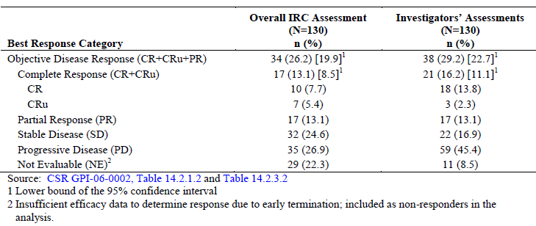
The complete response rate of 13.1% was at the high end of the protocol defined target point estimate of 8-15%. The objective disease response rate for the IRC review was 26.2%. These responses were comparable to the investigators’ evaluations with a complete response rate of 16.2% and an objective disease response rate of 29.2%. It is worth noting that in the overall IRC review patients who were withdrawn from therapy before having a determination of response were classified as non-responders. For those patients who fulfilled all criteria of the protocol and went on to receive adequate therapy with complete response and objective disease response rates based on overall IRC review, the numbers were 19.2% or 15/78 patients and 39.7% or 31/78 patents, respectively. The investigators’ assessments were 25.6% or 20/78 patients and 44.9% or 35/78 patients respectively.
There was reasonable agreement between the overall IRC assessment of response and the investigators assessment as indicated in a cross-tabulation of responses in Table 15.
Table 15. Cross-tabulation of Best Response to Treatment Based on Overall IRC and Investigators’ Assessments (Histopathologically-Confirmed Population, Study GPI-06-0002, N=130)
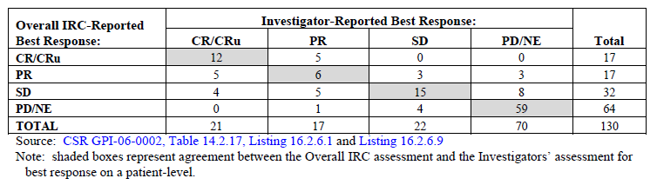
Overall the assessments agreed in 92 or 70.8% of the 130 patients treated in the study and in 38 cases the assessments differed as follows:
- Differences between responder categories (N=10): In 5 cases the IRC best response was CR or CRu and the Investigators’ best response was PR; similarly, in 5 cases the IRC reported PR and the Investigators reported CR or CRu.
- Differences between responder and non-responder categories (N=16): In 6 patients the IRC best response was reported as PR and the Investigators’ best response was SD or PD and conversely in 10 patients, the Investigators reported CR or PR and the IRC reported SD or NE.
- Differences between non-responder categories (N=12): In 8 patients the IRC best response was SD and the Investigators’ was PD and conversely in 4 patients, the Investigators’ response was SD and the IRC was PD or NE.
The IRC radiology reviewers also determined best response for each patient based on review of CT and MRI scans without clinical information and the results are summarised in Table 16. Consistent with the overall IRC response assessment, the complete response rate reported by the IRC reviewers was 14.6% with an objective disease response rate of 26.2%.
Table 16. Response Rates Based on IRC Radiological review using CT/MRI scans (Histopathologically-Confirmed Population, Study GPI-06-0002)
Treatment with romidepsin led to durable responses and is indicated in Table 17: Kaplan-Meier results for the duration of response for 17 patients who achieved CR or CRu and for all 34 patients who achieved an objective disease response based on overall IRC review; and also the corresponding data from the investigator assessments is presented. Figures 4 and 5 present the Kaplan-Meier curves for duration of response for complete responders and patients with an objective disease response based on Overall IRC review, respectively.
With a median duration of follow up for patients with complete response of 250 days (8.2 months), the median duration of response had not been reached for the 17 patients with complete response based on overall IRC assessment. Maximum duration of response for these patients was 801+ days (26+ months). As of the initial data cut-off, 16 or 94.1% of these 17 patients who achieved complete response had not relapsed. Median duration of objective disease response for 34 responders in the overall IRC review as of the 31st March 2010 was estimated at 353 days or 12 months.
Table 17. Summary of Kaplan-Meier estimates of duration of response (Days) based on Overall IRC and Investigators’ Assessments (Histopathologically-Confirmed Population, Study GPI-06-0002)
Figure 4. Kaplan-Meier Curve of Duration of Overall Response for Patients with CR/CRu Based on Overall IRC Review (Histopathologically-Confirmed Population, Study GPI-06-0002)
Figure 5. Kaplan-Meier Curve of Duration of Overall Response for Patients with CR, CRu and PR Based on Overall IRC Review (Histopathologically-Confirmed Population, Study GPI-06-0002)
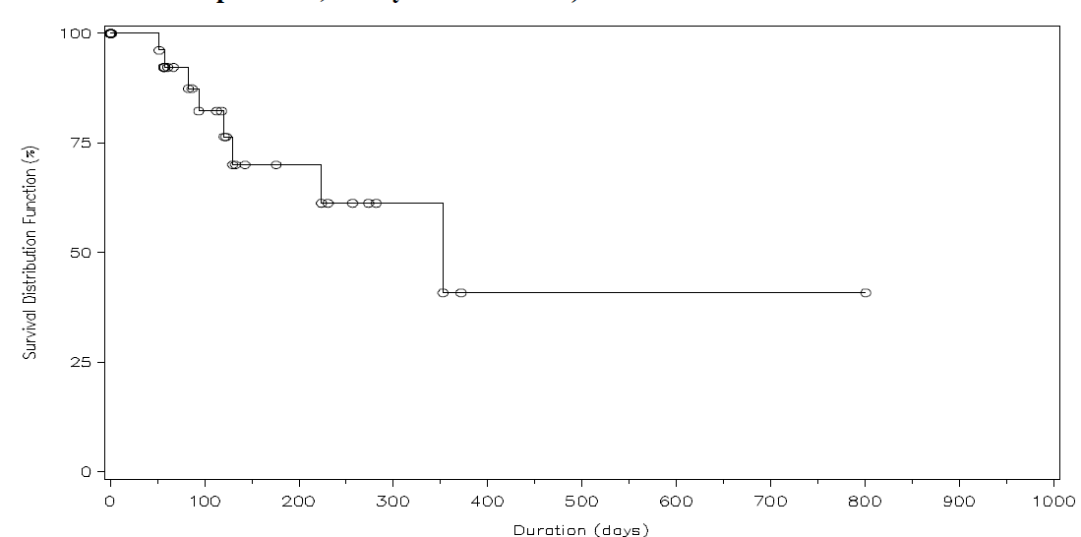
Based on investigator assessments the median duration of response for complete responders was 429 days or 14 months. Median duration of objective disease response across all 38 responders based on the investigators assessment was estimated 353 days or 12 months.
In relation to stable disease, among the 32 patients with stable disease by overall IRC review 22 had durations of SD >90 days and six had durations >180 days, with a maximum duration of SD being 749+ days or 24+ months.
Durations of response in the per protocol population was similar to that in the histologically confirmed population with a median duration of objective disease response estimated at 353 days for patients who achieved CR or PR, and for results based on the investigator assessments median duration of response in the per protocol population was estimated at 429 days or 14 months for patients with objective disease response as well as for patients with complete response.
In relation to time to response, responses for romidepsin were observed during the first course of treatment with a median time to objective disease response being 56 days or two cycles (range 43 days–169 days). The median time to complete response was 105 days or four cycles with a range 49 days–281 days. This data was similar for the investigators determinations.
In relation to time to disease progression median time to progression was 177 days or six months for the IRC reviewed patients and 85 days based on the investigators assessments. This difference is determined in part by the fact that the IRC review does not involve routine reporting of date of disease progression.
Evaluation of time to disease progression for the IRC assessment evaluated by response category is indicated in Table 18 and Figure 6. As indicated this was considerably longer for patients who achieved complete remission.
Table 18. Summary of Kaplan-Meier estimates of Time to Progression (Days) based on Overall IRC Assessment by Response to Treatment (Histopathologically-Confirmed Population, Study GPI-06-0002)
Figure 6. Kaplan-Meier Curve of Time to Progression Based on Overall IRC Review by Response Category (Histopathologically-Confirmed Population, Study GPI-06-0002)
Data for time to disease progression based on investigator assessment were similar in that compete response patients had significantly longer time to disease progression of 16 months or 500 days for complete responders while time to tumour progression were 188, 120 and 49 days respectively for patients with PR, SD and PD categories.
Data for progression free survival is summarised in Table 19. The median progression free survival for IRC patients was 107 days or four months and 77 days or three months based on the investigators assessments. Evaluation of progression free survival across the response category is indicated in Table 20. Again patients with complete response had significantly longer PFS compared to the other response categories.
Table 19. Summary of Kaplan-Meier estimates of Progression-Free Survival (Days) based on Overall IRC and Investigator’s Assessments (Histopathologically-Confirmed Population, Study GPI-06-0002)
Table 20. Summary of Kaplan-Meier estimates of Progression-Free Survival (Days) based on Overall IRC Assessment by Response to Treatment (Histopathologically-Confirmed Population, Study GPI-06-0002)
Review of the demographic baseline disease characteristics and prior therapy for patients who achieved CR or CRu compared to those who did not achieve complete response is indicated in Table 21 and confirms that these patients were representative of the patient population as a whole and were not a sub-group of patients with a better prognosis.
Table 21. Comparison of baseline disease characteristics for patients with CR compared to other response categories (Histopathologically-confirmed population)
In relation to improvements in ECOG performance status (which was assessed on a regular basis throughout treatment and is an assessment of clinical benefit of response to treatment), this was determined by comparison of change from baseline ECOG PS to that throughout the course of the study. Eighty-two percent of patients with complete response had improvement in ECOG PS compared to 58% for PR and 55% for patients with SD. A further evaluation of the changes in ECOG performance status were undertaken to assess potential improvement or overall worsening of the entire treatment course for each response category and this is indicated graphically in Figure 7.
Figure 7. Area Under the Curve Analysis of ECOG Performance Status Over Time on Study by Response to Romidepsin (Histopathologically-Confirmed Population)
It is worth commenting that assessment of extra nodal sites of disease within skin and bone marrow were assessed. Of 41 patients who had evidence of extra nodal lesions, nine or 22% achieved complete resolution and three achieved partial responses. These data are equivalent to the overall response categories.
Review of responses to treatment according to patient sub-groups including gender, age, region, PTCL sub-type, number of prior therapies etc is indicated in Table 22. There were no meaningful differences in the rate of complete responders or the rate of objective disease response when assessed by these sub-groups. This is particularly pertinent in relation to the various histological sub-types of PTCL where the response rates within each were comparable. It is also noteworthy that even in those patients who had received more than three prior systemic therapies there were responses recorded in line with the overall response rate.
Table 22. Complete Response and Objective Disease Response Rates Based on Overall IRC Assessment in Patient Subgroups (Histopathologically-Confirmed Population, Study GPI-06-0002, N=130)

Update of efficacy
An updated analysis of the clinical data with a later cut-off date of the 31st October 2010 or seven months after the initial data is provided. Table 23 compares the original analysis results in terms of primary and secondary objectives to the updated results. In the updated analysis the complete response rate based on the overall IRC review improved from 13.1% to 14.6% or 19/130 patients as two patients had improvement from PR to CR. A further two patients with CRu became CR. The overall response rate for the updated data was 25.4% and there was one patient with PR initially had an update result of stable disease.
Table 23. Original and Updated Response Rates and Duration of Response Based on Overall IRC Review (Histopathologically Confirmed Population, N=130)
Kaplan-Meier curves for duration of response based on the update are given in Figures 8 and 9. The updated estimated median duration of response was 17 months or 505 days, 13 or 68% of these 19 patients had duration of response in excess of six months and seven or 37% duration of response In excess of 12 months. The median duration of objective disease response across the 33 patients improved from 12 months or 353 days to 17 months or 505 days.
Figure 8. Updated Kaplan-Meier Curve of Duration of Overall Response for Patients with CR or CRu Based on Overall IRC Review (N=19)
Figure 9. Updated Kaplan-Meier Curve of Duration of Overall Response for Patients with CR/CRu or PR Based on Overall IRC Review (N=33)
In the updated review median time to objective disease response across all responders was 1.8 months with a range of 1.4-5.3 months and median time to complete response was 3.7 months with a range of 1.6–13.7 months.
A graphic display of the duration of response for the 19 patients with a complete response is given in Figure 10.
Figure 10. By-Patient Display of Updated Duration of Response for Patients with CR and CRu Based on Overall IRC Review (N=19).
Updated analysis for progression free survival for the overall patient population was provided. There is essentially no difference between the initial and updated analyses for these data.
Summary data on overall survival for the 130 patients in the HC population showed that overall 76 or 58.5% of patients had died with a median overall survival of 11.3 months from the start of romidepsin treatment. The data on overall survival by best response to romidepsin indicate that complete response was associated with a longer survival compared with other response categories as might be expected.
Review of investigator assessments for the update indicates that these were consistent and supportive of the IRC assessments. Investigator reported complete response rate and overall response rate did not change in the updated analysis.
Updated results also confirmed consistency of results across the various sub-groups as per the original analysis.
COMMENT:
The data from the original updated analyses indicate that the administration of romidepsin to the heavily pre-treated population of patients with PTCL is associated with a complete response rate of 15% and an overall response rate of 25%. These data were consistent across the population, including histological sub-type, risk factors and number and type and response to prior therapy. Responses were durable with a median duration of response of 17 months for all responders. These data are therefore in line with evidence of worthwhile clinical benefit for patients who otherwise would have very limited therapeutic options available to them. The only area of uncertainty rests with the fact that this was a phase II study without a comparator, although it is recognised that such selection would have been extremely difficult.

Study NCI 1312:

Study design, objectives and patient population
The supportive study provided in this submission, NCI study 1312, is a phase II open-label multicentre international study designed to evaluate the activity and tolerability of romidepsin in separate cohorts of patients with CTCL and PTCL. Initially the PTCL cohort in the study was restricted to patients with relapsed or refractory PTCL NOS or primary cutaneous ALCL who had not received more than two systemic cytotoxic chemotherapy regimens. Observed activity in the early phases of trial led to amendment to include all sub-types of PTCL in patients who had previously received more than two cytotoxic therapies.
Inclusion criteria included male and female patients 18 years of age all with measurable disease, ECOG PS of 0-2 and life expectancy of at least 12 weeks. Central histopathological confirmation of PTCL was required.
Romidepsin was administered as a four-hour infusion on days 1, 8 and 15 of a 28-day cycle with a starting dose of 14mg/m². It is noted that the first two patients in this study were treated with 18mg/m² on days 1 and 5 of a 21-day cycle but the schedule modified because of relatively poor tolerance.
Patients with a measurable response continued to be treated with romidepsin with increasing intervals allowed between cycles after completion of six cycles if needed to improve patient tolerance and compliance.
The primary efficacy endpoint of study was objective disease response rate as determined by the site investigators. Standard criteria for evaluation were utilised including IWC for lymphadenopathy and RECIST for skin and visceral lesions. Response assessments were performed every two cycles.
Overall 47 patients were enrolled in the study and received a median of three cycles of treatment and the maximum duration of treatment was 57 cycles.
Demographic characteristics for patients are given in Table 24. These were consistent with that expected for the disease. Central histopathological review confirmed that 46/47 patients treated in the study had PTCL. The median number of prior regimens for treatment of PTCL was three ranging from 1–11 and 17 or 36.1% had undergone stem cell transplantation.
Table 24. Demographic and Baseline Disease Characteristics (All Treated Patients, NCI Study 1312)

Results
Reviewing results, a total of 45 patients were eligible for assessment of response to treatment, one being excluded because of not having the diagnosis of PTCL and the other because of protocol violation before starting the treatment.
The objective disease response rate was 37.8% with eight (17.8%) complete responses. Median time to response was 1.8 months with most patients achieving response within two months. The overall median duration of objective disease response was nine months, ranging from 2–74 months and median duration of CR was 29.7 months.
An overview of baseline characteristics, treatment duration and time to duration response for the eight patients who achieved complete response in this study is given in Table 25. This group is representative of the overall patient population under study. Six of the eight patients with complete response had duration of response of six months or longer and five durations of 12 months or longer. Among the nine patients with the best response of PR, five had duration of response of six months or longer and two duration of 12 months of longer. Among the five patients the best response of SD all five had SD for at least three months and three for six months or longer.
Table 25. Patient Listing of Baseline Characteristics and Time to Event Data for Patients with Complete Response Based on Investigators’ Assessments (NCI Study 1312, N=8)
Objective disease response was observed in patients with PTCL NOS being 42.9%, ARTL 16.7%, ALK -1 negative, ALCL 100% and enteropathy and associated T-cell lymphoma are 1 of 1. Of the 17 patients who had undergone prior stem cell therapy six or 35.3% experienced an objective response and three CR or 17.6%.
COMMENT:
These supportive data support the evidence of efficacy for romidepsin in heavily previously treated patients with PTCL. Response rates observed including the incidence of complete remission are comparable to that for the pivotal trial. Overall the two patient populations involving 175 patients indicates definite activity of romidepsin in this patient population with at least a 15% complete remission rate with the responses being durable and clinically meaningful.

Clinical safety

Studies providing evaluable safety data
This submission for evaluation of clinical safety supporting the PTCL indication presents data from the total of 891 patients who received at least one dose of romidepsin as monotherapy through 30 September 2010 in clinical studies supported by Celgene with the US National Cancer Institute, including 447 patients with haematological malignancies including lymphomas and 444 patients with solid tumours as indicated in Table 26. Individual studies involved in the safety population for evaluation are indicated in Table 27. As shown, 178 patients were involved in the two clinical efficacy PTCL studies. It is to be noted that patients included in the CTCL studies as well as those for other indications were included in the safety evaluation data for the US determination of marketing for romidepsin for the indication of CTCL who had received previous therapy.
Table 26. Patients Treated with Romidepsin as Monotherapy in Celgene- and US NCI Sponsored Studies
Table 27. Safety Data included in this Summary of Clinical Safety
It is worth noting that there were differences in the pivotal study GPI-06-0002 and the NCI study 1312 in terms of the protocols, observation schedules and patient characteristics that are not considered to have a clinically significant influence on assessment of adverse effects. There were some differences in the frequency of evaluation for the two studies in PTCL, particularly in NCI 1312 where laboratory evaluations were undertaken more frequently.
This evaluator considers it most appropriate to concentrate on the safety data in relation to the two PTCL studies. Accordingly the disposition of the 178 patients with PTCL is indicated in Table 28.
Table 28. Patient Disposition, by Indication and Study: Patients with PTCL (N=178)

Exposure
Table 29 indicates the extent of exposure to romidepsin by study for patients with PTCL. Figure 11 indicates the number of patients treated with romidepsin within each treatment cycle by study.
Table 29. Exposure to romidepsin, by Study: Patients with PTCL (N=178)
Figure 11. Percentage of Patients Treated in Each Cycle, by Study: Patients with PTCL (N=178)
Design methodology for the two studies has previously been presented in the Efficacy section. Among the patients with PTCL the mean and median number of romidepsin cycles administered were 5.2 and 2 respectively and mean and median duration of treatment of 142 days or 4.7 months and 46 days or 1.5 months respectively. The range of the number of cycles administered was wide being 1-57 cycles. Among all the patients with PTCL the mean and median total doses of Romidepsin administered were 333mg and 151mg respectively with a range from 25-2391 mg.
The mean and median number of cycles administered in the pivotal study, being 4.3 and 2 respectively, were both lower than that for the supportive NCI study 1312, being 7.9 and 3 respectively. The extent of the exposure to romidepsin is appreciably greater in the NCI study than the pivotal study; this had some influence on the adverse event rate between the two studies. Demographic and other pre-treatment characteristics for the two patient populations have previously been presented.

Adverse events
Analyses of adverse events during the two studies were performed on treatment emergent adverse events defined as those events that start during romidepsin administration or through 30 days after the last dose. All adverse events that are study drug related and all events present at baseline that were worsening in intensity were subsequently considered drug related or were subsequently drug related by the investigator. Assessment of grading of toxicities was determined by NCI toxicity criteria. It is to be noted that the methodological differences between the pivotal study and NCI study 1312 included differences in the visit and evaluation schedules, adverse events reporting procedures, and documentation of treatment for adverse events. Also there were differences in the patient characteristics in each study population with patients in NCI study 1312 having more advanced disease and receiving more prior lines of therapy.
An overall summary of the categories of adverse events reported in the two studies is indicated in Table 30. As indicated approximately 97% of patients experienced at least one treatment emergent adverse event of which 71% were at least grade III and 27% at least grade IV in intensity. Fifty-one per cent of patients experienced at least one serious adverse event and 8% of patients had an adverse event that resulted in death. Overall 20% of patients discontinued study drug because of an adverse event.
Table 30. Summary of Treatment-emergent Adverse Events, by Study: Patients with PTCL (N=178)
The most common adverse events and the grade III and IV incidences of these common adverse events among the patients is summarised in Table 31. It is to be noted that more than half, ie 10/18 events that occurred at an incidence of at least 20% in the NCI study 1312 and <20% of study in the pivotal study were clinical chemistry abnormalities.
Table 31. Treatment-emergent Adverse Events Experienced by at Least 20% of Patients in Either Study, Overall and By Intensity, by MedDRA Preferred Term: Patients with PTCL (N=178)
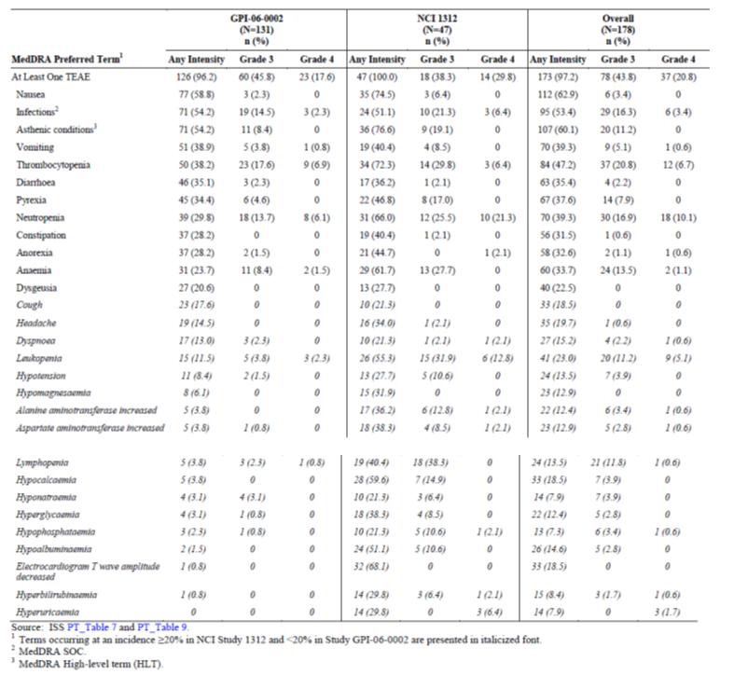
The principal adverse events observed in the two studies included GI disturbances in 83% particularly nausea, vomiting, diarrhoea and constipation. These events were however generally mild to moderate in intensity and most patients continued treatment despite these effects. Severe grade III or IV nausea and vomiting occurred in 3% and 6% of patients respectively.

Haematological adverse events
Haematological abnormalities were noted in 66% of patients including thrombocytopenia in 47%, neutropenia 39%, anaemia 34%, leukopenia 23% and lymphopenia 14%. Thrombocytopenia in particular was most common in those patients who had received at least one prior systemic therapy or had received prior bone marrow transplantation, being 71% vs 41% for those who had not undertaken these procedures. Grade III or greater haematological abnormalities were also common with grade III thrombocytopenia 21%, neutropenia 17%, leukopenia 11%, anaemia 14% and lymphopenia 12%. The grade IV incidences of these events were 7%, 10%, 5%, 1% and <1% respectively. Because of these toxicities doses were held or reduced in 29% of patients and 5% of patients permanently discontinued study drug.

Asthenic conditions
Asthenic conditions occurred in 60% of patients including fatigue, asthenia and malaise. These were generally grade I and II in intensity although grade III asthenia occurred in 11% of patients but there were no grade IV events. <1% of patients required treatment discontinuation because of asthenia.

Infections
Infection was common in these two studies occurring in 53% with 16% of patients experiencing infections of grade III intensity and 3% grade IV intensities. Febrile disorders were common in 38%. It is noted that these infections were much more common in patients who had received prior monoclonal antibody therapy than those that did not being 77% vs 50% and more common in patients >65 years being 51% vs 37% for younger patients.
Twenty per cent of patients had serious infection and 6/18 patients in the two studies with a treatment emergent death had a diagnosis of infection, ie pneumonia, sepsis and infection and infection was involved in 2/3 deaths assessed as possibly or probably related to study drug. Twelve per cent of patients required dose suspension or reduction and 3% discontinued Romidepsin because of infection. The most common infections include pneumonia and sepsis in 10% being at least grade III in 17 patients. It is noted that these patients were also neutropenic at the time of pneumonia/sepsis in five patients.

Differences between studies
It is noted that due to the methodological differences between the two studies that the frequency of haematologic and biochemical abnormalities noted in NCI study 1312 were greater than the pivotal trial, including hypocalcaemia in 60% vs 4% for the pivotal study, hypoalbuminia in 51% vs 2%, increased AST 38% vs 4%, hyperglycaemia 38% vs 3%, increased ALT 36% vs 4%, hypomagnesaemia 32% vs 6% and hypokalaemia 17% vs 10% respectively. The vast majority of these clinical chemistry abnormalities were grade I or II in intensity. Most patients continued treatment unchanged. The incidence of adverse events was generally most often after cycle 1.

Deaths
In relation to treatment emergent deaths, these were reported for 10 or 8% of patients in the pivotal study and it is noted that the investigator considered death to be unrelated to study drug for 9/10 patients and the patient in which the investigator considered the patient’s death to be possibly related died of multi-organ failure in the setting of sepsis and progressive disease.
In study NCI 1312, eight or 17% of patients had treatment emergent deaths with the investigator considering that two of these deaths were potentially related to treatment, one dying with recurrent P. carinii pneumonia in the setting of progressive disease and the second a sudden death at home that was considered by the investigator potentially related to vascular disease. An overall summary of treatment emergent deaths for the two studies is given in the dossier.
It is worth noting that eight patients whose death was not considered due solely to progressive disease also died with associated infection.

Serious adverse events
In relation to serious adverse events, in the pivotal study these occurred in 60 or 46% of patients, the most common being pyrexia 7%, pneumonia 5%, vomiting and sepsis 5%, cellulitis 4%, abdominal pain, febrile neutropenia and deep vein thrombosis 3% each and dehydration, dyspnoea, neutropenia, chest pain and pulmonary embolism 2% each. The investigators considered these serious adverse events to be study drug related in 33 or 25% of patients in the pivotal study with those related to at least two patients being vomiting, pyrexia in four patients, febrile neutropenia, deep vein thrombosis and cellulitis in three patients each.
In the NCI study 1312, the incidence of serious adverse events was higher than the pivotal study being 64%. The most common being pyrexia in eight patients, increased AST and hypotension in six patients, ALT increased, anaemia, thrombocytopenia and disease progression in five patients and infection, dyspnoea and dehydration in four patients. A serious adverse event was considered by the investigator to be study drug related for 55% of patients with the most common being pyrexia, hypotension and increased AST in five patients each, thrombocytopenia, ALT increase and dehydration in four patients each and anaemia, lymphopenia and infection in three patients each.

Adverse events leading to study drug discontinuation or dose reduction
Adverse events leading to study drug discontinuation occurring in at least 1% of patients in the two studies were summarised, both in terms of overall incidence and relationship to study drug. In the pivotal study, 22 patients discontinued according to an adverse event involving thrombocytopenia in three patients, dyspnoea, pneumonia and sepsis in two patients and the remainder only occurring in one patient each. These adverse events were considered by the investigator to be study drug related for 11 patients with only thrombocytopenia in three patients being noted in more than one patient.
In the NCI study 1312, 13 or 28% of patients discontinued study drug because of an adverse event. The only adverse events other than disease progression led to study drug discontinuation for more than one patient were thrombocytopenia in three patients and ALT increase in two patients.
In relation to dose reductions or delays in dosing in the pivotal study, delay of romidepsin dose was most frequent in course 2 and course 3. Dose reductions were most common in course 2 and 3. The nature of the adverse events leading to dose reductions or delays in the pivotal study was shown. It is noted that 60 or 46% of patients required one dose to be held and 14 or 11% required at least one dose reduction for the management of an adverse event. The most frequent events related were thrombocytopenia and neutropenia.

Adverse events by system organ class
A full breakdown of adverse events occurring in at least 5% of patients in the two studies classified according to organ system or syndrome and level of intensity is given in the dossier.
Reviewing some of the disorders by individual system: In relation to gastrointestinal disorders the incidence of this was 83% of patients. The summary of the common GI disorders in terms of incidence and severity was noted, again emphasising the frequency of nausea and vomiting, diarrhoea and constipation. The estimated probability of onset of GI disorders overall and of nausea and vomiting symptoms diarrhoea and constipation as a function of time on treatment is shown. It is noted that it is estimated approximately 75% of patients experienced the onset of these symptoms by the end of C1.
In relation to haematologic abnormalities, these were common in both studies as previously indicated above particularly study NCI 1312 for reasons of increased frequency of haematologic assessment. Despite the common incidence of these haematologic abnormalities a relatively low incidence of transfusions and growth factors were required in the pivotal study with six patients receiving platelet transfusion support, eight receiving red blood cell transfusion and four GCSF support.
The estimated probability of onset of haematologic abnormalities of any intensity as a function of time on treatment was indicated. There is a sharp rise in the estimated probability that the first onset of haematologic abnormities of any intensity with approximately two cycles of dosing, thereafter there was a low probability of experiencing the first onset of haematologic abnormality.
In relation to thrombocytopenia as previously stated it is noted the higher incidence of this in the NCI study 1312 with grade III and IV intensity in this study being 30% and 6% of patients respectively and related to treatment in 30% of patients. Thrombocytopenia led to discontinuation of the study drug in this trial for three patients. The incidence was notably higher in patients who received more than one prior line of systemic therapy being 55% vs 28% for those only receiving one prior line of systemic therapy and in patients who received prior bone marrow transplantation compared to those who did not being 71% vs 41%.
It is noted that there were 23 bleeding events in the studies but only four were considered at least possibly related to treatment and at the time patients were thrombocytopenic.
In relation to neutropenia, as previously indicated the incidence in the pivotal study was 30% and study drug related in all but one patient. The incidence of grade III and IV neutropenia was 14% and 6% respectively. Neutropenia led to a dose being held or reduced in 11% of patients although none led to discontinuation of study drug. In study NCI 1312 the incidence of neutropenia was higher at 66% and considered study drug related in 64% of patients. Neutropenia was grade III and IV in 26% and 21% of patients respectively. No patient discontinued because of neutropenia. Other aspects of neutropenia in these two studies have been previously discussed.
In relation to febrile neutropenia, which was reported as an adverse event for five or 4% of patients in the pivotal study and considered drug related, at least grade III in intensity and serious for four patients each. One patient discontinued treatment because of febrile neutropenia. The incidence of febrile neutropenia was slightly higher in the NCI study 1312 with an incidence of 6% or three patients. The event was considered study drug related, at least grade III in intensity for all three patients and serious in two. No patient discontinued study drug because of febrile neutropenia.
Aspects of anaemia, leukopenia and lymphopenia have been previously outlined above.
In relation to clinical chemistry abnormalities among all patients in the two studies the incidence of chemistry abnormalities was 43% and the most common events are noted.
In relation to liver function test abnormalities in the pivotal study the incidence of increased AST was 4% and related to treatment in 3% of patients. It was grade III and related to treatment in one patient and one case was serious. There were no patients requiring treatment discontinuation because of elevation of AST. The incidence of increased AST was higher in the NCI study 1312 at 38% with most such events considered to be drug related. Grade III and IV increased AST was reported for 9% and 2% of patients respectively with most being study drug related. One patient discontinued study drug as a result of increased AST.
In relation to increased ALT which is also low at 4% in the pivotal study and study drug related in 3%. There were no cases of grade III and no study drug discontinuation. The incidence in the NCI study 1312 of increased ALT was 36% with most events being considered drug related and grade III or IV in 13% and 2% of patients with all such events considered study drug related. Eleven per cent of patients adverse events were reported as serious and in 4% the event led to study drug discontinuation.
In regards to serious liver function test abnormalities overall nine patients or 5% in the two studies had at least one LFT abnormality reported as serious or at least grade III in intensity. Among these nine patients the serious LFT resolved and treatment was continued thereafter for seven patients. One patient had study drug permanently discontinued and the remaining patient experiencing onset of serous LFT abnormalities because of progressive disease.
In relation to asthenia which has been discussed above, as previously indicated 60% of patients in the two studies experienced an asthenic condition.
In relation to infections, a summary of the incidence of infections in the two studies overall and by study is provided in the dossier, as are treatment emergent infections reported for at least 5% of patients, and all infections reported among all the 178 patients in the two studies.
It should be noted that in patients with this diagnosis of infection is a common phenomenon because of overall immune-compromise. Accordingly infections are common both in relation to the disease and treatment. It is noted in these two studies, the overall incidence of infection was high but no particular infection occurred at an incidence >10% with the most common being urinary tract infections, upper respiratory tract infections, cellulitis and pneumonia and sepsis. As noted earlier infections of any intensity were more common in patients who had received prior monoclonal antibody therapy or previous stem cell transplant. Study drug discontinuation due to an infection was infrequent at 3%.
In relation to pneumonia and sepsis 18 patients in the two studies experienced this and they were >grade III intensity in all patients. Four patients discontinued Romidepsin because of this complication and pneumonia and sepsis led to death in five patients, two of which were assessed by the investigator as study drug related.
It is worth commenting that reactivation of DNA viruses is being reported with Romidepsin and after review of the infection data from the two studies it was noted that two patients in the NCI study 1312 had experienced EBV and Hepatitis B virus reactivation respectively.
In relation to skin and subcutaneous disorders overall 33% of patients in these studies experienced this adverse effect.
Other adverse events such as musculoskeletal and connective tissue disorders are summarised in the dossier.
The relation to hypotension in the pivotal study and the incidence of vascular hypotensive disorders was 8% and most cases being grade I or II and two patients experienced grade III hypotension, no patient discontinued study drug because of this. Hypotension was considered study drug related for 6/11 patients. In NCI study 1312 the incidence was 30% and study drug related in 10 patients with hypotension grade III and IV and three patients discontinued study drug because of hypotension.
In relation to ECG changes during the two studies for the pivotal study eight patients had an ECG abnormality reported as a treatment emergent adverse event although they were grade I or II in intensity but assessed as treatment related. In two patients the ECG abnormalities were grade III. In six patients the ECG abnormalities were reported as serious adverse events or led to treatment discontinuation.
The most common abnormality was ECG QT prolongation reported in four patients although none of these patients had concurrent cardiac adverse events or syncope. A summary of the incidence of treatment emergent cardiac disorders for patients in the two studies is indicated in the dossier and cardiac disorders reported during the study including the grade III and IV incidences of these events is reported. It is noted that in the pivotal study 15% of patients had at least one cardiac disorder although no particular disorder was reported of at least 10%. Approximately half of these events were considered study drug related with one patient experiencing grade III cardiac disorder of supraventricular tachycardia and another grade IV cardiac disorder of cardiogenic shock and sub-endocardial ischaemia. These events were not considered related to study drug. Study drug was discontinued because of a cardiac event, ie grade II ventricular systoles in one patient and this was considered study drug related.
In study NCI 1312 there was an incidence of cardiac events in 15% of patients and at least grade III in intensity for 4% and serious for 9% of patients with one patient discontinuing study drug.
In relation to venous thromboembolism events a total of 8 or 4% of patients in the studies experienced this including DVT in four patients, pulmonary embolism in three patients and venous embolism in two patients. This was grade III or IV in intensity for all but one patient and was considered study drug related in four patients and two patients discontinued study drug.
This incidence is not unexpected for patients with a serious malignancy in its advanced stages.
A review of adverse events by baseline disease characteristics is summarised in the dossier. In general these findings were in line with the various adverse events and the relationship to baseline characteristics discussed earlier.

Safety update
A four month safety update which included data through the 31st October 2010 for all the 178 patients in the two studies, a total of 23 patients including 18 in the pivotal study and five in the NCI study 1312 remain on treatment and 15 of these are still on treatment as of the 31st October 2010. Across all analyses there have been no clinically meaningful changes in the incidence or types of adverse events, serious adverse events of grade III or IV events between the data discussed above and that included in the update. Table 32 summarises adverse events discussed in detail above compared to the four month update data.
Table 32. Adverse Reactions occurring in >20% of Patients with PTCL in Study GPI-06-0002 (N=131)

Post-marketing data:
Romidepsin was approved in the United States on the 5th November 2009 for the treatment of patients with CTCL who had received at least one prior systemic therapy. Romidepsin is not currently marketed outside the U.S. Post-marketing data for Romidepsin are based on four periodic adverse experience reports submitted to the FDA through 30th October 2010. A total of 652-978 treatment cycles have been given in 6-8 vials per cycle. Events reported in the post-marketing experience are provided. The most common adverse events reported were fatigue in four patients, sudden death in four patients and disease progression, asthenia, EBV virus infection which has been discussed earlier, ECG T-wave inversion, laboratory test abnormalities, decreased platelet counts, decreased appetite and dysgeusia all in two patients each.
COMMENT:
The safety data from these two studies has generally outlined adverse effects that are consistent with those observed in pre-clinical and previous clinical studies. It is to be noted that the toxicities encountered are generally well-recognised in conjunction with various cancer chemotherapies, including GI disturbances, haematologic toxicities, asthenic conditions and infections. Generally well managed in most circumstances and there is no data from these two studies to suggest that there would be greater difficulties for oncologists with this agent.

First round benefit-risk assessment

First round assessment of benefits
The pivotal study GPI-06-0002, the phase II trial evaluating romidepsin in patients with previously treated PTCL, has demonstrated in 130 histologically confirmed patients a complete response rate of 13.1% and an overall objective response rate of 26.2%. In this heavily pre-treated patient population including a significant proportion of patients who had received prior autologous stem cell infusions this is quite an impressive response. Certainly the responses appear to be durable with an overall median duration of response of 12 months and median duration of complete response not yet reached, but [there are] patients with response in excess of 26 months.
Various sub-group analyses have confirmed this response data. With respect to the issue of this being a phase II study, it is noted that in general terms undertaking a phase III trial would be more appropriate, but recognising the relatively uncommon nature of PTCL and most particularly its considerable variability in histological sub-types as well as responsiveness to therapy, such a phase III trial would have difficulties in being undertaken. With regards to decisions regarding complete response as the primary efficacy endpoint it is generally recognised that in phase II trials complete response is a good indicator of likely benefit for therapy translating to improved progression free survival and overall survival.
The supportive study NCI 1312 in a patient population of 45 patients with histologically confirmed PTCL demonstrated a complete response rate of 17.8% and an objective disease response rate of 37.8%. There was a median overall response duration of nine months and 17 months for complete responders. Again this data tends to support and confirm that from the pivotal trial.
Accordingly this reviewer considers that there is every indication that romidepsin has worthwhile clinical activity in patients with previously treated PTCL that may well translate to further benefit as potential first-line therapy and in combination with other approaches. Further studies will determine this.

First round assessment of risks
The safety profile observed in the two studies of patients with PTCL evaluated in this submission was consistent with anticipated events in a patient population with advanced previously treated PTCL who have received prior chemotherapy and consistent with the effects observed in pre-clinical and previous clinical studies of Romidepsin. The most common adverse events were functional GI disturbances, haematologic toxicities, asthenic conditions and infections. While the incidence of these adverse effects was common they were generally mild to moderate in severity with severe adverse effects being relatively uncommon. It is noted however that there were 10 treatment emergent adverse events resulting in death although five of the deaths were considered directly due to disease progression while for the remaining five the primary cause of death was an infection or an event that occurred in the setting of infection. All but one of these deaths was considered by the investigator unrelated to study drug. In general the adverse event profile is one which is familiar to oncologists managing patients on chemotherapy and recognises the requirements for appropriate prophylactic and early interventional management. This evaluator does not consider that the profile exhibited from these studies represents excessive risk for patients with advanced stage PTCL who otherwise would have a very limited duration of survival.

First round assessment of benefit/risk balance
As has been indicated above the pivotal study involving 130 patients has established definite efficacy for romidepsin in the management of patients with relapsed and refractory PTCL who have been heavily previously treated with a complete response rate of 13.1% and overall response rate of 26.2%. These responses were durable and various analyses including sub-group analyses have supported the legitimacy of the findings. Data from the supportive study NCI 1312 were also indicative of complete response rate of 17.8% and overall response rate of 37.8%.
The toxicity profile generally is consistent with that to be expected with various chemotherapeutic agents and generally associated with well-known forms of toxicities including gastrointestinal, haematological and asthenia. These have appeared to be generally manageable and well within the province of oncologists areas of expertise. Accordingly this reviewer considers the benefit/risk balance favourable.
[Information redacted]

Clinical questions
None.

Second round evaluation of clinical data submitted in response to questions
Not applicable.

Recommendation regarding authorisation
This evaluator considers that on balance in view of the discussion indicated above that there is evidence of definite efficacy for romidepsin in the treatment of advanced stage relapsed and refractory PTCL. Despite the fact that the studies involved were phase II in nature without a direct comparator this evaluator considers that the overall evidence of benefit vs the relative risks involved would support approval for marketing of this agent.
It is also worth commenting that it is noted that prior approval for romidepsin in the management of patients with advanced stage refractory and relapsed PTCL has been given by the US FDA.

Sponsor clarification: In the updated efficacy analysis, the response rate was 14.6% and the overall objective response rate was 25.4%.
Sponsor clarification: In the updated efficacy analysis, the overall median duration of response and the median duration of complete response were both 17 months.

