October 2019

Australian Public Assessment Report for Rivaroxaban
  - Proprietary Product Name: Xarelto
  - Sponsor: Bayer Australia Ltd

About the Therapeutic Goods Administration (TGA)
- The Therapeutic Goods Administration (TGA) is part of the Australian Government Department of Health and is responsible for regulating medicines and medical devices.
- The TGA administers the Therapeutic Goods Act 1989 (the Act), applying a risk management approach designed to ensure therapeutic goods supplied in Australia meet acceptable standards of quality, safety and efficacy (performance) when necessary.
- The work of the TGA is based on applying scientific and clinical expertise to decision-making, to ensure that the benefits to consumers outweigh any risks associated with the use of medicines and medical devices.
- The TGA relies on the public, healthcare professionals and industry to report problems with medicines or medical devices. TGA investigates reports received by it to determine any necessary regulatory action.
- To report a problem with a medicine or medical device, please see the information on the TGA website < https://www.tga.gov.au> .
About AusPARs
- An Australian Public Assessment Report (AusPAR) provides information about the evaluation of a prescription medicine and the considerations that led the TGA to approve or not approve a prescription medicine submission.
- AusPARs are prepared and published by the TGA.
- An AusPAR is prepared for submissions that relate to new chemical entities, generic medicines, major variations and extensions of indications.
- An AusPAR is a static document; it provides information that relates to a submission at a particular point in time.
- A new AusPAR will be developed to reflect changes to indications and/or major variations to a prescription medicine subject to evaluation by the TGA.
Copyright
© Commonwealth of Australia 2019
This work is copyright. You may reproduce the whole or part of this work in unaltered form for your own personal use or, if you are part of an organisation, for internal use within your organisation, but only if you or your organisation do not use the reproduction for any commercial purpose and retain this copyright notice and all disclaimer notices as part of that reproduction. Apart from rights to use as permitted by the Copyright Act 1968 or allowed by this copyright notice, all other rights are reserved and you are not allowed to reproduce the whole or any part of this work in any way (electronic or otherwise) without first being given specific written permission from the Commonwealth to do so. Requests and inquiries concerning reproduction and rights are to be sent to the TGA Copyright Officer, Therapeutic Goods Administration, PO Box 100, Woden ACT 2606 or emailed to < tga.copyright@tga.gov.au>.

Contents
Common abbreviations 4
I. Introduction to product submission 8
Submission details 8
Product background 9
Regulatory status 10
Product Information 11
II. Registration time line 11
III. Quality findings 12
Quality summary and conclusions 12
IV. Nonclinical findings 12
V. Clinical findings 13
Introduction 13
Pharmacokinetics 17
Pharmacodynamics 17
Dosage selection for the pivotal studies 17
Efficacy 18
Safety 21
First round benefit-risk assessment 30
First round recommendation regarding authorisation 32
Clinical questions and second round evaluation 33
Second round benefit-risk assessment 33
VI. Pharmacovigilance findings 34
Risk management plan 34
VII. Overall conclusion and risk/benefit assessment 36
Background 36
Quality 37
Nonclinical 37
Clinical 37
Risk management plan 45
Risk-benefit analysis 46
Outcome 60
Attachment 1. Product Information 60

Common abbreviations
Abbreviation | Meaning
ABI | Ankle-brachial index
ACC / AHA | American College of Cardiology/American Heart Association
ACE | Angiotensin-converting enzyme
ADR | Adverse drug reaction
AE | Adverse event
AF | Atrial fibrillation
ALI | Acute limb ischaemia
ASA | Acetylsalicylic acid / aspirin
AUC | Area under the plasma concentration versus time curve from zero to infinity after single (first) dose
AUC_{(0-tn)} | AUC from time 0 to the last data point
AUC_{(tn-∞)} | AUC from the last data point to infinity
AUC/D | AUC divided by dose (mg)
AUC_{norm} | Normalised area under the plasma concentration versus time curve from zero to infinity after single (first) dose
BD | Twice daily (Latin: bis in die)
BP | Blood pressure
BMI | Body mass index
CABG | Coronary artery bypass graft
CAD | Coronary artery disease
CHD | Coronary heart disease
CI | Confidence interval
C_{max} | Maximum drug concentration in plasma after single dose administration
C_{max}/D | Maximum drug concentration in plasma after single dose administration divided by dose (mg)
COX-1 | Cyclooxygenase-1
CSR | Clinical Study Report
CT | Computed tomography
CV | Cardiovascular
CYP | Cytochrome P enzyme
DOAC | Direct oral anticoagulant
DSMB | Data Safety and Monitoring Board
DVT | Deep vein thrombosis
ECG | Electrocardiogram
eGFR | Estimated glomerular filtration rate
EMA | European Medicines Agency (EU)
EU | European Union
FDA | Food and Drug Administration (USA)
GI | Gastrointestinal
GFR | Glomerular filtration rate
eGFR | Estimated glomerular filtration rate)
HR | Hazard ratio
ICH | International Council for Harmonisation (of Technical Requirements for Pharmaceuticals for Human Use)
INR | International normalised ratio
ITT | Intention to treat
KM | Kaplan-Meier
LC-MS/MS | Liquid chromatography with tandem mass spectrometry
LDL | Low density lipoprotein
LLOQ | Lower limit of quantification
MACE | Major adverse cardiac events
MedDRA | Medical Dictionary for Regulatory Activities
MI | Myocardial infarction
MRI | Magnetic resonance imaging
NNH | Number needed to harm
NYHA | New York Heart Association
OD | Once daily
PAD | Peripheral artery disease
PAI | Platelet aggregation inhibitor
PE | Pulmonary embolism
P-gp | P-glycoprotein
PHRI | Population Health Research Institute
PD | Pharmacodynamic(s)
PK | Pharmacokinetic(s)
PPI | Proton pump inhibitor
Prob. | Probability
p-yrs | Patient years
PT | Preferred term
REACH | Reduction of Atherothrombosis for Continued Health
Riva | Rivaroxaban
RR | Relative risk
RRR | Relative risk reduction
SAE | Serious adverse event
SAF | Safety analysis set
SAP | Statistical analysis plan
SBP | Systolic blood pressure
SD | Standard deviation
SE | Standard error
SMQ | Standardised MedDRA query
SOC | System Organ Class
STEMI | ST-elevation myocardial infarction
t½ | Half-life associated with the terminal slope
TEAE | Treatment emergent adverse event
T_{max} | Time to reach maximum drug concentration in plasma after single (first) dose
VTE | Venous thromboembolism
WHO | World Health Organization
Xa | Activated coagulation factor Xa

I. Introduction to product submission

Submission details
Type of submission: | Extension of indications; new dosage
Decision: | Approved
Date of decision: | 24 December 2018
Date of entry onto ARTG: | 11 January 2019
ARTG numbers: | AUST R 298198, 147400; 181185; 181186
Black Triangle Scheme | No
Active ingredient: | Rivaroxaban
Product name: | Xarelto
Sponsor’s name and address: | Bayer Australia Ltd  875 Pacific Highway  Pymble NSW 2073
Dose form: | Film-coated tablet
Strengths: | 2.5 mg, 10 mg, 15 mg, and 20 mg
Container: | Blister pack
Pack sizes: | 2.5 mg: 14 tablets (sample pack), 56, 60, and 100 (hospital only); 10 mg: 3 tablets (sample pack), 10, 15, 30, 100 (hospital only); 15 mg: 7 tablets (sample pack), 14, 28, 42, 84, 98, 100; 20 mg: 7 tablets (sample pack), 28, 84, 98, 100.
Approved therapeutic use: | Xarelto, in combination with aspirin, is indicated for the prevention of major cardiovascular events (composite of stroke, myocardial infarction and cardiovascular death) in patients with coronary artery disease (CAD) and/or peripheral artery disease (PAD).
Route of administration: | Oral
Dosage: | The recommended dose for the prevention of major cardiovascular events in patients with CAD and/or PAD is one tablet of 2.5 mg Xarelto twice daily in combination with a daily dose of 100 mg aspirin. Please see the Product Information for the full details for dosage and administration.

Product background
This AusPAR describes the application by Bayer Australia Ltd (the sponsor) to register a new strength Xarelto rivaroxaban 2.5 mg for the following indication:
Xarelto, in combination with aspirin, is indicated for the prevention of stroke, myocardial infarction and cardiovascular death, and for the prevention of acute limb ischaemia and mortality in patients with coronary artery disease (CAD) and/or peripheral artery disease (PAD).
The new strength (2.5 mg) tablet is specifically developed for this indication.
The submission also included proposed changes to the Product Information (PI) for the other strengths that were registered at the time of this submission. The submission did not propose to change the indications for these currently approved strengths (10 mg, 15 mg and 20 mg) which were:
Xarelto is indicated for:
Prevention of venous thromboembolism (VTE) in adult patients who have undergone major orthopaedic surgery of the lower limbs (elective total hip replacement, treatment for up to 5 weeks; elective total knee replacement, treatment for up to 2 weeks).
Prevention of stroke and systemic embolism in patients with non-valvular atrial fibrillation and at least one additional risk factor for stroke.
Treatment of deep vein thrombosis (DVT) and pulmonary embolism (PE) and for the prevention of recurrent DVT and PE.
Atherothrombosis in patients with coronary artery disease (CAD), cerebrovascular disease, and peripheral artery disease (PAD) are the main causes of mortality worldwide. Coronary artery disease is the most common presentation of atherosclerotic disease and the most common cause of cardiovascular disease. One third to one half of middle aged men and women in high income countries are expected to develop manifestations of CAD during their lifetime, and the number of patients with established CAD is rising globally. Peripheral artery disease of the lower extremities, while often undiagnosed, is an important risk marker of cardiovascular disease.
The morbidity in patients with CAD or PAD that results from diffuse atherosclerotic disease includes myocardial infarction (MI), stroke, claudication, acute limb ischaemia, and amputation of limbs, and ultimately cardiovascular (CV) death. These events are the manifestation of rupture of an underlying atherosclerotic plaque, resulting in atherothrombus formation and arterial occlusion.
There have been few advances in antithrombotic therapy for secondary prevention of CV events over the past two decades. Acetylsalicylic acid (ASA), more commonly known as aspirin), lipid-lowering agents, beta-blockers, and angiotensin converting enzyme (ACE) inhibitors are the standard of care, but patients with coronary, cerebral, and peripheral artery disease remain at high risk of acute events.
Acetylsalicylic is the single most widely used antithrombotic therapy for secondary prevention of thrombotic CV events with the only exception being patients who have experienced an acute coronary syndrome (ACS), in whom the combination of ASA and a P2Y12 inhibitor (for example, clopidogrel) is the standard of care during the first year following an acute episode. Despite the current standard of care, annual event rates remain high in patients with atherosclerosis.
New therapies that further improve efficacy when added to or replacing ASA could have a major impact in reducing the individual, community, and global burden of disability and death due to cardiovascular disease. Rivaroxaban has the potential to address this unmet need and could significantly reduce the CV events of death, MI and stroke when used in conjunction with pharmacological and non-pharmacological standard of care as recommended by current guidelines.
Rivaroxaban is an oral, direct, factor Xa inhibitor that interrupts the intrinsic and extrinsic pathway of the blood coagulation cascade, inhibiting both thrombin formation and development of thrombi.
With robust evidence of efficacy of rivaroxaban for the prevention of atherothrombotic events in the incident (acute) population on a background of dual antiplatelet therapy, it is hypothesised that prevalent (non-acute) patients with established CAD or PAD with no indication for dual anti-platelet therapy may also benefit from the addition of 2.5 mg twice daily (BD) rivaroxaban to ASA for prevention of atherothrombotic events.

Regulatory status
The product received initial registration on the Australian Register of Therapeutic Goods (ARTG) on 24 November 2008 (Xarelto rivaroxaban 10 mg tablet) for the prevention of venous thromboembolism in adults. An application to extend the indication to include prevention of stroke and systemic embolism in patients with non‐valvular atrial fibrillation and treatment of deep vein thrombosis (DVT) and pulmonary embolism (PE) and add the 15 mg and 20 mg tablets was approved in April 2012.
The quality section of the dossier for this submission for the 2.5 mg tablet was submitted as part of a previous submission;³ and the evaluation was completed at that time.
An application to extend the indication to include treatment of DVT and PE and for the prevention of recurrent DVT and PE was approved in June 2013.
At the time of submission, the current approved indications were as follows:
Xarelto is indicated for:
Prevention of venous thromboembolism (VTE) in adult patients who have undergone major orthopaedic surgery of the lower limbs (elective hip replacement, treatment for up to 5 weeks; elective total knee replacement, treatment for up to 2 weeks)
Prevention of stroke and systemic embolism in patients with non‐valvular atrial fibrillation and at least one additional risk factor for stroke
Treatment of deep vein thrombosis (DVT) and pulmonary embolism (PE) and for the prevention of recurrent DVT and PE.

Overseas regulatory status
At the time the TGA considered this application, a similar application had been approved or was under consideration as follows:
European Union (EU): Submitted 3 November 2017; approved on 23 August 2018 for the following indication at a dose of 2.5 mg twice daily in conjunction with a daily dose of 75 to 100 mg of aspirin (acetylsalicylic acid):
Xarelto, co‐administered with acetylsalicylic acid (ASA), is indicated for the prevention of atherothrombotic events in adult patients with coronary artery disease (CAD) or symptomatic peripheral artery disease (PAD) at high risk of ischaemic events.
United States of America (USA): Submitted 8 December 2017; approved on 11 October 2018 for the following indication, at a dose of 2.5 mg twice daily in combination with aspirin (75 to 100 mg) once daily:
in combination with aspirin, to reduce the risk of major cardiovascular events (cardiovascular (CV) death, myocardial infarction (MI) and stroke) in patients with chronic coronary artery disease (CAD) or peripheral artery disease (PAD).
Canada: Submitted 24 November 2017; not finalised.

Product Information
The Product Information (PI) approved with the submission which is described in this AusPAR can be found as Attachment 1. For the most recent PI, please refer to the TGA website at < https://www.tga.gov.au/product-information-pi> .

II. Registration time line
The following table captures the key steps and dates for this application and which are detailed and discussed in this AusPAR.
Table 1: Timeline for Submission PM-2017-04819-1-3
Description | Date
Submission dossier accepted and first round evaluation commenced | 31 January 2018
First round evaluation completed | 2 July 2018
Sponsor provides responses on questions raised in first round evaluation | 29 August 2018
Second round evaluation completed | 9 October 2018
Delegate’s Overall benefit-risk assessment and request for Advisory Committee advice | 1 November 2018
Sponsor’s pre-Advisory Committee response | 19 November 2019
Advisory Committee meeting | 6 December 2018
Registration decision (Outcome) | 24 December 2018
Completion of administrative activities and registration on ARTG | 11 January 2019
Number of working days from submission dossier acceptance to registration decision* | 184
*Statutory timeframe for standard applications is 255 working days

III. Quality findings
No change in drug substance manufacture or control by the product manufacturer has been introduced since the initial assessment; as a result, there was no requirement for a full quality evaluation in a submission of this type (see the quality summary and conclusions below).

Quality summary and conclusions

Summary
Approval for registration of the proposed Xarelto rivaroxaban 2.5 mg tablets is recommended from a pharmaceutical chemistry perspective. The following details relate to the application:
- No change in drug substance manufacture or control by the product manufacturer has been introduced since the initial assessment.
- A shelf-life of 36 months with the storage condition, ‘store below 30°C’ and ‘store tablets in original pack until required’ is recommended.
- The labels of the drug products are acceptable from a pharmaceutical chemistry perspective.
- The finished product release and shelf life specifications for Xarelto rivaroxaban 2.5 mg tablets are acceptable from pharmaceutical chemistry perspective.
- The proposed trade name Xarelto is acceptable.
- The PI is acceptable from a pharmaceutical chemistry point of view.
- The Good Manufacturing Practice (GMP) clearances for all overseas manufacturing sites are valid.

Recommendation
Xarelto 2.5 mg tablet has been previously assessed by the TGA and was deemed acceptable from a pharmaceutical chemistry point of view. This is a resubmission which the sponsor chose to withdraw prior to registration. The sponsor has provided assurance that there have been no significant changes to what was submitted before in relation to the production of the proposed 2.5 mg strength and the drug substance used for current product is the same details as the registered Xarelto tablets.
For the initial application, the company conducted a single centre, randomised, non-blinded, non-controlled, 3-way crossover study to assess the pharmacokinetics, safety and tolerability of different dose strengths (2.5, 5, and 10 mg) of rivaroxaban immediate release tablets administered in 23 healthy male subjects. It was concluded by the TGA evaluator that the proposed 2.5 mg tablets can be considered dose proportional to the Australian registered 10 mg product, based on the pharmacokinetic study. This study was evaluated in a separate TGA report. The company also submitted a relative bioavailability study with extended release prototype formulations.
Approval for registration of the proposed product is recommended from a pharmaceutical chemistry perspective.

IV. Nonclinical findings
There was no requirement for a nonclinical evaluation in a submission of this type.

V. Clinical findings
A summary of the clinical findings is presented in this section.

Introduction

Background

Information on the condition being treated
Atherothrombosis in patients with coronary artery disease (CAD), cerebrovascular disease, and peripheral artery disease (PAD) are the main causes of mortality worldwide. Based on a World Health Organization (WHO) report, an estimated 17.7 million people died from cardiovascular diseases in 2015, representing 31% of all global deaths. Of these deaths, an estimated 7.4 million were due to coronary heart disease, and 6.7 million were due to stroke. Cardiovascular diseases remain the number one cause of death globally. It is estimated that by 2030, almost 23.6 million people worldwide will die annually from cardiovascular disease.
Atherothrombosis is a polyvascular disease (that is, affecting more than one vascular bed) with substantial patient overlap between CAD and PAD. This was demonstrated in the Reduction of Atherothrombosis for Continued Health (REACH) registry, where polyvascular disease was common with 1 in 6 patients with CAD, PAD or cerebrovascular disease having symptomatic involvement in one or two other arterial beds. Polyvascular disease is highly prevalent because of overlapping risk factors and common pathogenic mechanisms. Thus, atherothrombosis is considered as a systemic disease.
Coronary artery disease is the most common presentation of atherosclerotic disease and the most common cause of cardiovascular disease. One-third to one-half of middle-aged men and women in high income countries are expected to develop manifestations of CAD during their lifetime, and the number of patients with established CAD is rising globally. The prevalence of CAD among adults in the United States is 16.5 million. While rates vary from country to country, the incidence and prevalence of CAD are also high in the European Union as well as in other countries.
Peripheral artery disease of the lower extremities, while often undiagnosed, is an important risk marker of cardiovascular disease. The global prevalence of PAD is less well studied than that of CAD, but screening studies suggest that approximately 20% of adults older than 55 years have objective evidence of PAD, and the worldwide prevalence of PAD based on objective testing is between 3% and 10%. The disease prevalence is strongly age-related, and like CAD, the number of affected patients is rising because of an aging of the population. Best available estimates suggest that 27 million individuals in Europe and North America have PAD, and it is likely that worldwide, the prevalence is at least 3 to 6 fold higher.
The morbidity in patients with CAD or PAD that results from diffuse atherosclerotic disease includes MI, stroke, claudication, acute limb ischaemia, and amputation of limbs, and ultimately cardiovascular (CV) death. These events are the manifestation of rupture of an underlying atherosclerotic plaque, resulting in atherothrombus formation and arterial occlusion.

Current treatment options
There have been few advances in antithrombotic therapy for secondary prevention of CV events over the past two decades. Acetylsalicylic acid (ASA, aspirin), lipid-lowering agents, beta-blockers, and angiotensin converting enzyme (ACE) inhibitors are the standard of care, but patients with coronary, cerebral, and peripheral artery disease remain at high risk of acute events and the global disease burden is rising because of the aging population.
ASA is the single most widely used antithrombotic therapy for secondary prevention of thrombotic CV events with the only exception being patients who have experienced an acute coronary syndrome (ACS), in whom the combination of ASA and P2Y12 inhibitor (for example, clopidogrel) is the standard of care during the first year following an acute episode.
After MI or stroke and in PAD patients, ASA is recommended for long-term secondary prevention of CV events and is the most studied drug. In a meta-analysis of 16 trials comprising 17,000 patients, ASA treatment was associated with a reduction of serious vascular events with a risk of 6.7% of patients experiencing an event per year compared with 8.2% in control groups. ASA treatment also led to a reduction of total stroke events with a risk of 2.08% of patients experiencing an event per year compared with 2.59% in controls (p = 0.002); risk reductions under ASA treatment were also seen for coronary events compared with controls (4.3% versus 5.3%, respectively, p = 0.0001). ASA was associated with a 10% reduction in total mortality, with a significant excess of major bleeding events (rate ratio 2.69 [95% confidence interval (CI) 1.25 to 5.76, p = 0.01). Nevertheless, the benefits of ASA exceeded the bleeding hazards. With the widespread use of, lipid-lowering therapy, blood pressure lowering, angiotensin converting enzyme (ACE) inhibitors and ASA for secondary prevention, relative risk reductions of major adverse cardiac events of 21%, 20%, 22%, and 19% have been shown in clinical trials.

Table 2: Proven effective secondary prevention therapies
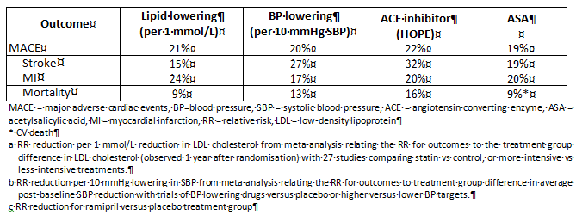

Clinical rationale
Despite the current standard of care, annual event rates remain high in patients with atherosclerosis. A 4% to 8% cumulative annual rate of CV death, MI, and stroke, and an even greater risk of hospitalisation for unstable angina or severe recurrent myocardial ischaemia was observed in the REACH registry. Event rates of CV death, MI or stroke in patients with CAD and symptomatic PAD range from 3.0% per year to 4.5% per year in clinical trials (HOPE; CAPRIE; CHARISMA; and ONTARGET. Higher risk subpopulations from the ONTARGET and TRANSCEND databases estimate the annual event rate to be as high as 4.6% in patients with PAD.
The standard of care for the secondary prevention of CV events depends on the clinical presentation of patients with CAD or PAD and includes other classes of medications such as other antiplatelet agents (for example, clopidogrel), angiotensin-converting enzyme (ACE) inhibitors or angiotensin receptor blocker, and beta blockers. In addition to these medications, newer antiplatelet agents are available for prevention of recurrent ischaemic events in patients with CAD either in the acute phase post myocardial infarction (ticagrelor, prasugrel, and vorapaxar) or the later chronic phase (ticagrelor, vorapaxar) used in combination with ASA.
Nonetheless, patients with established CAD, cerebrovascular disease, and PAD remain at high risk of CV events. New therapies that further improve efficacy when added to or replacing ASA could have a major impact in reducing the individual, community, and global burden of disability and death due to cardiovascular disease. Rivaroxaban has the potential to address this unmet need and could significantly reduce the CV events of death, MI and stroke when used in conjunction with pharmacological and non-pharmacological standard of care as recommended by current guidelines.
The replacement of clopidogrel by more potent P2Y12 receptor antagonists such as prasugrel and ticagrelor provided increased benefit (prasugrel 10 mg OD: HR 0.82; [95% CI 0.73 to 0.93; p = 0.002]; ticagrelor 90 mg BD: HR 0.84; [95% CI 0.77 to 0.92; p < 0.001]) during the first 12 to 18 months after an acute coronary event. However, at the time of Study 15786, COMPASS protocol finalisation, a benefit of long-term dual antiplatelet therapy (beyond the first 12 to 18 months) had not been demonstrated. Overall, despite the availability of newer antiplatelet agents, patients with established CAD, cerebrovascular disease, and PAD remain at high risk of CV events.
Other recently completed studies (the TRA2 P-TIMI 50, PEGASUS and EUCLID trials) have reported a modest benefit of combined antiplatelet therapy for long-term prevention of cardiovascular disease.
To date, no Phase III trials have directly compared a direct oral anticoagulant (DOAC) with ASA for long term prevention of cardiovascular events in subjects with CAD or PAD. Prior efforts to identify more effective antithrombotic treatments have focused on new antiplatelet therapies (terutroban, a platelet thromboxane receptor antagonist; clopidogrel, prasugrel, and ticagrelor, P2Y12 antagonists; and vorapaxar, a proteinase activated receptor 1 (PAR-1) antagonist) and warfarin. In most cases, the benefit of the experimental treatment has either been of insufficient magnitude to warrant a switch in treatment (for example, clopidogrel, prasugrel) or has been accompanied by a substantial excess of bleeding which outweighed the benefit (for example, vorapaxar, ticagrelor, and warfarin).
Rivaroxaban is an oral, direct, factor Xa inhibitor that interrupts the intrinsic and extrinsic pathway of the blood coagulation cascade, inhibiting both thrombin formation and development of thrombi. Rivaroxaban does not require routine laboratory monitoring, has no relevant food interactions, and has only a few drug interactions. Rivaroxaban is not administered as pro-drug and no genetic polymorphisms are known which could affect the pharmacokinetic/pharmacodynamic (PK/PD) profile or result in a loss of efficacy.
With robust evidence of efficacy of rivaroxaban for the prevention of atherothrombotic events in the incident (acute) population on a background of dual antiplatelet therapy, it is hypothesised that prevalent (non-acute) patients with established CAD or PAD with no indication for dual anti-platelet therapy may also benefit from the addition of 2.5 mg BD of rivaroxaban to ASA for prevention of atherothrombotic events.

Guidance
The TGA has adopted the following guidance documents relevant to this submission:
- Guideline on the Evaluation of Medicinal Products for Cardiovascular Disease Prevention. EMEA/DHMP/EWP/311890/2007, effective 1 April 2009
- Points to Consider on Application with 1) Meta-Analyses; 2) One Pivotal Study, CPMP/EWP/2330/99, effective: 27 March 2002

Contents of the clinical dossier
The dossier was confined to a bioavailability comparison of the proposed new strength tablet and the registered dose forms and one new efficacy and safety study:
- Study 12361: a clinical pharmacology study providing bioavailability data.
- Two additional pharmacokinetic (PK) studies (Studies 12570 and 12571) were included in the submission. These are both studies to assess the PK, safety and tolerability of an extended release formulation (12 mg) of rivaroxaban with and without food in comparison to an immediate release formulation (10 mg). The sponsor advised in their submission that these studies are beyond the scope of the submission and should be disregarded. These studies were not evaluated.
- Studies R-8642 and R-8645: two population PK (PopPK) analyses were included in the submission. These relate to population pharmacokinetics/pharmacodynamics (PK/PD) and safety analyses in subjects with acute coronary syndrome from the ATLAS ACS TIMI 46 Trial. The sponsor advised in their submission that these studies are beyond the scope of the submission and should be disregarded. These studies were not evaluated.
- Study 15786 (published as the COMPASS trial): a pivotal efficacy/safety study; and an additional pooled safety analysis of this study.
- Literature references
- A Clinical Overview, Summary of biopharmaceutical studies (same as previously submitted in application), Summary of clinical pharmacology (same as previously submitted in application), Summary of clinical efficacy, and a Summary of clinical safety.

Paediatric data
The submission did not include paediatric data.
There is an agreed Paediatric Investigation Plan in Europe (000430-PIP01-08-M10 [P/0194/2017]) which includes a waiver for all paediatric populations from birth to < 18 years on the grounds that the prevention of thromboembolic events do not occur in the specified paediatric subsets.
The sponsor has applied for the inclusion within the agreed wavered condition for the adult indication covered in the COMPASS trial (the study included in this application).

Good clinical practice
The studies are stated to have been conducted in accordance with the ethical principles that have their origin in the Declaration of Helsinki and the International Conference on Harmonisation (ICH) guideline E6 (Good Clinical Practice (GCP)), and all local legal and regulatory requirements. All trial documentation was approved by an appropriate ethics committee and patients and volunteers gave written informed consent prior to any trial procedures.

Pharmacokinetics

Studies providing pharmacokinetic data
Study 12361 examined the bioequivalence of different strengths (single dose) in healthy adults.
None of the pharmacokinetic studies had deficiencies that excluded their results from consideration.

Evaluator’s conclusions on pharmacokinetics
Only a single study was included in this submission. Study 12361 is a bioequivalence study to support the new 2.5 mg dose strength which is the recommended dose for the new indication of prevention of death in patients with CAD and/or PAD.
Overall, dose proportionality was demonstrated for the area under the plasma concentration versus time curve from zero to infinity after single (first) dose divided by the dose in mg (AUC/D), however not for the maximum drug concentration in plasma after single dose administration divided by dose in mg (C_{max}/D), after intake of the 2.5, 5, and 10 mg immediate release tablets under fasting conditions. Since the 2.5 mg dose is indicated for the new indication and is not used with the other doses this is acceptable.

Pharmacodynamics

Studies providing pharmacodynamic data
No pharmacodynamic (PD) studies were included in the submission.

Evaluator’s conclusions on pharmacodynamics
No new information relevant to the clinical PD of rivaroxaban was provided in the submission.

Dosage selection for the pivotal studies
The selection of the 2.5 mg dose for the pivotal study (Study 15786, published as the COMPASS trial) was based on a pooled post-hoc analysis of the data from patients with a recent acute coronary syndrome (ACS) in the Phase II and Phase III trials (the ATLAS ACS TIMI 46 trial and ATLAS ACS 2 TIMI 51 trial, respectively). It was expected that the addition of rivaroxaban 2.5 mg twice daily to a standard dose of ASA would provide additional benefit compared with ASA alone. In the ATLAS ACS 2 TIMI 51 trial, rivaroxaban 5 mg twice daily combined with ASA, although effective in reducing atherothrombotic events, was associated with an increase in bleeding. It was hypothesised that rivaroxaban 5 mg twice daily without ASA may reduce the risk of MI, stroke, or cardiovascular death and that this benefit may be associated with a lower incidence of major bleeding events than when combined with ASA. Therefore, rivaroxaban was tested in the pivotal study (Study 15786/COMPASS trial) at a dose of 2.5 mg twice daily plus ASA compared with ASA alone, and at a dose of 5 mg twice daily alone compared with ASA alone.
The ASA dose for the COMPASS trial was chosen based on previous studies. ASA given at doses of 75 to 100 mg is the commonly recommended range for secondary prevention of atherothrombotic events across clinical guidelines, although EU guidelines allow for a broader dose range. As rivaroxaban was to be studied with or without ASA, and due to the double-blind nature of the COMPASS trial, a specified dose of ASA was chosen as study medication. ASA 100 mg is globally widely used and available for prevention of ischaemic cardiac events associated with established CAD in most countries outside of North America.
In summary, it was hypothesised that the combination of rivaroxaban 2.5 mg twice daily and ASA 100 mg once daily compared with ASA 100 mg once daily alone would substantially reduce the risk of composite outcome of myocardial infarction, stroke, or cardiovascular death and that this benefit would outweigh any potential bleeding risk. It was also hypothesised that rivaroxaban 5 mg twice daily alone would reduce the risk of the composite efficacy outcome of myocardial infarction, stroke, or cardiovascular death and that this benefit would not be accompanied by a relevant increase in major bleeding.

Evaluator’s conclusions on dose finding for the pivotal studies
The dose selection for the pivotal studies is based on experience in previous studies and is adequately justified.

Efficacy

Studies providing efficacy data
A single clinical study was submitted:
- Study 15786: A randomised controlled trial of rivaroxaban for the prevention of major cardiovascular events in patients with coronary or peripheral artery disease (published as the COMPASS trial Cardiovascular Outcomes for People Using Anticoagulation Strategies).

Evaluator’s conclusions on efficacy
The sponsor is seeking approval for five new indications prevention of:
- stroke
- myocardial infarction (MI)
- cardiovascular death (CV death)
- acute limb ischaemia (ALI)
- mortality
in patients with coronary artery disease and/or peripheral artery disease.
The efficacy data relies on a single study; however, it is a very large study with over 27,000 patients enrolled. The primary efficacy outcome was the composite of MI, stroke or CV death. The secondary outcomes were:
- composite of coronary heart disease (CHD) death, MI, ischaemic stroke, and ALI
- composite of CV death, MI, ischaemic stroke, and ALI
- all-cause mortality.
Prevention of acute limb ischaemia (ALI) (on its own) was not a pre-specified efficacy outcome of the study.
The study was planned for an expected duration of 4 to 5 years. The trial was stopped early as the result of the Data Safety and Monitoring Board (DSMB) recommending that the rivaroxaban/aspirin treatment arms be stopped based on the results of the first formal interim analysis:
‘The rationale provided to the Steering Committee for this recommendation was that for one of the rivaroxaban arms, the z-value (test statistic of the log-rank test) for the primary efficacy outcome had crossed the critical value (z > 4) for efficacy as outlined in the DSMB charter, and the z-value for the other rivaroxaban arm had reached ‘conventional significance’ for efficacy. The Steering Committee concurred with the recommendation of the DSMB, and the sponsor decided to stop the rivaroxaban/aspirin arms of the study. The global rivaroxaban/aspirin outcomes cut-off date for the primary analysis is 6 February 2017.’
At the time of stopping the trial had been running for 4 years with average duration of treatment of 3 to 4 years.
The study met the primary outcome endpoint of a reduction in the number of composite events (MI, stroke and CV deaths). The relative risk reduction (RRR) of 24% for the combination of rivaroxaban 2.5 mg twice daily plus aspirin 100 mg once daily compared with aspirin 100 mg once daily represents a clinically and statistically significant treatment effect (p = 0.00004).
This is supported by the consistency of the individual components in which the RRR of both stroke (42%) and CV death (22%) were clinically and statistically significant at the nominal alpha level of 5% and was accompanied by a reduction for MI of 14% which was not statistically significant (p = 0.14458) but claimed by the sponsor to be clinically meaningful. Without statistical significance the result for MI cannot be considered reliable.
All-cause mortality was a secondary efficacy outcome. Of the 1057 deaths, 558 were categorised as CV deaths and 499 as non-CV deaths through adjudication. For all-cause mortality the comparison of rivaroxaban 2.5 mg twice daily/ASA 100 mg once daily with ASA 100 mg once daily alone showed a relative risk reduction of 18% (hazard ratio (HR) 0.82; 95% CI 0.71 to 0.96; log-rank test p = 0.01062).
CV death showed a HR of 0.78; 95% CI 0.64 to 0.96; log-rank test p = 0.02053 and non-CV death a HR of 0.87; 95% CI 0.70 to 1.08; log-rank test p = 0.20357.
ALI alone was not a pre-specified outcome of the study. It was included as one of the components of two of the secondary objectives of the study. The first composite was CHD death, MI, ischaemic stroke and ALI and the second composite was CV death, MI, ischaemic stroke and ALI. The ALI contributed only 6% to 8% of patients in the first composite and 5.6 to 7.8% of patients in the second composite (see Table 3). Both secondary composite endpoints were significant (p = 0.00001 for both).
Table 3: Summary of efficacy and net-clinical benefit results from Phase III COMPASS trial in patients with CAD or PAD (Intention to treat population)
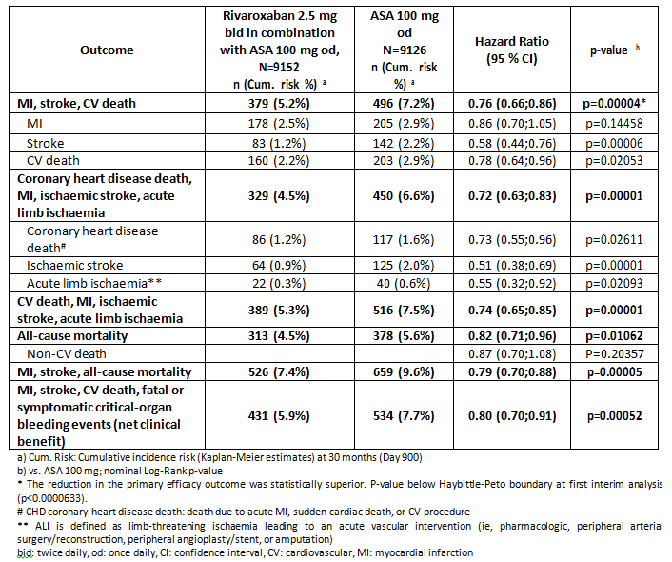
The analysis for ALI alone appears to be done post hoc. For the total population, the comparison of rivaroxaban 2.5 mg twice daily/aspirin 100 mg once daily with aspirin 100 mg once daily alone showed a HR of 0.55 (95% CI 0.32 to 0.92, log-rank test p = 0.02093).
For the PAD yes population, there were 19/2492 subjects (crude incidence: 0.8%) randomised to rivaroxaban 2.5 mg twice daily/aspirin 100 mg once daily and 34/2504 subjects (1.4%) randomised to aspirin 100 mg once daily alone who experienced an event of ALI. The incidence rates were 0.42/100 person-years and 0.75/100 person-years, respectively. The comparison of rivaroxaban 2.5 mg twice daily/aspirin 100 mg once daily with aspirin 100 mg once daily alone showed a HR of 0.56 (95% CI 0.32-0.99, log-rank test p = 0.04218).
In the CAD yes subgroup, ALI was reported for 13/8313 subjects (crude incidence: 0.2%) randomised to rivaroxaban 2.5 mg BD/ASA 100 mg OD and for 27/8261 subjects (0.3%) randomised to ASA 100 mg OD. The incidence rates were 0.08/100 person-years and 0.17/100 person-years, respectively. The comparison of rivaroxaban 2.5 mg twice daily/ASA 100 mg once daily with ASA 100 mg once daily alone showed a HR of 0.48 (95% CI 0.25-0.93, log-rank test p = 0.02520).
In the CAD and PAD yes subgroup, ALI was reported for 10/1656 subjects (crude incidence: 0.6%) randomised to rivaroxaban 2.5 mg twice daily/ASA 100 mg once daily and for 21/1641 subjects (1.3%) randomised to ASA 100 mg once daily alone. The incidence rates were 0.32/100 person-years and 0.68/100 person-years, respectively. The comparison of rivaroxaban 2.5 mg twice daily/ASA 100 mg once daily with ASA 100 mg once daily alone showed a HR of 0.48 (95% CI 0.23-1.02, log-rank test p = 0.04948).
The numbers of patients with ALI are small and the greater significance is seen only in the CAD yes subgroup and the overall population, heavily weighted by the reduction in stroke.
The adopted EU guideline on evaluation of medicinal products for CV disease contains the following:
‘All-cause mortality is preferred over cardiovascular mortality as primary endpoint or as one component of the primary endpoint.’
‘To provide supportive information, and to ensure reliable interpretation, analyses of each separate component of the composite should be presented. For overall mortality and cardiovascular mortality both confidence intervals and point estimate are relevant for assessment.’
‘The primary analysis of a composite endpoint should be based on a ‘time-to’ first event (survival) analysis.’
‘One large-scale pivotal trial may be acceptable if all of the requirements of the PtC document on an Application with 1) Meta-analyses 2) One pivotal study CPMP/EWP/2330/99 are met.’
The EU Guideline on acceptance of one pivotal study states: ‘The degree of statistical significance. Statistical evidence considerably stronger than p < 0.05 is usually required, accompanied by precise estimates of treatment effects, ie, narrow confidence intervals.’
Summary of the key results shown are shown in Table 3.
Based on the results above Xarelto can be recommended for approval but not for all the indications which were requested. The results from a single study support the indications of prevention of stroke and cardiovascular death in patients with coronary artery disease and/or peripheral artery disease, but not for MI. While it appears that the combination of rivaroxaban 2.5 mg twice daily plus aspirin 100 mg once daily may be effective in ALI it was not a specified objective of the trial and the actual numbers are small (22 events on rivaroxaban/ASA versus 40 events on ASA alone). This is also true for the effect on amputations due to cardiovascular reasons (15 versus 31 events; HR 0.48; 95% CI 0.26 to 0.89, p = 0.01755) which is claimed in the draft PI.
It is also true for the composite of MI, stroke and all-cause mortality which appears to be have been added post hoc. It shows statistical significance (p < 0.00052) but was not a pre-specified efficacy outcome.

Safety

Studies providing safety data
- Study 15786 (the COMPASS trial) is the pivotal efficacy study for this submission, with evaluable data for safety.
- Pharmacokinetic-based Study 12361 (considered as a study with evaluable safety data: dose finding and pharmacology) collected AEs, clinical laboratory parameters, vital signs and ECGs.
- Pooled data
  - Report PH-39980 (dated 19 September 2017) provided additional pooled safety analyses for Study 15786. This report is the statistical analysis plan for the safety analysis using the pool of the main Phase III studies (all indications) and exposure from all completed rivaroxaban Phase II and III studies. Only tables of results are included.
  - Report PH-39963 (dated 11 September 2017) additional safety analyses for Study 15786 submission. This report is the statistical analysis plan for the post hoc safety analysis of Study 15786 (COMPASS) for the prevention of major cardiovascular events in patients with CAD/PAD. Only tables of results are included.

Patient exposure
The safety data for patients with CAD/PAD for this submission is based on only one study, Study 15786. Mean duration of treatment was 619 days (20 months), median 615 days.

Table 4: Study 15786: Exposure to Xarelto and aspirin
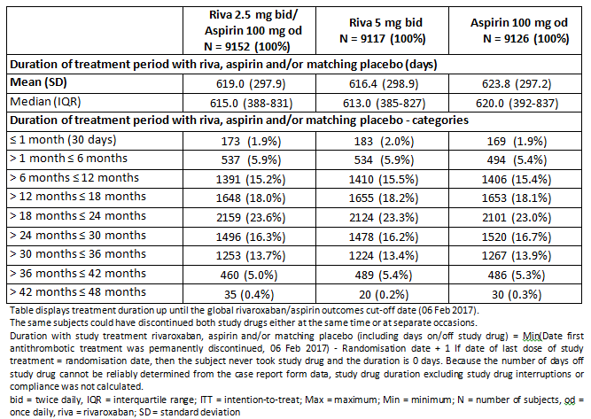

Major bleeding events
The primary safety outcome of Study 15786 was major bleeding based on a modification of the International Society on Thrombosis and Haemostasis (ISTH) criteria, defined as:
- Fatal bleeding, or
- Symptomatic bleeding in a critical area or organ, such as intraarticular, intracranial, intramuscular with compartment syndrome, intraocular, intraspinal, liver, pancreas, pericardial, respiratory, retroperitoneal, adrenal gland or kidney; or bleeding into the surgical site requiring reoperation, or
- Bleeding leading to hospitalisation. (Major bleeding also includes presentation to an acute care facility with discharge on the same day. It relies on the investigator’s judgement as to whether the bleeding event prompted the presentation).
There were 288/9152 subjects (crude incidence: 3.1%) randomised to rivaroxaban 2.5 mg BD/aspirin 100 mg OD, 255/9117 subjects (2.8%) randomised to rivaroxaban 5 mg BD, and 170/9126 subjects (1.9%) randomised to aspirin 100 mg OD who experienced major bleeding events.
The incidence rates for modified ISTH major bleeding events were higher in the rivaroxaban 2.5 mg BD/aspirin 100 mg OD group (1.67/100 patient-years) followed by the rivaroxaban 5 mg BD group (1.48/100 patient-years), compared with the aspirin 100 mg OD group (0.98/100 patient-years).
For modified ISTH major bleeding events, the comparison of rivaroxaban 2.5 mg BD/aspirin 100 mg OD with aspirin 100 mg OD showed an increased HR of 1.70 (95% CI 1.40 to 2.05, log rank test p < 0.00001) and for the comparison of rivaroxaban 5 mg BD with aspirin 100 mg OD an increased HR of 1.51 (95% CI 1.25 to 1.84, log-rank test p = 0.00003).
Table 5: Study 15786 Summary of the results for modified ISTH major bleeding events up until global rivaroxaban/aspirin outcomes cut-off date (ITT)
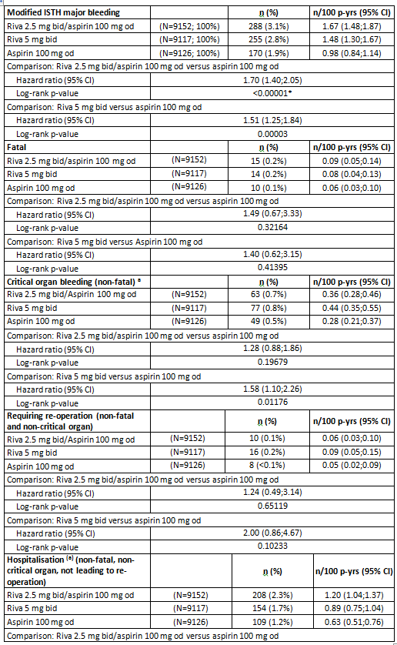
Table 5: (continued): Study 15786 Summary of the results for modified ISTH major bleeding events up until global rivaroxaban/aspirin outcomes cut-off date (ITT)
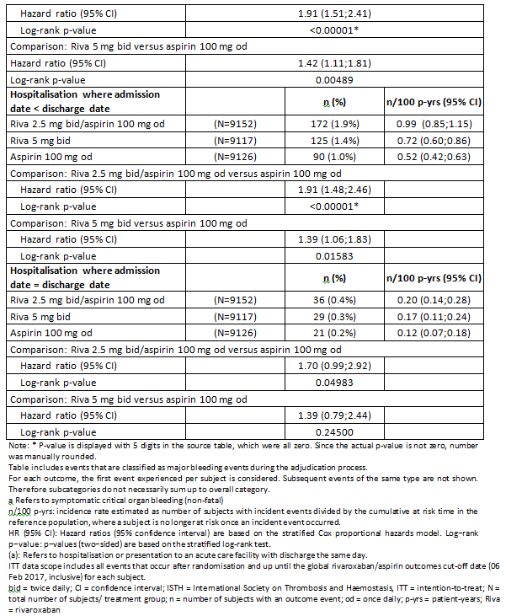
Both rivaroxaban treatment groups show a higher cumulative incidence risk of modified ISTH major bleeding events compared with the aspirin 100 mg OD treatment group soon after start of treatment. About 180 days post-randomisation, the rivaroxaban 2.5 mg BD/aspirin 100 mg OD group shows a higher cumulative incidence risk of modified ISTH major bleeding events compared with rivaroxaban 5 mg BD and aspirin 100 mg OD. The difference in the incidence risk between the rivaroxaban 2.5 mg BD/aspirin 100 mg OD and the aspirin 100 mg OD group is relatively constant after 1 year, indicating that more major bleeding events occur early.
Figure 1: Study 15786: Kaplan-Meier estimates of cumulative incidence risk of modified ISTH major bleeding events up until global rivaroxaban/aspirin outcomes cut-off date (ITT)
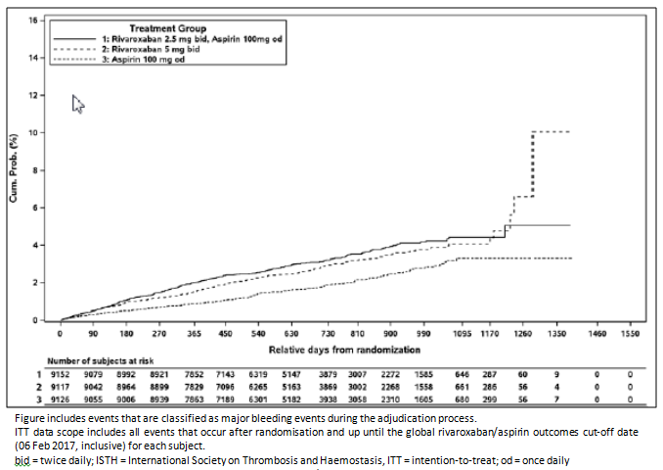

Table 6: Kaplan-Meier cumulative incidence risk for modified ISTH major bleeding events
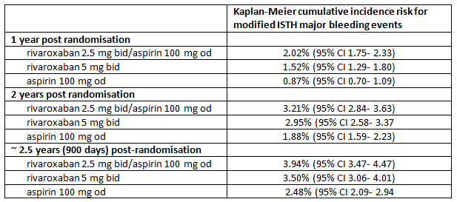

Analysis of modified ISTH major bleeding events for important subgroups: subjects with CAD and/or PAD
The results for modified ISTH major bleeding events in all three subgroups were consistent with those of the overall population.
Table 7: Study 15786: Summary of the results for modified ISTH major bleeding events until global rivaroxaban/aspirin outcomes cut-off date by CAD and/or PAD subgroup (ITT)
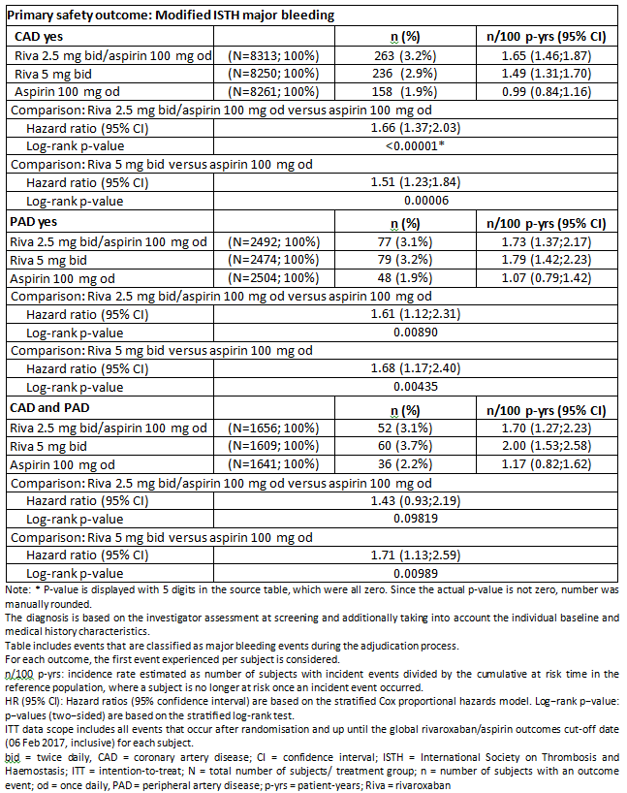

Safety issues with the potential for major regulatory impact

Liver function and liver toxicity
Routine measurement of liver function was not collected in Study 15786.
The incidence of hepatobiliary AEs was similar in each treatment group in Study 15786: rivaroxaban 2.5 mg BD/ASA 100 mg OD 25/8617 (0.3%), rivaroxaban 5 mg BD 25/8593 (0.3%) and ASA 100 mg OD 28/8588 (0.3%).

Renal function and renal toxicity
Routine measurement of renal function was not collected in Study 15786.
The incidence of renal and urinary AEs was similar in each treatment group in Study 15786: rivaroxaban 2.5 mg BD/ASA 100 mg OD 49/8617 (0.6%), rivaroxaban 5 mg BD 44/8593 (0.5%) and ASA 100 mg OD 30/8588 (0.3%).

Other clinical chemistry
No routine clinical chemistry measurement was collected during Study 15786.

Haematology and haematological toxicity
Routine haematological measurements were not collected in Study 15786.
Anaemia was the only haematological AE reported in > 0.1% of subjects – 15 (0.2%) for rivaroxaban 2.5 mg BD/ASA 100 mg OD, 11 (0.1%) for rivaroxaban 5 mg BD and 4 (< 0.1%) for aspirin 100 mg OD.
The overall crude incidence of TEAEs assessed as related to any antithrombotic study treatment was 2.9% in both, the rivaroxaban 2.5 mg BD/aspirin 100 mg OD group and in the rivaroxaban 5 mg BD group, and 2.2% in the aspirin 100 mg OD group. Crude incidences for TEAEs by SOC were evenly distributed across the 3 treatment groups.

Vital signs and clinical examination findings
The mean values at baseline as well at the 2 years visit and at the final follow-up visit were similar among the three treatment groups. The changes from baseline were small and not clinically meaningful within the treatment group.

Serious skin reactions
The incidence of skin and subcutaneous tissue disorder AEs was similar in each treatment group in Study 15786: rivaroxaban 2.5 mg BD/ASA 100 mg OD 48/8617 (0.6%), rivaroxaban 5 mg BD 58/8593 (0.7%) and ASA 100 mg OD 32/8588 (0.4%).

Safety in special populations

Age
Post-hoc analyses of modified ISTH major bleeding data were performed for fragile subjects, and the age groups < 65 years, 65 to < 75 years, 75 to < 85 years, ≥ 85 years, < 80 years and ≥ 80 years. No relevant differences in safety related to bleeding risk were observed between older and younger subjects, when compared with active control. The point estimates of the HRs for the additional subgroups were consistent with the overall primary safety outcome. All HRs were > 1 (that is, in favour of aspirin control), with the two-sided nominal 95% CIs in most cases not including ‘1’.

Post marketing data
Between 1 September 2016 and 31 August 2017, the overall volume of distributed rivaroxaban tablets was [information redacted]. The cumulative worldwide exposure to Xarelto since start of marketing until end of August 2017 is estimated at [information redacted] patient years.
No post safety update reports (PSUR) or other information on the post marketing experience were included in the application.

Evaluator’s conclusions on safety
Bleeding is the most prominent risk of rivaroxaban. The sponsor argued that as the safety profile of rivaroxaban is well established based on the extensive database of clinical studies, Study 15786, (COMPASS trial) was suitable for selective and targeted safety data collection and reporting. Minimal routine safety monitoring was therefore undertaken in the study but AEs were collected and analysed. Special attention was paid to bleeding as the most important adverse reaction of rivaroxaban.
The study used a modified ISTH definition which led to a higher number of bleeding events being recorded. The ‘modified’ ISTH definition used in this trial differed from the ISTH definition in that it did not take into account whether bleeding was associated with a decrease in the haemoglobin level or with blood transfusion. Instead, the modified ISTH major bleeding included any bleeding that led to hospitalisation with or without an overnight stay. This revision resulted in the inclusion of events that would not be considered major bleeding in other trials and in addition might introduce potential over-reporting of hospitalisation due to local practices, physicians’ experience, and local in- and out-patient policies. This resulted in the total of 713 events using the modified ITSH versus 495 using the non-modified ISTH definition.
Both regimens of rivaroxaban treatment increased modified ISTH major bleeding events in comparison to aspirin 100 mg OD. There was a 1.7 fold increase in major bleeding with the rivaroxaban 2.5 mg BD/ASA 100 mg OD group compared with ASA 100 mg OD alone.
Incidences of fatal and symptomatic critical organ bleeding events (non-fatal) were low. Bleeding incidence for the primary endpoint was primarily driven by bleeding leading to hospitalisation. Further assessment of these 471 subjects that experienced bleeding events leading to hospitalisation showed that 84 did not stay in a hospital overnight.
The data for any major bleeding event in subgroups of subjects with CAD yes, PAD yes, CAD and PAD, are consistent with those for the overall analysis.
Table 8: Study 15786 Summary of primary safety results in patients with CAD and/or PAD
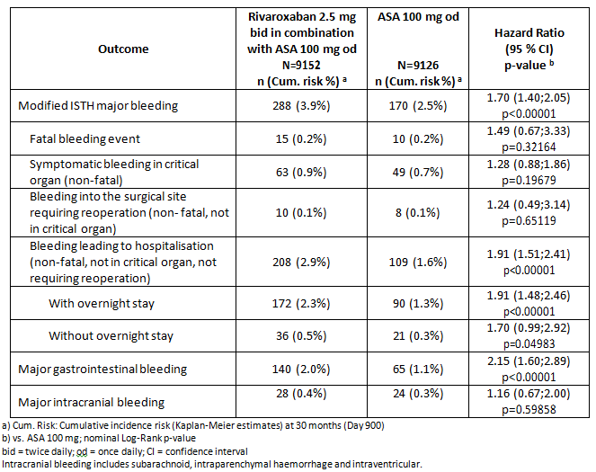
Overall, no new safety issues were identified in Study 15786. The significant risk of bleeding which is less with 2.5 mg than 5 mg must be balanced against the benefit.

First round benefit-risk assessment

First round assessment of benefits
Table 9: First round assessment of benefits with strengths and uncertainties
Indication
Benefits | Strengths and Uncertainties
Study 15786 met the primary efficacy outcome for composite of MI, stroke and CV death:  HR 0.76; 95%CI 0.66 to 0.86; p < 0.00004.  The positive effect was consistent over time.  Positive treatment effect also seen for 2 of 3 components of the composite: Stroke and CV death.  Stroke: HR 0.58; 95% CI 0.44 to 0.76, (p = 0.00006) risk reduction 42%  CV death: HR 0.78: 95% CI 0.64 to 0.96, (p = 0.02053) risk reduction 22%  The benefit of rivaroxaban 2.5 mg BD/ASA 100 mg OD was also reflected in the secondary outcomes defined as other composites of major thrombotic events:  Composite outcome of ischaemic stroke, MI, ALI, or CHD death occurred in significantly fewer patients in the rivaroxaban 2.5 mg BD/ASA 100 mg OD group than with ASA alone (329 patients (3.6%) versus 450 patients (4.9%); HR 0.72; 95% CI, 0.63 to 0.83; log rank p < 0.00001).  Composite secondary outcome of MI, ischaemic stroke, ALI, or CV death also occurred in significantly fewer patients in the rivaroxaban 2.5 mg BD/ASA 100 mg OD (389 patients (4.3%) versus 516 patients (5.7%); HR 0.74; 95% CI, 0.65 to 0.85; p < 0.00001).  All-cause mortality, comprising the subcategories CV death and non-CV death, occurred in significantly fewer patients in the rivaroxaban 2.5mg BD/ASA 100 mg OD group versus ASA alone: HR 0.82 (95% CI 0.71 to 0.96; p = 0.01062). | Single study but very large (> 27,000 subjects).  Statistically significant result for composite outcome and for components stroke and CV death but not for MI.  MI: HR 0.86; 95%CI 0.770 to 1.05, (p = 0.14458) risk reduction 14%  All-cause mortality included as secondary outcome and not component of primary composite as recommended in EU Guideline.  Reduction in all-cause mortality weighted by 22% RRR for CV death (55% of all deaths). Reduction in non-CV death was not statistically significant.  Result for ALI not a pre-specified outcome, only included in composite but result statistically and clinically significant; not discussed in CSR.  ALI: HR 0.55; 95% CI 0.32 to 0.92, (p = 0.02093) risk reduction 45% but actual number of patients is small.

First round assessment of risks
Table 10: First round assessment of risks with strengths and uncertainties
Risks | Strengths and Uncertainties
Bleeding is the most significant adverse event  There was a 1.7 fold increase in modified ISTH major bleeding events with the rivaroxaban 2.5 mg BD/aspirin 100 mg OD group compared with aspirin 100 mg OD. | No new adverse events were identified in large study with patients treated to mean duration of 20 months.

First round assessment of benefit-risk balance
Based on the data submitted the benefit-risk balance is favourable.
The benefit of a clinically significant reduction of risk of stroke or CV death balanced against the significant risk of bleeding is favourable in the patient population of patients with documented history of CAD and/or PAD.
The study demonstrated that the combination of rivaroxaban 2.5 mg BD and aspirin 100 mg OD was associated with an significantly increased bleeding risk compared to aspirin alone. There was a 1.7 fold increase in major bleeding with the combination compared to aspirin alone. However, this increased risk is balanced by the positive treatment outcome which demonstrated that the combination resulted in a reduction in the primary endpoint of the composite of MI, stoke and CV death (HR 0.76; 95%CI 0.66 to 0.86; p < 0.00004). A positive treatment effect was also seen for the individual components of stroke (HR 0.58; 95% CI 0.44 to 0.76, p = 0.00006 risk reduction 42%) and CV death (HR 0.78: 95% CI 0.64 to 0.96, p = 0.02053 risk reduction 22%). The sponsor also claims a positive treatment effect for MI with a risk reduction of 14% which the sponsor considers clinically significant but the result is not statistically significant and so cannot be considered reliable (HR 0.86; 95%CI 0.770 to 1.05, (p = 0.14458).
The benefit risk balance for prevention of MI is not favourable given the result for MI was not statistically significant and there is a significant risk of bleeding.
The sponsor is also claiming a positive treatment effect for ALI. ALI was not a pre-specified outcome alone. It was included in the secondary outcomes as one of the components in the composites of ischaemic stroke, MI, ALI, or CHD death (combination compared with aspirin HR 0.72; 95% CI, 0.63 to 0.83; log rank p < 0.00001) and MI, ischaemic stroke, ALI or CV death (combination compared with aspirin HR 0.74; 95% CI, 0.65 to 0.85; p < 0.00001).
The benefit risk of reduction of ALI and mortality is not favourable given that there is the significant risk of bleeding and the number of patients with ALI was small and this was not a pre-specified outcome of the study.
Reduction in all-cause mortality is also included in the indication. All-cause mortality was a secondary outcome in the study. There was a positive treatment effect for all-cause mortality but it is weighted by the reduction in CV death as the reduction in non-CV death was not statistically significant. All-cause mortality HR 0.82 (95% CI 0.71 to 0.96, logrank test p = 0.01062), risk reduction of 18%; CV death = HR 0.78 (95% CI 0.64 to 0.96, logrank test p = 0.02053) and non-CV death a HR of 0.87 (95% CI 0.70 to 1.08), p = 0.20357.
The benefit-risk balance for all-cause mortality is favourable but should be included in the clinical trials section of the PI and the full data should be provided that it is positive for CV death but not for non-CV death. Reduction is CV death is included in the indication.

First round recommendation regarding authorisation
Based on the clinical data submitted, approval of Xarelto is recommended but with some modification of the indication.
The requested indication is:
Xarelto, in combination with aspirin, is indicated for the prevention of stroke, myocardial infarction and cardiovascular death, and for the prevention of acute limb ischaemia and mortality in patients with coronary artery disease (CAD) and/or peripheral artery disease (PAD).
It is unclear why the indication is worded as it is, it could be read to be that the first part of the indication (that is, the prevention of stroke, MI and CV death) applies to all patients and the second part (prevention of ALI and mortality) applies to the PAD and CAD patients.
In the study submitted the primary endpoint was the composite of stroke, MI and CV death. The study found that the composite endpoint was reduced with 2.5 mg rivaroxaban BD and 100 mg aspirin OD. While the study also found that the combination reduced the risk of the components stroke, MI and CV death, only stroke and CV death were both clinically and statistically significantly reduced. The sponsor’s claims that the result for MI is clinically significant (14%) but without statistical significance this result cannot be considered reliable.
Therefore, the proposed indication needs to reflect the results of the study and MI should not be included as having a positive treatment effect.
Further, the inclusion of prevention of ALI which was not an endpoint of the study and the inclusion of overall mortality needs to be modified. The actual numbers of patients with ALI was small and while the all-cause mortality was reduced it was heavily weighted by the reduction of CV mortality (non CV mortality was not significantly reduced). The results need to be presented in more detail to reflect the totality of the results (that is, with the numbers of patients and the results which were not significant). The results for ALI can be included in the PI but should not be included in the indication.
On balance, given the significant risk of bleeding which exists and to correctly reflect the outcomes of the study the indication should be:
Xarelto, in combination with aspirin, is indicated for the prevention of stroke and cardiovascular death in patients with coronary artery disease (CAD) and/or peripheral artery disease (PAD).

Clinical questions and second round evaluation
The sponsor has responded to the first round evaluation with a proposed amended indication. The new proposed indication is:
Xarelto, in combination with aspirin, is indicated for the prevention of major cardiovascular events (composite of stroke, myocardial infarction and cardiovascular death) in patients with coronary artery disease (CAD) and/or peripheral artery disease (PAD).
The first round evaluator proposed revised wording that removed the indication of myocardial infarction as the study did not demonstrate statistical significant improvement in this component of the composite primary outcome (stroke + MI + CV death).
The revised wording more accurately reflects the outcome of the study but it is not clear how this wording assists the practicing physicians with individual patients to understand that there was not a significant improvement in each of the components. The sponsor states and it is acknowledged that:
‘The COMPASS trial was not powered to reach statistical significance in the individual components of the composite outcome, neither at the end of the study if it had continued as planned until 2,200 subjects had experienced a primary outcome event nor at the time of the interim analysis which led to the stop of the antithrombotic treatment arms following the DSMB recommendation.’
The sponsor argues that despite the study not being powered to show significant superiority in the individual components of the primary composite outcome, for all individual components a numerical reduction was found and that the treatment effect of 14% for MI is considered clinically relevant despite not being statistically significant.
The sponsor has agreed to the removal of reference to all-cause mortality and acute limb ischaemia from the indication, and moving it to the Clinical Trials section of the PI.
The revised wording of the indication is in line with the outcome of the study and is therefore acceptable.

Second round benefit-risk assessment
No new clinical information was submitted in response to questions. Accordingly, the benefits and risks of Xarelto are unchanged from those identified in the first round.

Second round assessment of benefit-risk balance
The benefit-risk balance of Xarelto, given the proposed usage, is favourable.
No new clinical information was provided in response to the first round evaluation. The revised wording of the indication is a more accurate reflection of the clinical study and is acceptable.

Second round recommendation regarding authorisation
Approval of Xarelto is recommended for the following revised indication:
Xarelto, in combination with aspirin, is indicated for the prevention of major cardiovascular events (composite of stroke, myocardial infarction and cardiovascular death) in patients with coronary artery disease (CAD) and/or peripheral artery disease (PAD).
The revised wording of the indication is now in line with the objectives and outcomes of the clinical study.

VI. Pharmacovigilance findings

Risk management plan
The most recently evaluated EU‐RMP was version 8.1 (dated 13 November 2014; data lock point (DLP) 15 June 2014) and Australian-specific annex (ASA) version 2.2 (dated January 2015). In support of the extended indications, the sponsor has submitted EU‐RMP version 11.1 (dated 23 October 2017; DLP 15 September 2017) and ASA version 2.6 (dated December 2017).
In the response to the first round evaluation, the sponsor submitted EU‐RMP version 11.4 (dated 5 July 2018; DLP 15 September 2018) and ASA version 2.7 (dated August 2018).
In response to the second round evaluation, the sponsor submitted ASA version 2.8 (dated October 2018).

Summary of RMP evaluation
The proposed Summary of Safety Concerns and their associated risk monitoring and mitigation strategies are summarised in Table 11.

Table 11: Sponsor’s summary of safety concerns
Summary of safety concerns |  | Pharmacovigilance |  | Risk Minimisation
 |  | Routine | Additional | Routine | Additional
Important identified risks | Haemorrhage
Important potential risks | Embryo-fetal toxicity |  |  |  | –
Missing information | Patients with severe renal impairment (CrCl < 30 mL/min) |  |  |  | –
Missing information | Patients receiving concomitant systemic inhibitors of CYP 3A4 or P-gp other than azole antimycotics (for example ketoconazole) and HIV-protease inhibitors (for example ritonavir) |  | * |  | –
Missing information | Remedial pro-coagulant therapy for excessive haemorrhage |  |  |  | –
Missing information | Pregnant or breast-feeding women |  |  |  | –
Missing information | Patients with atrial fibrillation (AF) and a prosthetic heart valve |  | – |  | –
Missing information | Long-term therapy with rivaroxaban in treatment of DVT, PE, SPAF and ACS in real-life setting |  |  |  | –
Missing information | Patients with significant liver diseases (severe hepatic impairment/Child Pugh C) |  |  |  | –
Missing information | Patients < 18 years |  |  |  | –
*Additional pharmacovigilance activities for this safety concern are only described in the ASA
- The proposed pharmacovigilance plan consists of a number of drug utilisation studies and post‐authorisation safety studies. The plan is unchanged from what has previously been agreed, and remains acceptable for the proposed extended use of Xarelto given the similarity in the safety specification.
- The proposed risk minimisation plan is adequate from an RMP perspective. The additional risk minimisation activities include a guide for health professionals and a Patient Alert Card.
Both require updating to reflect the proposed extension of indication and associated change in dosing and new tablet strength.

New and outstanding recommendations from second round evaluation
- There are no outstanding recommendations following post second-round negotiations. The sponsor has adequately addressed the recommendations made in the second round evaluation.

Proposed wording for conditions of registration
Any changes to which the sponsor has agreed should be included in a revised RMP and ASA. However, irrespective of whether or not they are included in the currently available version of the RMP document, the agreed changes become part of the risk management system.
The suggested wording is:
The Xarelto EU‐Risk Management Plan (RMP) (version 11.4, dated 5 July 2018, data lock point 15 September 2017), with Australian Specific Annex (version 2.7, dated August 2018), included with submission PM‐2017‐04819‐1‐3, to be revised to the satisfaction of the TGA, will be implemented in Australia.

VII. Overall conclusion and risk/benefit assessment
The submission was summarised in the following Delegate’s overview and recommendations.

Background

Indication
The originally proposed new indication was as follows:
Xarelto, in combination with aspirin, is indicated for the prevention of stroke, myocardial infarction and cardiovascular death, and for the prevention of acute limb ischaemia and mortality in patients with coronary artery disease (CAD) and/or peripheral artery disease (PAD).
The revised new indication (agreed to by the sponsor in the sponsor’s post-first round response) is:
Xarelto, in combination with aspirin, is indicated for the prevention of major cardiovascular events (composite of stroke, myocardial infarction and cardiovascular death) in patients with coronary artery disease (CAD) and/or peripheral artery disease (PAD).

Dosage and administration
Proposed new dosage and administration instructions (for the 2.5 mg dose form) are:
Coronary artery disease (CAD) and/or peripheral artery disease (PAD)
The recommended vascular dosing regimen for patients with CAD or PAD is one tablet of 2.5 mg Xarelto twice daily in combination with a daily dose of 100 mg aspirin. This combination can be started at any time.
In patients with CAD and/or PAD, Xarelto 2.5 mg twice daily is not indicated in combination with dual antiplatelet therapy (see Pharmacodynamic properties).
Patients taking Xarelto 2.5 mg twice daily should also take a daily dose of 100 mg aspirin.
Therapy should be continued long term provided the benefit outweighs the risk.

Quality
Quality data for the 2.5 mg strength was fully evaluated in an earlier submission prior to withdrawal of that submission. The conclusion of that evaluation was that the 2.5 mg tablet was acceptable from a pharmaceutical chemistry perspective.
The 2.5 mg tablets were considered dose proportional to the Australian registered 10 mg product. The current submission is based on the previously evaluated quality data, with the sponsor providing a summary of additional changes made for the current application. The quality evaluation assessed these new data and reviewed compliance of the submission with updated requirements since the previous evaluation.
The PI and labels are acceptable from a pharmaceutical chemistry perspective and all GMP clearances are valid.
The quality evaluator recommends approval.

Nonclinical
There was no requirement for a nonclinical evaluation in a submission of this type.

Clinical
The clinical dossier included a clinical pharmacology study (Study 12361), a single pivotal efficacy and safety study (Study 15786/ published as the COMPASS trial) and an additional pooled safety analysis of Study 15786.

Pharmacokinetics (PK)
Study 12361 was a single centre, randomised, open label, 3 way crossover study to assess the PK, safety and tolerability of different dose strengths (2.5, 5, and 10 mg) of rivaroxaban immediate release tablets administered in 23 healthy male volunteers. The study drug was administered under fasting conditions.
The PK parameters AUC and C_{max} increased dose dependently for the 2.5, 5, and 10 mg immediate‐release tablet (Table 12). T_{max} was similar for the different doses, with median values between 1.5 and 2.5 hours.

Table 12: Study 12361. PK parameters of rivaroxaban in plasma following oral administration of 2.5, 5 and 10 mg rivaroxaban as an immediate release tablet under fasting conditions (geometric mean/%CV (range)); PK population)
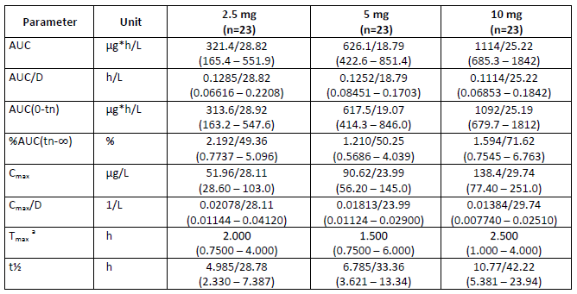
AUC of rivaroxaban increased dose proportionally with the 2.5, 5, and 10 mg dose (see Table 13). For dose normalised AUC (AUC/D), the 95% CI for the ratios 10 mg/5 mg, 10 mg/2.5 mg and 5 mg/2.5 mg were contained within the acceptance range for bioequivalence (0.80 to 1.25). C_{max} increased dose dependently, but less than dose proportionally from 2.5 to 10 mg rivaroxaban. For dose normalised C_{max} (C_{max}/D), the 95% CI for the ratios 10/5 mg, 10/2.5 mg and 5/2.5 mg were outside the acceptance range for bioequivalence (0.8 to 1.25). This difference in C_{max} is not considered to be of concern to this application because the 2.5 mg dose would apply only for the new indication and only one dose regimen is proposed.
Table 13: Study 12361 Point estimators (LS‐means) and exploratory two‐sided 95% CI of selected PK parameters after administration of rivaroxaban (ANOVA results, PK population)
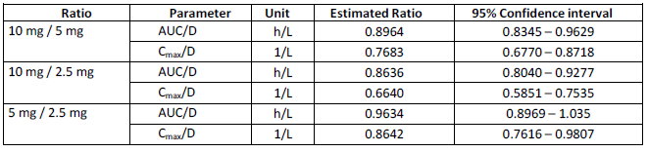
Study 12361 was performed in the fasted state only. The previous clinical evaluation and pharmaceutical chemistry evaluation accepted the presented evidence for a lack of food effect in doses below 10 mg, supporting the proposed PI statement that Xarelto 2.5 mg tablets may be taken with or without food.

Efficacy

Study 15786 (COMPASS trial)
This was a Phase III, randomised, double blind, active comparator controlled study with a 3 x 2 partial factorial design conducted at 602 centres in 33 countries, including USA, Canada, Western Europe, Australia, China, Japan and Argentina. It was an event‐driven study which planned to randomise at least 27,400 subjects with CAD and/or PAD for an expected duration of 4 to 5 years (at least 2200 subjects with a primary efficacy outcome event were planned).
Figure 2: Study 16786 study design
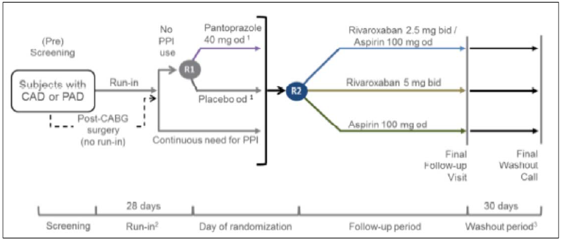
R1 and R2 were performed at same time via the PHRI randomisation and drug management system. All study treatments were to be started on the day of randomisation or one day thereafter. 1: the pantoprazole/placebo arms of the trial are still ongoing and will be reported at a later stage based on the second database release. 2: aspirin 100 mg OD and rivaroxaban placebo as run‐in medication 3: Subjects treated according to local standard of care

Study objectives
The primary objectives of rivaroxaban randomisation were:
- To determine whether rivaroxaban 2.5 mg BD/aspirin 100 mg OD compared with aspirin 100 mg OD reduces the risk of a composite of MI, stroke, or CV death in subjects with CAD or PAD.
- To determine whether rivaroxaban 5 mg BD compared with aspirin 100 mg OD reduces the risk of a composite of MI, stroke, or CV death in subjects with CAD or PAD.
The secondary objectives of rivaroxaban randomisation were:
- To determine whether each of rivaroxaban 2.5 mg BD/aspirin 100 mg OD and rivaroxaban 5 mg BD alone reduces the risk of the composite of major thrombotic events: CHD death, MI, ischaemic stroke, acute limb ischaemia (ALI), compared with aspirin 100 mg OD in subjects with CAD or PAD.
- To determine whether each of rivaroxaban 2.5 mg BD/aspirin 100 mg OD and rivaroxaban 5 mg BD alone reduces the risk of the composite of major thrombotic events: CV death, MI, ischaemic stroke, ALI, compared with aspirin 100 mg OD in subjects with CAD or PAD.
- To determine whether each of rivaroxaban 2.5 mg BD/aspirin 100 mg OD and rivaroxaban 5 mg BD alone reduces the risk of mortality compared with aspirin 100 mg OD in subjects with CAD or PAD.
The objective of pantoprazole randomisation was to determine whether pantoprazole 40 mg OD compared with placebo reduces the risk of upper GI bleeding, ulceration, or GI obstruction or perforation in subjects with CAD or PAD receiving antithrombotic study medications. The pantoprazole/placebo arms of the study are still ongoing and the results were not available for this submission.

Efficacy variables and outcomes
The primary efficacy outcome was the time (in days) from randomisation to the first occurrence of the composite of MI, stroke, or CV death.
The secondary efficacy outcomes were:
- Composite of CHD death, MI, ischaemic stroke or ALI
- Composite of CV death, MI, ischaemic stroke or ALI
- Mortality by any cause.

Analysis populations
The inclusion criteria were male or female (non‐childbearing potential) patients with objectively confirmed CAD and/or PAD. CAD patients had multi‐vessel CAD and/or prior MI. CAD patients aged < 65 years were required to have atherosclerosis in ≥ 2 vascular beds or ≥ 2 additional risk factors (current smoker, diabetes mellitus, eGFR < 60mL/min, heart failure, non‐lacunar ischaemic stroke ≥ 1 month prior).
27,395 subjects were randomised 1:1:1 to treatment: 9,152 to rivaroxaban 2.5 mg BD/aspirin 100 mg OD, 9,117 to rivaroxaban 5 mg BD and 9,126 to aspirin 100 mg OD.

Baseline data
Baseline characteristics of subjects were similar between the three treatment groups. 78% of subjects were male, with 62.2% White or Caucasian, 15.6% Asian, and 19.3% Hispanic. 31.2% of subjects were from Western Europe/Australia, Israel, or South Africa, 22.4% were from South America, 17.6% from Eastern Europe, 14.4% from Asia Pacific, and 14.3% from North America. The three countries with the highest number of randomised subjects were Argentina (n = 2,789), the Netherlands (n = 2,522) and Canada (n = 2,443), together contributing over a quarter (28%) of the study population. The mean age was 68.2 years (SD = 7.9 years). The largest proportion of subjects (55.4%) was between 65 and 74 years of age, 23.8% of subjects were younger than 65 years and 20.8% of subjects were 75 years of age or older. Use of lipid lowering agents was comparable at randomisation. Over 90% of patients had CAD (see Figure 3).
Figure 3: Study 15786 Distribution of subjects by CAD and/or PAD subgroups (ITT)

Results
Following a pre‐planned interim analysis, the study was terminated early on the recommendation of the Data Safety Monitoring Board (DSMB) on 6 February 2017. The DSMB recommended that the three treatment arms should be stopped as soon as an orderly close‐out of the study could be carried out. The analyses reviewed by the DSMB found that for one of the rivaroxaban arms, the z‐value for efficacy outcome had crossed the critical value for efficacy consistently over a 3 month period, and the z‐value for the other rivaroxaban arm had reached conventional significance for efficacy. The mean duration of treatment was 619 days, median 615 days.
The incidence rate for the composite primary efficacy outcome was lowest in the rivaroxaban 2.5 mg BD/aspirin 100 mg OD group (2.18/100 patient‐years), and second lowest in the rivaroxaban 5 mg BD group (2.60/100 patient‐years), compared with the aspirin 100 mg OD group (2.88/100 patient‐years).
Rivaroxaban 2.5 mg BD/aspirin 100 mg OD was superior to aspirin 100 mg OD alone with regard to the composite primary outcome with a HR of 0.76 (95% CI 0.66‐0.86, p = 0.00004). The HRs for the individual components of the composite primary outcome were 0.58 (95% CI 0.44 to 0.76, p = 0.00006) for stroke (RRR = 42%), 0.78 (95% CI 0.64 to 0.96, p = 0.02053) for CV death (RRR = 22%) and 0.86 (95% CI 0.70 to 1.05, p = 0.14458) for MI (RRR = 14%).
The comparison of rivaroxaban 5 mg BD with aspirin 100 mg OD slightly favoured rivaroxaban 5 mg BD but did not reach statistical significance (HR 0.90 (95% CI 0.79 to 1.03, p = 0.11490)). The 5 mg BD dosage is not proposed for registration so efficacy outcomes for this dosage are not discussed further.
The composite secondary efficacy outcomes demonstrated consistency in the cardiovascular benefit for rivaroxaban 2.5 mg BD/aspirin 100 mg OD compared with aspirin 100 mg OD.
Subgroup analyses for subjects with CAD, PAD, and both CAD and PAD for rivaroxaban 2.5 mg BD/aspirin 100 mg OD compared to aspirin 100 mg OD alone were consistent with the overall results. The CAD subgroup HR was 0.74 (95% CI 0.65 to 0.86, p = 0.00003), the PAD subgroup HR was 0.72 (95% CI 0.57 to 0.90, p = 0.00466), and the CAD and PAD subgroup HR was 0.67 (95% CI 0.52 to 0.87, p = 0.00262).
Analyses of the primary composite outcome for rivaroxaban 2.5 mg BD/aspirin 100 mg OD compared with aspirin 100 mg OD by age group showed HR 0.63 (95% CI 0.5 to 0.8) for subjects < 65 years, HR 0.74 (95% CI 0.6 to 0.9) for subjects > 65 to 74 years, and HR 0.89 (95% CI 0.7 to 1.1) for subjects ≥ 75 years.

Table 14: Study 15786 (COMPASS trial) Summary of efficacy results (ITT)
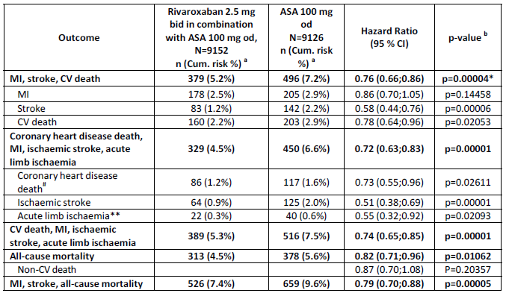
100 mg OD was consistent over time (Figure 4).
Figure 4: Study 15786: Kaplan‐Meier estimates of cumulative incidence risk of the composite primary efficacy outcome up until global rivaroxaban/aspirin outcomes cut‐off date (ITT)

Safety
Safety data for patients with CAD/PAD is derived from Study 15786 (COMPASS trial). The submission also presented limited safety data for the 2.5 mg strength in healthy volunteers in PK Study 12361.
Based on the extensive safety database for rivaroxaban, and the established evidence that bleeding is the most important safety risk for rivaroxaban, the COMPASS trial was designed for targeted safety data collection and reporting, with bleeding events reported as safety outcome events rather than AEs/SAEs.
The primary safety outcome in the COMPASS trial was major bleeding based on modified International Society on Thrombosis and Haemostasis (ISTH) criteria, defined as:
- fatal bleeding; or
- symptomatic bleeding in a critical area or organ, such as intraarticular, intracranial, intramuscular with compartment syndrome, intraocular, intraspinal, liver, pancreas, pericardial, respiratory, retroperitoneal, adrenal gland or kidney; or
- bleeding into the surgical site requiring reoperation; or
- bleeding leading to hospitalisation (with or without overnight stay).
The modified ISTH definition did not take into account whether bleeding was associated with a decrease in the haemoglobin level or with blood transfusion. Instead, major bleeding included any bleeding that led to hospitalisation, with or without an overnight stay. This had the effect of increasing the number of bleeding events recorded than would have been recorded with non‐modified ISTH criteria.
Mean duration of treatment in the COMPASS trial was 619 days (20 months), median 615 days. There was a 1.7 fold increase in modified‐ISTH major bleeding events for the rivaroxaban 2.5 mg BD/aspirin 100 mg OD group compared with aspirin 100 mg OD alone (95% CI 1.40 to 2.05, p < 0.00001). Results for major bleeding events were driven primarily by bleeding leading to hospitalisation (non‐fatal, not in critical organ, and not requiring reoperation, see Table 15).
The results for major bleeding events in the three subgroups (CAD; PAD; CAD and PAD) were broadly consistent with the overall population.

Table 15: Study 15786 Summary of primary safety results in patients with CAD and/or PAD
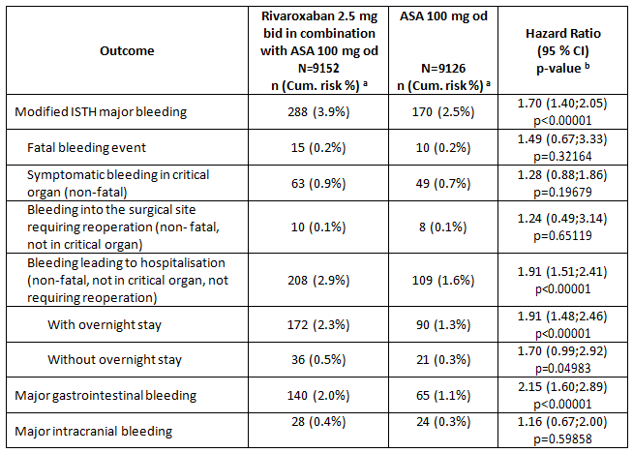
The overall crude incidence of SAEs was 5.6% in the rivaroxaban 2.5 mg BD/aspirin 100 mg OD group, 5.5% in the rivaroxaban 5 mg BD group, and 5.3% in the aspirin 100 mg OD group. The overall crude incidence of TEAEs assessed as related to any antithrombotic study treatment was 2.9% in both the rivaroxaban 2.5 mg BD/aspirin 100 mg OD group and the rivaroxaban 5 mg BD group, and 2.2% in the aspirin 100 mg OD group.

Table 16: Study 15786 Overall summary of number of all subjects with AEs (Safety analysis set)
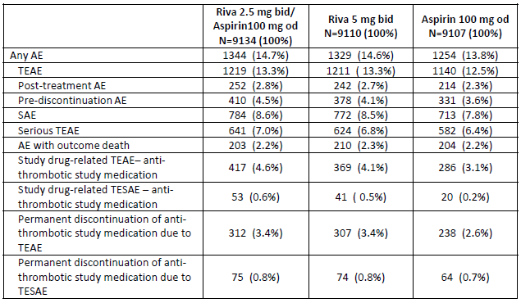
Post‐hoc analyses of major bleeding data were performed for fragile subjects and the following age groups: < 65 years, 65 to < 75 years, 75 to < 85 years, ≥ 85 years, < 80 years and ≥ 80 years. Fragile subjects were defined as age > 75 years or weight < 50 kg or baseline eGFR < 50 mL/min. Bleeding risk increased with fragile status and with age in both the rivaroxaban 2.5 mg BD/aspirin 100 mg OD group and the aspirin 100 mg OD group. The hazard ratio for major bleeding events in the 75 to < 85 year old group was 2.25 (95% CI 1.50 to 3.36) compared to 1.84 (95% CI 1.41 to 2.42) for the 65 to < 75 year old group and 1.41 (95% CI 0.83 to 2.42) for the < 65 years age group (Figure 5). Interpretation of the result for the ≥ 85 years age group is unreliable due to low numbers (wide CI). The analysis of < 80 years and ≥ 80 years age groups did not reveal a difference in bleeding risk but there were low numbers in the ≥ 80 years age group and the CI was wide.
Figure 5: Study 15786: Forest plot for treatment emergent ISTH major bleeding events by fragile subject classification and age group

Risk management plan
In support of the new indication, the sponsor submitted EU‐RMP version 11.1 (dated 23 October 2017; DLP 15 September 2017) and ASA version 2.6 (dated December 2017).
The sponsor subsequently submitted EU‐RMP version 11.4 (dated 5 July 2018; DLP 15 September 2018) and ASA version 2.7 (dated August 2018), and ASA version 2.8 (dated October 2018) with the second round response.
The proposed Summary of Safety Concerns and the associated risk monitoring and mitigation strategies are summarised in Table 11 above.
The proposed pharmacovigilance plan includes drug utilisation studies and post authorisation safety studies. The plan is unchanged from what has previously been agreed, and remains acceptable for the proposed new indication given the similarity in the safety specification. The proposed risk minimisation plan is adequate from an RMP perspective. The additional risk minimisation activities include a guide for health professionals and a Patient Alert Card (PAC). Both require updating to reflect the proposed new indication and the associated change in dosing and new tablet strength.
The sponsor has committed to submit the revised PAC and prescriber guide to TGA prior to marketing the new indication in Australia.

Recommended conditions of registration
The following condition of registration was recommended in the Round 2 RMP report:
The Xarelto EU‐Risk Management Plan (RMP) (version 11.4, dated 5 July 2018, data lock point 15 September 2017), with Australian Specific Annex (version 2.7, dated August 2018), included with submission PM‐2017‐04819‐1‐3, to be revised to the satisfaction of the TGA, will be implemented in Australia.

Risk-benefit analysis

Discussion
The COMPASS trial demonstrated a significant reduction in major cardiovascular events (composite of stroke, myocardial infarction and CV death) in patients with CAD and/or PAD for rivaroxaban 2.5 mg BD/aspirin 100 mg OD compared to aspirin 100 mg OD alone, with statistically and clinically significant reductions in the risk of stroke and CV death. MI risk decreased by 14% for rivaroxaban 2.5 mg BD/aspirin 100 mg OD compared to aspirin 100 mg OD alone but this result was not statistically significant. It is acknowledged that COMPASS was not powered to reach statistical significance in the individual components of the primary composite outcome, even if it had continued to the planned completion date rather than being terminated prematurely. The cardiovascular benefit was demonstrated in the CAD, PAD and ‘CAD and PAD’ subpopulations and secondary composite efficacy outcomes were similar to the primary composite outcome. The HR for the primary composite outcome was reduced to a lesser extent in patients aged ≥ 75 years compared to younger subjects.
There was a higher risk of ISTH‐modified major bleeding events for rivaroxaban 2.5 mg BD/aspirin 100 mg OD compared to aspirin 100 mg OD, with bleeding leading to hospitalisation (non‐fatal and not in critical organ) being the major contributor to this higher bleeding risk. Gastrointestinal bleeding was the most common major bleeding event. There was a higher risk of major bleeding events in older subjects, and the risk was higher for rivaroxaban 2.5 mg BD/aspirin 100 mg OD compared with aspirin 100 mg OD.
The COMPASS trial did not demonstrate a benefit of rivaroxaban 5 mg BD over aspirin 100 mg OD and this dosage is not proposed for registration.
The use of aspirin 100 mg OD as the active comparator in the COMPASS trial is consistent with the Australian Therapeutic Guidelines which recommend long‐term therapy with aspirin 100 mg to 150 mg daily, or clopidogrel 75 mg daily if intolerant of aspirin, for secondary prevention of atherosclerotic cardiovascular events. Patients requiring dual antiplatelet therapy or non‐aspirin antiplatelet therapy were excluded from the COMPASS trial. There are no data on the efficacy of rivaroxaban 2.5 mg BD/aspirin 100 mg OD compared to antiplatelet treatments other than aspirin.
The evidence for efficacy and safety in the proposed indication is based on a single pivotal study, but it was a large study which achieved clinically meaningful and statistically significant results other than for the MI component of the primary composite outcome.
The cardiovascular benefits of rivaroxaban 2.5 mg BD/aspirin 100 mg OD in the proposed indication are offset by an increase in major bleeding events, but when the clinical significance of the reduction in major cardiovascular events is weighed against the increase in major bleeding events, the benefit‐risk is considered favourable overall. The cardiovascular benefit is lower in patients aged ≥ 75 years, a group affected by a higher risk of bleeding events, so the benefit‐risk is more finely balanced in this age group.

Proposed indication
The sponsor has accepted the evaluator’s recommendation to remove the references to prevention of MI, ALI and all‐cause mortality from the proposed indication. The COMPASS trial met the primary outcome for the composite of MI, stroke or CV death, but the 14% decrease in risk of MI was not statistically significant. The result for ALI was statistically significant but it was not a pre‐specified outcome of the study and the number of patients with ALI was small. ALI was included only as a component of two of the secondary objectives of the study. All‐cause mortality was a secondary efficacy outcome. The comparison of rivaroxaban 2.5 mg BD/aspirin 100 mg OD with aspirin 100 mg OD showed a relative risk reduction for all‐cause mortality of 18% (HR 0.82; 95% CI 0.71‐0.96; p = 0.01062), but all-cause mortality was heavily influenced by the reduction in CV mortality (non CV mortality was not significantly reduced).
The revised wording of the indication is consistent with the outcomes of the COMPASS trial.

Deficiencies of the data
No data are available for CAD/PAD patients requiring dual antiplatelet therapy or non-aspirin antiplatelet therapy, or those with a history of ischaemic stroke within 1 month or any history of haemorrhagic or lacunar stroke.
Long term data are limited. Mean duration of treatment in the COMPASS trial was 619 days (20 months), median 615 days.

Proposed regulatory action
Subject to the advice of ACM and satisfactory resolution of the PI, the Delegate proposed to approve this application for a new indication and a new strength of rivaroxaban.

Proposed conditions of registration
The Xarelto EU‐Risk Management Plan (RMP) (version 11.4, dated 5 July 2018, data lock point 15 September 2017), with Australian Specific Annex (version 2.8, dated October 2018), included with submission PM‐2017‐04819‐1‐3, will be implemented in Australia.

Summary
The COMPASS trial demonstrated a significant reduction in the risk of major cardiovascular events (composite of stroke, MI and CV death). There was an increased risk of major bleeding events, predominantly bleeding leading to hospitalisation (non‐fatal and not in a critical organ). The overall benefit‐risk for the proposed indication is considered favourable when the CV benefits demonstrated in the COMPASS trial are weighed against the safety outcomes (major bleeding events). The cardiovascular benefit in the COMPASS trial was lower in patients aged ≥ 75 years and the bleeding risk was higher, so the benefit‐risk is more finely balanced in patients aged ≥ 75 years.

Proposed action
The Delegate had no reason to say, at this time, that the application for a new indication and new strength of Xarelto should not be approved for registration.

Request for ACM advice
- What is the committee’s opinion regarding the overall benefit‐risk?
- What is the committee’s opinion regarding the COMPASS trial findings for patients aged ≥ 75 years? Should the PI include a specific precaution regarding the benefit‐risk in this age group?
- What is the committee’s opinion on the wording of the revised indication?

Response from sponsor

Introduction
The sponsor welcomes the opportunity to respond to the Delegate’s request for ACM advice and proposed recommendations (dated 1 November 2018) concerning our application to vary the conditions of registration for Xarelto to extend the indications and add a new strength (2.5 mg).

Indication
Originally proposed new indication:
Xarelto, in combination with aspirin, is indicated for the prevention of stroke, myocardial infarction and cardiovascular death, and for the prevention of acute limb ischaemia and mortality in patients with coronary artery disease (CAD) and/or peripheral artery disease (PAD).
The sponsor during the post-first round response agreed to revise the new indication as:
Xarelto, in combination with aspirin, is indicated for the prevention of major cardiovascular events (composite of stroke, myocardial infarction and cardiovascular death) in patients with coronary artery disease (CAD) and/or peripheral artery disease (PAD).

Dose
Originally proposed dose (at initial application):
Coronary artery disease (CAD) and/or peripheral artery disease (PAD).
The recommended vascular dosing regimen for patients with CAD or PAD is one tablet of 2.5 mg Xarelto twice daily in combination with a daily dose of 100 mg aspirin. This combination can be started at any time.
In patients with CAD and/or PAD, Xarelto 2.5 mg twice daily is not indicated in combination with dual antiplatelet therapy (see Section 5.1 pharmacodynamic properties).
Patients taking Xarelto 2.5 mg twice daily should also take a daily dose of 100 mg aspirin.
Therapy should be continued long term provided the benefit outweighs the risk.
At the pre-ACM stage:
Coronary artery disease (CAD) and/or peripheral artery disease (PAD).
The recommended dose is one tablet of 2.5 mg Xarelto twice daily in combination with a daily dose of 100 mg aspirin.
In patients with CAD and/or PAD, Xarelto 2.5 mg twice daily is not indicated in combination with dual antiplatelet therapy (see Section 5.1 pharmacodynamic properties).
Duration of treatment should be determined for each individual patient based on regular evaluations and should consider the risk for thrombotic events versus the bleeding risks.
Missed dose, originally proposed at initial application:
Xarelto 2.5 mg tablets taken twice a day: If a dose is missed the patient should continue with the regular dose as recommended at the next scheduled time.
Missed dose, at the pre-ACM stage:
Xarelto 2.5 mg tablets taken twice a day: If a dose is missed the patient should continue with the regular dose as recommended at the next scheduled time. The dose should not be doubled to make up for a missed dose.

Comments on evaluation reports
The TGA’s clinical evaluator has mentioned that the revised wording of the indication is consistent with the outcomes of the COMPASS trial. The TGA’s clinical, chemistry and RMP evaluators have recommended the approval of Xarelto for the sponsor’s proposed indication.
The Delegate has also raised few question/comments.
- The draft PI includes a precaution in section 4.4 (and repeated in section 4.2) that treatment with Xarelto 2.5 mg twice daily in combination with aspirin should be avoided in patients with CAD and/or PAD who have had an ischaemic, non-lacunar stroke within the previous month or previous haemorrhagic or lacunar stroke. Please comment on the reasons for placing this guidance in section 4.4 rather than section 4.3 Contraindications, as it is in the EU SmPC.
Sponsor’s response:
The sponsor agrees to placing this guidance in 4.3 Contraindications in the proposed PI, as it is in the EU Summary of Product Characteristics (SmPC).
- Further, the TGA Delegate has mentioned that the cardiovascular benefit is lower in patients aged ≥ 75 years, a group affected by a higher risk of bleeding events, so the benefit-risk is more finely balanced in this age group.
Sponsor’s response
The Delegate has noted a limited benefit for the subgroup ≥ 75 years (121/1924, 6.3% in the rivaroxaban 2.5 BD/aspirin 100 mg OD arm versus 132/1897, 7.0% in the aspirin only arm, HR=0.89 [95% CI 0.7 to 1.1]). The numbers of subjects with CV death (63 versus 61, respectively) and MI (47 versus 43) are similar in both treatment arms indicating a neutral effect in this age group on MI and CV death. There was a significant reduction in subjects with stroke (23 versus 46). In general, the long-term risk of ischemic events need to be balanced against the bleeding complications. In the ITT analysis set, the numbers of subjects with a modified ISTH major bleeding event are 101 the rivaroxaban 2.5 BD/aspirin 100 mg OD arm versus 47 in the aspirin only arm (5.2% versus 2.5%). The sponsor has provided analyses of events of equal severity for additional consideration as part of the qualitative discussion of benefit risk. For the ≥ 75 years there is a 1.9% absolute risk reduction in stroke compared to a 0.3% increase in fatal and symptomatic bleeding into critical organ. The sponsor performed the benefit risk assessment based on the complete review of efficacy and a detailed review of all major bleeding events.
In the COMPASS trial the broad definition of the modified ISTH major bleeding was applied. Many events that are not severe in intensity were categorised as major, especially events leading to hospitalisation.
When comparing incidences of major bleeding events across trials it is important to note that they are not comparable in intensity, for example the TIMI major bleedings in the ATLAS TIMI 51 trial are not comparable to the modified ISTH major bleeding in the COMPASS trial).
TIMI major bleeding is defined mainly by severe, fatal and life-threatening bleeding events. Modified ISTH major bleeding includes mild, moderate and severe events. In contrast to TIMI major bleeding, the majority of modified ISTH ‘major’ bleeding events in the COMPASS trial are of mild and moderate intensity. Mild to moderate major bleeding events are increased and although important in terms of morbidity for patients are of different relevance for individual patients and prescribers than CV death, MI and stroke. Detailed information is provided below on all subjects ≥ 75 years with any modified ISTH major bleeding event.
In the ATLAS TIMI 51 trial, 15,526 patients with a recent acute coronary syndrome were randomly assigned to receive rivaroxaban 2.5 mg BD or 5 mg BD in addition to single or dual antiplatelet therapy.
Rivaroxaban 2.5 mg BD reduced the risk of the composite endpoint of death from cardiovascular causes, myocardial infarction, or stroke. Rivaroxaban increased the risk of major bleeding and intracranial haemorrhage but not the risk of fatal bleeding. 14,292 of the patients received rivaroxaban plus aspirin plus thienopyridine. Just 1,050 subjects received rivaroxaban plus aspirin as in the COMPASS trial. 9% of the patients in the rivaroxaban 2.5mg BD group were ≥ 75 years old, 9.6% in the comparator group. The mean age was 62.
For the ACS indication (Not evaluated and approved by the TGA) with dual and triple therapy, the EU SmPC section 4.4 includes a warning under ‘other haemorrhagic risk factors’ that rivaroxaban should be used with caution in ACS patients ≥ 75 years of age if co-administered with aspirin alone or with aspirin plus clopidogrel or ticlopidine. Patients ≥ 75 years are not excluded in the ACS indication.
In theROCKET AF trial, in 14,264 patients with non-valvular atrial fibrillation rivaroxaban 20 mg or 15 mg daily was non-inferior to warfarin for the prevention of stroke or systemic embolism. There was no significant between-group difference in the risk of major bleeding, although intracranial and fatal bleeding occurred less frequently in the rivaroxaban group. The median age of the patients included was 73 (interquartile range 65 to 78). Patients ≥ 75 years are not excluded in the atrial fibrillation indication.
For the COMPASS trial population the dual therapy with antiplatelet and anticoagulant (that is rivaroxaban 2.5 mg BD + aspirin) showed a lower bleeding risk compared to the triple therapy (that is rivaroxaban + aspirin + clopidogrel or other anti-platelets) used in the ATLAS trial, and this also applies for subjects ≥ 75 years.
In addition, from a clinical pharmacology perspective, in contrast to other antithrombotic agents on the market (for example prasugrel), rivaroxaban exposure does not change significantly with age. Rivaroxaban has no active metabolites.
A contraindication for patients ≥ 75 years would have relevant consequences for the prescribers, which would not allow him/her to consider the risk/benefit of the individual patient and the biological age. In clinical practice, excluding patients would require discontinuation of an efficacious and well-tolerated preventive therapy based on an arbitrary age limit. For example, when a patient reaches the age of 75 although he/she has tolerated and benefited from the therapy for years, the therapy needs to be discontinued. The prescribing physician and patient should be allowed to review the individual benefit risk and make a decision in the best interest of the patient on a regular basis without a proscribed age restriction. The sponsor proposes that an individual regular assessment for the benefit risk in patients ≥ 75 years can be addressed in section 4.4.
Generally, there are different approved cardiovascular indications for different doses up to 30 mg (daily) of Xarelto without any upper age limit. In addition to the extensive clinical trial experience with rivaroxaban in the elderly, there is a large post-marketing database with positive experience in the market. A warning statement is already included in the SmPC for the similar ACS population and is the relevant place in the SmPC to address the need for a careful risk benefit evaluation for 2.5 mg BD in elderly patients ≥ 75 years.
The known overall increased bleeding risk in the elderly is addressed in current section 4.4.

Proposed PI wording
To address the concerns of the Delegate and to provide the prescriber with the relevant information with regards to this population, the sponsor accepts to include wording in Section 4.2 of the PI, and proposes to add a warning statement in Section 4.4 and to include a statement in Section 5.1 as follows:
Section 4.2, proposed changes (under elderly population):
The risk of bleeding increases with increasing age. (see section 4.4).
Section 4.4, proposed changes:
General haemorrhagic risk factors
It should be used with caution in CAD and /or PAD patients:
≥ 75 years of age if co-administered with aspirin. The benefit-risk of the treatment should be individually assessed on a regular basis.
Elderly population
Increasing age may increase haemorrhagic risk (see sections 5.1 and 5.2).
Section 5.1:
For the primary efficacy outcome, the observed benefit of Xarelto 2.5 mg BD plus aspirin 100 mg OD compared with aspirin 100 mg OD was HR 0.89 (95% CI 0.7-1.1) in patients ≥ 75 years and HR=0.70 (95% CI 0.6-0.8) in patients < 75 years. For modified ISTH major bleeding, the observed risk increase was HR 2.12 (95% CI 1.5-3.0) in patients ≥ 75 years and HR=1.53 (95% CI 1.2-1.9) in patients < 75 years.

Benefit risk assessment in elderly patients ≥ 75 years of age
The sponsor agrees that the benefit risk assessment should be based on the complete review of efficacy / safety and provides additional data to support a warning instead of a contraindication for patients ≥ 75 years.
To support the benefit risk for patients ≥ 75 years the sponsor presents the following results for the ITT set:
- The effects for the primary efficacy and safety outcome by age subgroup.
- Kaplan-Meier estimates of cumulative incidence risk of stroke, modified ISTH major bleeding, and fatal bleeding or symptomatic bleeding into critical organ for subjects ≥ 75 years.
- Number of subjects ≥ 75 years with modified ISTH major bleeding events by hierarchy and maximum intensity.
- Case summaries of the 6 fatal bleeding events.
- Patient listings of all modified ISTH bleeding events for ≥ 75 years [Table not included in this document].
The primary safety analysis is based on the ITT analysis set. Note that for the ITT analysis set, the first major bleeding event is included in the primary safety outcome even if the bleeding event occurred after discontinuation of study medication. Therefore, all major bleeding events are included whether the subject was on study medication or not.
The comparison of rivaroxaban 2.5 mg BD/aspirin 100 mg OD with aspirin 100 mg OD was favourable for the primary outcome across all age groups, nevertheless the point estimate of treatment effect decreases with age (Table 17).

Table 17: Rivaroxaban treatment effect for the primary efficacy and rivaroxaban treatment effect for the primary efficacy and safety outcomes up until global rivaroxaban/aspirin outcomes cut-off date by age (ITT analysis set)
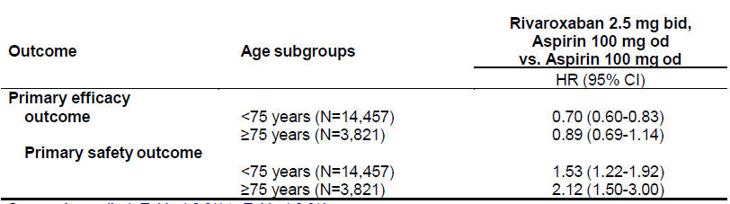
The benefit for stroke is maintained for subjects aged ≥ 75 years (HR 0.48 (95% CI 0.3 to 0.8). The observed 52% relative risk reduction in stroke in ≥ 75 years of age is clinically relevant and statistically significant at a nominal alpha level of 5%, although the study was not powered to expect that the CI for the HR would exclude 1 in a subgroup of that size. In subjects ≥ 75 years, in terms of absolute risks, the estimated cumulative incidence risk to experience a stroke up to 900 days after randomisation is 1.52% in the rivaroxaban 2.5 mg BD/aspirin 100 mg OD arm compared with 3.42% in the aspirin 100 mg OD arm. This translates into a 1.9% (95% CI (-3.18, -0.62)) absolute risk reduction at Day 900 (Table 18).
The observed benefit in the prevention of strokes should be balanced against bleeding events caused of comparable clinical relevance and severity, that is, the composite of fatal bleeding or symptomatic bleeding into critical organ. The estimated cumulative incidence risk to experience a fatal bleeding or symptomatic bleeding into critical organ up to 900 days after randomisation is 1.30% in the rivaroxaban 2.5 mg BD/aspirin 100 mg OD arm compared with 1.00% in the aspirin 100 mg OD arm in subjects ≥ 75 years. This translates into a 0.3% (95% CI -0.59 to -1.19) absolute risk increase in fatal and critical organ bleeding at Day 900 (Table 18)). While the difference in the estimated cumulative incidence risk for stroke is increasing over time with aspirin only compared to rivaroxaban 2.5 mg BD/aspirin 100 mg OD, the difference for fatal bleeding or symptomatic bleeding into critical organ is essentially similar between the 2 treatments after Year 1, see also Figure 6, below.

Table 18: Cumulative incidence risk of stroke / major bleeding up until global rivaroxaban/aspirin outcomes cut-off date (ITT analysis set for subjects ≥ 75 years)
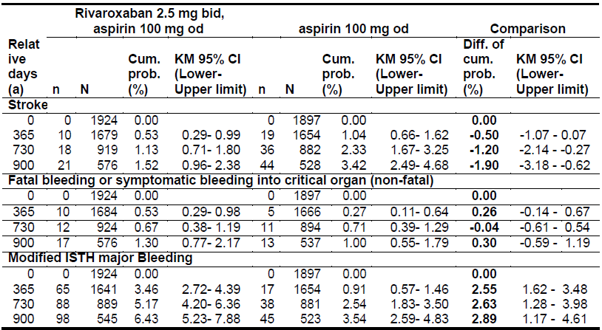
Relative days from randomisation; n = cumulative number of subjects with events up to the day, inclusive; N = number of subjects at risk at that day; Cum. prob. (%) = Kaplan-Meier estimates of the cumulative probability for an event, calculated as 100 * (1 minus the Kaplan-Meier estimates of the survival function); CI = Confidence Interval. Kaplan-Meier confidence limits are calculated using the complementary loglog transformation for estimating the standard error.; MI = myocardial infarction, CV = cardiovascular, , ALI = acute limb ischemia, BD = twice daily, OD = once daily
Aspirin 100 mg OD is the only available option for prevention of cardiovascular events including CV death, MI and stroke. The KM curves in the COMPASS trial show that despite of randomisation to aspirin 100 mg OD treatment the risk for stroke is still higher than the risk for severe bleeding (fatal bleeding or critical organ bleeding). Note, the stroke outcome event includes definite ischemic stroke and definite haemorrhagic stroke. Bleeding events leading to hospitalisation without fatal outcome, or not into a critical organ are not included. For the primary safety outcome of modified ISTH major bleeding there is an absolute risk increase (Kaplan-Meier estimates at Day 900: 6.43% versus 3.54%) that is numerically larger in subjects ≥ 75 years of age.
The risk for fatal or critical organ bleeding in the elderly is comparable between aspirin 100 mg OD and the combination of rivaroxaban 2.5 md BD and aspirin 100 mg OD. By randomisation to the combination the risk observed for strokes is reduced considerably. The price to pay for an important reduction in stroke risk is the increasing bleeding risk with increasing age. The risk must be assessed individually on a regular basis by the prescriber.
Figure 6: Kaplan-Meier estimates of cumulative incidence risk of stroke and fatal bleeding or symptomatic bleeding into critical organ (non-fatal) up until global rivaroxaban/aspirin outcomes cut-off date by age group (cut- off 75 years) (ITT analysis set)
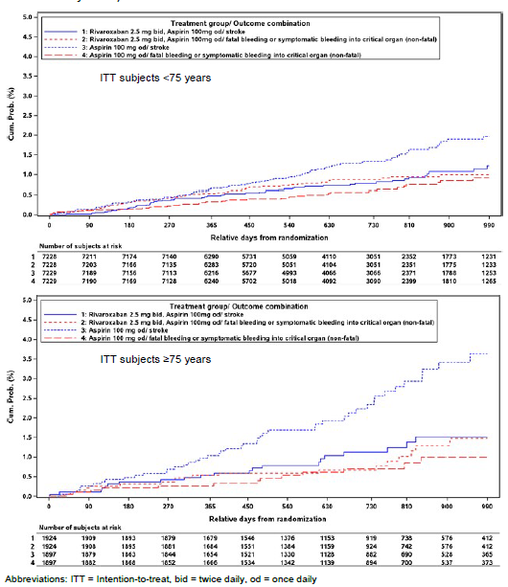
As pointed out previously, the majority of modified ISTH major bleedings were mild to moderate in intensity (74% and 79%) and comparable between the treatment groups.
Critical organ bleeding events were infrequent and mostly of mild to moderate severity. A total of 13/1924 subjects ≥ 75 years of age randomised to rivaroxaban 2.5 mg BD/aspirin 100 mg OD experienced a symptomatic bleeding into critical organ, of which 8/13 were mild to moderate in intensity and 5/13 were severe. A total of 13/1897 subjects ≥ 75 years of age randomised to aspirin 100 mg OD alone experienced a symptomatic bleeding into critical organ, of which 9/13 were mild to moderate in intensity and 4/13 were severe.
A total of 80/1924 subjects ≥ 75 years of age randomised to rivaroxaban 2.5 mg BD/aspirin 100 mg OD experienced a bleeding leading to hospitalisation, of which two-thirds (63/80) were mild to moderate in intensity and 17/80 were severe. A total of 36/1897 subjects ≥ 75 years of age randomised to aspirin 100 mg OD alone experienced a bleeding leading to hospitalisation, of which 30/36 were mild to moderate in intensity and 6/36 were severe.

Table 19: Number of subjects ≥ 75 years with modified ISTH major bleeding events by hierarchy and maximum intensity (ITT)
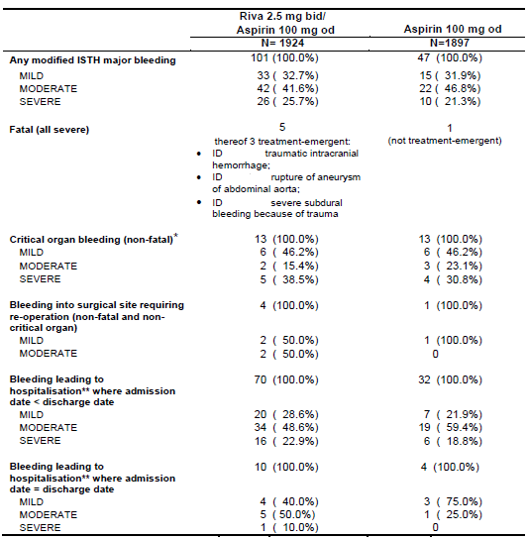
Due to the nature of fatality, severity is not analysed for fatal bleeding. Table includes events that are classified as major bleeding events during the adjudication process. Intensity is reported by the investigator and not adjudicated. Each event is counted in the most severe hierarchical category (fatal; critical organ bleeding; bleeding into surgical site requiring re-operation; bleeding leading to hospitalisation) only. * Refers to symptomatic critical organ bleeding (non-fatal), ** Refers to Bleeding leading to any hospitalisation (non-fatal, non-critical organ, not leading to re-operation) (a) Refers to hospitalisation or presentation to an acute care facility with discharge the same day. BD = twice daily, ISTH = International Society on Thrombosis and Haemostasis; OD = once daily; Riva = rivaroxaban; ITT = intent to treat analysis set. Note: Patient ID numbers have been redacted.
Fatal bleeding events were numerically increased 5 to 1 against rivaroxaban 2.5 mg BD/aspirin 100 mg OD in patients ≥ 75 years of age, (0.3% absolute numerical increase in fatal bleeding at Day 900) (Table 20). Of the 6 fatal bleeding events in the ITT analysis set, 3 occurred after considerable time after discontinuation of study medication.

Table 20: Kaplan-Meier estimates for the cumulative incidence risk of modified ISTH major bleeding and fatal bleeding at Day 900 by age group (ITT analysis set)
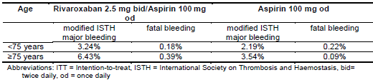
Case summaries of the 6 fatal events are provided below; and include information that was manually extracted from the eCRF:
Aspirin 100 mg OD group:
Subject ID [information redacted] (fatal bleeding event not treatment-emergent): This 82-year-old male subject has a medical history of myocardial infarction, multi-vessel coronary disease with unstable angina, heart failure NYHA (New York Heart Association) class I, hypertension, peptic ulcer and haemorrhoids. The subject was a current smoker who started using tobacco at the age of 17. The subject had suffered from “dysphonia since October 2014 (smoker’s chronic laryngitis)”. On 11 May 2015, he was hospitalised due to a laryngeal node and was diagnosed with laryngeal cancer. On 17 October 2015, the subject experienced a mild laryngeal bleeding, classified as critical organ bleeding. On 30 January 2016 and on 22 March 2016, respectively, a moderate haemorrhoidal bleeding, classified as leading to hospitalisation, and a mild gastrointestinal tract bleeding at an unknown site, classified as requiring re-operation, occurred. After the subject had a tracheotomy and a nasogastric tube, the investigator had decided to permanently discontinue the study drugs on 18 July 2016, 145 days prior to the fatal bleeding event. On 11 December 2016, at the age of 83, the subject experienced a severe spontaneous bleeding of the oral cavity, was transfused with 1 unit of red blood cells (RBCs)/whole blood and received “other” corrective therapy for the bleeding. The event was classified as fatal. The death was adjudicated as malignancy death.
Rivaroxaban 2.5 mg BD/aspirin 100 mg OD group:
Subject ID [information redacted] (not treatment-emergent major bleeding): This 81 year-old male subject had a medical history of multi-vessel coronary disease with stable angina. The subject was a former smoker. On 4 February 2017, at the age of 81, the subject was hospitalised for prostatectomy due to prostatic hyperplasia. On the same date, a prostate bleeding occurred which was reported as procedure-related, and the subject was transfused with 2 units of RBCs/whole blood. The event was classified as fatal, no further information was provided. The death was adjudicated as due to bleeding other than haemorrhagic stroke. The study drugs had been permanently discontinued on 8 September 2016, 148 days prior to the fatal bleeding event, due to a minor urinary tract bleeding.
Subject ID [information redacted]: This 77 year-old male subject had a medical history of myocardial infarction, multi-vessel coronary disease, CABG (Coronary artery bypass graft) surgery, peripheral artery bypass surgery, intermittent claudication, heart failure NYHA class II, hypertension, bleeding requiring transfusion, and peptic ulcer. The subject was a current smoker. On 29 November 2014, at the age of 77, the subject was hospitalised due to stroke, heart failure and injury/trauma were also noted. The stroke was reported as haemorrhagic stroke but during adjudication turned out to be a traumatic intracranial haemorrhage. The corresponding bleeding event was reported as severe intracranial bleeding. Corrective therapies for bleeding were reported as “other therapy” and heart failure as well as renal disease were noted as major co-morbidities at the time of the bleeding. The event was classified as fatal. The death was adjudicated as due to unknown cause.
Subject ID [information redacted] (not treatment-emergent major bleeding): This 76 year-old male subject has a medical history of myocardial infarction and diabetes and was a former smoker. On 04 July 2016, the subject was diagnosed with gastrointestinal cancer. On 24 August 2016, the subject experienced an overt bleeding of gastrointestinal origin and was hospitalised. Endoscopy/radiography showed a gastroduodenal ulcer, active bleeding from a gastroduodenal lesion, and malignancy. The corresponding bleeding event was reported as moderate spontaneous gastric bleeding and classified as requiring re-operation; cancer was noted as major co-morbidity at the time of the bleeding. On 8 September 2016, at the age of 78, the subject experienced a second overt bleeding of gastroduodenal origin and was hospitalised. The event was reported as severe spontaneous gastric bleeding and the subject was transfused with an unknown amount of RBCs/whole blood. Corrective therapy included fresh frozen plasma; cancer was noted as major co-morbidity at the time of the bleeding. The event was classified as fatal. The subject had decided to permanently discontinue the study drugs on 16 December 2014, 631 days prior to the fatal bleeding event. Non-study antiplatelet therapy reported at the visits thereafter included aspirin, aspirin plus ticagrelor, and aspirin plus clopidogrel.
Subject ID [information redacted]: This 81 year-old female subject had a medical history of multi-vessel coronary disease with unstable angina, CABG surgery, hypertension and diverticulitis. On 29 June 2016, the subject was hospitalised due to injury/trauma with bleeding. The corresponding bleeding event was reported as severe subdural bleeding that occurred because of trauma and was classified as fatal. The death was adjudicated as due to bleeding other than haemorrhagic stroke.
In summary, three of the six fatal bleeding events occurred after the study drugs had been permanently discontinued. For the remaining three bleeding events, two were associated with external circumstances (injury/trauma) or an underlying disease (abdominal aortic aneurysm).

Summary
The sponsor acknowledges to provide relevant information to the prescribers and considers the benefit risk to be positive for patients ≥ 75 years of age. The known overall increased bleeding risk in the elderly is best reflected in Section 4.4 of the PI. The sponsor will revise Section 4.4 to include the COMPASS trial population as follows:
Other haemorrhagic risk factors
[…] it should be used with caution in CAD and/or PAD patients:
≥ 75 years of age if co-administered with aspirin alone. The benefit-risk of the treatment should be individually assessed on a regular basis
Elderly population
Increasing age may increase haemorrhagic risk (see sections 5.1 and 5.2).
In addition, the Delegate has pointed out few deficiencies of the data
- No data are available for CAD/PAD patients requiring dual antiplatelet therapy or non-aspirin antiplatelet therapy, or those with a history of ischaemic stroke within 1 month or any history of haemorrhagic or lacunar stroke.
- Long term data are limited. Mean duration of treatment in the COMPASS trial was 619 days (20 months), median 615 days.
The proposed PI is amended per the Delegate’s recommendations in the Delegate’s overview is provided togther with the amended CMI.
Overall, the sponsor is in agreement with the TGA evaluators and the Delegate that the COMPASS trial demonstrated a significant reduction in the risk of major cardiovascular events (composite of stroke, MI and CV death). There was an increased risk of major bleeding events, predominantly bleeding leading to hospitalisation (nonfatal and not in a critical organ). The overall benefit-risk for the proposed indication is considered favourable when the CV benefits demonstrated in the COMPASS trial are weighed against the safety outcomes (major bleeding events).

Advisory Committee Considerations
The Advisory Committee on Medicines (ACM), taking into account the submitted evidence of efficacy, safety and quality, agreed with the Delegate and considered Xarelto film‐coated tablet containing 2.5 mg of rivaroxaban to have an overall positive benefit‐risk profile for the amended indication;
Xarelto, in combination with aspirin, is indicated for the prevention of major cardiovascular events (composite of stroke, myocardial infarction and cardiovascular death) in patients with coronary artery disease (CAD) and/or peripheral artery disease (PAD).
In providing this advice the ACM:
- noted that in the pivotal safety and efficacy study (COMPASS trial):
  - patients with a high bleeding risk were excluded from the COMPASS trial. The definition of ‘high bleeding risk’ was not clearly defined by the sponsor; patients who were less than 65 years old had to have higher risk disease to be included in COMPASS trial
  - ‘fragile patient’ was defined based on weight, age or renal function only
- expressed concern that in the subgroup analysis for different age groups, the cardiovascular benefit in the age group of greater than 75 years (≥ 75 years) was smaller when compared to the younger age group. The older age group also had a higher bleeding risk. The benefit‐risk profile of rivaroxaban is more finely balanced in the ≥ 75 years age group.

Proposed Product Information (PI)/ Consumer Medicine Information (CMI) amendments
The ACM agreed with the Delegate to the proposed amendments to the Product Information (PI) and Consumer Medicine information (CMI) and specifically advised on the inclusion of the following:
- a statement in section 4.4 Special Warnings and Precaution for use of the PI and relevant sections of the CMI to more accurately reflect the post hoc analysis in patients categorised as fragile and patients ≥ 75 years of age. The statement should include the increased risk of bleeding (fatal and non-fatal) observed in this group of patients. A table describing the primary efficacy and safety outcome in the two age groups (≥ 75 years and < 75 years), similar to Table 1.1 included in the sponsor’s Pre‐ACM response, should also be included in the PI.
- The PI should explain how patients at ‘high bleeding risk’ were identified as this led to their exclusion from participating in the COMPASS trial. If not replicated clinically, then the concern is that real life use could see a loss of the positive benefit: risk analysis with the emergence of more bleeding events.
- Additional references to the co‐administration of 100 mg aspirin in the body of Table 1 in Section 4.2 Dose and Method of Administration of the PI to more clearly reflect the treatment for CAD and/or PAD.
- a statement in the CMI to ensure that patients are aware that they must carry the Patient Alert Card in the wallet at all times, as per described in the RMP.
- a statement in the CMI to more accurately reflect that rivaroxaban is not indicated for patients with a mechanical heart valve.

Specific advice
The ACM advised the following in response to the delegate’s specific questions on the submission:
- What is the committee’s opinion regarding the overall benefit‐risk?
The absolute risk reduction in MI, stroke and CV of 2% in the rivaroxaban 2.5 mg BD/aspirin 100 mg OD patients with CAD and/or PAD was offset by the 1.4% increase in major bleeding risk.
When the clinical significance of the reduction in the primary composite endpoint is weighed against the increase risk of bleeding, the committee considered the overall benefit-risk profile to be favourable.

Table 21: Comparison of the primary composite endpoint and major bleed events (Compass trial)
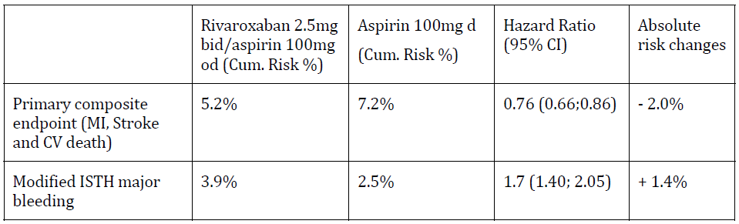
- What is the committee’s opinion regarding the COMPASS trial findings for patients aged ≥ 75 years? Should the PI include a specific precaution regarding the benefit‐risk in this age group?
The ACM considered the post hoc analyses in patients aged ≥ 75 years and was of the view that the benefit‐risk profile was less clear, as the cardiovascular benefit was smaller but the bleeding risk was higher. The committee recommended a specific warning in the PI to more accurately reflect the post hoc analysis results and the increased risk in bleeding in the patients categorised as fragile and patients aged ≥ 75 years of age.
- What is the committee’s opinion on the wording of the revised indication?
The ACM was of the view that the revised wording indication from the sponsor was acceptable. It was appropriate to exclude ‘acute limb ischaemia’ from the indication.
The ACM advised that implementation by the sponsor of the recommendations outlined above to the satisfaction of the TGA, in addition to the evidence of efficacy and safety provided would support the safe and effective use of this product.

Outcome
Based on a review of quality, safety and efficacy, the TGA approved the registration of Xarelto rivaroxaban 2.5 mg film-coated tablet for the new indication as follows:
Xarelto, in combination with aspirin, is indicated for the prevention of major cardiovascular events (composite of stroke, myocardial infarction and cardiovascular death) in patients with coronary artery disease (CAD) and/or peripheral artery disease (PAD).
In addition, the TGA approved amendments to the PI’s for the Xarelto rivaroxaban 10, 15 and 20 mg tablet blister packs.
The indications for Xarelto rivaroxaban 10, 15 and 20 mg tablet are now:
Xarelto is indicated for:
Prevention of venous thromboembolism (VTE) in adult patients who have undergone major orthopaedic surgery of the lower limbs (elective total hip replacement, treatment for up to 5 weeks; elective total knee replacement, treatment for up to 2 weeks)
Prevention of stroke and systemic embolism in patients with non-valvular atrial fibrillation and at least one additional risk factor for stroke
Treatment of deep vein thrombosis (DVT) and pulmonary embolism (PE) and for the prevention of recurrent DVT and PE

Specific conditions of registration applying to these goods
The Xarelto EU-Risk Management Plan (RMP) (version 11.4, dated 5 July 2018, data lock point 15 September 2017), with Australian Specific Annex (version 2.8, dated October 2018), included with submission PM-2017-04819-1-3, and any subsequent revisions, as agreed with the TGA, will be implemented in Australia.

Attachment 1. Product Information
The PI for Xarelto approved with the submission which is described in this AusPAR is at Attachment 1. For the most recent PI, please refer to the TGA website at < https://www.tga.gov.au/product-information-pi> .

Therapeutic Goods Administration
PO Box 100 Woden ACT 2606 Australia
Email: info@tga.gov.au Phone: 1800 020 653 Fax: 02 6232 8605
https://www.tga.gov.au

The extension of indications in this submission applies only to the 2.5 mg dose form.
The new dosage form in this submission is 2.5 mg
For a full description please see the introduction section below as the new indication has been approved for the 2.5 mg dose form whilst the previously approved indications remain for the other strengths.
Submission PM-2007‐3400‐3‐3
Submission PM‐2010‐03901‐3‐3
Submission PM‐2012‐01179‐3‐3
Steg PG et al.; One-Year Cardiovascular Event Rates in Outpatients With Atherothrombosis. JAMA. 2007; 297: 1197-1206.
Yusuf S et al.; Effects of an angiotensin-converting-enzyme inhibitor, ramipril, on cardiovascular events in high-risk patients. N Engl J Med. 2000; 342: 145-153
CAPRIE Steering Committee; A randomised, blinded, trial of clopidogrel versus aspirin in patients at risk of ischaemic events (CAPRIE). CAPRIE Steering Committee. Lancet 1996; 348: 1329-1339
Bhatt D et al.; International prevalence, recognition, and treatment of cardiovascular risk factors in outpatients with atherothrombosis. JAMA 2006; 295: 180-189
Teo K et al.; Rationale, design, and baseline characteristics of 2 large, simple, randomized trials evaluating telmisartan, ramipril, and their combination in high-risk patients: the Ongoing Telmisartan Alone and in Combination with Ramipril Global Endpoint Trial/Telmisartan Randomized Assessment Study in ACE Intolerant Subjects with Cardiovascular Disease (ONTARGET/TRANSCEND) trials.
Not included in this submission.
Routine risk minimisation activities may be limited to ensuring that suitable warnings are included in the product information or by careful use of labelling and packaging. Routine pharmacovigilance practices involve the following activities: - All suspected adverse reactions that are reported to the personnel of the company are collected and collated in an accessible manner; - Reporting to regulatory authorities; - Continuous monitoring of the safety profiles of approved products including signal detection and updating of labelling; - Submission of PSURs; - Meeting other local regulatory agency requirements.
Definitions as per CRF instruction: Mild - Usually transient in nature and generally not interfering with normal activities; Moderate - Sufficiently discomforting to interfere with normal activities; Severe - Prevents normal activities
The ACM provides independent medical and scientific advice to the Minister for Health and the Therapeutic Goods Administration (TGA) on issues relating to the safety, quality and efficacy of medicines supplied in Australia including issues relating to pre-market and post-market functions for medicines. The Committee is established under Regulation 35 of the Therapeutic Goods Regulations 1990. Members are appointed by the Minister. The ACM was established in January 2017 replacing Advisory Committee on Prescription Medicines (ACPM) which was formed in January 2010. ACM encompass pre and post-market advice for medicines, following the consolidation of the previous functions of the Advisory Committee on Prescription Medicines (ACPM), the Advisory Committee on the Safety of Medicines (ACSOM) and the Advisory Committee on Non-Prescription Medicines (ACNM). Membership comprises of professionals with specific scientific, medical or clinical expertise, as well as appropriate consumer health issues relating to medicines.

