First round report: 27 March 2017
Second round report: 24 July 2017

AusPAR Attachment 2

Extract from the Clinical Evaluation Report for Rituximab
  - Proprietary Product Name: Riximyo
  - Sponsor: Sandoz Pty Ltd

About the Therapeutic Goods Administration (TGA)
- The Therapeutic Goods Administration (TGA) is part of the Australian Government Department of Health, and is responsible for regulating medicines and medical devices.
- The TGA administers the Therapeutic Goods Act 1989 (the Act), applying a risk management approach designed to ensure therapeutic goods supplied in Australia meet acceptable standards of quality, safety and efficacy (performance), when necessary.
- The work of the TGA is based on applying scientific and clinical expertise to decision-making, to ensure that the benefits to consumers outweigh any risks associated with the use of medicines and medical devices.
- The TGA relies on the public, healthcare professionals and industry to report problems with medicines or medical devices. TGA investigates reports received by it to determine any necessary regulatory action.
- To report a problem with a medicine or medical device, please see the information on the TGA website <https://www.tga.gov.au>.
About the Extract from the Clinical Evaluation Report
- This document provides a more detailed evaluation of the clinical findings, extracted from the Clinical Evaluation Report (CER) prepared by the TGA. This extract does not include sections from the CER regarding product documentation or post market activities.
- The words Information redacted, where they appear in this document, indicate that confidential information has been deleted.
- For the most recent Product Information (PI), please refer to the TGA website <https://www.tga.gov.au/product-information-pi>.
Copyright
© Commonwealth of Australia 2018
This work is copyright. You may reproduce the whole or part of this work in unaltered form for your own personal use or, if you are part of an organisation, for internal use within your organisation, but only if you or your organisation do not use the reproduction for any commercial purpose and retain this copyright notice and all disclaimer notices as part of that reproduction. Apart from rights to use as permitted by the Copyright Act 1968 or allowed by this copyright notice, all other rights are reserved and you are not allowed to reproduce the whole or any part of this work in any way (electronic or otherwise) without first being given specific written permission from the Commonwealth to do so. Requests and inquiries concerning reproduction and rights are to be sent to the TGA Copyright Officer, Therapeutic Goods Administration, PO Box 100, Woden ACT 2606 or emailed to <tga.copyright@tga.gov.au>.

Contents
List of common abbreviations 6
1. Submission details 10
1.1. Identifying information 10
1.2. Submission type 10
1.3. Drug class and therapeutic indication 10
1.4. Dosage forms and strengths 11
1.5. Dosage and administration 11
1.6. Proposed changes to the product documentation 11
2. Background 11
2.1. Information on the condition being treated 11
2.2. Current treatment options 11
2.3. Clinical rationale 11
2.4. Formulation 12
2.5. Guidance 14
2.6. Evaluator’s commentary on the background information 14
3. Contents of the clinical dossier 15
3.1. Scope of the clinical dossier 15
3.2. Paediatric data 15
3.3. Good clinical practice 16
3.4. Evaluator’s commentary on the clinical dossier 16
4. Pharmacokinetics 16
4.1. Molecular characteristics of rituximab 16
4.2. Studies providing pharmacokinetic information 17
4.3. Evaluation of the PK studies 19
4.4. Evaluator’s overall conclusions on pharmacokinetics 37
5. Pharmacodynamics 38
5.1. Studies providing pharmacodynamic information 38
5.2. Pharmacodynamic endpoint 38
5.3. Study GP13-201 Pivotal PD data 39
5.4. Study GP13-301 Supportive PD data 43
5.5. Evaluator’s overall conclusions on pharmacodynamics 46
6. Dosage selection for the pivotal and supportive studies 47
6.1. Study GP13-301 Pivotal Study Follicular Lymphoma (FL) 47
6.2. Study GP13-201 Supportive Study Rheumatoid Arthritis (RA) 48
7. Clinical efficacy 50
7.1. Studies providing evaluable efficacy data 50
7.2. Pivotal efficacy study (Study GP13-301) – Follicular Lymphoma 51
7.3. Supportive Efficacy Study (Study GP13-201) – Rheumatoid Arthritis 71
7.4. Other indications 82
7.5. Analyses performed across trials: pooled and meta analyses 87
7.6. Evaluator’s conclusions on clinical efficacy 87
8. Clinical safety 90
8.1. Studies providing evaluable safety data 90
8.2. Exposure 91
8.3. Adverse events 94
8.4. Deaths, other SAEs and other significant AEs 106
8.5. Evaluation of safety issues with possible regulatory impact 109
8.6. Other safety issues 120
8.7. Post marketing experience 120
8.8. Evaluator’s overall conclusions on clinical safety 120
9. First round benefit-risk assessment 123
9.1. First round assessment of benefits 123
9.2. First round assessment of risks 125
9.3. First round assessment of benefit-risk balance 130
10. First round recommendation regarding authorisation 131
11. Clinical questions 133
11.1. Administrative 133
11.2. Pharmacokinetics 133
11.3. Pharmacodynamics 133
11.4. Efficacy 133
11.5. Safety 134
12. Second round evaluation 135
12.1. Sponsor’s response to the first round questions 135
12.2. Sponsor’s response to evaluators recommendation in first round clinical evaluation report 148
12.3. Updated efficacy data from Study GP13-201 (data cut-off date 31 December 2016) 153
12.4. Updated safety data 158
13. Second round benefit-risk assessment 181
13.1. Second round assessment of benefits 181
13.2. Second round assessment of risks 184
13.3. Second round assessment of benefit-risk balance 199
14. Second round recommendation regarding authorisation 200
15. References 201

List of common abbreviations
Abbreviation | Meaning
ACR | American College of Rheumatology,
ADA | Anti-drug antibodies
ADCC | Antibody dependent cellular cytotoxicity.
ADR | Adverse drug reaction.
AE | Adverse event.
AUC | Area under the concentration-time curve
AUC_{(0-inf)} | Area under the serum concentration-time curve from time zero to infinity.
AUC_{last} | Area under the serum concentration-time curve from time zero to the last measured time point.
AUC_{(0-last)} | The area under the curve calculated from start of dose to the end of the dosing interval, tau.
AUC_{all} | The area under the curve from the time of dosing to the time of the last observation, regardless of whether the last concentration is measureable or not.
AUEC | Area under the effect-time curve.
AUEC_{(0-t)} | The area under the effect-time curve from time zero to time ‘t’.
BOR | Best overall response.
BSA | Body surface area.
CDAI | Clinical Disease Activity Index.
CDC | Complement-dependent cytotoxicity.
CER | Clinical evaluation report
CHMP | Committee for Medicinal Products for Human Use.
CHOP | Cyclophosphamide, hydroxydaunorubicin, oncovin (vincristine) and prednisone.
CI | Confidence interval(s)
CLL | Chronic lymphocytic leukaemia
C_{max} | The maximum (peak) observed serum concentration of rituximab
Cmin | Minimum observed concentration
CMI | Consumer medicine information
CR | Complete response
CRP | C-reactive protein
CTCAE | Common Terminology Criteria for Adverse Events
Ctrough | The minimum observed serum drug concentration which is measured right before the next infusion dose administration.
CVP | Cyclophosphamide, vincristine, prednisone
DAS | Disease Activity Score
DLBCL | Diffuse large B cell lymphoma
DMARD | Disease modifying anti-rheumatic
ECG | Electrocardiogram
ECL | Electrochemiluminescence
ECOG | Eastern Cooperative Oncology Group
ELISA | Enzyme-linked immunosorbent assay
EMA | European Medicines Agency
EOT | End of treatment
ESR | Erythrocyte sedimentation rate
EU | European Union
EULAR | European League Against Rheumatism
FACS | Fluorescence-activated cell sorting
FAS | Full Analysis Set
FDA | Food and Drug Administration
FIMEA | Finnish Medicines Agency
FL | Follicular lymphoma
FLIPI | Follicular Lymphoma International Prognostic Index
GPA | Granulomatosis with polyangiitis
HACA | Human anti-chimeric antibodies
HAMA | Human anti-mouse antibody
HAQ-DI | Health Assessment Questionnaire – Disability Index
HBV | Hepatitis B virus
HR | Hazard ratio
IMP | Investigational medicinal product
IV | Intravenous
LLOQ | Lower limit of quantification.
MAA | Marketing Authorisation Application
mAB | Monoclonal antibody
MedDRA | Medical Dictionary for Regulatory Activities
MPA | Microscopic polyangiitis
MTX | Methotrexate
NAb | Neutralising antibody
NHL | Non-Hodgkin’s Lymphoma
NMQ | Novartis MedDRA Query
ORR | Overall response rate
OS | Overall survival
PAS | PK analysis set
PD | Pharmacodynamics
PFS | Progression free survival
PI | Product Information
PMDA | Pharmaceuticals and Medical Devices Agency
PML | Progressive multifocal leukoencephalopathy
PPS | Per Protocol Set
PR | Partial response
PT | Preferred term
RA | Rheumatoid arthritis
RF | Rheumatoid factor
SAE | Serious adverse event
SD | Standard deviation
SDAI | Simplified disease activity index
SmPC | Summary of Product Information
SOC | System organ class
SPD | Sum of the product of the diameters
T_{1/2} | Elimination half-life
TEAE | Treatment emergent adverse event
T_{max} | Time to maximum serum concentration
TNF | Tumour Necrosis Factor
TGA | Therapeutic Goods Administration
USA | United States of America

Submission details

Identifying information
Submission number | PM-2016-03153-1-4
Sponsor | Sandoz P/L
Trade name | Riximyo
Active substance | Rituximab (rch)

Submission type
This was an application to register Riximyo (rituximab, rch), a new biosimilar medicine to MabThera (rituximab, rch).

Drug class and therapeutic indication
Rituximab is a genetically engineered chimeric murine/human monoclonal antibody directed against the CD20 antigen found on the surface of normal and malignant B lymphocytes. The antibody is a glycosylated IgG₁ kappa immunoglobulin containing murine light and heavy chain variable region sequences (Fab domain) and human constant region sequences (Fc domain).
The proposed indications for Riximyo are identical to the approved indications for MabThera, the innovator product sponsored by Roche. The proposed indications for Riximyo are as follows:
Non-Hodgkin’s Lymphoma (NHL): Riximyo (rituximab) is indicated for treatment of patients with:
- CD20 positive, previously untreated, Stage III/IV follicular, B-cell non-Hodgkin’s lymphoma,
- CD20 positive, relapsed or refractory low grade or follicular, B-cell non-Hodgkin's lymphoma,
- CD20 positive, diffuse large B-cell non-Hodgkin’s lymphoma, in combination with chemotherapy.
Chronic Lymphocytic Leukaemia (CLL): Riximyo (rituximab) is indicated for the treatment of patients with CD20 positive chronic lymphocytic leukaemia in combination with chemotherapy.
Rheumatoid Arthritis (RA): Riximyo (rituximab) in combination with methotrexate is indicated for the treatment of adult patients with severe, active rheumatoid arthritis who have had an inadequate response or intolerance to at least one tumour necrosis factor (TNF) inhibitor therapy. Rituximab has been shown to reduce the rate of progression of joint damage as measured by x-ray when given in combination with methotrexate.
Granulomatosis with polyangiitis (Wegener’s) (GPA) and Microscopic polyangiitis (MPA): Riximyo (rituximab) in combination with glucocorticoids is indicated for the induction of remission in patients with severely active Granulomatosis with polyangiitis (GPA, also known as Wegener’s granulomatosis) and Microscopic polyangiitis (MPA). The efficacy and safety of retreatment with rituximab have not been established.

Dosage forms and strengths
Riximyo rituximab (rch) concentrated injection 100 mg/10 mL and 500 mg/50 mL vial.

Dosage and administration
Riximyo is a concentrated solution intended for intravenous (IV) injection. Riximyo is not intended for subcutaneous (SC) injection. The proposed dosage and administration of Riximyo (the proposed biosimilar product) are identical to that of MabThera (the innovator product).

Proposed changes to the product documentation
Not applicable.

Background

Information on the condition being treated
The proposed indications for Riximyo are identical to those approved for MabThera. These are serious medical conditions associated with significant morbidity.

Current treatment options
The current treatment options for all proposed indications include MabThera (the innovator rituximab product).

Clinical rationale
GP2013 (Riximyo) has been developed as a similar biological medicinal product to the European Union (EU) authorised reference product MabThera sponsored by Roche. Riximyo is being proposed for the same indications as those approved for MabThera in the EU and in Australia. The sponsor states that the proof biosimilarity of Riximyo to MabThera is based on a totality-of-data approach, including physicochemical, nonclinical (functional parameters tested in in vitro bioassays as well as animal studies) and clinical data (PK/PD, efficacy and safety including immunogenicity from an immunology indication (rheumatoid arthritis (RA)) and from an oncology indication (previously untreated advanced follicular lymphoma (FL)). The sponsor submitted a justification for extrapolating the clinical data for Riximyo in patients with RA and in patients with previously untreated non-Hodgkin’s FL to all other proposed indications. This justification is discussed later in this clinical evaluation report (CER). An overview of the step-wise GP2013 (Riximyo) development program is provided below in Figure 1.
Figure 1: Overview of the GP2013 development program
Comment: In the submission, Riximyo was consistently identified by the code name GP2013. For consistency with the submitted data, this approach has been adopted in this CER with the rituximab biosimilar (Riximyo) being identified by the code name GP2013.

Formulation

Formulation development
The following information relating to formulation and formulation development was provided by the sponsor in a document identified as ‘2.2 CTD Introduction’. The sponsor states that the qualitative and quantitative composition of the GP2013 formulation is identical to that of MabThera (EU).
GP2013 has been developed as a liquid formulation with a concentration of 10 mg/mL in two strengths, 100 mg/10 mL and 500 mg/50 mL. The drug substance (DS) process was developed, characterised and subsequently validated.
All clinical material was produced at the same line, which will also be used for commercial production. GP2013 is produced by recombinant Chinese hamster ovary (CHO) cells expressing GP2013 in a fed-batch process in chemically defined medium. After main stage cultivation, the cells are harvested and GP2013 is purified from the cell culture supernatant through a set of standard chromatography, virus inactivation and virus removal steps. Except for N-acetyl-D-glucosamine (GlcNAc), no other materials of human or animal origin are used in the GP2013 manufacturing process.
The sponsor states that a conventional process is applied to the manufacture of GP2013 drug product (DP). The sponsor reports that DS is provided frozen as a concentrated solution which is then thawed and finally formulated by dilution in the prepared excipient solution. As the product cannot be terminally sterilised, aseptic filling including a sterile filtration is applied. A DP shelf-life is claimed with 36 months (as compared to 30 months for MabThera) at 5 ± 3°C for both strengths.
The sponsor states that same formulation of GP2013 was used in all nonclinical and clinical studies. In the pivotal confirmatory clinical studies, GP2013 was supplied at a concentration of 10 mg/mL in 50 mL in single use vials, which represents one of the two strengths intended for marketing.

Excipients
GP2013 is formulated in a sodium citrate buffer consisting of 5.25 mg/mL (25 mM) citric acid monohydrate, 9.0 mg/mL sodium chloride, 0.7 mg/mL polysorbate 80, and sterile water for injections. The pH is adjusted to 6.5 with hydrochloric acid or sodium hydroxide solution.

Australian reference medicine
The TGA guideline Regulation of biosimilar medicines (Version 2.0, December 2015) states that ‘(f)or a biosimilar to be registered in Australia, the reference medicine must be a biological medicine that has been registered in Australia based on full quality, safety and efficacy data (‘the Australian reference medicine’). In addition, the Australian reference medicine must have been marketed in Australia for a substantial period and have a volume of marketed use so that there is likely to be a substantial body of acceptable data regarding the safety and efficacy for the approved indications.’
Based on the Australian guidelines it is considered that the appropriate Australian reference medicine is MabThera (rituximab (rch)), concentration for solution for IV infusion. The reference medicine used for the clinical studies in the submitted dossier was not the Australian reference medicine, but an EU formulation of MabThera sponsored by a European branch of innovator sponsor. Therefore, in accordance with the Australian biosimilar guidelines the sponsor provided bridging data aimed at demonstrating comparability of the Australian reference medicine (AUS-approved MabThera) to the EU reference medicine used in the clinical studies (EU-approved MabThera). The bridging data included in vitro comparability studies. No clinical bridging data were provided comparing the Australian and EU MabThera formulations in human volunteers or in patients. Therefore, primary evaluation of the in vitro comparability data rests with the quality evaluator.
The following information has been taken from Module 2.3.R Regional Information of the submitted dossier. The sponsor states that GP2013 and the originator product (that is, EU-approved MabThera, Australian (AUS) approved MabThera and US-licensed Rituxan) contain rituximab as the active pharmaceutical ingredient and are produced by a mammalian cell culture system. Consequently, they are not defined as a single homogeneous molecule but rather as an array of molecular species, containing variable physicochemical characteristics spread over the whole molecule. Due to the heterogeneous nature of antibody-based therapeutic products and the potential impact of the variants on the safety and efficacy of the medicines, orthogonal analytical approaches have to be employed to elucidate the physicochemical and biological properties of the antibodies. Therefore, an extensive set of analytical techniques was used to evaluate the comparability of GP2013 with the originator rituximab product. These included biochemical and biological attributes such as primary structure (that is, the amino acid sequence), higher-order structures (secondary and tertiary structures), carbohydrate structure, heterogeneity (for example, by size, charge and hydrophobicity), Fcγ receptor binding, CD20 and C1q binding as well as complement dependent toxicity (CDC) and antibody-dependent cytotoxicity (ADCC) activities.
GP2013 was developed to supply global markets and is targeted for worldwide approval. To demonstrate comparability of GP2013 with the local Australian reference product (AUS-MabThera) a bridging approach was employed.
The sponsor states that the comparability assessment included the following steps:
- Comparability of GP2013 was evaluated and confirmed against the EU-approved and US licensed originator product in a comprehensive analytical study. The results of this analytical assessment did not reveal any unjustified differences between the antibody preparations showing consistency of the GP2013 batches as well as high comparability to the originator products as a whole, with respect to their physicochemical properties, binding characteristics (Fab and Fc), and functional activity. Taking all physicochemical, biophysical and functional data together, it can be expected that GP2013 performs similar in the clinical setting with respect to safety and efficacy.
- The global originator product range was determined by analysis of rituximab sourced from a variety of regions. The majority of the analysed batches correspond to EU-approved MabThera and US-licensed Rituxan. Firstly, the comparability of EU-approved MabThera and US-licensed Rituxan was confirmed by applying a comprehensive set of state of the art analytical methods leading to the conclusion that the two products are analytically indistinguishable and can therefore be regarded to originate from the same source. In the second step, the comparability of the AUS-MabThera with the combined range of EU-approved MabThera and US-licensed Rituxan was evaluated. The data obtained from two AUS-MabThera batches were directly compared to the available data from EU-approved MabThera and US-licensed Rituxan, leading to the conclusion that AUS-MabThera is indistinguishable from rituximab batches sourced from other markets. This supports the conclusion that AUS-MabThera originates from the identical manufacturing process, which justifies that the established comparability of GP2013 with the combined EU-approved and US-licensed originator product is also applicable to AUS-MabThera. The data confirms comparability of GP2013 with the local reference product (AUS-MabThera).
Comment: The sponsor’s claims relating to the in vitro comparability of the Australian reference product (AUS-MabThera), the EU reference product (EU-MabThera) and GP2013 should be confirmed by the Quality evaluator.

Guidance
The sponsor states that, apart from minor differences which it identified, the contents of the full data package are consistent with the information and attachments provided with the pre-submission planning form (PPF) submitted to the TGA online on 31 August 2016.

Evaluator’s commentary on the background information
The application was submitted by an intermediatory on behalf of the sponsor. The sponsor states that the trade name proposed in Australia (Riximyo) will differ from the global product name (Rixathon), which was initially proposed during pre-submission, in order to avoid potential confusion with another product in the Australian Register of Therapeutic Goods (ARTG) called Rixadane.
The background information is considered to be acceptable. However, the data indicates that submission of the EU dossier to the EMA occurred in April 2016 and that submission of the US dossier to the FDA is planned for May 2017. The reason for the difference in timing between the submissions to the EU and the US appears to relate to the currently ongoing Study GP13-201 (Part II) comparing GP2013 to Rituxan (US) in patients with RA. Data in the draft EU Risk Management Plan (RMP) indicates that the 24 week report for Part II of the study is expected in January 2017 and that the 52 week report is expected in January 2018.
In addition, there is an ongoing switching Study GP13-302 comparing safety and immunogenicity in patients with RA switched from MabThera (EU)/Rituxan (US) to GP2013 with patients continuing treatment with MabThera (EU)/Rituxan (US). The 12 week report for Study GP13-302 is expected in January 2017 and the 24 week report (final report) is expected for July 2017.
The sponsor is requested to comment on whether the FDA requires both the 24 week and 52 week reports for Part II (Study GP13-201) and both the 12 week and 24 week reports for Study GP13-201 to be included in the US clinical evaluation dossier.

Contents of the clinical dossier

Scope of the clinical dossier
The clinical dossier consisted of an abridged submission aimed at demonstrating bioequivalence, pharmacodynamic comparability, and efficacy and safety similarity of GP2013 to MabThera (EU) in patients with advanced RA and non-Hodgkin’s FL. There were no clinical studies supporting approval of GP2013 for all proposed indications. The sponsor has provided a justification supporting extrapolation of the submitted clinical comparability data in patients with advanced RA and non-Hodgkin’s FL to all proposed indications.

Clinical studies
- Study GP13-201 (Part I): The pivotal Phase II PK/PD study in patients with RA, primarily designed to assess PK equivalence of GP2013 and MabThera (EU). The study also included comparative PD, efficacy, safety and immunogenicity data for GP2013 and MabThera (EU). Part II of the study, which is the same design as Part I, is currently ongoing and compares GP2013 to Rituxan (US). No data from Part II of the study was provided in the clinical part of the submission. The 24 week report for Part II is expected in January 2017 and the 52 week report is expected in January 2018.
- Study GP13-301: The pivotal Phase III efficacy and safety study compared GP2013 and MabThera (EU) in patients with non-Hodgkin’s disease FL. In addition to efficacy and safety comparability data, the study also provided comparative immunogenicity data and supportive PK and PD equivalence data. The submission included data for the primary efficacy and safety analysis for the combination phase of the study (Week 24) and interim efficacy and safety results for the maintenance phase of the study (planned duration of 2 years).The final study report for Study GP13-301 is expected in August 2018.
- Study GP13-101: This was a supportive Phase I study assessing the safety and PK of GP2013 monotherapy in Japanese patients with CD20+ low tumour burden indolent B cell NHL. The study was requested by the Japanese regulatory authorities (PMDA). The study included only 6 patients and no direct comparative data were provided (that is, GP2013 versus Rituxan (Japanese comparator)). The data for GP2013 from this study were compared with the data for Rituxan from the approved Japanese prescribing for this product.
- Reports of bioanalytical and analytical methods for studies Study GP13-101, Study GP13-201, and Study GP13-301.
- Literature references.

Paediatric data
No paediatric data were submitted. No statements regarding paediatric development plans submitted to other regulatory agencies could be identified in the dossier. In the Clinical Overview (2.5) the sponsor stated that clinical studies in the paediatric population were not conducted ‘since the overall objective of the biosimilar development program is to establish comparability, and therefore the selection of the primary patient population is driven by the need for homogeneity and sensitivity (EMA/CHMP/BMWP/403543/2010)’. The sponsor refers to the EU Summary of Product Characteristics (SmPC) for MabThera, which states that the safety and efficacy of MabThera in children below 18 years of age has not been established and that no data in this population are available.
Comment: The absence of paediatric data in the submitted clinical dossier is considered to be acceptable, given the proposed usage of GP2013.

Good clinical practice
The sponsor states that all three clinical studies were designed and conducted in full compliance with Good Clinical Practice (GCP) and according to the ethical principles of the Declaration of Helsinki.

Evaluator’s commentary on the clinical dossier
It is considered that submission of the clinical dossier is premature. Submission of the clinical dossier should have waited until the final report for the pivotal efficacy and safety Study GP13-301 became available for inclusion. The submitted data from Study GP13-301 includes the final efficacy and safety data from the combination phase of the study (24 weeks duration), but only interim efficacy and safety data from the maintenance phase of the study (2 years planned duration). If the submission had been delayed in order to include the final clinical report from Study GP13-301, then the submission could also have included the 24 and 52 week efficacy and safety data from Part II of Study GP13-201 in patients with RA (that is, GP2013 versus Rituxan (US)), and the 12 and 24 week general safety and immunogenicity data from the switching Study GP13-302 in patients with RA (that is, switch from MabThera (EU)/Rituxan (US) to GP2013 versus continuing treatment with MabThera (EU)/Rituxan (US)). Submission of the final data from these studies would have provided additional reassurance that the submitted safety and efficacy data from Study GP13-301 in FL and Study GP13-201 (Part I) in patients with RA could be safely extrapolated to all proposed indications for GP2013.

Pharmacokinetics

Molecular characteristics of rituximab
GP2013 (INN: rituximab) is a genetically engineered murine/human chimeric IgG1 kappa type monoclonal antibody directed against the CD20 antigen found on the surface of normal and malignant B lymphocytes. The antibody has a molecular mass of 145 kDa and is composed of two light chains (213 amino acids) and two N-glycosylated heavy chains (451 amino acids), which are covalently associated with one another at defined cysteine residues via disulphide bridges. The structural representation of an IgG1 antibody is provided below in Figure 2.
Figure 2: Structural representation of a standard IgG1 antibody, with key parameters influencing heterogeneity listed
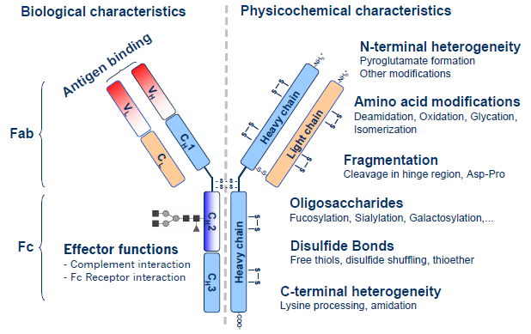
General information about the rituximab molecule is summarised below in Table 1.

Table 1: Molecular attributes of rituximab
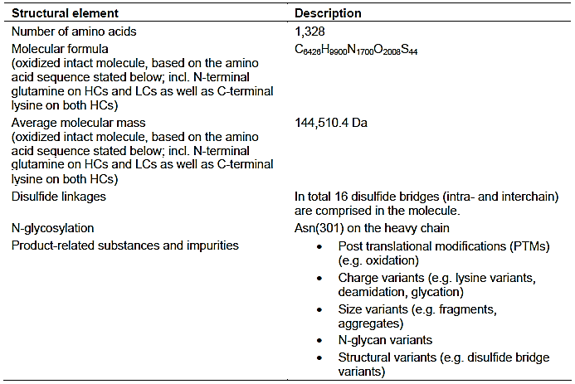

Studies providing pharmacokinetic information
The submission included three studies providing PK information in patients. These three studies were:
- Study GP13-201 (Part 1) This was the pivotal Phase II PK/PD study designed to assess the bioequivalence of GP2013 and MabThera (EU reference product). The study was undertaken in 173 patients with rheumatoid arthritis (RA) refractory or intolerant to standard disease modifying anti-rheumatic drugs (DMARDs) and 1 to 3 anti-tumour necrosis factor (anti-TNF) therapies. The two rituximab formulations were each administered in combination with methotrexate. The sponsor stated that the study was designed in accordance with the EMA Guideline on similar biological medicinal products containing biotechnology-derived proteins as active substance: non-clinical and clinical issues EMEA /CHMP/BMWP /42832/2005 Rev 1), and demonstrated bioequivalence of GP2013 and MabThera in accordance with the EMA Guideline on Bioequivalence CHMP/EWP/QWP/1401/98 Rev. 1/Corr**). Both of these guidelines have been adopted by the TGA.
- Study GP13-301 This was the pivotal Phase III efficacy and safety study in patients with previously untreated non-Hodgkin’s advanced follicular lymphoma (FL). The study included supportive (descriptive) comparative PK/PD data for the two rituximab formulations. The study included PK data (Ctrough, C_{max}) on 196 patients following sparse sampling and 54 patients with PK data (AUCall, AUC_{0-21d}) following more extensive sampling. The two formulations were each administered in combination with cyclophosphamide, vincristine and prednisone. The study was undertaken in accordance with the TGA adopted EMA guideline on similar biological medicinal products containing monoclonal antibodies (EMA/CHMP/BMWP/403543/2010).
- Study GP13-101 In this Phase I safety study, limited supportive PK data for GP2013 was provided for 6 Japanese patients with CD20 positive low tumour burden indolent B cell NHL. In this study, no contemporaneous comparative data for MabThera versus Rituxan (Japan) were provided. Instead, the study included a comparison of the observed PK results for GP2013 with those from the Japanese package insert for Rituxan (rituximab).

Analytical methods
The concentration of rituximab in human serum was determined by a competitive enzyme-linked immunosorbent assay (ELISA). Separate ELISA methods were used for PK analysis in human FL serum for clinical studies Study GP13-101 and Study GP13-301, and for PK analysis in human RA serum for clinical Study GP13-201 (Part I). Two validation studies using the respective patient-specific serum matrix for FL and RA were performed. The ELISA validation study for the RA clinical study (Study GP13-201) was BA11015. In this study, the upper and lower limits of quantification for the validation sample were 104.0 µg/mL and 0.8 µg/mL, respectively. The ELISA to quantify rituximab in healthy human serum was reported to show acceptable linearity over a concentration range from 0.8 µg/mL to 104.0 µg/mL.
The ELISA validation study for the two FL clinical studies (Study GP13-301; Study GP13-101) was BA12032. In this study, the upper and lower limits of quantification for the validation sample were 1,040 µg/mL and 26 µg/mL, respectively. As none of the calibration curve samples included exactly 26.0 µg/mL the LLOQ concentration for routine analysis was set to 28.9 µg/mL. The ELISA to quantify rituximab in serum of patients with FL serum was reported to show acceptable linearity over a concentration range from 28.9 µg/mL to 1,040.0 µg/mL.
Comment: There were no PK/PD data in the submission in healthy volunteers. All submitted clinical PK/PD data were from patients. The sponsor stated that studies in healthy volunteers were not conducted due to safety concerns. Anti-CD20 therapy is known to induce a long-lasting depletion of peripheral B cells, which has the risk of serious infections. The sponsor’s justification for not undertaking studies in healthy volunteers is considered to be acceptable. The use of patients rather than healthy volunteers in situations such as these is supported by the relevant guideline relating to similar biological medicinal products containing monoclonal antibodies (EMA /CHMP/BMWP/403543/ 2010).
The pivotal PK/PD study was in patients with RA. There were no pivotal PK/PD studies in patients with haematological malignancies, with supportive (descriptive) comparative PK/PD data in patients with FL being provided in one study and limited non-comparative PK data being provided in Japanese patients with CD20 positive low tumour burden indolent B cell NHL. Therefore, in this submission pivotal Phase II PK/PD have been provided for patients with RA while pivotal Phase III efficacy data have been provided for patients with FL. This situation is discussed in the relevant guideline relating to similar biological medicinal products containing monoclonal antibodies (EMA/CHMP/BMWP/403543/2010). The guideline comments that the most sensitive population for comparison of PK characteristics may not be the same as the most sensitive population for demonstration of similar efficacy and safety. In such scenarios, the sponsor recommends that population PK measurements be undertaken during the clinical efficacy trial in order to add to the ‘overall database to claim comparability’. There were no population PK data in the submission.
The relevant guideline relating to similar biological medicinal products containing monoclonal antibodies (EMA/CHMP/BMWP/403543/2010) states that the ‘choice of the patient population for the PK study should be fully justified, based on a comprehensive survey of the scientific literature as regards its sensitivity, and also the possibility to infer the PK results to other situations where the reference mAb is licensed.’ The sponsor states that for ‘the clinical development program, RA was chosen as the most sensitive population for PK/PD comparison mainly because in patients with RA, the between-patient variability in terms of PK/PD is much lower compared to oncology indications (NHL, CLL), in which the baseline B cell counts can vary significantly and thus affect both the PK and PD variability between patients. Furthermore, in patients with RA the treatment courses are given every 6 months – less frequent compared to the oncology indications, making it possible to capture the complete drug concentration-time profile before re-treatment’. The sponsor’s justification for providing pivotal PK/PD in patients with RA and supportive PK/PD data in patients with FL is considered to be acceptable.

Evaluation of the PK studies

Pivotal PK/PD Phase II Study GP13-201 (Part 1)

Title, location and dates
A randomized, double-blind, controlled study to evaluate pharmacokinetics , pharmacodynamics, safety and efficacy of GP2013 and rituximab in patients with rheumatoid arthritis refractory or intolerant to standard DMARDs and one or up to three anti-TNF therapies.
The first subject visit was 14 December 2010 and the last subject visit (Part 1) was 10 April 2014. The report was dated 9 December 2015. The study was sponsored by Hexal AG, a Sandoz Company, and member of the Novartis group. The study was undertaken in collaboration with Novartis Pharma AG. The study was conducted in compliance with GCP.

Objectives: PK
- The primary objective of the study was to assess the bioequivalence of GP2013 and MabThera, in combination with methotrexate (MTX), with respect to AUC (0-inf). Bioequivalence was defined as the AUC_{0-inf} values of the two rituximab products being comparable, based on the 90% CI for the ratio of the geometric means (GP2013/MabThera) being within the standard bioequivalence limits of 0.8 to 1.25.
- The secondary objectives with respect to the PK assessment of bioequivalence were: (i) determination of the C_{max} after the first infusion (that is, C_{max}1 = key secondary endpoint), with bioequivalence being shown if the 90% CI for the ratio of the geometric means (GP2013/MabThera) for C_{max}1 were within the standard bioequivalence limits of 0.8 to 1.25; and (ii) determination of AUC0-14d, AUC0-12w, AUC0-24w, C_{max} after the second infusion (C_{max}2) and tmax for both rituximab infusions.

Design
The sponsor states that, based on the initial scientific advice from the Committee for Medicinal Products for Human Use (CHMP) of the European Medicine Agency (EMA) in June 2009, a pivotal PK/PD study (Study GP13-201) was conducted in patients with active RA in order to demonstrate comparability of PK/PD between GP2013 and MabThera. The study was the first in human study of GP2013.
Study GP13-201 was a 52 week multicentre, randomised, double-blind, parallel-group, comparative study in patients with active RA who had not responded adequately, or had shown intolerance, to standard DMARDs, including methotrexate (MTX), and one or up to three anti-TNF therapies. The study was designed to have two separate parts in order to meet the regulatory requirements of both the EMA (Part I: GP2013 versus MabThera-EU) and the US FDA (Part II: GP2013 versus Rituxan-US). Part 1 of the study has been completed and the 24- and 52 week results were included in the clinical dossier in a CSR dated 9 December 2015. The sponsor stated that Part II of the study was ongoing at the time of finalisation of the CSR for Part I, and that the results of Part II will be provided in a separate CSR. The expected dates of the Part II reports are 24 weeks (January 2017) and 52 weeks (January 2018).
Two analyses were performed for Part I (Week 24 and Week 52), and the results of both analyses were included in the clinical dossier. The Week 24 analysis was performed after all patients had completed Week 24 assessments (or had been prematurely withdrawn from the study). For this analysis, the sponsor’s study team (but not investigators, site personnel or patients) was unblinded to the treatments. The Week 52 (final analysis) was performed after all patients had completed Week 52 assessments (or were prematurely withdrawn from the study). Investigators, site personal and patients are to remain blinded until the end of Part II of the study. The design of Part 1 of the study is summarised below in Figure 3.
Figure 3: Study GP13-201 Study design for Part 1
In Part I, a total of 173 patients with RA (55.9% male and 44.1% female) were randomised in a ratio of 1:1 to receive the first course of study medication (1000 mg IV infusions of GP2013 or MabThera on two separate occasions, two weeks apart (that is, Day 1 and Day 15)). After Week 24, responders based on pre-specified criteria relating to decrease from baseline in DAS28 (derived with either ESR or CRP) of > 1.2 could be re-treated with study medication (identical to the first course) at the discretion of the investigator, if they had at least residual active disease (DAS28 (ESR or CRP) ≥ 2.6).
After the first treatment with study medication on Day 1, patients were followed for 52 weeks. Patients were sampled for the PK analysis (until Week 24) and the PD analysis (until Week 52). Efficacy and safety data were assessed on a regular basis until Week 52 and were used to evaluate the similarity of GP2013 and MabThera. For patients who received the second course of treatment, in addition to the regular follow-up visits up to Week 52 a final safety, efficacy and PD assessment was to be performed 26 weeks after the first infusion of the second course of study medication.
Randomisation was stratified by the number of anti-TNF pre-treatments or other biological treatments. The sponsor stated that stratification based on the number of anti-TNF pre-treatments was undertaken as this factor was known to have an impact on efficacy parameters such as Disease Activity Scores (DAS28) and American College of Rheumatology scores (ACR20).
Comment: In general, bioequivalence studies are based on a cross-over design with each study participant being exposed to both treatments after a suitable washout period derived from the terminal half-life of the reference treatment. However, in Study GP13-201 parallel-group design was undertaken due to the long-terminal half-life of rituximab (19 to 22 days). Based on the terminal half-life for the product it can be estimated that the drug will be eliminated from the body in 57 to 66 days (that is, three half-lives). Therefore, it is considered that parallel-group design for the PK study is acceptable.

Inclusion and exclusion criteria
The study population consisted of male and non-pregnant, non-lactating female patients (≥ 18 years old) with active RA with an inadequate response or intolerance to non-biologic DMARDs and one or up to three anti-TNF therapies. In Part I, 164 patients were to be randomised to GP2013 or MabThera in a ratio of 1:1. A screening failure rate of 40% was anticipated. Patients who withdrew or who were withdrawn from the study after randomisation were not to be replaced.

Study treatments
- The two study drugs were GP2013 or MabThera (Roche UK) both administered at a dose of 1000 mg as two single IV infusions, two weeks apart on Days 1 and 15. The products were supplied in 10 mg/mL single-use vials (500 mg in 50 mL), and two 500 mg vials (1000 mg of active substance) were diluted in an 0.9% NaCl solution, yielding and end concentration of 2 mg/mL of study medication.
- The initial dose of the study drugs was to be administered as an IV infusion through a dedicated line over approximately 4 hours 15 minutes. The recommended initial rate for the infusion was 50 mg/h (25 mL/h). After the first 30 minutes, the infusion rate could be escalated in 50 mg/h (25 mL/h) increments every 30 minutes, to a maximum of 400 mg/h (200 mL/h), at the investigator's discretion. Subsequent doses of the study drugs were to be infused IV through a dedicated line over approximately 3 hours 15 minutes (if the first infusion was uneventful) at an initial rate of 100 mg/h (50 mL/h), and increased by 100 mg/h (50 mL/h) increments every 30 minutes, to a maximum of 400 mg/h (200 mL/h), at the discretion of the investigator.
- No dose adjustments of the study drugs were allowed. Patients who developed evidence of severe reactions, especially severe dyspnoea, bronchospasm or hypoxia were to have the infusion interrupted immediately and the infusion was not to be restarted until complete resolution of all symptoms. Rescue medication for RA was not allowed during this study.
- Premedication consisting of an antipyretic and an antihistaminic were to be administered before each infusion of the study drug. In addition, all patients were to receive treatment with 100 mg IV infusions of methylprednisolone (or equivalent) administered with both study infusions. The methylprednisolone infusion was to be finished at least 30 minutes prior to administration of the study drug. The methylprednisolone infusions were administered in order to decrease the frequency and severity of acute infusion reactions to the study drugs.
- There was an optional second course of GP2013 or MabThera administered at a dose of 1000 mg as two single IV infusions, two weeks apart after Week 24 of the study, for patients with residual active disease who had demonstrated a response to the first course of the study drugs. Residual active disease was defined as DAS28 ≥ 2.6 derived either by ESR or CRP protocol specified criteria, and response to treatment was defined as decrease in DAS28 derived from either ESR or CRP of > 1.2 from baseline. Retreatment was scheduled at Visit 12 (Week 24), Visit 13 (Week 38) or Visit 14 (Week 52), but could be undertaken at other times from Week 24 through to Week 52 if the three pre-specified times were unsuitable.
- Patients were required to have been receiving MTX (7.5 mg to a maximum of 25 mg per week) for at least 4 months, with a stable dose for 4 weeks prior to randomisation. Patients were to receive folic acid or equivalent from at least 4 weeks prior to randomisation at a stable dose (≥ 5 mg per week) to minimize the likelihood of MTX-associated toxicity. Folic acid supplementation was not to be taken on the day of MTX intake, but preferably one day after MTX administration.
- Concomitant medications allowed during this study are summarised below in Table 2.

Table 2: Study GP13-201 Concomitant medications allowed in the study
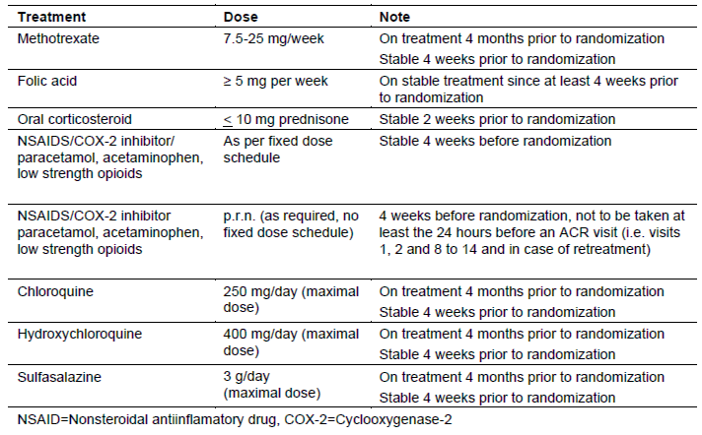
• Prohibited treatments included: (i) intra-articular or intramuscular steroid injections; (ii) analgesics other than paracetamol and low dose opioids; (iii) non-biological DMARDs and/or other immunosuppressant medicines other than MTX, chloroquine, hydroxychloroquine and sulfasalazine; and (iv) biologic DMARDs (other than study medication) and other biologics marketed for RA or any other indication. Administration of live vaccines was not recommended during treatment with the study drug or while peripheral B cells were depleted.

Premature withdrawal from the study
Patients could voluntarily withdraw from the study for any reason at any time. They were to be considered withdrawn if they stated an intention to withdraw, failed to return for visits, became lost to follow-up for any other reason or, were not responding adequately to the study treatment by Week 24. If premature withdrawal occurred for any reason, the investigator was to make every effort to contact the patient and determine the primary reason for the premature withdrawal from the study. At a minimum, patients were to be contacted for a safety evaluation during the 30 days following the last dose of study drug or at last visit, whichever was later.
Patients, who prematurely withdrew from the study for any reason, were to be scheduled for a final assessment visit as soon as possible. If patients withdrew from the study before Week 24, the assessments for the Week 24 were to be performed. If the patient withdrew from the study after Week 24, the assessments for Week 52 were to be performed. In case of discontinuation before Week 24, an additional PK sample was to be taken. If the investigator decided that a patient was not responding adequately either to GP2013 or MabThera by Week 24, the patient was to be withdrawn from the study and could then receive any anti-rheumatic treatments at the discretion of the investigator.

Discontinuation of study drug
Study drug discontinuation was defined as discontinuation of an ongoing infusion, discontinuing after the first infusion but before the second infusion of the first course, or after the first course (that is, not starting another course/retreatment). The criteria for discontinuation of study treatment have been examined and are considered to be acceptable.

PK variables

Primary PK variable (AUC_{0-inf})
The primary PK endpoint was the AUC0-inf, which was derived from serum rituximab concentrations over the entire 1st treatment course of 24 weeks following both infusions of GP2013 and MabThera. AUC_{0-inf} was determined by non-compartmental methods using WinNonlin.
PK samples for analysis were collected at Visit 3 (pre-and post-dose on Day 1), Visit 4 (72 hours post-dose), Visit 5 (7 days post-dose), visit 6 (pre and post-dose on Day 15)) and Visits 7 to 12 (72 hours to 154 days post-dose). On the infusion days of the study drug (Visit 3 and Visit 6), PK samples prior to infusion of study drug were to be taken before any premedication had been administered. The complete sampling schedule for PK, PD and anti-drug antibody (ADA) sampling was provided.
Comment: The primary PK endpoint (AUC0-inf) was assessed at Week 24 and was based on two treatments of the study drug administered IV on Days 1 and 15. In the TGA adopted EU guideline on biosimilar biological medicines containing monoclonal antibodies (EMA/CHMP/BMWP/ 403543/2010) it is stated that the primary PK parameters of interest in a multiple-dose IV study should be the truncated AUC after the first administration until the second administration (AUC0-t) and AUC over a dosage interval at steady state (AUCτ). The sponsor stated that, following EMA/CHMP scientific advice, the originally defined co-primary endpoints for the study of AUC_{0-inf} and C_{max} selected to evaluate PK bioequivalence were changed (Protocol Amendment 1) to a single primary endpoint (AUC0-inf). The sponsor comments that the AUC, which reflects the extent of exposure, depends mainly on the total amount of GP2013 or reference product administered and, unlike the C_{max}, is not greatly dependent on infusion rate and length of infusion. Therefore, PK bioequivalence based on the AUC_{0-inf} values was chosen to be the primary PK variable. The sponsor considered that the AUC_{0-inf} was the most relevant PK parameter, with sufficient sensitivity for assessing bioequivalence and not subject to variability like the C_{max}. The selection of the AUC0-inf, assessed at Week after the first course of treatment involving two infusion (Days 1 and 15), as the primary PK variable is considered to be acceptable.
Secondary PK variables
The key secondary PK variable was the comparison between the C_{max} of the two formulations following the first infusion (C_{max}1). Other secondary PK variables included AUC_{0-inf} after the first infusion, AUC0-14d, AUC0-12w, AUC0-24w, and C_{max} (C_{max}2) after the second infusion and Tmax after both infusions.
Comment: The key secondary PK variable of C_{max}1 is consistent with the secondary parameter specified in the relevant guidelines for biosimilar monoclonal antibodies for single-dose IV studies. The sponsor stated that the C_{max} after the first infusion was accepted by the EMA/CHMP as the key secondary PK endpoint. The key secondary and other secondary PK variables are considered to be acceptable.

Randomisation and blinding methods
The study included 173 randomised patients, including 86 in the GP2013 arm and 87 in the MabThera arm. At Visit 3 (Day 1), all eligible patients were randomised via an Interactive Response Technology (IRT) system to one of the two treatment arms. An independent, unblinded dedicated site staff member contacted the IRT system to confirm that the patient fulfilled all the inclusion/exclusion criteria. The IRT system then assigned a unique medication number for the first package of study drug to be dispensed to the patient.
The randomisation numbers were generated using procedures to ensure that treatment assignment was unbiased and concealed from patients and blinded investigator staff. Patients, investigator site staff and persons performing the assessments are to remain blinded to the identity of the treatment from the time of randomisation until after the final study database lock at the end of Part II. Both the sponsor and Novartis global clinical study teams were unblinded after the Week 24 PK and clinical database lock with respect to the patients in Part I of the study.
Randomisation was stratified by the number of anti-TNF pre-treatments or other biological treatments. Stratum 1 included patients with one anti-TNF and no pre-treatment with other biological. Stratum 2 included pre-treatment with one anti-TNF plus pre-treatment with tocilizumab, canakinumab or abatacept, or two or three pre-treatments with anti-TNFs with or without pre-treatment with tocilizumab, canakinumab or abatacept.

Analysis populations
The Full Analysis Set (FAS) consisted of all randomised patients, excluding any patients randomised in error who did not receive any randomised study medication. Following the intent-to-treat principle, patients were analysed according to the treatment they were assigned to at randomisation. The FAS included 86 patients in the GP2013 arm and 87 patients in the MabThera arm.
The PK Analysis Set (PAS) was a subset of the FAS and consisted of patients who had none of the following major protocol deviations: (i) first infusion of the first treatment course not completed; and (ii) not treated and randomised during the first 24 weeks. All PK and PD analyses were conducted using the PAS. The PAS included 86 patients (100% of the FAS) in the GP2013 arm and 86 patients (98.9% of the FAS) in the MabThera arm. The only patient in the FAS excluded from the PAS was a patient in the MabThera who was treated with the commercially available product rather than the provided product.
For the primary PK bioequivalence analysis in Part I, a subset of the PAS with evaluable AUC_{0-inf} data was used. Patients were excluded from the analysis for the following reasons: (i) patients who did not receive the complete first treatment course (that is, both infusions); (ii) missing PK samples such that the primary PK parameter AUC_{0-inf} could not be appropriately derived; (iii) the extrapolated part of AUC beyond AUC0-last exceeded 20% of AUC0-inf; and (iv) confirmed immunogenicity (ADA) prior to or up to Week 24. The bioequivalence analysis of AUC_{0-inf} was undertaken in 75 patients in the GP2013 arm and 70 patients in the MabThera arm.
For the bioequivalence analysis of the key secondary PK parameter (C_{max}1), a subset of the PAS with evaluable data was used. Patients were excluded from this analysis for the following reasons: (i) missing PK samples such that the PK parameter C_{max}1 could not be appropriately evaluated; (ii) blood sampling was not within 15 minutes after end of the first infusion; (iii) interruption of the first infusion for more than one hour; (iv) confirmed immunogenicity (ADA) prior to the first infusion of the study drug. The bioequivalence analysis of C_{max}1 was undertaken in 79 patients in the GP2013 arm and 77 patients in the MabThera arm/
The Pre-protocol (PP) Analysis Set was a subset of the FAS and consisted of all patients who had none of a pre-specified list of major protocol deviations. The PP set included 85 patients in the GP2013 arm and 82 patients in the MabThera arm.
The Safety Analysis Set (SAF) consisted of all patients who had received study drug at least once. Patients in the SAF were analysed according to treatment received. The SAF included 85 patients in the GP2013 arm and 82 patients in the MabThera arm.
Disposition of the FAS contributing to the PK/PD analyses
Of the 173 patients in the FAS, 99.4% (n = 172) were included in the PK analysis, with 1 patient in the MabThera arm being excluded from the analysis due to treatment with commercially available product rather than MabThera supplied by the sponsor. Of the 173 patients in the FAS, 146 (84.4%) provided data for the AUC_{0-inf} analysis, 148 (85.5%) provided data for the AUC0-14d analysis and 157 (90.8%) provided data for the C_{max}1 analysis. The reasons for patient exclusions from the FAS for the PK/PD analyses were summarised.

Sample size

Sample size for the primary PK variable AUC0-inf
PK bioequivalence was defined as the AUC_{0-inf} values of the study drugs being comparable, that is, the 90% CI for the ratio of the geometric means (GP2013/MabThera) must be within the standard bioequivalence limits of 0.8 to 1.25.For the sample size calculation, the sponsor used the published coefficient of variation of 0.33 for AUC following the administration of rituximab in combination with MTX in RA patients (Breedveld et al., 2007). Therefore, the study should have sufficient power of 90% for each of the three comparisons of AUC_{0-inf} (that is, GP2013 versus MabThera EU-approved; GP2013 versus Rituxan US-approved; MabThera EU-approved versus Rituxan US-approved), even if the ratio of the geometric means of the AUCs between GP2013 and MabThera is 1.06. That ratio (1.06) was observed in preclinical studies conducted in cynomolgus monkeys comparing GP2013 and MabThera. For each pairwise comparison, a total of 132 evaluable patients (66 patients in each arm) were needed. In order to account for a 20% loss of patients in the PK analysis set, a total of 82 patients needed to be randomised in each
The PK parameters were transformed prior to analysis using a logarithmic transformation. The null hypothesis (H0) versus the alternative hypothesis (HA) was specified to be,
H0: exp (μ1-μ2) ≤ 0.80 or exp (μ1-μ2) ≥ 1.25 versus HA: 0.80 < exp (μ1-μ2) < 1.25,
where μ1 = mean for one treatment (GP2013 or Rituxan) on logarithmic scale, μ2 = mean for MabThera or Rituxan on logarithmic scale, exp(μ1)/exp(μ2) = exp μ1-μ2), exp (μ1)/exp (μ2) = ratio of population means on original scale.
Comment: Part 1 of Study GP13-201 compares GP2013 with MabThera (EU-approved). Part II of Study GP13-201 compares GP2013 with Rituxan (US-approved) and was introduced after the sponsor received Scientific Advice from the FDA. The introduction of this additional treatment arm allows for the comparison of GP2013 with US-licensed Rituxan (US-approved) and establishes a bridge between the non-US-licensed reference product MabThera and the US-licensed product Rituxan as mandated by the FDA for authorisation of a proposed biosimilar. The sponsor stated that Part II of Study GP2013-201 recently reached the ‘Global Patient, Last Visit’ milestone (10 November 2016), and that a final CSR including the data from US-licensed Rituxan is not yet available.

Power analysis for the key secondary PK variable Cmax1
To establish PK bioequivalence, as defined by C_{max} after the first infusion (C_{max}1), the 2-sided 90% CI for the ratio of the geometric means (GP2013/MabThera) had to be within the pre-defined bioequivalence limits of 0.8 to 1.25. For this comparison of the geometric means of C_{max}1 the power of the study was calculated based on a coefficient of variation of 0.34 derived from published references showing that this parameter ranges between 0.22 and 0.46 (Breedveld et al 2007; Ng et al 2005). If a coefficient of variation of 0.34 and a ratio of the geometric means of 1.06 are assumed, the study had a power of 88% for 66 patients per group for all pairwise treatment comparisons (132 evaluable patients).The null and alternative hypothesis for C_{max}1 were the same as for AUC0-inf, and the relevant ratios were calculated using the same method as for AUC0-inf.

Statistical methods

Primary PK variable
The primary PK variable was the AUC_{0-inf}. The ratio of geometric means for AUC_{0-inf} (GP2013/MabThera) and 90% CI were estimated by an ANOVA on the log-transformed parameter with treatment as the factor and gender (male/female) as a covariate. The results were then back-transformed to the original scale. To conclude bioequivalence it was pre-specified that the 90% CI must be entirely enclosed within the standard bioequivalence limits of 0.8 to 1.25. Serum concentrations of rituximab below the limit of quantification (0.8 µg/mL) were treated as zero for the calculation of PK parameters. No imputation of missing values was performed.
Comment: The CSR stated that the analysis was to be undertaken using an ANCOVA. However, the Summary of Clinical Pharmacology states that the analysis was actually undertaken using an ANOVA as no continuous independent variables needed to be accounted for in the final analysis.

Key secondary PK variable
The key secondary PK variable of C_{max}1 and the additional secondary PK variables were analysed using the same methodology as that described for the primary PK variable of AUC0-inf.

Demographics and other baseline characteristics

Demographics and baseline RA disease characteristics
The baseline demographic characteristics were well balanced between the two treatment arms. The mean (±SD) of the total population was 53.7±12.34 years (range: 21, 82 years), with 36 (20.8%) patients being aged ≥ 65 years. The total population was predominantly Caucasian (80.9%, n = 140), with the majority of the remaining population being Asian (13.9%, n = 24) or Black (4.0%, n = 7). The majority of the population was female (86.1%, n = 149). The mean (±SD) BMI was 27.2±6.04 kg/m² (range: 16.5, 48.2 kg/m²).
In general, the baseline RA disease characteristics were well balanced between the two treatment arms. The mean (±SD) duration of RA in the total FAS was 10.1±7.0 years (range: 1, 34 years), and the mean number of prior non-biologic DMARDs and the number prior anti-TNF therapies was similar for the treatment arms. The parameters relating to disease severity were similar in the two treatment arms. Mean baseline MTX dose and prednisolone equivalent dose at baseline were almost identical in the two treatment arms.
The baseline demographic and disease characteristics for the PK and PP analysis sets were consistent with those for the FAS, which is not surprising as the number of patients in the three data sets were similar.

Medical history
The majority of patients in the safety analysis sets (78.0%, n = 135) had at least one medical history/current medical condition active at the start of the study, with no meaningful differences between the treatment arms. Vascular disorders were the most common co-morbid condition (38.7% (n = 67) of all patients). Other commonly reported SOCs (>15% of all patients) were: metabolism and nutrition disorders (24.9% (n = 43)), social circumstances (26.6% (n = 46)), Musculoskeletal and connective tissue disorders (25.4% (n = 44)), and psychiatric disorders (16.2% (n = 28)). The most commonly reported preferred term conditions (>10% of all patients) were hypertension (35.3% (n = 61)), menopause (15.0% (n = 26)), post-menopause (11.0% (n = 19)), hypercholesterolaemia (11.0% (n = 19)), hypothyroidism (10.4% (n = 18)), and osteoporosis (10.4% (n = 18)).

Prior medications discontinued before start of study drug
All patients in the FAS received anti-TNFs and non-biologic DMARDs prior to entering the study. The most commonly reported prior RA-related medications (excluding anti-TNFs) in the safety analysis set were immunosuppressant medicines (23.1% (n = 40)), with leflunomide accounting for nearly all instances 22.5% (n = 39), and glucocorticoids (19.1% (n = 33)). Etanercept was the most frequently used (34.1% (n = 59)) prior TNF-ɑ inhibitor, followed by adalimumab (23.1% (n = 40)) and infliximab (15.6% (n = 27). There were no relevant differences between the two treatment arms as regards RA-related medications, non RA-related medications and significant non-drug therapies used and discontinued prior to the start of the study drug.

Results Primary PK variable (AUC0-inf)
The study demonstrated bioequivalence of GP2013 and MabThera based on the primary PK variable of AUC0-inf. The geometric mean ratio (GP2013/MabThera) of the serum AUC_{0-inf} values at Week 24 was 1.064, and the 90% CI (0.968, 1.169) of the ratio was enclosed entirely within the pre-specified bioequivalence interval of 0.8 to 1.25. The results are summarised below in Table 3.

Table 3: Study GP13-201 (Part 1) AUC_{0-inf} results for the comparison between GP2013 and MabThera (primary PK variable), PK analysis set
n = number of patients with non-missing values. AUC_{0-inf} = Area under the serum concentration-time curve from time zero to infinity; CI = Confidence interval.
The serum concentration-time profiles over 24 weeks for the two formulations following the first course of treatment were virtually superimposable, suggesting comparable distribution and elimination of rituximab following GP2013 and MabThera (see Figure 4, below).
Figure 4: Study GP13-201 Arithmetic mean (SD) serum concentration-time profiles of GP2013 and MabThera over 24 weeks, linear (left panel) and semi-log (right panel) plots, PK Analysis Set
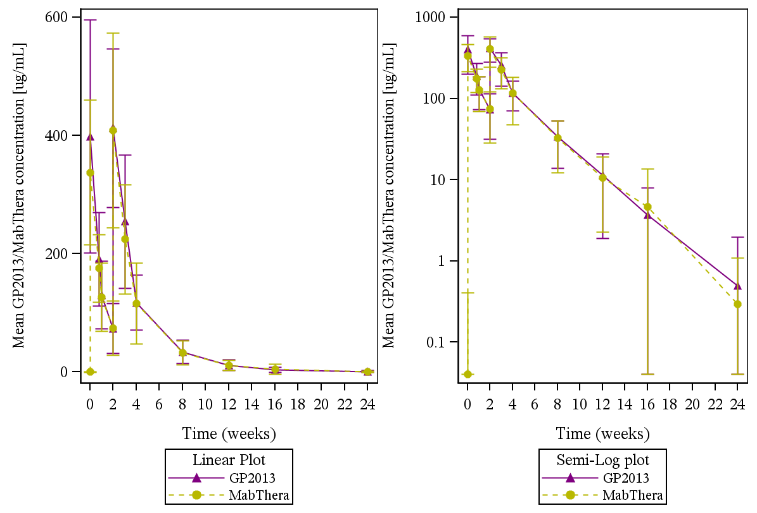
The summary statistics for AUC_{0-inf} for both treatment arms are summarised below in Table 4.

Table 4: Study GP13-201 Summary of the primary PK variable (AUC_{0-inf}), PK analysis set
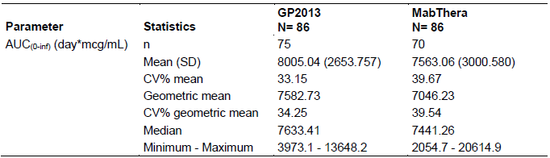
Geometric mean = exp ((sum of log transformed data)/number of non-missing data points after log transformation). CV% = coefficient of variation (%) = sd/mean*100; CV% geometric mean = sqrt (exp (variance for log transformed data)-1)*100.
The sponsor stated that data from the population PK analysis in patients with RA provided in the MabThera SmPC (EU) revealed that body surface area (BSA) and gender were the most significant covariates explaining inter-individual variability of the PK parameters of MabThera. Therefore, a sensitivity analysis of the ratio of geometric means and 90% CI was undertaken using an ANCOVA on the log-transformed AUC_{0-inf} with treatment as the factor and gender (categorical variable (male/female)) and BSA (continuous variable) as covariates. The results of the sensitivity analysis for AUC_{0-inf} supported the results of the primary endpoint analysis for this PK variable. The ratio of the geometric means (GP2013/MabThera) for AUC_{0-inf} was 1.054, and the corresponding 90% CI (0.965 to 1.151) was entirely within the standard bioequivalence limits of 0.80 to 1.25.
Comment: The study met its primary objective, with bioequivalence being demonstrated for the PK parameter AUC0-inf. There was a moderate degree of inter-individual variability based on CV% values in the arithmetic and geometric means of the AUC_{0-inf} of both formulations. Of note, 11 (12.8%) patients in the FAS for the GP2013 arm were excluded from the analysis of AUC_{0-inf} compared to 16 (18.4%) patients in the FAS for the MabThera arm. Of the 11 patients in the FAS for the GP2013 excluded from the analysis, 5 were excluded due to confirmed immunogenicity (ADA) prior to Week 24, 5 were excluded due to missing data precluding derivation of the parameter, and 1 failed to meet the pre-specified concentration requirements for infusion. Of the 16 patients in the FAS for the GP2013 excluded from the analysis, 8 were excluded due to confirmed immunogenicity (ADA) prior to Week 24, 7 were excluded due to missing data precluding derivation of the parameter, and 1 had an unconfirmed first treatment.

Other PK variables

Key secondary PK variable (Cmax1)
The key secondary PK variable was the maximum serum concentration after the first infusion (C_{max}1). In order to claim bioequivalence, the 90% CI of the ratio of the geometric means had to be within the standard bioequivalence limits of 0.8 to 1.25. The ratio and 90% CI of the geometric means (GP2013/MabThera) was 1.133 (90% CI: 1.017, 1.262). The 90% CI was not enclosed entirely within the standard bioequivalence limits (0.8, 1.25), with the upper limit of the 90% CI of 1.262 being just outside the standard upper limit for bioequivalence of 1.25. The results are summarised below in Table 5.

Table 5: Study GP13-201 (Part 1) C_{max}1 (C_{max} after the first infusion) of serum concentration of GP2013 and MabThera, comparison between GP2013 and MabThera in PAS
PK parameter (µg/mL) | Treatment | n | Adjusted  Geometric mean | Comparison | Geometric  mean ratio | 90% CI of  mean ratio
C_{max}1 | GP2013 | 79 | 341.67 | GP2013/MabThera | 1.133 | (1.017, 1.262)
 | MabThera | 77 | 301.62
n = number of patients with non-missing values; CI = Confidence interval; PK = Pharmacokinetics.

Other secondary PK variables
The other secondary PK variables were AUC0-14d, AUC0-12w, AUC0-24w, and C_{max}2. The 90% geometric mean ratios for each of these PK variables were enclosed entirely within the conventional bioequivalence interval of 0.80 to 1.25. The results for the Tmax1 and Tmax2 values were similar for two treatment arms. The results for the statistical analyses of the other secondary PK variables are summarised below in Table 6.

Table 6: Study GP13-201 (Part 1) – Other secondary PK parameters comparison between GP2013 and MabThera, PK analysis set
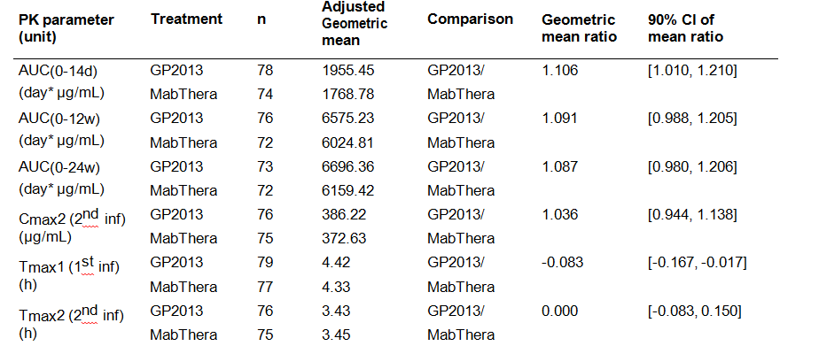
Notes: For Tmax1 and Tmax2, median values and difference in median values are presented under the ‘Adjusted Geometric mean’ and ‘Geometric mean ratios’, respectively.
Comment: The results for C_{max}1 (key secondary PK variable) did not meet the bioequivalence criteria, but bioequivalence criteria were met for C_{max}2. The sponsor attributes the difference to the larger inter-subject variability of infusion rates and infusion durations associated with the first infusion compared to the second infusion. The CV% mean values for the mean C_{max}1 and C_{max}2 values were 48.5% and 31.6%, respectively, indicating notably greater inter-subject variability in C_{max}1 compared to C_{max}2. The sponsor states that, following administration via IV infusion, the peak systemic concentrations (C_{max}) represent the end-of-infusion concentration and as such will be influenced by the rate and duration of infusion. Therefore, differing infusion rates and infusion durations can lead to increased variability in C_{max}. The sponsor comments that according to the EMA’s scientific advice relating to the study protocol dating from 2011, ‘in case the Standard bioequivalence criteria are missed for C_{max}, a justification for this supported by clinical data (for example, significant deviations in infusion times due to infusion related reactions) could still be acceptable’ (EMA/CHMP/SAWP/18800/2011).
The sponsor notes that, as defined in the protocol, the first infusion was to be administered through approximately seven rate escalations of 50 mg/h (25 mL/h) increments every 30 minutes to a maximum of 400 mg/h (200 mL/h) over a period of 4 hours and 15 minutes, while the second infusion was to be administered through approximately three rate escalations of 100 mg/h (50 mL/h) increments every 30 minutes to a maximum of 400 mg/h (200 mL/h) over a period of 3 hours and 15 minutes. Therefore, the first infusion process was more complex (longer duration, more escalation steps and lower mean infusion rates) compared to the second infusion process. Therefore, administration of the first infusion was subject to larger variability than administration of the second infusion which resulted in larger variability in C_{max}1 than in C_{max}2.
More patients in both treatment arms experienced infusion interruptions during the first infusion (total of 26 (15.0%) patients) as compared to the second infusion (total of 12 (7.1%) patients). In addition there were more adverse events leading to dose adjustment or infusion interruption during the first infusion than during the second infusion (that is, total of 14 (8.1%) patients and 19 events versus total of 3 (1.8%) patients and 4 events, respectively). Both of these factors contributed to the larger inter-subject variability in infusion rates and durations during the first infusion.
In summary, the sponsor considers that the ‘root cause of C_{max}1 marginally missing the bioequivalence criteria’ is the ‘increased variability in infusion rates and durations after the first infusion’. Furthermore, the sponsor draws attention to a post hoc analysis that showed neither high nor low C_{max}1 values had an impact on efficacy (DAS28 (CRP)) or safety outcomes. In addition, all other secondary PK endpoints, C_{max}2, AUC_{0-14d}, AUC_{0-12w}, and AUC_{0-24w}, met the bioequivalence criteria, with the ratio of the geometric means falling within the standard bioequivalence limits. Therefore, the sponsor concludes that ‘(c)onsidering the totality of PK data, PK bioequivalence of GP2013 and MabThera was demonstrated’. The sponsor’s conclusion relating to bioequivalence of the two products is considered to be acceptable.

Supportive PK studies

Study GP13-301

Background
Study GP13-301 was the pivotal Phase III efficacy and safety study comparing GP2013 with MabThera in patients with previously untreated advanced non-Hodgkin’s follicular lymphoma (FL). The primary objective of this study was to demonstrate comparability of the overall response rate (ORR) in patients with previously untreated advanced FL treated with GP2013 in combination with cyclophosphamide, vincristine and prednisone (CVP) or MabThera in combination with CVP. The secondary objectives included, among others, evaluation of the PK and PD of GP2013-CVP and MabThera-CVP. The main features of the study are summarised immediately below. The study is described in detail in the efficacy section of this CER.

Design
The study consists of a combination treatment phase (6 months) followed by a maintenance treatment phase (2 years) and/or a follow-up period (6 months). The dossier included results from the completed combination treatment phase and from the ongoing maintenance treatment phase up to the cut-off date of 10 July 2015. In the combination treatment phase (study drug-CVP), GP2013 or MabThera were administered IV at a dose of 375 mg/m² on Day 1 of each 21 day (±3 days) cycle for 8 cycles (that is, approximately 6 months). In the maintenance treatment phase, patients with a complete or partial response after 8 cycles of combination treatment continued therapy with single agent GP2013 or MabThera administered IV at a dose of 375 mg/m² every 3 months (± 14 days) for a further 2 years (that is, 8 treatment cycles).

Analyses
The primary objective of this study was to demonstrate similarity of treatment with GP2013-CVP to treatment with MabThera-CVP with respect to the ORR (primary endpoint/primary analysis). The primary analysis was performed when all randomised patients had completed the combination treatment phase. The study was powered to demonstrate equivalence of clinical response (ORR) as the primary endpoint between GP2013 and MabThera. In addition to the primary analysis, there was an analysis of sparse PK data on approximately 100 patients per treatment arm (Cohort 1) and extensive PK and PD data on approximately 20 patients per treatment arm (Cohort 2 (subset of Cohort 1)). The study was not powered to test bioequivalence of the two formulations based on PK endpoints. Therefore, the PK results for this study were presented descriptively. PK data from the study are considered to be supportive rather than pivotal.

PK assessments
For PK assessments, patients were randomised into two treatment arms (GP2013-CVP or MabThera-CVP), and stratified into Cohort 1 or Cohort 2.
- Cohort 1 (approximately 100 patients/treatment arm): sparse PK sampling of Ctrough and C_{max} in Cycles 1 (Day 1), 4 (Day 1) and 8 (Day 1) in the PK Analysis Set (PAS+A1). Pre-dose samples were collected 3 hours prior to administration and post-dose samples were collected ± 5 minutes after the end of the infusion (EOI). Additionally, a PK sample was collected at the end of treatment visit of the combination phase.
- Cohort 2 (subset of Cohort 1 including approximately 20 patients/treatment arm): additional extensive PK sampling in Cycle 4 in the PK Analysis Set (PAS+A2). In Cohort 2, samples were collected in Cycle 4 on Day 1 (- 3 hours pre-dose, and then EOI (± 5 minutes) at 0, 1 and 4 hours), Day 4 (72 hours (±3 hours) EOI) and Day 16 (360 hours (± 1 day) EOI). In addition, a pre-dose sample (- 3 hours) was taken in Cycle 5, Day 1.
The planned PK/PD cohort design is summarised below in Figure 5.
Figure 5: Study GP13-301 – Planned PK/PD cohort design
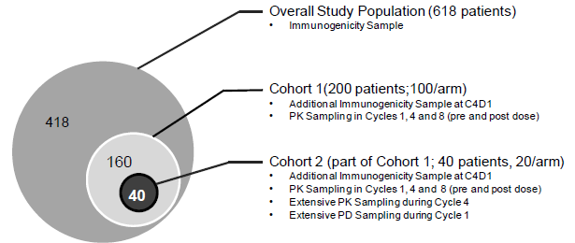

PK parameters assessed
Standard descriptive statistics were presented for GP2013 and MabThera concentrations obtained at maximum concentration (C_{max} (EOI)) and at minimum concentration (Ctrough (pre-dose)) during Cycles 1, 4, and 8 for Cohort 1 (including Cohort 2) patients. Furthermore, for Cycle 4 Day 1 C_{max}, two-sided 90% CIs for the mean difference of GP2013 (test) versus MabThera (reference) on the log-scale were calculated and the back-transformed point estimate as well as the 90% CI for the ratio of geometric means were also provided. This CI was provided for descriptive purposes only and was pre-specified to be not associated with any hypothesis test. For Ctrough, due to the variability in the reported rituximab PK data, it was expected that some values would be below the detection limit. Therefore, the two-sided 90% CIs for the mean difference of Ctrough (GP2013 versus MabThera) on the log-scale was not reported.
For patients in Cohort 2, additional extensive PK samples were collected during Cycle 4 (0, 1, 4, 72, and 360 hours after the end of infusion (EOI) and pre-dose Cycle 5 Day 1). Using these data, Cycle 4 AUC_{0-21d} and AUCall were derived with non-compartmental methods using WinNonlin for patients who had an evaluable profile. An evaluable profile was defined by criteria including but were not limited to: (i) pre-dose Cycle 4 Day 1 and pre-dose Cycle 5 Day 1 samples were collected prior to start date/time of infusion in order to be included in a PK profile; (ii) at least one sample available from the 0 hour, 1 hour, 4 hour, and EOI time-points; and (iii) at least four samples were available across the whole evaluable profile. For patients in Cohort 2 (extensive PK sampling), the rituximab PK concentration values for the Cycle 4 samples were summarised by time-point. Individual serum concentration versus time profiles of rituximab in Cycle 4 was also presented by treatment arm.

PK analysis sets
A total of 629 adult patients (≥ 18 years old) were randomised to GP2013 (n = 314) or MabThera (n = 315), and 627 of these patients were included in the FAS (GP2013, n = 312; MabThera, n = 315). Two patients in the FAS were mis-randomised to GP2013 group and discontinued before being treated.
In Cohort 1 (PAS+A1), 239 patients had evaluable PK samples (GP2013, n = 119; MabThera, n = 120) and in Cohort 2 (PAS+A2), 49 patients had evaluable PK samples (GP2013, n = 27; MabThera, n = 22).

PK results (PAS+A1)

Cmax results – Cohort 1
The geometric means (CV%) of the secondary endpoint C_{max} at Cycle 4 Day 1 (near steady state) were 333.59 µg/mL (CV% 41.09%) for the GP2013 arm and 331.93 µg/mL (CV% 35.32%) for the MabThera arm. The C_{max} values at Cycle 1 Day 1 were similar for the two treatment arms as were the C_{max} values at Cycle 8 Day 1. The results for the C_{max} values at Cycles 1, 4, and 8 are summarised below in Table 7. The geometric mean ratio of C_{max} at Cycle 4 Day 1 (GP2013 (n = 108)/MabThera (n = 111)) was 1.00 (334/332 µg/mL) and the corresponding 90% CI was 0.925, 1.09.

Table 7: Study GP13-301 – Cmax (mcg/mL) results for Cohort 1, PAS+A1
The sponsor reviewed the Cycle 1 C_{max} results in the context of the published literature showing high inter-subject variability in the single-dose PK of MabThera for the treatment of NHL. The historical data referred to by the sponsor appears to be derived from the Pharmacokinetics section of the MabThera PI. The historical data indicate that MabThera administered as an IV infusion at a dose of 375 mg/m² at weekly intervals for 4 doses to 203 patients with NHL naive to MabThera resulted in a mean C_{max} following the fourth infusion of 486 µg/mL (range: 77.5, 996.6 µg/mL). Rituximab was detectable in the serum of patients for 3 to 6 months after completion of the last treatment. Following administration of MabThera at a dose of 375 mg/m² administered as an IV infusion at weekly intervals for 8 doses to 37 patients with NHL, the mean C_{max} increased with each successive infusion, ranging from a mean of 243 µg/mL (range: 16, 582 µg/mL) after the first infusion to 550 µg/mL (range: 171, 1177 µg/mL) after the eighth infusion. Marked inter-subject variability in the C_{max} after each infusion was observed. The historical C_{max} results after each infusion are summarised below in Table 8.

Table 8: Study GP13-301 – Historical PK (Cmax) information for MabThera
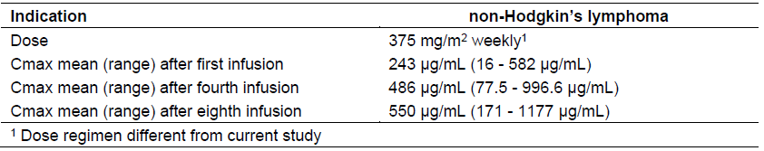
Comment: The results for the C_{max} values were similar for the GP2013 and MabThera arms. The C_{max} values for both treatment arms were highly variable at Day 1 for Cycles 1, 4, and 8, and the results were consistent with the historical data for MabThera in patients with NHL.

Ctrough results – Cohort 1
The means ( CV%) of the Ctrough levels at Cycle 4 Day 1 evaluated in Cohort 1 were 66.42 µg/mL (CV% 71.66%) for the GP2013 arm and 82.13 µg/mL (CV% 74.91%) for the MabThera arm respectively. The results for the Ctrough levels at Cycles 1, 4, and 8 are summarised below in Table 9.

Table 9: Study GP13-301 – Ctrough (mcg/mL) results for Cohort 1, PAS+A1
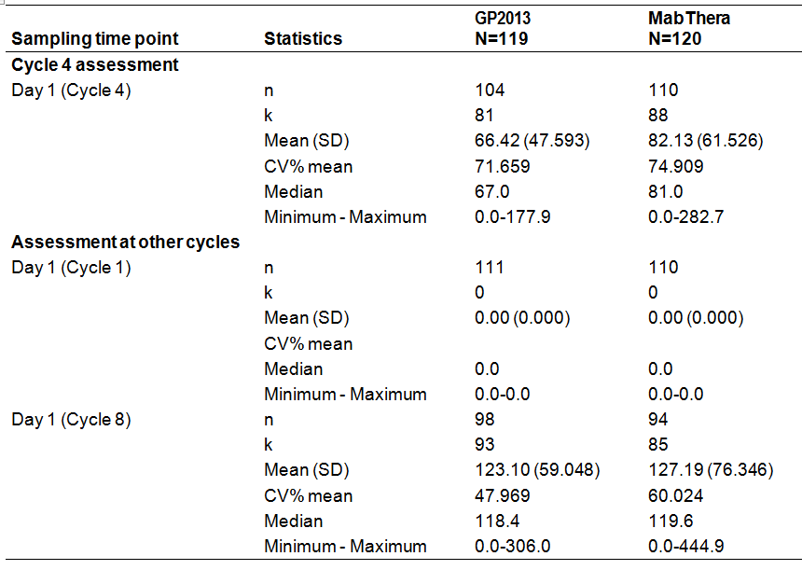
k = number of non-zero counts. CV% = coefficient of variation (%) = sd/mean*100. Lower limit of quantification 28.9 µg/mL. Ctrough represents the measured rituximab concentration prior to infusion at cycles 1, 4, and 8.
Comment: The mean difference in the Ctrough levels at Cycle 4 Day 1 between the two treatment arms was approximately 16 µg/mL, with the level in the MabThera arm being greater than in the GP2013 arm (82.13 versus 66.42 µg/mL, respectively).The CV% mean values for the mean Ctrough levels at Cycle 4 Day 1 were > 70% for both treatment arms, indicating high inter-subject variability in Ctrough levels in both treatment arms. The Ctrough levels at Cycle 8 Day 1 were similar for the two treatment arms. The Ctrough levels at Cycle 1 Day 1 were not calculated as all rituximab concentrations pre-dose (that is, first dose) were zero for all patients in both treatment arms.

PK Results PAS+A2
The Cohort 2 results for AUC_{0-21d} and AUCall are summarised below in Table 10.

Table 10: Study GP13-301 – Summary of AUC_{0-21d} (µg·day/mL) and AUCall (µg·day/mL) for Cycle 4, Cohort 2 PAS+A2
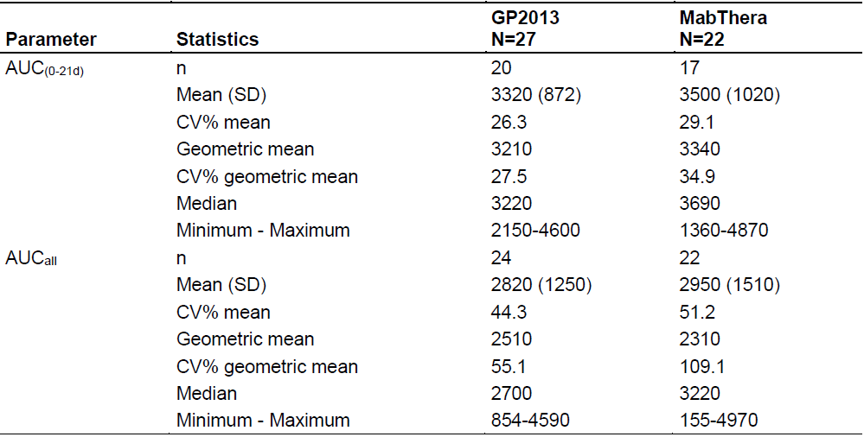
AUC_{(0-21d)} = Area under the concentration-time curve from time 0 to Day 21; AUCall = Area under the curve from the time of dosing to the time of the last observation, regardless of whether the last concentration is measureable or not; CV% = Coefficient of variation (%) = sd/mean*100; PAS+A2 = Pharmacokinetic analysis set 2; SD = Standard deviation; CV% geo-mean = sqrt (exp (variance for log transformed data)-1)*100.
Comment: The geometric mean (CV% geometric mean) for AUC_{0-21d} during Cycle 4 evaluated in Cohort 2 was 3210 µg·day/mL (27.5%) and 3340 µg·day/mL (34.9%) for the GP2013 and MabThera arms, respectively. Since many patients had rituximab concentrations below the lower limit of quantification (LLOQ) at later time points of the Cycle 4 PK profile their AUC_{0-21d} could not be accurately determined. In such cases, area under the curve from the time of dosing to the time of the last observation (AUCall), regardless of whether the last concentration was measureable or not was used for exposure evaluation. The geometric mean (CV% geometric mean) for AUCall during Cycle 4 evaluated in Cohort 2 was 2510 µg·day/mL (55.1%) and 2310 µg·day/mL (109.1%) for the GP2013 and MabThera arms, respectively.
Both the arithmetic and geometric mean AUC_{0-21d} values were greater in the MabThera arm than in the GP2013 arm. However, while the arithmetic mean AUCall value was greater in the MabThera arm than in the GP2013 arm, the geometric mean AUCall value was greater in the GP2013 arm than in the MabThera arm. The median values for both the AUC_{0-21d} and the AUCall were lower in the GP2013 arm than in the MabThera arm. The range of values for both the AUC_{0-21d} and AUCall were large in both the GP2013 and MabThera arms, with overlapping of values in the two treatment arms for both PK variables.

Study GP13-101 – supportive study in Japanese patients
A supportive Phase I study was conducted to evaluate PK and safety of GP2013 in 6 Japanese patients with CD20+ low tumour burden indolent B cell NHL. The study was conducted in response to a request from the Japanese drug regulatory agency (PMDA) to obtain clinical experience with the weekly dosing schedule required to support the GP2013 clinical data package for Japanese submission. The study was conducted from 26 September 2013 (first patient visit) to 7 August 2014 (last patient visit). The CSR was dated 24 September 2015 (content final). The study was stated to have been conducted in accordance with GCP including archiving of documents. The study was sponsored by Novartis, Switzerland.
The primary objective of the study was to evaluate safety and PK of GP2013 monotherapy. The secondary objectives were to evaluate efficacy of GP2013 at the visit defined as Study Evaluation Completion, to evaluate the incidence ADA formation against GP2013, and to evaluate peripheral CD19+ B cell count as a PD biomarker.
The study was designed as an open label, single-arm, multi-centre trial comprising 3 periods: screening period (Day −14 to Day −1); treatment period (Weeks 1 to 8); and 30 day follow-up period. All patients received an IV infusion of GP2013 monotherapy on Day 1 of each
week at a dose of 375 mg/m² for up to 8 weeks or until disease progression, intolerable toxicity, or withdrawal of patient consent. All patients were followed for study evaluation for at least 30 days after the last dose of study treatment.
The following primary PK parameters were evaluated on Day 1 of Week 1 and Day 1 of Week 8 following GP2013 administration at a dose of 375 mg/m²: (i) AUC_{0-tau} - area under the curve calculated from start of dose to the end of the dosing interval, tau (that is, AUC0-7d); (ii) C_{max}; (iii) AUC_{0-last}; (iv) C_{min}; and (v) T_{max}. In this study, no patients were treated with Rituxan (Japanese-approved), which is the Japanese rituximab innovator product. The results for the primary PK parameters are summarised below in Table 11.

Table 11: Study GP13-301 - Primary PK parameters, PK analysis set
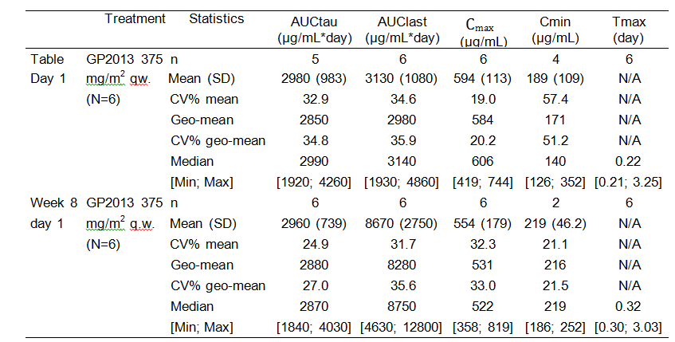
Comment: The sponsor stated that the PK profile observed for GP2013 in Study GP13-101 was similar to that reported in the Japanese package insert for Rituxan. In Study GP13-101, 5 patients reported AEs of which 2 were suspected to be related to study drug (1 x hepatobiliary disorder, 1 x hypersensitivity). No Grade 3 or 4 AEs, no SAEs, and no deaths were reported in this study. No patients discontinued from the study due to AEs. No clinically significant findings in haematology, biochemistry or ECG parameters were observed. Overall, GP2013 appeared to be safe and well tolerated in this small group of Japanese patients.

Evaluator’s overall conclusions on pharmacokinetics
It is considered that the pivotal PK/PD Phase II Study GP13-201 in patients with RA has satisfactorily established the bioequivalence of GP2013 and MabThera (EU-approved). The pivotal PK bioequivalence results from Study GP13-201 in patients with RA are supported by the descriptive PK data from Study GP13-301 in patients with FL. There were limited descriptive PK data relating to GP2013 from the Phase I Study GP13-101 in Japanese patients with CD20+ low tumour burden indolent B cell NHL.

Pivotal PK/PD study (Study GP13-201) – Phase II study
The pivotal PK/PD study (Study GP13-201 (Part 1)) included patients with RA (n = 173) who were refractory or intolerant to standard DMARDs and 1 to 3 anti-TNF therapies. In this study, patients were treated with either GP2013 or MabThera (EU-approved) in combination with MTX. The decision to use patients with RA to provide pivotal PK/PD data rather than patients with oncological indications was appropriately justified by the sponsor.
The primary PK variable in the pivotal study was AUC_{0-inf} at Week 24 following two IV infusions of GP2013 or MabThera at doses of 1000 mg administered 2 weeks apart (that is, Day 1 and Day 15). The geometric mean ratio (GP2013/MabThera) of the AUC_{0-inf} was 1.064 (90% CI: 0.968, 1.169). The 90% CI was enclosed entirely with the pre-specified bioequivalence interval of 0.80 to 1.25, which indicates that GP2013 was bioequivalent to MabThera (EU-approved) based on the AUC0-inf. The analysis was adequately powered to detect a statistically significant difference between the two products. The choice of AUC_{0-inf} as the primary PK variable for assessment of bioequivalence was satisfactorily justified by the sponsor.
The key secondary PK variable (C_{max}1) failed to demonstrate bioequivalence of the two formulations as the 90% CI of the geometric ratio was outside the pre-specified bioequivalence interval of 0.80 to 1.25. The geometric mean ratio (GP2013 /MabThera) of C_{max}1 was 1.133 (90% CI: 1.017, 1.262). The results indicated that the geometric mean C_{max}1 for GP2013 was approximately 13% higher than for MabThera, with the upper 90% CI for the geometric ratio being marginally greater than the standard upper 90% CI for bioequivalence (that is, 1.262 > 1.25). In contrast, the results for C_{max}2 indicated that the two formulations were bioequivalent based on this parameter as the 90% CI was enclosed entirely within the pre-specified bioequivalence interval of 0.80 to 1.25 (that is, geometric mean ratio (GP2013/MabThera) = 1.036 (90% CI: 0.944, 1.138)). The sponsor provided an acceptable explanation for C_{max}1 missing the standard bioequivalence criteria based on greater variability in the rate and duration of the infusion associated with the first infusion/first course compared to the second infusion/first course. Both the infusion rate and the duration of the infusion are known to affect end-infusion drug serum concentrations.
Overall, it is considered that the pivotal PK study has satisfactorily established the bioequivalence of GP2013 and MabThera (EU-approved) in patients with RA refractory or intolerant to standard DMARDs and 1 to 3 anti-TNF therapies. The primary efficacy variable of AUC_{0-inf} satisfactorily demonstrated bioequivalence. In addition, it is considered that although GP2013 and MabThera were not bioequivalent based on the C_{max}1 results, the observed difference in this parameter between the two rituximab formulations is unlikely to be clinically significant. Furthermore, the 90% CI values for the geometric mean ratios for all the other secondary PK variables (C_{max}, AUC0-14d, AUC0-12w, and AUC0-24w) met the standard bioequivalence criteria. Tmax1 was similar for GP2013 and MabThera, as was Tmax2.

Supportive PK/PD studies
Supportive PK bioequivalence data were provided by the pivotal Phase III efficacy and safety study (Study GP13-301) in patients with FL. The study was not powered for bioequivalence and, therefore, all PK data were presented descriptively. The PK of GP2013 and MabThera (EU-approved) at Cycle 4/Day 1 were evaluated as the secondary objective of the study. The PK variables C_{max} and Ctrough on Day 1 for Cycles 1, 4 and 8 were calculated from sparse sampling after administration of GP2013 or MabThera at an IV dose of 375 mg/m², in combination with CVP, in approximately 100 patients in each treatment arm. In addition to C_{max} and Ctrough levels based on sparse sampling, AUC_{0-21d} and AUCall (steady state) were calculated using extensive sampling after study drug administration on Day 1 of Cycle 4 in a subset of approximately 20 patients in each treatment arm.
In Study GP13-301, the C_{max} values at Cycle 1/Day 1, Cycle 4/Day 1 and Cycle 8/Day 1 were similar for the two formulations. There were some differences between the two formulations in mean Ctrough levels in Cycle 4/Day 1 and Cycle 8/Day 1, with marked inter-subject variability of this variable being observed with both formulations. Both the AUC_{0-21d} and AUCall (steady state) were similar for the two formulations, with moderate to marked inter-subject variability being observed for both PK variables with both formulations.
Limited supportive PK data relating to GP2013 were provided in a Phase I study (Study GP13-101) in Japanese patients with CD20+ low tumour burden indolent B cell NHL. The PK variables (AUC0-7d; C_{max}; AUC0-last; Cmin; Tmax) were assessed on Week 1/Day 1 and Week 8/Day 1 after administration of GP2013 IV at a weekly dose of 375 mg/m². The PK results were reported to be consistent with the PK results in the package insert for Rituxan (Japanese-approved). No patients in this study were treated with an approved rituximab formulation.

Pharmacodynamics

Studies providing pharmacodynamic information
The submission included two studies providing PD data comparing GP2013 to MabThera:
- The pivotal Phase II, PK/PD study (Study GP13-201 (Part 1)) in patients with RA included PD data on depletion of peripheral B cells based on the AUEC_{0-14d}. The two formulations were considered to be equivalent if the 95% CI of the ratio of the geometric means (GP2013 /MabThera) of the area under the effect-time curves for 14 days (AUEC_{0-14d}) was within the pre-specified equivalence limits of 0.8 to 1.25.
- The supportive PK/PD data from the Phase III, efficacy study (Study GP13-301) in patients with FL included PD data on depletion of B cells based on the AUC_{0-21d}. The two formulations were considered similar as the 95% CI of the ratio of the geometric means (GP2013/MabThera) of the AUC_{0-21d} was within the equivalence limits of 0.8 to 1.25. The PD in this study was considered exploratory.

Pharmacodynamic endpoint
The sponsor summarised the PD of rituximab in the submission. Both GP2013 and MabThera bind specifically to the transmembrane antigen CD20 located on pre-B and mature B-lymphocytes. The Fab domains of both products bind to the CD20 antigen on B lymphocytes, while the Fc domain can recruit immune effector functions to mediate B cell lysis. Possible mechanisms of effector-mediated cell lysis include ADCC, CDC and apoptosis. The sponsor stated that ‘(d)ue to the above described mechanism of action, monitoring B cell depletion can be considered a measure to evaluate drug effect and compare PD properties of GP2013 and MabThera. Depletion of peripheral B cells AUEC_{(0-14d)} was therefore selected as the PD marker in RA patients since it is mechanistically linked to the efficacy of rituximab.’ The sponsor stated that evaluation of PD equivalence is in accordance with the current EMA guideline on similar biological medicinal products containing monoclonal antibodies – non-clinical and clinical issues EMA/CHMP/BMWP/403543/2010), which states, ‘(p)harmacokinetic studies can be combined with pharmacodynamics (PD) endpoints, where available. This could add valuable information for the overall comparability exercise.’
Comment: The sponsor reports that peripheral B cells expressing CD19 overlap nearly 100% with CD20 expression. Since the presence of rituximab in serum interferes with detection of CD20, peripheral B cells expressing CD19 were measured as a surrogate for peripheral B cells expressing CD20 in the sponsor’s GP2013 clinical trials. The sponsor’s selection of peripheral B cell expressing CD19 to compare the PD effects of GP2013 and MabThera (EU-approved) is considered to be appropriate.

Study GP13-201 Pivotal PD data
In the pivotal PK/PD Study GP13-201, GP2013 or MabThera 1000 mg IV were administered 2 weeks apart (first infusion on Day 1 followed by a second infusion on Day 15) to patients with RA refractory or intolerant to standard disease modifying anti-rheumatic drugs (DMARDs) and one or up to three anti-TNF therapies The same dosing regimen was used for patients who qualified for retreatment from Week 24. Both rituximab products were administered in combination with MTX.

Pharmacodynamic objectives
In this study, assessment of PD was a secondary objective. The key secondary PD objective was to assess equivalence based on depletion of peripheral B cells in response to GP2013 or MabThera (EU-approved). The PD of the two rituximab products were considered to be equivalent if the 95% CI of the geometric mean ratio (GP2013/MabThera) for AUCE0-14d was within the pre-defined equivalence limits of 0.80 to 1.25. The AUCE0-14d was defined as the area under the effect-time curve of the percent peripheral B cell count relative to baseline up to the second infusion (that is, Day 15). The AUEC0-14d summarised the PD data following the first infusion of GP2013 and MabThera.
Other secondary PD objectives included: (i) evaluation of the percent peripheral blood B cell count relative to baseline following GP2013 or MabThera infusion at Day 15 and Weeks 12, 16, 24, 38, and 52; and (ii) evaluation of the proportion of patients in whom the peripheral blood B cell count decreased below the detection limit at Days 1 (after first infusion) 4, 8 and 15 (before second infusion).

Pharmacodynamic assessment
In general, blood was collected for PD assessment at the same time points as for PK assessment. The sponsor reported that circulating rituximab binds to CD20 which interferes with the flow cytometric measurement of this parameter. Therefore, B cell surface antigen CD19 was used as a marker to identify CD20+ B cells, as CD19 and CD20 are reported to have a similar expression profile on B cells (Breedveld et al., 2007). Levels of peripheral CD19+ B cells were measured by validated fluorescence-activated cell sorting (FACS). The limit of quantification (LoQ) of the assay was 3 cells/µL. Data acquisition and analysis was based on 10000 lymphocyte events.

Statistical methods

Key secondary PD variable AUEC0-14d
PD bioequivalence in depletion of peripheral B cells in response to GP2013 and MabThera (EU-approved) was measured by the AUEC0-14d, which was defined as the percent change in the peripheral blood B cell count relative to baseline up to the second infusion (that is, Day 15).
The two rituximab products were considered to be PD equivalent if the 2-sided 95% CI of the geometric mean ratio was within the pre-specified equivalence limits of 0.8 to 1.25. The ratio of the geometric means and 95% CI of the AUEC0-14d were estimated by ANCOVA on log transformed PD parameters with treatment as the factor. Results were then back-transformed to the original scale. B cell counts below the limit of quantification (<3 cells/μL) were treated as zero for the calculation of AUEC. No covariates were included in the ANCOVA model. No imputation of missing values was performed.
The AUEC0-14d was determined by non-compartmental methods using WinNonlin and a linear trapezoidal rule used for the parameter derivation. To account for some of the intra-individual variability in the parameter, two pre-dose samples were taken from every patient. The mean of these two pre-dose measurements, or the single measurement if only one sample was available, was chosen as the baseline value. If no baseline value was available, the patient was excluded from the analysis. For equivalence analysis of the AUEC0-14d as subset of the PK analysis set was used (see description of analysis sets in the Pharmacokinetics section of this CER). Patients were excluded from this analysis if B cell samples were missing such that AUEC0-14d could not be appropriately evaluated.
The sponsor stated that literature analysis showed that in 60 patients with active RA who had either failed anti-TNF therapy or had contraindications to such treatment, peripheral B cells were detectable in 6% of all patients using FACS analysis on Day 15 after the first infusion of 1000 mg rituximab (Dass et al., 2008). In patients with active RA who had failed treatment with DMARDs, peripheral B cell depletion (defined as ≤ 20% of the LLN) occurred in all patients treated with rituximab (1000 mg) (approximately 110 patients) on Day 15 after the first infusion, which was not seen in the control group of MTX alone (approximately 35 patients) (Breedveld et al., 2007). However, to the sponsor’s knowledge, there are no published data on the AUECs of peripheral B cell depletion.
The sponsor reported that in comparative studies conducted in cynomolgus monkeys, at least 2-times higher variability was seen for the PK parameter AUC than for the PD parameter AUEC looking only at B cell depletion. As the estimation of the required sample size for Study GP13-201 is based on AUC, the study was sufficiently powered to show comparative B cell depletion. For the comparison of the geometric means of AUEC0-14d of the percent change of the peripheral blood B cell count relative to baseline up to the second infusion (that is, Day 15), the study was reported to have a power of more than 99% based on a coefficient of variation of 0.16 and a geometric mean ratio of 1.06 for all three treatment comparisons of interest, including GP2013 versus MabThera (EU-approved).
Comment: The key secondary PD variable geometric mean ratio for AUEC0-14d, with a 95% CI for equivalence testing, following the first infusion is considered to be appropriate. In the original protocol it was specified that the 90% CI of the geometric mean ratio was to be used for PD equivalence testing. However, this was changed to the 95% CI following a request from the EMA.

Other secondary PD variables
In addition to the powered equivalence assessment for AUEC0-14d, the following descriptive PD analyses were also performed: (i) summary statistics of AUEC0-14d of the percent peripheral B cell count relative to baseline up to the second infusion (that is, Day 15); (ii) summary statistics of percent peripheral B cell levels relative to baseline by visit; and (iii) number and percent of patients with a B cell counts below the limit of quantification (that is, < 3 cells/µL) by Days 1 (before first infusion), 4, 8, and 15 (before second infusion).
As for the key secondary PD analysis, to account for some of the intra-individual variability, two pre-dose samples were taken from every patient. The mean of these two pre-dose measurements, or the single measurement if only one sample was available, was chosen as the baseline value. If there was no baseline value, the patient was excluded from analyses that required the percent peripheral B cell count relative to baseline. However patients with missing baseline values were included in PD analyses based on absolute B cell count data.

Results for the PD analyses

Key secondary PD variable – B cell depletion assessed by AUEC0-14d
The ratio of the geometric means (GP2013/MabThera) for AUCEC0-14d was 1.019 and the 95% CI (0.997, 1.042) was within the pre-specified PD equivalence limits (0.8, 1.25). Therefore the criterion for PD equivalence was met. The result of the statistical analysis is summarised below in Table 12.

Table 12: Study GP13-201 – Key secondary PD variable of AUEC_{0-14d} of percent B cell relative to the baseline by treatment, PK analysis set
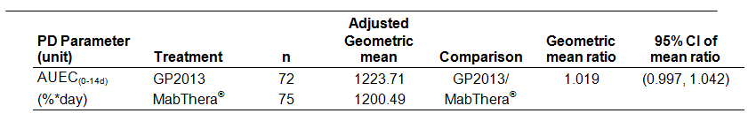

n = number of subjects with non-missing values.
The percent depletion in B cell relative to baseline from the first infusion through to Day 14 is summarised below in Figure 6. The profiles for the two formulations are virtually superimposable. Mean percent depletion of B cell relative to baseline at 72 hours after the infusion (Day 4) was 4.25% in the GP2013 arm and 6.69% in the MabThera arm, and was less than 1% in both treatment arms at Day 15 (that is, before next infusion).
Figure 6: Study GP13-201 - Arithmetic mean (SD) of percent B cell count relative to baseline over 14 days by treatment PK Analysis Set

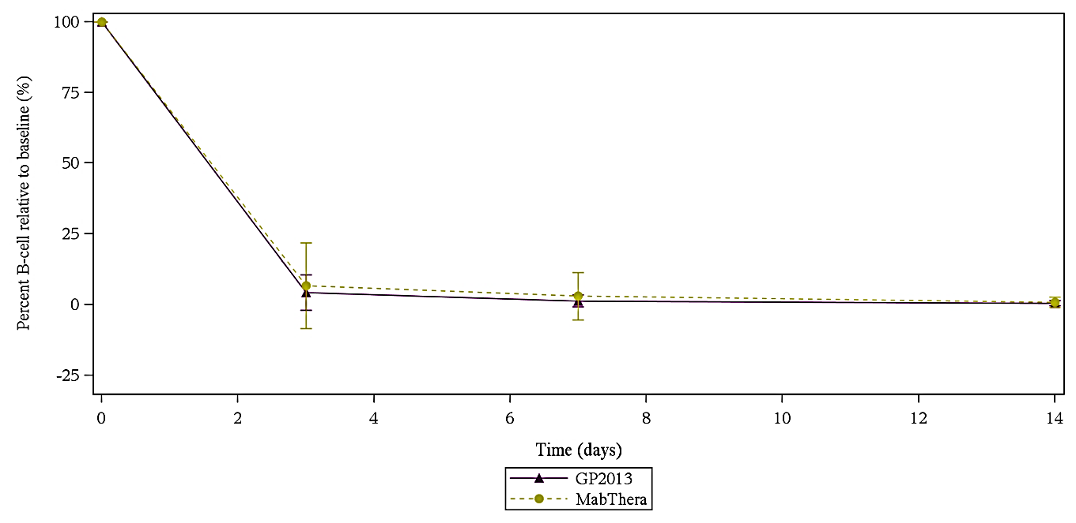

Other secondary PD variables
The individual patient profiles for the B cell count over 52 weeks were generally similar for both treatment arms (see Figure 7, below). Following GP2013 and MabThera, peripheral blood B cells were depleted for most of the patients at the first post-dose B cell count assessment at 72 h after the infusion.
Figure 7: Study GP13-201 – Graphical display of B cell count (cells/µL) patient profiles over 52 weeks of scheduled treatment, PK analysis set
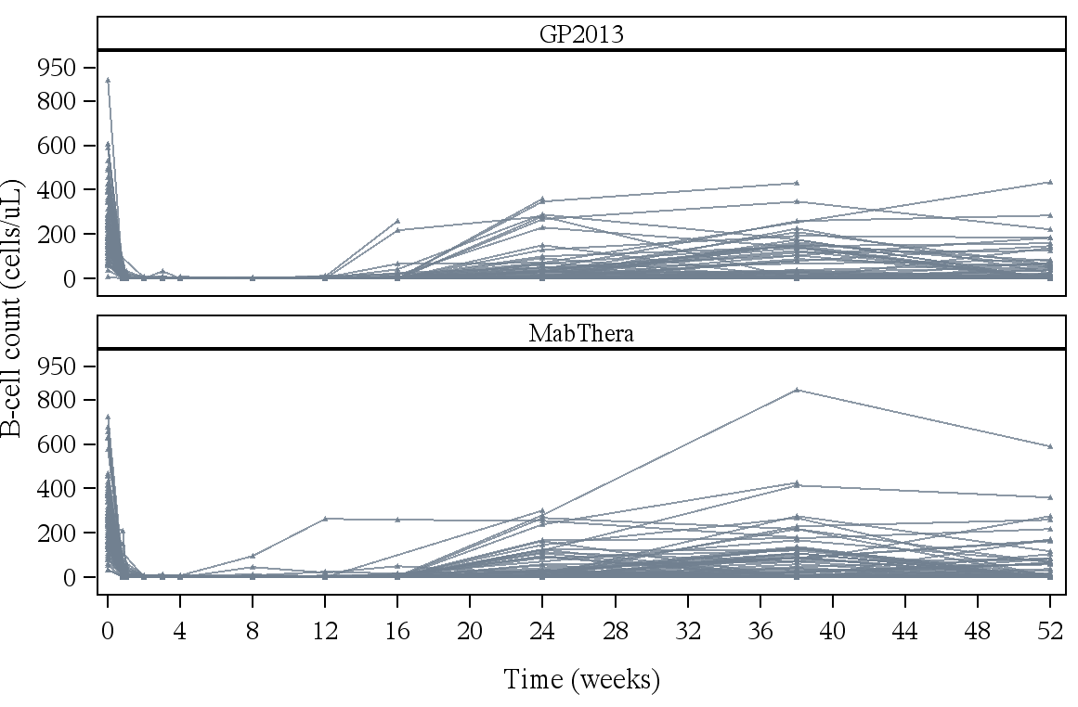
The mean percent B cell count relative to baseline over time through to Week 52 were similar for the two treatments (see Figure 8, below). The mean percent B cell counts relative to baseline were less than 1% on Day 15 and then remained below 20% up to Week 24 for both the GP2013 and MabThera arms. At Week 52, the mean percent B cell counts relative to baseline were similar in the GP2013 and MabThera arms (19.7% versus 21.1%, respectively).
Figure 8: Study GP13-201 – Arithmetic mean (SD) of percent-B cell relative to baseline over 52 weeks by treatment, PK analysis set
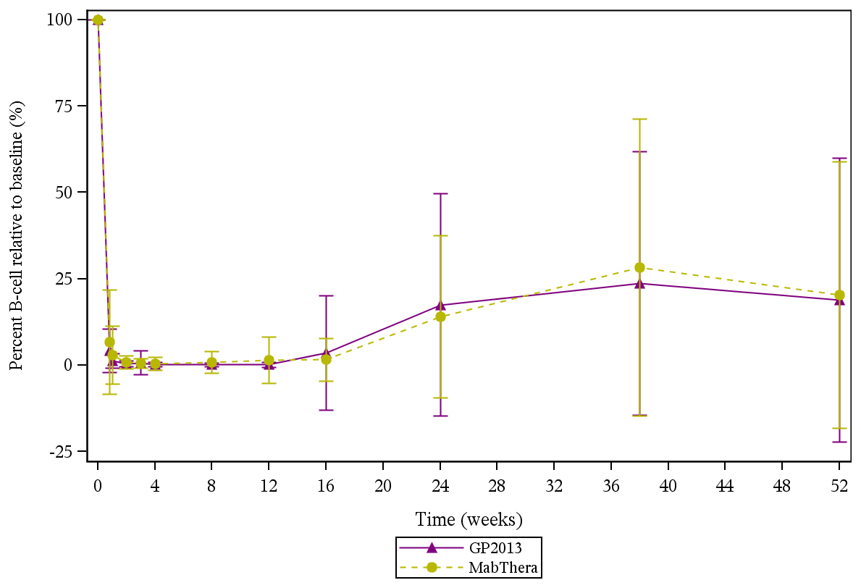
The proportion of patients with B cell counts below the LoQ (< 3 cells/µL) was comparable between the GP2013 and MabThera arms on Days 4, 8 and 14 (see Table 13, below). More than 50% patients by Day 8 and more than 70% patients by Day 15 were below the LoQ in both treatment arms.

Table 13: Study GP13-201 - Summary of absolute peripheral blood B cells below LoQ by treatment, PK analysis set
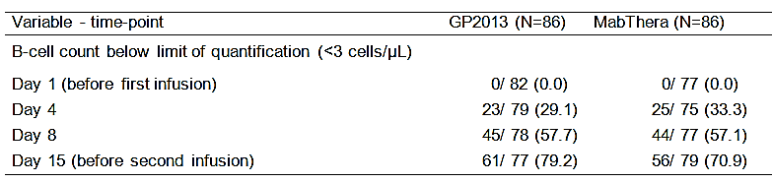

Study GP13-301 Supportive PD data

Outline
In the pivotal Phase III efficacy and safety Study GP13-301, GP2013 or MabThera 375 mg/m² via IV infusion were administered in combination with CVP were every 28 days for 8 cycles (approximately 6 months) or until disease progression, intolerable toxicity, treatment discontinuation, or withdrawal from treatment or study. Patients, who responded at the end of the 8 cycles of combination treatment as evidenced by demonstration of a CR or PR, were offered single-agent GP2013 or MabThera maintenance treatment according to their original treatment assignment, given every 3 months for a further 2 years or until disease progression, intolerable toxicity, treatment discontinuation, or withdrawal from treatment or study.

Pharmacodynamic objectives
In this study, assessment of a PD marker following treatment with GP2013-CVP and MabThera-CVP was a secondary objective.

Pharmacodynamic assessment
As previously discussed CD19+ B cell depletion is considered to be a surrogate for CD20+ B cell depletion and was assessed as an exploratory biomarker of GP2013 and MabThera activity. PD markers analysed in the study included peripheral CD19+ B cell counts (absolute and relative to baseline) and AUEC0-21d in Cycle 1 (depletion of peripheral B cells measured as the area under the effect-time curve (AUEC0-21d) of the percent peripheral B cell count relative to baseline up to the second infusion (that is, Day 21/Cycle 2 Day 1). A PD profile was obtained from approximately 20 patients per treatment group (GP2013-CVP and MabThera-CVP) during combination treatment Cycle 1 (Cohort 2 patients).
Blood samples were collected pre-dose during screening, 3 hours prior to the first dose (study Day 1), 0 hours post end of infusion (± 5 minutes) on study day 1 cycle 1, 24 hours post end of infusion (± 1 hour) on study day 2 cycle 1, 72 hours post end of infusion (± 3 hours) on study day 4 cycle 1, and 3 hours pre-dose on study day 1, cycle 2. A central laboratory was used to coordinate collection and analysis of PD samples. The analytical method used to measure CD19+ B cells was as described for Study GP13-201.

Statistical methods
The Pharmacodynamic Analysis Set (PDAS) consisted of all patients who received at least one dose (partial or complete) of MabThera or GP2013 in Cycle 1 and had PD blood samples collected and analysed for at least one scheduled time-point. The patient must have had at least one of the two pre-dose PD samples available. CD19+ B cell counts relative to the baseline value were assessed over 21 days during Cycle 1 according to the visit schedule.
The CD19+ B cell results were summarised using standard descriptive statistics. Results were presented for B cell counts, absolute changes and percentage relative to baseline in CD19+ B cell values. CD19+ -cell count percentages relative to the baseline versus time profiles and absolute CD19+ B cell counts versus time profiles were graphically presented by treatment arm.
The depletion of peripheral B cells was measured as the area under the effect-time curve (AUEC0-21d) of the percent peripheral B cell count relative to baseline up to the second infusion (that is, Day 21/Cycle 2 Day1). The sponsor stated that the area between the baseline and effect-time curve, which is presented as AUEC0-21d in this study, was the most relevant and sensitive parameter to evaluate pharmacodynamics. AUEC0-21d was determined with non-compartmental methods using WinNonlin and a linear trapezoidal rule was used for the parameter derivation. AUEC0-21d was not calculated for patients who were missing B cell key time points preventing appropriate evaluation of AUEC0-21d. These patients included but were not limited to: (i) patients who did not have an evaluable PD sample in Cycle 2 Day 1; (ii) patients who did not have an evaluable baseline sample; (iii) and patients who had fewer than 3 data points across the whole profile.
Descriptive statistics were provided for AUEC0-21d and Tlast. In addition, the ratio of the geometric means and 95% CI of the AUEC0-21d were estimated by ANCOVA on log-transformed PD parameters with treatment as the factor. Results were then back-transformed to the original scale. Similarity was concluded as the 95% CI of the ratio of the geometric means (GP2013/MabThera) of the AUC_{0-21d} was within the equivalence limits of 0.8 to 1.25. It should be noted that the CI was provided for descriptive purposes only. The PDAS was used for the analysis. All CD19+ B cell depletion values (in counts, absolute change and percent relative to baseline) were listed for the FAS.
Comment: The AUEC0-21d for depletion of CD19+ B cell counts is an appropriate exploratory PD endpoint for this study. The 90% CI for the geometric mean ratio between the two treatment arms for AUEC0-21d was provided for descriptive purposes only. The 90% CI rather than the 95% CI for the geometric mean ratio between the two treatment arms for AUEC0-21d was pre-specified in this study. However, a post-hoc analysis of geometric mean ratio of AUEC0-21d of peripheral B cells (GP2013/MabThera) with 95% CI was conducted by the sponsor to meet EMA requirements. The study was not powered for comparison of PD between the two treatment arms. All PD data were provided using descriptive statistic.

Results for the PD analyses

Summary of peripheral CD19+ B cells percentage relative to baseline
In general, the PD profile in terms of peripheral CD20+ B cells percentage relative to baseline was similar for the GP2013 and MabThera arms. The sponsor comments that the large CV% of the mean is due to skewed distribution of the data, which is normally seen with B cell counts. The majority of the patients had a low percentage relative to baseline values (median less than or at 2.2%). However, a few patients had higher values skewing the mean to the higher range and also inflating the CV%. The results are presented below in Table 14.
The arithmetic mean plot of percentage of peripheral B cell counts relative to baseline at the scheduled time-points through to 504 hours after the end of the infusion for the two treatment arms are summarised below in Figure 9. The plots were similar for the two treatment arms.

Table 14: Study GP13-301 – Summary of peripheral CD19+ B cells relative to baseline by treatment, PDAS
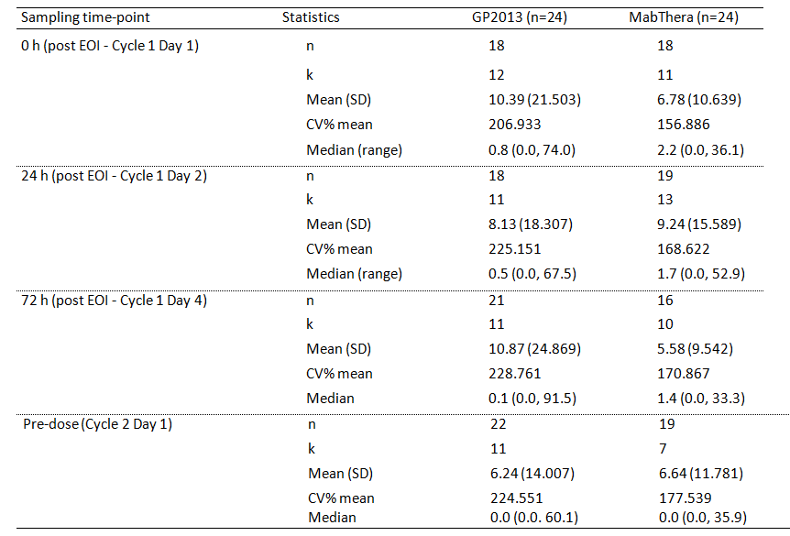
Figure 9: Arithmetic mean (SD) plot of percentage relative to baseline for peripheral CD20+ B cells counts vs times, by treatment, PDAS

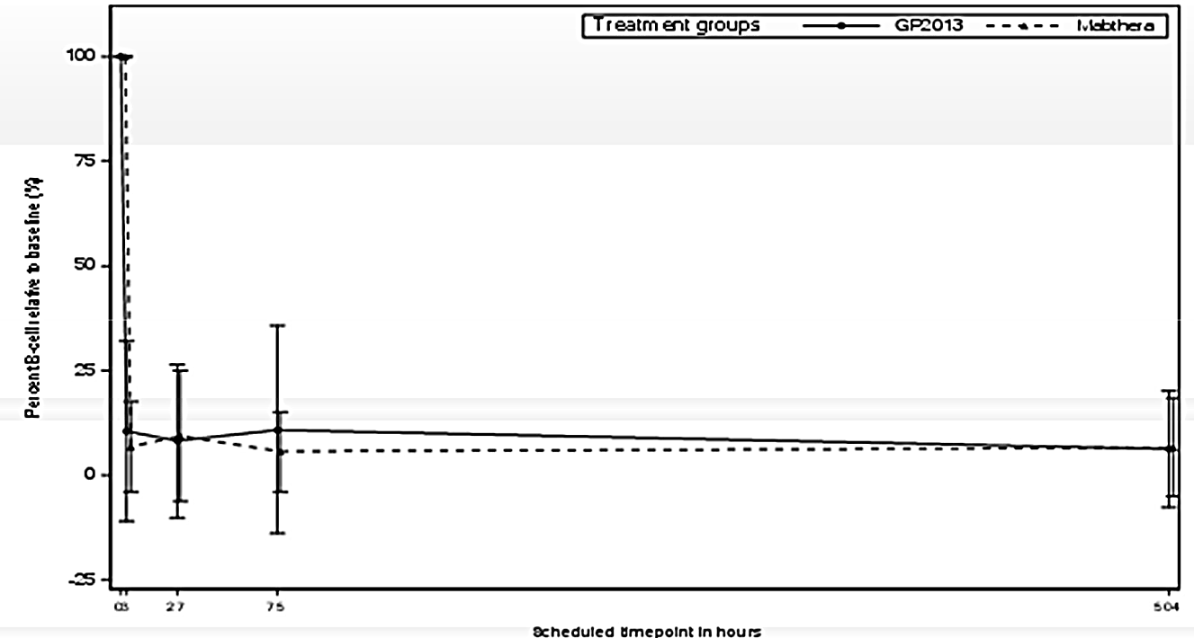

AUEC0-21d for peripheral CD19+ B cell counts
The arithmetic mean for the AUEC0-21d during Cycle 1 was 1830 %·day (CV% 18.7%) for patients in the GP2013 arm (n = 18) and 1920 %·day (CV% 12.0%) for patients in the MabThera arm (n = 18). The geometric mean for the AUC_{0-21d} was 1790 %·day (CV% 23.5) for the GP2013 arm and 1910 %·day (CV% 13.3) for the MabThera arm, with the geometric mean ratio (GP2013/MabThera) being 0.939 (90% CI: 0.845, 1.04). A post-hoc analysis of the geometric mean ratio of AUEC0-21d (%·day) of peripheral B cells (GP2013/MabThera) with 95% CI was conducted to meet EMA requirements. The geometric mean ratio was 0.939, and the 95% CI was 0.827 to 1.065. The 95% CI was enclosed entirely within the PD equivalence limits of 0.80 to 1.25. Overall, the results indicate that the AUEC0-21d was comparable in the GP2013 and MabThera arms.

Evaluator’s overall conclusions on pharmacodynamics
- It is considered that the submitted PD data have satisfactorily established the PD equivalence of GP2013 and MabThera (EU-approved). In the pivotal PK/PD study (Study GP13-201) both GP2013 and MabThera were administered in combination with MTX and in the supportive PK/PD study (Study GP13-301) both GP2013 and MabThera were administered in combination with CVP. The PD of the two formulations were assessed using depletion of CD19+ B cells relative to baseline, which is an acceptable surrogate biomarker for CD20+ B cell depletion. In the following discussion, B cell depletion refers to CD19+ B cell depletion.
- The pivotal PK/PD study (Study GP13-201) in patients with RA demonstrated that the PD of GP2013 (n = 72) and MabThera (n = 75) were equivalent, based on the 95% CI for the geometric mean ratio for the AUEC0-14d of percent depletion in B cells relative to baseline being entirely within the pre-specified PD equivalence limits of 0.80 to 1.25. The geometric mean ratio (GP2013/MabThera) for the AUEC0-14d was 1.019 (95% CI: 0.997, 1.042).
- In the pivotal PK/PD study (Study GP13-201), mean percent depletion of B cells relative to baseline at 72 hours after the infusion (that is, study Day 4) was 4.3% in the GP2013 arm and 6.7% in the MabThera arm, and was less than 1% in both arms at study Day 15 (that is, before second infusion). The percent B cell depletion relative to baseline versus time curves from baseline through to study Day 15 were almost superimposable for the two treatment arms. In addition, the percent B cell depletion relative to baseline curves through to Week 52 were similar for the two treatment arms. The mean percent B cell counts relative to baseline were less than 1% on Day 15 in both treatment arms, remained below 20% up to Week 24 for both formulations, and were 19.7% in the GP2013 arm and 21.1% in the MabThera arm at Week 52.
- In the pivotal PK/PD Study GP13-201, the proportion of patients with B cell counts below the LoQ (< 3 cells/µL) was comparable between the GP2013 and MabThera arms on Days 4, 8 and 14. More than 50% of patients by Day 8 and more than 70% patients by Day 15 were below the LoQ (< 3 cells/µL) in both treatment arms.
- In Study GP12-201, the PD equivalence of the two formulations was supported by the exploratory data in approximately 20 patients with FL in each treatment arm in the pivotal Phase III efficacy and safety study (Study GP13-301). In this study, the geometric mean ratio (GP2013/MabThera) with associated 90% CI for AUEC0-21d for B cell depletion relative to baseline was 0.939 (90% CI: 0.845, 1.04). In a post hoc analysis undertaken to meet EMA requirements the geometric mean ratio (GP2013/MabThera) for with associated 95% CI for AUEC0-21d 0.939 (95% CI: 0.827, 1.065). The 90% CI and the 95% CI were both enclosed entirely within the pre-specified equivalence limits of 0.80 to 1.25. The arithmetic mean plots of percentage B cell reduction relative to baseline from end of infusion through to 504 hours post infusion were similar for the two treatment arms.

Dosage selection for the pivotal and supportive studies

Study GP13-301 Pivotal Study Follicular Lymphoma (FL)
The pivotal Phase III efficacy and safety study (Study GP13-301) in patients with FL consisted of two treatment phases comprising a combination phase (approximately 6 months duration) and a maintenance phase (24 months of further treatment with single-agents). In the combination phase, GP2013 and MabThera were administered in combination with cyclophosphamide, vincristine and prednisone (CVP) for 8 x 21 day cycles (that is, approximately 6 months treatment). In the maintenance phase, patients with either a complete or partial response to treatment in the combination phase were eligible to continue single-agent treatment with either GP2013 (patients initially randomised to the GP2013+CVP arm) or MabThera (patients initially randomised to the MabThera+CVP arm) for an additional 24 months (8 x 3 month cycles).
In the combination phase, GP2013 and MabThera were administered by IV infusion at a dose of 375 mg/m² on Day 1 of each 21 day cycle, cyclophosphamide was administered at a dose of 750 mg/m² by IV bolus or infusion on Day 1 of each 21 day cycle, vincristine was administered at a dose of 1.4 mg/m² (max 2 mg) by iv infusion on Day 1 of each 21 day cycle and prednisone (or equivalent dose of prednisolone) at an oral dose of 100 mg was administered Days 1 to 5 of each 21 day cycle.
The sponsor stated that ‘for biosimilar development, reference medicinal drug product indications with the largest add-on-effect to standard treatment would provide the most sensitive population. In FL, rituximab has shown an add-on effect for clinical response when combined with various chemotherapeutic regimens (such as CHOP, CVP, or Bendamustine)’. The sponsor comments that CVP is an established chemotherapy of choice given in combination with rituximab for the treatment of patients with previously untreated, advanced FL. The sponsor notes that although MabThera is approved in first-line setting with various chemotherapy combination regimens, rituximab-CVP is the treatment of choice recommended in the US National Comprehensive Cancer Network guidelines (along with CHOP and Bendamustine).
The sponsor considers that rituximab in combination with CVP is a ‘sensitive and preferable setting to test for similarity of GP2013 and MabThera in the oncology setting’. In support of the sensitivity of the rituximab plus CVP regimen to identify differences in efficacy outcomes between GP2013 and MabThera, the sponsor referred to a study by Marcus et al (2008) which confirmed the benefit of adding rituximab to CVP for the treatment of previously untreated CD20+ stage III/IV FL. Examination of the published paper (Marcus et al., 2008) identify the study to be identical to that summarised in the clinical trials section of the MabThera PI and referred to as M39021. In Study M39021, patients were randomly assigned to 8 cycles of MabThera + CVP (n = 159) or CVP alone (n = 162), with a median follow up of 53 months. The MabThera -CVP regimen used in the study was consistent with the rituximab combination regimens in Study GP13-301.
The primary efficacy endpoint in Study M39021 (Marcus et al., 2008) was time to treatment failure (TTF). The median TTF was statistically and clinically significantly longer in the R-CVP arm than in the CVP arm (that is, median 27 versus 6.6 months). Other efficacy endpoints of note in Marcus et al (2008) which showed a benefit in the MabThera -CVP arm compared to the CVP arm were the overall response rate (ORR = CR + CR unconfirmed + PR = 87% versus 57%, respectively, p < 0.0001) and median disease-free survival (DFS = not reached versus 21 months, respectively, p = 0.0001). Median overall survival (OS) had not been reached in either treatment arm at the time of the study report, but Kaplan-Meier estimates for OS rates at 48 months were greater in the MabThera-CVP arm than in the CVP arm (77% versus 83%, respectively, p = 0.0290). The study found that, as had been previously reported in Marcus et al (2005), the incidence of AEs was similar in the rituximab-CVP and CVP groups. However, there was a higher incidence of Grade 3/4 neutropenia in the MabThera-CVP group than in the CVP group (24% versus 14%, respectively), but this did not translate into a higher rate of infection. The efficacy outcomes from Marcus et al., 2008 are summarised below in Table 15.

Table 15: Efficacy data from Marcus et al., 2008 comparing R-CVP to CVP alone for the treatment of patients with previously untreated CD20+ Stage III/IV FL
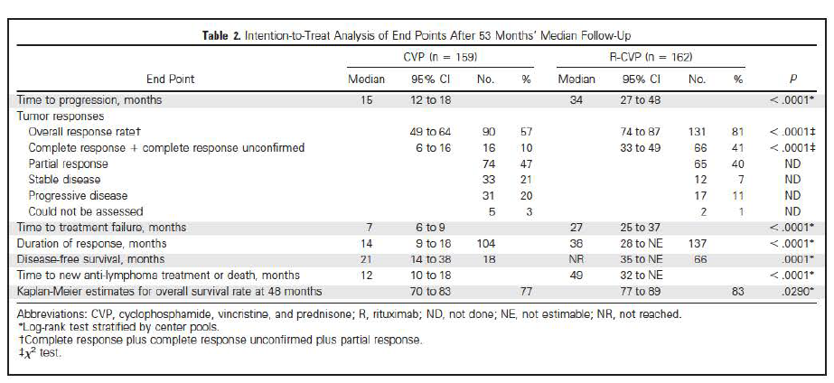
Comment: The rituximab + CVP treatment regimens used in the combination phase of Study GP13-301 are consistent with the approved recommended treatment regimen of MabThera plus chemotherapy for 8 cycles as induction therapy for the treatment of patients with previously untreated stage III/IV non-Hodgkin’s FL (MabThera PI). Based on the data from Marcus et al (2008) it is considered that comparison of GP2013+CVP to MabThera+CVP in patients with previously untreated non-Hodgkin’s FL is sufficiently sensitive to identify efficacy differences between the two regimens arising from differences between the two rituximab formulations. Similarly, it can be anticipated that differences in the safety profiles of the two regimens used in the combination phase of Study GP13-301 are likely to be due to differences between the two rituximab formulations.
The maintenance regimen used in Study GP13-301 of GP2013 or MabThera for 8 x 3 month cycles for 2 years, differs from the recommended MabThera maintenance regimen of treatment every 2 months for 2 years (see approved MabThera PI). However, this is not a major issue as it can be reasonable inferred that differences in the efficacy outcomes and safety profiles between single-agent GP2013 and single-agent MabThera regimens in the maintenance phase of Study GP13-301 will be due to differences between the two rituximab formulations.

Study GP13-201 Supportive Study Rheumatoid Arthritis (RA)
In Study GP13-201, the treatment regimens were GP2013 or MabThera administered at doses of 1000 mg by IV infusion on Day 1 and Day 15 in patients with active RA with an inadequate response or intolerance to non-biologic DMARDs and 1 to 3 anti-TNF therapies. Throughout the study, patients also received methotrexate (MTX) (between 7.5 mg/week and 25 mg/week) and folic acid (≥ 5 mg/week).
A second course of treatment with GP2013 or MabThera was allowed in patients with residual active disease (DAS28 ≥ 2.6 derived either by ESR or CRP formula) who had demonstrated a response to study medication (decrease in DAS28 of > 1.2 from baseline). Re-treatment with GP2013 or MabThera (2 infusions of 1000 mg each 2 weeks apart), depending on which arm the patient was originally randomised to, was allowed from Week 24 onwards and up to Week 52. Re-treatment was scheduled at Week 24, Week 38, or Week 52. If re-treatment complying with this schedule was not feasible, an optional re-treatment visit between Week 24 and Week 52 was undertaken.
The sponsor stated that the ‘dose and method of administration of the study treatment was chosen according to the recommended dose and method of administration of the marketed comparator treatment (MabThera) for RA patients’.
Comment: Data from the Clinical trials section of the approved MabThera PI indicates that ACR response (20, 50, 70) at Week 24 in patients with RA is consistently better (statistically and clinically) across studies in patients treated with MabThera in combination with MTX compared to patients treated with placebo in combination with MTX. In addition, the Clinical trials section of the approved MabThera PI provides data showing that both the mean change in DAS28 and the EULAR responses at Week 24 across studies are superior in patients treated with MabThera in combination with MTX compared to patients treated with placebo in combination with MTX. The approved MabThera PI also states that the ‘efficacy and safety of further courses (of rituximab in combination with MTX (are) comparable to the first course (of rituximab in combination with MTX))’. Based on the data in the Clinical trials section of the approved MabThera PI, it is considered that the treatment regimens of GP2013 or MabThera (both in combination with MTX) are sufficiently sensitive to detect clinically meaningful efficacy and safety differences between the two rituximab formulations. This is considered to be the case even though the criteria for patients with RA treated in Study GP13-201 differed from the Australian approved criteria for patients with RA eligible for treatment with MabThera.
The rituximab treatment regimen used in Study GP13-201 in patients with active RA intolerant or resistant to DMARDs and 1-3 anti-TNF therapies is consistent with, but not identical to, the regimen recommended for MabThera in the approved Australian PI. In Australia, MabThera in combination with methotrexate is indicated for the treatment of adult patients with severe, active rheumatoid arthritis who have had an inadequate response or intolerance to at least one TNF-inhibitor therapy. The RA indication in Study GP13-201 requires patients to have had an inadequate response or be intolerant to non-biological DMARDs and 1 to 3 anti-TNF therapies. However, the difference in the indications is not considered to be a major clinical issue. It is considered reasonable to infer that if there are no clinically meaningful differences in efficacy and safety between GP2013 and MabThera in patients with RA treated in Study GP13-201 then there are unlikely to be clinically significant efficacy and safety differences between the two rituximab formulations for treatment of patients with RA meeting the approved indication. In addition, further support for the acceptability of the two rituximab formulations for the treatment of both groups of RA patients arises from the finding that GP2013 and MabThera are bioequivalent based on the PK data and equivalent based on the PD data in patients with RA studied in Study GP13-201.
All patients in the study were required to have been on a stable dose of MTX of 7.5 to 25 mg per week for at least 4 months prior to randomisation and with a stable dose for 4 weeks prior to randomisation. At baseline, the mean ± SD dose of MTX in the total population was approximately 15 ± 4.9 mg/week, and the mean dose in both treatment groups was approximately 15 mg/week with a similar SD of 5 mg/week. MTX at baseline was used by all patients in accordance with the protocol, with the exception of 2 patients who had not been taking MTX for at least 4 months prior to randomisation or who had not been taking MTX (both in the GP2013 group) and 3 patients who had not been on a stable dose of MTX for 4 weeks prior to randomisation (1 in the GP2013 group; 2 in the MabThera group).
In patients with RA, the maintenance dose of MTX is generally within the range of 7.5 mg to 20 mg per week (methotrexate PI) and the dose of MTX to be given concurrently with MabThera is the dose tolerated by the patient (MabThera PI). In Study GP13-201, all patients received MTX at a dose of between 7.5 mg and 15 mg per week (oral dose recommended), which was to remain unchanged throughout the study. It is considered that the dose of MTX administered with rituximab in Study GP13-201 is appropriate.

Clinical efficacy

Studies providing evaluable efficacy data
There were two studies in the submission providing evaluable efficacy data comparing GP2013 with MabThera (EU-approved). The two studies with evaluable efficacy data are outlined below in Table 16.

Table 16: Brief outline of the two studies with evaluable efficacy data
Study | Design | Study population | Treatment
Study GP13-301  Phase III  Pivotal efficacy | Randomised, double-blind, active-control, 3 year, multinational, multicentre, study comparing PK, PD, efficacy, and safety of GP2013 versus MabThera in patients with previously untreated non-Hodgkin’s stage III/IV follicular lymphoma.  Efficacy was the primary objective; primary efficacy variable was comparison of the two study drug with respect to ORR in the combination phase; secondary efficacy variables included BOR of CR, PR, SD and PD for the combination phase and PFS and OS covering the whole study (that is, combination phase, maintenance phase, and post-treatment phase (if applicable), | Patients with untreated FL, mean age 56.9 years (range: 23, 84 years), Caucasian 67.1%, Asian 24.9%, Black 1.4%.  Total N = 627 (330f, 289m);  GP2013 N = 312 (181m, 131f);  MabThera N = 315 (f169, m146). | Combination Phase (6 months) – GP2013 (n = 312) or MabThera (n = 315) 375 mg/m2 administered by IV infusion on day 1 of 8 x 21 day cycles in combination with cyclophosphamide, vincristine and prednisone.  Maintenance Phase (2 years) treatment with single-agent GP2013 (n = 231) or MabThera (n = 231) 375 mg/m2 for 8 x 3 month cycles for responders to combination phase treatment.  Follow-up phase (6 months) for patients completing 2 years of maintenance treatment or discontinuing treatment prematurely.
Study GP13-201 (Part 1)  Phase II  Supportive efficacy | Randomised, double-blind, active-control, 52 week, multinational, multicentre study comparing PK, PD, efficacy and safety of GP2013 versus MabThera in patients with active RA refractory or intolerant to standard non-biologic DMARDs and 1-3 anti-TNF therapies.  Efficacy was a secondary objective in this study; key variable was non-inferiority of GP2013 to MabThera with respect to change from baseline in DAS28 at Week 24. There were a large number of other secondary efficacy variables. | Patients with active RA, mean age 53.7 years (range: 21, 82 years), Caucasian 80.9%, Asian 13.9%, Black 4.0%  Total N = 173 (149f, 24m);  GP2013 N = 86 (76f, 10f); MabThera N = 87 (73f, 14m). | GP2013 or MabThera: 1000 mg, two single IV infusions two weeks apart (days 1 and 15) in combination with MTX (7.5-25 mg/week); treatment could be repeated for responder between Week 24 and Week 52. Follow-up to Week 52 or 26 weeks after the first infusion of second course of study medication for re-treated patients.  Primary analysis at Week 24, responders could then be re-treated between Week 24 and Week 52.

Pivotal efficacy study (Study GP13-301) – Follicular Lymphoma
Title: A randomised, controlled, double-blind Phase III trial to compare the efficacy, safety and pharmacokinetics of GP2013 plus cyclophosphamide, vincristine, prednisone versus
MabThera plus cyclophosphamide, vincristine, prednisone, followed by GP2013 or MabThera maintenance therapy in patients with previously untreated, advanced stage follicular lymphoma

Study design, objectives, locations and dates

Primary objective
The primary objective was to demonstrate comparability of the overall response rate (ORR) in patients with previously untreated, advanced stage follicular lymphoma (FL) who received GP2013-CVP combination treatment to patients who received MabThera-CVP combination treatment.

Secondary objectives
The secondary efficacy objectives were to: (i) to evaluate the complete response (CR) rate; (ii) to evaluate the partial response (PR) rate; (iii) to evaluate progression-free survival (PFS); and (iv) to evaluate overall survival (OS).
The secondary safety objectives were: (i) to describe the safety of GP2013 in comparison to MabThera either as a single agent or in combination with CVP; and (ii) to evaluate the incidence of immunogenicity (anti-drug antibody (ADA) formation) against GP2013 and MabThera.
The secondary PK/PD objectives were: (i) to evaluate the PK of GP2013 and MabThera; and (ii) to evaluate a PD marker following the treatment with GP2013-CVP and MabThera-CVP.

Study design
Study GP13-301 is a Phase III, randomised, active-controlled, double-blind, multinational, multicentre, parallel group confirmatory study designed to compare the efficacy, safety, PK, and PD of GP2013 plus CVP versus MabThera plus CVP, followed by single-agent GP2013 or MabThera maintenance therapy in patients with previously untreated, advanced stage FL.
Approximately 618 patients with previously untreated, advanced stage (Ann Arbor stage III/IV), CD20+ FL with a World Health Organisation (WHO) histological grade of 1-3a were randomised in a 1:1 ratio to receive either GP2013-CVP or MabThera-CVP for 8 cycles during the combination treatment phase. Patients were stratified by Follicular Lymphoma International Prognostic Index (FLIPI) score risk group and geographic region. The stratification by the (FLIPI) risk group was as follows: low/intermediate risk (FLIPI score 0 to 2) versus high risk (FLIPI score 3 to 5). The stratification was defined by the location of the participating countries and was categorised into one of three regions: (i) Asia Pacific; (ii) Latin America; and (iii) Europe. The PK and PD aspects of this study have been previously reviewed in this CER and will not be repeated in this section of the CER.
The study includes four periods: screening (up to 28 days prior to randomisation); combination treatment (8 x 21 day cycles of approximately 6 month duration); maintenance treatment (2 years); and follow-up (maximum of 3 years from the date of randomisation). The study is ongoing and will be complete when all patients have reached the 3 year follow-up time point, have died, or have been lost to follow-up. The study design is presented schematically below in Figure 10.
Figure 10: Study GP13-301 Study design
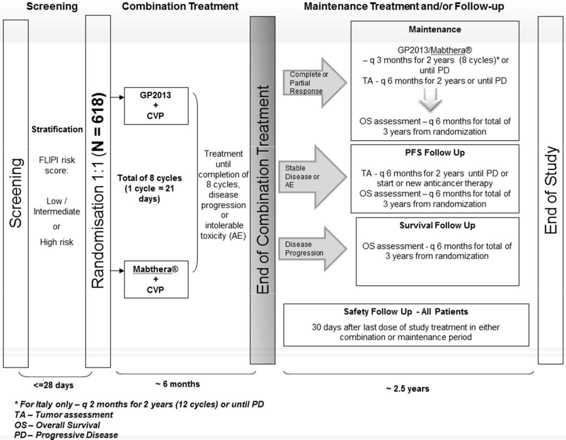
The screening phase (≤ 28 days) began on the day the first study procedure was performed after the patient had provided written informed consent to participate in the study and ended on the day of randomisation. To confirm FL histology, CD20-positivity, and WHO histological grade, a tumour containing lymph node sample (preferable) or an extranodal tissue sample (if a nodal biopsy was not available/accessible) was required. A bone marrow sample was not acceptable for this purpose. The tissue sample, provided as either tumour blocks or slides, was sent to a designated central pathology laboratory and the results were available prior to randomisation. The bone marrow assessment required in this protocol was performed by the site’s local pathology laboratories.
In the combination treatment phase (8 x 21 day cycles; approximately 6 months), all patients were randomised in a 1:1 ratio to receive 8 cycles of either GP2013-CVP or MabThera-CVP. The double-blinded combination treatment phase began in Cycle 1, Day 1. The sequence of the study treatment in the combination phase was prednisone, blinded investigational treatment (GP2013 or MabThera), and chemotherapy (cyclophosphamide, vincristine). Cycles were repeated every 21 days for 8 cycles or until disease progression, intolerable toxicity, treatment discontinuation, or withdrawal from treatment or study. If any component of combination treatment regimen needed to be discontinued (for example, due to intolerable toxicity), the patient continued to receive the other components of the combination regimen. Patients completing 8 cycles of combination treatment had a Combination End of Treatment Visit at the end of cycle 8 (within 7 days of Cycle 8, Day 21).
The maintenance treatment phase (2 years) with single agent GP2013 or MabThera followed completion of the combination treatment phase. Patients, who responded at the end of the 8 cycles of combination treatment as evidenced by demonstration of a CR or PR using Modified Response Criteria for Malignant Lymphoma, were offered double-blinded, single-agent GP2013 or MabThera maintenance treatment according to their original treatment assignment. Maintenance treatment was given every 3 months in all countries apart from Italy (every 2 months) for a further 2 years or until disease progression, intolerable toxicity, treatment discontinuation, or withdrawal from treatment or study. Patients completing 8 cycles of maintenance treatment had a Maintenance End of Treatment Visit, within 7 days of Cycle 8, Day 90. (For Italy only, patients completing 12 cycles of maintenance treatment had a Maintenance End of Treatment Visit, within 7 days of Cycle 12, Day 60).
The follow-up phase for progressive disease and overall survival was 3 years from the date of randomisation for all patients. In addition, all patients were followed for safety evaluation for at least 30 days after the last dose of study treatment (either in the combination or the maintenance phase). Patients, whose treatment was prematurely discontinued due to an adverse event (AE), were monitored until resolution or stabilisation of the event.
The term ‘study treatment discontinuation’ referred to withdrawal from GP2013 or MabThera and all components of CVP chemotherapy during the combination treatment phase or from GP2013 or MabThera during the maintenance treatment phase. The protocol included pre-specified criteria for premature withdrawal from the study. These criteria have been examined and are considered to be appropriate.
The study will be considered complete when all patients have been followed up for three years from the date of randomisation, or have been confirmed as lost to follow-up or have withdrawn consent. However, the study could be terminated at any time before end of the study for any reason by the sponsor and appropriate administrative and follow-up procedures are in place should this occur. At the time of the submission, the study was still ongoing and all maintenance treatment phase efficacy and safety data included in the CSR are considered interim.

Location and dates
The study was undertaken in 26 countries (174 centres screened patients, 159 centres randomised patients). The participating countries are Argentina, Australia, Austria, Brazil, Bulgaria, Columbia, France, Germany, Greece, Hungary, India, Ireland, Israel, Italy, Japan, Malaysia, Netherlands, Peru, Poland, Portugal, Romania, Russia, South Africa, Spain, Ukraine, and the United Kingdom. The study was initiated on 1 December 2011 (first patient screened) and the last patient last visit in the combination treatment phase was 9 July 2015. The study report (content final) was dated 4 February 2016. The study was conducted in compliance with Good Clinical Practice (GCP), including the archiving of essential documents. The study was sponsored by Hexal AG, a Sandoz company.

Inclusion and exclusion criteria
The study population consisted of adult (≥ 18 years old) patients with previously untreated, advanced stage (Ann Arbor stage III/IV) FL of WHO histological Grades 1-3a. FL histology, WHO histological grade and CD20-positivity were all confirmed by central pathological testing prior to patient randomisation. It was anticipated that approximately 618 patients would be randomised in a 1:1 ratio to receive either GP2013-CVP or MabThera-CVP. Randomisation was stratified by FLIPI risk group (low/intermediate risk, FLIPI score 0-2 versus high risk, FLIPI score 3-5) and geographic region (Asia Pacific, Latin America, or Europe). The study included only those patients with FL, with at least one measurable lesion, who were considered to require therapy for the disease as per local guidelines or in the opinion of the investigator. In addition, patients were required to have Eastern Cooperative Oncology Group (ECOG) performance status 0, 1 or 2 and adequate cardiac function.

Study treatments

Investigational and control treatments

Combination treatment – 8 x 21 day cycles
GP2013 and MabThera (Roche Products Limited, UK) were provided as sterile, colourless, preservative-free liquid concentrate for solution for IV infusion. They were supplied at a concentration of 10 mg/mL in 500 mg (50 mL) single use vials. For IV administration, 375 mg/m² of concentrate was diluted in 0.9% NaCl solution, to a concentration of 1 to 4 mg/mL as per local/country guidelines. GP2013 and MabThera were administered with standard pre-medication (paracetamol 500 mg PO, H1 antihistamine (PO of IV), and prednisone PO (which was also the Day 1 dose of prednisone for the CVP combination regimen)).
The recommended initial rate for infusion of GP2013 or MabThera was 50 mg/h, escalated after the first 30 minutes in 50 mg/h increments every 30 minutes, in the absence of infusion toxicity, to a maximum of 400 mg/h. If the first infusion was uneventful, subsequent doses could be infused at an initial rate of 100 mg/h, and increased by 100 mg/h increments at 30 minutes intervals in the absence of infusion toxicity, to a maximum of 400 mg/h. Alternatively sites followed local/country guidelines or standard institutional practice.
CVP chemotherapy consisted of cyclophosphamide, vincristine and prednisone given every 21 days (± 3 days) for 8 cycles in combination with GP2013 or MabThera. The CVP regimen consisted of cyclophosphamide 750 mg/m² administered by IV bolus or infusion on Day 1 (or Day 2 if not logistically feasible on Day 1), vincristine 1.4 mg/m² (maximum 2 mg) by IV infusion on Day 1 (or Day 2 if not logistically feasible on Day 1), and prednisone 100 mg orally (or prednisolone in countries where prednisone was not available) on Days 1 to 5.
Comment: The combination phase treatment regimen for GP2013-CVP and MabThera-CVP for 8 x 21 day cycles is consistent with the induction regimen specified in the MabThera PI (Australia) for previously untreated stage III/IV follicular non-Hodgkin’s lymphoma.

Maintenance treatment
All patients who demonstrated a response (CR or PR) using Modified Response Criteria for Malignant Lymphoma at the end of 8 cycles of GP2013-CVP or MabThera-CVP combination treatment were offered single agent GP2013 or MabThera maintenance treatment at a dose of 375 mg/m². Maintenance treatment began 3 months (± 14 days) after the last combination treatment (Cycle 8, Day 1) according to the original treatment assignment. Subsequent GP2013 or MabThera was to be administered in a blinded manner every 3 months (± 14 days) over a 2 year period (8 x 3 month maintenance treatment cycles) in all countries apart from Italy, where maintenance treatment was administered every 2 months for 2 years.
Comment: In the MabThera PI (Australian), the maintenance regimen of single-agent GP2013 or MabThera for patients with previously untreated stage III/IV follicular non-Hodgkin’s lymphoma who have responded to combination induction therapy is every 2 months for 2 years. In patients with relapsed/refractory Stage III/IV follicular non-Hodgkin’s lymphoma the PI recommends maintenance therapy with single-agent MabThera every 3 months for 2 years following combination induction for 8 x 21 day cycles. However, the PI states that ‘(t)here are currently no data to support superior efficacy for maintenance treatment given every 2 months over maintenance therapy given every 3 months, in either the relapsed/refractory or previously untreated setting’. It is considered that the single-agent GP2013 or MabThera maintenance regimen used in the study is appropriate.

Dosage adjustments
No dose reductions were permitted for GP2013 or MabThera. For patients who did not tolerate the protocol-specified dosing schedule, dose adjustments were permitted for CVP chemotherapy in order to allow the patient to continue the study treatment. The treating physician managed patients according to their own medical judgment. However, if a scheduled cycle of treatment was delayed by > 21 days beyond the next intended treatment cycle, the patient was to be discontinued from study treatment.
All dose modifications of CVP chemotherapy were based on the worst preceding toxicity. Although institutional or local practice could be followed for dose modifications, the sponsor encouraged investigators to follow protocol specified recommended dose adjustments and delays. Appropriate specific dosing recommendations with CVP for patients who developed haematological toxicity, renal impairment, hepatic impairment, neuropathy, or haemorrhagic cystitis were provided. Each patient was allowed no more than 2 dose reductions of any drug in the CVP regimen, after which, on recurrence of toxicity, the specific drug was discontinued. Any component of CVP chemotherapy could have been dose reduced and/or discontinued without affecting a patient’s continued participation in the trial. Only when all components of the treatment regimen were discontinued (GP2013 or MabThera and CVP) was the patient considered to be discontinued from study treatment.

Concomitant treatment
Drugs recommended for pre-medication have been described above. Prophylactic use of growth factors was not allowed prior to Cycle 1 (with the exception of patients with bone marrow involvement) and routine use of G-CSF support was not required. Growth factor support using standard practice was permitted after combination treatment Cycle 1 if AEs, such as ≥ Grade 3 neutropenia or suppression of ANC with febrile neutropenia, had been observed in order to assist patients receive subsequent treatments at a scheduled time-point. Blood/platelet transfusions (except during screening to make a patient eligible for the study), the use of bisphosphonates, topical steroid products, and daily corticosteroid use of ≤ 20 mg/day prednisone (or equivalent) were permitted at the discretion of the treating physician. As a general recommendation, no antimicrobial prophylaxis was indicated, although individual patients with recurring infections during the study could be considered for such treatment. Other medications required during the administration of study treatment, such as anti-emetics, hydration, and antacids/proton pump inhibitors, may have been used as required and in accordance with local practice.
Permitted concomitant therapy with caution was allowed with some medications. These included CYP1A2 inhibitors such as azoles (antifungals), antidepressants, and theophylline with the potential to affect the exposure of CVP. Hypotension may occur during the infusion with the study drug therefore, consideration was to be given to withholding anti-hypertensive medicines 12 hours prior to infusions.
There were a number of medicines and therapies not permitted during the study. These included: growth factors or transfusions (with the exception of patients with bone marrow involvement where this would be permissible) to allow for patient eligibility at screening; primary prophylactic use of growth factors prior to Cycle 1, Day 1; immunosuppressive medication; live vaccines; other medical treatments that are or may be active against lymphoma, including investigational agents; and radiation therapy.

Efficacy variables and outcomes

Primary efficacy variable Overall Response Rate (ORR)
The primary efficacy variable was the overall response rate (ORR) during the combination treatment phase assessed using the Modified Response Criteria for Malignant Lymphoma based on the International Working Group response criteria (Cheson et al., 1999) and the International Harmonization Project revised response criteria (Cheson et al., 2007b). Further clarification on these criteria has been published by (Cheson 2007a).
ORR was defined as the proportion of patients whose best overall disease response (BOR) was either CR or PR during the combination treatment phase. Best overall disease response (also called best overall response) was defined as the best disease response recorded from randomisation until disease progression, start of new anticancer therapy or end of combination treatment phase whichever came first.
The evaluation of radiological response for the primary analysis of ORR was based on Central Blinded Review of radiological response (that is, independent central radiological review).

Assessment of overall disease response
For each efficacy assessment during the combination phase, two sources of overall disease responses were obtained (investigator and Central Blinded Review). The first response was based on the investigator assessment of tumour response, B-symptom, liver and spleen enlargement assessment and bone-marrow assessment, and was based on the overall disease response entered in the Cheson tumour evaluation eCRF pages by the investigator. The second response was based on the radiologic response and liver/spleen enlargement assessment provided by the Central Blinded Review. These responses, together with the information collected on eCRF on B-symptom and bone marrow assessment, were used to derive an overall disease response that was based on the Central Blinded Review. The overall disease responses based on the Central Blinded Review of the radiological response were used for the derivation of best overall disease response for the combination treatment phase and for the primary efficacy analysis.
For combination treatment phase, tumour assessments were performed at the end of Cycle 4 and Cycle 8, and at EOT, if applicable. EOT tumour assessment only occurred if the combination treatment phase tumour assessment prior to the EOT was greater than 4 weeks, the EOT visit was a result of premature discontinuation, or there was no documented disease progression.
The best overall disease response was the best disease response recorded from randomisation until progressive disease, start of new anti-cancer therapy or end of combination treatment phase, whichever came first. Information on anti-cancer treatments after discontinuation of study treatments was also collected.

Nodal and extra nodal lesions
Lesions identified in this study were defined as nodal lesions (lymph node of nodal mass) or extranodal lesions (located in organs other than lymph or nodal mass, but excluding spleen and liver). Both modal and extranodal lesions were categorised as index or non-index lesions. All lesions identified at baseline were reassessed using the same method (CT or MRI) and technique throughout the course of the study. All patients (except those with an allergy to the contrast) had a CT scan with contrast or MRI with contrast of the neck, chest, abdominal and pelvic areas. Appropriate imaging procedures were specified for patients who were allergic to the contrast. Positron Emission Tomography (PET) scan was not an acceptable imaging modality in this study. The definition of index nodal lesion, non-index nodal lesion, index extranodal lesion, and non-index extranodal lesion was summarised. The methods used to calculate response for index and non-index lesions and calculation of the overall disease response were also summarised.
All CT scans and MRIs obtained on all patients enrolled at each centre were reviewed by the local radiologist who, together with the investigator, determined the local assessment of response and progression. Any treatment decision (for example, eligibility for maintenance treatment, patient discontinuation due to disease progression) was based on the investigator assessed tumour response in both the combination and maintenance treatment phases. In addition, scans (CT or MRI) used for baseline tumour assessment, as well as for assessment of tumour response during the combination treatment phase were sent for independent central radiology review on an ongoing basis. Assessment of tumour response per independent central radiology review was used for the primary analysis of ORR. Scans (CT or MRI) obtained during the maintenance treatment phase were also sent to the central imaging laboratory for quality assurance and archiving.

Tumour assessment definitions
- Complete response (CR): Normalisation of all index nodal lesions (that is, ≤ 15 mm in both axes), disappearance of all index extranodal lesions, and normalisation of all non-index lesions (that is, regression to normal size of non-index nodal lesions and disappearance of non-index extranodal lesions).
- Partial response (PR): Normalisation of all index nodal lesions (that is, ≤ 15 mm in both axes) without disappearance of the lesions but with < 50% increase from nadir in the sum of the products of the diameters (SPD) of all index extranodal lesions and non-normalisation of all index nodal lesions but with ≥ 50% decrease from baseline in the SPD of all index lesions.
- Stable disease (SD): SD was declared if at least one stable disease assessment as defined by the Modified Response Criteria for Malignant Lymphoma was available at least 11 weeks after randomisation and the patient did not qualify for CR or PR.
- Progressive disease (PD): PD was declared if disease progression as defined by the Modified Response Criteria for Malignant Lymphoma was observed less than 13 weeks after randomisation and the patient did not qualify for CR, PR or SD.
- Unknown: All other cases not qualifying for CR, PR, SD or PD were denoted as unknown. The following reasons were used to summarise patients with a response categorised as unknown: no valid post-baseline assessment; all post-baseline assessments have overall disease response of ‘unknown’; new anti-neoplastic therapy started before first post-baseline assessment; SD too early (that is, if best overall disease response would have been SD but observed within the first 11 weeks); and PD too late (that is, if best overall disease response would have been PD but observed equal or more than 13 weeks after randomisation).

Other assessments
Other assessments in the study included bone marrow assessments and B-symptom assessments. Bone marrow biopsy (not aspirate) was mandatory during screening, although archived biopsy material could have been used if obtained within 90 days prior to screening. This assessment was to be performed by the site’s local laboratories. In addition bone marrow biopsies were performed at the time of radiological CR confirmation (if applicable). In addition, bone marrow assessments may have been performed anytime during treatment for suspicion of new or recurrent infiltration. B-symptoms were defined as: significant unexplained fever (≥ 38°C); unexplained, recurrent drenching night sweats; and unexplained loss of >10% body weight within the previous 6 months, as assessed and reported (present versus absent) by the investigator.
Comment: The selection of the ORR as the primary efficacy variable is considered to be consistent with the TGA adopted EMA guideline relating to the evaluation of similar biological products containing monoclonal antibodies (EMA/CHMP/BMWP/403543/2010). The guidelines note that ‘the focus of the comparability exercise is to demonstrate similar efficacy and safety compared to the reference product, not patient benefit per se, which has already been established by the reference medicinal product’. The guidelines state that ‘[i]n general, the most sensitive patient population and clinical endpoint is preferred to be able to detect product related differences’. The guidelines refer to the ORR being an example of a clinical endpoint that measures activity as a primary clinical endpoint in a homogeneous population. The guidelines comment that endpoints such as PFS and OS ‘may not be feasible or sensitive enough for establishing the comparability of biosimilar [monoclonal antibodies] since they may be influenced by various factors not attributable to differences between the biosimilar [products], but by factors like tumour burden, performance status, previous lines of treatment, underlying clinical conditions, subsequent lines of treatment (for OS), etc. They may therefore not be suitable to establish similar efficacy of [the two monoclonal antibody products]’. However, the guidelines state that the PFS and OS should be recorded, where feasible, and note that the PFS is likely to be more sensitive than the OS due to the ‘numerous factors influencing survival beyond the performance of the [two monoclonal antibody products]’.
The assessment of ORR based on Central Blinded Review of radiological response is considered to be appropriate. Protocol Amendment 1 changed assessment of the ORR from local to Central Blinded review of radiological response. It was expected that central radiology review of the scans allowed for uniformity in data analysis and interpretation due to inherent complexity with the interpretation of the Modified Response Criteria for Malignant Lymphoma.

Secondary efficacy variables
The secondary efficacy variables included the best overall response (BOR) of CR, PR, SD, and PD for the combination treatment phase based on Central Blinded Review of the radiological response, and PFS and OS covering the combination phase, maintenance phase, and post-treatment phase (if applicable). The PFS covering all treatment phases was based on the investigator assessment of overall disease response.

Randomisation and blinding methods
Randomisation (1:1) into the two treatment arms (GP2013-CVP or MabThera-CVP) was stratified by FLIPI risk group for low/intermediate risk (FLIPI score 0-2) versus high risk (FLIPI score 3-5), geographic region (Asia Pacific, Latin America, and Europe) and by participating cohort for PK data collection (Cohort 2 - extensive PK sampling; Cohort 1 exclusive of Cohort 2 - sparse PK sampling; rest of patients without PK sampling). Stratification by centre was not feasible due to the large number of centres participating in the study with potentially only a few patients enrolled per centre.
Randomisation within participating patient cohort by FLIPI score risk and region was as follows:
- Patients in Cohort 2: randomisation was stratified by FLIPI score risk group only. Within each FLIPI score risk group, a list of randomisation numbers was generated by Interactive Response Technology (IRT) with a 1:1 randomisation ratio to GP2013-CVP or MabThera-CVP.
- Patients in Cohort 1: randomisation was stratified by both FLIPI score risk group and region. Within each strata level, a list of randomisation numbers was generated by IRT with a 1:1 randomisation ratio to GP2013-CVP or MabThera-CVP.
- All other patients Cohort: randomisation was stratified by both FLIPI score risk group and region. Within each strata level, a list of randomisation numbers was generated by IRT with a 1:1 randomisation ratio to GP2013-CVP or MabThera-CVP.
The study was double-blinded. Adequate procedures were in place to maintain the blind in the combination and maintenance treatment phases.

Analysis populations
The Full Analysis Set (FAS) contained 627 randomised patients, 312 in the GP2013 arm and 315 in the MabThera arm. The FAS population consisted of all patients to whom study treatment had been assigned by randomisation and who received at least one (partial or complete) dose of investigational treatment (that is, MabThera or GP2013).
The Safety Set contained 627 patients, 312 in the GP2013 arm and 315 in the MabThera arm. The Safety Set consisted of a subset of the patients in the FAS who actually received at least one (partial or complete) dose of investigational treatment (MabThera or GP2013) and had at least one post-baseline safety evaluation.
The Per-Protocol Set (PPS) contained 624 patients, 311 in the GP2013 arm and 313 in the MabThera arm. The PPS consisted of a subset of patients in the FAS who received at least one (partial or complete) dose of investigational treatment (MabThera or GP2013) and had no major protocol deviations. Three patients were excluded from the PPS, 2 patients took the wrong medication at one occasion during the combination treatment phase and 1 patient was excluded for other reasons.
The Maintenance Set contained of 462 patients (231 patients in each treatment arm) and consisted of all patients who received at least one dose of investigational treatment (MabThera or GP2013) in the maintenance treatment phase.
The study also included PK and PD analysis sets, which have been previously described. The study also included an Immunogenicity Analysis Set (IAS), which contained 551 patients, 268 in the GP2013 arm and 283 in the MabThera arm. The IAS included patients in the FAS who had an immunogenicity assessment at baseline (pre-first dose) and post-dose.

Sample size
The sample size calculation assumed an expected overall response rate of 81% for each treatment arm and a pre-specified equivalence margin of 12%. A total of 556 patients were required for the study, with 90% power to show equivalence of GP2013 to the reference drug at a two, one-sided significance level of 2.5%. In order to allow for drop-outs of 10% and major protocol violations, a total of 618 patients were required, and 629 patients were randomised.
The sponsor stated that the pre-specified equivalence margin of 12% was based on historical data from a Phase III study in patients with previously untreated advanced FL (Ann Arbor classification stages III/IV) were randomised to either 8 cycles of MabThera + CVP (n = 162) or CVP (n = 159) (Marcus et al., 2005; Marcus et al., 2008). The observed ORR in the published study was 81% for the MabThera + CVP arm and 57% for CVP arm, the observed add-on effect of CVP plus MabThera on ORR was 24% (95% CI: 14%, 34%). The sponsor stated that this was the only relevant historical trial currently available to assess the add-on effect of MabThera + CVP versus CVP in patients with previously untreated, advanced stage FL. The equivalence margin of 12% was determined considering the variability of the point estimate of the add-on effect (24%) by taking a value lower than the lower bound of the 95% CI for the add-on effect of MabThera plus CVP on ORR (that is, lower than 14%). The value of 12% was approximately the lower bound of a wider 98% CI for the difference between MabThera + CVP versus CVP. The sponsor stated that this fixed margin approach was considered conservative and generally acceptable according to the FDA (FDA draft Guidance for industry Non-inferiority Clinical Trials).
In addition, the sponsor stated that the choice of the 12% margin was also supported by the indirect CI approach recommended by the EMA in the TGA adopted guideline (EMA Guidance Choice of Non-inferiority Margin). This method combines variability and size of the active control effect from the historical data with those expected from the current trial. Similar to the fixed margin approach, the margin of 12% based on the lower bound of the 95% predictive interval using the indirect CI approach was relatively conservative since it picks the ‘smallest’ out of the prediction confidence interval.
The sponsor stated that the choice of margin of 12% was further supported by the data based on the central radiological review of tumour assessments of the same historical Phase III FL study (MabThera EPAR Scientific Discussion 2005) with the observed add-on effect of 34% with 95% CI of 24% to 44%.
Comment: It is considered that the sponsor’s pre-specified equivalence margin of 12% for the ORR is appropriate, based on the sponsor’s evaluation of the available historical Phase III data comparing MabThera-CVP with CVP, and the add-on effect of CVP to MabThera. No power analysis for the secondary efficacy variables was undertaken.

Statistical methods

Primary analysis – ORR assessment of equivalence
Two analysis time points were planned in this study. The first and primary analysis was to demonstrate comparability of GP2013-CVP to MabThera-CVP with respect to the primary endpoint of ORR. This analysis was performed at the end of the combination treatment phase when all patients had either completed or prematurely discontinued combination treatment. The second and final analysis will occur when all patients have reached the 3 year follow-up from the date of randomisation time-point, have died or have been lost to follow-up. The submitted CSR was prepared for the first analysis based on data reported by the cut-off date of 10 July 2015 when the last patient had completed the combination treatment phase. No interim statistical analyses were planned or undertaken for this study. There were no changes to the planned analysis of the study.
The primary assessment of equivalence of GP2013 to MabThera was based on the two-sided, 95% CI for the difference in the ORR rates. Equivalence of the two treatment arms was concluded if the entire 95% CI was contained within the equivalence interval -12% to +12%. The null hypothesis was that the two treatments were not equivalent and the alternative hypothesis was that the two treatments were equivalent.
Since the primary objective of the study was to demonstrate comparability in efficacy between GP2013-CVP and MabThera-CVP during the combination treatment phase, the analysis of primary efficacy endpoint in the PPS was considered the primary analysis. The analysis of primary efficacy endpoint in the FAS was considered to be supportive.
The following analyses were performed as supportive to the primary analysis: the analysis of ORR based on Central Blinded Review of radiological response was performed on PPS excluding patients whose best overall response was unknown or missing; the analysis of ORR based on Central Blinded Review of radiological response was performed on FAS; sub-group analyses of ORR on both PPS and FAS by age and FLIPI score risk group; and the analysis of ORR based on investigator review was performed on PPS and was repeated using FAS.
In addition to equivalence testing, a response variable was derived for each variable specifying whether or not a patient achieved a best overall response of PR or CR, using Central Blinded Review of tumour assessment during the combination treatment phase. This binary response (yes versus no) was used to fit a logistic regression analysis where the explanatory variables were FLIPI score and treatment arm. The fitted logistic regression was used to derive an estimate and associated 90% CI of the odds ratio of treatment difference (GP2013 versus MabThera) adjusted for FLIPI score. This analysis was based on the PP set.
Comment: The primary efficacy analysis of comparability of the two treatment arms based on equivalence testing of the ORR in the PPS at the end of the combination treatment phase is considered to be acceptable.

Analysis of secondary efficacy variables

Best Overall Response (BOR)
The proportion of patients with BOR (90% CI) of CR, PR, SD, and PD was generated for the combination treatment phase for each treatment arm. The analysis of the BOR endpoints was based on Central Blinded Review of radiological response and was undertaken in the PP set. As a sensitivity analysis, the analysis was repeated in the FAS. In addition, the comparison of the BOR based on investigator and Central Blinded Review in the PP set was undertaken, and repeated as a sensitivity analysis in the FAS.

Progression free survival (PFS)
PFS was the time from the date of randomisation to the date of event defined as the first observation of documented disease progression or death due to any cause. PFS was derived as follows: PFS = date of PFS event – date of randomisation + 1. PFS evaluation was based on the investigators’ assessment of disease progression. Progressive disease was to be assigned only if it was documented according to Modified Response Criteria for Malignant Lymphoma. If a patient had not had an event, PFS was censored at the date of last adequate radiological assessment. When a patient discontinued treatment for ‘disease progression’, but without documentation of radiological evidence of progression based on the Modified Response Criteria for Malignant Lymphoma, this was not counted as a PFS event.
The following censoring rules were implemented for PFS analysis: (i) if a PFS event was not observed at the time of the data cut-off, PFS was censored at the date of last adequate tumour assessment; (ii) if the patient started another cancer therapy, PFS was censored on the date of the last adequate tumour assessment at or before the start date of new cancer therapy; (iii) if the patient had no adequate post-baseline assessment available, then the patient was censored at the date of randomisation; (iv) if disease progression or death was documented after just one missing adequate assessment, PFS for these patients was calculated assuming the event had occurred at the date of progression (or death); ( v) if there was more than one visit with missing or inadequate tumour assessments (that is, ‘unknown’) between the last adequate tumour assessment and death or disease progression, the PFS was censored at the last adequate tumour assessment of no progression (or death).
PFS censoring and event date options depend on the presence and the number of missing tumour assessments. In this study, the protocol-defined schedule of assessment was at Week 12 (Cycle 4 Day 21) and Week 24 (Cycle 8 Day 21) in the combination treatment phase and every 6 months in the maintenance treatment phase. In the combination treatment phase, tumour assessment had a window of ± 1 week (7 days). In the maintenance treatment phase, tumour assessment had a window of ± 2 weeks (14 days). Therefore, the documentation of statistical methods specified exact rules to determine whether there was no, one or two missing assessments. These rules were based on the distance between the last adequate assessment date and the current event date. The rules used to determine the number of missing assessments have been examined and are considered to be satisfactory.

Overall survival (OS)
OS was defined as the time from date of randomisation to date of death due to any cause. If a patient was not known to have died, OS was censored at the date of last contact.

Analysis of PFS and OS
The Kaplan-Meier method was used to estimate the median time (and 90% CI) to PFS and OS for each treatment arm. The Cox regression analysis with treatment as covariate and FLIPI score as stratification factor was used to estimate the hazard ratio (and 90% CI) between the two treatment arms. The study was not powered to compare PFS or OS between the two treatment arms. Therefore, the sponsor states that generation of PFS and OS estimates and their associated CIs were for descriptive purposes only and should not be associated with any hypothesis testing.
To assess the robustness of the random censoring mechanism for PFS, for censored patients the gap time (month) between data cut-off date and last tumour assessment was summarised in the FAS. Gap times for PFS were defined as: (i) prior to the cut-off date for patients who completed the study or prematurely discontinued from the study due to certain reasons (for example, withdraw consent, lost to follow-up) the gap time = (study termination date - censoring date)/30.4375; and (ii) for patients who were censored regardless of follow-up status, gap time = (study cut-off date - censoring date)/30.4375.

Participant flow
The planned number of randomised patients for the primary analysis of the ORR was 618. However, 629 were actually randomised (314 patients to the GP2013 arm and 315 patients to the MabThera arm; two GP2013 patients were mis-randomised and were discontinued before being treated).

Combination phase disposition
Of the total number of patients in the two treatment arms, 87.3% in the GP2013 arm and 87.0% in the MabThera arm completed the combination treatment phase as planned, and 12.7% and 13.0%, respectively, discontinued treatment prematurely. In the combination treatment phase, the primary reason for early treatment discontinuation was disease progression in both treatment arms. The incidence of discontinuations due to AEs was similar in the GP2013 arm (2.2%) and in the MabThera arm (3.2%) as was the incidence of death (1.6% and 2.2%, respectively). Disease progression was the most common reason resulting in treatment discontinuation, and was reported in 3.2% of patients in both treatment arms. Patient disposition in the combination treatment phase is summarised below in Table 17.

Table 17: Study GP13-301 Patient disposition by treatment in the combination phase
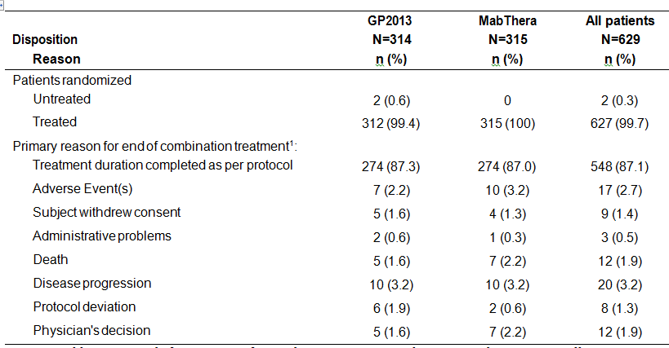
¹ End of treatment refers to discontinuation combination study treatment. All percentages are based on randomised patients.

Maintenance phase disposition
As of the 10 July 2015 data cut-off date, 73.6% (n = 231) of patients in the GP2013 arm and 73.3% (n = 231) of patients in the MabThera arm had entered the maintenance treatment phase and had received at least one dose of treatment. A total of 303 patients (65.6%) were still receiving study treatment in the maintenance phase, 142 patients (61.5%) in the GP2013 arm and 161 patients (69.7%) in the MabThera arm. In the maintenance treatment phase, the primary reason for ‘End of Treatment’ (38.5% (n = 89), GP2013 versus 30.3% (n = 70), MabThera) was ‘Disease progression’ (16.0% (n = 37), GP2013 versus 10.8% (n = 25), MabThera) and ‘Treatment duration completed as per protocol’ (15.2% (n = 35), GP2013 versus 13.4% (n = 31), MabThera).

Major protocol violations/deviations
A total of 279 patients had at least one protocol deviation and these were balanced between the treatment arms: 137 patients (43.9%) in the GP2013 arm and 142 patients (45.1%) in the MabThera arm. These deviations were not believed to have introduced a bias in the efficacy or safety data comparisons between the two treatment arms. Of the total number of protocol deviations, 3 were considered to be major protocol deviations resulting in exclusion from PP set. One of the major protocol deviations was CD20, and/or WHO histology grading not performed at the central laboratory and ‘Subject did not receive the correct kit assigned by IRT’ (1 patient (0.3%) in the MabThera arm), and 2 of the major protocol deviations were ‘Subject did not receive the correct kit assigned by IRT’ (1 patient (0.3%) in the GP2013 arm and 1 patient (0.3%) in the MabThera arm).

Baseline data

Baseline demographics
The baseline demographics were similar between the treatment arms in terms of age, gender, race, and other parameters. The median age of patients in the GP2013 arm was 58.5 years (range: 23, 84 years) and 57.0 years (range: 24, 84) in the MabThera arm, and 47.8% and 44.4% of patients were ≥ 60 years old in the GP2013 and MabThera arms, respectively. There were marginally more female than male patients in both arms (58.0%, GP2013; 53.7%, MabThera). The majority of patients in both arms had a baseline ECOG status of 0 (57.4%, GP2013; 55.6%, MabThera).

Disease history and baseline disease characteristics
As per study entry criteria, all patients had a primary diagnosis of non-HL, with predominant histology/cytology of FL. Presence of CD20 was confirmed by central laboratory for all patients, except for one patient in the MabThera arm. The median time from the initial diagnosis to randomisation was the same for both treatment arms (1.8 months), but the range was greater in the GP2013 arm (0.4, 183.9 months) than in the MabThera arm (0.6, 69.3 years). In general, the disease characteristics of the two treatment arms were similar.

Other current medical conditions and past medical history
In general, prior medical histories and concurrent medical conditions for the two treatment arms showed a similar pattern of medical events. The pattern was consistent with a population of patients with a median age of 58 years with previously untreated, advanced stage FL.
There were 64.7% (n = 202) of patients in the GP2013 arm with relevant medical histories compared with 65.1% (n = 205) of patients in the MabThera arm. The primary system organ class (SOC) events reported in ≥ 5 % of patients in the GP2013 or MabThera arms (respectively) were ‘surgical and medical procedures’ (32.7% versus 36.5%), ‘Infections and infestations’ (14.4% versus 12.4%), ‘social circumstances’ (14.1% versus 15.2%), ‘Gastrointestinal disorders’ (13.5% versus 13.7%), ‘neoplasms benign, malignant and unspecified (incl cysts and polyps)’ (14.1% versus 15.2%), ‘Musculoskeletal and connective tissue disorders’ (5.4% versus 3.2%), ‘cardiac disorders’ (5.1% versus 4.1%), and ‘vascular disorders’ (5.1% versus 2.9%)
Current medical conditions were reported in 80.4% (n = 251) of patients in the GP2013 arm and 79.0% (n = 249) of patients in the MabThera arm. Primary system organ class (SOC) events reported in ≥ 5 % more patients in the GP2013 arm than in the MabThera arm were cardiac disorders (12.2% versus 5.7%) and vascular disorders (38.5% versus 30.8%). There were no primary system organ class (SOC) events reported in ≥ 5 % more patients in the MabThera arm than in the GP2013 arm. The following cardiac events were reported more commonly in the GP2013 arm than in the MabThera arm: myocardial ischaemia (4.2% versus 2.9%); mitral valve incompetence (1.3% versus 0%); cardiac failure chronic (1.0% versus 0%); and cardiovascular disorder (1.0% versus 0%). The following vascular disorders were reported more commonly in the GP2013 arm than in the MabThera arm: hypertension (31.7% versus 28.3%), essential hypertension (1.6% versus 0.3%), and deep vein thrombosis (1.0% versus 0%).

Non-compliance issue - drug temperature out of range findings
Until 08 September 2015, a total of 362 potential Temperatures out of Range (TORs) cases were reported. These included 219 cases reported at site level (including storage at site, TOR upon arrival/receipt of medication at site), and 143 cases reported during shipments (including shipment from depot to main site, shipment to local depot, including 6 cases where medication was transported from hospital to site). It was determined that 78 out of 187 of the sites did not comply with the pre-specified process for reporting temperature excursions.
There were 131 cases where medication affected by TOR was administered to 20 patients. For 3 patients the study drug was administered while the drug should have been on quarantine, but the drug was later considered still suitable for use. The sponsor stated that the decision on release/rejection of the study drug was always based on available stability data for GP2013 and stability data for MabThera. For all 23 patients, protocol deviations were recorded for ‘Study medication with significant temperature excursion was administered to patient’. In all but one case the TOR was only reported after the study drug administration.
The CSR states that Novartis became aware of the full extent of the TOR issue at about the time of the 10 July 2015 data cut-off date and continues to reconcile the issue. The full reconciliation is still ongoing and the number of cases may still increase. The sponsor states that corrective and preventive actions have been put into place. The sponsor states that the issue has been closely monitored. The overall impact has been deemed by the sponsor to be limited and non-critical and not to have affected the clinical trial endpoints. The sponsor reports that a review of the clinical data (safety and efficacy data) from the affected patients showed that there were no discernible data integrity issues resulting administration of the TOR medicines. The sponsor considers that TOR cases are minor protocol violations.
Comment: The sponsor is requested to provide updated information on the TOR issue and tabular summaries of the efficacy and safety results for each patient affected by this noncompliance issue.

Results for the primary efficacy outcome

Primary analysis – ORR in the PPS
The study met its primary objective, which was to show equivalence between GP2013 and MabThera for ORR based on the Modified Response Criteria for Malignant Lymphoma using central blinded review of the radiological response and liver/spleen enlargement assessments in patients in the PPS. The 95% CI for the difference in the ORR (GP2103 minus MabThera) was entirely enclosed within the pre-specified equivalence margin of ± 12%. The results are summarised below in Table 18.

Table 18: Study GP13-301 Primary efficacy analysis of ORR based on central blinded review, PPS
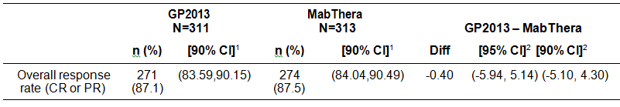
1 The 90% CIs of ORR are exact intervals derived using the Clopper-Pearson formula. 2 The 95% and 90% CIs for differences in proportions are based on normal approximation to the binomial distribution.
Comment: Both the 95% CI and the 90% CI for the difference in the ORR between the two treatment arms were enclosed entirely within the pre-specified equivalence margin of -12% to +12%. The study was adequately powered (90%) to show equivalence based on the pre-specified equivalence margin (-12, +12%) at a two, one-sided significance level of 2.5% (that is, 95% CI).The sponsor stated that it provided both the 95% CI and the 90% CI to assess equivalence as the EMEA prefers a 95% CI and the FDA prefers a 90% CI.

Sensitivity analysis of ORR in PPS excluding patients without BOR
The results for the sensitivity analysis of the ORR based on central blinded review of patients in the PPS excluding those with missing BOR, was consistent with the results of the primary analysis. Of the 624 patients in the PPS, 35 patients (5.6%) had missing/unknown best overall response (BOR) based on central blinded review (n = 19, GP2013 patients; n = 16, MabThera). The results of this sensitivity analysis are summarised below in Table 19.

Table 19: Study GP13-301 – Sensitivity efficacy analysis of ORR based on central blinded review, PPS excluding patients whose BOR was missing or unknown
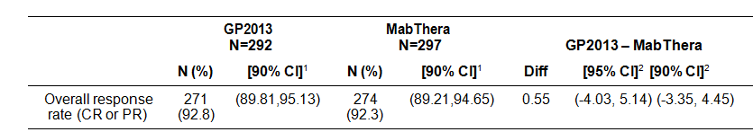
1 The 90% CIs of ORR are exact intervals derived using the Clopper-Pearson formula. 2 The 95% and 90% CIs for differences in proportions are based on normal approximation to the binomial distribution.

Analysis of ORR in the FAS
The analysis of the ORR based on the Modified Response Criteria for Malignant Lymphoma using central blinded review of the radiological response and liver/spleen enlargement assessments in the FAS was supportive of the primary analysis of the ORR in the PPS. The results for the ORR in the FAS are summarised below in Table 20.

Table20: Study GP13-301 – Efficacy analysis of ORR based on central blinded review, FAS
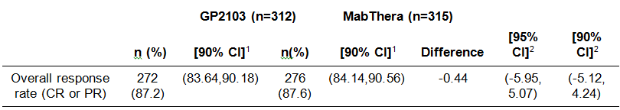
1 The 90% CIs of ORR are exact intervals derived using the Clopper-Pearson formula. 2 The 95% and 90% CIs for differences in proportions are based on normal approximation to the binomial distribution.

Analysis of the ORR by FLIPI score
The analysis of the ORR based on the Modified Response Criteria for Malignant Lymphoma using central blinded review of the radiological response and liver/spleen enlargement assessments by FLIPI subgroup in the PPS is summarised below in Table 21. The results in both FLIPI subgroups for the analyses in the FAS were consistent with those for the analyses in the PPS.

Table 21: Study GP13-301 – Efficacy analysis of ORR based on central blinded review, PPS
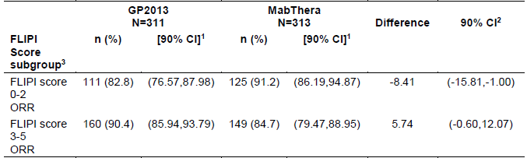
1 The 90% CIs are exact intervals derived using the Clopper-Pearson formula. 2 The 90% CI for differences in proportions is based on normal approximation to the binomial distribution. 3 The source for FLIPI score is the IVRS dataset.
Comment: The results showed that the 90% CI for the difference in the ORR between GP2013 and MabThera were not enclosed entirely within the equivalence margin of ± 12%. Based on the subgroup analysis results, the two arms were numerically different for ORR randomised by FLIPI strata, favouring MabThera (91.2%) compared with GP2013 (82.8%) in the subset of patients with a FLIPI score 0-2 (low-intermediate risk), and favouring GP2013 (90.4%) compared to MabThera (84.7%) in the subset of patients with a FLIPI score 3-5 (high risk). These results make interpretation of the subgroup analyses problematic.
The sponsor comments that the FLIPI score was developed as a prognostic factor of overall survival (Solal-Céligny et al., 2004) and, therefore, the differences observed in the analysis of ORR by FLIPI score may not be clinically relevant. However, the sponsor’s comments regarding the clinical relevance of the FLIPI prognostic score to the analysis of the ORR appears to have been made retrospectively following review of the results. The protocol specified stratification of randomised patients based on the FLIPI prognostic score made no mention of concerns that the score might not be clinically relevant to the analysis of the ORR. The protocol specified a subgroup analysis of the ORR based on the FLIPI score risk group, from which it can be reasonably inferred that the sponsor prospectively considered the FLIPI score to be a clinically relevant prognostic factor for the ORR. The FLIPI score is based on five demographic, clinical and laboratory parameters: age > 60 years; Ann Arbor stage III & IV; involvement of more than 4 lymph node groups; elevated LDH; and haemoglobin level < 12 g/dL. There is no obvious reason to assume that the individual parameters contributing to the FLIPI score are not clinically relevant to the analysis of ORR based on the FLIPI score.

Analysis of the ORR based on age
The analysis of the ORR based on the Modified Response Criteria for Malignant Lymphoma using central blinded review of the radiological response and liver/spleen enlargement assessments in patients aged < 60 years and ≥ 60 years was supportive of the primary analysis of the ORR in the PPS. The results for the subgroup analyses of the ORR based on age were similar in the FAS to those observed in the PPS. The results for the subgroup analyses of the ORR based on the PPS are summarised below in Table 22.

Table 22: Study GP13-301 Efficacy analysis of ORR based on central blinded review of tumour assessment based on age, PPS
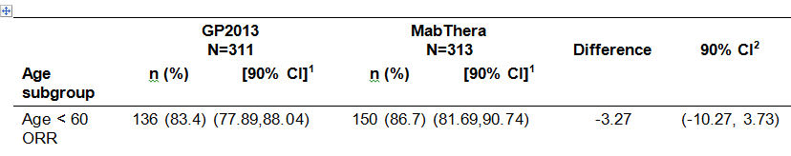
1 The 90% CIs are exact intervals derived using the Clopper-Pearson formula.

Logistic regression analysis of the ORR
For each patient, a response variable was derived specifying whether or not a patient achieved a best overall response of PR or CR, using central blinded review of tumour assessment, during the combination treatment phase based on the PPS. This binary response was used to fit a logistic regression analysis where the explanatory variables were FLIPI score and treatment arm. The fitted logistic regression was used to derive an estimate and associated 90% CI of the odds ratio of the treatment difference (GP2013 versus MabThera) adjusting for FLIPI score. The ORR in the GP2013 arm was 87.1% (271/311) and 87.5% (274/313) in the MabThera arm, with an odds ratio of 0.96 (90%CI: 0.65, 1.43). Based on the 90% CI, the odds ratio was not significant indicating that there was no difference between the two treatment arms.

Results for the secondary efficacy outcomes

Best overall response (BOR)
The proportion of patients with BOR based on central blinded review of tumour assessments (CR, PR, SD, PD) and their associated 90% CIs were generated for the combination treatment phase for each treatment arm. In general, the proportions of patients with BORs for the four categories were similar for the two treatment arms. The results for the BOR in the two treatment arms in the sensitivity analysis using the FAS were similar to the results of the analysis using the PPS. The results for the BOR in the two treatment arms in the PPS are summarised below in Table 23, and the results were similar in the FAS.

Table 23: Study GP13-301 Best overall response based on central blinded review, FAS
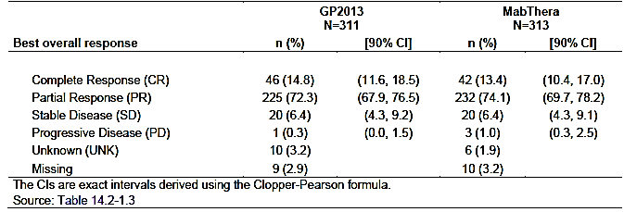

ORR based on investigator and central blinded review
The ORRs based on investigator assessment and central review were similar for both treatment arms. The results are summarised below in Table 24.

Table 24: Study GP13-301 Efficacy analysis of ORR based on investigator and central blinded review by treatment, PPS
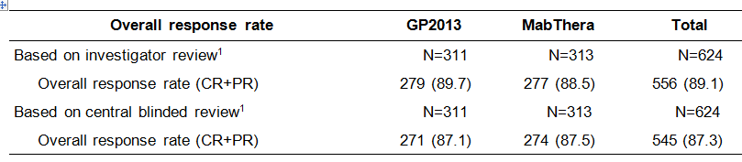
¹ Best Overall Response (BOR) for both central radiology assessment and investigator assessment are derived by Novartis.
High concordance was observed between the BORs based on investigator assessment and the central blinded review. For cases where the responses did not agree they generally differed by 1 level of response, for example, CR versus PR, PR versus SD. Approximately 5% of responders based on investigator assessments were considered non-responders based on central blinded review. Similarly, 4% of responders based on central blinded review were non-responders according to the investigator.

Progression Free Survival (PFS)
PFS was based on investigator assessment only. At the data cut-off date of 10 July 2015, 21.5% (n = 67) of patients in the GP2013 arm and 16.5% (n = 52) of patients the MabThera arm had progressed or died, with 62.5% (n = 195) and 71.7% (n = 226)) patients, respectively, censored without an event and having adequate follow-up. The median follow-up time for both treatment arms was 11.6 months. The median PFS had not yet been reached in either of the treatment arms and the hazard ratio (GP2013/MabThera) using the Cox’s regression model adjusted for stratification factor FLIPI risk group was 1.33 (90%CI: 0.98, 1.80) in the FAS. The analysis was not powered to assess PFS and the HR was presented for descriptive purposes only. The analysis of PFS using the Cox-regression model in the PPS (HR = 1.32 (90% CI: 0.97, 1.79)) gave similar results to the FAS. The results for the PFS in the FAS are summarised in below in Table 25.

Table 25: Study GP13-201 PFS based on investigator assessment, FAS
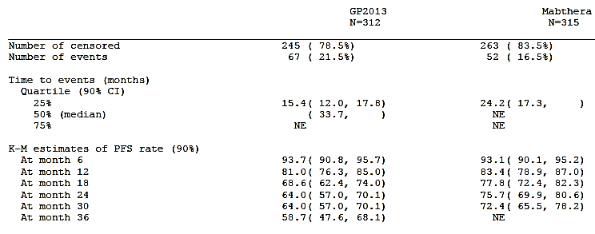
Notes: Quartiles are KM estimates. PFS probability estimates are obtained from the KM survival estimates for all treatment groups. Greenwood formula is used for CIs of KM estimates. N = Total number of patients included in the analysis.
The Kaplan-Meier plots of PFS by time in months are provided below in Figure 11. The Kaplan-Meier plots are almost identical until month 6, and then start diverging from month 6 onwards in favour of MabThera.
Figure 11: Study GP13-301 – Kaplan-Meier plots of PFS based on investigator assessment, FAS
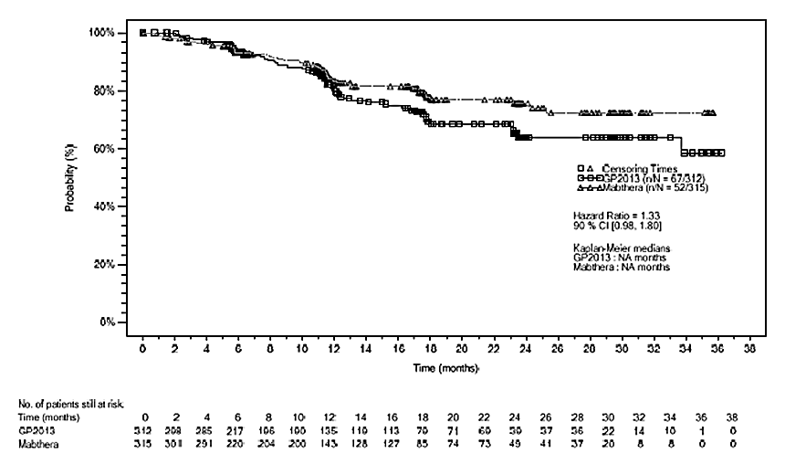
Comment: The PFS is considered to be too immature to make clinically meaningful conclusions about the comparability of the two treatment arms. The median PFS had not been reached in either treatment arm. The majority of patients in both treatment arms had been censored due to not experiencing a PFS event over 11.6 months of follow-up (that is, 62.5% (n = 195), GP2013; 71.7% (n = 226), MabThera). Other reasons for censoring in the two treatment arms (GP2013 versus MabThera) were initiation of new anticancer therapy (4.8% (n = 14) versus 2.5% (n = 8)) and adequate assessment no longer available (11.2% (n = 35) versus 9.2% (n = 29)). The sponsor commented that as the majority of patients in the study ‘were still ongoing after the Combination Treatment Phase … their eventual PFS outcomes in the study may still potentially alter the PFS curve of either treatment arm beyond 6 months. Hence the interim PFS results were deemed inconclusive and should be interpreted with caution’.

Overall survival (OS)
At the time of data cutoff (10 July 2015), the number of deaths in the FAS were similar between the two treatment arms (18 events in 312 patients in the GP2013 arm (5.8%) versus 17 events in 315 patients in the MabThera arm (5.4%)). Media OS had not been reached in either of the two treatment arms. The majority of patients had been censored as they were still alive at the time of the analysis (291 (93.3%), GP2013; 294 (93.3%), MabThera). Censoring due to lost to follow-up was reported in 3 (1.0%) patients in the GP2013 arm and 4 (1.3%) patients in the MabThera arm. In the analysis of OS using the Cox regression method adjusted for stratification factor FLIPI risk group the HR (GP2013/MabThera) was 1.03 (90% CI: 0.59, 1.80). The OS analysis was not powered to assess OS and the HR was presented for descriptive purposes only. The analysis of OS using the Cox-regression model in the PPS gave identical results to the analysis in the FAS for the HR and 90% CI. The K-M plots for the two treatment arms were superimposable.
Comment: The OS data are too immature to make meaningful conclusions about the comparability of the two treatment arms.

Evaluator commentary Study GP13-301
The study met its primary objective, which was to show equivalence between GP2013-CVP and MabThera-CVP in the ORR based on the Modified Response Criteria for Malignant Lymphoma using central blinded review of the radiological response and liver/spleen enlargement assessments in patients with FL (PPS). The ORR was 87.1% (271/311) in the GP2013 arm and 87.5% (274/313) in the MabThera arm, with the difference in the ORR between the two arms being -0.40% (95% CI: -5.94%, 5.14%). The 95% CI for the difference in ORR between the two arms was entirely enclosed within the pre-specified ORR equivalence margin of -12% to +12%.The study was adequately powered (90%) to show equivalence based on the pre-specified equivalence interval at a two, one-sided significance level of 2.5%. The results for the analysis in the FAS were consistent with the results in the PPS.
In a pre-specified subgroup analysis testing ORR equivalence between the two treatment arms in patients with FL stratified by baseline FLIPI score in the PPS, the 90% CI of the difference between the two treatment arms for both FLIPI subgroups (score 0-2; score 3-5)were not enclosed entirely within the equivalence margin of -12% to +12%. Of note, the ORR notably favoured the MabThera arm compared to the GP2013 arm in patients with a FLIPI score of 0-2 (91.2% versus 82.8%, PPS), while the ORR notably favoured the GP2013 arm compared to the MabThera arm in patients with a FLIPI sore of 3-5 (90.4% versus 84.7%, PPS).
The sponsor states comments that the FLIPI score was developed as a prognostic factor of overall survival and, therefore, the differences observed in the analysis of ORR by FLIPI score may not be clinically relevant. However, it is considered that there is no reason to assume that the FLIPI score is not a clinically relevant prognostic factor for all efficacy endpoints in patients with FL, given that it is based on scores relating to age > 60 years, Ann Arbor stage III & IV, involvement of more than 4 lymph node groups, elevated LDH, and haemoglobin level < 12 g/dL. Furthermore, it is reasonable to infer that the sponsor considered that the FLIPI score was an important clinically relevant prognostic factor, given that it was one of the factors used to stratify randomised patients. However, the inconsistent results in the two FLIPI subgroups make interpretation of the analysis problematic. No firm conclusions concerning the comparability of the two treatment arms can be made based on the results of the FLIPI subgroup analysis. However, the ORR was high in both the GP2013 and the MabThera arms suggesting that both products are effective in both subgroups
In the pre-specified subgroup analysis testing ORR equivalence between the two treatment arms stratified by baseline age, the 90% CI of the difference between the two treatment arms for both subgroups (< 60 years; ≥ 60 years) in both the PPS and the FAS was within the equivalence margin of -12% to +12%. The results in the subgroup analysis based on age support equivalence of the two treatment arms observed in the primary analysis.
The logistic regression analysis of the ORR based on central blinded review of the tumour assessment during the combination treatment phase in the PPS determined the odds ratio (CP2013/MabThera) to be 0.96 (90% CI: 0.65, 1.43).The results showed no statistically significant difference between the two treatment arms based on the 90% CI (that is, the interval include an odds ratio of 1). The results of the logistic regression based on BOR (yes or no) of CR or PR with explanatory variables of treatment and FLIPI score supported the primary analysis of the ORR showing equivalence of the two treatments.
The results of the BOR based on central review of tumour assessments (CR, PR, SD, PD) in the combination phase were comparable in the two treatment arms in both the PPS and the FAS. The results support the primary analysis of the ORR showing equivalence of the two treatments.
The preliminary results of PFS and OS are too immature to make clinically meaningful conclusions relating to the comparability of the two treatments. Therefore, neither the PFS nor the OS provide supportive data for the primary efficacy analysis of the ORR in the combination phase of the study. However, there was a trend toward better PFS in the MabThera arm compared to the GP2013.
Overall, it is considered that the primary analysis of the ORR established the equivalence of GP2013-CVP and MabThera-CVP based on central blinded review of tumour assessment in combination treatment phase of the study (8 x 21 day treatment cycles) in patients with FL. However, while the pre-specified subgroup analyses of the ORR based on age (< 60 years; ≥ 60 years) demonstrated equivalence of the two treatments, the pre-specified subgroup analyses of the ORR based on FLIPI prognostic scores (0-2; 3-5) failed to demonstrate equivalence of the two treatments. The logistic regression analysis of the ORR demonstrated no statistically significant difference between the two treatment arms in BOR of CR or PR, based on modelling with explanatory variables of treatment and FLIPI score.
The preliminary data for PFS and OS are too immature to conclude that there are no clinically meaningful differences between the two treatments for these two parameters. Consequently, in the absence of confirmatory comparable PFS and OS data it cannot be concluded that GP2013 and MabThera are therapeutically equivalent.

Supportive Efficacy Study (Study GP13-201) – Rheumatoid Arthritis

Background
The supportive efficacy study was Study GP13-201 (Part I). This Phase II, randomised, double-blind, controlled study was designed to evaluate the PK, PD, safety and efficacy of GP2013 and rituximab in patients with rheumatoid arthritis refractory or intolerant to standard DMARDs and one or up to three anti-TNF therapies. This study had been reviewed in Section 4.3.1 of this CER. Therefore, in this section of the CER the focus is on the supportive efficacy data in patients with active rheumatoid arthritis (RA).

Objectives
The primary objective of the study was to assess the PK bioequivalence of GP2013-MTX and MabThera-MTX in patients with advanced RA based on comparison of the AUC_{0-inf} of the two treatment regimens.
The secondary objectives included the assessment of the non-inferiority of GP2013 to MabThera with respect to change from baseline in Disease Activity Score (DAS28) at Week 24. The mean difference and 95% CI for the mean difference between GP2013 and MabThera were calculated. The upper 95% CI had to be less than or equal to the non-inferiority margin of 0.6 in order to claim non-inferiority.

Patients
The study included male and non-pregnant, non-lactating female patients aged ≥ 18 years with a ≥ 6 months diagnosis of RA based on the ACR 1987 criteria. Patients had to be seropositive for RF and/or ACPA, with an inadequate response or intolerance to non-biologic DMARDs and one or up to three TNF antagonists. In addition, patients were required to have been receiving MTX (7.5 mg/week to a maximum of 25 mg/week) for at least 4 months, with a stable dose for 4 weeks prior to randomisation. Patients were excluded from the study if they had functional status Class IV classified according to the ACR 1991 revised criteria, had levels of serum IgG, IgM and IgA below the lower limit of normal at Visit 1 and/or Visit 2, or had systemic manifestations of RA (with the exception of Sjögren’s syndrome).

Methods
The study was 52 weeks in duration, with responders at Week 24 (that is, decrease in DAS28 derived either with ESR or CRP of > 1.2 from baseline) being eligible for re-treatment with study medication between Week 24 and Week 52, at the discretion of the investigator, if they had at least residual active disease (that is, DAS28 ≥ 2.6).
On Day 1 of the study patients were randomised (1:1) to receive the first course of study medication consisting of a 1000 mg IV infusion of GP2013 or MabThera administered on two separate occasions, two weeks apart on Day 1 and Day 15. Patients selected for re-treatment at or after Week 24 were administered another course of GP2013 or MabThera at a dose of 1000 mg IV on two separate occasions 2 weeks apart. Efficacy and safety data to evaluate the similarity of GP2013 and MabThera were assessed on a regular basis until Week 52. For patients receiving a second course of study medication, in addition to the regular follow-up visits up to Week 52 a final safety and efficacy assessment was undertaken 26 weeks after the first infusion of the second course of study drug. Non-responders at Week 24 underwent a final assessment and were withdrawn from the study, and those not treated with a prohibited anti-rheumatic therapy were assessed on a regular basis until Week 52. The final analysis of Part I of the study was performed when the data from the last visit of the last patient in Part 1 was available.
Concomitant therapy with permitted anti-rheumatic medications included MTX, folic acid, chloroquine, hydroxychloroquine, sulfasalazine, NSAIDs/COX-2 inhibitors, paracetamol/ acetaminophen/low strength opioids and oral corticosteroids. For patients being treated with leflunomide a washout procedure with cholestyramine before randomisation was to be considered before being randomised to study treatment.

Efficacy assessments – RA activity

Disease activity score including 28 joint count (DAS28)
DAS28 is a measure of disease activity in RA. The score is calculated by a formula which includes the number of tender and swollen joints (out of a total of 28), the ESR or the CRP and the patient’s global assessment of disease activity (visual analog scale (VAS) of 100 mm ranging from very good to very bad). For this study, DAS28 (CRP) was prioritised over DAS28 (ESR). A DAS28 score above 5.1 means high disease activity, a DAS28 score > 3.2 to ≤ 5.1 means moderate disease activity, a DAS28 score of ≥ 2.6 to ≤ 3.2 indicates low disease activity. Remission is achieved by a DAS28 score lower than 2.6.

European League Against Rheumatism (EULAR) response criteria using the DAS28
The EULAR response criteria using the DAS28 are defined below in Table 26.

Table 26: Study GP13-201 – Definition of EULAR response criteria using DAS28
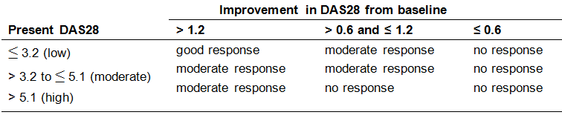

Clinical response according to American College of Rheumatology (ACR)
A patient is considered a responder according to ACR20 criteria if all of the following criteria are met:
- at least 20% improvement from baseline in tender joint count, using the 68-joint count,
- at least 20% improvement from baseline in swollen joint count, using the 66-joint count,
- and at least 20% improvement from baseline in at least 3 of the following 5 measures:
- Patient’s assessment of RA pain (VAS 100 mm)
- Patient’s global assessment of disease activity (VAS 100 mm)
- Physician’s global assessment of disease activity (VAS 100 mm)
- Patient self-assessed disability (HAQ-DI)
- Acute phase reactant (CRP or ESR)
ACR50 and ACR70 are defined similarly to ACR20, replacing ‘20% improvement’ with ‘50% improvement’ and ‘70% improvement’, respectively. ACR-N gives the percentage of improvement from baseline an individual patient has experienced (for example, a patient with an ACR-N of 38 means that the patient has achieved at least a 38% improvement).

Tender 68-joint count and swollen 66-joint count
Joint counts were to be performed at all visits, except for Visits 3 (Day 1) to 7 (Day 18), by the physician or by well trained personnel. Whenever possible, the same evaluator was to perform these assessments at all visits. In addition the joint assessment was to be performed at the same time of the day, preferably in the morning.
The following joints were to be assessed for tenderness and swelling:
- The 68 joints to be examined for tenderness were: temporomandibular (2), sternoclavicular (2), acromioclavicular (2), shoulder (2), elbow (2), wrist (2), metacarpophalangeal (10), thumb interphalangeal (2), distal interphalangeal (8), proximal interphalangeal (8), hip (2), knee (2), ankle mortise (2), ankle tarsus (2), metatarsophalangeal (10), interphalangeal of great toe (2) and proximal/distal interphalangeal of the toes (8).
- The 66 joints to be examined for swelling were the same as those examined for tenderness, except for hip joints (2) which were not included.
For the calculation of DAS28, Simplified Disease Activity Index (SDAI) and Clinical Disease Activity Index (CDAI), only a subset of 28 joints was assessed for tenderness and swelling, which were as follows metacarpophalangeal (10), thumb interphalangeal (2), hand proximal interphalangeal (8), wrist (2), elbow (2), shoulders (2), and knees (2).

Simplified disease activity index (SDAI) and clinical disease activity index (CDAI)
The SDAI and CDAI are measures of disease activity in RA. The scores are calculated by numerical summation of the number of tender and swollen joints (using the 28-joint count) and the patient’s and physician’s global assessment of disease activity. For the calculation of SDAI, CRP is then added, which is not done for the CDAI. For the SDAI and the CDAI, the cut-off points for different disease activity states are defined below in Table 27.

Table 27: Study GP13-201 – Definition of disease activity according to SDAI and CDAI
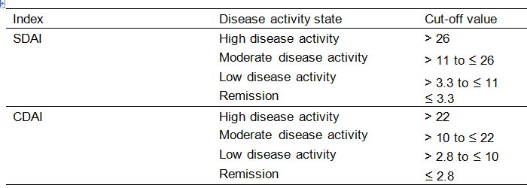

Patient assessment of RA pain
The patient’s assessment of pain was assessed using a 100 mm VAS ranging from ‘no pain’ to ‘unbearable pain’.

Patient’s global and physician’s global assessment of disease activity
Both the patient’s and the physician’s global assessment of disease activity were measured using 100 mm VAS scales ranging from ‘very good’ to ‘very poor’. To enhance objectivity, the physician was not aware of the specific patient’s global assessment of disease activity, when performing his/her own assessment on that patient.

Rheumatoid factor (RF) and Anti-CCP antibodies
RF and anti-CCP antibody assessments were performed as a measure of RA serological status.

C-reactive protein (CRP) and Erythrocyte sedimentation rate (ESR)
Blood for these assessments was obtained and assessed to identify the presence of inflammation, to determine its severity, and to monitor response to treatment.

Analysis of the efficacy variables

Key efficacy variable – change from baseline in DAS28 (CRP) at Week 24
All the efficacy variables in this study were secondary study objectives. The sponsor stated that continuous endpoints such as DAS28 are more sensitive than ACR20 for the purpose of ruling out clinically meaningful differences between GP2013 and the reference rituximab product. Therefore, mean change from baseline in DAS28 (calculated by using CRP only) at Week 24 using a non-inferiority assessment (0.6 margin; 95% CI two-sided) in the PP analysis set was pre-specified by the sponsor as being the key secondary endpoint. The sponsor stated that the non-inferiority approach was adequate to compare the two treatment arms due to the fact that the clinical dose of rituximab is at the dose-response plateau where no further gain in efficacy was expected (Emery et al., 2006), so there is a lack of plausibility for superiority.
A mixed model for repeated measures of DAS28 (CRP) was used, including treatment, time, the interaction between time (visits) and treatment as categorical variables, and baseline DAS28 (CRP) as a continuous variable. The covariance structure was specified as autoregressive. Mean change from baseline at Week 24 was estimated from the model. A two-sided 95% CI for the mean difference between GP2013 and MabThera was derived and compared to the pre-specified non-inferiority margin of 0.6. The upper bound of the confidence limit was to be equal to or less than 0.6 in order to conclude non-inferiority. No imputation was performed for missing components of the DAS28 score or the DAS28 score itself.
The sponsor stated that the pre-specified non-inferiority margin of 0.6 is statistically justified by the results of the Randomized Evaluation of Long-Term Efficacy of Rituximab in RA (REFLEX) trial (Cohen et al, 2006) providing a 95% confidence interval for the mean difference between rituximab/MTX and the MTX alone of (-1.74;-1.25). The margin of 0.6 was determined by retaining more than 50% of the reference treatment effect which is considered clinically acceptable. The REFLEX trial resulted in a mean change from baseline in DAS28 at Week 24 of 1.9 (SD 1.6) for rituximab/MTX. Since this Study GP13-201 trial is nearly identical to the REFLEX trial with regards to the inclusion criteria, exclusion criteria and applied treatments, a similar result can be expected for rituximab/MTX. In order to demonstrate non-inferiority of GP2013/MTX to MabThera/MTX using a margin of 0.6 the mean change from baseline in DAS28 (CRP) at 24 weeks would need to be at least 1.3 for GP2013/MTX, assuming a mean change of 1.9 for MabThera/MTX. This would demonstrate a three-fold increase in efficacy over putative control MTX alone, which provided a mean change from baseline of 0.4 in the REFLEX trial. In addition, a mean change from baseline of 1.3 exceeds the cut-off of 1.2 required by EULAR criteria for moderate to good improvement on patient level regardless of baseline DAS28 score and ‘no response’ is defined by EULAR criteria as change from baseline being < 0.6.
If no expected differences in mean change from baseline at Week 24 in DAS28 (CRP) scores between the two treatment arms and a common SD of 1.25 are assumed, the study had a power of 78% for the change from baseline at Week 24 using 66 patients per group for all pairwise treatment comparisons (132 evaluable patients).
Comment: In this study, the sponsor used a non-inferiority method to compare the two treatment arms. The sponsor selected non-inferiority rather than a superiority method to compare the two treatment arms as a superiority method was not expected to be sensitive enough to detect efficacy differences. However, it is not clear why the sponsor did not undertake an equivalence study rather than a non-inferiority study. The TGA approved EMA guidelines relating to the assessment of similar monoclonal antibodies states that efficacy studies comparing the biosimilar and reference products should normally be assessed using equivalence trials. The sponsor is requested to comment on the reasons it undertook a non-inferiority study rather than an equivalence study to compare GP2013 and MabThera in patients with RA in Study GP13-201.

Other secondary efficacy variables
For all continuous variables of efficacy (such as DAS28 (CRP), DAS28 (ESR), ACR-N, SDAI, CDAI) a negative change from baseline represented an improvement in RA disease activity. All secondary efficacy variables were analysed using the PP analysis set, which constituted the most conservative approach for a non-inferiority evaluation. No imputation was performed for missing components of the efficacy variables or the efficacy variables themselves. Both ACR-N and DAS28 variables were computed using both CRP and ESR, however, CRP derived efficacy variables were prioritised over ESR in the statistical analysis. No imputation was performed for missing components of the efficacy variables. Last observation carried forward as the imputation method was removed from the protocol via an amendment as this method was deemed inappropriate for the RA indication and in addition very few missing data were expected.

Averaged change from baseline in DAS28 (CRP) between Week 4 and 24
Averaged change from baseline in DAS28 (CRP) between Week 4 and 24 (standardised AUEC approach) was estimated from the same mixed model used to analyse the key secondary endpoint of change from baseline in DAS28 (CRP) at Week 24. The averaged change between Week 4 and 24 was estimated by a weighted mean across visits with weights matching the standardised AUEC (that is, 0.5× (4, 8, 8, 12, and 8)/20 corresponding to Weeks 4, 8, 12, 16, 24, respectively). The weights were derived using the standard formula from the trapezoidal rule across the visits. A two-sided 95% CI was derived and the upper CI should be equal to or less than 0.6 in order to conclude non-inferiority.

Change from baseline in DAS28 by visit
The mixed model for repeated measures described was used to analyse the change from baseline in DAS28 (CRP) and DAS28 (ESR) at each visit (Week 4, 8, 12, 16, 24, 38, and 52). Mean changes from baseline and two-sided 95% CIs for the mean difference between GP2013 and MabThera at each visit were derived.

Difference in ACR-N scores at Week 24
A two-sided 95% CI for the difference in ACR-N (CRP) and ACR-N (ESR) scores at Week 24 and 52 were calculated based on the pooled standard error and t-test statistic. This analysis was repeated based on the FAS to serve as a sensitivity analysis to ensure the robustness of the results.

ACR20 response analysis
Patients who fulfilled the ACR20 (CRP) criteria and the ACR20 (ESR) criteria at Week 24 were considered responders. A two-sided 95% CI for the difference in both the ACR20 (CRP) and ACR20 (ESR) response rates at Week 24 was estimated based on the pooled standard error and chi-square statistic. The lower bound of the confidence limit was compared to a margin of -0.15 (-15.0%) and must be greater than -0.15 (-15.0%) in order to conclude non-inferiority. This analysis was repeated based on the FAS to serve as a sensitivity analysis to ensure the robustness of the results.
A meta-analysis based on two RA studies (Emery et al., 2006 and Cohen et al., 2006) using a standard random-effects model for ACR20 (CRP) at Week 24 provided an estimated difference of 31% (95% CI: 25%, 38%) between rituximab and MTX. The 15% non-inferiority limit is justified as being approximately half of this effect size and is below the lower limit of the 95% CI. An exploratory logistic regression analysis on ACR20 (CRP) using all available data between Week 4 and 24 was performed. In addition, an exploratory analysis was conducted to explore the treatment effect of GP2013 and MabThera, as measured by ACR20 (CRP), over time using a longitudinal model based averaging approach.

Patient disposition
A total of 302 patients were screened in Part I of Study GP13-201, and 173 (57.3%) patients were randomised to either GP2013 (n = 86) or MabThera (n = 87). The screening failure rate was 42.7%. The majority of randomised patients (82.1%, n = 142) completed the study up to 52 weeks, with 84.8% (n = 73) of patients in the GP2013 arm completing up to 52 weeks compared to 79.3% (n = 69) of patients in the MabThera arm. The majority of patients completing up to 52 weeks of treatment received re-treatment with GP2013 or MabThera. The most common reasons for premature discontinuation were AEs (n = 8, 4.6% overall), unsatisfactory therapeutic effect (n = 8, 4.6% overall) and withdrawal of consent (n = 6, 3.5% overall). There were no marked differences between the GP2013 and MabThera treatment arms with respect to the reasons for premature discontinuation from the study. Patient disposition is summarised in below in Table 28.

Table 28: Study GP13-201 – Subject disposition by treatment, FAS
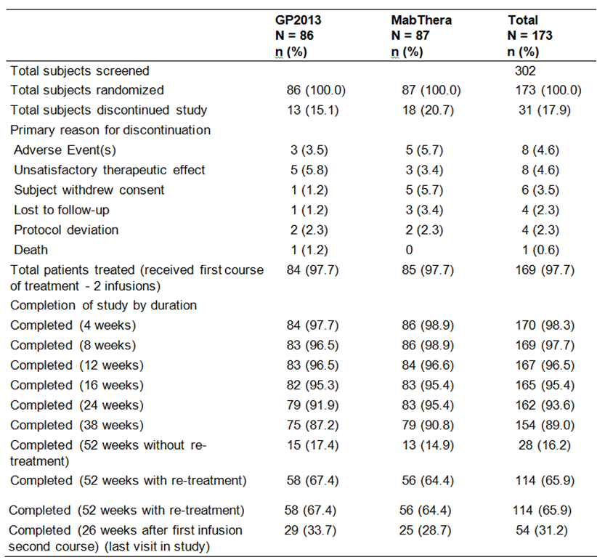

Results for the key secondary efficacy variables
The key secondary efficacy endpoint was change from baseline in DAS28 (CRP) at Week 24. This efficacy endpoint was analysed in the PP set as it constitutes the most conservative approach for non-inferiority evaluation. Non-inferiority was to be concluded if the upper limit of the 95% CI for the mean difference between GP2013 and MabThera was less than or equal to the non-inferiority margin of 0.6. The least square (LS) mean difference between GP2013 and MabThera in change from baseline in DAS28 (CRP) at Week 24 was 0.07. The upper limit of the corresponding 95% CI was 0.462, which is below the pre-defined non-inferiority margin of 0.6. Therefore, the criterion for non-inferiority was met. The results are summarised below in Table 29.

Table 29: Study GP13-201 Change from baseline in DAS28 (CRP) at Week 24, PPS
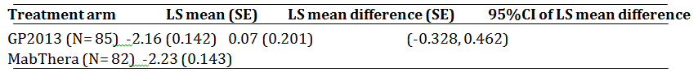
1. LS means, standard errors and 95% CI were estimated by a repeated measures mixed model with treatment, time and treatment*time interaction term as categorical variables and baseline DAS28 as a continuous variable. 2. A negative change from baseline represents an improvement in RA assessment. 3. To conclude non-inferiority the upper 95% CI should be less than or equal to 0.6 4. No imputation of missing values was performed.
Comment: The results for the analysis of the key secondary efficacy variable demonstrated that GP2013 was non-inferior to MabThera, with the upper limit of the 95% CI for the LS mean difference between the two treatment arms being less than the pre-defined non-inferiority margin. The results suggest that GP2013 is no less efficacious than MabThera, based on the change from baseline in DAS28 (CRP) at Week 24. The results for the LS mean (SE) change from baseline in DAS28 (CRP) at Week 24 were comparable for the two treatment arms. Of note, if an equivalence margin of -0.6 to +0.6 is defined for the difference between the two treatment arms for change from baseline in DAS28 at Week 24 in the PPS, then GP2103 and MabThera can be considered to be therapeutically equivalent as the 95% CI of the LS mean difference is enclosed entirely within the equivalence margin.

Results for other secondary efficacy variables

Average change from baseline in DAS28 (CRP) between Weeks 4 and 24
The average LS mean (SE) change from baseline in DAS (CRP) between Weeks 4 and 24 in the PP analysis set was -1.83 (0.109) in the GP2013 (n = 85) arm and -2.16 (0.110) in the MabThera (n = 82) arm, with the LS mean (SE) difference being 0.33 (0.155) and the 95% CI being 0.029, 0.639.
Comment: The criterion for non-inferiority based on this efficacy variable was not met as the upper limit of the 95% CI of the LS mean difference of 0.639 was greater than the pre-specified non-inferiority margin of 0.6. The average LS mean reduction from baseline between weeks 4 and 24 was greater in the MabThera arm than in the GP2013, suggesting a trend towards greater improvement in the MabThera arm compared to the GP2013 arm.

DAS28 by visit
The arithmetic mean (SD) of DAS28 (CRP) over 52 weeks in the PP analysis set is shown below in Figure 12. Mean DAS28 (CRP) was numerically lower in the MabThera arm compared to the GP2013 arm until Week 24. After Week 24, a reverse trend in the two treatment arms was observed up to Week 52. However, both treatment arms demonstrated a large degree of variation in DAS28 at all time-points as shown by the wide SD intervals for the mean values. The results observed for this DAS28 parameter in the CRP were consistent with the results observed in the ESR.
Figure 12: Study GP13-201 – Arithmetic mean (SD) of DAS28 (CRP) by treatment over 52 weeks, PPS

Change from baseline in DAS28 across study drug batches
Study drug from different batches for both GP2013 and MabThera were administered during the study. A post hoc analysis of arithmetic mean (SD) of change from baseline in DAS28 (CRP) by treatment batches over 24 weeks in the PP analysis set was undertaken by the sponsor and the results are summarised below in Figure 13. Numerical differences in mean change from baseline DAS28 (CRP) profiles between batches can be observed for both GP2013 and MabThera. However, the mean change from baseline in DAS28 profiles for both GP2013 batches lie mainly within the range of mean profiles for different MabThera batches. For all batches, it should be noted there is a large degree of variability in the mean change from baseline in DAS28 (CRP) profiles as depicted by the wide SDs.
Figure 13: Study GP13-201 – Arithmetic mean (SD) of change from baseline in DAS28 (CRP) by treatment and batches, PPS
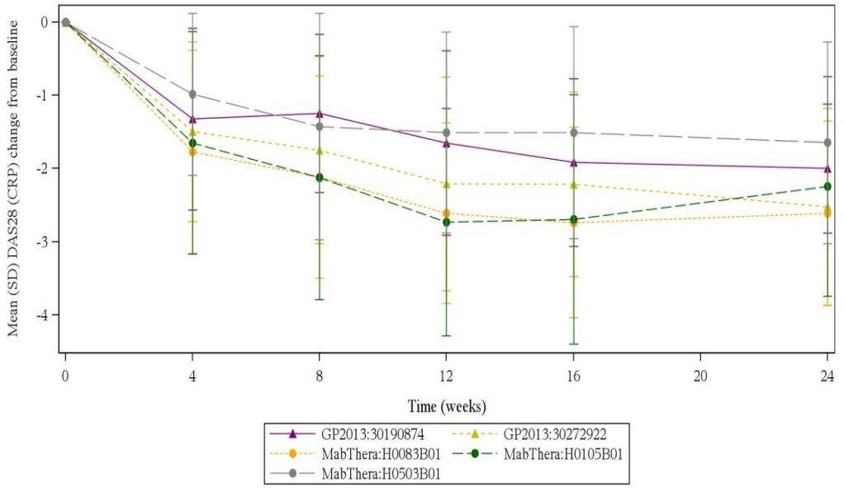
Note: In the 152 patients in the PPS receiving study drug from the same batch at Visits 3 and 6 (that is, both infusions of the first visit course), 77 received GP2013 (40 (51.9%) Batch 30190874; 37 (48.1%) Batch 302729220) and 75 received MabThera (35 (46.7%) Batch H0083B01); 22 (29.3%) Batch H0105B01; 18 (24.4%) Batch H0503B01).

ACR20 (CRP) response at Week 24
A two-sided 95% CI for the difference in the ACR20 (CRP) response rates at Week 24 was estimated. The lower bound of the CI was compared to a non-inferiority margin of -15.0% and had to be greater than this margin to conclude non-inferiority. The ACR20 (CRP) response rates at Week 24 in the PP analysis set were similar for the GP2013 and the MabThera treatment arms (71.8% (56/78) versus 72.4% (55/76), respectively). The difference (SE) in the response rates was -0.57% (7.23) and the 95% CI for the difference was -14.74 to 13.60.The difference between the two treatment arms met the pre-defined non-inferiority margin as the lower limit of the 95% CI was greater than -15.0%. The ACR20 (CRP) response by treatment over 52 weeks is summarised below in Figure 14. The results of the analysis this ACR20 response parameter in the PPS was consistent with the results in the FAS.
Figure 14: Study GP13-201- ACR20 (CRP) responders by treatment, PP analysis set
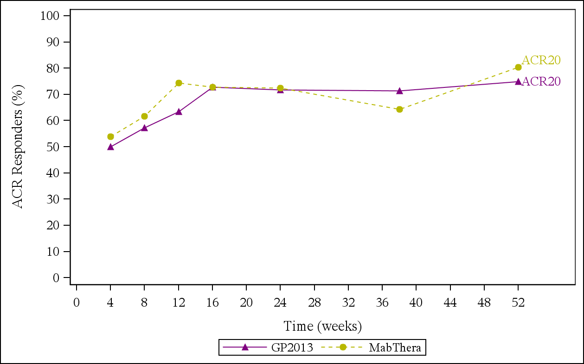

Averaged ACR20 (CRP) responders between Weeks 4 and 24
An exploratory analysis of ACR20 (CRP) using all available data between Week 4 and 24 was performed using a logistic RM mixed model in the PPS. The averaged ACR20 (CRP) responder estimate between Week 4 and 24 in the PP analysis set was similar for the GP2013 (n = 85) and MabThera (n = 82) arms (64.9% and 68.7%, respectively), with the averaged response rate difference between the two arms being -3.86 % (95% CI: -12.5%, 4.614%). The lower limit of the 95% CI for the difference in response rates was -12.5%, which was above the pre-defined non-inferiority margin of -15.0% supporting non-inferiority of GP2013 to MabThera.

Averaged ACR20 (CRP) responders at Week 24 – non-linear mixed effects model
An exploratory analysis was conducted to explore the treatment effect of GP2013 and MabThera, as measured by ACR20 (CRP), over time using a longitudinal model based averaging approach. The averaged ACR20 (CRP) response rates at Week 24 in the PP analysis set were similar for the GP2013 (n = 85) and MabThera (n = 82) arms (68.6% and 72.5%, respectively), with the averaged response rate difference between the two treatment arms being -3.92 % (95% CI: -12.81, 4.60%). The lower limit of the 95% CI for the difference in response rates was -12.81%, which was above the pre-defined non-inferiority margin of -15.0% supporting the non-inferiority of GP2013 to MabThera.

Difference in ACR-N scores at Week 24
A two-sided 95% CI for the difference in ACR-N (CRP) scores at Week 24 was calculated based on the pooled standard error and t-test statistic. The difference between mean ACR-N (CRP) scores at Week 24 for the two treatment arms in the PP analysis set was clinically not meaningful and statistically not significant (that is, -36.58, GP2013 versus -35.66, MabThera; Δ = -0.92 (SE 6.44), 95% CI (-13.65, 11.81)). The two treatment arms also showed comparable mean ACR-N (CRP) scores at Week 52 in the PP analysis set (GP2013 (n = 64) -40.9 versus MabThera (n = 61) -36.9; Δ = -3.97 (SE 7.91), 95% CI (-19.63, 11.68)).

ACR20, ACR50, ACR70 response analyses
The ACR20 response rate in the GP2013 treatment arm was similar to the response rate observed in the MabThera arm throughout the 52 weeks. However, numerical differences favouring the MabThera arm compared to the GP2013 arm were observed for the ACR50 and ACR70 response rates, which were more pronounced at Weeks 4, 8, 12, and 16.

EULAR response based on DAS28 (CRP)
The proportion of patients with a moderate response was comparable in the two treatments arms, with the exception of Week 12 (response was lower in the GP2013 arm (74.1%) compared to the MabThera arm (84.4%)) and Week 38 (response was higher in the GP2013 (83.8%) arm compared to the MabThera arm (73.9%)).

Disease activity according to DAS28 (CRP)
High disease activity at baseline was reported more frequently in the MabThera arm than in the GP2013 arm (79.3% versus 71.4%), but high disease activity was reported more frequently in the GP2013 arm than in the MabThera arm at Weeks 4, 8, 12 and 16. At Week 52, 4 (6.6%) patients in the GP2013 arm had high disease activity compared to 7 (11.5%) patients in the MabThera arm, and 20 (32.8%) patients in the GP2013 arm and 15 (24.6%) patients in the MabThera arm had achieved remission by Week 52.

Disease activity according to SDAI/CDAI
The disease activity pattern assessed by these two instruments was generally consistent with the disease activity according to DAS28.

Quality of life
The median absolute values in the HAQ-DI at baseline were similarly high for GP2013 and MabThera (2.0 versus 2.0, respectively), indicating a study population with severe disability. The median (%) change from baseline in the HAQ-DI showed improvements for both treatment arms, but there were numerical differences between the two arms with a trend towards greater improvement in the MabThera arm than in the GP2013 arm.
The median absolute values in the FACIT-Fatigue scale at baseline were similar for GP2013 and MabThera (29 versus 28, respectively). The median change from baseline in the FACIT-Fatigue score showed improvements for both treatment arms, but there were numerical differences between the two treatments with a trend towards greater improvement in the MabThera arm than in the GP2013 arm.

Rheumatoid factor (RF)
RF values and the proportion of patients in the PP analysis set with a positive RF were lower at Week 24 and Week 52 in comparison to baseline, in both treatment arms, with no meaningful differences between the GP2013 and MabThera arms. At baseline, the proportions of patients with a positive RF were 94.1% (n = 80) for GP2013 and 91.5% (n = 75) for MabThera. At Week 24, the proportions of patients with a positive RF were 64.7% (n = 55) for GP2013 and 78.0% (n = 64) for MabThera. At Week 52, the proportions of patients with a positive RF were 58.8% (n = 50) for GP2013 and 56.1% (n = 46) for MabThera.

Anti-CCP antibodies (ACPA)
Anti-CCP antibodies and the proportion of patients in the PP analysis set with positive anti-CCP antibodies were lower at Week 24 and Week 52 in comparison to baseline, in both treatment groups, with no meaningful differences between the GP2013 and MabThera arms. At baseline, the proportions of patients with positive anti-CCP antibodies were 90.6% (n = 77) for GP2013 and 84.1% (n = 69) for MabThera. At Week 24, the proportions were 74.1% (n = 63) for GP2013 and 78.0% (n = 64) for MabThera. At Week 52, the proportions were 69.4% (n = 59) for GP2013 and 62.2% (n = 51) for MabThera.

Evaluator commentary Study GP13-201 supportive efficacy study
Supportive efficacy data for comparability of the two formulations were provided in patients with advanced RA in the Phase II Study GP13-201. In this study, the assessment of efficacy in patients with RA was a secondary objective. The study met its key secondary efficacy endpoint, which was to show non-inferiority of change from baseline in DAS28 (CRP) at Week 24. The LS mean change from baseline in DAS28 (CRP) at Week 24 was similar for the GP2013 and the MabThera arms (-2.16 and -2.23, respectively) in the PPS, and the LS mean difference between the two treatment arms was 0.07 (95% CI: -0.328, 0.462). The upper 95% CI of 0.462 was below the pre-defined non-inferiority margin of 0.6. The arithmetic mean change from baseline in DAS28 (CRP) from baseline over the 52 weeks of the study was similar in the two treatment arms, with marked inter-subject variability in the parameter being observed in both treatment arms.
The criterion for non-inferiority of averaged change from baseline in DAS28 (CRP) between Week 4 and 24 in the PPS was not met; with the upper 95% CI for the LS mean difference between the two treatment arms of 0.639 being higher than the pre-specified non-inferiority margin of 0.6. The criterion for non-inferiority of ACR20 (CRP) response at Week 24 in the PPS was met, with the lower 95% CI for the difference between the two treatment arms of -14.74% being greater than the pre-specified non-inferiority margin of -15.0%. The criteria for non-inferiority of averaged change from baseline in ACR20 (CRP) using a logistic repeated measures mixed model and a non-linear mixed effect longitudinal model in the PPS were met, with the lower 95% CIs for the difference between the two treatment arms ( -12.5% and -12.8%, respectively) being greater than the pre-specified non-inferiority margin of -15%.
The study included a number of other secondary efficacy variables which were summarised descriptively. There were some numerical differences between the two treatment arms in some of these variables. However, the observed differences are considered not to be clinically meaningful.
The proportion of patients in each treatment arm (GP2013 versus MabThera, respective) receiving the first course of treatment was comparable (first course/first infusion (100% versus 100%); first course/second infusion (97.7% versus 97.7%)), as was the proportion of patients in each treatment arm (GP2013 versus MabThera, respective) receiving the second course of treatment (second course/first infusion (68.6% versus 69.0%); second course/second infusion (68.6%% versus 66.7%)). The arithmetic mean DAS (28) was numerically lower in the MabThera arm compared to the GP2013 arm until Week 24 in the PP analysis set, with a reverse trend being observed from Week 24 though to Week 52. However, the difference in mean DAS28 (CRP) between the treatment arms was not clinically meaningful at any time point from baseline though to Week 52. The results observed for DAS28 (CRP) through to Week 52 were consistent with the results observed for DAS28 (ESR). Other endpoints for which there were no clinically meaningful differences between the two treatment arms from baseline through Week 52 in the PP analysis set were ACR20, 50, 70 (CRP) responder rates, mean ACR-N (CRP) scores, EULAR response based on DAS28 (CRP), and disease activity according to CDAI/SDAI.
There were no comparative data in the study comparing radiologically assessed structural joint damage in the two treatment arms. Data from the clinical trials section of the approved MabThera PI indicates that MabThera in combination with MTX slowed the progression structural damage compared to placebo in combination with MTX at Years 1 and 2 years of treatment.
Overall, based on the totality of the RA data it is considered that Study GP13-201 satisfactorily demonstrated that the efficacy of the two formulations was comparable, with observed numerical differences between the two formulations being not clinically meaningful.

Other indications

Overview
The sponsor is seeking approval of GP2013 for all TGA approved indications for the Australian reference product MabThera. The sponsor provided a scientific justification for extrapolating the submitted comparability data for GP2013 and MabThera for the FL and RA indications to all other approved MabThera indications.
The sponsor notes that the common factor of all approved indications for MabThera is malfunctioning of CD20 expressing B cells, either in the form of an autoimmune disease or cancer. Therefore, the foundation for the sponsor’s scientific justification for extrapolation across indications is based on showing that the pharmacological activity of the medicine is essentially the same in all indications proposed for approval. The modes of action of rituximab relevant to all proposed indications include ADCC, CDC and apoptosis resulting in depletion of CD20+ B cells. The sponsor refers to its extensive physicochemical, biological and nonclinical database, including potency assays and in vitro assays covering the functionality of GP2013, supplemented by relevant clinical data ‘(proving) the biosimilarity of GP2013 to MabThera in a totality-of-data approach’.
The sponsor’s justification for extrapolating the submitted comparability data for GP2013 and MabThera across all approved indications for MabThera was provided in the Summary of Clinical Efficacy (Module 2.7.3). The sponsor states that the scientific justification is in accordance with the EMA (TGA adopted) guidelines on similar biological medicinal products (EMEA/CHMP/437/04 Rev 1) and similar biological medicinal products containing biotechnology-derived proteins as active substance (EMEA/CHMP/BMWP/42832/2005 Rev1). The relevant sections of the guidelines state that ‘(i)f biosimilarity has been demonstrated in one indication, extrapolation to other indications of the reference product could be acceptable with appropriate scientific justification’ (EMEA/CHMP/437/04 Rev 1), and ‘(e)xtrapolation should be considered in the light of the totality of data, i.e. quality, non-clinical and clinical data’ (EMA/CHMP/BMWP/403543/2010). The sponsor also notes that the EMA (TGA adopted) guideline on similar biological medicinal products containing monoclonal antibodies (EMA/CHMP/BMWP/403543/2010) states that, ‘if a reference mAb is licensed both as an immunomodulator and as an anticancer antibody, the scientific justification as regards extrapolation between the two (or more) indications is more challenging’.

Justification for extrapolation across indications based on comparability of clinical data

Pharmacokinetic (PK) comparability across indications
The sponsor states that extrapolation of PK equivalence can be justified based on the structural and functional (CD20 binding) similarity between GP2013 and MabThera, as well as the scientific understanding of how the structure and function of monoclonal antibodies affect their PK. The clearance of rituximab occurs through two pathways for all indications, namely, the non-specific IgG clearance pathways and the target mediated drug disposition (TMDD) pathway.
The non-specific IgG clearance pathways are reported to be mediated by binding to the neonatal Fc receptor (FcRn), a major histocompatibility complex class-1-related receptor (salvage pathway) or binding to various Fc receptors (FcγRs) expressed by various phagocytic cells (effector function pathway) (Tabrizi et al., 2006). However, expression profiles and variability in distribution of FcγRs on phagocytic and other cell types are reported to be heterogeneous and complex and are further compounded by genetic polymorphisms observed among different individuals. Nevertheless, the sponsor states that ‘compelling evidence (has been provided showing) that GP2013 and MabThera are similar in structure and that they bind to FcRn and various FcγRs with similar affinity, (indicating that) their clearance by … non-specific IgG clearance pathways is expected to be comparable regardless of patient populations’.
The TMDD pathway for rituximab is reported to be mediated by binding to the CD20 receptor on target cells. It is known that the extent of TMDD in various populations is correlated to the CD20+ B cell levels (or tumour load in haematologic oncology indications), which differ within and between populations (for example, CD20+ B cell NHLs << CLL), and it has been reported that in vitro target binding is predictive of in vivo drug elimination via TMDD for antibody drugs (Luu et al., 2012). Therefore, similar binding properties in vitro should predict similar extent of TMDD in vivo. Consequently, the sponsor considers that, despite expected differences in CD20+ B cell levels and extent of TMDD for different indications, the same clearance mechanisms, comparable in vitro binding properties, and comparable B cell depletion levels provide sufficient evidence that the clearance of GP2013 can be expected to be comparable to that of MabThera for all indications.
The sponsor states that the clinical PK results for GP2013 from the pivotal PK/PD clinical study in patients with RA (Study GP13-201) demonstrated PK bioequivalence of GP2013 to MabThera in terms of the extent of exposure (AUC). This was further supported by similar PK profiles of GP2013 and MabThera in terms of rate and extent of exposure being demonstrated in patients with FL (Study GP13-301). Therefore, the PK results proved similarity between GP2013 and MabThera from two selected sensitive indications in immunology and oncology and further support the extrapolation of indications for RA and FL to other approved indications for MabThera.
Comment: The assessment of the structural and functional comparability of FcRn and FcγRs for GP2013 and MabThera is a matter for the Module 3 evaluator. If structural and functional comparability of FcRn and FcγRs for GP2013 and MabThera are established then it can be reasonably inferred that there is unlikely to be a clinically meaningful difference between the two formulations in non-specific IgG clearance pathways. The assessment of in vitro target binding being predictive of in vivo drug clearance via TMDD for monoclonal antibodies exhibiting non-linear PK clearance is a matter for the Module 4 evaluator. The sponsor concluded that, based on the mechanism of rituximab clearance and the structural and functional similarity between GP2013 and MabThera, ‘it is expected that the PK equivalence can be extrapolated to other indications (in addition to FL and RA) in which the CD20+ B cells play a role in the disposition of rituximab’. This is considered to be a reasonable conclusion, provided that the Module 3 and 4 evaluators confirm the data on which the conclusion is based.
The PK results referred to by the sponsor from the pivotal PK Study GP13-201 in patients with RA and the supportive PK Study GP13-301 in patients with RA have been evaluated in this CER. It is considered that the pivotal and supportive PK data have satisfactorily established the bioequivalence of GP2013 and MabThera (EU approved). Therefore, the comparable PK data for GP2013 and MabThera in patients with RA and FL support extrapolation from these two indications to all other indications being sought for GP2013 and approved for MabThera.

Pharmacodynamic (PD) comparability across indications

CD20 antigen as target
CD20 antigen is reported to present on the surface of B-lymphocytes from the pro-B cell phase until the plasma cell stage, but is not present on B cell precursors, mature plasma cells, or other non-lymphoid normal tissues (Anderson et al., 1984; Reff et al., 1994; Boross and Leusen, 2012). It is reported to be expressed exclusively on the surface of B-lymphocytes with an extracellular loop (approximately 43 amino acids) containing the binding site of rituximab (Ernst et al., 2005). CD20 is reported not circulate in the plasma as free protein that could competitively inhibit mAb binding to target cells and is not down-regulated after antibody binding (Grillo-Lopez et al., 2000).
The CD20 antigen is reported to be not only expressed on normal B cells in patients with RA but also on malignant B cells in the majority of low- and high-grade B cell lymphomas (Ginaldi et al., 1998) in greater than 90% of patients (Horvat et al., 2010). CD20 expression on benign and malignant B cells is reported to be quantitatively heterogeneous, with B cell NHLs being CD20+ in over 90% of cases (Anderson et al., 1984), while in CLL CD20+ is expressed in nearly all cases (Tembhare et al., 2013). A higher level of CD20 is reported to be expressed on FL cells compared to B cell CLL cells (Bellosillo et al., 2001; Golay et al 2001., Almasri et al., 1992) and a corresponding lower rituximab response rate in CLL compared to FL has been observed, at least for previously treated disease (McLaughlin et al., 1998). However, diffuse large B cell lymphoma (DLBCL) cells are reported to have similar or even higher CD20 expression than FL cells, with expression being in a similar range to expression on physiologic CD20+ B cells (Olejniczak et al., 2006)
The physiological ligand and the exact biological function of CD20 are currently unknown (Boross and Leusen, 2012). However, the sponsor referred to a potential role for CD20 in humoral immunity, which might play a supporting role in treatment of autoimmune diseases with B cell depleting anti-CD20 monoclonal antibodies but not in the treatment of oncological diseases. In one experiment, CD20-deficient mice were reported to have shown to elicit reduced humoral immunity to complex T-cell dependent antigens in vivo (Morsy et al., 2013), while patients completely lacking CD20 expression were reported to have persistent hypogammaglobulinaemia, diminished T-cell dependent response, and decreased number of circulating class-switched memory B cells in vivo (Kuijpers et al., 2010).

Modes of action of rituximab
Rituximab is a Type I IgG and can activate the classical pathway of the complement system inducing CDC, ADCC and programmed cell death (PCD) (Boross and Leusen, 2012). Rituximab has several components that can contribute to its modes of action. The Fab domain of rituximab binds to the CD20 antigen on B-lymphocytes and the Fc domain of rituximab recruits effector functions capable of mediating target cell lysis. Elicited mechanisms of effector-mediated cell lysis include CDC resulting from C1q binding, and ADCC mediated by one or more of the Fcγ receptors on the surface of immune effector cells such as granulocytes, macrophages and natural killer (NK) cells. Additionally, binding of rituximab to CD20 has been shown to inhibit cell proliferation, and cell death via apoptosis (Demidem et al., 1997). Due to its ability to induce B cell depletion, rituximab is used in the treatment of lymphoma and leukaemia to deplete malignant B cells and to reduce the number of benign B cells alleviating inflammation in RA, GPA and MPA.
The pro-apoptotic signals generated by direct engagement of rituximab with CD20 appear to be insufficient to induce target B cell killing in vitro, including malignant cell lines. However, the contribution of pro-apoptotic signals to the clinical efficacy of rituximab in oncology indications appears to influence the pre-disposition of cancer cells to the anti-tumour effects of combinatorial chemotherapy (Chow et al., 2002). No such synergistic effects have been reported for MTX used as a co-medication in RA, or cyclophosphamide used as co-medication in the vasculitic syndromes. In turn, CDC is probably less relevant in haematological settings in comparison to autoimmune diseases (RA, GPA and MPA) because complement resistant factors are often expressed by tumour cells (Natsume et al., 2009; Klepfish et al., 2009). In contrast to the reported differences between CLL and B cell NHLs in regards to ADCC, or between haematological and immunological diseases in regards to apoptosis and CDC, immunological diseases (RA, GPA and MPA) are likely to recruit all three modes of action to a similar extent due to B cell involvement in the pathogenesis of these disorders being similar.
The sponsor states that the principle of B cell depletion as a basis for treatment with rituximab is the same across all indications, which justifies the proposed extrapolation of the modes of action targeting the CD20 antigen on normal or malignant B-lymphoid cells across the approved indications of MabThera. Overall, the data demonstrate comparability of GP2013 with the reference product MabThera for CD20 binding, C1q binding, apoptosis, CDC and ADCC. However, the relative contribution of each component of the modes of action to B cell killing is unknown (Boross and Leusen, 2012). The main components contributing to rituximab’s modes of action are presented schematically in Figure 15, below, and an overview of the observed ranges of the corresponding analytical in vitro assays is presented below in Table 30.
Figure 15: Elements contributing to the modes of action of rituximab binding to the CD20 target on a cell surface

Consideration of modes of action in the justification of extrapolation of indications for GP2013 from FL to other non-investigated malignant conditions
As discussed above, the efficacy of rituximab in B cell malignancies include elimination of malignant CD20+ B cells via multiple mechanisms, including direct effects such as CDC and ADCC, and indirect effects such as structural changes, apoptosis, and sensitisation of malignant cells to chemotherapy.

Non-Hodgkin’s Lymphoma (NHL)
In Study GP13-301, GP2013 was compared to MabThera in combination with chemotherapy (CVP) in previously untreated patients with non-Hodgkin’s FL (stage III/IV). This study is considered to be directly relevant to the approved MabThera indication of ‘CD20, previously untreated, Stage III/IV follicular B cell non-Hodgkin’s lymphoma’.
TGA approved FL indications for MabThera for which no directly relevant comparability data were submitted are: (i) ‘CD20 positive, relapsed or refractory low grade or follicular, B cell NHL’; and (ii) ‘CD20+, diffuse large B cell NHL, in combination with chemotherapy’. However, the sponsor considers that the therapeutic effectiveness of MabThera for all approved CD20+ NHL FL indications rely on the same basic mode of action leading to depletion of the malignant B cells. Therefore, the sponsor concludes that, based on the totality-of-data at a clinical level in previously untreated patients with FL showing comparability of GP2013 with MabThera, it is considered scientifically justified to extrapolate to all FL indications.
Extrapolation of the efficacy data from FL to diffuse large B cell NHL is based on the same characteristics of the diseases with respect to the proliferation of malignant B-lymphocytes expressing relative high CD20+ levels, with CD20+ depletion activity of rituximab being understood to be mainly driven by ADCC. The two other components of the proposed modes of action of rituximab (CDC and induction of apoptosis) seem to contribute to a smaller extent to the activity of the medicine in the treatment of both CD20+ FL and CD20+ DLBCL (Lim et al., 2010).

Chronic lymphocytic leukaemia (CLL)
MabThera is approved for ‘the treatment of patients with CD20 positive chronic lymphocytic leukaemia in combination with chemotherapy’. CLL is a chronic lymphoproliferative disease characterised by proliferation and accumulation of predominantly mature CD20 expressing monoclonal B cells. No studies were submitted in patients with CD20 positive CLL comparing the efficacy and safety of GP2013 and MabThera in combination with chemotherapy for the treatment of this condition
The sponsor states that the contribution of individual components of the mode of action of rituximab to the efficacy of the medicine in CLL is more controversial than in NHL. Some reports have suggested that CDC has a major contribution to the activity of rituximab in CLL, whereas mainly ADCC seems to contribute to the efficacy of the medicine in FL and DLBCL (Golay et al., 2000; Klepfish et al., 2009). Other studies have reported that complement activation may reduce rather than increase rituximab activity in vivo, suggesting that CDC might not be the potential key mode of action in CLL (Wang et al., 2008; Wang et al., 2009). The potential importance of ADCC in CLL is suggested by the clinically superior efficacy of type II anti-CD20 monoclonal antibodies, such as obinutuzumab, which have stronger ADCC effects but weaker CDC effects compared to type I anti-CD20 monoclonal antibodies, such as rituximab (Smolej, 2015).
The sponsor states that, irrespective of which components of the modes of action contribute to the efficacy of rituximab in CLL, it has been shown that CD20 binding, ADCC, CDC and apoptosis are comparable between GP2013 and MabThera. Therefore, a comparable CLL-cell depleting effect can be expected for GP2013 and MabThera, which supports the scientific justification to extrapolate the indications of GP2013 from the FL study (Study GP13-301) to CLL.

Consideration of modes of action in the justification of extrapolation of indications for GP2013 from RA to other non-investigated immunological conditions
MabThera in combination with MTX has been approved by the TGA for the treatment of adult patients with severe, active RA who have had an inadequate response or intolerance to at least one TNF inhibitor therapy. The Phase II Study GP13-201 in patients with RA, refractory or intolerant to standard DMARDs and one or up to three anti-TNF therapies is considered to be relevant to the approved RA indication. However, it is noted that Study GP13-201 included patients who had an inadequate response or intolerance to non-biologic DMARDs and 1-3 anti-TNF therapies. However, if there are no clinically significant differences between GP2013 and MabThera for the treatment of patients with RA who had an inadequate response or intolerance to non-biologic DMARDs and 1-3 anti-TNF therapies then it is considered reasonable to infer that there are unlikely to be clinically significant differences between the two rituximab products for patients who have had an inadequate response or intolerance to at least one TNF inhibitor therapy. This is particularly the case given that Study GP13-201 showed that GP2013 and MabThera were PK bioequivalent in patients with RA.
The other approved immunological indications for MabThera include the drug being administered in combination with glucocorticoids for the induction of remission in patients with severely active GPA and MPA. The sponsor states that RA, GPA and MPA indications are likely to recruit all of the component modes of action of rituximab to a similar extent, given that B cell involvement in the pathogenesis of these disorders is similar (for example, auto-antigen presentation, B cell/T-cell crosstalk, secretion of pro-inflammatory cytokines, auto-antibody production). Therefore, the sponsor considers that it is scientifically justified to extrapolate the indications of GP2013 from RA to the other two immunological indications approved by the TGA for MabThera (that is, GPA, MPA).
Comment: Treatment of both the GPA and MPA indications involve the administration of rituximab in combination with glucocorticoids. There were no clinical studies in the submission comparing GP2013 and MabThera with glucocorticoids for the treatment of GPA or MPA. However, if the totality of the submitted data satisfactorily establishes the comparability of GP2013 and MabThera, then it is considered reasonable to infer that there is unlikely to be any clinically significant PK or PD differences between the two formulations when administered with glucocorticoids. Furthermore, GP2013 and MabThera showed comparable efficacy in the combination treatment phase of Study GP13-301 in patients with FL when administered with a chemotherapy regimen containing prednisone. Study 13-301 in patients with FL also showed similar PK and PD outcomes when GP2013 and MabThera were combined with chemotherapy regimen containing prednisone.

Evaluator’s commentary on other indications
The sponsor based its scientific justification for extrapolating the proposed indications of GP2013 from the data in RA and FL to all other TGA approved indications of MabThera on the totality-of-data submitted to establish the comparability of GP2013 and MabThera. The Module 3 and Module 4 aspects of the submitted comparability exercise will be evaluated by the relevant biochemistry and nonclinical evaluators. The submitted clinical PK, PD and efficacy data investigating the comparability of GP2013 and MabThera for the treatment of FL and RA are promising and suggest that there might be no clinically meaningful differences between the two formulations for all proposed indications. However, it is considered that confirmation of clinical comparability should await the final efficacy results of Study GP13-301 relating to PFS and OS. The data for these two important time-to-event endpoints are too immature to demonstrate comparability of GP2013 and MabThera for the treatment of FL.

Analyses performed across trials: pooled and meta analyses
No pooled data or meta analyses were submitted.

Evaluator’s conclusions on clinical efficacy

Pivotal Phase III Study GP13-301 Follicular Lymphoma (FL)
Pivotal efficacy data for comparability of the two formulations were provided in patients with untreated stage III/IV non-Hodgkin’s FL in the Phase III Study GP13-301. The study met its primary objective, which was to show equivalence between GP2013-CVP and MabThera-CVP based on the ORR assessed by the Modified Response Criteria for Malignant Lymphoma using central blinded review of the radiological response and liver/spleen enlargement assessments in patients with FL (PPS). The ORR was 87.1% (271/311) in the GP2013 arm and 87.5% (274/313) in the MabThera arm, with the difference between the two arms being -0.40% (95% CI: -5.94%, 5.14%). The 95% CI for the difference in ORR between the two arms was entirely enclosed within the pre-specified ORR equivalence margin of -12% to +12%.The study was adequately powered (90%) to show equivalence based on the pre-specified equivalence margin of 12% to +12% at a two one-sided significance level of 2.5%. The results for the analysis in the FAS were consistent with the results in the PPS.
In a pre-specified subgroup analysis testing ORR equivalence between the two treatment arms in patients with FL stratified by baseline FLIPI score (PPS), the 90% CI of the difference between the two treatment arms for both FLIPI subgroups (scores 0-2; scores 3-5) were not enclosed entirely within the equivalence margin of -12% to +12%. Of note, the ORR notably favoured the MabThera arm compared to the GP2013 arm in patients with a FLIPI score of 0-2 (91.2% versus 82.8%, respectively), while the ORR notably favoured the GP2013 arm compared to the MabThera arm in patients with a FLIPI sore of 3-5 (90.4% versus 84.7%, respectively). The results of this subgroup analysis do not support the primary analysis, as the 90% CI of the difference between the two treatment arms was not enclosed entirely within the equivalence margin of -12 to +12% for either of the two subgroups. However, the inconsistent results in the two FLIPI subgroups make interpretation of the analysis problematic. No firm conclusions concerning the comparability of the two treatment arms can be made based on the results of the FLIPI subgroup analysis. However, the ORR was high in both the GP2013 and the MabThera arms suggesting that both products are effective in both subgroups
The sponsor states comments that the FLIPI score was developed as a prognostic factor for overall survival and, therefore, the difference between the two treatment arms observed in the analysis of ORR by FLIPI score may not be clinically relevant. However, it is considered that there is no reason to assume that the FLIPI score is not a relevant prognostic factor for all efficacy endpoints in patients with FL, given that it is based on scores relating to age > 60 years, Ann Arbor stage III & IV, involvement of more than 4 lymph node groups, elevated LDH, and haemoglobin level < 12 g/dL. Furthermore, it is reasonable to infer that the sponsor considered that the FLIPI score was an important prognostic factor for ORR in the pivotal study, given that it was one of the factors used to stratify randomised patients and the pre-defined primary efficacy endpoint was the ORR.
In the pre-specified subgroup analysis assessing ORR equivalence between the two treatment arms stratified by baseline age (PPS), the 90% CI of the difference between the two treatment arms for both subgroups (< 60 years; ≥ 60 years) was within the equivalence margin of -12% to +12%. The results of the subgroup analysis in the FAS were consistent with the results in the PPS. The results in the subgroup analysis based on age support equivalence of the two treatment arms observed in the primary analysis.
The logistic regression analysis of the ORR based on central blinded review of the tumour assessment during the combination treatment phase (PPS) determined the odds ratio (CP2013/MabThera) to be 0.96 (90% CI: 0.65, 1.43).The results showed no statistically significant difference between the two treatment arms based on the 90% CI (that is, the interval includes an odds ratio of 1). The results of the logistic regression with explanatory variables of treatment and FLIPI score support the primary analysis of the ORR showing equivalence of the two treatments.
The results of the BOR based on central review of tumour assessments (CR, PR, SD, PD) in the combination phase were comparable in the two treatment arms in both the PPS and the FAS. The results support the primary analysis of the ORR showing equivalence of the two treatments.
Overall, it is considered that the primary analysis of the ORR established the equivalence of GP2013-CVP and MabThera-CVP based on central blinded review of tumour assessment in the combination treatment phase of the study (8 x 21 day treatment cycles) in patients with FL. However, while the pre-specified subgroup analyses of the ORR based on age (< 60 years; ≥ 60 years) demonstrated equivalence of the two treatments, the pre-specified subgroup analyses of the ORR based on FLIPI prognostic scores (0-2; 3-5) failed to demonstrate equivalence of the two treatments. The logistic regression analysis of the ORR demonstrated no statistically significant difference between the two treatment arms in BOR of CR or PR, based on modelling with explanatory variables of treatment and FLIPI score.
The preliminary data for PFS and OS are too immature to conclude comparability of the two treatments for the two parameters. Therefore, it is considered that although the primary analysis of the ORR demonstrated equivalence of the two treatments, the absence of confirmatory comparability data for PFS and OS preclude GP013 and MabThera being declared therapeutically equivalent. It is suggested that this matter be re-visited when the final results for PFS and OS from Study GP13-301 become available.

Supportive Phase III Study GP13-201 Rheumatoid Arthritis (RA)
Supportive efficacy data for comparability of the two formulations were provided in patients with advanced RA in the Phase II Study GP13-201. In this study, the assessment of efficacy in patients with RA was a secondary objective. The study met its key efficacy objective, which was to show non-inferiority of change from baseline in DAS28 (CRP) at Week 24 in the PPS. The LS mean change from baseline in DAS28 (CRP) at Week 24 in the PPS was similar for the GP2013 and the MabThera arms (-2.16 and -2.23, respectively), and the LS mean difference between the two treatment arms was 0.07 (95% CI: -0.328, 0.462). The upper 95% CI of 0.462 was below the pre-defined non-inferiority margin of 0.6. The arithmetic mean change from baseline in DAS28 (CRP) from baseline over the 52 weeks of the study was similar in the two treatment arms, with marked inter-subject variability in the parameter being observed in both treatment arms.
The criterion for non-inferiority of averaged change from baseline in DAS28 (CRP) between Week 4 and 24 in the PPS was not met, with the upper 95% CI for the LS mean difference between the two treatment arms of 0.639 being marginally higher than the pre-specified non-inferiority margin of 0.6. The criterion for non-inferiority of ACR20 (CRP) response at Week 24 in the PPS was met, with the lower 95% CI for the difference between the two treatment arms of -14.74% being greater than the pre-specified non-inferiority margin of -15.0%. The criteria for non-inferiority of averaged change from baseline in ACR20 (CRP) using a logistic repeated measures mixed model and a non-linear mixed effect longitudinal model in the PPS were met, with the respective lower 95% CIs for the difference between the two treatment arms for the two analyses of -12.5% and -12.8% being greater than the pre-specified non-inferiority margin of -15%.
The study included a number of other secondary efficacy variables which were summarised descriptively. There were some numerical differences between the two treatment arms in some of these variables. However, the observed differences are considered not to be clinically meaningful
Overall, based on the totality of the RA data it is considered that Study GP13-201 satisfactorily demonstrated that the efficacy of the two formulations were comparable with the differences between the two formulations being not clinically meaningful.

Switching data
The were no data in the submission comparing efficacy in patients with either RA or FL initially treated with MabThera and switched to GP2013 to the efficacy of patients continuing with MabThera. The submission indicates that there is an ongoing safety study (Study GP13-302) in patients with RA designed to identify potential risks (general safety and immunogenicity) associated with transitioning from the originator product (Rituxan (US approved) or MabThera (EU approved)) to GP2013 compared to continuous treatment with the originator product. The main safety and immunogenicity analysis in this study will take place at Week 12 with an additional follow-up analysis at Week 24. No efficacy analyses are planned for this study. The study is planned to randomise approximately 100 patients in the USA and EU.

Other indications
The sponsor submitted a scientific justification for extrapolating the data for GP2013 and MabThera in patients with RA and FL to all other TGA approved indications of MabThera. This justification was based on the totality-of-data submitted to establish the comparability of GP2013 and MabThera. The results of the comparability exercise based on the clinical data (PK, PD, efficacy (RA, FL)) are considered to be promising and suggest that GP2013 and MabThera are therapeutically for all proposed indications. However, it is considered that confirmation of clinical comparability of the two products should await the final results of Study GP13-301 relating to PFS and OS. The submitted data for these two important time-to-event endpoints are too immature to demonstrate comparability of GP2013 and MabThera for the treatment of FL.

Clinical safety

Studies providing evaluable safety data
The three studies providing evaluable safety data were:
- the pivotal Phase II PK/PD study in patients with active RA (Study GP13-201);
- the pivotal Phase III clinical efficacy and safety study in patients with FL (Study GP13-301); and
- the Phase I study in Japanese patients with indolent B cell NHL (Study GP13-101).
The safety analysis sets defined for each of the three studies with evaluable safety data are summarised below in Table 31.

Table 31: Safety analysis sets defined for safety analysis of three studies with evaluable safety data
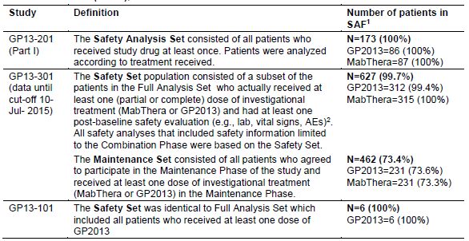
The submission included no pooled safety analysis of the data from the three studies with evaluable safety data. The sponsor stated that a pooled analysis was not performed due to diverse indications, comorbid conditions and concomitant medications across the three studies. The absence of a pooled safety analysis is considered to be acceptable for the reasons provided by the sponsor.
The approach to evaluation of the safety data in the CER has been to separately evaluate the comparative safety data (GP2013 versus MabThera) for Studies Study GP13-201 and Study GP13-301. The safety data for Study GP13-101 included information from 6 Japanese patients treated with GP2013. The safety data from this study have been examined and raise no concerns. Therefore, the safety data in the 6 Japanese patients from Study GP13-101 treated with GP2013 are not included in the review of safety presented below.

Exposure

Study GP13-201 – RA
In Study GP13-201, patients received a dose of rituximab (GP2013 or MabThera) 1000 mg IV per infusion, for up to four infusions over the 52 weeks of the study. Dose adjustment per infusion was not permitted. The number of patients and doses administered were comparable for the two treatment arms for both the first and second infusions in the first treatment course. An almost identical proportion of patients in both treatment arms received a second treatment course after Week 24. Re-treatment could be administered any time between Week 24 and Week 52. The number of infusions and the dosage for the two treatment arms are summarised below in Table 32.

Table 32: Study GP13-201 – Study drug administration and compliance in patients with RA, safety analysis set
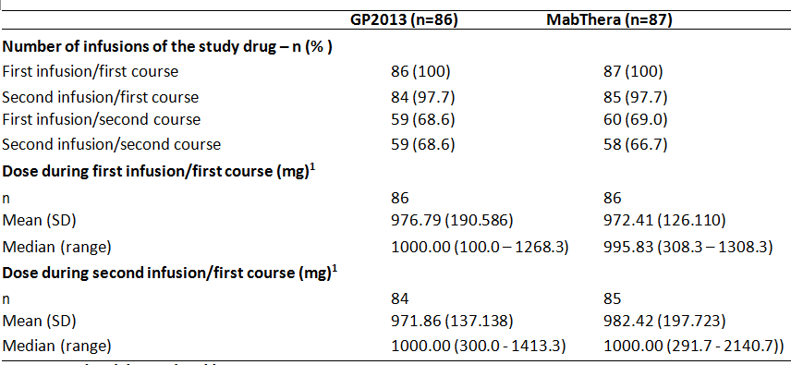
¹In the clinical study report, the dose is indicated as ‘Volume of first or second infusion/first course’. The administered dose was determined using the volume of infusion administered to the patients and the required concentration of the infusion solution (2 mg/mL). Doses higher than 1000 mg resulted from a higher infusion volume, not of an actual overdosing, that is, the study drug was diluted in more than 500 mL resulting in an actual concentration of less than 2 mg/mL. By default, however, the required concentration of 2 mg/mL was used for the calculation of the administered dose resulting in a dose higher than 100 mg.
A post hoc analysis of the timing of the second treatment course showed that patients in both treatment arms were on average re-treated at the same time-point in both treatment arms (that is, mean ± SD timing of administration of the first infusion of the second treatment course after randomisation was 232.83 ± 62.093 days for GP2013 and 241.53 ± 64.386 days for MabThera). Mean durations for the first and second infusions were comparable for the two treatment groups.
In case of severe reactions, the infusion had to be interrupted and was restarted after resolution of all symptoms. In the total population, more patients experienced infusion interruptions, related to medical and non-medical reasons during the first infusion than in the second infusion (that is, 26 of 173 patients (15.0%) versus 12 of 169 patients (7.1%), respectively). This pattern was also observed in both treatment arms.
The majority of interruptions of the first infusion were due to medical reasons (for example, allergic-type reactions such as itching, rash, pruritus, headache, throat irritation, or respiratory effects in 14 of 26 patients (53.8%) in total), while interruptions of the second infusion were mainly due to non-medical reasons (for example, technical problems with the infusion pump, patient comfort break in 8 of 12 patients (66.7%) in total).

Study GP13-301 – FL
GP2013 or MabThera were given on Day 1 of each cycle at a dose of 375 mg/m². No dose reductions were permitted for GP2013 or MabThera. For patients who did not tolerate the protocol-specified dosing schedule, dose adjustments were permitted for CVP chemotherapy in order to allow the patient to continue the study treatment.
The exposure parameters were comparable for GP2013 and MabThera in both the combination phase and the maintenance phase (see Table 33, below). In the combination phase the differences in the exposure parameters between the two treatment arms was < 1%, which is unlikely to have introduced biases in the interpretation of the efficacy and safety data. In the maintenance phase, cumulative dose and actual dose intensity were higher in the MabThera arm than in the GP2013 arm due to a lower rate of premature treatment discontinuations (16.9%, MabThera versus 23.4%, GP2013). The exposure parameters for vincristine, cyclophosphamide and prednisone were similar for the two treatment arms in the combination phase of the study.

Table 33: Study GP13-301 – Exposure to GP2013 and MabThera in the two phases of the study, safety set
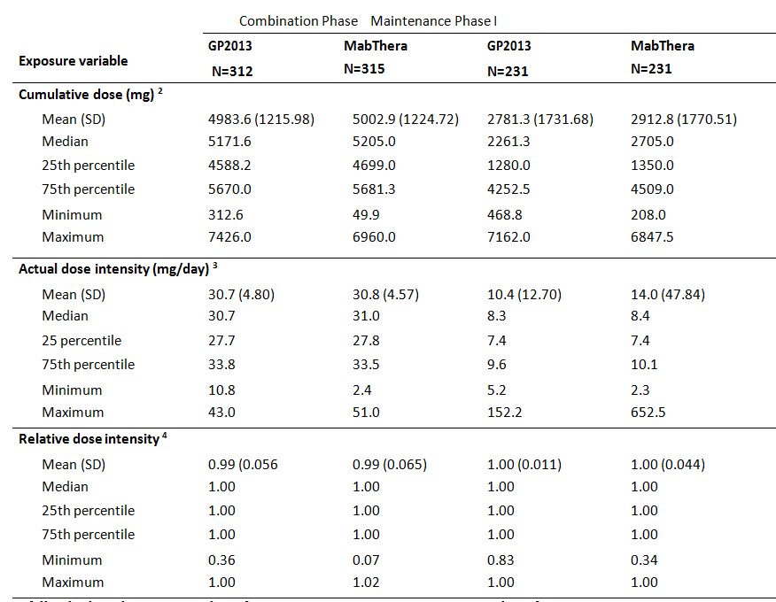

FL=follicular lymphoma; n = number of patients in respective category; N = number of patients in a treatment group; SD=standard deviation. 1 Maintenance Phase is still ongoing; data until the cut-off date 10 July 2015 is included. 2 Cumulative dose=total dose received. 3 Dose intensity=cumulative dose / duration of exposure. 4 Relative dose intensity= actual dose intensity / planned dose intensity.
The number of treatment cycles of GP2013 and MabThera was similar in the two treatment arms in both the combination and maintenance phases of the study. The number of patients entering the maintenance phase as of the cut-off date of 15 July 2015 was identical in both treatment arms. Exposure in the combination and maintenance treatment phases is summarised below in Table 34.

Table 34: Study GP13-301 – Number of investigational cycles with GP2013 and MabThera in the two phases of the study, safety set
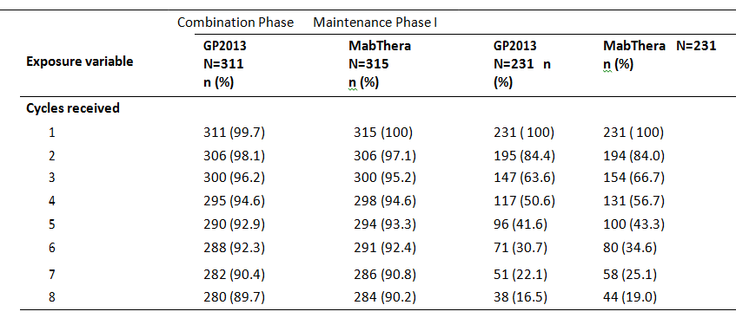
FL=follicular lymphoma; n = number of patients in respective category; N = number of patients in a treatment group. A patient is counted in each cycle where he/she has received the specified medication. 1 = The Maintenance Phase is still ongoing; data until the cut-off date 10-Jul-2015 is included. For Italian patients maintenance cycle is every 2 months (Cycles 1-12), however, no Italian patient had reached cycles 9-12 at cut-off date. For all other patients maintenance cycle is every 3 months (Cycles 1-8).
The mean and median duration of exposure in the combination treatment phase was the same in both treatment arms (162 days (mean); 168 days (median)). In the combination phase, the number of patients with at least one dose change or dose delay/ interruption was similar in the GP2013 and MabThera arms (n = 131 (42.0%) versus n = 141 (44.8%), respectively). The number of patients with at least one dose delay was 128 (41.0%) in the GP2013 arm and 130 (41.0%) in the MabThera arm, while the number of patients with at least one dose change was notably lower in both arms (16 (5.1%) versus 17 (5.4%), respectively). The reasons for dose change or dose delay/interruption in the combination treatment phase were similar in the two treatment arms, and comprised (GP2013 versus MabThera, respectively) AEs (31,4% (n = 98) versus 33,3% (n = 105)), scheduling conflict (13.1% (n = 41) versus 12.1% (n = 28)), dosing error (1.9% (n = 6) versus 2.9% (n = 9)), as per protocol (0.6% (n = 2) versus 0.6% (n = 2)), and lack of efficacy (0% versus 1 (0.3%). No patients received a relative dose ((cumulative actual dose/ cumulative planned dose) x 100%) above 105% of either GP2013 or MabThera, while 5 patients in the GP2013 arm and 4 patients in the MabThera arm received a relative dose below 95%.
In the maintenance treatment phase, the number of patients with at least one dose change or dose delay/ interruption was similar in the two treatment arms (41 (17.1%), GP2013 versus 40 (17.3%), MabThera). At least one dose delay was reported in 41 (17.1%) patients in the GP2013 arm and 40 (17.3%) patients in the MabThera arm, while there were only 2 patients in each of the two treatment arms with at least one dose change. The reasons for dose change or delay/ interruption in the maintenance phase were similar in the two treatment arms, with the two most common reasons being AEs (24 (10.4%), GP2013 versus 18 (7.8%), MabThera) and scheduling conflict (16 (6.9%), GP2013 versus 22 (9.5%), MabThera). All other reasons were reported in ≤ 1 patient. No patients in either treatment arm received a relative dose of GP2013 or MabThera greater than 105%, while one patient in each of the two arms received a relative dose below 95%.
Dose adjustments of CVP chemotherapy were permitted for patients who did not tolerate the protocol-specified dosing schedule of CVP in order to allow them to continue study treatment.
In the combination phase, the number of patients with at least one dose change or delays/interruption while receiving cyclophosphamide was similar in the GP2013 arm and the MabThera arm (that is, changes: 26 patients, 8.3%; delays: 100 patients, 32.1% vs changes: 32 patients, 10.2%; delays: 106 patients, 33.7%, respectively). The reasons for dose changes and delays/interruptions for patients receiving cyclophosphamide were similar in the two treatment arms, with the most common reason being AEs (n = 75 (24.0%), GP2013 versus n = 84 (26.7%), MabThera). No patients in either treatment arm received a relative dose of cyclophosphamide greater than 105%, while 5 (1.6%) patients in each treatment arm received a relative dose below 95%.
In the combination phase, the number of patients with at least one dose change or delay/interruption while receiving vincristine was similar in the GP2013 arm and the MabThera arm (that is, changes: 45 patients, 14.4%; delays: 99 patients, 31.7% vs changes: 45 patients, 14.3%; delays: 104 patients, 33.0%, respectively). The reasons for dose changes and delays/interruptions for patients receiving vincristine were similar in the two treatment arms, with the most common reason being AEs (n = 90 (28.8%), GP2013 versus n = 103 (32.7%), MabThera). No patients in either treatment arm received a relative dose of vincristine greater than 105%, while 17 (5.4%) patients in each treatment arm received a relative dose below 95%.
In the combination phase, the number of patients with at least one dose change or delay/interruption while receiving prednisone was similar in the GP2013 arm and the MabThera arm (that is, changes: 20 patients, 6.4%; delays: 98 patients, 31.4% vs changes: 17 patients, 5.4%; delays: 105 patients, 33.3%, respectively). The reasons for dose changes and delays/interruptions for patients receiving prednisone were similar in the two treatment arms, with the most common reason being AEs (n = 67 (21.5%), GP2013 versus n = 76 (24.1%), MabThera). No patients in the GP2013 arm and 1 patient in the MabThera arm received a relative dose of prednisone greater than 105%, while 9 (2.9%) patients in the GP2013 arm and 4 (1.3%) patients in the MabThera arm received a relative dose below 95%.

Adverse events

Overview

Study GP13-201 – RA
Safety assessments consisted of all AEs, serious adverse events (SAEs), with severity and relationship to study drug, and pregnancies. In addition, regular monitoring of haematology, blood chemistry and urine performed at a central laboratory, and regular assessments of vital signs, physical condition and body weight were to be conducted. In addition, infusion-related reactions (IRRs) were assessed.
AEs were defined as the appearance or worsening of any undesirable sign, symptom, or medical condition occurring after starting the study even if the event was not considered to be related to study drug. Medical conditions/diseases present before starting study were only considered AEs if they worsened after starting study drug. Abnormal laboratory values or test results constituted AEs only if they induced clinical signs or symptoms, were considered clinically significant or required therapy. AEs were identified by non-directive questioning of the patient at each visit during the study. AEs could also have been volunteered by the patient during or between visits or could have been identified through physical examination, laboratory test, or other assessments. MedDRA (V.17.1) was used for the reporting of AEs.
An AE was regarded as treatment-emergent if its onset was on or after the start of the first study drug infusion and not later than end of study. Only treatment-emergent AEs (TEAEs) were tabulated but all were listed. AEs were graded according to the Common Terminology Criteria for Adverse Events (CTCAE) version 4.03. If CTCAE grading did not exist for an AE, grades 1 – 4 corresponding to the severity of mild, moderate, severe, and life-threatening were used. The overview of the AE profile for both treatment arms is summarised below in Table 35.

Table 35: Study GP13-201 - Summary of AE categories in patients with RA, safety analysis set
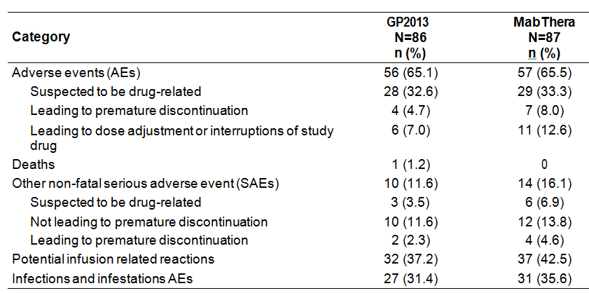
Comment: The overall incidence of AEs was similar in the two treatment arms (65.1%, GP2013; 65.5%, MabThera). However, the patient incidence for AEs in most other categories was numerically higher in the MabThera arm compared to the GP2013 arm. The numerical differences in AE categories between the two treatment arms are considered not to be clinically meaningful.

Study GP13-301 – FL
The overview of the AE profile for both treatment arms in the combination phase is summarised below in Table 36.

Table 36: Study GP13-301 – Combination phase - summary of AE categories in patients with FL, safety set
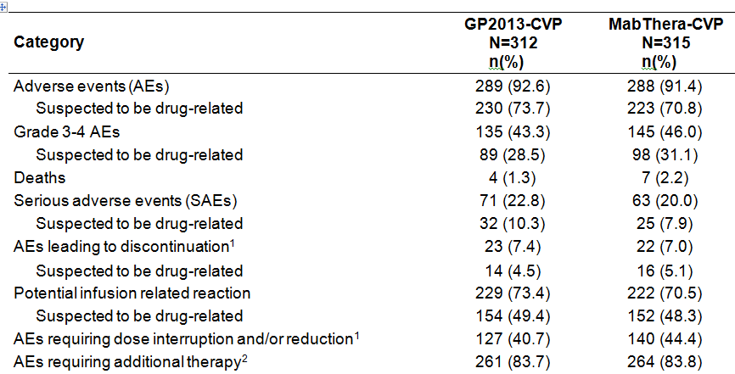
Notes: Categories are not mutually exclusive. Patients with multiple events in the same category are counted only once in that category. Patients with events in more than 1 category are counted once in each of those categories. 1 = Discontinuation and dose interruption and/or change during the combination treatment phase means of at least one component of study treatment.2 = Additional therapy includes all non-drug therapy, concomitant medications, and hospitalisation or prolonged hospitalisation.
The overview of the AE profile for both treatment arms in the maintenance phase is summarised below in Table 37:

Table 37: Study GP13-301 – Maintenance phase - summary of AE categories in patients with FL, maintenance set
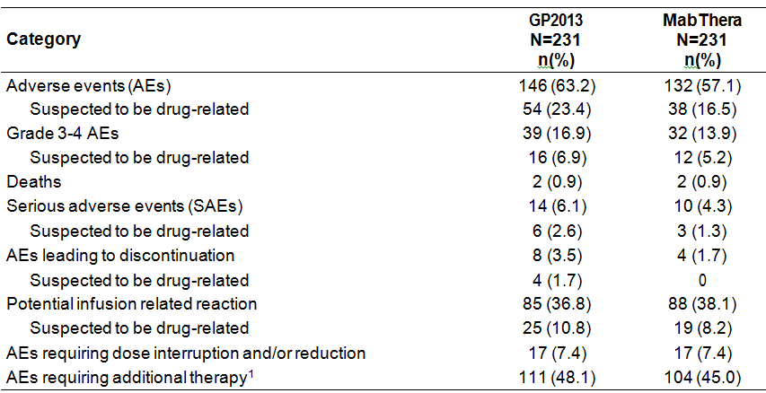
Notes: Categories are not mutually exclusive. Adverse events or death occurring more than 90 days after the discontinuation of maintenance investigational drug were not summarized. 1 = Additional therapy includes all non-drug therapy, concomitant medications, and hospitalisation or prolonged hospitalisation.
Comment: In the combination phase, AEs were reported in a similar proportion of patients in the two treatment arms. There were numerical differences between the two treatment arms in the proportion of patients in the different AE categories in the combination phase, but the differences are not considered to be clinically meaningful. In the maintenance phase, most AE categories were reported more frequently in patients in the GP2013 arm than in the MabThera arm, with ≥ 5% more patients in the GP2013 arm compared to the MabThera arm being observed for AEs (63.2% versus 57.1%, respectively) and AEs suspected to be drug-related (23.4% versus 16.5%, respectively)

Adverse events by system organ class

Study GP13-201 – RA
AEs by SOC, irrespective of suspected relationship to study drug, reported by at least 10% of patients in either treatment group in Study GP13-201 are shown below in Table 38.

Table 38: Study GP13-201 – Summary of AEs by SOC in at least 10% of patients with RA, safety analysis set
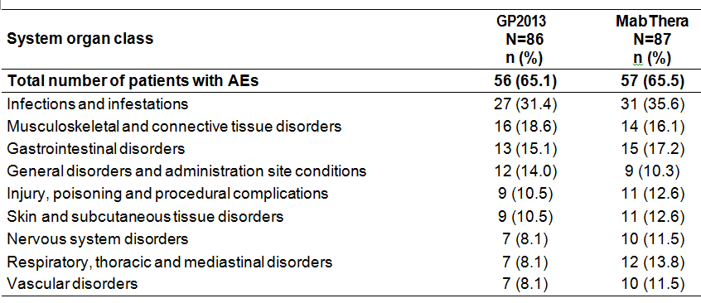
Comment: The AE profiles by SOC were comparable between the two treatment arms. The most commonly reported AEs by SOC in each treatment arm were ‘Infections and infestations’. The only AEs by SOC reported in ≥ 5% more patients in the GP2013 arm than in the MabThera arm were, respectively, ‘respiratory, thoracic and mediastinal disorders’ (13.8% versus 8.1%). There were no AEs by SOC reported in ≥ 5% more patients in the GP2013 arm than in the MabThera arm.

Study GP13-301 – FL
AEs by SOC, irrespective of suspected relationship to study drug, reported by at least 10% of patients in either treatment group in the combination phase are shown below in Table 39.

Table 39: Study GP13-301 – Combination phase, AEs by SOC in at least 10% of patients with FL, safety set
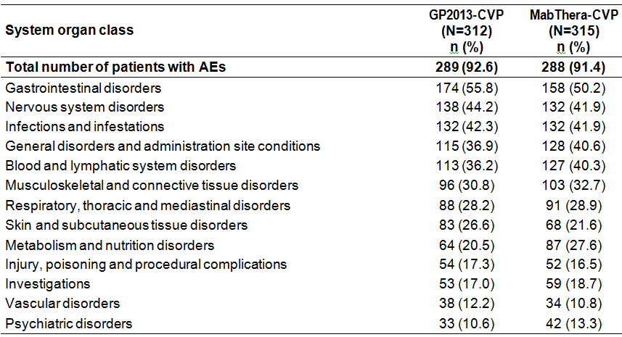
Primary system organ classes are sorted in descending frequency as reported in the GP2013-CVP column. A patient with multiple adverse events within a primary system organ class is counted only once (the maximum CTC grade is considered). For patients who did not enter the Maintenance Phase, adverse events occurring more than 30 days after the discontinuation of study treatment were not summarised.
AEs by SOC, irrespective of suspected relationship to study drug, reported by at least 10% of patients in either treatment group in the maintenance phase are shown below in Table 40.

Table 40: Study GP13-301 – Maintenance phase, AEs by SOC in at least 10% of patients with FL, safety set 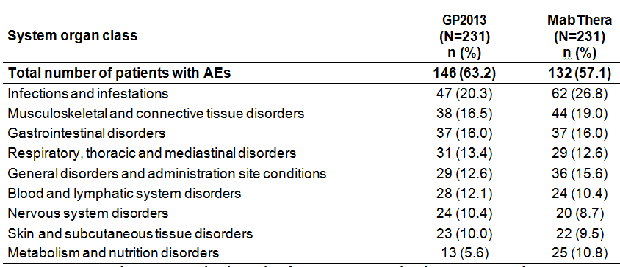
Primary system organ classes are sorted in descending frequency as reported in the GP2013-CVP column. A patient with multiple adverse events within a primary system organ class is counted only once (the maximum CTC grade is considered). Adverse events occurring more than 90 days after the discontinuation of the maintenance phase are not summarised.
Comment: In general, AEs by SOC in the combination phase were comparable in the two treatment arms and the difference between the two treatment arms in the incidence of patients with AEs grouped by SOC are considered unlikely to be clinically meaningful. In contrast to patients with RA, the most commonly occurring AEs grouped by SOC in both treatment arms in the patients with FL in the combination phase were ‘Gastrointestinal disorders’ rather than ‘Infections and infestations’. AEs grouped by SOC reported in ≥ 5% more patients in the GP2013 arm than in the MabThera arm in the combination phase were ‘Gastrointestinal disorders’ (55.8% versus 50.2%, respectively), and ‘Skin and subcutaneous tissue disorders’ (26.6% versus 21.6%, respectively). The only AEs grouped by SOC reported in ≥ 5% more patients in the MabThera arm than in the GP2013 arm in the combination phase were ‘metabolism and nutrition disorders’ (27.6% versus 20.5%, respectively).
In general, AEs by SOC in the maintenance phase were comparable in the two treatment arms and the difference between the two treatment arms in the incidence of patients with AEs grouped by SOC are considered unlikely to be clinically meaningful. In contrast to the combination phase, the two most commonly reported SOCs in the maintenance phase were ‘Infections and infestations’ and ‘Musculoskeletal and connective tissue disorders’ and both SOCs occurred more frequently than ‘Gastrointestinal disorders’, which was the most frequently reported SOC in the combination phase. In the maintenance phase, there were no AEs grouped by SOC reported in ≥ 5% more patients in the GP2013 arm than in the MabThera arm. AEs grouped by SOC reported in ≥ 5% more patients in the MabThera arm than in the GP2013 arm in the maintenance phase were ‘Infections and infestations’ (26.8% versus 20.3%, respectively) and ‘metabolism and nutrition disorders’ (10.8% versus 5.6%, respectively).

Adverse events by preferred term regardless of relationship to study drug

Study GP13-201 – RA
AEs by preferred term (PT) reported by at least 3% of patients in either treatment arm and regardless of the suspected relationship to the study drug are shown below in Table 41.

Table 41: Study GP13-201 – Adverse events (PTs) reported by at least 3% of patients with RA in either treatment arm regardless of the relationship to the study drug , safety set
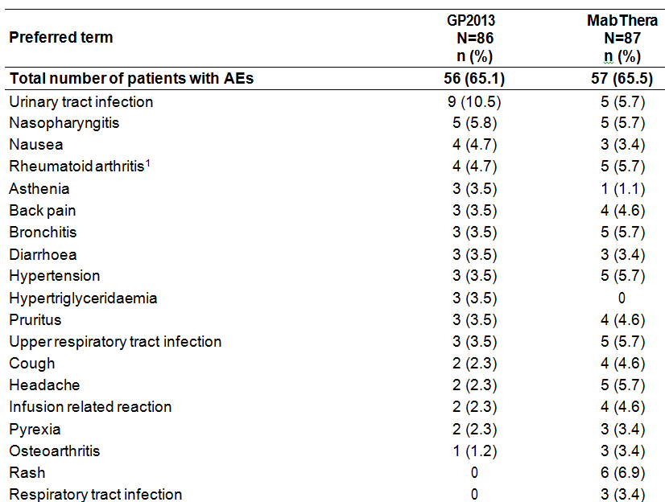
A subject with multiple AEs within a PT is counted only once in the total column. 1 = Worsening or flare-up of rheumatoid arthritis.
Comment: The observed differences in the incidence of AEs between patients in the two treatment arms are unlikely to be clinically meaningful. AEs reported in ≥ 5% of patients in either treatment arm (GP2013 versus MabThera, respectively) were urinary tract infection (10.5% versus 5.7%), nasopharyngitis (5.8% versus 5.7%), rheumatoid arthritis (4.7% versus 5.7%), bronchitis (3.5% versus 5.7%), hypertension (3.5% versus 5.7%), upper respiratory tract infection (3.5% versus 5.7%), headache (2.3% versus 5.7%) and rash (0% versus 6.9%).
AEs reported in ≥ 2% of patients in either treatment and in ≥ 2% more patients in the MabThera arm than in the GP2013 arm, in descending order of frequency, were rash (6.9% versus 0%),bronchitis (5.7% versus 3.5%), hypertension (5.7% versus 3.5%), upper respiratory tract infection (5.7% versus 3.5%), headache (5.7% versus 2.3%), infusion related reaction (4.6% versus 2.3%), cough (4.6% versus 2.3%), respiratory tract infection (3.4% versus 0%), osteoarthritis (3.4% versus 1.2%), angina pectoris (2.3% versus 0%), ear pruritus (2.3% versus 0%), dyspepsia (2.3% versus 0%), mouth ulceration (2.3% versus 0%), vomiting (2.3% versus 0%), conjunctivitis (2.3% versus 0%), gastroenteritis (2.3% versus 0%), paronychia (2.3% versus 0%), dyslipidaemia (2.3% versus 0%), hypoaesthesia (2.3% versus 0%), dyspnoea (2.3% versus 0%), throat irritation (2.3% versus 0%), and hypertensive crisis (2.3% versus 0%)
AEs reported in ≥ 2% of patients in either treatment arm and in ≥ 2% more patients in the GP2013 arm than in the MabThera arm, in descending order of frequency, were urinary tract infection (10.5% versus 5.7%), asthenia (3.5% versus 1.1%), hypertriglyceridaemia (3.5% versus 0%), chills (2.3% versus 0%), fatigue (2.3% versus 0%), fistula (2.3% versus 0%), myalgia (2.3% versus 0%), and leucocyturia (2.3% versus 0%).

Study GP13-301 – FL

AEs (all grades and Grade 3/4) in at least 10% of patients with FL in the combination phase by PT and regardless of the relationship to the study drug are summarised below in Table 42.

Table 42: Study GP13-301 – Combination phase, AEs (PT) regardless of relationship to study drug reported in at least 10% of patients in either treatment arm, safety set
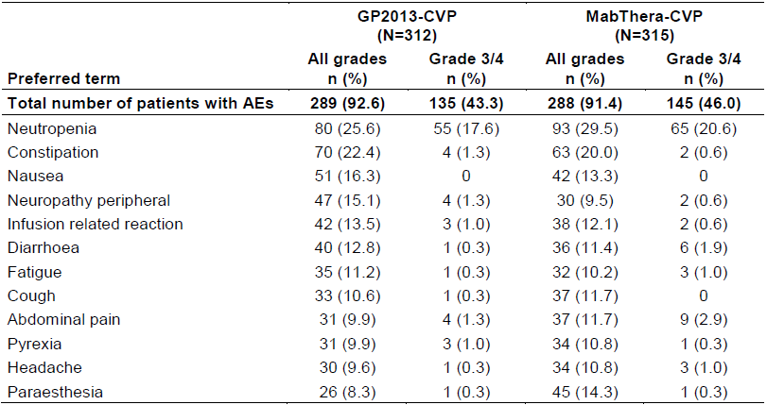Preferred terms are sorted in descending frequency as reported in GP2013-CVP, All grades column. A patient with multiple occurrences of an AE under one treatment is counted only once in the AE category for that treatment. A patient with multiple adverse events is counted only once in the total row. For patients who did not enter the Maintenance Phase, AEs occurring more than 30 days after the discontinuation of study treatment were not summarised.

AEs (all grades and Grade 3/4) in at least 5% of patients with FL in the maintenance phase by PT and regardless of the relationship to the study drug are summarised below in Table 43.

Table 43: Study GP13-301 – Maintenance phase, AEs (PT) regardless of relationship to the study drug reported in at least 5% of patients in either treatment arm, safety set
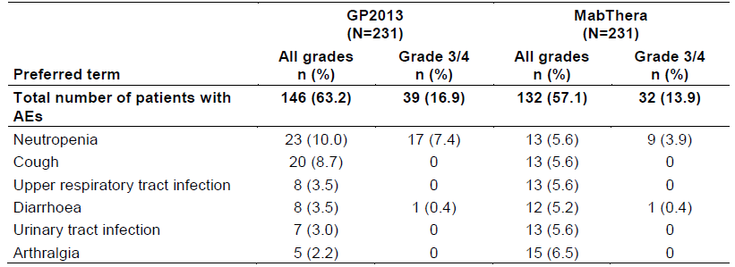
Preferred terms are sorted in descending frequency as reported in the GP2013, All grades column. A patient with multiple occurrences of an AE under one treatment is counted only once in the AE category for that treatment. A patient with multiple AEs is counted only once in the total row. AEs that occurred more than 90 days after the discontinuation of maintenance investigational drug are not summarised.
Comment: In general, the frequency of patients with AEs (both all grades and Grade 3/4) in the combination phase was comparable in the two treatment arms, and the observed numerical differences between the two treatment arms are considered unlikely to be clinically meaningful. The most clinically significant AE observed in both treatment arms was neutropenia, and this AE (both all grades and Grade 3/4) occurred more frequently in the MabThera arm than in the GP2013. In addition to neutropenia, other AEs (Grade 3/4) reported in ≥ 2% of patients in either of the two treatment arms and more frequently in the MabThera arm than in the GP2013 arm were, anaemia (3.8% versus 1.6%), leukopaenia (4.4% versus 2.6%), abdominal pain (2.9% versus 1.3%), hyperglycaemia (3.2% versus 1.9%), hyponatraemia (2.2% versus 1.0%) and dyspnoea (2.2% versus 0.6%). AEs (Grade 3/4) reported in ≥ 2% of patients in either of the two treatment arms and more frequently in the GP2013 arm than in the MabThera arm were, febrile neutropenia (6.1% versus 3.2%) and neutrophil count decreased (2.6% versus 1.0%).
In the maintenance phase, of the six AEs (all grades) reported in at least 5% of patients in either of the two treatment arms, two events occurred in ≥ 2% more patients in the GP2013 arm than in the MabThera arm (neutropenia and cough) and three events occurred in ≥ 2% more patient in the MabThera arm than in the GP2013 arm (upper respiratory tract infection, urinary tract infection and arthralgia). No AEs (Grade 3/4) other than neutropenia were reported in ≥ 2% of patients in either of the two treatment arms. Neutropenia (Grade 3/4) was reported more frequently in the GP2013 arm than in the MabThera arm (7.4% versus 3.9%).

Adverse events by severity

Study GP13-201 – RA
The majority of AEs were of mild or moderate severity. Mild AEs occurred in 29.1% of patients in the GP2013 arm and 28.7% of patients in the MabThera arm, while moderate AEs occurred in 25.6% of patients in the GP2013 arm and 26.4% of patients in the MabThera arm. The overall frequency of patients with severe AEs was comparable in the two treatment arms (n = 9 (10.5%), GP2013 arm; n = 9 (10.3%), MabThera arm).
The most common severe AEs (at least 6 patients overall) occurred in the SOC of ‘Infections and infestations’ (n = 4 (4.7%), GP2013; n = 2 (2.3%), MabThera). The severe AEs in this SOC were also reported as SAEs, and included abscess, Klebsiella sepsis, Lyme disease, sepsis, and septic shock in the GP2013 arm, and atypical pneumonia and pneumonia haemophilus in the MabThera arm.

Study GP13-301 – FL
In the maintenance phase, the majority of AEs, regardless of the relationship to study treatment, were categorised as Grade 1/2 events (57.6% (n = 133), GP2013; 55.0% (n = 127), MabThera), while Grade 3 events were reported in 13.9% (n = 32) of patients in the GP2013 arm and 13.0% (n = 30) of patients in the MabThera arm and Grade 4 events were reported in 5.2% (n = 12) of patients in the GP2013 arm and 1.7% (n = 4) of patients in the MabThera arm. The only Grade 4 AE reported in ≥ 2% of patients in either treatment arm was neutropenia (2.2% (n = 5), GP2013; 0.4% (n = 1), MabThera).
In the combination phase, the majority of AEs, regardless of the relationship to study treatment, were categorised as Grade 1/2 events (89.7% (n = 280) GP2103-CVP; 87.9% (n = 277) MabThera-CVP), while Grade 3 events were reported in 40.7% (n = 127) of patients in the GP2013-CVP arm and 41.9% (n = 132) of patients in the MabThera-CVP arm. The only Grade 4 AE reported in ≥ 2% of patients in either treatment arm was neutropenia (5.8% (n = 39), GP2013-CVP; 8.3% (n = 47), MabThera-CVP).

Adverse events suspected to be study drug-related

Study GP13-201 – RA
AEs suspected to be related study drug-related based on investigator assessment and reported in ≥ 2% of patients in either treatment arm are summarised below in Table 44.

Table 44: Study GP13-201 – Summary of AEs (PT) suspected to be related to the study drug in at least 2% of patients with RA, safety analysis set
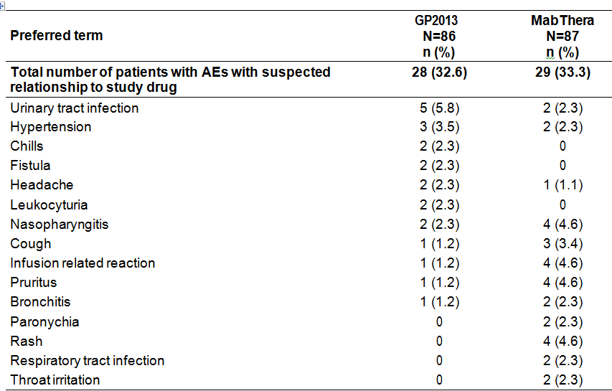

A subject with multiple AEs within a PT is counted only once in the total column.
Comment: AEs suspected to be study drug-related were reported in a similar proportion of patients in the GP2013 and MabThera arms (32.6% versus 33.3%, respectively). The only AE suspected to be study drug-related and reported in ≥ 5% of patients in either of the two treatment arms was urinary tract infection (5.8%, GP2013; 2.3%, MabThera). The AE suspected to be study drug-related with the greatest difference in incidence between the two treatment arms was rash, which was reported in 4.6% of patients in the MabThera arm and no patients in the GP2013 arm. The severity of rash was described as mild in 3 patients and moderate in 1 patient, and all 4 patients had recovered by the time of the final examination. Overall, the numerical differences between the two treatment arms in the incidence of AEs suspected to be study-drug related reported in ≥ 2% of patients in either treatment arm are unlikely to be clinically meaningful.

Study GP13-301 – FL
AEs suspected to be study drug-related and reported in ≥ 5% of patients in either treatment arm in the combination phase are summarised below in Table 45.

Table 45: Study GP13-301 – Combination phase, AEs suspected to be study-drug related occurring in at least 5 % of patients in either treatment arm, safety set
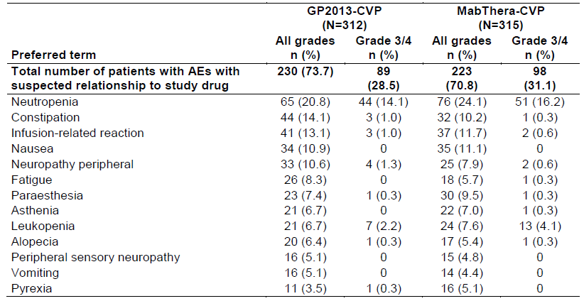
Preferred terms are sorted by descending frequency as reported in the GP2013-CVP, All grades column.
In the maintenance phase, AEs (all grades) suspected to be study drug-related were reported in 23.4% (n = 54) of patient in the GP2013 arm and 16.6% (n = 38) of patients in the MabThera arm, while AEs (Grade 3/4) were reported in 16.9% (n = 16) and 5.2% (n = 12) of patients respectively.
Comment: AEs (all grades and Grade 3/4) in the combination phase suspected to be study drug-related were reported in a similar proportion of patients in both treatment arms. The most frequently reported AE (all grades and Grade 3/4) suspected to be study-drug related in patients in both treatment arms in the combination phase was neutropenia, and both AEs all grades and Grade 3/4 occurred more frequently in patients in the MabThera arm than in the GP2013 arm. AEs (Grade 3/4) in the combination phase suspected to be study drug-related and reported in ≥ 2% of patients in either of the two treatment arms were neutropenia (14.1%, GP2013 versus 16.2%, MabThera), febrile leukopaenia (4.8%, GP2013 versus 3.2%, MabThera) and leukopaenia (2.2%, GP2013 versus 4.1%, MabThera).
In the maintenance phase, AEs (all grades) suspected to be study drug-related were reported more frequently in patients in the GP2013 arm than in the MabThera arm, while AEs (Grade 3/4) suspected to be study-drug related were reported more frequently in the MabThera arm than in the GP2013 arm. The only AE (all grades) and AE (Grade 3/4) suspected to be study-drug related reported in ≥ 5% of patients in either treatment arm was neutropenia (all grades: 6.9%, GP2013 versus 5.2%, MabThera; and Grade 3/4: 4.3%, GP2013 versus 3.5%, MabThera).

Adverse events (AEs) of special interest

Study GP13-201 – RA
The safety data were also analysed according to AEs of special interest defined by the Novartis Drug Safety and Epidemiology Group. The AEs of special interest included risks identified in the SmPC of MabThera, risks based on topics of interest regarding signal detection and risks identified by routine analysis. The overall incidence of AEs of special interest based on reference safety information was comparable for the two treatment arms (24.4% (21/86), GP2013 versus 25.3% (22/87), MabThera), with no clinically meaningful differences between the treatment arms for any AEs of special interest grouped by SOC. AEs of special interest reported in ≥ 5% of patients in either of the two treatment arms (GP2013 versus MabThera, respectively), and in descending order of frequency in the MabThera arm, were rheumatoid arthritis (4.7% versus 5.7%), hypertension (3.5% versus 5.7%) and headache (2.3% versus 5.7%).

Study GP13-301 – FL
In Study GP13-301, cytokine release syndrome and progressive multifocal leukoencephalopathy (PML) were defined as AEs of special interest in the clinical study protocol. During the combination phase, cytokine release syndrome occurred in 2 (0.6%) patients in the MabThera-CVP arm and no patients in the GP2013-CVP arm. No cases of cytokine release syndrome were reported in the maintenance phase. No cases of PML occurred in either treatment arm during the study. In addition to the AEs of special interest defined in the study protocol, infusion related reactions were also identified in the CSR as AEs of special interest. Infusion-related reactions are reviewed below.

Infusion-related reactions

Study GP13-201 – RA
Novartis undertook a MedDRA Query (NMQ-90000721) summarising infusion-related reactions reported with GP2013 and MabThera, excluding reactions such as local erythema of the skin around the infusion site. Infusion-related reactions were reported more frequently in patients in the MabThera arm than in patients in the GP2013 arm (42.5% (37/87) versus 37.2% (32/86), respectively). Infusion-related reactions reported in ≥ 5% of patients in either of the two treatment arms (GP2013 versus MabThera, respectively), in descending order of frequency in the GP2013 arm, were hypertension (3.5% versus 5.7%), headache (2.3% versus 5.7%), and rash (0% versus 6.9%).
Infusion-related reactions reported on the day of the first infusion and the day after the first infusion of the first course occurred in 10 (11.6%) patients in the GP2013 arm and 14 (16.1%) patients in the MabThera arm. Infusion-related reactions reported on the day of the first infusion and the day after the first infusion of the first course of treatment reported in ≥ 2% of patients in either of the two treatment arms (GP2013 versus MabThera, respectively), in descending order of frequency in the GP2013 arm, were chills (2.3% versus 0%), headache (2.3% versus 2.3%), pruritus (1.2% versus 4.6%), infusion related reaction (1.2% versus 3.4%), and rash (0% versus 4.6%),
Infusion-related reactions were reported less frequently on the day of the second infusion and day after the second infusion of the first course than after the first infusion in both the GP2013 arm (n = 4 (4.7%)) and the MabThera arm (n = 7 (8.0%)). Infusion-related reactions reported on the day of the second infusion and the day after the second infusion of the first course of treatment reported in ≥ 2% of patients in either of the two treatment arms (GP2013 versus MabThera, respectively), in descending order of frequency in the GP2013 arm, were asthenia (3.5% versus 1.1%) and headache (0% versus 2.3%).

Study GP13-301 – FL

Infusion-related reaction AE defined by narrow MedDRA query (NMQ)
During the combination phase, the incidence of patients experiencing any infusion related-reaction AE defined by narrow MedDRA query (NMQ) suspected to be study drug-related was 49.4% (n = 154) in the GP2013 arm and 48.3% (n = 152) in the MabThera arm. AEs (PT) suspected to be study drug-related reported in ≥ 5% of patients in either treatment arm (GP2013 versus MabThera) were infusion-related reaction (13.1% (n = 41) versus 11.7% (n = 37)), nausea (10.9% (n = 34) versus 11,1% (n = 35)), fatigue (8.3% (n = 26) versus 5.7% (n = 18)), asthenia (6.7% (n = 21) versus 7.0% (n = 22)), vomiting (5.1% (n = 16) versus 4.4% (n = 14)), and pyrexia (3.5% (n = 11) versus 5.1% (n = 16)). Anaphylactic reaction was reported in 1 (0.3%) patient in each treatment arm, and cytokine release syndrome was reported in 2 (0.6%) patients in the MabThera arm.
During the maintenance phase, the incidence of patients experiencing any infusion-related reaction AE defined by narrow MedDRA query (NMQ) suspected to be study drug-related was 10.8% (n = 25) in the GP2013 arm and 8.2% (n = 19) in the MabThera arm. AEs (PT) reported in in ≥ 1% of patients in either treatment arm (GP2013 versus MabThera) were infusion-related reaction (1.3% (n = 3) versus 1.3% (n = 3)), cough (2.2% (n = 5) versus 0%), thrombocytopenia (0.4% (n = 1) versus 1.3% (n = 3)), and arthralgia (0% versus 1.3% (n = 3)). There were no reports of anaphylactic reaction or cytokine release syndrome in either of the two treatment arms.

AE (PT) of infusion-related reaction
In the combination phase, the AE (PT) of infusion related-reaction with suspected relationship to the study drug was reported in a similar proportion of patients in the GP2013 arm (all grades = 13.1% (n = 44); Grade 3/4 = 1.0% (n = 3)) and the MabThera arm (all grades = 11.7% (n = 37); Grade 3/4 = 0.6% (n = 2)). The frequency of patients experiencing the AE (PT) of infusion related-reaction requiring dose adjustments or temporary interruptions of the study drug during the combination phase was also similar in the GP2013 arm (all grades = 6.7% (n = 21); Grade 3/4 = 1.0% (n = 3)) and the MabThera arm (all grades = 7.0% (n = 2); Grade 3/4 = 0.6% (n = 2). One patient in each treatment arm discontinued treatment due to the AE infusion related-reaction during the combination phase. During the combination phase, SAEs of infusion-related reactions (PT) suspected to be study drug-related were reported with a frequency of 1.0 % (n = 3) in patients in the GP2013 arm and of 0.3% (n = 1) of patients in the MabThera arm.
In the maintenance phase, the AE (PT) of infusion-related reaction (all grades) suspected to be study drug-related was reported in the same proportion of patients in both treatment arms (1.3% (n = 3)), while no Grade 3/4 infusion-related reactions occurred in either treatment arm. The frequency of patients experiencing the AE (PT) of infusion-related reaction (all grades) requiring dose adjustments or temporary interruptions to the study drug in the maintenance phase was also similar in both the GP2013 arm and the MabThera arm (0.9% (n = 2) versus 1.3% (n = 3), respectively). No patients discontinued the maintenance phase due to the AE (PT) of infusion-related reaction. No SAEs (PT) of infusion-related reactions suspected to be study-drug related were reported in the maintenance phase.

Deaths, other SAEs and other significant AEs

Deaths

Study GP13-201 – RA
One patient (64 year old Asian female) in the GP2013 treatment arm died during the study due to multi-organ failure (bone marrow failure, pancytopenia, and sepsis) following an accidental MTX overdose (20 mg daily for 5 days before onset of the event instead of the prescribed weekly dose). The patient had received both infusions of GP2013 (first course of treatment) and had completed 18 weeks of the study. The death was not considered to be study drug-related, but was considered to be related to MTX

Study GP13-301 – FL
There were 35 (5.6%) deaths during the study in all phases combined (combination, maintenance, and post-treatment), comprising 18 (5.8%) deaths in the GP2013 arm and 17 (5.4%) deaths in the MabThera arm. The most common cause of death during the study was NHL in both treatment arms, including 8 (2.6%) in the GP2013 arm and 6 (1.9%) in the MabThera arm. Other deaths due to AEs (PT) reported in 2 or more patients in either treatment arm (GP2013 versus MabThera) were multi-organ failure (n = 2 (0.6%) versus n = 1 (0.3%)) and septic shock (n = 2 (0.6%) versus 0%).
During the combination phase there were 4 (1.3%) deaths in the GP2013 arm (one AE each for multi-organ failure, sudden death, septic shock and respiratory failure) and 7 (2.2%) deaths in the MabThera arm (two AEs for NHL, and one AE each for acute coronary syndrome, multi-organ failure, sepsis, acute respiratory failure, and pulmonary artery thrombosis). Of the 11 deaths occurring during the combination phase, 3 of the 4 deaths in the GP2013 arm were reported to be caused by AEs suspected to be study-drug related and 2 of the 7 deaths in the MabThera arm were suspected to be caused by AEs suspected to be study-drug related. During the maintenance phase there were 2 (0.9%) deaths in the GP2013 arm (one AE each for NHL and ischaemic stroke) and 2 deaths in the MabThera arm (one AE each for cardiac arrest and hepatic failure). Of the 4 deaths reported in the maintenance phase, 1 death in the GP2013 arm was reported to be caused by AEs suspected to be study-drug related.
During the post-treatment phase there were 12 (3.8%) deaths in the GP2013 arm and 8 (2.5%) deaths in the MabThera arm. The most common cause of death during the post-treatment phase was NHL (7 deaths (2.2%) in the GP2013 arm and 4 deaths (1.3%) in the MabThera arm).
For patients who did not enter the maintenance phase, deaths occurring more than 30 days after completion of the combination phase were considered to have occurred in the post-treatment phase and for patients who entered the maintenance phase, deaths occurring more than 90 days after discontinuation of maintenance treatment were considered to have occurred in the post-treatment phase.

SAEs

Study GP13-201 – RA
Non-fatal SAEs were reported more frequently in patients in the MabThera arm than in patients in the GP2013 arm (16.1% (14/87) versus 11.6% (10/86), respectively). The most frequently reported SAEs by SOC were ‘infection and infestations’, which were reported in 5.8% (5/86) of patients in the GP2013 arm and 4.6% (4/87) of patients in the MabThera arm. Other SOCs with ≥ 2% of patients in either treatment arm (GP2013 versus MabThera, respectively) were ‘Musculoskeletal and connective tissue disorders’ (3.5% versus 3.4%), ‘General disorders and administrative site conditions’ (2.3% versus 0%), ‘injury poisoning and complications’ (2.3% versus 3.4%), ‘nervous system disorders’ (1.2% versus 2.3%) and ‘cardiac disorders’ (1.2% versus 2.3%). Non-fatal SAEs (PT) reported in at least 2 patients in either of the two treatment arms (GP2013 versus MabThera, respectively) were fistula (n = 2, 2.3% versus 0%), osteoarthritis (0% versus n = 2, 2.3%) and angina pectoris (0% versus n = 2, 2.3%).

Study GP13-301 – FL
During the combination phase, the incidence of SAEs regardless of the relationship to the study drug was similar in patients in the GP2013 arm (22.8% (n = 71)) and the MabThera arm (20.0% (n = 63)).The most frequently reported SAEs by SOC were ‘Blood and lymphatic system disorders’, which were reported in 7.4% (n = 23) of patients in the GP2013 arm and 5.4% (n = 17) patients in the MabThera arm. Other SAEs by SOC reported in ≥ 2% of patients in either treatment arm (GP2013 versus MabThera, respectively) and in descending order of frequency in the GP2013 arm were ‘Infections and infestations’ (6.7% (n = 21) versus 6.7% (n = 21)), ‘Gastrointestinal disorders’ (4.2% (n = 13) versus 5.1% (n = 16)), ‘General disorders and administration site conditions’ (2.9% (n = 9) versus 3.2% (n = 10)), ‘respiratory, thoracic and mediastinal disorders’ (2.9% (n = 9) versus 4.8% (n = 15)), and ‘Injury, poisoning, and procedural complications’ (2.2% (n = 7) versus 0.6% (n = 2)).
During the combination phase, SAEs regardless of the relationship to the study drug, reported in ≥ 1% of patients in either treatment arm (GP2013 versus MabThera, respectively) and more frequently in the GP2013 arm were febrile neutropenia (4.8% (n = 15) versus 2.9% (n = 9)), constipation (1.0% (n = 3) versus 0%), infusion-related reaction (1.0% (n = 3) versus 0.3% (n = 1)), septic shock (1.0% (n = 3) versus 0.3% (n = 1)), and urinary tract infection (1.0% (n = 3) versus 0.3% (n = 1)). During the combination phase, SAEs regardless of the relationship to the study drug, reported in ≥ 1% of patients in either treatment arm (GP2013 versus MabThera) and less frequently in the GP2013 arm were abdominal pain (1.3% (n = 4) versus 1.9% (n = 6)), neutropenia (1.3% (n = 4) versus 1.6% (n = 5)), pyrexia (1.3% (n = 4) versus 2.2% (n = 7)), pneumonia (0.6% (n = 3) versus 1.3% (n = 4)), sepsis (0.6% (n = 2) versus 1.6% (n = 5)), diarrhoea (0.3% (n = 1) versus 1.0% (n = 3)) pulmonary embolism (0.3% (n = 1) versus 1.0% (n = 3)), dyspnoea (0% versus 1.9% (n = 6)), intestinal obstruction (0% versus 1.0% (n = 3)), and pleural effusion (0% versus 1.0% (n = 3)).
During the maintenance phase, SAEs regardless of the relationship to the study drug were reported notably less frequently in both treatment arms than in the combination phase. In the maintenance phase, SAEs were reported in 6.1% (n = 14) of patients in the GP2013 arm and 4.3% (n = 10) of patients in the MabThera arm. SAEs by SOC, regardless of the relationship to the study drug, reported in ≥ 1.0% of patients in either treatment arm (GP2013 versus MabThera) in descending order of frequency in the GP2013 arm were ‘Infections and infestations (3.0% (n = 7) versus 2.6% (n = 6)), ‘nervous system disorders’ (1.3% (n = 3) versus 0.9% (n = 2)), and ‘Gastrointestinal disorders’ (0.4% (n = 1) versus 1.3% (n = 3)). SAEs, regardless of relationship to the study drug, reported in ≥ 2 patients in either treatment arm (GP2013 versus MabThera) in the maintenance phase in descending order of frequency in the GP2013 arm were ischaemic stroke (0.9% (n = 2) versus 0%), pneumonia (0.9% (n = 2) versus 0.4% (n = 1), respiratory tract infection (0.9% (n = 2) versus 0%), and febrile neutropenia (0% versus 0.9% (n = 2)).

AEs leading to premature discontinuation

Study GP13-201 – RA
The proportion of patients with AEs leading to premature discontinuation of the study drug was greater in the MabThera arm than in the GP2013 arm (8.0% (7/87) versus 4.7% (4/86), respectively).
The AEs in the 8 patients in the MabThera arm leading to premature discontinuation of the study drug were one each for drug hypersensitivity, pyelonephritis, vasculitis, granulocytopenia, diarrhoea, infusion relayed reaction, and rash. All AEs leading to premature discontinuation of MabThera were suspected by the investigator to be related to the study drug, except for pyelonephritis and rash.
The AEs in the 4 patients in the GP2013 arm leading to premature discontinuation of the study drug were one each for chills, multi-organ failure, drug hypersensitivity, Klebsiella sepsis, and hypertension. All AEs leading to premature discontinuation of GP2012 were suspected by the investigator to be related to the study drug, except for the fatal SAE of multi-organ failure considered to be related to MTX.

Study GP13-301 – FL
In the combination phase, the proportion of patients with AEs leading to discontinuation, regardless of the relationship to the study drug, was similar in the GP2013 arm and the MabThera arm (7.4% (n = 23) versus 7.0% (n = 22), respectively). AEs leading to discontinuation in ≥ 2 patients in either treatment arm (GP201 versus MabThera) in the combination phase, regardless of the relationship to the study drug, were peripheral neuropathy (n = 9 (2.9%) versus n = 2 (0.6%)), septic shock (n = 2 (0.6%) versus 0%), and peripheral motor neuropathy (0% versus n = 2 (0.6%)). AEs leading to discontinuation suspected to be related to the study drug were reported in 4.5% (n = 14) of patients in the GP2013 arm and 3.2 % (n = 10) of patients in the MabThera arm. AEs leading to discontinuation and suspected to be related to the study drug reported in ≥ 2 patients in either treatment arm (GP2013 versus MabThera) were peripheral neuropathy (n = 7 (2.2%) versus n = 2 (0.6%)), septic shock (n = 2 (0.6%) versus 0%)), and peripheral motor neuropathy (0% versus n = 2 (0.6%)).
In the maintenance phase, the proportion of patients with AEs leading to discontinuation, regardless of the relationship to the study drug, was higher in the GP2013 arm than in the MabThera arm (3.5% (n = 8) versus 1.7% (n = 4)). No AEs leading to discontinuation regardless of the relationship to the study drug in either treatment arm were reported in ≥ 2 patients. There were 4 AEs leading to discontinuation and suspected to be related to the study drug and all occurred in the GP2013 arm (one each for asthenia, lower respiratory tract infection, pseudomonal pneumonia and platelet count decreased).

AEs leading to dose adjustment or interruption of study drug

Study GP13-201 – RA
The proportion of patients with AEs leading to dose adjustment or interruption of the study drug was greater in the MabThera arm than in the GP2013 arm (12.6% (11/87) versus 7.0% (6/86), respectively).
The AEs in the 11 patients in the MabThera arm leading to dose adjustment or interruption of the study drug were three each for infusion related reaction, pruritus and rash , two each for ear pruritus and throat irritation, and one each for stomatitis, vessel puncture site thrombosis, cough, dyspnoea, laryngeal oedema, pharyngeal oedema, and throat tightness.
The AEs in the 6 patients in the GP2013 arm leading to dose adjustment or interruption of the study drug were one each for odynophagia, oral pruritus, hypersensitivity, headache, throat tightness, pruritus and urticaria.

Study GP13-301 – FL
In the combination phase, AEs leading to study drug dose adjustments or temporary interruptions, regardless of the relationship to the study drug, were frequently reported in both treatment arms in a similar proportion of patients (40.7% (n = 127), GP2013 versus 44.4% (n = 140) MabThera)), respectively). AEs in this category reported in ≥ 2% of patients in either treatment arm (GP2013 versus MabThera) were neutropenia (11.2% (n = 35) versus 11.4% (n = 36)), infusion-related reaction (6.7% (n = 21) versus 7.0% (n = 22)), peripheral neuropathy (3.5% n = 11) versus 2.9% (n = 9)), and peripheral sensory neuropathy (2.2% (n = 7) versus 1.3% (n = 4)).
In the maintenance phase, AEs leading to study drug dose interruptions or temporary interruptions, regardless of the relationship to the study drug, were reported in the same proportion of patients in the two treatment arms (7.4% (n = 17) in both arms). AEs leading to study drug dose interruption or temporary interruption, regardless of the relationship to the study drug and reported in ≥ 2 patients in either treatment arm (GP2013 versus MabThera) in the maintenance phase were neutropenia (n = 5 (2.2%) versus n = 3 (1.3%)), pharyngitis (n = 2 (0.9%) versus 0%), and infusion-related reaction (n = 2 (0.9%) versus n = 3 (1.3%)).

Evaluation of safety issues with possible regulatory impact

Liver function and liver toxicity

Study GP13-201 – RA
There were no clinically meaningful differences between the two treatment arms as regards newly occurring clinically notable liver function test abnormalities (see Table 46, below).

Table 46: GP2013-201 – Liver function tests newly occurring laboratory clinically notable abnormalities, safety analysis set
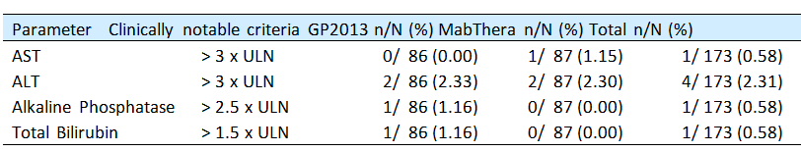
Notes: n = Number of patients meeting the criterion at any time after first dose of study drug (that is, those who have newly occurring clinically notable abnormalities). N = Number of patients at risk (patients having a baseline measurement not meeting the criterion or missing and having at least one post-baseline measurement for the laboratory test).
AE, regardless of relationship to the study drug grouped by the SOC of ‘hepatobiliary disorders’, was reported in 1 patient in the MabThera arm (gallbladder polyp).

Study GP13-301 – FL

Combination phase
The incidence of newly occurring or worsening clinical chemistry liver function tests in the combination phase is summarised below in Table 47. The results indicate no clinically meaningful differences between the two treatment arms in newly occurring or worsening liver function tests.

Table 47: Study GP13-301 – Patients with newly occurring or worsening clinical chemistry liver function parameters based on CTCAE v4.03 grade during the combination phase, safety set
Liver function | Worsening from | GP2013 |  | MabThera
Parameter | Baseline to | N | n (%) | N | n (%)
ALT  increased | Grade 1 | 268 | 70 (24.3) | 291 | 78 (26.8)
ALT  increased | Grade 2 | 308 | 8 (2.6) | 313 | 8 (2.6)
ALT  increased | Grade 3 | 308 | 4 (1.3) | 313 | 3 (1.0)
ALT  increased | Grade 4 | 308 | 0 | 313 | 1 (0.3)
AST  increased | Grade 1 | 279 | 69 (24.7) | 285 | 67 (23.5)
AST  increased | Grade 2 | 307 | 5 (1.6) | 313 | 6 (1.9)
AST  increased | Grade 3 | 307 | 2 (0.7) | 313 | 1 (0.3)
AST  increased | Grade 4 | 307 | 0 | 313 | 1 (0.3)
Alkaline Phosphatase  increased | Grade 1 | 260 | 59 (22.7) | 275 | 52 (18.9)
Alkaline Phosphatase  increased | Grade 2 | 304 | 4 (1.3) | 311 | 2 (0.6)
Total Bilirubin  increased | Grade 1 | 294 | 18 (6.1) | 297 | 16 (5.4)
Total Bilirubin  increased | Grade 2 | 306 | 6 (2.0) | 312 | 11 (3.5)
Total Bilirubin  increased | Grade 3 | 307 | 3 (1.0) | 313 | 2 (0.6)
Total = number of patients who had missing or less than grade x at baseline and with at least one post-baseline value for the considered parameter. n (%) = number (%) of patients whose the grade worsened form missing or less than grade x at baseline to grade x post-baseline.
In the combination phase, AEs (all grades) by SOC of ‘hepatobiliary disorders’, regardless of the relationship to the study drug, were reported in a similar proportion of patients in the two treatment arms (3.8% (n = 12), GP2013 versus 2.5% (n = 8), MabThera), as were AEs (Grade 3/4) in the grouping (1.3% (n = 4), GP2013 versus 1.0% (n = 3), MabThera). AEs (all grades) reported in ≥ 1% of patients in either treatment arm (GP2013 versus MabThera, respectively) were liver disorder (1.3% (n = 4) versus 0.3% (n = 1)) and cholelithiasis (0.3% (n = 1) versus 1.0% (n = 3)). In the 4 patients in the GP2013 arm with AEs (Grade 3/4) the events were one each for cholelithiasis, hyperbilirubinaemia, hepatic cirrhosis, and hepatocellular injury. In the 3 patients in the MabThera arm with AEs (Grade 3/4) the events were two each for cholelithiasis and one for liver disorder.
In the GP2013 arm versus the MabThera arm, respectively, in the combination phase the proportion of patients reporting AEs (PTs) all grades for ALT increased was 3.8% (n = 12) versus 3.2% (n = 10), for AST increased was 2.9% (n = 9) versus 2.9% (n = 9), for blood bilirubin increased was 0.6% (n = 2) versus 0.3% (n = 1), and for blood alkaline phosphatase increased was 1.3% (n = 4) versus 1.0% (n = 3). In the GP2013 arm versus the MabThera arm, respectively, the proportion of patients reporting AEs (PTs) Grade 3/4 for ALT increased was 1.0% (n = 3) versus 0.3% (n = 1) and for AST increased was 0.6% (n = 2) versus 0%. No Grade 3/4 events in either of the two treatment arms were reported for blood bilirubin increased or blood alkaline phosphatase increased.

Maintenance phase
The incidence of newly occurring or worsening liver function tests in the maintenance phase is summarised below in Table 48. The results indicate no clinically meaningful differences between the two treatment arms in newly occurring or worsening liver function tests.

Table 48: Study GP13-301 – Patients with newly occurring or worsening clinical chemistry liver function parameters based on CTCAE v4.03 during the maintenance phase, safety set
Liver function | Worsening from | GP2013 |  | MabThera
parameter | Baseline to | N | n (%) | N | n (%)
ALT  increased | Grade 1 | 186 | 30 (16.1) | 188 | 26 (13.8)
ALT  increased | Grade 2 | 207 | 4 (1.9) | 200 | (1 (0.5)
AST  increased | Grade 1 | 184 | 18 (9.8) | 186 | 28 (15.1)
AST  increased | Grade 2 | 207 | 1 (0.5) | 199 | 1 (0.5)
Alkaline Phosphatase  increased | Grade 1 | 182 | 29 (15.9) | 175 | 29 (16.6)
Alkaline Phosphatase  increased | Grade 2 | 207 | 1 (0.5) | 200 | 0
Total Bilirubin  increased | Grade 1 | 199 | 11 (5.5) | 192 | 9 (4.7)
Total Bilirubin  increased | Grade 2 | 205 | 3 (1.5) | 196 | 4 (2.0)
Total Bilirubin  increased | Grade 3 | 208 | 1 (0.5) | 198 | 0
Total = number of patients who had missing or less than grade x at baseline and with at least one post-baseline value for the considered parameter. n (%) = number (%) of patients whose the grade worsened form missing or less than grade x at baseline to grade x post-baseline.
In the maintenance phase, AEs (all grades) by SOC of ‘hepatobiliary disorders’, regardless of the relationship to the study drug were reported infrequently in both treatment arms (1.7% (n = 4), GP2013 versus 1.7% (n = 4), MabThera), while AEs (Grade 3/4) were reported in no patients in the GP2013 arm and 1 (0.4%) patient in the MabThera arm (hepatic failure). The AEs (all grades) in the 4 patients in the GP2013 arm were hepatic steatosis (x2), hepatocellular injury (x1), and liver disorder (x1), and in the 4 patients in the GP2013 arm were hepatic steatosis (x1), cholecystitis (x1), hepatic failure (x1) and hyperbilirubinaemia (x1).
In the GP2013 arm versus the MabThera arm, respectively, in the maintenance phase the proportion of patients reporting liver function test AEs (all grades) were ALT increased (1.3% (n = 3) versus 0.4% (n = 1)), AST increased (0% versus 0.4% (n = 1)), blood bilirubin increased (0.4% (n = 1) versus 0.9% (n = 3)), and blood alkaline phosphatase increased (0% versus 1 (0.4%)). There were no liver function test AEs (Grade 3/4) reported in either of the two treatment arms in the maintenance phase for ALT increased, AST increased, blood bilirubin increased or blood alkaline phosphatase increased.

Renal function and renal toxicity

Study GP13-201 – RA
There were no clinically meaningful differences between the two treatment arms as regards clinically notable abnormal serum creatinine levels, with the proportion of patients with levels > 50% above baseline being 4.7% (4/86) in the GP2013 arm and 2.3% (2/87) in the MabThera arm. AEs, regardless of relationship to the study drug grouped by the SOC of ‘renal and urinary disorders’, were reported in 2 (2.3%) patients in the GP2013 arm (2 x leucocyturia) and 1 (1.1%) patient in the MabThera arm (1 x nephropathy).
No systematic reporting of urinalysis findings was, with abnormalities detected during the course of the study being documented as AEs.

Study GP13-301 – FL
There were no clinically meaningful differences between the two treatment arms in the incidence of newly occurring or worsening serum creatine AE grades from baseline in either the combination phase or the maintenance phase of the study (see Table 49, below).

Table 49: Study GP13-301 – Newly occurring or worsening serum creatinine CTC AE grades in the combination and maintenance phases
 |  |  | Combination Phase |  |  |  | Maintenance Phase
Renal function  Worsening from |  |  | GP2013 |  | MabThera |  | GP2013 |  | MabThera
Parameter | Baseline to |  | N | n/% | N | n/% | N | n/% | N | n/%
Creatinine (Hyper) | Grade 1 |  | 282 | 196/  69.5 | 289 | 219/  75.8 | 148 | 67/  45.3 | 135 | 64/  47.4
Creatinine (Hyper) | Grade 2 |  | 305 | 9/  3.0 | 310 | 13/  4.2 | 207 | 5/  2.4 | 200 | 5/  2.5
Creatinine (Hyper) | Grade3 |  | 308 | 4/  1.0 | 313 | 1/  0.3 | 207 | 0 | 200 | 1/  0.5
Creatinine (Hyper) | Grade 4 |  | 308 | 1/  0.3 | 313 | 1/  0.3
Total = number of patients who had missing or less than grade x at baseline and with at least one post-baseline value for the considered parameter. n (%) = number (%) of patients whose the grade worsened form missing or less than grade x at baseline to grade x post-baseline.
In the combination phase, AEs (all grades) by SOC ‘renal and urinary disorders’, regardless of the relationship to the study drug were reported in a similar proportion of patients in the GP2013 and MabThera arms (7.7% (n = 24) versus 9.8% (n = 31), respectively), as were AEs (Grade 3/4) (1.0% (n = 3) versus 0.6% (n = 2)). AEs (all grades) reported in ≥ 1.0% of patients in either treatment arm (GP2013 versus MabThera, respectively) were dysuria (1.9% (n = 6) versus 2.5% (n = 8)), haematuria (1.0% (n = 3) versus 1.6% (n = 5)), pollakiuria (1.0% (n = 3) versus 1.0% (n = 3)), and urinary incontinence (0.6% (n = 2) versus 1.6% (n = 5)). In the 3 patients in the GP2013 arm with AEs (Grade 3/4) the events were renal failure (x2), renal colic (x1), anuria (x1) and oliguria (x1), and in the 2 patients in the MabThera arm with AEs (Grade 3/4) the events were proteinuria (x1) and acute and kidney injury (x1).
In the maintenance phase, AEs (all grades) by SOC ‘renal and urinary disorders’, regardless of the relationship to the study drug were reported in 3.5% (n = 8) of patients in the GP2013 arm and 1.7% (n = 4) of patients in the MabThera arm, with the corresponding results for AEs (Grade 3/4) being 0.4% (n = 1) in both treatment arms. AEs (all grades) reported in ≥ 2 patients in either treatment arm (GP2013 versus MabThera) were dysuria (n = 2 (0.9%) versus n = 2 (0.9%)), hydronephrosis (n = 2 (0.9%) versus 0%), nephrolithiasis (n = 2 (0.9%) versus 0%). In the 1 patient in the GP2013 arm with a Grade 3/4 AE the events were hydronephrosis and nephrolithiasis, and in the 1 patient in the MabThera arm with a Grade 3/4 AE the event was acute kidney injury.
In the combination phase, blood creatinine increased (AE all grades) was reported in 1.3% (n = 4) of patients in both the GP2013 arm and the MabThera arm, and blood creatinine increased (AE Grade 3/4) was reported in 0.3% (n = 1) of patients in both treatment arms. In the maintenance phase, blood creatinine increased (AE all grades) was reported in no patients in the GP2013 arm and 1 (0.4%) patient in the MabThera arm, and blood creatinine increased (AE Grade 3/4) was reported in no patients in either treatment arm.
No systematic reporting of urinalysis findings was, with abnormalities detected during the course of the study being documented as AEs.

Other clinical chemistry

Study GP13-201 – RA
In general, the majority of patients in both treatment arms had normal biochemistry values, other than rheumatoid factor, at baseline and post-baseline. Minor shifts from normal to low or high were seen in some biochemistry parameters, and the differences between the treatment arms were small. There were no clinically meaningful differences between the two treatment arms, as regards clinically notable abnormalities for clinical chemistry parameters or for immunoglobulins below the LLN.

Study GP13-301 – FL
Newly occurring or worsening clinical chemistry laboratory abnormalities reported in the combination phase were summarised. The incidence of newly occurring or worsening AE Grade 3 abnormalities was low, with the most commonly reported abnormalities occurring in ≥ 2% of patients in either treatment arm (GP2013 versus MabThera, respectively) being decreased sodium (1.3% versus 5.5%), increased gamma glutamyltransferase (2.0% versus 1.6%), increased glucose (3.6% versus 4.6%), and decreased potassium (0.6% versus 2.2%).
The incidence of newly occurring or worsening AE Grade 4 abnormalities in the GP2013 and MabThera arms in the combination phase was low (≤ 1.0%) for all laboratory parameters except for uric acid (1.0% versus 2.3%, respectively). There were no patients in either of the two treatment arms with the following AE Grade 4 abnormalities: decreased albumin, increased alkaline phosphatase, increased total bilirubin, decreased glucose, increased magnesium, increased or decreased potassium, or increased sodium.
Clinical chemistry grade shift tables in the combination phase revealed similar and mostly small grade shifts for the two treatment arms for all parameters examined. Clinical chemistry shift tables based on the normal range (values grouped as low, normal, and high) showed similar profiles between the two treatments arms in the combination phase.
Newly occurring or worsening clinical chemistry laboratory abnormalities reported in the maintenance phase were summarised. The incidence of newly occurring or worsening AE Grade 3 abnormalities was low, with the most commonly reported abnormalities occurring in ≥ 1% of patients in either treatment arm (GP2013 versus MabThera, respectively) being increased glucose (2.5% versus 3.1%), increased gamma glutamyltransferase (1.0% versus 0.5%), increased magnesium (1.0% versus 0%), increased potassium (1.0% versus 0.5%), and decreased sodium (0% versus 1.0%). The only newly occurring or worsening AE Grade 4 abnormality in the maintenance phase was increased uric acid in 3 (1.5%) patients in the GP2013 arm.

Haematology and haematological toxicity

Study GP13-201
In general, the majority of patients with normal haematology values at baseline continued to show normal values post-baseline, except for lymphocyte (%) and mean cell volume for which the majority of patients with normal values at baseline shifted to low or high values post-baseline in both treatment arms. Minor shifts from normal to low or high values were seen in most haematology parameters, but the changes in both treatment arms are considered to be not clinically meaningful. There were no clinically meaningful differences between the two treatment arms as regards newly occurring clinically notable haematological laboratory abnormalities (see Table 50, below).

Table 50: GP2013 Newly occurring haematological clinically notable laboratory abnormalities, safety analysis set 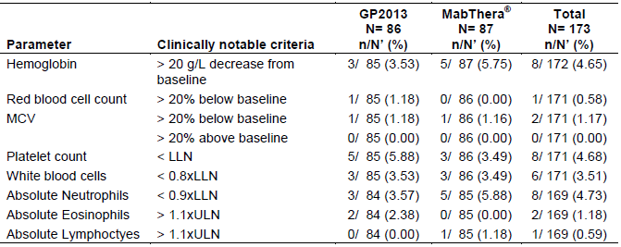
Notes: n: Number of patients meeting the criterion at any time after first dose of study drug (that is, those who have newly occurring clinically notable abnormalities). N’: Number of patients at risk (patients having a baseline measurement not meeting the criterion or missing and having at least one post-baseline measurement for the laboratory test. Denominator used in the percentage calculations is Total column.
AEs, regardless of the relationship to the study drug, grouped by the SOC of ‘Blood and lymphatic system disorders’ were reported in a similar proportion of patients in the GP2013 and MabThera arms (that is, 5.8% (n = 5) and 6.9% (n = 6), respectively). The AEs (PT) in the 5 patients in the GP2013 arm were: 2 anaemia and 1 each for leukopaenia, microcytic leukaemia, bone marrow failure, iron deficiency anaemia and pancytopenia). The AEs (PT) in the 6 patients in the MabThera arm were one each for anaemia, leukopaenia, microcytic anaemia, granulocytopenia, neutropenia and thrombocytopenia.

Study GP13-301 – FL

Combination phase
Haematology shift tables based on CTC grades revealed few changes for increased lymphocyte values and most patients remained at their baseline grade (> 90% at Grade 0) throughout the study. Decreased absolute neutrophil values showed some upward shift changes during the study in both the GP2013 and MabThera arms, with these being mostly similar shifts from Grade 0 (95.2% (n = 297) and 92.1% (n = 290) at baseline, respectively) to Grade 0 (41.3% (n = 129) and 37.8% (n = 119), respectively), Grade 1 (10.6% (n = 33) and 12.7% (n = 40), respectively), Grade 2 (20.2% n = 63) and 20.3% (n = 64), respectively), Grade 3 (13.8% n = 43) and 10.5% (n = 33), respectively), and Grade 4 (8.3% (n = 26) and 10.2% (n = 32), respectively).
Decreased total WBC values showed some worsening of grades in both the GP2013 and MabThera arms as shown by upward grade shifts for Grade 0 (93.3% (n = 291) and 91.4% (n = 288) at baseline, respectively) to Grade 0 (34.9% (n = 109) and 31.1% (n = 98), respectively), Grade 1 (24.0% (n = 75) and 30.2% (n = 95), respectively), Grade 2 (22.4% (n = 70) and 18.4% (n = 68), respectively), Grade 3 (7.7% (n = 24) and 9.2% (n = 29), respectively), and Grade 4 (3.2% (n = 10) and 1.9% n = 6), respectively).
Decreased lymphocyte values had slight upward grade shifts during the study, but these shifts were similar for the two treatment arms. Platelet values showed very few upward grade shifts and in several categories, showed improvement in grade and these shifts were similar in the two treatment arms (for example, GP2013 Grade 1 at baseline of 9.6% (n = 30) to Grade 1 of 4.8% (n = 15) and to Grade 0 of 4.5% (n = 14) vs MabThera Grade 2 at baseline of 17.1% (n = 54) to Grade 1 of 10.2% (n = 32) and to Grade 0 of 6.3% (n = 20)). Haemoglobin and platelet grade shifts were few, were mostly only single grade shifts up or down, and were similar for the two treatment groups.
The percentage of patients with newly occurring or worsening haematology abnormalities in the combination phase was summarised. In the combination phase, the most common newly occurring or worsening haematologic abnormalities reported in both treatment arms were decreased neutrophils followed by decreased absolute lymphocytes and decreased WBCs.
The incidence of newly occurring or worsening Grade 3 haematological abnormalities in the combination phase was low in both treatment arms and was reported as follows for the GP2013 versus MabThera arms, respectively: (i) decreased neutrophils (15.6% versus 12.7%); (ii) decreased lymphocytes (10.8% versus 12.0%); (iii) decreased WBC (9.1% versus 10.6%); (iv) decreased haemoglobin (2.3% and 3.6%), and (v) decreased platelets (1.0% versus 1.3%). The incidence of newly occurring or worsening Grade 4 haematological abnormalities in the combination phase was also low in both treatment arms and was reported as follows for the GP2013 versus MabThera arms respectively: (i) decreased lymphocytes (1.9% versus 2.2%); (ii) decreased neutrophils (8.7% versus 10.7%); (iii) decreased WBC (3.2% versus 2.6%); and (v) decreased platelets (0.6% versus 0.3%).
In the combination phase, AEs (all grades) in the SOC of ‘blood and lymphatic disorders’, regardless of the relationship to the study drug, were reported in 36.2% (n = 113) of patients in the GP2013 arm and 40.3% (n = 127) of patients in the MabThera arm, with the corresponding frequencies for AEs (Grade 3/4) being 23.7% (n = 74) and 26.7% (n = 84), respectively. Grade 3/4 haematological AEs (PT) in the combination phase reported in ≥ 2% of patients in either treatment arm (GP2013 versus MabThera), in descending order of frequency in the GP2013 arm, were neutropenia (17.6% (n = 55) versus 20.6% (n = 65)), febrile neutropenia (6.1% (n = 19) versus 3.2% (n = 10)), leukopaenia (2.6% (n = 8) versus 4.4% (n = 14)), and anaemia (1.6% (n = 5) versus 3.8% (n = 12)),

Maintenance phase
Haematology shift data from baseline during the maintenance phase in both treatment arms showed that there were almost no shifts in grade for increased lymphocytes, decreased haemoglobin or decreased platelets and only some slight upward shifts in grade for decreased lymphocytes, decreased neutrophils, and decreased white blood cells. Haematology shift tables based on the normal range (values grouped as low, normal, and high) showed similar profiles (basophils, eosinophils, monocytes, haematocrit, red blood cells) for both treatment arms over the course of the study.
During the maintenance phase, similar frequencies of newly occurring or worsening haematological abnormalities were reported in patients in both treatment arms. The most common newly occurring or worsening abnormalities were decreased WBC, decreased lymphocytes, and decreased neutrophils for both groups.
In the maintenance phase, the incidence of newly occurring or worsening Grade 3 haematological abnormalities was low in both treatment arms and was reported as follows for the GP2013 versus MabThera arms, respectively: (i) decreased lymphocytes (2.4% versus 1.0%); (ii) decreased neutrophils (5.3% versus 4.5%); and decreased WBC (2.4% versus 0%). The incidence of newly occurring or worsening Grade 4 haematological abnormalities in the maintenance phase was low in both treatment arms and was reported as follows for the GP2013 versus MabThera arms, respectively: (i) decreased lymphocytes (0% versus 0.5%); and (ii) decreased neutrophils (2.9% versus 2.0%). There were no patients in either of the two treatment arms with Grade 3 or 4 decreased haemoglobin, Grade 4 decreased WBC, or Grade 3 or 4 decreased platelets.
In the maintenance phase, AEs (all grades) in the SOC of ‘blood and lymphatic disorders’, regardless of the relationship to the study drug, were reported in 12.1% (n = 28) of patients in the GP2013 arm and 10.4% (n = 24) of patients in the MabThera arm, with the corresponding frequencies for AEs (Grade 3/4) being 7.4% (n = 17) and 6.1% (n = 14), respectively. The only Grade 3/4 haematological AE (PT) reported in ≥ 2% of patients in either treatment arm (GP2013 versus MabThera) in the maintenance phase was neutropenia (7.4% (n = 17) versus 3.9% (n = 9)).

Electrocardiograph findings and cardiovascular safety

Study GP13-201 – RA
ECG changes were not systematically assessed in this study. ECGs were performed only at screening.
AEs, regardless of relationship to the study drug, grouped by the SOC of ‘cardiac disorders’ were reported in a similar proportion of patients in the GP2013 and MabThera arms (4.7% (n = 4) versus 4.6% (n = 4), respectively). The AEs (PT) in the 4 patients in the GP2013 arm were one each for acute myocardial infarction, bradycardia, coronary artery insufficiency, palpitations and ventricular tachycardia. The AEs (PT) in the 4 patients in the GP2013 arm were two for angina pectoris and one each for cardiovascular disorder, sinus tachycardia and tachycardia.
AEs, regardless of relationship to the study drug, grouped by the SOC of ‘Vascular disorders’, were reported in 7 (8.1%) patients in the GP2013 arm and 10 (11.5%) patients in the MabThera arm. AEs (PT) reported in the 7 patients in the GP2013 arm were three for hypertension and one each for flushing, hypotension, orthostatic hypotension, and thrombophlebitis. The AEs (PT) reported in the 10 patients in the MabThera arm were five for hypertension, two for hypertensive crisis, and one each for flushing, hypotension, deep vein thrombosis, hyperaemia and vasculitis.

Study GP13-301 – FL
ECG assessments were performed at screening, on Day 1 of Cycle 1, 4 and 8, and at End of Treatment. Patients who entered the maintenance phase were also monitored on Day 1 of Cycle 2, 4, 6, and 8, and at maintenance End of Treatment. No clinically relevant differences were observed between the two treatment arms either in the number of patients with clinically notable abnormal ECG values or in newly occurring or worsening of ECG results. No specific pattern of ECG abnormalities was observed in either of the two treatment arms.

Combination phase
In the combination phase, AEs (all grades) in the SOC ‘cardiac disorders’, regardless of the relationship to the study drug, were reported in 9.0% (n = 28) of patients in the GP2013 arm and 4.8% (n = 15) of patients in the MabThera arm, with the corresponding results for AEs (Grade 3/4) being 1.9% (n = 6) and 1.3% (n = 4). AEs (all grades) reported in ≥ 2% of patients in either of the two treatment arms (GP2013 versus MabThera) were sinus tachycardia (2.6% (n = 8) versus 0%) and palpitations (2.2% (n = 7) versus 0.6% (n = 2)). AEs (Grade 3/4) reported in the 6 patients in the GP2013 arm were tachycardia (x2), sinus tachycardia (x1), extrasystoles (x1), angina pectoris (x1), atrial fibrillation (x1), cardio-respiratory arrest (x1), and Prinzmetal angina (x1). AEs (Grade 3/4) reported in the 4 patients in the MabThera arm were angina pectoris (x1), atrial fibrillation (x1), acute coronary syndrome (x1), cardiac disorder (x1), and cardiac failure (x1).
In the combination phase, AEs (all grades) in the SOC ‘vascular disorders’, regardless of relationship to the study drug were reported in 12.2% (n = 38) of patients in the GP2013 arm and 10.8% (n = 34) of patients in the MabThera arm, with the corresponding results for AEs (Grade 3/4) being 2.6% (n = 8) and 2.2% (n = 7), respectively. AEs (all grades) reported in ≥ 2% of patients in either of the two treatment arms (GP2013 versus MabThera) were hypertension (6.7% (n = 21) versus 4.4% (n = 14)) and hypotension (3.2% (n = 10) versus 3.5% (n = 11)). AEs (Grade 3/4) reported in ≥ 2 patients in either treatment arm (GP2013 versus MabThera) were hypertension (n = 5 (1.6%) versus n = 3 (1.0%)) and hypotension (n = 2 (0.6%) versus n = 2 (0.6%)).

Maintenance phase
In the maintenance phase, AEs (all grades) by SOC ‘cardiac disorders’, regardless of the relationship to the study drug, were reported in 2.2% (n = 5) of patients in the GP2013 arm and 3.0% (n = 7) of patients in the MabThera arm, with the corresponding results for AEs (Grade 3/4) being 0.4% (n = 1) and 0.4% (n = 1), respectively. No AEs (all grades) were reported in more than 1 patient either of the two treatment arms, while AEs (Grade 3/4) were reported in 1 patient in the GP2013 arm (atrial fibrillation x1) and 1 patient in the MabThera arm (cardiac arrest x 1).
In the maintenance phase, AEs (all grades) by SOC ‘vascular disorders’, regardless of relationship to the study drug, were reported in 5.6% (n = 13) of patients in the GP2013 arm and 3.5% (n = 8) of patients in the MabThera arm, with the corresponding results for AEs (Grade 3/4) being 0.9% (n = 2) and 0.9% (n = 2), respectively. The only AE (all grades) reported in ≥ 1% of patients in either treatment arm was hypertension (3.5% (n = 8), GP2013 versus 1.7% (n = 5), MabThera). In the 2 patients in the GP2013 arm with AEs (Grade 3/4) there were two events of hypertension, and in the 2 patients in the MabThera arm with AEs (Grade 3/4) there was one event of hypertension and one event of circulatory collapse.

Vital signs and clinical examination findings

Study GP13-201 – RA
There were no clinically meaningful differences in vital signs between the two treatment arms. Mean changes in systolic and diastolic blood pressure and pulse rate from baseline to Week 24 and to Week 52 were small in both treatment arms and not clinically significant In the GP2013 and MabThera arms, respectively, newly occurring systolic blood pressure < 90 mmHg was reported in 1.2% (n = 1) and 2.3% (n = 2) of patients and > 140 mmHg was reported in 39.0% (n = 30) and 44.9% (n = 31) of patients, newly occurring diastolic blood pressure of < 60 mmHg was reported in 10.6% (n = 9) and 7.0% (n = 6) of patients and > 90 mmHg was reported in 19.1% (n = 16) and 30.7% (n = 23) of patients, and newly occurring pulse rate < 60 bpm were reported in 16.7% (n = 14) and 13.1% (n = 11) of patients and > 100 bpm in 8.2% (n = 7) and 8.1% (n = 7) of patients.
The mean change from baseline to Week 24 in weight was 0.94 kg for patients in the GP2013 arm (n = 79) and 0.44 kg for patients in the MabThera arm (n = 82), and the mean change from baseline to Week 52 in weight was 1.35 kg for patients in the GP2013 arm (n = 66) and 1.75 kg for patients in the MabThera arm (n = 65).

Study GP13-301 – FL
In Study GP13-301, body weight, pulse rate, systolic/diastolic blood pressure and body/oral temperature were measured on Day 1 of each treatment cycle (irrespective of treatment phase), and at End of Treatment (irrespective of treatment phase). Height was only measured at screening. No relevant differences in any vital signs were observed between GP2013 and MabThera during the study. In the combination phase, high or low abnormalities in the pulse rate, systolic blood pressure or diastolic blood pressure reported in ≥ 2% of patients in either of the two treatment arms (GP2013 versus MabThera, respectively) were low systolic blood pressure (3.6% (n = 11) versus 5.1% (n = 16)) and low diastolic blood pressure (3.3% (n = 10) versus 2.2% (n = 7)). In the maintenance phase, high or low abnormalities in the pulse rate, systolic blood pressure or diastolic blood pressure reported in ≥ 2% of patients in either of the two treatment arms (GP2013 versus MabThera, respectively) was reported only for high systolic blood pressure (1.0% (n = 2) versus 2.0% (n = 4)).

Immunogenicity and immunological events

Study GP13-201 – RA
In Study GP13-201, blood samples for ADA assessments were collected before the first infusion and at Weeks 4, 16, 24, 38 and 52. If patients received a second treatment course blood samples were again collected before the first infusion and at the follow-up Visit 26 weeks after the first infusion of the second treatment course.
At randomisation (pre-treatment), ADAs were detected in 2 (1.2%) patients in the MabThera arm and both patients were excluded from further ADA analysis. Both patients tested negative for ADAs post-treatment.
The incidence of post-baseline ADA was lower in patients in the GP2013 arm than in patients in the MabThera arm (11.0% (9/82) versus 21.4% (18/84)). There were no relevant differences observed in terms of general safety or in efficacy between patients with ADAs and without ADAs.
Samples with confirmed positive binding anti-rituximab antibodies were further assessed for the neutralising capacity of the antibodies via a cell based assay (NAb assay). A total of 4 patients exhibited NAbs, 3 out of 82 (3.7%) patients in the GP2013 arm and 1 out of 84 (1.2%) patients in the MabThera arm. No SAEs were reported for the NAb positive patients in the GP2013 arm, but 2 suspected drug-related SAEs of moderate intensities (gastroenteritis and infusion related reaction) were reported in the 1 patient in the MabThera arm. This patient also exhibited the highest titre determined in Study GP13-201. The number of patients with NAbs is too small to meaningfully compare the efficacy and safety outcomes to patients who are negative for NAbs.
AEs (all grades) by SOC of ‘immune system disorders’, regardless of the relationship to the study drug were reported in 2 (2.3%) patients in the GP2013 arm (one each for drug sensitivity and hypersensitivity) and 1 (1.1%) patient in the MabThera arm (drug hypersensitivity).

Study GP13-301 – FL
In Study GP13-301, immunogenicity was assessed for all patients at screening (or pre-dose or both), EOT combination phase, and EOT maintenance phase. For Cohort 1 patients (that is, sparse PK sampling program), an additional immunogenicity assessment was performed at pre-dose Cycle 4 Day 1. Overall, 5 patients with pre-existing immunogenicity were excluded from the immunogenicity assessment. Of these 5 excluded patients, 4 patients (3 in the GP2013 arm and 1 in the MabThera arm) were consistently ADA negative at later visits and 1 patient in the GP2013 arm had a confirmed non-neutralising ADA positive result at the end of the maintenance phase. Of the 4 patients in the GP2013, 3 tested negative post-treatment and 1 tested positive. No post-treatment assessments were undertaken in the 1 patient in the MabThera arm as this patient died while on treatment due to acute respiratory failure.
Immunogenicity was assessed in 551 (87.6%) patients (268 (85.45) in the GP2013 arm; 283 (89.8%) in the MabThera arm). Overall, 8 of the 551 patients (1.5%) tested positive for ADAs post-treatment (5 (1.9%) in the GP2013 arm; 3 (1.1%) in the MabThera arm). In Cycle 4 Day 1 in the combination phase, confirmed ADAs were detected in 2 (2.1%) patients in the GP2013 arm and 1 (0.9%) patient the MabThera arm. At the EOT in the combination phase, there was 1 (0.4%) patient in GP2013 arm and 2 (0.7%) patients in the MabThera arm with ADAs. At the EOT in the maintenance phase, there was only 1 patient in the GP2013 arm confirmed positive for ADA. Overall, ADAs were detected in 5 (1.9%) patients in the GP2013 arm (4 in the combination phase, 1 in the maintenance phase) and 3 (1.1%) patients in the MabThera arm (all in the combination phase). Based on the limited PK data in ADA positive patients, there is no clear indication that ADA affects exposure to either GP2103 or MabThera.
Neutralising antidrug-antibodies (NAbs) were detected in 0.7% (2/268) of patients in the GP2013 arm and 0.7% (2/283) patients in the MabThera arm. NAb was detected in 1 of the patients in the GP2013 arm at the end of maintenance phase, while all other NAb positive events in both treatment arms were detected during the combination phase. The presence of NAbs showed no obvious link with any immunogenicity-related SAEs or diminished efficacy. An assessment of safety parameters found that the 4 patients in the GP2013 arm who were NAB-positive had no AEs suggestive of infusion-related reactions. One of the NAB-positive patients in the MabThera arm, who died due to cardiac arrest, had several SAEs, two of which were considered to be study drug-relate (neutropenia), and experienced Grade 3 chills after the first infusion. The sponsor commented that ‘(i)t is not possible to draw a meaningful conclusion from these clinical findings relative to ADA’. In summary, the incidence of NAb was low and similar in frequency in the GP2013 and MabThera arms.
In the combination phase, AEs (all grades) by the SOC of ‘immune system disorders’, regardless of the relationship to the study drug were reported in 8 (2.6%) patients in the GP2013 arm and 12 (3.8%) patients in the MabThera arm. AEs (Grade 3/4) were reported in 1 (0.3%) patient in the GP2013 arm (1 x anaphylactic reaction) and 3 (1.0%) patients in the MabThera arm (one each hypersensitivity, anaphylactic reaction and cytokine release syndrome, and drug hypersensitivity).
In the maintenance phase, AEs all grades by the SOC of ‘immune system disorders’, regardless of the relationship to the study drug were reported in 1 (0.4%) patient in the GP2013 arm (1 x hypogammaglobulinaemia) and 1 (0.4%) patient in the MabThera arm (1 x hypersensitivity), Neither of these two AEs were categorised as Grade 3/4 in severity.

Serious skin reactions

Study GP13-201 – RA
No SAEs grouped by the SOC of ‘Skin and subcutaneous tissue disorders’ were reported in either of the two treatment arms. Alopecia was the only ‘skin and subcutaneous tissue disorder of special interest’ reported (2 (2.3%) patients in the GP2013 arm and 1 (1.1%) patient in the MabThera arm).

Study GP13-301
In the combination phase, SAEs grouped by the SOC of ‘Skin and subcutaneous tissue disorders’, regardless of the relationship to the study drug, were reported in 3 (1.0%) patients in the GP2013 and no patients in the MabThera arm. In the GP2013 arm, the AEs reported in the 3 patients were all categorised as Grade 3/4 in severity (one event each for drug eruption, skin lesion, and toxic skin eruption). In the maintenance phase, SAEs grouped by the SOC of ‘Skin and subcutaneous tissue disorders’, regardless of the relationship to the study drug were reported in no patients in either of the two treatment arms.

Neoplasms

Study GP13-201 – RA
AEs (all grades) by SOC ‘neoplasm benign, malignant, and unspecified (incl cysts and polyps)’ were reported in 1 (1.2%) patient in the GP2013 arm (1 event each of basal cell carcinoma, melanocytic naevus, and skin papilloma) and 2 (2.3%) patients in the MabThera arm (1 event each of infected neoplasm and renal haemangioma).

Study GP13-301 – FL
In the combination phase, AEs (all grades) by SOC ‘neoplasm benign, malignant, and unspecified (incl cysts and polyps)’ were reported in 7 (2.2%) patients in the GP2013 arm and 6 (1.9%) patients in the MabThera arm. The AEs (PTs) in the 7 patients in the GP2013 arm were 2 events of lipoma and 1 event each for benign breast neoplasm, colon cancer, invasive ductal breast cancer, lentigo maligna, malignant lung neoplasm and myeloproliferative disorder. The AEs (PTs) in the 6 patients in the MabThera arm were 1 each for lipoma, anogenital warts, keratoacanthoma, malignant melanoma, seborrhoeic keratosis, and skin papilloma. AEs (Grade 3/4) were reported in 3 patients in the GP2013 arm (1 each for colon cancer, invasive ductal breast cancer, lung malignant neoplasm) and no patients in the MabThera arm.
In the maintenance phase, AEs (all grades) by SOC ‘neoplasm benign, malignant, and unspecified (incl cysts and polyps)’ were reported in 2 (0.9%) patients in the GP2013 arm and 8 (3.5%) patients in the MabThera arm. The AEs (PTs) in the 2 patients in the GP2013 arm were 1 event each of basal cell carcinoma, fibroma and uterine leiomyoma. The AEs (PTs) in the 8 patients in the MabThera arm were 2 events of seborrhoeic keratosis, and 1 event each for benign breast neoplasm, lipoma, malignant lung neoplasm, skin papilloma, squamous cell carcinoma of the lung, and thyroid neoplasm. There were no Grade 3/4 AEs in either of the two treatment arms.

Other safety issues

Safety in special populations and situations
The effects of intrinsic factors, extrinsic factors and drug interactions on the safety of the two rituximab products were not assessed in either Study GP13-201 or Study GP13-301. There were no pregnancies in the studies. There were no cases of GP2013 overdose. There were no data on the potential for drug abuse with GP2013, but abuse with the drug is unlikely. There were no data on withdrawal and rebound for GP2013. There were no studies on the effects of the drugs on the ability to drive and use machinery.

Post marketing experience
Not applicable. GP2013 has not yet been registered in any country.

Evaluator’s overall conclusions on clinical safety
The submitted safety data in patients with FL and RA suggest that there are no clinically meaningful differences in the safety profiles of GP2013 and MabThera. In patients with RA (Part I (Study GP13-201)) and FL (combination phase (Study GP13-301)) the safety profiles for the two treatment arms were comparable, while in patients with FL (maintenance phase (Study GP13-301)) most of the AE categories were reported marginally more frequently in the GP2013 arm than in the MabThera arm.
In the pivotal Phase III efficacy and safety study in patients with FL (Study GP13-301), safety data were reported for a total of 627 patients in the combination phase treated with 8 x 21 day cycles of either GP2013 or MabThera in combination with CVP for approximately 6 months (n = 312, GP2013 + CVP; n = 315, MabThera + CVP). In addition, safety data in Study GP13-301 were also provided for a total of 462 patients continuing treatment in the maintenance phase, with 8 x 3 month cycles planned for 2 years (n = 231, GP2013; n = 231, MabThera). The safety data reported for the maintenance phase of Study GP13-301 were considered as interim as the study is ongoing.
In the supportive Phase II efficacy and safety study in patients with RA, safety data (Part I) were reported for a total of 173 patients (n = 86, GP2013; n = 87 MabThera) treated for up to 52 weeks (two initial infusions separated by 2 weeks (Day 1 and Day 15), followed by two infusions separated by 2 weeks initiated from Week 24 to Week 52 for selected patients). In addition to safety data from the studies in patients with FL and RA, the submission also included safety data on 6 Japanese patients with low grade CD20+ NHL treated with GP2013 from the Phase I Study GP13-101.
In Study GP13-301, the median duration of exposure for both treatment arms in the combination phase was 168 days, and the median cumulative dose of study drug was similar in the two treatment arms (5172 mg, GP2013 versus 5205 mg, MabThera). In the combination phase, 89.7% (280/312) of patients in the GP2013 arm received 8 treatment cycles compared to 90.2% (284/315) of patients in the MabThera arm. In the maintenance phase, the median cumulative dose of study drug was lower in the GP2013 arm than in the MabThera arm (2261 mg versus 2705 mg, respectively) with the difference being due to the higher rate of discontinuations due to AEs in the GP2013 arm than in the MabThera arm. In the maintenance phase, 16.5% (38/231) of patients in the GP2013 arm received 8 treatment cycles compared to 19.0% (44/231) of patients in the MabThera arm.
In Study GP13-301, based on the number of cycles of investigational treatment in the maintenance phase it can be estimated that approximately 195 patients have been treated with GP2013 for 12 months (that is, combination plus maintenance phase) compared to approximately 194 patients treated with MabThera, with the corresponding number of patients treated for 30 months (combination plus maintenance phase) being 38 and 44 patients, respectively.
The duration of exposure to GP2013 in patients with RA (Study GP13-201; Part I) was 1 month for 84 patients, 3 months for 82 patients, 6 months for 77 patients, and 12 months for 49 patients. The total person years of exposure to GP2013 in Study GP13-201 (Part I) was 87.1 person years. In Study GP13-201 (Part I), the number of patients receiving the maximum number of 4 infusions was similar in the GP2013 and the MabThera arms (n = 59 (68.6%) versus n = 58 (66.7%), respectively).
Data from the draft RMP indicates that the total number of patients exposed to GP2013 was 470 (submitted trials and not submitted ongoing trials), which based on the ‘rule of 3s’ is too low to detect rare adverse drug reactions (that is, ≥ 1/10,000 to < 1/1,000). However, the available safety data suggest that rare adverse drug reactions for GP2013 and MabThera are unlikely to be notably different.
There were no general safety or immunogenicity data in patients with RA or FL treated initially with MabThera and then switched to GP2013. However, there is a study (Study GP13-302) currently underway in patients with RA comparing general safety and immunogenicity in patients switched from Rituxan (US approved) or MabThera (EU approved) to GP2013 to patients continuing treatment with Rituxan (US approved) or MabThera (EU approved).

Study GP13-201 – RA
In patients with RA (Study GP13-201), AEs were reported in a similar proportion of patients in the GP2013 and the MabThera arms (65.1% versus 65.5%, respectively), as were AEs suspected to be study drug-related (32.6% versus 33.3%, respectively). The most commonly occurring AEs by SOC in both treatment arms were ‘infection and infestations’ (31.4%, GP2013 versus 35.6%, MabThera). Overall, the AE profiles of the two treatment arms were similar and the observed differences are not considered to be clinically meaningful.
AEs leading to premature discontinuation of the study drug were reported more frequently in patients in the MabThera arm than in patients in the GP2013 arm (8.0% versus 4.7%, respectively), as were AEs leading to dose adjustments or interruptions to the study drug (11.2% versus 12.6%, respectively). There was only 1 death reported in the study (GP2013 arm), which was related to an accidental overdose of MTX. Other non-fatal SAEs, regardless of relationship to treatment were reported more frequently in the MabThera arm than in the GP2013 arm (16.1% versus 11.6%, respectively). The most frequently reported SAEs by SOC in both treatment arms were ‘Infections and infestations’ (5.8%, GP2013 versus 4.6%, MabThera).
The incidence of post-baseline ADAs was lower in patients in the GP2013 arm than in patients in the MabThera arm (11.0% versus 21.4%), while NAbs were reported in 3.7% and 1.2% of patients, respectively. Infusion related reactions (Novartis MedDRA Query) were reported more frequently in the MabThera arm than in the GP2013 arm (42.5% versus 37.2%, respectively).
There were no clinically meaningful differences between the two treatment arms as regards AEs of particular regulatory interest including hepatic, renal, cardiovascular or skin toxicity, immune system disorders or neoplasms. No notable clinically significant differences between the two treatment arms were observed as regards vital signs or clinical laboratory tests (haematology and chemistry).
There were no studies in special groups specifically comparing safety in patients by age, sex or race. There were no special studies in patients with hepatic, renal impairment or cardiac impairment. However, based on the currently available data it is unlikely that the safety profile of the two products will significantly differ in patients treated with GP2013 or MabThera.

Study GP13-301 – FL – Combination Phase (GP2013 + CVP vs MabThera + CVP)
In patients with FL (n = 312, GP2013; n = 315, MabThera), AEs (all grades) regardless of the relationship the relations to the study drug occurred frequently (92.6%, GP2013 versus 91.4%, MabThera). The majority of AEs (all grades) reported in both treatment arms (GP2013 versus MabThera, respectively) were suspected to be study drug-related (73.7% versus 70.8%). AEs (Grade 3/4), regardless of the relationship to the study drug, were reported in a similar proportion of patients in the two treatment arms (43.3%, GP2013 versus 46.0%, MabThera), and AEs (Grade 3/4) suspected to be study drug-related also occurred in a similar proportion of patients in the two treatment arms (28.5% versus 31.1%).
Deaths occurred infrequently in both treatment arms (1.3%, GP2013 versus 2.2%, MabThera), while SAEs regardless of relationship to the study drug occurred in a similar proportion of patients in the two treatment arms (22.8%, GP2013 versus 20.0%, MabThera) as did SAEs suspected to be study drug-related (4.5%, GP2013 versus 5.1%, MabThera). AEs leading to discontinuation of the study drug were reported in a similar proportion of patients in the two treatment arms (7.4%, GP2013 versus 7.0%, MabThera), as were AEs requiring dose interruption and/or reduction (40.7%, GP2013 versus 44.4%, MabThera).
The incidence of infusion related-reactions (AEs defined by NMQ) suspected to be related to the study drug was similar in patients in the GP2013 and MabThera arms (49.4% versus 48.3%, respectively). The incidence of infusion-related reaction AE (all grades; PT) suspected to be related to the study drug was reported in 13.1% of patients in the GP2013 arm and 11.7% of patients in the MabThera arm, while AE (Grade 3/4; PT) suspected to be related to the study drug was reported in 1.0% and 0.6% of patients, respectively.
AEs requiring additional therapy (all non-drug therapy, concomitant medications, hospitalisations and prolonged hospitalisations) occurred in a similar proportion of patients in both treatment arms (83.7%, GP2013 versus 83.8%, MabThera).

Study GP13-301 – FL – Maintenance Phase (GP2013 vs MabThera)
In patients with FL (n = 231, GP2013; n = 231, MabThera), AEs (all grades) regardless of the relationship to the study drug occurred in a similar proportion of patients in the two treatment arms (63.2%, GP2013 versus 57.1%, MabThera). AEs (all grades) suspected to be study drug-related were reported more frequently in the GP2013 arm than in the MabThera arm (23.4% versus 16.5%, respectively). AEs (Grade 3/4), regardless of the relationship to the study drug, were also reported more frequently in the GP2013 arm than in the MabThera arm (16.9% versus 13.9%, respectively), while AEs (Grade 3/4) were reported in a similar proportion of patients in both treatment arms (6.9%, GP2013 versus 5.2%, MabThera).
Deaths occurred infrequently in both treatment arms (0.9%, both arms). SAEs, regardless of the relationship to the study drug, were reported in a similar proportion of patients in both treatment arms (6.1%, GP2013 versus 4.3%, MabThera) as were SAEs suspected to be study drug-related (2.6%, GP2013 versus 1.3%, MabThera). AEs leading to discontinuation of the study drug were reported marginally more frequently in the GP2013 arm than in the MabThera arm (3.5% versus 1.7%), while AEs requiring dose interruption and/or reduction were reported in the same proportion of patients in both treatment arms (7.4%, both arms).
The incidence of infusion related-reactions (AEs defined by NMQ) suspected to be related to the study drug was similar in patients in the GP2013 and MabThera arms (10.8% versus 8.2%, respectively). The incidence of infusion-related reaction AE (all grades; PT) suspected to be related to the study drug was reported in a similar proportion of patients in both treatment arms (1.3%) and no AE (Grade 3/4) suspected to be related to the study drug was reported in either treatment arm.
AEs requiring additional therapy (all non-drug therapy, concomitant medications, hospitalisations and prolonged hospitalisations) occurred in a similar proportion of patients in both treatment arms (48.1%, GP2013 versus 45.0, MabThera).

Study GP13-301 - FL - Combination and Maintenance Phases
Immunogenicity was assessed in 551 patients (n = 268, GP2013; n = 283, MabThera). The frequency of ADAs in the combination phase was 1.5% in the GP2013 arm and 1.1% in the MabThera arm and in the maintenance phase was 0.4% and 0%, respectively. Overall, ADAs were detected in 5 (1.9%) of patients in the GP2013 arm and 3 (1.1%) patients in the MabThera arm. Neutralising antidrug-antibodies (NAbs) were detected in 2 out of 268 (0.7%) patients in the GP2013 arm and 2 out of 283 (0.7%) patients in the MabThera arm.
There were no clinically meaningful differences between the two treatment arms in the combination and maintenance phases as regards AEs of particular regulatory interest including hepatic, renal, cardiovascular and skin toxicity or immune system disorders. No notable clinically significant differences between the two treatment arms were observed as regards vital signs or clinical laboratory tests (haematology and chemistry).
There were no studies in special groups specifically comparing safety in patients by age, sex or race. There were no special studies in patients with hepatic, renal impairment or cardiac impairment. However, based on the currently available data it is unlikely that the safety profile of the two products will significantly differ in patients treated with GP2013 or MabThera.

First round benefit-risk assessment

First round assessment of benefits
Overall, it is considered that the efficacy data from the submitted clinical studies are promising and show that the benefits of treatment with GP2013 for the proposed indications are comparable to the benefits of treatment with MabThera. However, it is considered that firm conclusions relating to the therapeutic equivalence of the two rituximab formulations are precluded by the absence of mature PFS and OS data from the pivotal efficacy Study GP13-301 in patients with FL.
The pivotal Phase III clinical efficacy and safety Study GP13-301 showed that treatment with GP2013 (375 mg/m², IV) and MabThera (375 mg/m², IV) in combination with CVP chemotherapy for approximately 6 months (8 x 21 day cycles) had equivalent effects on the ORR based on Modified Response Criteria for Malignant Lymphoma using central blinded review of the radiological response and liver/spleen enlargement assessments in patients with FL (PPS). In the combination phase, the ORR was 87.1% (271/311) in the GP2013 arm and 87.5% (274/313) in the MabThera arm in the PPS, with the difference in the ORR between the two arms being -0.40% (95% CI: -5.94%, 5.14%). The 95% CI for the difference in ORR between the two arms was entirely enclosed within the pre-specified ORR equivalence margin of -12% to +12%. The results for the analysis in the FAS were consistent with the results for the primary analysis in the PPS.
In the subgroup analyses of the ORR in Study GP13-301 based on baseline FLIPI prognostic scores (scores 0-2; scores 3-5), GP2013 and MabThera were not equivalent in the combination phase as the 90% CIs for both analyses were not enclosed within the pre-specified equivalence margin of -12% to +12%. In the subgroup analyses of the ORR based on baseline age (< 60 years; ≥ 60 years), GP2013 and MabThera were equivalent in the combination phase as the 90% CIs for both analyses were enclosed entirely within the pre-specified equivalence margin of -12% to +12%. The logistic regression analysis based on BOR (yes or no) of CR or PR in the combination treatment phase showed no significant difference between GP2013 and MabThera.
In Study GP13-301, the results for PFS and OS were too immature to conclude that the benefits of GP2013 and MabThera were comparable for these two important time-to-event endpoints. Therefore, although the benefits of GP2013 and MabThera can be considered to be equivalent based on the ORR in the 6 month combination phase, comparable clinical benefit of the two products over the 2 year single-arm maintenance phase cannot be confirmed due to the absence of mature PFS and OS data.
In general, the supportive Phase II efficacy Study GP13-201 showed that the benefits of treatment with GP2013 and MabThera for advanced RA were comparable. In this Phase II study, assessment of efficacy was a secondary objective and the efficacy endpoints were secondary endpoints. It would have been preferable if the RA study had been Phase III in design with primary efficacy endpoints. However, it is considered that the data from this Phase II study are acceptable, given the robustness of the comparability efficacy data for the two treatment arms and the fact that both PK and PD equivalence of the two formulations were satisfactorily demonstrated. Nevertheless, the sponsor is requested to justify why a Phase III study was not undertaken in patients with RA.
Study GP13-201 in patients with RA met its key efficacy objective, which was to show non-inferiority of GP2013 compared to MabThera based on the change from baseline in DAS28 (CRP) at Week 24. The LS mean change from baseline in DAS28 (CRP) at Week 24 was similar for the GP2013 and the MabThera arms (-2.16 and -2.23, respectively) in the PPS, and the LS mean difference between the two treatment arms was 0.07 (95% CI: -0.328, 0.462). The upper 95% CI of 0.462 was below the pre-defined non-inferiority margin of 0.6. The arithmetic mean change from baseline in DAS28 (CRP) from baseline over the 52 weeks of the study was similar in the two treatment arms, with marked inter-subject variability in the parameter being observed in both treatment arms. Both treatments showed benefits in patients with RA based on a range of other secondary efficacy variables. No statistical analysis assessing the equivalence of the two treatment arms was submitted. The sponsor is requested to justify why the key secondary efficacy endpoint (change from baseline in DAS28 (CRP) at Week 24) was assessed using a non-inferiority analysis of GP2013 to MabThera rather than an equivalence analysis of GP2013 to MabThera.
Study GP13-201 in patients with RA did not include data on the effects of treatment with GP2013 or MabThera in combination with MTX on the rate of progression of joint damage as measured by x-ray. This is an important efficacy outcome as rituximab in combination with MTX has been shown to reduce the rate of progression as measured by X-ray. However, based on the data showing PK bioequivalence, PD equivalence, and comparable efficacy of the GP2013 and MabThera in patients with RA it is considered reasonable to infer that the two formulations will have similar effects on the rate of joint damage as measured by X-ray. Nevertheless, the sponsor is requested to justify the absence of such data from Study GP13-201.
The sponsor submitted a scientific justification for extrapolating the proposed indications of GP2013 from the data in RA and FL to all other TGA approved indications of MabThera based on the totality-of-data submitted to establish the comparability of GP2013 and MabThera. The results of the comparability exercise based on the clinical data (PK, PD, efficacy (RA, FL)) are considered to be promising and suggest that there are no clinically meaningful differences between the two formulations, as regards the benefits of treatment for all proposed indications. However, it is considered that confirmation of clinical comparability should await the final results of Study GP13-301 relating PFS and OS. The submitted data for these two important time-to-event endpoints are too immature to confirm therapeutic equivalence of GP2013 and MabThera for the treatment of FL.
There were no data in the submission comparing the benefits of switching from MabThera to GP2013 with continuing on MabThera in patients with RA or FL. The submitted data indicate that a study (Study GP13-302) is currently underway to compare general safety and immunogenicity in patients switching from MabThera (or Rituxan) to GP2013 with patients remaining on MabThera (or Rituxan). However, the submitted protocol for Study GP13-302 indicates that assessment of efficacy is ‘not applicable’ in this 24 week safety and immunogenicity study. The sponsor is requested to justify the absence of efficacy data comparing patients switched from MabThera to GP2013 with patients continuing on MabThera.

First round assessment of risks

Study GP13-201 – RA
In patients with RA (Study GP13-201) the risks of treatment with GP2013 in combination with MTX were comparable to the risks of treatment with MabThera in combination with MTX, following similar exposures (dose and duration) from baseline through to 24 weeks (first course / 2 infusions) and baseline through to 52 weeks (first and second courses / 4 infusions). All patients in the GP2013 arm (n = 86 (100%)) and in the MabThera (n = 87 (100%)) received the first infusion/first course and nearly all patients in both treatment arms received the second infusion/first course (n = 84 (97.7%), GP2013 versus n = 85 (97.7%), MabThera). A similar number of patients in the two treatment arms (GP2013 versus MabThera, respectively) received the first infusion/second course (n = 59 (68.6%) versus n = 60 (69.0%)) and the second infusion/second course (n = 59 (68.6%) versus n = 58 (66.7%)). The second course of treatment could be administered any time between Week 24 and Week 52.
The RMP indicates that treatment with GP2013 was reported in 84 patients for 1 month, 82 patients for 3 months, 77 patients for 6 months, and 49 patients for 12 months. The sponsor is requested to provide the comparative data for patients treated with MabThera. There were no long term safety-data in Study GP13-201 in patients with RA (that is, safety data ≥ 52 weeks).
The overall incidence of AEs, regardless of the relationship to the study drug was 65.1% in the GP2013 arm and 65.5% in the MabThera arm. The most commonly reported AEs by SOC in ≥ 10% of patients in the GP2013 arm compared to the MabThera arm, respectively, were ‘Infections and infestations’ (31.4% versus 35.6%), ‘Musculoskeletal and connective tissue disorders’ (18.6% versus 16.1%), ‘Gastrointestinal disorders’ (15.1% versus 17.2%), ‘General disorders and administration site conditions’ (14.0% versus 10.3%), ‘Injury, poisoning, and procedural complications’ (10.5% versus 12.6%), and ‘Skin and subcutaneous tissue disorders’ (10.5% versus 12.6%).
AEs, regardless of the relationship to the study drug, reported in ≥ 5.0% of patients in the GP2013 arm compared to the MabThera arm, respectively, were urinary tract infection (10.5% versus 5.7%) and nasopharyngitis (5.8% versus 5.7%). AEs, suspected of being related to the study drug were reported in a similar proportion of patients in the GP2013 and MabThera arms (32.6% versus 33.3%, respectively). AEs, suspected of being related to the study drug and reported in ≥ 2% of patients in the GP2013 arm compared to the MabThera arm, respectively, were urinary tract infection (5.8% versus 2.3%), hypertension (3.5% versus 2.3%), chills (2.3% versus 0%), fistula (2.3% versus 0%), headache (2.3% versus 1.1%), leukocyturia (2.3% versus 0%) and nasopharyngitis (2.3% versus 4.6%).
There was 1 death in the GP2013 arm resulting from AEs associated with accidental MTX overdose compared to no deaths in the MabThera arm. Other SAEs, regardless of the relationship to the study drug, were reported more frequently in patients in the MabThera arm than in the GP2013 arm (16.1% versus 11.6%, respectively). Non-fatal SAEs by SOC reported by ≥ 2% of patients in the GP2013 arm compared to the MabThera arm were ‘Infections and infestations’ (5.8% versus 4.6%), ‘Musculoskeletal and connective tissue disorders’ (3.5% versus 3.4%), ‘General disorders and administrative site conditions’ (2.3% versus 0%) and ‘Injury poisoning and procedural complications’ (2.3% versus 3.4%). The only non-fatal SAE reported in ≥ 2% of patients (n ≥ 2) in the GP2013 arm compared to the MabThera arm was fistula (2.3% versus 0%).
AEs leading to premature discontinuation of the study drug were reported more frequently in patients in the MabThera arm than in the GP2013 arm (8.0% (n = 7) versus 4.7% (n = 4)). The AEs leading to premature discontinuation of the study drug in patients in the GP2013 arm versus the MabThera arm, respectively, were chills (1.2% versus 0%), multi-organ failure (1.2% versus 0%), drug hypersensitivity (1.2% versus 1.1%), klebsiella sepsis (1.2% versus 0%), and hypertension (1.2% versus 0%).
AEs leading to dose adjustment or interruption of the study drug were reported more frequently in patients in the MabThera arm than in the GP2013 arm (12.6% (n = 11) versus 7.0% (n = 6), respectively). AEs leading to dose adjustment or interruption of the study drug in patients in the GP2013 arm versus the MabThera arm, respectively, were odynophagia (1.2% versus 0%), oral pruritus (1.2% versus 0%), hypersensitivity (1.2% versus 0%), infusion related reaction (1.2% versus 3.4%), headache (1.2% versus 0%), throat tightness (1.2% versus 0%), pruritus (1.2% versus 3.4%), and urticaria (1.2% versus 0%).
The incidence of post-baseline ADAs was lower in patients in the GP2013 arm than in patients in the MabThera arm (11.0% versus 21.4%), while NAbs were reported in 3.7% and 1.2% of patients, respectively, in the two arms. There were no relevant differences observed in terms of general safety in patients with and without Nabs, but the efficacy data in patients with NABs were too limited to make meaningful conclusions. Infusion related-reactions (NMQ) were reported more frequently in patients in the MabThera arm than in patients in the GP2013 arm (42.5% versus 37.2%, respectively). No infusion related-reactions (AEs preferred term) were reported in ≥ 5% of patients in the GP2013 arm.
There were no clinically meaningful differences in the AE profile of patients in the two treatment arms as regards events of particular regulatory significance including hepatic, renal, or cardiovascular toxicity, immune system disorders, serious skin disorders or neoplasms. There were no clinically meaningful differences in laboratory parameters (haematological or clinical chemistry) or changes in vital signs between the two treatment arms.
There were no studies in special groups specifically comparing safety in patients by age, sex or race. There were no special studies in patients with hepatic, renal impairment or cardiac impairment. However, based on the currently available data it is unlikely that the safety profile of the two products will significantly differ in patients treated with GP2013 or MabThera.

Study GP13-301 – FL

Combination Phase (GP2013 + CVP vs MabThera + CVP) – 6 months
The combination phase was 24 weeks in duration. During this phase, patients with FL were treated with G2013 + CVP (n = 312) or MabThera + CVP (n = 315) for 8 x 21 day cycles (that is, treatment for approximately 6 months). In the combination phase, GP2013 or MabThera were administered as an IV infusion at a dose of 375 mg/m² on Day 1 of each 21 day cycle.
AEs (all grades) regardless of the relationship to the study drug occurred frequently in both treatment arms (92.6%, GP2013 versus 91.4%, MabThera). In this category, AEs (all grades) by SOC reported in ≥ 40% of patients in the GP2013 arm versus the MabThera arm were ‘Gastrointestinal disorders’ (55.8% versus 50.2%), ‘nervous system disorders’ (44.2% versus 41.9%), and ‘Infections and infestations’ (42.3% versus 41.9%).
AEs (all grades), regardless of the relationship to the study drug and reported in ≥ 10% of patients in the GP2013 arm versus the MabThera arm, respectively, were neutropenia (25.6% versus 29.5%), constipation (22.4% versus 20.0%), nausea (16.3% versus 13.3%), neuropathy peripheral (15.1% versus 9.5%), infusion-related reaction (13.5% versus 12.1%), diarrhoea (12.8% versus 11.4%), fatigue (11.2% versus 10.2%), and cough (10.6% versus 11.7%).
AEs (Grade 3/4) regardless of relationship to the study drug occurred frequently in both treatment arms (43.3%, GP2013 versus 26.7%, MabThera). AEs (Grade 3/4) by SOC reported in ≥ 20% of patients in the GP2013 arm versus the MabThera arm, regardless of the relationship to the study drug, were ‘Blood and lymphatic system disorders’ (23.7% versus 26.7%). The most frequently reported AE (Grade 3/4) in both treatment arms, regardless of the relationship to the study drug, was neutropenia (17.6%, GP2013 versus 20.6%, MabThera). The only other Grade 3/4 AEs reported in ≥ 1% of patients in the GP2013 arm versus the MabThera arm, respectively, regardless of the relationship to the study drug were constipation (1.3% versus 0.6%), neuropathy peripheral (1.3% versus 0.6%), abdominal pain (1.3% versus 2.9%), infusion-related reaction (1.0% versus 0.6%) and pyrexia (1.0% versus 0.3%).
AEs (all grades), suspected to be related to the study drug, were reported in a similar proportion of patients in the two treatment arms (73.7%, GP2013 versus 70.8%, MabThera). AEs (all grades) by SOC, suspected to be related to the study drug and reported in ≥ 20% of patients in the GP2013 arm versus the MabThera arm, respectively, were ‘Gastrointestinal disorders’ (34.0% versus 28.6%), ‘nervous system disorders’ (28.5% versus 28.3%), ‘blood and lymphatic disorders’ (27.9% versus 33.0%), and ‘General disorders and administration site conditions’ (23.4% versus 21.3%). AEs (all grades), suspected to be related to the study drug and reported in ≥ 10% of patients in the GP2013 arm versus the MabThera arm, respectively, were neutropenia (20.8% versus 24.1%), constipation (14.1% versus 10.2%), infusion-related reaction (13.1% versus 11.7%), nausea (10.9% versus 11.1%), and neuropathy peripheral (10.6% versus 7.9%).
AEs (Grade 3/4), suspected to be related to the study drug, were reported in a similar proportion of patients in the two treatment arms (28.5%, GP2013 versus 31.1%, MabThera). AEs (Grade 3/4) by SOC, suspected to be related to the study drug and reported in ≥ 10% of patients in the GP2013 arm versus the MabThera arm were ‘Blood and lymphatic system disorders’ (18.3% versus 21.9%). The most frequently reported AE (Grade 3/4) in both treatment arms suspected to be related to the study drug was neutropenia (14.1% versus 16.2%, respectively). Other Grade 3/4 AEs suspected to be related to the study drug and reported in ≥ 1% of patients in the GP2013 arm versus the MabThera arm, respectively, were leukopaenia (2.2% versus 4.1%), peripheral neuropathy (1.3% versus 0.6%), constipation (1.0% versus 0.3%), and infusion-related reaction (1.0% versus 0.6%).
In the combination phase, there were 4 (1.3%) deaths in the GP2013 arm (one AE each for multi-organ failure, sudden death, septic shock and respiratory failure) and 7 (2.2%) deaths in the MabThera arm (two AEs for NHL, and one AE each for acute coronary syndrome, multi-organ failure, sepsis, acute respiratory failure, and pulmonary artery thrombosis).
SAEs, regardless of the relationship to the study drug, were reported in a similar proportion of patients in both treatment arms (22.8%, GP2013 versus 20.0%, MabThera). SAEs, regardless of the relationship to the study drug and reported in ≥ 1% of patients in the GP2013 arm and more frequently than in the MabThera arm were febrile neutropenia (4.8% versus 2.9%), constipation (1.0% versus 0%), infusion-related reaction (1.0% versus 0.3%), septic shock (1.0% versus 0.3%), and urinary tract infection (1.0% versus 0.3%).
SAEs, suspected to be related to the study drug, were reported more frequently in the GP2013 arm than in the MabThera arm (10.3% versus 7.9%). SAEs, suspected to be related to the study drug and reported in ≥ 1% of patients in the GP2013 arm versus the MabThera arm were febrile neutropenia (3.5% versus 2.9%) and infusion-related reaction (1.0% versus 0.3%).
AEs leading to premature discontinuation, regardless of the relationship to the study drug, were reported in a similar proportion of patients in the two treatment arms (7.4%, GP2013 versus 7.0%, MabThera). The only AE reported in ≥ 1% of patients in the GP2013 arm and more frequently than in the MabThera arm, regardless of the relationship to the study drug, was peripheral neuropathy (2.9% versus 0.6%). AEs leading to premature discontinuation and suspected to be related to the study drug were reported in a similar proportion of patients in the two treatment arms (4.5%, GP2013 versus 3.2%, MabThera). The only AE suspected to be related to the study drug and reported in ≥ 1% of patients in the GP2013 arm and more frequently than in the MabThera arm was peripheral neuropathy (2.2% versus 0.6%).
AEs leading to study drug dose adjustments or temporary interruptions, regardless of the relationship to the study drug, occurred in a similar proportion of patients in the two treatment arms (40.7%, GP2013 versus 44.4%, MabThera). AEs regardless of the relationship to the study and reported in ≥ 2% of patients in the GP2013 arm versus the MabThera arm, respectively, were neutropenia (11.2% versus 11.4%), infusion-related reaction (6.7% versus 7.0%), peripheral neuropathy (3.5% versus 2.9%), and peripheral sensory neuropathy (2.2% versus 1.3%).
There were no clinically significant differences between the two treatment arms as regards AEs of potential regulatory impact including haematological, hepatic, renal or cardiovascular toxicities, immune disorders, serious skin conditions or neoplasms. There were no clinically significant differences between the two treatment arms as regards clinical laboratory findings (haematological and chemistry) during the course of the study. There were no clinically significant differences between the two treatment arms as regards AEs associated with vital signs during the course of the study.
There were no studies in special groups specifically comparing safety in patients by age, sex or race. There were no special studies in patients with hepatic, renal impairment or cardiac impairment. However, based on the currently available data it is unlikely that the safety profile of the two products will significantly differ in patients treated with GP2013 or MabThera.

Maintenance Phase (GP2013 vs MabThera) – 2 years (ongoing)
Patients with FL who successfully completed the combination phase with complete or partial response without intolerable toxicity were eligible to enter the maintenance phase and continue treatment with single-agent GP2013 or MabThera at a dose of 375 mg/m² every 3 months for 2 years (that is, 8 x maintenance cycles each of 3 months duration). The submission included interim safety data for the on-going maintenance phase. At the data cut-off date of 10 July 2015, 61.5% (142/231) of patients in the GP2013 arm and 69.7% (161/231) of patients in the MabThera arm were still receiving treatment in the maintenance phase, while 38.5% (39/231) and 30.3% (70/231) of patients, respectively, had reached ‘end of treatment’ in the maintenance phase. Final safety data from the maintenance phase of the study is anticipated in 2018.
AEs (all grades) regardless of the relationship to the study drug occurred frequently in both treatment arms and marginally more frequently in the GP2013 arm than in the MabThera arm (63.2% versus 57.1%, respectively). The only AEs by SOC in the GP2013 arm, regardless of the relationship to the study drug and reported in ≥ 20% of patients versus the MabThera arm, respectively, were ‘Infections and infestations’ (20.3% versus 26.8%). AEs (all grades) regardless of the relationship to the study drug and reported in ≥ 2% of patients in the GP2013 arm versus the MabThera arm, respectively, were neutropenia (10.0% versus 5.6%), cough (8.7% versus 5.6%), upper respiratory tract infection (3.5% versus 5.6%), diarrhoea (3.5% versus 5.2%), urinary tract infection (3.0% versus 5.6%), and arthralgia (2.2% versus 6.5%). AEs (Grade 3/4), regardless of the relationship to the study drug, were reported more frequently in the GP2013 arm than in the MabThera arm (16.9% versus 13.9%, respectively), and the only AE (Grade 3/4) reported in ≥ 1% of patients in the GP2013 arm versus the MabThera arm was neutropenia (7.4% versus 3.9%).
AEs (all grades), suspected to be related to the study drug, were reported notably more frequently in the GP2013 arm than in the MabThera arm (23.4% versus 16.5%, respectively). AEs (all grades) by SOC, suspected to be related to the study drug and reported in the GP2013 arm in ≥ 5% of patients versus the MabThera arm, respectively, were ‘blood and lymphatic disorders’ (7.4% versus 7.4%) and ‘Infections and infestations’ (6.5% versus 2.6%). AEs (all grades), suspected to be related to the study drug and reported in ≥ 2% of patients in the GP2013 arm versus the MabThera arm, respectively, were neutropenia (6.9% versus 5.2%), leukopaenia (3.0% versus 1.7%), and cough (2.2% versus 0%). AEs (Grade 3/4) suspected to be related to the study drug were reported more frequently in the GP2013 arm than in the MabThera arm (6.9% versus 5.2%, respectively), and the only AE (Grade 3/4) suspected to be related to the study drug and reported in ≥ 1% of patients in the GP2013 arm versus the MabThera arm was neutropenia (4.3% versus 3.5%, respectively).
In the maintenance phase, there were 2 (0.9%) deaths in the GP2013 arm (one AE each for NHL and ischaemic stroke) and 2 (0.9%) deaths in the MabThera arm (one AE each for cardiac arrest and hepatic failure). SAEs, regardless of the relationship to the study drug, were reported in a similar proportion of patients in both treatment arms (6.1%, GP2013 versus 4.3%, MabThera), and SAEs reported in ≥ 2 patients in the GP2013 arm versus the MabThera arm were ischaemic stroke (0.9% versus 0%), pneumonia (0.9% versus 0.4%), and respiratory tract infection (0.9% versus 0%). SAEs suspected to be related to the study drug were reported in 2.6% of patients in the GP2013 arm and 1.3% of patients in the MabThera arm. SAEs suspected to be related to the study drug reported in the GP2013 arm were one (0.4%) each for asthenia, diverticulitis, pneumonia, pseudomonal pneumonia, respiratory tract infection, and pulmonary oedema. SAEs suspected to be related to the study drug reported in the MabThera arm were two (0.9%) events of febrile anaemia, and one event (0.4%) of acute kidney injury.
AEs (all grades) leading to premature discontinuation, regardless of the relationship to the study drug, were reported with a similar frequency in the GP2013 and MabThera arms (3.5% versus 1.7%). No AEs regardless of the relationship to the study drug in either treatment arm were reported in ≥ 2 patients. AEs (all grades) regardless of the relationship to the study drug were reported in 4 (1.7%) patients in the GP2013 arm (one each for asthenia, lower respiratory tract infection, pseudomonal pneumonia and platelet count decreased) and in no patients in the MabThera arm. AEs (all grades) leading to discontinuation of the study drug and suspected to be related to the study drug were reported in 4 (1.7%) patients in the GP2013 arm (one each for asthenia (Grade 3/4), lower respiratory tract infection, pseudomonal pneumonia, and platelet count decreased) and no patients in the MabThera arm.
AEs (all grades) leading to study drug dose adjustments or temporary interruptions, regardless of the relationship to the study drug, were reported in the same proportion of patients in both treatment arms (7.4%, both arms). AEs leading to study drug dose adjustments or temporary interruptions, regardless of the relationship to the study drug and reported in ≥ 2 patients in the GP2013 arm versus the MabThera arm were neutropenia (n = 5 (2.2%) versus n = 3 (1.3%)), pharyngitis (n = 2 (0.9%) versus 0%), and infusion-related reaction (n = 2 (0.9%) versus n = 3 (1.3%)).
There were no clinically significant differences between the two treatment arms as regards AEs of potential regulatory impact including haematological, hepatic, renal or cardiovascular toxicities, immune disorders, serious skin conditions or neoplasms. There were no clinically significant differences between the two treatment arms as regards clinical laboratory findings (haematological and chemistry) during the course of the study. There were no clinically significant differences between the two treatment arms as regards AEs associated with vital signs during the course of the study.
There were no studies in special groups specifically comparing safety in patients by age, sex or race. There were no special studies in patients with hepatic, renal impairment or cardiac impairment. However, based on the currently available interim safety data in the maintenance phase it is unlikely that the safety profile of the two products will significantly differ in patients treated with GP2013 or MabThera.

Immunogenicity in both the combination and maintenance phase
Immunogenicity was assessed in 551 patients (n = 268, GP2013; n = 283, MabThera). The incidence of ADAs in patients the combination phase was 1.5% in the GP2013 arm and 1.1% in the MabThera arm. The incidence of ADAs in the maintenance phase was 0.4% in the GP2013 arm and 0% in the MabThera arm. Overall, the immunogenicity data from Study GP13-301 showed that ADAs were detected in 5 (1.9%) patients in the GP2013 arm and 3 (1.1%) patients in the MabThera arm. Neutralising antidrug-antibodies (NAbs) were detected in 2 out of 268 (0.7%) patients in the GP2013 arm and 2 out of 283 (0.7%) patients in the MabThera arm. The data in ADA positive patients are too limited to confirm that the presence of the antibodies had no significant effects on the safety or efficacy of either GP2013 or MabThera. However, the available immunogenicity data suggests that the incidence of ADA with both GP2013 and MabThera is small and does not significantly differ between the two formulations.

First round assessment of benefit-risk balance
The benefit-risk balance for GP2013 for the proposed indications is promising. The submitted data suggest that there is no clinically meaningful difference between the benefit-risk balance for GP2013 and MabThera for the proposed indications. However, confirmation of the comparability of GP2013 and MabThera for the proposed indications is dependent on evaluation of the final efficacy (PFS and OS) and safety data from the pivotal Phase III Study GP13-301.
There were no data on the risks associated with GP2013 compared to MabThera in Study GP13-201 in patients with RA treated for longer than 12 months. In Study GP13-301, at the time of the data cut-off (10 July 2015) it can be estimated that approximately 195 patients had been treated with GP2013 for 12 months compared to approximately 194 patients treated with MabThera, with the corresponding number of patients treated for 30 months being approximately 38 and 44 patients, respectively. At the time of the data cut-off, there were 142 (61.5%) patients in the GP2013 group receiving on-going maintenance compared to 161 (69.7%) patients in the MabThera group. Follow-up for 3 years from randomisation is planned for all patients.
There were no data in the submission assessing the benefits or risks of switching from MabThera to GP2013 in patients with either RA or FL. However, the submission indicates that a Phase III study (Study GP13-302 (ASSIST-RT)) is currently underway to identify possible potential safety risks of the transition from Rituxan (US approved) or MabThera (EU approved) in patients with RA. The study will compare general safety and immunogenicity in patients who are switched from Rituxan or MabThera to GP2013 to patients who remain on Rituxan or MabThera. The study protocol was provided in the submission and it indicates that safety and immunogenicity assessments will be performed on Day 14 (before administration of the second infusion) and at the Week 12 visit (main analysis). An additional visit will take place at Week 24 after randomisation to assess ‘long-term immunogenicity’.

First round recommendation regarding authorisation
It is recommended that the application to register GP2013 for the proposed indications be rejected on the basis of uncertainty relating to the comparability of GP2013 and MabThera for the proposed indications, due to the absence of final efficacy (PFS, OS) and safety data from the ongoing pivotal Phase III Study GP13-301 in patients with FL. The reasoning behind the requirement for OS/PFS data from Study GP13-301 to confirm the therapeutic equivalence of GP2013 and MabThera is discussed below.
The TGA adopted EMA Guideline on the Evaluation of anticancer medicinal products in man (CHMP/EWP/205/95) states that confirmatory clinical trials for anticancer medicinal products ‘should demonstrate that the investigational product provides clinical benefit’ and that ‘(a)cceptable primary endpoints include cure rate, OS and PFS/DFS’. The TGA adopted EMA Guideline on similar biological medicinal products containing monoclonal antibodies – non clinical and clinical issues (EMA/CHMP/BMWP/403543/2010) notes that establishing similar clinical efficacy and safety might be particularly challenging in the case of monoclonal antibodies.
The guideline on similar biological monoclonal antibodies states that endpoints such as OS and PFS ‘may not be feasible or sensitive enough for establishing comparability of a biosimilar mAb to a reference mAb’ and notes that ORR may be considered as a primary endpoint for comparability studies for anticancer indications. The guideline also states that ‘PFS and OS should be recorded, where feasible’, but notes that interpretation of survival data beyond the performance of the monoclonal antibodies may have to be undertaken with caution. In addition, the guideline states that ‘in case PFS is likely to be more sensitive than ORR as outcome, this is the preferred option even though this will prolong the clinical study’.
The MabThera PI indicates that PFS, time to new lymphoma treatment and DFS were all statistically significantly prolonged over a 28 months median observation in patients with relapsed/refractory follicular NHL receiving maintenance treatment with rituximab compared to observation alone. The median time to OS had not been reached in either treatment arm, although the risk of death was reduced in the MabThera arm relative to observation alone. In patients with previously untreated advanced follicular NHL, rituximab induction regimens (R-CHOP, R-CVP, or R-FCM) resulted in a clinically relevant and statistically significant improvement in the primary endpoint of investigator-assessed PFS compared to no maintenance therapy after a median observation time of 73 months. Significant benefit from maintenance treatment with MabThera was also seen for the secondary endpoints of EFS, time to next anti-lymphoma treatment, time to next chemotherapy and ORR, while no statistically significant difference in OS was observed.
Taking into account the TGA EMA adopted guidelines (similar monoclonal antibodies; evaluation of anticancer medicines) and the clinical data relating to the treatment of follicular NHL summarised in the MabThera PI, it is considered that PFS is the most appropriate clinical endpoint for establishing the therapeutic equivalence of similar biological products containing rituximab for the treatment of follicular NHL. Therefore, it is considered that confirmation of the promising comparative efficacy data for GP2013 and MabThera based on the ORR results from Study GP13-301 in patients with FL should be confirmed by similar PFS outcomes, while there should be no evidence of a survival detriment with GP2013 compared to MabThera.
It is considered that if the final efficacy and safety data from pivotal Study GP13-301 satisfactorily establishes the comparability of GP2013 and MabThera in patients with FL then GP2013 might be approvable for all proposed indications. Additional final PK, PD, efficacy and safety data from ongoing Study GP13-201 (Part II) in patients with RA comparing GP2013 with Rituxan (US-approved), and additional final supportive general safety and immunogenicity data from ongoing Study GP13-302 in patients with RA previously treated with Rituxan (US-approved) or MabThera (EU-approved) switched to GP2013 should also be provided with the final data from pivotal Study GP13-301.
The pivotal PK data from the Phase II Study GP13-201 are considered to have satisfactorily established the bioequivalence of GP2013 and MabThera in patients with RA refractory or intolerant to standard DMARDs and 1 to 3 anti-TNF therapies. The supportive PK data from the Phase III Study GP13-301 showed that the PK of GP2013 and MabThera were similar in patients with FL. The PD data based on depletion of CD19+ B cells (surrogate biomarker for CD20+ B cells) relative to baseline from studies Study GP13-201 and Study GP13-301 have satisfactorily established the similarity of the two drugs.
The supportive clinical efficacy and safety data from study CP13-201 are considered to show comparable benefit-risk balances for GP2013 and MabThera in combination with MTX for the treatment of patients with RA. However, there were no primary efficacy endpoints in this pivotal Phase II PK/PD study. In this study, the key secondary efficacy endpoint of change from baseline in DAS28 (CRP) at Week 24 in the PP analysis set demonstrated non-inferiority of GP2013 (n = 85) to MabThera (n = 82). Other secondary efficacy endpoints in the study supported the comparability of GP2013 and MabThera. The submitted safety data from the study showed that the safety profiles of GP2013 and MabThera were comparable through to Week 52.
The pivotal Phase III clinical efficacy and safety Study GP13-301 is considered to show a promising benefit-risk balance for GP2013 comparable to that of MabThera for the treatment of FL. The study met is primary objective of demonstrating equivalence in ORR between GP2013 + CVP (n = 311) and MabThera + CVP (n = 313) following approximately 6 months combination treatment consisting of 8 x 21 day cycles in the PP analysis set. The safety data for the two treatment arms were comparable in the approximately 6 month combination phase of the study.
In Study GP13-301, patients who achieved a CR or a PR response at the end of the 6 month combination phase were eligible to enter the maintenance phase consisting of an additional 2 years of treatment during which treatment was continued with either single-agent GP2013 or MabThera, depending on the initial randomisation arm. As of the 10 July 2015 data cut-off date, 231 of the 314 patients (73.6%) randomised to the GP2013 + CVP arm and 231 of the 315 patients (73.3%) randomised to the MabThera + CVP arm had entered the maintenance phase and received at least one dose of single-agent treatment. Of the patients in the maintenance phase, 142 (61.5%) patients in the GP2013 arm and 161 (69.7%) patients in the MabThera arm were still receiving treatment at the data cut-off date.
The interim safety data for the two treatment arms in the maintenance phase of Study GP13-301 are promising and suggest that the safety profiles of GP2013 and MabThera are comparable. However, the results of the interim safety data from the maintenance phase should be confirmed by the final safety data. The PFS and OS from Study GP2013 (all phases combined) are too immature to confirm that the GP2013 and MabThera are therapeutically equivalent based on these two time-to-event endpoints.
The submitted data included a justification supporting the comparability of GP2013 and MabThera based on a totality-of-data approach, including physicochemical, nonclinical and clinical data. In-principle, the clinical aspects of the justification are considered to be acceptable but are dependent on the final efficacy and safety data from Study GP13-301 satisfactorily establishing comparability of GP2013 and MabThera in patients with FL.

Clinical questions

Administrative
- The Module 1 data indicate that submission of the EU dossier to the EMA occurred in April 2016 and that submission of the US dossier to the FDA is planned for May 2017. Two studies are currently ongoing, namely, the pivotal PK/PD Study GP13-201 (Part II) comparing GP2013 and Rituxan (US) in patients with RA, and the switching Study GP13-302 comparing general safety and immunogenicity in patients with RA switched from MabThera (EU)/Rituxan (US) to GP2013 with patients continuing treatment with MabThera (EU)/Rituxan (US). The sponsor is requested to comment on whether the FDA requires both the 24 week and 52 week reports for Part II (Study GP13-201) and both the 12 week and 24 week reports for Study GP13-201 to be included in the US clinical evaluation dossier. Please clearly identify all differences between the clinical dossier submitted to the TGA and the clinical dossier planned for submission to the FDA.
- Study GP13-201 submitted Part I of the study for evaluation however a Part II of the study is currently underway. No data from Part II of the study was provided in the submission. The 24 week report for Part II was expected in January 2017 and the 52 week report is expected in January 2018. If the 24 week report is available, the sponsor is requested to submit this data for evaluation as part of its response.
- There is an ongoing switching Study GP13-302 comparing safety and immunogenicity in patients with RA switched from MabThera (EU)/Rituxan (US) to GP2013 with patients continuing treatment with MabThera (EU)/Rituxan (US). The 12 week report for Study GP13-302 is expected in January 2017 and the 24 week report (final report) is expected for July 2017. If the 24 week report is available, the sponsor is requested to submit this data for evaluation as part of its response.

Pharmacokinetics
- In the CSR for study PK13-201 (Section 13) it is stated that the second IV infusion of the rituximab product ‘was to be administered through approximately three rate escalations of 100 mg/h (25 mL/h)’. However, the 25 mL/h rate appears to be incorrect and should be 50 mL/h. Please comment on this matter.

Pharmacodynamics
No questions.

Efficacy
- Please provide updated information from Study GP13-301 on the temperature out of range (TOR) noncompliance issue identified in this study. This information should include tabulated summaries of the efficacy and safety results for each patient affected by this noncompliance issue.
- In Study GP13-201, the key secondary efficacy variable in patients with RA was the change from baseline in DAS28 (CRP) at Week 24. The difference between the two treatment arms was analysed using a non-inferiority method in the PPS, with the non-inferiority margin being defined as 0.6. Please justify why an equivalence analysis was not undertaken to compare the two treatment arms. Please provide the results of an equivalence analysis for the two treatment arms based on change from baseline in DAS28 (CRP) at Week 24 using an equivalence margin of -0.6 to +0.6 and 90% and 95%CIs for the difference between the two arms. Similarly, please explain why non-inferiority analyses rather than equivalence analyses were used to assess the other secondary efficacy variables in Study GP13-201.
- No data were submitted in patients with RA or FL comparing efficacy in patients switched from MabThera to GP2013 to patients continuing with MabThera. Please justify why a ‘switching study’ to compare efficacy has not been undertaken and appears not to be planned. The protocol for the ongoing ‘switching’ study (Study GP13-302) indicates that this is a general safety and immunogenicity study and that efficacy assessment in this study is ‘not applicable’.
- Please justify why a Phase III study was not undertaken in patients with RA meeting the exact criteria specified in the approved RA indication for MabThera and comparing GP2013 and MabThera as the primary objective?
- Study GP13-201 included no comparable efficacy data relating to the effect of the two rituximab formulations on the rate of progression of joint damage as measured by x-ray when given in combination with methotrexate. Please justify why such data were not submitted.
- Please comment on the comparability of GP2013 and MabThera administered in combination with glucocorticoids (that is, PK, PD, efficacy and safety), the administration regimen in the MabThera PI for the induction of remission in patients with severely active Granulomatosis with polyangiitis (GPA, also known as Wegener’s granulomatosis) and Microscopic polyangiitis (MPA).

Safety
- The RMP indicates that treatment with GP2013 in Study GP13-201 was reported in 84 patients for 1 month, 82 patients for 3 months, 77 patients for 6 months, and 49 patients for 12 months. Please provide the corresponding data for patients treated with MabThera. In addition, please provide the total person years of exposure to MabThera in Study GP13-201 (Part I) and compare it to the corresponding exposure parameter for GP2013.
- For Study GP13-301, please provide the mean (SD), median, and range of duration of treatment in the maintenance phase for both treatment arms up to the data cut-off date of 10 July 2015, and corresponding exposure data for both treatment arms from date of randomisation to the data cut-off date of 10 July 2015.
- For Study GP13-301, please provide the number of patients in both treatment arms who have been exposed to treatment for 6 months, 12 months, 18 months, 24 months, 30 months and 36 months at the data cut-off date of 10 July 2015.
- In Study GP13-301 there were a total of 35 deaths in all phases combined (18 in the GP2013 arm and 17 in the MabThera arm). Please tabulate the deaths for the both treatment arms in the each phase of the study and indicate which deaths were considered to be caused by AEs suspected to be study-drug related.
- Please comment on the reasons for the higher incidence of post-baseline anti-drug antibodies in both treatment arms observed in patients with RA in Study GP13-201 compared to patients with FL in Study GP13-301.

Second round evaluation

Sponsor’s response to the first round questions

Introductory comment
The complete question has been provided together with either the sponsor’s complete response or an abbreviated response summarised by the clinical evaluator. Where an abbreviated sponsor’s response has been provided the evaluator has maintained the key features of the response.

Administrative

Question 1 (Administrative)
The Module 1 data indicate that submission of the EU dossier to the EMA occurred in April 2016 and that submission of the US dossier to the FDA is planned for May 2017. Two studies are currently ongoing, namely, the pivotal PK/PD Study GP13-201 (Part II) comparing GP2013 and Rituxan (US) in patients with RA, and the switching Study GP13-302 comparing general safety and immunogenicity in patients with RA switched from MabThera (EU)/Rituxan (US) to GP2013 with patients continuing treatment with MabThera (EU)/Rituxan (US). The sponsor is requested to comment on whether the FDA requires both the 24 week and 52 week reports for Part II (Study GP13-201) and both the 12 week and 24 week reports for Study GP13-201 to be included in the US clinical evaluation dossier. Please clearly identify all differences between the clinical dossier submitted to the TGA and the clinical dossier planned for submission to the FDA.

Sponsor’s response
The sponsor would like to confirm that the submission of the EU dossier to EMA took place in April 2016 and a positive CHMP opinion was adopted in April 2017. The submission of the US dossier to the FDA, initially planned for May 2017, has been re-scheduled to June 2017. The maintenance phase of Study GP13-301 is currently still ongoing with an expected last patient, last visit (LPLV) date in January 2018. Furthermore, clinical studies Study GP13-201 Part II and Study GP13-302 are completed with the last patient last visit achieved on 10 November 2016 and 12 October 2016, respectively. The applicant confirms that the following Clinical Study Reports (CSRs) have been included in the US dossier for the BLA to the FDA (see Table 51 below).

Table 51: Comparison of GP2013 CSR submission between TGA (Australia) and FDA (USA)
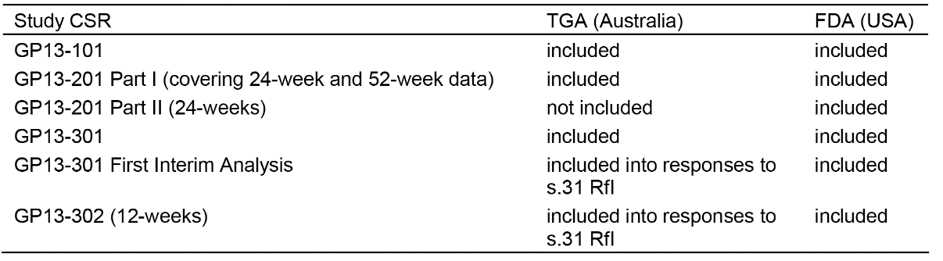
The following CSRs will be provided to FDA at a later point in time upon availability:
- Study GP13-201 Part II (52 weeks)
- Study GP13-302 (24 weeks)
Studies Study GP13-201 Part II and Study GP13-302 were conducted based on consultation with the FDA. Study GP13-201 Part II was conducted to include a clinical PK bridge between the EU authorized MabThera and the US-licensed Rituxan. Study GP13-302 was conducted to obtain safety and immunogenicity data after a single transition from reference medicine (MabThera/Rituxan) to GP2013. The dossier prepared for the submission to the FDA in June 2017 contains updated clinical information as compared to the dossier submitted to TGA (based on the EU dossier) in November 2016.

Evaluator's Comment
The sponsor's response is satisfactory. It is noted that the CHMP adopted a positive opinion for the approval of the application to market Sandoz biosimilar rituximab in April 2017.

Question 2 (Administrative)
Study GP13-201 submitted Part I of the study for evaluation however Part II of the study is currently underway. No data from Part II of the study was provided in the submission. The 24 week report for Part II was expected in January 2017 and the 52 week report is expected in January 2018. If the 24 week report is available, the sponsor is requested to submit this data for evaluation as part of its response.

Sponsor’s response
TGA correctly points out that no data from Part II of the Study GP13-201 study was provided in Module 5 of the initial submission to TGA. Neither the Study GP13-201 Part II 24 week report nor the 52 week report was available at the time of submission. The 24 weeks CSR for Study GP13-201 Part II is now available and included in (Module 5.3.3.2 Study GP13-201 Part II 24 weeks) to comply with TGA’s request. The schedule for the final 52 weeks CSR for Study GP13-201 Part II has been updated and the report is currently expected to be available in October 2017. Furthermore, for Study GP13-301 during the dossier review by the EMA a first interim analysis with a cut-off date 10-Jul-2016 was performed and a full CSR was created. This CSR is now included for TGA’s reference.

Evaluator's Response
The sponsor's response is satisfactory. The data referred to in the sponsor's response have been evaluated as part of this Round 2 CER, and the results included in the report. The Second round risk-benefit assessment (Section 15) includes reference to all relevant updated efficacy and safety data included in the sponsor's response.

Question 3 (Administrative)
There is an ongoing switching Study GP13-302 comparing safety and immunogenicity in patients with RA switched from MabThera (EU)/Rituxan (US) to GP2013 with patients continuing treatment with MabThera (EU)/Rituxan (US). The 12 week report for Study GP13-302 is expected in January 2017 and the 24 week report (final report) is expected for July 2017. If the 24 week report is available, the sponsor is requested to submit this data for evaluation as part of its response.

Sponsor’s response
At the time of response preparation, the Study GP13-302 24 week study report is not yet ready for submission to TGA. Instead, the applicant would like to submit the Study GP13-302 12 week report for TGA’s evaluation. Incidence of hypersensitivity reactions and general AEs did not change meaningfully between Week 12 and Week 24. Therefore, the applicant deems the data from the 12 week report representative and appropriate for evaluation by TGA. The 24-wk CSR is anticipated to be available in July 2017 and could be provided upon availability.

Evaluator's Comment
The sponsor's response is satisfactory. The Week 12 data and the interim Week 24 data from the transition (switching) study (Study GP13-302) have been evaluated below in this second round CER.

Pharmacokinetics

Question 1 (Pharmacokinetics)
In the CSR for study PK13-201 it is stated that the second IV infusion of the rituximab product ‘was to be administered through approximately three rate escalations of 100 mg/h (25 mL/h)’. However, the 25 mL/h rate appears to be incorrect and should be 50 mL/h. Please comment on this matter.

Sponsor’s response
The sponsor thanks the TGA for pointing out that the rate was incorrectly described in the CSR for Study GP13-201 Part I by mistake. The text has been updated in the Study GP13-201 Part I CSR amendment 3 to: ‘was to be administered through approximately three rate escalations of 100 mg/h (50 mL/h)’. The Study GP13-201 Part I CSR amendment 3 is included in the response package to the TGA’s Requests for Information.

Evaluator's Comment
The sponsor's response is satisfactory.

Efficacy

Question 1 (Efficacy)
Please provide updated information from Study GP13-301 on the temperature out of range (TOR) noncompliance issue identified in this study. This information should include tabulated summaries of the efficacy and safety results for each patient affected by this noncompliance issue.

Sponsor’s response
The most up to date data on TOR are available as of the data cut-off 10 July 2016 (date of first interims analysis), in 196 cases study medication affected by temperature out of range (TOR) was administered to 44 patients, 23 in the GP2013 arm and 21 in the MabThera arm. During the combination phase, 16 patients in the GP2013 arm and 15 patients in the MabThera arm and during the maintenance phase 14 patients in the GP2013 arm and 13 patients in the MabThera arm had been exposed to medication affected by TOR. Since the data cut-off of 10 July 2016 no further patient (as off 30 May 2017) exposed to TOR affected drug had been reported, showing that the implemented corrective and preventive actions had been effective.
(The sponsor’s response included a detailed assessment of efficacy and safety (combination and maintenance phases) in patients treated with the TOR affected study drugs, and compared outcomes with total population treated with the study drugs. The ORRs for the TOR affected patients based on the second interim analysis (cut-off date 2016) were 81.3% (13/16) in the GP2013 arm and 100% (15/15) in the MabThera arm).

Efficacy
Based on data from the second interim analysis cut-off date of 31 December 2016, an overall response rate (ORR) of complete response (CR) or partial response (PR) based on central independent review was achieved in 13 of 16 (81.3% (95% CI: 58.3, 94.7)) patients in the GP2013 arm and in 15 of 15 (100% (95% CI: 81.9, 100)) patients in the MabThera arm. The difference between the two treatment arms (GP2013-MabThera) was -18.8% (95% CI: -44.3, 6.8 and 90% CI: -41.3, 3.8). (Considering the small number of patients, the sponsor comments that results could be considered consistent with the ORR in all patients (per protocol set) of 87.1% in the GP2013 arm and 87.5% in the MabThera arm).
Based on the data cut-off 31 December 2016 (second interims analysis to update PFS and OS), of the patients who had been exposed to study drug affected by TOR, 4 (17.4%) of 23 patients in the GP2013 arm and 5 (23.8%) of 21 patients in the MabThera arm had disease progression. No deaths had been reported for these patients in either treatment arm. The PFS rates are below the PFS rates reported as of data cut-off 31 December 2016 for the FAS: that is, 30.1% in the GP2013 arm and 24.1% in the MabThera arm.
(Considering the limitation of small numbers of available patients exposed to TOR affected study drug, the sponsor concluded that there was no indication that the exposure to medication affected by TOR had an influence on ORR, PFS or OS).

Safety
The small number of patients exposed to TOR affected study drug allowed for only a limited assessment of safety. (Based on its assessment of the data the sponsor considered it unlikely that exposure to TOR affected drug has increased the rate of AEs or changed the pattern of AEs experienced by these patients). There were no clinically relevant differences in Grade 3 or 4 AEs or SAEs between patients exposed to TOR affected study drug and all patients.
The rate of potential infusion related reactions was numerically higher in the patients exposed to TOR affected study drug compared to all patients.
In the combination phase, infusion related reactions (expanded AEs grouped under Novartis MedDRA Query - NMQ) were reported in 93.8% (15/16) of patients exposed to TOR affected GP2013 and 73.1% (228/312) of all patients exposed to GP2013 in the safety set, and 100% (15/15) of patients exposed to TOR affected MabThera and 71.4% (225/315) of all patients exposed to MabThera in the safety set. In the TOR affected GP2013 arm, the infusion related reactions were mainly attributed to asthenia in 7 (43.8%) patients, headache in 6 (37.5%) patients, abdominal pain in 4 (25.0%) patients, arthralgia in 4 (25.0%) patients and dyspepsia in 3 (18.8%) patients. In the TOR affected MabThera arm, the infusion related reactions were headache in 3 (20.0%) patients, abdominal pain in 4 (26.7%) patients, nausea in 4 (26.7%) patients and back pain in 4 (26.7% patients. These AEs started either before or 4 months after exposure to TOR affected study drug in 2 patients with asthenia, 2 patients with headache, 3 patients with abdominal pain, all 4 patients with arthralgia, and 1 patient with dyspepsia in the GP2013 arm.
In the combination phase, the rate of AE infusion related reaction (preferred term) was consistent between the patients exposed to TOR affected drug and the all patient safety set. In the GP2013 arm, 2 (12.5%) of 16 patients exposed to TOR affected study drug and 42 (13.5%) of 312 patients of the safety set. In the MabThera arm, 3 (20.0%) of 15 patients exposed to TOR affected study drug and 38 (12.1%) of 315 patients of the safety set had an infusion related reaction.
(Considering the small number of patients exposed to TOR affected drug in the combination phase and the pattern of AEs contributing to potential infusion related reactions, the sponsor concluded that the numerical the sponsor concluded that numerical differences between the TOR affected patient and the total safety set were not clinically meaningful).
In the maintenance phase, infusion related reactions (NMQ) were reported in 71.4% (10/14) of patients exposed to TOR affected GP2013 and 18.9% (48/254) of all patients exposed to GP2013 in the safety set , and 61.5% (8/13) of patients exposed to TOR affected MabThera and 18.3% (46/252) of all patients exposed to MabThera in the safety set. In the TOR affected GP2013 arm, infusion related reactions were mainly attributed to cough in 5 (35.7%) patients, and in 3 of the 5 patients the AE started either before or more than 10 months after the exposure to the TOR affected drug. In the TOR affected MabThera arm, infusion related reactions were mainly attributed to cough in 3 (23.1%) patients, headache in 3 (23.1%) patients and arthralgia in 3 (23.1%) patients, in 2 of the 3 patients in the MabThera arm the AE started either before or more than 10 months after the exposure to the TOR affected drug. All other AEs contributing to potential infusion related reactions were reported by 1 or 2 patients only in the TOR affected GP2013 or MabThera arms. AEs reported by 2 patients were fatigue in the GP2013 arm and fatigue, dyspepsia and pyrexia in the MabThera arm.
(Considering the small number of patients exposed to TOR affected drug in the maintenance phase, the pattern of AEs contributing to potential infusion related reactions and the fact that no Grade 4 AE and only 1 Grade 3 AE per treatment group was reported, the sponsor concluded that numerical differences between the TOR affected patient and the total safety set were not clinically meaningful).

Evaluator’s comment
The sponsor’s response is satisfactory. The main difference between patients treated with TOR affected study drugs and patients in the total safety population treated with the study drugs, relates to the higher rate of potential infusion related reactions (NMQ) in the TOR affected treatment arms. However, the number of patients in the TOR affected study drug treatment arm is too small relative to the total safety population to make meaningful conclusions about the clinical significance of the differences. Furthermore, the AE (PT) of infusion related reaction was reported in only 2 (12.5%) patients in the GP2013 TOR affected arm and 3 (20.0%) patients in the MabThera TOR affected arm in the combination phase and no patients in either of the TOR affected arms in the maintenance phase.

Question 2 (Efficacy)
In Study GP13-201, the key secondary efficacy variable in patients with RA was the change from baseline in DAS28 (CRP) at Week 24. The difference between the two treatment arms was analysed using a non-inferiority method in the PPS, with the non-inferiority margin being defined as 0.6. Please justify why an equivalence analysis was not undertaken to compare the two treatment arms. Please provide the results of an equivalence analysis for the two treatment arms based on change from baseline in DAS28 (CRP) at Week 24 using an equivalence margin of -0.6 to +0.6 and 90% and 95% CIs for the difference between the two arms. Similarly, please explain why non-inferiority analyses rather than equivalence analyses were used to assess the other secondary efficacy variables in Study GP13-201.

Sponsor’s response
The non-inferiority approach was used to assess DAS28 (CPR) as the clinical dose of rituximab is at the dose-response plateau. Therefore, a lower exposure could lead to an inferior clinical response, whereas a larger exposure cannot be expected to lead to a superior clinical response. Thus, there is a lack of plausibility for superiority. As shown, equivalence of GP2013 was demonstrated: inferiority, theoretically plausible, and superiority, not considered plausible, were both ruled out. The results for the equivalence comparison between GP2013 and MabThera are summarised below in Table 52.

Table 52: Change from baseline in DAS (CRP) at week 24, comparison between GP2013 and MabThera using repeated measure mixed model, PPS
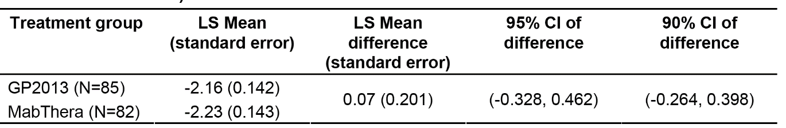
1. LS means, standard errors, 95% and 90% CIs were estimated by a repeated measures mixed model with treatment, time and treatment*time interaction term as categorical variables and baseline DAS28 as a continuous variable. 2. A negative change from baseline represents an improvement in RA assessment. 3. To conclude equivalence the 95% CI should be fully maintained within the range of -0.6 to 0.6. 4. No imputation of missing values was performed.
The results for the equivalence comparison between GP2013 and Rituxan are summarised below in Table 53.

Table 53: Change from baseline in DAS (CRP) at week 24, comparison between GP2013 and Rituxan using repeated measure mixed model, PPS
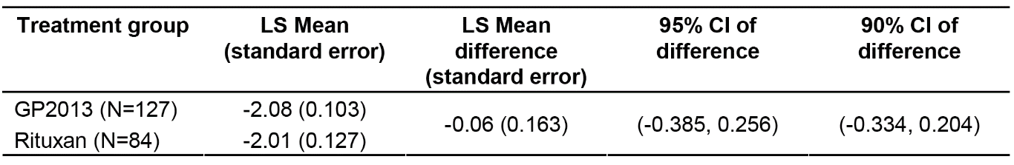
1. LS means, standard errors, 95% and 90% CIs were estimated by a repeated measures mixed model with treatment, time and treatment*time interaction term as categorical variables and baseline DAS28 as a continuous variable. 2. A negative change from baseline represents an improvement in RA assessment. 3. To conclude equivalence the 95% CI should be fully maintained within the range of -0.6 to 0.6. 4. No imputation of missing values was performed.

Evaluator’s comment
The sponsor's response is satisfactory. The analyses demonstrate that the change from baseline in DAS (CRP) at Week 24 is equivalent for the comparison between GP2013 and MabThera (Study GP13-201, Part I) and for the comparison between GP2013 and Rituxan (CP13-201, Part II).

Question 3 (Efficacy)
No data were submitted in patients with RA or FL comparing efficacy in patients switched from MabThera to GP2013 to patients continuing with MabThera. Please justify why a ‘switching study’ to compare efficacy has not been undertaken and appears not to be planned. The protocol for the ongoing ‘switching’ study (Study GP13-302) indicates that this is a general safety and immunogenicity study and that efficacy assessment in this study is ‘not applicable’.

Sponsor’s response
The sponsor designed the GP2013 clinical development program taking into account the EMA biosimilar guidelines, which are adopted by TGA. These guidelines recommend a stepwise approach throughout the development program, and the extent and nature of the non-clinical and clinical studies should depend on the level of evidence obtained in the previous step(s) (EMA ‘Guideline on similar biological medicinal products, CHMP/437/04 Rev 1, 23 October 2014’; TGA ‘Regulation of biosimilar medicines’, Version 7, December 2015). Neither the TGA ‘Regulation of biosimilar medicines’, nor the EMA guideline referenced in there require specific studies of efficacy parameters after a switch from originator to biosimilar. The profound evidence of comparability between GP2013 and originator rituximab as demonstrated at the physicochemical, biological, nonclinical and clinical levels did not lead to any uncertainty with respect to the efficacy of GP2013 after a treatment switch from the originator to GP2013. Consequently, such question was not included into the GP2013 development program and was not requested by any health care authority in the scientific advises obtained by the sponsor so far.
From a mechanistic point of view, an altered efficacy could be suspected for biologics with a substantial immunogenic potency or/and if a transition from originator to biosimilar would be associated with increased immunogenicity to the biosimilar. This is in particular true if ADA specific to the binding site of the biosimilar occur or if ADA interact with the pharmacokinetics (PK) of the biosimilar. A potential ‘class switch of ADA’, with a risk of anaphylactic and hypersensitivity reactions after transition from originator to biosimilar, has been also discussed. Rituximab is a biologic with known low immunogenicity (up to 11% of ADA incidence in RA being the highest rate between the studied indications according to the label) while it is not described that neutralizing ADA (specific to the binding site and of potential to compromise drug efficacy) are of any relevance.
To address the question of a potential risk of immune-related safety AEs and immunogenicity after the switch from originator rituximab to GP2013 the sponsor conducted the Study GP13-302 clinical study which was also requested by FDA followed by the FDA agreement to the submitted study protocol. The study evaluated the incidence of hypersensitivity, anaphylactic and infusion related reactions as well as immunogenicity and general AEs up to Week 12 after either a switch from originator rituximab to GP2013 or continuation of the originator rituximab. The 12 week CSR of this study is submitted with this document. Only one (out of 107 patients) in Study GP13-302 developed ADA post treatment, which were non-neutralizing.
This incidence is even lower than known from the originator label but in agreement with literature that rituximab immunogenicity decreases with advanced treatment duration. This result of Study GP13-302 further decreases the theoretical likelihood of altered GP2013 efficacy after a switch following the above mechanistic considerations. Study GP13-302 did not include efficacy endpoints due to the low sample size (a powered comparison would significantly increase the number of study patients) which would not allow any statistical conclusions on efficacy endpoints. The sample size was agreed with FDA following the biosimilar clinical development approach of addressing only endpoints representing the residual uncertainty from the previous development program steps (FDA guidance) and ethical considerations of keeping the number of study patients as low as needed.
An alternative approach of introducing the switch component to the pivotal efficacy Study GP13-301 was not considered meaningful due to the study population (patients with follicular lymphoma (FL)) being not sensitive for the targeted endpoints. Indeed FL patients are more immunocompromised based on the background condition and the concomitant treatment with chemotherapy, rituximab is given more frequently (for example, every 3 weeks), immunogenicity of rituximab is known to be lower in this population, transition specific immune related AEs would be ‘diluted’ by the generally higher frequency of AEs in oncologic patients.

Evaluator’s comment
The sponsor's response is acceptable. The transition (switching) study (Study GP13-302) has been evaluated below in this CER. The Week 12 data showed that the risk profiles of GP2013 (switched from Rituxan/MabThera) and Rituxan/MabThera (continued treatment) were comparable based on the four key safety outcomes (anaphylactic reactions, hypersensitivity reactions, infusion related-reactions and immunogenicity). In addition, the general safety data at Week 12 suggested no clinically significant differences between the two treatment arms, as did the limited safety data at Week 24. The study is ongoing and not all patients have completed 24 weeks of treatment.

Question 4
Please justify why a Phase III study was not undertaken in patients with RA meeting the exact criteria specified in the approved RA indication for MabThera and comparing GP2013 and MabThera as the primary objective?

Sponsor’s response
(The sponsor outlined that the decision was based on the chosen development strategy for GP2013. The sponsor noted that establishing bioequivalence of the candidate biosimilar and its reference medicine is the cornerstone of biosimilar clinical development). The gold standard is to perform PK studies in healthy subjects. The Study GP13-201 study could only be performed in patients rather than in healthy subjects due to the B cell-depleting mechanism of action of rituximab, and the concern to expose healthy subjects to an increased risk of infections.
Patients with RA had been chosen as the most sensitive population for PK and PD comparison mainly because in patients with RA, the between-patient variability in terms of PK and PD is much lower compared to oncology indications ((NHL), (CLL)), in which the baseline B cell counts can vary significantly and thus affect both the PK and PD variability between patients. Furthermore, in patients with RA the treatment courses are given every 6 months – less frequent compared to the oncology indications, making it possible to capture the complete drug concentration-time profile before re-treatment. The Study GP13-201 study had the primary objective of establishing 3-way PK bioequivalence of GP2013, MabThera (EU) and Rituxan (US). The PK study was thus performed in RA patients who had an inadequate response or intolerance of standard DMARDs and at least one anti-TNF agent. The study medication was used in combination with methotrexate, at the therapeutic dose as per rituximab label. Therefore, the population and the dose reflect the target population and therapeutic dosing regimen. As PK was the primary endpoint, comparative efficacy data in a RA patient population had been collected as a secondary objective of the study.
For the similarity of efficacy and safety in a pivotal clinical study (Study GP13-301), after receiving an initial scientific advice from the EMA (CHMP/EMA/SAWP/357322/2009), the FL indication was chosen amongst the approved oncology indications of MabThera as the most sensitive indication to establish therapeutic equivalence. From a scientific perspective, for demonstrating therapeutic equivalence between GP2013 and MabThera, the combination R-CVP (Rituximab with cyclophosphamide, vincristine and prednisone) was considered the most sensitive treatment option. Addition of rituximab to the chemotherapy CVP in patients with previously untreated FL had a higher add-on effect of 24% in terms of ORR of rituximab to the chemotherapy backbone as compared to further standard of care combinations between rituximab and other chemotherapies (Marcus et al 2005, Marcus et al 2008).
(The sponsor considered that the outlined approach allows for the evaluation of comparative efficacy outcomes in oncology (FL) and immunology (RA) indication. The data from the Study GP13-201 RA study and the Study GP13-301 FL study demonstrate that in both FL and RA patients GP2013 and MabThera lead to similar clinical responses).
An additional Phase III study in RA was not performed as the clinical similarity was already established by Study GP13-201 and Study GP13-301. Based on the totality-of-evidence approach this allows the scientific extrapolation to all approved indications without conducting further unnecessary (EMA ‘Guideline on similar biological medicinal products, EMA/CHMP/437/04 Rev1, 23 October 2014) and thus unethical studies.
Furthermore, this EMA guidelines states: ‘The ultimate goal of the biosimilar comparability exercise is to exclude any relevant differences between the biosimilar and the reference medicinal product. Therefore, studies should be sensitive enough with regard to design, conduct, endpoints and/or population to detect such differences.’ Therefore, the main purpose of clinical studies for biosimilars is the detection of potential differences to the reference product, should they exist, and not the de novo establishment of efficacy and safety, which have already been shown by the reference product.

Evaluator’s comment
The sponsor's response is acceptable.

Question 5 (Efficacy)
Study GP13-201 included no comparable efficacy data relating to the effect of the two rituximab formulations on the rate of progression of joint damage as measured by x-ray when given in combination with methotrexate. Please justify why such data were not submitted.

Sponsor’s response
EMA’s Biosimilar Guideline states that ‘it is expected that the safety and efficacy (of a biosimilar product) can be extrapolated when biosimilar comparability has been demonstrated by thorough physico-chemical and structural analyses as well as by in vitro functional tests complemented with clinical data (efficacy and safety and/or PK/PD data) in one therapeutic indication.’ (EMA ‘Guideline on similar biological medicinal products, EMA/CHMP/437/04 Rev1, 23 October 2014). It further states that additional data are required in certain situations, for example, when the active substance interacts with several receptors or has more than one active site, or in case the studied indication is not sensitive for differences in all relevant aspects of efficacy and safety.
The sponsor considers that the biosimilar comparability for GP2013 was demonstrated by physicochemical and structural analyses, by in vitro functional tests and also by clinical PK/PD, efficacy, safety and immunogenicity data, in two therapeutic areas - immunology (rheumatoid arthritis) and oncology (follicular lymphoma). The Study GP13-201 study has provided comparative efficacy data for multiple clinical efficacy parameters in rheumatoid arthritis, confirming the therapeutic equivalence established by Study GP13-301 study.
The mechanism of action of rituximab in rheumatoid arthritis is based on its B cell-depleting efficacy (Emery 2015) and on the involvement of B cells in the immune processes within the joint (McInnes 2011). Notably, the mechanism of action through which rituximab is efficacious in the prevention of structural joint damage does neither involve a different receptor, nor a different active site. Rather, higher disease activity correlates with greater progression of joint damage, and radiographic progression is significantly increased in patients with periodic flares compared with those with sustained disease control (Keystone 2009). Further, radiographic progression is not considered sensitive to detect differences between two active treatments. In a study analyzing radiographic progression in patients treated with rituximab versus placebo, more than five hundred patients were needed to demonstrate superiority of the active treatment (Keystone 2009). Demonstrating equivalence between two active treatments would have required significantly more patients. In other words, the current study, which had the primary objective of demonstrating 3-way PK equivalence, could not have been powered adequately to demonstrate equivalence in terms of prevention of joint damage. A thorough analysis of efficacy outcome parameters including DAS28(CRP), DAS28(ESR), ACR20, ACR50, ACR70, ACR-N, CDAI, SDAI, EULAR response criteria, FACIT and HAQ-DI up to Week 52 demonstrated that GP2013 and its reference medicine lead to similar response in patients with active RA. Based on the above, analysis of structural joint damage was not considered an appropriate parameter to support biosimilarity claim.

Evaluator’s comment
The sponsor's response is acceptable.

Question 6 (Efficacy)
Please comment on the comparability of GP2013 and MabThera administered in combination with glucocorticoids (that is, PK, PD, efficacy and safety), the administration regimen in the MabThera PI for the induction of remission in patients with severely active Granulomatosis with polyangiitis (GPA, also known as Wegener’s granulomatosis) and Microscopic polyangiitis (MPA).

Sponsor’s response
The sponsor considers that the development of GP2013 has followed the (EMA) guidance (for the development of biosimilar products) and (that) the biosimilar comparability for GP2013 was demonstrated by physicochemical and structural analyses, by in vitro functional tests and also by clinical PK/PD, efficacy, safety and immunogenicity data, in both therapeutic areas, immunology and oncology. The Study GP13-301 study confirmed therapeutic equivalence in FL supported by Study GP13-201 study which provided comparative efficacy data for multiple clinical efficacy parameters in rheumatoid arthritis, confirming a similar efficacy of GP2013 and MabThera.
The mechanism of action of rituximab in RA, GPA and MPA is invariably based on its B cell depleting efficacy (Emery 2015, Stone 2010), and on the involvement of B cells in the immune processes (McInnes 2011). B lymphocytes play an important role in the pathogenesis of autoimmune diseases, including ANCA-associated vasculitis, such as GPA and MPA. In ANCA-associated vasculitis the percentage of activated peripheral blood B lymphocytes correlates with disease activity (Stone 2010). Notably, the mechanism of action through which rituximab is efficacious in the induction of remission in patients with severely active GPA and MPA does neither involve a different receptor, nor a different active site of the active substance, which could lead to uncertainty, regarding a potentially different impact. From a safety perspective, the most frequent adverse reactions in patients with MPA and GPA are also known to be linked to rituximab’s binding to CD20 and the consequent depletion of peripheral B cells, as observed in RA, infection being the most common category of events reported (MabThera Australian PI).
In Granulomatosis with polyangiitis (GPA) and Microscopic polyangiitis (MPA) it is recommended to administer rituximab in combination with 1000 mg IV methylprednisolone from Day 1 to day 3, then followed by 1 mg/kg/day oral prednisone which should be tapered off as rapidly as possible. The extrapolation to GPA and MPA is justified when discussing the combination of rituximab with glucocorticoids. On the one side there is no known drug-drug interaction between rituximab and glucocorticoids. On the other side, in the clinical trials Study GP13-301 and Study GP13-201 rituximab was also – following the prescribing information – administered with glucocorticoids. In Study GP13-301, 100 mg oral prednisone was administered from Day 1 to 5 as part of the chemotherapy regimen and in Study GP13-201, 100 mg IV methylprednisolone (or equivalent) as part of the premedication. Even if lower doses had been administered in FL and RA patients, the reported safety profile in patients with GPA and MPA is – as discussed above – also linked to the B cell depleting effect of rituximab.

Evaluator’s comment
The sponsor's response is acceptable.

Safety

Question 1 (Safety)
The RMP indicates that treatment with GP2013 in Study GP13-201 was reported in 84 patients for 1 month, 82 patients for 3 months, 77 patients for 6 months, and 49 patients for 12 months. Please provide the corresponding data for patients treated with MabThera. In addition, please provide the total person years of exposure to MabThera in Study GP13-201 (Part I) and compare it to the corresponding exposure parameter for GP2013.

Sponsor’s response
The requested data is provided in Table 54 below.

Table 54: Rheumatoid arthritis (GP2013-201 Part 1) trial exposure by duration
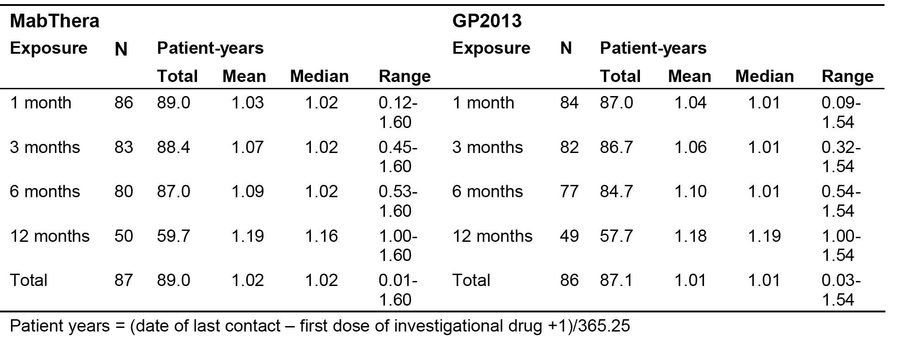

Evaluator's comment
The sponsor's response is satisfactory. The exposure data through to 12 months for patients in Study GP13-201 (Part I) are similar for the GP2013 and MabThera treatment arms.

Question 2 (Safety)
For Study GP13-301, please provide the mean (SD), median, and range of duration of treatment in the maintenance phase for both treatment arms up to the data cut-off date of 10 July 2015, and corresponding exposure data for both treatment arms from date of randomisation to the data cut-off date of 10 July 2015.

Sponsor’s response
Study GP13-301 - Exposure in maintenance phase: Overall, the exposure by days to investigational treatment in the maintenance phase up to the data cut-off point 10 July 2015 was similar between the treatment groups. The difference in median (GP2013 283 days, MabThera 325 days) is less than half of 1 cycle, which is 90 days in maintenance phase (except for Italy: 60 days). Of note, maintenance treatment is ongoing until July 2017, therefore exposure days are only counted up to the last respective study visit up to the data cutoff of 10-Jul-2015.

Table 55: Summary of investigational treatment (GP2013/MabThera) exposure by treatment Maintenance phase and set
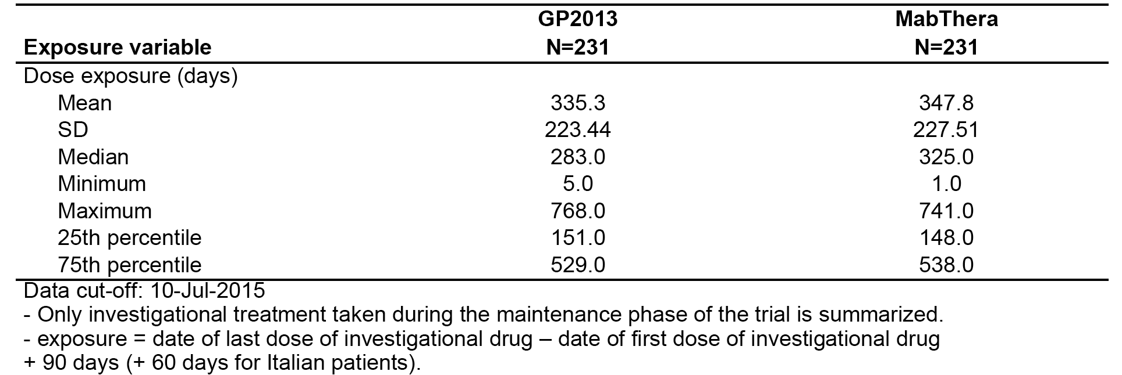
Study GP13-301 - Exposure from date of randomisation to the data cut-off date of 10 July 2015: Overall, the exposure by days to investigational treatment from date of randomisation to the data cut-off date of 10 July 2015 was similar between the treatment groups. The median is with 349 days the same for both treatment groups.

Table 56: Summary of investigational treatment (GP2013/MabThera) exposure in days by treatment from randomisation to data cut-off Combination and Maintenance phase (Safety set)
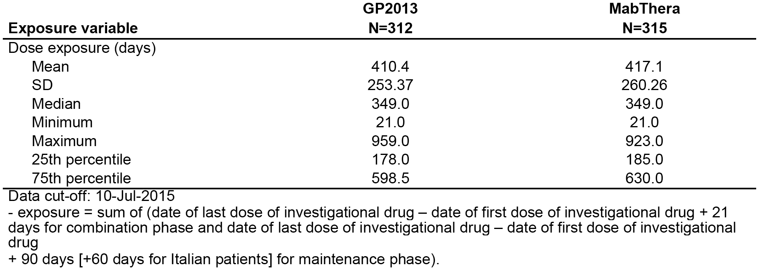

Evaluator's comment
The sponsor's response is satisfactory. For Study GP13-301, exposure in the maintenance phase to the date of data cut-off was similar in the two treatment arms, as was exposure from the date of randomisation to the date of data cut-off (that is, combination and maintenance phase).

Question 3 (safety)
For Study GP13-301, please provide the number of patients in both treatment arms who have been exposed to treatment for 6 months, 12 months, 18 months, 24 months, 30 months and 36 months at the data cut-off date of 10 July 2015.

Sponsor’s response

Table 57: Summary of investigational treatment (GP2013/MabThera) exposure in months by treatment both Combination and Maintenance phase (Safety set)
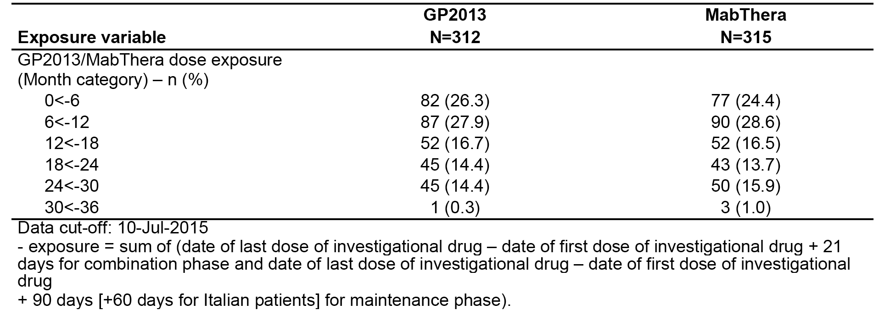

Evaluator's comment
The sponsor's response is satisfactory. In Study GP13-301, patient numbers for the exposure categories through to 36 months are similar for the two treatment arms.

Question 4 (Safety)
In Study GP13-301 there were a total of 35 deaths in all phases combined (18 in the GP2013 arm and 17 in the MabThera arm). Please tabulate the deaths for the both treatment arms in the each phase of the study and indicate which deaths were considered to be caused by AEs suspected to be study-drug related.

Sponsor’s response
The deaths for both treatment arms as of data cut-off 10 July 2015 are tabulated per patient in Table 58 indicating the treatment phase and the relationship to the study drug of the adverse event (AE) considered causing the death. In the GP2013 arm, 3 deaths in the combination phase and 1 death in the maintenance phase and in the MabThera arm 2 deaths in the combination phase were considered to be caused by AEs related (based on investigator’s assessment) to the study drug. In the combination phase an AE was judged as suspected to be study-drug related if it was judged related to any component of the GP2103-CVP or MabThera-CVP combination. Of note, an assessment of suspected relationship to study drug is not available for the following : 1) cases where death was due to progression of the underlying malignancy and therefore not reported as an AE or 2) death cases if the cause of death was an AE or serious adverse event (SAE) occurring more than 30 days after the last dose of study drug and not suspected to be related to study drug by the investigator (according to the protocol AE monitoring could be stopped 30 days after the last dose and only SAEs suspected to be related to study drug had to be reported after this 30 day period).

Table 58: Overview of deaths up to data cut-off of 10 July 2015
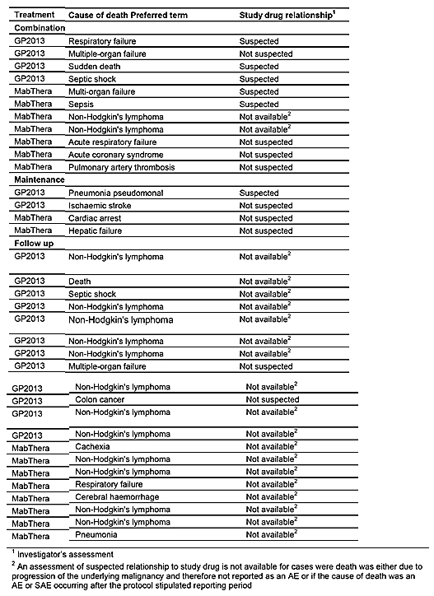

Evaluator's comment
The sponsor's response is satisfactory.

Question 5 (Safety)
Please comment on the reasons for the higher incidence of post-baseline anti-drug antibodies in both treatment arms observed in patients with RA in Study GP13-201 compared to patients with FL in Study GP13-301.

Sponsor’s response
In the Study GP13-201 study post-treatment anti-drug antibodies (ADAs) were detected in 9 (10.5%) patients in the GP2013 vs. 18 (21.2%) patients in the MabThera group. In the Study GP13-301 study post-treatment ADAs were detected in 5 (1.9%) patients in the GP2013 group and 3 (1.1%) patients in the MabThera group as of the data cut-off 10 July 2015.
The results are consistent with the MabThera product information (MabThera Australian PI):
- Patients with non-Hodgkin’s Lymphoma developed ADAs, in particular Human-Anti Chimeric Antibodies (HACAs) in 1.1% of patients (4 of 356 patients)
- Patients with RA tested ADA positive in 12.7% (392 of 3095 patients)
The higher incidence in RA patients compared to patients with FL can be explained by disease- and treatment-related factors, that is, the immunocompromised status of follicular lymphoma patients in Study GP13-301.
- Concomitant immunosuppressive therapy reduces the immunogenicity induced by a monoclonal antibody (Maini et al. 1998). In RA rituximab is used in combination with methotrexate, whereas in the Study GP13-301 study rituximab was used in combination with CVP. CVP is considered more immunosuppressive than methotrexate.
- Cancer – like FL – is a immunosuppressive disease reducing immunogenicity further (Tovey et al. 2011)
- RA is an autoimmune disease, the risk for immunogenicity is increased in patients with autoimmune diseases (Tovey et al. 2011)
In summary, due to immunocompromised status of patients with FL and the more immunosuppressive combination therapy compared to that in patients with RA higher number of ADA positive RA patients was expected.

Evaluator's Comment:
The sponsor's response is satisfactory.

Sponsor’s response to evaluators recommendation in first round clinical evaluation report

Introductory comment
The sponsor submitted a detailed 34 page response to the first round recommendation to reject the application to register GP2013. The sponsor’s response (in abbreviated form) to the issues raised in the recommendation to reject has been provided below. Comments relating to the sponsor’s response have also been provided. The sponsor’s response refers to data for study provided at the time of the first interim analysis (that is, data cut-off 10 July 2016) and the second interim analysis (that is, data cut-off 31 December 2016). The primary analysis (that is, data)

Sensitivity of endpoints - sponsor's comment on most appropriate endpoint (Study GP13-301) – and efficacy updates (second interim analysis)
Based on data from the available literature, the sponsor considers that the ORR is the most sensitive endpoint for the Study GP13-301 bioequivalence study. Neither PFS nor OS are powered endpoints and both will remain ‘immature’ even once Study GP13-301 is completed. The sponsor comments that in the clinical development of a biosimilar the most appropriate endpoint selected to demonstrate bioequivalence my deviate from endpoints used for superiority trials when studying a new compound. As the focus of the equivalence trial with a biosimilar is not to establish efficacy per se, but to demonstrate comparability, the most sensitive setting to allow detection of a potential difference between GP2013 and MabThera was chosen. In the setting of Study GP13-301 the sponsor considers ORR more sensitive than PFS, DFS, EFS, time to new lymphoma treatment and OS.
The sponsor stated that study is not powered for PFS and OS, and even if the study is completed (36 months of follow-up) these data will remain highly immature and subject to chance findings. As the primary endpoint of ORR was obtained at the end of the combination phase further follow-up will have no influence on the biosimilar equivalence assessment, which was based on the ORR being the most sensitive endpoint. In the sponsor's opinion, final data from Study GP13-301 would not make PFS and OS more robust, and thus not add further value for the evaluation of the biosimilar efficacy equivalence. The sponsor states the justification of ORR as the primary endpoint, the limitation of PFS and OS as well as the extent of the provided efficacy data was accepted by EMA providing positive opinion on 21 April 2017.
Comment: The evaluator acknowledges that the efficacy endpoint chosen for the registration studies of the innovator product might differ from the efficacy endpoint selected to demonstrate bioequivalence of the biosimilar and the innovator. The primary objective of Study GP13-301 was to demonstrate comparability of the ORR in patients with previously untreated advanced stage follicular lymphoma who receive GP2013-CVP combination treatment to patients who receive MabThera-CVP combination treatment. However, the evaluator's position expressed in the first round recommendation was that PFS and not ORR was the most appropriate clinical endpoint for establishing the therapeutic equivalence of similar biological products containing rituximab for the treatment of follicular NHL. This was based on consideration of the relevant TGA adopted guidelines (that is, similar biological medicinal products containing monoclonal antibodies and evaluation of anticancer medicinal products) and the clinical data relating to the treatment of follicular NHL summarised in the MabThera PI. It was considered that confirmation of the promising comparative efficacy data for GP2013 and MabThera based on the ORR results from Study GP13-301 in patients with FL should be confirmed by comparable PFS outcomes, while there should be no evidence of a survival detriment with GP2013 compared to MabThera based on OS outcomes.
The sponsor provided data indicating that ORR was the most appropriate endpoint for assessing the clinical similarity of GP2013 and MabThera in Study GP13-301. Furthermore, the sponsor provided data indicating that PFS will remain immature at the time of completion of the 36 months follow-up in Study GP13-301, with median time to PFS at completion not being reached in either of the two treatment groups. The sponsor provided updated analyses (second interim analysis) for the secondary efficacy endpoints of PFS and OS based on a cut-off of 31 December 2016 (that is, approximately 18 months of additional follow-up from cut-off of 10 July 2015 for the primary analysis included in the original submission). The updated descriptive analyses of PFS and OS showed that median times for both parameters had still not been reached, despite approximately 18 months of additional follow-up.
The sponsor summarised the data from the literature relating to the add-on effect of rituximab on ORR and PFS (see Table 59 below). The sponsor commented on the very limited add-on PFS data in previously untreated patients with FL treated with R-CVP induction followed by rituximab maintenance. The sponsor identified only one study reporting PFS in patients with FL with an overall response (CR + CR unconfirmed + PR) at the end of the induction therapy followed by 2 years of rituximab maintenance or observation (Moccia et al., 2010). In this study, the absolute add-on-effect for PFS was +21% in the rituximab group (83%) compared to the observation group (62%). However, the data from this study were from a retrospective population-based analysis using the British Columbia (Canada) Cancer Agency Lymphoid Cancer Database including all patients with FL who received first-line R-CVP between March 2004 and January 2010. Furthermore, the data were presented as an abstract rather than a peer reviewed full journal article.

Table 59: Add on effect to ORR and PFS of treatment containing rituximab compared to treatment without rituximab
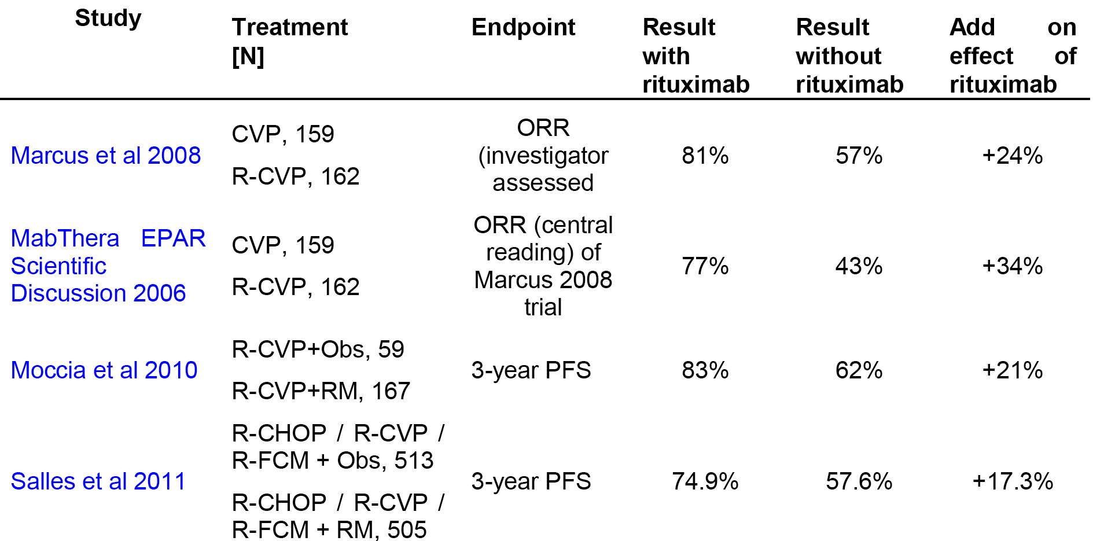
The sponsor referred to clinical trial data (PRIMA) from the literature suggesting that the add-on effect for PFS of rituximab maintenance for 2 years compared to observation following induction chemotherapy (R-CHOP/R-CVP/R-FCM) in patients with previously untreated FL was +17.3% (PFS = 74.9% (rituximab maintenance) versus 57.6% (observation), with a median follow-up of 36 months from randomisation (Salles et al., 2011). The majority of patients in this study were treated with R-CHOP induction (n = 768) and less than 20% of the patients were treated with R-CVP induction (n = 222). As the PFS benefit from rituximab maintenance is smaller in R-CVP patients compared to R-CHOP patients it can be assumed that the add-on effect of rituximab maintenance following induction with R-CVP for PFS is smaller than 17% at 3 years.
The sponsor also referred to data from the literature which showed that the addition of rituximab to CVP resulted in an absolute increase in the overall response rate (CR + CR unconfirmed + PR) of +24% compared to CVP alone in patients with previously untreated stage III/IV FL treated for a maximum of 8 cycles of therapy (Marcus et al., 2008). In this study, median follow-up was 53 months. The sponsor concludes that an add-on effect of +24% in the ORR when adding rituximab to CVP indicates that ORR was an appropriate endpoint for the biosimilar trial Study GP13-301 in patients with FL.

Efficacy: sponsor's comments on equivalence based on PFS endpoint (Study GP13-301)
The sponsor acknowledged the TGA's request for more mature PFS and OS data. The sponsor had also received this request from the EMA and the PMDA (Japanese Medical and Devices Agency). However, the sponsor stated that Study GP13-301 was powered only for the primary endpoint of ORR and was not powered for the secondary endpoints of PFS and OS. Consequently, no equivalence margin was specified for PFS. The sponsor commented that, from a biosimilar development perspective, addition of a maintenance phase to show equivalence between GP2013 and the reference medicine was not required. Similarity was established based on the primary endpoint ORR at the end of the combination phase (6 months). However, the maintenance phase was added as this was standard of care for patients with FL. In addition, the maintenance phase was added based on a feasibility assessment, as many oncologists would not have enrolled a patient into the study if it did not include a maintenance phase.
The maintenance phase was not added for scientific considerations, as it would not have been possible to enroll an adequate number of patients for a powered PFS or OS analysis nor would this be required based on the concept of biosimilarity, as outlined EMA guidelines (EMA/CHMP/437/04 Rev1, 23 October 2014). The relevant guidelines suggest that the most sensitive endpoints for clinical efficacy comparison be used for studies designed to demonstrate biosimilarity. The sponsor considers that neither PFS nor OS are sensitive endpoints for efficacy comparisons aimed at detecting potential differences between the reference medicine and a proposed biosimilar.
In response to a request from the EMA, the sponsor conducted an assessment based on the literature aimed at identifying data relating to the duration of the PFS that might mitigate the potential risk that the specific study sample median PFS could have deviated from the true population median PFS. However, only scarce data could be identified by the sponsor relating to median PFS values in the setting of previously untreated patients with FL using R-CVP induction followed by rituximab maintenance. In Moccia et al, 2010, 167 previously untreated patients with FL treated with R-CVP induction followed by rituximab maintenance the 3 year PFS was 83% in patients with response (CR/CRu, PR) to induction. Several other studies reported PFS data from previously untreated FL patients with R-CVP induction treatment only. In Frederico et al (2013), in 178 patients treated with R-CVP without maintenance the PFS at 3 years was 52%. In Nastoupil et al (2015), in 187 patients treated with R-CVP with (61% of patients) or without rituximab maintenance the 5 year PFS was 49%, and the 8 year PFS was 34%. In Barta et al (2016), in 311 previously untreated FL patients with CVP induction and rituximab maintenance the median PFS was 4.6 years from start of treatment. The sponsor calculated approximate median PFS values for each of the four studies identified in the literature by assuming basic exponential distribution S(t)=e^{(-λt)} (Table 60).

Table 60: Estimated median PFS based on S(t)= e^{(-λt)}
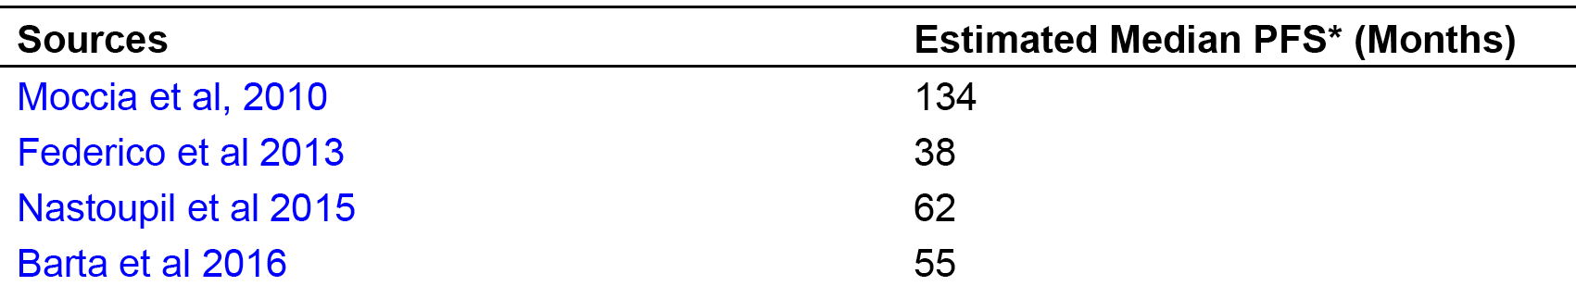
The sponsor states that, although the median PFS in Study GP13-301 cannot be reliably estimated due to the study not being powered for PFS, the hazard rate can still be approximated as 1.33% per month based on the estimated PFS rate of 62% at 36 month for all patients. Based on the hazard rate and the assumption of basic exponential distribution, the estimated median PFS in the Study GP13-301 study would be 52 months. The sponsor considers that this is plausible and consistent with the literature references found so far with the exception of Moccia et al (2010). This publication observed a small number of events only and analysed patients with a response of CR/CRu and PR after induction only which would lead to a positive selection bias and overestimation of PFS for the specific Study GP13-301 study setting. It is therefore reasonable to assume that in previously untreated patients receiving R-CVP induction followed by additional rituximab maintenance, the true median PFS time would exceed 50 months (assuming median PFS time being equal in both arms).
In response to another request from the EMA, power analyses (Table 61, below) were performed using methods proposed by Chow et al (2008) to assess: (1) power with hypothetical length of follow-up ranging from 36 to 72 months for a study of the same sample size as Study GP13-301 (Designs 1-4); and (2) power with hypothetical length of follow-up ranging from 36 to 72 months for a study with adequate number of events and sample size to ensure 80% power for HR equivalence margins of 0.8-1.25 (Designs 5-8). The widest clinically justifiable equivalence margin for the power analysis was chosen to be HR between (0.8, 1.25) representing -10 to 12.5 months difference in the median PFS of GP2013 versus MabThera. Smaller margins, if deemed appropriate, would lead to larger sample sizes requirement and/or less power when other aspects of the trial design were unchanged.

Table 61: PFS equivalence test with HR equivalence margin (0.8, 1.25)
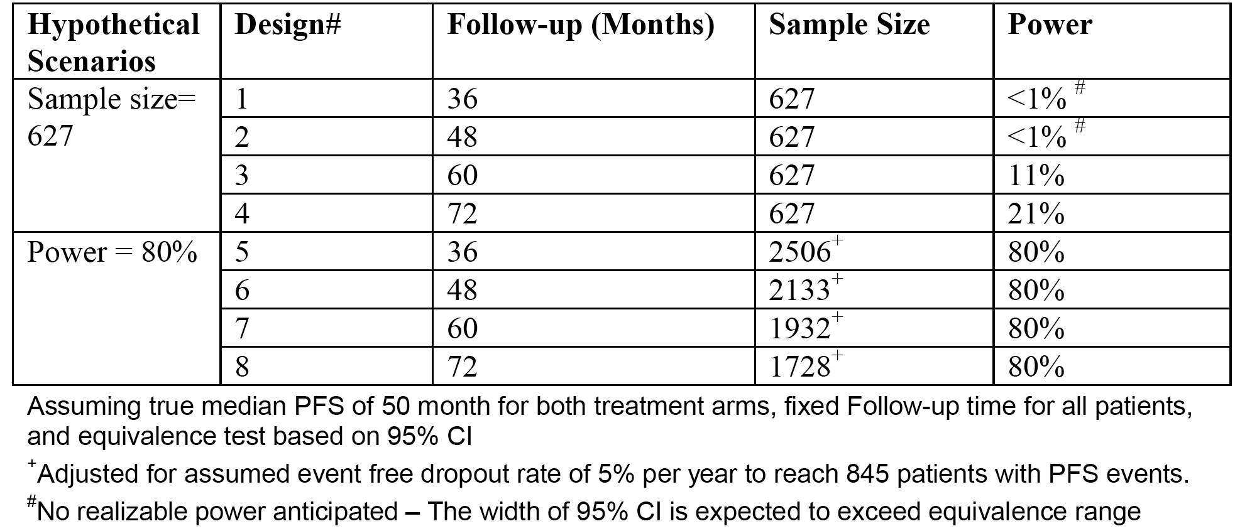
Based on the assumptions of a true median PFS time of 50 months for both treatment arms and an equivalence test based on 95% CI of the hazard ratio with equivalence margin of (0.8 - 1.25), a study design for a trial with the same number of subjects (total 627) as Study GP13-301 and a 3 year uniform PFS follow-up would not be feasible because the 95% CI of the HR is expected to exceed the equivalence margin. Such issue would persist even if the follow-up time is extended to 48 months for all patients. The power would only be 21% with a hypothetical 6 years PFS follow-up period for all patients without any early dropout. The current study would require at least 16 additional months of follow up in order to reach the median PFS without any consideration for its precision.
With the same median PFS assumptions and equivalence margin, in order to ensure 80 % power a study would need approximately 2506 patients (assuming 5% yearly dropout rate) to reach the required 845 events of disease progression assuming the PFS follow up for all patients is 36 months, similarly as per Table 61 for other length of follow up.
The Study GP13-301 study included 174 study sites which screened patients, the first patient was screened in December 2011 and the last patient was randomised in January 2015, so it took more than 3 years to enrol 627 patients in the full analysis set. At such recruitment rate of 17 patients per month, it would take more than 13 years just to have enough patients enrolled in order to achieve the 80% power for the PFS equivalence test. As an example, study design # 5 (Table 61) would require a duration of 16 years (13 accrual and 3 follow-up) to complete. In conclusion, for a biosimilar trial using induction R-CVP followed by maintenance (that is, Study GP13-301 design) the sponsor considers that it is not feasible to obtain robust PFS data with a reasonable study size and within a reasonable time frame.
In the light of the discussion above, the sponsor agreed with the comment of the clinical evaluator that ‘(t)he PFS is considered to be too immature to make clinically meaningful conclusions about comparability of the two treatment arms’ and ‘the OS data are too immature to make meaningful conclusions about the comparability of the two treatment arms’. However, the sponsor pointed out that Study GP13-301 follows up patients for PFS and OS for up to 3 years from randomisation and thus PFS and OS will stay highly immature and the study will not deliver robust PFS and OS data even when the study is finished (anticipated for December 2017), thus not allowing a clinically meaningful conclusion on PFS and OS.
Based on the potential sample size required in an equivalence setting for PFS and the higher sensitivity of ORR compared to PFS to detect potential differences in patients with untreated FL treated with R-CVP followed by rituximab maintenance, the sponsor's assessment of the feasibility and appropriateness of the PFS as the clinical endpoint of choice differs from the clinical evaluator’s opinion. The sponsor agrees that PFS is often considered a relevant clinical endpoint in an originator trial aiming at showing superiority however in a biosimilar trial not the most clinically meaningful but the most sensitive endpoint should be chosen. To generate robust PFS data would not be possible within the frame of reasonable study size and study duration. The adopted guideline cited by the clinical evaluator (EMEA/CHMP/BMWP/403543/ 2010) explicitly states that PFS or OS ‘may not be feasible or sensitive enough for establishing comparability of a biosimilar mAb to a reference mAb’ and explicitly mentions ORR -measuring antitumor activity - as a potential primary endpoint.
In summary, the sponsor considers the PFS to be not an adequate efficacy endpoint for biosimilarity assessment in untreated patients with FL treated with GP2013-CVP or R-CVP.
Comment: Based on the analysis undertaken by the sponsor it appears that the PFS data at the completion of Study GP13-301 (that is, 36 months from randomisation) will still be immature, with the estimated median PFS of 50 months not being reached in either of the two treatment groups. Furthermore, the sample size and recruitment time needed to support an adequately powered study designed to demonstrate equivalence of the innovator and reference medicines based on PFS appears to be impractical. Therefore, the sponsor’s decision to select ORR rather than PFS as the primary efficacy endpoint for demonstrating similarity of GP2013 and MabThera in Study GP13-301 in patients with FL is considered to be reasonable.

Other issues of relevance relating to the recommendation to reject
The sponsor considered that reference by the clinical evaluator to the PFS results from the MabThera PI, included in the recommendation to reject the application, are not directly relevant to a biosimilarity study. The sponsor considered that the endpoints chosen to demonstrate the superiority of the innovator compared to a control in a registration study are not necessarily the most appropriate endpoints for a biosimilar study (EMA/ CHMP/437/04). The sponsor discussed the design and outcomes of the two studies that contributed the efficacy data referred to in the MabThera PI (EORTC and PRIMA) and concluded that these studies were not comparable to Study GP13-301. Therefore, these two studies cannot be used to support the use of PFS as the primary endpoint to establish similarity of GP2013 and MabThera.
Comment: The sponsor's arguments have been considered and are considered to be reasonable.

Updated efficacy data from Study GP13-201 (data cut-off date 31 December 2016)

Introduction
Following the sponsor’s response of 28 June 2017 it should be noted that there are now three separate efficacy analyses of PFS and OS for Study GP13-301 undertaken at three separate cut-off dates. The primary analysis, which was the analysis provided in the original submission, has a data cut-off of 10 July 2015, the first interim analysis has a data cut-off of 10 July 2016 (the sponsor’s response also included a completely updated CSR based on this cut-off date), and the second interim analysis has a data cut-off date of 31 December 2016 (the sponsor provided only patient disposition data for the maintenance phase and PFS and OS data from this analysis).
For the second interim analysis (data cut-off 31 December 2016), the secondary efficacy parameters of PFS and OS were descriptively analysed using the FAS based on the investigators’ assessment and the analysis was repeated using the PPS. Central reading was only conducted during the combination phase for the ORR, the primary study endpoint. Additional analyses (proportionality of hazard ratio and CR over time) were added to the sponsor’s response to address the sensitivity of PFS.

Patient disposition
Updated disposition data for patients who entered the maintenance phase, based on the second interim analysis with data cut-off 31 December 2016, are summarised below in Table 62.

Table 62: Patient disposition by treatment Maintenance phase and Set
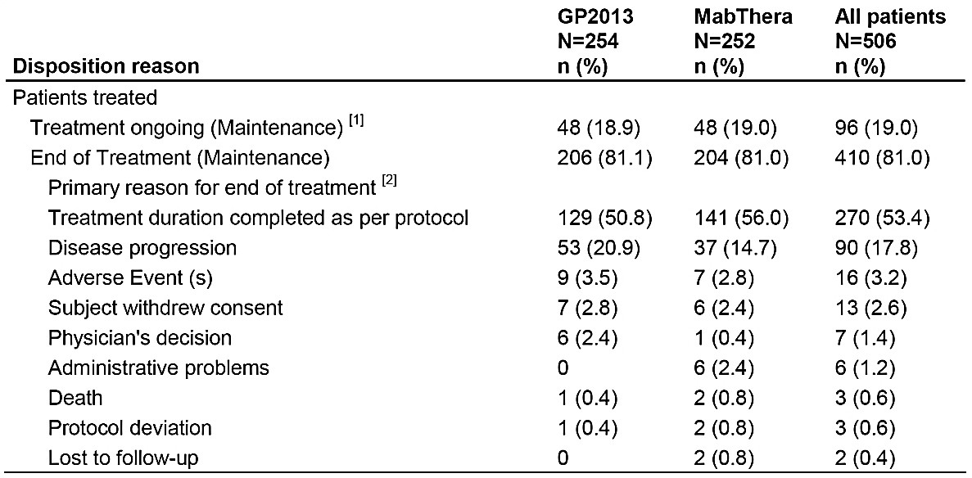
(1) Patients continue maintenance study treatment at the time of the cut-off 31-Dec-2016. (2) End of treatment refers to discontinuation of maintenance treatment. All percentages are based on maintenance set
Comment: The proportion of patients who discontinued maintenance treatment is similar in the two treatment groups (approximately 81%). The majority of patients in both treatment groups completed maintenance treatment as per protocol (50.8%, GP2103 versus 56.0%, MabThera). The proportion of patients discontinuing maintenance treatment due to disease progression is greater in the GP2013 group than in the MabThera group (20.9% versus 14.7%, respectively), and the proportion of patients discontinuing maintenance treatment due to AEs is similar in both groups (3.5% versus 2.8%, respectively).

Updated progression free survival (PFS)
Updated PFS is summarised below in Table 63, and the Kaplan-Meier curves are presented below in Figure 16. The median follow-up was 23.56 months for the GP2013 group and 24.21 months for the MabThera group. The proportion of censored patients was 69.9% (n = 218) in the GP2013 group and 75.9% (n = 239) in the MabThera group. The reasons for censoring were patients without event (n = 94, GP2013; n = 108, MabThera), patients initiating new anticancer therapy (n = 15, GP2013; n = 10, MabThera) or adequate patient assessment no longer available (that is, distance to last tumour assessment too long) (n = 109, GP2013; n = 121, MabThera).

Table 63: Analysis of PFS based on investigator assessment using Kaplan-Meier and Cox-regression method (FAS)
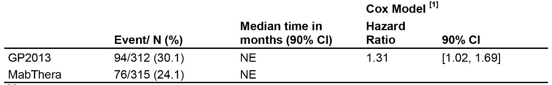
(1) The hazard ratio (HR) estimate and its associated 90% CI are obtained by fitting Cox regression model with treatment allocation as covariate and FLIPI score as stratification factor. This study is not powered for any hypothesis testing of PFS; hence, the HR and its associated 90% CI are presented for descriptive purpose. NE: Not estimable. Median (time to event) and the associated 90% CI are generated by KM estimation. The data used for this output was from interim analysis data cut-off as of 31-Dec-2016.
Figure 16: Kaplan-Meier plot of PFS by treatment based on investigator assessment (FAS)
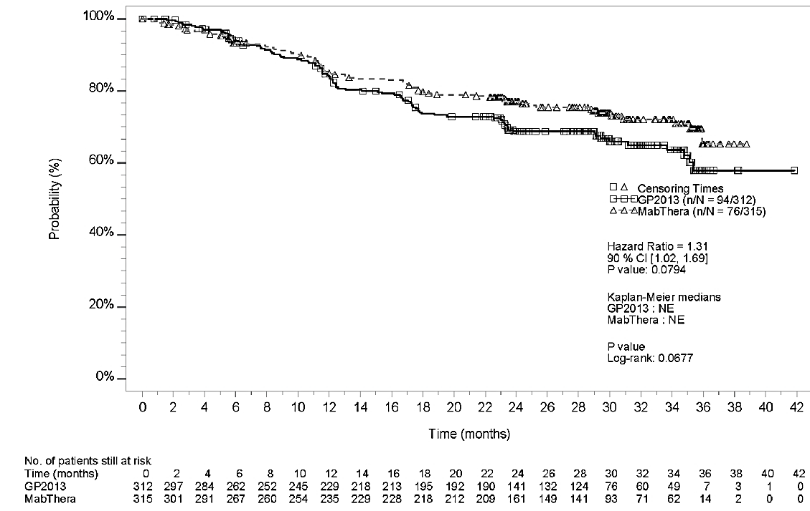

The cumulative event rates for PFS are summarised below in Table 64.

Table 64: Cumulative event rates for PFS
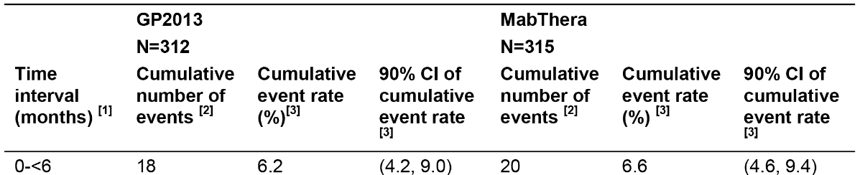
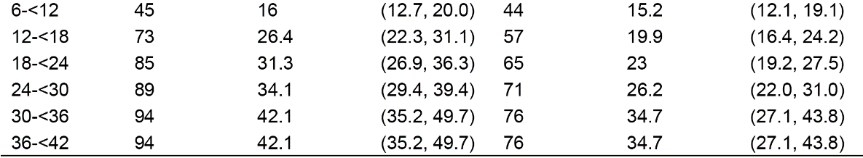
Comment: The proportion of patients with a PFS event (disease progression or death) was greater in the GP2013 group than in the MabThera group (30.1% versus 24.1%). The descriptive HR for PFS favoured MabThera relative to GP2013, and the result was nominally statistically significant. The median PFS had not been reached in either of the two treatment groups. As discussed previously, the median PFS for R-CVP induction followed by maintenance therapy is estimated to exceed 5 years. Therefore, the median PFS is not expected to be reached in either treatment group at the completion of this 3 year study. The proportion of censored patients was high in both treatment groups (69.9% (n = 218) GP2013 and 75.9% (n = 239) MabThera. The proportion of patients ongoing without an event was 30.1% (n = 94) in the GP2013 arm and 34.3% (n = 108). The proportion of patients for whom an adequate assessment of PFS is no longer available is greater in the GP2013 group than in the MabThera group (34.9% (n = 109) versus 38.4% (n = 121)), and patients censored for this reason will not be available for future PFS assessments.
The Kaplan-Meier curves begin to diverge at about 12 months and continue to diverge through to 24 months after which the two curves run in parallel. There was an initial period of overlapping of the two curves prior to separation at 12 months. The sponsor comments that this violates the assumption of proportional hazards for the two treatment groups. Consequently, the HR, which is based on the Cox proportional hazard model, must be interpreted with caution as it might not reflect the true difference between treatments. The results for the PFS analysis should be interpreted with caution due to the study not being designed and powered for PFS biosimilar equivalence testing, the low event rate in the two treatment groups, and violation of the assumption of proportional hazards on which calculation of the HR is based. Furthermore, the sponsor concluded that the opposite direction of the HR for the PFS and OS analyses suggests that the PFS results are influenced by patient heterogeneity and random observations rather than a drug effect and a high level of censoring.

Updated overall survival (OS)
Updated OS is summarised below in Table 65 and the Kaplan-Meier curves are presented below in Figure 17. The analyses were based on the data cut-off date of 31 December 2016.

Table 65: Updated OS data
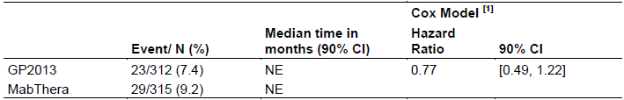
(1) The hazard ratio (HR) estimate and its associated 90% CI are obtained by fitting Cox regression model with treatment allocation as covariate and FLIPI score as stratification factor. This study is not powered for any hypothesis testing of OS; hence, the HR and its associated 90% CI are presented for descriptive purpose. NE: Not estimable. Median (time to event) and the associated 90% CI are generated by KM estimation. The data used for this output was from interim analysis data cut-off as of 31-Dec-2016.
Figure 17: Kaplan-Meier plot of OS by treatment (FAS)
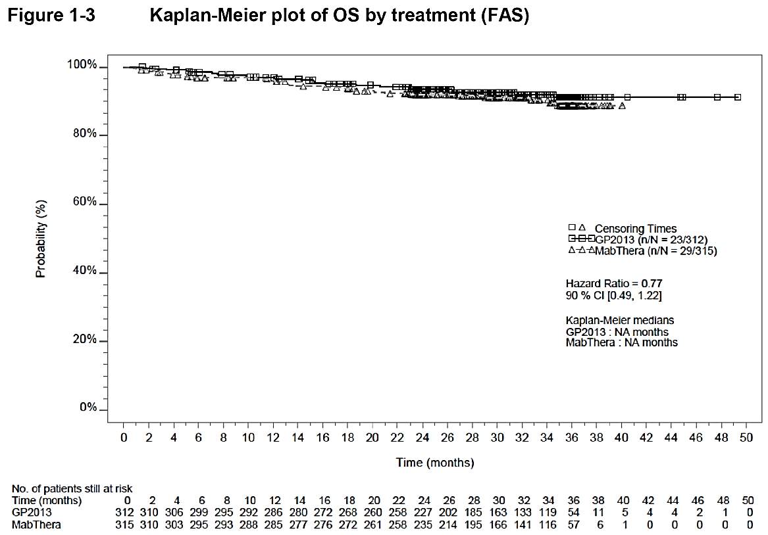
Comment: From the time of the primary analysis data cut-off (10 July 2015) to the time of the second interim analysis data cut-off (31 December 2015), the number of deaths increased by 5 in the GP2013 group and 12 in the MabThera group. In the second interim analysis, the proportion of deaths was greater in the MabThera group than in the GP2013 group (9.2% versus 7.4%). The descriptive HR for OS favoured GP2013 relative to MabThera, but the result was not statistically significant and the study was not powered to detect a difference in OS. The descriptive results for the HR for OS (GP2013 favoured relative to MabThera) were in the opposite direction to the descriptive results for the HR for PFS (MabThera favoured relative to GP2013). The Kaplan-Meier OS curves are similar for the two treatment groups and are mostly superimposable. Median OS had not been reached in either of the two treatment groups, and given that the duration of the study is only 3 years it is unlikely that median OS will be reached in either treatment at the completion of the study. The proportion of patients censored was 92.7% (n = 289) in the GP2013 group (286 alive, 3 lost to follow-up) and 90.8% (n = 286) in the MabThera group (281 alive, 5 lost to follow-up). Based on the updated OS data there is no evidence of a survival detriment for patients in the GP2013 group compared to the MabThera group.

Updated best overall response
The best overall response rate in the maintenance phase in the second interim analysis at the data cut-off of 31 December 2013 is summarised in the table presented immediately below.

Table 66: Best overall response rate in the maintenance phase in the second interim analysis at the data cut-off of 31 December 2013
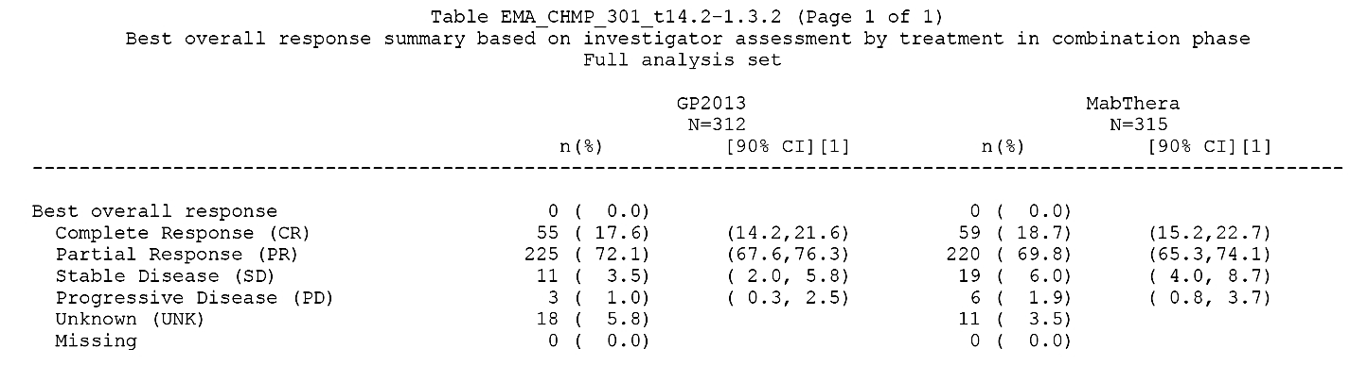
(1) The 90% CIs are exact intervals derived using the Clopper-Pearson formula. Data cut-off data 31 December 2016
The CR rate in the two treatment groups were similar up to Month 15, up to Month 27, up to Month 33 and up to the end of study (see Table 67 below).

Table 67: Number of patients with latest disease status of complete response based on investigator assessment by the time interval and treatment (FAS)
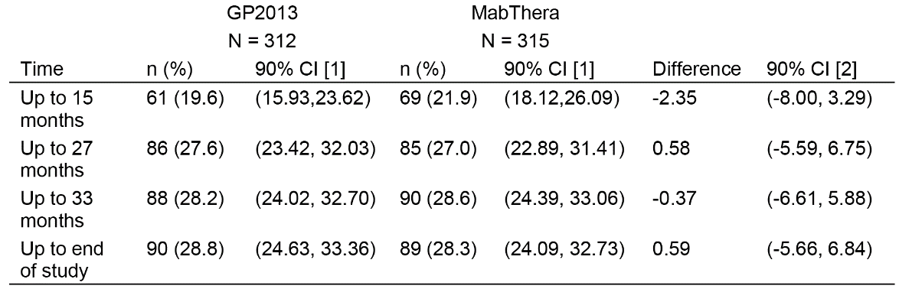
(1) The 90% CIs are exact intervals derived using the Clopper-Pearson formula. (2) The 90% CI for differences in proportions is based on normal approximation to the binomial distribution. The latest assessment based on investigator assessment up to the specified time point was used.
Comment: The updated data for best overall response in the maintenance period showed that the complete response rate was similar in the GP2013 and MabThera groups (17.6% versus 18.7%, respectively). The CR was also similar between the two treatment groups up to the end of the study and for each of the time intervals in the study. The sponsor considers that these results support the therapeutic equivalence of the two treatment groups based on the primary analysis of the ORR in the combination phase.

Updated safety data
The sponsor noted that safety data in the initial submission included:
- Study GP13-301 data up to data cut-off 10 July 2015 (primary analysis) showing comparable safety for Study GP13-301 and MabThera.
- Study GP13-201 Part I for 52 weeks showing comparable safety for Study GP13-301 and MabThera.
The sponsor stated that additional or updated safety data have been provided in the response including:
- Study GP13-301 up to data cut-off 10 July 2016 (first interim analysis) showing comparable safety for Study GP13-301 and MabThera and thus confirming the comparable safety from the primary analysis. More than 65% of the Study GP13-301 patients of the maintenance set had already completed maintenance treatment as of 10 July 2016. Study GP13-201 (Part II) data for 24 weeks showing comparable safety for GP2013 and Rituxan (US licensed originator rituximab). The sponsor states that as MabThera and Rituxan were found to be physico-chemically and biologically indistinguishable and as Study GP13-201 also demonstrated bioequivalence for PK between MabThera and Rituxan this confirms the comparable safety from Part I of the study.
- Study GP13-302 (‘transition study’) 12 week clinical study report showed a comparable safety profile of GP2013 and the originator products (US-licensed Rituxan and EU-authorised MabThera). An additional safety risk for patients transitioning from the originator products to GP2013 could not be detected when compared to continuous treatment with the reference medicines.
The sponsor states that, to date, the safety of GP2013 has been evaluated in 504 patients: 133 GP2013 treatment naïve patients with active RA (Study GP13-201, Parts I and II); 53 patients with active RA transitioned to GP2013 after being treated with Rituxan/MabThera (Study GP13-302); 6 Japanese patients with indolent NHL (Study GP13-101); and 312 patients with FL up to cut-off date of 10 July 2016 (Study GP13-301). Patients with RA have been followed-up for 52 weeks, and patients with FL have been followed-up for 3 years.
In summary, the sponsor stated that all safety data show that safety is comparable between GP2013 and the reference medicine and that the safety profile matches the currently known safety data of the reference medicine (MabThera PI). Only 35% of patients in Study GP13-301 were ongoing at the time of the data cut-off for the first interim analysis of 10 July 2016, and two thirds of the patients had finished the maintenance treatment. The sponsor considers it extremely unlikely, based on the available totality of evidence, that the additional data from the ongoing patients in Study GP13-201 will further influence the safety interpretation based on the available data.
Comment: The safety data from Study GP13-302 (‘transition study’) have been evaluated below in this second round CER. The data from this study together with the updated safety data from Study GP13-301 and Study GP13-302 provided in the sponsor’s response of 28 June 2017 have been included in the Second Round benefit-risk assessment.

Study GP13-302 (‘transition study’)

Title
A randomized, double-blind, controlled, parallel-group, multicenter study to assess the safety and immunogenicity of transitioning to GP2013 or re-treatment with Rituxan or MabThera in patients with active rheumatoid arthritis, previously treated with Rituxan or MabThera (ASSIST-RT).

Objective
To identify potential safety risks of the transition (switch) from Rituxan or MabThera to GP2013 based on general safety and immunogenicity outcomes.

Design
This Phase III descriptive safety study was a randomized, double-blind, comparator-controlled, parallel-group, multicentre, clinical trial designed to assess immunogenicity and safety in patients with RA switched from treatment with MabThera or Rituxan to GP2013. The study planned to randomised approximately 100 patients. The study included a screening period of 4 weeks to assess eligibility and ADA status. Eligible patients were randomised at the baseline Visit 1:1 to one of two treatment groups: (1) GP2013 (2 x IV infusions), these patients were transitioned from Rituxan or MabThera received prior to study entry to GP2013; or (2) Rituxan or MabThera (2x IV infusions), these patients continued treatment with Rituxan or MabThera received prior to study entry. In both treatment groups infusions were administered on Day 1 (first infusion) and Day 14 (second infusion), followed by a 3 month follow-up period with safety and immunogenicity assessments at Day 14 (before administration of the second infusion) and at Week 12 (main analysis). An additional visit took place at Week 24 after randomisation to assess long-term immunogenicity. A Data Monitoring Committee (DMC) reviewed the safety data of the study on a periodic basis. The study design is presented below in Figure 18.
Figure 18: Design for switch-over Study GP13-302
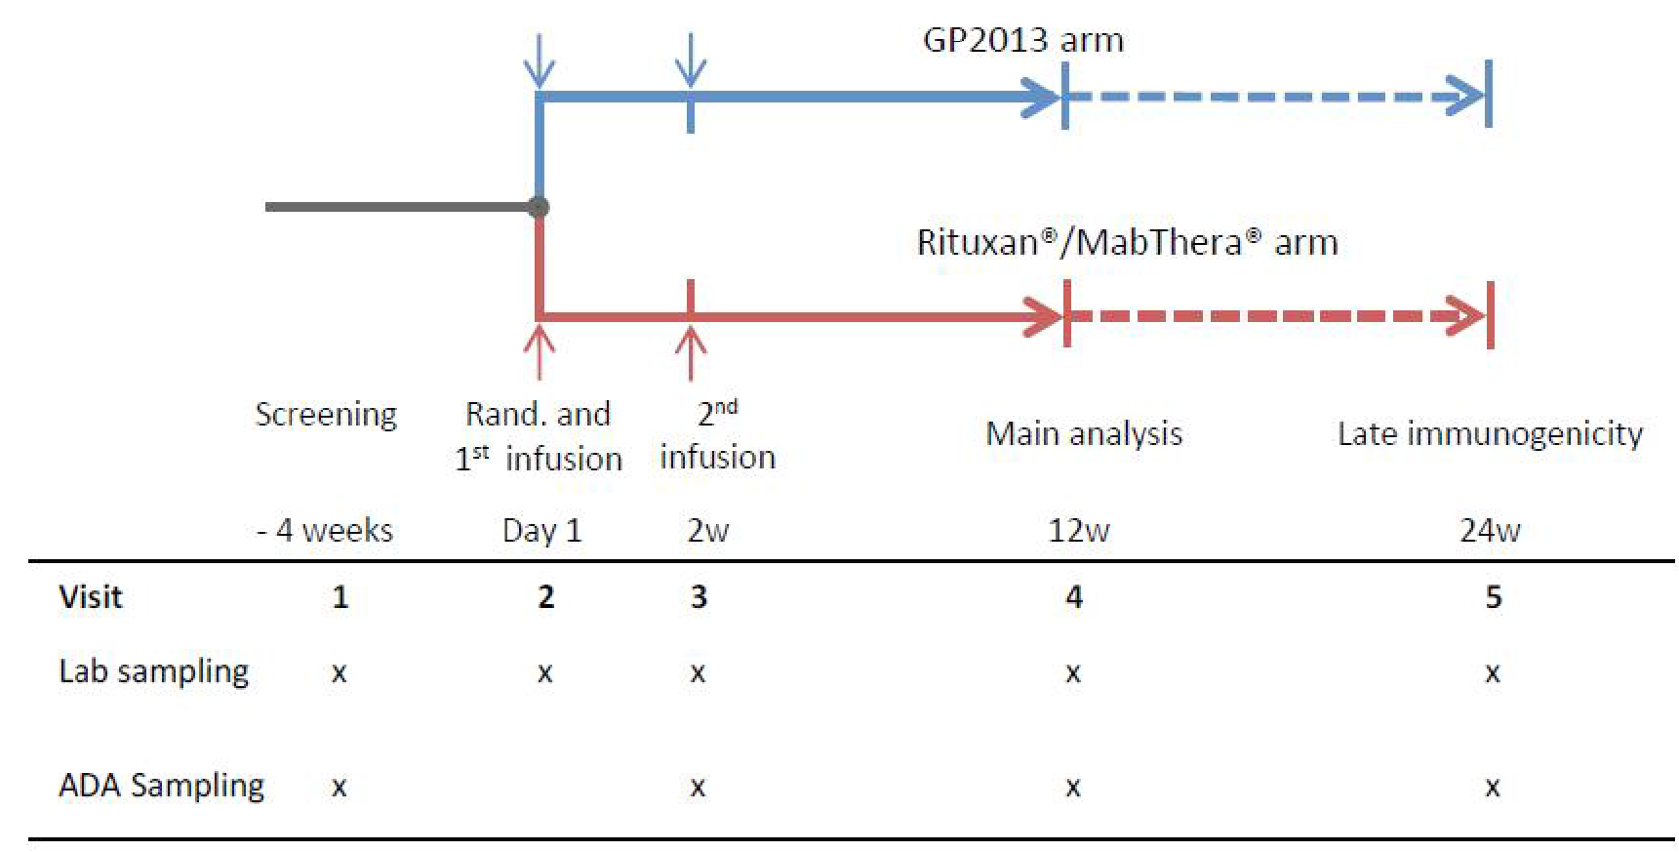
ADA = anti-drug antibody; rand = randomisation; w = week.
Comment: The randomised double-blind design of Study GP13-302 minimises the potential for bias. The sponsor stated that relevant AEs related to the transition from MabThera or Rituxan to GP2013 were expected to occur within 3 months of the transition. Acute hypersensitivity reactions were anticipated to occur close to rituximab administration, while late hypersensitivity reactions (for example, serum sickness, vasculitis, and other delayed reactions) were expected to occur within weeks of administration. The sponsor noted that data from the ongoing Study GP13-201 in patients with RA showed that ADAs were detectable in some patients 3 months after re-treatment with rituximab, while in other patients ADAs were not detectable until 6 months after re-treatment with rituximab. Therefore the assessments of ADA at Month 3 and an additional follow-up visit at Month 6 were deemed by the sponsor to be adequate to characterise immunogenicity following switching over time. The time intervals chosen to assess hypersensitivity reactions and immunogenicity are considered to be appropriate.

Location, dates, sponsorship
Patients were screened for study entry at a total of 54 sites (16 in Germany, 4 in Hungary, 6 in Poland and 28 in the USA) and a total of 44 sites randomised at least 1 patient (15 in Germany, 4 in Hungary, 5 in Poland and 20 in the USA). The first patient visit was on 22 July 2015 and the last patient Week 12 visit was on 11 July 2016. The study was still ongoing at time of main analysis. The safety parameters were assessed up to the data cutoff date of 11 July 2016 (last patient Week 12). The submitted study report was dated 8 February 2017. The sponsors were Sandoz Inc. for the USA and Hexal AG, a Sandoz company, for countries outside the USA. The study was conducted according to the ethical principles of the Declaration of Helsinki.

Inclusion and Exclusion criteria
Patients eligible for inclusion had to fulfill all of the following criteria:
- Male or non-pregnant, non-lactating female patients at least 18 years of age at screening, who provided written informed consent before any assessment was performed.
- Patients must have had the diagnosis of RA (according to American College of Rheumatology (ACR) 2010 criteria).
- Patients must have had received at least one full treatment course of rituximab for the therapy of RA (that is, two complete IV infusions of 1000 mg of Rituxan in the US or MabThera in the EU) 6 to 18 months prior to randomisation.
- Patients had to be eligible for a subsequent treatment course of Rituxan or MabThera according to the clinical judgment of the investigator.
- Patients must have had been on a stable dose of methotrexate (MTX) (7.5 to 25 mg per week) for at least 4 weeks prior to randomisation. If patients had received a combination of DMARDs (MTX + hydroxychloroquine or MTX+ chloroquine or MTX+ sulfasalazine) then they should have also been on a stable dose of DMARDs for at least 4 weeks prior to randomisation.
- Patients must have had been on a stable dose of folic acid or folinic acid (≥5 mg per week) for at least 4 weeks prior to randomisation.
Comment: The inclusion criteria are considered to be appropriate.
Patients with RA of functional status class IV according to the ACR 1991 revised criteria were excluded from the study as were patients with systemic manifestation of RA, with the exception of Sjögren’s syndrome. Patients were also excluded if they had received therapy with any DMARDs (including tofacitinib) other than MTX or combination of MTX with hydroxychloroquine or MTX with chloroquine or MTX with sulfasalazine within 4 weeks prior to randomisation. In case of leflunomide, the drug had to be discontinued 8 weeks prior to randomisation (if a cholestyramine washout was performed, leflunomide had to be discontinued 4 weeks prior to randomisation). Patients with serious recurrent or chronic diseases, other than RA, were also excluded.
Comment: The exclusion criteria have been examined and are considered to be appropriate.

Study treatments
Patients were randomised to one of the following two treatment groups in a ratio of 1:1: (1) transitioned to treatment with proposed biosimilar GP2013; or (2) continued treatment with originator rituximab. Patients received either two 1000 mg IV doses of GP2013 or two 1000 mg IV doses of the originator two weeks apart. The first IV infusion was administered on the day of randomisation (Visit 2) and the second IV infusion was administered 2 weeks later (Visit 3). Both treatments were given with MTX (7.5 to 25 mg/week) alone or in combination with allowed DMARDs, and folic acid or its equivalents, at the same stable doses as before randomisation.
Comment: The dose regimen of the rituximab products are in accordance with the Australia PI for MabThera for the treatment of RA, with a course consisting of two 1000 mg IV infusions given two weeks apart. The course of MabThera is given concomitantly with the dose of MTX tolerated by the patients. The PI states that patients may receive further courses of treatment based on the signs and symptoms of the disease. The PI goes on to state that in clinical studies, no patient received a second course of MabThera treatment within 16 weeks of the first infusion of the first course. The time interval between courses was variable, with the majority of patients who received additional courses doing so 6 -12 months after the previous course.

Primary safety variables

Anaphylactic reactions
Anaphylactic reactions were prospectively defined according to the National Institute of Allergy and Infectious Diseases/Food Allergy and Anaphylaxis Network (NIAID/FAAN) criteria (summarised below in Table 68). Any anaphylactic event observed within 24 hours after the start of study drug administration had to be reported by the investigators on a specific eCRF page. The eCRF background algorithm was programmed such that study drug treatment was considered as a ‘likely’ allergen for patients without a history of any infusion related reactions and as a ‘known’ allergen for patients with history of infusion related reactions during their previous treatments with rituximab.

Table 68: NIAID/FAAN clinical criteria for diagnosing anaphylaxis
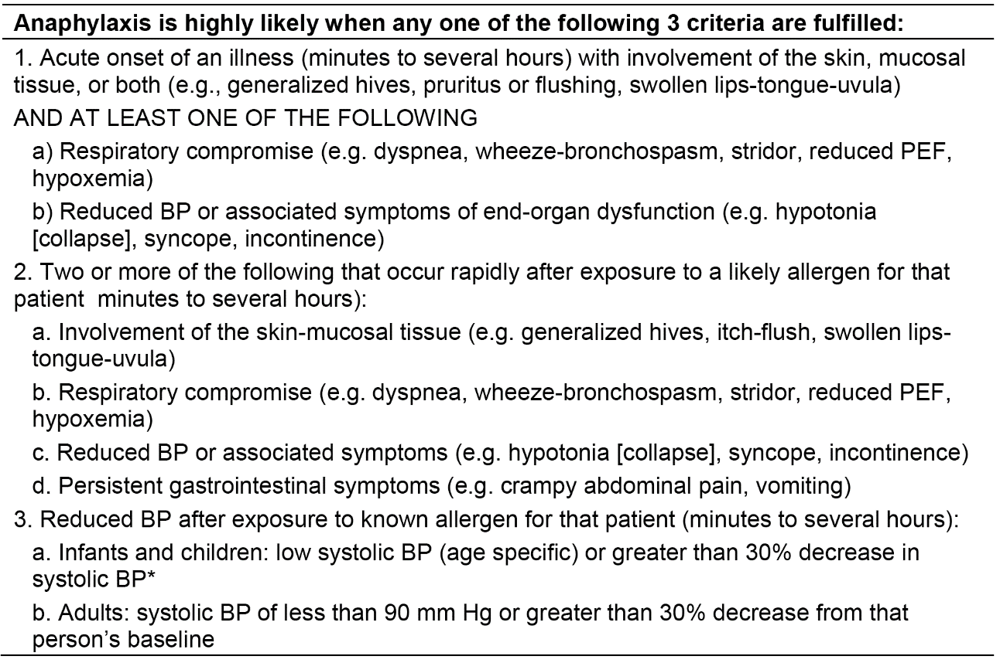
Notes - BP = blood pressure; FAAN = Food Allergy and Anaphylaxis Network; NIAID= National Institute of Allergy and Infectious Diseases; PEF= Peak expiratory flow * Low systolic blood pressure for children is defined as less than 70 mmHg from 1 month to 1 year, less than (70 mmHg + (2 x age)) from 1 to 10 years, and less than 90 mmHg from 11 to 17 years.
Comment: The approach used by the sponsor to collect anaphylactic events differs from the classical search strategy utilising the standardised MedDRA query (SMQ) system. The SMQ strategy allows for a standardised definition of particular AEs as anaphylactic reactions without sponsor judgment, but loses the objective component of the NIAID/FAAN clinical criteria and accepts the subjectivity of investigators deciding on anaphylaxis definition. The sponsor states that it was discouraged by the FDA to apply a SMQ strategy for definition of anaphylactic reactions and was encouraged to use the NIAID/FAAN criteria.
The sponsor referred to published literature (Campbell et al., 2012) which showed that the sensitivity of NIAID/FAAN clinical criteria was 96.7%, the specificity was 82.4%, the positive predictive value was 68.6%, the negative predictive value was 98.4%, the positive likelihood ratio was 5.48, and the negative likelihood ratio was 0.04. The authors of the study concluded that ‘these results suggest that the NIAID/FAAN criteria are highly sensitive but less specific and are likely to be useful in the ED (emergency department) for the diagnosis of anaphylaxis. It is considered that the NIAID/FAAN criteria are acceptable for collecting information on acute anaphylactic events.

Hypersensitivity
A Standardised MedDRA query (SMQ) – ‘Hypersensitivity reactions’ (a pre-defined list of MedDRA preferred terms), was used for the identification of hypersensitivity reactions in the AE database.

Infusion related reactions
A Novartis MedDRA query (NMQ) – ‘Infusion related reactions’ (a pre-defined list of MedDRA preferred terms, which was applied by the sponsor consistently across all GP2013 clinical studies) was used for identification of infusion related reactions in the AE database.

Immunogenicity (development of ADAs)
The presence of ADAs against rituximab was assessed according to visit schedule (including unscheduled visits). Only ADA-negative patients at screening in the SAF were considered for the analysis of immunogenicity (development of ADA). A patient was considered as ADA-positive during the study if he/she had at least one post-baseline ADA-positive sample, otherwise the patient was regarded as ADA-negative.

Other safety variables
Standard safety variables based on AEs were collected. AEs were coded using MedDRA coding dictionary. An AE was considered as a treatment emergent AE (TEAE) if its onset was on or after the start of first infusion and not later than end of study. Only treatment emergent AEs were tabulated but all AEs were listed. Other safety reported safety variables were: (1) laboratory variables (haematology, coagulation, clinical chemistry); (2) vital signs; and (3) body weight.

Randomisation and blinding methods

Randomisation
At Visit 2, all eligible patients were randomised via an Interactive Response Technology (IRT) system to one of the two treatment arms. The IRT system assigned two kits, identified by unique numbers, for the preparation of the first IV infusion. For the second IV infusion on Day 14 (Visit 3), another two kits were assigned via the IRT system. Randomisation was stratified by: (1) region (US/EU); (2) ADA status of the patient at screening (positive/negative); (3) number of treatment courses with originator products, which the patient had received before study entry (one treatment course versus more than one treatment course).
Comment: The number of previous treatment courses with an originator product might have had an impact on the immunogenicity of subsequent administration of rituximab. In addition, differences in rates of hypersensitivity, anaphylactic and infusion related reactions could be expected between patients with or without ADA response after prior rituximab treatment. Therefore, patients were stratified based on both of these factors.

Blinding
This was a double-blind study. Patients, blinded investigator site staff, persons performing the study related assessments, and blinded staff of the sponsor or designated contract research organisation (CRO), including data analysts, remained blinded to the identity of the treatment from the time of randomisation until database lock for the 12 week main analysis. Receipt, storage and preparation of the medication were performed by unblinded site staff. Unblinding could only occur in case of patient emergencies, at the time of the main analysis and at the conclusion of the study. After the database lock for the 12 week main analyses, designated sponsor team members were unblinded to the treatment assigned at randomisation (Visit 2), whereas patients, blinded investigator staff and persons performing the assessments remained blinded until after the final study database lock at the end of the study.

Analysis populations
- Randomised population: consisted of all randomised patients. Following the intent-to-treat principle, patients were analysed according to treatment assigned at randomisation. The randomised population included a total of 107 patients (53 in the GP2013 group and 54 in the Rituxan/MabThera group).
- Safety Analysis Set (SAF): consisted of all patients who received study drug at least once. Patients were analysed according to treatment received. The SAF included a total of 107 patients (53 in the GP2013 group and 54 in the Rituxan/MabThera group).
- Per-protocol (PP) analysis set: consisted of all patients in the SAF who did not have any pre-specified major protocol deviations. The PP population included a total of 97 patients (47 in the GP2013 group and 50 in the Rituxan/MabThera group).

Sample size
The sample size of 100 patients (50 in each treatment arm) was not based on statistical considerations. Given the low incidences of the key safety endpoints after repeated rituximab treatment courses, it is apparent that a fully powered comparison would require a substantially larger sample size. Sandoz discussed with the FDA several study design scenarios to adequately assess the safety of transitioning from the originator product to the proposed biosimilar. The FDA agreed to a sample size of 100 patients, randomised 1:1 to one of the two treatment arms.

Statistical methods
All safety parameters were analysed descriptively based on the SAF set. Incidences of hypersensitivity reactions, anaphylactic reactions, infusion-related reactions and immunogenicity (ADA development) were analysed on the PP analysis set as supportive analysis to the primary analysis on the SAF. Baseline was defined as the last non-missing pre-dose assessment. All incidences were descriptively compared between the two study arms, and the 95% CI for the difference in incidences of hypersensitivity reactions, anaphylactic reactions, infusion-related reactions and immunogenicity between the two arms was presented. The 95% CI for the risk difference was estimated using an exact unconditional method, given the small sample size and low event rate for the evaluated safety endpoints.
Comparing the two treatment arms by using the upper limit of the 95% CI for the incidence difference the following expected limits were calculated by the sponsor (no difference between treatment arms was assumed):
- Anaphylactic reaction: according to the MabThera label (EU), a rate of ≤1% can be assumed. The calculated upper limit in the current study is expected at 3.9%.
- Hypersensitivity: according to the preliminary results of Study GP13-201, a rate of 7.5% of hypersensitivity events after the re-treatment course can be assumed. The calculated upper limit in the current study is expected at 10.3%.
- Infusion related reactions (IRR): based on the preliminary results of Study GP13-201 and on literature, a rate of 25% IRR after the re-treatment course can be assumed. The calculated upper limit in the current study is expected at 17.0%.
- Immunogenicity (ADA development): according to the preliminary results of Study GP13-201 study, an incidence rate of 9% after the second treatment course can be assumed. The calculated upper limit in the current study is expected at 11.2%.
No imputation was performed for missing values. Central laboratory values below the limit of quantification were imputed as half the limit of quantification.
Handling of missing and incomplete dates for AEs, concomitant medications and initial diagnosis of RA were imputed. The methods were specified in the Statistical Analysis Plan and used complex algorithms for imputing the AE and concomitant medication start dates.
For anaphylactic events, hypersensitivity reactions and infusion related reactions the following supportive subgroup analyses were performed: (1) incidence rates were calculated within both treatment groups for US/EU patients separately; and (2) incidence rates were calculated within both treatment groups for patients with one/more than one courses of pre-treatment.
There were two amendments to the first version of the Statistical Analysis Plan, and the final SAP (Version 3.0; 16 September 2016) included a list of the amendments. All amendments are considered to be satisfactory and were made before the database lock.

Participant flow
A total of 194 patients were screened at 54 centres in 4 countries (USA, Germany, Hungary, and Poland). Of these 194 patients, 107 were randomised to either GP2013 (53 patients) or Rituxan/MabThera (54 patients) and 67 were screen failures. Patient disposition in the randomised population is summarised below in Table 69.

Table 69: Patient disposition by treatment group Randomised population
Notes: The primary reason for withdrawal was provided on the study completion eCRF page.
Comment: The patient disposition was well balanced between the two treatment groups. As the study is still ongoing, only 41.5% of patients in the GP2013 group and 42.6% in the Rituxan/MabThera group had completed Week 24.

Major protocol violations/deviations
The main analysis of the study endpoints was performed on the SAF (including all patients with protocol deviations). As a supportive analysis, the endpoints were additionally analysed on the PP analysis set, which excluded patients with major protocol deviations as assessed during the blind data review meeting (BDRM).
Protocol deviations were considered major if they had the potential to influence the immune response to the study treatment and could therefore affect the incidence of the safety endpoints. In particular, these included treatments with corticosteroids in doses significantly higher than allowed by the study protocol, interruptions of concomitant treatment with MTX, or significant MTX dose reduction, if they occurred before Week 12 during the study. Furthermore, the use of biologics including other non-approved proposed biosimilar versions of rituximab (for example, within previous clinical trials) in clinically significant proximity to study entry was considered a major protocol deviation.
A total of 10 (9.3%) patients were excluded from the PP analysis set due to major protocol deviations, with a higher proportion of patients in the GP2013 group being excluded compared to the MabThera/Rituxan group (11.3%, n = 6 versus 7.4%, n = 4, respectively). One additional patient in the Rituxan/MabThera group was identified with a major protocol deviation after the database lock (patient treated with 20 mg/day prednisolone (that is, >10 mg/day) due to an AE of bronchitis). Since this major protocol deviation was detected after database lock, the patient was neither excluded from the PP analysis set used for the supportive endpoint analyses nor included in the summary of major protocol deviations or in the summary of the deviation category ‘prohibited concomitant medication’. At database lock, the patient was listed with other minor protocol deviations only and therefore included in the total number of patients with at least one report-relevant protocol deviation in the summary tables. Patients with at least one relevant protocol deviation and patients with major protocol deviations identified before the database lock in both study groups are summarised below in Table 70.

Table 70: Study GP13-302 - Major protocol deviations by deviation code and treatment, SAF analysis set
Notes: AE=adverse event; Excl=exclusion criterion; MTX=methotrexate; RND=randomisation. A patient may have protocol deviations in more than one protocol deviation category, in which case the patient is included in more than one protocol deviation category. A patient may have protocol deviations several times in the same protocol deviation category, in which case the patient is counted only once in this protocol deviation category. (1) Previous treatment with any cell depleting therapies other than rituximab also included treatment with other proposed biosimilars for rituximab.
There were 64 (59.8%) patients identified with a minor protocol deviation before the database lock, comprising 54.7% (n = 29) in the GP2013 group and 64.8% (n = 35) in the Rituxan/MabThera group. These patients were included in all analyses. The most common minor protocol deviation in the total population (n = 23, 21.5%) was informed consent not obtained correctly (n = 12, 22.6%, GP2013 versus n = 11, 20.4%, Rituxan/MabThera)). Overall, the proportion of patients with minor protocol deviations was comparable between the two treatment groups. After the database lock, additional minor protocol deviations were identified in 7 patients in the GP2013 group.
Comment: The sponsor concludes that the frequent minor protocol deviations did not have an impact on the main analysis in the SAF or on data integrity, despite the numerical difference in incidences between the two treatment groups. The major protocol deviations occurred in similar proportions of patients in both treatment groups and were, therefore, not considered to have introduced a bias into the safety comparison of the two treatment groups.

Baseline data

Demographic characteristics
In the SAF (n = 107), the median age of the population was 58 years (range: 30, 87), with the age distribution being 14.0% for patients aged 18 to < 45 years, 63.6% for patients aged 45 to < 65 years, and 22.4% for patients aged ≥ 65 years. The majority of patients in the total population were female (79.4%) and White (96.3%). The majority of patients were from the EU (67.3%) with remainder being from the US (32.7%). Baseline demographics were balanced between the two treatment arms with respect to mean age, child-bearing potential, race/ethnicity, region, height, weight, and BMI. However, differences between the two treatment groups were observed with respect to age group distribution and sex.
Comment: The imbalances in age group distribution and sex are not considered to have biased the safety endpoint comparisons.

Baseline disease and history characteristics
The mean duration of disease in all patients in the SAF was 13.7 years (range: 1.7, 46.0) and the majority of patients (58.9%) had ACR functional status Class II. The majority of patients (75.7%) had been treated with > 1 previous course of rituximab (mean of 4.6 treatments), and most patients (95.3%) had experienced no infusion related reactions during rituximab treatments prior to randomisation. Overall, baseline disease and history characteristics of the two treatment groups were comparable, apart from the notably higher proportion of patients in the GP2013 group with RA ACR Class I compared to the Rituxan/MabThera group (37% versus 17%, respectively). There were 2 patients with ADAs at screening (1 in each treatment group).
Comment: Overall, the baseline disease and history characteristics of the two treatment groups were comparable. There was a difference between the treatment groups in the proportion of patients with Class I and II functional status according to ACR, but the proportion of patients with Class III functional status according to ACR was similar for the two treatment groups (13.2%, GP2013 versus 14.8%, Rituxan/MabThera). The sponsor comments that the imbalances in Class I and II functional status according to ACR between the two treatment groups were not considered to introduce a bias with respect to the occurrence of hypersensitivity, anaphylactic and infusion-related reactions and the development of ADAs.The proportion of all patients with infusion related reactions prior to randomisation was low (4.7%), and the sponsor comments that this rate is lower than the rates described in the prescribing documents for Rituxan (US) and MabThera (EU) for the first infusion (32% versus 23%, respectively). The sponsor comments that recall bias cannot be excluded as a possible reason for the low ADA rate reported in the study.

Current medical conditions
The majority of patients (93 patients (86.9%)) had medical comorbidities ongoing at study entry, with comorbidities being reported in a higher proportion of patients in the GP2013 group than in the Rituxan/MabThera group (90.6% (n = 48) versus 48 versus 83.3% (n = 45), respectively). Not unexpectedly, the most commonly affected SOC in both treatment groups was Musculoskeletal and connective tissue disorders (62.3%, GP2013 versus 69.3%, Rituxan/MabThera), mainly osteoarthritis and osteoporosis. Overall, the proportion of patients with the various SOCs was comparable between the two treatment groups.

Medical history
Relevant medical history in patients prior to the study were reported in 64.2% (n = 34) of patients in the GP2013 group and 68.5% (n = 54) of patients in the Rituxan/MabThera group. There were imbalances between the two treatment groups in a number of SOCs, but patient numbers were small. Overall, it is considered that there are no differences between the two treatment groups that are likely to bias assessment of hypersensitivity, anaphylactic and infusion-related reactions and development of ADAs.

Medication history for RA prior to study entry
All patients had received prior treatment with rituximab, as required by the study protocol. Treatment for RA with synthetic DMARDs and biologics that occurred before screening was documented without time limitation. Other RA-related treatments (for example, NSAIDs, glucocorticoids, analgesics) were documented if used in the 6 months immediately prior to screening. The majority of patients had received treatment with TNF-inhibitors (69.8%, GP2013 versus 79.6%, Rituxan/MabThera), mainly adalimumab, etanercept and infliximab. The difference between the two treatment groups in the proportion of patients treated with TNF-inhibitors was primarily due to the difference in the use of prior infliximab (15.1%, GP2013 versus 33.3%, Rituxan/MabThera). The mean number of prior anti-TNF therapies was similar between both treatment groups (0.9, GP2013 versus 1.1, Rituxan/MabThera). In general, the prior use of RA-related treatments was similar in the two treatment groups.

Extent of Exposure
Study drug dose adjustments were not permitted unless medically justified, and did not occur.
All patients in the Rituxan/MabThera group received both infusions (100% (n = 54)), while 51 (96.2%) of the 53 patients in the GP2013 group received both infusions (100% (n = 53) first infusion, 96.2% (n = 51) second infusion). In the GP2013 group, 2 patients were withdrawn from the study before the second infusion (1 patient due to an AE, 1 patient due to withdrawal of consent).
The majority of patients in both treatment groups received the first or second infusion without interruption. For the first infusion, 94.3% (n = 50) of patients in the GP2013 group experienced no infusion interruptions compared to 92.6% (n = 50) of patients in Rituxan/MabThera group. For the second infusion, 92.5% (n = 49) of patients in the GP2013 group experienced no infusion interruptions compared to 98.1% (n = 53) of patients in Rituxan/MabThera group. Overall, the proportion of patients experiencing an infusion interruption was marginally higher for the first infusion compared to the second infusion in both treatment groups. The main reason for interrupting the first infusion was AEs (for example, throat irritation, pruritus, in total 6 of 7 patients; comprising 2 (3.8%) patients in the GP2013 group and 4 (7.4%) patients in the Rituxan/MabThera group), whereas the reasons for interrupting the second infusion were more of a technical nature (patient comfort break and new venous access in total 2 of 3 patients; comprising 2 (3.8%) patients in the GP2013 group and no patients in the Rituxan/MabThera group).
Comment: Overall, there were no marked differences between the two treatment groups as regards study drug administration and compliance. The observed differences between the two treatment groups are unlikely to have biased assessment of hypersensitivity, anaphylactic reactions, infusion-related reactions or development of ADAs.

Concomitant medications

RA related
All patients had started treatment with MTX and folic or folinic acid before randomisation and continued both medications during the study. Glucocorticoids were being taken by 43.4% (n = 23) of patients in the GP2013 group and 48.1% (n = 26) of patients in the Rituxan/MabThera group. Overall, the medications for RA started before study drug treatment with rituximab and continued during the study were comparable in the two treatment groups.
Similar proportions of patients in each treatment group started or changed the dose of RA related medications on or after start of the study up to Week 12 (9.4% (n = 5), GP2013 versus 9.3% (n = 5), Rituxan/MabThera). The most frequently initiated medications for RA in both treatment arms were glucocorticoids (5.7% (n = 3), GP2013 versus 5.6% (n = 3), Rituxan/MabThera). Except for one patient who was treated for an AE (a potential infusion-related reaction during the first infusion), the RA related glucocorticoid treatments initiated in both treatment arms were classified as protocol deviations (that is, the dose was either higher than allowed by the study protocol or not stable).
From Week 12 to data cut-off, 4 (7.4%) patients in the Rituxan/MabThera group and no patients in the GP2013 group initiated or changed the dose of RA related medications. The RA related medications in the Rituxan/MabThera group included MTX, glucocorticoids, folic acid and rituximab. All these RA related medications initiated or dose changed from Week 12 to data cut-off were classified as minor protocol deviations.

Non-RA related
Overall, the majority of patients had started non-RA related treatment before the start of the study and continued during the study, with similar proportions of patients in both treatment groups (86.8% (n = 46), GP2013 versus 83.3% (n = 45), Rituxan/MabThera). Overall, the most commonly used medications were proton pump inhibitors (32.7%), Vitamin D and analogues (28.0%), and ACE inhibitors (15.0%). Vitamin D and analogues were taken by fewer patients in the GP2013 group than in the Rituxan/MabThera group (20.8% versus 35.2%, respectively).
Similar proportions of patients in each treatment group started non-RA related treatment on or after start of the study up to Week 12 (32.1% (n = 17) GP2013 versus 29.6% (n = 16), Rituxan/MabThera). The most commonly used medications were paracetamol and ciprofloxacin, with an overall proportion of 3.7% each. Most of the reported medications were used by 1 patient in either of the two treatment groups. There were no clinically meaningful differences between the two treatment groups in the type of non-RA medications used from study start up to Week 12.
From Week 12 to data cutoff, non-RA related medications were initiated by 10.3% of patients (7.5% (n = 4), GP2013 versus 13.0% (n = 7), Rituxan/MabThera). None of the reported medications were used by more than 1 patient in either of the two treatment groups.

Premedication used prior to study drug infusion
All patients received premedication with methylprednisolone (or equivalent) and an antihistamine. Antipyretics were administered to all patients except one in the Rituxan/MabThera group. There were no meaningful differences with respect to pre-medications received for both the first and second infusions.

Safety results - Key safety assessments

Anaphylactic reactions
Anaphylactic reactions (NAID/FAAN criteria) in the SAF were reported in 1 (1.9% (1/54)) patient in the Rituxan/MabThera group and no patients (0/53) in the GP2013 group. The anaphylactic reaction was reported within 24 hours of the first infusion. The patient was from the EU region and had received 1 prior treatment with rituximab before randomisation. In the PP analysis set, 1 (2.0% (1/50)) patient in the Rituxan/MabThera group experienced an anaphylactic reaction within 24 hours of the first infusion and no patients (0/47) in the GP2013 group experienced an anaphylactic reaction.

Hypersensitivity reactions
There were no clinically meaningful differences between two treatment groups as regards the proportion of patients experiencing hypersensitivity reactions up to Week 12 after the first or second infusion. The standardised MedDRA query (SMQ) was used for the identification of hypersensitivity reactions in the adverse event database. The results for the SAF and the PP analysis set are summarised below in Table 71.

Table71: Study GP13-302 - Hypersensitivity reactions up to week 12, SAF (upper panel) and PP (lower panel)
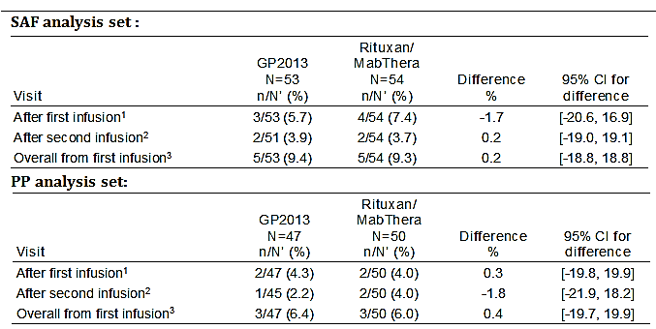
CI=confidence interval; n = number of patients with a hypersensitivity reaction after the infusion; N’=total number of patients with an evaluable assessment at the infusion visit. 1 Hypersensitivity reactions occurring after the start of first infusion and before the start of second infusion. 2 Hypersensitivity reactions occurring after start of second infusion up to Week 12 visit date. 3 Hypersensitivity reactions occurring after start of first infusion up to Week 12 visit date.
Comment: It was not clear why the overall number of patients with hypersensitivity reactions from the first infusion did not equal the number of patients experiencing reactions after the first and second infusions in the Rituxan/MabThera group for either the SAF or PP analysis set.
There were no regional differences between the two treatment groups in the proportion of patients experiencing hypersensitivity reactions up to Week 12, or in the proportion of patients experiencing hypersensitivity reactions up to Week 12 who had received 1 or >1 rituximab treatment courses prior to randomisation (see Table 72, below).

Table 72: Study GP13-302 - Subgroup analysis of hypersensitivity reactions up to Week 12, SAF
CI=confidence interval; n = number of patients with a hypersensitivity reaction after the infusion; N’=total number of patients with an evaluable assessment at the infusion visit.
The incidences of hypersensitivity reactions in the SAF up to Week 12, irrespective of study drug relationship and suspected by the investigator to be related to the study drug are summarised below in Table 73.
There was no hypersensitivity reactions reported from Week 12 to data cut-off in either of the two treatment groups.

Table 73: Study GP13-302 - Hypersensitivity reactions after the first infusion and up to Week 12, SAF
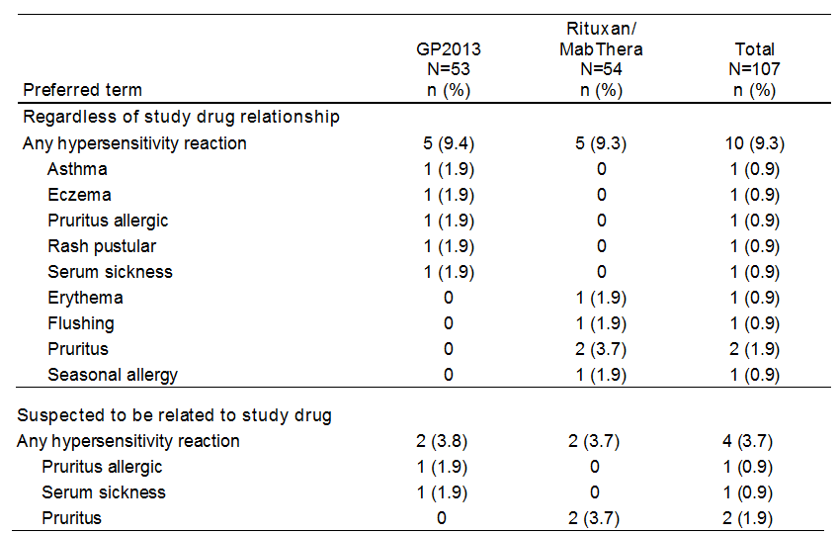
Preferred terms are sorted by descending frequency, as reported in the GP2013 column. A patient with multiple occurrences of an AE for a preferred term under one treatment is counted only once.

Infusion-related reactions
The Novartis MedDRA query (NMQ) for infusion-related reactions was used for the identification of potential infusion-related reactions in the adverse event database. Overall 16 (15.0%) patients in the SAF experienced potential infusion-related reactions (NMQ); 6 (11.3%) patients from the GP2013 group and 10 (18.5%) patients from the Rituxan/MabThera group. The results for the PP analysis were consistent with the results in the SAF, with 12.8% (6/47) of patients experiencing a potential infusion related reaction in the GP2013 group compared to 16.0% (8/50) of patients in the Rituxan/MabThera group. Potential infusion-related reactions in the SAF are summarised below in Table 74.
In the US region, the proportion of patients in the SAF experiencing a potential infusion-related reaction was similar in the GP2013 and Rituxan/MabThera groups (17.6% (3/17) versus 16.7% (3/18), respectively), while in the EU region the proportion of patients in the SAF experiencing a potential infusion-related reaction was notably greater in the Rituxan/MabThera group than in the GP2013 group (19.4% (7/36) versus 8.3% (3/36), respectively).
In patients who received 1 rituximab treatment course prior to randomisation, the proportion of patients in the SAF experiencing a potential infusion-related reaction was greater in the Rituxan/MabThera group than in the GP2013 group (30.8% (4/13) versus 15.4% (2/13), respectively), as was the proportion of patients in the SAF who had received > 1 rituximab treatment course prior to randomisation (14.6% (6/41) versus 10.0% (4/40), respectively).

Table 74: Study GP13-302 - Potential infusion-related reactions on the day of or the day after either infusion, SAF
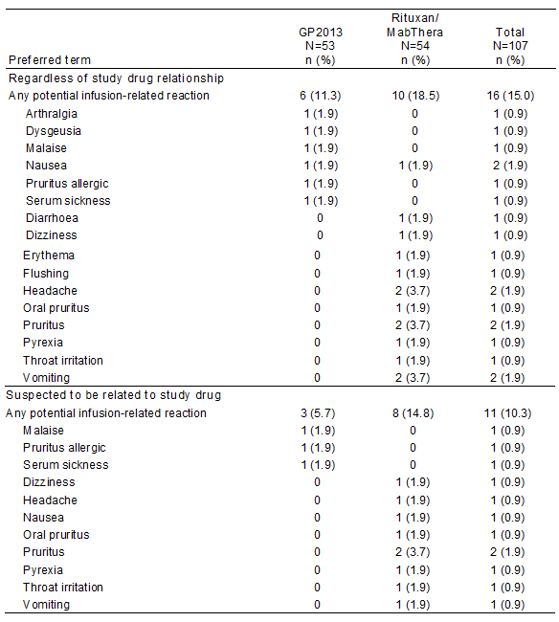
Preferred terms are sorted by descending frequency, as reported in the GP2013 column. A patient with multiple occurrences of an AE for a preferred term under one treatment is counted only once.
The incidence of potential infusion-related reactions occurring on the day of or the day after either infusion up to Week 12 in the SAF are summarised below in Table 75.

Table 75: Study GP13-302 - Potential infusion related reactions, SAF
CI=confidence interval; n = number of patients with a potential infusion related during the time specified at the visit; N’=total number of patients with an evaluable assessment at the infusion visit.

Immunogenicity (development of ADA)
Immunogenicity (development of ADAs) was assessed for all patients at screening, Week 12 and Week 24. Furthermore, if a patient experienced an AE, which was suspected by the investigator to be immunologically related, outside the regular study visits, unscheduled ADA samples were collected at the time of, or as soon as possible after this adverse event.
Two patients were ADA-positive at screening, one in each treatment group. These two patients were excluded from the analysis of immunogenicity. One patient in the Rituxan/MabThera group was ADA-positive in Week 2 and at the subsequent visits in Week 12 and Week 24. No AEs were reported in this patient up to the last visit (Week 24). No other patients tested ADA-positive after screening in either the GP2013 or Rituxan/MabThera group, including the 2 patients who were ADA-positive at screening and patients with unscheduled immunogenicity evaluations. None of the ADA-positive patients detected at screening or after randomisation tested positive for neutralising antibodies.

Other safety results

Adverse event categories up to Week 12 – high-level overview
The high-level overview of AE categories up to Week 12 is summarised below in Table 76.

Table 76: Study GP13-302 - Summary of adverse event categories up to Week 12, SAF
Categories are not mutually exclusive. Patients with multiple events in the same category are counted only once in that category. Patients with events in more than 1 category are counted once in each of those categories.
Comment: AEs were reported more frequently in the GP2013 group than in the Rituxan/MabThera group (66.0% versus 38.9%, respectively). The difference between the two treatment arms was primarily due to the higher incidence of AEs grouped under the SOC of Musculoskeletal and connective tissue disorders in the GP2013 arm than in the MabThera arm (20.8% versus 3.7%, respectively).

Adverse event categories reported from Week 12 to data cut-off
AEs reported from Week 12 to data cut-off are summarised below in Table 77. The analysis is based on the complete SAF (n = 107), but not all patients had completed treatment at data cut-off.

Table 77: Study GP13-302- Adverse event categories reported from Week 12 to data cut-off, SAF
Categories are not mutually exclusive. Patients with multiple events in the same category are counted only once in that category. Patients with events in more than 1 category are counted once in each of those categories. The summary is based on the complete SAF. However, not all patients had contributed data to this period yet.
Comment: In the 2 patients in the GP2013 group with AEs, regardless of relationship to study drug, the events, were 1 each for pharyngitis and synovial cyst. In the 9 patients in Rituxan/MabThera group with AEs, regardless of relationship to study drug, the events were 1 each for nausea, bronchitis, cellulitis, pharyngitis (streptococcal), pneumonia, URTI, UTI, viral infection, RA worsening, and varicose vein.

Adverse events up to Week 12 grouped by SOC
AEs up to Week 12 grouped by SOC, regardless of study drug relationship, are summarised below in Table 78.

Table 78: Study GP13-302 - Adverse events up to Week 12 grouped by SOC, SAF
MedDRA Version 19.0 was used for the reporting of adverse events. Primary system organ classes are sorted by descending frequency, as reported in the GP2013 column. A patient with multiple adverse events within a primary system organ class is counted only once in the total row.
Comment: The main difference between the two treatment groups was the higher incidence of Musculoskeletal and connective tissue disorders in the GP2013 group than in the Rituxan/MabThera group (20.8% versus 3.7%, respectively). The only other difference of note relates to the higher incidence of Gastrointestinal disorders in the Rituxan/MabThera group than in the GP2013 group (14.8% versus 3.8%). Other differences between the two treatment groups in the proportion of patients experiencing other SOCs are considered unlikely to be clinically meaningful as none of the differences involved more than 3 patients.
In the SOC of musculoskeletal and connective disorders, AEs reported in ≥ 2 patients in the GP2013 group (vs Rituxan/MabThera) were arthralgia (n = 3, 5.7% versus 0%), rheumatoid arthritis worsening (n = 2, 3.8% versus n = 1, 1.9%) and osteoarthritis (n = 2, 3.8% versus 0%). Other AEs each reported in 1 patient in the GP2013 group and no patients in the Rituxan/MabThera group were intervertebral disc protrusion, joint effusion, myosclerosis, and pain in extremity. There were no musculoskeletal and connective disorder AEs reported in more than 1 patient in the Rituxan/MabThera group.
In the SOC of Gastrointestinal disorders, the only AE reported in more than 1 patient in either of the two treatment groups was vomiting (n = 3, 5.6%, Rituxan/MabThera versus 0%, GP2013).

Adverse events (preferred term), regardless of relationship to study drug, up to Week 12
AEs (preferred term) up to Week 12, regardless of relationship to study drug, reported in ≥ 2% of all patients are summarised below in Table 79.

Table 79: Study GP13-302 - Adverse events (preferred term) up to Week 12, regardless of relationship to study drug, reported with an incidence of at least 2% in the total patient population, SAF
MedDRA Version 19.0 was used for the reporting of adverse events. Preferred terms are sorted by descending frequency, as reported in the GP2013 column. A patient with multiple adverse events within a primary system organ class is counted only once in the total row. 1 = worsening of rheumatoid arthritis.
Comment: Arthralgia was reported more frequently in patients in th the GP2013 group than in patients in the Rituxan/MabThera group (5.7% versus 0%), while vomiting was reported more frequently in patients in the Rituxan/MabThera group than in patients in the GP2013 group (5.6% versus 0%, respectively). There were no clinically meaningful differences between the two treatment groups as regards other commonly occurring AEs.

Adverse events, suspected to be drug related, up to Week 12
AEs, suspected to be drug related, up to Week 12 are summarised below in Table 80.

Table 80: Study GP13-302 - Adverse events, suspected to be drug related, up to Week 12, SAF
MedDRA Version 19.0 was used for the reporting of adverse events. Preferred terms are sorted by descending frequency, as reported in the GP2013 column. A patient with multiple adverse events within a primary system organ class is counted only once in the total row.
Comment: AEs, suspected to be drug related, were reported more frequently in patients in the Rituxan/MabThera group than in patients in the GP2013 group (16.7% versus 11.3%, respectively). The only AE reported in ≥ 1 patient in either of the two treatment groups was pruritus (n = 2, 3.7%, Rituxan/MabThera versus 0%, GP2013.

AEs by severity up to Week 12
Mild severity AEs were reported more frequently in patients in the GP2013 group than in the Rituxan/MabThera group (34.0% (n = 18) versus 25.9% (n = 14), respectively), as were moderate severity AEs (30.2% (n = 16) versus 9.3% (n = 5), respectively). AEs of severe severity were reported infrequently in patients in both treatment groups (1.9% (n = 1), GP2013 versus 3.7% (n = 2) Rituxan/MabThera. In the 1 patient in the GP2013 group with a severe AE, the event was serum sickness. In the 3 patients in the Rituxan/MabThera group with severe AEs, the events were 1 each for cardiopulmonary failure, hiatus hernia, and seizure).

Adverse events suspected to be immunologically mediated
In addition to the assessment of suspected causal relationship to the study drug, the investigator had to judge whether an AE was suspected to be immunologically related. In case of a suspected immunological relationship, an ADA sample had to be collected, either at a regular visit or at an unscheduled visit, dependent on the time of occurrence/reporting of the AE. Since this assessment was only introduced with Protocol amendment 1, it is not available for all AEs. Immunologically related AEs, suspected by the investigator to be related to the study drug, up to Week 12 were reported in 5.7% (n = 3) of patients in the GP2013 arm (1 each for paraesthesia, asthma, and allergic pruritus) and no patients in the Rituxan/MabThera arm. No immunologically mediated AEs, suspected by the investigator to be related to the study drug, were reported from Week 12 to data cut-off.

Deaths and other serious adverse events (SAEs)

Deaths
One patient (1.9%) in the Rituxan/MabThera group died due to cardiopulmonary failure on Day 41 (that is, 27 days after the last dose). The patient was a 58 year old White female, with a relevant medical history of cerebral ischaemia and with current medical conditions (hypertension, hemiparesis, aphasia, depression, anaemia, and spinal osteoarthritis). The investigator did not consider the death to be related to the study drug. The investigator concluded that progression of hypertension with atrial fibrillation could have caused cardiopulmonary failure.

SAEs
There were 2 (3.7%) patients in the Rituxan/MabThera group with SAEs, regardless of study drug relationship, reported up to Week 12 (cardiopulmonary failure x1 (fatal), hiatus hernia x1 (non-fatal) and no patients in the GP2013 group. There were no patients in either of the two treatment groups with SAEs reported up to Week 12 suspected to be related to the study drug by the investigator.

Adverse events leading to treatment discontinuation
There was 1 (1.9%) patient in the GP2013 group with an AE leading to discontinuation of the study drug reported up to Week 12 (serum sickness), and no patients in the Rituxan/MabThera group. The case of serum sickness reported in the patient in the GP2013 group occurred 6 hours after the first infusion and was suspected by the investigator to be related to the study drug.

Adverse events leading to interruption of the study drug
There were 2 (3.8%) patients in the GP2013 group with an AE leading to interruption of the study drug up to Week 12 (1 each for vessel puncture site swelling and allergic pruritus), and 4 (7.4%) patients in the Rituxan/MabThera group (1 each for oral pruritus, vomiting, throat irritation and pruritus). Except for the one event of vomiting reported in the Rituxan/MabThera group, all AEs leading to interruption of the study drug occurred during the first infusion. The events of allergic pruritus, oral pruritus, vomiting, throat irritation and pruritus were all considered by the investigator to be treatment related, while vessel puncture site swelling was considered to be unrelated to treatment. No dose adjustments occurred during the study,

Clinical laboratory abnormalities

Haematology
The following hematological parameters were assessed at each visit (that is, screening, Day 1, Weeks 2, 12 and 24): haemoglobin; haematocrit, erythrocytes; mean cell volume (MCV); mean corpuscular hemoglobin (MCH); platelets; leukocytes; neutrophils (absolute and percent); lymphocytes (absolute and percent); monocytes (absolute and percent); eosinophils (absolute and percent); and basophils (absolute and percent).
In general, the majority of patients in both treatment groups had normal haematological values at baseline and post-baseline, except for neutrophils (percent). In both treatment groups, more than 40% of patients had high neutrophils (percent) at baseline and more than 50% of patients had high values post-baseline. Shifts from normal baseline to low or high post-baseline values were observed in small proportions of patients for most of the haematological parameters, however, none of the differences between the two treatment groups were considered to be clinically meaningful.
There were 3 newly occurring clinically notable hematological abnormalities reported up to Week 12 (see Table 81, below). None of these abnormalities were reported as AEs. The abnormalities occurred in different patients on single occasions and were within the reference range at the following visit. There were no relevant differences between the two treatment groups.

Table 81: Study GP13-302 - Newly occurring clinically notable haematological abnormalities up to Week 12, SAF
LLN = lower limit of normal; n = number of patients meeting the criterion at any time after first dose of study medication up to Week 12 (that is, who had newly occurring clinically notable laboratory abnormalities); Total=number of patients at risk (patients having a baseline measurement not meeting the criterion or missing and having at least one post-baseline measurement up to Week 12 for the laboratory test(s)); ULN = upper limit of normal
Newly occurring clinically notable haematological abnormalities after Week 12 to data cut-off were reported in 3 (13.5%) patients in the GP2013 group and in no patients in the Rituxan/MabThera group. In the GP2013 group, the abnormalities were decrease in haemoglobin (> 20 g/L from baseline) in 1 (4.5%) patient, increase in MCHC (> 20% above baseline) in 1 (4.5%) patient, and decrease in absolute neutrophils (< 0.9 x LLN) in 1 (4.5%) patient. The differences between the two treatment groups were not considered clinically meaningful. None of haematological abnormalities were reported as AEs.

Coagulation parameters
The activated partial thromboplastin time (aPTT) and prothrombin international normalised ratio (INR) were assessed at each visit (that is, screening, Day 1, Weeks 2, 12 and 24). The majority of patients in both treatment groups had normal coagulation values at baseline and post-baseline up to Week 12 as well as from Week 12 to data cutoff. Shifts from normal at baseline to a high or low post-baseline value were observed for a similar number of patients in both treatment groups.
Up to Week 12, newly occurring clinically notable abnormal coagulation values were only observed for aPTT in the Rituxan/MabThera group (2 patients (3.7%)). After Week 12 up to data cut-off, newly occurring clinically notable abnormal values were only observed for aPTT in the GP2013 group (1 patient (4.8%)). The differences between the two treatment groups were not considered to be clinically meaningful. None of the clinically notable coagulation abnormalities were reported as AEs.

Clinical chemistry
The following clinical chemistry parameters were assessed at each visit (that is, screening, Day 1, Weeks 2, 12 and 24): alanine aminotransferase (ALT); alkaline phosphatase (AP); aspartate aminotransferase (AST); total bilirubin; C-reactive protein (CRP); calcium; chloride, total cholesterol; serum creatinine; gamma-glutamyl transferase (GGT); estimated glomerular filtration rate (eGFR); magnesium; phosphate; potassium; total protein; sodium; and triglycerides.
In general, the majority of patients in both treatment groups had normal clinical chemistry values at baseline and post-baseline. The majority of patients in the GP2013 group (54.7%) had a high cholesterol value at baseline which remained high post-baseline. In the Rituxan/MabThera group, 37.0% of patients had a high cholesterol value at baseline. Shifts from normal baseline to low or high post-baseline values were observed for most of the clinical chemistry parameters, however, none of the differences between the two treatment groups were considered to be clinically notable.
The incidence of newly occurring clinically notable abnormalities for clinical chemistry parameters was low (see Table 82, below). The most commonly reported abnormalities (≥ 3.0% frequency in either treatment group) were serum creatinine, ALT, and eGFR and differences between the two treatment groups were small and not considered to be clinically meaningful. The increased levels for serum creatinine fulfilled the criterion for a clinical notable value as defined in the study protocol (that is, > 50% above baseline), but was actually either still below or within the reference range.
Three of the newly occurring clinically notable abnormalities were reported as AEs (that is, 2 cases of ALT increased in the GP2013 group and 1 case of eGFR increased in the Rituxan/MabThera group). Both patients in the GP2013 group with ALT-related AEs had elevated values at screening. The patient in the Rituxan/MabThera group with the eGFR-related AE had a decreased eGFR at screening which first increased post-treatment and then decreased to the baseline level. None of the abnormalities were suspected to be related to study drug.

Table 82: Study GP13-302 - Newly occurring clinically notable clinical chemistry abnormalities up to Week 12, SAF
No newly occurring clinically notable abnormalities in clinical chemistry parameters were observed from Week 12 up to data cut-off.

Urinalysis
Urine dipstick test was performed at each visit (screening, Day 1, Weeks 2, 12 and 24) and assessed by the investigator. However, the results were not summarised. Few abnormal findings in the patient listings were reported by the sponsor in both treatment groups up to data cut-off (that is, 2 patients, GP2013; 5 patients, Rituxan/MabThera). For 3 patients, urine dipstick findings were related to the AE of urinary tract infection (1 patient, GP2013; 2 patients Rituxan/MabThera). In the other patient in the GP2013 group who had abnormal urine dipstick results, the finding was related to the patient’s medical history of diabetes mellitus. For 3 patients in the Rituxan/MabThera group, urine dipstick findings were reported, but not considered to be of pathologic value, thus, no AE was reported.

Vital signs and ECG
Newly occurring clinically notable abnormalities in vital signs (systolic and diastolic blood pressure, and pulse rate) up to Week 12 were observed with small differences in incidences between the two treatment groups. The differences between the two treatment groups were not considered meaningful. Clinically notable abnormalities up to Week 12 are summarised below in Table 83 and from Week 12 to data cut-off in Table 84.
ECGs were conducted at screening to assess eligibility for enrolment and to provide guidance to investigators regarding the need for cardiac monitoring during the study drug infusions. No systematic evaluation of ECG changes during the study was undertaken.

Table 83: Study GP13-302 - Newly occurring clinically notable vital sign abnormalities up to Week 12, SAF

Table 84: Study GP13-302 - Newly occurring clinically notable vital sign abnormalities from Week 12 to data cut-off, SAF

Second round benefit-risk assessment

Second round assessment of benefits
It is considered that the original and the updated efficacy data provided in the sponsor's response to the first round CER data show that the benefits of treatment with GP2013 for the proposed indications are comparable to the benefits of treatment with MabThera.
The pivotal Phase III clinical efficacy and safety Study GP13-301 showed that treatment with GP2013 (375 mg/m², IV) and MabThera (375 mg/m², IV) in combination with CVP chemotherapy for approximately 6 months (8 x 21 day cycles) had equivalent effects on the ORR based on Modified Response Criteria for Malignant Lymphoma using central blinded review of the radiological response and liver/spleen enlargement assessments in patients with FL (PPS). In the combination phase, the ORR was 87.1% (271/311) in the GP2013 arm and 87.5% (274/313) in the MabThera arm in the PPS, with the difference in the ORR between the two arms being -0.40% (95% CI: -5.94%, 5.14%). The 95% CI for the difference in ORR between the two arms was entirely enclosed within the pre-specified ORR equivalence margin of -12% to +12%. The results for the analysis in the FAS were consistent with the results for the primary analysis in the PPS.
In the subgroup analyses of the ORR in Study GP13-301 based on baseline FLIPI prognostic scores (scores 0-2; scores 3-5), GP2013 and MabThera were not equivalent in the combination phase as the 90% CIs for both analyses were not enclosed within the pre-specified equivalence margin of -12% to +12%. In the subgroup analyses of the ORR based on baseline age (< 60 years; ≥ 60 years), GP2013 and MabThera were equivalent in the combination phase as the 90% CIs for both analyses were enclosed entirely within the pre-specified equivalence margin of -12% to +12%. The logistic regression analysis based on BOR (yes or no) of CR or PR in the combination treatment phase showed no significant difference between GP2013 and MabThera.
Based on the data submitted in the sponsor's response of 28 June 2017, it is considered that the ORR in the combination phase (Study GP13-301) is the most appropriate and sensitive efficacy endpoint for comparing the therapeutic equivalence of GP2013 and MabThera. The results for the ORR analysis were based on the data cut-off date of 10 July 2015 and were complete at the time of the primary analysis. The updated data at the cut-off date of 31 December 2016 showed that the CR rate in the maintenance phase based on the investigator's assessment was similar in the GP2013 and the MabThera arms (17.6% (55/312) versus 18.7% (59/315), respectively), with the majority of patients in both treatment arms having a partial response (72.1% (225/315) versus 69.8% (220/315)). The data indicate that therapeutic equivalence based on best overall response of CR and PR in the maintenance phase is comparable for the two treatment arms.
PFS and OS were secondary efficacy endpoints in Study GP13-301, and the study was not powered to show equivalence between GP2013 and MabThera for either of these two endpoints. The updated PFS data based on the cut-off date of 31 December 2016 were still immature, with median PFS not being reached in either of the two treatment arms. The proportion of patients experiencing a PFS event (disease progression or death) based on investigator assessment was greater in the GP2013 arm than in the MabThera arm (30.1% (94/312) versus 24.1% (76/315), respectively). The descriptive HR (GP2013/MabThera) was 1.31 (90% CI: 1.02, 1.69). However, the Kaplan-Meier curves for the two treatment arms crossed-over relatively early in treatment, which violates the assumption of proportional hazards and makes interpretation of the HR unreliable. Meaningful interpretation of the updated PFS analysis is further limited by the high proportion of censored patients in both treatment arms (that is, 69.9% (218/312), GP2013 versus 75.9% (239/315), MabThera arm). Furthermore, the HR for PFS (MabThera favoured relative to GP2013) was in the opposite direction to the HR for OS (GP2013 favoured relative to MabThera), which raises the possibility that the PFS difference between the two treatment arms is due to patient heterogeneity or random data variation rather than a true treatment effect.
Information provided by the sponsor in the response of 28 June 2017 indicates that the PFS data at the end of Study GP12-301, with approximately 36 months of follow-up from the date of randomisation, will still be immature. Based on mathematical modelling, the sponsor estimates that the median PFS will be approximately 50 months in both treatment arms.
The updated OS data from Study GP13-301, based on the data cut-off date of 31 December 2016, were still immature with the median OS not being reached in either of the two treatment arms. The proportion of patients with an OS event (death) was greater in the MabThera arm than in the GP2013 arm (9.2% (29/315) versus 7.4% (23/312), respectively). The descriptive HR (GP2013/MabThera) was 0.77 (90% CI: 0.49, 1.22), in favour of GP2013. The proportion of censored patients was high in both treatment arms at the time of the updated analysis (92.7% (n = 289: 286 alive, 3 lost to follow-up), GP2013 versus 90.8% (n = 286: 281 alive, 5 lost to follow-up)). The high proportion of censored patients limits meaningful interpretation of the updated OS analysis. Furthermore, the high proportion of censored patients suggests that the data will still be immature at the completion of the study.
In general, the supportive Phase II efficacy Study GP13-201 showed that the benefits of treatment with GP2013 and MabThera for advanced RA were comparable. In this Phase II study, assessment of efficacy was a secondary objective and the efficacy endpoints were secondary endpoints. The study met its key efficacy objective, which was to show non-inferiority of GP2013 compared to MabThera based on the change from baseline in DAS28 (CRP) at Week 24. The LS mean change from baseline in DAS28 (CRP) at Week 24 was similar for the GP2013 and the MabThera arms (-2.16 and -2.23, respectively) in the PPS, and the LS mean difference between the two treatment arms was 0.07 (95% CI: -0.328, 0.462). The upper 95% CI of 0.462 was below the pre-defined non-inferiority margin of 0.6. In an equivalence analysis of DAS (CRP) at Week 24, requested by the TGA and provided by the sponsor in its response of 28 June 2017, LS mean difference between the two treatment arms (MabThera - GP2013) was 0.07 (SE=0.201) with a 95% CI of -0.328,0.462 and a 90% CI of -0.264, 0.398. The 95% CI and 90% CI were both completely within the equivalence interval of -0.6 to +0.6. The equivalence analysis demonstrates that GP2013 and MabThera are therapeutically equivalent, based on the DAS28 (CRP) at Week 24.
In Study GP13-201, the arithmetic mean change from baseline in DAS28 (CRP) from baseline over the 52 weeks of the study was similar in the two treatment arms, with marked inter-subject variability in the parameter being observed in both treatment arms. Both treatments showed benefits in patients with RA based on a range of other secondary efficacy variables.
Study GP13-201 in patients with RA did not include data on the effects of treatment with GP2013 or MabThera in combination with MTX on the rate of progression of joint damage as measured by x-ray. However, in its response of 28 June 2017 the sponsor argued that, based on the totality of the data establishing comparability of GP2013 and MabThera, no additional study comparing the effects of the two products on joint damage was required. Furthermore, the sponsor maintains that the beneficial effect of rituximab on the rate of progression of joint damage in RA does not involve a different receptor or different mechanism of action from its beneficial effects on other components of the disease. The sponsor noted that analysis of efficacy outcome parameters including DAS28(CRP), DAS28(ESR), ACR20, ACR50, ACR70, ACR-N, CDAI, SDAI, EULAR response criteria, FACIT and HAQ-DI up to Week 52 demonstrated that GP2013 and MabThera lead to similar results in patients with active RA. It is considered that the sponsor's justification for not undertaking a study comparing the effects of GP2013 and MabThera are acceptable.
The sponsor's response of 28 June 2017 presented the Week 24 report for Study GP13-201 (Part II). Patients in Part II were randomised to either GP2013 or Rituxan (originator rituximab as licensed in the USA). The primary objective of Part II of the study was to determine the PK bioequivalence between GP2013 and Rituxan in combination with MTX in patients with active RA who had not responded adequately, or had shown intolerance, to DMARDs, including MTX, and one or up to three anti-TNF therapies. In order to claim bioequivalence, the 90% CI of the ratio of the geometric means of AUC_{0-inf} of serum concentrations (GP2013/Rituxan) up to Week 24 had to be within the standard bioequivalence limits of 0.8 to 1.25. Bioequivalence was also assessed between MabThera and Rituxan.
The PK bioequivalence analysis in Study GP13-201 (Part II) included 124 patients in the GP2013 arm, 80 patients in the Rituxan arm and 79 patients in the MabThera arm. The geometric mean ratio (GP2013/Rituxan) for the AUC_{0-inf} at Week 24 was 1.02 (90% CI: 0.925, 1.108), which met the criterion for bioequivalence of GP2013 and Rituxan (that is, 90% CI completely enclosed within the interval 0.80 to 1.25). In addition, the geometric mean ratio (Rituxan/MabThera) for the AUC_{0-inf} at Week 24 was 1.093 (90% CI: 0.989, 1.208), which met the criterion for bioequivalence of Rituxan and MabThera (that is, 90% CI completely enclosed within the interval 0.80 to 1.25). Bioequivalence was also demonstrated for the key secondary PK parameter of C_{max}1 (that is, C_{max} after the first infusion) for the comparisons between GP2013 and Rituxan, and Rituxan and MabThera.
In Study GP13-201 (Part II), the key secondary PD endpoint of B cell depletion (AUEC_{0-14d} of % B cells relative to baseline) was met for the comparisons between GP2013 and Rituxan, and Rituxan and MabThera, with the 95% CI of the relative geometric means being within the pre-defined equivalence limits of 0.8 to 1.25.
In Study GP13-201 (Part II), the key secondary endpoint was change from baseline in DAS28 (CRP) at Week 24. This efficacy endpoint was analysed using the PP analysis set as this constitutes the most conservative approach for non-inferiority evaluation. The LS mean (SE) changes from baseline to Week 24 were -2.07 (0.103) in the GP2013 arm (n = 128) and -1.99 (0.126) in the Rituxan arm (n = 85), with the mean (SE) difference between the two arms being -0.08 (95% CI: -0.397, 0.240). The criterion of non-inferiority was met as the upper limit of the 95% CI was below the pre-defined margin of 0.6. In an equivalence analysis of DAS (CRP) at Week 24 provided by the sponsor in its response of 28 June 2017, LS mean difference between the two treatment arms (MabThera - Rituxan) was -0.06 (SE=0.163) with a 95% CI of -0.385, 0.0256 and a 90% CI of -0.334, 0.204. The 95% CI and 90% CI were both completely within the equivalence interval of -0.6 to +0.6. The results of the analyses for DAS 28 (CRP) at Week 24 for the comparison between GP2013 and Rituxan (Study GP13-201, Part II) were consistent with the results for the comparison between GP2013 and MabThera (Study GP13-201, Part I). Other secondary efficacy parameters in this study supported the comparability of Rituxan and GP2013, with the numerical differences between the two treatment arms not being clinically meaningful.
There was no switching study in the original submission. However, in the sponsor’s response of 28 June 2017 interim safety results were provided from a Phase III descriptive safety study (Study GP13-302) comparing outcomes in patients with active RA switched from Rituxan/MabThera to GP2013 to patients continuing treatment with Rituxan/MabThera. This study did not investigate efficacy, but focussed primarily on development of ADAs, hypersensitivity reactions, infusion-related reactions and anaphylactic reactions following switching. The sponsor commented that relevant TGA/EU biosimilar guidelines do not require specific efficacy studies investigating the effects of switching from the innovator to the biosimilar. The sponsor noted that the development of ADAs following a switch from the innovator to the biosimilar could theoretically result in decreased efficacy. However, the sponsor considered that the totality of the comparability data indicates that loss of efficacy will not be an issue for patients switching from MabThera to GP2013. The sponsor also commented that, to date, no drug regulatory agency has requested a study investigating the effects on efficacy of switching from MabThera to GP2013. The sponsor's justification for not submitting efficacy data exploring the effects of switching from MabThera to GP2013 is acceptable.
The sponsor submitted a scientific justification for extrapolating the proposed indications of GP2013 from the data in RA and FL to all other TGA approved indications of MabThera based on the totality-of-data submitted to establish the comparability of GP2013 and MabThera. The results of the comparability exercise based on the clinical data (PK, PD, efficacy (RA, FL)) are considered to be acceptable. The data indicate that there are unlikely to be clinically meaningful differences between the two formulations, as regards the benefits of treatment for all proposed indications.

Second round assessment of risks

Exposure
The safety of GP2013 has been evaluated in 504 patients, comprising 133 GP2013 treatment naïve patients with active RA (Study GP13-201, Parts I and II), 53 patients with active RA transitioned to GP2013 after being treated with Rituxan/MabThera (Study GP13-302), 6 Japanese patients with indolent NHL (Study GP13-101) and 312 patients with FL up to cut-off date of 10 July 2016 (Study GP13-301). Patients with RA have been followed for up to 52 weeks, and patients with FL haven been followed for up to 3 years.
In Study GP13-201, 133 patients with RA were randomised to treatment with GP2013 (Parts I and II) and 123 (92.5%) have completed the study up to 24 weeks and 89 (66.9%) have completed the study up to 52 weeks. In Study GP13-302, 53 patients with RA were randomised to treatment with GP2013 following prior treatment with Rituxan/MabThera and 22 (41.5%) have completed the planned 24 weeks. In Study GP-301, 312 patients with FL were randomised to GP2013 and 87 (27.9%) have completed 6 months, 52 (16.7%) have completed 12 months, 45 (14.4%) have completed 18 to < 24 months, 45 (14.4%) have completed 24 to < 30 months and 1 (0.3%) has completed 30 to < 36 months.

Study GP13-201 (Part I) – RA
In patients with RA (Study GP13-201) the risks of treatment with GP2013 in combination with MTX were comparable to the risks of treatment with MabThera in combination with MTX, following similar exposures (dose and duration) from baseline through to 24 weeks (first course / 2 infusions) and baseline through to 52 weeks (first and second courses / 4 infusions). The study included 84 patients randomised to GP2013 and 86 patients randomised to MabThera, with 49 and 50 patients, respectively, completing 12 months. The risks of treatment summarised below are based on the safety analysis set, which comprises 86 patients in the GP2103 arm and 87 patients in the MabThera arm.
All patients in the GP2013 arm (n = 86 (100%)) and in the MabThera arm (n = 87 (100%)) received the first infusion/first course and nearly all patients in both treatment arms received the second infusion/first course (n = 84 (97.7%), GP2013 versus n = 85 (97.7%), MabThera). A similar proportion of patients in the two treatment arms (GP2013 versus MabThera, respectively) received the first infusion/second course (n = 59 (68.6%) versus n = 60 (69.0%)) and the second infusion/second course (n = 59 (68.6%) versus n = 58 (66.7%)). The second course of treatment could be administered any time between Week 24 and Week 52.
The overall incidence of AEs, regardless of the relationship to the study drug was 65.1% in the GP2013 arm and 65.5% in the MabThera arm. The most commonly reported AEs by SOC in ≥ 10% of patients in the GP2013 arm compared to the MabThera arm, respectively, were ‘Infections and infestations’ (31.4% versus 35.6%), ‘Musculoskeletal and connective tissue disorders’ (18.6% versus 16.1%), ‘Gastrointestinal disorders’ (15.1% versus 17.2%), ‘General disorders and administration site conditions’ (14.0% versus 10.3%), ‘Injury, poisoning, and procedural complications’ (10.5% versus 12.6%), and ‘Skin and subcutaneous tissue disorders’ (10.5% versus 12.6%).
AEs, regardless of the relationship to the study drug, reported in ≥ 5.0% of patients in the GP2013 arm compared to the MabThera arm, respectively, were urinary tract infection (10.5% versus 5.7%) and nasopharyngitis (5.8% versus 5.7%). AEs, suspected of being related to the study drug were reported in a similar proportion of patients in the GP2013 and MabThera arms (32.6% versus 33.3%, respectively). AEs, suspected of being related to the study drug and reported in ≥ 2% of patients in the GP2013 arm compared to the MabThera arm, respectively, were urinary tract infection (5.8% versus 2.3%), hypertension (3.5% versus 2.3%), chills (2.3% versus 0%), fistula (2.3% versus 0%), headache (2.3% versus 1.1%), leukocyturia (2.3% versus 0%) and nasopharyngitis (2.3% versus 4.6%).
There was 1 death in the GP2013 arm resulting from AEs associated with accidental MTX overdose compared to no deaths in the MabThera arm. Other SAEs, regardless of the relationship to the study drug, were reported more frequently in patients in the MabThera arm than in the GP2013 arm (16.1% versus 11.6%, respectively). Non-fatal SAEs by SOC reported by ≥ 2% of patients in the GP2013 arm compared to the MabThera arm were ‘Infections and infestations’ (5.8% versus 4.6%), ‘Musculoskeletal and connective tissue disorders’ (3.5% versus 3.4%), ‘General disorders and administrative site conditions’ (2.3% versus 0%) and ‘Injury poisoning and procedural complications’ (2.3% versus 3.4%). The only non-fatal SAE reported in ≥ 2% of patients (n ≥ 2) in the GP2013 arm compared to the MabThera arm was fistula (2.3% versus 0%).
AEs leading to premature discontinuation of the study drug were reported more frequently in patients in the MabThera arm than in the GP2013 arm (8.0% (n = 7) versus 4.7% (n = 4)). The AEs leading to premature discontinuation of the study drug in patients in the GP2013 arm versus the MabThera arm, respectively, were chills (1.2% versus 0%), multi-organ failure (1.2% versus 0%), drug hypersensitivity (1.2% versus 1.1%), klebsiella sepsis (1.2% versus 0%), and hypertension (1.2% versus 0%).
AEs leading to dose adjustment or interruption of the study drug were reported more frequently in patients in the MabThera arm than in the GP2013 arm (12.6% (n = 11) versus 7.0% (n = 6), respectively). AEs leading to dose adjustment or interruption of the study drug in patients in the GP2013 arm versus the MabThera arm, respectively, were odynophagia (1.2% versus 0%), oral pruritus (1.2% versus 0%), hypersensitivity (1.2% versus 0%), infusion related reaction (1.2% versus 3.4%), headache (1.2% versus 0%), throat tightness (1.2% versus 0%), pruritus (1.2% versus 3.4%), and urticaria (1.2% versus 0%).
The incidence of post-baseline ADAs was lower in patients in the GP2013 arm than in patients in the MabThera arm (11.0% (9/82) versus 21.4% (18/84)), while NAbs were reported in 3.7% (n = 3) and 1.2% (n = 1) of patients, respectively, in the two arms. There were no relevant differences observed in terms of general safety in patients with and without Nabs, but the efficacy data in patients with NABs were too limited to make meaningful conclusions. Infusion related-reactions (NMQ) were reported more frequently in patients in the MabThera arm than in patients in the GP2013 arm (42.5% versus 37.2%, respectively). No infusion related-reactions (AEs preferred term) were reported in ≥ 5% of patients in the GP2013 arm.
There were no clinically meaningful differences in the AE profile of patients in the two treatment arms as regards events of particular regulatory significance including hepatic, renal, or cardiovascular toxicity, immune system disorders, serious skin disorders or neoplasms. There were no clinically meaningful differences in laboratory parameters (haematological or clinical chemistry) or changes in vital signs between the two treatment arms.
There were no studies in special groups specifically comparing safety in patients by age, sex or race. There were no special studies in patients with hepatic, renal impairment or cardiac impairment. However, based on the currently available data it is unlikely that the safety profile of the two products will significantly differ in patients treated with GP2013 or MabThera.

Study GP13-201 (Part II) - RA
The sponsor's response of 28 June 2017 presented the Week 24 report for Study GP13-201 (Part II). Patients in Part II were randomised to either GP2013 or Rituxan (originator rituximab as licensed in the USA). The design of Part II the study (GP2013 versus Rituxan) was the same as Part I of the study (GP2013 versus MabThera).
Exposure
The following safety analyses were presented in the study report: (i) up to the Week 24; and (ii) from Week 24 to data cut-off (that is, up to 19 January 2016). In the safety analyses up to Week 24, all patients in the GP2013 arm recruited in Parts I and II of the study were included (n = 133), while in the safety analyses from Week 24 to data cut off only GP2013 patients from Part II of the study were included (n = 47). In both the Week 0 to Week 14 and Week 24 to data cut-off safety analyses Rituxan patients from Part II of the study were included (n = 92)
The safety analysis set for the comparison between GP2013 and Rituxan at Week 24 included 225 patients, comprising 133 in the GP2013 arm and 92 in the Rituxan arm. Up to Week 24, all patients in both treatment arms had received the first infusion/first course, while the second infusion/first course had been received by 97.7% (n = 130/133) of patients in the GP2013 arm and 95.7% (n = 88/92) of patients in the Rituxan arm.
The safety analysis set for the comparison between GP2013 and Rituxan from Week 24 to the data cut-off included 47 patients in the GP2013 arm and 92 patients in the Rituxan arm. From Week 24 to the data cut-off, the first infusion/second course had been received by 63.8% (30/47) of patients in the GP2013 arm and 77.2% (71/92) of patients in the Rituxan arm and the second infusion/second course had been received by 63.8% (30) of patients in the GP2013 arm and 72.8% (n = 67) of patients in the Rituxan arm.
The safety analysis for Part II of Study GP13-201 did not give rise to new safety signals. The risk profiles of GP2013 and Rituxan are considered to be comparable.
AEs from Week 0 to Week 24
The overall incidence of AEs up to Week 24, regardless of the relationship to the study drug, was 60.2% (n = 80) in the GP2013 arm and 54.3% (n = 50) in the Rituxan arm. The most commonly reported AEs by SOC in ≥ 10% of patients in either of the two treatment arms (GP2013 versus Rituxan), in descending order of frequency in the GP2013 arm, were ‘Infections and infestations’ (25.6% versus 22.8%), ‘Musculoskeletal and connective tissue disorders’ (14.3% versus 13.0%), ‘General disorders and administration site conditions’ (13.5% versus 6.5%), ‘Gastrointestinal disorders’ (11.3% versus 12.0%), ‘Skin and subcutaneous tissue disorders’ (10.5% versus 6.5%), and Nervous system disorders (7.5% versus 10.9%).
AEs up to Week 24, regardless of the relationship to the study drug, reported in ≥ 5.0% of patients in either of the two treatment arms (GP2013 versus Rituxan), in descending order of frequency in the GP2013 arm, were urinary tract infection (6.0% versus 2.2%), nausea (5.3% versus 5.4%), headache (4.5% versus 6.5%), cough (3.0% versus 5.4%), and rheumatoid arthritis (3.0% versus 6.5%).
AEs up to Week 24, suspected to be related to the study drug were reported more frequently in the GP2013 arm than in the Rituxan arm (30.1% versus 25.0%, respectively). AEs, suspected to be related to the study drug and reported in ≥ 2% of patients in either of the two treatment arms (GP2013 versus Rituxan), in descending order of frequency in the GP2013 arm, were urinary tract infection (3.8% versus 1.1%), headache (3.0% versus 3.3%), hypertension (3.0% versus 0%), infusion related reaction (3.0% versus 4.3%), cough (1.5% versus 4.3%) and nausea (1.5% versus 2.2%).
AEs of special interest up to Week 24 were reported in a similar proportion of patients in the GP2013 and Rituxan treatment arms (24.1%, n = 32 versus 25.0%, n = 23). AEs of special interest reported in ≥ 1.0% of patients in either treatment arm, and in descending order of frequency in the GP2013 arm were nausea (5.3% versus 5.4%), headache (4.5% versus 6.5%), hypertension (3.8% versus 1.1%), rheumatoid arthritis (3.0% versus 6.5%), arthralgia (2.3% versus 0%), diarrhoea (2.3% versus 1.1%), abdominal pain upper (1.5% versus 1.1%), dizziness (1.5% versus 1.1%), hypercholesterolaemia (1.5% versus 1.1%), alopecia (0.8% versus 1.1%), osteoarthritis (0.8% versus 1.1%), migraine (0.8% versus 2.2%), anxiety (0.8% versus 1.1%), musculoskeletal pain (0% versus 1.1%), depression (0% versus 3.3%) and dyspepsia (0% versus 1.1%).
AEs from Week 24 to data cut-off
The overall incidence of AEs from Week 24 to data cut-off, regardless of the relationship to the study drug, was 23.4% (n = 11) in the GP2013 arm and 25.0% (n = 23) in the Rituxan arm. The most commonly reported AEs by SOC in ≥ 5% of patients in either treatment arm (GP2013 versus Rituxan) were ‘Infections and infestations’ (6.4%, n = 3 versus 15.2%, n = 14) and ‘Injury, poisoning and procedural complications’ (6.4%, n = 3 versus 4.3%, n = 4).
AEs from Week 24 to data cut-off, regardless of the relationship to the study drug, reported in ≥ 2 patients in either treatment arm (GP2013 versus Rituxan) were nasopharyngitis (4.3%, n = 2 versus 5.4%, n = 5), pneumonia (0% versus 2.2%, n = 2), rheumatoid arthritis (0% versus 4.3%, n = 4), rib fracture (0% versus 2.2%, n = 2) and sinusitis (0% versus 3.3%, n = 3).
AEs from Week 24 to data cut-off, suspected to be related to the study drug were reported in 1 (2.1%) patient in the GP2013 arm (infusion related reaction x1) and 7 (7.6%) patients in the Rituxan arm (nasopharyngitis x2, rheumatoid arthritis x2, and sinusitis x2).
AEs of special interest from Week 24 to data cut-off were reported in 2.1% (n = 1) of patients in the GP2013 arm and 7.6% (n = 7) of patients in the Rituxan arm. The AE of special interest in the GP2013 arm was diarrhoea.
Deaths other non-fatal SAEs
Two deaths were reported during Part II of the study. One death, considered by the investigator to be unrelated to treatment, was reported in a 62 year old female with metastatic cancer during the screening period. The patient had not been randomised and had not received study medication. The patient was not included in the safety analysis set and did not appear any safety outputs. One death due to purulent pericarditis, considered by the investigator to be unrelated to treatment, was reported in a 37 year old female in the Rituxan group on Day 19 and resulted in death on Day 20.
Other non-fatal SAEs up to Week 24, regardless of study drug relationship, were reported in 6.8% (n = 9) of patients in the GP2013 arm and 5.4% (n = 5) of patients in the Rituxan arm. The non-fatal SAEs in the GP2013 arm were abscess (x1), soft tissue infection (x1), fistula (x1), spinal osteoarthritis (x1), pyrexia (x1), basal cell carcinoma (x1), syncope (x1), urogenital prolapse (x1) and pulmonary fibrosis (x 1). The non-fatal SAEs in the Rituxan arm were infusion related reaction (x2), spinal fracture (x1), synovial rupture (x1), sinus tachycardia (x1) and venous thrombosis (x1). SAEs up to Week 24 judged by the investigator to have a relationship to study drug were reported in 3 (2.3%) patients in the GP2013 arm (abscess, soft tissue infection, infusion related reaction, and fistula) and 2 (2.2%) patients in the Rituxan arm (infusion related reaction).
Other non-fatal SAEs from Week 24 to data cut-off, regardless of study drug relationship, were reported in 4.3% (n = 2) of patients in the GP2013 arm and 5.4% (n = 5) of patients in the Rituxan arm. The SAEs in the GP2013 arm were myocardial infarction (x1) and infusion related reaction (x1), and in the Rituxan arm were rib fracture (x2), fractured sacrum (x1), anaemia (x1), lipogranuloma (x1), pneumonia (x1), purulent pericarditis (x1), haemoglobin decreased (x1), vitamin D deficiency (x1), seizure (x1), depression (x1) and dissociative disorder (x1). From Week 24 to data cut-off, one SAE of infusion related reaction was suspected by the investigator to be related to study drug in the GP2013 arm.
AEs leading to discontinuation or dose adjustment of interruption - both time periods
AEs up to Week 24 leading to premature discontinuation of the study drug were reported in 3.0% (n = 4) of patients in the GP2013 arm and 4.3% (n = 4) of patients in the Rituxan arm. The AEs in the GP2013 arm were chills (x1), drug hypersensitivity (x1), infusion related reaction (x1), and pulmonary fibrosis (x1). The AEs in the GP2013 arm were infusion related reaction (x3) and rheumatoid arthritis (x1). From Week 24 to data cut-off, no patients in the GP2013 arm discontinued due to AEs and 2 (2.2%) patients in the Rituxan arm discontinued due to AEs (purulent pericarditis x1, restlessness x1).
AEs up to Week 24 resulted in dose adjustment or interruption in 8.7% (n = 8) of patients in the Rituxan arm and 6.8% (n = 9) of patients in the GP2013 arm. AEs reported in ≥ 2 patients in either of the two treatment arms (GP2013 versus Rituxan) were infusion related reactions (1.5%, n = 2 versus 1.1%, n = 1), urticaria (1.5%, n = 2 versus 0%), cough (0% versus 3.3%, n = 3), and throat irritation (0% versus 3.3%, n = 3). From Week 24 to data cut-off, no patients in the GP2013 arm experienced an AE leading to dose adjustment or interruption, while 1 (1.1%) patient in the Rituxan arm experienced AEs leading to dose adjustment or interruption (ear pruritus x1, throat irritation x1).
Anti-drug antibodies
The overall incidence of binding anti-rituximab antibodies up to Week 24 was similar in the GP2013 and Rituxan arms (10.0% (12/120) versus 8.9% (7/79), respectively). Overall, from Week 4 post-baseline ADA was detected in 12 (9.4%) out of 127 patients in the GP2013 arm and 7 (8.5%) out of 82 patients in the Rituxan arm. None of the ADAs were confirmed to be neutralising except for one patient in GP2013 group. The patient showed neutralising antibody 154 days after the second dose of the study drug and completed the study as planned.
AEs of regulatory significance
There were no clinically meaningful differences in the AE profile of patients in the two treatment arms as regards events of particular regulatory significance including haematological, hepatic, renal, or cardiovascular toxicity, immune system disorders, serious skin disorders or neoplasms.
Clinical laboratory abnormalities (haematology and clinical chemistry)
There were no clinically meaningful differences between the two treatment arms as regards newly occurring or worsening clinical laboratory haematological parameters. Up to Week 24, newly occurring or worsening parameters reported in ≥ 2% of patients in either treatment arm (GP2013 versus Rituxan) were haemoglobin > 20 g/L decrease from baseline (4.6%, n = 6 versus 4.5%, n = 4), platelet count < LLN (3.1%, n = 4 versus 1.1%, n = 1), WBC < 0.8 x LLN (2.3%, n = 3 versus 3.4%, n = 3), and absolute neutrophils < 0.9 x LLN (2.3%, n = 3 versus 2.3%, n = 2). From Week 24 to data cut-off, newly occurring or worsening parameters reported in ≥ 2% of patients in either treatment arm (GP2013 versus Rituxan) were haemoglobin > 20 g/L decrease from baseline (2.3%, n = 1 versus 3.4%, n = 3), platelet count < LLN (0% versus 2.3%, n = 2), WBC < 0.8 x LLN (4.8%, n = 2 versus 0%), and absolute neutrophils < 0.9 x LLN (2.4%, n = 1 versus 1.1%, n = 1).
There were no clinically meaningful differences between the two treatment arms as regards newly occurring or worsening clinical chemistry laboratory parameters. Up to Week 24, newly occurring or worsening parameters reported in ≥ 2 patients in either treatment arm (GP2013 versus Rituxan) were AST > 3 x ULN (1.5%, n = 2 versus 0%), ALT > 3 x ULN (1.5%, n = 2 versus 1.1%, n = 1), and total cholesterol ≥ 9.1 mmol/L (0% versus 3.4%, n = 3). From Week 24 to data cut-off, the only newly occurring or worsening parameter reported in ≥ 2 patients in either treatment arm (GP2013 versus Rituxan) was total cholesterol ≥ 9.1 mmol/L (0% versus 2.2%, n = 2).
Vital signs and ECGs
There were no clinically meaningful differences in newly occurring or worsening vital signs. Up to Week 24, newly occurring or worsening vital signs reported in the GP2013 versus Rituxan arms were systolic BP < 90 mmHg (0% versus 0%), systolic BP > 140 mmHg (32.2%, n = 38 versus 27.3%, n = 21), diastolic BP < 60 mmHg (5.4%, n = 7 versus 5.4%, n = 5), diastolic BP > 90 mmHg (16.7%, n = 21 versus 15.2%, n = 13), pulse rate < 60 bpm (13.9%, n = 18 versus 7.9%, n = 7), and pulse rate > 100 bpm (6.9%, n = 9 versus 5.6%, n = 5). From Week 24 to data cut-off, newly occurring or worsening vital signs reported in the GP2013 versus Rituxan arms were systolic BP < 90 mmHg (0% versus 0%), systolic BP > 140 mmHg (20.0%, n = 6 versus 19.2%, n = 10), diastolic BP < 60 mmHg (3.2%, n = 1 versus 6.1%, n = 4), diastolic BP > 90 mmHg (6.9%, n = 2 versus 10.2%, n = 6), pulse rate < 60 bpm (9.4%, n = 3 versus 12.7%, n = 8), and pulse rate > 100 bpm (6.3%, n = 2 versus 6.3%, n = 2).
No data were presented for ECG changes over the course of the study as ECGs were performed only at screening.
Special groups
There were no studies in special groups specifically comparing safety in patients by age, sex or race. There were no special studies in patients with hepatic, renal impairment or cardiac impairment. However, based on the currently available data it is unlikely that the safety profile of the two products will significantly differ in patients treated with GP2013 or Rituxan.

Study GP13-301 – FL

Combination Phase (GP2013 + CVP vs MabThera + CVP) – 6 months
The sponsor's response of 28 June 2017 included an updated study CSR for Study GP13-301 based on a cut-off of 10 July 2016. The CSR for this study in the initial submission had a cut-off date of 10 July 2015. There was no significant difference in the safety profiles of the two drugs in the combination phase between the initial and updated reports. This is not unexpected as the final assessment of safety in the combination phase at Week 24 was presented in the initial CSR with no additional patients being treated in the combination phase. There were some small numerical differences for some AE categories between the safety data reported in the original and updated reports. However, these were too small to affect the conclusions based on the original data. Therefore, the safety data for the combination phase provided in the first round CER (primary analysis) has been included unchanged in the second round CER.
The combination phase was 24 weeks in duration. During this phase, patients with FL were treated with G2013 + CVP (n = 312) or MabThera + CVP (n = 315) for 8 x 21 day cycles (that is, treatment for approximately 6 months). In the combination phase, GP2013 or MabThera were administered as an IV infusion at a dose of 375 mg/m² on Day 1 of each 21 day cycle.
AEs (all grades) regardless of the relationship to the study drug occurred frequently in both treatment arms (92.6%, GP2013 versus 91.4%, MabThera). In this category, AEs (all grades) by SOC reported in ≥ 40% of patients in the GP2013 arm versus the MabThera arm were ‘Gastrointestinal disorders’ (55.8% versus 50.2%), ‘nervous system disorders’ (44.2% versus 41.9%), and ‘Infections and infestations’ (42.3% versus 41.9%).
AEs (all grades), regardless of the relationship to the study drug and reported in ≥ 10% of patients in the GP2013 arm versus the MabThera arm, respectively, were neutropenia (25.6% versus 29.5%), constipation (22.4% versus 20.0%), nausea (16.3% versus 13.3%), neuropathy peripheral (15.1% versus 9.5%), infusion-related reaction (13.5% versus 12.1%), diarrhoea (12.8% versus 11.4%), fatigue (11.2% versus 10.2%), and cough (10.6% versus 11.7%).
AEs (Grade 3/4) regardless of relationship to the study drug occurred frequently in both treatment arms (43.3%, GP2013 versus 26.7%, MabThera). AEs (Grade 3/4) by SOC reported in ≥ 20% of patients in the GP2013 arm versus the MabThera arm, regardless of the relationship to the study drug, were ‘Blood and lymphatic system disorders’ (23.7% versus 26.7%). The most frequently reported AE (Grade 3/4) in both treatment arms, regardless of the relationship to the study drug, was neutropenia (17.6%, GP2013 versus 20.6%, MabThera). The only other Grade 3/4 AEs reported in ≥ 1% of patients in the GP2013 arm versus the MabThera arm, respectively, regardless of the relationship to the study drug were constipation (1.3% versus 0.6%), neuropathy peripheral (1.3% versus 0.6%), abdominal pain (1.3% versus 2.9%), infusion-related reaction (1.0% versus 0.6%) and pyrexia (1.0% versus 0.3%).
AEs (all grades), suspected to be related to the study drug, were reported in a similar proportion of patients in the two treatment arms (73.7%, GP2013 versus 70.8%, MabThera). AEs (all grades) by SOC, suspected to be related to the study drug and reported in ≥ 20% of patients in the GP2013 arm versus the MabThera arm, respectively, were ‘Gastrointestinal disorders’ (34.0% versus 28.6%), ‘Nervous system disorders’ (28.5% versus 28.3%), ‘Blood and lymphatic disorders’ (27.9% versus 33.0%), and ‘General disorders and administration site conditions’ (23.4% versus 21.3%). AEs (all grades), suspected to be related to the study drug and reported in ≥ 10% of patients in the GP2013 arm versus the MabThera arm, respectively, were neutropenia (20.8% versus 24.1%), constipation (14.1% versus 10.2%), infusion-related reaction (13.1% versus 11.7%), nausea (10.9% versus 11.1%), and neuropathy peripheral (10.6% versus 7.9%).
AEs (Grade 3/4), suspected to be related to the study drug, were reported in a similar proportion of patients in the two treatment arms (28.5%, GP2013 versus 31.1%, MabThera). AEs (Grade 3/4) by SOC, suspected to be related to the study drug and reported in ≥ 10% of patients in the GP2013 arm versus the MabThera arm were ‘Blood and lymphatic system disorders’ (18.3% versus 21.9%). The most frequently reported AE (Grade 3/4) in both treatment arms suspected to be related to the study drug was neutropenia (14.1% versus 16.2%, respectively). Other Grade 3/4 AEs suspected to be related to the study drug and reported in ≥ 1% of patients in the GP2013 arm versus the MabThera arm, respectively, were leukopaenia (2.2% versus 4.1%), peripheral neuropathy (1.3% versus 0.6%), constipation (1.0% versus 0.3%), and infusion-related reaction (1.0% versus 0.6%).
In the combination phase, there were 4 (1.3%) deaths in the GP2013 arm (one AE each for multi-organ failure, sudden death, septic shock and respiratory failure) and 7 (2.2%) deaths in the MabThera arm (two AEs for NHL, and one AE each for acute coronary syndrome, multi-organ failure, sepsis, acute respiratory failure, and pulmonary artery thrombosis).
SAEs, regardless of the relationship to the study drug, were reported in a similar proportion of patients in both treatment arms (22.8%, GP2013 versus 20.0%, MabThera). SAEs, regardless of the relationship to the study drug and reported in ≥ 1% of patients in the GP2013 arm and more frequently than in the MabThera arm were febrile neutropenia (4.8% versus 2.9%), constipation (1.0% versus 0%), infusion-related reaction (1.0% versus 0.3%), septic shock (1.0% versus 0.3%), and urinary tract infection (1.0% versus 0.3%).
SAEs, suspected to be related to the study drug, were reported more frequently in the GP2013 arm than in the MabThera arm (10.3% versus 7.9%). SAEs, suspected to be related to the study drug and reported in ≥ 1% of patients in the GP2013 arm versus the MabThera arm were febrile neutropenia (3.5% versus 2.9%) and infusion-related reaction (1.0% versus 0.3%).
AEs leading to premature discontinuation, regardless of the relationship to the study drug, were reported in a similar proportion of patients in the two treatment arms (7.4%, GP2013 versus 7.0%, MabThera). The only AE reported in ≥ 1% of patients in the GP2013 arm and more frequently than in the MabThera arm, regardless of the relationship to the study drug, was peripheral neuropathy (2.9% versus 0.6%). AEs leading to premature discontinuation and suspected to be related to the study drug were reported in a similar proportion of patients in the two treatment arms (4.5%, GP2013 versus 3.2%, MabThera). The only AE suspected to be related to the study drug and reported in ≥ 1% of patients in the GP2013 arm and more frequently than in the MabThera arm was peripheral neuropathy (2.2% versus 0.6%).
AEs leading to study drug dose adjustments or temporary interruptions, regardless of the relationship to the study drug, occurred in a similar proportion of patients in the two treatment arms (40.7%, GP2013 versus 44.4%, MabThera). AEs regardless of the relationship to the study and reported in ≥ 2% of patients in the GP2013 arm versus the MabThera arm, respectively, were neutropenia (11.2% versus 11.4%), infusion-related reaction (6.7% versus 7.0%), peripheral neuropathy (3.5% versus 2.9%), and peripheral sensory neuropathy (2.2% versus 1.3%).
There were no clinically significant differences between the two treatment arms as regards AEs of potential regulatory impact including haematological, hepatic, renal or cardiovascular toxicities, immune disorders, serious skin conditions or neoplasms. There were no clinically significant differences between the two treatment arms as regards clinical laboratory findings (haematological and chemistry) during the course of the study. There were no clinically significant differences between the two treatment arms with regards to AEs associated with vital signs during the course of the study.
There were no studies in special groups specifically comparing safety in patients by age, sex or race. There were no special studies in patients with hepatic, renal impairment or cardiac impairment. However, based on the currently available data it is unlikely that the safety profile of the two products will significantly differ in patients treated with GP2013 or MabThera.

Maintenance Phase (GP2013 vs MabThera) – 2 years
The sponsor's response of 28 June 2017 included updated safety data for Study GP13-301 with a cut-off of 10 July 2016 (first interim analysis). The updated safety data provided 12 additional months of maintenance phase treatment compared to the data reported in the first round CER (cut-off 10 July 2015). The data reviewed below relate to the updated safety information at the cut-off date of 10 July 2016 (first interim analysis). The updated safety data were similar to the originally submitted safety data and no new or unexpected safety signals were identified. Final safety data from the maintenance phase are anticipated in 2018.
Patients with FL who successfully completed the combination phase with complete or partial response without intolerable toxicity were eligible to enter the maintenance phase and continue treatment with single-agent GP2013 or MabThera at a dose of 375 mg/m² every 3 months for 2 years (that is, 8 x maintenance cycles each of 3 months duration). At the data cut-off of 10 July 2016, 254 (80.9%) patients in the GP2013 arm and 252 (80.0%) patients in the MabThera arm had received at least one dose of study drug during the maintenance phase. As of the 10 July 2016 cut-off, 176 (69.3%) patients in the GP2013 arm and 165 (65.5%) patients in the MabThera arm had discontinued the maintenance phase, while 78 (30.7%) and 87 (34.5%) patients, respectively, were receiving on-going treatment in the maintenance phase. There were 99 (39.0%) patients in the GP2013 arm who had completed treatment per protocol compared to 107 (65.5%) patients in the MabThera arm. Patient disposition is summarised below in Table 85.

Table 85: Study GP13-301 - Patient disposition, maintenance phase as of 10 July 2016, maintenance set
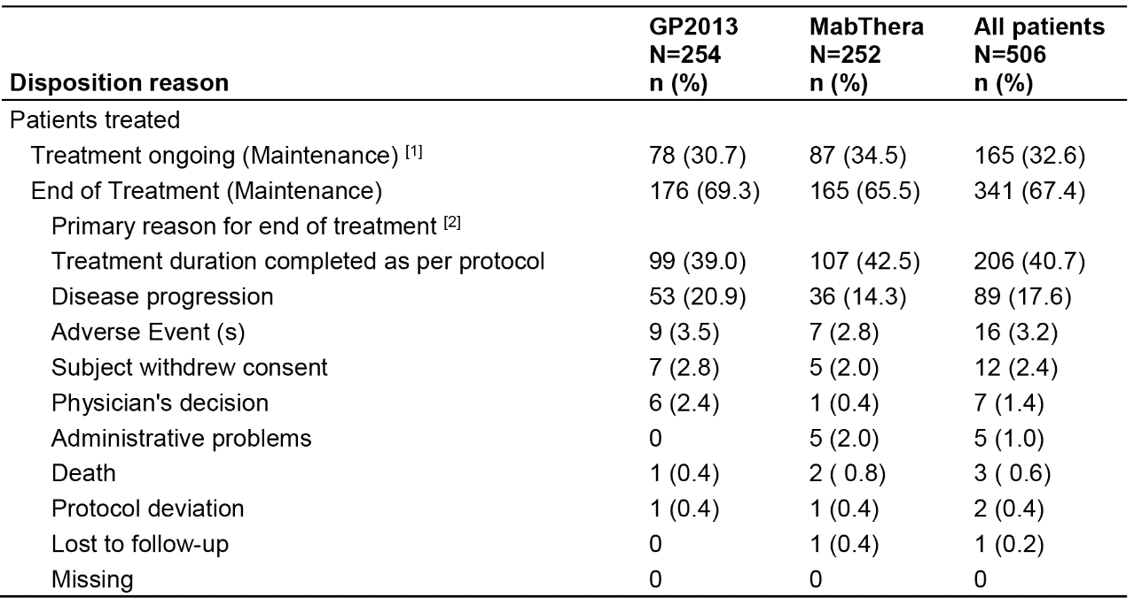
(1) Patients continue maintenance study treatment at the time of the cut-off 10-Jul-2016. (2) End of treatment refers to discontinuation of maintenance treatment. All percentages are based on Maintenance Set.
The number of treatment cycles received by the two treatment arms during the maintenance phase are summarised below in Table 86.

Table 86: Study GP13-301 maintenance set, as of 10 July 2016
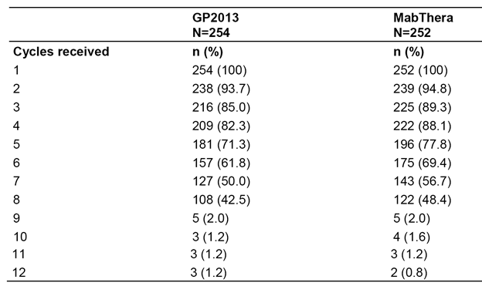
A patient is counted in each cycle where he/she has received the specified medication. For Italian patients maintenance cycle is every 2 months (Cycles 1-12). For all other patients Maintenance cycle is every 3 months (Cycles 1-8).
The median cumulative dose in the GP2013 arm was 4379.5 mg (range: 469, 8809) compared to 4619.5 mg (range: 208, 8250) in the MabThera arm. The median dose intensity was 7.7 mg/day (range: 5.2, 14.4) in the GP2013 arm compared to 7.8 mg/day (range: 2.3, 13.6) in the MabThera arm. The median number of days of exposure in the GP2013 arm was 539 days (range: 90, 774) compared to 608 days (range: 90, 787) in the MabThera arm.

AEs, all grades and Grade 3/4, regardless of relationship to study drug
AEs (all grades), regardless of the relationship to the study drug, occurred frequently and in a similar proportion of patients in both treatment arms (72.0%, n = 183, GP2013 versus 69.4%, n = 175, MabThera). AEs by SOC reported in ≥ 20% of patients in either treatment arm (GP2013 versus MabThera), in descending order of frequency in the GP2013 arm, were ‘Infections and infestations’ (32.7%, n = 83 versus 36.5%, n = 92), ‘Gastrointestinal disorders’ (22.8%, n = 58 versus 22.6%, n = 57), ‘Musculoskeletal and connective tissue disorders’ (20.1%, n = 51 versus 23.4%, n = 59), and ‘General disorders and administration site conditions’ (16.5%, n = 42 versus 20.2%, n = 51).
AEs (all grades), regardless of the relationship to the study drug, reported in ≥ 5% of patients in either treatment arm (GP2013 versus MabThera), in descending order of frequency in the GP2013 arm, were neutropenia (11.8%, n = 30 versus 6.3%, n = 16), cough (11.4%, n = 29 versus 6.7%, n = 17), UTI (5.1%, n = 13 versus 9.1%, n = 23), URTI (4.3%, n = 11 versus 6.3%, n = 16), back pain (4.3%, n = 11 versus 5.6%, n = 14), diarrhoea (3.9%, n = 10 versus 6.7%, n = 17), arthralgia (3.1%, n = 8 versus 7.9%, n = 20), pain in extremity (2.4%, n = 6 versus 5.2%, n = 13), and nasopharyngitis (2.0%, n = 6 versus 5.2%, n = 13).
AEs (Grade 3/4), regardless of the relationship to the study drug, were reported in a similar proportion of patients in the two treatment arms (19.3%, n = 49, GP2013 versus 19.0%, n = 48 MabThera). AEs (Grade 3/4), regardless of the relationship to the study drug, reported in ≥ 1% of patients in either treatment arm (GP2013 versus MabThera), in descending order of frequency in the GP2013 arm, were neutropenia (8.3%, n = 21 versus 4.8%, n = 12), leukopaenia (1.2%, n = 3 versus 0.4%, n = 1), and hypertension (0.8%, n = 2 versus 1.2%, n = 3).

AEs, all grades and Grade 3/4, suspected to be related to the study drug
AEs (all grades), suspected by the investigator to be related to the study drug, were reported more frequently in the GP2013 arm than in the MabThera arm (31.9%, n = 81 versus 23.0%, n = 58, respectively). AEs by SOC reported in ≥ 5% of patients in either treatment arm (GP2013 versus MabThera), in descending order of frequency in the GP2013 arm, were ‘Infections and infestations’ (11.4%, n = 29 versus 4.8%, n = 12), ‘Blood and lymphatic system disorders’ (8.3%, n = 21 versus 7.9%, n = 20), and ‘Nervous system disorders’ (5.1%, n = 13 versus 2.0%, n = 5).
AEs (all grades), suspected by the investigator to be related to the study drug, reported in ≥ 2% of patients in either treatment arm (GP2013 versus MabThera), in descending order of frequency in the GP2013 arm, were neutropenia (7.9%, n = 20 versus 5.2%, n = 13), leukopaenia (3.1%, n = 8 versus 1.6%, n = 4), cough (2.8%, n = 7 versus 0.4%, n = 1), infusion related reaction (2.4%, n = 6 versus 1.6%, n = 4), and herpes zoster (2.0%, n = 5 versus 1.2%, n = 3).
AEs (Grade 3/4), suspected by the investigator to be related to the study, drug were reported more frequently in the GP2013 arm than in the MabThera arm (8.7%, n = 22 versus 6.0%, n = 15, respectively). AEs (Grade 3/4), suspected by the investigator to be related to the study drug, reported in ≥ 1% of patients in either treatment arm (GP2013 versus MabThera), were neutropenia (5.1%, n = 13 versus 3.6%, n = 9) and febrile neutropenia (0% versus 1.2%, n = 3).

Deaths
There were 2 (0.8%) deaths in the GP2013 arm (one AE each for NHL and ischaemic stroke) and 2 (0.8%) deaths in the MabThera arm (one AE each for cardiac arrest and hepatic failure). Both of these deaths were reported in the primary analysis and no additional deaths had occurred between 10 July 2015 and 10 July 2016.
For patients who did not enter the maintenance phase, deaths occurring more than 30 days after completion of combination phase treatment were considered to have occurred in the post-treatment phase. For patients who entered the maintenance phase, deaths occurring more than 90 days after discontinuation of treatment were considered to have occurred in the post-treatment Phase. As of 10 July 2016, 30 (4.8%) deaths had occurred during the post-treatment phase, with similar incidences in the GP2013 arm (14 patients, 4.5%) and the MabThera arm (16 patients, 5.1%). Of these 30 deaths, 10 new cases, 2 in the GP2013 arm and 8 in the MabThera arm were reported between 10 July 2015 and 10 July 2016. The most common cause of death during the post-treatment phase for the GP2013 and MabThera arms was underlying neoplastic disease (that is, NHL with 7 (2.2%) deaths reported in both treatment arms).
As of 10 July 2016, a total of 45 (7.2%) deaths have been reported in the study (combination, maintenance and post-treatment phases), comprising 20 (6.4%) deaths in the GP2013 arm and 25 (7.9%) deaths in the MabThera arm.

SAEs
All patients were followed for SAEs for a minimum of 30 (+7) days after the last dose of study drug.
SAEs (all grades), regardless of study drug relationship, were reported in a similar proportion of patients in both treatment arms (7.9%, n = 20, GP2013 versus 7.1%, n = 18, MabThera). Of these, 6 patients with SAEs in the GP2013 group and 8 patients in the MabThera group were newly reported since the previous cut-off of 10 July 2015. Nearly all SAEs, regardless of study drug relationship, were Grade 3/4 SAEs, and were reported in a similar proportion of patients in both treatment arms (7.5%, n = 19, GP2013 versus 6.7%, n = 17, MabThera). SAEs (Grade 3/4) reported in ≥ 2 patients in either of the two treatment arms (GP2013 versus MabThera) were pneumonia (0.8%, n = 2 versus 0.4%, n = 1), respiratory tract infection (0.8%, n = 2 versus 0%), nephrolithiasis (0.8%, n = 2 versus 0.4%, n = 1), febrile neutropenia (0% versus 0.8%, n = 2), and UTI (0% versus 0.8%, n = 2).
SAEs (all grades), suspected by the investigator to be related to the study drug, were reported in a similar proportion of patients in the two treatment arms (3.1%, n = 8 versus 2.0%, n = 5). Nearly all SAEs suspected by the investigator to be related to the study drug were Grade 3/4 SAEs, and were reported in a similar proportion of patients in both treatment arms (2.8%, n = 7 versus 2.0%, n = 5). SAEs (Grade 3/4) suspected by the investigator to be related to the study drug (GP2013 versus MabThera) were febrile neutropenia (0% versus 0.8%, n = 2), asthenia (0.4%, n = 1 versus 0%), diverticulitis (0.4%, n = 1 versus 0%), hepatitis B (0.4%, n = 1 versus 0%), herpes zoster (0% versus 0.4%, n = 1), pneumonia (0.4%, n = 1 versus 0%), respiratory tract infection (0.4%, n = 1 versus 0%), headache (0.4%, n = 1 versus 0%), peripheral sensory neuropathy (0% versus 0.4%, n = 1), pulmonary oedema (0.4%, n = 1 versus 0%), and acute kidney injury (0% versus 0.4%, n = 1).

AEs leading to treatment discontinuation
AEs (all grades) leading to treatment discontinuation, regardless of study drug relationship, were reported in a similar proportion of patients in the two treatment arms (3.9%, n = 10, GP2013 versus 2.8%, n = 7, MabThera). Grade 3/4 AEs leading to treatment discontinuation, regardless of study drug relationship, were reported in a similar proportion of patients in the two treatment arms (1.6%, n = 4, GP2013 versus 1.2%, n = 3, MabThera). No AEs (all grades) leading to treatment discontinuation were reported in ≥ 2 patients in either of the two treatment arms. During the year between the previous cut-off of 10 July 2015 and the updated cut-off of 10 July 2016, 2 new AEs leading to discontinuation of study drug were reported in the GP2013 arm (Grade 4 hepatitis B and Grade 1 pneumonitis) and 3 new AEs in the MabThera arm (Grade 1 lung consolidation, Grade 3 renal impairment and Grade 2 arthralgia). The AE of arthralgia in a patient in the MabThera arm was un-reported in the clinical database for the first analysis.
AEs (all grades) leading to treatment discontinuation, suspected by the investigator to be related to the study drug, were reported in 2.0% (n = 5) of patients in the GP2013 arm and 0.4% (n = 1) of patients in the MabThera arm, with Grade 3/4 events being reported in 0.8% (n = 2) and 0% of patients, respectively. AEs (all grades) leading to treatment discontinuation (GP2013 versus MabThera), suspected by the investigator to be related to the study drug, were asthenia (0.4%, n = 1 versus 0%), hepatitis B (0.4%, n = 1 versus 0%), lower respiratory tract infection (0.4%, n = 1 versus 0%), pneumonia pseudomonal (0.4%, n = 1 versus 0%), platelet count decreased (0.4%, n = 1 versus 0%), and lung consolidation (0% versus 0.4%, n = 1).

Adverse events leading to dose adjustment or temporary interruptions
AEs (all grades), leading to dose adjustment or temporary interruptions, regardless of study drug relationship, were reported in the same proportion of patients in the two treatment arms (8.3%, n = 21, GP2013 versus 8.3%, n = 21), with Grade 3/4 AEs being reported in 3.9% (n = 10) of patients in the GP2013 arm and 1.6% (n = 4) of patients in the MabThera arm. The only AEs (all grades), leading to dose adjustment or temporary interruptions, regardless of study drug relationship, reported in ≥ 2 patients in either of the two treatment arms (GP2013 versus MabThera) were neutropenia (2.4%, n = 6 versus 1.6%, n = 4), infusion related reactions (1.2%, n = 3 versus 1.2%, n = 3) pharyngitis (n = 0.8%, n = 2 versus 0%), and UTI (0% versus 0.8%, n = 2).

Adverse events requiring additional therapy
AEs (all grades) requiring additional therapy, regardless of study drug relationship, were reported in a similar proportion of patients in the two treatment arms (60.6%, n = 154, GP2013 versus 56.7%, n = 143, MabThera) as were the proportion of patients with Grade 3/4 AEs (13.8%, n = 35, GP2013 versus 13.9%, n = 35, MabThera). AEs (all grades) requiring additional therapy, regardless of relationship to the study drug, reported in ≥ 2% of patients in either of the two treatment arms (GP2013 versus MabThera), in descending order of frequency in the GP2013 arm, were cough (6.3%, n = 16 versus 3.2%, n = 8), neutropenia (4.7%, n = 12 versus 2.4%, n = 6), UTI (4.3%, n = 11 versus 8.3%, n = 21), URTI (3.9%, n = 10 versus 5.6%, n = 14), hypertension (3.9%, n = 10 versus 3.2%, n = 8), RTI (3.5%, n = 9 versus 4.4%, n = 11), dyspepsia (3.1%, n = 8 versus 1.6%, n = 4), pyrexia (3.1%, n = 8 versus 2.4%, n = 6), headache (3.1%, n = 8 versus 3.2%, n = 8), LRTI (2.8%, n = 7 versus 0.8%, n = 2), back pain (2.4%, n = 6 versus 4.0%, n = 10), diarrhoea (2.4%, n = 6 versus 4.0%, n = 10), constipation (2.0%, n = 5 versus 2.4%, n = 6), bronchitis (2.0%, n = 5 versus 2.4%, n = 6), herpes zoster (2.0%, n = 5 versus 2.4%, n = 6), influenza (2.0%, n = 5 versus 2.0%, n = 5), rash (2.0%, n = 5 versus 0.4%, n = 1), hyperuricaemia (1.6%, n = 4 versus 3.2%, n = 8), pneumonia (1.2%, n = 3 versus 2.0%, n = 5), pain in extremity (1.2%, n = 3 versus 2.8%, n = 7), nasopharyngitis (1.2%, n = 3 versus 4.0%, n = 10), arthralgia (0.8%, n = 2 versus 5.2%, n = 13), and peripheral oedema (0.4%, n = 1 versus 2.0%, n = 5).

Drug-related infusion-related reactions
Drug-related potential infusion-related reactions (Novartis MedDRA Query (NMQ) - infusion reactions) were reported in 13.4% (n = 34) of patients in the GP2013 arm and 11% (n = 28) of patients in the MabThera arm. AEs (preferred term) reported in ≥ 1% of patients in either of the two treatment arms (GP2013 versus MabThera) were cough (2.8%, n = 7 versus 0.4%, n = 1), infusion-related reaction (2.4%, n = 6 versus 1.6%, n = 4), nausea (1.2% versus 0.8%, n = 2), fatigue (1.2%, n = 3 versus 0.4%, n = 1), hypertension (n = 1.2%, n = 3 versus 0.4%, n = 1), thrombocytopenia (0.4%, n = 1 versus 1.2%, n = 3), and arthralgia (0% versus 1.6%, n = 4).

Clinical laboratory – new or worsened abnormalities
The incidence of new or worsened haematological abnormalities from the Maintenance baseline was similar in the two treatment arms. Grade 3/4 new or worsened clinical laboratory haematological AEs reported in ≥ 2% of patients in either of the two treatment arms (GP2013 versus MabThera) were decreased lymphocytes Grade 3 AEs (2.4%, n = 6 versus 2.5%, n = 6), decreased neutrophils Grade 3 AEs (6.0%, n = 14 versus 4.1%, n = 10) and Grade 4 AEs (2.8%, n = 7 versus 2.9%, n = 7), and decreased WBCs Grade 3 AEs (2.0%, n = 5 versus 0.4%, n = 1). The most notable Grade 3/4 abnormality in both treatment arms was decreased neutrophils.
The incidence of new or worsened clinical chemistry abnormalities from the Maintenance baseline was similar in the two treatment arms. Grade 3/4 new or worsened clinical laboratory chemistry AEs reported in ≥ 2% of patients in either of the two treatment arms (GP2013 versus MabThera) were hyperglycaemia Grade 3 AEs (2.4%, n = 6 versus 3.8%, n = 9), and uric acid Grade 4 AEs (2.0%, n = 5 versus 0%).

Vital signs and ECGs
There were no significant differences between the two treatment arms as regards notable abnormal vital signs. Systematic assessment of ECG changes was not undertaken. ECG abnormalities in the maintenance phase between 10 July 2015 and 10 July 2016 were reported in 3 patients in the GP2013 arm and 8 patients in the MabThera arm. No obvious patterns in the reported ECG abnormalities were noted.

Immunogenicity - anti-drug antibodies (ADAs)
In this study, immunogenicity was assessed for all patients at screening (or pre-dose or both), EOT combination phase, and EOT maintenance phase. In total, ADAs were detected in 8 out of 559 patients (1.4%), comprising 5 out of 274 (1.8%) patients in the GP2013 arm and 3 out of 285 patients (1.1%) in the MabThera arm. Neutralising antibodies were detected in a total of 4 patients (n = 2, GP2013 versus n = 2, MabThera). PFS events (documented disease progression or death) were observed in 3 of the 5 ADA positive patients in the GP2013 group, and in 1 of 3 ADA positive patients in the MabThera group. Additionally, clinical signs of immunogenic reactions evaluated with the incidences of potential infusion related reactions did not reveal any new safety signal and the incidences were similar between treatment groups. As the number of ADA positive patients was low, no definite conclusion can be drawn for the impact of observed immunogenicity on the efficacy or safety outcomes of the study.

Special groups
There were no studies in special groups specifically comparing safety in patients by age, sex or race. There were no special studies in patients with hepatic, renal impairment or cardiac impairment. However, based on the currently available interim safety data in the maintenance phase it is unlikely that the safety profile of the two products will significantly differ in patients treated with GP2013 or MabThera.

Study GP13-302
The CSR for Study GP13-302 (descriptive safety) was provided in the sponsor's response of 28 June 2017. The study was undertaken in patients with RA and was designed to identify potential risks associated with switching from Rituxan/MabThera to GP2013. It is considered that the safety profile of patients switched from Rituxan/MabThera to GP2013 is comparable to the safety profile of patients continuing Rituxan/MabThera. The observed numerical differences between switched and continuing patients are considered to be not clinically meaningful.
The study randomised patients being treated with Rituxan/MabThera to either GP2013 (1000 mg dose; two infusions) or continuing treatment with Rituxan/MabThera (1000 mg dose; two infusions). Infusions in both treatment groups were administered on Day 1 (first infusion) and Day 14 (second infusion), followed by a 3 month follow-up period with safety and immunogenicity assessments at Day 14 (before administration of the second infusion) and at Week 12 (main analysis). An additional visit took place at Week 24 to assess long-term immunogenicity and general safety. Of the total number of randomised patients (n = 107), 103 (96.3%) have completed 12 weeks and 45 (42.1%) have completed 24 weeks. The study is ongoing.
The safety analysis set included 53 patients in the GP2013 arm and 54 patients in the Rituxan/MabThera arm. All patients in both treatment arms received the first infusion, and all patients in the Rituxan/MabThera arm (n = 54) received the second infusion compared to 51 (96.2%) patients in the GP2013 arm. All patients had started treatment with MTX and folic or folinic acid before randomisation and continued both medications during the study. Of the 53 patients randomised to GP2013, 51 (96.2%) have completed 12 weeks, 22 (41.5%) have completed 24 weeks, and 3 have withdrawn from the study (AE x1, withdrawn consent x2). Of the 54 patients randomised to Rituxan/MabThera, 52 (96.3%) have completed 12 weeks, 23 (42.6%) have completed 24 weeks, and 2 have withdrawn from the study (death x1, withdrawn consent x1).
The key safety assessments in this study were undertaken at Week 12 and were incidence of hypersensitivity, anaphylactic and infusion-related reactions and immunogenicity (development of ADA). The study also included assessment of standard safety outcomes.
Hypersensitivity reactions after the start of the first infusion up to Week 12 were reported in a similar proportion of patients in the GP2013 and Rituxan/MabThera arms (9.4% (5/53) versus 9.3% (5/54), respectively; ∆ = 0.2 (95% CI: -18.8, 18.8)). Hypersensitivity reactions reported after the start of the first infusion and before the second infusion occurred more frequently in the Rituxan/MabThera arm than in the GP2013 arm (7.4% versus 5.7%, respectively), while hypersensitivity reactions reported after the start of second infusion up to Week 12 occurred in a similar proportion of patients in the two treatment arms (3.9% versus 3.7%, respectively).
There was 1 anaphylactic reaction reported within 24 hours of either infusion in the Rituxan/MabThera arm (1.9% (1/54)). There were no anaphylactic reactions reported in the GP2013 arm (0% (0/53)).
Overall, potential infusion-related reactions on or after the day of either infusion occurred more frequently in the Rituxan/MabThera arm than in the GP2013 arm (18.5% (10/54) versus 11.3% (6/53), respectively; ∆ = -7.2 (95% CI: -26.0, 11.4).
There was 1 (0.9%) patient in the Rituxan/MabThera arm who tested ADA-positive at Weeks 2, 12, and 24. No patients in the GP2013 arm tested ADA-positive. There were 2 patients who tested ADA-positive at screening (1 in each treatment arm), and neither of these two patients tested ADA-positive after screening. None of the 3 patients who tested ADA-positive tested positive for neutralising antibodies.
Up to Week 12, AEs (all grades), regardless of study drug relationship, were reported in 35 (66.0%) patients in the GP2013 arm and 21 (38.9%) patients in the Rituxan/MabThera arm. The main difference between the two treatment arms related to the higher incidence of AEs in the SOC of ‘Musculoskeletal and connective tissue disorders’ in the GP2013 arm compared to the Rituxan/MabThera arm (20.8%, n = 11 versus 3.7%, n = 2). In the GP2013 arm (vs Rituxan/MabThera), the most frequently reported AE (preferred term) in this SOC was arthralgia (5.7%, n = 3 versus 0%), followed by rheumatoid arthritis (3.8%, n = 2 versus 1.9%, n = 1) and osteoarthritis (3.8%, n = 2 versus 0%). All other AEs in the SOC were reported in no more than 1 patient in either of the two treatment arms. Other AEs by SOC reported in ≥ 10% of patients in either of the two treatment arms (GP2013 versus Rituxan/MabThera) were ‘Infections and infestations’ (15.1% versus 14.8%) and ‘Gastrointestinal disorders’ (3.8% versus 14.8%).
Up to Week 12, AEs, regardless of study drug relationship, reported in ≥ 2% of patients in either treatment arm (GP2013 versus MabThera) were arthralgia (5.7% versus 0%), headache (3.8% versus 3.7%), nasopharyngitis (3.8% versus 1.9%), rheumatoid arthritis (3.8% versus 1.9%), sinusitis (3.8% versus 1.9%), fall (3.8% versus 0%, osteoporosis (3.8% versus 0%), bronchitis (1.9% versus 3.7%), URTI (1.9% versus 3.7%), cough (0% versus 3.7%), and vomiting (0% versus 5.6%).
From Week 12 to data cut-off, AEs, regardless of relationship to study drug, were reported in 2 (3.8%) patients in the GP2013 arm (pharyngitis x 1, synovial cyst x1) and 9 (16.7%) patients in the Rituxan/MabThera arm (nausea x1, bronchitis x1, cellulitis x1, streptococcal pharyngitis x1, pneumonia x1, URTI x1, UTI x1, viral infection x1, rheumatoid arthritis x1, varicose vein x1).
Up to Week 12, AEs, suspected by the investigator to be related to the study drug, were reported in 6 (11.3%) patients in the GP2013 arm and 9 (16.7%) patients in the Rituxan/MabThera arm. The only AE suspected to be related to the study drug reported in ≥ 2 patients in either of the two treatment arms was pruritus (n = 2 (3.7%) in the Rituxan/MabThera arm). From Week 12 to data cut-off, AEs suspected to be related to treatment were reported in 1 (1.9%) patient in the GP2013 arm (pharyngitis x1) and 2 (3.7%) patients in the Rituxan/MabThera arm (pneumonia x1, URTI x1).
Up to Week 12, immunologically relate AEs suspected by the investigator to be related to the study drug were reported in 3 (5.7%) patients in the GP2013 arm no patients in the Rituxan/MabThera arm. The immunologically related AEs in the GP2013 arm were paraesthesia (day after first infusion), asthma (2 days after first infusion) and allergic pruritus (day of first infusion). From Week 12 to data cut-off, no AEs were suspected by the investigator to be immunologically related.
One patient in the Rituxan/MabThera arm died during the study (cardiopulmonary failure considered to be unrelated to treatment in a 58 year old man with a history of hypertension), and no deaths were reported in the GP2013 arm. One (0.9%) non-fatal SAE was reported during the study in a patient in the Rituxan/MabThera arm (hiatus hernia considered to be unrelated to treatment). No fatal or non-fatal SAEs were reported in the GP2013 arm. The two SAEs reported in the Rituxan/MabThera arm (fatal cardiopulmonary failure, non-fatal hiatus hernia) both occurred in the first 12 weeks of the study, and no SAEs were reported in either treatment arm from Week 12 to data cut-off.
AEs leading to treatment discontinuation were reported in 1 (1.9%) patient in the GP2013 arm, and no patients in the Rituxan/MabThera arm. The AE in the patient in the GP2013 arm was serum sickness with symptoms of muscle aches and pain as well as fever occurring 6 hours after the first infusion and resolving on Day 11. The AE was considered by the investigator to be related to the study drug.
No dose adjustments were reported in the study. AEs up to Week 12 leading to treatment interruption were reported more frequently in the MabThera arm than in the GP2013 arm (7.4%, n = 4 versus 3.8%, n = 2). The AEs leading to dose interruptions reported in the GP2013 arm were vessel puncture site swelling (x1) and allergic pruritus (x 1). The AEs leading to dose interruption reported in the Rituxan/MabThera arm were oral pruritus (x 1), vomiting (x 1), throat irritation (x 1) and pruritus (x 1). All AEs in both treatment arms leading to dose interruption, apart from vomiting, occurred during the first infusion. All AEs in both treatment arms leading to dose interruption, apart from vessel puncture site swelling, were suspected by the investigator to be related to the study drug.
Up to Week 12, newly occurring clinically notable haematological abnormalities were reported in 1 (1.9% (1/52)) patient in the GP2013 arm (increased eosinophils > 1.1 x ULN), and 2 (3.8% (2/54)) patients in the Rituxan/MabThera arm (decreased haemoglobin > 20 g/L from baseline; deceased neutrophils < 0.9 x LLN). From Week 12 to data cut-off, newly occurring clinically notable haematological abnormalities were reported in 3 (13.5% (3/22)) patients in the GP2013 arm (decreased haemoglobin > 20 g/L from baseline; increased MCH > 20% above baseline; deceased neutrophils < 0.9 x LLN) and no patients (0/23-24) in the Rituxan/MabThera arm. None of the newly occurring clinically notable haematological abnormalities occurring during the study were reported as AEs.
Up to Week 12, newly occurring clinically notable clinical chemistry abnormalities were reported in 9 (17.0%) patients in the GP2013 arm and 6 patients (11.1%) patients in the Rituxan/MabThera arm. The clinically notable abnormalities (GP2013 versus Rituxan/MabThera) were ALT > 3 x ULN (3.8% versus 0%), GGT > 2.5 x ULN (1.9% versus 0%), serum creatinine > 50% above baseline (3.8% versus 5.6%), eGFR > 30% below baseline (3.8% versus 5.6%), potassium > 6.0 mmol/L (1.9% versus 0%), and sodium > 160 mmol/L (1.9% versus 0%). Three of the newly occurring clinically notable abnormalities were reported as AEs (that is, both cases of increased ALT in the GP2013 arm and 1 case of decreased eGFR in the Rituxan/MabThera arm). No newly occurring clinically notable clinical chemistry abnormalities were reported from Week 12 to data cut-off in either the GP2013 arm (0/22) or the Rituxan/MabThera arm (0/23).
Newly occurring clinically notable abnormalities in vital signs (systolic and diastolic blood pressure, and pulse rate) up to Week 12 were observed with small differences in incidences between both treatment groups. These differences were not considered to be clinically meaningful. Two of the newly occurring clinically notable abnormalities were reported as AEs (increased blood pressured in 1 patient in the GP2013 arm). The patient had normal systolic and diastolic blood pressure at screening, Day 1 and Week 2. In Week 12, the blood pressure was elevated (systolic = 150 mmHg; diastolic = 100 mmHg), but within normal range in Week 24. From Week 12 to data cutoff, few newly occurring clinical notable abnormalities in vital signs (systolic and diastolic blood pressure, and pulse rate) were observed. These abnormalities were mostly experienced by single patients, with similar incidences between both treatment arms. ECGs were conducted at screening only. Changes in body weight were similar in the two treatment arms.

Second round assessment of benefit-risk balance
It is considered that the totality of the submitted clinical data have satisfactorily demonstrated that that the benefit-risk assessment for GP2013 is comparable to the benefit-risk assessment for MabThera. The additional data submitted by the sponsor in its response of 28 June 2017 have adequately addressed the concerns relating to the benefits and risks of GP2013 raised in the first round CER.

Second round recommendation regarding authorisation
Approval of Riximyo is recommended for the following listed indications:
Non-Hodgkin’s Lymphoma (NHL)
Riximyo (rituximab) is indicated for treatment of patients with:
- CD20 positive, previously untreated, Stage III/IV follicular, B cell non-Hodgkin’s lymphoma.
- CD20 positive, relapsed or refractory low grade or follicular, B cell non-Hodgkin's lymphoma.
- CD20 positive, diffuse large B cell non-Hodgkin’s lymphoma, in combination with chemotherapy.
Chronic Lymphocytic Leukaemia (CLL)
Riximyo (rituximab) is indicated for the treatment of patients with CD20 positive chronic lymphocytic leukaemia in combination with chemotherapy.
Rheumatoid Arthritis (RA)
Riximyo (rituximab) in combination with methotrexate is indicated for the treatment of adult patients with severe, active rheumatoid arthritis who have had an inadequate response or intolerance to at least one tumour necrosis factor (TNF) inhibitor therapy.
Rituximab has been shown to reduce the rate of progression of joint damage as measured by x-ray when given in combination with methotrexate.
Granulomatosis with polyangiitis (Wegener’s) (GPA) and Microscopic polyangiitis (MPA)
Riximyo(rituximab) in combination with glucocorticoids is indicated for the induction of remission in patients with severely active Granulomatosis with polyangiitis (GPA, also known as Wegener’s granulomatosis) and Microscopic polyangiitis (MPA). The efficacy and safety of retreatment with rituximab have not been established.
Comment: The second round authorisation differs from the first round authorisation, which recommended rejection of the application. The reasons for the change in recommendation from rejection to approval are summarised below.
- Data provided in the sponsor's response of 28 June 2017 demonstrate that the Overall Response Rate (ORR) selected as the primary efficacy endpoint for Study GP13-301 is a more appropriate and sensitive endpoint in patients with follicular lymphoma for the assessment of comparability between GP2013 and MabThera than progression free survival (PFS) or overall survival (OS).
- Data provided in the sponsor's response of 28 June 2017 demonstrate that the size and duration of an adequately powered study designed to demonstrate equivalence of GP2013 and MabThera based on PFS makes such a study impractical.
- Data provided in the sponsor's response of 28 June 2017 demonstrate that the design of Study GP13-301 will result in both PFS and OS still being immature at the completion of the study (that is, 36 months from randomisation), with median time-to-event for both endpoints not being reached for either GP2013 or MabThera.
- Additional 12 months safety data up to 10 July 2016 for the maintenance phase of Study GP13-301 in patients with FL provided in the sponsor's response of 28 June 2017 continue to demonstrate comparable safety profiles for GP2013 and MabThera. As of 10 July 2016, a total of 67.4% (n = 506) patients who entered the maintenance phase had reached end of treatment (30.7%, n = 78, GP2013; 34.5%, n = 87, MabThera). Based on the current safety data from Study GP13-301 and safety data in patients with RA it is considered unlikely that new or unexpected safety signals will emerge from the 78 (30.7%) ongoing patients with FL in the GP2013 arm still to complete the maintenance phase in Study GP13-301.
- Data from Study GP13-201 (Part II) provided in the sponsor's response of 28 June 2017 demonstrated that GP2013 and Rituxan were bioequivalent in patients with RA based on AUC_{0-inf} up to Week 24, as were MabThera and Rituxan. In addition, the primary efficacy endpoint analysis of change from baseline in DAS28(CRP) at Week 24 showed that GP2013 and Rituxan were therapeutically equivalent. No new or unexpected safety signals were observed based on the main comparison between GP2013 and Rituxan at Week 24, and the supportive comparison between the two treatment arms from Week 24 through to data cut-off (that is, 19 January 2016).
- Safety data from Study GP13-302 provided in the sponsor's response of 28 June 2017 demonstrated that patients with RA can be safely switched from Rituxan/MabThera to GP2013 without an increase in hypersensitivity reactions, potential infusion-related reactions, anaphylactic reactions and development of ADA antibodies occurring at Week 12 (main analysis) or Week 24 (supportive analysis). In addition, the general safety data from Week 0 through to Week 24 demonstrated comparability between GP2013 and Rituxan/MabThera.
- Based on the totality of the clinical data provided by the sponsor in the original submission and the response of 28 June 2017 it is considered the GP2013 (Riximyo) is comparable to MabThera, as regards PK, PD, efficacy and safety. Therefore, the known safety and efficacy data for MabThera can be safety extrapolated to GP2013 (Riximyo).

References
Almasri NM, Duque RE, Iturraspe J, et al (1992). Reduced expression of CD20 antigen as a characteristic marker for chronic lymphocytic leukaemia. Am J Hematol; 40(4): 259-263.
Anderson KC, Bates MP, Slaughenhoupt BL, et al (1984). Expression of human B cell associated antigens on leukaemias and lymphomas: a model of human B cell differentiation. Blood; 63(6): 1424–1433.
Barta SK, Li H, Hochster HS, et al (2016). Randomized phase 3 study in low-grade lymphoma comparing maintenance anti-CD20 antibody with observation after induction therapy: a trial of the ECOG-ACRIN Cancer Research Group (E1496). Cancer, 122(19):2996- 3004.
Bellosillo B, Villamor N, López-Guillermo A, et al (2001). Complement-mediated cell death induced by rituximab in B cell lymphoproliferative disorders is mediated in vitro by a caspase-independent mechanism involving the generation of reactive oxygen species. Blood; 98(9): 2771-2777.
Boross P, Leusen JH (2012). Mechanisms of action of CD20 antibodies. Am J Cancer Res; 2(6): 676–690.
Breedveld F, Agarwal S, Yin M, et al. (2007). Rituximab pharmacokinetics in patients with rheumatoid arthritis: B cell levels do not correlate with clinical response. J Clin Pharmacol; 47(9):1119-1128.
Campbell RL, Hagan JB, Manivannan V et al (2012). Evaluation of national institute of allergy and infectious diseases/food allergy and anaphylaxis network criteria for the diagnosis of anaphylaxis in emergency department patients. J Allergy Clin Immunol; 129(3): 748-52.
Cheson BD (2007a). The international harmonization project for response criteria in lymphoma clinical trials. Hematol Oncol Clin N Am 21:841-854.
Cheson BD, Horning SJ, Coiffier B, et al (1999). Report of an International Workshop to standardize response criteria for non-Hodgkin's lymphomas. J Clin Oncol 17:1244-1253.
Cheson BD, Pfistner B, Juweid ME, et al (2007b), Revised response criteria for malignant lymphoma. J Clin Oncol 25:579-586.
Cheson BD, Wendtner CM, Pieper A, et al (2010). Optimal use of bendamustine in chronic lymphocytic leukemia, non-Hodgkin lymphomas, and multiple myeloma: treatment recommendations from an international consensus panel. Clin Lymphoma Myeloma Leuk. 10 (1):21-7.
Chow KU, Sommerlad WD, Boehrer S (2002). Anti-CD20 antibody (IDEC-C2B8, rituximab) enhances efficacy of cytotoxic drugs on neoplastic lymphocytes in vitro: role of cytokines, complement, and caspases. Haematologica; 87(1): 33-43.
Cohen SB, Emery P, Greenwald MW, et al (2006). Rituximab for rheumatoid arthritis refractory to anti-tumor necrosis factor therapy: Results of multicenter, randomized, double blind, placebo-controlled, Phase III trial evaluating primary efficacy and safety at twenty-four weeks. Arthritis Rheum; 54(9):2793-806.
Demidem A, Lam T, Alas S, et al (1997). Chimeric anti-CD20 (IDEC-C2B8) monoclonal antibody sensitizes a B cell lymphoma cell line to cell killing by cytotoxic drugs. Cancer Biother Radiopharm; 12(3): 177-186.
EMA Guidance Choice of Non-inferiority Margin (2006).
Emery P, Fleischmann R, Filipowicz-Sosnowska A, et al (2006). The efficacy and safety of rituximab in patients with active rheumatoid arthritis despite methotrexate treatment: results of a Phase IIB randomized, double-blind, placebo-controlled, dose-ranging trial. Arthritis Rheum; 54(5):1390-400.
Ernst JA, Li H, Kim HS, et al (2005). Isolation and characterization of the B cell marker CD20. Biochemistry; 44(46): 15150-15158.
FDA draft Guidance for industry Non-inferiority Clinical Trials, March 2010.
Federico M, Luminari S, et al (2013). R-CVP Versus R-CHOP Versus R-FM for the Initial treatment of Patients With Advanced-Stage Follicular lymphoma: Results of the Foll05 Trial Conducted by the Fondazione Italiana Linfomi. J Clin Oncol. 2013 Apr 20;31(12):1506-1513.
Ginaldi L, De Martinis M, Matutes E, et al (1998). Levels of expression of CD19 and CD20 in chronic B cell leukaemias. J Clin Pathol; 51(5): 364-369.
Golay J, Zaffaroni L, Vaccari T, et al (2000). Biologic response of B lymphoma cells to anti- CD20 monoclonal antibody rituximab in vitro: CD55 and CD59 regulate complement mediated cell lysis. Blood; 95(12): 3900–3908.
Golay J, Lazzari M, Facchinetti V, et al (2001). CD20 levels determine the in vitro susceptibility to rituximab and complement of B-cell chronic lymphocytic leukemia: further regulation by CD55 and CD59. Blood; 98(12): 3383-3389.
Grillo-Lopez AJ, White CA, Dallaire BK, et al (2000). Rituximab: The first monoclonal antibody approved for the treatment of lymphoma. Curr Pharm Biotechnol; 1(1): 1-9.
Horvat M, Prevodnik VK, Lavrencak J, et al (2010). Predictive significance of the cut-off value of CD20 expression in patients with B cell lymphoma. Oncol Rep; 24(4): 1101-1107.
Keystone E, Emery P, Peterfy CG, et al (2009), Rituximab inhibits structural joint damage in patients with rheumatoid arthritis with an inadequate response to tumour necrosis factor inhibitor therapies. Ann Rheum Dis; 68(2): 216-21.
Klepfish A, Gilles L, Ioannis K, et al (2009). Enhancing the action of rituximab in chronic lymphocytic leukemia by adding fresh frozen plasma: complement/rituximab interactions & clinical results in refractory CLL. Ann N Y Acad Sci; 1173: 865–873.
Kuijpers TW, Bende RJ, Baars PA, et al (2010). CD20 deficiency in humans results in impaired T cell-independent antibody responses. J Clin Invest; 120(1): 214–222.
Lim SH, Beers SA, French RR, et al 2010). Anti-CD20 monoclonal antibodies: historical and future perspectives. Haematologica; 95(1): 135–143.
Luu KT, Bergqvist S, Chen E, et al (2012). A model-based approach to predicting the human pharmacokinetics of a monoclonal antibody exhibiting target-mediated drug disposition. J Pharmacol Exp Ther; 341(3): 702–708.
Maini RN, Breedveld FC, Kalden JR, et al. (1998), Therapeutic efficacy of multiple intravenous infusions of anti-tumor necrosis factor alpha monoclonal antibody combined with low-dose weekly methotrexate in rheumatoid arthritis. Arthritis Rheum 41: 1552–1563
Marcus R, Imrie K, Belch A, et al (2005). CVP chemotherapy plus rituximab compared with CVP as first-line treatment for advanced follicular lymphoma. Blood 105 (4):1417-1423.
Marcus R, Imrie K`, Solal-Celigny, et al (2008). Phase III study of R-CVP compared with cyclophosphamide, vincristine, and prednisone alone in patients with previously untreated advanced follicular lymphoma J of Clin Oncol; 26: 4579-4586.
MabThera EPAR Scientific Discussion 2005.
Marcus R et al (2005). CVP chemotherapy plus rituximab compared with CVP as first-line treatment for advanced follicular lymphoma. Blood; 105: 1417-1423.
Marcus et al (2008). Phase III study of R-CVP plus rituximab compared with cyclophosphamide, vincristine, and prednisone alone in patients with previously untreated advanced follicular lymphoma. J Clin Oncol; 26(28):4579-4586.
McInnes, I. B., Schett, G. (2011). The pathogenesis of rheumatoid arthritis. New England Journal of Medicine, 365(23), 2205-2219.).
McLaughlin P, Grillo-Lopez AJ, Link BK, et al (1998). Rituximab chimeric anti-CD20 monoclonal antibody therapy for relapsed indolent lymphoma: half of patients respond to a four-dose treatment program. J Clin Oncol; 16(8): 2825-2833.
Moccia A, Hoskins, et al (2010). Front-line therapy with rituximab, cyclophosphamide, vincristine, and prednisone (R-CVP) followed by 2 years of rituximab maintenance for follicular lymphoma (FL) is associated with excellent outcomes and improved progression free survival (PFS) in comparison to no maintenance. Blood (ASH Annual Meeting Abstracts) 2010 116: abstract 1803.
Morsy DE, Sanyal R, Zaiss AK, et al (2013). Reduced T-dependent humoral immunity in CD20-deficient mice. J Immunol; 191(6): 3112-3118.
Nastoupil L, Sinha R, et al (2015). Comparison of the effectiveness of frontline chemoimmunotherapy regimens for follicular lymphoma used in the United States. Leukemia & Lymphoma, May 2015; 56(5):1295-1302.
Natsume A, Shimizu-Yokoyama Y, Satoh M, et al (2009). Engineered anti-CD20 antibodies with enhanced complement-activating capacity mediate potent anti-lymphoma activity. Cancer Sci; 100(2): 2411-2418.
Ng CM, Bruno R, Combs D, et al (2005). Population pharmacokinetics of rituximab (anti-CD20 monoclonal antibody) in rheumatoid arthritis patients during a Phase II clinical trial. J Clin Pharmacol; 45(7):792–801.
Olejniczak SH, Stewart CC, Donohue K, et al (2006). A quantitative exploration of surface antigen expression in common B cell malignancies using flow cytometry. Immunol Invest; 35(1): 93–114.
Reff ME, Carner K, Chambers KS, et al (1994). Depletion of B cells in vivo by a chimeric mouse human monoclonal antibody to CD20. Blood; 83(2): 435–445.
Salles G, Seymour JF, et al (2011). Rituximab maintenance for 2 years in patients with high tumour burden follicular lymphoma responding to rituximab plus chemotherapy (PRIMA): a phase 3, randomised controlled trial. The Lancet, January 1, 2011, 377: 42-51.
Smolej L (2015). Targeted treatment for chronic lymphocytic leukemia: clinical potential of obinutuzumab. Pharmgenomics Pers Med; 8: 1-7.
Solal-Céligny P, Roy P, Colombat, et al (2004). Follicular Lymphoma International Prognostic Index (FLIPI). Blood; 104:1258-1265.
Stone JH, Merkel PA, Spiera R, et al (2010). Rituximab versus cyclophosphamide for ANCA-associated vasculitis. N Engl J Med; 363(3): 221-32.
Tabrizi MA, Tseng CML, Roskos LK (2006). Elimination mechanisms of therapeutic monoclonal antibodies. Drug Discov Today; 11(1-2): 81–88.
Tembhare PR, Marti G, Wiestner, et al (2013). Quantification of expression of antigens targeted by antibody-based therapy in chronic lymphocytic leukemia. Am J Clin Pathol; 140(6): 813-818.
Tovey MG and Lallemand C (2011). Immunogenicity and other problems associated with the use of biopharmaceuticals. Therapeutic Advances in Drug Safety 2(3): 113-128
Wang SY, Racila E, Taylor RP, et al (2008). NK-cell activation and antibody-dependent cellular cytotoxicity induced by rituximab-coated target cells is inhibited by the C3b component of complement. Blood; 111(3): 1456–1463.
Wang SY, Veeramani S, Racila E, et al (2009). Depletion of the C3 component of complement enhances the ability of rituximab-coated target cells to activate human NK cells and improves the efficacy of monoclonal antibody therapy in an in vivo model. Blood; 114(26): 5322–5330.

Therapeutic Goods Administration
PO Box 100 Woden ACT 2606 Australia
Email: info@tga.gov.au Phone: 1800 020 653 Fax: 02 6232 8605
https://www.tga.gov.au

