10 August 2014

AusPAR Attachment 2

Extract from the Clinical Evaluation Report for Rituximab
  - Proprietary Product Name: MabThera
  - Sponsor: Roche Products Pty Ltd

About the Therapeutic Goods Administration (TGA)
- The Therapeutic Goods Administration (TGA) is part of the Australian Government Department of Health, and is responsible for regulating medicines and medical devices.
- The TGA administers the Therapeutic Goods Act 1989 (the Act), applying a risk management approach designed to ensure therapeutic goods supplied in Australia meet acceptable standards of quality, safety and efficacy (performance), when necessary.
- The work of the TGA is based on applying scientific and clinical expertise to decision-making, to ensure that the benefits to consumers outweigh any risks associated with the use of medicines and medical devices.
- The TGA relies on the public, healthcare professionals and industry to report problems with medicines or medical devices. TGA investigates reports received by it to determine any necessary regulatory action.
- To report a problem with a medicine or medical device, please see the information on the TGA website <https://www.tga.gov.au>.
About the Extract from the Clinical Evaluation Report
- This document provides a more detailed evaluation of the clinical findings, extracted from the Clinical Evaluation Report (CER) prepared by the TGA. This extract does not include sections from the CER regarding product documentation or post market activities.
- The words [Information redacted], where they appear in this document, indicate that confidential information has been deleted.
- For the most recent Product Information (PI), please refer to the TGA website <https://www.tga.gov.au/product-information-pi>.
Copyright
© Commonwealth of Australia 2015
This work is copyright. You may reproduce the whole or part of this work in unaltered form for your own personal use or, if you are part of an organisation, for internal use within your organisation, but only if you or your organisation do not use the reproduction for any commercial purpose and retain this copyright notice and all disclaimer notices as part of that reproduction. Apart from rights to use as permitted by the Copyright Act 1968 or allowed by this copyright notice, all other rights are reserved and you are not allowed to reproduce the whole or any part of this work in any way (electronic or otherwise) without first being given specific written permission from the Commonwealth to do so. Requests and inquiries concerning reproduction and rights are to be sent to the TGA Copyright Officer, Therapeutic Goods Administration, PO Box 100, Woden ACT 2606 or emailed to <tga.copyright@tga.gov.au>.

Contents
List of abbreviations 5
1. Clinical rationale 7
2. Contents of the clinical dossier 7
2.1. Scope of the clinical dossier 7
2.2. Paediatric data 8
2.3. Good clinical practice 8
3. Pharmacokinetics 8
3.1. Studies providing pharmacokinetic data 8
4. Pharmacodynamics 8
4.1. Studies providing pharmacodynamic data 8
5. Dosage selection for the pivotal studies 8
6. Clinical efficacy 8
7. Clinical safety 8
7.1. Studies providing evaluable safety data 8
7.2. Pivotal studies that assessed safety as a primary outcome 8
7.3. Patient exposure 26
7.4. Adverse events 26
7.4.2. Deaths and other serious adverse events 26
7.5. Laboratory tests 27
7.6. Post-marketing experience 29
7.7. Safety issues with the potential for major regulatory impact 30
7.8. Evaluator’s overall conclusions on clinical safety 30
8. First round benefit-risk assessment 32
8.1. First round assessment of benefits 32
8.2. First round assessment of risks 32
8.3. First round assessment of benefit-risk balance 32
9. First round recommendation regarding authorisation 32
10. Clinical questions 32
10.1. Pharmacokinetics 32
10.2. Pharmacodynamics 32
10.3. Efficacy 32
10.4. Safety 32
11. Second round evaluation of clinical data submitted in response to questions 32
12. References 33

List of abbreviations
Abbreviation | Meaning
ACR | American College of Rheumatology
AE | Adverse event
ALP | Alkaline phosphatase
ALT [SGPT] | Alanine aminotransferase
AST [SGOT] | Aspartate aminotransferase
BUN | Blood urea nitrogen
CFR | Code of Federal Regulations
CI | Confidence interval
CRF | Case report form
CTCAE v4.0 | Common Terminology Criteria for Adverse Events version 4.0
DBP | Diastolic blood pressure
DMARD | Disease-modifying antirheumatic drug
ECG | Electrocardiogram
eform | Electronic form (page)
ESF | Eligibility screening form
FDA | Food and Drug Administration
HBcAb | Hepatitis B core antibody
HBsAg | Hepatitis B surface antigen
GCP | Good Clinical Practice
ICF | Informed consent form
ICH | International Conference on Harmonisation
IMP | Investigational medicinal product
IRB | Institutional review board
IRR | Infusion-related reaction
IV | Intravenous
IxRS | Interactive voice and web response system
LDH | Lactate dehydrogenase
MedDRA | Medical Dictionary for Regulatory Activities
MTX | Methotrexate
NCI | National Cancer Institute
NSAID | Nonsteroidal anti-inflammatory drug
RA | Rheumatoid arthritis
RBC | Red blood cell
RF | Rheumatoid factor
RTX | Rituximab
SAE | Serious adverse event
SBP | Systolic blood pressure
SIRR | Serious infusion-related reaction
SIE | Serious infection event
SSR | SUSAR Report
SUSAR | Suspected unexpected serious adverse reaction
TNF | Tumor necrosis factor
ULN | Upper limit of normal
WBC | White blood cell

Clinical rationale
This is a Category 1, Type F application to register an alternative, faster infusion schedule of MabThera for rheumatoid arthritis.
Currently a patient visit for the second, or subsequent, infusion in RA takes 4-5 hours, including the time for premedication and post-infusion observation. With a faster infusion rate this time would be reduced to approximately 3 hours, thereby reducing the burden of time per treatment.
The only infusion regimen studied throughout the RA development program was largely based on the protocol used to treat patients with NHL. Patients with RA do not have an expanded pool of B cells compared with B-cell NHL or CLL patients. This may partially explain why the rate of IRRs reported in patients with RA is lower than those with oncology indications in which a large pool of B cells are rapidly depleted with the first infusion.
The sponsor has identified five Investigator sponsored, published studies that explored accelerated administration regimens (Table 1). However, due to the limitations of the published studies (primarily the identification and definition of IRRs) the sponsor considers these data to be supportive only. Hence, the sponsor has initiated its own study to demonstrate the safety of an accelerated administration regimen in patients with RA. These studies are discussed in more detail under Safety below.

Table 1: Summary of Published Studies with Faster-Infusions of Rituximab in Patients with Rheumatoid Arthritis and Other Autoimmune Disorders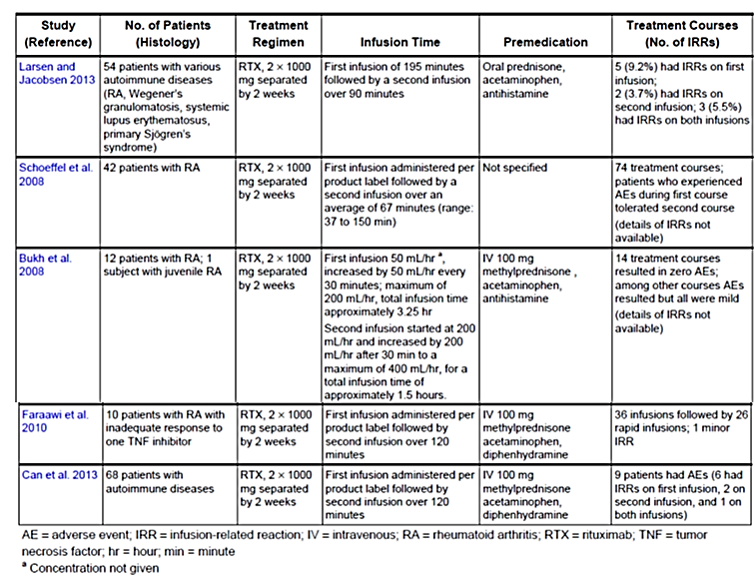

Contents of the clinical dossier

Scope of the clinical dossier
The submission contained the following clinical information:
- One pivotal safety study: Study ML25641.

Paediatric data
The submission did not include paediatric data.

Good clinical practice
Study ML25641 appears to have been conducted according to GCP.

Pharmacokinetics

Studies providing pharmacokinetic data
No new pharmacokinetic data were included in the submission.

Pharmacodynamics

Studies providing pharmacodynamic data
No new pharmacodynamic data were included in the submission.

Dosage selection for the pivotal studies
The dosage selection was based on the currently approved dose, with a new rate of delivery.

Clinical efficacy
No new efficacy data were included in the submission.

Clinical safety

Studies providing evaluable safety data
The following pivotal study provided evaluable safety data: Study ML25641.

Pivotal studies that assessed safety as a primary outcome

Study ML25641

Study design, objectives, locations and dates
Study ML25641 was a multicentre, open label, single arm study to evaluate the safety of administering rituximab at a more rapid infusion rate in patients with rheumatoid arthritis. The study was conducted at 74 sites in the US from July 2011 to February 2013.

Inclusion and exclusion criteria
The inclusion criteria included:
- Patients with RA of ≥6 month duration diagnosed according to the revised 1987 American College of Rheumatology.
- Received treatment on an outpatient basis.
- Age ≥ 18 years.
- Patients who had experienced an inadequate response due to inefficacy of treatment or intolerance with at least one approved anti-TNF agent (for example, adalimumab, etanercept, infliximab, golimumab, certolizumab).
- Patients who had received 1 to 2 prior courses of rituximab could enrol provided their most recent course of rituximab occurred greater than 6 months, but not more than 9 months, prior to baseline. The rituximab dosage must have been two 1000 mg infusions per course administered at the labelled infusion rates.
- Had received MTX between 10 and 25 mg/week (oral or parenteral) for at least 8 weeks immediately prior to baseline.
- Females of childbearing potential and males with female partners of childbearing potential could participate in this trial only if using a reliable means of contraception.
- Female patients of childbearing potential had to have a negative serum pregnancy test at screening and a negative urine pregnancy test at baseline to be eligible for the study.
The exclusion criteria included:
General criteria:
- Major surgery (including joint surgery) within 8 weeks prior to screening or planned surgery within 6 months following baseline.
- Rheumatic autoimmune disease other than RA, including systemic lupus erythematosus, mixed connective tissue disease, scleroderma, polymyositis, or significant systemic involvement secondary to RA (for example,, vasculitis, pulmonary fibrosis or Felty’s syndrome). Sjögren’s Syndrome with RA was allowed.
- Functional class IV as defined by the American College of Rheumatology (ACR) Criteria for Classification of Functional Status in Rheumatoid Arthritis.
- Prior history of or current inflammatory joint disease other than RA (for example, gout, reactive arthritis, psoriatic arthritis, seronegative spondyloarthropathy, Lyme disease).
- History of severe allergic or anaphylactic reactions to human, humanized, or murine monoclonal antibodies.
- Previous serious infusion reaction to any prior biologic therapy, including rituximab, adalimumab, etanercept, infliximab, golimumab, certolizumab, abatacept, and tocilizumab.
- Greater than two prior courses of rituximab. Patients were excluded if their most recent course of rituximab occurred within 6 months or greater than 9 months of baseline, or if the rituximab dosage was not two 1000 mg infusions per course administered at the labelled infusion rates.
- Evidence of serious uncontrolled concomitant cardiovascular (including hypertension), nervous system, pulmonary (including obstructive pulmonary disease), renal, hepatic, endocrine (including uncontrolled diabetes mellitus), hepatic, or gastrointestinal disease.
- History of or significant cardiac arrhythmias including atrial fibrillation and atrial flutter.
- Uncontrolled disease, such as asthma, psoriasis, or inflammatory bowel disease where flares are commonly treated with oral or parenteral corticosteroids.
- Known active current or history of recurrent bacterial, viral, fungal, mycobacterial, or other infections (including but not limited to tuberculosis and atypical mycobacterial disease, clinically significant abnormalities on chest x-ray as determined by the investigator, hepatitis B and C, and herpes zoster, but excluding fungal infections of nail beds) or any major episode of infection requiring hospitalization or treatment with IV antibiotics within 4 weeks of screening or oral antibiotics within 2 weeks prior to screening.
- Evidence of chronic active hepatitis B or C infection.
- Primary or secondary immunodeficiency (history of or currently active).
- Evidence of active malignant disease, malignancies diagnosed or treated within the previous 10 years including haematologic malignancies and solid tumors (except basal cell carcinoma of the skin that has been excised and cured), or breast cancer diagnosed or treated within the previous 20 years.
- Pregnant women or nursing (breastfeeding) mothers.
- History of alcohol, drug, or chemical abuse within the 6 months prior to screening.
- Patients with lack of peripheral venous access.
Laboratory criteria (at screening):
- Serum creatinine >124 μmol/L in female patients and >141 μmol/L in male patients
- ALT or AST >1.5xULN
- Platelet count <100x10⁹/L
- Haemoglobin <85 g/L
- White blood cells count <3x10⁹/L
- Absolute neutrophil count <2x10⁹/L
- Absolute lymphocyte count <0.5x10⁹/L
- Positive hepatitis B surface antigen (HBsAg), hepatitis B core antibody (HBcAb), or hepatitis C antibody
Previous or Concomitant Therapy:
- Previous treatment with any cell depleting therapies, including investigational agents (for example, CAMPATH, anti-CD4, anti-CD5, anti-CD3, anti-CD19, belimumab, anti-CD20 [excluding rituximab]).
- Treatment with IV gamma globulin, plasmapheresis, or Prosorba column within 6 months of baseline.
- Treatment with anti-TNF therapy or any other biologic disease-modifying anti-rheumatic drug (DMARD) at any time during the study.
- Treatment with leflunomide or azathioprine within 4 weeks prior to baseline or at any time during the study.
- Immunization with a live/attenuated vaccine within 4 weeks prior to baseline.

Study treatments
All subjects enrolled in the study were to receive the same dosing regimen. Rituximab was dosed on up to four occasions. Each administered dose was 1000 mg and was infused through a dedicated line. The dosing schedule for the first infusion for the first course is shown in Table 2.

Table 2: Dosing schedule for the first infusion of the first course
In the event that the patient experienced an infusion-related reaction, the infusion rate was to be reduced to half that rate (for example, from 100 mg/hour to 50 mg/hour). Once the AE had resolved, the investigator was to wait an additional 30 minutes while delivering the infusion at the reduced rate. If tolerated, the rate was to be increased to the next closest rate on the patient’s infusion schedule. The minimum infusion duration was 4.25 hours.
Patients who experienced a moderate-to-severe infusion-related reaction (for example, fever, chills, hypotension) were to have their infusion interrupted immediately and to receive symptomatic treatment. The infusion was not to be restarted until all of the symptoms had disappeared. The infusion was to be restarted at half the rate. If the patient tolerated the reduced rate for 30 minutes, the infusion rate was to be increased to the next closest rate following the infusion schedule. If the symptoms did not resolve with treatment, the subject was to be withdrawn from the treatment period of the study. Any patient experiencing a serious infusion-related reaction was to be withdrawn from the study.
For the second Infusion of the first course (Day 15) and both first and second infusions of the second course (Day 168 and 182) the dosing regimen was as shown in Table 3 below.

Table 3: Dosing regimen for second infusion of first course and second course
Patients who experienced a moderate-to-severe infusion-related reaction (for example, fever, chills, or hypotension) were to have their infusion interrupted immediately and to receive symptomatic treatment. The infusion was not to be restarted until all of the symptoms had disappeared. The infusion was to be restarted at half the rate. If the patient tolerated the reduced rate for 30 minutes, the infusion rate was to be increased to the next closest rate following the infusion schedule. If the symptoms did not resolve with treatment, the subject was to be withdrawn from the treatment period of the study. Any patient experiencing a serious infusion-related reaction was to be withdrawn from the study.
All subjects received the following pre-medication before each infusion:
- Methylprednisolone 100 mg by slow intravenous infusion (over 10 to 15 minutes) administered at least 30 minutes prior to each infusion.
- Acetaminophen 1 g administered orally 30 to 60 minutes prior to each infusion.
- An antihistamine (diphenhydramine HCl 50 mg or equivalent dose of alternate) administered orally 30 to 60 minutes prior to each infusion.
All patients continued to receive MTX 10 to 25 mg/week (oral or parenteral), as prescribed by their treating physician. Patients were required to be treated with MTX for ≥ 8 weeks prior to baseline. Changes in MTX dose were allowed as long as the patient remained on a dose of 10 to 25 mg/week. All patients also received folic acid (≥ 5 mg/week) given as either a single weekly dose or as a divided daily dose at the discretion of the investigator.

Safety variables and outcomes
The primary safety outcome measure was the incidence of IRRs associated with the second rituximab infusion. The secondary safety outcome measures were:
- Incidence of SIRRs associated with the second rituximab infusion.
- Incidence of IRRs and SIRRs associated with the third rituximab infusion.
- Incidence of Common Toxicity Criteria (CTC) Grade 3 or 4 AEs occurring during or within 24 hours following the second rituximab infusion.
- Incidence of stopping/slowing/interrupting the second rituximab infusion.
- Incidence of CTC Grade 3 or 4 AEs occurring during or within 24 hours following the third rituximab infusion.
- Incidence of stopping/slowing/interrupting the third rituximab infusion.
The data were also analyzed by the subgroups of rituximab-naïve and rituximab-experienced subjects.

Randomisation and blinding methods
The study was a single arm, open label study.

Analysis populations
The safety evaluable population included all patients who received rituximab during the study and had at least one safety assessment during or after the rituximab infusion.

Statistical methods
The data were summarized as incidence rates with 95% CIs.

Participant flow
There were 351 subjects who received Infusion one, 341 (97.2%) who received Infusion two, 290 (82.6%) who received Infusion three and 278 (79.2%) who received Infusion four (Table 4). A total of 73 (20.8%) subjects discontinued before Week 30: 19 (5.4%) because of AE, 20 (5.7%) due to protocol violation and 23 (6.6%) because of the Subject’s decision. Not all of the subjects received the intended faster infusion rate for the second and subsequent infusions: 337 (98.8%) of the subjects that received Infusion two, 289 (99.7%) at Infusion three and 278 (100%) at Infusion four.

Table 4: Patient Disposition by Infusion for Study ML25641

Major protocol violations/deviations
There were no listed protocol violations of Inclusion Criteria 2 (Patients with RA of ≥6 months duration diagnosed according to the revised 1987 American College of Rheumatology) or Exclusion Criteria 2 (Rheumatic autoimmune disease other than RA, including systemic lupus erythematosus, mixed connective tissue disease, scleroderma, polymyositis, or significant systemic involvement secondary to RA (for example,, vasculitis, pulmonary fibrosis or Felty’s syndrome). Sjögren’s Syndrome with RA was allowed. Hence all the study population appear to have had RA, and no other autoimmune diseases.
Twelve (3.4%) subjects did not meet at least one of the inclusion/exclusion criteria, including four (1.1%) who did not have records indicating that they had experienced an inadequate response with at least one anti-TNF agent.

Baseline data
There were 268 (79.5%) females, 69 (20.5%) males and the age range was 23 to 88 years (Table 5).

Table 5: Demographics and Baseline Characteristics for Study ML25641
There were 306 (87.2%) subjects with no prior rituximab exposure, 24 (6.8%) with one prior rituximab course and 21 (6.0%) with two prior rituximab courses (Table 6).

Table 6: Disease Duration, Prior and Baseline Treatments for RA for Study ML25641
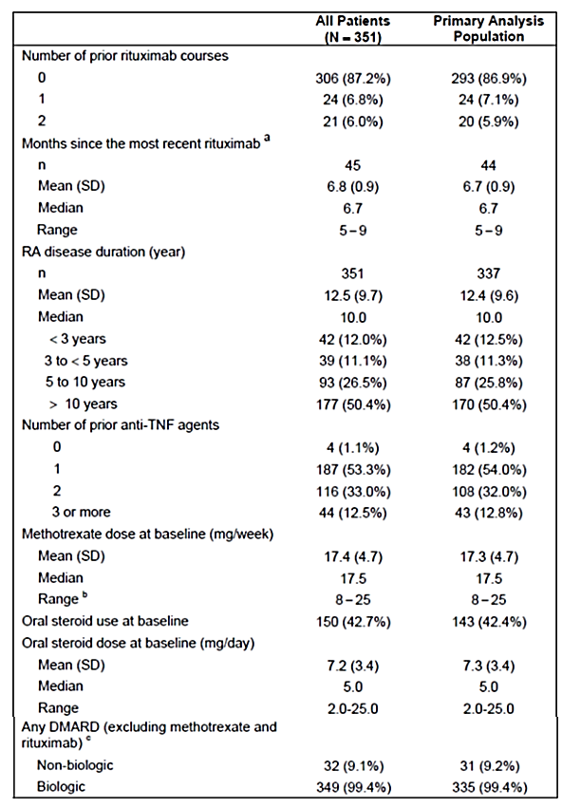
Mean (SD) duration of RA was 12.6 (9.7) years. All subjects were treated with concomitant MTX, dose range 7.5 mg/week to 25 mg/week. There were 185 (52.7%) subjects with a history of gastrointestinal conditions and 181 (51.6%) with a history of vascular disorders (Table 7). There were 198 (56.4%) subjects treated with concomitant glucocorticoids (Table 8).

Table 7: Medical and Surgical History-Conditions for Study ML25641

Table 8: Concomitant Medications at Screening and during the Study for Study ML25641

Results for the primary safety outcome
The incidence (95% CI) of IRRs during or within 24 hours of the second rituximab infusion was 6.5% (4.1% to 9.7%) (Table 9). There were 22 IRRs recorded for the 337 subjects who received the second rituximab infusion at the faster rate.

Table 9: Adverse Events during or within 24 Hours of the Second, Third, and Fourth Rituximab Infusions (Administered at the Faster Rate) for Study ML25641

Results for other safety outcomes
- The incidence (95% CI) of SIRRs during or within 24 hours of the second rituximab infusion was 0 (- to 0.9%). There were no SIRRs during or within 24 hours of the second rituximab infusion (Table 9).
- The incidence (95% CI) of IRRs during or within 24 hours of the third rituximab infusion was 5.9% (3.5% to 9.3%). There were 17 IRRs during or within 24 hours of the third rituximab infusion (Table 9).
- The incidence (95% CI) of SIRRs during or within 24 hours of the third rituximab infusion was 0 (- to 1.0%). There were no SIRRs during or within 24 hours of the second third infusion (Table 9).
- The incidence (95% CI) of Common Toxicity Criteria (CTC) Grade 3 or 4 AEs occurring during or within 24 hours following the second rituximab infusion was 0.6% (0.1% to 2.1%). There was one CTC Grade 3 or 4 AE reported during the second infusion (Table 10).

Table 10: Adverse Events Occurring during the Rituximab Infusions for Study ML25641
- The incidence (95% CI) of CTC Grade 3 or 4 AEs occurring during or within 24 hours following the third rituximab infusion was 0 (- to 1.0%). There were no CTC Grade 3 or 4 AEs reported during the third infusion.
- The incidence (95% CI) of stopping/slowing/interrupting the second rituximab infusion was 3.9% (2.1% to 6.5%). There were 13 subjects that had their second infusion stopped (Table 11).
- The incidence (95% CI) of stopping/slowing/interrupting the third rituximab infusion was 6.6% (4.0% to 10.1%). There were 19 subjects that had their third infusion stopped (Table 11).

Table 11: Summary of Events during or within 24 Hours after Rituximab Infusion by Infusion Safety-Evaluable Population for Study ML25641

Table 11 continued: Summary of Events during or within 24 Hours after Rituximab Infusion by Infusion Safety-Evaluable Population for Study ML25641

Thirteen of 351 patients who received the Day 1 rituximab infusion (4.25-hour) did not complete the infusion (1000 mg) due to non-serious AEs (7 patients), medication error (1 patient), other reason (1 patient), and no detailed volume recorded to determine the infusion rate (4 patients). On Day 15, four of the 337 patients who received the rituximab infusion at a faster rate did not complete the 1000 mg infusion due to non-serious AEs (3 patients) and other reasons (1 patient).
For Infusion 4, for those subject who were administered rituximab at the faster rate, there were two IRRs, incidence rate (95% CI) 0.7% (0.1% to 2.6%); no SIRRs, and no CTC Grade 3 or 4 AEs. During the infusion, there were 10 IRRs during Infusion 2, incidence rate (95% CI) 3.0% (1.4% to 5.4%); 15 during Infusion 3, 5.2% (2.9% to 8.4%); and one during Infusion 4, 0.4% (0.0% to 2.0%).
There were too few subjects in the rituximab-experienced group for meaningful comparisons of event rates with the rituximab naïve group, but there appeared to be similar risks of events for rituximab-experienced and rituximab-naïve subjects (Table 12).

Historical comparison data

Studies providing the historical comparison data
The previously conducted studies in the RA population are summarised in Table 12. The overall exposure was 3595 subjects, all of whom received rituximab infusions administered in the manner currently recommended in the Product Information document (4.25 hours for initial infusion and 3.25 hours for subsequent infusions). The studies included eight randomized clinical trials (six Phase III, two Phase II), two long-term open-label extensions, and one open-label prospective study.

Table 12: Studies providing historical data
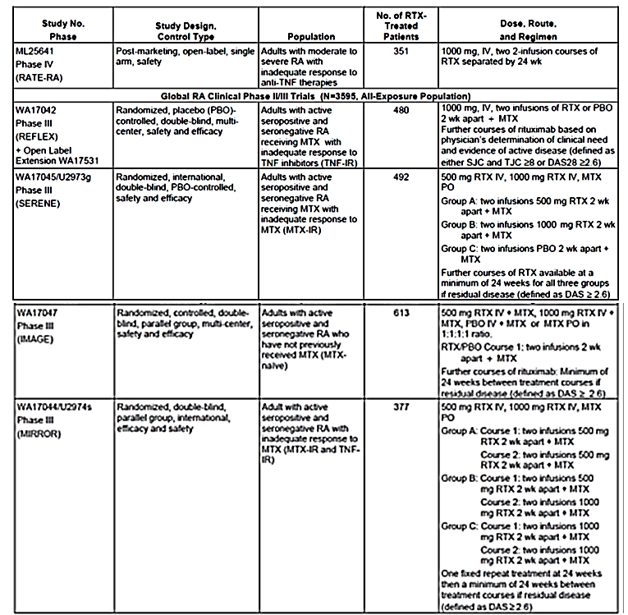

Table 12 continued: Studies providing historical data 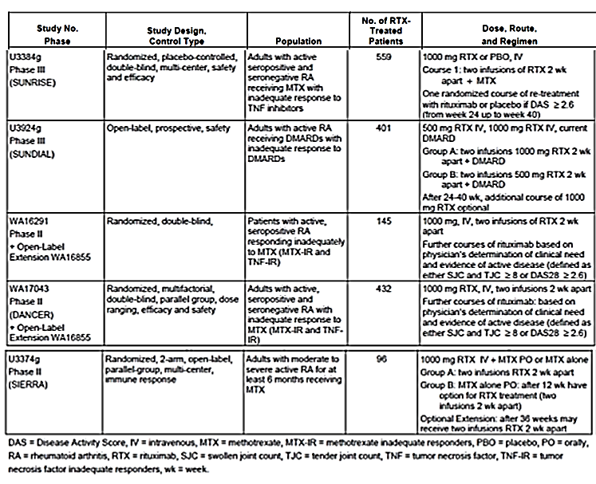

Historical rates of infusion related reactions provided by the sponsor
In the report for Study ML25641 the sponsor provided the following data relating to historical rates of IRRs. The Sponsor performed some adjustment of the data in the following manner: To account for Study ML25641 also recruiting subjects with prior rituximab exposure, the sponsor used the weighted average of incidences reported in the historical data as the expected control incidence. IRRs in the historical studies (except for three) were identified by filtering the Preferred Terms of AEs that occurred during or within 24 hours of the rituximab infusion per a list of MedDRA terms that was used to analyze IRRs across rituximab studies in RA patients conducted by Roche/Genentech. The eCRFs for Studies WA17044/U2974s, WA17045/U2973g, and WA17047/U3373g included the IRR page, so this search strategy was not required.
The historical incidence (95% CI) of IRRs during or within 24 hours of the second rituximab infusion was 8.6% (7.7% to 9.6%) (Table 13). The weighted historical incidence (95% CI) of IRRs associated with the second rituximab infusion was 8.1% (7.2% to 9.1%).
The historical incidence (95% CI) of IRRs during or within 24 hours of the third rituximab infusion was 11.9% (10.7% to 13.2%) (Table 13). The weighted historical incidence (95% CI) of IRRs associated with the third rituximab infusion was 11.5% (10.3% to 12.8%).
Data with regard to SIRRs, CTC Grade 3 or 4 AEs and stopping/slowing/interrupting were not provided by infusion number.

Table 13: Expected Control Incidence of Infusion-Related Reactions for Rituximab Administered at the Labelled Rates

Historical rates of infusion related reactions from Study WA17047 IMAGE and Study WA17045 SERENE.
- In Study WA17047 IMAGE, the rate of IRRs during or within 24 hours of the 1000 mg dose regimen was 4.9% with the second infusion and 8.5% with the third infusion (Table 14).
- In Study WA17045 SERENE, the rate of IRRs during or within 24 hours of the 1000 mg dose regimen was 6% with the second infusion and 10% with the third infusion (Table 15).
Combining the results of these two studies, there were 22 subjects with IRRs of the 413 subjects receiving a second infusion, and 35 subjects with IRRs of the 381 receiving a third infusion. Using Stata® version 9.0 to calculate incidence rates and Poisson 95% CIs, the incidence (95% CI) of IRRs for the second infusion was 5.3% (3.4% to 8.0%) and for the third infusion was 9.2% (6.5% to 12.5%).

Table 14: Summary of Infusion Related Reactions with Timing of Event for Study WA17047

Table 15: Summary of Infusion Related Reactions with Timing of Event (Safety Population) for Study WA17045

Patient exposure
As per section Participant flow above.

Adverse events

All adverse events (irrespective of relationship to study treatment)

Pivotal studies
In Study ML25641 TEAEs were reported in 221 (63%) subjects during the study. The most frequently reported TEAEs were: headache (5.7%), upper respiratory tract infection (5.4%), worsening RA (5.1%), pruritus (4.3%), sinusitis (4.0%), urinary tract infection (3.7%), throat irritation (3.4%), arthralgia (3.1%), nausea (3.1%), flushing (2.6%), cough (2.3%), dizziness (2.3%), ear pruritus (2.3%), and rash (2.3%).
There were 151 infections in 99 (28.2%) subjects, ten serious infections in 10 (2.8%) subjects and 12 serious infections / events treated with intravenous antibiotics in ten (2.8%) subjects. The event rate (95% CI) for infections was 73.01 (62.25 to 85.64) per 100 patient years, for serious infections was 4.84 (2.60 to 8.99) per 100 patient years and for serious infections / events treated with intravenous antibiotics was 5.80 (3.30 to 10.22) per 100 patient years.

Deaths and other serious adverse events

Pivotal studies
In Study ML25641 there were no deaths. There were 33 SAEs in 30 (8.5%) subjects. The commonest SAE was pneumonia, occurring in four (1.1%) subjects. The rate (95% CI) of SAEs was 16.0 (11.3 to 22.4) per 100 patient years.

Discontinuation due to adverse events

Pivotal studies
In Study ML25641 19 subjects discontinued because of AEs. The commonest DAE was throat irritation, occurring in two (0.6%) subjects.

Laboratory tests

Liver function

Pivotal studies
In Study ML25641 there were 54 (16.8%) subjects with ALT >ULN and 35 (10.5%) with AST >ULN (Table 16).

Table 16: Laboratory Abnormalities Outside of Upper/Lower Limit of Normal during Study for Study ML25641

Table 16 continued: Laboratory Abnormalities Outside of Upper/Lower Limit of Normal during Study for Study ML25641

Kidney function

Pivotal studies
In Study ML25641 nine (2.7%) subjects had serum creatinine reported >ULN.

Other clinical chemistry

Pivotal studies
In Study ML25641 there were no other clinically significant abnormalities in clinical chemistry.

Haematology

Pivotal studies
There were 47 (15.5%) subjects with haemoglobin <LLN and 65 (20.1%) with lymphocyte count <LLN during the study.

Lymphocyte count

Pivotal studies
At baseline, the subjects previously treated with rituximab had reduced CD19 counts compared with those who were rituximab naïve (Table 17).

Table 17: Lymphocyte Counts (cells/μL) at Screening for Study ML25641

Vital signs

Pivotal studies
There were no significant differences between the treatment days in mean values for vital signs: temperature, DBP, SBP and pulse.

Post-marketing experience

Post-marketing data
MabThera has been licensed and is marketed in over 100 countries including the US, all EU member states, Norway, Iceland, Japan, Australia, New Zealand, Canada and Switzerland. An estimated 402,372 RA patients have been treated with rituximab via commercially obtained drug and through clinical trials.
The data submitted in Study ML25641 were the only post-marketing data submitted by the sponsor relating to the rapid infusion rate.
The Sponsor had also identified through a literature search five studies that described subjects with RA that had received rapid infusions of rituximab but the sponsor rejected these data because of the poor quality of the studies and reports. These studies are described in Table 1 and were:
- Faraawi and Roth 2010 was a publication in abstract for describing 10 subjects with RA who between them received 36 infusions of which 26 were rapid infusions of rituximab. One subject experienced an episode of headache, chest tightness and shortness of breath which resolved during the infusion.
- Larsen and Jocabsen 2013 describe 54 subjects who received rapid infusions of rituximab. There were 16 subjects with RA. Ten (18.5%) subjects experienced IRRs: three (5.5%) with both infusions, eight (14.8%) on the first and five (9.2%) on the second. The highest prevalence of IRRs was stated to be in the RA group at 9.2% but this does not correspond to a plausible number of subjects (1.5 subjects).
- Schoeffel et al 2008 was a report in abstract form of a cohort of subjects with RA that were treated with a rapid infusion of rituximab (range 37 to 150 minutes). The methods for identifying and classifying IRRs were not reported. No IRRs were reported.
- Bukh et al was a conference presentation published in abstract form and presented as a poster. It described 13 subjects, 12 with RA that were treated with a rapid infusion of rituximab for their second infusion (1000 mg over 1.5 hours). The methods for eliciting and categorising IRRs were not described. One subject experienced mild hypotension. One subject had the infusion stopped temporarily due to sweating, feeling uncomfortable, temperature of 37.9°C and paraesthesiae in the arms.
- Can et al 2012 describes a cohort of 68 subjects, 60 of whom had RA. There were 71 rapid infusions (1000 mg over 2 hours) administered in the RA group. There were three (5.9%) subjects with IRRs on the second infusion. The symptoms experienced were pharyngeal discomfort, vertigo, hypotension and cough.
The Evaluator agrees with the sponsor’s assessment of the quality of the studies and that these studies did not provide sufficient demonstration of safety to support the proposed new rapid dosing regimen. The Evaluator also considers that these studies do not raise any additional safety concerns with regard the proposed new rapid infusion dosing regimen.

Safety issues with the potential for major regulatory impact
The issue of infusion related reactions is discussed in Section Pivotal studies that assessed safety as a primary outcome above.

Evaluator’s overall conclusions on clinical safety
The data primarily address the issue of infusion related reactions (IRRs), which are the primary concern arising from a more rapid administration rate of intravenous rituximab. The rates of IRRs with the proposed new rapid infusion rate are similar to those observed in previous studies conducted in the RA population. The incidence (95% CI) of IRRs associated with the rapid infusion rate at the time of the second rituximab infusion was 6.5% (4.1% to 9.7%). The Sponsor provided a weighted historical incidence (95% CI) of IRRs associated with the second rituximab infusion of 8.1% (7.2% to 9.1%). The rate of IRRs (95% CI) from Study WA17047 IMAGE and Study WA17045 SERENE was 5.3% (3.4% to 8.0%) for the second infusion.
The incidence (95% CI) of IRRs associated associated with the rapid infusion rate at the time of the third rituximab infusion was 5.9% (3.5% to 9.3%). The weighted historical incidence (95% CI) of IRRs associated with the third rituximab infusion was 11.5% (10.3% to 12.8%). The rate of IRRs (95% CI) from Study WA17047 IMAGE and Study WA17045 SERENE was 9.2% (6.5% to 12.5%) for the third infusion.
In Study ML25641 there were no SIRRs associated with the rapid infusion rate. There were two CTC Grade 3 or 4 AE reported following the second infusion and none following the third. The incidence (95% CI) of stopping/slowing/interrupting the second rituximab infusion was 3.9% (2.1% to 6.5%) and the third rituximab infusion was 6.6% (4.0% to 10.1%). The adverse event profile reported in the study is consistent with the known AE profile of rituximab.
The proposed new rapid infusion rate dosing regimen in the PI document is the same as that used in Study ML25641.
All subjects in Study ML25641 were treated with methotrexate. Hence, the study results are not generalisable to patients who are not treated with methotrexate. However, this is consistent with the indication, which includes only those patients with RA who are receiving concomitant treatment with methotrexate.
All subjects in Study ML25641 received the following pre-medication before each rapid rate infusion:
- Methylprednisolone 100 mg by slow intravenous infusion (over 10 to 15 minutes) administered at least 30 minutes prior to each infusion.
- Acetaminophen 1 g administered orally 30 to 60 minutes prior to each infusion.
- An antihistamine (diphenhydramine HCL 50 mg or equivalent dose of alternate) administered orally 30 to 60 minutes prior to each infusion.
The administration of methylprednisolone 100 mg, paracetamol and antihistamine is also recommended in the dosing instructions, according to the same regimen as in Study ML25641.
In Study ML25641 there were 198 (56.4%) subjects treated with concomitant glucocorticoids. However, this would be typical of the RA population and does not impact upon the dosing recommendations.
The study population in Study ML25641 was subjects with RA, treated with methotrexate, who had an inadequate response to a TNF inhibitor. However, the indication in Australia is restricted to patients with severe, active RA:
MabThera (rituximab) in combination with methotrexate is indicated for the treatment of adult patients with severe, active rheumatoid arthritis who have had an inadequate response or intolerance to at least one tumour necrosis factor (TNF) inhibitor therapy.
However, in the opinion of the evaluator, the results of Study ML25641, conducted in a general population of subjects with RA are applicable to a population of patients with severe, active RA.
The results of Study ML25641 are only generalisable to patients with RA, and not to any other medical conditions. Only subjects with RA were included in Study ML25641.
The study design (single arm, no comparator and using historical data for comparison) was acceptable for evaluation of the safety of the proposed new rapid infusion. The study design would not have been appropriate for the evaluation of efficacy. There were 337 subjects who received the rapid infusion regimen which, in the opinion of the evaluator represents a sufficient number of subjects included in the study. The open nature of the trial may have resulted in measurement bias. However, the primary outcome measure (IRRs) should have been sufficiently objective and robust to overcome this deficiency. The historical incidence (95% CI) of IRRs associated with the second rituximab infusion was 8.1% (7.2% to 9.1%), but the prospective data provided by the sponsor was a rate of IRRs (95% CI) from Study WA17047 IMAGE and Study WA17045 SERENE of 5.3% (3.4% to 8.0%) for the second infusion. This would suggest bias in the elicitation of IRRs for the historical data rather than bias in Study ML25641. The methods used for identifying IRRs from the historical data were different to those for identifying IRRs prospectively. Overall the evaluator was satisfied with the design and conduct of Study ML25641.

First round benefit-risk assessment

First round assessment of benefits
Efficacy was not addressed in the present application, but the proposed new rapid administration would be expected to reduce treatment costs and be more convenient to patients.

First round assessment of risks
The proposed alternative, faster infusion schedule of MabThera for rheumatoid arthritis has a similar risk for IRRs as the currently approved administration regimen. There were no other risks identified with the proposed alternative, faster infusion schedule of MabThera.
In the opinion of the evaluator, off-label use of the new rapid infusion is also an Important Potential Risk that should be addressed in the RMP.

First round assessment of benefit-risk balance
The benefit-risk balance of the alternative, faster infusion schedule of MabThera for rheumatoid arthritis, given the proposed usage, is favourable.

First round recommendation regarding authorisation
The evaluator has no objection to the approval of the alternative, faster infusion schedule of MabThera for rheumatoid arthritis.

Clinical questions

Pharmacokinetics
The evaluator does not have any questions relating to pharmacokinetics.

Pharmacodynamics
The evaluator does not have any questions relating to pharmacodynamics.

Efficacy
The evaluator does not have any questions relating to efficacy.

Safety
The evaluator does not have any questions relating to safety.

Second round evaluation of clinical data submitted in response to questions
There was no second round evaluation conducted.

References
Nil.
Therapeutic Goods Administration
PO Box 100 Woden ACT 2606 Australia
Email: info@tga.gov.au Phone: 1800 020 653 Fax: 02 6232 8605
https://www.tga.gov.au

Sponsor clarification: ‘The sponsor considers these data to be only supportive because of the poor quality of the studies and reports.’
Sponsor clarification: ‘There were two CTC Grade 3 or 4 AE reported during or within 24 hours of the second infusion and none during or within 24 hours of the third.’
Sponsor clarification: ‘Subjects with RA of ≥ 6 months duration.’
The sponsor has commented on the methods used to identify IRRS in the historical and Study ML25641 data on page 30 of the AusPAR.

