28 June 2013

AusPAR Attachment 2

Extract from the Clinical Evaluation Report for Rituximab
  - Proprietary Product Name: MabThera SC
  - Sponsor: Roche Products Pty Limited

About the Therapeutic Goods Administration (TGA)
- The Therapeutic Goods Administration (TGA) is part of the Australian Government Department of Health, and is responsible for regulating medicines and medical devices.
- The TGA administers the Therapeutic Goods Act 1989 (the Act), applying a risk management approach designed to ensure therapeutic goods supplied in Australia meet acceptable standards of quality, safety and efficacy (performance), when necessary.
- The work of the TGA is based on applying scientific and clinical expertise to decision-making, to ensure that the benefits to consumers outweigh any risks associated with the use of medicines and medical devices.
- The TGA relies on the public, healthcare professionals and industry to report problems with medicines or medical devices. TGA investigates reports received by it to determine any necessary regulatory action.
- To report a problem with a medicine or medical device, please see the information on the TGA website <http://www.tga.gov.au>.
About the Extract from the Clinical Evaluation Report
- This document provides a more detailed evaluation of the clinical findings, extracted from the Clinical Evaluation Report (CER) prepared by the TGA. This extract does not include sections from the CER regarding product documentation or post market activities.
- The words [Information redacted], where they appear in this document, indicate that confidential information has been deleted.
- For the most recent Product Information (PI), please refer to the TGA website <http://www.tga.gov.au/hp/information-medicines-pi.htm>.
Copyright
© Commonwealth of Australia 2013
This work is copyright. You may reproduce the whole or part of this work in unaltered form for your own personal use or, if you are part of an organisation, for internal use within your organisation, but only if you or your organisation do not use the reproduction for any commercial purpose and retain this copyright notice and all disclaimer notices as part of that reproduction. Apart from rights to use as permitted by the Copyright Act 1968 or allowed by this copyright notice, all other rights are reserved and you are not allowed to reproduce the whole or any part of this work in any way (electronic or otherwise) without first being given specific written permission from the Commonwealth to do so. Requests and inquiries concerning reproduction and rights are to be sent to the TGA Copyright Officer, Therapeutic Goods Administration, PO Box 100, Woden ACT 2606 or emailed to <tga.copyright@tga.gov.au>.

Contents
List of common abbreviations 5
1. Clinical rationale 6
1.1. Guidance 6
2. Contents of the clinical dossier 6
2.1. Scope of the clinical dossier 6
2.2. Paediatric data 7
2.3. Good clinical practice 7
3. Pharmacokinetics 7
3.1. Studies providing pharmacokinetic data 7
3.2. Summary of pharmacokinetics 8
4. Pharmacodynamics 8
4.1. Studies providing pharmacodynamic data 8
5. Dosage selection for the pivotal studies 9
6. Clinical efficacy 9
6.1. Studies providing efficacy data 9
6.2. Study BO 22334 stage 1 9
6.3. Analyses performed across trials (pooled analyses and meta-analyses) 18
6.4. Evaluator’s conclusions on efficacy 18
7. Clinical safety 18
7.1. Studies providing safety data 18
7.2. Study BO 25341 19
7.3. Patient exposure 21
7.4. Adverse events 23
7.5. Laboratory tests 29
7.6. Postmarketing experience 32
7.7. Safety issues with the potential for major regulatory impact 32
7.8. Other safety issues 32
7.9. Evaluator’s conclusions on safety 33
8. First round benefit-risk assessment 34
8.1. First round assessment of benefits 34
9. First round recommendation regarding authorisation 35
10. Clinical questions 35
10.1. Pharmacokinetics 35
10.2. Pharmacodynamics 35
10.3. Efficacy and safety 35
11. References 35

List of common abbreviations
Abbreviation | Meaning
AE | Adverse Event
ALT | Alanine aminotransferase
ARR | Administration-related events
AST | Aspartate aminotransferase
BSA | Body Surface Area
AUC | Area under concentration versus time curve
CHOP | Cyclophosphamide, doxorubicin, vincristine and prednisone
CI | Confidence Interval
CL | Clearance
CLL | Chronic Lymphocytic Leukaemia
C_{max} | Maximum concentration
CMI | Consumer Medicines Information
CR | Complete Response
CRR | Complete Response Rate
CT | X-Ray Computed Tomography
CVP | Cyclophosphamide, vincristine and prednisone
C_{trough} | Trough concentration
ECG | Electrocardiograph
ECOG | Eastern Cooperative Oncology Group
EMA | European Medicines Agency
ITT | Intention to Treat
IV | Intravenous
MRI | Magnetic resonance imaging
NHL | Non-Hodgkin’s Lymphoma
ORR | Overall Response Rate
PK | Pharmacokinetics
PP | Per Protocol
PR | Partial Response
rHuPH20 | recombinant human hyaluronidase
SAE | Serious Adverse Event
SC | Subcutaneous
TGA | Therapeutic Goods Administration
T_{max} | Time of maximum concentration
uCR | Unconfirmed Complete Response

Clinical rationale
According to the sponsor’s Clinical Overview the conversion from IV to SC administration for other monoclonal antibodies “.... has resulted in shorter administration times, increased patient convenience, and improved cost-effectiveness, as well as an improved tolerability with fewer infusion-related reactions”. The sponsor anticipated that similar benefits would be obtained with SC administration of rituximab.

Guidance
The following guidelines published by the European Medicines Agency (EMA) and adopted by the TGA are considered relevant to the current application:
Guideline On The Evaluation Of Anticancer Medicinal Products In Man (CPMP/EWP/205/95/Rev.3.Corr)
Guideline On The Clinical Investigation Of The Pharmacokinetics Of Therapeutic Proteins (CHMP/EWP/89249/2004).
Compliance with these guidelines will be considered in the relevant sections of this report.

Contents of the clinical dossier

Scope of the clinical dossier
The submission contained the following clinical information:
- A clinical study report for one Phase Ib clinical trial (BP 22333 Stages 1 and 2) examining the pharmacokinetics, pharmacodynamics and safety of SC administration of rituximab in patients with follicular lymphoma;
- A clinical study report for one Phase III clinical trial (BO 22334 Stage 1) examining the pharmacokinetics, pharmacodynamics, efficacy and safety of SC administration of rituximab in patients with follicular lymphoma;
- 3 population pharmacokinetic analyses;
- Individual patient narratives (for patients who died, experienced a serious adverse event or experienced an adverse event that resulted in withdrawal) and summary safety data for subjects participating in an ongoing study of SC administration of rituximab for the treatment of CLL (BO 25341).
- Literature references.

Paediatric data
The submission did not include paediatric data. As IV rituximab is not registered for use in children, the absence of such data is not considered a major deficiency.

Good clinical practice
The study reports for the three submitted clinical trials included assurances that they were conducted in accordance with the International Conference on Harmonisation (ICH) Good Clinical Practices (GCP) guidelines and any regulations applicable in the countries where the trials were conducted. Study protocols, consent forms etc. were reviewed by independent ethics committees.

Pharmacokinetics
The sponsor explains the rationale for the design of the pharmacokinetic studies included in the submission as follows:
“In view of the identical active ingredient in both IV and SC formulations, the clinical development program for rituximab SC is based on the rationale that rituximab Ctrough and AUC serum levels with rituximab SC at least as high as those after IV administration will result in a non-inferior degree of target-site saturation and will thus result in at least the same degree of efficacy, independent of the route of administration.”
The sponsor has therefore not attempted to establish bioequivalence between IV and SC administration according to conventional pharmacokinetic criteria (AUC, C_{max} etc.).

Studies providing pharmacokinetic data
Table 1 shows the studies relating to each pharmacokinetic topic.
Table 1. Submitted pharmacokinetic studies.
PK topic | Subtopic | Study ID | *
PK in NHL patients | General PK - Dose finding | BP 22333 Stage 1 | *
PK in NHL patients | - Dose confirmation | BP 22333 Stage 2 | *
PK in NHL patients | - Dose confirmation | BO 22334 Stage 1 | *
* Indicates the primary aim of the study

Study BP 22333 stage 1
Examined the PK of various SC dosing regimens (given on a mg/m² of body surface area [BSA] basis) with the objective of identifying one that would produce comparable serum concentrations (C_{trough}, AUC) to those seen with conventional IV dosing. Using the data generated, a population PK analysis was then conducted to determine a suitable fixed dose (that is, one not based on BSA).

Study BP 22333 stage 2
Directly compared the fixed SC dose (determined in BP 22333 Stage 1) with the conventional IV dose. The data generated were analysed using another population PK analysis.

Study BO 22334 Stage 1
Also directly compared PK parameters following the proposed SC and conventional IV dosing.
A population PK analysis was then conducted on all PK data collected in BP 22333 Stages 1 and 2 and BO 22334 Stage 1. The analysis was used to determine covariates that affected rituximab PK and to predict rituximab PK in various situations.
None of the pharmacokinetic studies had deficiencies that excluded their results from consideration.

Summary of pharmacokinetics
The submitted studies demonstrated the following:
- A fixed SC dose of 1400 mg produced non-inferior C_{trough} levels compared to the conventional IV dose of 375 mg/m² IV;
- The 1400 mg SC dose also resulted in an increased total systemic exposure (AUC) compared to the conventional IV dose of 375 mg/m² IV. The increase in AUC was in the range of 35 to 43%.
- BSA affects the pharmacokinetics of rituximab. In patients receiving a fixed SC dose of 1400 mg systemic exposure will greater in subjects with lower BSA.
- The absolute bioavailability of rituximab after SC administration is approximately 70%.
- Systemic absorption of the novel excipient rHuPH20 was undetectable in most patients.

Evaluator’s conclusions on pharmacokinetics
The proposed dosage regimen of 1400 mg SC has been demonstrated to produce systemic concentrations of rituximab that are not inferior to those produced by IV administration of 375 mg/m². The sponsor’s argument that this dose should therefore be associated with comparable efficacy is acceptable.
However, the proposed SC dosing regimen is associated with a significant increase in overall systemic exposure to the drug and this is more marked in subjects with low BSA. It might reasonably be expected that the SC dosage regimen will be associated with increased toxicity compared to the current IV dosage regimen.

Pharmacodynamics

Studies providing pharmacodynamic data
In both the submitted studies the peripheral blood CD19+ lymphocyte count was monitored. CD19 is a marker of B-lymphocytes.

CD 19 +ve lymphocyte count
In BP 22333 Stages 1 and 2, all patients had already received rituximab as part of induction treatment as well as at least one dose as part of maintenance treatment. Subjects therefore had depletion of CD19+ve lymphocytes with median counts = 0 at baseline.
In BP 22333 Stage 1, available data from patients at a 9 month follow-up visit showed some increase in B-cell levels at this time point compared with previous time points, with median counts of 50 (Cohort A, n = 6), 30 (Cohort B, n = 16), 20 (Cohort C, n = 15), and 30 cells/mm³ (Cohort D, n = 7).
In BP 22333 Stage 2, CD19+ve lymphocyte counts remained depleted throughout treatment with evidence of recovery in the small number of patients who had completed their 9-month follow up visit.
In BO 22334 Stage 1, CD19+ve cells were depleted soon after commencement of rituximab therapy in both treatment arms. Levels remained depleted throughout induction and early maintenance treatment.

Dosage selection for the pivotal studies
The proposed dosage regimen for SC use (a fixed dose of 1400 mg for all patients) was justified on pharmacokinetic criteria. Study BP 22333 demonstrated that this regimen would produce trough serum concentrations of rituximab that were non-inferior to those produced by the standard IV dose of 375 mg/m2.

Clinical efficacy

Studies providing efficacy data

Pivotal efficacy data
Only one of the two submitted studies (BO 22334 Stage 1) contained clinical efficacy data.
Comment: As described below, examination of efficacy was a secondary objective in BO 22334 Stage 1 and no formal efficacy hypothesis was tested. It might therefore not be considered a ‘pivotal’ efficacy study. However, as it provides the only clinical efficacy data in the submission, it will be considered pivotal for the purposes of this review.
Study BO 22334 is a two-stage study. The primary objective of Stage 1 was a pharmacokinetic one, that is, to estimate the ratio of serum trough concentrations obtained with SC and IV administration. The primary objective of Stage 2 will be of efficacy, that is, to estimate the overall response rates obtained with SC and IV administration. The design of Stages 1 and 2 was identical except that Stage 1 involved more intensive pharmacokinetic sampling. The submission only contained data from Stage 1 of the study.

Study BO 22334 stage 1

Study design, objectives, locations and dates
Study BO 22334 Stage 1 was a Phase 3, randomised, open study with two parallel groups. It was conducted in patients with previously untreated follicular lymphoma undergoing induction treatment.
The primary objective of Stage 1 was to estimate the ratio of trough serum concentrations of rituximab obtained at Cycle 7, (21 days after SC administration) to that obtained after IV administration (C_{trough}, SC/C_{trough}, IV during Cycle 7 of induction treatment).
One of the secondary objectives of Stage 1 was to compare overall response rate (ORR) of rituximab SC and rituximab IV given in combination with chemotherapy (CHOP or CVP) as induction treatment at the end/completion of induction treatment.
Stage 1 of BO 22334 was conducted in 67 centres in 23 countries. The first patient was screened in February 2010 and the cut-off date for data to be included in the study report was June 2012. The submitted study report was dated October 2012.
BO 22334 is also referred to as the ‘SABRINA’ study. It does not appear to have been published other than in conference abstract form⁽³⁾.

Inclusion and exclusion criteria
Comment: The study enrolled subjects with previously untreated follicular lymphoma (Grades 1, 2 and 3a) and therefore examined use of SC administration in the induction setting. In Study BP 223333, only use in the maintenance setting had been studied.

Study treatments

Induction treatment
All patients enrolled in the study received combination chemotherapy during induction treatment – either the CHOP regimen or the CVP regimen. The choice of chemotherapy regimen for an individual patient was at the discretion of the treating investigator. Investigators had to choose a regimen prior to randomisation.
One cycle of CHOP chemotherapy consisted of the following:
- Cyclophosphamide 750 mg/m² IV Day 1
- Doxorubicin 50 mg/m² IV Day 1
- Vincristine 1.4 mg/m² IV Day 1 (maximum dose of 2 mg)
- Prednisone 100 mg/day IV/PO Days 1, 2, 3, 4 and 5
This regimen was repeated every 21 days for up to 8 cycles.
One cycle of CVP chemotherapy consisted of the following:
- Cyclophosphamide 750 mg/m² IV Day 1
- Vincristine 1.4 mg/m² IV Day 1 (maximum dose of 2 mg)
- Prednisone 40 mg/day IV/PO Days 1, 2, 3, 4 and 5
This regimen was repeated every 21 days for 8 cycles.
For the first cycle of induction treatment all patients received rituximab 375 mg/m² IV, given on Day 0, Day 1 or Day 2.
For cycles 2-8 of induction treatment patients received either:
- Rituximab 375 mg/m² IV Day 1; or
- Rituximab 1400 mg SC Day 0 (for cycle 2) or Day 1 (cycles 3-8)

Maintenance treatment
After induction treatment, those patients who achieved a response (complete response, unconfirmed complete response or partial response according to the International Working Group response criteria for lymphoma) received maintenance therapy with single agent rituximab (either 375 mg/m² IV or 1400 mg SC). Maintenance doses were given every 8 weeks for up to 2 years (a total of 12 maintenance doses). Subjects were followed up for 2 years after completion of maintenance treatment.
A schematic of the study treatments is shown in Figure 1.
Figure 1. Study BO 22334 Stage 1 - Study schema
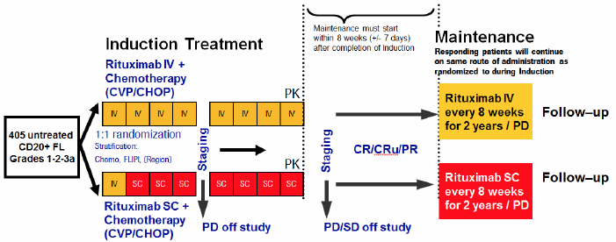
Comment: The approved maintenance regimen in Australia is once every 3 months, as opposed to the 2 monthly regimen used in this study. Nevertheless the data generated are still considered valuable for comparing the efficacy and safety of SC versus IV administration.
SC administration was via a 27-gauge needle inserted into the SC tissue of the abdomen. The injection was manually pushed at a flow rate of approximately 2 mL per minute; therefore an administration volume of 11.7 mL took approximately 5–6 minutes. Patients could request that the injection be interrupted if too painful.
Comment: The relevant EMA guideline⁽²⁾, notes that bioavailability of subcutaneously administered proteins might vary according to the site of injection (abdomen, thigh, etc.). In the proposed PI, the dosage instructions restrict administration to the abdomen.
The following premedication was recommended 30–60 minutes prior to starting each injection of rituximab SC or IV:
- 1000 mg of paracetamol; and
- 50–100 mg diphenhydramine hydrochloride or alternative antihistamine.
Medications for the prophylaxis of nausea and vomiting, infections, haemorrhagic cystitis and tumour lysis syndrome could be given as per usual institutional practice.

Efficacy variables and outcomes
The main efficacy variable was tumour response, as defined according to the International Working Group (IWG) response criteria for NHL⁽⁴⁾. A summary of the IWG response criteria is shown in Table 2.
Table 2. IWG response criteria
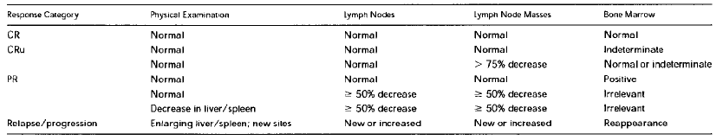
The efficacy outcomes were:
- The overall response rate (ORR) at the end of induction treatment. ORR is the proportion of patients who achieved a complete response (CR), an unconfirmed CR (uCR) or a partial response (PR) according to IWG criteria;
- The complete response rate (CRR) at the end of induction treatment. CRR is the proportion of patients who achieved a CR or a uCR according to IWG criteria;
Comment: The relevant EMA guideline⁽¹⁾ generally discourages the use of response rate as the primary efficacy variable in oncology studies. However, in the situation where two oncology products containing the same active ingredient are being compared, this is an acceptable approach. An analogous situation would be a non-inferiority efficacy study comparing an innovator and a biosimilar monoclonal antibody. The EMA guideline for this situation⁽⁵⁾ recommends the use of response rates as an appropriate efficacy endpoint.
Other efficacy outcomes intended for Stage 1 of BO 22334 were the ORR and CRR at the end of maintenance treatment, progression-free survival, event-free survival and overall survival. However the results for these endpoints were not provided in the submitted study report and will be reported in the final study report (that is, after the completion of Stage 2).
Tumour assessment by physical examination (palpable lymph nodes, liver and spleen size) took place at every treatment cycle (Cycles 1-8 at 3-weekly intervals during induction; Cycles 9-20 at 8 weekly intervals during maintenance) and at 12 weekly intervals during the follow-up period. A clinical diagnosis of disease progression had to be confirmed by CT scan within 4 weeks.
CT scans (or MRI if CT was contraindicated) of the abdomen, chest, pelvis and, if indicated, neck were scheduled at screening, Day 19 of Cycle 4 and Day 19 of Cycle 8 during induction and on Day 1 of Cycles 11, 14, 17 and 20 during maintenance. They were also performed at 24 week intervals during the follow-up period. Bone marrow aspirate and biopsy were performed at baseline and were repeated at the end of induction and maintenance only in patients requiring confirmation of complete response.

Randomisation and blinding methods
Randomisation was carried out in a 1:1 fashion using the Pocock and Simon dynamic randomisation algorithm. Randomisation was stratified by the selected chemotherapy (CHOP versus CVP), Follicular Lymphoma International Prognostic Index (FLIPI) (low-risk versus intermediate-risk versus high-risk – see Table 3) and region (Europe and North America versus South and Central America versus Asia). Randomisation was conducted centrally via an interactive voice recognition service.
Table 3. FLIPI score
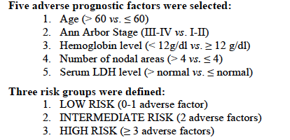
Neither investigators nor patients were blinded to treatment allocation.

Analysis populations
The PK evaluable population (PEP) comprised all patients with data for C_{trough} available at Cycle 7 and/or AUC available at Cycle 7. The intent-to-treat (ITT) population included all patients being randomised into study irrespective whether they received study drug or not. Treatment assignment was as randomized. All efficacy endpoints were analysed according to the ITT population.
The per-protocol (PP) population was defined as all patients in the ITT population who had been treated as randomized for at least 4 cycles of induction rituximab + chemotherapy without an event (progression or death) and without major eligibility violations (all inclusion/exclusion criteria). All the major efficacy analyses (ORR, CRR etc.) were to be repeated using the PP population.
The safety analysis population (SAP) was defined as all patients who received at least one dose of rituximab, either IV or SC. Patients were analysed as treated.

Sample size
The sample size for Stage 1 was determined on the basis of testing a pharmacokinetic hypothesis not an efficacy one.
The PK parameter of interest was the C_{trough} at the end of Cycle 7 (that is, pre-dose Cycle 8) The statistical analysis plan assumed that the coefficient of variation (CV) would be equal to 0.56 and that the true PK of rituximab SC formulation would be 5% above the rituximab IV formulation (that is, mean C_{trough} SC to be 5% above C_{trough}, IV). In this case, 50 patients in each treatment arm would be adequate in order to achieve 80% power with one-sided alpha of 0.05 (that is, 2-sided 90% confidence interval [CI]). Assuming that 20% of patients would not have valid PK data at Cycle 8 pre-dose, a total of approximately 125 patients were to be enrolled into Stage 1 of the study.
Comment: A further 280 patients are planned to be enrolled in Stage 2, giving a total of 405 subjects in the study overall.

Statistical methods
The primary endpoint (C_{trough} at the end of Cycle 7) was analysed using an analysis of covariance model, on logarithmic values of observed C_{trough}.
Response rates (ORR and CRR) at the completion of induction treatment were analyzed in frequency tables including 95% two-sided Pearson-Clopper confidence intervals (CIs) by treatment group. For the difference in response rates, 95% two-sided CIs (Hauck-Andersen) were calculated. The study protocol or statistical analysis plan did not specify any statistical testing for the difference between groups in response rate.

Participant flow
The study randomised 127 subjects, 64 to the IV arm and 63 to the SC arm. Participant flow is shown in Figure 2 and reasons for withdrawal in Table 4. A total of 13 subjects had withdrawn from the study, 11 during induction and 2 during maintenance. The analysis populations are shown in Table 5.
Figure 2. Study BO 22334 Stage 1 - Participant flow
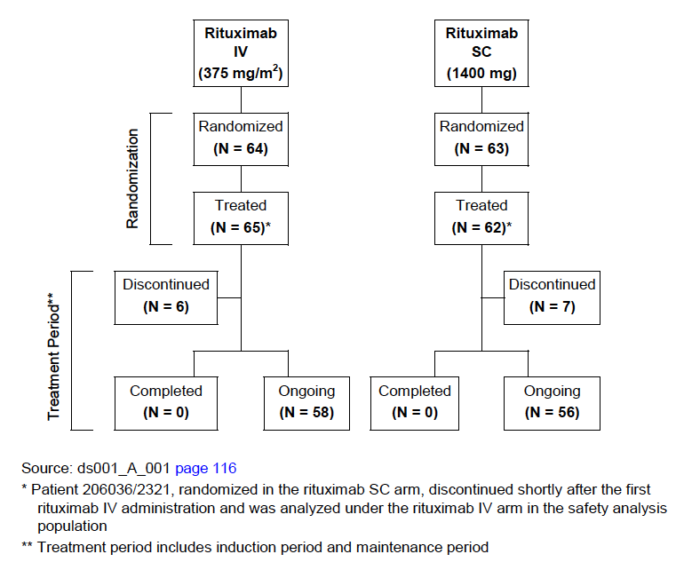
Table 4. Study BO 22334 Stage 1 - Reasons for withdrawal (Safety analysis population)
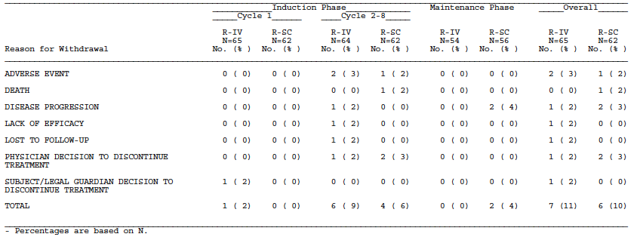
Table 5. Study BO 22334 Stage 1 - Analysis populations
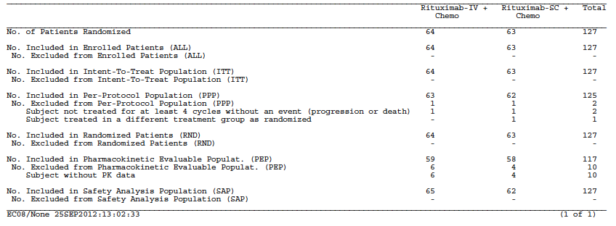

Major protocol violations/deviations
Two patients were excluded from the PP population because they did not receive at least 4 cycles of randomised treatment before experiencing disease progression. No other significant protocol violations were reported.

Baseline data
Baseline patient characteristics are shown in Table 6 and baseline disease characteristics are shown in Table 7.
Table 6. Study BO 23344 Stage 1 - Baseline patient characteristics (ITT population)
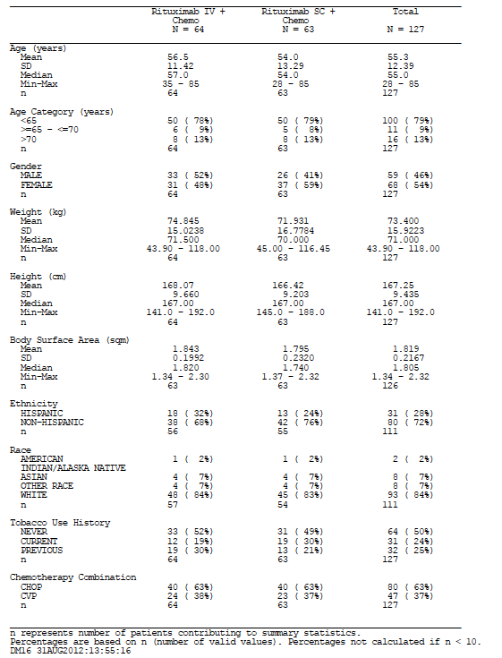
Table 7. Study BO 23344 Stage 1 - Baseline disease characteristics (ITT population)
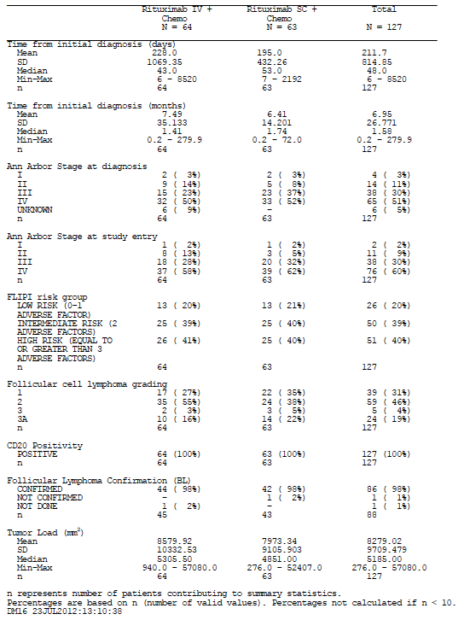
Comment: The two groups appear to have been reasonably well balanced at baseline.

Results for the primary outcome (C_{trough})
The results the PK outcomes, including C_{trough} are summarised in Table 8.
Table 8. Observed C_{trough} and AUC values at cycle 7 of induction are summarised in the following table:
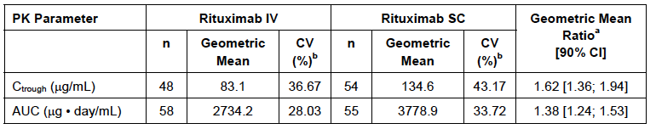
ªGeometric mean ration adjusted fpr tumour load at baseline. ^{b}CV calculated on the original scale. CV=coefficient of variation CI=confidence interval

Results for clinical efficacy outcomes
Results for the efficacy outcomes in the ITT population are summarised in Table 9. The ORR at the end of induction treatment was 90.5% (95% CI: 80.4 – 96.4) for the SC arm and 84.4% (95% CI: 73.1 – 92.2) in the IV arm. Although no statistical testing was mentioned in the study protocol, the difference between the two treatments was found to be non-significant using a Chi-squared test (p= 0.300).
Table 9. Study BO 23344 Stage 1 – Efficacy results
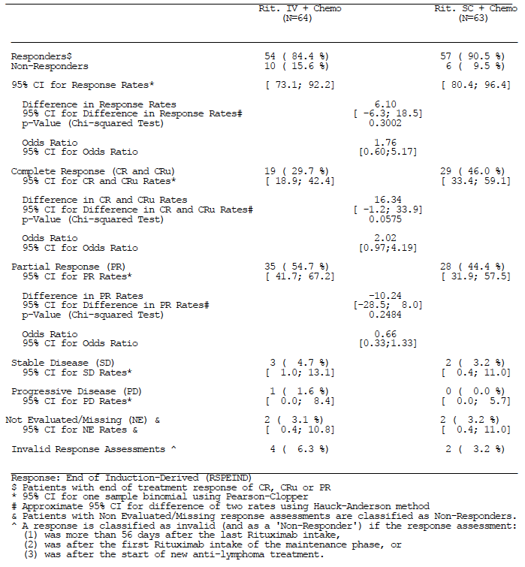
The CRR at the end of induction was 46.0% (95% CI: 33.4 – 59.1) in the SC arm and 29.7% (95% CI: 18.9 – 42.4) in the IV arm. The difference was again not significant (p = 0.058).
The protocol indicated that subgroup analyses would be conducted as exploratory analyses. The results for ORR subgroup analyses are shown in Table 10. There were no obvious differences between the two treatment arms for any subgroup analysed. The study report acknowledged that the value of these analyses was limited given the small sample sizes and wide confidence intervals obtained.
No results were presented for the per protocol population.
Table 10. Study BO 23344 Stage 1 - Subgroup analysis
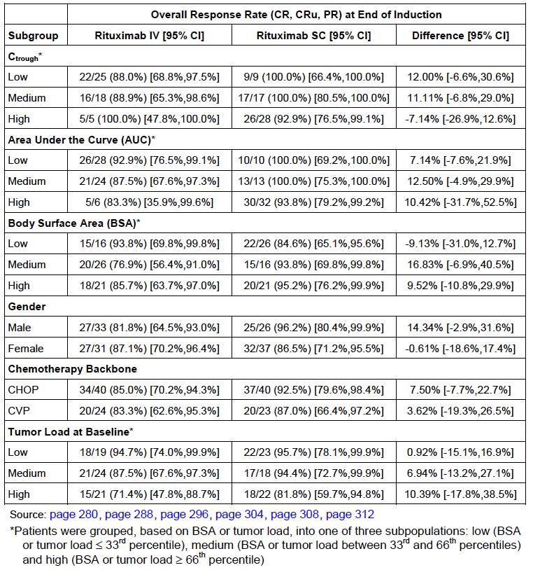

Analyses performed across trials (pooled analyses and meta-analyses)
Study BO 22334 was the only study submitted that contained clinical efficacy data and hence no pooled analysis was conducted.

Evaluator’s conclusions on efficacy
The clinical data suggest that subcutaneous and intravenous administration produce similar efficacy. However, no formal efficacy hypothesis was tested in the submitted study and hence these data should be considered supportive. The main evidence to support comparable clinical efficacy is the pharmacokinetic data described above.

Clinical safety

Studies providing safety data

Studies providing evaluable safety data

Studies in NHL patients
The following studies conducted in NHL patients (described above) provided evaluable safety data:
- Study BP 22333 Stage 1. Subjects received a single dose of 375 mg/m² IV, 375 mg/m² SC, 625 mg/m² SC or 800 mg/m² SC as part of maintenance treatment;
- Study BP 22333 Stage 2. Subjects received ongoing treatment with either 375 mg/m² IV or 1400 mg SC as part of maintenance treatment.
- Study BO 22334 Stage 1. Subjects received ongoing treatment with either 375 mg/m² IV or 1400 mg SC as part of both induction and maintenance treatment.
In these studies, the following safety data were collected:
- Information regarding general adverse events (AEs) was elicited from the patient at each study visit and during follow-up.
- Physical examination, including measurement of vital signs occurred at baseline at each study visit and during follow-up.
- Haematology tests, including haemoglobin, haematocrit, white blood cell count and differential and platelet count were performed at baseline, at each study visit and during follow-up.
- Coagulation parameters (International Normalized Ratio (INR) and activated partial thromboplastin time (APTT)) were performed at baseline, at most study visits and during follow-up.
- Biochemistry tests, including sodium, potassium, creatinine, urea, calcium, phosphate (BO 22334 only), glucose (BO 22334 only), albumin, total protein, bilirubin, aspartate aminotransferase (AST), alanine aminotransferase (ALT), alkaline phosphatase, lactate dehydrogenase, gamma GT (BP 22333 only), uric acid (BP 22333 only) and C-reactive protein (BO 22334 only), were performed at baseline, at each study visit and during follow-up.
- Assays for anti-rituximab antibodies and anti-rHuPH20 antibodies were collected predose in Cycles 1 and 2, and at the 3-month and 9-month follow-up visits in BP 22333. In BO 22334, they were collected pre-dose at each cycle and then at each follow-up visit until 96 weeks after the last dose of rituximab.
- Urinalysis (for pH, protein, ketones, glucose and blood) was performed in BP 22333 only, at baseline, at each study visit and during follow-up.
- Electrocardiograms (ECGs) were performed at baseline and end of study in BP 22333 and at baseline and Cycles 4 and 8 in BO 22334.
In BO 22334, left ventricular ejection fraction (LVEF) was assessed by echocardiogram or Multi Gated Acquisition (MUGA) scan at baseline, at Cycle 4 in patients receiving CHOP chemotherapy and at the end of induction.

Study in CLL patients
Study BO 25341 (the SAWYER study) is an ongoing, two part, randomised, open label, parallel group, multicenter, Phase Ib study in patients with previously untreated chronic lymphocytic leukaemia (CLL). This study is described below.

Study BO 25341
A complete study report was not provided for this study. The Clinical Summary of Safety in Module 2 gave a brief description of the study design and a summary of the safety findings, and Module 5 of the submission included individual patient narratives for those subjects who died, experienced a serious adverse event or experienced an adverse event that resulted in withdrawal.

Study design, objectives, locations and dates
The study is an ongoing two-part, randomized, open-label, parallel-group, multi centre, Phase Ib study. The study was designed to demonstrate that SC rituximab administration results in C_{trough} levels that are non-inferior to those obtained with rituximab IV administration. A study schema is shown in Figure 3. The data provided in the submission were from Part 1 of the study only.
Figure 3. Study BO 25341 - Study design
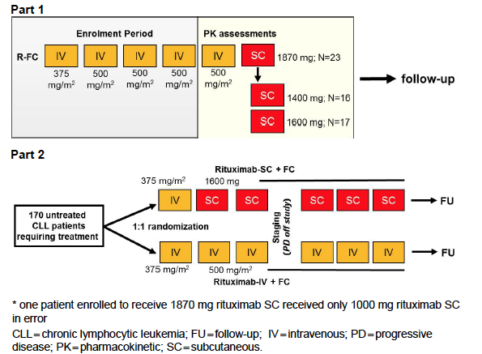
The cut-off for the safety data included in this submission was 4 April 2012. Other details of the study dates and locations were not provided.

Inclusion and exclusion criteria
Eligible patients were those with previously untreated CLL.

Study treatments
In Part 1 of the study, subjects received different SC doses of rituximab with the aim of selecting a dose of rituximab SC that would result in Ctrough values comparable to those achieved with the standard rituximab IV dose for CLL administered on a BSA-adjusted basis.
Patients could be enrolled at any point during their treatment with rituximab IV in combination with fludaribine and cyclophosphamide chemotherapy (FC), prior to commencement of Cycle 5 of treatment. At Cycle 5, patients received rituximab IV 500 mg/m² (with FC). At Cycle 6, patients received rituximab SC (1400 mg, 1600 mg, or 1870 mg) with FC.
In Part 2 of the study subjects would be randomised (1:1) to receive IV or SC treatment.

Safety variables and outcomes
The safety variables examined were:
- Adverse events;
- Physical examination and vital signs;
- Standard laboratory assessments (not further defined);
- ECGs.

Participant flow
A total of 64 subjects were enrolled. Five subjects discontinued treatment prior to Cycle 5. Three further patients were withdrawn after receiving Cycle 5 and hence did not receive SC rituximab in Cycle 6.
Three SC doses were studied; 1870 mg (n = 22), 1600 mg (n = 17) and 1400 mg (n = 16). One subject received 1000 mg in error.

Baseline data
Baseline demographics are shown in Table 11 and baseline disease characteristics in Table 12.
Table 11. Study BO 25341 - Baseline demographics
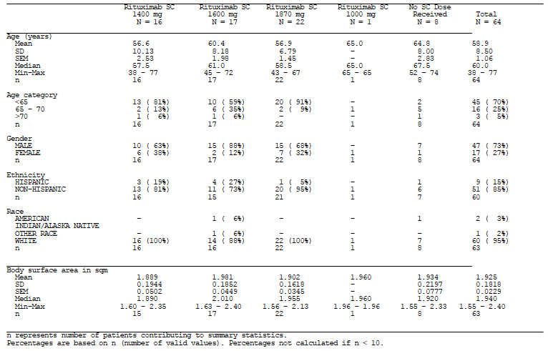
Table 12. Study BO 25341 - Baseline disease characteristics
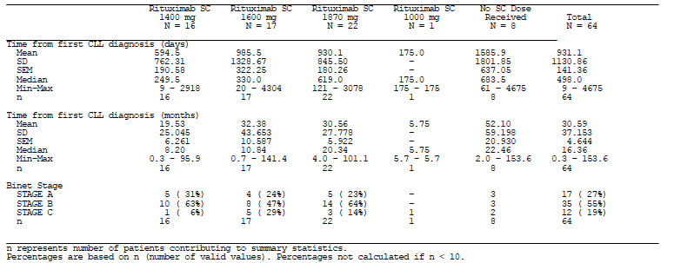

Results for safety outcomes
The safety findings are described below.

Patient exposure
Total exposure to rituximab (SC or IV) in the submitted studies is summarised in Table 13. The exposure to SC rituximab by the number of cycles received is summarised in Table 14. A total of 461 subjects received rituximab in the submitted studies and 303 of these received the drug subcutaneously.
Comment: According to the IV dosage regimens currently approved for NHL in Australia (Table 15), subjects can receive up to 8 cycles of rituximab during induction and up to a further 8 cycles during maintenance (a dose every 3 months for 2 years), giving a total possible treatment duration of 16 cycles. If the SC route of administration is approved, subjects will receive the first cycle IV and then up to 15 cycles of SC treatment.
As shown in Table 14, only 4 subjects received 12 cycles and 2 subjects received 13 cycles of SC rituximab. No subjects received 14 or 15 cycles. Of the 303 subjects who received SC rituximab, 123 received only 1 cycle.
Table 13. Total safety exposure in submitted studies
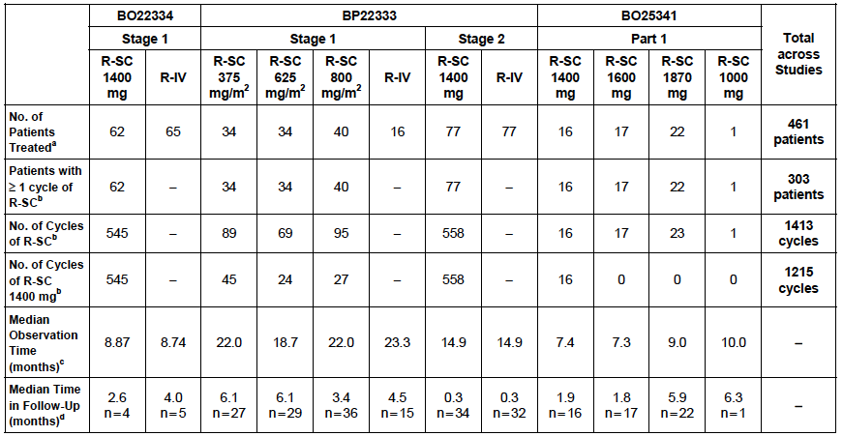
Table 14. Total exposure to SC administration in submitted studies
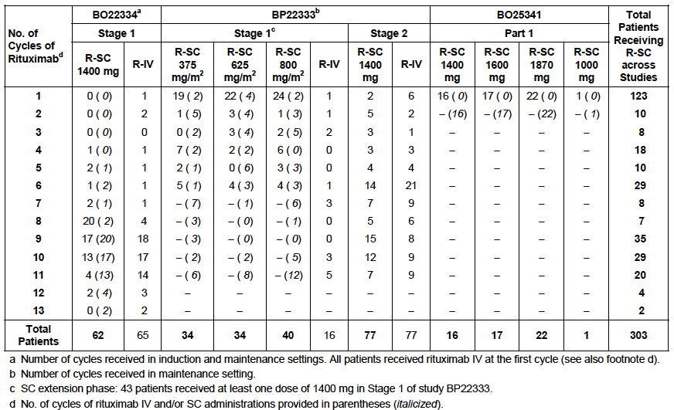
Table 15. Currently registered IV dosage regimens in NHL
Indication | Induction Treatment |  |  | Maintenance Treatment
Previously untreated stage III/IV follicular B-cell NHL | with chemotherapy | 375 mg / m²  each cycle | 8 cycles | monotherapy | Currently approved:  375 mg / m² every 3 months | Until PD or  2 yrs max
Relapsed or refractory low grade or follicular B-cell NHL | monotherapy | 375 mg / m²  weekly | 4 weeks | monotherapy | 375 mg / m² every 3 months | Until PD or  2 yrs max
 | with CHOP chemotherapy | 375 mg / m²  each cycle | 6 cycles | monotherapy | 375 mg / m² every 3 months | Until PD or  2 yrs max
Previously untreated diffuse large B-cell NHL | with CHOP chemotherapy | 375 mg / m²  each cycle | 8 cycles | - | - | -
NHL = Non-Hodgkin’s Lymphoma; PD = progressive disease

Adverse events
The most informative safety data come from Studies BP 22333 Stage 2 and BO 22334 Stage 1. These studies both involved a randomised, head-to-head comparison of the currently approved IV regimen and the proposed SC regimen with both given as repeated cycles. The following review of adverse events (AEs) will therefore focus on these two studies. The other studies (BP 22333 Stage 1 and BO 25341) involved single-dose administration of alternative SC regimens and are therefore less informative.
An overview of the safety findings from the two studies is shown in Table 16.
Table 16. Studies BP 22333 Stage 2 and BO 22334 Stage 1 - Overall safety profile
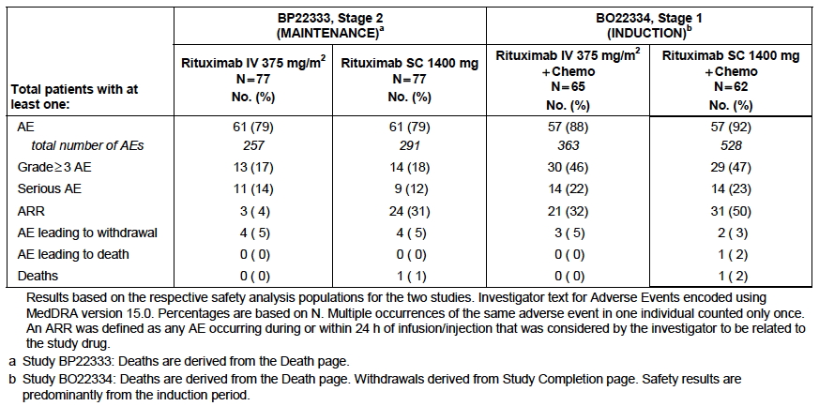

All adverse events (irrespective of relationship to study treatment)

Study BP 22333 stage 2
In Study BP 22333 Stage 2, the percentage of patients who experienced an AE was 79% in both treatment arms. However the total number of AEs was increased in the SC arm (291 versus 257 AEs). Table 17 shows the common AEs (those occurring in >5% in either treatment arm).
The SC arm was associated with a notably increased incidence of “administration-related reactions (ARR)”. ARRs are discussed further under Treatment-related adverse events (adverse drug reactions).
Other individual AEs that were more common with SC administration were headache (10% versus 3%), diarrhoea (8% versus 3%), neutropaenia (6% versus 3%) and injection site pain (5% versus 0%). A number of common individual AEs were more frequent in the IV arm.
Table 17. Study BP 22333 Stage 2 - Common AEs (occurring in at least 5% of subjects in either arm)
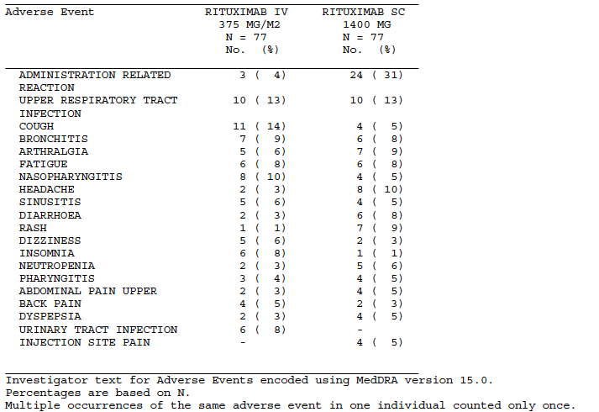

Study BO 22334 stage 1
The proportion of patients who experienced AEs was slightly higher in the SC arm (92% versus 88%). The total number of AEs was also higher in the SC arm (528 versus 363). Common AEs (those occurring in >2% in either treatment arm) are shown in Table 18.
The SC arm experienced an increased incidence of injection site events - erythema (15% versus 0%), oedema (5% versus 0%), pain (5% versus 0%), rash (3% versus 0%) and swelling (3% versus 0%) as well as an increased incidence of skin AEs – erythema (16% versus 3%), pruritus (10% versus 6%) and rash (11% versus 3%).
Other AEs that were notably increased in the SC arm included asthenia (23% versus 15%), fatigue (10% versus 5%), myalgia (11% versus 2%), dyspepsia 13% versus 0%), febrile neutropaenia (10% versus 3%) and headache (16% versus 8%).
Table 18. Study BO 22334 Stage 1 - Common AEs (occurring in at least 2% of subjects in either arm)
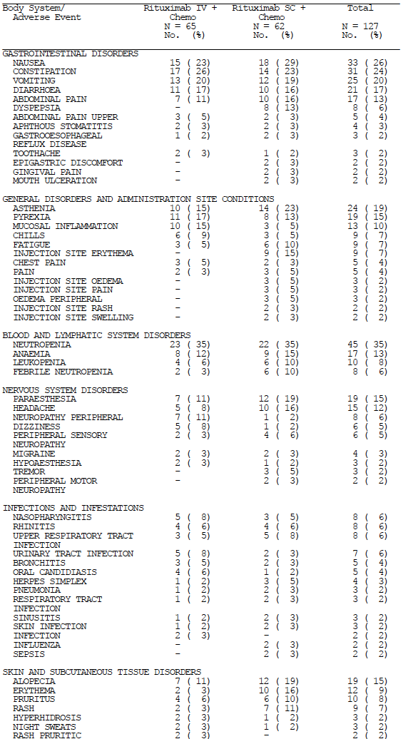
Continued next page.
Table 18 (continued) - Study BO 22334 Stage 1 - Common AEs (occurring in at least 2% of subjects in either arm)
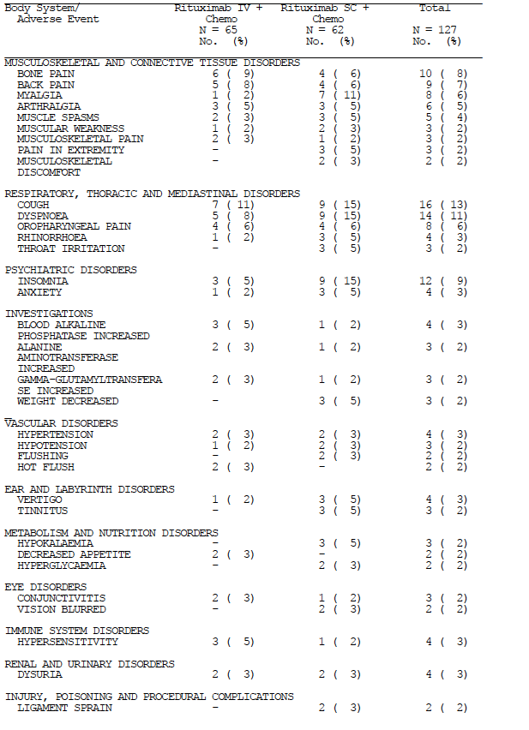

Other studies
In BP 22333 Stage 1, patients received a single SC dose of rituximab before reverting to IV treatment. The only meaningful data on AEs therefore comes following the single SC dose. The most relevant cohorts were Cohort A (the standard 375 mg/m² IV dose) and Cohort D (800 mg/m² SC dose which approximates the proposed SC dose). The incidence of ARRs was higher in Cohort D compared to Cohort A (23% versus 6%). Otherwise there were no notable differences between the two cohorts.
In the extension phase, 16 subjects in Cohort D elected to complete their maintenance treatment with SC dosing. The pattern of AEs in this group during the extension phase was similar to that seen in other studies.
In BO 25341, subjects received rituximab 500 mg/m² IV at Cycle 5 and then SC rituximab (various doses) at Cycle 6. The sponsor presented tabulations of AEs occurring in Cycles 5 and 6 to enable comparison. The incidence of AEs was higher with SC administration (64% versus 54%) as was the total number of AEs (81 versus 55). Injection site events (pain, erythema etc.) accounted for much of the difference (16 versus 0 events). The pattern of AEs was otherwise similar in the two cycles.

Grade 3 or higher AEs

Study BP 22333 stage 2
The incidence of Grade 3 or higher AEs was comparable in the two groups (17% versus 18%) as was the total number of such AEs in each group (19 versus 17). In terms of individual AEs, the only notable difference between the two treatment arms was that there were three Grade 3 or higher neoplasms in the SC arm (1 breast cancer, 1 melanoma, 1 thyroid adenoma) compared with none in the IV arm.

Study BO 22334 stage 1
The proportion of patients experiencing Grade 3 or higher toxicity was comparable in the two treatment arms (46% versus 47%). However, the total number of Grade 3+ AEs was higher in the SC arm (72 versus 41).
Patients in the SC arm experienced an increased number of haematological Grade 3+ AEs (33 versus 19). The remainder of the excess number of Grade 3+ AEs was spread out across various body systems.

Other studies
In BP 22333 Stage 1, the incidence of Grade 3+ toxicity after the single dose was comparable in Cohorts A and D. In the extension phase, no Grade 3+ toxicity was recorded in Cohort D patients.
In BO 25341 the incidence of Grade 3+ AEs following SC administration (Cycle 6) was lower than that following IV administration (Cycle 5) – 20% versus 32%.

Treatment-related adverse events (adverse drug reactions)

Study BP 22333 stage 2
The proportion of patients who experienced treatment-related AEs was increased in the SC arm (48% versus 25%). There were a total of 82 treatment related AEs in the SC arm and 44 in the IV arm.
An ARR was defined as any event that occurred during or within 24 hours of treatment and considered to be related to rituximab by the study investigator. The incidence of ARRs was increased in the SC arm (31% versus 4%). The most common ARRs were skin erythema, injection site erythema, myalgia, pain and swelling.
Other individual treatment-related AEs that occurred in more than one patient in the SC arm, and were more common in the SC arm compared to the IV arm were:
- Bronchitis (6% versus 1%);
- Nasopharyngitis (3% versus 0%);
- Pneumonia (3% versus 1%);
- Lower respiratory tract infection (3% versus 1%);
- Nausea (3% versus 0%);
- Injection site pain (5% versus 0%);
- Rash (3% versus 0%);
- Pneumonitis (3% versus 0%);
- Neutropaenia (5% versus 3%).

Study BO 22334 stage 1
The percentage of patients experiencing treatment-related AEs was again increased in the SC arm (73% versus 46%). The total number of treatment-related AEs was also higher (157 versus 67).
The incidence of ARRs was increased in the SC arm (50% versus 32%). The most common ARRs associated with SC administration were injection site erythema, skin erythema, pruritus and rash.
Another notable treatment-related AE that occurred more frequently in the SC arm was neutropaenia (23% versus 9%).

Other studies
In BP 22333 Stage 1, the incidence of ARRs was higher in Cohort D (23%) than in Cohort A (6%) after the single dose. There were also 2 cases of related application site erythema in Cohort D and none in Cohort A.
A tabulation of treatment-related AEs was not presented for BO 25341.

Deaths and other serious adverse events

Study BP 22333 stage 2
There was one death in the SC arm, in a patient who developed progressive disease and died 234 days after her last dose. The death was not considered related to SC rituximab. There were no deaths in the IV arm.
The incidence of serious AEs (SAEs) was comparable in the two groups (14% versus 12%) as was the total number of such AEs in each group (11 versus 10). There was no excess in the incidence of any individual serious AE in the SC arm.

Study BO 22334 stage 1
Deaths: One patient in the rituximab SC arm died as a result of myocardial infarction following Cycle 5; the death was considered unrelated to study drug. Another patient in the rituximab SC arm died due to disease progression following her withdrawal from the study on Day 273. No patient died in the rituximab IV arm.
SAEs: The incidence of SAEs was comparable in the two groups (22% versus 23%). The total number of serious AEs was increased in the SC arm (33 versus 21). Febrile neutropaenia was more common in the SC arm (10 versus 3 events). Otherwise there was no notable excess in the incidence of any individual serious AE in the SC arm.

Other studies
There were no deaths in BP 22333 Stage 1 either after the single dose or in the extension phase. After the single dose, there was one SAE in Cohort A (angina) and one in Cohort A (appendicitis). In the extension phase no patient in Cohort D experienced an SAE.
One patient died in BO 25341 (unknown cause). The death occurred before the patient received any SC rituximab. Two patients experienced SAEs with IV administration in Cycle 5 (1 febrile neutropaenia and 1 upper respiratory tract infection) and two patients with SC administration in cycle 6 (1 diarrhoea and 1 cholecystitis).

Discontinuation due to adverse events

Study BP 22333 stage 2
The incidence of discontinuations due to AEs was comparable in the two groups (5% versus 5%) as was the total number of such AEs in each group (4 versus 4). There were two patients discontinued to neoplasms in the SC group (1 breast cancer and 1 melanoma) compared to none in the IV arm. Interestingly there were 3 patients discontinued because of cytopaenias in the IV group versus none in the SC group.

Study BO 22334 stage 1
The incidence of discontinuations due to AEs was comparable in the two groups (5% versus 3%) as was the total number of such AEs in each group (5 versus 2).

Other studies
In BP 22333 Stage 1, one patient was discontinued from Cohort D after the single dose. The patient was diagnosed with a squamous cell carcinoma of the lung that was considered unrelated to rituximab. No patient in Cohort A was discontinued due to an AE.
Data on discontinuations due to AEs were not presented for BO 25341.

Laboratory tests

Liver function

Study BP 22333 stage 2
The study report for BP 22333 Stage 2 included shift tables for grades of toxicity for each of the liver function parameters tested. There were no notable differences between treatment arms in the incidence of shifts in grade of toxicity for any LFT variable.

Study BO 22334 stage 1
Shift tables for grades of toxicity did not demonstrate any notable differences between treatment arms for the LFTs tested (AST, ALT, alkaline phosphatase and bilirubin). No subject developed Grade 3/4 toxicity for any parameter.

Other studies
There were no notable changes in LFTs in BP 22333 Stage 1.

Kidney function

Study BP 22333 stage 2
In the IV arm, 6 subjects had an increase in creatinine (3 from Grade 0 to Grade 1 and 3 from Grade 1 to Grade 2). In the SC arm, 7 subjects had an increase in creatinine (all from Grade 0 to Grade 1). No subjects developed Grade 3 or 4 creatinine abnormalities. Results for urea were not reported.

Study BO 22334 stage 1
One subject in the SC arm developed a Grade 3 creatinine increase, compared to none in the IV arm. There were no Grade 4 increases.

Other studies
There were no notable changes in creatinine in BP 22333 Stage 1.

Other clinical chemistry

Study BP 22333 stage 2
There were no notable differences between treatment arms in the incidence of shifts in grades of toxicity for sodium, potassium, calcium or uric acid.

Study BO 22334 stage 1
There were no notable differences between treatment arms in the incidence of shifts in grades of toxicity for sodium, potassium, calcium, phosphate or glucose.

Other studies
In BP 22333 Stage 1, there were increases in uric acid from Grade 0 at baseline to Grade 3 at end of treatment in all the SC cohorts (7, 6 and 6 patients in Cohorts B through D, respectively). There were no similar shifts for Cohort A. Otherwise there were no notable abnormalities.

Haematology

Study BP 22333 stage 2
The study report for BP 22333 Stage 2 included shift tables for grades of toxicity for each of the haematology variables tested. There were no notable differences between treatment arms in the incidence of any haematological toxicity.

Study BO 22334 stage 1
Newly occurring Grade 3 and 4 haematology laboratory abnormalities are summarised in Table 19. There was a modestly increased incidence of Grade 3/4 lymphopaenia and leukopaenia in the SC arm.
Table 19. Study BO 22334 Stage 1 – Newly occurring Grade ≥ 3 haematology laboratory abnormalities
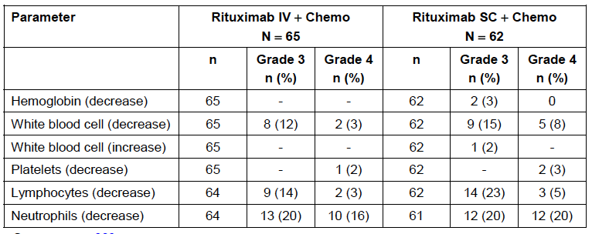

Other studies
There were no remarkable findings on laboratory haematology testing in BP 22333 Stage 1.

Anti-rituximab antibodies

Study BP 22333 stage 2
One subject in the SC arm had a positive test for anti-rituximab antibodies. Testing was positive both at baseline and during the study. No patient in the IV arm had a positive test.

Study BO 22334 stage 1
Two subjects in each of the IV and SC groups had a positive test for anti-rituximab antibodies at some point after baseline. For one subject in each group the test had also been positive at baseline.
The other two patients (one in each treatment arm) had a positive result following negative results at baseline. According to the sponsor the PK profiles for these 2 patients were within the expected range.

Other studies
In BP 22333 Stage 1 no subject had a positive test. In BO 25341 one patient developed a positive test, 6 months after completion of treatment. The PK profile for this patient showed lower than expected levels during cycle 6 but a complete response was achieved.
Comment: As noted in the relevant EMA guideline⁽²⁾, SC administration of a therapeutic protein is considered to be more immunogenic than IV administration. The results of antibody testing in the submitted studies did not suggest a notable increase in immunogenicity with SC administration of rituximab.

Anti-rHuPH20 antibodies

Study BP 22333 stage 2
Five subjects in the SC arm had positive testing for antibodies against rHuPH20 at baseline and at later time points. One additional subject had negative testing at baseline, a positive test at Day 22 and a negative test at Day 57. None of the positive samples tested positive for neutralising antibodies.

Study BO 22334 stage 1
At baseline, 10.6% of subjects had a positive screening assay for anti-rHuPH20 antibodies.
During the course of the study, the number of patients with a positive screening assay ranged between 9 − 17% in the rituximab IV arm and 4 − 8% in the rituximab SC arm. None of the samples tested positive for neutralizing antibodies.

Other studies
In BP 22333 Stage 1 only one patient had a negative test at baseline and subsequently developed a positive test. At baseline, 6% of subjects had a positive test. In BO 25341 10.7% of subjects had a positive test at some stage during the study. Again none of the subjects tested positive for neutralising antibodies.

Electrocardiograph

Study BP 22333 stage 2
ECGs were recorded at screening, Day 1 and then at the end of the study. Only 3 of 154 subjects had had an end of study ECG (IV = 2, SC = 1), with no new abnormalities detected.

Study BO 22334 stage 1
ECGs were recorded at baseline, after Cycle 4 of induction and after Cycle 8 of induction. One patient (out of 62) in the SC arm had a clinically significant ECG abnormality after Cycle 4, compared with none in the IV arm. One patient (out of 59) in the IV arm had a clinically significant ECG abnormality after Cycle 8, compared with none in the SC arm. The nature of these abnormalities was not discussed.

Other studies
No data were available from Study BO 25341.

Left ventricular ejection fraction

Study BO 22334 stage 1
There were no differences between the IV and SC arms in mean LVEF at baseline, at Cycle 4 or at the end of induction. There was no notable decrease in LVEF from baseline in either group.

Vital signs

Study BP 22333 stages 1 and 2
There were no differences between the IV and SC arms in changes in blood pressure, pulse rate, temperature, weight or ECOG performance status.

Study BO 22334 stage 1
Similarly, in BO 22334 Stage 1, there were no differences between the IV and SC arms in changes in blood pressure, pulse rate, temperature, weight or ECOG performance status.

Other studies
No data were available from Study BO 25341.

Urinalysis

Study BO 22334 stage 1
In BO 22334 Stage 1 there were no notable differences between the SC and IV treatment arms in urinalysis parameters.

Immunoglobulin levels

Study BO 22334 stage 1
There were no differences between the SC and IV arms in median immunoglobulin levels (IgG, IgA and IgM) at baseline, at the end of induction and during the first two cycles of maintenance.

Postmarketing experience
There were no postmarketing data included in the submission.

Safety issues with the potential for major regulatory impact

Liver toxicity
Laboratory testing of liver function in the submitted studies did not demonstrate any evidence of hepatic toxicity with SC dosing.

Haematological toxicity
Rituximab is given in conjunction with cytotoxic chemotherapy during induction treatment for NHL and hence haematological toxicity is not uncommon. Study BO 22334 Stage 1 raises the possibility of increased haematological toxicity with SC administration and this is discussed further below.

Serious skin reactions
Cases of toxic epidermal necrolysis and Stevens-Johnson syndrome have been reported with rituximab and these events are listed in the product information. No cases were reported in the studies included in this submission.

Cardiovascular safety
The currently approved product information for rituximab notes that cardiovascular AEs have been associated with the drug (hypotension, angina, cardiac arrhythmias). The safety data submitted with the current application did not suggest an increased risk of these events with SC administration.

Unwanted immunological events
Antibodies to rituximab or rHuPH20 developed in a small proportion of patients. These did not appear to be associated with adverse outcomes.

Other safety issues

Safety in special populations

Patients with low BSA
For each of BP 22333 Stage 2 and BO 22334 Stage 1, the sponsor presented an analysis of the incidence of AEs etc. according to subject BSA. These are summarised in Tables 20 and 21, respectively.
Table 20. Study BP 22333 Stage 2 – AEs by BSA
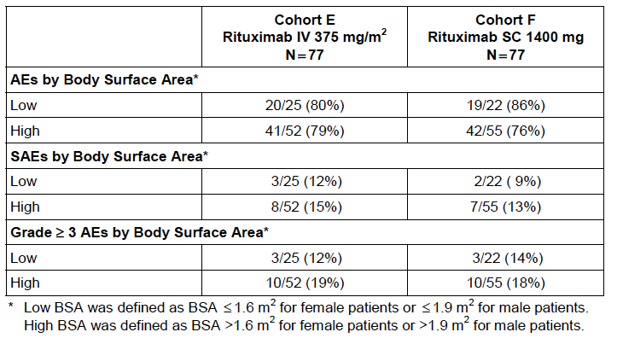
Table 21. Study BO 22334 Stage 1 – AEs by BSA
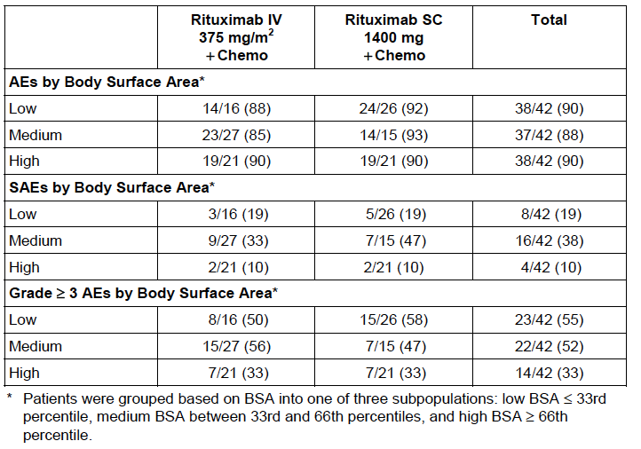
In BP22333 Stage 2, in the subpopulation of subjects with low BSA, there was a modestly increased incidence of AEs in the SC group (86% versus 80%). However, the incidence of SAEs or Grade 3+ AEs was not increased.
In BO 22334 Stage 1, there was a slightly increased incidence of AEs in the SC group (92% versus 88%) in the low BSA subpopulation. There was no increase in the incidence of SAEs (19% versus 19%) but there was an increased incidence of Grade 3+ AEs (58% versus 50%).

Evaluator’s conclusions on safety
In both of the randomised, repeated dose studies the SC regimen/product was associated with some increase in toxicity compared to the IV regimen.
Although the proportion of patients who developed AEs was comparable with SC and IV administration, the total number of AEs was increased with the SC route (291 versus 257 events and 528 versus 363 events). The additional AEs were mainly administration related events (ARRs), that is events that occurred in the first 24 h and were considered to be related by the investigators. Typically these consisted of injection site events (such as erythema and pain) and skin events (for example erythema). ARRs were typically Grade 1 or 2 in severity.
The proportion of subjects who developed Grade 3+ AEs was comparable with SC and IV administration in both studies. However, in BO 22334 Stage 1, where rituximab was administered in conjunction with chemotherapy during induction, the total number of Grade 3+ AEs was increased with SC administration (72 versus 41 events). There was a suggestion of increased Grade 3+ haematological toxicity with SC administration.
The proportion of patients who developed serious AEs (SAEs) was comparable with SC and IV administration in both studies. However the total number of SAEs was increased with SC administration in BO 22334 Stage 1 (33 versus 21 events), with an increased occurrence of febrile neutropaenia (10 versus 3 events).
SC administration was not associated with an increased incidence of fatal AEs or AEs leading to discontinuation.
Apart from the possibility of increased haematological toxicity suggested by Study BO 22334 Stage 1, there was no evidence from laboratory testing (biochemistry, urinalysis, vital signs, ECG, LVEF testing etc.) of increased toxicity with SC administration.
Antibodies to rituximab or rHuPH20 developed in a small proportion of patients. However, these did not appear to be associated with adverse outcomes. There did not appear to be an increased incidence of anti-rituximab antibodies with SC administration.
Based on the submitted clinical data, it is not possible to determine whether any of the toxicity observed with the SC route is due to the novel excipient rHuPH20.

First round benefit-risk assessment

First round assessment of benefits
The benefits of subcutaneous administration of rituximab in NHL patients are:
- A degree of efficacy comparable to that seen with IV administration;
- Increased convenience for patients, with the SC injection being given over 5 to 6 minutes, compared to an IV infusion given over a number of hours (375 mg/m² IV given at rates between 100 and 400 mg per h).
- In maintenance therapy, where rituximab is given as monotherapy, no intravenous access would be required.

First round assessment of risks
The risks of subcutaneous administration of rituximab in NHL patients are:
- Some increase in toxicity, mainly due to injection site events and skin events occurring in the first 24 h. These events were typically mild to moderate in severity (Grades 1 and 2).
- A possible increase in Grade 3 or higher/serious haematological events when rituximab is given in conjunction with chemotherapy during induction treatment.
Comment: This assessment of risks is based on a limited safety database. Of the 303 subjects treated with SC rituximab, 123 received only one cycle of treatment. No patient received a full (2 year) course of maintenance treatment.
It should be noted that the sponsor is collecting additional safety and efficacy data in Study BO 22334 Stage 2, where an additional 280 subjects will be randomised to SC or IV administration. The study will collect data during both induction and maintenance treatment.
As detailed in the ‘Adverse effects’ section of the current PI for IV rituximab, the drug has previously been associated with an increased incidence of Grade 3 and 4 leukopaenia and neutropaenia when given in combination with chemotherapy, compared to chemotherapy alone.

First round assessment of benefit-risk balance
The benefits of SC administration over IV administration are limited to patient convenience, with no demonstrated efficacy advantage.
These benefits come at a cost of some increase in toxicity in terms of administration related reactions. Also, one of the submitted studies suggests that there may be some exacerbation of chemotherapy induced myelosuppression associated with the SC route. The increased myelosuppression may be a manifestation of the greater systemic rituximab exposure obtained with SC administration compared to IV administration. Previous studies in NHL and CLL have shown that IV rituximab in combination with chemotherapy is associated with an increased incidence of Grade 3 and 4 leukopaenia and neutropaenia compared with chemotherapy alone. In these studies, the additional toxicity produced by rituximab was outweighed by an efficacy benefit. No efficacy benefit has been demonstrated for SC rituximab over IV rituximab.
The safety database is also limited, especially in relation to long-term administration.
In the opinion of the clinical evaluator, an assessment of the risk-benefit balance of SC rituximab should be delayed until additional safety data are available from BO 22334 Stage 2. These additional data may clarify the issue of possible increased haematological toxicity and would provide additional evidence for safety during long term maintenance treatment.
On the available evidence it is not possible to conclude that SC administration of rituximab has a favourable risk-benefit balance.

First round recommendation regarding authorisation
It is recommended that the current application be rejected.

Clinical questions

Pharmacokinetics
Nil.

Pharmacodynamics
Nil.

Efficacy and safety
Please advise when the results of Study BO 22334 Stage 2 will be available.

References
- Guideline On The Evaluation Of Anticancer Medicinal Products In Man (CPMP/EWP/205/95/Rev.3.Corr); 2005. Available from: <http://www.tga.gov.au/pdf/euguide/ewp020595enrev3.pdf>
- Guideline On The Clinical Investigation Of The Pharmacokinetics Of Therapeutic Proteins (CHMP/EWP/89249/2004); 2007. Available from: <http://www.tga.gov.au/pdf/euguide/ewp8924904enfin.pdf>
- Davies A et al, Abstract No 1629; 54th American Society of Hematology Annual Meeting; 2012. Available from: <https://ash.confex.com/ash/2012/webprogram/Paper49521.html>
- Cheson BD, et al. Report of an International Workshop To Standardize Response Criteria for Non-Hodgkin's Lymphomas. NCI Sponsored International Working Group. J Clin Oncol. 1999; 17:1244-1253.
- Guideline on similar biological medicinal products containing monoclonal antibodies – non-clinical and clinical issues (EMA/CHMP/BMWP/403543/2010); 2012. Available from: <http://www.ema.europa.eu/docs/en_GB/document_library/Scientific_guideline/2012/06/WC500128686.pdf>
- O’Brien S et al. Rituximab dose-escalation trial in chronic lymphocytic leukemia. J Clin Oncol. 2001; 19(8): 2165-2170.

Therapeutic Goods Administration
PO Box 100 Woden ACT 2606 Australia
Email: info@tga.gov.au Phone: 1800 020 653 Fax: 02 6232 8605
http://www.tga.gov.au

