This medicinal product is subject to additional monitoring in Australia. This will allow quick identification of new safety information. Healthcare professionals are asked to report any suspected adverse events at www.tga.gov.au/reporting-problems.
▼
AUSTRALIAN PRODUCT INFORMATION
Evrysdi® (risdiplam) powder for oral solution

NAME OF THE MEDICINE

Risdiplam.

QUALITATIVE AND QUANTITATIVE COMPOSITION

Evrysdi is available as a powder for oral solution. Each bottle is filled with 2.0 g of powder containing 60 mg of risdiplam. The powder is reconstituted to form an oral solution containing risdiplam 0.75 mg/mL

Excipients with known effect

Evrysdi contains less than 1 mmol sodium (23 mg) per dose, i.e. essentially ‘sodium-free’.
Evrysdi contains sodium benzoate and sucralose.
For the full list of excipients, see section 6.1.

PHARMACEUTICAL FORM

Powder for oral solution.

Evrysdi is supplied as a powder in an amber glass bottle.

The powder is reconstituted with purified water or water for injections to yield an oral solution containing 0.75 mg/mL of risdiplam (see section 4.2 Preparation of the powder for oral solution). The reconstituted solution is clear, greenish yellow to yellow in colour.

CLINICAL PARTICULARS

THERAPEUTIC INDICATIONS

Evrysdi is indicated for the treatment of 5q spinal muscular atrophy (SMA) in patients aged 2 months and older.

DOSE AND METHOD OF ADMINISTRATION

Evrysdi oral solution must be reconstituted by a healthcare professional prior to being dispensed.

SMA treatment should be initiated as early as possible after diagnosis.
Treatment with Evrysdi should be initiated and monitored by a specialist medical practitioner experienced in the diagnosis and management of SMA.

Evrysdi is taken orally once daily after a meal using the oral syringe provided, at approximately the same time each day.

In infants who are breastfed, Evrysdi should be administered after breastfeeding. Evrysdi cannot be mixed with formula or milk.

Dose

The recommended once daily dose of Evrysdi for SMA patients is determined by age and body weight (see Table 1).
Table 1 Dosing Regimen by Age and Body Weight
Age and Body Weight | Recommended Daily Dose
2 months to less than 2 years of age | 0.20 mg/kg
2 years of age and older weighing less than 20 kg | 0.25 mg/kg
2 years of age and older weighing 20 kg or more | 5 mg

Dose changes must be made under the supervision of a healthcare professional. Treatment with a daily dose above 5 mg has not been studied. No data are available in infants below 2 months of age.

Delayed or missed doses

Evrysdi is taken orally once daily at approximately the same time each day. If a dose of Evrysdi is missed, administer as soon as possible if still within 6 hours of the scheduled dose. Otherwise, skip the missed dose and take the next dose at the regularly scheduled time the next day.

If a dose is not fully swallowed or vomiting occurs after taking a dose of Evrysdi, do not administer another dose to make up for the incomplete dose. Wait until the next day to administer the next dose at the regularly scheduled time.

Preparation of the powder for oral solution by a healthcare professional

Refer to the “Instructions for Reconstitution” provided in the pack.

Caution should be exercised during handling. Avoid inhalation and avoid direct contact with skin or mucous membranes with the dry powder and the reconstituted solution.

Wear disposable gloves during reconstitution and while wiping the outer surface of the bottle/cap and cleaning the working surface after reconstitution. If contact occurs, wash thoroughly with soap and water; rinse eyes with water.

Instructions for reconstitution:
- Gently tap the bottom of the closed glass bottle to loosen the powder.
- Remove the cap. Do not throw away the cap.
- Carefully pour 79 mL of purified water or sterile water for injections into the bottle to yield the 0.75 mg/mL oral solution.
- Hold the medicine bottle on the table with one hand. Insert the press-in bottle adapter into the opening by pushing it down with the other hand. Ensure the adapter is completely pressed against the bottle lip.
- Put the cap back on the bottle and close the bottle tightly. Ensure it is completely closed and then shake well for 15 seconds. Wait for 10 minutes. You should have obtained a clear solution. If not, shake well again for after 15 seconds.
- Write the “Discard after” date of the solution on the bottle label. (The “Discard after” date is calculated as 64 days after reconstitution, the day of reconstitution is counted as day 0). Put the bottle back in its original carton with syringes (in pouches) and “Instructions for Use – Administration” booklet.

Method of administration

Refer to the “Instructions for Use – Administration” provided in the pack.

Use the re-usable oral syringe provided to deliver the daily dose of Evrysdi. It is recommended that a healthcare professional discuss with the patient or caregiver how to prepare the prescribed daily dose prior to administration of the first dose.

For the calculation of dosing volume, the syringe markings need to be considered. Round up or round down the dose volume to the nearest graduation mark on the selected oral syringe (see Table 2).
Table 2 Selecting the Oral Syringe for the Prescribed Daily Dose of Evrysdi
Syringe Size | Dosing Volume | Syringe Markings
6 mL | 1.0 mL to 6.0 mL | 0.1 mL
12 mL | 6.2 mL to 6.6 mL | 0.2 mL

Select the correct oral syringes (6 mL or 12 mL) based on the patient’s dosage and remove the other oral syringes from the carton/dispensing pack.

Patients should take Evrysdi immediately after it is drawn up into the oral syringe. If it is not taken within 5 minutes, the dose should be discarded and a new dose should be prepared.

The patient should drink some water after taking Evrysdi to ensure the drug has been completely swallowed. If the patient is unable to swallow and has a nasogastric or gastrostomy tube, administer Evrysdi via the tube. The tube should be flushed with water after delivering Evrysdi.

Special populations

Hepatic impairment
No dose adjustment is required in patients with mild or moderate hepatic impairment (see section 5.2 Pharmacokinetics in special populations, Hepatic impairment). Evrysdi has not been studied in patients with severe hepatic impairment.

Renal impairment
The safety and efficacy of Evrysdi in patients with renal impairment have not been studied. No dose adjustment is expected to be required in patients with renal impairment (see section 5.2 Pharmacokinetics in special populations, Renal impairment).

Elderly
Evrysdi has not been studied in patients with SMA above 60 years of age (see section 5.2 Pharmacokinetics in special populations, Elderly).

Paediatric populations
The safety and efficacy of Evrysdi in paediatric patients < 2 months of age have not yet been established (see sections 5.1 Clinical trials and 5.3 Preclinical safety data; Juvenile animal studies).

CONTRAINDICATIONS

Evrysdi is contraindicated in patients with a known hypersensitivity to risdiplam or to any of the excipients.

4.4 SPECIAL WARNINGS AND PRECAUTIONS FOR USE

Embryo-fetal toxicity

Embryo-fetal toxicity has been observed in animal studies (see section 4.6 Use in pregnancy). Patients of reproductive potential should be informed of the risks and must use highly effective contraception during treatment and until at least 1 month after the last dose of Evrysdi in female patients, and 4 months after the last dose of Evrysdi in male patients (see section 4.6 Contraception in males and females).

Potential effects on male fertility

Male patients should not donate sperm while on treatment and for 4 months after the last dose of Evrysdi due to reversible effects of Evrysdi on male fertility, based on observations from animal studies (see section 4.6 Effects on fertility).

Retinal toxicity

The effects of Evrysdi on retinal structure observed in the non-clinical safety studies have not been observed in clinical studies with SMA patients. However, long-term data are still limited. The clinical relevance of these nonclinical findings in the long-term has therefore not been established (see section 5.3 Preclinical safety data, Retinal toxicity).

Type 0 or IV SMA

Patients most likely to develop type 0 or IV SMA have not been included in the clinical development program for Evrysdi. The decision to treat should be based on individualised expert evaluation of the expected benefits of treatment for that individual, balanced against the potential risk of treatment with Evrysdi. The full benefits and risks are unknown among patients diagnosed with type 0 or IV SMA.

Use in hepatic impairment

The PK, safety and tolerability of a single dose of 5 mg risdiplam were evaluated in subjects with mild or moderate hepatic impairment in a dedicated clinical study. Mild or moderate hepatic impairment had no impact on the PK of risdiplam. No dose adjustment is therefore required in patients with mild or moderate hepatic impairment. Evrysdi has not been studied in patients with severe hepatic impairment (see sections 4.2 Dose, Special populations, Hepatic impairment and 5.2 Pharmacokinetics in special populations, Hepatic impairment).

Use in renal impairment

The safety and efficacy of Evrysdi in patients with renal impairment have not been studied. A change in dose is not expected to be required for patients with renal impairment (see sections 4.2 Dose, Special populations, Renal impairment and 5.2 Pharmacokinetics in special populations, Renal impairment).

Use in the elderly

Evrysdi has not been studied in patients with SMA above 60 years of age (see sections 4.2 Dose, Special populations, Elderly and 5.2 Pharmacokinetics in special populations, Elderly).

Paediatric use

Evrysdi has not been studied in paediatric patients below the age of 2 months (see section 5.1 Clinical trials and 5.3 Preclinical safety data; Juvenile animal studies).

Effects on laboratory tests

No data available.

4.5 INTERACTIONS WITH OTHER MEDICINES AND OTHER FORMS OF INTERACTIONS

Risdiplam is primarily metabolised by flavin monooxygenase 1 and 3 (FMO1 and 3), and also by cytochrome P450 (CYP)1A1, 2J2, 3A4 and 3A7. Risdiplam is not a substrate of human multidrug resistance protein 1 (MDR1).

Effects of other medicines on Evrysdi

Co-administration of 200 mg itraconazole twice daily, a strong CYP3A inhibitor, with a single oral dose of 6 mg risdiplam did not exhibit a clinically relevant effect on the PK of risdiplam (11% increase in AUC, 9% decrease in C_{max}). No dose adjustments are required when Evrysdi is co-administered with a CYP3A inhibitor.

The potential of co-administered FMO1/3 inducers or inhibitors to affect risdiplam or M1 metabolite exposure was not investigated.

Effects of Evrysdi on other medicines

In vitro risdiplam and its major circulating metabolite M1 did not induce CYP1A2, 2B6, 2C8, 2C9, 2C19 or 3A4. In vitro risdiplam and M1 did not inhibit (reversible or Time-Dependent Inhibition) any of the CYP enzymes tested (CYP1A2, 2B6, 2C8, 2C9, 2C19, 2D6) with the exception of CYP3A.

Evrysdi is a weak inhibitor of CYP3A. In healthy adult subjects, administration of Evrysdi once daily for 2 weeks slightly increased the exposure of midazolam, a sensitive CYP3A substrate (AUC 11%; C_{max} 16%). The extent of the interaction is not considered clinically relevant and therefore no dose adjustment is required for CYP3A substrates. Based on physiologically based pharmacokinetic (PBPK) modelling, a similar magnitude of the effect is expected in children and infants as young as 2 months old.
In vitro studies have shown that risdiplam and its major metabolite are not significant inhibitors of human MDR1, organic anion-transporting polypeptide (OATP)1B1, OATP1B3, organic anion transporter 1 and 3 (OAT 1 and 3) or organic cation transporter 2 (OCT2). Risdiplam and its metabolite are, however, in vitro inhibitors of the multidrug and toxin extrusion (MATE)1 and MATE2-K transporters. The effect of coadministration of risdiplam on the pharmacokinetics of MATE1 and MATE2-K substrates in humans is unknown. Based on in vitro data, Evrysdi may increase plasma concentrations of drugs eliminated via MATE1 or MATE2-K, such as metformin and fexofenadine. If co-administration cannot be avoided, monitor for drug-related toxicities and consider dosage reduction of the co-administered drug (based on the labelling of that drug) if needed.

Concomitant administration with other SMA therapies

There is no efficacy or safety data to support the concomitant use of risdiplam and nusinersen. Efficacy data for Evrysdi treatment when used in patients that previously received SMN1 gene therapy is not available.

Concomitant use with retinotoxic drugs

The potential for synergistic effects of concomitant administration of risdiplam with retinotoxic drugs has not been studied. Therefore, caution in using concomitant medications with known or suspected retinal toxicity is recommended.

4.6 FERTILITY, PREGNANCY AND LACTATION

Effects on fertility

Male patients

Based on nonclinical findings, male fertility may be compromised while on treatment with Evrysdi. Based on observations from animal studies, the effects on sperm cells are expected to be reversible upon discontinuation of risdiplam.

Oral administration of risdiplam to rats for 4 (0, 1, 3, or 9 mg/kg/day) or 26 (0, 1, 3, or 7.5 mg/kg/day) weeks resulted in histopathological effects in the testis (degenerated spermatocytes, degeneration/atrophy of the seminiferous tubules) and epididymis (degeneration/necrosis of ductular epithelium) at the mid and/or high doses. At the high dose in the 26-week study, the testicular lesions persisted to the end of the recovery period, which corresponds, in rat, to approximately one spermatogenic cycle. The no-effect dose for adverse reproductive system effects in adult male rats (1 mg/kg/day) was associated with plasma drug exposures (unbound AUC) similar to that in humans at the Maximum Recommended Human Dose (MRHD) of 5 mg/day.

Adverse effects of risdiplam on the testis could not be fully evaluated in the monkey because the majority of monkeys tested were sexually immature. However, oral administration of risdiplam (0, 2, 4, or 6 mg/kg/day) for 2 weeks resulted in histopathological changes in the testis (increases in multinucleate cells, germ cell degeneration) at the highest dose. At the no-effect dose for testicular toxicity in monkeys, plasma exposures were approximately 1.6 times (unbound AUC) that in humans at the MRHD. Oral administration of risdiplam to post-weaning juvenile rats resulted in male reproductive toxicity (degeneration/necrosis of the testis seminiferous epithelium with associated oligo/aspermia in the epididymis and abnormal sperm parameters). The no-effect dose for adverse reproductive effects in post-weaning male juvenile rats was associated with plasma exposures approximately 2.4 times (unbound AUC) that in humans at the MRHD.

Prior to initiating treatment with Evrysdi, fertility preservation strategies should be discussed with male patients receiving Evrysdi. Male patients may consider sperm preservation, prior to treatment initiation or after a treatment-free period of at least 4 months. Male patients who wish to father a child should stop treatment with Evrysdi for a minimum of 4 months. Treatment may be re-started after conception.

Female patients

Based on nonclinical data, an impact of Evrysdi on female fertility is not expected. No effects were seen on female reproductive organs in rats and monkeys after treatment with risdiplam.

Patients of reproductive potential

Contraception in males and females

Male and female patients of reproductive potential should adhere to the following contraception requirements:
- Female patients of childbearing potential should use highly effective contraception during treatment with Evrysdi and for at least 1 month after the last dose.
- Male patients and their female partners of childbearing potential should both use highly effective contraception during treatment with Evrysdi and for at least 4 months after his last dose.

Pregnancy testing

The pregnancy status of females of reproductive potential should be verified prior to initiating Evrysdi therapy. Pregnant women should be clearly advised of the potential risk to the fetus.

Use in pregnancy - Category D

There are no clinical data from the use of Evrysdi in pregnant women. Risdiplam has been shown to be embryo-fetotoxic and teratogenic in animals. Based on the findings from animal studies, risdiplam crosses the placental barrier and may cause fetal harm.

Oral administration of risdiplam (0, 1, 3, or 7.5 mg/kg) to pregnant rats throughout organogenesis resulted in decreased fetal body weights and increased incidences of fetal structural variations at the highest dose tested, which was not associated with maternal toxicity. The no-effect level for adverse effects on embryofetal development (3 mg/kg/day) was associated with maternal plasma exposure (unbound AUC) approximately 3 times that in humans at the maximum recommended human dose (MRHD) of 5 mg.

Oral administration of risdiplam (0, 1, 4, or 12 mg/kg) to pregnant rabbits throughout organogenesis resulted in embryofetal mortality, fetal malformations (hydrocephaly), and structural variations at the highest dose tested, which was associated with maternal toxicity. The no-effect dose for adverse effects on embryofetal development (4 mg/kg/day) was associated with maternal plasma exposure (unbound AUC) approximately 3 times that in humans at the MRHD.

In a pre- and post-natal study in rats treated daily with risdiplam, risdiplam caused a slight delay in gestation length. No adverse effects were recorded on the survival, growth, functional (behavioural or reproductive) performance of the offspring. There were no effects on female germ cells, as assessed by primordial follicle counts and ovarian histopathology.

Studies in pregnant rats showed that risdiplam crosses the placenta barrier.

Evrysdi should not be used during pregnancy unless the benefit to the mother outweighs the potential risks to the fetus. If a pregnant woman needs to be treated with Evrysdi, she should be clearly advised on the potential risk to the fetus.

Labour and delivery

The safe use of Evrysdi during labour and delivery has not been established.

Use in lactation

It is not known whether Evrysdi is excreted in human breast milk. Studies in rats show that risdiplam is excreted into milk. As the potential for harm to the nursing infant is unknown, a decision must be made with the treating physician. It is recommended not to breastfeed during treatment with Evrysdi.

4.7 EFFECTS ON ABILITY TO DRIVE AND USE MACHINES

Evrysdi has no influence on the ability to drive and use machines.

4.8 ADVERSE EFFECTS (UNDESIRABLE EFFECTS)

Clinical trials

The safety profile of Evrysdi is based on three clinical trials FIREFISH, SUNFISH, and JEWELFISH (see section 5.1 Clinical trials).

The safety profile for infantile-onset SMA patients is based on the pooled analysis of 62 patients from the FIREFISH study Part 1 and 2. FIREFISH is a two-part, open-label study that enrolled 62 patients with infantile-onset SMA between 2.2 and 6.9 months of age. Fifty-five patients received Evrysdi treatment for more than 12 months. The adverse events observed in clinical trials for infantile-onset SMA are based on the pooled analysis of patients from FIREFISH Part 1 and 2 (see Table 3).

The safety profile for later-onset SMA patients is based on the SUNFISH Part 2 study. The SUNFISH study is a two-part study with later-onset SMA between 2-25 years of age. The adverse events observed in clinical trials for later-onset SMA are based on SUNFISH Part 2 (n=180), the randomised double-blind, placebo-controlled portion of the study with a follow-up duration of at least 12 months (see Table 4). Adverse events occurring in ≥ 5% of Evrysdi treated patients which occurred ≥ 5% more frequently, or at least 2 times as frequently, as in placebo control patients, is provided in Table 4.

Tables 3 and 4 summarise the adverse events that have been reported with the use of Evrysdi in FIREFISH Part 1 and 2 and SUNFISH Part 2, regardless of causality.

The corresponding frequency category for each adverse events is based on the following convention: very common (≥1/10), common (≥1/100 to <1/10), uncommon (≥1/1,000 to <1/100), rare (≥1/10,000 to <1/1,000), very rare (<1/10,000). Adverse events from clinical trials are listed by MedDRA system organ class.

Table 3 Summary of adverse events for infantile-onset SMA patients observed in the FIREFISH study (Parts 1 and 2) with an incidence ≥ 5%
System Organ Class | Incidence  N=62  n (%) | Frequency Category
Adverse Events | Incidence  N=62  n (%) | Frequency Category
Respiratory, thoracic and mediastinal disorders:
URTI¹ | 46 (74) | Very common
Pneumonia | 20 (32) | Very common
Cough | 6 (9.7) | Common
Respiratory Failure | 4 (6.5) | Common
General disorders and administration site conditions
Pyrexia | 30 (48) | Very common
Teething | 8 (13) | Very common
Gastrointestinal disorders
Constipation | 12 (19) | Very common
Diarrhoea | 10 (16) | Very common
Vomiting | 9 (15) | Very common
Skin and Subcutaneous Tissue Disorders
Rash² | 17 (27) | Very common
Infections and infestations
Ear infection | 4 (6.5%) | Common
Urinary Tract Infection | 4 (6.5%) | Common
Viral Infections | 4 (6.5%) | Common
¹ Includes PTs upper respiratory tract infection, nasopharyngitis, respiratory tract infection, rhinitis, influenza, pharyngitis, respiratory tract infection viral, upper respiratory tract infection (bacterial and viral)
² Includes PTs rash, rash maculo-papular, erythema, dermatitis, dermatitis allergic, rash papular, folliculitis
Table 4 Summary of adverse events reported in ≥ 5% of patients treated with Evrysdi and with an incidence greater than on placebo observed in the SUNFISH study (Part 2)
System Organ Class | Evrysdi  N=120  n (%) | Placebo  N=60  n (%) | Frequency Category
Adverse Events | Evrysdi  N=120  n (%) | Placebo  N=60  n (%) | Frequency Category
General disorders and administration site conditions
Fever¹ | 26 (22) | 10 (17) | Very common
Gastrointestinal disorders
Diarrhoea | 20 (17) | 5 (8) | Very common
Nausea | 11 (9) | 3 (5) | Common
Constipation | 10 (8) | 3 (5) | Common
Abdominal pain upper | 7 (6) | 2 (3) | Common
Skin and Subcutaneous Tissue Disorders
Rash² | 20 (17) | 1 (2) | Very common
Mouth and aphthous ulcers | 8 (7) | 0 (0) | Common
Musculoskeletal and connective tissue disorders
Arthralgia | 6 (5) | 0 (0) | Common
Infections and infestations
Pneumonia | 10 (8) | 4 (7) | Common
Urinary tract infection³ | 6 (5) | 0 (0) | Common
Nervous system disorders
Headache | 24 (20) | 10 (17) | Very common
¹ Includes pyrexia and hyperpyrexia.
² Includes rash, erythema, rash maculo-papular, rash erythematous, rash papular, dermatitis allergic, and folliculitis.
³ Includes urinary tract infection and cystitis.

Safety profile in patients treated previously for SMA

In the JEWELFISH study, 76 patients previously treated with nusinersen and 14 patients previously treated with onasemnogene abeparvovec were enrolled. The safety profile of Evrysdi in the treatment of non-treatment naive patients in the JEWELFISH study is consistent with the safety profile for treatment naive SMA patients treated with Evrysdi in the FIREFISH and SUNFISH studies.

Post-marketing experience

Not applicable.

Reporting of suspected adverse reactions

Reporting suspected adverse reactions after registration of the medicinal product is important. It allows continued monitoring of the benefit-risk balance of the medicinal product. Healthcare professionals are asked to report any suspected adverse reactions at www.tga.gov.au/reporting-problems.

4.9 OVERDOSE

There is no experience with overdose of Evrysdi in clinical trials. There is no known antidote for overdose of Evrysdi. In case of overdose, the patient should be closely supervised and supportive care instituted.

For information on the management of overdose, contact the Poison Information Centre on 13 11 26 (Australia).

PHARMACOLOGICAL PROPERTIES

PHARMACODYNAMIC PROPERTIES

Mechanism of action

Evrysdi is a survival of motor neuron 2 (SMN2) pre-mRNA splicing modifier designed to treat SMA caused by mutations in chromosome 5q that lead to SMN protein deficiency. Functional SMN protein deficiency is the pathophysiological mechanism of all SMA types. Evrysdi corrects the splicing of SMN2 to shift the balance from exon 7 exclusion to exon 7 inclusion into the mRNA transcript leading to an increased production in functional and stable SMN protein. Thus, Evrysdi treats SMA by increasing and sustaining functional SMN protein levels.

In vitro and in vivo data indicate that risdiplam may cause alternative splicing of additional genes, including FOXM1 and MADD. FOXM1 and MADD are thought to be involved in cell cycle regulation and apoptosis, respectively, and have been identified as possible contributors to adverse effects seen in animals.

Risdiplam distributes evenly to all parts of the body, including the central nervous system (CNS) by crossing the blood brain barrier, and thereby leading to SMN protein increase in the CNS and throughout the body. Concentrations of risdiplam in plasma and SMN protein in blood reflect its distribution and pharmacodynamic effects in tissues such as brain and muscle.

In all clinical trials, Evrysdi led to a consistent and durable increase in SMN protein with a greater than 2-fold median change from baseline within 4 weeks of treatment initiation as measured in blood. This increase in SMN protein was sustained throughout the treatment period of up to 2 years for infantile-onset SMA and later-onset SMA patients (see section 5.1 Clinical trials).

Clinical trials

The efficacy of Evrysdi for the treatment of SMA patients with infantile-onset and later-onset SMA was evaluated in 2 pivotal clinical studies, FIREFISH and SUNFISH. The overall findings of these studies support the efficacy of Evrysdi for SMA patients. Patients with a clinical diagnosis of Type 0 and Type 4 SMA have not been studied in clinical trials.

Infantile-onset SMA

Study BP39056 (FIREFISH) is an open-label, 2-part study to investigate the efficacy, safety, PK and pharmacodynamics (PD) of Evrysdi in symptomatic Type 1 SMA patients (all patients had genetically confirmed disease with 2 copies of the SMN2 gene). Part 1 of FIREFISH was designed as the dose-finding part of the study. The confirmatory Part 2 of the FIREFISH study assessed the efficacy of Evrysdi at the therapeutic dose selected based on the results from Part 1 (see section 4.2 Dose and method of administration). Patients from Part 1 did not take part in Part 2.

FIREFISH Part 2
In FIREFISH Part 2, 41 patients with Type 1 SMA were enrolled. The median age of onset of clinical signs and symptoms of Type 1 SMA was 1.5 months (range: 1.0-3.0 months), 54% were female, 54% Caucasian and 34% Asian. The median age at enrolment was 5.3 months (range: 2.2-6.9 months) and the median time between onset of symptoms and first dose was 3.4 months (range: 1.0-6.0 months). At baseline, the median Children’s Hospital of Philadelphia Infant Test of Neuromuscular Disorders (CHOP-INTEND) score was 22.0 points (range: 8.0-37.0) and the median Hammersmith Infant Neurological Examination, Module 2 (HINE-2) score was 1.0 (range: 0.0-5.0).

The primary endpoint was the proportion of patients with the ability to sit without support for at least 5 seconds after 12 months of treatment (BSID-III gross motor scale, Item 22). The efficacy endpoints of Evrysdi treated patients were compared to similar cohorts of untreated patients with infantile-onset SMA from natural history (defined as performance criteria) as shown in Table 5.
Table 5 Summary of Key Efficacy Results at Month 12 (FIREFISH Part 2)
Efficacy Endpoints | Proportion of Patients  N=41 (90% CI)
Motor Function and Development Milestones
BSID-III: sitting without support for at least 5 seconds  p-value based on performance criterion of 5%ª | 29.3% (17.8%, 43.1%)  <0.0001
CHOP-INTEND: score of 40 or higher  p-value based on performance criterion of 17%ª | 56.1% (42.1%, 69.4%)  <0.0001
CHOP-INTEND: increase of ≥4 points from baseline  p-value based on performance criterion of 17%ª | 90.2% (79.1%, 96.6%)  <0.0001
HINE-2: motor milestone responders^{b}  p-value based on performance criterion of 12%ª | 78.0% (64.8%, 88.0%)  <0.0001
Survival and Event-Free Survival
Event-Free Survival^{c}  p-value based on performance criterion of 42%ª | 85.4% (73.4%, 92.2%)  <0.0001
Abbreviations: CI-confidence interval; BSID-III=Bayley Scales of Infant and Toddler Development, Third Edition; CHOP-INTEND=Children’s Hospital of Philadelphia Infant Test of Neuromuscular Disorders; HINE-2=Module 2 of the Hammersmith Infant Neurological Examination.
ª p-values for survival and event-free survival are based on a Z-test; p-values for all other endpoints (BSID-III, CHOP-INTEND, HINE-2) are based on an exact binomial test. Survival proportions estimated using Kaplan-Meier methodology.
^{b} According to HINE-2: ≥2 point increase [or maximal score] in ability to kick, OR ≥1 point increase in the motor milestones of head control, rolling, sitting, crawling, standing or walking, AND improvement in more categories of motor milestones than worsening is defined as a responder for this analysis.
^{c} An event is meeting the endpoint of permanent ventilation defined as tracheostomy or ≥16 hours of non-invasive ventilation per day or intubation for >21 consecutive days in the absence of, or following the resolution of, an acute reversible event. Three patients met the endpoint of permanent ventilation before Month 12. All 3 patients achieved an increase of at least 4 points in their CHOP-INTEND score from baseline.

After 12 months of treatment with Evrysdi, 29% (12/41) of patients met the criteria for sitting without support (BSID-III, Item 22), 93% (38/41) of patients were alive, and 85% (35/41) of patients were alive and event-free (without permanent ventilation) (see Figure 1). These results indicate a clinically meaningful deviation from the natural history of untreated infantile-onset SMA. Untreated patients with infantile-onset SMA would never be able to sit without support and only 25% would be expected to survive without permanent ventilation beyond 14 months of age.
Figure 1 Kaplan-Meier Plot of Event-Free Survival (FIREFISH Part 1 and Part 2)
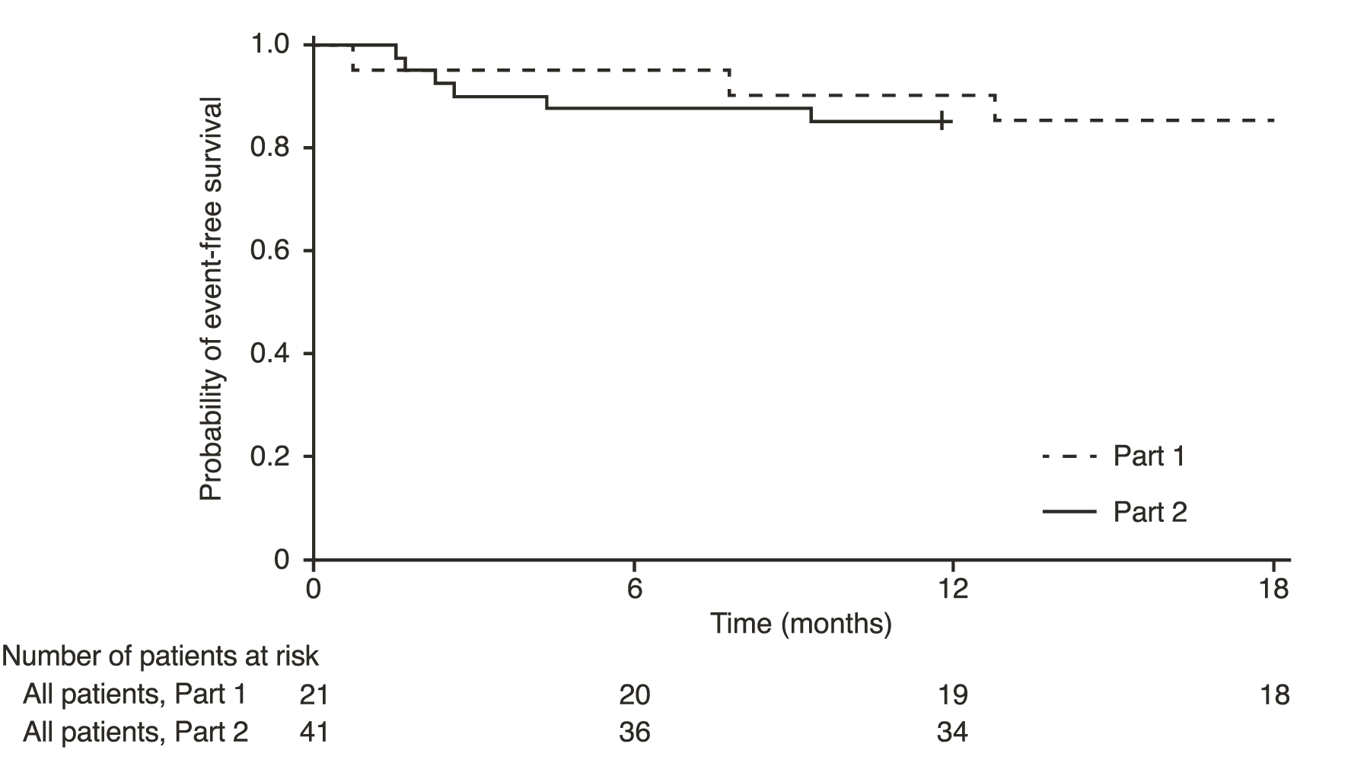
+ Censored: one patient in Part 2 was censored because they attended the Month 12 visit early

Figure 2 Mean change from baseline in CHOP-INTEND Total Score (FIREFISH Part 2)
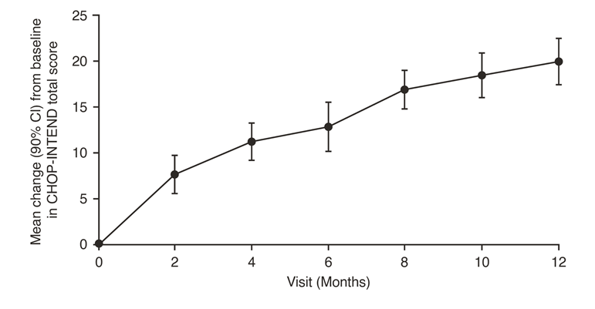

FIREFISH Part 1
The efficacy of Evrysdi in Type 1 SMA patients is also supported by results from FIREFISH Part 1. For the 21 patients from Part 1, the baseline characteristics were consistent with symptomatic patients with Type 1 SMA. The median age at enrolment was 6.7 months (range: 3.3-6.9 months) and the median time between onset of symptoms and first dose was 4.0 months (range: 2.0-5.8 months). A total of 17 patients received the therapeutic dose (dose selected for Part 2) during the first 12 months of treatment. After 12 months of treatment, 41% (7/17) of patients were able to sit independently for at least 5 seconds (BSID-III, Item 22). After 18 months of treatment, 88% (15/17) of patients were alive and event-free (without permanent ventilation) (see Figure 1). After 18 months of treatment, three patients had died during FIREFISH Part 1, see figure 1.

Later-onset SMA

Study BP39055 (SUNFISH), is a 2-part, multicentre trial to investigate the efficacy, safety, PK and PD of Evrysdi in SMA Type 2 or Type 3 patients between 2-25 years of age. Part 1 was the dose-finding portion and Part 2 was the randomised, double-blind, placebo-controlled confirmatory portion. Patients from Part 1 did not take part in Part 2.

The primary endpoint was the change from baseline score at Month 12 on the Motor Function Measure-32 (MFM32). The MFM32 has the ability to assess a wide range of motor function across a broad range of SMA patients. The total MFM32 score is expressed as a percentage (range: 0 to 100) of the maximum possible score, with higher scores indicating greater motor function. The MFM32 measures motor function abilities, which relate to important daily functions. Small changes in motor function can result in meaningful gain or loss of daily function(s).

SUNFISH Part 2
SUNFISH Part 2 is the randomised, double-blind, placebo-controlled portion of the SUNFISH study in 180 non-ambulant patients with Type 2 (71%) or Type 3 (29%) SMA. Patients were randomised 2:1 to receive either Evrysdi at the therapeutic dose (see section 4.2 Dose and method of administration) or placebo. Randomisation was stratified by age group (2 to 5, 6 to 11, 12 to 17, 18 to 25 years old).

The median age of patients at the start of treatment was 9.0 years old (range 2-25 years old) and the median time between onset of initial SMA symptoms to first treatment was 102.6 (1-275) months. Of the 180 patients included in the trial, 51% were female, 67% Caucasian and 19% Asian. At baseline, 67% of patients had scoliosis (32% of patients with severe scoliosis). Patients had a mean baseline MFM32 score of 46.1 and a Revised Upper Limb Module (RULM) score of 20.1. The overall baseline demographic characteristics were well balanced between Evrysdi and placebo groups with the exception of an imbalance of patients with scoliosis (63.3% of patients in the Evrysdi arm and 73.3% of patients in the placebo control).

The primary analysis for SUNFISH Part 2, the change from baseline in MFM32 total score at Month 12, showed a clinically meaningful and statistically significant difference between patients treated with Evrysdi and placebo. The results of the primary analysis and key secondary endpoints are shown in Table 6 and Figures 3 and 4.

Table 6 Summary of efficacy in patients with later-onset SMA at Month 12 of Treatment (SUNFISH Part 2)
Endpoint | Evrysdi  N=120 | Placebo  N=60
Primary Endpoint
Change from baseline in MFM32 total score¹ at Month 12 | 1.36 | -0.19
LS Mean (95%, CI) | (0.61, 2.11) | (-1.22, 0.84)
Difference from Placebo | 1.55
Estimate (95% CI) | (0.30, 2.81)
p-value² | 0.0156
Secondary Endpoints
Proportion of patients with a change from baseline in MFM32 total score¹ of 3 or more at Month 12 (95% CI) | 38.3%  (28.9, 47.6) | 23.7%  (12.0, 35.4)
Odds ratio for overall response (95% CI) | 2.35 (1.01, 5.44)
Adjusted p-value^{3,4} | 0.0469
Change from baseline in RULM total score⁵ at Month 12 | 1.61 | 0.02
LS Mean (95% CI) | (1.00, 2.22) | (-0.83, 0.87)
Difference from Placebo | 1.59 (0.55, 2.62)
Estimate (95% CI) adjusted p-value^{2,4} | 0.0469
Abbreviations: MFM32=Motor Function Measure-32; LS=least squares; CI=confidence interval; RULM= Revised Upper Limb Module
¹ Based on the missing data rule for MFM32, 6 patients were excluded from the analysis (Evrysdi n=115; placebo control n=59).
² Data analysed using a mixed model repeated measure with baseline total score, treatment, visit, age group, treatment-by-visit and baseline-by-visit.
³ Data analysed using logistic regression with baseline total score, treatment and age group.
⁴ The adjusted p-value was obtained for the endpoints included in the hierarchical testing and was derived based on all the p-values from endpoints in order of the hierarchy up to the current endpoint.
⁵ Based on the missing data rule for RULM, 3 patients were excluded from the analysis (Evrysdi n=119; placebo control n=58).
When compared to placebo, patients treated with Evrysdi demonstrated significant improvements in motor function assessed by the MFM32 after 12 months of treatment (mean difference 1.55 points; p=0.0156). Patients 2-5 years old treated with Evrysdi demonstrated the greatest improvement on MFM32 compared to placebo control (≥ 3 points increase: 78.1% vs 52.9%). Patients ≥ 18 years old treated with Evrysdi achieved stabilisation of disease (change from baseline MFM32 total score ≥ 0 point(s): 57.1% vs. 37.5%). Consistent improvement compared to baseline MFM32 was observed in both Type 2 and 3 SMA patients treated with Evrysdi compared to placebo control (1.54 points [95% CI: 0.06, 3.02]; 1.49 points [95% CI: -0.94, 3.93], respectively).

The study also met a secondary independent motor function outcome, RULM. On the RULM, statistically significant and clinically meaningful improvements in motor function were observed after 12 months of treatment compared to baseline. The patients 2-5 years old treated with Evrysdi demonstrated the greatest improvement on the RULM (3.41 points [95% CI: 1.55, 5.26]) and improvement was also observed in the patients ≥ 18 years old (1.74 points [95% CI: -1.06, 4.53]).
Figure 3 Mean change from baseline in total MFM32 score over 12 months in SUNFISH Part 2¹
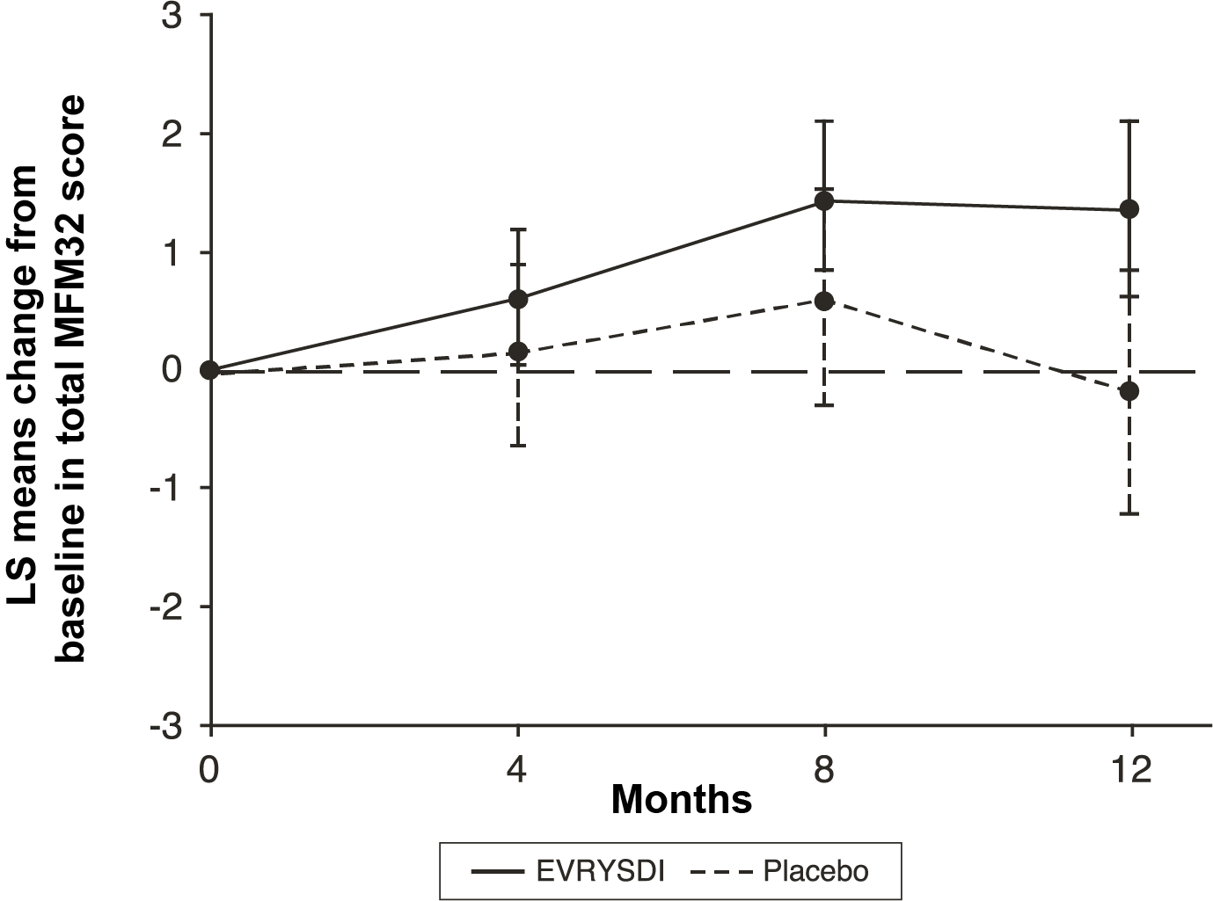
¹ The least squares (LS) mean difference for change from baseline in MFM32 score [95% CI]
Figure 4 Mean change from baseline in total RULM score over 12 months in SUNFISH Part 2¹
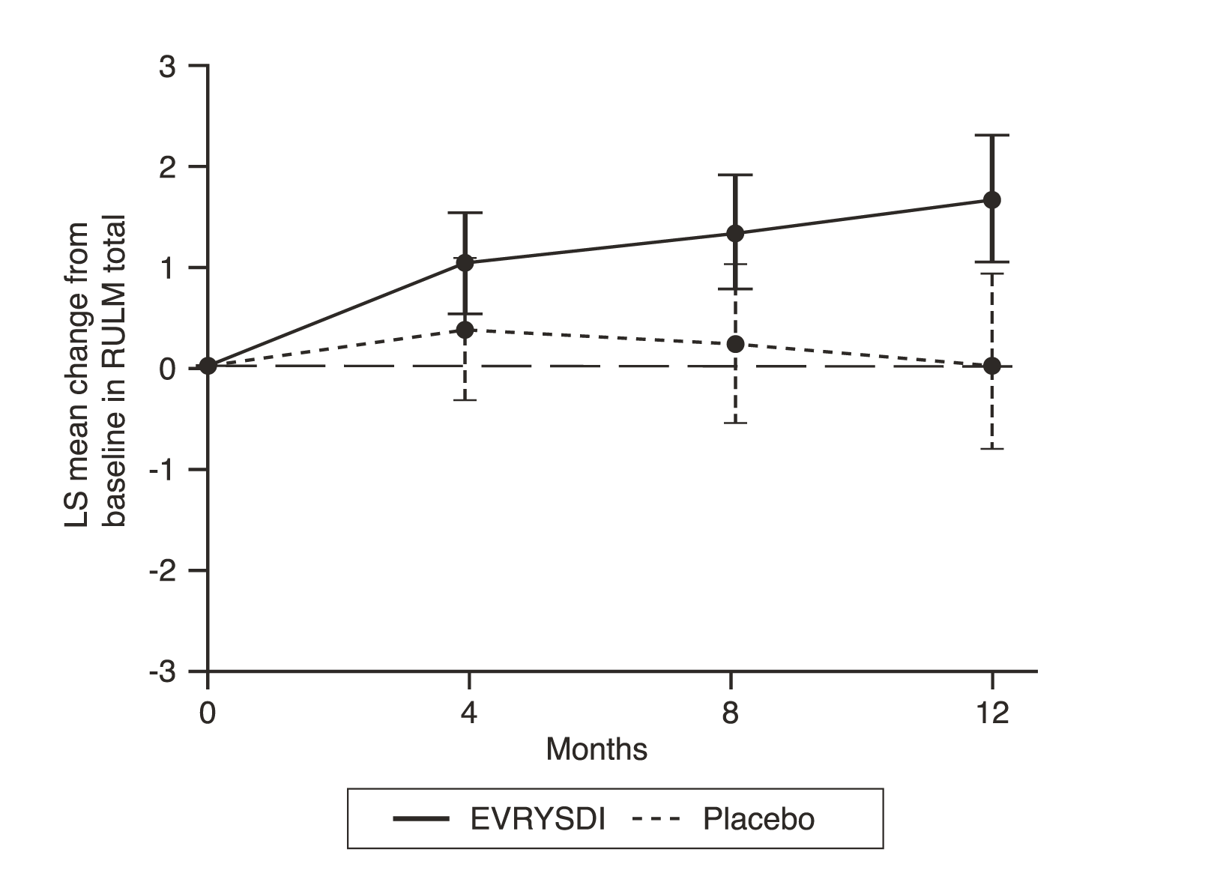
¹ The least squares (LS) mean difference for change from baseline in RULM score [95% CI]

SUNFISH Part 1
The efficacy of Evrysdi in later-onset SMA patients was also supported by results from Part 1, the dose-finding part of SUNFISH. In Part 1, 51 patients with Type 2 and 3 SMA (including 7 ambulatory patients) between 2 to 25 years old were enrolled. After 1 year of treatment at the therapeutic dose (the dose selected for Part 2), there was a clinically meaningful improvement in motor function as measured by MFM32 with a mean change from baseline of 2.7 points (95% CI: 1.5, 3.8). The improvement in MFM32 was maintained up to 2 years on Evrysdi treatment (mean change of 2.7 points [95% CI: 1.2, 4.2]).

5.2 PHARMACOKINETIC PROPERTIES

Pharmacokinetic parameters for Evrysdi have been characterised in healthy adult subjects and in patients with SMA.

After administration of Evrysdi as an oral solution, the PK of risdiplam were approximately linear between 0.6 and 18 mg. Risdiplam’s PK was best described by a population PK model with three-transit-compartment absorption, two-compartment disposition and ﬁrst-order elimination. Body weight and age were found to have significant effect on the PK.

The estimated exposure (mean AUC_{0-24h}) for infantile-onset SMA patients (age 2-7 months at enrolment) at the therapeutic dose of 0.2 mg/kg once daily was 1930 ng/mL. The estimated exposure for later-onset SMA patients (2-25 years old at enrolment) in the SUNFISH study (Part 2) at the therapeutic dose (0.25 mg/kg once daily for patients with a body weight < 20 kg; 5 mg once daily for patients with a body weight ≥ 20 kg) was 2070 ng/mL. The observed maximum concentration (mean C_{max}) was 194 ng/mL at 0.2 mg/kg in FIREFISH and 120 ng/mL in SUNFISH Part 2.

Absorption

Risdiplam was rapidly absorbed in the fasted state with a plasma t_{max} ranging from 1 to 4 hours after oral administration. In the clinical efficacy studies, risdiplam was administered with a morning meal or after breastfeeding..

Distribution

The population PK parameter estimates were 98 L for the apparent central volume of distribution, 93 L for the peripheral volume, and 0.68 L/hour for the inter-compartment clearance.

Risdiplam is predominantly bound to serum albumin, without any binding to alpha-1 acid glycoprotein, with a free fraction of 11%.

Metabolism

Risdiplam is metabolised primarily by flavin monooxygenase 1 and 3 (FMO1 and FMO3), and also by CYPs 1A1, 2J2, 3A4 and 3A7.

Co-administration of 200 mg itraconazole twice daily, a strong CYP3A inhibitor, with a single oral dose of Evrysdi 6 mg showed no clinically relevant effect on the PK of risdiplam (11% increase in AUC, 9% decrease in C_{max}).

Excretion

Population PK analyses estimated an apparent clearance (CL/F) of 2.6 L/h for risdiplam.
The effective half-life of risdiplam was approximately 50 hours in SMA patients.
Risdiplam is not a substrate of human multidrug resistance protein 1 (MDR1).

Approximately 53% of the dose (14% unchanged risdiplam) was excreted in the faeces and 28% in urine (8% unchanged risdiplam). Parent drug was the major component found in plasma, accounting for 83% of drug related material in circulation. The pharmacologically inactive metabolite M1 was identified as the major circulating metabolite.

Pharmacokinetics in special populations

Hepatic impairment

Mild and moderate hepatic impairment had no impact on the PK of Evrysdi. After administration of Evrysdi 5 mg, the mean ratios for C_{max} and AUC were 0.95 and 0.80 in mild (n=8) and 1.20 and 1.08 in moderate hepatic impaired subjects (n=8) versus matched healthy controls (n=10). The safety and PK in patients with severe hepatic impairment have not been studied.

Renal impairment

No studies have been conducted to investigate the PK of Evrysdi in patients with renal impairment. Elimination of risdiplam as an unchanged entity via renal excretion is minor (8%).

Elderly

No dedicated studies have been conducted to investigate the PK of Evrysdi in patients with SMA above 60 years of age. Patients with SMA up to 60 years of age were included in the JEWELFISH study. Subjects without SMA up to 69 years of age were included in clinical PK studies, which indicates that no dose adjustment is required for patients up to 69 years of age.

Paediatrics

Body weight and age were identified as covariates in the population PK analysis. The dose is therefore adjusted based on age (below and above 2 years) and body weight (up to 20 kg) to obtain similar exposure across the age and body weight range. No data are available in patients less than 2 months of age.

Ethnicity

The PK of Evrysdi do not differ in Japanese and Caucasian subjects.

5.3 PRECLINICAL SAFETY DATA

Genotoxicity

Risdiplam was negative in a bacterial reverse mutation assay and in the Comet assay. In the mouse TK lymphoma cell assay in vitro and in the bone marrow of rats, risdiplam increased the frequency of micronucleated cells. Micronucleus induction in bone marrow was observed in several toxicity studies in rats (adult and juvenile animals). The NOAEL across the studies is associated with an exposure similar to that in humans at the therapeutic dose. Data indicated that this effect is indirect and secondary to an interference of risdiplam with the cell cycle of dividing cells.

Carcinogenicity

A lifetime carcinogenicity study in rats with risdiplam has not yet been completed. A 26 week carcinogenicity study with risdiplam (oral, up to 9 mg/kg/day) in rasH2 transgenic mice showed no tumourigenic potential in animals exposed up to 7-fold (based on total AUC) the exposure in humans at the therapeutic dose.

Retinal toxicity

Risdiplam-induced functional and structural retinal abnormalities were seen in animal studies. In a 39-week toxicity study in monkeys, oral administration of risdiplam (0, 1.5, 3, or 7.5/5 mg/kg/day; high dose lowered after 4 weeks) produced functional abnormalities on the electroretinogram (ERG) in all mid-and high-dose animals at the earliest examination time (Week 20). These findings were associated with retinal degeneration, detected by optical coherence tomography (OCT), on Week 22, the first examination time. The retinal degeneration, with peripheral photoreceptor loss, was irreversible. A no-effect dose for the retinal findings (1.5 mg/kg/day) was associated with plasma exposures (AUC) similar to that in humans at the maximum recommended human dose (MRHD) of 5 mg.

Effect on epithelial tissues

Oral administration of risdiplam to rats and monkeys resulted in histopathological changes in epithelium of the gastrointestinal (GI) tract (apoptosis/single cell necrosis), lamina propria (vacuolation), the exocrine pancreas (single cell necrosis), the skin, tongue, and larynx (parakeratosis/hyperplasia/degeneration) with associated inflammation. The skin and GI epithelial effects were reversible. The no-effect doses for effects on epithelial tissues in rats and monkeys were associated with plasma exposures (AUC) similar to that in humans at the MRHD.

Juvenile animal studies

Oral administration of risdiplam (0, 0.75, 1.5, 2.5 mg/day) to young rats from postnatal day (PND) 4 through PND 31 resulted in decreased growth (body weight, tibia length) and delayed sexual maturation in males at the mid and high dose. The skeletal and body weight deficits persisted after cessation of dosing. Decreases in absolute B lymphocyte counts were seen at the high dose. Decreases in testis and epididymis weights, which correlated with degeneration of the seminiferous epithelium in the testis, occurred at the mid and high doses; the histopathology findings were reversible, but organ weight persisted after cessation of dosing. Impaired female reproductive performance (decreased mating index, fertility index, and conception rate) was observed at the high dose. At the NOAEL (1.5 mg/kg/day) the plasma exposure (unbound AUC) was 2.4 × that in humans at the maximum recommended human dose (MRHD) of 5 mg/day.

Oral administration of risdiplam (0, 1, 3, or 7.5 mg/day) to young rats from PND 22 through PND 112 produced a marked increase in micronuclei in the bone marrow, male reproductive organ histopathology (degeneration/necrosis of the seminiferous tubule epithelium, parameters (decreased sperm concentration and motility, increased sperm morphology abnormalities) at the highest dose tested. Increases in T lymphocytes (total, helper, and cytotoxic) were observed at the mid and high doses. The reproductive and immune effects persisted after cessation of dosing. At the NOAEL (3 mg/kg/day) plasma exposures (unbound AUC) were similar to that in humans at the MRHD.

PHARMACEUTICAL PARTICULARS

6.1 LIST OF EXCIPIENTS

Mannitol
Isomalt
Strawberry flavour PHS-180152
Tartaric acid
Sodium benzoate
Macrogol 6000
Sucralose
Ascorbic acid
Disodium edetate

6.2 INCOMPATIBILITIES

No incompatibilities between Evrysdi and the oral syringes provided have been observed.

6.3 SHELF LIFE

In Australia, information on the shelf life can be found on the public summary of the Australian Register of Therapeutic Goods (ARTG). The expiry date can be found on the packaging.

6.4 SPECIAL PRECAUTIONS FOR STORAGE

Powder for oral solution

Store powder in the original amber bottle below 25°C.

Evrysdi should not be used after the expiry date (“EXP” for the powder) on the carton and on the bottle.

Reconstituted oral solution

Store in a refrigerator at 2°C–8°C.

Do not freeze.

Keep the oral solution in the original amber bottle and keep the bottle always in an upright position with the cap tightly closed.

This medicine as an oral solution should not be used after 64 days (refer to “Discard After” date written on the bottle).

6.5 NATURE AND CONTENTS OF CONTAINER

Evrysdi 0.75 mg/mL powder for oral solution is supplied as powder in an amber glass bottle.

Each amber glass bottle contains 60 mg risdiplam in 2.0 g powder for oral solution. When reconstituted, the volume of the oral solution is 80 mL. Each mL of the reconstituted oral solution contains 0.75 mg of risdiplam.

Each carton contains: 1 bottle of risdiplam, 1 press-in bottle adapter, two 6 mL re-usable oral syringes and two 12 mL re-usable oral syringes.

6.6 SPECIAL PRECAUTIONS FOR DISPOSAL

The release of pharmaceuticals in the environment must be minimised. Medicines must not be disposed of via wastewater and disposal through household waste should be avoided. Unused or expired medicine should be returned to a pharmacy for disposal.

6.7 PHYSICOCHEMICAL PROPERTIES

Risdiplam has a molecular weight of 401.46 g/mol and a partition coefficient (log P) of 1.46. Risdiplam is a weakly basic compound exhibiting high aqueous solubility in low pH media (pH < 4) and poor solubility at pH 4 and above.

Chemical structure:

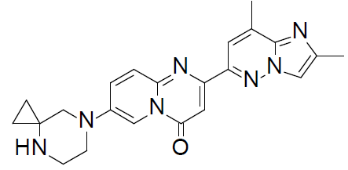

CAS-number: 1825352-65-5

Chemical name: 7-(4,7-diazaspiro[2.5]octan-7-yl)-2-(2,8dimethylimidazo[1,2-b]pyridazin-6- yl)pyrido-4H-[1,2-a]pyrimidin-4-one.

Empirical formula: C₂₂H₂₃N₇O.

MEDICINE SCHEDULE (POISONS STANDARD)

Schedule 4 – Prescription Only Medicine

SPONSOR

Roche Products Pty Limited
ABN 70 000 132 865
Level 8, 30-34 Hickson Road
Sydney NSW 2000
AUSTRALIA

Medical enquiries: 1800 233 950

DATE OF FIRST APPROVAL

02 June 2021

DATE OF REVISION

02 June 2021

Summary table of changes
Section Changed | Summary of new information

