November 2020

Australian Public Assessment Report for Ripretinib
  - Proprietary Product Name: Qinlock
  - Sponsor: TudorRose Consulting Pty Ltd

About the Therapeutic Goods Administration (TGA)
- The Therapeutic Goods Administration (TGA) is part of the Australian Government Department of Health and is responsible for regulating medicines and medical devices.
- The TGA administers the Therapeutic Goods Act 1989 (the Act), applying a risk management approach designed to ensure therapeutic goods supplied in Australia meet acceptable standards of quality, safety and efficacy (performance) when necessary.
- The work of the TGA is based on applying scientific and clinical expertise to decision-making, to ensure that the benefits to consumers outweigh any risks associated with the use of medicines and medical devices.
- The TGA relies on the public, healthcare professionals and industry to report problems with medicines or medical devices. TGA investigates reports received by it to determine any necessary regulatory action.
- To report a problem with a medicine or medical device, please see the information on the TGA website <https://www.tga.gov.au>.

About AusPARs
- An Australian Public Assessment Report (AusPAR) provides information about the evaluation of a prescription medicine and the considerations that led the TGA to approve or not approve a prescription medicine submission.
- AusPARs are prepared and published by the TGA.
- An AusPAR is prepared for submissions that relate to new chemical entities, generic medicines, major variations and extensions of indications.
- An AusPAR is a static document; it provides information that relates to a submission at a particular point in time.
- A new AusPAR will be developed to reflect changes to indications and/or major variations to a prescription medicine subject to evaluation by the TGA.

Copyright
© Commonwealth of Australia 2020
This work is copyright. You may reproduce the whole or part of this work in unaltered form for your own personal use or, if you are part of an organisation, for internal use within your organisation, but only if you or your organisation do not use the reproduction for any commercial purpose and retain this copyright notice and all disclaimer notices as part of that reproduction. Apart from rights to use as permitted by the Copyright Act 1968 or allowed by this copyright notice, all other rights are reserved and you are not allowed to reproduce the whole or any part of this work in any way (electronic or otherwise) without first being given specific written permission from the Commonwealth to do so. Requests and inquiries concerning reproduction and rights are to be sent to the TGA Copyright Officer, Therapeutic Goods Administration, PO Box 100, Woden ACT 2606 or emailed to <tga.copyright@tga.gov.au>.

Contents
Common abbreviations 4
I. Introduction to product submission 7
Submission details 7
Product background 8
Regulatory status 10
Product Information 10
II. Registration timeline 10
III. Submission overview and risk/benefit assessment 11
Quality 11
Nonclinical 12
Clinical 14
Risk management plan 26
Risk-benefit analysis 27
Outcome 28
Attachment 1. Product Information 29

Common abbreviations
Abbreviation | Meaning
ACM | Advisory Committee on Medicines
AE | Adverse event
ARTG | Australian Register of Therapeutic Goods
AUC | Area under the plasma concentration-time curve
AUC_{ss,0-12h} | Area under the plasma concentration-time curve at steady state from time 0 to 12 hours
AUC_{0-24h} | Area under the plasma concentration-time curve from time 0 to 24 hours
BCRP | Breast cancer resistance protein
BID | Twice a day, Latin: bis in die
BMI | Body mass index
BSEP | Bile salt export pump
CI | Confidence interval
CL/F | Oral clearance
C_{max} | Maximum plasma concentration
CMI | Consumer Medicines Information
CPK | Creatine phosphokinase
CR | Complete remission
CYP | Cytochrome P450
DCC-2618 | Product development code for ripretinib
DLT | Dose limiting toxicities
ECOG PS | Eastern Cooperative Oncology Group Performance Status
EU | European Union
FDA | Food and Drug Administration (United States)
GI | Gastrointestinal
GIST | Gastrointestinal stromal tumours
GLP | Good Laboratory Practice
GVP | Good pharmacovigilance practices
HC | Health Canada
HR | Hazard ratio
ICH | International Council for Harmonisation of Technical Requirements for Pharmaceuticals for Human Use
IRR | Incident rate ratio
IRT | Interactive response technology
ITT | Intent to treat
IV | Intravenous
KIT | Tyrosine-protein kinase
MATE 1 | Multidrug and toxin extrusion protein 1
MDR1 | Multi-drug resistance gene
MTD | Maximum tolerated dose
NMT | Not more than
NYHA | New York Heart Association
OCE | Oncology Center of Excellence (United States, Food and Drug Administration)
ORR | Objective response rate
OS | Overall survival
PD | Pharmacodynamic(s)
PDGFRA | Platelet‐derived growth factor receptor alpha
PET | Positron emission tomography
PFS | Progression free survival
P-gp | P-glycoprotein
PI | Product Information
PK | Pharmacokinetic(s)
PSUR | Periodic safety update report
QD | Once per day, Latin: quaque die
QTc | Corrected QT interval
RMP | Risk management plan
RP2D | Recommended Phase II dose
SAE | Serious adverse event
SM | Systemic mastocytosis
SRT | Safety review team
TEAE | Treatment emergent adverse event
TGA | Therapeutic Goods Administration
T_{max} | Time to reach maximum plasma concentration
TTP | Time to progression
UK | United Kingdom
US(A) | United States (of America)
VEGFR | Vascular endothelial growth factor receptor
V_{ss}/F | Apparent volume of distribution at steady state

I. Introduction to product submission

Submission details
Type of submission: | New chemical entity
Product name: | Qinlock
Active ingredient: | Ripretinib
Decision: | Approved
Date of decision: | 10 July 2020
Date of entry onto ARTG: | 13 July 2020
ARTG number: | 327899
Black Triangle Scheme: | Yes  This product will remain in the scheme for 5 years, starting on the date the product is first supplied in Australia
Sponsor’s name and address: | TudorRose Consulting Pty Ltd;  3 Grandview Avenue, Point Cook, VIC 3030
Dose form: | Tablet
Strength: | 50 mg
Container: | Bottle
Pack size: | 90 tablets
Approved therapeutic use: | Qinlock is a kinase inhibitor indicated for the treatment of adult patients with advanced gastrointestinal stromal tumours (GIST) who have received prior treatment with 3 or more kinase inhibitors, including imatinib.
Route of administration: | Oral
Dosage: | The recommended dosage of Qinlock is 150 mg (three 50 mg tablets, to swallow tablets whole) orally once daily with or without food until disease progression or unacceptable toxicity.  For further information regarding dosage, refer to the Product Information (PI).
Pregnancy category: | D  Drugs which have caused, are suspected to have caused or may be expected to cause, an increased incidence of human fetal malformations or irreversible damage. These drugs may also have adverse pharmacological effects. Accompanying texts should be consulted for further details.  The use of any medicine during pregnancy requires careful consideration of both risks and benefits by the treating health professional. This must not be used as the sole basis of decision making in the use of medicines during pregnancy. The TGA does not provide advice on the use of medicines in pregnancy for specific cases. More information is available from obstetric drug information services in your State or Territory.

Product background
This AusPAR describes the application by TudorRose Consulting Pty Ltd (the sponsor);2 to register Qinlock (ripretinib) 50 mg tablet for the following proposed indication:
Qinlock is a kinase inhibitor indicated for the treatment of adult patients with advanced gastrointestinal stromal tumours (GIST) who have received prior treatment with 3 or more kinase inhibitors, including imatinib.
Qinlock (also known as DCC-2618); is a novel, oral inhibitor of the proto-oncogene receptor tyrosine kinase (KIT) and platelet-derived growth factor receptor alpha (PDGFRA) kinase, and is a highly targeted therapeutic candidate for the treatment of patients with advanced gastrointestinal stromal tumours (GIST).
Gastrointestinal stromal tumours are rare, with an estimated incidence of about 1 per 100,000 per year, but are the most common non-epithelial neoplasms affecting the gastrointestinal tract.
The overall 5 year survival rate for GIST is 83%; however, patients with metastatic GIST have only a 52% 5 year survival. Approximately 90% of GISTs have a primary mutation in the KIT or PDGFRA genes. The majority of KIT mutations are found in exon 11; however, mutations in exons 9 or 13; or exon 17;7 have also been described. For tumours that do not have a KIT mutation, the most common mutation described is a PDGFRA D842V mutation. Tyrosine kinase inhibitors targeting KIT and PDGFR have been used successfully to treat patients with GIST, as evidenced by the previous approvals of imatinib, sunitinib, regorafenib in the first, second, and third line setting, respectively.
Systemic treatment options available for GIST include the following:
Imatinib
- imatinib was the first KIT therapy approved in 2002 by the United States (US) Food and Drug Administration (FDA).
- complete remission (CR) rate is less than 10%, and approximately 5%
- imatinib has a high clinical benefit rate of around 85%
- long-term disease control is seen in around a fifth of patients: 18% continuing therapy at a median follow up of 9.4 years. This corresponds with lower tumour bulk at diagnosis
- following the introduction of imatinib, the median survival of patients with advanced GIST increased from an average of 18 to 57 months in the trial with the longest follow-up to date
- most patients who initially respond develop resistance to imatinib, almost always through additional KIT mutations
- the median time to progression is approximately two to three years
Sunitinib
- sunitinib was approved in 2006 by the FDA as a second-line therapy for GIST patients who had disease progression on or intolerance to imatinib
- sunitinib shows greater activity than imatinib against exon 9, 13 and 14 mutations
- theclinical benefit rate is about 50%
- most patients again relapse within 6 months to 1 year due to additional or alternative secondary mutations in the KIT kinase gene, or due to multiple different KIT mutations occurring in different areas of the tumour
- sunitinib does not work in all imatinib-resistant tumours, due to the resistance mechanisms.
Regorafenib
- regorafenib was approved in 2013 by the FDA as a third-line therapy for adult patients with metastatic and/or unresectable GIST who have had disease progression on or intolerance to imatinib and sunitinib treatment
- regorafenib provides clinical benefit to some imatinib- and/or sunitinib-resistant patients
- regorafenib is active against exon 11 and a subset of exon 17 mutations
- progression free survival (PFS) is about 5 months
- several secondary mutations in the KIT kinase gene are enriched in resistant tumours during treatment, including those found in exon 13 and exon 17 in the KIT gene that do not respond to any FDA approved treatments.
Avapritinib, a tyrosine kinase inhibitor was most recently approved by the FDA (approved on 9 January 2020) for patients with advanced GIST patients that harbour a PDGFRA exon 18 mutation including PDGFRA D842V.
Unmet clinical need
Once patients have received imatinib, sunitinib, and regorafenib and experience disease progression, there are no other approved treatment options for patients with advanced or unresectable GIST, hence there is unmet medical need in this population.
This evaluation was facilitated through Project Orbis, an initiative of the United States (US) FDA Oncology Center of Excellence (OCE). Under this project, the FDA, Health Canada (HC) and the TGA collaboratively reviewed the application. This innovative evaluation process provided a framework for process alignment and management of evaluation issues in real-time across jurisdictions.
Each regulator agency maintained its regulatory process to make independent decisions about the approval (market authorisation).

Regulatory status
This product is considered a new chemical entity for Australian regulatory purposes.
At the time the TGA considered this application, Qinlock (ripretinib) is part of a simultaneous filing in the USA, Australia and Canada, under Project Orbis.
Ripretinib was approved by the FDA (15 May 2020) for the indication below:
Qinlock is a kinase inhibitor indicated for the treatment of adult patients with advanced gastrointestinal stromal tumor (GIST) who have received prior treatment with 3 or more kinase inhibitors, including imatinib.

Product Information
The PI approved with the submission which is described in this AusPAR can be found as Attachment 1. For the most recent PI, please refer to the TGA website at <https://www.tga.gov.au/product-information-pi>.

II. Registration timeline
The following table captures the key steps and dates for this application and which are detailed and discussed in this AusPAR.
Table 1: Timeline for Submission PM-2019-05961-1-4
Description | Date
Designation (orphan; and priority) | 4 December 2019
Submission dossier accepted and first round evaluation commenced | 13 January 2020
Evaluation completed | 24 June 2020
Delegate’s Overall benefit-risk assessment | 22 June 2020
Sponsor’s pre-Advisory Committee response | Not applicable
Advisory Committee meeting | Not applicable
Registration decision (Outcome) | 10 July 2020
Completion of administrative activities and registration on the ARTG | 13 July 2020
Number of working days from submission dossier acceptance to registration decision* | 123
*Target timeframe for priority applications is 150 working days from acceptance for evaluation to the decision.

III. Submission overview and risk/benefit assessment
This section is a TGA summary of wording used in TGA’s evaluation report, which discussed numerous aspects of overseas evaluation reports and included some information that was commercial-in-confidence.

Quality
The structure of ripretinib is shown in Figure 1.
Figure 1: Chemical structure of ripretinib
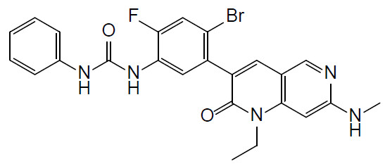
Ripretinib immediate release tablets are white to off-white, oval tablets, debossed with ‘DC1’ on one side of the tablet. The tablets are proposed to be contained in HDPE bottles with a child-resistant closure canister.
The application and the supporting data relating to the composition, development, manufacture, quality control and stability of the product have been assessed and checked for compliance, as applicable, with Australian legislation and requirements for new medicines and in accordance with pharmacopoeial standards and the technical guidelines adopted by the TGA.
Approval is recommended from a pharmaceutical chemistry (quality) perspective. The following points are of note:
- Shelf-life of 12 months would be assigned Qinlock with storage below 25 degrees Celsius.

Nonclinical
The submitted nonclinical dossier was in accordance with the relevant TGA-adopted guideline. The overall quality of the dossier was reasonable with all pivotal safety studies conducted under Good Laboratory Practice (GLP) conditions. There are no nonclinical objections to registration of ripretinib for the proposed indication.
Dedicated safety pharmacology studies assessed effects on the cardiovascular, respiratory and central nervous systems. Based on in vitro studies and in vivo studies in dogs, ripretinib is not predicted to prolong the corrected QT interval (QTc); during clinical use, but is likely to cause hypertension and may cause sleeping disturbances and/or increased heart rate during sleep in patients. Based on findings in animal studies, respiratory effects are not predicted during clinical use.
The bioavailability the [Information redaction] of ripretinib used in the toxicity studies was about 28% in rats and 24 to 55% in dogs with an area under the plasma concentration time curve (AUC) of 30 minutes. The ratio of the main human metabolite (DP-5439) to the parent was lower in rats and dogs (0.2 to 0.4:1) than in human subjects (about 1:1). Protein binding by ripretinib was very high in the plasma of mice, rats, dogs, monkeys and humans (> 99.85% bound fraction). Drug related material was distributed widely in rats with relatively high exposures seen in melanin containing tissues. There was minimal penetration of the blood brain barrier. Ripretinib was metabolised mainly by cytochrome P450 (CYP) 3A4/5; (to a lesser extent by CYP2C8 and CYP2D6). All observed human metabolites were detected in rats and/or dogs. The active metabolite DP-5439, an N-demethylation product, was a major circulating metabolite in humans, and the only major circulating metabolite in rats and dogs. DP-5439 was metabolised by CYP3A4/5, and to a lesser extent by CYP2C8, CYP2D6, CYP2E1, CYP2C9, CYP2C19, and CYP1A2. Plasma concentrations of ripretinib and the active metabolite, DP-5439 are expected to be increased by CYP3A4/5 inhibitors and decreased by CYP3A4/5 inducers. Excretion of ripretinib and/or its metabolites was predominantly via the faeces in rats and dogs. Biliary excretion was demonstrated in rats.
Ripretinib and DP-5439 are substrates of multi-drug resistance gene (MDR1) as known as P-glycoprotein 1 (P-gp), and breast cancer resistance protein (BCRP). P-gp and BCRP inhibitors may increase plasma concentrations of ripretinib and its active metabolite DP-5439. Ripretinib may alter the exposure of co-administered drugs that are substrates for P-gp, BCRP, CYP2C8, CYP2C9, and CYP2C19. Ripretinib inhibited P-gp, BCRP and bile salt export pump (BSEP). Ripretinib may increase plasma concentrations of P-gp or BCRP substrates in patients by increasing intestinal absorption and decreasing hepatic and/or renal excretion by P-gp and BCRP transporters. Active metabolite DP-5439 is a potent inhibitor of multidrug and toxin extrusion protein 1 (MATE1), and ripretinib may increase exposures to co-administered drugs that are predominantly eliminated by MATE1 mediated renal and/or biliary excretion.
Ripretinib had a high order of acute oral toxicity in rats and dogs. Repeat dose toxicity studies by the oral route were conducted in rats (up to 13 weeks) and dogs (up to 13 weeks). Target organs for toxicity were similar to those seen with other tyrosine kinase inhibitors: skin (alopecia, discoloured skin, inflammation, erosions, ulcers, and/or crusts in the skin, hyperkeratosis and hyperplasia), male reproductive organs (degeneration/atrophy of the testis and seminiferous tubules), lymphoid tissues (lymphoid depletion), blood vessels and epithelium of several organs (hyperplasia), liver (changes in hepatic enzymes), gastrointestinal (GI) tract (epithelial hyperplasia, emesis and faecal abnormalities), teeth (missing teeth/white teeth in rats), and bone (increased osteoblastic surface and/or decreased trabeculae of the femur in rats). These toxicological findings were observed at exposures (based on AUC) comparable to or less than those expected clinically. The nonclinical data suggest a substantial clinical risk of adverse effects on the skin and male reproductive system.
Ripretinib was not mutagenic in the bacterial mutation assay or clastogenic in vivo (rat micronucleus test). DP-5439 was not mutagenic in the bacterial mutation assay or clastogenic in vitro (in human lymphocytes). Carcinogenicity studies were not conducted and are not required.
Neither a fertility and early embryonic development study, nor a pre-/postnatal development study was conducted and this is acceptable for a drug indicated for the treatment of patients with advanced cancer. In rats, ripretinib was teratogenic (malformations were primarily associated with the cardiovascular and skeletal systems) at exposures (based on AUC) lower than those expected clinically, and embryolethal at exposures similar to those expected clinically.
The transfer of ripretinib in milk was not studied. Given the mode of action of ripretinib, and the findings in the reproductive system in males (testicular degeneration and atrophy) in the repeat dose toxicity studies, effects on fertility and pre-/postnatal development can be anticipated in patients. The proposed pregnancy category D; is appropriate.
Ripretinib was phototoxic in vitro.
The pharmacology studies generally support the use of ripretinib as an anticancer agent.
The combined animal safety studies revealed the toxicity profile of ripretinib was similar to that seen with other KIT and vascular endothelial growth factor receptor (VEGFR) inhibitors. The skin and male reproductive system were major target organs for toxicity, and hypertension and increased heart rate during sleep (and/or sleep disturbances) may be expected in patients receiving ripretinib. Hepatotoxicity, renal toxicity and bone marrow depletion were not observed with ripretinib compared with currently registered tyrosine kinase inhibitors; however due to toxicity in animal studies, exposures achieved in the animal studies were subclinical.

Clinical
The clinical dossier consisted of three Phase I studies and one Phase III study.
- Phase I Study DCC‐2618‐01‐001 is an open label study. The study started with an escalation phase evaluating increasing doses of single‐agent ripretinib administered in repeated 28 day cycles in patients with advanced malignancies with a molecular rationale for activity. The escalation phase was followed by an expansion phase testing for further safety, pharmacokinetics (PK), pharmacodynamics (PD), and evidence of antitumor activity across a variety of tumours with evidence of alterations in genes that are targets of ripretinib.
- Phase I Study DCC-2618-01-002 is an open label, randomised, single dose, partial replicate, and three period crossover study. It evaluates the bioavailability, safety, tolerability and PK of ripretinib.
- Phase I Study DCC-2618-01-003 is an open label, 2 parts fixed sequence study. It evaluates ripretinib PK, safety and tolerability.
- Phase III Study DCC-2618-03-001 (the Invictus trial) is an interventional, double blind, placebo controlled study to assess the safety and efficacy of ripretinib in patients with advanced gastrointestinal stromal tumours who have received treatment with prior anticancer therapies.

Pharmacology
The following section on the PK of ripretinib is taken from the proposed PI document for Qinlock.

Absorption
Ripretinib reaches peak plasma concentration at 4 hours after a single oral dose of 150 mg of ripretinib (given as three tablets each containing 50 mg). The area under the plasma concentration-time curve at steady state from time 0 to 12 hours (AUC_{ss,0-12h}) observed in patients at 150 mg is 5678 ng*h/mL. Steady state is achieved by approximately Day 15.
Administration with a high fat meal increased ripretinib area under plasma concentration time curve during from time 0 to 24 hours (AUC_{0-24h}) and maximum plasma concentration (C_{max}) by 30% and 22%, respectively. DP-5439 AUC_{0-24h} and C_{max} were higher by 47% and 66%, respectively.

Distribution
Both ripretinib and its active metabolite DP-5439 bind to plasma proteins at ≥ 99%. The apparent volume of distribution at steady state (V_{ss}/F) is approximately 307 L.

Metabolism
Ripretinib was metabolised in vitro. CYP3A4/5 is the major metaboliser of ripretinib while CYP2C8 and CYP2D6 are the only minor metabolisers.

Excretion
Following oral administration of ripretinib 150 mg once daily, the mean apparent oral clearance (CL/F) of ripretinib at steady-state is 15.3 L/hr and the mean plasma elimination half-life is 14.8 hours
In preclinical species, ¹⁴C-labeled ripretinib dosed to Sprague-Dawley rats (oral) and beagle dogs (intravenous (IV)), resulted in greater than 89% of the radioactive dose being excreted in faeces and 1.8% or less in the urine.
PK analyses obtained from urine and faeces samples in 10 healthy volunteers showed that systemic elimination of ripretinib was not primarily attributed to the kidney. Through 1 week (168 hours) after a single oral administration of 50 mg ripretinib (given alone), 0.02% of the ripretinib dose was excreted as ripretinib in urine and 34.2% of the ripretinib dose was excreted as ripretinib in faeces.

Efficacy
The efficacy of ripretinib is supported primarily by the results from the double-blind period of the pivotal study, Study DCC-2618-03-001, which included patients with GIST who had received ≥ 3 prior lines of treatment.
Additional support is provided by the results from patients with advanced GIST who had an initially assigned dose of 150 mg ripretinib once daily (QD) as a ≥ fourth line of treatment in Study DCC-2618-01-001.

Pivotal study: Study DCC-2618-03-001 (Invictus trial)
A Phase III, interventional, double blind, placebo controlled study to assess the safety and efficacy of ripretinib in patients with advanced gastrointestinal stromal tumours who have received treatment with prior anticancer therapies (also known as the Invictus trial).

Primary objective
To assess the efficacy PFS of ripretinib by independent radiologic review in patients with advanced GIST who had received prior anticancer therapies.

Secondary objective
Key objective is to assess objective response rate (ORR) by independent radiologic review.
Other secondary objectives were:
- to assess other parameters of efficacy, including but not limited to time to progression (TTP) and overall survival (OS)
- to assess the PK/PD relationship of ripretinib
- to assess the safety of ripretinib.

Methodology
This was a 2 arm, randomised, placebo controlled, double blind, international, multicentre study comparing the efficacy of ripretinib and best supportive care (hereafter referred to as ripretinib) to placebo and best supportive care (hereafter referred to as ‘placebo’) in patients with advanced GIST who had received treatment with at least 3 prior anticancer therapies (imatinib, sunitinib, and regorafenib).
Approximately 120 patients were to be randomised in a 2:1 ratio to an initial treatment of ripretinib 150 mg QD or placebo.
Randomisation was stratified by:
- Patients who had received 3 prior anticancer treatments versus patients who had received ≥ 4 prior anticancer treatments (enrolment for patients who had received ≥ 4 prior anticancer treatments was capped at 40% of the overall sample size). Prior anticancer therapies must have included treatment with imatinib, sunitinib, and regorafenib.
- Eastern Cooperative Oncology Group Performance Status (ECOG PS) = 0 versus ECOG PS = 1 or 2
Diagnosis and main criteria for inclusion: Male and female patients ≥ 18 years of age with histological diagnosis of GIST who had progressive disease on imatinib, sunitinib, and regorafenib or had documented intolerance to any of these treatments.
Figure 2: Study DCC-2618-03-001 (INVICTUS trial) study design
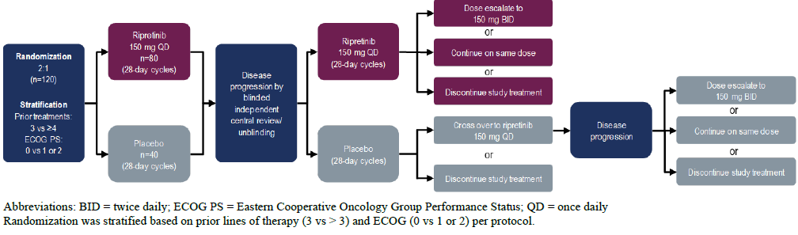
Figure 3: Study DCC-2618-03-001 (INVICTUS trial) Patient disposition by double blind and open label periods
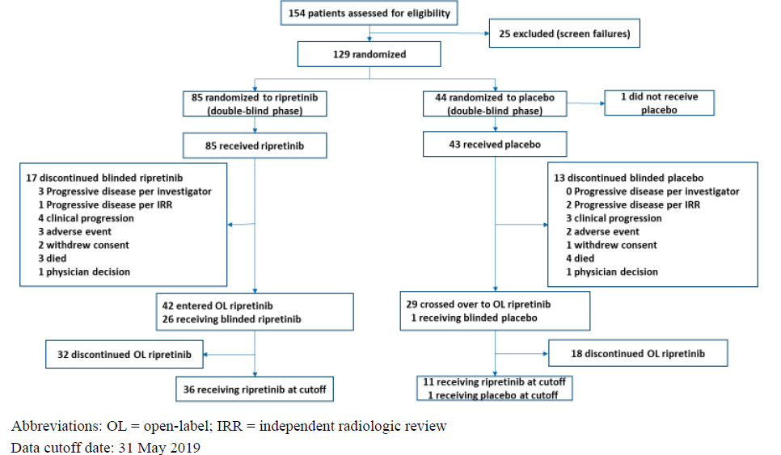
Source: Table 14.1.1.1, table 14.1.1.2, Listing 16.2.1.1 from sponsor submitted dossier.

Results
Efficacy assessment is based on 85 patients randomised to ripretinib and 44 patients randomised to placebo in the Invictus trial.
Overall, treatment arms were balanced for most demographic and baseline characteristics. There were more patients over 75 years in the placebo arm (23%) compared to the ripretinib arm (9%), with a corresponding imbalance in patients under 65 years.
The median PFS was 27.6 (95% confidence intervals (CI)): 20.0, 29.9) weeks for the ripretinib arm and 4.1 (95% CI: 4.0, 7.3) weeks for the placebo arm with a hazard ratio (HR) of 0.15 (95% CI: 0.09, 0.25; stratified log-rank test p‐value of < 0.0001) (see Table 2 and Figure 4). The results demonstrated a statistically significant and clinically meaningful improvement in PFS for ripretinib compared to the placebo.
Table 2: Study DCC-2618-03-001 (INVICTUS trial) Progression free survival based on independent radiological review in double blind period (intent to treat population)
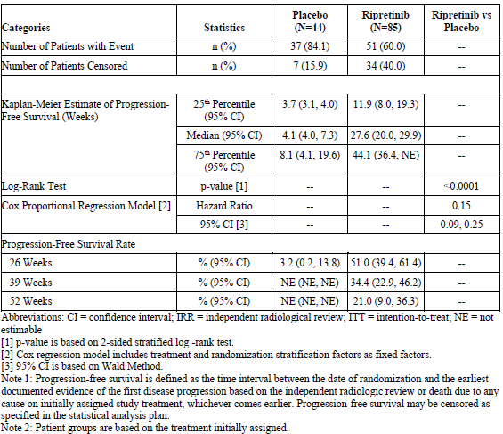
Source: Table 14.2.1.1 from sponsor submitted dossier
Figure 4: Study DCC-2618-03-001 (INVICTUS trial) Kaplan-Meier plot of progression-free survival based on independent radiological review in double-blind period (intent to treat population)
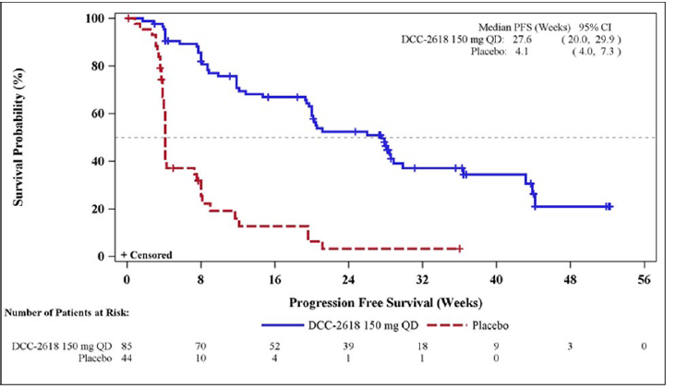
Data cut-off date: May 31, 2019. Source: Study DCC-2618-03-001 CSF Figure 14.2.1.1; Listing 16.2.6.5.1 from sponsor submitted dossier.
Ripretinib demonstrated a confirmed ORR of 9.4% compared with 0% for placebo; however, this failed to reach statistical significance (p = 0.0504) (see Table 3).
- Stable disease at ≥ 6 weeks was reported in 65.9% of patients in the ripretinib arm versus 20.5% in the placebo arm (see Table 3).
- Of the 8 patients in the ripretinib arm who had a response, 6 were still in response, 1 progressed, and 1 patient who had a partial response was censored (patient underwent surgical management) at the time of the data cut-off.
- No patient in the placebo arm had a response (see Table 3).
Table 3: Study DCC-2618-03-001 (INVICTUS trial) Summary of objective response based on independent radiological review in double-blind period (intent to treat population)
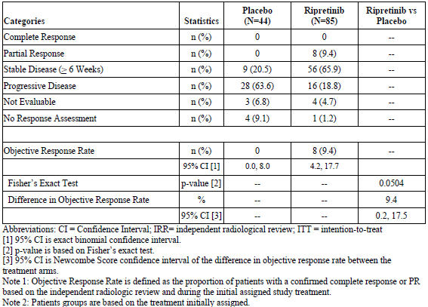
Source: Table 14.2.2.1.1 from sponsor submitted dossier.
The OS data for the placebo arm includes patients taking placebo who, following progression as assessed by incidence rate ratio (IRR), crossed over to ripretinib treatment.
- The median (95% CI) OS was 65.6 (53.6, 65.6) weeks for the ripretinib arm and 28.6 (17.9, 50.4) weeks for the placebo arm (see Figure 5).
- The hypothesis testing of OS was not formally performed because statistical significance was not achieved for ORR.
Figure 5: Study DCC-2618-03-001 (INVICTUS trial) Kaplan-Meier plot of overall survival (intention-to-treat population)
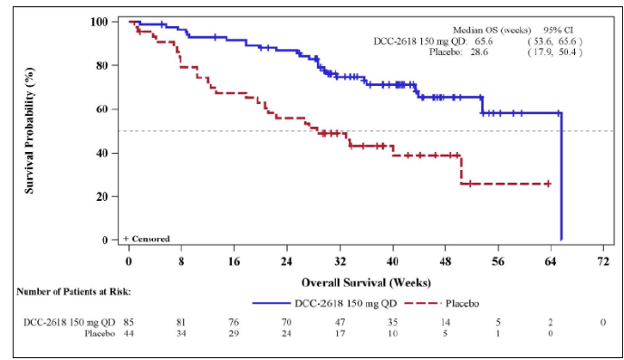
Data cutoff date: May 31, 2019. Source: Study DCC-2618-03-001 CSR Figure 14.2.4; Listing 16.2.6.6.

Efficacy conclusions
In Study DCC-2618-03-001 (the Invictus trial), ripretinib demonstrated statistically significant and clinically meaningful improvement in PFS compared to placebo as determined by IRR.
The median (95% CI) PFS was 27.6 (20.0, 29.9) weeks for the ripretinib arm and 4.1 (4.0, 7.3) weeks for the placebo arm with a HR of 0.15 (95% CI: 0.09, 0.25; stratified log-rank test p‐value of < 0.0001) (Figure 4).
The INVICTUS trial met its primary endpoint.
Ripretinib demonstrated an ORR of 9.4% compared with 0% for placebo (p-value = 0.0504, Fisher's exact test) as determined by IRR using modified RECIST; version 1.1, which was not statistically significant.
Ripretinib in this study also showed an improvement over placebo for the secondary endpoint overall survival (median OS of 65.6 weeks versus 28.6 weeks, respectively, HR = 0.36, nominal p-value = 0.0004, stratified log-rank test) (Figure 5). Because of the pre-specified hierarchical alpha spending plan for secondary endpoints and since statistical significance was not achieved for ORR, the hypothesis testing of OS was not formally performed.

Supportive data: Study DCC‐2618‐01‐001 (supportive Phase I study in patients with advanced malignancies)
Study DCC‐2618‐01‐001 is an open label Phase I study. The study started with an escalation phase evaluating increasing doses of single‐agent ripretinib administered in repeated 28 day cycles in patients with advanced malignancies with a molecular rationale for activity. The escalation phase was followed by an expansion phase testing for further safety, PK, PD, and evidence of antitumor activity across a variety of tumours with evidence of alterations in genes that are targets of ripretinib.
The dose escalation phase started with an oral 20 mg twice a day (BD) dose of ripretinib. Safety data collected during the escalation phase were reviewed and monitored by a safety review team (SRT). Three dose‐limiting toxicities (DLTs) of asymptomatic Grade 3 lipase increased (n = 2) and asymptomatic Grade 4 creatine phosphokinase (CPK) increased (n = 1) were reported. No maximum tolerated dose (MTD) was reached as there were < 33% of DLTs at each dose level explored. Based on in vivo and in vitro pharmacology studies in an interim population PK analysis, 150 mg QD was predicted to maintain the PK exposure above the presumed threshold for efficacy in > 90% of patients.
Patients assigned to a dose level may have escalated to a higher dose level that had subsequently been found to be safe and tolerable.
In the expansion phase, additional patients were enrolled in disease specific cohorts for KIT or PDGFRA mutant GIST, systemic mastocytosis (SM) and other hematologic malignancies, malignant gliomas, and other solid tumours. Patients started ripretinib at the recommended Phase II dose (RP2D) (150 mg QD) in the expansion phase to further evaluate the safety, tolerability, and preliminary evidence of antitumour response. positron emission tomography (PET) scans were performed for GIST patients that progressed and dose escalated. Dose escalation to 150 mg BD was allowed upon disease progression.

Results
Data analyses in patients with advanced GIST from the interim clinical study report with a data cut‐off of 1 March 2019, include a total of 142 patients with GIST who received 150 mg QD, of whom a total of 83 patients received ripretinib as a ≥ fourth line therapy.
Patients with advanced GIST (n = 142) who were treated at the RP2D of 150 mg QD had an ORR of 11.3% based on RECIST;16 version 1.1 by investigator assessment. The ORR for patients with GIST who received 150 mg QD was further examined by lines of therapy. The ORR was 7.2% in the 83 patients who received ripretinib as the ≥ fourth line therapy based on RECIST;16 version 1.1 by investigator assessment. The ORR was 19.4% in second line patients (n = 31) and 14.3% in third line patients (n = 28). The mean (standard deviation (SD)) time to response among all the responders was 19.2 (14.38) weeks.
The Kaplan‐Meier estimate of median duration of response was 76.1 weeks among the 6 responders who received 150 mg QD as the ≥ fourth line of therapy in the escalation and expansion phases; 4 patients remained in response as of the data cut-off date. The probability of maintaining response status for 52 weeks was 85.7% with 95% CI of 53.9%, 96.2%. The median duration of response for second line patients was 80 weeks and was not estimable for third line patients.
The Kaplan‐Meier estimate of median (50th percentile) PFS was 23.9 weeks (95% CI = 15.9, 24.3) in patients with GIST who received 150 mg QD as the ≥ fourth line of therapy in the escalation and expansion phases based on RECIST;16 version 1.1 by investigator assessment. The probability of maintaining PFS at 52 weeks was 21.7% with 95% CI of 13.1%, 31.6%. The median (50th percentile) PFS was 41.7 weeks for second line patients and 36.3 weeks for third line patients.

Safety
The safety evaluation is primarily based on the double blind period of Study DCC-2618-03-001 (the Invictus trial).
Study DCC‐2618‐03‐001 excluded patients who were at increased risk for toxicities observed in other studies with ripretinib as well as the known toxicities of similar kinase inhibitors. Such exclusion criteria included the following:
- Significant heart disease (New York Heart Association (NYHA) class II to IV); active ischemia, or any other uncontrolled cardiac condition including arrhythmias, uncontrolled hypertension, or cardiac heart failure.
- History of arterial thrombotic or embolic events within 6 months of planned study treatment initiation.
- QTc > 450 ms in males or > 470 in females or history of long QTc.
The most common adverse events (AEs)in the ripretinib arm (≥ 20% patients) included alopecia (44 (51.8%)), fatigue (36 (42.4%)), nausea (33 (38.8%)), abdominal pain (31 (36.5%)), constipation (29 (34.1%)), myalgia (27 (31.85%)), diarrhoea (24 (28.2%)), decreased appetite (23 (27.1%)), palmar-plantar dysesthesia syndrome (18 (21.2%)), and vomiting (18 (21.2%)), see Table 4.
The most common AEs in the placebo arm (≥ 20% patients) included abdominal pain (13 (30.2%)), fatigue (10 (23.3%)), and decreased appetite (9 (20.9%)), see Table 4.
A higher percent of patients experienced Grade 3/4 treatment emergent adverse events (TEAEs) in the ripretinib arm (42 (49.4%) patients) than in the placebo arm (19 (44.2%) patients), see Table 4.
In the ripretinib arm, the most commonly reported Grade 3/4 TEAEs (≥ 5%) were anaemia (8 (9.4%)), and abdominal pain and hypertension (6 (7.1%) in each), see Table 4.
In the placebo arm, the most commonly reported Grade 3/4 TEAE (≥ 5% patients) was anaemia (6 (14.0%)), see Table 4.
Table 4: Study DCC-2618-03-001 (INVICTUS trial) Treatment-emergent adverse events reported in ≥ 10% of patients who received Qinlock in the double-blind treatment period
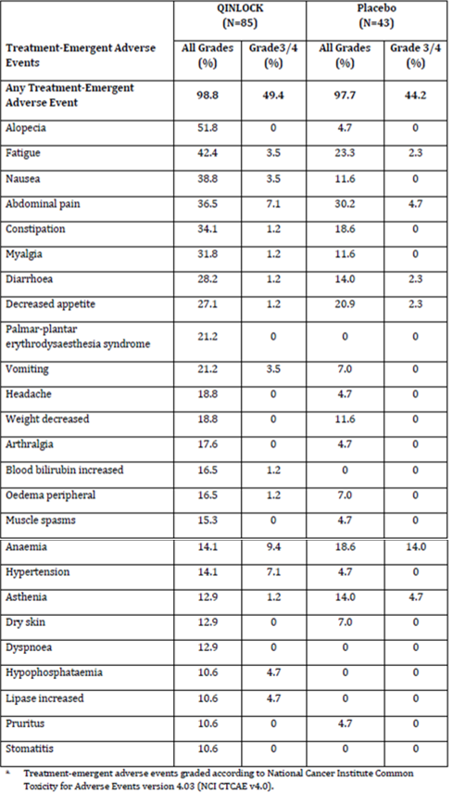
Table 5: INVICTUS trial, laboratory abnormalities reported in ≥ 10% of patients who received Qinlock in the double-blind treatment period.
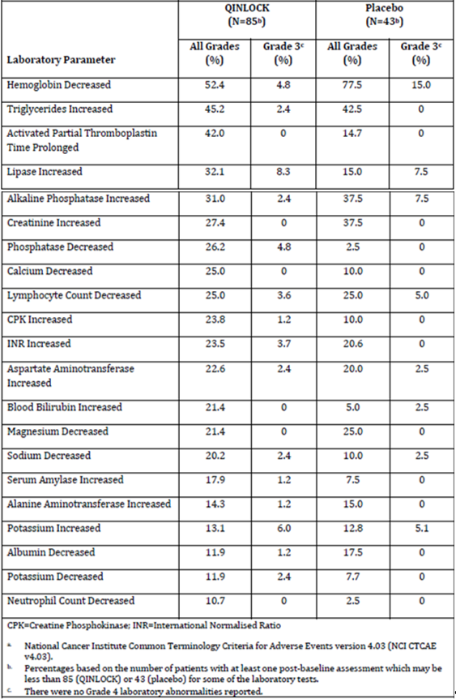
A higher percent of patients in the ripretinib arm (72 (84.7%) patients) experienced drug-related TEAEs than in the placebo arm (26 (60.5%) patients).
In the ripretinib arm, the most commonly reported drug-related AEs (≥ 20% patients) were alopecia (42 (49.4%)), myalgia (24 (28.2%)), nausea and fatigue (22 (25.9%) in each), diarrhoea and palmar-plantar dysesthesia syndrome (18 (21.2%) in each).
In the placebo arm, the most commonly reported drug-related AE (≥ 10% patients) was fatigue (7 (16.3%)).
In the double-blind period or long-term follow-up, 25 patients died (12 patients in the ripretinib arm and 13 patients in the placebo arm). In both treatment arms, the majority of deaths were caused by disease progression (11 patients in the ripretinib arm and 11 patients in the placebo arm).
Treatment-emergent serious adverse events (SAEs) were reported for a higher percent of patients in the placebo arm (19 (44.2%) patients) than for the ripretinib arm (26 (30.6%) patients). The most common (≥ 2 patients) treatment-emergent SAEs were abdominal pain (4 (4.7%) patients), anaemia and death (3 (3.5%) patients each), and nausea and vomiting (2 (2.4%) patients each) in the ripretinib arm and death (4 (9.3%) patients), acute kidney injury, sepsis, asthenia, and abdominal pain (2 (4.7%) patients each) in the placebo arm.

Cardiac dysfunction
The below text is an extract from FDA prescribing information for Qinlock.
‘In INVICTUS, cardiac failure occurred in 1.2% of the 85 patients who received ripretinib. In the pooled safety population, cardiac dysfunction (including cardiac failure, acute left ventricular failure, diastolic dysfunction, and ventricular hypertrophy) occurred in 1.7% of 351 patients, including Grade 3 adverse reactions in 1.1%.
In INVICTUS, Grade 3 decreased ejection fraction occurred in 2.6% of the 77 patients who received ripretinib and who had a baseline and at least one post-baseline echocardiogram. In the pooled safety population, Grade 3 decreased ejection fraction occurred in 3.4% of the 263 patients who received ripretinib and who had a baseline and at least one post-baseline echocardiogram.
In INVICTUS, cardiac dysfunction led to dose discontinuation in 1.2% of the 85 patients who received ripretinib. The safety of ripretinib has not been assessed in patients with a baseline ejection fraction below 50%.’

Dose interruptions, dose reductions, and treatment discontinuations
Table 6: Study DCC-2618-03-001 (INVICTUS trial) Dose interruptions, dose reductions, and treatment discontinuations due to adverse reactions
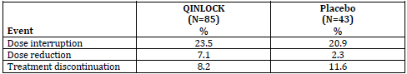

Safety summary
The evaluation of the safety of ripretinib 150 mg once daily in patients with advanced GIST who have received prior treatment with imatinib, sunitinib, and regorafenib was based primarily on 128 patients randomised in Study DCC‐2618‐03‐001 who received at least one dose of study drug (ripretinib: 85 patients, placebo: 43 patients). The review also included analysis of a pooled dataset of 295 patients with advanced malignancies with a molecular rationale for activity, who received at least one dose of ripretinib 150 mg once daily. Analysis of the pooled dataset validated the results of the analyses of Study DCC-2618‐03‐001, with the additional information of a few cases of heart failure.
In Study DCC‐2618‐03‐001, the median exposure was 23.9 weeks (range 1.3 weeks to 59.4) in the ripretinib arm versus 6 weeks (range 0.4 to 38.4) in the placebo arm; 46% of patients received ripretinib for at least 6 months.
The most common (≥ 2 patients) treatment-emergent SAEs were abdominal pain (4 (4.7%) patients), anaemia and death (3 (3.5%) patients each), and nausea and vomiting (2 (2.4%) patients each) in the ripretinib arm and death (4 (9.3%) patients), acute kidney injury, sepsis, asthenia, and abdominal pain (2 (4.7%) patients each) in the placebo arm.
In the double blind treatment period or long-term (post-treatment discontinuation) follow-up of the Invictus trial, 25 patients died (12 patients in the ripretinib arm and 13 patients in the placebo arm). In both treatment arms, the majority of deaths were caused by disease progression (11 patients in the ripretinib arm and 11 patients in the placebo arm).
Overall, the safety of ripretinib is considered acceptable in the context of the patient group being treated with the frequency of adverse events (all Grades, Grade 3 to 4, and serious) similar between the treated arm and the placebo arm in the Invictus trial. The frequency of treatment discontinuations, interruptions, and reductions was also comparable between arms.

Risk management plan
The sponsor has submitted Core-risk management plan (RMP) version 0.1 (18 December 2019; DLP 31 May 2019 for Study DCC-2618-03-001 study and 1 March 2019 for Study DCC-2618-01-001) and Australia Specific Annex version 1.0 (16 January 2020) in support of this application. In response to rolling questions sent 6 May 2020, the sponsor has submitted updated Core-RMP version 0.2 (22 May 2020; DLP 31 May 2019 for Study DCC-2618-03-001 study and 1 March 2019 for Study DCC-2618-01-001).
The summary of safety concerns and their associated risk monitoring and mitigation strategies are summarised in Table 7.
Table 7: Summary of safety concerns
Summary of safety concerns |  | Pharmacovigilance |  | Risk Minimisation
 |  | Routine | Additional | Routine | Additional
Important identified risks | Hand-foot skin reaction |  | – |  | –
Important identified risks | Hypertension |  | – |  | –
Important identified risks | Cardiac dysfunction |  | – |  | –
Important potential risks | Squamous cell carcinoma of skin | * | – |  | –
Important potential risks | Embryo-fetal toxicity | * | – |  | –
Missing information | Use in patients with moderate or severe hepatic impairment |  | † |  | –
Missing information | Use in patients with severe renal impairment |  | – |  | –
* Specific adverse drug reaction follow-up forms
† Clinical study
The Delegate requests that cardiac dysfunction, manifested as ejection fraction decrease (or similar), be added as an important identified risk.

Risk-benefit analysis

Delegate’s considerations
In Study DCC-2618-03-001 (the Invictus trial), ripretinib demonstrated statistically significant and clinically meaningful improvement in PFS compared to placebo as determined by IRR. Median PFS was 27.6 weeks in the ripretinib arm compared to 4.1 weeks in the placebo arm and significantly reduced the risk of disease progression or death by 85% (HR = 0.15) compared to placebo.
The Invictus trial met its primary endpoint.
The toxicity of ripretinib is considered tolerable, given the severity of the condition being treated.
A positive benefit/risk balance has been demonstrated for ripretinib as fourth line therapy in patients with GIST.
The main source of uncertainty for both efficacy and safety of ripretinib being used fourth line in patients with GIST is the small sample size of the main trial.

Proposed action
The Delegate recommends that the indication for ripretinib in Australia should align with the FDA approved full prescribing information for Qinlock:18
Qinlock is a kinase inhibitor indicated for the treatment of adult patients with advanced gastrointestinal stromal tumours (GIST) who have received prior treatment with 3 or more kinase inhibitors, including imatinib.
The FDA approved indication for Qinlockis:18
Qinlock is a kinase inhibitor indicated for the treatment of adult patients with advanced gastrointestinal stromal tumor (GIST) who have received prior treatment with 3 or more kinase inhibitors, including imatinib.
Other sections of the Australian PI should align with the FDA approved full prescribing information for Qinlock.

Advisory Committee considerations
The Delegate did not refer this application to the Advisory Committee on Medicines (ACM) for advice.

Outcome
Based on a review of quality, safety and efficacy, the TGA approved the registration of Qinlock (ripretinib) 50 mg oral tablet, indicated for:
Qinlock is a kinase inhibitor indicated for the treatment of adult patients with advanced gastrointestinal stromal tumours (GIST) who have received prior treatment with 3 or more kinase inhibitors, including imatinib.

Specific conditions of registration applying to these goods
- Qinlock(ripretinib) is to be included in the Black Triangle Scheme. The PI and Consumer Medicines Information (CMI) for Qinlockmust include the black triangle symbol and mandatory accompanying text for five years, which starts from the date that the sponsor notifies the TGA of supply of the product.
- The Qinlock Core-risk management plan (RMP) (version 0.2, dated 22 May 2020, data lock point 31 May 2019), with Australian Specific Annex (version 1.0, dated 16 January 2020), included with submission PM-2019-05961-1-4, and any subsequent revisions, as agreed with the TGA will be implemented in Australia.
An obligatory component of RMP is routine pharmacovigilance. Routine pharmacovigilance includes the submission of periodic safety update reports (PSURs).
Unless agreed separately between the supplier who is the recipient of the approval and the TGA, the first report must be submitted to TGA no later than 15 calendar months after the date of this approval letter. The subsequent reports must be submitted no less frequently than annually from the date of the first submitted report until the period covered by such reports is not less than three years from the date of the approval letter. The annual submission may be made up of two PSURs each covering six months. If the sponsor wishes, the six monthly reports may be submitted separately as they become available.
If the product is approved in the European Union (EU) during the three years period, reports can be provided in line with the published list of EU reference dates no less frequently than annually from the date of the first submitted report until the period covered by such reports is not less than three years from the date of this approval letter. The reports are to at least meet the requirements for PSURs as described in the European Medicines Agency’s Guideline on good pharmacovigilance practices (GVP) Module VII-periodic safety update report (Rev 1), Part VII.B Structures and processes. Note that submission of a PSUR does not constitute an application to vary the registration. Each report must have been prepared within ninety calendar days of the data lock point for that report.

Attachment 1. Product Information
The PI for Qinlock approved with the submission which is described in this AusPAR is at Attachment 1. For the most recent PI, please refer to the TGA website at <https://www.tga.gov.au/product-information-pi>.

Therapeutic Goods Administration
PO Box 100 Woden ACT 2606 Australia
Email: info@tga.gov.au Phone: 1800 020 653 Fax: 02 6232 8605
https://www.tga.gov.au

The Black Triangle Scheme provides a simple means for practitioners and patients to identify certain types of new prescription medicines, including those being used in new ways and to encourage the reporting of adverse events associated with their use. The Black Triangle does not denote that there are known safety problems, just that the TGA is encouraging adverse event reporting to help us build up the full picture of a medicine's safety profile.
Sponsorship of this product was transferred to Specialised Therapeutics PM Pty Ltd following ARTG entry.
DCC-2618 is the drug development code used by sponsor for ripretinib.
Menge F, et al. Clinical Presentation of Gastrointestinal Stromal Tumors. Visc Med. 2018;34(5):335-340.
Information extracted from Cancer.net, gastrointestinal stromal tumour-GIST: statistics.
Bachet JB and Emile JF. Diagnostic criteria, specific mutations, and genetic predisposition in gastrointestinal stromal tumors. Appl Clin Genet. 2010;3:85-101. Published 2010 Oct 29.
Oppelt PJ, et al. Gastrointestinal stromal tumors (GISTs): point mutations matter in management, a review. J Gastrointest Oncol. 2017;8(3):466-473.
Lasota J, et al. Mutations in exons 9 and 13 of KIT gene are rare events in gastrointestinal stromal tumors. A study of 200 cases. Am J Pathol. 2000;157(4):1091-1095.
Heinrich M.C, et al. PDGFRA activating mutations in gastrointestinal stromal tumors. Science. 2003;299:708–710.
'Orphan drugs' are often developed to treat small and very specific patient populations who suffer from rare diseases and conditions. In order to facilitate orphan drug access to the Australian marketplace and help offset orphan drug development costs the TGA waives application and evaluation fees for prescription medicine registration applications if a related orphan designation is in force. A medicine may be eligible for orphan drug designation if all orphan criteria set by the TGA are met. The orphan designation application precedes the registration application and the designation is specific to the sponsor, orphan indication for which designation was granted and dosage form of the medicine.
European Medicines Agency (EMA), Committee for Medicinal Products for Human Use (CHMP), International Council for Harmonisation of Technical Requirements for Pharmaceuticals for Human Use (ICH) guideline for the nonclinical assessment of anticancer pharmaceuticals (ICH S9), EMA/CHMP/ICH/646107/2008, May 2010.
The QT interval is the time from the start of the QRS wave complex to the end of the corresponding T wave. It approximates to the time taken for ventricular depolarisation and repolarisation, that is to say, the period of ventricular systole from ventricular isovolumetric contraction to isovolumetric relaxation. The corrected QT interval (QTc) estimates the QT interval at a standard heart rate of 60 bpm. This allows comparison of QT values over time at different heart rates and improves detection of patients at increased risk of arrhythmias.
CYPs are the major enzymes involved in drug metabolism, accounting for large part of the total metabolism. Most drugs undergo deactivation by CYPs, either directly or by facilitated excretion from the body. Also, many substances are bioactivated by CYPs to form their active compounds. Many drugs may increase or decrease the activity of various CYP isozymes either by inducing the biosynthesis of an isozyme (enzyme induction) or by directly inhibiting the activity of the CYP (enzyme inhibition). This is a major source of adverse drug interactions, since changes in CYP enzyme activity may affect the metabolism and clearance of various drugs. Such drug interactions are especially important to take into account when using drugs of vital importance to the patient, drugs with important side-effects and drugs with small therapeutic windows, but any drug may be subject to an altered plasma concentration due to altered drug metabolism.
Pregnancy category D: Drugs which have caused, are suspected to have caused or may be expected to cause, an increased incidence of human fetal malformations or irreversible damage. These drugs may also have adverse pharmacological effects. Accompanying texts should be consulted for further details.
ECOG Performance Status: The Eastern Cooperative Oncology Group (ECOG) has developed criteria used by doctors and researchers to assess how a patient's disease is progressing, assess how the disease affects the daily living abilities of the patient, and determine appropriate treatment and prognosis. The following are used: 0 - Fully active, able to carry on all pre-disease performance without restriction 1- Restricted in physically strenuous activity but ambulatory and able to carry out work of a light or sedentary nature, for example, light house work, office work 2 - Ambulatory and capable of all selfcare but unable to carry out any work activities. Up and about more than 50% of waking hours 3 - Capable of only limited selfcare, confined to bed or chair more than 50% of waking hours 4 - Completely disabled. Cannot carry on any selfcare. Totally confined to bed or chair 5 – Dead
The Response Evaluation Criteria in Solid Tumors (RECIST) is a voluntary, international standard using unified, easily applicable criteria for measuring tumor response using X-ray, CT and MRI.
The New York Heart Association (NYHA) Classification provides a simple way of classifying the extent of heart failure. It classifies patients in one of four categories based on their limitations during physical activity; the limitations/symptoms are in regards to normal breathing and varying degrees in shortness of breath and or angina pain. Class I - No symptoms and no limitation in ordinary physical activity, for example. shortness of breath when walking, climbing stairs for example. Class II - Mild symptoms (mild shortness of breath and/or angina) and slight limitation during ordinary activity. Class III - Marked limitation in activity due to symptoms, even during less-than-ordinary activity, for example. walking short distances (20—100 m).Comfortable only at rest. Class IV - Severe limitations. Experiences symptoms even while at rest. Mostly bedbound patients. No NYHA class listed or unable to determine.
Prescribing information for Qinlock (ripretinib) 50 mg tablets, for oral use, first approval 15 May 2020. Available from the FDA website.
Routine risk minimisation activities may be limited to ensuring that suitable warnings are included in the product information or by careful use of labelling and packaging. Routine pharmacovigilance practices involve the following activities: - All suspected adverse reactions that are reported to the personnel of the company are collected and collated in an accessible manner; - Reporting to regulatory authorities; - Continuous monitoring of the safety profiles of approved products including signal detection and updating of labelling; - Submission of PSURs; - Meeting other local regulatory agency requirements.
The ACM provides independent medical and scientific advice to the Minister for Health and the Therapeutic Goods Administration (TGA) on issues relating to the safety, quality and efficacy of medicines supplied in Australia including issues relating to pre-market and post-market functions for medicines. The Committee is established under Regulation 35 of the Therapeutic Goods Regulations 1990. Members are appointed by the Minister. The ACM was established in January 2017 replacing Advisory Committee on Prescription Medicines (ACPM) which was formed in January 2010. ACM encompass pre and post-market advice for medicines, following the consolidation of the previous functions of the Advisory Committee on Prescription Medicines (ACPM), the Advisory Committee on the Safety of Medicines (ACSOM) and the Advisory Committee on Non-Prescription Medicines (ACNM). Membership comprises of professionals with specific scientific, medical or clinical expertise, as well as appropriate consumer health issues relating to medicines.

