Product Information

KISQALI® TABLETS

Name of the Medicine
Active ingredient: | ribociclib succinate
Chemical name: | butanedioic acid - 7-cyclopentyl-N,N-dimethyl-2-{[5-(piperazin-1-yl) pyridin-2-yl]amino}-7H-pyrrolo[2,3-d]pyrimidine-6-carboxamide (1/1)
Chemical structure: | 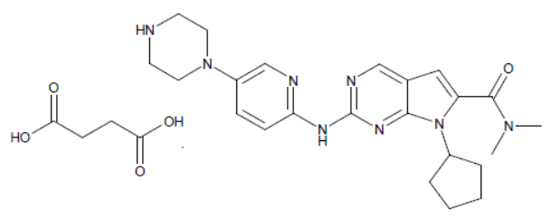
Molecular formula: | C₂₃H₃₀N₈O.C₄H₆O₄
Molecular weight: | As succinate: 552.64, and free base: 434.55
CAS numbers: | 1374639-75-4 (as succinate) and 1211441-98-3 (as free base)

DESCRIPTION
KISQALI tablets contain ribociclib succinate which is a light yellow to yellowish brown, crystalline powder. It is soluble in a 1:1 mixture of water and acetonitrile, and the pH of a 1 % w/v aqueous solution is about 5.2 at 25°C.
Each film coated tablet contains ribociclib succinate equivalent to 200 mg ribociclib. Each tablet contains microcrystalline cellulose, hyprolose, crospovidone, colloidal silicon dioxide, magnesium stearate (vegetable source), polyvinyl alcohol, titanium dioxide (E171), iron oxide black CI77499, iron oxide red CI77491, purified talc, lecithin (soya), and xanthan gum. KISQALI does not contain sucrose, lactose, gluten, or synthetic colours.

PHARMACOLOGY
Pharmacotherapeutic group: antineoplastic agents, protein kinase inhibitors; ATC code: L01XE42
Mechanism of Action
In vitro studies have shown ribociclib to selectively inhibit cyclin-dependent kinase (CDK) 4 and 6. These kinases are activated upon binding to D-cyclins and play a crucial role in signalling pathways which lead to cell cycle progression and cellular proliferation. The cyclin D-CDK4/6 complex regulates cell cycle progression through phosphorylation of the retinoblastoma protein (pRb).
In vitro, ribociclib decreased pRb phosphorylation leading to arrest in the G1 phase of the cell cycle and reduced cell proliferation in breast cancer cell lines. In vivo, treatment with single agent ribociclib lead to tumour regressions which correlated with inhibition of pRb phosphorylation at well tolerated doses.
In vivo studies using a patient-derived estrogen positive breast cancer xenograft model, the combination of ribociclib and antiestrogen (i.e. letrozole) resulted in superior tumour growth inhibition compared to each drug alone. Tumour regrowth was delayed for 33 days after stopping dosing.
Pharmacodynamic Effects
Ribociclib inhibits the CDK4/cyclin-D1 and CDK6/cyclin-D3 enzyme complexes with concentration resulting in 50 % inhibition (IC₅₀) values of 0.01 micromolar (μM) (4.3 ng/mL) and 0.039 μM (16.9 ng/mL) in biochemical assays, respectively.
In cell based assays with pRb positive breast cancer cell lines, ribociclib inhibits CDK4/6-dependent pRb phosphorylation with an IC₅₀ of 0.06-1.2 μM (26-521 ng/mL). Ribociclib halts G1 to S phase cell cycle progression measured by flow cytometry with IC₅₀ of 0.07-0.89 μM (30-387 ng/mL). Ribociclib also inhibits cellular proliferation measured by bromodeoxyuridine (BrdU) uptake with IC₅₀ of 0.04-3.3μM (17-1434ng/mL). The similar IC₅₀ values obtained from the target modulation, cell cycle and proliferation assays confirms that blockade of the pRb phosphorylation by ribociclib in cell-based assays directly leads to G1 to S phase arrest and subsequent inhibition of cellular proliferation. When tested in a panel of breast cancer cell lines with known ER status, ER+ cell lines were more sensitive than ER- cell lines to the anti-proliferation effects of ribociclib. Ribociclib had no inhibitory activity against pRb negative breast cancer cell lines.
Cardiac electrophysiology
Serial, triplicate electrocardiograms (ECGs) were collected following a single dose and at steady-state to evaluate the effect of ribociclib on the QTc interval in patients with advanced cancer. In vitro studies have shown that both ribociclib and its major metabolite, LEQ803, interact with hERG channels. In vivo cardiac safety studies in dogs demonstrated ribociclib dose- and concentration-related QTc interval prolongation at clinically relevant exposure. A pharmacokinetic-pharmacodynamic analysis included a total of 267 patients treated with ribociclib at doses ranging from 50 mg to 1,200 mg, including 193 patients treated with ribociclib 600 mg. The analysis suggested that ribociclib causes concentration-dependent increases in the QTc interval. The estimated mean change from baseline in QTcF was 22.87 ms (90 % CI: 21.6, 24.1) at the mean observed C_{max} at steady-state (2237 ng/mL) following administration at the recommended 600 mg dose (see PRECAUTIONS).
Pharmacokinetics (PK)
The pharmacokinetics of ribociclib was investigated in patients with advanced cancer following oral daily doses ranging from 50 mg to 1,200 mg. Healthy subjects received single oral doses ranging from 400 mg to 600 mg or repeated daily oral doses (8 days) at 400 mg. At the recommended dose of ribociclib 600 mg, the inter-patient variability in pharmacokinetics was approximately 60 %.

Absorption
Following oral administration of KISQALI to patients with advanced solid tumours or lymphomas, peak plasma levels (C_{max}) of ribociclib were achieved between 1 and 4 hours (time to reach maximum concentration, T _{max}). Following repeated once daily dosing, steady-state was generally achieved after 8 days and ribociclib accumulated with a geometric mean accumulation ratio of 2.51 (range: 0.97 to 6.40).

Linearity/non-linearity
Ribociclib exhibited slightly over-proportional increases in exposure (C_{max} and AUC) across the dose range of 50 mg to 1,200 mg following both single dose and repeated doses. The observed over-proportional increases in exposure might be attributed to auto-inhibition of CYP3A4. This analysis is limited by the small sample sizes for most of the dose cohorts with a majority of the data coming from the 600 mg dose cohort.
Food effect
Compared to the fasted state, oral administration of a single 600 mg dose of ribociclib DiC with a high-fat, high-calorie meal had no effect on the rate and extent of absorption of ribociclib (C_{max} GMR: 1.00; 90 % CI: 0.898, 1.11; AUCinf GMR: 1.06; 90 % CI: 1.01, 1.12).
Also see fruits and juices to avoid in INTERACTIONS WITH OTHER MEDICINES.

Distribution
Binding of ribociclib to human plasma proteins in vitro was approximately 70 % and independent of concentration (10 ng/mL to 10000 ng/mL). Ribociclib was equally distributed between red blood cells and plasma with a mean in vivo blood-to-plasma ratio of 1.04. The mean apparent volume of distribution at steady-state (Vss/F) was 1,090 L based on population PK analysis.

Biotransformation/ Metabolism
In vitro and in vivo studies indicated ribociclib undergoes extensive hepatic metabolism mainly via CYP3A4 in humans. Following oral administration of a single 600 mg dose of [¹⁴C] ribociclib to humans, the primary metabolic pathways for ribociclib involved oxidation {dealkylation, C and/or N-oxygenation, oxidation (-2H)} and combinations thereof. Phase II conjugates of ribociclib Phase I metabolites involved N-acetylation, sulphation, cysteine conjugation, glycosylation and glucuronidation. Ribociclib was the major circulating drug-derived entity in plasma (43.5 %). The major circulating metabolites included metabolite M13 (CCI284, N-hydroxylation), M4 (LEQ803, N-demethylation), and M1 (secondary glucuronide), each representing an estimated 9.39 %, 8.60 %, and 7.78 % of total radioactivity, and 21.6 %, 19.8 %, and 17.9 % of ribociclib exposure respectively. Clinical activity (pharmacological and safety) of ribociclib was due primarily to the parent drug, with negligible contribution from the circulating metabolites.
Ribociclib was extensively metabolized with unchanged drug accounting for 17.3 % and 12.1 % in feces and urine respectively. Metabolite LEQ803 was a significant metabolite in excreta and represented approximately 13.9 % and 3.74 % of the administered dose in feces and urine, respectively. Numerous other metabolites were detected in both feces and urine in minor abundance (≤ 2.78 % of the administered dose).

Elimination
The geometric mean plasma effective half-life (based on accumulation ratio) was 32.0 hours (63 % CV) and the geometric mean apparent oral clearance (CL/F) was 25.5 L/hr (66 % CV) at steady-state at 600 mg in patients with advanced cancer. The geometric mean apparent plasma terminal half-life (t_{1/2}) of ribociclib ranged from 29.7 to 54.7 hours and the geometric mean CL/F of ribociclib ranged from 39.9 to 77.5 L/hr at 600 mg across studies in healthy subjects.
Ribociclib is eliminated mainly via feces, with some elimination by the renal route. In six healthy male subjects, following a single oral dose of [¹⁴C] ribociclib, 91.7 % of the total administered radioactive dose was recovered within 22 days; feces was the major route of excretion (69.1 %), with 22.6 % of the dose recovered in urine. The estimated oral absorption of ribociclib was 59 %.

Special Patient Populations
Renal Impairment
Based on a population pharmacokinetic analysis that included 77 patients with normal renal function (eGFR ≥ 90 mL/min/1.73 m²), 76 patients with mild renal impairment (eGFR 60 to < 90 mL/min/1.73 m²) and 35 patients with moderate renal impairment (eGFR 30 to < 60 mL/min/1.73 m²), mild and moderate renal impairment had no effect on the exposure of ribociclib, no dose adjustment is necessary in patients with mild or moderate renal impairment. The pharmacokinetics of ribociclib in patients with severe renal impairment have not been studied (see DOSAGE AND ADMINISTRATION).
Hepatic Impairment
No dose adjustment is necessary in patients with mild hepatic impairment (Child-Pugh A); a dose adjustment is required in patients with moderate (Child-Pugh B), or severe hepatic impairment (Child-Pugh C) and starting dose of 400 mg is recommended (see DOSAGE AND ADMINISTRATION). Based on a PK trial in patients with hepatic impairment, mild hepatic impairment had no effect on the exposure of ribociclib (see DOSAGE AND ADMINISTRATION). The mean exposure for ribociclib was increased less than 2-fold in patients with moderate (geometric mean ratio [GMR]: 1.50 for C_{max}; 1.32 for AUC_{inf}) and severe (GMR: 1.34 for C_{max}; 1.29 for AUC_{inf}) hepatic impairment. Based on a population PK analysis that included 160 patients with normal hepatic function and 47 patients with mild hepatic impairment, mild hepatic impairment had no effect on the exposure of ribociclib, further supporting the findings from the dedicated hepatic impairment study (see DOSAGE AND ADMINISTRATION).
Geriatric use
Of 334 patients who received KISQALI in the phase III study (in ribociclib plus letrozole arm), 150 patients (44.9 %) were ≥ 65 years of age and 35 patients (10.5 %) were ≥ 75 years of age. No overall differences in safety or effectiveness of KISQALI were observed between these patients and younger patients (see DOSAGE AND ADMINISTRATION).
Effect of age, weight, gender and race:
Population PK analysis showed that there are no clinically relevant effects of age, body weight, gender, or race on the systemic exposure of ribociclib that would require a dose adjustment.

CLINICAL TRIALS
Double-Blind Placebo-Controlled Studies
Study CLEE011A2301 (MONALEESA 2)
KISQALI was evaluated in a randomized, double-blind, placebo-controlled, multicenter phase III clinical study in the treatment of postmenopausal women with HR positive, HER2-negative, advanced breast cancer who received no prior therapy for advanced disease in combination with letrozole versus letrozole alone. The primary endpoint for the study was progression-free survival (PFS) using Response Evaluation Criteria in Solid Tumors (RECIST v1.1), based on the investigator assessment in the full population (all randomised patients).
Six hundred and sixty eight (668) patients were randomized 1:1 to receive either KISQALI 600 mg and letrozole 2.5 mg (n= 334) or placebo and letrozole 2.5 mg (n=334), stratified according to the presence of liver and/or lung metastases [Yes (n=292 (44 %))] versus No [n=376 (56 %))]). Demographics and baseline disease characteristics were balanced and comparable between study arms. KISQALI was given orally at a dose of 600 mg daily for 21 consecutive days followed by 7 days off treatment in combination with letrozole 2.5 mg once daily for 28 days. Patients were not allowed to cross over from placebo to KISQALI during the study or after progression of disease.
Patients enrolled in this study had a median age of 62 years (range 23 to 91); 44.2 % patients were 65 years or older. The patients included were Caucasian (82.2 %), Asians (7.6 %), and Black (2.5 %). All patients had an ECOG performance status of 0 or 1. Almost all patients had metastatic breast cancer (99.6 %) at study entry. A total of 43.7 % of patients had received chemotherapy in the neoadjuvant or adjuvant setting, and 52.4 % had received antihormonal therapy in the neo/adjuvant setting prior to study entry. Also 34.1 % of patients had de novo metastatic disease. 20.7 % of patients had bone only disease and 59.0 % of patients had visceral disease (lung and/or liver). Patients with prior (neo) adjuvant therapy with anastrozole or letrozole must have completed this therapy at least 12 months before study randomisation.
First interim analysis
The first interim analysis was performed after a median duration of PFS follow-up of 15.3 months (29 January 2016 data cut off). The efficacy results are summarised in Table 1. The analysis for the primary end-point met the pre-specified criteria for superiority for patients receiving ribociclib plus letrozole compared to patients receiving placebo plus letrozole. There was an estimated 44 % reduction in risk of progression for patients treated with the combination of reduction in ribociclib plus letrozole. The median PFS was 14.7 months for placebo plus letrozole arm and was not reached in the KISQALI plus letrozole arm. The results for PFS based on the blinded independent central (BIRC) radiological assessment were supportive of the primary efficacy results based on the investigator’s assessment with an estimated 41 % reduction in risk of progression for patients treated with the combination of ribociclib plus letrozole.
Overall survival (OS) is a key secondary endpoint. At the time of first interim PFS analysis, OS was not mature (43 events had occurred). The final OS is planned after 400 deaths have occurred.
The global health status/QoL showed no relevant difference between the ribociclib plus letrozole arm and the letrozole control arm.
Second interim analysis
A more mature interim analysis was performed after a median duration of follow-up of 26.4 months (2 January 2017 data cut off). The median PFS was 25.3 months for patients receiving ribociclib plus letrozole and 16.0 months for patients receiving placebo plus letrozole. Efficacy data are summarised in Table 1 (PFS, OS, ORR, CBR), Figure 1 (Kaplan-Meier curve for PFS), and Figure 2 (Kaplan-Meier curve for OS). 54.7 % of patients receiving ribociclib plus letrozole were estimated to be progression free at 24 months compared with 35.9 % in the placebo plus letrozole arm.
A series of pre-specified subgroup PFS analyses was performed based on prognostic factors and baseline characteristics to investigate the internal consistency of treatment effect (see Figure 3). A reduction in the risk of disease progression or death in favour of the ribociclib plus letrozole arm was observed in all individual patient subgroups of age, race, prior adjuvant or neo-adjuvant chemotherapy or hormonal therapies, liver and/or lung involvement and bone-only metastatic disease. This was evident for patients with liver and/or lung metastases (HR of 0.561 [95% CI: 0.424, 0.743], median progression free survival [mPFS] 24.8 months for ribociclib plus letrozole versus 13.4 months for letrozole alone), or without liver and/or lung metastases (HR of 0.597 [95% CI: 0.426, 0.837], mPFS 27.6 months versus 18.2 months). OS data remain immature. There was no statistically significant difference in overall survival (OS) between the Kisqali plus letrozole arm and the placebo plus letrozole arm (HR 0.746).
Table 1 Efficacy results, Progression free survival (PFS) and Overall survival (OS) for study CLEE011A2301 (MONALEESA 2)

 | First interim analysis (29 Jan 2016 cut off) |  | Second interim analysis (2 Jan 2017 cut off)
 | KISQALI plus letrozole | Placebo plus letrozole | KISQALI plus letrozole | Placebo plus letrozole
Full analysis set, n | 334 | 334 | 334 | 334
PFS (Investigator radiological assessment)
Number of events, n (%) | 93 (27.8) | 150 (44.9) | 140 (41.9) | 205 (61.4)
Median PFS [months] (95 % CI) | NE (19.3 – NE) | 14.7 (13.0 – 16.5) | 25.3 (23.0 – 30.3) | 16.0 (13.4 – 18.2)
Hazard ratio, HR (95 % CI) | 0.556 (0.429 to 0.720) |  | 0.568 (0.457 to 0.704)
p-valueª | 0.00000329 |  | 0.0000000963
PFS (Blinded independent review committee radiological assessment)
Number of events, n (%) | 50 (15.0) | 72 (21.6) | 70 (21.0) | 100 (29.9)
Median PFS [months] (95 % CI) | 22.9 (NE, NE) | NE (NE, NE) | NE (30.3, NE) | NE (24.9, NE)
Hazard ratio, HR (95 % CI) | 0.592 (0.412, 0.852) |  | 0.564(0.415, 0.767)
p-valueª | 0.002 |  | 0.000107
OS
Number of events, n (%) | 23 (6.9) | 20 (6.0) | 50 (15.0) | 66 (19.8)
Median PFS [months] (95 % CI | NE (NE-NE) | NE (NE-NE) | NE (NE-NE) | 33.0 (33.0–NE)
Hazard ratio (95 % CI) | 1.128 (0.619, 2.055) |  | 0.746 (0.517–1.078)
p-valueª | 0.653 |  | 0.059
Overall Response Rate^{b} (95 % CI) | 40.7 (35.4, 46.0) | 27.5 (22.8, 32.3) | 42.5 (37.2 , 47.8) | 28.7 (23.9 , 33.6)
Clinical Benefit Rate^{c} (95 % CI) | 79.6 (75.3, 84.0) | 72.8 (68.0, 77.5) | 79.9 (75.6, 84.2) | 73.1 (68.3, 77.8)
Patients with measurable disease at baseline, n | 256 | 245 | 257 | 245
Overall Response Rate^{b} (95 % CI) | 52.7 (46.6, 58.9) | 37.1 (31.1, 43.2) | 54.5 (48.4, 60.6) | 38.8 (32.7, 44.9)
Clinical benefit rate^{c} (95 % CI) | 80.1 (75.2, 85.0) | 71.8 (66.2, 77.5) | 80.2 (75.3, 85.0) | 71.8 (66.2, 77.5)

CI=confidence interval; N=number of patients; NE = Not estimable

ª p-value is obtained from the one-sided stratified log-rank test; ^{b} ORR: Overall Response Rate = proportion of patients with complete response + partial response; ^{c} CBR: Clinical Benefit Rate (CBR) = proportion of patients with complete response + partial response + (stable disease or non-complete response/Non-progressive disease ≥ 24 weeks)

Figure 1 Kaplan-Meier plot of PFS per Investigator: 02-Jan-2017 data cut-off (Full Analysis Set)

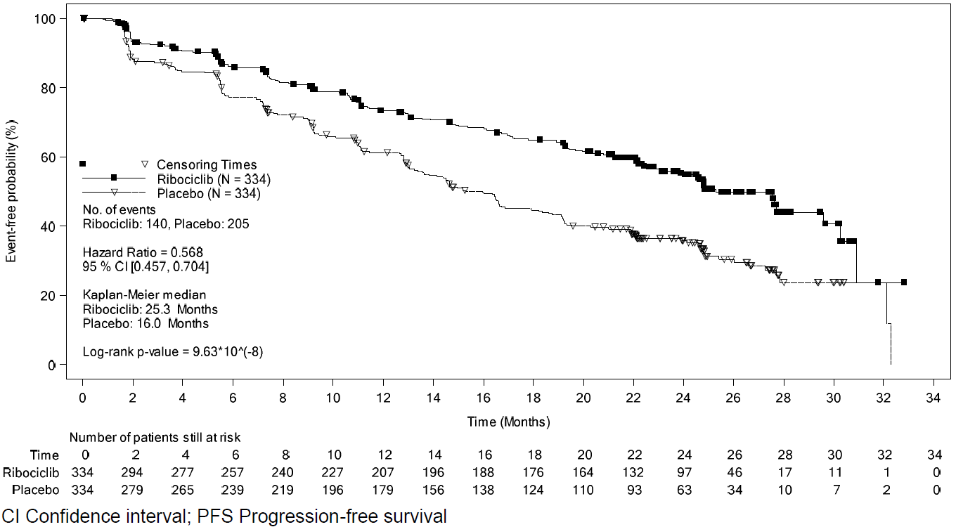

Figure 2 Kaplan-Meier plot of OS: 02-Jan-2017 data cut-off (Full Analysis Set)
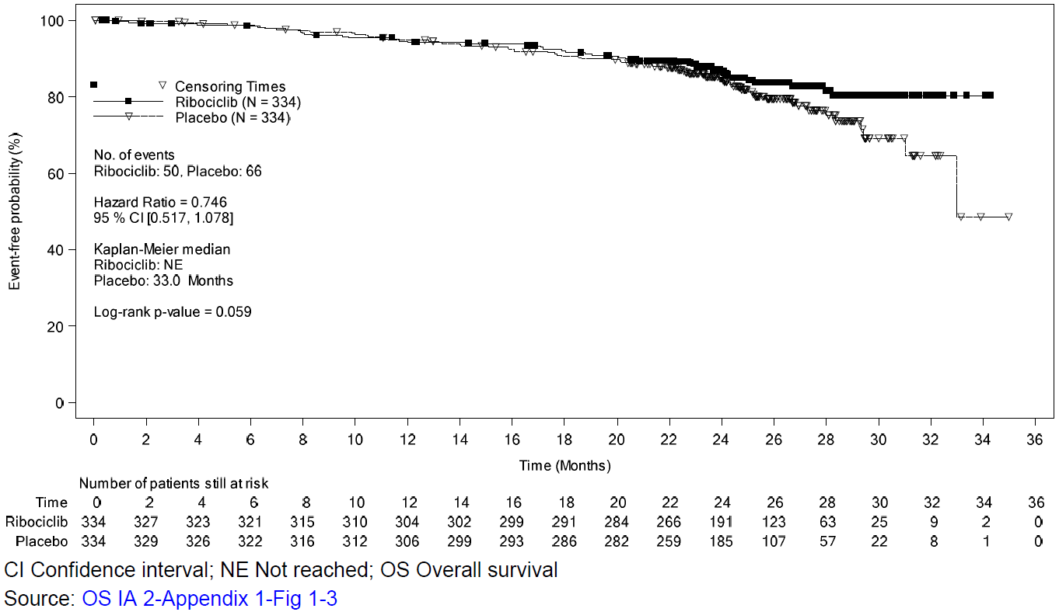
Figure 3 Forest plot subgroup analysis of PFS based on Investigator review – Study A2301 (2 January 2017 cut off)
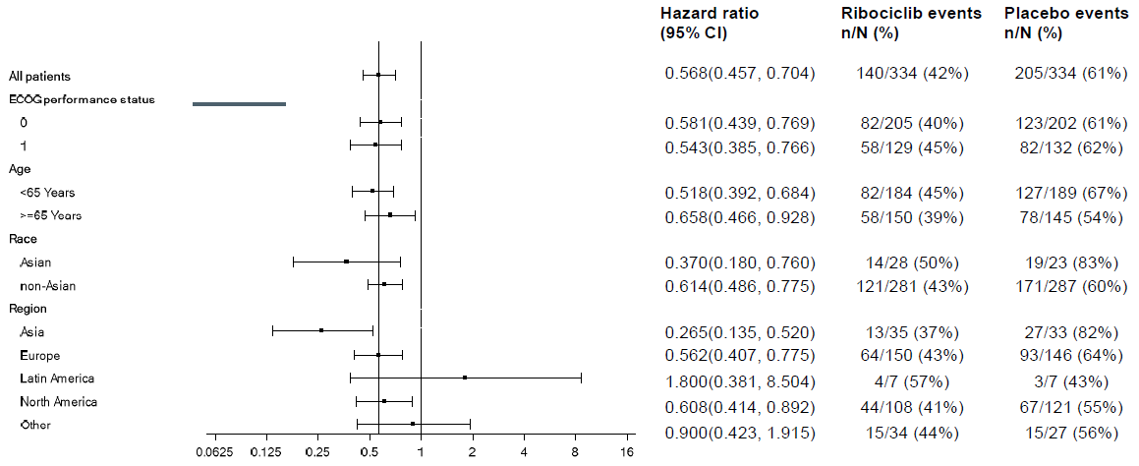
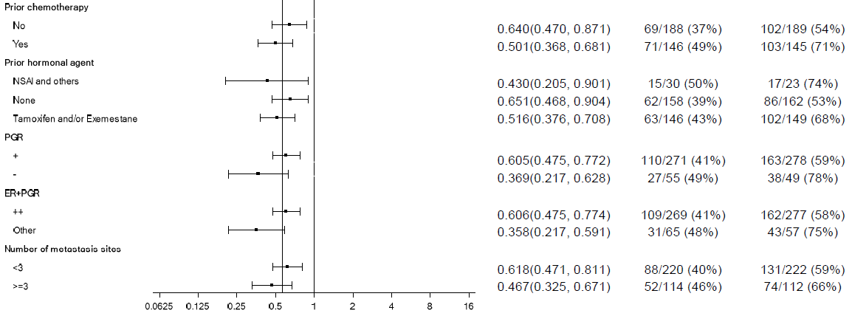
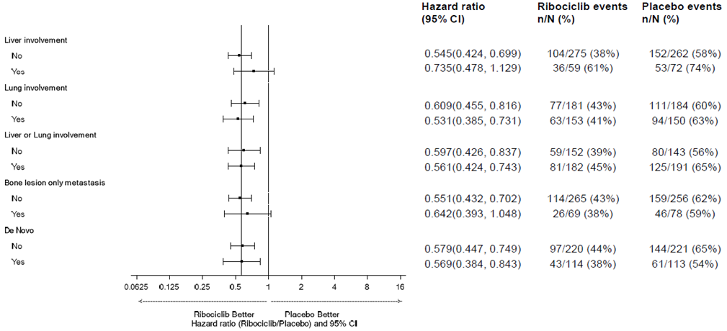

CI=confidence interval; ECOG PS=Eastern Cooperative Oncology Group performance status; ER=estrogen receptor; ET=endocrine therapy; EXE=exemestane; HR=hormone receptor; NSAI=non-steroidal aromatase inhibitor; PgR= progesterone receptor; TAM= tamoxifen.

INDICATIONS
KISQALI in combination with an aromatase inhibitor is indicated for the treatment of men and postmenopausal women with hormone receptor positive (HR+), human epidermal growth factor receptor 2 negative (HER2-) advanced or metastatic breast cancer, as an initial endocrine-based therapy.

CONTRAINDICATIONS
KISQALI is contraindicated in patients with corrected QT interval (QTcF) > 450 milliseconds (ms) prior to treatment or who already have long QT syndrome or who are at significant risk of developing QTc prolongation (see PRECAUTIONS).
KISQALI is contraindicated in patients with hypersensitivity to ribociclib succinate, soy products, or to any of the excipients (see DESCRIPTION).

PRECAUTIONS

QT interval prolongation
Ribociclib has shown concentration-dependent increases in the QTcF interval (see PHARMACOLOGY - Cardiac electrophysiology).
In vivo cardiac safety studies in dogs demonstrated dose and concentration related QTc interval prolongation at an exposure that would be expected to be achieved in patients following the recommended dose of 600 mg. As well, there is potential to induce incidences of premature ventricular contractions (PVCs) at elevated exposures (approximately 4-fold the anticipated clinical C_{max}).
In phase III clinical study A2301, patients with certain pre existing cardio-vascular diseases increasing the potential for QT prolongation (such as a history of documented heart failure, documented cardiomyopathy, or recent coronary disease) were excluded from study participation. A review of patient ECG data (average of triplicate) showed that 1 patient (0.3 %) had > 500 ms post-baseline QTcF value, and 9 patients (2.7 %) had a > 60 ms increase from baseline in QTcF intervals. There was one reported case of unexplained sudden death in a patient with Grade 3 hypokalaemia and Grade 2 QT prolongation (see ADVERSE EFFECTS), and there were no reported cases of Torsade de Pointes. There were more cases of syncope reported in the ribociclib-letrozole arm (9 cases, 2.7 %) than in the letrozole arm (3 cases, 0.9 %), although in no case was there conclusive evidence that syncope was due to ribociclib-induced ventricular arrhythmias.
The patient’s ECG should be assessed prior to initiation of treatment with KISQALI. Ribociclib should be initiated only in patients with QTcF values < 450 ms (see CONTRAINDICATIONS). The ECG should be repeated at approximately Day 14 of the first cycle, at the beginning of the second cycle, and as clinically indicated. More intensive ECGs should be considered based on a patient’s individual risk factors, if there are any symptoms that may be related to QT prolongation (e.g. palpitations or syncope), or if there is any increase in the risk of QT prolongation (e.g. new medication, or condition that may increase the likely exposure to ribociclib).
Appropriate monitoring of serum electrolytes (including potassium, calcium, phosphorous and magnesium) should be performed prior to initiation of treatment, at the beginning of first 6 cycles and as clinically indicated. Any abnormality should be corrected before the start of KISQALI therapy. In the event of hypokalaemia and/or hypomagnesaemia, ribociclib should be interrupted until these are corrected.
KISQALI should be avoided in patients who already have or who are at significant risk of developing QTc prolongation. This includes patients with:
- QTcF > 450 ms prior to treatment (see CONTRAINDICATIONS)
- a history of ventricular arrhythmias
- long QT syndrome (LQTS)
- significant risk of developing QTc prolongation including:
  - uncontrolled or significant cardiac disease including recent myocardial infarction, congestive heart failure, unstable angina, and bradyarrhythmias
  - uncorrected electrolyte abnormalities.
KISQALI should be avoided in patients taking medicinal products that are known to prolong the QTc interval (see INTERACTIONS WITH OTHER MEDICINES) and/or strong CYP3A inhibitors as this may lead to clinically meaningful prolongation of the QTcF interval (see DOSAGE AND ADMINISTRATION, INTERACTIONS WITH OTHER MEDICINES, and PHARMACOLOGY).
Based on the observed QT prolongation during treatment, KISQALI may require dose interruption, reduction or discontinuation as described in Table 8 Dose Modification and Management for Other Toxicities* (see sections DOSAGE AND ADMINISTRATION, ADVERSE EFFECTS and PHARMACOLOGY). If treatment with a strong CYP3A4 inhibitor cannot be avoided, the dose should be reduced to 200 mg once daily.

Hepatobiliary toxicity
Ribociclib commonly causes reversible elevations intransaminase levels, including uncommonly causes life-threatening hepatotoxicity.
Repeated dose toxicity studies in rats revealed the hepatobiliary system as the primary target organ of toxicity of ribociclib (see PRECAUTIONS - Nonclinical toxicity). Repeated dose toxicity studies in rats revealed the hepatobiliary system as the primary target organ of toxicity of ribociclib).
In the phase III clinical study, increases in transaminases were observed. Grade 3 or Grade 4 increases in ALT (10.2 % vs. 1.2 %) and AST (6.9 % vs. 1.5 %) were reported in the ribociclib and placebo arms respectively.
In the phase III clinical study and phase Ib study with KISQALI plus letrozole treatment, 83.8 % (31/37) of Grade 3 or Grade 4 ALT or AST elevation events occurred within the first 6 months of treatment (see ADVERSE EFFECTS). The majority of increases in ALT and AST were reported without concurrent elevations of bilirubin. Patients with grade 2 or worse elevations in the studies were managed by dose modification (delay, dose reduction, treatment discontinuation) of ribociclib. Among the patients who had Grade 3 or Grade 4 ALT/AST elevation, the median time-to-onset was 57 days (ranging from 15-401 days) for the KISQALI plus letrozole treatment group. Of the 33 out of 37 patients who recovered (with appropriate dose modifications to normalisation or baseline), the median time to resolution was 4.1 weeks. Of the 4 (1.2 %) Hy’s Law patients (concurrent elevations of ALT or AST greater than three times the upper limit of normal and of total bilirubin greater than two times the upper limit of normal, with normal alkaline phosphatase levels, and in the absence of cholestasis), all patients recovered to normal within 154 days after discontinuation of KISQALI.
Liver function tests (LFTs) should be performed before initiating therapy with KISQALI. The LFTs should be monitored every 2 weeks for first 2 cycles, at the beginning of each of the subsequent 4 cycles, and as clinically indicated.
Based on the severity of the transaminase elevations, KISQALI may require dose interruption, reduction, or discontinuation as described in Table 7 (see DOSAGE AND ADMINISTRATION). Recommendations for patients who have elevated AST/ALT > Grade 3 at baseline have not been established.

Neutropenia
Neutropenia was the most frequently reported adverse reaction (74.3 %) and a Grade 3 or Grade 4 decrease in neutrophil counts (based on laboratory findings) was reported in 59.6 % of patients receiving KISQALI plus letrozole in phase III clinical study A2301.
Among the patients who had Grades 2 to 4 neutropenia, the median time to Grade 2 and higher neutropenia was 16 days. The median time to resolution of ≥ Grade 3 neutropenia (to normalisation or < Grade 3) was 15 days in the KISQALI plus letrozole treatment group. Severity of neutropenia is concentration dependent. Febrile neutropenia was reported in 1.5 % of patients exposed to KISQALI in phase III clinical study. Physicians should inform patients to promptly report any fever (see ADVERSE EFFECTS).
A Complete Blood Count (CBC) should be performed before initiating therapy with KISQALI. CBC should be monitored every 2 weeks for the first 2 cycles, and at the beginning of each subsequent 4 cycles and as clinically indicated.
Based on the severity of the neutropenia, KISQALI may require dose interruption, reduction or discontinuation as described in Table 6 (see DOSAGE AND ADMINISTRATION).
Effects on Fertility
There are no clinical data available regarding effects of KISQALI on human fertility.
Based on animal studies, KISQALI may impair fertility in males of reproductive potential.
Use in Pregnancy (Category D)
Based on animal data and its mechanism of action, it is possible that KISQALI can cause fetal harm, including fetal developmental abnormalities and fetal loss, when administered to a pregnant woman. Women of reproductive potential should be advised of the risk to a fetus and to use effective contraception during therapy with KISQALI and for at least 21 days after the last dose, if KISQALI is used during pregnancy or if the patient becomes pregnant while taking this drug. (Also see Use in Pregnancy – Contraception.)
There are no adequate and well-controlled studies in pregnant women. Reproductive studies in rats and rabbits have demonstrated KISQALI induced embryotoxicity, fetotoxicity and teratogenicity.
In embryo-fetal development studies in rats and rabbits, pregnant animals received oral doses of KISQALI up to 1000 mg/kg/day and 60 mg/kg/day, respectively, during the period of organogenesis.
In rats, 1000 mg/kg/day was lethal in the maternal animals. At 300 mg/kg/day, reduced maternal body weight gain and fetal weights accompanied by skeletal variations were noted. There were no effects upon embryo-fetal mortality at 50 or 300 mg/kg/day. The no-observed effect level (NOEL) for maternal toxicity and embryo-fetal development was 50 mg/kg/day.
In rabbits at doses ≥ 30 mg/kg/day, there were adverse effects on embryo fetal development as evidenced by increased incidences of fetal abnormalities (malformations and external, visceral and skeletal variants) and fetal growth (lower fetal weights). These findings included reduced/small lung lobes and additional vessel on the aortic arch and diaphragmatic hernia, absent accessory lobe or (partly) fused lung lobes and reduced/small accessory lung lobe (30 and 60 mg/kg), extra/rudimentary 13th ribs and misshapen hyoid bone and reduced number of phalanges in the pollex. There was no evidence of embryo-fetal mortality. The NOEL for maternal toxicity was 30 mg/kg/day and the NOEL for the embryo-fetal development was 10 mg/kg/day.
At 300 mg/kg/day in rats and 30 mg/kg/day in rabbits, the maternal systemic exposure (AUC) were lower than or similar to the exposure achieved in patients at the highest recommended dose of 600 mg/day.
Data from CDK4 knockout mice strongly suggest that ribociclib exposure during development may result in adenohypophyseal hypoplasia, induction of insulin-dependent diabetes due to insufficient pancreatic beta cells, pituitary dwarfism and defects in T-lymphocyte ontogeny. However, knockout mouse data may not be predictive of effects in humans due to differences in degree of target inhibition.
There are no available human data informing the drug-associated risk. Advise pregnant women of the potential risk to the fetus.
Pregnancy testing
The pregnancy status for females of reproductive potential should be verified prior to initiating treatment with KISQALI.
Contraception
Females of reproductive potential should be advised that animal studies have been performed showing KISQALI to be harmful to the developing fetus. Sexually active females of reproductive potential should use effective contraception (methods that result in less than 1 % pregnancy rates) when using KISQALI during treatment and for 21 days after stopping treatment with KISQALI.
Use in Lactation
It is not known if KISQALI is present in human milk. There are no data on the effects of KISQALI on the breastfed child or the effects of KISQALI on milk production.
Ribociclib and its metabolites readily passed into the milk of lactating rats. In lactating rats administered a single dose of 50 mg/kg, exposure to ribociclib was 4-fold higher in milk compared to maternal plasma. Because of the potential for serious adverse reactions in nursing infants from KISQALI, a decision should be made whether to discontinue nursing or to discontinue the drug, taking into account the importance of the drug to the mother. It is recommended that women taking KISQALI should not breastfeed for at least 21 days after the last dose.
Carcinogenicity
No carcinogenesis studies have been conducted with ribociclib.
Genotoxicity
Genotoxicity studies in bacteria, and in mammalian cells (human lymphocytes and mouse lymphoma cells) in vitro with and without metabolic activation, and in a micronucleus test in rats did not reveal any evidence for a mutagenic potential of ribociclib.
Phototoxicity
Ribociclib was shown to absorb light in the UV-B and UV-A range. An in vitro phototoxicity test did not identify a relevant phototoxicity potential for ribociclib. The risk that KISQALI causes photosensitization in patients is considered very low.
Nonclinical toxicity
Repeated dose toxicity studies (treatment schedule of 3 weeks on/1 week off) in rats up to 26 weeks duration and dogs up to 39 weeks duration, revealed the hepatobiliary system (proliferative changes, cholestasis, sand-like gall bladder calculi, inspissated bile, periportal hepatocyte necrosis and arteriopathy in the hilar region) as the primary target organ of toxicity of ribociclib.
Additionally, effects on bone marrow (hypocellularity), pancytopenia, lymphoid system (lymphoid depletion), testes (atrophy), intestinal mucosa (atrophy), skin (atrophy), bone/ribs (decreased bone formation), lung (increased incidence of alveolar macrophages), and kidney (concurrent degeneration and regeneration of tubular epithelial cells) were described. In general, these changes in rats and dogs demonstrated either reversibility or a clear tendency towards reversibility. Exposure to ribociclib in animals in these toxicity studies was generally less than or equal to that observed in patients receiving multiple doses of 600 mg/day (based on AUC).
Effects on ability to drive and use machines
No studies on the effects of ribociclib on the ability to drive or operate machinery have been conducted. Patients experiencing fatigue while taking ribociclib should exercise caution when driving or operating machinery (see ADVERSE EFFECTS).

INTERACTIONS WITH OTHER MEDICINES
Drugs that may increase the QT interval
Co-administration of Kisqali with medicinal products with a known potential to prolong the QT interval may have an additive effect with ribociclib and increase the risk of QT prolongation.
Avoid co-administration of KISQALI with medicinal products with a known potential to prolong the QT interval, including, but not limited to: amiodarone, disopyramide, procainamide, quinidine, sotalol, ciprofloxacin, moxifloxacin, erythromycin, clarithromycin, fluconazole, pentamidine, citalopram, escitalopram, lithium, clomipramine, desipramine, imipramine, trimipramine, chlorpromazine, haloperidol, ziprasidone, cisapride, ondansetron, dolasetron, chloroquine, halofantrine, methadone, bepridil, and pimozide). If coadministration cannot be avoided, consider reducing the dose of ribociclib and monitor by ECG for QT prolongation (see INTERACTIONS WITH OTHER MEDICINES - Drugs that may increase ribociclib plasma concentrations).
In vitro interaction data
Effect of ribociclib on cytochrome P450 enzymes
In vitro, ribociclib is a reversible inhibitor of CYP1A2, CYP2E1 and CYP3A4/5 and a time-dependent inhibitor of CYP3A4/5, at clinically relevant concentrations. In vitro evaluations indicated that ribociclib has no potential to inhibit the activities of CYP2A6, CYP2B6, CYP2C8, CYP2C9, CYP2C19, and CYP2D6 at clinically relevant concentrations. Ribociclib has no potential for time-dependent inhibition of CYP1A2, CYP2C9, and CYP2D6.
In vitro data indicate that ribociclib has no potential to induce UGT enzymes or the CYP enzymes CYP2B6, CYP2C9, CYP2C19 and CYP3A4 via CAR or PXR. Therefore, Kisqali is unlikely to affect substrates of these enzymes.
Effect of transporters on ribociclib
Based on in vitro data, ribociclib is a substrate of P-gp but not a substrate of BCRP. However, P-gp mediated transport is unlikely to affect the extent of oral absorption of ribociclib at therapeutic doses because of moderate passive permeability.
Effect of ribociclib on transporters
In vitro evaluations indicated that ribociclib has a potential to inhibit the activities of drug transporters Pgp, BCRP, OATP1B1/1B3, OCT1, OCT2, MATE1, MATE2K and BSEP. Caution and monitoring for toxicity are advised during concomitant treatment with sensitive substrates of these transporters which exhibit a narrow therapeutic index, including but not limited to digoxin, pitavastatin and pravastatin. Ribociclib did not inhibit OAT1, OAT3 or MRP2 at clinically relevant concentrations in vitro.
Drug drug interaction between ribociclib and Letrozole
Comparison of data from a clinical trial in patients with breast cancer (Study X2107) to historical controls, and a population PK analysis indicated no clinically important drug interaction between ribociclib and letrozole following co-administration of the drugs.
Drugs that may increase ribociclib plasma concentrations
Ribociclib is primarily metabolized by CYP3A4 and is a time-dependent inhibitor of CYP3A4 in vitro (see PHARMACOLOGY – Pharmacokinetics: Biotransformation/Metabolism). Therefore, medicinal products which can influence CYP3A4 enzyme activity may alter the PK of ribociclib. No dose adjustments are required for mild and moderate CYP3A4 inhibitors, however, if treatment with a moderate CYP3A4 inhibitor is initiated, close monitoring for ribociclib-related AEs is recommended.
Concomitant use of strong CYP3A inhibitors including, but not limited to, clarithromycin, indinavir, itraconazole, ketoconazole, lopinavir, ritonavir (see below), nefazodone, nelfinavir, posaconazole, ritonavir, saquinavir, telaprevir, telithromycin, verapamil, and voriconazole should be avoided (see PRECAUTIONS). Alternative concomitant medications with less potential to inhibit CYP3A should be considered and patients should be monitored for adverse drug reactions (ADRs) (see DOSAGE AND ADMINISTRATION, PRECAUTIONS, and PHARMACOLOGY – Pharmacokinetics: Biotransformation/Metabolism).
If co-administration of ribociclib with a strong CYP3A inhibitor cannot be avoided, reduce KISQALI dose to 200 mg. However, there are no clinical data with this dose adjustment (see DOSAGE AND ADMINISTRATION). If the strong inhibitor is discontinued, resume the KISQALI dose (after at least 5 half-lives of the CYP3A inhibitor) to the dose used prior to the initiation of the strong CYP3A inhibitor. Due to inter-patient variability, the recommended dose adjustments may not be optimal in all patients individuals, therefore close monitoring for ribociclib related AEs is recommended. In case of ribociclib related toxicity, dose should be modified (see DOSAGE AND ADMINISTRATION), or treatment should be interrupted until toxicity is resolved. (See DOSAGE AND ADMINISTRATION, and PHARMACOLOGY – Pharmacokinetics: Biotransformation/ Metabolism.)
Ritonavir
A drug interaction trial in healthy subjects was conducted with ritonavir (strong CYP3A inhibitor). Compared to ribociclib alone, ritonavir (100 mg bid for 14 days) increased ribociclib C_{max} and AUC_{inf} by 1.7-fold and 3.2-fold, respectively, following a single 400 mg ribociclib dose. C_{max} and AUC_{last} for LEQ803 (a prominent metabolite of LEE011, accounting for < 10 % of parent exposure) decreased by 96 % and 98 %, respectively.
Erythromycin
Simulations using physiologically-based pharmacokinetic modelling (PBPK) suggested that erythromycin, a moderate CYP3A4 inhibitor, may increase ribociclib C_{max} and AUC by 1.3-fold and 1.9-fold, respectively.
Drugs that may decrease ribociclib plasma concentrations
Avoid concomitant use of strong CYP3A inducers, including, but not limited to, phenytoin, rifampin, carbamazepine and St John’s Wort (Hypericum perforatum). Consider an alternate concomitant medication with no or minimal potential to induce CYP3A (see PRECAUTIONS).
Rifampicin
A drug interaction trial in healthy subjects was conducted with rifampicin, a strong CYP3A4 inducer. Compared to ribociclib alone, co-administration with rifampicin (600 mg daily for 14 days) decreased ribociclib C_{max} and AUC_{inf} by 81 % and 89 %, respectively, following a single 600 mg ribociclib dose. LEQ803 C_{max} increased 1.7-fold and AUC_{inf} decreased by 27 %, respectively.
Efavirenz
Simulations using PBPK suggested that efavirenz, a moderate CYP3A inducer, may decrease ribociclib C_{max} and AUC by 37 % and 60 %, respectively.
Drugs that may have their plasma concentrations altered by ribociclib
Ribociclib is a moderate to strong CYP3A4 inhibitor and may interact with medicinal substrates that are metabolised via CYP3A4, which can lead to increased serum concentrations of the concomitantly used medicinal product.
Caution is recommended in case of concomitant use with sensitive CYP3A substrates with a narrow therapeutic index (see PRECAUTIONS). The dose of a sensitive CYP3A substrate with a narrow therapeutic index, including but not limited to alfentanil, cyclosporine, dihydroergotamine, ergotamine, everolimus, fentanyl, pimozide, quinidine, sirolimus and tacrolimus, may need to be reduced as ribociclib can increase their exposure.
Midazolam
Simulations using PBPK suggested that at a 600 mg ribociclib dose, midazolam Cmax and AUC may increase 2.4-fold and 5.2-fold, respectively.
Co-administration of midazolam (CYP3A4 substrate) with multiple doses of ribociclib (400 mg) increased the midazolam exposure by 280 % (3.8-fold) in healthy subjects, compared with administration of midazolam alone. Simulations using physiologically-based PK (PBPK) models suggested that ribociclib given at the clinically relevant dose of 600 mg is expected to increase the midazolam AUC by 5.2-fold.
Caffeine
Simulations using PBPK suggested only weak inhibitory effects on CYP1A2 substrates at a 600 mg ribociclib dose.
Co-administration of caffeine (CYP1A2 substrate) with multiple doses of ribociclib (400 mg) decreased C_{max} by 10 % and increased the caffeine AUC_{inf} by 20 % (1.2-fold) in healthy subjects, compared with administration of caffeine alone. At the clinically relevant dose of 600 mg, simulations using PBPK models predicted only weak inhibitory effects of ribociclib on CYP1A2 substrates (< 2-fold increase in AUC).
Drug-food interactions
Patients should be instructed to avoid pomegranate fruit or pomegranate juice, and grapefruits or grapefruit juice, all of which are known to inhibit cytochrome CYP3A enzymes and may increase the exposure to ribociclib.
KISQALI can be administered with or without food (see DOSAGE AND ADMINISTRATION).
Compared to the fasted state, oral administration of a single 600 mg dose of ribociclib film-coated tablet formulation with a high-fat, high-calorie meal had no effect on the rate and extent of absorption of ribociclib (C_{max} GMR: 1.00; 90 % CI: 0.898, 1.11; AUC_{inf} GMR: 1.06; 90 % CI: 1.01, 1.12).
Gastric pH elevating medications
Ribociclib exhibits high solubility at or below pH 4.5 and in bio-relevant media (at pH 5.0 and 6.5). Co-administration of ribociclib with medicinal products that elevate the gastric pH was not evaluated in a clinical trial; however, altered ribociclib absorption with proton pump inhibitors was not observed in population pharmacokinetic analysis, non–compartmental pharmacokinetic analyses nor in simulations using PBPK models.

ADVERSE EFFECTS
Clinical Trial Data
Summary of the safety profile
The overall safety evaluation of KISQALI is based on data from 898 patients. This includes 381 patients who received KISQALI at the recommended 600-mg dose, using the proposed treatment regimen (Days 1-21 of a 28-day cycle) in combination with letrozole at the approved 2.5 mg daily dose; 330 patients who received placebo in combination with letrozole and 187 patients who received ribociclib monotherapy (does range from 50 mg daily to 1200 mg daily).
Study CLEE011A2301 (MONALEESA 2)
The safety data reported below are based on the phase III clinical study of 668 postmenopausal women, randomised (1:1) receiving KISQALI plus letrozole or placebo plus letrozole. The median duration of exposure to KISQALI plus letrozole was 13 months with 58.1 % patients exposed for > 12 months.
Dose reductions due to AEs, regardless of causality occurred in 44.6 % of patients receiving KISQALI plus letrozole and in 3.0 % of patients receiving placebo plus letrozole. Permanent discontinuations due to adverse events were reported in 7.5 % of patients receiving KISQALI plus letrozole and 2.1 % in patients receiving placebo plus letrozole. The most common AEs leading to treatment discontinuation in patients receiving KISQALI plus letrozole were ALT increased (2.7 %), AST increased (2.4 %) and vomiting (1.5 %).
On-treatment deaths, regardless of causality, were reported in 3 cases (0.9 %) of KISQALI plus letrozole treated patients vs. 1 case (0.3 %) of placebo plus letrozole treated patients. Causes of death on KISQALI plus letrozole included one case of each of the following: study indication, death (cause unknown) and sudden death (in the setting of Grade 3 hypokalemia and Grade 2 QT prolongation). There was one death due to study indication on the placebo plus letrozole arm.
The most common ADRs (reported at an incidence > 20 % and for which the rate for KISQALI plus letrozole exceeds the rate for placebo plus letrozole) were neutropenia, leukopenia, headache, back pain, nausea, fatigue, diarrhoea, vomiting, constipation, alopecia, and rash.
The most common Grade 3/4 ADRs (reported at an incidence ≥ 2 % and for which the rate for KISQALI plus letrozole exceeds the rate for placebo plus letrozole) were neutropenia, leukopenia, abnormal LFT, lymphopenia, hypophosphataemia, vomiting, nausea, fatigue, and back pain.
Tabulated summary of adverse drug reactions from clinical trials in oncology
Adverse drug reactions from the Phase-III clinical trial A2301 are listed by MedDRA system organ class (Table 2). Within each system organ class, the adverse drug reactions are ranked by frequency, with the most frequent reactions first. Within each frequency grouping, adverse drug reactions are presented in order of decreasing seriousness. In addition, the corresponding frequency category for each adverse drug reaction is based on the following convention (CIOMS III):
very common (≥1/10); common (≥1/100 to <1/10); uncommon (≥1/1,000 to <1/100); rare (≥1/10,000 to <1/1,000); very rare (<1/10,000); and not known (cannot be estimated from the available data).

Table 2 Adverse drug reactions observed in the phase III clinical study A2301
Adverse drug reactions | KISQALI + Letrozole  N=334  n (%)  All Grades | Placebo + Letrozole  N=330  n (%)  All Grades | KISQALI+ Letrozole  N=334  n (%)  Grades 3/4 | Placebo + Letrozole  N=330  n (%)  Grades 3/4 | Frequency category  All Grades
Infections and infestations
Urinary tract infection¹ | 44 (13.2) | 28 (8.5) | 2 (0.6) | 0 (0.0) | Very common
Blood and lymphatic system disorders
Neutropenia | 248 (74.3) | 17 (5.2) | 198 (59.3) | 3 (0.9) | Very common
Leukopenia | 110 (32.9) | 13 (3.9) | 70 (21.0) | 2 (0.6) | Very common
Anaemia | 63 (18.9) | 15 (4.5) | 4 (1.2) | 4 (1.2) | Very common
Lymphopenia | 35 (10.5) | 7 (2.1) | 23 (6.9) | 3 (0.9) | Very Common
Thrombocytopenia | 30 (9.0) | 2 (0.6) | 2 (0.6) | 0 | Common
Febrile neutropenia | 5 (1.5) | 0 | 4 (1.2) | 0 | Common
Eye disorders
Lacrimation increased | 23 (6.9) | 6 (1.8) | 0 | 0 | Common
Dry eye | 19 (5.7) | 7 (2.1) | 0 | 0 | Common
Metabolism and nutrition disorders
Decreased appetite | 62 (18.6) | 50 (15.2) | 5 (1.5) | 1 (0.3) | Very common
Hypocalcaemia | 18 (5.4) | 6 (1.8) | 5 (1.5) | 0 | Common
Hypokalaemia | 15 (4.5) | 10 (3.0) | 4 (1.2) | 3 (0.9) | Common
Hypophosphataemia | 14 (4.2) | 3 (0.9) | 12 (3.6) | 2 (0.6) | Common
Nervous system disorders
Headache | 74 (22.2) | 63 (19.1) | 1 (0.3) | 1 (0.3) | Very common
Insomnia | 39 (11.7) | 31 (9.4) | 1 (0.3) | 0 | Very common
Cardiac disorders
Syncope | 9 (2.7) | 3 (0.9) | 6 (1.8) | 2 (0.6) | Common
Respiratory, thoracic and mediastinal disorders
Dyspnoea | 39 (11.7) | 29 (8.8) | 4 (1.2) | 2 (0.6) | Very common
Epistaxis | 15 (4.5) | 6 (1.8) | 0 | 0 | Common
Musculoskeletal and connective tissue disorders
Back pain | 66 (19.8) | 58 (17.6) | 7 (2.1) | 1 (0.3) | Very common
Gastrointestinal disorders
Nausea | 172 (51.5) | 94 (28.5) | 8 (2.4) | 2 (0.6) | Very common
Diarrhoea | 117 (35.0) | 73 (22.1) | 4 (1.2) | 3 (0.9) | Very common
Vomiting | 98 (29.3) | 51 (15.5) | 12 (3.6) | 3 (0.9) | Very common
Constipation | 83 (24.9) | 63 (19.1) | 4 (1.2) | 0 | Very common
Stomatitis | 41 (12.3) | 22 (6.7) | 1 (0.3) | 0 | Very common
Abdominal pain | 35 (10.5) | 25 (7.6) | 4 (1.2) | 0 | Very common
Dysgeusia | 31 (9.3) | 19 (5.8) | 1 (0.3) | 0 | Common
Dyspepsia | 22 (6.6) | 14 (4.2) | 0 | 0 | Common
Hepatobiliary disorders
Hepatotoxicity¹ | 5 (1.5) | 1 (0.3) | 5 (1.5) | 0 | Common
Skin and subcutaneous tissue disorders
Alopecia | 111 (33.2) | 51 (15.5) | 0 | 0 | Very common
Rash² | 67 (20.1) | 27 (8.2) | 3 (0.9) | 0 | Very common
Pruritus | 49 (14.7) | 20 (6.1) | 2 (0.6) | 0 | Very common
Erythema | 17 (5.1) | 4 (1.2) | 0 | 0 | Common
General disorders and administration site conditions
Fatigue | 122 (36.5) | 99 (30.0) | 8 (2.4) | 3 (0.9) | Very common
Asthenia | 43 (12.9) | 38 (11.5) | 3 (0.9) | 2 (0.6) | Very common
Pyrexia | 42 (12.6) | 18 (5.5) | 1 (0.3) | 0 | Very common
Investigations
Abnormal liver function tests³ | 60 (18.0) | 18 (5.5) | 32 (9.6) | 8 (2.4) | Very common
Blood creatinine increased | 23 (6.9) | 3 (0.9) | 2 (0.6) | 0 | Common
Weight decreased | 20 (6.0) | 11 (3.3) | 1 (0.3) | 0 | Common
ECG QT prolonged | 15 (4.5) | 4 (1.2) | 1 (0.3) | 0 | Common
¹Hepatotoxicity: hepatocellular injury, drug induced liver injury, hepatotoxicity, hepatic failure “1 non-fatal case”, autoimmune hepatitis (single case)
²Rash: rash, rash maculopapular
³Abnormal liver function tests: ALT increased, AST increased, blood bilirubin increased
Laboratory abnormalities
Clinically relevant or severe abnormalities of routine hematological or biochemical laboratory values are presented in Table 3.

Table 3 Laboratory abnormalities observed in the phase III clinical trial A2301
Laboratory abnormalities | KISQALI + Letrozole  N=334  n (%)  All grades | Placebo + Letrozole  N=330  n (%)  All grades | KISQALI + Letrozole  N=334  n (%)  Grades 3-4 | Placebo + Letrozole  N=330  n (%)  Grades 3-4 | Frequency category  (all grades)
Hematological parameters
Leukocyte count decreased | 311 (93.1) | 97 (29.4) | 115 (34.4) | 5 (1.5) | Very common
Neutrophil count decreased | 311 (93.1) | 79 (23.9) | 199 (59.6) | 4 (1.2) | Very common
Haemoglobin decreased | 189 (56.6) | 87 (26.4) | 6 (1.8) | 4 (1.2) | Very common
Lymphocyte count decreased | 169 (50.6) | 74 (22.4) | 45 (13.5) | 13 (3.9) | Very common
Platelet count decreased | 97 (29.0) | 21 (6.4) | 3 (0.9) | 1 (0.3) | Very common
Bio chemical parameters
Alanine aminotransferase increased | 155 (46.4) | 119 (36.1) | 34 (10.2) | 4 (1.2) | Very common
Aspartate aminotransferase increased | 147 (44.0) | 106 (32.1) | 23 (6.9) | 5 (1.5) | Very common
Creatinine increased | 65 (19.5) | 18 (5.5) | 2 (0.6) | 0 | Very common
Bilirubin increased | 44 (13.2) | 14 (4.2) | 17 (5.1) | 2 (0.6) | Common
Phosphorous decreased | 38 (11.4) | 24 (7.3) | 4 (1.2) | 4 (1.2) | Very common
Potassium decreased | 17 (5.1) | 9 (2.7) | 4 (1.2) | 1 (0.3) | Very common
Description of selected adverse drug reactions
QT prolongation
In the phase III clinical study, 7.5 % of patients in the ribociclib arm and 2.4 % in the placebo arm had at least one event of QT interval prolongation (including ECG QT prolonged, syncope). Dose interruptions/ adjustments were reported in 0.9 % of the KISQALI plus letrozole-treated patients due to electrocardiogram QT prolonged and syncope, respectively.
A central analysis of ECG data (average of triplicate) showed 11 patients (3.3 %) and 1 patient (0.3 %) with at least one > 480 ms post-baseline QTcF for the ribociclib plus letrozole arm, placebo plus letrozole arms respectively. Among the patients who had QTcF prolongation of > 480 ms, the median time to onset is 15 days and these changes were reversible with dose interruption and/or dose reduction (see DOSAGE AND ADMINISTRATION, PRECAUTIONS, and PHARMACOLOGY).
Hepatobiliary toxicity
In the phase III clinical study, hepatobiliary toxicity events occurred in a higher proportion of patients in the ribociclib plus letrozole group compared with the placebo plus letrozole group (24.0 % and 13.6 %, respectively), with more Grade 3/4 adverse events reported in the patients treated with ribociclib plus letrozole (11.4 % vs. 3.6 %, respectively). Dose interruptions and/or adjustments due to hepatobiliary toxicity events were reported in 8.4 % of ribociclib plus letrozole-treated patients, primarily due to ALT increased (5.7 %) and/or AST increased (4.5 %). Discontinuation of treatment with KISQALI plus letrozole due to abnormal liver function tests, and hepatotoxicity were 3.0 % and 0.6 % respectively (see DOSAGE AND ADMINISTRATION, PRECAUTIONS, and PHARMACOLOGY).
Neutropenia
Neutropenia was most frequently reported by laboratory findings in the phase III study. Based on its severity, neutropenia was managed by laboratory monitoring, dose interruption and/or dose modification. Treatment discontinuation due to neutropenia was low (0.9 %), however, dose interruptions were required in 50 % of patients (see DOSAGE AND ADMINISTRATION, and PRECAUTIONS).

DOSAGE AND ADMINISTRATION
Treatment with KISQALI should be initiated by a physician experienced in the use of anticancer therapies. Monitoring for adverse drug reactions (ADRs) is required, including complete blood counts, LFTs, serum electrolytes, and ECG; dose modification (delay, reduction) or cessation may be required – see Tables 6-10.
Dosage
General target population
The recommended starting dose of KISQALI is 600 mg (three 200 mg film-coated tablets) taken orally, once daily for 21 consecutive days, followed by 7 days off treatment, resulting in a complete cycle of 28 days. KISQALI may be taken with or without food (see INTERACTIONS WITH OTHER MEDICINES). Treatment should be continued as long as the patient is deriving clinical benefit from therapy or until unacceptable toxicity occurs.
An aromatase inhibitor is taken daily throughout the 28-day cycle. Please refer to the full product information for the aromatase inhibitor dosing regimen.
Patients should be encouraged to take their dose of KISQALI and aromatase inhibitor at approximately the same time each day, preferably in the morning.
Dose modifications
Management of severe or intolerable ADRs may require temporary dose interruption, dose reduction, or permanent discontinuation of KISQALI. If dose reduction is required due to an ADR, it is recommended to reduce the dose of KISQALI as indicated in Table 4.
Tables 5 to 8 summarize recommendations for dose interruption, reduction, or discontinuation of KISQALI in the management of specific ADRs. Clinical judgment of the treating physician should guide the management plan of each patient based on individual benefit/risk assessment (see PRECAUTIONS and ADVERSE EFFECTS).

Table 4 Recommended Dose Modification Guidelines for Adverse Drug Reactions
 | Dose | Number of Tablets
Starting dose | 600 mg/day | 3 × 200 mg tablets
First dose reduction | 400 mg/day | 2 × 200 mg tablets
Second dose reduction | 200 mg*/day | 1 × 200 mg tablets
*If further dose reduction below 200 mg/day is required, discontinue the treatment.

Table 5 Dose Modification and Management for QT prolongation
On treatment ECGs with QTcF value of: | Recommendations
> 480 ms | - The dose should be interrupted  - If QTcF prolongation resolves to < 481 ms resume treatment at the same dose level;  - If QTcF ≥ 481 ms recurs, dose interrupt until QTcF < 481 ms, and then resume KISQALI at next lower dose level
> 500 ms on at least 2 separate ECGs (on the same visit) | Interrupt KISQALI until QTcF < 481 ms then resume KISQALI at next lower dose level
> 500 ms or > 60 ms change from baseline  With either:  - Torsade de Pointes  or  - polymorphic ventricular tachycardia  or  - unexplained syncope  or  - signs/symptoms of serious arrhythmia | Permanently discontinue KISQALI.
ECG should be performed prior to initiation, repeated at approximately day 14 of the first cycle and at the beginning of the second cycle, and as clinically indicated. In patients with higher risk of QTcF prolongation or ventricular arrhythmias, more frequent ECG monitoring is recommended.
Serum electrolytes (including potassium, calcium, phosphorous and magnesium) should be performed prior to initiation of treatment and at the beginning of the next 5 cycles, with abnormalities corrected prior to commencement/ resumption of treatment. Cycle commencement must be accompanied by active review of all concomitantly administered medicines.
In case of QTcF prolongation at any given time during treatment:
- Perform analysis of serum electrolytes (K⁺, Ca²⁺, PO₄³⁻, Mg²⁺). If outside the normal range, interrupt ribociclib treatment, correct with supplements or appropriate therapy as soon as possible, and repeat electrolytes until documented as normal.
- Review concomitant medication usage for the potential to inhibit CYP3A4 and/or to prolong the QT interval
- More frequent ECG monitoring is recommended, e.g. 7 and 14 days after resumption of KISQALI

Table 6 Dose Modification and management for neutropenia and febrile neutropenia
 | Grade 1 or 2  (ANC 1000/mm³ – < LLN) | Grade 3  (ANC 500 - < 1000/mm³) | Grade 3 febrile* neutropenia | Grade 4**  (ANC < 500/mm³)
Neutropenia and febrile neutropenia | No dose adjustment is required. | Dose interruption until recovery to grade ≤ 2.  Resume KISQALI at the same dose level.  If toxicity recurs at grade 3, dose interruption until recovery, then resume KISQALI at the next lower dose level. | Dose interruption until recovery of neutropenia to grade ≤ 2. Resume KISQALI at the next lower dose level. | Dose interruption until recovery to grade ≤ 2.  Resume KISQALI at the next lower dose level.
Complete Blood Counts (CBC) should be performed before initiating treatment with KISQALI.
After initiating treatment with KISQALI, CBC should be monitored every 2 weeks for the first 2 cycles, at the beginning of each subsequent 4 cycles, and as clinically indicated.
*Grade 3 neutropenia with a single episode of fever >38.3°C (or) above 38°C for more than one hour and/or concurrent infection
Grading according to CTCAE Version 4.0. CTCAE=Common Terminology Criteria for Adverse Events.
ANC = absolute neutrophil count; LLN = lower limit of normal

Table 7 Dose Modification and Management for Hepatobiliary toxicity
 | Grade 1  (> ULN – 3 x ULN) | Grade 2  (>3 to 5 x ULN) | Grade 3  (>5 to 20 x ULN) | Grade 4  (>20 x ULN)
AST and/or ALT elevations from baseline*, without increase in total bilirubin above 2 x ULN | No dose adjustment is required. | Baseline at Grade ≤ 2:  Dose interruption until recovery to ≤ baseline grade, then resume KISQALI at same dose level. If grade 2 recurs, resume KISQALI at next lower dose level.  Baseline Grade = 2:  No dose interruption. | Dose interruption until recovery to ≤ baseline grade, then resume at next lower dose level.  If grade 3 recurs, discontinue KISQALI. | Discontinue KISQALI
Combined elevations in AST and/or ALT together with total bilirubin increase, in the absence of cholestasis | If patients develop ALT and/or AST > 3 x ULN along with total bilirubin > 2 x ULN irrespective of baseline grade, discontinue KISQALI.
Liver Function Tests (LFTs) should be performed before initiating treatment with KISQALI.
After initiating treatment with KISQALI, LFTs should be monitored every 2 weeks for the first 2 cycles, at the beginning of each subsequent 4 cycles, and as clinically indicated.
If Grade 2, 3 or 4 abnormalities are noted, more frequent monitoring is recommended
ULN = upper limit of normal
*Baseline = prior to treatment initiation. Grading according to CTCAE Version 4.0. CTCAE=Common Terminology Criteria for Adverse Events

Table 8 Dose Modification and Management for Other Toxicities*
 | Grade 1 or 2 | Grade 3 | Grade 4
Other toxicities | No dose adjustment is required. Initiate appropriate medical therapy and monitor as clinically indicated. | Dose interruption until recovery to grade ≤1 resume KISQALI at same dose level.  If grade 3 recurs, resume KISQALI at the next lower dose level. | Discontinue KISQALI.
*excluding neutropenia, febrile neutropenia, hepatobiliary toxicity, and QT interval prolongation.
Grading according to CTCAE Version 4.03. CTCAE=Common Terminology Criteria for Adverse Events.
Refer to the PI for the co administered aromatase inhibitor for dose modification guidelines and other relevant safety information in the event of toxicity.
Dose modification for use of KISQALI with strong CYP3A inhibitors
Avoid concomitant use of KISQALI with strong CYP3A inhibitors and consider an alternative concomitant medication with less potential for CYP3A inhibition. If a strong CYP3A inhibitor must be co-administered, reduce the KISQALI dose to 200 mg once daily.
Due to inter-patient variability, the recommended dose adjustments may not be optimal in all patients, therefore close monitoring of signs of toxicity is recommended. If the strong inhibitor is discontinued, the KISQALI dose should be changed (after 5 half-lives of the strong CYP3A inhibitor) to the dose used prior to the initiation of the strong CYP3A inhibitor (see PRECAUTIONS, INTERACTIONS WITH OTHER MEDICINES, and PHARMACOLOGY).

Special Populations

Renal Impairment
No dose adjustment is necessary in patients with mild or moderate renal impairment (see PHARMACOLOGY). There is limited experience in patients with moderate renal impairment and no experience in patients with severe renal failure or who require haemodialysis with the use of KISQALI. Caution and close monitoring for toxicity should be used in patients with severe renal impairment.

Hepatic Impairment
A pharmacokinetic study in healthy subjects and non-cancer subjects with impaired hepatic function found that no dose adjustment is necessary in patients with mild hepatic impairment (Child-Pugh class A). A dose adjustment is required in patients with moderate (Child-Pugh class B) and severe hepatic impairment (Child-Pugh class C) can have increased (less than two-fold) exposure to ribociclib, and the starting dose of Kisqali 400 mg once daily is recommended. Ribociclib has not been studied in breast cancer patients with moderate and severe hepatic impairment (see PHARMACOLOGY).

Paediatrics
The safety and efficacy of KISQALI in children and adolescents aged below 18 years have not been established.

Elderly patients (≥ 65 years of age)
No dose adjustment is necessary (see PHARMACOLOGY).
Administration
KISQALI should be administered orally once daily at the same time every day, preferably in the morning, with or without food. If the patient vomits after taking the dose or misses a dose, an additional dose should not be taken that day. The next prescribed dose should be taken at the usual time.
KISQALI tablets should be swallowed whole (tablets should not be chewed, crushed or split prior to swallowing). No tablet should be ingested if it is broken, cracked, or otherwise not intact.

OVERDOSAGE

Treatment
There are no known cases of overdosage with ribociclib. The treatment of overdose should consist of general symptomatic and supportive measures. For information on the management of overdose, contact the Poison Information Centre on telephone number 13 11 26 (local call in all areas).

PRESENTATION AND STORAGE CONDITIONS

Presentation
200 mg tablet
Light greyish violet that is also unscored, round (approx. diameter: 11.1 mm), curved film-coated tablet with bevelled edges; debossed with “RIC” on one side and “NVR” on the other side.
Aclar/aluminium blisters platforms in packs containing either 63, 42, or 21 tablets.

Storage
Store below 30°C.

NAME AND ADDRESS OF THE SPONSOR
NOVARTIS Pharmaceuticals Australia Pty Limited
ABN 18 004 244 160
54 Waterloo Road
MACQUARIE PARK NSW 2113
® = Registered Trademark

POISON SCHEDULE OF THE MEDICINE
Schedule 4 – Prescription only medicine

DATE OF FIRST INCLUSION IN THE AUSTRALIAN REGISTER OF THERAPEUTIC GOODS (THE ARTG)
23 Oct 2017: AUST R 280246 KISQALI ribociclib 200 mg (as succinate) film coated tablet blister

Internal document code (kis201017i) based on Novartis CDS dated 29 Dec 2016

