Date of CER: 9 July 2012

AusPAR Attachment 2

Extract from the Clinical Evaluation Report for Retigabine
  - Proprietary Product Name: Trobalt
  - Sponsor: GlaxoSmithKline Australia Pty Ltd
About the Therapeutic Goods Administration (TGA)
- The Therapeutic Goods Administration (TGA) is part of the Australian Government Department of Health and is responsible for regulating medicines and medical devices.
- The TGA administers the Therapeutic Goods Act 1989 (the Act), applying a risk management approach designed to ensure therapeutic goods supplied in Australia meet acceptable standards of quality, safety and efficacy (performance), when necessary.
- The work of the TGA is based on applying scientific and clinical expertise to decision-making, to ensure that the benefits to consumers outweigh any risks associated with the use of medicines and medical devices.
- The TGA relies on the public, healthcare professionals and industry to report problems with medicines or medical devices. TGA investigates reports received by it to determine any necessary regulatory action.
- To report a problem with a medicine or medical device, please see the information on the TGA website <http://www.tga.gov.au>.
About the Extract from the Clinical Evaluation Report
- This document provides a more detailed evaluation of the clinical findings, extracted from the Clinical Evaluation Report (CER) prepared by the TGA. This extract does not include sections from the CER regarding product documentation or post market activities.
- The words [Information redacted], where they appear in this document, indicate that confidential information has been deleted.
- For the most recent Product Information (PI), please refer to the TGA website <http://www.tga.gov.au/hp/information-medicines-pi.htm>.
Copyright
© Commonwealth of Australia 2013
This work is copyright. You may reproduce the whole or part of this work in unaltered form for your own personal use or, if you are part of an organisation, for internal use within your organisation, but only if you or your organisation do not use the reproduction for any commercial purpose and retain this copyright notice and all disclaimer notices as part of that reproduction. Apart from rights to use as permitted by the Copyright Act 1968 or allowed by this copyright notice, all other rights are reserved and you are not allowed to reproduce the whole or any part of this work in any way (electronic or otherwise) without first being given specific written permission from the Commonwealth to do so. Requests and inquiries concerning reproduction and rights are to be sent to the TGA Copyright Officer, Therapeutic Goods Administration, PO Box 100, Woden ACT 2606 or emailed to <tga.copyright@tga.gov.au>.

Contents
List of abbreviations 5
1. Clinical rationale 8
2. Contents of the clinical dossier 9
2.1. Scope of the clinical dossier 9
2.2. Paediatric data 9
2.3. Good clinical practice 9
3. Pharmacokinetics 9
3.1. Studies providing pharmacokinetic data 9
3.2. Summary of pharmacokinetics 9
3.3. Evaluator’s overall conclusions on pharmacokinetics 22
4. Pharmacodynamics 22
4.1. Summary of pharmacodynamics 22
4.2. Evaluator’s overall conclusions on pharmacodynamics 23
5. Dosage selection for the pivotal studies 23
6. Clinical efficacy 23
6.1. Pivotal efficacy studies 23
6.2. Other efficacy studies 46
6.3. Analyses performed across trials (pooled and meta-analyses) 53
6.4. Evaluator’s conclusions on clinical efficacy 61
7. Clinical safety 62
7.1. Studies providing evaluable safety data 62
7.2. Patient exposure 63
7.3. Adverse events 64
7.4. Laboratory tests 72
7.5. Electrocardiograph 74
7.6. Vital signs 75
7.7. Weight 76
7.8. Urological and renal safety 77
7.9. Psychiatric safety 79
7.10. Post-marketing experience 81
7.11. Safety issues with the potential for major regulatory impact 82
7.12. Other safety issues 84
7.13. Evaluator’s overall conclusions on clinical safety 88
8. First round benefit-risk assessment 90
8.1. First round assessment of benefits 90
8.2. First round assessment of risks 90
8.3. First round assessment of benefit-risk balance 91
9. First round recommendation regarding authorisation 92
10. Clinical questions 92
10.1. Pharmacokinetics 92
10.2. Pharmacodynamics 93
10.3. Efficacy 93
10.4. Safety 93
11. References 93
List of abbreviations
Abbreviation | Meaning
ADR | Adverse drug reactions
AE | Adverse event
AED | Antiepileptic drug
AUA | American Urological Association
ALT | Alanine aminotransferase
ANCOVA | Analysis of covariance
AST | Aspartate aminotransferase
AUA SI | American Urological Association Symptom Index
AUC | Area under the plasma concentration-time curve
AUC(0-τ) | AUC over the dosing interval
AUC(0-∞) | AUC from zero up to infinity
BID | Two times daily
BSA | Body surface area
CBZ | Carbamazepine
CHMP | Committee for Medicinal Products for Human Use
CL | Systemic clearance
CL/F | Apparent oral clearance
Cmax | Maximum concentration
CNS | Central nervous system
CrCL | Creatinine clearance
CSR | Clinical Study Report
ECG | Electrocardiogram
EMEA | European Medicines Evaluation Agency
FDA | US Food and Drug Administration
GABA | Gamma-aminobutyric acid
GCP | Good Clinical Practice
ICH | International Conference of Harmonisation
ILAE | International League Against Epilepsy
IR | Immediate release
ITT | Intent-to-treat
LEV | Levetiracetam
LTG | Lamotrigine
MR | Modified release
NAMR | N-acetyl metabolite of retigabine
NDA | New Drug Application
PB | Phenobarbital
PCC | Potential Clinical Concern
PCT | Pivotal Controlled Trials
PD | Pharmacodynamic
PDCO | Paediatric Committee
PHN | Post herpetic neuralgia
PHT | Phenytoin
PIP | Paediatric Implementation Plan
PK | Pharmacokinetic
popPK | Population pharmacokinetic
PPSR | Proposed Pediatric Study Request
PREA | Paediatric Research Equity Act
QTc | QT interval corrected
QTcB | QT interval corrected with Bazett’s formula
QTcF | QT interval corrected with Fridericia’s formula
QTcI | QT interval
RTG | Retigabine
SAE | Serious adverse event
SD | Standard deviation
SPA | Special Protocol Assessment
SUDEP | Sudden Unexplained Death in Epilepsy
TEAE | Treatment-emergent adverse events
TESAE | Treatment-emergent serious adverse events
TID | Three times daily
Tmax | Time to maximum concentration / reach Cmax
TPM | Topiramate
VNS | Vagus nerve stimulation
VPA | Valproic acid

Clinical rationale
Epilepsy is a common neurological condition, affecting 0.7-1% of the population. It is characterized by seizures, which are episodes of abnormal, synchronous neuronal firing, usually accompanied by a reduction in awareness or by focal neurological symptoms. Seizures are usually classified into focal (“partial”) seizures, which begin in one part of the brain, or primary generalised seizures, which involve the whole brain network from the onset of the seizure. Focal seizures may spread, eventually involving the whole brain as the seizure progresses, and these are known as secondarily generalised seizures. Focal seizures are the most common form of seizures, though the seizures may spread so rapidly that the initial focal phase is not clinically apparent. The sponsor proposes that retigabine be used for focal (partial) seizures, irrespective of whether these seizures spread to cause secondary generalisation.
Antiepileptic drugs (AEDs) can often reduce the frequency and severity of seizures, producing lasting seizure-free intervals in some patients, but up to 30% of patients with epilepsy are resistant to drug treatment and continue to have frequent seizures despite treatment. Many other patients can only achieve seizure-freedom at the expense of considerable side effects including sedation and blunted cognition, so clinicians must often choose a compromise between seizure frequency and medication tolerability. Patients who have failed to respond to standard anticonvulsants can sometimes reduce their seizure frequency when novel agents with a new mechanism of action are introduced. The need for novel, safe and effective anticonvulsants is therefore very clear to clinicians.
Most existing anticonvulsants work by inhibiting sodium channels, by enhancing or mimicking the inhibition mediated by endogenous gamma-amino butyric acid (GABA), or by inhibiting the release of excitatory neurotransmitters. Inhibiting voltage-gated calcium channels can also be useful for some seizure types.
Retigabine has a primary pharmacological activity that differs from established AEDs: it enhances the potassium (K+) current mediated by the Kv7 subfamily of voltage-gated potassium (KCNQ) channels, predominantly KCNQ2 and KCNQ3, but also KCNQ4 and KCNQ5. Kv7 potassium channels are expressed in neurons, which is the target tissue for retigabine, but also in other excitable cells. KCNQ2, KCNQ3 and KCNQ5 are the dominant forms expressed in neural tissues, but these channels are also expressed in the urinary bladder (all forms, but predominantly KCNQ3), intestine (KCNQ3 in combination with KCNQ1) and skeletal muscles (KCNQ5). KCNQ4 is mainly expressed in the cardiovascular and auditory systems. Retigabine would be expected to have some action at all of these sites.
Along with sodium ions, potassium ions play a key role in determining the resting membrane potential of excitable cells and their flow out of the cell helps terminate the “action potential” associated with neural firing. Because potassium ions are largely intracellular, the cell interior becomes less positive when potassium ions flow down their concentration gradient. Facilitating the potassium current would therefore be expected to reduce neuronal excitability. Thus, there are good a priori reasons for suspecting that retigabine would exert an anticonvulsant action, and this is supported by a range of animal models of epilepsy. The expression of potassium channels in other tissues suggests that retigabine might also cause bladder inhibition, modify gut motility or, most importantly, interfere with cardiac excitability.

Contents of the clinical dossier

Scope of the clinical dossier
The submission contained the following clinical information:
- 21 clinical pharmacology studies, including 18 that provided pharmacokinetic data and 3 that provided pharmacodynamic data. The pivotal efficacy studies also collected pharmacokinetic data;
- population pharmacokinetic analyses;
- 3 pivotal efficacy/safety studies; and
- 8 other efficacy/safety studies.

Paediatric data
The submission did not include paediatric data, and the sponsor is not seeking approval for use in the paediatric population.

Good clinical practice
The sponsor makes the following set of claims in the Clinical Overview:
“All studies conducted by Valeant Pharmaceuticals North America were undertaken in accordance with standard operating procedures of Valeant. All studies in the retigabine clinical development program were conducted in accordance with ethical principles recognized by the world community, e.g. Declaration of Helsinki and/or Good Clinical Practice (GCP). All studies were conducted with the approval of Ethics Committees or Institutional Review Boards. Informed consent was obtained for all patients. Where regulatory approval was required, this was obtained from the relevant health authority.”
Similar statements appear in the individual study descriptions and it appears that GCP was followed throughout the study program.

Pharmacokinetics

Studies providing pharmacokinetic data
None of the pharmacokinetic studies had deficiencies that excluded their results from consideration. However, the drug interaction studies should be interpreted with caution because the lamotrigine interaction study (3065A1-109) used a subclinical dose of lamotrigine. The ‘Multiple AEDs’ study (3065A1-202) did not use standardised treatments – subjects entered the study on whatever AED regimen their clinicians had chosen previously – and this study had low numbers in many treatment groups.

Summary of pharmacokinetics
The information in the following summary is derived from conventional pharmacokinetic studies unless otherwise stated.

Physicochemical characteristics of the active substance
From the proposed PI:
“Retigabine is a white to pinkish-brown solid with a molecular weight of 303.3. It is insoluble in water, and soluble in organic solvents, methanol, chloroform and dimethylformamide.
Trobalt film-coated tablets also contain the inactive ingredients croscarmellose sodium, hypromellose, magnesium stearate, microcrystalline cellulose. The film coat includes polyvinyl alcohol, titanium dioxide, talc, indigo carmine aluminium lake, cochineal, iron oxide yellow CI77492, lecithin and xanthum gum.”

Pharmacokinetics in healthy subjects

Absorption

Sites and mechanisms of absorption
Retigabine is absorbed from the gut, but details of the precise sites and mechanisms involved are lacking. Across multiple PK studies, Cmax was generally reached in 2-3 hours (Figure 1).
Figure 1: Mean plasma concentration-time profiles of retigabine after single oral administration of 50 to 600 mg retigabine (Study 3065A1-100).
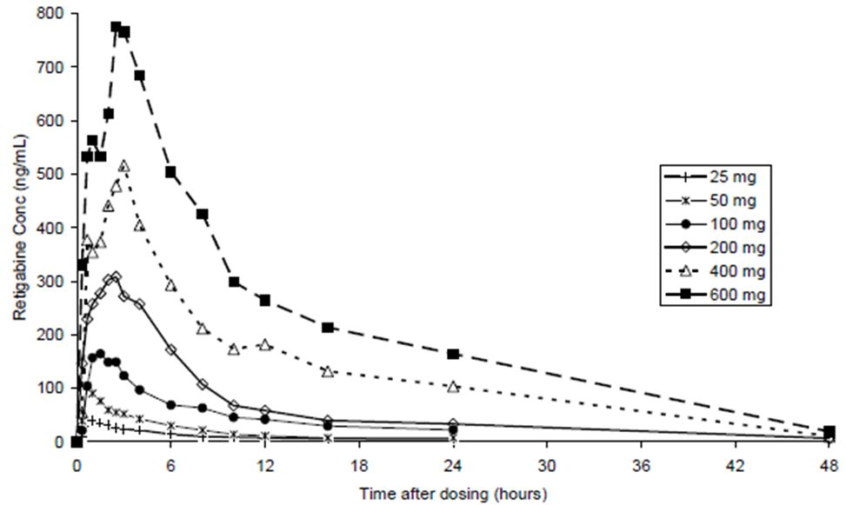

Bioavailability

Absolute bioavailability
The absolute bioavailability of retigabine was investigated in Study 3065A1-123 (n=12), when the bioavailability of retigabine as an oral solution and as oral immediate release (IR) capsules were compared with intravenous retigabine in fasting healthy adult male subjects. The absolute bioavailability was estimated to be 60%.

Bioavailability relative to an oral solution
Study 3065A1-123 compared the bioavailability of immediate release tablets and oral solution, finding them to be equivalent.

Bioequivalence of clinical trial and market formulations
Table 1 summarises the different formulations in use throughout the development program. Four main formulations are relevant, as listed in the left-hand column of Table 1: a capsule, the initial immediate release tablet, a clinical trial tablet and a market image tablet.
Table 1: Summary of the formulations and tablet strengths used in the bioequivalence and efficacy studies for retigabine.
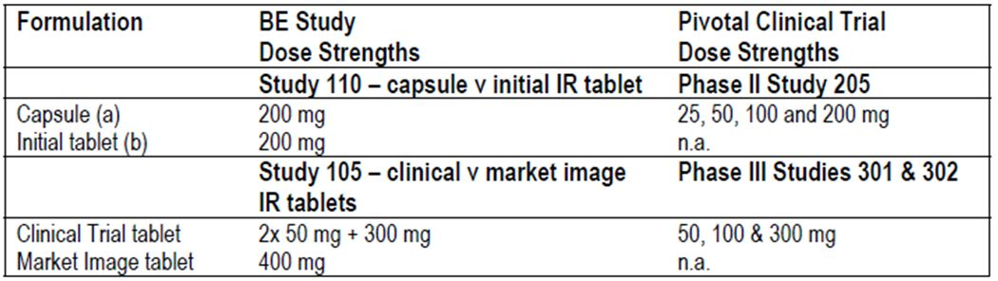
Pharmacokinetic studies generally used the “Initial tablet”. The capsule was used in the pivotal Phase II Study 205, but it was not used in the larger follow-up pivotal Phase III studies, which used a tablet designated the “Clinical Trial” tablet. The sponsor is seeking registration of the “Market Image” tablet, which has not been studied in any PK, PD or efficacy study.
Equivalence between the relevant formulations has been satisfactorily demonstrated, where necessary. In bioequivalence Study 3065A1-110, the bioavailability of retigabine in the IR capsules (200 mg) was shown to be bioequivalent to the Initial IR tablet (200 mg) on the basis that the 90% confidence intervals (CIs) of Cmax and AUC were within the standard bioequivalence range (80 to 125%). This shows that the original PK studies are applicable to the capsule formulation used in Study 205.
The “Clinical Trial” IR tablet has not been compared to the “Initial” IR tablet in any bioequivalence study, but it had the same core composition as the “Initial” tablets with only minor changes in tablet coating. The sponsor argues that the differences in tablet coating would not be anticipated to affect the rate or extent of release of retigabine, which sounds plausible, but this point should be addressed by the non-clinical evaluator.
Equivalence between the “Clinical Trial” tablet used in the pivotal Phase III studies and the “Market Image” tablet proposed for marketing was assessed in two studies: Study 105 (n=36) and RTG113287 (n=76). The first of these, Study 105, suggested that the Market Image tablet was more rapidly absorbed: the upper end of the 90% confidence interval (133%) for Cmax exceeded the standard criterion for equivalence (125%) and the geometric mean of the Market Image tablet was 16% higher than the Clinical Trial tablet. Overall systemic exposure was nonetheless the same, as reflected in similar AUC values within bioequivalence ranges. The sponsor argues that this study was underpowered: it had 72% power to demonstrate bioequivalence assuming the true difference between formulations is zero. A second bioequivalence study (RTG113287) with better power was conducted, and bioequivalence was demonstrated between the market image IR tablet and the clinical trial IR tablet on the basis of AUC and Cmax.
The sponsor also reports that the second study used clinical trial tablets with a d90 particle size for the active drug substance that was more representative of that used in the majority of patients studied in the pivotal Phase III clinical trials (Studies 301 and 302). This begs the question of whether particle size is likely to vary further, with subsequent changes in Cmax, such that the drug released on the market differs from that employed in the clinical studies. A higher Cmax would be likely to be associated with a higher incidence of peak-dose CNS and proarrhythmic side effects. The sponsor should be asked to comment on this issue.

Bioequivalence of different dosage forms and strengths
All retigabine tablets proposed for marketing are similar in composition, varying only in size and the amount of active drug. Bioequivalence of tablets of different strength has not been directly assessed, but differences are expected to be minor.

Influence of food
The influence of food has been assessed using retigabine capsules, Initial IR tablets and Market Image tablets. (The sponsor also submitted a food study involving sustained release retigabine tablets, 3065A1-104, which is not directly relevant to the current application.)
Study 3065A1-106 assessed the effect of administering retigabine IR capsules with a high fat breakfast: there were no significant effects on the AUC or Cmax values of retigabine relative to dosing in a fasted state, but there was a delay in the median tmax of ~2.75 h.
Study 3065A1-110 assessed administration of the Initial IR tablet formulation with a high-fat meal. There were no significant effects on the AUC but Cmax was increased by 14% relative to dosing in a fasted state.
The most relevant study of food effect was Study VRX-RET-E22-104, which assessed the effect of a high-fat breakfast on absorption of retigabine from the Market Image IR tablet. Food did not affect the extent of oral absorption (AUC) of retigabine, but it did result in a 38% higher Cmax. Median tmax for plasma retigabine was 2.50 h under fed conditions and 1.75 hours under fasted conditions, indicating an approximate delay of 45 minutes attributable to food.

Dose proportionality
Dose proportionality has been demonstrated in a number of studies using oral or IV retigabine. After IV dosing (1, 2.5, 5, 10, 25 or 50 mg) as a 15 minute IV infusion, dose proportionality was demonstrated within the range of 2.5-50 mg (Study 3065A1-117).
In Study (Study 3065A1-100), the single oral-dose PK of retigabine was dose-proportional over the dose range 25 mg to 600 mg. Retigabine was rapidly absorbed with a tmax of 2-3 hours and elimination was unaffected by dose, typically with a t½ around 10 hours.
A population pharmacokinetic analysis also showed that the systemic exposure to retigabine was linear over the therapeutic dose range of 600 to 1200 mg /day.
Overall, there is good evidence that retigabine produces a dose-proportional pharmacokinetic profile.

Bioavailability during multiple-dosing
Comparisons between single doses of retigabine and multiple doses were made in Study 3065A1-101. There was no evidence of varying bioavailability with continued use. Long-term studies have shown that, after long-term use of therapeutic doses, the PK of retigabine resembles that seen after single doses.

Effect of administration timing
Apart from the food effects discussed above, there are no known PK changes with different times of administration.

Distribution

Volume of distribution
The steady-state volume of distribution (Vss) of retigabine was assessed in Study 3065A1-117, and found to be 2-3 L/Kg after IV administration (dose range: 1-50 mg).

Plasma protein binding
From in vitro studies, it has been estimated that retigabine is ~80% bound to plasma protein over the concentration range of 0.1-2 μg/ml. Retigabine binding to human plasma proteins and to human serum albumin was similar, indicating that the drug is primarily bound to albumin. Binding was not concentration-dependent over a range 0.1-8 μg/mL for HSA and 0.1-2 μg/mL for human plasma proteins.

Erythrocyte distribution
No direct information was provided on the potential for erythrocyte distribution of retigabine. In Study 3065A1-108, whole-blood-to-plasma radioactivity ratios were 0.55 to 0.68, indicating that retigabine does not partition strongly into cellular components of blood.

Tissue distribution
In pre-clinical studies, the tissue distribution of radio-labelled [14C]-RTG was investigated in rats following a single oral dose. Most of the radioactivity was recovered in the gastrointestinal (GI) tract and liver, but also in most other tissues, e.g., adrenal, kidney, heart and spleen, suggesting widespread distribution to most tissues.
In humans, the apparent volume of distribution at steady state is much higher than body volume (2-3L/kg), consistent with moderate binding to tissues, including plasma proteins (mostly albumin). Specific details about where the drug is distributed in humans are lacking.

Metabolism

Metabolic pathways involved in the elimination of retigabine
Metabolism of retigabine was assessed in Study 3065A1-108. Retigabine is metabolised by formation of the N-acetyl metabolite of retigabine (NAMR) and through N-glucuronidation of both retigabine and NAMR (Figure 2). In vitro studies have shown that the glucuronidation is performed by a variety of uridine diphosphate glucuronyl transferase (UGT) isozymes (D-23129/FB23000).
Figure 2: Metabolic pathways of [14C]retigabine in healthy males after oral dosing of 200 mg retigabine as a capsule (excreted amounts in urine [0-72 h] and faeces [0-96 h] as % of dose administered) (study 3065A1-108).
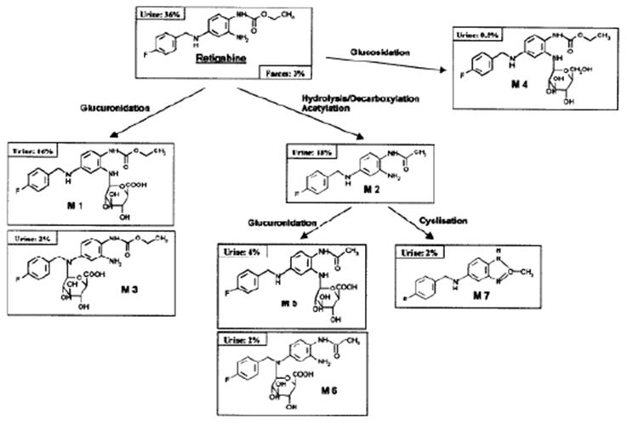
Additional metabolites of retigabine are an N-glucoside of retigabine and a cyclised metabolite of NAMR. There is no evidence for oxidative metabolism of retigabine via P450 enzymes.
In human plasma, the N2-glucuronide of retigabine is the predominant metabolite.

Non-renal clearance
The hepatic metabolism of retigabine is described above. Following metabolic conversion to NAMR or glucuronides, subsequent clearance is predominantly renal, with only a small proportion of an administered radioactive dose recoverable from faeces.

Metabolites identified in humans

Active metabolites
The major active metabolite of retigabine is NAMR, which is much less active than the parent compound as demonstrated during in vitro studies. No clinical data was submitted that illustrates the effect of NAMR on humans.

Other metabolites
Glucuronides are the most prevalent metabolites of retigabine. In the healthy volunteer study, Study 3065A1-108, retigabine-N2-glucuronide was responsible for the dominant radioactive peak in plasma, followed by retigabine and NAMR. Glucuronide conjugates generally have low pharmacological activity and the sponsor states that N-glucuronides of retigabine are not expected to contribute to the overall safety or activity profile of retigabine, but this claim was not directly assessed.

Pharmacokinetics of metabolites
The PK of retigabine and NAMR are broadly similar. The tmax of NAMR is slightly delayed relative to retigabine, as expected for a metabolite, and was reached about an hour later than the parent compound (Study 3065A1-108). The t½ for each compound typically ranged from about 6-10 hours, and the two compounds had a similar t½ within studies. Cmax for the metabolite was less than half that of retigabine. Comparative results are shown in Table 2 in response to a single dose of radio-labelled retigabine (200 mg orally).
Table 2: Pharmacokinetic parameters of [14C]retigabine in healthy subjects (mean ± SD, n = 6) (study 3065A1-108).
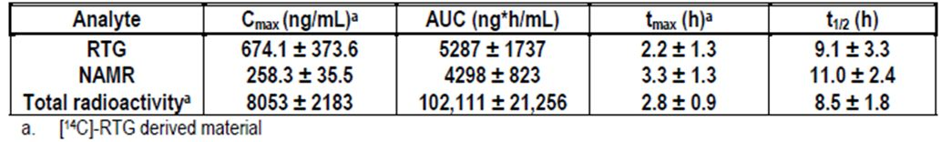

Consequences of genetic polymorphism
The effects of genetic polymorphism of different genotypes for UGT1A1 (subjects with and without Gilbert’s syndrome) and N-acetyltransferase (NAT2, fast and slow acetylators) were assessed in Study 3065A1-115. NAMR concentrations were slightly elevated in subjects with both Gilbert’s syndrome and fast NAT2 acetylator genotype The effects were minor compared to the normal interindividual variability, and no retigabine dose adjustments are required on the basis of UGT1A1 or NAT2 genotype.

Excretion

Routes and mechanisms of excretion
Retigabine is metabolised in the liver to a number of metabolites including NAMR and glucuronide conjugates. These metabolites are primarily eliminated by the kidney (84%), along with the parent compound (Figure 3). A small proportion (14%) is eliminated in faeces.
Figure 3: Mean cumulative recovery of [14C]retigabine derived radioactivity in urine and faeces following administration of a single oral dose of 200 mg (200 µCi) of [14C]retigabine to healthy male subjects (n = 6) (study 3065A1-108).
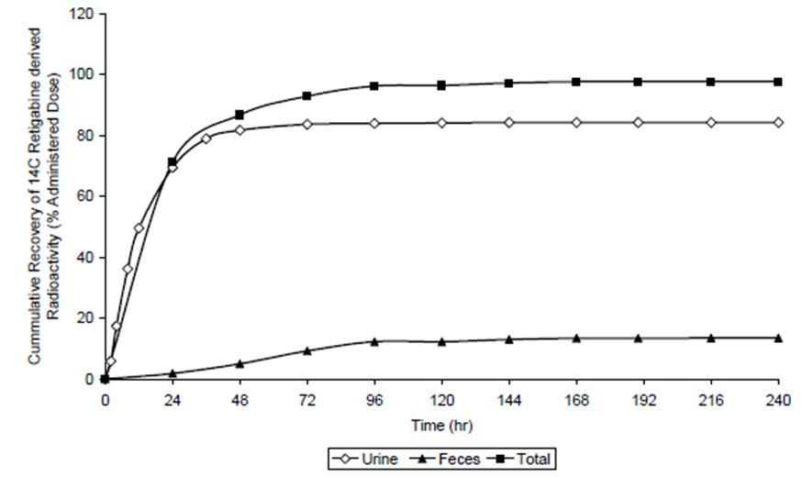

Mass balance studies
Figure 4 shows the retigabine, NAMR (AWD21-360) and [14C]retigabine derived radioactivity concentration-time profiles after administration of a single 200 mg dose of [14C]retigabine in healthy male volunteers.
Figure 4: Retigabine, NAMR (AWD21-360) and [14C]retigabine derived radioactivity concentration-time profiles after administration of a single 200 mg dose of [14C]retigabine in healthy male volunteers (mean ± SD, n = 6) (study 3065A1-108).
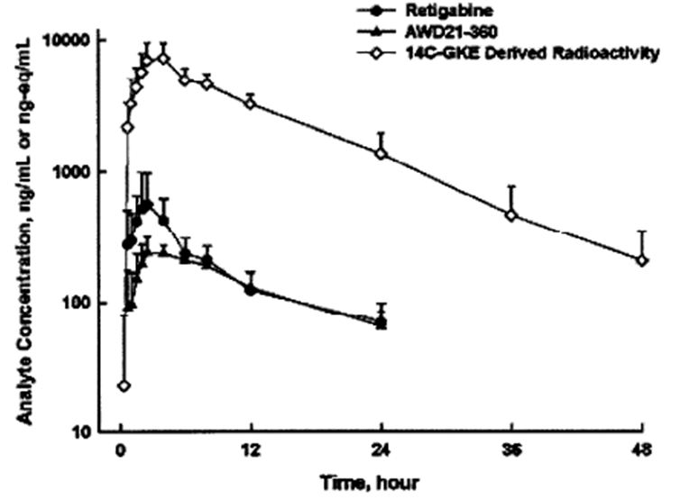

Renal clearance
Retigabine and its metabolites are mainly eliminated through the renal route: ~84% of a radiolabelled dose is recovered in the urine, with unchanged parent compound in urine accounting for 36% of the administered dose. The clearance of retigabine following IV dosing is ~0.4-0.6 L/h/kg.
A PK study in subjects with renal impairment (VRX-RET-E22-101) and the population PK analysis indicate that retigabine clearance is predominantly affected by renal function and body size (body surface area, BSA), with decreased retigabine clearance observed when creatinine clearance is also decreased and increased clearance observed with increasing BSA.

Intra- and inter-individual variability of pharmacokinetics
Interindividual variability as assessed in the PK studies was moderate at recommended doses, but more substantial at lower doses. For instance, in a multi-dose study of 12 healthy male volunteers (Study 3065A1-101) (Table 3), the t½ on Day 29 ranged approximately ten-fold across the group at a dose of 50mg BID (min 2.97 hr – max 27.66 hrs); at 200mg BID, the t½ was more consistent across the group (min 7.57 hr – max 11.01 hrs). In the same study, the coefficient of variation (CV) for Cmax was high (~40-70%), particularly at low doses. The CV for AUC was moderate (~30-35%).
Table 3: Pharmacokinetic parameters of retigabine after administration of single (day 1) or multiple (day 29) oral doses of retigabine in healthy male subjects (n = 12) (study 3065A1-101).
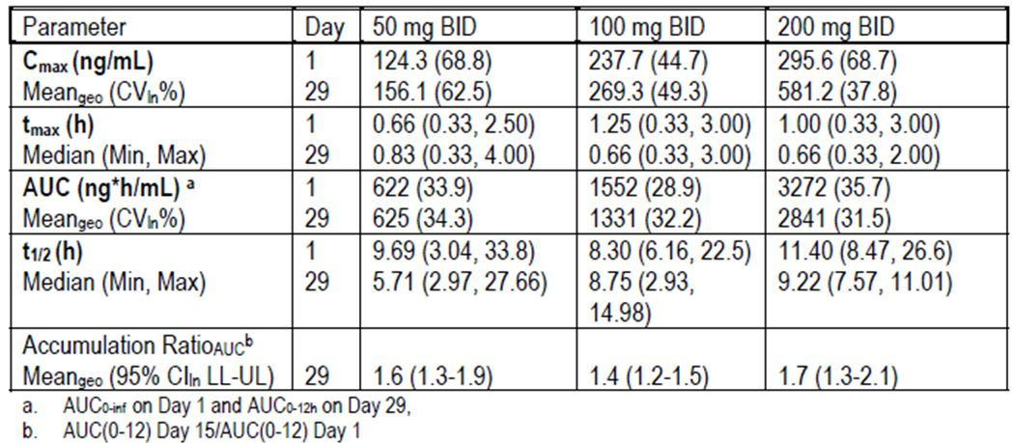
Interindividual variability was also assessed in the population PK analysis. In the final PK model (Model 6215), variability as expressed by the coefficient of variation (CV) was moderate for most parameters, but quite marked (>100%) for the central volume of distribution (V2) and the absorption rate constant (KA), as shown in Table 4.
Table 4: Parameter estimates of model 6215.
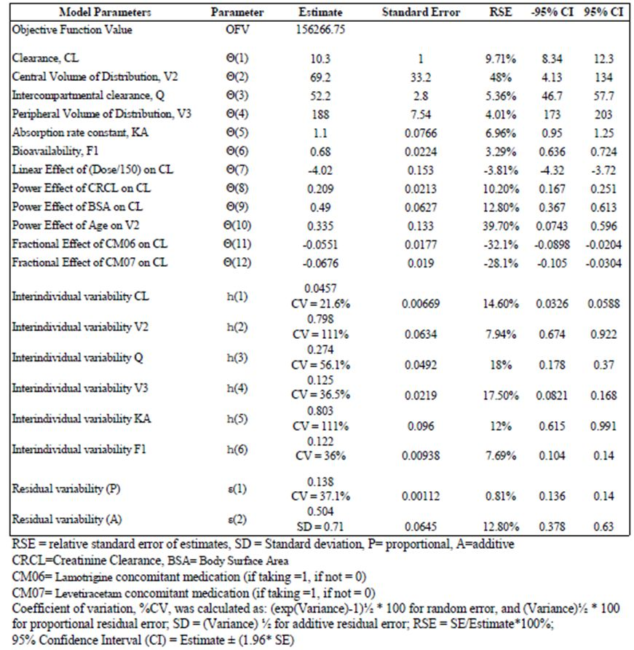
Between subject variability was also assessed in the PK analysis of the pivotal studies, and was shown to be 32-45% for Cmax, and 35-48% for AUC.
Within-subject variability has not been directly addressed by any PK study but is at least as great as that demonstrated in the food-effect studies (38% increase in Cmax with a fatty meal).
The variability in Cmax is of particular concern given the narrow therapeutic index of this drug, and the likelihood that proarrhythmic effects are related to peak concentration.

Pharmacokinetics in the target population
Blood samples for PK analysis were collected in each of the three pivotal studies, and the data was pooled for each dose group (Table 5). This analysis, reported in the Summary of Clinical Pharmacology, suggested that the PK of retigabine is broadly dose-proportional. The PK appears similar in a population of epilepsy patients as had been demonstrated in healthy volunteers who were studied in the initial PK program.
Table 5: Summary of the retigabine PK parameters by dose from studies 205, 301 and 302 (mean ± SD [CVb%]).
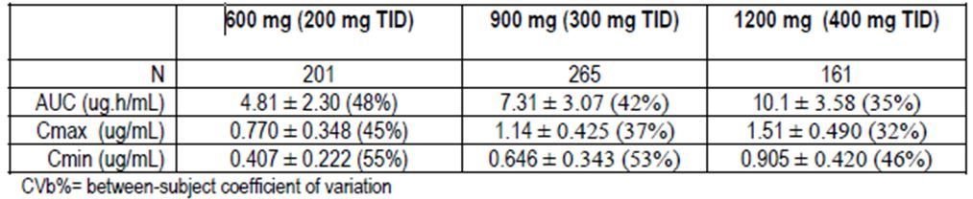

Pharmacokinetics in other special populations

Pharmacokinetics in subjects with impaired hepatic function
In a single-dose PK study in subjects with varying degrees of hepatic impairment (VRX-RET-E22-102), mild hepatic impairment produced no clinically relevant effects on retigabine AUC, but AUC was increased 52% or 109% in subjects with moderate or severe hepatic dysfunction, respectively, relative to subjects with normal hepatic function.
No retigabine dose adjustment is recommended in patients with mild hepatic impairment (Child-Pugh score 5 to 6), but in patients with moderate to severe hepatic impairment (Child Pugh score ≥ 7), a 50% decrease in the initial doses of retigabine is recommended, along with a 50% reduction in the maximum daily dose to 600mg/d.
This is especially important given the narrow therapeutic index of retigabine.

Pharmacokinetics in subjects with impaired renal function
The population PK analyses suggested that clearance of retigabine and NAMR decreases with decreasing creatinine clearance. A PK study in subjects with varying degrees of renal dysfunction (VRX-RET-E22-101) also indicated that retigabine clearance decreased with decreasing creatinine clearance (CrCL): retigabine AUC was increased by ~30% in subjects with mild renal impairment (CrCL 50 to 80 mL/min) and by ~ 100% in subjects with moderate or severe renal impairment (CrCL <50 mL/min), relative to healthy subjects. Subjects with ESRD had ~100% increase in retigabine AUC relative to healthy subjects.
The increase in AUC of 30% in mild renal impairment is of minor importance in a drug that is intended to be titrated according to tolerability and efficacy, so no dose adjustment is recommended in patients with mild renal impairment. For patients with moderate renal impairment (CrCL<50 mL/min) a 50% reduction in the initial and maintenance dose is recommended.
The effect of haemodialysis on retigabine clearance has not been adequately evaluated. For patients with ESRD receiving dialysis, a 50% reduction in dose is currently recommended. Given the pharmacokinetic uncertainties in this population and the narrow therapeutic index of retigabine, it would be appropriate to avoid the drug completely in patients with ESRD.

Pharmacokinetics according to age
Study 3065A1-105 assessed the PK of retigabine in elderly subjects. Cmax in elderly subjects was similar to the Cmax observed in younger control subjects, but AUC was ~40-50% higher in elderly subjects and t½ was ~30% longer. The weight-normalized clearance of retigabine was lower in elderly subjects than in young subjects; this is likely to be largely due to poorer renal function in the elderly.
Age was also identified as a significant covariate on retigabine V2 in the population PK analysis, which determined that retigabine Vd increased with increasing age.
The factors that cause declining clearance with age are themselves variable: some older subjects have relatively preserved renal and hepatic function, but many do not. The sponsor recommends a reduction by 50% of the starting dose in older subjects (≥ 65 years), with a reduction in the maximum total daily doses to 900mg. This seems reasonable.

Pharmacokinetics according to gender
Gender was not a major factor in determining the PK of retigabine, once weight was taken into account. In Study 3065A1-105, Cmax was ~50% higher in young females compared to young males and ~100% higher in elderly females compared to elderly males. Female subjects also had slightly higher AUC values (~20 to 30%) than in male subjects. Weight-normalised clearance did not differ between genders. The population PK analysis revealed a correlation between BSA and retigabine clearance, so reduced clearance and higher AUC in females could reflect the smaller median body size in females; this is supported by the finding of no gender difference in weight-normalised clearance in Study 3065A1-105.
The sponsor does not recommend that dosage adjustment is made on the basis of gender, which seems reasonable.

Pharmacokinetics according to body size
As discussed above, the population PK analysis determined that retigabine clearance increases with the increasing BSA, and gender differences in retigabine exposure could be resolved through weight normalisation in Study 3065A1-105. Over the range of body sizes assessed in the population PK analysis (1.5 to 3.0 m2), there was ~2-fold increase in clearance (~ 20 L/h to 40 L/h). Retigabine exposure will be increased in individuals of smaller body size, and clinicians would be wise to factor this in when choosing a dose for small patients. An explicit recommendation to adjust dose for body weight is not contained in the PI, but would be worthwhile given the narrow therapeutic index of this drug.

Pharmacokinetics according to race
In a post-hoc analysis of pooled data from multiple Phase I studies, the geometric mean of retigabine clearance (CL/F) was ~20% lower in Black subjects than in Caucasian subjects. The population PK analyses, however, indicated that the PK of retigabine are not significantly different between Caucasians and non-Caucasians. Given that the Phase I studies suggested only minor racial differences that were not supported by the population PK analysis, dose adjustment on the basis of race is not warranted.

Pharmacokinetics related to genetic factors
The effects of genetic polymorphism have been discussed above. No other relevant genetic information was provided, and there are no genetic groups expected to have significantly altered PK for retigabine.

Pharmacokinetic interactions

Pharmacokinetic interactions demonstrated in human studies

Effects of retigabine on the pharmacokinetics of other drugs

Phase III data
The effect of retigabine on clearance of other AEDs was assessed in the pivotal studies by measuring the trough AED concentrations prior to and during retigabine administration. For most AEDs, the 90% CI for the geometric mean ratios of AED concentrations with and without concomitant retigabine fell entirely within the standard 80% to 125% bioequivalence limits (Figure 5). For lamotrigine, however, retigabine co-administration was associated with a 20% decrease in lamotrigine trough concentrations.
Figure 5: Effects of retigabine on trough AED concentrations in epileptic subjects.
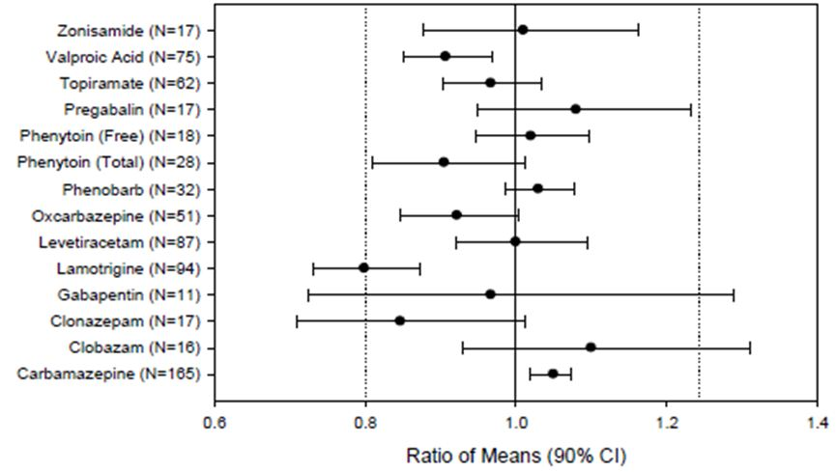

Study 3065A1-109
In a separate Phase I study (3065A1-109) in healthy subjects, retigabine 300 mg BID resulted in an 18% decrease in exposure to lamotrigine, in line with the Phase III observations. This minor pharmacokinetic effect would be expected to be swamped by additive or synergistic pharmacodynamic effects, which might lead to increased efficacy of the combination or increased side effects, or both. These pharmacodynamic interactions would require careful titration of both drugs even in the absence of any PK interaction, as is the case for all AED combinations, so the minor reduction in lamotrigine exposure does not require specific dose adjustment.

Oral contraceptives
In Study 3065A1-112, interactions between retigabine and the PK of norgestrel and ethinyl oestradiol were assessed. No significant differences were observed during coadministration, but the doses of retigabine assessed in this study (450 mg/d) were lower than those proposed in the PI (600-1200mg/d) and the period retigabine dosing (4 days) was far too short to assess the possibility of delayed effects including enzyme induction. Persistence of efficacy of oral contraceptives during retigabine treatment seems likely, but has not been satisfactorily proven.

Effects of other drugs on retigabine pharmacokinetics

Inducers of Glucuronidation
Study 3065A1-113, conducted in healthy volunteers (n=15), showed no effect of phenobarbital (90 mg once daily) on the PK of retigabine (200mg TID), but the phenobarbital dose was near the lower end of recommended dose range.
Study 3065A1-202 assessed the impact of the enzyme-inducing AEDs, phenytoin and carbamezepine, on the clearance of retigabine (n=8 for carbamazepine and n=9 for phenytoin). Co-administration of carbamezepine (600-2400 mg/d) and phenytoin (120 - 600 mg/d) with retigabine increased clearance of oral retigabine by approximately 27% and 36%, respectively. The sponsor calculates that this implies a mean reduction of systemic exposure to retigabine by approximately 21% and 26% for carbamazepine and phenytoin respectively. These findings were significant by ANOVA, despite the small sample size.
For the population pharmacokinetic analysis, all available data from the Phase I, II and III clinical studies were pooled. The impact of individual enzyme-inducing AEDs (EIAEDs) on the PK or retigabine was evaluated as part of the covariate analysis. This analysis had a much larger sample size than the Phase I interaction studies described above (carbamazepine, n=496; phenytoin, n=177; phenobarbital, n=109), but the analysis was indirect and subjects were on multiple drugs. In this analysis, there was no evidence that subjects already taking the enzyme-inducing AEDs carbamezepine, phenytoin or phenobarbital had significantly altered clearance of retigabine compared to subjects not taking the respective EIAED, but the effect could have been diluted by intersubject variability. A post-hoc covariate analysis showed that subjects who were taking an “enzyme-inducing combination” of EIAEDs did not have significantly different clearance of retigabine. The limitations of this indirect analysis do not overturn the findings of Study 3065A1-202, which did show a significant reduction in retigabine exposure when combined with enzyme-inducers, but the effect of enzyme-inducing agents seems to be minor. Patients on multiple agents with potentially synergistic pharmacodynamic effects will need their doses individually titrated anyway.

Inhibitors of Glucuronidation
In the population PK analysis there was no significant effects of valproate (n=252) on the pharmacokinetics of retigabine, as studied with covariate analysis, but patients were taking multiple AEDs that could have confounded the analysis. No Phase I study adequately assessed the impact of valproate.

Substrates of Glucuronidation
In Study 3065A1-109, co-administration of lamotrigine (25 mg once daily) with retigabine (200 mg single dose) to healthy subjects resulted in a 15% increase in retigabine AUC, which is of minor clinical significance. This dose of lamotrigine is much lower than that used in clinical practice (50mg BID to 200mg BID), so no conclusions can be drawn about the potential for standard lamotrigine doses to modify retigabine PK.
In the population PK analysis, lamotrigine administration was associated with a 7% reduction in retigabine clearance (which would be expected to increase AUC in line with the Phase I study), but this is of minor clinical significance. Because patients were on multiple drugs, this evidence is indirect and the true potential for an interaction with lamotrigine remains unclear.

Clinical implications of in vitro findings
According to the sponsor, in vitro studies with human biomaterials have not indicated that retigabine is likely to have any significant interactions with other AEDs. Known hepatic enzyme inhibitors such as valproic acid did not inhibit retigabine glucuronidation at clinically-relevant concentrations. A review of this evidence is outside the scope of this report.
The sponsor also reports that there is in vitro evidence that the N-acetyl metabolite of retigabine (NAMR) inhibits P-glycoprotein-mediated transport of digoxin, so retigabine at therapeutic doses might increase digoxin serum concentrations. If retigabine were to be given to a subject taking digoxin, it would be appropriate to monitor the digoxin levels and adjust the dose accordingly. Given the safety concerns raised in this evaluation, however, subjects on digoxin should not be given retigabine anyway, because the drug should be avoided in patients with heart disease.

Evaluator’s overall conclusions on pharmacokinetics
The pharmacokinetics of retigabine have been satisfactorily characterised, and are well described in the proposed Product Information sheet. It has an oral bioavailability of ~60%, is metabolised to range of partially active metabolites in the liver, and is ultimately eliminated by the kidneys with a half life of 6-10 hours, making it necessary to administer in three divided doses per day.
Consumption with food delays absorption and increases Cmax by ~38%. Clearance is significantly compromised in the setting of moderate to severe hepatic or renal impairment. Clearance is also proportional to body surface area. There is moderate variability between subjects, but gender, race and age do not make a significant difference to the PK of retigabine after accounting for body size. Pharmacokinetic interactions with other anticonvulsant drugs and the oral contraceptive pill appear minimal, but existing interaction studies are only partially adequate and did not use full therapeutic doses.
There is in vitro evidence that the N-acetyl metabolite of retigabine (NAMR) inhibits P-glycoprotein-mediated transport of digoxin, so retigabine at therapeutic doses might increase digoxin serum concentrations. No clinical study has been performed to investigate this question.

Pharmacodynamics

Summary of pharmacodynamics
No clinical studies were submitted that explored the primary pharmacology of retigabine, because of the lack of any suitable (ethical) human seizure model. The anticonvulsant effects of retigabine can only be inferred from the seizure frequency observed in efficacy studies.

Mechanism of action
Retigabine enhances the potassium (K+) current mediated by the Kv7 subfamily of voltage-gated potassium (KCNQ) channels, predominantly KCNQ2 and KCNQ3, but also KCNQ4 and KCNQ5. This is expected to reduce the excitability of neurons.

Pharmacodynamic effects

Primary pharmacodynamic effects
No relevant data were submitted.

Secondary pharmacodynamic effects
Pharmacodynamic studies were restricted to exploring safety-related secondary pharmacodynamic effects: Study VRX-RET-E22-103 explored the effect of retigabine on the QT interval of the ECG, and Study VRX-RET-E22-108 explored the abuse potential of retigabine. A third study listed as a pharmacodynamic study (RTG114137, not discussed in this report) was merely a quality-control study confirming that handling of urine specimens had not interfered with urinalysis.
The ECG study VRX-RET-E22-103 confirmed that retigabine has a very mild effect on the QT interval at doses up to 400mg TID.
The abuse potential study VRX-RET-E22-108 was inconclusive. It showed that recreational drug users, who were selected on the basis that they liked sedative drugs, identified some likeable sedation when treated with retigabine. This is not surprising.

Evaluator’s overall conclusions on pharmacodynamics
No primary pharmacodynamic studies have been performed. The sponsor has provided some evidence that retigabine has limited abuse potential, but only in the sense that recreational drug users found some of its sedative effects likeable. The sponsor has also assessed the effect of retigabine on the QT interval, finding a mild prolonging effect discussed in more detail in the Safety section.

Dosage selection for the pivotal studies
The dose range selected for further exploration in Study 205 was primarily based on the tolerability of the drug in clinical pharmacology studies. The oral PK Study 3065A1-100 had suggested that the maximum single dose likely to be tolerated was 400mg, because some subjects reported fatigue with this dose. The abuse-potential study (VRX-RET-E22-108) showed that single doses of 900mg were unsafe, leading to serious cardiac arrhythmias in two of six subjects (asystole and ventricular tachycardia). The half life suggested that a TID dosing schedule was appropriate, leading to a maximum feasible target dose of 400mg TID.
The Phase IIa studies (Studies 200 and 201) suggested a therapeutic window between 400mg/d and 1200mg/d.
The Phase IIb Study 205 therefore explored TID doses in this range (200mg TID to 400mg TID).
Together, the two Phase III studies explored the same dose range: Study 301 assessed 400mg TID ad Study 302 assessed 200mg TID and 300mg TID.

Clinical efficacy

Pivotal efficacy studies
The sponsor designated three studies as pivotal: a Phase IIb study (Study 205) and two similar Phase III studies (Studies 301 and 302). All were randomised, double-blind, placebo-controlled studies of the efficacy of retigabine as adjunctive therapy in refractory partial epilepsy. Study 205 assessed 3 active doses (600mg/d, 900mg/d, and 1200mg/d); Study 301 assessed retigabine at 1200mg/d, and Study 302 assessed retigabine at 600mg/d and 900mg/d. All studies used a forced titration schedule, and the double-blind treatment phase was divided into a titration phase and a maintenance phase.
Two outcome variables were evaluated in all three studies, based on differing recommendations in the US and EU regulatory settings:
- percent change in seizure frequency (in line with US requirements)
- responder rate, or percentage of patients with a ≥ 50% reduction in seizure frequency (in line with EU requirements).
Studies 301 and 302 employed similar methodologies, apart from the different doses and the longer titration period required to reach 1200mg/d, and they are appropriately considered together. They both used the same two primary endpoints: percent change in seizure frequency, and responder rate.
Study 205 had slightly different entry criteria to the Phase III studies, a single primary endpoint (percentage change in seizure frequency), and a shorter maintenance phase. It therefore needs to be considered separately.
The sponsor pooled all three studies in an integrated analysis, but this required some post hoc revision of the analysis methods for Study 205 and can only be considered supportive in nature. The pooled analysis was consistent with the analysis of the two main Phase III studies, and does not modify the overall conclusions about the efficacy of retigabine.

Studies 301 and 302

Design
Studies 301 and 302 were international studies. Study 301 was performed in 53 centres in the USA, Canada, Mexico, Argentina, and Brazil. Study 302 was performed in 71 centres in Australia, Belgium, France, Germany, Hungary, Israel, Poland, Russia, South Africa, Spain, UK, Ukraine, and USA. Both studies employed a randomised, double-blind, placebo-controlled design, a forced titration schedule (over 4 weeks in Study 302 and 6 weeks in Study 301), and a 12-week maintenance phase. They both used two primary efficacy endpoints consisting of percent change in 28-day partial seizure frequency for the US regulatory setting, and responder rate for the EU setting. The main difference between them was the dose of retigabine tested: 1200mg/d in Study 301, and 600mg/d or 900mg/d in Study 302.

Inclusion and exclusion criteria
Both pivotal Phase III studies recruited patients with partial (focal) epilepsy, with or without secondarily generalised seizures. They needed to be refractory to standard treatment and show evidence of on-going seizures at baseline.
In particular, eligible patients:
- were age 18-75;
- had a diagnosis of epilepsy for ≥2 years;
- had previously received treatment with at least two AEDs, concurrently or sequentially, without significant clinical benefit in the opinion of the investigator;
- could be receiving up to three AEDs at stable doses (+/-VNS). at least 1 month prior to screening and throughout the study treatment period;
- had at least four seizures per 28 days during the 8-week prospective baseline period;
- were not seizure-free for more than 21 days during the baseline period.
Patients were excluded if they had other significant medical conditions, a history of status epilepticus, seizure clusters or flurries where the individual seizures could not be counted within the 12 months prior to study entry, pseudo-seizures, or progressive central nervous system (CNS) disease such as CNS lupus, tumours, multiple sclerosis, or Alzheimer's disease.

Study treatments
Patients received retigabine or placebo in a forced titration schedule lasting 4 or 6 weeks, as shown in Figure 6 (Study 301) and Figure 7 (Study 302). Study 301 permitted a single down-titration step from 1200mg/d to 1050 mg/d for patients not tolerating the highest retigabine dose. All medication was given in equally divided doses three times per day; most of the sponsor’s tables and figure refer to the total daily dose.
Figure 6: Study 301 design.
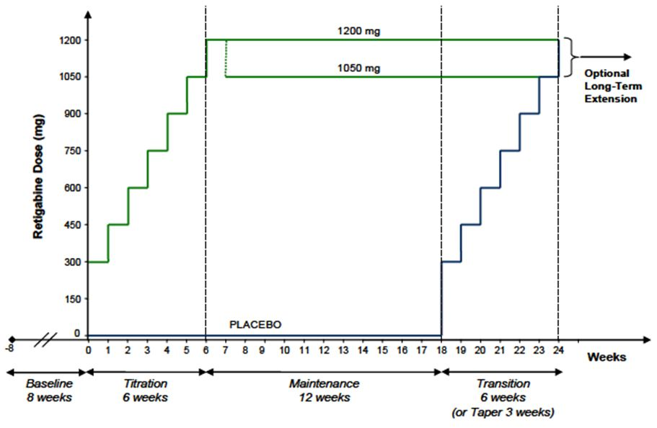
Figure 7: Study 302 design.
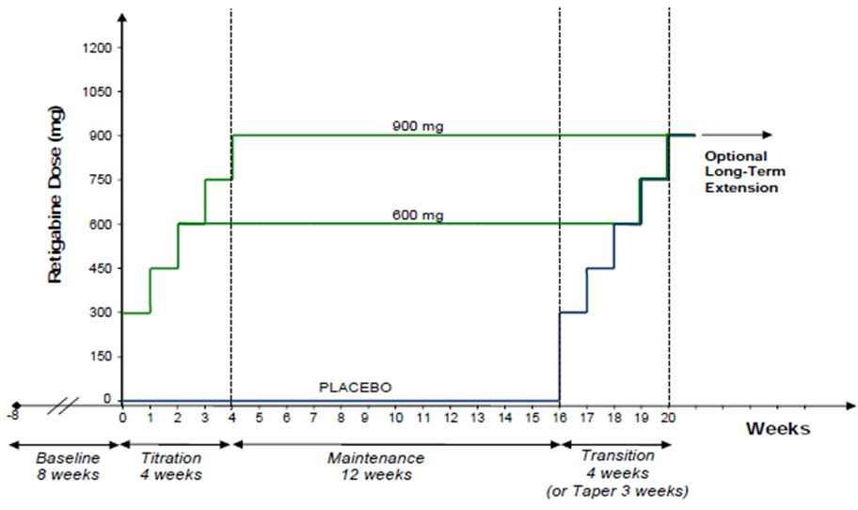
Benzodiazepines were allowed to control seizure clusters (or “flurries”) on up to 2 occasions.
Vigabatrin and felbamate were prohibited in the past 6 months because they can produce significant toxicity that could have clouded assessment of the safety of retigabine. Other prohibited medications included agents known to lower seizure threshold, such as neuroleptics. Antidepressants at low doses and monoamine oxidase inhibitors were allowed if the dose was kept constant.

Efficacy variables and outcomes
The two Phase III studies were designed with two primary endpoints, change in seizure frequency and response rate, reflecting different recommendations for epilepsy studies in the US and EU. The two endpoints also used a different period for assessing the treatment effect:
US (FDA) Endpoint: percent change in total partial seizure frequency per 4 weeks from baseline to the double-blind period (titration and maintenance periods combined);
EU (EMEA) Endpoint: proportion of responders experiencing a ≥ 50% reduction from baseline to the maintenance phase, in total partial seizure frequency per 4 weeks.
Both endpoints were evaluated as independent primary endpoints in both Phase III studies, without corrections for multiple endpoints. The sponsor argued that “Because the sequence of the tests was pre-ordered and fixed for each review, the overall type I error was controlled at 0.05 level.” Presumably this means the study had to meet whichever primary endpoint was considered most important in each regulatory domain (FDA in the US, or EMEA in the EU).
In the Australian context, this reasoning does not apply, but significance was achieved on both primary endpoints in both studies.
Other secondary efficacy outcomes included:
- Percent change in seizure frequency from baseline to the maintenance period.
- Proportion of responders in the combined double-blind period.
- Incidence of new seizure types.
- Proportion of patients experiencing an exacerbation of seizures (0-25% increase or >25% increase)
- Change in Clinical Global Impression of Improvement (CGI-I), measured on a 7-point Likert scale.
- Quality of Life in Epilepsy (QOLIE-31P)
The sponsor also reported:
- Proportion of patients seizure-free.
- Proportion of seizure-free days.

Randomisation and blinding methods
Patients were randomised equally in both Phase III studies. Blinding was maintained with matching placebos, a double-dummy technique, and matching titration schedules.

Analysis populations
The primary analysis was performed on an intent-to-treat (ITT) basis, but the definition of the ITT population differed according to the requirements of the FDA and the EU.
The ITT (EMA or ‘maintenance’ ITT) population was defined as all randomised patients who received at least one dose of study drug in the maintenance phase and had at least one seizure assessment recorded in the maintenance phase.
The ITT (FDA ‘double-blind’ ITT) population was defined as all randomised patients who received at least one dose of study drug.
For each endpoint, one of these two populations is a more natural population to consider (the maintenance ITT for maintenance-phase endpoints, the double-blind ITT for double-blind-phase endpoints), and has been used in the sponsor’s results tables. Importantly, the maintenance ITT analyses slightly inflate the potential benefit of treatment when considered from the perspective of a clinician who is deciding whether to start treatment, because these analyses censor the early failures leading to withdrawal during titration.

Sample size
The sponsor defended its sample size calculations as follows:
“In Study 301, a total of 250 patients (125 per arm, 1:1 randomization) were required to detect a 17% difference in responder rates between retigabine 1200 mg/d and placebo with 85% power and a type 1 error rate of 5%. Assuming a 10% attrition rate between randomization and the first post-dose evaluation assessment, a total of 280 patients (140 per treatment arm) were required to be randomized in order to satisfy the evaluable sample size requirements.
In Study 302, a total of 453 patients (151 per treatment arm, 1:1:1 randomization) were required to detect a 16% difference in responder rates between retigabine 900 mg/d and placebo with 85% power and a type 1 error rate of 5%. Assuming 10% attrition rate between randomization and the first post-dose evaluation assessment, a total of 510 patients (170 per treatment arm) were required to be randomized in order to satisfy the evaluable sample size requirements.”
Recruitment reached target in Study 301 (placebo n=152, retigabine n= 153) and Study 302 (placebo n=179, retigabine 600mg/d n=181, retigabine 900mg/d = 178), and attrition was within expected limits, so the studies were adequately powered for their primary endpoints.

Statistical methods
For one of the primary endpoints, the change in 28-day seizure frequency, a stratified non-parametric rank analysis of covariance (ANCOVA) was applied. Stratification was based on geographic region (Canada/United States versus Mexico/South America) and on categorized 28-day baseline seizure rate (≤8 versus >8), and the standardized rank of continuous baseline seizure rate was nested within the strata as covariate. For the other primary endpoint, responder rates, the proportions of responders in the retigabine groups and the placebo group were compared using Fisher’s Exact test.
The percent change in 28-day total partial seizure frequency was further analysed using stratified ANCOVA, first by geographic region only, and then by baseline seizure rate category only.
The sponsor also performed a secondary analysis of responder rates, stratified by region and baseline seizure rate category, based on the CMH test with the Breslow-Day test of homogeneity.
Analysis of the continuous secondary endpoints used ANCOVA.

Results

Participant flow
Participant flow is illustrated for Study 301 in Figure 8, and for 302 in Figure 9. The populations in each pool are also tabulated in Table 6, along with similar data for the pivotal Phase IIb trial, Study 205.
Figure 8: Number (%) of patients in analysis populations.
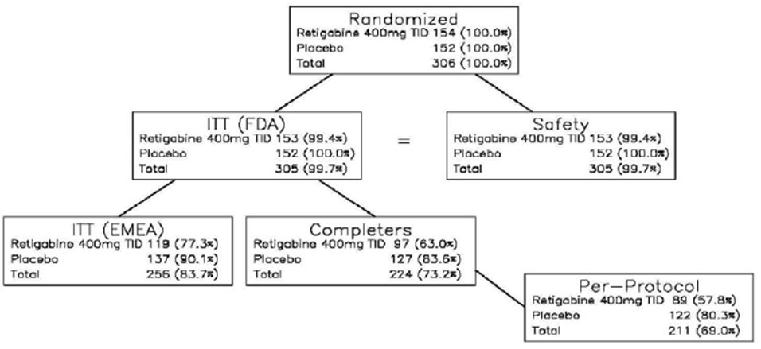
Figure 9: Diagram of number (%) of patients in analysis populations.
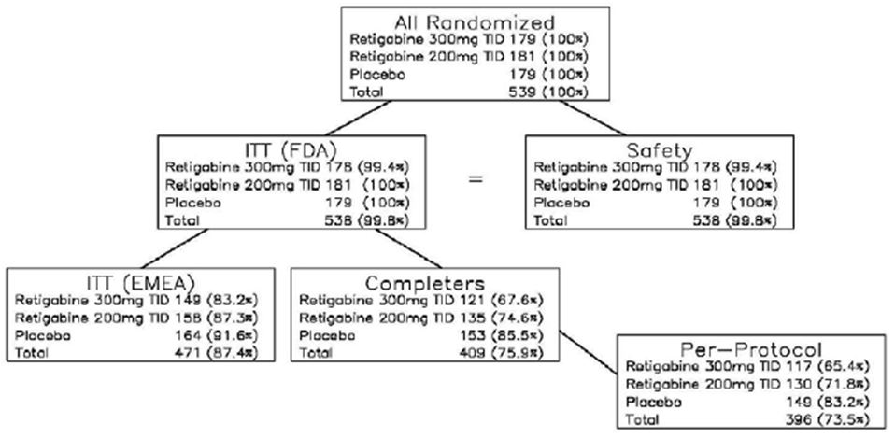
Table 6: Summary of patient disposition during the double blind phase in randomised, controlled trials (studies 205, 301 and 302).
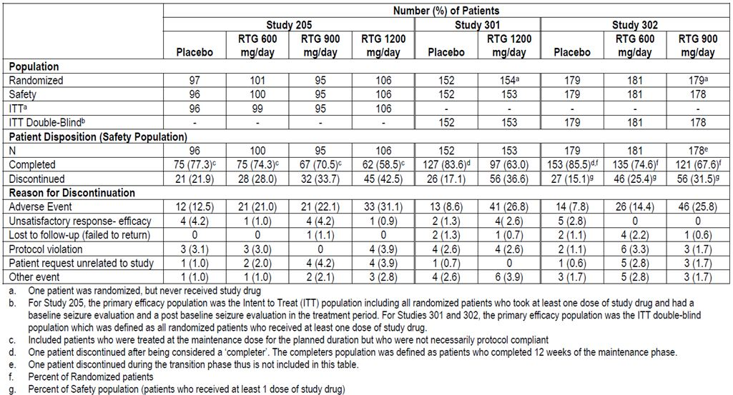
It should be noted that completion rates were satisfactory in the placebo groups: 84% for Study 301 and 86% for Study 302, but were fairly poor in the active groups: 63% for 1200mg/d, 68% for 900mg/d, and 75% for 600mg/d. This creates a risk of withdrawal bias, given that patients experiencing poor efficacy are more likely to drop out of a study in the face of drug-induced side effects, whereas patients with similar poor efficacy may tolerate placebo and continue. This bias was addressed to some extent by pessimistic imputation methods, such as treating withdrawn patients as non-responders.

Major protocol violations/deviations
Protocol violations were relatively infrequent, and are unlikely to have had any substantial impact on the study’s findings. They are tabulated below for Study 301 (Table 7) and 302 (Table 8).
Table 7: Study 301, protocol variations.
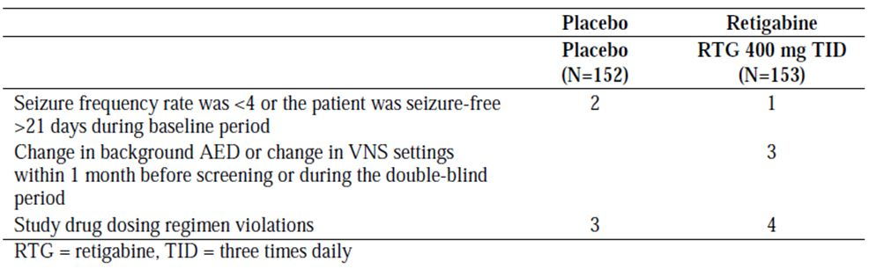
Table 8: Study 302, protocol variations.
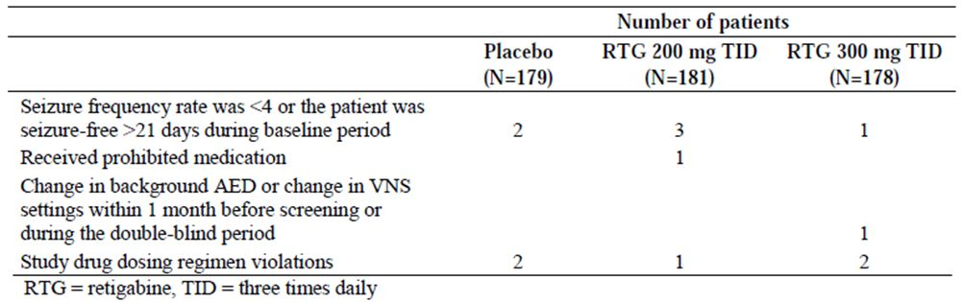

Baseline data
In both of the Phase III studies (Study 301 and 302), the treatment groups were generally balanced in terms of baseline demographics and disease characteristics (Table 9). The exception was number of subjects receiving 3 AEDs at baseline, which was substantially higher in the placebo group (40.1%) than the 1200mg/d group (27.5%) in Study 301. There was a milder imbalance for the same variable in Study 302, where the placebo group (29.1%) and the 600mg/d group (30.9%) had a higher proportion of subjects on 3 AEDs than the 900mg/d group (24.7%).
Table 9: Summary of demographic and baseline characteristics: randomised, controlled trials (safety population: studies 205, 301 and 302).
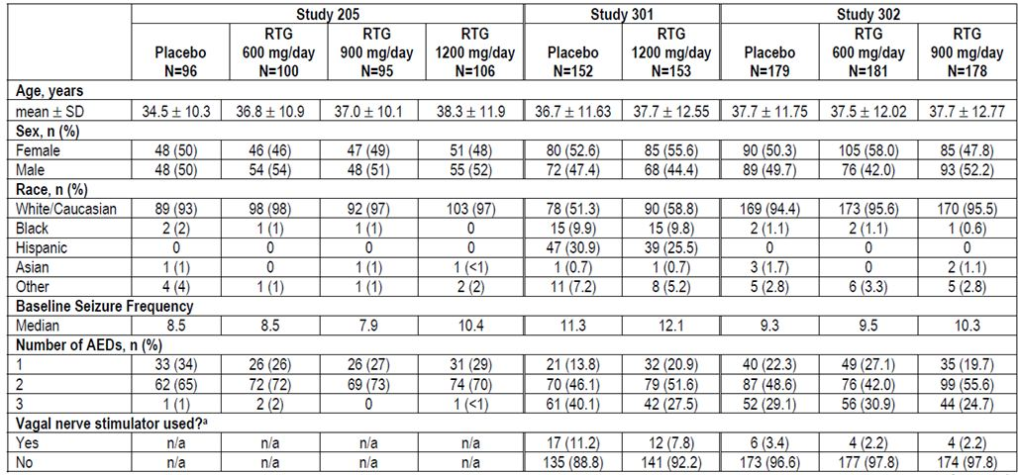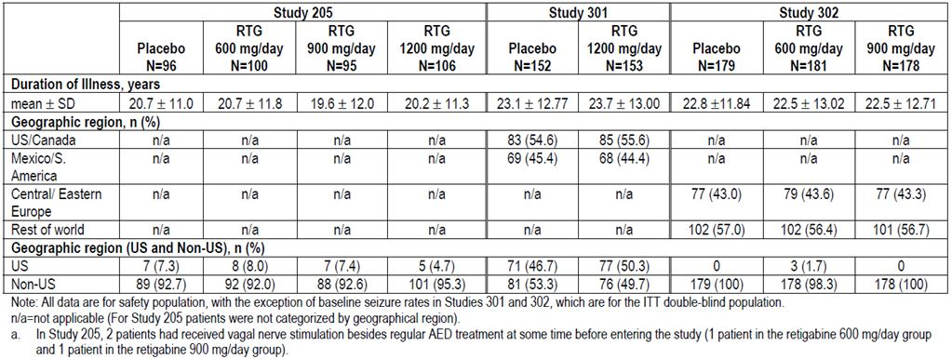
Given that the number of AEDs is an indirect marker of epilepsy severity and treatment-refractoriness, this may have biased the studies in favour of the two highest dose groups, as these had the lowest proportion of triple-therapy patients. (A sub-group analysis across the pooled retigabine population subsequently showed that the effect was robust, however, with subgroups based on number of AEDs showing similar treatment effects.)
In other respects, the studies were well balanced.

Results for the primary efficacy outcomes
Percent change in seizure frequency relative to baseline was a primary endpoint for Studies 301 and 302. This endpoint was positive in both Phase III studies, as shown in Figure 10 and Table 10. The median percent reduction in seizure frequency was 44% for the 1200mg/d group, in Study 301, compared to 18% in the corresponding placebo group (an attributable reduction in seizures of 26% over and above the placebo response). For the 900mg/d and 600mg/d groups, in Study 302, the reductions were somewhat less, 40% and 28% respectively, which was nonetheless superior to the 16% reduction observed with placebo. All comparisons with placebo were statistically significant (p<0.001 for 1200mg/d and 900mg/d, p=0.007 for 600mg/d).
Figure 10: Responder rate: maintenance phase (ITT maintenance population: studies 205, 301 and 302).
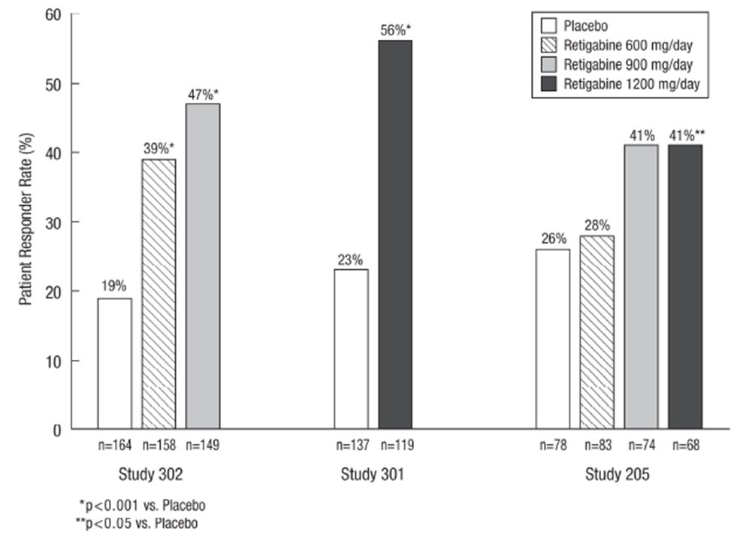
Table 10: Responder rates: maintenance phase (ITT maintenance population: studies 205, 301 and 302).
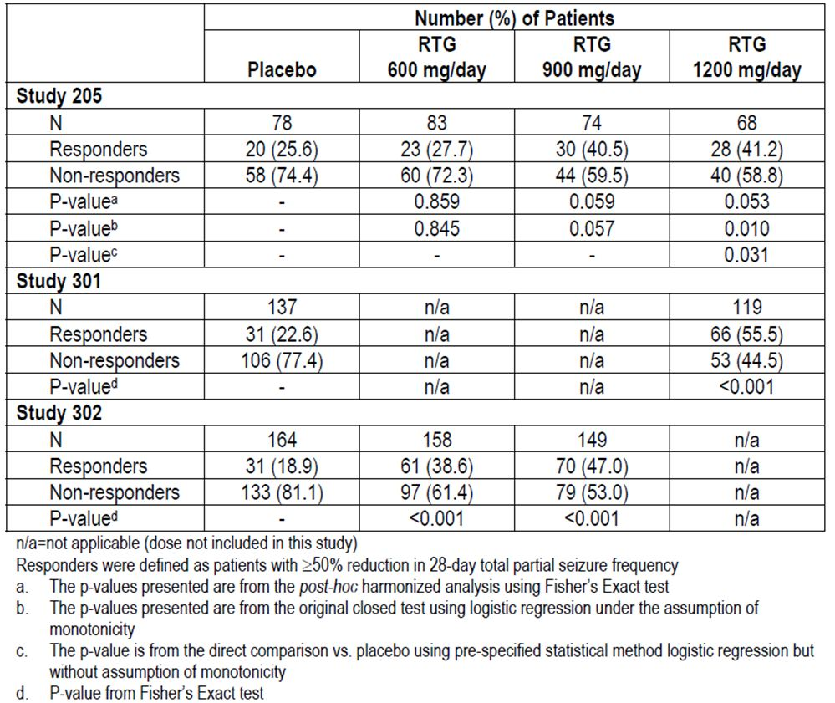
This seizure reduction represents a modest but worthwhile clinical gain, especially considering that these subjects had already shown treatment refractoriness when treated with established AEDs.
Although Study 205 will be discussed later, the results of that study are also included in the figure and table below. Considered together, all three studies indicate a broadly consistent dose-response relationship, with some efficacy at 600mg/d and better efficacy at increasing doses to 1200mg/d.
The second primary endpoint was the responder rate, with responders defined as those exhibiting a ≥ 50% reduction in the maintenance phase relative to the baseline phase. (Subjects not reaching the maintenance phase were censored from this analysis – for a sensitivity analysis with pessimistic imputation, see Table 11.)
Table 11: Post hoc sensitivity analysis of responder rates in the maintenance phase (ITT population for study 205 and ITT double blind population for studies 301 and 302).
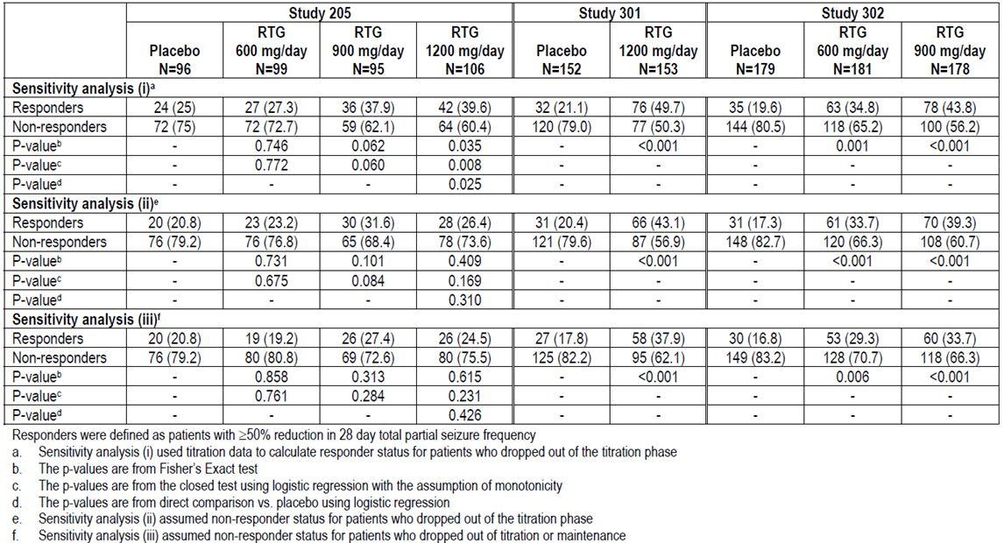
Results for this endpoint were clearly positive for both of the Phase III studies (p<0.001 for all comparisons with placebo, using Fisher’s exact test). There was a dose-response relationship, with progressively better responses at higher doses, up to 1200mg/d (Study 301). At this dose, 56% of subjects experienced a ≥ 50% seizure reduction, compared to a response rate of 23% in the corresponding placebo group. The response rate at lower doses was also clinically meaningful: 39% and 47% for the 600mg/d and 900mg/d doses, respectively, compared to 19% for the corresponding placebo group (Study 302).
Sensitivity analyses confirmed the robustness of this finding. If the entire double-blind phase is considered, and data from the titration phase is used where necessary to determine responder status, as in sensitivity analysis (SA) (i) below, the response rate in the 1200mg/d group of Study 301 deteriorates to 50% but remains significantly superior to the placebo response rate of 21% (p<0.001). If those withdrawing during the titration phase are pessimistically classified as non-responders, as in SA (ii), the response rate at this dose is 43% but still significantly superior to the placebo response rate of 20% (p<0.001). If all withdrawing patients are considered non-responders, as in SA (iii), the response rate in the 1200mg/d group is only 38%, but this is substantially better than the corresponding rate in the placebo group (18%, p<0.001). This last method of imputation probably has the best correlation with clinical notions of a useful response. The corresponding response rates in Study 302, where lower doses were used, are numerically inferior to the high-dose response but remain significant for all three sensitivity analyses (Table 11).

Results for other efficacy outcomes
Results for secondary endpoints were broadly consistent with the primary endpoints, and add little information except to confirm the robustness of the main findings. The percent change in seizure frequency remained significant when analysis was based on the maintenance phase (rather than the entire double-blind phase), as shown in Table 12.
Table 12: Percent change from baseline in total partial seizure frequency: maintenance phase (ITT maintenance population: studies 205, 301 and 302).
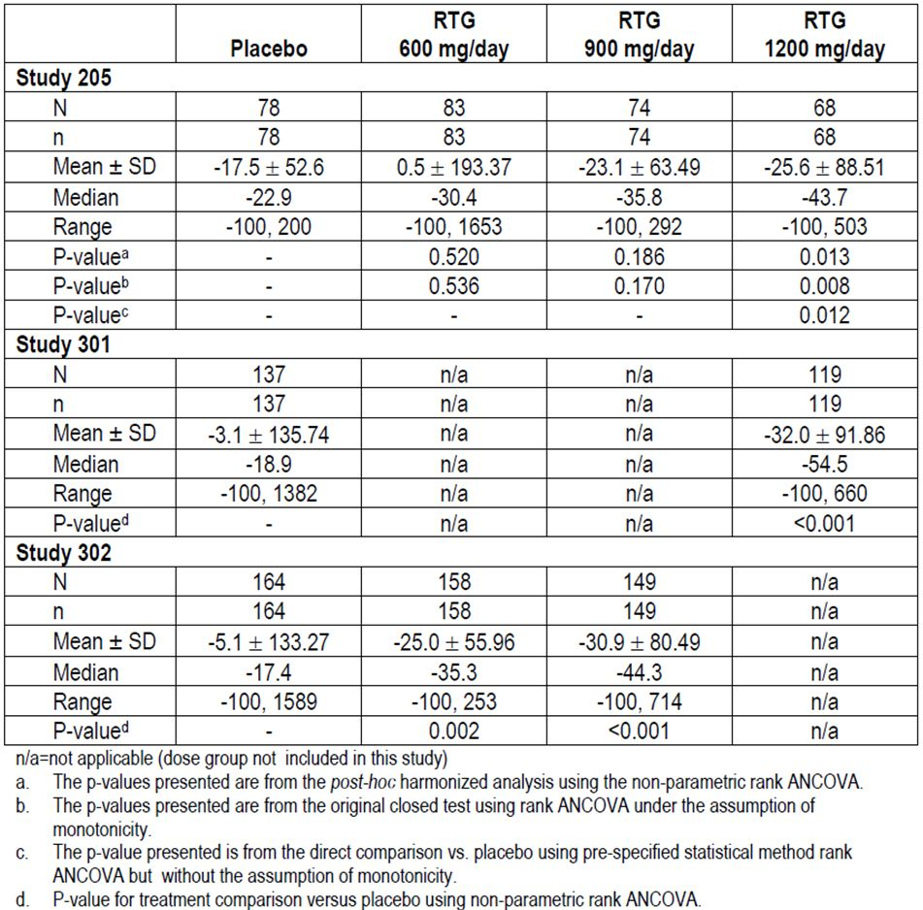
When the various responses were categorised into 25% brackets, as shown in the tables below, the statistical significance of the treatment effect was similar to that seen with the coarse responder/non-responder analysis. Reductions of ≥ 75% were relatively rare but were more common with high-dose retigabine than with placebo (18% at 1200mg/d, 4% with placebo, in the double-blind phase of Study 301). At lower doses, in Study 302, the proportions of patients experiencing this level of reduction were more similar to placebo (Table 13). Results in the maintenance phase were slightly better (Table 14).
Table 13: Percent reduction in 28-day total partial seizure frequency by reduction category (double blind phase) (ITT population: studies 205, 301 and 302).
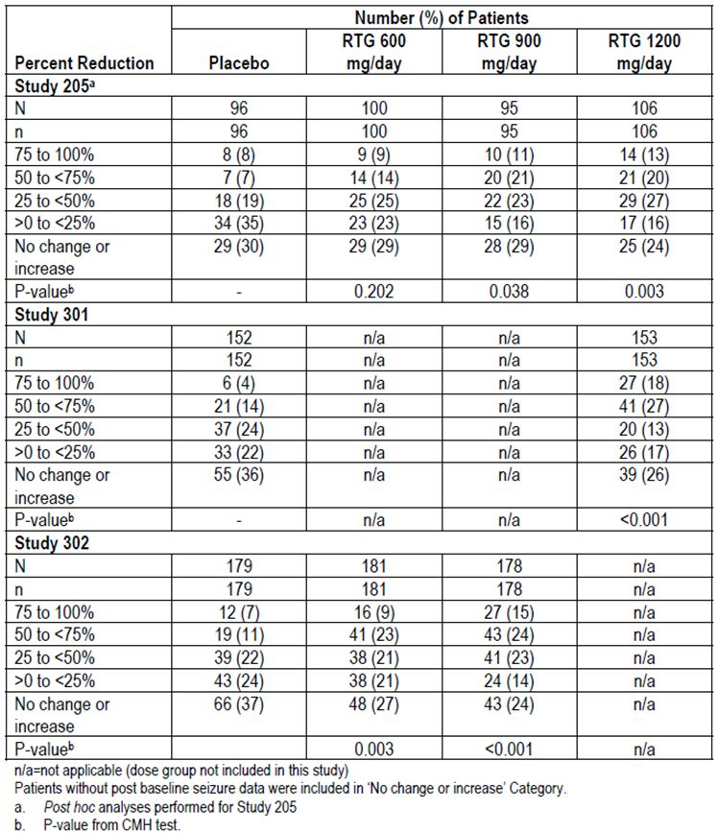
Table 14: Percent reduction in 28-day total partial seizure frequency by reduction category (maintenance phase) (ITT maintenance population: studies 205, 301 and 302).
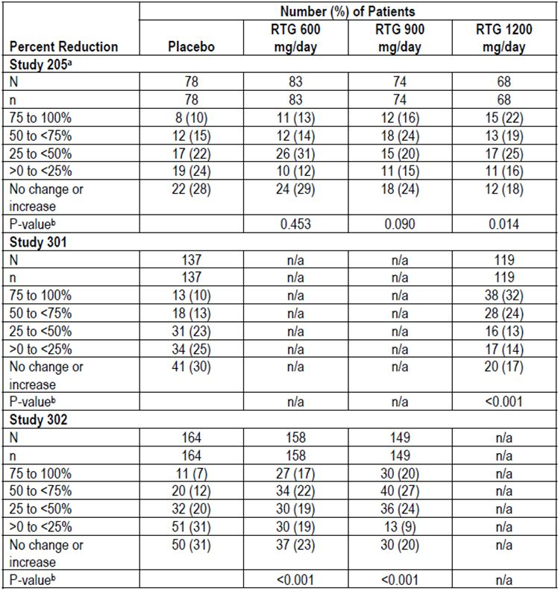
Seizure-freedom, the endpoint that most patients hope for when embarking on a new treatment, was unfortunately rare but it was more likely with retigabine. In the maintenance phase of Study 301, this was achieved in 7.6% of retigabine 1200mg/d recipients, compared to 1.5% of placebo recipients (p=0.027). In the maintenance phase of Study 302, seizure-freedom was achieved in 3.2% and 4.7% of the 600mg/d and 900mg/d doses, respectively, compared to 1.2% of placebo recipients (p-value not significant) (Table 15).
Table 15: Percent of patients who were seizure free (maintenance phase) (ITT maintenance population: studies 205, 301 and 302).
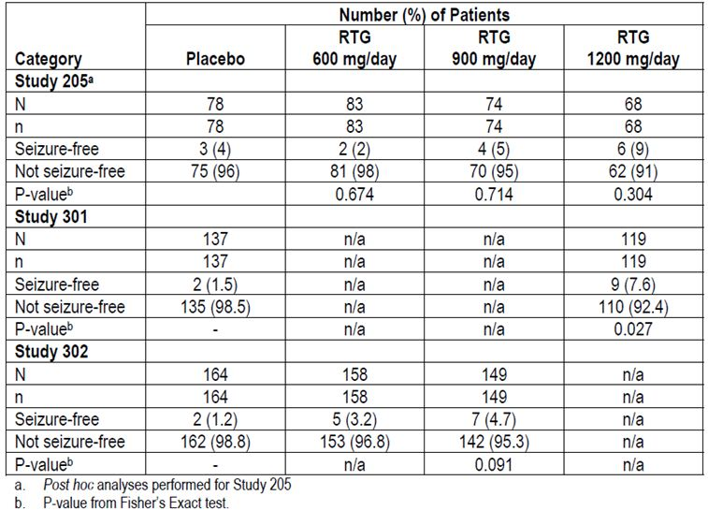
The percentage of seizure-free days (Tables 16 and 17) significantly favoured active treatment but the proportion of extra seizure-free days on active treatment was disappointing: just 5% in the double-blind phase for the highest dose group (retigabine 1200mg/d, mean 70.1% seizure-free days, versus placebo 65% seizure-free days), and 7% in the maintenance phase (retigabine 1200mg/d, mean 73.6% seizure-free days, versus placebo 66.3% seizure-free days).
Table 16: Percent of seizure free days (double blind phase) (ITT double blind population: studies 205, 301 and 302).
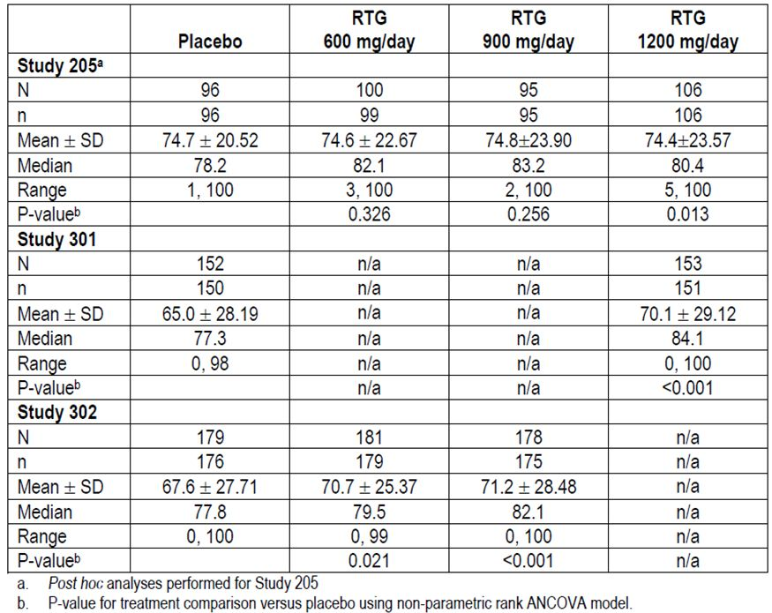
Table 17: Percent of seizure free days (maintenance phase) (ITT maintenance population: studies 205, 301 and 302).
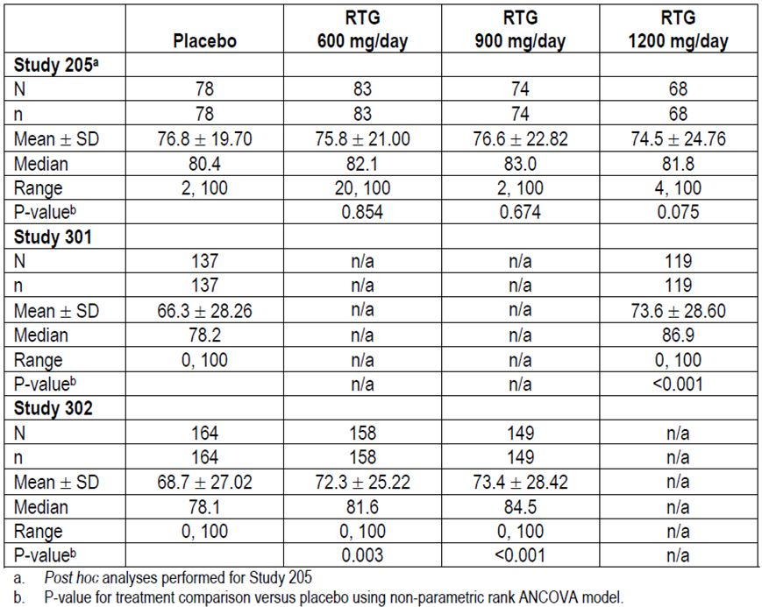

Subgroup analyses
The tables below show subgroup analyses based on age (Table 18, all three pivotal studies) and race (Table 19, Study 301 only). The comparisons versus placebo were underpowered, and did not always achieve statistical significance, but the trends in responder rates were strongly in favour of active treatment irrespective of patient age or race. (The sponsor also presented subgroup analyses for the pooled dose groups across all three pivotal studies, and these had better statistical power.)
Table 18: Responder rates by age group (maintenance phase) (ITT maintenance population: studies 205, 301 and 302).
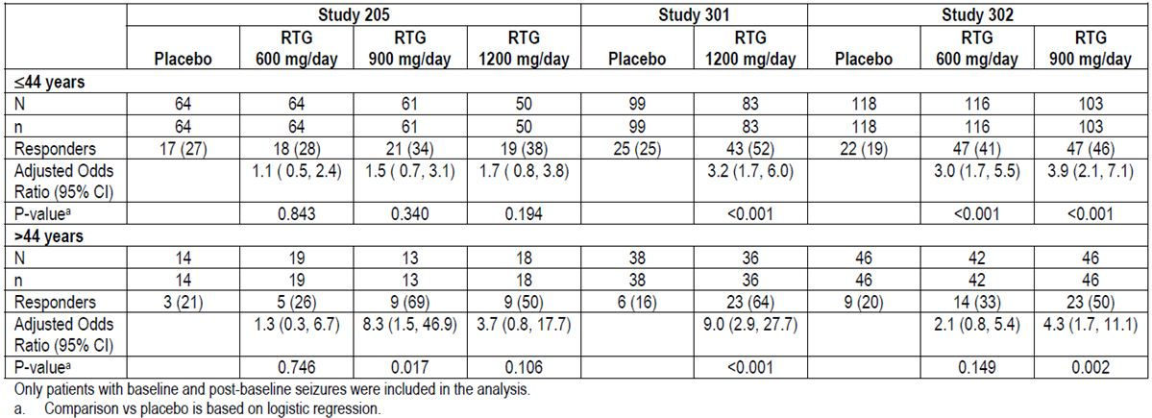
Table 19: Responder rates by race (maintenance phase) (ITT maintenance population: study 301).
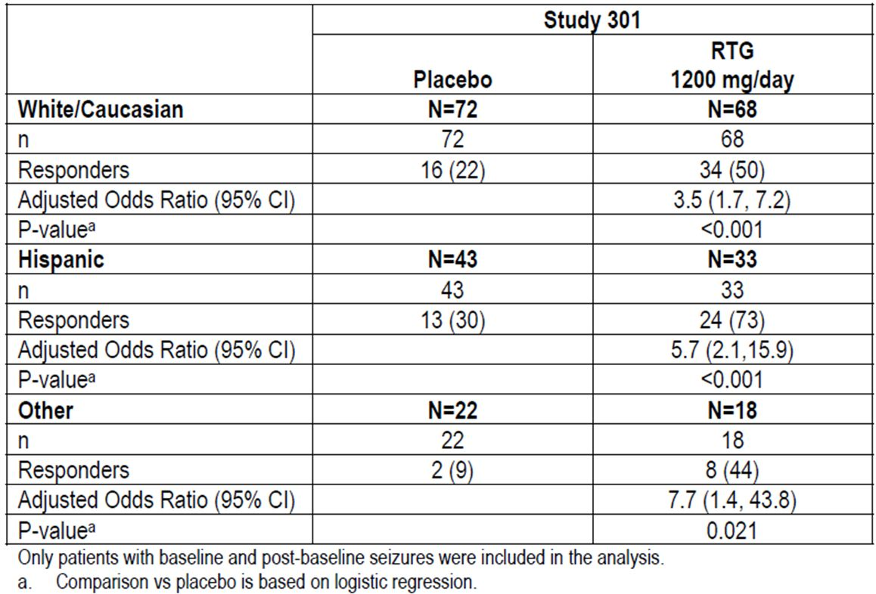

Study 205

Design
Study 205 was a Phase IIb international study performed in 1999-2001, with centres located in Australia, Belgium, Croatia, Czech Republic, Finland, France, Germany, Israel, Italy, The Netherlands, New Zealand, Norway, Poland, Portugal, Slovakia, Spain, Sweden, UK, and USA. The primary objective was to assess the efficacy and safety of retigabine as adjunctive therapy in partial epilepsy; this study also serves as the main dose-ranging study in the submission. It employed a randomised, double-blind, placebo-controlled design with four parallel treatment groups: placebo, retigabine 600mg/d, retigabine 900mg/d and retigabine 1200mg/d, given in equally divided doses three times daily (TID).
One flaw in the study is that it was relatively short. Baseline seizure frequency was assessed prospectively over 8 weeks before treatment commenced. Treatment was then titrated for up to 8 weeks, followed by a fixed-dose maintenance phase of at least 8 weeks, to give a potential treatment duration of 16 weeks. The duration of the maintenance phase was therefore quite short, and falls short of international recommendations (The EMEA recommended a minimum maintenance of 12 weeks in their “Guideline on Clinical Investigation of Medicinal Products in the Treatment of Epileptic Disorders”, 2009.) Given that many anticonvulsants exhibit a waning of efficacy with continued use, due to tachyphylaxis, 8 weeks is insufficient to assess the long term efficacy of an anticonvulsant and this study should therefore be considered merely supportive even though the sponsor has designated it as pivotal. Its primary importance is that it directly compared the doses likely to be adopted in clinical use.

Inclusion and exclusion criteria
The target population was patients with refractory partial epilepsy, identified on the basis of on-going seizures despite treatment with conventional AEDs.
In particular, eligible patients:
- were men or women aged 16 to 70 years (18 to 70 years for Norway);
- were receiving one or two pre-specified AEDs at stable doses for at least 1 month prior to screening (valproic acid, carbamazepine, phenytoin, topiramate, lamotrigine, gabapentin, oxcarbazepine, benzodiazepines, barbiturates, or vagal nerve stimulation, which was considered equivalent to an AED therapy);
- had at least four seizures per 28 days during the 8-week prospective baseline period;
- were not seizure-free for more than 30 days during the baseline period.

Study treatments
Subjects were targeted to receive retigabine 600mg/d, 900mg/d or 1200mg/d in three equally divided doses, or matching placebo (Figure 11). They titrated up to the target dose at a rate of 150mg/d each week, so that patients assigned to lower doses achieved their target dose earlier; the titration phase was nonetheless considered to be 8 weeks in all patents for analysis purposes.
Figure 11: Study design dosage steps for all phases of the study.
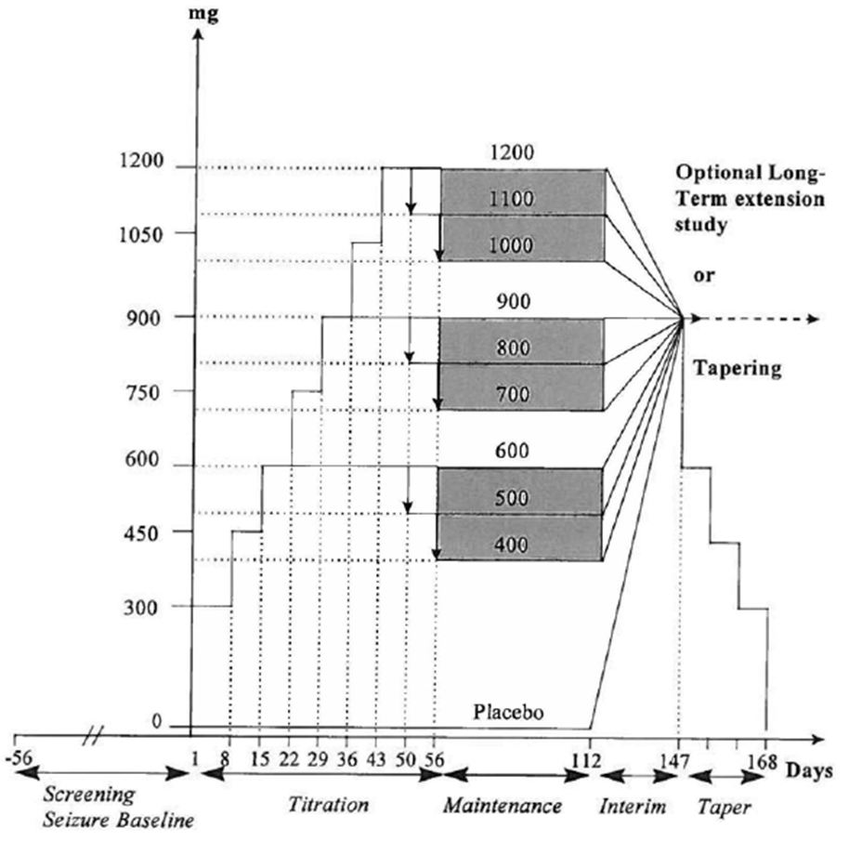
Concomitant treatment with vigabatrin, felbamate and tiagabine was prohibited, because of the side effect profile of these three agents. Medications known to lower seizures threshold (such as neuroleptics) were also prohibited. Antidepressants were permitted but doses had to be stable.
Benzodiazepines were permitted for rescue treatment of seizure clusters (“flurries”).

Efficacy variables and outcomes
The primary efficacy outcome was the percent change in the total partial seizure frequency per 28 days during the double-blind treatment phase (titration + maintenance), relative to baseline.
Other efficacy outcomes included:
- Percent change in seizure frequency from baseline to the maintenance period.
- Responder rate in the combined double-blind period.
- Proportion of patients seizure-free.
- Proportion of seizure-free days.
- Maximum number of consecutive seizure-free days.
- Incidence of new seizure types.
- Change in Clinical Global Impression of Improvement (CGI-I), measured on a 7-point Likert scale.
- Rate of discontinuation.

Randomisation and blinding methods
Subjects were randomised equally to the 4 treatment arms by a centralised procedure, without stratification.

Analysis populations
The primary population was the intent-to-treat (ITT) population, which included all patients who received at least 1 dose of study drug (retigabine or placebo), had a baseline seizure evaluation and at least one on-therapy seizure evaluation.
The modified ITT population was a subgroup of the ITT population, and consisted of patients in the ITT population who had taken the study drug for at least 14 days during the maintenance phase.

Sample size
Sample size estimation was based on the secondary endpoint, response rate, because the sponsor felt that this could be predicted with more confidence. The study was designed to allow the completion of up to 90 patients per treatment group. To achieve 90% power, using a 2-sided test at the 5% significance level, a minimum of 82 patients per treatment group was required to detect a difference of 20% in the response rate (retigabine 30% versus placebo 10%), and the sponsor sought to exceed this number.

Statistical methods
Responder rates and percent change in seizures were analysed with logistic regression with centre and treatment as effects. For the other endpoints, pairwise comparisons were done to investigate the dose-response without any adjustments for multiplicity.

Results

Participant flow
Of the 537 patients who were screened, 399 were enrolled in the study and randomly assigned to treatment. A total of 126 patients (32%) discontinued, most commonly because of adverse events, reported as the reason for discontinuing in 87 patients (22 %).
Two subjects did not receive any of the test capsules and were excluded from the safety population. One patient (from the retigabine 200 mg TID group) had no record of seizures during therapy and was excluded from the ITT population, so 396 of the original 399 randomised patients were analysed for efficacy. Only 279 patients completed the 8-week maintenance phase and were considered “completers.”

Major protocol violations/deviations
Fifteen patients had protocol violations that contributed to withdrawal from the study; 10 were withdrawn from the study with protocol violations reported as the primary reason and 5 as a secondary reason. The most common violation was poor compliance, but some patients were found to have baseline visual field defects, one patient took tablets from the wrong blister pack, and one changed their concomitant valproate dose. In a study of this nature, this number of violations is acceptable and is unlikely to have altered the findings of the study.

Baseline data
The baseline features of the study groups are shown in Tables 20-21, including demographic data, concomitant AEDs and seizure types. They were reasonably well matched, except that the placebo group was slightly younger, on average. The placebo group also had slightly more patients receiving just one concomitant AED, compared to the active groups. These minor differences are unlikely to have modified the results significantly.
Table 20: Demographic and other baseline characteristics (safety population).
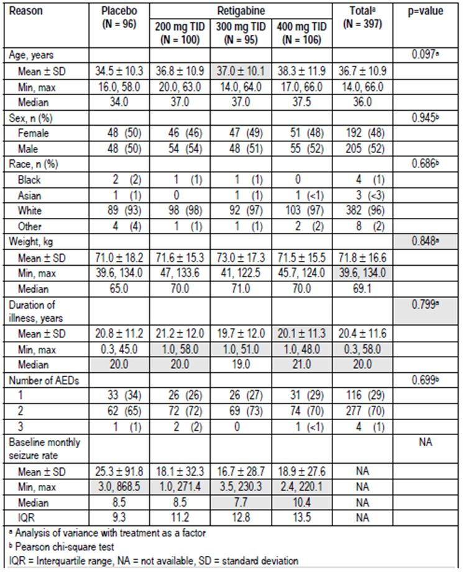
Table 21: Seizure type at baseline (ITT population).
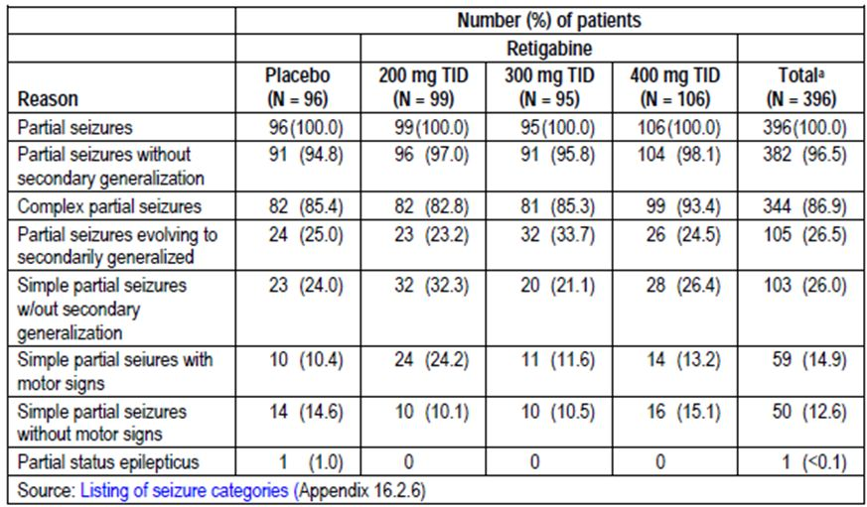

Results for the primary efficacy outcome
The results section for the two Phase III studies shows the primary and key secondary endpoints for this study alongside the Phase III results. Results across all three studies were broadly consistent. This study showed significant benefit for the two highest dose groups (900mg/d and 1200mg/d, but not for the lowest dose group (600mg/d).
During the “double-blind” phase (the protocol-specified phase for the primary efficacy endpoint, which included the titration plus maintenance phases), the median percent change from baseline in monthly seizure frequency was a decrease of 13% with placebo, 23% with retigabine 600mg/d, 29% with 900mg/d, and 35% with 1200 mg/d. For the two highest dose groups, the difference relative to placebo was significant (900 mg/d, p=0.043; 1200 mg/d, p<0.001) (Table 22).
Table 22: Percent change in monthly seizure rate for total partial seizures (ITT population).
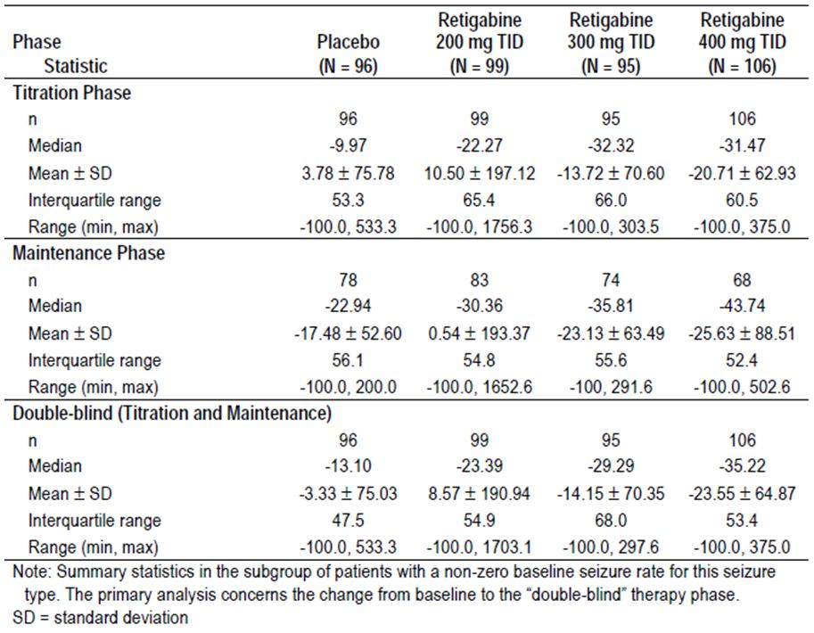

Results for other efficacy outcomes
For the main secondary endpoint, responder rate, a similar dose trend was observed, with 900mg/d and 1200mg/d producing response rates of 32% and 33%, respectively, which was twice that seen with placebo (16%). The response rate for the 600mg/d dose was intermediate, at 23%.
The overall dose trend was assessed by logistic regression across all treatment groups, and found to be significant (p=0.001). Pairwise comparisons indicated significant differences between 1200mg/d versus placebo (p=0.003) and 900mg/d versus placebo (p=0.008), but not for 600mg/d versus placebo (Table 23).
Table 23: Responder rate for total partial seizures (ITT population).
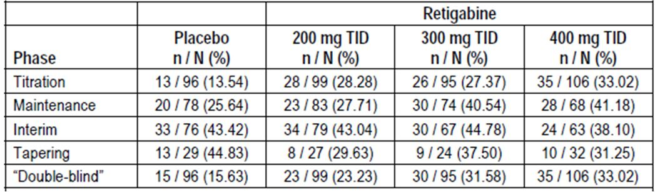
Other endpoints were under-powered but showed favourable trends. Median seizure-free days per 28 days in the double-blind period were quite similar regardless of treatment group: placebo 21.81 days, 600mg/d 23.00 days, 900mg/d 23.25 days, and 1200mg/d 22.50 days. This measure was not significant according to 95% CIs around the Hodges-Lehman estimates of group differences in medians, but the highest dose group was different to placebo by ANOVA. Regardless of statistical significance, the differences for this endpoint do not appear to be clinically significant.
Seizure-free remissions of at least 8 weeks were rare and were not obviously affected by active treatment; they were seen in 3, 2, 3, and 4 patients on placebo, 600mg/d, 900mg/d and 1200mg/d respectively.

Other efficacy studies
The sponsor submitted a number of weakly supportive studies that do not contribute substantially to the overall efficacy assessment. Studies 200, 201 and 202 were open-label, uncontrolled studies that have to be considered merely exploratory in nature because of the lack of a control group. Study 214 was randomised and double-blinded, but had a primary focus on the tolerability of different titration regimens. Efficacy was a secondary focus, and the study was inadequately powered for efficacy endpoints. Finally, Studies 212, 303 and 304 were open-label extension studies, which are difficult to interpret because of the lack of a control group, lack of blinding, and selection bias – only patients wanting to continue the therapy entered the studies. Two of these extension studies, Studies 303 and 304, were ongoing at the time of submission. These studies are described in more detail below.

Studies 200 and 201
Studies 200 and 201 were open-label, non-randomised, uncontrolled Phase IIa studies in patients aged 18 to 50 years with partial-onset seizures, with or without secondary generalisation. Patients were required to have at least 8 seizures during the preceding 2 months, and were receiving up to three concomitant AEDs. The protocols of these two studies were very similar so the efficacy data were pooled and the results submitted in a single study report; despite this the total number of patients remained very small (n=46).
The following three retigabine regimens were assessed:
- Starting dose of 25 mg/d; titration step of 25 mg/week; maximum daily dose of 400 mg.
- Starting dose of 100 mg/d; titration step of 100mg/week; maximum daily dose of 1200 mg.
- Starting dose of 200 mg/d; titration step of 200mg/week; maximum daily dose of 2400 mg.
The studies were divided into a baseline phase of 2 months, a titration phase of 3-months and maintenance phase of 3-months. At the end of the study, patients either tapered off retigabine over 3 weeks or entered into a long-term follow-up study (Study 8017). During the treatment phase, concomitant AEDs were kept constant.
Efficacy criteria were percent reduction in total partial seizure frequency and responder rate (> 50% reduction from baseline in seizure frequency) during the 3-month maintenance period or to the last study visit. Only descriptive statistics were produced; no statistical comparisons were performed.
Over the whole study population, the seizure frequency was reduced by 36% (ITT population, n=46) or 34% (PP population, n=34) relative to baseline. Twelve patients had a reduction in seizure rate of >50% and 7 became seizure free. For the PP population, a response rate by dose is shown in Table 24.
Table 24: Responder rates (PP).
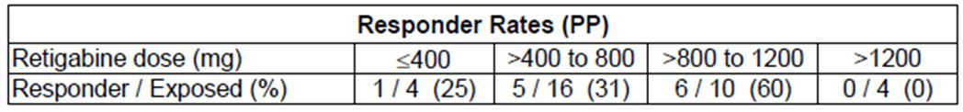
In the absence of a control group, these results are impossible to interpret. Most epilepsy studies show a reduction in seizure frequency compared to baseline, even in the placebo group.
The main value of this study was that it compared the tolerability of the different dosing regimens, guiding dose selection for the Phase IIb and Phase III studies. The therapeutic window appeared to be between 400 mg/d and 1200 mg/d, but patient numbers outside this dose range were too low for a meaningful assessment.

Study 202
Study 202 (3065 A1-202) was an open-label, uncontrolled study with efficacy considered as a secondary objective after assessment of the safety, tolerability and drug- interactions of retigabine in patients aged 16 to 75 years with partial or generalised epilepsy. It included 5 patients with primary generalised epilepsy, who do not match the proposed target population for retigabine in the current submission.
Retigabine at doses up to 1200mg/d was administered first as add-on therapy and then as monotherapy, in two or three divided doses daily. To be eligible, patients had a documented seizure frequency of at least two seizures/month and were receiving monotherapy with one of four established AEDs (valproic acid, carbamazepine, phenytoin, or topiramate) at stable doses.
The study was divided into five phases:
- screening/baseline (2-3 weeks)
- retigabine titration (variable, but at least 6 weeks)
- initial AED tapering (variable duration)
- retigabine monotherapy maintenance (2 weeks)
- tapering, reintroduction of initial AED, or transfer to long-term follow-up (Study 3065A1-208-US), at the discretion of the investigator.
Retigabine dosing was complex, but it involved titration of retigabine to a target of 1600mg/d in divided doses. The switch from BD to TID dosing was the result of a protocol amendment.
Efficacy was assessed by percent reduction in total seizure frequency and the responder rate (>50% reduction from pre-study baselines in seizure frequency) during the treatment period.
A total of 60 patients were enrolled. The addition of retigabine was associated with an improvement in seizure frequency in some patients, but this is impossible to interpret without an appropriate control group. Withdrawal of concomitant AEDs was sometimes associated with seizure worsening, as shown by positive mean percent changes in seizure frequency relative to baseline, but the median change during this phase was negative. The results were quite different across the four AED subgroups, as shown in Tables 25 and 26, with the topiramate group showing increased seizures during retigabine monotherapy, but the Summary of Clinical Efficacy described the results with the comment: “The efficacy profiles were generally similar across the four AED subgroups.” Numbers in each group are too small to draw any conclusions.
Table 25: Percentage change in total seizure rate relative to pre-study baseline (ITT population).
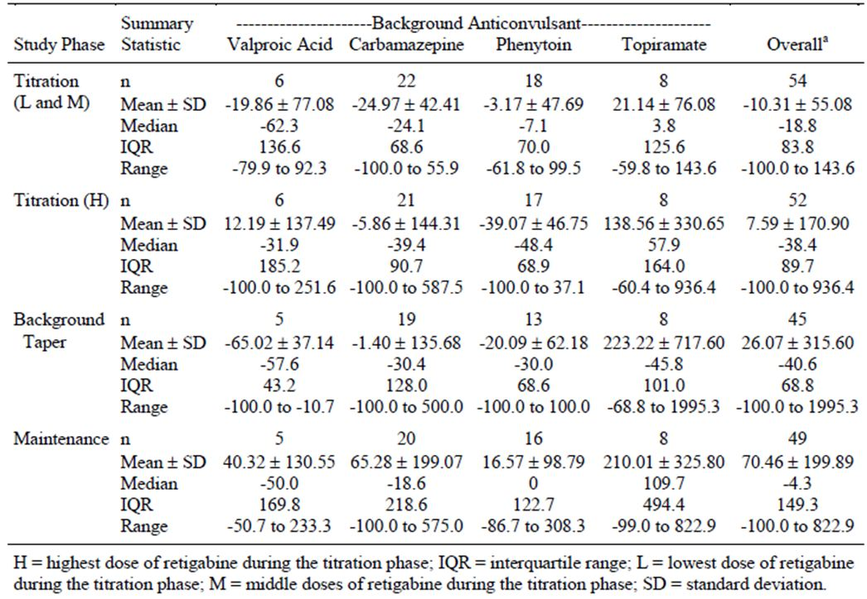
Table 26: Number and percentage of responders (total seizures) during the on-therapy phases (ITT population).
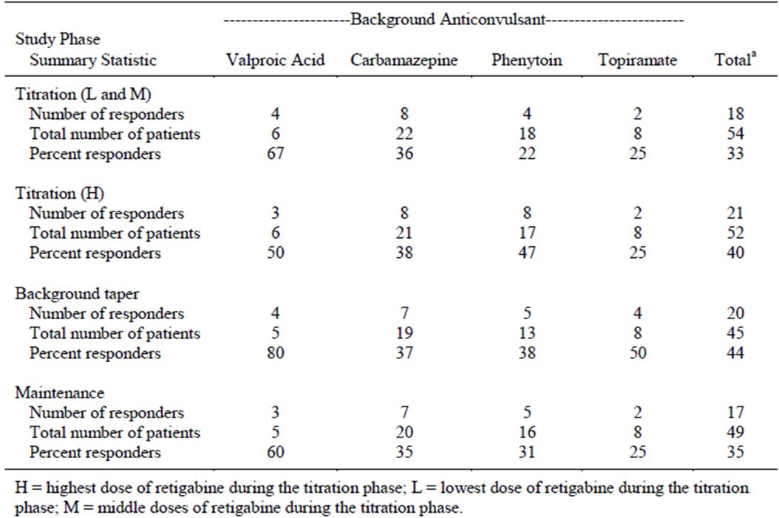
The main relevance of the study was that it seemed to indicate that retigabine 1200 mg/d was the maximum tolerated dose, and that efficacy was achievable with doses in this range, but it is impossible to draw any firm conclusions given the confounding influence of tapering other AEDs, the relatively short treatment duration and the lack of appropriate controls.

Study 214
Study 214 was a multi-centre, randomised, double-blind, parallel-group study primarily intended to compare the safety and tolerability of three titration rates of retigabine (300 mg/d TID starting dose, increasing by 150 mg/d every 2, 4, or 7 days, up to a maximum of 1200 mg/d). Assessment of efficacy was a secondary objective, and the study was not suitable for assessment of efficacy because it lacked a placebo group and there was no maintenance phase. Subjects either switched from the titration phase to the tapering phase, or entered a long-term extension.
Eligible patients were those aged 16 to 70 years with a diagnosis of partial epilepsy and a documented seizure frequency of ≥ 2 seizures/month during the baseline period. They could be receiving one or two concomitant AEDs at a stable dose for at least 1 month prior to screening.
Efficacy was assessed by percent change in seizure frequency relative to baseline.
The study enrolled 73 patients. Mean percent change in seizure frequency during titration showed a decrease in two of the treatment groups, and an increase in the third group; median percent change showed a reduction in all groups. Without a placebo group, this is impossible to interpret.
The main value of this study was that it showed better tolerability of a titration scheme of 150 mg every 7 days, relative to faster rates. The sponsor’s Summary of Clinical Efficacy concluded:
“While efficacy was demonstrated across the three titration regimens, a titration scheme of 150 mg every 7 days to a maximum tolerated dose of retigabine 1200 mg/d, ie. over a 6-week titration period, was considered optimum with respect to the lowest discontinuation rates due to AEs.”
The sponsor’s assertion that “efficacy was demonstrated across the three titration regimens” is not justifiable given the methodological limitations of this study. In particular, it is not clear that the reduction in seizure frequency differs from the usual phenomenon observed in placebo-controlled studies, where seizures tend to improve even in the placebo group.

Study 212
Patients who completed Study 205 were eligible to enter the long-term extension protocol, Study 212 (also known as Study 3225). This study was not placebo-controlled and was susceptible to selection bias, because patients with poor control on retigabine would be unlikely to enter. It therefore provides only weak evidence of persistence of efficacy.
At the end of the maintenance phase of Study 205, all patients entering Study 212 had their study drug adjusted to 900 mg/d (300 mg TID) in a double-blind, double-dummy manner. Further dose adjustments up to 1200 mg/d could be made depending on efficacy and tolerability. Patients who did not tolerate further dose adjustments tapered their dose to zero before withdrawal.
The background AED therapy could be adjusted according to the clinical balance of efficacy and safety. The primary efficacy variable was the percent change in the monthly seizure frequency from the baseline phase of Study 205 to the open-label treatment phase of Study 212. Additional efficacy endpoints included responder rates and the percentage of seizure-free days in the open-label phase.
The sponsor also performed a post-hoc analysis of responder rate and percent change in partial seizure frequency at specified time points up to 18 months.
A total of 222 of the 279 (79.5%) patients who completed Study 205 were enrolled into Study 212.
The median treatment duration was 358 days (mean 352.5 days). About half the patients (105/222, 47.3%) received retigabine 900mg/d as their maximum dosage, and a quarter (52/222, 23.4%) received retigabine 1200mg/d as their maximum dosage. Twelve patients (5.4%) received >1200mg/d.
The mean percent change in seizure rates was -30.3% (median –48.3%). Patients initially allocated to placebo or low-dose retigabine (600 mg/d) in Study 205 showed improved efficacy during the extension study, relative to the original baseline, with median percent seizure reductions of 54.5% and 48.3%, respectively. This improvement was similar to that observed during double-blind treatment in Study 205 in patients receiving retigabine 900 mg/d and 1200 mg/d, relative to the original baseline, but note that this improvement includes the original placebo response plus a selection effect. The improvement on crossing over from placebo in Study 205 to active treatment in Study 212 was more modest: the initial placebo response (improvement in seizure frequency by a median of 32.2%) was augmented by just 22.3% (to 54.5%) with commencement of active treatment, and some of this improvement could be accounted for by a selection effect (Table 27).
Table 27: Total partial seizure rates: patients enrolled in study 3225.
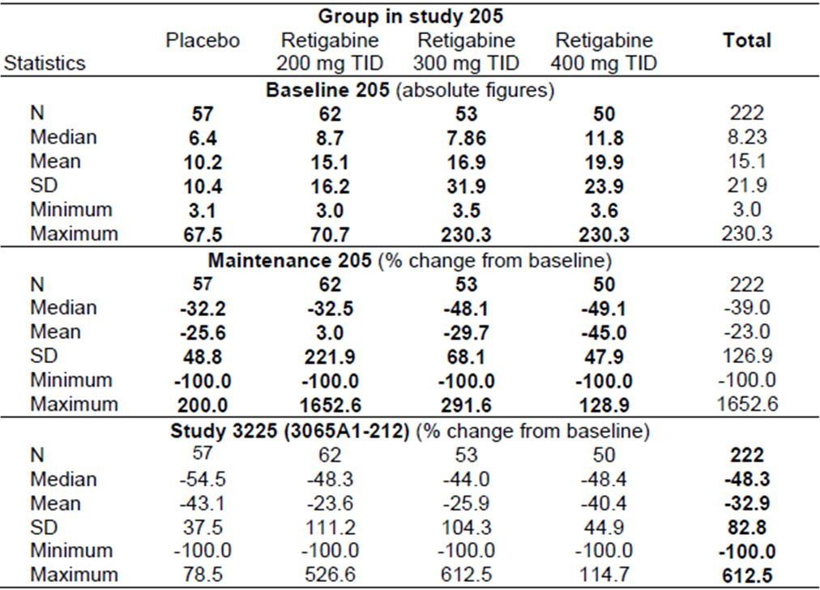
The overall responder rate, relative to the baseline of Study 205, was 47%.
In conclusion, retigabine administered during this open-label extension study showed a broadly similar effect to that demonstrated during double-blind treatment. Patients who had already received 900mg/d or 1200mg/d showed persistence of the seizure reduction they had already demonstrated, and patients who had previously received placebo or 600 mg/d showed a modest improvement on switching to therapeutic doses of retigabine, so they eventually resembled the other treatment groups. The lack of a placebo control means that no firm conclusions can be drawn, but there is at least no obvious decline in efficacy with continued treatment.

Studies 303 and 304
Studies 303 and 304 were uncontrolled, open-label extension studies to the placebo-controlled, double-blind Studies 301 and 302, respectively. A total 181/224 (81%) patients who completed Study 301, and 375/409 (92%) who completed Study 302 were enrolled into open-label extension studies. The target retigabine dose was 1200 mg/d for Study 303 and 900 mg/d for Study 304, but the investigator could modify the dose of retigabine or other AEDs to optimise patient response and tolerance.
The studies were ongoing at the time of submission and only interim results are available, but a reasonable period of follow-up is available. By 30 June 2008, the median time on open-label treatment was 357 days in Study 303, and 275 days in Study 304.
The percent change in seizure frequency, relative to the baseline of the original studies, is shown in the table below (-56.5% for Study 303, -53.4% for Study 304). For patients with at least 12 months of treatment, slightly better reductions were observed (subsequent table) but this could reflect withdrawal bias. Note that these tables also include results for Study 212, the extension of Study 205 (Tables 28 and 29).
Table 28: Percent change from baseline in monthly total partial seizure frequency for patients treated with retigabine during the open-label extension studies (safety population: studies 212, 303 and 304).
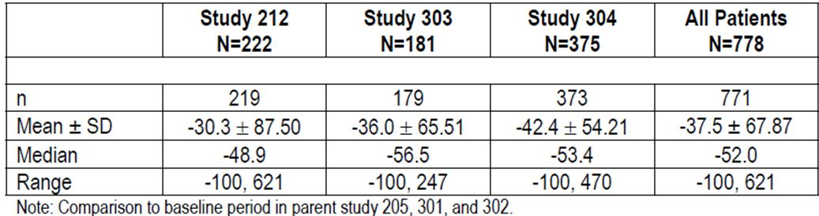
Table 29: Percent change from baseline in monthly total partial seizure frequency for patients treated with retigabine for at least 12 months during open-label extension (safety population: studies 212, 303 and 304).
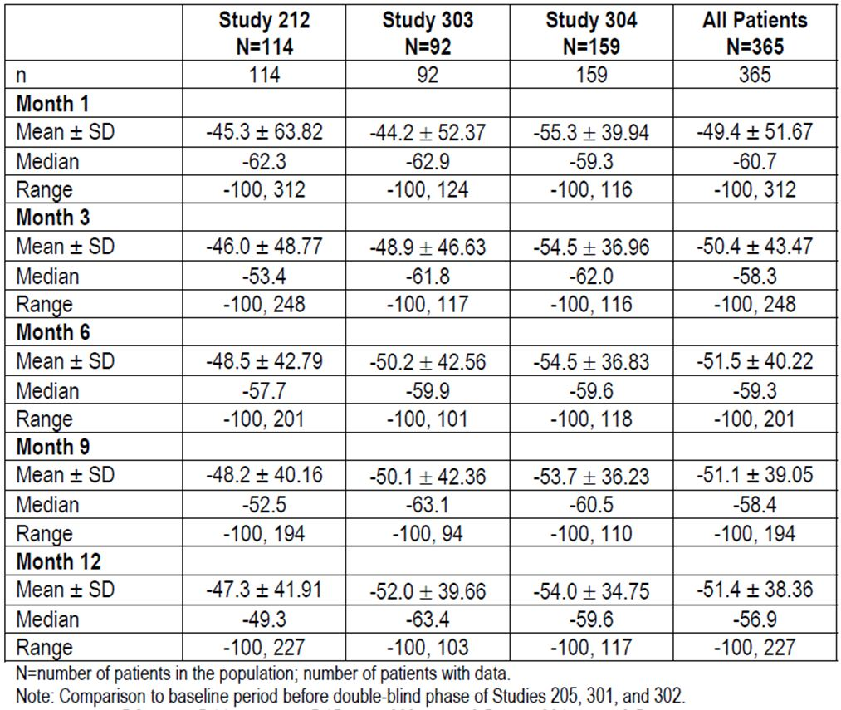
The response rate in these studies was 57% in Study 303, and 54% in Study 304, as shown in Table 30, and this was maintained for at least 12 months (Table 31). In the absence of a placebo control group, these observations provide only weak evidence of persistent efficacy, but at least they do not show a definite decline in efficacy with continued treatment.
Table 30: Responder rates for patients treated with retigabine during open-label extension (safety population: studies 212, 303 and 304).
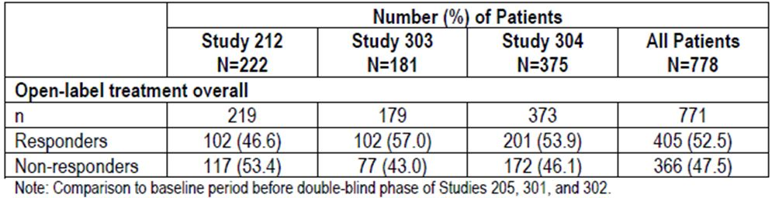
Table 31: Responder rates for patients treated with retigabine for at least 12 months during open-label extension (safety population: studies 212, 303 and 304).
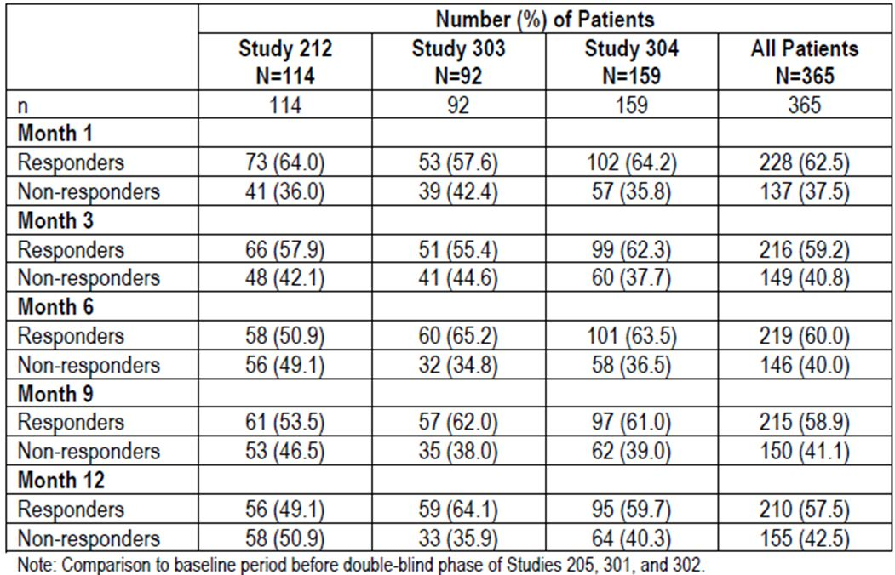

Study 208
Study 208 (n=47) was an open-label extension of Study 202, which was itself a small open-label study that did not have assessment of efficacy as its primary objective. It provided no reliable efficacy data, and was not included in the Summary of Clinical Efficacy. Median change in seizure frequency in the study population was broadly comparable to other efficacy studies, as shown in Table 32.
Table 32: Total seizure rates.
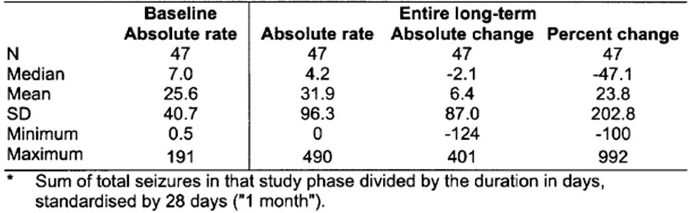

Other studies
Study 216 was an open-label extension study for Study 214. According to the sponsor, an abbreviated report was “prepared for closeout purposes”. This did not include any efficacy analysis, even though one of the original objectives was to assess efficacy. Studies 8017, 8001 and 8005 were very small uncontrolled studies, not submitted in enough detail to allow evaluation. Study 8017 was an extension of 8001 and 8005, and had only 23 patients. The details of Studies 8001 and 8005 are unclear. These studies were clearly exploratory in nature.

Analyses performed across trials (pooled and meta-analyses)
The 3 pivotal studies used similar designs, and recruited broadly comparable populations of patients with treatment-resistant partial epilepsy. The sponsor presented a pooled analysis of the three studies, which was consistent with analysis of the individual studies. Given that statistically significant results were obtained in the original studies, this post hoc analysis did not modify the conclusions reached in a more rigorous manner by considering the studies individually.
Table 33 shows the pooled results for change in seizure frequency.
One benefit of the pooled analysis is that it was adequately powered for a range of subgroup analyses. As shown in the tables below, a significant benefit was obtained for retigabine regardless of the presence or absence of simple partial, complex partial or secondarily generalised seizures (Tables 34-36), age (Tables 37 and 38), gender (Tables 39 and 40), race (Tables 41 and 42), and number of concomitant AEDs (Table 43 and 44).
Table 33: Percent change from baseline in 28-day total partial seizure frequency by seizure type (double-blind phase) – ITT double-blind population (studies 205, 301 and 302 integrated).
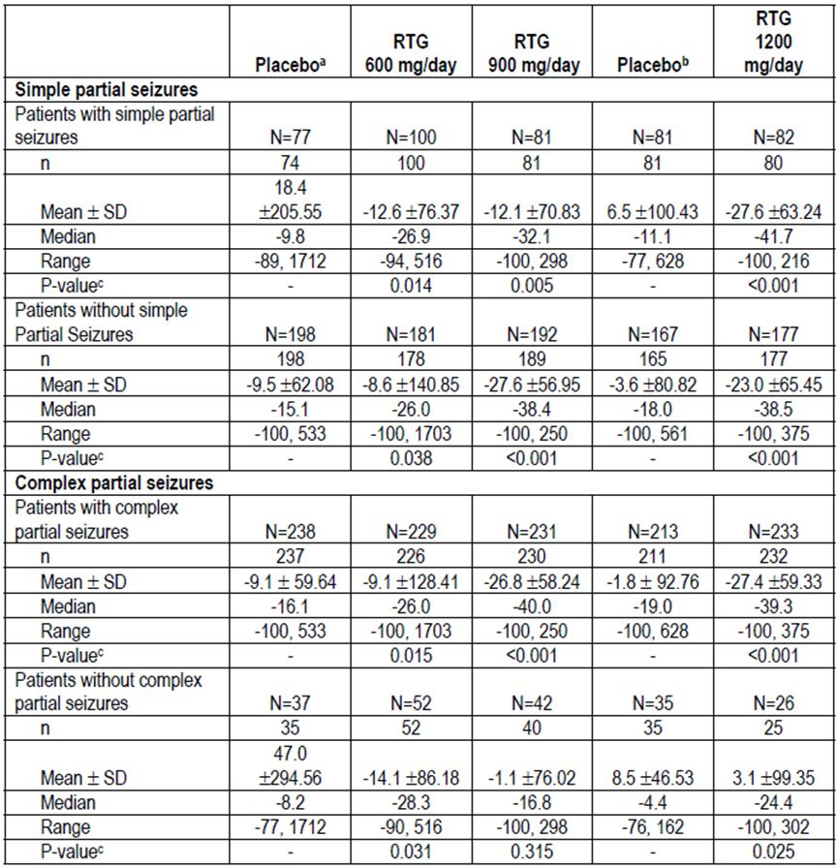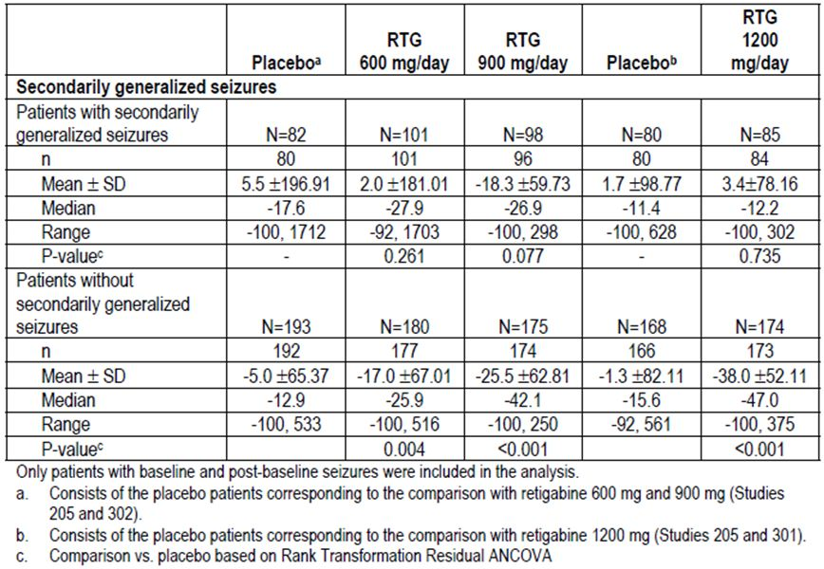
Table 34: Percent change from baseline in 28-day total partial seizure frequency by secondarily generalised seizures subgroup (maintenance phase) – ITT maintenance population (studies 205, 301 and 302 integrated).
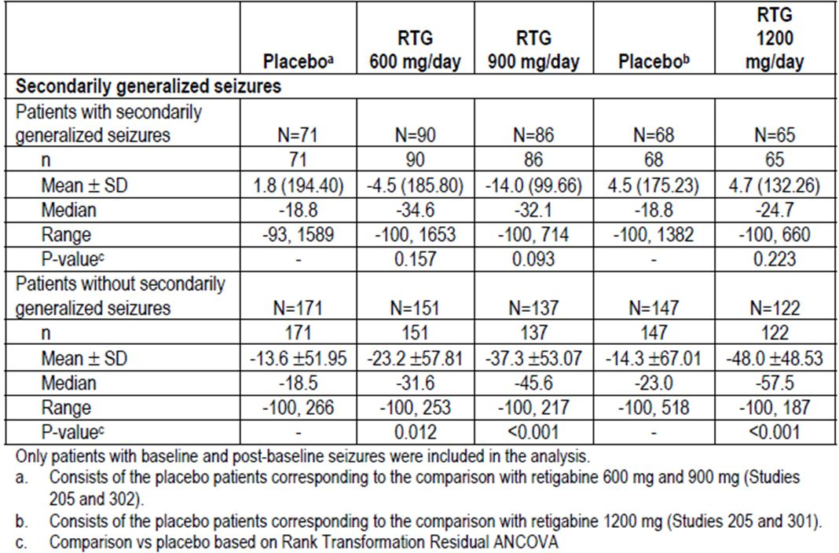
Table 35: Responder rate by seizure type (maintenance phase) – ITT maintenance population (studies 205, 301 and 302 integrated).
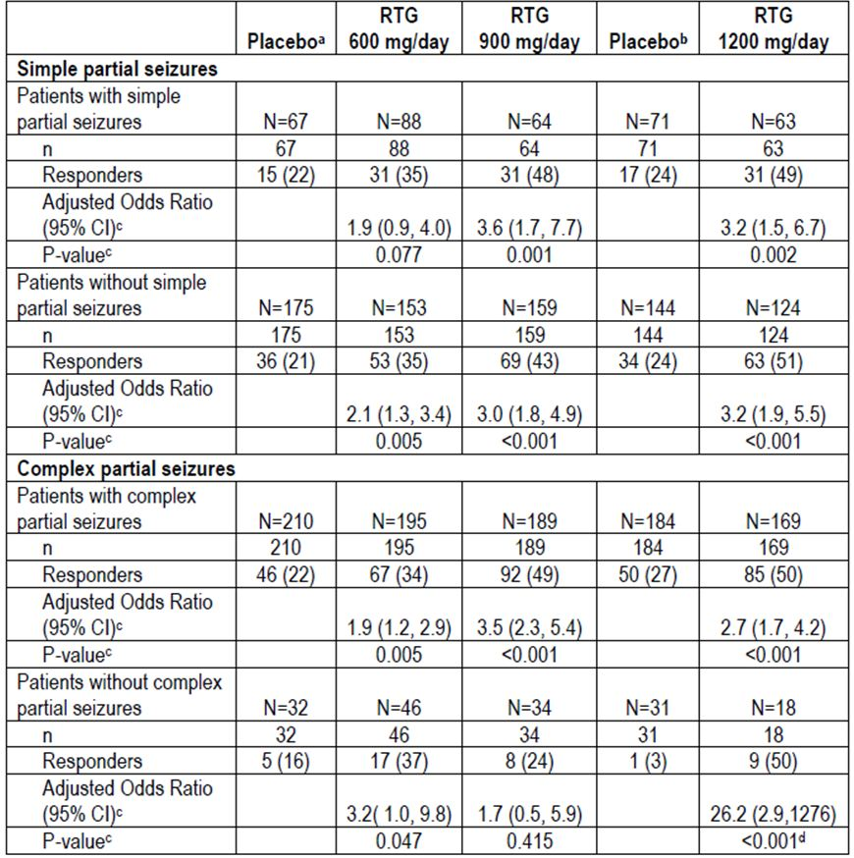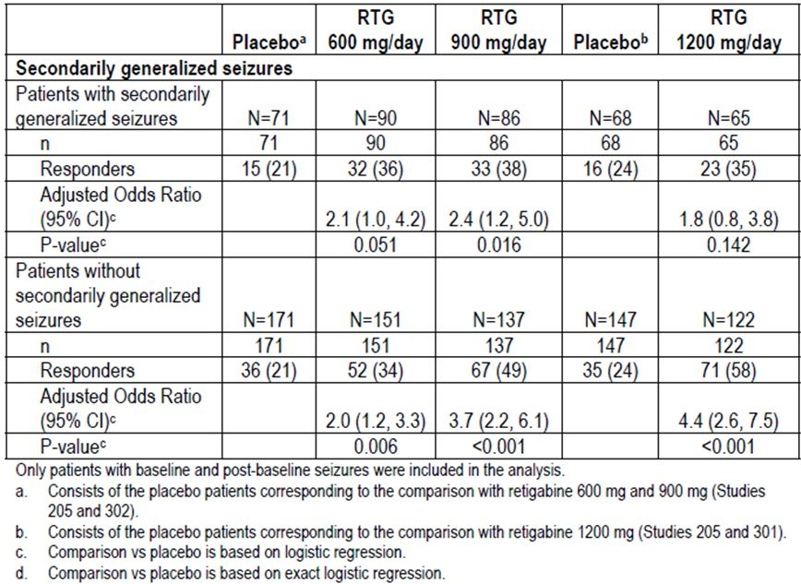
Table 36: Responder rate by secondarily generalised seizures subgroup (double-blind phase) – ITT double-blind population (studies 205, 301 and 302 integrated).
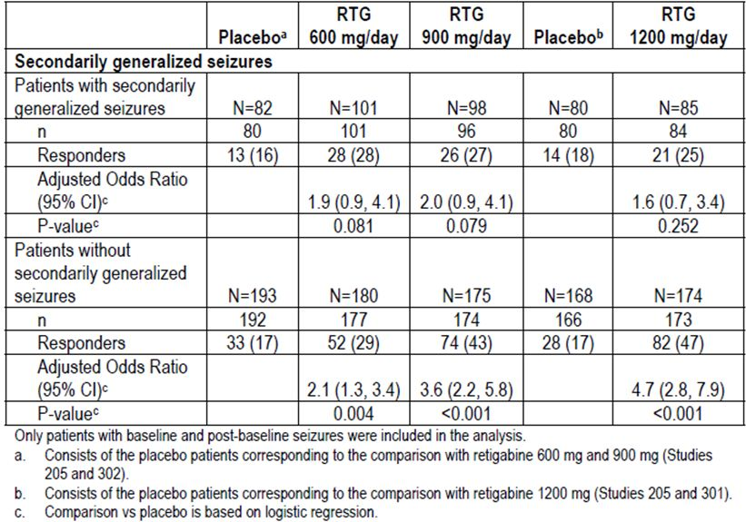
Table 37: Percent change from baseline in 28-day total partial seizure frequency by age group (double-blind phase) – ITT double-blind population (studies 205, 301 and 302 integrated).
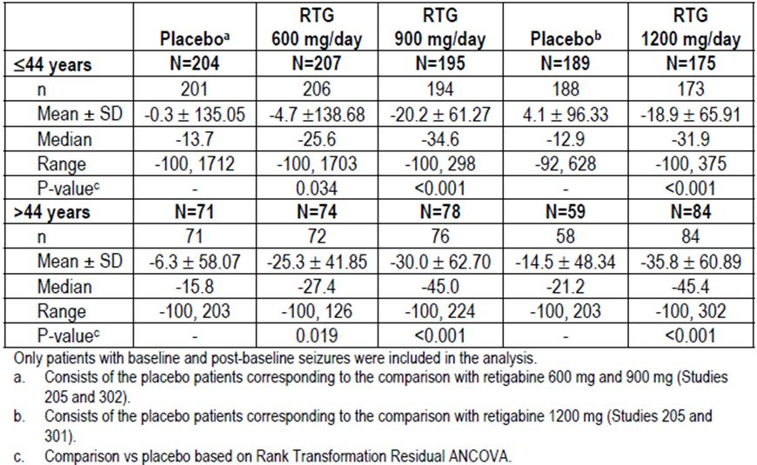
Table 38: Responder rate by age group (maintenance phase) – ITT maintenance population (studies 205, 301 and 302 integrated).
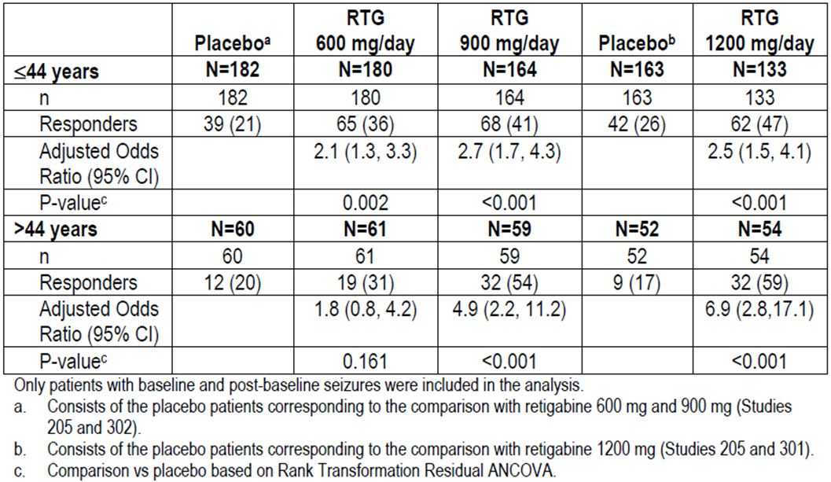
Table 39: Percent change from baseline in 28-day total partial seizure frequency by gender (double-blind phase) – ITT double-blind population (studies 205, 301 and 302 integrated).
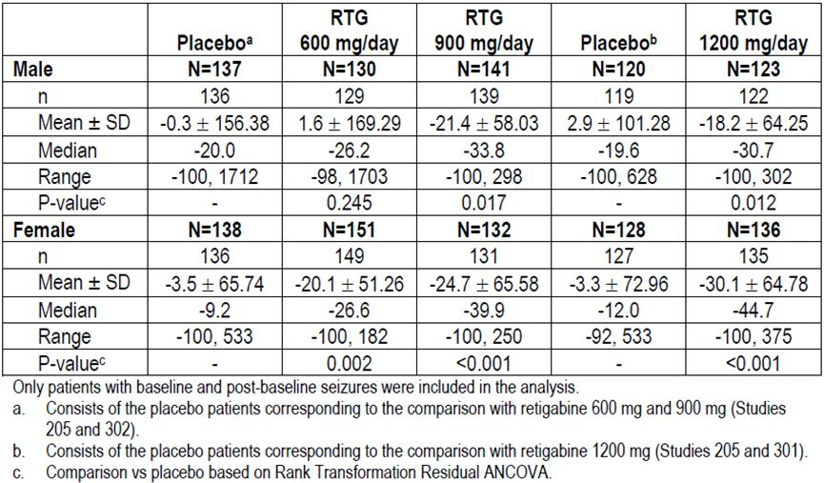
Table 40: Responder rate by gender (maintenance phase) – ITT maintenance population (studies 205, 301 and 302 integrated).
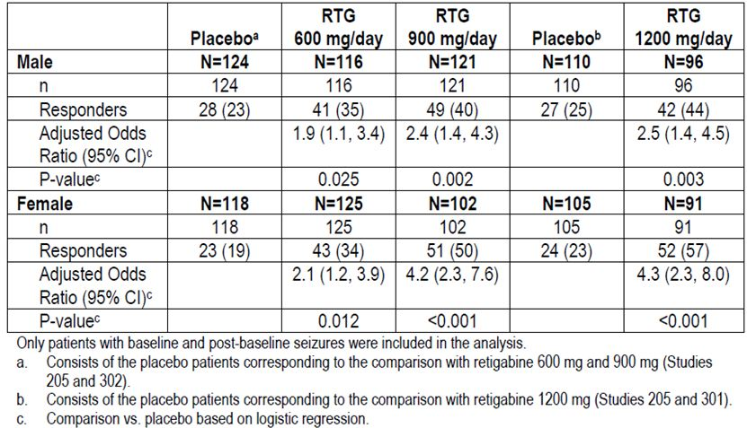
Table 41: Percent change from baseline in 28-day total partial seizure frequency by race (double-blind phase) – ITT double-blind population (studies 205, 301 and 302 integrated).
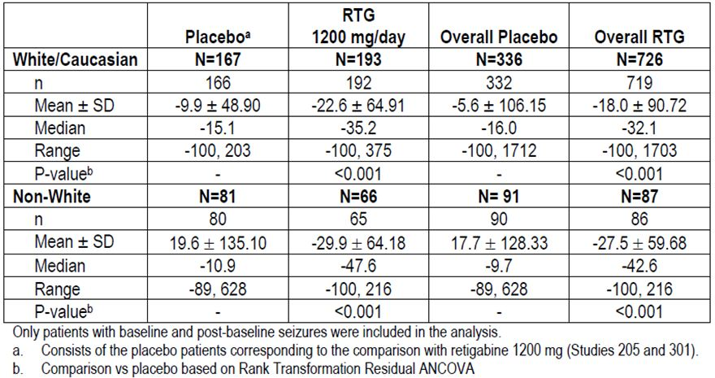
Table 42: Responder rate by race (maintenance phase) – ITT maintenance population (studies 205, 301 and 302 integrated).
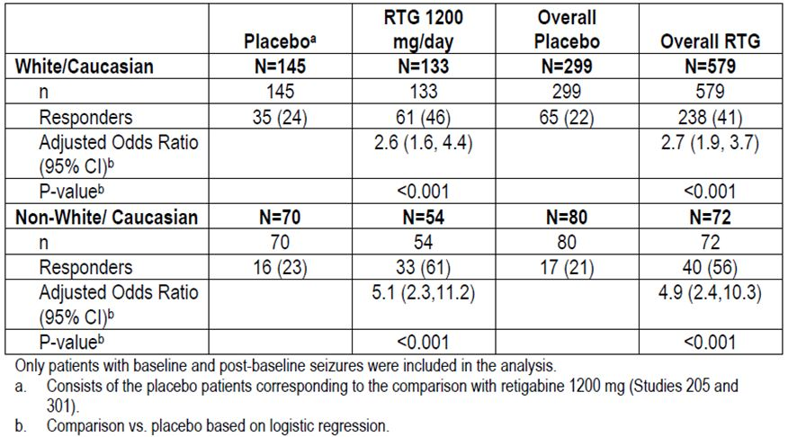
Table 43: Percent change from baseline in 28-Day total partial seizure frequency by number of background AEDs (double-blind phase) – ITT double-blind population (studies 205, 301 and 302 integrated).
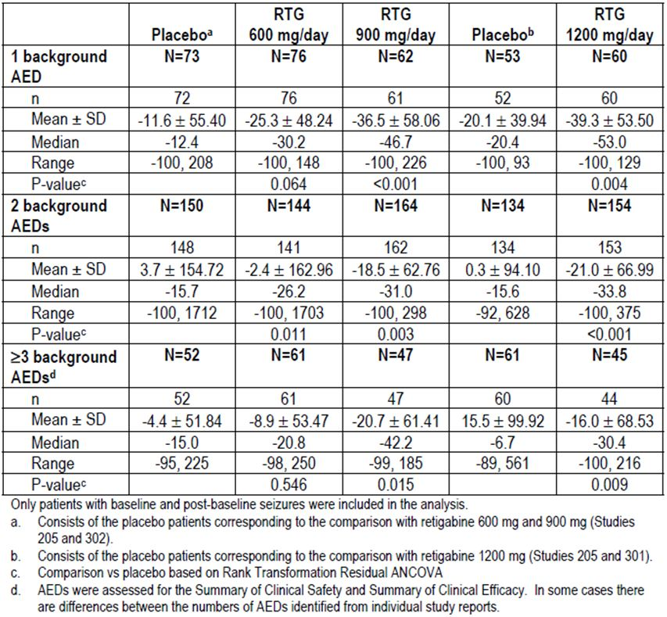
Table 44: Responder rate by number of background AEDs (maintenance phase) – ITT maintenance population (studies 205, 301 and 302 integrated).
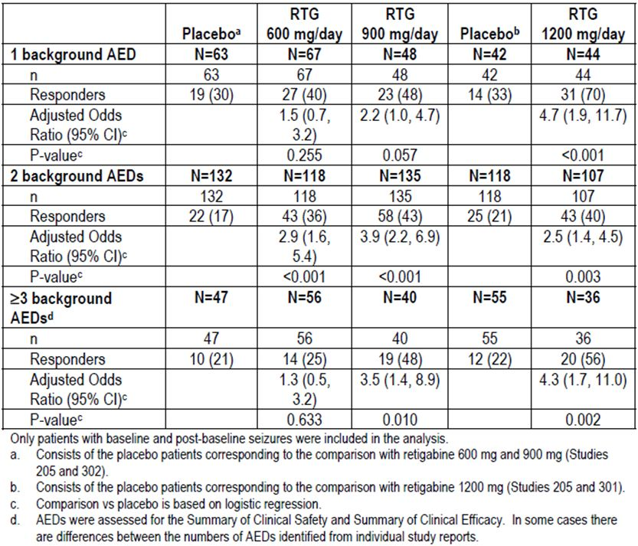

Evaluator’s conclusions on clinical efficacy
The sponsor has provided convincing evidence that retigabine has some efficacy as an anticonvulsant when used as adjunctive therapy in refractory patients, and that it differs significantly from placebo, as summarised in Table 45 (from the proposed PI).
Table 45: Summary of percentage changes in 28 day total partial seizure frequency and responder rates (‘double blind’ population is used for % change and ‘maintenance‘ population used for responder rates).
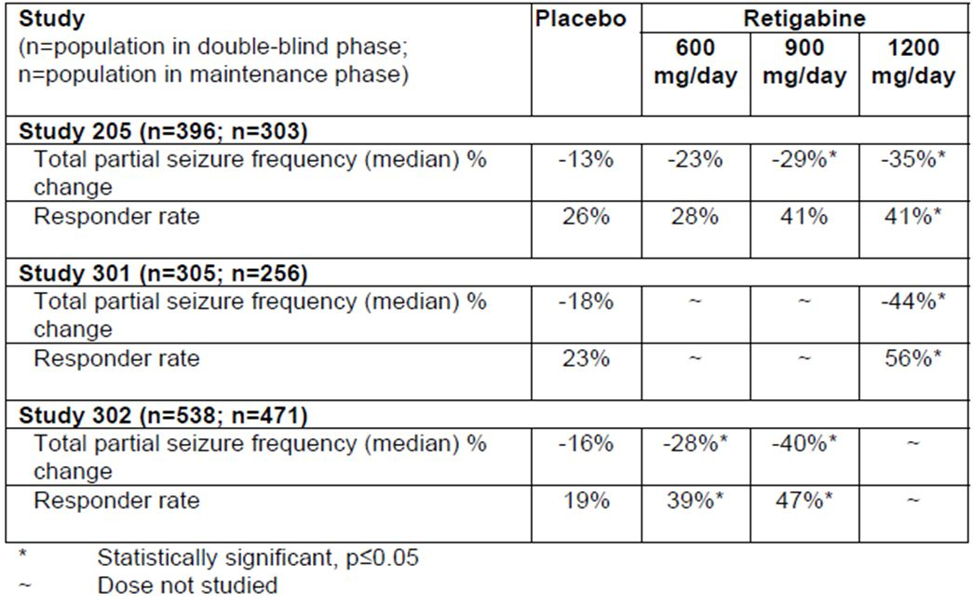
In clinical terms, the magnitude of the benefit appears modest, with a reduction in seizures of about 29-44% overall for the two highest dose groups (900 mg/day and 1200 mg/day), compared to a reduction with placebo of 13-18%. For the highest dose group (1200 mg/day), the attributable reduction in seizure frequency was 22% (13-35%) in Study 205, and 26% (18-44%) in Study 301. Patients are likely to welcome this reduction if it can be achieved with minimal side effects, but the size of the benefit is small enough that even a few side effects could offset it.
A reduction in seizure frequency of at least 50% (a “response”) is likely to be considered more worthwhile by most patients and clinicians. At the lowest recommended dose of 600 mg/day, the responder rate was similar to placebo in the Phase II Study 205 (retigabine 28% versus placebo 26%) but it was significantly superior in the Phase III Study 302 (retigabine 39% versus placebo 19%). At higher doses (900mg/d and 1200mg/d), the responder rates were more consistent (41% for either dose in Study 205, 47% for 900mg/d in Study 302, and 56% for 1200mg/d in Study 301), and these responder rates were significantly superior to placebo in both pivotal studies. Sensitivity analyses showed that, even if withdrawing patients were considered non responders, the superiority of active treatment was still significant.
For the highest dose group, the attributable response rate – the proportion of patients who responded to active treatment over and above the placebo response rate – was 15% in Study 205 (26-41%), and 33% in Study 301 (23-56%). This implies that between 3-7 patients need to be treated with retigabine to achieve one attributable response. However, the placebo response rate was 26% in Study 205 and 23% in Study 301; this implies that for every 4 patients treated, 1 patient will show a response that would have been obtained with placebo.
A range of secondary endpoints and subgroup analyses showed that these findings were robust, but these additional analyses did not change the overall impression that retigabine offers only moderate efficacy as an adjunctive agent. Seizure freedom was significantly more likely with HD retigabine, but was nonetheless rare. In the maintenance phase of Study 301, seizure freedom was achieved in 7.6% of retigabine 1200 mg/day recipients, compared to 1.5% of placebo recipients (p=0.027).
It seems likely that retigabine would have better efficacy in a less refractory population, but its efficacy in that setting remains untested. It also remains unknown whether retigabine compares favourably to other second line or third line AEDs in the adjunctive setting, and whether it has reasonable efficacy as a monotherapy agent.

Clinical safety

Studies providing evaluable safety data
The following studies provided evaluable safety data:
- 32 completed Phase I studies;
- 5 completed Phase II studies;
- 2 completed Phase III studies;
- 6 long-term, open-label extension studies (2 of which are ongoing; VRX-RET-E22-303 and VRX-RET-E22-304) in adults with partial onset seizures;
- an ongoing compassionate use program in epilepsy (D-23129-3227);
- 1 completed study in post-herpetic neuralgia (VRX-RET-E22-NP201); and
- 1 completed study in bipolar disorder and (D-23129/8040).

Pivotal efficacy studies
In the pivotal efficacy studies, the following safety data were collected:
- General adverse events (AEs) were collected by the clinical investigators.
- Laboratory tests, including electrolytes, renal and liver function tests, and haematology, were performed at regular intervals.

Studies that assessed safety as a primary outcome
No pivotal studies assessed safety as a primary outcome. Some Phase I PK studies assessed the tolerability of different doses, and have been described in the PK section. The PD study VRX-RET-E22-103 assessed the effects of retigabine on the QT interval of the electrocardiogram.

Patient exposure
A total of 2,365 subjects were exposed to retigabine, including 1,365 in Phase II and III epilepsy studies. Table 46 shows the total numbers exposed in each part of the development program, and Table 47 displays the numbers exposed to each dose in the ‘PCT-Safety Population’, consisting of patients exposed to treatment in the pivotal efficacy studies. Duration of exposure was reasonable, as shown in Tables 48 and 49: in pooled Phase II and III studies, mean exposure was >1 year (449.2 days). Exposure to individual single doses was unclear, particularly for single doses >400 mg, and this point should be clarified by the sponsor.
Table 46: Enumeration of unique patients exposed to study medication.
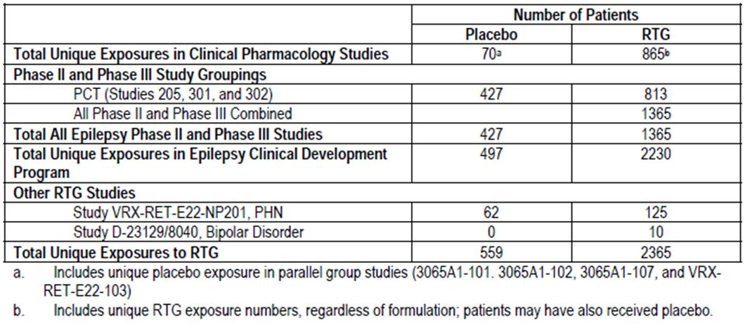
Table 47: Source and number of patients included in the integrated safety analysis (safety population: PCT).
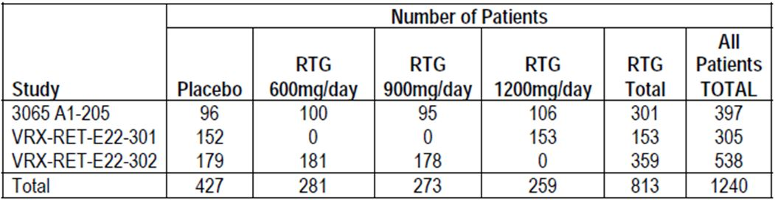
Table 48: Summary of total exposure to retigabine excluding transition phase (safety population: PCT).
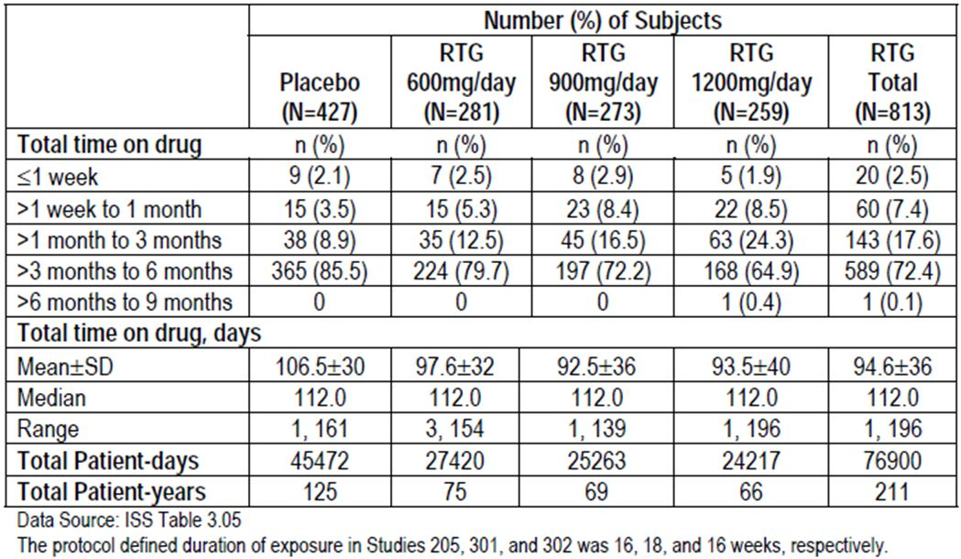
Table 49: Summary of total exposure to retigabine (safety population: all phase II/III combined).
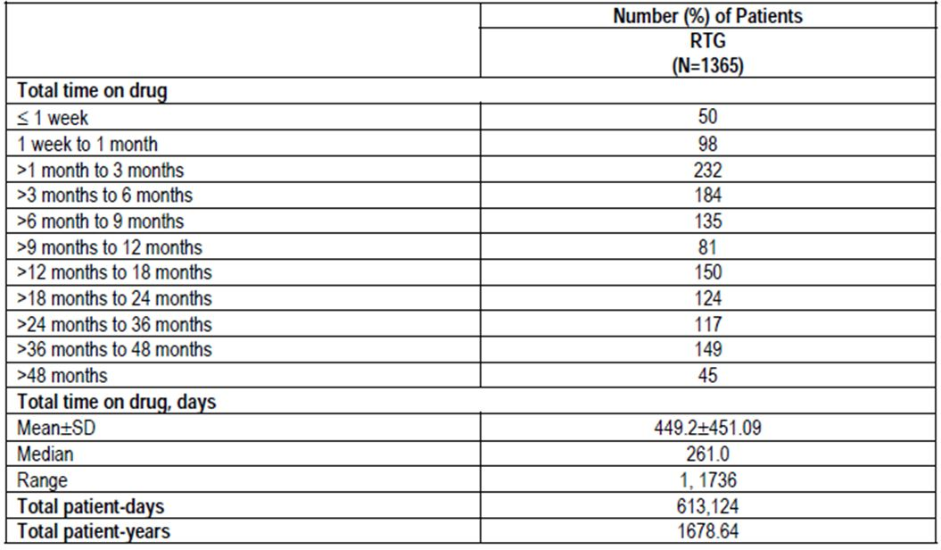

Adverse events

All adverse events (irrespective of relationship to study treatment)

Pivotal studies
In the pivotal controlled trials (PCT), adverse events (AEs) were common with both retigabine (80.8% of subjects) and placebo (74.5% of subjects). The minor difference in overall AE rate (80.8%-74.5% = 6.3%) disguises much higher attributable rates for specific AEs. As shown in Tables 50 and 51, which includes AEs reported in ≥ 5% of patients in any treatment group in the PCT population, AEs involving the central nervous system (CNS) were much more common in retigabine recipients, particularly at higher doses. This is supported by the subsequent table, which groups AE by organ class. “Nervous system disorder” AEs were ostensibly reported in 60.3% of retigabine recipients, compared to 43.1% of placebo recipients, but note that some CNS AEs are likely to have been listed in other categories, including psychiatric and eye disorders, so the actual incidence of CNS side effects was even higher. In the high-dose group, “nervous system” AEs occurred in 73.4% of subjects, an absolute excess of >30% compared to placebo.
Table 50: AEs reported by greater than or equal to 5% of patients in any treatment group by preferred term (safety population: PCT, studies 205, 301 and 302).
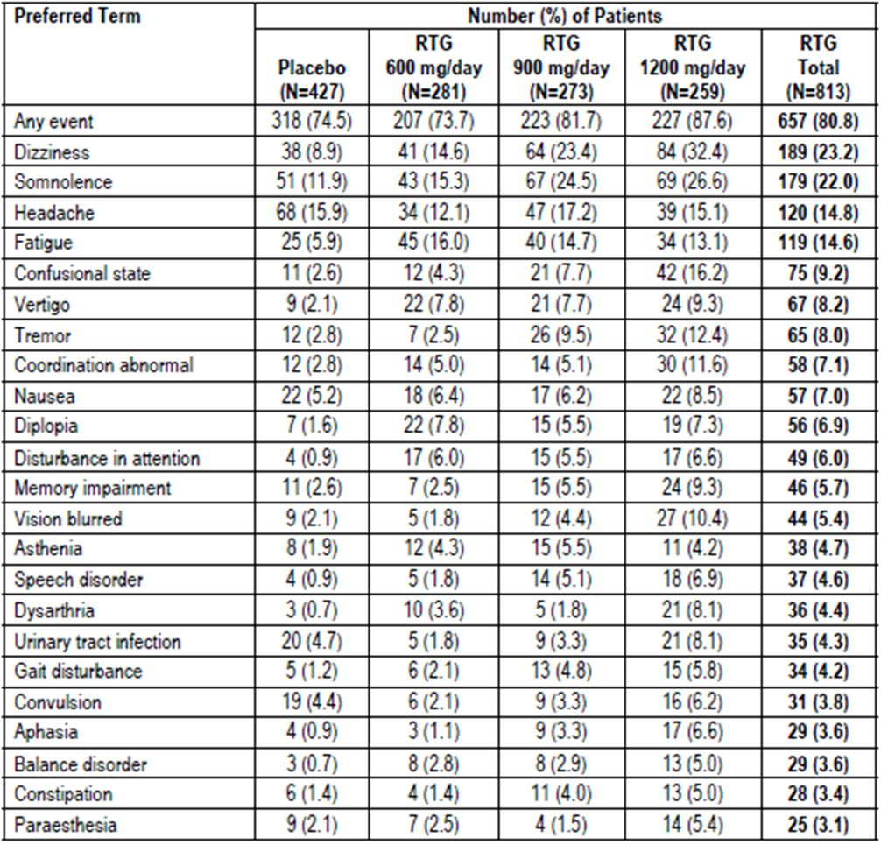
Table 51: Treatment-emergent AE incidence by system organ class (safety population: PCT).
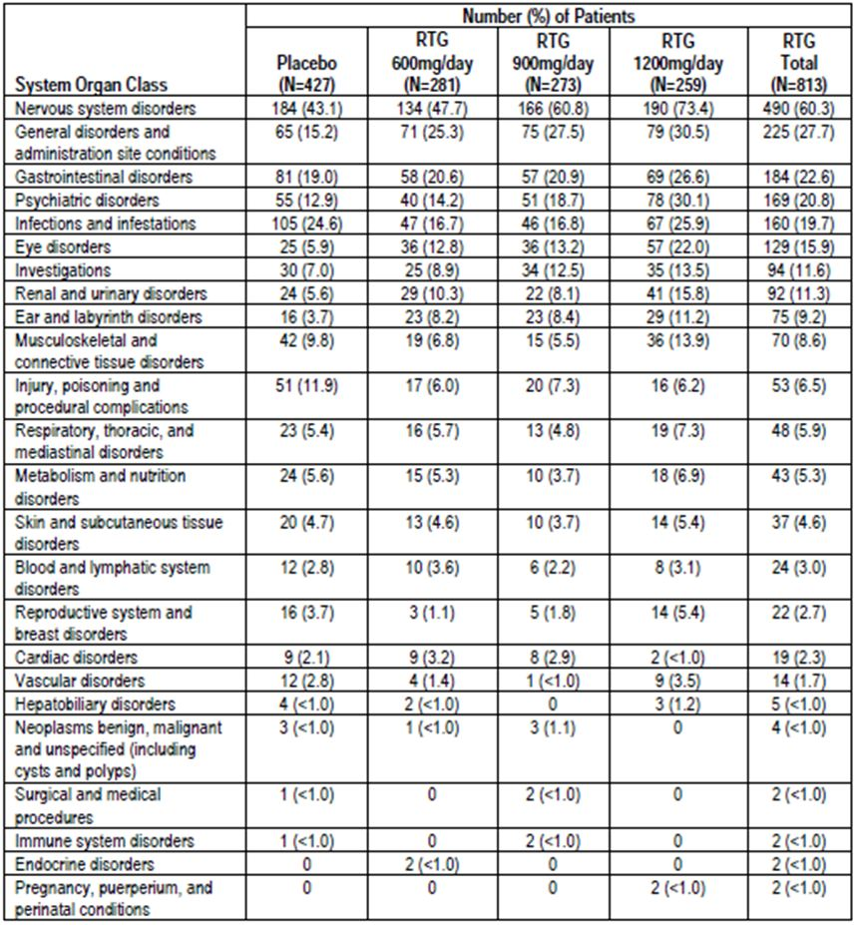
Dizziness was the most common individual complaint; it occurred in 23.2% of retigabine recipients overall, compared to only 8.9% of placebo recipients. Approximately 1 in 3 subjects (32.4%) reported dizziness at the highest dose of 1200mg/d. Other common CNS side effects were somnolence, fatigue, confusional state, vertigo, tremor and abnormal coordination, all of which occurred in >10% of recipients at the highest dose level, with a clear excess relative to placebo. Diplopia occurred in ~7% of retigabine recipients, without a clear dose trend, but this symptom was relatively rare in placebo recipients (1.6%). Most other CNS side effects, as listed in the table, are consistent with CNS inhibitory effects of retigabine at higher doses. Such side effects are common with anticonvulsants but the incidence with retigabine appears high.
Convulsion was one of two CNS-related AEs more common with placebo than with retigabine, but this AE is more properly considered under efficacy; the apparently low rates of this AE reported in an epileptic population presumably reflect the conclusion of many investigators that this was an efficacy endpoint rather than an AE, and therefore not worth reporting. The only other CNS-related AE more common with placebo was headache, seen in 14.8% of retigabine recipients, compared to 15.9% of placebo recipients, a trivial difference.
Non-CNS side effects were also noted, but were less common. Nausea was slightly more common with retigabine (7.0%) than placebo (5.2%). Urinary tract infections (UTIs) were slightly more common with placebo (4.7%) than with retigabine (4.3%), but among retigabine recipients there was an apparent dose trend with an increasing incidence of UTIs reported with increasing dose, reaching 8.1% at the highest dose level. Interpretation is not straightforward, because the higher incidence in the placebo group could reflect the confounding effect of seizures causing clinicians to look for UTIs. Given that retigabine is expected to bind to potassium channels in the bladder, this dose-trend could reflect a true causal relationship.
Constipation was also more common at higher doses of retigabine, being reported in 1.4% of both placebo recipients and the lowest retigabine dose group (600mg/d) but in 4.0% and 5.0% of the higher dose groups (900mg/d and 1200mg/d, respectively). This could reflect the presence of potassium channels in gut neurons.

Other studies
AEs from all Phase II and III studies, including the pivotal studies, are in Table 52. Not all of these studies had a placebo group, so the attributable risk is unclear, but the general conclusions are the same as in the PCT population: retigabine is associated with a high incidence of CNS-related side effects.
Table 52: AEs reported for 5% or more of patients (safety population: all phase II/III combined).
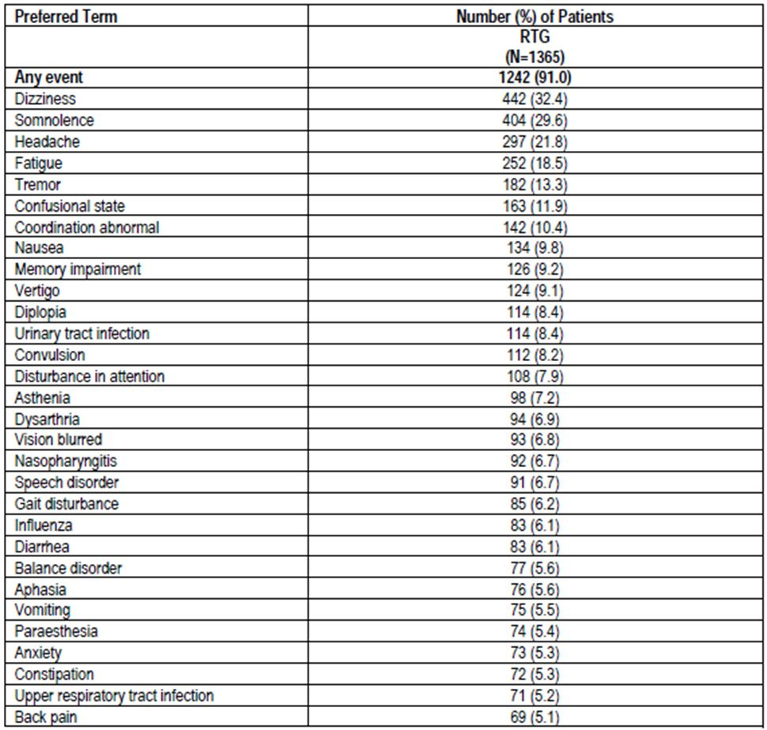

Treatment-related adverse events (adverse drug reactions)

Pivotal studies
When reporting AEs, investigators indicated which AEs they thought were likely to be related to study drug, as is standard practice for studies of this nature. Unfortunately, attribution of causality is difficult on a case-by-case basis, and may often reflect investigators’ expectations of the side-effect profile of a drug rather than a true causal relationship. Nonetheless, as shown in Table 53, the pattern of treatment-emergent AEs (TEAEs) that were considered related to study drug was similar to the overall pattern, and was dominated by CNS side effects.
Table 53: TEAEs considered related to study drug reported for 5% or more of patients in any treatment group by preferred term (safety population: PCT).
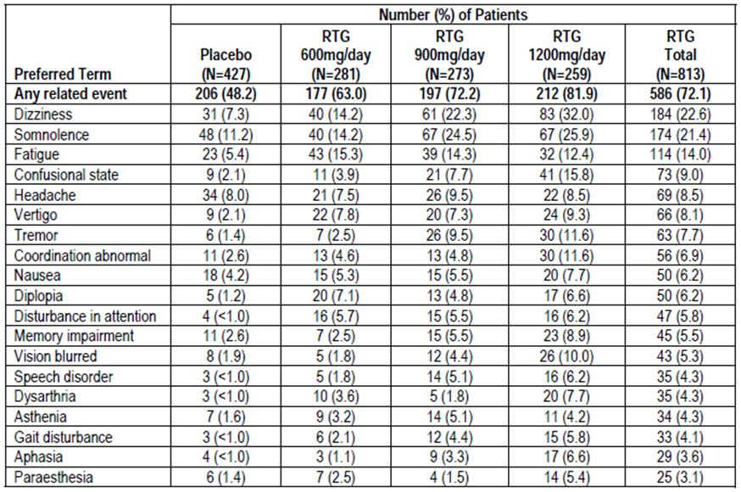

Other studies
A similar pattern of ‘treatment-related’ AEs was observed in the pooled Phase II and III study population, as shown in Table 54.
Table 54: TEAEs considered related to study drug reported for 5% or more of patients (safety population: all phase II/III combined).
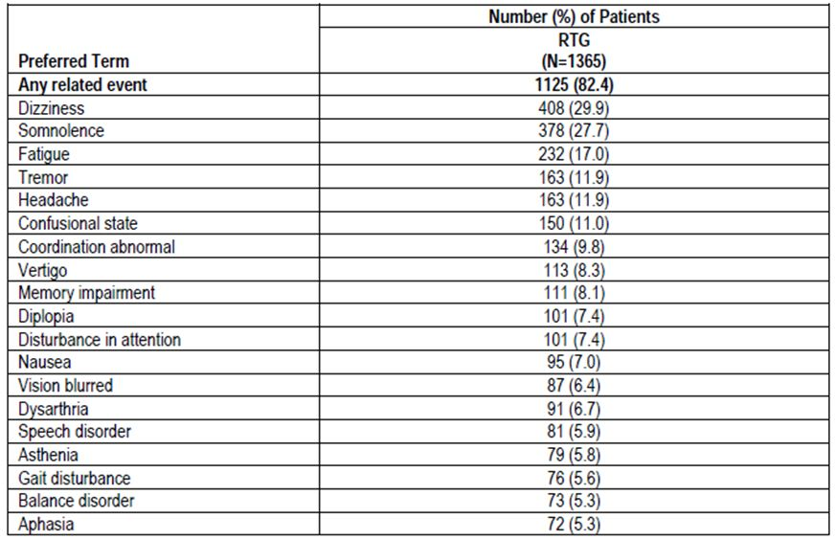

Serious adverse events

Pivotal studies
Serious adverse events (SAEs) were slightly more common in the pooled retigabine group than the placebo group (8.6% vs 5.9%), as shown in Table 55. Apart from convulsion, the only SAE occurring in more than 2 retigabine recipients was psychotic disorder, which was reported in 6/813 subjects (0.7%). Most of the psychosis was observed at the highest dose level (5/259, 1.9%). The other SAEs with an excess in the retigabine group were consistent with the overall pattern of AEs, and included a number of CNS side effects. Suicidal ideation was observed in 2 subjects at the highest dose level.
Table 55: TESAEs reported by greater than or equal to 2 patients in any treatment group by preferred term (safety population: PCT, studies 205, 301 and 302).
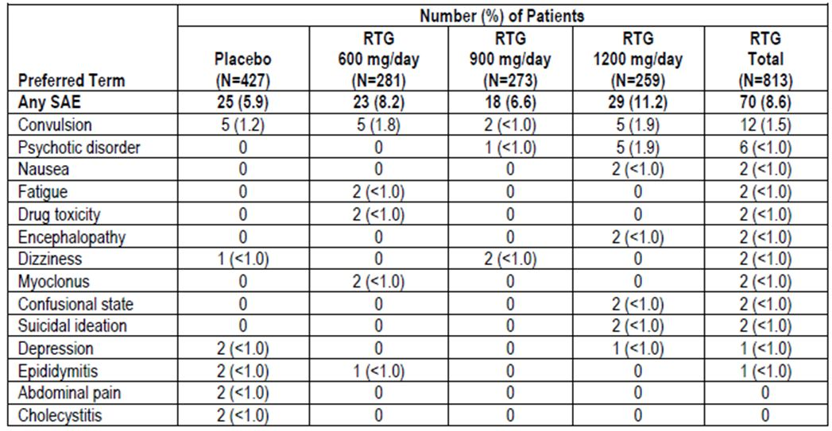

Other studies
Treatment emergent SAEs for the pooled Phase II and III population are shown in Table 56 and raise no new concerns.
Table 56: TESAEs reported by greater than or equal to 3 patients by preferred term (safety population: all phase II/III combined).
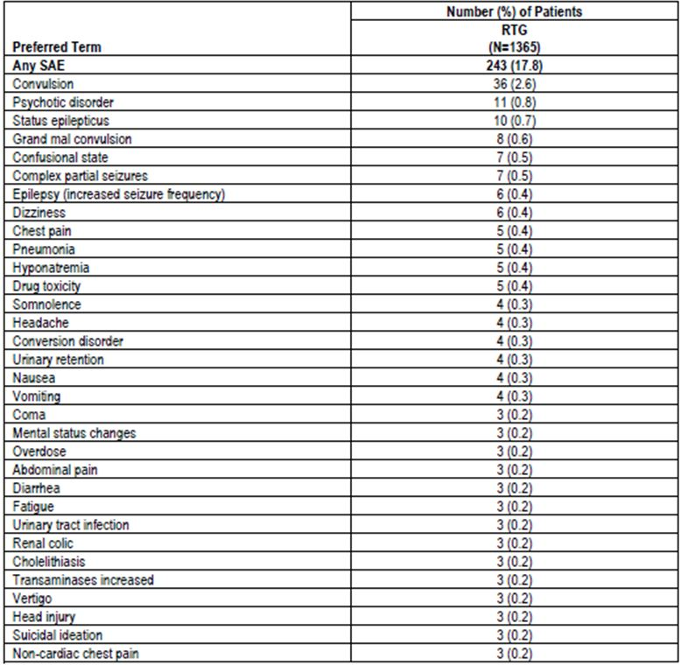

Deaths

Pivotal studies
In the PCT population, 3 deaths occurred in the placebo group (3/427, 0.7%) and 2 occurred in the pooled retigabine group (2/813, 0.2%), including 1 patient in the 600 mg/d group and 1 patient in the 1200 mg/d group. One of the placebo deaths and one of the retigabine deaths was attributed to sudden-unexpected death in epilepsy (SUDEP), a condition that would be expected to reduce in incidence with an effective anticonvulsant.
This rate of death is within expected bounds for this population, and is equivalent to 24.0 deaths per 1000 patient-years on placebo versus 9.5 deaths per 1000 patient-years on retigabine. The rate of SUDEP was 8.0 per 1000 patient-years on placebo versus 4.7 per 1000 patient-years in retigabine. The studies were not powered to prove that mortality is reduced with retigabine treatment, but the lower death rate in the active groups is reassuring.

Other studies
Some additional deaths occurred in the broader study population, including non-placebo-controlled studies (Table 57). This includes long-term follow-up studies. The overall rate of fatal events and SUDEP on retigabine treatment appeared similar in this broader population as had been observed with active treatment in the pivotal studies, and the mortality rates were lower than had been observed on placebo.
Table 57: Number of deaths and exposure numbers for each study data set.
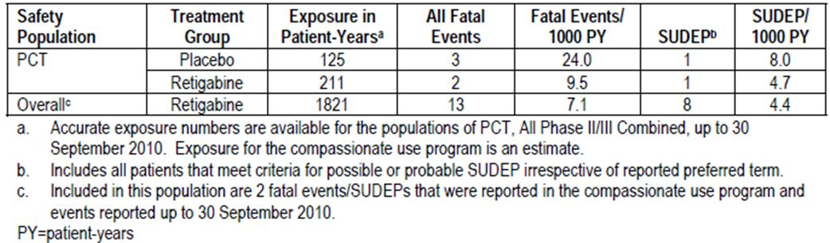
A review of individual deaths did not raise any new safety concerns. Apart from SUDEP, other seizure-related complications included a fall into water during a probable seizure, in one subject, and status epilepticus in another. The non-seizure-related causes of death were: metastatic carcinoma, myeloma, diabetic ketoacidosis, subarachnoid haemorrhage with complications, ischaemic heart disease and, in the father of one subject, probable retigabine overdose. With the exception of the overdose, retigabine did not appear to play a causal role. The overdose occurred in someone who was not taking retigabine prior to the overdose, so retigabine did not contribute to that individual’s suicidality.

Discontinuation due to adverse events

Pivotal studies
In the PCT population, the pattern of AEs leading to discontinuation reflected the CNS side effects of retigabine (Table 58). In retigabine recipients, approximately one patient in four (24.5%) withdrew because of AEs, and there was a clear dose trend from the placebo group (10.5% withdrawing due to AEs) through to the highest retigabine dose group (1200mg/d, 31.3% withdrawing due to AEs). This suggests that retigabine has a relatively high rate of intolerance, relative to many other anticonvulsants. The most common TEAE leading to discontinuation was dizziness (5.7%), followed by confusional state (3.9%), somnolence (3.4%) and fatigue (3.3%).
Table 58: TEAEs leading to discontinuation reported by more than 2% of patients in any treatment group (safety population: PCT).
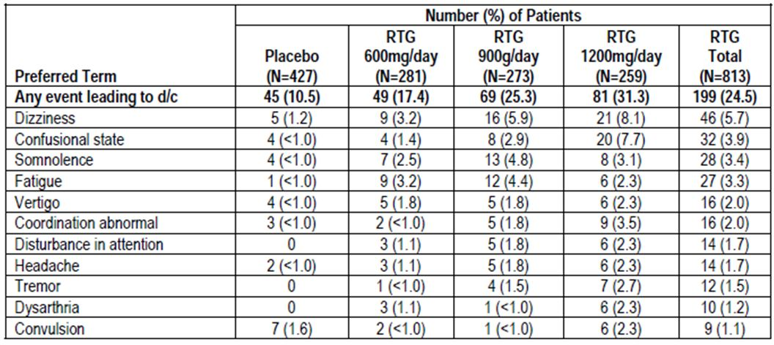

Other studies
In the pooled Phase II/III population, a similar constellation of TEAEs lead to withdrawal: dizziness (6%), somnolence (5%), confusional state (4%), fatigue (4%), disturbance of attention (2%), and abnormal coordination (2%).

Laboratory tests
TEAEs related to laboratory evaluations are shown in Table 59 (the table is truncated relative to the sponsor’s original, which included the additional categories ‘Vital Signs’ and ‘ECGs’). Abnormalities of liver function tests, electrolytes and haematology were relatively rare, and the only individual AEs reported in ≥ 1% of retigabine recipients were abnormal urinalysis, haematuria, leukopaenia, hypercholesterolaemia and elevated gamma-glutamyltransferase.
Table 59: TEAEs related to clinical laboratory evaluations (observed in more than 1 patient in any treatment group), vital signs, or ECGs (safety population: PCT).
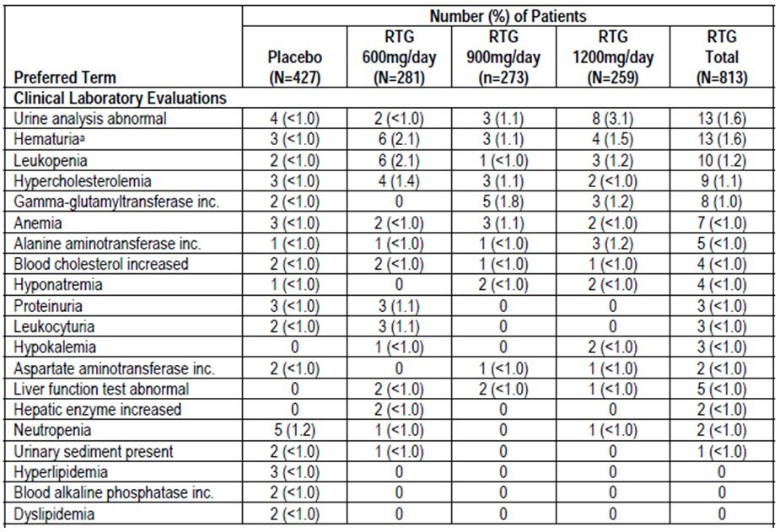
The sponsor also performed a shift analysis (Table 60). Subjects receiving retigabine had a slightly higher incidence of shifting from normal to abnormal for a range of parameters, including urea, bilirubin and ALT.
Table 60: Shifts to abnormal values for clinical chemistry (safety population: PCT).
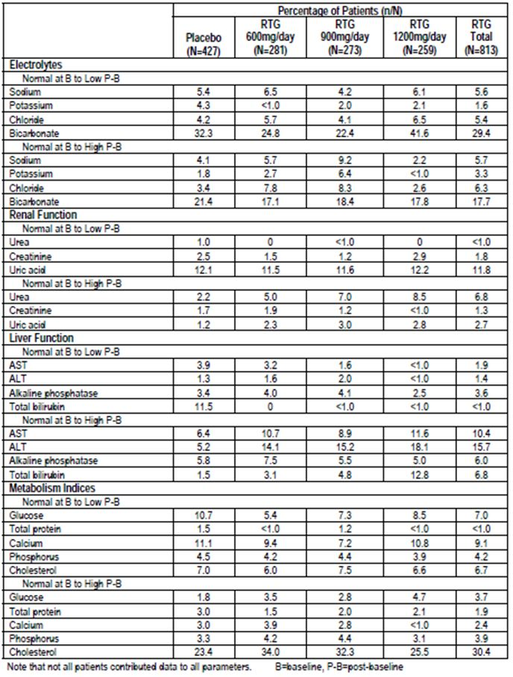

Liver function
In the PCT population, increased hepatic enzymes were reported in 1.4% of placebo recipients, compared to 3.0% of retigabine recipients. There was an apparent dose trend, with 2.1%, 3.3% and 3.5% of retigabine recipients exhibiting elevated enzymes in the 600mg/d, 900mg/d and 1200mg/d dose groups, respectively. The shift table above also suggests that, compared to placebo recipients, retigabine recipients were more likely to develop high ALT and bilirubin during treatment (ALT 15.7% on retigabine vs 5.2% on placebo; bilirubin 6.8% vs 1.5%). The incidence increased with increasing dose.

Kidney function
Shifts from normal urea to elevated urea were more common with retigabine recipients (6.8%) than placebo recipients (2.2%), as shown in the table above. On the other hand, shifts in creatinine from normal to high occurred with similar incidence in the retigabine group (1.3%) and the placebo group (1.7%).
There is, thus, no evidence of direct renal toxicity from retigabine. Other urological aspects of retigabine treatment are considered separately.

Other clinical chemistry
No consistent patterns were observed with other clinical chemistry monitoring, as shown in the tables above.

Haematology
Haematological AEs were rare in the PCT population. The only haematological AE reported in more than one patient was anaemia, which occurred in <1% of retigabine subjects (placebo 3/427, 0.7%, vs retigabine 7/813, 0.9%). Haematological values of potential clinical concern are shown in Table 61. Abnormalities were either rare or were similarly distributed across the active and placebo groups.
Table 61: Haematology values of potential clinical concern (safety population: PCT).
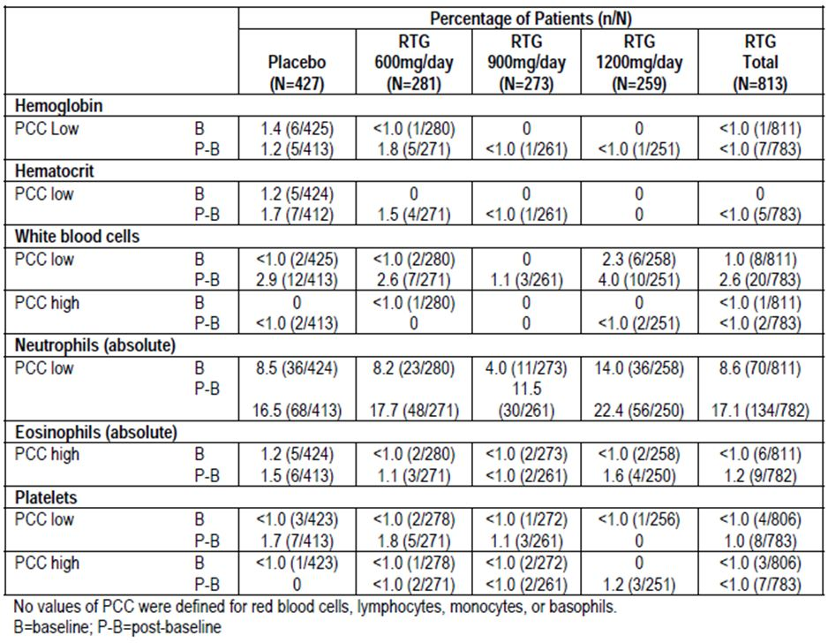

Electrocardiograph

Pivotal studies
ECG abnormalities reported in the PCT population are shown in Table 62. Individual ECG abnormalities were rare, and the most serious abnormality, ventricular asystole was only reported in a placebo recipient.
Table 62: TEAEs in PCT population involving ECGs.
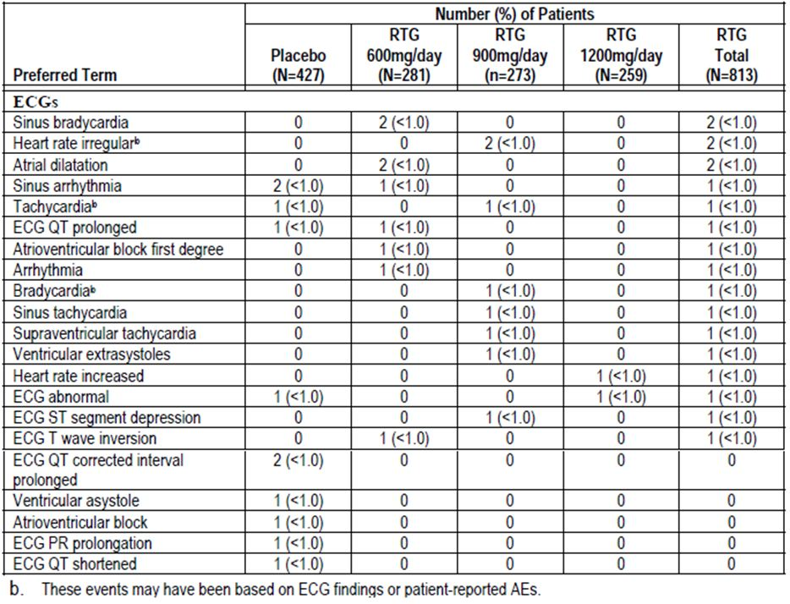

Other studies
In the clinical pharmacology studies, TEAEs related to ECGs were relatively uncommon, as shown in Table 63, but it should be noted that the table omits two serious adverse events of a cardiac nature that occurred in a PD study. In Study VRX-RET-E22-108, single doses of 900mg retigabine were shown to be unsafe. Two of six subjects receiving retigabine 900mg had potentially life-threatening arrhythmias: asystole in one subject and ventricular tachycardia in another. Also, the PD Study VRX-RET-E22-103 showed that retigabine is associated with mild QT prolongation, which would be expected to be dangerous in susceptible subjects.
Table 63: All TEAEs related to ECGs (safety population: integrated clinical pharmacology studies).
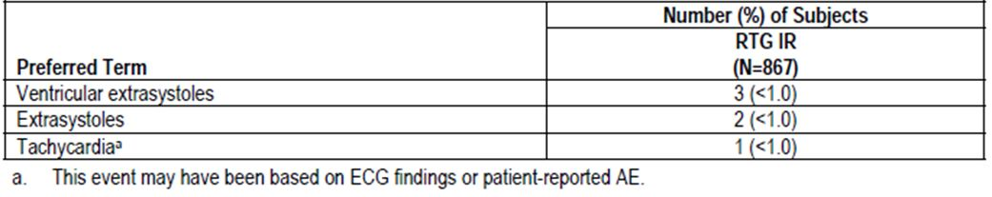

Vital signs

Pivotal studies
Table 64 shows TEAEs related to vital signs. No TEAE was seen in >1% of retigabine recipients, and abnormalities in vital signs were not more common in retigabine than placebo recipients.
Table 64: TEAEs related to clinical laboratory evaluations (observed in more than 1 patient in any treatment group), vital signs, or ECGs (safety population: PCT).
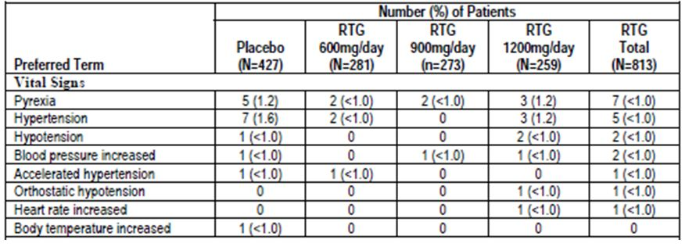

Other studies
AEs related to vital signs in the pooled Phase II/III population followed a broadly similar pattern to that observed in the PCT population.
In the Clinical Pharmacology studies, AEs related to vital signs were generally rare, as shown in Table 65. The most significant safety finding in the pharmacology studies was the two cases of cardiac arrest in subjects exposed to a single dose of 900mg (See Study VRX-RET-E22-108).
Table 65: All TEAEs related to vital sign assessment (safety population: integrated clinical pharmacology studies).
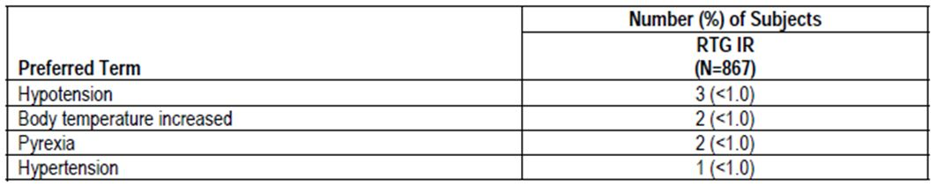

Weight

Pivotal studies
Retigabine was associated with an increased risk of weight gain (Tables 66 and 67). An increase in body weight was reported as an AE in 5/427 (1%) patients in the placebo group, compared to 6/281 (2%), 9/273 (3%), and 7/259 (3%) patients in the retigabine 600mg/d, 900mg/d and 1200mg/d groups, respectively.
Table 66: Baseline weight and change in weight from baseline (safety population: PCT).
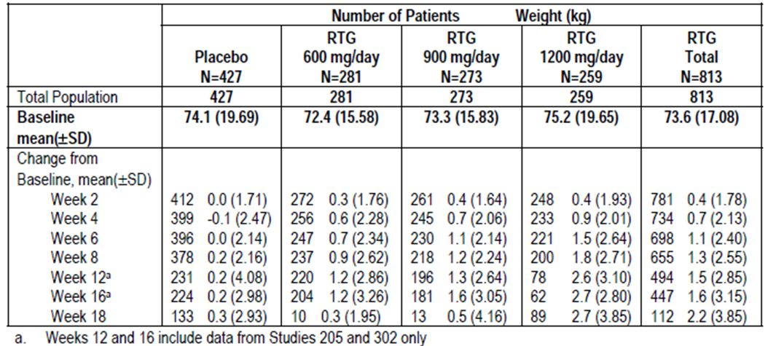
Table 67: Weight changes meeting values of PCC (safety population: PCT).
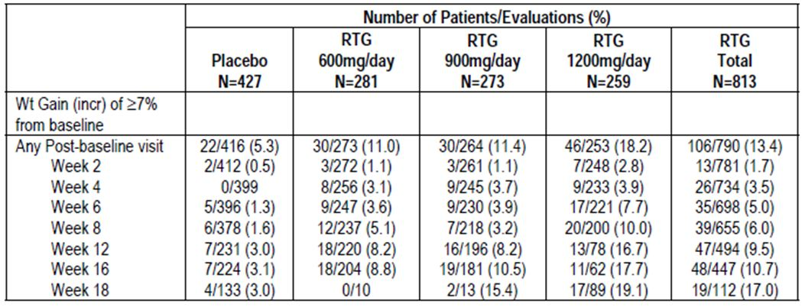
A decrease in body weight was reported as an AE in 3/281 (1%) and 1/273 (<1%) patients in the retigabine 600mg/d and 900mg/d groups, respectively, but in no patients from the placebo or 1200 mg/d groups.
An analysis of mean weights across all treatment groups (rather than just patients who reported weight gain as an AE) shows that retigabine treatment was associated with a weight gain of 2.2kg by week 18. There was a clear dose trend, with the highest dose group showing a mean gain of 2.7kg. Approximately 17% of retigabine recipients experienced weight gain of potential clinical concern (PCC) by week 18, with the highest risk at 1200mg/d (19.1%). This was defined as a weight gain of ≥ 7% from baseline.

Other studies
In the broader Phase II/III population, 340/1304 (26%) retigabine recipients had weight gain of PCC for one or more measurements.

Urological and renal safety

Pivotal studies
Retigabine is known to interact with voltage-gated potassium channels expressed in the bladder, and the potential for urinary toxicity was highlighted in the preclinical phase of development. The sponsor therefore pooled AEs and other safety data related to the following topics:
- Voiding Dysfunction and Urinary Retention
- Renal Dysfunction (renal failure)
- UTIs and Related Signs and Symptoms
- Urinary Crystals
Overall, AEs related to renal or urinary problems were slightly more common in retigabine recipients (17.0%) than placebo recipients (12.9%). The difference relative to placebo was more marked in the highest dose group, where 25.1% of subjects had a renal/urinary event, nearly twice as many as in the placebo group. For the highest dose group, the difference relative to placebo was statistically significant. The relative risk of reporting a renal/urinary AE was as follows:
- 600 mg/d group - 1.05 (95% CI 0.714, 1.543)
- 900 mg/d group - 0.995 (95% CI 0.67, 1.478)
- 1200 mg/d group - 1.948 (95% CI 1.409, 2.695)
- Total RTG group – 1.32 (95% CI, 0.986, 1.761)
The excess in the high-dose group was largely accounted for by urinary tract infections, dysuria, urinary hesitation, chromaturia, abnormal urine analysis and abnormal residual urine volume. Some of these, including UTIs, hesitation and abnormal residual urine volume, could be due to an inhibitory effect on bladder emptying (Table 68).
Table 68: AEs of renal/urinary disorders reported by 2 or more patients in any treatment group (safety population: PCT).
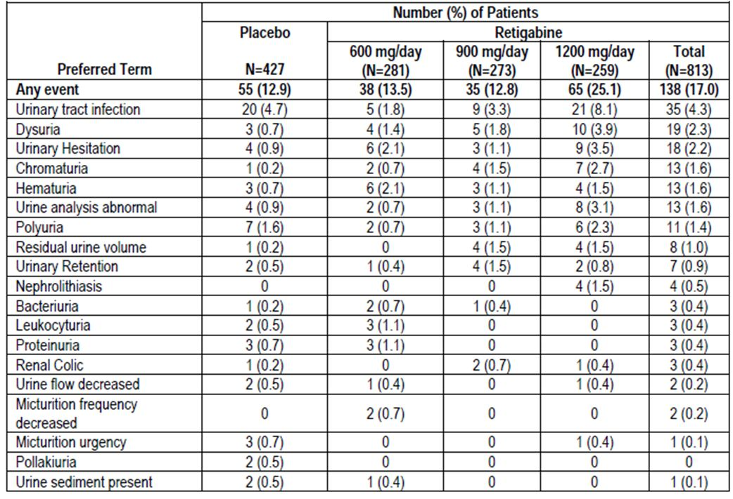
Serious AEs related to the renal/urinary system were rare in the PCT population, and in each case resolved, as shown in Table 69. The most concerning SAE was the development of renal failure in one recipient of retigabine 600mg/d – a causal relationship with retigabine treatment cannot be excluded. Discontinuations due to renal/urinary events were also rare, and affected the same proportion of placebo and retigabine recipients: 3 (0.7%) in the placebo treatment group and 6 (0.7%) in the pooled retigabine group.
Table 69: SAEs due to renal/urinary disorders (safety population: PCT).
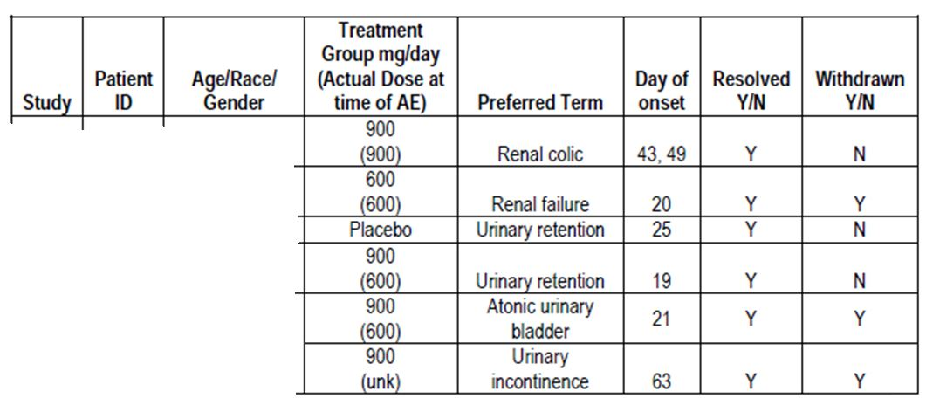
Ultrasounds were performed in Phase III pivotal studies to assess bladder emptying, and these suggested that, in most subjects, the effects of retigabine on bladder emptying were minor. Table 70 shows the mean post-void residual bladder volume at baseline (PVR, in mls) or changes from baseline (in mls) at different doses and time-points. Mean changes were minor and inconsistent, with no clear dose trend. There was, however, a mean increase in PVR in pooled retigabine subjects of 6-19 mls, at different time points, and a mean decrease in placebo subjects of 0.5 to 9.7mls.
Table 70: Baseline and change from baseline in post void residual bladder urine volume (safety population: PCT).
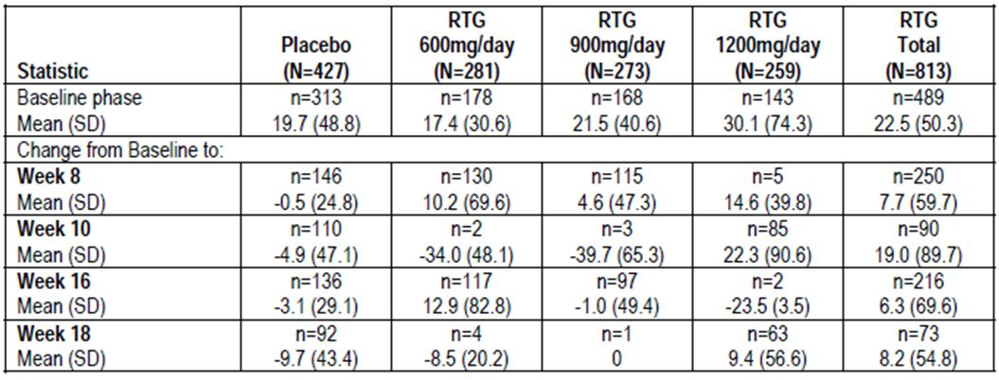

Other studies
Renal/urinary AEs in the broader study population resembled those in the PCT population. They were reported in 364 of 1365 retigabine recipients (26.7%). The only events reported in at least 2% of subjects were urinary tract infection (8.4%), urinary hesitation (3.3%), urinalysis abnormal (2.6%), dysuria (2.6%) and urinary retention (2.1%).

Psychiatric safety

Pivotal studies
Subjects with epilepsy sometimes experience psychosis in the post-ictal stage, particularly after recurrent or prolonged seizures. A drug that reduced seizures might be expected to reduce this, but any drug acting on the brain must also be assessed for its capacity to cause psychosis or hallucinations. On balance, retigabine appears to carry a small but significant risk of causing increased susceptibility to psychosis and hallucinations. The incidence of AEs related to psychosis was increased in retigabine subjects (3.9%) compared to placebo subjects (0.7%), and there was a clear dose trend, as shown in Table 71.
Table 71: AEs of psychosis and hallucinations (safety population: PCT).
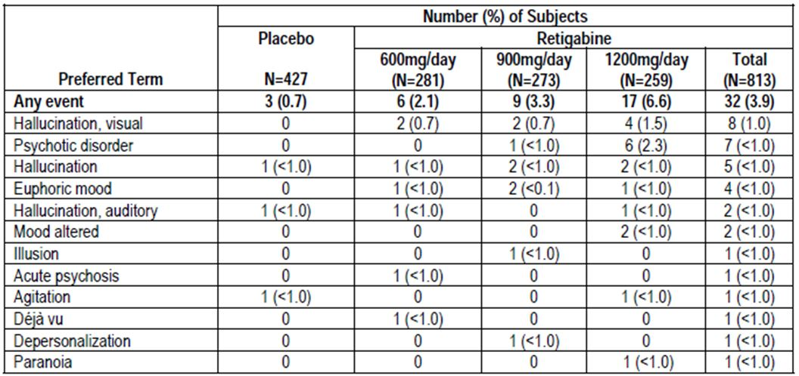
The events were classified as SAEs in 8 subjects (8/813, ~1%, details shown below in Table 72), and led to discontinuation in 15 cases (~2%). In most subjects, the psychosis appeared in the first few weeks of treatment, during the titration phase. A review of the individual SAE narratives indicated that the psychosis often presented as post-ictal psychosis, suggesting seizures contributed to this symptom, but it is likely that retigabine also played a causal role given the excess of this type of AE with active treatment. These observations thus suggest a complex causal interplay between the seizures and the drug. In other subjects, a past history of psychiatric disease was present.
Table 72: SAEs due to psychosis and hallucinations (safety population: PCT).
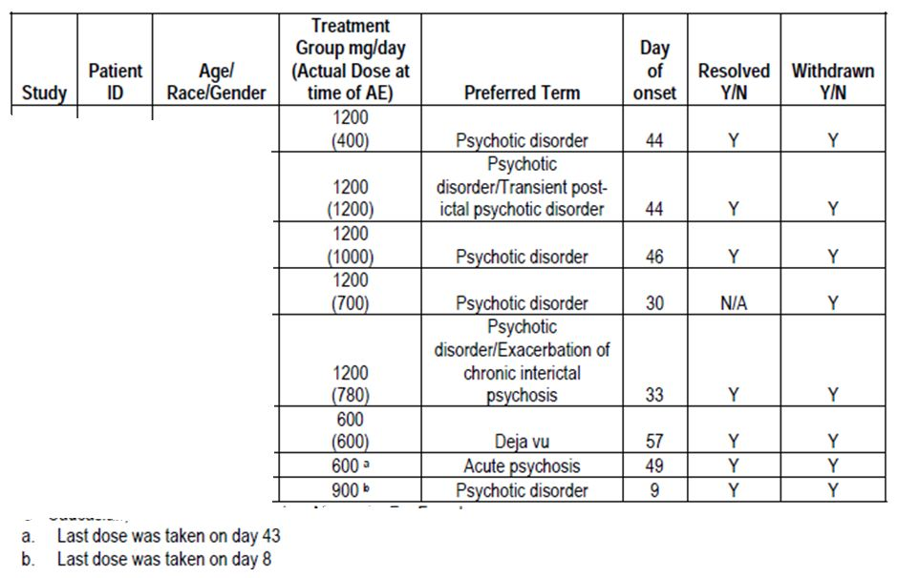
Suicidality on retigabine was also assessed, given that other antiepileptic drugs (AEDs) have been observed to increase the risk of suicide. The mechanisms behind this observation have not been determined, and it is unclear whether it is a group effect applicable to all AEDs and, if so, how this problem is related to the anticonvulsant action of AEDs.
There was one suicide attempt and one episode of suicidal ideation in retigabine recipients (2/813 subjects), which means that suicidality on active treatment was less common than in the placebo group, where two subjects had suicidal ideation (2/413) (Table 73). No firm conclusions can be drawn from such low numbers.
Table 73: Suicidality assessment: completed suicide, suicidality, and self-injurious behaviour (safety population: PCT).
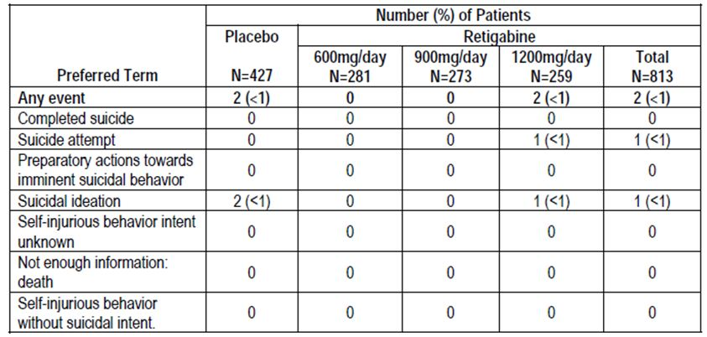

Other studies
Psychosis (including similar AEs) was also observed in 6.5% the broader population of Phase II and II studies, though it is not possible to draw firm inferences from this observation in the absence of a placebo group (Table 74).
Table 74: AEs of psychosis and hallucinations reported by 2 or more patients (safety population: all phase II/III combined).
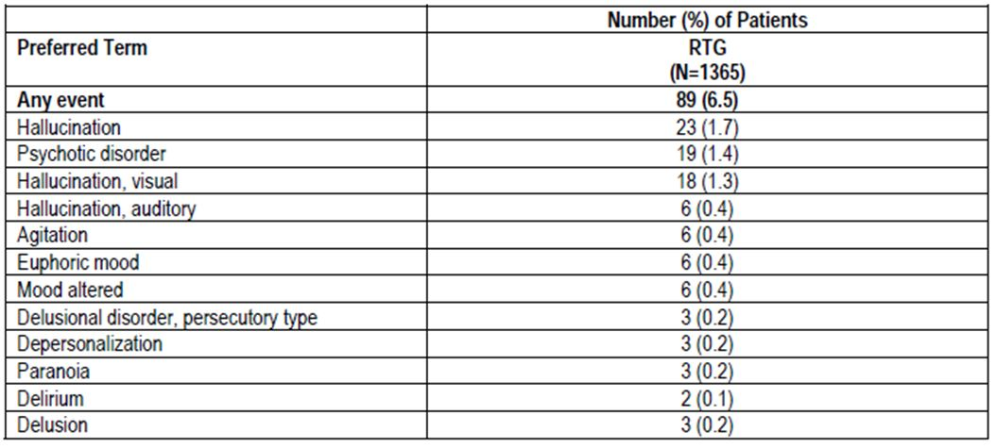
A review of suicidality in this broader population found six cases, plus the two from the PCT population already considered. In a population of this size, amongst patients with a chronic illness that often causes social impediments, hospitalisation and injuries, this rate of suicidality is not surprising. In the absence of a control group, no clear inferences can be drawn, but this limited evidence does not suggest that retigabine increases the risk of suicide.

Post-marketing experience
No post-marketing data was submitted, but some limited data should be available soon. The sponsor’s only comment in the Summary of Clinical Safety under ‘Post Marketing Data’ was the following:
“As of 1 May 2011, retigabine has been approved in the European Union, Switzerland and Norway. At this time, it is marketed in the UK and Germany.”
It has since been approved in the US.

Safety issues with the potential for major regulatory impact

Liver toxicity
There is no evidence that retigabine produces substantial liver toxicity.

Haematological toxicity
There is no evidence that retigabine produces substantial haematological toxicity.

Serious skin reactions
Serious skin reactions were not observed. Skin-related AEs were reported in 4.6% of retigabine recipients, compared to 4.7% of placebo recipients, and none were reported as SAEs.

Cardiovascular safety
The cardiovascular safety of retigabine is borderline, and the drug should be used with caution or avoided completely in patients thought to be at higher risk of cardiac events. The evidence is incomplete, but the therapeutic index appears to be narrow, and dosing errors could have serious consequences.
Of substantial concern, an abuse-potential study (Study VRX-RET-E22-108) showed that 900mg as a single dose can cause severe cardiac arrhythmias: two of six healthy subjects receiving this dose had a potentially fatal cardiac arrhythmia, including asystole in one subject and asymptomatic ventricular tachycardia in another, though both events resolved without specific treatment. A review of these two cases suggested that the risk of arrhythmia is difficult to predict beforehand. One subject had a family history of arrhythmia but his own cardiac investigations were completely normal, including baseline ECG. The other subject had bradycardia thought to be clinically benign.
For the first subject, the study report says:
“The subject had no previous history of arrhythmia or syncope but had a sibling with a form of arrhythmia that did not require a pacemaker or implantable cardioverter defibrillator. All previous study scheduled ECGs were normal … The subject experienced two 5 beat runs of wide complex ventricular tachycardia at 09:39, and subsequently at 09:48, three more runs of ventricular tachycardia, ranging from 3 to 8 beats occurred, and at 09:50, a longer run lasting 19 beats was noted. Heart rate during these runs of ventricular tachycardia was approximately 150 bpm. The subject was reported to have remained asymptomatic throughout the event.” All subsequent cardiac investigations were normal, including an echocardiogram.
For the second subject:
“This subject experienced an SAE of cardiac arrest 1.8 hours after receiving a single oral dose of retigabine 900 mg. The subject had no significant findings on medical history or physical examination but exhibited frequent bradycardia at rest (down to a minimum of 45 bpm on vital signs assessments). ... The subject also had previous ECG findings of marked sinus bradycardia (down to 44 bpm on ECG assessments) and possible left atrial enlargement that were not considered clinically significant. ... A 7-lead telemetry tracing just prior to the event revealed normal sinus rhythm with a rate of 61 bpm followed by a few beats of slowing leading to a period of asystole lasting approximately 25 seconds, followed by spontaneous recovery. The asystole was not preceded by any unusual ECG changes, with normal sinus rhythm up to the start of the pause. … At the time of the event, the patient was found to be pulseless, dusky, limp, and unresponsive. The patient was placed on the floor in order to initiate the CPR protocol; however, prior to receiving any resuscitative measures, she recovered spontaneously.”
Despite the spontaneous resolution of these episodes, they should be considered extremely serious, particularly as they occurred in two of six (33%) subjects exposed to this dose in a single study. (It remains unclear how many other subjects were exposed to this dose over the whole development program.)
On the other hand, when retigabine was used at recommended doses in the pivotal studies, the incidence of ECG-related and cardiac AEs was not excessive with active treatment compared to placebo, and the incidence of sudden death was lower with active treatment. Note that the pivotal studies excluded patients with significant heart disease, which reduced the ability of the studies to assess the cardiac risk in a realistic population. Also, very few subjects >65 years of age were included in the pivotal studies. This suggests that there is a narrow therapeutic setting in which retigabine can be used safely: repeated doses of 400mg seem reasonably safe in low-risk patients but single doses of 900mg seem highly dangerous even in healthy individuals. It seems likely that the therapeutic window would be further narrowed by increased age or pre-existing heart disease, a possibility that is not addressed by the existing safety data.
The difference between the recommended (400mg) and dangerous (900mg) doses provides very little margin for pharmacokinetic variability. The drug is associated with substantial inter-individual variability in Cmax , with a coefficient of variation of ~40-70%. Cmax would be expected to be higher in smaller subjects, or those with reduced clearance. Even the food effect raised Cmax by 38%. Cmax is also expected to be higher with repeat dosing, because trough levels are expected to be well above zero. These factors mean that some subjects taking the recommended dose of 400mg will achieve blood levels more typical of higher doses.
The drug is usually taken three times daily, so there is a three-fold difference between the intended single dose range (200-400mg) and the recommended total daily dose range (600-1200mg/d). The middle of the intended daily dose range (900mg/d) therefore equals a dose known to be dangerous when taken as a single dose (900mg), and the upper end of the recommended daily dose range exceeds this dangerous dose by 33%. There is a real risk that miscommunication or patient or doctor error could lead to triple dosing, and that occasional patients could take the intended daily dose as a single dose – it would be a rare clinician who had not seen this error occur with more benign drugs. The situation is not helped by the proposed Product Information sheet (PI), which expresses dosing recommendations in terms of daily totals (1200mg/d, rather than 400mg TID). At a minimum, this issue should be addressed with clear warnings in the PI, the consumer information sheet, and an education program aimed at prescribers. (Ideally, the drug should only be given by responsible adults who have been informed of this risk and have understood it. This would exclude many patients with age-related dementia, other CNS diseases affecting cognition, and those with cognitive side effects from their seizures or their anticonvulsants. The risk would be somewhat less if the drug were given by carers who were not themselves impaired.)
Also of concern, the QT study (VRX-RET-E22-103) showed that retigabine was associated with mild prolongation of the QT interval. The mean prolongation in the retigabine ITT group reached a maximum if 5 msec at 3 hours post-dosing, which is acceptable, but the usual statistical criteria for QT safety were not quite met. The upper bound of the two-sided 90% confidence intervals for the time-matched difference in QTcI was less than 10 msec at all time points except 3 hours post-dose, when it reached 10.3 msec. The sponsor also performed a post-hoc analysis of the completer population (the 26 of 40 subjects who actually tolerated retigabine 1200mg/d and completed the study as planned). In this analysis, 3 time points showed upper bounds of the 90%CIs >10msec, with the highest reaching 12.6msec at 3 hours. The mean placebo-corrected difference was 6.7 msec at 3 hours. Although the prolongation was minor, and the CIs partially reflect an under-powered analysis, this finding suggests that retigabine should not be combined with other drugs that cause QT prolongation, and it should not be used in subjects with baseline QT prolongation. It would be reasonable to recommend that all subjects have a baseline ECG.
Note that there is no evidence that the two cases of serious arrhythmia described above were associated with QT prolongation. Neither had an arrhythmia typical of prolonged QT syndrome, and neither subject had QT prolongation at baseline, so the mildness of the QT prolongation seen in VRX-RET-E22-103 is not directly relevant to the proarrhythmic effects of retigabine demonstrated in VRX-RET-E22-108. Screening subjects for QT prolongation at baseline, though important, would not remove the risk of arrhythmias at higher doses.

Unwanted immunological events
Unwanted immunological events were not a feature of retigabine treatment. In the pivotal studies, immune system AEs were rare, and skin reactions were no more common than in the placebo group.

Other safety issues

Safety in special populations
Limited data have been provided on patients ≥ 65 years old. Only 8 subjects in this age group were included in pivotal studies; of these, 7 had an adverse event. The most common individual AE was somnolence, in 4 of 8 subjects, followed by dizziness, in 3 of 8 subjects. Fatigue, tremor, abnormal coordination, UTI, gait disturbance and constipation were reported in two subjects each (Table 75).
Table 75: Number (%) of TEAEs reported by age and treatment group (study NP201).
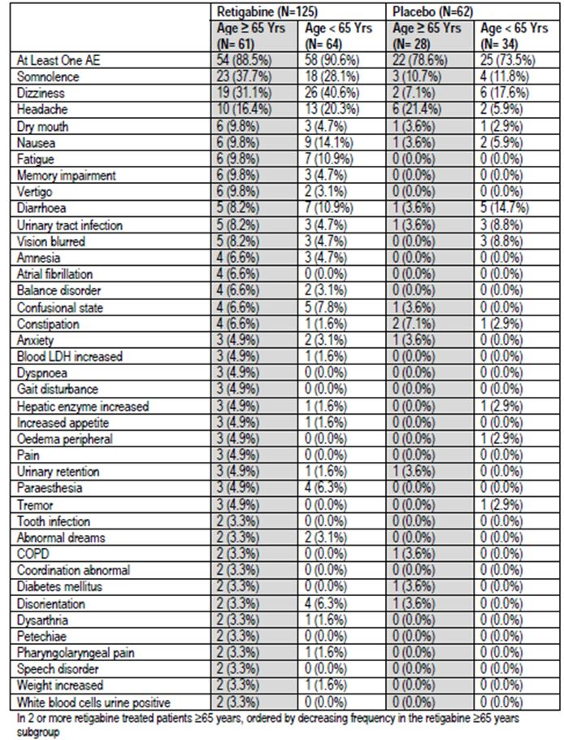
Additional data in subjects ≥ 65 years was obtained from a study of post herpetic neuralgia, as shown in the table below. In this study, 61 retigabine recipients were ≥ 65 years old, and 64 were <65 years. Treatment continued for up to 13 weeks total (a titration phase for up to 6 weeks; a 4-week, double-blind maintenance phase; and a 3-week taper phase.) The overall incidence of AEs was similar in the two age groups, with a slight excess in the older subgroup for somnolence, memory impairment, vertigo, balance disorder, speech disorder and urinary retention, but a slight excess in the younger group for some other CNS side effects.
In general, it would be expected that older patients would be at higher risk of CNS side effects with retigabine, as is the case for all AEDs, and the limited data do little to modify this general expectation. Clinicians should be advised to titrate doses with extra caution in this age group, even if the limited data do not yet show a clear increase in CNS-related AEs in older subjects compared to younger subjects.
Urinary retention seems to be at increased risk in older subjects, and was reported in 3 subjects on retigabine (4.9%), compared to only 1 older subject on placebo (3.6%); the patient numbers are too low to draw any firm conclusions.
Atrial fibrillation (AF) in older subjects on retigabine was flagged as a concern in the European Summary of Product Characteristics, but it is not mentioned in the Australian PI. AF occurred in 4 of 61 older subjects on retigabine (6.6%), no older subjects on placebo (0/28), and no younger subjects (0/98, including 64 retigabine recipients and 34 placebo recipients). The sponsor argues that the study had a 2:1 randomisation schedule, so it would be more likely to see rare events on retigabine. Nonetheless, an even distribution of AF might have been expected to produce 2 cases of AF in older subjects on placebo. Also, an incidence of AF of 6.6% in a 13 week study seems excessive – patients with clinically significant abnormalities on baseline ECGs were excluded from the study. Thus, a causal role of retigabine is at least plausible.

Safety related to drug-drug interactions and other interactions
CNS side effects due to AEDs are frequently additive or synergistic, with the overall medication load being responsible for sedation and cognitive blunting, rather than any individual AED within a combination being clearly responsible. Pharmacokinetic interactions are also common with many older AEDs, but are not expected to be of major significance with retigabine. The most important safety concerns with retigabine based on drug interactions would be those related to QT prolongation, where additive effects could increase the incidence of arrhythmias.
Most subjects in the pivotal studies received two or more concomitant AEDs, which allows an assessment of risk according to concomitant AED use. The incidence of AEs according to co-administered drugs is explored in Tables 76-79. Somewhat surprisingly, AEs were not more common in those receiving >2 concomitant AEDs compared to those receiving 1 or 2 concomitant AEDs. (This could reflect that the overall medication load had been titrated by clinicians prior to study entry, and that subjects on single agents received higher doses of those agents, but a breakdown by dose was not provided.)
Table 76: Summary of TEAE according to number of concomitant AED used (safety population: all phase II/III combined).
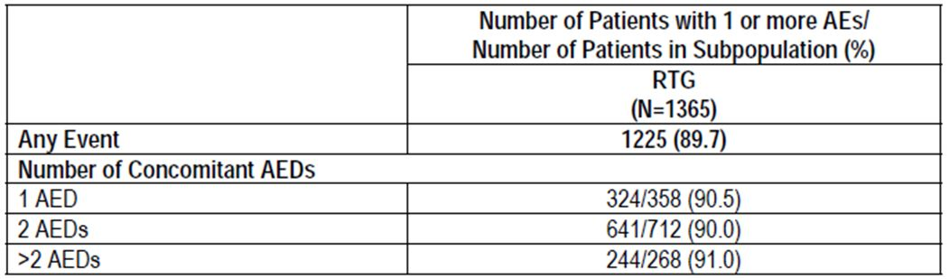
Table 77: Summary of TEAEs according to concomitant AED taken by 15% or more of patients (safety population: PCT).
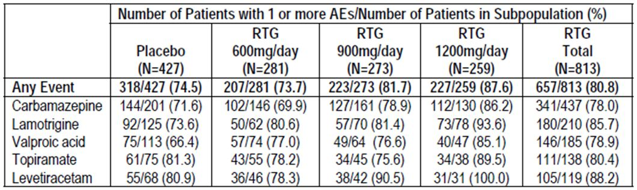
The incidence of AEs was relatively high when high-dose retigabine (1200mg/d) was combined with levetiracetam (100% of subjects on this combination reported an AE), and relatively low when lower doses of retigabine were used, especially when these were combined with valproate. Combinations involving carbamazepine and lamotrigine were associated with intermediate incidences of AEs. Topiramate was associated with a relatively high incidence of AEs in combination with placebo, but did not stand out as more likely to produce AEs when it was combined with retigabine.
Concomitant AEDs were not randomly assigned, but were chosen by clinicians prior to study entry because of a combination of tolerability and presumed efficacy. It is therefore difficult to draw any firm conclusions from these observations, beyond the fact that it might be prudent to avoid the combination of levetiracetam and high-dose retigabine. A survey of SAEs according to concomitant AEDs (subsequent tables) also suggests that the levetiracetam/retigabine combination may be less well tolerated, regardless of whether the PCT population is considered (Table 78), or the broader Phase II/III population (Table 79).
Table 78: SAEs by concomitant AEDs taken by ≥15% of patients (safety population: PCT).
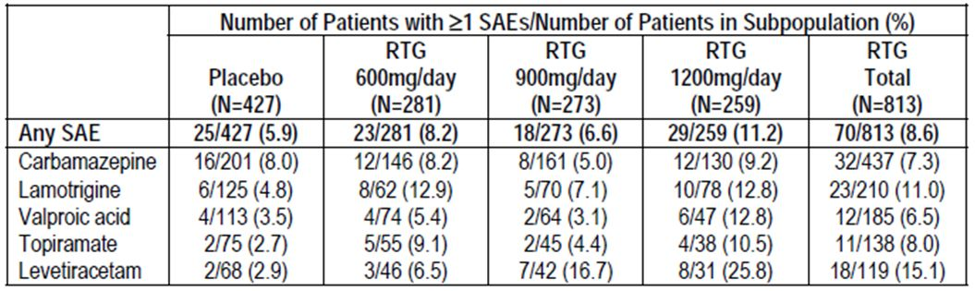
Table 79: SAEs by concomitant AEDs taken by 15% or more of patients (safety population: all phase II/III combined).
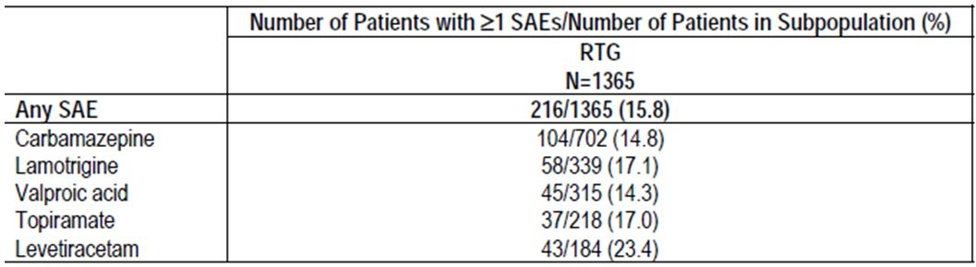

Withdrawal effects
It is generally accepted that anticonvulsants should be withdrawn slowly, because of the risk of increased seizure activity during the withdrawal process or soon after. Such seizure activity may merely represent the reappearance of the underlying seizure tendency that has been suppressed by the anticonvulsant up until withdrawal. It can also represent a period of artificially increased risk (relative to a never-treated patient), due to habituation of the brain to the drug.
In addition to seizures, other withdrawal symptoms may also occur if a drug acting on the CNS is removed while adaptations to the drug are still present.
In the case of retigabine, there is a suggestion that adverse effects are increased during withdrawal, but there is no clear dose trend. The sponsor considered slow withdrawals (tapers >7 days) and abrupt withdrawals (tapers of 7 days or less, or no taper), as shown separately in the following two tables. For slow withdrawals (Table 80), headaches were more common when retigabine was withdrawn, compared to placebo withdrawals. Other AEs were too infrequent to allow a comparison. For abrupt withdrawals (Table 81), no clear pattern emerged. Convulsion was more common when placebo was withdrawn - this possibly reflects some continued efficacy of retigabine during the taper. The timing of the AEs relative to the withdrawal was not clear in the sponsor’s Summary of Clinical Safety, so it is difficult to draw conclusions. There does not seem to be substantial cause for concern, but the general advice to withdraw an AED slowly should be extended to retigabine.
Table 80: AEs reported for 2 or more patients in the total RTG group by preferred term for patients with a taper of more than 7 days (safety population: PCT).
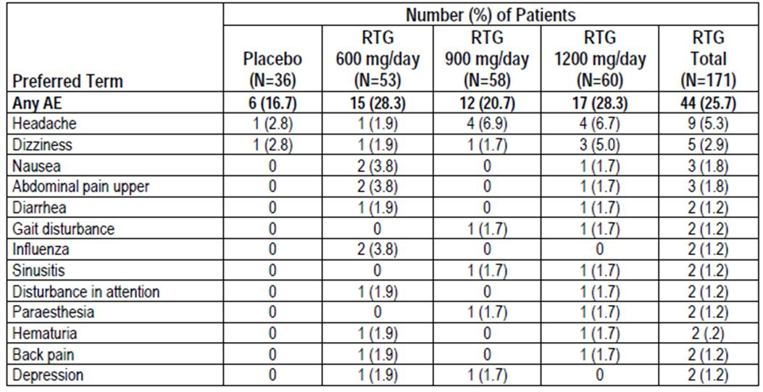
Table 81: AEs reported for 2 or more patients in the total RTG group by preferred term upon abrupt discontinuation of study drug (safety population: PCT).
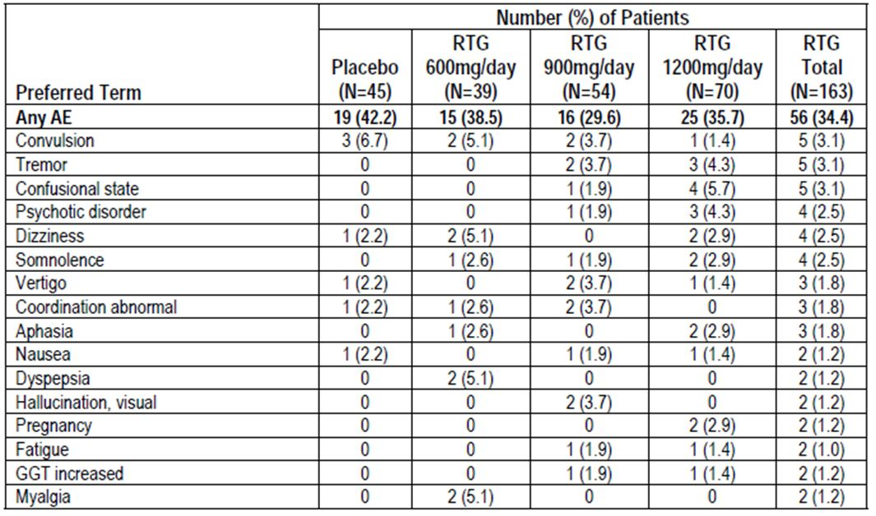

Evaluator’s overall conclusions on clinical safety
The safety of retigabine can be considered under the headings of tolerability and risk of serious harm. The tolerability of retigabine appears to be poor, relative to many other anticonvulsants, but this is probably acceptable for patients who have poorly controlled epilepsy and are prepared to risk nuisance side effects for better seizure control. Of more concern is the risk of serious harm due to cardiac arrhythmia. This risk remains poorly characterised; it is probably acceptable in low-risk patients using the drug exactly as intended, but the therapeutic window is narrow and single doses of 900mg (within the intended daily dose range) are known to be dangerous.

Tolerability
The main tolerability issues are related to the inhibitory action of retigabine on the CNS, and include dizziness, somnolence, fatigue, confusional state, vertigo, tremor and abnormal coordination, all of which occurred in >10% of recipients at the highest dose level, with a clear excess relative to placebo. Dizziness was reported in 23.2% of retigabine recipients overall, and in 32.4% at the highest dose of 1200mg/d, compared to only 8.9% of placebo recipients. As a group, “nervous system disorder” AEs were reported in 60.3% of retigabine recipients, compared to 43.1% of placebo recipients, but this does not include some CNS AEs that were attributed to other organ systems (eye and psychiatric disorders, for instance). In the high-dose group (1200mg/d), “nervous system” AEs occurred in 73.4% of subjects, an absolute excess of >30% compared to placebo. There was an increased risk of psychotic symptoms, particular post-ictal psychosis.
Non-CNS tolerability issues consist of a dose-related risk of constipation, urinary retention and nausea.
Retigabine was associated with a dose-related increase in the risk of combined urological and renal AEs, with an approximately two-fold increased risk of urological events in the highest dose group, relative to placebo. The incidence of UTI appeared to be increased at higher doses, but was not increased by retigabine overall – this is difficult to interpret because placebo patients had more seizures, which might have prompted clinicians to look for an infective trigger, leading to ascertainment bias. Bladder ultrasounds showed only a mild increase in mean post-void residual volumes.
Retigabine was also associated with a mean weight gain of 2.2kg by week 18 (2.7kg in the highest dose group). Approximately 17% of retigabine recipients experienced weight gain of potential clinical concern (PCC) by week 18, with the highest risk at 1200mg/d (19.1%). In the pooled Phase II/III population the risk was higher (26%).
Retigabine treatment was associated with a mild increase in abnormal liver function tests but clinically significant hepatic disease was not observed.
There did not appear to be a significant withdrawal syndrome when retigabine was tapered or ceased abruptly, but the general advice to withdraw anticonvulsants slowly should also apply to retigabine.

Cardiac risk
The most important safety concern related to retigabine is the observation that two of six healthy volunteers exposed to a single oral dose of 900mg experienced a substantial cardiac arrhythmia within 3 hours: non-sustained, asymptomatic ventricular tachycardia in one patient and cardiac arrest due to asystole in another patient. Both survived without sequelae, but this high incidence of arrhythmia (33%) is alarming, particularly given that the dose was only 2.25 times the recommended dose, and was less than the maximum recommended total daily dose. It might be expected that older patients or patients with underlying heart disease would suffer worse outcomes at this dose, and it is possible that dosing mishaps or pharmacokinetic variability could lead to subjects experiencing similar drug levels at 400mg TID as these subjects experienced with 900mg.
Retigabine was shown to have a mild prolonging effect on the QT interval of healthy subjects (mean prolongation of 6.7 msec in “completers”, with the upper end of the 90% confidence intervals reaching 12.6msec), and it should not be combined with antiarhythmic drugs, or drugs known to effect the QT interval. It should also be avoided in subjects with heart disease or hypokalaemia. Warnings in the PI related to this should be strengthened. The QT effect does not appear to account for the incidence of serious arrhythmias at 900mg.
In a study of post-herpetic neuralgia, atrial fibrillation was observed in older subjects receiving retigabine and no subjects receiving placebo, but it remans unclear if this represents a causal relationship.
Retigabine did not increase the risk of sudden unexplained death in epilepsy, and in fact reduced it relative to placebo, which potentially offsets some of the concerns about cardiac risk. Also, arrhythmias overall were not more common in retigabine recipients in the pivotal epilepsy studies. Although this is partially reassuring, subjects with significant heart disease were excluded from the pivotal studies and the close monitoring associated with trial conditions may have reduced the risk of dosing mistakes. The weight of evidence suggests that caution is appropriate.

First round benefit-risk assessment

First round assessment of benefits
The benefits of retigabine in the proposed usage (adjunctive anticonvulsive therapy in adults) are:
- At the highest proposed dose (1200mg/d), retigabine would be expected to produce a seizure reduction of 35-44%, including a reduction of 13-18% that would have been achieved with placebo alone, implying an attributable reduction in seizure frequency of 22-26%
- At the highest proposed dose, the attributable response rate would be expected to be in the range 15-33% (15% derived from Study 205: retigabine response 41% versus placebo 26%; 33% derived from Study 301: retigabine 56% versus placebo 23%). This implies that between 3-7 patients need to be treated with retigabine to achieve one attributable response.
- Some efficacy is also achievable at lower doses, including 900mg/d and 600mg/d.
- Sudden unexplained death in epilepsy (SUDEP) might be reduced by retigabine when used as directed in subjects without heart disease.

First round assessment of risks
The risks of retigabine in the proposed usage are:
- Poor CNS tolerability, with a range of symptoms including dizziness, somnolence, headache, fatigue, confusional state, vertigo, tremor and abnormal coordination. The incidence of these appeared to be higher than for many other anticonvulsants, and there was a clear dose trend with the incidence being worse for 1200mg/d. Dizziness was reported in 32.4% of subjects at 1200mg/d, compared to 8.9% of placebo recipients, an attributable rate of 23.5% (which does not even include some additional cases reported as “vertigo”). “Nervous system” AEs occurred in 73.4% of subjects receiving 1200mg/d, an absolute excess of >30% compared to placebo. The risk of psychosis was increased, particularly post-ictal psychosis.
- A range of other side effects including an increased risk of urological symptoms, possibly mediated by impaired bladder emptying, weight gain, abnormalities of liver function tests
- Overall, approximately one patient in four (24.5%) withdrew from pivotal studies because of AEs, and there was a clear dose trend from the placebo group (10.5% withdrawing due to AEs) through to the highest retigabine dose group (1200mg/d, 31.3% withdrawing due to AEs). Outside the context of a clinical study, the dropout rate due to AEs would be expected to be even higher, and this would be expected to degrade the achievable response rate. That is, a proportion of subjects who could have achieved a 50% reduction in seizures would be expected not to tolerate the drug.
- The drug appears to have a narrow therapeutic window, with a proarrhythmic effect demonstrated for single doses of 900mg, which is less than the upper range of the recommended daily dose range (1200mg/d). At this dose, two of six healthy volunteers had a major ventricular arrhythmia (self-terminating ventricular tachycardia in one subject and cardiac arrest with asystole in another). This proarrhythmic effect has not been clearly acknowledged by the sponsor, and has not been explored in any detailed study. A proarrhythmic effect was not observed in the pivotal studies, but patients with significant heart disease were excluded, very few older patients were studied, and the maximum single dose was 400mg. The cardiac risk would be expected to be higher in subjects with heart disease, increased age, electrolyte disturbances, or altered pharmacokinetics.
- The drug has moderate interindividual variability in Cmax, so that some patients exposed to single doses of 400mg might achieve drug levels more typical of higher doses, approaching the poorly characterised level at which a proarrhythmic effect might appear. Repeat dosing with 400mg would be expected to achieve higher levels than single doses of 400mg. This effect would be enhanced if the patient had a small body size, renal or hepatic impairment, or shortened the dose interval for any reason. The PI suggests a dose interval as short as 3 hours in the event of catching up after a forgotten dose. In some individuals with poor clearance or small volumes of distribution, two doses of 400mg separated by 3 hours could produce similar levels as a single dose of 900mg in healthy volunteers, particularly if the first dose was taken with food, which delays absorption. Furthermore, if any patient or doctor mistakenly interpreted the total daily dose as a once-daily dose, patients could be exposed to 1200mg as a single dose, exceeding the 900mg dose that is known to be dangerous.
- The drug has a mild QT prolonging effect.

First round assessment of benefit-risk balance
The benefit-risk balance retigabine, given the proposed usage as adjunctive therapy, is borderline. Somewhere between 3 and 7 patients would need to receive the highest dose of the drug to achieve one attributable “response” (50% seizure reduction), and an even higher number would need to be treated to achieve a well-tolerated response. Many patients receiving the highest dose would be expected to show poor CNS tolerability (at least 30% more than placebo). Although such patients are likely to cease therapy with no lasting sequelae, about 1 in 4 will show an apparent response that would have been achieved with placebo. Such subjects are at risk of continuing the drug for months or years without major benefit, possibly putting up with side effects because they believe their original response was due to the drug. (This situation already arises with existing anticonvulsants, and represents one of the challenges of managing epilepsy, but the tolerability profile of retigabine seems worse than for many other anticonvulsants.)
Of most concern, all exposed subjects would be at some risk of cardiac arrhythmias because of the narrow therapeutic index of retigabine, though the magnitude of this risk is unclear and this risk has not been explored by the sponsor. The risk would be expected to be higher in older subjects, those with heart disease, those with increased pharmacokinetic susceptibility, or those exposed to dosing errors (particularly the administration of the total daily dose as a single daily dose).
Against this risk, the incidence of SUDEP was reduced in retigabine recipients, compared to placebo recipients, implying that careful use of the drug in a screened population might lower the risk of sudden death.
The benefits and risks of retigabine are not likely to be homogenous across the entire target population. Clinicians who use retigabine with appropriate caution should be able to identify some patients who have a favourable benefit-risk balance. Patients with poorly controlled refractory epilepsy, for instance, who had failed to respond to other anticonvulsants and whose quality of life was poor and whose risk of SUDEP or status epilepticus was high, would be expected to find the risks of retigabine treatment worthwhile, particularly if their treating clinician was vigilant about withdrawing the drug if it did not produce lasting benefit. Subjects with milder epilepsy who had not yet tried other adjunctive agents and subjects with cardiac risk factors would be better to avoid the drug.
If made sufficiently aware of the narrow therapeutic index, prescribing clinicians should be able to take appropriate care to select suitable patients, to avoid dosing errors and to adjust the dose in those with pharmacokinetic susceptibility.

First round recommendation regarding authorisation
Retigabine should be approved for use in adult patients with refractory epilepsy, provided that appropriate changes are made to the PI.
Retigabine should not be used in subjects with heart disease.
The sponsor should provide education to physicians and patient-advocacy groups about the risks of retigabine, including the need to adjust the dose in the setting of low body weight, renal impairment or liver impairment.
Retigabine should only be used by neurologists, or other clinicians who have been educated about its risks.
Retigabine should only be used by patients (or their guardians) who have consented to use the drug despite its narrow therapeutic index, and who illustrate awareness of the difference between a total daily dose and a single daily dose.
The PI proposes a 3-hour gap between a catch-up dose (following a forgotten dose) and the next scheduled dose. Prior to finalising the PI, the sponsor should supply a detailed justification of the appropriateness of this interval, taking into account the food effect, interindividual variability, the effects of repeat dosing, and the uncertainty of the proarrhythmic potential of retigabine between single doses of 400mg and 900mg. The proposed minimum interval should be increased if necessary.
Rigorous post-marketing surveillance for sudden death and cardiac arrhythmia should be conducted.
Further studies should be performed to establish the proarrhythmic potential of retigabine beyond single doses of 400mg. These studies should be conducted in appropriate facilities with the capacity to provide immediate resuscitation and advanced life support.

Clinical questions

Pharmacokinetics
Two different bioequivalence studies assessing the Market Image tablet obtained differing results, and it was suggested that particle size of the Clinical Trial tablet differed in the two studies. Is particle size in the final Market Image tablet stable and, if so, is it equivalent to that used in the pivotal studies? How does it compare to the formulation used in the clinical Study VRX-RET-E22-108? (This is not a clinical question, but the clinical data suggest a narrow therapeutic index for retigabine highlighting the need to avoid pharmacokinetic variation, particularly variations that could increase Cmax.)
The PI proposes a 3-hour gap between a catch-up dose (following a forgotten dose) and the next scheduled dose of retigabine. Prior to finalising the PI, the sponsor should supply a detailed justification of the appropriateness of this interval, taking into account the food effect, interindividual variability, the effects of repeat dosing, and the uncertainty of the proarrhythmic potential of retigabine between single doses of 400mg and 900mg. The proposed minimum interval should be increased if necessary.

Pharmacodynamics
None.

Efficacy
None.

Safety
Substantial questions remain about the cardiac safety of retigabine, but these cannot be answered at the current time, on the available evidence. A condition of registration should be that the sponsor should commit to perform studies characterising the proarrhythmic potential of retigabine at doses greater than 400mg, and the sponsor should also guarantee that post-marketing surveillance will be directed at clarifying this issue.
The sponsor should also how many subjects have been exposed to single doses of 900mg or higher.

References
The only references consulted in the preparation of this report were:
- those listed by the sponsor;
- EMEA “Guideline for Clinical Investigation of Medicinal Products in the Treatment of Epileptic Disorders”, 2009.

Hirtz D, et al. (2007) How common are the "common" neurologic disorders? Neurology 68: 326-337.
Elger CE, Schmidt D. (2008) Modern management of epilepsy: a practical approach. Epilepsy Behav. 12: 501-539.
Sponsor comment: “In Section 3.2.5.1.1.3, Oral Contraceptives, the sponsor notes the comments regarding Study 3065A1-112 and would like to draw attention to information from a second oral contraceptive study (VRX-RET-E22-106 – m5.3.3.4) which addressed the shortfalls of Study 3065A1-112. This study was not described in this section. The second study was conducted within the therapeutic dose range of retigabine and retigabine was administered over 2 menstrual cycles allowing sufficient time for potential enzyme induction to occur. Review of this second study was included in Section 18 (Supporting Tables and Figures) of the assessment report.”
Sponsor comment: “Study RTG114137, listed as a pharmacodynamic study, was a study in healthy subjects that confirmed that conditions of storage have the potential to interfere with urinalysis findings.”
Sponsor comment: “Studies 301 and 302 had two primary endpoints, respectively, designated for the world region of interest. These were not co-primary endpoints. Each primary endpoint was assessed based on the regulatory requirements of the respective region. The other endpoint was considered secondary for that region, thus no multiplicity adjustment was required. The two phase III studies were designed with two primary endpoints.”
Sponsor comment: “The sponsor is unaware of any evidence to support that the sponsor took this action.”
Sponsor comment: “The sponsor advises this statement is incorrect as although responder rates were compared using logistic regression with centre and treatment as effects, the percent change in seizure frequency was analysed using a rank analysis of covariance.”

