January 2013

Australian Public Assessment Report for remifentanil (as hydrochloride)
  - Proprietary Product Name: Ultiva
  - Sponsor: GlaxoSmithKline Australia Pty Ltd
About the Therapeutic Goods Administration (TGA)
- The Therapeutic Goods Administration (TGA) is part of the Australian Government Department of Health and Ageing, and is responsible for regulating medicines and medical devices.
- TGA administers the Therapeutic Goods Act 1989 (the Act), applying a risk management approach designed to ensure therapeutic goods supplied in Australia meet acceptable standards of quality, safety and efficacy (performance), when necessary.
- The work of the TGA is based on applying scientific and clinical expertise to decision-making, to ensure that the benefits to consumers outweigh any risks associated with the use of medicines and medical devices.
- The TGA relies on the public, healthcare professionals and industry to report problems with medicines or medical devices. TGA investigates reports received by it to determine any necessary regulatory action.
- To report a problem with a medicine or medical device, please see the information on the TGA website <www.tga.gov.au>.
About AusPARs
- An Australian Public Assessment Record (AusPAR) provides information about the evaluation of a prescription medicine and the considerations that led the TGA to approve or not approve a prescription medicine submission.
- AusPARs are prepared and published by the TGA.
- An AusPAR is prepared for submissions that relate to new chemical entities, generic medicines, major variations, and extensions of indications.
- An AusPAR is a static document, in that it will provide information that relates to a submission at a particular point in time.
- A new AusPAR will be developed to reflect changes to indications and/or major variations to a prescription medicine subject to evaluation by the TGA.
Copyright
© Commonwealth of Australia 2013
This work is copyright. You may reproduce the whole or part of this work in unaltered form for your own personal use or, if you are part of an organisation, for internal use within your organisation, but only if you or your organisation do not use the reproduction for any commercial purpose and retain this copyright notice and all disclaimer notices as part of that reproduction. Apart from rights to use as permitted by the Copyright Act 1968 or allowed by this copyright notice, all other rights are reserved and you are not allowed to reproduce the whole or any part of this work in any way (electronic or otherwise) without first being given specific written permission from the Commonwealth to do so. Requests and inquiries concerning reproduction and rights are to be sent to the TGA Copyright Officer, Therapeutic Goods Administration, PO Box 100, Woden ACT 2606 or emailed to <tga.copyright@tga.gov.au>.

Contents
I. Introduction to product submission 4
Submission details 4
Product background 4
Regulatory status 6
Product Information 7
List of abbreviations 8
II. Quality findings 8
III. Nonclinical findings 8
IV. Clinical findings 9
Introduction 9
Pharmacokinetics 12
Pharmacodynamics 15
Dosage selection for the pivotal studies 15
Efficacy 15
Safety 18
List of questions 24
First round benefit-risk assessment 24
V. Pharmacovigilance findings 25
Risk management plan 25
VI. Overall conclusion and risk/benefit assessment 25
Quality 25
Nonclinical 25
Clinical 25
Risk-benefit analysis 31
Outcome 39
Attachment 1. Product Information 39

I. Introduction to product submission

Submission details
Type of Submission | Major variation: New mode of administration
Decision: | Approved
Date of Decision: | 8 May 2012

Active ingredient(s): | Remifentanil (as hydrochloride)
Product Name(s): | Ultiva
Sponsor’s Name and Address: | GlaxoSmithKline Australia Pty Ltd  PO Box 18095  Melbourne VIC 8003
Dose form(s): | Powder for injection for intravenous (IV) use, remifentanil as the hydrochloride salt
Strength(s): | 1 mg (remifentanil base equivalent) in 3 mL;  2 mg (remifentanil base equivalent) in 5 mL; and  5 mg (remifentanil base equivalent) in 10 mL
Approved Therapeutic use: | Target Controlled Infusion (TCI) as a new mode of administration.
Route(s) of administration: | Intravenous
Dosage: | For TCI in adults, the recommended dilution of Ultiva is 20 to 50 µg/mL. Doses are presented as target blood concentrations of remifentanil.
ARTG Number (s) | 58688 (1 mg), 58689 (2 mg), 58690 (5 mg)

Product background
This AusPAR describes an application by the sponsor, GlaxoSmithKline Australia Pty Ltd, to alter the Dosage and Administration section of the Product Information (PI) for remifentanil (Ultiva). Ultiva is normally administered by IV infusion for the induction and maintenance of general anaesthesia during surgical procedures in adults. The current application relates to a new mode of administration of Ultiva: administration by Target Controlled Infusion (TCI). TCI is an alternative method of IV infusion to the current method of Manually Controlled Infusion (MCI). Infusion devices can be by:
- MCI, where the anaesthetist makes each change to the infusion rate; or
- TCI, where the anaesthetist sets a target blood or effect site concentration and the computerised infusion device makes the necessary changes to the infusion rate.
There is no change proposed to the approved indications of Ultiva:
Ultiva for injection is indicated –
- as an opioid adjunct for use during induction and/or maintenance of general anaesthesia during surgical procedures including cardiac surgery in adults.
- as an opioid adjunct for use during induction and/or maintenance of general anaesthesia during surgical but not cardiac procedures in children aged 1 to 12 years.
- for continuation as an analgesic into the immediate post-operative period under the close supervision of medically qualified persons trained in the use of anaesthetic drugs, during transition to longer acting analgesia following adult cardiac surgery – when endotracheal intubation and controlled ventilation are anticipated.
- for provision of analgesia and sedation in mechanically ventilated intensive care patients.
Remifentanil is a potent, selective, 4-anilidopiperidine µ-opioid agonist with pharmacological action typical of this class of compound. It is distinguished from other 4-anilidopiperidines (fentanyl analogues) by its rapid onset and very short duration of action. The µ-opioid activity of remifentanil is antagonised by naloxone. Remifentanil in humans has a rapid blood brain equilibration half time of 1 ± 1 minutes (mean ± standard deviation) and a rapid onset of action. It was first registered in 1998.
With this submission, the sponsor seeks to provide specific details on dose regimens for use of remifentanil in TCI administered via an approved infusion device incorporating the Minto pharmacokinetic model with covariates for age and lean body mass.
There are at least four TCI pumps registered with the TGA, being used from at least 2005-2006 (Table 1).
Table 1: TCI pumps registered with the TGA.
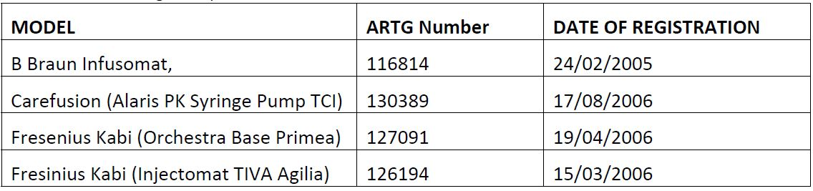
No change to the existing use of remifentanil in anaesthesia is proposed. The infusion rates delivered by remifentanil TCI systems fall within those recommended in the current Dosage and Administration section of the PI. The additional guidance for TCI proposed for inclusion in the Dosage and Administration section of the PI is intended to translate information on infusion rates (in µ/kg/min) into equivalent target blood concentration (in ng/mL) settings. An additional statement in the Precautions section of the PI that Ultiva is not recommended for use as the sole agent in general anaesthesia is also proposed.
Concerns with TCI systems that have previously been noted by the Australian Drug Evaluation Committee (ADEC) (which has since been superseded by the Advisory Committee on Prescription Medicines [ACPM]) are summarised below:
- Knowing the appropriate target blood concentrations and intra and inter patient variability;
- Accurate prediction of the target concentration by the computer software;
- Stability of pharmacokinetics and pharmacodynamics in a particular patient throughout the operative period, for example, influence of haemorrhage, haemodilution, altered renal and/or hepatic blood flow;
- Ability to alter the speed of bolus administration. Does the pump permit alterations to the speed of bolus administration? If not, there is a risk of rapid onset particularly in the elderly and compromised patients;
- Undue faith in accuracy and appropriateness of the target concentration;
- Technical faults could occur. Similarly, if a pump broke, a second pump could not be attached in TCI mode, as the infusion history was not known by the second pump.
TCI is not recommended for paediatric anaesthesia, post operative analgesia, or for spontaneous ventilation anaesthesia. TCI is also not proposed for the provision of analgesia and sedation in mechanically ventilated intensive care patients.

Regulatory status
TCI of Ultiva (remifentanil) using the Minto model is approved in the European Union. Submission was made in the EU under the mutual recognition procedure in 2004.
Table 2 shows the international regulatory history of Ultiva TCI.
Table 2: Summary of international regulatory status of Ultiva TCI.
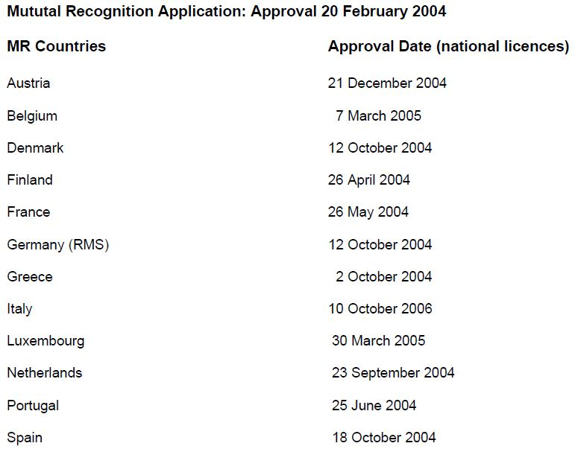


Product Information
The approved PI current at the time this AusPAR was prepared can be found as Attachment 1.

List of abbreviations
AE Adverse event
ASA American Society of Anesthesiologists
BIS Bispectral index
BMI Body mass index
CACI Computer assisted continuous infusion
CER Clinical evaluation report
CMI Consumer Medicine Information
CSR Clinical study report
EC₅₀ Half maximal effective concentration
EEG Electroencephalography
GCP Good clinical practice
IV Intravenous
k_{eo} Equilibrium rate constant
LBM Lean body mass
LBS Literature based submission
MCI Manually Controlled Infusion
MDAPE Median absolute performance error
MDPE Median performance error
NONMEM Non linear mixed effects modelling
PACU Post anaesthesia care unit
PD Pharmacodynamic(s)
PK Pharmacokinetic(s)
PI Product Information
RIVA Remifentanil
SAE Serious adverse event
SPC Summary of product characteristics
t_{½} Elimination half life
TCI Target Controlled Infusion
TCIR Target Controlled Infusion for remifentanil

II. Quality findings
There was no requirement for a quality evaluation in a submission of this type.

III. Nonclinical findings
There was no requirement for a nonclinical evaluation in a submission of this type.

IV. Clinical findings

Introduction
This is a submission seeking approval to alter the PI so as to include advice relating to a new mode of administration of Ultiva (remifentanil): administration by TCI. The main proposed PI additions indicate the new claims made, and are as follows (where the location of changes is given with reference to the Annotated PI):
Page 16, under Dosage and Administration:
Administration by Target Controlled Infusion
Ultiva may also be given by Target Controlled Infusion (TCI) with an approved infusion device incorporating the Minto PK model with covariates for age and lean body mass (LBM).
For TCI in adults the recommended dilution of Ultiva is 20 to 50 µg/mL.
Page 18, under General Anaesthesia. Dosage in Adults:
Administration by Target Controlled Infusion
Induction and maintenance of anaesthesia in ventilated patients: Ultiva TCI should be used in association with an intravenous or inhalational hypnotic agent during the induction and maintenance of anaesthesia in ventilated adult patients. In association with these agents, adequate analgesia for induction of anaesthesia and surgery can generally be achieved with target blood remifentanil concentrations ranging from 3 to 8 ng/mL. Ultiva should be titrated to individual patient response. For particularly stimulating surgical procedures, target blood concentrations up to 15 ng/mL may be required.
At the doses recommended above, Ultiva significantly reduces the amount of hypnotic agent required to maintain anaesthesia. Therefore, isoflurane and propofol should be administered as recommended above to avoid excessive depth of anaesthesia.
There are insufficient data to make recommendations on the use of TCI for spontaneous ventilation anaesthesia.
Guidelines for discontinuation/continuation into the immediate post operative period: At the end of surgery when the TCI infusion is stopped or the target concentration reduced, spontaneous respiration is likely to return at calculated remifentanil concentrations in the region of 1 to 2 ng/mL. As with Manually Controlled Infusion, post operative analgesia should be established before the end of surgery with longer acting analgesics (see Guidelines for discontinuation under Dosage and Administration – General Anaesthesia – Dosage in Adults – Administration by Manually Controlled Infusion).
There are insufficient data to make recommendations on the use of TCI for the management of post operative analgesia.
Page 21, under Cardiac Anaesthesia. Dosage in Adults:
Administration by Target Controlled Infusion
Induction and maintenance of anaesthesia: Ultiva TCI should be used in association with an intravenous or inhalational hypnotic agent during the induction and maintenance of anaesthesia in ventilated adult patients. In association with these agents, adequate analgesia for cardiac surgery is generally achieved at the higher end of the range of target blood remifentanil concentrations used for general surgical procedures. Following titration of remifentanil to individual patient response, blood concentrations as high as 20 ng/mL have been used in clinical studies. At the doses recommended above, remifentanil significantly reduces the amount of hypnotic agent required to maintain anaesthesia. Therefore, isoflurane and propofol should be administered as recommended above to avoid excessive depth of anaesthesia.
Guidelines for discontinuation/continuation into the immediate post-operative period: At the end of surgery when the TCI infusion is stopped or the target concentration reduced, spontaneous respiration is likely to return at calculated remifentanil concentrations in the region of 1 to 2 ng/mL. As with Manually Controlled Infusion, post operative analgesia should be established before the end of surgery with longer acting analgesics (see Guidelines for discontinuation under Dosage and Administration – Cardiac Anaesthesia – Dosage in Adults – Administration by Manually Controlled Infusion).
There are insufficient data to make recommendations on the use of TCI for the management of post operative analgesia.
Page 22, under Special patient populations. Dosage in Obese Patients:
Administration by Target Controlled Infusion
With the calculation of LBM used in the Minto model, LBM is likely to be underestimated in female patients with a body mass index (BMI) greater than 35 kg/m² and in male patients with BMI greater than 40 kg/m². To avoid underdosing in these patients, Ultiva TCI should be titrated carefully to individual response.

Detailed reports
Two detailed clinical reports (numbers USA-103 and USA-220) were presented. The sponsor acknowledges that
"these studies were not designed to validate the TCI mode of administration for remifentanil".
They appear to be irrelevant to this submission, whose purpose is to validate the TCI mode of administration for remifentanil.

The literature based component
This was of the second type of LBS described in the relevant TGA guideline document. However, the same section advises that for "changes in dosage and administration", the first type of LBS is suitable. Sponsors are advised to discuss the matter with TGA before proceeding, but I have not been informed of any such discussion.
Thus, the published articles presented do not represent the result of an objective bibliographic search, and the Clinical Overview does not take the form of an expert objective assessment of a body of data derived from a systematic bibliographic search. Rather, the Clinical Overview is the sponsor's argument supporting its application, and the articles are those the sponsor has chosen to cite as supporting evidence.
The set of publications comprising the LBS component has been listed. None of the published articles or abstracts is dated more recently than 2003.
In evaluating such material, although useful background information may emerge, it is necessary to regard with some scepticism any specific results obtained (including numerical values) − particularly from small studies − as these may be contradicted by studies not included in the set of articles presented. Formal evaluation of each article separately would not be productive; rather, I have commented as seems appropriate on the validity of evidence, relevant to the aim of the application, adduced by citation of particular studies in the Clinical Overview. Relevant parts of the Clinical Overview are dealt with in the corresponding sections of this Clinical Evaluation Report.

Clinical rationale
The Clinical Overview states (at page 10):
"For administration of remifentanil by TCI, no change in the use of remifentanil in anaesthesia is proposed but additional guidance is required to translate current information on infusion rates (mcg/kg/min) into equivalent target blood concentration settings (ng/ml). The amount of remifentanil delivered at a particular target setting can vary depending on the PK model incorporated in a TCI pump (...). This occurs because within the range of published parameters there are some differences in the estimates of volumes of distribution and clearance of remifentanil. By recommending a particular PK model for remifentanil for incorporation in all commercial TCI systems, standardisation of delivery of remifentanil by TCI will be achieved. Guidance on recommended target concentration settings for remifentanil in the SPC can then be linked to the delivery of remifentanil by these TCI systems."

Comment
Apart from the implication that administration using unspecified unevaluated TCI hardware and software involves "no change in the use of remifentanil in anaesthesia", the clinical evaluator agreed with this. However, it is difficult to reconcile the above text with the material actually presented in the dossier. I would have expected an appropriate dossier to include:
- Information on development of an appropriate algorithm for use in a TCI device, using PK and PD data;
- Detailed results obtained from testing of that algorithm extensively against other data, in patients with a variety of characteristics;
- Information on a specific branded injection device (or devices) in which the algorithm had been implemented. This would include an account of any rate limiting and cumulative dose limiting features in both software and hardware; and
- Detailed efficacy, safety, PK and PD results from use of the device/Ultiva combination in anaesthetic practice, involving several hundred patients, preferably including some randomised trial data.
It may be the case that TCI devices are not subject to detailed pre marketing evaluation. However, if the sponsor of Ultiva wishes to make PI claims relating to administration of the drug by TCI, I believe relevant data must be provided.

Paediatric data
The submission did not include paediatric data.

Good clinical practice
From the Clinical Overview:
- Studies USA-103 and USA-220 were compliant with GCP and ethical requirements;
- Of the 27 published articles, 23 noted approval by Ethics Committee or Institutional Review Board.

Pharmacokinetics

Studies providing PK data
Presentation of PK data was not a central aspect of the submission, although many of the studies which were included in the dossier included PK components. See Clinical Overview material relating to PK and Safety sections, below.

Summary of PK
Not applicable.

Clinical Overview material relating to PK
The Clinical Overview makes the following two points at the beginning of its Clinical Pharmacology section:
- It is desirable to recommend a particular PK model for the administration of remifentanil by TCI to ensure standardisation in the amount of remifentanil delivered at a particular target setting.
- The PK model described by Minto incorporating covariates for age and LBM is recommended as this model has been used in the majority of published studies, offers improved individualisation of dosage and has been shown to predict measured concentrations with an acceptable degree of accuracy.
The clinical evaluator agreed with the first of these, and would go further, rephrasing the point as:
"It is desirable that TCIs accurately achieve the outcomes implied by their settings".
The clinical evaluator disagreed with the first two lines of the second point. Whether Minto's model has been used in a majority of relevant published studies cannot be ascertained from the contents of this dossier. It was opined that scientific truth is not a matter for democratic decision − particularly when the collection of articles available is not the product of a systematic search. The pitfalls are readily illustrated in the Clinical Overview where (for example) some PK values published by Kapila and colleagues are reproduced that include the values printed in that article; however, they are simply introduced at the beginning of the article (and used in the study), their origin is not revealed. The point, of course, is that Minto's model should be judged on whether it leads to accurate results.

Clinical Overview − PK of remifentanil
Data on specific PK values contained in the published set of articles are mostly of little interest. They cannot replace evaluated data from detailed study reports, and cannot be relied upon, as explained above. The article by Minto and colleagues is potentially of major interest because the proposed PI amendment gives it special status. Also, the sponsor claims that:
"The PK model described by Minto incorporating covariates for age and LBM ... has been shown to predict measured concentrations with an acceptable degree of accuracy".

Study of Minto et al. (1997)
This was a study of 65 normal subjects (38 males and 27 females, ages 20-85), each of whom received remifentanil by constant rate infusion of 1-8 µg/kg/min for 4-20 min. Blood samples were frequently drawn for remifentanil assay and PD observations were made. Population PK and PD modelling was performed using the software package NONMEM. It was found that the PK were best described using a three compartment (rather than a two compartment) model. Several covariates (age, gender, weight, height, body surface area, lean body mass) were examined for significance using a generalised additive model, and both age and LBM were found to be significant, where LBM was estimated as follows from gender, weight (kg) and height (cm):
Males: LBM = 1.1 x weight - 128 x (weight/height)²
Females: LBM = 1.07 x weight - 148 x (weight/height)²
Although the predictive performances of the selected models were tested on a further 15 normal subjects, no numerical data on predicted versus measured drug blood concentrations were reported.

Comment on Clinical Overview – PK of remifentanil
As the sponsor notes:
"With TCI systems, the amount of drug delivered at a particular target setting is dependent on the parameters of the PK model incorporated in the pump."
It is also dependent on the algorithm used by the pump (that is, the way in which the associated software uses the model to govern infusion rates). Much of the discussion relating to different (specified) models is beside the point in the absence of information on the sofware and hardware to be used. Most of the text is not interpretable in the absence of the cited document, PK Simulation Report.
Predictive performance is discussed, commencing with the assertion:
"For the performance of a TCI system to be clinically acceptable, it has been proposed that the difference between measured drug concentrations and those calculated by the TCI system, that is, the bias of the system (MDPE), should be no greater than ± 10 to 20% and that inaccuracy, (MDAPE, independent of arithmetic sign), should be no greater than 20 to 30%."
The opinion of Schüttler and colleagues as expressed in their article appeared to relate specifically to the drugs they were studying (propofol and alfentanil), and was as follows:
"The performance of the system is acceptable when the mean variation of measured concentrations around the predicted values is about 20-30% and when the maximal variation does not exceed 50-60%. Under these conditions the blood level selected by the anaesthetist will be achieved in every case. If patient variability causes deviations of this magnitude, the ability of the device to respond allowed the blood level to be adjusted easily and as necessary. The PK data set provided to the delivery system should be modified, however, if the variability becomes greater and if the total bias exceeds 10-20%."
Details of methods in this paper were brief and it is not clear how the "predicted" values were derived. I do not know whether there are any agreed standards in these terms for the performance of TCI systems, but as no particular system (model-algorithm-hardware) has been specified in this application, the question appears to be moot.
The sponsor refers to a comparative study of different TCI systems done in 30 women undergoing Caesarean section. In this study, the five PK models studied, which included that of Minto and colleagues, and also the algorithm used, were specified. However, although details provided in the article were imprecise, it appears that the trialists' concept of "predictive performance" effectively related only to the PK models, not to the whole TCI system. The "predicted" blood concentrations to be compared to actual measurements were derived from actual infusion data from which "predicted" concentrations were calculated using the equations derived from each model. The role of the TCI device in the study was not of central importance − in fact, it appears that in the set up used, the TCI was always controlled on the basis of the Minto model, regardless of the model whose "predictive performance" was being tested. The sponsor remarks that:
"The values obtained with (the 4 models other than that of Drover and colleagues) would all meet the performance criteria proposed by Schuttler and colleagues", but as explained above I have reservations about the general applicability of these criteria.

Evaluator’s overall conclusions on PK
The model of Minto and colleagues may well be appropriate for use in a TCI system planned for further extensive study. Ultimately, as explained elsewhere in this Clinical Evaluation Report, acceptability of a TCI system depends upon clinical study of efficacy and safety (see below).

Pharmacodynamics

Studies providing PD data
No specific studies.

Summary of PD
Not applicable.

Evaluator’s overall conclusions on PD
Not applicable.

Dosage selection for the pivotal studies
No pivotal studies.

Efficacy
Few of the 27 published articles (Table 3) selected by the sponsor for inclusion in the literature based component of the application contribute useful comparative data relevant to the present application – that is, on whether remifentanil administered by TCI, with the aid of specified software using the Minto model, is as efficacious and safe as remifentanil administered without using TCI. I note that my information on the software used in each study (which I derived from the published articles) often differs from that which the sponsor has provided in the Clinical Overview. This may be because the information contained in the published articles was often imprecise and subject to interpretation.
Table 3: Published articles − Summary of patient and volunteer numbers and study objectives.
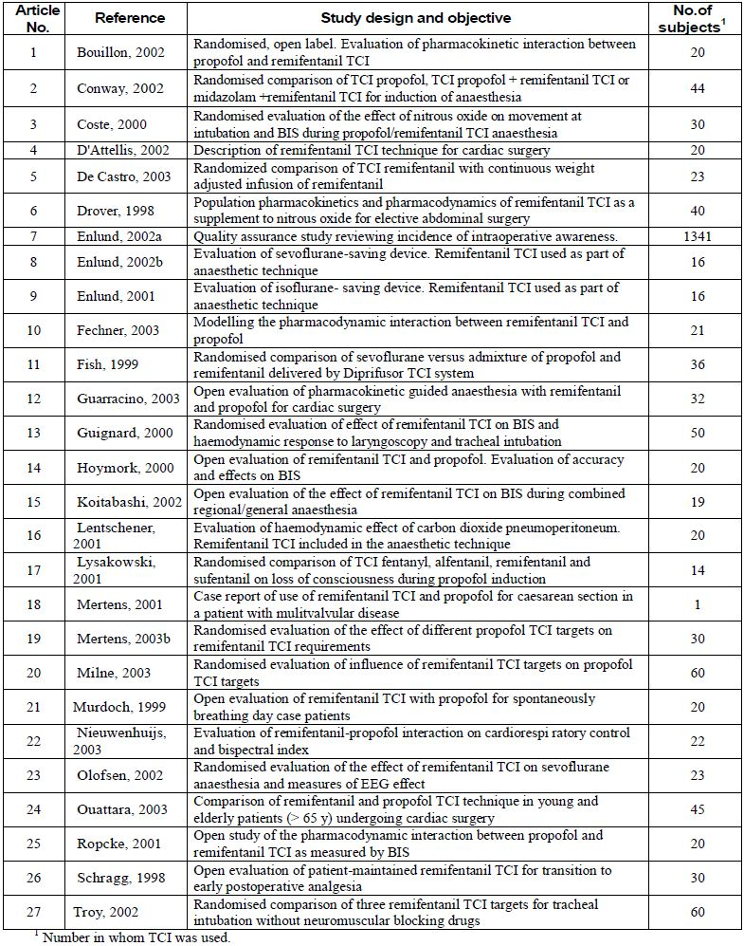
Of the articles reporting efficacy data with a TCI system, only eight (numbers 2, 5, 6, 7, 17, 22, 25 and 27) used the Minto model with specified branded software (Table 4). Even for these articles, further discussion seems pointless unless the sponsor chooses to specify software. Even if the sponsor were able to argue successfully that the software used was unimportant, only one of these studies presented efficacy data comparing TCI to non TCI administration.
Table 4: Some features of the studies listed in Table 3.
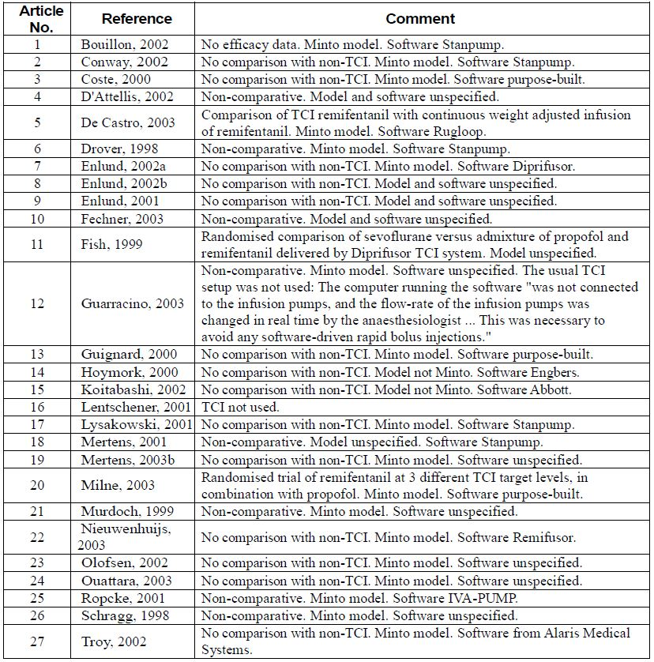
In my opinion, the 12 abstracts selected by the sponsor for inclusion in the LBS were not evaluable for efficacy on the grounds of brevity alone.

Pivotal efficacy studies
None submitted.

Other efficacy studies
None presented.

Analyses performed across trials (pooled analyses and meta-analyses)
None presented.

Evaluator’s conclusions on clinical efficacy
No useful clinical efficacy data were presented.

Safety

Studies providing evaluable safety data
None of the material presented provided safety data which could be properly evaluated in the context of the application.

Other studies evaluable for safety only
Studies USA-103 and USA-220 in this section of the Clinical Evaluation Report are cited several times in connection with safety in the Clinical Overview. However, it is not clear why the sponsor included these studies in the dossier.

Study USA-103
This was a small study (15 normal subjects received remifentanil by TCI), done in 1991. The Clinical Overview states:
"... the PK parameters used in Studies USA-103 and USA-220 were derived from only 4 volunteers who received a single dose of 2 mcg/kg over 1 min."
However, no mention of the above listed PK parameters was cited in the paper. Also, the claim that the above listed values derive from the cited study appears to be inconsistent with data presented in the Clinical Overview.
No information was located in the Protocol about the device or its associated software, but the sponsor states in the Clinical Overview that it used a PK model described by Glass and colleagues. This could not be verified from the cited paper − unless the reference is simply to the fact that the compartmental analysis of Glass and colleagues was
"done using a nonlinear weighted (1/[observed concentration]²) least squares regression method to estimate PK parameters (A_{i}, λ_{i}) using PCNONLIN (Version 3.0; SCI Software, Lexington, KY)."
Study USA-103 did not use the injection algorithm now proposed − that is, the one stipulated in the draft PI with citation of Minto and colleagues − but used an algorithm based on an earlier model, and PK parameters the origin of which is unclear.
In the opinion of the clinical evalutor, this study is of no relevance to the present application, as the study did not involve use of the proposed injection algorithm.

Study USA-220
In this study completed in 1994, 194 elective surgery patients received remifentanil. According to the Clinical Safety Report:
"a CACI device was used to administer remifentanil in order to achieve a target blood concentration".
The PK parameters used by the software (V_{C}, K₁₀, K₂₁ and K₁₂) were the same as those listed above for Study USA-103 (Protocol).
No information was located by the clinical evaluator in the Protocol about the device or the associated software. The sponsor states in the Clinical Overview that it used a PK model described by Kapila and colleagues. However, no account was located in the cited article of the development of a model suitable for implementation in a TCI algorithm. The modelling described in that article related to estimation of context sensitive half times at the end of the drug infusions.
The last two paragraphs under Study USA-103 apply here also.

Pivotal studies that assessed safety as a primary outcome
None.

Patient exposure
No relevant material on patient exposure.

Adverse events

All adverse events (irrespective of relationship to study treatment)

Pivotal studies
No such studies.

Other studies
AEs reported in Studies USA-103 and USA-220, as well as in the 27 published articles and 12 abstracts which formed the literature based component of the submission, are considered below.

Studies USA-103 and USA-220
These have been evaluated previously by TGA and have not been reassessed. However, the reports of those studies (including case narratives of SAEs) were checked for any AE specifically clearly associated with the TCI aspects. None were found.

Published articles
See Table 5. The information in the last column of the table is copied from the Clinical Overview.
Table 5: Published articles − AEs reported.
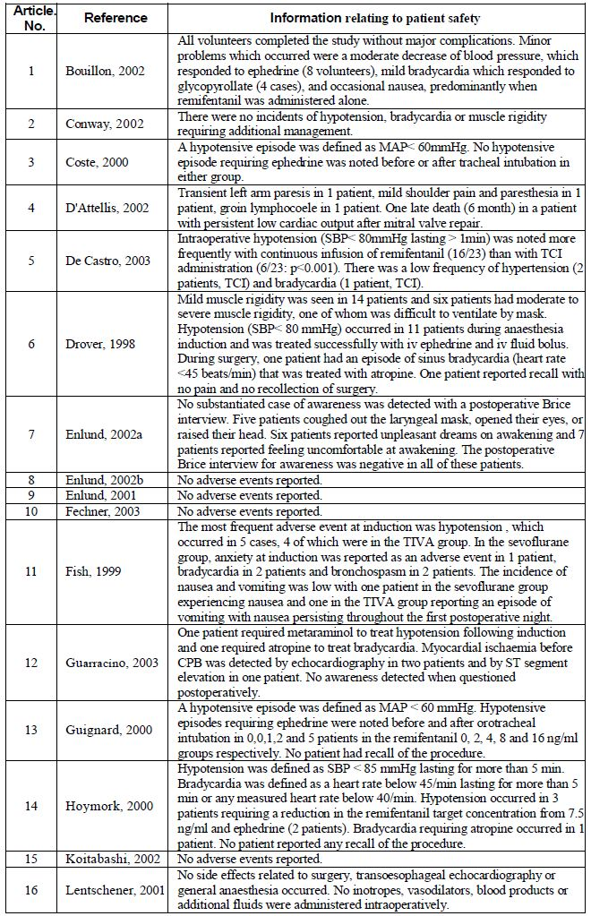
Table 5 (continued): Published articles − AEs reported.
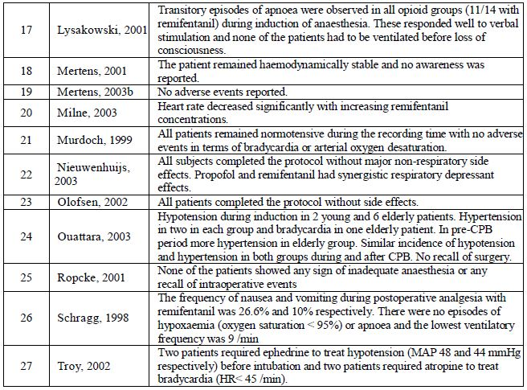
In general, it appears from the published articles that AEs were not rigorously sought in the studies reported. Further, the sponsor's comment on Bouillon and colleagues illustrates the difficulty in assessing AE experience accurately from the brief data presented in such articles. In that article, frequencies of AEs are not given. The frequencies stated in the first comment in Table 5 are taken from the article's table headed "Additional drugs administered during the study", so the only AEs counted there are those treated with drugs.

The published articles were considered of very little value in the safety assessment relevant to the present submission.

Abstracts
Only 2 of the 12 abstracts presented in the dossier reported any AEs at all:
- Olivier and colleagues reported "only 5 episodes of hemodynamic instability required vasoactive therapy"; and
- Stuart and colleagues mentioned that one of the patients received supplementary oxygen.
The clinical evaluator considered the abstracts of no value in the safety assessment.

Treatment related AEs (adverse drug reactions)

Pivotal studies
No such studies.

Deaths and other SAEs

Pivotal studies
No such studies.

Other studies
No deaths were recorded in the studies, apart from one death 6 months after cardiac surgery.

Discontinuation due to AEs

Pivotal studies
No such studies.

Other studies
No useful data.

Laboratory tests
No useful data.

Post marketing experience
No data.

Comment on the Safety section of the Clinical Overview

Dot points at the beginning of the section
These are as follows:
- The safety of remifentanil administered by TCI has been evaluated in a total of 2,650 subjects in 41 studies. This consisted of 2,593 patients and 57 volunteers. The safety profile of remifentanil administered by TCI is consistent with that in the original MAA and consistent with the known pharmacology of a potent and selective µ-opioid agonist. No increase in drug exposure occurs with the TCI mode of administration.
- At the target concentrations recommended for remifentanil TCI, infusion rates fall within the range described in the current SPC for MCI. Limited information is available to compare remifentanil TCI with remifentanil MCI but in one comparative study, the frequency of intra operative hypotension was significantly reduced in the remifentanil TCI group (p < 0.001). At worse the incidence of haemodynamic effects should be similar to that observed with current doses used by MCI.
- With the calculation of LBM as used in the Minto model for remifentanil TCI, LBM is likely to be underestimated in female patients with BMI greater than 35 kg/m² and in male patients with BMI greater than 40 kg/m². To avoid underdosing in these patients, remifentanil TCI should be carefully titrated to individual response.
The clinical evaluator considered it inappropriate to simply pool the data from the 41 studies mentioned, for the following reasons:
- The 41 studies have not been systematically selected. Thus, any comparative information among the pooled data may be biased.
- Safety and efficacy of TCI administration depends upon the equipment used to control the rate of infusion – in particular, the software. This, in turn, is dependent upon the PK model used.
The statement
"The safety profile of remifentanil administered by TCI is consistent with that in the original MAA and consistent with the known pharmacology of a potent and selective µ-opioid agonist"
is too vague to be useful.
As stated
"Limited information is available to compare remifentanil TCI with remifentanil MCI".
In the one relevant article presented, Rugloop software was used.
It is claimed
"At the target concentrations recommended for remifentanil TCI, infusion rates fall within the range described in the current SPC for MCI"
but the evidence for this is unclear. The assertion appears to be based upon computer simulation studies.
Regarding AEs, the simple collection of reports of AEs from non comparative TCI studies contributes very little to this application. The reports are not comprehensive so there is no way of knowing the extent to which these data overlap with the data on which the AE section of the currently approved PI is based.
Useful information would be:
- Comparative frequency data from studies in which a specific TCI system proposed by the sponsor was compared with another mode of administration; and
- Reports of any AEs which could have occurred because of the TCI mode of administration (for example, because the model may have been inappropriate, or the software faulty, or because of some other system failure).

Clinical Overview section headed "Safety of Equipment for Remifentanil TCI"
The sponsor states (Clinical Overview):
"Validation of TCI control software will be the responsibility of pump manufacturers",
yet in the draft PI, advice is given that:
"... adequate analgesia for induction of anaesthesia and surgery can generally be achieved with target blood remifentanil concentrations ranging from 3 to 8 ng/mL. Ultiva should be titrated to individual patient response. For particularly stimulating surgical procedures, target blood concentrations up to 15 ng/mL may be required."
If this advice (and similar advice elsewhere in the draft PI) has been derived from clinical trials using approved software and hardware, why not state the trade name(s) of the equipment and arrange for the trial data to be submitted for evaluation? If on the other hand the advice has not been derived from such trials, how can it properly be endorsed by the regulator?

Clinical Overview section headed "Conclusions on Safety of Remifentanil TCI"
The sponsor states:
"There is evidence from studies and literature publications that the frequency of hypotension increases at target concentrations of 16 ng/ml and above."
One of the main points to be assessed in any TCI system is the extent to which specified "target" concentration settings result in similar actual blood concentrations.

List of questions
The clinical evaluator considered there was little value in submitting questions to the applicant.

First round benefit-risk assessment

First round assessment of benefits
No benefits of the proposed usage have been demonstrated.

First round assessment of risks
Due to lack of relevant data, risks of the proposed usage cannot be properly assessed on the basis of the present dossier.

First round assessment of benefit-risk balance
In view of the findings of the clinical evaluator, the benefit-risk balance of the proposed usage must be regarded as unfavourable.

First round recommendation regarding authorisation
The clinical evaluator recommended against authorisation.

First round comments on clinical aspects of the Safety Specification in the draft Risk Management Plan
No Risk Management Plan was submitted. Instead, the sponsor submitted the following statement:
"A review of the GSK safety database and literature searches (covered the period of 1 Jan 2004 - 19 May 2011) since the availability of TCI in 2004 has shown that there has been no safety issues related to the TCI mode of delivery.
GlaxoSmithKline believe that a RMP is not required as part of the submission to include TCI as the patient population has not changed and the TCI dose is within the range of that approved for the use in manual administration."
This was rejected by the clinical evaluator who indicated that in addition to the possibility of malfunction in a complex computer controlled system, evidence is lacking that (quoting from the Clinical Overview):
"the infusion rate delivered, at the target settings proposed, fall within those recommended in the current SPC."

V. Pharmacovigilance findings

Risk management plan
No Risk Management Plan was submitted.

VI. Overall conclusion and risk/benefit assessment
The submission was summarised in the following Delegate’s overview and recommendations:

Quality
There was no requirement for a quality evaluation in a submission of this type.

Nonclinical
There was no requirement for a nonclinical evaluation in a submission of this type.

Clinical

Pharmacology
The sponsor has noted that the amount of remifentanil delivered at a particular target setting with TCI can vary depending on the PK model incorporated in a TCI pump. This occurs because within the range of published parameters there are some differences in the estimates of volumes of distribution and clearance of remifentanil. By recommending a particular PK model for remifentanil for incorporation in all commercial TCI systems, standardisation of delivery of remifentanil by TCI will be achieved. Guidance on recommended target concentration settings for remifentanil in the PI can then be linked to the delivery of remifentanil by these TCI systems.
The sponsor has recommended the PK model described by Minto and colleagues be recommended as the only PK model for delivery of remifentanil using TCI. The sponsor claims this model has the advantage that covariates are incorporated to take account of the known effects of patient age and LBM on the PK of remifentanil. In this way, the amount of remifentanil delivered at a particular target setting is automatically adjusted, based on the characteristics of each patient.
The Minto model development was described in two papers included in this submission. The initial remifentanil blood concentration relative to infusion rate data were obtained in an open PK/PD study in which 65 healthy subjects aged from 18 to 84 years (38 males, 27 females; 17 subjects > 65 years) received remifentanil by constant rate infusion of 1-8 µg/kg/min for 4-20 minutes.
Arterial blood samples were drawn and assayed for remifentanil concentration to assess the relationship between infusion rate and blood concentration. The timing and frequency of sampling was not provided in that paper. The absence of data on the number of samples and time sequence limits further comments that could be made on the raw data that was subsequently used for model development.
Of note this study included a PD assessment in which the effect of remifentanil on the brain was assessed using a spectral edge EEG. Modelling of that data showed a doubling of the t_{½} and k_{eo} for remifentanil and a halving of the EC₅₀ from ages 20-85. This was the basis of the proposed 50% reduction in target range for remifentanil for patients aged over 65 years.
Dose adjustments are also recommended for obese patients. The Minto model proposed for adoption has based dosing on LBM such that no further amendment of target settings should be required. However, the sponsor has submitted a letter to the editor by Green and Duffell from the School of Pharmacy University of Queensland published in Clinical Pharmacology and Therapeutics December 2002. This letter notes the LBM calculations were derived from 1976 population data. With that model, at extremes of BMI the estimated percentage of body fat becomes artificially high, leading to an underestimation of LBM in morbidly obese individuals.
The sponsor’s Clinical Overview reviewed information obtained from two company sponsored studies that did not use the Minto model and data from a further 27 peer reviewed published studies in which remifentanil was given by TCI to a total of 2,031 patients and 42 volunteers. Some additional information is provided in 12 published abstracts, which refer to use of remifentanil by TCI in a further 368 patients. That review grouped TCI without regard to the PK model used for delivery.
The Minto PK model proposed for inclusion in the PI is described in a published paper discussed in the Clinical Evaluation Report. The clinical evaluator was concerned that it could not be confirmed from the submission that the model used in the majority of published studies was the Minto model. He also noted that as no systematic search of the literature had apparently been conducted it was not possible to determine whether other literature, less favourable to either the Minto PK model or TCI in general was available.
The Minto PK model is reported in reference to a second paper by Minto and colleagues. In that study, 65 healthy subjects (35 male, 27 female; age 20-85 years) received remifentanil by constant rate infusion of from 1-8 µg/kg/min for 4-20 minutes. Blood samples for assessment of remifentanil concentration were taken and PD observations made. The primary measure of PD effect was spectral edge EEG. Blood samples taken during this study provided the data used to develop the Minto model described in the second Minto and colleagues paper and proposed for inclusion in the PI as the only model to be used with TCI of remifentanil.
A PK Simulation Report describing the Minto PK model was inadvertently omitted from the clinical data submission but was subsequently supplied by the sponsor. These data did not provide details of how each of the simulated models were derived. The objective of the PK simulation report was to provide data to support an application to add guidance on target blood remifentanil concentration settings to the PI for remifentanil, and ultimately facilitate the administration of remifentanil by TCI. In particular, simulations were provided to illustrate the concept and advantages of TCI, and to explain the terminology associated with this mode of drug administration. The simulations were also intended to provide an illustration of the influence of different published PK models for remifentanil on the amount of remifentanil delivered at a particular remifentanil target setting.
A key objective of this document was to compare TCI dosage with that currently recommended in remifentanil’s PI for administration by bolus and/or infusion. Results from other TCI models were compared with the Minto model in simulations. This model involved PK computer simulation using infusion rates and the PK parameters of the Minto model for remifentanil as inputs to determine the calculated blood remifentanil concentration/time profiles which these infusion rates achieve. These simulations showed that the calculated (predicted) values approach steady state after 25 minutes with blood remifentanil concentrations of 6.3 and 12.6 ng/ml with infusion rates of 0.25 and 0.5 µ/kg/min respectively. These concentrations are consistent with the range of target blood remifentanil concentrations, which have been used in clinical studies with TCI.
One of the published papers stated that for the performance of a TCI system to be clinically acceptable, the difference between measured drug concentrations and those calculated by the TCI system, that is, the bias of the system (MDPE) should be no greater than ± 10 to 20%, and that inaccuracy (MDAPE, independent of arithmetic sign) should be no greater than 20 to 30%.
Five PK models, including the Minto model were assessed for bias, inaccuracy and divergence in a paper by Mertens and colleagues. This study used remifentanil concentration/time data obtained from a previous interaction study of propofol and remifentanil conducted in 30 ASA I-II female patients aged 20 to 65 years who were undergoing lower abdominal surgery. These women received target propofol concentrations of 2, 4 or 6 µg/mL in combination with remifentanil delivered by TCI. Whereas the target concentration of propofol was constant during the surgical procedure, the target concentration of remifentanil was changed in response to the presence or absence of signs of inadequate anaesthesia.
The remifentanil concentrations predicted by the five parameter sets were calculated on the basis of the TCI device record of the infusion rate/time profile that had actually been administered to each individual. The individual and pooled bias, inaccuracy, and divergence of the remifentanil TCI device were determined from the pooled and intra subject performance errors. A total of 444 remifentanil blood samples were analysed. Blood remifentanil concentrations ranged from 0.1 to 19.6 ng/mL. Table 6 compares the performance of these models:
Table 6: A comparison of five parameter sets measuring individual and pooled bias, inaccuracy, and divergence of the remifentanil TCI device.
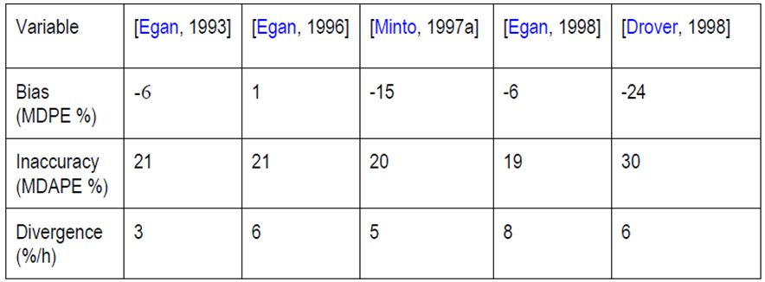
The three models proposed by Egan provided similar accuracy and less bias than the Minto model. The authors of the paper noted that the true performance, that is, the mismatch between the target remifentanil concentrations and the remifentanil concentrations actually measured could only be determined for the data set of Minto. Had one of the other data sets been implemented, the actually achieved (measured) concentrations would have been somewhat different.
However, the true performance of that data set would most likely be very similar to the expected performance calculated on the basis of the volumes per unit of time actually delivered. Remifentanil was delivered using TCI in Studies USA-103 and USA-220 that were included in this submission. These studies had been previously submitted to the TGA. The PK model used for TCI in these studies was proposed by Glass and colleagues; the Minto model was not used in these studies. The Glass model was derived from only 4 volunteers who received a single remifentanil dose of 2 µg/kg over 1 minute. In studies the measured blood remifentanil concentrations showed a positive bias with values exceeding the targeted concentrations by 26% and 36%, respectively.

Efficacy
The two efficacy and safety studies included in this submission did not use the proposed TCI model; the Glass model was used, and has been previously evaluated for safety and efficacy. They were not re-evaluated in this submission; however, safety and efficacy were considered acceptable in the previous evaluation. Evidence of efficacy and safety of TCI when given using the Minto model was available from some of the published papers.
A review of these papers has shown that of the 63 literature references, the Minto system was specified as the system used to administer TCI in 15 studies. These did not include the study used to develop the Minto system. The reference, number of patients, patient ASA grade, surgical procedure and TCI target level described in these studies are summarised in Table 7.
Table 7: The 15 studies using the Minto system to administer TCI.
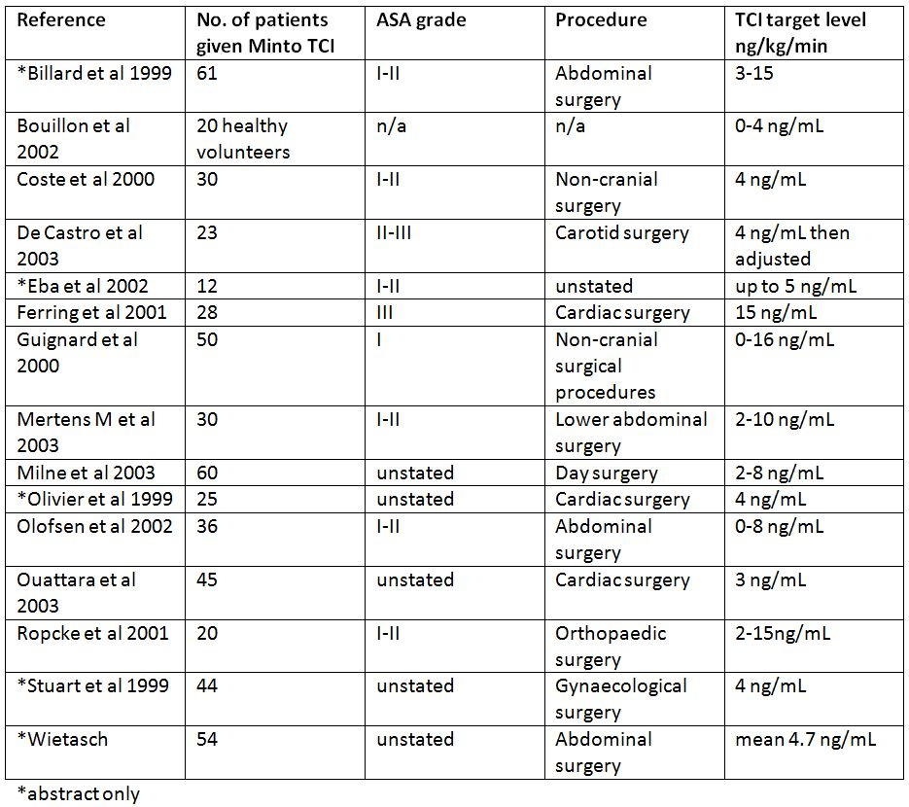
Comparative data for manual infusion versus TCI (Minto model) remifentanil were available only from the paper by De Castro and colleagues. That paper described a prospective, randomised study comparing the intra and post operative haemodynamics, remifentanil requirement during anaesthesia, and post operative morphine requirement in patients scheduled for carotid surgery. A total of 46 adult patients received either continuous IV weight adjusted infusion of RIVA (remifentanil) or TCIR (Target Controlled Infusion for remifentanil). All patients were anesthetised by using TCI for propofol.
A total of 23 patients received RIVA (0.5 μg/kg/min) for the induction of anaesthesia and endotracheal intubation, with the infusion rate decreased to 0.25 μg/kg/min after intubation, then adapted by step of 0.05 μg/kg/min according to haemodynamics. A total of 23 patients received TCIR (Minto model, Rugloop), with an effect site concentration at 4 ng/mL during induction, then adapted by step of 1 ng/mL according to haemodynamics. All patients received atracurium and a 50% mixture of N₂O/O₂. Haemodynamic variables were recorded each minute. The number and duration of hemodynamic events were collected, and total doses of anaesthetics (remifentanil and propofol) and vasoactive drugs were noted in both groups of patients.
Data were analysed by using unpaired t-tests. RIVA was significantly associated with more frequent episodes of intraoperative hypotension (16 versus 6, p < 0.001) and more frequent episodes of postoperative hypertension and/or tachycardia requiring more frequent administration of β adrenergic blockers (16 versus 10, p < 0.04) in comparison with TCIR. The need for morphine titration was not significantly different between groups. TCIR led to a significantly smaller requirement of remifentanil (700 ± 290 versus 1390 ± 555 μg, p < 0.001) without difference in propofol requirement.
The authors concluded that this study demonstrated that during carotid endarterectomy, in comparison with patients receiving remifentanil using continuous RIVA, TCI resulted in fewer hypotensive episodes during the induction of anaesthesia, fewer episodes of tachycardia and/or hypertension, a smaller β adrenergic blocker requirement during recovery, and a decrease in remifentanil requirement. Table 8 shows the doses of propofol and remifentanil given to each group in that study.
Table 8: Anaesthesia characteristics.
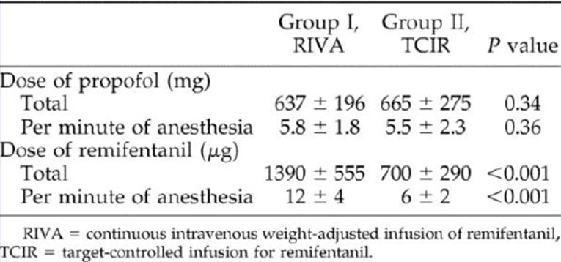
Other submitted papers described similarly successful outcomes where the remifentanil TCI was administered using some other PK model.
The sponsor has proposed that the initial target concentration for general anaesthesia in adults aged over 65 years should be reduced by 50% (that is, from 3-8 ng/mL to 1.5 to 4 ng/mL). In the sponsor’s Overview of the submission, it was acknowledged that there is no study which specifically addresses the target concentrations required in patients aged over 65 years. The basis for that recommendation was a published paper showing that the susceptibility of elderly patients to remifentanil is increased with a 50% reduction in the EC₅₀ for EEG effects over the age range 20 to 80 years.
No papers addressed dose reduction for ASA III patients however a 50% reduction in target concentration has been recommended for TCI delivery.

Safety
Safety data from the published studies were not evaluable. No new AEs associated with remifentanil would be anticipated given this submission concerns a method of administration rather than a change in recommended total doses of remifentanil.
The major safety issue is whether the TCI method of administration results in a worse outcome in terms of adverse events than the current manual method of infusion with adjustment according to response. This could not be determined from the data presented.

RMP evaluation
No RMP was required by the TGA.

Risk-benefit analysis

Discussion

Pharmacology
The paper by Mertens and colleagues provides the major PK support for the use of any TCI PK models for infusion of remifentanil. The sponsor has not proposed one of the Egan models; however, these were generally more predictive of the blood concentration than the Minto model for use with TCI, at least in female patients undergoing gynaecological surgery. The PK model used to administer the TCI in the interaction study described in the Mertens paper was not the Minto model that is proposed but rather was an earlier model that did not allow for covariates of age and lean body mass. This paper suggests there is no firm basis for recommending any of the five tested PK modelling systems for TCI over another. In addition, data for these assessments were obtained from a fairly homogeneous population. Different outcomes are likely to have been obtained if the testing had been performed with older and/or more severely ill surgical patients. All the tested PK models had accuracy that was within the clinically acceptable limits suggested in the paper by Schuttler and colleagues.
As noted in the paper by Mertens and colleagues, the PK of remifentanil is linear (that is, independent of dose or infusion rate) over a large dose range. Because remifentanil is cleared rapidly, most of the inter individual variability in concentration during a continuous infusion will reflect variability in metabolic clearance.

Efficacy
The sponsor has provided published papers where the proposed Minto model was used in TCI for surgical procedures, including cardiac surgery in patients who were ASA I-III. These studies did not compare TCI with the currently used manual method of administration of remifentanil.
The only study that allowed a comparison used a fixed infusion rate of remifentanil that delivered a higher total dose of remifentanil than the TCI dose. This resulted in fewer hypotensive episodes during the induction of anaesthesia, fewer episodes of tachycardia and/or hypertension and a smaller β adrenergic blocker requirement during recovery for patients given TCI.
As anaesthetists generally adjust infusion rates in response to patient’s responses including haemodynamic responses the results of this study are of limited value because the method of administration of the continuous infusion allowed for less flexibility in remifentanil dosing than would be the case in routine clinical practice.
The papers generally described small, open studies, and generally factors other than remifentanil TCI were the focus of the study. They do serve to show that remifentanil can be given safely via TCI with the Minto model in conjunction with general anaesthetics.
There were no data on the delivery of remifentanil using TCI for children, post operative analgesia or management of ventilated patients in the intensive care unit. TCI delivery of remifentanil has not been proposed for these patients.
It is reasonable to conclude from the data presented that any PK model that has been validated could be used to deliver remifentanil using TCI. The sponsor has not demonstrated that the Minto model is superior to other models. The sponsor’s primary justification for recommending the Minto model appears to be that some standardised model is required, and that the Minto model is acceptable.
Any of the TCI models discussed would deliver remifentanil at infusion rates that are within the current dose recommendations. I consider that it would be helpful for practitioners to have information on the suggested dilutions of remifentanil and target blood levels for various procedures, but that it should be clear that this is guidance only. There is wide variability in sensitivity to all opioids, including remifentanil, and the use of TCI is no substitute for close monitoring of the patient during anaesthesia with adjustment of the target remifentanil level according to patient response.

Safety
Both MCI and TCI have potential for adverse reactions due to over and under dosing in relation to the individual patient, the surgical procedure being performed, and other agents co-administered with remifentanil. Whether patients experience clinically significant AEs from relative over or under exposure to remifentanil depends to a large extent on the anaesthetist monitoring the patient. The TCI method of administration should be considered an aid in the selection of dosage which must then be further adjusted according to the individual patient’s response.
While no papers were submitted to support the proposed initial target TCI range for ASA III or IV patients, the current PI recommends caution in administration of Ultiva (by MCI) and an initial dose reduction and subsequent titration, but does not specify a dose reduction of 50%. There is no firm basis for the proposed 50% initial target reduction. The most important aspect of dosing is that the initial dose not be so high as to precipitate hemodynamic changes and that it be titrated according to the patient’s response.

Conclusion and recommendation
It is proposed to approve the inclusion in the PI of information regarding the use of TCI for delivery of remifentanil during induction and/or maintenance of general anaesthesia during surgical procedures including cardiac surgery in adults. Within the above indications, the proposed use in ASA III/IV patients is not recommended.
It is not proposed to approve a specific PK model to be used with devices to deliver remifentanil using TCI. Any software/model recommendation is likely to be overly restrictive and may quickly become out of date should subsequent modelling software become available.
The advice of the ACPM is requested concerning whether:
- a comparative study using remifentanil administered via MCI versus TCI should be required prior to accepting a description of TCI in the PI for Ultiva (remifentanil);
- if it is appropriate to recommend remifentanil if delivered using TCI that the Minto PK model be specified in the PI;
- it is appropriate to exclude ASA III/IV patients from TCI of remifentanil.

Response from sponsor
Purpose of Application: Category 1 application to amend the Dosage and Administration section of the PI to provide guidance on use via TCI.
The primary aim of this application was to provide guidance on administration of remifentanil via TCI, which is an established alternative to the manually controlled mode of delivering drugs via infusion.
The application does not seek to extend the indication or increase the use of remifentanil, or to change the approved dose range for achieving the required anaesthetic effect.
TCI of anaesthetic agents is an established mode of delivery of anaesthetic agents worldwide and in Australia. There are currently at least four devices approved by the TGA for delivery of anaesthetic agents via TCI, which include relevant software and PK models for TCI of remifentanil (Table 1).
Devices for TCI of anaesthetic agents are available and used within many hospitals in Australia. Therefore this mode of delivery of anaesthetic agents is not novel and the inclusion of relevant guidance relating to the administration of remifentanil via TCI is intended to assist the anaesthetist and is in the spirit of ensuring quality use of medicines.
Guidance on TCI of remifentanil has been approved in Europe since 2004.
The company agrees with the Delegate’s recommendation to
“Approve the inclusion in the PI of information regarding use of TCI for delivery of remifentanil during induction and/or maintenance of general anaesthesia during surgical procedures, including cardiac surgery in adults”
and supports this position on the grounds that:
- This mode of administration delivers remifentanil within the dose range recommended.
- IV infusion is the approved route of administration and TCI is an alternative mode of IV infusion supported by the available literature and company studies.
- The relevant device and software for this mode of IV infusions is already available via TGA approved devices and validated software within the Australian health system.
- The available literature indicates that adequate sedative effect is achieved via either MCI or TCI when administered in a controlled and monitored environment, that the consumption of remifentanil is reduced via TCI and the monitored side effects for TCI and MCI are comparable.
- The available AE data from the GlaxoSmithKline safety database does not indicate a change to the safety profile of remifentanil over 15 years of post market surveillance.

1. Requirement for a comparative study of remifentanil via MCI versus TCI prior to inclusion of a description of TCI in the PI.
The company does not believe that an additional comparative study of MCI versus TCI delivery of remifentanil would provide any new information that is not already available via the existing body of evidence.
The company acknowledges that the information on the clinical use of remifentanil TCI is not supported by a structured clinical program. However, there is sufficient published clinical information available to support guidance for use of remifentanil TCI and as such does not compromise the quality of the guidance provided to the anaesthetist.
The clinical studies submitted with this application while not including large subject numbers (Study USA‐103, n = 15; Study USA‐220, n = 194) nevertheless demonstrated acceptable efficacy and safety when remifentanil was administration via TCI.
The clinical evaluator’s comments on the lack of compliance of submitted literature based component are noted. The company wishes to highlight that the relevant TGA guidance document is for industry and is primarily recommended for changes to the PI associated with changes to the claimed indication, contraindications, dosage and route of administration. No changes are proposed to the claimed indication, contraindications, dosage and route of administration via this application. The submitted peer reviewed literature was intended to provide a critical review of the available information on the TCI mode of administration as an analgesic agent in the approved surgical settings.
The literature submitted with the application was limited to information published prior to 2003. A recent review of available published information since 2003 identified in excess of 344 publications on remifentanil TCI, indicating that there is a substantial body of evidence for this mode of administration.
In a revised search undertaken by the sponsor since 2003, five studies comparing MCI to TCI have been identified. A summary of the patient numbers, clinical setting and doses used are shown (Table 9).
Table 9: Summary of comparative clinical studies for remifentanil TCI versus MCI.
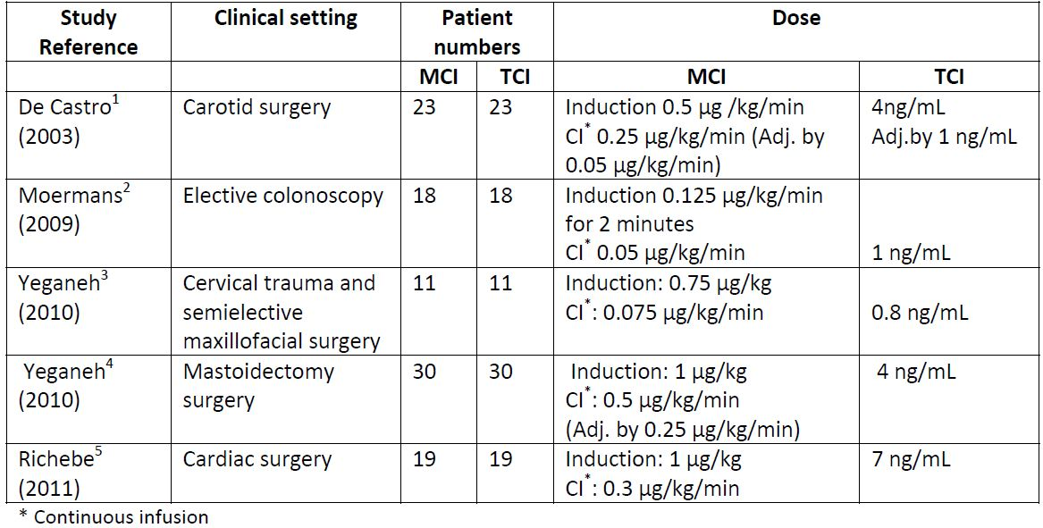
The first study, discussed in the submission and Delegate’s summary by De Castro and colleagues was conducted on patients scheduled for carotid surgery. The aim of the study was to compare intra and postoperative haemodynamics, remifentanil requirement during anaesthesia, and postoperative morphine requirement in patients receiving either MCI or TCI remifentanil. A total of 46 patients were enrolled in this study: all receiving propofol by TCI. Twenty three received MCI of remifentanil (0.5 μg/kg/min) for the induction of anaesthesia and endotracheal intubation, with the infusion rate decreased to 0.25 μg/kg/min after intubation, then adapted by step of 0.05 μg/kg/min according to haemodynamics. A total of 23 patients received TCI of remifentanil with an effect‐site concentration at 4 ng/mL during induction, then adapted by step of 1 ng/mL according to haemodynamics. The results indicated that patients in the TCI group required significantly lesser amount of remifentanil than the MCI group (p < 0.05) and the incidence of episodes of intra operative hypotension (16 versus 6; p < 0.001) and post operative hypertension (16 versus 10; p < 0.04) were more frequent with MCI than TCI.
The second study (n = 60) by Moerman and colleagues was conducted in patients undergoing elective colonoscopy. The primary outcomes investigated were to examine whether the addition of remifentanil to propofol TCI would result in more beneficial conditions during procedural deep sedation and to determine if there was further benefit if remifentanil was delivered via TCI compared to MCI. Patients were randomised to three groups:
- MCI plus propofol TCI;
- TCI plus propofol TCI; or
- placebo plus propofol TCI.
The TCI group received remifentanil 1 ng/mL (effect site target) and the MCI group received 0.125 μg/kg/min for 2 minutes followed by continuous infusion of 0.05 μg/kg/min. All patients received TCI propofol, adjusted to a target concentration level that provided deep sedation. Significantly more patients in the placebo group showed movement and hiccup that transiently interfered with the colonoscopy examination. There were no clinically significant differences in haemodynamic or recovery variables among the three groups. Remifentanil administered via TCI resulted in a decrease in propofol requirements and in a lower incidence of apnea and respiratory depression.
In a study by Yeganeh and colleagues in 22 patients requiring fibreoptic tracheal intubation who had cervical trauma and semielective maxillofacial surgery, remifentanil TCI was compared with MCI. The TCI group (n = 11) received 0.8 ng/mL remifentanil (effect site target) and the MCI group (n = 11) received a loading dose of 0.75 μg/kg and 0.075 μg/kg/min as maintenance dose. Preparation time was significantly shorter in the TCI group (6 minutes versus 12 minutes; p < 0.05) and effect site targets were higher and vital signs were more stable in the TCI group, although not significant. Levels of sedation were comparable in both groups; however, recall and pain during endoscopy were more common in the MCI group.
A second study by Yeganeh and colleagues in 60 patients undergoing mastoidectomy, propofol and remifentanil MCI was compared to propofol and remifentanil TCI. The MCI group received propofol via a slow bolus dose of 1 mg/kg and after that 170 μg/kg/min for 10 minutes, and then 130 μg/kg/min for 10 minutes and finally 100 μg/kg/min for maintenance of anaesthesia. Remifentanil MCI was delivered as a slow bolus dose of 1 μg/kg and then was continued with 0.5 μg/kg/min. For the TCI group, the initial effect site target of propofol was set at 4 μg/ml, titrated against clinical effect and BIS values, and the initial effect site target of remifentanil was 4 ng/ml. Duration of PACU residence was significantly less in TCI group, similarly the postoperative side effects (nausea and vomiting) were also significantly less in the TCI group. The quantity of opioid consumption was significantly higher in the MCI group compared with the TCI group.
A study by Richebe and colleagues compared TCI to MCI during cardiac surgery to investigate occurrence of hyperalgesia. A total of 40 ASA II to III patients scheduled for elective cardiac surgery were enrolled and 38 completed the study (TCI, n = 19; MCI, n = 19). The TCI group received 7 ng/mL (effect site target) and the MCI group received a slow bolus of 1 µg/kg at induction followed by continuous infusion at a rate of 0.3 μg/kg/min. The anaesthetic protocol and post operative pain management were the same in both groups. Remifentanil use was significantly less in the TCI group than MCI group. Over the first 44 hours post operation, there was no difference in morphine consumption, visual analog scale (VAS) and verbal rating scale (VRS). The extent of hyperalgesia was significantly lower on post operative Days 1, 2 and 4 in the TCI group, indicating that the decrease in the intraoperative use of remifentanil via TCI may result in less opioid induced hyperalgesia after cardiac surgery and as a consequence a reduction in post operative morphine use.
The information above demonstrates that remifentanil TCI, when administered under appropriate anaesthetic monitoring in various surgical procedures (including cardiac surgery) achieves similar sedation outcomes to MCI and is associated with reduced remifentanil usage and a favourable side effect profile.
To further assist anaesthetists, the sponsor proposes to amend the PI to include the information generated via the submitted PK simulation report to provide guidance on target blood concentrations relative to continuous infusion rate (Table 10).
Table 10: Blood concentrations achieved at steady state with MCI in a 70 kg, 170 cm, 40 year old, male patient (using Minto PK model).
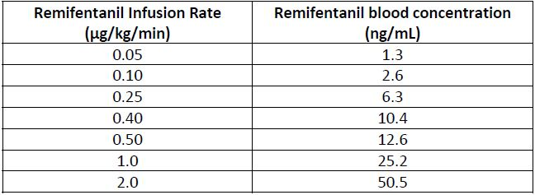

2. Recommendation of specific Minto PK model if remifentanil is delivered via TCI
The Delegate’s recommendation that nominating a specific PK model or device would be overly restrictive is acknowledged by the company.
The PK models used in the company Study USA‐103 utilised the model by Glass and colleagues and Study USA‐220 utilised the model by Kapila model and colleagues, with both studies considered to demonstrate satisfactory efficacy when reviewed by the TGA with the original application for registration. As noted in the clinical overview and Delegate’s summary, the Egan PK models for remifentanil have also been reported to be similar to the Minto PK model for delivery of remifentanil TCI.
However, while the available information does suggest that other PK models would be suitable for remifentanil TCI, the Minto model is currently the most widely used PK model for delivery of remifentanil via TCI. This is supported by the fact that:
- All available TCI devices, on the Australian market and approved by the TGA, incorporate the Minto PK model in available validated software.
- The majority of published literature (249/344 papers) used the Minto model in remifentanil TCI.
The Delegate’s concerns that this PK model could be superseded with new PK models over time, as has occurred with PK models used for Propofol TCI delivery, are valid and have been taken into consideration and revised wording is proposed:
Administration by Target‐Controlled Infusion
Ultiva may also be given by target‐controlled infusion (TCI) with an approved infusion device incorporating a validated PK model (the Minto PK model with covariates for age and lean body mass (LBM) is an example of a model available with current devices) (Anesthesiology 1997; 86: 10‐23).
TCI can be used for induction and maintenance of general and cardiac anaesthesia in adults. There are insufficient data to make recommendations for delivery of Ultiva by TCI for spontaneous ventilation anaesthesia, use in ICU sedation, monitored conscious sedation or in children.
For TCI in adults the recommended dilution of Ultiva is 20 to 50 µg/mL.

3. Exclusion of ASA III/IV patients from TCI remifentanil
It is acknowledged that there are no specific data to support the specified lower initial target of 1.5-4 ng/mL in ASA III/IV patients. However, the recommendation is consistent with the supported recommendation for reduction in initial dose in ASA III/IV patients via MCI and is approved in the UK SPC.
The company does not agree that use of TCI in this ASA III/IV patients would result in a different outcome to administration via MCI provided the same precautionary measures (initial lower dose and subsequent titration to effect) as specified for MCI are followed.
On this basis we propose to include the following dosing statement relating to TCI in ASA III/IV patients under general anaesthesia:
3.6 ASA III/IV patients
- General anaesthesia: As the haemodynamic effects of potent opioids can be expected to be more pronounced in ASA III/IV patients, caution should be exercised in the administration of Ultiva in this population.
Manually Controlled Infusion: Initial dosage reduction and subsequent titration to effect is therefore recommended.
Target‐Controlled Infusion: a lower initial target of 1.5 to 4 ng/mL should be used in ASA III or IV patients and subsequently titratedion to response effect is recommended
- Cardiac anaesthesia: No initial dose reduction is required (see Cardiac Anaesthesia – Dosing Guidelines for Cardiac Anaesthesia).
- Intensive Care: No initial dose reduction is required (see Use in Intensive Care).

4. Safety Summary
The premise for this application, to include guidance for use via TCI, as stated in the Clinical Overview and in the Delegate’s summary, is that no new AEs would be anticipated as this change concerns a method of administration rather than a change in remifentanil dose or route of administration.
Remifentanil was first approved on 17 May 1996 in Germany. It has been approved in 81 countries and is currently marketed in 68 countries.
A review of the data available in GlaxoSmithKline’s global safety database was performed so as to identify adverse events associated with the TCI route of administration. Very few cases were identified, where it was specified that remifentanil hydrochloride was given by TCI. The adverse drug reactions reported were mostly consistent with the known safety profile of remifentanil.
The safety profile is well defined and supported by over 15.5 years of post marketing experience. The approved labelling states that Ultiva should be administered only in a setting fully equipped for the monitoring and support of respiratory and cardiovascular function and by persons trained in the use of anaesthetic drugs. The users of Ultiva should also be trained in the recognition and management of the expected adverse events of potent opioids.
GlaxoSmithKline will engage in routine pharmacovigilance activities as post marketing surveillance, routine signal detection, periodic safety update reports and literature reviews. No additional risk minimisation measures are considered necessary beyond the routine pharmacovigilance activities and information in the product labelling and PI leaflet.

Advisory Committee Considerations
The ACPM, taking into account the submitted evidence of efficacy, safety and quality, considered this product to have an overall positive benefit-risk profile for the currently approved indication for this new mode of administration.
In making this recommendation, the ACPM agreed with the delegate that any model or software recommended is likely to be overly restrictive and may quickly become obsolete with future developments. Thus approval of a specific PK model to be used with devices to deliver this product would be counterproductive.
The ACPM agreed with the delegate to the proposed amendments to the PI and CMI and specifically advised on inclusion of the following;
- Include in the PI information regarding the use of TCI for delivery of this product during induction and/or maintenance of general anaesthesia during surgical procedures.
- That the TCI mode of administration has not been adequately assessed in ASA III/IV patients and include a statement that it is not recommended for these patients, including for cardiac surgery patients.
The ACPM agreed with the delegate on the proposed conditions of registration and particularly that the sponsor should be encouraged to increase prescriber education on the interpretation of PK models for administration of anaesthetics.
The ACPM advised that the implementation by the sponsor of the recommendations outlined above to the satisfaction of the TGA, in addition to the evidence of efficacy and safety provided would support the safe and effective use of these products.

Outcome
Based on a review of quality, safety and efficacy, TGA approved:
- the registration of Target Controlled Infusion as a new mode of administration for Ultiva (remifentanil); and
- the amendments of the Product Information of Ultiva (remifentanil) to include instructions for administration by Target Controlled Infusion and other minor changes.
Specific conditions of registration applying to these therapeutic goods:
- Details of the distribution of the drug including quantities and forms of products distributed and related batch numbers should be supplied on request while the drug remains on the Australian Register of Therapeutic Goods.

Attachment 1. Product Information
The following Product Information was approved at the time this AusPAR was published. For the current Product Information please refer to the TGA website at <http://www.tga.gov.au/hp/information-medicines-pi.htm>.

Minto CF, et al. (1997) Influence of age and gender on the pharmacokinetics and pharmacodynamics of remifentanil. I. Model development. Anesthesiology 86: 10-23.
Minto CF, et al. (1997) Influence of age and gender on the pharmacokinetics and pharmacodynamics of remifentanil. I. Model development. Anesthesiology 86: 10-23.
Therapeutic Goods Administration, “Literature-based submissions: Points to consider”, April 2003, Web, accessed 10 January 2013 <http://www.tga.gov.au/pdf/pm-literature-based-submissions.pdf>.
Minto CF, et al. (1997) Influence of age and gender on the pharmacokinetics and pharmacodynamics of remifentanil. I. Model development. Anesthesiology 86: 10-23.
Kapila A, et al. (1995) Measured context-sensitive half-times of remifentanil and alfentanil. Anesthesiology 83: 968-975.
Minto CF, et al. (1997) Influence of age and gender on the pharmacokinetics and pharmacodynamics of remifentanil. I. Model development. Anesthesiology 86: 10-23.
Minto CF, et al. (1997) Influence of age and gender on the pharmacokinetics and pharmacodynamics of remifentanil. I. Model development. Anesthesiology 86: 10-23.
Schuttler J, et al. (1988) Total intravenous anaesthesia with propofol and alfentanil by computer-assisted infusion. Anaesthesia 43 Supp 1: 2-7.
Schuttler J, et al. (1988) Total intravenous anaesthesia with propofol and alfentanil by computer-assisted infusion. Anaesthesia 43 Supp 1: 2-7.
Mertens MJ, et al. (2003). Predictive performance of computer-controlled infusion of remifentanil during propofol/remifentanil anaesthesia. Br. J. Anaesthesia 90: 132-141.
Minto CF, et al. (1997) Influence of age and gender on the pharmacokinetics and pharmacodynamics of remifentanil. I. Model development. Anesthesiology 86: 10-23.
Drover DR, et al. (1998) Population pharmacodynamics and pharmacokinetics of remifentanil as a supplement to nitrous oxide anesthesia for elective abdominal surgery. Anesthesiology 89: 869-877.
Schuttler J, et al. (1988) Total intravenous anaesthesia with propofol and alfentanil by computer-assisted infusion. Anaesthesia 43 Supp 1: 2-7.
Minto CF, et al. (1997) Influence of age and gender on the pharmacokinetics and pharmacodynamics of remifentanil. I. Model development. Anesthesiology 86: 10-23.
Conway DH, et al. (2002) Target-controlled propofol requirements at induction of anaesthesia: effect of remifentanil and midazolam. Eur. J. Anesthesiology 19: 580-584; De Castro V, et al. (2003) Target-controlled infusion for remifentanil in vascular patients improves hemodynamics and decreases remifentanil requirement. Anesthesia and Analgesia 96: 33-38; Drover DR, et al. (1998) Population pharmacodynamics and pharmacokinetics of remifentanil as a supplement to nitrous oxide anesthesia for elective abdominal surgery. Anesthesiology 89: 869-877; Enlund M, et al. (2002a). Intraoperative awareness: detected by the structured Brice interview? Acta. Anaesthesiol. Scand. 46: 345-349; Lysakowski C, et al. (2001) Effects of fentanyl, alfentanil, remifentanil and sufentanil on loss of consciousness and bispectral index during propofol induction of anaesthesia. Br. J. Anaesthesia 86: 523-527; Nieuwenhuijs DJF, et al. (2003) Response surface modeling of remifentanil-propofol interaction on cardiorespiratory control and bispectral index. Anesthesiology 98: 312-322; Ropcke H, et al. (2001) Propofol and remifentanil pharmacodynamic interaction during orthopedic surgical procedures as measured by effects on bispectral index. J. Clin. Anesthesia 13: 198-207; Troy AM, et al. (2002) Tracheal intubating conditions using propofol and remifentanil target-controlled infusions. Anaesthesia 57: 1204-1207.
Fechner J, et al. (2003) Modelling the pharmacodynamic interaction between remifentanil and propofol by EEG-controlled dosing. Eur. J. Anaesthesiology 20: 373-379.
Glass PSA, et al. (1993) Preliminary pharmacokinetics and pharmacodynamics of an ultra-short-acting opioid: Remifentanil (GI87084B). Anesthesia and Analgesia 77: 1031-1040.
Glass PSA, et al. (1993) Preliminary pharmacokinetics and pharmacodynamics of an ultra-short-acting opioid: Remifentanil (GI87084B). Anesthesia and Analgesia 77: 1031-1040.
Minto CF, et al. (1997) Influence of age and gender on the pharmacokinetics and pharmacodynamics of remifentanil. I. Model development. Anesthesiology 86: 10-23.
Kapila A, et al. (1995) Measured context-sensitive half-times of remifentanil and alfentanil. Anesthesiology 83: 968-975.
Bouillon T, et al. (2002) Non-steady state analysis of the pharmacokinetic interaction between propofol and remifentanil. Anesthesiology 97: 1350-1362.
Olivier P, et al. (1999) Evaluation of target controlled infusion (TCI) of remifentanil in combination of TCI propofol in cardiac surgery. Br. J. Anaesthesia 82: Supp1, A51.
Stuart PC, et al. (1999) Patient maintained analgesia with remifentanil following day case gynaecological laparoscopy. Br. J. Anaesthesia 82: Supp 1, A-393.
D’Attellis N, et al. (2002) Robotic-assisted cardiac surgery: anesthetic and postoperative considerations. Journal of Cardiothoracic and Vascular Anesthesia 16: 397-400.
De Castro V, et al. (2003) Target-controlled infusion for remifentanil in vascular patients improves hemodynamics and decreases remifentanil requirement. Anesthesia and Analgesia 96: 33-38.
A document not included in the submission.
Minto CF, et al. (1997) Influence of age and gender on the pharmacokinetics and pharmacodynamics of remifentanil. I. Model development. Anesthesiology 86: 10-23.
Minto CF, et al. (1997) Pharmacokinetics and pharmacodynamics of remifentanil. II. Model application. Anesthesiology 86: 24-33.
Minto CF, et al. (1997) Influence of age and gender on the pharmacokinetics and pharmacodynamics of remifentanil. I. Model development. Anesthesiology 86: 10-23.
Minto CF, et al. (1997) Pharmacokinetics and pharmacodynamics of remifentanil. II. Model application. Anesthesiology 86: 24-33.
Minto CF, et al. (1997) Influence of age and gender on the pharmacokinetics and pharmacodynamics of remifentanil. I. Model development. Anesthesiology 86: 10-23.
Schuttler J, et al. (1988) Total intravenous anaesthesia with propofol and alfentanil by computer-assisted infusion. Anaesthesia 43 Supp 1: 2-7.
Mertens MJ, et al. (2003) Predictive performance of computer-controlled infusion of remifentanil during propofol/remifentanil anaesthesia. Br. J. Anaesthesia 90: 132-141.
Egan TD, et al. (1993) The pharmacokinetics of the new short-acting opioid remifentanil (GI87084B) in healthy adult male volunteers. Anesthesiology 79: 881-892; Egan TD, et al. (1996) Remifentanil versus alfentanil: comparative pharmacokinetics and pharmacodynamics in healthy adult male volunteers. Anesthesiology 84: 821-833; Minto CF, et al. (1997) Influence of age and gender on the pharmacokinetics and pharmacodynamics of remifentanil. I. Model development. Anesthesiology 86: 10-23; Egan TD, et al. (1998) Remifentanil pharmacokinetics in obese versus lean patients. Anesthesiology 89: 562-573; Drover DR, et al. (1998) Population pharmacodynamics and pharmacokinetics of remifentanil as a supplement to nitrous oxide anesthesia for elective abdominal surgery. Anesthesiology 89: 869-877.
Glass PSA, et al. (1993) Preliminary pharmacokinetics and pharmacodynamics of an ultra-short-acting opioid: Remifentanil (GI87084B). Anesthesia and Analgesia 77: 1031-1040.
De Castro V, et al. (2003) Target-controlled infusion for remifentanil in vascular patients improves hemodynamics and decreases remifentanil requirement. Anesthesia and Analgesia 96: 33-38.
Minto CF, et al. (1997) Influence of age and gender on the pharmacokinetics and pharmacodynamics of remifentanil. I. Model development. Anesthesiology 86: 10-23.
Mertens E, et al. (2001) Target controlled infusion of remifentanil and propofol for cesarean section in a patient with multivalvular disease and severe pulmonary hypertension. Acta Anaesthesiol Belg. 52: 207-209.
Schuttler J, et al. (1988) Total intravenous anaesthesia with propofol and alfentanil by computer-assisted infusion. Anaesthesia 43 Supp 1: 2-7.
Therapeutic Goods Administration, “Literature-based submissions: Points to consider”, April 2003, Web, accessed 10 January 2013 <http://www.tga.gov.au/pdf/pm-literature-based-submissions.pdf>.
De Castro V, et al. (2003) Target-controlled infusion for remifentanil in vascular patients improves hemodynamics and decreases remifentanil requirement. Anesth Analg. 96: 33-38.
Moerman AT, et al. (2009) Manual versus target-controlled infusion remifentanil administration in spontaneously breathing patients. Anesth. Analg. 108: 828-834.
Yeganeh N, et al. (2010) Target-controlled infusion of remifentanil to provide analgesia for awake nasotracheal fiberoptic intubations in cervical trauma patients. J. Trauma 69: 1185-1190.
Yeganeh N, et al. (2010) Target-controlled infusion anesthesia with propofol and remifentanil compared with manually controlled infusion anesthesia in mastoidectomy surgeries. Middle East J. Anesthesiol. 20: 785-793.
Richebe P, et al. (2011) Target-controlled dosing of remifentanil during cardiac surgery reduces postoperative hyperalgesia. J. Cardiothorac. Vasc. Anesth. 25: 917-25.
Glass PSA, et al. (1993) Preliminary pharmacokinetics and pharmacodynamics of an ultra-short-acting opioid: Remifentanil (GI87084B). Anesthesia and Analgesia 77: 1031-1040.
Kapila A, et al. (1995) Measured context-sensitive half-times of remifentanil and alfentanil. Anesthesiology 83: 968-975.
Egan TD, et al. (1993) The pharmacokinetics of the new short-acting opioid remifentanil (GI87084B) in healthy adult male volunteers. Anesthesiology 79: 881-892; Egan TD, et al. (1996) Remifentanil versus alfentanil: comparative pharmacokinetics and pharmacodynamics in healthy adult male volunteers. Anesthesiology 84: 821-833; Egan TD, et al. (1998) Remifentanil pharmacokinetics in obese versus lean patients. Anesthesiology 89: 562-573.
Minto CF, et al. (1997) Influence of age and gender on the pharmacokinetics and pharmacodynamics of remifentanil. I. Model development. Anesthesiology 86: 10-23.
Minto CF, et al. (1997) Influence of age and gender on the pharmacokinetics and pharmacodynamics of remifentanil. I. Model development. Anesthesiology 86: 10-23.

