May 2022

Australian Public Assessment Report for Remdesivir
  - Proprietary Product Name: Veklury
  - Sponsor: Gilead Sciences Pty Ltd

About the Therapeutic Goods Administration (TGA)
- The Therapeutic Goods Administration (TGA) is part of the Australian Government Department of Health and is responsible for regulating medicines and medical devices.
- The TGA administers the Therapeutic Goods Act 1989 (the Act), applying a risk management approach designed to ensure therapeutic goods supplied in Australia meet acceptable standards of quality, safety and efficacy (performance) when necessary.
- The work of the TGA is based on applying scientific and clinical expertise to decision-making, to ensure that the benefits to consumers outweigh any risks associated with the use of medicines and medical devices.
- The TGA relies on the public, healthcare professionals and industry to report problems with medicines or medical devices. TGA investigates reports received by it to determine any necessary regulatory action.
- To report a problem with a medicine or medical device, please see the information on the TGA website <https://www.tga.gov.au>.

About AusPARs
- An Australian Public Assessment Report (AusPAR) provides information about the evaluation of a prescription medicine and the considerations that led the TGA to approve or not approve a prescription medicine submission.
- AusPARs are prepared and published by the TGA.
- An AusPAR is prepared for submissions that relate to new chemical entities, generic medicines, major variations and extensions of indications.
- An AusPAR is a static document; it provides information that relates to a submission at a particular point in time.
- A new AusPAR will be developed to reflect changes to indications and/or major variations to a prescription medicine subject to evaluation by the TGA.

Copyright
© Commonwealth of Australia 2022
This work is copyright. You may reproduce the whole or part of this work in unaltered form for your own personal use or, if you are part of an organisation, for internal use within your organisation, but only if you or your organisation do not use the reproduction for any commercial purpose and retain this copyright notice and all disclaimer notices as part of that reproduction. Apart from rights to use as permitted by the Copyright Act 1968 or allowed by this copyright notice, all other rights are reserved and you are not allowed to reproduce the whole or any part of this work in any way (electronic or otherwise) without first being given specific written permission from the Commonwealth to do so. Requests and inquiries concerning reproduction and rights are to be sent to the TGA Copyright Officer, Therapeutic Goods Administration, PO Box 100, Woden ACT 2606 or emailed to <tga.copyright@tga.gov.au>.

Contents
List of abbreviations 4
I. Introduction to product submission 5
Submission details 5
Product background 6
Regulatory status 8
Product Information 9
II. Registration timeline 9
III. Submission overview and risk/benefit assessment 10
Quality 10
Nonclinical 10
Clinical 11
Risk management plan 25
Risk-benefit analysis 27
Outcome 33
Attachment 1. Product Information 34

List of abbreviations
Abbreviation | Meaning
ACM | Advisory Committee on Medicines
ACTT | Adaptive COVID-19 treatment trial
ALT | Alanine aminotransferase
ARTG | Australian Register of Therapeutic Goods
ASA | Australia specific annex
CI | Confidence interval
CMI | Consumer Medicines Information
COVID-19 | Coronavirus disease 2019
DLP | Data lock point
EMA | European Medicines Agency
EU | European Union
EUA | Emergency Usage Authorization (Unites States of America)
FDA | Food and Drug Administration (United States of America)
Nsp12 | Nonstructural protein 12
PI | Product Information
PK | Pharmacokinetic(s)
PSUR | Periodic Safety Update Report
RMP | Risk management plan
SARS-CoV-2 | Severe acute respiratory syndrome related coronavirus 2
SBECD | Sulfobutylether-beta-cyclodextrin
TGA | Therapeutic Goods Administration
US(A) | United States (of America)

I. Introduction to product submission

Submission details
Type of submission: | Extension of indication
Product name: | Veklury
Active ingredient: | Remdesivir
Decision: | Approved for provisional registration
Date of decision: | 5 May 2022
Date of entry onto ARTG: | 6 May 2022
ARTG number: | 338419
Black Triangle Scheme: | Yes  As a provisionally registered product, this medicine will remain in the Black Triangle Scheme for the duration of its provisional registration

Sponsor’s name and address: | Gilead Sciences Pty Ltd  Level 6, 417 St Kilda Road,  Melbourne, Victoria 3004
Dose forms: | Powder for injection
Strengths: | Powder for injection: 100 mg
Container: | Vial
Pack size: | One
Approved therapeutic use: | Disease and setting  Veklury has provisional approval for the treatment of coronavirus disease 2019 (COVID-19) in:  - paediatric patients (at least 4 weeks of age and weighing at least 3 kg) who have pneumonia due to SARS-CoV-2, and who require supplemental oxygen.  - adults and paediatric patients (weighing at least 40 kg) who do not require supplemental oxygen and who are at high risk of progressing to severe COVID-19.  The decision to approve this medicine has been made based on limited data. More comprehensive evidence is required to be submitted.
Route of administration: | Intravenous infusion
Dosage: | The recommended dosage of Veklury for adults and paediatric patients (weighing at least 40 kg) is:  - Day 1 - a single loading dose of Veklury 200 mg given by intravenous (IV) infusion  - Day 2 onwards - 100 mg given once daily by intravenous infusion.  The recommended dosage of Veklury in paediatric patients at least 4 weeks of age and weighing 3 kg to less than 40 kg is:  - Day 1 – a single loading dose of Veklury 5 mg/kg given by intravenous infusion  - Day 2 onwards – 2.5 mg/kg given once daily by intravenous infusion.
Pregnancy category: | B2  Drugs which have been taken by only a limited number of pregnant women and women of childbearing age, without an increase in the frequency of malformation or other direct or indirect harmful effects on the human fetus having been observed.  Studies in animals are inadequate or may be lacking, but available data show no evidence of an increased occurrence of fetal damage.  The use of any medicine during pregnancy requires careful consideration of both risks and benefits by the treating health professional. This must not be used as the sole basis of decision making in the use of medicines during pregnancy. The TGA does not provide advice on the use of medicines in pregnancy for specific cases. More information is available from obstetric drug information services in your State or Territory.

Product background
This AusPAR describes the application by Gilead Science Pty Ltd (the sponsor) to register Veklury (remdesivir) 100 mg, powder for injection for the following extension of indication:
Adults and paediatric patients (at least 4 weeks of age and weighing at least 3 kg) with pneumonia, requiring supplemental oxygen (low- or high-flow oxygen or other non-invasive ventilation at start of treatment) (see section 5.1).
Adults and paediatric patients (weighing at least 40 kg) who do not require supplemental oxygen and who are at increased risk of progressing to severe COVID-19
Coronavirus disease 2019 (COVID-19) is a coronavirus that can cause a complex respiratory and systemic syndrome that includes severe pneumonitis and shock. The pathophysiology of severe COVID-19 disease includes both cellular damage by the virus and a harmful immune response producing systemic inflammation. Antiviral medications and immune modulating agents have both been used in severe COVID-19 disease along with supportive therapy, generally producing positive outcomes of limited scale. The effectiveness of these agents has been difficult to quantify partly because the pathogenicity COVID-19 differs between various strains of the virus, is difficult to predict in individual cases, and pre-existing immunity from vaccination or natural infection substantially modifies the course of COVID-19 disease.
A range of therapeutic options for COVID-19 are being investigated and include antivirals, monoclonal antibodies, immunomodulators, plasma and corticosteroids. However, severe acute respiratory syndrome related coronavirus 2 (SARS-CoV-2) specific treatment options are limited, and management is primarily supportive, and the optimal management approach is evolving. There are currently no SARS-CoV-2 specific registered therapeutic options indicated for use in severe COVID-19 illness in Australia. The current treatments with provisional approval are listed below and those being evaluated are available on the Therapeutic Goods Administration (TGA) website and shown in Table 1.
Table 1: Current Australia registered COVID-19 therapeutics
Effective date | Sponsor | Name | Regulatory status
4 November 2021 | AstraZeneca Pty Ltd | tixagevimab and cilgavimab (EVUSHELD) | Provisionally approved for pre-exposure prophylaxis only on 24 February 2022
5 October 2021 | Pfizer Australia | nirmatrelvir + ritonavir (PAXLOVID) | Provisionally approved on 18 January 2022
27 September 2021 | Roche Products Pty Ltd | tocilizumab (ACTEMRA) | Provisionally approved on 1 December 2021
20 August 2021 | Celltrion Healthcare Australia Pty Ltd | regdanvimab (REGKIRONA) | Provisionally approved on 6 December 2021
20 August 2021 | Roche Products Pty Ltd | casirivimab + imdevimab (RONAPREVE) | Provisionally approved on 15 October 2021
9 August 2021 | Merck Sharp and Dohme (Australia) Pty Ltd | molnupiravir (LAGEVRIO) | Provisionally approved on 18 January 2022
13 April 2021 | GlaxoSmithKline Australia Pty Ltd | sotrovimab (XEVUDY) | Provisionally approved on 20 August 2021
6 July 2020 | Gilead Sciences Pty Ltd | remdesivir (VEKLURY) | Provisionally approved on 10 July 2020  Extension of indications under evaluation
Of these, none are currently approved in Australia for use in the paediatric population < 12 years of age.

Regulatory status
The product received initial provisional registration on the Australian Register of Therapeutic Goods (ARTG) on 10 July 2020 for the following indication:
Veklury has provisional approval for the treatment of Coronavirus Disease 2019 (COVID-19) in adults and adolescents (aged 12 years and older weighing at least 40 kg) with pneumonia, requiring supplemental oxygen.
The decision to approve this medicine has been made based on limited data. More comprehensive evidence is required to be submitted.

At the time the TGA considered this application, a similar application was under consideration in European Union (EU) and the United States of America (USA). The US Food and Drug Administration (FDA) has issued an Emergency Usage Authorization (EUA) for use of remdesivir in patients > 12 years of age as follows:
Based on the totality of scientific evidence available to FDA, it is reasonable to believe that Veklury may be effective for the treatment of COVID-19 in paediatric patients weighing 3.5 kg to less than 40 kg or paediatric patients less than 12 years of age weighing at least 3.5 kg, with positive results of direct SARS-CoV-2 viral testing, and who
    - Are hospitalized, or
    - Are not hospitalized and have mild to moderate COVID-19, and are at high risk for progression to severe COVID-19, including hospitalization or death.
The EUA is not a registration process per se but is based on an assessment by the FDA that the product may be effective for the treatment of COVID-19, that COVID-19 is a severe or life-threatening condition, and that there is no adequate, approved and available alternative treatment available.

Product Information
The Product Information (PI) approved with the submission which is described in this AusPAR can be found as Attachment 1. For the most recent PI, please refer to the TGA website at <https://www.tga.gov.au/product-information-pi>.

II. Registration timeline
Data were provided as a rolling submission. Under normal circumstances, TGA's assessment (for both provisional and general registration) begins once all information to support registration is available. As part of the Department of Health's response to the pandemic, the TGA has agreed to accept rolling data for COVID-19 vaccines and treatments, to enable early evaluation of data as it comes to hand
Table 2: Timeline for Submission PM-2022-00260-1-2
Description | Date
Submission dossier accepted and first round evaluation commenced | 8 March 2022
Evaluation completed | 2 May 2022
Delegate’s Overall benefit-risk assessment and request for Advisory Committee advice | 21 April 2022
Sponsor’s pre-Advisory Committee response | 25 April 2022
Advisory Committee meeting | 26 April 2022
Registration decision (Outcome) | 5 May 2022
Completion of administrative activities and registration on the ARTG | 6 May 2022
Number of working days from submission dossier acceptance to registration decision* | 40 days
*Statutory timeframe for standard applications is 255 working days

III. Submission overview and risk/benefit assessment
The submission was summarised in the following Delegate’s overview and recommendations.

Quality
A full quality evaluation was conducted at the time this product received initial registration. There was no requirement for a quality evaluation for this submission.

Nonclinical
The nonclinical evaluator has summarised the toxicology findings as:
- Remdesivir retains activity against SARS-CoV-2 variants (Alpha, Beta, Gamma, Delta, Epsilon, and Omicron BA.1) and recombination virus with viral RNA dependent RNA polymerase nonstructural protein 12 (Nsp12) mutations P323L, A97V, D484Y or F694Y, which were found in clinical isolates.
- Several mutations of at the Nsp12 were selected by serial passaging of the virus in the presence of remdesivir or its metabolite GS-441524. The mutations include V166A/L, N198S, F476L, V553L, S759A, V792I, C799F/R and E802D. Susceptibility to remdesivir of the mutants was reduced by 2.3- to 10-fold.
- The previously unidentified, major human metabolite (M27) was identified as thiocyanate anion, which was also formed in rats. The safety of this metabolite is considered to have been assessed by the toxicity studies in rats.
- In vitro studies demonstrated that remdesivir is rapidly hydrolysed by carboxyesterase 1 b, carboxyesterase 1c and cathepsin A, with minimal contribution by CYP450.
- There are no studies in juvenile animals. As discussed in the nonclinical evaluation report, the safety, particularly renal toxicity is of concern for remdesivir in paediatric patients.
- The PI should be amended as directed in the nonclinical evaluation report.
- The previous nonclinical evaluation recommended additional studies should be provided to the TGA as a condition of provisional approval. The following studies remain outstanding:
  - Study AD-399-2009 on the activation potential of remdesivir on the aryl hydrocarbon receptor (AhR) and pregnane X receptor (PXR) .
  - Substrate/inhibition studies for the remdesivir metabolite GS-441524 with organic cation transporter-2 (OCT2) and multidrug and toxin extrusion 1 and 2 transporters (MATE1/2K) and possibly other transporters.
  - Effect of the remdesivir metabolite GS-704277 on hepatic efflux transporters (for example, P-glycoprotein (P-gp), and MATE1).
The evaluator has noted that remdesivir contains the excipient sulfobutylether-beta-cyclodextrin (SBECD), which can cause renal toxicity. No toxicity studies for SBECD in young animals were submitted.
The nonclinical evaluator has noted:
‘The use of remdesivir in very young children poses a greater risk of renal toxicity than in adults.’ It is noted that the European Medicines Agency (EMA) recommends that a case by case judgement should be made for cyclodextrins regarding the risk/benefit for the patient, due to insufficient information on the effects of cyclodextrin in children < 2 years old.
The evaluator has concluded that there are nonclinical objections to the proposed use in paediatric patients provided potential renal toxicity in paediatric patients has been adequately assessed by clinical data.

Clinical
The clinical dossier consisted of:
- One population pharmacokinetics study: Study CTRA-2021-01055
- Five efficacy and safety studies:
  - Study CO-US-540-5776 (ACTT trial)
  - Study GS-US-540-9012 (Pinetree trial)
  - Study GS-US-540-5774
  - Study GS-US-540-5823
  - Study PC-540-2030.
The main study providing efficacy and safety data for the paediatric population < 12 years of age is Study GS-US-540-5823. The clinical evaluator has analysed the pharmacokinetics (PK), efficacy, and safety results of this study in the three relevant sections of the clinical evaluation report. It is, however, mainly a PK study which has collected some safety and efficacy data in this age cohort.
To reviews of compassionate use, Study IN-US-540-5755 report 1 and 2, have been provided which provide supplemental paediatric data.
The main study examining the efficacy and safety of remdesivir in adults are Study GS-US-540-9012 (also known as the Pinetree trial), which is a Phase III study in outpatient adults with COVID-19.
Study GS-US-540-5776 (also known as the ACTT trial) is the final report of the pivotal study submitted in the initial Australian application to provisionally register remdesivir. It provides additional efficacy and safety data in adults but is in hospitalised patients.
The population pharmacokinetics report was evaluated by an expert in this area, with their conclusions incorporated into the TGA’s clinical evaluation for this submission.

Pharmacology

Pharmacokinetics
Study GS-US-540-5823 was a Phase II/III open arm study in participants from birth to < 18 years of age with COVID-19. It included eight weight and age based cohorts, of which the sponsor has provided an interim analysis of Cohorts 1 to 4 and 8 (Table 3). Cohort 4 represented the lowest age weight cohort, including patients between 3 to 12 kg and with a mean age of 0.4 years. The primary objective of the study was to analyse the safety and tolerability of remdesivir in patients with laboratory confirmed COVID-19.
The primary PK endpoints measured in this study were concentrations of remdesivir and its main metabolites, GS-441524 and GS-704277. The pharmacokinetics endpoints from this study were used to fit a PK model to predict exposure to remdesivir and its metabolites across the age and weight range included in the study.
Efficacy was a secondary endpoint in this study and has been reviewed by the clinical evaluator as supportive information in clinical evaluation report.
The safety outcomes of this study have been reviewed by the clinical evaluator in the TGA’s assessment of this submission.
Table 3: Study GS-US-540-5823 Definition of treatment cohorts
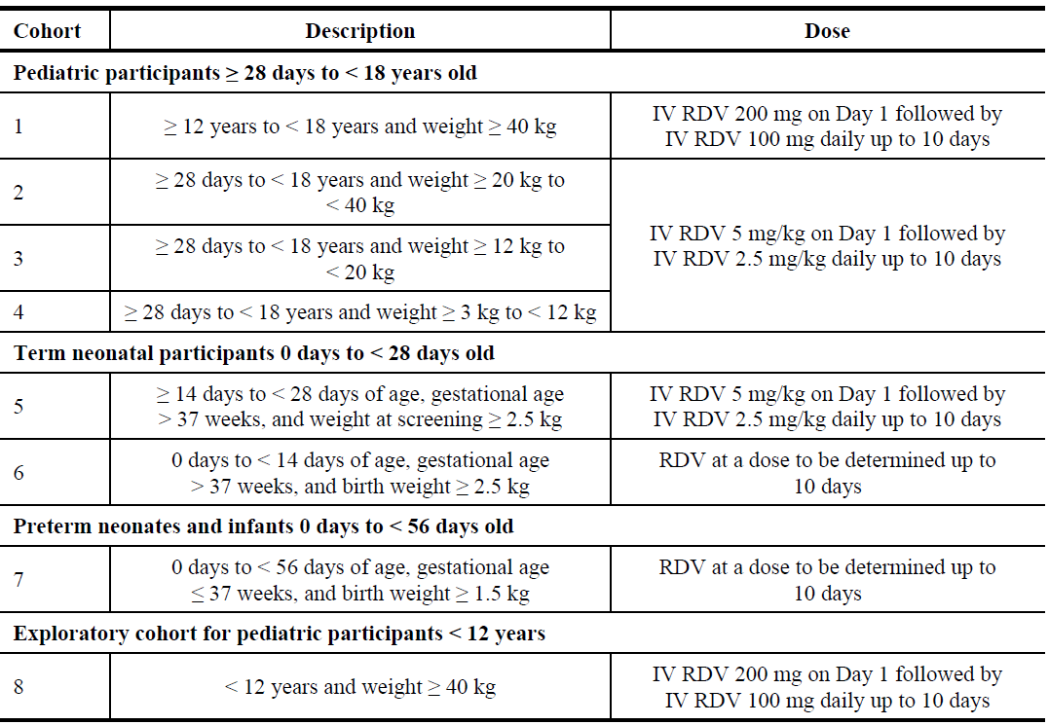
IV = intravenous, RDV = remdesivir (GS-5734)
Each cohort enrolled 12 patients except Cohort 8, which had five patients, for a total of 53 patients in the full analysis population (Table 4). Patients received remdesivir for up to ten days following enrolment. The Delegate notes that Cohorts 2 to 4 received the dosage regimen proposed by the sponsor for registration.
Table 4: Study GS-US-540-5823 Baseline weight and size of patients in each cohort
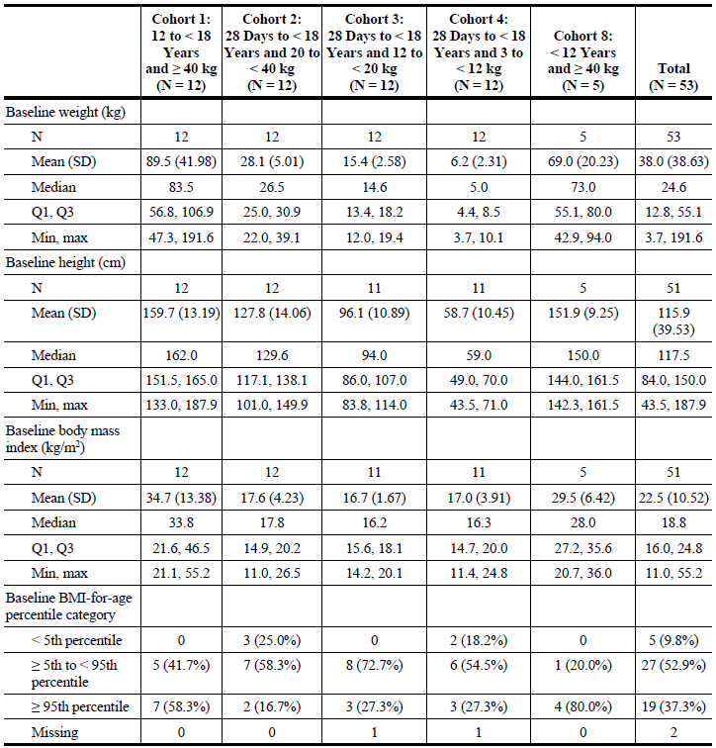
BMI = body mass index; CDC = Centers for Disease Control and Prevention; max = maximum; min = minimum; Q1 = first quartile; Q3 = third quartile; SD = standard deviation; WHO = World Health Organization.
For race and ethnicity, ‘Not permitted’, ‘Missing’ and ‘Other’ were excluded from the percentage calculation.
‘Not permitted’ = local regulators did not allow collection of race/ethnicity information.
BMI (kg/m²) = weight (kg)/height (cm2) x 10,000
BMI percentile for children < 24 months old was computed using WHO SAS package: www.who.int/toolkits/child-growth-standards/software
BMI percentile for children 24 months or older was computed based on CDC: www.cdc.gov/nccdphp/dnpao/growthcharts/resources/sas.htm
The mean age and sex composition of each cohort is shown in Table 5.
Table 5: Study GS-US-540-5823 Age and sex of patients enrolled in each cohort
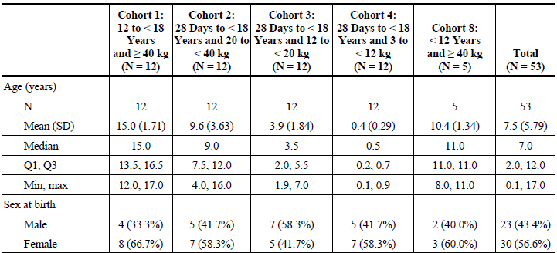
Max = maximum; Min = minimum; N = sample size; Q1 = first quartile; Q3 = third quartile; SD = standard deviation
Table 6: Study GS-US-540-5823 Clinical status of patients in each cohort at Baseline
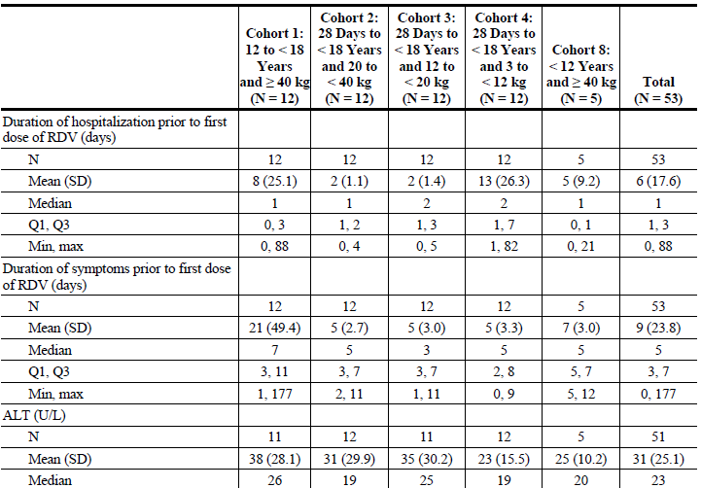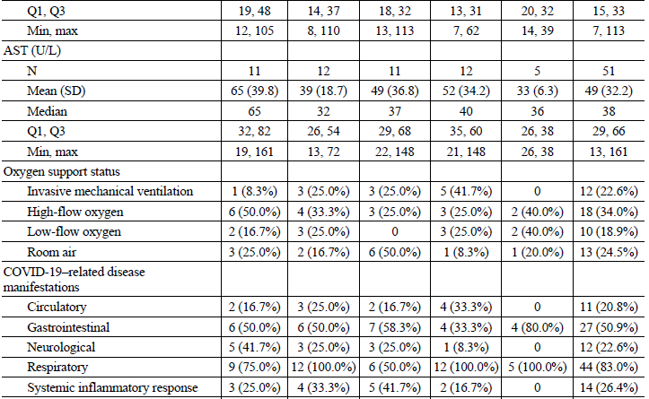
ALT = alanine aminotransferase; AST = aspartate aminotransferase; min = minimum; max = maximum; RDV = remdesivir (GS-5734); SD = standard deviation; Q1 = first quartile; Q3 = third quartile.
The median duration of hospitalisation prior to the first dose of remdesivir was 1 to 3 days and the median duration of symptoms prior to hospitalisation was five days (Table 6).
Most patients (75.5%) were receiving supplemental oxygen. The lowest weight cohort had the highest rate of invasive ventilation (41.7%) as well as the highest rate of circulatory (33.3%) and respiratory (100%) manifestations of disease. The had a relatively low rate (16.7) of COVID related systemic inflammatory response compared to other cohorts (Table 6).
The PK evaluator has noted that the proposed model was complex as it had to account for broad range of variables, but overall performed relatively well. Bodyweight was the most significant variable affecting exposure to remdesivir and its metabolites. However, the median exposure to remdesivir and its metabolites was higher in the paediatric patients than in adult patients, being 5 to 6 times higher than median exposure by cohort in 2 of 21 subjects in Cohorts 3 and 4. The sponsor has noted that there were no significant differences in the exposures of remdesivir or its metabolites between patients with or without the seven most common adverse events.

Study GS-US-540-9012 (Pinetree trial)
Study GS-US-540-9012 (Pinetree trial) was a Phase III study which was intended to examine the safety and efficacy of three days of remdesivir outpatient treatment for COVID-19 in 1230 patients randomised in a 1:1 ratio to remdesivir (n = 615) or placebo (n = 615). Study enrolment was terminated early for administrative reasons, which included declining COVID-19 cases in the study sites and the availability of monoclonal therapies as a comparator. It therefore only recruited 584 patients.
Included patients were enrolled in two site determined cohorts, either > 18 years of age (all sites) or 12 to 18 years of age and > 40 kg body mass (where approved). However, only 3 patients < 18 years of age were recruited to active, and five to placebo treatment, making a stratified analysis impossible.
All patients had at least one pre-existing risk factor for progression to hospitalisation. They had not received nor were expected to receive supplemental oxygen at the time of enrolment and did not require hospitalisation at enrolment. Patients received three days of remdesivir treatment (Table 7).
The primary endpoint was hospitalisation or death by Day 14. All causes of hospitalisations were examined a post-hoc endpoint.
Table 7: Study GS-US-540-9012 Efficacy endpoints
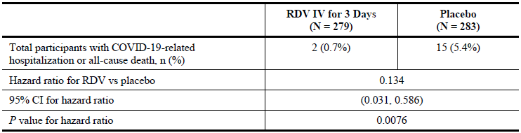
CI = confidence intervals COVID-19 = coronavirus disease 2019; IV = intravenous; RDV = remdesivir (GS-5734)
Proportion of COVID-19 related hospitalisation or all cause death by Day 28 from Kaplan-Meier estimate.
Hazard ratio, 2 sided 95% confidence interval (CI) and P value were estimated using the Cox regression with baseline stratification factors as covariates.
Hazard ratio was adjusted for baseline stratification factors.
No deaths had occurred in either treatment arm by Day 14, meaning that the primary endpoint was driven by the occurrence of hospitalisation.
Table 8: Study GS-US-540-9012 Proportion of participants progressing to requiring oxygen supplementation by Day 28 (full set analysis)
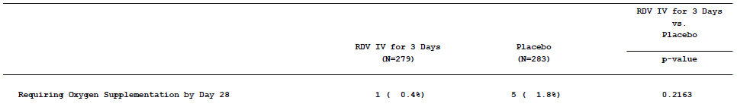
The proportion of patients requiring oxygen supplementation at Day 28 was 0.4% in the remdesivir group and 1.8% in the placebo group and this difference did not reach statistical significance (p = 0.2163) (Table 8).
Table 9: Study GS-US-540-9012 Stratified analysis of efficacy endpoints
A subgroup analysis indicates there were no occurrences of the primary endpoint in the remdesivir treatment arm in patients for whom their risk factor was chronic lung disease, cardiovascular disease or current cancer (Table 9).

Study GS-US-540-5774
The clinical evaluator has noted that this study had significant methodological flaws that render it not usable for an analysis of efficacy in the proposed indications.

Study GS-US-540-5776 (ACTT trial)
Study GS-US-540-5776 also known as adaptive COVID-19 treatment trial, (ACTT), was an adaptive methodology used to examine prospective COVID-19 treatments. An interim report was submitted in the initial provisional registration dossier for remdesivir;⁴ in Australia in 2020, and the final report has been submitted in this application.
Included patients were stratified by having mild to moderate disease or severe disease, but all were hospitalised. Mild to moderate subjects had oxygen saturation of > 94% and a respiratory rate < 24/minute on room air. Severe disease subjects either required mechanical ventilation, had oxygen saturation < 94% on room or a respiratory rate of > 24/minute on room air.
The primary endpoint of ACTT was to assess time to recovery of patients receiving remdesivir compared to those in the control arm. Time to recovery was defined as the number of days from randomisation required to achieve an improvement in an eight point ordinal symptoms scale from 4 to 7 (baseline) to 1 3 (after treatment). The scale used is shown in Table 10 and Figure 1.
Table 10: Study GS-US-540-5776 (ACTT trial) Ordinal index of clinical severity
Score | Definitions
1 | Not hospitalised, no limitations
2 | Not hospitalised, with limitations
3 | Hospitalised, no active medical problems
4 | Hospitalised, not on oxygen
5 | Hospitalised, on oxygen
6 | Hospitalised, on high flow oxygen or non-invasive mechanical ventilation
7 | Hospitalised, on mechanical ventilation or ECMO
8 | Death
Figure 1: Study GS-US-540-5776 (ACTT trial) Patient disposition
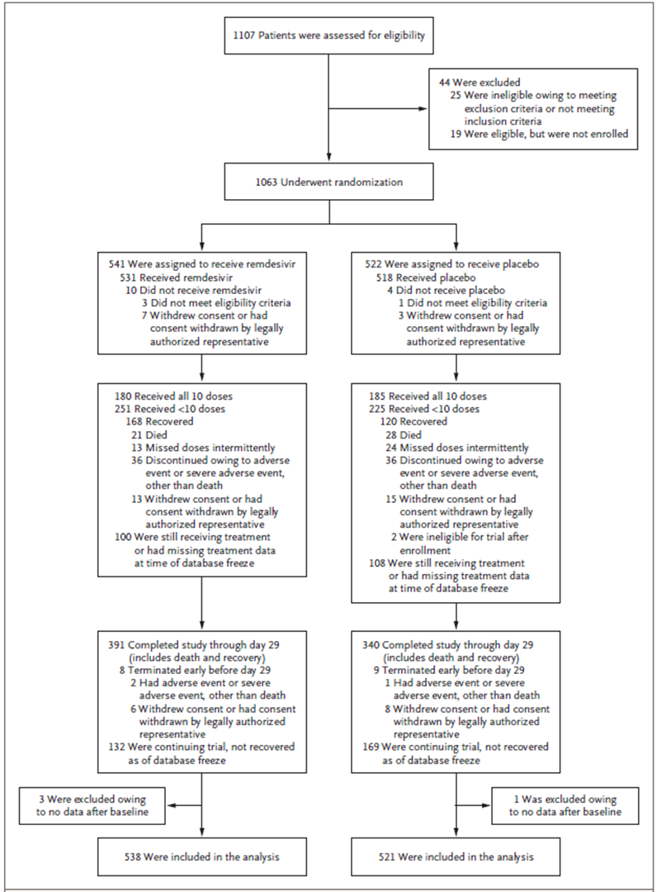
Figure 2: Study GS-US-540-5776 (ACTT trial) Kaplan-Meier plots of time to recovery
CI = confidence interval; HR = hazard ratio
There was a statistically significant reduction in medial time to recovery in patients with severe disease receiving remdesivir, which was ten days (95% confidence interval (CI) 9 to 11), compared to 15 days (95% CI 13 to 18) in placebo patients. No difference in time to recovery was in patients with mild to moderate disease (Figure 2).
The clinical evaluator has noted that this trial was conducted before standard of case included steroids and so the difference in treatment arms may not be as great with a contemporary comparator arm.

Study GS-US-540-5823
Study GS-US-540-5823 investigate remdesivir safety and efficacy in paediatrics population. Efficacy analysis was a secondary objective of this study.
Clinical improvement was assessed by change in a seven point ordinal scale from Baseline. Recovery was defined as an improvement from Baseline score of 2 to 5 to one of 6 or 7, or an improvement from Baseline score of 6 to 7 (Table 11).
Table 11: Study GS-US-540-5823 Ordinal index of disease severity used to assess clinical response
Score | Definition
1 | Death
2 | Hospitalised, on invasive ventilation or ECMO
3 | Hospitalised, non-invasive ventilation or high-flow oxygen
4 | Hospitalised, low flow oxygen
5 | Hospitalised, room air but requiring ongoing medical care
6 | Hospitalised, room air and not requiring ongoing medical care
7 | Not hospitalised
The proportion of subjects who recovered was 83% (44 out of 53 subjects) at the time of last assessment, with at least 75% of patients in each cohort achieving recovery.
For patients discharged alive by Day 30, the median duration of hospitalisation for all cohorts was seven days (interquartile range of 5 to 12). By Day 10 and Day 30 the proportion of patient discharged was 60.4% and 83% respectively.
The clinical evaluator has noted that there was no comparison of efficacy based on age or weight.
Table 12: Study GS-US-540-5823 Baseline disease severity in cohorts
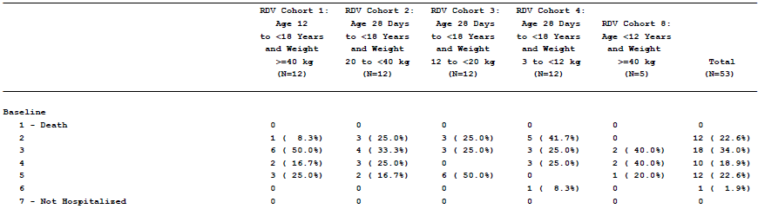
The Delegate notes that the youngest/lowest weight Cohort 4 were generally more severely ill than the other cohorts at Baseline (Table 12).
Table 13: Study GS-US-540-5823 Change from Baseline at Day 10 of patients in Cohorts 1 to 4 and Cohort 8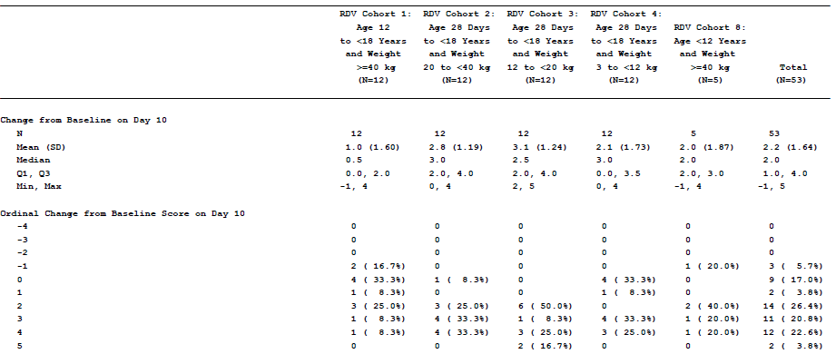
Of Cohort 4, 4 subjects (33.3%) showed no improvement from Baseline by Day 10 compared to 17% of the overall trial subjects. This suggests to the Delegate that the efficacy of remdesivir in treating more severe disease in this very young/low weight group is likely to be less than that observed in the general population (Table 13).
Negative COVID-19 polymerase chain reaction detections on Days 2 to 10 were reported for 42.1% (8 out of 19) of total participants with nasal oropharyngeal samples, 21.4% (6 out of 28) participants with nasopharyngeal/oropharyngeal samples or 22.2% (2 out of 9) of participants with endotracheal aspirates.

Study IN-US-540-5755
This was an open label review of outcomes from 163 cases of compassionate use of remdesivir before March 2020. Approximately 80% of these patients survived and nearly half showed clinical improvement. The clinical evaluator has noted that the non-comparative nature of the study and the uncertain methodology behind the patient selection render this study inconclusive.

Study GS-US-540-5755
This was a report of 77 paediatric patients who received compassionate use between March and August 2020.
At Baseline 50.6% (n = 39) of the patients had invasive oxygen support and 49.4% (n = 38) did not (Table 14).
Table 14: Study GS-US-540-5755 Baseline characteristics of compassionate use recipients
Clinical outcomes at Day 28 were assessed on a six point ordinal scale (Table 15).
Table 15: Study GS-US-540-5755 Six-point ordinal scale used to assess clinical outcomes
Score | Definition
1 | Not hospitalised (discharge)
2 | Hospitalised, not requiring supplement oxygen (room air)
3 | Hospitalised, requiring supplement (low flow) oxygen
4 | Hospitalised, requiring high flow oxygen and/or NIPPV
5 | Hospitalised, requiring invasive mechanical ventilation and/or ECMO
6 | Death
Recovery was defined as improvement from (1) room air at Baseline to discharge or (2) oxygen support of any kind at Baseline to room air or discharge.
Overall, 83.1% of the patients recovered, 72.7% were discharged and 83.1% observed a > 2 point clinical improvement.
The Delegate notes that 12 of the patients were < 1 year of age, and approximately half of them were > 12 years of age.

Safety

Clinical safety in paediatrics
Patient exposure in Study GS-US-540-5823 is listed in Table 16.
Table 16: Study GS-US-540-5823 Patient exposure
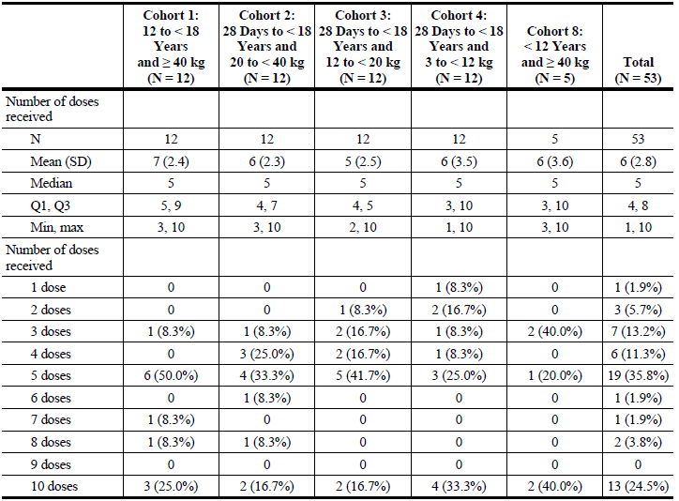
Max = maximum; min = minimum; Q1 = first quartile; Q3 = third quartile
In this study patients received remdesivir for a median duration of five days (interquartile range, 4 to 8) during the study. Only approximately a quarter of patients reached ten days of treatment.
Table 17: Study GS-US-540-5823 Summary of adverse events
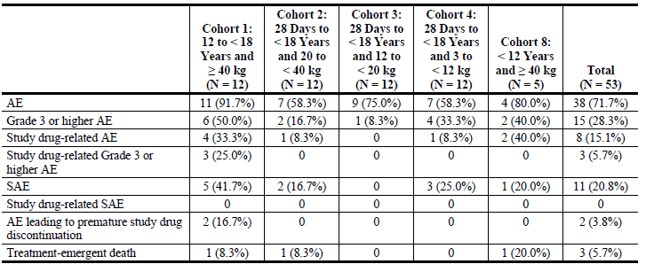
AE = adverse events; DAIDS = Division of AIDS; MedDRA = Medical Dictionary for Regulatory Activities
Adverse events were coded using MedDRA Version 24.
Severity grades were defined by the DAIDS Table for Grading the Severity of Adult and Paediatric Adverse Events, Version 2.1, July 2017.
Treatment emergent death refers to deaths that occurred between the first dose date and the last dose date plus 30 days (inclusive).
One participant died 32 days after the last dose date and is not counted as a treatment emergent death.
A total of 71.7% (n = 38) subjects experienced one adverse event, with 28.3% of these being Grade 3 or higher. Overall, 8 participants experienced an adverse event considered related to study drug (Table 17).
Serious adverse events were reported in 11 participants, but none were considered related to study drug (Table 17).
Three treatment emergent deaths occurred during the study, all in patients with comorbidities. These are not noted to have been considered related to study drug.
Overall, 47 participants (90.4%) had at least one laboratory abnormality, which were Grade 3 or 4 in 42.3% (n = 22) of participants overall. The most common Grade 3 to 4 laboratory abnormalities was decreased haemoglobin (17.6%). In general, alanine aminotransferase (ALT) increased in subjects during remdesivir treatment but returned to baseline by Day 30.

Clinical safety in adults
Safety data for use of remdesivir in adults was investigated in Study GS-US-540-9012. Overall, 56.1% (n = 282) participants had at least one adverse event. The most common of these was nausea (8.2%), diarrhoea (5.6%) and headache (5.4%). Most of these adverse events were Grade 1 or 2.
There were 13 treatment emergent deaths reported during follow up in Study GS-US-540-5774 Part B, which the clinical evaluation report has not noted to be considered related to study drug. Hepatic adverse events were reported in 10.1% of patients, the most common being ALT rise (3.6) and transaminase rise (3.2%). One participant had a Grade 1 hepatitis that was considered related to study treatment. Median ALT and aspartate aminotransferase for the study population rose over treatment to a clinically non-significant extent.
No renal adverse events were considered related to study treatment.
The clinical evaluator has noted that overall safety for remdesivir in the submitted adult trials was comparable to data from previous trials.

Risk management plan
Pending final RMP recommendation/report
The most recently evaluated EU-risk management plan (RMP) was version 1.0 (24 June 2020; 27 May 2020). No Australia specific annex (ASA) has been evaluated for Veklury thus far. EU RMP version 2.0 and ASA version 2.0 were also submitted to the TGA as an RMP update in September 2021. In support of this extension of indication the sponsor has submitted EU-RMP version 3.2 (date 22 January 2022; data lock point (DLP) 2 Jan 2022) and ASA version 2.0 (date September 2021) and subsequently ASA version 3.0 (date March 2022) following TGA recommendation.
The summary of safety concerns and their associated risk monitoring and mitigation strategies are summarised in Table 18.
Table 18: Summary of safety concerns and their associated risk monitoring and mitigation strategies
Summary of safety concerns |  | Pharmacovigilance |  | Risk Minimisation
 |  | Routine | Additional | Routine | Additional
Important identified risks | None | – | – | – | –
Important potential risks | None | – | – | – | –
Missing information | Safety in patients with hepatic impairment |  | * |  | –
Missing information | Safety in patients with severe renal impairment |  | * |  | –
Missing information | Safety in pregnant and lactating women |  | † |  | –
* post authorisation safety, efficacy, and pharmacokinetic studies
† pregnancy safety report (informed by follow up questionnaires) and study of the pharmacokinetics and safety of RDV (remdesivir) in pregnant women (Study IMPAACT 2032)
The proposed summary of safety concerns is considered acceptable from an RMP perspective. Current nonclinical, clinical and ACM advice have been considered when reaching this decision.
The proposed pharmacovigilance activities are considered acceptable. The sponsor confirmed that they partner with the COVID-19 International Drug Pregnancy Registry (COVID-PR). The sponsor commits that when they receive reports from this registry, they will include these reports in the yearly pregnancy report submitted with the Periodic Safety Update Report (PSUR). In addition, these cases would be summarised in the PSUR period section of Safety in Pregnant and Lactating Women and in the cumulative pregnancy outcomes within the PSUR.
Routine risk minimisation measures are considered acceptable to address the risks associated with this product.

Proposed wording for conditions of registration
Any changes to which the sponsor has agreed should be included in a revised RMP and ASA. However, irrespective of whether or not they are included in the currently available version of the RMP document, the agreed changes become part of the risk management system.
The Veklury EU-Risk Management Plan (RMP) (version 3.2; date 22 Jan 2022; DLP 02 Jan 2022), with ASA (version 3.0, dated March 2022), included with submission PM-2022-00260-1-2, and any subsequent revisions, will be implemented in Australia.
Unless agreed separately between the supplier who is the recipient of the approval and the TGA, the first report must be submitted to TGA no later than 15 calendar months after the date of the approval letter. The subsequent reports must be submitted no less frequently than annually from the date of the first submitted report until the period covered by such reports is not less than three years from the date of the approval letter, or the entire period of provisional registration, whichever is longer.
The reports are to at least meet the requirements for PSURs as described in the European Medicines Agency’s Guideline on good pharmacovigilance practices (GVP) Module VII-periodic safety update report (Rev 1), Part VII.B Structures and processes. Note that submission of a PSUR does not constitute an application to vary the registration. Each report must have been prepared within ninety calendar days of the data lock point for that report.
Veklury (remdesivir) is to be included in the Black Triangle Scheme. The PI and Consumer Medicines Information (CMI) for Veklury must include the black triangle symbol and mandatory accompanying text for the products entire period of provisional registration.

Risk-benefit analysis

Delegate’s considerations

Regulatory action proposed in the application
The Delegate note that this is a complex application, both in terms of the data submitted and interpreting how this correlates with the regulatory actions the sponsor has proposed.
remdesivir is currently provisionally registered for the following indication:
Veklury has provisional approval for the treatment of Coronavirus Disease 2019 (COVID-19) in adults and adolescents (aged 12 years and older weighing at least 40 kg) with pneumonia, requiring supplemental oxygen (see Section 5.1).
The decision to approve this medicine has been made based on limited data. More comprehensive evidence is required to be submitted.
The sponsor has proposed to extend this indication to:
Adults and paediatric patients (at least 4 weeks of age and weighing at least 3 kg) with pneumonia, requiring supplemental oxygen (low- or high-flow oxygen or other non-invasive ventilation at start of treatment) (see section 5.1).
Adults and paediatric patients (weighing at least 40 kg) who do not require supplemental oxygen and who are at increased risk of progressing to severe COVID-19
This proposed new indication includes treatment of three new patient populations.
- Patients with pneumonia requiring supplemental oxygen > 4 weeks of age and weighting at least 3 kg but under 12 years of age. Note that patients > 12 years of age are already in the current indication.
- Paediatric patients who weigh at least 40 kg and do not require supplemental oxygen but are at increased risk of progressing to severe COVID-19.
- Adult patients (who weigh at least 40 kg) and do not require supplemental oxygen but are at increased risk of progressing to severe COVID-19.
The Delegate notes that neither the clinical evaluator nor the toxicology evaluator have expressed unreserved support for the use of remdesivir in Population 1. The clinical evaluator has recommended approving the use of remdesivir in Population 3, with the toxicology evaluator having no expressed concerns with adult use of remdesivir.

Legislative context of this application
Remdesivir is currently ‘Provisionally Registered’ by TGA. Provisional registration allows the TGA to consider applications based on ‘preliminary data’, but the criteria for decisions regarding applications to provisionally register a product are set out in Section 25 of the Therapeutic Goods Act, which states (regarding clinical safety and efficacy):
1(d) for an application for provisional registration of a medicine:
      - whether, based on preliminary clinical data, the safety and efficacy of the medicine for the purposes for which it is to be used have been satisfactorily established; and
      - whether the quality of the medicine for the purposes for which it is to be used has been satisfactorily established; and
      - whether, if the Secretary were to register the medicine, the Secretary is satisfied with the applicant’s plan to submit comprehensive clinical data on the safety and efficacy of the medicine before the end of the 6 years that would start on the day that registration would commence
The Delegate notes that the pertinent phrase is that the safety and efficacy of the medicine for the purposes for which it is to be used must be ‘satisfactorily established’, although the data is acknowledged to be preliminary.
The Delegate notes that this is different from the criteria for the FDA’s Emergency Use Authorization (EUA), which might otherwise be taken as a comparable international assessment material to this application.

Use of remdesivir in patients with pneumonia requiring supplemental oxygen > 4 weeks of age (but under 12 years of age) and weighting at least 3kg
The Delegate agrees with the clinical evaluator summary that ‘robust efficacy data in paediatric patients with COVID-19 are lacking in this extension of indication application’.
The main deficiencies which the Delegate considers material are:
- The population of patients < 12 years presented in the studies is too small to estimate population efficacy or safety. In Study GS-US-540-5823, only 41 patients were < 12 years of age and of these only 36 patients in Cohorts 2 to 4 received the proposed dose regimen of remdesivir. The second compassionate use report provides data on 36 additional patients under 12 years of age.
- There is a particular deficiency of patients in the lowest weight groups in which toxicity from remdesivir and the excipient sulfobutylether-beta-cyclodextrin (SBECD) is considered most likely to occur. There are only 12 patients in Study GS-US-540-5823 in the < 1 year old cohort, and the second compassionate use report only adds another 12 patients to this. The toxicity of SBECD has not been examined in young animals in the preclinical data, and the clinical studies have not monitored for its accumulation.
- The population of 72 patients < 12 years of age and receiving the proposed dose of remdesivir is, apart from being a minimal population on which to base a conclusion of efficacy or safety, not analysed against a comparator. It is therefore not possible to test hypothesis that remdesivir is comparable to standard of care in either efficacy or safety. The Delegate notes that Study GS-US-540-5823 only included efficacy as a secondary analysis, being primarily designed for pharmacokinetics and safety.
- While the recovery rates observed in the non-comparative trials provided are in some cases high, the Delegate notes that this appears that this is most evident in older children. A third of the Cohort 4 children in Study GS-US-540-5823 who were proportionally more unwell than the general population failed to improve on remdesivir therapy.
- 75% of the children in the second compassionate use report recovered but it is difficult to map this population onto the proposed indication as 21.1% of them were on room air at Baseline (that is not requiring supplemental oxygen) and whether the patients had pneumonia is not clear.
The Delegate concludes that there is insufficient data in patients < 12 years of age to satisfactorily demonstrate efficacy and safety, this being a question of the absence of adequate data rather than its ‘preliminary’ nature. This deficiency is most marked in the youngest patients. The Delegate notes that the efficacy and safety of remdesivir in children > 12 years old who have pneumonia has been accepted but does not consider this can be extrapolated to the paediatric cohort without an appropriately age-stratified analysis of outcomes in statistically meaningful numbers.

Use of remdesivir in paediatric patients who weigh at least 40 kg and do not require supplemental oxygen but are at increased risk of progressing to severe COVID-19
The Delegate notes that, based on 50% weight for age percentiles, a 40 kg child is likely to be about 12 years of age. Therefore, this maps closely to the current US FDA indication, that specifies paediatric patients aged over 12 years of age in this indication.
This expansion of the indicated population is linked to the same proposed use of remdesivir in adults and is mainly supported by Study GS-US-540-9012 (Pinetree trial). The clinical evaluator has noted that the ACTT does not inform the use of remdesivir in patients who do not have severe disease or require supplemental oxygen, since all the patients in this study were hospitalised and 85% had severe disease.
The Delegate notes Pinetree trial does not provide any direct evidence to support for the use of remdesivir in paediatric patients in this proposed indication because it only enrolled three patients to active therapy under the age of 18 years of age and five to placebo. This is not a sufficient basis for a stratified paediatric analysis of the efficacy or safety of remdesivir in this group.
The Delegate notes that efficacy and safety in > 12 years old might be imputed from the adult efficacy data in Pinetree trial depending on the clinical risk benefit balance of exposing patients to remdesivir who have a limited risk of hospitalisation with vaccination and contemporary strains.
The Delegate notes that the current FDA USA indication in this respect proposes use in patients at ‘high risk of progression to severe COVID-19, including hospitalisation and death’ which may be more suitable.

Use of remdesivir in adult patients (who weigh at least 40 kg) and do not require supplemental oxygen but are at increased risk of progressing to severe COVID-19
Study GS-US-540-9012 (Pinetree trial) provides evidence for a reduction in the rate of hospitalisation but not death at Day 28 in those:
- were not vaccinated (as the study preceded widespread vaccination);
- had one or more comorbidities for severe disease;
- were of an average age of 50 (interquartile range 40 to 61); and
- did not need hospitalisation or supplemental oxygen at Baseline.
The clinical evaluator has noted that the ACTT trial does not inform the use of remdesivir in patients who do not have severe disease or require supplemental oxygen, since all the patients in this study were hospitalised and 85% had severe disease.
The treatment consisted of three days of remdesivir administered at the proposed > 12 years old and weighing more than 40 kg dose, that is 200 mg on the first dose followed by 100 mg on subsequent doses.
The Delegate notes that no deaths occurred in either treatment arm of this study and so efficacy against the composite endpoint of hospitalisation plus death cannot be sustained, but rather only a reduction in hospitalisation rate at 28 days.
The Delegate considers that the efficacy of remdesivir in this use has been established but is not certain that the degree of benefit observed in a contemporary vaccinated population is likely to warrant exposing the patient to a potentially toxic medication which requires a supervised environment. This is likely to be a case by case determination based on patient co-morbidities.
The Delegate notes that the current US FDA indication in this respect proposes use in patients at ‘high risk of progression to severe COVID-19, including hospitalization and death’ which may be more suitable.

Proposed action
The Delegate is currently minded to:
- not approve the extension of indications for remdesivir to paediatric patients > 3 kg in weight with pneumonia requiring supplemental oxygen.
- not approve the extension of indications for remdesivir to paediatric patients > 40 kg who do not require supplemental oxygen but are at increased risk of progressing to severe COVID-19.
- approve the extension of indications for remdesivir to include adult patients who do not require supplemental oxygen but are at increased risk of progressing to severe COVID-19.
This will mean approving a new indication that read:
Adults with pneumonia requiring supplemental oxygen (low or high flow oxygen at start of treatment.
Adults who do not require supplemental oxygen and who are at increased risk of progressing to severe COVID-19

Advisory Committee considerations
The Advisory Committee on Medicines (ACM), having considered the evaluations and the Delegate’s overview, as well as the sponsor’s response to these documents, advised the following.

Specific advice to the Delegate
The ACM advised the following in response to the Delegate’s specific request for advice:
- Whether, based on preliminary clinical data, the safety and efficacy of the medicine for the purposes of treating paediatric patients > 3 kg in weight with pneumonia requiring supplemental oxygen has been satisfactorily established?
The ACM noted that remdesivir appears to be well tolerated in clinical practice and that this has been confirmed by the studies included within the data package. The ACM however highlighted that the primary paediatric treatment study was not powered for efficacy, but rather designed as a pharmacokinetic (PK) study and inferred efficacy from adult data. The ACM noted that based on available PK data, the exposure of remdesivir in paediatric patients at the proposed dosing schedules is likely to achieve similar efficacy to adults. There was considerable inter-patient variability in exposure, but this was consistent with the variation observed in adults, and was mainly seen with the pro-drug reflecting the short half life of the parent compound.
Considering the use of PK modelling, the ACM agreed that the restriction to greater than 4 weeks of age is appropriate, particularly given the significant variation in perinatal PK variables and already restricted PK evidence for the neonatal age group.
The ACM highlighted the importance of consultation with an expert experienced with treating COVID-19 in children and the development of clinical guidelines to support the use of remdesivir within the paediatric population.
On balance the ACM was of the view that the risk-benefit is likely to be favourable in paediatric patients with established moderate to severe disease, particularly given the lack of approved treatments currently available to this cohort.
The ACM was supportive of an indication for paediatric patients (at least 4 weeks of age and weighing at least 3 kg) with pneumonia due to SARS-CoV-2, requiring supplemental oxygen.
The ACM noted that the indication should state pneumonia due to SARS-CoV-2 rather than just pneumonia as this aligns with the provided study data.
- Whether, based on preliminary clinical data, the safety and efficacy of the medicine for the purposes of treating paediatric patients > 40 kg who do not require supplemental oxygen but are at increased risk of progressing to severe COVID-19 has been satisfactorily established?
The ACM noted that the rate of progression to severe COVID-19 even within high-risk cohorts appears low in the paediatric population. The ACM however agreed that for those paediatric patients most susceptible to progression to severe COVID-19 treatment may be beneficial. However, in providing this advice the ACM highlighted that only a small number of paediatric patients (particularly those aged less than 12 years and weighing greater than 40 kg) were included within the provided clinical studies for this ‘at risk’ indication.
On balance, the ACM was of the view that the risk-benefit is likely to be favourable in paediatric patients at high risk of progressing to severe COVID-19, particularly given the lack of approved treatments currently available to this small cohort.
The ACM again highlighted the importance of consultation with an expert experienced with treating COVID-19 in children and the development of clinical guidelines to support the use of remdesivir within the paediatric population.
The ACM was supportive of an indication for paediatric patients > 40 kg who do not require new supplemental oxygen but are at increased risk of progressing to severe COVID-19.
The ACM noted that the indication should not exclude those on long term supplemental oxygen for comorbidities and suggested the phrase ‘new supplemental oxygen’ or similar could be included within the indication.
The ACM further noted that the clinical trial inclusion criteria for high risk of progression patients should be included within the PI, however agreed that these criteria will likely evolve over time.
- Whether the limitation of indication (2) should be limited to ‘high risk of progression to severe COVID-19’ in either adult or paediatric populations?
The ACM was supportive of the inclusion of ‘high risk of progression to severe COVID-19’ for both the adult and paediatric population indications. The ACM noted that comorbidities were part of the study inclusion criteria and it is appropriate to reflect this within the indications.
- Other advice
The ACM was of the view that the indication wording should include ‘supplemental oxygenation’ rather than ‘supplemental oxygen (low-or high –flow oxygen or other non-invasive ventilation at start of treatment)’ as this is consistent with the current remdesivir indication and more in line with the clinical evidence presented.
The ACM emphasised that this therapy is not an alternative or substitute for vaccination. The ACM reiterated its view that vaccination is the preferred and primary option to prevent COVID-19.

Conclusion
The ACM considered this product to have an overall positive benefit-risk profile for the provisional indication:
Adults and paediatric patients (at least 4 weeks of age and weighing at least 3 kg) with pneumonia due to SARS-CoV-2, requiring supplemental oxygen.
Adults and paediatrics patients (weighing at least 40 kg) who do not require new supplemental oxygen and who are at increased risk of progressing to severe COVID-19.
The decision has been made on the basis of short-term efficacy and safety data. Continued approval depends on the evidence of longer-term efficacy, safety from ongoing clinical trials and post-market assessment.

Outcome
Based on a review of quality, safety and efficacy, the TGA approved the registration of Veklury (remdesivir) 100 mg, powder for injection, vial, indicated for the following extension of indications:
Disease and setting
Veklury has provisional approval for the treatment of coronavirus disease 2019 (COVID-19) in:
- paediatric patients (at least 4 weeks of age and weighing at least 3 kg) who have pneumonia due to SARS-CoV-2, and who require supplemental oxygen.
- adults and paediatric patients (weighing at least 40 kg) who do not require supplemental oxygen and who are at high risk of progressing to severe COVID-19.
The decision to approve this medicine has been made based on limited data. More comprehensive evidence is required to be submitted.
As such, the full indications at this time were:
Veklury has provisional approval for the treatment of coronavirus disease 2019 (COVID-19) in:
- adults and paediatric patients (at least 4 weeks of age and weighing at least 3 kg) who have pneumonia due to SARS-CoV-2, and who require supplemental oxygen.
- adults and paediatric patients (weighing at least 40 kg) who do not require supplemental oxygen and who are at high risk of progressing to severe COVID-19.
The decision to approve this medicine has been made based on limited data. More comprehensive evidence is required to be submitted.

Specific conditions of registration applying to these goods
- Veklury (remdesivir) is to be included in the Black Triangle Scheme. The PI and CMI for Veklury must include the black triangle symbol and mandatory accompanying text for the products entire period of provisional registration.
- The Veklury EU- RMP (version 3.2; dated 22 January 2022; DLP 2 January 2022), with ASA (version 3.0, dated March 2022), included with submission PM-2022-00260-1-2, and any subsequent revisions, will be implemented in Australia.
Unless agreed separately between the supplier who is the recipient of the approval and the TGA, the first report must be submitted to TGA no later than 15 calendar months after the date of the approval letter. The subsequent reports must be submitted no less frequently than annually from the date of the first submitted report until the period covered by such reports is not less than three years from the date of the approval letter, or the entire period of provisional registration, whichever is longer.
The reports are to at least meet the requirements for PSURs as described in the European Medicines Agency’s Guideline on good pharmacovigilance practices (GVP) Module VII-periodic safety update report (Rev 1), Part VII.B Structures and processes. Note that submission of a PSUR does not constitute an application to vary the registration. Each report must have been prepared within ninety calendar days of the data lock point for that report.
- Confirmatory trial data (as identified in the sponsor’s plan to submit comprehensive clinical data on the safety and efficacy of the medicine before the end of the 6 years that would start on the day that registration would commence) must be provided.
Specifically, the sponsor must provide the study reports for studies as specified in part III.2. Additional Pharmacovigilance activities of the Veklury EU-Risk Management Plan (RMP) (Version 1.0, dated 24 June 2020, data lock point 27 May 2020).
Clinical study reports (CSRs) for the following remdesivir studies/data should be submitted to the TGA, once available:
  - Remdesivir pregnancy safety reports (yearly submission of annual reports).
  - Phase I study in subjects with hepatic impairment (final CSR expected 31 July 2022).
  - Phase I study in subjects with severe renal impairment and subjects with endstage renal disease on dialysis (final CSR expected 31 January 2023).
- The following data should be provided to the TGA as a condition of registration:
  - a. The study on the activation potential of remdesivir on AhR and PXR (Study AD-399-2009).
  - b. Clinical isolates susceptibility data.
  - c. Study AD-540-2026 on P-gp inhibition by remdesivir metabolites.

Attachment 1. Product Information
The PI for Remdesivir approved with the submission which is described in this AusPAR is at Attachment 1. For the most recent PI, please refer to the TGA website at <https://www.tga.gov.au/product-information-pi>.

Therapeutic Goods Administration
PO Box 100 Woden ACT 2606 Australia
Email: info@tga.gov.au Phone: 1800 020 653 Fax: 02 6232 8605
https://www.tga.gov.au

The Black Triangle Scheme provides a simple means for practitioners and patients to identify certain types of new prescription medicines, including those being used in new ways and to encourage the reporting of adverse events associated with their use. The Black Triangle does not denote that there are known safety problems, just that the TGA is encouraging adverse event reporting to help us build up the full picture of a medicine's safety profile.
Current COVID-19 treatment with provisional approval is available at https://www.tga.gov.au/covid-19/covid-19-treatments (accessed on 27 April 2022).
EMA/CHMP/333892/2013 (https://www.ema.europa.eu/en/documents/scientific-guideline/questions-answers-cyclodextrins-used-excipients-medicinal-products-human-use_en.pdf).
AusPAR for initial application for Veklury - remdesivir – PM-2020-01491-1-2 available at https://www.tga.gov.au/auspar/auspar-remdesivir
GS-5734 is the drug development code used by sponsor for remdesivir
GS-5734 is the drug development code used by sponsor for remdesivir
Routine risk minimisation activities may be limited to ensuring that suitable warnings are included in the product information or by careful use of labelling and packaging. Routine pharmacovigilance practices involve the following activities: - All suspected adverse reactions that are reported to the personnel of the company are collected and collated in an accessible manner; - Reporting to regulatory authorities; - Continuous monitoring of the safety profiles of approved products including signal detection and updating of labelling; - Submission of PSURs; - Meeting other local regulatory agency requirements.
The ACM provides independent medical and scientific advice to the Minister for Health and the TGA on issues relating to the safety, quality and efficacy of medicines supplied in Australia including issues relating to pre market and post-market functions for medicines. Further information can be found here: https://www.tga.gov.au/committee/advisory-committee-medicines-acm.

