July 2020

Australian Public Assessment Report for Remdesivir
  - Proprietary Product Name: Veklury
  - Sponsor: Gilead Sciences Pty Ltd

About the Therapeutic Goods Administration (TGA)
- The Therapeutic Goods Administration (TGA) is part of the Australian Government Department of Health and is responsible for regulating medicines and medical devices.
- The TGA administers the Therapeutic Goods Act 1989 (the Act), applying a risk management approach designed to ensure therapeutic goods supplied in Australia meet acceptable standards of quality, safety and efficacy (performance) when necessary.
- The work of the TGA is based on applying scientific and clinical expertise to decision-making, to ensure that the benefits to consumers outweigh any risks associated with the use of medicines and medical devices.
- The TGA relies on the public, healthcare professionals and industry to report problems with medicines or medical devices. TGA investigates reports received by it to determine any necessary regulatory action.
- To report a problem with a medicine or medical device, please see the information on the TGA website <https://www.tga.gov.au>.

About AusPARs
- An Australian Public Assessment Report (AusPAR) provides information about the evaluation of a prescription medicine and the considerations that led the TGA to approve or not approve a prescription medicine submission.
- AusPARs are prepared and published by the TGA.
- An AusPAR is prepared for submissions that relate to new chemical entities, generic medicines, major variations and extensions of indications.
- An AusPAR is a static document; it provides information that relates to a submission at a particular point in time.
- A new AusPAR will be developed to reflect changes to indications and/or major variations to a prescription medicine subject to evaluation by the TGA.

Copyright
© Commonwealth of Australia 2020
This work is copyright. You may reproduce the whole or part of this work in unaltered form for your own personal use or, if you are part of an organisation, for internal use within your organisation, but only if you or your organisation do not use the reproduction for any commercial purpose and retain this copyright notice and all disclaimer notices as part of that reproduction. Apart from rights to use as permitted by the Copyright Act 1968 or allowed by this copyright notice, all other rights are reserved and you are not allowed to reproduce the whole or any part of this work in any way (electronic or otherwise) without first being given specific written permission from the Commonwealth to do so. Requests and inquiries concerning reproduction and rights are to be sent to the TGA Copyright Officer, Therapeutic Goods Administration, PO Box 100, Woden ACT 2606 or emailed to <tga.copyright@tga.gov.au>.

Contents
Common abbreviations 4
I. Introduction to product submission 7
Submission details 7
Product background 9
Regulatory status 10
Product Information 11
II. Registration timeline 11
III. Submission overview and risk/benefit assessment 12
Quality 12
Nonclinical 13
Clinical 14
Risk management plan 44
Risk-benefit analysis 46
Outcome 52
Attachments 1 and 2. Product Information 54

Common abbreviations
Abbreviation | Meaning
ACM | Advisory Committee on Medicines
AE | Adverse event
AhR | Aryl hydrocarbon receptor
ALT | Alanine aminotransferase
ARDS | Acute respiratory distress syndrome
ARTG | Australian Register of Therapeutic Goods
ASA | Australian specific Annex
AST | Aspartate aminotransferase
ATP | Adenosine triphosphate
AUC_{last} | Area under the plasma concentration-time curve from time zero to time of last measurable concentration
AUC_{tau} | Area under the plasma concentration time curve over dosing interval
BSEP | Bile salt export pump
CI | Confidence interval
CLr | Renal clearance
C_{max} | Maximum plasma concentration
CMI | Consumer Medicines Information
COVID-19 | Coronavirus disease 2019
CrCl | Creatinine clearance
CSR | Clinical study report
CV | Coefficient of variation
CYP3A | Cytochrome P450 enzyme family 3 subfamily A
DLP | Data lock point
ECMO | Extracorporeal membrane oxygenation
eGFR | Estimated glomerular filtration rate
EMA | European Medicines Agency (European Union)
EU | European Union
EU-RMP | European Union-risk management plan
EVD | Ebola virus disease
FDA | Food and Drug Administration (United States)
GS-5734 | Remdesivir (Veklury drug development name)
HEp-2 | Human epithelial type 2
HSA | Health Sciences Authority (Singapore)
IQR | Interquartile range
IMV | Invasive mechanical ventilation
IHR | International Health Regulations (WHO; 2005)
IV | Intravenous
IWRS | Interactive web response system
LRTI | Lower respiratory tract infection
M27 | Main uncharacterised human metabolite of remdesivir
MATE1/2K | Multidrug and toxin extrusion 1 and 2K
MRP4 | Multidrug resistance-associated protein 4
NIAID | National Institute of Allergy and Infectious Diseases (National Institutes of Health, United States)
NEWS2 | National Early Warning Score 2
OATP1B1 | Organic anion transporting polypeptide 1B1
OATP1B3 | Organic anion transporting polypeptide 1B3
OCT2 | Organic cation transporter 2
OR | Odds ratio
PBMC | Peripheral blood mononuclear cell
PBPK | Physiologically based pharmacokinetic(s)
PCR | Polymerase chain reaction
PD | Pharmacodynamic(s)
P-gp | P-glycoprotein
PHEIC | Public Health Emergency of International Concern (WHO)
PI | Product Information
PK | Pharmacokinetic(s)
PMDA | Pharmaceuticals and Medical Devices Agency (Japan)
PSUR | Periodic safety update report
PXR | Pregnane X receptor
RCT | Randomised controlled trial
RMP | Risk management plan
RNA | Ribonucleic acid
RR | Rate ratio
RSV | Respiratory syncytial virus
SAE | Serious adverse event
SARS-CoV-2 | Severe acute respiratory syndrome coronavirus 2
SBECD | Sulfobutylether-β-cyclodextrin
SOC | Standard of care
SpO₂ | Oxygen saturation
t_{½} | Terminal half-life
UGT | Uridine 5'-diphospho-glucuronosyltransferase
UK | United Kingdom
ULN | Upper limit of normal
USA | United States of America
WHO | World Health Organization

I. Introduction to product submission

Submission details
Type of submission: | New chemical entity
Product name: | Veklury
Active ingredient: | Remdesivir
Decision: | Approved for provisional registration;
Date of decision: | 10 July 2020
Date of entry onto ARTG: | 10 July 2020
ARTG numbers: | 338419, 338420
Black Triangle Scheme: | Yes  As a provisionally registered product, this medicine will remain in the Black Triangle Scheme for the duration of its provisional registration
Sponsor’s name and address: | Gilead Sciences Pty Ltd  Level 6, 417 St Kilda Road, Melbourne, Victoria 3004
Dose forms: | Concentrated injection, powder for injection
Strengths: | Concentrated injection: 100 mg/20 mL  Powder for injection: 100 mg
Container: | Vial
Pack size: | One
Approved therapeutic use: | Veklury has provisional approval for the treatment of Coronavirus Disease 2019 (COVID-19) in adults and adolescents (aged 12 years and older weighing at least 40 kg) with pneumonia, requiring supplemental oxygen.  The decision to approve this medicine has been made based on limited data. More comprehensive evidence is required to be submitted.  The provisional registration period for the above medicine is two years starting on the day specified in the Australian Register of Therapeutic Goods (ARTG) certificate of registration.
Route of administration: | Intravenous infusion
Dosage: | Use of Veklury is confined to healthcare facilities in which patients can be monitored closely. Veklury is for single use in one patient only.  The recommended dosage of Veklury in patients 12 years of age and older and weighing at least 40 kg is:  - Day 1: a single loading dose of Veklury 200 mg given by intravenous infusion  - Day 2 onwards: 100 mg given once-daily by intravenous infusion  The total duration of treatment should be at least 5 days and not more than 10 days.  For further information on dosage, refer to the Product Information.
Pregnancy category: | B2  Drugs which have been taken by only a limited number of pregnant women and women of childbearing age, without an increase in the frequency of malformation or other direct or indirect harmful effects on the human fetus having been observed.  Studies in animals are inadequate or may be lacking, but available data show no evidence of an increased occurrence of fetal damage.  The use of any medicine during pregnancy requires careful consideration of both risks and benefits by the treating health professional. This must not be used as the sole basis of decision making in the use of medicines during pregnancy. The TGA does not provide advice on the use of medicines in pregnancy for specific cases. More information is available from obstetric drug information services in your State or Territory.

Product background
This AusPAR describes the application by Gilead Sciences Pty Ltd (the sponsor) to register Veklury (remdesivir) 100 mg concentrate for injection and 100 mg powder for injection for the following proposed indication:
Veklury is indicated for the treatment of adults and paediatric patients weighing at least 3.5 kg with coronavirus disease 2019 (COVID-19).
Coronavirus disease 2019 (COVID-19) is caused by an infection with severe acute respiratory syndrome coronavirus 2 (SARS-CoV-2), a positive-stranded ribonucleic acid (RNA) betacoronavirus with a crown-like appearance. Direct person to person transmission is the primary form of transmission of the virus. Information available thus far indicates that infection can occur via contact with respiratory droplets from an infected person, or through touching the eyes, nose or mouth following contact with an infected surface.
SARS-CoV-2 was first identified in an outbreak of respiratory illness in Wuhan, Hubei Province, People’s Republic of China, in December 2019. Following the rapid spread of the virus and an increasing number of cases around the globe, on 30 January 2020, at the second meeting of the Emergency Committee convened by the World Health Organization (WHO) Director General under the International Health Regulations (IRC; 2005); the COVID-19 outbreak was declared to be a Public Health Emergency of International Concern (PHEIC)., Following further spread of the virus and a reported incidence of over 100,000 cases worldwide, the WHO characterised COVID-19 as a pandemic on 11 March 2020. COVID-19 cases have since been reported in all continents, except for Antarctica. To date, there have been more than 11,000,000 cases of COVID-19 reported globally.
Clinical features of COVID-19 include fever, cough, dyspnoea, upper respiratory tract symptoms, myalgia, diarrhoea, and loss of senses of smell or taste. Complications may include pneumonia, acute respiratory distress syndrome (ARDS); thromboembolic events, acute cardiac injury, kidney injury, inflammatory complications and death.11
The mainstay of COVID-19 treatment is supportive. At the time this submission was under consideration, there were no approved therapeutic agents specifically available for the treatment of COVID-19 in Australia.
Remdesivir is an antiviral agent that has been evaluated in patients with Ebola virus disease (EVD). Since the emergence of COVID-19, remdesivir has also been evaluated as an antiviral agent against SARS-CoV-2. Remdesivir is an adenosine nucleotide prodrug that distributes into cells where it is metabolised to form the pharmacologically active nucleoside triphosphate metabolite. Remdesivir triphosphate acts as an analogue of adenosine triphosphate (ATP) and competes with the natural ATP substrate for incorporation into nascent RNA chains by the SARS-CoV-2 RNA-dependent RNA polymerase, which results in delayed chain termination during replication of the viral RNA.15 The sponsor applied to register a new chemical entity Veklury (remdesivir) for the treatment of COVID-19, and the submission was evaluated through the TGA’s provisional approval pathway.1

Regulatory status
This product is considered a new chemical entity for Australian regulatory purposes.
At the time the TGA considered this application, a similar application had been approved in Japan, Singapore and the European Union (EU), and was under consideration in the United States of America (USA) and Canada (see Table 1).
On 3 July 2020, the European Commission granted a conditional marketing authorisation; for remdesivir, for the treatment of COVID-19 in adults and adolescents from 12 years of age (weighing at least 40 kg) with pneumonia who require supplemental oxygen.
Table 1: International regulatory status of Veklury remdesivir (selected regulators only)
Region / regulator | Submission date | Status | Approved indications
USA; FDA | Rolling Submission Tier 1: 8 April 2020 | Under consideration | Under consideration
EU; EMA (via Centralised Procedure) | Rolling Submission Tier 1: 16 April 2020 | Approved (conditional marketing authorisation): 3 July 2020 | Veklury is indicated for the treatment of coronavirus disease 2019 (COVID 19) in adults and adolescents (aged 12 years and older with body weight at least 40 kg) with pneumonia requiring supplemental oxygen.
Japan; PMDA | 4 May 2020 | Approved (special approval for emergency): 7 May 2020 | For the treatment of SARS-CoV-2 infection
Canada; Health Canada | 19 June 2020 | Under consideration | Under consideration
Singapore (HSA) | 22 May 2020 | Approved (conditional approval): 10 June 2020 | Veklury is indicated for the treatment of SARS-CoV-2 infection in adult patients with oxygen saturation of ≤ 94% (room air), or those requiring oxygen inhalation, under invasive mechanical ventilation (IMV), or under extracorporeal membrane oxygenation (ECMO).
FDA = United States Food and Drug Administration; EU = European Union; EMA = European Medicines Agency; PMDA = Pharmaceuticals and Medical Devices Agency (Japan); HSA = Health Sciences Authority (Singapore).

Product Information
The Product Information (PI) documents approved with the submission which is described in this AusPAR can be found as Attachments 1 and 2. For the most recent PIs, please refer to the TGA website at <https://www.tga.gov.au/product-information-pi>.

II. Registration timeline
The following table captures the key steps and dates for this application and which are detailed and discussed in this AusPAR.
International regulatory cooperation played a significant role, as the European Medicines Agency (EMA) and the Singapore Health Sciences Authority (HSA) shared their review reports with TGA at an early stage.
Table 2: Timeline for Submission PM-2020-01491-1-2
Description | Date
Positive Designation (Provisional) | 6 July 2020
Submission dossier accepted and first round evaluation commenced* | 6 July 2020
Evaluation completed | 8 July 2020
Delegate’s Overall benefit-risk assessment and request for Advisory Committee advice | 7 July 2020
Sponsor’s pre-Advisory Committee response | 8 July 2020
Advisory Committee meeting | 9 July 2020
Registration decision (Outcome) | 10 July 2020
Completion of administrative activities and registration on ARTG | 10 July 2020
Number of working days from submission dossier acceptance to registration decision** | 5
* Some data were available during the pre-submission assessment.
** Expedited evaluation of the submission was achieved through a large multidisciplinary review team at the TGA.

III. Submission overview and risk/benefit assessment
The submission was summarised in the following Delegate’s overview and recommendations.

Quality
Remdesivir is a nucleotide prodrug which inhibits RNA polymerase. The structure of remdesivir is shown below.
Figure 1: Structure of remdesivir
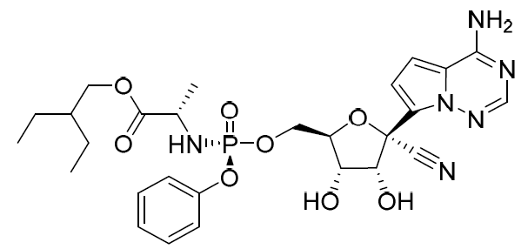
Two presentations are proposed for registration, a sterile 100 mg/20 mL aqueous solution and a sterile 100 mg powder for injection. Both of these have been used in clinical studies. The products are presented in clear glass vials with elastomeric stoppers and an over-seal with a flip-off cap.

Summary
The administrative, product usage, chemical, pharmaceutical and microbiological data submitted in support of this application have been evaluated in accordance with the Australian legislation, pharmacopoeial standards and relevant technical guidelines adopted by the TGA.
Approval is recommended from a pharmaceutical chemistry perspective.

Proposed conditions of registration
Additional information to further substantiate the sponsor’s control strategy should be provided to the TGA. In order to facilitate timely access in Australia, it is appropriate that this information be provided as conditions of registration.
Corrected Australian labels will be required, although initial supply is likely to be of overseas labelled injections. A Section 14 exemption from Australian labelling requirements will be necessary in this case.

Nonclinical
Limited nonclinical pharmacology studies support the clinical indication for the treatment of SARS-CoV infection. Resistance of different SARS-CoV-2 isolates/strains were not assessed and further studies are considered essential to characterise the resistance profile of SARS-CoV-2 isolates to remdesivir.
Secondary pharmacodynamics (PD) and safety pharmacology studies did not raise safety concerns, although exposures remdesivir achieved in the safety pharmacology studies were low and the main (uncharacterised) human metabolite M27 was not present in the animal species.
The nonclinical safety dataset identified the following potentially clinically relevant concerns:
- Remdesivir is an inhibitor of cytochrome P450 enzyme family 3 subfamily A (CYP3A), several uridine 5'-diphospho-glucuronosyltransferase (UGT) enzymes (UGT1A1, 1A3, 1A4, 1A9, 2B7) and transporters organic anion transporting polypeptide 1B1 (OATP1B1), organic anion transporting polypeptide 1B3 (OATP1B3), multidrug resistance-associated protein 4 (MRP4) and bile salt export pump (BSEP). It may increase exposures to co-administered drugs that are predominantly cleared by these enzymes or transporters. Pharmacokinetic (PK) data suggest a dosing gap longer than 2 hours (as recommended in the PI) would be more appropriate.
- Hepatotoxicity.
- Renal toxicity.
Limitations in the nonclinical dataset include:
- Remdesivir and M27 exposures were undetectable in rats and M27 not in monkeys, the main species used in the toxicity studies. Therefore, the toxicity profile of remdesivir (and its metabolites) may not have been fully elucidated in the submitted data.
- The nonclinical data are insufficient to support use for longer than 2 weeks, which needs to be considered if repeated treatment courses are to be considered.
There are safety concerns for the use of Veklury remdesivir in patients ≤ 12 years, in particular those < 2 years, due to the excipient sulfobutylether-β-cyclodextrin (SBECD) which is known to cause renal toxicity. Approval of the Veklury remdesivir concentrate for injection, which contains a high level of SBECD, is not recommended in patients < 12 years.
The limits for drug substance and drug product impurities should be lowered as indicated in the nonclinical evaluation report.
Given the clinical need for a drug in this class, there are no nonclinical objections to the registration of Veklury remdesivir. However, given the uncertainties in the safety dataset and the known potential risks (renal toxicity and hepatotoxicity, as well as safety concerns of the excipient in certain patients), consideration should be given as to whether the benefit-risk balance is acceptable in all proposed patient groups.
The draft PI should be amended as directed in the nonclinical evaluation report.

Clinical
The clinical studies provided in the dossier are listed in Table 3. Some do not have an investigator-completed clinical study report (CSR), but only an interim analysis, or a published peer-reviewed article. This is referenced in the table under ‘Data Cross-Reference’.
Table 3: Veklury (remdesivir) clinical study overview
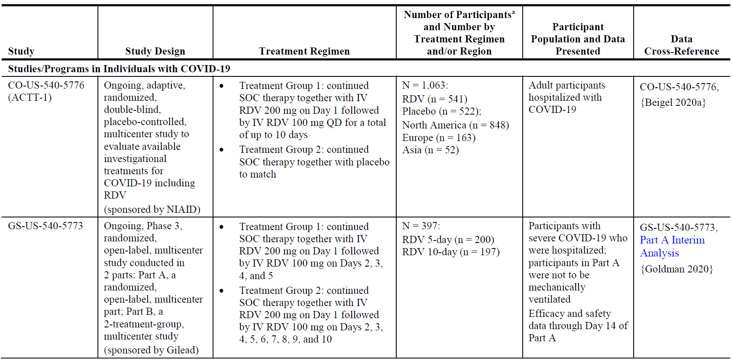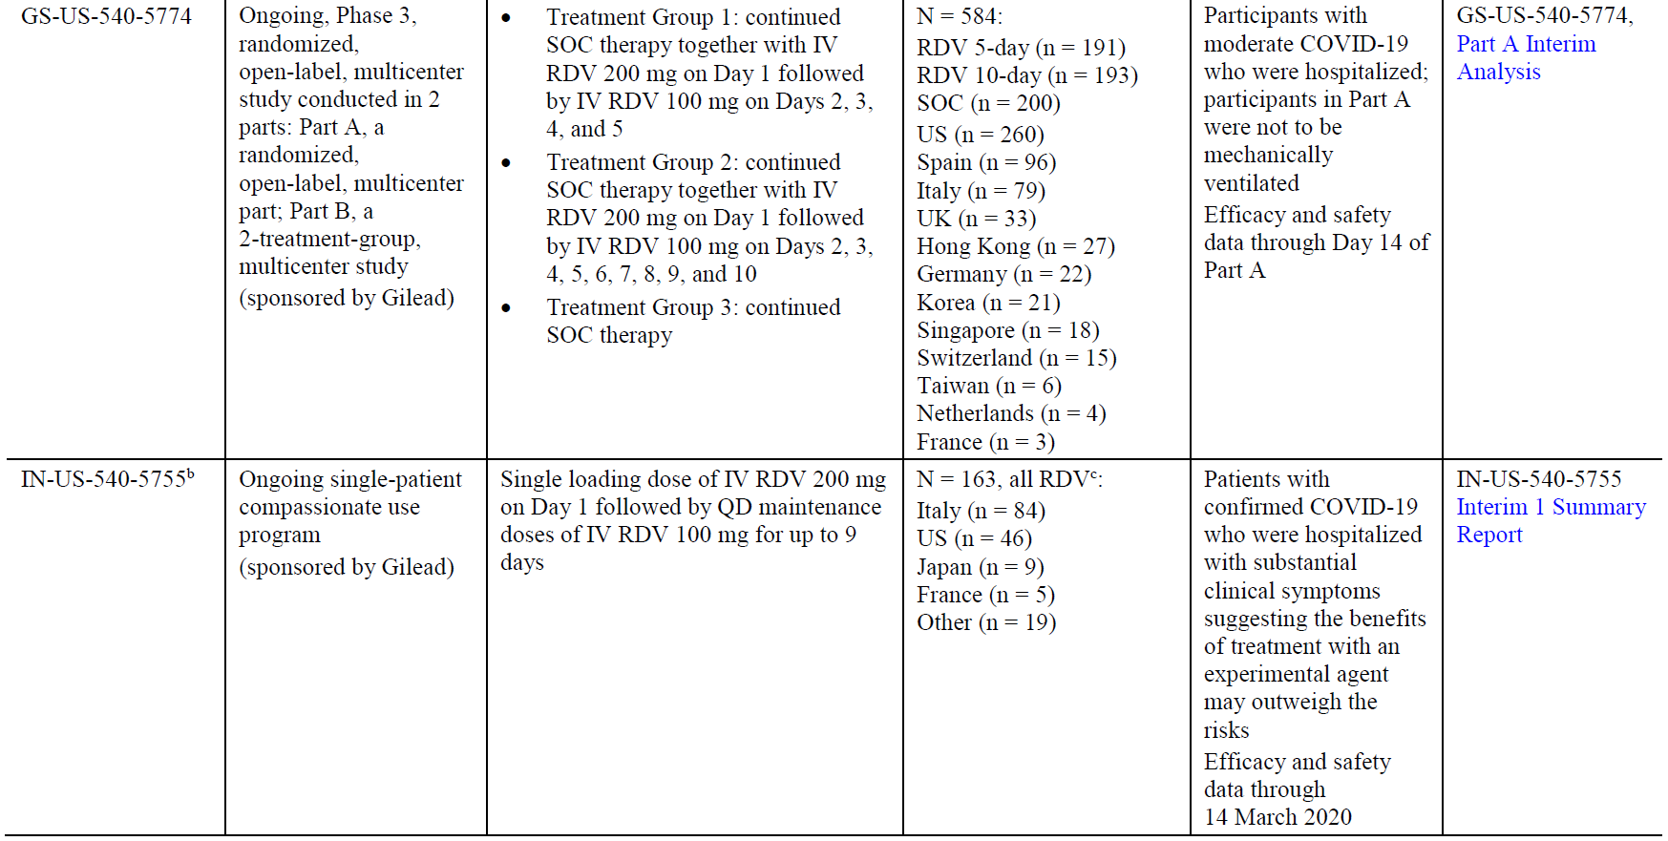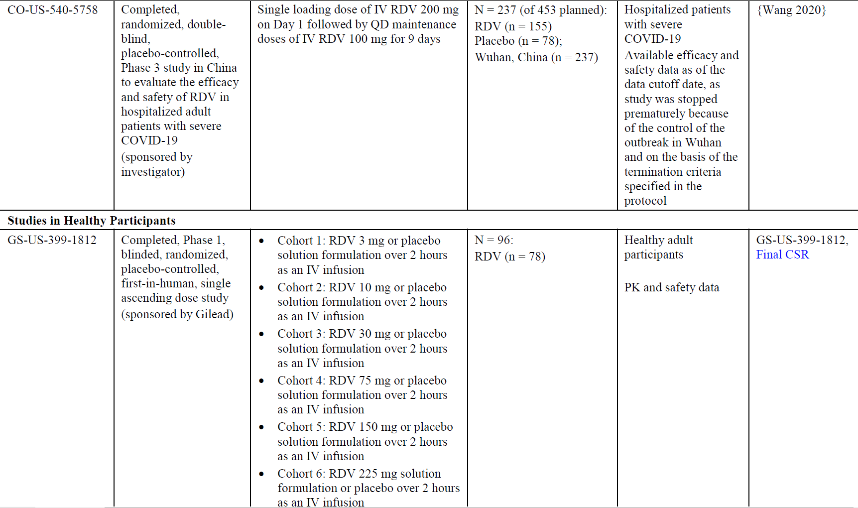
Table 3 (continued): Veklury (remdesivir) clinical study overview
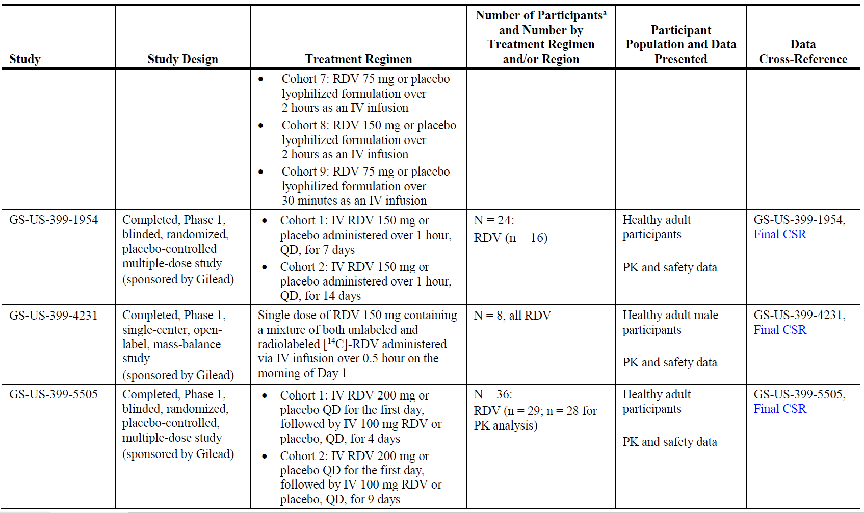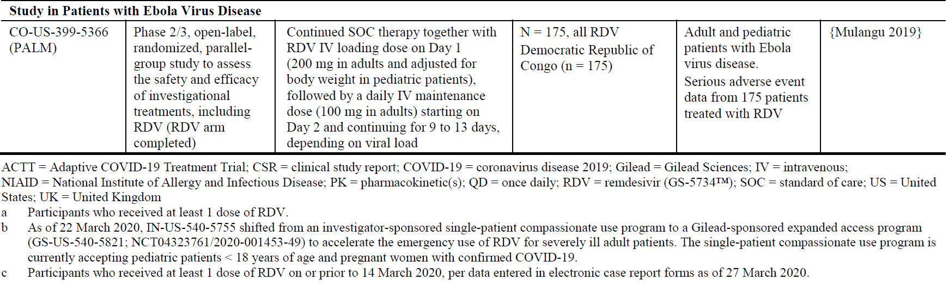
Literature references included in the table above: Beigel 2020,; Goldman 2020,; Wang 2020,; Mulangu 2019.14

Pharmacology

Pharmacology study overview
The following four clinical pharmacology studies in healthy volunteers were included.

Study GS-US-399-1812
Study GS-US-399-1812 was a completed, Phase I, blinded, randomised, placebo controlled, first-in-human, single ascending dose study (3 mg to 225 mg). The main results were:
- After single-dose intravenous (IV) administration over 2 hours of GS-5734; solution formulation at doses ranging from 3 to 225 mg, GS-5734 exhibited a linear PK profile.
- After single dose IV administration over 2 hours of GS-5734 lyophilised formulation at doses of 75 and 150 mg, plasma PK parameters of GS-5734 were similar to those obtained following administration of the solution formulation at the same doses.

Study GS-US-399-1954
Study GS-US-399-1954 was a completed, Phase I, blinded, randomised, placebo controlled, multiple dose study (150 mg daily for 7 or 14 days). The main results were:
- After once-daily IV administration of 150 mg doses of GS-5734 for 7 or 14 days, GS-5734 exhibited a PK profile similar to that observed during single dose administration.
- By Day 14, the metabolites GS-441524 and GS-704277 accumulated approximately 1.9 fold after daily dosing. Both metabolites had detectable trough concentrations in semen with multiple dosing.

Study GS-US-399-4231
Study GS-US-399-4231 was a completed, Phase I, single-centre, open label, mass balance study. The main results were:
- Remdesivir is extensively metabolised and primarily eliminated in:
  - Urine (74.2%) as the nucleoside metabolite GS-441524 (49%), followed by remdesivir (10%), GS-704277 (2.9%), and 6 other metabolites (each less than 2%); and
  - Faeces (18.1%), in which M14 (desamino-hydroxy-GS-441524 metabolite) accounted for 12% of the radioactive dose; all other metabolites were in trace amounts, accounting for approximately 1% of total radioactivity (each less than 0.5%).
- The cumulative mean (% coefficient of variation (CV)) recovery of [¹⁴C]-radioactivity in urine plus faeces was 92.3% (1.83%).

Study GS-US-399-5505
Study GS-US-399-5505 was a completed, Phase I, blinded, randomised, placebo controlled, multiple-dose study (200 mg loading dose, followed by 100 mg daily for 4 or 9 days). This dosing regimen is also the dosing used in the main clinical efficacy trials and is the proposed recommended regimen. The main results were:
- The PK of remdesivir and its metabolites after a 200 mg loading dose on Day 1, followed by 100 mg maintenance doses for 4 or 9 days, was consistent with previous studies in healthy volunteers.
- High intracellular concentrations of the active triphosphate metabolite GS-443902 were observed.

Pharmacokinetic summary
Remdesivir is a prodrug with a peripheral blood mononuclear cell (PBMC)-associated pharmacologically active metabolite, GS-443902.
Absorption: following IV administration of remdesivir at adult doses, the peak plasma concentration occurred at end of infusion (regardless of dose level) and declined rapidly thereafter. Peak plasma concentrations of GS-441524 were observed at 1.5 to 2.0 hours post start of a 30 minute infusion. In Study GS-US-399-5505, for remdesivir, the mean maximum plasma concentration (C_{max}) was 4377.9 ng/mL, the mean area under the plasma concentration-time curve from time zero to time of last measurable concentration (AUC_{last}) was 2850.3 (h*ng/mL) and median terminal half-life (t_{1/2}) was 0.90 hours. For GS-443902 (measured in PBMCs), the mean C_{max} was 14.6 µmol and median t_{1/2} was 43.39 hours. For GS-441524 and GS-704277 (measured in plasma), the median t_{½} ranged from 24.5 to 27.36 hours, and 1.23 to 1.7 hours, respectively.
Distribution: the mean volume of distribution of remdesivir was approximately 93 L. Remdesivir is approximately 88% bound to human plasma proteins. Protein binding in plasma is low for GS-704277 and GS-441524 (1% to 2% bound). After a single 150 mg dose of [¹⁴C]-remdesivir in healthy subjects, the blood to plasma ratio was approximately 0.68 at 15 minutes from start of infusion, and increased over time reaching a ratio of 1.0 at 5 hours.
Metabolism and biotransformation: the metabolic activation pathway involves hydrolysis by esterases, leading to the formation of the intermediate metabolite GS-704277. Phosphoramidate cleavage followed by phosphorylation forms the active triphosphate, GS-443902 (formed intracellularly). Dephosphorylation of all phosphorylated metabolites can result in the formation of nucleoside metabolite GS-441524 that itself is not efficiently re-phosphorylated. The human mass balance study also indicates presence of a currently unidentified major metabolite (M27) in plasma.
Elimination: remdesivir elimination is followed by the sequential appearance of GS-704277, GS-441524, and PBMCs-associated pharmacologically active metabolite, GS-443902.
Following a single 150 mg IV dose of [¹⁴C]-remdesivir, the mean total recovery proportion of the radioactive dose was > 92%, of which approximately 74% and 18% were recovered in urine and faeces, respectively. The majority of the remdesivir dose recovered in urine was GS-441524 (49%), while 10% was recovered as remdesivir. These data indicate that renal clearance is the major elimination pathway for GS-441524.
Renal clearance for GS-441524 was estimated at 151 mL/min. Renal excretion was reported as being dose-linear. Mean clearance and renal clearance (CLr) values for remdesivir were 1171 and 129 mL/min, respectively, indicating that most of its elimination was potentially via the non-renal route.
No clinical data are available on:
- PK in the target population: the sponsor states that the PK of remdesivir in healthy adult participants is expected to be generalisable to SARS-CoV-2 infected patients with normal renal or hepatic function.
- A currently unidentified major metabolite (M27) in plasma.
- PK in subjects with impaired hepatic function.
- PK in subjects with impaired renal function: as renal clearance is the major elimination pathway for the metabolite GS-441524, there is the potential for accumulation in subjects with impaired renal function.
- PK related to genetic factors.
- PK according to age.
- Population pharmacokinetic data.
- In vivo PK interactions (some in vitro data are available).
- PD.

Physiologically based pharmacokinetic modelling
No population PK modelling has been performed. The sponsor has conducted physiologically based pharmacokinetic (PBPK) modelling.
Model design: the adult model was used to predict steady-state exposures (area under the plasma concentration time curve over dosing interval; AUC_{tau}) exposures in adolescents and paediatric subjects (age range 0 to 18 years). For subjects with weight ≥ 40 kg, the proposed dosing was used for the simulations whereas for subjects between ≥ 2.5 to < 40 kg, weight based dosing 5 mg/kg on Day 1 followed by 2.5 mg/kg for 9 days was used for the simulations.
Main results: the model predicted exposure appear to be similar to the observed exposure based on the limited healthy volunteer data. As expected, the variability in predicted exposure was high, especially for GS-441524. The predictions were truncated at 80 kg. There seem to be uncertainty in predictions, especially for GS-441524, in the < 40 kg weight group.

Deficiencies/limitations:
- There were a number of assumptions used in the input data into the PBPK model, which require verification with the observed data.
- The model predictions were not verified given the lack of paediatric PK data. Based on the current literature and experience with the registered products, adolescent PK of remdesivir and metabolites expected to be similar to adult PK, which is confirmed in the current model with the above limitations. The exposure in the adolescent population weighing less than the adult population is expected to be increased compared to adults.
- The model did not include information on the pharmacologically active metabolite of remdesivir (GS-443902). Given that remdesivir is a non-active prodrug, extrapolating paediatric dosages based on active moiety GS-443902 would be more appropriate.
- Currently, PK of either remdesivir or any of the metabolites are not available for adult, adolescent or paediatric patients with COVID-19 and hence the model predictions were compared with the observed PK data from the Phase I PK study with 28 patients. The PK differences between healthy volunteers and COVID-19 patients remain unknown. Although the sponsor expects the PK to be similar, this required verification. Based on the experience with other anti-infectives, the PK between non-critically ill patients and critically ill patients could differ.

Efficacy

Efficacy study overview
Four clinical studies and 1 compassionate use program that provided data on efficacy in COVID-19 patients were included:
- Study CO-US-540-5776 (ACTT-1 trial; pivotal study): ongoing, adaptive, randomised, double blind, placebo controlled, multicentre study to evaluate available investigational treatments for COVID-19 including remdesivir.19
- Study GS-US-540-5773 (SIMPLE-severe trial): ongoing, Phase III, randomised, open label, multicentre study conducted in 2 parts.20
- Study GS-US-540-5774 (SIMPLE-moderate trial): ongoing, Phase III, randomised, open label, multicentre study conducted in 2 parts.
- Study CO-US-540-5758;: completed, randomised, double blind, placebo controlled, Phase III study in China to evaluate the efficacy and safety of remdesivir in hospitalised adult patients with severe COVID-19.
- Study IN-US-540-5755: ongoing single-patient compassionate use program.

Study CO-US-540-5776 (ACTT-1 trial; pivotal study)
Preliminary results are available. The study is ongoing.

Study design
Study CO-US-540-5776 is a Phase III, stratified (by site and illness severity), randomised, double blind, placebo controlled, multicentre (60 centres in the USA, Denmark, United Kingdom (UK), Greece, Germany, South Korea, Mexico, Spain, Japan, and Singapore), superiority study to evaluate the efficacy and safety of remdesivir compared to placebo in 1063 hospitalised male and non-pregnant female adults ≥ 18 years of age with laboratory-confirmed SARS-CoV-2 infection with enrolment between 21 February 2020 to 19 April 2020.
Participants required at least one of: radiographic infiltrates by imaging; oxygen saturation (SpO₂) ≤ 94% on room air; or requirement for supplemental oxygen or for mechanical ventilation. Participants with alanine aminotransferase (ALT) or aspartate aminotransferase (AST) > 5 times the upper limit of normal (ULN) or estimated glomerular filtration rate (eGFR) < 30 mL/min/1.73m² were excluded.
In this trial, severe disease was defined as fulfilling at least one of: requiring invasive or non-invasive mechanical ventilation, requiring supplemental oxygen, an SpO₂ ≤ 94% on room air, or tachypnoea (respiratory rate ≥ 24 breaths per minute).
The population was randomised 1:1 to receive remdesivir or placebo, and further by site and illness severity:
- Treatment Group 1 (n = 541): continued standard of care (SOC) therapy together with IV remdesivir 200 mg on Day 1 followed by IV remdesivir 100 mg daily for a total of up to 10 days
- Treatment Group 2 (n = 522): continued SOC therapy together with placebo.

Baseline characteristics
There were no substantial imbalances between the groups. The baseline characteristics are summarised in Table 4 (including disease severity).
Table 4: Study CO-US-540-5776 (ACTT-1 trial) Baseline demographic and clinical characteristics
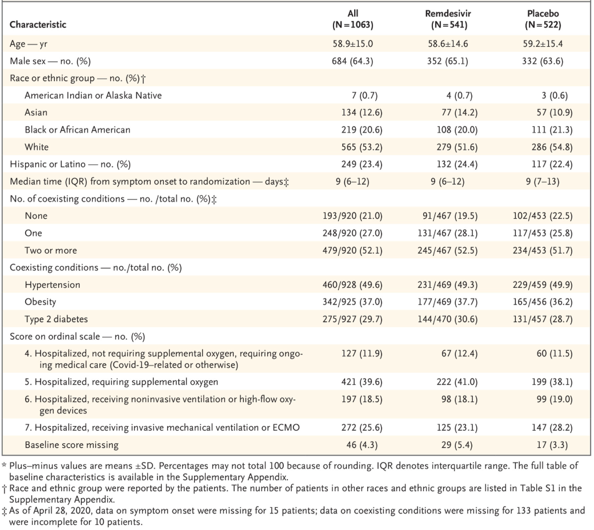
Source: Beigel et al. 2020.19
The mean age was 58.9 years, and 64.3% were male. 53.2% were White, 23.4% Hispanic or Latino, 20.6% Black, and 12.6% Asian. Most had either 1 (27.0%), or 2 or more (52.1%) of the pre-specified coexisting conditions, including hypertension (49.6%), obesity (37.0%), and type 2 diabetes mellitus (29.7%).
943 (88.7%) patients had severe disease at enrolment. The median between symptom onset and randomisation was 9 days (interquartile range (IQR): 6 to 12 days).
Figure 2: Study CO-US-540-5776 (ACTT-1 trial) Study schema
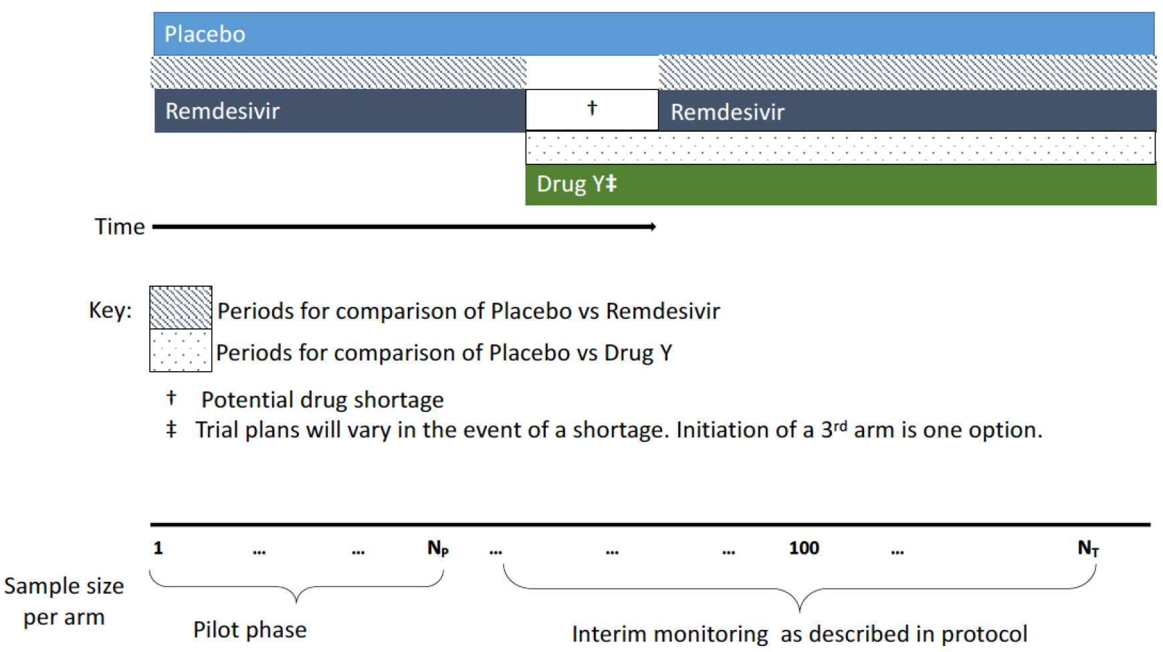

Magnitude of the treatment effect and its clinical significance

Primary endpoint: time to recovery
The primary endpoint was time to recovery (defined as being in ordinal status 1, 2, or 3) or hospital discharge, whichever came first even if that recovery/discharge was followed by a death. Recovery was evaluated up until Day 29.
- Main result: participants in the remdesivir group had a shorter time to recovery compared to placebo (recovery rate ratio (RR) = 1.32 (95% confidence interval (CI): 1.12 to 1.55; n = 1059) (Table 6).
Subgroup analyses: the results were statistically significant for the severe disease group, but not the mild-moderate group (see Table 6). The results were also statistically significant for the baseline ordinal score 5 group; (recovery RR = 1.47 (95% CI: 1.17 to 1.84; n = 421), but not for the others, potentially due to insufficient power for those groups (see Table 7). For those on mechanical ventilation or extracorporeal membrane oxygenation (ECMO); and therefore with a baseline ordinal score of 7, the recovery RR was 0.95 (95% CI: 0.64 to 1.42; n = 272) (see Table 7). Other subgroup analyses showed similar results between subgroups (for example, male versus female, or symptom duration before randomisation ≤ 10 days versus > 10 days).
Table 5: Study CO-US-540-5776 (ACTT-1 trial) Primary endpoint; time to recovery subgroup analyses
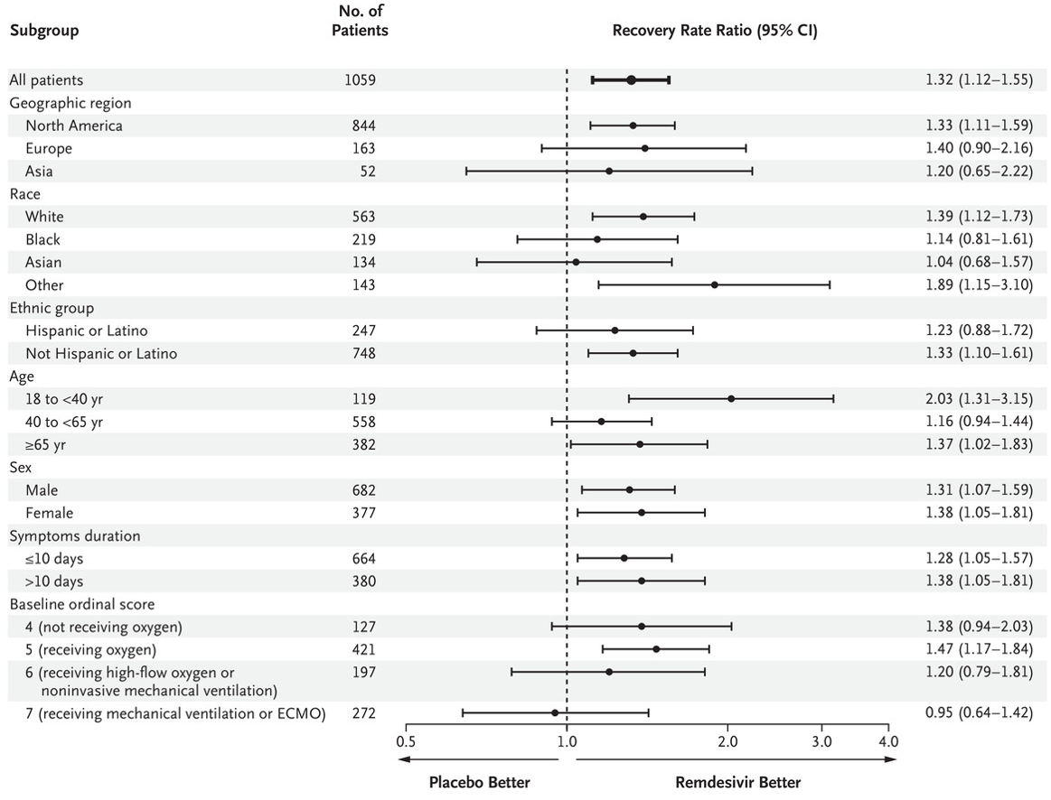Source: Beigel et al. 2020.19
- Additional analyses: a test of interaction of treatment by baseline ordinal scale was not statistically significant. An analysis adjusting for baseline ordinal score as a stratification variable (to evaluate the overall effect of the percentage of participants in each ordinal score at Baseline) on the primary outcome produced a similar treatment effect estimate (RR = 1.31; 95% CI: 1.12 to 1.54; n = 1017).
Table 6: Study CO-US-540-5776 (ACTT-1 trial) Primary endpoint, time to recovery overall and by baseline disease severity (intent to treat population)
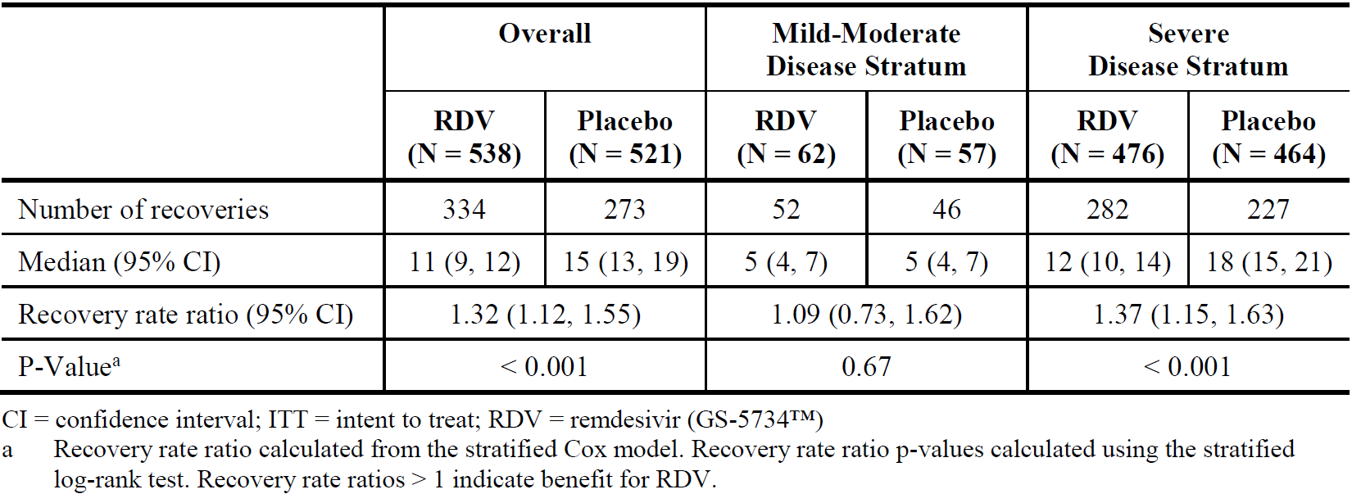
Table 7: Study CO-US-540-5776 (ACTT-1 trial) Time to recovery by baseline disease severity ordinal scale score (intent to treat population)
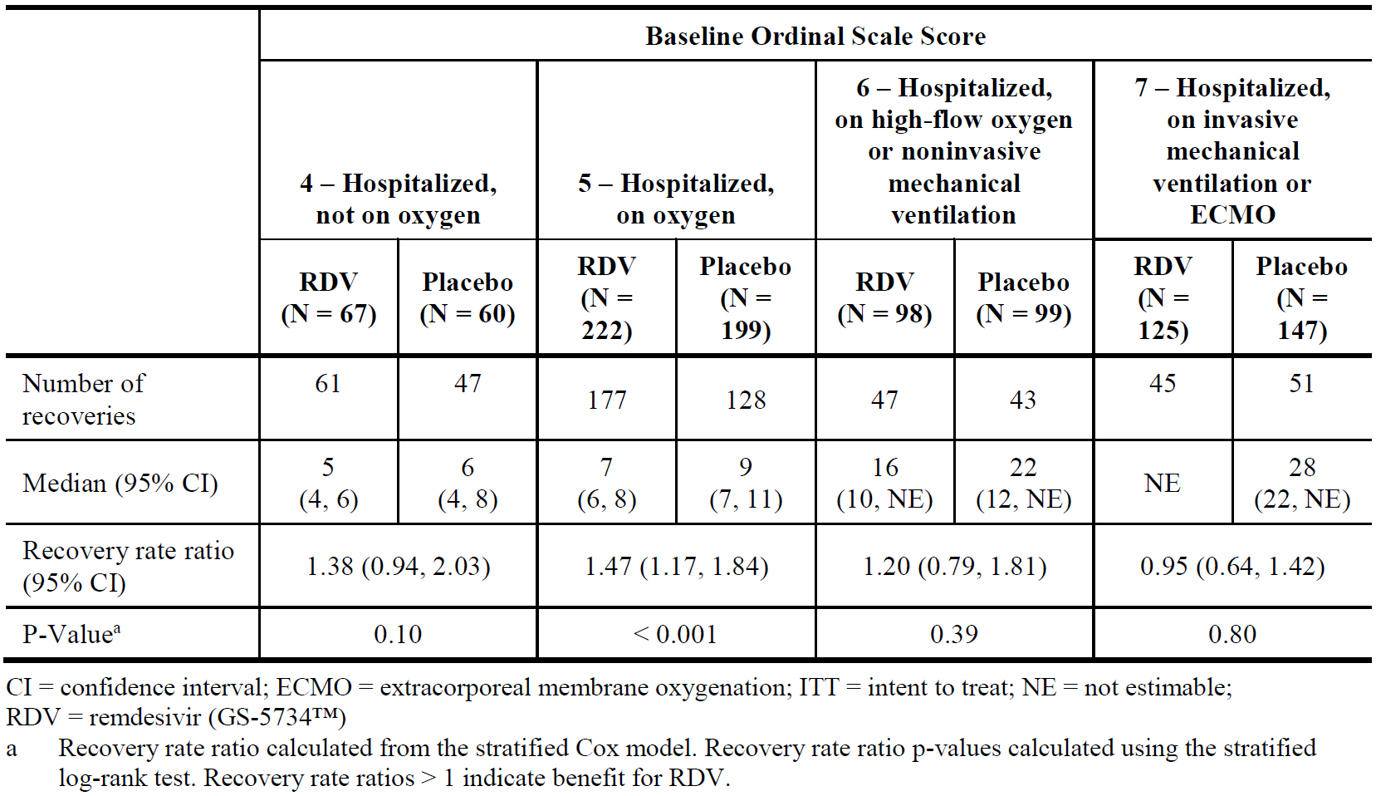

Key secondary endpoint: clinical status (8 point ordinal scale) at Day 15
The key secondary endpoint was clinical status (8 point ordinal scale) at Day 15.
- Main result: the odds of improvement in the ordinal scale were higher in the remdesivir group as determined by a proportional odds model at Day 15 (odds ratio (OR) = 1.50 (95% CI, 1.18 to 1.91) (see Table 8).
- Subgroup analyses: the results were also statistically significant for the severe disease group, but not the mild-moderate group (see Table 8), likely due to insufficient power in that subgroup.
Table 8: Study CO-US-540-5776 (ACTT-1 trial) Clinical status (8 point ordinal scale) at Day 15 overall and by baseline disease severity (intent to treat population)
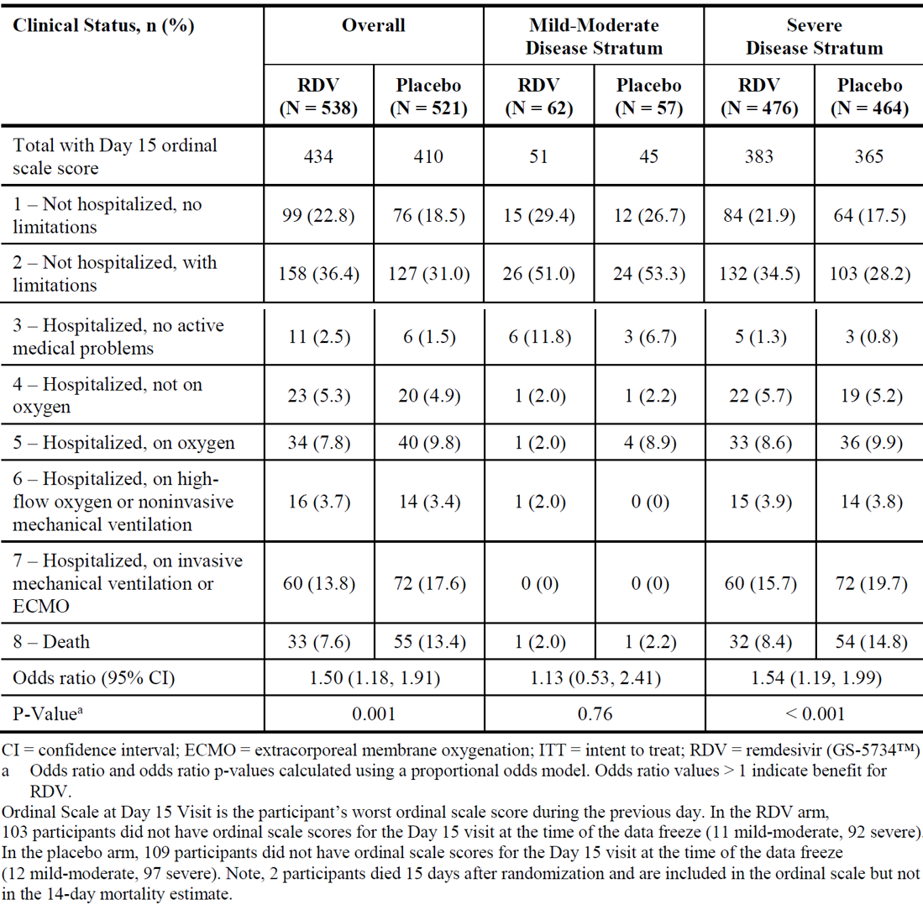

Other secondary endpoint: mortality at Day 14
One important secondary endpoint was mortality at Day 14.
Main result: overall, the mortality proportion was numerically lower in the remdesivir group compared to placebo, but this was not statistically significant: The Kaplan-Meier estimates of mortality by 14 days were 7.1% for remdesivir and 11.9% for placebo (HR 0.70 (95% CI: 0.47 to 1.04)) (see Table 9). An analysis with adjustment for baseline ordinal score as a stratification variable showed a HR for death of 0.74 (95% CI: 0.50 to 1.10).
Subgroup analyses: the results were not statistically significant for any subgroup analyses, neither by baseline disease severity (Table 9) or ordinal scale score (Table 10).
The Kaplan-Meier estimates of mortality by 14 days were 7.1% and 11.9% in the remdesivir and placebo groups, respectively. 28 day mortality data was not reported in the preliminary analysis due to incomplete Day 29 visits.
Table 9: Study CO-US-540-5776 (ACTT-1 trial) Mortality at Day 14 overall and by baseline disease severity (intent to treat population)
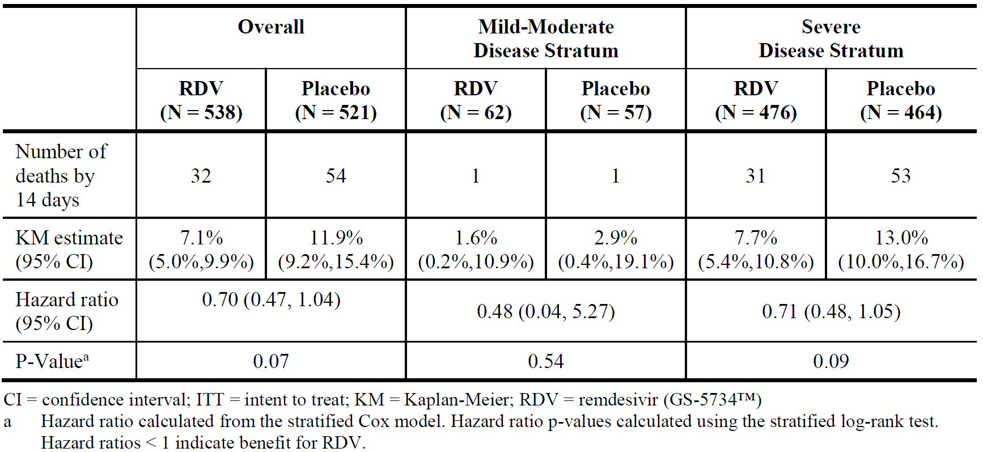
Table 10: Study CO-US-540-5776 (ACTT-1 trial) Time to recovery, mortality, and disease severity ordinal scale score at Day 15 overall and by baseline disease severity ordinal scale score (intent to treat population)
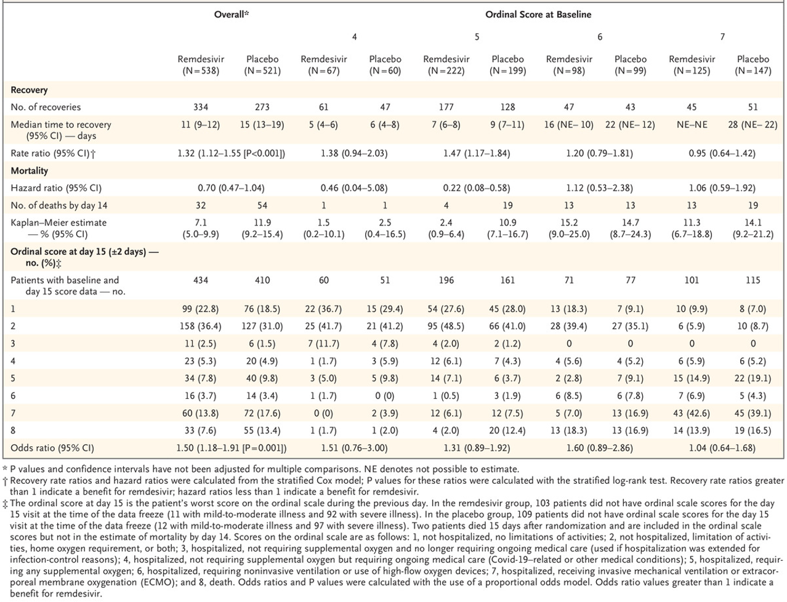
Source: Beigel et al. 2020.19

Study CO-US-540-5773

Study design
Preliminary results are available. The study is ongoing.
Study CO-US-540-5773 is a Phase III, randomised, open label, multicentre (55 centres in the USA, Italy, Spain, Germany, Hong Kong, Singapore, South Korea, and Taiwan) study to evaluate the efficacy and safety of remdesivir (5 day treatment versus 10 day treatment) in 397 hospitalised male and non-pregnant female adults ≥ 12 years of age (weighing ≥ 40 kg) with polymerase chain reaction (PCR)-confirmed severe SARS-CoV-2 infection enrolled between 6 March 2020 to 26 March 2020. However, no subject under 20 years of age participated.
Participants required: hospitalisation, radiographic infiltrates by imaging; SpO₂ ≤ 94% on room air; or requirement for supplemental oxygen (but no mechanical ventilation ≥ 5 days for Part A).
Participants with ALT or AST > 5 x ULN or creatinine clearance (CrCl) < 50 mL/min were excluded.
The study is split into Part A (preliminary results available and listed below) and Part B (no results available yet).
Part A: the population was randomised 1:1 to receive remdesivir for 5 days or 10 days:
- Treatment Group 1 (5 day treatment, n = 200): continued SOC therapy together with IV remdesivir 200 mg on Day 1 followed by IV remdesivir 100 mg daily on Days 2, 3, 4, and 5.
- Treatment Group 2 (10 day treatment, n = 197): SOC therapy together with IV remdesivir 200 mg on Day 1 followed by IV remdesivir 100 mg daily on Days 2, 3, 4, 5, 6, 7, 8, 9, and 10.
Part B (no results available yet) plans to enrol more participants stratified into a Mechanically Ventilated Treatment Group or an Extension Treatment Group (Part A excluded mechanical ventilation) with both groups receiving either 5 days or 10 days of remdesivir depending on the outcomes of Part A.

Baseline characteristics
The groups were balanced in their demographic characteristics but not in their baseline disease characteristics.
Most participants were male (63.7%), and White (70.4%) with a median age (range) of 61 (20 to 98) years, and a median (IQR) body mass index of 28.7 (25.3 to 33.5) kg/m². Comorbidities included hypertension (50.4%), diabetes mellitus (22.4%), hyperlipidaemia (22.4%), and asthma (11.8%).
The median (range) duration of symptoms prior to first dose of remdesivir was 8 (0 to 43) days and median (range) duration of hospitalisation prior to first dose of remdesivir was 2 (0 to 35) days, and these were similar in both treatment groups (Study GS-US-540-5773 Part A Interim Analysis).
Clinical status was statistically significantly different between the 5 day versus the remdesivir 10 day group (p = 0.019), with greater proportions of participants in the 2 highest disease severity categories (that is, on invasive mechanical ventilation or ECMO and on non-invasive ventilation or high-flow oxygen devices) in the 10 day group. Non-invasive ventilation or high-flow oxygen support was required at Baseline by 30.5% (10 day group) or 24.5% (5 day group).
Simple randomisation was conducted using an interactive web response system (IWRS).

Magnitude of the treatment effect and its clinical significance

Primary endpoint: clinical status (7 point ordinal scale) on Day 14
The primary endpoint was clinical status on Day 14 (using the 7 point ordinal scale):
- Main result: at Baseline, participants randomised to the remdesivir 10 day group had significantly worse clinical status than those randomised to the remdesivir 5 day group (p = 0.019). After adjusting for baseline clinical status, participants receiving a 10 day course of remdesivir had a similar distribution in clinical status at Day 14 as those receiving a 5 day course (p = 0.1443) (see Table 11). It is unclear how the adjustment was conducted.
- Age 12 to 18 years old: there were no patients in that age group, the youngest was 20 years old.
Table 11: Study GS-US-540-5773 Primary endpoint: clinical status (7 point ordinal scale) on Day 14 (full analysis set)
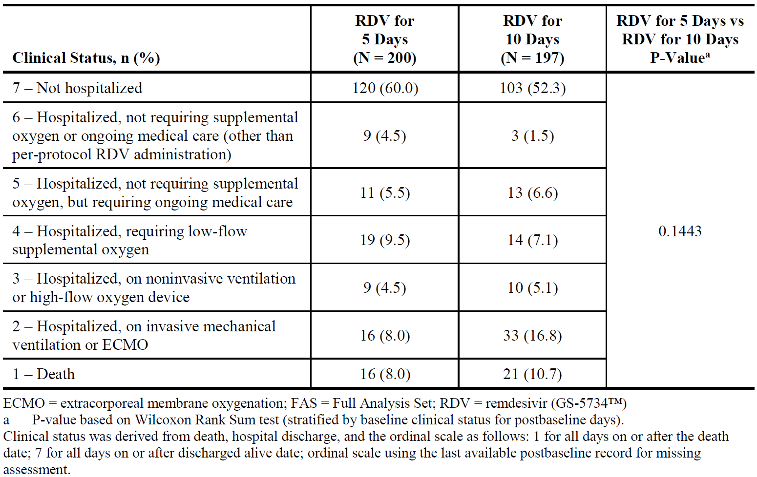

Other endpoint: time to ≥ 2 point clinical improvement
- Main result: after adjustment for baseline clinical status, the median time to ≥ 2 point clinical improvement was not statistically significantly different between treatment groups (see Table 12). At Day 14, 64.5% of patients in the 5 day group showed a ≥ 2 point clinical improvement compared to 53.8% in the 10 day group, which appears not to be statistically significantly different (see Table 12).
Table 12: Study GS-US-540-5773 Time to ≥ 2 point clinical improvement and proportion of participants with ≥ 2 point clinical improvement at Days 5, 7, 11, and 14 (full analysis set)
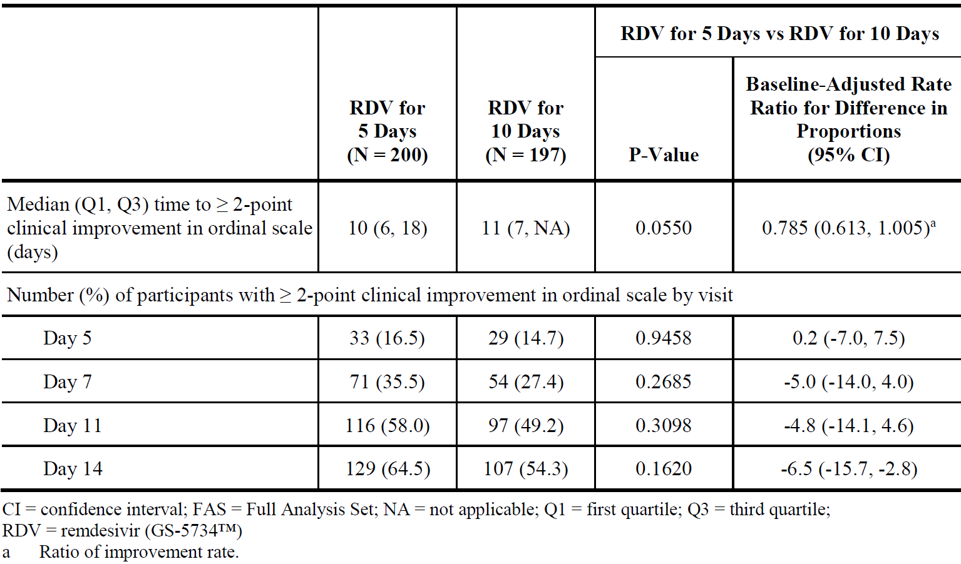

Post hoc endpoint: clinical outcome by Day 5 oxygen support status
- Reasoning for conducting a post hoc analysis: the primary endpoint showed no significant differences between groups. Baseline oxygen support status was shown to be the strongest predictor of the Day 14 clinical outcome. Thus, the sponsor conducted a descriptive post hoc analysis on oxygen support status at Day 5 (excluding participants who died or were discharged before Day 5).
- Main result: at Day 5, patients on invasive mechanical ventilation, appeared to have higher mortality in the 5 day group (10 out of 25 (40%) versus 7 out of 41 (17.1%)) (see Table 13). These results appeared not to have been tested for statistical significance and the number of patients on invasive mechanical ventilation was too low for definite conclusions (n = 25 or n = 41) (see Table 13). Dosing of remdesivir beyond 5 days in participants receiving high-flow oxygen, low-flow oxygen, or room air did not appear to improve Day 14 outcome, but patient numbers were low.
Table 13: Study GS-US-540-5773 Oxygen support status at Day 14 by Day 5 oxygen support status (full analysis set)
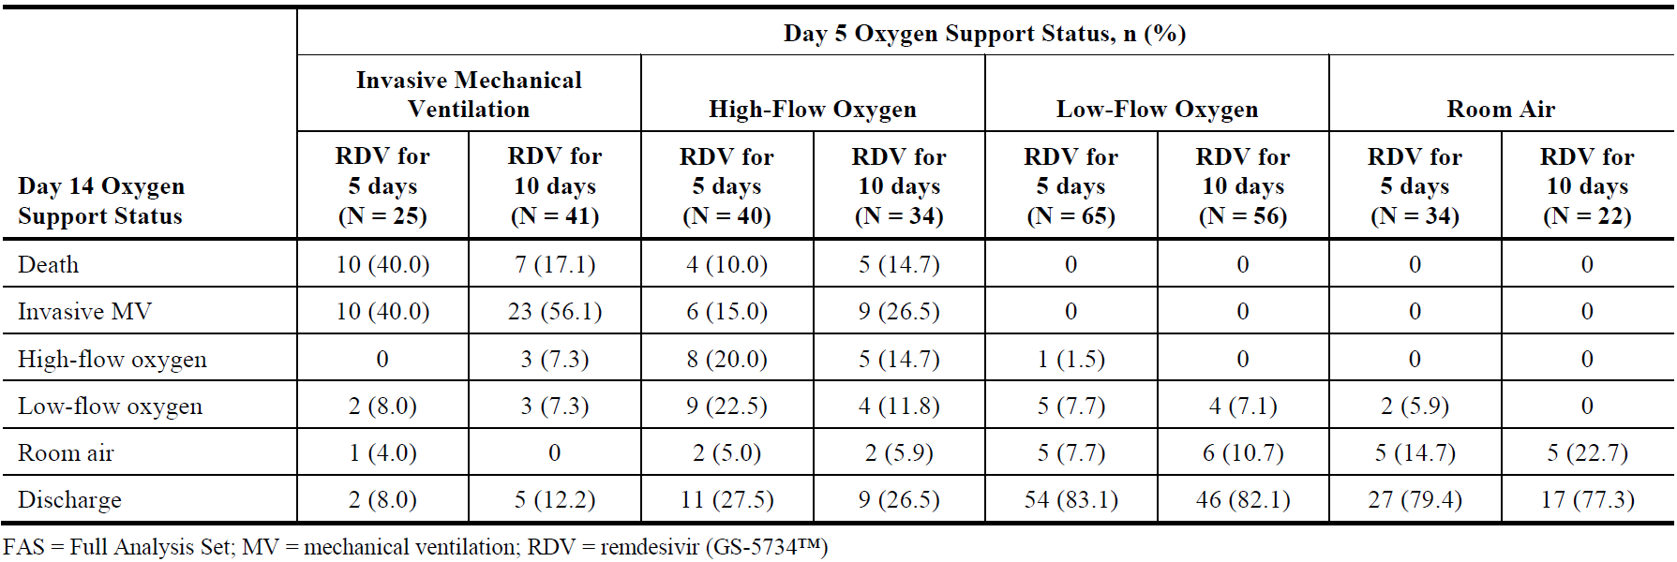
It would be difficult to conclude that 10 days of remdesivir provides better mortality outcomes than 5 days, even though a potential trend is present. However, given that the pivotal study showed benefit in a 10 day course (without testing a 5 day course), the significance of the post hoc analysis in Study GS-US-540-5773 is rather low. The study was originally designed not to stratify and was not powered for this.

Study CO-US-540-5774
Preliminary results are available. The study is ongoing.

Design
Study CO-US-540-5774 is a Phase III, randomised, open label, multicentre study to evaluate the efficacy and safety of remdesivir (5 day treatment versus 10 day treatment) in 584 hospitalised male and non-pregnant female adults ≥ 12 years of age (weighing ≥ 40 kg) with PCR-confirmed moderate SARS-CoV-2 infection.
Participants required: hospitalisation, radiographic infiltrates by imaging; SpO₂ ≤ 94% on room air; or requirement for supplemental oxygen (but no mechanical ventilation ≥ 5 days for Part A).
Participants with ALT or AST > 5 x ULN or CrCl < 50 mL/min were excluded.
The study is split into Part A (preliminary results available and listed below) and Part B (no results available yet).
Part A: the population was randomised 1:1:1 to receive remdesivir for 5 days, remdesivir for 10 days, or SOC:
- Treatment Group 1 (5 day treatment, n = 191): continued SOC therapy together with IV remdesivir 200 mg on Day 1 followed by IV remdesivir 100 mg daily on Days 2, 3, 4, and 5.
- Treatment Group 2 (10 day treatment, n = 193): continued SOC therapy together with IV remdesivir 200 mg on Day 1 followed by IV remdesivir 100 mg daily on Days 2, 3, 4, 5, 6, 7, 8, 9, and 10.
- Treatment Group 3 (SOC, n = 200): SOC therapy.
Part B (no results available yet) plans to enrol more participants stratified into an Extension Treatment Group receiving either 5 days or 10 days of remdesivir depending on the outcomes of Part A.
Simple randomisation was conducted using an IWRS.
The primary endpoint was analysed using a proportional odds model including baseline clinical status as a covariate. Each remdesivir group (5 or 10 days) was compared to the SOC group. The null hypothesis being tested is whether the odds of improvement on the ordinal scale is the same for the SOC group and either remdesivir group (that is, whether the common odds ratio is equal to 1).

Baseline characteristics
The groups were balanced in their demographic and baseline disease characteristics.
Most participants were male (61.1%), and White (61.3%) with a median age (range) of 57 (12 to 95) years (but only one participant aged between 12 and < 18 years), and a median (IQR) body mass index of 27.1 (24.1, 31.1) kg/m². Comorbidities included hypertension (39.0%) and hyperlipidaemia (15.4%).
Overall, median (range) duration of symptoms prior to first dose of remdesivir was 8 (1 to 48) days and median (range) duration of hospitalisation prior to first dose of remdesivir was 2 (0 to 36) days. Baseline oxygen status proportions were: 0.9% (high-flow), 15.1% (low-flow), and 84.1% (room air).

Magnitude of the treatment effect and its clinical significance

Primary endpoint: clinical status (7 point ordinal scale) on Day 11
The primary endpoint was clinical status on Day 11 (using the 7 point ordinal scale).
- Main result:
  - For treatment with remdesivir for 5 days compared to SOC: OR 1.65 (95% CI: 1.09 to 2.48, statistically significant difference; see Table 14).
  - For treatment with remdesivir for 10 days compared to SOC: OR 1.31 (95% CI: 0.880 to 1.952, no statistically significant difference; see Table 14).
  - Based on the sponsor analysis, the distribution in clinical status at Day 11 showed a statistically significant difference for 5 day remdesivir versus SOC, but not for 10 day remdesivir versus SOC (see Table 15). Multiplicity issues due to two main endpoints (with mixed results) appear not to have been addressed.
At Day 11, ≥ 2 point improvements in the clinical ordinal scale or recovery had higher patient proportions for 5 day remdesivir and 10 day remdesivir groups, compared to SOC alone, but there was no statistically significant difference (see Table 16).
Table 14: Study GS-US-540-5774 Analysis of clinical status (7 point ordinal scale) on Day 11 using proportional odds with baseline adjustment (full analysis set)
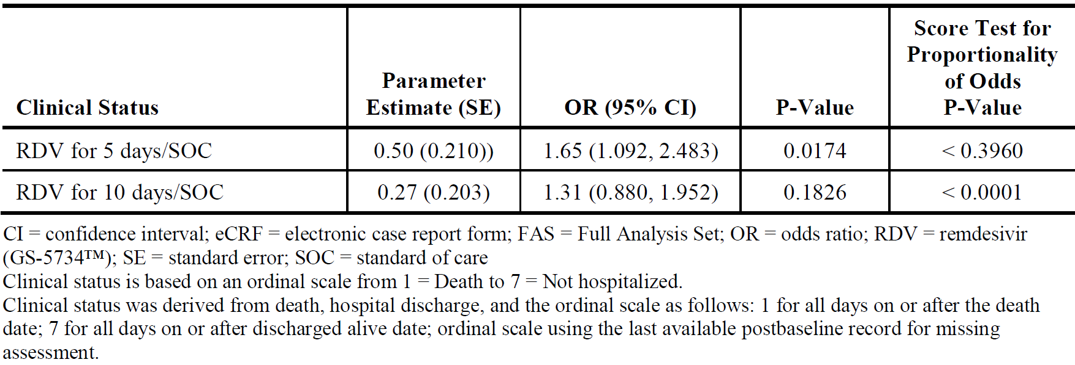
Table 15: Study GS-US-540-5774 Clinical status (7 point ordinal scale) on Day 11 (full analysis set)
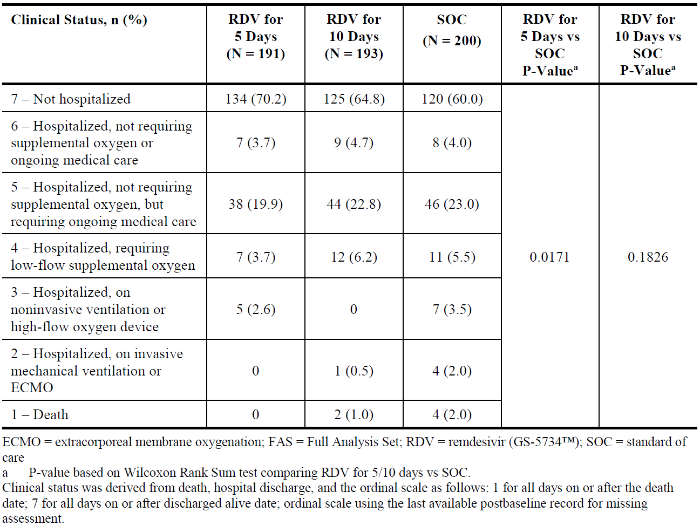
Table 16: Study GS-US-540-5774 Clinical outcomes at Day 11 (full analysis set)
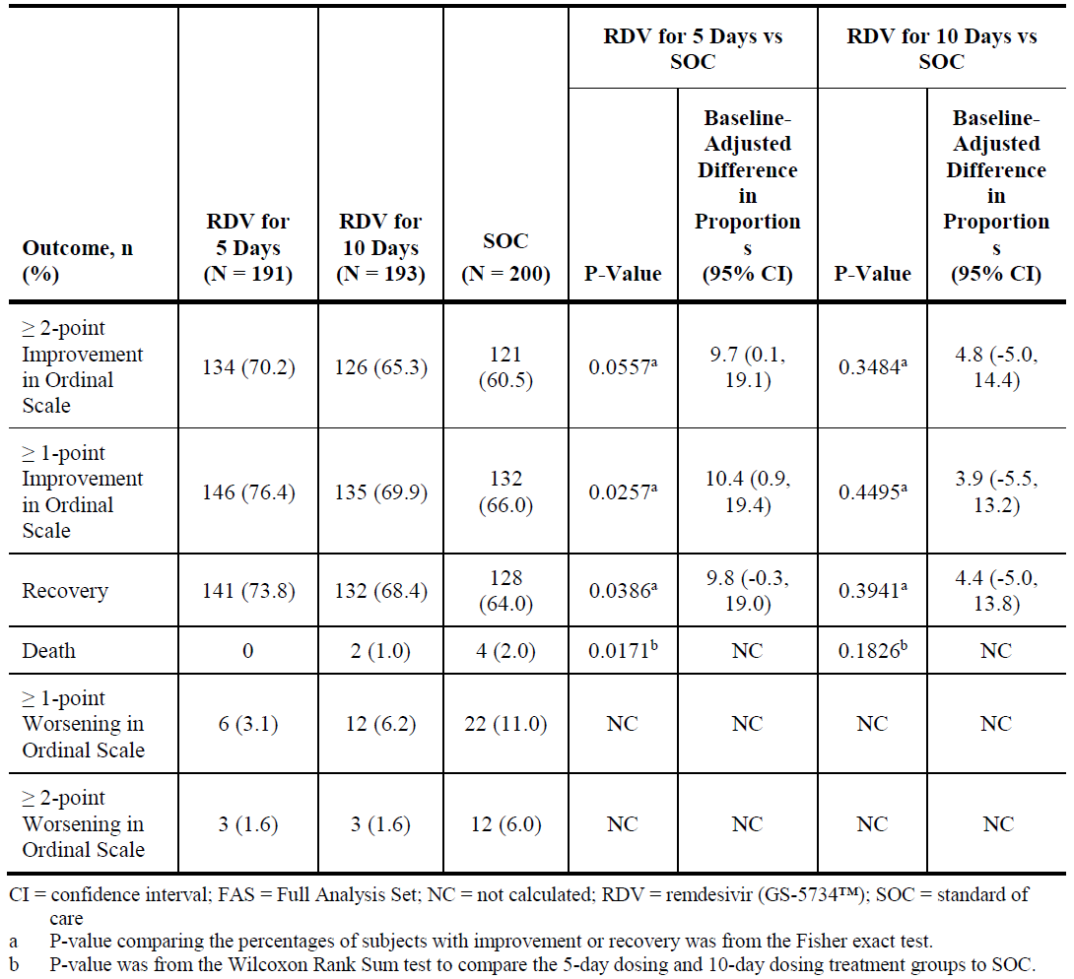
Study CO-US-540-5758

Design
Study CO-US-540-5758 was a completed, Phase III, randomised, double blind, multicentre (10 centres in Hubei, China), study to evaluate the efficacy and safety of remdesivir (10 day treatment) in 237 hospitalised male and non-pregnant female adults ≥ 18 years of age with laboratory-confirmed severe SARS-CoV-2 infection enrolled between 6 February 2020 and 12 March 2020.
Participants required: radiologically confirmed pneumonia; SpO₂ ≤ 94% on room air, or a ratio of arterial oxygen partial pressure to fractional inspired oxygen of 300 mm Hg or less.
Exclusion criteria included pregnancy or breastfeeding; hepatic cirrhosis; ALT or AST > 5 x ULN; known severe renal impairment. Patients were permitted concomitant use of lopinavir–ritonavir, interferons, and corticosteroids.
Patients were randomly assigned in a 2:1 ratio to IV remdesivir (200 mg on Day 1 followed by 100 mg on Days 2 to 10 in single daily infusions) or placebo.

Magnitude of the treatment effect and its clinical significance

Primary endpoint: time to clinical improvement
The primary endpoint was time to clinical improvement (defined as a decline of two levels on a six point ordinal scale of clinical status (from 1 = discharged to 6 = death) or discharged alive from hospital, whichever came first).
- Main result: remdesivir use was not associated with a statistically significant difference in time to clinical improvement (HR = 1.23 (95% CI: 0.87 to 1.75),
- Table 17).
Table 17: Study CO-US-540-5758 Primary endpoint: time to clinical improvement (intent to treat population)
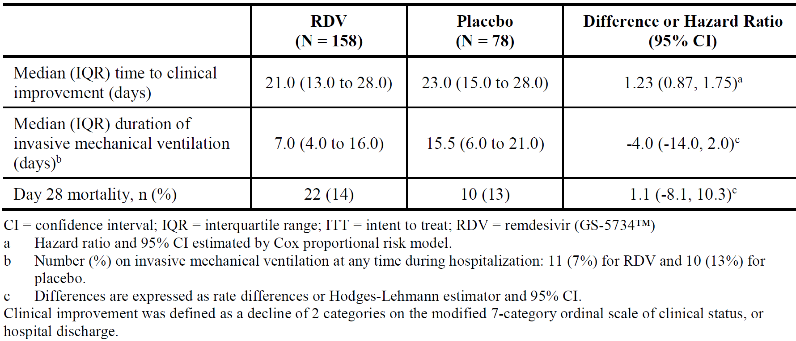
This study would have required 325 events of clinical improvement to provide 80% power if the hazard ratio comparing remdesivir to placebo were 1.4. Due to no further COVID-19 cases at the trial sites, the trial stopped leading to the study not having sufficient power. However, safety data was generated.

Study IN-US-540-5755: ongoing single-patient compassionate use program
The program is ongoing, but has preliminary results.

Design
Study IN-US-540-5755 summarises the available data from the 163 patients who received remdesivir for COVID-19 treatment on or before 14 March 2020.
Criteria for compassionate use included: hospitalisation, confirmed n-CoV; by PCR, severity marker O₂ saturations < 94% or National Early Warning Score 2 (NEWS2) score > 4; and exclusion of multi-organ failure where the benefits of treatment outweighed the risks. These criteria were revised to become more restrictive over time as the number of requests overwhelmed the single-patient compassionate use process. The single patient compassionate use program is currently accepting paediatric patients < 18 years of age and pregnant women with confirmed COVID-19.
Study treatments were:
- Remdesivir 200 mg IV on Day 1 followed by 100 mg IV once daily for 9 days.
There was no control group. Patients were excluded if they had CrCl < 30 mL/min or ALT ≥ 5 x ULN.

Magnitude of the treatment effect and its clinical significance
47.2% (77 of 163 patients) showed any clinical improvement, 41.1% (67 patients) showed ≥ 2 point clinical improvement, and 30.1% (49 patients) were discharged.
Overall, median time to ≥ 2 point clinical improvement or discharge was 19.0 days (95% CI: 16.0, 25.0 days).
No control group was present. The differences seen for non-invasive versus invasive baseline oxygen support are likely associated with the severity of the disease rather than drug-specific. The country-specific differences are also likely owing to other non-drug-related factors.

Safety

Exposure
The safety profile of IV remdesivir is based on data from 1936 individuals who received at least 1 dose of IV remdesivir (including 1630 with COVID-19; 175 with Ebola virus disease; and 131 healthy participants in the Phase I studies (see Table 18). The database for the safety evaluation reflects the target population fairly well. It is expected that remdesivir will be exclusively used in hospital under controlled conditions with appropriate monitoring.
Table 18: Summary of exposure to intravenous remdesivir across clinical studies
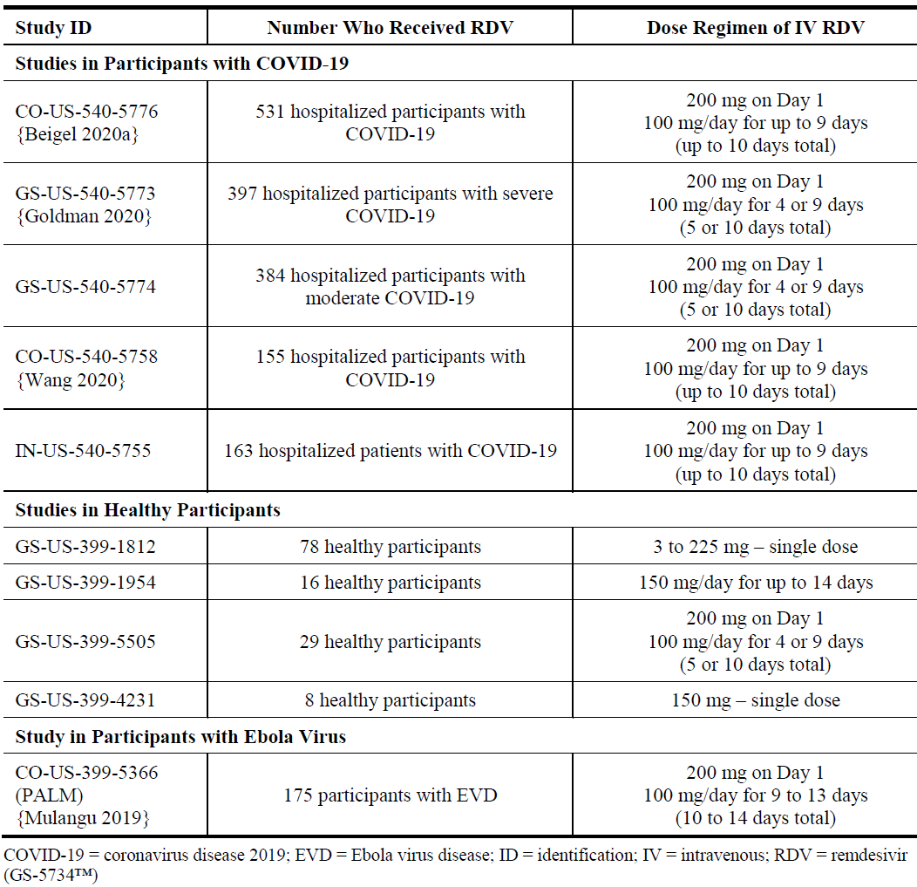

Adverse event overview

Study CO-US-540-5776 (ACTT-1 trial)
Data on Grade 1 or 2 adverse events (AEs) were not provided in the dossier. Statistical analyses appeared not to have been reported.
Regarding Grade 3 or 4 non-serious AEs (remdesivir versus placebo): 156 (28.8%) versus 172 (33.0%), overall. The most common were anaemia or haemoglobin decreased (7.9% versus 9.0%); acute kidney injury, glomerular filtration rate decreased, creatinine renal clearance decreased, or blood creatinine increased (7.4% versus 7.3%); pyrexia (5.0% versus 3.3%); hyperglycaemia (4.1% versus 3.3%); and transaminases increased (4.1% versus 5.9%) (see Table 19).
Table 19: Study CO-US-540-5776 (ACTT-1 trial) Grade 3 or 4 non-serious adverse events in ≥ 2% of participants by treatment group (all randomised)
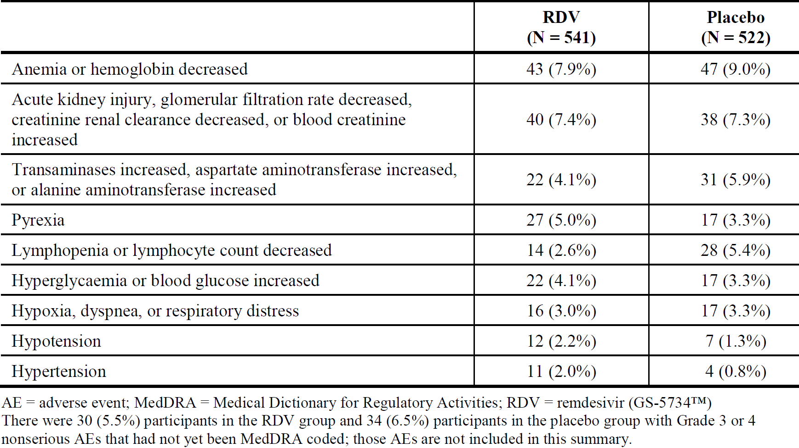

Study GS-US-540-5773 (SIMPLE-severe trial)
Overall, the incidence of AEs, study drug-related AEs, study drug-related serious adverse events (SAEs), and death were similar between the remdesivir 5 day and 10 day treatment groups (Table 20).
Table 20: Study GS-US-540-5773 Overall summary of adverse events (safety analysis set)
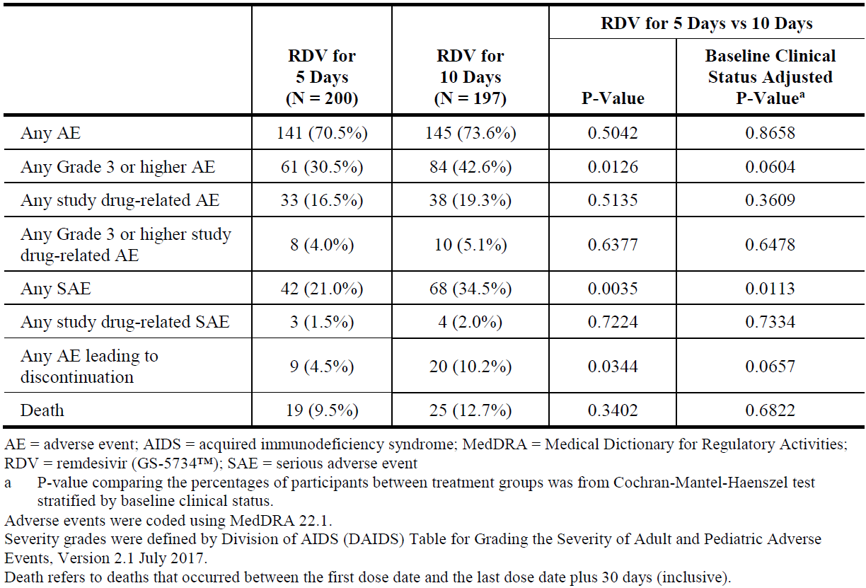
More patients in the remdesivir 10 day group compared to the 5 day group had Grade ≥ 3 AEs, SAEs, and AEs leading to discontinuation, likely due to differences in baseline disease characteristics (10 day group had a worse clinical status; p = 0.019). After controlling for baseline clinical status, a statistically significant difference remained only for SAEs (p = 0.0113, mainly respiratory failure or worsening COVID-19 disease).
The most common AEs were (Table 21):
- Remdesivir for 5 days: nausea (10.0%), constipation (6.5%), and acute respiratory failure (6.0%).
- Remdesivir for 10 days: acute respiratory failure (10.7%); nausea (8.6%); and ALT increased and acute kidney injury (7.6% each).
Table 21: Study GS-US-540-5773 Adverse events occurring in ≥ 3% of participants overall by treatment group (safety analysis set)
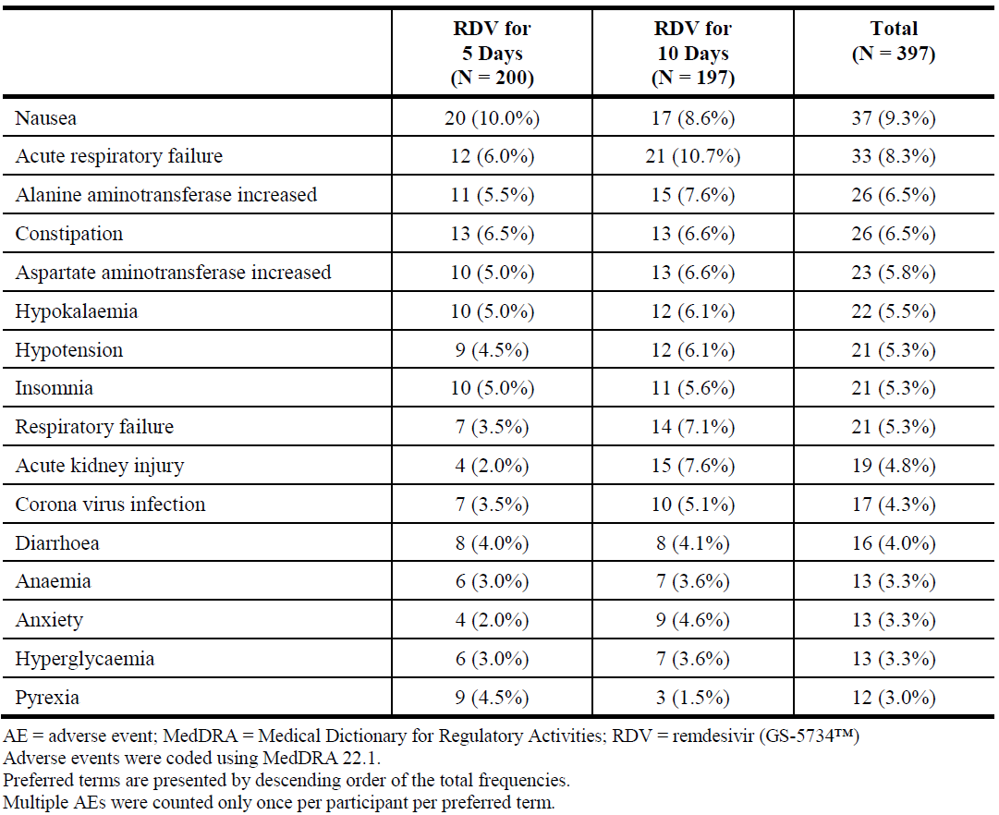

Study GS-US-540-5774 (SIMPLE-moderate trial)
The overall incidence of Grade ≥ 3 AEs, SAEs, and deaths were generally comparable between the three groups. However, Grade 1 or 2 AEs were more frequent in the remdesivir groups compared to placebo (see Table 22).
Table 22: Study GS-US-540-5774 Overall summary of adverse events (safety analysis set)
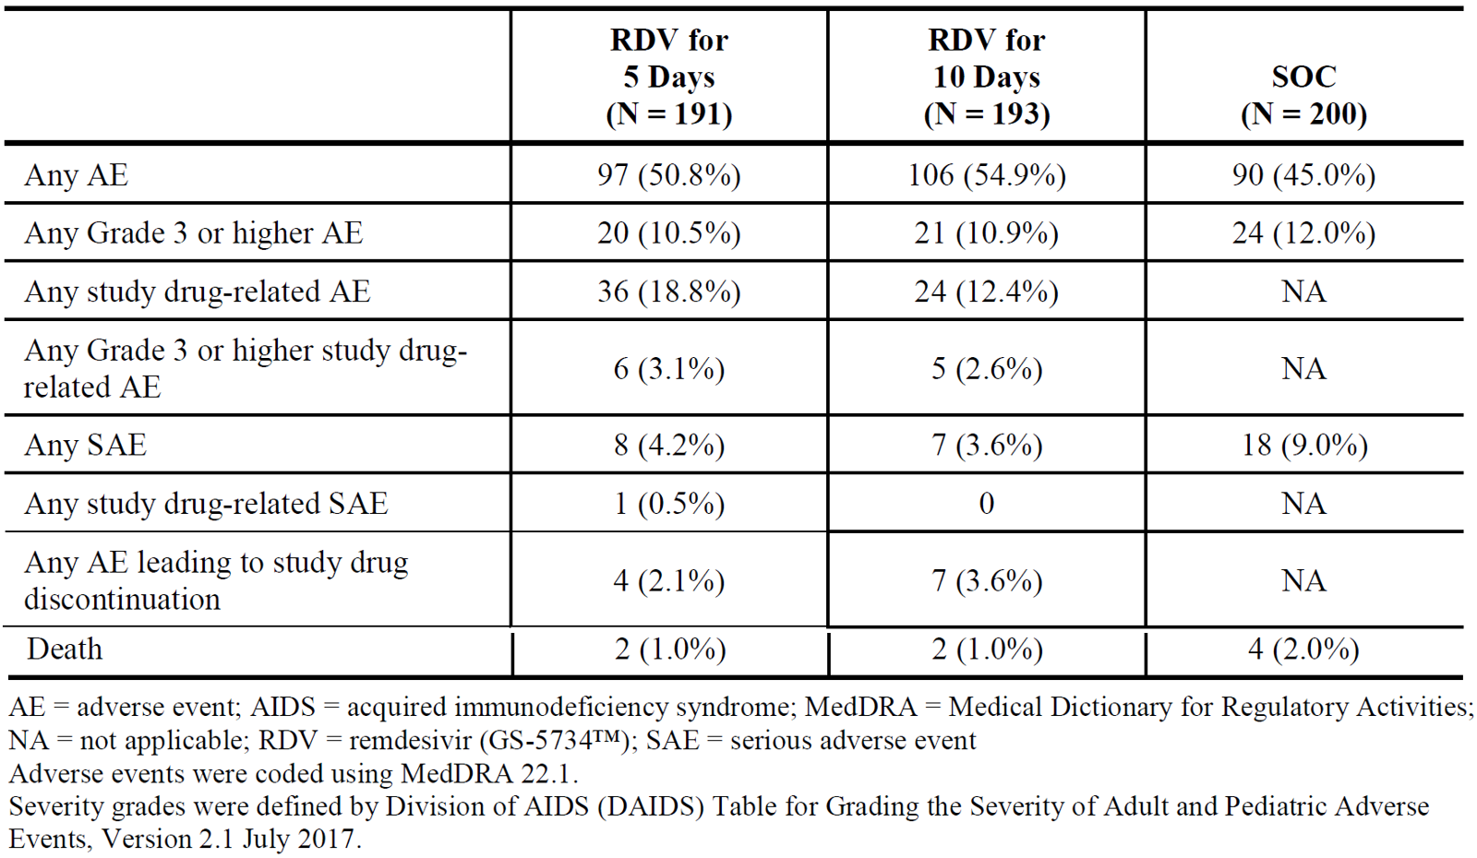
The most common AEs were (Table 23):
- Remdesivir for 5 days: nausea (9.9%), headache (5.2%), and diarrhoea (5.2%).
- Remdesivir for 10 days: nausea (9.3%), hypokalaemia (6.7%), and diarrhoea (5.2%).
- SOC: diarrhoea (7.0%), constipation (4.5%), and insomnia and pyrexia (each 3.5).
Table 23: Study GS-US-540-5774 Adverse events occurring in ≥ 3% of participants in any treatment group by treatment group (safety analysis set)
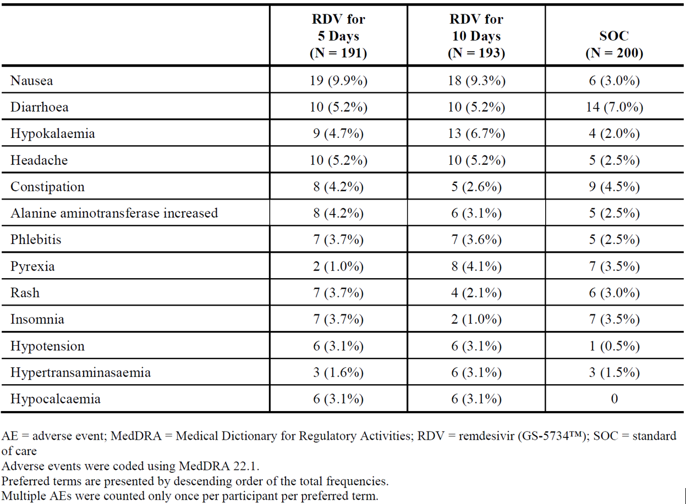

Study CO-US-540-5758
AEs were reported in 66% (102 of 155 participants) of the remdesivir group and 64% (50 of 78 participants) of the placebo group. Grade 3 or 4 AEs were reported in 8% (13 participants) of the remdesivir group and 14% (11 participants) of the placebo group. The most common Grade 3 or 4 AEs (reported in > 1%) were thrombocytopenia (3% versus 4%) and anaemia (1% versus 3%).

Study IN-US-540-5755
Overall, AEs were reported in 50.3% of the 163 patients treated with remdesivir. The most common AEs (> 4% overall) were respiratory failure (6.7%), transaminases increased (4.9%), acute kidney injury (4.9%), hypotension (4.9%), and diarrhoea (4.3%). More patients on invasive baseline oxygen support had AEs compared to patients on non-invasive baseline oxygen support: overall (55.8% versus 41.4%); respiratory failure (9.6% versus 1.7%), CoV infection (5.8% versus 1.7%), acute kidney injury (6.7% versus 1.7%), renal impairment (4.8% versus 0), hypotension (6.7% versus 1.7%), and multiple organ dysfunction syndrome (4.8% versus 0). This is consistent with the increased severity of illness in these patients.

Deaths
Study CO-US-540-5776 (ACTT-1 trial): as judged by the site investigators no deaths were related to treatment assignment.
Study GS-US-540-5773 (SIMPLE-severe): overall, 44 deaths were reported: 19 (9.5%) in the remdesivir 5 day group and 25 (12.7%) in the remdesivir 10 day group (see Table 22).
Study GS-US-540-5774 (SIMPLE-moderate): overall, 8 deaths were reported; 2 (1.0%) in the remdesivir 5 day group, 2 (1.0%) in the remdesivir 10 day group, and 4 (2.0%) in the SOC group (Study GS-US-540-5774 Part A Interim Analysis).
Study CO-US-540-5758: all deaths during the observation period were judged by the site investigators to be unrelated to study drug.
Study IN-US-540-5755: 33 patients out of 163 (20.2%) died.

Serious adverse events

Study CO-US-540-5776 (ACTT-1 trial)
SAEs occurred in 21.1% (remdesivir) versus 27.0% (placebo). Four events (2 in each group) were judged by site investigators to be related to remdesivir or placebo. There were 28 (5.2%) respiratory failure SAEs in the remdesivir group and 42 (8.0%) in the placebo group (see Table 24). SAEs of acute respiratory failure, hypotension, viral pneumonia, and acute kidney injury were slightly more common among participants in the placebo group.
Table 24: Study CO-US-540-5776 (ACTT-1 trial) Serious adverse events occurring in ≥ 2% of participants in either treatment group by treatment group (all randomised)
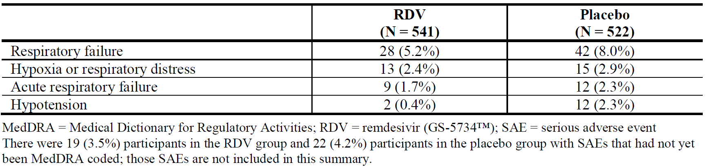

Study GS-US-540-5773 (SIMPLE-severe trial)
SAEs in > 1% of participants overall appeared to occur more often in the remdesivir 10 day group compared to remdesivir 5 day or placebo (see Table 25). The remdesivir 5 day and placebo groups had similar incidences (see Table 25).
Table 25: Study GS-US-540-5773 Serious adverse events occurring in > 1% of participants overall by treatment group (safety analysis set)
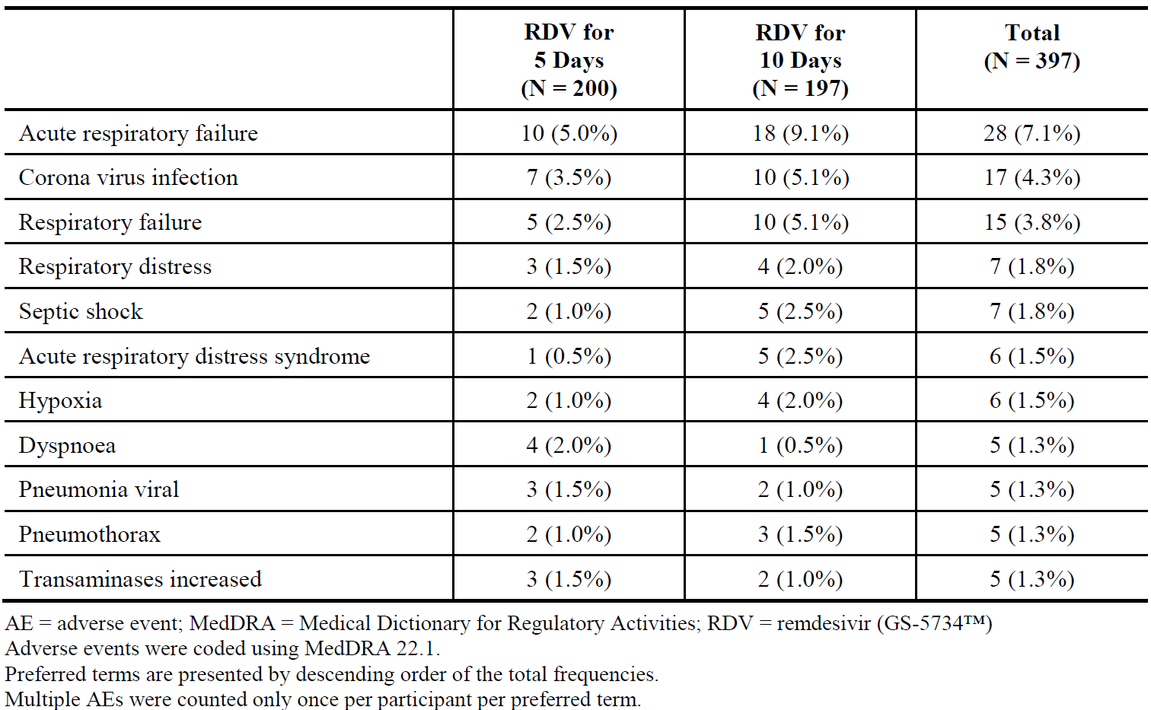

Study GS-US-540-5774 (SIMPLE-moderate trial)
SAEs in > 1% of participants overall appeared to occur less frequently in the remdesivir groups compared to placebo, but the numbers were small (see Table 26).
Table 26: Study GS-US-540-5774 serious adverse events occurring in ≥ 1% of participants in any treatment group by treatment group (safety analysis set)
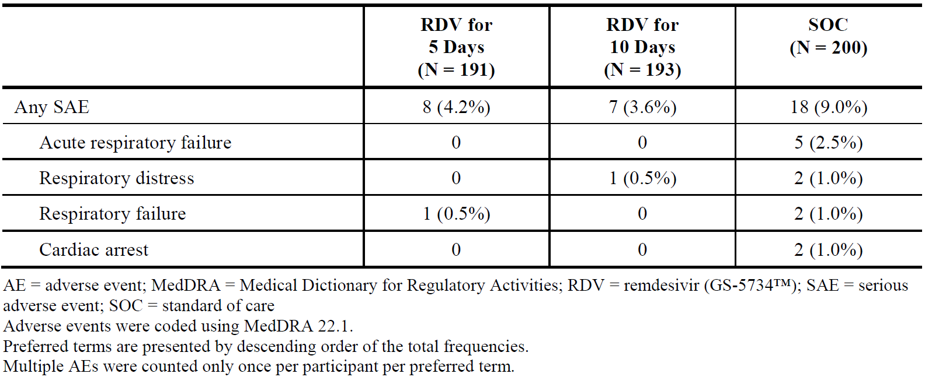

Study CO-US-540-5758
SAEs were reported in 18% (remdesivir) versus 26% (placebo) group. The most common SAEs (> 1%) were respiratory failure or acute respiratory distress syndrome (10% versus 5%), cardiopulmonary failure (5% versus 9%), and multiple organ dysfunction syndrome (1% versus 3%).

Study IN-US-540-5755
SAEs were reported in 23.3% of patients. Fewer patients on non-invasive baseline oxygen support had SAEs compared to invasive baseline oxygen support (15.5% versus 27.9%). The only SAE occurring in > 5% was respiratory failure (in 6.1% overall; in 8.7% in those on invasive baseline oxygen support compared to 1.7% for non-invasive baseline oxygen support.
Discontinuations
Study CO-US-540-5776 (ACTT-1 trial): 36 patients discontinued in either remdesivir (6.7%) or placebo (6.9%) groups due to AEs or SAEs.
Study GS-US-540-5773 (SIMPLE-severe trial): 4.5% in the remdesivir 5 day group and 10.2% in the remdesivir 10 day group discontinued remdesivir due to AEs with 7.1% in the remdesivir 10 day group discontinuing by Day 5.
Study GS-US-540-5774 (SIMPLE-moderate trial): 2.1% in the remdesivir 5 day group, and 3.6% in the remdesivir 10 day group discontinued remdesivir (most commonly due to liver enzyme elevation).
Study CO-US-540-5758: 12% in the remdesivir group and 5% in the placebo group discontinued. The most common AEs leading to study drug discontinuation were secondary infection (remdesivir: 3%), respiratory failure or acute respiratory distress syndrome (remdesivir: 5%, placebo: 1%), and cardiopulmonary failure (remdesivir: 2%, placebo: 1%).
Study IN-US-540-5755: 8.0% discontinued remdesivir due to AEs. Most discontinuations due to AEs were associated with renal dysfunction (4 patients) or due to hepatic AEs (5 patients).

Pharmacology studies in healthy volunteers (single dose only)
Across the four completed Phase I PK studies (Studies GS-US-399-1812, GS-US-399-1954, GS-US-399-4231, GS-US-399-5505), all participants were healthy adults aged 19 to 55 years, and the majority of participants (> 58%) were male. The most commonly reported AEs (in ≥ 5 remdesivir-treated healthy participants Phase I studies) were infusion-site phlebitis, constipation, headache, ecchymosis, nausea, and pain in extremity. All AEs were Grade 1 or 2 in severity. Treatment-related AEs were infrequently reported and primarily consisted of infusion-site phlebitis, headache, rash or pruritus, and gastrointestinal adverse effects. No Grade 3 or 4 AEs, SAEs, or deaths were reported. Two participants discontinued remdesivir due to AEs of nausea (and additionally paraesthesia in one of the participants).

Study CO-US-399-5366 (PALM trial)
175 participants with Ebola virus disease were treated with IV remdesivir (200 mg on Day 1; 100 mg/day from Day 2 for 9 to 13 days). Nine SAEs judged by the site investigator as not related to underlying Ebola virus disease were reported for participants receiving remdesivir.

Safety issues of potential regulatory importance: hepatic safety
Study CO-US-540-5776 (ACTT-1): the incidence of Grade 3 or 4 liver-related non-serious AEs was low and similar between the remdesivir and placebo groups (Table 27). No liver-related SAEs were reported in ≥ 5 participants overall.
Table 27: Study CO-US-540-5776 (ACTT-1 trial) Grade 3 or 4 non-serious liver-related adverse events occurring in ≥ 5 participants overall by treatment group (all randomised)
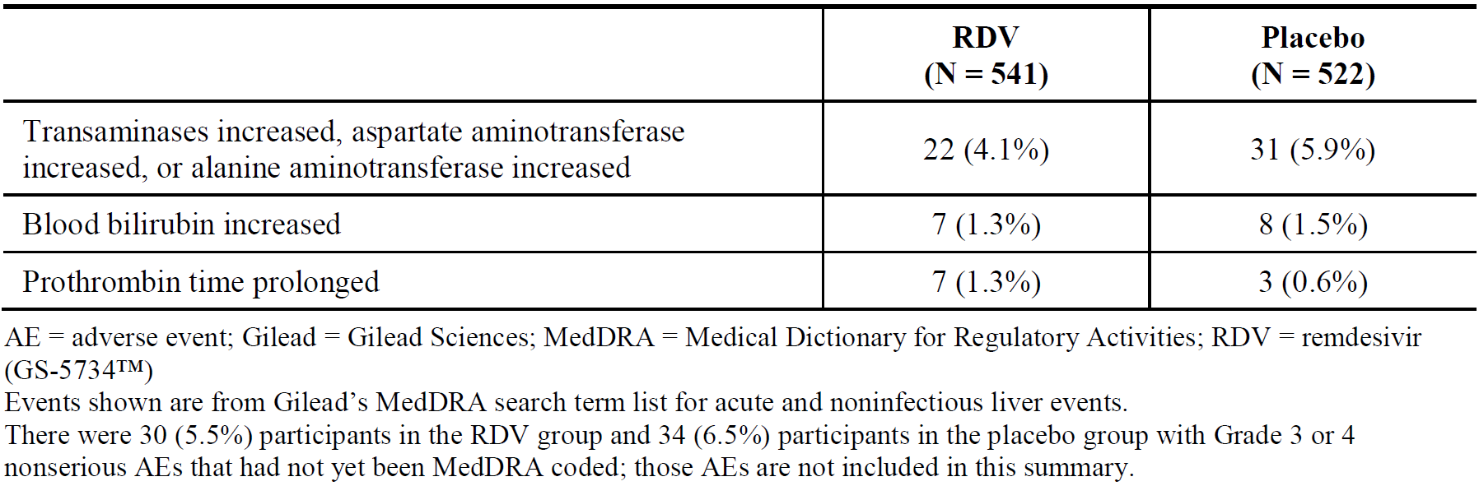
Study GS-US-540-5773 (SIMPLE-severe trial): the incidence of liver-related AEs and Grade 3 or 4 laboratory abnormalities were comparable between 5 day and 10 day remdesivir groups.
Study GS-US-540-5774 (SIMPLE-moderate trial): the incidence of liver-related AEs and Grade 3 or 4 laboratory abnormalities was similar in the groups. However, transaminase increases were higher in the remdesivir groups (remdesivir for 5 days: 8.9%; remdesivir for 10 days: 8.8%; SOC: 5.0%).
Study CO-US-540-5758: liver-related AEs were similar for remdesivir versus placebo.
Study IN-US-540-5755: 41.7% had ALT increases and 47.8% had AST increases (mostly Grade 1 or 2). Grade 3 ALT occurred in 5.6%. Grade 3 AST increases occurred in 6.6%, and a Grade 4 AST increase occurred in 0.7% (1 patient). Nearly all Grade 3 or Grade 4 ALT/AST increases occurred in patients with invasive baseline oxygen support. One patient had worsening hepatitis and discontinued remdesivir.
Safety issues of potential regulatory importance: renal safety
Study CO-US-540-5776 (ACTT-1 trial): the incidence of Grade 3 or 4 renal-related non-serious AEs was similar between the remdesivir and placebo groups. The incidence of renal-related SAEs was similar between groups: acute kidney injury (remdesivir: 0.7% versus placebo 1.3%); glomerular filtration rate decreased (0.6% versus 0.4%).
Study GS-US-540-5773 (SIMPLE-severe trial): the incidence of renal-related SAEs was similar in the remdesivir 5 day group (1.5%) and in the remdesivir 10 day group (2.0%). The incidence of Grade 3 or 4 abnormalities in serum creatinine and CrCl was higher in the 10 day group. An exploratory analysis, suggests that the imbalances between groups are linked to baseline disease characteristics.
Study GS-US-540-5774 (SIMPLE-moderate): the incidence of renal-related AEs was low and similar across all treatment groups. There were no renal-related SAEs in the remdesivir groups, but one participant in the SOC group had an SAE of acute kidney injury. The incidence of Grade 3 or 4 laboratory abnormalities of creatinine increased and CrCl decreased was lower in remdesivir groups compared to the SOC group.
Study CO-US-540-5758: there was 1 SAE of acute kidney injury in the remdesivir group and no renal SAEs in the placebo group. One participant discontinued drug due to Grade 3 or 4 acute kidney injury in the remdesivir group.
Study IN-US-540-5755: 10.2% had renal AEs. Renal AEs > 2% were reported more often in patients with invasive baseline oxygen support compared to non-invasive baseline oxygen support: acute kidney injury (6.7% versus 1.7%), renal failure (3.8% versus 1.7%), and renal impairment (4.8% versus 0), potentially consistent with the increased severity of illness in these patients.

Safety related to interactions
No clinical studies on the effect of extrinsic factors on the PK of remdesivir are available. The sponsor has only performed in vitro studies.
Effects of other medicinal products on remdesivir: in vitro, remdesivir is a substrate for esterases in plasma and tissue, CYP2C8, CYP2D6, CYP3A4, and OATP1B1 and P-gp transporters. The resulting impact may be low, as remdesivir metabolism is predominantly mediated by hydrolase activity. However, strong inhibitors/inducers of the hydrolytic pathway inhibitors may result in increased remdesivir exposure.
The effect of inhibition or induction of hepatic transporters on remdesivir PK may be attenuated due to the moderate-to-high hepatic extraction of remdesivir and its administration via the IV route. Since extra-hepatic esterase-mediated clearance cannot be excluded, the use of remdesivir with known inducers of P-gp (for example, rifampin or herbal medications) is not recommended, as they may decrease plasma concentrations of remdesivir.
Effects of remdesivir on other medicinal products: in vitro, remdesivir is an inhibitor of CYP3A4, OATP1B1 and OATP1B3. The clinical relevance of these interactions is unknown.
Specific drugs: due to antagonism observed in vitro, concomitant use of remdesivir with chloroquine phosphate or hydroxychloroquine sulphate is not recommended.
Metabolites: evaluation of inhibitory effects of GS-704277 and GS-441524 is ongoing.

Safety in special populations
Use in hepatic impairment: no specific studies were conducted in patients with hepatic impairment. A Phase I study in participants with varying degrees of hepatic impairment is planned.
Use in renal impairment: no specific studies have been conducted in patients with renal impairment. A Phase I study in participants with severe renal impairment or on dialysis is planned.
As the excipient SBECD is renally cleared and accumulates in patients with decreased renal function, remdesivir is not recommended in patients with CrCl < 30 mL/min unless the benefit of therapy outweighs the risk.
Sex (gender): in the presented clinical trials, there were more male patients (approximately 60%), and significant differences in the safety profile are not expected.
Paediatric use: dosing in patients ≥ 12 years and ≥ 40 kg is identical to the adult dose regimen and was derived based on modelling and simulation of PK data, as well as information on renal maturation and body weight. Simulations from that model indicate that exposures of remdesivir and its metabolites are generally within the range of exposures observed in adults. However, insufficient data are available on patients less than 12 years of age or weighing < 40 kg.
Age: there was a reasonable proportion of patients ≥ 65 years of age, and a limited number of patients ≥ 75 years of age in the clinical trials. However, no subgroup analysis on potential differences is available yet.
Ethnicity: there was a reasonable proportion of Asian patients in the clinical trials. However, no subgroup analysis on potential differences is available yet.
Use in pregnancy or lactation: pregnant women are included in the ongoing compassionate use program (Study IN-US-540-5755) if they meet the criteria for severe COVID-19. To date, remdesivir has been provided to over 300 pregnant women through the compassionate use program. However, no data appears to be available. The sponsor states that, at this time, data are insufficient to determine the risk of remdesivir use in pregnant women. In the risk management plan (RMP), post-marketing pregnancy report forms and outcome forms are planned as part of routine pharmacovigilance. A remdesivir pregnancy safety report based on outcomes with the use of remdesivir during pregnancy from the compassionate use program (Study IN-US-540-5755) and expanded access program (Study GS-US-540-5821) are planned as part of additional pharmacovigilance.
There is no information regarding the presence of remdesivir in human milk, the effects on the breastfed infant, or the effects on milk production.

Post-market data
No post-market data were available for remdesivir at the time of this application. The compassionate use program (Study IN-US-540-5755) is considered pre-market.

Safety conclusion
Only Studies CO-US-540-5776 (ACTT-1 trial), Study GS-US-540-5774 (SIMPLE-moderate trial), and Study CO-US-540-5758 had a control group (that is, SOC treatment/placebo).
Grade 3 or 4 AEs were similar in remdesivir and placebo groups for both the SIMPLE-moderate trial and ACTT-1 trial. However, Grade 1 or 2 AEs were more frequent in the remdesivir groups compared to placebo in the SIMPLE-moderate trial. The ACTT-1 trial has not reported data on Grade 1 or 2 AEs yet. Study GS-US-540-5773 (SIMPLE-severe trial) did not report significant AE differences between remdesivir 5 day and 10 day treatment groups. There appears also a trend towards a higher incidence of AEs and SAEs in those with greater disease severity (but it remains unclear whether this is exacerbated by drug treatment). Deaths in the controlled studies were considered unrelated to study drug by the investigators.
The sponsor seems to favour a disease-driven origin of hepatic AEs. It is acknowledged that hepatic issues (including increased transaminases) may be common in COVID-19 disease symptomatology, and potentially more severe with increasing severity of disease. However, hepatic AEs due to the drug cannot be excluded and may also exacerbate those caused by COVID-19, especially in patients with existing hepatic impairment or other hepatic issues. In the RMP ‘hepatotoxicity’ is listed as an ‘important potential risk’, and needs to be investigated further.
The kidney was identified as a target organ of toxicity in nonclinical studies. In the provided studies, the incidence of renal AEs was reasonably similar in remdesivir versus placebo groups. As for hepatic AEs, renal AEs may be due to the underlying disease process, or due to the drug, and potentially more severe with increasing severity of disease, especially with patients with existing renal impairment or other renal issues. In the RMP, ‘Nephrotoxicity’ is listed as an ‘important potential risk’, and needs to be investigated further.
The database for the safety evaluation reflects the target population reasonably well. It is expected that remdesivir will be exclusively used in hospital under controlled conditions with appropriate monitoring. With regard to the number of participants: more data are needed to distinguish AEs caused by the drug versus those caused by the disease process itself.

Risk management plan
The sponsor has submitted European Union-risk management plan (EU-RMP) version 1.0 (24 June 2020; data lock point (DLP) 27 May 2020) and Australian specific Annex (ASA) version 0.1 (3 July 2020) in support of this application.
The proposed summary of safety concerns and their associated risk monitoring and mitigation strategies documented in the EU-RMP are summarised below in Table 28.
Table 28: Summary of safety concerns
Summary of safety concerns |  | Pharmacovigilance |  | Risk minimisation
 |  | Routine | Additional | Routine | Additional
Important identified risks | Hypersensitivity including Infusion-Related Reaction |  | * |  | –
Important potential risks | Hepatotoxicity |  | * |  | –
Important potential risks | Nephrotoxicity |  | * |  | –
Missing information | Safety in patients with hepatic impairment |  | * |  | –
Missing information | Safety in patients with severe renal impairment |  | * |  | –
Missing information | Safety in pregnant and lactating women |  | † |  | –
*Post authorisation safety and efficacy studies, †Pregnancy safety report (informed by follow up questionnaires).
- The summary of safety concerns is acceptable for the indication described in the EU-RMP.
- Routine and additional pharmacovigilance activities proposed by the sponsor are acceptable to gather further efficacy data for the indication and to further characterise the risks outlined in the summary of safety concerns.
- Routine risk minimisation through the PI and Consumer Medicines Information (CMI) is acceptable to manage the risks that have been articulated in the summary of safety concerns.

Risk-benefit analysis

Delegate’s considerations

Proposed indication

Endpoint considerations in the efficacy studies
No guidance is available to guide trial design and in particular choice of endpoints in clinical trials for COVID-19.
The endpoints chosen in the provided clinical trial program (in particular the ACTT-1 trial) appear reasonable for measuring outcomes. Time to recovery appears to be a suitable indicator for disease outcome, and also in a wider public health context of potential resource constraints. Mortality comparisons are also considered useful, in particular in large randomised controlled trial (RCTs).
Additionally, it may have been advantageous to incorporate some form of direct measure of the effect of remdesivir on SARS-CoV-2, for example, through viral load measurements, even though acknowledging that clinical correlation may be difficult and still poorly understood.
A meaningful direct comparison of the results between the provided trials was not always possible, due to the differences in design, and the different endpoints used. For example, three different types of clinical status scoring were used across the four randomised trials, even though 2 point improvements may still be comparable to some extent.

Clinical studies and their contribution
Four clinical studies and 1 compassionate use program provided data on efficacy in COVID-19 patients.
The sponsor has not nominated pivotal studies. Study CO-US-540-5776 (ACTT-1 trial) can be considered the pivotal study, primarily due to its design and size. Together with Study CO-US-540-5758, it was one of two trials with a double blind design. Both the SIMPLE-severe trial and SIMPLE-moderate trial were open label. Three trials were placebo controlled (the ACTT-1 trial, SIMPLE-moderate trial, and Study CO-US-540-5758).
- The ACTT-1 trial contributed data on an up to 10 day course of remdesivir in mainly severe COVID-19 patients.
- The SIMPLE-severe trial compared 5 day and 10 day courses of remdesivir in severe COVID-19 patients, but had no control group.
- The SIMPLE-moderate trial provided some data in moderate COVID-19 patients, but suffered from its open label design, and potential multiplicity issues (comparing both 5 day and 10 day courses of remdesivir to SOC).
- Study CO-US-540-5758 intended to provide data in severe COVID-19 patients, but was stopped early and did not reach sufficient power to deliver statistically significant results.
- Study IN-US-540-5755 (compassionate use program) had no control group.
Consequently, the main, robust data are derived from the ACTT-1 trial, and this will ultimately influence the indication of Veklury remdesivir (including disease severity and patient age group). The other studies are generally supportive of the pivotal study.
All studies (except for Study CO-US-540-5758) are still ongoing, and have no full clinical study report available. However, the preliminary results do report on top line data.

Duration of treatment considerations
The pivotal ACTT-1 trial used continued SOC therapy together with IV remdesivir 200 mg on Day 1 followed by IV remdesivir 100 mg daily for a total of up to 10 days (in the remdesivir group 180 patients received all 10 doses, and 251 patients received < 10 doses, but it is unspecified how many doses).
Data from the SIMPLE-severe trial appears to indicate that 5 days may be an adequate alternative regimen. However, this study was open label, and furthermore, clinical status was statistically significantly different between the 5 day versus the remdesivir 10 day group (even though adjustments were made in the analysis). These results are not supported by the SIMPLE-moderate trial, but this was conducted in a different patient group with moderate COVID-19.
Overall, from the data available, the most appropriate duration appears to be 5 to 10 days, in particular when restricted to facilities where adequate monitoring for adverse events can occur.
This duration is reflected in the proposed PI document: ‘The total duration of treatment should be at least 5 days and not more than 10 days.’

Considerations of disease characteristics
Pneumonia/ lower respiratory tract infection (LRTI): all main studies included the presence of pulmonary infiltrates as an inclusion criterion (that is, lung involvement), there appear to be only very limited data on the use of remdesivir in COVID-19 patients without lung involvement.
Results stratified by disease severity: as stated above, Study CO-US-540-5776 (ACTT-1 trial) provided the most robust and relevant data on the use of remdesivir in COVID-19. The primary analysis from this study indicates that, overall, treatment with remdesivir results in a shorter time to recovery as compared to placebo. Subgroup analyses of this study revealed that the effect could only be demonstrated in either severe disease, or patients with baseline disease severity ordinal scale Score 5 (hospitalised, on oxygen) (see Table 29). The other groups may not have had sufficient power to demonstrate an effect, or did not experience a beneficial effect.
Table 29: Study CO-US-540-5776 (ACTT-1 trial) Summary of primary endpoint results: time to recovery overall and by baseline disease severity (intent to treat population)
Disease subgroup | ACTT-1 trial primary endpoint result (time to recovery RR (95% CI) comparing remdesivir to placebo) | Statistically significant
Overall | 1.32 (1.12, 1.55) (n = 1059) | Yes
Stratified by baseline disease severity (mild-moderate or severe)
Mild-moderate disease | 1.09 (0.73, 1.62) (n = 119) | No
Severe disease | 1.37 (1.15, 1.63) (n = 940) | Yes
Stratified by baseline disease severity ordinal scale score
4 – Hospitalised, not on oxygen | 1.38 (0.94, 2.03) (n = 127) | No
5 – Hospitalised, on oxygen | 1.47 (1.17, 1.84) (n = 421) | Yes
6 – Hospitalised, on high-flow oxygen or non-invasive mechanical ventilation | 1.20 (0.79, 1.81) (n = 197) | No
7 – Hospitalised, on invasive mechanical ventilation or ECMO | 0.95 (0.64, 1.42) (n = 272) | No

Age considerations

Patients aged 12 to < 18 years old
Most of the data in the dossier support an indication of severe COVID-19 in hospitalised patients over 18 years of age. The ACTT-1 trial only investigated patients aged 18 years or over. Even though theoretically, patients aged 12 to under 18 years were eligible for both SIMPLE trials, only one patient in that age bracket was enrolled. No patients younger than 12 years were investigated.
The physiology in adolescents aged 12 years and above is unlikely significantly different in the context of remdesivir in COVID-19. Furthermore, there are some data from PBPK modelling supporting the use from age 12 years and above. However, there were limitations to the PBPK modelling (shown in the ‘Pharmacology’ section, above).
Based on the above, adult data could be reasonably extrapolated to also include patients 12 years and above.

Patients aged < 12 years old
The provisional approval for paediatric patients less than 12 years of age with COVID-19 disease would require preliminary promising data in this age group. This is not the case for patients less than 12 years of age. The lack of data in that age group, would lead to an unfavourable benefit-risk balance, even under a provisional approval.
The PBPK modelling data do not support an extrapolation to children aged less than 12 years of age. The model predictions could not be verified given the lack of paediatric PK data. The exposure in the adolescent population weighing less than the adult population is expected to be increased compared to adults.
No specific nonclinical studies in juvenile animals were submitted. The remdesivir drug products contain the excipient SBECD which is renally cleared, accumulates in patients with decreased renal function, and may cause renal toxicity. Products containing SBECD are not recommended for use in newborn babies and infants aged under 2 years due to insufficient toxicological knowledge in these age groups. In addition, there are no nonclinical data for SBECD in young animals and the human safety data for SBECD (not part of the dossier) are limited in children and adolescents (2 to 12 years of age).

Summary of data by age group
Table 30 shows a summary of the data by age group.
Table 30: Summary of data in the dossier by age group
Age | Data
No age restriction, but weighing ≥ 3.5 kg (proposed by sponsor) | No clinical data available. Not supported by PBPK modelling data. Safety concerns regarding SBECD.
Aged ≥ 12 years, but weighing ≥ 40 kg | Very limited clinical data (one patient only in the main clinical trials, and results from a PBPK analysis from healthy adult volunteers), but can be reasonably extrapolated from adult data.
Aged ≥ 18 years | Nearly all clinical data were derived from an adult population.

Provisional registration
The provisional approval pathway allows sponsors to apply for provisional registration on the ARTG. It provides access to certain promising new medicines where the public health benefit of immediate or early availability of the medicine outweighs the risk inherent in the fact that additional data are still required.1
The sponsor has applied for the provisional approval pathway, and the TGA has made a provisional determination for the indication proposed by the sponsor for this application.
The presented remdesivir data available are only the top line trial results with no comprehensive study reports submitted for any of the Phase III studies. Thus, provisional registration is therefore the most appropriate regulatory option. Based on the above rationale, and given the urgent public health need during the COVID-19 pandemic, the TGA Delegate proposes to register Veklury (remdesivir) via the provisional pathway. The provisional registration reflects the present deficiencies of the data balanced with the public health need.

Indication
The sponsor is proposing the following indication:
Veklury is indicated for the treatment of adults and paediatric patients weighing at least 3.5 kg with coronavirus disease 2019 (COVID-19).
The preliminary analysis from the pivotal ACTT-1 trial mainly demonstrated an efficacy benefit (time to recovery) in adult patients with severe COVID-19 with the presence of pulmonary infiltrates, and requiring supplemental oxygen.
- There is no clear demonstrated benefit in patients with mild to moderate disease.
- There is no clear demonstrated benefit in patients in the following baseline disease severity ordinal scale score groups: 4 – Hospitalised, not on oxygen, 6 – Hospitalised, on high-flow oxygen or non-invasive mechanical ventilation, and 7 – Hospitalised, on invasive mechanical ventilation or ECMO.
- There are no data in paediatric patients less than 12 years of age.
- There are only very limited data in patients aged 12 to 18 years of age, but the adult data may be extrapolated to that population. For the age group under 12 years, there are no data available, and thus, the benefit-risk balance is unfavourable for that group.
This TGA proposed indication will capture the main risk groups. Those groups have the most available data.
After careful consideration of the provided data and the public health context, the TGA proposed indication is:
Veklury has provisional approval for the treatment of Coronavirus Disease 2019 (COVID-19) in adults and adolescents (aged 12 years and older weighing at least 40 kg) with pneumonia requiring supplemental oxygen.
The decision to approve this medicine has been made based on limited data. More comprehensive evidence is required to be submitted.
Advice from the ACM on the indication is requested.

Deficiencies of the data
Data limited to one double blind RCT (only one pivotal study): only one sufficiently powered double-blind RCT provided data on the use of remdesivir in COVID-19, namely the ACTT-1 trial. Typically, more than one pivotal double-blind RCT is required, but the existing dataset may be sufficient for provisional registration.
Limited data on mild or moderate disease: most data available relate to the use of remdesivir in severe COVID-19. There are only limited data available on mild or moderate COVID-19.
Limited data and documentation in general: there was no study report made available in the dossier for any of the clinical trials. The provided results have mainly originated from the Clinical Overview and the associated literature publications.
Lack of biomarker/viral load correlation in clinical studies: it may have been advantageous to incorporate some form of direct measure of the effect of remdesivir on SARS-CoV-2, for example, through viral load measurements, even though acknowledging that clinical correlation may be difficult and still poorly understood.
Generalisability: the populations studied were not relevant for the sponsor proposed indication, but would be relevant, if amended as per TGA recommendation. Thus, the results are generalisable to the general Australian population with the potential exception of the Indigenous Australian population. However, it is unlikely that there are significant differences.
Lack of long-term data: no studies studied the drug for more than 10 days. There appeared to have been no long-term follow-up. On the other hand, remdesivir is not intended to be used long-term, but only as a short course in patients where the potential benefit of treatment outweighs the potential risk.
No mass balance data for multiple dosing available: the mass-balance study (Study GS-US-399-4231) relied on single dosing only, and did not provide data on multiple dosing and potentially associated longer-term accumulation. However, given that the treatment duration would usually be restricted to a maximum of 10 days, and should ideally involve strict monitoring to assess any potential adverse events early, this is acceptable.
No data in children aged under 12 years of age: since there are no data in this age group, the Delegate is of the view that this age group should not been included in the indication, even under a provisional approval.
Limited data for the age group 12 to < 18 years: only one participant in clinical trials was in that age group.
Data in the elderly population aged ≥ 75: the total number of subjects > 75 years of age was limited. They were more likely to have co-morbidities (including renal or hepatic issues). In a full CSR, subgroup analyses for potential differences in efficacy and safety would have likely been available, but were not provided in this dossier.
Use in pregnancy or lactation: even though pregnant women were included in the ongoing compassionate use program (Study IN-US-540-5755), no clinical data appears to be available. No clinical data on lactation appears to be available.
Resistance testing: resistance of different SARS-CoV-2 isolates/strains was not assessed and further studies are considered essential to characterise the resistance profile of SARS-CoV-2 isolates to remdesivir.
Pharmacology data deficiencies:
- PK in the target population.
- A currently unidentified major metabolite (M27) in plasma.
- PK in subjects with impaired hepatic function.
- PK in subjects with impaired renal function.
- PK related to genetic factors.
- PK according to age.
- Population PK data.
- In vivo PK interactions (some in vitro data are available).
- PD.

Proposed action
The Delegate has no reason to say, at this time, that the application for Veklury remdesivir should not be approved for provisional registration (with specific conditions) for the following indication (in lieu of the sponsor proposed indication):
Veklury has provisional approval for the treatment of Coronavirus Disease 2019 (COVID-19) in adults and adolescents (aged 12 years and older weighing at least 40 kg) with pneumonia requiring supplemental oxygen.
The decision to approve this medicine has been made based on limited data. More comprehensive evidence is required to be submitted.

Request for Advisory Committee on Medicines advice
The committee is requested to provide advice on the following specific issues:
- Can the Advisory Committee on Medicines (ACM) comment on the appropriate patient groups that would benefit from remdesivir treatment?
- Can the ACM comment on the age group that would benefit from remdesivir treatment, and that should be specified in the indication?
- Can the ACM comment on the indication wording proposed by the TGA Delegate?
The committee is also requested to provide advice on any other issues that it thinks may be relevant to a decision on whether or not to approve this application.

Advisory Committee considerations
The Advisory Committee on Medicines (ACM), having considered the evaluations and the Delegate’s overview, as well as the sponsor’s response to these documents, advised the following.

Advice to the delegate
- Can the ACM comment on the appropriate patient groups that would benefit from remdesivir treatment?
The ACM noted that the clinical categories used in the Australian context do not align entirely with those used in the studies. However, the benefit appears to be most apparent in hospitalised patients with pneumonia requiring supportive oxygen.
- Can the ACM comment on the age group that would benefit from remdesivir treatment, and that should be specified in the indication?
The ACM does not recommend the use of remdesivir for children under the age of 12 years, as to date there is no data provided in COVID-19 patients in this age group. Adult data provided does not allow for reasonable extrapolation to children or neonates.
Overall, the ACM was supportive of use in adolescents 12 to 18 years of age, weighing over 40 kg, as per the indication, noting that this has been extrapolated from the limited adult data that is currently available.
- Can the ACM comment on the indication wording proposed by the TGA Delegate?
The ACM recommended that the indication include those patients 12 years and older who are hospitalised with pneumonia as a result of moderate or severe COVID-19 requiring supplemental oxygen or other high-level respiratory supports including non-invasive ventilation, invasive ventilation or ECMO.
The decision to approve this medicine has been made based on limited data. More comprehensive evidence is required to be submitted.

Conclusion
The ACM considered that this product had an overall positive benefit-risk profile for the indication:
Velkury has provisional approval for the treatment of Coronavirus Disease 2019 (COVID-19) in hospitalised adults and adolescents (aged 12 years and older weighing at least 40 kg) with pneumonia, requiring supplemental oxygen or other high-level respiratory support including non-invasive ventilation, invasive ventilation or extracorporeal membrane oxygenation (ECMO).
The decision to approve this medicine has been made based on limited data. More comprehensive evidence is required to be submitted.

Outcome
Based on a review of quality, safety and efficacy, the TGA approved the provisional registration of Veklury (remdesivir) 100 mg/20 mL concentrate for injection and 100 mg powder for injection, indicated for:
Veklury has provisional approval for the treatment of Coronavirus Disease 2019 (COVID-19) in adults and adolescents (aged 12 years and older weighing at least 40 kg) with pneumonia, requiring supplemental oxygen.
The decision to approve this medicine has been made based on limited data. More comprehensive evidence is required to be submitted.
The provisional registration period for the above medicine is two years starting on the day specified in the Australian Register of Therapeutic Goods (ARTG) certificate of registration.

Summary of specific conditions of registration
As a provisionally registered medicine, extensive post-market commitments are required of the sponsor. The following is a summary of the post-market commitments.
- Veklury (remdesivir) is to be included in the Black Triangle Scheme. The PI and CMI for Veklury must include the black triangle symbol and mandatory accompanying text for the products entire period of provisional registration.
- The Veklury EU-RMP (version 1.0, dated 24 June 2020, data lock point 27 May 2020), with ASA (version 0.1, dated 3 July 2020), included with submission PM-2020-01491-1-2, to be revised to the satisfaction of the TGA, and subsequent versions, as agreed with the TGA, will be implemented in Australia.
Periodic safety update reports (PSURs) are to be provided in line with the current published list of EU reference dates and frequency of submission of PSURs until the period covered by such reports is not less than three years from the date of the approval letter.
- Additional to the submission of routine PSURs, the sponsor provides to the TGA expedited monthly remdesivir safety summary reports (including safety data for patients in Australia) for the first 6 months post registration, and thereafter at intervals specified by the TGA.
- Confirmatory trial data (as identified in the sponsor’s plan to submit comprehensive clinical data on the safety and efficacy of the medicine before the end of the 6 years that would start on the day that registration would commence) must be provided.
Specifically, the sponsor must provide the study reports for studies as specified in Part III.2. Additional Pharmacovigilance activities of the Veklury EU-RMP (Version 1.0, dated 24 June 2020, data lock point 27 May 2020).
Clinical study reports (CSRs) for the following remdesivir studies/data should be submitted to the TGA, once available:
  - Study GS-US-540-5773 (final CSR expected in December 2020 for Part A).
  - Study GS-US-540-5774 (final CSR expected in December 2020 for Part A).
  - Study CO-US-540-5776 (ACTT-I) (final CSR expected in December 2020).
  - An analysis of all available safety data from clinical trials CO-US-540-5776, GS-US-5405773, GS-US-540-5774 and CO-US-540-5758 when completed, including case narratives, detailed information about adverse reaction and exposure data as well as an analysis of occurrence and aggravation of AEs, SAEs and adverse drug reactions (ADRs) are associated with increasing exposure.
  - Remdesivir pregnancy safety reports (yearly submission of annual reports).
  - Phase I study in subjects with hepatic impairment (final CSR expected in November 2021).
  - Phase I study in subjects with severe renal impairment and subjects with end stage renal disease on dialysis (final CSR expected in September 2021).
- Additional quality data as requested by the TGA should be provided.
- As part of the Section 14 and 14A consent for Veklury (ARTG 338419 and 338420) to be imported into and supplied in Australia without compliance with certain parts of the Therapeutic Goods Order No. 91 until 10 February 2021, the following conditions were imposed:
  - The products are supplied with the labels as submitted to the TGA.
  - The sponsor must provide to each Australian healthcare facility to which the products are supplied a Dear Healthcare Professional Letter (DHCPL) that is approved by the TGA and contains labelling information, as specified by the TGA.
- Additional nonclinical data as requested by the TGA should be provided.

Attachments 1 and 2. Product Information
The PIs for Veklury approved with the submission which is described in this AusPAR is at Attachments 1 and 2. For the most recent PIs, please refer to the TGA website at <https://www.tga.gov.au/product-information-pi>.

Therapeutic Goods Administration
PO Box 100 Woden ACT 2606 Australia
Email: info@tga.gov.au Phone: 1800 020 653 Fax: 02 6232 8605
https://www.tga.gov.au

As part of the provisional approval pathway, the provisional registration process will allow certain medicines to be provisionally registered in the Australian Register of Therapeutic Goods (ARTG) for a limited duration. These medicines are registered on the basis of preliminary clinical data, where there is the potential for a substantial benefit to Australian patients. The TGA will re-assess risks related to the absence of evidence through data provided at a later stage, as part of the confirmatory data. Confirmatory data should confirm the relationship between outcomes predicted by the surrogate endpoint, or other preliminary data, and the clinical benefit as demonstrated by direct clinical outcomes. The provisional registration period is 2 years starting on the day registration commences. Up to two extensions of up to 2 years can be applied for, resulting in a possible maximum provisional registration period of 6 years. The sponsor may apply to transition to full registration at any time up until the provisional registration lapse date, once they have completed the obligations outlined for the provisional registration period and complete confirmatory data on safety and efficacy are available.
Therapeutic goods must be entered in the Australian Register of Therapeutic Goods (ARTG) before they can be lawfully supplied in or exported from Australia, unless exempt from being entered in the ARTG, or otherwise authorised by the TGA. For further information visit: https://www.tga.gov.au/australian-register-therapeutic-goods.
The Black Triangle Scheme provides a simple means for practitioners and patients to identify certain types of new prescription medicines, including those being used in new ways and to encourage the reporting of adverse events associated with their use. The Black Triangle does not denote that there are known safety problems, just that the TGA is encouraging adverse event reporting to help us build up the full picture of a medicine's safety profile.
McIntosh, K. Coronavirus disease 2019 (COVID-19): Epidemiology, virology, and prevention, In: UpToDate, Waltham, MA (Accessed on 9 July 2020).
World Health Organization (2020) Disease outbreak news: Update. Novel Coronavirus – China. Published 12 January 2020. Available from the WHO website.
The International Health Regulations (2005) are a legally binding instrument of international law aiming to assist international collaboration to save lives and livelihoods endangered by the international spread of diseases and other health risks and avoid unnecessary interference with international trade and travel. The purpose and scope of IHR (2005) are ‘to prevent, protect against, control, and provide a public health response to the international spread of disease in ways that are commensurate with and restricted to public health risks and that avoid unnecessary interference with international traffic and trade’.
A Public Health Emergency of International Concern (PHEIC) is a formal declaration by the World Health Organization (WHO) of ‘an extraordinary event which is determined to constitute a public health risk to other States through the international spread of disease and to potentially require a coordinated international response’, following a ‘serious, sudden, unusual or unexpected’ situation that ‘carries implications for public health beyond the affected state's national border [and] may require immediate international action’.
World Health Organization (2020) WHO Director-General speeches: WHO Director-General's statement on IHR Emergency Committee on Novel Coronavirus (2019-nCoV). Published 30 January 2020. Available from the WHO website.
World Health Organization (2020) WHO Director-General speeches: WHO Director-General's opening remarks at the media briefing on COVID-19 - 11 March 2020. Available from the WHO website.
World Health Organization, Coronavirus disease (COVID-2019) situation reports, Situation report 169, (Accessed 8 July 2020).
McIntosh, K. Coronavirus disease 2019 (COVID-19): Clinical features. In: UpToDate, (Accessed on 7 July 2020).
ARDS is defined by timing (acute; within 1 week of clinical insult or onset of respiratory symptoms); radiographic changes (bilateral opacities not fully explained by effusions, consolidation, or atelectasis); origin of edema (not fully explained by cardiac failure or fluid overload); and severity based on the arterial oxygen partial pressure (PaO₂)/ fractional inspired oxygen (FiO₂) ratio on 5 cm of continuous positive airway pressure (CPAP). The 3 categories are mild (PaO₂/FiO₂ 200-300), moderate (PaO₂/FiO₂ 100-200), and severe (PaO₂/FiO₂ ≤ 100). Adapted from: The ARDS taskforce. Acute Respiratory Distress Syndrome; the Berlin Definition. JAMA. 2012; 307(23): 2526-2533.
Kim AY and Gandhi RT. Coronavirus disease 2019 (COVID-19): Management in hospitalized adults. In: UpToDate, Waltham, MA (Accessed on 09 July 2020).
Mulangu, S. et al. A Randomized, Controlled Trial of Ebola Virus Disease Therapeutics, N Engl J Med, 2019; 381:2293-2303.
Australian Product Information documents for Veklury (remdesivir) powder for injection and Veklury (remdesivir) concentrate for injection. Date of first approval: 10 July 2020.
European Medicines Agency (EMA); conditional marketing authorisation. In the interest of public health, applicants may be granted a conditional marketing authorisation for such medicines where the benefit of immediate availability outweighs the risk of less comprehensive data than normally required, based on the scope and criteria defined in legislation and guidelines.
Medicines and other therapeutic goods must comply with applicable standards to be supplied in Australia. It is an offence to import, supply or export therapeutic goods that do not comply with a standard applicable to the goods, unless the prior consent in writing of the Secretary has been given (see Section 14 the Therapeutic Goods Act 1989) or a civil penalty may be payable (see Section 14A of the Act). Section 14 consent decisions are listed on the TGA website at https://www.tga.gov.au/ws-s14-index.
Inclusion of these recommendations is beyond the scope of this AusPAR.
Beigel, J.H. et al. Remdesivir for the Treatment of Covid-19 — Preliminary Report, N Engl J Med, 2020; DOI: 10.1056/NEJMoa2007764. Online ahead of print.
Goldman, J.D. et al. Remdesivir for 5 or 10 Days in Patients with Severe Covid-19, N Engl J Med, 2020; DOI: 10.1056/NEJMoa2015301, Online ahead of print.
Wang, Y. et al. Remdesivir in adults with severe COVID-19: a randomised, double-blind, placebo-controlled, multicentre trial, Lancet, 2020; 395: 1569–1578.
GS-5734 is the sponsor’s drug development name/code for remdesivir.
Adaptive COVID-19 Treatment Trial (ACTT). Sponsor: National Institute of Allergy and Infectious Diseases (NIAID); National Institutes of Health (NIH); United States of America. ClinicalTrials.gov Identifier: NCT04280705.
Study to Evaluate the Safety and Antiviral Activity of Remdesivir (GS-5734) in Participants With Severe Coronavirus Disease (COVID-19). Sponsor: Gilead Sciences. ClinicalTrials.gov Identifier: NCT04292899
Study to Evaluate the Safety and Antiviral Activity of Remdesivir (GS-5734) in Participants With Moderate Coronavirus Disease (COVID-19) Compared to Standard of Care Treatment. Sponsor: Gilead Sciences. ClinicalTrials.gov Identifier: NCT04292730.
A Phase 3 Randomized, Double-blind, Placebo-controlled, Multicenter Study to Evaluate the Efficacy and Safety of Remdesivir Combined with Standard of Care (SOC) in Hospitalized Adult Patients with Severe 2019-nCoV Respiratory Disease. Sponsor: Capital Medical University (Beijing, China). ClinicalTrials.gov Identifier: NCT04257656.
Randomised clinical trials analysed by the intent-to-treat (ITT) approach provide unbiased comparisons among the treatment groups. In the ITT population, none of the patients are excluded and the patients are analysed according to the randomisation scheme.
300 mm Hg is approximately equivalent to 40 kPa.
SARS-CoV-2 was initially referred to as n-CoV.
The National Early Warning Score 2 (NEWS2) is based on a simple aggregate scoring system in which a score is allocated to physiological measurements, already recorded in routine practice, when patients present to, or are being monitored in hospital. Six simple physiological parameters form the basis of the scoring system: respiration rate, oxygen saturation, systolic blood pressure, pulse rate, level of consciousness or new confusion and temperature. A score is allocated to each parameter as they are measured, with the magnitude of the score reflecting how extremely the parameter varies from the norm.
Single patient compassionate use program provide patients with a clinical need to access an unauthorised investigational medical product in accordance with mechanism available in each country. This program does not apply to products used as part of a registered clinical trial.
Routine risk minimisation activities may be limited to ensuring that suitable warnings are included in the product information or by careful use of labelling and packaging. Routine pharmacovigilance practices involve the following activities: - All suspected adverse reactions that are reported to the personnel of the company are collected and collated in an accessible manner; - Reporting to regulatory authorities; - Continuous monitoring of the safety profiles of approved products including signal detection and updating of labelling; - Submission of PSURs; - Meeting other local regulatory agency requirements.
The ACM provides independent medical and scientific advice to the Minister for Health and the Therapeutic Goods Administration (TGA) on issues relating to the safety, quality and efficacy of medicines supplied in Australia including issues relating to pre-market and post-market functions for medicines. The Committee is established under Regulation 35 of the Therapeutic Goods Regulations 1990. Members are appointed by the Minister. The ACM was established in January 2017 replacing Advisory Committee on Prescription Medicines (ACPM) which was formed in January 2010. ACM encompass pre and post-market advice for medicines, following the consolidation of the previous functions of the Advisory Committee on Prescription Medicines (ACPM), the Advisory Committee on the Safety of Medicines (ACSOM) and the Advisory Committee on Non-Prescription Medicines (ACNM). Membership comprises of professionals with specific scientific, medical or clinical expertise, as well as appropriate consumer health issues relating to medicines.

