December 2021

Australian Public Assessment Report for Regdanvimab
  - Proprietary Product Name: Regkirona
  - Sponsor: Celltrion Healthcare Australia Pty Ltd

About the Therapeutic Goods Administration (TGA)
- The Therapeutic Goods Administration (TGA) is part of the Australian Government Department of Health and is responsible for regulating medicines and medical devices.
- The TGA administers the Therapeutic Goods Act 1989 (the Act), applying a risk management approach designed to ensure therapeutic goods supplied in Australia meet acceptable standards of quality, safety and efficacy (performance) when necessary.
- The work of the TGA is based on applying scientific and clinical expertise to decision-making, to ensure that the benefits to consumers outweigh any risks associated with the use of medicines and medical devices.
- The TGA relies on the public, healthcare professionals and industry to report problems with medicines or medical devices. TGA investigates reports received by it to determine any necessary regulatory action.
- To report a problem with a medicine or medical device, please see the information on the TGA website <https://www.tga.gov.au>.

About AusPARs
- An Australian Public Assessment Report (AusPAR) provides information about the evaluation of a prescription medicine and the considerations that led the TGA to approve or not approve a prescription medicine submission.
- AusPARs are prepared and published by the TGA.
- An AusPAR is prepared for submissions that relate to new chemical entities, generic medicines, major variations and extensions of indications.
- An AusPAR is a static document; it provides information that relates to a submission at a particular point in time.
- A new AusPAR will be developed to reflect changes to indications and/or major variations to a prescription medicine subject to evaluation by the TGA.

Copyright
© Commonwealth of Australia 2021
This work is copyright. You may reproduce the whole or part of this work in unaltered form for your own personal use or, if you are part of an organisation, for internal use within your organisation, but only if you or your organisation do not use the reproduction for any commercial purpose and retain this copyright notice and all disclaimer notices as part of that reproduction. Apart from rights to use as permitted by the Copyright Act 1968 or allowed by this copyright notice, all other rights are reserved and you are not allowed to reproduce the whole or any part of this work in any way (electronic or otherwise) without first being given specific written permission from the Commonwealth to do so. Requests and inquiries concerning reproduction and rights are to be sent to the TGA Copyright Officer, Therapeutic Goods Administration, PO Box 100, Woden ACT 2606 or emailed to <tga.copyright@tga.gov.au>.

Contents
List of abbreviations 4
I. Introduction to product submission 7
Submission details 7
Product background 8
Regulatory status 12
Product Information 12
II. Registration timeline 12
III. Submission overview and risk/benefit assessment 13
Quality 13
Nonclinical 14
Clinical 15
Risk management plan 63
Risk-benefit analysis 64
Outcome 69
Attachment 1. Product Information 71

List of abbreviations
Abbreviation | Meaning
ACE2 | Angiotensin converting enzyme 2
ACM | Advisory Committee on Medicines
ADA | Anti-drug antibodies
ADE | Antibody dependent enhancement
ALT | Alanine aminotransferase
ARGPM | Australian Regulatory Guidelines for Prescription Medicines
ARTG | Australian Register of Therapeutic Goods
ASA | Australia specific annex
AUC | Area under the plasma concentration time curve
AUC_{0-inf} | Area under the plasma concentration time curve from time zero to infinity
AUC_{0-last} | Area under the plasma concentration time curve from time zero to the last measurable time point
BMI | Body mass index
CDC | Centers for Disease Control and Prevention (United States of America)
CHMP | Committee for Medicinal Products for Human (European Medicines Agency)
CI | Confidence interval
CL | Total body clearance
C_{max} | Maximum plasma concentration
CMI | Consumer Medicines Information
CMH | Cochran-Mantel-Haenszel
COVID-19 | Coronavirus disease 2019
CPD | Certified Product Details
CPK | Creatine phosphokinase
CTCAE | Common Terminology Criteria for Adverse Events
CT-P59 | Drug development code for regdanvimab
CV | Coefficient of variation
DLP | Data lock point
EC₅₀ | Half maximal (50%) effective concentration
EC₉₀ | 90% effective concentration
EMA | European Medicine Agency (European Union)
EU | European Union
Ph. Eur. | European Pharmacopoeia
FDA | Food and Drug Administration (United States of America)
GVP | Good Pharmacovigilance Practices
hACE2 | Human angiotensin converting enzyme 2
IC₅₀ | Half maximal (50%) inhibitory concentration
IC₉₀ | 90% inhibitory concentration
IgG | Immunoglobulin G
IgG1 | Immunoglobulin G1
IgM | Immunoglobulin M
IRR | Infusion related reaction
ITT | Intent-to treat
ITTI | Intent-to-treat infected
K_{D} | Dissociation constant
mRNA | Messenger ribonucleic acid
NF | National Formulary (United States of America)
NIH | National Institutes of Health (United States of America)
PD | Pharmacodynamic(s)
PI | Product Information
PK | Pharmacokinetic(s)
popPK | Population pharmacokinetic(s)
PRNT | Plaque reduction neutralisation test
PSUR | Periodic safety update report
PT | Preferred Term(s)
RBD | Receptor binding domain
RMP | Risk management plan
RNA | Ribonucleic acid
RT-qPCR | Reverse transcription quantitative real time polymerase chain reaction
qPCR | Quantitative real time polymerase chain reaction
SAE | Serious adverse event
SARS-CoV-2 | Severe acute respiratory syndrome coronavirus 2
SD | Standard deviation
SE | Standard error
SOC | System Organ Class
SpO₂ | Saturation peripheral oxygen
t_{1/2} | Terminal drug half life
TEAE | Treatment emergent adverse event
TESAE | Treatment emergent serious adverse event
T_{max} | Time at maximum concentration
US(A) | United States (of America)
USP | United States Pharmacopeia
VoC | Variant of concern
VoI | Variant of interest
V_{ss} | Volume of distribution during the steady state
WHO | World Health Organization

I. Introduction to product submission

Submission details
Type of submission: | New biological entity
Product name: | Regkirona
Active ingredient: | Regdanvimab
Decision: | Approved for provisional registration
Date of decision: | 6 December 2021
Date of entry onto ARTG: | 6 December 2021
ARTG number: | 374190
Black Triangle Scheme: | Yes.  As a provisionally registered product, this medicine will remain in the Black Triangle Scheme for the duration of its provisional registration.
Sponsor’s name and address: | Celltrion Healthcare Australia Pty Ltd.  Suite 13.03, 31 Market Street  Sydney NSW 2000
Dose form: | Concentrate for solution for infusion
Strength: | 60 mg/mL
Container: | Vial
Pack size: | One
Approved therapeutic use: | Regkirona has provisional approval for the treatment of adults with coronavirus disease 2019 (COVID-19) who do not require supplemental oxygen and are at increased risk of progressing to severe COVID-19 (see Section 5.1 Pharmacodynamic properties, clinical trials).  The decision has been made on the basis of short term efficacy and safety data. Continued approval of this indication depends on the evidence of longer term efficacy and safety from assessment.
Route of administration: | Intravenous (infusion)
Dosage: | Regkirona (regdanvimab) should be given as part of risk stratification of patients the pivotal consideration is the comorbidities, alongside age, particularly multiple comorbidities.  Regkirona (regdanvimab) should not be used in patients hospitalised due to COVID-19.  The recommended dosage of Regkirona (regdanvimab) in adults is a single intravenous infusion of 40 mg per kg bodyweight. The maximum dosage of Regkirona (regdanvimab) should not exceed 8000 mg.  For further information regarding dosage, refer to the Product Information.
Pregnancy category: | B2  Drugs which have been taken by only a limited number of pregnant women and women of childbearing age, without an increase in the frequency of malformation or other direct or indirect harmful effects on the human fetus having been observed.  Studies in animals are inadequate or may be lacking, but available data show no evidence of an increased occurrence of fetal damage.  The use of any medicine during pregnancy requires careful consideration of both risks and benefits by the treating health professional. This must not be used as the sole basis of decision making in the use of medicines during pregnancy. The TGA does not provide advice on the use of medicines in pregnancy for specific cases. More information is available from obstetric drug information services in your State or Territory.

Product background
This AusPAR describes the application by Celltrion Healthcare Australia Pty Ltd. (the sponsor) to register Regkirona (regdanvimab) 60 mg/mL, concentrate for solution for infusion for the following proposed indication:
Regkirona has provisional approval for the treatment of mild to moderate coronavirus disease 2019 (COVID-19) in adult patients who are confirmed to be infected with SARS-CoV-2.
The SARS-CoV-2 virus is an enveloped, positive sense, single stranded ribonucleic acid (RNA) betacoronavirus. Severe acute respiratory syndrome coronavirus 2 (SARS-CoV-2) has spread rapidly and globally since its emergence, causing coronavirus disease 2019 (COVID-19). The World Health Organization (WHO) declared that the outbreak constituted a public health emergency of international concern on 30 January 2020, and declared the outbreak to be a pandemic on 11 March 2020. It is predominantly a respiratory illness that can affect other organs. People with COVID-19 have reported a wide range of symptoms, ranging from mild symptoms to severe illness. Symptoms may appear 2 to 14 days after exposure to the virus. Symptoms may include any combination of: fever or chills; cough; shortness of breath; fatigue; muscle or body aches; headache; new loss of taste or smell; sore throat; congestion or runny nose; nausea or vomiting; diarrhoea. Infections caused by SARS-CoV-2, and the resulting disease, COVID-19, have spread globally.
Since its emergence, the SARS-CoV-2 virus has spread rapidly around the globe. As of 2 December 2021, there have been over 262.8 million confirmed cases of COVID-19 globally, with over 5.2 million deaths reported to WHO. The highest number of cases have been reported in the United States of America (USA), followed by India and Brazil.⁴ In Australia, there have been 213,360 cases and 2021 deaths reported in Australia as of 2 December 2021. Following suppression of the initial outbreak in early 2020, the situation in Australia has been characterised by periods of zero community transmission, interspersed with sporadic outbreaks caused by escape of the virus from the hotel quarantine system that has been used for returning overseas travellers. At the time of this report, the relevant public health units are struggling to contain outbreaks in Melbourne and in Sydney.
Treatment for COVID-19 is mainly supportive, as specific SARS-CoV-2-targeted options are limited. Therapeutics under investigation include antivirals, antibodies and immunomodulators, in addition to several preventative vaccines in various stages of development. At present there are very few products on the Australian Register of Therapeutic Goods (ARTG) with a COVID-19 indication, and none have full registration. They are instead approved under the provisional pathway.

Current treatments (provisional) in Australia
- Veklury (remdesivir), provisionally registered on 10 July 2020 for the treatment of COVID-19 in adults and adolescents (aged 12 years and older, weighing at least 40 kg) with pneumonia, requiring supplemental oxygen.,
- Xevudy (sotrovimab), provisionally registered on 20 August 2021 for the treatment of adults and adolescents (aged 12 years and over and weighing at least 40 kg) with COVID-19 who do not require initiation of oxygen due to COVID-19 and who are at increased risk of progression to hospitalisation or death.,
- Ronapreve (casirivimab/imdevimab), provisionally registered on 18 October 2021 for the treatment of COVID-19 in adults and adolescents (aged 12 years and older and weighing at least 40 kg) who do not require supplemental oxygen for COVID-19 and who are at increased risk of progressing to severe COVID-19. Ronapreve is also indicated for the prevention of COVID 19 in adults and adolescents (aged 12 years and older and weighing at least 40 kg) who have been exposed or are at high risk of exposure to SARS-CoV-2; and/or have a medical condition making them unlikely to respond to or be protected by vaccination. Ronapreve is not intended to be used as a substitute for vaccination against COVID-19.,

Vaccines currently approved in Australia
  - Comirnaty (BNT162b2 (messenger ribonucleic acid (mRNA)), the Pfizer/BioNTech vaccine, provisionally approved 25 January 2021 for active immunisation to prevent COVID-19 caused by SARS-CoV-2, in individuals 16 years of age and older; and provisionally approved on 22 Jul 2021 in adolescents aged 12 years and over.,,
  - COVID-19 Vaccine AstraZeneca (ChAdOx1-S), an adenoviral vectored vaccine, provisionally approved 15 February 2021 for active immunisation of individuals ≥ 18 years old for the prevention of COVID-19 caused by SARS-CoV-2.,
  - COVID-19 Vaccine Janssen (Ad26.COV2.S), an adenoviral vectored vaccine, provisionally approved 25 June 2021 for active immunisation to prevent COVID-19 caused by SARS-CoV-2 in individuals 18 years of age and older.,
  - Spikevax (elasomeran) COVID-19 vaccine, the Moderna vaccine, an mRNA vaccine, provisionally approval on 9 August 2021 for active immunisation to prevent COVID-19 caused by SARS-CoV-2 in individuals 18 years of age and older and provisionally approved on 3 September 2021 in individuals 12 years of age and older.,,
Vaccine rollout has been affected by supply issues, as well as concerns over the emergence of rare events such as thrombosis with thrombocytopenia syndrome in association with the COVID-19 Vaccine AstraZeneca; or increased myocarditis/pericarditis with Comirnaty and Spikevax.
There remains an urgent need for effective therapeutics and/or preventive vaccines to reduce the burden and spread of disease.
The natural history of COVID-19 includes an initial stage of viral replication that can be followed by a second stage of immunopathology driven by a hyperinflammatory response to SARS-CoV-2 infection. The earlier intervention is made, the better is the overall prognosis through reducing the viral load and arresting disease progression in patients at risk. As demonstrated in recent hospitalised patient study, the efficacy of anti-SARS-CoV-2 antibodies was not discernible in patients requiring high flow oxygen, ventilation or extracorporeal membrane oxygenation. This is likely due to degree of pulmonary damage, higher contribution of the inflammatory as opposed to virological factors, presence of coagulopathy and multi-organ damage as well as lack of antibody penetration into the consolidated lung tissues.^{26,}
In addition, older people, and those with underlying medical problems like cardiovascular disease, diabetes, chronic respiratory disease, chronic kidney disease, chronic liver disease and cancer are more likely to develop serious illness. The US Food and Drug Administration (FDA) guidance; also recommended that clinical trials should include groups of persons at high risk of complications. Even though COVID-19 vaccines developed, high risk patients are not potentially fully efficacious and need passive immunisation protection. Therefore, study population of Study CT-P59 3.2 includes the patients who are at high risk of progressing to severe COVID-19.
Thus, strategic use of anti-SARS-CoV-2 monoclonal antibodies in high risk patients could serve to alleviate pressure on healthcare services in areas where COVID-19 is prevalent as well as limiting the morbidity and mortality associated with more severe disease. There is a lack of therapies which could be administered to patients in the immediate pre-hospital settings in order to arrest disease progression and reduce time to recovery. These data support the use of the sponsor’s Regkirona (regdanvimab), also known as CT-P59 (the sponsor company code for Regkirona (regdanvimab)) for mild to moderate COVID-19 patients in the pre-hospital setting and provide with scientific and public health justifications for the rationale of the selected study population.
Regdanvimab is a recombinant human immunoglobulin G1 (IgG1) monoclonal antibody that binds to the receptor binding domain (RBD) of the spike protein of SARS-CoV-2 consequently blocking cellular entry and SARS-CoV-2 infection.

Regulatory status
This product is considered a new biological entity for Australian regulatory purposes.
At the time the TGA considered this application, a similar application had been approved in the European Union on 12 November 2021. Similar applications were under consideration in Canada (submitted on 28 May 2021) and Switzerland (submitted on 26 July 2021).
Table 1: International regulatory status
Region | Submission date | Status | Approved indications
European Union | 24 February 2021 | Approved on 12 November 2021 | Regdanvimab is indicated for the treatment of adults with coronavirus disease 2019 (COVID-19) who do not require supplemental oxygen and who are at increased risk of progressing to severe COVID-19
Canada | 28 May 2021 | Under consideration | Under consideration
Switzerland | 26 July 2021 | Under consideration | Under consideration

Product Information
The Product Information (PI) approved with the submission which is described in this AusPAR can be found as Attachment 1. For the most recent PI, please refer to the TGA website at <https://www.tga.gov.au/product-information-pi>.

II. Registration timeline
The following table captures the key steps and dates for this application and which are detailed and discussed in this AusPAR.
Data were provided as a rolling submission. Under normal circumstances, the TGA's assessment (for both provisional and general registration) begins once all information to support registration is available. As part of the Department of Health's response to the pandemic, the TGA has agreed to accept rolling data for COVID-19 vaccines, to enable early evaluation of data as it comes to hand.
Table 2: Timeline for Submission PM-2021-04004-1-2
Description | Date
Positive Designation (Provisional)⁷ | 20 August 2021
Submission dossier accepted and first round evaluation commenced | 6 September 2021
Evaluation completed | 25 November 2021
Delegate’s Overall benefit-risk assessment and request for Advisory Committee advice | 10 November 2021
Sponsor’s pre-Advisory Committee response | 15 November 2021
Advisory Committee meeting | 18 November 2021
Registration decision (Outcome) | 6 December 2021
Completion of administrative activities and registration on the ARTG | 6 December 2021
Number of working days from submission dossier acceptance to registration decision* | 65
*Statutory timeframe for standard applications is 255 working days

III. Submission overview and risk/benefit assessment
The submission was summarised in the following Delegate’s overview and recommendations.
Relevant guidelines or guidance documents referred to by the Delegate are listed below:
- European Medicine Agency (EMA), Committee for Medicinal Products for Human (CHMP), Guideline on Immunogenicity Assessment of Monoclonal Antibodies Intended for in vivo Clinical, EMA/CHMP/BMWP/86289/2, 24 May 2012.
- United States of America (USA) Food and Drug Administration (FDA), COVID-19: Developing Drugs and Biological Products for Treatment or Prevention, Guidance for Industry, updated 22 February 2021.

Quality
Regkirona (regdanvimab), also known by the sponsor’s drug development code CT-P59, is a recombinant human IgG1 monoclonal antibody. It is a glycoprotein with one N-linked glycosylation site in the CH2 domain of each heavy chain. Each heavy chain consists of 457 amino acids with 11 cysteine residues, and each light chain consists of 216 amino acids with 5 cysteine residues. Crystal structure of CT-P59 are shown in Figure 1 below.
Figure 1: Crystal structure of CT-P59 (Regkirona, regdanvimab) bound to the SARS-CoV-2 receptor binding domain
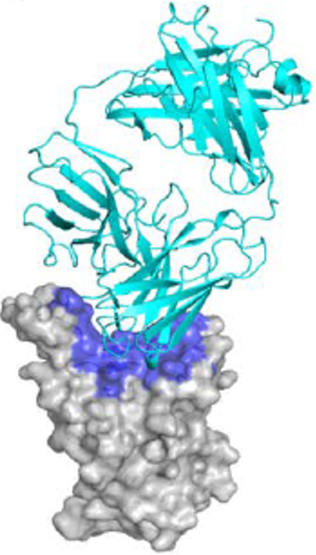
CT-P59 = drug development code for regdanvimab.
Cyan: crystal structure of the CT-P59 Fab, Grey: SARS-CoV-2 receptor binding domain, Light blue: epitope residues on SARS-CoV-2 receptor binding domain.
The primary packaging container closure system for the Regkirona (regdanvimab) CT-P59 drug product is composed of vial, stopper and seal. The vial is a 20 mL Type I glass vial which complies with European Pharmacopoeia (Ph. Eur.) and United States Pharmacopeia (USP) requirements for glass containers. The stopper is a Flurotec coated chlorobutyl rubber stopper which complies with Ph. Eur. and USP requirements for rubber closures. The vials are sealed with an aluminium flip off seal.
All excipients are well known pharmaceutical ingredients and their quality is compliant with Ph. Eur., and USP/National Formulary (NF) and complies with EMA guideline. There are no novel excipients used in the finished product formulation.
The final drug substance is filled into 2 L, 10 L and 20 L pre-sterilised (gamma irradiation), pyrogen free polycarbonate bottles with polypropylene closure. The container closure is considered suitable for its intended use as demonstrated by compatibility and stability studies.
The unopen packs are to be stored in a refrigerator (2°C to 8°C). Once opened, the chemical and physical in-use stability has been demonstrated for 72 hours at 2°C to 8°C or 4 hours at ≤ 30°C after dilution in sodium chloride 9 mg/mL (0.9%) solution for infusion. From a microbiological point of view, the prepared infusion solution should be used immediately. If not used immediately, in-use storage times and conditions prior to use are the responsibility of the user and would normally not be longer than 72 hours at 2°C to 8°C. The product is for single use in one patient only and any residue should be discarded.
All outstanding quality issues have been resolved prior to registration.

Nonclinical
The following is a summary of findings from the nonclinical evaluation:
- In vitro, regdanvimab bound to recombinant SARS-CoV-2 spike receptor binding domain with high affinity (half maximal effective concentration (EC₅₀) 4.44 ng/mL, dissociation constant (K_{D}) 0.065 nM). In vitro assessment using SARS-CoV-2 viruses (pseudovirus and authentic) showed that regdanvimab neutralised effectively the wild type, alpha (lineage B.1.1.7), zeta (lineage P.2), iota (lineage B.1.526) and eta (lineage B.1.525) variants, but there was ≥ 20 fold increase in half maximal inhibitory concentration (IC₅₀) for the beta (lineage B.1.351), gamma (lineage P.1), epsilon (lineages B.1.427 and B.1.429), kappa (lineage B.1.617.1) and delta (lineage B.1.617.2) variants.
- In vivo in multiple animal models (monkeys, transgenic mice, hamsters and ferrets), regdanvimab decreased infectious virus titres and virus RNA in lungs (and/or nasal wash) as well as hindered clinical disease progression (assessed as improved weight loss or lung pathology). In human angiotensin converting enzyme 2 (hACE2) transgenic mice, regdanvimab showed antiviral efficacy both as pre- and post-infection treatment. In vivo regdanvimab showed significant antiviral activity against SARS-CoV-2 variants (beta, gamma and delta) and reduced disease progression at exposures below the clinical exposure based on maximum plasma concentration (C_{max}) and area under the plasma concentration time curve (AUC).
- In vitro and in vivo data lend support to the use of regdanvimab for the proposed clinical indication.
- Regdanvimab did not exhibit Fc-dependent effector functions. Regdanvimab is not expected to induce complement dependent cytotoxicity or antibody dependent cellular cytotoxicity. Regdanvimab at a range of doses from sub-neutralising up to fully neutralising showed no evidence of antibody dependent enhancement (ADE) of disease in in vitro and in vivo animal models.
- Pharmacology results suggest efficacy against the wild type, alpha, beta, gamma and delta variants.
- Mutations at S494 and Q493 of the receptor binding domain are resistant to regdanvimab. Double mutation (S494P and R685H) was present in most escape viruses after 4 passages but this mutant might have emerged after the first passage. The potential risk of treatment failure due to the development of viral variants that are resistant to regdanvimab would need to be monitored clinically.
- No reproductive toxicity studies were submitted. Pregnancy category B2; is considered appropriate. Potential effects on embryofetal development are unclear given the binding of regdanvimab to fetal/neonatal nerve ending and arachnoid cap cells of neonatal spinal cord. Use in pregnant women is not recommended.
- There are no nonclinical objections to provisional approval of regdanvimab.

Clinical
The clinical dossier consisted of the following:
- two Phase I studies: Study CT-P59 1.1 and Study CT-P59 1.2; and
- one Phase II/III study: Study CT-P59 3.2 (Parts 1 and 2)

Pharmacology

Pharmacokinetics
The pharmacokinetics (PK) of CT-P59 (that is regdanvimab, or Regkirona as per this submission) in healthy volunteers as a single dose was evaluated in Study CT-P59 1.1. Study CT-P59 1.2 assessed the PK profile of CT-P59 in patients with mild COVID-19. The PK profile of CT-P59 in patients with mild to moderate COVID-19 is further evaluated in Study CT-P59 3.2. No interaction studies, metabolism and excretion studies or dedicated studies in special populations were performed.
Table 3: Studies CT-P59 1.1, CT-P59 1.2, and CT-P59 3.2 Part 1 Summary of pharmacokinetic parameters
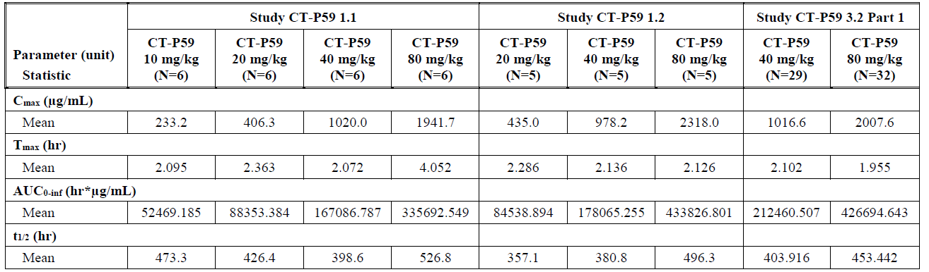
AUC_{0-inf} = area under the plasma concentration time curve from time zero to infinity; C_{max} = maximum plasma concentration; CT-P59 = drug development code for regdanvimab; N = population size; t_{1/2} = terminal drug half life; T_{max} = time at maximum concentration.

Pharmacokinetics in healthy volunteers

Study CT-P59 1.1
A completed first in human study in healthy volunteers. The PK set included all randomised subjects who received a full dose of CT-P59 (regdanvimab) and provided at least one evaluable post-treatment PK concentration result. The PK parameters of CT-P59 in serum were assessed as secondary endpoints and as descriptive statistics.
Thirty-two subjects were randomised of which 24 received CT-P59. The PK set consisted of 24 (75%) subjects who received CT-P59, that is, 6 (100%) at 10 mg/kg, 6 (100%) at 20 mg/kg, 6 (100%) at 40 mg/kg and 6 (100%) at 80 mg/kg. Overall, subject demographics and baseline characteristics were comparable across the treatment groups.

Pharmacokinetics results
The serum mean concentration-time profiles up to Day 90 for the four CT-P59 (regdanvimab) treatment groups (10 mg/kg, 20 mg/kg, 40 mg/kg and 80 mg/kg bodyweight) were presented on linear and semi-logarithmic scales as illustrated in Figure 2 below.
Figure 2: Study CT-P59 1.1 Mean (± standard deviation) serum concentration of CT-P59 (regdanvimab), pharmacokinetic set (up to Day 90)
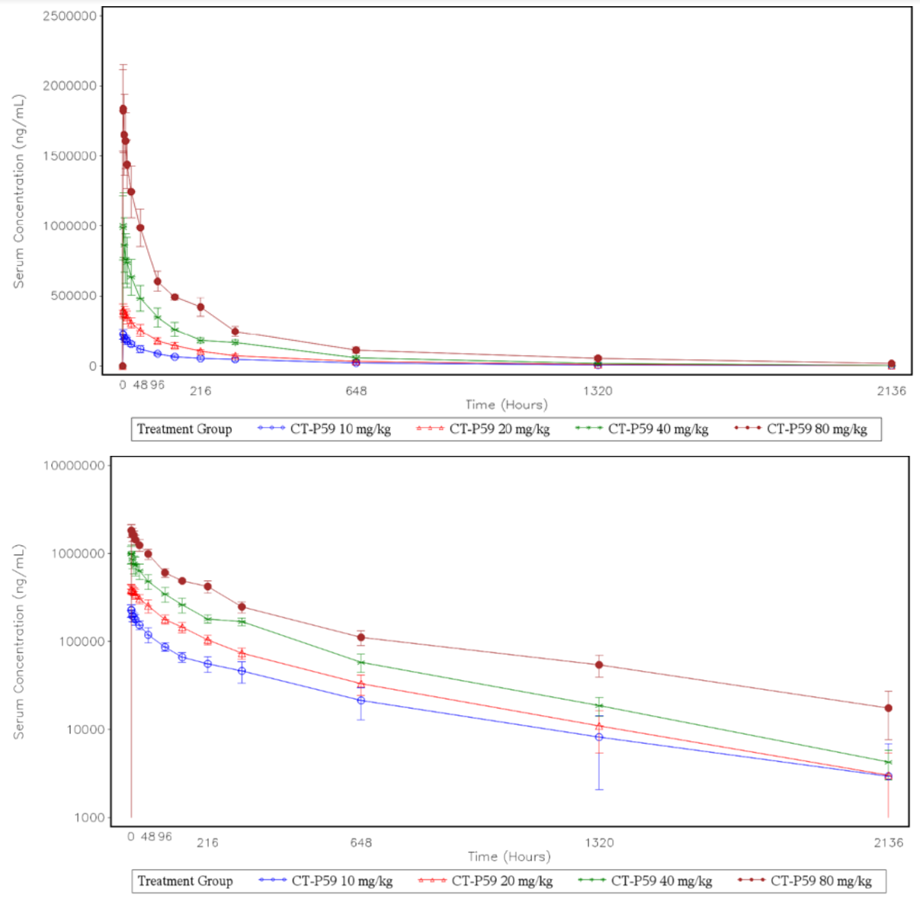
CT-P59 = drug development code for regdanvimab.
Semi-logarithmic scale
Following a single intravenous infusion of CT-P59 (regdanvimab), the geometric mean values of C_{max} were 230290.3 ng/mL for CT-P59 10 mg/kg, 404385.4 ng/mL for CT-P59 20 mg/kg, 994192.2 ng/mL for CT-P59 40 mg/kg, and 1925564.8 ng/mL for CT-P59 80 mg/kg. The mean C_{max} of CT-P59 were increased in a dose proportional manner, and mean dose normalised C_{max} (C_{max}/dose) were similar among the 4 cohorts. These results suggest that exposure to CT-P59 increased with increasing dose in a proportional manner across the 10 to 80 mg/kg dose range investigated with no indication of target mediated drug disposition.
The mean PK estimates in healthy subjects at the proposed therapeutic dose 40 mg/kg were: total body clearance (CL) 18.46 mL/h (about 0.24 mL/h/kg), volume of distribution during the steady state (V_{ss}) 98.8 mL/kg and t_{1/2z} 398.6 hours (about 17 days).
There were no samples that tested positive for anti-drug antibodies (ADA).

Pharmacokinetics in the target population

Study CT-P59 1.2
This is a completed Phase I pilot study in patients with mild COVID-19 in which the PK of regdanvimab (CT-P59) is evaluated at three dose levels, that is, 20, 40 and 80 mg/kg with N = 5 patients per group. The PK parameters of regdanvimab (CT-P59) in serum are assessed as secondary endpoints. This submission includes serum concentration level of CT-P59 up to Day 90 and all the PK parameters calculated. The results are described as descriptive statistics.
Overall patient demographics and baseline characteristics were comparable across the treatment groups.
The serum mean concentration time profiles up to Day 90 for the 3 cohorts (20 mg/kg, 40 mg/kg and 80 mg/kg) are presented on linear and semi-logarithmic scales as illustrated in Figure 3 below.
Figure 3: Study CT-P59 1.2 Mean (± standard deviation) serum concentration of regdanvimab (CT-P59), pharmacokinetic set (up to Day 90)
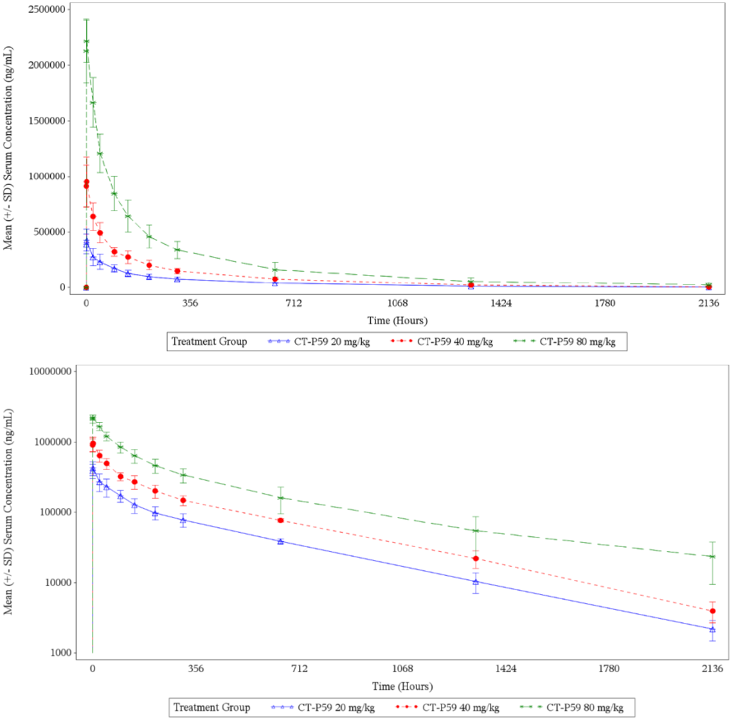
CT-P59 = drug development code for regdanvimab; SD = standard deviation.
Following a single intravenous infusion of CT-P59 (regdanvimab), the geometric mean values of C_{max} were 428758.5 ng/mL for CT-P59 20 mg/kg, 958142.5 ng/mL for CT-P59 40 mg/kg, and 2309196.7 ng/mL for CT-P59 80 mg/kg. The geometric mean values of C_{max} increased with increasing CT-P59 dose, and geometric mean values of C_{max}/dose (normalised to dose/body weight) increased in a slightly greater than dose proportional manner over the 20 to 80 mg/kg dose range.
The median values of time at maximum concentration (T_{max}) were 2.5 hours for CT-P59 20 mg/kg, CT-P59 40 mg/kg and CT-P59 80 mg/kg.
The median values of T_{1/2} were 363.2 hours for CT-P59 20 mg/kg, 388.2 hours for CT-P59 40 mg/kg and 530.1 hours for CT-P59 80 mg/kg.

Study CT-P59 3.2 Part 1
A completed Phase II/III study in patients with mild to moderate COVID-19. The PK parameters of CT-P59 (regdanvimab) in serum are assessed as exploratory endpoints. The PK set is defined as all randomly assigned patients with confirmed SARS-CoV-2 infection by pre-infusion result of reverse transcription quantitative real time polymerase chain reaction (RT-qPCR) or cell culture and signed informed consent to participate in a PK sub-study in Part 1 and received a complete dose of study drug and have at least one evaluable post-treatment PK result.
Two-hundred sixteen patients were randomised to the CT-P59 treatment groups and the PK set consisted of 61 patients, of these, 29 patients for CT-P59 40 mg/kg and 32 patients for CT-P59 80 mg/kg. Overall, patient demographics and baseline characteristics were comparable across the treatment groups.

Pharmacokinetic results
The serum mean concentration time profiles up to Day 90 for the 2 treatment groups (40 mg/kg and 80 mg/kg) are presented on linear and semi-logarithmic scales as illustrated in Figure 4 below.
Figure 4: Study CT-P59 3.2 Part 1 mean (± standard deviation) serum concentration of regdanvimab (CT-P59), pharmacokinetic set (up to Day 90)
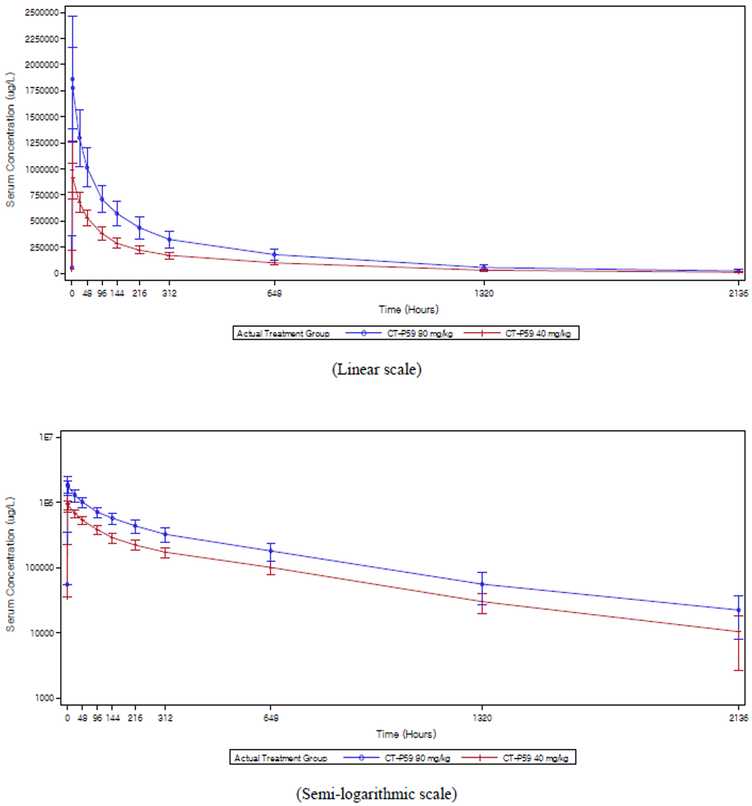
CT-P59 = drug development code for regdanvimab.
Following a single intravenous infusion of CT-P59 (regdanvimab), the geometric mean values of C_{max} were 992.4 μg/mL and 1963.2 μg/mL for CT-P59 40 mg/kg and CT-P59 80 mg/kg, respectively, and the geometric mean values of area under the plasma concentration time curve from time zero to the last measurable time point (AUC_{0-last}) were 187655.295 hr μg/mL and 373301.658 hr μg/mL, respectively.
The C_{max} and AUC_{0-last} of CT-P59 (regdanvimab), were increased in a dose-proportional manner as the ratio of geometric least square mean (80 mg/kg/40 mg/kg) was 1.978 (90% confidence interval (CI): 1.81, 2.17) for C_{max} and 1.989 (90% CI: 1.73, 2.29) for AUC_{0-last}.
The median values of T_{max} were 1.833 hours for CT-P59 40 mg/kg and 1.683 hours for CT-P59 80 mg/kg. The median values of t_{1/2} were 410.072 hours for CT-P59 40 mg/kg and 447.212 hours for CT-P59 80 mg/kg.
The arithmetic mean (coefficient of variation (CV)%) parameter estimates at the proposed therapeutic intravenous single dose of 40 mg/kg were: CL 0.20 mL/h/kg (24%), V_{ss} 83 mL/kg (26%) and t_{1/2z} 17 days (37%), that is, very similar to those in Studies CT-P59 1.1 and 1.2.
Of the 1857 immunogenicity samples analysed, 45 samples were confirmed positive, seven of which were positive for anti-CT-P59 neutralising antibodies when using the study specific cut point. Overall, the proportions of patients with positive ADA and neutralising antibodies up to Day 90 were 17/318 (5.3%) and 3/324 (0.9%), respectively in the safety set (including placebo).
At corresponding doses, the PK parameters were generally similar between healthy subjects and patients with SARS-CoV-2 infection.

Pharmacokinetic interaction studies
No interactions studies have been performed which is acceptable. Regdanvimab is not expected to be renally cleared or metabolised by cytochrome P450 enzymes; therefore, interactions with concomitant medications that are renally excreted or that are substrates, inducers, or inhibitors of cytochrome P450 enzymes are unlikely.

Absorption
Following a single intravenous dose of CT-P59 (regdanvimab), in healthy subjects (as per Study CT-P59 1.1), the rate of absorption was rapid, achieving mean peak concentration within approximately 2 to 4 hours, across the dose range of 10 to 80 mg/kg. Since CT-P59 (regdanvimab) is administered intravenously, bioavailability by definition is 100%.

Distribution
The geometric mean (%CV) apparent volume of distribution of the proposed clinical dosage of regdanvimab (CT-P59; 40 mg/kg) is 99.7 ml/kg (21.9%), based on the data from Study CT-P59 1.2 in COVID-19 patients; a limited distribution outside the blood compartment. CT-P59 is not expected to bind to plasma proteins in a specific manner. No plasma protein binding study was performed, which is considered acceptable.

Metabolism
The metabolism and excretion pathways of regdanvimab have not been investigated. This is acceptable. Regdanvimab, (CT-P59) is a monoclonal antibody and is expected to be degraded into small peptides and amino acids via catabolic pathways in the same manner as endogenous immunoglobulin G proteins; thus, metabolism does not contribute to its clearance.

Excretion
As a protein product, CT-P59 (or regdanvimab), is not expected to be eliminated by renal or biliary excretion. The median values of t_{1/2} for CT-P59 were 397.6 to 486.1 hours and the mean values of total body clearance were 14.98 to 18.46 mL/h in healthy subjects (Study CT-P59 1.1).
The clearance of regdanvimab was low, 0.2 mL/h/kg. Serum concentrations appeared to decline in a multi-phasic manner with a terminal half life of 17 days. The PK was very similar in patients and healthy volunteers.

Dose proportionality
Regdanvimab, (CT-P59) exposure increased in a dose proportional manner over a dose range of 10 to 80 mg/kg given as an intravenous injection.

Pharmacokinetic in special populations

Elderly
Of the 327 patients with SARS-CoV-2 infection randomised in Study CT-P59 3.2, 16.5% were 65 years or older, and 3.06% were 75 years of age or older. PK subgroup analyses was performed by age (< 65 years old versus ≥ 65 years old) in Study CT-P59 3.2 Part 1 and the exposure parameters showed no discernible differences between different age groups regardless of the dose (post-hoc). As the posology is based on mg/kg basis, the impact of age as demonstrated by relevant analyses is not anticipated. Therefore, no dose adjustment of regdanvimab is required in elderly patients.

Renal and hepatic impairment
Regdanvimab, also known as CT-P59 is a monoclonal antibody and expected to be eliminated via proteolytic degradation to amino acids, and is not anticipated to be eliminated intact in the urine. Specific clinical pharmacology studies to evaluate the effect of renal impairment and hepatic impairment on the PK of CT-P59 have not been conducted. This is considered acceptable.

Weight
In order to evaluate the impact of body weight on PK, a subgroup analysis of PK parameters (area under the plasma concentration time curve from time zero to infinity (AUC_{0-inf}), AUC_{0-last} and C_{max}) by tertile of body weight (≤ 75 kg, 75 kg < weight ≤ 88 kg, > 88 kg) was conducted in Study CT-P59 3.2 Part 1. The results showed that exposure to CT-P59 were generally similar across subgroups by weight, which was expected since the patient received the study drug based on one’s weight

Gender
A subgroup analysis of PK parameters (AUC_{0-inf}, AUC_{0-last} and C_{max}) by gender (male versus female) in Study CT-P59 3.2 Part 1 was conducted and it did not show any discernible differences in the exposure parameters between subgroups (post-hoc). Therefore, no dose adjustment of regdanvimab is required based on gender.

Race
Study CT-P59 3.2 Part 1 showed that PK parameters of regdanvimab (CT-P59) were not influenced by race (Asian versus White) (post-hoc). The results of PK parameters in Study CT-P59 1.2 were assessed (post-text), which includes the results derived from serum concentration up to Day 90 of each patient. Although increased geometric mean values of AUC_{0-inf}/dose, AUC_{0-last}/dose and C_{max}/dose (normalised to dose/body weight) were observed in the highest dosage group (80 mg/kg, White), the difference did not seem to be significant and also the values were similar between the CT-P59 (regdanvimab) 20 mg/kg (Asian) and CT-P59 (regdanvimab) 40 mg/kg (White) groups. Therefore, no dose adjustment of regdanvimab is required based on race.

Population pharmacokinetics data
No population pharmacokinetics (popPK) analysis was performed, which is acceptable.

Pharmacodynamics
Coronavirus entry into host cells via binding to the angiotensin converting enzyme 2 (ACE2) receptor in alveolar cells and intestinal epithelia is an important determinant of viral infectivity and pathogenesis. The main mechanism of action of regdanvimab is blocking the binding between SARS-CoV-2 spike protein RBD and the cellular receptor, ACE2, thus blocking the SARS-CoV-2 infection.

Immunogenicity
In Study CT-P59 1.1, no subjects tested positive for ADA up to Day 90 and in Study CT-P59-1.2, there were no patients who had positive results for ADA at post-treatment visits up to Day 90.
In Study CT-P59 3.2 Part 1, the proportion of patients with positive conversion in ADA after study drug administration was 3/101 (3.0%), 8/109 (7.3%), 11/210 (5.2%) and 6/108 (5.6%) in the CT-P59 (regdanvimab) 40 mg/kg, CT-P59 (regdanvimab) 80 mg/kg, pooled (regdanvimab) CT-P59 and Placebo groups, respectively.. ADA positives identified in the placebo group and baseline samples prior to administration are likely to have pre-existing antibodies which are components of the natural antibody population or components of adaptive immune responses to environmental antigens., The prevalence of pre-existing antibodies in clinical data for biotherapeutics has been reported to range from 1 to 42% (mean 12.7%)³⁴ indicating 4.5% of ADA prevalence in the placebo group is not an unexpected event.
Table 4: Study CT-P59 3.2 Part 1 Frequency of anti-drug antibodies and neutralising antibodies, safety set
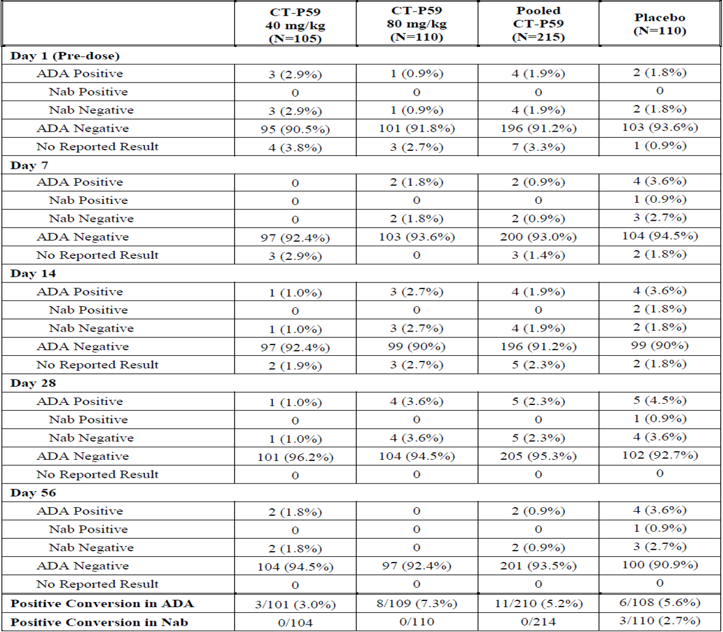
ADA = anti-drug antibody; CT-P59 = drug development code for regdanvimab; N = population size; Nab = neutralising antibody.
Positive conversion in ADA/Nab is defined as patients who reported at least one ADA/Nab positive result after drug administration in patients who have at least one ADA/Nab result after study drug administration and do not have any ADA/Nab positive results before study drug administration.
In Study CT-P59 3.2 Part 2, the proportion of patients with positive conversion in ADA at post-treatment visits up to Day 28 visit were 10/635 (1.6%) patients in the CT-P59 (regdanvimab) 40 mg/kg treatment group and 15/619 (2.4%) patients in the placebo group.
Table 5: Study CT-P59 3.2 Part 2 Frequency of anti-drug antibodies, safety set
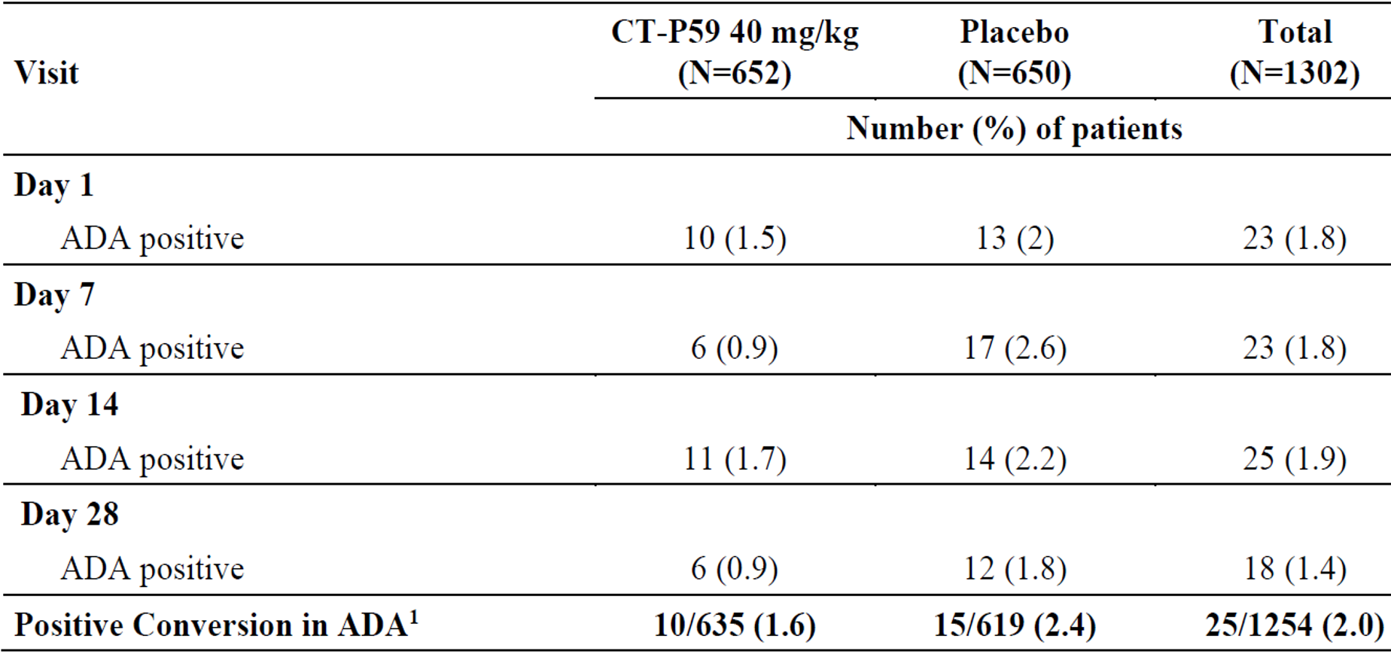
ADA = anti-drug antibody; CT-P59 = drug development code for regdanvimab; N = population size.
Percentages are calculated by using the number of patients in the safety set as the denominator. The ADA test involved both screening and confirmatory assays to confirm true positive results. Samples that were potentially positive in the screening assay are spiked with excess study drug to determine if patients were a true positive, labelled ‘positive’.
1. Number of patients who reported at least one ADA positive after study drug administration is used as the numerator, and the number of patients who have at least one immunogenicity result (including not reported result (NRR)) after study drug administration and have not any ADA positive result before study drug administration is used as the denominator.

Clinical virology, exploratory virology endpoints

Study CT-P59 1.2 and Study CT-P59 3.2
- Viral shedding in nasopharyngeal swab specimen based on RT-qPCR
- Genotype and phenotype of SARS-CoV-2 viral isolates
- Viral serology for SARS-CoV-2 antibody

Study CT-P59 1.2
The mean (standard deviation (SD) viral titre at Baseline was slightly higher in the CT-P59 (regdanvimab) 20 mg/kg treatment group (6.708 (0.9393)) than in the CT-P59 40 mg/kg treatment group (4.710 (2.4257)), CT-P59 80mg/kg treatment group (5.950 (1.8960)) and placebo group (5.003 (2.0637)). The mean (SD) change in viral titre from Baseline to Day 7 was -3.104 (1.7149) in the CT-P59 20 mg/kg treatment group, -2.308 (1.3686) in the CT-P59 40 mg/kg group, -2.374 (0.9866) in the CT-P59 80 mg/kg group and -1.913 (1.7623) in the placebo group.
Overall, the mean change from Baseline for viral shedding in nasopharyngeal swab specimens (titres) based on quantitative real time polymerase chain reaction (qPCR) was generally higher in the CT-P59 treatment groups than the placebo group.
In all the categories, the mean AUC value of viral titres from Baseline to the last measurable value up to Day 28 was generally greater in the placebo group than in the CT-P59 treatment groups.

Study CT-P59 3.2 Part 1
The mean (SD) viral titre at Baseline was slightly lower in the placebo group than the (regdanvimab) CT-P59 treatment groups (6.280 (1.5328), 6.288 (1.5223) and 5.958 (1.6968) in the CT-P59 40 mg/kg, CT-P59 80 mg/kg and placebo groups, respectively). By Day 7, patients administered with CT-P59 40 mg/kg or 80 mg/kg showed greater reduction in viral shedding in nasopharyngeal swab specimens (titres) based on qPCR compared to the patients in the placebo group. The mean (SD) change from Baseline for viral shedding at Day 7 were -3.183 (1.5787), -3.184 (1.4226) and -3.184 (1.4963) log10 copies/mL in the CT-P59 40 mg/kg, CT-P59 80 mg/kg and pooled CT-P59 treatment groups, respectively, and -2.290 (1.7090) log10 copies/mL in the placebo group. Viral shedding results from Day 10 through Day 28 were similar across the treatment groups.

Study CT-P59 3.2 Part 2
The mean (standard error (SE) viral titres at Baseline were comparable between the 2 groups (6.055 (0.0634) log10 copies/mL and 6.089 (0.0604) log10 copies/mL in the CT-P59 (regdanvimab) 40 mg/kg and placebo groups, respectively). By Day 7, patients administered with CT-P59 40 mg/kg showed greater reduction in viral shedding in nasopharyngeal swab specimens (titres) based on qPCR compared to the patients in the placebo group. The mean (SE) change from Baseline for viral shedding at Day 7 were -2.770 (0.0652) log10 copies/mL in the CT-P59 40 mg/kg and -2.236 (0.0637) log10 copies/mL in the placebo groups, respectively. Viral shedding results from Day 10 through Day 28 were similar between the 2 groups.
In a subgroup analysis of viral load reduction, viral shedding decreased more rapidly when patients’ baseline viral load titre was high, which is consistent with a sensitivity analysis done with Study CT-P59 3.2 Part 1.
The sponsor has provided data from a Ferret model infected with the gamma variant, and from a ACE2 transgenic mouse model infected with beta, gamma as well as delta variants, treated with human equivalent doses as post-exposure prophylaxis. These studies are indicative of antiviral effects. However, the clinical implications are not completely known.

Exposure biological response relationship
In order to investigate relationship between exposure of CT-P59 (regdanvimab) and viral load reduction, the PK profile of CT-P59 in patients were compared to the IC₅₀ and 90% inhibitory concentration (IC₉₀) values of CT-P59 from plaque reduction neutralisation test (PRNT) using Vero E6 cells. The IC₅₀ and IC₉₀ values of CT-P59 toward wild type SARS-CoV- 2 were 9.70 ng/mL and 25.09 ng/mL, respectively.
From the literature, the assumption was made that the concentration of monoclonal antibody in the lungs is approximately 15% of the serum concentration. Calculated as 15% of the median serum concentration levels of CT-P59, the predicted concentration levels in the lung were 26700 ng/mL and 45150 ng/mL in the CT-P59 40 mg/kg and CT-P59 80 mg/kg groups, respectively, at Day 14 and 15300 ng/mL and 26250 ng/mL, respectively, at Day 28 (Table 6 below). It is predicted that CT-P59 concentration in the lung for all patients who received CT-P59 is well above the IC₅₀ and IC₉₀ values calculated in vitro at Day 14 and Day 28 after treatment administration.
Table 6: Study CT-P59 3.2 Part 1 Serum concentration levels of CT-P59 (regdanvimab) at Days 14 and 28 compared to in vitro half maximal inhibitory concentration and 90% of the maximum inhibitory concentration values, pharmacokinetic set
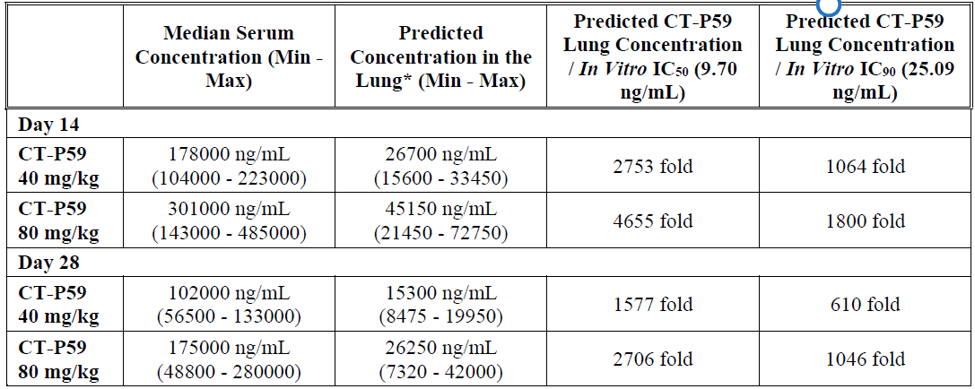
CT-P59 = drug development code for regdanvimab; IC₅₀ = half maximal inhibitory concentration; IC₉₀ = 90% inhibitory concentration, max = maximum; min = minimum.
* concentration level of CT-P59 was predicted by calculating 15% of serum concentration level.
Table 7: Study CT-P59 3.2 Part 1 The observed mean serum concentrations and the predicted lung concentrations of regdanvimab (CT-P59) following a single intravenous dose of 40 mg/kg
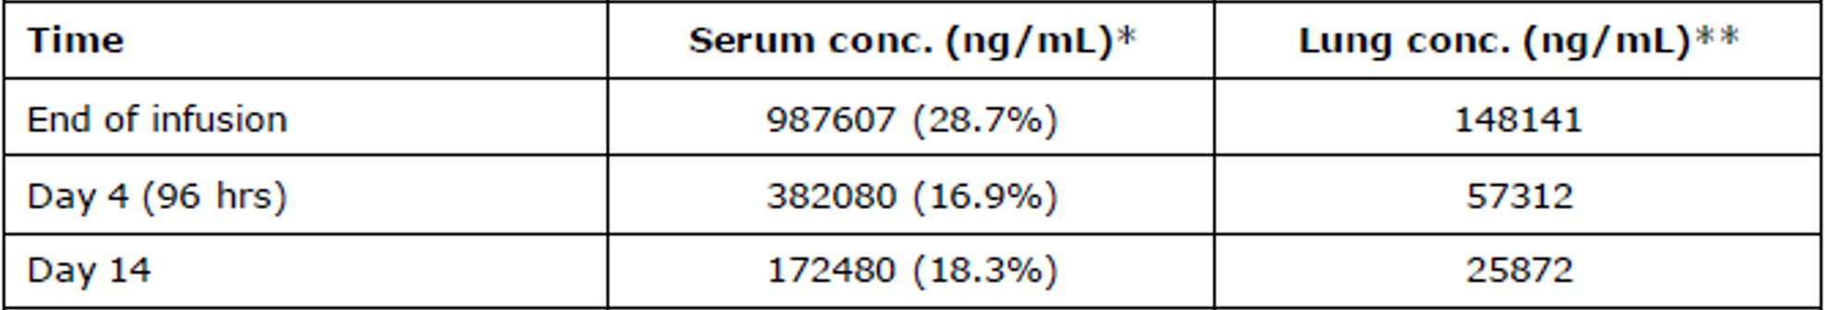
Conc = concentration; CT-P59 = drug development code for regdanvimab.
* Observed arithmetic mean (coefficient of variation (CV) %) serum concentration
** Predicted lung concentration assuming a lung/serum distribution coefficient of 0.15, as reported for a monoclonal antibody.³⁵
The IC₅₀ and IC₉₀ of CT-P59 towards variant of concern (VoC) are as follows:
- alpha (lineage B1.1.7): 3.77 ng/mL; 40.86 ng/mL
- beta (lineage B.1.351): 2,096 ng/mL; 16,550 ng/mL
- delta (lineage B.1.617.2): 1,237 ng/mL; 2,093 ng/mL
- gamma (lineage P.1): 1,135 ng/mL; 8,272 ng/mL

Analysis of spike protein variants
Nasopharyngeal samples collected from patients at Baseline and post-treatment were analysed by next generation sequencing in order to monitor for presence of potential resistance associated variations to CT-P59 for Studies CT-P59 1.2 and 3.2 Part 1. The genotypic testing for Study CT-P59 3.2 Part 2 is still ongoing.
To determine the activity against variants and potential escape mutants, neutralisation of the emerging variants is being evaluated using in vitro pseudovirus assay and potential escape mutants are characterised by sequencing the spike gene at Baseline and at various time points for all patients from Study CT-P59 1.2 and patients who failed to respond to treatment or experienced virologic failure in Study CT-P59 3.2.

Study CT-P59 1.2
Out of 18 patients from Study CT-P59 1.2, the number of patients with qualifying sequencing data was 14 patients (5, 3, 4 and 2 patients in the CT-P59 20 mg/kg, CT-P59 40 mg/kg, CT-P59 80 mg/kg and placebo groups, respectively). Four patients were excluded as the viral concentrations from their samples were below the lower limit for sequencing.
Nonclinical studies using serial passage of SARS-CoV-2 and directed evolution of the spike protein identified Q493K/R and S494P/L, amino acid substitutions in the RBD of the SARS-CoV-2 spike protein, that had reduced susceptibility (IC₅₀: > 500 ng/mL, respectively) to CT-P59 as determined in neutralisation assays using SARS-CoV-2. In Study CT-P59 1.2, no patients were detected with Q493K/R or S494P/L variants at an allele frequency of ≥ 15%.
In addition, variants with N501Y, E484K, K417T, K417N, L452R and E484Q mutations were not observed at ≥ 15% allele frequency in the study at Baseline or post-treatment.

Study CT-P59 3.2 Part 1
Nasopharyngeal samples with viral concentrations above the lower limit for sequencing and from patients who did not reach clinical recovery by Day 14 or did not show decrease in viral shedding are sequenced at Baseline and post-treatment in order to monitor for potential CT-P59 resistance associated spike variations.
An analysis focused on amino acid positions in the RBD of the SARS-CoV-2 spike protein which had been identified in nonclinical studies as being important for susceptibility to CT-P59: Q493K/R and S494P/L (IC₅₀: > 500 ng/mL, respectively); and mutant RBDs that are present in the B.1.1.7, B.1.351, P.1, B.1.427, B.1.429, B. 1.526 and B.1.617.1 and B.1.617.2 variants.
Variant at spike protein amino acid positions Q493 or S494 at an allele fraction of ≥ 15% were detected for 16.7% (6/36) of patients in the CT-P59 40 mg/kg group and 7.5% (3/40) of patients in the CT-P59 80 mg/kg group. None of these patients required oxygen therapy or hospitalisation or experienced mortality due to SARS-CoV-2 infection.
N501Y, E484K, K417T, K417N, L452R and E484Q mutations were not observed at an allele frequency of ≥ 15% in the study at Baseline or post-treatment.
At the present, there is no clear indication of any new emerging resistant SARS-CoV-2 variant in patients failing regdanvimab treatment. However, genotyping results from Part 2 are pending and a complete assessment will be made upon availability of those results.
Double mutations (S494P and R685H) were detected in all in vitro escape viruses. The amino acid 494 is located in the RBD and regdanvimab was unable to neutralise the escape virus.
Neutralising activity was shown against the wild type virus as well as for the alpha variant (lineage B.1.1.7). However, regdanvimab had reduced neutralising activity against beta (lineage B.1.351), gamma (lineage P.1), epsilon (lineages B.1.427 and B.1.429) and kappa (lineage B.1.617.1) and delta (lineage B.1.617.2) variants in the PRNT, microneutralisation and pseudovirus assays and fold reductions ranged between 24-310 for assays with authentic virus.
In the first pseudovirus assay mentioned above the combination of key substitutions involved in the delta variant is not included, in the second assay performed by the United States (US) National Institutes of Health (NIH) the fold reduction for the delta variant is 27.7. The sponsor used the IC₅₀ values determined in the Mlcochova et al. (2021) study, to calculated neutralising effect against the delta variant of FDA Emergency Use Authorisation approved monoclonal antibody treatments taking into consideration its IC₅₀ value and administration dosage. The sponsor concluded that because of the comparatively higher clinical dosage (40 mg/kg) of CT-P59 (regdanvimab) compared to other monoclonal antibodies, but also with similar PK expected with IgG1 monoclonal antibodies, the partial reduction in neutralisation seen with CT-P59 against the current VoC and variant of interest (VoI) is not expected to impact clinical efficacy at the proposed dose (40 mg/kg) of CT-P59 given to the patients.
In summary, PK/pharmacodynamics (PD) is compatible with clinical activity against the delta variant, and a ACE2 transgenic mouse animal model is supportive of such activity.

Primary pharmacodynamics
Regdanvimab (CT-P59) targets a unique epitope on the RBD of spike proteins in SARS-CoV-2, which is not produced by mammalian cells. Therefore, CT-P59 does not have a primary pharmacological target in humans who are not infected with SARS-CoV-2. In order to determine targeting and neutralising ability of CT-P59 against SARS-CoV-2 strains, an array of in vitro and in vivo studies have been conducted. In vitro studies demonstrated that CT-P59 neutralises clinically isolated SARS-CoV-2 strains and strongly binds to SARS-CoV-2 RBD with no evidence of binding to other corona virus derived spike proteins. The primary pharmacodynamic effect on SARS-CoV-2 infection was evaluated in virus challenged hACE2 expressing transgenic mice, hamsters, ferrets and non-human primate (rhesus monkeys) where the ability of CT-P59 to decrease viral titre and/or improve clinical signs in the virus-challenged animal models was observed.
In Study CT-P59 3.2 Part 1, patients randomised to the CT-P59 treatment groups had a greater reduction in viral shedding in nasopharyngeal swab specimens (titres) based on qPCR up to Day 7 compared to patients in the placebo group. The mean (SD) change from Baseline for viral shedding at Day 7 were -3.184 (1.496) and -2.290 (1.709) log10 copies/mL in the pooled CT-P59 groups and placebo group, respectively. In Study CT-P59 3.2 Part 2, the mean (SE) viral titres at Baseline were comparable between the two groups, with 6.055 (0.0634) log10 copies/mL and 6.089 (0.0604) log10 copies/mL in the CT-P59 40 mg/kg and placebo groups, respectively. The presented reduction in the viral load in the early stage of the disease is encouraging. However, this remains as a supportive data and it is not clear how this translates into severity of the illness.

Secondary pharmacodynamics
To address the potential ADE effect of CT-P59, SARS-CoV-2 (betaCoV/Korea/KCDC03/2020) viruses (0.05 multiplicity of infection) were incubated with both permissive cells (VeroE6 cells) and Fc-bearing cells (Raji cells; FcγR II, U937 cells; FcγR I and II) in the presence of CT-P59. Two antibodies, CR3022 (SARS neutralising antibody) and CT-P27 (influenza A neutralising antibody) were used as non-neutralising antibody and unrelated control, respectively. It is confirmed that CT-P59 did not induce ADE effect in all concentrations tested in both cells.

Efficacy

Dose selection
The proposed clinical regimen for the treatment of patients with mild to moderate COVID-19 is a single intravenous dose of CT-P59 (regdanvimab) 40 mg/kg on Day 1.
The selection of this dosing regimen is based on the following:
- pharmacokinetic bridging from animal to human doses;
- results of in vivo efficacy studies conducted in SARS-CoV-2 infected ferrets, hamsters and rhesus monkeys; and
- Phase I studies in healthy human subjects.
According to the study findings, the selected doses are expected to neutralise emerging global variants including beta (lineage B.1.351), gamma (lineage P.1) and delta (lineage B.1.617.2) variants. In vivo neutralisation effect against B.1.351 was evaluated with clinically relevant dose of 80 mg/kg and 160 mg/kg which are converted to approximately 20 mg/kg and 38 mg/kg in human, respectively and the animals challenged with the beta variant or wild type showed significantly reduced viral RNA and the infectious virus titres in the upper and lower respiratory tracts.
In addition, in vivo efficacy studies were also conducted in the K18-hACE transgenic mice model challenged with the P.1 (gamma) and B.1.617.2 (delta) viruses. Significant decreases in viral load in nasal wash and lung (in the case of the P.1 neutralisation study) or lung (in the case of B.1.617.2) were observed in all regdanvimab (CT-P59) treated mice at human equivalent doses of 2.5, 10, 20 and 40 mg/kg in both studies.
Based on the comparison of exposure to CT-P59 (partial AUC), the predicted human efficacious doses ranged from 8 to 36 mg/kg. In consideration of the safety profile observed during Study CT-P59 1.1 and pharmacodynamic/PK analysis, the selected doses of 40 mg/kg and 80 mg/kg were considered appropriate for Study CT-P59 3.2 Part 1. The efficacy of the CT-P59 40 mg/kg were further evaluated in a larger population in Study CT-P59 3.2 Part 2.
Pharmacodynamic/pharmacokinetic analyses support a 40 mg/kg dose of CT-P59 (regdanvimab),. The serum concentration of CT-P59 in human lung tissues was estimated using antibody distribution coefficients. Shah and Betts (2013) found that typically the concentration of monoclonal antibody in lung is 15% of that in serum.³⁵ Based on this, the CT-P59 40 mg/kg dose is expected to achieve approximately 14.9 µg/mL (99.5µg/mL (mean serum concentration at Day 28 in the CT-P59 40 mg/kg treatment group from Study CT-P59 3.2 Part 1) x 0.15) of serum concentration in lung tissue at 28 days after study drug administration in mild to moderate COVID-19 patients. The estimated serum and lung concentrations are above the in vitro 90% effective concentration (EC₉₀) value (25.09 ng/mL) against wild type SARS-CoV-2 virus (betaCoV/Korea/KCDC03/2020) for viral neutralisation.

Pivotal study

Study CT-P59 3.2
Study CT-P59 3.2 is a Phase II/III, randomised, parallel-group, placebo controlled, double blind study with 2 parts to evaluate the efficacy, safety, PK and virology of regdanvimab (CT-P59), in combination with standard of care (except potential antiviral drugs and/or possible anti-SARS-CoV-2 activity drugs) in outpatients with mild to moderate SARS-CoV-2 infection, not requiring supplemental oxygen therapy.
Study CT-P59 3.2 data up to Day 180 of Part 1 and Day 28 of Part 2 are available. Study CT-P59 3.2 Part 1 was completed and its final study report was submitted on 6 October 2021. Study CT-P59 3.2 Part 2 is currently ongoing, and its final study report for is expected to be ready in February 2022. For the current evaluation, efficacy data up to Day 180 for Study CT-P59 3.2 Part 1 and up to Day 28 for Study CT-P59 3.2 Part 2 are considered.
A total of 1642 patients were enrolled in this study. In Part 1, 327 patients were to be randomly assigned in a 1:1:1 ratio of CT-P59 80 mg/kg, 40 mg/kg or placebo. In Part 2, 1315 patients were randomly assigned in a 1:1 ratio to CT-P59 40 mg/kg, or placebo.
For both study parts the randomisation was stratified by age (≥ 60 years versus < 60 years), baseline comorbidities (yes versus no, having at least one of cardiovascular disease, chronic respiratory disease, hypertension, diabetes mellitus, and pneumonia), region (USA versus Asia versus EU versus other) and participation in PK sub-study (yes versus no, Part 1 only).
Figure 5: Study CT-P59 3.2 Study design
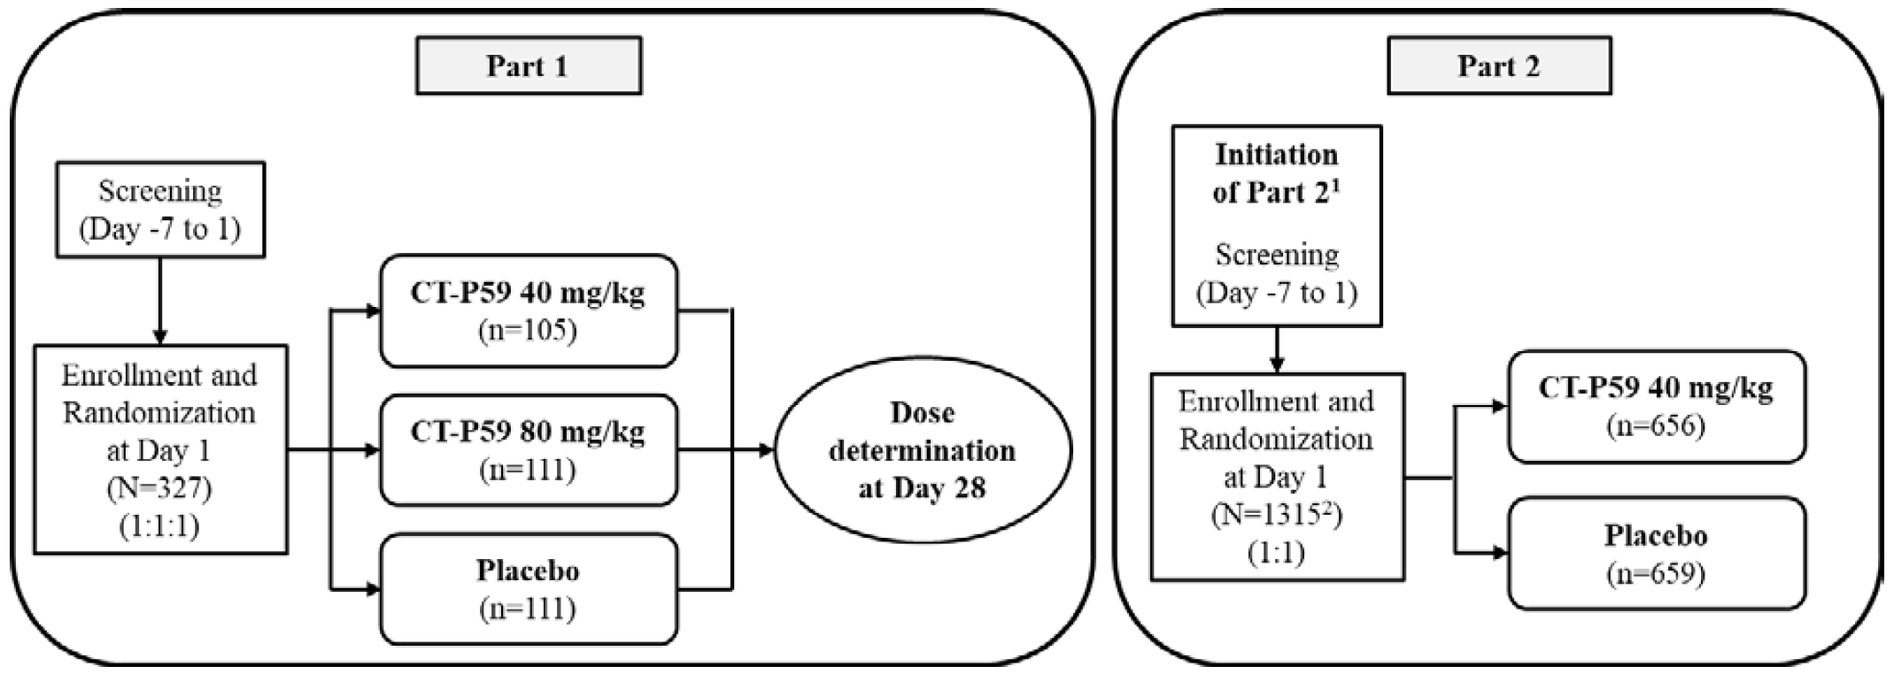
CT-P59 = drug development code for regdanvimab; N = population size; n = sample size.
In Part 1, patients with body weight at or above 100 kg and who are allocated to CT-P59 80 mg/kg group or placebo group received 8,000 mg of CT-P59 or matching volume of placebo. In Part 2, patient with body weight at or above 200 kg received 8,000 mg of CT-P59 or matching volume of placebo.
1. Part 2 is initiated based upon the independent Data Safety Monitoring Board (DSMB)’s review of all available data after all patients have reached Day 28 in Part 1.
2. Of 1315 patients in Part 2, 880 high risk patients were included.

Duration of study
The study comprises 3 study periods (including screening, treatment period and follow-up period). An end of treatment visit is scheduled on Day 90 and the total study duration is planned as 180 days for each patient.
All patients in both Part 1 and Part 2 were given optimal standard of care, which can include rehydration therapy, antipyretics or antitussives prescribed by the investigator’s discretion.

Study treatments
Regdanvimab (CT-P59) 40 mg/kg or a matching volume of placebo was administered as an intravenous infusion over 60 minutes (± 15 minutes). Patients who had a body weight at or above 200 kg received 8,000 mg of regdanvimab or a matching volume of placebo. A 250 mL infusion solution of 0.9% sodium chloride was used for the patient infusions. The placebo contained the same ingredients as the regdanvimab/CT-P59 formulation with the exception of containing no SARS-CoV-2 RBD binding monoclonal antibody (that is, it contained excipients only), in 16 mL water for injection. Three batches of regdanvimab/CT-P59 drugs were tested (0VHB07, 0VHB09, 0VHC01). Standard of care was made available to all enrolled patients, and included rehydration therapy, antipyretics, or antitussives prescribed at the investigator’s discretion. Potential antiviral drugs and/or possible anti-SARS-CoV-2 activity drugs were not allowed during the study.

Objectives

Study CT-P59 3.2 Part 1
Primary and secondary objectives included exploration of the PK, antiviral effects, efficacy and safety of regdanvimab, including its impact on the risk of hospitalisation and time to clinical recovery.

Study CT-P59 3.2 Part 2
Primary objective
- To demonstrate the clinically meaningful therapeutic efficacy of regdanvimab as determined by proportion of patients with clinical symptom requiring hospitalisation, oxygen therapy, or experiencing mortality due to SARS-CoV-2 infection up to Day 28 in patients at high risk for severe COVID.
Key secondary objectives
- To demonstrate the clinical meaningful therapeutic efficacy of regdanvimab as determined by proportion of patients with clinical symptom requiring hospitalisation, oxygen therapy, or experiencing mortality due to SARS-CoV-2 infection up to Day 28 in all randomised patients
- To assess the potential therapeutic efficacy of regdanvimab as determined by time to clinical recovery up to Day 14 in high risk patients
- To assess the potential therapeutic efficacy of regdanvimab as determined by time to clinical recovery up to Day 14 in all randomised patients

Efficacy endpoints
Part 1 was an exploratory study. The confirmatory Part 2 study was planned to evaluate the efficacy and safety of regdanvimab in a larger number of patients.

Study CT-P59 3.2 Part 1

Key primary efficacy endpoint
- Proportion of patients with clinical symptom requiring hospitalisation, oxygen therapy, or experiencing mortality due to SARS-CoV-2 infection up to Day 28

Supportive primary efficacy endpoints
- Time to clinical recovery up to Day 14
- Time to negative conversion in nasopharyngeal swab specimen based on RT-qPCR or cell culture up to Day 14
- Proportion of patients with negative conversion in nasopharyngeal swab specimen based on RT-qPCR or cell culture at each visit up to Day 14

Study CT-P59 3.2 Part 2
Primary efficacy endpoint
- Proportion of patients with clinical symptom requiring hospitalisation, oxygen therapy, or experiencing mortality due to SARS-CoV-2 infection up to Day 28 in high risk patients
High risk patients are defined as patients who are at high risk for progressing to severe COVID-19 and/or hospitalisation and who meet at least one of the following criteria:
- advanced age (Age > 50 years)
- obesity (body mass index (BMI)> 30 kg/m²)
- cardiovascular disease, including hypertension
- chronic lung disease, including asthma
- type 1 or type 2 diabetes mellitus
- chronic kidney disease, including those on dialysis
- chronic liver disease
- immunosuppressed, based on prescriber’s assessment. Examples include cancer treatment, bone marrow or organ transplantation, immune deficiencies, human immunodeficiency virus infection (if poorly controlled or evidence of acquired immune deficiency syndrome), sickle cell anaemia, thalassemia, and prolonged use of immune weakening medications.

Key secondary efficacy endpoint
- Proportion of patients with clinical symptom requiring hospitalisation, oxygen therapy, or experiencing mortality due to SARS-CoV-2 infection up to Day 28 in all randomised patients
- Time to clinical recovery up to Day 14 in high risk patients
- Time to clinical recovery up to Day 14 in all randomised patients
Clinical recovery was defined as all symptoms on the SARS-CoV-2 infection symptom checklist 1 (feeling feverish, cough, shortness of breath or difficulty breathing, sore throat, body pains or muscle pain, fatigue, and headache) being recorded as ‘absent’ or ‘mild’ in intensity for at least 48 hours. To meet the clinical recovery, symptoms ‘severe’ or ‘moderate’ in intensity at Baseline should be changed to ‘mild’ or ‘absent’, or symptoms ‘mild’ in intensity at Baseline should be changed to ‘absent’, after the study drug administration. Symptoms ‘absent’ in intensity at Baseline should maintain as ‘absent’ for at least 48 hours. If a symptom ‘absent’ in intensity at Baseline becomes ‘severe’, ‘moderate’, or ‘mild’ during the study, this should be changed back to ‘absent’ for at least 48 hours. In Part 2, missing symptoms at Baseline should become ‘absent’ for at least 48 hours to meet the clinical recovery. Patients who report at least one symptom at Baseline were included in the analysis.

Main inclusion criteria
Male or female outpatients aged 18 or above, diagnosed with SARS-CoV-2 infection at Screening by using the sponsor-supplied rapid SARS-CoV-2 diagnostic test or RT-PCR were to be considered for enrolment in the study. ‘Outpatient’ in this study included patients visiting the study centre, and patients confined in the study centre or quarantine at home due to local regulation or at discretion of the investigator.
The patients had to have oxygen saturation > 94% on room air, not requiring supplemental oxygen, and onset of SARS-CoV-2 infection associated symptom no more than 7 days prior to the study drug administration.
The patients had to have 1 or more of the following (but not limited to) SARS-CoV-2 infection associated symptoms within but not more than 7 days prior to study drug administration: feeling feverish, cough, shortness of breath or difficulty breathing, sore throat, body pain or muscle pain, fatigue, headache, chills, nasal obstruction or congestion, loss of taste or smell, nausea or vomiting, or diarrhoea as well as 1 of the following SARS CoV-2 infection-associated symptoms within 48 hours prior to study drug administration: feeling feverish, cough, shortness of breath or difficulty breathing, sore throat, body pain or muscle pain, fatigue, or headache.

Main exclusion criteria
Study CT-P59 3.2 Part 1: Key exclusion criteria included severe COVID-19, immunocompromised, iatrogenic or due to disease, use of other drugs with activity or efficacy in COVID-19, as well as uncontrolled or unstable underlying medical conditions.
Study CT-P59 3.2 Part 2: The main exclusion criteria were:
- current serious condition including: previous hospitalisation for treatment of serious SARS-CoV-2- related conditions, respiratory distress with respiratory rate ≥ 30/min, supplemental oxygen requirement, shock, organ failures, need for intensive care unit monitoring
- patients who received or planned to receive the following medications: antiviral drugs, drugs with potential anti-SARS-CoV-2 activity (including corticosteroids and other immunomodulatory agents, hydroxychloroquine)
- any other investigational medical product or devices for the treatment of SARS-CoV-2 infection
- taking medications that were contraindication with standard of care
- SARS-CoV-2 vaccine prior to the study drug administration
- any other active infection requiring systemic treatment
- for female patients: anyone who was (or planned to become) pregnant or breastfeeding during the study.

Statistical analysis plan

Study CT-P59 3.2 Part 1

Efficacy, virology and safety analyses
There was no assignation of type 1 error control and all analyses are considered exploratory.

Study CT-P59 3.2 Part 2

Efficacy analyses
To demonstrate the primary efficacy endpoint (proportion of patients requiring hospitalisation, oxygen therapy, or experiencing mortality due to SARS-CoV-2 infection up to Day 28 in high risk patients), a total of 822 patients (411 patients per group) provided 80% power to detect 4.2% difference (60% reduction) at a significance level of 5% (2-sided test) assuming placebo rate of 7.1% and CT-P59 rate of 2.9%. As it was expected that high risk patients accounted for 64% of all patients, approximately a total of 1,300 (650 patients per group) patients were to be enrolled in this study.
The primary efficacy endpoint was analysed on the intent-to treat (ITT); set – High Risk using the p-value from stratified Cochran-Mantel-Haenszel (CMH) test at the 2-sided significance level of 5%. For sensitivity analysis, Fisher’s exact test was conducted on ITT set – High Risk and the 95% exact CI (Chan and Zhang 1999) for the treatment difference was provided. Also, supportive analysis was performed on intent-to-treat infected (ITTI) set – High Risk. Proportion of patients with clinical symptom requiring hospitalisation, oxygen therapy, or experiencing mortality due to SARS-CoV-2 infection up to Day 28 in high risk patient were presented along with 95% Wilson (score) CI for the proportion in each treatment group.
As the primary endpoint is statistically significant, the key secondary endpoints were tested using the fixed sequence procedure in order to preserve the Type I error. The order of testing is as follows:
- proportion of patients with clinical symptom requiring hospitalisation, oxygen therapy, or experiencing mortality due to SARS-CoV-2 infection up to Day 28 in all randomised patients; then
- time to clinical recovery up to Day 14 in high risk patients; then
- time to clinical recovery up to Day 14 in all randomised patients.
The key secondary endpoints were tested at the 2-sided significance level of 5% on the ITT set (for high risk patients, ITT set - high risk) using the p-value from stratified CMH test for binary endpoints or stratified log rank test for time to event endpoints. The supportive analysis was performed on ITTI set (for high risk patients, ITTI set - high risk).
For time to event endpoints, Kaplan-Meier methodology was used to estimate the twenty Fifth percentile, fifth percentile (median) and seventy fifth percentile in each treatment arm. Time to event was defined as the elapsed time (in days) from the study drug administration to the earliest day satisfying condition, and calculated as (date/time of event or censoring - date/time of study drug administration).
The analysis of secondary efficacy endpoints will be descriptive manner with no adjustments for multiple testing.

Results
Figure 6: Study CT-P59 3.2 Part 1 Patient disposition, intent-to-treat set
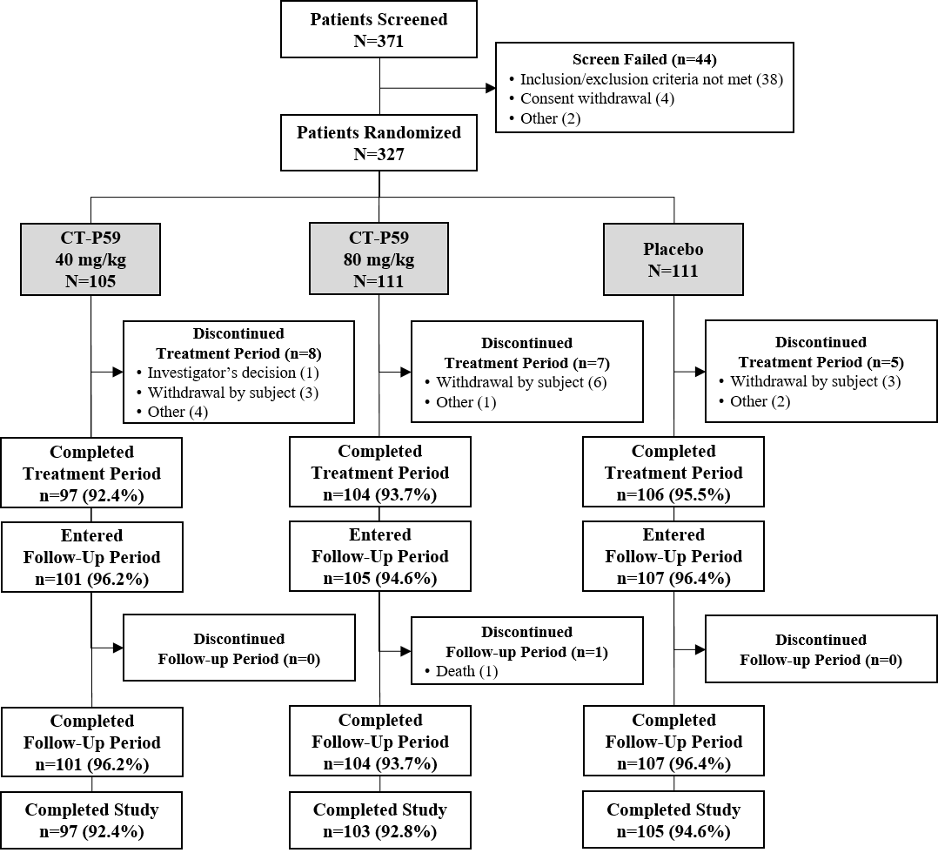
CT-P59 = drug development code for regdanvimab; N = population size; n = sample size.

Baseline data; Study CT-P59 3.2 Part 1
Overall, demographic characteristics were overall generally well balanced among the 3 groups. The mean (SD) age of patients was 50.4 (12.48), 51.1 (14.79), and 51.4 (13.05) years in the CT-P59 (regdanvimab) 40 mg/kg, CT-P59 (regdanvimab) 80 mg/kg, and placebo groups, respectively. In total, the proportion of male and female patients were similar (166 (50.8%) male and 161 (49.2%) female patients) and the majority of patients were White (286 (87.5%) patients). The mean (SD) screening BMI of patients was 27.101 (4.8086), 27.095 (4.1364), and 26.819 (4.2071) kg/m² in the CT-P59 (regdanvimab) 40 mg/kg, CT-P59 (regdanvimab) 80 mg/kg, and placebo groups, respectively.
Within the ITT set, the treatment groups were overall balanced with respect to stratification factors.
Figure 7: Study CT-P59 3.2 Part 2 Patient disposition: intent-to-treat set
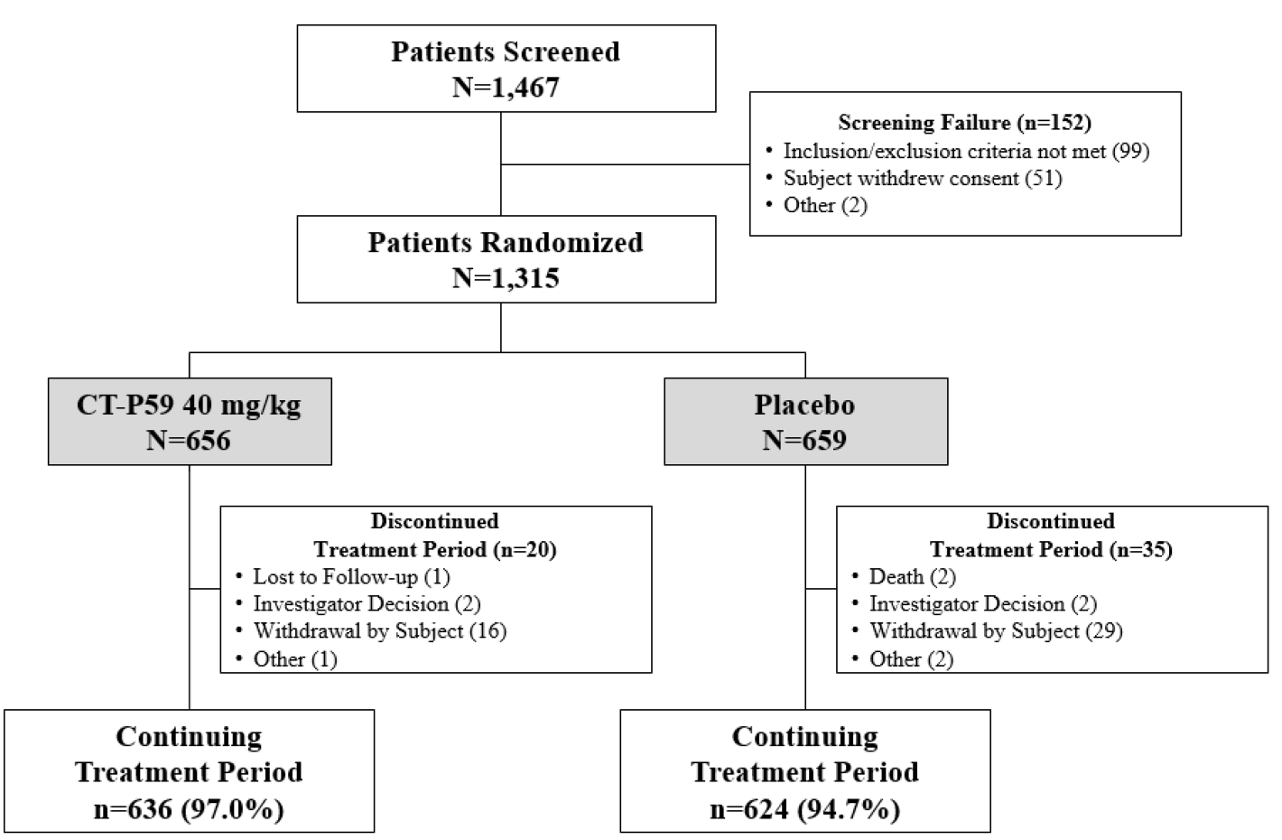
CT-P59 = drug development code for regdanvimab; N = population size; n = sample size.

Baseline data; Study CT-P59 3.2 Part 2
Overall, demographic characteristics were generally well balanced between the 2 groups. The mean (SD) age of patients was 48.4 (14.15) and 47.5 (14.22) years in the CT-P59 (regdanvimab) 40 mg/kg and placebo groups, respectively. In total, the proportion of male and female patients were similar (674/1315 (51.3%) male and 641/1315 (48.7%) female patients) and the majority of patients were White (1132/1315 (86.1%) patients). The mean (SD) screening BMI of patients was 28.10 (5.15) and 27.98 (5.58) kg/m² in the CT-P59 (regdanvimab) 40 mg/kg and placebo groups, respectively.
Within the ITT set, the treatment groups were overall balanced with respect to stratification factors, that is, age (≥ 60 years versus < 60 years), overall baseline comorbidities (yes versus no, having at least one of cardiovascular disease, chronic respiratory disease, hypertension, diabetes mellitus, and pneumonia) and region.

Efficacy results

Study CT-P59 3.2 Part 1

Key primary efficacy endpoint
Table 8: Study CT-P59 3.2 Part 1 Proportion of patients with clinical symptoms requiring hospitalisation, oxygen therapy, or experiencing mortality due to SARS-CoV-2 infection up to Day 28, intent-to-treat infected set
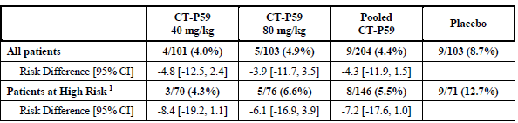
CI = confidence interval; CT-P59 = drug development code for regdanvimab; SARS-CoV-2 = severe acute respiratory syndrome coronavirus 2.
1. the high risk patients with one or more of the following risk factors: age > 50 years, body max index > 30 kg/m² collected via vital signs case report form; cardiovascular disease including hypertension; chronic lung disease including asthma; type 1 and 2 diabetes mellites; chronic kismet disease including those on dialysis; chronic liver disease; and immunosuppressed, based on prescriber’s assessment.
There were no deaths up to Day 28 in this study.

Supportive primary efficacy endpoints
Table 9: Study CT-P59 3.2 Part 1 Time to clinical recovery (for at least 48 hours) up to Day 14
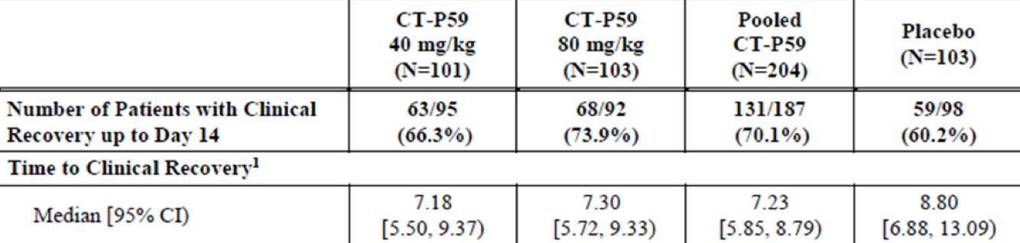
CI = confidence interval; CT-P59 = drug development code for regdanvimab; N = population size.
1. Time to clinical recovery (days) is calculated as (date/time of event/censoring - date/time of study drug administration) and Kaplan-Meier estimates are presented.
Table 10: Study CT-P59 3.2 Part 1 Time to negative conversion based on reverse transcription quantitative real time polymerase chain reaction up to Day 14 (< 3.31 log10 copies/mL as negative) (virologic endpoint)
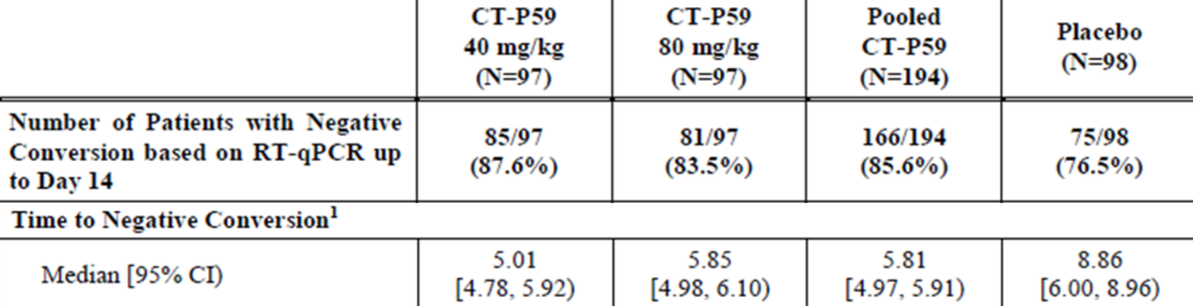
CI = confidence interval; CT-P59 = drug development code for regdanvimab; N = population size; RT-qPCR = reverse transcription quantitative real time polymerase chain reaction.
1. Time to negative conversion (days) is calculated as (date/time of event/censoring - date/time of study drug administration) and Kaplan-Meier estimates are presented.
Table 11: Study CT-P59 3.2 Part 1 Proportion of patients with negative conversion (< 2.33 log10 copies/mL as negative) up to Day 14) (virologic endpoint)
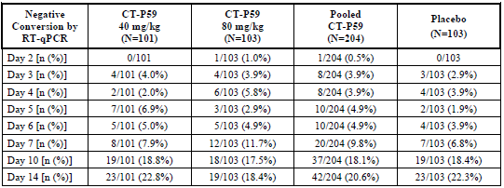
CT-P59 = drug development code for regdanvimab; N = population size; n = sample size; RT-qPCR = reverse transcription quantitative real time polymerase chain reaction.

Study CT-P59 3.2 Part 2

Primary efficacy endpoint
Table 12: Study CT-P59 3.2 Part 2 Proportion of patients with clinical symptoms requiring hospitalisation, oxygen therapy, or experiencing mortality due to SARS-CoV-2 infection up to Day 28 in high risk patients
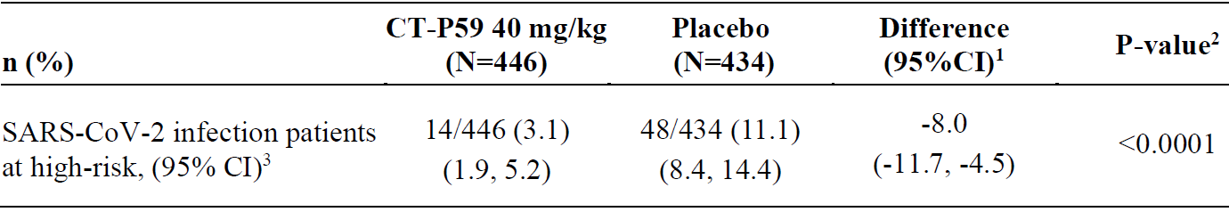
CI = confidence interval; CT-P59 = drug development code for regdanvimab; N = population size; n = sample size, SARS-CoV-2 = severe acute respiratory syndrome coronavirus 2.
1. The difference of proportions between two groups estimated using Cochran-Mantel-Haenszel (CMH) weights, and the 95% stratified Newcombe CI with CMH weights were presented. Analysis was stratified by age (≥ 60 years versus < 60 years), baseline morbidities (yes versus no) and region (United States of America (USA) versus European Union (EU) versus other).
2. The p-value from stratified CMH test was presented. The CMH test was stratified by age (≥ 60 years versus < 60 years), baseline comorbidities (yes versus no) and region (USA versus EU versus other)
3. 95% CI for each proportion was computed by Wilson (score) method.
The result for the ITTI set - high risk and sensitivity analysis using fisher’s exact test for the ITT set - high risk showed similar trend.
The subgroup analysis for the primary endpoint was conducted in accordance with the predefined category in statistical analysis plan. The subgroup analysis of age, sex, and baseline comorbidities in high risk patients indicated a similar trend to the main analysis. The subgroup analysis of region and race showed no clear trend as majority of patients were enrolled from EU-region and were White.

Subgroup analyses of the primary endpoint
The CT-P59 (regdanvimab), 40 mg/kg group reported 71% of reduction rate in the risk of disease progression (requiring hospitalisation, oxygen therapy, or experiencing mortality) in patients with age 50 years (4.2 % versus 14.3 %; p < 0.0001 (stratified CMH test); estimated difference - 10.0%; 95% CI (-15.0, -5.2); 63% of reduction rate in the risk of disease progression in patients with age ≥ 60 years (6.0 % versus 16.4 %; p = 0.0032; estimated difference - 10.8%; 95% CI (-18.7, -3.1)) and 72% of reduction rate in the risk of disease progression in patients with baseline comorbidities (3.7 % versus 13.3 %; p < 0.0001 (stratified CMH test); estimated difference -9.6%; 95% CI (-14.0, -5.4)), compared to the placebo group in each subgroup.
- Age (< 60 years, ≥ 60 years, ≥ 50 years)
Table 13: Study CT-P59 3.2 Part 2 Proportion of patient with clinical symptom requiring hospitalisation, oxygen therapy, or experiencing mortality due to SARS-CoV-2 infection up to Day 28 in intent-to-treat set, high risk
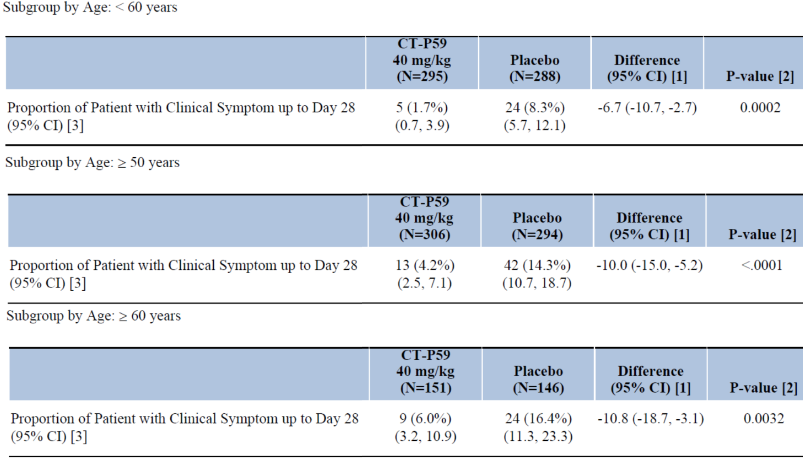
CI = confidence interval; CT-P59 = drug development code for regdanvimab; N = population size; SARS-CoV-2 = severe acute respiratory syndrome coronavirus 2.
Clinical symptom which requires hospitalisation, oxygen therapy, or experiencing mortality due to SARS-CoV-2 infection up to Day 28 is included.
1. The difference of proportions between two treatment groups estimated using Cochran-Mantel-Haenszel (CMH) weights, and the 95% stratified Newcombe CI with CMH weights are presented. analysis was stratified by age (≥ 60 years versus < 60 years), baseline comorbidities (yes versus. no) and region (United States of America (USA) versus European Union (EU) versus other).
2. The nominal p-value from stratified CMH test is presented in descriptive purpose. The CMH test is stratified by age (≥ 60 years versus < 60 years), baseline comorbidities (yes versus no) and region (USA versus. EU versus. other).
3. 95% CI for each proportion is computed by Wilson (score) method.
In Study CT-P59 3.2 Part 2, 14.2% of patients in the CT-P59 40 mg/kg group and 11.8% of patients in the placebo group were aged 65 or older.
Table 14: Study CT-P59 3.2 Part 2 Proportion of patients with clinical symptom requiring hospitalisation, oxygen therapy, or experiencing mortality due to SARS-CoV-2 infection up to Day 28 by age: intent-to-treat set, high risk
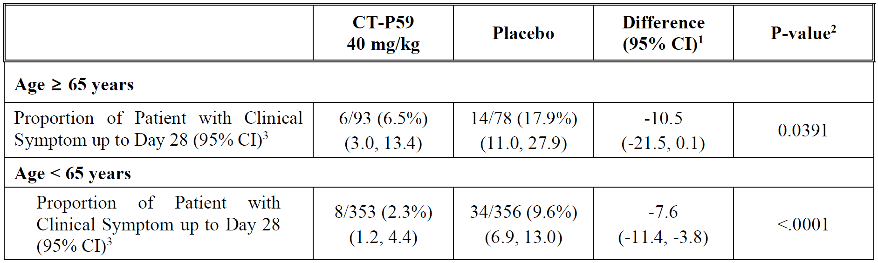
CI = confidence interval; CT-P59 = drug development code for regdanvimab; SARS-CoV-2 = severe acute respiratory syndrome coronavirus 2.
Clinical symptom which requires hospitalisation, oxygen therapy, or experiencing mortality due to SARS-CoV-2 infection up to Day 28 is included. Criterion of hospitalisation is ≥ 24 hours of acute care. Criteria of oxygen therapy are at least 24 hours of supplemental oxygen care and saturation peripheral oxygen (SpO₂) measure in room air before applying supplemental oxygen showing ≤ 94%.
1. The difference of proportions between two treatment groups estimated using Cochran-Mantel-Haenszel (CMH) weights, and the 95% stratified Newcombe CI with CMH weights are presented. Analysis was stratified by age (≥ 60 years versus < 60 years), baseline comorbidities (yes versus. no) and region (United States of America (USA) versus European Union (EU) versus other).
2. The nominal p-value from stratified CMH test is presented in descriptive purpose. The CMH test is stratified by age (≥ 60 years versus < 60 years), baseline comorbidities (yes versus no) and region (USA versus EU versus other).
3. 95% CI for each proportion is computed by Wilson (score) method.
- Baseline comorbidities (yes or no)
In Study CT-P59 3.2 Part 2, 65.7% of patients in the regdanvimab 40 mg/kg group and 62.2% of patients in the placebo group had at least one of cardiovascular disease, chronic respiratory disease, hypertension, diabetes mellitus, and pneumonia at Baseline.
Table 15: Study CT-P59 3.2 Part 2 Proportion of patients with clinical symptom requiring hospitalisation, oxygen therapy, or experiencing mortality due to SARS-CoV-2 infection up to Day 28 by baseline comorbidities: intent-to-treat set, high risk
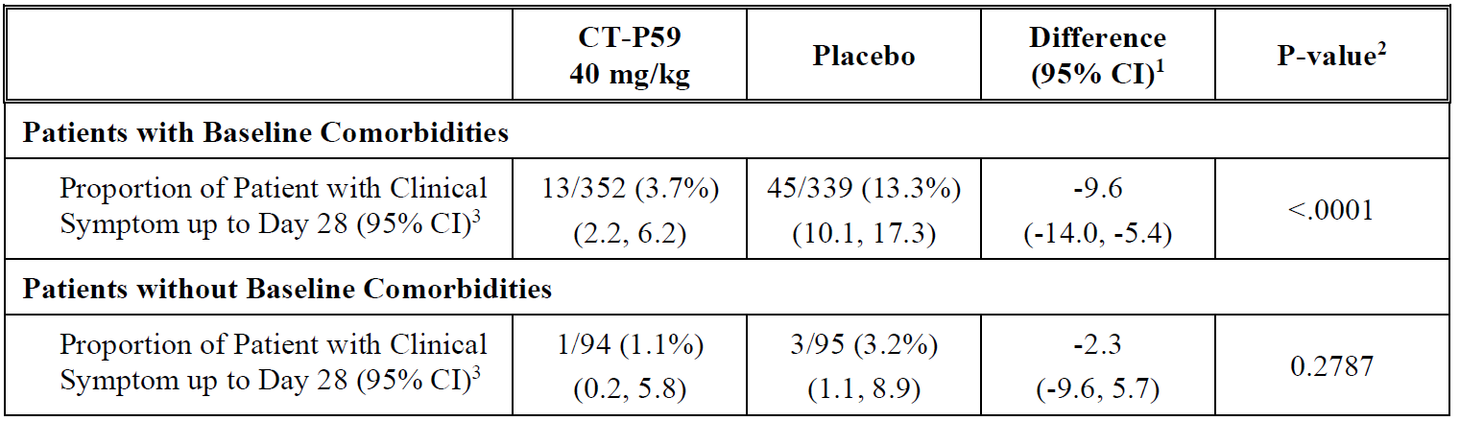
CI = confidence interval; CT-P59 = drug development code for regdanvimab; SARS-CoV-2 = severe acute respiratory syndrome coronavirus 2.
Clinical symptom which requires hospitalisation, oxygen therapy, or experiencing mortality due to SARS-CoV-2 infection up to Day 28 is included. Criterion of hospitalisation is ≥ 24 hours of acute care. Criteria of oxygen therapy are at least 24 hours of supplemental oxygen care and saturation peripheral oxygen (SpO₂) measure in room air before applying supplemental oxygen showing ≤ 94%.
1. The difference of proportions between two treatment groups estimated using Cochran-Mantel-Haenszel (CMH) weights, and the 95% stratified Newcombe CI with CMH weights are presented. Analysis was stratified by age (≥ 60 years versus < 60 years), baseline comorbidities (yes versus. no) and region (United States of America (USA) versus European Union (EU) versus other).
2. The nominal p-value from stratified CMH test is presented in descriptive purpose. The CMH test is stratified by age (≥ 60 years versus < 60 years), baseline comorbidities (yes versus no) and region (USA versus EU versus other).
3. 95% CI for each proportion is computed by Wilson (score) method.
Results of the age and baseline comorbidities subgroup analyses adds support to the outcome of the primary analysis in high risk patients. The analysis in patients ≥ 65 years was not a pre-specified subgroup analysis, however, a similar trend is shown for this age group.
- Individual high risk factors
In Study CT-P59 3.2 Part 2, a subgroup analysis by individual risk factor for progressing to severe COVID-19 was conducted for proportion of patients with clinical symptoms requiring hospitalisation, oxygen therapy or experiencing mortality due to SARS-CoV-2 infection up to Day 28. Subgroup analyses of age, sex, and baseline comorbidities in high risk patients indicated a similar trend to the main analysis; the proportion of patients with clinical symptoms requiring hospitalisation, oxygen therapy, or experiencing mortality due to SARS-CoV-2 infection was lower in the CT-P59 (regdanvimab) 40 mg/kg group compared to the placebo group.
Table 16: Study CT-P59 3.2 Part 2 Proportion of patients with clinical symptom requiring hospitalisation, oxygen therapy, or experiencing mortality due to SARS-CoV-2 infection up to Day 28 by individual risk factor, intent-to-treat set
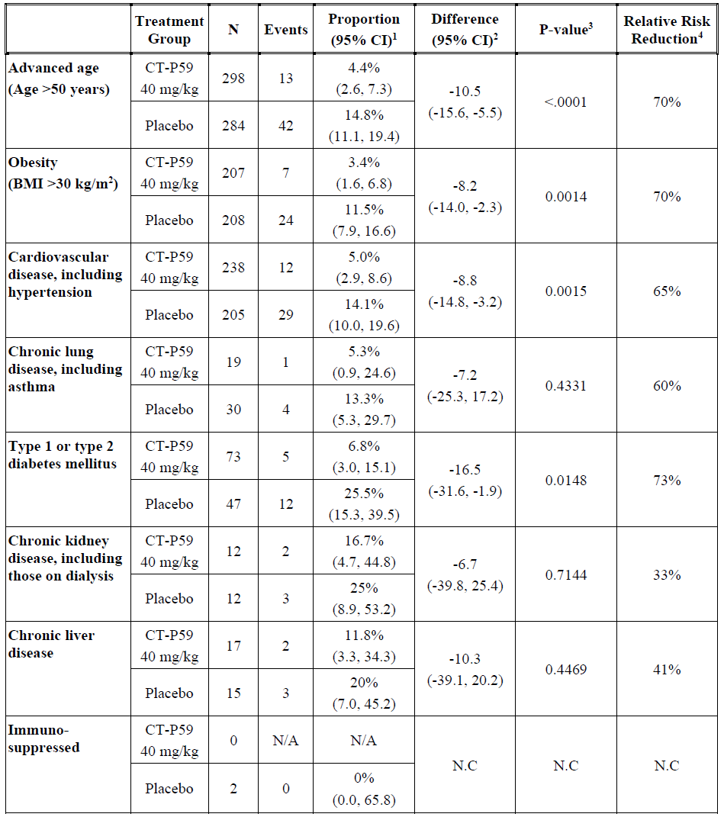
BMI = body mass index; CI = confidence interval; CT-P59 = drug development code for regdanvimab; N = population size; N/A = not applicable; N.C = not calculated.
Note: Clinical symptom which requires hospitalisation, oxygen therapy, or experiencing mortality due to SARS-CoV-2 infection up to Day 28 is included. criterion of hospitalisation is ≥24 hours of acute care. Criteria of oxygen therapy are at least 24 hours of supplemental oxygen care and saturation peripheral oxygen (SpO₂) measure in room air before applying supplemental oxygen showing ≤ 94%. Patient with two or more risk factor is included in each risk factor respectively.
1 95% CI for each proportion is computed by Wilson (score) method.
2 The difference of proportions between two treatment groups estimated using Cochran-Mantel-Haenszel (CMH) weights, and the 95% stratified Newcombe CI with CMH weights are presented. Analysis was stratified by age (≥60 years versus < 60 years), baseline comorbidities (yes versus no) and region (United States of America (USA) versus. European Union (EU) versus other).
3 The nominal p-value from stratified CMH test is presented in descriptive purpose. The CMH test is stratified by age (≥60 years vs. <60 years), baseline comorbidities (yes versus. no) and region (USA versus. EU versus other).
4 Relative risk reduction = (proportion in CT-P59 - proportion in placebo)/proportion in placebo x 100.
In non-high risk patients, the proportion of patients with clinical symptoms requiring hospitalisation, oxygen therapy or experiencing mortality due to SARS-CoV-2 infection up to Day 28 was lower in the regdanvimab 40 mg/kg group (2/210 (1.0%)) compared to the placebo group (5/225 (2.2 %)), which corresponds to a 55 % reduction (p = 0.2511 (stratified CMH test); estimated difference (95% CI) is -1.4 (-4.6, 2.6)).
As the primary endpoint was statistically significant, the first key secondary endpoint was tested following hierarchical principles.

Key secondary efficacy endpoints
Table 17: Study CT-P59 3.2 Part 2 Proportion of patients with clinical symptoms requiring hospitalisation, oxygen therapy, or experiencing mortality due to SARS-CoV-2 infection up to Day 28, intent-to-treat set (in all randomised patients)
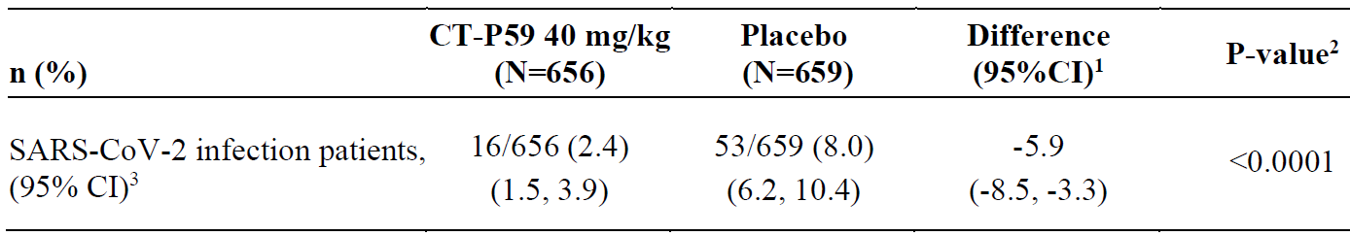
CI = confidence interval; CT-P59 = drug development code for regdanvimab; N = population size; n = sample size; SARS-CoV-2 = severe acute respiratory syndrome coronavirus 2.
1. The difference of proportions between 2 groups estimated using Cochran-Mantel-Haenszel (CMH) weights, and the 95% stratified Newcombe CI with CMH weights were presented. Analysis was stratified by age (≥ 60 years versus < 60 years), baseline comorbidities (yes versus no) and region (United States America (USA) versus European Union (EU) versus other).
2. The p-value from stratified CMH test was presented. The CMH test was stratified by age (≥ 60 years versus < 60 years), baseline comorbidities (yes versus no) and region (USA versus EU versus other).
3. 95% CI for each proportion was computed by Wilson (score) method.
Table 18: Study CT-P59 3.2 Part 2 Time to clinical recovery up to Day 14, intent-to-treat set, high risk
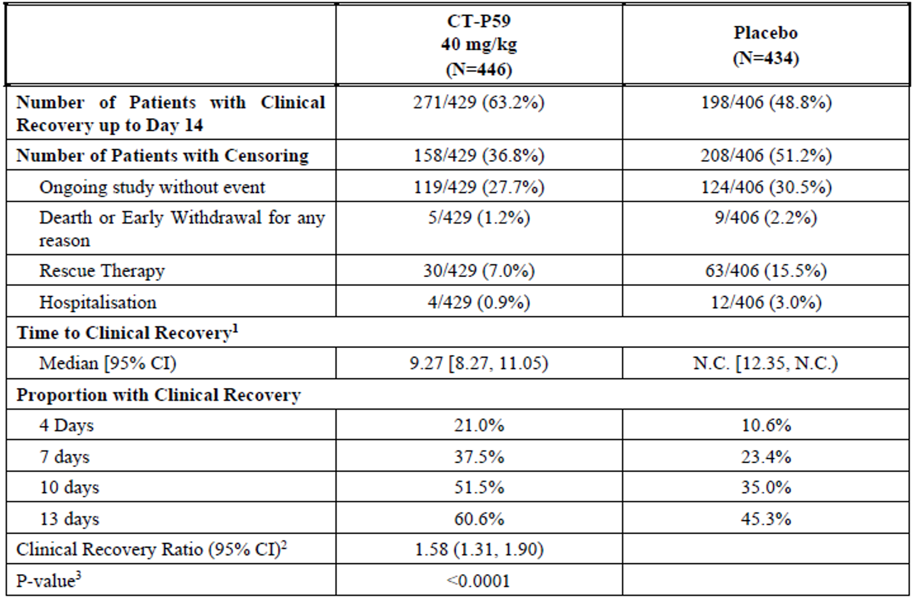
CI = confidence interval; CT-P59 = drug development code for regdanvimab; N = population size; N.C. = not calculated.
Patients who reported at least one symptom at Baseline are included in the analysis. A patient with two or more censoring reasons was included in the earliest occurred reason. If the dates were the same, the patient were included in a reason listed first in the table.
1. Time to clinical recovery (days) was calculated as (date/time of event or censoring - date/time of study drug administration), and Kaplan-Meier estimates and 95% CI based on Brookmeyer-Crowley methodology (via log-log transformation) were presented.
2. Clinical recovery ratio and its 95% CI estimated from the stratified Cox proportional hazard model were presented. The Cox proportional hazard model was stratified by age (≥ 60 years versus. < 60 years), baseline comorbidities (yes versus. no) and region (United States of America (USA) versus EU versus other).
3. The p-value from stratified log rank test is presented. The log-rank test is stratified by age (≥ 60 years versus < 60 years), baseline comorbidities (yes versus no) and region (USA versus EU versus other).
Figure 8: Study CT-P59 3.2 Part 2 Summary of time to clinical recovery up to Day 14 (Kaplan-Meier plot), intent-to-treat set, high risk
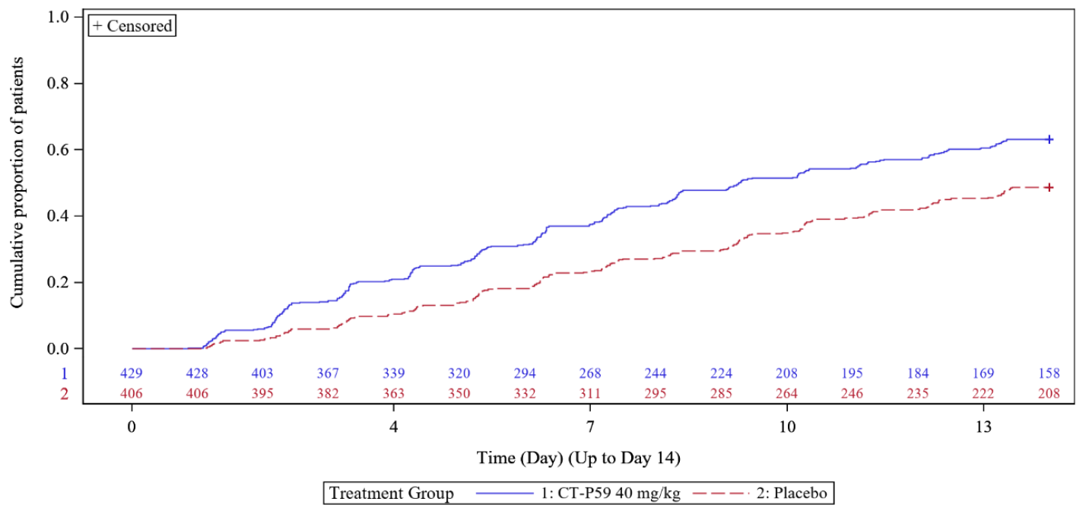
CT-P59 = drug development code for regdanvimab.
Table 19: Study CT-P59 3.2 Part 2 Time to clinical recovery up to Day 14 in all randomised patients
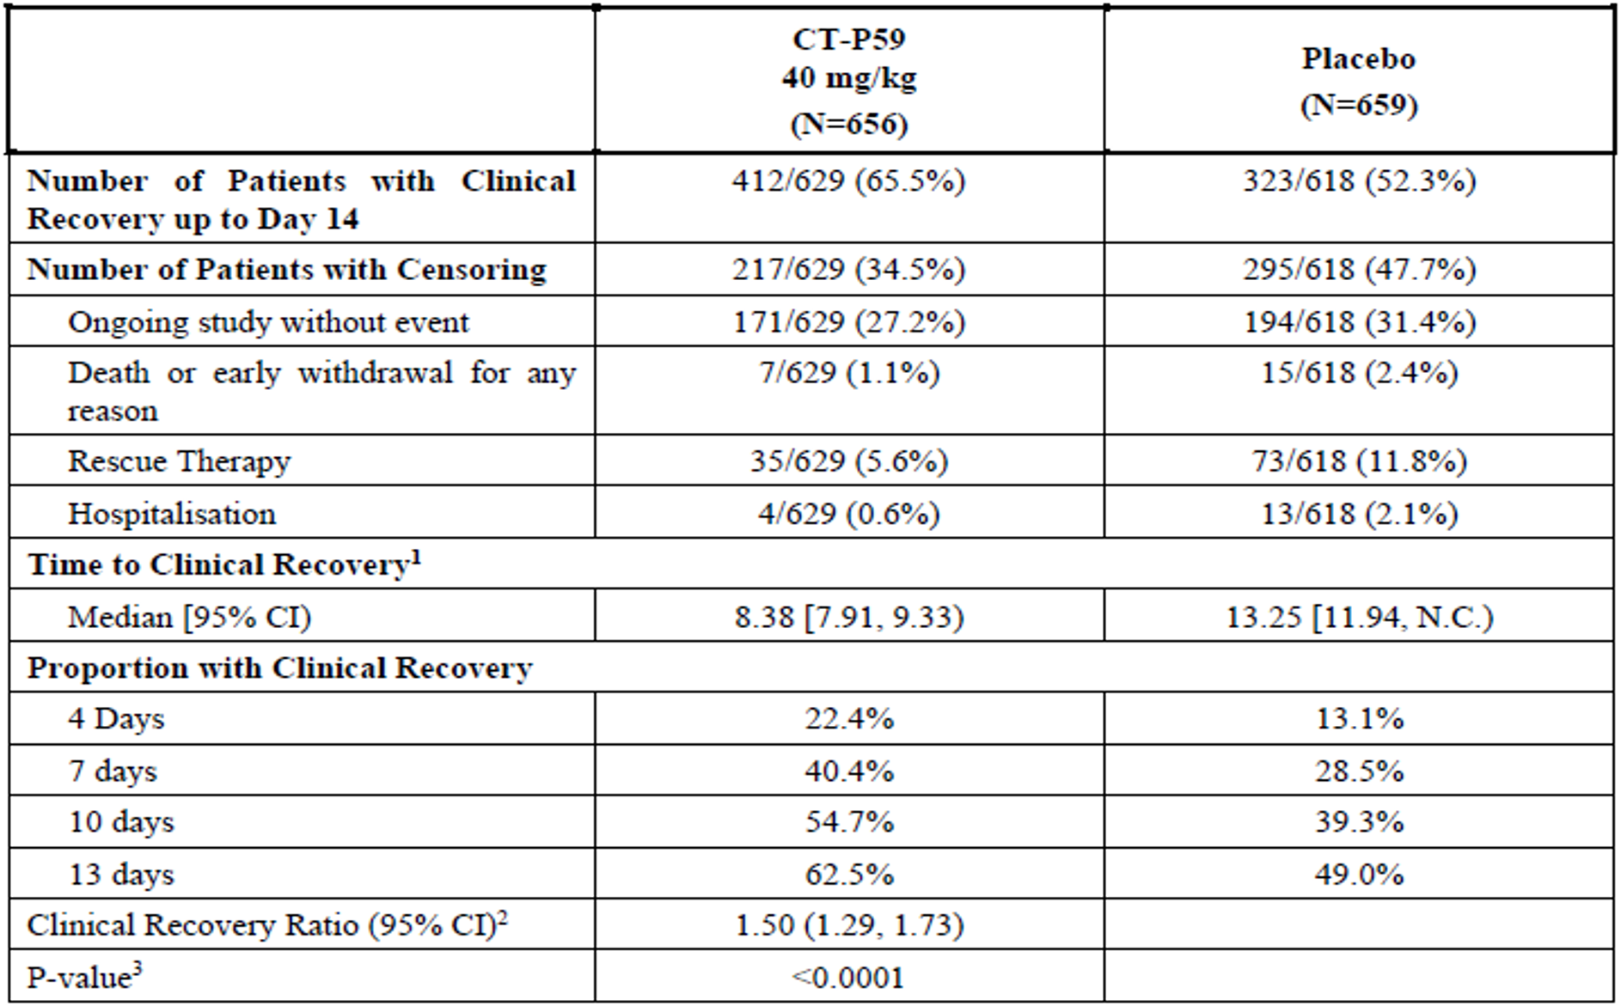
CI = confidence interval; CT-P59 = drug development code for regdanvimab; N = population size; N.C. = not calculated.
Patients who reported at least one symptom at Baseline were included in this analysis. A patient with two or more censoring reasons was included in the earliest occurred reason. If the dates were the same, the patient were included in a reason listed first in the table.
1. Time to clinical recovery (days) was calculated as (date/time of event or censoring - date/time of study drug administration), and Kaplan-Meier estimates and 95% CI based on Brookmeyer-Crowley methodology (via log-log transformation) were presented.
2. Clinical recovery ratio and its 95% CI estimated from the stratified Cox proportional hazard model were presented. The Cox proportional hazard model was stratified by age (≥ 60 years versus < 60 years), baseline comorbidities (yes versus no) and region (United States of America (USA) versus European Union (EU) versus other).
3. The p-value from stratified log-rank test is presented. the log-rank test is stratified by age (≥ 60 years versus < 60 years), baseline comorbidities (yes versus no) and region (USA versus EU versus other).
Figure 9: Study CT-P59 3.2 Part 2 Summary of time to clinical recovery (for at least 48 hours) up to Day 14 (Kaplan-Meier plot), intent-to-treat set
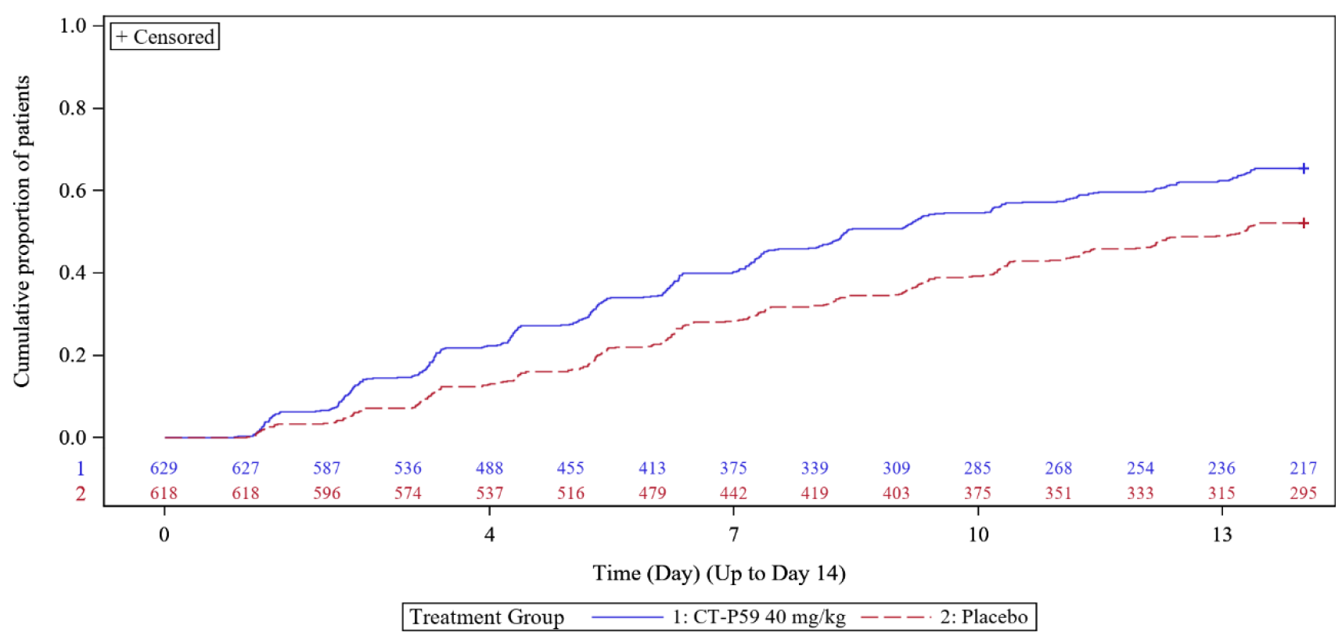
CT-P59 = drug development code for regdanvimab.

Secondary endpoints
Number of secondary analysis were performed which included the following. Confidence interval and p-value are descriptive with no adjustments for multiple testing.
- Proportion of patients with all cause mortality (intent to treat set)
Up to Day 28, a total of 3 patients died due to worsening of COVID-19 (1 (0.2%) and 2 (0.3%) patients in the CT-P59 40 mg/kg and placebo groups, respectively). All three patients were assigned to high risk group due to their advanced age and comorbidities.
- Time to negative conversion up to Day 28 (intent to treat set)
The time to negative conversion (< 2.33 log10 copies/mL as negative) up to Day 28 by RT-qPCR was (median) 11.89 and 13.13 days in the regdanvimab 40 mg/kg and placebo groups, respectively). Overall, the proportion with negative conversion in all time points up to Day 28 was numerically higher for the CT-P59 (regdanvimab) 40 mg/kg group (87.6%) than the placebo group (78.0%).

Serology against SARS-CoV-2 (exploratory)
In Study CT-P59 3.2 Part 2, 57/656 (8.7%) and 50/659 (7.6%) in the regdanvimab 40 mg/kg and placebo groups, respectively, were positive at Day 1 for either immunoglobulin G (IgG) or immunoglobulin M (IgM) antibodies as determined by sponsor supplied rapid diagnostic test, Celltrion DiaTrustTM COVID-19 IgG/IgM Rapid Test.
In the ITT high risk set, a subgroup analysis for the proportion of patients with clinical symptoms requiring hospitalisation, oxygen therapy or experiencing mortality due to SARS-CoV-2 infection up to Day 28 was conducted by serology status (ITT high risk) (Table 20 below).
Table 20: Study CT-P59 3.2 Part 2 Proportion of patients with clinical symptom requiring hospitalisation, oxygen therapy, or experiencing mortality due to SARS-CoV-2 infection up to Day 28 by serology status, intent-to-treat set, high risk
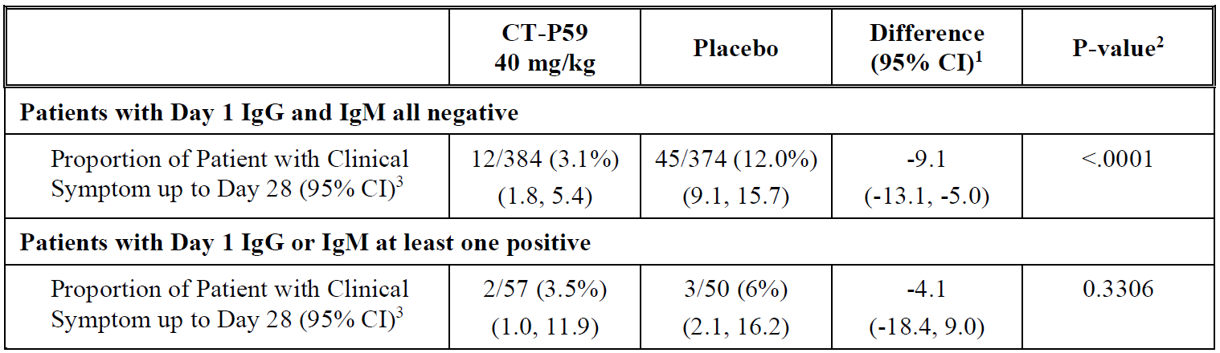
CI = confidence interval; CT-P59 = drug development code for regdanvimab; IgG = immunoglobulin G; IgM = immunoglobulin M; SARS-CoV-2 = severe acute respiratory syndrome coronavirus 2.
Clinical symptom which requires hospitalisation, oxygen therapy, or experiencing mortality due to SARS-CoV-2 infection up to Day 28 is included. Criterion of hospitalisation is ≥ 24 hours of acute care. Criteria of oxygen therapy are at least 24 hours of supplemental oxygen care and saturation peripheral oxygen (SpO2) measure in room air before applying supplemental oxygen showing ≤ 94%.
1 The difference of proportions between two treatment groups estimated using Cochran-Mantel-Haenszel (CMH) weights, and the 95% stratified Newcombe CI with CMH weights are presented. Analysis was stratified by age (≥ 60 years versus < 60 years), baseline comorbidities (yes versus no) and region (United States of America (USA) versus European Union (EU) versus other).
2 The nominal p-value from stratified CMH test is presented in descriptive purpose. The CMH test is stratified by age (≥ 60 years versus < 60 years), baseline comorbidities (yes versus no) and region (USA versus EU versus other).
3 95% CI for each proportion is computed by Wilson (score) method.
The sponsor has confirmed that efficacy data against VoC in the clinical setting is limited as these variants (especially delta) were not widespread at the time of CT-P59 (regdanvimab) administrations in the supporting clinical trials. Data from in vitro neutralisation and in vivo efficacy data have shown promising results for regdanvimab against VoC including the delta variant.
Currently, a post-marketing surveillance study (Study CT-P59 4.1) is taking place in Republic of Korea (South Korea), where the delta strain (at the time) has been the dominant variant. Based on an interim report of the study, the rates of progression to severe COVID-19 were similar between patients with the delta variant (19.0%) and non-delta variant (17.5%). Most of the patients with non-delta variant had been infected with either the wildtype (85.8%) or alpha variant (11.7%).
Based on these interim real world data, one may expect that regdanvimab will demonstrate clinical efficacy against VoC including the delta variant, although the precise magnitude of the benefit is not yet known. For the purpose this provisional registration the available evidence is appropriate.

Safety
The primary evidence in support of the safety of treatment regdanvimab is from the following three studies with CT-P59 (regdanvimab), 906 subjects received at least one dose of CT-P59 (regdanvimab). Of these, 889 received the proposed dose of 40 mg/kg or more.
Table 21: Studies CT-P59 1.1, CT-P59 1.2, CT-P59 3.2 Number of subjects who received at least one dose of CT-P59 (regdanvimab)
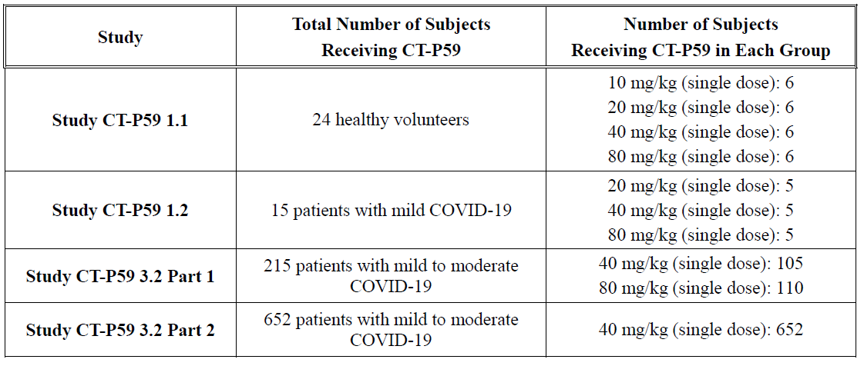
COVID-19 = coronavirus disease 2019; CT-P59 = drug development code for regdanvimab.

Adverse events
Table 22: Studies CT-P59 1.2 and CT-P59 3.2 Summary of treatment emergent adverse events (COVID-19 patients), safety set
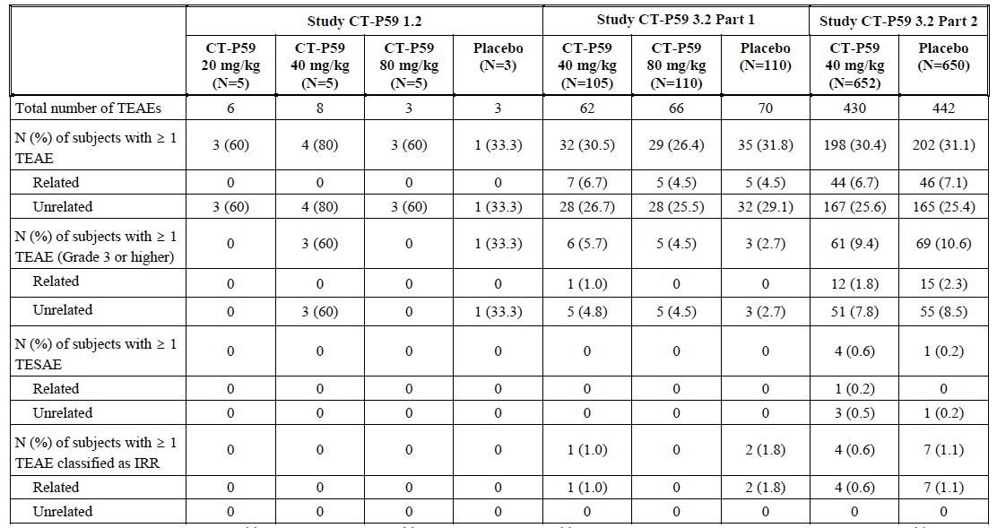
COVID-19 = coronavirus disease 2019; CT-P59 = drug development code for regdanvimab; N = number; TEAE = treatment emergent adverse event; TESAE=treatment emergent serious adverse event; IRR= infusion related reactions.
No TEAEs leading to discontinuation or death were reported in Studies CT-P59 1.2 and CT-P59 3.2 Part 1 and Part 2. However, in Study CT-P59 3.2 Part 2, 3 patients died due to worsening of COVID-19 not due to TEAE.

Common adverse events

Study CT-P59 1.1 (healthy subjects)
The number of subjects who experienced at least one treatment emergent adverse event (TEAE) in the treatment groups were 0, 4 (66.7%), 3 (50.0%) and zero subjects in the regdanvimab 10 mg/kg, 20 mg/kg, 40 mg/kg and 80 mg/kg treatment groups, respectively, and one (12.5%) subject in the placebo group. All TEAEs were Common Terminology Criteria; for Adverse Events (CTCAE) Grade 1 or 2 in intensity except for Grade 3 TEAEs of limb injury and urticaria in one subject in the regdanvimab 20 mg/kg treatment group.

Study CT-P59 1.2 (patients with mild COVID-19)
Study CT-P59 1.2 consisted of 18 randomised patients with SARS-CoV-2 infection, of which 15 patients were treated with CT-P59 (5 subjects each for 20, 40, 80 mg/kg).
The number of patients who experienced at least one TEAE in the treatment groups were 3 (60.0%), 4 (80.0%) and 3 (60.0%) patients in the regdanvimab 20 mg/kg, 40 mg/kg and 80 mg/kg treatment groups, respectively, and 1 (33.3%) patient in the placebo group. Most of the TEAEs were CTCAE Grade 1 or 2 in intensity. There were no TEAEs reported by the Investigator to be related to the study drug.
Grade 3 or higher TEAEs were reported for 3 (60.0%) patients in the regdanvimab 40 mg/kg treatment group (Grade 3 of hepatocellular injury, Grade 3 of alanine aminotransferase (ALT) increased and Grade 4 hypertriglyceridaemia) and 1 (33.3%) patient in the placebo group (Grade 3 of COVID-19 pneumonia). Most of the laboratory parameters recovered to normal range at the end of treatment visit. These ALT abnormalities have not been reproduced in the later studies.

Study CT-P59 3.2 Part 1

Results for the safety outcome (up to Day 180)
Table 23: Study CT-P59 3.2 Part 1 Summary of treatment emergent adverse events, safety set
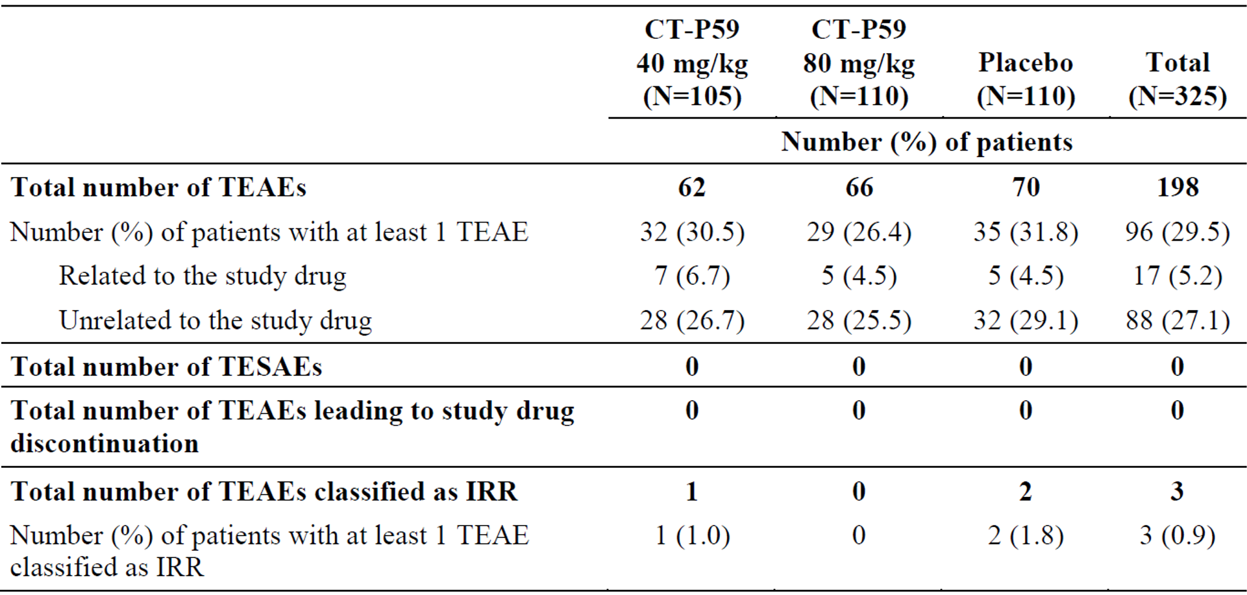
CT-P59 = drug development code for regdanvimab; IRR = infusion related reaction; N = population size; TEAE = treatment emergent adverse event; TESAE = treatment emergent serious adverse event.
Table 24: Study CT-P59 3.2 Part 1 treatment emergent adverse events of patients by System Organ Class and Preferred Terms occurring in at least one treatment group
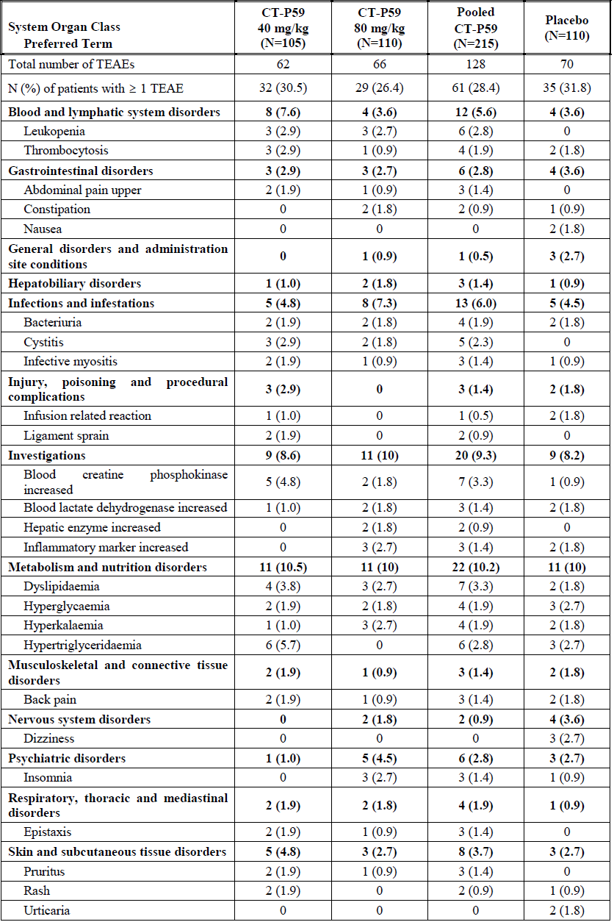
CT-P59 = drug development code for regdanvimab; N = number; TEAE = treatment emergent adverse event.
The TEAEs were largely balanced in the three groups when analysed by System Organ Class (SOC) and Preferred Terms (PT) (Table 25 below).
The most commonly reported TEAEs (> 2% patients overall) were hypertriglyceridaemia (9 (2.8%) patients overall; 6 (5.7%), 0, and 3 (2.7%) patients in the regdanvimab 40 mg/kg, regdanvimab 80 mg/kg, and placebo groups, respectively), dyslipidaemia (9 (2.8%) patients overall; 4 (3.8%), 3 (2.7%), and 2 (1.8%) patients, respectively), blood creatine phosphokinase (CPK) increased (8 (2.5%) patients overall; 5 (4.8%), 2 (1.8%), and 1 (0.9%) patients, respectively), and hyperglycaemia (7 (2.2%) patients overall; 2 (1.9%), 2 (1.8%), and 3 (2.7%) patients, respectively).

Treatment emergent adverse events related to the study drug
The proportion of patients who experienced at least one TEAE considered by the investigator to be related to study drug was similar across the groups (7 (6.7%), 5 (4.5%), and 5 (4.5%) patients in the CT-P59 (regdanvimab), 40 mg/kg, CT-P59 (regdanvimab) 80 mg/kg, and placebo groups, respectively).
The most frequently reported TEAE considered to be related to study drug by the investigator was hypertriglyceridaemia for patients in the CT-P59 (regdanvimab), 40 mg/kg group (3 (2.9%) patients), infusion related reaction (IRR) and hypertriglyceridaemia for patients in the placebo group (2 (1.8%) patients, respectively).

Treatment emergent adverse events by intensity
The majority of TEAEs reported during the study were CTCAE Grade 1 or 2 in intensity.
Table 25: Study CT-P59 3.2 Part 1 Grade 3 or higher treatment emergent adverse events of patients by System Organ Class and Preferred Terms, safety set
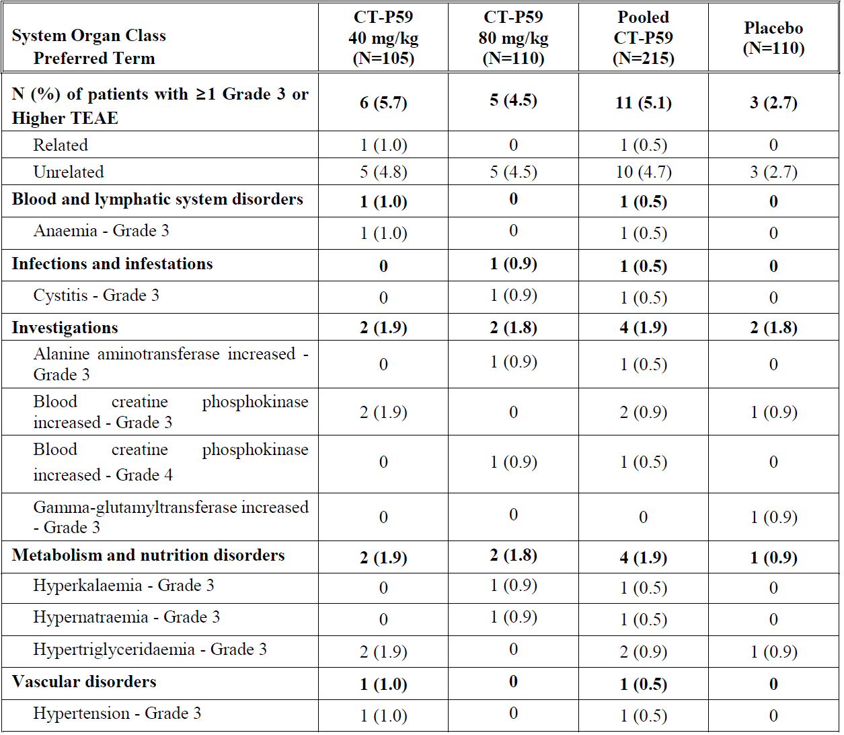
CT-P59 = drug development code for regdanvimab; N = number; TEAE = treatment emergent adverse event.

Study CT-P59 3.2 Part 2
In Study CT-P59 3.2 Part 2, a total of 1,302 patients were treated with CT-P59 (regdanvimab), or placebo (652 and 650, respectively) on Day 1, and included in the safety set.

All treatment emergent adverse events
The TEAEs were reported for 198 (30.4%) and 202 (31.1%) patients in the CT-P59 (regdanvimab) 40 mg/kg and placebo groups, respectively.
The treatment emergent serious adverse events (TESAEs) were reported for 4 (0.6%) and 1 (0.2%) patients in the CT-P59 (regdanvimab) 40 mg/kg and placebo groups, respectively. No TEAEs leading to permanent discontinuation of the study drug were reported up to Day 28.
The TEAEs classified as IRR were reported for 4 (0.6%) and 7 (1.1%) patients in the CT-P59 (regdanvimab) 40 mg/kg and placebo groups, respectively.
Table 26: Study CT-P59 3.2 Part 2 Treatment emergent adverse events of patients by System Organ Class and Preferred Terms occurring in at least one treatment group, safety set
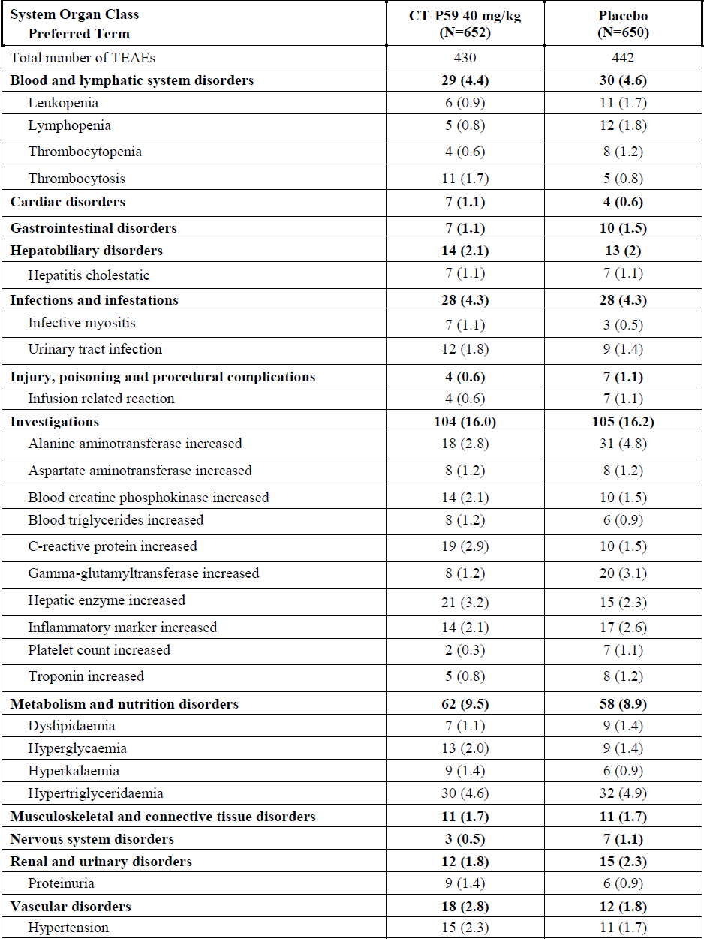
CT-P59 = drug development code for regdanvimab; N= number; TEAE = treatment emergent adverse event.
No death reported as a TESAE or an outcome of other TESAE occurred up to Day 28. However, there were three deaths considered to be due to worsening of their COVID-19 illness.
The TEAEs by SOC and PT were largely balanced between the two groups. The most frequently reported TEAE was hypertriglyceridaemia for patients in both CT-P59 (regdanvimab) 40 mg/kg and placebo groups (30 (4.6%) and 32 (4.9%) patients in CT-P59 (regdanvimab) 40 mg/kg and placebo groups, respectively).

Treatment emergent adverse events related to the study drug
The proportion of patients who experienced at least one TEAE considered by the investigator to be related to study drug was similar between the groups (44 (6.7%) and 46 (7.1%) patients in the CT-P59 (regdanvimab) 40 mg/kg and placebo groups, respectively). The most frequently reported TEAE considered to be related to study drug by the investigator was hepatic enzyme increased and hypertriglyceridaemia for patients in the CT-P59 (regdanvimab) 40 mg/kg group (7 (1.1%) patients, respectively), alanine aminotransferase increased for patients in the placebo group (10 (1.5%) patients).

Treatment emergent adverse events by intensity
In Study CT-P59 3.2 Part 2, the majority of TEAEs were CTCAE Grade 1 or 2 in intensity. Grade 3 or higher TEAEs were reported for 61 (9.4%) and 69 (10.6%) patients in the CT-P59 (regdanvimab) 40 mg/kg and placebo groups, respectively. The most frequently reported Grade 3 or higher TEAE was hypertriglyceridaemia (23 (1.8%) patients overall; 13 (2.0%) and 10 (1.5%) patients in the CT-P59 40 mg/kg and placebo groups, respectively).
One patient (0.2%) in the CT-P59 (regdanvimab) 40 mg/kg experienced Grade 4 TEAE considered to be related to the study drug by the investigator. This patient was from the CT-P59 (regdanvimab) 40 mg/kg group, and experienced a Grade 2 TESAE of IRR with the symptoms of Grade 2 generalised urticaria and Grade 1 pruritus one day after study drug administration (Day 2) and was hospitalised on Day 3. There were no systemic symptoms such as abnormal vital signs or electrocardiogram Treatment medications were used, and the patient was recovered on Day 5. The event was considered by the investigator to be possibly related to the study drug.
The number of patients who experienced at least one Grade 4 TEAE considered to be unrelated to the study drug by the investigator was similar between the groups (2 (0.3%) and 3 (0.5%) patients in the CT-P59 (regdanvimab) 40 mg/kg and placebo groups, respectively).
Table 27: Study CT-P59 3.2 Part 2 Grade 3 or higher treatment emergent adverse events s of patients by System Organ Class and Preferred Terms, safety set
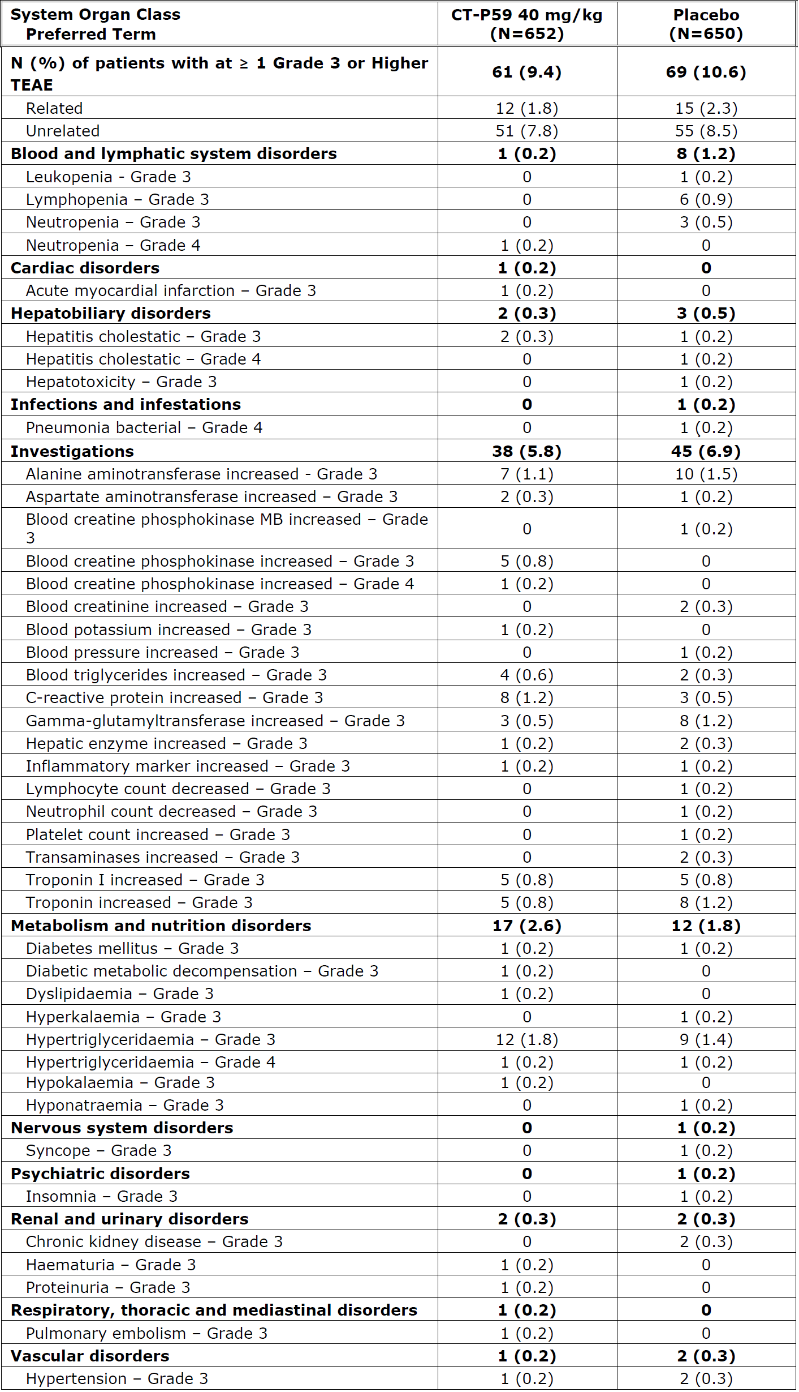
CT-P59 = drug development code for regdanvimab; N = number; TEAE = treatment emergent adverse event.
Serious adverse events and deaths
Other than one unrelated TESAE of limb injury which occurred 36 days after the study drug administration in the regdanvimab 20 mg/kg treatment group of Study CT-P59 1.1, no TEAEs were considered as serious and no deaths were reported in Studies CT-P59 1.1, CT-P59 1.2 and CT-P59 3.2 Part 1.
In Study CT-P59 3.2 Part 2, 5 TESAEs were reported in 5 (0.4%) patients overall (4 (0.6%) patients in the CT-P59 (regdanvimab) 40 mg/kg treatment group and 1 (0.2%) patient in the placebo group). There were no TESAEs reported for more than one patient in either treatment group. TESAE considered by the Investigator to be related to study drug was IRR (1 (0.2%) patient, Grade 2) in the CT-P59 (regdanvimab) 40 mg/kg treatment group, and all other TESAEs were considered by the investigator to be unrelated to study drug.
There were one and two deaths in the CT-P59 (regdanvimab) 40 mg/kg and placebo groups, respectively. The cause of death was in all cases assessed as related to worsening of COVID-19.

Laboratory test results

Study CT-P59 1.1 (healthy subjects)
The majority of patients had no CTCAE grade (the post-Baseline laboratory result did not satisfy any CTCAE grade), or CTCAE Grade 1 (mild) or 2 (moderate) for each laboratory parameter and each subsequent time point. There were no laboratory test results of Grade 3 or above per CTCAE grading. There was no notable trend in the laboratory abnormalities within or between CT-P59 (regdanvimab) and the placebo groups. No dose dependent relationship was observed for the laboratory abnormalities across the CT-P59 (regdanvimab) treatment groups.

Study CT-P59 1.2
The majority of patients had no CTCAE grade, or CTCAE Grade 1 (mild) for each laboratory parameter and each subsequent time point.
Common terminology criteria for adverse events Grade 4 (hypocalcaemia and hypertriglyceridemia) clinically significant abnormal laboratory parameters were reported in 2 patients (1 (20%) patient in each of the CT-P59 (regdanvimab) 20 mg/kg and CT-P59 (regdanvimab) 40 mg/kg treatment groups).
One patient in the CT-P59 (regdanvimab) 20 mg/kg treatment group had CTCAE Grade 4 hypocalcaemia on Day 14 (calcium of 0.9 mmol/L; normal range of 2.15 to 2.525 mmol/L). The Investigator considered the laboratory result as not clinically significant and the patient’s calcium level increased to normal range on Day 28 (calcium of 2.2 mmol/L) without any medication.
One patient in the CT-P59 (regdanvimab) 40 mg/kg treatment group had CTCAE Grade 4 hypertriglyceridemia on Day 10 (triglycerides of 13.097 mmol/L; normal range of 0.17 to 1.695 mmol/L) and it was reported as a TEAE and considered to be recovering at the end of the study (triglycerides of 6.272 mmol/L on Day 90) by the Investigator. The patient didn’t take any medication related to the event during the treatment period. The event was considered to be worsening of patient’s existing medical history of hypertriglyceridaemia. Given the very limited study size the rates of laboratory abnormalities should be interpreted with caution. ALT elevations and hypocalcaemia are frequently seen in COVID-19 patients.

Study CT-P59 3.2 Part 1
The changes from Baseline in all clinical chemistry and haematology laboratory parameters showed no notable differences among the CT-P59 (regdanvimab) 40 mg/kg, CT-P59 (regdanvimab) 80 mg/kg, and placebo groups.
The most frequently reported CTCAE Grade 3 laboratory parameter was neutrophil count decreased in all groups (13 (12.4%), 10 (9.1%), and 7 (6.4%) patients in the CT-P59 (regdanvimab) 40 mg/kg, CT-P59 (regdanvimab) 80 mg/kg, and placebo groups, respectively).
Common terminology criteria for adverse events Grade 4 (life threatening) clinically significant abnormal laboratory parameters were reported in 9 patients (0, 6 and 3 patients in the CT-P59 (regdanvimab) 40 mg/kg, CT-P59 (regdanvimab) 80 mg/kg and, placebo groups, respectively). In the placebo group, these included: raised CPK, neutrophil count decreased, and hypertriglyceridaemia. Grade 4 events in the CT-P59 (regdanvimab) 80 mg/kg group included: CPK increased (in 3 patients), hypocalcaemia (1), and neutrophil count decreased (2); these were either considered to be unrelated to the treatment or not clinically significant by the investigator.
Table 28: Study CT-P59 3.2 Part 1 Summary of most severe common terminology criteria for adverse events grading (Grade 3 or higher), safety set
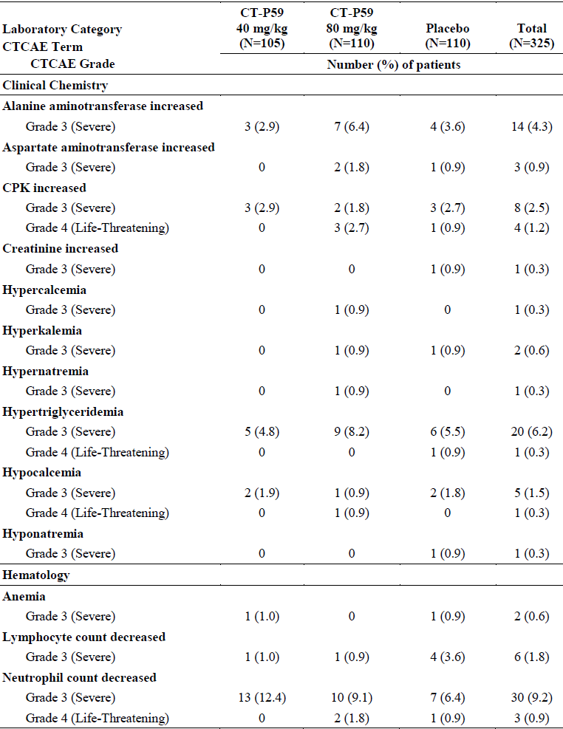
CPK = creatine phosphokinase; CTCAE = Common Terminology Criteria For Adverse Events; CT-P59 = drug development code for regdanvimab; N= population size.

Study CT-P59 3.2 Part 2
Overall, changes from the Baseline post-treatment in all clinical chemistry and haematology laboratory parameters did not show major differences between the CT-P59 (regdanvimab) 40 mg/kg and placebo groups
Table 29: Study CT-P59 3.2 Part 2 Summary of most severe common terminology criteria for adverse events grading (Grade 3 or higher), safety set
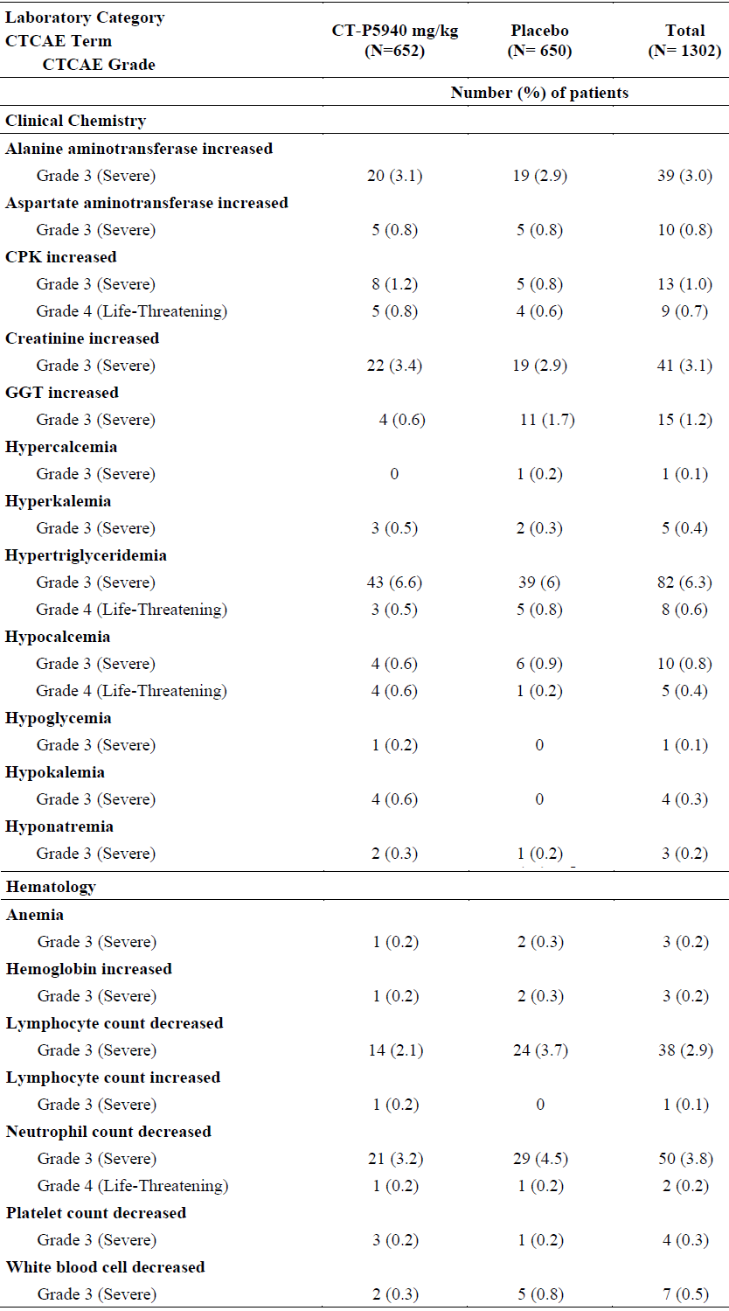
CPK = creatine phosphokinase; CTCAE = Common Terminology Criteria For Adverse Events; CT-P59 = drug development code for regdanvimab; GGT = gamma-glutamyltransferase; N= population size.
Overall, laboratory abnormalities are similar between the treatment group and placebo group except for a few instances where abnormalities are seen more frequently in the placebo group. Grade 3 to 4 CPK elevations are seen slightly more frequent in the treatment group compared to placebo. The are no signs of a causal relation between regdanvimab treatment and transaminitis, neutropenia or hypocalcaemia where some imbalances were seen in the smaller studies.

Vital signs, electrocardiogram and physical examination
In Studies CT-P59 1.1, CT-P59 1.2, and CT-P59 3.2 Part 1 and Part 2, there were no clinically notable abnormalities reported from other safety assessments, including vital signs, hypersensitivity reaction monitoring, electrocardiogram, and physical examination, following study drug administration.

Treatment emergent adverse events classified as infusion related reaction
In Studies CT-P59 1.1 and CT-P59 1.2, there was no TEAE of IRR including hypersensitivity/ anaphylactic reaction in patients in the regdanvimab treatment groups during the study period.
In Study CT-P59 3.2 Part 1, the TEAEs classified as IRR (including hypersensitivity and anaphylactic reactions) were reported for 1 (1.0%), 0, and 2 (1.8%) patients in the CT-P59 (regdanvimab), 40 mg/kg, CT-P59 (regdanvimab), 80 mg/kg, and placebo groups, respectively. All TEAEs classified as IRR during the study were Grade 1 or 2 in intensity. One patient in CT-P59 (regdanvimab), 40 mg/kg group had experienced Grade 2 pyrexia and Grade 1 dyspnoea (92% of saturation peripheral oxygen (SpO₂) at the time of the event) after 40 minutes from the end of the study drug administration. The patient had recovered after taking paracetamol and applying oxygen therapy.
In Study CT-P59 3.2 Part 2, the TEAEs classified as IRR were reported for 4 (0.6%) and 7 (1.1%) patients in the CT-P59 (regdanvimab) 40 mg/kg and placebo groups, respectively. All of TEAEs classified as IRR during the study were Grade 1 or 2 in intensity. All patients from both groups were recovered during the treatment period.

Antibody dependent enhancement
No suspicious ADE events were reported during the studies.
There were no ADA positive results reported at post-treatment visit up to Day 90 and up to Day 180 for Studies CT-P59 1.1 and CT-P59 1.2, respectively.
In Study CT-P59 3.2 Part 1, the number of patients with the positive ADA conversion after study drug administration up to Day 90 was 3 (3.0%), 8 (7.3%), 11 (5.2%) and 6 (5.6%) in the CT-P59 (regdanvimab), 40 mg/kg, CT-P59 (regdanvimab) 80 mg/kg, pooled CT-P59 (regdanvimab), and placebo groups, respectively. In Study CT-P59 3.2 Part 2, the proportions of patients with the positive ADA conversion after study drug administration up to Day 28 were 1.6% and 2.4% in the CT-P59 (regdanvimab) 40 mg/kg and placebo groups, respectively. Among the patients with positive conversion in ADA, IRR was reported only for 1/10 (10%) in the CT-P59 40 mg/kg in Study CT-P59 3.2 Part 2.

Vaccination as concomitant medications
The sponsor confirms that, in Study CT-P59 3.2 Part 1 and Part 2, concomitant medication was defined as one that may be given within 30 days prior to the first administration of the study drug (Day 1) or from when the informed consent form was signed, whichever was earlier. Four patients received the vaccination as concomitant medication (three patients and one patient from Part 1 and Part 2, respectively). All patients received the vaccines after the study drug administration, and two of them received SARS-CoV-2 vaccines.
None of the patients had experienced disease progression (requiring hospitalisation, oxygen therapy, or experiencing mortality due to SARS-CoV-2 infection). No adverse event was also reported after these patients received the vaccination.
Table 30: Study CT-P59 3.2 Summary of vaccination given as concomitant medications
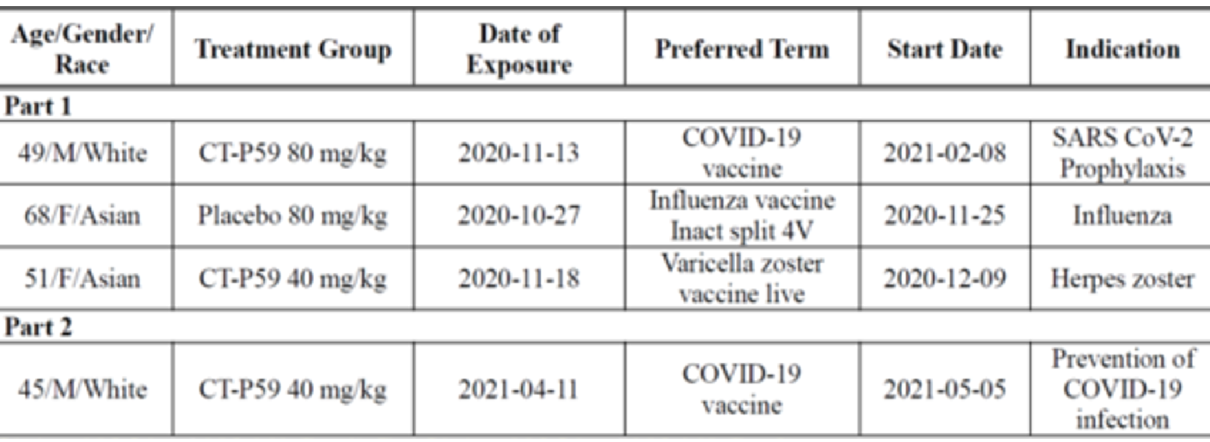
COVID-19 = coronavirus disease 2019; CT-P59 = drug development code for regdanvimab; F = female; ID = identity; M = male; SARS-CoV-2 = severe acute respiratory syndrome coronavirus 2.
The number of people who received concomitant vaccinations is too small to draw any clinically meaningful conclusion at this stage.

Post-marketing experience
A post-marketing surveillance of Regkirona 960 mg (Study CT-P59 4.1) is currently being conducted in Republic of Korea. This surveillance is to continue for a period of 6 years from the approval date.
Regkirona has been approved in Republic of Korea since 5 February 2021 after which surveillance activities have been conducted.
As of the data cut-off date of 15 September 2021, post-marketing cumulative exposure to CT-P59 (regdanvimab) is estimated at approximately 21,100 patients in Republic of Korea, which includes exposure to CT-P59 (regdanvimab) through post-marketing surveillance study (Study CT-P59 4.1). In addition, exposure to CT-P59 (regdanvimab) is estimated at approximately 60 patients in Brazil where CT-P59 (regdanvimab) was approved under the Emergency Use Authorisation, and 84 patients in Spain, Cyprus and Austria, in which countries regdanvimab was used for individual basis treatment prior to marketing authorisation. Among a total of 21,244 patients, 31 serious adverse events (SAEs) were reported in 11 (0.05%) patients overall, and most of the events were recovered with the exception of 2 patients, including one fatal case. This patient reported suspected anaphylaxis during CT-P59 (regdanvimab) infusion with symptoms of dyspnoea, chest discomfort and cough; the infusion was immediately discontinued, and the patient received corrective treatments with oxygen therapy and epinephrine. Thereafter, the patient was moved to intensive care unit and died the next day.
The post-marketing experience with almost 8,500 doses administered provides some additional insight on the safety profile of regdanvimab. The SAEs reported are difficult to interpret, given that several of the events could have been caused by progression of COVID-19 disease (from mild to moderate disease which is the intended target group for the emergency use approval in Republic of Korea), but the timing in relation to administration could give further insight. The sponsor has provided narratives for the SAEs showing alternative causes of events for most cases.

Risk management plan
The sponsor has submitted EU-risk management plan (RMP) version 0.3 (dated 18 June 2021 according to Australia specific annex (ASA) v1.0; data lock point (DLP) 11 June 2021) and ASA version 1.0 (dated 31 August 2021) in support of this application. In response to the RMP evaluator’s recommendations dated 24 September 2021, the sponsor has submitted the updated EU-RMP version 0.5 (dated 27 September 2021 according to ASA v2.0; DLP 24 September 2021) and ASA version 2.0 (dated 7 October 2021). In response to Recommendation 16 dated 12 October 2021, the sponsor has submitted updated ASA version 3.0 (dated 21 October 2021).
The summary of safety concerns and their associated risk monitoring and mitigation strategies are summarised in Table 31.
Table 31: Summary of safety concerns
Summary of safety concerns |  | Pharmacovigilance |  | Risk Minimisation
 |  | Routine | Additional | Routine | Additional
Important identified risks | Hypersensitivity (including infusion-related reactions and anaphylaxis)¹ | ³ | ^{5, 6} |  | –
Important potential risks | Antiviral resistance¹ | ^{3, 4} | – |  | –
Missing information | Use during pregnancy or lactation² | ³ | ^{6, 7} |  | –
Missing information | Effects on COVID-19 immunisation responses | ³ | – |  | –
Missing information | Long-term safety data | ³ | ⁵ | –
Missing information | Use in COVID-19 vaccine breakthrough infection¹ | ³ | – |  | –
Missing information | Use in immunosuppressed patients¹ | ³ | – | – | –
1 Australian specific safety concerns
2 Use in lactation is an Australian specific safety concern
3 Monthly summary safety reports
4 Specific adverse reaction follow-up questionnaires
5 Clinical trial Study CT-P59 3.2 (overseas)
6 Post-authorisation safety study - Study CT-P59 4.1 (Republic of Korea)
7 COVID-19 International Drug Pregnancy Registry (COVID-PR)
- As requested by the RMP evaluator, the sponsor has updated the ASA to include the following as Australian specific safety concerns: hypersensitivity (including infusion related reactions and anaphylaxis) (important identified risk), antiviral resistance (important potential risk), use in lactation (missing information), use in COVID-19 vaccine breakthrough infections (missing information), and use in immunosuppressed patients (missing information).
- The sponsor has added COVID-19 International Drug Pregnancy Registry and agreed to submit monthly summary safety reports to the TGA. Australian patients are to be included in the registry. Australian patients are not included in the post-authorisation safety study (Study CT-P59 4.1). However, findings from the study are considered applicable to Australia.
- Recommendations to improve patient selection and safety communication on missing information ‘use in immunosuppressed patients’ have been made for the TGA Delegate to consider.

Risk-benefit analysis

Delegate’s considerations

Quality and nonclinical
In vitro and in vivo data support the use of regdanvimab for the proposed clinical indication.
Outstanding quality and nonclinical issues have been resolved prior to registration.

Efficacy
Regdanvimab is a recombinant monoclonal antibody targeting the RBD of the spike protein of SARS-CoV-2.
The PK of regdanvimab was assessed in all three submitted clinical studies using rich sampling schedules. No interaction studies, metabolism and excretion studies or dedicated studies in special populations were performed. This is considered acceptable.
The PK analysis and statistical methods used are considered adequate.
The PK of regdanvimab was very similar to that observed in healthy volunteers.
No dose adjustment is currently proposed elderly, hepatic/renal impairment, based on weight, gender or race. This has been adequately justified and considered acceptable.
The results showed that regdanvimab have PK characteristics typical for an IgG monoclonal antibody, that is a low clearance, a small volume of distribution and a long terminal half life. The immunogenicity potential of regdanvimab is low.
Clearance was independent of dose. At the 40 mg/kg dose, the PK of regdanvimab was characterised by a (arithmetic mean (CV%)) CL of 0.20 mL/h/kg (24%), a V_{ss} of 83 mL/kg (26%) and a t_{1/2z} of 17 days (37%).
The neutralising ability of representative regdanvimab against wild type SARS-CoV-2 was determined by an in vitro plaque reduction neutralisation test (PRNT). The IC₅₀ and IC₉₀ of regdanvimab toward SARS-CoV-2 was 9.70 ng/mL and 25.09 ng/mL, respectively. Its neutralising activity against the wild type virus and the alpha variant. The virus like particles assays showed that spike mutations involved in the virus variants beta, gamma and kappa led to increased IC₅₀ values compared to the original type. In summary, PK/PD is compatible with clinical activity against the delta variant, and a ACE2 transgenic mouse animal model is supportive of such activity. According to the sponsor, it will continue to monitor and study newly emerging variants, escape mutants, and duly report the results as they become available. This is considered acceptable.
The doses chosen for the clinical trials were based on the efficacy findings in various animal models. The chosen dose of 40 mg/kg is equivalent to the dose that were efficacious in the animal models. The 40 mg/kg regimen is predicted to achieve mean Day 14 lung CT-P59 (regdanvimab) concentration that is higher than in vitro IC₉₀ of all variants of concern. Overall, the chosen dose regimen of single intravenous administration of 40 mg/kg CT-P59 (regdanvimab) appears to be appropriate.
This submission is supported by a Phase II/III, randomised, parallel group, placebo controlled, double blind study to evaluate the efficacy and safety of CT-P59 (regdanvimab) in combination with standard of care in outpatients with SARS-CoV-2. The confirmatory Part 2 of the study tested the hypothesis that regdanvimab given to outpatients with early disease might reduce the risk of hospitalisation or severe disease.
The study included outpatients aged 18 or above. Patients had to have oxygen saturation > 94% on room air, not requiring supplemental oxygen, and onset of SARS-CoV-2 infection associated symptom no more than 7 days prior to the study drug administration. The key exclusion criterion was signs of severe COVID-19. Furthermore, patents were required to be unvaccinated for SARS-CoV-2. Patients were randomised to receive a single dose of 40 mg/kg of regdanvimab, or placebo. About 2/3 of recruited patients were over age 50 and had other recognised risk factors for severe COVID-19; however only two patients were classified as ‘immunosuppressed’. 90% of patients had negative serology for SARS-CoV-2 at Baseline.
Those who had received COVID-19 vaccination were excluded from both parts of Study CT-P59 3.2. Of note, the latest version (dated 25 October 2021) of the USA Centers for Disease Control and Prevention (CDC) guideline; referenced by the sponsor states that vaccination for COVID-19 (first or second dose) should be deferred for at least 90 days. This is stated to be a ‘precautionary measure until additional information becomes available, to avoid potential interference of the antibody therapy with vaccine-induced immune responses’.
The baseline characteristics for both parts of the study were evenly balanced. This was also the case for the baseline comorbidities.
The pivotal study met its primary objective. In patients with high risk for progressing to severe COVID-19, the proportion of patients with clinical symptoms requiring hospitalisation, oxygen therapy or experiencing mortality due to SARS-CoV-2 infection up to Day 28 was significantly lower in the regdanvimab group (14/446 (3.1 %)) compared to the placebo group (48/434 (11.1 %)). The difference between the proportions was statistically significant (p < 0.0001 (stratified CMH test); estimated difference (95% CI) is -8.0 (-11.7, -4.5)). In Part 2, the key secondary endpoint looked into the proportion of patients with clinical symptoms requiring hospitalisation, oxygen therapy, or experiencing mortality due to SARS-CoV-2 infection up to Day 28 in all randomised patients. There were 16 (2.4%) patients in the (regdanvimab) CT-P59 group, against 53 (8.0%) in the placebo group. The difference was statistically significant (p < 0.0001).
The median time to clinical recovery (at least 48 hours) in high risk patients was 9.27 days in regdanvimab group, but the median time was not reached in placebo group as less than 50% of patients in this group achieved clinical recovery up to Day 14 (48.8%). The difference in time to clinical recovery between treatment groups was statistically significant (p < 0.0001 (stratified log rank test); clinical recovery ratio (95% CI) is 1.58 (1.31, 1.90)).
The time to negative virological conversion (< 2.33 log10 copies/mL as negative) up to Day 28 by RT-qPCR of nasopharyngeal swabs was shorter in the regdanvimab group was shorter than the placebo group (median, 11.89 and 13.13 days in the regdanvimab and placebo groups, respectively). Genotype and phenotype results of SARS-CoV-2 viral isolates from Part 2 will be presented in the final clinical study report.
In vitro neutralising activity was shown against the wild type virus as well as for the alpha variant (lineage B.1.1.7). However, regdanvimab has reduced neutralising activity against beta (lineage B.1.351), gamma (lineage P.1), epsilon (lineages B.1.427 and B.1.429) and kappa (lineage B.1.617.1) and delta (lineage B.1.617.2) variants in the PRNT and pseudovirus assays. PK/PD data, animal model data, as well as post-marketing data from Republic of Korea are compatible with activity also against the delta variant, for which in vitro susceptibility is decreased. Clinical efficacy against the delta variant, however, has not been demonstrated. This is considered acceptable for this provisional approval.
There is no index of efficacy in patients that are ‘immunosuppressed’. It is assumed on a mechanistic basis that there will be some level of efficacy in such patients.

Safety
Across the 3 studies with CT-P59 (regdanvimab),, 906 subjects received at least one dose of CT-P59. Of these, 889 received the proposed single dose of 40 mg/kg or more, and 882 were infected with SARS-CoV-2.
In Studies CT-P59 3.2 Part 1, the proportion of patients experiencing at least one TEAEs were comparable between the CT-P59 (regdanvimab) 40 mg/kg, CT-P59 (regdanvimab) 80 mg/kg and placebo groups (30.5%, 26.4%, and 31.8%, respectively). Those experiencing TEAEs considered to be related to the study drug were also largely similar across the groups (6.7%, 4.5%, and 4.5%, respectively). The most commonly reported TEAE by PT was hypertriglyceridaemia (in 5.7% of the CT-P59 40 mg/kg group, and 2.7% in the placebo group).
In Study CT-P59 3.2 Part 2, the proportion of patients experiencing at least one TEAEs were 30.4% and 31.1% for the CT-P59 40 mg/kg and placebo groups; 6.7% and 7.1% were considered to be related to the study drug, respectively. The most commonly reported TEAE by PT was hypertriglyceridaemia (4.6% and 4.9%, respectively). The Grade 3 and 4 TEAEs by SOCs and PTs were largely similar across the groups.
TEAEs classified as IRR reported in 1.0%, 0.0% and 1.8% of patients in Study CT-P59 3.2 Part 1 for the CT-P59 (regdanvimab), 40 mg/kg, 80 mg/kg, and placebo groups, respectively. In Study CT-P59 3.2 Part 2, TEAEs classified as IRR were for 4 (0.6%) and 7 (1.1%) patients in the CT-P59 40 mg/kg and placebo groups, respectively. All of TEAEs classified as IRR during the study were Grade 1 or 2 in intensity. Study CT-P59 3.2 Part 1 did not report any TESAE. Study CT-P59 3.2 Part 2 reported one case of TESAE, which consisted of Grade 2 generalised urticaria and Grade 1 pruritis one day after the infusion, and was considered to be possibly related to the study drug.
Laboratory investigations showed a number of abnormal findings, but largely balanced between the CT-P59 (regdanvimab), and placebo groups. An exception was in Study CT-P59 3.2 Part 1, where grade ≥ 3 neutropenia was seen in 12.4%, 9.1%, and 6.4% of the patients in the CT-P59 (regdanvimab) 40 mg/kg, 80 mg/kg, and placebo groups, respectively. There are certain events that appear to be elevated in both the treatment and placebo groups (for example, transaminitis, hypocalcaemia) however these may also be related to the underlying COVID-19 and associated SOC treatments, rather than causally related to CT-P59.
Overall, there was no death considered to be due to CT-P59 (regdanvimab) by the investigator in Part 1 and Part 2 of the study.
No particular electrocardiogram and vitals finding of concern was reported in Study CT-P59 3.2 Part 1 or Part 2. There were no ADE events reported.
Study CT-P59 1.1 and CT-P59 1.2 were Phase I trials performed in much smaller number of patients than Study CT-P59 3.2 Part 1 and Part 2. These studies did not show significant safety concerns, other than a small number of isolated findings with no clear causal relation to CT-P59 (regdanvimab),
The post-market surveillance of Regkirona 960 mg is currently being conducted in Republic of Korea and other countries. Overall, the incidence of SAEs in the post-marketing setting appears to be low. Most of the SAEs occurred on the day of CT-P59 (regdanvimab) infusion, however it is difficult to interpret whether these events are due to CT-P59 treatment, or due to concurrent COVID-19 illness, or from other treatments.
Overall, the safety profile of regdanvimab appears favourable, in line with what is expected from a monoclonal antibody targeting a viral protein.
While there are no currently identified safety issues that would preclude provisional registration, there are some remaining uncertainties and missing information. These are summarised below:
- the studies were not powered to detect potential rare/very rare ADRs;
- Long term safety (beyond Day 28) in Study CT-P59 3.2 is not known;
- There are no/limited clinical safety data in certain subgroups, in particular the following:
  - pregnant/lactating women
  - subjects with prior/concomitant COVID-19 vaccination
  - subjects with other concomitant vaccinations
  - immunocompromised.

Proposed action
The PK of regdanvimab has been well characterised in healthy volunteers and in the target population. The PK was typical for an IgG monoclonal antibody with a low clearance, a small volume of distribution and a terminal half life of 17 days. The serum exposure increased approximately in proportion to dose over the investigated dose interval 10 to 80 mg/kg.
Regdanvimab demonstrated efficacy with statistically significant reduction in the primary endpoint of the risk for progression to severe disease requiring hospitalisation or oxygen therapy, in outpatients, that are at increased risk of severe disease. It has also been demonstrated that regdanvimab reduces the duration of symptoms in such patients. The secondary endpoints were all supportive of the primary result. The median time to clinical recovery (at least 48 hours) in high risk patients was 9.27 days in regdanvimab group, and statistically significantly more than placebo (p < 0.0001 (stratified log rank test); clinical recovery ratio (95% CI) is 1.58 (1.31, 1.90)).
Based on the safety data to-date, no safety concerns with intravenous infusion of regdanvimab were identified that would affect a favourable risk/benefit.
Overall, based on the review of data on quality, safety and efficacy, the Delegate considers that the benefit-risk balance of Regkirona (regdanvimab) is favourable in the following indication:
Regkirona has provisional approval for the treatment of adults with coronavirus disease 2019 (COVID-19) who do not require supplemental oxygen and are at increased risk of progressing to severe COVID-19 (see Section 5.1 Pharmacodynamic properties, clinical trials).
The decision has been made on the basis of short term efficacy and safety data. Continued approval of this indication depends on the evidence of longer term efficacy and safety from assessment.

Advisory Committee considerations
The Advisory Committee on Medicines (ACM), having considered the evaluations and the Delegate’s overview, as well as the sponsor’s response to these documents, advised the following.

Specific advice to the Delegate
- Please comment on the revised indication (proposed by TGA evaluator/Delegate and accepted by the sponsor):
Regkirona has provisional approval for the treatment of adults with coronavirus disease 2019 (COVID-19) who do not require supplemental oxygen and are at increased risk of progressing to severe COVID-19 (see Section 5.1 Pharmacodynamic properties, clinical trials).
The decision has been made on the basis of short term efficacy and safety data. Continued approval of this indication depends on the evidence of longer term efficacy and safety from assessment.
The ACM agreed that the wording of the revised indication is appropriate. The ACM agreed that there is sufficient data for provisional approval of this indication, with the requirement for further data to be submitted.
- The committee is also requested to provide advice on any other issues that it thinks may be relevant to a decision on whether or not to approve this application
While the ACM agreed there is sufficient data for provisional registration, they advised that there should be a requirement for more data to be submitted in relation to long term follow up. In particular, the ACM advised that further data in immunocompromised patients would be beneficial as this is a population where there is a clinical need for this type of therapy. Data on use in pregnancy and in children would also be advantageous.
The ACM also emphasised the lack of clinical data in variants of concern and expressed interest in the provision of this data.
The ACM noted that the study population was unvaccinated and queried whether the efficacy would be different in those who have received COVID-19 vaccines. The ACM also commented that it is unclear if this therapy will impact the response to COVID-19 vaccination, particularly if the vaccination is given soon after the therapy.
The ACM commented that the relative role of this drug compared to other new monoclonal antibody therapies is unknown as all studies were conducted against placebo. The ACM expressed interest in a head-to-head study with other similar therapies.
The ACM were supportive of the risk stratification being included in the PI, noting that is already included in the draft PI.
The ACM advised that it would be beneficial to include wording in the CMI [Consumer Medicines Information] around risk stratification for consumers, to assist with managing community expectations about availability and timing of the therapy.
The ACM emphasised that this therapy is not an alternative or substitute for vaccination. The ACM reiterated its view that vaccination is the preferred and primary option to prevent COVID-19.

Conclusion
The ACM considered this product to have an overall positive benefit-risk profile for the indication:
Regkirona has provisional approval for the treatment of adults with coronavirus disease 2019 (COVID-19) who do not require supplemental oxygen and are at increased risk of progressing to severe COVID-19 (see Section 5.1 Pharmacodynamic properties, clinical trials).
The decision has been made on the basis of short term efficacy and safety data. Continued approval of this indication depends on the evidence of longer term efficacy and safety from assessment.

Outcome
Based on a review of quality, safety and efficacy, the TGA approved the registration of Regkirona (regdanvimab) 60 mg/mL, concentrate for solution for infusion, vial, indicated for:
Regkirona has provisional approval for the treatment of adults with coronavirus disease 2019 (COVID-19) who do not require supplemental oxygen and are at increased risk of progressing to severe COVID-19 (see Section 5.1 Pharmacodynamic properties, clinical trials).
The decision has been made on the basis of short term efficacy and safety data. Continued approval of this indication depends on the evidence of longer term efficacy and safety from assessment.

Specific conditions of registration applying to these goods
- Regkirona is to be included in the Black Triangle Scheme. The PI and CMI for Regkirona must include the black triangle symbol and mandatory accompanying text for five years, which starts from the date that the sponsor notifies the TGA of supply of the product.
- The Regkirona EU-RMP (version 0.5, dated 27 September 2021 according to ASA v3.0, DLP 24 September 2021), with ASA (version 3.0, dated 21 October 2021), included with Submission PM-2021-04004-1-2, and any subsequent revisions, as agreed with the TGA will be implemented in Australia.
An obligatory component of RMP is routine pharmacovigilance. Routine pharmacovigilance includes the submission of periodic safety update reports (PSURs).
Unless agreed separately between the supplier who is the recipient of the approval and the TGA, the first report must be submitted to TGA no later than 15 calendar months after the date of the approval letter. The subsequent reports must be submitted no less frequently than annually from the date of the first submitted report until the period covered by such reports is not less than three years from the date of the approval letter, or the entire period of provisional registration, whichever is longer.
The reports are to at least meet the requirements for PSURs as described in the European Medicines Agency’s Guideline on Good Pharmacovigilance Practices (GVP) Module VII - periodic safety update report (Rev 1), Part VII.B structures and processes. Note that submission of a PSUR does not constitute an application to vary the registration. Each report must have been prepared within ninety calendar days of the DLP for that report.
Additional to the submission of PSURs, expedited Regkirona monthly summary safety reports (including safety data for patients in Australia and reporting of Australia specific safety concerns) are to be provided for the first 6 months post registration, and thereafter at intervals specified by the TGA.
- Clinical
  - The sponsor to provide updates to the TGA regarding the clinical activity, efficacy, and effectiveness of Regkirona against the current and future variants of concern (VoC) and variants of interest (VoI) identified by the WHO.
  - When available, further data relating to efficacy in immunocompromised subjects, pregnant women, lactating mothers, paediatric subjects, long term safety and the information relating to post-market safety and effectiveness studies should be provided to the TGA to update the PI.
- Confirmatory trial data (as identified in the sponsor’s plan to submit comprehensive clinical data on the safety and efficacy of the medicine before the end of the 6 years that would start on the day that registration would commence) must be provided.
Specifically the sponsor must conduct studies as described in the clinical study plan in version 3.0 (dated 21 October 2021) of the ASA. The following study report(s) should be submitted to TGA:
  - Study CT-P-59 3.2 Part 2
Further guidance for sponsors is available on the TGA website.
- Quality
Post approval commitments:
  - The sponsor will submit up to 12 months of acceptable stability data for the drug substance manufactured at Celltrion (CLT1) to the TGA by 10 December 2021.
  - The sponsor will complete all ongoing stability studies and report any confirmed out of specification result and proposed remediation approaches to the TGA immediately.
- Laboratory testing and compliance with Certified Product Details
  - All batches of Regkirona supplied in Australia must comply with the product details and specifications approved during evaluation and detailed in the Certified Product Details (CPD).
  - When requested by the TGA, the sponsor should be prepared to provide product samples, specified reference materials and documentary evidence to enable the TGA to conduct laboratory testing on the product. Outcomes of laboratory testing are published biannually in the TGA Database of Laboratory Testing Results http://www.tga.gov.au/ws-labs-index and periodically in testing reports on the TGA website.
Certified Product Details
The CPD, as described in Guidance 7: Certified Product Details of the Australian Regulatory Guidelines for Prescription Medicines (ARGPM) http://www.tga.gov.au/industry/pm-argpm-guidance-7.htm, in PDF format, for the above products should be provided upon registration of these therapeutic goods. In addition, an updated CPD should be provided when changes to finished product specifications and test methods are approved in a Category 3 application or notified through a self assessable change.
- For all injectable products the PI must be included with the product as a package insert.

Attachment 1. Product Information
The PI for Regkirona approved with the submission which is described in this AusPAR is at Attachment 1. For the most recent PI, please refer to the TGA website at <https://www.tga.gov.au/product-information-pi>.

Therapeutic Goods Administration
PO Box 100 Woden ACT 2606 Australia
Email: info@tga.gov.au Phone: 1800 020 653 Fax: 02 6232 8605
https://www.tga.gov.au

The Black Triangle Scheme provides a simple means for practitioners and patients to identify certain types of new prescription medicines, including those being used in new ways and to encourage the reporting of adverse events associated with their use. The Black Triangle does not denote that there are known safety problems, just that the TGA is encouraging adverse event reporting to help us build up the full picture of a medicine's safety profile.
World Health Organization (WHO) Statement on the Second Meeting of the International Health Regulations (2005) Emergency Committee Regarding the Outbreak of Novel Coronavirus (2019-nCoV). 30 January 2020. Available at: https://www.who.int/news/item/30-01-2020-statement-on-the-second-meeting-of-the-international-health-regulations-(2005)-emergency-committee-regarding-the-outbreak-of-novel-coronavirus-(2019-ncov)
World Health Organization (WHO) Director-General's Opening Remarks at the Media Briefing on COVID-19. 11 March 2020. Available at: https://www.who.int/director-general/speeches/detail/who-director-general-s-opening-remarks-at-the-media-briefing-on-covid-19---11-march-2020
World Health Organization (WHO) (2021) WHO Coronavirus (COVID-19) Dashboard. Available at: https://covid19.who.int/ (accessed 3 December 2021).
Australian Government Department of Health (2021) Coronavirus (COVID-19) Case Numbers and Statistics. Available at: https://www.health.gov.au/news/health-alerts/novel-coronavirus-2019-ncov-health-alert/coronavirus-covid-19-case-numbers-and-statistics (accessed 3 December 2021).
Therapeutic goods must be entered in the Australian Register of Therapeutic Goods (ARTG) before they can be lawfully supplied in or exported from Australia, unless exempt from being entered in the ARTG, or otherwise authorised by the TGA. For further information visit: https://www.tga.gov.au/australian-register-therapeutic-goods.
As part of the provisional approval pathway, the provisional registration process will allow certain medicines to be provisionally registered in the Australian Register of Therapeutic Goods (ARTG) for a limited duration. These medicines are registered on the basis of preliminary clinical data, where there is the potential for a substantial benefit to Australian patients. The TGA will re-assess risks related to the absence of evidence through data provided at a later stage, as part of the confirmatory data. Confirmatory data should confirm the relationship between outcomes predicted by the surrogate endpoint, or other preliminary data, and the clinical benefit as demonstrated by direct clinical outcomes. The sponsor may apply to transition to full registration at any time up until the provisional registration lapse date, once they have completed the obligations outlined for the provisional registration period and complete confirmatory data on safety and efficacy are available.
Veklury was first registered on the ARTG on 10 July 2020 (ARTG number: 338419).
AusPAR for Veklury (remdesivir) new chemical entity, published on 21 July 2020. Available at: https://www.tga.gov.au/auspar/auspar-remdesivir
Xevudy was first registered on the ARTG on 20 August 2021 (ARTG number: 364110)
AusPAR for Xevudy (sotrovimab) new biological entity, published on 20 August 2021. Available at: https://www.tga.gov.au/auspar/auspar-sotrovimab
Ronapreve was first registered on the ARTG on 18 October 2021 (ARTG number: 373839 and 374310)
AusPAR for Ronapreve (casirivimab/imdevimab) new biological entity, published on 2 November 2021. Available at: https://www.tga.gov.au/auspar/auspar-casirivimabimdevimab
Comirnaty was first registered on the ARTG on 25 January 2021 (ARTG number: 346290).
AusPAR for Comirnaty (BNT162b2 (mRNA)) new biological entity, published on 25 January 2021. Available at: https://www.tga.gov.au/auspar/auspar-bnt162b2-mrna-comirnaty
AusPAR for Comirnaty (BNT162b2 (mRNA)) extension of indications, published on 23 July 2021. Available at: https://www.tga.gov.au/auspar/auspar-bnt162b2-mrna
COVID-19 Vaccine AstraZeneca was first registered on the ARTG on 16 February 2021 (ARTG number: 349072).
AusPAR for COVID-19 Vaccine AstraZeneca (ChAdOx1-S) new biological entity, published on 16 February 2021. Available at: https://www.tga.gov.au/auspar/auspar-chadox1-s
COVID-19 Vaccine Janssen was first registered on the ARTG on 25 June 2021 (ARTG number: 350150).
AusPAR for COVID-19 Vaccine Janssen (Ad26.COV2.S) new biological entity, published on 25 June 2021. Available at: https://www.tga.gov.au/auspar/auspar-ad26cov2s
Spikevax was first registered on the ARTG on 9 August 2021 (ARTG number: 370599).
AusPAR for Spikevax (elasomeran) new biological entity, adult indication, published on 9 August 2021. Available at: https://www.tga.gov.au/auspar/auspar-elasomeran
AusPAR for Spikevax (elasomeran) new biological entity, paediatric indication, published on 4 September 2021. Available at: https://www.tga.gov.au/auspar/auspar-elasomeran-0
Therapeutic Goods Administration (TGA) (2021) AstraZeneca ChAdOx1-S COVID-19 Vaccine Three Additional Australian Cases of TTS Likely Linked to Vaccine. Available at: https://www.tga.gov.au/alert/astrazeneca-chadox1-s-covid-19-vaccine-3 (accessed 19 November 2021).
Department of Health (2021) Comirnaty (Pfizer), Spikevax (Moderna) and Cardiac Inflammation. Available at: https://www.health.gov.au/initiatives-and-programs/covid-19-vaccines/advice-for-providers/myocarditis-pericarditis (accessed 19 November 2021).
Gustine, J. N. and Jones, D. Immunopathology of Hyperinflammation in COVID-19, Am J Pathol, 2021; 191(1): 4-17.
Eli Lilly and Company (26 October 2020) Lilly Statement Regarding NIH’s ACTIV-3 Clinical Trial. Available at: https://www.lilly.com/news/stories/statement-activ3-clinical-trial-nih-covid19 (accessed 19 November 2021).
Gómez-Mesa, J. E. et al. Thrombosis and Coagulopathy in COVID-19, Curr Probl Cardiol, 2021; 46(3): 100742.
Food and Drug Administration (FDA) (United States of America), COVID-19: Developing Drugs and Biological Products for Treatment or Prevention, Guidance for Industry, updated 22 February 2021.
European Medicines Evaluation Agency (EMEA), Committee for Medicinal Products for Human Use (CHMP), Guideline on Excipients in the Dossier for Application for Marketing Authorisation of a Medicinal Product, EMEA/CHMP/QWP/396951/2006, 19 June 2007.
Pregnancy category B2: Drugs which have been taken by only a limited number of pregnant women and women of childbearing age, without an increase in the frequency of malformation or other direct or indirect harmful effects on the human fetus having been observed. Studies in animals are inadequate or may be lacking, but available data show no evidence of an increased occurrence of fetal damage.
Cytochrome P450 (CYP) enzymes: CYPs are the major enzymes involved in drug metabolism, accounting for large part of the total metabolism. Most drugs undergo deactivation by CYPs, either directly or by facilitated excretion from the body. Also, many substances are bioactivated by CYPs to form their active compounds. Many drugs may increase or decrease the activity of various CYP isozymes either by inducing the biosynthesis of an isozyme (enzyme induction) or by directly inhibiting the activity of the CYP (enzyme inhibition). This is a major source of adverse drug interactions, since changes in CYP enzyme activity may affect the metabolism and clearance of various drugs. Such drug interactions are especially important to take into account when using drugs of vital importance to the patient, drugs with important side-effects and drugs with small therapeutic windows, but any drug may be subject to an altered plasma concentration due to altered drug metabolism.
Xue, L. et al. Recommendations for the Assessment and Management of Pre-existing Drug-reactive Antibodies During Biotherapeutic Development, AAPS J, 2017; 19(6): 1576-1586.
Xue, L. et al. Pre-existing Biotherapeutic-reactive Antibodies: Survey Results within the American Association of Pharmaceutical Scientists, AAPS J, 2013; 15(3): 852-825.
Shah, D, K. and Betts, A. M Antibody Biodistribution Coefficients, MAbs, 2013; 5(2): 297–305.
Mlcochova, P. et al. SARS-CoV-2 B.1.617.2 Delta Variant Replication and Immune Evasion, Nature, 2021; 599: 114-119.
Randomised clinical trials analysed by the intent-to-treat (ITT) approach provide the unbiased comparisons among the treatment groups. In the ITT population, none of the patients are excluded and the patients are analysed according to the randomisation scheme.
Common Terminology Criteria (CTC) is a standardised classification of side effects used in assessing drugs for cancer therapy, in particular. Specific conditions and symptoms may have values or descriptive comment for each level, but the general guideline is 1 – Mild, 2 – Moderate, 3 – Severe, 4 - Life threatening, 5 - Death.
Routine risk minimisation activities may be limited to ensuring that suitable warnings are included in the product information or by careful use of labelling and packaging. Routine pharmacovigilance practices involve the following activities: - All suspected adverse reactions that are reported to the personnel of the company are collected and collated in an accessible manner; - Reporting to regulatory authorities; - Continuous monitoring of the safety profiles of approved products including signal detection and updating of labelling; - Submission of PSURs; - Meeting other local regulatory agency requirements.
Centers for Disease Control and Prevention (CDC) (United States of America) (16 February 2021) Interim Clinical Guidance for Management of Patients with Confirmed Coronavirus Disease (COVID-19). Available at: https://www.cdc.gov/coronavirus/2019-ncov/hcp/clinical-guidance-management-patients.html#clinical-presentation (accessed 19 November 2021).
Inclusion of this information is beyond the scope of the AusPAR.
The ACM provides independent medical and scientific advice to the Minister for Health and the TGA on issues relating to the safety, quality and efficacy of medicines supplied in Australia including issues relating to pre market and post-market functions for medicines. Further information can be found here: https://www.tga.gov.au/committee/advisory-committee-medicines-acm.

