First Round report: 22 September 2017
Second round report: 28 February 2018

AusPAR Attachment 2

Extract from the Clinical Evaluation Report for Recombinant Varicella Zoster Virus (VZV) glycoprotein E (gE) antigen
  - Proprietary Product Name: Shingrix
  - Sponsor: GlaxoSmithKline

About the Therapeutic Goods Administration (TGA)
- The Therapeutic Goods Administration (TGA) is part of the Australian Government Department of Health, and is responsible for regulating medicines and medical devices.
- The TGA administers the Therapeutic Goods Act 1989 (the Act), applying a risk management approach designed to ensure therapeutic goods supplied in Australia meet acceptable standards of quality, safety and efficacy (performance), when necessary.
- The work of the TGA is based on applying scientific and clinical expertise to decision-making, to ensure that the benefits to consumers outweigh any risks associated with the use of medicines and medical devices.
- The TGA relies on the public, healthcare professionals and industry to report problems with medicines or medical devices. TGA investigates reports received by it to determine any necessary regulatory action.
- To report a problem with a medicine or medical device, please see the information on the TGA website <https://www.tga.gov.au>.
About the Extract from the Clinical Evaluation Report
- This document provides a more detailed evaluation of the clinical findings, extracted from the Clinical Evaluation Report (CER) prepared by the TGA. This extract does not include sections from the CER regarding product documentation or post market activities.
- The words [Information redacted], where they appear in this document, indicate that confidential information has been deleted.
- For the most recent Product Information (PI), please refer to the TGA website <https://www.tga.gov.au/product-information-pi>.
Copyright
© Commonwealth of Australia 2018
This work is copyright. You may reproduce the whole or part of this work in unaltered form for your own personal use or, if you are part of an organisation, for internal use within your organisation, but only if you or your organisation do not use the reproduction for any commercial purpose and retain this copyright notice and all disclaimer notices as part of that reproduction. Apart from rights to use as permitted by the Copyright Act 1968 or allowed by this copyright notice, all other rights are reserved and you are not allowed to reproduce the whole or any part of this work in any way (electronic or otherwise) without first being given specific written permission from the Commonwealth to do so. Requests and inquiries concerning reproduction and rights are to be sent to the TGA Copyright Officer, Therapeutic Goods Administration, PO Box 100, Woden ACT 2606 or emailed to < tga.copyright@tga.gov.au> .

Contents
List of abbreviations 5
1. Introduction 9
1.1. Submission type 9
1.2. Dosage forms and strengths 9
1.3. Dosage and administration 9
1.4. Drug class and therapeutic indication 9
1.5. Information on the condition being treated 9
1.6. Current treatment options and clinical rationale 10
2. Clinical rationale 11
2.1. Formulation development 11
3. Contents of the clinical dossier 11
3.1. Scope of the clinical dossier 11
3.2. Paediatric data 12
3.3. Good clinical practice 12
3.4. Evaluator’s commentary on the clinical dossier 12
4. Pharmacokinetics 13
5. Pharmacodynamics 13
5.1. Studies providing pharmacodynamic information 13
5.2. Summary of pharmacodynamics 14
5.3. Evaluator’s overall conclusions on pharmacodynamics 24
6. Dosage selection for the pivotal studies 25
6.1. Pharmacokinetics and pharmacodynamics: dose finding studies 25
6.2. Phase II dose finding studies 25
6.3. Dose number, schedule and route 32
6.4. Evaluator’s conclusions on dose finding for the pivotal studies 32
7. Clinical efficacy 33
7.1. Studies providing evaluable efficacy data 33
7.2. Pivotal or main efficacy studies 33
7.3. Other efficacy/immunogenicity studies 57
7.4. Analyses performed across trials: pooled and meta analyses 62
7.5. Evaluator’s conclusions on clinical efficacy 62
8. Clinical safety 64
8.1. Studies providing evaluable safety data 64
8.2. Studies that assessed safety as the sole primary outcome 69
8.3. Patient exposure 69
8.4. Adverse events 71
8.5. Evaluation of issues with possible regulatory impact 83
8.6. Other safety issues 84
8.7. Post marketing experience 84
8.8. Evaluator’s overall conclusions on clinical safety 85
9. First round benefit-risk assessment 86
9.1. First round assessment of benefits 86
9.2. First round assessment of risks 87
9.3. First round assessment of benefit-risk balance 88
10. First round recommendation regarding authorisation 89
11. Clinical questions 89
11.1. Pharmacokinetics 89
11.2. Pharmacodynamics 90
11.3. Efficacy 90
11.4. Safety 90
12. Second round evaluation of clinical data submitted in response to questions 91
12.1. Efficacy questions 91
12.2. Safety questions 98
13. Second round benefit-risk assessment 103
13.1. Second round assessment of benefits 103
13.2. Second round assessment of risks 103
13.3. Second round assessment of benefit-risk balance 103
14. Second round recommendation regarding authorisation 104
15. References 105

List of abbreviations
Abbreviation | Meaning
Ab | Antibody
AE | Adverse event
AIDS | Acquired immune deficiency syndrome
AML | Acute Myeloid Leukemia
AN(C)OVA | Analysis of (Co)variance
ART | Anti-retroviral therapy
AS01_{B} | Adjuvant System containing 50 µg MPL, 50 µg QS-21 and liposomes
ATP | According-To-Protocol
BoD | Burden of disease
BoI | Burden of Illness
CD4 | Cluster of differentiation marker 4
CD40 L | Cluster of differentiation marker 40 ligand
CD8 | Cluster of differentiation marker 8
CD8 | Cluster of differentiation marker 8
CHMP | Committee for Medicinal Products for Human Use
CI | Confidence interval
CIOMS | Council for International Organisations of Medical Sciences
CMI | Cell mediated immunity
CSR | Clinical study report
DOPC | Dioleoyl phosphatidylcholine
ELISA | Enzyme-linked immunosorbent assay
ELISPOT | Enzyme-linked ImmunoSpot
EMA | European Medicines Agency (EU)
EOS | End of study
EU | European Union
EU/mL | ELISA unit per mL
FDA | Food and Drug Administration (US)
FLU-D-QIV | GlaxoSmithKline’s unadjuvanted quadrivalent seasonal influenza vaccine
GCP | Good Clinical Practice
gE | Glycoprotein E
GM | Geometric mean
GMC | Geometric mean concentration
GMT | Geometric mean titre
GSK | GlaxoSmithKline
HCT | Haematopoietic stem cell transplant
HI | Haemagglutinin inhibition
HIV | Human immunodeficiency virus
HZ | Herpes zoster
HZ/su | The herpes zoster subunit vaccine (50 µg gE/ AS01 B), also called gE/AS01_{B} candidate vaccine
HZAC | HZ Adjudication Committee
IC | Immunocompromised
ICH | International Conference on Harmonisation
ICS | Intracellular cytokine staining
IDMC | Independent data monitoring committee
IEC | Independent ethics committee
IFN-γ | Interferon gamma
IgG | Immunoglobulin G
IL-2 | Interleukin 2
IM | Intramuscular
LL | Lower limit
LLL | Lower limit of linearity
LOD | Limit of
LPS | Lipopolysaccharide
MedDRA | Medical Dictionary for Regulatory Activities
MGI | Mean Geometric Increase
mIU | milli International Unit
mL | millilitre
ml | milliliter
MPL | 3-O-desacyl-4’-monophosporyl Lipid A
mTVC | modified Total Vaccinated Cohort
NHBCL | Non Hodgkin B Cell Lymphoma
PBMC | Peripheral blood mononuclear cell
PCR | Polymerase chain reaction
PHN | Postherpetic Neuralgia
pIMD | Potential immune-mediated disease
PIP | Paediatric Investigation Plan
PMDA | Pharmaceuticals and Medical Devices Agency (Japan)
PRNT | Plaque reduction neutralisation test
PT | Preferred Term
QoL | Quality of Life
QS-21 | QS-21 Stimulon (Quillaja saponaria Molina fraction 21)
RCT | Randomised controlled trial
RMP | Risk management plan
RR | Risk ratio
SAE | Serious adverse event
SC | Subcutaneous
SCR | Seroconversion rate
SD | Standard deviation
SI | Stimulation index
SmPC | Summary of Product Characteristics (EU/EMA)
SMQ | Standardised MedDRA Query
SOC | System Organ Class
SPR | Seroprotection rate
TNF-α | Tumour necrosis factor alpha
TVC | Total Vaccinated Cohort
UK | United Kingdom
UL | Upper limit
US | United States
VE | Vaccine efficacy
VL | Viral load
VRR | Vaccine response rate
VZV | Varicella zoster virus
YOA | Years of age
ZBPI | Zoster Brief Pain Inventory
µg | Microgram
µL | Microliter

Introduction

Submission type
This is a submission to register Shingrix, recombinant varicella zoster virus (VZV) glycoprotein E (gE) antigen (vaccine); a new biological entity.

Dosage forms and strengths
The vaccine is presented as a single dose vial with a lyophilised powder for injection (gE antigen) together with a single dose vial containing a suspension (AS01_{B} adjuvant). The reconstituted vaccine is a suspension for injection appearing opalescent, colourless to pale brownish liquid. After reconstitution, one dose is 0.5 mL containing 50 µg of gE antigen adjuvanted with AS01_{B}.

Dosage and administration
The proposed dosage is:
The primary vaccination schedule consists of two doses of 0.5 mL each; an initial dose followed by a second dose 2 to 6 months later.
The need for booster doses has not been established.
Shingrix is not indicated for prevention of primary varicella infection.
Administration is via intramuscular injection only, preferably in the deltoid muscle.

Drug class and therapeutic indication
Shingrix is a non-live vaccine consisting of 50 µg of the recombinant subunit varicella zoster virus (VZV) glycoprotein E (gE) and the AS01_{B} adjuvant system. The gE antigen is produced by recombinant DNA technology in Chinese hamster ovarian cells (CHO). AS01_{B} is a new adjuvant that is not included in any licensed vaccine.
The candidate Herpes Zoster vaccine is referred to as HZ/su and in early studies as gE/AS01_{B}.
The proposed indication is:
Shingrix is indicated for the prevention of herpes zoster (HZ) and HZ-related complications, such as post-herpetic neuralgia (PHN), in adults 50 years of age or older.

Information on the condition being treated
The varicella-zoster virus (VZV) is a DNA virus of the herpes virus family. The primary infection with VZV, varicella, causes a diffuse vesicular rash or chickenpox. Clinical resolution is followed by the establishment of latent infection within the sensory dorsal root ganglia. Reactivation of this neurotropic virus, believed to be due to a decline in cellular immunity, leads to herpes zoster (HZ), or shingles, a painful, unilateral vesicular eruption in a restricted dermatomal distribution. A prodromal phase may occur 2 to 3 days prior to the appearance of the rash. This may include headache, photophobia, malaise and itching, tingling or pain in the affected dermatome. The rash is typically self-limiting lasting 10 to 15 days.
The Australian Immunisation Handbook states that approximately 490 cases per 100,000 population of HZ are reported annually in Australia for all ages, while in those aged 50 years and over the rate is approximately 1000 cases per 100,000 population. The incidence rises with age from an estimated rate of 652 per 100,000 person-years in persons aged 50 to 59 years to 1,450 per 100,000 person-years in persons aged 70 to 79 years (ATAGI 2017). Using general practice data, the annual incidence of HZ in the 60+ age group was estimated at 15.4 per 1,000 persons (MacIntyre 2015). The increased risk with advancing age is believed due to declining cell mediated immunity.
Apart from age, other risk factors for HZ are disorders of cell mediated immunity and immunosuppression from any cause including HIV and immunosuppressive medications, as well as physical trauma, underlying malignancy, and chronic lung or renal disease. The rates of HZ are up to 15 times higher in those who are immunocompromised due to HIV infection, and in the first year following haematopoietic stem cell transplantation up to 30% of patients may develop HZ (ATAGI 2017).
Complications are estimated to occur in 13 to 26% of patients with HZ (ATAGI 2017). The most frequent is post herpetic neuralgia (PHN) which is neuropathic pain persisting after the rash has healed. The risk of PHN increases with age up to about 1 in 5 of those aged over 80 years compared to 1 in 10 of those aged 50 to 59 years. Other complications included ophthalmic disease, neurological complications (for example meningoencephalitis and myelitis), secondary bacterial skin infection, scarring and pneumonia. Disseminated HZ may develop rarely and is more common in the immunocompromised.

Current treatment options and clinical rationale
Treatment of herpes zoster is with oral antiviral therapy which can hasten healing of lesions and decrease the duration and severity of neuritis. Treatment needs to be given within 72 hours of rash onset. The Australian Immunisation Handbook (ATAGI 2017) notes:
‘that antiviral therapy, if initiated within 3 days of the onset of HZ, has been shown to reduce the severity and duration of HZ and may reduce the risk of developing PHN. However, despite medical therapy, PHN may persist for years and can be refractory to treatment.’
Those with complicated herpes zoster may require intravenous and or prolonged therapy.
In terms of prophylaxis there is currently one herpes zoster vaccine available in Australia; Zostavax. This is a lyophilized preparation of the Oka/Merck strain of live, attenuated VZV given as a single dose regimen. The approved indication is:
Zostavax is indicated for the prevention of herpes zoster (shingles) in individuals 50 years of age and older.
Zostavax is indicated for the prevention of postherpetic neuralgia (PHN) and for reduction of acute and chronic zoster-associated pain in individuals 60 years of age and older.
Vaccination with Zostavax is not indicated for the treatment of herpes zoster or postherpetic neuralgia.
The Shingles Prevention Study was a randomised, double blind, placebo controlled efficacy study of the frozen formulation of Zostavax conducted in 38,546 adults aged ≥ 60 years. The protective efficacy of Zostavax against zoster was 51% (95% CI: 44 to 58%). Efficacy was greater in those aged 60 to 69 years than those aged 70 years and over (64% versus 38%). Efficacy against PHN was similar in both age groups at 66 to 67% (Zostavax PI). In a further large study in adults 50 to 59 years, the protective efficacy of Zostavax was 69.8% (95% CI: 54.1 to 80.6%). The effect of Zostavax on PHN was not evaluated in the latter trial (Zostavax PI).

Clinical rationale
Herpes zoster can be a debilitating illness with a significant risk of complications, particularly in the immunocompromised, and there are limited treatment options. The currently available vaccine, Zostavax, has a moderate protective efficacy of 51% in adults 60 years of age or older. This vaccine is a live attenuated vaccine and so is contraindicated in immunocompromised patients who are at particular risk of herpes zoster. Therefore, there is an evident clinical place for a vaccine which can be used in this patient group, as well as for a vaccine with higher clinical efficacy.
The sponsor stated that the VZV antigen glycoprotein E (gE) was selected for the vaccine antigen as ‘it is the most abundant viral surface glycoprotein in VZV virions and VZV infected cells, plays a central role in VZV infection and is an important target of VZV specific cellular and humoral immune responses’.
The adjuvant AS01 contains the immunostimulants QS-21 (Quillaria saponaria 21) and monophosphoryl lipid A (MPL A) combined with liposomes. It was stated that this adjuvant is being tested in other investigational vaccines.

Formulation development
Some early phase studies assessed antigen and adjuvant dose selection. Later studies and the two pivotal trials were conducted using the proposed to-be-marketed formulation. Study ZOSTER-007 assessed lot-to-lot manufacturing consistency using the same process and scale as the commercial lots. This study and data in Module 3 are used to bridge between clinical and commercial manufacturing.

Contents of the clinical dossier

Scope of the clinical dossier
The dossier documented a full clinical development program for a vaccine.
The clinical dossier contained a tabular list of clinical studies, literature references, documents relating to clinical assay validation, Integrated Summary of Safety, patient narratives and the clinical study reports (including the main report, amendments and annexes) for the following 19 studies:
- Phase I:
  - Study EXPLO-CRD-004; Phase I/II exploratory study with varicella vaccine
  - Study ZOSTER-018, -019; Phase I/II extension studies of EXPLO-CRD-004
  - Study ZOSTER-023; Phase I study in adults of Japanese ethnic origin
- Phase II
  - Study ZOSTER-003; antigen dose selection study
  - Study ZOSTER-011, -012, -013; extension studies of ZOSTER-003 for years 1, 2 and 3
  - Study ZOSTER-024; extension study of ZOSTER-003 to year 6
  - Study ZOSTER-010; adjuvant dose selection study
- Phase III in healthy adults
  - Study ZOSTER-006; pivotal efficacy and safety in ≥ 50 year olds
  - Study ZOSTER-022; pivotal efficacy and safety in ≥ 70 year olds
  - Study ZOSTER-004; co-administration with influenza vaccine
  - Study ZOSTER-007; lot-to-lot consistency study
  - Study ZOSTER-026; schedule comparison study
  - Study ZOSTER-032; route of administration study (SC versus IM)
  - Study ZOSTER 033; adults with previous HZ
- Phase I/II Immunocompromised adults
  - Study ZOSTER-001; autologous haematopoietic stem cell transplant recipients
  - Study ZOSTER-015; HIV infected adults
The submission also contained Clinical Overview, Summaries of Clinical Efficacy and Clinical Safety, list of literature references and synopses of individual studies.

Paediatric data
The dossier did not include paediatric data. The sponsor stated that a PIP for the vaccine has been approved in July 2013 by the EU Paediatric Committee for ‘prevention of Varicella Zoster Virus reactivation’ and the target indication is ‘prevention of herpes zoster in immunocompromised subjects’. A waiver for infants from birth to less than one year of age has been granted on the grounds that the reactivation of Varicella Zoster Virus does not occur in the youngest paediatric population. The two agreed studies will be initiated if a positive benefit-risk balance in immunocompromised adults is achieved.

Good clinical practice
The Clinical Overview states that all trials were conducted in accordance with the principles of GCP as well as local regulatory and ethical requirements.
Comment: One site in Mexico which enrolled subjects in Studies ZOSTER-006 and ZOSTER-022 was found to have significant and widespread deviations from GCP and subjects from this site were excluded from analyses. The numbers involved were 671/16,160 (4.15%) and 865/14,816 (5.84%) in the respective studies.

Evaluator’s commentary on the clinical dossier
The clinical dossier was well presented with no evident shortcomings. There were two pivotal efficacy studies, Studies ZOSTER-006 and ZOSTER-022. Other studies provided immunogenicity but no efficacy data.
There were two studies in immunocompromised adults however this indication is not being sought in this application.
There was a significant issue of GCP compliance in a Mexican site which precluded the use of data from about 5% of subjects in the two pivotal trials.
There were no submitted paediatric data although there is a PIP with plans for studies in the immunocompromised paediatric population.

Pharmacokinetics
Pharmacokinetic studies are not relevant for vaccines (EMEA guidelines) therefore no studies were performed with the herpes zoster vaccine (HZ/su).

Pharmacodynamics

Studies providing pharmacodynamic information
Pharmacodynamic data for the vaccine comprises of its immunogenicity in terms of the vaccine induced humoral immune response and the cell mediated immune (CMI) response.
CMI response was only assessed during early phase development to select vaccine formulation. This was due to specialised procedures and blood volume required. Humoral immune response was then assessed as measured by anti-gE enzyme linked immunosorbent assay (ELISA).
The sponsor stated in the Clinical Overview that ‘a moderately positive correlation has been observed between humoral immune responses as measured by anti-gE ELISA and CMI responses as measured by GSK’s antigen-specific CMI assay.’

Table 1: Submitted pharmacodynamic studies
PD Topic | Subtopic | Study ID
Primary Pharmacology | Cell Mediated Immunity | EXPLO-CRD-004
Primary Pharmacology | Cell Mediated Immunity | ZOSTER-OO3
Primary Pharmacology | Humoral Immunity | ZOSTER-003
Primary Pharmacology | Humoral Immunity | ZOSTER-023
Primary Pharmacology | Humoral Immunity | ZOSTER-007
Primary Pharmacology | Humoral Immunity | ZOSTER-032
Secondary Pharmacology | Effect on Lymphoproliferation | EXPLO-CRD-004
Secondary Pharmacology | Effect on Memory B cells | EXPLO-CRD-004
Secondary Pharmacology | Effect on Memory B cells | ZOSTER-018
Secondary Pharmacology | Effect on Memory B cells | ZOSTER-019
Gender other genetic and Age Related Differences in PD Response | Effect of gender | No studies
 | Effect of age | ZOSTER-003
 | Japanese subjects | ZOSTER-023
PD Interactions | HCT | ZOSTER-001
PD Interactions | HIV / antiretrovirals | ZOSTER-015
Population PD and PK-PD analyses | No studies
Population PD and PK-PD analyses | No studies

Summary of pharmacodynamics

Mechanism of action
HZ/su has been designed to induce antigen specific cellular and humoral immune responses expected to translate into robust vaccine efficacy in individuals with pre-existing immunity against VZV.
VZV gE was chosen as the subunit vaccine antigen because of both its prominence as a target for host immune responses and its functional significance during viral infection. A truncated version of the protein was selected that lacks the transmembrane anchor and carboxy-terminal domains, and is thereby secreted into the culture supernatant. In pre-clinical studies, vaccination with gE induced anti-gE antibodies (Abs) and gE-specific cell-mediated immunity (CMI).
Non-clinical data show that AS01B induces a local and transient activation of the innate immune system through specific molecular signalling pathways specific to MPL (TLR4) and QS-21 (caspase-1 and other unknown pathways) in resident cells, in particular macrophages in the draining lymph node (dLN). This creates a local environment that favours the activation of antigen presenting cells loaded with antigens in the dLN where they can activate recently recruited naive CD4+ T cells. Those antigen-specific activated T cells in turn can support the differentiation on antigen-specific B cells and consequently increase antibody responses.

Pharmacodynamic effects

Assays to evaluate CMI induced by HZ/su

gE/VZV intracellular cytokine staining (ICS)
gE/VZV intracellular cytokine staining (ICS) assay measured in vitro, in peripheral blood mononuclear cells (PBMCs), the frequency of gE-specific and VZV specific CD4+ T cells. Cytofluorometry was used to detect the immune markers: CD40 Ligand (CD40L), interferon γ (IFN-γ), tumour necrosis factor α (TNF-α), or interleukin-2 (IL-2). Response to stimulation with medium only is then subtracted from the gE/VZV specific response to provide the gE/VZV specific frequencies of CD4+ T cells.

Memory B cell quantification
Memory B cell quantification was determined with B Cell Enzyme-Linked ImmunoSpot (ELISPOT) assay which allows the quantification of memory B cells specific to a given antigen. Results were expressed as a frequency of gE-specific memory B cells per million of memory B cells.

Lymphoproliferation
Lymphoproliferation was assessed by measuring the uptake of tritiated thymidine by PBMC and was expressed in terms of Stimulation Index (SI).

Serological assays (humoral immunity) for HZ/su
Vaccine induced humoral immune responses were evaluated in all Phase I, II and III clinical studies with HZ/su.

Anti-gE enzyme-linked immunosorbent assay (ELISA)
Anti-gE enzyme-linked immunosorbent assay (ELISA) allowed quantitative measurement of the humoral immune response induced by HZ/su. Supportive assays were used in the HZ/su clinical studies to complement the results obtained with the main assays.
The following supportive assays were used:

Anti-VZV ELISA
Anti-VZV ELISA was used to obtain a general understanding of the immune responses against VZV elicited by the gE subunit HZ/su. Anti-VZV Ab concentrations were measured using a commercial ELISA kit.

Anti-VZV neutralization assay
Anti-VZV neutralization assay. Abs were quantified using a plaque reduction neutralization test (PRNT). This assay was planned in Studies ZOSTER-006/ZOSTER-022 but testing was not performed, since a correlation was demonstrated in Study ZOSTER-010 between the anti-gE ELISA and anti-VZV PRNT assay. Therefore, the sponsor considered that anti-gE Ab levels measured by ELISA are predictive for neutralization titres. As a consequence, anti-VZV neutralization assay has not been performed in more recent studies.

Primary pharmacodynamic effect: Immunogenicity

Cell Mediated Immunity
Evaluation of CMI responses was the main objective of several Phase I/II studies (Studies EXPLO-CRD-004, ZOSTER-003 and their extension studies and Study ZOSTER-010). CMI responses were also evaluated in Study ZOSTER-006 and in immune-compromised adults (Studies ZOSTER-001 and ZOSTER-015).
In adults ≥ 50 years of age having received 2 doses of HZ/su in Study ZOSTER-006, median frequencies (Q1; Q3) of gE-specific CD4[2+] T cells was 1,844.1 (1,253.6; 2,932,3) per million T cells, and the observed median (Q1; Q3) fold increase over pre-vaccination in the frequency of gE-specific CD4[2+] T cells was 24.6 (9.9; 744.2) at Month 3.
Generally, the median frequencies of gE-specific CD4[2+] T cells one month post Dose 2 were consistent across studies, ranging from 1,755.39 (ZOSTER-003 ≥ 60 years of age) to 2,323.00 (EXPLO-CRD-004 ≥ 50 years) gE-specific CD4[2+] T cells per million T cells. The gE-specific CD4[2+] T cell response was consistent across age strata.
In adults ≥ 50 years having received 2 doses of HZ/su in ZOSTER-006, median frequencies (Q1; Q3) of VZV specific CD4[2+] T cells was 1,255.6 (685.6; 1986.4) per million T cells, and the observed median (Q1; Q3) fold increase over pre-vaccination in the frequency of VZV specific CD4[2+] T cells was 3.1 (1.9; 7.3) at Month 3.
Generally, the median frequencies overall of VZV specific CD4[2+] T cells one month post Dose 2 were consistent across studies, ranging from 866.7 (ZOSTER-010 ≥ 50 years of age) to 1,862.0 (EXPLO-CRD-004 ≥ 50 years of age) VZV specific CD4[2+] T cells per million T cells. Results were similar across age strata.

Humoral immunity
At Month 3 the overall anti-gE GMCs across studies ranged from 43,158.5 (ZOSTER-003 ≥ 60 years) to 65589.0 mIU/mL (ZOSTER-023 50 to 69 years). The median (Q1; Q3) fold increase over pre-vaccination ranged from 32.8 (16.4; 66.5) (ZOSTER-022 ≥ 70 years) to 51.9 (24.2; 106.0) (ZOSTER-007 ≥ 50 years). VRR ranged from 95.7% (95% CI: 92.0% to 98.0%) (ZOSTER-007 ≥ 50 years) to 100% (95% CI: 88.1% to 100%) (ZOSTER-032 ≥ 50 years). The anti-gE Ab response was consistently high across age strata.
To further characterise the functional HZ/su humoral immune response, the anti-VZV neutralization assay was used in early Phase I/II HZ/su studies (EXPLO-CRD-004 at Months 0, 3 and 12 and in ZOSTER-010 (subset of subjects in HZ/su group) at Months 0 and 3), The GMT for anti-VZV neutralizing Abs in the gE/E group (HZ/su group of 50 to 70 years) was 26.8 (95% CI: 19.3 to 37.4) at pre-vaccination and increased to 577.3 (95% CI: 336.2 to 991.3) one month post Dose 2. GMTs decreased by approximately 2 fold between Months 3 and 12. The GMT for anti-VZV neutralizing Abs in the HZ/su group was 662.2 (95% CI: 565.0 to 776.1) at Month 3 compared to 53.5 (95% CI: 45.0 to 63.5) at Month 0 (pre-vaccination), indicating an approximately 12 fold increase in anti-VZV neutralizing Ab titres.

Secondary pharmacodynamic effects
Lymphoproliferation was also used to measure gE and VZV specific CMI response in EXPLO-CRD-004. The general trend was an increase of the geometric mean (GM) of stimulation index (SI) with the number of vaccinations for all groups. When stimulated with gE, all groups showed an increase from baseline to Month 3, except the VAR/E group. There was no difference in GMT of SI increase between baseline and Month 3 among groups when stimulated with VZV.
Memory B-cell response to gE and VZV was measured in EXPLO-CRD-004 and extension studies ZOSTER-018, 019 (gE/E group only) and ZOSTER-003 and extension Study ZOSTER-011 (in a subset of subjects ≥ 70 years of age only). The EXPLO-CRD-004 B cell memory results at Months 0, 1, 12, 30 and 42 were reported in the extension Study ZOSTER-018, 019. Since these results were collected in a small sample size they need to be interpreted cautiously. At Month 3, the observed increases of frequency of gE-specific memory B cells over pre-vaccination ranged from 12.1 to 23.9 fold across the 25 µg gE/AS01B, HZ/su, and100 µg gE/AS01B groups with the highest median fold increase over pre-vaccination observed in the 100 µg gE/AS01B group. At Month 3, the observed increases of frequency of VZV specific memory B cells over pre-vaccination were in a similar range (3.3 to 5.9 fold increase) across the 25 µg gE/AS01B, 50 µg, and 100 µg gE/AS01B groups with highest median fold increase over pre-vaccination observed in the 100 µg gE/AS01B group. At Month 12, the median fold increase was of the same range as the median fold increase observed at Month 2. In the EXPLO-CRD-004 and extension studies ZOSTER-018, 019, an increase in gE and VZV specific B cell response was observed after vaccination with HZ/su at 1 month post Dose 1 and remained elevated at Month 12. Persistence of the B cell response was measured in the extension studies ZOSTER-018, 019 where at Month 30 the median increase in the frequency of gE and VZV specific memory B cells over pre-vaccination levels was 6.2 fold and 3.6 fold, respectively. At Month 42 these frequencies remained 3.6 fold and 2.4 fold above pre-vaccination levels.

Persistence of immune response
The persistence of the immune response to HZ/su during various follow-up periods was examined in several studies. The CMI and humoral immune responses were sustained for up to at least 72 months post Dose 1 when HZ/su was administered according to a 0, 2 month vaccination schedule (ZOSTER-024). The study was an extension of ZOSTER-003 and evaluated gE and VZV specific CMI and humoral immune responses in the HZ/su group in the overall cohort (≥ 60 years at enrolment in ZOSTER-003; mean age of 72.7 years at enrolment in ZOSTER-024) and within each age cohort (60 to 69 and ≥ 70 years at enrolment in ZOSTER-003) at Months 48, 60 and 72. Of the 146 subjects from the ZOSTER-003 HZ/su group who were offered participation in ZOSTER-024, 129 subjects consented to enrol in this study and were included in the total cohort for persistence. Immunogenicity data at 12, 24 and 36 months post Dose 1 were also generated in studies ZOSTER-011, ZOSTER-012 and ZOSTER-013.
Descriptive statistics for Study ZOSTER-024 indicated that both humoral immune and CMI responses to gE were highest at Month 3 and then declined until they began to plateau by Month 12 (Table 2, Table 3) The gE-specific humoral and cellular immune responses remained respectively 7 fold and 3.8 fold above the baseline pre-vaccination immune response levels through Month 72. Also VZV specific humoral immune and CMI responses were maintained up to Month 72 (Table 4, Table 5). HZ/su-induced immune response (humoral and CMI) persisted above pre-vaccination levels at least 72 months post Dose 1, following a 0, 2 month vaccination schedule.

Table 2: Descriptive statistics of the frequency of gE-specific CD4[2+] T-cells at Month 0, 3, 12, 24, 36, 48, 60 and 72 (ATP cohort for immunogenicity)
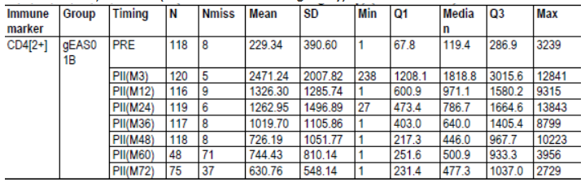

Table 3: Descriptive statistics of the frequency of VZV-specific CD4[2+] T-cells at Month 36, 48, 60 and 72 (ATP cohort for immunogenicity)
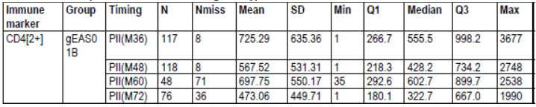

Table 4: Descriptive statistics of anti-gE antibody ELISA concentrations (mIU/mL) at Month 0, 3, 12, 24, 36, 48, 60 and 72 (ATP cohort for immunogenicity)
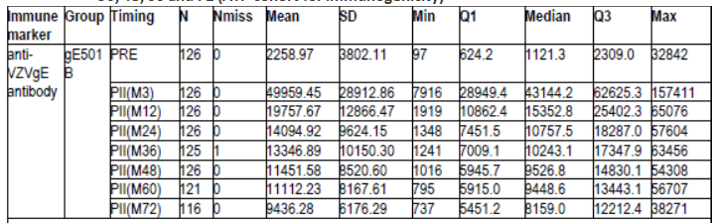

Table 5: Descriptive statistics of anti-VZV antibody ELISA concentrations (mIU/mL) at Month 48, 60 and 72 (ATP cohort for immunogenicity)
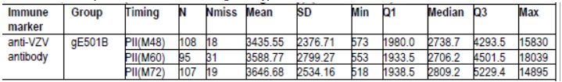
gE501B = 50 ug gE/AS01B N = number of subjects with available results; Nmiss = number of subjects with missing results SD = Standard Deviation; Q1,Q3 = First and third quartiles; Min/Max = Minimum/Maximum PII(M48) = Post-vaccination Dose II (Month 48) ; PII(M60) = Post-vaccination Dose II (Month 60) PII(M72) = Post-vaccination Dose II (Month 72)
Studies ZOSTER-018 and ZOSTER-019 were follow-up studies to EXPLO CRD-004, in which the persistence of the immune response to HZ/su at 30 and 42 months post Dose 1 was studied. Responses to gE and VZV specific CMI were generally aligned with those observed in ZOSTER-024.
Modelling of the HZ/su-induced immune response based on the 6 year persistence data of ZOSTER-024 predicted that vaccine induced immune responses (gE specific CMI as well as humoral immune responses) would remain above baseline values for at least 10 years in subjects ≥ 60 years at enrolment and having received 2 doses of HZ/su in ZOSTER-003 (Figure 1).
Figure 1: Prediction of the persistence of gE-specific CD4 [2+] T cell (A) and antibody (B) responses by using 3 different models on ZOSTER-024 data (Subjects who received 2 doses of HZ/su in ZOSTER-003)
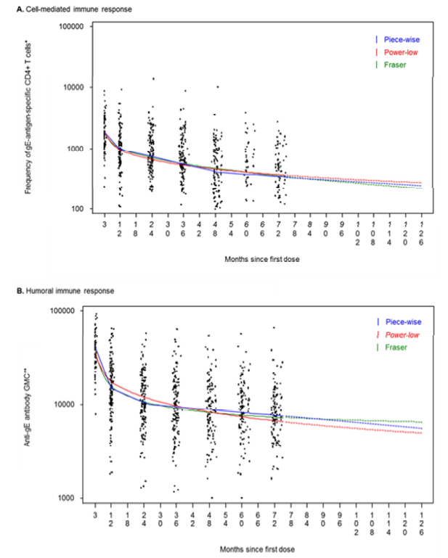

Lot-to-Lot consistency
The consistency of the immune response and safety to the administration of three lots of HZ/su vaccine was assessed in adults ≥ 50 years of age (ZOSTER-007). A double blind trial enrolled 651 subjects randomised 1:1:1 to receive 2 doses on a 0, 2 month schedule of 3 different lots of HZ/su. All subjects, (218, 217 and 216 in the three groups respectively) received at least one dose of Lot A, Lot B and Lot C and 645 subjects completed the study up to the active phase. Mean age of the study participants was 64.5 years (range: 49 to 91 years) for the per protocol cohort for immunogenicity (N = 622). The clinical lots evaluated were fully representative of the final commercial manufacturing process. Responses to the different lots were compared pairwise. Seropositivity was demonstrated for anti-gE antibody in all groups and geometric mean concentrations (GMCs) at Month 0 and one month post-Dose 2 are shown in Table 6. One month after the second dose, the primary objective in terms of pair-wise geometric mean concentration (GMC) ratios for anti-gE Abs was demonstrated, 95 % CI of the anti-gE Ab ratio between all pairs of lots were within the [0.67, 1.5] pre-determined range for equivalence (Table 7).
A secondary confirmatory objective was also assessed, that is, consistency of 3 manufacturing lots of HZ/su in terms of Vaccine Response Rate one month after the second dose. The secondary objective was also met, since for each pair wise comparison, the 95% CIs on the lot difference in VRR to HZ/su were within the [-10%; +10%] margin.
Clinical lot-to-lot consistency was demonstrated in adults ≥ 50 years of age.

Table 6: Seropositivity rates and geometric mean concentrations (GMCs) of anti-gE antibody at Month 0 and one month post-Dose2 (ATP cohort for immunogenicity) Ethnicity and Age related differences in Immune Responses
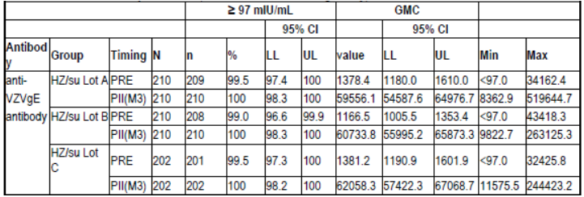
GMC = geometric mean antibody concentration calculated on all subjects N = number of subjects with available results n/% = number/percentage of subjects with concentration equal to or above specified value 95% CI = 95% confidence interval; LL = Lower Limit, UL = Upper Limit MIN/MAX = Minimum/Maximum PRE = Pre-vaccination (Month 0) PII(M3) = Post-vaccination Dose II (Month 3)

Table 7: 95% CIs of the GMC ratios between all pairs of lots in terms of anti-gE humoral immunogenicity one month post-Dose 2
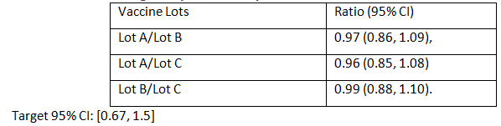

Age
Use of the proposed vaccine is for adults aged 50 years and older. The majority of studies have accordingly evaluated responses in populations of subjects within the age range of the intended use of the final product. Smaller groups of young adults, aged 18 to 30 years, were included in some Phase I/II studies. No formal analysis of the differences in responses across the age cohorts was conducted for these Phase I/II studies as the sample sizes were too small.
Study EXPLO-CRD-004 was designed to evaluate the separate or concomitant administration of two doses of the HZ/su and live attenuated OKA (Varilrix) vaccines, in terms of safety and CMI response. CMI responses to the gE and VZV antigen and humoral immune response to the gE and VZV antigens after 1 or 2 doses of HZ/su for 18 to 30 year old subjects and 50 to 70 year old subjects were similar.
ZOSTER-033 was designed to evaluate the immune response in terms of anti-gE VRR one month following a 2 dose administration with HZ/su in all study subjects ≥ 50 years of age with a previous episode of HZ. There was no apparent difference between age groups (50 to 59 years of age, 60 to 69 years of age and ≥ 70 years of age) in terms of fold increase in anti-gE Ab concentrations at 1 month post Dose 2 (Month 3) over pre-vaccination.
ZOSTER-023:There was no apparent difference between age groups (50 to 59 years of age, 60 to 69 years of age and ≥ 70 years of age) in terms of fold increase in anti-gE Ab concentrations at 1 month post Dose 2 (Month 3) over pre-vaccination. In ZOSTER-023 responses in younger Japanese subjects were generally higher than in older Japanese subjects (Table 8) but all subjects were seropositive at three months.

Table 8: Seropositivity rates and GMCs of anti-gE Antibody by age group (ZOSTER-023)
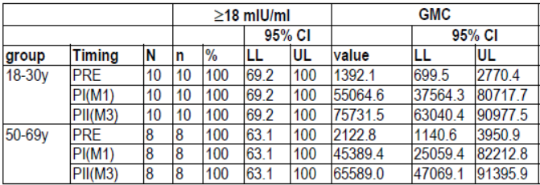
GMC = geometric mean antibody concentration calculated on all subjects N = number of subjects with available results n/% = number/percentage of subjects with concentration above the specified range (anti-gE Ab concentration ≥18 mIU/mL) 95% CI = 95% confidence interval; LL = Lower Limit, UL = Upper Limit

Ethnicity
ZOSTER-023 evaluated the reactogenicity and immunogenicity of HZ/su when administered as 2 doses (0, 2 months) in healthy adults of ethnic Japanese origin aged 18 to 30 years and 50 to 69 years. Prior to vaccination, all subjects were seropositive for anti-gE Abs. Compared to baseline (2122.8 mIU/mL), anti-gE Ab geometric mean concentration was approximately 21 fold higher after the first dose (45389.4) and 31 fold higher after the second dose (65589.0) of HZ/su in the 50 to 69 year old group. In the 18 to 30 year old group compared to baseline (1392.1 mIU/mL), anti-gE Ab GMC was approximately 40 fold higher after the first dose (55064.6) and 54 fold higher after the second dose (75731.5) of HZ/su.
Compared to baseline (1283.1mIU/mL), anti-VZV Ab geometric mean concentration were approximately 7 fold higher after the first dose (9201.2 mIU/mL) and 11 fold higher after the second dose (13551.9 mIU/mL) of HZ/su in the 50 to 69 year old group. Compared to baseline (1301.7 mIU/mL), anti-VZV Ab geometric mean concentrations were approximately 9 fold higher after the first dose (11691.6 mIU/mL) and 13 fold higher after the second dose (17383.6 mIU/mL) of HZ/su in the 18 to 30 year old group.
No formal analysis of responses compared to Caucasian or other ethnicities was conducted, but within age cohorts there did not appear to be major differences from responses in non-Japanese subjects in the Phase I/II studies.

Pharmacodynamic interactions

Immunocompromised subjects (ZOSTER-001, ZOSTER-015)
The safety and immunogenicity of HZ/su in immune-compromised populations ≥ 18 years were studied in two Phase I/II trials: ZOSTER-001 and ZOSTER-015. In ZOSTER-001 autologous haematopoietic stem cell transplant (HCT) recipients were studied while ZOSTER-015 included HIV-infected subjects.
An observer blind, placebo controlled study was conducted in four parallel treatment groups in patients who had undergone HCT in the previous 50 to 70 days (ZOSTER-001). Patients were randomized according to a 1:1:1:1 ratio to receive one of 3 different immunisation regimens (3 doses of HZ/su or gE/AS01E at 0, 1, 3 months or 1 dose of placebo at Month 0 and 2 doses of HZ/su at Months 1 and 3) or placebo (3 doses of saline at 0, 1, 3 months). The study was stratified for underlying disease status. A total of 120 subjects were enrolled and received at least one vaccine dose (29 subjects in the 3 dose gE/AS01Egroup, 30 subjects in each the 3 dose HZ/su and placebo groups and 31 subjects in the 2 dose HZ/su group), and 110 subjects completed the study. The primary immunogenicity end point of the study related to was to compare gE-specific humoral and cellular immune responses at Month 4 (one month post-final vaccination) between groups. With respect to the gE-specific CMI response at Month 4 the superiority of 3 doses of HZ/su versus 3 doses of placebo was demonstrated as the lower limit of the 76.16% CI of the gE-specific CD4[2+] T cell frequency ratio was greater than 2. The superiority of 2 doses of HZ/su versus 3 doses of placebo was demonstrated as the lower limit of the 76.16% CI of the gE-specific CD4[2+] T cell frequency ratio was greater than 2 (Table 9). The highest mean fold increases over pre-vaccination in the frequency of CD4[2+] following induction with gE were seen at Month 4 in all 3 gE/AS01 vaccination regimens – ranging from 49.58 in the gE/AS01B 2-dose group and 50.23 in the gE/AS01E 3-dose group to 66.81 in the gE/AS01B 3-dose group (Table 10). The anti-gE humoral immune responses at Month 4 demonstrated similar superiority. Antibody response to vaccination as measured by anti-gE ELISA as well as by anti-VZV ELISA at each time point in the sub-group of subjects with Hodgkin lymphoma, non-Hodgkin T-cell lymphoma or AML and the sub-group 3 of subjects with myeloma reflected that seen in the pooled analyses. However, the sub-group of subjects with non-Hodgkin B cell lymphoma showed no boost in anti-gE or anti-VZV GMCs following subsequent vaccine doses of either the HZ/su or gE/AS01E vaccine formulations. Since the numbers in subgroups are small the results may not be reliable.

Table 9: Geometric Means and fold increase for gE/AS01B 3-dose and 2-dose groups over placebo of anti-gE antibody ELISA Concentrations at Month 4 with CI adjusted for multiplicity (Total Vaccinated Cohort)
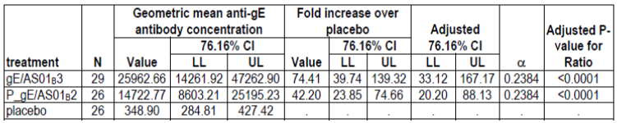
gE/AS01B3 = gE/AS01B 3 doses P_gE/AS01B2 = placebo for Dose 1 +gE/AS01B for Dose 2 and 3 placebo = placebo 3 doses N = number of subjects in a given category with available results LL = Lower Limit, UL = Upper Limit and CI = Confidence Interval Confidence Interval (CI) were back transformed to original units P-values are adjusted according to Dunnett for multiple comparisons to placebo A vaccine group presents significantly higher humoral immune response as compared to placebo when the lower limit of the CI of the ratio of geometric means is greater than 3

Table 10: Geometric means and fold increase with CI in the frequency of CD4(2+) T-cells at Month 4 following induction with gE adjusted for multiplicity in groups who received gE/AS01B over placebo (Total Vaccinated Cohort)
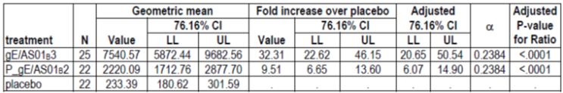
gE/AS01B3 = gE/AS01B 3 doses P_gE/AS01B2 = placebo for Dose 1 +gE/AS01B for Dose 2 and 3 placebo = placebo 3 doses N = number of subjects in a given category with available results LL, UL = Lower and Upper confidence limits CI were back transformed to original units P-values are adjusted according to Dunnett for multiple comparisons to placebo A vaccine group presents significantly higher CMI response as compared to placebo when the lower limit of the CI of the ratio of geometric means is greater than 2
The primary objective of ZOSTER-015 related to immunogenicity was to estimate the gE specific humoral and cellular immune responses at Month 7 (one month post-final vaccination) in subjects who received 3 doses of HZ/su (Months 0, 2 and 6) in comparison to subjects who received placebo, in both anti-retroviral (ART) and non-antiretroviral cohorts presenting high CD4 counts at enrolment. An observer blind, placebo controlled study was conducted in the two groups randomized according to a 3:2 ratio. Subjects received 3 doses of HZ/su or placebo at 0, 2, 6 months. The study was stratified in 3 HIV-infected cohorts: An ART High CD4 cohort, an ART Low CD4 cohort, and a non-ART High CD4 cohort, with 94, 14 and 15 subjects in the respective cohorts. A total of 123 eligible subjects were vaccinated (74 subjects in the 3-dose HZ/su group and 47 subjects in the placebo group), and 116 subjects completed the study. The superiority of HZ/su compared to placebo was demonstrated in terms of gE specific CD4[2+] T cell frequencies, at Month 7 in subjects with high CD4+ T cell count (≥ 200 cells/mm³ for subjects on ART and ≥ 500 cells/mm³ for ART-naïve subjects) at enrolment as the LL of the 70% CI on the GM ratio [HZ/su group /Placebo group] was greater than 2 (Table 11). The superiority of HZ/su compared to placebo was demonstrated in terms of the gE specific humoral immune response at Month 7 in subjects with high CD4+ T cell count (≥ 200 cells/mm³ for subjects on ART and ≥ 500 cells/mm³ for ART-naïve subjects) at enrolment as the LL of the 90% CI on the GM ratio [HZ/su group /Placebo group] was greater than 3 (Table 12).
In both studies, HZ/su vaccination in a limited number of adults ≥ 18 years of age (135 adults of whom 73 were ≥ 50 years) with a selection of immune-compromising conditions (autologous HCT and HIV) has been shown to induce robust CMI and humoral immune responses. Both studies, in which 2-dose and 3-dose schedules were tested, allowed for the selection of a 2-dose schedule of HZ/su for use in further Phase III studies in immune-compromised populations.
In both studies, a total of 135 recipients of whom 73 (45 in ZOSTER-001 and 28 in ZOSTER-015) were ≥ 50 years old showed high CMI and humoral gE-specific and VZV specific vaccine induced immune responses. The immune responses in both trials persisted until 1 year post last vaccination.

Table 11: Geometric means and ratio of gE/AS01B over placebo in anti-gE antibody ELISA concentrations at Month 7 in subjects with high CD4 T–cell count at enrolment (ATP cohort for immunogenicity) (ZOSTER-015)
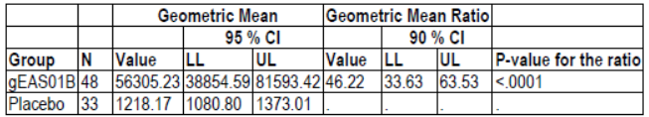
gEAS01B = 50µg/AS01B - 3 doses Placebo = Placebo - 3 doses N = number of subjects in a given category with available results LL = Lower Limit, UL = Upper Limit and CI = Confidence Interval Confidence Interval (CI) were back transformed to original units A vaccine group presents significantly higher humoral response as compared to placebo when the lower limit of the CI of the ratio of geometric means is greater than 3 The p-value is relative to the null hypothesis Ho: Vaccine / Placebo =< 1

Table 12: Geometric means and ratio of PIII (M7) over PII (M3) in anti-VZV antibody ELISA concentrations in all subjects for gEAS01B (ATP cohort for immunogenicity (ZOSTER-015)
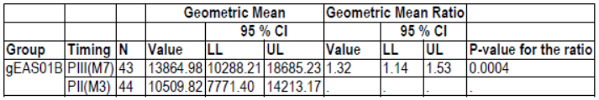
gEAS01B = 50µg/AS01B - 3 doses PII(M3) = Post-vaccination Dose II (Month 3) PIII(M7) = Post-vaccination Dose III (Month 7) N = number of subjects in a given category with available results LL = Lower Limit, UL = Upper Limit and CI = Confidence Interval Confidence Interval (CI) were back transformed to original units The p-value is relative to the null hypothesis Ho: Month 7 / Month 3 =< 1

Evaluator’s overall conclusions on pharmacodynamics
HZ/su, given by IM route according to a 2 dose schedule, induced robust antigen specific immune responses in adults ≥ 50 years of age that were consistently high 1 month post Dose 2 in all age strata. Immune response was also robust in adults ≥ 70 years although with increasing age, there appears to be a trend to slightly lower anti-gE Ab and CMI responses and more rapid waning of immune responses. The strong immune response, both cell mediated and humoral, is important due to the declining immunity in the elderly population. While the antigen-specific immunogenicity decreased shortly after vaccination, it remained above pre-vaccination levels over at least 6 years. It is currently not known whether efficacy will persist over a longer period of time and if, in case of diminishing efficacy, additional doses will be required to maintain protection by boosting the immune response of previously vaccinated individuals.
Based on the immunogenicity data in a limited number of immune compromised adults (autologous HCT or with HIV infection), the vaccine was shown to be immunogenic in this population. Further studies in a larger population are necessary before more definite conclusions can be drawn. An indication in immunocompromised subjects is not being sought in this application.
There are currently no immunological correlates of protection for the HZ/su vaccine.
Consistency in terms of anti-gE Ab response was demonstrated between three HZ/su lots formulated from commercial-scale gE and AS01B.
The proposed product information reflects the information from the pharmacodynamics studies conducted.

Dosage selection for the pivotal studies

Pharmacokinetics and pharmacodynamics: dose finding studies
There are no pharmacokinetic studies as this is a vaccine, therefore there are no studies relating kinetic findings to pharmacodynamic effects.

Phase II dose finding studies

gE antigen dose finding studies
Study EXPLO CRD-004 found that two doses of 50 µg gE increased the immune response over a single dose and from this 50 µg gE was used as the reference dose of Study ZOSTER-003. A lower dose (25 µg) and higher dose (100 µg) were then also included in the study to assess antigen dose.
ZOSTER-003 was a Phase II, single-blind, randomised, controlled, multicentre vaccination study which evaluated the safety and immune response of HZ/su in 715 healthy adults aged 60 to 69 and ≥ 70 years. The study compared 3 doses (25, 50 or 100 µg) of gE with AS01B adjuvant when administered as 2 doses (at 0, 2 months) compared to 2 doses of 100 µg gE/Saline or a single dose of 100 µg gE/AS01_{B} to select the optimal antigen dose and schedule of the candidate HZ vaccine for use in future trials. A total of 715 subjects were enrolled in the study and randomized 1:3:3:3:3 with stratification by age in a 1:4 ratio (60 to 69 and ≥ 70 years of age). The primary objective was to compare the gE-specific CD4+ T cell response in gE/AS01B study vaccine groups at Month 3 in older adults (≥ 70 years).
The gE antigen dose selection was based on assessment of CD4 T cell response to gE (secreting at least 2 different cytokines upon stimulation with gE) at Month 3 following two doses of vaccine.
Comment: The sponsor stated that cell mediated immune response data were used for the primary assessment rather than humoral immunogenicity as CMI is considered to play a critical role in controlling symptomatic VZV reactivation. The evaluator agrees with this selection.
The study design is shown in Figure 2 and participant flow in Figure 3. There were 667 subjects in the ATP immunogenicity cohort.
Figure 2: ZOSTER-003 Study design
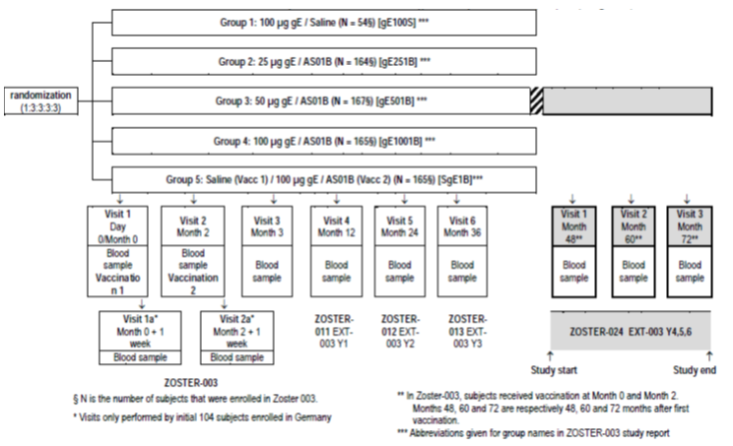
Figure 3: ZOSTER-003 Subject disposition
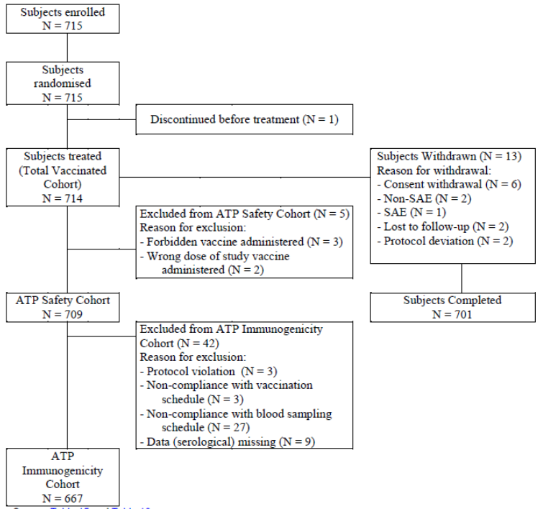
At Month 3, the median frequency of gE-specific CD4 T cells secreting at least 2 different cytokines upon stimulation with gE showed an 11.2 to 14.4 fold increase compared to pre-vaccination levels for the groups who received two vaccinations containing AS01B. By contrast, the rises were lower in the 100 µg gE/AS01B one dose group and also in the 100 µg gE/saline two doses group (3.8 and 4.2 fold increase, respectively). The 25, 50 and 100 µg gE/AS01B groups were not significantly different while the single dose 100 µg gE/AS01B, and the two dose 100 µg gE/saline were found to be inferior on CD4 T cell response. For subjects aged 60 to 69 years and ≥ 70 years results were similar.
In terms of CMI response, at Month 3, analysis of the frequency odds ratios of CD4 T cells secreting at least 2 cytokines (all doubles) found no difference between the 50 and 100 µg gE/AS01B groups but inferiority of all other vaccine groups (Table 13).

Table 13: ZOSTER-003. Geometric Means of Frequency Odds Ratios of gE-specific CD4 T Cells Secreting ALL DOUBLES Cytokines at Month 3 and p Values for Multiple Comparisons With Best Between Vaccine Groups According to Hsu’ Procedure; ATP Cohort for Immunogenicity
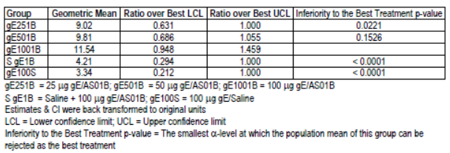
The rate of symptoms (solicited and unsolicited) was similar between the three gE/AS01B groups (74 to 82%) and higher in these groups than in the 100 µg gE/saline group (39%). Similar trends were seen for Grade 3 symptoms (16 to 19.7% versus 5.7%). There was no evident trend for increasing adverse effects with increasing antigen dose and adverse effects appeared more related to the presence of the adjuvant.
Comment: Study ZOSTER-003 found similar CMI responses with both the 50 µg and 100 µg antigen doses together with similar reactogenicity. Therefore the lower dose of 50 µg was selected for further development.
The presence of AS01B resulted in a superior immune response but also increased incidence of AEs.

Adjuvant dose finding studies

ZOSTER-010
ZOSTER-010 was a Phase II, observer blind, randomised, placebo controlled vaccination study which evaluated the immunogenicity of gE/AS01B vaccine in comparison to gE combined with half dose AS01B adjuvant (gE/AS01E) and un adjuvanted gE (gE/saline) vaccine in 410 healthy adults aged ≥ 50 years (mean of 65 years). Two doses of vaccine were administered two months apart.
Figure 4 ZOSTER-010. Study design
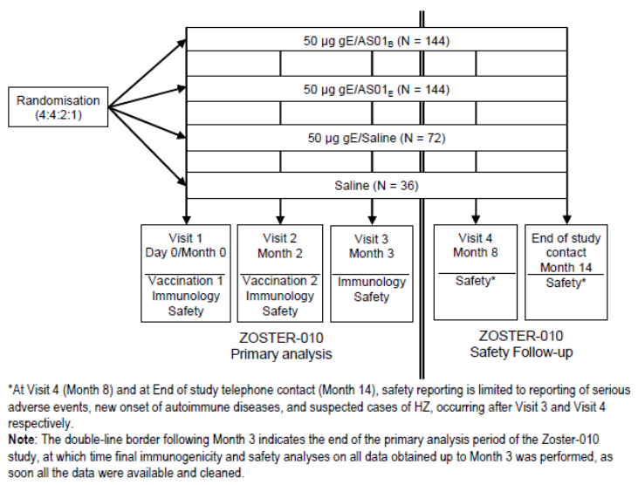
At one month after the second vaccination, the study found that compared to gE/saline both gE/AS01B and gE/AS01E had a statistically significant (p < 0.0001) increases in gE specific CD4[2+] of 5.2 fold (95% CI: 3.9 to 7.0) and 4.0 fold (95% CI: 3.0 to 5.4), respectively. Comparing the two strengths of AS01 at Month 3, the full dose AS01B containing vaccine had a 1.30 fold increase (95% CI: 1.07 to 1.58, p = 0.009) in gE-specific CD4[2+] compared to the half dose AS01E. The increase in immune response with AS01 containing vaccine compared to gE/saline vaccine was seen across age groups and was most evident in those aged ≥ 60 years (Table 14).

Table 14: ZOSTER-010. Fold increase in frequency of gE-specific CD4[2+] for gE/AS01E and gE/AS01B over gE/Saline by age group (ATP cohort for immunogenicity)
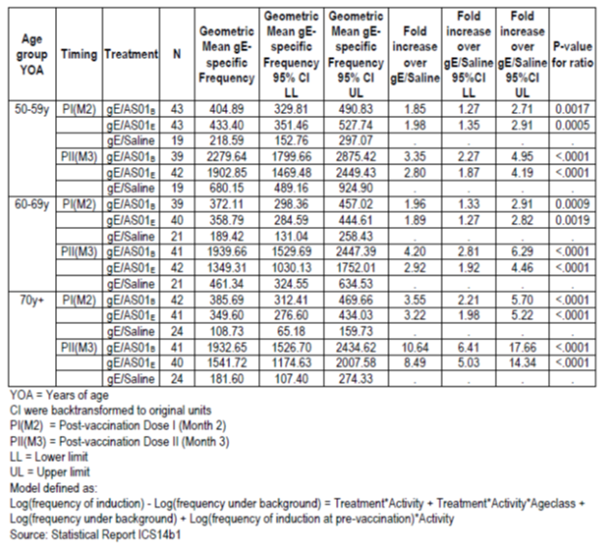
In terms of the CMI response to VZV stimulation, similar results were found. There was a statistically significant 2.1 and 1.6 fold increase in VZV specific CD4[2+] at Month 3 for both the gE/AS01B and gE/AS01E vaccines compared to the gE/saline vaccine. There was also a 1.3 fold increase (95% CI: 1.09 to 1.56) with AS01B containing vaccine compared to AS01E vaccine.
At Month 3, the anti-gE antibody concentration levels were 3.4 to 4.7 fold greater for adjuvanted vaccine compared to gE/saline. In addition, the AS01B containing vaccine had 40% higher anti-gE antibody levels than AS01E (p = 0.0002). Again the adjuvanted vaccine had a greater response in those aged ≥ 60 years. Analysis of anti-VZV antibodies found concordant statistically significant results in favour of vaccine containing adjuvant and also the full adjuvant dose.
The vaccine reactogenicity increased with the presence of AS01 and the symptom rate in the seven days following vaccination was 11% higher with AS01B compared to AS01E. While symptom rate were high with gE/AS01B (80%), the rate of Grade 3 events (local and general) was moderately low at 6% (versus 2.7% with saline) (Table 15).
For those who received gE/AS01B, the overall rate per dose of any symptom (local and general) in the first 7 days was 87.5%, 81.2%, 71.8%, 64.0% in the 50 to 59, 60 to 69, 70 to 79 and 80+ years of age groups, respectively.

Table 15: ZOSTER-010. Incidence and nature of Grade 3 symptoms (solicited and unsolicited) reported during the 7-day (Days 0-6) post vaccination period following each dose and overall (Total Vaccinated Cohort)
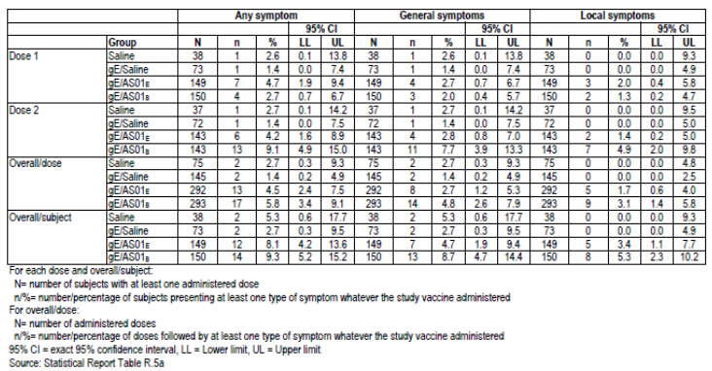
Comment: The sponsor concluded that, while there was higher reactogenicity with AS01B, the rates were deemed ‘clinically acceptable’.
Given the improved immunogenicity of the higher dose adjuvant the evaluator agrees with the conclusions.
Reactogenicity was higher in the younger age groups.
The symptom rates are relatively high and this could possibly impact on compliance with Dose 2 of the vaccine schedule.
The sponsor has been asked to comment whether a lower adjuvant dose was considered for younger adults.

ZOSTER-003
ZOSTER-003 found that CD4 T cell response to vaccine containing adjuvant was greater than 100 µg gE/Saline for both median frequencies and also the proportion of responders (Tables 16 and 13).

Table 16: ZOSTER-003. Median of Frequency of gE-specific CD4 T Cell Secreting ALL DOUBLES Cytokines at Month 3 and p-Values for Multiple Comparisons with Best Between Vaccine Groups According to Hsu's Procedure - ATP Cohort for Immunogenicity
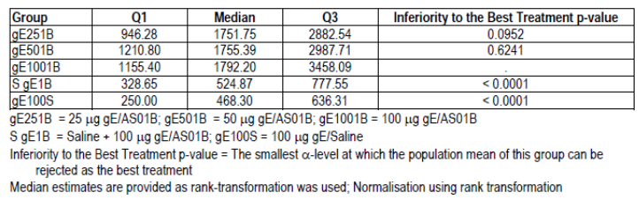

Dose number, schedule and route

Dose number
Study ZOSTER-003 also assessed immunogenicity responses after 1 and 2 vaccinations. The CD4 T cell response after the first dose increased 2.4 to 3.1 fold compared to pre-vaccination levels for subjects who received 25, 50 or 100 µg gE/AS01B vaccine and following the second vaccination at Month 3 there was a further 3.5 to 4.8 fold increase. When comparing one to two doses of 100 µg gE/AS01B, it was found that the CMI response (median frequency of gE-specific CD4[2+] T cells) was greater with two doses in both the 60 to 69 and ≥ 70 year old age groups. Humoral immune response was also notably greater with two doses.
These data were supported by Study ZOSTER-010, where there was also a consistent increase in CMI response after the second vaccination of gE/AS01B. Similarly, in EXPLO CRD-004 a second dose of vaccine induced better CD4 T cell response and higher antibody levels than 1 dose of vaccine.

Dose schedule

ZOSTER-026
ZOSTER-026 was an open label, randomised, parallel group immunogenicity study which assessed two vaccination intervals longer than 2 months (0,6 and 0,12 Months) in 354 adults ≥ 50 years of age. As measured by the anti-gE antibody GMC ratio one month post second vaccination, the 0,6 month schedule was found to be non-inferior to the 0,2 month schedule, however the 0,12 month vaccination interval did not meet the non-inferiority criterion (GMC ratio UL of the 97.5% CI < 1.5).

Route

ZOSTER-032
ZOSTER-032 was a Phase III, randomised, open label, single site clinical trial to assess the safety and immunogenicity of HZ/su vaccine when administered subcutaneously (SC) as compared to intramuscularly (IM) according to a 0, 2 month schedule in 30 Japanese adults aged ≥ 50 years.
Comment: The study was not statistically powered to allow between group comparisons.
The study found similar immune responses (GMC and VRR) at Month 3 between SC and IM administration. However, the local reactogenicity (particularly Grade 3 redness and swelling) of the SC was much higher than the IM administration.
Comment: Due to the reactogenicity, GSK discontinued development of the SC indication.

Evaluator’s conclusions on dose finding for the pivotal studies
In ZOSTER-003, there was a similar CMI response and reactogenicity with both the 50 µg and 100 µg antigen doses. The 25 µg gE dose was inferior to the higher doses in terms of CMI response. Therefore, the dose of 50 µg was selected for further development.
The presence of AS01B adjuvant resulted in a superior immune response but also increased reactogenicity. The full dose AS01B resulted in an increased immune response (CMI and humoral) compared to half strength dose and was selected for further development.
Based on the presented clinical immunogenicity data, the evaluator agrees with the sponsor’s dose selection for use in the Phase III program.
Two doses of vaccine resulted in an improved response compared to a single dose (ZOSTER-003, ZOSTER-026 and EXPLO CRD-004). While the vaccine dosing interval could be extended to 6 months based on non-inferior immunogenicity data, until there are data linking immunogenicity to efficacy the evaluator believes that only the 2 month dosing interval should be recommended. A 12 month interval is not recommended.
Subcutaneous administration was associated with high local reactogenicity and development was ceased.

Clinical efficacy

Studies providing evaluable efficacy data
There were two studies providing efficacy data: ZOSTER-006 and ZOSTER-022. Other studies in the dossier provided immunogenicity data and are summarised in Section 7.3. ZOSTER-006 included subjects aged ≥ 50 years and ZOSTER-022 included subjects aged ≥ 70 years. The studies ran concurrently at the same sites. The study report for ZOSTER-022 contained analysis of pooled data from the two studies. The sponsor stated that the design of the two studies was agreed upon with regulatory agencies in Europe, the US and Japan.
In the event that both studies met their primary endpoint (efficacy against HZ) then the pooled data analysis for HZ and PHN was undertaken. This pooled analysis was the primary analysis for efficacy against PHN in adults ≥ 70 years of age.
Comment: Pooling of data was acceptable due to the studies having the same design and methodologies, inclusion and exclusion criteria, treatment groups and evaluations. An analysis of correlates of protection from studies ZOSTER-006 and ZOSTER-022 was planned but could not be located in the dossier. A question has been raised.

Pivotal or main efficacy studies

Study ZOSTER-006

Study design, objectives, locations and dates
ZOSTER-006 was a Phase III, randomised, observer blind, placebo controlled, multicentre study to assess the prophylactic efficacy, safety, and immunogenicity of gE/AS01B vaccine administered intramuscularly on a 0, 2 month schedule in adults ≥ 50 years.
The study ran between August 2010 and July 2015 at over 200 study sites in 18 countries (Australia, Brazil, Canada, Czech Republic, Estonia, Finland, France, Germany, Hong Kong, Italy, Japan, Mexico, Republic of Korea, Spain, Sweden, Taiwan, United Kingdom and United States). The end of study (EOS) efficacy analysis cut-off date was 21 April 2015.
The study was sponsored by GSK Biologicals and in Japan there was a joint collaboration with Japan Vaccine Company Ltd. GSK Biologicals performed humoral immunogenicity testing, PCR testing for HZ and a CRO performed CMI testing. There was an independent data monitoring committee (IDMC) for safety monitoring and recommendations on trial continuation, modification or termination. It consisted of a statistician and five to six clinical experts. There was also a blinded HZ adjudication committee (HZAC) consisting of five physicians (not study investigators) which classified all suspected cases of HZ. The study had remote data entry and electronic case report forms.

Primary objective
The primary objective was to evaluate vaccine efficacy (VE) in the prevention of HZ compared to placebo in adults ≥ 50 years of age, as measured by the reduction in HZ risk.

Secondary objectives
Secondary objectives included:
- To evaluate VE in the prevention of HZ compared to placebo in subjects within each of the following age ranges: 50 to 59 years of age, 60 to 69 years of age and ≥ 70 years of age, as measured by the reduction in HZ risk
- To evaluate VE in the prevention of overall post herpetic neuralgia (PHN) compared to placebo in subjects ≥ 50 years of age and in subjects within each of the following age ranges: 50 to 59 years of age, 60 to 69 years of age and ≥ 70 years of age
- To evaluate VE in reducing the total duration of severe ‘worst’ HZ associated pain over the entire pain reporting period compared to placebo in subjects ≥ 50 years of age and in subjects within each of the following age ranges: 50 to 59 years of age, 60 to 69 years of age and ≥ 70 years of age, with confirmed HZ
- To evaluate VE in the reduction of overall and HZ-related mortality and hospitalisations compared to placebo in subjects ≥ 50 years of age and in subjects within each of the following age ranges: 50 to 59 years of age, 60 to 69 years of age and ≥ 70 years of age
- To evaluate VE in the reduction in incidence of HZ associated complications compared to placebo in subjects ≥ 50 years of age and in subjects within each of the following age ranges: 50 to 59 years of age, 60 to 69 years of age and ≥ 70 years of age, with confirmed HZ
- To evaluate VE in the reduction in use of pain medications compared to placebo in subjects ≥ 50 years of age and in subjects within each of the following age ranges: 50 to 59 years of age, 60 to 69 years of age and ≥ 70 years of age, with confirmed HZ
- To evaluate vaccine safety and reactogenicity.

Study design
Study design is in Figure 5. Eligible subjects received two doses of vaccine/placebo two months apart. There were followed for at least 30 months post Dose two. Study visits occurred at Day 0, then at Months 2, 3, 14, 26 and 38. There were monthly contacts in between set visits. Subjects continued on the study until the end of study analysis. Subjects with HZ were followed for at least 90 days or until 4 weeks of HZ associated pain free and the rash had resolved. Suspected HZ cases had more intensive follow up with visits at Day 0, 7, 28, and 91 and contacts at Day 14, 21 and 56. At the end of study, subjects could enter long term follow up and placebo-treated subjects were offered vaccination in a ‘cross vaccination study’.
There were three subset populations in the study: a 7 day diary card group (collecting data on solicited AEs from Day 0 to 6); an immunogenicity group (assessing humoral immune response); and a CMI subset of the immunogenicity group.
Following analysis of ZOSTER-006 in December 2014 by external statisticians, high vaccine efficacy (97.16%) was found after a mean follow up of 3.1 years. It was calculated that the studies had sufficient statistical power for the HZ and PHN efficacy endpoints. In addition, the follow up time was sufficient. There was also a desire to provide vaccine to the placebo group. Therefore, the sponsor decided to terminate studies ZOSTER-006 and ZOSTER-022 earlier than planned and this was agreed by the IDMC and regulatory authorities.
Figure 5: ZOSTER-006. Study Design
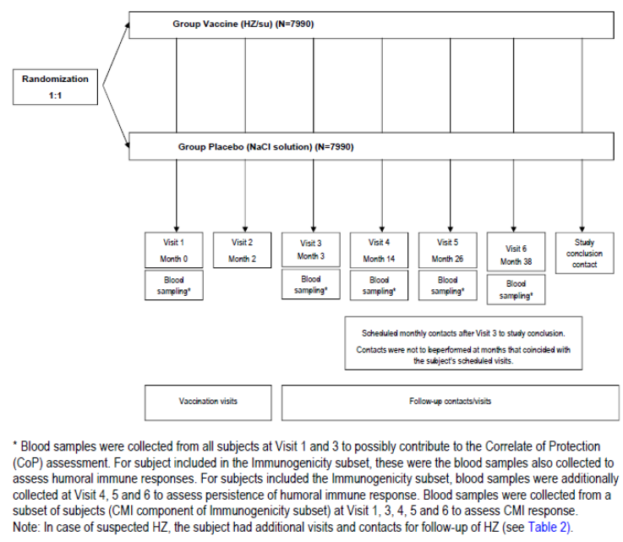

Inclusion and exclusion criteria
The study included males and females ≥ 50 years. Women were of non-childbearing potential or using adequate contraception and had a negative pregnancy test.
Exclusion criteria were: confirmed or suspected immunosuppressive or immunodeficient condition (disease or from therapy); history of HZ; previous vaccination against varicella or HZ; allergic disease or reactions likely to be exacerbated by any component of the vaccine; significant underlying illness that might prevent completion of the study (for example disease likely to limit survival to less than 4 years); use of any investigational or non-registered product; participating in another clinical study; receipt of immunoglobulins and/or any blood products within the 90 days or planned during the study period; other immunisations within 30 days of the first or second study vaccination or scheduled within 30 days after study (influenza vaccine could be administered up to 8 days prior to each dose and/or at least 14 days after any dose of study vaccine); any other condition (for example extensive psoriasis, chronic pain syndrome, cognitive impairment, severe hearing loss) that might have interfered with the evaluations required by the study; acute disease and/or fever at the time of enrolment (fever was defined as temperature ≥ 37.5°C oral, axillary or tympanic or ≥ 38.0°C rectal, subjects with a minor illness without fever could be enrolled); chronic administration (defined as > 15 consecutive days) of immunosuppressants or other immune-modifying drugs within six months prior to the first vaccine dose (for corticosteroids, this meant prednisone < 20 mg/day, or equivalent, was allowed and inhaled and topical steroids were allowed); pregnant or lactating female; female who planned to become pregnant or planned to discontinue contraceptive precautions (if of childbearing potential).
Contraindications to subsequent vaccination included anaphylaxis, pregnancy, vaccine related SAE, and immunosuppressive or immunodeficient condition. Subjects with suspected HZ episode between visits 1 and 2 did not receive the second vaccine dose.

Study treatments
Reconstituted study vaccine HZ/su contained 50 µg VZV gE (lyophilised) and AS01B in 0.5 mL. Placebo vaccine was sodium chloride (NaCl) 150 mM per 0.5 mL. Vaccine/placebo 0.5 mL was administered to the deltoid region of the non-dominant arm via IM injection. Subjects received two vaccinations, the first on Day 0 and the second at Month 2.

Efficacy variables and outcomes
Definitions used:
- A suspected case of HZ was defined as a new unilateral rash accompanied by pain (broadly defined to include allodynia, pruritus or other sensations) and no alternative diagnosis.
- HZ onset date was defined as the earlier of the following two events: 1) the HZ rash start date; or 2) the date on which pain or itching at the site of a subsequent HZ rash was first noted.
- End date of a HZ episode was defined as the first time at which a subject had no rash (papules, vesicles, ulcers or crusts) present.
- PHN was defined by the presence of HZ associated severe ‘worst’ pain persisting or appearing more than 90 days after onset of the HZ rash. Severe ‘worst’ pain was defined as HZ associated pain rated as 3 or greater on the ‘worst pain’ Zoster Brief Pain Inventory (ZBPI) question.
- Cessation of pain to assess duration of HZ associated pain: A 28 day pain free period was used to confirm cessation of HZ associated pain. If that pain free period was not achieved or if pain did not cease, the time-to-event was censored at the last day of HZ associated pain.
- Acute pain was defined as pain measured during the 4 week period following the onset of confirmed HZ.
Any sign or symptom suggestive of HZ was evaluated during the study period up to the cut-off date of 21 April 2015. Subjects completed a specific diary card for HZ and attended a study visit. If HZ was clinically diagnosed then the subject completed the Zoster Brief Pain Inventory (ZBPI) questionnaire, photos of the rash were taken, concomitant medications recorded and rash lesion samples (3 replicates on the same day) were collected. Subjects also completed the further ZBPI questionnaires (daily for 28 days then weekly until 28 days post pain cessation), the Euro-Quality of Life-5 Dimension (EQ-5D) and the Short Form-36 (SF-36) questionnaires (both weekly while completing the ZBPI).
HZ confirmation was by PCR and the HZ adjudication committee (HZAC). The HZAC classified cases as ‘HZ’, ‘not HZ’ or ‘not able to decide’. HZAC was only used for final definition of cases when PCR could not confirm or exclude the case. A hierarchical case definition algorithm was used to classify suspected HZ cases and is illustrated in Figure 6. If one or more samples were PCR positive for VZV, then the case was confirmed HZ. If all samples were VSV negative, then PCR for β-actin from human cell DNA was performed to determine the validity of the sampling procedure. If positive, the sample was considered valid and without VZV DNA and classified as ‘not a case of HZ’. If PCR results for VZV and β-actin were negative, or if no samples were available, then the HZAC opinion was used to classify the case.
Figure 6: ZOSTER-006. Algorithm for HZ case definition by PCR
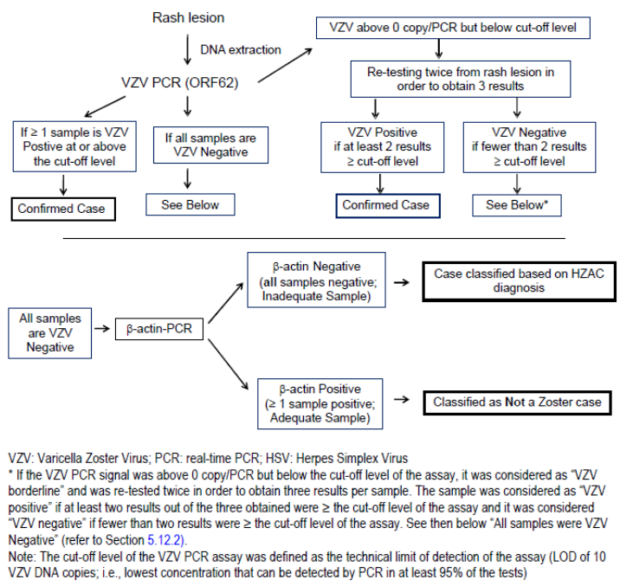
VZV PCR targeted the orf62 gene and if the signal was ≥ cut-off level (LOD 10 VZV DNA copies) the sample was considered positive. Samples above 0 and below the cut-off were retested twice and, if positive (≥ cut-off level) in at least 2 of the 3 tests, the sample was considered positive. There was optional herpes simplex virus (HSV) testing for VZV negative/β-actin positive cases.
HZ complications were documented by the investigator and included vasculitis, disseminated disease (≥ 6 lesions outside the primary dermatome), ophthalmic disease, neurological disease, visceral disease and stroke.
Immunogenicity assessments included anti-gE antibodies, anti-VZV antibodies and CMI response (gE and VZV specific CD4 T cells).

Primary endpoint
The primary endpoint was the confirmed HZ cases during the study in the modified total vaccinated cohort (mTVC).

Secondary endpoints
Secondary endpoints were:
- Incidence of PHN in the mTVC
- Duration of severe ‘worst’ HZ associated pain
- Incidence of overall and HZ-related mortality
- Incidence of HZ complications in those with confirmed HZ
- Duration of pain medication administered for HZ
- Solicited local and general symptoms in a subset of subjects
- Occurrence of unsolicited AEs, SAEs, predefined AEs and medically attended visits.

Exploratory endpoints
Exploratory endpoints were:
- Acute HZ severity
- interference of HZ with QoL (ZBPI, EQ-5D, SF-36)
- HZ burden of illness (BOI)
- CMI (antigen specific CD4 T cell frequencies), and
- humoral immune response (anti-gE and anti-VZV antibody concentrations).

Randomisation and blinding methods
Subjects were randomised in a 1:1 ratio to either HZ/su or placebo. They were stratified by age groups of 50 to 59, 60 to 69, 70 to 79 and ≥ 80 years in an 8:5:3:1 ratio (approximately).
Subjects aged ≥ 70 years were randomly assigned to either Study ZOSTER-006 or ZOSTER-022 and then randomised to vaccine or placebo.
Subjects in the 50 to 59 and 60 to 69 year age group were randomly allocated to participation or not in the 7 day diary card subset (n = 2820 per age group).
There was also random allocation to the immunogenicity subset. Within this the CMI subset included approximately 156 from each of Czech Republic, Japan and US (provisional number of 468). The immunogenicity subset included approximately 138 from each other country (n = 2538).
The study was observer blind due to differences in appearance of HZ/su and NaCl placebo. To achieve this, vaccine preparation and administration was done by medical staff who did not evaluate the subjects and immunological data were not available during the course of the study to those involved in clinical conduct. The sponsor set up a ‘Firewall Team’ to ‘safeguard integrity of the study before the EOS data bases freeze of the study’.
The IDMC reviewed unblinded safety data regularly and conducted unblinded futility analyses after set number of HZ cases has been accrued.

Analysis populations
The total vaccinated cohort (TVC) included all enrolled subjects who received at least one dose of vaccine. The TVC for efficacy was the vaccinated subjects who had data relating to efficacy endpoints. The modified TVC (mTVC) excluded subjects who did not receive the second dose of vaccine, who developed confirmed HZ prior to 30 days post second vaccination, or who did not receive vaccine according to the protocol.
Comment: Efficacy in the TVC will also be important to assess efficacy in those who only received one dose of vaccine.
The according to protocol (ATP) cohort included all evaluable subjects (those who met eligibility criteria, complied with procedures and were not eliminated) from the TVC with efficacy data.
The mTVC was used for primary efficacy analysis. Secondary analysis used the TVC and the ATP populations.

Sample size
The assumptions used for calculating the sample sizes in Study ZOSTER-006 and ZOSTER-022 are in Table 17. An overall incidence of HZ per year of approximately 0.7%, a dropout rate of 5% and a non-compliance with vaccine schedule rate of 5% were assumed for the calculations.
Efficacy analysis was planned after 196 confirmed cases of HZ as this would give the study approximately 97% power to detect HZ VE of at least 40% assuming a true rate of 68%. The sample size was chosen to allow the required number of HZ cases to be detected within an approximate 3 year follow up period. Age stratification ratios were used to ensure similar HZ case numbers in the three main age groups. The aim was for a total sample size of 15,980 (Table 18).
Comment: While the study objective was based on a lower limit of the 95% CI of VE being above 25%, the sample size was based on 40% to assist with case accrual and study robustness.

Table 17: ZOSTER-006. Assumptions for incidences under placebo, and VE used for trial simulations
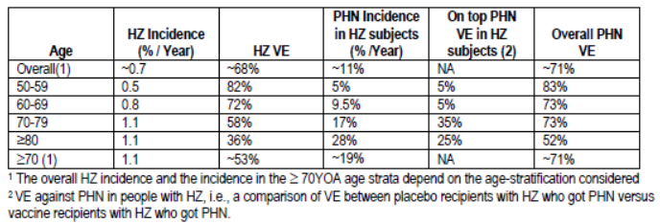

Table 18: Expected number of HZ and PHN cases in ZOSTER-006 (Amended 18 April 2014)
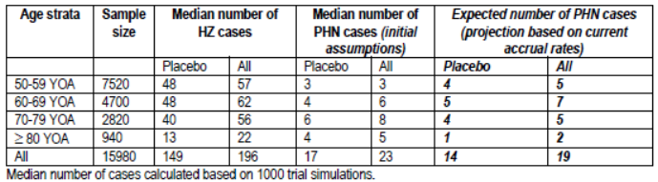

Statistical methods
The relative risk (RR) was defined as the ratio of the incidence rates of the HZ/su group over the placebo group stratified by age group and region using Poisson methods. VE was defined as 1 – RR. The RR was calculated for the overall population and by age group. The efficacy of HZ/su against HZ was demonstrated if the LL of the two-sided 95% CI of VE was above 25%. Primary analysis was supported by sensitivity analyses of the HZ VE in the 50 to 59 years of age and 60 to 69 years of age groups (LL of the two-sided 95% CI of VE was above 10%). Follow up time in the mTVC started from 30 days post second vaccination until the time of the event or the date of last visit for those without an event. VE and its confidence intervals were also calculated in a secondary analysis using a Cox regression model.
Reduction in PHN was assessed using the same methods as HZ risk. VE of HZ/su against PHN in subjects ≥ 50 years of age was demonstrated if the LL of the two-sided 95% CI of VE was above 0%.
Comment: It is not clear why this PHN efficacy level was chosen and a question has been raised.
A summary of the statistical inferential evaluations for ZOSTER-006, ZOSTER-022 and the pooled analysis is in Table 19. Pooled analysis was undertaken if the clinically meaningful HZ VE was met in subjects ≥ 50 years of age in ZOSTER-006 and ≥ 70 years of age in ZOSTER-022. The ‘gatekeeping strategy’ is shown in Figure 7. The primary objective of the pooled analysis of the ZOSTER-006 and ZOSTER-022 studies was to estimate PHN VE in subject’s ≥ 70 years of age and re-estimate the HZ VE in subjects ≥ 70 years of age. The statistical significance of PHN VE in ≥ 70 years of age randomised subjects would be demonstrated if the LL of the 95% CI was above 0%. Secondary objectives of the pooled analysis included reduction in PHN in ≥ 50 year olds, reduction in PHN in subjects ≥ 50 years of age with HZ, and reduction in duration of pain in subjects ≥ 70 years of age with HZ.
Comment: Apart from the ‘gatekeeping strategy’ it was not clear how the sponsor controlled for multiplicity in relation to analysis of secondary endpoints.
Also, the impact of futility analyses conducted during the course of the two studies on statistical methodology is not clear from the clinical study reports. These points have been queried.

Table 19: Summary of statistical inferential evaluations of primary and secondary objectives for studies ZOSTER-006, ZOSTER-022 and the pooled analysis
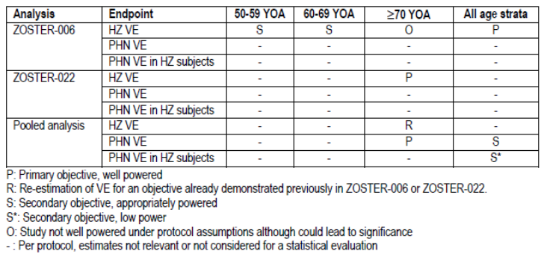
Figure 7: ZOSTER-006 and ZOSTER-022. Gatekeeping strategy
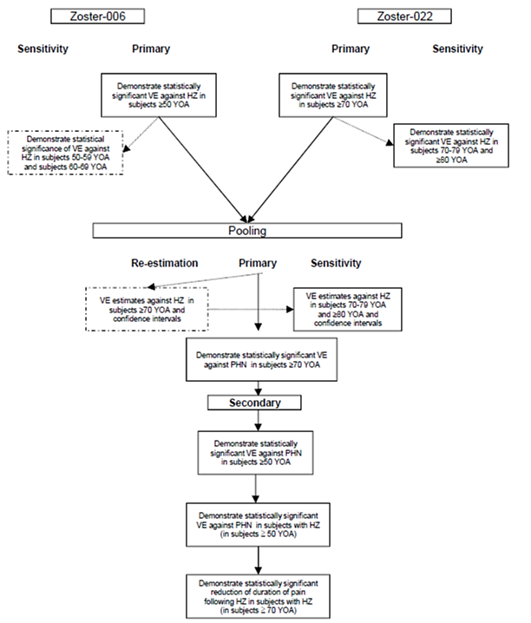
A Cox proportional model was used to analyse the hazard rate reduction in the ZBPI worst pain duration in subjects with HZ.
The protocol was amended 4 times with most changes clarifying study requirements. The main change was Amendment 4 (dated 18 April 2014) which unlinked the timing of analysis of ZOSTER-006 and ZOSTER-022 due to earlier HZ case accrual in Study ZOSTER-006. As such, a two-step analysis was allowed with firstly the analysis of HZ efficacy from Study ZOSTER-006 and then secondly the end of study (EOS) analysis where PHN efficacy was analysed. There was also a change in the primary endpoint of ZOSTER-022 whereby the co-primary endpoint of PHN in ≥ 70 year olds became a secondary endpoint. Also the co-primary endpoint in ≥ 70 year olds for the pooled analysis of ZOSTER-006 and ZOSTER-022 became the primary analysis for PHN. PHN in ≥ 50 year olds became a secondary endpoint for the pooled analysis. The target number of PHN cases was reduced (at least 35 PHN cases in subject’s ≥ 70 years of age) and the analysis steps redefined.
The conditions required for study end were at least 196 confirmed cases of HZ in the mTVC with about 60 cases in each of the 50 to 59 and 60 to 69 years of age groups and 75% of subjects in each age group had completed at least 36 months follow up after Dose 2 with the remaining having at least 30 months of follow up. In December 2014, as case numbers had been reached, the final analysis of ZOSTER-006 vaccine efficacy was undertaken by external statisticians in order to maintain study blind at subject and site level.

Participant flow
At the HZ efficacy analysis step, 16,160 subjects were enrolled and 726 were excluded, leaving 15,434 subjects with 15,411 in the TVC, 7698 in the HZ/su group and 7713 in the placebo group. The rate of withdrawal was 9.7% and 8.8% in the respective groups. The most frequent reason was consent withdrawal (4.1% versus 3.8%) followed by SAE (2.4% versus 2.5%) (Table 20). At the EOS analysis, the TVC included 15,405 subjects (7,695 and 7,710 in the respective groups).

Table 20: ZOSTER-006. Number of subjects vaccinated and withdrawn with reason for withdrawal (Total Vaccinated Cohort - Final HZ efficacy analysis)
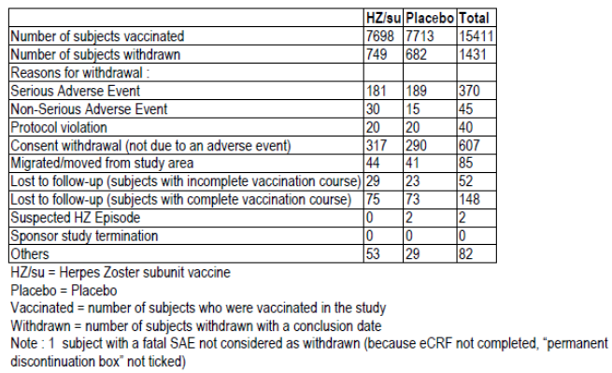

Major protocol violations/deviations
One site in Mexico was found to have significant ICH GCP non-compliance in both studies ZOSTER-006 and ZOSTER-022. The site had enrolled 671 subjects in ZOSTER-006 (4.15% of the study cohort) and these were all excluded from analysis.
Comment: There were also 865 subjects in ZOSTER-022 (5.8% of 14,816) from this site who were also excluded from analysis of that study.
At a further two sites in Mexico, nine subjects were excluded from analyses due issues with informed consent. One site in the US was closed due to ‘business reasons’ and 46 subjects were excluded from analysis. A further 6 subjects were excluded for other GCP non-compliance issues, leading to a total of 732 subjects not included in statistical analyses.
Comment: A variety of other deviations not leading to elimination from the study were well discussed and addressed by the sponsor.
From the TVC of 15,411, there were 14,759 subjects in the mTVC (95.4% and 96.1% of the HZ/su and placebo groups, respectively). The most frequent reason for exclusion was not receiving two doses of vaccine (about 4%). The rates of exclusion from the mTVC were similar across the age groups.

Baseline data
The mean age of study subjects was 62 years in the TVC, with more females than males included (61% versus 39%). Most subjects were Caucasian (71.3%) followed by East Asian (14.8%). Groups were balanced on demographic characteristics and this was also the case when assessed by age group. There was little change in the demographic characteristics of subjects in the TVC at the EOS analysis step.

Results for the primary efficacy outcome
In the mTVC, there were 6 cases of confirmed HZ in the HZ/su group and 210 in the placebo group. Confirmation of HZ by PCR was determined in four (66.7%) of the 6 cases in the HZ/su group and 189/210 (90%) of the placebo group. The mean follow up period was 3.1 years (range 0 to 3.7 years). The overall HZ incidence per 1000 person-years was 0.3 and 9.1 in the HZ/su and placebo groups, respectively.
For subjects aged ≥ 50 years, the HZ vaccine efficacy was 97.16% (95% CI: 93.72 to 98.97%; p < 0.0001) and therefore the study met its primary objective as the LL of the 95% CI was > 25%.
Vaccine efficacy was consistent across the age groups as follows: 96.57% (95% CI: 89.62 to 99.31%) in 50 to 59 years of age, 97.36% (95% CI: 90.14 to 99.69% in 60 to 69 years of age and 97.93% (95% CI: 87.91 to 99.95%) in ≥ 70 years of age (Table 21). As the LL of the 95% CI for VE in the 50 to 59 and 60 to 69 year age groups was > 10% the study met its secondary objectives.

Table 21: ZOSTER-006. Vaccine efficacy: First or only episode of HZ during the entire study period by age strata and overall using Poisson method (modified Total Vaccinated Cohort - Final HZ efficacy analysis)
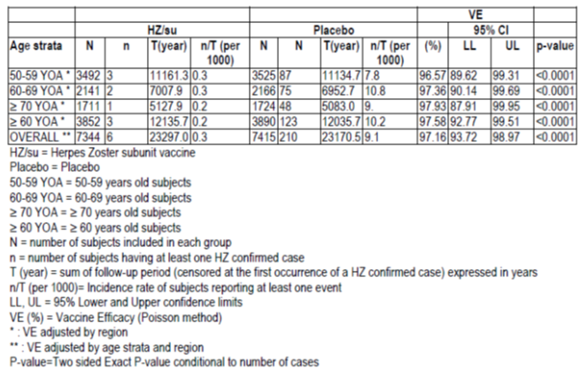
At end of study, after a mean follow up time of 3.9 years (range 0 to 4.5 years), there were a further 47 cases of HZ (3 and 44 in the HZ/su and placebo groups, respectively). At this point, the incidence of HZ was 0.3 and 8.9 per 1000 person-years, respectively and VE was 96.50% (95% CI: 93.2 to 98.5%).
VE was consistent between males and females across the age groups (Figure 8) and also across geographical regions. Sensitivity analysis using Cox regression found similar results with VE > 96% overall and across the age groups.
Figure 8: ZOSTER-006. Forest plot: Vaccine efficacy against HZ by gender using Poisson method (modified Total Vaccinated Cohort - End of study analysis)
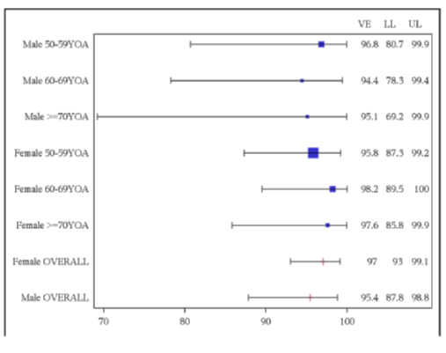
Analysis of the TVC (subjects who received at least one dose of vaccine) found results in line with the mTVC. The overall VE was 95.78 (95% CI: 92.52 to 97.85). Similarly, in the ATP population the VE was 96.6% (95% CI: 93.18 to 98.55%).
Comment: As mentioned earlier, there were issues with GCP compliance at one site in Mexico which enrolled 671 subjects (4% of the study cohort). The sponsor conducted a sensitivity analysis of the safety data from this site in Mexico in order to assess any possible safety signal. Any impact of removing these subjects on the efficacy results should also be discussed and this has been queried.

Results for other efficacy outcomes
There were no cases of PHN in the HZ/su group and 18 in the placebo group with incidence rates per 1000 person-years of 0 and 0.6, respectively. The PHN VE was 100% (95% CI: 77.11 to 100.0%, p < 0.0001). Efficacy was seen in the 50 to 59 and ≥ 70 year age groups however a lack of cases in the 60 to 69 years of age group meant no conclusion could be drawn for this group (Table 22).

Table 22: ZOSTER-006. Vaccine efficacy: First or only episode of PHN during the entire study period by age strata and overall using Poisson method (modified Total Vaccinated Cohort – End of study analysis)
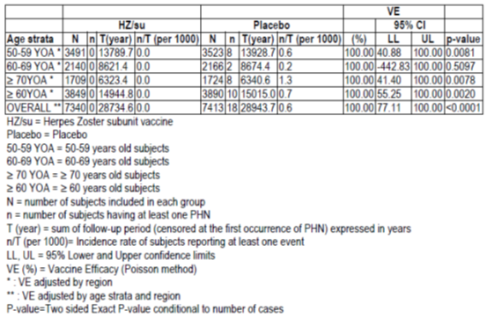
The median duration of severe ‘worst’ HZ associated pain was 11 days (range 3 to 78 days) and 15 days (1 to 464) in the HZ/su and placebo group, respectively. The overall VE for reduction of duration of ‘worst’ HZ associated pain of 26.9% and was not statistically significant (95% CI:-59.6 - 66.48%, p = 0.432).
There was no HZ-related mortality and also no HZ-related hospitalisations were reported. There were no HZ-related complications (other than PHN) in the HZ/su group with HZ and 6 subjects (out of 254) in the placebo group had complications. This resulted in a non-statistically significant VE of 100% (95% CI: -1336-100% p = 1.0). The complications in the placebo group were 1 HZ vasculitis,4 disseminated disease and 1 ophthalmic disease. There was no significant effect on reduction HZ associated pain medication use (VE of 11.7%, 95% CI: -19.4 to 53.6%, p = 0.697). The median duration of HZ associated pain medication use was similar between groups (21.0 versus 22.0 days).
Similar results to the mTVC were seen when the main secondary endpoints were assessed in the TVC and ATP cohort.

Quality of life
The mean ZBPI average pain score was 3.9 and 5.5 in the HZ/su and placebo groups, respectively, with the difference just reaching significance (p = 0.049). By contrast, the ZBPI worst pain score (5.5 versus 6.7) and the ZBPI ADL worst score were not significantly different. Area under the curve (AUC) analysis of the ZBPI (worst pain score, average pain score, ADL score) found no significant differences. The severity of illness score was significantly lower in the HZ/su group (0.07 versus 4.64, p < 0.0001). Overall, there were no remarkable differences between treatment groups on the EQ-5D and the SF-36 parameters.

Immunogenicity
In the immunogenicity subset of approximately 2,000 subjects, most were seropositive for anti-gE antibodies prior to vaccination (99%) and at Month 3 all in HZ/su group were seropositive. The pre-vaccination GMCs of anti-gE Ab were 1,247 and 1,311.9 mIU/mL for the HZ/su and placebo groups, respectively. The GMC increased in the HZ/su group to 52,376 mIU/mL at Month 3 and at Month 38 was 11,919 mIU/mL. There was little change in the placebo group. The VRR for anti-gE antibody in the HZ/su group was 98.5% at Month 3 and 80.9% at Month 38, and by contrast in the placebo group was < 4% throughout follow up. The adjusted geometric mean ratio (anti-gE antibodies) at Month 3 was 44.3 (95% CI: 41.7 to 47.1). For the three age groups, the adjusted GM ratio ranged from 38.5 to 44.8.
There was an increase in gE specific CD4[2+] T cells post vaccination in the HZ/su group which was not apparent in the placebo group. Compared to pre-vaccination, the post vaccination median fold increase in the HZ/su group was 24.6 compared to 1.0 in the placebo group. By Month 38, the fold increase over pre-vaccination levels had reduced to 7.9 in the HZ/su group. In the HZ/su group, the VRR for gE specific CD4[2+] T cells was 93.3% at Month 3 and declined to 52.6% (95% CI: 43.8-61.3) at Month 38. At Month 3, the adjusted GM ratio for gE specific CD4[2+] T cells was 18.7 (95% CI: 14.0-24.9). The data for VZV specific CMI showed a less marked response with a VRR of 57.1% and 20.9% at Months 3 and 38, respectively in the HZ/su group. Consistent immunogenicity results were found across age groups and study regions.

Evaluator commentary
In ZOSTER-006, in the mTVC, the HZ/su vaccine was found to be highly efficacious in preventing HZ in subjects aged ≥ 50 years with a VE of 97.16% (95% CI: 93.72% to 98.97%). The result was consistent when analysis was undertaken at the final HZ analysis and at the EOS time points. It was also supported by TVC and ATP population analyses. VE was consistent across age groups of 50 to 59, 60 to 69 and ≥ 70 years.
The overall VE for PHN in adults ≥ 50 years was 100% (95% CI: 77.1 to 100.0%) although the study was not powered for this endpoint. PHN efficacy was seen in the 50 to 59 and ≥ 70 year age groups however no conclusions were possible in the 60 to 69 years of age group due to a lack of cases. It was also not possible to draw conclusions on other secondary endpoints due to the low numbers in the HZ/su group. There was no HZ-related mortality and no HZ-related hospitalisations in the HZ/su group. There were no significant effects on pain or pain medication use.
Immunogenicity data from a subset of subjects showed a strong anti-gE antibody response and CMI response, with some decline over 3 years, nonetheless levels remained higher than pre vaccination levels. Data were consistent across age groups and study regions.

Study ZOSTER-022

Study design, objectives, locations and dates
ZOSTER-022 was a Phase III, randomised, observer blind, placebo controlled, multicentre study to assess the prophylactic efficacy, safety, and immunogenicity of gE/AS01B vaccine administered intramuscularly on a 0, 2 month schedule in adults ≥ 70 years. The study was conducted between August 2010 and July 2015 and run concurrently at the same sites as Study ZOSTER-006.

Primary objective
The primary objective was to evaluate VE in the prevention of HZ compared to placebo in adults ≥ 70 years of age, as measured by the reduction in HZ risk.
The primary objectives of the pooled analysis of studies ZOSTER-006 and ZOSTER-022 were to:
- To evaluate VE in the prevention of PHN compared to placebo in subjects ≥ 70 years of age across both Phase III studies;
- To consolidate VE estimation in the prevention of HZ compared to placebo in subjects ≥ 70 years of age across both Phase III studies.

Secondary objectives
Secondary objectives for ZOSTER-022 (in ≥ 70 year olds) included: VE in prevention of PHN; VE in reducing total duration of severe ‘worst’ HZ associated pain; VE in reduction of HZ-related mortality and hospitalisation; VE in reduction in incidence of HZ-related complications; VE in reduction in use of pain medications; and safety and reactogenicity.
Secondary objectives in the pooled analysis included: VE in prevention of overall PHN in adults ≥ 50 years of age; VE in prevention of PHN in those with confirmed HZ in adults ≥ 50 years of age; VE in reducing total duration of severe ‘worst’ HZ associated pain in adults ≥ 70 years of age; and safety and reactogenicity in adults ≥ 70 years of age.
The study design and methodology were the same as ZOSTER-006. The study enrolled subjects in two age groups 70 to 79 years of age and ≥ 80 years of age in a 3:1 ratio, respectively. As with ZOSTER-006, there were subsets of subjects who completed the 7 day diary card or who had samples taken for immunogenicity.
As with ZOSTER-006, ZOSTER-022 was terminated earlier than planned. The cut-off for EOS efficacy analysis was 21 April 2015.

Inclusion and exclusion criteria
The study included adults aged 70 years or older with no history of HZ or previous vaccination against HZ or varicella. Exclusion criteria were as per ZOSTER-006 and in particular any suspected or confirmed immunosuppressive or immunodeficient condition was an exclusion.

Study treatments
All subjects received two doses of HZ/su vaccine or placebo (0.5 mL) via IM injection two months apart.

Efficacy variables and outcomes
The efficacy variables were the same as ZOSTER-006. The primary endpoint was the confirmed HZ cases in the mTVC and the same algorithm for HZ case definition was used.
For the pooled analysis, the primary endpoints were the occurrence of overall PHN in the mTVC during the study period in subjects ≥ 70 years of age and the occurrence of confirmed HZ during the study period in subjects ≥ 70 years of age.

Randomisation and blinding methods
Subjects aged ≥ 70 years were randomised to Study ZOSTER-006 or ZOSTER-022 and then were randomised in a 1:1 ratio to HZ/su or placebo groups. Subjects were stratified by region and age cohort. Subjects were also randomised to be included in the diary card subset (504 per group) and the immunogenicity subset (460 per group).

Analysis populations
The primary efficacy analysis was conducted on the mTVC.

Sample size
Target enrolment was approximately 14,512 eligible subjects (7256 in both HZ/su and Placebo group). Following protocol amendment 4, the expected number of HZ in ZOSTER-022 was 310 with 210 in the placebo group. For the pooled studies, the expected number of PHN cases in the placebo group was 57 but based on accrual rates was projected to be 34 (Table 23). A total of 35 PHN cases would give the study a 90% power to demonstrate PHN VE of at least 0% in subjects ≥ 70 years of age. The assumptions for sample size calculations were a HZ VE of about 53% in ≥ 70 years of age, VE in PHN of about 71%, a dropout rate of 5% and a non-compliance rate with vaccination schedule of 5%.

Table 23: Expected number of HZ and PHN cases in pooled ZOSTER-006 and ZOSTER-022 (Amended 18 April 2014)
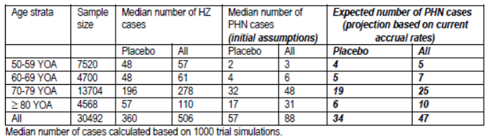

Statistical methods
Statistical methods were the same as ZOSTER-006. The chosen clinically meaningful HZ VE in ≥ 70 year old subjects was if the LL of the 95% CI was > 10%. For the pooled analysis it was if the LL of the 95% CI for PHN VE was above 0%.

Participant flow
Study ZOSTER-022 enrolled 14,816 subjects. There were 903 (6.1%) not included in the statistical analysis. Of the remaining 13,913 subjects, 13,900 were vaccinated with 6,950 in each of the HZ/su and placebo groups. The discontinuation rate was 17.04% (2,369/13,900) with a similar number in each group. The main reasons (HZ/su versus placebo) were having an SAE (6.6% versus 7.0%) and consent withdrawal (5.6% versus 5.7%). The withdrawal rate in the 70 to 79 years of age group was similar between treatment groups (14.2% versus 13.6%) and in the ≥ 80 years of age group the rates increased though remained similar between groups (26.9% versus 29.3%).

Major protocol violations/deviations
The site in Mexico which was closed due to serious GCP compliance issues had enrolled 865 subjects in ZOSTER-022 or 5.84% of the study’s population. There were also 34 subjects at one site in the US which was closed and a further 4 subjects with other GCP issues (informed consent, source documentation). A total of 903 subjects were excluded from the TVC.
Of the TVC, 94.7% were included in the mTVC. There were 697 subjects who did not receive a second dose of vaccine (392 versus 305) and a further 42 with other exclusion criteria resulting in a mTVC of 13,163 (6541 and 6622 in the HZ/su and placebo groups, respectively) (Table 24). The ATP efficacy cohort included 12,091 subjects (6030 versus 6061) which was 87.0% of the TVC.

Table 24: ZOSTER-022. Number of subjects enrolled into the study as well as the number excluded from modified Total Vaccinated Cohort and ATP cohort for efficacy with reasons for exclusion
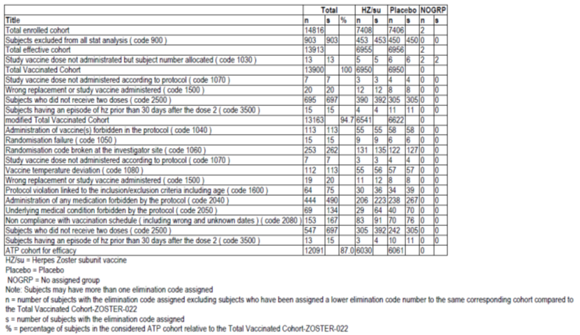

Baseline data
The mean age of study participants in the TVC was 75.6 years. There were slightly more females than males (54.9% versus 45.1%) and most subjects were Caucasian (76.3%). Groups were balanced on baseline demographic characteristics in both the TVC and mTVC. The mean age in the 70 to 79 years of age group was 73.5 years and in the ≥ 80 years of age group was 82.7 to 82.8 years.

Results for the primary efficacy outcome
In the mTVC, after a median follow up time of 3.9 and 3.7 years in the HZ/su and placebo groups, respectively, there were 246 subjects with a confirmed HZ episode; 23 in the HZ/su group and 223 in the placebo group. The incidence rate was 0.9 and 9.2 per 1000 person-years, respectively. This resulted in a HZ VE of 89.79% (95% CI: 84.29 to 93.66%, p < 0.0001) (Table 25). As the LL of the 95% CI was above 10%, the study met its primary objective.
Most HZ cases were confirmed by PCR (82.6% and 93.3%) rather than determined by the HZAC (17.4% and 6.7%).
HZ VE in the 70 to 79 years of age group was 90.02% (95% CI: 83.54-94.32%) and in the ≥ 80 years of age group was similar at 89.08% (95% CI: 74.65-96.16%) (Table 25 and Figure 9). Results were consistent between males and females and across geographic regions (Australasia, Europe, Latin America and North America) where VE was > 83% in each region. When data were analysed using Cox regression the results were supportive. Analysis of vaccine efficacy over the study period found HZ VE in the 4th year of 85.1% (95% CI: 64.5 to 94.8%) (Table 26).
Analyses of vaccine efficacy in the TVC and the ATP populations were also consistent with the mTVC.
Comment: As per the comment for Study ZOSTER-006, the sponsor should comment on the impact on the efficacy results of removing the 865 subjects from the site in Mexico.

Table 25: Vaccine efficacy: First or only episode of HZ during the entire study period by age stratum and overall using Poisson method (modified Total Vaccinated Cohort-ZOSTER-022)
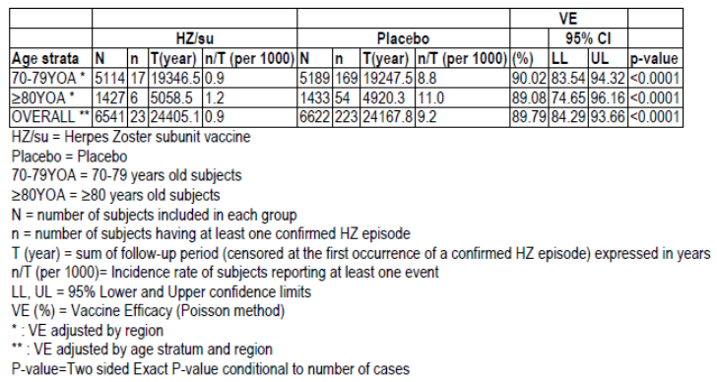
Figure 9: Forest plot: Vaccine efficacy against HZ by age stratum and overall using Poisson method (modified Total Vaccinated Cohort-ZOSTER-022)
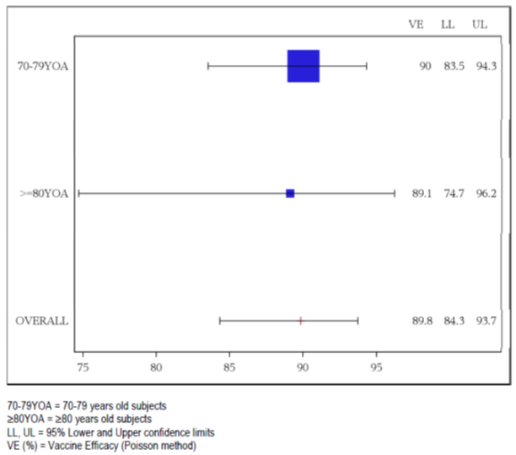

Table 26: Vaccine efficacy: First or only episode of HZ during the entire study period by time using Poisson method (modified Total Vaccinated Cohort-ZOSTER-022)
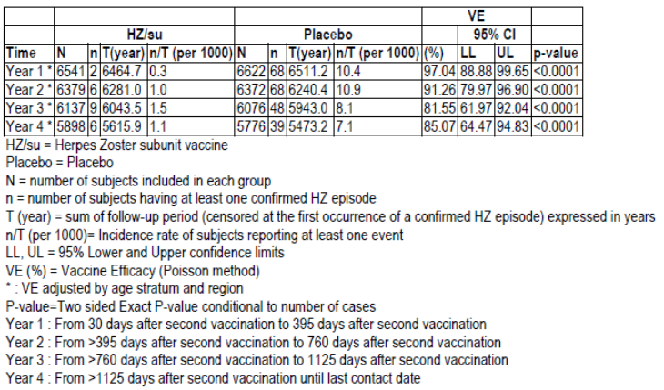

Results for other efficacy outcomes
There were 32 subjects with PHN, 4 in HZ/su group and 28 in the placebo group which equated to an incidence of 0.2 and 1.1 per 1000 person-years, respectively. The overall PHN VE was 85.49% (95% CI: 58.52-96.30%). By age group, the VE was 90.8% (95% CI: 62.57-98.95%) and 65.8% (95% CI: -91.5-96.62%) in the 70 to 79 and ≥ 80 year olds, respectively.
Comment: There were too few cases in the ≥ 80 years of age group to draw any conclusions.
The mean duration of pain (severe ‘worst’ HZ associated pain) was 34.6 and 48.5 days (median 13.5 and 19.0 days) in the HZ/su and placebo groups, respectively. This reduction in severe pain duration was not statistically significant (VE of 28.4% [95% CI: -17.7 to 56.4%] p = 0.188).
There were no cases of HZ-related mortality or hospitalisation in the subjects in the HZ/su group and 5 in the placebo group. In those with HZ, the rate of HZ-related complications other than PHN was 4.3% (n = 1) and 4.5% (n = 10) in the HZ/su and placebo groups, respectively. The single case in the HZ/su group was of ophthalmic disease. In the placebo group there were 2 reports of disseminated disease, 6 of ophthalmic disease and 3 of neurological disease.
The median duration of pain medication use in subjects with HZ was 30.0 and 38.0 days in the HZ/su and placebo groups, respectively. The VE for duration of pain medication use was 49.3% (95% CI: 2.9 to 73.5%, p = 0.040). There was also a trend towards reduction in use of pain medication in the HZ/su group (VE of 39.6% [95% CI: 10.8 to 64.8%] p = 0.008).
For subjects with HZ, the rate of PHN was 17.4% and 12.6% in the HZ/su and placebo groups, respectively. There was no reduction in risk of PHN for subjects with confirmed HZ (VE of -35.6% [95% CI: -222.7-49.1%] p = 0.51).
Comment: Due to the low number of events, firm conclusions cannot be drawn on the secondary endpoints of duration of pain, HZ-related mortality or hospitalisation, HZ-related complications other than PHN, and PHN rate in those with HZ.

Quality of life
There were no differences found between groups in the mean ZBPI questionnaire worst pain score item, nor any difference in the median time to resolution of clinically significant pain.

Immunogenicity
Baseline seropositivity with anti-gE antibodies was high (99.5%). The VRR for anti-gE antibodies at Month 3 was 95.9% and 3.6% in the HZ/su and placebo groups, respectively. At Month 38, the VRR in the HZ/su group was 66.1% (95% CI: 60.6-71.2%). The GMC at Month 3 in the HZ/su over placebo groups for anti-gE antibody concentrations was 32.9 (95% CI: 29.7 to 36.4, p < 0.001). The results for the two age subgroups were consistent with the overall population.

Results for pooled analysis ZOSTER-006/ZOSTER-022
There were 30,977 subjects (≥ 50 years of age) in the pooled database with 1,635 eliminated form analyses leaving 29,342 subjects. Of these, 37 were not vaccinated. The TVC included 29,305 subjects with 14,645 and 14,660 in the HZ/su and placebo groups, respectively. Overall, 4,913 (14.3%) subjects were withdrawn (Table 27). The mTVC included 27,916 (95.3%) subjects and the ATP cohort 25,786 (88.0%). In the mTVC, the mean age was 68.5 years and 58.1% were females. In the TVC, the number of subjects aged 70 to 79 years was 6,837 and 6,856, and aged ≥ 80 years 1,921 and 1,917 in the HZ/su and placebo groups, respectively.

Table 27: Number of subjects vaccinated, completed and withdrawn with reason for withdrawal (Total Vaccinated Cohort, subjects ≥ 50 years of age - POOLED ZOSTER-006/ZOSTER-022)
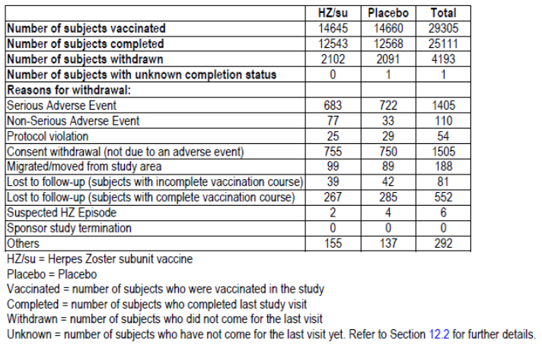

Primary objectives pooled analysis
In the mTVC for subjects aged ≥ 70 years, after a median follow up of 4.0 years, there were 25 and 284 cases of HZ in the HZ/su and placebo groups, respectively. The incidence rate was 0.8 and 9.3 per 1000 person years, respectively. The HZ VE was 91.30% (95% CI: 86.88-94.46%, p < 0.0001). Efficacy rates were consistent in both the 70 to 79 and the ≥ 80 years of age groups (91% in both) (Table 28, Figure 10). In these subjects aged ≥ 70 years, at year 4 the HZ VE was 87.9% (95% CI: 73.3 to 95.3).
In subjects aged ≥ 70 years in the pooled database, there were 40 cases of PHN with 4 in the HZ/su group and 36 in the placebo group. The incidence was 0.1 and 1.2 per 1000 person years, respectively. The PHN VE was 88.78 (95% CI: 68.70 to 97.10%, p < 0.0001). For the 70 to 79 years of age group the PHN VE was 93.0% (95% CI: 72.5 to 99.2) while efficacy was not demonstrated in the ≥ 80 years of age subjects (PHN VE of 71.2%, 95% CI: -51.5-97.1%) which is likely due to small numbers (2 cases in the HZ/su and 7 in the placebo group) (Table 29). For the overall population (≥ 50 years of age), the PHN VE was 91.22% (95% CI: 75.95-97.70%, p < 0.0001). Results from pooled analyses of the TVC and the ATP cohort were in line with the mTVC.

Table 28: Vaccine efficacy: First or only episode of HZ during the entire study period by study and by age stratum and overall using Poisson method (modified Total Vaccinated Cohort; subjects ≥ 70 years of age - POOLED ZOSTER-006/ZOSTER-022)
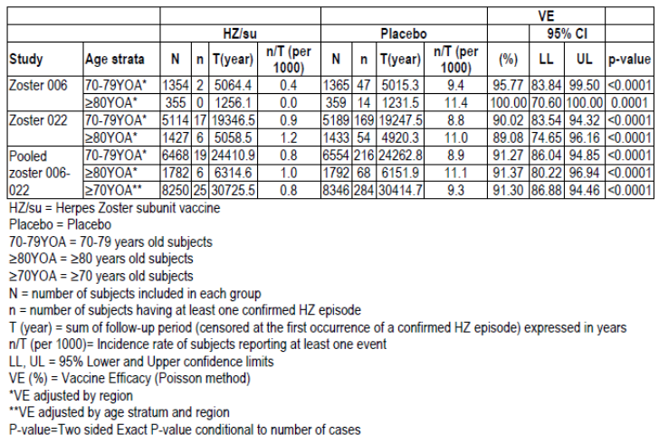
Figure 10: Forest Plot: Vaccine efficacy against HZ by study and by age stratum and overall using Poisson method (modified Total Vaccinated Cohort, subjects ≥70 years of age -POOLED ZOSTER-006/ZOSTER-022)
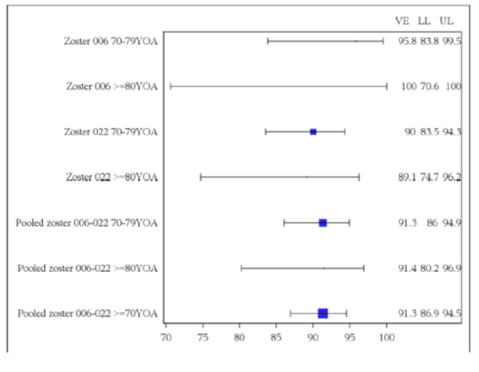

Table 29: Vaccine efficacy: First or only episode of PHN during the entire study period by study and by age stratum and overall using Poisson method (modified Total Vaccinated Cohort; subjects ≥ 70 years of age - POOLED ZOSTER-006/ZOSTER-022)
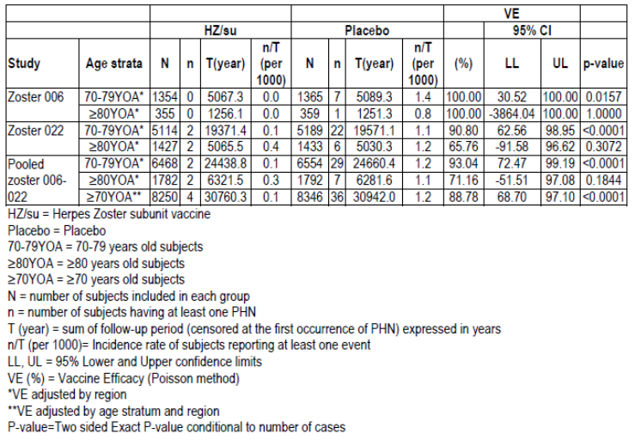

Secondary objectives pooled analysis
For those with confirmed HZ, the mean duration of severe ‘worst’ pain was 32.1 and 47.5 days, respectively, and the overall VE in terms of reduction of pain duration was not significant (30.5%, 95% CI: -10.5 to 56.7%). For those with HZ, there was no significant reduction in the incidence of PHN (VE of 0.29% [95% CI: -161.53% to -65.57%]).
Comment: Subject numbers were too low in the HZ/su group to draw conclusions on these endpoints.
From the pooled data, post-hoc analysis of VE for HZ related complications not including PHN in subjects aged ≥ 50 years found a VE of 93.7% (95% CI: 59.5 to 99.9%) and for those aged ≥ 70 years was 91.6% (95% CI 43.4 to 99.8%) (Tables 30 and 31).
Comment: VE over time was not presented in the pooled study analysis and this has been queried.

Table 30: Vaccine efficacy: First or only episode of HZ related complications (PHN not included) during the entire study period by study and by age strata and overall using Poisson method (modified Total Vaccinated Cohort, subjects ≥ 50 years of age -POOLED ZOSTER-006/ZOSTER-022)
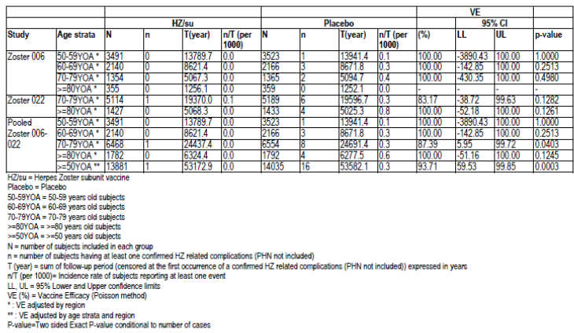

Table 31: Vaccine efficacy: First or only episode of HZ related complications (PHN not included) during the entire study period by study and by age strata and overall using Poisson method (modified Total Vaccinated Cohort, subjects ≥ 70 years of age -POOLED ZOSTER-006/ZOSTER-022)
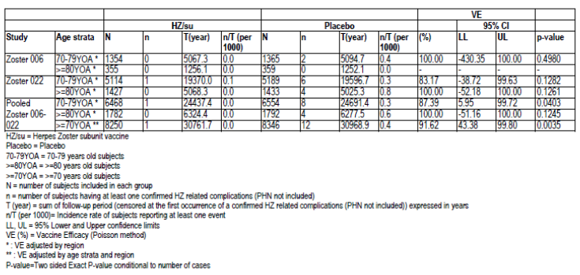

Quality of life
Analysis of the ZBPI questionnaire found a significant difference between groups in the mean ZBPI score over time (p = 0.032). The mean of the ZBPI worst pain score was 5.7 and 7.0 in the HZ/su and placebo groups, respectively. There were no statistically significant differences in the mean AUC analysis of the ZBPI worst pain score, the ZBPI average pain or the ZBPI ADL scores. Analysis of the EQ-5D and the SF-36 did not demonstrate any notable differences between groups.

Immunogenicity
Results were consistent with the findings of the individual studies. At Month 3 in the overall population, the adjusted GM ratio of HZ/su over placebo for anti-gE antibodies was 40.8 (95% CI: 38.7 to 43.0). Consistent results were also found in the 70 to 79 and ≥ 80 years of age groups.

Evaluator commentary
In ZOSTER-022, VE in the prevention of HZ was confirmed in the elderly population (≥ 70 years of age) after a median follow up period of 3.9 years. Efficacy was high at 89.8% (95% CI: 84.3 to 93.7%, p < 0.0001) and consistent across the two age subgroups (70 to 79 and ≥ 80 years). PHN VE was also found in this study (85.5%, 95% CI: 58.5 to 96.3%) although the study was not powered for this.
A reduction in duration of pain was not confirmed despite a reduction in duration of pain medication use. High efficacy and resultant small case numbers meant secondary endpoints could not be confirmed.
There was a strong humoral immune response across the age subgroups (70 to 79 and ≥ 80 years of age).
Pooled analysis of ZOSTER-006 and ZOSTER-022 found results consistent with the individual studies. In the prespecified analysis, for subjects aged ≥ 70, the HZ/su vaccine was efficacious in preventing HZ 91.3% (95% CI: 86.9 to 94.5%) with consistent results for both the 70 to 79 and ≥ 80 years of age groups.
Efficacy was also demonstrated for PHN in the ≥ 70 years of age (88.8%, 95% CI: 68.7 to 97.1%). The low numbers in the ≥ 80 years of age group meant that VE for PHN in this group could not be demonstrated. For those with HZ, there was no significant reduction in the incidence of PHN (VE of 0.3%, 95% CI: -161.5% to -65.6%), although case numbers were very small. These results mean that vaccine efficacy in preventing PHN is most likely due to the effect against HZ.
The sponsor has been asked to comment on the impact on PHN efficacy if different definitions of pain duration were used (rather than 90 days).
A post-hoc analysis of the pooled data found a reduction in risk complications other than PHN. Consequently the proposed indication includes the broad wording ‘prevention of HZ and HA-related complications such as PHN’. The evaluator does not agree with the inclusion of complications other than PHN in the indication as the statement has been based on a post-hoc analysis with low power and such complications can have varying mechanisms and pathogenesis.
Long term follow up studies will be needed to demonstrate efficacy against HZ and PHN beyond 4 years and this may be addressed by the follow up Study ZOSTER-049 which is currently ongoing.
In general for subjects with HZ, quality of life data not demonstrate any notable differences between treatment groups.

Other efficacy/immunogenicity studies

ZOSTER-026

Design and methods
ZOSTER-026 was a Phase III, randomised, open label, uncontrolled, parallel group study to assess the safety and immunogenicity of HZ/su vaccine when administered according to a 0,2 month, 0,6 month or 0,12 month schedule in adults aged ≥ 50 years. It was conducted between March 2013 and April 2015 at one site in the US and one in Estonia.
The primary objective was to evaluate vaccine response rate (VRR) for anti-gE immune responses at one month post-Dose 2 in the 0,6 month and 0,12 month schedule groups. Assessment was based on the lower limit (LL) of the 97.5% confidence interval (CI) of the VRR for anti-gE ELISA antibody concentrations being at least 60%. If this objective was met then non-inferiority of 0,6 months to 0,2 months schedule was assessed. Non-inferiority was deemed if the upper limit (UL) of the 97.5% CI for the anti-gE ELISA GMC ratio (0,2 month schedule over 0,6 month schedule) at one month post-Dose 2 was below 1.5. If this objective was met then non-inferiority of the 0,12 month schedule to 0,2 months was assessed using the same criterion.
The study was open label and subjects were randomised in a 1:1:1 ratio to one of the three dosing schedules, stratified by age group. Subjects were followed for 12 months post second vaccination. All subjects received Hz/su vaccine containing 50 µg gE antigen with AS01B via IM injection in the deltoid region.
The study included healthy males and non-pregnant females aged ≥ 50 years. The main exclusion criteria were history of HZ, previous HZ or varicella vaccination, immunosuppressants within 6 months, and immunodeficient or immunosuppressive conditions.
Analysis was based on ATP immunogenicity cohort and the primary analysis was conducted one month post second vaccination for each group. Between group comparisons were analysed using an ANCOVA model of the log transformed titres with pre vaccination levels as a covariate. A sample of 100 evaluable subjects per group gave the study 99% power to detect the LL of the 95% CI for the VRR of at least 60%. Hierarchical testing was used to control the type I error rate (one sided 2.5%). This sample size also gave the study 91% power for the non-inferiority test on the GMC ratio between the standard and alternate schedules.

Results
There were 354 subjects enrolled, 346 completed the study and 342 were in the ATP cohort. The mean age was 64 years.
At one month post Dose 2, the VRR for anti-gE antibodies was 95.5% (LL of 97.5% CI: 90.4%) and 94.5% (LL 97.5% CI: 87.6%) for the 0,6 month and 0,12 month schedules, respectively. As both lower limits of the 97.5% CI were above 60%, the study met is first co-primary objective.
For the 0,6 month schedule, the anti-gE ELISA adjusted GMC ratio (at one month post Dose two), compared to the 0,2 month schedule, was 1.16 (97.5% CI: 0.98, 1.39). As the UL of the CI was < 1.5, the 0,6 month schedule met the non-inferiority criteria.
For the 0,12 month schedule, the anti-gE ELISA GMC ratio (at one month post Dose two) was 1.19 (97.5% CI: 0.93, 1.53). As the UL of the CI was 1.53, the 0,12 month schedule did not meet the non-inferiority criteria.
At 12 months post Dose 2 all study subjects were seropositive and the vaccine response rates were in the order of 82 to 84%.

Summary
Study ZOSTER-026 was an open label, randomised, parallel group immunogenicity study which assessed two vaccination intervals longer than 2 months (0,6 and 0,12 months) in 354 adults ≥ 50 years. As measured by the anti-gE antibody GMC ratio one month post second vaccination, the 0,6 month schedule was found to be non-inferior to the 0,2 month schedule, however the 0,12 month vaccination interval did not meet the non-inferiority criterion (GMC ratio UL of the 97.5% CI < 1.5).

Study ZOSTER-033

Design and methods
ZOSTER-033 was a Phase III, non-randomised, open label, multicentre clinical trial to assess the immunogenicity and safety of HZ/su vaccine when administered intramuscularly on a 0,2 month schedule to adults ≥ 50 years of age with a history of a prior episode of HZ. The study was conducted between June 2013 and November 2014 in Canada and Russia.
The primary objective was to evaluate anti-gE VRR at Month 3. The objective was met if the LL of the 95% CI of VRR was at least 60%. A sample size of 84 evaluable subjects gave the study a 97% power to detect this objective. Subjects were stratified by age group (50 to 59, 60 to 69 and ≥ 70 years of age). Analysis was on the ATP immunogenicity cohort. Subjects received two doses of HZ/su two months apart by IM injection and were followed to Month 14.
For inclusion subjects needed a physician documented history of HZ. Exclusion criteria were active HZ, previous HZ or varicella vaccination and immunosuppression or immunodeficient conditions.

Results
There were 96 subjects enrolled and vaccinated and 93 (96.9%) completed the study. There were 82 (85.4%) subjects in the ATP cohort for immunogenicity. The mean age was 64.9 years.
The study met its primary objective as the VRR at Month 3 was 90.2% (95% CI: 81.7 to 95.7%). The GMC ratio (Month 3 versus pre-vaccination) was 19.9 (95% CI: 15.0-26.5). The mean fold increase in anti-gE Ab concentrations from baseline to Month 3 was 42.5, 37.2 and 29.5 in the 50 to 59, 60 to 69 and ≥ 70 years of age groups, respectively.
There were 6 subjects (6.3%) with 9 reported events of suspected HZ. There was no laboratory confirmation. Vaccine administration was tolerated and there were no vaccine related SAEs.
Comment: As there was no laboratory confirmation of suspected HZ cases, some self-reporting and no control group in the study, the interpretation of this seemingly high rate of HZ post vaccination is difficult to interpret.

Summary
In adults with a prior episode of HZ, two doses of HZ/su induced a high humoral immune response with a VVR of 90.2% (95% CI: 81.7 to 95.7%). The study met is primary objective as the LL of the 95% CI for the VRR was 82% (≥ 60%).

Study ZOSTER-004

Design and methods
ZOSTER-004 was a Phase III, randomised, open label, controlled, multicentre study which assessed the immunogenicity and safety of HZ/su when co-administered with GSK’s quadrivalent seasonal influenza vaccine (FLU-D-QIV) in adults ≥ 50 years of age. Subjects were followed for 12 months after second vaccination. The study design is shown in Figure 11. The study was conducted between October 2013 and March 2015 in Canada, Germany and the US.
Figure 11: ZOSTER-004; Study design
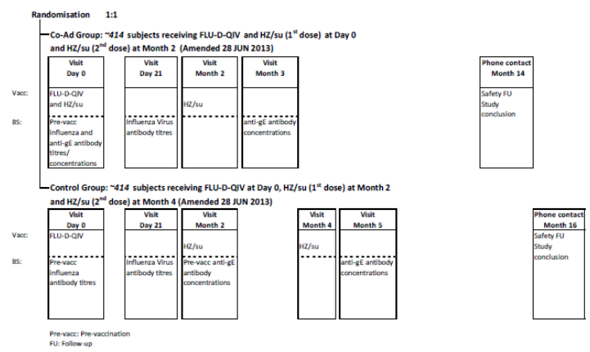

Primary objectives
The primary objectives were:
- To evaluate VRR to the HZ/su vaccine (based on the humoral immune response) one month after the last vaccine dose in the HZ/su FLU-D-QIV co-administration group. The objective was met if the LL of the 95% CI of the VRR for anti-gE antibody concentrations in the co-administration group was ≥ 60%.
- To demonstrate non-inferiority in terms of humoral immune response of two doses of the HZ/su when FLU-D-QIV vaccine is co-administered with the first HZ/su dose compared to two doses of HZ/su vaccine given alone, one month after the last vaccine dose. The criterion used: one month after the second vaccine dose, the upper limit (UL) of the 95% CI for the GMC ratio for anti-gE antibodies of the control group over the HZ/su FLU-D-QIV co-administration group was < 1.5.
- To demonstrate non-inferiority (in terms of haemagglutinin inhibition (HI) antibody geometric mean titres [GMTs]) of one dose of FLU-D-QIV vaccine when co-administered with the first HZ/su vaccine dose compared to one dose of FLU-D-QIV vaccine given alone, for the four strains included in FLU-D-QIV vaccine, at Day 21 post vaccination. The criterion used: at Day 21 post vaccination, the UL of the two-sided 95% CI for the GMT ratio of the control group over the HZ/su-FLU-D-QIV co-administration group was < 1.5 for each strain included in the FLU-D-QIV vaccine.

Secondary objectives
Secondary objectives included:
- Non-inferiority (in terms of HI antibody seroconversion rates) of one dose FLU-D-QIV with HZ/su compared to FLU-DQIV alone for the four strains in the FLU-D-QIV vaccine at Day 21 post vaccination. The criterion used was if the UL of the two-sided 95% CI for the seroconversion rate (SCR) difference of the control group minus the HZ/su-FLU-D-QIV co-administration group was below 10% for each strain included in the FLU D-QIV vaccine.
- Immunogenicity of the FLU-D-QIV in terms of GMTs, seroprotection rates (SPR)(Day 0 and 21), SCR, and mean geometric increase (MGI) (Day 21). The criteria for SCR was the LL of the 95% CI for SCR should be ≥ 40% in subjects aged 50-64 years of age or ≥ 30% in subjects ≥ 65 years of age. The criteria for SPR was the LL of the 95% CI for SPR should be ≥ 70% in subjects aged 50-64 years of age or ≥ 60% in subjects ≥ 65 years of age.
SCR was defined as the percentage of vaccinees who had either a pre-vaccination titre < 1:10 and a post vaccination titre ≥ 1:40 or a pre-vaccination titre ≥ 1:10 and at least a fourfold increase in post-vaccination titre. MGI was defined as the geometric mean of the within subject ratios of the post vaccination reciprocal HI titre to the Day 0 reciprocal HI titre. SPR was defined as the percentage of vaccinees with a serum HI titre ≥ 1:40.
Subjects were randomised in a 1:1 ratio to one of two parallel groups stratified by age group (50 to 59, 60 to 69 and ≥ 70 years of age):
- Co-Ad group where subjects received one dose of HZ/su vaccine and one dose of FLU-D-QIV vaccine at Day 0 and one dose of HZ/su vaccine at Month 2.
- Control group where subjects received one dose of FLU-D-QIV vaccine at Day 0, one dose of HZ/su at Month 2 and another at Month 4.
Comment: The quadrivalent inactivated split virion influenza vaccine is approved for use in Australia under the name Fluarix Tetra.
Vaccinations were given by IM injection and the treatment was open label.
The study included males and females ≥ 50 years old. The main exclusion criteria were history of HZ, previous vaccination against HZ or varicella, influenza vaccination in the past 6 month, immunosuppressive or immunodeficient conditions.
The primary analysis was conducted on the ATP cohort for immunogenicity. Post-vaccination log-transformed concentrations of anti-gE were analysed using an ANCOVA model with age stratum and treatment as fixed effects and pre vaccination antibody (Ab) concentrations as a covariate. An ANOVA model was used to analyse log-transformed Ab titres for each FLU-D-QIV strain. Assuming 393 subjects per group, the study was adequately powered (93.7%) for the primary objectives.

Results
There were 828 subjects randomised and vaccinated (413 and 415 in the Co-Ad and Control groups, respectively). The study completion rate was 96.1%. The ATP immunogenicity cohort included 781 (94.3%) subjects. In the TVC, the mean age was 63.4 years and 51.8% were female with most (92%) subjects being Caucasian/European heritage.
The VRR for anti-gE Ab in the Co-Ad group one month post last vaccine dose was 95.8% (95% CI: 93.3 to 97.6%). The study met this primary objective as the LL of the 95% CI was > 60%.
The adjusted GMC ratio (Control/Co-Ad) for anti-gE ab one month after the last vaccine dose was 1.08 (95% CI: 0.97 to 1.20). Non-inferiority of humoral immune response was demonstrated as the UL of the 95% CI was < 1.5.
At Day 21 post vaccination, the adjusted GMT ratios (Control/Co-Ad) for the four HI antibodies were approximately 1.0 and the UL of the 95% CI for each HI antibody ratio was ≤ 1.22. Therefore, non-inferiority was demonstrated for this primary endpoint (UL 95% CI < 1.5) (Table 32).

Table 32: ZOSTER-004. Adjusted ratios of Control over Co-Ad in Flu HI antibodies GMTs at Day 21 post -vaccination (ATP cohort for immunogenicity)
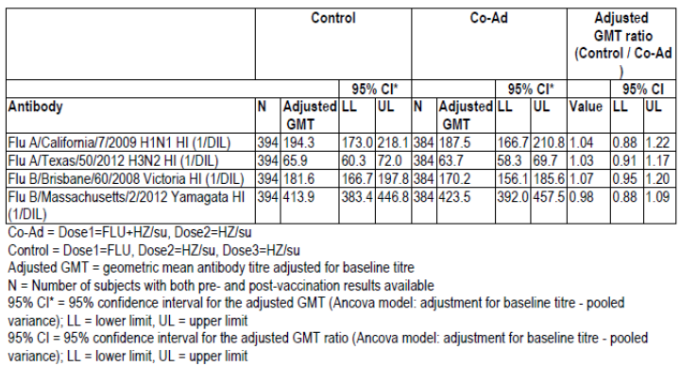

Secondary endpoints
The HI antibody seroconversion rate differences for the four influenza vaccine strains (Control minus Co-Ad) ranged from -2.54 to 5.64. The UL of the 95% CI for the difference in SCR was < 10% for three strains but was 12.5% for one strain (B/Victoria). Therefore only 3 of the 4 HI antibody SCRs met the non-inferiority criteria.
Assessment of the immunogenicity of the FLU-D-QIV vaccine by age group using CBER criteria found that the LL of the 95% CI of the SPR for all strains was ≥ 70% in 50 to 64 years of age group and ≥ 60% in ≥ 65 years of age group and so the criteria were met. For SCR, the CBER criteria (LL of the 95% CI ≥ 40% in 50 to 64 years of age and ≥ 30% in ≥ 65 years of age) were only met consistently for the H1N1 strain. Analyses of the TVC were supportive of the ATP cohort analyses.

Evaluator commentary: other efficacy/immunogenicity studies
The dossier contained a number of further studies all of which had immunogenicity, rather than efficacy, endpoints.
In ZOSTER-026 two doses of HZ/su in a 0,6 month schedule was found to be non-inferior to a 0,2 month schedule, however the 0,12 month vaccination interval did not meet the non-inferiority criterion. The sponsor has concluded that the vaccine dosing interval should be 2 months but could be extended to 6 months and a 12 month interval is not recommended. The study was based on humoral immunity despite cell mediated immunity being accepted as the more important response for HZ prevention. As there are currently no correlates of immune protection it is difficult to interpret the findings of the study and so at this stage the evaluator only recommends a 0,2 month schedule.
In subjects with a previous history of HZ (ZOSTER-033), the humoral immune responses to HZ/su were high and the study met its primary objective as the LL of the 95% CI for the VRR was 82% (≥ 60%). Again, without data on correlates of protection, the interpretation of the results is difficult. The sponsor proposed that the high rate of suspected HZ cases in this study could be due to over reporting by study subjects. The lack of laboratory confirmation of these HZ cases means that no conclusions on this can be drawn.
ZOSTER-004 found that concomitant administration of tetravalent seasonal influenza vaccine with HZ/su vaccine was acceptable with no immunological interference for either vaccine. It is noted that there are ongoing studies with pneumococcal vaccine (Pneumovax 23) (ZOSTER-035) and diphtheria-tetanus-pertussis vaccine (Boostrix) (ZOSTER-042). The sponsor has been queried on whether there are plans to assess administration with other adjuvanted vaccines.
Further studies are planned in the immunocompromised patient indication.

Analyses performed across trials: pooled and meta analyses
Data were pooled from studies ZOSTER-006 and ZOSTER-022 and these are presented above.

Evaluator’s conclusions on clinical efficacy
The efficacy of the HZ/su vaccine was based on two concurrent pivotal Phase III studies; ZOSTER-006 and ZOSTER-022. These were large scale, randomised, observer blind, placebo controlled, multicentre studies, conducted in 18 countries worldwide. The primary objective of the studies was to evaluate vaccine efficacy compared to placebo in preventing HZ in adults ≥ 50 and ≥ 70 years of age, respectively. Both studies had the same design and subjects were randomised in a 1:1 ratio to receive two doses of HZ/su or saline placebo 0.5 mL via IM injection two months apart. Stratification by age group was undertaken to achieve comparable numbers of HZ cases in the three main age strata (50 to 59 years of age, 60 to 69 years of age, ≥ 70 years of age).
Subjects were excluded if immunosuppressed for any reason. Baseline medical conditions were not described in the CSR for either study and this has been queried. This is important to address comparability between groups and the effects of conditions which may predispose to HZ.
Having the two studies allowed for greater enrolment in older subjects. This separation was undertaken due to the higher PHN incidence in those aged ≥ 70 years and also to accurately assess vaccine efficacy as it was assumed vaccine efficacy may decrease with age. The study design and oversight was appropriate and supported by regulatory advice.
The primary endpoint was HZ as confirmed by PCR and all suspected HZ cases were reviewed by a blinded HZ Adjudication Committee. PHN was a secondary endpoint in the individual studies but for those aged ≥ 70 years was a primary endpoint in the pooled analysis of the two studies. Pooling was acceptable due to the studies having the same design, inclusion/exclusion criteria and treatment. Pain assessment was based on the ZBPI which was completed daily until 28 days post HZ onset and then weekly. PHN was defined as the presence of HZ associated severe ‘worst’ pain (≥ 3 on the ZBPI questionnaire) persisting or appearing more than 90 days after onset of the HZ rash.
Efficacy analysis was conducted on the modified TVC which excluded subjects who did not receive the second dose of vaccine, who developed confirmed HZ prior to 30 days post second vaccination, or who did not receive vaccine according to the protocol. It was, however, supported by the TVC analysis which included subjects who may have only received one dose of vaccine which is of clinical relevance.
Analysis of ZOSTER-006 was undertaken in a two-step procedure, first HZ VE and then at EOS for PHN efficacy, due to earlier case accrual in ZOSTER-006. There was a ‘Firewall team’ set up to maintain study blind between the two analyses.
Statistical analysis description was not completely clear on how multiplicity was controlled and also the impact of futility analyses conducted during the study and this has been questioned.
The studies were terminated early as the required number of cases of HZ and PHN had been met, vaccine efficacy was high and there was a desire to offer vaccine to the placebo group.
There was a site in Mexico with significant GCP non-compliance and its data were excluded from analysis of both studies. The site had included a significant number of subjects: 671 (4.15%) in Study ZOSTER-006 and 865 (5.84%) in Study ZOSTER-022. Overall approximately 5% of enrolled subjects were excluded from TVC analyses in the two studies. The total vaccinated cohort for Studies ZOSTER-006 and ZOSTER-022 was 15,411 and 13,900 subjects, respectively.
For ZOSTER-006 there were 14,759 subjects in the mTVC. The median follow up time was 3.1 years at the first HZ analysis and 4.1 years at the end of Study HZ and PHN analysis. For ZOSTER-022 the median follow up time was 3.9 years.
The HZ/su vaccine was found to have very high efficacy in both studies. In ZOSTER-006, the HZ incidence was 0.3 and 9.1 per 1000 person years in the HZ/su and placebo groups, respectively (6 versus 210 cases). This resulted in a vaccine efficacy of 97.2% (95% CI: 93.7 to 99.0%; p < 0.0001) in this population of ≥ 50 year olds. Efficacy was consistent across age groups (50 to 59, 60 to 69, ≥ 70 years of age) and the LL of 95% CI for VE was at least 87%.
In ZOSTER-022, the mTVC included 13,163 subjects and the median follow up time was 3.9 years. The HZ incidence was 0.9 and 9.2 per 1000 person years in the HZ/su and placebo groups, respectively (23 versus 223 cases). The HZ VE in the adults aged ≥ 70 years was 89.8% (95% CI: 84.3-93.7%, p < 0.0001). Efficacy was similar in the two age subgroups (70 to 79 years of age and ≥ 80 years of age). Data from Study ZOSTER-022 was supported by the pooled analysis where VE in the ≥ 70 years of age was 91.3% (95% CI: 86.9-94.5%).
In both studies, results were consistent across geographic regions and gender and supported by sensitivity analyses.
There were very few cases of HZ in vaccinated subjects and it would be worthwhile to understand if there were any features in these subjects such as baseline conditions and immunological results that could have explained the breakthrough.
Both studies demonstrated efficacy against PHN: 100% in ZOSTER-006 and 85.5% in ZOSTER-022. In ZOSTER-006 there were no PHN cases in the HZ/su group and 18 in the placebo group. In ZOSTER-022, there were 4 and 28 cases in the respective groups, with an incidence of 0.2 and 1.1 per 1000 person-years. In the pooled analysis for those aged 70 years and over, VE against PHN was 88.9% (95% CI: 68.7 to 97.1%). The impact of the definition used for PHN has been questioned. For those with HZ, there was no significant reduction in the incidence of PHN (VE of 0.29%, 95% CI: -161.53% to 65.57%) and so the vaccine efficacy in preventing PHN is likely due to its effect on HZ. The sponsor should comment on whether there could be an increased risk of PHN in those with HZ who had been vaccinated.
The high vaccine efficacy led to a small number of cases in the vaccinated group and therefore assessment of secondary endpoints was difficult.
Post-hoc analysis of pooled data reported high efficacy against HZ-related complications other than PHN. This fact has been included in the proposed indication ‘prevention of HZ and HZ-related complications such as PHN’. The very limited number of cases, the post-hoc analysis and the varying pathogenesis mean that inclusion of complications other than PHN is not endorsed in the proposed indication. The data may be included in the Clinical Trial section of the PI.
There was a reduction in the use and duration of use of pain medications in Study ZOSTER-022, however there was no reduction in the duration of actual pain and data were not supported by results from Study ZOSTER-006.
Efficacy was demonstrated out to 4 years post vaccination however the issue of possible waning efficacy and the need for booster vaccination has not yet been defined.
Co-administration with quadrivalent seasonal influenza vaccine found no evidence of immunological interference.
A 0,6 month vaccination schedule was non-inferior to the 0,2 month schedule based on humoral immune response. Nonetheless, due to the lack of correlates of protection and lack of CMI data the 0,6 month schedule cannot be supported at this stage. The 0,12 month schedule did not meet non-inferiority criteria.
The vaccine was immunogenic in subjects with a prior episode of HZ.
The indication for use in immunocompromised subjects is not the subject of this submission. The two submitted studies in autologous HCT recipients and HIV-infected adults found that three doses of vaccine were immunogenic.

Clinical safety

Studies providing evaluable safety data

Pivotal studies that assessed safety as the sole primary outcome
None.

Pivotal and/or main efficacy studies
In ZOSTER-006 and ZOSTER-022, solicited AEs were collected in the diary card subset of subjects for seven days from Day 0 to Day 6 after each vaccination. Solicited local (injection site) AEs included pain, redness and swelling. Solicited general AEs included fatigue, fever, GI symptoms (nausea, vomiting, diarrhoea and/or abdominal pain), headache, myalgia and shivering. Daily temperature was also recorded. All other AEs were reported as ‘unsolicited’ and were collected during the 30 days post vaccination. For subjects not in the diary card subset, local and general symptoms post vaccination were recorded as unsolicited AEs. If there was an unsolicited AE with a medically attended visit this was recorded up to Month 8.
HZ and PHN were not considered an AE or SAE although complications of these conditions were. All suspected cases of HZ were confirmed by PCR or the HZ adjudication committee.
AE intensity was graded as follows: 0 being none; 1 mild; 2 moderate; and 3 severe and preventing normal everyday activities. Redness and swelling were scored: 0 < 20 mm; 1 ≥ 20 mm to ≤ 50 mm; 2 > 50 mm to ≤ 100 mm; and 3 > 100 mm diameter. Temperature was scored: 0 < 37.5°C; 1 37.5°C to 38.0°C; 2 38.1°C to 39.0°C; and 3 > 39.0°C (Table 33).
SAEs were recorded from Day 0 to Month 14, or to study completion if the SAE related to study participation or if it was fatal. SAEs were also analysed if occurring in the 30 day period post vaccination. Information on potential immune-mediated diseases (pIMDs) was collected for the duration of the study. A list of these disorders is in Table 34.

Table 33: Intensity scales for solicited symptoms
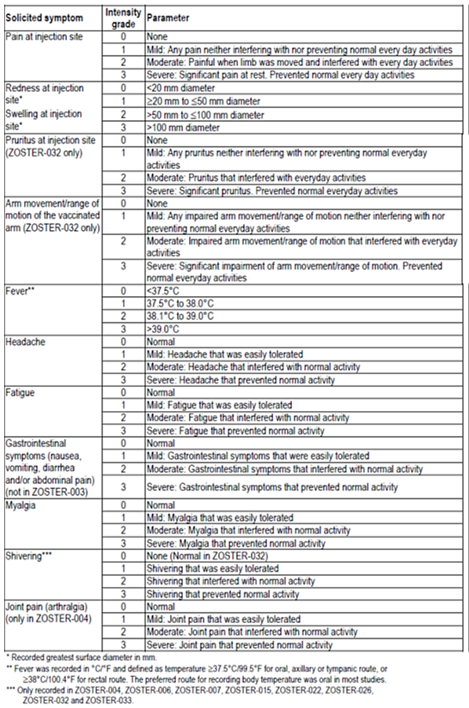

Table 34: Pre-defined list of Potential Immune-Mediated Diseases (Protocol template v14.1 – 01 December 2014)
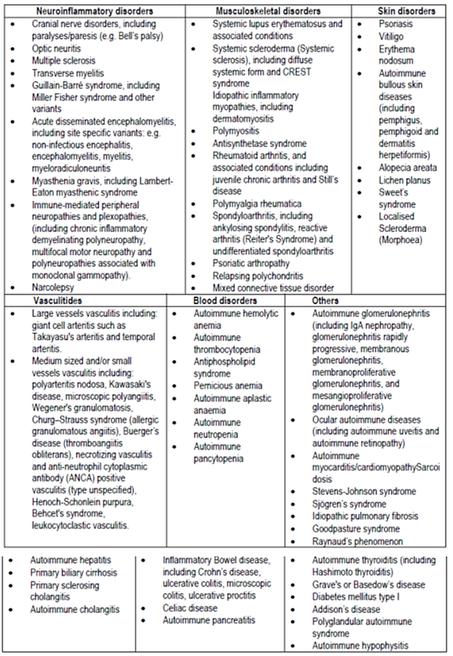

Other studies

Other efficacy/immunogenicity studies
There were 17 further studies, two in immunocompromised adults and 15 in adults ≥ 50 years of age. In this latter group, 6 studies were extension studies.
In all studies solicited and unsolicited AEs were recorded on diary cards, the solicited AEs for 7 days and unsolicited AEs for 30 days post vaccination. SAEs were collected in all studies for their duration from the time of study vaccination. Study EXPLO-CRD-004 had follow up for 42 months and Study ZOSTER-003 for 72 months. Potential IMDs were collected for the study duration.
Haematology and biochemistry parameters were assessed in studies EXPLO-CRD-004, ZOSTER-003, ZOSTER-010 and ZOSTER-023, as well as in IC adults in ZOSTER-001 and ZOSTER-015. Suspected cases of HZ were evaluated by PCR or an expert in ZOSTER-001 and ZOSTER-015.

Data pooling
Safety data from studies in adults ≥ 50 years of age who received the final formulation of vaccine (50 µg gE/ASO1B) in a 0,2 month schedule by IM injection, and had at least one year of follow up post vaccination, were pooled. The data were grouped into the ‘main safety pooling analysis’ where HZ/su was compared to placebo and the studies had similar design (ZOSTER-006 and ZOSTER-022), or the ‘broader safety pooling analysis’ (Table 35).
When there was co-administration (ZOSTER-004 with FLU-D-QIV) or assessment in IC adults (ZOSTER-001 and ZOSTER-015) the data were not included in pooled analyses. Data from ZOSTER-007 and ZOSTER-026 were not included in the safety pooling as one year follow up was not available at the time of database lock. EXPLO-CRD-004 was not included as follow up was for 10 months and the extension studies ZOSTER-018 and ZOSTER-019 only recorded study related SAEs and suspected HZ cases. ZOSTER-023 in Japanese ethnic origin subjects which only had 6 months of follow up and ZOSTER-001 and ZOSTER-015 which were in IC adults were also not included.

Table 35: Clinical studies with HZ/su included in the main and broader safety pooling analyses
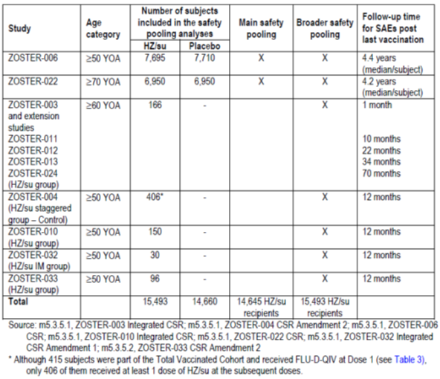

Studies that assessed safety as the sole primary outcome
None.

Patient exposure
The total exposure to HZ/su in the clinical development program studies included in the dossier was 17,204 subjects. The breakdown of how studies were included in the safety pools is shown in Figure 12. In the main safety pool (ZOSTER-006 and ZOSTER-022), there were 14,745 subjects who received at least one dose of HZ/su vaccine (Table 36). In the broader safety pool, there were 15,493 adults ≥ 50 years of age who received at least one dose of HZ/su vaccine and 9,078 who were ≥ 70 years of age. Approximately 95% of subjects received two doses of vaccine. Exposure in studies not included in the broader safety pool is summarised in Table 37. In the main safety pool there were 14,660 subjects who received placebo.
Figure 12: Diagram on HZ/su exposure in all completed clinical studies included in the application
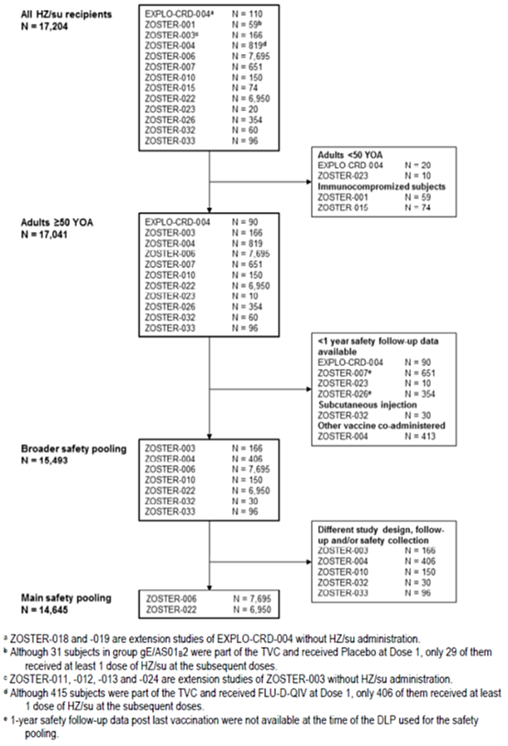

Table 36: Clinical studies with HZ/su included in the two pooled analyses of safety data
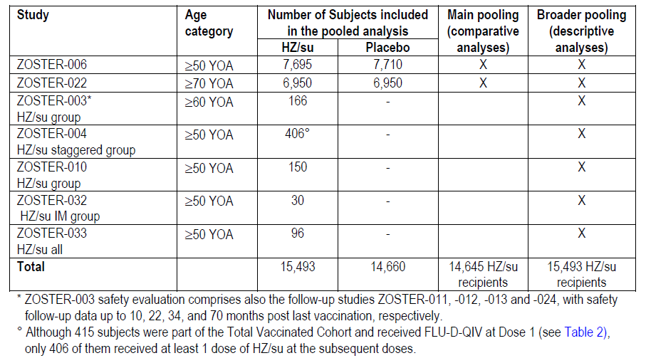

Table 37: Summary of exposure to HZ/su in older adults from study groups and studies not included in the broader safety pooling analysis (Total Vaccinated Cohort)
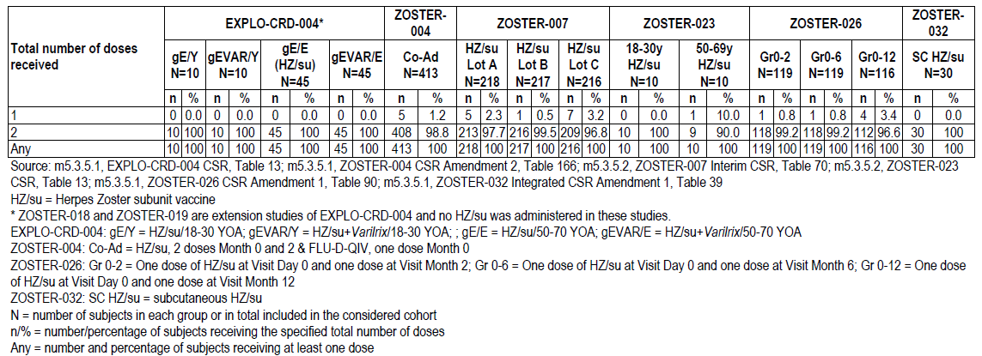
In the immunocompromised adult population, there were 30 HCT recipient subjects who received three doses of HZ/su and 29 who received two doses of HZ/su in ZOSTER-001. A further 74 HIV infected subjects in ZOSTER-015 received three doses of HZ/su.
In the broader safety pool, the mean age of subjects was 68.5 years, 57.9% were female and 74.7% were classed as White/Caucasian/European heritage. This demographic pattern was similar in the main safety pool.

Adverse events

All adverse events (irrespective of relationship to study treatment)

Main safety pool

Solicited symptoms
In the diary card subset, there were 4,884 and 4,880 subjects in the HZ/su and placebo groups, respectively. Solicited symptoms were more common following a HZ/su dose than placebo (76.6% versus 22.9%) in the 7 day post vaccination period. The overall incidence per subject was 84.5% versus 33.7%, respectively. By age group, the incidence was 89.6% versus 38.1% in the 50 to 69 years of age subjects and slightly lower in the ≥ 70 years of age subjects (78.7% versus 28.7%).

Local solicited symptoms
Local solicited symptoms were frequent with HZ/su with an overall per subject incidence of 80.8% compared to 11.7% in the placebo group. The most frequent local symptom post dose was pain (68.1% versus 6.9%) and Grade 3 pain occurred after 3.8% of doses in 6.4% of HZ/su group (versus 0.3% of the placebo group). Redness (38.1% versus 1.3%) and swelling (25.9% versus 1.0%) were also frequent with HZ/su. Rates of local solicited symptoms were similar after the second dose.
In the HZ/su group, the mean duration of symptoms (pain, redness and swelling) was < 4.0 days with a median of 3.0 days each. The mean duration of Grade 3 local symptoms was ≤ 2.1 days.
Most local solicited symptoms were Grade 1 (47.5 to 67.1% of doses) or 2 (27.2% to 46.4% of doses). A Grade 3 local symptom was reported by ≤ 6.4% of HZ/su subjects. The majority of local symptoms following a placebo dose were Grade 1 (87.7% to 93.8%). The rate of Grade 3 local symptoms following Dose 1 and 2 was 5.4% and 5.7%, respectively.
The ≥ 70 years of age subjects had a slightly lower rate of local solicited symptoms than the 50 to 69 years of age subjects (73.4% versus 87.1%).

General solicited symptoms
General solicited symptoms were also more frequent following HZ/su than placebo in the 7 day post vaccination period (51.6% versus 19.4% of doses and 64.8% versus 29.1% of subjects). The most frequent general symptoms were myalgia (32.9% versus 7.3% of doses), fatigue (32.2% versus 10.5%) and headache (26.3% versus 9.6%). The most frequent Grade 3 general symptom was fatigue which was reported in 5.3% of HZ/su group compared to 1.0% of the placebo group. Fever incidence was also more frequent (20.5% versus 3.0%), although Grade 3 fever was not common (0.3% of subjects in the HZ/su group).
Solicited general symptoms lasted for 3.0 days or less in the HZ/su group and the mean duration of Grade 3 general symptoms by dose was ≤ 1.6 days. Most general symptoms were Grade 1 (59.9% to 73.6% of doses and 55.7% to70.7% of subjects) or Grade 2 (20.9% to 28.5% of doses and 21.6% to 31.5% of subjects). The rate of Grade 3 general symptoms per subject was ≤ 5.3% (fatigue and myalgia being the most frequent). There was a small increase in the rate of Grade 3 general symptoms from Dose 1 (5.7%) to Dose 2 of HZ/su (8.0%). Fatigue increased from 2.4% to 3.5%, headache from 1.4% to 2.3%, myalgia from 2.3% to 3.6% and shivering from 1.4% to 3.1%.
General symptoms were also slightly less frequently reported in the 70 years of age than the 50 to 69 years of age group (42.5% versus 59.3% of doses and 55.6% versus 72.7% of subjects).

Unsolicited AEs
Unsolicited AEs were analysed in the total vaccinated cohort up to 30 days post vaccination. The rate was greater in the HZ/su group (50.5% versus 32.0%, RR = 1.58 [95% CI: 1.52-1.64, p < 0.00001]). The most frequent AE SOC was ‘general disorders and administration site conditions’ which covered symptoms reported on the diary cards (pain, redness, swelling, fever headache, fatigue, chills, myalgia, nausea).
Comment: Subjects not in the diary card subset were reporting the expected local and general symptoms as ‘unsolicited’ AEs.
Of the events that were significantly more frequent in the HZ/su group, the most common was injection site pain (23.0% versus 1.7%) followed by injection site erythema (9.3% versus 0.3%) and pyrexia (7.1% versus 0.5%). There were also four AEs with an incidence of at least 1% that were at least twice as common in the HZ/su group: injection site pruritus (2.2% versus 0.24%), malaise (1.7% versus 0.3%), pain (1.4% versus 0.2%) and injection site warmth (1.0% versus 0.03%) (Table 38).
The unsolicited AE rate in the 30 day post vaccination period per dose was 37.2% and 19.4% in the HZ/su and placebo groups, respectively.
Post-hoc analysis was conducted on the unsolicited AEs during different time periods. In Study ZOSTER-006, the rate during Days 0 to 2 was 31.8% versus 9.3%, within 7 days was 34.9% versus 14.3%, and from Day 7 to 29 was 20.9% versus 22.5%. In Study ZOSTER-022, the unsolicited AE rate during Days 0 to 2 was 43.3% versus 11.6%, Days 0 to 6 was 45.7% versus 16.3%, and between Days 7 and 29 was 21.2% versus 22.2%.
Unsolicited AEs in the HZ/su group occurred at a similar rate in the 50 to 69 years of age and the ≥ 70 years of age subgroups (51.4% and 49.9%).
In the diary card subset of subjects, the rate of unsolicited AEs was more similar between treatment groups (rate per dose: 17.7% versus 16.1%, rate per subject: 29.2% versus 27.5%). The most frequent unsolicited AEs per dose were nasopharyngitis (1.6% each) and URTI (1.0% versus 0.6%).
Comment: Data on medically attended visits were stated to have been collected to Month 8. No pooled data on these events could be located. The sponsor has been asked to discuss these events, as well as any other AE data available in the year post vaccination, and comment on any imbalances between the treatment groups.

Table 38: Main safety pooling analysis: Relative Risk between groups of subjects reporting the occurrence of unsolicited adverse events classified by MedDRA Primary System Organ Class and Preferred Term within the 30-day (Days 0-29) post-vaccination period (incidence ≥1.0% of subjects in the HZ/su group, sorted by System Organ Class and by incidence in HZ/su group) (Total Vaccinated Cohort)
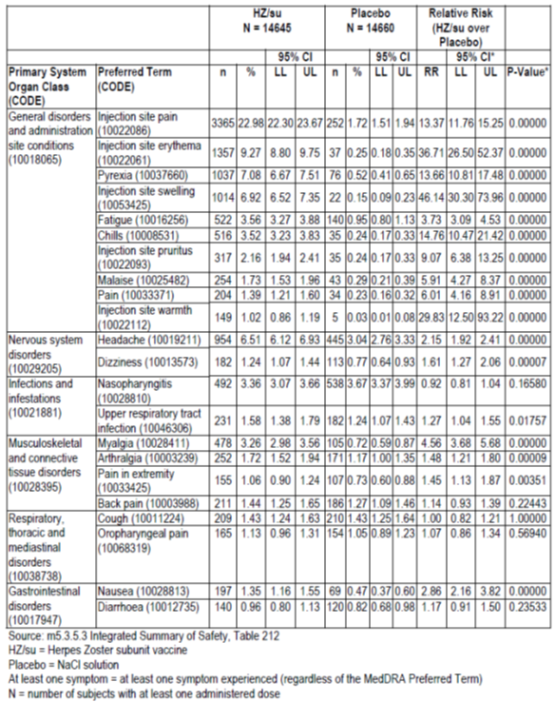

Broader safety pool
In the broader safety pool to 30 days post vaccination, unsolicited AEs were reported after 36.1% of doses in 49.3% of subjects. Grade 3 unsolicited AEs occurred after 2.1% of doses and 3.9% of subjects. For those subjects with a 7 day diary card, unsolicited AEs were reported in 29.2% of subjects after 17.7% of doses.

Other studies
In the 50 to 70 years of age group of EXPLO-CRD-004, during the 7 day post vaccination period, the rate per dose of HZ/su for local symptoms was 86.7% and for general symptoms was 72.2%. This compares to 57.8% and 27.8%, respectively, for those who received Varilrix. Frequent events were pain, myalgia and fatigue. The rate of Grade 3 symptoms (solicited and unsolicited) was 24.4% and 5.6% in the HZ/su and Varilix groups, respectively.
In the Phase II antigen dose selection Study ZOSTER-003, the presence of adjuvant AS01B increased the vaccine’s reactogenicity. The rate per dose of symptoms (solicited and unsolicited) was similar between the three gE/AS01B groups (74 to 82%) and higher in these groups than in the 100 µg gE/saline group (39%). Similar trends were seen for Grade 3 symptoms (16 to 19.7% versus 5.7%). There was no evident trend for increasing adverse effects with increasing antigen dose.
In the Phase II adjuvant dose selection Study ZOSTER-010, AEs increased with AS01 and also increased with the higher dose AS01B compared to half dose AS01E. The rates per dose of any symptom (solicited or unsolicited, local or general) during the 7 days post vaccination were 14.7%, 29.0%, 68.2% and 79.5% in the saline, gE/saline, gE/AS01E and gE/AS01B groups, respectively. Analysis found that, in general, the difference in symptom rates between gE/AS01B and gE/AS01E was statistically significant (Table 39). For Grade 3 symptoms, the rates per dose were 2.7%, 1.4%, 4.5% and 5.8%, respectively (Table 15 above). In the 7 days post vaccination, there was a trend for symptom rates with adjuvanted vaccine to be slightly higher in the 50 to 59 year old subjects than in the older age groups.

Table 39: ZOSTER-010. Difference between groups in percentage of subjects reporting symptoms (solicited and unsolicited) during the 7 day post-vaccination period (Total Vaccinated Cohort)
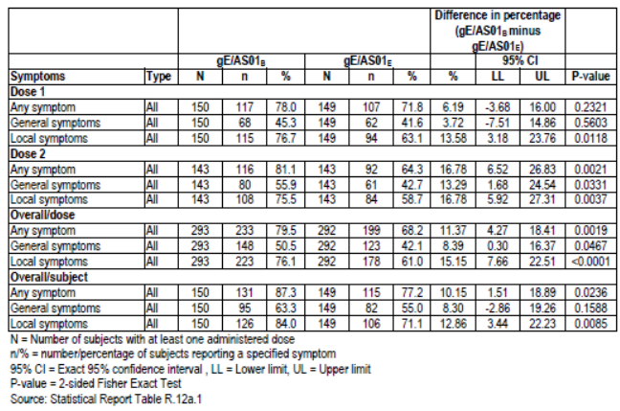
The rate of unsolicited symptoms from Day 0 to 29 were 16%, 25%, 25% and 31% in the saline, gE/saline, gE/AS01E and gE/AS01B groups, respectively. The rate of Grade 3 unsolicited symptoms was similar between groups (2.6%, 1.4%, 2.0% and 3.3% respectively).
In the dose schedule Study ZOSTER-026, there was little difference in AE rates between the schedule groups (0 to 2, 0 to 6 and 0 to 12 months).
In ZOSTER-007, the safety profile was similar between the three vaccine lots.
In ZOSTER-004, the rate of any symptom (solicited and unsolicited) in the 7 days post vaccination (Dose 1) was higher with co-administered influenza and HZ/su vaccines compared to influenza vaccine alone (84.9% versus 48.3%). This was also the case for any Grade 3 symptom (14.9% versus 4.1%). Pain was the most frequent solicited symptom. In the control group, the rate of local solicited symptoms was notably higher after HZ/su (Dose 2 or Dose 3 of the study) than after FLU-D-QIV (Dose 1).
In ZOSTER-032, subcutaneous vaccine administration resulted in a notably higher reactogenicity than intramuscular administration. In the 7 days post vaccination, Grade 3 events (solicited and unsolicited) were reported in 56.7% compared to 16.7% of subjects. The higher rate in the SC group was due to a higher rate of solicited local symptoms (Grade 3: 56.7% versus 6.7%) in particular redness and swelling. Symptoms also lasted longer in the SC group.
Comment: Due to the reactogenicity of SC administration, development was ceased.

Treatment related adverse events (adverse drug reactions)

Main safety pool
In the 30 day post vaccination period, the rate per subject of treatment related AEs was 34.5% versus 6.6% and the rate per vaccine dose was 26.2% versus 3.8% in the HZ/su and placebo groups, respectively. The treatment related AEs were those covered by the diary card and also injection site pruritus, malaise, pain, and injection site warmth. Grade 3 treatment related AEs occurred after 2.2% and 0.2% of HZ/su and placebo doses respectively and in 4.0% and 0.4% of subjects in the respective groups. Unsolicited Grade 3 events had, in general, the same profile as the solicited events.
In the 7 day diary card subset of subjects, the unsolicited treatment related AE rate by subject was 6.5% versus 2.8%. The most frequent reaction was injection site pruritus (1.1% versus 0.1%).

Broader safety pool
Unsolicited AEs related to treatment were reported after 25.1% of doses in 33.1% of subjects. In those with a 7 day diary card, unsolicited AEs related to vaccination occurred after 3.9% of doses in 6.9% of subjects and Grade 3 treatment related unsolicited AEs after 0.4% of doses and in 0.8% of subjects.

Other studies
For adults 50 to 70 years of age in EXPLO-CRD-004 in the 30 days post vaccination, the rate of treatment related unsolicited AEs in the HZ/su group was 44.4% (26.7% of doses) and for Grade 3 events was 6.7% (3.3% of doses). This was higher than the Varilrix group (15.6% of doses and 0% of subjects, respectively).
In ZOSTER-003 in the 30 days post vaccination, the rate of treatment related unsolicited AEs in the HZ/su group was 13.3% (8.2% of doses). In ZOSTER-010 these events were reported in 16.0% of subjects. Prominent events were chills, injection site pruritus and malaise. In ZOSTER-026 for the 0,2 month schedule, treatment related unsolicited AEs were reported in 7.6% of subjects after 5.1% of doses and the Grade 3 events were less frequent occurring in 0.8% of subjects after 0.4% of doses. Treatment related unsolicited AEs occurred at similar rates across the 3 vaccine lots in ZOSTER-007 with a rate per dose 5.1% to 7.1%. The Grade 3 treatment related unsolicited AE rate per dose ranged from 0.7% to 1.4%. In ZOSTER-032, there was only one subject with a treatment related unsolicited AE in each group (IM and SC).

Deaths and other serious adverse events

Main safety pool

Deaths
The were 634 subjects (4.3%) in the HZ/su group and 680 subjects (4.6%) in the placebo group who died in studies ZOSTER-006 and ZOSTER-022 during the follow up period (Table 40). The main causes of death (HZ/su versus placebo) were cardiac failure (0.3% versus 0.4%), pneumonia (0.3% in both groups), myocardial infarction (0.3% in both groups), death not otherwise specified (0.2% versus 0.3%), cardiac arrest (0.2% in both groups) and lung neoplasm malignant (0.2% versus 0.1%).

Table 40: Main safety pooling analysis: Percentage of subjects reporting the occurrence of serious adverse events with fatal outcome classified by MedDRA Primary System Organ Class during the whole post-vaccination follow-up period overall and by age stratum (sorted by incidence in the HZ/su group) (Total Vaccinated Cohort)
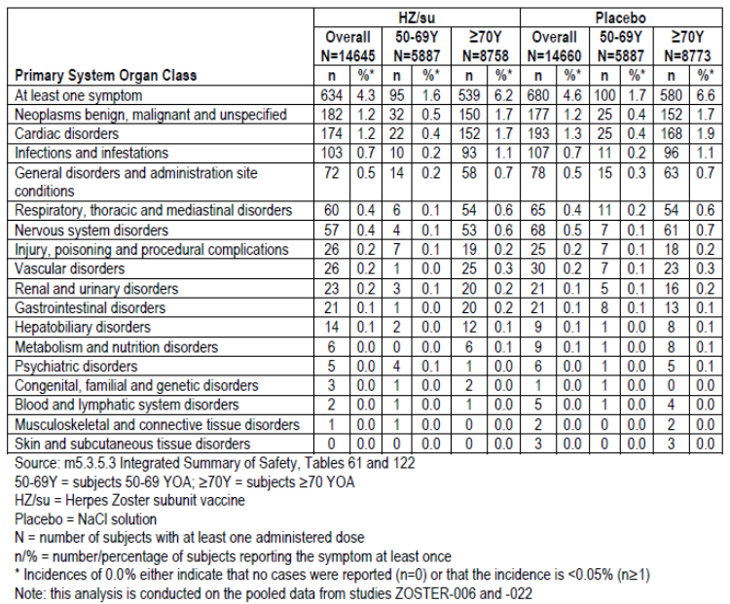
There was one death considered vaccine related. A 90 male in the ZOSTER-022 with pre-existing thrombocytopaenia developed Grade 3 acute myeloid leukaemia 75 days post first vaccine dose. He was withdrawn from the study and treated with blood transfusion, azacitidine, allopurinol and ondansetron. He represented to hospital 11 days post discharge with febrile neutropaenia and was treated with filgastim, piperacillin/tazobactam. He died from the neutropaenic sepsis 97 days post vaccination.
Comment: The investigator stated that there was a reasonable possibility the AML and the neutropaenic sepsis may have been caused by the vaccine. The sponsor stated in the Clinical Overview that it ‘considers that the age of the subject, the long time to onset (97 days after first vaccination), and subject’s pre-existing conditions as well as the nature of the event (no biological plausibility) makes a possible causal association between the neutropaenic sepsis and the administration of HZ/su unlikely.’ The evaluator agrees with this conclusion.
The rate of death in the period from first vaccination to 30 days post last vaccination was 0.1% in both groups. In the period up to 1 year post last vaccination 1.0% and 1.1% of subjects died in the respective groups. The rate of death was similar in the age groups (6.2% versus 6.6% in the ≥ 70 year olds and 1.6% versus 1.7% in the 50 to 69 year olds).

SAEs
During the whole follow up period, the rate of a subject having at least one SAEs (fatal and non-fatal) in the HZ/su group was 12.8% (95% CI: 12.30 to 13.39) and in the placebo group was 13.3% (95% CI: 12.72 to 13.83). There was no significant difference in these rates (RR = 0.97 [95% CI: 0.91 to 1.03] unadjusted p = 0.316).
The most common SAEs were pneumonia (0.8% versus 0.7%), cardiac failure (0.5% versus 0.6%), myocardial infarction (0.5% each), atrial fibrillation (0.4% each), cerebrovascular accident (0.4% versus 0.3%), coronary artery disease (0.3% each), cardiac failure congestive (0.3% each) and UTI (0.3% versus 0.2%). SAEs by SOC are shown in Table 41.

Table 41: Main safety pooling analysis: Percentage of subjects reporting the occurrence of serious adverse events classified by MedDRA Primary System Organ Class during the whole post-vaccination follow-up period (sorted by incidence in the HZ/su group) (Total Vaccinated Cohort)
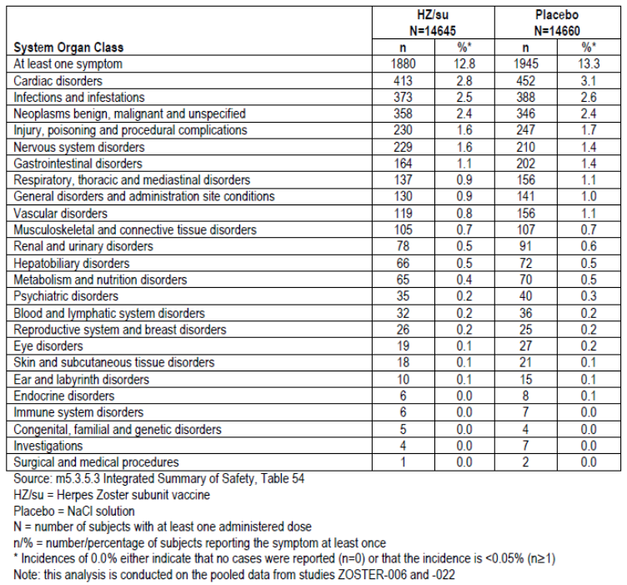
There were two preferred terms which were significantly more frequently reported in the HZ/su group: ovarian cancer (0.05% versus 0%, p = 0.016) and supraventricular tachycardia (0.04% versus 0%, p = 0.031). In the placebo group, the following conditions were more frequent: aortic stenosis (0% versus 0.08%, p = 0.001), myocardial ischaemia (0.08% versus 0.18%, p = 0.024), post procedural infection (0% versus 0.04%), p = 0.031), chronic kidney disease (0.04% versus 0.12%, p = 0.035) and retinal detachment (0.01% versus 0.05%, p = 0.039).
Comment: The p values provided are unadjusted for multiplicity. The sponsor undertook a permutation test and reported that the preferred terms with a p value < 0.002 were considered relevant.
In the 30 days post vaccination, the rate of subjects with an SAE was 2.3% and 2.2% in the HZ/su and placebo groups, respectively. Up to 1 year post vaccination, the SAE rate was 10.1% versus 10.4%, respectively.
The rate of SAEs considered treatment related was 0.1% in both groups during the whole study period. Apart from rheumatoid arthritis and syncope (2 subjects each in the placebo group), all other treatment related SAEs were only reported in a single subject (Table 42).
The SAE rate in subjects ≥ 70 years of age was 16.5% and 17.3% in the HZ/su and placebo groups, respectively. Similar rates between treatment groups were also seen in the lower age group of 50 to 69 years of age (7.4% versus 7.2%).

Table 42: Main safety pooling analysis: Percentage of subjects reporting the occurrence of serious adverse events classified by MedDRA Primary System Organ Class and Preferred Term with causal relationship to vaccination during the whole post-vaccination follow-up period (Total Vaccinated Cohort)
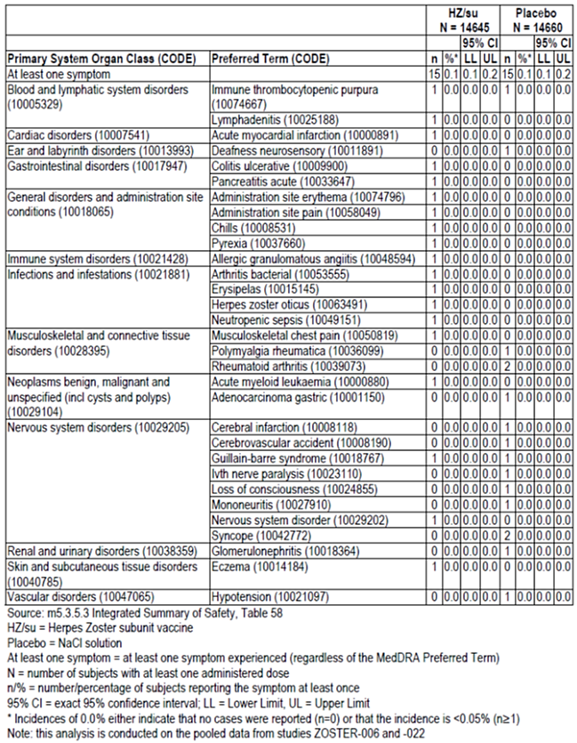

Broader safety pool
In the broader safety pool, there were 9 additional deaths (n = 643, 4.2%) and no major change in the preferred terms for the cause of death. In this population, the SAE rate was 12.8% (there were 100 additional subjects with an SAE). The pattern of SAEs was similar to the main safety pool. There were no additional treatment related SAEs in the HZ/su group.

Other studies
In EXPLO-CRD-004 there were no fatal SAEs and no vaccine related SAEs.
In ZOSTER-003 there were two deaths (drowning and bronchial carcinoma) unrelated to study vaccine. There were 19 non-fatal SAEs in 16 patients with none deemed vaccine related. There were two subjects with HZ-like rash symptoms reported after one dose of vaccine (25 µg gE/AS01B), one of which was felt to be vaccine related. In the extension studies, no SAEs were considered treatment related. In these extension studies, there were 4 subjects with clinically diagnosed HZ one of which was in the HZ/su group.
In ZOSTER-010, there were 40 SAEs in 27 subjects to Month 14 and none were considered vaccine related. There were three deaths, two from a myocardial infarction (one the HZ/su group and one in the gE/saline group) and one from cardiac failure in the gE/saline group. There was one case of suspected HZ in the gE/saline group which was not considered HZ by a dermatologist. No immune mediated diseases were reported.
There were two deaths in Study ZOSTER-026 (cerebral haemorrhage and cardiovascular disorder). Neither of these, nor any of the SAEs, was considered treatment related. One subject died in ZOSTER-007 from an acute MI. There were 29 subjects with an SAE, none of which was considered treatment related. There were 4 subjects with a pIMD of which three were considered treatment related (raynaud’s, polymyalgia rheumatica and rheumatoid arthritis). There was one case of HZ reported.
In ZOSTER-023, there were 3 SAEs (two in the SC and one in the IM group) none of which were vaccine related. There were no cases of pIMDs. In ZOSTER-032 there were no deaths and three non-treatment related SAEs.
In ZOSTER-004 the number of SAEs was similar between the co-administration and control groups. The most frequent AEs were coronary artery disease, pneumonia, cerebrovascular accident and osteoarthritis. There were 8 deaths, 3 in the co-administration and 5 in the control group. No cases were deemed treatment related.

Discontinuations due to adverse events

Main safety pool
Up to 1 month post Dose 2 of vaccine, the withdrawal rate due to a non-serious AE was 0.42% and 0.12%, and due to an SAE was 0.37% and 0.33% in the HZ/su and placebo groups, respectively (Table 43). During the whole follow up period the withdrawal rate due to non-serious AEs was 0.5% versus 0.2% and due to an SAE was 4.7% versus 4.9%.
Comment: The higher rate of withdrawal for non-serious AEs in HZ/su group could possibly be due to its reactogenicity. A summary of the type of adverse events leading to premature discontinuation was, however, not provided in the CSRs for the pivotal trials, nor in the Summary of Clinical Safety. The sponsor has been asked to provide this information.

Table 43: Main and broader safety pooling analysis: Number of subjects vaccinated and withdrawn due to an (S)AE before Month 3 visit (Total Vaccinated Cohort)
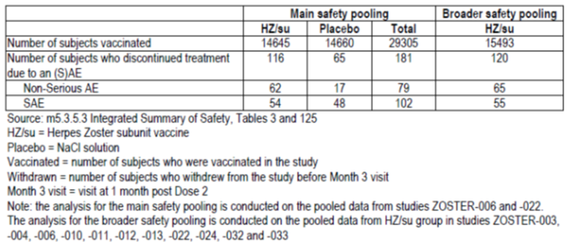

Broader safety pool
There were a further four subjects withdrawn from the broader safety pool due to an AE three of which were non-serious and one was serious.

Other studies
In EXPLO-CRD-004, there were no premature discontinuations due to an AE. In ZOSTER-003, there were three premature discontinuations due to an AE, one a fatal drowning and one from nausea in the gE1001B group and one from generalised weakness in the HZ/su group.
In ZOSTER-010 to month three, four subjects prematurely discontinued due to an AE: one death due to an MI; one with an upper GI haemorrhage; and two who had vaccine related events (malaise [gE/AS01B group] and injection site redness [gE/AS01E group]).
In ZOSTER-026, there were six premature discontinuations due to an SAE (cerebral haemorrhage, cardiovascular disorder, two colon cancers and two prostate cancers). In ZOSTER-007 there were 7 subjects who discontinued prematurely due to an AE. Three were considered vaccine related: rash, pressure-like sensation of swelling on left side of face and another of facial swelling.
There were no premature discontinuations due to an AE in ZOSTER-032. In ZOSTER-004, there was one AE of shivering post HZ/su vaccine that was treatment related and led to discontinuation.

Post-hoc analysis of excluded site
In ZOSTER-006 and ZOSTER-022, data from a site in Mexico was excluded from analysis due to issues of GCP non-compliance. The site enrolled 1,536 subjects with 768 in each treatment group. A post-hoc safety data analysis was undertaken of this excluded group. There were 70 subjects with SAEs (9.1% in each group) and the death rate was 7.4% and 6.4% in the HZ/su and placebo groups, respectively. Compared to the main safety pool, the SAE rate at the Mexican site was not higher (main safety pool SAE rate of approximately 13%), while the fatal SAE rate was slightly higher (main safety pool death rate of 4.3% to 4.6%). The rate of pIMDs at this site was 0.3% and 0.4%, respectively, with none deemed treatment related.

Evaluation of issues with possible regulatory impact

Potential Immune Mediated Diseases

Main safety pool
There were 179 (1.2%, 95% CI: 1.1 to 1.4) and 202 (1.4%, 95% CI: 1.2 to 1.6) subjects in the HZ/su and placebo groups, respectively, with a potential immune mediated disease (pIMD). The most frequent conditions were polymyalgia rheumatica (32 versus 29 subjects respectively), rheumatoid arthritis (20 versus 26 subjects), psoriasis (15 versus 18 subjects) and autoimmune thyroiditis (13 versus 10 subjects). The rate of pIMDs with an onset from the first vaccination to 30 days post last vaccination was 0.2% in each group, and in the period up to 1 year post last vaccination was 0.6% and 0.7%, respectively. The remainder (about half the cases of pIMDs in each group) had an onset over 1 year post vaccination.
Treatment related pIMDs were reported in 0.1% of each treatment group. There were no notable differences in the rate of pIMDs by age group (1.2% versus 1.4% in 50 to 69 years of age and 1.3% in both groups in ≥ 70 years of age).
Comment: There was no evident imbalance in the occurrence of pIMDs between the vaccine and placebo groups.

Broader safety pool
In the broader safety pool, the rate of pIMDs during the whole follow up period was 1.2%. There were five additional subjects with a pIMD and none were considered treatment related.

Hypersensitivity

Main safety pool
Using the SMQ ‘hypersensitivity narrow’, the rate of such AEs was 2.6% and 2.4% in the HZ/su and placebo groups, respectively, and the rate per dose was 1.4% and 1.3%. The most frequent preferred terms were rash, injection site rash, eczema, urticaria and dermatitis. Using the SMQ ‘anaphylactic reaction narrow’ in the 30 day post vaccination period, there was a single case identified in the HZ/su group. This occurred after Dose 1 and was graded level 1. The subject had site pain, pyrexia, fatigue, injection site redness, chills, nausea and disorientation and recovered by Day 3 without treatment.

Broader safety pool
The rate of ‘hypersensitivity’ SMQ was 2.5% and was reported after 1.4% of doses. There were no additional anaphylaxis cases in the broader safety pool.

Other studies
No cases of anaphylaxis were identified.

Laboratory tests
Laboratory assessments were undertaken in EXPLO-CRD-004, ZOSTER-003, ZOSTER-010 and ZOSTER-023. There were no evident safety signals reported.

Vital signs and clinical examination findings
There was no routine vital sign measurement during the studies apart from body temperature which was ascertained prior to each vaccination. Clinical examination was performed at study entry if indicated from the medical history. Clinically significant abnormalities during the study were reported as AEs as appropriate.

Other safety issues

Safety in special populations

Immunocompromised
Studies ZOSTER-001 and ZOSTER-015 assessed the vaccine in adults ≥ 18 years of age who had received an autologous HCT and or who had HIV infection, respectively. In ZOSTER-001, vaccine was tolerated with no evident safety signals apart from an increase in symptoms following 3 doses compared to two doses. There were 9 deaths, 7 from underlying malignancy and two of unknown cause. Of the 33 subjects with an SAE, one (pneumonia in HZ/su group) was considered treatment related. There were no pIMDs and two cases of suspected HZ.
In HIV infected adults, three doses of vaccine (0, 2, 6 months) were tolerated. There were no deaths and there were six (8.1%) SAEs in the HZ/su and 2 (4.1%) in the placebo group. There was one withdrawal in HZ/su group from portal hypertension and oesophageal varices haemorrhage. There were no pIMDs and one case of HZ in the HZ/su group. The study was put on hold once to review 4 cases of protocol-defined worsening of the underlying HIV. The study was continued when the review committee found no particular safety concern.
Comment: The clinical development program in this indication is ongoing and this indication does not form part of this application.
The sponsor reported in the Clinical Overview that the IDMCs overseeing the three ongoing studies in this indication have not reported any safety concerns.

Previous HZ
In the open label, non-randomised Study ZOSTER-033, 77.9% of subjects with a history of HZ reported solicited local symptoms and 71.6% reported solicited general symptoms. Grade 3 pain was reported following 4.4% of doses by 8.4% of subjects and Grade 3 fatigue following 6.1% of doses by 10.5% of subjects. There were no evident safety signals.

Japanese ethnicity
In the small Phase I Study ZOSTER-023 in adults with Japanese ethnic origin, the vaccine was tolerated however the numbers were too small to draw conclusions (10 subjects aged 50 to 69 years).

Younger adults
Data on younger adults aged 18 to 30 are available from the two early Phase studies EXPLO-CRD-004 and ZOSTER-023. There were no evident safety signals from these small studies.

Pregnancy and lactation
There are no data on the use of vaccine in pregnant or lactating women.

Safety related to drug-drug interactions and other interactions
In Study ZOSTER-004, co-administration of HZ/su with FLU-D-QIV was assessed. The rate per dose of solicited local symptoms was higher in the group that received co-administered vaccine compared the control group who received vaccine doses alone (77.1% versus 57.4%). In particular, there was a higher rate of pain (73.6% versus 54.2%) and Grade 3 pain (8.4% versus 4.4%). Solicited general symptoms were also more frequent in the co-administered group (62.5% versus 49.7% overall per dose). There were no notable differences in the rate of unsolicited AEs following each vaccine dose (15.5% versus 17.0%).

Post marketing experience
None.

Evaluator’s overall conclusions on clinical safety
The total exposure to HZ/su in the studies included in the dossier was 17,204 subjects. The main safety pool, which contained data from the two pivotal Phase III studies, included 14,745 adults ≥ 50 years of age who received at least one dose of HZ/su vaccine. Of these, approximately 95% received two doses of vaccine. The mean follow up period was 3 years.
The HZ/su vaccine was reactogenic with a high rate (overall rate per dose) of local symptoms of pain (68%), redness (38%) and swelling (26%) as well as of general symptoms of myalgia (33%), fatigue (32%) and headache (26%). Other common symptoms were GI disorders (nausea, vomiting, diarrhoea and/or abdominal pain) (10.7%), shivering (17.6%) and fever (12.8%).
Most reactions were Grade 1 or 2 and symptoms tended to last less than 4 days. Severe, Grade 3, local symptoms were reported in ≤ 6.4% of subjects (pain being the most frequent) and Grade 3 general symptoms in ≤ 5.3% (fatigue and myalgia the most frequent). It was noted that the rate of Grade 3 general symptoms increased with the second dose of HZ/su (5.7% to 8.0%).
The safety data indicate that local and general solicited symptoms rate tends to be higher in 50 to 69 years of age group than the ≥ 70 years of age subjects.
The death rate in the study was comparable between HZ/su and placebo groups (4.3% versus 4.6%) and rates were also similar in the two age groups (50 to 69 and ≥ 70 years of age). Only one death was deemed treatment related by an investigator (neutropaenic sepsis in a 90 year old subject with AML diagnosed 75 days post vaccination). The sponsor has been asked to comment on any other such malignancies.
The rate of SAEs (fatal and non-fatal) was similar between groups in the main safety pool (12.8% versus 13.3%, RR = 0.97 [95% CI: 0.91 to 1.03] unadjusted p = 0.316) and there were no evident safety signals. Rates were similar between treatment groups in the two main age groups.
In the briefing document to the Vaccines and Related Products Advisory Committee of the FDA (13 September 2017 meeting) imbalances in a number of conditions were noted including optic ischaemic neuropathy, temporal arteritis, amyotrophic lateral sclerosis, osteonecrosis and convulsions. It was also noted in the EU regulatory evaluation that the sponsor has been asked to comment on whether the adjuvanted vaccine has shown any evidence of impact on the immune system that may increase the risk of infections or malignancy. Apart from the finding on ovarian cancer (0.05% versus 0%), there were no evident signals on SAE rates. Nonetheless, further discussion on these points from the sponsor has been requested.
Data on medically attended visits were stated to have been collected to Month 8; however pooled data on associated adverse events could not be located. The sponsor has been asked to discuss these events and comment on any imbalances between the treatment groups.
During the whole follow up period the withdrawal rate due to non-serious AEs was 0.5% versus 0.2% and due to an SAE was 4.7% versus 4.9%. There was a slightly higher withdrawal rate for non-serious AEs in the period up to one month post the second vaccine dose (0.4% versus 0.1%). This may be due to the vaccine’s reactogenicity. The sponsor has been asked to comment on the type of adverse events leading to premature discontinuation.
There were no notable differences between the HZ/su and placebo groups in the rates of pIMDs in the main safety pool (1.2% versus 1.4%) and about half the events were reported over one year post vaccination. Such events are rare and despite the sample size of about 15,000 there may be insufficient data to adequately detect such a risk. Pharmacovigilance surveillance will therefore be crucial.
There was one report of ‘anaphylaxis’ which did not require treatment and no increased rate of hypersensitivity reactions. There were also no clinically relevant changes in laboratory parameters in the studies where these were assessed.
In the small number of adults with history of HZ, the vaccine was tolerated with no evident safety concerns although there was no control group in the study. The product development in the immunocompromised population is ongoing and to date in the limited population of autologous HCT recipients and HIV infected subjects no safety concerns were evident. Background medical history was not discussed and, while subjects with immunosuppression were excluded, the safety in elderly patients with pre-existing immune mediated disorders should be further outlined.
There are no data in pregnant or lactating women and data in adults under 50 years of age are limited. There are no data as yet on the need for or safety of a booster dose of vaccine.
HZ/su given with quadrivalent seasonal influenza vaccine increased local and general solicited symptom rates and it is recommended that this is noted in the PI.
Subcutaneous vaccination leads to an increased rate of local reactions and should not be undertaken.

First round benefit-risk assessment

First round assessment of benefits

Table 44: First round assessment of benefits
Benefits | Strengths and Uncertainties
High efficacy against HZ in adults ≥ 50 yrs:  - VE of 97.2% (95% CI: 93.7-99.0%). | Strong and robust evidence from a well-designed and powered study with a clear, well documented endpoint. Results were consistent across subgroups and sensitivity analyses.
High efficacy against HZ in adults ≥ 70 yrs:  - VE of 91.3% (95% CI: 86.9-94.5%) | Strong and robust evidence from well designed and powered studies with a clear, well documented endpoint. This was the primary prespecified endpoint of the pooled study analysis and was supported by results in the two individual studies.
High vaccine efficacy against HZ across all age groups (50 to 59, 60 to 69, 70 to 79 and ≥ 80 years of age). | The secondary endpoint data were consistent and supported by the pooled data for the ≥ 70 years of age group which improved the power of results.
High vaccine efficacy against PHN:  - ≥ 50 years of age: 100% (95% CI: 77.1 to 100.0%)  - ≥ 70 years of age: 88.8% (95% CI: 68.7 to 97.1%) | Study ZOSTER-006 in ≥ 50 years of age subjects was not powered for the PHN secondary endpoint, however in the ≥ 70 years of age group PHN was the primary endpoint in the pooled analysis and this result is robust.
No major safety signals | The safety dataset included a broad population of 17,000 exposed subjects with a median follow up time of at least 3 years. From this there was no increased risk of death, SAEs or pIMDs.
Non-live vaccine | There is a potential benefit to patients who cannot be given live vaccination. Initial data in the immunocompromised population appear positive but development is still ongoing.

First round assessment of risks

Table 45: First round assessment of risks
Risks | Strengths and Uncertainties
Notable increase in risk of solicited local and systemic symptoms in the week post vaccination | Robust safety data obtained from the two pooled placebo controlled studies with thorough safety data collection. The diary card subset included 9,764 subjects.
Some increase in reactogenicity (mainly Grade 3 systemic events) with the second dose of vaccine which may lead to decreased compliance with second dose. | Robust safety data obtained from the placebo controlled studies with thorough safety data collection. Effects on compliance are unknown.
Reactogenicity higher in adults aged 50 to 69 compared to those over 70 years. | Robust safety data obtained from the placebo controlled studies with thorough safety data collection. Resultant effects on compliance are unknown.
No immunological correlates of protection. | Supportive studies were based on immunological endpoints. Drawing conclusions on resultant efficacy is therefore difficult, particularly for humoral immunity endpoints. This is relevant for data on a dosing schedule other than 0,2 months.
No data on long term (> 4 years) protection and the need for booster dose has not been determined. | Pivotal studies provided efficacy data to 4 years. There are no data at present on the need for booster dosing. Long term follow up is planned for ZOSTER-006, ZOSTER-022 and ZOSTER-003.
Risk of very rare events is not currently quantifiable | Detection of rare events was limited by the dataset size to 1/17,000.
Unknown risks in those with pre-existing immune conditions | Limited data at present in immunocompromised subjects who were excluded from the pivotal studies. The non-live vaccine has a clear clinical place if safe and efficacious in this population.

First round assessment of benefit-risk balance
Herpes zoster and its complications, in particular post herpetic neuralgia, can cause considerable morbidity and current treatment with antiviral therapy is not curative. Consequently, there is a clear clinical place for an efficacious vaccine which can prevent these conditions.
The proposed vaccine, Shingrix, demonstrated in the pivotal studies a high efficacy against herpes zoster of about 97% in adults 50 years and older and importantly a high efficacy of about 91% in those aged 70 years and older. The currently available zoster vaccine, Zostavax, has a lower reported efficacy particularly in those aged ≥ 70 years who may be most at risk. While there are no head-to-head comparisons, the efficacy results in this dossier for Shingrix are compelling.
Although the study was not powered for this endpoint, Shingrix demonstrated efficacy against post herpetic neuralgia of 100% in those aged ≥ 50 years of age. From pre-specified pooled data analysis, the efficacy against PHN in those aged 70 years and older was robustly demonstrated at approximately 88%. In adults 50 years and over, the efficacy against PHN in those with confirmed HZ was not demonstrated (VE of 0.29%) and, while this may be a result of the very small sample size leading to inadequate power, it is recommended that this potential risk be monitored post-marketing. As there was no decreased risk of PHN in those with confirmed HZ, it is concluded that the vaccine efficacy in preventing PHN is very likely due the effect against HZ.
The vaccine was noted to have high reactogenicity with local injection site reactions and general symptoms such fatigue, headache and myalgia. It is possible that in the clinical practice setting, this reactogenicity could interfere with second dose compliance. As the reactions subsided in a couple of days and are to some extent treatable, it is anticipated that this risk should be manageable. It is recommended that the vaccine’s reactogenicity be further outlined in the PI.
There were no major safety concerns although the database size of some 15,000 recipients limits its ability to detect very rare conditions. The risk of hypersensitivity is consistent with other vaccines. There was no increased rate of potential immune mediated disorders after a median safety follow period of about 3 years that should be sufficient to capture events. Nevertheless pharmacovigilance surveillance of such conditions will be important.
The background morbidity of the trial population was not discussed and so has been questioned. This will be necessary to ensure the trial population represents the elderly population in Australia who would receive the vaccine and to determine if there are any safety data on subjects with immune mediated disorders. The vaccine has high immunogenicity and this might impact on the elderly population with pIMDs. This should be discussed and consideration given to conducting further efficacy and safety studies in this population. In the interim, it is recommended to include precautionary wording in the PI and implement pharmacovigilance monitoring.
The product development in the immunocompromised population is ongoing and to date in the limited population of autologous HCT recipients and HIV infected subjects no safety concerns were evident. Zostavax is a live attenuated vaccine and so is contraindicated in immunocompromised patients. Should favourable efficacy and safety data become available, Shingrix, being a non-live vaccine will have an obvious clinical place for immunocompromised subjects.
There are several areas where data are limited or lacking. These include:
- the effect of giving the vaccine to VZV naïve adults
- data on immunological correlates of protection
- co-administration with pneumococcal vaccine and co-administration with other adjuvanted vaccines
- ability to give to adults who have received Zostavax
- the duration of protection beyond 4 to 6 years and the need for booster vaccination
- evidence in the immunocompromised population.
These issues have been covered by conduct of further studies, appropriate wording in the PI or questions (see below).
In summary, an efficacious and safe vaccine against HZ and PHN has an evident clinical place for morbidity prevention. Shingrix was found to have high efficacy against herpes zoster, and consequently its complication of post herpetic neuralgia, across the adult population aged 50 years and older. The vaccine was notably reactogenic, however such effects should be manageable and there were no evident major safety signals or concerns in the data presented.
The vaccination schedule assessed in the efficacy trials was 0,2 months. Based on the findings of an immunogenicity study, it has been proposed to allow the period between doses to extend to 6 months. This recommendation was based on humoral immunogenicity data rather than the more relevant cell mediated immune responses. As there are no correlates of protection nor specific efficacy data on the 0,6 month schedule, the evaluator does not endorse a schedule other than 0,2 months.
The proposed indication includes the prevention of HZ-related complications other than PHN. The data on complications other than PHN were very limited and based on post-hoc analyses. As such, the evaluator does not support its inclusion in the indication.
Hence, the benefit-risk balance of Shingrix is unfavourable for the proposed usage, but would become favourable if the changes recommended are adopted and the questions are satisfactorily answered.

First round recommendation regarding authorisation
Approval of Shingrix is not recommended for the following proposed indication:
Shingrix is indicated for the prevention of herpes zoster (HZ) and HZ-related complications, such as post-herpetic neuralgia (PHN), in adults 50 years of age or older.
Approval is recommended for a revised indication which removes HZ-related complications other than PHN. A suggestion is as follows:
Shingrix is indicated for the prevention of herpes zoster and post-herpetic neuralgia in adults 50 years of age or older.
This recommendation is subject to satisfactory responses to the questions and the comments on the draft PI and CMI

Clinical questions

Pharmacokinetics
Not applicable.

Pharmacodynamics
No questions.

Efficacy
- In ZOSTER-006 and ZOSTER-022 there were issues with serious GCP non-compliance at one site in Mexico and the subjects were removed from efficacy analysis. Was a sensitivity efficacy analysis conducted which included these subjects? Please discuss the impact of removing these subjects from the efficacy results.
- In the pivotal studies ZOSTER-006 and ZOSTER-022, it was not clear how multiplicity was controlled in analysis of secondary endpoints. Also, the impact of futility analyses during the course of the two studies was not outlined. Please discuss these points.
- Baseline medical conditions were not described in the clinical study reports for either ZOSTER-006 or ZOSTER-022. Please discuss these and address comparability between treatment groups and any possible differences in conditions which may predispose to HZ such as immune mediated conditions. Please also discuss the comparability of the trial population to the target Australian population.
- There were very few breakthrough cases of HZ in HZ/su vaccinated subjects in ZOSTER-006 and ZOSTER-022. Were there any features in these subjects such as baseline conditions or immunological results that could have explained the breakthrough?
- In studies ZOSTER-006 and ZOSTER-002, the objective for PHN efficacy stated that VE of HZ/su against PHN in subjects ≥ 50 years of age was demonstrated if the LL of the two-sided 95% CI of VE was above 0%. Please explain why an efficacy level above 0% was chosen.
- From pooled data analysis, please discuss the change, if any, of HZ and PHN vaccine efficacy over time.
- From pooled data, please comment on the incidence of PHN and the impact on vaccine efficacy against PHN if a different definition of pain duration was used (rather than 90 days).
- In ZOSTER-026, it was stated that humoral immunogenicity results supported a vaccine dosing interval of 2 months that could be extended to 6 months, while a 12 month interval was not recommended. As there are currently no correlates between humoral immunogenicity data and vaccine efficacy, such a conclusion is questionable. Please discuss.
- Are there any data on correlates of protection from analysis of ZOSTER-006 and ZOSTER-022? If so, please discuss these and how it relates to immunogenicity results from other studies.
- If available, please discuss efficacy of the vaccine if given to VZV naïve adults.

Safety
- In ZOSTER-010, reactogenicity was higher the younger age groups (50 to 69) than older adults who received gE/AS01B vaccine. Please discuss whether a lower adjuvant dose was considered for younger adults.
- Data on medically attended visits were stated to have been collected to Month 8 in ZOSTER-006 and ZOSTER-022 however no pooled data on the associated adverse events could be located. Please discuss these data, and any other AE data to one year post vaccination, and comment on any imbalances between the treatment groups.
- For ZOSTER-006 and ZOSTER-022, a summary of the AEs and SAEs leading to premature discontinuation was not provided in the clinical study reports or in the Summary of Clinical Safety. Please summarise, including frequencies, and discuss the type of adverse events leading to premature discontinuation in these two studies.
- There was one death deemed treatment related by an investigator (neutropaenic sepsis in a 90 year old subject with AML diagnosed 75 days post vaccination). Please discuss any other cases with similar malignancies and comment on possible relatedness to vaccine administration.
- Please discuss in more detail the rates of infection and neoplasm and comment on whether the adjuvanted vaccine may have any impact on the development of such conditions.
- The FDA briefing document for the Vaccines and Related Products Advisory Committee (September 2017 meeting) noted imbalances in a number of conditions including optic ischaemic neuropathy, temporal arteritis, amyotrophic lateral sclerosis, osteonecrosis and convulsions. Please discuss the relevant data.
- Immunosuppression or immunodeficient conditions were exclusion criteria in the pivotal studies however baseline medical conditions were not discussed. Please discuss any available safety data in adults with a pre-existing immune mediated disorder. Please also discuss whether the use of such an immunogenic vaccine may result in an increased safety risk in the population with these conditions. Please also discuss if further clinical trials are planned in an elderly population with pIMDs.
- If available, please discuss safety of the vaccine if given to VZV naïve adults. If no data are available please discuss any plans for assessment in this population.

Second round evaluation of clinical data submitted in response to questions

Efficacy questions
- In ZOSTER-006 and ZOSTER-022 there were issues with serious GCP non-compliance at one site in Mexico and the subjects were removed from efficacy analysis. Was a sensitivity efficacy analysis conducted which included these subjects? Please discuss the impact of removing these subjects from the efficacy results.
Sponsor’s response:
Due to the aforementioned GCP issues, and considering that the impacted subjects were not properly covered by the Informed Consent, samples from those excluded subjects were destroyed in accordance with ICH-GCP E6 and GSK internal SOP 9*14074 and therefore it is not possible to perform sensitivity analysis and evaluate the possible impact on vaccine efficacy results.
However, since high vaccine efficacy is observed in all regions, it is extremely improbable that results from this site would be different. In addition, since the impacted data represents only 5% of the study sample size, it is improbable that inclusion or exclusion of these data would have significantly impacted the overall results.
Evaluator’s comments: The evaluator accepts the explanation.
- In the pivotal studies ZOSTER-006 and ZOSTER-022, it was not clear how multiplicity was controlled in analysis of secondary endpoints. Also, the impact of futility analyses during the course of the two studies was not outlined. Please discuss these points.
Sponsor’s response:
The statistical testing for each study was to proceed sequentially using an order for the gatekeeping families defined prospectively. The overall type 1-error of 5% two-sided could only be fully controlled for those objectives that were mentioned sequentially in the gatekeeping strategy. If a gatekeeping family failed to be demonstrated, the remaining planned tests were to be performed, but the type-1 error of the following families might not be fully controlled (see Table 19 and Figure 7).
Due to the very high VE for HZ in subjects ≥ 50 years of age (ZOSTER-006) and in subjects ≥ 70 years of age (ZOSTER-022), the power for analysis of the secondary objectives listed below was estimated to be very small (due to the very low number of confirmed HZ episodes in the vaccine [HZ/su] group). Therefore the following objectives were assessed without controlling for multiplicity.
ZOSTER-006:
- To evaluate VE in reducing the total duration of severe ‘worst’ HZ associated pain over the entire pain reporting period compared to placebo in subjects ≥ 50 years of age and in subjects within each of the following age ranges: 50 to 59 years of age, 60 to 69 years of age and ≥ 70 years of age, with confirmed HZ;
- To evaluate VE in the reduction in incidence of HZ associated complications compared to placebo in subjects ≥ 50 years of age and in subjects within each of the following age ranges: 50 to 59 years of age, 60 to 69 years of age and ≥ 70 years of age, with confirmed HZ;
- To evaluate VE in the reduction in use of pain medications compared to placebo in subjects ≥ 50 years of age and in subjects within each of the following age ranges: 50 to 59 years of age, 60 to 69 years of age and ≥ 70 years of age, with confirmed HZ.
ZOSTER-022:
- To evaluate VE in reducing the total duration of severe ‘worst’ HZ associated pain over the entire pain reporting period compared to placebo in subjects ≥ 70 years of age, with confirmed HZ;
- To evaluate VE in the reduction in incidence of HZ associated complications compared to placebo in subjects ≥ 70 years of age, with confirmed HZ;
- To evaluate VE in the reduction in use of pain medications compared to placebo in subjects ≥ 70 years of age, with confirmed HZ.
One futility analysis was performed in ZOSTER-006 and none in ZOSTER-022. A predictive power of 10% was selected as the threshold below which the ZOSTER-006 study would be declared futile. The calculated predictive power was greater than the futility boundary and so the study was deemed not futile by the IDMC. The alpha for this interim analysis was set as very small (0.0001%) with the final analysis alpha at 4.9998%.
Evaluator’s comments:
The explanation on the use of sequential testing to control multiplicity is satisfactory. Secondary endpoints in the pooled analysis, apart from VE against PHN in subjects ≥ 50 years of age, can only be viewed as descriptive. The draft PI has a paragraph on HZ-related complications other than PHN and at request has now including wording that it is a post-hoc analysis. The other secondary endpoint data in the draft PI relate to use of pain medication and comments on these data are covered in the response to PI questions (not presented as they are beyond the scope of the AusPAR).
The impact of the single futility analysis was minimal.
- Baseline medical conditions were not described in the clinical study reports for either ZOSTER-006 or ZOSTER-022. Please discuss these and address comparability between treatment groups and any possible differences in conditions which may predispose to HZ such as immune mediated conditions. Please also discuss the comparability of the trial population to the target Australian population.
Sponsor’s response:
The Applicant has not performed any comparative analyses of pre-existing medical conditions and baseline medications. Such comparative analyses are therefore not included in the study reports for ZOSTER-006 and ZOSTER-022 or in the Integrated Summary of Safety (ISS).
Following request, analysis of current (at time of study entry) chronic medical conditions was undertaken for both studies ZOSTER-006 and ZOSTER-022 and in the pooled dataset. The occurrence of pre-existing medical conditions in ≥ 2% of subjects at baseline was similar for subjects receiving the HZ/su vaccine and subjects receiving the placebo in ZOSTER-006 and ZOSTER-022.
In conclusion, the tabulated data indicate that the prevalence of baseline pre-existing conditions was similar between the HZ/su and Placebo groups.
Post-hoc vaccine efficacy analysis was undertaken in subgroups of the 15 main baseline conditions in the pooled -ZOSTER-006 and -ZOSTER-022 data (Table 46). Vaccine efficacy was high across disease subgroups (> 84%) although there were small numbers in the chronic renal disease/renal impairment subgroup.

Table 46: Vaccine efficacy: First or only episode of HZ during the entire study period by baseline condition using Poisson method (modified Total Vaccinated Cohort, subjects ≥ 50 years of age -POOLED ZOSTER-006/ ZOSTER-022)
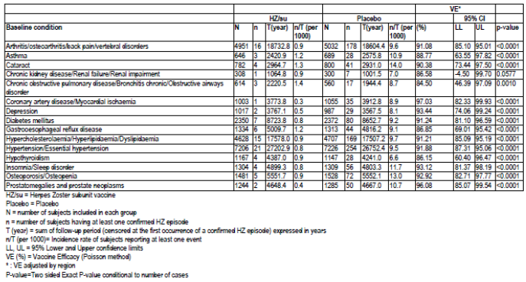
An analysis of subjects with pIMDs on medical history was undertaken (see Safety Question 7). The most frequent conditions were psoriasis (21.9% versus 24.9% in the HZ/su and placebo groups, respectively), spondyloarthropathy (11.1% versus 9.3%) and rheumatoid arthritis (9.8% in both groups). Of these subjects, 2.8% in both groups had a possible exacerbation of pre-existing pIMD and 1.6% versus 2.4% had a new onset of a different pIMD during the post vaccination period.
Studies ZOSTER-006 and ZOSTER-022 enrolled 418 and 309 subjects in Australia, respectively. Baseline medication conditions (hypertension, hypercholestemia, diabetes, osteoarthritis) were reported to be similar to that seen in older Australian adults.
Evaluator’s comments:
There were no evident differences in baseline medical conditions between treatment groups. In post-hoc analyses, efficacy was maintained in these main medical condition subgroups. There were also no evident differences between groups in the occurrence of pIMD exacerbation or onset of new pIMD in subjects with a history of a pIMD. The evaluator accepts that the population studied is likely to be reflective of the target Australian population.
- There were very few breakthrough cases of HZ in HZ/su vaccinated subjects in ZOSTER-006 and ZOSTER-022. Were there any features in these subjects such as baseline conditions or immunological results that could have explained the breakthrough?
Sponsor’s response:
In ZOSTER-006, there were 9 HZ breakthrough cases in the HZ/su group during the entire study period in adults ≥ 50 years of age of the mTVC. Narratives of the cases were provided. The HZ cases seem to be of mild intensity as compared to placebo recipients based on medical review of data. For none of these cases were HZ-related complications reported.
In ZOSTER-022, there were 23 HZ breakthrough cases in the HZ/su group during the entire study period in adults ≥ 70 years of age of the mTVC. Five of these cases were associated with HZ-related complications, including 4 cases of postherpetic neuralgia (PHN) and one case with an ophthalmic complication (blurred vision).
The sponsor stated that: Further assessment of the medical profile showed that there was no specific common denominator to explain these breakthrough cases in the HZ/su group.
The anti-gE Ab concentrations measured by ELISA at Months 0 and 3 for the HZ breakthrough cases were provided. The sponsor stated that: These immunogenicity data indicate that all subjects with HZ breakthrough cases were seropositive at baseline (that is, anti-gE concentration > cut-off value of 97 mIU/mL). The anti-gE Ab humoral immune response to HZ/su at Month 3 was overall high in both studies (overall GMC of 52376.6 and 51048.0 in ZOSTER-006 and ZOSTER-022 respectively; refer to Summary of Clinical Efficacy Table 74). Three subjects did not respond to the vaccine (defined as a 4 fold increase of the gE-ELISA concentration from pre to post vaccination). The sponsor also noted that in the context of the Correlate-of-Protection analyses, it was shown that the baseline anti-gE ELISA concentration is a strong prognostic factor for HZ.
Evaluator’s comments:
There were no evident features, clinically or immunologically, in subjects with breakthrough HZ to explain the occurrence apart from three subjects who failed to respond to the vaccine.
- In studies ZOSTER-006 and ZOSTER-002, the objective for PHN efficacy stated that VE of HZ/su against PHN in subjects ≥ 50 years of age was demonstrated if the LL of the two-sided 95% CI of VE was above 0%. Please explain why an efficacy level above 0% was chosen.
Sponsor’s response:
The criteria levels for each objective have been set up on the importance of the objective but also on rate of occurrence of the events (which has a direct impact on the width of the confidence interval). For instance, HZ events are more common than PHN events and therefore confidence interval for PHN VE are expected to be larger than the corresponding confidence interval for HZ VE.
Therefore:
- Criteria for primary objective HZ VE in ZOSTER-006 study was set to 25% (Total HZ cases expected 196 and VE expected was 68%)
- Criteria for primary objective HZ VE in ZOSTER-022 study was set to 10% (Total HZ cases expected 278 and VE expected was 53%)
- Criteria for primary objective PHN VE in Pooled ZOSTER-006 and ZOSTER-022 study was set to 0% (Total PHN cases expected 88 and VE expected was 71%)
Evaluator’s comments:
The explanation is satisfactory.
- From pooled data analysis, please discuss the change, if any, of HZ and PHN vaccine efficacy over time.
Sponsor’s response:
Pooled data from studies ZOSTER-006 and ZOSTER-022 was used to estimate vaccine efficacy over time in adults ≥ 70 years of age. Vaccine efficacy was 97.6%, 92.0%, 84.7% and 87.9% in years 1, 2, 3 and 4, respectively (Table 47). The sponsor stated that: While the study was not designed to assess VE over time, the point estimates and overlapping confidence intervals suggest no significant waning over the trial period.
The Applicant has not performed analyses to estimate vaccine efficacy against PHN over time, given the very limited number of PHN cases observed over the whole duration of the trial, particularly in the HZ/su group (4 PHN cases in the mTVC in adults ≥ 70 years of age), which precluded any meaningful analysis by respective years (over time).
Evaluator’s comments:
Data indicate HZ vaccine efficacy was maintained over 4 years. Change in efficacy against PHN could not be estimated due to small case numbers. The need for a booster vaccination is being investigated and data should be submitted when available.

Table 47: Vaccine efficacy: First or only episode of HZ during the entire study period by time using Poisson method (modified Total Vaccinated Cohort, subjects ≥70YOA -POOLED ZOSTER 006-022)
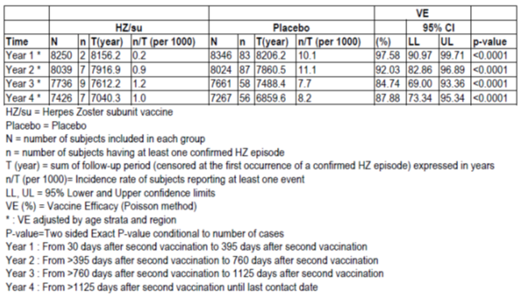
- From pooled data, please comment on the incidence of PHN and the impact on vaccine efficacy against PHN if a different definition of pain duration was used (rather than 90 days).
Sponsor’s response:
Pooled analyses according to alternative PHN definitions (based on duration of pain of ≥ 30, ≥ 60, ≥ 120 and ≥ 180 days, rather than 90 days) were performed for adults ≥ 70 years of age.
The estimated incidence of PHN according to different definitions in the placebo recipients were 2.9 (duration of pain of ≥ 30), 1.6 (duration of pain of ≥ 60), 0.7 (duration of pain of ≥ 120) and 0.5 (duration of pain of ≥ 180) per 1000 person-years in adults ≥ 70 years of age in the pooled analyses.
The point estimates for VE against PHN for the different alternative definitions were 93.25% (95% CI, 84.72% to 97.59%), 91.61% (95% CI, 77.08% to 97.80%), 95.41% (95% CI, 71.57% to 99.89%) and 100% (95% CI, 72% to 100%) in adults ≥ 70 years of age (pooled analyses), respectively.
Evaluator’s comments:
In adults ≥ 70 years of age, results for VE against PHN were consistent across the definitions of pain duration (30 days up to 180 days).
- In ZOSTER-026, it was stated that humoral immunogenicity results supported a vaccine dosing interval of 2 months that could be extended to 6 months, while a 12 month interval was not recommended. As there are currently no correlates between humoral immunogenicity data and vaccine efficacy, such a conclusion is questionable. Please discuss.
Sponsor’s response:
As discussed in the response to Question 9, the established correlation between vaccine induced anti-gE response 1 month post-Dose 2 and probability of protection against confirmed HZ provides confidence that an equivalent anti-gE antibody response observed in sufficiently similar conditions is a reasonable surrogate for protection.
Based on the information provided, the Applicant believes it is reasonable to expect that efficacy of HZ/su following a 0,6- month schedule is similar to the efficacy provided by the 0,2- month schedule (ZOSTER-006 and ZOSTER-022).
The sponsor also stated that the study groups (0, 6 month and 0, 2 month) in ZOSTER-026 had equivalent age distribution. It was also discussed that Flexibility of the HZ/su dosing schedule is considered important from a public health perspective; a flexible administration timeframe for the 2nd dose is expected to positively impact compliance with the second dose, which is believed to be important for inducing the most optimal protection against HZ, including long-term protection.
Evaluator’s comments:
Given the data presented in response to Efficacy Question 9 on correlates of protection, the evaluator accepts the sponsor’s argument for extending the timing of the second dose of vaccine to a maximum of 6 months. Therefore, suggested changes to the draft PI in relation to dose schedule do not need to be made.
- Are there any data on correlates of protection from analysis of ZOSTER-006 and ZOSTER-022? If so, please discuss these and how it relates to immunogenicity results from other studies.
Sponsor’s response:
The sponsor investigated the potential correlation between efficacy and the anti-gE antibody response 1 month post vaccination using a GSK-proprietary gE-ELISA assay, although it is unclear if this specific immune response is directly involved or not in protection against VZV reactivation. It was stated that the anti-gE antibody response measured by ELISA one month after the second vaccine dose has been correlated with 1) the anti-VZV neutralizing response and 2) the gE-specific CD4+ T-cell response at the same time point.
The sponsor presented the correlate of protection (CoP) analysis from studies ZOSTER-006 and ZOSTER-022. The statistical analysis report was included in the response. Anti-gE antibody concentrations one month after the second dose show a distinction between placebo and HZ/su groups as well as a trend for lower titres in the HZ cases. All subjects with HZ were seropositive at baseline and three subjects with HZ did not respond to the vaccine (< 4 fold increase in antibody concentrations).
Further assessment of CoP was undertaken according to Prentice criteria:
- Showing the treatment effect (Z) on the disease endpoint (T) (in this case: demonstrate that HZ/su reduces the incidence of HZ)
- Showing the treatment effect (Z) on surrogate endpoint (immune marker) (S) (in this case, demonstrate that HZ/su induces a specific anti-gE antibody response as compared to placebo)
- Showing that surrogate endpoint (S) correlates with disease endpoint (T) (in this case, demonstrate that the gE ELISA titre correlates with disease outcome that is confirmed HZ case)
- Showing that probability of disease (T) is independent of treatment status (Z), given the surrogate endpoint (S); that is that the full treatment effect is captured by the surrogate endpoint
Various analyses of these models were undertaken and the four criteria were met. Given the effect of age on HZ, the models were adjusted for age and baseline anti-gE ELIZA concentrations. Results show that one month post-Dose 2 anti-gE ELISA concentration is identified as a ‘specific’ correlate of protection for individuals > 50 years old (combination of the two studies).
Dunning regression was used to calculate the predicted probability of protection as a function of the biomarker concentration in case-cohort designs. This found, using data from the combined efficacy studies, that HZ VE could be predicted in subjects ≥ 50 years of age.
The sponsor also stated that: The correlate of protection identified in this analysis is an immune marker predictive of vaccine efficacy that may or may not be a mechanistic causal agent of protection.
Evaluator’s comments:
The presented data indicate a correlation between the gE ELISA antibody level and the protection against HZ in adults ≥ 50 years of age. As mentioned by the sponsor, the data presented can only be applied to the population studied and with this particular vaccine.
- If available, please discuss efficacy of the vaccine if given to VZV naïve adults.
Sponsor’s response:
In ZOSTER-006 and ZOSTER-022, less than 1% of subjects included in the humoral immuno-subset were VZV seronegative at baseline (measured by gE VZV ELISA), equally distributed in both arms.
Evaluator’s comments:
Data are not available to assess effects with the vaccine if given to VZV naïve adults.

Safety questions
- In ZOSTER-010, reactogenicity was higher the younger age groups (50 to 69) than older adults who received gE/AS01B vaccine. Please discuss whether a lower adjuvant dose was considered for younger adults.
Sponsor’s response:
The formulation gE/AS01B was selected because of the reasonable balance between maximizing immune response while maintaining a reasonable reactogenicity profile. Both gE/AS01B and gE/AS01E were more reactogenic in the 50 to 69 years of age group compared to the older subjects, and the difference between the two adjuvants within this age group was considered clinically similar.
The company has not generated long-term persistence data with both adjuvants. Nevertheless, the fact that the post vaccination levels are higher with gE/AS01B than gE/AS01E, in combination with the observation that the waning of immunogenicity is dependent on the initial post vaccination level suggests it can be reasonably assumed that gE/AS01B will provide longer lasting immune response and therefore protection.
The HZ/su vaccine formulation (50 µg of gE antigen combined with AS01B adjuvant) was considered having the best benefit-risk profile for all age groups, considering
- the increased immune response 1 month post Dose 2 of gE/AS01B as compared to gE/AS01E in Study ZOSTER-010,
- the expected higher long-term persistence of immunity with gE/AS01B than with a lower adjuvant dose, as suggested by Study ZOSTER-024 and the derived 10-year modelling data, and
- the fact that both adjuvanted formulations showed an overall acceptable reactogenicity (and safety) profile.
Evaluator’s comments:
The evaluator accepts the explanation.
- Data on medically attended visits were stated to have been collected to Month 8 in ZOSTER-006 and ZOSTER-022 however no pooled data on the associated adverse events could be located. Please discuss these data, and any other AE data to one year post vaccination, and comment on any imbalances between the treatment groups.
Sponsor’s response:
The rate of unsolicited AEs with a medically attended visit up to Month 8 post first vaccine dose was 39.8% and 40.8% in the HZ/su and placebo groups, respectively (RR = 0.98 [95% CI: INF to 0.98], unadjusted p-value = 0.192). By SOC, general disorders and administrative site conditions were higher in the HZ/su group (3.1% versus 2.3%, p < 0.0001) and hepatobiliary disorders higher in the placebo group (0.4% versus 0.6%). There were ten unsolicited AEs with a medically attended visit to Month 8 that were significantly more frequent with HZ/su (injection site erythema, injection site pain, injection site swelling, pyrexia, wound infection, respiratory tract infection, injection site cellulitis, chest injury, headache and chills). There were also ten AEs significantly more frequent in the placebo group. The sponsor stated that apart from the AEs known to be related to the vaccine (injection site reactions, headache, chills, pyrexia) other reactions are likely chance findings.
In the 30 day post vaccination period, the rate of an unsolicited AE with a medically attended visit was similar between groups (18.8% versus 18.9%). The rate of treatment related unsolicited AEs with a medically attended visit to Month 8 was higher in the HZ/su group (2.1% versus 0.9%) mainly due to the increase in the SOC of general disorders and administration site conditions.
Analysis of unsolicited AEs with a medically attended visit by age group (50 to 69 and ≥ 70 years of age) did not show any notable between group differences.
Evaluator’s comments:
The rate of unsolicited AEs with a medically attended visit to Month 8 was similar between groups. There was an increase rate of the known vaccine related events in the HZ/su group. The evaluator agrees that, apart from this, other findings could well be due to chance due to the high number of comparisons. Findings are consistent with safety data discussed in the first round evaluation.
- For ZOSTER-006 and ZOSTER-022, a summary of the AEs and SAEs leading to premature discontinuation was not provided in the clinical study reports or in the Summary of Clinical Safety. Please summarise, including frequencies, and discuss the type of adverse events leading to premature discontinuation in these two studies.
Sponsor’s response:
In ZOSTER-006, the rate of AEs leading to study withdrawal was 3.3% in both groups. The rate of SAEs leading to study withdrawal was 2.9% and 3.0% in the HZ/su and placebo groups, respectively. There was one SAE deemed treatment related that led to study withdrawal. This was mononeuritis in a subject in the placebo group. The rate of AEs leading to discontinuation of vaccination was higher in the HZ/su group (0.7% versus 0.3%) and was primarily due to local and general solicited symptoms. The rate of SAEs leading to discontinuation of vaccination was the same in both groups (0.1%).
In ZOSTER-022, the rate of AEs leading to study withdrawal was 7.2% in both groups. The rate of SAEs leading to study withdrawal was 6.5% and 7.0%, respectively. There were three patients with such events deemed treatment related, all in the HZ/su group (acute myocardial infarction, acute myeloid leukaemia, and one patient with administration site erythema, administration site pain, chills and pyrexia).
In ZOSTER-022, the rate of AEs leading to discontinuation of vaccination was 0.7% and 0.5%, respectively. SAEs leading to discontinuation of vaccination occurred in 0.1% versus 0.2% of the HZ/su and placebo groups, respectively. Treatment related events in the HZ/su group were erysipelas and eczema and in the placebo group were cerebral infarction, cerebrovascular accident, syncope and Guillain-Barre syndrome.
Evaluator’s comments:
Study withdrawal rates due to an AE or SAE in ZOSTER-006 and ZOSTER-022 were similar between groups. The rate of discontinuation of vaccination due to an AE was slightly higher in the HZ/su group due to known vaccine related symptoms; however discontinuation of vaccination due to an SAE was not higher in HZ/su group.
- There was one death deemed treatment related by an investigator (neutropaenic sepsis in a 90 year old subject with AML diagnosed 75 days post vaccination). Please discuss any other cases with similar malignancies and comment on possible relatedness to vaccine administration.
Sponsor’s response:
In the pooled dataset, from first vaccination to 365 days post last vaccination, the rate of SAEs in the SOC of Neoplasms, benign, malignant and unspecified was 1.5% in both groups (RR 1.01, 95% CI: 0.83, 1.21). Using the high level group term ‘Leukaemia’, there were 7 cases in the HZ/su group and 1 in the placebo group (< 0.1% in both groups). The 7 cases in the HZ/su group were diagnosed at 65, 75, 88, 111, 141, 142 and 359 days post Dose 2. The sponsor reported no apparent clustering in terms of their acute or chronic progress, cell origin or time-to-onset distribution. The case in the placebo group was acute monocytic leukaemia diagnosed at Day 214 post vaccination. There were two deaths due to leukaemia one in each treatment group. During the entire study period there were 3 fatal SAEs of leukaemia in the HZ/su group and 7 in the placebo group.
The Applicant considers that the available clinical data summarized above do not suggest a potential association between reported malignancies, including leukaemia subtypes, and HZ/su. The reported events appear to be in line with the anticipated occurrence of the disease in the populations under study.
The sponsor also summarised some preclinical data and stated that activation of the immune system is transitory and any long-term effects on loss of anti-cancer immuno-surveillance are unlikely.
The sponsor summarised by stating: The clinical and non-clinical data available collectively indicate that the occurrence of a sustained dysregulation of the innate immune response that could accelerate/facilitate the development of cancer induced by HZ/su is unlikely. From a scientific/medical point of view, biological plausibility of the events discussed above and a potential correlation with vaccination appears unlikely, and other factors may directly intervene in their occurrence.
Evaluator’s comments:
The evaluator accepts the sponsor’s conclusion that a potential link between vaccination with HZ/su and malignancy development appears unlikely.
- Please discuss in more detail the rates of infection and neoplasm and comment on whether the adjuvanted vaccine may have any impact on the development of such conditions.
Sponsor’s response:
From pooled data of ZOSTER-006 and ZOSTER-022 from the time of first vaccination to 365 days post last vaccination the rate of SAEs in the SOC of infections and infestations was 2.05% and 2.06% in the HZ/su and placebo groups, respectively (RR = 0.99, 95% CI 0.84, 1.17) and for the SOC of neoplasms was 1.54% versus 1.53% (RR-1.01, 95% CI: 0.83, 1.21).
The sponsor stated that studies in animal models did not reveal any concern, including carcinogenesis. Moreover, because of the transient nature of the innate immune activation that is induced by AS01, any long-term effects on loss of anti-cancer immuno-surveillance are unlikely. The sponsor also discussed results with a candidate immunotherapeutic vaccine which uses another adjuvant and stated the data with repeated injection of a potent adjuvant strongly suggest that an adjuvanted vaccine is unlikely to facilitate or accelerate infection or cancer formation.
In addition, data from a clinical trial where HZ/su was co-administered with Quadrivalent Inactivated influenza vaccine (QIV) in ZOSTER-004 study show that the concomitant administration of HZ/su does not affect the initiation of an immune response to the antigens in QIV. Considering QIV immunization as a proxy of immune challenge with a viral antigen, these results emphasize that AS01B administration does not lead to any dysregulation of the immune system.
Evaluator’s comments:
The trial data do not indicate an increased risk of serious infections or neoplasms. Other data presented relating to the adjuvant also suggest no related risk.
- The FDA briefing document for the Vaccines and Related Products Advisory Committee (September 2017 meeting) noted imbalances in a number of conditions including optic ischaemic neuropathy, temporal arteritis, amyotrophic lateral sclerosis, osteonecrosis and convulsions. Please discuss the relevant data.
Sponsor’s response:
Analysis of pooled data for these preferred terms was undertaken.
Optic ischaemic neuropathy was reported in 3 subjects (two cases were serious) in the HZ/su group and none in the placebo group. All three events were non-inflammatory and in elderly female subjects. The sponsor stated that the incidence of this pathology is low, but due to concerns for potential serious disability, serious ocular complications that may be due to vasculitis or inflammation are considered adverse events of special interest for further monitoring.
There were three cases of temporal arteritis in the HZ/su group and one in the placebo group from first vaccination to 1 year post last vaccination. During the whole study period there were 6 and 3 cases in the HZ/su and placebo groups, respectively. Three of the 9 cases were serious and 8 cases occurred after 30 days post vaccination. The sponsor stated that the condition will be monitored under its monitoring of pIMDs.
There were no cases of amyotrophic lateral sclerosis in the 30 day post vaccination period and up to 1 year post vaccination there were three cases in the HZ/su group and none in the placebo group with a further single case in the placebo group during the whole study period. The time to event onset was ≥ 80 days post last vaccination.
There were 4 cases of osteonecrosis in the HZ/su group and none in the placebo group to 1 year post vaccination. One case occurred in the 30 day post vaccination period. There were no further cases during the whole study period. All subjects were reported to have concurrent conditions which may have explained the osteonecrosis. The sponsor is proposing to monitor amyotrophic lateral sclerosis and osteonecrosis with routine pharmacovigilance.
There were 8 subjects in the HZ/su group (three were serious) and one in the placebo group with an AE of convulsions in the 30 days post last vaccination. Two subjects had other possible aetiologies and two has a past history of convulsions. The sponsor stated that these events will be monitor in post-marketing surveillance via active surveillance as medically attended event.
The sponsor also submitted the response provided to CBER in relation to this topic. From this it was noted an increased risk of arthralgia in the 30 day post vaccination period (1.72% versus 1.17%, RR = 1.48 [95% CI: 1.21-1.80]). There was also a higher risk of gout or gouty arthritis in the period (0.18% versus 0.05% RR = 3.38 [95% CI: 1.49- 8.60]) (Table 48). The sponsor stated that gout was an immune inflammatory event of interest.

Table 48: Relative Risk between groups of subjects reporting the occurrence of unsolicited symptoms classified by MedDRA Primary System Organ Class and Preferred Term and associated with gout, within the 30-day (Days 0 to 29) post-vaccination period (Total Vaccinated Cohort, subjects ≥50YOA - POOLED ZOSTER 006-022)
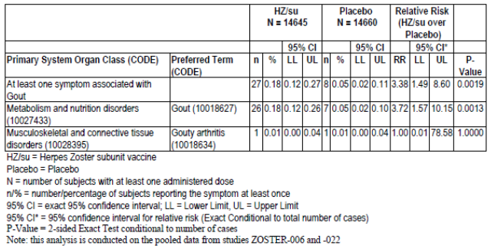
Evaluator’s comments:
The evaluator agrees that routine pharmacovigilance monitoring of amyotrophic lateral sclerosis and osteonecrosis should be sufficient, however optic ischaemic neuropathy, temporal arteritis and convulsions should be actively monitored. Gout is listed in the pIMDs for pharmacovigilance monitoring. The approved US label for Shingrix has the wording below in relation to gout and it is recommended to include something similar in the PI.
Gout (including gouty arthritis) was reported by 0.18% (n = 27) versus 0.05% (n = 8) of subjects who received Shingrix and placebo, respectively, within 30 days of vaccination; available information is insufficient to determine a causal relationship with Shingrix.
- Immunosuppression or immunodeficient conditions were exclusion criteria in the pivotal studies however baseline medical conditions were not discussed. Please discuss any available safety data in adults with a pre-existing immune mediated disorder. Please also discuss whether the use of such an immunogenic vaccine may result in an increased safety risk in the population with these conditions. Please also discuss if further clinical trials are planned in an elderly population with pIMDs.
Sponsor’s response:
Additional safety analyses identified 983 and 960 subjects in HZ/su and Placebo groups, respectively with a pIMD. Within this group, the most frequent conditions were psoriasis (21.9% versus 24.9%), spondyloarthropathy (11.1% versus 9.3%) and rheumatoid arthritis (9.8% in both groups). In this group of subjects with pre-existing pIMDs to 1 years post vaccination, the SAE rate was 14.6% versus 11.7%, and fatal SAE rate was 1.2% versus 0.9%. The fatal SAE rate for the whole study period was 5.1% versus 6.6%. In addition, for subjects with a pIMD at baseline during the whole post vaccination period, the rate of possible exacerbation of the pre-existing pIMD was 2.8% in both groups and the rate of a new onset of a different pIMD was 1.6% and 2.4%, respectively.
Use in adults with pre-exisiting pIMD has been listed as missing information in the RMP. The sponsor proposes to start feasibility assessments to conduct a dedicated study (ZOSTER-069) to assess the immunogenicity and safety of HZ/su in subjects with pre-existing pIMDs.
The sponsor concluded that numbers were balanced between study groups and the immunological effects of vaccination with HZ/su do not translate into increased risk of pIMD in healthy adults or increased risk of exacerbations or onset of new pIMD in adults with an existing pIMD.
Evaluator’s comments:
The available data do not point towards and increase safety risk in subjects with a pre-existing pIMD. Nonetheless, the data are limited and this has been reflected in the RMP and warrants further study (proposed ZOSTER-069).
The sponsor did not discuss the plan for further trials in frail elderly population. This is listed in the RMP as a safety concern with missing information and a further delineation of safety in the population is warranted.
- If available, please discuss safety of the vaccine if given to VZV naïve adults. If no data are available please discuss any plans for assessment in this population.
Sponsor’s response:
Less than 1% of enrolled subjects included in the immunosubset were VZV seronegative at baseline. Toxicology studies performed in VZV naïve rabbits did not reveal any safety issues. In an infrequent situation where HZ/su would be administered to a VZV-naïve subject the Applicant does not expect that HZ/su would show a different safety profile than the one observed in VZV-seropositive subjects. There are no plans to assess this seronegative population.
Evaluator’s comments:
Given the low rate of seronegativity, and overall safety profile of the vaccine, the evaluator accepts the explanation.

Second round benefit-risk assessment

Second round assessment of benefits
Following evaluation of clinical data provided in response to the first round evaluation, there are no changes to the benefits of Shingrix in the proposed usage as listed the first round assessment of benefits.

Second round assessment of risks
The clinical data provided in response to the first round evaluation included data on immunological correlates of protection. These data indicated a correlation between the gE ELISA antibody level and the protection against HZ in adults ≥ 50 years of age. Consequently, the immunological data from the dosing schedule Study ZOSTER-026 is more clinically relevant.
Apart from this, there are no other changes to the risks of Shingrix in the proposed usage as listed in the first round assessment of risks.

Second round assessment of benefit-risk balance
Following the first round evaluation, the sponsor has satisfactorily answered most questions. Further clinical data was presented and relevant findings include:
- No evident features, clinically or immunologically, in subjects with breakthrough HZ.
- Efficacy against PHN was maintained across differing definitions of PHN pain duration.
- Efficacy against HZ was maintained over 4 years, although maintenance of efficacy against PHN could not be determined due to low case numbers.
- No notable safety signals when medically attended visits up to Month 8 were analysed or when AEs leading to vaccine discontinuation or study withdrawal were assessed.
- Data did not indicate an increased risk of serious infections or neoplasms.
- Baseline morbidity in the trial population was balanced between treatment groups and vaccine efficacy was consistently high across the main disease subgroups assessed.
- In subjects with a pre-existing pIMD, there was no increased rate of exacerbation or of a new onset pIMD. There was a possible increase risk of gout post vaccination.
As previously discussed, pharmacovigilance surveillance of pIMDs will be important and safety assessment in frail elderly adults and in those with immune mediated disorders should be examined in further studies.
The data presented on immunological correlates of protection indicated a correlation between the gE ELISA antibody level and the protection against HZ in adults ≥ 50 years of age. Following on from this, as non-inferiority of the humoral immune response with the 0,6 month dosing schedule was demonstrated to the 0,2 month schedule in ZOSTER-026, it is agreed that the dosing interval may be extended to a maximum of 6 months. As mentioned by the sponsor, the data presented on correlates of protection can only be applied to the population studied and with this particular vaccine.
The indication has been satisfactorily reworded and HZ-related complications other than PHN have been deleted.
There still remain several areas where data are limited or lacking. These include:
- co-administration with pneumococcal vaccine and or with other adjuvanted vaccines
- ability to give to adults who have received Zostavax
- the duration of protection beyond 4 years and the need for booster vaccination
- efficacy and safety in immunocompromised patients.
These issues have been covered by planned studies and appropriate wording in the draft PI.
The PI has been updated taking into account the majority of comments made after the first round evaluation. There remains a few points to be addressed.
In conclusion, following the second round evaluation the benefit-risk balance of Shingrix is favourable for revised proposed usage.

Second round recommendation regarding authorisation
Approval of Shingrix is recommended for a revised indication:
Shingrix is indicated for the prevention of herpes zoster and post-herpetic neuralgia in adults 50 years of age or older.
This recommendation is subject to satisfactory responses to the remaining points on the draft PI.

References
Australian Technical Advisory Group on Immunisation (ATAGI). The Australian immunisation handbook 10th ed (2017 update). Canberra: Australian Government Department of Health, 2017.
MacIntyre R, Stein A, Harrison C, et al. Increasing Trends of Herpes Zoster in Australia. PLoS ONE 2015; 10(4): e0125025.

Therapeutic Goods Administration
PO Box 100 Woden ACT 2606 Australia
Email: info@tga.gov.au Phone: 1800 020 653 Fax: 02 6232 8605
https://www.tga.gov.au

ZBPI uses an 11-point Likert scale (0 to 10) to rate HZ pain and discomfort for four dimensions (worst, least, and average during the past 24 hours and now) and HZ pain and discomfort related interference with seven functional status and ADL items: general activity, mood, walking ability, work, relations with others, sleep, and enjoyment of life. The seven questions included in the functional status and ADL were summarized into a single score by taking the mean of the seven items. HZ associated pain was derived from item 3 ‘worst pain’ on the ZBPI.
VRR for anti-gE was defined as the percentage of subjects who had at least: - a 4-fold increase in the post-dose 2 anti-gE antibody concentration as compared to the pre-vaccination anti-gE antibody concentration, for subjects who were seropositive at baseline, or, - a 4-fold increase in the post-dose 2 anti-gE antibody concentrations as compared to the anti-gE antibody cut-off value for seropositivity, for subjects who were seronegative at baseline.

