LUCENTIS®
ranibizumab (rbe)

NAME OF THE MEDICINE

Active ingredient: Ranibizumab
Chemical name: Immunoglobulin G1, anti-(human vascular endothelial growth factor) Fab fragment (human-mouse monoclonal rhuFab V2 γ1-chain), disulfide with human-mouse monoclonal rhuFab V2 к-chain
CAS number: 347396-82-1
Molecular weight: Approximately 48kDa
Structure: Ranibizumab is the Fab moiety of a high affinity version of recombinant humanised monoclonal antibody rhuMAb vascular endothelial growth factor (VEGF). It consists of a 214-residue light chain linked by a disulfide bond at its C-terminus to the 231-residue N-terminal segment of the heavy chain. The expected amino acid sequences of the heavy and light chains are shown in Figures 1a and 1b.
Figure 1a The amino acid sequence of the heavy chain of ranibizumab

10 20 30 40 50 60
EVQLVESGGGLVQPGGSLRLSCAASGYDFTHYGMNWVRQAPGKGLEWVGWINTYTGEPTY
70 80 90 100 110 120
AADFKRRFTFSLDTSKSTAYLQMNSLRAEDTAVYYCAKYPYYYGTSHWYFDVWGQGTLVT
130 140 150 160 170 180
VSSASTKGPSVFPLAPSSKSTSGGTAALGCLVKDYFPEPVTVSWNSGALTSGVHTFPAVL
190 200 210 220 230
QSSGLYSLSSVVTVPSSSLGTQTYICNVNHKPSNTKVDKKVEPKSCDKTHL

Complementarity-determining regions (CDR) are underlined.
Figure 1b The amino acid sequence of the light chain of Ranibizumab

10 20 30 40 50 60
DIQLTQSPSSLSASVGDRVTITCSASQDISNYLNWYQQKPGKAPKVLIYFTSSLHSGVPS
70 80 90 100 110 120
RFSGSGSGTDFTLTISSLQPEDFATYYCQQYSTVPWTFGQGTKVEIKRTVAAPSVFIFPP
130 140 150 160 170 180
SDEQLKSGTASVVCLLNNFYPREAKVQWKVDNALQSGNSQESVTEQDSKDSTYSLSSTLT
190 200 210
LSKADYEKHKVYACEVTHQGLSSPVTKSFNRGEC

Complementarity-determining regions (CDR) are underlined.

DESCRIPTION

Ranibizumab is a humanised monoclonal antibody fragment produced in Escherichia coli cells by recombinant DNA technology.

Lucentis is supplied in a vial or a pre-filled syringe.

Vial
Each vial contains 2.3 mg of ranibizumab in 0.23 mL solution for intravitreal injection. The solution is sterile, clear, colourless to pale yellow, aqueous and preservative free.
Pre-filled syringe
Each pre-filled syringe contains 1.65 mg of ranibizumab in 0.165mL solution.
The solution is sterile, clear, colourless to pale yellow, aqueous and preservative free.

Excipients: Trehalose dihydrate, histidine hydrochloride monohydrate, histidine, polysorbate 20, water for injections.

PHARMACOLOGY

Pharmacotherapeutic group, ATC
Antineovascularisation agents, ATC code: S01LA04.

Mechanism of action
Ranibizumab is a humanised recombinant monoclonal antibody fragment targeted against human vascular endothelial growth factor A (VEGF-A). It binds with high affinity to the VEGF-A isoforms (e.g. VEGF₁₁₀, VEGF₁₂₁ and VEGF₁₆₅), thereby preventing binding of VEGF-A to its receptors VEGFR-1 and VEGFR-2.

Pharmacodynamics
Binding of VEGF-A to its receptors leads to endothelial cell proliferation and neovascularisation, as well as vascular leakage, all of which are thought to contribute to the progression of the neovascular form of age-related macular degeneration or pathologic myopia. and the macular oedema causing visual impairment in diabetes and retinal vein occlusion.

Pharmacokinetics
Absorption:
Following monthly intravitreal administration of Lucentis to patients with neovascular AMD, serum concentrations of ranibizumab were generally low, with maximum levels (C_{max}) generally below the ranibizumab concentration necessary to inhibit the biological activity of VEGF by 50% (11 to 27 ng/mL, as assessed in an in vitro cellular proliferation assay). C_{max} was dose proportional over the dose range of 0.05 to 1.0 mg/eye. Upon monthly intravitreal administration of Lucentis 0.5 mg/eye, serum ranibizumab C_{max}, attained approximately 1 day after dosing, is predicted to generally range between 0.79 and 2.90 ng/mL, and C_{min} is predicted to generally range between 0.07 and 0.49 ng/L. Serum ranibizumab concentrations in RVO patients were similar to those observed in neovascular AMD patients.

Distribution and Elimination:
Based on analysis of population pharmacokinetics and disappearance of ranibizumab from serum for patients with neovascular AMD treated with the 0.5 mg dose, the average vitreous elimination half-life of ranibizumab is approximately 9 days. Serum ranibizumab exposure is predicted to be approximately 90,000-fold lower than vitreal ranibizumab exposure.

Renal impairment: No formal studies have been conducted to examine the pharmacokinetics of Lucentis in patients with renal impairment. In a population pharmacokinetic analysis of neovascular AMD patients, 68% (136 of 200) of patients in a population pharmacokinetic analysis had renal impairment (46.5% mild [50 to 80 mL/min], 20% moderate [30 to 50 mL/min] and 1.5% severe [< 30 mL/min]). In RVO patients, 48.2% (253 of 525) had renal impairment (36.4% mild, 9.5% moderate and 2.3% severe). Systemic clearance was slightly lower, but this was not clinically significant.

Hepatic impairment: No formal studies have been conducted to examine the pharmacokinetics of Lucentis in patients with hepatic impairment.

CLINICAL TRIALS

Treatment of Wet AMD
In wet AMD, the clinical safety and efficacy of Lucentis have been assessed in three randomised, double-masked, sham**- or active-controlled studies in patients with neovascular age-related macular degeneration (AMD). A total of 1,323 patients (879 active and 444 control) was enrolled in these studies.

In study FVF2598g (MARINA), patients with minimally classic or occult with no classic choroidal neovascularisation (CNV) received monthly intravitreal injections of Lucentis 0.3 mg or 0.5 mg or sham injections. A total of 716 patients was enrolled in this study (sham, 238; Lucentis 0.3 mg, 238; Lucentis 0.5 mg, 240). A total of 664 subjects (92.7%) completed month 12 (defined as having a visual acuity score for the study eye at month 12) and a total of 615 subjects (85.9%) completed the 2-year study period. Data are available up to the end of month 24.

In study FVF2587g (ANCHOR), patients with predominantly classic CNV lesions received either: 1) monthly intravitreal injections of Lucentis 0.3 mg and sham photodynamic therapy (PDT); 2) monthly intravitreal injections of Lucentis 0.5 mg and sham PDT; or 3) sham intravitreal injections and active verteporfin PDT. Sham or active verteporfin PDT was given with the initial Lucentis injection and every 3 months thereafter if fluorescein angiography showed persistence or recurrence of vascular leakage. A total of 423 patients was enrolled in this study (sham, 143; Lucentis 0.3 mg, 140; Lucentis 0.5 mg, 140). A total of 386 subjects (91.3%) completed month 12 of the study and 343 subjects (81.1%) completed month 24 of the study. Data are available up to the end of month 24.

** The sham Lucentis injection control procedure involved anesthetising the eye in a manner identical to a Lucentis intravitreal injection. The tip of a needleless syringe was then pressed against the conjunctiva and the plunger of the needleless syringe depressed.

In both studies the primary efficacy endpoint was the proportion of patients who maintained vision, defined as losing fewer than 15 letters of visual acuity at 12 months compared to baseline. Almost all Lucentis-treated patients (approximately 95%) maintained their visual acuity. 34 to 40% of Lucentis-treated patients experienced a clinically significant improvement in vision, defined as gaining 15 or more letters at 12 months. The size of the lesion did not significantly affect the results.

In MARINA, the primary endpoint was fewer than 15 letters loss at 12 months. 148 of 238 randomised to sham injections met this criterion, as did 225 of 238 injected with 0.3 mg, and 227 of 240 injected with 0.5 mg. The difference between sham and injected groups is statistically (p<0.0001) and clinically significant but the difference between the two ranibizumab dose groups is not, as shown in Figure 2.

The visual acuity gain with ranibizumab is present at 1 month, continues to increase up to month 3, and is maintained up to month 24, compared to a gradual deterioration in the sham treatment group, as shown in Figure 2.

Figure 2 Mean change in visual acuity from baseline to month 24 in study FVF2598g (MARINA): ITT population
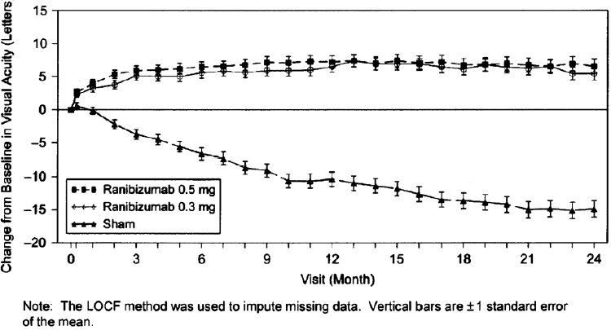

In ANCHOR, the primary endpoint was fewer than 15 letters loss at 12 months. 92 of 143 randomised to sham injections and verteporfin met this criterion, as did 132 of 140 injected with 0.3 mg ranibizumab, and 134 of 140 injected with 0.5 mg.

The difference between sham and injected groups is statistically (p<0.0001) and clinically significant but the difference between the two doses of ranibizumab is not. The secondary endpoint of a (clinically significant) gain of at least 15 letters was met in 8 of the 143 verteporfin group and in 50 of the 140 0.3 mg group: χ2= 37.6, p<0.0001. 56 of the 140 0.5 mg group met this criterion also, statistically not significantly better than the 0.3 mg group: χ2=0.38, p>0.8.

The visual acuity gain with ranibizumab is present at 1 month, continues to increase up to month 3, and is maintained up to month 12 compared to a gradual deterioration in the verteporfin treatment group, as shown in Figure 3.

Figure 3 Mean change in visual acuity from baseline to month 24 in study FVF2587g (ANCHOR): ITT population

Detailed results are shown in the tables below:

Table 1 Outcomes at month 12 and month 24 in study FVF2598g (MARINA)
Outcome measure | Month | Sham  (n=238) | Lucentis 0.3 mg  (n=238) | Lucentis 0.5 mg  (n=240)
Loss of <15 letters in visual acuity n (%)ª (Maintenance of vision) | Month 12 | 148 (62.2%) | 225 (94.5%) | 227 (94.6%)
 | Month 24 | 126 (52.9%) | 219 (92.0%) | 216 (90.0%)
Gain of ≥15 letters in visual acuity n (%)ª | Month 12 | 11 (4.6%) | 59 (24.8%) | 81 (33.8%)
Gain of ≥15 letters in visual acuity n (%)ª | Month 24 | 9 (3.8%) | 62 (26.1%) | 80 (33.3%)
Mean change in visual acuity (letters) (SD)ª | Month 12 | -10.5 (16.6) | +6.5 (12.7) | +7.2 (14.4)
Mean change in visual acuity (letters) (SD)ª | Month 24 | -14.9 (18.7) | +5.4 (15.2) | +6.6 (16.5)
ª p<0.01.

Table 2 Outcomes at month 12 and 24 in study FVF2587g (ANCHOR)
Outcome measure | Month | Verteporfin PDT  (n=143) | Lucentis 0.3 mg  (n=140) | Lucentis 0.5 mg  (n=140)
Loss of <15 letters in visual acuity n (%)ª  (Maintenance of vision) | Month 12 | 92 (64%) | 132 (94%) | 134 (96%)
 | Month 24 | 94(66%) | 126 (90%) | 125 (90%)
Gain of ≥15 letters in visual acuity n (%)ª | Month 12 | 8 (6%) | 50 (36%) | 56 (40%)
Gain of ≥15 letters in visual acuity n (%)ª | Month 24 | 9(6%) | 48 (34%) | 57 (41%)
Mean change in visual acuity (letters) (SD)ª | Month 12 | -9.5 (16.4) | +8.5 (14.6) | +11.3 (14.6)
Mean change in visual acuity (letters) (SD)ª | Month 24 | -9.8 (17.6) | +8.1 (16.2) | +10.7 (16.5)
ª p<0.01

Patients in the group treated with Lucentis had minimal observable CNV lesion growth, on average. At month 12, the mean change in the total area of the CNV lesion was 0.1 to 0.3 DA for Lucentis versus 2.3 to 2.6 DA for the control arms.

The use of Lucentis beyond 24 months has not been studied.

In MARINA, at month 12, patients treated with Lucentis reported, on average, a statistically and clinically meaningful improvement in their ability to perform activities related to near vision, distance vision and vision-specific dependency, as measured by the NEI VFQ-25, while sham-treated patients reported a decrease in their ability to perform these activities. On the near activities scale, patients treated with 0.5 mg Lucentis reported a +10.4 point increase (0.3 mg: +9.4), while sham-treated patients had a -2.6 point decrease (p< 0.01). On the distance activities scale, Lucentis 0.5 mg-treated patients had a +7.0 point increase (0.3 mg: +6.7), while sham-treated patients had a -5.9 point decrease (p< 0.01). On the vision-specific dependency scale, Lucentis 0.5 mg-treated patients experienced +6.8 point increase (0.3 mg: +3.6), while sham-treated patients reported a decrease of -4.7 points (p< 0.01).

This increase from baseline in each of these three VFQ-25 subscales at month 12 was maintained at month 24 for Lucentis-treated patients, while in the sham-injection group the mean change from baseline decreased further from month 12 to month 24 in each of these subscales. Therefore, the treatment benefit of Lucentis over the sham control at month 24 was greater than that at month 12.

In ANCHOR, at month 12, patients treated with Lucentis reported a statistically and clinically meaningful improvement in their ability to perform activities related to near vision, distance vision and vision-specific dependency compared to patients receiving verteporfin PDT treatment. On the near activities scale, patients treated with 0.5 mg Lucentis reported a +9.1 point increase (0.3 mg: +6.6), while verteporfin PDT-treated patients had a +3.7 point increase (p< 0.01). On the distance activities scale, Lucentis 0.5 mg-treated patients reported a +9.3 point increase (0.3 mg: +6.4), while verteporfin PDT-treated patients had a +1.7 point increase (p< 0.01). On the vision-specific dependency scale, Lucentis 0.5 mg-treated patients reported a +8.9 point increase (0.3 mg: +7.6), while verteporfin PDT-treated patients had a -1.4 point decrease (p<0.01). In the verteporfin PDT group, the mean improvement from baseline in the near activities and distance activities subscale scores at month 12 were lost at month 24, while the mean decrease from baseline in the vision-specific dependency subscale score at month 12 was maintained at month 24. These changes between months 12 and 24 within each treatment group resulted in either maintained or greater treatment benefit of ranibizumab over verteporfin PDT compared with month 12, while the treatment benefit of ranibizumab in the vision-specific dependency subscale was smaller at month 24 compared with month 12 (p-values ranging from 0.0023 to 0.0006).

Study FVF3689g (SAILOR) was a Phase IIIb, single-masked, one-year multicentre study in naïve and previously treated subjects with CNV secondary to AMD. The primary study objective was to estimate the incidence of ocular and non-ocular serious adverse events in subjects treated for 12 months. Two thousand three hundred seventy eight patients were randomised in a 1:1 ratio to receive one intravitreal injection of 0.3 mg or 0.5 mg ranibizumab every month for three consecutive months followed by as-needed re-treatment not more often than monthly.

Overall, no imbalances between the two dose groups were observed in the frequency of ocular and non-ocular adverse events. There was a statistically non significant trend towards a higher stroke rate in the 0.5 mg group compared to the 0.3 mg group. The respective 95% CIs for the overall stroke rate were wide (0.3% to 1.3% for the 0.3 mg group vs. 0.7% to 2.0% for the 0.5 mg group). The number of strokes was small in both dose groups, and there is not sufficient evidence to conclude (or rule out) that there is a true difference in stroke rates among the treatment groups. The difference in stroke rates may be greater in patients with known risk factors for stroke, including history of prior stroke and transient ischaemic attack.

Quarterly Dosing after Three Consecutive Monthly Doses: Study FVF3192g (PIER) was a randomised, double-masked, sham-controlled, two-year study designed to assess the safety and efficacy of Lucentis in patients with neovascular AMD (with or without a classic CNV component). Data are available up to the end of month 12. Patients received Lucentis 0.3 mg or 0.5 mg intravitreal injections or sham injections once a month for three consecutive doses, followed by a dose administered once every 3 months. A total of 184 patients was enrolled in this study (Lucentis 0.3 mg, 60; Lucentis 0.5 mg, 61; sham, 63); 171 (93%) completed 12 months of this study. Patients treated with Lucentis in PIER received a mean of 6 total treatments out of possible 6 from day 0 to month 12.

In PIER, the primary efficacy endpoint was mean change in visual acuity at 12 months compared with baseline (see Figure 4). After an initial increase in visual acuity (following monthly dosing), on average, patients dosed once every three months with Lucentis lost the initial visual acuity gain, returning to baseline at month 12. In PIER, almost all Lucentis-treated patients (90%) maintained their visual acuity at month 12.

Figure 4 Mean change in visual acuity from baseline to month 12 in Study FVF3192g (PIER): ITT population
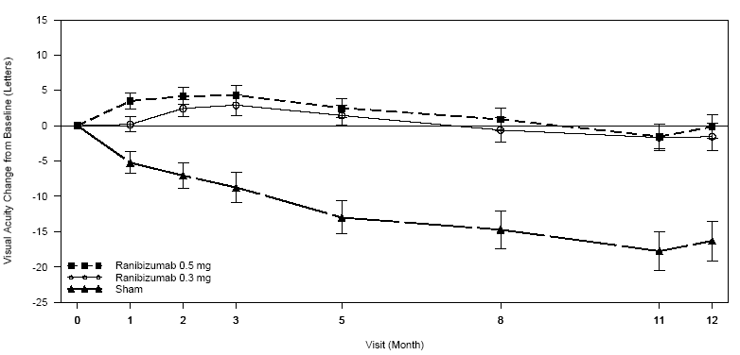
Note: The LOCF method was used to impute missing data. Vertical bars are ± 1 standard error of the mean.

Interpretation of PIER: Although less effective, treatment might be reduced to one injection every 3 months after the first three injections (e.g. if monthly injections are not feasible) but, compared to continued monthly doses, dosing every 3 months may lead to an approximate 5-letter (1-line) loss of visual acuity benefit, on average, over the following nine months. Patients should be evaluated regularly.

Treatment of Visual Impairment Due to DME
The efficacy and safety of Lucentis have been assessed in two randomized, double-masked, sham- or active controlled studies of 12 months duration in patients with visual impairment due to diabetic macular oedema. A total of 496 patients (336 active and 160 control) was enrolled in these studies, the majority had type II diabetes, 28 ranibizumab-treated patients had type I diabetes.

In study D2301 (RESTORE), a total of 345 patients with visual impairment due to macular oedema was randomised to receive either initial intravitreal injection of ranibizumab 0.5 mg as monotherapy and sham laser photocoagulation (n=116), combined ranibizumab 0.5 mg and laser photocoagulation (n=118), or sham** injection and laser photocoagulation (n=111). Treatment with ranibizumab was started with monthly intravitreal injections and continued until visual acuity was stable for at least three consecutive monthly assessments. The treatment was reinitiated when there was a reduction in best corrected visual acuity (BCVA) due to DME progression. Laser photocoagulation was administered at baseline on the same day, at least 30 minutes before injection of ranibizumab, and then as needed based on ETDRS criteria.

Key outcomes are summarised in Tables 3 and 4 and Figure 5.

Table 3 Primary Efficacy Outcomes at month 12 in study D2301 (RESTORE)

Visual acuity of the study eye (letters): Mean average change from Month 1 to Month 12 compared to baseline (Full analysis set / LOCF)
Parameter | Statistic | Ranibizumab  0.5 mg  N = 115 | Ranibizumab  0.5mg + Laser  N = 118 | Laser  N = 110
Baseline | n | 115 | 118 | 110
 | Mean (SD) | 64.7 (10.07) | 63.4 (9.99) | 62.6 (11.01)
 | Median | 68.0 | 65.0 | 65.0
 | Min - Max | 38.0 - 81.0 | 38.0 - 79.0 | 36.0 - 78.0
Average Month 1 to Month 12 | n | 115 | 118 | 110
 | Mean (SD) | 70.8 (10.53) | 69.2 (11.44) | 63.4 (12.26)
 | Median | 73.7 | 71.5 | 66.2
 | Min - Max | 38.6 - 88.7 | 28.5 - 93.3 | 32.0 - 84.2
Average change from baseline | n | 115 | 118 | 110
 | Mean (SD) | 6.1 (6.43) | 5.9 (7.92) | 0.8 (8.56)
 | Median | 6.1 | 6.0 | 1.3
 | Min - Max | -10.9 - 25.2 | -26.7 - 27.6 | -37.8 - 26.8
 | 95% CI for mean (1) | (4.9, 7.3) | (4.4, 7.3) | (-0.8, 2.4)
Comparison vs. Laser | Difference in LS means (2) | 5.4 | 4.9
 | 95% CI for difference (2) | (3.5, 7.4) | (2.8, 7.0)
 | p-value (3) | <.0001 | <.0001
- n is the number of patients with a value for both baseline and average Month 1 to Month 12.
- Stratified analysis includes DME type (focal, diffuse/other) and baseline visual acuity (<=60, 61-73, >73 letters).
- (1) Two-sided 95% confidence intervals (CI) are based on the t-distribution.
- (2) Differences in LS means and the two-sided 95% CIs are estimated from pair wise ANOVA (stratified) model.
- (3) p-values for treatment difference are from the two-sided stratified Cochran-Mantel-Haenszel test using the row means score

Table 4 Secondary Efficacy Outcomes at month 12 in study D2301 (RESTORE):
Visual acuity of the study eye (letters): Categorized change from baseline at Month 12 (FAS / LOCF)
Categorized change from baseline | Ranibizumab  0.5 mg  N = 115 | Ranibizumab  0.5mg + Laser  N = 118 | Laser  N = 110
N | 115 | 118 | 110
Gain of ≥ 10 letters [1] | 43 (37.4) | 51 (43.2) | 17 (15.5)
Loss of ≥ 10 letters | 4 ( 3.5) | 5 ( 4.2) | 14 (12.7)
Gain of ≥ 15 letters [1] | 26 (22.6) | 27 (22.9) | 9 ( 8.2)
Loss of ≥ 15 letters | 1 ( 0.9) | 4 ( 3.4) | 9 ( 8.2)
- N is the number of patients with a value at both baseline and the Month 12 visit.
- [1] specified gain, or BCVA of 84 letters or more

Figure 5 Mean BCVA change from baseline over time in study D2301 (RESTORE)
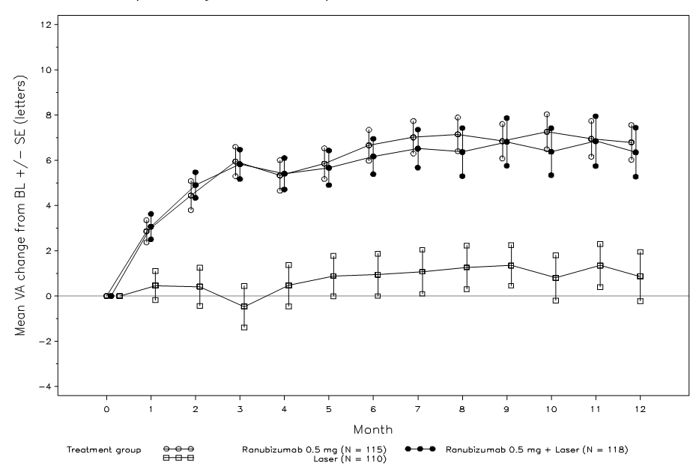

In a supportive, partly exploratory study D2201 (RESOLVE), a total of 151 patients with DME with centre involvement in at least one eye, including those with focal or diffuse DME, causing visual impairment were treated with ranibizumab (6 mg/mL, n=51, 10 mg/mL, n=51) or sham (n=49) by monthly intravitreal injections until pre-defined treatment stopping criteria were met. The initial ranibizumab dose (0.3 mg or 0.5 mg) could be doubled at any time during the study after the first injection if at the Month 1 visit, retinal thickness in the study eye remained > 300 µm; or if at any monthly visit after Month 1, retinal thickness in the study eye was > 225 µm and reduction in retinal oedema from the previous assessment was < 50 µm. Laser photocoagulation rescue treatment was allowed from month 3 in both treatment arms.

The average injection doses in the 6 mg/mL group, 10 mg/mL group, and pooled group, were 0.47 mg, 0.76 mg and 0.62 mg, respectively. A total of 86% of patients in the ranibizumab treated groups received doses of 0.5 mg/injection or higher, of which 69% received doses of 0.6 mg/injection or higher.

The study was comprised of two parts: an exploratory part (the first 42 patients analysed at months 6), and a confirmatory part (the remaining 109 patients analysed at months 12).

The exploratory analysis revealed no sign of a clinically relevant response to dose doubling (in terms of efficacy neither for visual acuity nor for central retinal thickness). The results of this study therefore do not support the concept of dose doubling where response to the recommended dose is considered inadequate. Key outcomes from the confirmatory part of the study (2/3 patients) are summarised in Tables 5 and 6 and Figure 6.

Table 5 Overall Population, VA (study eye), mean average change in letters from baseline from month 1 to month 12; FAS, LOCF of study D2201 (RESOLVE):

Visual acuity of the study eye (letters): Mean average change from baseline from Month 1 to Month 12 (Group A+B; FAS / LOCF)
Parameter | Statistic | Ranibizumab  6 mg/ml  N=51 | Ranibizumab  10 mg/ml  N=51 | Ranibizumab  Pooled  N=102 | Sham  N=49
Baseline | n | 51 | 51 | 102 | 49
 | Mean (SD) | 59.2 (10.23) | 61.2 (9.48) | 60.2 (9.86) | 61.1 (9.04)
 | Median | 61.0 | 61.0 | 61.0 | 63.0
 | Min-Max | 37.0-73.0 | 39.0-79.0 | 37.0-79.0 | 39.0-76.0
Average Month 1 to Month 12 | Mean (SD) | 68.4 (11.09) | 67.5 (12.37) | 68.0 (11.70) | 61.0 (13.91)
 | Median | 69.4 | 70.4 | 70.3 | 63.0
 | Min-Max | 38.9-87.9 | 34.8-88.3 | 34.8-88.3 | 19.9-83.1
Average change from baseline | Mean (SD) | 9.2 (5.60) | 6.4 (9.21) | 7.8 (7.72) | -0.1 (9.77)
 | Median | 9.5 | 7.4 | 8.2 | 2.8
 | Min-Max | -2.9-24.3 | -24.9-21.4 | -24.9-24.3 | -36.1-14.8
 | 95% CI for mean (1) | (7.7, 10.8) | (3.8, 9.0) | (6.3, 9.3) | (-2.9, 2.7)
Comparison vs. sham | Difference in LS means (2) | 9.4 | 6.7 | 7.9
 | 95% CI for difference (2) | (6.2, 12.6) | (3.0, 10.5) | (5.0, 10.9)
 | p-value (3) | <0.0001 | 0.0004 | <0.0001
- n is the number of patients with a value for both baseline and average Month 1 to Month 12
- Stratified analysis includes baseline visual acuity (<=60, >60 letters) and baseline central retinal thickness (<=400, >400 µm).
- (1) Two-sided 95% confidence intervals (CI) are based on t-distribution.
- (2) Differences in LS means and the two-sided 95% CIs are estimated from pair wise ANOVA (stratified) model.
- (3) p-values for treatment difference are from the two-sided stratified Cochran-Mantel-Haenszel test using the row means score statistics.

Table 6 Overall Population, treatment comparisons key secondary efficacy variables; FAS (LOCF) of study D2201 (RESOLVE)

Variable | Ran 6mg/mL  (n=51) | Ran 10mg/mL  (n=51) | Ran Pooled  (n=102) | Sham  (n=49)
Gain ≥ 15 letters [Δ BL to month 12]¹  Loss ≥ 15 letters [Δ BL to month 12] ¹ | 35.3% (n=18)  0% | 29.4% (n=15)  5.9% (n=3) | 32.4% (n=33)  2.9% (n=2) | 10.2% (n=5)  20.4% (n=10)
Gain ≥ 10 letters [Δ BL to month 12]²  Loss ≥ 10 letters [Δ BL to month 12] ² | 72.5% (n=37)  0% | 49.0% (n=25)  9.8% (n=5) | 60.8% (n=62)  4.9% (n=5) | 18.4% (n=9)  24.5% (n=12)
CRT μm mean (SE) [Δ BL to month 12] ³ | -200.7 (17.11) | -187.6 (20.70) | -194.2 (13.38) | -48.4 (21.92)
CRT < 225 μm (%) at month 12⁴ | 31.4% (n=16) | 39.2% (n=20) | 35.3% (n=36) | 10.2% (n=5)
Δ BL = change from baseline
¹CMH test, stratified: 6 mg/mL vs sham p=0.0001; 10 mg/mL vs sham p=0.0037; and pooled p=0.0001
²CMH test, stratified: 6 mg/mL vs sham p<0.0001; 10 mg/mL vs sham p=0.0010; and pooled p<0.0001
³CMH test, stratified: 6 mg/mL vs sham p<0.0001; 10 mg/mL vs sham p<0.0001; and pooled p<0.0001
⁴CMH test, stratified: 6 mg/mL vs sham p=0.0108; 10 mg/mL vs sham p=0.0007; and pooled p=0.0011

Figure 5 Mean change in visual acuity from baseline over time in study D2201 (RESOLVE) (overall population)

Patients treated with ranibizumab experienced a continuous reduction in central retina thickness. At month 12, the mean CRT change from baseline was -194 micrometres for ranibizumab versus -48 micrometres for sham control.

Overall, ocular and non-ocular safety findings in DME patients of both studies D2201 and D2301 were comparable with the previously known safety profile observed in wet AMD patients.

Treatment of visual impairment due to macular oedema secondary to RVO
The clinical safety and efficacy of Lucentis in patients with visual impairment due to macular oedema secondary to RVO have been assessed in the randomised, double-masked, controlled studies BRAVO and CRUISE that recruited subjects with BRVO (n=397) and CRVO (n=392), respectively. In both studies, subjects received either 0.3 mg or 0.5 mg intravitreal ranibizumab or sham** injections. Patients were initially treated monthly for 6 months. Neither study compared a flexible versus fixed dosing regimen. Thereafter, treatment was given as needed following pre-specified re-treatment criteria. After 6 months, patients in the sham-control arms were crossed over to 0.5 mg ranibizumab. In BRAVO, laser photocoagulation as rescue was allowed in all arms from Month 3.

Laser therapy was not used as a comparative treatment. During the first six months, laser rescue treatment was administered to 27 (20.1%) patients in the ranibizumab 0.3 mg group, 28 (21.4%) in the ranibizumab 0.5 mg group and 76 (57.6%) in the sham group.

In the first six months, ranibizumab was given monthly. In the second six month period, all patients were given only ranibizumab as needed i.e. were given only active treatment as required (0.5mg monthly if previously on sham treatment) and at monthly intervals as necessary, the latter determined by a best corrected visual acuity of 20/40 - or worse - or mean central subfield thickness ≥ 250 μm on optical coherence tomography.

Out of the 525 patients who received active treatment in the first 6 months, 501 patients entered into the observation period, with 87.2% (n=437) of them receiving at least one injection. Overall, patients received from 0 to 6 injections, with the lowest percentage of patients (10%) receiving 1 injection and the highest percentage of patients (20.8%) receiving 6 injections. The average number of injections was 3.3.

While numerically the better results were seen for 0.5 mg the differences between the two doses of Lucentis are not clinically significant. Key outcomes from BRAVO and CRUISE are summarised in Tables 7 and 8 and Figures 6 and 7.

Table 7 Outcomes at Month 6 and 12 (BRAVO)
 | Sham/Lucentis 0.5 mg  (n=130) | Lucentis 0.3 mg  (n=134) | Lucentis 0.5 mg  (n=130)
Mean change in visual acuity from baseline at Month 6ª (letters) (primary endpoint) | +7.3 | +16.6 | +18.3
Mean change in visual acuity from baseline at Month 12 (letters) | +12.1 | +16.4 | +18.3
Proportion of patients gained ≥15 letters in BCVA from baseline at Month 6ª | 28.8 % | 55.2% | 61.1 %
Proportion of patients gained ≥15 letters in BCVA from baseline at Month 12 | 43.9 % | 56.0% | 60.3 %
Proportion of patients receiving laser rescue over 12 months | 61.4 % | 41.0% | 34.4 %
ª p<0.0001

Figure 6 Mean Change from Baseline BCVA over time to Month 6 and Month 12 (BRAVO)

Table 8 Outcomes at Month 6 and 12 (CRUISE)
 | Sham/Lucentis 0.5 mg  (n=130) | Lucentis 0.3 mg  (n=132) | Lucentis 0.5 mg  (n=130)
Mean change in visual acuity from baseline at Month 6 (letters)ª | +0.8 | +12.7 | +14.9
Mean change in visual acuity from baseline at Month 12 (letters) | +7.3 | +13.9 | +13.9
Proportion of patients gained > 15 letters in BCVA from baseline at Month 6 ª | 16.9 % | 46.2% | 47.7 %
Proportion of patients gained > 15 letters in BCVA from baseline at Month 12 | 33.1 % | 47.0% | 50.8 %
ª p<0.0001

Figure 7 Mean Change from Baseline BCVA over time to Month 6 and Month 12 (CRUISE)

In both studies, the improvement of vision was accompanied by a continuous decrease in the macular oedema as measured by central retinal thickness.

The improvement in visual acuity seen with ranibizumab treatment at 6 and 12 months was accompanied by patient-reported benefits as measured by the National Eye Institute Visual Function Questionnaire (VFQ-25) sub-scales related to near and distance activity, a pre-specified secondary efficacy endpoint. The difference between Lucentis 0.5 mg and the control group was assessed at Month 6 with p-values of 0.02 to 0.0002.

Efficacy and safety of Lucentis for treatment of visual impairment due to macular oedema secondary to RVO has not been evaluated beyond 12 months.

Treatment of visual impairment due to choroidal neovascularization (CNV) secondary to Pathologic myopia (PM)
The clinical safety and efficacy of Lucentis in patients with visual impairment due to CNV in PM have been assessed based on the 12-month data of the randomized, double-masked, controlled pivotal study F2301 (RADIANCE) which was designed to evaluate two different dosing regimens of 0.5 mg ranibizumab given as intravitreal injection in comparison to verteporfin PDT (vPDT, Visudyne photodynamic therapy).
Patients with retinal detachment, cataract, pre-retinal membrane of the macula, history of panretinal or focal/grid laser photocoagulation with involvement of the macular area, history of intraocular treatment with any anti-VEGF or vPDT, history of intra-ocular surgery or treatment with corticosteroids in preceding 3 months were excluded from the trial.
A total of 277 eligible patients participated in the trial. The mean (SD) age of all randomized patients was 55.5 (13.94) years. At baseline, the mean (SD) BCVA was 55.4 (13.11) letters. The mean (SD) axial length was 29.07 (1.892) mm and the mean refraction-sphere was -12 diopters (range -6 to ~-30) at baseline. A total of 68.6% patients had subfoveal, 23.8% patients had juxtafoveal and 4.0% patients had extrafoveal lesions. The patients were randomised to the following three treatment groups:
- Group I (ranibizumab 0.5mg, dosing regimen driven by “stability” criteria defined as no change in BCVA compared to two preceding monthly evaluations)
- Group II (ranibizumab 0.5mg, dosing regimen driven by “disease activity” criteria defined as vision impairment attributable to intra-or-subretinal fluid or active leakage due to the CNV lesion as assessed by Optical Coherence Tomography (OCT) and/or Fluorescein Tomography (FA))
- Group III (vPDT - patients were allowed to receive ranibizumab treatment as of Month 3)
Over the 12 months of the study patients received on average 4.6 injections (range 1-11) in Group I and 3.5 injections (range 1-12) in Group II. In Group II (in which patients received the recommended treatment regimen based on disease activity, see section 4 Dosage and administration), 50.9% of patients required 1 or 2 injections, 34.5% required 3 to 5 injections and 14.7% required 6 to 12 injections over the 12-month study period. In Group II, 62.9% of patients did not require injections in the second 6 months of the study.
Key outcomes from RADIANCE are summarised in Table 9 and Figure 8.

Table 9 Outcomes at Month 3 and Month 12 (RADIANCE)
 | Group I  Ranibizumab  0.5mg  ` visual acuity stability`  (n=105) | Group II  Ranibizumab 0.5mg  `disease activity`  (n=116) | Group III  vPDT*  (n=55)
Month 3
Mean average BCVA change from Month 1 to Month 3 compared to baselineª (letters) | +10.5 | +10.6 | +2.2
Proportion of patients who gained  ≥ 10 letters, or reached ≥ 84 letters in BCVA  ≥ 15 letters, or reached ≥ 84 letters in BCVA | 61.9 %  38.1 % | 65.5 %  43.1 % | 27.3 %  14.5 %
Month 12
Number of injections up to Month 12:
Mean | 4.6 | 3.5 | N/A
Median | 4.0 | 2.0 | N/A
Mean average BCVA change from Month 1 to Month 12 compared to baseline (letters) | +12.8 | +12.5 | N/A
Proportion of patients who gained  ≥ 10 letters, or reached ≥ 84 letters in BCVA  ≥ 15 letters, or reached ≥ 84 letters in BCVA | 69.5 %  53.3 % | 69.0 %  51.7 % | N/A  N/A
* Comparative control up to Month 3. Patients randomized to vPDT were allowed to receive ranibizumab treatment as of Month 3 (in Group III, 38 patients received ranibizumab from month 3 onwards)
a: p<0.00001 comparison with vPDT control

Figure 8 Mean change from Baseline BCVA over time up to Month 12 (RADIANCE)
vPDT Group III up to Month 3 (N=55)

Ranibizumab 0.5 mg/vPDT Group III from Month 3 onwards (N=55)
Ranibizumab 0.5 mg Group II by disease activity (N=116)
Ranibizumab 0.5 mg Group I by stabilization (N=105)

+9.3
+13.8
+14.4
+1.4
Ranibizumab allowed

Mean VA change from BL ± SE (letters)
+12.1
+12.5

BL = baseline; SE = standard error of the mean.
Patients randomized to vPDT were allowed to receive ranibizumab from Month 3 onwards.

The improvement of vision was accompanied by a reduction in central retinal thickness.
Patient-reported benefits were observed with the ranibizumab treatment arms over vPDT (p-value <0.05) in terms of improvement in the composite score and several subscales (general vision, near activities, mental health and dependency) of the VFQ-25.

INDICATIONS

Lucentis (ranibizumab) is indicated in adults for:
- the treatment of neovascular (wet) age-related macular degeneration (AMD).
- the treatment of visual impairment due to diabetic macular oedema (DME).
- the treatment of visual impairment due to macular oedema secondary to retinal vein occlusion (RVO).
- the treatment of visual impairment due to choroidal neovascularisation (CNV) secondary to pathologic myopia (PM)

CONTRAINDICATIONS

- Hypersensitivity to the active substance or to any of the excipients.
- Patients with active or suspected ocular or periocular infections.
- Patients with active intraocular inflammation.

PRECAUTIONS

Intravitreal injections, including those with Lucentis, have been associated with endophthalmitis, intraocular inflammation, rhegmatogenous retinal detachment, retinal tear, iatrogenic traumatic cataract and increased intraocular pressure (see ADVERSE EFFECTS). Symptoms of these adverse effects should be explained and the patient should be given a copy of the consumer medicine information document. The patient should be given contact details in the case of adverse effects.

Proper aseptic injection techniques must always be used when administering Lucentis. In addition, patients should be reviewed during the week following the injection to permit early treatment if an infection occurs. Patients should be instructed to report any symptoms suggestive of endophthalmitis or any of the above-mentioned events without delay.

Transient increases in intraocular pressure (IOP) have been seen within 60 minutes of injection of Lucentis (see ADVERSE EFFECTS). Sustained IOP increases have also been reported but the frequency is unclear. Both intraocular pressure and the perfusion of the optic nerve head must therefore be monitored and managed appropriately. Patients should be reviewed for IOP rise pre-injection and 60 minutes post-injection.

The safety and efficacy of Lucentis therapy administered to both eyes concurrently have not been studied (see DOSAGE AND ADMINISTRATION).

There is a potential risk of arterial thromboembolic events following intravitreal use of inhibitors of VEGF. Arterial thromboembolic events are defined as nonfatal stroke, nonfatal myocardial infarction, or vascular death (including deaths of unknown cause). In the wet AMD Phase III studies, the overall frequency of arterial thromboembolic events was similar between ranibizumab and control. A numerically higher stroke rate was observed in patients treated with ranibizumab 0.5 mg compared to ranibizumab 0.3 mg or control, however, the differences were not statistically significant. The difference in stroke rates may be greater in patients with known risk factors for stroke, including history of prior stroke or transient ischemic attack. Therefore, these patients should be carefully evaluated by their physicians as to whether Lucentis treatment is appropriate and the benefit outweighs the potential risk.

As with all therapeutic proteins, there is a potential for immunogenicity with Lucentis.

There is only limited experience in the treatment of subjects with DME due to type I diabetes. Lucentis has not been studied in patients who have previously received intravitreal injections, in patients with active systemic infections, proliferative diabetic retinopathy, or in patients with concurrent eye conditions such as retinal detachment or macular hole. There is also no experience of treatment with Lucentis in diabetic patients with an HbA1c over 12% and uncontrolled hypertension.

There is limited experience with treatment of patients with prior episodes of RVO and of patients with ischemic branch RVO (BRVO) and central RVO (CRVO). In patients with RVO presenting with clinical signs of irreversible ischemic visual function loss, treatment is not recommended.

Effects on Fertility
No study has been conducted to investigate the effects of ranibizumab on male or female fertility. In animal studies with bevacizumab, a closely related recombinant anti-VEGF monoclonal antibody, a reversible inhibition of ovarian function was observed in rabbits and cynomolgus monkeys following intravenous treatment. This finding is thought to be associated with inhibitory effects of bevacizumab on angiogenesis. The clinical relevance of this finding to Lucentis is unclear.

Use in Pregnancy (Category D)
For ranibizumab, no clinical data on exposed pregnancies are available. The potential risk for humans is unknown.

In pregnant monkeys, intravitreal ranibizumab treatment did not elicit developmental toxicity or teratogenicity, and had no effect on weight or structure of the placenta, at doses up to 1 mg/eye/fortnight, yielding systemic exposure levels estimated to be up to 58-times those expected clinically. However, based on its pharmacological effect ranibizumab should be regarded as potentially teratogenic and embryo-foetotoxic. For women who wish to become pregnant and have been treated with ranibizumab, it is recommended to wait at least 3 months after the last dose of ranibizumab before conceiving a child.

The absence of ranibizumab-mediated effects on the embryo-foetal development is plausibly related to the expected inability of the Fab fragment to cross the placenta. Nevertheless, ranibizumab was detected in a foetus coincident with high maternal ranibizumab and anti-ranibizumab antibody serum levels, possibly because the anti-ranibizumab antibody acted as a (Fc region containing) carrier protein for ranibizumab, thereby decreasing its maternal serum clearance and enabling its placental transfer.

As the embryo-foetal development investigations were performed in healthy pregnant animals and disease (e.g. diabetes) may modify the permeability of the placenta towards a Fab fragment, ranibizumab should be used with caution in women of child bearing potential in general, and during pregnancy in particular.

Women of Childbearing Potential
Women of childbearing potential should use effective contraception during treatment (see PRECAUTIONS Use in Pregnancy).

Use in Lactation
It is not known whether ranibizumab is excreted in human milk. As a precautionary measure, breast-feeding is not recommended during the use of Lucentis.

Children and Adolescents (below 18 years of age)
Safety and efficacy of Lucentis have not been tested in children and adolescents below 18 years of age. Lucentis is therefore not recommended for use in these sub-populations.

Elderly (65 years and above)
No dose adjustment is required in the elderly.

Hepatic Impairment
Lucentis has not been studied in patients with hepatic impairment. However, as systemic exposure is negligible, no special measures are considered necessary in this population.

Renal Impairment:
Dose adjustment is not needed in patients with renal impairment (see PHARMACOLOGY Pharmacokinetics).

Carcinogenicity
No carcinogenicity studies were performed with ranibizumab.

Genotoxicity
No genotoxicity studies were performed with ranibizumab.

Interactions with Other Drugs
No formal interaction studies have been performed (see CLINICAL TRIALS).

For the adjunctive use of verteporfin and Lucentis in wet AMD and PM, see CLINICAL TRIALS.

For the adjunctive use of laser photocoagulation and Lucentis in DME and BRVO, see CLINICAL TRIALS and DOSAGE AND ADMINISTRATION.

Effects on Ability to Drive and Use Machines
The Lucentis treatment procedure may induce temporary visual disturbances, which may affect the ability to drive or use machines (see ADVERSE EFFECTS). Patients who experience these signs must not drive or use machines until these temporary visual disturbances subside.

ADVERSE EFFECTS

Wet AMD Population
A total of 1,315 patients constituted the safety population in the three phase III studies in wet AMD with 24 months exposure to Lucentis and 440 patients were treated with the 0.5mg dose.

Serious adverse events related to the injection procedure included endophthalmitis, rhegmatogenous retinal detachment, retinal tear and iatrogenic traumatic cataract (see PRECAUTIONS). The cumulative 2-year incidence of endophthalmitis (serious and non-serious) in the pooled pivotal trials (i.e. studies FVF2598g(MARINA), FVF2587g (ANCHOR), and FVF3192g (PIER)) was about 1%.

Other serious ocular events observed among Lucentis-treated patients included intraocular inflammation and increased intraocular pressure (see PRECAUTIONS).

The adverse events listed below occurred at a higher rate (at least 2 percentage points) in patients receiving treatment with Lucentis 0.5 mg than in those receiving control treatment (sham injection (see definition under CLINICAL TRIALS) or verteporfin photodynamic therapy (PDT)) in the pooled data of the three controlled wet AMD phase III studies FVF2598g (MARINA), FVF2587g (ANCHOR) and FVF3192g (PIER). They were therefore considered potential adverse drug reactions. The safety data described below also include all adverse events suspected to be at least potentially related to the injection procedure or medicinal product in the 440 patients of the combined 0.5 mg treatment groups in wet AMD. The adverse event rates for the 0.3 mg dose were comparable to those for 0.5 mg.

DME population
The safety of Lucentis was studied in a one-year sham-controlled trial (RESOLVE) and in a one-year laser-controlled trial (RESTORE) conducted respectively in 102 and 235 ranibizumab-treated patients with visual impairment due to DME (see CLINICAL TRIALS).

The event of urinary tract infection, in the common frequency category, met the criteria for the table above; otherwise ocular and non-ocular events in the RESOLVE and RESTORE trials were reported with a frequency and severity similar to those seen in the wet AMD trials.

Post-Registration Study in DME population
An analysis of 24-month data from two Phase III studies in DME, RIDE and RISE, is available. Both studies are randomised, sham-controlled studies of monthly intravitreal ranibizumab injections (0.5 mg or 0.3 mg) for a total of 36 months in patients with clinically significant macular oedema with centre involvement secondary to diabetes mellitus (type 1 or type 2). The patients are treated using a fixed dosing regimen which requires monthly injections as opposed to the approved individualised dosing regimen (see DOSAGE AND ADMINISTRATION). A total of 500 patients were exposed to ranibizumab treatment in the pooled studies (250 patients in each pooled ranibizumab 0.3mg and 0.5mg arm as well as the sham arm.

The pooled safety analysis showed a numerically higher, but not statistically significant, number of deaths and cerebrovascular events in the 0.5mg group as compared to the 0.3mg or sham groups. The stroke rate at 2 years was 3.2% (8/250) with 0.5mg ranibizumab, 1.2% (3/250) with 0.3mg ranibizumab, and 1.6% (4/250) with sham. Fatalities in the first 2 years occurred in 4.4% (11/250) of patients treated with 0.5mg ranibizumab, in 2.8% (7/250) treated with 0.3mg ranibizumab, and in 1.2% (3/250) of control patients.

RVO population
The safety of Lucentis was studied in two 12-month trials (BRAVO and CRUISE) conducted respectively in 264 and 261 ranibizumab-treated patients with visual impairment due to macular oedema secondary to Branch RVO (BRVO) and Central RVO (CRVO), respectively (see CLINICAL TRIALS). Ocular and non-ocular events in the BRAVO and CRUISE trials were reported with a frequency and severity similar to those seen in the wet-AMD trials.

Pathologic Myopia (PM) population
The safety of Lucentis was studied in the 12-month clinical study (RADIANCE), which included 224 ranibizumab-treated patients with PM (see CLINICAL TRIALS). Ocular and non-ocular events in this trial were reported with a frequency and severity similar to those seen in the wet-AMD trials.

Patients with PM have an increased risk for retinal detachment and retinal tear. No case of ‘retinal detachment’ was reported in the pivotal clinical trial (RADIANCE) in PM and three events coded as ‘retinal tear’ were reported. This incidence (1.3%) is higher than that seen in other approved indications for ranibizumab (0 to 1.1% in wet AMD, 0 to 0.8% in DME and in RVO) and consistent with the reporting rate for retinal tear described in Table 10.

Tabulated summary of adverse effects from clinical trials
The adverse effects from clinical trials are listed by MedDRA system organ class. Within each system organ class, the adverse effects are ranked by frequency, with the most frequent reactions first. Within each frequency grouping, adverse drug reactions are presented in order of decreasing seriousness. In addition, the corresponding frequency category for each adverse drug reaction is based on the following convention (CIOMS): very common (≥ 1/10), common (≥ 1/100 to < 1/10), uncommon (≥ 1/1,000 to < 1/100), rare (≥ 1/10,000 to < 1/1,000), very rare (< 1/10,000).

Table 10 Adverse Effects from Clinical Trials
Infections and Infestations
Very common | Nasopharyngitis
Common | Influenza, urinary tract infection*
Blood and lymphatic system disorders
Common | Anaemia
Psychiatric disorders
Common | Anxiety
Nervous system disorders
Very common | Headache
Common | Stroke
Eye disorders
Very common | Intraocular inflammation, vitritis, vitreous detachment, retinal haemorrhage, visual disturbance, eye pain, vitreous floaters, conjunctival haemorrhage, eye irritation, foreign body sensation in eyes, lacrimation increased, blepharitis, dry eye, ocular hyperaemia, eye pruritis.
Common | Retinal degeneration, retinal disorder, retinal detachment, retinal tear, detachment of the retinal pigment epithelium, retinal pigment epithelium tear, visual acuity reduced, vitreous haemorrhage, vitreous disorder, uveitis, iritis, iridocyclitis, cataract, cataract subcapsular, posterior capsule opacification, punctate keratitis, corneal abrasion, anterior chamber flare, vision blurred, injection site haemorrhage, eye haemorrhage, conjunctivitis, conjunctivitis allergic, eye discharge, photopsia, photophobia, ocular discomfort, eyelid oedema, eyelid pain, conjunctival hyperaemia.
Uncommon | Blindness, endophthalmitis, hypopyon, hyphaema, keratopathy, iris adhesions, corneal deposits, corneal oedema, corneal striae, injection site pain, injection site irritation, abnormal sensation in eye, eyelid irritation.
Respiratory, thoracic and mediastinal disorders
Common | Cough
Gastrointestinal disorders
Common | Nausea
Skin and subcutaneous tissue disorders
Common | Allergic reactions (rash, urticaria, pruritis, erythema)
Musculoskeletal and connective tissue disorders
Very common | Arthralgia
Investigations
Very common | Intraocular pressure increase
*Observed only in the DME population

DOSAGE AND ADMINISTRATION

Single-use vial for intravitreal use only. Use of more than one injection from a vial can lead to contamination and subsequent infection.

Lucentis must be administered by a qualified ophthalmologist experienced in intravitreal injections.

The recommended maximal dose (0.5 mg) should not be exceeded. One eye only should be injected on each occasion and post-injection monitoring is recommended (see PRECAUTIONS).

The pre-filled syringe can only deliver a dose of 0.5mg (0.05 mL) due to a fixed dose
mark. The single-use vial must be used when a dose of 0.3mg (0.03 mL) is required.

Treatment of Wet AMD
The recommended dose of Lucentis is 0.5 mg (0.05 mL) or 0.3 mg (0.03 mL) given as a single intravitreal injection.

Lucentis is given monthly. The interval between two doses should not be shorter than 1 month. Although less effective, treatment might be reduced to one injection every 3 months after the first three injections (e.g. if monthly injections are not feasible) but, compared to continued monthly doses, dosing every 3 months may lead to an approximate 5-letter (1-line) loss of visual acuity benefit, on average, over the following nine months. Patients should be evaluated regularly.

Treatment of Visual Impairment due to DME
The recommended dose of Lucentis is 0.5 mg (0.05 mL) given as a single intravitreal injection.

Treatment is given monthly and continued until maximum visual acuity is achieved, confirmed by stable visual acuity for three consecutive monthly assessments performed while on ranibizumab treatment. Thereafter patients should be monitored monthly for visual acuity. Treatment is resumed with monthly injections when monitoring indicates a loss of visual acuity due to DME and continued until stable visual acuity is reached again for three consecutive monthly assessments. The interval between two doses should not be shorter than one month.

Lucentis and Laser Photocoagulation in DME
Lucentis has been used concomitantly with laser photocoagulation in clinical trials (see CLINICAL TRIALS). When given on the same day, Lucentis should be administered at least 30 minutes after laser photocoagulation. Lucentis can be administered in patients who have received previous laser photocoagulation.

Treatment of visual impairment due to macular oedema secondary to RVO
The recommended dose of Lucentis is 0.5 mg (0.05 mL) or 0.3 mg (0.03 mL) given as a single intravitreal injection. The interval between two doses should not be shorter than one month.

Treatment is given monthly for six months. Consideration should be given to ceasing treatment if no response is seen after 3-4 injections.

Thereafter, treatment is resumed with monthly injections when monitoring indicates a loss of visual acuity due to macular oedema secondary to RVO and continued until stable visual acuity is reached for three consecutive monthly assessments. Experience in the clinical trials regarding individual needs during the second 6-month period shows a wide variation in the number of injections required (see CLINICAL TRIALS). Evaluated experience beyond a total of 12 months and a maximum of 12 injections is not available.

Lucentis and laser photocoagulation in Branch RVO (BRVO): Lucentis has been used concomitantly with laser photocoagulation in clinical studies (see CLINICAL TRIALS). When given on the same day, Lucentis should be administered at least 30 minutes after laser photocoagulation. Lucentis can be administered in patients who have received previous laser photocoagulation.

Treatment of visual impairment due to CNV secondary to PM
The recommended dose of Lucentis is 0.5 mg (0.05 mL) given as a single intravitreal injection.
Treatment is initiated with a single injection.
If monitoring reveals signs of disease activity e.g. reduced visual acuity and/or signs of lesion activity, further treatment is recommended. While many patients may only need one or two injections during the first year, some patients may need more frequent treatment. Therefore, monitoring is recommended monthly for the first two months and at least every three months thereafter during the first year. After the first year, the frequency of monitoring should be determined by the treating physician (see CLINICAL TRIALS).
The interval between two doses should not be shorter than one month.
There is no experience in using Lucentis in combination with Visudyne.

Mode of Administration
As with all medicinal products for parenteral use, Lucentis should be inspected visually for particulate matter and discolouration prior to administration.

The injection procedure should be carried out under aseptic conditions, which include the use of surgical hand disinfection, sterile gloves, a sterile drape and a sterile eyelid speculum (or equivalent), and the availability of sterile paracentesis (if required). The patient’s medical history should be carefully evaluated for hypersensitivity reactions prior to performing the intravitreal procedure (see CONTRAINDICATIONS). The periocular skin, eyelid and ocular surface should be disinfected. Adequate anaesthesia and a broad-spectrum topical microbicide should be administered prior to the injection.

For information on preparation of Lucentis, see Instructions for Use and Handling.

The injection needle should be inserted 3.5 to 4.0 mm posterior to the limbus into the vitreous cavity, avoiding the horizontal meridian and aiming towards the centre of the globe. The injection volume of 0.05 mL or 0.03 mL is then delivered; the scleral site should be rotated for subsequent injections.

Instructions for Use and Handling
Vial pack
Vials are for single use only (see Dosage and administration).

To prepare Lucentis for intravitreal injection, please adhere to the following instructions:
A.  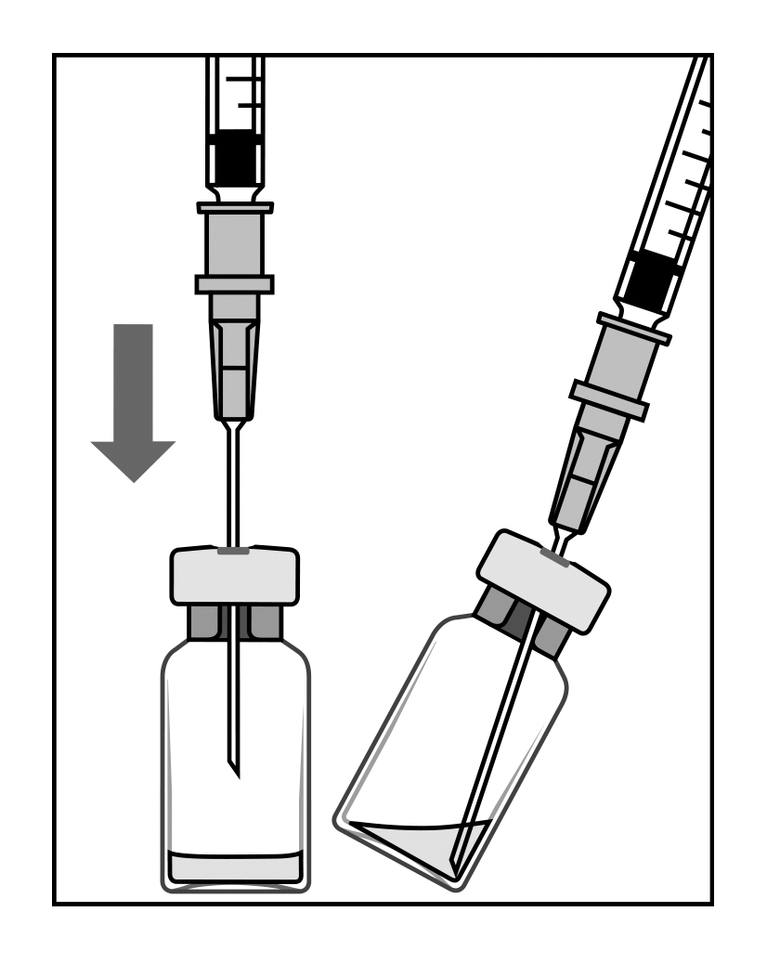 | 1. Before withdrawal, the outer part of the rubber stopper of the vial should be disinfected.  2. Assemble the 5 µm filter needle (provided) onto the 1 mL syringe (provided) using aseptic technique. Push the blunt filter needle into the centre of the vial stopper until the needle touches the bottom edge of the vial.  3. Withdraw all the liquid from the vial, keeping the vial in an upright position, slightly inclined to ease complete withdrawal.
B.  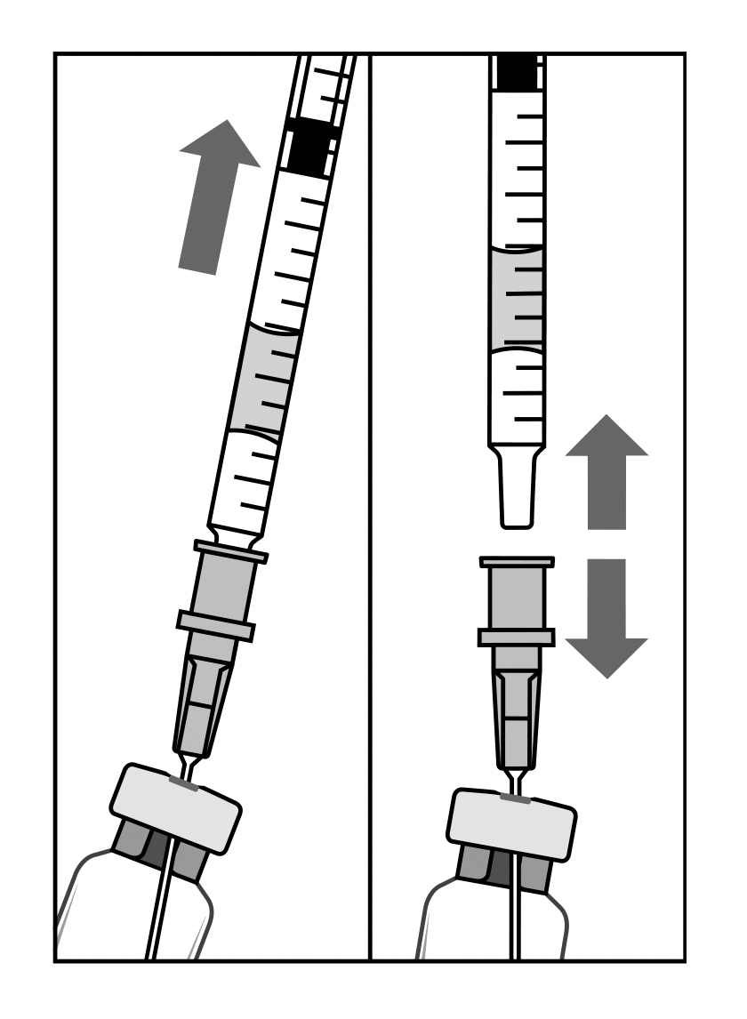 | 4. Ensure that the plunger rod is drawn sufficiently back when emptying the vial in order to completely empty the filter needle.  5. Leave the blunt filter needle in the vial and disconnect the syringe from the blunt filter needle. The filter needle should be discarded after withdrawal of the vial contents and should not be used for the intravitreal injection.
C.  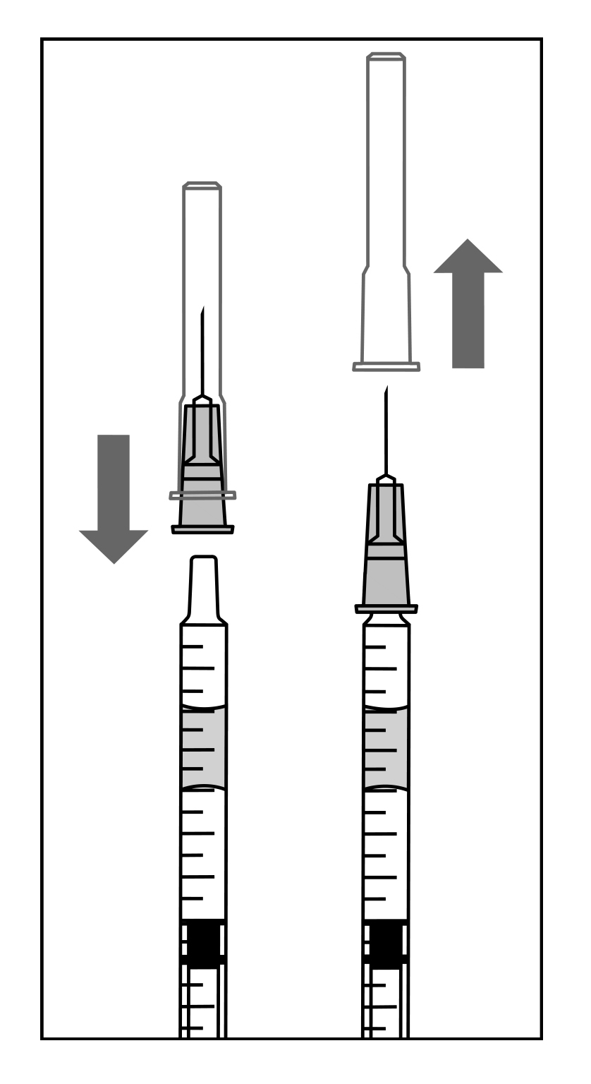 | 6. Aseptically and firmly assemble the injection needle (provided) onto the syringe.  7. Carefully remove the cap from the injection needle without disconnecting the injection needle from the syringe.  Note: Grip at the yellow hub of the injection needle while removing the cap.
D.  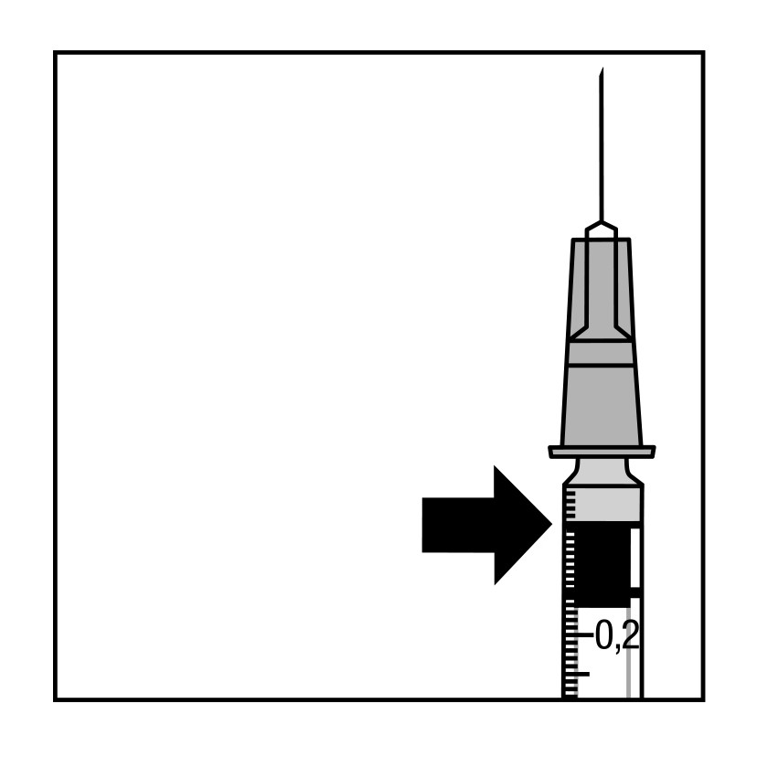  0.05 mL  or  0.03mL | 8. Carefully expel the air from the syringe and adjust the dose to the 0.05 mL or 0.03mL mark on the syringe. The syringe is ready for injection.  Note: Do not wipe the injection needle. Do not pull back on the plunger.  Any unused product or waste material should be disposed of in accordance with local requirements.

Pre-filled syringe pack
The pre-filled syringe is for single use only (see Dosage and administration).

The pre-filled syringe is sterile. Do not use the pre-filled syringe if the packaging is
damaged. The sterility of the pre-filled syringe cannot be guaranteed unless the tray
remains sealed. Do not use the pre-filled syringe if the solution is discoloured, cloudy, or
contains particulates.

For the intravitreal injection, a 30G x 1/2 inch injection needle should be used.

To prepare Lucentis for intravitreal administration, please adhere to the instructions for
use:

Heading | Instructions | Diagram/Image
Read all the instructions carefully before using the pre-filled syringe.
The pre-filled syringe is for single use only. The pre-filled syringe is sterile. Do not use the product if the packaging is damaged. The opening of the sealed tray and all subsequent steps should be done under aseptic conditions.

Note: The dose must be set to 0.05 mL
Pre-filled syringe description | 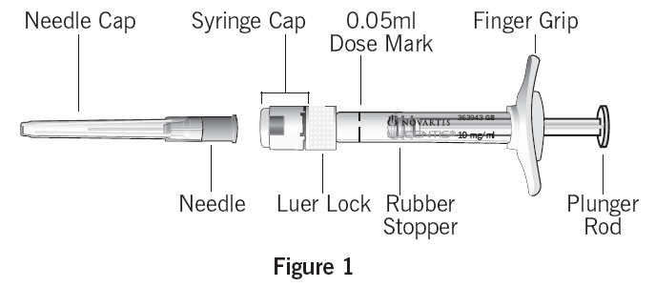
Prepare | 1. Make sure that your pack contains:  - a sterile pre-filled syringe in a sealed tray.  2. Peel the lid off the syringe tray and, using aseptic technique, carefully remove the syringe.
Check syringe | 3. Check that:  - the syringe cap is not detached from the Luer Lock.  - the syringe is not damaged.  - the drug solution looks clear, colourless to pale yellow and does not contain any particulates.  4. If any of the above is not true, discard the pre-filled syringe and use a new one.
Remove syringe cap | 5. Snap off (do not turn or twist) the syringe cap (see Figure 2).  6. Dispose of the syringe cap (see Figure 3). | 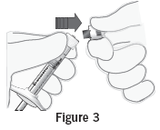
Attach needle | 7. Attach a 30G x 1/2 inch sterile injection needle firmly onto the syringe by screwing it tightly onto the Luer Lock (see Figure 4).  8. Carefully remove the needle cap by pulling it straight off (see Figure 5).  Note: Do not wipe the needle at any time. | 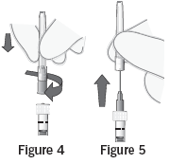
Dislodge air bubbles | 9. Hold the syringe upright.  10. If there are any air bubbles, gently tap the syringe with your finger until the bubbles rise to the top (see Figure 6). | 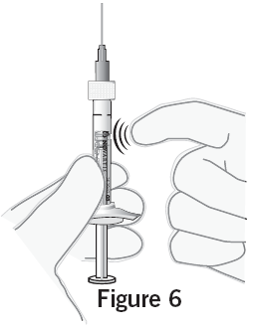
Set dose | 11. Hold the syringe at eye level and carefully push the plunger until the edge below the dome of the rubber stopper is aligned with the dose mark (see Figure 7).  - This will expel the air and the excess solution and set the dose to 0.05 mL.  Note: the plunger rod is not attached to the rubber stopper – this is to prevent air being drawn into the syringe. | 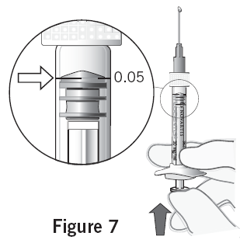
Inject | The injection procedure should be carried out under aseptic conditions.  12. The injection needle should be inserted 3.5 - 4.0 mm posterior to the limbus into the vitreous cavity, avoiding the horizontal meridian and aiming towards the centre of the globe.  13. Inject slowly until the rubber stopper reaches the bottom of the syringe to deliver the volume of 0.05 mL.  14. A different scleral site should be used for subsequent injections.  15. After injection, do not recap the needle or detach it from the syringe. Dispose of the used syringe together with the needle in a sharps disposal container or in accordance with local requirements.

Lucentis contains no antimicrobial agent. Product is for single use in one patient only. Discard any residue.

Incompatibilities: In the absence of compatibility studies, this medicinal product must not be mixed with other medicinal products.

OVERDOSAGE

Cases of accidental overdose have been reported from the clinical studies in wet AMD and post-marketing data. Adverse reactions most frequently associated with these reported cases were intraocular pressure increased and eye pain. If an overdose occurs, intraocular pressure should be monitored and treated, if deemed necessary by the attending physician.

Contact the Poisons Information Centre on 13 11 26 for advice on management.

PRESENTATION AND STORAGE CONDITIONS

Vial pack
Lucentis is supplied as 0.23 mL solution for injection in glass vials (colourless type I glass) with chlorobutyl rubber stopper. One pack contains one vial, one filter needle for withdrawal of the vial contents, one needle for intravitreal injection and one syringe for withdrawal of the vial contents and for intravitreal injection. Each vial contains 2.3 mg of ranibizumab in 0.23 mL solution.

Pre-filled syringe pack
Lucentis is supplied as 0.165 mL sterile solution in a pre-filled syringe (type I glass) with a bromobutyl rubber plunger stopper and a syringe cap consisting of a white, tamper-evident rigid seal with a grey bromobutyl rubber tip cap and a Luer Lock adapter. The pre-filled syringe has a plunger rod and a finger grip, and is packed in a sealed tray. One pack contains one pre-filled syringe. Each pre-filled syringe contains 1.65 mg of ranibizumab in 0.165mL solution.

Not all presentations may be marketed.

Storage:
Vial pack
Store at 2°C to 8°C (refrigerate - do not freeze). Protect from light.
Keep the vial in the outer carton in order to protect from light.

Pre-filled syringe pack
Store at 2°C to 8°C (refrigerate - do not freeze). Protect from light.
Keep the pre-filled syringe in its sealed tray in the carton in order to protect from light. Prior to usage, the unopened tray may be kept at room temperature (25°C) for up to 24 hours.

POISON SCHEDULE OF THE MEDICINE

Poisons Schedule: Schedule 4.

NAME AND ADDRESS OF THE SPONSOR

Novartis Pharmaceuticals Australia Pty Limited
ABN 18 004 244 160
54 Waterloo Road
North Ryde NSW 2113

DATE OF FIRST INCLUSION IN THE AUSTRALIAN REGISTER OF THERAPEUTIC GOODS (THE ARTG)
27 February 2007

DATE OF MOST RECENT AMENDMENT
28 April 2014

® = Registered trademark

For Internal Use Only
(luc280414i.doc) based on CDS dated 31 Oct 2013 and DO PM-2013-00985-1-5 and post-ACPM recommendations.

