Date of CER: 31 August 2012

AusPAR Attachment 2

Extract from the Clinical Evaluation Report for Raltegravir
  - Proprietary Product Name: Isentress
  - Sponsor: Merck Sharp & Dohme (Australia) Pty Ltd

About the Therapeutic Goods Administration (TGA)
- The Therapeutic Goods Administration (TGA) is part of the Australian Government Department of Health and Ageing, and is responsible for regulating medicines and medical devices.
- The TGA administers the Therapeutic Goods Act 1989 (the Act), applying a risk management approach designed to ensure therapeutic goods supplied in Australia meet acceptable standards of quality, safety and efficacy (performance), when necessary.
- The work of the TGA is based on applying scientific and clinical expertise to decision-making, to ensure that the benefits to consumers outweigh any risks associated with the use of medicines and medical devices.
- The TGA relies on the public, healthcare professionals and industry to report problems with medicines or medical devices. TGA investigates reports received by it to determine any necessary regulatory action.
- To report a problem with a medicine or medical device, please see the information on the TGA website <http://www.tga.gov.au>.
About the Extract from the Clinical Evaluation Report
- This document provides a more detailed evaluation of the clinical findings, extracted from the Clinical Evaluation Report (CER) prepared by the TGA. This extract does not include sections from the CER regarding product documentation or post market activities.
- The words [Information redacted], where they appear in this document, indicate that confidential information has been deleted.
- For the most recent Product Information (PI), please refer to the TGA website <http://www.tga.gov.au/hp/information-medicines-pi.htm>.
Copyright
© Commonwealth of Australia 2013
This work is copyright. You may reproduce the whole or part of this work in unaltered form for your own personal use or, if you are part of an organisation, for internal use within your organisation, but only if you or your organisation do not use the reproduction for any commercial purpose and retain this copyright notice and all disclaimer notices as part of that reproduction. Apart from rights to use as permitted by the Copyright Act 1968 or allowed by this copyright notice, all other rights are reserved and you are not allowed to reproduce the whole or any part of this work in any way (electronic or otherwise) without first being given specific written permission from the Commonwealth to do so. Requests and inquiries concerning reproduction and rights are to be sent to the TGA Copyright Officer, Therapeutic Goods Administration, PO Box 100, Woden ACT 2606 or emailed to <tga.copyright@tga.gov.au>.

Contents
List of abbreviations 4
1. Clinical rationale 6
2. Contents of the clinical dossier 6
2.1. Paediatric data 6
3. Study P068 6
3.1. Design 6
3.2. Results 7
3.3. Pharmacokinetic results 7
3.4. Safety results 8
3.5. Discussion 9
4. Pivotal study P1066 9
4.1. Pharmacokinetics – Stage I dose finding 9
4.2. Efficacy stage II 16
4.3. Population pharmacokinetics 34
5. Clinical safety 36
5.1. Study P1066 36
5.2. Literature review 39
5.3. Postmarket experience 40
5.4. Compassionate use access program 42
6. Clinical summary and discussion 42
6.1. Study P068 42
6.2. Study P1066 43
7. First round benefit-risk assessment 46
7.1. First round assessment of benefits 46
7.2. First round assessment of risks 46
7.3. First round assessment of balance 46
8. First round recommendation regarding authorisation 46
9. Clinical questions and second round evaluation of sponsor’s response to questions 47
9.1. Question 1-Efficacy analysis 47
9.2. Question 2-Dosage administration 50

List of abbreviations
Abbreviation | Meaning
AIDS | Acquired Immunodeficiency Syndrome
ANOVA | Analysis of Variance
AUC | Area Under the Concentration-time Curve
AUC_{0-12h}/AUC_{12h} | Area Under the Concentration-time Curve from time zero to 12 h postdose
AUC_{0-∞}: | area under the plasma concentration time curve from time zero to infinity
Β-hCG | Human chrionic gonadotrophin
BLQ | Below limit of quantification
BMI | Body Mass Index
C_{12h} | Concentration 12 h postdose
CL/F - | oral clearance
CLt | apparent clearance
CLiwt | intercept term between weight and CLt
CLswt | slope term between weight and CLt
C_{max} | Peak plasma concentration
CRO | Contract research organisation
CSR | Clinical study report
DNA | Deoxyribonucleic acid
EC | ethylcellulose
ECG | Electrocardiogram
GMR | Geometric mean ratio
HAART | Highly active anti-retroviral therapy
HIV | Human immunodeficiency virus
IC50 | 50% inhibitory concentration
i.e. | that is
IRB | Institutional review board
LLOQ | Lower level of quantification
MedDRA | Medical Dictionary for Drug Regulatory Affairs
MRL | Merck Research Laboratory
MSE | Mean square error
NRTI | Nucleoside reverse transcriptase inhibitor
NNRTI | Non-nucleoside reverse transcriptase inhibitor
OG | Oral granules for suspension
PI | Protease inhibitor
Q/F | apparent distributional clearance
SD | Standard deviation
t_{1/2I} | Initial phase Half-life
t_{1/2T} | Terminal phase Half-life
T_{max} | Time of peak plasma concentration
Vc | apparent volume of distribution of the central compartment
Viwt | intercept term between weight and Vc
Vswt | slope term between weight and Vx

Clinical rationale
Raltegravir belongs to the class of HIV integrase inhibitors which prevent covalent insertion of the HIV genome into the host cell genome during the early phase of infection preventing viral propagation. Isentress 400 mg tablets were registered in Australia for adult use for the treatment of HIV-1 in January 2008.
The paediatric development program for raltegravir began with Phase I pharmacokinetic and safety studies of paediatric formulation candidates evaluated in healthy adult volunteers, the pivotal study being Protocol 068. The data from this study were used to select two formulations, the chewable tablets and the oral granules for suspension, which were further evaluated, along with the adult formulation, in the pivotal clinical Phase I/II study P1066, in HIV-infected-paediatric patients.

Contents of the clinical dossier

Paediatric data
The applicant stated that all trials were conducted following contemporary Good Clinical Practice guidelines and considerations for the ethical treatment of human subjects.

Study P068

Design
P068 was a Phase I, open label, 4-period, randomized and crossover study to compare the plasma pharmacokinetic profiles and safety in healthy adults following single-dose administration of the raltegravir oral granules (OG) formulation, the final market image (FMI) poloxamer adult formulation, and the ethylcellulose (EC) paediatric chewable formulation. The secondary objective was to compare plasma pharmacokinetic profiles following single-dose administration of the raltegravir chewable tablet formulation in the fasted state and following a high fat meal formulation.
The raltegravir plasma concentration profile was measured over 72 hours following dosing.
Twelve healthy, non-smoking adult males and non-pregnant females between 18 and 55 years of age, with a body mass index (BMI) < 35 kg/m² were included.
Each participant received 4 treatments randomized in a balanced, crossover design in Periods 1 to 4 with a minimum of 4 days washout between the single doses in each treatment period. All doses were administered in the clinic. Each dose was taken with 240 mL of water except for Treatment C which was administered in solution. All doses, except for Treatment D were administered in the fasted state.
- Treatment A: 400 mg raltegravir adult formulation, one tablet swallowed whole
- Treatment B: 400 mg raltegravir chewable tablet, 4 x 100 mg tablets chewed.
- Treatment C: 400 mg raltegravir oral granules (not relevant to this submission)
- Treatment D: 400 mg raltegravir chewable tablets, 4 x 100 mg tablets following a standardised high fat meal.

Statistics
Formulation effects on plasma pharmacokinetic (PK) parameters were evaluated using a linear mixed-effects model with fixed effects terms of treatment and period and a random participant effect. Carryover effects was evaluated at the significance level of 0.10 and put into model if found to be significant. Natural log transformations were applied. Two-sided 90% confidence intervals (CIs) for the true mean differences in raltegravir C_{12h} in the log scale were calculated. These confidence limits were then exponentiated to obtain 90% Confidence Intervals for the true geometric mean ratios (GMRs) for raltegravir C_{12h}, AUC_{0-∞} and C_{max}.

Results
The study was conducted according to protocol. Three female and nine male participants were enrolled. Ages ranged from 26 – 50 years, height from 155.5 to 192 cm, weight from 54 to 95.3 kg and BMI from 20.8 to 31.4 kg/m².

Pharmacokinetic results

Adult formulation versus chewable tablets, fasted state
Results are summarised in Table 1 below.
The geometric means of AUC_{0-∞} were 19.2 µM.h for the adult tablet and 34.2 µM.h for the chewable formulation. The GMR (90% CI) was 1.78 (1.47, 2.15). The result was outside the bioequivalence acceptance limits of 80 – 125%.
The geometric means of C_{max} were 5.0 µM for the adult tablet and 16.1 µM for the chewable tablet. The GMR (90% CI) was 2.73 (2.37, 4.38). The result was outside the bioequivalence acceptance limits.
The geometric means for C_{12h} of 400 mg adult formulation and 400 mg chewable formulation were 149 nM and 134 nM respectively. The GMR (90% CI) was 0.90 (0.7, 1.18). The lower limit of the 90% CI was below bioequivalence acceptance limits; however this parameter was the closest to fulfilling bioequivalence criteria.
The median T_{max} was 0.5 hours for the chewable tablet versus 4.0 hours for the adult tablet.
Table 1 Study P068 Summary statistics fasted state (geometric means)
Parameter | Treatment A fasted  (adult tablet) | Treatment B  (chewable tablet) | GMR  Treatment B/A | 90% CI
C_{12h} (nM) | 149 | 134 | 0.90 | 0.70, 1.18
AUC_{0 - ∞} (µM•h) | 19.2 | 34.2 | 1.78 | 1.47, 2.15
C_{max} (µM) | 5.00 | 16.1 | 3.22 | 2.37, 4.38
T_{max} (hr) | 4.0 | 0.5
t ½_{I} | 1.5 (0.3) | 1.7 (0.2)
t ½ _{T} | 9.0 (5.9) | 9.3 (5.1)

Chewable tablets fasted and fed states
After single dose administration of raltegravir, the geometric mean C_{12h} of 400-mg chewable tablet formulation administered with a standard high-fat meal was moderately higher than that obtained with the EC formulation administered in the fasted state whereas the geometric mean AUC_{0-∞} was similar following EC administration under both fasted and fed conditions.
- C_{12h} GMR (90% CI) for fed/fasted 2.88 (2.21, 3.75)
- C_{max} with GMR (90% CI) 0.38 (0.28, 0.52),
- T_{max} (median 0.5 hour in the fasted state and 1.0 hour in the fed state)
- AUC_{0-∞} with GMR (90% CI) of 0.94 (0.78, 1.14) (Table 2 below)
Table 2 Summary statistics treatment B fasted, treatment D with high fat meal (geometric means)
Parameter | Treatment B fasted  (chewable tablet) | Treatment D  (chewable tablet) | GMR  Treatment D/B | 90% CI
C_{12h} (nM) | 134 | 387 | 2.88 | 2.21, 3.75
AUC 0 - ∞ (µM•h) | 34.2 | 32.3 | 0.94 | 0.78, 1.14
C_{max} (µM) | 16.1 | 6.14 | 0.38 | 0.28, 0.52
T_{max} (hr) | 0.5 | 1.0
t ½_{I} | 1.7 (0.2) | 2.0 (0.6)
t ½ _{T} | 9.3 (5.1) | 9.2 (3.8)

Safety results
No serious adverse events were reported and no participant discontinued because of an adverse experience. Six participants reported a total of nine different non-serious clinical adverse experiences, one of which, somnolence, was judged by the investigator to be possibly related to study drug. All adverse experiences reported were mild and transient. There were no laboratory adverse experiences reported in this study.

Discussion
With regard to the adult formulation it was in the submission that the final market image (FMI) was used in all Phase III studies. The raltegravir 12% poloxamer formulation used in all Phase II and some late Phase I studies differs from the FMI in the colour and thickness of the film coating and in the debossing used for the Phase III formulation. However, this CSR reports use of the FMI in this Phase 1 study.
In the fasted state, the chewable, 400 mg tablet was more rapidly absorbed than the adult tablet, with higher peak concentrations and AUC, and lower trough concentrations for the chewable tablet compared to the adult tablet. Administration of the chewable tablet with a high fat meal resulted in delay of absorption, a lower C_{max}, a higher Cmin and a similar AUC to results in the fasted state.
The applicant states that there are considerable data indicating that the higher peak concentrations obtained in Cohorts IIB and III are not a safety concern. In Phase I trials in healthy adult volunteers, single doses of the lactose formulation up to 1,600 mg and multiple doses of 800 mg twice daily were generally well tolerated. No dose-related or dose-limiting toxicities have been observed in dose ranging studies, including 600 mg twice administered concomitantly with tenofovir and/or atazanavir in HIV-infected patients. In Phase II studies in adult patients, 25 patients mistakenly took raltegravir doses of ≥ 1600 mg daily for a range of 1-14 days; during which time no raltegravir-related adverse experiences were reported. In Phase III adult studies, 8 patients mistakenly took raltegravir doses of ≥ 1600 mg daily for between 1-36 days; with no raltegravir-related adverse experiences reported during that that time. In clinical studies of raltegravir in adult patients, there were no acute safety findings that were temporally associated with peak concentrations, and raltegravir was found to be generally well tolerated in the clinical program with no dose-related toxicities. This includes experience with 800 mg once daily from Protocol 071, where geometric mean C_{max} for the 800 mg once daily arm was 13.5 µM; the 800 mg once daily arm of Protocol 071 included 382 treatment naive adults studied for at least 48 weeks, and no safety issues of note were reported.
The applicant also points out that despite extensive analyses of pharmacokinetic/pharmacodynamic data from raltegravir Phase II and III studies, a strong association has not been found between pharmacokinetic summary measures and efficacy parameters, and thus a target pharmacokinetic parameter known to strongly influence outcome has not yet been identified. However, for other classes of antiretroviral agents, there is a reasonable but imperfect association of efficacy with doses that achieve C_{trough} values that exceed the IC₉₅ in the HIV spread assay.

Pivotal study P1066

Pharmacokinetics – Stage I dose finding
P1066 is an ongoing Phase I/II, multi-centre, open-label and non-comparative study of raltegravir for treatment of HIV-1 infected children and adolescents. Forty centres enrolled participants in the United States, Brazil, South Africa, Botswana, and Argentina. The study, conducted between September 2007 and February 2011, was divided into two sequential Stages and evolved over the course of three versions of the protocol. Stage I primary objectives were:
- To evaluate the short term safety and tolerability of raltegravir in infants, children and adolescents in combination with stable background therapy.
- To evaluate the steady state plasma concentration profiles and pharmacokinetic parameters of raltegravir in infants, children and adolescents in order to ascertain the appropriate dose.
Stage I was designed to determine a paediatric dose with pharmacokinetics approximating adult exposure at 400 mg of the adult formulation. Adult dosing in Phase III studies resulted in a geometric mean AUC _{0 – 12h} of 18 µM.h and median AUC_{0 – 12h} of 18 µM.h. The target minimum exposure for this study was set at AUC _{0 – 12h} > 14µM.h. The target geometric mean C_{12h} was set at > 33 nM to exceed the in vitro IC95. For safety considerations the maximum AUC _{0 – 12h} was defined as < 95µM.h which was the AUC for a single 1600 mg dose used in phase I studies. The lower acceptable AUC limit was set at 5µM.h. However, during the conduct of the study, it was noted that the upper AUC limit actually corresponded to an AUC 0-24 value and so in Version 3.0 of the protocol ((March 2010), the maximum upper AUC_{12h} limit was changed to 45 μM.h while the lower threshold remained at 5 μM.hr.
Stage II was primarily to evaluate the safety and tolerability of chronic dosing of raltegravir at the selected dose in combination with optimized background therapy (OBT) in children and adolescents in the age group categorises ≥ 2 to < 6 years, ≥ 6 to < 12 years and ≥ 12 to < 19 years, assessed by review of the accumulated safety data over 24 weeks.
HIV-1 infected treatment experienced children and adolescents aged ≥ 2 to < 19 years at study entry were eligible if HIV RNA was ≥ 1,000 copies/mL and treatment with background therapy was stable, i.e. either unchanged therapeutic regime for at least 12 weeks or, treatment experience but on no treatment for ≥ 4 weeks. Treatment experience did not including therapy to interrupt maternal-infant transmission. Exclusion criteria included diagnosis of a new CDC Stage C criteria or opportunistic or bacterial infection diagnosed within 30 days prior to screening and not considered clinically stable. Pregnant or breast feeding females were excluded. The participants in Stage I mini-cohorts were not to use ARV regimen that included atazanavir, tenofovir or tipranavir during Stage I.
The planned enrolment was 120 to 140 participants enrolled by age groups into cohorts as follows:
- Cohort 1: ≥ 12 to < 19 years assigned to receive raltegravir adult tablets
- Cohort IIA: ≥ 6 to < 12 years assigned to receive raltegravir adult tablets
- Cohort IIB: ≥ 6 to < 12 years assigned to receive raltegravir chewable tablet
- Cohort III: ≥ 2 to < 6 years assigned to receive raltegravir chewable tablets
Enrolment began with a mini-cohort of 4 participants in Cohort I and progressed to the younger cohorts once a preliminary dose of raltegravir for the older cohort had been determined and safety was found to be acceptable. If, on review of all the PK and safety data, the dose was not acceptable, the dose was to be adjusted and the mini-cohort would have repeat safety and PK evaluations, with the process repeating until an acceptable dose was determined.
Following completion of intensive PK and optimisation of background therapy in Stage I, participants began chronic dosing of raltegravir. Enrolment of the complete full cohort of approximately 10 participants (12 for Cohort III) commenced if the PK and safety assessment was satisfactory and at that time enrolment of the next sequential age cohort was to commence. The intensive PK participants did not count towards the additional ten participants required for each Cohort in Stage II, but if their Stage I dose was equivalent to the selected dose, Stage I exposure was to be considered in the Week 24 and 48 data analysis. Treatment duration of Stage I was a minimum of 48 weeks on the selected dose. The study plan for Stage I is illustrated in Figure 1below.
Figure 1. Study P1066 Stage I schema
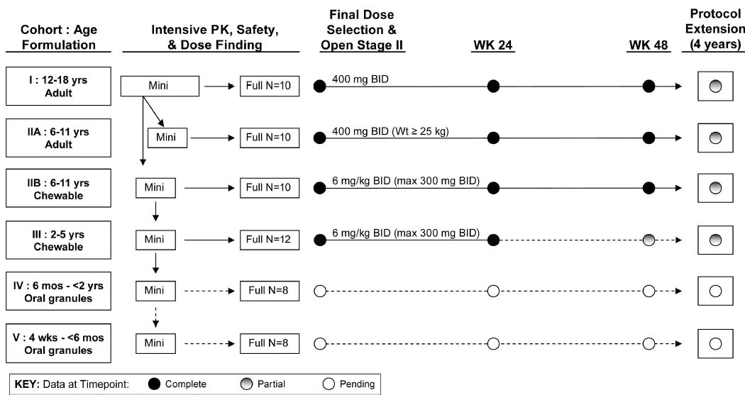
Treatments were planned as follows according to Protocol version 1 (May 2007):
- - Cohort I: Poloxamer Film-coated raltegravir (adult) tablets at a starting dose of 6 mg/kg orally every 12 hours to a maximum dose of 800 mg by mouth twice daily
- - Cohort II A: Poloxamer Film-coated raltegravir tablets at a starting dose of 8 mg/kg (or the dose determined by review of all available data, including Cohort I data) orally every 12 hours to a maximum dose of 800 mg twice daily
- - Cohort IIA and Cohort IIIB: raltegravir paediatric chewable tablet at a starting dose of 6 mg/kg or the dose determined by review of all available data, including Cohort I or Cohort IIB, respectively, orally every 12 hours to a maximum dose of 800 mg.
Raltegravir (Isentress™) was available in poloxamer film coated tablets (marketed adult tablets) with dose strength of 400 mg. Dose strengths of 100 mg and 200 mg were also available, but were phased out after dose finding for Cohort I and IIA).
The chewable tablet formulations (100 mg and 25 mg) used in study P1066 were identical to those proposed for marketing apart from colour and shape; the 25 mg tablet was orange instead of yellow; the 100 mg tablet was round and unscored. The colour change was effected by leaving out the red ferric oxide from the blend. To bridge between the round, unscored tablet and the oval, scored, commercial tablets, comparative dissolution profiles were studied. A 50 mg chewable tablet, a weight multiple of the 100 mg chewable tablet was used by some patients in Study P1066 but is not proposed for marketing.
Stage I was originally designed such that participants would take their raltegravir doses without regard to food intake. A standardised low-fat meal was implemented for all participants, to be ingested with the study drug at the time of the intensive PK evaluation. After the P1066 study opened, additional data were provided from the manufacturer suggesting food intake affects the raltegravir concentration-time profile. High-fat meals increased the AUC_{12h}, low-fat meals decreased the AUC_{12h}, and food intake in general increased the pharmacokinetic variability. These effects were considered likely to affect the interpretation of pharmacokinetic data. Protocol Version 2 (April 2008) changed the requirements to that dosing was to be subsequently undertaken in the fasted state.
Blood samples were drawn and plasma prepared at the clinical sites. Clinical report forms detailing information such as height, weight, dose of medication, cohort number, food intake, the timing of participant doses and blood draws were prepared at clinical sites. Samples were then packaged in dry ice and shipped to [information redacted]. All samples were received frozen on dry ice and in good condition.
An assay was developed for raltegravir analysis in human plasma using a liquid-liquid extraction and high performance liquid chromatography (HPLC) separation coupled with tandem mass spectrometry (MS-MS) detection. Analytes were obtained from Merck Research Laboratories.
The initial dynamic range of 1 to 3000 ng/mL resulted in a large number of repeat analyses due to sample concentrations above the upper limit of quantitation. The assay was revalidated with a new dynamic range of 10 ng/mL to 10,000 ng/mL (date not specified). Adjustments were made to the volume of plasma required and the final reconstitution volume.
All intensive PK sets were analysed using non-compartment analysis methods as described in the Noncompartmental Pharmacokinetic Analyses Standard Operating Procedures. WinNonlin versions 5.1 and 5.2 (Pharsight Corporation, Mountain View, CA) was used for all pharmacokinetic analyses. All concentration-time results were internally quality controlled by the Antiviral Pharmacology Laboratory at UAB and externally quality controlled by the IMPAACT Data Monitoring Center (DMC). Evaluation of the laboratory work was outside the expertise of the clinical evaluator.

Stage I Pharmacokinetics results – non-fasted
The dose-finding phase was reviewed in real time by the protocol team for the purpose of dose selection. No safety events occurred that led to rejection or modification of doses, therefore, all dose selection decisions were based entirely on the pharmacokinetic data.

Cohort I ≥ 12 years to < 19 years – adult tablet
The Intensive PK mini-cohort I of four participants received weight based dosing approximately 6 mg/kg twice daily. The geometric mean C_{12h} was 218 mM which was well above the minimum target of 33 nM. The GM AUC_{12h} was 10.4 µM.h which was below the target of > 14 µM.h. Based on these results the protocol team implemented a dose increase to 8 mg/kg twice daily.
Results for the four participants in the mini-cohort dosed with 8 mg/kg; the GM C_{12h} was 455.32 nM with CV% 133.26%. The GM AUC_{12h} was 19.81 µM.h with CV% of 36.43%. These results met the protocol defined criteria.
Based on the study design, once the mini- Cohort I met the PK and safety criteria, additional participants were enrolled into Cohort I to complete the full-cohort and enrolment in Cohort IIA commenced.
Results from the complete set of full Cohort I participants (N=10) who received 8 mg/kg twice daily and had PK done under fed conditions were summarised. Two participants were inadvertently dosed with 6 mg/kg. The GM C_{12h} was 198.4 nM with CV% 138.44%. The GM AUC_{12h} was 6.64 µM.h with CV% 80.02%. While the C_{12h} met the target, the AUC_{12h} failed to do so.

Cohort IIA ≥ 6 years to < 12 years – adult tablet
Individual results for the mini-cohort IIA of four participants ; GM C_{12h} was 153.62 nM with CV% 61.05% and the GM AUC_{12h} was 8.69 µM.h with CV% 72.63%.
At this point in the study, due to the large degree of PK variability, fasting PK assessments were instigated for further study.

Stage I Pharmacokinetics results - fasted

Cohort I ≥ 12 years to < 19 years – adult tablet
A new Cohort I (N=11) was enrolled, none of whom were in the initial non-fasting group. The Cohort I fasting dose was 8 mg/kg of the poloxamer tablet twice daily.
The GM AUC_{12h} of 15.7 µM.h and GM C_{12h} of 332.6 nM, both met the protocol specified PK targets. The majority of patients in this Cohort received a dose of 400 mg (GM dose = 379.6 mg) twice daily.

Cohort IIA ≥ 6 years to < 12 years – adult tablet
Participants in mini-cohort IIA had fasting PK evaluated at a dose of 8 mg/kg. For the mini-cohort of four patients, the GM C_{12h} was 227.30 nM (CV% 97.81%) and the GM AUC_{12h} was 15.39 µM.h (CV% 63.82%). Both results met the target levels and additional participants were enrolled to complete the full cohort.
Results for the full Cohort II (N = 11); the AUC_{12h} of 12 µM.h, was slightly below the target of >14 µg.h and therefore did not meet the pre-specified exposure criteria; however, the GM C_{12h} value of 167.5 nM exceeded the protocol target of 33 nM.
Based on these results a dose of 400 mg twice daily was also recommended for this age group. Participants had their dose adjusted accordingly, and repeat PK was collected for any participant who did not initially receive 400 mg twice daily, and new patients were enrolled if needed to fill the Cohort at this dose.
The resulting pharmacokinetic parameter values for the 400 mg twice daily dose; the GM AUC_{12h} of 15.8 µM.h and GM C_{12h} value of 246 nM were within the predefined targets. The CV% for AUC_{12h} and C_{12h} were 120.43% and 220.55% respectively.
Two children with weights below 25 kg had high AUC values at the 400 mg twice daily dose. The two children were subsequently switched to the chewable tablet formulation and had a repeat intensive PK performed. Following the formulation change, their AUC_{12h} results were consistent with other participants receiving the same formulation. These two children were not reassigned to Cohort IIB, nor were their PK data on the chewable tablets merged with the Cohort IIB data. For purposes of demographic, safety, and efficacy analyses, their data are reported in Cohort IIA.

Cohort IIB ≥ 6 years to < 12 years – chewable tablet
In Version 3.0 of the protocol, the AUC_{12h} target was changed in order to better accommodate the observed pharmacokinetic variability and the anticipated higher bioavailability of the chewable tablet formulation. The GM AUC_{12h} target was reset as a range of 14 - 25 µM.h with concurrent GM C_{12h} > 33 nM.
Based on the dose evaluated for Cohort IIA, the first participants enrolled in the mini- Cohort IIB received dosing to approximate 8 mg/kg of the chewable tablet twice daily. The GM AUC_{12h} of 27.5 µM.h was greater than the target upper limit of 25 µM.h. The GM C_{12h} value of 146.3 nM was within the predefined target. The coefficients of variation for AUC_{12h} and C_{12h} were respectively 38.83% and 67.38%.
Subsequently, the chewable tablet dose was reduced to approximately 6 mg/kg twice daily up to a maximum dose of 300 mg and a mini-cohort of 4 patients received intensive PK at this dose. Results for the second mini-Cohort IIB; the GM AUC_{12h} was 20.1 µM.h r (CV% 56.52%) and GM C_{12h} of 115.1 nM (CV 87.15%). According to protocol, once the mini-Cohort IIB met the PK and safety criteria, additional participants were enrolled into Cohort IIB to complete the full-cohort.
Results for the complete set of full-Cohort IIB participants (N=10) who received 6 mg/kg twice daily; the full-Cohort IIB (N=10) had a GM AUC_{12h} of 22.6 µM.h and C_{12h} of 130 nM, both which met the protocol specified PK targets. The CV% for AUC_{12h} and C_{12h} respectively were 33.56% and 87.58%.

Cohort III ≥ 2 years to < 6 years – chewable tablet
Based on the PK results from the mini-Cohort IIB (N=4) receiving weight based dosing of approximate 6 mg/kg (maximum 300 mg) twice daily, Cohort III was opened.
The GM AUC_{12h} was 17.2 µM.h and C_{12h} of 72.4 nM both which met the protocol PK targets. The CV% for AUC_{12h} and C_{12h} respectively were 78.81% and 63.97%. Based on the study design, once the mini-Cohort III met the PK and safety criteria, additional participants were enrolled into Cohort III to complete the full cohort. Results from the complete set of full-Cohort III participants (N=12) who received ~6 mg/kg twice daily were provided.
The full-Cohort III (N=12) had a GM AUC_{12h} of 18 µM.h and C_{12h} of 71 nM both which met the protocol PK targets. The CV% of the results was 58.59% for the AUC_{12h} and 55.46% for C_{12h}. The AUC_{12h}, C_{12h}, and 4 week safety criteria were met.
For all cohorts, the raw concentration-time data for all Cohorts is shown in Figure 2, from participants receiving only the poloxamer formulation in Cohorts I and IIA (Figure 3), and participants receiving the chewable tablets in Cohorts IIB and III (Figure 4).
Figure 2. Raltegravir concentration-time data from all participants in cohorts I, IIA, IIB, and III - fasted
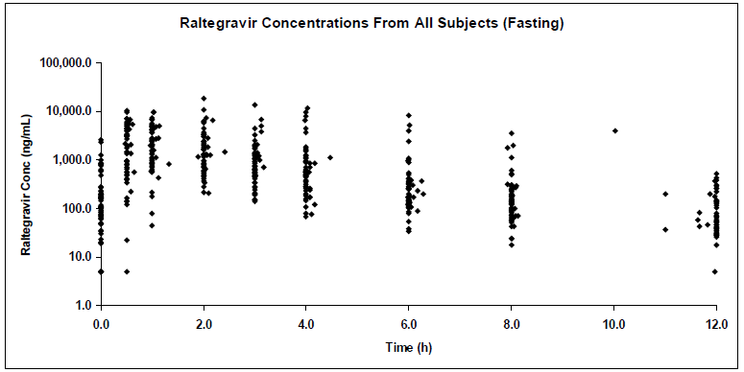
Figure 3. Raltegravir concentration time data from cohorts I and IIA (adult tablet, fasting)
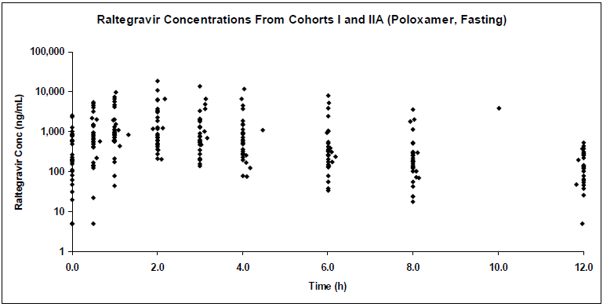
Figure 4. Raltegravir concentration-time data from cohorts IIB and III (chewable tablets, fasting)
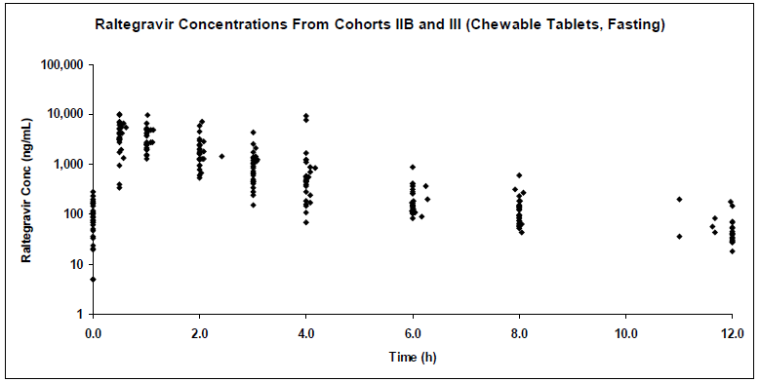

Conclusions from Stage 1 pharmacokinetics
Consistent with adult data, the adult tablet formulation displayed a high degree of pharmacokinetic variability in the paediatric population, even under fasting conditions. The chewable tablet formulation exhibited somewhat more consistent concentration-time profiles, as evidenced by the lower coefficients of variation.
A dose of 400 mg twice daily of the poloxamer (adult) tablet was carried forward as the final recommendation for participants aged ≥ 12 to < 19. A dose of 400 mg twice daily was also recommended for the age group 6 – 11 years weighing ≥ 25 kg. Weight based dosing to approximate 6 mg/kg (maximum 300 mg) twice daily of the chewable tablet was carried forward as the final recommendation for participants aged ≥ 2 to < 12 years.

Efficacy stage II

Design
Following Stage I, at least 10 additional participants at the selected dose were to be enrolled into each Stage II cohort. Enrolment was without restriction on age or raltegravir formulation; however efforts were to be made to enrol all age groups. Treatment duration of Stage II was 48 weeks. Study design is illustrated in Figure 5.
Figure 5. Study P1066 stage II schema
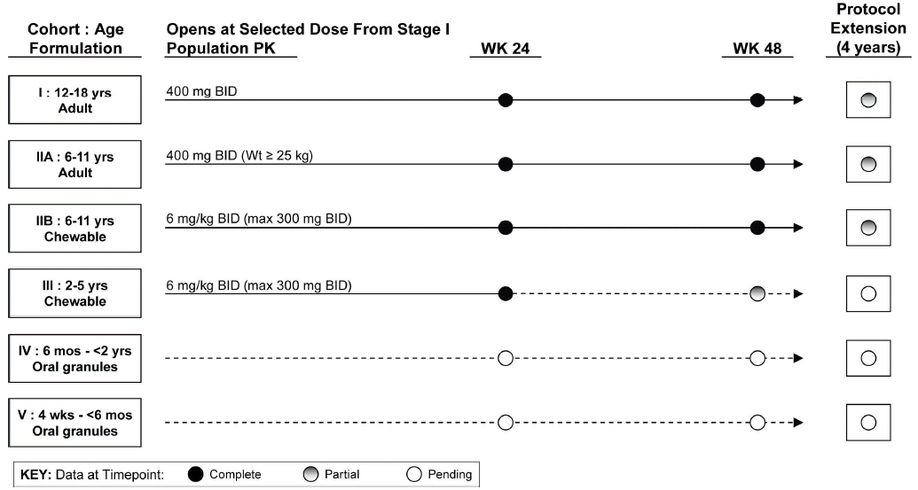
Treatment for the 48 weeks of Stage II was based on doses derived in Stage I. The final doses selected were as shown Table 3 below.
Table 3. Final dose selection
Cohort | Age group and formulation | Final recommended dose
Cohort I | ≥12 to <19 years of age receiving poloxamer film coated adult tablets | 400 mg BID
Cohort IIA | ≥6 to <12 years of age receiving poloxamer film coated adult tablets | 400 mg BID if ≥25 kg
Cohort IIB | ≥6 to <12 years of age receiving chewable tablets | Weight based dosing to approximate 6 mg/kg up to maximum dose of 300 mg BID
Cohort III | ≥2 to <16 years of age receiving chewable tablets | Weight based dosing to approximate 6 mg/kg up to maximum dose of 300 mg BID
Protocol defined methods of ingesting the chewable tablet were described for patients in Stage II: The formulation had not been finalised at the time of approval of Protocol version 1. Protocol version 2 Dosing Instructions were: “Chew tablet in mouth before swallowing. The ingestion of food or liquids after chewing the paediatric tablet is permitted but not required”. Protocol version 3 instructions were similar to Protocol version 2 but also included: “If they prefer, subjects may swallow the chewable tablets whole.”
The objectives of Stage II were as follows and pertained to administration of the selected dose in combination with optimised background therapy to children in age groups ≥ 2 to < 6 years, ≥ 6 to < 12 years and ≥ 12 to < 19 years
Primary: To evaluate the safety and tolerability assessed over 24 weeks.
Secondary Objectives:
- To evaluate the safety and tolerability of raltegravir over 48 weeks.
- To evaluate the antiretroviral activity of raltegravir at study weeks 24 and 48 as measured by the proportion of participants achieving HIV RNA < 400 copies/mL, or maintaining a 1-log drop in HIV RNA from baseline.
- To evaluate the immunological activity measured by changes in CD4 cell count and changes in CD4 % over 24 and 48 weeks.
- To describe paediatric raltegravir exposure over time, using a population pharmacokinetic modelling approach.

Definitions
The Final Dose Population included patients who received only the final selected dose, whether enrolled in Stage I or Stage II. This population was considered the evaluable population and was to be used for the primary assessment of safety and efficacy.
The All Treated Patient Population includes all enrolled patients who received any dose of raltegravir. Patients in the All Treated Population may have received doses other than the final selected dose for a variety of reasons, including participation in Stage I with dose adjustment following intensive PK for mini-cohort or full cohort assessment, or following individual dose adjustments due to extreme outlier AUC values of < 5 or > 45 μM.hr, as allowed per protocol. The All Treated population was used to provide a comprehensive supportive assessment of safety.
Virologic success: In the protocol, the primary definition of virologic success required participants to have achieved and maintained ≥ 1-log drops from baseline or viral loads of < 400 copies/ml. In the analysis of virologic responses at each time point, a cross-sectional approach was used, such that only the HIV RNA measurement within each visit window that was closest to the scheduled visit date was used.
Virologic Failure: The protocol definition was:
- A confirmed decrease from baseline plasma HIV RNA of < 1.0 log10 and HIV RNA > 400 copies/mL at Week 24 or later with confirmatory HIV RNA measurement performed within 1 to 4 weeks.
or
- Virologic rebound at Week 24 or later defined as:
  - confirmed HIV RNA > 400 copies/mL (on 2 consecutive measurements at least 1 week apart) after initial response with HIV RNA < 400 copies/mL
or
  - confirmed >1.0 log10 increase in HIV RNA above nadir level (on 2 consecutive measurements at least 1 week apart). Nadir was defined as the lowest HIV RNA while on study drug.
A confirmatory HIV RNA test was to have been done in 1 week (or up to 4 weeks) later to verify viral failure/relapse. Due to the difficulty of having paediatric patients adhere to extra clinic visits, most patients did not have the confirmatory test within the 1 to 4 week window. Therefore, the next available test for the patient, which may have been within 1 to 4 weeks or longer, was used as confirmatory test to identify virologic failures.

Changes and clarifications
Changes and clarifications to the analyses originally specified in the protocol are summarized below. It was stated that changes were made during the analysis preparation period before the database lock, and they were not included in a protocol amendment.
The criteria of HIV RNA > 400 copies/mL for virologic failure was changed to HIV RNA ≥ 400 copies/mL to be complementary with the virologic success definition of HIV RNA < 400 copies/mL.
To be able to clearly classify the non-responder and virologic rebounder in the analysis, the definition of virologic failure was modified as
- Never achieved ≥1 log drop from baseline in plasma HIV RNA or HIV RNA < 400 copies/mL through Week 24
or
- Virologic rebound at Week 24 or later is defined as
(a) confirmed HIV RNA ≥ 400 copies/mL (on 2 consecutive measurements at least 1 week apart) after initial response with HIV RNA < 400 copies/mL; or
(b) confirmed >1.0 log10 increase in HIV RNA above nadir level (on 2 consecutive measurements at least 1 week apart). Nadir is defined as the lowest HIV RNA by the evaluated time point.
The protocol specified that patients whose OBT was changed after initial optimization would be considered treatment failures, unless the change was one specifically allowed by the protocol. In this CSR, change of OBT was not factored in the definition of Virologic Success/Failure because the reason for OBT change was not captured in a consistent manner making it difficult to assign virologic failure algorithmically. However, upon clinical review of the OBT changes, the applicant stated that the overall assessment of patients with virologic failure would not have changed; however, the impact on the over-time response was not evaluated.

Results
Results were reported to 14 February 2011. A total of 126 patients were enrolled into Cohorts, I, IIA, IIB and III. By the time of data cut-off date, all patients in Cohorts I, IIA, IIB, and III had complete Week 24 data . All patients in Cohorts I, IIA, and IIB also had complete Week 48 data. All except 2 patients in Cohort I had complete Week 80 data.
The majority of patients in Cohorts I, IIA, and IIB (≥ 6 to < 19 years of age) were enrolled in the United States; however the majority of patients in Cohort III (≥ 2 to < 6 years of age) were enrolled in South Africa and Brazil.
Disposition of the 96 ‘Final Dose’ patients in Cohorts I, IIA, IIB, and III:of these patients, 93 (96.9%) completed Week 24 and 82 (85.4%) completed Week 48. Nineteen patients (19.8%) discontinued study drug treatment, and 9 (9.4%) of these patients discontinued due to noncompliance.
Table 4. Study P1066 Overall disposition of patients by cohort; final dose population
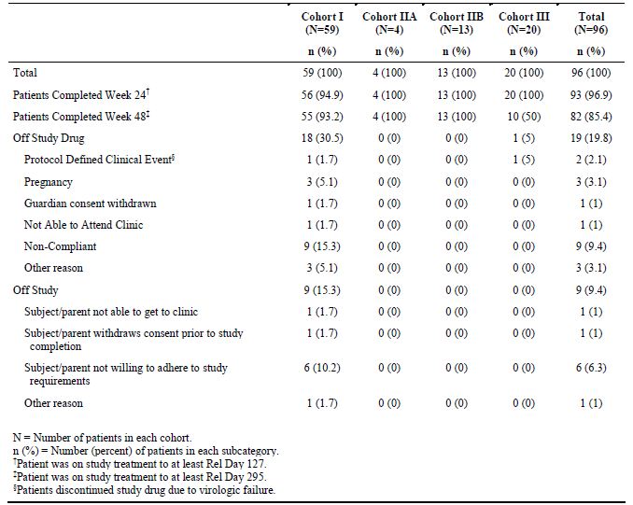
Of the 96 Final Dose patients, 51% were female, 59.4% were Black or African American, and 34.4% were White. The median age was 13 years. The mean baseline log10 plasma HIV RNA level was 4.3 log10 copies/mL and 60.4% of patients had baseline HIV RNA between 4,000 and 50,000 copies/mL. The mean baseline CD4 cell count and percent were 592.2 cells/mm3 and 23%, respectively; 71.9% of patients were infected with clade B virus although viral subtype of non-Clade B was more common in Cohort III, representing greater enrolment from non-US sites. Inclusion of patients with hepatitis B and/or C virus con-infection was not permitted by the protocol, and none were enrolled.
A higher proportion of adolescent patients in Cohort I (86.4%) reported the use of three or more classes of prior ARV than younger patients in Cohort III (25%); higher use of prior protease inhibitors (PIs) was also reported in Cohort I (96.6%) than Cohort III (60%). Similar trends were seen for baseline phenotypic sensitivity scores between Cohorts I and III. Based on genotypic sensitivity scores (GSS), the OBT selected contained 2 or more active ARV agents in 63.5% of Final Dose patients, ranging from 57.6% in Cohort I to 85% in Cohort III. Patients had been previously treated with ARV for a mean of 9.3 years (11.9 in Cohort I, 10.1 years in Cohort IIA, 7.4 years in Cohort IIB, and 2.4 years in Cohort III), and had received a mean of 7.5 prior ARV agents (9.1 in Cohort I, 7.5 in Cohort IIA, 5.7 in Cohort IIB, and 4.2 in Cohort III). The baseline characteristics for the All Treated population were similar to the Final Dose population.
Table 5. Number of patients entered by country and cohort; stages I and II; all treated population
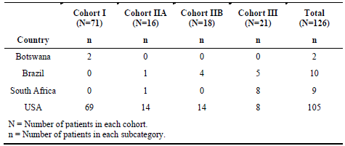
Table 6. Study P1066 patient baseline characteristics by cohort; final dose population
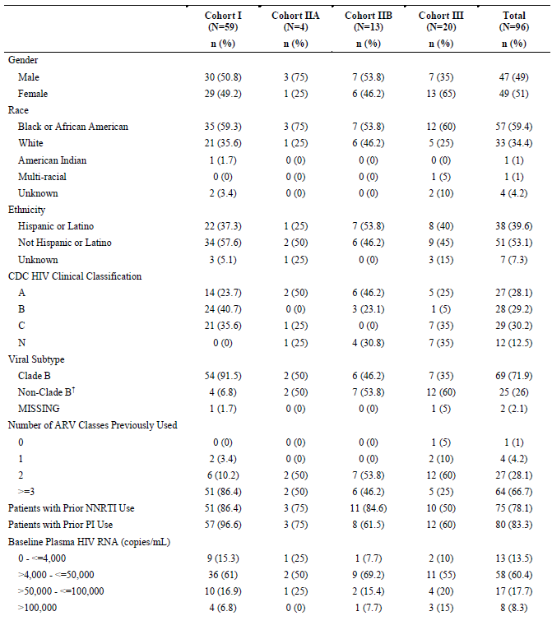
Overall, the baseline secondary diagnoses appeared consistent with those expected for children with HIV infection. The most common secondary diagnoses (≥ 5%) included: asthma (13.5%), attention deficit/hyperactivity disorder (9.4%), oral candidiasis (9.4%), eczema (7.3%), herpes zoster (6.3%), pneumonia (6.3%), otitis media (5.2%), and atopic dermatitis (5.2%). The profile of secondary diagnoses for All Treated patients was similar to that of Final Dose patients.

Concomitant therapy
The most frequently reported baseline antiretroviral treatments were tenofovir (46.9%), ritonavir (44.8%), used mainly as a booster, and lamivudine (41.7%). Darunavir (37.5%) and lopinavir (as Kaletra, 40.6%) were the most commonly used protease inhibitors, and tenofovir and lamivudine were the most commonly used NRTIs while NNRTI use (primarily efavirenz [12.5%] and etravirine [20.8%]) was less common. Additionally, there was some variation among cohorts in pattern of concomitant ARV. For example, older patients in Cohort I generally received ritonavir (64.4%) with various protease inhibitors, such as darunavir (54.2%), more frequently than patients in Cohort III. The profile and frequency of concomitant ARV therapies for All Treated patients were similar to those for Final Dose patients.
Of the 96 enrolled patients, 84.4% had concomitant non-ARV therapies, and the most common non-ARVs included influenza virus vaccine (47.9%), trimethoprim-sulfamethoxazole (19.8%), azithromycin (15.6%), and H1N1 vaccine (15.6%).

24 Week results – final dose population
Compliance data were not available for every patient or every time point during the treatment period; the substantial amount of missing compliance data undermined reliability of compliance assessment.
Table 7 summarises the results separately for Cohorts I, IIA and IIB. The composite results below for Cohorts I, IIA and IIB for the “Final Dose” cohorts are reported as Proportions (% [95% CI]) using observed failure approach. The numbers in each group were small, particularly Cohort IIA reflected by wide confidence intervals:
HIV RNA < 50 copies/mL | 51/95 (53.7% [43.2, 64])
≥ 1 log10 HIV RNA decrease from baseline or HIV RNA < 400 copies/mL | 68/95 (71.6% [61.4, 80.4])
HIV RNA < 400 copies/mL | 63/95 (66.3% [55.9, 75.7])
Change form baseline in CD4 cell count | 119.0 (74.9, 163.1)
Change from baseline CD4% | 3.8 (2.7, 4.9)

Note: the footnote explanation of OF analysis specifies use of the last available HIV RNA value <1 log10 drop from baseline and ≥400 copies/mL, while the reported results states Proportion of patients with ≥ log10 drop from baseline in HIV RNA or HIV RNA < 400 copies/mL. There was no statistical analysis plan for this study.
The results using non-completer = failure approach are included in Table 8. There was not a great deal of difference in the results as there were few discontinuations. As would be expected, the OF results were better than those for NC=F.

Table 7. Study P1066 week 24 final dose efficacy – observed failure approach
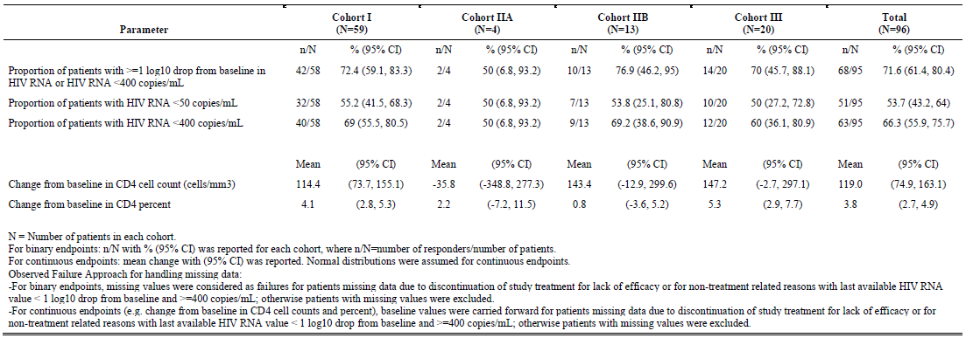

Table 8. Final dose population week 24 results. Study P1066 week 24 final dose efficacy – non-completer = failure approach
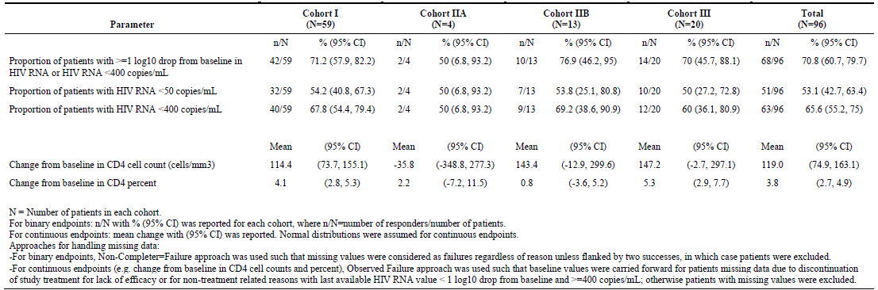

Cohort III – Week 24 results (OF approach) not included in the composite results above:
HIV RNA ≥ 1 log 10 drop from baseline or HIV RNA < 400 copies/mL:
Final Dose Population: 14/20 (70% [45.7, 88.1])
All Treated Population: 15/21 (71.4% [47.8, 88.1])
HIV RNA < 50 copies/mL
The 24 week results (OF approach) for Cohort III are as follows:
Final Dose Population: 10/20 (50% [27.2, 72.8])
All Treated Population: 11/21 (52.4% [29.8, 74.3])
HIV RNA < 400 copies/mL
Final Dose Population: 12/20 (60% [36.1, 80.9])
All Treated Population: 13/21 (61.9% [38.4, 81.9])
Change from baseline CD4 cell count
Final Dose Population: 147.2 (-2.7, 297.1)
All Treated Population: 157.8 (14, 301.6)
Change from baseline CD4 %
Final Dose Population: 5.3 (2.9, 7.7)
All Treated Population: 6.1 (3.3, 9])
Results for the All Treated Population are summarised in Table 9 OF approach and Table 10 NC = F approach.

Table 9. All treated population week 24 results. Study P1066 week 24 all treated population efficacy – observed failure approach
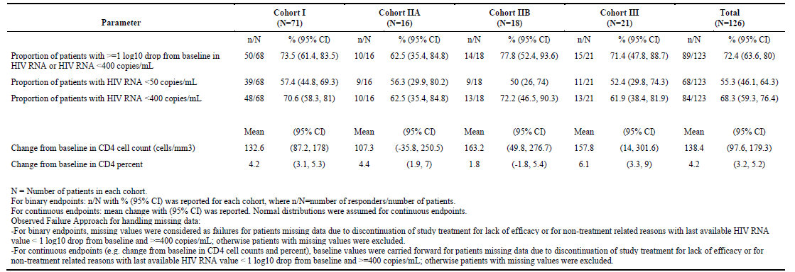

Table 10. All treated population week 24 results. Study P1066 week 24 all treated population efficacy – non-completer = failure approach
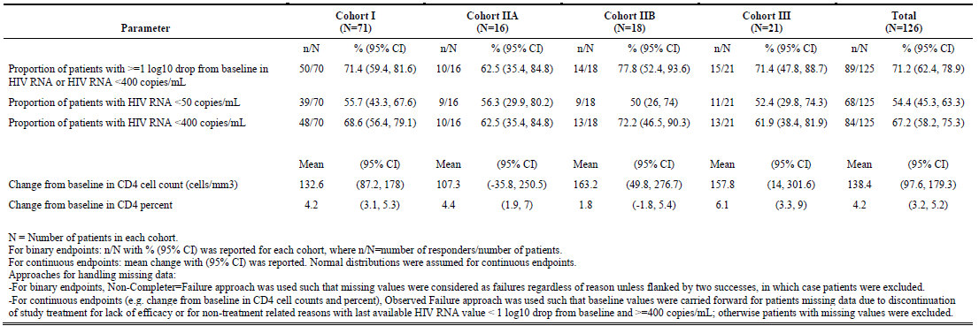

Week 48 results – final dose population
The composite results below for Cohorts I, IIA and IIB for the “Final Dose” cohorts are reported as either proportion (% [95% CI]) or means (95% CI) using observed failure approach. Analyses for Final Dose cohorts based on NC = F approach are reported in Table 11. Results for the All Treated Population are summarised in Table 12 OF approach, and Table 13 NC = F approach.
Observed failure approach
HIV RNA < 50 copies/mL | 40/71( 56.3 [44, 68.1])
≥ 1 log10 HIV RNA decrease from baseline or HIV RNA < 400 copies/mL | 55/71 (77.5 [66, 86.5])
HIV RNA < 400 copies/mL | 51/71 (71.8 [59.9, 81.9])
Change form baseline in CD4 cell count | - (107.9, 202.2)

Table 11. Final dose population week 48 results. study P1066 week 48 final dose efficacy – non completer = failure
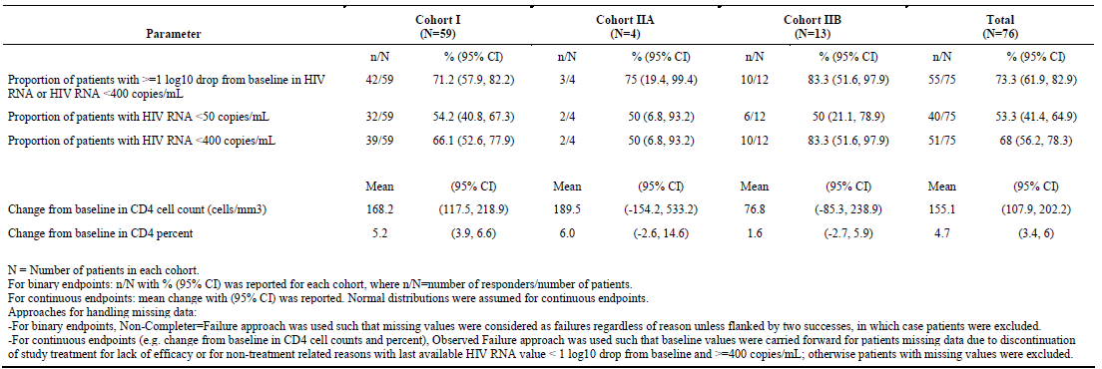

Table 12. All treated population Week 48 results. Study P1066 week 48 all treated population efficacy – observed failure approach
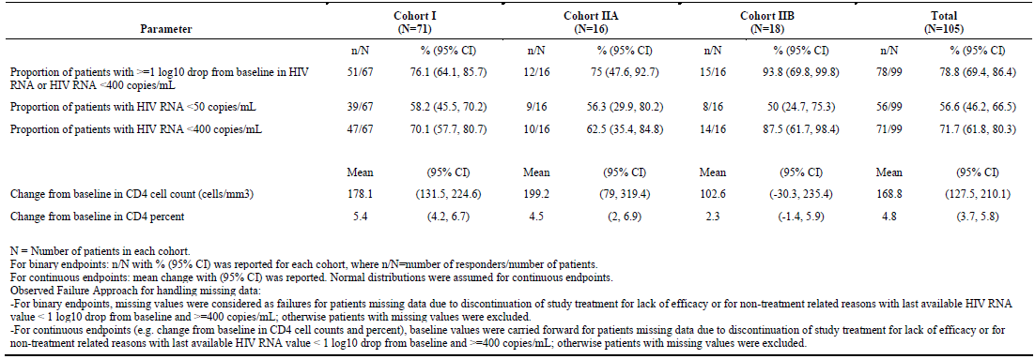

Table 13. All treated population week 48 results. Study P1066 week 48 all treated population efficacy – non-completer = failure approach
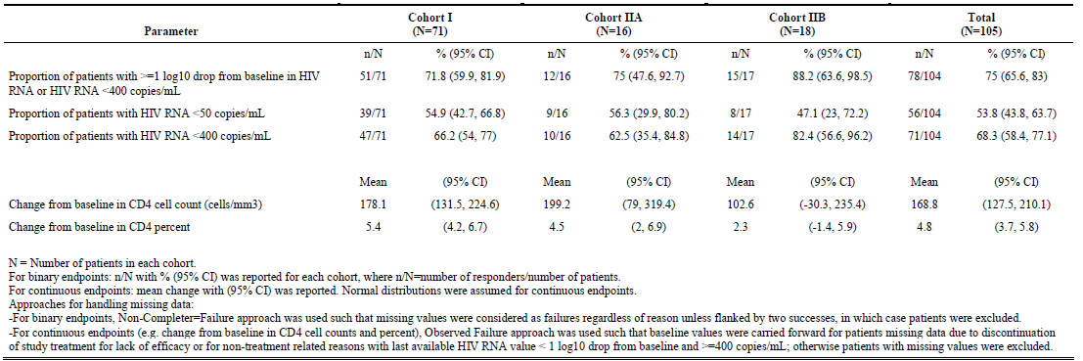

Responses over time
Responses over time are illustrated for HIV RNA ≥ 1 log 10 drop from baseline or HIV RNA < 400 copies/mL in Figure 6; for HIV RNA < 50 copies/mL in Figure 7; for HIV RNA < 400 copies/mL in Figure 8 for change from baseline CD4 cell count in Figure 9and change from baseline CD4 % in Figure 10.
Figure 6 Study P1066 final dose population, ≥1 Log10 drop from baseline HIV RNA or HIV RNA <400 Copies/mL (95% CI) observed failure approach
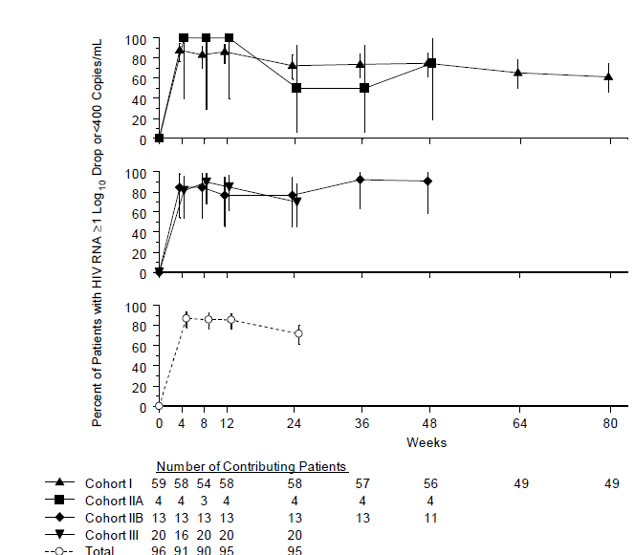
Figure 7. Study P1066 final dose population, HIV RNA < 50 Copies/mL (95% CI) observed failure approach
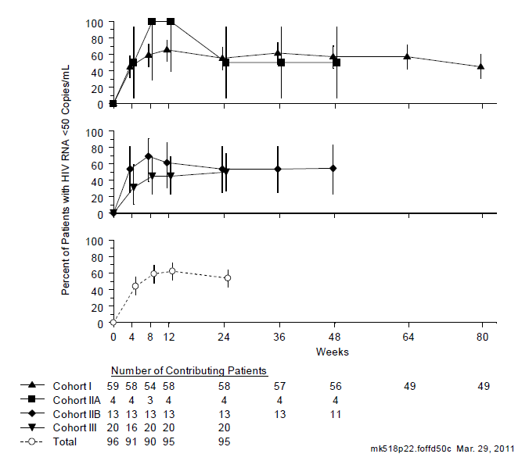
Figure 8. Study P1066 final dose population, HIV RNA < 400/mL observed failure approach
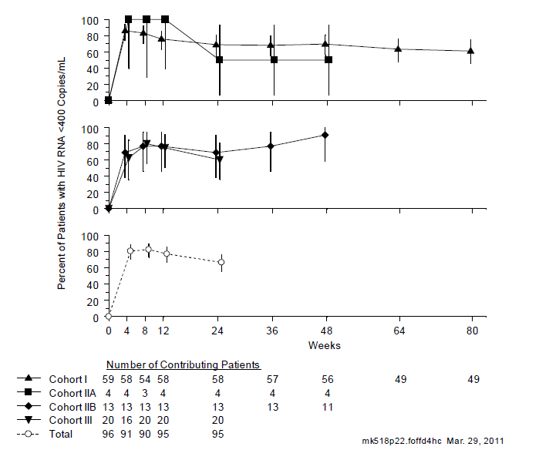
Figure 9. Study P1066 change from baseline in CD4 cell count (Cells/mm3) (95% CI) final dose population; observed failure approach
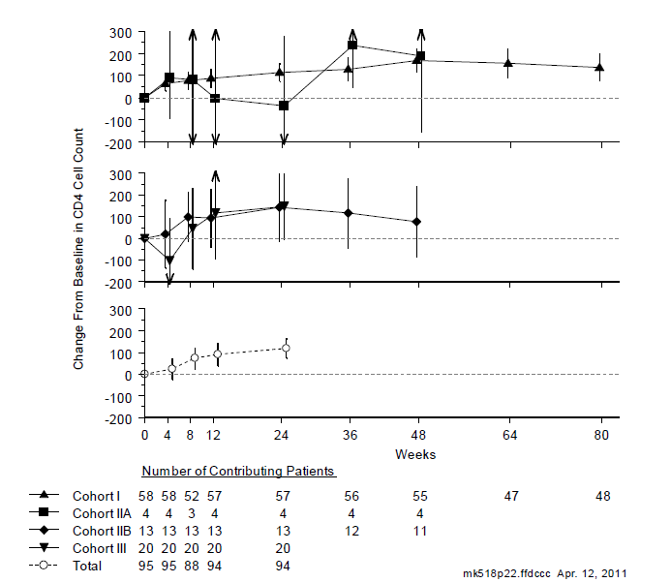
Figure 10.1 Change from baseline in CD4 percent (95% CI) over time by cohort; final dose population; observed failure approach
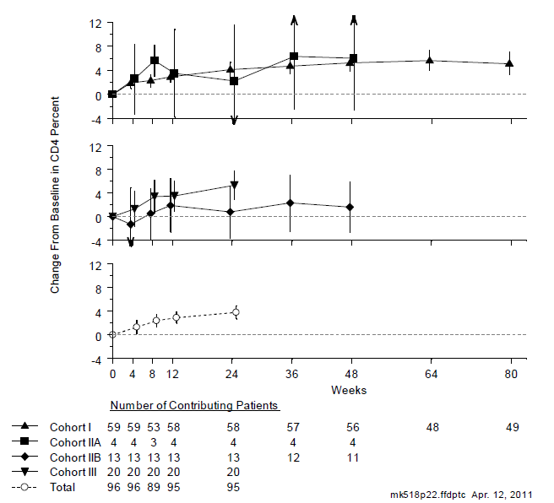

Taste evaluation
Assessment of taste of the chewable tablet was undertaken using a questionnaire; however, only 53.7% of participants responded which is considered insufficient to ensure lack of bias.

Resistance

Genotypic resistance
Viral RNA was isolated from patients displaying virologic failure and patients who discontinued the study early with HIV RNA > 1000 copies/mL at Week 24 or later. Overall, 25 patients failed by Week 24 and 34 by Week 48. Of the 31 All Treated patients across all formulations, for whom any genotypic data were available, viruses from 10 (32.3%) displayed signature resistance mutations: 1 at AA143, 7 at AA148, and 5 at AA155, consistent with observations in adults. In addition, one patient displayed L74I at both baseline and virologic failure. L74I is an integrase polymorphism that by itself does not confer phenotypic resistance to raltegravir, but is listed as a raltegravir resistance mutation because it can enhance resistance conferred by signature resistance mutations. Virus isolated from another patient displayed L74L/M and T97A. T97A. Viruses isolated from 19 patients soon after virologic failure did not register any known raltegravir resistance mutations.

Phenotypic resistance
Analysis was undertaken to summarize the phenotypic sensitivity of viruses isolated from patients at baseline and after they experienced virologic failure; since data was limited for each cohort analysis was undertaken by formulation. In some cases different time points were used for the two different tests. A fold change IC50 > 1.5 was above the technical assay cut-off and suggested the possibility of true raltegravir resistance.
Among the All Treated patients who failed by Week 48, there were 26 patients with both baseline and post-baseline phenotypic resistance data by the data cut-off date. In these patients, baseline samples displayed for both mean and median, an IC50 fold-change of 1.0 (range 0.7 to 1.5), respectively, indicating phenotypic susceptibility. After virologic failure phenotypic susceptibility testing showed a mean and median fold-change IC50 of 33.8 and 1.0 (range 0.6 to 150.2), respectively. The patient with mutation L741, mentioned above, was phenotypically sensitive.

Conclusion
MSD Genotypic resistance results were consistent with observations in adults. Results by phenotypic resistance testing are consistent with those by genotypic resistance testing among All Treated patients in P1066 with available resistance data.
Evaluator: Conclusions regarding phenotypic resistance are hampered by the lack of data for all patients with viral failure; however, the results appear consistent with those for adult patients and no new resistance mutation was reported.

Population pharmacokinetics
Past attempts to develop a population pharmacokinetic model for raltegravir based on data from studies in adults dosed with the currently approved adult tablet formulation were unsuccessful due to the considerable inter- and intra-patient pharmacokinetic variability seen with this formulation, without strong associations with explanatory covariates. Pharmacokinetic data from Cohorts I and IIA of the paediatric study in which patients were treated with the adult tablet, also displayed considerable variability while pharmacokinetics of the chewable tablets administered in the fasted state in Cohorts IIB and III exhibited somewhat less variability and were considered likely to be more amenable to modelling. For Cohorts IIB and III only, a population PK model was developed using ADAPT 5.
In addition to PK assessment in Stage I, in each cohort, blood samples were collected between 10 and 14 hours post-dose at weeks 4 and 12 of treatment. At week 8, two samples were to be collected two hours apart between 0.5 and 6 hours post-dose. At week 24, two samples were to be collected two hours apart between 6 and 12 hours post-dose. There was no restriction on food for these sparse PK collection days.
Blood samples were drawn and plasma prepared at the clinical sites. Blood samples were collected in K-EDTA tubes and were shipped and stored at - 80° C. All samples were received frozen on dry ice and in good condition.
For all Cohorts, three non-model based exposure summary measures were calculated based on the observed sparse concentration data.
- Geometric Mean of All Observed Concentration (Call or GMall): defined as the geometric mean of all samples for a particular patient, regardless of when they were collected.
- Geometric Mean C_{12h} (GM C_{12h}): defined as the geometric mean of all samples for a particular patient collected between 10 and 14 hours post dose (for GM C_{12h}).
- Minimum of All Observed Concentrations (Cmin): defined as the minimum value of all samples for a particular patient, regardless of time of collection.

Results
A two-compartment model with first order absorption and elimination was found to adequately described raltegravir plasma pharmacokinetics in paediatric patients aged from≥ 2 to < 12 years, dosed with the chewable tablet formulation. Of the covariates evaluated, weight was a significant covariate for apparent clearance (CLt) and apparent volume of distribution of the central compartment (Vc). The best model fit was with weight on both the CLt and Vc terms. Age was also a significant covariate on CLt and Vc relative to the base model, but since the correlation between age and weight in this dataset was so high, only weight was further considered. Also, the final model was indicated overall age has less of an effect on the pharmacokinetic parameters than weight. Body weight, age, and body surface area were all highly correlated in this dataset. Considerable within and inter-individual variability was observed. After incorporating weight into the base model, the inter-individual variability decreased from 56.2% to 44% for CLt, and from 41.2% to 17% for Vc, respectively.
Exploratory PK/PD assessments suggested that C_{12h} was a predictor of antiretroviral response as shown in Table 14. There was no accounting for multiplicity in interpretation of the reported results in the submission report. However, this finding, and the suggestion from the data that response was related to compliance with treatment would not be unexpected.
Table 14. Population PK parameters as a predictor for antiretroviral responses (all cohorts, final dose population)
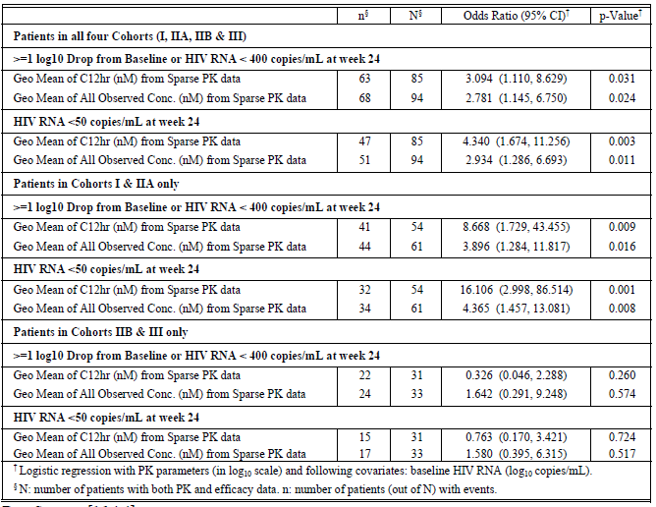

Population pharmacokinetics conclusions
The findings supports the decision to use weight based dosing for the children taking chewable tablets and appears to support the conclusion that there is an association between Cmin and efficacy in terms of HIV-1 viral load < 400 copies/mL.

Clinical safety
Because of design differences, the safety results for Studies P068 and P1066 were not combined. Safety results for the 12 adult patients included in the Phase I Study P068 are discussed under Pharmacokinetics-Stage I Dose finding above in order to minimise need for repetition of study design.

Study P1066
The primary objective of this study was to assess safety and tolerability of raltegravir in combination with optimised background therapy in management of HIV-1 infection in treatment experienced children aged 2 to 18 years who were treated with the dose selected in the Phase I component of the study (N = 96). The Final Dose population was the subset of All Treated patients who received only the final selected dose, whether enrolled in Stage I or Stage II. This population was used by the investigators for the primary assessment of safety in the application as it was considered that these data best represent the dose that will be recommended for commercial use. Safety findings relating to the All Treated population (N= 126) including the children who had participated in the dose finding component of the study, were also reported.
Patients whose raltegravir formulation was switched while on study were included with their originally assigned age cohort and formulation for safety reporting; however, for specific reporting of drug exposure, patients who switched formulations were counted in each respective table based on the actual formulation received.
For the tabular displays the following conventions applied: clinical and laboratory adverse events reported more than once during the study period were counted only once, and as the worst grade reported; however, all occurrences are provided on the listing tables. In addition, laboratory events were summarised only if the on-treatment grade was higher than the reported baseline value for the study participant. If the baseline laboratory value was missing, the screening laboratory value was used to make the comparison to the on-treatment laboratory value.
The mean number of days (range) that All Treated Cohort I and IIA patients (N = 90) took the raltegravir adult formulation 400 mg BID was 647 (11 to 1181) days. The mean number of days (range) for All Treated Cohort IIB and III patients (N=41) on raltegravir chewable tablets at any dose was 413 (179 to 887) days.
Forty-eight weeks of treatment had been completed by all participants in Cohorts I, Cohorts IIA and IIB and fifty percent of participants in Cohort III. As of the 14 February 2011, 96 Final Dose patients were treated with raltegravir for a mean of 565 days (range 28 to 1112 days) and 126 All Treated patients were treated with raltegravir for a mean of 626 days (range 28 to 1246 days). Raltegravir was given in combination with an optimized background regimen.

Clinical adverse events
The proportion of patients with any adverse event (AE) reported for the Final Dose Population to Week 48 was 85.4%. Serious and Grade 3 or greater AEs were reported by 14.6% and 15.6%, respectively. Drug-related serious AEs (SAEs) were reported by 1%; drug related ≥ Grade 3 AEs were reported by1%. There were no discontinuations due to clinical or laboratory adverse events.
The most frequently reported clinical adverse events were: cough (42.7%), pyrexia (32.3%), rhinorrhoea (27.1%), vomiting (20.8%), nasal congestion (20.8%) and oropharyngeal pain (16.7%). The drug-related Grade 3 or greater clinical adverse events were psychomotor hyperactivity, abnormal behaviour, and insomnia, which occurred concurrently in one patient. The one serious adverse event of allergic dermatitis was considered related to raltegravir eventually resolved and did not lead to discontinuation.
With respect to events of Grade 3 or above, pneumonia, reported by three patients, was the most common; two patients reported suicidal behaviour. With respect to adverse events reported by the All Treated Population until data lock; of note, several of the reported clinical adverse events are included in the CDC Category A list for mildly symptomatic HIV infection in children (age <13 years old), such as lymphadenopathy, hepatomegaly, parotitis, dermatitis, and recurrent or persistent upper respiratory infection, sinusitis, or otitis media.
For the Final Dose patients to Week 48 there was one report of bipolar disorder, four of major depression, and two of suicidal behaviour. In each case there were confounding issues including prior psychiatric diagnoses, situational stressors, or manipulative actions for secondary gain; none of the events was considered related to raltegravir administration.
One patient died during the study (Day 597) after the Week 48 time point. The cause of death was bilateral pneumonia complicated by pulmonary oedema; this was a 15 year old female with very advanced HIV disease including severe HIV wasting syndrome and failure to thrive

Laboratory adverse events
Laboratory adverse events were graded using the DAIDS toxicity criteria. The proportion of patients with any laboratory event was 84.4%. Grade 3 or higher events were common (15.6%), but drug-related serious laboratory events (1%) and drug related Grade 3 or higher lab events (1%) were uncommon. There were no discontinuations due to a laboratory event.
For the final Dose Population, laboratory adverse events to Week 48 were reported for 84.4%. Most events were Grade 1 or 2. The most frequently reported events of Grades 1-4 among all Final Dose patients were neutrophil count decreased 22/96 (23%), blood sodium decreased 22/96 (23%]), and (non-fasting) blood glucose decreased 20/96 (21%). Decreased neutrophil counts are commonly observed with ARV regimens that include nucleoside reverse transcriptase inhibitors. Differences between formulation groups in the frequency of specific laboratory events were considered not clinically significant.

Events of special interest

Metabolic disorders
Very few patients had fasted blood samples submitted. Clinical adverse events of metabolism and nutrition disorders were reported in 12 (9.5%) of All Treated patients, and include (number of patients): decreased appetite (8), body fat disorder (2), hypertriglyceridemia (1), lactic acidosis (1), and fat tissue increased (1). The events considered serious or of ≥ grade 3 severity were failure to thrive (1), hyperlactacidaemia (1), Type 2 diabetes mellitus and hyperglycaemis (1) and each was considered unrelated to raltegravir treatment. Raltegravir demonstrated minimal effects on non-fasting serum lipids and glucose.

Immune reconstitution syndrome
No events consistent with immune reconstitution syndrome were reported.

Rash, pruritus and hypersensitivity
Cumulatively, clinical adverse events of rash reported in All Treated patients include (number of patients): allergic dermatitis (6), drug eruption (2), rash (9), generalized rash (5), macular rash (1), and papular rash (1). One of these was a Grade 3 event of generalized rash in a Cohort I patient that was considered not related to raltegravir. When rash was reported, it was not considered serious and it did not lead to discontinuation of study raltegravir. The attribution of rash was confounded by the concomitant administration of other ARVs, some of which have been associated with rash.
Clinical adverse events of pruritus were reported in 11 All Treated patients (8.7%). None of these events were reported as Grade 3 or 4 or serious, or led to discontinuation of study raltegravir. During the long-term off-study treatment follow-up phase of P1066, one patient reported a serious clinical adverse event of pruritic rash while on commercial raltegravir, considered not related to commercial raltegravir. No clinical adverse event of hypersensitivity/drug hypersensitivity was reported in Final Dose patients or All Treated patients from Weeks 0 to 48 or in all available data as of the 14-Feb-2011 data cut-off date.

Aminotransferase (ALT/AST) elevations and hepatobiliary disorders
For All Treated patients, two patients reported Grade 3 or greater ALT considered not related to raltegravir. One other patient had increased serum ALT and AST reported as a serious laboratory event and considered possibly related to study raltegravir. Three patients had Grade 3 or greater AST reported; two events were considered unrelated and the third (mentioned above) was considered possibly related. Overall hepatobiliary disorder was reported by 5 patients: hepatomegaly by 4 and steatosis by 1 patient. Hepatomegaly is included in the CDC Category A list for mildly symptomatic HIV infection in children.

Creatine phosphokinase (CPK) elevations and muscle abnormalities
Raltegravir was not associated with the occurrence of rhabdomyolysis or myositis in paediatric patients. Routine CPK measurements were not required in the study.

Psychiatric disorders
At study entry, 16 Final Dose patients (16.7%) had secondary diagnoses of psychiatric disorders, including ADHD in 9 patients (9.4%) and major depression in 4 patients (4.2%). During the 30-day period prior to study entry, 9 Final Dose patients (9.4%), all in the adult tablet formulation group were receiving neuropsychiatric medications.
Clinical adverse events of psychiatric disorders were reported by 10 Final Dose patients (10.4%) from Weeks 0 to 48 and include (number of patients): abnormal behaviour (2), adjustment disorder (1), anger (1), attention deficit/hyperactivity disorder (1), depression (3), insomnia (1), mood swings (1), restlessness (1), sleep terror (1), and suicidal behaviour (2). Three of these were Grade 3 adverse events:
- New onset of psychomotor hyperactivity, abnormal behaviour and insomnia considered possibly related
- New onset suicidal behaviour considered unrelated
- Suicidal behaviour with baseline history of “acting out”,
A similar review performed for All Treated patients, from Weeks 0 to 48 and based on all available data as of the 14-Feb-2011 data cut-off date, showed an increase in reports of psychiatric disorders. Cumulatively, clinical adverse events of psychiatric disorders were reported in 18 All Treated patients (14.3%) by the data cut-off date. Two AEs were considered serious
- New onset major depression considered related to grief after the death of her father
- Bipolar disorder superimposed on existing history of ADHD and anger, conduct disorder, post-traumatic stress disorder, anxiety disorder and depression, considered unrelated to raltegravir.
The psychiatric events reported during the study did not lead to discontinuation of study therapy. The applicant considers that these data do not suggest an increased risk of psychiatric disorders due to raltegravir use.

Malignancy
No malignancy events were reported up until data cut-off.

Gastrointestinal disorders
Cumulatively, 73 (57.9%) All Treated patients reported gastrointestinal disorders. There was one serious adverse event reported, grade 3 oesophagitis considered unrelated to raltegravir. Although the occurrence of gastrointestinal disorders was common among patients receiving raltegravir, these events were generally less than Grade 3.

Headache
Although the occurrence of headache was relatively common there was only one ≥ Grade 3 event reported: migraine considered unrelated. Generally headache was limited to Grade 1 and 2.

AIDS-defining conditions
One patient in Cohort I of the All Treated population had a confirmed new Category C ADC of wasting syndrome after Week 48. No other new Category C condition was reported on study.

Pregnancy
Pregnancy was not considered to be a serious clinical adverse experience. Three pregnancies were reported with the following outcomes: Intrauterine foetal death at 8.6 weeks gestation considered unrelated to study drug; one planned termination and one with unknown outcome.

Deaths
One death was reported. The patients was a 15 year old Black female with severe HIV wasting syndrome who died as a result of severe respiratory distress due to bilateral pneumonia and pulmonary oedema considered unrelated to raltegravir treatment.

Serious adverse events
The highest frequency of serious clinical adverse events occurred in the Infections and Infestations System Organ Class: 12 (9.5%), of which most were pneumonias. The serious events that were reported in more than one patient in the All Treated Population at cut-off date were pneumonia (9/126), pyrexia (2/126) and suicidal behaviour (2/126). The serious clinical adverse events reported were types generally expected in this population with marked immunosuppression due to HIV infection. One event Grade 2 dermatitis was considered study drug related but did not lead to discontinuation. One serious laboratory event occurred after the data cut-off date, Grade 4 lipase considered unrelated to study drug. One event of pancreatitis was considered related to (commercial) raltegravir treatment which was discontinued. There were no other serious adverse events considered to be study drug related.

Literature review
A literature review was undertaken by the applicant up until 20 January 2011. Two relevant reports were discovered including 13 patients treated with adult formulation tablets; one case report and one small observational study as summarised below.
- A Turkova, C Ball, S Gilmour-White, M Rela, and G Mieli-Vergani. (2009). A paediatric case of acute liver failure associated with efavirenz-based highly active antiretroviral therapy and effective use of raltegravir in combination antiretroviral treatment after liver transplantation. J Antimicrob Chemother 63(3):623-5.
- Thuret I, Chaix ML, Tamalet C, Reliquet V, Firtion G, Tricoire J, Rabaud C, Frange P, Aumaître H, Blanche S. (2009). Raltegravir, etravirine and r-darunavir combination in adolescents with multidrug-resistant virus. AIDS 23 (17):2364-6.
Table 15. Summary of results from the two published papers.
Reference  (see list above) | Country | Number treated | Age range years | Effectiveness | Number AEs
Thuret I et al (2009) | France | 12 | 12-17 | 92% favourable response (viral load <400 copies/mL at median 12 month follow-up) | No unusual events were observed during tolerance evaluation; no Grade 2 side effects were recorded; there was 1 report of a probable immune reconstitution inflammatory response
Turkova A et al (2009) | Belgium | 1 | ~10 | Viral load became undetectable within 2 weeks of treatment | None reported in association with raltegravir. LFTs were abnormal in association with mild graft dysfunction after a second liver transplant that occurred prior to initiation of raltegravir.
The patients reported by Thuret et al had been perinatally HIV-infected and had received extensive ARV therapy for a median duration of 15 years. Raltegravir 400 mg bd was administered to all patients in addition to backbone therapy. One patient experienced probable immune reconstitution syndrome. One patient had reported virologic failure with viral load more than 400 copies/mL, which was reported to be related to suboptimal adherence to treatment. Tolerability was stated to be “remarkable” with no clinical symptoms of intolerance related to raltegravir.
The case report was of a 9 year old patient treated with raltegravir/lamivudine and zidovudine after liver transplantation for acute liver failure 13 weeks after starting efavirenz-based ART. Within 2 weeks viral load became undetectable.

Postmarket experience
An estimate of off-label raltegravir use in the paediatric population could not be determined from available data. Raltegravir - reports by age and gender from 27 September 2007 to 31 December 2010 are summarised in Table 16. Reports by System Organ Class are summarised in Table 17.
Table 16. Post market reports by age and gender
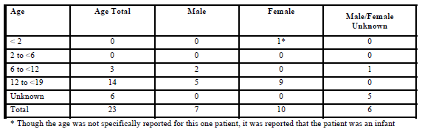
Table 17. Pediatric reports by system organ class 27 September 2007 to 31 December 2010
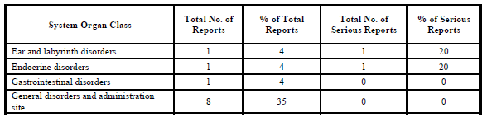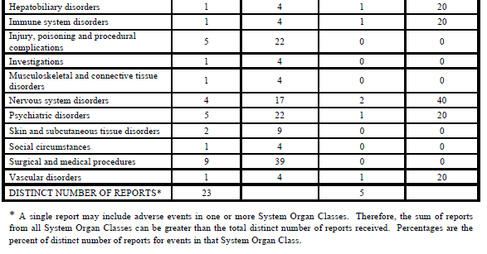
The most common reports (number of events) were: drug exposure during pregnancy (4), intentional drug misuse (3), insomnia (2) and psychomotor hyperactivity (2). Of the 4 reports of pregnancy, 3 resulted in live births with no congenital anomalies. The outcome of the fourth pregnancy was unknown.
There was one report of flare of endogenous autoimmune thyroiditis considered by the reporter to be possible manifestation of Immune Reconstitution Syndrome but considered by the Market Authorisation Holder (MAH), not be entirely consistent with IRS.
One patient had increase in liver enzymes associated with hepatic failure considered unlikely to be due to treatment as the patient recovered while still being treated with raltegravir.
The MAH conclusion was that the events reported were generally consistent with the Company Core Data Sheet for raltegravir and pose no new safety concerns.
The Post market Safety Update Report for 27 March 2011 to 26 September 2011 was reviewed contemporaneously. The reported changes made to the Company Core Data Sheet had either already been included in the current Product Information, or are addressed in [information redacted] which is currently also under evaluation.

Compassionate use access program
The applicant has established a worldwide compassionate-use access program to provide the paediatric chewable tablet formulation to eligible patients ages 2 through 11 years with 3-class multi-drug resistant virus and HIV RNA ≥1000 copies/mL. As of 17-Mar-2011, two patients have been accepted into the ex-US portion of the program, and Merck has received no formal patient requests for the US program. No serious adverse events have been reported to 07-Apr-2011 in the raltegravir paediatric compassionate-use programs.

Clinical summary and discussion
The application by Merck Sharp & Dohme (Australia) to register raltegravir chewable tablets for use in HIV-1 infected children included two pivotal studies, Protocols 068 and P1066. The same formulation of chewable tablet was used in each of these studies and differed from the formulation planned for registration only in colour (25 mg) and shape (100 mg).

Study P068

Summary
Study P068 evaluated relative bioavailability of the raltegravir paediatric chewable tablet, raltegravir oral granules for suspension (not relevant to this evaluation) and the registered raltegravir adult 400 mg tablet. The effect of a high fat meal on the pharmacokinetic profile of the paediatric chewable tablet formulation was also assessed. Twelve healthy adults, three women and nine men each received four treatments randomised in a balanced, crossover design in Periods 1 to 4. Treatments A to C were administered in fasted conditions.
Treatment A: single oral dose of 400 mg raltegravir adult formulation tablet (1 x 400 mg tablet).
Treatment B: single oral dose of 400 mg raltegravir paediatric chewable tablet (4 x 100 mg tablets).
Treatment C: single oral dose of 400 mg raltegravir oral granules in liquid suspension.
Treatment D: single oral dose of 400 mg paediatric chewable tablet (4 x 100 mg) following a standard high fat meal.
Key findings relevant to this application were as follows.
The results for AUC and C_{max}were well outside the accepted bioequivalence 90% confidence limits of 80% - 125%. The lower limit of the 90% CI for Cmin was below acceptance level.
The geometric means of AUC_{0 - ∞} were 19.2 µM•h for the adult tablet and 34.2 µM•h for the chewable formulation. The GMR (90% CI) was 1.78 (1.47, 2.15).
The geometric means of C_{max}were 5.0 µM for the adult tablet and 16.1 µM for the chewable tablet. The GMR (90% CI) was 2.73 (2.37, 4.38).
The geometric means for C_{12h} of 400 mg adult formulation and 400 mg chewable formulation were 149 nM and 134 nM respectively. The GMR (90% CI) was 0.90 (0.7, 1.18).
The chewable tablet was absorbed more rapidly than the adult formulation tablet as evidenced by the difference in t_{max} estimations: 4 hours versus 0.5 hours for the adult and chewable tablets respectively.
Compared to the fasted state, administration of the chewable tablet with a high-fat meal led to an increase in C_{12h}. The GMR (90% CI) for fed/fasted was 2.88 (2.21, 3.75), a decrease in C_{max}with GMR (90% CI) equalling 0.38 (0.28, 0.52), a delay in T_{max}(median 0.5 hour in the fasted state and 1.0 hour in the fed state), and an AUC_{0-∞} with GMR (90% CI) of 0.94 (0.78, 1.14).
There was considerable variability in individual results. The differing means and the large standard deviations suggested skewed data with widespread distribution which was visible in the figures. These findings are consistent with those of previous studies.
With regard to safety, one participant experienced of somnolence following ingestion of both oral granules and chewable tablets; the event was considered study drug related. However, in general the various formulations were well tolerated.

Discussion
A strong association had not been found between raltegravir pharmacokinetic summary measures and efficacy parameters, and thus a target pharmacokinetic parameter known to strongly influence outcome had not yet been identified. For other classes of antiretroviral agents, there is a reasonable association of efficacy with doses that achieve Ctrough values that exceed the IC95 in the HIV spread assay.
The applicant contends that the higher AUC_{0-∞} and C_{max}values are not expected to have meaningful clinical consequences because to date in the development program for raltegravir, there had been no acute safety findings that were temporally associated with peak concentrations, and raltegravir was found to be generally well tolerated in the clinical program with no dose-related toxicities so far detected.
In keeping with results of previous studies, administration with a high-fat meal slowed the rate of absorption from the chewable tablet; however, the extent of absorption was almost within bioequivalence criteria and the applicant believes that the differences are not clinically meaningful.
Based on the similarity in trough values, these results were taken as support continued clinical development of both paediatric formulations. The applicant states that the effect of food on raltegravir pharmacokinetics is variable depending on the meal type and that administration of food leads to increased variability and that it is therefore unlikely that a recommendation to administered raltegravir with food would lead to consistent changes in the C_{12h} or other measures of exposure to raltegravir that would be likely to impact on efficacy or safety. The effects of food on the pharmacokinetic profile of raltegravir administered as either the adult tablet or the chewable tablet were thus not thought to be of clinical importance. The 400 mg tablet is registered for use in adult patients without food restriction.

Study P1066

Summary
Study P1066 (also known as IMPAACT or 022) is an ongoing multicentre, open label, non-comparative study in treatment-experienced children and adolescents aged ≥ 4 weeks to < 19 years of age with documented HIV-1 infection and HIV RNA > 1,000 copies/mL at screening. The aim was to evaluate the safety, tolerability, PK parameters and antiviral activity of raltegravir in combination with an optimised background regimen. The study evolved over the course of three versions of the protocol.
Raltegravir was administered orally as the adult tablet or chewable tablet. A third formulation, oral granules for suspension in water, was included in the study for use by patients aged ≥ 4 weeks to < 2 years. Data on the oral granule formulation are planned for inclusion in a future clinical study report. Patients enrolled in the study were stratified into six cohorts, four of which were relevant to this application:
Cohort I: ≥ 12 to < 19 years of age assigned to receive adult tablets
Cohort IIA: ≥ 6 to <12 years of age assigned to receive adult tablets
Cohort IIB: ≥ 6 to < 12 years of age assigned to received chewable tablets
Cohort III: ≥ 2 to < 6 years of age assigned to receive chewable tablets
Stage I examined the pharmacokinetics, short-term tolerability, and safety of raltegravir in a limited number of patients to permit dose selection for further study in Stage II. The objective was to determine appropriate doses based on target ranges derived from adult studies. Testing, which ultimately determined choice of dose, was undertaken in the fasted state. Stage I enrolment opened with the oldest cohort and progressed sequentially to the younger cohorts. Patients enrolled in Stage I remained in this stage. Duration of treatment was at least 48 weeks.
Resultant pharmacokinetic data exhibited considerable inter-individual variability. The final doses chosen are those proposed for the Dosage and administration section of the Product Information (see Table 18).
Table 18. Final recommended doses
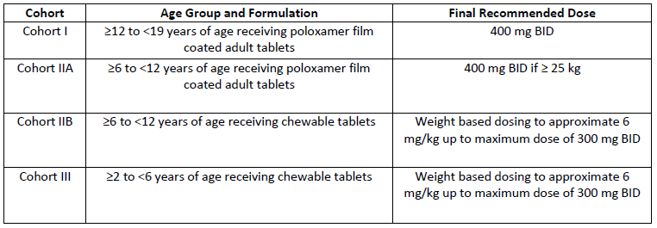
Population pharmacokinetic assessment was undertaken based results of Stage I and on sparse sampling undertaken in Stage II. Variability was more pronounced in the results for those participants treated with the adult formulation than those taking the chewable tablet formulation. Modelling was undertaken using only results for the chewable tablet taken in the fasted state. Weight and to a lesser extent age were found to be significant covariates for apparent clearance and volume of distribution. These two variables were highly correlated. The finding would add support to use of weight in determining dosage requirements.
The objectives of Stage II were primarily to evaluate the safety and tolerability of raltegravir at the selected dose in combination with optimised background therapy at Week 24. The secondary objectives included assessment of efficacy in terms of the composite of HIV RNA <400 copies/mL or ≥ 1-log drop from baseline and in terms of changes in CD4 cell count and CD4% over 24 and 48 weeks. The duration of chronic dosing in Stage II was 48 weeks on the Stage I selected dose.
The submission report focused primarily on the results generated by patients from Stage I and II who received only the selected dose, the Final Dose Population, (N = 96). Results for the All Treated Population (N = 126) were also reported. Enrolment numbers were unevenly spread throughout the cohorts, with 59 participants in Cohort I, 4 in Cohort IIA, 13 in Cohort IIB and 20 in Cohort III.
Complete data were currently available for Week 24 (the primary endpoint) for Cohorts I, IIA, IIB, and III; at Week 48 data (a secondary time point) for Cohorts I, IIA and IIB and at Week 80 for Cohort I.
At Week 24 for all cohorts combined, 71.6% of patients achieved ≥ 1 log drop in HIV RNA or HIV RNA < 400 copies/mL and 53.7% of patients achieved HIV RNA < 50 copies/mL, based on Observed Failure (OF) approach. The mean change from baseline in CD4 cell count and percent were 119.0 cells/mm3 and 3.8%, respectively.
At Week 48, 77.5% of patients in Cohorts I, IIA, and IIB achieved ≥ 1 log drop in HIV RNA or HIV RNA < 400 copies/mL and 56.3% of patients achieved HIV RNA <50 copies/mL. The mean change from baseline in CD4 cell count and percent were 155.1 cells/mm3 and 4.7%, respectively.
Overall, a total of 25 patients failed treatment by Week 24, and 34 patients failed by Week 48. Compliance data were insufficiently complete to be reliable. With respect to viral resistance, genotype and phenotype testing, though not always conducted simultaneously, were consistent. Of the 31 All Treated patients for whom any genotypic data were available, viruses from 10 (32.3%) across all cohorts displayed signature resistance mutations. No unexpected viral resistance associated mutations were detected. The findings were considered consistent with those observed in Phase II clinical studies in HIV infected adults.
With respect to safety, drug related serious clinical adverse events were reported for 1% of the Final Dose Population and Grade 3 and 4 laboratory adverse events were reported by 1%. The profile of clinical and laboratory adverse events for the All Treated population were similar to those of the Final Dose population. There were no discontinuations due to adverse events. One patient developed confirmed new Category C AIDS defining condition. One death due to pneumonia was considered unrelated to study drug. One serious adverse event, pancreatitis, resulted in discontinuation of raltegravir adult tablet treatment.
There were no events reported consistent with immune reconstitution syndrome, rhabdomyolysis or myositis or malignancy. Reports of rash and pruritus or psychiatric conditions were relatively common but attribution was confounded by baseline condition, by indication or by use of concomitant antiretroviral treatment. Headache and gastrointestinal disorders were also relatively common but generally less than Grade 3 in severity and did not lead to discontinuation of raltegravir therapy. Psychiatric events were also common but did not lead to discontinuation and in the main there were confounding issues including prior psychiatric diagnoses and situational stressors. Review of the literature and of post market information did not alter the safety profile.

Discussion
With reference to the Note for Guidance on Clinical Investigation of Medicinal Products in the Paediatric Population (CPMP/ICH/2711/99), the disease process in adults and children is considered to be similar and the outcome of therapy is thought likely to be likely comparable. The applicant has supplied pharmacokinetic study P068 and for P1066 in the appropriate age ranges together with evaluation of safety in study P1066.
The guideline states that an approach based on pharmacokinetics is insufficient for medicinal products where blood levels are known, or expected not to correspond with efficacy, or where there is concern that the concentration-response relationship may differ between the adult and paediatric populations. In such cases, studies of the clinical or the pharmacological effect of the medicinal product would usually be expected. Efficacy was examined in the observational study P1066.
Thus it is concluded that the applicant has complied with the Guideline and the request for inclusion in the indication of use by children and adolescents aged at least two years and registration of the chewable tablet, is recommended.
It is noted that the application has been approved by the FDA. The dosage and administration section of the US Product Information specifies a lower weight limit of 10 kg, whereas the applicant includes instructions for children down to weight of 7 kg, i.e. approximately 7 mg/kg (in comparison, a 25 kg child taking 300 mg would be taking 12 mg/kg). From the data available, the lightest patient studied intensively (Stage 1) weighed 11.8 kg. According to the Australasian Paediatric Endocrine Group growth charts, 7 kg is marginally below the 3rd percentile for a 2 year old child; an ill child may well fail to thrive. Taking these matters into consideration, if the lower age limit is to be 2 years, it is recommended that the dosage advice for children down to 7 kg is allowed. In saying this it is also recommended that information is added to the Dosage and Administration section of the Product Information to the effect that for the chewable tablet formulation, dosage is based on approximation of 6 mg/kg, and it is recommended that rather than including the proposed dosage table as the dosage instruction as proposed, it is included as dosage guidance.
The inter-individual and intra-individual variability which has been consistently demonstrated in PK studies in both adults and children is considered problematic, particularly as the variability increased when food is factored in. In the fasted state, the applicant has demonstrated less variability with the chewable formulation than the adult tablet which suggests that some of the problem of variability lies with the formulation of the adult tablet.

First round benefit-risk assessment

First round assessment of benefits
HIV infection results in potentially life threatening illness which is controlled, but not cured, by use of highly active antiretroviral therapy consisting of combination of drugs with different mechanisms of action. Raltegravir has been registered for treatment of adult naive and treatment experienced adults based on controlled clinical of efficacy and safety in combination therapy. The mechanism of action of raltegravir in selectively inhibiting HIV-1 integrase catalysed strand transfer is unlikely to be different for adults and children.

First round assessment of risks
The raltegravir safety profile has so far been studied only in a relatively small number of children. Safety in children, particularly the very young, who are still growing, developing and maturing, may ultimately prove to have a different profile to that of adults.

First round assessment of balance
The benefit risk balance is considered to lie on the side of benefit.

First round recommendation regarding authorisation
It is recommended that the paediatric chewable tablet formulation is registered for use in children and adolescents aged from 2 years according to the dosage regimen selected in Stage I of Study P1066. For the doses dependent on calculation by weight, it is recommended that the Dosage and Administration section of the Product Information includes the statement that dose is based on nearest approximation to 6 mg/kg and the proposed Table 15 is included as a guideline. It is further recommended that the Dosage and Administration section includes the instruction to chew the chewable tablet as PK studies were undertaken following witnessed chewing of the tablet.
With regard to reporting of efficacy results, it is recommended that that the most conservative evaluation of results should included in the Product Information, i.e. in this case the NC=F results, a method which has legitimacy according to the European Union Guideline: Points to consider on missing data CPMP/EWP/1776/99. This guideline does not mention the Observed Failure approach and literature on the subject of Observed Failure has been exceedingly difficult to locate. While accepting that on this occasion the results for the 2 methods of analysis were similar, it is considered a matter of principle that results should be based on a method of handling of missing data that is standard and included in the guidelines.

Clinical questions and second round evaluation of sponsor’s response to questions

Question 1-Efficacy analysis
The applicant is requested to provide clarification regarding use of the Observed Failure approach to analysis of efficacy data stated to provide a more clinically meaningful estimate of the antiretroviral effect. The following is included in Module Section 9.7.3.2.1 page 95 (electronic version): “In general: the OF approach considers a virologic failure endpoint, which is focused on the antiretroviral effect of the treatment; and the NC=F approach considers a study failure endpoint, which depends on the conduct of the study.”
It appears that the OF approach is dependent on definition of viral failure and this varies from study to study. For instance, in Study P1066, observed failure was dependent on the composite of results relating to drop HIV RNA value log10 drop from baseline and HIV RNA < 400 copies/mL. More frequently, in studies adhering to the Guideline on the Clinical Development of Medicinal Products for the Treatment of HIV Infection EMEA/CPMP/EWP/633/02, the primary objective is assessed in terms of HIV RNA < 50 copies/mL. It also seems likely that the analysis includes an investigator’s assessment of relatedness of events to study treatment.
With regard to Study P1066, the following definitions were provided in the protocol. It can be seen that the choice of definition of treatment failure/success within this study was selective with the definitions appearing to differ subtly depending on the use of “or” or “and”
Approaches to handling of missing values - Observed failure approach
-For binary endpoints, missing values were considered as failures for patients
- missing data due to discontinuation of study treatment for lack of efficacy or
- for non-treatment related reasons with last available HIV RNA value < 1 log10 drop from baseline and ≥400 copies/mL;
Otherwise patients with missing values were excluded.
Virologic success
The primary definition of virologic success required participants to have achieved and maintained 1-log drop from baseline or viral loads of < 400 copies/ml. A secondary, more stringent definition of virologic success, which requires that subjects achieve and maintain viral loads of <50 copies/ml, will also be utilized.
Virologic Failure:
- A confirmed decrease from baseline plasma HIV RNA of < 1.0 log10 and HIV RNA > 400 copies/mL at Week 24 or later. Confirmatory HIV RNA measurement must be performed within 1 to 4 weeks. OR
- Virologic REBOUND at Week 24 or later that is defined as:
  - confirmed HIV RNA > 400 copies/mL (on 2 consecutive measurements at least 1 week apart) after initial response with HIV RNA < 400 copies/mL OR
  - Confirmed >1.0 log10 increase in HIV RNA above nadir level (on 2 consecutive measurements at least 1 week apart). Nadir was defined as the lowest HIV RNA while on study drug.
A confirmatory HIV RNA test was to have been done in 1 week (or up to 4 weeks) later to verify viral failure/relapse. Due to the difficulty of having paediatric patients commit and adhere to extra clinic visits, most patients did not have the confirmatory test within 1 to 4 weeks. Therefore, the next available test for the patient, which may have been within 1 to 4 weeks or longer, was used as confirmatory test to identify virologic failures.
Results using the OF approach are noted to be better than those using the NC=F approach; however, the NC=F approach would appear less susceptible to varying interpretation or definition and is more conservative. Thus when a Product Information includes OF analysis results of studies with different definitions of failure, comparative information is considered to have the potential to be misleading.

MSD response
The Study P1066 protocol did not specify the approaches to impute missing data for efficacy endpoints. A key issue for the analysis of virologic responses is the missing data imputation. Two missing data approaches were prospectively defined and used in all previous studies of raltegravir conducted by MSD, the Observed Failure (OF) approach and the Non-completer=Failure (NC=F) approach.
The following text summarises the differences between these two missing data approaches:
- Observed Failure (OF): Patients who prematurely discontinued assigned treatment due to lack of efficacy (including investigator's assessment of discontinuation due to lack of efficacy, or discontinuation due to other reasons other than adverse experiences and the last available HIV RNA value is a failure) were considered as failures thereafter. Patients who prematurely discontinued assigned treatment, for reasons other than lack of efficacy, were excluded from the analyses. Intermittent missing values were also excluded from the analyses.
- Non-Completer = Failure (NC=F): Patients who prematurely discontinued assigned treatment regardless of reasons were considered as failures thereafter. Intermittent missing values were assigned as failures unless immediately flanked by 2 successes.
In general: the OF approach considers a virologic failure endpoint, which is focused on the antiretroviral effect of the treatment; and the NC=F approach considers a study failure endpoint, which also depends on the conduct of the study.
It is true that the OF approach is dependent on the definition of viral failure and this varies from study to study. It is also acknowledged that recent Guidelines require an assessment of HIV RNA <50 copies/mL as the primary objective. However, for study P1066, the primary definition of virologic success specified in the protocol required patients achieving 1-log drop from baseline or viral loads of <400 copies/mL. Therefore, patients with <1-log drop from baseline and viral load >=400 copies/mL were considered as failure and this criterion was used while doing imputation using the OF approach.
Results using the OF approach are always as good as or better than those using the NC=F approach. We will clarify in the label that the result is based on the OF approach. However, key results were also summarized in the Clinical Study Report and Common Technical Document using an NC=F approach as well as for the endpoint of HIV RNA <50 copies/mL individually and may be used for comparative purposes.
In a well-conducted study for a treatment with good safety profile, the non-treatment-related discontinuation (i.e. lost of follow-up, withdrawn consent, etc) rate is low and discontinuation rate due to adverse experiences is low, response rates estimated by OF approach will be similar to NC=F approach. Indeed, these two approaches gave similar results in Study P1066 (only 1 patient difference in the denominator) as shown in Table 19.
Table 19. P1066 Virologic response at week 24 using different missing data approach (final dose population)
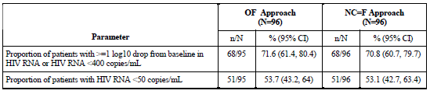
The overall pattern of efficacy was comparable to that observed in adults. In particular, in published Phase III studies of treatment-experienced HIV-infected adults, BENCHMRK-1 and -2, response rates (NC=F) for HIV RNA < 50 copies/mL in patients receiving raltegravir plus OBT were 62% at Week 48, and sustained (57%) at Week 96. We acknowledge caution is warranted whenever comparing across studies as there may be many confounding factors making these comparisons difficult to interpret.
Only two reasons of discontinuation were considered as treatment-related: lack of efficacy or adverse experiences (either caused by study medication or other concomitant medication). The OF approach is affected by the investigator's report of reason for discontinuation, but is not dependent on investigator's assessment of relatedness of adverse events to study medication.

Evaluator comment
The results for the NC = F analysis of HIV RNA < 50 copies/mL results were for Week 24 and appear similar to the Week 96 results for adults quoted above.
It is reassuring that in this study, there was minimal loss of patient numbers affecting the denominator for the OF analysis, but this is not always the case and may not be the case for studies with which this one will be compared if use of OF results becomes systemic. The minimal loss of patient numbers in this study is remarkable small. It is also reassuring to know that discontinuations due to adverse events were not based on investigators’ decision regarding relatedness of the adverse event. However, is does appear that there is some scope for investigator interpretation of reason for discontinuation.
MSD stated the intention to clarify that the results was based on the OF approach; however in the Product Information included with the S31 response, no mention of the method of analysis could be found.
In conclusion, it is this evaluator’s opinion that the most conservative evaluation of results should included in the Product Information, i.e. in this case the NC=F results, a method which has some legitimacy according to the European Union Guideline: Points to consider on missing data CPMP/EWP/1776/99. This guideline does not mention the Observed Failure approach and literature on the subject of Observed Failure has been exceedingly difficult to locate.

Question 2-Dosage administration
The applicant is requested to clarify how thoroughly the chewable tablet is to be chewed. How critical is thorough chewing? And to what extent can the response to this question be backed with data?
On examination of the protocol of Study P068, the instructions for chewing the paediatric tablet could not be located. With respect to Study P1066, the instructions appeared to evolve as follows. Protocol version 2: “Chew tablet in mouth before swallowing. The ingestion of food or liquids after chewing the paediatric tablet is permitted but not required”. Protocol version 3: Instructions as for version 2 plus “If they prefer, subjects may swallow the chewable tablets whole.”

MSD response
To ensure consistency in dosing administration, patients were required to chew the chewable tablet for the witnessed dose prior to intensive PK collection.
Loss of tablet integrity has been reported to result in a change of pharmacokinetic response for some drug compounds either due to:
- Differential drug release or solubilization of the compound in the gastrointestinal lumen from the intact versus dispersed formulation, or
- Significant intraoral absorption when tablet integrity is lost during chewing.
Neither mechanism appears likely for raltegravir.
The proposed chewable tablet for raltegravir is an immediate release, fast disintegrating and fast dissolving formulation that results in rapid absorption of raltegravir in the GI tract. The formulation does not include any solubility enhancers or release modifiers. Thus, a somewhat faster disintegration due to chewing is not expected to result in differential bioavailability.
Regarding the potential for intraoral absorption, raltegravir physicochemical properties suggest significant absorption would be unlikely. Raltegravir is not highly lipophilic; permeability in the oral tissue will be limited. As raltegravir is dosed as the potassium salt and any small amount of drug that may be released due to chewing in the saliva in the oral cavity will be dissolved quickly in an ionized form which would also be expected to have even lower permeability through the oral tissues.
To investigate this matter, crushed (mortar and pestle) and intact tablets (100 mg potency) were evaluated in the pentagastrin treated dog model. Crushed and intact tablets resulted in comparable total exposure (AUC0-24hr, 41.2 ± 3.5 versus 45.4 ± 4.4 μM*hr, n=3) as well as rate of absorption as judged by C_{max}(17.7 ± 4.9 versus 19.1 ± 1.6 μM), with fast T_{max}in the 0.5-1.0 hr range for both.
Based on these data, the raltegravir chewable tablet may be chewed or swallowed whole. It is not necessary to emphasize "thorough chewing" of these tablets in the labelling.

Evaluator comment
It appears that use of pentagastrin treated dog may be a useful animal model for predicting the absorption characteristics of poorly water-soluble drugs in humans; however, this method is not included in the European Union clinical Guideline on the investigation of bioequivalence CPMP/EWP/QWP/1401/98. While the arguments above may be accepted for the 100 mg chewable tablet, information was not provided for the 25 mg tablet and there is some suggestion that dissolution differs for the two dose strengths of the chewable tablet. As the PK data has been based on results after chewing the tablet, it is recommended that this method of ingestion is the method included in the Product Information.

Erratum: 3.22 (2.37, 4.38)
Stage I safety signals, defined in the protocol as (1) No life threatening suspected adverse drug reaction (SADR), (2) No Grade 4 event considered probably or definitely attributable to raltegravir, and (3) No more than 25% terminated study treatment due to a Grade 3 SADR
That is, patients either completed the Week 24 visit, or, for those who discontinued before Week 24, had the potential to attend the Week 24 visit; the same convention applies to Week 48
Erratum: 15/21 (71.4% [47.8, 88.7])
Sponsor Erratum: “Also, the final model indicated that overall age has less of an effect on the pharmacokinetic parameters than weight.”
Erratum: “Based on the similarity in trough values, these results were taken as support for continued clinical development of both paediatric formulations.”
This text is from the foot note of table labelled Observed failure approach and is the most detailed explanation of the approaches used. Other information is included in the protocol but there was not statistical analysis plan.

