July 2014

Australian Public Assessment Report for radium (²²³Ra) dichloride
  - Proprietary Product Name: Xofigo
  - Sponsor: Bayer Australia Ltd
About the Therapeutic Goods Administration (TGA)
- The Therapeutic Goods Administration (TGA) is part of the Australian Government Department of Health and is responsible for regulating medicines and medical devices.
- The TGA administers the Therapeutic Goods Act 1989 (the Act), applying a risk management approach designed to ensure therapeutic goods supplied in Australia meet acceptable standards of quality, safety and efficacy (performance), when necessary.
- The work of the TGA is based on applying scientific and clinical expertise to decision-making, to ensure that the benefits to consumers outweigh any risks associated with the use of medicines and medical devices.
- The TGA relies on the public, healthcare professionals and industry to report problems with medicines or medical devices. TGA investigates reports received by it to determine any necessary regulatory action.
- To report a problem with a medicine or medical device, please see the information on the TGA website <http://www.tga.gov.au>.
About AusPARs
- An Australian Public Assessment Record (AusPAR) provides information about the evaluation of a prescription medicine and the considerations that led the TGA to approve or not approve a prescription medicine submission.
- AusPARs are prepared and published by the TGA.
- An AusPAR is prepared for submissions that relate to new chemical entities, generic medicines, major variations, and extensions of indications.
- An AusPAR is a static document, in that it will provide information that relates to a submission at a particular point in time.
- A new AusPAR will be developed to reflect changes to indications and/or major variations to a prescription medicine subject to evaluation by the TGA.
Copyright
© Commonwealth of Australia 2014
This work is copyright. You may reproduce the whole or part of this work in unaltered form for your own personal use or, if you are part of an organisation, for internal use within your organisation, but only if you or your organisation do not use the reproduction for any commercial purpose and retain this copyright notice and all disclaimer notices as part of that reproduction. Apart from rights to use as permitted by the Copyright Act 1968 or allowed by this copyright notice, all other rights are reserved and you are not allowed to reproduce the whole or any part of this work in any way (electronic or otherwise) without first being given specific written permission from the Commonwealth to do so. Requests and inquiries concerning reproduction and rights are to be sent to the TGA Copyright Officer, Therapeutic Goods Administration, PO Box 100, Woden ACT 2606 or emailed to <tga.copyright@tga.gov.au>.

Contents
List of abbreviations 5
I. Introduction to product submission 8
Submission details 8
Product background 8
Regulatory status 10
Product information 10
II. Quality findings 10
Introduction 10
Drug substance (active ingredient) 11
Drug product 11
Quality summary and conclusions 13
III. Nonclinical findings 13
Introduction 13
Pharmacology 13
Pharmacokinetics 15
Toxicology 16
Nonclinical summary and conclusions 21
IV. Clinical findings 22
Introduction 22
Pharmacokinetics 23
Pharmacodynamics 24
Dosage selection for the pivotal studies 25
Efficacy 25
Safety 26
First round benefit-risk assessment 30
First round recommendation regarding authorisation 31
Clinical questions 31
Second round evaluation of clinical data in response to questions 31
Second round benefit-risk assessment 31
Second round recommendation regarding authorisation 31
V. Pharmacovigilance findings 32
Risk management plan 32
VI. Overall conclusion and risk/benefit assessment 32
Quality 32
Nonclinical 33
Clinical 33
Risk management plan 42
Risk-benefit analysis 42
Outcome 51
Attachment 1. Product Information 51
Attachment 2. Extract from the Clinical Evaluation Report 51

List of abbreviations
Abbreviation | Meaning
²²³Ra | radium
ACPM | Advisory Committee on Prescription Medicines
ADR | adverse drug reaction
ADT | androgen deprivation therapy
AE | adverse event
ALP | alkaline phosphatase
AML | acute myelogenous leukaemia
ASA | Australian Specific Annex
AUC | area under the plasma concentration-time curve
BSA | Broad Spectrum Activities
Bq | becquerel
BSoC | best standard of care
CHMP | Committee for Medicinal Products for Human Use
Cmax | maximum plasma drug concentration
CNS | central nervous system
CRPC | castration resistant prostate cancer
CTCAE | Common Terminology Criteria for Adverse Events
DK | decay correction
EAIR | exposure adjusted incidence rate
EBRT | external beam radiotherapy
ECG | electrocardiogram
EMA | European Medicines Agency
ESMO | EU European Society for Medical Oncology
FDA | Food and Drug Administration (US)
GI | gastrointestinal
GLP | Good Laboratory Practice
Gy | Gray
HR | hazard ratio
HRQoL | health related quality of life
HRPC | hormone refractory prostate cancer
ICH | International Conference on Harmonisation
ITT | intention-to-treat
IV | intravenous
kBq | kilobecquerel
LDH | lactate dehydrogenase
LET | Linear Energy Transfer
LLQ | lowest level of quantification
mBq | megabecquerel
MDS | myeloblastic syndrome
MTD | maximum tolerated dose
NCCN | National Comprehensive Cancer Network (US)
NMT | not more than
ONJ | osteonecrosis of jaw
OS | overall survival
PP | per protocol
PSA | prostate specific antigen
QoL | quality of life
RBE | relative biological effectiveness
RMP | Risk Management Plan
SRE | skeletal related event
t_{1/2} | half life
TEAE | treatment emergent adverse event
TGO | Therapeutic Goods Order

I. Introduction to product submission

Submission details
Type of submission: | New chemical entity
Decision: | Approved
Date of decision: | 13 May 2014
Active ingredient: | Radium (²²³Ra) dichloride
Product name: | Xofigo
Sponsor’s name and address: | Bayer Australia Ltd  PO Box 903  875 Pacific Highway  Pymble NSW 2073
Dose form: | Injection solution
Strength: | 6.0 MBq / 6 mL vial
Container: | Vial
Pack size: | 1 vial
Approved therapeutic use: | For the treatment of castration-resistant prostate cancer patients with symptomatic bone metastases and no known visceral metastatic disease
Route of administration: | Intravenous
Dosage: | Slow intravenous injection at a dose of 50 kBq per kg body weight, given as a course of 6 injections at 4 week intervals
ARTG number: | 208905

Product background
This AusPAR describes the application by Bayer Australia Ltd to register radium dichloride (²²³RaCl₂) (trade name: Xofigo) for the following proposed indication:
Xofigo is indicated for the treatment of castration-resistant prostate cancer patients with bone metastases.
The active ingredient, ²²³RaCl₂, is a therapeutic alpha particle emitting radio-pharmaceutical.
Prostate cancer cells are stimulated by androgens, in particular testosterone. Conventional androgen deprivation therapy (ADT) in patients with bone metastases aims to reach castration levels of testosterone, which can be effective initially to control the metastases in the bone. However, the majority of patients soon become castration resistant prostate cancer (CRPC) or the older term hormone refractory prostate cancer (HRPC). Early stages of CRPC with bone metastases are associated with substantial pain and with rising levels of prostate specific antigen (PSA). The extent of PSA control after initial ADT affects prognosis. After 7 months of ADT, patients with PSA <0.2 ng/mL (undetectable) have a better prognosis than patients with PSA ≥4 ng/mL.
For a long time, CRPC was regarded as largely resistant to chemotherapy. Consequently, the traditional role of chemotherapy in metastatic CRPC had been for palliative care without any survival benefit. Since the finding that docetaxel in combination with prednisone improved survival in studies compared to mitoxantrone plus prednisone, docetaxel has been considered standard first line chemotherapeutic therapy for patients with CRPC. However, most patients receiving docetaxel relapse within the first year of treatment. Both the US National Comprehensive Cancer Network (NCCN) and EU European Society for Medical Oncology (ESMO) treatment guidelines recommend docetaxel once every 3 weeks and steroid regimen for the treatment of CRPC patients who are symptomatic, rapidly progressive or who have developed visceral metastases. It has been found that treatment with docetaxel is commonly delayed or not administered at all in clinical practice. This is generally due to the known toxicities of docetaxel as well the clinical status of patients, such as older age, more co-morbidities and lower Gleason scores.
Newer anticancer agents (sipuleucel-T, cabazitaxel, abiraterone and enzalutamide) are available overseas; at the time of this submission, cabazitaxel and abiraterone were registered in Australia. These are only indicated in patients who have been previously treated with docetaxel. Other treatments options for patients not receiving docetaxel are mitoxantrone as well as the traditional options of glucocorticoids and external beam radiatherapy (EBRT), which can provide palliative benefit for patients with bone metastases who cannot tolerate docetaxel. Neither of these alternative options has demonstrated a statistically significant survival benefit in patients who do not receive docetaxel for any reason. Thus, there are limited treatment options for docetaxel unsuitable (CRPC) patients with bone metastases. ²²³Ra is neither anti hormonal nor chemotherapeutic, is considered to be an alternative option to address the medical need in CRPC patients with bone metastases.
The submission proposes registration of the following dosage form and strength of Xofigo:
- Solution for injection: 6 mL glass vial closed with a rubber stopper, with an activity concentration of 1,000 kBq (kilobecquerel, 10³ Bq) per mL (corresponding to a total activity of 6.0 MBq [megabecquerel] per vial) at the reference date. The vial is wrapped with an adhesive transparent film and stored in a lead container.
The dose regimen of Xofigo is 50 kBq per kg body weight, given at 4 week intervals for 6 injections. Safety and efficacy beyond 6 injections have not been studied.
Xofigo is to be administered by slow intravenous (IV) injection (generally up to 1 minute). The IV access line or cannula must be flushed with isotonic saline before and after injection. Xofigo is a ready to use solution and should not be diluted or mixed with any solutions. In the absence of compatibility studies, Xofigo must not be mixed with other medicinal products. Each vial is for single use in one patient only.
The volume to be administered to a given patient should be calculated using the:
- Patient’s body weight (kg);
- Dose (50 kBq/kg body weight);
- Radioactivity concentration of the product (1,000 kBq/mL) at reference date. The reference date is stated on the vial and lead container label; and
- Decay correction (DK) factor to correct for physical decay of ²²³Ra. The table of DK factors is provided with each vial.
The total volume to be administered to a patient is calculated as follows:

Regulatory status
The international regulatory status for ²²³RaCl₂ in major jurisdictions as at March 2014 is shown in Table 1. The application has not been rejected, deferred, or withdrawn in any country.
Table 1: International regulatory status for Xofigo (²²³RaCl₂).
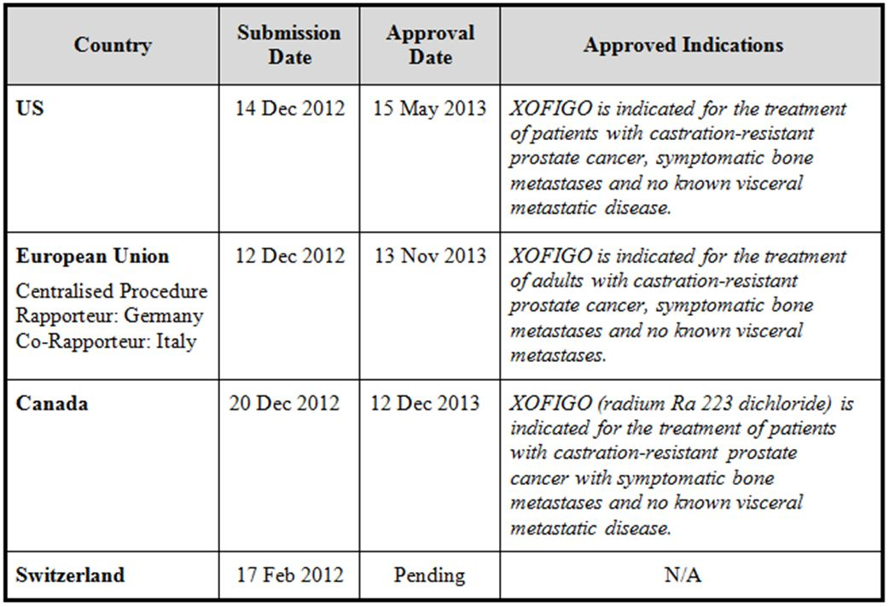

Product information
The approved Product Information (PI) current at the time this AusPAR was prepared can be found as Attachment 1. For the most recent Product Information please refer to the TGA website at <http://www.tga.gov.au/hp/information-medicines-pi.htm>.

II. Quality findings

Introduction
Radium (²²³Ra) dichloride is a therapeutic alpha particle emitting radio pharmaceutical for use in the treatment of bone metastases resulting from prostate cancer.
The product contains radium (²²³Ra) ions which mimic calcium ions to selectively target bone. ²²³Ra complexes with the bone mineral hydroxyapatite specifically at areas of increased bone turnover associated with bone metastases. The high linear energy transfer of alpha particle emitters such as ²²³Ra leads to a high frequency of double strand DNA breaks in adjacent cells, resulting in a targeted anticancer effect. The alpha particle range from ²²³Ra is less than 100 µm (less than 10 cell diameters), which minimises damage to the surrounding normal tissue.
The drug product is supplied as a ready-to-use, clear, colourless, sterile, isotonic solution for IV injection in type 1 glass vials in packs of one inside a lead shielded carton.
No other registered products contain radium (²²³Ra) dichloride. There are other radiopharmaceuticals registered which also utilise a calcium mimicking mode of action to selectively target bone metastases: strontium (⁸⁹Sr) chloride injection (trade name Metastron), and samarium (¹⁵³Sm) lexidronam pentasodium injection (trade name Quadramet). In these cases the radioisotopes are beta emitters and the products are indicated only for palliation of pain associated with the bone metastases, rather than for treatment.

Drug substance (active ingredient)
The active moiety of the radium dichloride drug substance exists as free divalent radium ions (²²³Ra²⁺). The molecular formula of radium dichloride is ²²³RaCl₂ and it has a molecular weight of 293.9 g/mol.
The six stage decay of ²²³Ra to lead-207 (²⁰⁷Pb) occurs via short lived daughters (longest half life 36.1 min), and is accompanied by four alpha, two beta and some gamma emissions, as shown in the decay chain diagram in Figure 1. The energy emitted from ²²³Ra and its daughters is dominated by that carried by alpha particles (95.3 %) with a small amount as beta particles (3.6 %) and as gamma radiation (1.1 %).
Figure 1: ²²³Ra decay chain with daughter nuclides and half lives. Energies listed are average energies.
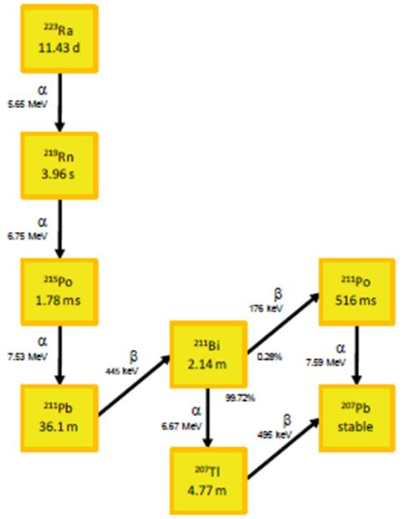
The drug substance solution is tested for appearance, radionuclidic identity, pH (6.0-7.0), osmolarity, citrate, radionuclidic purity, methanol, nitrate and radioactive concentration.. Limits for the radionuclidic purity are adequately justified based on calculated maximum organ doses, integrated over 20 years.

Drug product
The manufacturing process for the finished product involves combining batches of the drug substance solution and dilution with a premixed excipient solution to achieve the claimed ²²³Ra radioactivity concentration and maintaining isotonicity and physiological pH (6.0-7.0) and filling into vials with terminal sterilisation.
The drug product is supplied as a ready-to-use, clear, colourless, sterile, isotonic solution for intravenous injection in type 1 glass vials with siliconised chlorobutyl rubber stoppers. Each sealed vial is wrapped with an adhesive transparent film and inserted in a lead shielded container inside a cardboard box.
The solution has a pH of 6.0-8.0, and the proposed shelf life is 28 days stored below 40°C. The declared radioactivity concentration is 1000 kBq/mL (6.0 MBq per 6 mL vial) at the reference date.
The same solution formulation has been used in all clinical studies.
Sterility and endotoxin aspects are acceptable.
The product is administered as a slow intravenous injection at a typical dose of 50 kBq per kg body weight, given as a course of 6 injections at 4 week intervals. The total volume to be administered to a patient is calculated at the time of administration based on the applicable DK factor. This makes allowance for the radioactive decay which has occurred since product manufacture. Near the end of the shelf life, more than one vial may be needed to achieve the required dose.

Dosimetry
The company successfully argued that ‘equivalent dose’ and ‘effective dose’ information in the PI (as usually supplied for radiopharmaceuticals) is not appropriate or informative in this unusual case which involves highly localised alpha radiation used for therapeutic purposes. A more useful measure would be the calculated absorbed dose for each organ or tissue, weighted with an appropriate relative biological effectiveness (RBE) of the alpha radiation. The sponsor argues that appropriate RBE values are not available with the current state of knowledge. Application of typical literature values (RBE = 5) to the dose absorbed by red marrow predicts toxic effects which are not observed in clinical trials. Consequently, only a table of calculated absorbed radiation doses for the various organs and for the various radiation types are included in the PI, based on clinical biodistribution data and using OLINDA/EXM software plus additional assumptions/calculations for intestine, red marrow and bone/osteogenic cells.

Labelling
The provided vial and lead container labels include the radioactive concentration in term of the total activity per vial at the reference date (6.0 MBq/6mL vial) as required by Therapeutic Goods Order (TGO) 69. The company has also requested an ongoing Section 14 exemption from the requirements of TGO 69 to include the statement of activity ‘1000 kBq/mL solution for injection’.
The labels are acceptable from a pharmaceutical chemistry perspective.

Quality summary and conclusions
There is no objection to the registration of the proposed radium dichloride (Xofigo) 6.0 MBq per 6 mL solution for injection in vials, with respect to chemistry and quality control aspects.

III. Nonclinical findings

Introduction
The nonclinical dossier submitted by the sponsor included data for primary pharmacology, secondary pharmacodynamics, safety pharmacology, pharmacokinetics and toxicity. Pivotal toxicity studies were Good Laboratory Practice (GLP) compliant and toxicokinetic data were provided for relevant studies. An appropriate Risk Assessment was provided.

Pharmacology

Primary pharmacology
²²³RaCl₂ is a radiopharmaceutical with a ²²³Ra²⁺ isotope as the active moiety (as ²²³RaCl₂). The sponsor presented a number of published studies which collectively highlight the utility of ²²³Ra²⁺ in attenuating bone metastases.
Owing to intrinsic bone targeting properties of ²²³Ra²⁺ (similar to calcium), it is proposed to target and accumulate within regions of high bone turnover in metastases, by forming a complex with hydroxyapatite. Hydroxyapatite constitutes ~50% of the bone structure. Previous studies have demonstrated comparable tracer radium isotope uptake levels in bone between humans and animals.
The localised antitumor effects in target tissues is due to the high frequency of double strand DNA breaks resulting from high Linear Energy Transfer (LET) alpha particle radiation (~ 80 keV/μm). Collateral damage to adjacent healthy tissue is hypothesised to be minimal due to the short path length (< 100 µm) alpha particles.
The sponsor conducted in vitro studies to assess the impact of alpha particles on cellular survival (Studies R-8687, R-8688, R-8689 and R-8692), DNA damage and double stranded breaks (Study R-8689), cell cycle effects (Study R-8690), age response (Study R-8691) and differentiation and activity of osteoclasts and osteoblasts (Studies R8693 and R8694). Survival analysis on NHIK 3025^{±(dox)} (cervical carcinoma) and A549^{±(dox)} (lung epithelial) cell lines revealed reductions in survival fractions at dose rates from 0.008-0.196 Gy/h (R-8687 and R-8688). Minimal impact from growth characteristics and cellular lineage to ²²³Ra²⁺ mediated cell death is indicated based on analysis of these two cancer cell lines in vitro. Study R-8689 showed alpha particle emissions mediate cell death by introducing double stranded breaks to the DNA in NHIK 3025 cells (compared with increased γH2AX signals (~15 fold) compared to controls with doses up to 3 Gy). The sponsor also refers to a study by Kataoka and colleagues where X-rays induced double stranded breaks in endothelial cells from the human dermis. A cell cycle analysis conducted as part of Study R-8690 showed an accumulation of NHIK^{-/-p53, -/-pRb} cells in G2 phase (compared with 91%) post irradiation following a 24 h 0.94 Gy exposure regimen. No clear mechanistic explanation was provided for the accumulation of cells in G2 phase. Furthermore, Study R-8691 suggests cell survival after ²²³RaCl₂ treatment is independent of cell cycle phase. The effect of ²²³RaCl₂ on differentiation and activity of human osteoclasts (study R-8693) and mouse osteoblasts (study R-8694) were examined. At concentrations between 50-1600 Bq/ml, statistically significant and dose dependent inhibition of human osteoclast differentiation was noted. However, no impact on osteoclast activity was observed. Similarly, in mouse osteoblast differentiation studies statistically significant and dose dependent inhibition of differentiation was noted at doses ≥ 400 Bq/ml. Doses < 400 Bq/ml was comparable to base line. The activity of mouse osteoblasts were significantly impacted at doses ≥ 800 Bq/ml; at doses < 800 Bq/ml, activity was comparable to baseline. In summary, pronounced effects on osteoclasts were observed at lower concentrations.
In vivo pharmacodynamic data were provided from three mouse studies (Studies R-8695, R-8696 and R-8697) and one published rat study. In a dose finding study performed in a breast cancer bone metastasis athymic nude mouse (female) model (Studies R-8695), 300 kBq/kg IV (single dose) emerged as the optimal dose for inhibition of osteolytic lesions and whole body tumour burden while maintaining serum TRACP 5b activity and better body weight maintenance (except hind/limb tumour burden, which did not decrease). This dose was able to prolong the survival in an additional experiment in this model (Study R-8697). Survival was also significantly increased in a breast cancer metastasis model in nude rats by treatment with ~110 kBq/kg. The sponsor stated that there were no commercially available osteoblastic prostate bone metastasis preclinical models.

Secondary pharmacodynamics and safety pharmacology
The sponsor conducted three safety pharmacology studies to investigate the effect of ²²³RaCl₂ in the respiratory, cardiac and central nervous system (CNS) functions (Studies R-8657, R-8658and R-8659).
In Study R-8657, the pharmacological effects of ²²³RaCl₂ on respiratory function were investigated following a single IV dose at 50, 250 and 1000 kBq/kg in rats. No test article related effects on the body weights, bodyweight gains, respiratory rate, tidal volume and minute volume were noted, when compared to controls. While baseline adjusted pulmonary physiology parameters of respiratory rate and minute volume showed isolated statistically significant changes compared to controls, no dose or timepoint relationship were observed. Variability was high.
Study R-8658 investigated the pharmacological effects of ²²³RaCl₂ in the cardiovascular system in 4 beagle dogs at 50, 150 and 450 kBq/kg. No test article related mortalities, clinical observations, or body weights or weight gains were noted in the treatment group. No test article related change was noted in heart rate, QRS Complex, PR Duration, RR Duration, or QTc Duration. Reduction in blood pressure was noted in all three treatment groups. In the absence of change in other cardiovascular parameters in response to the test-article, the significance of the reduced blood pressure is uncertain. Test article related changes in white blood cells, platelets, eosinophils, reticulocytes, monocytes and lymphocytes were also noted. While mild inflammation in the liver was observed, no dose related histopathology was observed.
The effect of ²²³RaCl₂ on CNS function in Sprague Dawley (SD) rats was investigated in Study R-8659 at 50, 250 and 1000 kBq/kg doses. No mortalities were recorded. Functional observations revealed decreases in forelimb and hindlimb grip strength and foot splay up to 24 h post dose. Body weights in the Functional Observational Battery (FOB) were also reduced 24 h post dose. While variations were observed, no consistent test article related changes to locomotor activity were observed.
The doses at which the safety pharmacological studies were conducted yielded, based on Broad Spectrum Activities (BSA), animal:human low safety ratios of ~3 and 5 in rats and dogs, respectively.

Pharmacokinetics
The sponsor conduced three pharmacokinetic and distribution studies in mice (Studies R-8646, R-8648 and R-8649).

Biodistribution
No test article related clinical signs or body weight changes were noted after a single 625kBq/kg IV dose for up to, either 14 or 56 days post dose (Studies R-8646, R-8648 and R-8649). Radioactivity was low or absent in blood in all studies from 24 h post dose, indicating rapid tissue uptake. Clearance of ²²³RaCl₂ was rapid with a biphasic pattern. An initial t_{1/2} of 5-10 minutes and a terminal t_{1/2} of ~12 h were determined. Biodistribution data indicated consistent hard tissue distribution up to 14 (Studies R-8646 and R-8649) or 56 days (R-8648). With the exception of the spleen, minimal distribution of ²²³RaCl₂ was detected in soft tissue at 14 and 56 days (R-8646, R-8648 and R-8649). Of the soft tissues, high radioactivity was noted in the kidney and large and small intestine tissues up to 1 h post dose (R-8646 and R-8649); most likely due to excretion through urine and faeces. Intestinal radioactivity was not detected at 56 days post dose. To this end, in Study R-8648 radioactivity was detected in urine and faeces up to 56 h (a ~3 and 2 fold decrease in radioactivity was noted in urine and faeces, respectively, at Day 14). Study R-8649 was also conducted to evaluate bioequivalence between two different production process (Process I and Process II). No statistical difference was noted between the two production methods.
Biodistribution in repeat dose toxicity studies in dog also indicated selective distribution to bone tissue (at 50 Kbq/kg) and minimal accumulation in soft tissue (Study R-8670).

Excretion
The sponsor submitted two excretion studies in mice for ²²³RaCl₂ (Study R-8647 and R-8650). The studies tested excretion of ²²³RaCl₂ generated by the two productions processes. In Study R-8647 (Production Process I), 625 kBq/kg IV was administered to female mice and samples taken up to 120 h post dose. Based on corrected values, radiation was detected in the urine and faeces as early as 1 h post dose with maximal excretion at 6 h post dose (urine:faecal excretion ratio 1:1.35). Study R-8650 investigated excretion of ²²³RaCl₂ (Production Process II) following a 625 kBq/kg IV administration to female mice. Radiation was detected in the urine and faeces as early as 1 h post dose with maximal excretion at 6-12h post dose (urine:faecal excretion ratio 1:1.35). The excretion profiles of the two production processes appeared comparable with no significant difference in the excretory profiles.

Metabolism
As no metabolic pathways are present for, no metabolic data was presented, which is acceptable.
Collectively, the submitted data and peer reviewed article collective indicate that the pharmacokinetic profiles in the laboratory animal species (particularly those used in the pivotal repeat dose toxicity studies) were sufficiently similar to allow them to serve as appropriate models for the assessment of ²²³RaCl₂ toxicity in humans.

Pharmacokinetic drug interactions
Study R-8698 investigated the pharmacodynamic interaction of ²²³RaCl₂ when co-administered with doxorubicin or zoledronic acid in breast cancer bone metastases in athymic nude mice. ²²³RaCl₂ up to 300 kBq/kg (IV, single dose), doxorubicin up to 5 mg/kg (weekly) and zoledronic acid 4 mg/kg (subcutaneous, single dose) were administered alone or in combination. Based on observations such as delayed onset of weight loss (²²³RaCl₂ and zoledronic acid), increased time to sacrifice (combination groups), decreased osteolytic lesion areas (²²³RaCl₂ and zoledronic acid) and reduced TRACP 5b activity (combination groups), combination therapy appears to impart better outcomes compared to single treatment or vehicle control in the mouse model of breast cancer bone metastases. In Study R-8651, the pharmacokinetics and biodistribution of 625 kBq/kg (IV single dose) ²²³RaCl₂ was assessed following co-treatment with zoledronic acid up to 14 days post dose. Radioactivity was low in blood in by 24 h post dose (a level of zoledronic acid was also comparable to the test article at 24 h). Clearance of ²²³RaCl₂ was rapid with a biphasic pattern in the presence or absence of zoledronic acid. The biodistribution data indicated consistent hard tissue distribution up to 14 days; with the exception of the spleen, minimal distribution of ²²³RaCl₂ was detected in soft tissue at 336 h. Of the soft tissues, high radioactivity was noted in the kidney and large and small intestine tissues up to 1 h post dose. No significant difference in ²²³RaCl₂ biodistribution was noted in the presence or absence of zoledronic acid.

Toxicology

Acute toxicity
The sponsor submitted four acute toxicity studies in mice, rats and dogs (Studies R-8660, R-8661, R-8662, R-8668-msra1, 8668a-msra1 and R8669-msra1). Study R-8660 administered 223RaCl2 at doses from 1250-3750 kBq/kg (single IV bolus) to mice and Study R-8661 administered ²²³RaCl₂ at doses from 1027-3081 kBq/kg (single IV bolus) to rats. Study R8662 administered ²²³RaCl₂ at doses from 20-1300 kBq/kg to male and female rats followed by 12 month observation period. Three deaths were reported in the mouse study: one from mid dose and two from high dose. No deaths were reported in the rat Study R-8661. In mice, clinical signs consisting of piloerection, hunched posture and a passive behaviour were noted in all groups.
In Study R-8662, clinical signs in the high dose groups (325 and 1300 kBq/kg) included worn down teeth, partial paralytic hind limbs, piloerection and red secretions were the most common observations in rats. Weight loss and reduced food consumption was noted in all dose groups up to 30 days post dose in both rats and mice. Furthermore, test article related reduced red blood cells, white blood cells, lymphocyte and eosinophil counts were also noted in both species; likely related to depletion of haematopoietic cells in the bone marrow. In both species, reduced alkaline phosphatase activity was observed in all dose groups which were attributed to depletion of osteoblasts. Increased activity of extramedullary haematopoiesis was implicated in the increased spleen weight in both mice and rats. In mice, observed microscopic changes included, dose related minimal to moderate depletion of osteocytes and osteoblasts, minimal to marked depletion of the haematopoietic cells (in bone) and extramedullary haematopoiesis in the spleen, mandibular and mesenteric lymph nodes.
Study R-8668-MSRA1 and R-8668a-MSRA1 investigated the effects of single IV doses (50 kBq/kg, 150 kBq/kg and 450 kBq/kg) of ²²³RaCl₂ on dogs. One death due to pneumonia was reported in the study. No test article related clinical signs were noted. A dose dependent decrease in total white blood cells, granulocyte, and platelet counts was noted with nadir at 10-14 days. These observations were correlated with a dose dependent reduction in marrow elements. In the low dose group, the haematology parameters returned to reference range by Day 30 post dose. A light reduction in faecal production was noted in mid and high dose groups. ²²³RaCl₂ was rapidly cleared from blood (1-2% of injected dose present 24 h post dose for all groups; the mean alpha half lives of the 50, 150 and 450 kBq/kg dose groups were 10.9, 5.9 and 11.0 minutes, respectively). A dose dependent increase in radioactivity of bone tissue with increasing dose of ²²³RaCl₂ was noted. Minimal radioactivity was noted in soft tissue (liver and spleen recording the highest levels) in comparison to bone. These observations were consistent with the rodent studies. Bilateral, segmental retinal detachment was noted in 3/3 surviving dogs in the high dose (450 kBq/kg) treatment group (Amendment, R-8669), and in 1/4 dogs in the 150 kBq/kg group, 30 days post dose. It was not observed at 50 kBq/kg. Retinal detachment appeared to be secondary to choroidal haemorrhage with subretinal effusion. While selective accumulation of ²²⁶Ra in beagles has been previously documented, with highest concentrations in the melanin granules of the tapetum lucidum (a structure absent in the human eye), and subsequent melanoma formation, the clinical implications of these findings remain uncertain. Retinal detachment was not observed in the repeat dose toxicity study in dogs at a dose level of 50 kBq/kg, nor was it observed in clinical trials.
Overall, a moderate order of acute toxicity was observed in rodents, consistent to the intended activity of the test article. Low toxicity was observed in the dog studies, with the exception of retinal detachment.

Repeat dose toxicity
The sponsor submitted 3 repeat dose toxicity studies in rat and dog models (Studies R-8662, R-8663 and R-8670). Study R-8662 administered x4 doses of 20, 325 or 650 kBq/kg ²²³RaCl₂ to rats once every 4 weeks followed by 12 month observation period. Up to 6 animals/sex in the high dose group (75%) and 5 animals/sex in the mid dose group (64%) were terminated or reported dead prior to study end. Some of the common clinical signs observed included, short teeth (with elongated lower jaw teeth), weight loss (secondary to shortened teeth), red secretions around eyes, piloerection, limping (hind/forelimbs), reduced reflexes, noisy laboured respiration and passive responses.
The clinical signs, which occurred approximately at the 6 month time point were more prominent in the mid and high dose groups. In both the mid and high dose groups, dose related and statistically significant reductions in body weight gain were noted. The reduced weight gain trended towards a slight recovery by experiment termination. Transient reductions in food consumption was also noted; likely related to shortening of teeth.
Fourteen days following the final dose, statistically significant changes in haemoglobin (reduced), red blood cells (reduced), haematocrit (reduced), white blood cells (reduced), neutrophils (reduced), absolute lymphocytes (reduced), eosinophils (reduced), mean cell volume (increased), mean cell haemoglobin concentration (increased) and mean cell haemoglobin (increased) were observed. By 52 weeks post dose only, mean cell volume (increased), and mean cell haemoglobin concentration (increased) remained statistically different in medium and high dose groups. This suggests a recovery trend for most haematology parameters.
The following chemistry parameters showed significant differences up to experimental termination; alanine aminotransferase (increased), aspartase aminotransferase (increased), triglycerides (reduced), creatinine (increased), phosphate (increased), and chloride (reduced). Given the significant changes in other clinical chemistry parameters 14 days post dose, a slight trend towards normalisation is indicated. Changes in urinary parameters such as γ-glutamyl transferase, sodium, potassium, calcium, chloride, and pH (with the exception of creatinine) returned to less than significant levels by study termination; the changes in urinary parameters appear to related to kidney and liver pathologies indicative of radiation toxicity.
Histopathological examination revealed treatment related changes in the bone socket of the teeth, in the liver, kidneys, uterus, spleen and bone which included: lost or fractured teeth, karyomegaly in liver and kidneys and bile duct hyperplasia. The study also reported incidents of osteosarcoma, often with metastasis, and non bone neoplasms across different treatment groups (mammary gland carcinoma in one treated female, lymphoma in multiple organs in one treated male). There are published reports of radium inducing osteosarcomas in mice, rats and dogs. The No Observed Adverse Effect Level (NOAEL) was deemed to be below the 20 kBq/kg low dose threshold. At the time of each low dose, the animal:human safety ratio is < 0.5 based on BSA.
Study R-8663 was a 12 month repeat dose toxicity study in rats (²²³RaCl₂ dose; 25, 50 or 100 kBq/kg IV at 4 a week interval). Notable clinical signs included, loss of teeth (high prevalence in males), lameness in limbs (likely osteosarcoma related), reduced body weight and reduced food consumption, compared to controls. The signs were prominent in the medium and high dose groups and less frequent in the low dose group.
Changes to haematology parameters included decrease in red blood cell, white blood cell, neutrophil, lymphocyte and eosinophils counts, increased reticulocyte counts, as well as reduced platelets pre-thrombin time, haemoglobin and haematocrit. Increases in mean cell haemoglobin and mean cell volume were also reported.
Clinical chemistry parameters showed reduced alkaline phosphatase activity, albumin, albuminglobulin ratio, chloride and sodium levels and increased alanine amino transferase and phosphate levels. While increased spleen weight was noted in all treatment groups, other organs recorded reduced absolute weight, reflecting lower body weights compared to controls.
Histopathological examinations revealed increased osteosarcomas in bone tissue in treatment groups and metastasis of osteosarcomas in muscle and lungs some animals. Based on observed toxicity, no NOAEL was established. Based on the lowest dose, the animal:human safety ratio is < 0.5 based on BSA.
In Study R-8670, ²²³RaCl₂ was administered to dogs at 50 kBq/kg at monthly intervals for six months. No mortalities were reported. No test article related clinical signs were noted. Pharmacokinetic parameters revealed rapid clearance from blood and excretion into the urinary and gastrointestinal pathways. Selective accumulation was noted in bone with minimal accumulation in observed in soft tissues. Changes in body weight of the treatment group were restricted to ±10% of baseline body weight. Haematology parameters revealed a decrease in granulocyte and platelet counts (with maximal at third injection and gradual recovery thereafter). In addition, decreases in white blood cells, red blood cells (slight) haemoglobin counts and myeloid:erythroid (M:E) ratio of bone marrow were also noted by the third dose, which returned to levels comparable with that of the control group by dose six. Bone specific alkaline phosphatase and N-telopeptide increases were noted in the clinical chemistry analysis. No test article related changes were observed in the urinalysis. While no major macroscopic or histopathological findings were noted a general reduction in the sternal and/or vertebral bone marrow hematopoietic cellularity was noted in the treatment group. Bone mineral density was unaffected. The observed bone/bone marrow phenotypes are consistent with the anticipated target and physiological effect of ²²³RaCl₂.
Given the rapid clearance from blood (<24 h to reach the lowest level of quantification [LLQ]), safety margins were determined based on BSA. Due to the inherent radioactivity of the test article, exposure ratios were low in rodent studies. While the toxicity effects were minimal in the dog study, only a single dose at 50 kBq/kg was utilised at an exposure ratio of approximately 0.6. The dose utilised appears to less than the maximum tolerated dose (MTD) for dogs; based on the cardiovascular study, R-8658. In the cardiovascular study, where single doses up to 450 kBq/kg were utilised in dogs (wash out study), no clinical signs were noted; however, this study was not a repeat dose toxicity study. Thus, the repeat dose toxicity study in dogs would likely have benefited from inclusion of additional (higher) doses approaching the MTD. The toxicity studies utilised the clinical rout of administration and with the exception of mouse studies, included the appropriate number (or more) of the clinical doses.

Major toxicities
The major target tissue for ²²³RaCl was bone. The most common bone associated ²²³RaCl related toxicity was the presence of osteosarcomas in rodents. Though not observed in dogs in the data submitted for current dossier, osteosarcomas have also been identified in canine models dosed with ²²⁴Ra and ²²⁶Ra. The haematological abnormalities consequent to myelotoxicity observed in animals were also observed in clinical studies.

Genotoxicity, carcinogenicity and reproductive toxicity studies
No genotoxicity, carcinogenicity or reproductive toxicity studies were performed due to mechanisms of actions of alpha particle radiation from the test article, which is acceptable.
Osteosarcomas were observed in rats at clinical exposures 7-12 months after start of treatment, and other neoplastic changes were observed in rats after single or repeated doses. Given the radioactive properties of ²²³Ra, it has the potential to elicit secondary malignancies. Although osteosarcomas were not observed in clinical trials, the maximum follow up of about 3 years is not sufficient to fully assess the tumourigenic risk. The latency period for development of osteosarcomas may exceed the median life expectancy of treated patients.
Based on potential effects of radiation on spermatogenesis, effective contraception methods during and up to 6 months after treatment are recommended. The 6 month period is based on 5 half lives for ²²³Ra plus one complete cycle of spermatogenesis.
An Australian medicines in pregnancy category of D was proposed, category X is recommended.

Local tolerance
Study R-8667 investigated the local tolerance of 750 kBq/animal of ²²³RaCl₂ administered to rabbits peri-venously. Local erythema was noted with gradual lessoning of irritation up to 7 days post dose. No oedema, haemorrhage, or histological change of the injection site was noted up to 7 days post dose.

Other studies
Studies R-8664, R-8665 and R-8666 investigated the toxicity impact of dual administration of docetaxel and ²²³RaCl₂. In the initial dose ranging Study R-8664 no test article related deaths were noted. Clinical signs observed, such as mild local reactions, red secretions around mouth and nostrils, hyperventilation and piloerection appeared to be transient. The loss of weight gain was also noted in docetaxel treated groups alone or in dual treatment groups. Test groups administered both docetaxel and ²²³RaCl₂ were found to be sufficient to induce significant reductions in leukocyte counts; no impact on leukocyte counts were noted when docetaxel alone (≤5 mg/kg). Combined administration also resulted in reduced red blood cell counts (compensated for by increased erythropoiesis by 2 weeks post dose). Notable clinical chemistry changes included increased creatinine and urea levels, and decreased alkaline phosphatase activity. No significant macroscopic findings were observed. No microscopic findings were performed.
Studies R-8665 and R-8666 were 12 and 22 week repeat dose studies involving docetaxel and ²²³RaCl₂ dual administration (4 mg/kg and 50 kBq/kg, respectively). Two deaths in treatment groups were reported in Study R-8665; however, causality was not established. No test article related clinical signs were noted in either study. Reduced body weights compared to controls were noted in both studies in groups treated with docetaxel or docetaxel and ²²³RaCl₂ combined; corresponding reductions in food intake was also noted in the same test groups. Haematology analysis revealed reductions in red blood cells, haemoglobin and haematocrit, and increases in absolute and relative reticulocytes in docetaxel or docetaxel and ²²³RaCl₂ combined in both studies. Mean corpuscular volume increased in most treatment groups in both studies with a trend towards normalisation with time. Neutrophils, white blood cells, and eosinophils showed a treatment related reduction in both studies, particularly in the docetaxel and ²²³RaCl₂ combined groups. Increases in platelet counts were noted in both studies with either docetaxel or docetaxel and ²²³RaCl₂ combined. Single or dual test article effect was variable in the two difference studies. In Study R-8666, reductions in urea, creatinine, trigylcerides and protein were also reported. The relative and absolute heart, kidney, liver, thymus and testes weights were also reduced in dual treatment group in Study R-8666.

Paediatric use
²²³RaCl₂ is not proposed for paediatric use and no specific studies in juvenile animals were submitted. Radiation effects might be more severe in developing bone.

Impurities
Radiolysis of water may give rise to small amounts of H₂O₂, on a worst case basis the solution for injection will contain an amount of 0.0084 mmol H₂O₂, corresponding to 0.08 µmol/kg in a 100 kg patient. H₂O₂ is likely to be enzymatically degraded in blood, and the small amounts are toxicologically qualified. Potential radioactive impurities are ²²⁷Th and ²²⁷Ac (raw material), with respective limits (shelf life) of NMT 0.5% and NMT 0.004% relative to ²²³Ra. The product decays through multiple daughter radionuclides to the stable isotope ²⁰⁷Pb.

Nonclinical summary and conclusions

Summary
- The nonclinical dossier comprised of data encompassing pharmacology, pharmacodynamics, safety pharmacology and toxicology for radium (²²³Ra) dichloride. Pivotal studies were GLP compliant and met necessary International Conference on Harmonisation (ICH) guidelines. However, the repeat toxicity study in dog was only conducted with a single dose level (50 kBq/kg), a higher dose appeared feasible. Given the radioactive nature of the test article, no genotoxicity, carcinogenicity or reproductive toxicity studies were performed, which is acceptable.
- In vivo and in vitro pharmacology data demonstrated satisfactory localisation to bone in long term studies, DNA damage, and attenuation of cell cycle on cancer cell lines and reduction in osteoclast differentiation and osteoblast activity. In vivo efficacy in bone metastasis in athymic nude mouse models was demonstrated, with increased survival times and reduced osteolytic area.
- No safety pharmacology issues were noted in respiratory, cardiac and CNS function studies.
- ²²³RaCl₂ is rapidly cleared from blood and demonstrates minimal accumulation in soft tissue long term.
- Single dose toxicity studies in mouse, rat and dog revealed test article related changes in haematology parameters in all species; likely due to loss of haematopoietic cells. A compensatory increase in spleen haematopoiesis was noted in the rodent species. In addition, dose related weight loss, reduced food consumption and dose related depletion of osteoblasts and osteocytes were noted in mice and rats.
- Retinal detachment was seen in dogs after a single injection of 150 or 450 kBq/kg body weight (3 and 9x clinical dose), but not after repeat doses of 50 kBq/kg body weight, nor was it observed in rats. The literature reports high uptake of radium in the tapetum lucidum of the canine eye, a structure which humans do not possess.
- Repeat dose toxicity studies were conducted in rats and dogs. Both species recorded reduction in body weights, food consumption and haematology parameters (red blood cells, white blood cells, and platelet counts). Concurrent increase of haematopoiesis in the spleen was reported. Osteosarcomas (with metastasis) were observed in rodent studies only. Based on BSA, the animal to human safety ratios were <1.

Conclusions and recommendation
- No major deficiencies were noted.
- Submitted data, in the form of published articles and in-house data satisfactorily demonstrated an ability of ²²³RaCl₂ to (a) accumulate in bone tissue (b) cause double stranded DNA breaks and cell cycle arrest in at least two cancer cell lines and (c) inhibit differentiation of osteoclasts and activity of osteoblasts in vitro. In an in vivo mouse model, prolonged survival, and reduced osteolytic area was also noted.
- Respiratory, cardiac and CNS functions were not adversely affected by a single dose of ²²³RaCl₂ in rats and dogs (1000 Bq/kg in rats and 450 Bq/kg in dogs).
- ²²³RaCl₂ demonstrated rapid clearance from the blood with only long term significant accumulation (up to 56 days) detected in bone tissue. Compared to single treatment, co-administration of ²²³RaCl₂ with doxorubicin or zoledronic acid in breast cancer bone metastases in athymic nude mice appears to impart better outcomes, such as delayed onset of weight loss, increased time to sacrifice, decreased osteolytic lesion areas and reduced TRACP 5b activity.
- Repeat dose toxicity studies conducted in rats and dogs showed reduced body weights, food consumption, white blood cells, platelets, and red blood cells. Concomitant increases in reticulocyte and extramedullary haematopoiesis (spleen) were also observed. ²²³RaCl₂ was targeted to the bone and detectable up to 56 days post dose. Osteosarcomas (often with metastasis) were seen in rat studies from 6 months post dose, and one incidence each of mammary carcinoma and lymphoma. Based on BSA, the animal to human safety ratios were <1. However, the toxicity effects observed are direct effects anticipated to be associated with the pharmacology of ²²³RaCl₂.
- Retinal detachment was seen in dogs after a single injection of 150 or 450 kBq/kg body weight (3 and 9x clinical dose), but not after repeat doses of 50 kBq/kg body weight, nor was it observed in rats. The literature reports high uptake of radium in the tapetum lucidum of the canine eye, a structure which humans do not possess.
- No genotoxicity, carcinogenicity or reproductive toxicity studies were performed due to mechanisms of actions of alpha particle radiation from the test article, which is acceptable.
- While the safety exposure ratios are low, and a high level of toxicity was observed in rodent repeat dose studies (such as osteosarcomas), there are no nonclinical objections to registration on the grounds that (a) toxicity associated with repeat dosing in dogs was minimal (though with exposure margins <1) and (b) the indicated human population has advanced cancer.
- The nonclinical evaluation does not cover the radiation protection aspects of the submission.

IV. Clinical findings
A summary of the clinical findings is presented in this section. Further details of these clinical findings can be found in Attachment 2.

Introduction

Contents of the clinical dossier
The submission contained the following clinical information:
- 4 clinical pharmacology studies providing data on pharmacokinetics, biodistribution and dosimetry;
- 1 pivotal efficacy/safety studies; and
- 2 other efficacy/safety studies.

Guidance
There are no adopted guidelines for radiopharmaceuticals. The TGA has adopted the EU guideline relating to anticancer agents. This guideline allows for a single efficacy study and for interim analysis and stopping a trial where benefit has been demonstration.

Paediatric data
The submission did not include paediatric data. This is appropriate given the indication being sought.

Good clinical practice
The clinical study reports state that the conduct of the clinical studies met all local legal and regulatory requirements and that all studies were conducted in accordance with the ethical principles that have their origin in the Declaration of Helsinki and the ICH guidelines. The protocols were reviewed by the appropriate ethics committees and all patients gave written informed consent prior to their participation in the studies.

Pharmacokinetics

Studies providing pharmacokinetic data
Table 2 shows the studies relating to each pharmacokinetic topic and the location of each study summary.
Table 2: Submitted pharmacokinetic studies.
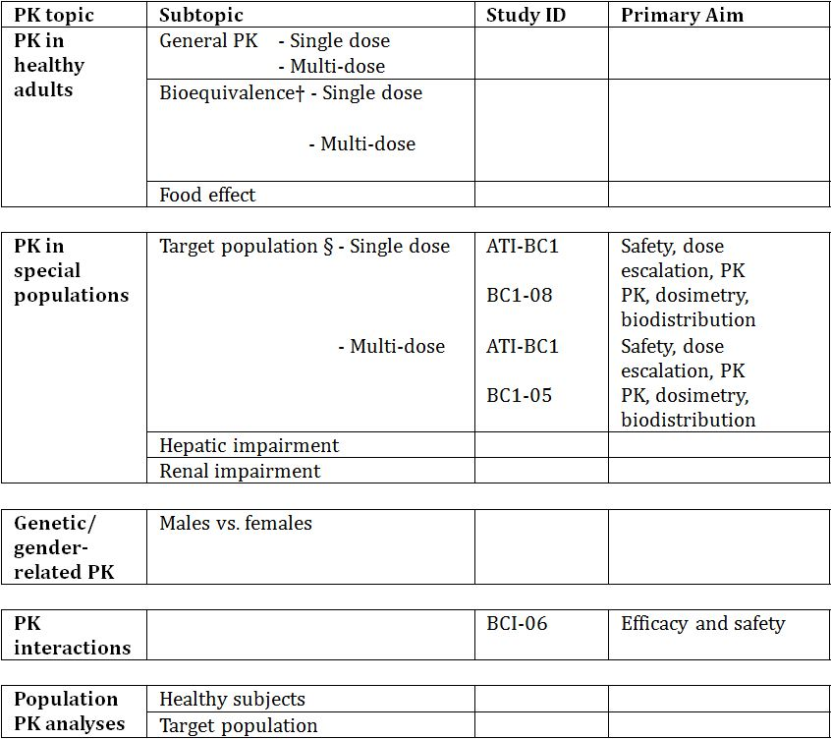
† Bioequivalence of different formulations.
§ Subjects who would be eligible to receive the drug if approved for the proposed indication.
None of the pharmacokinetic studies had deficiencies that excluded their results from consideration.

Evaluator’s conclusions on pharmacokinetics
The pharmacokinetic data has been obtained from three Phase I studies including a total of 47 patients. Due to the mechanism of action of ²²³RaCl₂ as an alpha emitting radiopharmaceutical which may cause chromosomal damage, all clinical studies were conducted in cancer patients (prostate and breast). This is in accordance with the EU guideline on anticancer medicinal products.
There were no pharmacokinetic studies performed in special populations. The information for these populations was obtained via subgroup analysis from the pivotal efficacy Study BCI-06.
The data from the single and multiple dose studies indicated close to but not exact dose proportionality. The pharmacokinetic studies support the dose and dose timing used in the efficacy studies.

Pharmacodynamics

Studies providing pharmacodynamic data
Table 3 shows the studies relating to each pharmacodynamic topic and the location of each study summary.
Table 3: Submitted pharmacodynamic studies.
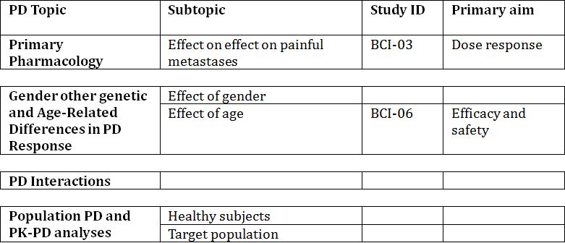
None of the pharmacodynamic studies had deficiencies that excluded their results from consideration.

Evaluator’s conclusions on pharmacodynamics
Very little pharmacodynamic evaluation was done as the mechanism of action of radiopharmaceuticals is well known. The dose response to the single dose in the one study conducted demonstrated the dose response over the range examined for the response of pain as measured by the pain index and the secondary endpoints of pain relief, analgesic consumption and change in function interference.
The results of this study justify the dose selected for the pivotal studies.

Dosage selection for the pivotal studies
During the clinical development program, ²²³Ra was studied as a single dose up to 250 kBq/kg body weight, and as repeated doses up to 240 kBq/kg body weight. The proposed dosing regimen of 50 kBq/kg body weight every 4 weeks for a total of 6 injections was based on the following.

Dose
Throughout the dose range tested during the initial Phase I study (ATC-BCI) (single doses up to 250 kBq/kg body weight), no dose limiting toxicities were recorded and there was no gradient of risk across the doses up to 100 kBq/kg body weight in the Phase II studies (Studies BCI-02, BCI-03, and BCI-04).
In Study BCI-04, the two highest doses (50 and 80 kBq/kg body weight) demonstrated a greater effect on the PSA and bone alkaline phosphatase (ALP) as compared to the lowest dose level. The 50 kBq/kg body weight dose was not significantly different from the 80 kBq/kg dose in terms of response for PSA and bone ALP. Therefore, a dose of 50 kBq/kg body weight was considered to be a biologically effective dose.

Injection duration (up to 1 minute)
The protocol of the pivotal Phase III study (BCI-06) specified a “slow bolus” injection. This led to a low frequency (<0.5%) and intensity (≤ Grade 2) of injection site reactions. This proposed timing took into consideration avoidance of injection site reactions and radiation protection for the clinical personnel (ALARA principal: as low as reasonably achievable).

Injection interval
Based on the nadir count of neutropenia seen in Study ATI-BCI between Day 15 and 20, the interval between injections was selected to be 4 weeks.

Number of injections
The results of the Study BCI-02, conducted with 4 injections suggested a relationship between benefit and duration of treatment. In addition, the maximum single dose applied during Phase I did not lead to dose limiting toxicities. The findings led to the 6 injections used in the pivotal efficacy study (Study BCI-06).

Efficacy

Evaluator’s conclusions on efficacy
The pivotal study, which was appropriately terminated early, demonstrated a 3.6 month survival benefit to patients with castration resistant prostate cancer when treated with ²²³Ra. The study numbers are high and the survival benefit is supported by a suggestion of a survival advantage in the supportive study and related benefits on skeletal related events and pain relief and also on the surrogate markers of effect on bone ALP and PSA.
The supportive studies did not use the same dose regimen as the pivotal study. Study BCI-06 applied the proposed recommended dose of 50 kBq/kg body weight every 4 weeks for 6 cycles. Study BCI-02 assessed 50 kBq/kg body weight every 4 weeks for 4 cycles. The study showed a survival benefit for ²²³Ra in the per protocol (PP) population but not in the intention-to-treat (ITT) population.
The pivotal clinical study excluded patients with visceral metastases. This has been noted by the FDA in their approved indication which accurately reflects the patients who were included in the single pivotal study. The sponsor in the Clinical Overview comments that while patients with visceral metastases were excluded from the pivotal trial, these patients should not be excluded from the approved indication. They base this assertion on the fact that in prostate cancer in patients with both bone and visceral disease, bone disease is often dominant and the visceral lesions may be clinically inconsequential and that in these patients the bone disease determines clinical outcome, and therefore ²²³Ra is likely to be of benefit. While this may be true, it has not been proven and the sponsor still chose to exclude these patients from the studies. It is therefore recommended that the indication be changed to accurately reflect the patients in whom benefit has been proven, that is, CRPC patients with symptomatic bone metastases with no visceral metastases.

Safety

Studies providing safety data
The following studies provided evaluable safety data.

Pivotal efficacy study
In the pivotal efficacy study, (Study BCI-06), the following safety data were collected:
- General adverse events (AEs) were assessed by collecting all AEs that may have been reported spontaneously by the subject or elicited through open (non leading) questioning during each visit and at the end of the AE follow up period. Any AEs that occurred after randomisation and within 12 weeks after last injection of study drug were reported, whether or not considered related to the study drug.
- AEs of particular interest, indicating long term toxicity, were assessed by recording the presence of any of the following diseases: acute myelogenous leukaemia (AML), myeloblastic syndrome (MDS), aplastic anaemia, and primary sarcomas of the bone or new primary cancer in other organs. During the follow up period patients were evaluated every 2 months for 6 months then every 4 months for 3 years.
- Laboratory tests, including haematology and clinical chemistry, were performed at baseline and at weeks 4, 8, 12, 16, 20, 24 and then every 2 months for 6 months and then every 4 months for 3 years.
- A standard 12 lead electrocardiogram (ECG) was performed at screening, 4 and 24 weeks after first study drug administration, and at treatment discontinuation if relevant. Results were recorded as normal or abnormal. The ECG was evaluated by the local investigator.
- An abbreviated physical examination consisting of general appearance, lungs, cardiovascular system and abdomen, and other physical findings was done at each hospital visit.

Pivotal studies that assessed safety as a primary outcome
Not applicable.

Dose-response and non-pivotal efficacy studies
The dose response and non pivotal efficacy studies provided safety data, as follows:
- Study BCI-02 provided data on AEs, haematology and clinical chemistry and an abbreviated physical examination.
- Study BCI-04 provided data on AEs, concomitant medications, physical examination, ECOG and clinical laboratory tests.

Clinical pharmacology studies
- Study ATI-BCI provided data on AEs, haematology and serum biochemistry, urinalysis and occurrence of AEs. Safety was assessed for 8 weeks after the single injection.
- Study BCI-03 provided data on AEs, change in clinical laboratory values including bone ALP and PSA and changes in abbreviated physical examination. During the 24 month follow up, AEs considered drug related and long term toxicities (such as AML, MDS, aplastic anaemia and primary sarcomas of the bone) were recorded.
- Study BCI-05 provided data on AEs changes in vital signs, ECG parameters, physical examination and changes in haematology and blood chemistry. Long term toxicity was collected for up to 12 months after the first injection.
- Study BCI-08 provided data on AEs, concomitant medication, physical examination, Karnofsky performance status, vital signs, 12 lead ECG, clinical laboratory tests, patient status (survival) and long term toxicities and bone marrow biopsy. Follow up was for 12 months after treatment.

Patient exposure
For the safety analysis the sponsor has used 3 data pools (Pool 2, 4 and 5) as shown in Tables 4 and 5.
Table 4: Exposure to ²²³Ra in clinical studies.
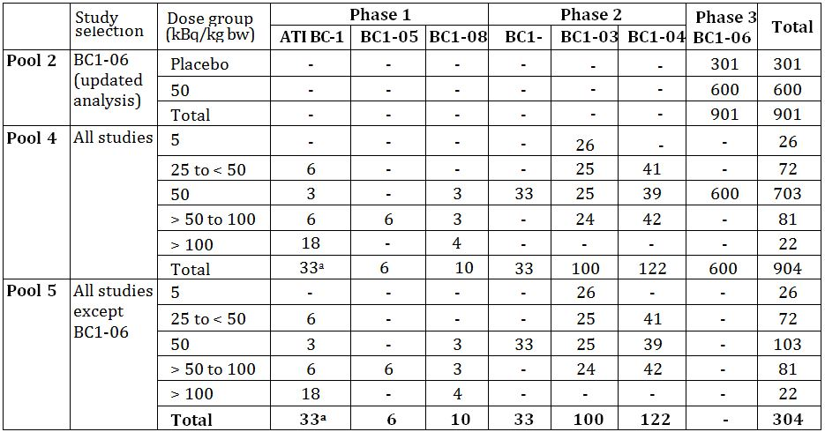
a. 2 patients in Study ATI-BC1 were treated twice during the study and were re-numbered for the second injection. Data from both the original injection and re-injection are summarised separately, thereby double counting these patients.
Table 5: Exposure to ²²³Ra in clinical studies according to exposure and number of injections.
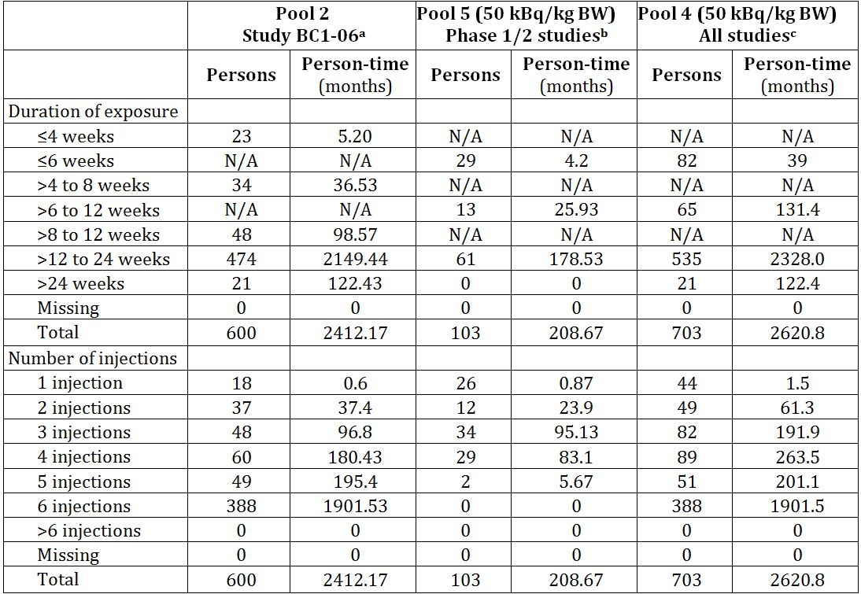
a Safety data from the randomised, double-blind, placebo-controlled study BC1-06 (cycle length of 4 weeks).
b Safety data from (50 kBq/kg data only) from phase 1/2 studies: ATI-BC-1 (n = 3), BC1-02 (n = 33), BC1-03 (n = 25), BC1-04 (n = 39), BC1-08 (n = 3)
c Safety data (50 kBq/kg data only) from studies: ATI-BC-1 (n = 3), BC1-02 (n = 33), BC1-03 (n = 25), BC1-04 (n = 39), BC1-08 (n = 3), BC1-06 (n = 600)
N/A = Not available
Person Time for each patient is calculated as the date of the last injection of study treatment - date of the first injection + 1.
Total is the sum of person-time in months.

Safety issues with the potential for major regulatory impact

Liver toxicity
Safety and efficacy of ²²³Ra has not been studied in patients with hepatic impairment. Since ²²³Ra is neither metabolised by the liver nor eliminated via the bile, hepatic impairment is not expected to affect the PK of ²²³Ra. No dose adjustment is considered necessary in patients with hepatic impairment.

Haematological toxicity
Table 6 shows haematologic treatment emergent adverse events (TEAEs).
Table 6: 50 kBq/kg pool: Haematologic TEAEs using MEDRA term grouping.
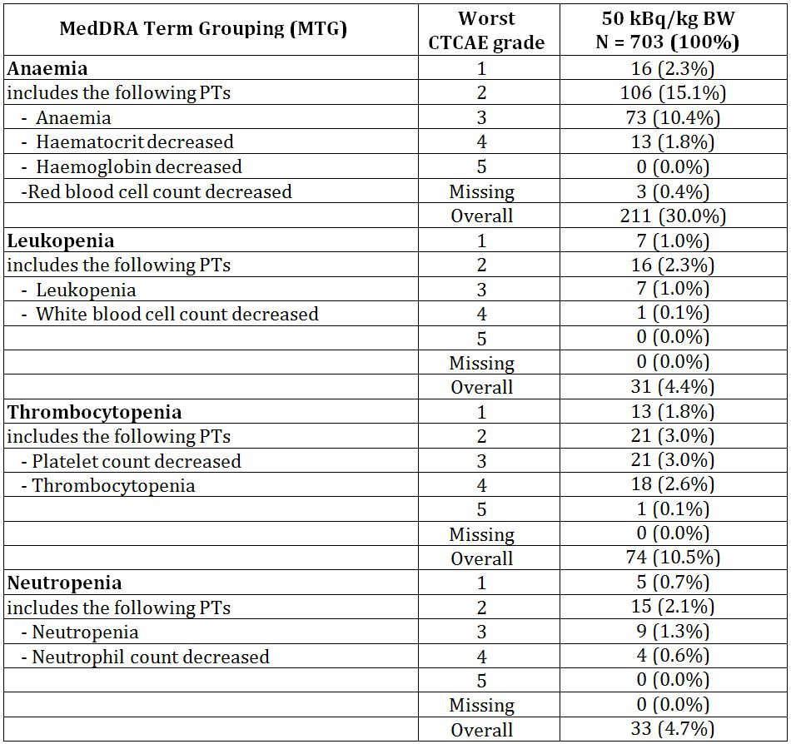
a. Safety data (50 kBq/kg data only) from studies: ATI-BC-1 (n = 3), BC1-02 (n = 33), BC1-03 (n = 25), BC1-04 (n = 39), BC1-08 (n = 3), BC1-06 (n = 600)
This table contains counts of patients. If a patient experienced more than one episode of an adverse event (AE), the patient is counted only once within a Preferred Term (PT) and for the episode with the maximum intensity. If a patient experienced more than one AE within a System Organ Class (SOC), the patient is counted once for each PT and once for the SOC. The denominator for percentages is the number of patients in the Safety Analysis Set.
MedDRA Dictionary Version 14.1 was used for coding. CTCAE Version 3 was used for severity grading.

Evaluator’s conclusions on safety
The safety is based largely on the large patient numbers in the pivotal clinical study (BCI-06). A total of 600 patients received ²²³Ra. This large patient population means the upper limit of the 95% confidence interval (CI) of an undetected AE is not higher than 3/904 (0.3%).
While almost all patients reported at least one AE, this is to be expected from the patient population. In the randomised pivotal efficacy study (BCI-06), the AE rate was lower in the ²²³Ra group compared to placebo.
As expected for a radiopharmaceutical excreted by the gut, the most frequent AEs were gastrointestinal and bone marrow suppression. The gastrointestinal (GI) events were diarrhoea, nausea and vomiting but most were primarily Grade 1 or 2. The bone marrow suppression, thrombocytopenia and leucopoenia were mostly Grade 1 or 2 but higher grade events were also observed. Of note, the higher frequencies of thrombocytopenia, neutropenia and lymphopenia did not result in an increased rate of haemorrhages or infections.
There were isolated reports of second primary malignancies following treatment with ²²³RaCl₂. However, a reasonable causal relationship to ²²³Ra cannot be established in the cases, mainly due to the short time after injection of the drug. Nevertheless, secondary malignancies including AML, MDS and sarcomas of the bone are a potential risk based on the known carcinogenic effect of radiation. As the latency of radiation induced malignancies is long, the studies were not really long enough to demonstrate these but the impact on the target patient population which has a reduced life expectancy is most likely limited.

First round benefit-risk assessment

First round assessment of benefits
The benefits of ²²³Ra in the proposed usage are:
- Prolonged survival seen in the pivotal efficacy study (BCI-06). The patients treated with ²²³Ra had a statistically significant and clinically meaningful (3.6 months) increased survival compared to placebo treated patients;
- A survival benefit was also suggested in the supporting study BCI-02 where a statistically significant improvement in survival was seen in the PP analysis set;
- In both studies assessing skeletal related events (SREs) (Studies BCI-06 and BCI-02), ²²³Ra reduced the incidence of SREs and delayed the onset of SREs. It also delayed the onset and reduced the incidence of the individual components of SREs, especially spinal cord compression and EBRT, which are both of particular clinical relevance;
- In the pivotal efficacy Study BCI-06, pain was reported as an adverse event for fewer patients in the ²²³Ra group compared to placebo. This was supported by the favourable results for time to EBRT for pain relief and for time to analgesic use;
- The results for the surrogate markers bone ALP and PSA were favourable to ²²³Ra; and
- Results from all studies are consistent.

First round assessment of risks
The risks of ²²³Ra in the proposed usage are:
- Adverse events were observed in almost all patients, most frequent AEs were gastrointestinal (diarrhoea, nausea and vomiting);
- Moderate bone marrow suppression particularly thrombocytopenia, neutropenia and lymphopaenia but not associated with increased rates of haemorrhage and infection;
- Bone marrow suppression is greater in patients who have received prior docetaxel therapy;
- Injection site reactions of erythema, pain and swelling were observed in small number of patients;
- Isolated reports of second primary malignancies following treatment, however causal relationship is not established due to short time to onset of new malignancy; and
- Risk of secondary malignancies of AML, MDS and sarcoma of bone could not be excluded due to long latency of these tumours and short duration of the trials

First round assessment of benefit-risk balance
The benefit-risk balance of ²²³Ra, given the proposed usage, is favourable.

First round recommendation regarding authorisation
Based on the clinical data submitted, it is recommended that the application be approved.

Clinical questions
The sponsor should be asked to clarify the discrepancy between the formulation of the product in the Application Form and that described in Module 2.7.1.1.

Second round evaluation of clinical data in response to questions

Clinical question
The sponsor should be asked to clarify the discrepancy between the formulation of the product in the Application Form and that described in Module 2.7.1.1.
The sponsor has clarified that the formulation in Module 2.7.1.1 refers to the drug substance solution in which calcium is declared and the application form represents the drug product formulation. A justification was provided by the sponsor for the discrepancy.
It is noted that this question was also raised by the Chemistry and Quality evaluator and a response to their question was provided and accepted by the Chemistry and Quality evaluator.
From a clinical perspective, it is accepted that the formulation used in the clinical studies is the same as that proposed for marketing.

Second round benefit-risk assessment

Second round assessment of benefits
No new clinical information was submitted in response to questions. Accordingly, the risks of ²²³Ra are unchanged from those identified in the first round.

Second round assessment of risks
No new clinical information was submitted in response to questions. Accordingly, the risks of ²²³Ra are unchanged from those identified in the first round.

Second round assessment of benefit-risk balance
The benefit-risk balance of ²²³Ra, given the proposed usage, is favourable.

Second round recommendation regarding authorisation
Based on the clinical data submitted, it is recommended that the application be approved.

V. Pharmacovigilance findings

Risk management plan

Contents of the submission
The sponsor submitted a Risk Management Plan (RMP) for Xofigo:
- EU-RMP version 1.0 dated 12 November 2012 (data lock point 12 November 2012) + Australian Specific Annex (ASA) version 1 dated 12 April 2013;
- EU-RMP version 1.3 dated 12 August 2013 (data lock point 12 November 2012) + Australian Specific Annex version 1.1 dated November 2013 which was reviewed by the TGA’s Office of Product Review (OPR).

Ongoing safety concerns
The sponsor provided a summary of ongoing safety concerns in the Australian Specific Annex (ASA) version 1 which are shown at Table 7.
Table 7: Ongoing safety concerns for Xofigo.
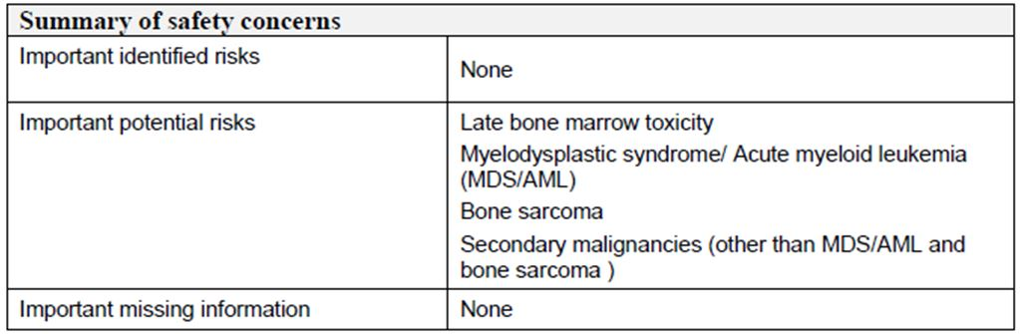

Reconciliation of issues outlined in the RMP report
Matters raised in the RMP were resolved to the satisfaction of the OPR prior to a final decision on this application.

VI. Overall conclusion and risk/benefit assessment
The submission was summarised in the following Delegate’s overview and recommendations:

Quality
The application and the supporting data relating to the composition, development, manufacture, quality control and stability of the product have been assessed and checked for compliance, as applicable, with Australian legislation and requirements for new medicines and in accordance with pharmacopoeial standards and the technical guidelines adopted by the TGA. Sterility and endotoxin aspects of the submission have been evaluated and are considered acceptable. This submission has not been considered by the PSC.
The chemistry evaluator has no objection to the registration of the proposed ²²³RaCl₂ Xofigo 6.0 MBq per 6 mL solution for injection in vials, with respect to chemistry and quality control aspects.

Nonclinical
- The evaluator did not identify major deficiencies.
- Submitted data, in the form of published articles and in-house data satisfactorily demonstrated an ability of ²²³RaCl₂ to (a) accumulate in bone tissue (b) cause double stranded DNA breaks and cell cycle arrest in at least two cancer cell lines and (c) inhibit differentiation of osteoclast and activity of osteoblast in vitro. In an in vivo mouse model, prolonged survival and reduced osteolytic area was also noted.
- Respiratory, cardiac and CNS functions were not adversely affected by a single dose of ²²³RaCl₂ in rats and dogs (1000 Bq/kg in rats and 450 Bq/kg in dogs).
- ²²³RaCl₂ demonstrated rapid clearance from the blood with only long term significant accumulation (up to 56 days) detected in bone tissue. Compared to single treatment, co-administration of ²²³RaCl₂ with doxorubicin or zoledronic acid in breast cancer bone metastases in athymic nude mice appears to impart better outcomes, such as delayed onset of weight loss, increased time to sacrifice, decreased osteolytic lesion areas and reduced TRACP 5b activity.
- Repeat dose toxicity studies conducted in rats and dogs showed reduced body weights, food consumption, white blood cells, platelets and red blood cells. Concomitant increases in reticulocyte and extramedullary haematopoiesis (spleen) were also observed. ²²³RaCl₂ was targeted to the bone and detectable up to 56 days post dose. Osteosarcomas (often with metastasis) were seen in rat studies from 6 months post dose, and one incidence each of mammary carcinoma and lymphoma. Based on BSA (assumes 70 kg individual 50 kBq/kg maximal single dose), the animal to human safety ratios were <1. However, the toxicity effects observed are direct effects anticipated to be associated with the pharmacology of ²²³RaCl₂.
- Retinal detachment was seen in dogs after a single injection of 150 or 450 kBq/kg body weight (3 and 9x clinical dose), but not after repeat doses of 50 kBq/kg body weight, nor was it observed in rats. The literature reports high uptake of radium in the tapetum lucidum of the canine eye, a structure which humans do not possess.
- No genotoxicity, carcinogenicity or reproductive toxicity studies were performed due to mechanisms of actions of alpha particle radiation from the test article, which is acceptable.
- While the safety exposure ratios are low, and a high level of toxicity was observed in rodent repeat dose studies (such as osteosarcomas), there are no nonclinical objections to registration on the grounds that (a) toxicity associated with repeat dosing in dogs was minimal (though with exposure margins <1) and (b) the indicated human population has advanced cancer.
- The nonclinical evaluation does not cover the radiation protection aspects of the submission.

Clinical
The submitted clinical data include one pivotal Phase III study (BCI-06), three Phase I studies (ATI-BCI, BCI-05, and BCI-08), and three Phase II (BCI 02, 03 and 04) studies.

Pharmacokinetics
The pharmacokinetic data has been obtained from three Phase I studies including a total of 47 patients.
- Study ATI-BCI was an open label, multicentre, dose escalation study conducted in 31 patients with skeletal metastases from breast or prostate cancer and the study assessed the use of ²²³Ra in single doses from 46 to 250 kBq/kg body weight.
- Study BCI-05 was an open label study in 6 CRPC patients to investigate the safety, biodistribution, radiation dosimetry and PK of two separate IV injections of ²²³Ra 100 kBq/kg body weight for each injection at 6 week intervals.
- Study BCI-08 was an open label, ascending dose study conducted in 10 CRPC patients with skeletal metastases to evaluate the safety, PK, distribution and radiation dosimetry of ²²³Ra at doses of 50, 100, and 200 kBq/kg body weight.
At 15 minutes post injection, about 20% of the injected activity remained in the blood. At 4 h, about 4% of the injected activity remained in the blood, decreasing to less than 1% at 24 h after the injection. The volume of distribution was higher than the blood volume indicating distribution to peripheral compartments.
²²³Ra is incorporated primarily into bone or is excreted into the intestine. In Study BCI-05, the level of activity in bone was determined to be in the range 44% to 77% of the administered activity at 4 h post injection. In Study BCI-08, activity in the intestine was observed 10 minutes post injection. No significant uptake was seen in other organs such as heart, liver, kidneys, urinary bladder, and spleen at 4 h post injection (Study BCI-05).
Faecal excretion is the major route of elimination from the body. There was high variability in gut transit rates across the population with one daily to up to once weekly bowel evacuation. In Study BCI-05 faecal excretion was determined by direct measurement of radioactivity in the faecal samples collected over 48 h. In this study faecal excretion post injection at 24 h was 2% (range 1-13%) and at ~48 h cumulative faecal excretion was 13% (range <1% to 34%). Imaging data from Studies BCI-05 and BCI-08 allowed for an estimate of the amount of radioactivity in the different regions of the GI tract. Once ²²³Ra is excreted into the GI tract, it is excreted via the faecal route. Based on the % of injected activity at 24 h in the GI tract, it is estimated that at least about 50-60% of injected ²²³Ra will be excreted via the faecal route.
Studies BCI-05 and BCI-08 also collected information on the amount of radioactivity excreted in urine. In Study BCI-05 urine samples were collected over 48 h and measured for total radioactivity. At ~48 h cumulative urine excretion was 2% (range <1% to 5%) of injected radioactivity. In Study BCI-08, the urine concentrations were measured indirectly by comparing the data from the whole body count before the first void and after the first void post injection. It is estimated that ~5% ²²³Ra was excreted through urine in the first void, a mean of 2.4 h after injection. Both studies concluded that urine excretion is a small component of the overall excretion of ²²³Ra. Whole body measurements at 7 days after injection indicates that a median of 76% of administered activity was excreted from the body (Study BCI-08). The rate of elimination of ²²³Ra from the GI tract is influenced by the high variability of intestinal transit rates across the population, with one daily to once weekly bowel evacuation.
Results from Study ATI-BCI showed that the area under the plasma concentration-time curve (AUC) and maximum plasma drug concentration (Cmax) values increased with increasing dose and there were very similar pharmacokinetic characteristics for all 5 dose groups. The two higher doses indicated a slightly more than dose proportional increase but overall the rage of doses suggested a close to linear dose relationship.
No pharmacokinetic studies were conducted in patients with hepatic impairment. It is not expected that hepatic impairment will affect the pharmacokinetics of ²²³RaCl₂ since ²²³Ra is a divalent cation, it is not metabolised and there is no evidence of hepatic biliary excretion. No pharmacokinetic studies in patients with renal impairment. However, since excretion in urine is minimal (1-5% in 48 h) and since the major route of elimination is via the faeces, it is not expected that renal impairment will affect the pharmacokinetics of ²²³RaCl₂.

Pharmacodynamics and selection of dose regimen
Three Phase II studies were submitted and these studies assessed the PD effect of ²²³RaCl₂. Selection of the final dose regimen for the Phase III study was based on these Phase I and II studies. Phase II studies are discussed further under ‘Efficacy’ section of this overview.
- Study BC1-02 was a placebo controlled, randomised, double blind trial and the study assessed the effect of ²²³RaCl₂ as measured by time to occurrence of SRE and the change in bone specific bone ALP levels. A total of 33 patients received 4 doses of 50 kBq/kg body weight at 4 week intervals and 31 patients received placebo.
- Study BC1-03 was a randomised, double blind, dose ranging study conducted in patients suffering from bone pain due to multiple bone metastases secondary to prostate cancer. The study assessed the palliative effect of 4 single dose levels (5, 25, 50 and 100 kBq/kg body weight ²²³RaCl₂) on painful bony metastases.
- Study BC1-04 was a randomised, double blind, repeat dose, dose response study conducted in subjects with asymptomatic or symptomatic CRPC. The study explored the effect of different doses of ²²³RaCl₂ on the proportion of patients with a confirmed PSA response. A total of 122 subjects were randomised to 3 different dose groups (25, 50 and 80 kBq/kg body weight). In each group, 3 injections were given at 6 week intervals.
At the initial Phase I study (ATC-BCI), ²²³Ra was studied as a single dose up to 250 kBq/kg body weight and no dose limiting toxicities were recorded. There was no gradient of risk across the doses up to 100 kBq/kg body weight in the Phase II studies (BCI-02, BCI-03, and BCI-04). In Study BCI-04, the two highest doses (50 and 80 kBq/kg body weight) demonstrated a greater effect on the PSA and bone ALP as compared to the lowest dose level. The 50 kBq/kg body weight dose was not significantly different from the 80 kBq/kg dose in terms of response for PSA and bone ALP. Therefore, a dose of 50 kBq/kg body weight was considered to be a biologically effective dose.
The Study BCI-02 assessed the 4 injections of ²²³Ra at 4 week intervals and the results suggested a relationship between beneficial effect and duration of treatment. In view of the results from Phase I studies showing the maximum single dose did not lead to dose limiting toxicities, the 6 injections was selected for the pivotal Phase III study. Based on the nadir count of neutropenia seen in Study ATI-BCI between Day 15 and Day 20, the interval between injections was selected to be 4 weeks.
In term of injection duration (up to 1 minute): the protocol of the Phase III study (BCI-06) specified a ‘slow bolus’ injection. This led to a low frequency (<0.5%) and intensity (≤ Grade 2) of injection site reactions. This proposed timing took into consideration avoidance of injection site reactions and radiation protection for the clinical personnel (ALARA principal – as low as reasonably possible).

Clinical efficacy

Pivotal study: Study BCI-06
This was a double blind, randomised, multiple dose, placebo controlled study conducted at 128 sites worldwide from June 2008 until the trial was stopped prematurely in October 2011. The primary objective was to compare, in subjects with symptomatic HRPC and skeletal metastases, the efficacy of best standard of care (BSoC) plus ²²³Ra versus BSoC plus placebo. The treatment regimen consisted of 6 slow bolus IV injections of ²²³Ra (50 kBq/kg body weight) or placebo (normal saline) each separated by an interval of 4 weeks. ‘Best standard of care’ was regarded as the routine standard of care at each centre, for example, local EBRT, corticosteroids, antiandrogens, oestrogens (for example, stilboestrol), estramustine or ketoconazole. If cytotoxic chemotherapy, other systemic radioisotopes or hemibody external radiotherapy treatments were considered as the BSoC to be given during the treatment period, further study drug had to be discontinued. The target population was subjects with progressive symptomatic HRPC, treated with BSoC with at least 2 skeletal metastases on bone scan and no known visceral metastases. Patients with Crohn’s disease, ulcerative colitis, visceral metastases, prior hemibody radiation and untreated imminent or established spinal cord compression were excluded.
The primary efficacy outcome was overall survival (OS) which was defined as the time from date of randomisation to the date of death. There was a list of secondary endpoints, including the five main secondary endpoints (time to total ALP progression, total ALP response, time to occurrence of first SRE, total ALP normalisation, and time to PSA progression).
The study subjects were randomised in a ratio of 2:1 to ²²³Ra or placebo, taking into account the following stratification factors:
- Total ALP < 220 U/L versus total ALP ≥ 220 U/L
- Current use of bisphosphonates: yes versus no
- Any prior use of docetaxel: yes versus no
The planned sample size was 900 patients with the final analysis to be conducted after 640 events had been observed (Table 8). However, the sample size was increased due to an increase in statistical power from 80% to 90%. A protocol planned interim analysis was to be conducted when ~320 events had occurred. A total of 809 patients had been randomised at the time of interim analysis data cut off (14 October 2010) and 314 events had occurred. At the time of the updated analysis (July 2011), a total of 921 patients had been randomised.
Table 8: Patients’ disposition (Study BCI-06).
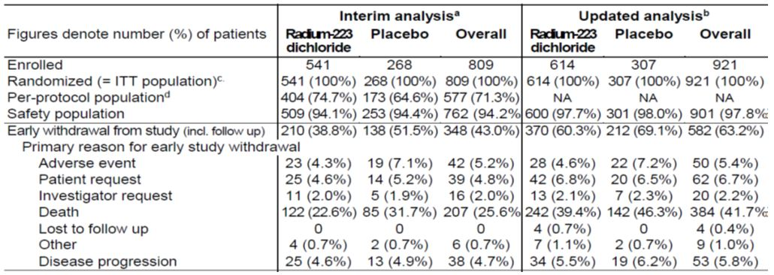
Of the 921 patients, 47% were aged between 65 and 75 years and 94% were Caucasian. Demographic and baseline disease characteristics (interim analysis population) were generally comparable between the treatment and the placebo groups. For baseline median PSA, there was a somewhat higher value in the placebo group patients versus the ²²³RaCl₂ group. Approximately half of the subjects in each treatment group had a Combined Gleason Score of 8 or more (47.2%, 223/472 ²²³Ra and 56.2%, 132/235 placebo) at the time of prostate cancer diagnosis.

Analysis of primary efficacy endpoint: Overall Survival (OS)
The primary (interim) analysis show that treatment with ²²³Ra has a statistically significant and positive effect on OS (HR = 0.695, 95% CI 0.552 – 0.875; 2-sided p = 0.00185). Median OS was prolonged to 14.0 months (425.0 days) with radium-223 treatment compared to 11.2 months (340.0 days) with placebo. The results were similar in the updated analysis (cut off at July 2011) (Table 9).
Table 9: Study BCI-06: OS - Interim and updated analysis (months), ITT population.
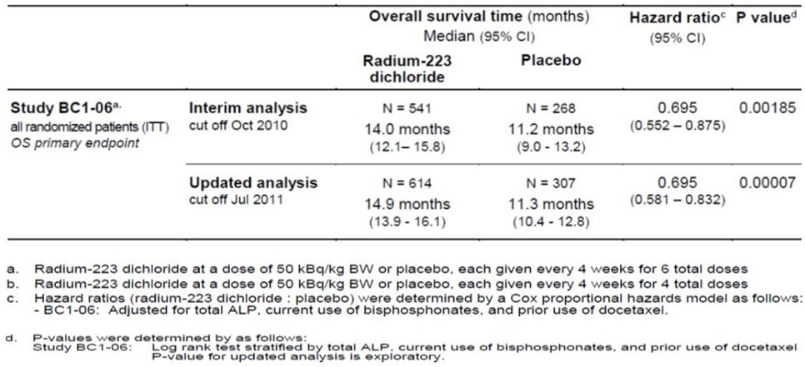
Covariate analyses of OS were carried out as a sensitivity analysis. The following baseline variables were assessed for their prognostic effect on overall survival: albumin, haemoglobin, lactate dehydrogenase (LDH), Eastern Cooperative Oncology Group Performance Status (ECOG PS), PSA, total ALP, and age. Subgroup survival analysis showed a consistent survival benefit for treatment with Xofigo, independent of total ALP, current use of bisphosphonates and prior use of docetaxel.

Analysis of the main secondary efficacy endpoints
Five endpoints were identified as main secondary endpoints: (1) time to total ALP progression, (2) total ALP response at Week 12, (3) time to occurrence of first SRE, (4) total ALP normalisation and (5) time to PSA progression.

Time to total ALP progression
For the interim analysis, fewer patients treated with ²²³RaCl₂ experienced total-ALP progression compared to patients treated with placebo. ²²³RaCl₂ was superior to placebo in delaying the time to total ALP progression (HR = 0.162; P <0.00001). Similar results were seen at the updated analyses.

Total ALP responses at week 12
In the interim analyses, higher proportions of patients in the ²²³RaCl₂ group achieved either a ≥ 30% (60.1% subjects) or ≥ 50% (32.3% subjects) reduction in total ALP levels at Week 12 compared to those in the placebo group (6.3% and 1.3%, respectively). Moreover, the confirmed total ALP responses with both ≥ 30% or ≥ 50% reduction showed statistically significant differences for patients treated with ²²³RaCl₂ versus placebo (P < 0.001). The difference in the percentage change from baseline at Week 12, as well as the maximum percentage decrease from baseline up to Week 12 in total ALP levels also reached statistical significance (P < 0.001). At the updated analysis, treatment with ²²³RaCl₂ continued to demonstrate more favourable total ALP response at Week 12.

Time to occurrence of first SRE
SRE was analysed as a composite endpoint comprising 4 variables: (i) the use of EBRT (external beam radiotherapy) to relieve skeletal symptoms, (ii) the occurrence of new symptomatic pathological bone fractures, (iii) the occurrence of spinal cord compression, and (iv) a tumour related orthopaedic surgical intervention. For the interim analysis, a smaller percentage of patients in the ²²³RaCl₂ group versus the placebo group (24.4% versus 30.6%) experienced a SRE. The median length of time to first SRE was 13.5 months for ²²³RaCl₂ group versus 8.4 months for placebo group. Occurrence of SRE was significantly delayed in patients receiving ²²³RaCl₂ (HR = 0.610, P = 0.00046). At the updated analysis, ²²³RaCl₂ demonstrated a significant and consistent prolongation in time to occurrence of first SRE compared with placebo (15.6 months versus 9.8 months, HR = 0.658) (Tables 10-11).
Table 10: Study BC1-06: SREs.
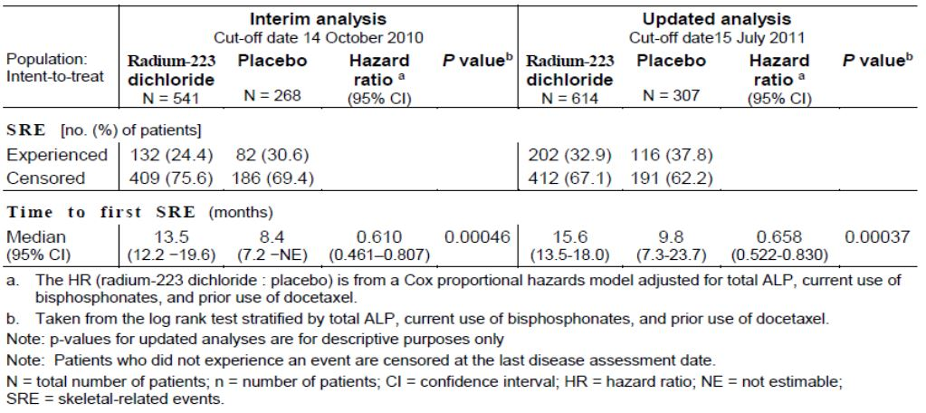
Table 11: Study BC1-06: Disease related events associated with SREs.
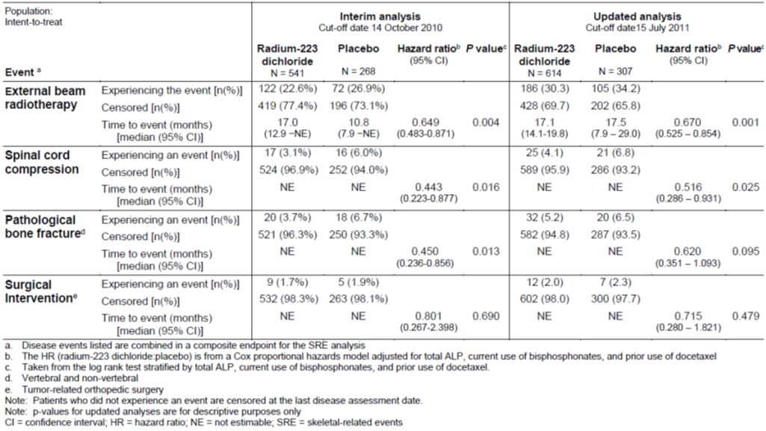
The delay of occurrence of SRE was mainly driven by the statistically significant delay in time to EBRT for pain relief. A greater proportion of patients in the placebo arm were deceased, resulting in fewer EBRT events in the placebo group, thus producing a biased longer median time to EBRT at the time of the updated analysis. A delay was also observed in patients receiving ²²³RaCl₂ compared to patients receiving placebo in time to spinal cord compression, time to surgical intervention, and time to bone fracture.

Total ALP normalisation at week 12
At the interim analysis, total ALP normalisation was reached in 32.9% of patients with an elevated ALP at baseline in the ²²³RaCl₂ group versus only 0.9% of patients receiving placebo (P < 0.001). At the updated analysis, treatment with ²²³RaCl₂ continued to demonstrate favourable total ALP normalisation at Week 12 compared with placebo treatment.

Time to PSA progression
At interim analysis, similar proportion of subjects in both groups experienced PSA progression (53.2% in the active treatment group versus 52.6% in the placebo group). Time to PSA progression was slightly longer in the ²²³RaCl₂ group compared to the placebo group (median 3.6 months versus 3.4 months, HR = 0.671; P = 0.00015). The results at the updated analysis were very similar to the interim analysis. While this endpoint (time to PSA progression) met the statistical significance, the magnitude of the effect was small.

Other endpoints: quality of life
The patient’s health related quality of life (HRQoL) was assessed through the use of two HRQoL instruments: the EuroQoL 5D (EQ-5D), which provides a generic assessment of health status, and the Functional Assessment of Cancer Therapy for Patients with Prostate Cancer (FACT-P Version 4), which is designed to assess the HRQoL of patients with prostate cancer. All quality of life data were analysed using the ITT population. The results of the primary QoL analysis showed that patients treated with ²²³Ra had better HRQoL than patients with placebo. The mean decrease from baseline in the FACT-P total, EQ-5D utility index, the EQ-VAS self reported health status scores were all significantly less for ²²³Ra treated patients than for placebo treated patients. When assessing patients over the whole trial period, similar results were seen. This indicates that there was a trend toward some improvement in quality of life with ²²³Ra treatment.

Supportive phase II studies
Study BCI-02 was a randomised, double blind, placebo controlled study conducted in prostate cancer patients with painful bone metastases. Eligible patients had confirmed adenocarcinoma of the prostate with multiple bone metastases. The treatment period was 12 weeks, during which 4 injections of ²²³Ra (50 kBq/kg body weight) were given at 4 week intervals, follow up until 24 months. All subjects received a single treatment of EBRT followed within 7 days by the first injection of study medication. The primary objective was to evaluate the effectiveness of ²²³Ra. The primary endpoints were time to occurrence of SRE and the relative change (%) in bone ALP levels from baseline to 4 weeks after last injection. A total of 64 patients enrolled with 33 receiving ²²³Ra and 31 receiving placebo. 31 patients completed 2 months and 13 completed 24 months. The ITT population included 64 patients while PP population included 58 patients. The statistical analysis was exploratory. Most analysis was done on the PP population rather than the ITT.

Time to first SRE
In the PP population, the median time to first SRE was 16.0 weeks in the ²²³Ra group and 11.0 weeks in the placebo group. The difference was not statistically significant (p = 0.2144).

Change in bone ALP
The median values for bone ALP generally fell initially in the ²²³Ra group and remained stable or increased in the placebo group. The median relative change from baseline to 4 weeks after the last treatment was -66% in the ²²³Ra group and +9% in the placebo group for both the ITT and PP populations (p <0.001). Comparison of the time course of changes in bone ALP shows that the relative change from baseline in the two treatment groups was statistically significantly different in all time points from 2 weeks after the first injection until Month 6.

Overall survival
Median survival at the 24 month analysis was 71 weeks (16.3 months) in the ²²³RaCl₂ group compared to 46 weeks (10.5 months) in the placebo group (PP population; P = 0.0254, log rank). At 24 months, 10 patients (30%) in the ²²³RaCl₂ group were alive compared to 4 patients (13%) in the placebo group. This study showed a survival benefit of ²²³RaCl₂ despite the small sample size (HR = 0.476; p = 0.017).
The study showed that treatment with ²²³Ra was associated with significant effects on a biochemical marker of bone turnover (bone ALP). A beneficial trend in the survival data also supported a treatment effect, although survival data in only 64 patients should be interpreted with caution.
Study BC1-03 was a double blind, dose response study of ²²³Ra to assess whether there is a dose response relationship for ²²³Ra in patients with painful bone metastases secondary to prostate cancer regarding the palliation of bone pain. The study assessed 4 dose levels (5, 25, 50 and 100 kBq/kg body weight) of ²²³Ra in 100 HRPC patients. The primary endpoint was the pain index (based on self assessment of pain on a visual analog scale and analgesic consumption) defined by a combination of the change in diary pain rating and the change in analgesic consumption. The study patients received a single injection of ²²³RaCl₂ (at 5, 25, 50 or 100 kBq/kg body weight) followed by a 16 week Post Treatment Period. At the end of this period the study was unblinded. Follow-up visits were planned 6, 9, 12, 18, and 24 months. A second injection of ²²³RaCl₂ (fixed dose of 50 kBq/kg body weight) could be offered to patients during the Follow-up Period.
The results of the primary efficacy variable (a higher score reflects more pain) in four single dose levels (5, 25, 50 and 100 kBq/kg body weight) established a dose dependent beneficial effect of ²²³RaCl₂ on the pain index. At Week 2, the highest mean scores were in the 5 and 25 kBq/kg body weight dose groups (4.8 and 4.1, respectively) compared with lower mean scores in the 50 and 100 kBq/kg body weight dose groups (both 3.9) (p = 0.035 [Jonckheere-Terpstra test for trends]). At Weeks 4 and 8, the best response was recorded in the 100 kBq/kg body weight dose group. Likewise, the use of analgesics recorded in this study showed a similar beneficial effect of ²²³RaCl₂. In the two lowest dose groups, a higher percentage of patients had increased bone pain medication compared with the two highest dose groups at Weeks 2, 4 and 8.
Study BCI-04 was a double blind, randomised, dose finding, repeat dose study of ²²³Ra for the treatment of patients with HRPC and skeletal metastases. The primary objective was to compare the proportion of patients showing a PSA response (PSA decrease ≥ 50% from baseline, confirmed 3 weeks later) on 3 different repeat dose regimens of ²²³Ra. Eligible patients were randomised with equal probability to receive 25, 50 or 80 kBq/kg body weight, the same dose being given on each dosing occasion (total doses of 75, 150 or 240 kBq/kg). The treatment consisted of 3 injections of ²²³Ra each separated by an interval of 6 weeks. The treatment period was the 12 week after the first injection.
The primary efficacy endpoint was the proportion of patients with a confirmed PSA response. Efficacy was assessed during the treatment and post treatment periods (12 weeks after the last injection). Survival was assessed throughout the study. The study met the primary endpoint as a statistically significant dose response relationship for confirmed 50% PSA response was demonstrated. In the PP set, this occurred in 0 (0 %), 2 (5.6 %) and 5 (12.8 %) of subjects in the 25 kBq/kg, 50 kBq/kg and 80 kBq/kg dose groups, respectively (p = 0.0297). There was a Jonckheere-Terpstra test for dose response; pair wise comparison between 25 kBq/kg and 80 kBq/kg dose groups was borderline significant (p = 0.0548). Results in the ITT set were similar (p = 0.0290). This shows that there is a positive dose response relationship and the highest dose is more effective than the lowest dose.

Clinical safety
The safety is based largely on the analysis of the pivotal clinical study (BCI-06) (Table 12). Safety population of Study BCI-06 included a total of 600 patients who were treated with ²²³Ra. This patient population means the upper limit of the 95% CI of an undetected AE is not higher than 3/904 (0.3%). Almost all subjects reported at least one AE. The overall AE rate was lower in the ²²³Ra group compared to placebo. The most frequent AEs were GI and bone marrow suppression. The AEs with a notably higher frequency in the ²²³Ra group than in the placebo group were diarrhoea (25.2% versus 15.0%), thrombocytopenia, (11.5% versus 5.6%), and neutropenia (5.0% versus 1.0%). Dehydration was also higher in the ²²³Ra group (3.3% versus 1.3%). Diarrhoea, nausea and vomiting were primarily Grade 1 or 2. The bone marrow suppression, thrombocytopenia and leukopenia were mostly Grade 1 or 2 but higher grade events were also observed. Of note, the higher frequencies of thrombocytopenia, neutropenia and lymphopenia did not result in an increased rate of haemorrhages or infections, which indicates that acute toxicity is manageable. Patients with Crohn’s disease or ulcerative colitis were excluded from the pivotal study. This is currently mentioned in a PRECAUTION section of the PI. Due to the local radiation during faecal excretion, the risk for complication in inflammatory bowel diseases (for example, toxic megacolon and sepsis) seems high.
Table 12: TEAEs of Interest in Study BCI-06.
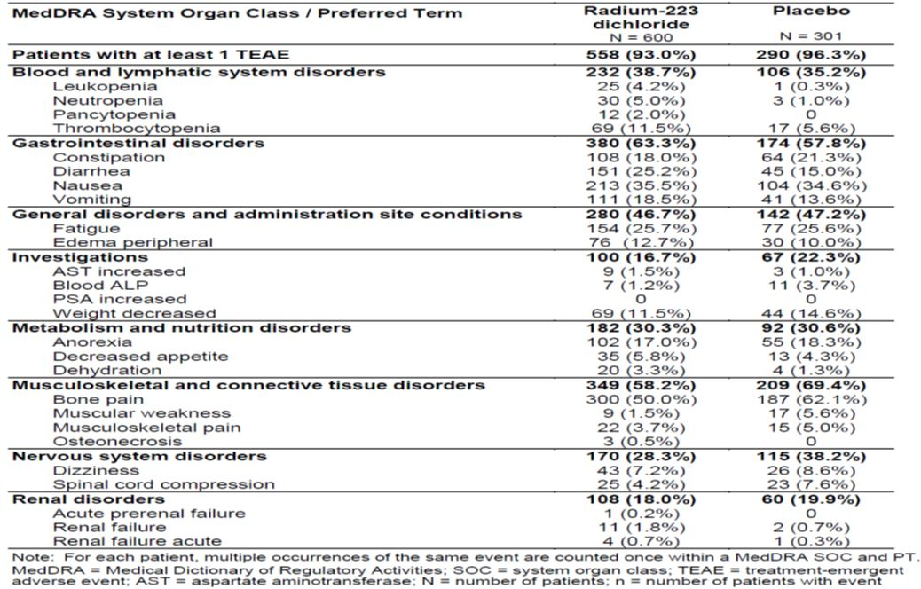
The mortality rate during treatment period was lower in the ²²³Ra group (4.3%, 26/600) compared to placebo group (7.3%, 22/301). Between 24 weeks (end of treatment) to <1 year of initiating treatment, a slightly smaller percentage of patients in the ²²³Ra group (22.2%) died than in the placebo group (25.6%); deaths during the 3 year follow-up period were balanced between the treatment groups. The deaths were due to disease progression in 48.2% of patients in the ²²³Ra group and 49.5% in the placebo group. Most deaths in both groups were considered to be unrelated to study drug.
There were isolated reports of second primary malignancies following treatment with ²²³RaCl₂. However, a reasonable causal relationship to ²²³Ra cannot be established in the cases, mainly due to the short time after injection of the drug. Nevertheless, secondary malignancies including AML, MDS and sarcomas of the bone are a potential risk based on the known carcinogenic effect of radiation. As the latency of radiation induced malignancies is long, the studies were not really long enough to demonstrate these but the impact on the target patient population which has a reduced life expectancy is most likely limited.
Across all studies included in the safety analyses for this submission, the highest proportion of subjects were treated with ²²³RaCl₂ at any dose for >12 to 24 weeks and received a total of 6 injections. Only a small proportion of subjects (21/904) had received ²²³RaCl₂ for more than 24 weeks; no subject was ever administered more than 6 injections. Patients were followed up for up to two years in the Phase II studies, and will be followed up for up to three years in the Phase III study. Therefore, the available database is rather limited to allow clear conclusions regarding the long term safety of ²²³RaCl₂. It should be noted that secondary malignancies may develop at a latency of several years; this should be seen in view of the reduced life expectancy of the patients.
No clinical interaction studies have been conducted. Concomitant chemotherapy with ²²³Ra may have additive effects on bone marrow suppression. Safety and efficacy of concomitant chemotherapy with ²²³RaCl₂ have not been established.

Risk management plan
The submitted RMP has been evaluated by the OPR evaluator and the evaluation report is provided for the Advisory Committee on Prescription Medicines (ACPM) meeting. There are no outstanding RMP issues and the OPR evaluator has no objection to the changes in the EU-RMP and the ASA and recommends to the Delegate that the implementation of the updated version as the condition of registration:
Implement RMP EU-RMP version 1.3, dated 12 August 2013 (data lock point 12 November 2012) with Australian Specific Annex version 1.1, dated November 2013; and any future updates as a condition of registration.
The sponsor has agreed to communicate the findings from post marketing studies, including the ones in additional pharmacovigilance activities of the EU-RMP and required by the US FDA as part of the post marketing commitments, to the TGA at the same time as they are communicated to other regulatory agencies.
It is noted that FDA requested a post marketing study to explore optimal dose, as Study BCI-04 revealed dose dependent improvements in PSA declines and there did not appear to be an increase in toxicity between the 50 and 80 kBq/kg cohorts. This result suggests that the optimal dose of ²²³Ra may be higher than the 50 kBq/kg.

Risk-benefit analysis

Delegate’s considerations
The benefits of ²²³Ra in the proposed usage include prolonged survival as shown in the pivotal study (BCI-06). The patients treated with ²²³Ra had a statistically significant and clinically meaningful (3.6 months) increased survival compared to patients treated with placebo. A survival benefit was also suggested in the supporting study (BCI-02) where an improvement in survival was seen in the per protocol analysis set at Month 24. The pivotal study also showed that ²²³Ra reduced the incidence of SREs and delayed the onset of SREs. Therapy with ²²³Ra also delayed the onset and reduced the incidence of the individual components of SREs, especially spinal cord compression and EBRT. In the pivotal study, pain was reported as an AE for fewer patients in the ²²³Ra group compared to placebo. This was supported by the favourable results for time to EBRT for pain relief and for time to analgesic use. The results for the surrogate markers of bone ALP and PSA were also favourable for ²²³Ra.
The limitation is that there is no head to head comparison between ²²³Ra and other anticancer agents for systemic treatment of prostate cancer (such as cabazitaxel or abiraterone) and there is no study conducted to compare the palliate bone effect of ²²³Ra in comparison to other radionuclides (such as ¹⁵³Sm or ⁸⁹Sr). It is therefore difficult to put the beneficial survival effect of ²²³Ra into perspective among the currently available therapeutic options.
AEs associated with ²²³Ra were observed in almost all patients, most frequent AEs were GI (diarrhoea, nausea and vomiting). There were moderate bone marrow suppression particularly thrombocytopenia, neutropenia and lymphopaenia but not associated with increased rates of haemorrhage and infection. Bone marrow suppression is greater in patients who have received prior docetaxel therapy. Injection site reactions of erythema, pain and swelling were observed in small number of patients. There were isolated reports of second primary malignancies following treatment, however causal relationship is not established due to short time to onset of new malignancy. Risk of secondary malignancies of AML, MDS and sarcoma of bone could not be excluded due to long latency of these tumours and short duration of the trials. Bone radiation with ²²³Ra may increase the general risk for osteonecrosis; in particular in combination with bisphosphonate treatment the risk for osteonecrosis of jaw (ONJ) the risk may increase. In Study BC1-06, the incidence rate of osteonecrosis was higher in the ²²³Ra chloride group, (0.67%), compared to (0.33%) in the placebo group. However, data were considered inconclusive due to the overall limited low event rate and relatively small study population for an event of such frequency.
It should be noted that the enrolled target population in the pivotal study consisted of hormone refractory prostate cancer patients with symptomatic skeletal metastases and with no known visceral metastasis. Based on the evaluation of the submitted data, the delegate agrees with the clinical evaluator that the benefit-risk balance of ²²³Ra is considered favourable for the revised indication below:
Xofigo is indicated for the treatment of castration-resistant prostate cancer (CRPC) patients with symptomatic bone metastases and no known visceral metastatic disease.
Implementation of the RMP EU-RMP version 1.3, dated 12 August 2013 (data lock point 12 November 2012) with ASA version 1.1, dated November 2013; and any future updates should be the condition of registration.

Summary of issues
Single pivotal study (Study BCI-06) was provided to support this application. Study BCI-06 was a double blind, randomised, and placebo controlled study conducted in CRPC without visceral metastases. The study has met the primary endpoint by demonstrating a statistically significant longer (3.6 months longer) OS in subjects treated with ²²³Ra plus standard care compared to the subjects treated with placebo plus standard care. The efficacy was also supported by a number of secondary endpoints relating to bone metastasis sequelae and on bone makers. There is no head to head comparison with other products that are indicated for CRPC patients with bone metastases. It is therefore difficult to put the beneficial survival effect of ²²³Ra into perspective among the currently available therapeutic options.
The main adverse effects are mild to moderate GI toxicity and bone marrow suppression. There is also a concern of long term risk for secondary malignancies; however, taking into account the life expectancy of the target population of advanced prostate cancer, this is not considered as a major concern.

Proposed action
The Delegate has no reason to say, at this time, that the application should not be approved for the following revised indication:
Xofigo is indicated for the treatment of castration-resistant prostate cancer (CRPC) patients with symptomatic bone metastases and no known visceral metastatic disease.

Request for ACPM advice
The ACPM is requested to provide advice and comments on the following issues:
- Does the committee consider the revised indication is acceptable given the population studied in Study BCI-06?
- What is the opinion of the committee regarding the risk/benefit balance of Xofigo for the revised indication?
- Does the committee consider that the data from the single pivotal study is sufficient to support the revised indication?
- Does the committee have any concern regarding the lack of comparative study?
The committee is also requested to provide advice on any other issues that it thinks may be relevant to a decision on whether or not to approve this application.

Response from sponsor
The sponsor’s comments on the issues for which the advice of the ACPM was sought, as outlined in the Delegate’s Overview, are presented below.
The initial proposed indication at the time of submission was:
Xofigo is indicated for the treatment of castration-resistant prostate cancer patients with bone metastases.
On the basis of the recommendation following clinical evaluation, the sponsor agrees to revise the proposed indication wording to more accurately reflect the population in the pivotal trial.
The sponsor concurs with the Delegate’s pre ACPM preliminary assessment that the application should be approved for the following revised indication:
Xofigo is indicated for the treatment of castration-resistant prostate cancer patients with symptomatic bone metastases and no known visceral metastatic disease.
The proposed dose regimen of Xofigo is:
50 kBq per kg body weight, given at 4 week intervals for 6 injections. Safety and efficacy beyond 6 injections have not been studied.

Overview of clinical evidence to support registration of Xofigo
Prostate cancer is the most common non cutaneous malignancy in men worldwide. The clinical evidence to support the registration of Xofigo for the treatment of CRPC patients with symptomatic bone metastases and no known visceral metastatic disease is based on the single pivotal Phase III study (BC1-06). The primary efficacy outcome was OS. The overall efficacy results from the pivotal Study BC1-06 demonstrated a statistically significant and clinically meaningful benefit in prolonging OS in CRPC patients with symptomatic bone metastases treated with Xofigo plus BSoC compared to placebo plus BSoC. The study was terminated early as recommended by an independent data monitoring committee during a pre specified interim analysis in view of the statistically significant prolongation of OS with respect to the primary endpoint and its support from the secondary study endpoints.
At the interim (primary) analysis, the median OS was 14.0 months in the Xofigo treated group and 11.2 months in the placebo group. The observed increased in median OS of 2.8 months was both statistically significant and clinically meaningful, corresponding to a 30% reduction in the risk of death in patients treated with Xofigo as compared with placebo (HR = 0.695; 95% CI = 0.552 - 0.875; 2-sided p = 0.00185). Consistent results were observed in the updated analysis performed with a later cut off. In the updated analysis, the difference in median OS benefit increased to 3.6 months (14.9 months in the Xofigo group compared to 11.3 months in the placebo group; HR = 0.695, 95% CI = 0.581-0.832). The treatment effect on OS was robust after adjustment for stratification factors and was consistently favourable across all subgroups. The beneficial effect on survival was supported by the secondary endpoints. Results from the secondary endpoints showed a positive effect of Xofigo treatment in reducing and delaying the onset of clinical bone metastases sequelae (symptomatic skeletal events [SSE]) and confirms the target efficacy of Xofigo on bone metastases, also evident by the favourable effects on bone markers and on pain relief. The overall incidence of adverse events reported in the study was consistently lower in the Xofigo group than in the placebo group. The most commonly reported AEs were primarily mild-to-moderate GI (diarrhoea, nausea and vomiting) and thrombocytopaenia. The drug-related AEs reported were overall manageable during the study.
Based on the clinical data submitted, the sponsor concurs with the Delegate that the benefit-risk balance of Xofigo is considered favourable for the proposed use.

Acceptability of the revised indication wording
In Study BC1-06, the target population was CRPC patients with symptomatic bone metastases. Patients with history of or the presence of visceral metastases were excluded. Thus, the proposed revised indication wording:
Xofigo is indicated for the treatment of castration-resistant prostate cancer patients with symptomatic bone metastases and no known visceral metastatic disease
is considered appropriate and is consistent with the patient population assessed in Study BC1-06.

Acceptability of the proposed dose regimen
The proposed dosing regimen for Xofigo (fixed dose injections of 50 kBq/kg body weight given at 4 weekly intervals for a total of 6 injections) as assessed in the pivotal study (BC1-06) is based on the results of the supportive BC1-02 and BC1-04 studies.
In Study BC1-04, a dose of 50 kBq/kg body weight given three times every six weeks was statistically significantly superior to 25 kBq/kg body weight given in the same regimen with respect to the surrogate markers ALP and PSA. However, no incremental efficacy was observed at the higher dose of 3 x 80 kBq/kg every 6 weeks for the same markers. Throughout the dose range tested during the initial Phase I study (ATI-BC1), that is, single doses up to 250 kBq/kg body weight, no dose limiting toxicities were recorded and there was no gradient of risk across the doses up to 100 kBq/kg body weight in the Phase II studies. Given the lack of dose limiting toxicities at single doses up to 250 kBq/kg body weight, this was investigated as an approximate total dose in a fractionated regimen by adopting the minimum effective dose of 50 kBq/kg body weight (50 x 6 fractions). The choice of 6 injections was also based on data from the Phase I and II studies. The Phase II Study BC1-02 was conducted with 4 injections, and the data suggested a relationship between benefit and duration of treatment, so an increase to 6 injections from four was deemed reasonable.
In the randomised Phase II Study BC1-02, the 50 kBq/kg body weight dose given every four weeks showed activity in the bone based on the primary endpoint of changes to bone ALP and on time to skeletal related events. This dose also showed a positive effect on the secondary endpoint of OS, and therefore supported the choice of OS as the primary endpoint for the Phase III study. The decision on the dose selection was based on the concept that given the two radiation doses have the same activity on bone markers of turnover, and similar safety profiles, the lower dose provides the lowest radiation risk and therefore should be chosen. Six doses of 50 kBq/kg body weight every four weeks was tested in Study BC1-06 and the results from Study BC1-06 demonstrated an OS advantage in CRPC patients with bone metastases as well as a highly tolerable safety profile, and supports the tested dosage regimen as the proposed dosage regimen for registration.
In summary, the dosing regimen was selected based on the Phase I and II data. The results from the Phase III Study BC1-06 clearly show that the dosing regimen chosen provided a significant clinical benefit in terms of the primary endpoint of OS and all of the secondary endpoints, and showed a very tolerable safety profile. Taken together, the current dosing regimen was deemed safe and effective. Nevertheless, the sponsor is currently exploring the possibility that higher doses and/or additional doses may be of further benefit.

Limitations/issues identified in the delegate’s evaluation

No head-to-head comparison with other products that are indicated for CRPC patients with bone metastases
At the time of initiation and conduct of Study BC1-06 (accrual between June 2008 and February 2011), docetaxel was the only treatment available for the treatment of CRPC patients with bone metastases with a confirmed survival benefit. Further treatment options available at that time included other chemotherapeutic agents (such as mitoxantrone or cyclophosphamide), hormonal treatments (such as ketoconazole or corticosteroids), or local EBRT. While these therapies have been shown to induce some responses or palliation, none of these agents have demonstrated a survival benefit in clinical trials. In particular, there was no approved treatment available with a survival benefit in patients who had progressed on or after docetaxel, or in patients who were unfit for or had refused docetaxel.
BSoC for metastatic CRPC patients in 2008 who were ineligible or not willing to receive docetaxel and patients who had relapsed after docetaxel consisted of symptomatic palliative treatment such as mitoxantrone or EBRT, corticosteroids, antiandrogens, estrogens, estramustine, ketoconazole or radionuclide therapy (other than Xofigo).
In Study BC1-06, all patients were to receive BSoC. This allowed patients in the study to be treated with standard therapies chosen by the physician that were regarded as the routine standard of care at each centre, for example EBRT, corticosteroids, antiandrogens, estrogens (for example, stilboestrol), estramustine or ketoconazole. Study BC1-06 enrolled only patients for which docetaxel treatment was not an option. Thus, a patient randomised to placebo had also full access to all treatment options available at that time. Therefore, the comparison of Xofigo (plus BSoC) against placebo (plus BSoC) was appropriate in these patients. Upon scientific advice received in October 2007, the Committee for Medicinal Products for Human Use (CHMP) agreed to include a placebo control.
Bone seeking radionuclides have been developed for palliation of bone pain from metastases: Metastron (⁸⁹Sr) and Quadramet (¹⁵³Sm) have been approved in several countries but are limited to bone pain control. The bone seeking nature of these agents results in direct delivery of beta radiation to the sites of disease (metastases). Due to the long range of the beta particles originating from these radioisotopes, the major dose limiting factor with these treatments is toxicity to the bone marrow cells. This toxicity has limited the repeated use of Quadramet and Metastron in clinical practice beyond single applications and therefore prevented their use beyond pain palliation in the clinical setting. The significant toxicities of these two drugs would have made repeated dosing impossible for a head-to-head comparison with Xofigo. Therefore, Quadramet and Metastron were not considered an adequate comparator. Neither of these radionuclides has been shown to improve survival of CRPC patients with bone metastases. In contrast to these agents, at the time the BC1-06 pivotal trial was designed, there was suggestive evidence from Study BC1-02 that Xofigo could improve survival in patients with bone metastases and CRPC.
Furthermore, the recently FDA approved products in CRPC became available only after the BC1-06 study had started accrual in June 2008. The currently available products for CRPC and their respective approval dates by the FDA are as follows: cabazitaxel in June 2010, abiraterone in April 2011, and enzalutamide in August 2012. All of these agents are indicated for the second line treatment of CRPC patients, that is, after docetaxel progression. Based on the OS superiority of Xofigo demonstrated in BC1-06, the proposed usage for Xofigo is for the treatment in CRPC patients with symptomatic bone metastases and no known visceral metastatic disease (that is, not restricted to second line treatment), and such proposed usage has already been approved by the FDA, EMA and Health Canada. Thus, the sponsor is of the opinion that any direct or indirect head-to-head comparison of Xofigo with other second line treatment agent (such as cabazitaxel or abiraterone) would be deemed unjustified.
In conclusion, the conduct of BC1-06 comparing Xofigo (plus BSoC) against placebo (plus BSoC) is considered appropriate since at the time of study start and conduct there were no products approved other than docetaxel for the treatment of CRPC patients with bone metastases. Notwithstanding the lack of head-to-head comparison with other products that are now indicated for CRPC patients with bone metastases, the results demonstrated in Study BC1-06 can be regarded as highly generalisable to clinical practice of metastatic CRPC.

Long-term risk for secondary malignancies
The sponsor acknowledges that in the Study BC1-06, isolated incidences of second primary malignancies were reported following treatment. However, causal relationship could not be established due to short time of onset of new malignancy, and the long-term risk for secondary malignancies could not be excluded. But as acknowledged by the Delegate:
taking into account the life expectancy of the target population of advanced prostate cancer, this is not considered as major concern.
Based on the recommendation from the nonclinical Evaluation, a statement advising osteosarcomas as a known effect of bone seeking radionuclides has been included in the Australian PI (under PRECAUTIONS, Carcinogenicity). Furthermore, the potential risk for secondary malignant neoplasms is adequately reflected in the Australian PI (under ADVERSE EFFECTS) as well as included in the RMP (as an important potential risk). Routine and enhanced pharmacovigilance activities as well as active surveillance are being conducted. Patients from Study BC1-06 will be followed up to 36 months from date of first injection, and all occurrences of secondary malignancies would be collated regardless of the investigator’s causality assignment. So far no cases of AML, MDS, or bone sarcoma have been reported in patients treated for 3 years. For additional safety surveillance, a long term safety study (16913, as described in the RMP) is planned to assess the incidence of second primary malignancies among patients treated with Xofigo. Patients enrolled in this study will be followed for an observation period of up to 7 years from the start of therapy.

Increase risk for osteonecrosis
In the Delegate’s request for ACPM’s advice, the Delegate has raised the concern that:
Bone radiation with ²²³Ra may increase the general risk for osteonecrosis, in particular in combination with bisphosphonate treatment the risk for osteonecrosis of jaw (ONJ) may increase.
However, the sponsor is of the opinion that the observed frequency of osteonecrosis jaw in the Xofigo treated patients does not indicate an increased risk compared to the known frequency of patients treated with zoledronate alone. As already acknowledged in the clinical evaluation, it is well known that zoledronic acid treatment and the newer therapies that inhibit bone resorption such as denosumab are associated with ONJ. In a Phase III clinical trial in a HRPC population with bone metastases, ONJ occurred in 1% of patients treated with zoledronic acid.
In Study BC1-06, the incidence rate of osteonecrosis was 0.67% (4/600 patients) in the Xofigo group compared to 0.33% (1/301 patients) in the placebo group. All of the four cases (reported preferred terms: 'osteonecrosis jaw', 'mandibular necrosis', 'osteonecrosis', 'osteolysis’) reported in the Xofigo group occurred in patients exposed to Zometa (zoledronic acid/zoledronate) and prior chemotherapy. The one case in the placebo group was reported as abscess jaw/osteonecrosis jaw and was reported as a treatment emergent SAE (grade 3). This patient also had exposure to Zometa (zoledronic acid/zoledronate) and prior chemotherapy. The time to onset for the four cases in the Xofigo group was 2 to 3 months after first injection of Xofigo. All of these events were non serious. The cases were confounded by prior chemotherapy, dental conditions such as gum infection or pre-planned tooth extraction and most importantly by prior or concomitant zoledronate treatment. Bisphosphonates have a long half-life in the bone and there are case reports of ONJ occurring one year or longer after stopping of zoledronate. In Study BC1-06, there was no case of osteonecrosis of the jaw without zoledronate exposure. No cases of ONJ were reported from the Phase I and II studies with Xofigo. Thus, the data does not indicate an increased risk compared to the known frequency of patients treated with zoledronate alone.
In summary, the observed frequency of osteonecrosis jaw in the Xofigo treated patients is low and could be attributable to the patients having prior exposure or concomitant zoledronic acid and prior chemotherapy. While ‘osteonecrosis of jaw’ has been identified as an important potential safety risk by the EMA and a precautionary statement has been included in the EU-SmPC, the sponsor wishes to point out that ‘osteonecrosis of jaw’ has not been considered as a safety risk by the FDA or Canada and thus is not included in the US-PI and Canadian Product Monograph, respectively. For the labelling in Australia, the sponsor is of the opinion that a precaution or warning statement concerning osteonecrosis of the jaw is not warranted in the Xofigo Australian PI. Information on the risk of ONJ and appropriated treating guidelines are described in the respective bisphosphonates labelling.

Specific questions sought by the delegate for ACPM’s advice

Does the committee consider the revised indication is acceptable given the population studied in study BC1-06?
For reasons indicated above, the sponsor is of the opinion that the revised indication is acceptable as it appropriately reflects the population studied in Study BC1-06.

Does the committee consider that the data from the single pivotal study is sufficient to support the revised indication?
The approach to include BC1-06 as the single pivotal Phase III study in the clinical development program had been thoroughly discussed with the FDA and the EMA, and is in line with the regulatory guidelines. The outcomes of Study BC1-06 meet the requirements for a clinical trial to support an application as a single pivotal study as judged by the following criteria.
Study BC1-06 was a large, multicentre study (n = 921 randomised patients) and the results from this study successfully demonstrated consistent survival and clinical benefit across a broad range of pre specified and post hoc subgroups based on baseline characteristics. The primary efficacy endpoint (OS) is considered a robust and well accepted measure of clinical benefit. In addition to demonstrating a statistically significant and clinically meaningful benefit in prolonging OS, multiple secondary efficacy endpoints were assessed to provide supporting evidence of treatment benefit. The benefits observed in BC1-06 are supported by the results observed in the supportive studies (BC1-02, BC1-03 and BC1-04).
Thus, given the statistically significant and clinically meaningful results, the sponsor is of the opinion that BC1-06 provides sufficient clinical evidence to serve as the single pivotal study to support the registration for Xofigo.

Does the committee have any concern regarding the lack of comparative study?
Based on the arguments provided herewith, the sponsor is of the opinion that notwithstanding the absence of an active comparator, the results from the Phase III Study BC1-06 are considered clinically meaningful to adequately demonstrate the efficacy and safety of Xofigo to support the use in the targeted population.

Conclusion
The robust results from the pivotal Phase III Study BC1-06 demonstrate a clear benefit of Xofigo in prolonging OS in patients suffering from CRPC and bone metastases. The magnitude of the survival benefit is regarded as statistically significant and clinically meaningful in this target patient population of advanced prostate cancer. The observed improvement in OS is supported by the positive results from all secondary endpoints on clinical bone metastasis sequelae and surrogate biomarkers, as well as the positive effects on palliation of bone pain. Taking into consideration the favourable acute toxicity profile observed with Xofigo, the overall benefits clearly overweigh the risks in patients with CRPC with symptomatic bone metastases. The sponsor concludes that the benefit-risk balance for Xofigo is favourable and supports the registration of Xofigo for the revised indication.

Advisory committee considerations
The ACPM, taking into account the submitted evidence of efficacy, safety and quality, agreed with the Delegate and considered Xofigo solution for injection containing 1000 kBq/mL of radium (²²³Ra) dichloride to have an overall positive benefit-risk profile for the amended indication:
Treatment of CRPC patients with symptomatic bone metastases and no known visceral metastases

Proposed conditions of registration
The ACPM agreed with the Delegate on the proposed conditions of registration.

Proposed Product Information (PI)/Consumer Medicine Information (CMI) amendments
The ACPM agreed with the Delegate to the proposed amendments to the Product Information (PI) and Consumer Medicine Information (CMI).

Specific advice
The ACPM advised the following in response to the specific Delegate’s questions on this submission.
- Does the committee consider the revised indication is acceptable given the population studied in Study BCI-06?
The ACPM advised that the revised indication is acceptable given the study population in BCI-06.
- What is the opinion of the committee regarding the risk-benefit balance of Xofigo for the revised indication?
The benefit-risk balance of Xofigo for the revised indication is acceptable based on a single pivotal study of extremely high quality. The single study submitted showed improved survival but equally as important is improved symptom control and quality of life (QoL). This is often a frail elderly population where improving and maintaining QoL is the main goal. Treatment appears to be well tolerated overall.
- Does the committee consider that the data from the single pivotal study is sufficient to support the revised indication?
Survival is the most important outcome of cancer therapy. The evidence shows that ²²³Ra improves survival in CRPC, second line after docetaxel. Currently available radiopharmaceuticals do not.
- Does the committee have any concern regarding the lack of comparative study?
A head-to-head study would be informative but is not considered essential.
The ACPM advised that the implementation by the sponsor of the recommendations outlined above to the satisfaction of the TGA, in addition to the evidence of efficacy and safety provided would support the safe and effective use of this product.

Outcome
Based on a review of quality, safety and efficacy, TGA approved the registration of Xofigo solution containing radium (²²³Ra) dichloride 6.0 MBq per 6 mL solution for injection vial indicated for:
Xofigo is indicated for the treatment of castration-resistant prostate cancer patients with symptomatic bone metastases and no known visceral metastatic disease

Specific conditions of registration applying to these goods
- The Xofigo (radium dichloride [²²³RaCl₂]) EU-RMP version 1.0 dated 12 November 2012 (data lock point 12 November 2012) + Australian Specific Annex version 1 dated 12 April 2013; EU-RMP version 1.3 dated 12 August 2013 (data lock point 12 November 2012) + Australian Specific Annex version 1.1 dated November 2013, included with the submission, and any subsequent revisions, as agreed with the TGA will be implemented in Australia.

Attachment 1. Product Information
The Product Information approved for Xofigo at the time this AusPAR was published is at Attachment 1. For the most recent Product Information please refer to the TGA website at <http://www.tga.gov.au/hp/information-medicines-pi.htm>.

Attachment 2. Extract from the Clinical Evaluation Report

Therapeutic Goods Administration
PO Box 100 Woden ACT 2606 Australia
Email: info@tga.gov.au Phone: 1800 020 653 Fax: 02 6232 8605
http://www.tga.gov.au

The start of shelf-life is the ‘compounding date’, which is the time of dilution of the drug substance solution to form the finished product solution.
The reference date is defined as “day 14 after drug product compounding date at 12h Central European Time (CET)”.
The decay correction (DK) factor is the proportion of radioactivity present compared to the amount present at the ‘reference date’. A table of DK factors is provided with each vial and in the PI.
Stabin MG, et al. (2005) OLINDA/EXM: the second-generation personal computer software for internal dose assessment in nuclear medicine. J Nucl Med. 46: 1023-1027.
Henriksen G, et al. (2002) Significant antitumor effect of bone-seeking, α-particle-emitting 223Ra demonstrated in an experimental skeletal metastases model. Cancer Res. 62: 3120-3125; Bruland ØS, et al. (2006) High-linear energy transfer irradiation targeted to skeletal metastases by the alpha-emitter 223Ra: adjuvant or alternative to conventional modalities? Clin Cancer Res. 12(20 Pt 2): 6250s-6257s.
Lloyd RD, et al. (1997) Comparison of internal emitter radiobiology in animals and humans. Health Phys. 72: 100-110.
Ritter MA, et al. (1977) High-LET radiations induce a large proportion of non-rejoining DNA breaks. Nature 266: 653-655; Kassis AI, Adelstein SJ. (2005) Radiobiologic principles in radionuclide therapy. J Nucl Med. 46: 4S-12S; Sgouros G. (2008) Alpha-particles for targeted therapy. Adv Drug Deliv Rev. 60: 1402-1406.
Larsen RH, et al. (1999) ²¹¹At- and ¹³¹I-labeled bisphosphonates with high in vivo stability and bone accumulation. J Nucl Med. 40: 1197-1203; Kassis AI, Adelstein SJ. (2005) Radiobiologic principles in radionuclide therapy. J Nucl Med. 46: 4S-12S.
Kataoka Y, et al. (2006) Flow cytometric analysis of phosphorylated histone H2AX following exposure to ionizing radiation in human microvascular endothelial cells. J Radiat Res. 47: 245-257.
Experiment performed in absence of incubator room; suspected impact on outcome minimal, yet undetermined.
Henriksen G, et al. (2002) Significant antitumor effect of bone-seeking, α-particle–emitting 223Ra demonstrated in an experimental skeletal metastases model. Cancer Res. 62: 3120-3125.
Assumes 70 kg individual, 50 kBq/kg maximal single dose.
Corrected for weight of the samples and for the radioactive decay to sampling time.
Taylor GN, et al (2000). Radium induced melanomas in dogs. Health Phys. 79: 196-198.
Assumes 70 kg individual, 50 kBq/kg maximal single dose.
Assumes 70 kg individual, 50 kBq/kg maximal single dose.
Assumes 70 kg individual, 50 kBq/kg maximal single dose.
Muggenburg BA, et al. (1996) The biological effects of radium-224 injected into dogs. Radiat Res. 146:171-186; Bijwaard H, et al. (2004) Two-mutation models for bone cancer due to radium, strontium and plutonium. Radiat Res. 162: 171-184.
Pregnancy Category X: Drugs which have such a high risk of causing permanent damage to the foetus that they should not be used in pregnancy or when there is a possibility of pregnancy.
Assumes 70 kg individual, 50 kBq/kg maximal single dose.
Assumes 70 kg individual, 50 kBq/kg maximal single dose.
European Medicines Agency, “Guideline on the evaluation of anticancer medicinal products in man (EMA/CHMP/205/95)”, 13 December 2012.
European Medicines Agency, “Guideline on the evaluation of anticancer medicinal products in man (EMA/CHMP/205/95)”, 13 December 2012.
New terminology proposed to replace the former terminology “skeletal related event (SRE)”.
Fizazi K, et al. (2011) Denosumab versus zoledronic acid for treatment of bone metastases in men with CRPC: a randomised, double-blind study. Lancet 377: 813-822.
Fizazi K, et al. (2011) Denosumab versus zoledronic acid for treatment of bone metastases in men with CRPC: a randomised, double-blind study. Lancet 377: 813-822.
Kimmel DB. (2007) Mechanism of action, pharmacokinetic and pharmacodynamics profile. And clinical applications of nitrogencontaining bisphosphonates. J Dent Res. 86: 1022-1033.
Borrás-Blasco J, et al. (2007) Possible delayed onset of osteonecrosis of the jaw in association with zoledronic acid. J Clin Pharm Ther. 32: 651-654; Del Conte A, et al. (2010) Bisphosphonate-induced osteonecrosis of the jaw 32 months after interruption of zoledronate in a patient with multiple myeloma. J Oral Maxillofac Surg. 68: 1179-1182.
European Medicines Agency, “Committee for Proprietary Medicinal Products (CPMP): Points to Consider on Application with 1. Meta-Analyses; 2. One Pivotal Study (CPMP/EWP/2330/99)”, 31 May 2001; US Food and Drug Administration, “Guidance for Industry: Providing Clinical Evidence of Effectiveness for Human Drug and Biological Products”, May 1998.

