First Round CER report: 2 July 2014
Second Round CER report: 26 November 2014

AusPAR Attachment 1

Extract from the Clinical Evaluation Report for purified antigen fractions of inactivated split virion A/Indonesia/05/2005 (H5N1), AS03 adjuvanted
  - Proprietary Product Name: Prepandrix
  - Sponsor: GlaxoSmithKline Australia Pty Ltd

About the Therapeutic Goods Administration (TGA)
- The Therapeutic Goods Administration (TGA) is part of the Australian Government Department of Health, and is responsible for regulating medicines and medical devices.
- The TGA administers the Therapeutic Goods Act 1989 (the Act), applying a risk management approach designed to ensure therapeutic goods supplied in Australia meet acceptable standards of quality, safety and efficacy (performance), when necessary.
- The work of the TGA is based on applying scientific and clinical expertise to decision-making, to ensure that the benefits to consumers outweigh any risks associated with the use of medicines and medical devices.
- The TGA relies on the public, healthcare professionals and industry to report problems with medicines or medical devices. TGA investigates reports received by it to determine any necessary regulatory action.
- To report a problem with a medicine or medical device, please see the information on the TGA website <https://www.tga.gov.au>.
About the Extract from the Clinical Evaluation Report
- This document provides a more detailed evaluation of the clinical findings, extracted from the Clinical Evaluation Report (CER) prepared by the TGA. This extract does not include sections from the CER regarding product documentation or post market activities.
- The words [Information redacted], where they appear in this document, indicate that confidential information has been deleted.
- For the most recent Product Information (PI), please refer to the TGA website <https://www.tga.gov.au/product-information-pi>.
Copyright
© Commonwealth of Australia 2015
This work is copyright. You may reproduce the whole or part of this work in unaltered form for your own personal use or, if you are part of an organisation, for internal use within your organisation, but only if you or your organisation do not use the reproduction for any commercial purpose and retain this copyright notice and all disclaimer notices as part of that reproduction. Apart from rights to use as permitted by the Copyright Act 1968 or allowed by this copyright notice, all other rights are reserved and you are not allowed to reproduce the whole or any part of this work in any way (electronic or otherwise) without first being given specific written permission from the Commonwealth to do so. Requests and inquiries concerning reproduction and rights are to be sent to the TGA Copyright Officer, Therapeutic Goods Administration, PO Box 100, Woden ACT 2606 or emailed to <tga.copyright@tga.gov.au>.

Contents
List of abbreviations 5
1. Background 8
1.1. Submission type 8
1.2. Drug class and therapeutic indication 8
1.3. Dosage forms and strengths 8
1.4. Dosage and administration 8
2. Clinical rationale 9
3. Contents of the clinical dossier 9
3.1. Scope of the clinical dossier 9
3.2. Paediatric data 10
3.3. Good clinical practice 10
4. Pharmacokinetics 10
5. Pharmacodynamics 10
5.1. The methods used to evaluate immunogenicity 10
5.2. Criteria for judging immunity 11
6. Dosage selection for the pivotal studies 12
7. Clinical efficacy 16
7.1. H5N1 Influenza prophylaxis 17
8. Clinical safety 49
8.1. Studies providing evaluable safety data 49
8.2. Pivotal studies that assessed safety as a primary outcome 50
8.3. Patient exposure 51
8.4. Adverse events 51
8.5. Laboratory tests and vital signs 56
8.6. Concomitant medication use 57
8.7. Integrated summaries of safety 57
8.8. Post-marketing experience 62
8.9. Specific populations 64
8.10. Safety issues with the potential for major regulatory impact 64
8.11. Evaluator’s overall conclusions on clinical safety 64
9. First round benefit-risk assessment 66
9.1. First round assessment of benefits 66
9.2. First round assessment of risks 66
9.3. First round assessment of benefit-risk balance 67
10. First round recommendation regarding authorisation 69
11. Clinical questions 69
11.1. Pharmacokinetics 69
11.2. Pharmacodynamics 69
11.3. Efficacy 69
11.4. Safety 69
12. Second round evaluation 70
12.1. Efficacy 70
12.2. Safety 71
13. Second round benefit-risk assessment 73
13.1. Second round assessment of benefits 73
13.2. Second round assessment of risks 73
13.3. Second round assessment of benefit-risk balance 73
14. Second round recommendation regarding authorisation 73
15. References 74

List of abbreviations
Abbreviation | Meaning
AE | Adverse event
AESI | Adverse event of special interest
AESI | Adverse event of specific interest
AS03 | Oil-in-water emulsion based adjuvant system with tocopherol
AS03_{A} | Antigen sparing adjuvant, oil-in-water emulsion based adjuvant system with 11.86 mg tocopherol (full adult dose AS03)
AS03_{B} | Antigen sparing adjuvant, oil-in-water emulsion based adjuvant system with 5.93 mg tocopherol (half adult dose AS03)
ATP | According to protocol
CBER | Center for Biologics Evaluation and Research
CHMP | Committee for Human Medicinal Products
CI | Confidence Interval
CMI | Cell-mediated immunity
D-Pan | Dresden-sourced adjuvanted pandemic/pre-pandemic influenza vaccine
eCRF | Electronic Case Report Form
EMA | European Medicines Agency
FDA | Food and Drug Administration
EU | European Union
GACVS | Global Advisory Committee on Vaccine Safety
GCP | Good Clinical Practice
GMFR | Geometric mean fold-rise
GMR | Geometric mean ratio
GMT | Geometric mean titre
GSK | GlaxoSmithKline
HA | Haemagglutinin
HI | Hemagglutination inhibition
ISS | Integrated safety summary
LL | Lower limit
MA | Marketing authorisation
MAE | Medically-attended adverse event
Max. | Maximum
MedDRA | Medical Dictionary for Regulatory Activities
Min. | Minimum
mL | Millilitre
NOCD | New Onset Chronic Disease
PID | Patient Identification Number
pIMD | Potentially Immune-Mediated Disease
PT | Preferred term
Q-Pan | Quebec-sourced adjuvanted pandemic/pre-pandemic influenza vaccine
SAE | Serious adverse event
SCE | Summary of Clinical Efficacy
SCF | Seroconversion factor
SCR | Seroconversion rate
SCS | Summary of Clinical Safety
SMQ | Standardised MedDRA Query
SN | Seroneutralisation or serum neutralization
SNT | Seroneutralisation titre
SPR | Seroprotection rate
TVC | Total vaccinated cohort
UL | Upper limit
VR | Vaccine response
VRR | Vaccine response rate
WHO | World Health Organization
µg | Micrograms

Background

Submission type
This is a Category 1 type A submission to register a new pandemic influenza vaccine, PREPANDEMRIX, a, which contains purified antigen fractions of inactivated split virion A/Indonesia/05/2005 (H5N1) adjuvanted with AS03.

Drug class and therapeutic indication
Prepandemrix is a split virion influenza vaccine against a strain of influenza with pandemic potential. It contains antigen equivalent to A/Indonesia/05/2005 PR8-IBCDC-RG2 (H5N1) 3.75 micrograms (µg) adjuvanted with AS03 per 0.5 ml dose. The GlaxoSmithKline proprietary AS03 adjuvant system is composed of squalene (10.69 milligrams), DL-tocopherol (11.86 milligrams) and polysorbate 80 (4.86 milligrams). The vaccine is presented as an emulsion and suspension which need to be mixed prior to administration.
The proposed indication is:
Prophylaxis of influenza caused by the H5N1 strain with a pandemic potential. Prepandemrix should be used in accordance with official recommendations.

Dosage forms and strengths
Prepandemrix consists of two containers: one multidose vial containing the antigen (suspension) and a second multidose vial containing the adjuvant (emulsion). The suspension is a colourless light opalescent liquid. The emulsion is a whitish to yellowish homogeneous (milky) liquid. The submission proposes registration of multidose vials as follows:
- 2.5 ml suspension in a vial (type I glass) for 10 doses with a stopper (butyl rubber). Pack size of 50.
- 2.5 ml emulsion in a vial (type I glass) for 10 doses with a stopper (butyl rubber). Pack size of 25 x 2.

Dosage and administration
Prepandemrix is intended to be used according to the same dosing as the currently registered Pandemrix H5N1 (AUST R 145924). That is, adults from the age of 18 years will receive two doses of 0.5 mL Prepandemrix, the first administered at an elected date, the second at least three weeks and up to twelve months after the first dose for maximum efficacy. Vaccination should be carried out by intramuscular injection preferably into the deltoid muscle or anterolateral thigh (depending on the muscle mass).
The Dosage and Administration section states that the experience in children is limited (See clinical trials and adverse reactions). There is no information on dosage in children.
Evaluator’s Comment: the issue of whether children are to be included in the indication, given this lack of dosage information, is unclear and has been questioned.
At the time of vaccine administration the content of the adjuvant vial (emulsion) is withdrawn from the vial with a needle and syringe and is injected into the antigen vial (suspension). After the addition of the emulsion to the suspension, the mixture should be well shaken. After mixing, 10 individual vaccine doses of 0.5 mL can be withdrawn from the vial. This methodology is detailed in the proposed PI.

Clinical rationale
There are two types of vaccines prepared for pandemic situations. The first is a pandemic “mock-up” vaccine which in the event of an influenza pandemic would be produced once the pandemic strain has been identified and technical data would be submitted as a variation. This vaccine Pandemrix is currently approved in Australia. The second vaccine, Prepandemrix, is a prepandemic vaccine that is produced prior to the onset of a pandemic. The vaccine contains a strain derived from a currently circulating highly pathogenic avian influenza that has the potential to cause a pandemic. The prepandemic vaccine could be used either before a pandemic is declared or during the early stages of a declared pandemic situation. The usage of these vaccines (e.g. only in a pandemic period, or during pandemic alert period) would depend on the recommendations issued by individual governments and their Public Health Authorities. This prepandemic vaccine can be made available to governments for stockpiles.
Such a prepandemic vaccine needs to have the capacity induce cross-reactivity among variants of the same influenza subtype virus in case the strain causing the pandemic is different to the one in the vaccine. The Sponsor states that the H5N1 vaccine with the AS03 adjuvant is able to induce such cross-reactivity. In addition, it is claimed that the adjuvant in the vaccine increases immunogenicity of the vaccine and thereby provides the potential to decrease the antigen content of the vaccine. This may result in increased vaccine supplies which is necessary during a pandemic situation.

Contents of the clinical dossier

Scope of the clinical dossier
The submission contained the following clinical information:
- 10 reports of bioanalytical methods.
- 18 clinical trials (presented in 54 clinical study reports) as follows:
  - H5N1-007 (dose-finding)*
  - H5N1-002 (phase III adults and lot consistency) and extensions H5N1-030# and H5N1-038# (booster studies)
  - H5N1-010# (elderly adults) and extension H5N1-021
  - Paediatric studies: H5N1-009# and extensions H5N1-022# and H5N1-023# (3 to 9 years); H5N1-013 (6 m to <36 months with booster); and H5N1-032 (3 to 17 years with booster)
  - H5N1-008* (adult safety) and extension H5N1-011
  - H5N1-041 (formulation equivalence)
  - H5N1-012 and H5N1-015 (booster studies)
  - Q-Pan-001+( vaccine formulation, antigen equivalence) and Q-Pan-009 (accelerated schedules)
# Studies H5N1-010, the extension studies H5N1-030 and -038, and the paediatric studies H5N1-009, -022 and -023 were submitted in 2012 in the dossier for Pandemrix.
+ Study Q-Pan-001 was submitted in the Arepanrix submission.
Evaluator’s Comment: *Studies H5N1-007 and -008 were submitted in the original Prepandemrix dossier in 2007.

Paediatric data
The submission included paediatric efficacy and safety data from three clinical trials (H5N1 - 009 with its additional phases H5N1 - 022 and H5N1 - 023 [3 to 9 years]; H5N1-013 [6 to < 36 months]; and H5N1 - 032 [3 to 17 years]).

Good clinical practice
The Sponsor stated for each clinical trial that it was conducted in accordance with Good Clinical Practice guidelines as well as local ethical and regulatory requirements.

Pharmacokinetics
As mentioned in the Note for Guidance on Clinical Evaluation of New Vaccines (CPMP/EWP/463/97), pharmacokinetic studies are generally not required for injectable vaccines as the kinetic properties of vaccines do not provide information useful for establishing adequate dosing recommendations. PK studies were therefore not conducted.

Pharmacodynamics
Pharmacodynamic evaluations were performed as part of the clinical efficacy studies and therefore results are discussed. As efficacy can only be assessed in the event of the circulation of a pandemic strain of virus, the efficacy of the vaccine is based on surrogate immunogenicity markers.

The methods used to evaluate immunogenicity
There were two main methods for evaluating humoral response against the vaccine strain or variant strain. The first was the haemagglutination inhibition (HI) assay which is the most utilised and recognised standard for testing influenza-specific serum antibody and was the primary method in the development program. The second method was the serum neutralisation (SN) assay which assessed the ability of serum antibodies to inhibit the multiplication of influenza viruses. Both the HI and SN assays were performed in house at GSK Biologicals’ central laboratory in Dresden, Germany.
HA antibody titres were conducted on thawed frozen serum samples with a standardised and validated methods and all assays were performed in duplicate. Virus neutralisation by antibodies contained in the serum was determined by a microneutralisation assay on thawed frozen serum samples. Each serum was tested in triplicate prior to 2013 and in single from 2013 after method validation.
Cell-mediated immune (CMI) assay was performed at GSK Biologicals’ laboratories in Belgium using standardised and validated methods with relevant controls. Peripheral blood antigen-specific CD4+/CD8+ T cells were restimulated in vitro (with H5N1 split antigen or with a pool of peptides spanning the HA sequence) to produce cytokines or express activation markers if incubated with their corresponding antigen. A subsequent analysis in flow cytometry assessed the frequencies of antigen-specific CD4 and CD8 T-cells expressing specific immune markers (CD40L, IL-2, TNF-α and IFN-γ) within the CD4+/CD8+ T cell subpopulation. CMI responses were assessed in studies H5N1-007 (and -030, -038), H5N1-002, H5N1-010 (and -021), H5N1-012, H5N1-015 and H5N1-009. Serum anti-neuraminidase antibodies were also assessed in a subset of children in study H5N1-013.

Criteria for judging immunity

Haemagglutination inhibition
A seropositive subject was defined as a subject whose reciprocal antibody titre was greater than or equal to the cut-off value of 10. Subjects with titres below the detection limit (1:10) were considered as seronegative. The geometric mean titre (GMT) calculations were performed by taking the anti-log of the mean of the log-transformed reciprocal titres. Antibody titres below the cut-off of the assay were given an arbitrary reciprocal value of half the cut-off (i.e. 5) for the purpose of GMT calculation.
The seroconversion rate (SCR) defined as the proportion of subjects who were either seronegative prior to vaccination and had a protective post-vaccination titre of ≥ 1:40 or who were seropositive prior to vaccination and had at least a 4-fold increase in titre post-vaccination.
Evaluator’s Comment: This parameter should be more than 40% in subjects aged 18 - 60 years or more than 30% in subjects aged > 60 years. FDA guidelines for adults < 65 years of age and for the paediatric population state that the lower bound of the 95% CI for the percent of subjects achieving seroconversion for HI antibody should meet or exceed 40%. For adults ≥ 65 years of age, the lower bound should meet or exceed 30%.
The seroprotection rate (SPR) is defined as the proportion of subjects in each group having a protective post-vaccination titre of ≥ 1:40.
Evaluator’s Comment: This parameter should be more than 70% in subjects aged 18 - 60 years or more than 60% in subjects aged > 60 years. The corresponding FDA guidelines for adults < 65 years of age and for the paediatric population is that the lower bound of the 95% CI for the percent of subjects achieving an HI antibody titre ≥ 1:40 should meet or exceed 70%. For adults ≥ 65 years of age, the lower bound should meet or exceed 60%.
The mean increase in the antibody titre (seroconversion factor, or SCF) is defined as the ratio of the post-vaccination GMT divided by the pre-vaccination GMT. The SCF is also called mean geometric increase (MGI), geometric mean ratio (GMR) or geometric mean fold rise (GMFR).
Evaluator’s Comment: This parameter should be more than 2.5 in adults aged 18 - 60 years or more than 2.0 in adults aged > 60 years. There is no corresponding FDA guideline which utilises the lower bound of the 95% CI for the seroconversion factor.
The differing requirements on SCF, SCR and SPR for licensing influenza vaccines by the EMA and FDA are summarised in Table 1.
Table 1: CHMP, CBER criteria for licencing influenza vaccines.
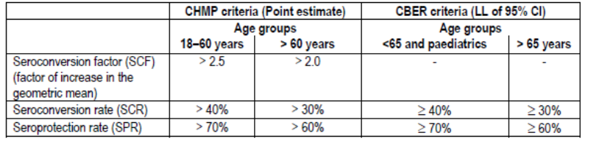

The EMA guideline (CHMP 2007) on influenza vaccines with pandemic potential states that As generally stipulated for vaccines used for primary immunisation of a previously immunologically naïve population, influenza vaccines used for pandemic preparedness should induce high seroprotection rates, preferably after one or at most two doses. All three criteria (seroprotection rate, GMT increase and response rate) as defined in guideline CPMP/BWP/214/96 should be fulfilled.

Virus neutralisation
A seropositive subject was defined as a subject whose reciprocal neutralising antibody titre was greater than or equal to the cut-off value of 28. The serological variables assessed for neutralising antibodies were GMT and Vaccine Response Rate (VRR), also termed seroconversion rate (SCR) in some reports. VRR is defined as the proportion of vaccine recipients that have either a pre-vaccination titre < 1:28 and a post-vaccination titre ≥ 1:56 or a pre-vaccination titre ≥ 1:28 and at least a 4-fold increase in post-vaccination titre.
The European guideline (CHMP 2007) states that in addition to the HI response A demonstration that the candidate vaccine elicits neutralising antibodies directed against the vaccine strain is very important. Cross-reactivity of antibodies elicited by the H5N1 vaccine to emerging drift variants of the H5N1 virus should be assessed by means of neutralising antibody tests using different strains in the assay. It also goes on to state that Although additional immunological assessments, such as explorations of cell-mediated immunity and neuraminidase inhibition, are of unknown relevance to protection, these should be explored in a subset of vaccine recipients to provide more insight into the overall effects of vaccination.

Dosage selection for the pivotal studies
The selection of antigen dose and schedule were evaluated in D-Pan study H5N1-007. This was a phase I, observer-blind randomised, single centre study, with 400 adults enrolled, aged between 18 and 60 years. It was designed to evaluate the reactogenicity and immunogenicity of one and two administrations of pandemic monovalent (H5N1) influenza vaccines (split virus formulation) administered at different antigen doses (3.8 µg, 7.5 µg, 15 µg and 30 µg HA) adjuvanted or not with AS03. The study was previously evaluated and was also included in the current dossier. Given its previous evaluation, the study design and results have been summarised here.
Subjects were randomised into parallel groups with vaccination on days 0 and 21 and blood sampling on days 0, 21, 42 and 180. The primary endpoint was the serum anti-HA antibody titre against the A/Vietnam/1194/2004 (H5N1) vaccine strain.
The haemagglutination inhibition (HI) immune response against the H5N1 strain found that after the second dose (day 42) all antigen groups using the adjuvanted formulation met the CHMP immunogenicity criteria, while only the highest antigen dose of the non-adjuvanted groups met the criteria. At day 42, seroconversion and seroprotection rates were both 83.3% in initially seronegative subjects who received 3.8 µg HA adjuvanted with AS03, with a seroconversion factor of 29.8. The results on SCR, SPR and SCF are shown in Figures 1-3.
Figure 1: Study H5N1-007: SCR for serum HI antibody at Days 21 and 42 (ATP immunogenicity cohort).
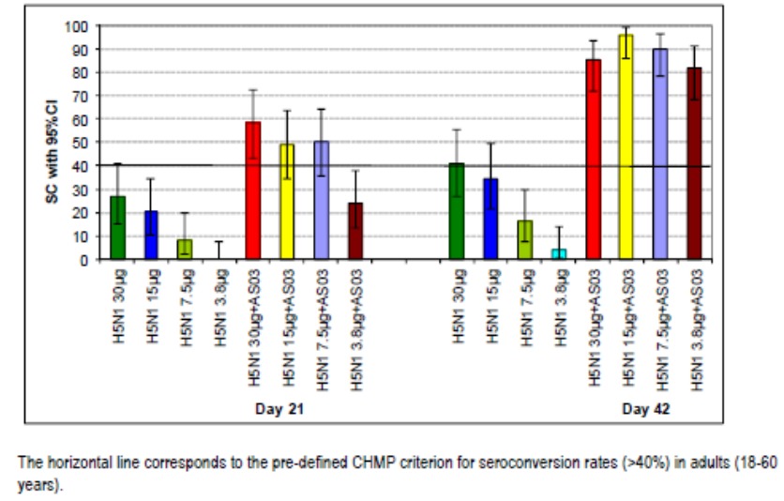
Figure 2: Study H5N1-007: SPR for serum HI antibody at Days 0, 21 and 42 (ATP immunogenicity cohort).
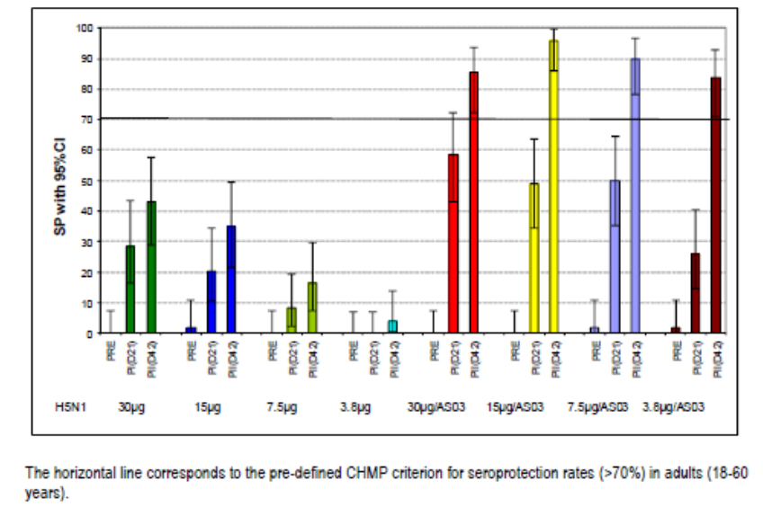
Figure 3: Study H5N1-007: SCF for serum HI antibody at Days 21 and 42 (ATP immunogenicity cohort).
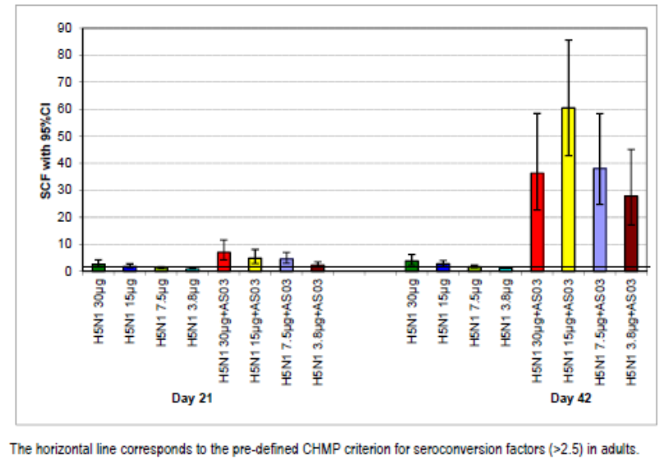
In annexed study reports, the seropositivity for anti-HA antibodies to the vaccine strain at day 180 remained high at 60 - 74.0% with adjuvanted vaccine and lower with non-adjuvanted vaccine (10 - 45.8%). Seroprotection rates were 54 - 64% and 4.0 - 37.5% in the adjuvanted and non-adjuvanted groups, respectively. The seroconversion factor at day 180 was 2.9 - 4.5% in the adjuvanted groups and 1.0 - 2.2% in the non-adjuvanted groups.
The study demonstrated a clear benefit of AS03 adjuvanted formulation compared to non-adjuvanted formulation when assessing the GMTs of the HI antibody. This was seen across antigen doses (Figures 4 and 5).
Figure 4: Study H5N1-007: GMTs for serum HI antibody at Days 0, 21 and 42 (ATP immunogenicity cohort).
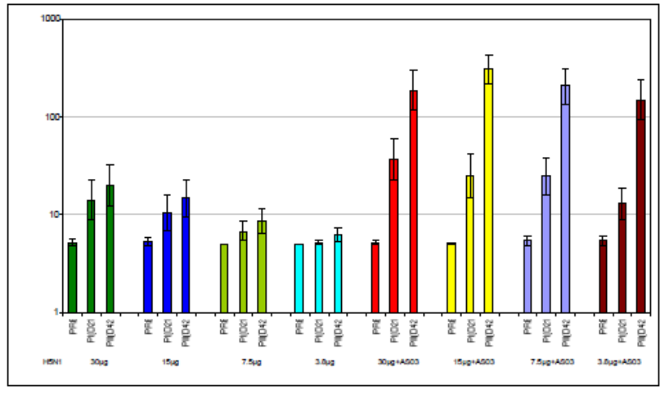
Figure 5: Study H5N1-007: “Adjuvantation” over “HA-dose effect” after the second dose (Day 42) (ATP immunogenicity cohort).
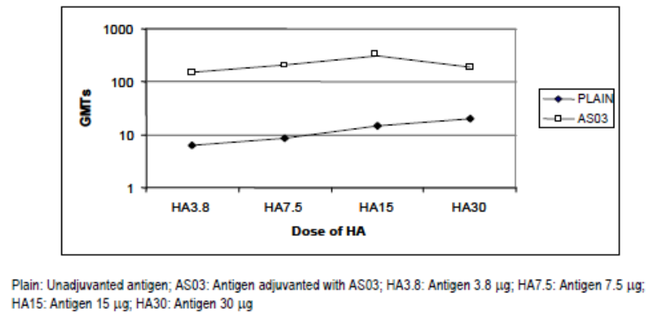
Cross-reactive immunity was assessed by measuring anti-HA antibody titres against an H5N1 heterologous strain (A/Indonesia/5/2005). For all non-adjuvanted formulations, protective levels of antibodies were not reached at any time point (days 21 or 42). In the adjuvanted vaccine groups, a significant increase in SPRs of 20 - 33% was observed between days 0 and 42. The SCFs in the adjuvanted vaccine groups, ranged from 1.0 to 1.2 after the first dose and from 2.0 to 2.8 after the second dose compared to no response in the non-adjuvanted groups.
Neutralising antibody responses against vaccine strain H5N1 A/Vietnam/1194/2004 were induced with all adjuvanted formulations. In the lowest dose group (3.8 µg HA/AS03), all subjects except one were seropositive after the second dose, with a seroconversion rate of 85.7%. The NA response was notably higher after the second adjuvanted dose and only the adjuvanted vaccine elicited a heterologous NA response.
Evaluator’s Comment: The study demonstrated a clear benefit of the adjuvanted compared to the non-adjuvanted vaccine formulation across all parameters.
The results indicated the need for a 2 dose schedule.
The sponsor stated that considering the limited manufacturing capacities in the case of a pandemic, the formulation containing the minimum amount of antigen which fulfilled all three CHMP criteria would be selected for the adult population. Given this, the lower dose of 3.75 µg was selected.

Clinical efficacy
As the selected vaccine strain is not circulating in human populations, efficacy trials are unable to be carried out. Efficacy therefore is based on surrogate immunogenicity endpoints and these data are included in this section.
The clinical studies enrolled healthy subjects. The exclusion criteria for the adult studies were similar and are listed here:
- use of immunosuppressants, immune-modifying or cytotoxic drugs, (generally within 6 months and including ≥0.5mg/kg/day of corticosteroids);
- confirmed or suspected immunosuppressive or immunodeficient condition or autoimmune disease;
- allergy or hypersensitivity to any component of the vaccine, allergic disease or reactions which could be exacerbated by the vaccine;
- acute moderate or severe disease with or without axillary temperature ≥37.5 °C at time of vaccination;
- administration of immunoglobulins or blood products (generally within 3 months);
- prior vaccination with pandemic candidate vaccine or vaccine containing AS03;
- lactating or pregnant women, or women of childbearing potential without appropriate contraception;
In addition, in general the studies also excluded:
- vaccination between day 0 and 51 with seasonal influenza vaccine;
- administration of licensed vaccines within 2 weeks for inactivated and 4 weeks for live vaccines;
- prior contact with H5N1 wild type virus;
- clinically significant disease on screening test/examination;
- serious chronic disease including pulmonary, cardiovascular, renal, neurological, psychiatric or metabolic disorder;
- chronic alcohol consumption or drug abuse;
- diagnosis or treatment of cancer within 3 years;
- receipt of analgesic or antipyretic medication on the day of vaccination.

H5N1 Influenza prophylaxis

Adult efficacy studies

Study H5N1-002 and extensions H5N1-030 and H5N1-038

Study design, objectives, locations and dates
H5N1-002 was a phase III, observer-blind, randomised, controlled study in adults 18 to 60 years which assessed the lot-to-lot consistency of the immunogenicity of pandemic influenza vaccine (split virus formulation adjuvanted with AS03). The study was conducted in 2007 at 6 centres in Taiwan, Singapore, Thailand and Hong Kong. The Sponsor stated that it was evaluated, however the current evaluator could not find mention of it in the included evaluation report for 2007/0254/2.
The primary objective was to demonstrate consistency of immune response in terms of GMT ratio for anti-Haemagglutinin antibody response 21 days after the second vaccination elicited by four vaccine compositions. Secondary objects were safety/reactogenicity and further immune response endpoints. Subjects were randomised to one of 6 groups and followed to month 12.
The study was extended (protocol H5N1-030 ) in which booster vaccination with heterologous A/Indonesia was given at month 6 post primary vaccination in a subset of 265 subjects who had received 2 doses of adjuvanted vaccine. The subjects in the non-adjuvanted vaccine control groups received two booster doses of adjuvanted heterologous A/Indonesia vaccine at 6 months under protocol H5N1 - 030 and then were then discontinued.
Study H5N1 - 038 was an open label extension study of study H5N1 - 002. Subjects who were not randomised to receive a booster dose at month 6 in study H5N1 - 030 were randomised to receive a booster dose of adjuvanted vaccine at either 12, 24 or 36 months after initial priming. Protocol amendment changed the booster group for month 24 to receive booster vaccine at month 36 instead. In addition, subjects from H5N1 - 030 who received booster vaccination at 6 months in that study were included for long term follow-up. The CSR covered data up to month 18 including those who were boosted at month 12 and those who were not. There were also annexed reports to cover months 24 - 30, 36 - 42 and month 48.

Inclusion and exclusion criteria
For inclusion subjects were healthy adults 18 - 60 years. Women were of non-childbearing potential. Exclusion criteria were the standard exclusion criteria which were discussed above.

Study treatments
Four formulations were tested containing two lots of antigen (A and B) and two lots of AS03 adjuvant (X and Y). The four formulations tested were referred to as A/X, A/Y, B/X and B/Y. The vaccine contained 3.8 μg of H5N1 split virus antigen (A/Vietnam/1194/2004). The control groups received non-adjuvanted split virus vaccine (A or B) which was mixed with diluents. Vaccine and adjuvant/diluent were supplied in multidose vials. Two priming doses of vaccine were given 21 days apart.
Under study H5N1 - 030, at 6 months booster vaccination was given with heterologous H5N1 strain (A/Indonesia/5/2005) adjuvanted vaccine containing 3.8µg of HA. A subset of subjects (n = 265) who received the investigational adjuvanted vaccine received one dose of booster dose. The other 672 subjects of this study group did not receive booster vaccination at 6 months and are termed non-boosted subjects. The control groups (A/Dil and B/Dil) received two booster doses 21 days apart of adjuvanted vaccine.
In study H5N1 - 038, the booster at 12 months or at 36 months was a single dose of AS03 adjuvanted 3.8 µg of A/Indonesia/05/2005. Complementary influenza vaccine Fluarix was available for annual vaccination at the investigator’s discretion.
All vaccinations were 0.5 mL given by IM injection in the deltoid region of the non-dominant arm. Subjects were observed for 30 minutes post vaccination. Prohibited medications included immunoglobulins, blood products, immune modifying drugs and other vaccines.

Efficacy variables and outcomes
The main efficacy variables were:
Humoral immune response for anti-HA antibodies:
- GMT at days 21 and 42.
- Seroconversion rates (SCR) at day 21, day 42 (defined as the percentage of vaccine recipients who have either an anti-HA prevaccination titre < 1:10 and a post-vaccination titre ≥ 1:40 or a prevaccination titre ≥ 1:10 and at least a 4-fold increase in post-vaccination titre).
- Seroconversion factors (SCF) at day 21, day 42 (defined as the fold increase in serum anti-HA antibody GMTs post-vaccination compared to Day 0).
- Seroprotection rates (SPR) at day 0, day 21, day 42 (defined as the percentage of vaccine recipients with a serum anti-HA antibody titre ≥ 1:40 that usually was accepted as indicating protection).
Humoral immune response for neutralising antibodies:
- GMT at day 42;
- SCR at day 42 (defined as the percentage of vaccine recipients with a minimum 4-fold increase in neutralising antibody titre at post-vaccination).
The primary endpoint was the anti-HA antibody response against the A/Vietnam/1194/2004 vaccine strain measured 21 days after the second dose of the adjuvanted H5N1 vaccine (day 42).

Randomisation and blinding methods
Subjects were randomised in a 2:2:2:2:1:1 ratio to one of the 6 treatment groups using an internet based call-in randomisation system. Subjects were stratified by age (18 - 30 years and 31 - 60 years) in a 1:1 ratio.
Due to differences in vaccine appearance, the study was observer-blind. This meant that study personnel responsible for the vaccine preparation and administration were unblinded while those involved in clinical evaluations and subject follow up were blinded and not involved in vaccination.
Subjects in the extension study H5N1 - 030 were randomised to receive either booster at 6 months or not. Subjects in the extension study H5N1 - 038 were randomised to receive the booster vaccination at either 12, 24 or 36 months with the 24 month group later changed to receiving booster at 36 months.

Analysis populations
The total vaccinated cohort (TVC) for safety or immunogenicity was all vaccinated subjects with available safety data or immunogenicity data, respectively. The According to Protocol (ATP) cohort for immunogenicity was defined as all evaluable subjects (i.e., those meeting all eligibility criteria, complying with the procedures defined in the protocol, with no elimination criteria during the study) with available immunogenicity endpoint measures. This includes subjects for whom assay results were available for antibodies against at least one study vaccine antigen component after vaccination. The primary analysis was on the ATP cohort.

Sample size
A sample of 195 subjects per group gave the study a 98% power to detect a difference of > 2 fold in the pairwise comparison (GMT ratio) between the groups with a standard deviation of 0.735 and type 1 error of 0.025 one-sided. Bonferroni adjustment of beta was made for 6 comparisons between 4 groups. Assuming 10% non-evaluable subjects, 218 subjects per group were required (total of 1090 subjects consisting of four groups of 218 and two control groups of 109).

Statistical methods
The statistical analyses were performed in three steps. A first core analysis was on data to day 51, a second analysis on 6 month data and third analysis on 12 month data. These latter analyses were presented in clinical study reports for studies H5N1 - 030 and H5N1 - 038. Lot-to-lot consistency at 21 days after dose 2 was demonstrated if, for all pairs of lots, the two-sided 95% CIs for the ratio of anti-HA antibody GMT was within the [0.5,2.0] clinical limit interval. An ANCOVA model on the log10 transformed titres was used to calculate the 95% CI of the anti-HA GMT ratio between vaccine groups. Other analyses were descriptive.

Participant flow
The H5N1-002 study enrolled 1206 subjects (240 subjects in H5N1_AX; 239 subjects in H5N1_AY; 242 subjects in H5N1_BX; 240 subjects in H5N1_BY; 122 subjects in H5N1_AD; 123 subjects in H5N1_BD). There were 1190 subjects who completed the study and 16 subjects were withdrawn. The ATP immunogenicity cohort included 1169 subjects (96.9%) with 233, 235, 231, 234, 117 and 119 in the respective groups. The 21 subjects not included in the immunogenicity cohort had either non-compliance with blood sampling schedules or missing serological data.
In the extension study H5N1-030, there were 265 subjects from the adjuvanted vaccine group who received one booster dose, 672 subjects from this group who were not boosted and 236 subjects from the non-adjuvanted groups who received 2 booster vaccine doses. The ATP immunogenicity cohort included 485 (96.8%) subjects. There were 665 (99.0%) subjects not boosted who were included in the ATP cohort for antibody persistence.
In study H5N1 - 038, there were 845 subjects enrolled. Of those 189 scheduled to be boosted at 12 months, 188 received vaccine and 186 (98.9%) and 184 (97.9%) were included in the ATP cohort for immunogenicity at month 12 and 18, respectively. There were 219 subjects boosted at month 6 and 437 who had not received any booster vaccination who entered this extension study. Of these, 217 and 435, respectively, were included in immunogenicity analyses at 18 months. There were 435 subjects boosted at month 36 and 387 were included in the month 42 ATP immunogenicity cohort. By month 48, the reported size of the ATP cohort for immunogenicity was 731, with 194, 170 and 367 who received a booster dose at month 6, 12 and 36, respectively.

Major protocol violations/deviations
The 16 subjects withdrawn from study H5N1 - 002 had received forbidden concomitant vaccination or had vaccine doses not given according to the protocol. The 21 subjects not included in the immunogenicity cohort had either non-compliance with blood sampling schedules or missing serological data.

Baseline data
The mean patient age was 33.6 years (range 18 to 59 years) and 49% were female. All except 2 subjects were Asian. The groups were balanced on these characteristics.

Results for the primary efficacy outcome
Lot-to-lot consistency was demonstrated as at 21 days post the second vaccine dose the two sided 95% CI for the adjusted ratios of the anti-HA antibody GMT (A/Vietnam/1194/2004) was within the 0.5,2.0 predefined interval for all 6 pairs of comparisons (Table 2).
Table 2: GMT ratio (with 95%CI) of anti HA antibodies against the A/Vietnam/1194/2004 strain between all adjuvanted vaccine groups at Day 42 (ATP cohort for immunogenicity).
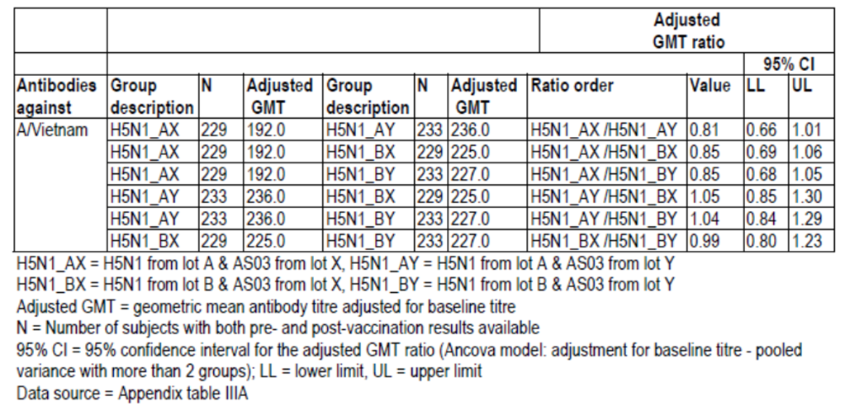

Results for other efficacy outcomes
For pooled vaccine groups, the GMT for anti-HI antibodies against A/Vietnam strain was higher with adjuvanted than for non- adjuvanted vaccine particularly after the second vaccine dose. A similar finding was seen, although at lower levels, for the heterologous strain A/Indonesia.
SCR (93.7%), SPR (94.3%) and SCF (39.8) all met the CHMP criteria against homologous A/Vietnam post two doses of adjuvanted vaccine at day 42. In terms of protection against heterologous A/Indonesia (as measured by anti-HA antibodies), after two doses of adjuvanted vaccine, CHMP criteria were met for SCR (50.2%) and SCF (4.9) while the SPR (50.2%) did not meet the ≥ 70% criteria. The pooled non-adjuvanted vaccine group did not meet these European criteria for SCR, SPR, or SCF against either A/Vietnam or A/Indonesia.
For the adjuvanted vaccine pooled group, the SCR for neutralising antibodies at day 42 post 2 vaccine doses was 96% and 91% against A/Vietnam and A/Indonesia strains, respectively. The SCR was markedly lower in the pooled non-adjuvanted groups (32.4% and 5.6% for the A/Vietnam and A/Indonesia, respectively).
H5N1-030: At month 6 pre-booster vaccination, the GMTs (anti-HA antibodies) had declined notably compared to day 42.The SCR at month 6 after one booster dose was 96.1% and 94.9% for A/Vietnam and A/Indonesia, respectively, in the adjuvanted group compared to 48.5% and 46.3% respectively in the non-adjuvanted group. Figure 6 shows the improvement post vaccination in SCF against both influenza strains in the adjuvanted group. The SPR was 96.5% and 94.9% against the A/Vietnam and A/Indonesia strains post booster vaccination in the adjuvanted group and two booster vaccinations in the non-adjuvanted group resulted in SPR of 78.9% and 82.9% against the respective strains. For subjects not boosted, at 6 months the SPR was 61.7% and 17.9% for A/Vietnam and A/Indonesia respectively. After boosting the SCR for serum neutralising antibodies was 76.1% and 90.2% against A/Vietnam and A/Indonesia, respectively, for those in the adjuvanted vaccine group.
Figure 6: SCF A/Vietnam and A/Indonesia – boosted subjects (ATP immunogenicity cohort).
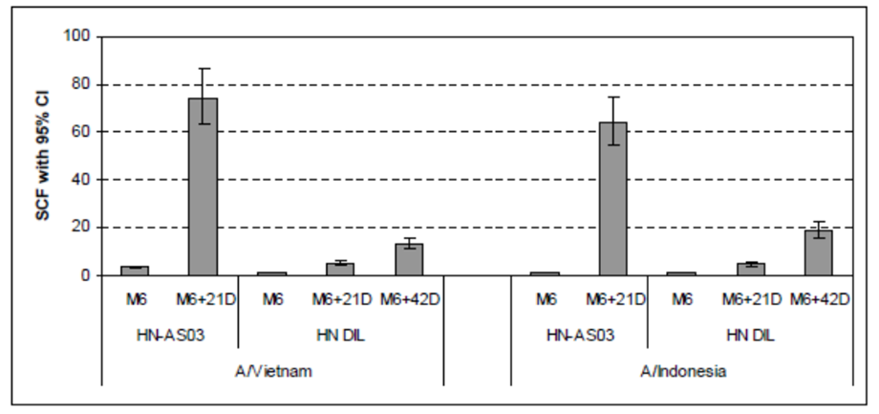
H5N1 – 038: At month 12, without any booster vaccination, the GMT for H5N1 HI antibodies was close to the cut-off (11.8 and 6.2 for A/Vietnam and A/Indonesia, respectively). Following booster vaccine at 12 months the GMT rose and then declined by month 18 but the seropositive rate at month 18 was 93.4% for both strains. The booster SCR for both strains at month 12 and 18 was above guideline requirements of > 40%. The booster SCF and booster SPR were above the CHMP threshold post booster at month 12 + 21 days and month 18 for both vaccine strains.
For subjects who were boosted at month 6, by month 12 the booster SCR was still above the threshold for both strains but by month 18 only HI antibody response to the booster strain A/Indonesia still met regulatory requirement levels.
For subjects who had not received any booster doses, by month 12 seropositivity rates were 43.0% and 12.3% against A/Vietnam and A/Indonesia respectively, and at 18 months were 40.3% and 34.0%, respectively. The SCRs at month 12 and 18 in these subjects were below CHMP criteria for both vaccine strains.
For subjects boosted at month 12, by month 24 and month 30 all criteria (SPR, booster SCR and booster SCF) were still met for both vaccine strains apart from SPR against A/Indonesia. For those boosted at month 6 the immunogenicity criteria were no longer met at month 24 and 30 nor were they met for subjects who did not receive any booster dose. For subjects boosted at month 36, all regulatory criteria were met at month 48 for both vaccine strains.
CMI response: There was an increase in the frequency of antigen-specific (upon stimulation with either the split Indonesia or split Vietnam vaccine antigen) CD4 + T cells producing at least two immune response markers that was apparent 21 days after booster vaccination. There was no notable response in terms of the frequency of the cytokine-positive CD8+ T-cells in any group.
Summary: Study H5N1-002 was a randomised controlled trial in 1206 Asian adults which demonstrated lot-to-lot consistency of immune response in terms of HI antibody against the homologous A/Vietnam strain between the four vaccine compositions (2 adjuvant lots and 2 antigen lots). The adjuvanted formulation resulted in higher immune response compared to non-adjuvanted formulation. After two doses the criteria for SCR, SPR and SCF against homologous strain as well as the SCF and SCF for the heterologous strain were met as set out in CHMP guidelines. Adjuvanted vaccine also resulted in a high VRR for neutralising antibodies against both A/Vietnam and A/Indonesia.
A single heterologous booster vaccine dose at 6, 12 or 36 months in subjects primed with 2 doses led to immune response meeting guideline criteria for the homologous and heterologous vaccine strains. Neutralising antibody data were supportive. Subjects not receiving any booster did not meet CHMP requirements against either strain at 12 or 18 months.

Study H5N1-008 and follow up H5N1-011

Study methods
Study H5N1 - 008 was a phase III, observer-blind, randomised, multicentre study to evaluate the safety and immunogenicity of one and two administrations of pandemic (H5N1) influenza vaccine (split virus formulation containing 15 µg HA and adjuvanted with AS03) in 5,075 adults aged 18 years and older. The study was conducted in 2006 in 41 sites in 7 countries in Europe and Russia. The primary objective was safety and reactogenicity. Immunogenicity was a secondary objective and only measured in a subset of vaccinated subjects. The month 6 follow-up visit was termed study H5N1 - 011.
Study H5N1 - 008 was previously evaluated in PM-2007-0254-2 and was also included in the current dossier. A full evaluation of the study can be found in the earlier clinical evaluation report. The main efficacy findings are summarised here.
The vaccine consisted of 15µg of HA from the A/Vietnam/1194/2004 strain adjuvanted with AS03. Subjects were randomised in a 3:1 ratio to either 2 doses of H5N1 vaccine 21 days apart or one dose of Fluarix vaccine (trivalent split virion influenza vaccine containing 45µg total HA) followed by placebo vaccine 21 days later. The randomisation was stratified by age to include half the subjects in the 18 - 60 years age group and half in the over 60 years group.
The ATP immunogenicity cohort included 609 subjects, 455 and 154 in the H5N1 and Fluarix groups, respectively. At day 180, the ATP cohort for antibody persistence included 450 in the H5N1 group and 150 in the Fluarix group.

Results for the efficacy outcomes
In study H5N1 - 008, for adults aged 18 - 60 years of age, the SCR and SPR were both 55.4% and the SCF was 6.2, 21 days after the first dose. The pre-defined CHMP criteria for SCR (> 40%) and SCF (> 2.5) but not for SPR (> 70%) were attained after the first dose H5N1 vaccine (15 µg HA) adjuvanted with AS03. Twenty-one days after the second dose (i.e. day 42), SCR and SPR rates increased to 91.6% and a SCF of 58.6 was obtained. There was a significant increase in the GMT level between day 21 and day 42 (33.3 vs 312.8). Each of the CHMP requirements was exceeded by a large amount after completion of the 2 dose schedule.
In study H5N1 - 008, for patients over the age of 60 years, the SCR and SPR rates were 62.1% and 67.4%, respectively, following the first dose. These increased to values of 87.8% and 93.1%, respectively, after the second dose. Seroconversion factors of 8.1 and 29.1, respectively, were observed after the first and second doses. GMTs observed at both time points were 57.3 and 206.4, respectively. The CHMP criteria for all three immunological criteria in elderly subjects (i.e. SCR > 30%, SPR > 60% and SCF > 2.0) were fulfilled after the first and second doses.
It is noted that the seropositivity rates were higher in the > 60 year olds than the 18 - 60 year olds at baseline (18.0% vs 2.5%).

Results for follow-up
Antibody persistence was measured at day 180 and in adults 18 - 60 years (n = 279). The SCR and SPR were 56.6% and 57.7%, respectively, with a SCF of 5.2. In the elderly >60 years at day 180 (n = 171) the SCR was 73.5%, the SPR was 78.9% and the SCF was 8.3.
Evaluator’s Comment: The Sponsor proposed that the higher seropositive rate in the elderly subjects at baseline, which may be due to cross-reactivity with other influenza strains, may have contributed to this apparent higher result in that age group.
Persistence of neutralising antibody response was also measured and at day 180 and the vaccine response rate (VRR) was 58.1% and 43.4% in those aged 18 - 60 and > 60 years, respectively.
Evaluator’s Comment: It is noted that at baseline in the elderly subjects (> 60 years) the seropositivity rate for neutralising antibodies was 83.6% and 90.0% in the vaccine and control groups, respectively (compared to 45.0% and 44.7%, respectively, in the 18 - 60 year olds). This likely cross-reactivity of antibodies makes interpreting results of neutralising antibody difficult.
Summary: H5N1-008 was a large, randomised, controlled study in 5071 adults with the primary objective being safety of the A/Vietnam strain vaccine at a higher antigen dose of 15 µg. After a two dose priming course the immune response for subjects aged 18 - 60 and > 60 years olds met all CHMP regulatory requirements. There was persistence of immune response to 6 months after the first vaccination with the three CHMP criteria still met for subjects > 60 years, while only two (SCF, SCR) of these criteria were met for subjects 18 - 60 years.

Study H5N1-010 and extension H5N1-021

Study design and methods
Study H5N1 - 010 was a phase II, randomised, open-label study to evaluate the immunogenicity and safety of a single or double-dose of the pandemic influenza vaccine (split virus formulation adjuvanted with AS03) given following a two dose administration schedule (21 days apart) in 437 adults over 60 years of age. It was conducted between 2006 and 2008 at 12 centres in Belgium and Italy. The primary objective was to evaluate the immunogenicity 21 days after vaccination and to assess antibody persistence to 2 years. Safety and reactogenicity were secondary objectives. Subjects were followed to month 6 in study H5N1 - 021 and a subset had antibody persistence assessed to 24 months. Study H5N1-010 was evaluated in the Pandemrix submission.
Included subjects were healthy adults aged 61 years or older. Exclusion criteria were the same as other studies. In addition, administration of licensed MF-59 containing or virosome-based influenza vaccines during the 2006 - 7 season was an exclusion criteria.
Subjects were randomised in a 3:1:3:1 ratio to one of 4 treatment groups:
- 3.8/AS - single dose (3.8μg) of the adjuvanted influenza vaccine (AS03).
- 3.8/NoAS - single dose (3.8μg) of the non-adjuvanted vaccine.
- 7.5/AS – double dose (7.5μg) of the adjuvanted vaccine (AS03).
- 7.5/NoAS - double dose (7.5μg) of the non-adjuvanted vaccine.
Subjects were stratified by age group (61 - 65, 66 - 70 and > 70 years) in a 1:1:1 ratio. The vaccine contained A/Vietnam/1194/2004 (H5N1) strain. The 7.5μg dose was given as two injections of 3.8μg at the same visit. All subjects received vaccination on day 0 and 21. Subjects not already vaccinated for the 2006 - 7 season, or who had no history of seasonal influenza disease, received the Sponsor’s commercial Fluarix at least 3 weeks prior to the first dose of study vaccine.
Evaluator’s Comment: This was done in order to mitigate possible confounding effects on the assessment of the immune response against the pandemic influenza candidate vaccine due to prior exposure to seasonal influenza virus, whether through natural exposure or through vaccination.
A sample size of 170 evaluable subjects per group gave the study an 86% power to detect a 1.7-fold difference between the two adjuvanted vaccine groups with AS03, assuming standard deviations of 0.738 and 0.656 (log10 unit) for the 7.5/AS and 3.8/AS vaccine groups (data from study H5N1 - 007 study) using a two sample t-test and a two sided significance level of 0.05. Allowing for drop outs, the target was 180 per AS03 vaccine group and 60 per comparator group.
Statistical methods were similar to study H5N1-002. An interim analysis was conducted at day 7 after enrolment of 100 subjects to assess safety and reviewed by an internal safety monitoring board. The study protocol was amended 6 times. Following FDA comments, amendments included, changing the interval between Fluarix and study vaccine to 21 days, allowing previous influenza vaccination that season, changing safety follow-up to 2 years in Belgian subjects only and adding neutralising antibodies assessment in a subset only.

Participant flow and baseline characteristics
There were 437 subjects enrolled and vaccinated: 159 and 165 in the 7.5/AS and 3.8/AS groups, respectively, and 52 and 61 in the 7.5/NoAS and 3.8/NoAS groups, respectively. The ATP immunogenicity cohort included 395 (90.4%) subjects with 145, 152, 44 and 54 in the four respective groups. There were 415 subjects who completed the study and 22 (5.2%) were withdrawn.
At day 180 (study H5N1 - 021), there were 376 in the ATP cohort to assess antibody persistence. At month 12 there were 298 subjects and at month 24 there were 228 (only Belgian centres participating).
The mean age of study subjects was 69.7 - 70.8 years with a range of 61 to 89 years with 54.2% of subjects male. At baseline, prior to vaccination, the seropositivity rate for HI antibody was 38.2% and 2.0% for the A/Vietnam/1194/2004 and the A/Indonesia/5/2005 strains, respectively. The GMTs were low against A/Vietnam (8.8 - 11.3) and A/Indonesia (5.0 - 5.2).

Results for efficacy outcomes
The increase, particularly in the adjuvanted vaccine groups, in seropositivity rates and GMTs after two vaccine doses for the two viral strains is shown in Tables 3 and 4. In the adjuvanted vaccine groups 3.8/AS and 7.5/AS, the SCR against A/Vietnam was 45.4% and 52.4% after one dose and 72.4% and 88.3% after two doses, respectively, thus meeting the CHMP regulatory requirements (> 30%). Non-adjuvanted vaccine did not meet these requirements. A SCR meeting regulatory requirements against heterologous A/Indonesia was only achieved after two doses of the double strength adjuvanted vaccine.
Table 3: Seropositivity rates and GMTs of H5N1 HI antibodies against the vaccine strain A/Vietnam/1194/2004 (ATP cohort for immunogenicity).
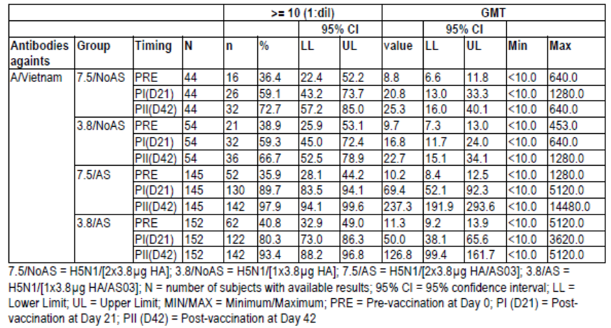
Table 4: Seropositivity rates and GMTs of H5N1 HI antibodies against the vaccine strain A/Indonesia/5/2005 (ATP cohort for immunogenicity).
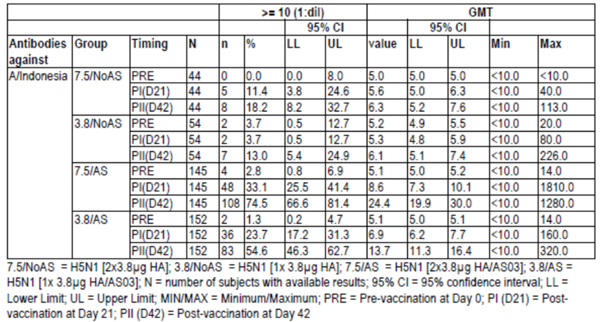
The SCF threshold (> 2.0) was met after one dose of adjuvanted vaccine (both strengths) for A/Vietnam and after two doses of adjuvanted vaccine (both strengths again) for A/Indonesia. Non-adjuvanted vaccine did not lead to SCF results meeting the threshold for A/Indonesia.
The SPR data are shown in Figure 7. The non-adjuvanted vaccine did not meet the requirement of > 60%. For A/Vietnam, the 3.8/AS and 7.5/AS vaccine resulted in SPR of 61.2% and 62.1% after one dose and 83.6% and 95.9% after two doses, respectively. However, adjuvanted vaccine did not meet requirements for SPR against heterologous A/Indonesia.
Figure 7: Seroprotection rates for H5N1 HI antibodies against A/Vietnam/1194/2004 and A/Indonesia/5/2005 strains (ATP immunogenicity cohort).
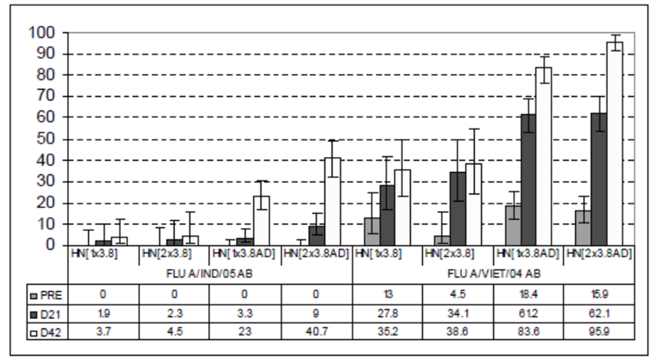
A comparison of GMT ratios on day 42 (post 2 doses) found significant effects for adjuvanted over non-adjuvanted vaccine and the double strength adjuvanted (7.5 AS) over the standard strength (3.8 AS) dose groups.
An exploratory analysis on the subgroups that were seropositive or seronegative to A/Vietnam/1194/2004 at baseline was conducted. In seronegative subjects at baseline, the SPR after one dose of adjuvanted vaccine was < 60% however after two doses was 73.3% and 94.6% in the 3.8/AS and 7.5/AS dose groups, respectively. The effect of seronegativity was not so evident on SCF or SCR.
A subset of subjects had neutralising antibodies against A/Indonesia measured after two adjuvanted vaccine doses. The baseline seropositivity rate was high (58.5 - 65.5%) and the SCR at day 42 was 48.8% and 28.7% in the 7.5/AS and 3.8/AS groups, respectively. For A/Vietnam, baseline seropositivity for neutralising antibodies was high (93 - 94%) and all subjects in these adjuvanted vaccine groups were seropositive after one vaccine dose. The SCR at day 42 was 56.1% and 44.8% in the 7.5/AS and 3.8/AS groups, respectively.
CD4 T cell responses were found across study groups and were higher in the adjuvanted vaccine group with an increase post second vaccine dose. No CD8 T cell response was found in any group.

Results for antibody persistence
At day 180 (H5N1 - 021), the seropositivity rate in the adjuvanted vaccine groups was 76.4 - 86.3% to A/Vietnam and 21.4 - 41.2% to A/Indonesia. There was a decline in GMT. For adjuvanted vaccine groups 3.8/AS and 7.5/AS, the SCR was 37.1% and 53.8% against A/Vietnam but much lower against A/Indonesia (3.6% and 6.2%). SCR was still above regulatory requirements for A/Vietnam but not for A/Indonesia. A SPR of > 60% was only found in the 7.5/AS group against A/Vietnam. CD4 T cell response had decreased. Neutralising antibody SCR to to A/Vietnam was 28.8% and 21.1% and to A/Indonesia was 43.8% and 26.3% in the 7.5/AS and 3.8/AS groups, respectively.
In the subset of elderly subjects who were followed for 2 years, at month 12 the SPR for antibodies to A/Vietnam was 42.5% and 43.8% and to A/Indonesia was 20.8% and 15.2% in the 7.5/AS and 3.8/AS groups, respectively. The SCR ranged from 15.2% to 22.9% against both strains and the SCF from 1.8 to 2.6. At month 24 rates had declined further with SCR ranging from 4.7 to 11.1%, the SCF from 1.4 to 1.9 and the SPR from 4.7 to 37.2% for the HI immune response against the two strains in the adjuvanted vaccine groups.
Summary: In study H5N1 - 010, two doses of vaccine were given 21 days apart in 437 adults 61 years or older. Adjuvanted and non-adjuvanted vaccine with either a single (3.8 µg) or double (7.5 µg) dose of A/Vietnam antigen were assessed. The elderly population was noted to have a high baseline HI antibody positivity to A/Vietnam at 38%. The study found a clear advantage of adjuvanted vaccine over non-adjuvanted vaccine particularly on heterologous HI response. The adjuvanted vaccine at either dose met all guideline requirements after one dose for the homologous strain and after 2 doses for the heterologous strain (except for SPR). The double dose adjuvanted vaccine (7.5/AS) resulted in a greater immune response than the single dose adjuvanted vaccine (3.5/AS). Overall, the response of 2 doses of 3.8 ug adjuvanted vaccine 21 days apart was better than 2 doses given on same day. Exploratory analysis found that in seronegative subjects two doses of vaccine were required for the immune response to meet all regulatory requirements. At month 12 and 24 the immune response no longer met CHMP thresholds.

H5N1-041

Study design and methods
Study H5N1 - 041 was a phase III, observer-blind, randomised, controlled study in 320 adults aged 18 to 60 years which aimed to demonstrate the non-inferiority of a thiomersal-free processed pandemic influenza vaccine (split virus formulation adjuvanted with AS03) compared to a thiomersal-containing processed pandemic influenza vaccine (split virus formulation adjuvanted with AS03). It was conducted in 2008 - 2009 at a single centre in Taiwan. The primary objective was non-inferiority, as based on immunogenicity of the thiomersal-free to thiomersal-containing vaccine 21 days after the second vaccination.
Subjects were healthy adults and the standard exclusion criteria were applied. They received two doses of vaccine 21 days apart and were followed to day 180. The study vaccine consisting of 3.75 μg (referred to as 3.8 μg) of H5N1 split virus antigen (A/Indonesia/05/2005) and the adjuvant AS03. Subjects were randomised in a 1:1 ratio to one of the two parallel groups. Clinical study data were collected in by study personnel who were not involved in vaccine administration to maintain observer-blind.
The upper limit of the two sided 95% CI for the GMT ratio for HI antibodies titre against A/Indonesia on day 42 needed to be ≤ 2.0 for non-inferiority of thiomersal free (TF) to thiomersal containing (TC) vaccine to be declared. A sample of 152 evaluable subjects per group gave the study a 99% power to detect this assuming a SD (log10) of 0.543. The 95% CI was calculated using an ANCOVA model (adjusting for baseline titre).

Results
There were 320 subjects enrolled and vaccinated and the ATP cohort for immunogenicity included 312 subjects, 156 in each group. Subjects had a mean age of 31.9 years and all were Asian. Baseline GMTs for HI antibodies for both strains (A/Indonesia and A/Vietnam were below the cutoff of < 1:10).
At 21 days after the second vaccination, the adjusted GMT ratio (TF/TC) was 1.20 (95% CI: 1.01, 1.42) indicating that non-inferiority was achieved as the upper limit of the 95% CI was less than 2.0.
For both TF and TC vaccine, seropositivity rates and GMTs against both strains increased by day 42. The SCR for A/Indonesia was 100% and 98.7% and for A/Vietnam was 91.7% and 81.3% for the TF and TC vaccines, respectively. The lower bounds of the 95% CI were all above 40% guideline threshold. The SCF was > 2.5 for both TF and TC groups against both strains. The SPR for both TF and TC groups also met regulatory requirement with rates ≥ 81.9% against both vaccine strains.
At day 180 follow-up, the ATP cohort for persistence of antibodies included 310 subjects (155 in each group). The GMT had decreased in both formulation groups and to a greater extent against A/Vietnam than to A/Indonesia. At day 180, the SPR for HI antibodies to A/Indonesia was 82.6% and 67.1% in the TF and TC vaccine groups, respectively. The SCR for A/Indonesia was 82.6% and 67.1% and SCF was 10.4 and 6.5 in the TF and TC groups, respectively. The response to the heterologous A/Vietnam strain no longer met regulatory requirements at day 180 for either formulation group. The SCR for neutralising antibody against A/Vietnam at day 42 was 25.9% vs 22.0% and at day 180 was 12.1% vs 15.3% for the TF and TC formulations, respectively. The 95% CIs were overlapping indicating no difference between formulations.
Summary: In this study of 320 Taiwanese adults, two vaccine formulations were assessed and non-inferiority of the thiomersal free processed vaccine to the thiomersal containing vaccine was demonstrated at day 42 after two doses. The study used the proprosed vaccine antigen A/Indonesia/05/2005, adjuvanted with AS03, for the priming course. The immune response to both vaccine formulation groups met regulatory requirements for both the homologous A/Indonesia and heterologous A/Vietnam strains. After 2 priming doses, at 6 months immune the response still met regulatory requirements for homologous A/Indonesia strain (except for SPR with TC vaccine). There was trend for antibody persistence at 6 months to be greater with the TF formulation although this was not formally assessed.

H5N1-012

Study design and methods
H5N1 - 012 was a phase II, open label, randomised study in adults to evaluate the reactogenicity and immunogenicity of a 1- and 2-dose prime-boost concept of pandemic monovalent (H5N1) influenza vaccine (split virus formulation) adjuvanted with AS03, administered according to different vaccination schedules. It was conducted between 2007 and 2008 at 11 centres in Germany. The study assessed primary vaccination with one or two doses and booster vaccination at 6 or 12 months with either homologous or heterologous vaccine strains.
The primary objectives were safety/reactogenicity and humoral immune response of a single heterologous booster dose 6 months after primary vaccination.
The study included healthy adults 18 to 60 years with the standard exclusion criteria. The study duration was 18 months with the primary analysis at month 6 or month 6 plus 30 days depending on treatment group. Further analyses were conducted at 12 and 18 months.
Subjects were randomised centrally to one of eight parallel groups. Randomisation was stratified by age (18 - 30 and > 30 to 60 years) in a 1:1 ratio. Treatment was open label. The eight treatment groups were:
- VT/VT/6Mo: two administrations of the pandemic influenza vaccine containing Vietnam (VT) strain at Day 0 and Month 6.
- VT/VT/12Mo: two administrations of the influenza vaccine containing the VT strain at Day 0 and Month 12.
- VT/IN/6Mo: one administration of the influenza vaccine containing the VT strain at Day 0 and one of vaccine containing the Indonesia (IN) strain at Month 6.
- VT/IN/12Mo: one administration of the influenza vaccine containing the VT strain at Day 0 and one of vaccine containing the IN strain at Month 12.
- 2VT/VT/6Mo: two administrations of the influenza vaccine containing the VT strain at Day 0 and Day 21 and a third dose of vaccine containing the VT strain at Month 6.
- 2VT/VT/12Mo: two administrations of the influenza vaccine containing the VT strain at Day 0 and Day 21 and a third dose of vaccine containing the VT strain at Month 12.
- 2VT/IN/6Mo: two administrations of the influenza vaccine containing the VT strain at Day 0 and Day 21 and a third dose of vaccine containing the IN strain at Month 6.
- 2VT/IN/12Mo: two administrations of the influenza vaccine containing the VT strain at Day 0 and Day 21 and a third dose of vaccine containing the IN strain at Month 12.
The vaccine was the monovalent influenza pandemic candidate vaccine with the H5N1 A/Vietnam/1194/2004 like NIBRG-14 or the A/Indonesia/05/2005 like PR8-IBCDCRG2 strains containing 3.8 μg of HA antigen and the adjuvant AS03.
The primary efficacy variables were the HI antitbody titres against A/Indonesia in the VT/IN/6Mo group. The 95% CI for the mean log-transformed titres were calculated. Between group comparisons were analysed using an ANCOVA model.
Assuming a seroconversion rate of 82% after dose 2 of vaccine, a sample size of 57 per group gave the study a > 99% chance of obtaining a lower 95% CI limit of ≥ 40%. If the true SPR was 84% then this sample size gave the study >70% probability of a lower 95% CI limit of ≥ 70%. Allowing for non-evaluable data, a sample size of 63 subjects per group was chosen.

Study participant flow and characteristics
There were 512 enrolled subjects, 498 in the safety cohort and 438 (85.5%) in the ATP cohort for immunogenicity. This resulted in the group sizes ranging from 48 to 60. The major protocol deviation was noncompliance with blood sampling schedule. The 6 month completion rate was 93.9% (481/512) and the 12 month rate was 88.7% (454/512). The ATP cohort for immunogenicity at month 12 included 402 subjects with 49 to 55 per group.
The mean age of participants was 34 years, 53.3% were female and 97.7% were Caucasian. These characteristics were balanced between groups. Baseline GMTs for H5N1 HI antibodies against both strains were low and near or below the cut-off of 5.0.

Results for the primary efficacy outcome
In subjects who received one priming dose of vaccine with A/Vietnam and then one booster dose at 6 months with A/Indonesia, the HI antibody response against A/Indonesia at 6 months + 7 days and 6 months + 21 days met CHMP requirements for SCR, SPR and SCF (Table 5).
Table 5: H5N1 HI antibody response against the A/Indonesia/5/2005 strain for the VT/IN/6Mo group at Day 0, Month 6, Month 6 + 7 days and Month 6 +21 days (ATP cohort for immunogenicity).
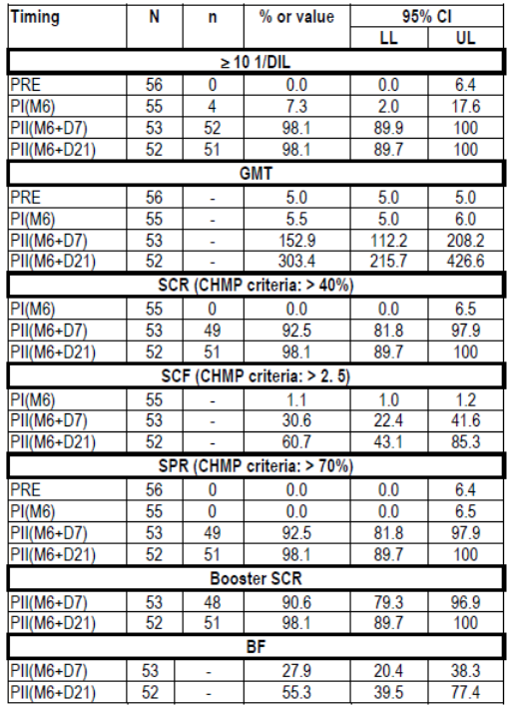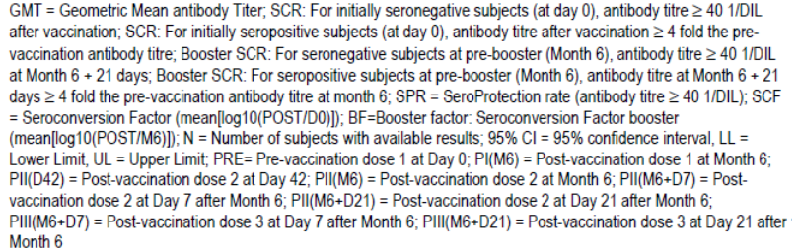

Results for other efficacy outcomes
Month 6 booster response: After priming vaccination with A/Vietnam and a booster vaccination at 6 months, the GMTs for H5N1 HI antibodies against A/Indonesia and A/Vietnam increased across the groups. Response to A/Indonesia was greater when boosted with the homologous strain. Response to A/Vietnam was similar between groups whether boosted with A/Vietnam or A/Indonesia.
The SCR at 6 months (+ 7 or + 21 days) for both A/Indonesia and A/Vietnam was > 40% (83.3% to 98.1% at 6 months + 21days) for all 4 groups boosted at 6 months. The SCF at 6 months also met regulatory requirements being > 2.5 against both vaccine strains. The SPRs were > 70% following booster vaccination in all groups however the lower limit of the 95% CI for SPR against A/Indonesia was not ≥70% in the VT/VT/6Mo and the 2VT/VT/6Mo groups.
The booster SCR (month 6 baseline as pre booster level to post booster) was >40% in all groups for HI antibodies against both strains: A/Vietnam 69.2 % - 100.0 % and A/Indonesia 50.0 % - 100.0% at 6 months + 21 days. The booster factor (SCF using pre-booster titres at month 6 as baseline) at month 6 + 21 days was 45.6 - 55.3 and 17.6 - 17.9 against A/Indonesia and A/Vietnam, respectively.
Antibody persistence to month 6: The persistence of antibodies against either strain to month 6 after primary vaccination was greatest in those who had received two priming doses. At month 6 the only groups with a SCR > 40% were those with two primary vaccinations and only against the homologous strain. Similarly, the persistence of antibodies in terms of SCF and SPR was best with the two dose priming course. The SPRs at 6 months did not meet regulatory requirements against either strain.
All groups after receiving 6 month boosters had high seroconversion rates for neutralising antibodies against both strains (≥ 95.7%).
Month 12 booster response: At month 12 + 21 days, the highest booster response against either strain was in the 2VT/IN/12Mo group. The SCR met regulatory requirements at month 12 + 7 days and month 12 + 21 days for both strains in all groups. The SCF > 2.5 was also achieved in all groups for antibodies against both strains. The SPR was > 70% for antibodies against both strains in all groups. The lower limit of the 95% CI was not ≥ 70% at 12 months + 7 days in the VT/VT/12Mo group for A/Indonesia, although this criteria was met at month 12 + 21 days. The booster SCR ranged from 76 - 90% against the 2 strains at month 12 + 7 days.
Antibody persistence to month 12: For those boosted at month 12, the antibody titres pre-booster had declined and the seropositivity rates were 28.8 - 59.1% and 9.6 - 29.5% against A/Vietnam and A/Indonesia respectively. For those boosted at month 6 the SCR at month 12 ranged from 74.5 - 80.4 % for the A/Vietnam and 37.2 - 67.4 % for the A/Indonesia strain. At 12 months, without any booster, the SCF was > 2.5 for A/Vietnam but was less than this against heterologous A/Indonesia. For those boosted at month 6, the SCF at month 12 was > 2.5 for both strains. At 12 months, the SPR ranged from 0 to 38.6% for both strains in those not boosted and for those who had received a booster at 6 months the SPR was 74.5 - 80.4% against A/Vietnam and 37.2-67.4% for A/Indonesia.
Neutralising antibody responses reported on 12 month data were in line with the HI antibody data.
Month 18 data: For subjects boosted at 6 months, at 18 months seropositivity rates ranged from 62% to 78% and SPRs from 27.7% to 49.8% across all groups and for both strains. For subjects boosted at 12 months, at 18 months CHMP criteria for SPR, booster SCR and booster SCF were all met for both strains with the exception of the SPR in the VT/VT/12Mo group for antibodies to A/Indonesia.
Summary: H5N1 - 012 was a phase II study in 512 adults which assessed in eight parallel groups either one or two primary doses of vaccine containing A/Vietnam followed by booster vaccination at 6 or 12 months with either A/Vietnam or A/Indonesia strain. The study met its primary objective as after a single priming dose and a 6 month booster with heterologous strain regulatory requirements were met against the strain used in boosting. In addition, a heterologous strain booster administered at 12 months after one or two priming doses provided satisfactory immune response. The booster response is noted 7 days after vaccination. There was a trend for higher responses in those who received two priming doses. Data on HI antibodies were supported by neutralising antibody response data.

H5N1 - 015

Study design and methods
Study H5N1 - 015 was a phase II, open label, non-randomised study designed to evaluate the reactogenicity and immunogenicity of one or two booster administrations of heterologous influenza pandemic vaccine in adults previously vaccinated with 2 doses of influenza vaccine (H5N1 A/Vietnam/1194/2004 containing 3.8, 7.5, 15 or 30 μg HA, adjuvanted or not with AS03) in study H5N1 - 007. The study was conducted in 2007 - 2008 (with follow up to 2010) at one centre in Belgium. The primary objectives were to assess the immune response 21 days after one booster vaccination in subjects who had received two priming doses 14 months earlier, as well as safety/reactogenicity.
Subjects who had previously received non-adjuvanted vaccine in H5N1 - 007 were given two booster doses of A/Indonesia/05/2005 strain (3.8 μg HA/AS03) at day 0 and day 21. Subjects who had previously received adjuvanted vaccine in H5N1-007 were given one booster dose of A/Indonesia/05/2005 strain (3.8 μg HA/AS03) at day 0. There was also a control group of unprimed subjects who received two doses of adjvanted vaccine
Evaluator’s Comment: Subjects who received non-adjuvanted vaccine in study H5N1-007 were considered to not be sufficiently primed and so were given two booster doses.
There were ten parallel groups, nine from original groups in H5N1 - 007 and one control group. Adults aged 19 to 61 years were included and the standard exclusion criteria applied. Subjects were followed to month 24. The study was open label and not randomised. The core analysis was conducted one month after booster vaccination/s. Analysis was descriptive and intergroup comparisons were exploratory. The target sample size was 400 from H5N1 - 007 and 50 control subjects. The SCR and SCF reported are booster SCR and booster factor.
There were 300 subjects enrolled from study H5N1 - 007 (35 - 41 per group) and 50 control subjects with 347 completing the study. The ATP cohort for immunogenicity included 325 subjects. The mean age was 36.3 years, 98.6% were Caucasian and 55% female.

Results for the primary efficacy outcome
For subjects who received H5N1 3.8 adjuvanted vaccine in the primary study, 21 days after a single heterologous booster containing A/Indonesia strain all CHMP and FDA regulatory requirements were met for SCR, SPR and SCF.

Results for other efficacy outcomes
In the control group at day 28 (7 days after the second dose), the seropositivity rate for H5N1 HI antibodies against the A/Indonesia/05/2005 strain was 100%. At day 42 (21 days after the last vaccination) the seropositivity rates in the four primary study H5N1 non-adjuvanted groups were between 67.6 % and 96.4 %. In the four adjuvanted groups, seropositivity rate at day 21 was between 92.3 and 100%.
The SCR threshold of > 40% was reached by all four adjuvanted groups by day 7, by non-adjuvanted groups by day 14 and by the control group by day 21. The exception was the lower limit of the 95% CI was not >40% in the lowest H5N1 3.8 non-adjuvanted group at day 21.
The SCF for a H5N1 HI antibodies against A/Indonesia was > 2.5 in all groups by day 14. SPR threshold of > 70% was met by all adjuvanted groups by day 7 and by the control group at day 28. The non-adjuvanted groups had poorer results and the threshold was not met by the H5N1 3.8 group at any point.
The HI response was also assessed against A/Vietnam strain in the control, H5N1 3.8 and H5N1 3.8 AD groups. All groups met the SCR and SCF thresholds. The SPR threshold of > 70% against A/Vietnam was only met in the H5N1 3.8 AD group.
GMT, seropositivity and SCR for neutralising antibodies against A/Indonesia were in line with HI data. Exploratory analysis found no significant differences in terms of GMT ratios between groups whether primed with adjuvanted or non-adjuvanted vaccine.
At 6 months, there were 337 subjects in the ATP cohort for immunogenicity. The persistent immune response appeared higher in the adjuvanted vaccine group against the A/Indonesia and A/Vietnam strains. The H5N1 3.8 AD group met regulatory requirements for SCR and SCF but not for SPR.
By month 18, the persistence of immune response was greater in adjuvanted than non-adjuvanted groups and also greater in the boosted subjects than in the control group. The results for H5N1 3.8 AD vs control groups against A/Indonesia were: SCR 63.6% vs 13.5%, SCF 10.1 vs 2.4 and SPR 64.7% vs 13.5%.
There were 312 subjects who completed the study to month 24 and 304 (86.9%) were in the ATP cohort for immunogenicity. At this time point GMTs had decreased markedly across groups. In the H5N1 3.8 AD vaccine group, for HI antibodies against the booster strain A/Indonesia, the SCR was 54.5%, the SCF 6.9 and the SPR was 55.9%.
Summary: The study met its primary objective as the humoral immune response 21 days following a single booster dose of heterologous vaccine to subjects previously (14 months prior) primed with two doses of adjuvanted vaccine met the CHMP and FDA guideline criteria. The study showed that a heterologous booster can be given up to 14 months after 2 dose priming vaccination and elicit a satisfactory immune response to both the booster and primary vaccine strain. The response was better in those who had received priming with adjuvanted compared to non-adjuvanted vaccine.
The antibody persistence was greater in the subjects who received a single booster after the earlier priming with 2 doses than in the control group who received the 2 dose primary vaccination. Antibody persistence was also greater in the adjuvanted than non-adjuvanted vaccine groups and at 24 months, 2 of 3 CHMP thresholds were still met in the adjuvanted group who received heterologous booster vaccination.

Paediatric efficacy studies

H5N1-009, H5N1-022 and H5N1-023

Study design and methods
These studies were phase II, randomised, open label, controlled studies to evaluate the safety and immunogenicity of different formulations of the pandemic influenza vaccine adjuvanted with AS03 given following a two-dose schedule (21 days apart) in children 3 to 9 years of age. They were conducted at seven centres in Spain between 2007 and 2008. The primary objectives were humoral immune response (HI antibodies), safety/reactogenicity and biochemical safety.
The study assessed three formulations of the vaccine, one in each of phase A, B and C. This phasing was done for safety reasons. Each phase was designated a study number:
- Phase A, study H5N1-009, assessed formulation 1 which contained half the adult dose of both antigen (1.9 µg) and adjuvant (AS03B).
- Phase B, study H5N1-022, assessed formulation 2 which contained the full adult dose of antigen but only the half adult dose of adjuvant (AS03B).
- Phase C, study H5N1-023, assessed formulation 3 which contained the full adult dose of both antigen and adjuvant.
The vaccine used contained A/Vietnam/1194/2004 (H5N1) like NIBRG-14 strain. Subjects were randomised centrally in a 3:1 ratio to the vaccine formulation being assessed or to Fluarix (which contained 45 µg of HA from 3 influenza strains). Children were enrolled sequentially into two age strata, first the 6 to 9 year olds then the 3 to 5 year olds in a 1:1 ratio. Two doses of vaccine were given 21 days apart by IM injection into the deltoid region. Subjects were followed to month 24. Healthy children 3 to 9 years of age were included with standard exclusion criteria.
Interim safety analyses were conducted in the first age group after day 7 before the second vaccination was given, before the second age group was commenced and before moving to the next phase. An independent data monitoring committee was involved for the go/no-go decisions. Statistical analyses were the same as for previous studies. The protocol was amended three times to add age stratification with safety review, to distinguish internal and external safety review and to extend safety follow-up to 2 years.
The target sample size was 400 (3 groups of 100 for each formulation and one group of 100 controls) to reach 360 evaluable subjects assuming a 10% drop out rate. A sample of 90 evaluable subjects per group gave the study a 95% power to detect a 2 fold difference in the anti-HA GMT between the three groups assuming a SD of 0.5 (log10) and a 0.0167 two sided significance level.

Participant flow
In phase A, 138 subjects were enrolled and vaccinated, 102 in the half HA/half AS03 group and 36 in the control group. Half of these subjects were 6 - 9 years and half 3 - 5 years of age. The ATP immunogenicity cohort included 122 (88.4%). As the excluded proportion of subjects was 11.6%, analysis was also undertaken on the total vaccinated cohort.
In phase B, 134 subjects were enrolled with 100 in the full HA/half AS03 (49 subjects in each age group) and 35 in the control group. There were 120 (89.6%) in the ATP cohort for immunogenicity.
In phase C, 133 subjects were enrolled with 98 in the full HA/full AS03 (49 and 51 in the 6-9 and 3-5 year age group) and 34 in the control group. There were 115 (86.5%) in the ATP cohort for immunogenicity.

Results for the efficacy outcomes
Phase A (half HA/half AS03): The GMT rose notably from day 21 to day 42 after the second vaccination in the half HA/half AS03 group. The seropositivity rate for HI antibodies against A/Vietnam was 100% and 98.0% and against A/Indonesia was 79.1% and 77.6% in the 6 - 9 and 3 - 5 years age groups, respectively, compared to 0% in the control group. After the second vaccination, the SCR was > 40% (and the lower limit of the 95% CI was > 40%) against both strains in the half HA/half AS03 group.
The SCF at day 42 was 78.5 - 108.1 against A/Vietnam and 10.7 - 12.2 against A/Indonesia in the half HA/half AS03 group. The SPR against A/Vietnam at day 42 was 100% and 95.9% for the 6 - 9 and 3 - 5 year age groups, respectively. It was lower against the A/Indonesia strain, 74.4% and 71.4%, in the two age groups, respectively. There was no seroprotection against these strains in the Fluarix control group.
Neutralising antibodies were assessed against the homologous A/Vietnam strain and seropositivity rates at day 42 were 90.7% and 91.7% in the 6 - 9 and 3 - 5 years age groups and 78.6 - 80.0% in the control group. The SCR at day 42 was 95.6 to 100% in the half HA/half AS03 group compared to 57.1 - 66.7% in the control group.
Data on the total vaccinated cohort analysis were in line with the ATP cohort analysis.
Phase B (full 3.8 µg HA/half AS03): GMTs and seropositivity rates rose notably at day 42 against both antigen strains. The SCR for H5N1 HI antibodies against both strains met regulatory thresholds by day 42. At day 42, the SCF was 123.2 and 132.3 against A/Vietnam and 13.0 and 14.7 against A/Indonesia in the 6-9 and 3-5 years age groups, respectively. The SPR met CHMP thresholds for both strains and FDA thresholds for the homologous strain at day 42 after two vaccine doses.
Phase C (full 3.8 µg HA/full AS03): There were similar findings on GMTs and seropositivity rates at day 42 as in the previous phases. The SCR and the SCF met regulatory requirements against both strains at day 42. At day 42, the SPR was 100% against A/Vietnam and 79.1% and 95.5% in the 6 - 9 and 3 - 5 year groups, respectively, against A/Indonesia with only the 6 - 9 age group not meeting FDA requirements against the heterologous strain.
Neutralising antibody response against A/Vietnam found a high SCR with both the phase B and phase C formulations at day 42 in both age groups. Analysis of the total vaccinated cohort was consistent with the ATP analysis.
A comparison of the H5N1 vaccine formulations used in the phases found some differences in favour of the full strength antigen dose (phase B and C) although the results were somewhat variable.
CMI data were available on 23 half HA/half AS03 and 8 control 3 to 5 year olds (and no 6 - 9 year olds). H5N1-specific CD4 T cells producing IL-2 increased post H5N1 vaccination while there was no increase in CD8 T cells and little effect from the seasonal influenza vaccine on CD4 T cells.
Antibody persistence: At 6 months, at least 64.0% of subjects in the half HA/half AS03 group (Phase A), 72.3% of the full HA/half AS03 group (Phase B) and 78.0% of the full HA/full AS03 group (Phase C) were seropositive for H5N1 HI antibodies against the vaccine-homologous strain. At this time in all groups, the lower limit of the 95% CI for the SCR was ≥ 40%, and the SCF ranged from 5.9 to 16.0, however no groups met US criteria for SPR. For the heterologous A/Indonesia strain the antibody persistence was greater with the full HA groups (Phase B and C) than in the half HA group (Phase A).
Antibody response was seen to decline further with low GMTs at month 24. The SPRs for the H5N1 HI antibodies against the A/Vietnam strain at month 12 in the two age groups across the three formulations ranged from 24.3% to 62.9% and at month 24 from 24.3% to 76.9%. The SCR ranged from 22.9% to 62.9% and from 22.9% to76.9% at month 12 and 24 respectively. Data on immune response to A/Indonesia were consistent with some low levels of antibody persistence.
Evaluator’s Comment: There was some increase in results from month 12 to 24 which the Sponsor attributes to the assay variability due to low GMTs.
Persistence of the humoral immune response in terms of neutralising antibodies against the A/Vietnam strain was only assessed in Phase A. In this group, the SCR at month 24 ranged from 63.9% to 80.0%. The rate in the control group was 25.0% to 36.4%. Overall, data on antibody persistence was consistent between the 3 - 5 and 6 - 9 years age groups.
Evaluator’s Comment: The Sponsor proposes that this response in the control group to A/Vietnam was due to cross-reactive antibodies.
Summary: Studies H5N1-009, -022 and -023 assessed three formulations of the H5N1 vaccine, with seasonal trivalent influenza vaccine as a control, in 405 children 3 to 9 years of age. The three formulations were half HA (1.9 µg)/half AS03, full HA (3.75 µg)/half AS03 and full HA/full AS03. All formulations resulted in high immune response in terms of HI and neutralising antibodies and the immunogenicity of the three formulations was similar between age groups of 6 - 9 and 3 - 5 year olds. A two dose course, 21 days apart, resulted in immune responses that met regulatory requirements for SCR, SCF and SPR against the homologous A/Vietnam strain and SCR and SCF against the heterologous A/Indonesia strain. The SCR and SPR rates were high overall and did not show marked differences between the three formulations tested. For HI antibody response again homologous strain, the GMTs and SCF results were however higher in the full dose group than the half dose group. While there was a decrease in immune response with time, there was evidence of persistent antibody response at month 24 particularly against the homologous strain. Results suggested an improved antibody persistence with the full HA dose vaccine compared to half dose vaccine, however comparisons were not formally tested and there was some variability in the data.

H5N1-013

Study design and methods
Study H5N1-013 was a phase II, non-randomised, open label study to evaluate the safety and immunogenicity of the adjuvanted pandemic H5N1 influenza vaccine following a heterologous prime-boost schedule (six months apart) in children aged 6 to 35 months. It was conducted between 2011 and 2012 at 6 sites in Australia and 2 in Singapore.
The primary objective was to assess whether a heterologous booster dose of 1.9 μg A/turkey/Turkey/1/2005 (H5N1) haemagglutinin (HA) with AS03B given six months following a two-dose primary vaccination series with 1.9 μg A/Indonesia/05/2005 (H5N1) HA with AS03B elicited an antibody response that met the EMA CHMP guidance targets for pre-pandemic vaccine SCR, SPR and mean geometric increase (MGI) based on haemagglutination inhibition (HI) responses to A/turkey/Turkey/1/2005 (H5N1) ten days following booster vaccination. The CHMP criteria were fulfilled if: the point estimate for SCR was > 40%, the point estimate for SPR was > 70%, and the point estimate for MGI was > 2.5.
Healthy infants and children aged 6 to < 36 months were enrolled with standard exclusion criteria. Children in care such as institutions were excluded.
All infants and children received two primary doses 21 days apart of A/Indonesia/05/2005 H5N1 vaccine containing 1.9 µg HA and AS03B. A booster dose of A/Turkey/Turkey/1/2005 H5N1 vaccine containing 1.9 µg HA and AS03 B was given on day 182. Injections were IM (deltoid or anterolateral thigh) with a volume per dose of 0.25 mL. Adjuvant volume in the vaccine was 0.125 mL.
Subjects were planned to be stratified into 3 age groups, 6 - 11 months, 12 - 23 months and 24 - 35 months, in a 2:1:1 ratio. The study was open label and non-randomised. There was no control group. Children were followed for one year.
A sample size of 108 evaluable subjects (120 allowing for drop outs) was selected.
Evaluator’s Comment: There were no sample size calculations discussed in the CSR.
The main efficacy analysis was at day 204 with a final analysis at day 364. Statistical methods were the same as in other studies. There were 3 protocol amendments to correct table errors, to exclude subjects with a history of H5N1 virus infection or vaccination and to cease the age stratification ratio due to recruitment difficulties.

Results
There were 113 subjects enrolled; 46, 34 and 33 in the 6-< 12, 12- < 24 and 24- < 36 month age groups, respectively. Of these, 109 completed the study to month 6 and 107 (94.7%) to month 12. The mean age was 16.9 months, 55.8% were female, 72.6% Asian and 25.7% Caucasian.
In the ATP cohort for immunogenicity, at 6 months following two dose priming and a single dose heterologous booster 6 months later, all three CHMP regulatory criteria for antibody response to the booster strain were met in the three age strata. For the total group, the SCR was 100% (95% CI: 95.7 - 100), the SPR was 100% (95% CI: 95.7 - 100) and the SCF (MGI) was 357.7 (95% CI: 302.4 - 423.2).
Seropostivity rates and GMTs were high against both A/Vietnam and A/Indonesia strains at 6 months across the age groups. The HI antibody response against A/Indonesia was also robust for all parameters (100% for both SCR and SPR and a SCF of 357).
At 12 months, there was persistence of immune response in terms of HI antibodies to both strains. For the combined age groups, the SPR was 100% for both strains, the SCR was 100% for A/Indonesia and 96% for A/Turkey and the SCF was 209.7 and 14.9 for the respective strains. The seropositivity and GMTs of neutralising antibodies against both strains also remained high at 12 months.
Results of the total vaccinated cohort reflected the ATP analysis.
Summary: In the phase II study H5N1-013, 113 infants children 6 - 35 months received two priming doses with 1.9 µg of A/Indonesia H5N1 HA combined with AS03B 21 days apart and a single booster dose at 6 months with 1.9 µg of A/Turkey/Turkey H5N1 HA combined with AS03B. Following the heterologous booster (10 days), the immune response met all CHMP criteria with 100% SCR and SPR and a SCF of 358. Results were consistent across the age groups of 6- < 12, 12- < 24 and 24- < 36 months. There was persistence of immune response to 12 months for both the booster strain A/Turkey and the primary vaccination strain of A/Indonesia.

H5N1-032

Study design and methods
Study H5N1-032 was a phase III, randomised, open label, active controlled study to evaluate the safety and immunogenicity of a prime-boost schedule of the H5N1 vaccine adjuvanted with AS03B administered to children aged 3 to 17 years. It was conducted between 2011 and 2012 at one site in the Philippines.
The primary immunogenicity objective was to assess the superiority of the HI antibody response against A/turkey/Turkey/01/2005 (H5N1) 10 days following H5N1 booster vaccination on Day 182 (1.9 μg A/turkey/Turkey/01/2005 [H5N1] HA antigen adjuvanted with AS03B) in subjects previously primed with two doses of heterologous A/Indonesia/5/2005 (H5N1) vaccine (Group H5N1_H5N1) versus non-primed subjects (Group Havrix_H5N1).
Subjects were randomised centrally in a 3:3:2:2 ratio to one of four groups and followed for 12 months. The groups were designated H5N1_H5N1, H5N1_Havrix (156 subjects each), Havrix_H5N1, and Havrix-Havrix (the latter two with 104 subjects each). There were two age strata: 3 - 9 and 10 - 17 years with at least 40% required in each group. All treatment was open label.
Primary vaccination at days 0 and 21 (for groups H5N1_H5N1 and H5N1_Havrix) was with 1.9 μg of A/Indonesia/5/2005 (H5N1) HA antigen adjuvanted with 5.93 mg AS03B. Heterologous booster vaccination (for group H5N1_H5N1) was with 1.9 μg A/turkey/Turkey/01/2005 (H5N1) HA antigen adjuvanted with AS03B on day 182. The H5N1_Havrix group received a dose of Havrix at day 182 instead of the influenza booster. The group Havrix_H5N1 received Havrix vaccination on day 0 and a single dose of the A/Turkey strain H5N1 vaccine on day 182. The Havrix_Havrix group received two doses of Havrix six months apart and did not receive H5N1 vaccine (Table 6). The control vaccine was commercially available Havrix or Havrix Junior (for subjects ≤ 15 years of age) hepatitis A vaccine in prefilled syringes and all children received two doses of Havrix to complete the course, some of which was undertaken off study. Vaccinations were given IM in the deltoid region of the arm.

Table 6: Study H5N1-032 treatment groups.
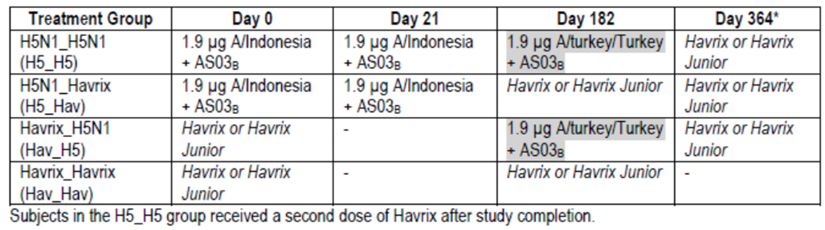
Healthy children aged 3 to 17 years were included. Standard exclusion criteria were used. Children in government or institutional care were excluded.
H5N1 HI antibody titres against the A/turkey/Turkey/01/2005 (H5N1) strain on day 192 were obtained and the GMT ratio of group H5N1_H5N1 over group Havrix_H5N1 was calculated. If the lower limit of the two-sided 95% confidence interval (CI) for the HI GMT ratio on day 192 was > 1.0, then the superiority of priming vaccination was shown. The GMT was adjusted for baseline titre at day 182.
A sample of 150 subjects in group H5N1_H5N1 and 100 subjects in group Havrix_H5N1 had 99.4% power to detect a two-fold increase in the H5N1 antibody response between the two groups H5N1_H5N1 and Havrix_H5N1, assuming the common deviation was 0.52 (log unit) and using a one-sided two-group t-test with a 0.025 significance level. For the primary safety objective, with 300 evaluable subjects in the H5N1 study vaccine groups, and 200 in the control group, there was at least a probability of 91.0% and 79.9% to detect one AE with an occurrence rate of 0.8% in the H5N1 and control groups, respectively. The enrolment target was 520 to result in 500 evaluable subjects.

Participant flow and demographics
There were 520 children enrolled and vaccinated and 464 (89.2%) in the month 6 ATP cohort for immunogenicity with 127, 152, 84 and 101 in the H5N1_H5N1, H5N1_Havrix, Havrix_H5N1 and Havrix_Havrix groups, respectively. The mean age was 9.5 years, 51.2% were female and all children were Asian. The groups were balanced on age and gender. The completion rate to day 364 was high at 98.1 - 99.4% across the four groups.

Results for the primary efficacy outcome
The adjusted GMT ratio of HI antibodies on day 192 between the H5N1_H5N1 and the Havrix_H5N1 groups for A/Turkey strain was 11.84 (95% CI: 7.3,19.2). As the lower limit of the 95% CI was 7.3, the study met its primary object and the subjects previously primed with heterologous A/Indonesia had a superior response than those not primed. The response was consistent across the two age groups.

Results for other efficacy outcomes
Data from the primary vaccination course in the H5N1_H5N1 and H5N1_Havrix groups showed that both the 3 - 9 and the 10 - 17 year olds met regulatory requirement for immune response at day 42 following the primary vaccination course. At day 42 these groups also had a cross-reactive immune response against A/Turkey.
Ten days after the A/Turkey booster (day 192), the HI antibody response against A/Turkey in the H5N1_H5N1 group met CHMP regulatory requirements for booster factor, booster SCR and SPR. These requirements were not met in the non-primed Havrix_H5N1 group. The neutralising antibody response was similar.
At 12 months, there was persistence of immune response in terms of GMT, SPR, SCR and SCF against both the A/Indonesia and A/Turkey strains in the H5N1_H5N1 group. Neutralising antibody data were again consistent.
Summary: H5N1-032 was a phase III randomised, controlled study in 520 three to 17 year olds which found that children previously primed with vaccine containing A/Indonesia strain had a superior response to the heterologous A/Turkey booster than those not primed. Results were consistent across the age groups of 3 to 9 and 10 to 17 years. The primary vaccination course met CHMP regulatory requirements against homologous and heterologous strains. There was persistence of immune response to 12 months and consistent neutralising antibody data.

Other studies
There were two studies submitted in the dossier which evaluated an H5N1 vaccine containing antigen from a different manufacturing site in Quebec (Q-Pan-001 and Q-Pan-009). The Sponsor stated that study Q-Pan-001 had previously been evaluated.

Q-Pan-001
Methods: Q-Pan-001 was a phase I/II observer-blind, active controlled randomised study of the safety and immunogenicity of monovalent H5N1 vaccine with or without adjuvant and with two different strengths of AS03. It was conducted in 2007 - 2008 at 10 sites in the US and Canada.
The primary immunogenicity objective was to demonstrate the adjuvant activity of AS03 by comparing the immunogenicity of the Quebec-manufactured H5N1 antigen (Q-Pan) at the 3.8 µg dose level with AS03 at two different strengths (full and half) versus that of Quebec-manufactured H5N1 antigen non-adjuvanted at the 3.8 µg dose level.
The study included healthy adults 18 to 64 years. Standard exclusion criteria were used. All subjects received two doses of vaccine 21 days apart and were followed to 6 months. They were randomised in a 1:2:2:2:2 ratio with stratification by age (18 - 40 and 41 - 60 years). The five groups were:
- Group A: Quebec-manufactured A/Indonesia/5/05 H5N1 antigen containing 3.8 µg of HA with no adjuvant
- Group B: Quebec-manufactured A/Indonesia/5/05 H5N1 antigen containing 3.8 µg of HA with full strength adjuvant (AS03A)
- Group C: Quebec-manufactured A/Indonesia/5/05 H5N1 antigen containing 3.8 µg of HA with half strength AS03B
- Group D: Dresden-manufactured A/Indonesia/5/05 (H5N1) antigen containing 3.8 µg of HA with full strength AS03A
- Group E: Dresden-manufactured A/Indonesia/5/05 (H5N1) antigen containing 3.8 µg of HA with half strength AS03B
Additional to the five study groups in the core study, two more study groups were recruited since the following protocol specified conditions were met during the day 42 analysis of the core study arms:
- GMTs fulfilled the ≥2-fold criterion for adjuvant effect, and
- Groups with 3.75 μg antigen with full dose adjuvant (AS03A, Group B) and half dose adjuvant (AS03B, Group C) had Day 42 rates of vaccine homologous HI titres ≥ 1:40 of at least 76%.
The two additional groups, referred to as contingency arms (n = 50 each), received two doses of the vaccine 21 days apart:
- Group H: Q-Pan H5N1 antigen containing 1.9 μg of HA (A/Indonesia) with AS03A
- Group I: Q-Pan H5N1 antigen containing 1.9 μg of HA (A/Indonesia) with AS03B.
Superiority of the adjuvant formulation was to be established if the lower bound of the 95% CI of the GMT ratio exceeded 2.0 and the lower bound of the 95% CI of the difference in SCR exceeded 15%.
There were 675 subjects enrolled and 673 completed to day 42. The ATP immunogenicity cohort included 648 subjects (96%).
Results: The study met its primary objective with a superior response of the Q-Pan vaccine with full strength adjuvant compared to without adjuvant: difference in SCR of 79.9% (95%CI: 69.4 - 87.3%) and GMT ratio of 43 (95%CI: 30 - 63) at Day 42. In addition, the Q-Pan vaccine with half strength AS03 was also found to be superior: difference in SCR of 72.3% (95%CI: 61.0 - 80.8%) and GMT ratio of 30 (95%CI: 20.7 - 43.4).
At day 42, all groups who received adjuvanted vaccine had immune responses meeting CHMP criteria against homologous A/Indonesia and heterologous A/Vietnam strains.
Pooling data from the groups B and C for the Q-Pan vaccine, and from groups D and E for the D-Pan vaccine, found the two formulations (Q-Pan and D-Pan) were equivalent as the 95% CI limits of the GMT ratio were within 0.67 and 1.5. The GMT ratio for A/Indonesia was 0.94 (95% CI: 0.75 - 1.17) and the GMT ratio for A/Vietnam was 1.16 (95% CI: 0.92 - 1.46).
At day 42 in the two contingency arms (1.9 HA with full or half dose adjuvant), all CHMP criteria were met against the homologous A/Indonesia strain. The GMTs were nearly two-fold higher in the AS03A group (331.6) than in the AS03B group (173.9).
Summary: Study Q-Pan-001 demonstrated the superior immune response with adjuvanted vaccine. As a secondary objective it also found equivalence (in adjuvanted formulations) between the vaccine antigen manufactured in Quebec (Q-Pan) and that manufactured in Dresden (D-Pan) as the 95% CI of the GMT ratio was between 0.67 and 1.5 for both antigen strains assessed.

Q-Pan-009
Methods: Q-Pan-009 was a phase II, open label, randomised, parallel group trial in adults which assessed the immunogenicity of an accelerated primary vaccination course in adults of A/Indonesia/5/2005 (H5N1) vaccine with AS03A adjuvant. It was conducted at 3 centres in Canada between 2008 and 2009. Healthy adults aged 18 to 64 years were included and the standard exclusion criteria were applied.
The primary objective was to demonstrate that H5N1 antigen in association with AS03A administered in accelerated immunisation schedules elicits, at day 14 after the second dose, an immune response measured by post-immunisation vaccine-homologous virus HI titres that meets or exceeds the Center for Biologics Evaluation and Research (CBER) guidance targets for SCR and also provides a potentially useful rate of attainment (= 50% of subjects) of reciprocal HI titres of ≥ 40.
Subjects were randomised to one of four treatment groups in a 1:1:1:1 ratio with stratification by age group (18 - 40 and 41 - 60 years). Subjects received vaccination with Q-Pan H5N1 vaccine containing A/Indonesia strain (3.75 μg HA/AS03A) according to a standard 2-dose schedule (day 0, 21, group A) or accelerated schedules (days 0, 14 [group B] or days 0, 7 [group C] or both doses on day 0, one in each arm [group D]). Subjects were followed to month 6.
The primary immunogenicity variable was the homologous HI antibody titre 14 days after the second dose of vaccine. Demonstration that the H5N1 antigen in association with AS03 elicits an immune response was if the lower limit of the 98.75% CI for SCR was ≥ 40% in any of the treatment groups and if the lower limit of the 98.75% CI for SPR was ≥ 50% in any of the treatment groups 14 days after the second vaccination.
Results: There were 312 subjects vaccinated with 78 in each treatment group. The ATP cohort for immunogenicity included 283 (90.7%). There were 304 subjects who completed the study to day 51. There was a higher rate of exclusion from the ATP cohort in groups A (16.7%) and group B (11.5%) than groups C and D (5.1% and 3.8%, respectively). The mean age was 40.3 years, 53.2% were female and 87.8% Caucasian. There were more females (61.5%) in group D than in other groups (46 - 55%).
At day 14 post the second vaccine dose, the lower limit of the 98.75% CI of the SCR was ≥ 40% thus meeting the FDA targets, although the response was greater in groups A and B (97% and 93%) where the vaccines were given at a 21 or 14 day interval than in groups C and D (72% both). The result was consistent across the two age groups (18 - 40 and 41 - 60 years).
Likewise, in all groups the SPR at 14 days post the second vaccination met targets as the lower limit of the 98.75% CI was ≥ 50%. Again, rates were higher in groups A and B (93 - 97%) than groups C and D (74 - 75%). When examined by age group, the younger age group of 18 - 40 years in groups C and D did not meet the SPR target. It was noted that the lower limit of the CI was < 70% and so the accelerated schedules of group C and D did not meet the FDA requirements.
CHMP immunogenicity requirements were met at day 14 and 21 in all treatment groups. Responses to drift variants A/Vietnam and A/Turkey were less than to the homologous strain in all groups and higher in groups A and B than C and D.
Summary: Results indicated that in pandemic situation it could be possible to reduce the vaccine administration schedule to two doses 14 days apart rather than the recommended 21 days.

Analyses performed across trials (pooled analyses and meta-analyses)
None submitted.

Evaluator’s conclusions on clinical efficacy for Influenza prevention
The dossier included 18 clinical trials, 16 carried out in Europe and Asia and the two Q-Pan studies were conducted in the US and Canada. Study duration ranged from 6 months up to 48 months (H5N1-002/-030/-038) and enrolled healthy adult volunteers (with well controlled diseases in H5N1-008 and -010). Two studies included adults >60 years (H5N1-010 and -008/-011). There were three paediatric studies, H5N1-013, H5N1-009 and H5N1-032, which enrolled children aged 6-35 months, 3-9 years and 3–17 years, respectively. Most of the adult subjects were Caucasians (range 85.0-100%), except for study H5N1-041 and H5N1-002 and its extensions where subjects were predominantly Asian. For the paediatric studies, H5N1-009 included Caucasians, and -013 and -032 mainly Asians.
All studies had a primary vaccination schedule of 0 and 21 days, except some groups in H5N1-012 and the paediatric Study H5N1-032, and Study Q-Pan-009 which assessed accelerated vaccination schedules. Booster vaccination was assessed in several studies: homologous booster in H5N1-012; heterologous booster in H5N1-015, -030, -038, -012 and the paediatric Studies H5N1-013 and -032.
The submitted Prepandrix vaccine contains the D-Pan antigen strain A/H5N1/Indonesia/5/2005 while the registered mock up pandemic vaccines contain D-Pan A/H5N1/Vietnam/1194/2004 or Q-Pan A/H5N1/Indonesia/5/2005. Immunological equivalence of the D-Pan and Q-Pan vaccines was demonstrated in study Q-Pan-001 and so the data were included in this submission. Apart from the different manufacturing sites of the vaccine antigen, there are differences in the vaccine with respect to excipients used in the formulation (Tween-80, Triton X-100 and Magnesium Chloride).
Table 7 summarises the composition of the H5N1 vaccine formulations used in the clinical program. The proposed vaccine contains adjuvant AS03A which was used in all studies apart from paediatric studies which used AS03B and some groups of Q-Pan-001. AS03A is the so called full dose and AS03B contains half of this dose. The proposed antigen dose is 3.75 µg. In general, the paediatric studies assessed half the adult dose.
Table 7: Composition and lot numbers of H5N1 vaccine formulations used in clinical trials.
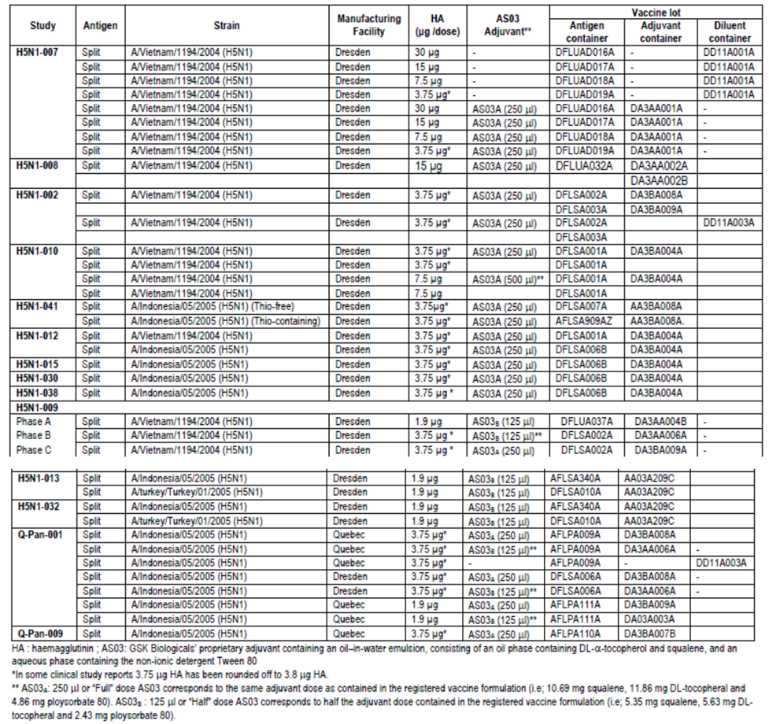
All serology testing of HI antibody response and serum neutralisation was performed in GSK Biologicals’ central laboratory using standardised procedures which have been validated by the sponsor. The HI antibody titre was used as the main measure of the immunogenicity response to the vaccine. The use of this surrogate efficacy endpoint is accepted by EU and US guidelines.
The studies were well conducted and the overall rate of premature discontinuation was low at 1.5% (157/10208). The most frequent reasons were consent withdrawal, moved from study area and lost to follow-up.

Antigen dose
Antigen dose was based on Study H5N1-007 where it was demonstrated that in presence of the AS03 adjuvant, antigen content as low as 3.75 µg was sufficient to induce the immune response meeting all three CHMP criteria. This dose was selected as it was the lowest dose which still yielded high immunogenicity. No lower doses were assessed in Study 007. In children, there was a higher response with full (3.7 µg) HA dose in Study -009 however the half strength dose (1.9 µg) elicited a satisfactory immune response across the age groups in all three trials.

Adjuvant dose
Adjuvant dose selection was based on results from Study Q-Pan-001 which found that adjuvanted vaccine (both full and half strength) was superior to non-adjuvanted vaccine as determined by SCR and GMT at day 42. Post hoc analyses found the reduction of the AS03 adjuvant dose (full to half) had a modest effect on vaccine homologous virus immunogenicity in subjects 18 to 40 years old, but led to a significant reduction in GMT and proportion of subjects attaining reciprocal titres ≥40 (SPR) among subjects 41-64 years old. For this reason, the full dose was recommended. Study H5N1-007 provided supportive evidence for the benefit of the adjuvanted formulations.

Primary vaccination homologous response
The included studies provided strong evidence for the immunogenicity of a two dose primary vaccination course at days 0 and 21 (3.75 µg HA, AS03_{A} vaccine). All regulatory criteria (SCR, SPR and SCF) for HI homologous antibody response were met for adults, including those aged >60 years, at 21 days following the second vaccination (Table 8). The response was seen for the A/Indonesia and the A/Vietnam strains. Similarly, in children, the homologous response (A/Vietnam in -009 and A/Indonesia in -013 and -032) following a two dose priming course with the half strength vaccine met the adult regulatory criteria (Table 9).
Table 8: Studies H5N1-007, H5N1-002, H5N1-010, H5N1-041, H5N1-015 and Q-Pan-001: HI antibody responses against the homologous vaccine strain after two doses of H5N1 vaccine (3.75 µg HA) with or without AS03_{A} at Day 42 in adults (ATP immunogenicity cohort).
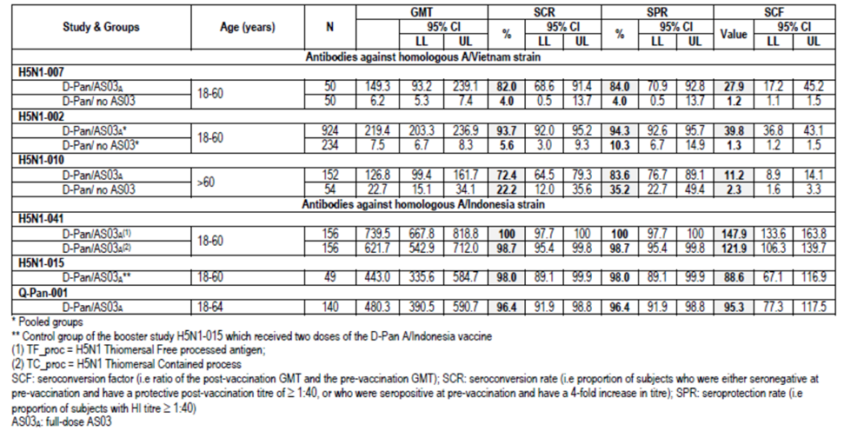
Table 9: Studies H5N1-009, H5N1-013 and H5N1-032: HI antibody responses against vaccine homologous strain after two doses of H5N1 vaccine at Day 42 in children (ATP immunogenicity cohort).
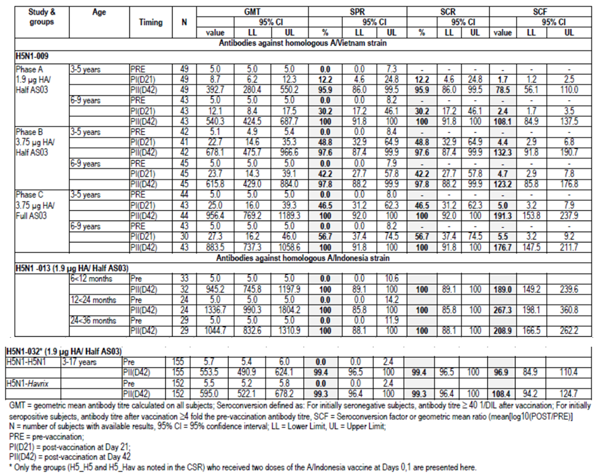
The homologous neutralising antibody response was high with adjuvanted vaccine, although the VRR in adults >60 years was notably less than those 18-60 years which may have been due to high baseline seropositivity in the elderly (93%)(Table 10). Children also demonstrated a strong homologous neutralising antibody response (Table 11).
Table 10: Studies H5N1-007, H5N1-002, H5N1-010, H5N1-015 and Q-Pan-001: Neutralising antibody responses against the homologous vaccine strain after two doses of H5N1 vaccine (3.75 µg HA) with or without AS03_{A} at Day 42 in adults (ATP immunogenicity cohort).
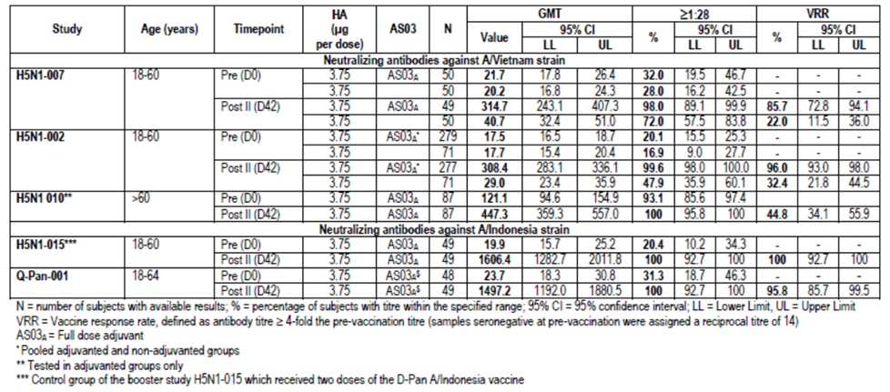
Table 11: Studies H5N1-009, H5N1-032, H5N1-013: Neutralising antibody responses against vaccine homologous strains at Day 42 (ATP immunogenicity cohort).
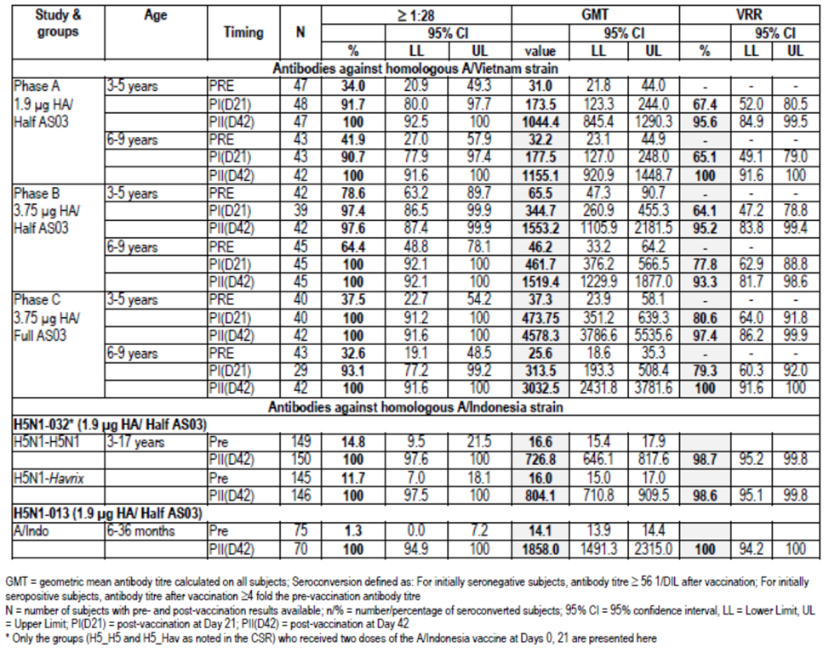

Primary vaccination heterologous response
The adjuvanted vaccine demonstrated cross reactive immunity to drifted strains although not all CHMP criteria were met on Day 42 following a 2 dose course (Table 12). The cross reactive immune response in children was high (Table 13). There was evidence of a heterologous neutralising antibody response with the adjuvanted vaccine in adults although results were more variable (Table 14). Children 3-9 years had a high heterologous NA response with a VRR of 95-97% and seropositivity of >95% after two doses of half strength adjuvanted vaccine (Day 42).
Table 12: Studies H5N1-007, H5N1-002, H5N1-010, H5N1-041, H5N1-015 and Q-Pan-001: HI antibody responses against the heterologous vaccine strain after two doses of H5N1 vaccine (3.75 µg HA) with or without AS03_{A} at Day 42 in adults (ATP immunogenicity cohort).
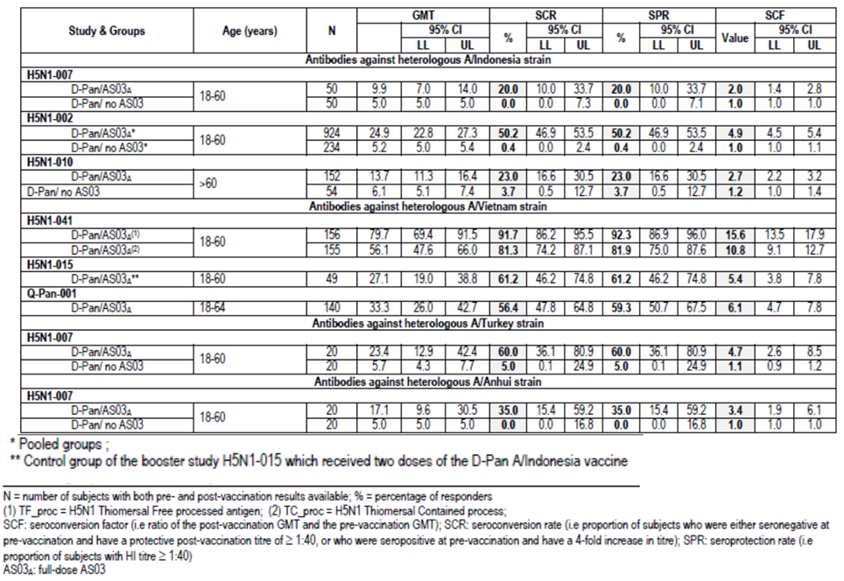
Table 13: Studies H5N1-009 and H5N1-032: HI antibody responses against the heterologous strain after two doses of H5N1 vaccine at Day 42 in children (ATP immunogenicity cohort).
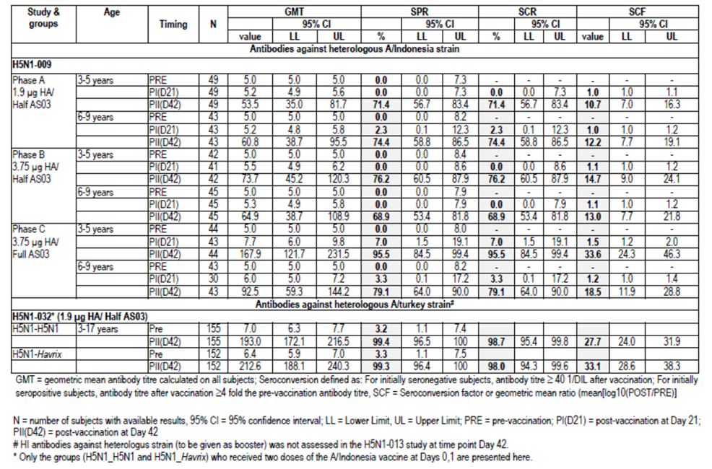
Table 14: Studies H5N1-007, H5N1-002, H5N1-010, H5N1-041, H5N1-015 and Q-Pan-001: Neutralising antibody responses against heterologous strains at Day 42 (ATP immunogenicity cohort).
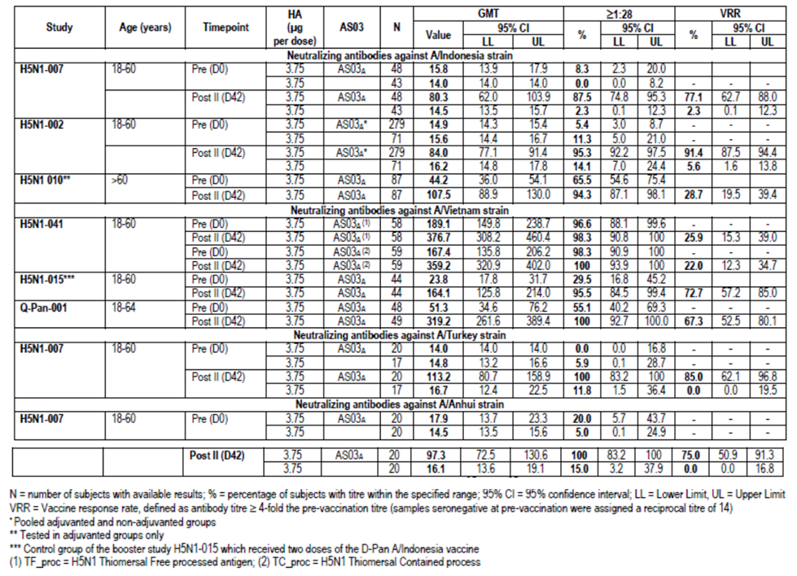

Vaccination schedule
Study Q-Pan-009 demonstrated that an accelerated schedule of 0 and 14 days led to an immune response that was satisfactory and could be employed if required. Shorter schedules of 0,7 days and two doses on day 0 resulted in lower responses. Study -012 found that an increased period of 0 and 6 months or 12 months led to a robust immune response.

Booster response
In adults, when given a booster dose of the same strain as the 2 dose primary vaccination course (A/Vietnam) at 6 or 12 months, the HI immune response met all CHMP criteria (Study H5N1-012). The response was notable by 7 days post vaccination. When the booster vaccination was a heterologous strain (A/Indonesia) to the priming course (A/Vietnam) the HI immune response against the booster strain also met CHMP criteria (day 21 post booster). This was the case if the priming course was one or two doses and the booster was at 6 or 12 months. These data were supported by NA response to the booster strain (H5N1-012). Heterologous booster vaccination was able to be given at 6, 12, 14 or even 36 months post a two dose priming course and induce a strong immune response meeting CHMP criteria (H5N1-030,-038 and -015) (Table 15).
Table 15: Studies H5N1-030, H5N1-038, H5N1-015: HI antibody responses against booster vaccine strain H5N1 A/Indonesia after two doses of primary vaccination with A/Vietnam (ATP immunogenicity cohort).
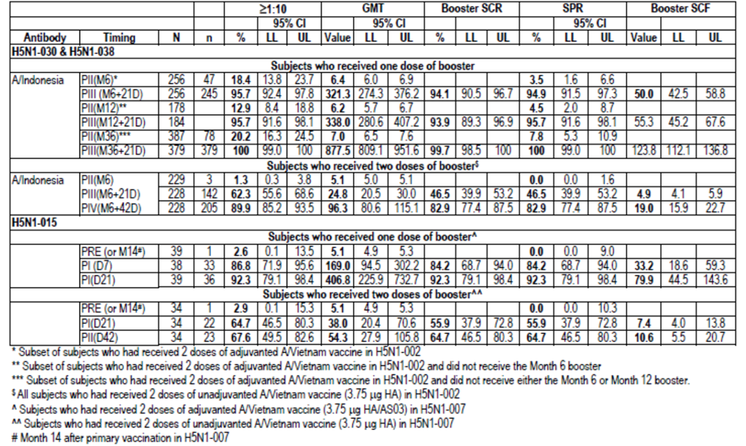
Heterologous booster was given at 6 months after the two dose primary vaccination course in the paediatric Studies H5N1-013 and -032. Study H5N1-032 found a superior booster response in 3-17 year olds primed with two doses of heterologous vaccine compared to those not primed. The HI antibody response to the booster strain 10 days after vaccination met all CHMP criteria in the 6 to 36 month old children in H5N1-013 (Table 16).
Table 16: Studies H5N1-032 and H5N1-013: HI antibody responses against booster vaccine strain 10 days after the booster dose (ATP immunogenicity cohort).
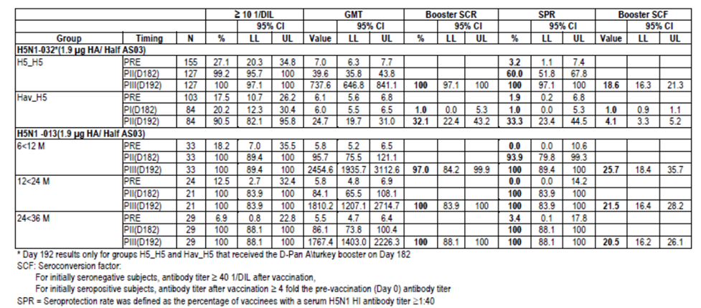

Persistence of immune response
Persistence of immune response up to 6 months following administration of two doses of D-Pan vaccine was assessed in all D-Pan studies. Data were available up to 36 months in adult subjects from H5N1-002 and its extension and up to 24 months in a subset of the elderly in H5N1-011 and the paediatric population of H5N1-009. In general, the GMTs were declining at 6 months although still above pre vaccination levels, the SCF met CHMP criteria at 6 months, then it and other immune measures waned (Table 17). HI antibody to heterologous strains also declined and did not meet regulatory criteria. Seropositivity to neutralising antibodies remained high to 24 months. Twelve months after booster vaccination, the immune response meet CHMP criteria and at 48 months after booster vaccination in H5N1-038, 64% of subjects were seropositive.
Table 17: Studies H5N1-007, H5N1-010, H5N1-041 and Q-Pan-001: Persistence of H1 antibody responses against vaccine strain (ATP persistence cohort).
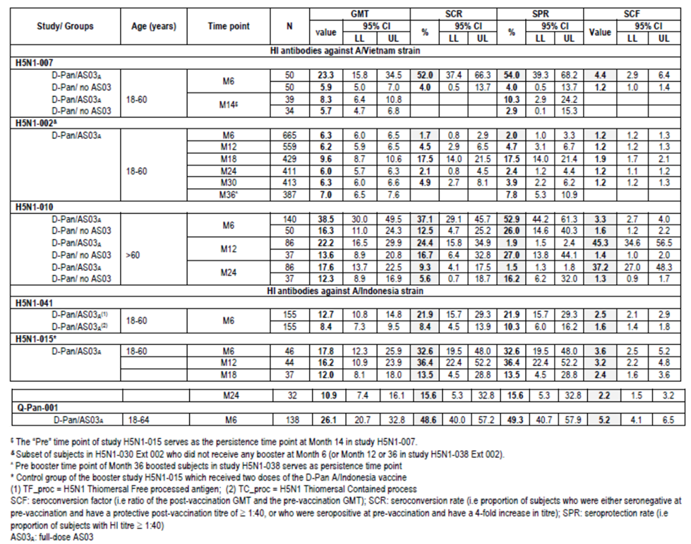
In children, HI immune response persistence at 6 months was greater in those who had received full dose vaccine compared to half strength particularly against the heterologous strain (H5N1-009); however neutralising antibody data in the half strength group were high (seropositivity 92-93% and VRR 95-100%). Data from Studies 013 and 032 found robust persistence to 6 months of HI antibody and neutralising antibody response for homologous and heterologous strains. This was also the case after booster vaccination.
Overall, the immunogenicity data from the clinical trials included in the dossier are accurately reflected.

Clinical safety

Studies providing evaluable safety data
The following 14 studies provided evaluable safety data:
- Adult primary vaccination studies
  - H5N1-007, H5N1-008, H5N1-002, H5N1-010 (elderly adults), H5N1-041
- Adult booster studies
  - H5N1-012, H5N1-015, H5N1-030, H5N1-038
- Paediatric primary vaccination studies
  - H5N1-009 (3 to 9 years);
- Paediatric booster studies
  - H5N1-013 (6 to < 36 months); H5N1-032 (3 to 17 years)
- Supportive studies
  - Q-Pan-001 and Q-Pan-009
The Sponsor also submitted two Integrated Summaries of Safety (ISS) which included relevant data from adult trials. These were compiled at the request of the FDA. The first (2008) included eight studies performed with the AS03 adjuvanted Q-Pan and D-Pan H5N1 vaccines (six D-Pan studies: H5N1-007, H5N1-002/030, H5N1-008/011, H5N1-010/021, H5N1-012 and H5N1-015; two Q-Pan studies: Q-Pan-001 and Q-Pan-002). The second ISS (2011) included studies performed with the AS03 adjuvanted D-Pan and Q-Pan H5N1 vaccines, as well as studies conducted more recently with the D-Pan and Q-Pan H1N1 vaccines (total of 28 studies). The first ISS aimed to develop estimates of AEs and to examine for rarer events. The second ISS aimed to assess less common and more serious AEs, in particular medically attended events (MAEs), SAEs and potential immune-mediated diseases (pIMDs).
Evaluator’s Comment: The ISSs were discussed in the Summary of Clinical Safety however the data were not included. A question has been raised on this.
Much of these safety data have been evaluated previously: study H5N1-007 and -008 in the original Prepandemrix dossier (2008); study Q-Pan-001, H5N1-007 -008, -002 and the first ISS (2008) in the Arepanrix H5N1 dossier (2011); and H5N1-010 and -009 in the Pandemrix dossier (PM-2012-02732-3-2).

Safety and reactogenicity methods
In the clinical studies, information was collected on local and general AEs and recorded by each subject using diary cards for the first seven days (days 0 - 6) following each vaccination. General adverse events (fatigue, fever, headache, myalgia/muscle aches, shivering, sweating/sweating increase and arthralgia/joint pain at other location) were solicited during a 7-day (days 0 - 6) follow-up period after each vaccination in all studies. Local symptoms (pain, redness, swelling, ecchymosis, and induration at the injection site) were also solicited during this period. Solicited symptoms were deemed related to the vaccination. The solicited symptoms were slightly different in the paediatric studies. Unsolicited AEs within the 21 days following first vaccination, and 30 days following second vaccination, were recorded. In the paediatric studies, they were reported to day 180 in H5N1-009 and from day 0-84 in H5N1-013 and -032 and for 21 days after booster vaccination. SAEs were collected for the duration of the study periods.
In studies Q-Pan-001 and H5N1-008, investigators were asked to identify on the CRF AEs that they considered as New Onset of Chronic Disease (NOCD). Adverse events of specific interest (AESI), potential immune-mediated diseases (pIMDs) including autoimmune diseases and other immune-mediated inflammatory and/or neurological disorders were also assessed. Laboratory assessments (haematology and biochemistry) were undertaken in H5N1-010, H5N1-009 and Q-Pan-001.
Safety analysis was on the total vaccinated cohort for safety which included all vaccinated subjects for whom safety data were available.

Pivotal studies that assessed safety as a primary outcome
The primary outcome of study H5N1-008 was safety. As this study has previously been evaluated the data are summarised in Section 8.4 with other study data.

Patient exposure
In total, 16541 doses of AS03-adjuvanted H5N1 split influenza vaccine containing the Dresden-derived antigen have been administered as primary or booster vaccination to 8676 subjects in the evaluation of safety. Of these 16541 D-Pan vaccine doses, 6558 doses in 3687 subjects were of the proposed formulation (3.75 μg HA adjuvanted with AS03A).
The A/Indonesia/5/05 strain was used in the D-Pan studies H5N1-041, H5N1-013, H5N1-032 and in Q-Pan-001. All other studies had primary vaccination with A/Vietnam/1194/04. Booster vaccination strain was either A/Vietnam/1194/04 or A/Indonesia/5/05 in all studies except H5N1-013 and H5N1-032, where the booster strain was A/turkey/Turkey/01/2005.
In the two Q-Pan studies, 1336 doses of AS03-adjuvanted H5N1 vaccine have been administered as primary vaccination to 715 subjects. Of these 1336 doses, 838 doses in 464 subjects were of the registered formulation (3.75 μg HA adjuvanted with AS03A). The strain in both Q-Pan-001 and Q-Pan-009 was A/Indonesia/5/05.
For the paediatric studies, H5N1-009 there were 195, 196 and 201 doses given in the 3.8 µg HA /AS03A, 3.8µg HA/AS03B (half dose adjuvant) and 1.9 µg HA/AS03B groups, respectively. In study H5N1-013, 113 subjects received a total of 333 doses of 1.9 μg AS03B D-Pan vaccine. Of these, 225 were priming doses containing half dose AS03-adjuvanted A/Indonesia/05/2005 antigen and 108 were boosters containing half-dose AS03-adjuvanted A/turkey/Turkey/01/2005 antigen. In study H5N1-032, 520 subjects received a total of 1,349 study doses (including doses of both D-Pan and Havrix) to Day 182, with 156 subjects receiving 468 doses of D-Pan 1.9 µg HA/AS03B vaccine for priming and boosting (group H5N1_H5N1).

Adverse events

Solicited adverse events

Adults
In H5N1-007, the rate of solicited local AEs reported during the 7 days post vaccination was greater with adjuvanted than non-adjuvanted vaccine. This included pain, redness, swelling, induration and ecchymosis. Pain was the most frequent solicited AE and was notably higher with adjuvanted than non-adjuvanted vaccine (81 - 83% vs 26 - 46%) (Table 18). Solicited general AEs were also more frequent with adjuvanted vaccine. The most frequently reported symptoms were fatigue and headache and were observed following 20.0%-24.0% and 18.0%-23.0% of doses, respectively, in the non-adjuvanted vaccine groups, as compared with 34.3%-49.0% and 29.6%-42.0% of doses, respectively, in the adjuvanted vaccine groups. Grade 3 solicited local AEs were low (0 - 6%) with no marked difference between adjuvanted or non-adjuvanted vaccine groups. There was no relationship between the incidence of general adverse events and the vaccine dose.
Table 18: Studies H5N1-007, H5N1-002, H5N1-010 and Q-Pan-001: Percentage of doses followed by solicited local symptoms including those of Grade 3 intensity (total vaccinated cohort).
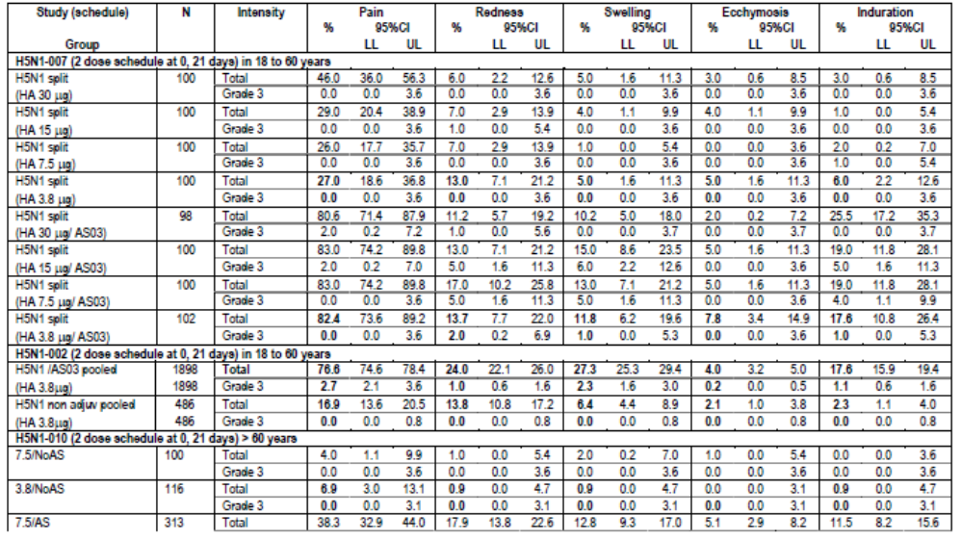
In studies H5N1-002 and Q-Pan-001, pain was the most frequent solicited local symptom with rates of 77% to 85% and grade 3 pain rates of 2.7% to 3.7% in the 3.75µg HA/AS03A group (Table 18).
In study H5N1-012, the rate of solicited AEs after booster vaccination was similar between vaccine strains given. There was a higher incidence (compared to priming doses) of general solicited AEs with comparable rates of local solicited AEs and of grade 3 solicited symptoms. In other booster studies, H5N1-015, H5N1-030 and H5N1-038 this trend of higher general symptoms post booster compared to post priming doses was also seen with myalgia, fatigue and headache the most frequent symptoms.
In study H5N1-041 the rates of local and general solicited events were similar between thiomeral free and containing vaccines. The solicited reactogenicity data from the Q-Pan-001 and -009 studies was not markedly different to the D-Pan studies. Again there was a higher rate of events with adjuvanted vaccine.

Elderly
From study H5N1-010 in 437 subjects aged >60 years, the rate of solicited local AEs in the first 7 days was greater with adjuvanted vaccine. The elderly had pain less frequently reported than in the younger adults in studies discussed above (rate in elderly 3.8/AS group of 32.6%). Overall, 4.3% of subjects in the 3.8/AS vaccine group experienced grade 3 solicited local AEs compared with 11.9% of subjects in the 7.8/AS vaccine group. In contrast, no subjects in the two non-adjuvanted vaccine groups experienced solicited local AEs of grade 3 intensity in the seven days following vaccination. All solicited local symptoms occurred less frequently in subjects in the 3.8/AS than the 7.5/AS vaccine group, but there were no statistically significant differences between the two adjuvanted treatment groups as regards any of the solicited local AEs (Table 18). The rate for general solicited AEs in the elderly was similar between the 3.8/AS and 7.5/AS groups (34.1% vs 37.7%) although grade 3 events were higher in the 7.5/AS group (5.7% vs 1.2%). In the 3.8/AS group, fatigue was the most frequent event (12.9%) followed by headache (10.8%).

Paediatric population
In H5N1-009, the adjuvanted formulation resulted in a higher rate of solicited local and general AEs compared to Fluarix control in the 3 to 9 year old population. Pain was the most frequent event (41 - 73.5%) with 2.0 - 6.0% having grade 3 pain. In the 3 - 5 years age group, the incidence of solicited local AEs was notably higher in the H5N1 full adult dose group than the H5N1 half adult dose group for all events apart from ecchymosis. Pain (any grade) was very commonly reported in both the H5N1 full adult dose and H5N1 half adult dose groups (62.9% vs 48.5%, respectively). In the 6-9 years age group, the incidence of solicited local AEs was also higher in the H5N1 full adult dose compared to half dose.
In both the 3 - 5 and the 6 - 9 year old groups, all solicited general AEs were reported more commonly in the H5N1 full adult dose group compared with the H5N1 half adult dose group. Overall, the incidence of grade 3 solicited general AEs was low in both dose and both age groups. Fever (> 39.0°C) was the most commonly reported grade 3 AE in the H5N1 full adult dose groups (5.2%, 3 - 5 years; 7.1%, 6 - 9 years). In the H5N1 half adult dose groups, grade 3 fever (> 39.0°C) was reported after 2.0% and 0% of doses given to children aged 3 - 5 and 6 - 9 years, respectively. The rate of fever with full dose antigen increased after the second vaccination from 8.2% to 31.3% in subjects 3-5 years and from 12.2% to 32.7% in subjects 6 - 9 years. The most commonly reported grade 3 AE in 3 - 5 year olds was loss of appetite (3.0% vs 5.2%, half vs full dose). The most commonly reported grade 3 AE in 6 - 9 years olds was headache (2.0% vs 3.1% half vs full dose). There were no reports of febrile convulsions reported with either H5N1 vaccine or Fluarix. The use of antipyretics in the full dose compared to half dose group was higher 51.0% vs 16.3% respectively in 3 - 5 year olds, and 65.3% vs 16.7%, respectively in the 6 - 9 years group.
In study H5N1-013 (6 - 35 month old children) there was an increase in reactogenicity with each subsequent vaccine dose (half strength) with the rate of solicited and unsolicited AEs increasing from 32.1% at dose 1, to 34.2% at dose 2 and 51.9% at dose 3. Fever increased from 12.5%, 32.4% and 50.5% and grade 3 fever 1.8%, 5.4% and 10.2%. This trend was also evident in study H5N1-032 in children 3- < 6 years. The most common local symptom was pain and most frequently reported general symptoms were irritability and fussiness in < 6 year olds and headache in those over 6 years.

Unsolicited adverse events

Adults < 60
Any other AEs reported to the investigator during the 21-day follow-up period after the first vaccination and the 30-day follow-up period after the second vaccination were documented as unsolicited AEs.
In pooled data from H5N1-007 and -008, the rate per dose of at least one unsolicited AE was 24.4% and 19.0% in the adjuvanted H5N1 and control groups, respectively. The rate per dose of grade 3 events was similar between groups (2.5% vs 2.2%). In study H5N1-002, the rate per dose of unsolicited events was 18.9% vs 17.9% in the adjuvanted and non-adjuvanted groups. The most frequent events were injection site warmth and pruritus as well as flu-like symptoms and gastrointestinal symptoms. Grade 3 unsolicited events were infrequent (1.4% vs 0.8% in the adjuvanted and non-adjuvanted groups, respectively).
The rate of unsolicited AEs per dose was similar in the thiomersal containing and free vaccine groups in H5N1-014 (19.2% vs 19.7%). The rate of grade 3 events was 2.5% vs 1.3%, and the rate of related AEs was 4.1% vs 5.6%, respectively.
In study H5N1-012, following booster vaccination the unsolicited AE rate per dose (during the following 30 days) was similar in those who received one or two primary doses (6 month booster: 9.8 - 12.4% vs 5.5 - 6.8%, 12 month booster: 17.2 - 25.8% vs 26.4 - 28.6%). Rates were similar between groups receiving A/Indonesia or A/Vietnam strain booster vaccine.
In study H5N1-015, the per dose rate of unsolicited AEs after booster dose of adjuvanted H5N1 A/Indonesia was 39.7 - 49.5% and 32.5 - 50.0% in subjects who had received priming with non-adjuvanted/control and adjuvanted vaccine, respectively. The most frequent events were URTI, headache and rhinitis.
The per dose unsolicited AE rate following booster at month 6 (30 days follow up) in H5N1-030 was 24.5% in those primed with adjuvanted vaccine and 13.0% in those primed with non-adjuvanted vaccine (study H5N1-002). The grade 3 AE rate was 1.9% and 1.3%, respectively. When boosted at month 12 (H5N1-038) the percentage of subjects with unsolicited AEs and grade 3 AEs was 23.4% and 3.2%, respectively.

Elderly
In study H5N1-010, the rate per dose of at least one unsolicited AE in the post vaccination reporting period was 12.8% and 9.5% in the 3.8/AS and 7.5/AS groups, respectively, compared to 14.4% and 8.8% in the 3.8 and 7.5 non-adjuvanted groups. The rate of grade 3 unsolicited symptoms ranged from 1.0 to 2.5% with no evident trends. Unsolicited AEs (preferred term) occurring in ≥ 1% of subjects in the 3.8/AS vaccine group (vs the 7.5/AS group) were: tracheitis (2.4% vs 0%); pain in extremity (1.8% vs 0%); diarrhoea (1.8% vs 0.6%); nausea (1.2% vs 1.9%); arthralgia (1.2% vs 0%); vertigo (1.2% vs 0.6%); upper abdominal pain (1.2% vs 0%); cough (1.2% vs 0.6%); nasopharyngitis (1.2% vs 0%); rhinitis (1.2% vs 0.6%); and erythema (1.2% vs 0.6%). Unsolicited AEs occurring in ≥1% of subjects in the 7.5/AS vaccine group (vs the 3.8/AS vaccine group) were: injection site pruritus (2.5% vs 0%); nausea (1.9% vs 1.2%); pharyngitis (1.3% vs 0.6%); and neck pain (1.3% vs 0.6%). All other unsolicited AEs in the 7.5/AS vaccine group occurred in only 1 patient for each event.

Paediatric population
Up to day 51 in study H5N1-009, the rate per dose of unsolicited AEs in the half adult H5N1 dose groups was 56.9% in the 3-5 years and 19.6% in the 6-9 years group. The corresponding percentages in the full adult H5N1 dose groups were 53.1% and 55.1%. The rate per dose of grade 3 unsolicited AEs with half adult H5N1 vaccine was 7.8% and 2.0% in the 3 - 5 and 6 - 9 year old group, respectively and in the H5N1 full-adult dose groups were 6.1% and 2.0%. The rates per dose of unsolicited AEs were similar between the half strength H5N1 and Fluarix groups but higher in the full dose group. The most common events were URTI, cough and gastroenteritis, tonsillitis, pharyngitis.
In the full dose group, the rate of events deemed related to vaccination was 18.4% and 6.1% for 3 - 5 and 6 - 9 year olds, respectively, compared to 0% and 5.6%, respectively in the Fluarix group. One 5 year old subject in the H5N1 full adult dose group developed an AE of unilateral anterior chamber uveitis at 8 days after the second dose, which was considered to have a potential causal relationship to vaccination. About 2 months, later after topical corticosteroid treatment, the subject recovered with a residual mydriais.
In H5N1-013, the percentage of doses with unsolicited events within 21 days of vaccination was 32.1%, 32.0% and 38.4% in the 6- < 12, 12- < 24 and 24- < 36 month old groups, respectively. Grade 3 events ranged from 2.0 to 3.6%. The rate of any grade 3 event (local or general, solicited or unsolicited) also increased with increasing dose from 4.5% to 5.4% to 17.6% after dose 1, 2 and 3, respectively. The per dose rate of unsolicited AEs that were treatment-related was 10.2%, 5.2% and 9.1% in the 6- < 12, 12- < 24 and 24- < 36 month old groups, respectively. The most frequent events in the overall population were cough (1.8%), rhinorrhoea (1.8%), nasopharyngitis, rhinitis and URTI (each 1.2%). Two grade 3 events were deemed related to vaccination (nasopharyngitis and face swelling).
In study H5N1-032, the percentage of doses with unsolicited events (within 21 days of vaccination) in children receiving H5N1 vaccine for priming and booster was 15.8% with a rate of 21.1% in 3 to 9 year olds and 10.4% in 10 to 17 year olds. Again, URTI was the most frequent AE. The percentage of doses with grade 3 unsolicited events in this H5N1_H5N1 group was 0% and 0.4% in the 3 - 9 year and 10 - 17 year age group, respectively.
In H5N1-009, the incidence of unsolicited AEs between Day 51 and Day 180 were low in the three H5N1 vaccine groups and comparable with that in each of the Fluarix control groups. There was no difference in the incidence of unsolicited AEs between Day 51 and Day 180 between the two age groups in each of the three Phases (A, B, C).

Adverse events of special interest
Lymphadenopathy (unsolicited) was examined in D-Pan studies. In study H5N1-007 there were 7 subjects with reported lymph node swelling, all were in vaccine dose group above 3.8 µg. None were grade 3 and all resolved. In H5N1-008, the rate per dose of lymphadenopathy/lymph node pain/lymphadenitis was higher in H5N1/AS03 than control groups (1.25% vs 0.44%). In H5N1-002, of 961 subjects receiving 3.8 HA/AS03 vaccine there were 3 cases of lymphadenopathy. There was one (0.6%) elderly subject in H5N1-010 (7.5 HA/AS group) with lymphadenopathy and two subjects (1.3%) in the thiomersal-containing vaccine group in H5N1-041. H5N1-009 there were also 2 reported cases, neither of which was severe. The rate in booster studies varied up to a maximum of 7.5%. Overall, lymphadenopathy risk was low, non-severe and resolved.
Medically attended events: In H5N1-008, medically attended events (MAEs) to day 180 (as reported by the investigator) for adults 18 - 60 and > 60 years, occurred in 3.4% and 3.9% of the H5N1/AS03 group compared to 2.8% and 3.9% of the Fluarix group. In H5N1-038, medically attended events within 30 days of booster with A/Indonesia at month 36 occurred in 9.7% of subjects and 1.8% were due to influenza like illness.
In the paediatric study H5N1-013, the rate of MAEs during the study year was 63%, 55.9% and 60.6% in subjects aged 6- < 12, 12- < 24 and 24- < 36 months, respectively. In H5N1-032, the rate of MAEs to day 182 was 36.9% and 30.8% in subjects primed with adjuvanted vaccine and those not primed, respectively (pooled data). URTI was the most common MAE in children.
In Q-Pan-001, subjects receiving D-Pan H5N1/AS03 had a MAE rate of 9.3% none of which was grade 3. In Q-Pan-009 the reported rate of MAEs (days 0 - 50) was 16.3% with 4 (1 in each group, 1.3%) that were vaccine-related and grade 3.
New Onset Chronic Disease (NOCD): In the original Prepandemrix dossier data up to day 180 in study H5N1-008 indicated a higher incidence of NOCD in the elderly vaccinated group (1.8%) compared to the elderly control group (0%). The imbalance was considered as a potential safety signal. The adult data on NOCDs are discussed in Section 8.6 with the review of the two integrated summaries of safety.
In H5N1-009 there were 5 cases of potentially immune mediated disease (pIMD) during 24 months follow up, two were considered vaccine-related. One subject who received the full-dose vaccine had grade 3 uveitis on day 8 which resolved after day 51. Another subject who received the full-dose antigen/half-dose adjuvant vaccine was diagnosed with autoimmune hepatitis, based on liver biopsy histology, 294 days after the first dose. This event was also an SAE (see below).

Deaths and other serious adverse events

Deaths
There were 13 deaths in the studies, 12 in D-Pan studies (H5N1-002, -010, -012, -015, -030 and -038) and one in Q-Pan-009 study. No fatal events were reported in studies H5N1-007, H5N1-008, H5N1-009, H5N1-013, H5N1-032, H5N1-041 and Q-Pan-001. No death was assessed as vaccine-related by the investigator.

SAEs
There were 294 subjects with an SAE in the D-Pan studies. Of these, one was classed as treatment-related (pneumonia). During six months of follow up, the rate of SAEs in H5N1-007 was 3.0% (6/200), in H5N1-002 was 0.7% (7/961), in H5N1-008 was 1.2% and in H5N1-041 was 1.8%. In 24 months of follow up in H5N1-015, the SAE rate was 4.2% and in H5N1-012 was 3.5%. After 48 months of follow up in H5N1-030/038, the SAE rate was 8.4%
In the elderly in H5N1-010, during 24 months of the study, the SAE rate was 11.4% (50/437) and five events were fatal. The single treatment-related SAE of pneumonia occurred 299 post last vaccine dose in a subject who received 7.5 µg/AS03 vaccine.
There were 5/405 (1.2%) children in H5N1-009 with an SAE. One was classed as treatment-related. This [information redacted] subject was withdrawn due to elevated transaminases and autoimmune hepatitis was diagnosed on liver biopsy at day 294. The child was reported to have the elevated transaminases prior to vaccination and the event was assessed as predating vaccination. During H5N1-013, 9 subjects reported 18 SAEs and in study H5N1-032, 5 subjects reported 7 SAEs, none of these SAEs were deemed treatment-related.

Discontinuation due to adverse events
There were no discontinuations due to AEs in studies H5N1-007, -041, -013, -032 and in Q-Pan-001. In the elderly subjects of H5N1-010, the only discontinuations due to AEs were the 5 fatal events. In H5N1-002, there were 5 AE discontinuations (all received 3.8 μg HA/AS03), one fatal unrelated event and 4 non-serious events of which 3 were treatment-related (pruritus, urticaria and nasopharyngitis). In H5N1-008, the three discontinuations were due to SAEs and 20 for non-serious events in H5N1 groups.
In the booster study H5N1-015, there were 4 AE discontinuations, 3 were fatal events and one was reported as foot deformity. In the booster studies H5N1-030 and -038, the 3 AE discontinuations included 2 fatal events and one SAE (joint dislocation). In H5N1-012, the events were Hodgkin’s lymphoma, traumatic brain injury and one non-serious event of myalgia. In study Q-Pan-009, the 2 AEs that led to premature discontinuation were SAEs of blunt injury and congestive cardiac failure.
In paediatric studies, the only premature discontinuation due to an AE was the case of autoimmune hepatitis.

Laboratory tests and vital signs
Laboratory assessments were performed in H5N1-009, H5N1-10 and Q-Pan-001.
H5N1-010 Adults > 60 years: The results of the haematological and biochemical analyses (ALT, AST, CREA, BUN, LDH, CPK, differential blood count and haemoglobin) in subjects (> 60 years) from all study groups (days 0 to 42) were generally within the normal range, except for blood urea nitrogen where up to 28.2% of the subjects showed elevated levels. Overall, there were no safety signals from the haematological and biochemical analyses.
H5N1-009 Children 3 - 9 years: When compared to Fluarix controls, overall, the results for the selected biochemistry parameters (ALT, AST, creatinine, BUN, LDH, and CK) did not give rise to safety signals in the full-adult dose vaccine groups or the half-adult dose vaccine groups in children aged 3 - 5 years and 6 - 9 years.
Q-Pan-001 Adults 18 - 64 years: The analyses of haematology and biochemistry (ALT, AST, basophils, eosinophils, haemoglobin, haematocrit, leucocytes, lymphocytes, monocytes, neutrophils, platelet count and red blood cells) showed no trend on biochemistry. On haematology there was a trend for more subjects (3 - 9%) to have haemoglobin or haematocrit below the lower limit of normal. When analysed further, the mean change from baseline was similar across groups and there was no change in WBC or platelet counts. The Sponsor concluded the finding may be due to the study-associated blood draws.
Vital signs were assessed in the paediatric study H5N1-032 but only pre-vaccination. In Q-Pan-001 they were assessed pre and post vaccination and no notable findings were reported.

Concomitant medication use
In studies H5N1-007, -008 and -002, there was a trend for slightly higher concomitant medication use in those receiving adjuvanted vaccine than non-adjuvanted or Fluarix control. Antipyretic use was reported to be mainly for analgesia. In the elderly population of H5N1-010, concomitant medication use was similar between groups although antipyretic use was higher in the adjuvanted than non-adjuvanted groups (11.3 - 12.1% vs 1.9 - 9.8%). There were no remarkable findings on medication use in the periods after booster vaccination.
In H5N1-009 the rate of concomitant medication use was lower in the 6 - 9 compared to the 3 - 5 year olds. The rate was higher in those receiving full dose vaccine (59 - 71%) compared to Fluarix control (29 - 33%), and this was mainly antipyretics (presumably related to the higher fever rate). In H5N1-013, after the first priming dose day 0 the rate of concomitant medication use and antipyretic use was 45% and 31%, respectively. After the second priming dose, the rates were 65% and 50%, respectively. On the booster dose day, the rates were 66% and 59% with 3.7% who took the antipyretic as a prophylactic. In H5N1-032, the medication use post D-Pan/AS03 vaccine dose 1, 2 and 3 was 20%, 45% and 29% and these were also mainly antipyretics.

Integrated summaries of safety

ISS (2008)
In the first Integrated Summary of Safety (ISS) of eight studies there were 9,873 adults included. The first analysis (Analysis 1) was of the two studies with non-H5N1 controls and the second analysis (Analysis 2) was of all 8 studies. This ISS was evaluated in the Arepanrix submission with the following summary:

Local and systemic solicited AEs
Analysis 1 data were used to analyse all solicited AEs and the results of the analysis showed that both local and systemic solicited AEs are clearly increased relative to control preparations following H5N1/AS03 doses. However, they do not appear to worsen with consecutive doses, are predominantly mild or moderate in severity and are apparently tolerable to subjects.

Unsolicited adverse events
In both Analysis 1 and 2, all unsolicited AEs were evaluated in the period including Days 0 to 50 after Dose 1 and Days 0 to 29 after Dose 2, a time period for which a uniform dataset containing all AEs was available for all studies. Among unsolicited AEs, eight MedDRA Preferred Terms (PTs) were associated with an increased relative Risk (RR: lower limit of 95% CI for RR ≥ 1.0) among H5N1/AS03 recipients in contrast to controls. Injection site reaction, injection site warmth, injection site pruritus, malaise, nausea and insomnia demonstrate increased RR in both Analyses 1 and 2. All have a close temporal association with injections, are transient and differ little in duration when H5N1/AS03 and control group cases are compared. The sponsor considers these as elements of short-term reactogenicity.

Medically-attended adverse events (MAEs) and SAEs
MAEs and SAEs were evaluated in Analysis 1: As a class, MAEs do not occur with disproportionate frequency among H5N1/AS03 recipients relative to controls, nor do subsets such as Grade 3 MAEs, vaccine-related MAEs, or Grade 3 and vaccine-related MAEs. Every Preferred Terms (PTs) for which MAEs occurred in >0.1% of the H5N1/AS03 population occurred at a generally similar (or greater) rate among control recipients, with substantial overlap in 95% CIs.
Similar considerations apply to the SAE dataset: The two most common SAE PTs, appear to be over-represented in the H5N1/AS03 group: myocardial infarction in five H5N1/AS03 subjects and no control subjects, and pneumonia in six H5N1/AS03 subjects and one control subject. However, consideration of all SAE PTs indicative of coronary artery disease leads to a more balanced distribution: seven of 7224 subjects in the H5N1/AS03 group (0.1%) versus four of 2,408 subjects in the control group (0.2%). Similarly, the inclusion of the PTs of “pneumonia bacterial” and “pneumonia pneumococcal” with the term “pneumonia” yields a contrast of six of 7224 subjects in the H5N1/AS03 group (0.1%) versus three of 2408 subjects in the control group (0.1%).
Overall, there is no apparent increased incidence of either MAEs or SAEs among H5N1/AS03 recipients, nor is there an obvious clustering of MAEs or SAEs in a particular Primary System Organ Class among H5N1/AS03 recipients.

Adverse events of special interest (AESI)
AESI or pIMDs (potential Immune-Mediated Disease) were evaluated in Analysis 1 and Analysis 2. Fourteen AESI/pIMDs occurred in the H5N1/AS03 group in Analysis 1 and 16 in Analysis 2. This is in contrast with one such event among control subjects. Of the 17 cases reported in total, there is no obvious concentration for any of the antigens, with nine cases in subjects that received vaccine derived from Dresden antigen and 7 cases in subjects that received vaccine derived from Quebec antigen. The antigen dose that the subjects received was 15 μg (7 subjects), 7.5 μg (1 subject) or 3.75 μg (8 subjects), and no unusual concentration appeared in any of those dose groups (relative to the proportion of subjects contributing to the database). All subjects in the H5N1/AS03 group received a full dose of AS03, with the exception of the subject in study H5N1-010, who received both a double dose of AS03 adjuvant and antigen.
A limitation of the ISS analysis is the 3:1 treatment allocation. In order to provide a more meaningful comparison to the H5N1/AS03 group, the sponsor also evaluated the AESI/pIMDs in a pool of clinical trial data from five trials where 11,721 subjects had received either saline placebo or licensed seasonal trivalent inactivated influenza vaccine. The trials selected included all clinical trials since 2004 that used the company’s licensed seasonal trivalent inactivated influenza vaccines and/or placebo controls in observer-blind controlled designs and included approximately 6 months of safety follow-up for at least medically-attended AEs. The dataset mimicked the control and H5N1/AS03 groups in the ISS closely in terms of demographics, in terms of test article exposure and in duration of safety follow-up. The subject incidence rate of the aggregate AESI/pIMDs in this historical control dataset was 18 of 11,721 subjects, which is similar to that seen for the H5N1/AS03 recipients in the Analysis 1 or Analysis 2 datasets. When the proportions of H5N1/AS03 recipients with AESI/pIMDs from Analysis 1 or Analysis 2 were compared to the proportions of subjects with AESI/pIMDs in the control groups, no significant differences were observed, as shown in Table 19.
Table 19: Proportions of H5N1/AS03 recipients with AESI/pIMDs contrasted to various control datasets.
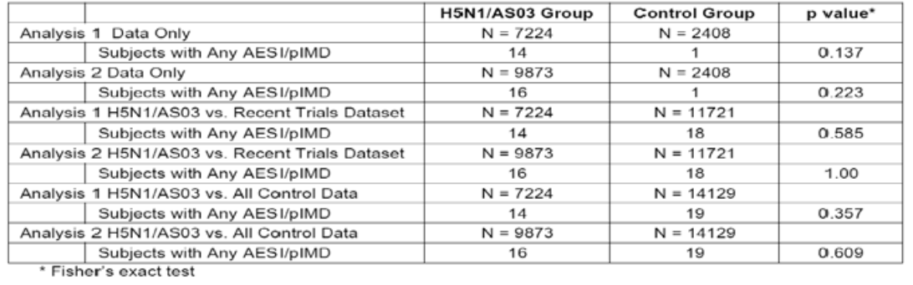
Evaluator’s Comment: It was reported that local and systemic reactogenicity did not increase after the second vaccine dose. Overall, no unexpected findings were revealed in this ISS analysis; in particular, the analysis of AESI/pIMDs and a comparison with historical clinical trials databases did not provide any strong evidence to support a causal relationship between the incidence of AESI/pIMD and the use of AS03 adjuvanted H5N1 vaccine. However, the limited number of events in each study precludes an assessment of consistency, and the available data are considered insufficient to either confirm or refute the causal relationship. The association between the occurrence of these rare AESI/pIMD events and the use of the vaccine can neither be established nor ruled out.

ISS (2011)
Methods: The second ISS (2011) combined data from H5N1 and H1N1 studies in order to assess the incidence of MAEs, SAEs and detect rare AEs and in particular pIMDs. There were 28 studies included all with adjuvanted formulation and 14 of these studies had controls. The primary vaccination database included 22,521 subjects aged ≥ 18 years and the booster database 3,158 adults. Pooling was regardless of antigen strain, antigen or adjuvant dose or antigen manufacture site. Controls received saline or split virion antigens without adjuvant. Of note, the Sponsor stated that most H5N1 studies were carried out before more stringent collection of safety data in relation to pIMDs while the H1N1 studies were conducted later when there was more focus on this area. There was no controlling for multiplicity. In this report the term AESI/pIMD was simplified to pIMD. The Sponsor stated the group of AEs included in the list of MedDRA preferred terms was generated in collaboration with the FDA.
There were a number of analyses carried out:
- Level 1 – H5N1 only
  - Analysis 1a: adjuvanted formulations vs. controls (controlled trials) (n = 10,132 H5N1, 3168 controls)
  - Analysis 1b: same as 1a, excluding vaccine recipients who received AS03B (n = 9303 H5N1 and 3168 controls)
  - Analysis 2a: adjuvanted formulation based on both controlled and uncontrolled trials (n = 11,376)
  - Analysis 2b: same as 2a, excluding vaccine recipients who received AS03B
- Level 2 – H5N1 and H1N1 combined
  - Analysis 3a: adjuvanted formulations vs. controls (controlled trials) (n = 13,325 H5N1+H1N1 and 6,361 controls)
  - Analysis 3b: same as 3a, excluding vaccine recipients who received AS03B
  - Analysis 4a: adjuvanted formulations based on both controlled and uncontrolled trials (n = 16,160)
  - Analysis 4b: same as 4a, excluding vaccine recipients who received AS03B.
  - Analysis 5: description of any additional identified cases of pIMD following booster vaccination
- Level 3 - H1N1
  - Analysis 6a: adjuvanted H1N1 formulations vs. controls (controlled trials)
  - Analysis 6b: same as 6a, excluding vaccine recipients who received AS03B
  - Analysis 7a: adjuvanted H1N1 formulation based on both controlled and uncontrolled trials
  - Analysis 7b: same as 7a, excluding vaccine recipients who received AS03B.
The number of subjects included in the ISS (2011) is summarised in Table 20.
Table 20: Number of subjects included in the ISS (2011).
Person-year rates (per 100,000 person-year) were computed for endpoints associated to MAEs, SAEs, pIMDs and AESIs, with exact 95% CIs for both adjuvanted and control groups. The RR of events in adjuvanted vaccine recipients relative to that in control recipients was estimated, with a 95% CI using the exact conditional likelihood approach adjusted for study effect.
Results: The relative risks from analyses are summarised in Table 21.
Table 21: Summary of results for analyses 1 and 3 (RR AS03-adjuvanted vaccine recipient over control test article recipients).
There was no higher risk for MAEs compared to control groups in the analyses. Individual PTs more frequently reported were cystitis, diarrhoea, seasonal allergy and vulvovaginal candidiasis but no causal relationship was considered likely on further analysis. There was also no higher risk of SAEs across the analyses.
There was a higher risk of pIMDs on analysis 1a and 1b of adjuvanted H5N1 vaccine (all AS03 and AS03A) compared to controls of 6.85 (95% CI: 1.1,283.6) and 6.68 (95%CI: 1.07,276.8), respectively. This was not seen when the H1N1 group was included in the analyses.
The incidence rate of pIMD reported by adjuvanted vaccine recipients in controlled and uncontrolled studies in analyses 2a (H5N1/AS03), 4a (H5N1+H1N1/AS03) and 7a (H1N1/AS03) were, respectively, 378.1, 351.9 and 318.2 per 100,000 person-years.
AEs of special interested by preferred term did not have a higher risk compared to controls and no individual term was notable. AESI (with a rate > 100 per 100,000 person-years) were convulsion (6 cases), hypoaesthesia (14 cases), paresthesia (35 cases), presyncope (10 cases) and urticaria (21 cases). There was however an increased rate of AEs of special interest when grouped by SMQ.
There were 57 pIMDs in 56 subjects in this ISS which include 16 of 17 cases from the first ISS with one case for whom the investigator withdrew the diagnosis. There were 4 more cases withdrawn by the investigator while subjects were still blinded resulting in 53 cases. The Sponsor stated it agreed with the investigator’s pIMD status in 26 of these cases. Disagreement by the Sponsor with the Investigator was mostly on whether the condition was immune-mediated, or whether there was a change post vaccination. Following is a summary of pIMDs which were reported in > 1 subject.
Facial paresis/facial nerve paralysis: There were 8 cases, 2 facial paresis and 6 facial nerve paralysis. The diagnosis in one case was withdrawn by the investigator , the Sponsor agreed with 5 cases, and in the other two cases the time to onset was stated as inconsistent with vaccination. The RR was 2.26 (95% CI: 0.21,118.1) or 1.0 (95% CI: 0.05,65.6) following Sponsor review. The Sponsor stated that postmarketing study data from the UK reported 3 cases in 9142 subjects with one at day 31 and the other 2 at days 77 and 108.
Polymylagia rheumatica or temporal arteritis was reported in 7 cases with a RR of 2.63 (95% CI: 0.27, 131.4). The Sponsor states the disease rates are in line with background population rates.
Psoriasis: There were 5 subjects with psoriasis reported, 3 with adjuvanted vaccine and 2 with control product. Onset ranged from 5 to 226 days. The three subjects in the adjuvanted group had new onset or exacerbation of disease with a RR of 0.67 (95%CI: 0.03,39.3).
There were 3 cases of autoimmune thyroiditis and one of Basedow’s (Grave’s) disease all in the adjuvanted group. In one case the condition predated vaccination, in two cases there were no symptoms, and one had chronic hepatitis C.
Coeliac disease was reported in 3 cases with onset at 65, 182 and 189 days post vaccination. One was in the control group and two in the adjuvanted vaccine group (RR 1.46 95% CI: 0.07,91.6). Two cases had predating symptoms and the sponsor stated the third case could not be supported by available information.
Multiple Sclerosis was reported in 3 subjects, 2 in active (1 of which was in a booster study) and 1 in control groups. One case in the active group had symptoms predating vaccination.
Thrombocytopaenia was reported in 3 cases, all in Q-Pan-H1N1-001, and no cases in the control group. The Sponsor stated 2 cases were not autoimmune. There are been no other reports in post marketing data of thrombocyotopaenia.
There were 2 cases of radiculitis and one of radiculopathy at > 250 days post vaccination. All cases were thought to be mechanically mediated.
Uveitis was reported in 2 subjects, one active and one control, at 48 and 91 days post vaccination. The Sponsor agreed that the case in the active group was a pIMD. This case resolved in 15 days.
Ulcerative colitis was reported in 2 subjects both of whom received adjuvanted vaccine and there were no cases in the control groups.
Rheumatoid arthritis also was reported in 2 cases with the single case in the control group had the diagnosis withdrawn by the investigator leaving a single case in the adjuvanted vaccine group.
For total pIMDs with H5N1 and H1N1 vaccines, the RR was 1.69 (95% CI 0.81,3.81) compared to a RR of 4.67 (95% CI: 0.71, 196.1) in the first ISS. After withdrawal of two cases by investigators and the Sponsor’s review there were 16 cases with adjuvanted vaccine and 2 with control product with a RR of 4.21 (95% CI: 0.95,38.75). The RR for H5N1 recipients was 6.85 (95% CI: 1.1,283.4) and following Sponsor review there were 12 cases all in the H5N1 group with the RR unable to be calculated (lower limit 95% CI 0.89). The RR for H1N1 vaccine was 1.0 before Sponsor review and 2.0 (95% CI 0.29, 22.12) post review. The person-year observation periods were balanced in the H1N1 groups (3175 for H1N1 vs 3193 control) while this was not the case in the H5N1 group (5672 vs 1771).
Evaluator’s Comment: The Sponsor proposes that this imbalance may have contributed to detection of a higher number of pIMDs in the H5N1 adjuvanted vaccine recipients.
The sponsor discussed causality assessment according to the WHO/GACVS criteria (GACVS, 2011) and concluded that there are no known mechanisms by which the adjuvanted pandemic influenza vaccine might induce autoimmune diseases. The main points stated were:
- Consistency: The small number of individual pIMDs precludes a robust assessment of consistency by disease.
- Strength of association: None of the calculated RRs for the 24 pIMDs identified among 122 monitored PTs sought in controlled trials suggested increased risk. Overall, strength of association for aggregate pIMDs is lacking (RR = 1.69; 0.81, 3.81 for Analysis 3a). No dose response was seen [for adjuvant]; however, these analyses lacked power to detect a biological gradient because the overall exposure to a formulation containing AS03B was limited and was dominated by AS03A exposure.
- Specificity: The 24 pIMD diagnoses were spread across all diagnostic groups without apparent pattern with nine MedDRA SOCs represented. No apparent differences were seen by subtype (RR for H5N1 higher though 95% CIs were overlapping with those for the RR for H1N1) or site of antigen manufacture (Q-PAN versus D-PAN). Case counts encountered in the integrated summary are generally compatible with literature rates in the population unexposed to adjuvanted pandemic influenza vaccines.
- Temporal association: For individual pIMDs discussed above, there were no clear temporal relationships between adjuvanted vaccine and the AE. A log-rank test was conducted which found no significant difference (p = 0.22) between adjuvanted and control vaccine subjects in time to onset of pIMD and this was also the case when just assessing studies of 12 months duration (where all the control subject pIMDs were reported)(p = 0.42).
- Biological plausibility: What is known of the mechanisms of action for AS03 does not support theoretical mechanisms by which the adjuvanted pandemic influenza vaccine might induce autoimmune diseases.

Post-marketing experience
There were no post marketing data in the dossier for the H5N1 vaccine. The sponsor summarised post marketing surveillance data for the adjuvanted H1N1 pandemic influenza vaccine in the Clinical Overview. It was reported that approximately 31 and 59 million doses of Pandemrix H1N1 and Arepanrix H1N1, respectively, have been administered, including at least 9.5 million doses to children and 300,000 doses to pregnant women. The main risk reported from this surveillance is the risk of narcolepsy, particularly in adolescents (Table 22 and 23).
Comment: This risk has been included in the Precautions section of the draft PI.
The RMP also discusses 25 reports of solid organ transplant rejection (and 2 reports of graft versus host disease post bone marrow transplantation). Of these cases, 8 had other risk factors involved (such as non compliance with immunosuppressive regimen, discontinuation of immunosuppressants, acute infection, cyclosporine nephropathy and prior rejection episodes), 2 had biopsies not revealing acute rejection and 4 cases had insufficient clinical information.
Table 22: Post marketing H1N1 surveillance – summary of narcolepsy risk estimates in Europe, children.
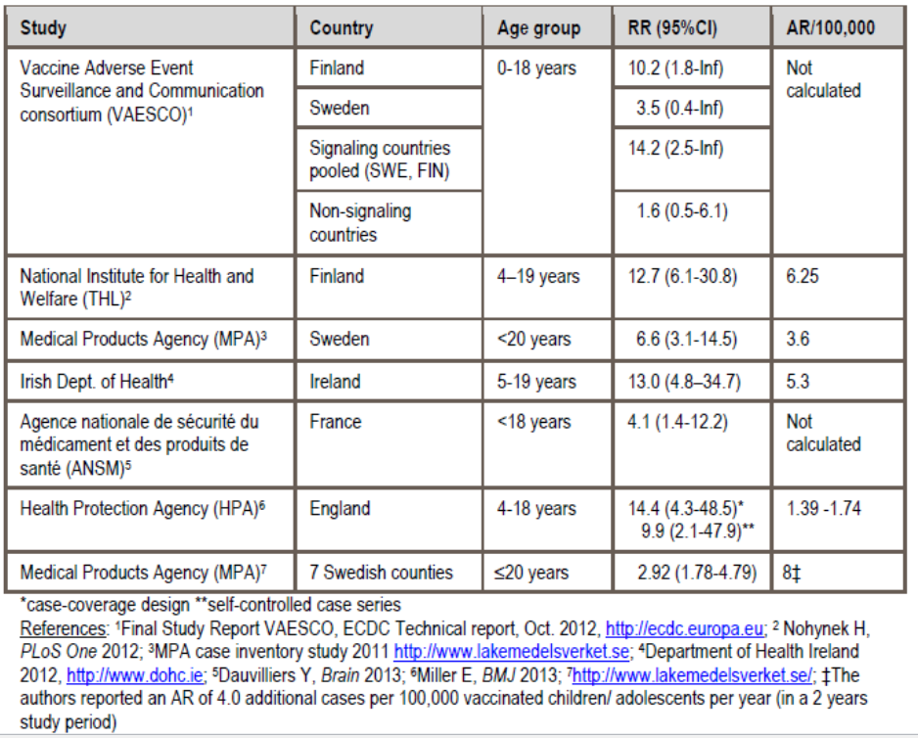
Table 23: Post marketing H1N1 surveillance – summary of narcolepsy risk estimates in Europe, adults.
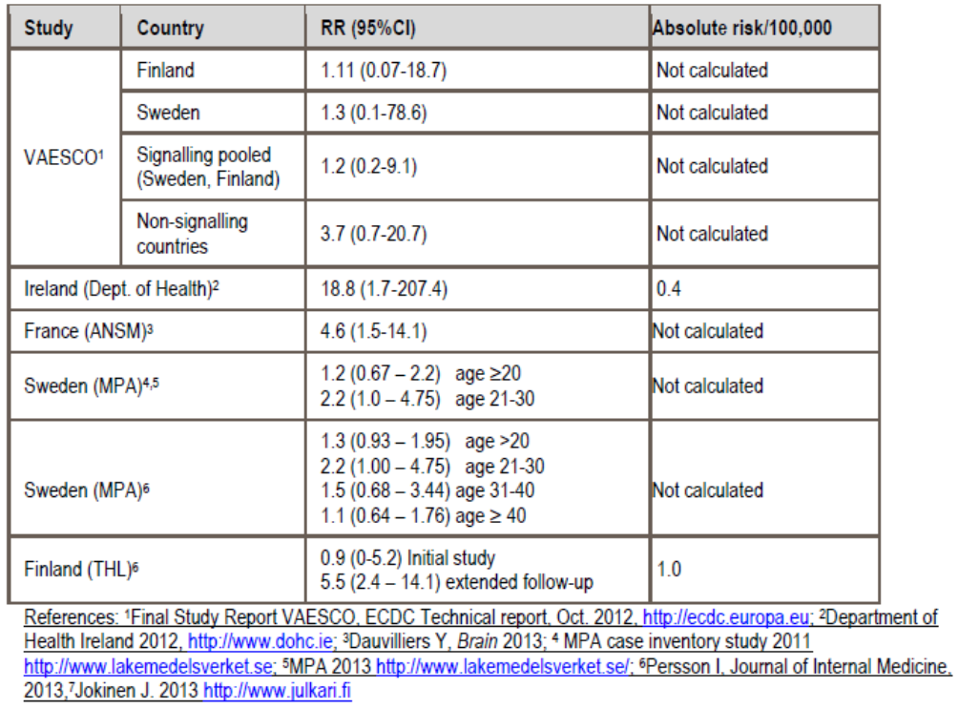

Specific populations
Pregnant and lactating women were excluded from the clinical trials. The RMP summarised that there were 52 pregnancies reported in studies H5N1-007, -008, -012, -015, and -032 with 40 deliveries of 41 healthy babies. There were 2 infants with non-serious ankyloglossia which was treated successfully shortly after birth. There were 6 elective terminations, one of which was for a congenital abnormality. There was also one stillbirth and one spontaneous abortion neither with reported abnormalities. Two subjects were lost to follow-up.

Safety issues with the potential for major regulatory impact

NOCD and pIMD
In all phases of study H5N1-009, a total of three potentially immune-mediated diseases were observed: one case of autoimmune hepatitis in the H5N1 full/half-adult dose group (Phase B) that appeared to be present pre-vaccination; one case of unilateral uveitis in the H5N1 full-adult dose group (Phase C); and one insulin-dependent diabetes mellitus in the Fluarix control group (Phase B). No meaningful conclusions about a potential causal relationship between the H5N1 vaccine and immune-mediated diseases can be drawn from the limited number of cases observed in study H5N1-009 in children aged 3 - 9 years.

Evaluator’s overall conclusions on clinical safety
In total, 16541 doses of AS03-adjuvanted H5N1 split influenza vaccine containing the Dresden-derived antigen have been administered as primary or booster vaccination to 8676 subjects in the evaluation of safety. Of these, 6558 doses in 3687 subjects were of the proposed formulation (3.75 μg HA adjuvanted with AS03A). In the paediatric subset, 300 children aged 3 to 9 years old received 592 D-Pan doses, 520 3 - 17 year olds received 728 priming and 156 booster doses and 113 6- < 36 month olds received 225 priming doses and 108 booster doses.
The A/Indonesia/5/05 strain was used in the D-Pan studies H5N1-041, H5N1-013, H5N1-032 and in Q-Pan-001. All other studies had primary vaccination with A/Vietnam/1194/04. Booster vaccination strain was either A/Vietnam/1194/04 or A/Indonesia/5/05 in all studies except H5N1-013 and H5N1-032, where the booster strain was A/turkey/Turkey/01/2005.
In adults, there was increased reactogenicity with the adjuvanted formulation compared to the non-adjuvanted formulation particularly pain, nonetheless the rate of grade 3 solicited local AEs was generally low. General solicited events of fatigue and headache were also more frequent with adjuvanted vaccine. Symptoms were generally mild to moderate in intensity and resolved within several days. Overall, rates of unsolicited AEs were unremarkable. Lymphadenopathy was reported with higher antigen dose and with adjuvanted vaccine. The risk however was low, non-severe and resolved.
There was a trend for higher rates of general symptoms such as mylagia, fatigue and headache following booster than priming doses but no notable findings on unsolicited AEs following booster vaccination.
In the elderly (> 60 years) the double strength vaccine dose resulted in an increased risk of local and general solicited AEs.
In children 6 months to 17 years of age, reactogenicity was found to increase with each subsequent vaccine dose whether full or half strength. The full dose vaccine, compared to half dose vaccine, resulted in a higher rate of solicited local and general AEs. Fever, particularly that > 39°C, was a notable risk particularly with the full dose vaccine and rates increased with subsequent doses. There were however no reports of febrile convulsions.
There were 13 deaths in the clinical program, none of which were classed as vaccine-related. Of the 294 subjects with SAEs there was one of pneumonia that was treatment-related in an elderly subject; however, the event was 299 days post vaccination. Of the 19 paediatric subjects with an SAE there was one, autoimmune hepatitis, which was treatment-related. The child however was reported to have elevated transaminases predating the first vaccination. Premature study discontinuation due to an adverse event was infrequent across all ages.
Where laboratory assessments were undertaken (> 60 years olds in H5N1-010, 3 - 9 year olds in H5N1-009 and adults in Q-Pan 001) there were no notable findings.
There was little difference in the rate of solicited local and general AE and unsolicited AEs between the thiomersal containing and thiomersal free formulations of vaccine. The Q-Pan vaccine studies were not remarkably different to the D-Pan studies in terms of reactogenicity. The reactogenicity with an accelerated immunisation schedule was acceptable.
The relationship between the candidate vaccine and the onset of any new chronic disease or medically significant condition was assessed in detail in the integrated safety summaries. The ISS (2008) included eight completed adult trials evaluating either Q-Pan or D-Pan adjuvanted vaccines. The analysis did not reveal any unexpected safety findings and there was no strong evidence to support a causal relationship between the use of AS03 adjuvanted H5N1 vaccine (Q-Pan or D-Pan) and the incidence of AESI /pIMDs. Drawing definitive conclusions from the data were however not possible due to the limited number of events.
The second ISS (2011) included data from 22,000 subjects in 28 studies, with close to 20,000 in controlled studies, exposed to H5N1 or H1N1 vacccines. It was undertaken to assess the incidence of MAEs, SAEs and detect rare AEs and in particular pIMDs associated with the adjuvanted vaccine. There were a number of limitations with this ISS including the lack of correction for multiplicity, the 3:1 randomisation limiting the control numbers, the lack of specific pIMD surveillance in the H5N1 studies which was present in the H1N1 studies and a high level of discordance on pIMD status between the investigator’s reports and the Sponsor’s assessment. Nonetheless, no imbalance was seen in adjuvanted vaccine recipients compared to control product recipients for MAEs, grade 3 MAEs or SAEs. A higher RR of pIMDs of 1.69 (95% CI 0.81,4.11) in the combined H1N1+H5N1 group was due to an effect seen in the H5N1 group (RR = 6.85, 95% CI: 1.10, 283.6). While there were specific diagnoses (facial nerve paralysis/paresis, PMR/temporal arteritis, uveitis, UC and RA) with suggestions of higher risk there were no specific patterns evident and the evaluator accepts the Sponsor’s arguments on the lack of consistency, specificity and lack of power to detect a biological gradient.
There were two paediatric cases of pIMD – autoimmune hepatitis (also an SAE) and uveitis. The first was assessed as predating vaccination and the second was non-serious and resolved with treatment. The paediatric safety database however is relatively small and integrated data did not cover this age group.

First round benefit-risk assessment

First round assessment of benefits
The benefits of Prepandemrix, pandemic influenza vaccine (H5N1), in the proposed usage are:
- Demonstrated immunogenicity for the homologous vaccine strain which meets regulatory criteria for pandemic influenza vaccines. The response was consistent across clinical trials and age groups and achieved with a schedule of two doses 21 days apart.
- Ability of the vaccine to elicit both haemagglutination inhibition and neutralising antibody responses with notable cross-reactive immune response to drift variant strains.
- Anticipated benefit in the event of a influenza pandemic which could have significant public health impacts.
- Immunological equivalence (as measured by GMT ratio) of vaccine manufactured at the two facilities ( Q-Pan and D-Pan).
- Ability to shorten primary vaccination schedule to 0 and 14 days if required without compromising immunogenicity.
- Strong booster response after single or dual dose priming. The booster can be a heterologous strain and is immunogenic when administered from 6 to 36 months after priming.
- Immunogenicity demonstrated in children from 6 months to 17 years of age.

First round assessment of risks
The risks of Prepandemrix, pandemic influenza vaccine (H5N1), in the proposed usage are:
- The actual degree of protection the vaccine may provide in the event of a future influenza pandemic is not able to be gauged from the available data.
- It is not known whether a lower antigen dose would be satisfactorily immunogenic.
- There is evidence that the immune response is waning by 6 to 12 months.
- Reactogenicity both local and general, which is higher than non-adjuvanted vaccine and increases with subsequent doses. It is acknowledged that these events, which are well documented, are generally mild to moderate in severity and resolve.
- Notable risk of fever in the paediatric population.
- There are limited safety data in the paediatric population and the risk of pIMDs has not been established in this population.
- Possible increased risk of pIMDs in adults, although integrated safety data from 16,000 adults exposed to AS03 adjuvant have not identified any specific concerns.
- No data on pregnancy and lactation or on immunosuppressed subjects.
- Theoretical potential risks of narcolepsy in adolescents and of solid organ transplant rejection due to the post-marketing signals with adjuvanted H1N1 vaccine.
- No data on co-administration with other vaccines.
- No long term safety data on the AS03 adjuvant.

First round assessment of benefit-risk balance
The clinical development program for Prepandemrix was extensive and well conducted. It assessed populations from infants of 6 months through to adults over 60 years, different primary vaccination schedules, differing booster intervals and booster response with homologous and heterologous vaccines to the primary course. Immunogenicity evaluations were thorough with assaying for both HI and neutralising antibodies.
The immune response to the D-Pan vaccine containing 3.75µg HA and adjuvanted with AS03A, when given in the proposed priming regimen of two doses 21 days apart, was strong and met all CHMP immunogenicity criteria. While the addition of the adjuvant increased reactogenicity, these events were generally mild or moderate and were outweighed by the marked increased immunogenicity of the vaccine when it was included.
The proposed product contains the A/Indonesia strain compared to the A/Vietnam strain in the original dossier. The adult D-Pan primary vaccination studies were conducted with A/Vietnam, except study H5N1-041 which had the proposed A/Indonesia strain in a study which compared thiomersal containing and free formulations. It was therefore relevant to have an immune response in that study which met CHMP criteria. The immunological equivalence of the Q-Pan and D-Pan vaccines in study Q-Pan-001 and immunogenicity results meeting threshold criteria also provided supporting evidence as the vaccine in that study contained A/Indonesia strain.
The original Prepandemrix submission had two areas of concern which led to its rejection: lack of data on booster response and a possible safety signal of increased risk of NOCD in adults over 60 year of age in study H5N1-008. Both issues have been addressed in this dossier which presents a far more thorough clinical development program than that evaluated in 2007. A number of booster studies assessing both homologous and heterologous booster to the priming strain have been conducted in adults and children and at different intervals from the priming course. All demonstrated a robust booster response for HI and neutralising antibodies to the booster strain as well as cross-reactive response to heterologous strains.
Regarding the risk of NOCD, since the earlier evaluation the Sponsor has conducted further studies, including a study in adults >60 years, as well as compiling two integrated summaries of safety. The safety of the vaccine and adjuvant has now been assessed from a database of approximately 16,000 subjects who received AS03-adjuvanted H5N1 or H1N1 antigens, of who 9300 received H5N1 with AS03A, together with about 6000 control subjects. The Sponsor stated that the size of this safety database provides 99.3% confidence that at least one instance of any adverse event occurring with a frequency of at least 0.05%. This analysis found an increased relative risk of pIMDs with the H5N1 adjuvanted vaccine (RR=6.8, 95% CI:1.1,283) compared to no increased risk with H1N1 (RR = 1.0, 95% CI: 0.4,2.7). The pIMDs identified covered a broad range of diseases without any specific areas being identified. The evaluator agrees with the Sponsor that the imbalance in person years of observation between the H5N1 and control groups may have contributed to the observed imbalance. It is concluded that while the data do not suggest a causal link the risk will still need to be closely monitored.
It has been noted in this evaluation, as well as one relating to Pandemrix, that while the standard dose (3.75 µg HA) vaccine in adults > 60 years resulted in an immune response which met CHMP criteria it was less than that of a double dose vaccine. The safety profile as regards solicited local and general AEs after vaccination, however was better with the single dose. The European SPC for Prepandrix summarises HI antibody responses at day 42 based on age subgroups (61 to 70; 71 - 80, and > 80 years) and this shows that the H5N1 HI antibody response (SPR, SCR, SCF) in subjects aged > 80 was greater in the double dose group (n = 10) than in the single dose group (n = 13). It also comments that “based on very limited data, adults aged > 80 years may require a double dose of [the vaccine] ..... in order to achieve an immune response”. This recommendation is not included in the Australian PI which recommends a single dose vaccination regimen in adult adults aged 18 years and above, irrespective of age. These data appear to be from post-hoc analyses as they were not available to the evaluator and the Sponsor has been asked to clarify immunogenicity and dosing in the elderly population.
The paediatric clinical development covered children from 6 months to 17 years and demonstrated that two doses three weeks apart (using half the adult dose) was immunogenic with adult CHMP criteria being achieved. There was also strong booster response. It was found that the full adult dose led to increased reactogenicity and, given the high rate of fevers with the adjuvanted vaccine, the benefit-risk balance is therefore in favour of the half strength dose. As there are no paediatric dosage instructions in the draft PI the Sponsor has been asked to clarify this issue.
With the number of children with grade 3 fever it was reassuring to find no reported cases of febrile convulsions, nonetheless the Sponsor has been asked to confirm that this is the case. In addition, this risk of fever has not been adequately covered in the draft PI. The overall safety of the vaccine in the paediatric population has been based on relatively small numbers. There were two pIMDs identified, autoimmune hepatitis and uveitis, although the former was believed to predate vaccination and the latter resolved with treatment. There were no integrated data on the paediatric population presented and the Sponsor should provide further information to justify the safety of the product in children.
Overall, it is not clear if the indication for the vaccine seeks to cover children as there is a lack of dosage instructions, inadequate coverage of paediatric clinical trial immunogenicity and safety data in the PI, a CMI which includes no instructions relating to children and inconsistencies in the RMP. These issues all need to be addressed before an assessment of benefit-risk in this population can be undertaken.
Regarding the indication, the current wording is Prophylaxis of influenza caused by the H5N1 strain with a pandemic potential. As there are no data to confirm prophylaxis of influenza, the evaluator believes preferable wording would be along the lines of that in the European SPC which states active immunisation against H5N1 subtype of Influenza A virus.
There are substantial public health risks of pandemic influenza and so there is a high need for immunogenic vaccines. Prepandemrix vaccine was found to be immunogenic with evidence of cross-reactive antibodies at a relatively low antigen dose. There was some flexibility with priming dose schedule, a robust and rapid booster response, and manageable reactogenicity risks. Integrated safety data found an increased relative risk of pIMD with the adjuvanted H5N1 vaccine while detailed assessment did not appear to support any specific findings. The evaluator believes the causal risk is not sufficiently strong to outweigh the potential public health benefit of the vaccine. Nonetheless, it is a case where there will need to be ongoing vigilant safety monitoring and it will be essential that the Sponsor has highly developed plans for the monitoring of the candidate vaccine in the event of a pandemic influenza outbreak.
In summary the evaluator finds that the benefit-risk balance of prepandemrix given the proposed usage, is favourable for adults subject to satisfactory responses to questions and comments in Section 12. The evaluator finds that there are a number of issues still to be addressed regarding the paediatric population and so the benefit-risk balance in this group is currently unfavourable.

First round recommendation regarding authorisation
It is recommended that Prepandemrix, pandemic H5N1 influenza vaccine (A/Indonesia/05/2005 3.75 µg adjuvanted with AS03) is authorised for use in adults. The recommendation is subject to:
- Addressing questions raised
- Rewording of the proposed indication
- Satisfactorily addressing changes to the PI and CMI
- Close post-marketing safety monitoring
It is not currently recommended that Prepandemrix is authorised for use in the paediatric population as issues that were raised in Section 12 need to be addressed by the Sponsor and evaluated by the TGA.

Clinical questions

Pharmacokinetics
None

Pharmacodynamics
None

Efficacy
- The EU SPC for Prepandrix includes what appears to be a post-hoc immunogenicity analysis of study H5N1-010 by age subgroups. These data were not located in the clinical study report. The data point towards an improved immune response in subjects aged >80 years with the double dose vaccine regimen. From this there is a statement in the EU SPC dosage and administration section which suggests a double dose of vaccine may be necessary in this age group. Discuss these findings and whether or not the information is relevant in the Australian context.

Safety
- In the Summary of Clinical Safety it states that 6558 doses of D-Pan 3.75 µg HA adjuvanted with AS03A have been given to 3687 subjects (page 43) while in the Clinical Overview it states that these 6558 doses were given to 2804 subjects (Table 35). Please explain the difference and verify the number of subjects who have been exposed to the proposed vaccine.
- In the Summary of Clinical Safety results of the two ISSs were discussed. Neither ISS had corresponding data located in the dossier. The first ISS (2008) has been previously evaluated, however the evaluator believes that the second ISS (2011) has not been previously evaluated and so the data should be submitted to the TGA.
- Given the risk of fever with the adjuvanted vaccine it was reassuring that no reports of febrile convulsions were identified in the three paediatric clinical trials. Could the Sponsor confirm that there have indeed been no cases of febrile convulsion or discuss any cases that may have occurred in infants, children or adolescents with the administration of the H5N1 vaccine.
- The safety of the vaccine in the paediatric population has been evaluated in the three clinical trials in the dossier. There is a however no broader integrated summary of safety in children, either for the H5N1 vaccine alone or for combined adjuvanted H5N1 and H1N1 vaccines. Discuss any integrated data on paediatric safety and post-marketing safety data including information on cases of pIMDs.

Second round evaluation
The sponsor submitted a response where they requested to change the trade name from Prepandemrix to Prepandrix, which is the approved name in Europe. Below is a summary of the sponsor’s responses to the questions followed by the evaluator’s comments.

Efficacy

Question 1
- The EU SPC for Prepandrix includes what appears to be a post-hoc immunogenicity analysis of study H5N1-010 by age subgroups. These data were not located in the clinical study report. The data point towards an improved immune response in subjects aged >80 years with the double dose vaccine regimen. From this there is a statement in the EU SPC dosage and administration section which suggests a double dose of vaccine may be necessary in this age group. Discuss these findings and whether or not the information is relevant in the Australian context.

Sponsor’s response
In Study H5N1-010, exploratory post hoc analysis was conducted in age subgroups (60-65, 66-70, 71-75, 76-80 and >80 years) at the request of the European Authorities. These data were included with the sponsor’s response to this question.
There were only 10 and 13 subjects aged >80 years who received single and double dose adjuvanted vaccine, respectively. There was a high rate of seropositivity for HI antibodies to A/Vietnam so the age-stratified analysis also assessed results by baseline serostatus. The baseline seropositivity rates to A/Vietnam increased with age (50-60% in the >80 year olds). No seropositivity was seen for HI antibodies against A/Indonesia.
Prevaccination GMTs for HI antibodies against A/Vietnam were low in all age groups (7.0-14.1). At Day 42 post vaccination, GMTs were found to be lower in subjects aged >80 years, particularly in those who received one dose of vaccine.
Seroprotection rates at Day 42 against A/Vietnam were >60% in all age groups whether they received single or double dose vaccine. When assessed by baseline serostatus, those who were seropositive had higher SPRs. In the seronegative subjects >80 years (n = 5), there was no seroprotection when only one vaccine dose was given. The SPR threshold was not met by any age group for HI antibodies against A/Indonesia.
A seroconversion rate of >30% against A/Vietnam was achieved in all age groups at day 42 whether a single or double dose was given. When assessed by baseline serostatus, again the 5 seronegative subjects aged over 80 years failed to demonstrate seroconversion. The SCR threshold for HI antibodies against A/Indonesia was met by all age groups when vaccinated with two doses but not when only one dose was given.
The seroconversion factor of >2.0 against A/Vietnam was achieved in all age groups at day 42 regardless of serostatus. The threshold of >2.0 was met against A/Indonesia in all age groups when two vaccine doses were given but not in the >80 year age group with only one dose (SCF 1.3, 95% CI: 1.0, 1.8).
The sponsor’s conclusion was:
All CHMP criteria are met for the HI response against the vaccine strain at Day 42, regardless of age, and for both the single and the double injection dose. The baseline serostatus of the subjects does not impact on the ability to meet the criteria, except for the oldest subjects (aged above 80 years), in case they were seronegative before vaccination and vaccinated with the 1x3.8AD formulation. In this latter group, for which it should nevertheless be noted that the sample size is very limited (n = 5), SCR and SPR criteria are not met, although SCF is met at Day 42. It was stated that the trend towards improved immunogenicity with a double dose has to be interpreted with caution.
The sponsor’s response to this question also covers Question 30 on the PI.

Evaluator’s comments
The sample size is very small on which to draw conclusions and the analysis post hoc. Nonetheless, the data are suggestive of an improved immune response in subjects aged >80 years with the double dose vaccine regimen. Therefore, it would appear prudent to include the same statement as in the European SmPC in the Dosage and Administration section of the PI.
Based on very limited data, adults aged >80 years may require a double dose of Prepandrix on an elected date and again after an interval of at least three weeks in order to achieve an immune response.

Safety

Question 2
- In the Summary of Clinical Safety it states that 6558 doses of D-Pan 3.75 µg HA adjuvanted with AS03A have been given to 3687 subjects (page 43) while in the Clinical Overview it states that these 6558 doses were given to 2804 subjects (Table 35). Please explain the difference and verify the number of subjects who have been exposed to the proposed vaccine.

Sponsor’s response
The sponsor agreed there was a mistake in Table 35. The correct number exposed subjects is 3687.

Evaluator’s comments
None.

Question 3
- In the Summary of Clinical Safety results of the two ISSs were discussed. Neither ISS had corresponding data located in the dossier. The first ISS (2008) has been previously evaluated, however the evaluator believes that the second ISS (2011) has not been previously evaluated and so the data should be submitted to the TGA.

Sponsor’s response
The sponsor submitted the second ISS of AS03 adjuvanted monovalent H5N1 and H1N1 vaccines in adults 18 years of age and older (dated September 2011).

Evaluator’s comments
The data in this ISS report are consistent with that presented in the submitted dossier and summarised.

Question 4
- Given the risk of fever with the adjuvanted vaccine it was reassuring that no reports of febrile convulsions were identified in the three paediatric clinical trials. Could the Sponsor confirm that there have indeed been no cases of febrile convulsion or discuss any cases that may have occurred in infants, children or adolescents with the administration of the H5N1 vaccine.

Sponsor’s response
The sponsor confirmed that no febrile convulsion cases were reported in H5N1-009 (3-9 year olds) and H5N1-032 (3-17 year olds). In H5N1-013, there was one “seizure – suspected” in a subject aged 18 months of age at 88 days post dose 2. The event was not an SAE and no treatment was given. Dose 3 of vaccine was not given due to this event.
There was one febrile convulsion (an SAE) in Q-Pan-021 (children 6 m to <18 years) in a 30 month old child at 11 days post first vaccine dose (H5N1/AS03). The child was hospitalised for 3 days and recovered. There was no history of fever in the 7 days post dose 1 or dose 2 of vaccine. A second case of a convulsion was reported in this study 212 days post vaccine dose 2. The event was medically attended. A third case of possible seizure occurred 134 days post dose 2 and one day prior to the onset of an upper respiratory tract infection (URTI).

Evaluator’s comments
The evaluator agrees with the sponsor that the timing of these events are not suggestive of a temporal relationship to vaccination.

Question 5
- The safety of the vaccine in the paediatric population has been evaluated in the three clinical trials in the dossier. There is a however no broader integrated summary of safety in children, either for the H5N1 vaccine alone or for combined adjuvanted H5N1 and H1N1 vaccines. Discuss any integrated data on paediatric safety and post marketing safety data including information on cases of pIMDs.

Sponsor’s response
There are no integrated safety data in children. Compared to H5N1 vaccine, H1N1 vaccine is noted to have a higher immunogenicity profile and the number of exposed children is greater (n = 5264). This could skew the safety data. Overall, the number of paediatric subjects is not sufficient to detect rare events. The response also stated:
Across the complete H5N1 paediatric clinical development program, there have been 4 case reports of a pIMD, three of them with the D-Pan H5N1 vaccine: one case reported Vitiligo and one case Uveitis. A third case reported autoimmune hepatitis in 3.5 year old female who received the first dose of DPan H5N1. The event was considered by the investigator to have a possible causal relationship to the vaccine. However, testing of serum samples collected before vaccination revealed abnormalities consistent with pre existing hepatic disease (elevated serum alanine aminotransferase and aspartate aminotransferase levels). In the paediatric QPan H5N1 development, there was one pIMD case reporting Alopecia. Overall no safety signal arose from the data.

Evaluator’s comments
It remains that pIMDs need to remain under close monitoring for the adjuvanted vaccines.
The Sponsor submitted a response dated 29 October 2014. In this response the Sponsor has requested to change the tradename from Prepandemrix to Prepandrix which is the approved name in Europe. Below is a summary of the Sponsor’s responses to the questions followed by the evaluator’s comments.

Second round benefit-risk assessment

Second round assessment of benefits
After consideration of the responses to clinical questions, the benefits of Prepandemrix/Prepandrix in the proposed usage are unchanged from those identified in the first round.

Second round assessment of risks
After consideration of the responses to clinical questions, the risks of Prepandemrix/Prepandrix in the proposed usage are unchanged from those identified in the first round.

Second round assessment of benefit-risk balance
The Sponsor has submitted a thorough response to the questions asked after the first round evaluation. Comments on the PI have been satisfactorily addressed and resulted in substantial modifications to the document.
The major change in the second round evaluation is that the Sponsor no longer proposes an indication which covers the paediatric population. Given this alteration, the evaluator recommends that it is made clear in the indication that the vaccine is for the active immunisation of adults only. In addition, a precaution relating to use in children should be included in the PI.
Submitted post-hoc data analysis of the elderly study pointed towards possible reduced immunogenicity of the vaccine in those aged >80 years and improved response with double vaccine dose. While these analyses are post-hoc and the subgroup sample size very small, the evaluator agrees with the EU’s decision to include a statement outlining these facts in the PI.
In summary, evaluator finds the benefit-risk balance for Prepandemrix/Prepandrix pandemic H5N1 influenza vaccine use in adults is favourable. This is subject to the remaining few questions relating to the PI being satisfactorily addressed.

Second round recommendation regarding authorisation
It is recommended that Prepandemrix/Prepandrix, pandemic H5N1 influenza vaccine (A/Indonesia/05/2005 3.75 µg adjuvanted with AS03) is authorised for use in adults. The recommendation is subject to:
- Making the indication specific for adults.
- Finalising the PI
- Close post-marketing safety monitoring.

References
- Committee for Human Medicinal Products (CHMP). Guideline on influenza vaccines prepared from viruses with the potential to cause a pandemic and intended for use outside the core dossier context. 2006a. EMEA/CHMP/VWP/263499/2006.
- Committee for Medicinal Products for Human Use (CHMP). Guideline on dossier structure and content for pandemic influenza vaccine marketing authorisation application. 2008. EMEA/CPMP/VEG/4717/2003-Rev.1.
- Committee for Proprietary Medicinal Products (CPMP). Note for guidance on harmonisation for requirements for influenza vaccines. CPMP/BWP/214/96. 1997
- Committee for Medicinal Products for Human Use (CHMP). Core SPC for Pandemic Influenza vaccines. EMEA/CHMP/VWP/193031/2004 Rev 1. 2009.
- Center for Biologics Evaluation and Research (CBER). Guidance for industry. Clinical data needed to support the licensure of Pandemic Influenza Vaccines. U.S. Department of Health and Human Services, Food and Drug Administration, Center for Biologics Evaluation and Research, May 2007.
- Global Advisory Committee on Vaccine Safety (GACVS). Causality assessment of adverse events following immunisation. Weekly Epidemiology. Record. 2001; 76:85-92.

Therapeutic Goods Administration
PO Box 100 Woden ACT 2606 Australia
Email: info@tga.gov.au Phone: 1800 020 653 Fax: 02 6232 8605
https://www.tga.gov.au

