Date of CER: April 2015

AusPAR Attachment 3

Extract from the Clinical Evaluation Report for Progesterone
  - Proprietary Product Name: Prometrium / Utrogestan
  - Sponsor: Besins Healthcare Australia Pty Ltd

About the Therapeutic Goods Administration (TGA)
- The Therapeutic Goods Administration (TGA) is part of the Australian Government Department of Health, and is responsible for regulating medicines and medical devices.
- The TGA administers the Therapeutic Goods Act 1989 (the Act), applying a risk management approach designed to ensure therapeutic goods supplied in Australia meet acceptable standards of quality, safety and efficacy (performance), when necessary.
- The work of the TGA is based on applying scientific and clinical expertise to decision-making, to ensure that the benefits to consumers outweigh any risks associated with the use of medicines and medical devices.
- The TGA relies on the public, healthcare professionals and industry to report problems with medicines or medical devices. TGA investigates reports received by it to determine any necessary regulatory action.
- To report a problem with a medicine or medical device, please see the information on the TGA website <https://www.tga.gov.au>.
About the Extract from the Clinical Evaluation Report
- This document provides a more detailed evaluation of the clinical findings, extracted from the Clinical Evaluation Report (CER) prepared by the TGA. This extract does not include sections from the CER regarding product documentation or post market activities.
- The words [Information redacted], where they appear in this document, indicate that confidential information has been deleted.
- For the most recent Product Information (PI), please refer to the TGA website <https://www.tga.gov.au/product-information-pi>.
Copyright
© Commonwealth of Australia 2017
This work is copyright. You may reproduce the whole or part of this work in unaltered form for your own personal use or, if you are part of an organisation, for internal use within your organisation, but only if you or your organisation do not use the reproduction for any commercial purpose and retain this copyright notice and all disclaimer notices as part of that reproduction. Apart from rights to use as permitted by the Copyright Act 1968 or allowed by this copyright notice, all other rights are reserved and you are not allowed to reproduce the whole or any part of this work in any way (electronic or otherwise) without first being given specific written permission from the Commonwealth to do so. Requests and inquiries concerning reproduction and rights are to be sent to the TGA Copyright Officer, Therapeutic Goods Administration, PO Box 100, Woden ACT 2606 or emailed to <tga.copyright@tga.gov.au>.

Contents
List of abbreviations 4
1. Introduction 5
2. Clinical rationale 6
3. Contents of the clinical dossier 7
3.1. Scope of the clinical dossier 7
3.2. Paediatric data 7
3.3. Good clinical practice 8
4. Pharmacokinetics 8
4.1. Studies providing pharmacokinetic data 8
4.2. Summary of pharmacokinetics 8
4.3. Evaluator’s overall conclusions on pharmacokinetics 8
5. Pharmacodynamics 8
5.1. Studies providing pharmacodynamic data 8
5.2. Summary of pharmacodynamics 10
5.3. Evaluator’s overall conclusions on pharmacodynamics 10
6. Dosage selection for the pivotal studies 10
7. Clinical efficacy 10
7.1. Indication 1: hormone replacement therapy 10
7.2. Indication 2: luteal phase support 16
7.3. Indication 3: treatment of menstrual irregularities 21
8. Clinical safety 23
8.1. Pivotal studies that assessed safety as a primary outcome 24
8.2. Patient exposure 26
8.3. Adverse events 27
8.4. Laboratory tests 30
8.5. Post-marketing experience 31
8.6. Safety issues with the potential for major regulatory impact 31
8.7. Evaluator’s overall conclusions on clinical safety 31
9. First round benefit-risk assessment 32
9.1. HRT 32
9.2. Luteal phase support 32
9.3. Menstrual irregularities 32
10. First round recommendation regarding authorisation 33
11. Clinical questions 33

List of abbreviations
Abbreviation | Meaning
4P | progesterone; pregn-4-ene-3,20-dione
17P | 17-hydroxy-progesterone; formed by endogenous hydroxylation of 4P during pregnancy
ART | Assisted Reproductive Technology
ICSI | Intra-cytoplasmic sperm injection
IVF | In vitro fertilisation
MPA | Medroxyprogesterone acetate

Introduction
This is a submission to register, micronised progesterone product, for four indications. As there are already progesterone products on the ARTG, this is a major variation and an extension of indication.
Progesterone is a naturally occurring hormone.
This application is to register a new clinical entity with no current indications.
The proposed new indications are:
- Prometrium 100 mg and 200 mg:
  - Treatment of menstrual irregularities
    - Menstrual irregularities due to ovulation disorders or anovulation, secondary amenorrhea
  - Hormone replacement therapy
    - Adjunctive use with an oestrogen in postmenopausal women with an intact uterus (for hormone replacement therapy [HRT])
- Utrogestan 200 mg:
  - Luteal phase support
    - Supplementation of the luteal phase during cycles including:
      - Luteal phase support during in vitro fertilisation (IVF) cycles
      - Progesterone support during ovarian insufficiency or complete ovarian failure in women lacking ovarian function (oocyte donation)
      - Luteal phase support during spontaneous or induced cycles, in primary or secondary infertility or subfertility in particular due to dysovulation
- Prometrium 100 mg and 200 mg:
In women receiving oestrogen replacement therapy with intact uterus, the adjunctive use of progesterone at a dose of 200 mg daily at bedtime should be administered for twelve days in the last half of each therapeutic cycle (beginning on day 15 of the cycle and ending on day 26). Withdrawal bleeding may occur in the following week. Alternatively 100 mg can be given at bedtime from day 1 to day 25 of each therapeutic cycle, withdrawal bleeding being less with this treatment schedule.
In women with secondary amenorrhea, the treatment may be given as a single daily dose of 400 mg (2 capsules 200 mg) at bedtime for 10 days.
The standard daily dosage regimen is 200 to 300 mg of progesterone taken in one or two doses (i.e. 200 mg in the evening before retiring and another 100 mg in the morning, if needed). In menstrual irregularities due to ovulation disorders or anovulation, the treatment is administered over 10 days per menstrual cycle, usually from cycle days 17 to 26 inclusive.
- Utrogestan 200 mg:
  - Adults:
    - In the Luteal Phase Support (LPS) in Controlled Ovarian cycles (COS):
      - The recommended dosage is 600 mg/day, in three divided doses, from the day of embryo transfer until at least the 7th week of pregnancy and not later than the 12th week of pregnancy.
      - In the prevention of preterm delivery in women with a short cervix or with a history of spontaneous premature delivery:
      - The usual dose is 200 mg/day, at bed time, between the 22nd and 36th week of pregnancy.
  - Children: Not applicable.
  - Elderly: Not applicable.
  - Method of Administration: Vaginal. Each capsule of Utrogestan must be inserted deep into the vagina.
The average dosage is 200 to 600 mg of progesterone per day to be introduced deep into the vagina, possibly using an applicator. This may be increased, depending on the patient's response.
    - In partial luteal insufficiency (dysovulation): treatment should be given for 10 days per cycle, usually from days 17 to 26 of the cycle, at a dosage of 200 mg of progesterone daily.
    - In sterility oocyte donation program: the recommended dosage of progesterone is 100 mg on day 13 and 14 of the transfer cycle, followed by 100 mg of progesterone in the morning and evening, from days 15 to 25 of the cycle. From day 26, the dose should be increased - in early pregnancy - weekly, from 100 mg of progesterone per day up to a maximum of 600 mg of progesterone per day, as three divided doses. This dosage should be continued until day 60.
    - In luteal phase supplementation during ART (IVF), treatment should be started latest from the evening of the transfer, as 600 mg of progesterone in three divided doses, morning, midday and evening.
    - In threatened miscarriage or to prevent repeated miscarriage due to luteal insufficiency, the average dosage is 200 mg to 400 mg of progesterone daily, as two divided doses until week 12 of pregnancy.

Clinical rationale
Progesterone is a naturally occurring steroid hormone which plays a pivotal role in the maintenance of pregnancy and the regulation of menstruation. In the menstrual cycle, it promotes maturation of the endometrial lining to allow implantation of a fertilised embryo, and is essential to maintain pregnancy. During pregnancy progesterone is produced by the Corpus Luteum for 7-9 weeks before placental production is established. Falling progesterone levels, in the absence of a fertilised embryo, during the normal menstrual cycle lead to the onset of menstrual bleeding. Progesterone is likely to be a factor in maintaining uterine quiescence during pregnancy, and a reduction levels may be one factor in the onset of labour.
The first clinical rationale for Utrogestan is to provide progesterone supplementation to women in whom natural production is absent or deficient in order to support implantation of embryos in assisted reproduction and maintain early pregnancy.
The first clinical rationale for Prometrium is to provide progesterone as part of Hormone Replacement Treatment in women with an intact uterus. This is recommended to reduce the potentially carcinogenic effect of unopposed oestrogen treatment on the uterus. The second clinical rationale is to provide progesterone production in women with irregular menstrual cycles or secondary amenorrhea. This promotes the development of endometrium typical of the luteal phase of the menstrual cycle which, when progesterone is withdrawn, leads to menstrual bleeding.
Progesterone has a low oral bioavailability of about 7% due to extensive first pass metabolism. The micronised formulation is intended to increase absorption of progesterone, and the vaginal administration of Utogestan is to significantly increase bioavailability by avoiding entero-hepatic circulation.

Contents of the clinical dossier

Scope of the clinical dossier
The dossier contains 17 studies providing pharmacokinetic data and 5 providing pharmacodynamic data which the evaluator considered pivotal in those areas.
The dossier contains several company sponsored clinical efficacy studies supported by an extensive literature review which has provided published references, clinical consensus statements and meta analyses regarding the use of progesterone. The sponsor has divided these into pivotal studies, primary and secondary literature sources, and the evaluator has considered these designations.

Hormone replacement therapy
The sponsor has provided two evaluable safety and efficacy studies which the evaluator considers pivotal; Lorrain (1994) and Moyer (1987). Christiansen (1985) is considered a non-pivotal trial.
The sponsor has provided supporting literature which the evaluator considers non-pivotal for reasons described in the evaluation of these trials.

Luteal phase support
The sponsor has provided one study (Kleinstein (2002)) which the evaluator considers pivotal. A second study (Salat-Baroux (1988)) was submitted by the sponsor as pivotal but the evaluator considers it insufficient as pivotal evidence for reasons outlined in the description of this trial. It has been considered supportive. Six meta-analyses, Polyzos (2010), Liu (2012), Nosarka (2005), Van der Linden (2011, 2012), Glujovksy (2010) and Hill (2013) are considered supportive evidence.
Six further trials or clinical guidelines. These have been considered by the evaluator.

Menstrual irregularities
The sponsor has submitted one pivotal study (Simon (1988)) in support of this indication. A Cochrane review (Hickey (2012)) which found no useful studies has been submitted as supportive evidence.
The evaluator notes that the electronic copies of some documents provided was faded, poorly aligned or blurred. The evaluator has tried to present extracts from these documents legibly but cannot improve on the quality of the original.

Paediatric data
The submission did not include paediatric data.

Good clinical practice
Clinical trials appear to have been conducted in accordance with GCP but this cannot be confirmed for published references.

Pharmacokinetics

Studies providing pharmacokinetic data
The dossier contains 17 studies which provided pharmacokinetics data.
Of particular relevance was Study 01272 2002: A randomised 2-way cross-over trial which examined the pharmacokinetics of a single oral dose of Utrogestan 2 x 100mg capsules containing either sunflower oil or peanut oil as an excipient in 60 healthy post-menopausal women. This indicated that Utrogestan-arachis oil was bioequivalent to Utrogestan-sunflower oil with the ratios of the two AUCs being within 80-125%.

Summary of pharmacokinetics
Progesterone is 96-99% protein bound and metabolised in the liver to glucuronide metabolites which are excreted in the bile and urine. Tmax is 3-4 hours with an elimination half-life of 12-18 hours. Bioavailability is significantly increased for p.v progesterone compared to p.o progesterone due to reduced first pass metabolism (AUC 114.45 ng.h/mL vs 359.96 ng.h/mL for 200mg oral and vaginal single doses respectively). Bioavailability increases approximately linearly across the proposed dosage range but is more variable between subjects in p.o than p.v dosing. Food approximately doubles the AUC of progesterone compared to fasted subjects.
The sunflower and peanut oil presentations of Utrogestan are orally bioequivalent.
A single dose of Utrogestan p.v was 50% more bioavailable than Crinone 8% progesterone cream administered p.v (AUC ratio 146%; 90% C.I 126.2-169.1%) when administered to healthy women. In this study an applicator was used to administer both medications.
There is evidence that progesterone is retained in the endometrium when administered p.v for ART.

Evaluator’s overall conclusions on pharmacokinetics
Progesterone is a naturally occurring hormone for which the oral pharmacokinetics has been examined extensively. Drug interaction studies were not submitted and may be significant given the extensive hepatic metabolism of progesterone. Utrogestan p.v is not bioequivalent to Crinone 8% cream.

Pharmacodynamics

Studies providing pharmacodynamic data
Progesterone is a naturally occurring hormone and its pharmacodynamic effects are its normal biological actions. Endometrial morphology was assessed in 137 women in 4 studies; Saarokoksi (1986), Deveroey (1994), Dupont (1991) and Foidart (1993). Hormone levels were measured in 77 women in 3 studies; Saarikoski (1986), Dupont (1991) and Erny (1986).
Saarikoski (1986) was a parallel two-arm study of 80 women randomised to receive progesterone 300 daily (n=40) or noesthistrone 15mg (n=40) on days 15-24 of 6 menstrual cycles. Subjects were women aged 33-59 with dysfunctional menstrual bleeding disorders. Endometrial biopsy was assessed at the end of the 3rd and 6th cycles.

Table 1: Histological status of endometrium after treatment with progesterone.
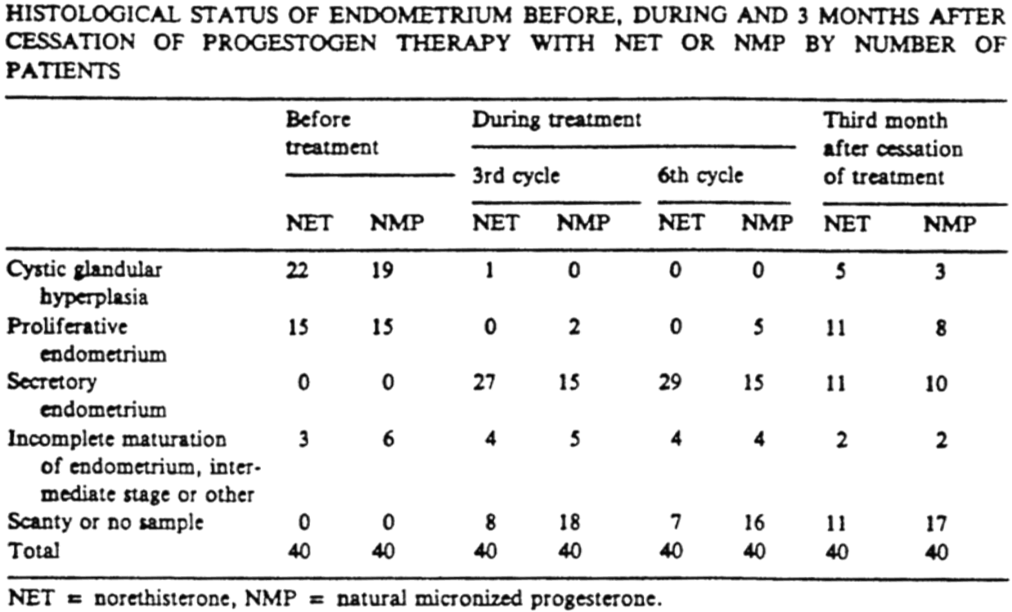
The majority of women receiving progesterone (NMP) moved from glandular hyperplasia on cycle 3 to secretory endometrium typical of the luteal phase of the menstrual cycle. Histological samples were only obtained in 33/40 subjects at week 6.
Dupont (1991) was a parallel 4-arm study in 63 women equally randomised to receive percutaneous estradiol or oral estradiol +/- progesterone 200mg daily on day 12-25 of six menstrual cycles (n=15-16 each arm). The primary endpoint was relief of menopausal symptoms and half the subjects had undergone hysterectomy. In women with a uterus, endometrial biopsy was assessed before and after 6 cycles of treatment.

Table 2: Endometrial biopsy results after progesterone and oestrogen treatment.
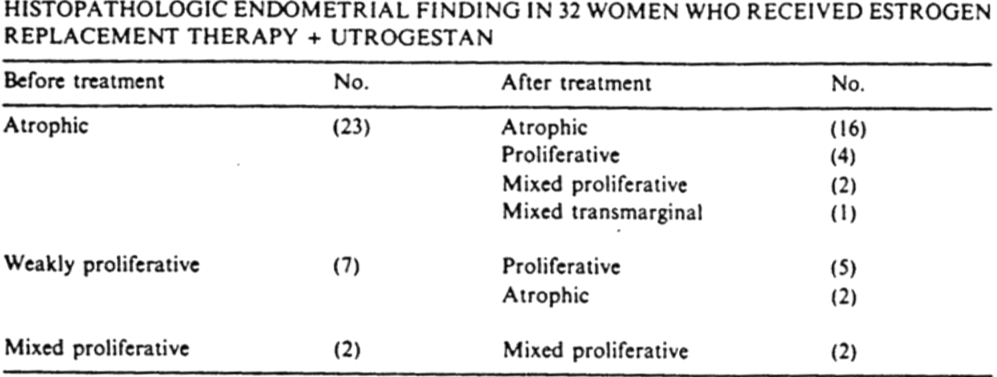
The majority of women receiving oestrogen plus progesterone retained an atrophic post-menopausal pattern, but 9/32 developed a degree of endometrial proliferation.
Foidart (1992) was a single arm study of 30 post-menopausal women to observe changes in endometrial histology following treatment with percutaneous estrodiol 2.5mg daily combined with 100mg progesterone from day 1 to day 25 of each cycle for 1 year. Endometrial histology was obtained before and after treatment; 22 of the before treatment and 26 of the post-treatment biopsies provided sufficient tissue for examination. The pre-treatment biopsies all indicated atrophic endometrium, and none of the 26 post-treatment biopsies indicated secretory maturation or suggestion of endometrial proliferation.
Devroey (1994) was primarily a pharmacokinetic study in 46 women without ovaries who were randomised to four dosage schedules of progesterone while receiving concomitant oestrogen therapy. These were not independent treatment arms; 59 progesterone treatments were received by 46 women over different cycles. The report notes that biopsies were not obtained in all women but where they were ‘adequate endometrial morphology’ in all patients, but does not provide a tabulated or statistical analysis.
Erny (1986) examined the pharmacokinetics of two doses of 200mg progesterone p.v taken 24 hours apart in 6 healthy volunteers. This study measured the levels of hormones as well as progesterone.

Summary of pharmacodynamics
The biological effects of progesterone are complex but the effect of progesterone on endometrial histology is the key for the proposed indications considered in this application. The studies support the conclusion that progesterone can support the development of secretory endometrium for ART; Devroey (1994), promotes the maintenance of atrophic endometrium in HRT; Foidart (1992), and development of a normal secretory endometrium in women with menstrual bleeding disorders; Saarikoski (1986). In these studies progesterone did not modify levels of oestradiol, Luteinising Hormone or Follicle Stimulating Hormone.

Evaluator’s overall conclusions on pharmacodynamics
The findings of the pharmacodynamic studies are unremarkable.

Dosage selection for the pivotal studies
There are no dedicated dosage selection trials. The dosages proposed for clinical treatment are included in the pharmacodynamic studies but there is no evidence that they are optimal, or the lowest dose which will achieve the desired therapeutic effect.

Clinical efficacy

Indication 1: hormone replacement therapy

Pivotal efficacy studies

Study lorrain (1994)

Study design, objectives, locations and dates
This was a one-year single centred study in 40 healthy post-menopausal women randomised equally to receive sequential HRT for at least 13 consecutive cycles. Patients were enrolled in the study for up to 4 years.

Inclusion and exclusion criteria
Healthy post-menopausal women with an intact uterus were enrolled. Menopausal status was confirmed with an FSH > 80 IU/L.
Women who had received unopposed oestrogen therapy within six months and had a history of thromboembolic disease, uncontrolled hypertension, gallbladder disease or endometriosis were excluded.

Study treatments
Enrolled women all received 17-β-estrodiol 0.05mg/day transdermal patches from day 1 to 25 of each cycle (Estraderm 50). Treatment arm A (n=20) received medroxyprogesterone acetate 10mg o.d (Provera), and treatment arm B (n=20) received 100mg Prometrium o.d, on days 14 to 25 of each cycle. No hormone treatment was administered on days 25-28 of each cycle.

Efficacy variables and outcomes
A number of variables were defined around bleeding pattern in women receiving the two treatments including day of onset of withdrawal bleeding, duration of vaginal bleeding, importance of vaginal bleeding and occurrence of breakthrough bleeding.
Endometrial biopsies were also analysed by being read by 1, 2 or 3 pathologists. The process for arbitrating disagreements between pathologists to reach a single conclusion was not presented.
Efficacy was analysed from a total of 393 ‘cycles’.

Randomisation and blinding methods
These are not listed in the study report.

Analysis populations
This is not presented in the study report. It is noted that ’40 patients who satisfied the inclusion criteria’ were treated and, as such, this is considered the ‘per-protocol’ population.

Sample size
20 women received each treatment. Analysis was performed on 393 ‘cycles’ between the study subjects.

Statistical methods
Standard statistical methods were used.

Participant flow
17/20 Prometrium patients completed one year, 15/20 completed two years of therapy, and 12/20 patients completed four years of treatment. 12/20 Provera patients completed one year and 9/20 completed two years of treatment.
The loss of patients appears to be due to adverse events.

Major protocol violations/deviations
These are not described.

Baseline data
Only age, weight and height are provided as baseline demographic data. The average age of women enrolled were 52.9 years of age in the Prometrium arm and 51.8 years of age in the Provera arm.

Results for the primary efficacy outcome
- Pattern of withdrawal bleeding: Prometrium produced a higher rate of amenorrheic cycles (19.5% vs 3.4%) than Provera (p<0.01). Prometrium was associated with statistically significant earlier onset of bleeding (23.1 vs 24.9 day of cycle), a lower intensity (9.6 vs 11.3) and lower number of days of bleeding (4.8 vs 6.0) than Provera (P<0.01).
- Endometrial biopsies: Endometrial biopsy results at one year of treatment are shown in Table 3.

Table 3: Endometrial biopsy results at one year of treatment.
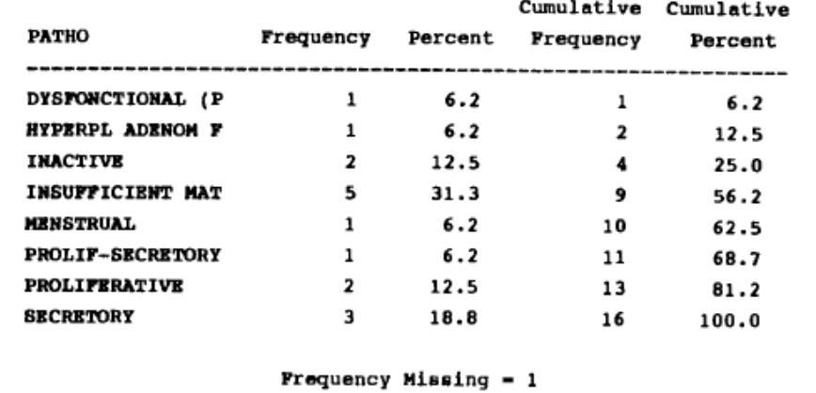
The study reports that ‘no significant anomalies were detected in the endometrial biopsies for either treatment group’.
Focal or adenomatous hyperplasia were reported in three patients receiving Utrogestan after 5 months, 1 year and 4 years respectively but this finding was not confirmed by a second pathologist.
The evaluator notes that, at one year of therapy, there was insufficient material to report a finding on 31% (n=5) of the Prometrium patients. It is difficult to interpret the results of the biopsies because the protocol does not specify a consistent day in the cycle on which the samples were to be taken. The line listing of these results indicates many missing values for the cycle-day of sampling. It is clear that some were taken mid-cycle or even at the beginning of the cycle. Clearly the endometrial histology is expected to vary across the cycle, and the effect of progestogens can only be assessed after they have started to work in the later part of that cycle.

Moyer (1987)

Study design, objectives, locations and dates
This was an open-label, uncontrolled, single centre study which enrolled 236 women taking oestrogen/progesterone HRT for a five year period between 1980 and 1987. The study methodology notes that it was ‘prospective’ for the period 1980-1986 and ‘retrospective’ for the period 1986-1987.

Inclusion and exclusion criteria
Women who presented to an outpatient clinic for postmenopausal symptoms and had not had a hysterectomy were enrolled. All subjects had hormonal markers of menopause; estradiol <40 pg/mL, LH>20 mUI/mL, FSH>20 mUI/mL. Enrolled women did not have breast or uterine disease which was a contraindication to HRT.

Study treatments
Enrolled women received one of four treatments;
- A: estradiol (Oestrogel) 1.5mg daily/ Prometrium 200mg daily
- B: estradiol (Oestrogel) 3mg daily/ Prometrium 200mg daily
- C: estradiol (Oestrogel) 1.5mg daily/Prometrium 300mg daily
- D: estradiol (Oestrogel) 3mg/ Prometrium 300mg daily
Estradiol dose was clinically adjusted for post-menopausal symptoms and administered on days 1-21 of the cycle or 1-25 of the cycle in women who experienced symptoms during the treatment-free week. Progesterone was administered at 200mg from days 8-10 to 21 depending of the onset of bleeding before the end of each cycles course of treatment, and increased to 300mg in women who ‘were willing to have regular withdrawal bleedings’ but in whom this did not occur at 200mg/day. Day 21 to 28 was treatment free.

Efficacy variables and outcomes
The main efficacy variable was estradiol plasma level during the last 10 days of the treatment cycle.
Of relevance to the progestogen component of therapy, however, were safety variables
- Induction of withdrawal of bleeding by Prometrium.
- Endometrial histology or hysteroscopy after five-years of therapy at between days 2 to 14 of progesterone treatment on the cycle when histology was examined.

Randomisation and blinding methods
This trial was non-randomised.

Analysis populations
157 of the 236 enrolled women were in the analysis population.
- A: estradiol (Oestrogel) 1.5mg daily/ Prometrium 200mg daily (n=126)
- B: estradiol (Oestrogel) 3mg daily/ Prometrium 200mg daily (n=3)
- C: estradiol (Oestrogel) 1.5mg daily/Prometrium 300mg daily (n=5)
- D: estradiol (Oestrogel) 3mg/ Prometrium 300mg daily (n=23)

Sample size
- 157 women completing 5-years of therapy were analysed for bleeding pattern.
- 153 women (minus the 4 who had dilation and curettage) underwent endometrial biopsy at 5 years.

Statistical methods
There is no statistical methods section in the study report.

Participant flow
Drop outs: Of the initial group of 236 women starting percutaneous estradiol and oral micronised progesterone treatment in 1980, 1981 or 1982, there were 79 women who dropped out during the first five years of treatment. The primary reasons for not continuing treatment were the lack of recurrence of initial clinical symptoms after several years of replacement therapy or a fear of cancer induced by reading the lay press. In four women who developed irregular bleeding while under treatment, a dilation and curettage was performed under general anaesthesia. The tissue morphology showed benign endometrial polyps in three, and a fourth woman was diagnosed as having a submucosal leiomyoma. None of these four women showed either endometrial hyperplasia or carcinoma.

Results for the primary efficacy outcome
- Bleeding patterns: During the last 12 months of the study, 4/157 women had at least two periods of irregular withdrawal bleeding, 34/157 had regular cycle withdrawal bleeding, and 119/157 had no withdrawal bleeding. Most of the women on the low progesterone dose (88%) had no withdrawal bleeding.
- Endometrial histology: See Figure 1.
Figure 1: Endometrial biopsy results after treatment Moyer (1987).
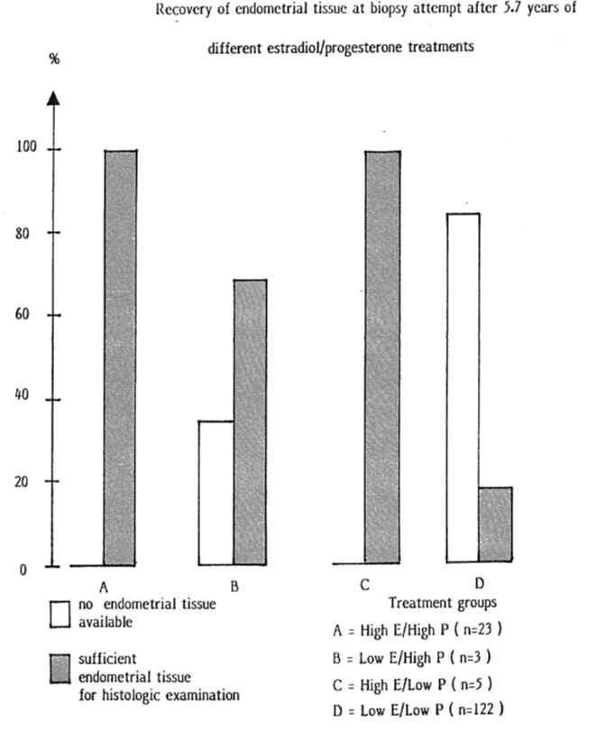
Endometrial evaluation was conducted in 153 women. Sufficient tissue for analysis was only obtained in 53 patients, and the remainder underwent hysteroscopy. In those women macroscopic atrophy throughout the endometrial cavity was observed. None of the biopsies indicated evidence of hyperplasia or carcinoma. Secretory maturation was variable, ranging from minimal to moderate in amount, moderate secretory maturation being observed in 78% of the highest dose group.

Other efficacy studies

Christiansen (1985)
This was a two year study which originally enrolled 57 post-menopausal women in a single centre double blind study comparing four arms of treatment; placebo, calcium 1000 mg o.d, estradiol gel (oestrogel) 3mg daily + calcium 1000mg o.d., or estradiol gel 3mg alone o.d.
In the second year of the trial, 45 women who remained in the estradiol 3mg arm had 200mg progesterone o.d added after breaking the investigator blinding.
The primary efficacy endpoint was reduction in menopausal symptoms as measured by the Kupperman index. This indicated a statistically significant reduction in patients receiving estadiol compared to those on calcium or placebo alone, although this was only statistically significant at 3 and 18 months.
With regard to progesterone the study concluded, “The addition of oral progesterone did not appear to affect the symptomatology in any way”, which the Clinical Efficacy Summary has presented as “The addition of calcium or progesterone does not have any appreciable effect on these symptoms”.
The evaluator notes that the only statistical analysis presented in this trial is between treatment arms. Since both estradiol arms received Progesterone in the second year of therapy, there was no estradiol only arm with which to compare progesterone. The only analysis which could have been performed would have been a cross-over comparison within the estradiol arms between symptoms in the first and second year. There is no description in the study report of this kind of analysis which would have required specific treatment for the altered study design.

Evaluator’s conclusions
The evaluator notes that the TGA has endorsed the EMEA auspiced “Guideline on Clinical Investigation of Medicinal Products for Hormone Replacement Therapy of Oestrogen Deficiency Symptoms in Postmenopausal Women”, EMEA/CHMP/021/97.
The efficacy of oestrogen as a symptomatic treatment for post-menopausal symptoms is not at issue in this evaluation, which deals with the efficacy of progesterone as a component of that therapy. The purpose of progesterone in combination HRT is to mitigate the long-term effects of unopposed oestrogen on the endometrium. The relevant efficacy endpoint is, therefore, endometrial ‘safety’.
Of relevance to this evaluation, EMEA/CHMP/021/97 states that:
- Endometrial biopsy is the gold standard method for assessing endometrial safety.
- A minimum of one year therapy is required to assess endometrial safety.
- Biopsies should be assessed by two independent pathologists blinded to treatment and time of biopsy, with a third blinded pathologist to arbitrate disagreements in interpretation.
- For sequentially combined treatment, it is recommended that biopsies be obtained at a pre-specified time in the treatment cycle, at least 10 days after the start of progesterone administration.
- A new HRT should be comparable to, or better than, currently marketed HRTs with respect to endometrial safety. The decision on endometrial safety must be based on reliable data from a sufficient number of patients treated for a sufficient period of time.
The trials submitted by the sponsor do not meet this standard of data regarding endometrial safety.
Lorrain (1994) enrolled only 20 patients. While this allowed data to be collected on 393 ‘cycles’ of treatment, repeated sampling of safety in 20 women does not increase the sample size for safety evaluation because the findings of each cycle are not independent of each other. In any case, a significant number of women did not have sufficient tissue on biopsy for endometrial histology to be performed and the line-listing indicates that sampling did not occur at a specified time in the treatment cycle. The system for arbitrating abnormal findings (3 patients with adenomatous hyperplasia) on endometrial biopsy was not standardised. These factors combined make Lorrain (1994) uninformative with respect to endometrial safety.
Moyer (1987) was a larger study but failed to obtain endometrial biopsies in the majority of patients, in whom endometrial safety was reported on the macroscopic appearance of the endometrium on hysteroscopy. This is not an acceptable means of assessing safety and makes Moyer (1987) uninformative with respect to endometrial safety.
Furness (2012) was a Cochrane review of the endometrial safety of HRT which concluded that progestogen therapy in combined sequential HRT regimens decreases the risk of endometrial hyperplasia. This analysis only included one trial which used progesterone in the sequential regimen proposed and thus it does not directly inform the safety of micronized progesterone.
The variety of supporting documentation in the form of clinical guidelines does not provide evaluable data for the purposes of assessing endometrial safety, although it provides a clinical consensus supporting the use of progestogens in HRT.

Indication 2: luteal phase support

Pivotal efficacy studies

Kleinstein (2002)

Study design, objectives, locations and dates
Kleinstein was a randomised, open label, active treatment controlled study in 430 women receiving IVF or ICSI which occurred between 1999 and 2001. The study involved 17 centres in Germany. Enrolled women were randomly allocated to receive either Crinone 8% progesterone vaginal cream (n=212) or Utrogest 200mg capsules (n=218) for luteal phase support. The purpose of the study was to compare the rate of successful implantation of pregnancies at the 12th week of pregnancy.

Inclusion and exclusion criteria
Enrolled women had an indication for IVF or ICSI and were between 18 and 35 years of age. All had a successful transfer of 2 or 3 embryos at the commencement of the trial. Exclusion criteria were severe acute or chronic liver disease, hepatocellular tumours or known hypersensitivity to ingredients of the study medications.

Study treatments
Women randomised to the active comparator arm received Crinone 8% vaginal cream (90 mg progesterone) twice daily. Those randomised to Utrogestan received 200mg capsules three-times daily. Treatment commenced on the evening of the day of embryo transfer and continued until either a pregnancy test was negative, bleeding occurred in non-pregnant women, or the 12th week of gestation was reached.

Efficacy variables and outcomes
The main efficacy endpoint was the number of live pregnancies at 12 weeks of gestation.

Randomisation and blinding methods
Treatment was unblinded. A randomisation code was used to assign consecutive trial subjects to treatment arms at the time of enrolment. Trial centres enrolled between 10 and 40 patients each.

Analysis populations
The analysis is based on the number of women randomised to treatment after screening from woman seeking IVF/ICSI therapy. The population is therefore a per-protocol subset of the women screened who had a successful embryo transfer. The evaluator notes that this is an appropriate population for the indication since only those who have a successful embryo transfer would commence treatment.

Sample size
The sample size was selected to detect a 10% difference in the rate of pregnancy at 12 weeks with a power (beta) of 0.2 and significance level (alpha) of 0.05. This required 222 patients per arm, which is slightly higher than was recruited.

Statistical methods
A difference in ongoing pregnancy rates of 10% was selected as clinically equivalent as it corresponded to the variability between treatment centres. The treatments were analysed using a one sided test of non-inferiority.

Participant flow
This is shown in Table 4.

Table 4: Participant flow among women enrolled in Kleinstein (2002).
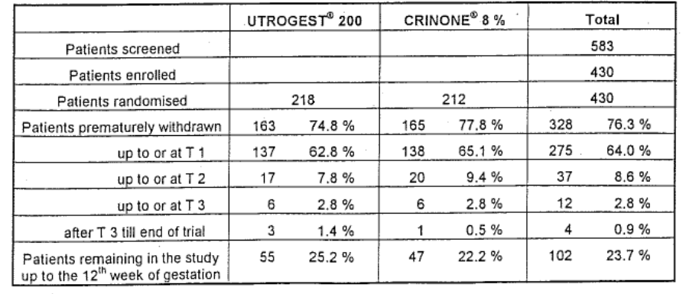
Women were assessed at four time points: 2 weeks, 4 weeks, 8 weeks and 12 weeks after embryo transfer. Most withdrawals happened before the visit due to failure to establish pregnancy. The rates of withdrawal were similar between the two treatment groups at all timepoints.

Major protocol violations
This is shown in Table 5.

Table 5: Reasons for withdrawal in patients enrolled in Kleinstein (2002).
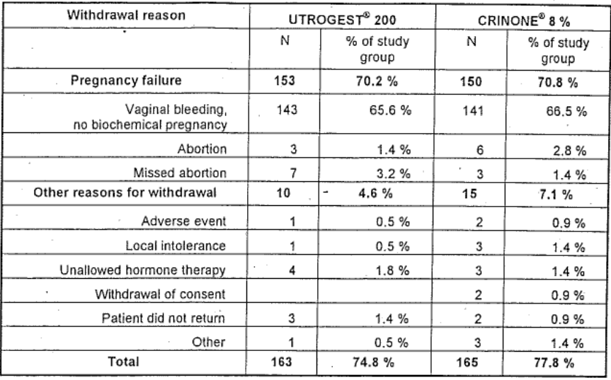
In 12 women assigned to Crinone 8%, only a once daily dose was administered, but these were included in the analysis.

Baseline data
Age, height and weight were not significantly different between the two treatment groups. The causes of infertility were similar between the two groups (Table 6).

Table 6: Baseline characteristics of enrolled patients in Kleinstein (2002).
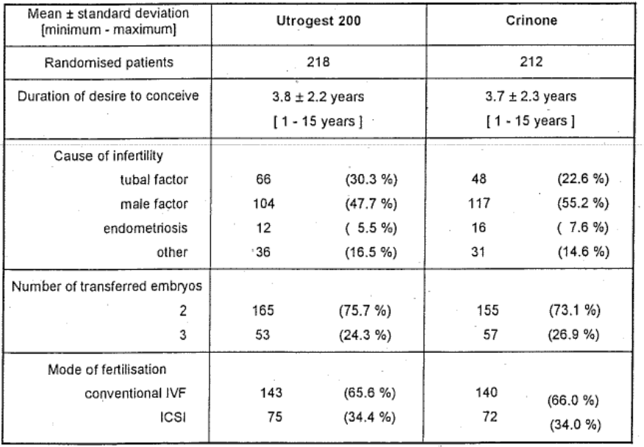

Results of the primary efficacy endpoint
Pregnancy at 12 weeks was achieved in 28.0(95%CI 22.1-34.4) percent of women treated with Utrogestan 200mg TDS and 26.9 (95% CI 21.0-33.4) percent of women treated with Crinone 8% 8%. The difference between the treatments was calculated as -1.1 (95% CI -6.1 to +8.27%). This met the criteria for non-inferiority between the two treatments. The trial was not powered to detect treatment centre variability.
Most pregnancies were singletons and there was no statistically significant difference in the multiplicity of pregnancies between the two treatments.
Figure 4: Difference in ongoing pregnancy >12 weeks of gestation in patients receiving progesterone or Crinone 8% treatment.
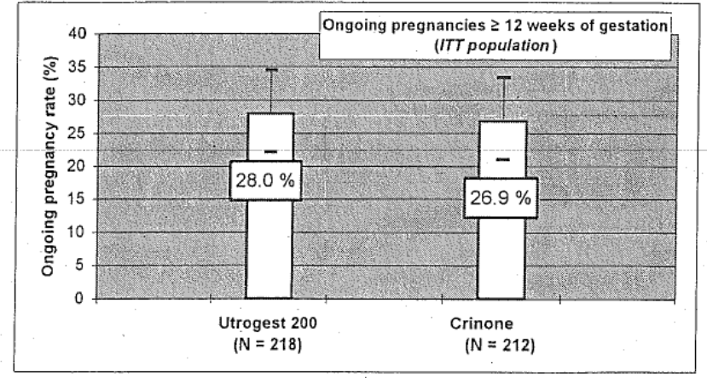

Other efficacy studies

Polyzos (2010)
This is the published literature report of a meta-analysis of studies comparing the efficacy of different forms of vaginal progesterone for luteal support. The authors considered all randomised controlled trials in which any form of P4 was used for luteal support in IVF or ICSI. The analysis was performed on published reports of the included studies. Seven trials were selected for inclusion.
51.7% of the patients included in the meta-analysis were from a study which did not involve P4 capsules. A sub-analysis of those which did use capsules as a comparator indicates that the odds-ratio of successful pregnancy in women receiving P4 capsules was not statistically different from those receiving vaginal gel. The summary odds radio from all studies was 1.12 (95%CI 0.86-1.45), with a ratio <1 indicating superiority of vaginal capsules.
The evaluator notes that 40% of the patients in this analysis were contributed by Kleinstein (2002), which has been evaluated separately, and therefore this meta-analysis contributes little additional information. The Summary of Clinical Efficacy notes that it indicates
that there is no significant difference in the clinical pregnancy rate between vaginal progesterone gel and progesterone capsules, inserts and pessaries
The evaluator notes that the three additional studies in this analysis all have point estimates of effect which are unfavourable to the effect of P4 capsules.
The evaluator notes that care should be taken interpreting Odds Ratios in this context. An Odds Ratio of 1:1 between two treatments indicates that the odds of achieving pregnancy are the same on each treatment. There is, however, no linear correlation between the Odds Ratio and the relative difference in effect between treatments. Kleinstein (2002) established the margin of therapeutic equivalence as being a 10% difference in pregnancy rate between comparator treatments. The Odds Ratio does not inform whether the difference in effect between treatments was within this range.

Liu (2012)
This was a meta-analysis of six randomised controlled studies to examine the effect of the duration of progesterone treatment on pregnancy outcomes. In the majority of cases P4 is provided until 7-12th week of gestation. This analysis indicates that there may be no different in pregnancy rate between continuing P4 therapy and ceasing it on the day of a positive β-HCG test.
The authors concluded that due to the heterogeneity in the data and the size of the studies, additional trials were needed to investigate the optimal length of progesterone therapy.
The evaluator notes that the sponsor proposed treatment to be between 7 and 12 weeks of gestation. The Summary of Clinical Efficacy does not comment on the apparent contradiction between this meta-analysis and the proposed dosing schedule.

Nosarka (2005)
This was a meta-analysis of published trials which examined whether luteal support with HCG or progesterone was effective at increasing rates of pregnancy compared to placebo. Six trials examined the effectiveness of progesterone compared to placebo, four of which used intramuscular injection of 17P and one of which used oral Dydrogesterone. The study which examined vaginal progesterone used 100mg BD vaginal pessaries.

Table 7: Meta-analysis of the relative risk of achieving pregnancy on progesterone pessaries or placebo in Nosarka (2005).
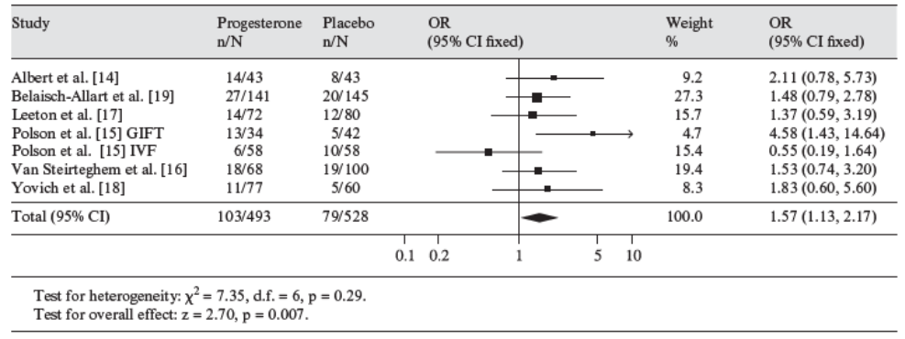
The Odds Ratio of effect favoured progestogen supplementation compared to placebo for achieving pregnancy. It is not clear whether this was early pregnancy or sustained pregnancy to a particular week of gestation. The evaluator notes that the results do not directly relate to vaginal progesterone due to the treatments used in the majority of studies.

Van der Linden (2011) (2012)
This was a review by the Cochrane Collaboration examining the efficacy of several treatments for luteal support on pregnancy outcomes.
The authors concluded that progesterone has a beneficial effect on pregnancy rate, ongoing pregnancy rate and live birth rate. There were no significant differences in routes of administration. There was a significant difference in favour of synthetic progesterone compared to micronized natural progesterone for the clinical pregnancy rate; OR 0.79 (95% CI 0.65-0.96) but this was not evident in the miscarriage rate, ongoing pregnancy rate or live birth rate.

Glujovsky (2010)
This was a Cochrane review of studies to examine the optimal regimen for preparing women undergoing transfer of frozen embryos or embryos from donor oocytes. The primary endpoint it examined was the rate of live births. 22 randomised controlled studies were included, of which four compared progesterone routes of administration. Only one of these involved use of micronized vaginal progesterone. The review concluded that there was insufficient evidence to recommend any particular preparatory protocol with regard to live births.

Hill (2013)
This was a meta-analysis of the effect of luteal phase support with progesterone following ovulation induction and intrauterine insemination (IUI).
5 randomised studies were included which examined the effect of progesterone in 1271 women undergoing 1886 cycles of IUI, three of which included data on rates of live birth. A synthesis of these studies indicate a significantly greater proportion of live births OR 2.11 95%CI (1.21-3.67) and clinical pregnancies OR 1.47 95%CI (1.1-1.98) when progesterone is used for luteal support than when it is not. The evaluator notes only one of these studies (Kyrou 2010) used Utrogestan as the progesterone, contributing 15.48% to the weight of the analysis of clinical pregnancy rates and not collecting live birth data.

Evaluator’s conclusions
The sponsor has provided a methodologically sound pivotal trial Kleinstein (2002) which establishes the equivalence of progesterone capsules to vaginal cream for luteal support of early treatment in assisted reproductive therapy to within a non-inferiority margin of 10%. The evaluator notes that the point estimate of effect for progesterone capsules are superior to cream in this analysis.
Salut-Baroux (1988) was submitted as a pivotal trial in support of luteal support of women with ovarian failure during oocyte donation. The report of this study does not allow the evaluator to assess the validity of this trial.
The Evaluator notes the limitations of interpreting published reports of meta-analyses discussed apply to the data submitted in support of this indication. However, the meta-analyses are better representative of the effect of vaginal progesterone (as opposed to progestogens generally) relevant to the proposed indication and presentation. This indicates the superiority of progesterone for luteal support over placebo.

Indication 3: treatment of menstrual irregularities

Pivotal efficacy studies

Simon (1988)

Study design, objectives, locations and dates
This was a randomised, double blind, placebo controlled study which examined the efficacy of Prometrium in the induction of withdrawal bleeding in 60 patients with secondary amenorrhea. Participants were randomised with equal probability to receive placebo (n=21), 200mg Prometrium daily (n=19) or 300mg Prometrium daily (n=20) for 10 days. The primary efficacy endpoint was induction of withdrawal bleeding. The study was conducted at one obstetric centre in the USA in 1988.

Inclusion and exclusion criteria
Enrolled patients were >18 years of age who had secondary amenorrhea for at least 60 days. Patients had estradiol levels >60 pg/mL and FSH, LH in the pre-menopausal range of <40 miu/mL. Serum progesterone was <1 ng/mL and testosterone <200 ng/dL.
Women who were pregnant, lactating, or had hormone sensitive tumours were excluded. Those with chronic illness were excluded unless these were well controlled by medication not known to interfere with progesterone. Women who had received exogenous steroids within 90 days of the trial were excluded.

Study treatments
Enrolled subjects received placebo, 100mg Prometrium or 200mg Prometrium daily at bedtime. Treatment was blinded by receiving 3 capsules of either placebo or 100mg Prometrium as appropriate to the required dose.

Efficacy variable and outcomes
The primary efficacy outcome was the initiation of withdrawal bleeding. This was defined as any bleeding or stained discharge per vagina between the initiation of treatment and one week after the final dose.

Randomisation and blinding methods
Patients were randomised in a double-blinded process using sequential numbers assigned at enrolment. Medication labels were double blinded.

Analysis populations
The analysis was performed on a per-protocol population which excluded four patients.

Sample size
The planned sample size was 75 based on an expected placebo response of 20% and treatment response of 60-70%. This level of difference could be detected with 80% power at a p=0.025 single sided 95% confidence interval.

Statistical methods
The rate of withdrawal bleeding would be compared between the treatment arms using Chi-square test.

Major protocol violations
Four were withdrawn from efficacy analysis; 2 because the patient received no treatment and 2 because biochemistry was found to violate the inclusion criteria after enrolment.

Baseline data
The treatment arms were well matched for age, race, height, weight, blood pressure and concomitant medications.

Results for the primary efficacy outcome
Withdrawal bleeding occurred in 90% of the Prometrium 300mg treated patients, and 57% of the Prometrium 200mg treated patients compared to 29% of placebo treated patients. This was a significant difference compared to placebo for the Prometrium 300mg dose (p<0.05) but not for the Prometrium 200mg dose (p=0.06).
Two Prometrium 200mg treated patients who did not experience bleeding during the trial period, and one placebo treated patient had an onset of withdrawal bleeding at 20 and 21 days after treatment respectively. If these patients are included then the difference between Prometrium 200mg and placebo is statistically significant.

Table 8: Effect of progesterone therapy on withdrawal bleeding in Simon (1988).
Variable | Placebo (n=21) | Prometrium 200mg (n=19) | Prometrium 300mg (n=20)
Withdrawal bleeding within trial period | 6 | 11 | 18
Delayed bleeding >16 days after treatment | 3 | 2 | 2
No withdrawal bleeding | 12 | 6 | 0

Other efficacy studies

Hickey (2012)
This is a Cochrane review examining the efficacy of progestogens with or without oestrogen in the management of irregular uterine bleeding associated with anovulation. This identified no randomised trials which compared progestogens with oestrogens, or progestogens with placebo in the management of irregular bleeding associated with anovulatory cycles. The authors concluded that there is a paucity of randomised studies which examine this issue, and that there is no consensus about which regimens are the most effective.

Evaluator’s conclusions
Little data has been submitted in support of this indication and the main finding of the Cochrane meta-analysis Hickey (2012) has been to demonstrate the paucity of this data in the literature. The evaluator notes that the Cochrane review did not identify the sponsor’s pivotal trial Simon (1988) as a relevant study for irregular uterine bleeding associated with anovulation.
Simon (1988) is a small study which established a statistically significant effect on withdrawal bleeding in a population with secondary amenorrhea. The main limitation of this data is that women were only treated for a single episode and the efficacy of ongoing treatment, whether this is in combination with other hormone therapy or as monotherapy, is not examined.

Clinical safety
Safety data is mainly available from the company sponsored studies which were provided as full study reports. These are:
- Hormone Replacement Therapy (oral): Lorrain (1994), Moyer (1987), Christiansen (1985)
- Luteal phase support (vaginal): Kleinstein (2002), Salat-Baroux (1988)
- Menstrual irregularities (oral): Simon (1988)
The meta-analyses submitted in support of these indications generally do not examine safety endpoints. The meta-analyses examining to luteal phase support present data on miscarriage rates and immediate neonatal outcomes, but this is directly related to the therapeutic efficacy of the product and has been examined in that context.
Laboratory data is available from company sponsored studies only.
The sponsor has submitted 6 additional systemic analyses addressing the safety of progesterone in Hormone Replacement Therapy which are described.
No company-sponsored trial addressed safety as a primary outcome.
The sponsor has submitted Post Marketing safety data covering the period 1998 to August 2013.

Pivotal studies that assessed safety as a primary outcome

Furness (2012)
This was a meta-analysis by the Cochrane collaboration intended to assess which hormone replacement regimens were protective against endometrial hyperplasia and carcinoma. The review included 46 RCTs with a total of 39,409 participants randomised to treatment. The analysis concluded that unopposed oestrogen is associated with an increased risk of endometrial hyperplasia at all doses and durations of therapy. The risk of endometrial hyperplasia with HRT combining a minimum of 1mg norethistrone acetate or 1.5 medroxyprogesterone acetate is not significantly different from placebo at two years. The odds of developing endometrial hyperplasia after 3 years of oestrogen 0.625mg/day+progesterone 200mg/day on days 1-12 was not significantly different to placebo (OR 2.78; 95%CI (0.68-11.34).

Majoribanks (2012)
This was a meta-analysis by the Cochrane collaboration which examined the incidence of adverse events in women taking HRT. The analysis included 23 studies with a total of 42 830 participants randomised to treatment, of which only 2 involved micronized P4. The analysis concluded that there was an increased risk of the incidence of several adverse events on continuous HRT:
- Coronary event (after one year’s use: AR 4 per 1000, 95% CI 3 to 7)
- VTE (after one year’s use: AR 7 per 1000, 95% CI 4 to 11)
- Stroke (after three years’ use: AR 18 per 1000, 95% CI 14 to 23)
- Breast cancer (after 5.6 years’ use: AR 23 per 1000, 95% CI 19 to 29)
- Gallbladder disease (after 5.6 years’ use: AR 27 per 1000, 95% CI 21 to 34)
- Death from lung cancer (after 5.6 years’ use plus 2.4 years additional follow-up: AR 9 per 1000, 95% CI 6 to 13)
Among women aged over 65 years, there was a statistically significant increase in the incidence of dementia (after 4 years’ use: AR 18 per 1000, 95% CI 11 to 30).
Among women with cardiovascular disease, there was a significantly increased risk of VTE (at one year: AR 9 per 1000, 95% CI 3 to 29).
Continuous HRT significantly decreased the absolute risk (AR) of fractures (after 5.6 years of combined HRT: AR 86 per 1000, 95% CI 79 to 84; after 7.1 years’ use of oestrogen-only HRT: AR 102 per 1000, 95% CI 91 to 112).

Greiser (2007)
This was a meta-analysis examining the potential association between HRT and ovarian cancer. It included 42 studies reporting 12,238 cases of ovarian cancer which occurred between 1966 and 2006. No specific analysis was conducted for HRT regimens included micronized P4, and the analysis included trials in which the HRT regimen was not specified. The analysis indicated that the risk of ovarian cancer was higher in women who have received oestrogen or oestrogen+progestogen HRT.

Lin (2012)
This was a meta-analysis of 20 studies intended to examine the association between HRT and the incidence of colorectal cancer. The study found a decreased risk of colorectal cancer in women who had ever received oestrogen only or oestrogen/progestogen therapy (OR 0.81; 95% CI 0.74-0.89).

Sare (2008)
This was a meta-analysis of 31 RCTs involving 44,113 women intended to examine the association between HRT and arterial or venous vascular events. It concluded that HRT is associated with an increased risk of stroke, stroke severity, and venous thromboembolism (VTE) but not coronary heart disease. Combined HRT increases the risk of VTE compared to oestrogen monotherapy. It was not clear what progestogen regimen was being used in the trials included.

Table 9: Summary of cardiovascular adverse effects of HRT compared to placebo in Sare (2008).
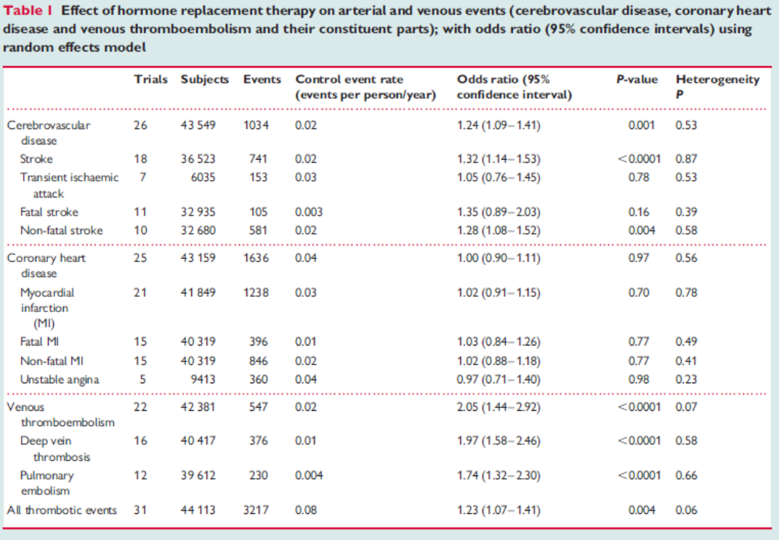

MacLennan (2004)
This was a meta-analysis by the Cochrane Collaboration which examined the efficacy of oestrogen/progesterone therapy for the management of hot flushes. It included 24 RCTs with 3329 women randomised to treatment. The Clinical Safety Summary states
in conclusion the short-term safety of oral hormone therapy for the alleviation of hot flushes and night sweats appears to be well established
The authors of the analysis stated
The description of possible side-effects and adverse events in the trials assessed was inconsistently reported and often not expressed numerically to allow meta-analysis of these events.
The evaluator notes that this someone limits this data as a piece of evidence on which to reply for safety data. The odds ratio of any adverse event was, as expected, increased versus placebo OR 1.41 95% CI 1.00-1.99.

Dodd (2013)
This is a Cochrane Review of the evidence supporting the use of progestogens in high risk pregnancies in a variety of formulations. It concluded on the basis of 36 RCTs. Despite referring to progesterone in its title, it includes studies with 17P as well as progesterone.
The Summary of Clinical Safety has noted that the analysis found no major neurodevelopmental handicap in childhood in the subgroup of women with a history of pre-term labour but not a shortened cervix. This is based on a single study authored by Northen et al., entitled “Follow-up of children exposed in utero to 17 alpha-hydroprogesterone caproate compared with placebo”, (Obstet Gynecol. 2007 Oct;110(4):865-72), which was a followup of children born to mothers exposed to 17P in Meis et al. (N Engl J Med. 2003 Jun 12;348(24):2379-85).

Table 10: Summary of childhood developmental outcomes summarised in Dodd (2013).
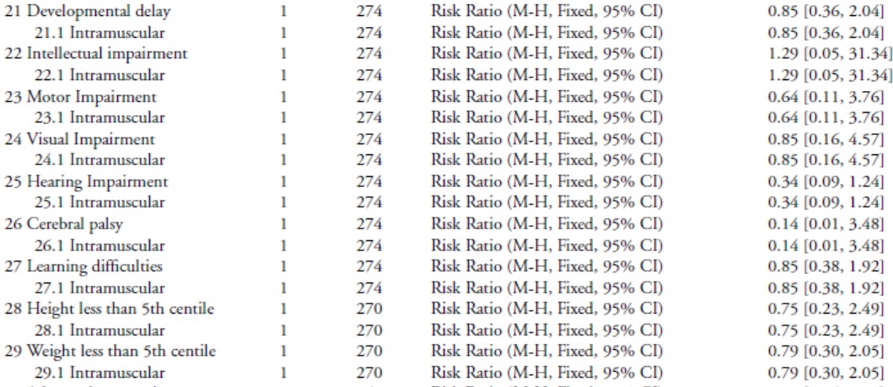
The evaluator notes that the confidence intervals of these estimates are relatively broad and could indicate either a reduction or unacceptable increase in childhood abnormalities for progesterone compared to placebo. It is therefore not evidence of therapeutic equivalence to placebo, merely a lack of a finding of statistical difference likely to be related to lack of power. This study also has used IM P4 rather than a vaginal preparation. Childhood developmental outcomes are not reported for the analysis of women treated for a shortened cervix.

Patient exposure
The sponsor has noted that micronized progesterone has been clinically available worldwide for more than 50 years and clinical experience is extensive. Utrogestan was first marketed in France in 1980. The cumulative exposure to Utrogestan capsules from 2008 to 2011 is estimated to be 650,391 patient years for the 100 mg capsules, and 320,303 patient years for the 200mg capsules.
Exposure in the sponsor initiated trials in this dossier was as shown in Table 11.

Table 11: Patient exposure company initiated trials.
Trial | Indication | Treatment | Number of patients treated | Duration of treatment
Christiansen (1985) | HRT | Utrogestan 200mg daily on days 14-28 of cycle | 29 | 1 year
Kleinstein (2002) | Luteal Support | Utrogestan 600mg daily | 218 | 10 weeks
Lorain (1994) | HRT | Utrogestan 200mg on days 14-28 of cycle | 20 | 13 months
Simon (1988) | Menstrual irregularity | Utrogestan 200mg and 300mg daily | 39  19 x 200mg  20 x 300mg | 10 days
Salat-Baroux (1988) | Luteal support | Up to 600mg daily | 22 | 60 days
Moyer (1987) | HRT | 200mg or 300mg daily on days 14-28 of cycle | 157  131 x 200mg  26 x 300mg | >5 years

Adverse events

All adverse events (irrespective of relationship to study treatment)

Pivotal studies

HRT
Lorrain (1994) has tabulated adverse events related to oestroderm. Adverse events reported in the Utrogestan group included headache (2 patients), weight increase (1 patient), nervousness (2 patients), bronchitis (1 patient) and amenorrhea (1 patient).
Christiansen (1985) notes that there were 10 adverse reactions but does not record whether they occurred during Utrogestan open-label phase of the trial.
Moyer (1987) does not appear to have systematically reported adverse events other than those related to the efficacy endpoint (endometrial histology/bleeding).
The Summary of Clinical Safety has referred to the meta-analyses evaluated in section 8.2 in addition to those submitted in support of efficacy. It has not presented any quantitative analysis of the adverse events reported in these studies.

Luteal phase support
Kleinstein (2002) reported 21 patients (9.7%) of the Utrogestan patients reported adverse events. Local adverse events are shown in Table 12.

Table 12: Summary of adverse events reported in Kleinstien (2002).
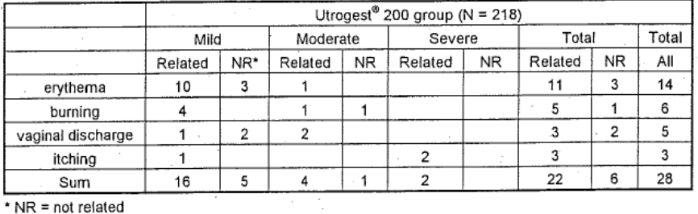
Salat-Baroux (1988) reported no adverse events but does not appear to have systematically assessed these in the trial protocol.

Menstrual irregularity
Simon (1988) indicated that 80% of women receiving Utrogestan 200mg and 71% of women receiving Utrogestan 300mg experienced adverse events, compared to 66% in the placebo arm. The majority of these resulted from the pharmacological action of progesterone as well as from the onset of withdrawal bleeding.

Table 13: Adverse events reported in Simon (1988).
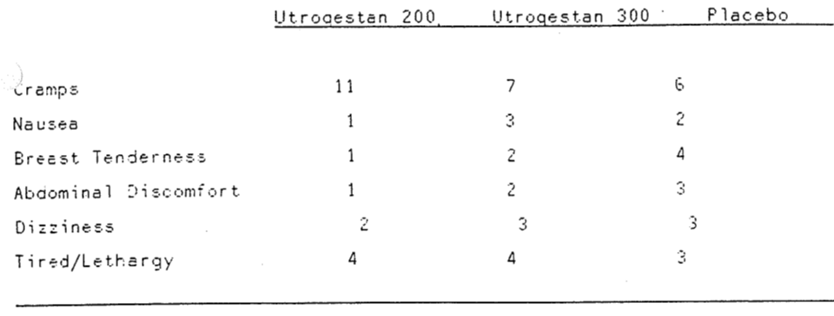

Other studies
Except where specifically noted, the meta-analyses and clinical guidelines provided as supportive evidence were not evaluable for the incidence of adverse events.

Deaths and other serious adverse events

Pivotal studies
No deaths were reported in the pivotal trials associated with vaginal administration of progesterone. No deaths were reported in the pivotal trials associated with the oral administration of progesterone.

Other studies
The meta-analysis described in section 8.2 indicate an increased risk of adverse events, including death from lung cancer after >5 years of therapy for HRT (Majoribanks (2012)).

Discontinuation due to adverse events

Pivotal studies
See Table 14.

Table 14: Discontinuations due to adverse events reported in sponsor initiated trials.
Trial | Indication | Treatment | Number of patients treated | Duration of treatment | Withdrawal due to AE in Utrogestan treated patients
Christiansen (1985) | HRT | Utrogestan 200mg daily on days 14-28 of cycle | 29 | 1 year | 9
Kleinstein (2002) | Luteal Support | Utrogestan 600mg daily | 218 | 10 weeks | 1
Lorain (1994) | HRT | Utrogestan 200mg on days 14-28 of cycle | 20 | 13 months | Unknown
Simon (1988) | Menstrual irregularity | Utrogestan 200mg and 300mg daily | 39  19 200mg  20 300mg | 10 days | 0
Salat-Baroux (1988) | Luteal support | Up to 600mg daily | 22 | 60 days | Unknown
Moyer (1987) | HRT | 200mg or 300mg daily on days 14-28 of cycle | 157  131 200mg  26 300mg | >5 years | 79 for ‘personal reasons’

Other studies
These were meta-analyses which were not evaluable for withdrawals due to adverse events.

Safety of inactive ingredients – Peanut oil
The formulation of Utrogestan/Prometrium proposed for marketing contains arachis (peanut) oil. As the Summary of Clinical Safety notes:
Individuals allergic to peanuts can undergo a severe, life-threatening reaction following exposure to peanut allergens.
The submission contains no sponsor initiated trials examining the allergenicity of peanut oil.
The sponsor has referred to a report by the UK Ministry of Health Committee on Toxicity of Chemicals in Food Consumer Products and the Environment. This concluded:
1.2 It was noted that, although crude peanut oil can contain peanut allergens, refined peanut oil is a neutralised bleached deodorised product which contains no proteins detectable by immunoassay and which has not caused reactions in peanut-allergic individuals. It was considered that the use of the refined oil in food and medicinal products is without risk to sensitive individuals. Refined peanut oil is therefore not included in the category of ‘peanut products’ in the advice below.
The sponsor has also noted that the US FDA advises that highly refined oils which have been refined, bleached, and deodorised are exempted as major food allergens.
The sponsor has referenced a study, Hourihane (1997), in which 60 subjects with postive skin prick tests to peanut allergens were administered oral crude and refined oil. 10% of the subjects reacted to oral crude peanut oil, and none reacted to refined oil.
The evaluator notes that the electronic copy of this study contained links to tables which did not open.
The sponsor has reference EMEA guidance on the recommended labelling of products containing peanut oil (EMA/HMPWP/37/04), which the evaluator has included as an appendix to this report. This provides indicative labelling for peanut containing products with IV, oral and topical exposure which recommend not using the product if you are allergic to peanuts. This guideline also notes that evidence regarding the allergenicity of refined peanut oils is contradictory.
The evaluator notes that the EMEA guidance was written for herbal products, and it contains no advice regarding vaginal administration of products or reference to particular indications of usage in which mild or local allergic reactions might be relevant in addition to generalised systemic reactions.

Laboratory tests

Vaginal administration
Kleinstein (2002) examined clinical chemistry and urinalysis in 218 women. These indicated no clinically significant difference in life function tests. The incidence of anaemia increased from 7 to 22 over the course of the trial, but this is likely to be related to pregnancy. There was an increase in the number of women with above-normal (>440/nL) thrombocytes from1 to 6.

Oral administration
In trials using progesterone for HRT (Moyer (2007)) there were no significant changes in laboratory parameters over the course of treatment. Lorrain (1994) found that triglyceride plasma levels increased from baseline by about 50% at 1 year and 34% after 2 years of treatment. Most of this was within the upper limits of normal range. Blood glucose level and other lipid profiles were comparable between Utrogestan and comparator treatment.
The evaluator notes that Lorrain (1994) is a small study of 20 participants. Moyer (1987) is not a comparative trial for the purposes of Utrogestan treatment, and Kleinstein (2002) is a comparison between two forms of vaginal progesterone. There are no placebo comparison laboratory results for this product in the pivotal trials.

Post-marketing experience
The sponsor has provided 13 post-market safety update reports (PSURs) covering the period 1998-2011.
Serious adverse events reported in the post-marketing experience with Utrogestan/Prometrium are presented.

Safety issues with the potential for major regulatory impact
None reported in PSURs.

Evaluator’s overall conclusions on clinical safety

HRT
The safety of progesterone for HRT indication is represented both in the efficacy data and safety studies submitted, since the main effect of progesterone is to provide ‘safety’ against endometrial complications of unopposed oestrogen therapy. As discussed in section 7.1.3 the pivotal data submitted in Lorraine (1994) and Moyer (1987) is sufficiently methodologically flawed to prevent analysis of this endpoint. Furness (2012) is a meta-analysis which provides support for the effect of progestogens in reducing the rate of endometrial hyperplasia to placebo levels but is not statistically definitive for progesterone per se.
The evidence for side effects of progesterone itself, rather than of HRT, is entirely derived from post-marketing data. Given the long historical experience with progesterone the Evaluator feels this is likely to be indicative of the adverse events related to progesterone.
The analysis of the safety of progesterone as a component of HRT therefore relies entirely on the published meta-analyses indicating the historical experience of combination HRT; Majoribanks (2012), Furness (2012), Greiser (2007), Liu (2012), McLennan (2004). These indicate the slightly increased rate of breast cancer, heart disease, stroke and dementia found in long term studies.

Menstrual irregularities
There is no safety data for this indication, and so safety would depend on the duration of treatment. As a short term therapy for secondary amenorrhea the evaluator concludes that there is unlikely to be significant adverse events not observed with similar doses administered in the long term for HRT.

Luteal phase support
As with Support of pregnancy, the safety of progesterone in this indication relates to the mother and the child.
The pivotal studies did not report significant adverse effects of progesterone in mothers over the period of treatment in excess of those which are associated with pregnancy itself.
There is no long term paediatric data submitted to demonstrate the lack of long term effects of progesterone on development. The Evaluator notes, however, that there considerable historical post-marketing oversight by regulatory agencies in comparable jurisdictions for this indication. The increased uterine exposure to progesterone from vaginal administration is relevant to paediatric safety, but is countered by evidence supporting increased efficacy for vaginal progesterone in luteal support compared to other routes of administration. Pharmacological luteal support is required where there is a luteal phase deficit for IVF to work e.g. placebo is not a viable option as an alternative.
The evaluator also notes that the general concern about potential allergy to peanut oil is significant for vaginal administration of progesterone (see below). Whether refined peanut oil is safe in general, the evaluator is of the view that even localised cervical inflammation may be relevant to pregnancy outcomes in women at low risk of conception. No evidence has been provided to support the safety of peanut oil in this indication.

General: peanut oil
Prometrium and Utrogestan are marketed worldwide in presentations which are based on either peanut or sunflower oil.
The US, Canada, United Kingdom, France, Germany and Switzerland do not have a vaginal presentation containing peanut oil registered.
The sponsor has provided EMEA regulatory guidance which does not apply to vaginal administration of peanut oil and, indeed, highlights the lack of conclusive safety of refined oils. The rate of oral reaction to peanut oil is not indicative of the significance of local reactions to the two indications proposed for vaginal progesterone.
The Evaluator notes that the safety of peanut containing vaginal progesterone would be more plausibly supported by the sponsor had not women with an allergy to peanut not been excluded from pivotal clinical trials.
While a warning for people at risk of peanut allergy to avoid using Utrogestan may be appropriate if the risk could not be definitively removed, it is inappropriate when it is possible to engineer the risk out of the clinical environment. Since there is a sunflower oil based product marketed in many comparable jurisdictions, this should be the one supplied in Australia. This avoids the potential for the warning regarding allergy to be ineffectively communicated in the clinical setting, or adverse events occurring in women whose local reactivity is not commensurate with their oral tolerance of peanut oil.

First round benefit-risk assessment

HRT
The considerable historical experience with progestogen containing HRT, clinical consensus, and the large post-market oversight for this indication, suggest that progesterone is likely to be safe and effective as part of combination HRT. The evaluator notes the approval of this indication in the US, Canada and UK. The pivotal trials submitted in support of endometrial safety are, however, extremely poor and should not be relied upon. Balancing this, several large meta-analyses consistent with clinical consensus indicate that endometrial safety of combined HRT with progestogen is acceptable.

Luteal phase support
The efficacy of vaginal progesterone in luteal support is adequately demonstrated by the submitted data. The main risks are the lack of long term paediatric data and the probability of allergic reactions to the proposed peanut oil containing formulation. The latter is an unacceptable risk given that it can be avoided by marketing a closely related product.

Menstrual irregularities
Progesterone appears effective in the short term management of secondary amenorrhea. There is no safety data supporting this indication in the dossier, although there is some regulatory oversight of post-marketing experience in comparable jurisdictions. The risk of AEs is mitigated by the short term use of the product, and similarity to the dose proposed for intermittent HRT.

First round recommendation regarding authorisation
The evaluator recommends that:
- The proposed indication for HRT be approved with the wording changed to “Prometrium Capsules are indicated for use in the prevention of endometrial hyperplasia in non-hysterectomised postmenopausal women who are receiving conjugated estrogens tablets”. This recommendation is based on the understanding that the sponsor makes the changes to the PI as recommended.
- The proposed indication for Menstrual Irregularities be approved, with the wording of the Indication changed to “The management of secondary amenorrhea”. This recommendation is based on the understanding that the sponsor makes the changes to the PI as recommended.
- The evaluator recommends that both indications for vaginal use of peanut oil containing progesterone be rejected due to inadequate safety data to support this route of administration in the clinical settings proposed.
If the sponsor is minded to supply a sunflower oil containing formulation for vaginal administration, the evaluator feels that:
- The proposed indication for Luteal Support be approved, with the wording of the Indication changed to “Luteal Support of Assisted Reproductive Technology (ART) cycles”. This recommendation is based on the understanding that the sponsor make the changes to the PI recommended.
The sponsor responded to these recommendations by agreeing to submit the product formulated with sunflower oil and making some amendments to the PI.

Clinical questions
None

Therapeutic Goods Administration
PO Box 100 Woden ACT 2606 Australia
Email: info@tga.gov.au Phone: 1800 020 653 Fax: 02 6232 8605
https://www.tga.gov.au

