First round CER: December 2011
Second round CER: May 2012

AusPAR Attachment 2

Extract from the Clinical Evaluation Report for progesterone
  - Proprietary Product Name: Endometrin Pessaries
  - Sponsor: Ferring Pharmaceuticals Pty Ltd
About the Therapeutic Goods Administration (TGA)
- The Therapeutic Goods Administration (TGA) is part of the Australian Government Department of Health and Ageing, and is responsible for regulating medicines and medical devices.
- The TGA administers the Therapeutic Goods Act 1989 (the Act), applying a risk management approach designed to ensure therapeutic goods supplied in Australia meet acceptable standards of quality, safety and efficacy (performance), when necessary.
- The work of the TGA is based on applying scientific and clinical expertise to decision-making, to ensure that the benefits to consumers outweigh any risks associated with the use of medicines and medical devices.
- The TGA relies on the public, healthcare professionals and industry to report problems with medicines or medical devices. TGA investigates reports received by it to determine any necessary regulatory action.
- To report a problem with a medicine or medical device, please see the information on the TGA website <http://www.tga.gov.au>.
About the Extract from the Clinical Evaluation Report
- This document provides a more detailed evaluation of the clinical findings, extracted from the Clinical Evaluation Report (CER) prepared by the TGA. This extract does not include sections from the CER regarding product documentation or post market activities.
- The words [Information redacted], where they appear in this document, indicate that confidential information has been deleted.
- For the most recent Product Information (PI), please refer to the TGA website <http://www.tga.gov.au/hp/information-medicines-pi.htm>.
Copyright
© Commonwealth of Australia 2013
This work is copyright. You may reproduce the whole or part of this work in unaltered form for your own personal use or, if you are part of an organisation, for internal use within your organisation, but only if you or your organisation do not use the reproduction for any commercial purpose and retain this copyright notice and all disclaimer notices as part of that reproduction. Apart from rights to use as permitted by the Copyright Act 1968 or allowed by this copyright notice, all other rights are reserved and you are not allowed to reproduce the whole or any part of this work in any way (electronic or otherwise) without first being given specific written permission from the Commonwealth to do so. Requests and inquiries concerning reproduction and rights are to be sent to the TGA Copyright Officer, Therapeutic Goods Administration, PO Box 100, Woden ACT 2606 or emailed to <tga.copyright@tga.gov.au>.

Contents
List of abbreviations 5
1. Clinical rationale 6
2. Contents of the clinical dossier 6
2.1. Scope of the clinical dossier 6
2.2. Paediatric data 6
2.3. Good clinical practice 6
3. Pharmacokinetics 6
3.1. Studies providing pharmacokinetic data 6
3.2. Summary of pharmacokinetics 7
3.3. Evaluator’s overall conclusions on pharmacokinetics 7
4. Pharmacodynamics 9
4.1. Studies providing pharmacodynamic data 9
4.2. Summary of pharmacodynamics 9
4.3. Evaluator’s overall conclusions on pharmacodynamics 9
5. Dosage selection for the pivotal studies 9
6. Clinical efficacy 9
6.1. Pivotal efficacy study: No. 2004-02 9
6.2. Other efficacy studies 15
6.3. Analyses performed across trials (pooled analyses and meta-analyses) 15
6.4. Evaluator’s conclusions on clinical efficacy 15
7. Clinical safety 16
7.1. Studies providing evaluable safety data 16
7.2. Pivotal studies that assessed safety as a primary outcome 16
7.3. Patient exposure 16
7.4. Adverse events 17
7.5. Laboratory tests 20
7.6. Post-marketing experience 21
7.7. Other safety or tolerability assessments 22
7.8. Evaluator’s overall conclusions on clinical safety 22
8. First round benefit-risk assessment 22
8.1. First round assessment of benefits 22
8.2. First round assessment of risks 22
8.3. First round assessment of benefit-risk balance 22
9. First round recommendation regarding authorisation 22
10. Clinical questions 23
10.1. Trial certification 23
10.2. Drug product 23
10.3. Pharmacokinetics 23
10.4. Efficacy 25
10.5. Safety 25
11. Second round recommendation regarding authorisation 25
12. References 25
12.1. Studies presented in the dossier 25
12.2. Other references 26

List of abbreviations
Abbreviation | Meaning
ADR | Adverse drug reaction
ALT | Alanine aminotransferase
AST | Aspartate aminotransferase
BMI | Body mass index
CER | Clinical evaluation report
CSR | Clinical study report
E₂ | Oestradiol
GCP | Good clinical (research) practice
GGT | Gamma glutamyl transferase
hCG | Human chorionic gonadotrophin
hMG | Human menopausal gonadotrophin
LC-MS/MS | Liquid chromatography–tandem mass spectrometry
LLQ | Lower limit of quantitation
LSM | Geometric least square mean
OHSS | Ovarian hyperstimulation syndrome
PI | Product information
PD | Pharmacodynamic
PK | Pharmacokinetic
PRL | Prolatin
PSUR | Periodic safety update report
TVU | Trans-vaginal ultrasound

Clinical rationale
In the Clinical Overview, the sponsor argues that "It has been demonstrated that absorption through the vaginal walls delivers high levels of medication directly to the uterine circulation, thereby providing high levels of progesterone to the endometrial tissue", and that "Endometrin provides a convenient, user-friendly option for treatment of women who require luteal support during ART treatment."

Contents of the clinical dossier

Scope of the clinical dossier
The submission contained the following clinical information:
- 2 clinical pharmacology studies, both of which provided pharmacokinetic data.
- 1 efficacy and safety study. (Note: As an Addendum to this study a pharmacokinetic study was done in some of the patients. The report of this addendum study was misfiled as a population PK study report.)
- 3 periodic safety update reports.
- Literature references.

Paediatric data
The submission did not include paediatric data.

Good clinical practice
The ethical certification of all the studies submitted appears to be acceptable.
The GCP certification of all 3 studies submitted was deficient, in that it read as follows:
"This trial was conducted in accordance with the ethical principles of Good Clinical Practice, according to the ICH Harmonized Tripartite Guideline."
As ICH’s principles of GCP cover scientific as well as ethical principles, the applicant's statement is inadequate for the purposes of GCP certification.

Pharmacokinetics

Studies providing pharmacokinetic data
Table 1 shows the studies relating to each pharmacokinetic topic and the location of each study summary.
Table 1: Submitted pharmacokinetic studies.
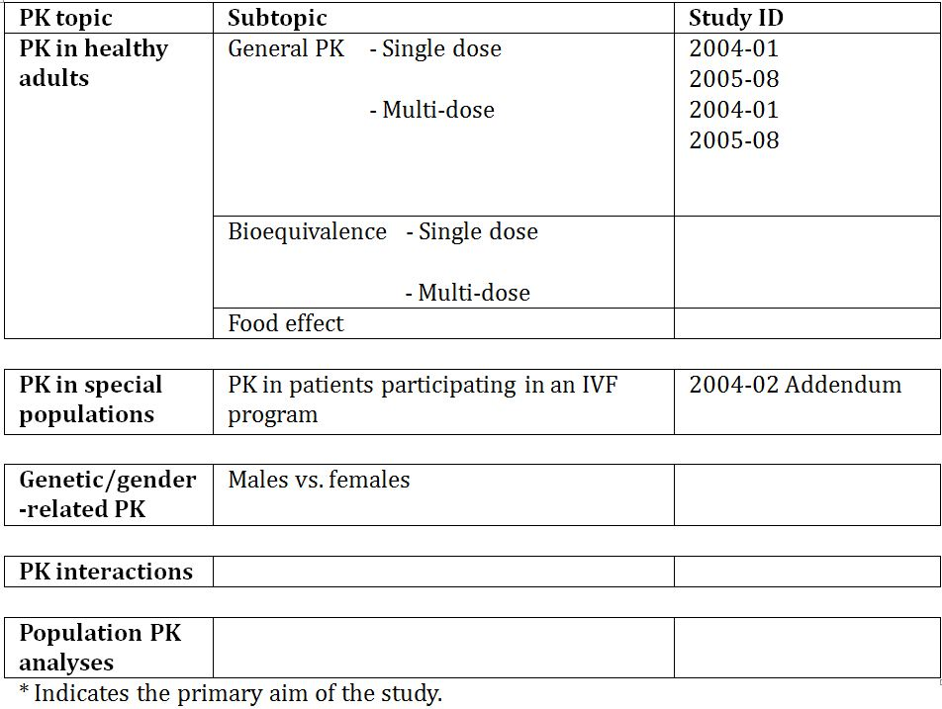
Table 2 lists pharmacokinetic results that were excluded from consideration due to study deficiencies.
Table 2: Pharmacokinetic results excluded from consideration.
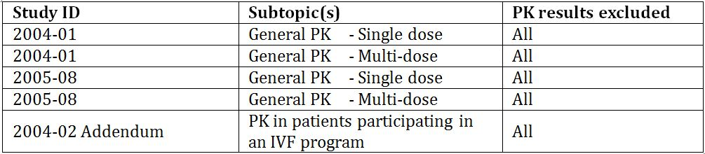

Summary of pharmacokinetics
The information in the following summary is derived from conventional pharmacokinetic studies unless otherwise stated.

Evaluator’s overall conclusions on pharmacokinetics
The pharmacokinetics of the product − particularly relating to absorption − are not well understood.
I have recommended that the pharmacokinetic results should not be accepted. If they are accepted, then the next paragraph below applies.
No data are available comparing vaginal absorption of similar doses of Endometrin and Crinone in the same study. However, serum progesterone concentration data for treatment with Endometrin 100 mg daily are available from Study 2004-01, and data for Crinone 90 mg daily from Study 2005-08. Pharmacokinetic parameters are summarised in Tables 3 and 4. These data suggest that Endometrin is absorbed to a lesser extent and less reliably than Crinone.
Table 3: PK parameters in each treatment group.
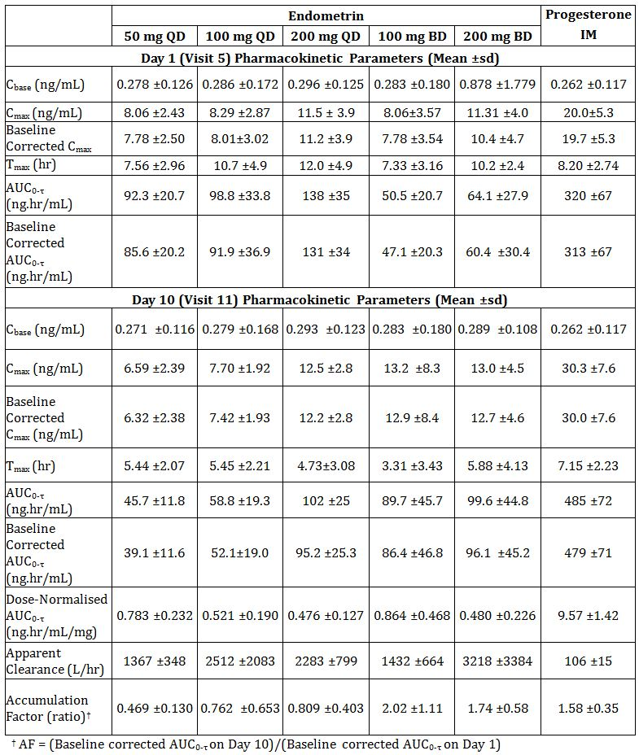
Table 4: Serum progesterone PK parameters.
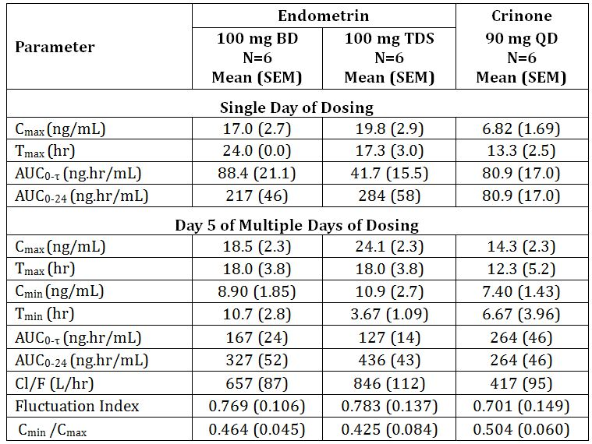

Pharmacodynamics

Studies providing pharmacodynamic data
Table 5 shows the studies relating to each pharmacodynamic topic and the location of each study summary.
Table 5: Submitted pharmacodynamic studies.
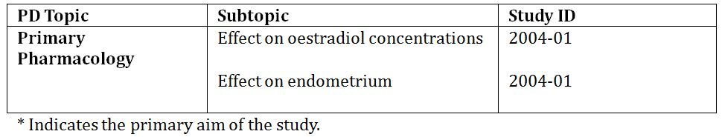
Table 6 lists pharmacodynamic results that were excluded from consideration due to study deficiencies.
Table 6: Pharmacodynamic results excluded from consideration.

Summary of pharmacodynamics
I consider all the pharmacodynamic results non-contributory, as it was not possible to distinguish the effects of the administered progesterone from those of the endogenous progesterone.

Evaluator’s overall conclusions on pharmacodynamics
See section 4.2 above.

Dosage selection for the pivotal studies
Not relevant.

Clinical efficacy

Pivotal efficacy study: No. 2004-02

Study design, objectives, locations and dates
This was a multicentre, randomised, open label, parallel group study to determine the efficacy of Endometrin administered vaginally in terms of ongoing pregnancy rates in women undergoing IVF. It was conducted at 25 sites in the USA between 18 July 2005 and 11 April 2006.

Inclusion and exclusion criteria
Broadly, the population in Study 2004-02 comprised women undergoing IVF treatment, not requiring donor ova. Full inclusion and exclusion criteria are as follows.
- Inclusion criteria:
  - Pre-menopausal females aged 18 - 42.
  - Early follicular phase (Day 2-4) FSH ≤ 15 IU/L and oestradiol within normal limits.
  - LH, PRL, and TSH within the normal limits for the clinical laboratory, or considered not clinically significant by the Investigator, within 6 months before screening.
  - Negative serum hepatitis B surface antigen, hepatitis C antibody, HIV antibody, and rapid plasma reagin tests within 3 months before screening.
  - Seropositive for rubella, and ABO grouping and Rho (D) typing prior to screening.
  - Documented history of infertility (eg, unable to conceive for ≥ 1 year or for 6 months for women aged ≥ 38; bilateral tubal occlusion or absence).
  - Male partner with recent (within 6 months before screening) semen analysis adequate for IVF by standard WHO and/or Kruger criteria. Donor sperm could be used, if indicated, provided that it met standard criteria.
  - Transvaginal ultrasound at screening (or within 14 days of screening) consistent with findings adequate for ART with respect to uterus and adnexa.
  - At least one cycle with no fertility medication before screening.
  - Normal uterine cavity documented by hysterosalpingography, hysteroscopy, or sonohysterogram.
  - Negative pregnancy test on the day of pituitary down regulation (before administration of GnRH agonist).
- Exclusion criteria:
  - Was a donor oocyte or embryo recipient or a gestational or surrogate carrier.
  - Was undergoing blastomer biopsy and other experimental ART procedures.
  - Had inadequate number of oocytes, defined as fewer than 3 oocytes retrieved.
  - Presence of any clinically relevant systemic disease (eg insulin-dependent diabetes mellitus).
  - Surgical or medical condition that, in the judgment of the Investigator or Sponsor, could interfere with absorption, distribution, metabolism, or excretion of the drugs to be used.
  - Subjects with a BMI > 34 at time of Screening.
  - Previous IVF or ART failure due to a poor response to gonadotrophins. Poor response was defined as development of ≤ 2 mature follicles or history of 2 previous cycle cancellations before oocyte retrieval due to poor response.
  - Presence of abnormal uterine bleeding of undetermined origin.
  - Current or recent substance abuse, including alcohol.
  - History of chemotherapy (except for gestational conditions) or radiotherapy.
  - Currently breast-feeding, pregnant or had a contraindication to pregnancy.
  - Refusal or inability to comply with the requirements of the protocol for any reason, including scheduled clinic visits and laboratory tests.
  - For male partner, obvious leukospermia ( > 2 million WBC/mL) or signs of infection in semen sample within 2 months before subject's pituitary down regulation; if either of these conditions existed, male was to be treated with antibiotics and retested prior to his partner's pituitary down regulation.
  - Documented intolerance or allergy to any of the medications used, including the study drug.
  - Participation in any experimental drug study within 60 days before screening.
  - Use of any of the following medications during the pretreatment and treatment phase: hormonal drug products (use of oral contraceptives during down regulation was allowed), progesterone creams, hydrocortisone and other steroid drug products, and fertility modifiers such as insulin sensitisers.
  - History of recurring pregnancy loss, defined as 3 or more spontaneous miscarriages.

Study treatments

Pretreatment phase

Down regulation
Upon successful completion of the screening procedures, the subject began down regulation. This was performed with an injectable GnRH agonist using a long protocol with luteal phase initiation. The GnRH agonist was injected daily. Down regulation was indicated by a serum E₂ level of < 50 pg/mL , endometrial lining of < 7 mm and no evidence of ovary activity on TVU.

Stimulation
Upon successful documentation of down regulation, ovarian stimulation was performed, using gonadotrophins administered in accordance with each site's IVF protocol. However, a daily administration of at least 1 vial of hMG was required for the duration of the stimulation, except in the case of coasting at the end of stimulation. If at any time a subject was felt to be at a significant risk for the development of moderate or severe OHSS, the Investigator discontinued administration of the gonadotrophins, and withheld hCG administration.

hCG administration
When the lead follicle mean diameter was at ≥ 18mm, a single IM injection of hCG (Novarel) 5,000-10,000 USP units was administered to trigger ovulation. The mean diameter for each follicle >15mm was documented.

Oocyte retrieval
Oocytes were retrieved within approximately 36 hours after hCG administration according to site-specific procedures.

Randomisation/Treatment phase

Randomisation
Each subject was randomly assigned to the study drug (Endometrin 100 mg BD, Endometrin 100 mg TDS, or Crinone 8% gel QD) on the day of or day following oocyte retrieval. The study drug was initiated on the day after oocyte retrieval. Each subject who became pregnant continued on the study drug for a total duration of 10 weeks.

Embryo transfer
In vitro fertilisation and embryo transfer were performed according to site-specific procedures. However, no more than 3 embryos or 2 blastocysts could be transferred in the study cycle. Intracytoplasmic sperm injection and/or assisted hatching could be performed during the study cycle. The study site could choose to use co-culture if routinely used with all patients undergoing IVF.

Treatment period visits
The subject returned to the study center approximately 5 additional times during the 10-week treatment period. A serum pregnancy test was performed 14 ± 5 days post embryo transfer to document biochemical pregnancy. If positive, a repeat serum pregnancy test was performed 2 days later. If the initial pregnancy test was negative, a second test could be performed at the Investigator's discretion. If the subject did not have a confirmed biochemical pregnancy, she was discontinued from the study and the follow-up procedures were performed.
Approximately 14 ± 5 days after the second positive serum pregnancy test, a TVU was performed to confirm clinical pregnancy, defined as presence of gestational sac. If foetal heart motion was detected, ongoing pregnancy was confirmed and no further ultrasound was warranted. If clinical pregnancy was noted without foetal heart motion, the subject continued on the study drug and a second TVU was performed at approximately 6 weeks' gestation to identify foetal heart motion. The person who performed the TVUs to confirm clinical and ongoing pregnancy was blinded to the subject's treatment group.
A final visit was scheduled upon completion of the tenth week of study drug (preferably on the same day as the last dose of study drug administration or within 1 to 3 days from the last dose). In addition, the study centre contacted each subject via phone or mail at the expected time of delivery to obtain birth data.

Efficacy variables and outcomes
The primary efficacy outcome was ongoing pregnancy following 1 treatment cycle in the efficacy population. Ongoing pregnancy was defined as identification of foetal heart movement at approximately 6 weeks of gestation.
Other efficacy outcomes included:
- Biochemical pregnancy (defined as positive β-hCG pregnancy test at 12 to 14 days post-embryo transfer).
- Clinical pregnancy (defined as presence of a gestational sac on ultrasound examination approximately 4 weeks post-embryo transfer).

Randomisation and blinding methods
Allocation to treatment group was performed via a telephone-based electronic Interactive Voice Response System, which randomly assigned the subject to 1 of 3 treatment groups. The protocol stipulated stratification for age and FSH level. The study was not blinded except for TVU assessors.

Analysis populations
Four subject populations were defined: ITT, Efficacy, Per-Protocol, and Completers. The ITT population included all subjects who were randomised to treatment and took at least 1 dose of study drug (N=1211). The Efficacy population included ITT subjects who underwent an embryo transfer (N=1175). The Per-Protocol population included all subjects in the Efficacy population who did not have major protocol violations and did not take any additional medications for luteal support (N=1129). The Completers population included all subjects who continued treatment for 10 weeks (N=465). The numbers of subjects in each study population are in Table 7.
Table 7: Number of subjects in each study population.
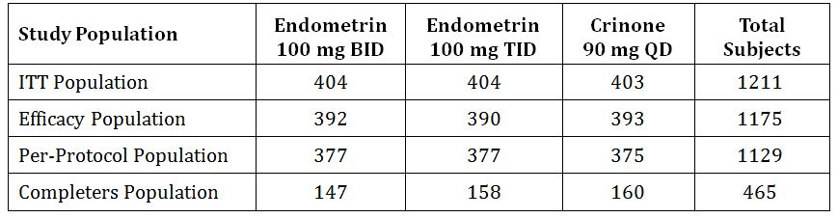

Sample size
A sufficient number of subjects was sought to have at least 80% power to demonstrate the non-inferiority of Endometrin versus Crinone in the pregnancy rate, using a two-sided 95% confidence interval and a prespecified non-inferiority margin of 10%. Based on these requirements, and assuming a Crinone pregnancy rate of 30%, a sample size of ≥ 330 evaluable subjects per treatment group would provide at least 80% power to demonstrate such non-inferiority of Endometrin relative to Crinone.

Statistical methods
The primary analysis was performed to determine if the ongoing pregnancy rate for each dose of Endometrin was non-inferior to Crinone. This was determined by comparing the pregnancy rate for each dose of Endometrin with the pregnancy rate for Crinone using a 95% confidence interval for each pregnancy rate. To declare non-inferiority, the lower bound of the confidence interval was to exclude a difference greater than 10% in favour of the comparator. To adjust for multiple comparisons, Endometrin 100 mg TDS v Crinone was considered the primary comparison. If the lower bound of the confidence interval excluded a difference greater than 10% in favour of Crinone, then the non-inferiority of Endometrin 100 mg BD versus Crinone would be assessed.

Major protocol violations/deviations
One site [information redacted] inadvertently administered oestradiol to all subjects, following its own standard IVF treatment protocol. These subjects remained in the ITT and Efficacy populations but were excluded from the Per-Protocol population.
Two subjects were withdrawn from the study due to protocol violations:
- [information redacted] in the Endometrin TDS group underwent embryo transfer on 3 October 2005; beginning on 21 October 2005, oestrogen was administered for 3 days for luteal support due to heavy bleeding.
- [information redacted] in the Crinone group underwent embryo transfer on 9 October; the subject experienced bleeding on 17 November 2005, was instructed to administer the test medication twice daily, and was withdrawn from the study on 25 November 2005.
Four subjects (3 Endometrin TDS, 1 Crinone) were administered exclusionary concomitant medications:
- In the Endometrin TDS group, [information redacted] was administered progesterone-in-oil IM QD due to low serum progesterone levels, [information redacted] was administered enoxaparin due to history of miscarriage, and [information redacted] was administered oestrogen due to vaginal bleeding. In the Crinone group, [information redacted] was administered oestrogen due to bleeding.

Results for the primary efficacy outcome
For a non-inferiority study, analysis of the Per-Protocol population is appropriate. Results in this population are in Table 8.
Table 8: Analysis of the Per-Protocol population.
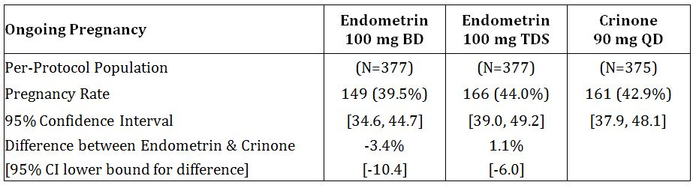
Endometrin 100 mg TDS v Crinone 90 mg QD satisfies the non-inferiority criterion, so the Endometrin 100 mg BD dosage group is then analysed. This group does not meet the criterion.
Ongoing pregnancy rates for the other populations are in Table 9. By definition, all subjects in the Completers population were pregnant based on foetal heart movement.
Table 9: Ongoing pregnancy rates.
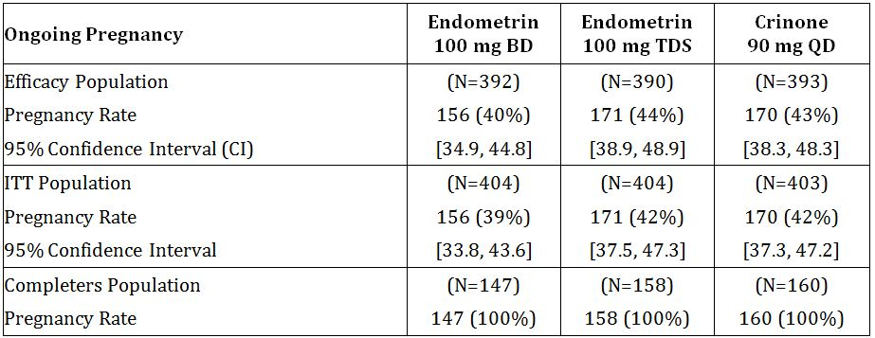

Results for other efficacy outcomes
Results of the secondary efficacy analyses, done on the Per Protocol populations are shown in Table 10.
Table 10: Results of secondary efficacy analyses.
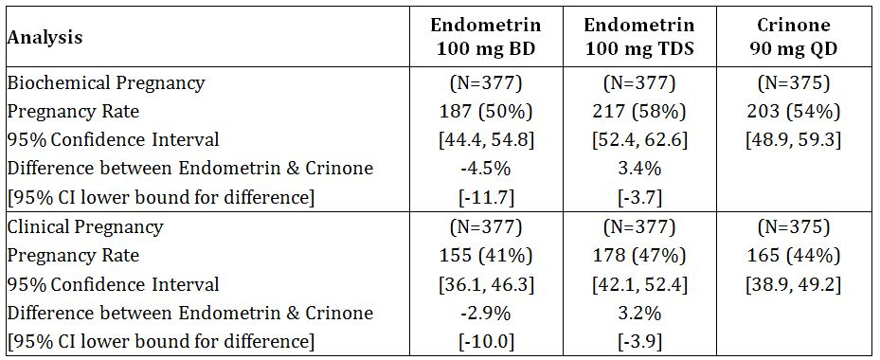
Among the ancillary analyses, subgroups were analysed, corresponding to the initial stratification:
- subjects aged < 35 (737 subjects); and
- subjects with FSH < 10 IU/L, representing ovarian reserve (1047 subjects).
Analyses of ongoing pregnancy rates in age and FSH subgroups (ITT population) are shown in Table 11.
Table 11: Pregnancy rate − subgroup analysis − ITT population (Study 2004-02).
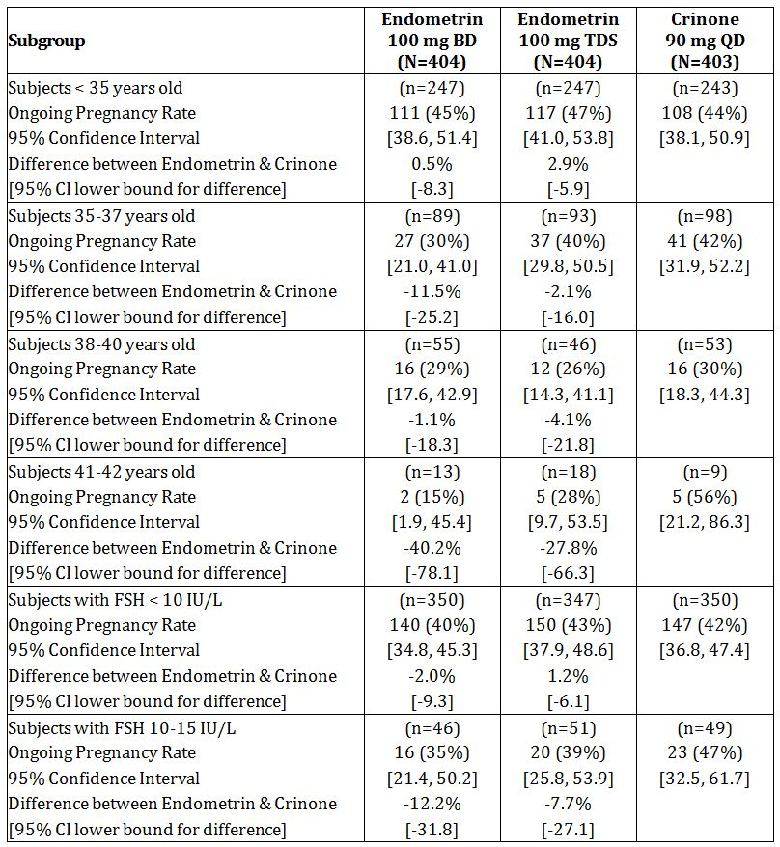

Other efficacy studies
None submitted.

Analyses performed across trials (pooled analyses and meta-analyses)
Not relevant.

Evaluator’s conclusions on clinical efficacy
Dose-finding studies are lacking − unless the one efficacy study, designed as a non-inferiority study, can be regarded as a dose-finding study, in which case it can hardly also have the status of a "pivotal" efficacy and safety study.
Note that the comparison was done against the minimum recommended dosage of Crinone (90 mg daily), whereas the Dosage and administration section of the approved PI for Crinone envisages 90 mg daily or bd (see section 1.5 above). The non-inferiority criterion was not met for Endometrin 100 mg bd.
The non-inferiority criterion was met for Endometrin 100 mg tds, but I would make the following points which would call into question the external validity of Study 2004-02 in the comparative assessment of the 2 progesterone products:
- Whether the administered progesterone was necessary to the outcome. No placebo group was included in the study − presumably because it has been established that the luteal phase of all stimulated IVF cycles is abnormal (Fatemi et al., 2007). Accurate information on the extent of the benefit to be gained by the use of progesterone for luteal support is not available. In a series reported by Sallam et al. (1999), among 192 women in whom ovulation was induced and who received no luteal support, 62.5% resulted in full-term pregnancy. A recent Cochrane Review (van der Linden et al., 2011) estimated a Peto OR of 1.83 from 7 studies with the following characteristics:
  - Comparison: progesterone v placebo or no treatment.
  - Outcome: clinical pregnancy rate.
- Patients with special need. Older subgroups, or patients with early follicular phase FSH > 10 IU/mL, may have been at greater need for luteal support, but this can only be clarified by further study. As the trialists state (CSR page 119):
  - "These findings suggest that, for younger patients and patients with adequate ovarian reserve, Endometrin TID provides no greater clinical benefit than BID dosing. Older patients and patients with diminished ovarian reserve might require stronger luteal support and would benefit from Endometrin TID."
The Overview Addendum seeks to mitigate the formal outcome of the non-inferiority trial by a variety of retrospective analyses, concluding with:
"In summary, the data presented support that Endometrin 100 mg BID and 100 mg TID are efficacious in women up to 40 years of age, and the efficacy of Endometrin 100 mg TID efficacy has been shown also in women older than 40 years. Therefore, the dosing recommendations proposed for women up to 40 years is Endometrin 100 mg administered vaginally two (BID) or three times (TID) daily starting at oocyte retrieval and continuing for up to 10 weeks total duration (or 12 weeks of gestation). For patients older than 40 years, Endometrin 100 mg TID is recommended."
The clinical evaluator finds the Overview Addendum unconvincing, based as it is on retrospective data re-analysis.

Clinical safety

Studies providing evaluable safety data
Studies 2004-01, 2005-08 and 2004-02 provided evaluable safety data.

Pivotal studies that assessed safety as a primary outcome
Not applicable.

Patient exposure
Table 12 shows exposure to Endometrin and comparators in the clinical studies.
Table 12: Exposure to Endometrin and comparators in clinical studies.
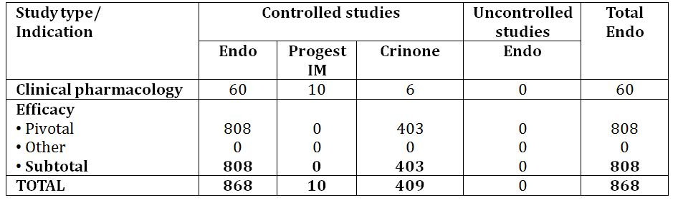

Adverse events

All adverse events (irrespective of relationship to study treatment)
All adverse events (irrespective of relationship to study treatment) are listed in Table 13.
Table 13: AEs occurring in ≥ 2% subjects in any treatment group (Study 2004-02).
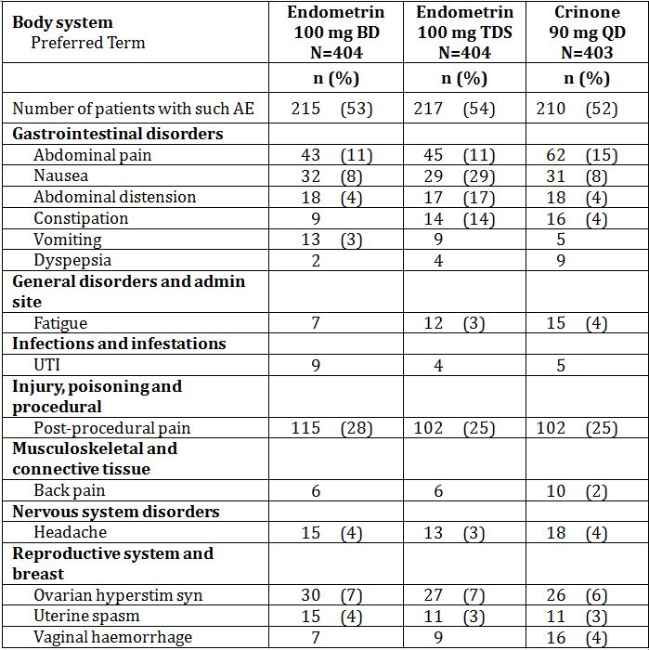

Treatment-related adverse events (adverse drug reactions)
Treatment-related adverse events (adverse drug reactions) are shown in Table 14.
Table 14: AEs whose relationship to treatment was considered probable or uncertain (Study 2004-02).
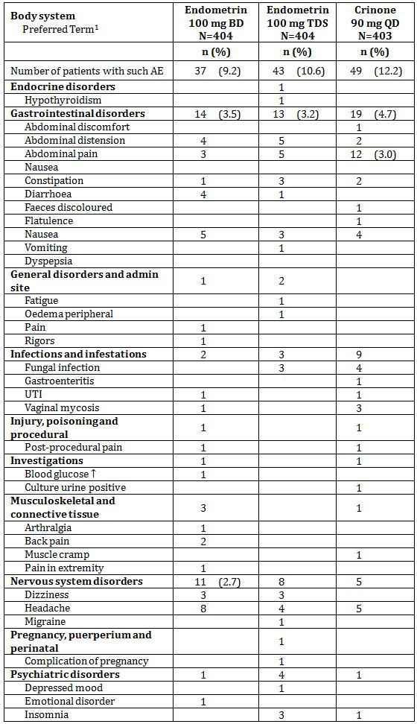
Table 14 (continued): AEs whose relationship to treatment was considered probable or uncertain (Study 2004-02).
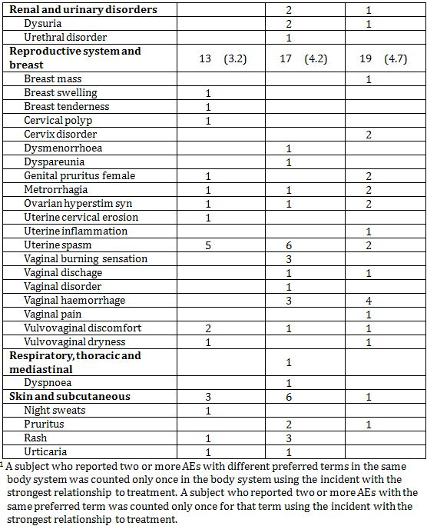

Deaths and other serious adverse events
No deaths were reported. Serious AEs are shown in Table 15.
Table 15: Serious AEs (Study 2004-02).
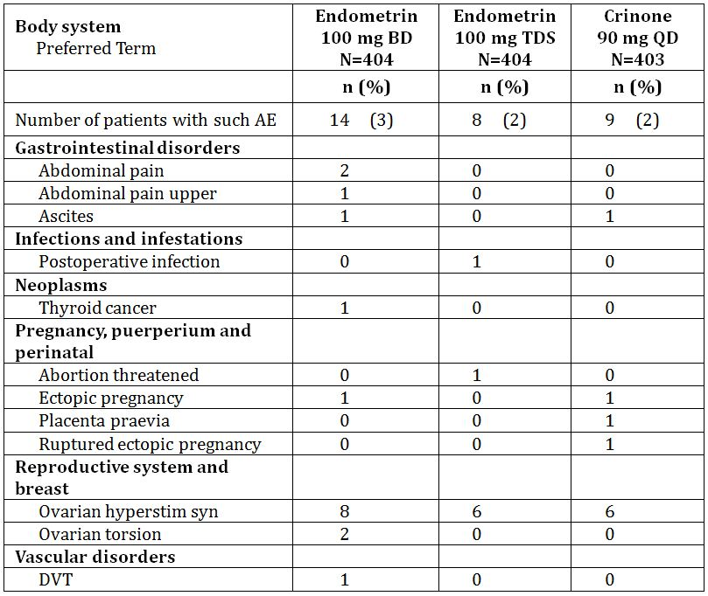

Discontinuation due to adverse events
AEs that led to discontinuation of the study drug are shown in Table 16.
Table 16: AEs that led to discontinuation of study drug.
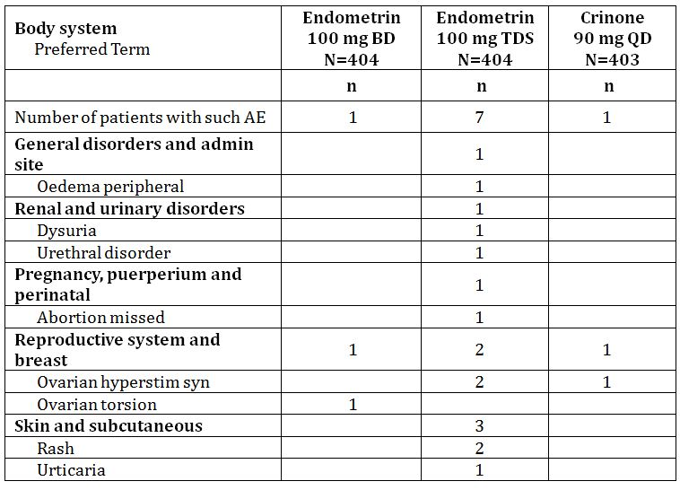

Laboratory tests

Study 2004-02
Blood was drawn for routine haematology and biochemistry screening at screening and at study end (day of last dose).
Changes in mean values of haematology and biochemistry parameters were not considered clinically meaningful. All mean values remained within the normal ranges.
Shifts from normal baseline to abnormal values at study end largely reflected normal pregnancy, and none was of concern to investigators.

Post-marketing experience
Included in the dossier were PSUR 1 (20 November 2009 - 19 May 2010); PSUR 2 (20 May 2010 - 19 November 2010); and PSUR 3 (20 November 2010 - 19 May 2011).
The cumulative exposure from sales up to 30 April 2011 was estimated to be 156500 patients, judged from total sales of 14.084 million vaginal tablets.
Serious unlisted ADRs recorded in Ferring's Global Pharmacovigilance database were presented in the PSURs as follows:
- PSUR 1 presented no such reports as received during its reporting period, but presented the following reports as being on the database before the reporting period:
  - Spontaneous reports: 1 spontaneous abortion.
  - Regulatory authorities' reports: 0
  - Clinical trials: 1 infection; 1 OHSS
  - Literature: 0
- PSUR 2, Current reporting period:
  - Spontaneous reports: 1 spontaneous abortion.
- PSUR 2, Cumulative presentation:
  - Spontaneous reports: 1 spontaneous abortion; 1 abdominal pain; 1 pelvic pain
  - Regulatory authorities' reports: 0
  - Clinical trials: 1 infection; 1 OHSS
  - Literature: 0
- PSUR 3, Current reporting period:
  - Spontaneous reports: 1 spontaneous abortion
  - Literature: 1 disseminated intravascular coagulation
- PSUR 3, Cumulative presentation:
  - Spontaneous reports: 2 spontaneous abortion.
  - Regulatory authorities' reports: 0
  - Clinical trials: 1 infection; 1 OHSS
  - Literature: 1 disseminated intravascular coagulation
These reports generally related to patients who were being treated with several drugs, and who were at risk of the event reported anyway. The report of disseminated intravascular coagulation perhaps deserves special attention: The report, from Korea, did not relate specifically to Ergometrin. The patient had a history of primary infertility and diffuse adenomyosis (a recognised risk factor for development of menstruation-related DIC). She presented with anuria and elevated serum creatinine three weeks after her second IVF treatment cycle.

Other safety or tolerability assessments

Subject diary
Each day, subjects recorded on a Subject Diary Card the presence and severity of symptoms of genital bleeding, vaginal discharge, vaginal irritation/itching, and drowsiness and whether they had problems with sexual intercourse. No obvious pattern emerged, except with vaginal discharge, the results for which suggested the symptom was more pronounced in the Endometrin groups than in the Crinone group. It is not clear whether any of these reports of vaginal discharge might have represented partial loss of treatment product.

Evaluator’s overall conclusions on clinical safety
The AE and laboratory monitoring do not raise any matters of concern. There is a question relating to tolerance of Endometrin in comparison to Crinone (see paragraph immediately above).

First round benefit-risk assessment

First round assessment of benefits
In my opinion, the unsatisfactory pharmacokinetic basis for Endometrin militates against approval, in that it calls into question the external validity of the efficacy and safety study. The efficacy study showed that when administered at approximately double the dosage of Crinone, Endometrin failed the non-inferiority test, and the results point to a requirement for further study of patients who may be at greater need of luteal support (on the basis of age or FSH level).

First round assessment of risks
The inadequacy of pharmacokinetic data on Endometrin is also of concern in relation to safety, as levels of the drug, and consequent pharmacodynamic effects, may be unpredictable. The tolerance in comparison to Crinone is also in question.

First round assessment of benefit-risk balance
Compared to Crinone, Endometrin needs to be given at higher dosage to achieve comparable efficacy. The pharmacokinetics of the Endometrin have not been adequately studied. In the absence of some compensating advantage, it appears to be an inferior product.

First round recommendation regarding authorisation
The application should not be approved.

Clinical questions

Trial certification
Question 1: The sponsor should be asked to review the GCP certification of each of the studies submitted.

Answer provided by sponsor
Please find attached a statement confirming that the three studies were all conducted according to both the ethical and scientific principles of ICH GCP. The statement is provided as an appendix.

Assessment
The answer is not independently evaluable. However, the question has been answered. Unfavourable audit reports would have to be reported, so the matter is regarded as resolved.

Drug product
Question 2: To what extent were the products used in the studies identical to the product proposed for registration?

Answer provided by sponsor
The phase I/II study 2004-01 evaluated three different multiple-dose regimens, making use of two tablet strengths, 50 mg and 100 mg. The 100 mg tablet was identical to the 100 mg tablet used in the two other studies, 2005-08 and 2004-02, and to the product proposed for registration.

Assessment
The formulation details are provided per batch and not per unit dose and therefore might not say much about content uniformity or the certificates of analysis. However, the quality matters are the subject of a separate Quality evaluation. There are minor quantitative differences that pertain to the 100 mg strength that was used in 2004-01.
The question has been satisfactorily answered. The implication is that pharmaceutical differences should not account for any observed differences in the studies.

Pharmacokinetics
Question 3: The mean trough progesterone concentration reported for 100 mg BD dosage (Figure 1) requires explanation. Why has the concentration at 228 hours (supposedly 12 hours after the last dose) fallen to a level so much lower than the trough concentrations recorded before earlier doses?
Figure 1: Mean trough progesterone concentrations during treatment (Study 2004-01).
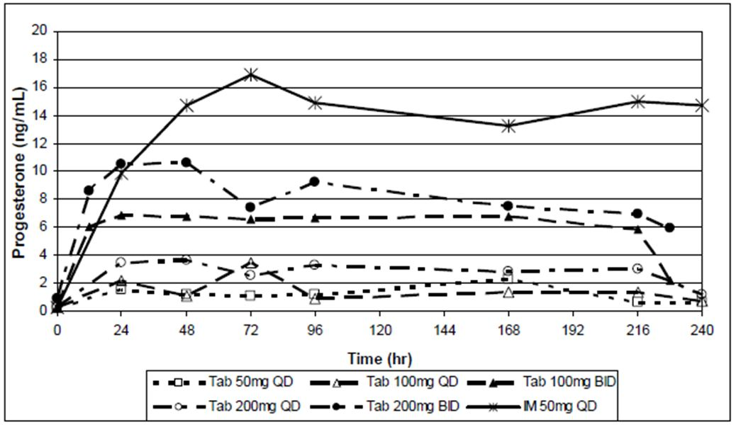

Answer provided by sponsor
Endometrin is a vaginal tablet containing progesterone formulated to disintegrate and dissolve rapidly. A portion of the released progesterone is absorbed into the systemic circulation across the vaginal epithelium over an extended time span. The 2004-01 study evaluated the time course of the appearance of the progesterone in the systemic circulation under a variety of dosing paradigms.
While this formulation is not a sustained release dosage form, the resulting serum progesterone concentrations generally follow a time course more characteristic of a sustained release dosage form than of an immediate release dosage form. The actual concentrations attained in the systemic circulation represent the net effect of the absorption rate of the drug across the vaginal epithelium (tending to increase the serum drug concentrations) and the clearance of drug from the systemic circulation by metabolic processes (tending to decrease the serum drug concentrations). The progesterone will continue to be absorbed across the vaginal surfaces only so long as an adequate amount of progesterone remains in the vaginal space, and only so long as progesterone molecules remain in close contact with the vaginal epithelium so that diffusion to and across the cell layers can occur.
In response to the question of why the mean trough progesterone concentration following administration of the 100 mg tablet on a BID schedule was lower on Day 10 than on the preceding days, the serum concentrations for the 8 individual subjects that received that treatment were reexamined.
The apparently lower mean concentration appears to be the result of a narrower distribution of serum progesterone concentrations across the 8 subjects at that particular sample collection time as compared to the other comparable collection times. The lowest trough concentration following that Day 10 dose among the 8 subjects was similar to the other minimum trough concentrations measured over the previous days (1.10 ng/ml vs. a mean of 1.04 ng/mL for the other trough minimums). However, the maximum trough concentration observed following that Day 10 dose among the 8 subjects was only 40% of the average maximum value observed on the other days of treatment (5.15 ng/mL vs. 13.0 ng/mL for the other trough minimums). Thus it appears that one or a few of the subjects that normally had higher serum concentrations over the entire 12 hour dosing interval, had the higher concentrations for slightly fewer hours on Day 10 than was typically the case. The source of this difference can only be speculated on, but one possibility is that the one or more of the subjects with normally higher serum concentrations did not maintain the usual vaginal progesterone depot for the entire 12 hours of the dosing interval. Thus the mean concentration across the 8 subjects dropped substantially between 8 and 12 hours post dose. The 12-hour time point in the concentration-time profile for the 100 mg BID dose is the same data point as the 228-hour time point.
Therefore, the observation that was the subject of this query appears to be the result of random variation associated with biological variability across subjects and intrinsic variability in the absorption of an immediate release dosage form across a transfer limiting barrier (the vaginal epithelium), from a an uncontrolled and variable depot space (the vaginal space occupied by the dissolved Endometrin tablet).

Assessment
The sponsor has no robust explanation available to explain these differences. It is quite possible that intra individual differences pertain but this would make a consistent and predictable response difficult to achieve if the 100 mg presentation is taken to be the optimal dose and formulation.
By way of alternative explanations, it is equally possible that an undetected dosing error or protocol violation occurred at the end of the study. The 200 mg b.d. dose was not associated with such variability. It is noted that no 50 mg b.d. dose was used which would have contributed more sensitivity to dose finding and to establishing intra individual variability (i.e. this dose might have been more susceptible than the two higher doses).

Efficacy
No questions.

Safety
No questions.

Second round recommendation regarding authorisation
The applicant has answered all three questions. Answers 2 and 3 are critical to the Quality aspects of the application as much as they relate to the observed results of the clinical studies. It is possible that Endometrin is not optimally formulated and is simply an inferior product to Crinone. Crinone was used in the non-inferiority study at the lowest recommended dose (90 mg o.d.) whereas Endometrin was used at a dose of 100 mg b.d.
The first round evaluator noted, “No data are available comparing vaginal absorption of similar doses of Endometrin and Crinone in the same study.” That is, there is no basis for varying the first round conclusions.

References

Studies presented in the dossier
Table 17 lists studies presented in the clinical dossier.
Table 17: Studies presented in the dossier.
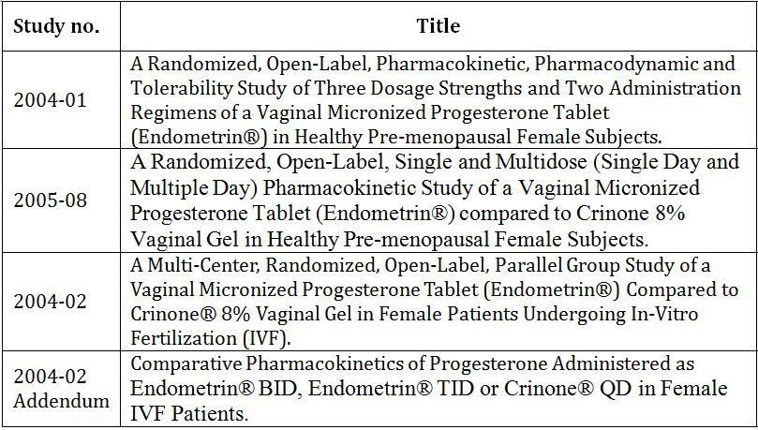

Other references
Fatemi HM et al. 2007. An update of luteal phase support in stimulated IVF cycles. Human Reproduction Update 13: 581-590.
Sallam HM et al. 1999. Reference values for the midluteal plasma progesterone concentration: evidence from human menopausal gonadotropin-stimulated pregnancy cycles. Fertility and Sterility. 71: 711-714.
van der Linden M et al. 2011. Luteal phase support for assisted reproduction cycles. Cochrane Database of Systematic Reviews

The clinical evaluator notes they could not find in the Protocol any specific instructions for administration of the study treatments (e.g. a prescribed period of recumbency after administration, as was recommended in Study 2004-01).
Apparently these were subsequently transferred to the "listed" category.
Apparently these were subsequently transferred to the "listed" category.

